Transcript March 2024

Table of Contents
Transcript Overview 1
Transcript Preferences Overview 2
Define Fiscal Year 3
Training Completion Page Preferences 4
Transcript 7
Approval Workflow Preferences Overview 8
Default Approval Requirements by Division 9
Default Approval Workflow Templates 20
Universal Profile - Transcript Overview 27
Certifications 38
Transcript - Curriculum Subscriptions 55
Transcript - Events and Sessions 56
External Training - Add Overview 61
External Training Request - Mark Complete 86
Library - Manage 87
Network Player Transcript Options 89
Observation History 91
Transcript - Print Transcript Pop-up 94
Transcript (Universal Profile) - Status and Options 96
Transcript - Training Category Statuses 115
Training Completion Page 118
Training Details - View 124
Training - Archive 180
Training - Remove from Transcript 181
Remove Self-Requested Training from Transcript 187
Remove Training from User's Transcript 196
Training - Restore to Transcript 199
Transcript - Download Offline Learning 201
Transcript - On the Job Training 202
Transcript Statuses 205
Training - Open Overview 217
New Online Course Version Available - Notifications 221
Training - Register from Transcript 223
Transcript Lockdown - Administrator Overview 224
Transcript - Transcript Report 229
Course Troubleshooting Guide 234
Curriculum Player Overview 237
Curriculum Player - Sections 239
Curriculum Player - Curriculum/Section Details 241
Curriculum Player - Progress Display 244
Curriculum Player 2.0 252
Assign Training 256
Assign Training to Users from Inventory 265
Assign Training Without Managerial or Approver Roles 268
Assign Training - Add to Waitlist Pop-up 279
Assign Training - Confirm Enrollment Pop-up 280
Assign Training - Increase Seats Pop-up 281
Assign Training - Seats Available Pop-up 282
Assign Training - Seats Not Available Pop-up 283
Assign Training - Training Already in Transcript Pop-up 284
Assign Training - Users Not Assigned Training 285
Training Enrollments - View 286
Browse/Search/Request Training Overview 287
Browse for Training Overview 288
Search for Training 305
Events Calendar 307
Request Training 310

Transcript Overview

Transcript Preferences Overview

Define Fiscal Year
Administrators can select the month and date the hours should be calculated for the fiscal year end.
To define the fiscal year, go to Admin > Tools > Learning > Learning Preferences > Define Fiscal Year.
Permissions
PERMISSION NAME | PERMISSION DESCRIPTION | CATEGORY

Define Fiscal Year | Grants ability to set the fiscal year for aggregating annual training hours completed by users for display on the transcript page. This is an administrator permission. | Core Administration
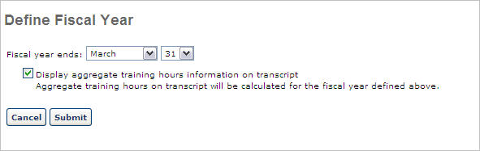
Define Fiscal Year Settings
Define fiscal year settings using the following steps:
- Fiscal year ends - Determine the ending date for the fiscal year for which the aggregate training hours will reflect
- Display aggregate training hours information on transcript - Check to enable users to view their aggregate training hours for the year on their transcript page.
  - Aggregate total hours is the total of all Completed hours for any activity that has training hours associated with it (online class, quick class, session, external training, etc.) and the dollar amount based on one year as determined by the end date.
  - The fiscal year is automatically calculated as follows; 12 months + 1 day = Fiscal Year Start Date. Example: Current Year is 2008. Fiscal Year ends 12/31, and then the start date is 1/1/2008.
  - If a fiscal year is selected that is less than the current date, then the fiscal end date will be for the following year and not the current year.
- Click the Submit button.

Training Completion Page Preferences
Administrators have the ability to enable a Completion page, which will be available for a user once they have completed the training.
The Training Completion Page Preferences page enables administrators to configure the default behavior for training completion pages, including whether a completion page is enabled by default for each learning object (LO) type and the default completion message that appears on the Training Completion page.
To manage Training Completion Page Preferences, go to Admin > Tools > Learning > Learning Preferences > Training Completion Page.
Permissions
PERMISSION NAME | PERMISSION DESCRIPTION | CATEGORY

Training Completion Page Preferences - Manage | Grants ability to access and edit the Training Completion Page Preferences where the administrator can configure the default behavior for training completion pages, including whether a completion page is enabled by default for each learning object (LO) type and the default completion message that appears on the Training Completion page. This permission cannot be constrained. This is an administrator permission. | Learning - Administration
Settings by Learning Object Type
This section enables administrators to set the default behaviors for each LO type that can be configured in the Course Catalog. See Course Catalog - General.
The following options can be set for each available LO type:
- Enable Training Completion Page - A Training Completion page is a page that is available for a user when they complete the training. Depending on the configuration of the training and the portal, the Training Completion page may display any points or badges that were awarded, the opportunity to rate and review the training, and the option to view their certificate of completion. When this option is selected, the Training Completion page is enabled by default for the corresponding training type. Administrators can choose to enable or disable the Training Completion page for each individual LO via the Course Catalog. This setting only determines the default configuration.
Course Recommendations
This section allows you to specify whether training recommendations should display to users at the bottom of their Training Completion page, when available. If the Display Course Recommendations option is selected, the Training Completion page displays training that is recommended to the user based on what other users with similar course histories have completed. For example, if there is a user who has completed similar training, then the system will recommend other training that the similar user has completed.
To disable course recommendations on the Training Completion page, uncheck the Display Course Recommendations option.
Completion Message
This section enables administrators to configure the default completion message that is displayed to users on the Training Completion page when they complete a LO. When editing a LO via the Course Catalog, administrators can choose to utilize the default completion message or they can create a custom completion message for the LO. This setting only determines the default completion message. See Course Catalog - General.
To view a list of all of the tags that can be used in the default completion message, click the List of Available Tags link. To use one of the tags, copy the tag from the pop-up and paste it into the custom message editor. Be sure to copy the brackets on both sides of the tag name.
To edit the default completion message, click the Gear icon in the upper-right corner of the Preview panel. This opens an HTML editor, in which a custom message can be configured using HTML. See HTML Safe List.
The Preview panel displays a preview of the message as it is currently configured. If tags are used in the message, then the tag is displayed with brackets in the preview.
Overwrite Custom Completion Page Settings
Choose whether or not to overwrite custom training completion page settings for all LOs. If you choose to overwrite custom settings for all LOs, the selected settings are applied to both new and existing LOs. Any previously customized LOs are updated with the selected settings.
- If this option is unselected, then only the LOs that do not have customized settings will be updated, as well as any LOs that are created in the future.
- A LO that has not been customized always inherits from the default settings, regardless of whether this option is selected.
- A LO is considered customized if its settings have been changed via the Course Catalog.
Save/Cancel
Click Save to commit any unsaved changes, or click Cancel to discard any unsaved changes.
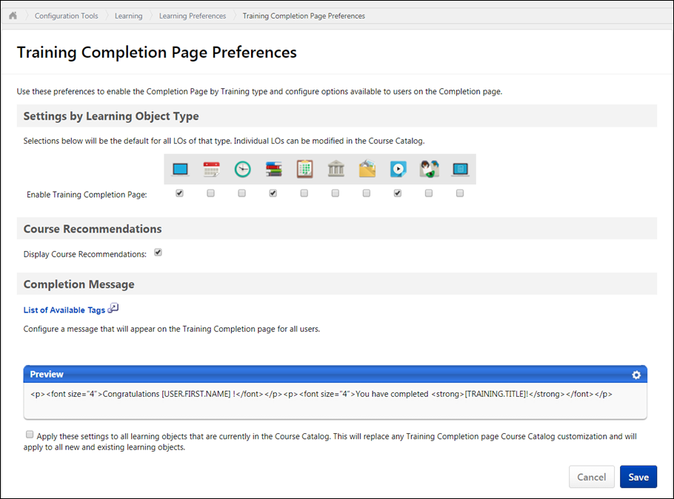

Transcript

Approval Workflow Preferences Overview

Default Approval Requirements by Division
The Default Approval Preferences by Division page allows administrators to set the default learning object approval preferences by division. The preferences set here apply to the Division of the user who is assigned the training. These preferences allow you to determine by learning object if the training is pre-approved and/or if the training is registered upon approval by default. For external training and Connect postings, you can set the default number of approvals required for each. These settings can be changed at the Learning Object level.
When determining the approval requirements for a learning object, the system first checks the User Record - Required Training Approvals field, then the Learning Object setting, and finally the Approval Requirement for the Training Type.
To manage default approval requirements, go to Admin > Tools > Learning > Learning Preferences > Preferences > Default Approval Requirements.
Permissions
PERMISSION NAME | PERMISSION DESCRIPTION | CATEGORY

Default Approval Requirements by Training Type | Grants ability to set Default Approval Requirements by Training Type that apply when users request training. Defaults may be overridden at learning object level by those who create and manage the learning objects. This is an administrator permission. | Learning - Administration
The preferences are divided into the following sections. Select the appropriate settings in each section:
- Standard Training Types
- External Training
- Connect Posting
Custom Relationships as Approvers
If custom relationships or miscellaneous users or groups are added as approvers in a custom approval workflow template, those users must have the Approve Training by Manager permission in order to access those pending approvals. This permission should be added to the corresponding custom relationship role, and approvers outside of a standard or custom relationship also need the permission via one of their security roles. The easiest overall solution to this is to add the Approve Training by Manager permission in the default user role. This has no impact if a user is not a designated approver or manager. Having this permission is necessary, however, if the user becomes part of a population of training approvers via a custom training approval workflow template.
Overwrite Settings
Select this option to overwrite custom settings for child division OUs. If you overwrite custom settings for child division OUs, the selected settings are applied to both new and existing child OUs. Any previously customized child OUs are updated with the selected settings.
- If there are no customizations to the child OU, then the parent OU customizations are applied to all child OUs.
- Overwrite custom settings checkbox setting
  - If this option is selected, all child OU customizations are deleted from the database, which means the parent OU customizations will be applied to new and existing child OUs.
  - If this option is unselected, all existing child OU customizations will remain unchanged, and any new child OUs will inherit the parent OU customizations by default.
- If a child OU has been customized to display any widgets, then regardless of the parent OU customizations, the child OU customizations are applied.
- If a child OU has been customized to hide all widgets, then parent OU customizations will take precedence and will be applied.
Save
Click Save to save the selected preferences.
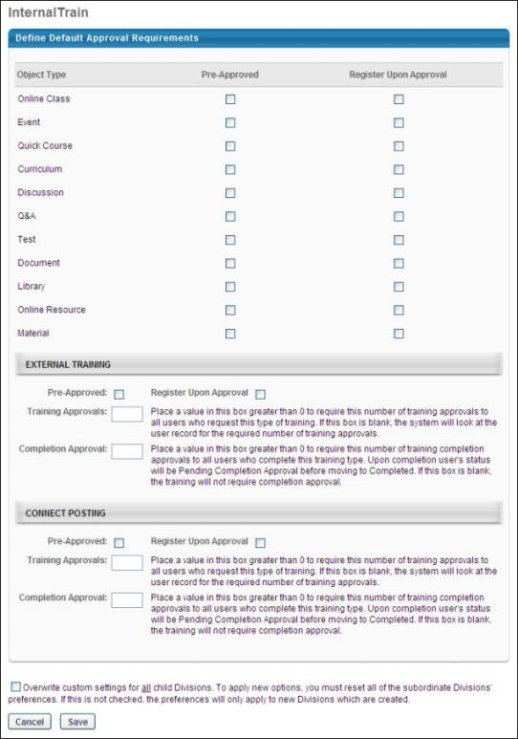

Default Approval Requirements - Standard Training Types
The standard training types section of the Default Approval Requirements page enables administrators to define the default settings for adding availability criteria of a course in Catalog Management, Test Engine, ILT Manage Sessions and Events, Curricula Administration, and Manage Materials. This section also enables administrators to select the default approval workflow and default completion approval workflow for each learning object (LO) type.
To manage default approval requirements, go to Admin > Tools > Learning > Learning Preferences > Preferences > Default Approval Requirements.
Permissions
PERMISSION NAME | PERMISSION DESCRIPTION | CATEGORY

Default Approval Requirements by Training Type | Grants ability to set Default Approval Requirements by Training Type that apply when users request training. Defaults may be overridden at learning object level by those who create and manage the learning objects. This is an administrator permission. | Learning - Administration
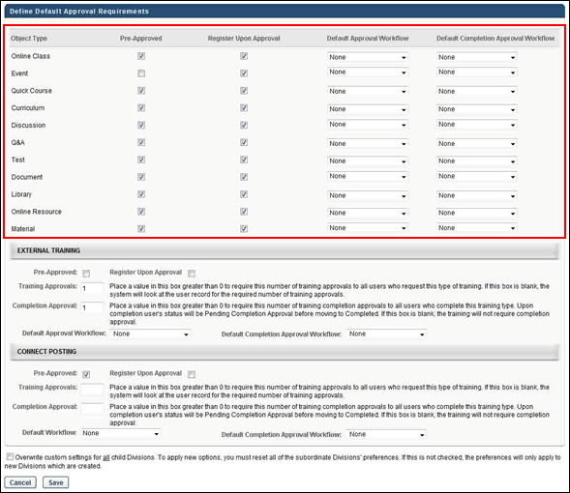
Object Type
This column displays the name of the learning object (LO).
Pre-Approved
This column allows administrators to define the default setting for pre-approval for the LO.
Register Upon Approval
This column allows administrators to define the default setting that determines whether the LO is placed into a Registered status upon approval.
Default Approval Workflow and Default Completion Approval Workflow
In these columns, the administrator can select a default approval workflow and default completion approval workflow for the LO type. The selected workflow is used as the default workflow for all approvals and completions associated with that LO. The LO types and the templates available for the administrator to select are dependent on the administrator's permission constraints. Note: The default approval workflow can be overridden at the individual LO level.
The default value for all LO types in both columns is "System-Generated Template." This is the default approval workflow that is defined for the portal.
The same template can be defined for multiple LO types.
- Note: You must create at least one approval workflow template in order for an option in addition to "None" and "System-Generated Template" to appear in the drop-down.
- Note: If the value in the column is a template that is outside of the administrator's permission constraints and the administrator changes the value for the LO type, then after the administrator saves the change, they cannot change the value back to the previous value that is outside of their permission constraints.
- Note: Approval workflow templates are created by the administrator in Approval Workflow Templates.
Once all settings are completed, click Save to save the settings.
See also:
- Default Approval Requirements - External Training
- Default Approval Requirements - Connect
The following image displays the Pre-Approved and Register Upon Approval settings on the Availability tab in Course Catalog:
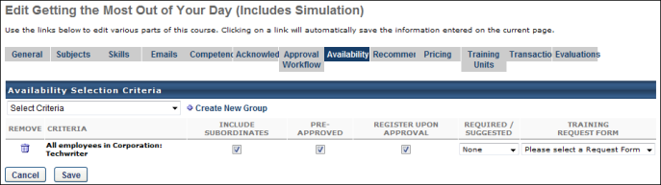
The following image displays the approval workflow settings in Course Catalog:
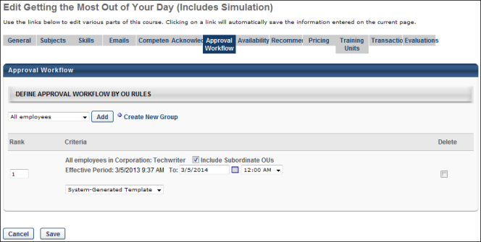

Default Approval Requirements - External Training
In the External Training section, the administrator can set the Pre-Approved and Register Upon Approval default settings for external training. In addition, the number of training and completion approvals can be configured, as well as the approval and completion approval workflows.
Note: External training is not a standard learning object, and cannot be managed in Catalog Management.
To manage default approval requirements, go to Admin > Tools > Learning > Learning Preferences > Preferences > Default Approval Requirements.
Permissions
PERMISSION NAME | PERMISSION DESCRIPTION | CATEGORY

Default Approval Requirements by Training Type | Grants ability to set Default Approval Requirements by Training Type that apply when users request training. Defaults may be overridden at learning object level by those who create and manage the learning objects. This is an administrator permission. | Learning - Administration
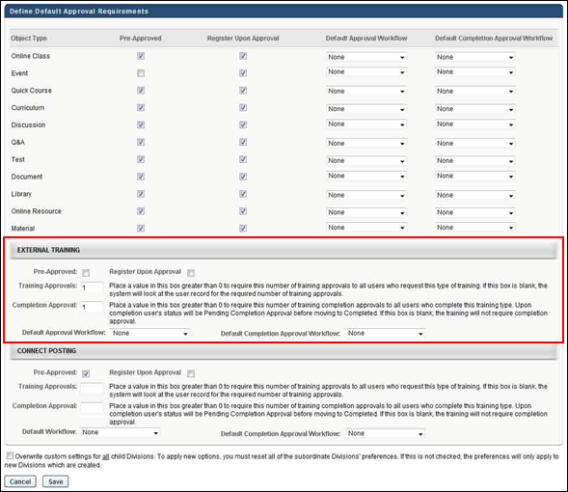
Pre-Approved
Select the Pre-Approved option to pre-approve external training.
Register Upon Approval
Select the Register Upon Approval option to define the default setting that determines whether the external training is placed into a Registered status upon approval.
Training Approvals
In the Training Approvals field, set the number of approvals required for external training. The system compares this number with the user record setting. If both the user record and Training Approvals are set to greater than 0, the higher number of the two is the number of approvals required for external training for the user. If the user record is set to 0, the user record setting overwrites the Training Approvals field setting and training does not require approval. If both are set to zero, training does not require approval.
Completion Approval
In the Completion Approvals field, set the number of approvals required for external training completion. If this number is set to zero, the user does not require approval for external training completion. When external training requires completion approvals and a user marks an external training as complete, the status of the external training is Pending Completion Approval until the number of required approvals is reached.
Best Practice: Because external training details are entered by the user, completion approval should be required so that the details of the external training are reviewed before the external training is considered complete.
Default Workflow
The Default Approval Workflow field enables administrators to define a default approval workflow for external training. Select an approval workflow template from the drop-down. When selected, the template is used as the default approval workflow for all external training.
The default value is "System-Generated Template." This is the default approval workflow for the portal.
Default Completion Approval Workflow
The Default Completion Approval Workflow field enables administrators to define a default approval workflow for external training completion. Select an approval workflow template from the drop-down. When selected, the template is used as the default approval workflow for all external training completions.
The default value is "System-Generated Template." This is the default approval workflow for the portal.
SF-182 Post Training Approvals
For SF-182 forms, post-training (completion) approvals can be configured via the Default Approval Workflow Templates page and the Default Approval Requirements for External Training page. The first approver who approves displays in Section F on SF-182 forms.
Section F allows for the printing of the following fields:
- Full name
- Title
- Email address
- Phone
- Approval date
- Signature box with full name displayed
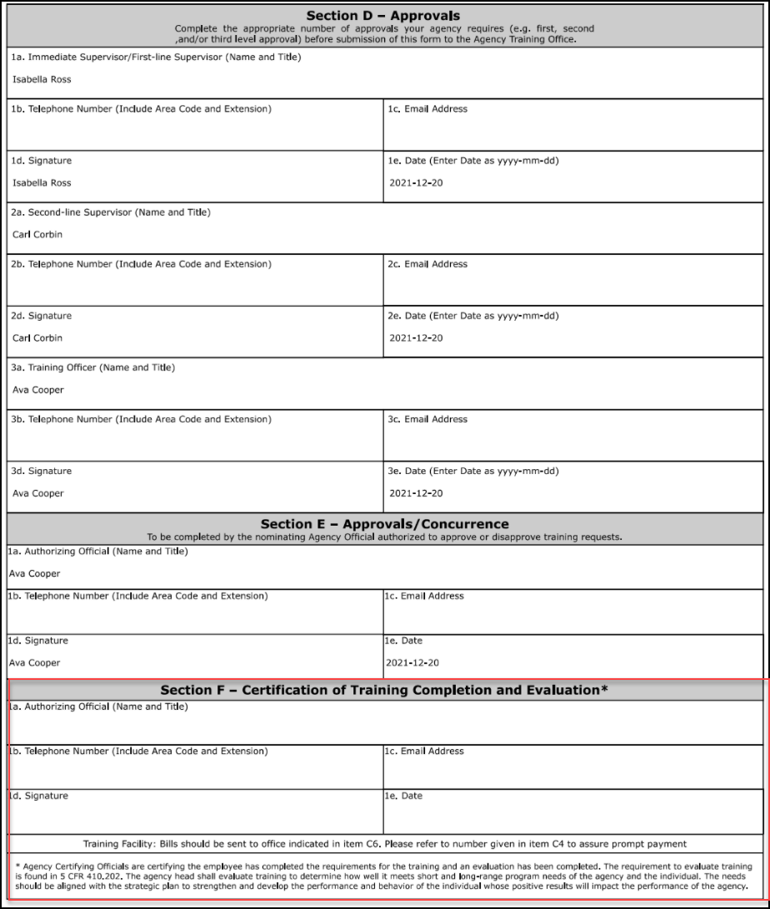

Default Approval Requirements - Connect Posting
In the Connect Postings section, the administrators can set the Pre-Approved and Register Upon Approval default settings for Connect postings. In addition, the number of training and completion approvals can be configured, as well as the approval and completion approval workflows.
Note: A Connect posting is not a standard learning object, and cannot be managed in Catalog Management.
To manage default approval requirements, go to Admin > Tools > Learning > Learning Preferences > Preferences > Default Approval Requirements.
Permissions
PERMISSION NAME | PERMISSION DESCRIPTION | CATEGORY

Default Approval Requirements by Training Type | Grants ability to set Default Approval Requirements by Training Type that apply when users request training. Defaults may be overridden at learning object level by those who create and manage the learning objects. This is an administrator permission. | Learning - Administration
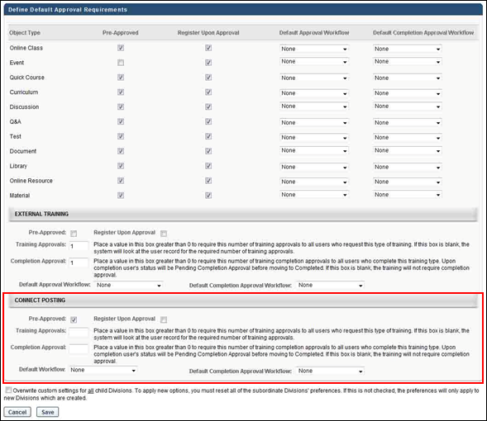
Pre-Approved
Select the Pre-Approved option to pre-approve connect postings.
Register Upon Approval
Select the Register Upon Approval option to define the default setting that determines whether the connect posting is placed into a Registered status upon approval.
Training Approvals
In the Training Approvals field, set the number of approvals required for Connect postings. The system compares this number with the user record setting. The higher number of the two is the number of approvals required for Connect postings for the user. If both are set to zero, Connect postings do not require approval.
Completion Approval
In the Completion Approvals field, set the number of approvals required for Connect posting item completion. If this number is set to zero, the user does not require approval for Connect posting item completion. When a Connect posting item requires completion approvals and a user marks a Connect posting item as complete, the status of the Connect posting is Pending Completion Approval until the number of required approvals is reached.
Default Workflow
The Default Workflow field enables administrators to define a default approval workflow for Connect postings. Select an approval workflow template from the drop-down. When selected, the template is used as the default approval workflow for all Connect postings.
The default value is "System-Generated Template." This is the default approval workflow for the portal.
Default Completion Approval Workflow
The Default Completion Approval Workflow field enables administrators to define a default approval workflow for Connect postings completion. Select an approval workflow template from the drop-down. When selected, the template is used as the default approval workflow for all Connect postings completions.
The default value is "System-Generated Template." This is the default approval workflow for the portal.

Default Approval Workflow Templates
The Approval Workflow Templates page enables administrators to create approval workflow templates for learning objects (LO). Upon implementation, a system-generated default template appears on the Approval Workflow Templates page for all portals and contains the approval workflow that exists at the time of the implementation of this enhancement.
To access the Approval Workflow Templates page, go to Admin > Tools > Learning > Learning Preferences > Default Approval Workflow Templates.
Permissions
PERMISSION NAME | PERMISSION DESCRIPTION | CATEGORY

Approval Template Administration - Manage | Grants ability to manage approval templates that can be applied to learning objects. Defaults must be overridden at the learning object level by those who create and manage them. This permission can be constrained by OU, User's OU, and Training Type. This is an administrator permission. | Learning - Administration

Approval Template Administration - View | Grants ability to view approval templates that can be applied to learning objects. Defaults must be overridden at the learning object level by those who create and manage them. This permission can be constrained by OU, User's OU, and Training Type. This is an administrator permission. | Learning - Administration
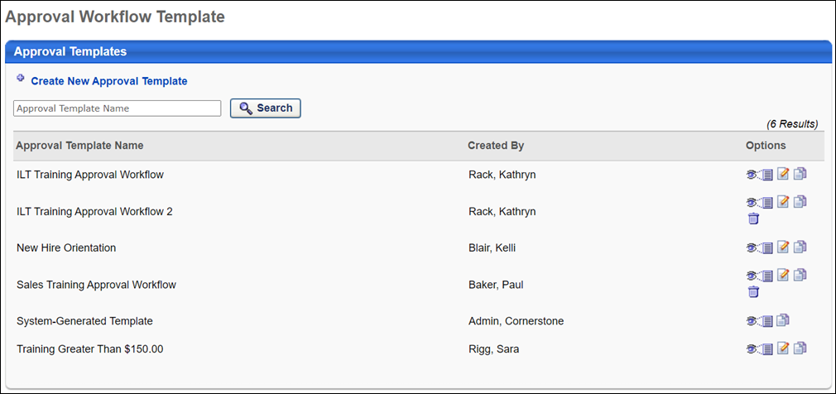
Approval Workflow Template
The following features and fields are available on the Approval Workflow Template page:
- Create New Approval Template - Click this link to create a new approval workflow template. You must have permission to manage approval workflow templates in order to create new templates.
- Search - Filter the results in the Approval Template table by entering a template name in the search field and clicking Search. The field accepts up to 100 characters.
- Approval Templates table - The following columns display in this table:
  - Approval Template Name - This column displays the template name. This column also displays the portal's system-generated template. For portals with multiple languages, template names display in the administrator's localized language. If a translation is not configured, the template name displays in the language of the template creator. This column is sortable.
  - Created By - This column displays the name of the administrator who created the template.
  - Options - The following options may be available for each approval template:
    - View Template - Click this icon to view the template as read-only.
    - Edit Template - Click this icon to edit the template. You must have permission to manage approval workflow templates in order to edit templates.
    - Copy Template - Click this icon to copy the template. All fields are copied except the Approval Template Name field. You must have permission to manage approval workflow templates in order to copy templates.
    - Delete Template - Click the Trash Can icon to delete the template. Then, click the Save button at the bottom-right of the page to save the deletion. Templates cannot be deleted if they are defined as the default template for a LO or have ever been assigned to a LO.
Once all changes are made to the Approval Workflow Templates page, such as deleting a template, click Save at the bottom-right of the page to save the changes. Click Cancel to cancel the changes.
System-Generated Template
The system-generated template on the Approval Workflow Templates page contains the default approval workflow. This template cannot be edited or deleted. Until a workflow is defined for a LO type, the system-generated template is used as the approval workflow.
If a template is never defined for a LO type or for an individual LO, then the system-generated template is always used as the approval workflow.
Note: When additional templates are added, the system-generated template is still available to select when defining an approval workflow at either the LO type or individual LO level.
Localization
For portals with multiple languages enabled, the title "System-Generated Template" can be localized. To localize the title:
- Click the View Template icon in the Options column. This opens the Define Approval Template page.
- Click the Translate icon in the Approval Template Name field. This opens the Translate pop-up.
- Enter localized text into the desired language fields.
- Click Save.
SF-182 Post Training Approvals
For SF-182 forms, post-training (completion) approvals can be configured via the Default Approval Workflow Templates page and the Default Approval Requirements for External Training page. The first approver who approves displays in Section F on SF-182 forms.
Section F allows for the printing of the following fields:
- Full name
- Title
- Email address
- Phone
- Approval date
- Signature box with full name displayed
Define Approval Template
The Define Approval Template page enables administrators to create and edit approval workflow templates.
To access the Approval Workflow Templates page, go to Admin > Tools > Learning > Learning Preferences > Default Approval Workflow Templates.
To access the Define Approval Template page, click the Create New Approval Template link from the Approval Workflow Templates page. Or, click the Edit Template or Copy Template icon from the Options column on the Approval Workflow Templates page.
Permissions
PERMISSION NAME | PERMISSION DESCRIPTION | CATEGORY

Approval Template Administration - Manage | Grants ability to manage approval templates that can be applied to learning objects. Defaults must be overridden at the learning object level by those who create and manage them. This permission can be constrained by OU, User's OU, and Training Type. This is an administrator permission. | Learning - Administration
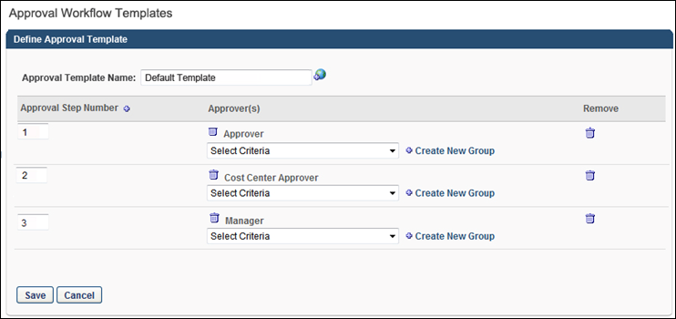
Create New Template
Approval Template Name
When creating a new template, the first step is to enter a name in the Approval Template Name field, up to 100 characters. This is a required field. For portals with multiple languages enabled, click the Translate icon to localize the template name.
Approval Step Number
The Approval Step Number column displays the step number that is associated with the approver in the Approver(s) column. The step number is automatically populated when a new step is created. You can edit the step number by entering up to three positive whole numbers in the field.
Multiple steps can have the same step number. Steps with the same number occur simultaneously during the approval process. Approval from any approver in either step approves the step. The other approvers in the step can still enter their approval decision, but their decision does not impact the step. If all approvers in the step deny approval, then the step is denied. See the Considerations section below for more information about the approval process for steps.
Add Approval Step
When creating a new template, the second step is to add an approval step. At least one step must be added. Click the Plus icon to the right of the Approval Step Number column name to add an approval step. This adds a new step to the Define Approval Template table.
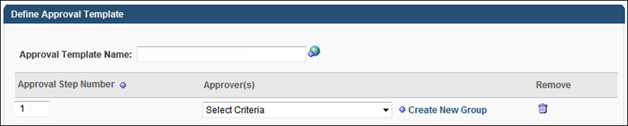
Approver(s)
When creating a new template, the third step is to define the approver criteria. Multiple approvers can be defined for each step.
To define criteria for the approval step, select an employee relationship, familiar job title, organizational unit (OU), or specific user from the Criteria drop-down. Once selected, the approver type appears in the Approver(s) column. Approval from any approver defined for the step approves the step. The other approvers in the step can still enter their approval decision, but their decision does not impact the step. The Approval History section on the Training Details page for the user displays the name of the approver that approved the user and also the OU or group from which the approval was granted.
Considerations
- If an approval is not obtained after going through all of the steps in an approval workflow template, the system automatically approves the training. Therefore, it is always a best practice to ensure that the number of steps in the approval process is greater than the largest number of approvals needed for a user or LO.
- If the final approver in the approval workflow defers approval, then the step is considered approved. The user's status changes to Approved.
- If the same approver is added to multiple steps, then approving any one of the steps counts as approval for all of the steps for which they are an approver. Example
- If one approver in the step denies the step, then the LO is denied and the workflow is complete.
- If all approvers in the step defer the step, then the step is deferred and moves to the next step in the workflow. Note: In this case, if the user is approved at a later step, then the Approval History section on the Training Details page for the user displays the OU or group that approved the user.
- If all approvers in the step are vacant for the user, then the approval moves to the next step in the workflow. If an approval is not obtained after going through all steps, the system automatically approves the training.
- If the Required Training Approvals field on the user record is set to zero, then no training approvals are ever required for the user, regardless of any training approvals that are set anywhere in the system.
Remove
Click the Trash Can icon to remove the criteria defined for the step.
Save or Cancel
Once all fields are completed, click the Save button. This saves the template and returns you to the Approval Workflow Templates page. Click Cancel to cancel creation of the template and return to the Approval Workflow Templates page.
Edit/Copy Template
The process for editing or copying a template is similar to creating a new template. See the Create New Template section above for more information.

Universal Profile - Transcript Overview
The Transcript page is a part of the Universal Profile.
Every user has a personalized transcript which enables the user to manage their training. The transcript displays the status of each learning object (LO) requested by, assigned to, or required of the user, which allows the user to determine if the training is pending, approved, denied, or many other potential statuses. Depending on the training status, users can register, launch, and perform a variety of other training functions directly from the transcript.
To access the Transcript page, go to Home > Universal Profile. Then, click the Transcript tab. Note: The location of this link is configurable by your system administrator. Note: The Employee Transcripts - Manager/Approver Access permission does not grant access to this page.
Permissions
PERMISSION NAME | PERMISSION DESCRIPTION | CATEGORY

Bio About - View | Enables user to view the Bio page for users within their permission constraints. This permission must be enabled to view the Transcript page within Universal Profile. If a user does not have this permission and they click a person's name or user photo within the Universal Profile, then the Bio page will not open.  On the Learner Home page, this permission also allows end users to view the Completions & Hours field, the training sidebar, and the Continue Learning carousel.  This permission can be constrained by Employee Relationship, OU, User's OU, User's Direct Reports, User Self and Subordinates, and User. Note: For security purposes, this permission is constrained to User Self and Subordinates by default. However, the permission constraints can be modified to allow users to view the Bio About page for other users. | Universal Profile

Employee Transcripts - Manager/Approver Access | Grants access to transcript (training record) screen of those for whom user is designated manager, approver or cost center approver. System administrators can access all user transcripts from this page. Link to this screen appears under Standard Reports/Track Employees. This is a manager/approver permission. This permission can be constrained by Employee Relationship and User's Direct Subordinates.  Note: The Employee Relationship constraint allows administrators to constrain the permission to a user’s custom employee relationship. For example, an administrator can select to restrict the Matrix Manager relationship to viewing user data for users who have that Matrix Manager indicated on their user record.  Note: The User's Direct Subordinates constraint allows administrators to constrain the data that a user can view to only the data for their direct reports. The user will not be able to view their own data with this constraint.  Note: By design, for any Track Employees report permission that is included in the Manager default security role, all of the manager's direct and indirect reports are included in the constraints, even if they are not selected in the permission constraints for the role. | Reports - Track Employee

External Training - Add | Grants a user the ability to add or edit their own external training. When viewing another user's transcript, the user must also have permission to edit transcript items in order to add or edit the user's external training. This permission cannot be constrained. This is an end user permission. | Learning

Local Network Player - File Download Link - View | Grants access to the Download Network Player link in Course Catalog and on the Transcript. Users must also have permission to access the Course Catalog. This permission cannot be constrained. This permission is recommended for local trainers who deliver course content remotely. This is an end user and local trainer permission. If the user no longer needs to view the download link after installation, this permission can be removed for those users. | Learning

Local Network Player - Launch Courses Offline Through the Network Player | Enables users to see the Launch Locally link on their transcript for courses that have been downloaded and can be launched through the local network. This permission cannot be constrained. This permission is recommended for end users of the LMS. | Learning

Mark Training Complete | Grants ability to mark learning objects complete for other users, via the training details page when viewing the learning object from the user's transcript. This permission does not grant ability to mark a user's learning object complete from their Transcript page. This permission can be constrained by OU, User's OU, User, User's Self, and User Self and Subordinates. This is an administrator permission. | Learning - Administration

Mark Transcript Exempt | Grants ability to exempt users from a learning object, using the "Mark Exempt" link on the top right corner of the target user's Transcript/Training details page. This permission can be constrained by OU, User's OU, and User's Subordinates. This is an administrator permission.  With the May '17 release, this permission also applies to prerequisites, pre-work, and post-work. Users without this permission cannot mark any training type exempt for a user. | Learning - Administration

Old Offline Player | Enables the user to access to the old offline player functionality. Users with this permission can download courses to the old offline player as well as upload training results from the old offline player. Without the permission, users cannot see the link on the transcript page to retrieve the offline player key, they cannot log in to the offline player, and no uploaded results are accepted. This permission cannot be constrained. This is an end user permission. | Learning

Remove Training | Grants ability to remove training from other users' transcripts (training records) when viewing their transcript. This permission can be constrained by OU, User's OU, User's Corporation, User Self and Subordinates, User's Self, User's Direct Subordinates, and User. This is an administrator permission. | Learning - Administration

User View “Add SF-182” link on Transcript | Grants ability to view the "Add SF-182 External Training" link to complete the form for requesting an external course (Governmental clients). This is an end user permission.  Note: If a user does not have this permission but has the Edit Transcript Items permission, the Add SF-182 External Training link will also appear. | Limited Use/Obsolete

View Transcript Item | Grants ability to view details of learning objects that appear on the transcript (training record), by clicking on the name of the learning object. Users must also have the Bio About - View permission in order to access the transcript within Universal Profile. This permission can be constrained by OU, User's OU, User Self and Subordinates, User, or User's Self. This is an end user permission. | Learning - Administration

Withdraw Users from Sessions | Allows administrators and managers to withdraw users from sessions on their behalf. This is done from the user's Transcript page. Note: There is a setting in the Session Defaults for an event that may prevent users from being able to withdraw from sessions. When this option is selected, users, managers, and administrators are prevented from withdrawing from sessions for themselves or on behalf of other users. This permission can be constrained by OU, User's OU, User's Self and Subordinates, User, User's Subordinates, and User's Direct reports. This is a manager or administrator permission. | Learning
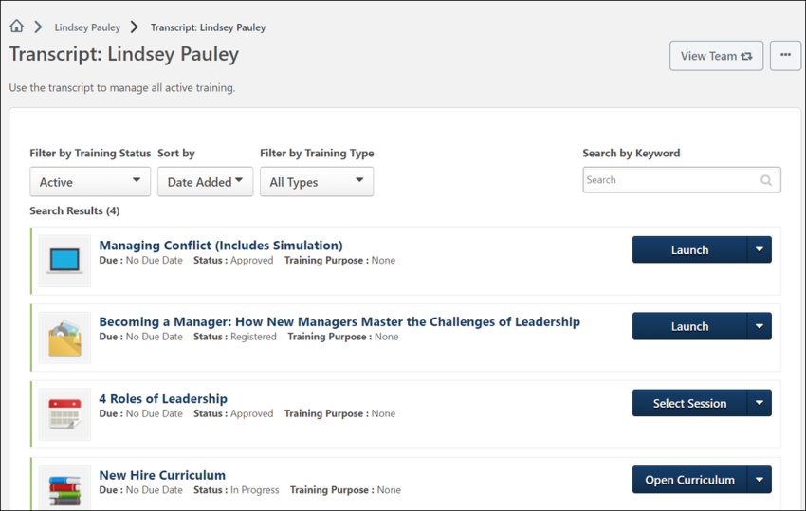
Troubleshooting Information
The Transcript page title and instructions can be configured by the system administrator in Transcript Preferences.
The following page contains an administrator's guide for configuring the Universal Profile:
- See Configuration Guide - Universal Profile.
Course Troubleshooting Guide
In certain cases, users may have issues receiving a Completed status for their online course even if they have launched the course and completed the assessment within the course. See Course Troubleshooting Guide on page 234 for additional information.
View Team
The View Team flyout allows managers, approvers, and custom relationships to quickly navigate between subordinates' profiles and transcripts. When enabled, the View Team flyout is available to managers and dotted line managers on all pages of their Universal Profile and the Universal Profile of their subordinates. This flyout displays the manager's reports visually.
The View Team button displays if enabled in the portal. Administrators may enable or disable this flyout via the My Team Dropdown section within Universal Profile General Preferences. See Universal Profile General Preferences.
See Universal Profile - View Team Flyout.
Options
The following options are available in the Options drop-down menu:
- Assign Training - Select this option to assign training to a direct or indirect report. This option is only available if the user has permission to assign training and when viewing the Universal Profile page of a direct or indirect report. See Universal Profile - Options - Assign Training.
- Add External Training - Select this option to add external training to your transcript. This option is only available for users with permission to add external training. Also, the availability of this option is controlled by backend settings. See Universal Profile - Options - Add External Training. Note: In order to add external training to a certification, users must first add the external training to their transcript. Then, they must add it from their transcript to the certification or add the external training via the certification's Training Details page.
- Add SF-182 External Training - Select this option to add external training using an SF-182 form. This option is only available for users with permission to add external training via the SF-182 form and if an SF-182 form has been configured by the administrator. Also, the availability of this option is controlled by a backend setting. See SF-182 Form - Overview on page 70 for additional information.
- Download Network Player - Select this option to download the Network Player. The installation dialog varies based on the user's Internet browser settings. This option is only available if the user has permission to download the Network Player. Also, the availability of this option is controlled by a backend setting. See Network Player Transcript Options on page 89 for additional information.
- Export to PDF - Select this option to print the current view of the transcript page to PDF. Only the training that is currently displayed is included in the printed transcript. If there are multiple pages, then only the current page is printed. The PDF file name is "[User First Name] [User Last Name] - Transcript - MM/DD/YYYY." This option is available to any user who can view the Transcript page.
- Print Transcript - Select this option to view an HTML printable version of your transcript. Depending on which training category is selected when you select this option (Active, Archived, Removed), a printable version of the corresponding transcript training category is generated. This option is available to any user who can view the Transcript page. See Transcript - Print Transcript Pop-up on page 94 for additional information.
- Register Offline Device - Select this option to register an offline device, which enables you to log in to the Cornerstone mobile application using a unique PIN, rather than your username and password. This option opens the Mobile Devices tab of My Account. See My Account - Devices. Note: My Account is redesigned with the June 2014 release. If enabled, this option takes the user to the redesigned My Account page, rather than the old My Account page.
- Run Transcript Report - Select this option to run the Transcript Report. This option is available to any user who can view the Transcript page. See Transcript - Transcript Report on page 229 for additional information.
- Request Exemption - The Request Exemption option is available in the Actions drop-down for training items, if applicable to both the training item and the user. If a user clicks this option, the Request Exemption pop-up appears. Using this pop-up, the user must select a reason for the exemption request and enter a comment. The user can click Confirm to complete the request or click Cancel to cancel the request. See Exemption - Request on page 156 for additional information.
- Mark Exempt - The Mark Exempt option is available to administrators in the Actions drop-down for training items, if applicable to both the training item and the user. If an administrator clicks this option, the Mark Exempt pop-up appears. Using this pop-up, the administrator must select a reason for the exemption and enter a comment. The administrator can click Confirm to complete the exemption or click Cancel to cancel the exemption.
Fiscal Year Training Overview
In Define Fiscal Year Preferences, the system administrator can configure the fiscal year and whether the aggregate training information is displayed on the Transcript.
If enabled, the following fiscal year training information is displayed at the top of the transcript:
- Aggregate Training Completed - This displays the total number of hours of all completed training for the fiscal year that has hours associated with it. Removed training will be deducted from this total.
- Fiscal Year - This displays the fiscal year for which the aggregate training and cost are calculated.
- Cost - This displays the total cost of all completed training for the fiscal year that has an associated cost.
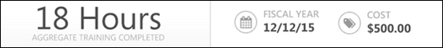
Training Category Filter
From the Training Category filter, users can filter the training based on whether the training in the transcript is active, completed, archived, or removed from the transcript. The Active filter option is selected by default. See Transcript - Training Category Statuses on page 115 for additional information.
Transcript Sort
To the right of the Training Category filter, the sort option allows users to determine the order in which transcript items are displayed on the page. The default sort order for the transcript can be configured by the system administrator via Transcript Preferences. The following options are available:
- By Title - This option sorts the transcript alphabetically by title in ascending or descending order, depending on how sorting preferences are configured within Transcript Preferences.
- By Completion Date - This option sorts the transcript by completion date with the most recent dates appearing first. This option is not available when viewing the Active transcript category. Note: This sort option does not apply to certifications, so certifications appear at the bottom of the list when this sort option is selected.
- By Status - This option sorts the transcript by status. The statuses are sorted alphabetically in ascending order.
- By Training Purpose - This option sorts the transcript by training purpose. The training purposes are sorted in ascending numeric order, which is configured in Training Purpose Administration. The Training Purpose sort option is only available if training purpose is enabled. Note: This sort option does not apply to certifications, so certifications appear at the bottom of the list when this sort option is selected.
- By Date Added - This option sorts the transcript by the date on which the item was added to the transcript. The items that were most recently added are displayed first. If the training item is a recurrence, then the most recent date associated with the item is used.
- By Training Type - This option sorts the transcript by training type. The training types are sorted in alphabetical order.
- By Due Date - This option sorts the transcript by due date with the soonest due dates appearing first.
- By Family - This option sorts the transcript by certification family. This option is only available when Certification is selected from the LO Type filter.
- By Category - This option sorts the transcript by certification category. This option is only available when Certification is selected from the LO Type filter.
- By Expiration Date - This option sorts the transcript by certification expiration date. This option is only available when Certification is selected from the LO Type filter.
When a training item does not contain the field by which the transcript is sorted, those items appear at the bottom of the list sorted alphabetically.
LO Type Filter
To the right of the Transcript Sort option, the LO Type filter enables users to filter the items within their transcript by a specific LO type, such as online course, cohort, or certification. Only a single LO type can be selected at a time.
The LO Type filter only displays the LO types that are currently displayed on the user's transcript. For example, if the user only has certifications, online classes, and sessions on their transcript, then the user can only select those LO types from the filter. By default, all LO types are displayed on the transcript.
The LO Type filter is available for all training categories (i.e., Active, Completed, Archived, and Removed).
Transcript Search
Users can search for training items within the selected category of the transcript using the Search functionality. To search for a training item, enter the appropriate keywords in the Search for training field and then press the [Enter] key or click the Search icon .
The training items that match the search are displayed. The number of search results is displayed at the top of the list.
- Only the selected transcript category is searched. For example, if the Completed category filter is selected, then only items within the Completed category are searched.
- When searching for a LO that is on the user's transcript as part of a curriculum, the following is true:
  - Search returns the curriculum, but not the individual LO unless the LO is also on the Transcript as an individual item.
  - If the LO is not activated, it will not appear in the search results. LOs that are Registered or In Progress will appear in search results.
  - The child LO only appears in the search results if the child LO's training category status (i.e., Active, Completed, Archived) matches the parent LO's training category status.
  - The transcript search also supports searching for learning object(s) by pre-work and post-work titles. To search for a learning object by its associated pre-work, the pre-work must have been activated. Entering the title or a text string from the pre-work title will return the associated learning object(s) on the Active and Completed tab. Entering the pre-work string in the Search field on the Archived or Removed tab will NOT return the associated learning object(s). Similarly, if post-work is used and the post-work has been activated and the learning object is pending post-work or has been completed, entering the title of the post-work in the search box will display the learning object(s) associated with the post-work on the Active and Completed tab. Post-work searches on the Archived or Removed transcript tabs will NOT return the associated learning object(s).
To clear the search filter, click the Remove icon in the Search for training field.
Hide Certified Certifications
This option is only available when viewing the Active training category and when certifications exist on the user's transcript.
When this option is selected, the transcript only displays incomplete certifications for the user. Any certifications in which the user is currently certified are hidden. If the LO Type filter is set to a specific training type other than certifications, then this option is not available.
Transcript Items
By default, new users do not have any training on their transcript until training is assigned, requested, or loaded to their transcript.
The following information is displayed for each training item in the transcript:
- Color Strip - The left edge of the LO is color coded to represent the proximity to the due date of the LO. For example, if the LO due date is past due, then the color strip is red to indicate that LO is due immediately. If a LO due date is not eminent, then the color strip is green to indicate that LO is not due immediately. See the Color Strip Key section below for additional information.
- LO icon - The icon that is displayed corresponds with the LO type (e.g., certification, curriculum, event, library, online course). Hover the computer cursor over the icon to view the LO type.
- LO title - When a user clicks the title of a training item on their transcript, they are navigated to an actionable page, which in most cases is the Learning Details page, where the user is allowed to launch and take other action on the training. See below for the different actionable pages to which the user may be directed, depending on the training type:
  - Learning Details - The user will be directed to the Learning Details page when they click the title of any of the following training types from their transcript:
    - Material
    - Online course
    - Test
    - Video
    - Posting
    - Event
    - Curriculum
    - Certification
    - Cohort
  - Event Learning Details - The user will be directed to the Event Learning Details page with the Session flyout expanded if they click the title of a session from their transcript.
  - External Content - The external content will launch when the user clicks the title of an external training item from their transcript.
  - External Training - The user will still be directed to the Transcript Details page if they click the title of an external training item.
Note: For session LOs, the session start date is appended to the LO title (e.g., Session Title Starts 12/01/2014). If the session is configured to Display in User's Timezone, the session start time will appear in addition to the session start date and LO title.
Note: For curriculum LOs, the curriculum expiration date is appended to the LO title (e.g., Curriculum Title Expires on 12/01/2014).
- LO Due Date or Completion Date - For training that is active, archived, or removed, the LO due date is displayed, if available. For training that is completed, the LO completion date is displayed.
- Status - The LO status is displayed. Note: For SCORM 1.2 and 2004 online courses that have SSL security enabled, the Transcript page refreshes automatically to show the most up to date status.
- Training Type - This displays the type of training, such as Online Class, Material, etc.
- LO Expiration - For LO's that are associated with a subscription, an expiration date displays to the right of the Status field for transcript items.
  - The expiration date is the date on which the training will no longer be available for the user to complete at no cost. The subscription will need to be renewed for the user to have access to the LO for no cost, or the user can alternatively purchase the training at this point.
  - When an LO is available to a user in multiple subscriptions, the subscription with the latest date will apply.
  - If the administrator edits the end date of the subscription at any point, a user who has already consumed the LO will maintain the settings that were active at the time of their consumption. The new dates will only apply to users who have not yet consumed the LO.
- Training Purpose - The training purpose only displays when training purpose is enabled for the transcript and if the LO has an associated training purpose.
- Actions drop-down - This drop-down enables users to perform actions on the LO. Click the left side of the drop-down to perform the displayed action. Or, click the drop-down arrow to select a secondary action. By default, the Action drop-down displays the primary action for the LO. See Transcript (Universal Profile) - Status and Options on page 96 for additional information.
  - When a LO is inactive, "Inactive" appears as the first action in the Action drop-down menu. This option is not clickable. The only other option available in the Action drop-down menu is the View Details option, which opens the Training Details page.
Color Strip Key
The following colors are available:
- Red - Due today or past due
- Orange - Due within the next seven days, not including today
- Green - Due after seven days

Certifications
Certification Item - Launch
Users can launch certifications from their transcript.
To launch a certification, go to Learn > View My Transcript. Select the View Training Details option for the certification. In the Certification section, click the appropriate link to activate or launch the certification.
Note: Access to Certification Details from the transcript is controlled at the portal level, and is based on the Certification - User View security object. If the value is active, certifications are visible for all users of the portal. There is currently no permission that controls an individual user's ability to view their certifications via the transcript.
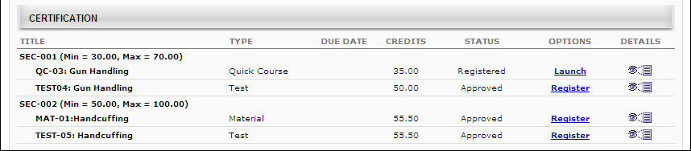
Observation Checklists within Certification
- To view an observation checklist that is part of a certification, users may be required to first request and register for the observation checklist.
- If an observation checklist is inside a curriculum that is part of the certification, then users must click the Manage link in the Options column for the curriculum. This opens either the Curriculum Details page or the Curriculum Player, depending on how the administrator configured the curriculum.
- Observation checklists that are part of a certification only recur if there are certification periods with recurrence configured. Further, the final completion date of the checklist is used to calculate the rules of the validity period.

External Training - Add to Certification from Details Page
From the Certification Details page, users can submit external training to fulfill a certification requirement. Users can also add external training to a certification from their Transcript. See External Training - Add to Certification from Transcript on page 42 for additional information.
The ability for users to submit external training is determined by the administrator during the certification creation. The User is allowed to submit external training option must be selected. If this option is not selected, users do not have the option to submit external training.
Add External Training to Certification
To add external training to the certification, click the Add External Training link in the Details section. The External Training pop-up appears. Enter the following information for the external training:
- Training Title - This title is displayed on the certification report as the training title. This field is limited to 200 characters.
- Language - The associated language for the training
- Training Description - The description of the training, which is visible to the administrator upon submission. This field is limited to 1000 characters.
- Institution - The institution associated with the training. This field is limited to 200 characters.
- Training Dates - The dates on which the training occurred.
- Apply Training to - Select the certification section to which the external training is applied. As an option, administrators may create an empty section titled External Training for the purpose of allowing users to complete and submit external training.
- Request Credits - Enter the number of credits you feel the external training is worth. The value must be an integer between 0 and 999. Administrators and certification owners can later modify this value upon review.
- Upload Attachment - To upload a supporting document related to the external training, including diplomas, transcripts, and certifications, click the Browse button and locate the file on your computer. One attachment is allowed and the maximum file size is 1 MB.
Click the Submit button to finalize the external training request. The request is submitted to the administrator or certification owner as a pending request. The Certification External Training Credit Submission Confirmation email is triggered, if enabled.
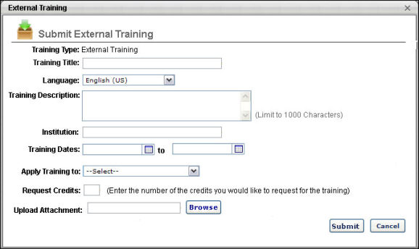

External Training - Add to Certification from Transcript
From the Certification Details page, users can submit external training from their transcript to fulfill a certification requirement.
The ability for users to submit external training is determined by the administrator during the certification creation. The User is allowed to submit external training option must be selected when the certification is created. If this option is not selected, users do not have the option to submit external training.
If a validity period is set for external training within the certification, then when adding external training to a certification from your transcript, you will only receive credit for external training that is completed within the external training validity period. The validity period can be set by the administrator who created the certification.
- The external training dates can be edited even after the training is added to the certification. If an update to the training date causes the training to be outside the validity period, the user does not receive credit for the training. Once the external training reaches a Completed status, the training dates applied at that time are set for the certification. Any changes to the external training afterward do not affect the certification.
To add external training to a certification from your transcript, go to Learning > View Your Transcript. Select the View Training Details option for the certification.
- In the upper section, click the Add External Training from Transcript link. This opens the Submit External Training from Transcript pop-up. Note: This link only appears if the Allow users to add external training option is selected when creating the certification.
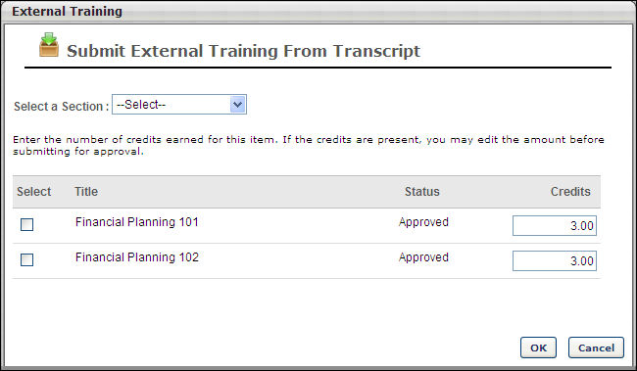
Submit External Training from Transcript
The Submit External Training From Transcript pop-up only displays external training that can be added to the selected section within the certification. This applies to both training that is already a part of the section to which the user is adding external training and to training that is outside the validity period. However, the external training items that are outside the validity period appear in gray and cannot be added to the certification.
- The Select a Section drop-down list includes all parent and child sections within the current period of the certification. Select the section to which you are adding the external training. This is required.
- The list of training items displays all of the external training that is submitted through the transcript. The Status is pulled from the transcript status and the Credits values are pulled from the number of credits that were entered when the external training was added. Click the Select option to the left of the appropriate training items to add them to the certification. If you have submitted the external training in the selected area previously, the training cannot be selected.
- In the Credits field to the right of the external training item, enter the number of credits that were earned for the item.
- Click OK to submit the training for approval. If multiple training items are selected, each item is submitted as a separate request to the certification owner, even though they are submitted at the same time.
An external training item can be submitted to multiple periods in different sections.

Historical Certifications - Print
Historical certifications may be printed from the Transcript Details Page for the certification if allowed by the administrator.
To print a historical certification from prior periods, go to Learning > View Your Transcript.
Select the View Training Details option for the certification. In the History section, click the Print Certificate link for the appropriate period.
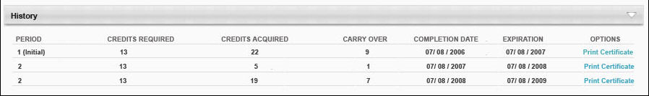
Note: Depending on whether an administrator has configured a custom certificate for the system, either default or custom certificate will be printed. For information about configuring a custom certificate: See Certification Administration.
Revoked Certifications
When a user's certification is revoked, the Certification Transcript page reflects the Revoked status in the Status column. The Manage link is still available in the Options column, which directs the user to the Certification Details page. However, only the following options are available on the Certification Details page:
- View the details of a learning object
- Print certificates associated with previously completed certification periods
- View the Progress Report
- Archive the certification
In addition, certifications in a Revoked status do not proceed to renewal periods if renewal periods are associated with the certification.
If the user would like to become re-certified, they must re-request the certification or it must be reassigned. Note: The user must be removed from the certification by the certification owner before they can re-request the certification. When re-requested, the Approval History section displays the approval history data of all previous instances of the certification in the user's transcript, regardless of the number of times the certification has been revoked. Progress from the previous certification carries over to the new instance of the certification request/assignment if the learning objects are still valid. Further, the History section does not display for new instances of a certification that was in a Revoked status.
Note: The option to print certificates is not available for certification periods that are in a Revoked status.

Training Details Page - Certification
From the Training Details Page for certifications, users can view and launch the training associated with the certification, view the certification history, and print any past certificates.
To view the Training Details Page for a certification, navigate to the Transcript and click the Certifications tab on the left navigation. Then, click the title of a certification. Note: This is not available if certifications are not enabled for the portal.
Permissions
PERMISSION NAME | PERMISSION DESCRIPTION | CATEGORY

Certification - Update Credit | Grants administrator ability to update the number of acquired credits on a user's certification progress report page. This also enables administrators or users to "certify" users by adjusting the number of credits received. This is an administrator permission. | Learning - Administration

Withdraw Users from Sessions | Allows administrators and managers to withdraw users from sessions on their behalf. This is done from the user's Transcript page. Note: There is a setting in the Session Defaults for an event that may prevent users from being able to withdraw from sessions. When this option is selected, users, managers, and administrators are prevented from withdrawing from sessions for themselves or on behalf of other users. This permission can be constrained by OU, User's OU, User's Self and Subordinates, User, User's Subordinates, and User's Direct reports. This is a manager or administrator permission. | Learning
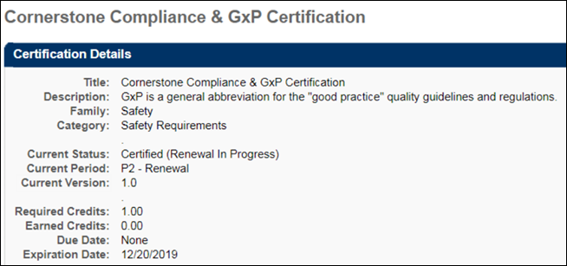
Certification Details
In the Details section, view the details of the certification. Note: For portals with multiple languages enabled, the Current Period field displays in the language of the user viewing the Training Details page. If the user's language is not available, the field displays in the default language of the certification. The name and localization of this field is managed on the Scheduling step when creating, editing, or copying a certification. The value in the Certification Period Title field on the Configure Training Period pop-up displays in the Current Period on the Training Details page.
In the Certification section, the training associated with the certification is displayed. You can select the appropriate View option to view All Training, Activated Training, or Not Activated Training. By default, All Training is selected. Note: For certifications that are configured not to override the availability settings defined in Course Catalog for a LO, the only LOs that are visible to the user are the LOs for which the user meets the availability criteria defined in Course Catalog for the LO. See Create Certification - General for additional information.
Parent and child sections can be expanded or collapsed by using the Expand and Collapse icons to the left of the section title. By default, the parent section is expanded and the child section is collapsed.
For each training item, the following information displays:
- Title - The section of the certification displays, as well as the number of required and acquired credits. Each time a learning object within then section achieves a status of Completed, the number of credits acquired accumulates for both the parent and child sections. If a learning object has zero credits, the number of acquired credits does not change.
  - The point at which credits accumulate in the parent section is dependent on the certification's configuration in Certification Administration. If the certification is configured to require users to complete the minimum number of credits for all child sections before the credits are counted toward the parent section, then credits only begin to accumulate in the parent section once the child sections have accumulated the minimum number of required credits.
  - Below the section, the title of the training item displays. Click the arrow to the left of the training title to view a description of the training item.
- Type - The training item type (e.g., online class, test, section, external training)
- Credits - The number of credits towards the certification that is granted for completing the training item. For portals with multiple languages enabled, the name of the Credits column appears in the language of the user viewing the Training Details page. If the user's language is not available, the column displays in the default language of the certification.Note: The name and localization of this column is managed on the General step when creating, editing, or copying a certification. The value in the Change tracking unit from credit to field displays as the column name on the Training Details page.
- Status - The current status of the training item. For users who are enrolled as certified, this is set to Not Activated.
If a user is in the Certified status for a certification, the system displays the due date and expiration date for the next certification period, if available.
You can manage the training items by selecting the appropriate option from the Options column. See Certification Item - Launch on page 38 for additional information. For administrators, if an observation checklist is added to a certification, you can validate the checklist by clicking the Validate Checklist link in the Options column. This opens the checklist and allows you to validate the items. If the checklist is part of a curriculum that is inside the certification, then click the Manage link in the Options column. This opens either the Curriculum Details page or the Curriculum Player, depending on how the administrator configured the curriculum.
Note: Administrators can also access the Validate Checklist link from the Training Details page of the checklist. Additionally, managers can validate a checklist if the checklist is configured by the administrator to allow managers to validate. Managers can access the checklist from either the Certification Details page or the Training Details page, but the link that appears is View Checklist instead of Validate Checklist.
To view the training details for an active training item, click the View Details icon in the Details column. This option is only available once the user is approved for the training item. Note: If the training was removed by an administrator, the user will receive a "Restricted Area" message, as removed training is inaccessible to end users.
To add external training to the certification, click the Add External Training link in the Details section. See External Training - Add to Certification from Details Page on page 40 for additional information.
To add an external training item to the certification that already exists on your transcript, click the Add External Training from Transcript link in the Details section. See External Training - Add to Certification from Transcript on page 42 for additional information.
Fields for Certifications in Certified Status
The following fields apply to certifications in a Certified status only. These fields do NOT apply to certifications in any other status, including the Certified (Renewal in Progress) status.
- The Current Period field displays the title of the certification period, along with the date the user completed the period requirements (dates will be shown in UTC time zone).
- The Next Period field displays the title of the next certification period, along with the date the next period will begin (dates will be shown in UTC time zone).
- The Next Version field displays the certification version number the user will receive during the next certification period.
- The Expiration Date field has been updated to Next Period Expiration Date, which indicates when the user's next certification period will expire (dates will be shown in UTC time zone).
- The Due Date field has been updated to Next Period Due Date, which displays the due date for the user's next certification period (dates will be shown in UTC time zone).
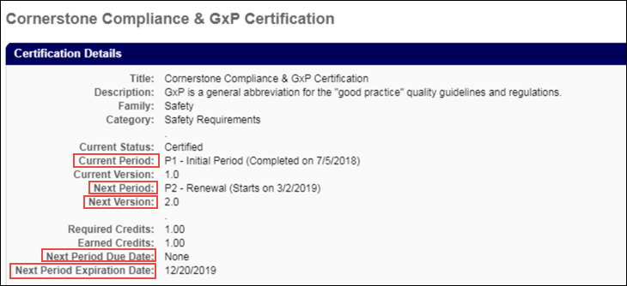
History
The History section displays all of the past certification periods for the certification, if applicable. For each period, the following information displays:
- Period - The certification period number.
- Credits Required - The number of credits required for the period.
- Credits Acquired - The number of credits that were earned for the period.
- Carry Over - If carry over is allowed, this displays the number of credits that were carried over to the next period.
- Completion Date - The date the period was completed. For ILT sessions, the session completion date is used, rather than the roster upload date.
- Expiration - The date the certification period was completed. For Past Periods, the Expiration column will display the previous Period Completion Date.
Print Certificate
To print a past certificate, in the History section, click the Print Certificate link next to the appropriate certification. This option is only available if enabled by the administrator. See Historical Certifications - Print on page 44 for additional information.
Certification Requirements
If the certification you are viewing is also within another certification, a Certifications Requirement section displays the requirements for that certification.
Approval History
The certification approval history is displayed in the Approval History section. This includes all approvals related to the certification. If a user is enrolled as certified, this is displayed in this section. If comments were included when the certification was approved or denied, an indication is made here, as well as stating the type of request for which comments were provided (i.e., Initial, Completion, Exception, or Renewal request).
Modification History
For certifications with external training added, a Modification History section is available at the bottom of the Certification Training Details page. This section tracks all updates that are made to the certification.
- If a training section or credits are updated, this is logged.
- If a field is updated, the specific field is logged, including the updated value.
- If multiple fields are updated, a line item is added for each change.
Approval or denial of external training towards the certification continues to be tracked in the Approval History section.
Revoke
To revoke a certification, click the Revoke button. When a user's certification is revoked, the Certification Transcript page reflects the Revoked status in the Status column. In addition, certifications in a Revoked status do not proceed to renewal periods if renewal periods are associated with the certification.
If the user would like to become re-certified, they must re-request the certification or it must be reassigned. Note: The user must be removed from the certification by the certification owner before they can re-request the certification. When re-requested, the Approval History section displays the approval history data of all previous instances of the certification in the user's transcript, regardless of the number of times the certification has been revoked. Progress from the previous certification carries over to the new instance of the certification request/assignment if the learning objects are still valid. Further, the History section does not display for new instances of a certification that was in a Revoked status.
Note: The option to print certificates is not available for certification periods that are in a Revoked status.
Place On Hold
From the Certification Details page, you can place a certification on hold by clicking the Place On Hold button. After clicking the Place On Hold button, a Certification On Hold pop-up window appears. In the pop-up, you can provide a comment explaining why the certification is being placed on hold in the Comments box. After entering a comment, click the Submit button to place the certification on hold. Note: Certifications in any transcript status can be placed on hold.
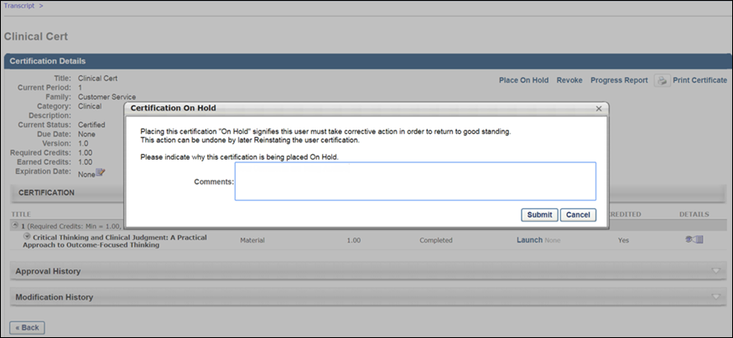
When the user views the certification on their transcript, the status for the displays with "(On Hold)" following the status the certification was in prior to being placed on hold. For example, if the certification was in a Certified status prior to being placed on hold, when the certification has been placed on hold, the status reads, "Certified (On Hold)."
The "(On Hold)" addendum appears in any system location where the certification status may display, including:
- Transcript
- Certification Details
- Action steps
- Cohort
- Manage Employee Learning
- Certification Management
- Certification Approval page
Reinstate Certification
To reinstate a certification that is on hold, click the Reinstate button on the Certification Details page. A Reinstate Certification pop-up window appears. Enter a comment explaining the reinstatement in the Comments field, and click the Submit button.
The certification returns to its previous transcript status on the user's transcript page, and the reinstatement appears in the Approval History section of the Certification Details page along with the name of the user who reinstated the certification, the time stamp of the reinstatement, and any comments provided during the reinstatement process.
Progress Report
To view the progress report for the certification, click the Progress Report link in the upper-right corner of the page. You can then select the period from the drop-down list and print the report by clicking the Print icon. From the Progress Report, administrators with the appropriate permission can update the user's number of acquired credits. Note: Acquired credits can still be updated when the transcript lockdown feature is enabled. See the Transcript Lockdown section below for additional information.
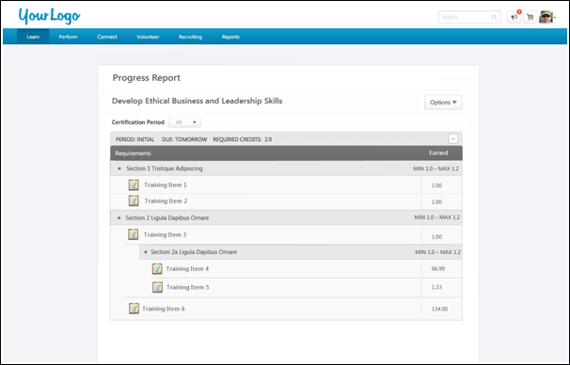
The following information displays for the report:
- Title - The certification title displays at the top of the report.
- Certification Period - This field displays the certification period. By default, the report shows the progress for the period the user is currently in.
- Options - The Options drop-down displays the option to print the report. Click the Print link to print the report.
- Period - This displays the certification period.
- Due - This displays when the certification is due.
  - Relative Due Date - For certifications with a relative due date defined, the Due field displays the time frame from the start date (i.e., "2 days from start date," or "1 year from start date").
  - Fixed Due Date - For certifications with a fixed due date defined, the Due field displays the actual date.
- Duration - This displays for renewal periods and shows the duration of the renewal period.
- Required Credits - This displays the number of credits required to be completed in order to complete the certification.
- Expand/Collapse - An Expand/Collapse option displays in the upper-right corner of the period. Click the icons to view or close the information in the period. By default, all certification periods are expanded.
- Requirements - This column displays the sections for the certification and lists the LOs defined for each section.
  - If the certification is configured to override the Course Catalog LO availability settings, then all LOs display for the user regardless of whether or not the user meets the availability criteria for the LOs.
  - If the certification is not configured to override the Course Catalog LO availability settings, then the only LOs that display are the LOs for which the user meets the availability criteria.
- LO Type - An icon displays to the left of each LO to indicate the LO type for the training item. Hover over the icon to view the name of the LO type.
- Earned - This column displays information about the credits earned for the certification. If the certification is configured not to override LO availability, then the number of credits is dependent upon the availability of the LOs in the certification.
  - Min/Max - This displays the minimum and maximum number of credits to be completed for a section.
  - Number of Credits - The number of credits defined for a LO displays in the Credits column for each LO.
Modify Period Expiration Date
Only certification owners have the ability to adjust the end date or expiration date for the current certification period. For certification owners, an Edit icon appears to the right of the Expiration Date field. Modifying the expiration date for the period affects the renewal periods in the following manner:
- Fixed Date
  - Only the current period is affected. All future periods retain their expiration date.
  - The updated expiration date must occur prior to the due date of the subsequent period.
- Relative Date and Relative Date with Rolling Renewal
  - If the expiration date for a period is changed, the expiration date and past due date for all future periods are updated based on the change. For example, if the expiration date is pushed back by three months, the expiration date and past due date for all subsequent periods is also pushed back by three months.
  - There is no maximum adjustment for the expiration date.
  - The Past Due date for the current period is not affected.
Transcript Lockdown
If the transcript lockdown functionality is enabled for the portal, then the data that is related to a learning object (LO) on the Certification Transcript Details page and the Progress Report is locked once the LO is completed. Once the LO is completed, the data on the Transcript Details page will not change for the LO. This applies even if the LO is moved to the Archived or Removed tabs of the transcript. This functionality applies to all LO types.
Note: The lockdown functionality does not include custom fields. Custom fields are not locked upon course completion.
Considerations
- If the Transcript Lockdown functionality is disabled and was not enabled at the time the user completed the LO, then the Transcript Details page and Progress Report display the LO information based on the current values in the Course Catalog.
- If the Transcript Lockdown functionality is enabled or was enabled at the time the user completed the LO, then the Transcript Details page and Progress Report always displays the LO information from the time the user completed the LO.
- If the Transcript Lockdown functionality was disabled at the time the user completed the LO and was enabled after the user completed the LO, then the Transcript Details page and Progress Report displays the LO information from the time the Transcript Lockdown functionality is enabled.

Transcript - Curriculum Subscriptions
When curriculum subscriptions are available, the transcript page is updated to reflect subscription options. Users can renew their curricula from their transcript.
The subscription options set in Curriculum Administration determine the expiration behavior and options available on the transcript:
- If subscription renewal is not available for a curriculum, when the curriculum expires, there is no renewal option. The curriculum remains Expired. Users must purchase a new instance of the curriculum in order to access the curriculum.
- If subscription renewal is available for a curriculum, but not automatic:
  - The expiration date displays after the title.
  - Once the curriculum expires, Renew Subscription is an option available in the Options column. Upon renewal, the expiration date is extended by a full subscription period, which is set in the LO Expiration Date. For example, if the LO expiration date is set to 120 days, when the LO is renewed, the expiration date is extended by 120 days.
  - When the user clicks the Renew Subscription link, the LO is added to the shopping cart for the user to purchase.
  - If you want to restart the curriculum and erase your progress, search for the LO using Global Search or Learning Search and purchase a new instance, provided that recurrence is available for the LO.
- If auto-renewal is set for a curriculum:
  - The expiration date is displayed after the title and "Auto-Renew" is displayed after the expiration date.
  - On the expiration date, the curriculum subscription is automatically renewed and the user is billed with the same payment method that was originally used.
  - Auto-renewal can be turned on or off from the Transcript Details Page, which is reached by clicking the curriculum title.
    - If auto-renew is turned off, "Auto-Renew" is no longer displayed after the expiration date and the Renew Subscription option appears in the Options column.
  - If you want to restart the curriculum and erase your progress, search for the LO using Global Search or Learning Search and purchase a new instance, provided that recurrence is available for the LO.

Transcript - Events and Sessions
When a user navigates to the Transcript page, events on the transcript display with the Select Session option until a session is selected. However, when a session is selected, the event is no longer visible on the Transcript page. The session is still visible on the transcript.
The event training details can be viewed by selecting the View Training Details option for the session and then clicking the event title.
- If a user has completed multiple sessions for the same event, administrators and users can view all past sessions of an event on the event's Training Details page.
- The event's Training Details page displays all previous sessions that are in a status of Completed in addition to any current sessions for the user. Click the session locator number to view the Training Details page for the corresponding session.
Only the training details for the latest session are available directly from the transcript. All previous sessions must be viewed by navigating to the event's Training Details page from the session's Training Details page.
Workflow
- A user requests or is assigned an event. The event appears on their transcript and the user can click the event title to open the event's Training Details page. The Select Session option is available.
- The user selects a session in the event. The event is replaced with the session information on the Transcript page. The user must click the event title inside the session's Training Details page to view the event's Training Details page.
- The user registers for an additional session in the same event. Both sessions that are requested appear on the user's transcript and both sessions are displayed on the event's Training Details page with the same event registration number (reg num).
- The user completes one of the sessions in the event. The completed session moves to the Completed training status. The session that is still in a Registered status is still in the Active training status and is associated with the next sequential event reg num. Each completed session is also listed in the Assignment History section.
  - The event reg num is dependent on the point in time that a session is moved to a status of Completed. This is independent of the session date and time. Thus, session dates and times may not be displayed in chronological order if they were not moved to a status of Completed in chronological order.
- The user withdraws from a session. That session is listed on the event's Training Details page associated with the latest event reg num available. If another session is completed, this session moves with any others to the next sequential event reg num. Users can update the status of this session at any time by re-requesting the same session.
- The user is denied from a session. That session is listed on the event's Training Details page associated with the latest event reg num available. If another session is completed, this session moves with any others to the next sequential event reg num.
- If the user is waitlisted for a session, the session is listed on the event's Training Details page associated with the latest event reg num available. If another session is completed, this session moves with any others to the next sequential event reg num.
- The user requests a session from within an event and completes it. The session is moved to the Completed training category and the event is no longer visible on the transcript. To view the event on the transcript, users must request it again or be assigned it again.
- The user requests or is directly assigned a session. The session appears on their transcript and is moved to the Completed training category upon completion. No instance of the associated event is present in the Active training category. If additional sessions associated with the event to which the session belonged are assigned or requested, they are assigned the next sequential event reg num.
  - If the session was directly registered and the event or another session associated with the same event was already on the user's transcript, this session is assigned the same event reg num as any other registered sessions or the next sequential event reg num if all other sessions associated with the same event are in the Completed training category.
Events within Curricula
If an event is included in a curriculum, the first completed session will be mapped to the event completion in the curriculum. If a user registers for multiple sessions, the first completed session will satisfy the event completion requirements within the curriculum.
The other session(s) will then be mapped to the next sequential reg num for the event, and will display as standalone on the user’s transcript.
Example:
Curriculum A contains
  - Online Course 1
  - Event X
  - Material Y
A user is assigned Curriculum A and completes Online Course 1. He then registers for Session 1 and Session 2 under Event X. Both sessions are mapped to Event X reg num 1. The user then attends Sessions 1 and completes it, which completes Event X reg num 1 within the curriculum.
Session 2 will then display as standalone under Event X reg num 2. After the user completes Material Y, Curriculum A will be completed.
Recurrence Example:
If the event recurs or is assigned with the Assign New Occurrence option enabled, the progress will be reset within the curriculum.
Curriculum A contains
  - Online Course 1
  - Event X
  - Material Y
A user is assigned Curriculum A and completes a session from Event X. If a learning assignment is processed to assign a new occurrence of Event X, the user will receive another registration of Event X and progress within the curriculum will be reset. This also applies if a manager directly assigns a new registration of Event X.

Session - Register
When a user navigates to the Transcript page, event training items appear with the Select Session option until a session is selected. However, when a session is selected, the event is no longer visible on the Transcript page. The session is still visible in the Active training category.
To register for a session, go to Learning > View Your Transcript. Select the Select Session option for the session. Note: You are not listed in the roster for a session until you register for the session. The Select Session option does not display if the event is configured by the administrator to restrict users from selecting sessions. You can still view the details of the event by clicking the event title but cannot select a session.
- System automatically processes the registration and the Withdraw becomes available for the session.
- The session status remains Registered until you attend the session, at which point it will chang to Completed.
- After the registration start date, an administrator can still request a session for a user. For non-administrator users, however, registration will be closed.

Session - Withdraw
Users can withdraw from a session they are registered for via the Transcript page.
Permissions
PERMISSION NAME | PERMISSION DESCRIPTION | CATEGORY

Withdraw Users from Sessions | Allows administrators and managers to withdraw users from sessions on their behalf. This is done from the user's Transcript page. Note: There is a setting in the Session Defaults for an event that may prevent users from being able to withdraw from sessions. When this option is selected, users, managers, and administrators are prevented from withdrawing from sessions for themselves or on behalf of other users. This permission can be constrained by OU, User's OU, User's Self and Subordinates, User, User's Subordinates, and User's Direct reports. This is a manager or administrator permission. | Learning
To withdraw from a session, go to Learning > View Your Transcript. Select the Withdraw option for the session.
- Select reason from drop-down list.
- Enter comments.
- Click Submit. If any Withdraw penalties exist, they are charged to the user. See Session Withdrawal Penalties on page 60 for additional information.
- Status changes to Withdrawn and the Select Session option is available.
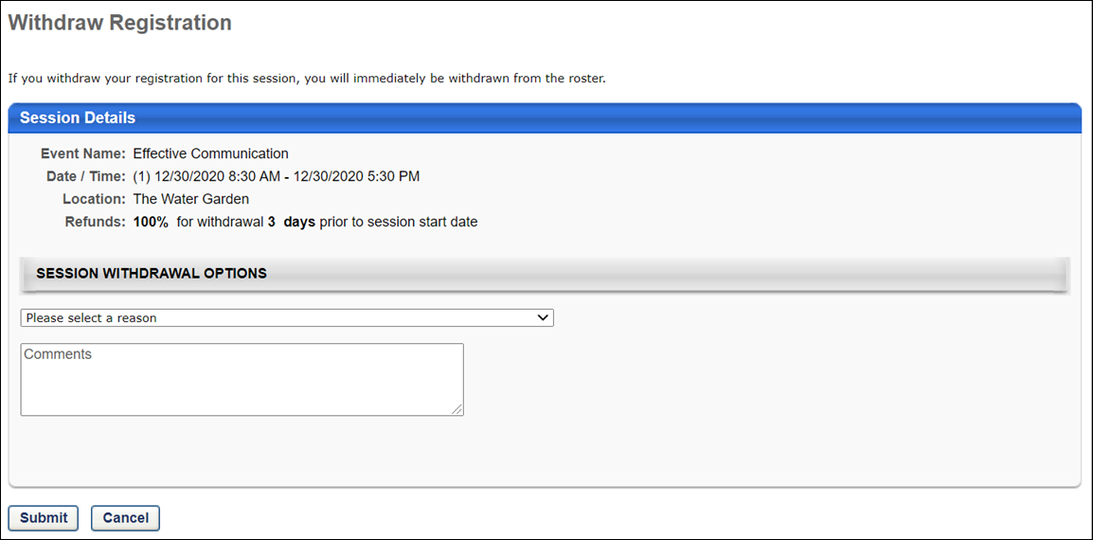

Session Withdrawal Penalties
Withdrawal penalties are charged in the following situations:
Situation | Penalty is Charged?
User withdraws from a session (not inventory-assigned). There must be a transaction record at the time of the withdrawal. Note: If the session was never registered (user only requests session or is waitlisted), the withdrawal penalty is not charged. | Yes
User withdraws from a session that is part of an event within a curriculum, and a withdrawal penalty is configured for the session. | Yes
A session is removed from user's transcript by an administrator. | No
User's status becomes inactive in the system. | No
A session with Pending Requisite status is withdrawn when the session starts. | Yes
A session is substituted by the administrator. | No
Administrator removes user from the roster. | Administrator can decide whether to charge the withdrawal penalty.
An inventory-assigned session is withdrawn by user. | No

External Training - Add Overview
External training allows users to capture training taken outside the system, such as conferences, external online courses, books, etc. on their learning transcript.
External Training - Add from Transcript
Users with the related permission can add external training to their learning transcript.
To add external training to your transcript, go to Learning > View Your Transcript. Then, select the Add External Training option from the Options drop-down menu.
Permissions
PERMISSION NAME | PERMISSION DESCRIPTION | CATEGORY

External Training - Add | Grants a user the ability to add or edit their own external training. When viewing another user's transcript, the user must also have permission to edit transcript items in order to add or edit the user's external training. This permission cannot be constrained. This is an end user permission. | Learning
Clicking the Add External Training link opens the Add External Training page.
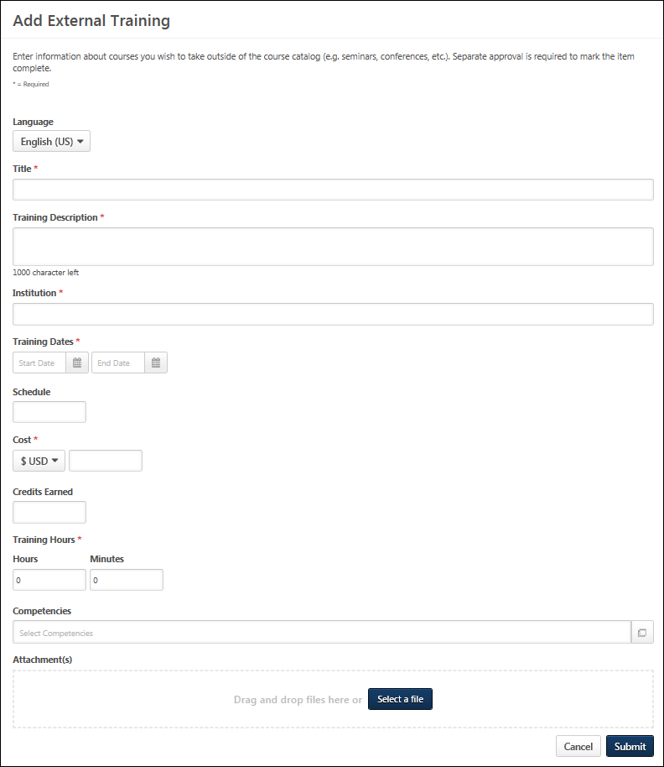
The instructions and field names that appear on this page are configurable by the system administrator in Configure External Training Preferences. Also, the system administrator can configure which fields and options are available and required in Configure External Training Preferences. See Configure External Training by Division for additional information.
Populate the following fields for the external training.
- Language - Select language if applicable.
- Title - Enter the external training title.
- Training Description - Enter the training description.
- Provider/Institution - Enter the provider or institution providing the external training.
- Training Dates - Use the Calendar icon to select a training start date (From) and end date (To).
- Schedule - Enter a schedule.
- Cost - Enter a training cost.
- Credits - Enter the credits earned.
- Training Hours - Enter the number of training hours.
- Course Syllabus - Enter the course syllabus, if applicable.
- Attachments - Click the Attachments link to add attachments to the external training. Each attachment can be up to 1 MB in size, and a maximum of 15 attachments can be added to an external training. They are limited to ppt, pptx, doc, docx, pdf, jpg, jpeg, jpe, png, txt, gif, xls, xlsx, and rtf file types. After selecting the appropriate attachments, click the SAVE button to save the attachments to the review.
Click Submit to submit the form after all the required fields have been populated.
Troubleshooting
Upon clicking Submit, you may receive an error message next to a field, indicating that the value you entered in the field is not valid. This error occurs if an administrator has configured the field to only accept certain values. If the value you entered does not meet the criteria configured by the administrator, an error message displays. The value must re-entered and calculated as valid before the external training can be submitted successfully. Note: For portals with multiple languages enabled, the custom validation message appears in the user's display language, if available. If the user's language is not available, the error message appears in its default language.
Only one error message displays at a time. This means that if there are multiple invalid values, the error message displays for the first invalid value until the value in that field is valid. Once the value is valid and the Submit or Calculate button clicked, the error message for the next invalid field displays.
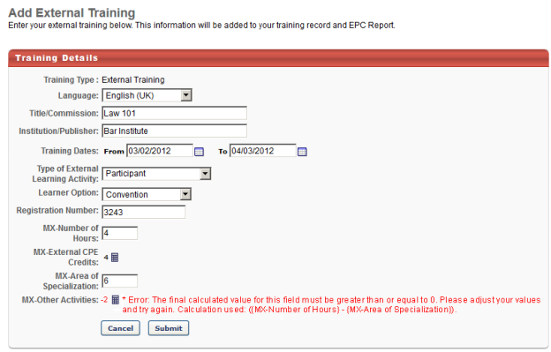
NOTE: When loading a large set of External Training transcript records with Edge, there is a limit of two million records per portal.
SF-182 Form - Overview
When requesting external training, users can use the SF-182 request form if the functionality is available in the portal.
To request SF-182 external training, select the Add SF-182 External Training option from the Options drop-down menu on the Transcript page.
When SF-182 functionality is available in the portal, the Add External Training option on the Transcript page is changed to Add Regular External Training. Also, an SF-182 filter option is available in the Training Type drop-down at the top of the transcript. When this is selected and the Search icon is clicked, only external training that was requested using the SF-182 request form displays. The results also display in-progress SF-182 requests.
Note: The Add SF-182 External Training and Add Regular External Training options must be configured in SF-182 Preferences in order for the links to display on the Transcript page.
Permissions
PERMISSION NAME | PERMISSION DESCRIPTION | CATEGORY

Edit Transcript Items | Grants ability to modify training due dates, statuses, and scores on other user's transcripts (training records) when viewing training details for particular learning objects on the transcript. User must also have permission to add external training in order to add or edit another user's external training. This permission can be constrained by OU, User's OU, User Self and Subordinates, User, and User's Self.  Note: Users with this permission also will also see the Add SF-128 link on the transcript. | Learning - Administration

SF-182 Administration | Grants ability to view SF-182 requests for populations of users (based on constraints), approve SF-182 forms at any step of the process, and view the link for managing SF-182 specific vendors for their organization. (Governmental clients). This is an administrator permission. | Limited Use/Obsolete

SF-182 Requests - Manage | Grants ability to view SF-182 requests for a population of users based on constraints.  If this permission is added to the dynamic Manager security role, the permission will automatically be constrained to self and subordinates. If the SF-182 approver is a manager and should not be constrained to just self and subordinates, please create a separate security role and add the SF-182 Requests Manage permission to that role with any needed constraints. | Limited Use/Obsolete

User View “Add SF-182” link on Transcript | Grants ability to view the "Add SF-182 External Training" link to complete the form for requesting an external course (Governmental clients). This is an end user permission.  Note: If a user does not have this permission but has the Edit Transcript Items permission, the Add SF-182 External Training link will also appear. | Limited Use/Obsolete
Note: The Add SF-182 External option will appear if the user has any one or more of the above security permissions.
When using the SF-182 form to request external training, there are four steps to completing the form:
- Training
- Costs and Billing
- Personal Details
- Confirm
Form Instructions
To view instructions for completing the form, click the Download Instructions link in the upper-right corner of any step. Note: The Download Instructions link only appears if instructions are created by the administrator. If the link does not appear, then an instructions document is not available.
Required, Read-only, and Pre-configured Fields
Some fields may be required or read-only, depending on how the administrator has configured the form. In addition, some fields may already contain a default value that is configured by the administrator. Pre-configured fields may be editable or read-only, depending on how the administrator has configured the form. Note: An SF-182 request cannot be edited if the vendor is set to inactive.
In-Progress Forms
Forms that are in progress can be saved and completed at a later time. Only the Course Title field is required in order to save the form. Click Save at the bottom of any step to save the form. The form appears on your transcript under the course title with a status of Not Submitted.
To return to an in-progress form, select the Edit option on the Transcript page. This opens the form and allows you to continue completing it. Note: An SF-182 request cannot be edited if the vendor is set to inactive. To delete an in-progress form, select the Withdraw option on the Transcript page. This opens the Withdraw pop-up. Click Submit to delete the form from your transcript.
Status Workflow
When the user submits the form, the external training is added to their transcript. The following is the workflow of the status process once a form is submitted:
User Action | SF-182 Form Request Status | External Training Transcript Status | External Training Options Available On Transcript
Saves SF-182 | Not Submitted | Not Submitted | Edit, Remove
Submits SF-182 and SF-182 approvals are required | Pending Approval Step "<current approval step no.>" (e.g., Pending Approval Step 3) | Pending SF-182 Form Approval | None
Edits SF-182 that is currently pending approval | Pending Approval Step "<current approval step no.>" (e.g., Pending Approval Step 3) | Not Started | Edit
LO approval is also required for user | Approved | Pending Approval
LO approval denied | Approved | Denied | None
SF-182 approval denied | Denied | SF-182 Form Denied | None
Exempted | Same status that the form had at the time of exemption | Exempt | None
Gained all approvals for SF-182 and Register upon Approval is unchecked | Approved | Approved | Withdraw
Gained all approvals for SF-182 and Register upon Approval is checked for portal | Approved | Registered | Withdraw
User withdraws from training | Same status as the form was at the time of withdrawal | Withdrawn | None
Training end date has passed | Approved | Registered | Mark Complete
User marks complete; External Training and Completion Approvals are required for user | Approved | Pending Completion Approval | None
Completion approval is granted or external training is completed | Completed | Completed | None
Note: The Register Upon Approval option is configured in Default Approval Requirements (by Division) preferences.
SF-182 Form - Overview
When requesting external training, users can use the SF-182 request form if the functionality is available in the portal.
To request SF-182 external training, select the Add SF-182 External Training option from the Options drop-down menu on the Transcript page.
When SF-182 functionality is available in the portal, the Add External Training option on the Transcript page is changed to Add Regular External Training. Also, an SF-182 filter option is available in the Training Type drop-down at the top of the transcript. When this is selected and the Search icon is clicked, only external training that was requested using the SF-182 request form displays. The results also display in-progress SF-182 requests.
Note: The Add SF-182 External Training and Add Regular External Training options must be configured in SF-182 Preferences in order for the links to display on the Transcript page.
Permissions
PERMISSION NAME | PERMISSION DESCRIPTION | CATEGORY

Edit Transcript Items | Grants ability to modify training due dates, statuses, and scores on other user's transcripts (training records) when viewing training details for particular learning objects on the transcript. User must also have permission to add external training in order to add or edit another user's external training. This permission can be constrained by OU, User's OU, User Self and Subordinates, User, and User's Self.  Note: Users with this permission also will also see the Add SF-128 link on the transcript. | Learning - Administration

SF-182 Administration | Grants ability to view SF-182 requests for populations of users (based on constraints), approve SF-182 forms at any step of the process, and view the link for managing SF-182 specific vendors for their organization. (Governmental clients). This is an administrator permission. | Limited Use/Obsolete

SF-182 Requests - Manage | Grants ability to view SF-182 requests for a population of users based on constraints.  If this permission is added to the dynamic Manager security role, the permission will automatically be constrained to self and subordinates. If the SF-182 approver is a manager and should not be constrained to just self and subordinates, please create a separate security role and add the SF-182 Requests Manage permission to that role with any needed constraints. | Limited Use/Obsolete

User View “Add SF-182” link on Transcript | Grants ability to view the "Add SF-182 External Training" link to complete the form for requesting an external course (Governmental clients). This is an end user permission.  Note: If a user does not have this permission but has the Edit Transcript Items permission, the Add SF-182 External Training link will also appear. | Limited Use/Obsolete
Note: The Add SF-182 External option will appear if the user has any one or more of the above security permissions.
When using the SF-182 form to request external training, there are four steps to completing the form:
- Training
- Costs and Billing
- Personal Details
- Confirm
Form Instructions
To view instructions for completing the form, click the Download Instructions link in the upper-right corner of any step. Note: The Download Instructions link only appears if instructions are created by the administrator. If the link does not appear, then an instructions document is not available.
Required, Read-only, and Pre-configured Fields
Some fields may be required or read-only, depending on how the administrator has configured the form. In addition, some fields may already contain a default value that is configured by the administrator. Pre-configured fields may be editable or read-only, depending on how the administrator has configured the form. Note: An SF-182 request cannot be edited if the vendor is set to inactive.
In-Progress Forms
Forms that are in progress can be saved and completed at a later time. Only the Course Title field is required in order to save the form. Click Save at the bottom of any step to save the form. The form appears on your transcript under the course title with a status of Not Submitted.
To return to an in-progress form, select the Edit option on the Transcript page. This opens the form and allows you to continue completing it. Note: An SF-182 request cannot be edited if the vendor is set to inactive. To delete an in-progress form, select the Withdraw option on the Transcript page. This opens the Withdraw pop-up. Click Submit to delete the form from your transcript.
Status Workflow
When the user submits the form, the external training is added to their transcript. The following is the workflow of the status process once a form is submitted:
User Action | SF-182 Form Request Status | External Training Transcript Status | External Training Options Available On Transcript
Saves SF-182 | Not Submitted | Not Submitted | Edit, Remove
Submits SF-182 and SF-182 approvals are required | Pending Approval Step "<current approval step no.>" (e.g., Pending Approval Step 3) | Pending SF-182 Form Approval | None
Edits SF-182 that is currently pending approval | Pending Approval Step "<current approval step no.>" (e.g., Pending Approval Step 3) | Not Started | Edit
LO approval is also required for user | Approved | Pending Approval
LO approval denied | Approved | Denied | None
SF-182 approval denied | Denied | SF-182 Form Denied | None
Exempted | Same status that the form had at the time of exemption | Exempt | None
Gained all approvals for SF-182 and Register upon Approval is unchecked | Approved | Approved | Withdraw
Gained all approvals for SF-182 and Register upon Approval is checked for portal | Approved | Registered | Withdraw
User withdraws from training | Same status as the form was at the time of withdrawal | Withdrawn | None
Training end date has passed | Approved | Registered | Mark Complete
User marks complete; External Training and Completion Approvals are required for user | Approved | Pending Completion Approval | None
Completion approval is granted or external training is completed | Completed | Completed | None
Note: The Register Upon Approval option is configured in Default Approval Requirements (by Division) preferences.
SF-182 Form - Copy
Users can be granted the ability to copy SF-182 forms from their transcript.
- To access your transcript, go to Learning > View Your Transcript.
- To access a user's Transcript page, go to HOME > UNIVERSAL PROFILE. Click the name of an employee and then navigate to the user's Transcript tab.
Permissions
PERMISSION NAME | PERMISSION DESCRIPTION | CATEGORY

Bio About - View | Enables user to view the Bio page for users within their permission constraints. This permission must be enabled to view the Transcript page within Universal Profile. If a user does not have this permission and they click a person's name or user photo within the Universal Profile, then the Bio page will not open.  On the Learner Home page, this permission also allows end users to view the Completions & Hours field, the training sidebar, and the Continue Learning carousel.  This permission can be constrained by Employee Relationship, OU, User's OU, User's Direct Reports, User Self and Subordinates, and User. Note: For security purposes, this permission is constrained to User Self and Subordinates by default. However, the permission constraints can be modified to allow users to view the Bio About page for other users. | Universal Profile

Copy SF-182 Training from Transcript | This permission allows users to copy an SF-182 form from their transcript. Users with this permission will see a Copy SF-182 option in the Options drop-down menu for SF-182 forms on their transcript.  This permission can be constrained by Restrict to User Self and Subordinates, User Self, or User's Direct Subordinates.  If you wish to leverage this permission, please reach out to Global Customer Support and ask for the Copy SF-182 Training From Transcript feature to be enabled). | Learning

SF-182 Administration | Grants ability to view SF-182 requests for populations of users (based on constraints), approve SF-182 forms at any step of the process, and view the link for managing SF-182 specific vendors for their organization. (Governmental clients). This is an administrator permission. | Limited Use/Obsolete

View Transcript Item | Grants ability to view details of learning objects that appear on the transcript (training record), by clicking on the name of the learning object. Users must also have the Bio About - View permission in order to access the transcript within Universal Profile. This permission can be constrained by OU, User's OU, User Self and Subordinates, User, or User's Self. This is an end user permission. | Learning - Administration
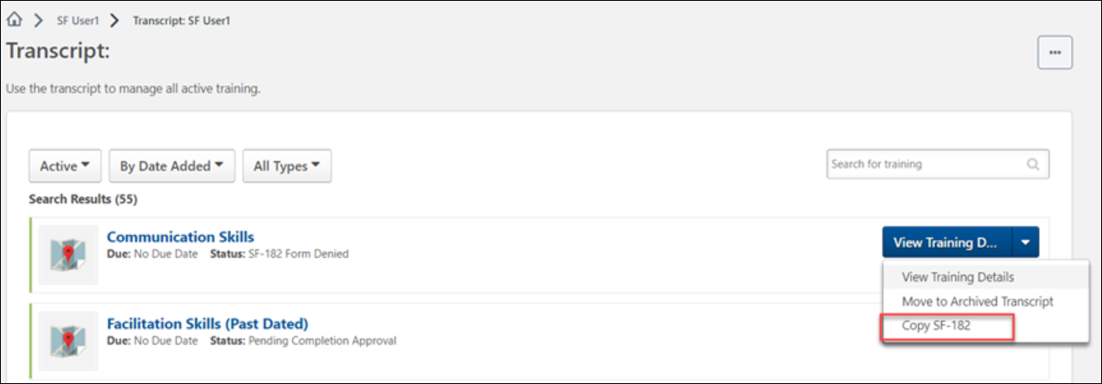
Copy SF-182 Form from Transcript
To copy an SF-182 form, locate the SF-182 form on the transcript and click the Options drop-down to the right of the form. Then, click the Copy SF-182 Form link in the drop-down menu.
- Note: Draft forms cannot be copied.
- Note: When a user copies an SF-182 form from their transcript, they will be the only user included in the copy, even if the original form included multiple users.
Create SF-182 Request - Step 1 - Training
The Training step is the first step of the SF-182 request process, and it includes the following sections:
- Training Information
- Training and Vendor Location
- Advanced
Some fields may be pre-populated if enabled by the administrator in Configure External Training preferences. The following table shows which fields on the Training step may be pre-populated if their corresponding external training field is enabled by the administrator:
External Training Field | SF-182 Field
Language | N/A in SF-182. Use end user's language
Title | Course Title
Training Description | Training Objective
Training Provider | Name of Vendor
Training Dates | Start and End Date
Schedule | N/A
Cost | Total direct costs + Total indirect costs
Credits earned | Training Credit
Training Hours | Training Duty Hours + Training Non-duty hours
Grade | N/A
Comments | N/A
Training Information
- Course Title - Enter the course title, up to 400 characters.
- Course Number Code - Enter the course number code, up to 250 characters.
- Training Start Date - Enter the start date or click the Calendar icon to select a date from the calendar feature.
- Training End Date - Enter the end date or click the Calendar icon to select a date from the calendar feature.
- Training Duty Hours - Enter the number of duty hours.
- Training Non-Duty Hours - Enter the number of non-duty hours.
- Training Objective - Enter the objective or purpose of taking the training, up to 1000 characters.
Training and Vendor Location
- Name of Training Vendor - Click the Select icon to open the Choose a Vendor pop-up. Select a vendor by clicking the plus sign in the Add column next to the vendor name. This closes the Choose a Vendor pop-up and enters the vendor name in the field.
- Vendor Contact Information - Enter the vendor's street address, city, state, zip, phone number, and email address.
- Training Location Address - Check this option to indicate that the training is located at the same address as the vendor. This populates the address fields with the information in the Vendor Contact area. If the address is not the same, enter the street address, city, state, and zip.
Advanced
- Training Purpose Type Code
- Training Type Code
- Training Sub Type Code
- Training Delivery Type Code
- Training Designation Type Code
- Training Credit Type Code
- Training Credit
- Training Source Type Code
- Training Accreditation Indicator
- Continued Service Agreement Required - This indicates whether you are required to complete the Continued Service Agreement form, and this is configured by the administrator.
  - If this option is set to Yes, you are required to download and complete the Continued Service Agreement form, and then attach the completed form to the request. Enter the form's expiration date in the Continued Service Agreement Expiration Date field. Note: The completed Continued Service Agreement form appears in the printable view of the request.
    - If the Continued Service Agreement Required toggle is set to Yes and an attachment has not been included, the SF-182 printable form will display a value of Yes but the transcript view will display a value of No to indicate no form was attached.
    - If the Continued Service Agreement Required toggle is set to Yes and an attachment has been included, the SF-182 printable form will display a value of Yes AND the transcript view will display a value of Yes.
  - If this option is set to No, you are not required to complete the form or enter an expiration date.
    - If the Continued Service Agreement Required toggle is set to No then it will display No on both the SF-182 printable form and the transcript view.
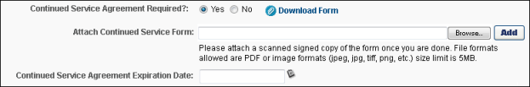
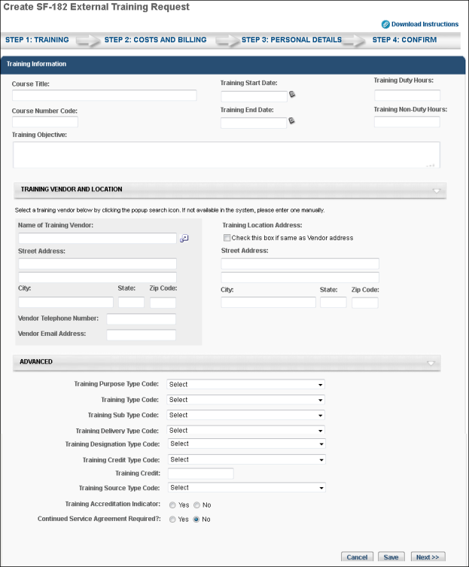
- Click Cancel to cancel the form.
- Click Save to save the form without submitting it. Note: The Course Title field must be completed before you can save the form.
- Click Next to go to Step 2. See Create SF-182 Request - Step 2 - Costs and Billing on page 80 for additional information.
Create SF-182 Request - Step 2 - Costs and Billing
The Costs and Billing step is the second step of the SF-182 request process, and allows the user to enter cost information about the training. This step includes the following sections:
- Direct Cost and Appropriation/Fund Chargeable
- Indirect Cost and Appropriation/Fund Chargeable
- Other
Direct Cost and Appropriation/Fund Chargeable
To enter costs for tuition, fees, books, or materials:
- Enter the tuition/fees and books/material costs in the Amount column. The total appears in the Total field at the bottom of the column.
- Enter the fund information in the Appropriation Fund column. The system automatically calculates the total and populates it in the Total field at the bottom of the column.
Indirect Cost and Appropriation/Fund Chargeable
To enter related travel and per diem costs:
- Enter the travel and per diem cost in the Amount column. The total appears in the Total field at the bottom of the column.
- Enter the travel and per diem fund information in the Appropriation Fund column. The system automatically calculates the total and populates it in the Total field at the bottom of the column.
Other
Enter other relevant cost information, including:
- Total Training Non-Government Contribution Cost
- Document/Purchasing Order/Registration Number
- 8-Digit Station Symbol
- Billing Instructions - Enter billing instructions.
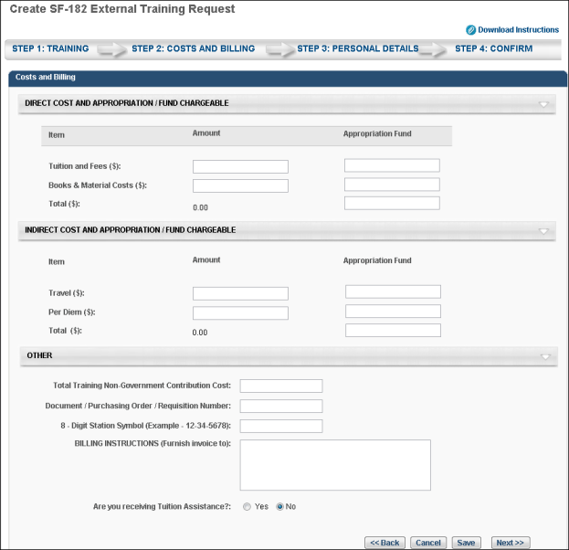
- Click Back to return to Step 1.
- Click Cancel to cancel the form.
- Click Save to save the form without submitting it. Note: The Course Title field must be completed before you can save the form.
- Click Next to go to Step 3. See Create SF-182 Request - Step 3 - Personal Details on page 82 for additional information.
Create SF-182 Request - Step 3 - Personal Details
The Personal Details step is the third step in the SF-182 request process, and it includes the following sections:
- Personal Information
- Advanced
Personal Information
In this section, enter your name and personal contact information, as well as work contact information.
Advanced
- Position Level - Select your position level from the drop-down menu.
- Position Title - Enter your job title.
- Special Accommodation - Use this option to indicate if special accommodations are needed. If Yes is selected, describe the accommodations in the text field.
Navigation
- Click Back to go to Step 2.
- Click Cancel to cancel the form.
- Click Save to save the form without submitting it. Note: The Course Title field must be completed before you can save the form.
- Click Next to go to Step 4. See Create SF-182 Request - Step 4 - Confirm on page 83 for additional information.
Create SF-182 Request - Step 4 - Confirm
The Confirm step is the fourth and final step of the SF-182 request process, and allows the user to review the request for accuracy and submit the request.
Review the information entered on each step and click Submit. This triggers the SF-182 Form Submitted email, if enabled. Once submitted, the SF-182 request is added to your transcript. If the form requires approval, the status of the form is Pending Approval <Current Approval Step>. Note: The approval step is dependent upon the current step in the approval process.
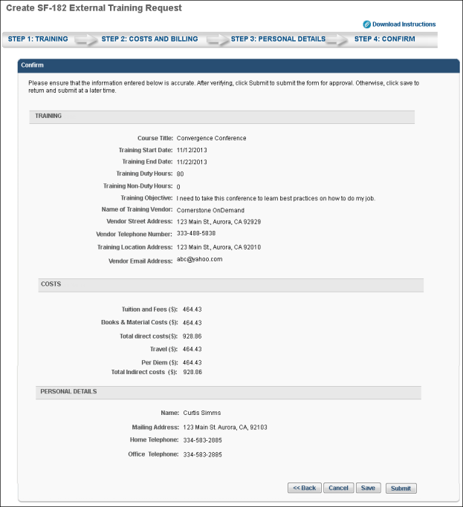
- Click Back to go to Step 3.
- Click Cancel to cancel the form.
- Click Save to save the form without submitting it. Note: The Course Title field must be completed before you can save the form.
SF-182 Forms - Add Completion Evidence
With this enhancement, users and approvers can add completion documentation to SF-182 requests to provide evidence of the completion. Users and approvers can view previously attached or attach new completion documents from the training details of the SF-182 Request form on the user's transcript. Note: Completion documents cannot be added to SF-182 requests that are in a Denied, Draft, or Completed status.
- Both users and approvers can view and add completion documents to a SF-182 request by navigating to the Training Details page for the SF-182 request form on a user's transcript and selecting the Completion Documents icon.
To add the documentation to a request via the Completion Documents page:
- Click the Choose Files button and select the relevant document(s) from your computer.
- Click the Add button. The document will be uploaded to the SF-182 request.
- Click the Submit button to save your changes and finish attaching the completion documents to the SF-182 request. Once a request has moved to a Completed status, no completion documents can be added to or removed from the request.
Note: Completion documents can also be added to SF-182 requests in bulk by administrators. See SF-182 Request Management - Bulk Approve Requests.
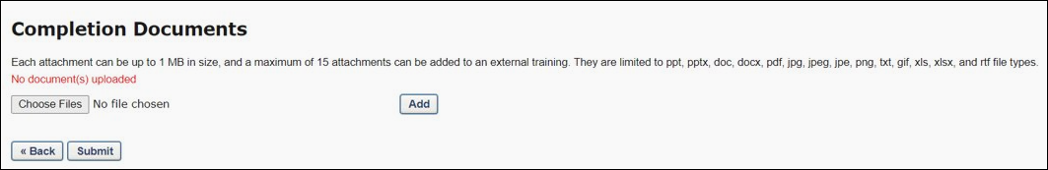
Considerations
- If a user and an approver both attempt to upload the same document to the same SF-182 request, a message appears stating that a duplicate file has been recognized, and the file cannot be added a second time.

External Training Request - Mark Complete
To mark an external training item complete, go to Learning > View Your Transcript.
Once the external training is approved and the external training date has passed, a Mark Complete option is available for the external training. Select the Mark Complete option for the external training.
If the Grade and Submitted Paperwork options are enabled by the administrator, you are prompted to provide responses for these fields on a separate page after the external training is marked complete.
- Grade - If applicable, Enter the grade that was earned for this external training, up to 100 characters.
- Submitted Paperwork - Select whether or not paperwork has been submitted for the external training.
If external training required completion approval by your approver, status will be Pending Completion Approval until your manager or approver approves completion. Upon approval, the training status will be Completed.
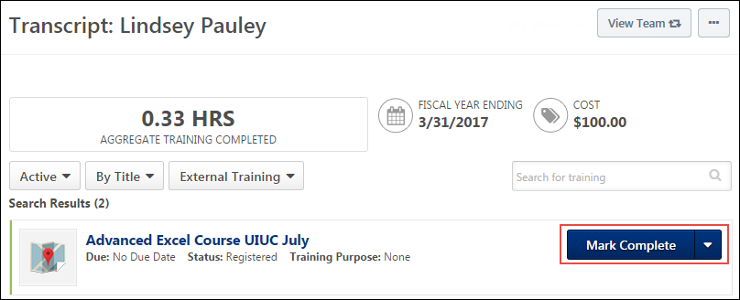

Library - Manage
The Library training type will be deprecated with the November 2022 release!
A library is a collection of online courses. A user can manage a library assigned to them via their transcript.
To manage a training library, go to Learning > View Your Transcript. Then, select the Manage option for the library to review the library training details.
Permissions
PERMISSION NAME | PERMISSION DESCRIPTION | CATEGORY

View Transcript Item | Grants ability to view details of learning objects that appear on the transcript (training record), by clicking on the name of the learning object. Users must also have the Bio About - View permission in order to access the transcript within Universal Profile. This permission can be constrained by OU, User's OU, User Self and Subordinates, User, or User's Self. This is an end user permission. | Learning - Administration
To search for a specific item in the library, enter key words in the Search field, and click the Search button.
- View the Search results and locate the appropriate training within the library.
- Click the Expand icon to see the course description.
The following options may be available in the Options column:
- Activate - Click to activate a specific training course in the library. Note: If a training item within a library is already activated outside the library, the Activate link does not work. If you experience the Activate link not working within a library, search for the training item on your transcript and access it directly.
- Register - Click to register for the course in the library.
- Launch - Click to launch the course within the library.
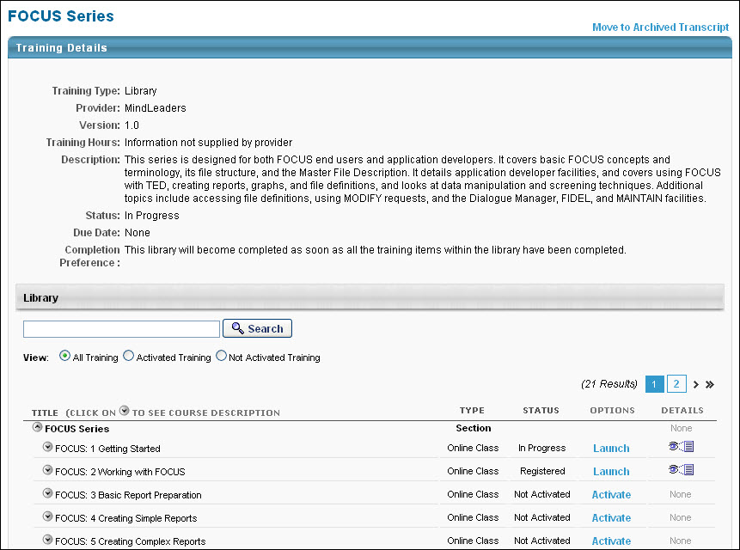

Network Player Transcript Options
If the Network Player is enabled and if an online course has been downloaded to a local network, users have the option to launch the course locally or online from their transcript.
Permissions
PERMISSION NAME | PERMISSION DESCRIPTION | CATEGORY

Local Network Player - Launch Courses Offline Through the Network Player | Enables users to see the Launch Locally link on their transcript for courses that have been downloaded and can be launched through the local network. This permission cannot be constrained. This permission is recommended for end users of the LMS. | Learning

Local Network Player - File Download Link - View | Grants access to the Download Network Player link in Course Catalog and on the Transcript. Users must also have permission to access the Course Catalog. This permission cannot be constrained. This permission is recommended for local trainers who deliver course content remotely. This is an end user and local trainer permission. If the user no longer needs to view the download link after installation, this permission can be removed for those users. | Learning
Download Network Player
The Download Network Player option appears in the Options drop-down menu for users who have permission to download the local network course player.
Launch Locally and Launch Online
The Launch Locally and Launch Online options appear for an online course if the following is true:
- The user has permission to launch courses offline via the Network Player.
- The course is a SCORM 1.2 or SCORM 2004 course that was tagged as available for download when it was published.
- At least one course network path was set for the user's organizational unit (OU).
- The Launch Locally option is only available if the course is already downloaded to at least one network path that was set for the user's OU.
Users can click the Launch Online option to launch the course online or the Launch Locally option to launch the course from the local network. When the Launch Locally option is clicked, the system verifies that the course exists on a local network using the network paths set by the administrator in Set Network Player Download Paths preferences.
- If the course does not exist on a local network, an error message is displayed, indicating that the course can only be launched online.
- If the course does exist on a local network, the system then checks to see if the local network player is installed on the user's computer.
  - If the local network player is installed, then the course is launched in the player from the local network.
  - If the local network player is not installed, then the user is not able to launch the course. The user can save the course file to their computer, which can be launched after the local network player is installed, provided that the user is still authenticated within the system.
After the course is launched locally and the user closes or completes the course, the network player submits the appropriate user progress information back to the system.
If the online version of the course is out of sync with the downloaded version of the course, then a warning icon is displayed to the left of the Launch Locally option. Users can hover the mouse over the icon to view the warning message, which alerts the user that they should launch the online version of the course. The Warning icon appears if new course files are uploaded or if the course is modified in Course Publisher or Course Builder.
Launch
If the course is not available offline or if the user does not have permission to launch courses offline, then the Launch option appears, as the functionally previously existed.

Observation History
The Observation Attempts History page displays various read-only information about previously recorded On the Job Training (OJT) completion attempts. It is accessible to both users and associated observers.
A View link is available on the Transcript Details page for OJT items, which allows users to view any previous completion attempts for the OJT item. This link becomes available for the OJT item after the user has made at least one completion attempt, if the user has the appropriate permission. Click the View link to access the Observation Attempts History page.
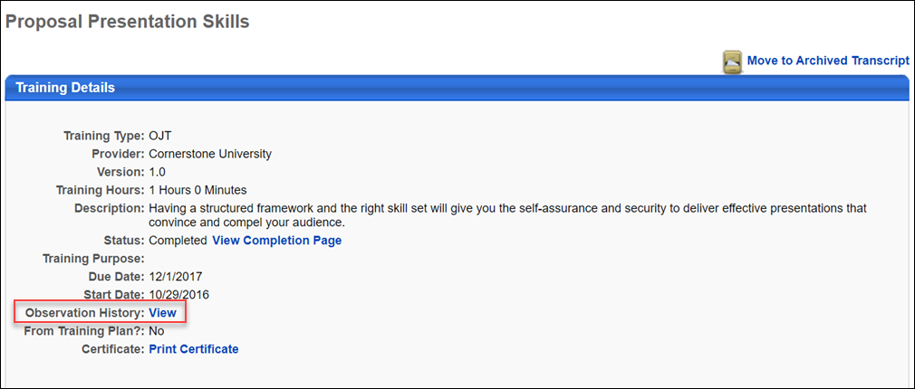
Permissions
PERMISSION NAME | PERMISSION DESCRIPTION | CATEGORY

On the Job Training - Observation History From Transcript | Grants access for users to view On the Job Training Observation History from Transcript Details. This permission cannot be constrained. This is an end user permission. | Learning - Administration
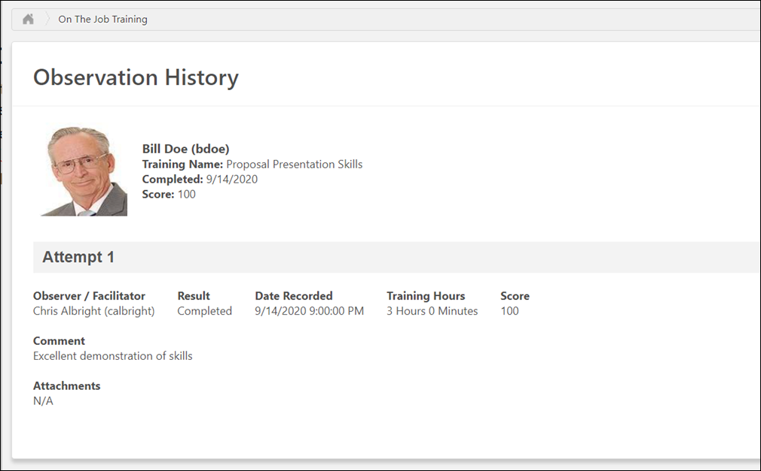
Observation History
The header of the Observation History page contains the following information:
- Profile Photo - The evaluated user’s profile photo
- Name - The evaluated user’s full name
- Training Name - The title of the attempted OJT
- Completed - The date the OJT was marked complete
- Score - The numeric score awarded for the user’s OJT attempt (if provided)
Each individual OJT completion attempt displays below the Observation History page header, from most recent to least recent. If provided by the observer at the time the attempt record was submitted, the following information displays for each attempt:
- Result - Displays whether the observer marked the user as Completed or as Failed for the observation attempt
- Date - The date the user's OJT attempt was recorded
- Training Hours - The number of training hours earned through the completion of the OJT, if applicable
- Score - Displays the numeric score the user achieved on the OJT, if applicable
- Comment - Any comments regarding the OJT completion attempt, if provided by the observer
- Attachments - Any attachments related to the OJT completion attempt, if uploaded by the observer
Close
To exit the Observation Attempts History page, click the Close button.

Transcript - Print Transcript Pop-up
Users are able to print their transcript from the Universal Profile - Transcript page. To print the transcript from the Universal Profile - Transcript page, select the Print Transcript option from the Options drop-down menu.
At the top of the pop-up, the training category that is selected on the Transcript page is displayed (e.g., Active, Completed, Archived), along with the user's name.
The following information displays for each learning object (LO):
- Title - This displays the full LO title.
- Type - This displays the LO type. If the LO is a posting, the specific posting type displays. If the LO is a material, the specific material category displays.
- Due Date - This displays the LO due date. If no due date is configured, "None" displays. When printing the Completed training category, this is not included.
- Completion Date - This displays the LO completion date. This is only included when printing the Completed training category.
- Score - This displays the LO score for tests and online courses, if available. This column is blank if no score is available.
- Status - This displays the LO status.
The transcript items are sorted in the same manner they were sorted on the Transcript page when the Print Transcript option was selected.
To print the transcript, click the Print button. Or, click Cancel to return to the Universal Profile - Transcript page. See Universal Profile - Transcript Overview on page 27 for additional information.
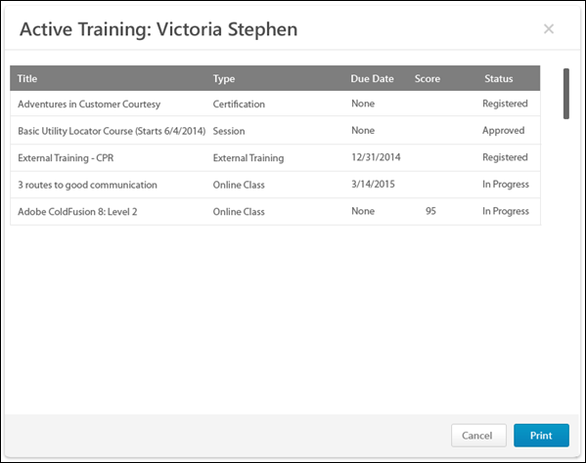

Transcript (Universal Profile) - Status and Options
The transcript contains numerous statuses and options, which are automatically updated as a result of user, manager, and administrator actions, and based on the type of learning object (LO). See Transcript - Curriculum Subscriptions to view how the transcript behaves when curriculum subscriptions are enabled.
Course Status Update
The automation of the system enables course statuses and options to be automatically updated. For example:
- When a manager approves a course:
  - The transcript status is automatically changed to Approved.
  - The transcript option changes to allow the user to register.
- When you register for a course:
  - The status changes to Registered.
  - A Launch option is available if the LO is an online course.
Course Troubleshooting Guide
In certain cases, users may have issues receiving a Completed status for their online course even if they have launched the course and completed the assessment within the course. See Course Troubleshooting Guide on page 234 for additional information.
Training Statuses
When a LO is inactive, "Inactive" appears as the first action in the Action drop-down menu. This option is not clickable. The only other option available in the Action drop-down menu is the View Details option, which opens the Training Details page.
The following statuses and options are available for each LO type on the Universal Profile - Transcript page:
Cohort
Status | Options
Approved | Register
 | View Training Details
Approved / Past Due | Register
 | View Training Details
Completed | View Training Details
 | View Certificate
Completion Approval Denied | Request Completion Approval
 | View Training Details
Completion Approval Denied / Past Due | Request Completion Approval
 | View Training Details
Denied | Request Again
 | View Training Details
Denied / Past Due | Request Again
 | View Training Details
Exempt | View Training Details
 | Launch
Inactive | View Training Details
In Progress | Launch - When a cohort LO is launched, the Main tab of the cohort community is opened. See Cohort Community - Main for additional information.
 | View Training Details
In Progress / Past Due | Launch - When a cohort LO is launched, the Main tab of the cohort community is opened. See Cohort Community - Main for additional information.
 | View Training Details
Pending Acknowledgment | Acknowledge
 | View Training Details
Pending Acknowledgment / Past Due | Acknowledge
 | View Training Details
Pending Approval | View Training Details
Pending Approval / Past Due | View Training Details
Pending Completion Approval | View Training Details
Pending Completion Approval / Past Due | View Training Details
Pending Completion Signature | Sign
 | View Training Details
Registered | None
 | View Training Details
Registered / Past Due | None
 | View Training Details
Curriculum
Status | Options
Approved | Register
 | Manage
 | Renew License
Completed | Subscription Renew
 | Open
 | Renew License
 | Evaluate
 | View Details
 | View Certificate
Completed Equivalent | Manage
 | Evaluate
 | Subscription Renew
 | Renew License
Completion Approval Denied | Manage
 | Request Completion Approval
Denied | Request Again
 | Renew License
Exempt | View Completion Page
 | View Training Details
Expired | Subscription Renew
 | Renew License
In Progress | Manage
 | Subscription Renew
 | Evaluate
 | Renew License
Not Activated | Activate - This option is available if the administrator does not check the Auto-Register option when configuring the LO within the curriculum.
Payment Denied | Repurchase
Payment Refunded | Repurchase
Pending | Manage
 | Renew License
Pending Acknowledgment | Acknowledge
 | Manage
 | Subscription Renew
 | Renew License
Pending Completion Approval | Manage
 | Renew License
Pending Completion Signature | Sign
 | Subscription Renew
 | Manage
 | Renew License
 | Evaluate
Pending Evaluation | Manage
 | Evaluate
 | Subscription Renew
 | Renew License
 | View Details
Pending Payment | Manage
Pending Post Work | Manage
 | Subscription Renew
 | Renew License
Pending Prerequisite | Manage
 | Subscription Renew
 | Renew License
Registered | Manage
 | Subscription Renew
 | Renew License
 | Evaluate
Registered Not Available | Manage
 | Evaluate
 | Renew License
Event
Status | Options
Approved | Select Session
 | Evaluate
 | Manage
 | Renew License
Denied | Request Again
 | Renew License
Exempt | View Training Details
Not Started | Select Session
 | Evaluate
 | Renew License
Payment Denied | Repurchase
Payment Refunded | Repurchase
Pending Acknowledgment | Acknowledge
 | Evaluate
 | Renew License
Pending Completion Signature | Sign
 | Manage
 | Renew License
 | Evaluate
Pending Evaluation | Renew License
 | Evaluate
External Training
Status | Options
Approved | Register
 | Renew License
Completion Approval Denied | Request Completion
Denied | Renew License
Exempt | View Training Details
Not Started | SF-182 Edit
 | SF-182 Remove
Payment Denied | Repurchase
Payment Refunded | Repurchase
Pending Completion Signature | Sign
 | Renew License
Registered | Withdraw
 | Mark Complete
 | Renew License
File
Status | Options
Approved | Register
 | Renew License
Exempt | View Training Details
In Progress | Launch
 | Mark Complete
 | Renew License
Pending Completion Signature | Sign
 | Launch
 | Renew License
Registered | Launch
 | Mark Complete
 | Renew License
Library
Status | Options
Approved | Register
 | Manage
 | Renew License
Completion Approval Denied | Manage
 | Request Completion Approval
Denied | Request Again
 | Renew License
Exempt | View Completion Page
 | View Training Details
In Progress | Manage
 | Evaluate
 | Renew License
Payment Denied | Repurchase
Payment Refunded | Repurchase
Pending | Manage
 | Renew License
Pending Acknowledgment | Acknowledge
 | Manage
 | Renew License
Pending Completion Approval | Renew License
Pending Completion Signature | Sign
 | Manage
 | Renew License
 | Evaluate
Pending Evaluation | Launch
 | Manage - See Library - Manage on page 87 for additional information.
 | Renew License
 | Evaluate
 | View Details
Pending Payment | Manage
 | Renew License
Pending Prerequisite | Manage
 | Renew License
Registered | Manage
 | Renew License
 | Evaluate
Registered Not Available | Manage
 | Evaluate
 | Renew License
Material
Status | Options
Approved | Register
 | Manage
 | Renew License
Completed | Launch
 | Manage
 | Evaluate
 | View Details
 | View Certificate
Completion Approval Denied | Manage
 | Request Completion Approval
Denied | Manage
 | Renew License
Exempt | View Completion Page
 | View Training Details
In Progress | Launch
 | Manage
 | Upload and Verify
 | Mark Complete
 | Renew License
Payment Denied | Repurchase
Payment Refunded | Repurchase
Pending | Manage
 | Renew License
Pending Acknowledgment | Launch
 | Acknowledge
 | Manage
 | Renew License
Pending Completion Approval | Launch
 | Manage
 | Evaluate
 | Renew License
 | View Details
Pending Completion Signature | Sign
 | Manage
 | Renew License
 | Evaluate
Pending Evaluation | Launch
 | Manage
 | Renew License
 | Evaluate
 | View Details
Pending Payment | Manage
 | Renew License
Pending Post Work | View Post Work
 | Launch
 | Manage
 | Renew License
Pending Prerequisite | View Prerequisite
 | Renew License
Pending Prework | View Prework
Registered | Launch
 | Mark Complete
 | Manage
 | Renew License
 | Evaluate
Registered Not Available | Manage
 | Evaluate
 | Renew License
Online Course
Status | Options
Approved | Register
 | Manage
 | Renew License
Completed | Launch Locally
 | Launch
 | Manage
 | Renew License
 | Evaluate
 | View Details
 | View Certificate
Completed Equivalent
 | Manage
 | Renew License
 | Evaluate
Completion Approval Denied | Request Completion Approval
 | Manage
Denied | Request Again
 | Manage
 | Renew License
Exempt | View Completion Page
 | View Training Details
Failed | Retake Test
 | Renew License
In Progress | Launch Locally
 | Launch
 | Unlock
 | Manage
 | Renew License
Payment Denied | Repurchase
Payment Refunded | Repurchase
Pending | Manage
 | Renew License
Pending Acknowledgment | Launch Locally
 | Launch
 | Acknowledge
 | Manage
 | Evaluate
 | Renew License
Pending Completion Approval | Launch Locally
 | Launch
 | Manage
 | Renew License
 | Evaluate
 | View Details
Pending Completion Signature | Launch Locally
 | Launch
 | Sign
 | Manage
 | Renew License
 | Evaluate
 | View Details
Pending Evaluation | Launch Locally
 | Launch
 | Manage
 | Renew License
 | Evaluate
 | View Details
Pending Payment | Manage
 | Renew License
Pending Post Work | View Post Work
 | Launch Locally
 | Launch
 | Manage
 | Renew License
Pending Prerequisite | View Prerequisite
 | Renew License
Pending Prework | View Prework
Registered | Launch Locally
 | Launch
 | Unlock
 | Manage
 | Renew License
 | Evaluate
Registered Not Available | Manage
 | Evaluate
 | Renew License
Note: The Failed status can be enabled by contacting Global Customer Support. If not activated, a failed Online Content displays "In Progress" status.
Quick Course
Status | Options
Approved | Register
 | Manage
 | Renew License
Completed | Launch
 | Manage
 | View Certificate
Completion Approval Denied | Manage
 | Request Completion Approval
Denied | Request Again
 | Manage
 | Renew License
Exempt | View Completion Page
 | View Training Details
In Progress | Launch
 | Manage
 | Renew License
Payment Denied | Repurchase
Payment Refunded | Repurchase
Pending | Manage
 | Renew License
Pending Acknowledgment | Launch
 | Acknowledge
 | Manage
 | Renew License
Pending Completion Approval | Launch
 | Manage
 | Renew License
Pending Completion Signature | Launch
 | Sign
 | Manage
 | Renew License
 | Evaluate
Pending Evaluation | Launch
 | Manage
 | Renew License
 | Evaluate
Pending Payment | Manage
 | Renew License
Pending Post Work | View Post Work
 | Launch
 | Manage
 | Renew License
Pending Prerequisite | View Prerequisite
 | Renew License
Pending Prework | View Prework
Registered | Launch
 | Manage
 | Renew License
 | Evaluate
Registered Not Available | Manage
 | Evaluate
 | Renew License
Session
Evaluation Availability: With most learning objects (LOs), the evaluation is available to the user after the LO is completed. However, when an evaluation is used with an event session, the evaluation is only available to the user at the session start time. In the case of a multi-part session, the evaluation is only available at the session start time of the final part.
For troubleshooting information regarding Level 1 evaluations: See Troubleshooting Guide - Level 1 Evaluations.
Status | Options
Approved | Register
 | Withdraw
 | Renew License
 | View Details
Canceled | Select Session
 | Renew License
Completion Approval Denied | Request Completion Approval
 | Manage
Denied | Select Session
 | Renew License
Exception Requested | Withdraw
 | Renew License
 | View Details
Exempt | View Completion Page
 | View Training Details
In Progress | Withdraw
 | Manage
 | Launch WebCast Session
 | Renew License
 | Evaluate
 | View Details
No Show | Select Session
 | Renew License
Payment Denied | Repurchase
Payment Refunded | Repurchase
Pending | Withdraw
 | Manage
 | Renew License
 | View Details
Pending Acknowledgment | Evaluate
 | Acknowledge
 | Manage
 | Renew License
Pending Completion Approval | Manage
 | Renew License
Pending Completion Signature | Sign
 | Manage
 | Renew License
 | Evaluate
Pending Evaluation | Manage
 | Renew License
 | Evaluate
Pending Payment | Manage
Pending Pre-work | View Pre-work
Pending Post-work | View Post-work
 | Renew License
Pending Prerequisite | Manage
 | Withdraw
 | Renew License
Pending Prework | View Prework
Registered | View Training Details
 | Withdraw
 | Manage
 | Launch WebCast Session
 | Renew License
 | Evaluate
Registered Not Available | Manage
 | Evaluate
 | Renew License
Registration Pending | Register
 | Withdraw
 | Renew License
 | View Details
Waitlisted | Withdraw
 | Renew License
 | View Details
Waitlist Expired | Register
 | Select Session
 | Renew License
Withdrawn | Select Session
 | Renew License
Test
Status | Options
Approved | Register
 | Manage
 | Renew License
Completed | Review
 | Renew License
 | Manage
 | Evaluate
 | View Certificate
Completion Approval Denied | Manage
 | Request Completion Approval
Denied | Request Again
 | Renew License
Exempt | View Completion Page
 | View Training Details
Failed | Retake Test
 | Renew License
In Progress | Take Test
 | Manage
 | Renew License
Payment Denied | Repurchase
Payment Refunded | Repurchase
Pending | Manage
 | Renew License
Pending Acknowledgment | Acknowledge
 | Manage
 | Renew License
Pending Completion Approval | Manage
 | Renew License
Pending Completion Signature | Sign
 | Manage
 | Renew License
 | Evaluate
Pending Evaluation | Manage
 | Renew License
 | Evaluate
Pending Payment | Manage
 | Renew License
Pending Post Work | View Post Work
 | Renew License
Pending Prerequisite | View Prerequisite
Pending Prework | View Prework
Registered | Take Test
 | Manage
 | Renew License
 | Evaluate
Registered Not Available | Manage
 | Evaluate
 | Renew License
Video
Status | Options
Approved | Register
 | Renew License
Completed | Launch Video
 | Manage
 | Renew License
 | Evaluate
 | View Details
 | View Certificate
Completed Equivalent | Manage
 | Evaluate
 | Launch Video
 | Renew License
Completion Approval Denied | Manage
 | Request Completion Approval
Denied | Request Again
 | Renew License
Exempt | View Completion Page
 | View Training Details
Payment Denied | Repurchase
Payment Refunded | Repurchase
Pending | Manage
 | Renew License
Pending Acknowledgment | Launch Video
 | Manage
 | Acknowledge
 | Renew License
Pending Completion Approval | Launch Video
 | Manage
 | Renew License
Pending Completion Signature | Launch Video
 | Sign
 | Manage
 | Renew License
 | Evaluate
Pending Evaluation | Launch Video
 | Manage
 | Renew License
 | Evaluate
 | View Details
Pending Payment | Manage
Pending Prerequisite | View Prerequisite
 | Renew License
Pending Prework | View Prework
Registered | Launch Video
 | Mark Complete
 | Manage
 | Renew License
 | Evaluate
Registered Not Available | Manage
 | Evaluate
 | Renew License

Transcript - Training Category Statuses
The Transcript page can be filtered by training category. The following categories are available: Active, Completed, Archived, and Removed.
Permissions
PERMISSION NAME | PERMISSION DESCRIPTION | CATEGORY

Remove Training | Grants ability to remove training from other users' transcripts (training records) when viewing their transcript. This permission can be constrained by OU, User's OU, User's Corporation, User Self and Subordinates, User's Self, User's Direct Subordinates, and User. This is an administrator permission. | Learning - Administration
Active
The Active category displays training items that are in the following statuses and do not qualify for the Completed, Archived, or Removed category:
- Approved
- Approved/Past Due
- Cancelled
- Canceled/Past Due
- Completion Approval Denied
- Completion Approval Denied/Past Due
- Denied
- Denied/Past Due
- Discontinued
- Discontinued/Past Due
- Equivalent
- Exception Requested
- Exception Requested/Past Due
- Exception Requested/Waitlisted
- Exempt
- Expired
- Expired/Past Due
- Failed
- Failed/Past Due
- Incomplete
- Incomplete/Past Due
- In Progress
- In Progress/Past Due
- Not Activated
- Not Available
- Not Started
- Not Started/Past Due
- No Show
- No Show/Past Due
- Old Version
- Past Due
- Payment Denied
- Payment Denied/Past Due
- Payment Refunded
- Payment Refunded/Past Due
- Pending Acknowledgment
- Pending Acknowledgment/Past Due
- Pending Approval
- Pending Approval/Past Due
- Pending Approval/Waitlisted
- Pending Approval/Waitlisted/Past Due
- Pending Completion Approval
- Pending Completion Signature
- Pending Completion Signature/Past Due
- Pending Completion/Past Due
- Pending Evaluation
- Pending Evaluation/Past Due
- Pending Grade
- Pending Grade/Past Due
- Pending Payment
- Pending Payment/Past Due
- Pending Post-Work
- Pending Post-Work/Past Due
- Pending Prerequisite
- Pending Prerequisite/Past Due
- Pending Pre-Work
- Pending Pre-Work/Past Due
- Pending Prior Training
- Pending SF-182 Form Approval
- Registered
- Registered/Not Available
- Registered/Not Available/Past Due
- Registered/Past Due
- Registration Pending
- Registration Pending/Past Due
- SF-182 Form Denied
- Waitlisted
- Waitlisted/Past Due
- Waitlist Expired
- Waitlist Expired/Past Due
- Withdrawn
- Withdrawn/Past Due
Completed
The Completed category displays training items that are in a Completed or Completed (Equivalent) status. Once a training item is in a Completed status, the training is automatically moved to the Completed category.
For training items that are configured to allow re-requests, when a user completes the first instance of the training, it moves to the Completed category. When re-requested, the training item moves back to the Active category.
For training items that require pre-work, post-work, or prerequisites, the training item is not moved to the Completed category until all pre-work, post-work, and prerequisites are also in a Completed status.
Archived
The Archived category includes training items that have been archived by the end user, their manager, or an administrator. Training can be archived from the Training Details page for the learning object.
Removed
The Removed category displays training items that are removed. This category is only available to managers and administrators with permission to remove training from a user's transcript. Also, managers or administrators can never view the Removed category on their own transcript.

Training Completion Page
A Training Completion page is a page that is available to a user when they complete the training. Depending on the configuration of the training and the portal, the Training Completion page may display any points or badges that were awarded and provide opportunities to rate and review the training, view their certificate of completion, evaluate the training.
If a Training Completion page is available for a training item, then users can always manually navigate to the page via the Transcript Details page once the training is completed. Automatic redirection to the Training Completion page only occurs for select trainingtypes in certain scenarios.See the Training Completion Page Availability & Redirection section below for additional information.
Permissions
PERMISSION NAME | PERMISSION DESCRIPTION | CATEGORY

Learning Badge - View | Grants ability to view the Badge field on the Learning Details page and the Training Completion page. This permission cannot be constrained. | Learning

Learning Points - View | Grants ability to view the Points field on the Learning Details page and the Training Completion page. This permission cannot be constrained. | Learning

Snapshot - Leaderboard | Enables user to view the Leaderboard widget and subpage within the Universal Profile - Snapshot page for users within their permission constraints. This permission works in conjunction with the Snapshot Main - View permission. This permission can be constrained by OU, User's OU, User Self and Subordinates, User, User's Self, User's Manager, User's Superiors, User's Subordinates, User's Direct Reports, and Employee Relationship. Any user with this permission will always be able to view their own Leaderboard widget when the widget is enabled. Best Practice: For most users, this permission should be constrained by User Self and Subordinates. | Universal Profile
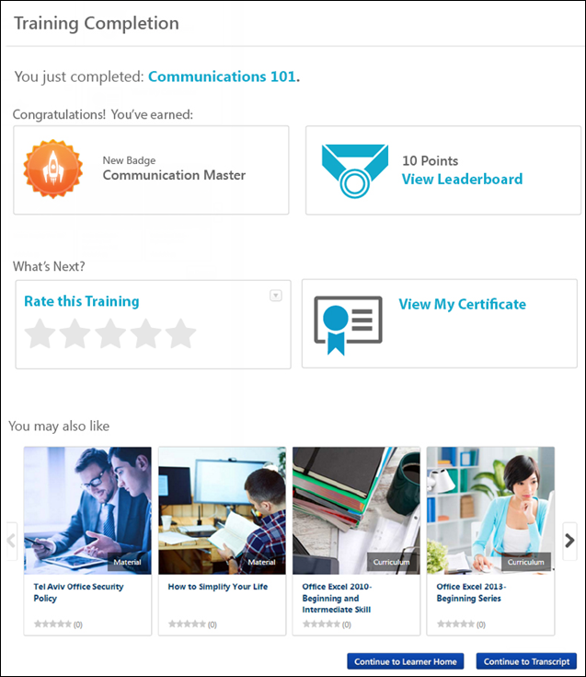
Completion Message
A completion message is displayed at the top of the Training Completion Page. This is intended to inform the user that they have successfully completed the training. This message may also provide the user a directive regarding next steps, such as how to rate the course or print a certificate of completion.
If the training title is included in the completion message, then the Training Completion page always displays the training's title at the time the training was completed. If the training title is updated in the future, the Training Completion page is not impacted.
Earned Badges and Points
The user may be awarded a badge and training points by completing the training:
- Badge - If the user is awarded a badge by completing the training, then this badge is displayed. If the user has the Snapshot - Badges permission, they can click the badge title to view the Snapshot - My Badges page. See Snapshot - My Badges.
  - If there is no badge associated with the LO, then this information is hidden. Also, this information is only visible if the user has permission to view Learning Badges.
- Points - If the user earned points by completing the training, then the number of points that were earned is displayed. If the user has the Snapshot - Leaderboard permission, they can the View Leaderboard link to view the Snapshot - Leaderboard page. See Snapshot - Leaderboard.
  - If no points were earned, then this information is hidden. Also, this information is only visible if the user has permission to view Learning Points.
Note: Badges and Points do not display on the Training Completion page for ILT sessions. Any earned Badges or Points will still be awarded to the user, but for ILT sessions they must be accessed from the Badges and/or Points Snapshot widgets in Universal Profile.
Rate and Review the Training
To rate the training, click the Rate this Training link. This opens a pop-up, in which the user is able to assign a star rating and provide a review of the training. See LO Details Page - Rate this Training.
The option to rate the training is available if the following are true:
- Course ratings are enabled
- The user is able to view and apply course ratings for the selected LO
Edit/Delete My Review
If the user has already rated the training, then the user's rating is displayed and an Edit My Review link is displayed. Users can click this link to edit their rating and review.
Also, an Options drop-down is available in the upper-right corner of the widget. The following options are available:
- Edit - Select this option to edit your review, including the rating and review text.
- Delete - Select this option to delete your review. The review will no longer be available on the Training Completion page or the LO Details page.
View Certificate of Completion
The user may be awarded a certificate of completion if the following are true:
- A certificate is associated with the training type or training item via Certificate Preferences. See Certificates Preferences Overview.
- The training has a status of Complete or Completed Equivalent.
To view and print the certificate of completion, click the View My Certificate link. This enables the user to instantly view their certificate, and they can choose to print it if necessary.
Recommended Training
This section is only available when Course Recommendations are enabled for the portal via the Training Completion Page Preferences and for the completed course via the Course Catalog.
This section displays training that is recommended to the user based on what other users with similar course histories have completed. For example, if there is a user who has completed similar training, then the system will recommend other training that the similar user has completed.
Only the latest version of training that is active, available to the user, and eligible for course recommendations is included in the recommendations. This section does not include any course that is on the user's transcript. Also, sessions and cohorts are not included in the recommendations.
For each available training item, the following information is displayed:
- Image - An image is displayed to represent the training or training type. If the training does not have a set image, then a randomly selected default image is displayed. Click the image to view the LO Details page.
- Training Type - In the lower-right corner of the image, the training type is displayed.
- Title - Below the image, the training title is displayed. Click the title to view the LO Details page.
- Rating - If ratings are enabled, then the training's rating is displayed. Click the rating to view the Ratings tab of the LO Details page.
- Cost - If pricing is enabled, then the training's price is displayed.
Up to four LOs are displayed at once. To view additional LOs, click the arrow to the right of the section. This displays the next four LOs. A maximum of 12 recommendations may be available. Note: If the user does not have 12 recommended courses, only the number of available recommended courses displays. If no recommendations are available, a message displays informing the user they do not have any recommendations.
Recommended Training - No Results
If no course recommendations display for a user on their Training Completion page after they complete an LO, the following message will display to the user:
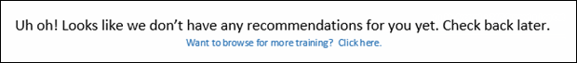
Clicking the Want to browse for more training? Click here. link navigates the user to the Browse for Training landing page. Note: If no Browse for Training landing page has been configured in the portal, the user is navigated to the Browse for Training page.
If the user does not have any course recommendations, one of the following scenarios may have occurred:
- No results were returned because the system did not have enough user data for the user to provide recommendations.
- No results were returned because service is down.
Navigation Buttons
The following navigation buttons are available at the bottom of the Training Completion page:
Continue to Learner Home - The user can click this button to be redirected to the Learner Home page, where they can continue their learning journey and discover more training. Note: Learner Home must be active in the portal in order for this button to display, and the Learner Home link must be available to the user in a navigation tab in order for them to access Learner Home via the Training Completion page.
Continue to Transcript - The user can click this button to be redirected to their learning transcript, where they can continue managing their training.
Training Completion Page Availability & Redirection
If a Training Completion page is available for a training item, then users can always manually navigate to the page via the Transcript Details page once the training is completed. Automatic redirection to the Training Completion page only occurs for select trainingtypes in certain scenarios.
Automatic Redirection
Automatic redirection only applies to the following LO types:
- Online Course
- Material
- Test
- Video
Automatic redirection occurs for the specified LO types in the following scenarios:
- User completes the LO (see exceptions below)
- User marks the LO Complete from their Transcript
- User marks the LO Complete from their Action Items
- User completes a recurrence of the LO
- User completes another version of the LO
- Test Only: The test is submitted and passed
Automatic redirection does NOT occur for the specified LO types in the following scenarios:
- Admin marks the LO Complete from the Transcript Details Page
- Admin marks the user Exempt from the LO from the Transcript Details page - Note: While Exempt users will not be automatically redirected to the Training Completion Page, the Training Completion page will remain accessible.
- User completes the LO as an associated LO in the following scenarios:
  - Prerequisite
  - Pre-work
  - Post-work
  - Within cohort structure
  - Within curriculum structure
  - Within library structure
- LO is a Training Equivalent or Language Equivalent - Only the LO that is completed will redirect
- When a LO is in a pre-completion status due to a required action:
  - Pending Signature
  - Pending Evaluation
  - Pending Acknowledge
  - Pending Post Work
- Upon completing required pre-completion work:
  - Pending Signature
  - Pending Evaluation
  - Pending Acknowledge
  - Pending Post Work
- When completing a LO launched from the following:
  - Welcome Page Widget
  - Deep Link
  - LO Details Page - This only applies to Online Courses
  - Learner Home - This only applies to Online Courses
- The system is in Low Bandwidth mode - This is controlled by a backend setting.
- Test Only:
  - Test is submitted and failed
  - Test contains free-form questions
Manual Redirection
User's can manually navigate to the Training Completion page from the Transcript Details page for the following LO types:
- Online Course
- Event
- Quick Course
- Curriculum
- Test
- Library
- Materials
- Video
- Cohort

Training Details - View
To view the Training Details page, follow these steps:
- Click the View Transcript link, which can be accessed from the Home or the Learner Home page.
- Click the training title to view the training details.
Permissions
PERMISSION NAME | PERMISSION DESCRIPTION | CATEGORY

Attachments in Transcript - Manage | Grants ability to upload new attachments and delete existing attachments for LOs on a user's transcript. Users with this permission are automatically granted permission to view attachments. This permission can be constrained by OU, User's OU, User Self and Subordinates, User, User's self, User's ILT Provider, ILT Provider, and Instructor. | Learning Administration

Attachments in Transcript - View | Grants ability to view attachments that have been uploaded for LOs on a user's transcript. This permission can be constrained by OU, User's OU, User Self and Subordinates, User, User's self, User's ILT Provider, ILT Provider, and Instructor. | Learning

Cohort Roster - Manage | Grants ability to manage cohort rosters. A variety of other features are available depending upon additional roster permissions. This permission works in conjunction with Cohorts - Manage or Cohorts - Edit permissions and the Cohort Roster - View permission. This permission cannot be constrained. This is an administrator permission. | Learning - Administration

Cohort Roster - View | Grants view-only access to cohort rosters. This permission works in conjunction with the Cohorts - Manage or Cohorts - Edit permissions. This permission cannot be constrained. This is an administrator permission. | Learning - Administration

Display all Training Custom Fields | Enables display of all training custom field values including blank fields when viewing details of training on transcript. Without this permission, the custom field will only appear if it is populated with a value. This is an end user permission. | Learning

Edit Transcript Items | Grants ability to modify training due dates, statuses, and scores on other user's transcripts (training records) when viewing training details for particular learning objects on the transcript. User must also have permission to add external training in order to add or edit another user's external training. This permission can be constrained by OU, User's OU, User Self and Subordinates, User, and User's Self.  Note: Users with this permission also will also see the Add SF-128 link on the transcript. | Learning - Administration

Mark Training Complete | Grants ability to mark learning objects complete for other users, via the training details page when viewing the learning object from the user's transcript. This permission does not grant ability to mark a user's learning object complete from their Transcript page. This permission can be constrained by OU, User's OU, User, User's Self, and User Self and Subordinates. This is an administrator permission. | Learning - Administration

Mark Transcript Exempt | Grants ability to exempt users from a learning object, using the "Mark Exempt" link on the top right corner of the target user's Transcript/Training details page. This permission can be constrained by OU, User's OU, and User's Subordinates. This is an administrator permission.  With the May '17 release, this permission also applies to prerequisites, pre-work, and post-work. Users without this permission cannot mark any training type exempt for a user. | Learning - Administration

Request Exemption from Training | Grants ability to request Exemption from completing an assigned learning object, via the "Request Exemption" link on the top right corner of the Training details page for any transcript item. The request is sent to the persons allowed to approve Exemption requests of the submitting user. This permission cannot be constrained. This is an end user permission. | Learning

Session Details - View Student Roster | Allows user to view student roster for a given ILT session via a link on ILT session details screen when searching for training, and from transcript details screen after a session has been added to the user's transcript. This is an end user permission. | Learning

Training Certificate - Admin | Grants access for administrators to view and print training certificates of completion on behalf of users. The link appears on the Transcript Details page for a user's completed learning objects. This is an administrator permission. | Learning - Administration

Training Certificate - Self | Grants access for users to view and print training certificates of completion for learning objects they have completed. The link appears on the Transcript Details page for the user's completed learning objects. This is an end user permission. | Learning - Administration

Training Purpose - Edit User's Purpose | Grants access to edit the training purpose and category on the user's transcript details. Admin must have access to user's transcript. This is an administrator permission. | Learning - Administration

View Transcript Item | Grants ability to view details of learning objects that appear on the transcript (training record), by clicking on the name of the learning object. Users must also have the Bio About - View permission in order to access the transcript within Universal Profile. This permission can be constrained by OU, User's OU, User Self and Subordinates, User, or User's Self. This is an end user permission. | Learning - Administration
Edit Transcript Details
When the user has permission to edit the transcript details, the Edit Transcript Details link appears below the LO title for all LO types. See Training Details - Edit Transcript Details on page 152 for additional information.
Generate Audit PDF
Select the Generate Audit PDF link to generate an audit PDF. This is only available to administrators. See Generate Audit PDF on page 163 for additional information.
Note: The Generate Audit PDF link is not available if the Transcript Lockdown functionality is enabled in your portal. Also, this link is not available when administrators view training details for their own training.
Training Detail Fields
Training detail fields vary depending on the type of training. Click each section below to see training detail fields and descriptions:
General Training Details
Depending on the type of training selected, some fields may not appear:
- Title - The training title is provided at the top of the page.
- Training Type - This is the type of training, such as online course, curriculum, material, etc.
- Version - If the training item has multiple versions, the version number is displayed here.
- Provider - This is the vendor that provides the training.
- Training Hours - This is the total number of hours of the training.
- Description - This is a description of the training.
- Schedule - This indicates the days and time the training is offered.
- Institution - This is the institution that offers the external training.
- Grade - This is the grade received for external training.
- Submitted Paperwork - This is the status of required paperwork for an external training course, which user must submit for a complete status
- Cost - This is the cost of the external training.
- Resources - This section displays any documents that have been attached to the learning object (LO) and are visible to the user. The attachments are only visible if the administrator selected the Registered Users visibility option for the attachment and if the user has permission to view or manage LO attachments. Users can click the attachment title to open the attachment.
- Status - The user's status with regards to the training item.
  - View Completion Page - This link is available if the user has completed the training and the training has a Training Completion page enabled. This link enables users to view their Training Completion page. See Training Completion Page on page 118 for additional information.
  - Mark Complete - This link is available for administrators with the appropriate permissions when viewing the Training Details page for another user. This link allows the administrator to mark the user's training Complete.
- Training Purpose - This field displays the training purpose, as defined when the training was requested or assigned. The field label will display by default for Curriculum, Cohort, Library, Material, Online Course, Video, Test, Event, and External Training training items even if training purpose is not in use or not defined.
- Available Date - This field displays the date on which the training is available for the user. This field is only visible to users with permission to manage the available date setting for learning assignments and only appears if the user was assigned the LO via a standard learning assignment. Note: This field does not display for events. In addition, the field does not display if the LOs in the learning assignment are configured to be available immediately upon processing of the proxy enrollment.
- Due Date - The date by which the user must complete the training item. Managers and administrators may have permission to edit the due date of a subordinate's LO. See Training Details - Edit Due Date on page 150 for additional information.
- Start Date - This is only available for material LOs. If the material does not have a start date, then the field does not display.
- End Date - This is only available for material LOs. If the material does not have a end date, then the field does not display.
- Expiration Date - The date on which the user is no longer available to launch the training item. Note: This expiration date is different from a license expiration date.
- From Training Plan? - This field displays whether the course was assigned to the user from a training plan. This field is only available if training plans are enabled and if the field is enabled by the administrator in Transcript Preferences.
  - If the learning object (LO) is assigned to the user from a training plan, then "Yes" is displayed.
  - If the LO is not assigned to the user from a training plan, then "No" is displayed.
  - If the LO is assigned to the user from a training plan and the LO replaces an existing LO on the user's transcript, then "Replaced" is displayed. Whether a LO can replace an existing LO on a user's transcript is dependent on whether the Force initial enrollment for users who already have the training option is checked when creating the training plan.
- Auto Renewal - When viewing a curriculum, if auto-renewal is enabled, this displays whether or not auto-renewal is currently on or off.
  - If the Auto Renewal value is On, click the On link to turn it off. The Renew Subscription option is now available on the Transcript page.
  - If the Auto Renewal value is Off, click the Off link to turn it on.
- Highest Score - This is the user's highest score
- Attempts Left - This is the total number of attempts remaining
- Roster - This option is only available to users who have permission to view or manage the cohort roster.
- Student Roster - This is the list of users currently registered in this session. This is only available for users with permission to view the student roster for the cohort or session. Note: For sessions, if you select the View Student Roster link, the list displays up to 500 users. If there are more than 500 users, they will not display.
- Course Rating - If course ratings are enabled for a portal, in the upper-right corner of the Training Details section, the overall course rating is displayed. The rating is displayed visually with a star rating. Also displayed is the number of ratings that are available for the course. Users can click the "XX Reviews" link to view the Course Ratings page for the course. Note: Course ratings are not displayed if the Course Ratings functionality is not enabled.
Training Progress Details
- Progress - This is the percentage of course units completed.
- Last Accessed - This is when the user last viewed the course.
- Total Views - This is the number of times the user opened the course.
- View Time - This is the length of time the user remained in the course.
- Status - The status indicates whether the course is in progress, completed, etc.
- Modules - This displays the segmented scores on particular modules .
- Attendance - The attendance lists each part of the session with "N/A" if the session has not started yet and either "Absent" or "Attended" depending on whether the instructor marked that person as attending within that part on the Attendance and Scoring sheet from the roster.
Attachments
The Attachments section is only available for instructor led training (ILT) sessions and it is only available if the user or administrator has permission to view or manage attachments in the transcript. Attachments are displayed in the order in which they were uploaded, with the oldest attachments displayed first.
Click the attachment name to open the attachment.
See Training Details - Attachments on page 141 for additional information.
Scoring Details
- Attempts - This field displays the attempt number for the user.
- Date - This field displays the date completed.
- Score - This field shows the score received for that attempt. For online courses, if the course is configured by the administrator to have a maximum possible score, then the score is calculated as a percentage of correct answers: [Number of Correct Answers] x 100 / [Max Score]. For example, if the maximum possible score is 30 and the user answers 21 out of 30 questions correctly, their score is 70%. Note: When creating a new course or publication in which a score is calculated, in order for the system to calculate and display a score on the Training Details page, both the maximum score and the user score must be set. If the Score field does not appear on the Training Details page, then the maximum score is not defined (greater than zero) in the SCORM wrapper (max_score). If the Score label does appear, but there is no value, then the user's score is not defined (not equal to null).
- Test Time - This provides the amount of time user took to complete the test.
Pre-work
- Title - This is the pre-work training object title.
- Type - This is the pre-work training object medium (online training, event, quick course, etc.).
- Due Date - This is the date by which the pre-work must be competed.
- Required - This states whether the pre-work is required.
- Exempted - This states whether the user is exempt from completing pre-work.
- Option - This provides the status of the pre-work completion.
Post-work
- Title - This is the post-work training object title.
- Type - This is the post-work training object medium (online training, event, quick course, etc.).
- Due Date - This is the date by which post-work must be completed.
- Required - This states whether the post-work is required.
- Exempted - This states whether the user is exempt from completing post-work.
- Option - This provides the status of the post-work completion.
Prerequisites
- Title - This is the prerequisite training object title.
- Type - This is the prerequisite training object medium (online training, event, quick course, etc.).
- Exempted - This states whether the user is exempt from completing the prerequisite.
- Status - This provides the status of the prerequisite completion.
Session Details
- Title - This provides the session name.
- Locator Number - This provides the assigned locator number for reference.
- Provider - This is the vendor providing the training.
- Description - This is a description of the session.
- Subjects - This displays the training subjects in which session can be searched. If the selected subject is a child subject, then the entire hierarchy is displayed.
- Training Hours - This shows the duration of the training.
- Credits - This shows the number of credits a user will receive for completing training.
- Price - This shows the cost of the training. The price displays with the following considerations, depending on the percentage of the price the user is required to pay to register for the training.
  - If User Payment Preferences are configured so that User Pays is set to 0% (i.e., User's Cost Center is set to 100% and pays 100% of the price), the Price field does not display in the Training Details.
  - If User Payment Preferences are configured so that User Pays is set to 100% (i.e., User's Cost Center is set to 0%, then the following occurs:
    - Before the payment, the Price field displays the total price of the training.
    - After the payment, the Total Price and Registration fields both display total price of the training.
  - If User Payment Preferences are configured so that User Pays is set to a percentage between 0% and 100% (e.g., User Pays is set to 50% and User's Cost Center is set to 50%), then the following occurs:
    - Before the payment, the Price field displays the total price of the training (i.e., the user portion plus the cost center portion).
    - After the payment, the Total Price and Registration fields both display the part of the price that the user paid to register for the training (i.e., only the user portion).
- Schedule - This shows the day, time, location and instructor for the training.
- Prerequisites - This shows the prerequisites required for the training.
- Pre-work - This shows the pre-work required for the training.
- Post-work - This shows the post-work required for the training.
- Penalty for Withdrawal - This displays the amount of the penalty withdrawal as well as the number of days prior to event a user must withdraw
- Penalty for No-Show - This displays the amount of the penalty for a no-show.
- Registration Deadline - This displays the last day a user can register for an event.
Note: Custom fields must have a value in order to be displayed in the session transcript on the Training Details page.
Print Certificate
Link displays after the training is completed for an online course, quick course, session, curricula and certification. Click to view or print certificate. Note: If training is a curriculum, the Print Certificate link will display when all training items are completed inside the curriculum and the status of the curriculum is Completed.
Print Training Details
When a completion signature is required, you also have the option to print the Training Details page. To print the Training Details page, click the Print Details icon in the upper-right corner of the page. Note: This option is only available when the training completion signature is required for the item. If completion signature is disabled for the item, the Print Details option is removed, no matter the completion status. See Training Details - Print Preview on page 167 for additional information. The following sections are included in the printable version:
- Training Details
- Custom Training Fields
- Acknowledge Completion
- History
Assignment and Version History
On the Training Details page for a training item on a user's transcript, an Assignment and Version History section displays. Each occurrence of training displays as a separate line item in this section. The following information displays in this section, if available:
- Registration Number - This column shows the registration number for each assignment of the training. This field can be reported on using a custom transcript report.
- Latest Registration? - In the Latest Registration column, a Yes/No value displays, indicating whether or not the training registration is the latest active registration on the user's transcript.
- Delivery - This column displays the method by which the training was assigned to the user, the user who assigned the training, and the date and time the training was assigned.
- Transcript Delivery Method - In the Transcript Delivery Method section, the method by which the training registration was delivered to the user's transcript displays. Possible values include:
  - Self Requested
  - System Assignment (LAT)
  - Direct Assignment (From a manager or via ILT roster submission)
  - Express Class
  - Assignment
  - Other
- Version - This column displays which version of the training is on the user's transcript.
- Effective Date - This column displays the date the training is effective in the Course Catalog.
- Start Date - This column displays the Start Date specified for the training assignment, if available.
- End Date - This column displays the End Date specified for the training assignment, if available.
- Due Date - This column displays the Due Date specified for the training assignment, if available.
- Status - This column indicates what status the training is in on the user's transcript (i.e. Registered, In Progress, Completed, etc.)
- Options - The following options are available for line items in the Assignment and Version History section:
  - View Details - Click this icon to view the Training Details page for a specific assignment on the user's transcript. The top of the page reads, "Previous Assignment Information" to alert the viewer that they are viewing the training details for a previous instance of the training on the user's transcript. See the below section for more information.
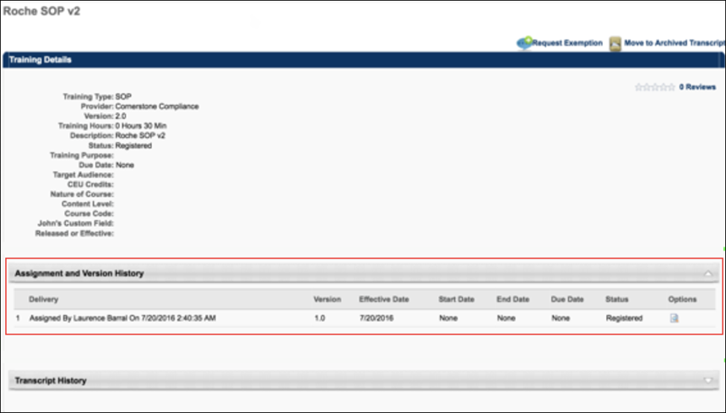
  - Transcript Delivery Method - In the Transcript Delivery Method section, the method by which the training registration was delivered to the user's transcript displays. Possible values include:
    - Self-Requested
    - System Assignment (LAT)
    - Direct Assignment
      - Training was assigned directly (for example by a manger to a user)
      - Training was submitted via ILT Roster Submission
    - Express Class
    - Assignment* (This category is representative of historical data records prior to the Feb '19 release which are not reliable and therefore have been contained separately to preserve data quality. Over time, this category will be deprecated.
Other
    - The Other status appears for all other miscellaneous transcript delivery cases, including:
      - Assignment via Inventory
      - Added by Training Plan
      - Historical Data Loads (except in certain cases described in above values)
      - Data Load Wizard
Considerations
    - The Assignment and Version History section is called "Assignment History" if the training has not yet been versioned. This is preexisting functionality.
    - There may be multiple entries within the Assignment and Version History section that are considered the Latest Registration. This is preexisting functionality that occurs when a training is versioned using Append versioning.
Acknowledge Completion
If a completion signature is required for a learning object, the user must submit an electronic signature on the Transcript Details page for the LO. See Training Details - Acknowledge Completion on page 138 for additional information.
Cohort Structure
For cohort LOs, the cohort structure is displayed in the Cohort Structure section. This section displays all of the training that is contained in the cohort structure. See unTraining Details - Cohort Structure on page 144 for additional information.
Session Details Table
See Training Details - Session Details Table on page 169 for additional information.
Curriculum Details Table
See Training Details - Curriculum Details Table on page 145 for additional information.
Approval History
Lists each step in the approval process and the history of the training item.
- Comments entered by Managers assigning training are displayed under the Approval History.
- Exemption requests, approvals, and denials are recorded under Approval History.
- Sessions for which the Completed status has been reversed are recorded under the Approval History and appear as "Reverted by <(user name) (user ID) on (M/D/YYYY)." The original timestamp recorded for the Completed status is unchanged.
- Time zone specified here under the Approval History area is set based upon the location of the host server. Historical transactions times (such as these) are listed in Pacific Time Zone.
Assignment and Version History
See Training Details - Assignment and Version History on page 139 for additional information.
Move to Archived Transcript
Click the Move to Archived Transcript link in the upper-right corner to move a training course from your active transcript to your archived transcript.
Back
Click Back button from the Training Details window to return to your Transcript.
Pending Approval/Pending Completion Approval Panel
See Training Details - Pending Approval/Completion Approval Panel on page 165 for additional information.
Online Course
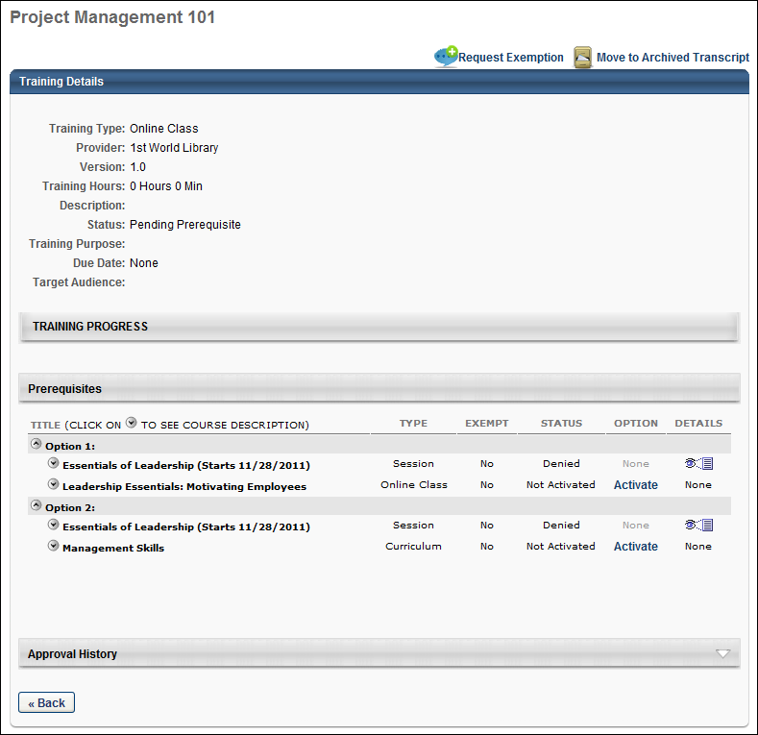
Curriculum
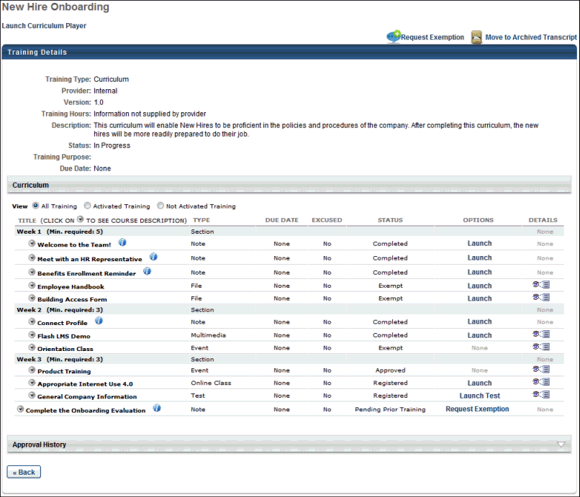
Session
Only the training details for the latest session are available directly from the transcript. All previous sessions must be viewed by navigating to the event's Training Details page from the session's Training Details page.
Note: If the administrator configures the session to display the start and end times in the user's time zone, then the session start and end time displays in the user's time zone.
Note: Daylight saving time (DST) time zones are supported for ILT for events or sessions.
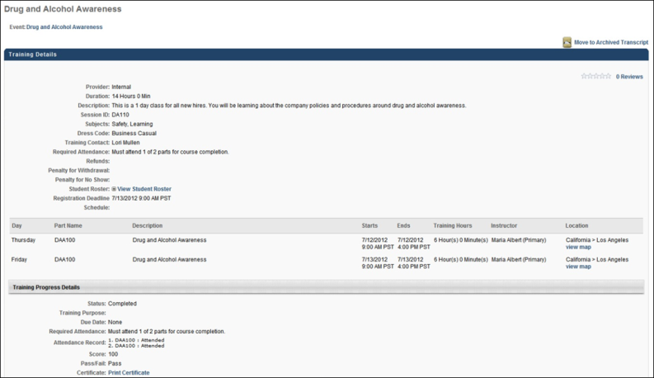
Event
The event's Training Details page displays all previous sessions that are in a status of Completed in addition to any current sessions for the user. Click the session locator number to view the Training Details page for the corresponding session.
The event's Training Details page can be accessed by clicking the event title in the upper-left corner of the session's Training Details page.
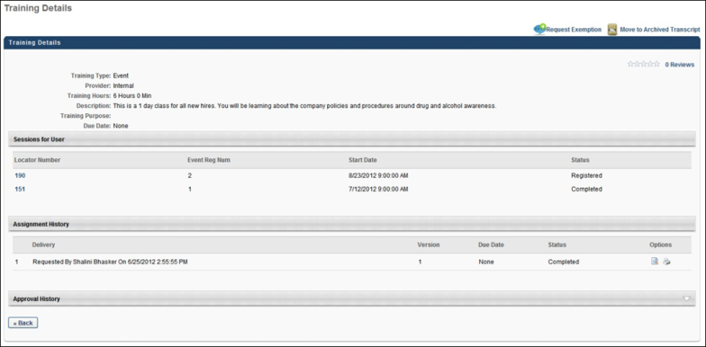
External Training Requested via SF-182 Form
See Training Details - External Training Requested via SF-182 Form on page 160 for additional information.
Learning Details Redesign
With the February 2019 release, a redesigned Learning Details page was released as an Early Adopter project. As of the August 2020 release, this project is no longer in an Early Adopter status and is now generally available. The Learning Details page is available for the following training types if enabled by your system administrator:
- Curricula
- Events and Sessions
- External Content
- Materials
- Online Content
- Online Courses
- Tests
- Videos
More features will be added to the Learning Details page in future releases. For more information about the redesigned Learning Details page: See Learning Details Page .
Training Details - Acknowledge Completion
If a completion signature is required for a learning object (LO), the user must submit an electronic signature on the Transcript Details page for the LO. Note: If an electronic signature is not required, the electronic signature section does not appear.
The name of the electronic signature section is customizable in the Training Completion Signature Preferences, but the default section name is Acknowledge Completion. The electronic signature section is always located above the Approval History section and is available as soon as the item is added to the user's transcript. However, the ability to sign is not available until the LO is in a status of Pending Completion Signature.
The administrator is able to determine the signature type and signature font in Training Completion Electronic Signature Preferences.
- If the signature is pre-populated, then the system displays a read-only view of the user's signature in the selected signature font. Users must click the Sign button in order to electronically sign the completed LO.
- If the signature must be entered manually, then the user must manually enter their full name and click the Sign button in order to electronically sign the completed LO. After the LO is electronically signed, the user's electronic signature appears in the selected signature font.
Clicking the Sign button serves as your acknowledgment that you have completed the training item. Only the user can provide an electronic signature for training that is on their transcript. Managers and Administrators are unable to provide an electronic signature for a user. This character limit for this field is 600.
Once an electronic signature is applied, the user's name appears in place of the input box and cannot be edited. Also, a history stamp is displayed to the right of the signature, including the date and time on which the electronic signature is provided. The learning object status is changed to Complete.
User Authentication
If the User Authentication option is selected in the Training Completion Signature Preferences, when the user clicks the Sign button, an authentication pop-up appears. The user must authenticate the electronic signature by entering their user ID and system password and click Submit. This authentication must occur before the learning object is considered Complete.
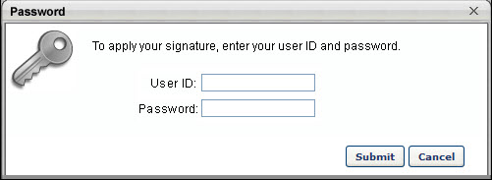
Training Details - Assignment and Version History
On the Training Details page for a training item on a user's transcript, an Assignment and Version History section displays. Each occurrence of training displays as a separate line item in this section. The following information displays in this section, if available:
- Registration Number - This column shows the registration number for each assignment of the training. This field can be reported on using a custom transcript report.
- Latest Registration? - In the Latest Registration column, a Yes/No value displays, indicating whether or not the training registration is the latest active registration on the user's transcript.
- Delivery - This column displays the method by which the training was assigned to the user, the user who assigned the training, and the date and time the training was assigned.
- Transcript Delivery Method - In the Transcript Delivery Method section, the method by which the training registration was delivered to the user's transcript displays. Possible values include:
  - Self Requested
  - System Assignment (LAT)
  - Direct Assignment (From a manager or via ILT roster submission)
  - Express Class
  - Assignment
  - Other
- Version - This column displays which version of the training is on the user's transcript.
- Effective Date - This column displays the date the training is effective in the Course Catalog.
- Start Date - This column displays the Start Date specified for the training assignment, if available.
- End Date - This column displays the End Date specified for the training assignment, if available.
- Due Date - This column displays the Due Date specified for the training assignment, if available.
- Status - This column indicates what status the training is in on the user's transcript (i.e. Registered, In Progress, Completed, etc.)
- Options - The following options are available for line items in the Assignment and Version History section:
  - View Details - Click this icon to view the Training Details page for a specific assignment on the user's transcript. The top of the page reads, "Previous Assignment Information" to alert the viewer that they are viewing the training details for a previous instance of the training on the user's transcript. See the below section for more information.
  - Transcript Delivery Method - In the Transcript Delivery Method section, the method by which the training registration was delivered to the user's transcript displays. Possible values include:
    - Self-Requested
    - System Assignment (LAT)
    - Direct Assignment
      - Training was assigned directly (for example by a manger to a user)
      - Training was submitted via ILT Roster Submission
    - Express Class
    - Assignment* (This category is representative of historical data records prior to the Feb '19 release which are not reliable and therefore have been contained separately to preserve data quality. Over time, this category will be deprecated.
Other
    - The Other status appears for all other miscellaneous transcript delivery cases, including:
      - Assignment via Inventory
      - Added by Training Plan
      - Historical Data Loads (except in certain cases described in above values)
      - Data Load Wizard
Considerations
    - The Assignment and Version History section is called "Assignment History" if the training has not yet been versioned. This is preexisting functionality.
    - There may be multiple entries within the Assignment and Version History section that are considered the Latest Registration. This is preexisting functionality that occurs when a training is versioned using Append versioning.
Training Details - Attachments
The Attachments section is only available for instructor led training (ILT) sessions and it is only available if the user or administrator has permission to view or manage attachments in the transcript. Attachments are displayed in the order in which they were uploaded, with the oldest attachments displayed first.
Click the attachment name to open the attachment.
Permissions
PERMISSION NAME | PERMISSION DESCRIPTION | CATEGORY

Attachments in Transcript - Manage | Grants ability to upload new attachments and delete existing attachments for LOs on a user's transcript. Users with this permission are automatically granted permission to view attachments. This permission can be constrained by OU, User's OU, User Self and Subordinates, User, User's self, User's ILT Provider, ILT Provider, and Instructor. | Learning Administration

Attachments in Transcript - View | Grants ability to view attachments that have been uploaded for LOs on a user's transcript. This permission can be constrained by OU, User's OU, User Self and Subordinates, User, User's self, User's ILT Provider, ILT Provider, and Instructor. | Learning
Attachment - Add
The maximum number of attachments that can be added for a single session per attendee is five.
To add an attachment to the Transcript Details page for an ILT session, follow these steps:
- In the Attachments section, click the Add Attachment link. This opens the Upload File pop-up.
- Click the Browse button.
- Browse for and select the appropriate file on your computer. The following file types are accepted: Word, Excel, PowerPoint, pdf, txt, rtf, gif, and jpg.
- Once a file is selected, it is displayed in the Upload File pop-up. Click the Upload button, or click the Browse button to select a different file.
- Once a file is uploaded, it appears in the Attachments section.
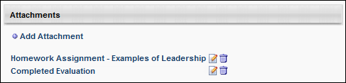
Attachment - Edit
If an attachment is added to the Attachments section of the Transcript Details page, the display name can be edited.
To edit the display name for an attachment, follow these steps:
- Next to the appropriate attachment in the Attachments section, click the Edit icon . The display name becomes editable.
- In the Display Name field, modify the display name, as necessary. The character limit for this field is 300.
- After editing the display name, click the Save icon to save the changes, or click the Cancel icon to discard the changes.
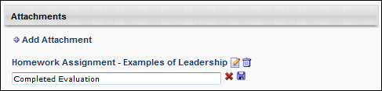
Attachment - Remove
To remove an attachment, next to the appropriate attachment in the Attachments section, click the Remove icon .

Training Details - Audit History Stamps
The following statuses and actions are tracked in the Audit History for the Transcript Details page:
- Requested
- Exception Requested
- Assigned
- Requested Waitlist
- Canceled
- Expired
- Denied
- Deferred
- Approved
- Registered
- Started
- Completed
- Granted
- Granted Waitlist
- Withdrawn
- Discontinued
- Marked Incomplete
- Reset Attempts
- Failed
- Edited
- Score Updated
- Removed
- Removed from Transcript
- Restored to Transcript
- Archived
- Unarchived
- Rolled Back
- Due Date Edited
The Electronic Signature history stamp is included in the Audit History, if applicable. When a user submits an electronic signature, a history stamp appears, detailing the signer's full name, user ID, signature date and time, and any signature message that is associated with the signature. Please note that the signature message on transcript history is limited to 250 characters. If the signature message exceeds 250 characters, the message will be truncated within the transcript history section.
All history stamps in the transcript include the user ID following the user's name (i.e., "<Last Name, First Name><User ID>").
unTraining Details - Cohort Structure
For cohort LOs, the cohort structure is displayed in the Cohort Structure section. This section displays all of the training that is contained in the cohort structure. The following information is displayed for each training item in the cohort structure:
- Section Title
- Title - Click the arrow to the left of the training title to view the training description.
- Type
- Due Date
- Status
- Details - If the corresponding training item is on the user's transcript, then this column contains a link that opens the Transcript Details page for the training.
Training Details - Curriculum Details Table
For curricula, the curriculum details table on the Training Details page displays the following columns and options:
- View - The following viewing options are available:
  - All Training - This option displays both activated and not activated training.
  - Activated Training - This option displays activated training.
  - Not Activated Training - This option displays training that is not yet activated.
- Title - This field displays the training title. You can click the arrow next to the title to view the training description.
- Type - This field displays the training type.
- Due Date - This field displays the due date of the training if a due date is configured; shows "None" if a due date is not configured.
- Excused - This field displays whether or not a user is excused from the training. Note: Excused is not a transcript status and therefore does not prevent the user from being required to complete the LO if it is required in another curriculum, cohort, or somewhere else on the transcript. It only excuses the user from the version of the LO that is active in the curriculum or cohort in which it has been marked excused. If the LO is later reversioned, it will no longer be Excused. This is different from Exempt, which is a transcript status and exempts the LO anywhere it is required on the transcript.
- Status - This field displays the status of the learning object.
- Options - This field displays the options available, such as Launch, which allows you to launch a training item, View Checklist, which allows you to view an observation checklist, or Request Exemption. If there are no options are available, then "None" displays in grayed out text.
For administrators, if an observation checklist is added to a curriculum, you can validate the checklist by clicking the Validate Checklist link in the Options column. This opens the checklist and allows you to validate the items. Note: Administrators can also access the Validate Checklist link from the Training Details page of the checklist. Additionally, managers can validate a checklist if the checklist is configured by the administrator to allow managers to validate. Managers can access the checklist from either the Curriculum Details page or the Training Details page, but the link that appears is View Checklist instead of Validate Checklist.
  - For administrators, it is possible to exempt a learner from a specific training item in the curriculum if this training is in one of the following statuses (as described on the Curriculum Details page):
    - Pending Prior Training
    - Activation Allowed
    - None (“None” corresponds to a Completed, Withdrawn, Denied or No Show training status)
- Details - This field displays the View Details icon. If details are not available to view, "None" displays in grayed out text.
Curriculum Structure Modification History Page
The Structure Modification History page is accessible from both the Course Console page and the Transcript Details page for curricula. The Structure Modification History page captures an audit trail of changes made to the curriculum's structure.
Permissions
PERMISSION NAME | PERMISSION DESCRIPTION | CATEGORY

Course Catalog - Update | Grants ability to manage and edit training items listed in the Course Catalog and also grants access to the Course Console, where training can also be managed and edited. This permission also grants access to the Popular Requests and Highest Rated widgets on the Learning Admin Console (in conjunction with the Learning Admin Console - View permission). This permission also allows administrators to reversion online courses via the Course Console page. This permission also allows administrators to access an Edit Training option for training items included as objectives in Development plans.  This permission can be constrained by OU, User's OU, Training Type, Training Item, Provider, ILT Provider, User's ILT Provider, User, User Self and Subordinates, and User's LO Availability. This is an administrator permission.  Note: Adding an OU constraint and a provider constraint to this permission results in an "AND" statement. | Learning - Administration

Course Catalog - View | Grants access to view the learning objects in the course catalog and enables administrators to view the Course Console and the Popular Requests and Highest Rated widgets on the Learning Admin Console (in conjunction with the Learning Admin Console - View permission). This permission can be constrained by OU, User's OU, Training Type, Training Item, Provider, ILT Provider, User's ILT Provider, and User's LO Availability. This is an administrator permission.  Adding an OU constraint and a provider constraint to this permission results in an "AND" statement. | Learning - Administration

View Transcript Item | Grants ability to view details of learning objects that appear on the transcript (training record), by clicking on the name of the learning object. Users must also have the Bio About - View permission in order to access the transcript within Universal Profile. This permission can be constrained by OU, User's OU, User Self and Subordinates, User, or User's Self. This is an end user permission. | Learning - Administration
Structure History from Course Console
To access the Structure History from the curriculum's Course Console page, the administrator must have permission to access Course Console. To view the Structure History page, click the Options drop-down at the top of the Course Console page and click the Structure History link. For more information about the Course Console: See Course Console - Details.
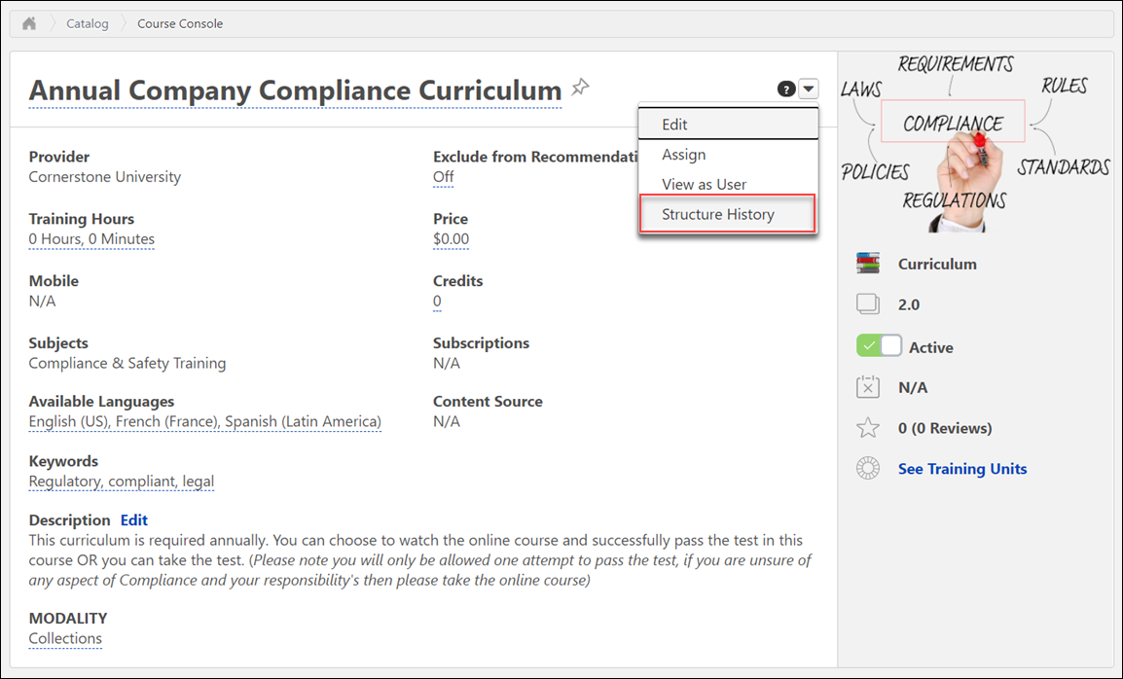
Structure History from Transcript Details
To access the Structure History from the Transcript Details page for a curriculum, the user must have permission to view transcript items. To view the Structure History page from the Transcript Details page, click the Structure History link located next to the curriculum version number.
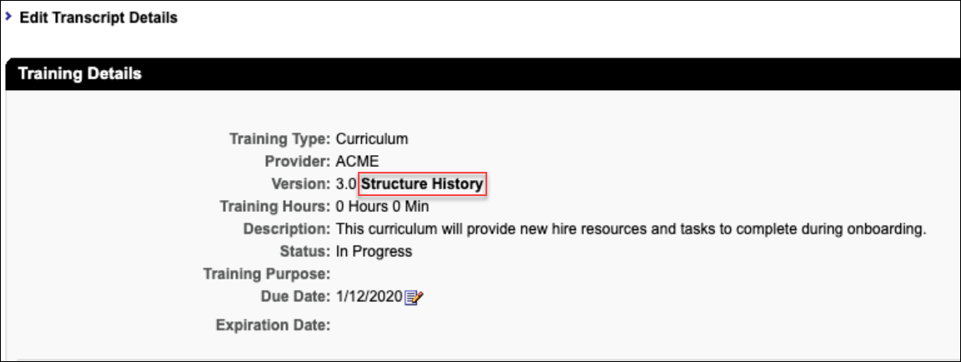
Structure Modification History Page
The following features are available on the Structure Modification History page:
- Search Bar - Type the name of a training item included in the curriculum into the search bar to search for modification records related to that item.
- Export - Click the Export button to export the information from the Structure Modification History page in PDF format.
- Table of modifications - The following information displays for each structure modification item in the table:
  - Curriculum Version
  - Training Title
  - Training Version
  - Training Object ID
  - Course Code
  - Effective Date (i.e. the date when a version becomes active or effective. For training types that do not version, the Effective Date will be the date the training was created)
  - Date of Change - This field displays the date the action took place (e.g. when a curriculum child training item was added to the structure). On the transcript view for Structure History, the Date of Change will display the date the curriculum and child training items are assigned to the user. Every entry after initial assignment will display the date the action took place.
  - Changed By
  - Change Description - There are two values that may display for this field: Added or Removed. When a child training item is added to a curriculum structure, is denoted as Added. When a child training item is removed from a curriculum structure, it is denoted as Removed.
    - If a child training item is versioned with Replace logic, the prior version will be listed with a Change Description value of Removed. A separate line item displays the newly-created version as Added.
    - If a child training item is versioned with Append logic, a line item displays the newly-created version as Added.
    - When the prior version expires, an entry is created only in the Course Console structure history page, and will audit when the expired training is removed from the curriculum. Child training expirations are not captured on the Structure History page at the user transcript level.
Training Details - Edit Due Date
Managers can edit a learning object's (LO) due date for a subordinate from the Transcript Details page or the Edit Transcript Details pop-up if the LO status is not Completed and the LO is active. When a manager is viewing the Transcript Details page or the Edit Transcript Details pop-up for a subordinate's LO, an Edit icon appears to the right of the Due Date in the Training Details section. This opens the Edit Due Date pop-up.
Select the new due date and enter comments to explain why the change was made. These comments will appear on the Transcript Details page.
After selecting the new due date and entering comments, click Save to save the new due date. Or, click Cancel to cancel the due date change.
Permissions
PERMISSION NAME | PERMISSION DESCRIPTION | CATEGORY

Edit Transcript Items | Grants ability to modify training due dates, statuses, and scores on other user's transcripts (training records) when viewing training details for particular learning objects on the transcript. User must also have permission to add external training in order to add or edit another user's external training. This permission can be constrained by OU, User's OU, User Self and Subordinates, User, and User's Self.  Note: Users with this permission also will also see the Add SF-128 link on the transcript. | Learning - Administration

View Transcript Item | Grants ability to view details of learning objects that appear on the transcript (training record), by clicking on the name of the learning object. Users must also have the Bio About - View permission in order to access the transcript within Universal Profile. This permission can be constrained by OU, User's OU, User Self and Subordinates, User, or User's Self. This is an end user permission. | Learning - Administration
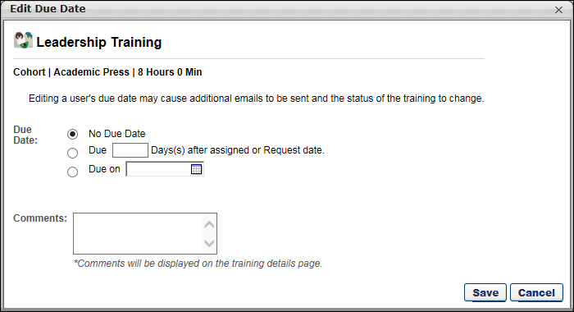
Helpful Hints
- Because it is possible to define a due date for a session or event via proxy enrollment, it is possible to edit a due date for a session or event.
- Reporting only references a user's LO due date as it exists on their transcript. It is not possible to report on changes to a due date.
- Editing a due date may change or impact when a user may receive an email related to the LO. For example, if you extend a due date for an item that is past due, and now it is no longer past due, the user will not receive Training is Past Due email, but may receive a reminder email that training is due.
Training Details - Edit Transcript Details
The Edit Transcript Details pop-up allows administrators to edit certain fields from the Training Details page. Which fields are visible in the pop-up is dependent upon the learning object type. Which fields you have the ability to edit is dependent upon your permissions.
Administrators can edit the transcript details from the Transcript Details page by clicking the Edit Transcript Details link at the top of the page. This opens the Edit Transcript Details pop-up.The due date can be edited by clicking the Edit icon to the right of the Due Date. This opens the Edit Due Date pop-up. See Training Details - Edit Due Date on page 150 for additional information.
Permissions
PERMISSION NAME | PERMISSION DESCRIPTION | CATEGORY

Edit Transcript Items | Grants ability to modify training due dates, statuses, and scores on other user's transcripts (training records) when viewing training details for particular learning objects on the transcript. User must also have permission to add external training in order to add or edit another user's external training. This permission can be constrained by OU, User's OU, User Self and Subordinates, User, and User's Self.  Note: Users with this permission also will also see the Add SF-128 link on the transcript. | Learning - Administration

Training Purpose - Edit User's Purpose | Grants access to edit the training purpose and category on the user's transcript details. Admin must have access to user's transcript. This is an administrator permission. | Learning - Administration

View Transcript Item | Grants ability to view details of learning objects that appear on the transcript (training record), by clicking on the name of the learning object. Users must also have the Bio About - View permission in order to access the transcript within Universal Profile. This permission can be constrained by OU, User's OU, User Self and Subordinates, User, or User's Self. This is an end user permission. | Learning - Administration
Note: If Training Purposing is active in the portal and a user has indicated a training purpose when assigning or requesting training, the administrator can edit the Training Purpose and Category fields in the Edit Transcript Details pop-up. The category field only displays for purposes that require a two-step process.
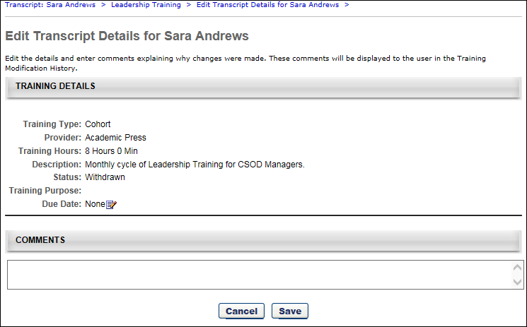

Exempt Prerequisites/Pre-Work/Post-Work
Administrators can exempt pre or post work and override a prerequisite requirement from the Training Details page.
To exempt prework, post work, or override a prerequisite, go to Admin > Tools > Core Functions > Users. Then, select the View Transcript option in the Options drop-down menu for the appropriate user.
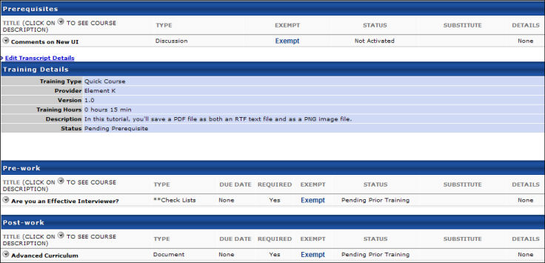
- From the user's transcript, select the appropriate training item to view the Training Details page. See Training Details - View on page 124 for additional information.
- Exempt:
  - Prerequisites - Select the Exempt link to allow the user to register for the associated training without having to complete the prerequisite. The user will see "Yes" under the Exempt column.
  - Pre-Work - Select the Exempt link to bypass the pre-work requirement.
  - Post-Work - Select the Exempt link to bypass the post-work requirement.
User Workflow
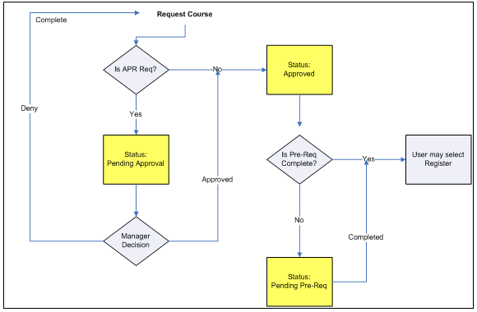
Helpful Hints
Catalog Management (Register upon Approval) - If a training item is set to Register on Approval and the training item has a prerequisite, the prerequisite will be ignored and the user will be registered for the training. The Training Details page will show the prerequisite as not exempt for the user, even though the user was able to bypass the prerequisite due to the Register upon Approval setting.
Learning Assignment (Assign, Approve & Enroll employees directly into Training) - If a training item has a prerequisite, and is assigned using a learning assignment with the option to Assign, Approve, & Enroll employees, the prerequisite will be ignored, and the user will be registered into the training. The Training Details page will show the prerequisite as not exempt for the user, even though the user was able to bypass the prerequisite due to the learning assignment option.

Exemption - Request
Exemption from a training item can be requested by the user from either the Training Details page or the Curriculum Player.
Permissions
PERMISSION NAME | PERMISSION DESCRIPTION | CATEGORY

Launch Curriculum Player | Grants users the ability to launch a curriculum in the curriculum player view if the curriculum player option is enabled for the particular curriculum. This is an end user permission. | Learning - Administration

Request Exemption from Training | Grants ability to request Exemption from completing an assigned learning object, via the "Request Exemption" link on the top right corner of the Training details page for any transcript item. The request is sent to the persons allowed to approve Exemption requests of the submitting user. This permission cannot be constrained. This is an end user permission. | Learning
To request training exemption from the transcript, click the Options drop-down next to the training on the transcript page and click the Request Exemption option. Then, follow these steps:
- The Exemption Request pop-up opens. Select a reason for the exemption in the Indicate Reason field and enter comments in the Comments box (character limit of 100). Note: Other is available by default in the Indicate Reason field. Additional reasons are available if configured for the portal. Only one exemption request can be made at a time for a learning object.
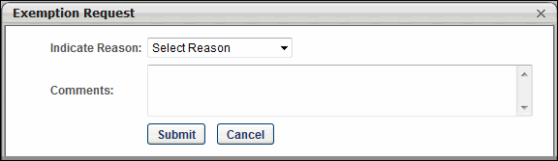
  - Click Submit. The Request Exemption link on the Training Details page changes to Exemption Request Pending and cannot be clicked. The Approval History section records the exemption request.
  - Click Cancel to cancel the Exemption Request action.
To request exemption via the Training Details page from curriculum that is not yet activated:
- Click the Request Exemption link in the upper-right corner to request exemption from an entire curriculum. Or, click the Request Exemption link under the Options column to request exemption from an LO within a curriculum.
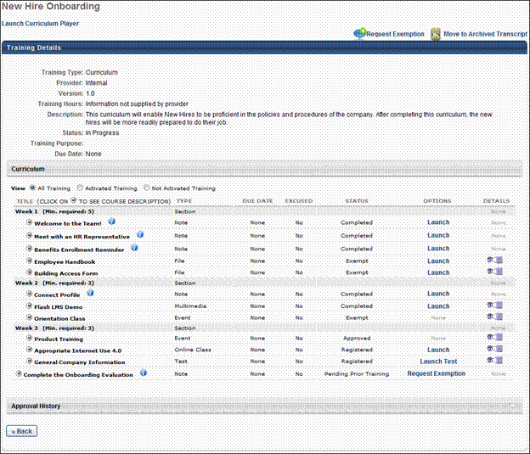
- The Exemption Request pop-up opens. Select a reason for the exemption in the Indicate Reason field and enter comments in the Comments box (character limit of 100). Note: Other is available by default in the Indicate Reason drop-down. Additional reasons are available if configured for the portal. Only one exemption request can be made at a time for a learning object.
  - Click Submit. If requesting exemption for an entire curriculum, clicking Submit changes the Request Exemption link in the upper-right corner of the Training Details page to Exemption Request Pending and cannot be clicked. If requesting exemption from an LO within a curriculum, clicking Submit changes the value in the Options column on the Training Details page to Exemption Request Pending and cannot be clicked. The Approval History section records the exemption request. Note: If an LO has a Launch value in the Options column prior to submitting the request, the value in the Options column remains unchanged. You can verify that your exemption request was submitted by opening the View Details page and seeing that the Exemption Request Pending link is grayed out.
  - Click Cancel to cancel the Exemption Request action.
To request exemption from a curriculum item that has been activated:
- Click the View Details icon in the Details column on the Training Details page.
- The View Details page opens. The Request Exemption link displays in the upper-right corner.
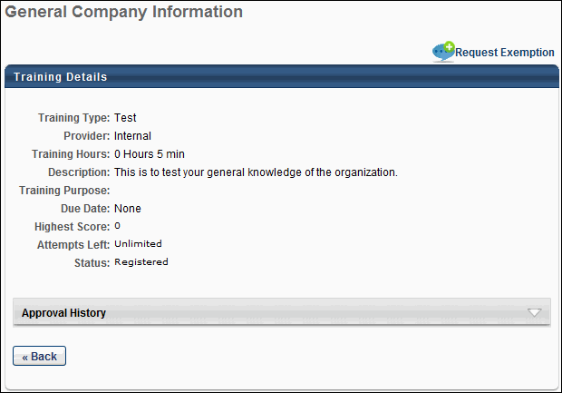
- Click the Request Exemption link.
- The Exemption Request pop-up opens. You must select a reason for the exemption in the Indicate Reason field and enter comments in the Comments box (character limit of 100). Note: Other is available by default in the Indicate Reason drop-down. Additional reasons are available if configured for the portal. Only one exemption request can be made at a time for a learning object.
  - Click Submit. The Request Exemption link on the Training Details page changes to Requested Exemption and cannot be clicked. The Approval History section records the exemption request.
  - Click Cancel to cancel the Exemption Request action.
Transcript Status for Exempted Learning Objects
If your exemption request is granted, the LO's status changes to Exempt on your transcript. If the LO is configured to allow users to request it more than once and you select the Request Again link, the LO with the Exempt status displays in the Assignment History section of the Training Details page.
To see actions available for Exempt LOs and other statuses: See Transcript (Universal Profile) - Status and Options on page 96 for additional information.
Considerations for Events and Sessions
- If you are exempted from an event, the status of the LO on your transcript changes to Exempt. The event's status does not affect the session's status; you must be exempted from a session separately.
- If you are already exempted from an event and are subsequently exempted from a session, the exemption does not change the event's status.
- If you complete a session within an event that has an Exempt status, the status remains Exempt and does not change to Completed.
- When a user registers for an event that is not associated with a session, then only the event is displayed in the Completed (if exempted) and Removed tabs of the user's transcript.
- When a user registers for an event that is associated with a session, only the session is displayed in the Completed (if exempted) and Removed tabs of the user's transcript.
Training Details - External Training Requested via SF-182 Form
When external training is requested with the SF-182 form, the Training Details page displays an SF-182 Request Details section. Only the fields that are configured to display in SF-182 Preferences appear. If the user completed the Conditional Service Agreement form, a link to download the form appears in the Conditional Service Agreement Form field.
Additionally, users can select an approver for each applicable step in the approval process by clicking the Add Approver link in the Options column. The user can select from any active user in the portal, and the approver is added to the approval queue for that step. The link remains available even after an approver is selected.
Print
The Print option displays a printable view of the SF-182 form. Custom fields appear at the bottom of each applicable section. The Approval section appears at the bottom of the printable view window.
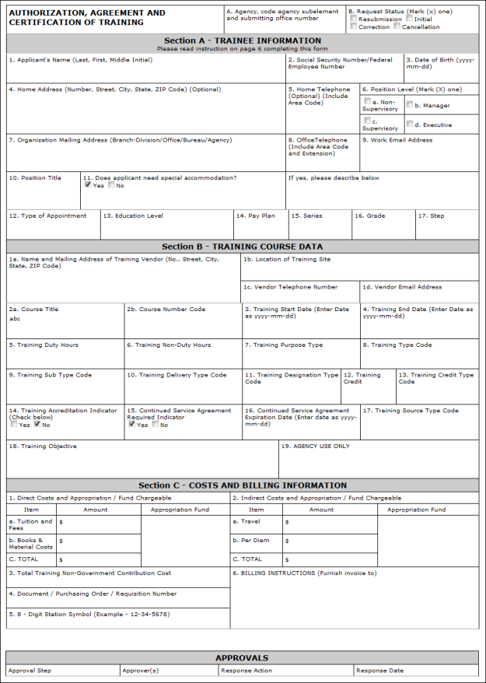
Approval History
The Approval History section tracks SF-182 approval actions and the initial submission of the request.
Note: The SF-182 functionality must be available in your portal in order to request external training using the SF-182 request form. See SF-182 Form - Overview on page 70 for additional information.
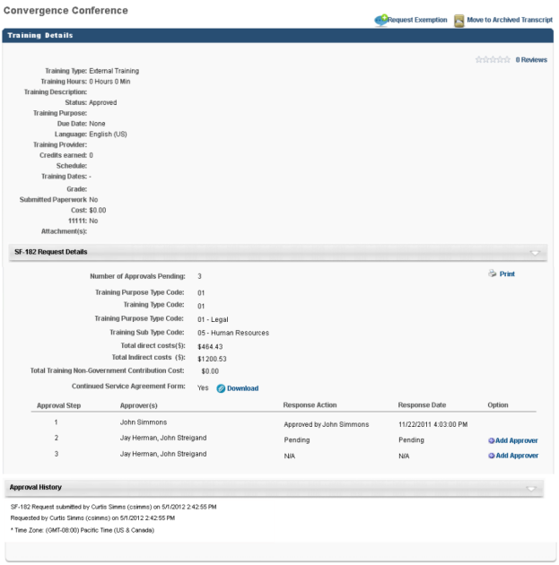
Generate Audit PDF
If Audit Trail functionality has been enabled in your portal, the Generate Audit PDF feature enables administrators to generate a PDF export of the audit trail for the following training types and fields:
- Online Courses - Title, Description, Prerequisites, Pre-work, Post-work, Training Equivalents, Language Equivalents, Active/Inactive Status, Custom Fields
- Materials - Title, Description, Prerequisites, Pre-work, Post-work, Training Equivalents, Language Equivalents, Active/Inactive Status, Custom Fields, Start Date, Source (Source changes via the UI and Edge Import do not appear in the report)
- Tests - Title, Description, Attempts Allowed, Time Limit, Passing Score, Pre-work, Post-work, Training Equivalents, Language Equivalents, Active/Inactive Status, Custom Fields
- Videos - Title, Description, Prerequisites, Pre-work, Post-work, Training Equivalents, Language Equivalents, Active/Inactive Status, Custom Fields, Source
- Events - Title, Description, Training Equivalents, Language Equivalents, Active/Inactive Status, Custom Fields
- Sessions - Instructor, Start Date/Time, End Date/Time, Prerequisites, Pre-work, Post-work, Custom Fields
- Curricula - Title, Description, Training Equivalents, Language Equivalents, Active/Inactive Status, Custom Fields
- External Training - Title, Description, Institution, Date Range, Attachment
- Transcript Items - Status (to Completed), Status (to Exempted), Score (Online Courses), Score (Tests), Score (Sessions)
Permissions
PERMISSION NAME | PERMISSION DESCRIPTION | CATEGORY

Course Catalog - Update | Grants ability to manage and edit training items listed in the Course Catalog and also grants access to the Course Console, where training can also be managed and edited. This permission also grants access to the Popular Requests and Highest Rated widgets on the Learning Admin Console (in conjunction with the Learning Admin Console - View permission). This permission also allows administrators to reversion online courses via the Course Console page. This permission also allows administrators to access an Edit Training option for training items included as objectives in Development plans.  This permission can be constrained by OU, User's OU, Training Type, Training Item, Provider, ILT Provider, User's ILT Provider, User, User Self and Subordinates, and User's LO Availability. This is an administrator permission.  Note: Adding an OU constraint and a provider constraint to this permission results in an "AND" statement. | Learning - Administration

Course Catalog - View | Grants access to view the learning objects in the course catalog and enables administrators to view the Course Console and the Popular Requests and Highest Rated widgets on the Learning Admin Console (in conjunction with the Learning Admin Console - View permission). This permission can be constrained by OU, User's OU, Training Type, Training Item, Provider, ILT Provider, User's ILT Provider, and User's LO Availability. This is an administrator permission.  Adding an OU constraint and a provider constraint to this permission results in an "AND" statement. | Learning - Administration

View Transcript Item | Grants ability to view details of learning objects that appear on the transcript (training record), by clicking on the name of the learning object. Users must also have the Bio About - View permission in order to access the transcript within Universal Profile. This permission can be constrained by OU, User's OU, User Self and Subordinates, User, or User's Self. This is an end user permission. | Learning - Administration
Generate Audit PDF from User Transcript
To generate an audit PDF from a user's transcript, the administrator can access the Training Details page for a training item on the user's transcript and click the Generate Audit PDF link located above the Training Details table.
Note: The Generate Audit PDF link is not available if the Transcript Lockdown functionality is enabled in your portal.
Generate Audit PDF from Course Console
To generate an audit PDF from the Course Console, the administrator can navigate to the Course Console page for a specific training item, click the Options drop-down arrow, and then select the Generate Audit PDF link.
Audit PDF Report Output
The report output displays detailed information about the training item's history on the user's transcript, including the following information:
- Field Name - The field that has changed
- From - What the field value changed from
- To - What the field value changed to
- Actor Name - The name of the user who changed the field value
- Action Date - The date the field value was changed
- Comments - Any comments an administrator may have provided for the change
Training Details - Pending Approval/Completion Approval Panel
For learning objects (LO) that require approval or completion approval, a Pending Approval or Pending Completion Approval panel displays. The panel displays the approver who is required to approve the user's LO, as well as the approver's associated OU.
Permissions
PERMISSION NAME | PERMISSION DESCRIPTION | CATEGORY

Pending (Completion) Approval Training Details | Grants ability to view the Approvals section of the Training Details page. This permission can be constrained by OU, User's OU, and Training Type. This is an end user permission. | Learning
Panel Approval/Completion Approval Panel
The following information displays:
- Current Approval Step - "Approval currently pending from [OU Name]: [Name of user required to approve]"
- Single Approver - "Approval Required by [OU Name]: [Name of user required to approve]"
- Two Approvers - "Approval Required by [OU Name]: [Name of user required to approve] or [Name of user required to approve]"
- Three Approvers - "Approval Required by [OU Name]: [Name of user required to approve], [Name of user required to approve], or [Name of user required to approve]"
- Four or More Approvers - "Approval Required by [OU Name]: [Name of user required to approve], [Name of user required to approve], [Name of user required to approve], etc." Note: In order to ascertain the remaining approvers that are not visible in the row, contact the appropriate training contact for the LO.
- Multiple OUs in One Approval Step - In this setup, either OU can record an approval decision:
  - "Approval Required by [OU Name]: [Name of user required to approve] OR"
"Approval Required by [OU Name]: [Name of user required to approve]"
- Multiple OUs in One Approval Step - In this setup, both OUs are required to record an approval decision:
  - "Approval Required by [OU Name]: [Name of user required to approve] AND"
"Approval Required by [OU Name]: [Name of user required to approve]"
Note: When an approval step has two or more approvers, approval for the step is achieved as soon as one of the approvers approves the step.
Note: The approval process for an LO is configured by the administrator.
Once an approval step is completed, the step is removed from the panel, and the Approval History section displays the approval decision.
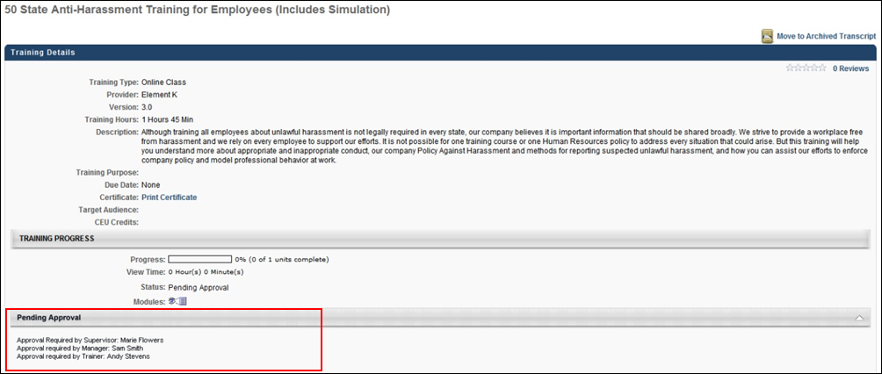

Training Details - Print Preview
When a learning object requires an electronic signature for completion, the user, manager, and administrator have the option to view a printable version of the Transcript Details page. This page includes a section for the electronic signature whether or not it has been signed and completed.
Only the following sections will appear in the print out:
- Training Details
- Acknowledge Completion
- Approval History
If the electronic signature has not yet been provided, the print preview indicates that this is not yet complete.
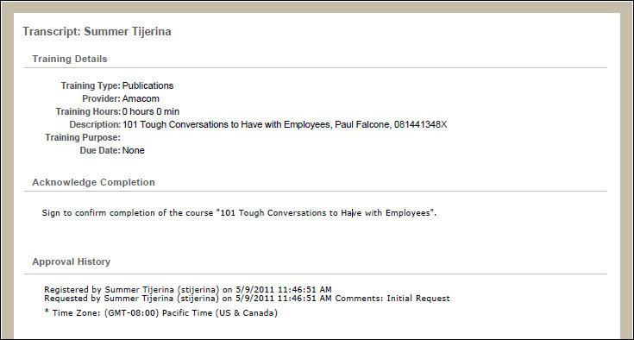
Once the electronic signature is provided, the print preview displays the signature as well as a history stamp indicating the date and time at which the signature occurred.
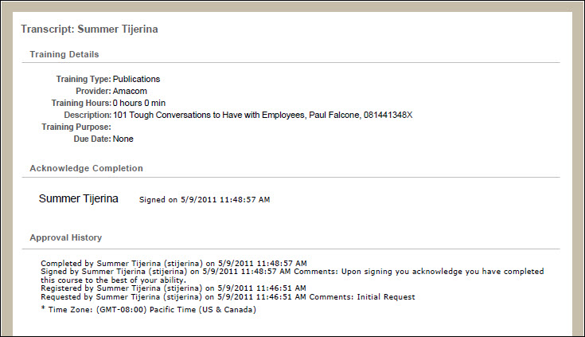
Training Details - Session Details Table
For sessions, the session details table displays the following for each session part:
- Day - This column displays the day on which the part occurs.
- Part Name - This column displays the name of the part.
- Description - This column displays the part description.
- Starts - This column displays the part's start date and time. Note: If the administrator configures the session to display the start and end times in the user's time zone, then the start time displays in the user's time zone.
- Ends - This column displays the part's end date and time. Note: If the administrator configures the session to display the start and end times in the user's time zone, then the end time displays in the user's time zone.
- Add to Calendar - This column displays the Add to Calendar option. The Add to Calendar option enables users to add the session to their Outlook or Google calendar. This option is especially helpful for users who register for a session for which no emails are configured or who decline the initial meeting invite but decide later that they would like to add the session to their calendar. The option appears for each part instance. See the Add Part to Calendar section below for additional information.
- Training Hours - This column displays the number of training hours for the part.
- Instructor - This column displays the instruction for the part.
- Location - This column displays the part's location.
Add Part to Calendar
To add the part to your calendar:
- Click Add to Calendar. This opens the File Download pop-up.
- Click Open. This opens a security pop-up.
- Click Allow. This downloads the file and opens an appointment email. The subject is the name of the event, and the location is the session location. However, the Sender field and message body of the email is blank. Note: The appointment may have a default reminder time set. The reminder time can be changed using the options in your calendar tool.
- Click Save & Close to add the session to your calendar. If you do not wish to add the session to your calendar, click Delete. This prompts you to select Yes or No to delete the email. Click Yes. This prompts you to confirm your response. Click Yes. This closes the email and does not add the session to your calendar.
Once a user adds a part to their calendar, any updates related to the part are made to their calendar via email, if configured by the administrator. If the part is cancelled or removed from the session, this triggers a session cancellation email for the part, if configured by the administrator. The cancellation email contains the standard email options for cancelled appointments.
If the part is not cancelled but the user no longer wishes to have the part appear on their calendar, then they must manually remove it from their calendar.

Training Details Page - Certification
From the Training Details Page for certifications, users can view and launch the training associated with the certification, view the certification history, and print any past certificates.
To view the Training Details Page for a certification, navigate to the Transcript and click the Certifications tab on the left navigation. Then, click the title of a certification. Note: This is not available if certifications are not enabled for the portal.
Permissions
PERMISSION NAME | PERMISSION DESCRIPTION | CATEGORY

Certification - Update Credit | Grants administrator ability to update the number of acquired credits on a user's certification progress report page. This also enables administrators or users to "certify" users by adjusting the number of credits received. This is an administrator permission. | Learning - Administration

Withdraw Users from Sessions | Allows administrators and managers to withdraw users from sessions on their behalf. This is done from the user's Transcript page. Note: There is a setting in the Session Defaults for an event that may prevent users from being able to withdraw from sessions. When this option is selected, users, managers, and administrators are prevented from withdrawing from sessions for themselves or on behalf of other users. This permission can be constrained by OU, User's OU, User's Self and Subordinates, User, User's Subordinates, and User's Direct reports. This is a manager or administrator permission. | Learning
Certification Details
In the Details section, view the details of the certification. Note: For portals with multiple languages enabled, the Current Period field displays in the language of the user viewing the Training Details page. If the user's language is not available, the field displays in the default language of the certification. The name and localization of this field is managed on the Scheduling step when creating, editing, or copying a certification. The value in the Certification Period Title field on the Configure Training Period pop-up displays in the Current Period on the Training Details page.
In the Certification section, the training associated with the certification is displayed. You can select the appropriate View option to view All Training, Activated Training, or Not Activated Training. By default, All Training is selected. Note: For certifications that are configured not to override the availability settings defined in Course Catalog for a LO, the only LOs that are visible to the user are the LOs for which the user meets the availability criteria defined in Course Catalog for the LO. See Create Certification - General for additional information.
Parent and child sections can be expanded or collapsed by using the Expand and Collapse icons to the left of the section title. By default, the parent section is expanded and the child section is collapsed.
For each training item, the following information displays:
- Title - The section of the certification displays, as well as the number of required and acquired credits. Each time a learning object within then section achieves a status of Completed, the number of credits acquired accumulates for both the parent and child sections. If a learning object has zero credits, the number of acquired credits does not change.
  - The point at which credits accumulate in the parent section is dependent on the certification's configuration in Certification Administration. If the certification is configured to require users to complete the minimum number of credits for all child sections before the credits are counted toward the parent section, then credits only begin to accumulate in the parent section once the child sections have accumulated the minimum number of required credits.
  - Below the section, the title of the training item displays. Click the arrow to the left of the training title to view a description of the training item.
- Type - The training item type (e.g., online class, test, section, external training)
- Credits - The number of credits towards the certification that is granted for completing the training item. For portals with multiple languages enabled, the name of the Credits column appears in the language of the user viewing the Training Details page. If the user's language is not available, the column displays in the default language of the certification.Note: The name and localization of this column is managed on the General step when creating, editing, or copying a certification. The value in the Change tracking unit from credit to field displays as the column name on the Training Details page.
- Status - The current status of the training item. For users who are enrolled as certified, this is set to Not Activated.
If a user is in the Certified status for a certification, the system displays the due date and expiration date for the next certification period, if available.
You can manage the training items by selecting the appropriate option from the Options column. See Certification Item - Launch on page 38 for additional information. For administrators, if an observation checklist is added to a certification, you can validate the checklist by clicking the Validate Checklist link in the Options column. This opens the checklist and allows you to validate the items. If the checklist is part of a curriculum that is inside the certification, then click the Manage link in the Options column. This opens either the Curriculum Details page or the Curriculum Player, depending on how the administrator configured the curriculum.
Note: Administrators can also access the Validate Checklist link from the Training Details page of the checklist. Additionally, managers can validate a checklist if the checklist is configured by the administrator to allow managers to validate. Managers can access the checklist from either the Certification Details page or the Training Details page, but the link that appears is View Checklist instead of Validate Checklist.
To view the training details for an active training item, click the View Details icon in the Details column. This option is only available once the user is approved for the training item. Note: If the training was removed by an administrator, the user will receive a "Restricted Area" message, as removed training is inaccessible to end users.
To add external training to the certification, click the Add External Training link in the Details section. See External Training - Add to Certification from Details Page on page 40 for additional information.
To add an external training item to the certification that already exists on your transcript, click the Add External Training from Transcript link in the Details section. See External Training - Add to Certification from Transcript on page 42 for additional information.
Fields for Certifications in Certified Status
The following fields apply to certifications in a Certified status only. These fields do NOT apply to certifications in any other status, including the Certified (Renewal in Progress) status.
- The Current Period field displays the title of the certification period, along with the date the user completed the period requirements (dates will be shown in UTC time zone).
- The Next Period field displays the title of the next certification period, along with the date the next period will begin (dates will be shown in UTC time zone).
- The Next Version field displays the certification version number the user will receive during the next certification period.
- The Expiration Date field has been updated to Next Period Expiration Date, which indicates when the user's next certification period will expire (dates will be shown in UTC time zone).
- The Due Date field has been updated to Next Period Due Date, which displays the due date for the user's next certification period (dates will be shown in UTC time zone).
History
The History section displays all of the past certification periods for the certification, if applicable. For each period, the following information displays:
- Period - The certification period number.
- Credits Required - The number of credits required for the period.
- Credits Acquired - The number of credits that were earned for the period.
- Carry Over - If carry over is allowed, this displays the number of credits that were carried over to the next period.
- Completion Date - The date the period was completed. For ILT sessions, the session completion date is used, rather than the roster upload date.
- Expiration - The date the certification period was completed. For Past Periods, the Expiration column will display the previous Period Completion Date.
Print Certificate
To print a past certificate, in the History section, click the Print Certificate link next to the appropriate certification. This option is only available if enabled by the administrator. See Historical Certifications - Print on page 44 for additional information.
Certification Requirements
If the certification you are viewing is also within another certification, a Certifications Requirement section displays the requirements for that certification.
Approval History
The certification approval history is displayed in the Approval History section. This includes all approvals related to the certification. If a user is enrolled as certified, this is displayed in this section. If comments were included when the certification was approved or denied, an indication is made here, as well as stating the type of request for which comments were provided (i.e., Initial, Completion, Exception, or Renewal request).
Modification History
For certifications with external training added, a Modification History section is available at the bottom of the Certification Training Details page. This section tracks all updates that are made to the certification.
- If a training section or credits are updated, this is logged.
- If a field is updated, the specific field is logged, including the updated value.
- If multiple fields are updated, a line item is added for each change.
Approval or denial of external training towards the certification continues to be tracked in the Approval History section.
Revoke
To revoke a certification, click the Revoke button. When a user's certification is revoked, the Certification Transcript page reflects the Revoked status in the Status column. In addition, certifications in a Revoked status do not proceed to renewal periods if renewal periods are associated with the certification.
If the user would like to become re-certified, they must re-request the certification or it must be reassigned. Note: The user must be removed from the certification by the certification owner before they can re-request the certification. When re-requested, the Approval History section displays the approval history data of all previous instances of the certification in the user's transcript, regardless of the number of times the certification has been revoked. Progress from the previous certification carries over to the new instance of the certification request/assignment if the learning objects are still valid. Further, the History section does not display for new instances of a certification that was in a Revoked status.
Note: The option to print certificates is not available for certification periods that are in a Revoked status.
Place On Hold
From the Certification Details page, you can place a certification on hold by clicking the Place On Hold button. After clicking the Place On Hold button, a Certification On Hold pop-up window appears. In the pop-up, you can provide a comment explaining why the certification is being placed on hold in the Comments box. After entering a comment, click the Submit button to place the certification on hold. Note: Certifications in any transcript status can be placed on hold.
When the user views the certification on their transcript, the status for the displays with "(On Hold)" following the status the certification was in prior to being placed on hold. For example, if the certification was in a Certified status prior to being placed on hold, when the certification has been placed on hold, the status reads, "Certified (On Hold)."
The "(On Hold)" addendum appears in any system location where the certification status may display, including:
- Transcript
- Certification Details
- Action steps
- Cohort
- Manage Employee Learning
- Certification Management
- Certification Approval page
Reinstate Certification
To reinstate a certification that is on hold, click the Reinstate button on the Certification Details page. A Reinstate Certification pop-up window appears. Enter a comment explaining the reinstatement in the Comments field, and click the Submit button.
The certification returns to its previous transcript status on the user's transcript page, and the reinstatement appears in the Approval History section of the Certification Details page along with the name of the user who reinstated the certification, the time stamp of the reinstatement, and any comments provided during the reinstatement process.
Progress Report
To view the progress report for the certification, click the Progress Report link in the upper-right corner of the page. You can then select the period from the drop-down list and print the report by clicking the Print icon. From the Progress Report, administrators with the appropriate permission can update the user's number of acquired credits. Note: Acquired credits can still be updated when the transcript lockdown feature is enabled. See the Transcript Lockdown section below for additional information.
The following information displays for the report:
- Title - The certification title displays at the top of the report.
- Certification Period - This field displays the certification period. By default, the report shows the progress for the period the user is currently in.
- Options - The Options drop-down displays the option to print the report. Click the Print link to print the report.
- Period - This displays the certification period.
- Due - This displays when the certification is due.
  - Relative Due Date - For certifications with a relative due date defined, the Due field displays the time frame from the start date (i.e., "2 days from start date," or "1 year from start date").
  - Fixed Due Date - For certifications with a fixed due date defined, the Due field displays the actual date.
- Duration - This displays for renewal periods and shows the duration of the renewal period.
- Required Credits - This displays the number of credits required to be completed in order to complete the certification.
- Expand/Collapse - An Expand/Collapse option displays in the upper-right corner of the period. Click the icons to view or close the information in the period. By default, all certification periods are expanded.
- Requirements - This column displays the sections for the certification and lists the LOs defined for each section.
  - If the certification is configured to override the Course Catalog LO availability settings, then all LOs display for the user regardless of whether or not the user meets the availability criteria for the LOs.
  - If the certification is not configured to override the Course Catalog LO availability settings, then the only LOs that display are the LOs for which the user meets the availability criteria.
- LO Type - An icon displays to the left of each LO to indicate the LO type for the training item. Hover over the icon to view the name of the LO type.
- Earned - This column displays information about the credits earned for the certification. If the certification is configured not to override LO availability, then the number of credits is dependent upon the availability of the LOs in the certification.
  - Min/Max - This displays the minimum and maximum number of credits to be completed for a section.
  - Number of Credits - The number of credits defined for a LO displays in the Credits column for each LO.
Modify Period Expiration Date
Only certification owners have the ability to adjust the end date or expiration date for the current certification period. For certification owners, an Edit icon appears to the right of the Expiration Date field. Modifying the expiration date for the period affects the renewal periods in the following manner:
- Fixed Date
  - Only the current period is affected. All future periods retain their expiration date.
  - The updated expiration date must occur prior to the due date of the subsequent period.
- Relative Date and Relative Date with Rolling Renewal
  - If the expiration date for a period is changed, the expiration date and past due date for all future periods are updated based on the change. For example, if the expiration date is pushed back by three months, the expiration date and past due date for all subsequent periods is also pushed back by three months.
  - There is no maximum adjustment for the expiration date.
  - The Past Due date for the current period is not affected.
Transcript Lockdown
If the transcript lockdown functionality is enabled for the portal, then the data that is related to a learning object (LO) on the Certification Transcript Details page and the Progress Report is locked once the LO is completed. Once the LO is completed, the data on the Transcript Details page will not change for the LO. This applies even if the LO is moved to the Archived or Removed tabs of the transcript. This functionality applies to all LO types.
Note: The lockdown functionality does not include custom fields. Custom fields are not locked upon course completion.
Considerations
- If the Transcript Lockdown functionality is disabled and was not enabled at the time the user completed the LO, then the Transcript Details page and Progress Report display the LO information based on the current values in the Course Catalog.
- If the Transcript Lockdown functionality is enabled or was enabled at the time the user completed the LO, then the Transcript Details page and Progress Report always displays the LO information from the time the user completed the LO.
- If the Transcript Lockdown functionality was disabled at the time the user completed the LO and was enabled after the user completed the LO, then the Transcript Details page and Progress Report displays the LO information from the time the Transcript Lockdown functionality is enabled.
Training Details - Certification Removal History
From the Training Details Page for certifications, users can view and launch the training associated with the certification, view the certification history, and print any past certificates. Important: This section is only available if the user was re-enrolled in the certification after previously being removed.
To view the Training Details Page for a certification, navigate to the transcript and click the Certifications tab on the left navigation. Then, click the title of a certification.
The following information is available in the Removal History section (fields with an asterisk will also display history for users removed prior to August 5th, 2022):
- User ID*
- Certification ID*
- Removal date*
- Removed by user*
- Certification Status
- User Status
- Certification user status
- Certification Title
- Comments of Removal
- How was user removed
- Certification status at time of removal
- Certification period at time of removal
- Due Date at time of removal
- Expiration Date at time of removal
- Certification version at time of removal
- Assignment Date
- How assigned
- Who assigned
Export removal history to Excel in the certification management removal history section by clicking the EXPORT TO EXCEL. To access Export to Excel, go to CERTIFICATION MANAGEMENT > MANAGE CERTIFICATIONS > VIEW USERS (under Options), select View Details for a user, and then view the removal history section. The removal history table displays the most recent 10 records with the text The most recent 10 rows are displayed. To export all removal history Export To Excel. To see the previously removal history data, click Export to Excel option which exports all removal history records to Excel.
As of the November 4, 2022 release, these fields are available in Reporting 2.0 in the Certification Removal History Report Type. Capturing of certification removal history was introduced on August 5, 2022, so some data will not be populated prior to August 5 2022, and you will see these fields with empty values.

Training - Archive
Training can be archived from the training's Training Details page.
To archive training, go to Learning > View Your Transcript. Select the View Training Details option for the training. In the upper-right corner, click the Move to Archived Transcript link.
- Archiving training removes training from the Active or Completed transcript and moves it into the Archive transcript.
- From the Transcript page, at the top of the Transcript section, click the Archive tab to view all archived training.
- Training can be made Active again or moved back to the Completed tab by clicking the Training Title and then on the Activate button.
When a certification is archived, the due date is removed from all of the training items associated with the certification. Also, the certification and the certification child training items are archived and moved to the Archived section of the certification transcript. Automatic Movement of Training Items (Auto-Archival) does not apply to certifications. For the display of certifications refer to the Certification Display Preferences section of the Transcript Preferences help topic: See Transcript Preferences for additional information.
By default, certification reporting excludes archived users. However, administrators may choose to include archived users when running the reports.
Note: If a certification is in a status of Certified and on the Archived tab of a user's transcript, and an administrator attempts to reassign the certification to this user, the certification will remain on the Archived tab.
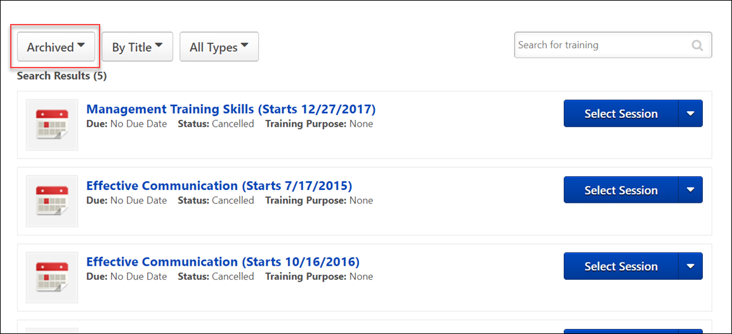

Training - Remove from Transcript
Administrators may have the option to remove training from a user's transcript. Any type of training that has not been completed can be removed. The removal of a training item is a reversible action. No records are actually deleted, just hidden from a user. With the exception of sessions, the original transcript status of the item is not changed; the transcript status of a removed session is changed to Withdrawn.
From the user's perspective, the process of requesting training that once existed on their transcript and was removed is exactly the same as requesting it for the first time, except that once it is requested, the transcript status of the item may be different. For example, if the item was previously approved, the user will not need to get the training approved again.
- Requesting a removed training item restores it to the user's transcript.
- Assigning a removed training item restores it to the assigned user's transcript.
- The Request button will appear if the user has the item on their transcript but the item has been Removed. Clicking the button will add the training item back to the user's active transcript.
  - The transcript status of the item will not change, unless the item was a withdrawn session, in which case it is requested again.
Note: LOs marked exempt from the Training Details page cannot be removed from the user's transcript. The Options column on the Transcript page displays N/A for LOs with an Exempt status.
Permissions
PERMISSION NAME | PERMISSION DESCRIPTION | CATEGORY

Edit Transcript Items | Grants ability to modify training due dates, statuses, and scores on other user's transcripts (training records) when viewing training details for particular learning objects on the transcript. User must also have permission to add external training in order to add or edit another user's external training. This permission can be constrained by OU, User's OU, User Self and Subordinates, User, and User's Self.  Note: Users with this permission also will also see the Add SF-128 link on the transcript. | Learning - Administration

Refund Training | Grants ability to issue a refund for a training item while removing it from the user's transcript. This is an administrator permission. | eCommerce - Administration

Remove Training | Grants ability to remove training from other users' transcripts (training records) when viewing their transcript. This permission can be constrained by OU, User's OU, User's Corporation, User Self and Subordinates, User's Self, User's Direct Subordinates, and User. This is an administrator permission. | Learning - Administration

Transaction Manager - Manage | Grants ability to access the Manage Transaction page and also create and edit transactions. On the Order History Details page, the administrator can edit the order status, adjust prices, issue refunds, or enter comments. This permission can be constrained by User's OU. This is an administrator permission. | eCommerce - Administration

Users - View | Grants the ability to search for and view summary information about users in the portal via the Admin/Users screen. This permission can be constrained by OU, User's OU, User Self and Subordinates, and Users. If multiple constraints are added, these constraints are considered OR statements. This is an administrator permission. | Core Administration

View Transcript Item | Grants ability to view details of learning objects that appear on the transcript (training record), by clicking on the name of the learning object. Users must also have the Bio About - View permission in order to access the transcript within Universal Profile. This permission can be constrained by OU, User's OU, User Self and Subordinates, User, or User's Self. This is an end user permission. | Learning - Administration
Emails
EMAIL NAME | EMAIL DESCRIPTION | ACTION TYPE

Training Removed from Transcript | If enabled, this email is triggered when an administrator removes a training item from a user's transcript. This email is also triggered when a training item is dynamically removed because the user was dynamically removed from a dynamic learning assignment. | Training
Training can be removed from the user's transcript from the Users page, My Team, or Track Employees based on access and permissions assigned to administrator.
Access Transcript
A user's transcript can be accessed in the following ways:
- Users page - Admin > Users. Search for user. Then, select the View Transcript option in the Options drop-down menu.
- Reports page - Reports > Track Employees > Transcripts. Click the View link for the user
- My Team - My Team > User ID Card > Profile > Transcript
- Universal Profile > Search for and select a user using Global Search. Click the Transcript tab.
Remove LO
To remove a LO, go to Learning > View Your Transcript. From the Action drop-down menu, click Remove, if available.
Remove Training Pop-up
Clicking the Remove option opens the Remove Training pop-up.
Select Reason - Select the reason for removing the LO. This is required. Note: Reasons appear in the user's display language, when available. If the user's display language is not available, then the reason appears in the reason's default language.
Comments - In the field, enter additional comments regarding the LO removal. Depending on the selected reason, this may be required.
Refund training item to user - If refunds are enabled, this option allows you to initiate a refund for the user. The original payment method is refunded the training cost less any fees. Note: This functionality is only available for items purchased with training units or a credit card. Also, refunds are not available if the item was purchased entirely by the user's cost center.
- If the administrator has permission to manage transactions, but not remove training from a user's transcript, they can only issue refunds from the Manage Transactions page.
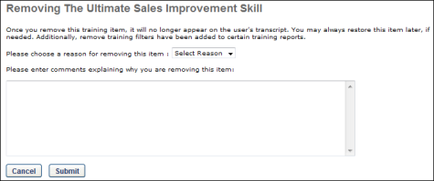
Remove all instances of this training
Select this option to remove all instances of the training.
- All instances of the training are moved from the Active or Archived training category to the Removed training category.
Remove the current instance only and revert training details to display the previous instance
Select this option to only remove the current instance of the training.
- The removed instance of the training appears on the Training Details page as Cancelled.
- The previous instance of the training becomes the current instance and appears in the Active training category on the transcript.
- The removal is documented in the History section on the Training Details page.
- The removed instance cannot be restored.
Remove Child LOs from within a Curriculum
If the selected LO is a curriculum, an additional option is available on the Training Removal page. Check the Remove training within the Curriculum option to ensure that when the curriculum is removed from the user's transcript, the child LOs contained within the curriculum are also removed from the transcript. If this option is left unchecked, when the curriculum is removed, the child LOs will remain on the user's transcript. This option is disabled by default. Note: The entire curriculum, including its child training, remains intact when removed via the Training Removal Tool, Learning Assignment Tool, or by manual transcript removal. This preserves the structure of the removed curriculum and eliminates the need for transcript cleanup. Upon reassignment, the intact curriculum moves to the Active tab of the user's transcript. Important: This behavior only applies to curriculum child training items which are in a non-completed status. In other words, if a curriculum child training is in a Completed, Completed Equivalent, or Exempt status, it will not remain intact within the curriculum; it will remain as a standalone completed training item on the Completed tab of the user's transcript. Similarly, upon reassignment of the curriculum, these completed training items will remain as standalone items on the Completed tab.
Note: If the child training contained within a curriculum cannot be removed from the user's transcript due to an exception in this scenario, it remains as a standalone LO on the user’s transcript, and the due date for the child LO, if any, is removed. If the LO is within another curriculum on the User’s transcript and left as standalone, it will then inherit the Due Date set for the LO in the curriculum structure.
The due date behaviors for LOs that cannot be removed are:
- If the LO has no parent LO, the due date is set to “No Due Date.”
- If the LO has one or more parent LOs:
  - If the LO has one parent, the due date is set as the parent’s due date. If the parent LO has no due date, the child LO due date is set to “No Due Date.”
  - If the LO has multiple parent LOs, due date is set as the minimum due date from the parent. For example, if the due date of Parent 1 is 3/1/2017 and the due date of Parent 2 is 1/1/2017, then the due date for the child LO is 1/1/2017).
Note: If an Administrator has the Remove Training Permission but does not have the Remove Training - Directly Assigned or the Remove Training - Self-Requested permission, then the administrator cannot remove Sessions with the following statuses from user transcripts.
- Completed
- Incomplete
- Pending Completion Approval
- Failed
- Pending Evaluation
- Pending Prerequisite
- No Show
- Pending Acknowledgement
- Pending Post-Work
- Pending Pre-Work
- Pending Completion Signature
Directly Assigned sessions in the statuses listed above cannot be removed from the transcript using the Remove Training permission and Remove Training - Directly assigned permissions unless the remover is the user who directly assigned the session. Administrators should use the Training Removal Tool to remove sessions in those statuses. Administrators will need Training Removal - Remove Completed training permission to remove sessions in a Completed status. For self-requested sessions in the statuses above, if an Administrator has both the Remove Training Permission and the Remove Training – Self-Requested, then the administrator can remove non-completed sessions requested by users.
Q: Can you revert an instance of a course to its previous registration?
A: Yes, as long as the following are true:
- There are more registrations for the training in the transcript.
- The previous registration is the same version number
However, if there is only one registration or the previous instance is a different version number, you will be navigated to a different page on which you can only move all instances to the user's Removed tab.
Save or Cancel
After selecting the appropriate option, click Save to remove the training. Or, click Cancel to cancel the removal action and return to the Transcript page.
Removing a training item will trigger any active emails for the Training Removed from Transcript email trigger.
Removed Training
- Removed training is still recognized by the system as part of the user's transcript when checking for prerequisite training.
- When an administrator or manager removes a training item from a user's transcript that is part of a certification, the following occurs:
  - If the training item has already been credited, the credit will not be rolled back.
  - If sequencing is available for the certification sections and the user has completed the training item, thus enabling a section later in the sequence, the later section continues to be available. For example, LO1 is in section A and you must complete section A prior to accessing section B. If LO1 is completed and thus completes section A, if LO1 is removed, the user can still access section B.
- If an administrator removes a session for which the user is on the roster, waitlist, or exception request list, the user will automatically be withdrawn from the session and the transcript status will update accordingly (the user will be withdrawn and the session will be removed).
  - Removed users will appear on the roster if the instructor chooses to view Withdrawn users.
  - These users will also appear on the Session Withdrawal report if they were previously registered.
  - Sessions with Completed status cannot be removed.
  - Any related training or pre/post work that is activated is added to the main transcript page.
- Removing a training item from the transcript does not change the transcript status of that item (it only changes the value of the Removed flag for that item).
- Removing training items that are in a Pending Approval status removes the training from the Approvers inbox, and it can no longer be approved
- If the item is a curriculum that contains training items which have been activated, then any items within that curriculum that have been activated will be moved to the main transcript page as standalone items (if they are not there already).
  - Any items that were Not Activated will be removed with the curriculum.
  - The curriculum details page for the removed curriculum, accessed from the Removed Transcript Items page, will list all of the items that were originally there regardless of whether they were also moved to the main transcript page.
- Training Unit Approval History displays the date the item was removed, the administrator that performed the action, and the comments entered. If training item is restored, the entry includes the date the item was restored and the name of the administrator that performed the action.
Restore Training
See Training - Restore to Transcript on page 199 for additional information.
Reporting
- Removed Training that is Pending Approval or Pending Completion Approval will not appear on the Employee Pending Requests page.
- Removed training items do not count towards to the Training Hours completed for that user that year (which is displayed on the transcript).
- Removed Status (Transcript section), Removal Comments, Removal Date and Remover (Transaction section) fields available for reporting in custom reports.
- The transcript record will not appear in any training reports that do not have the filter set to include removed training items.
- The registration costs are not reimbursed when a training item is removed. The records for removed training items will still appear in the Enterprise billing and Cost Center billing reports.
- Removed training items do not appear in any reports except the Enterprise Billing Report, Cost Center Billing Report, Session Withdrawal Report, Enterprise Training Report, and Analytics reports.

Remove Self-Requested Training from Transcript
Learners can remove training items they self-requested from their transcripts using the Remove option available on the Transcript page.
To access the Transcript page, go to HOME > UNIVERSAL PROFILE. Then, click the Transcript tab. Note: The location of this link is configurable by your system administrator.
Permissions
PERMISSION NAME | PERMISSION DESCRIPTION | CATEGORY

Bio About - View | Enables user to view the Bio page for users within their permission constraints. This permission must be enabled to view the Transcript page within Universal Profile. If a user does not have this permission and they click a person's name or user photo within the Universal Profile, then the Bio page will not open.  On the Learner Home page, this permission also allows end users to view the Completions & Hours field, the training sidebar, and the Continue Learning carousel.  This permission can be constrained by Employee Relationship, OU, User's OU, User's Direct Reports, User Self and Subordinates, and User. Note: For security purposes, this permission is constrained to User Self and Subordinates by default. However, the permission constraints can be modified to allow users to view the Bio About page for other users. | Universal Profile

Remove Training - Self Requested | Grants learners the ability to remove training that was self-requested from their active transcript and move it to the Removed tab of their transcript. This is an end user permission. This permission can be constrained by the following criteria:  - User's Direct Subordinates  - Direct Reports  - User's Self  - Employee Relationship  - User's Subordinates  - User Self and Subordinates  - User's Defined OUs | Learning

View Transcript Item | Grants ability to view details of learning objects that appear on the transcript (training record), by clicking on the name of the learning object. Users must also have the Bio About - View permission in order to access the transcript within Universal Profile. This permission can be constrained by OU, User's OU, User Self and Subordinates, User, or User's Self. This is an end user permission. | Learning - Administration
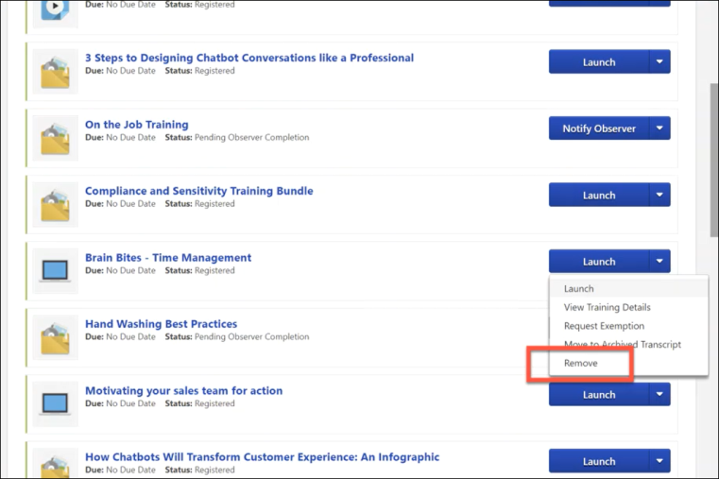
Remove
After a user has requested training and it has been added to their transcript, the user can remove that training by navigating to their transcript and selecting the Options drop-down menu to the right of the training. If the user has permission to remove self-requested training, a Remove link is available in the drop-down. The user can click the Remove link to remove the training from their transcript. This opens the Remove Training pop-up, in which the user must populate the following fields:
- Select Reason - Select the reason for removing the training. This is required. Note: Reasons appear in the user's display language, when available. If the user's display language is not available, then the reason appears in the reason's default language.
- Comments - In the field, enter additional comments regarding the training removal. Depending on the selected reason, this may be required.
When the user has finished populating the above fields, they can click the Submit button, and the training item will be removed from their transcript. If the user does not wish to finalize the training removal, they can click the Cancel button and return to the Transcript page, and the training will not be removed.
FAQ
Q: What is self-requested training?
A: Self-requested training is training that the learner requested themselves. It is NOT training that was assigned to them by a manager, administrator, or via a learning assignment or other tool.
Q: Can training with a due date be removed?
A: Yes, training with a due date can be removed.
Q: Can users remove training from their transcript via other system locations, such as Learner Home?
A: No, users can remove training from their transcript via the Transcript page only.
Q: Can any emails be triggered by training self-removal?
A: No, there are no emails triggered when a user removes self-requested training from their own transcript.
Considerations
The following considerations apply to this functionality:
Training Type Considerations
The following training types are supported for self-removal:
- Curricula
- Events and sessions
- External content
- External training
- Libraries
- Materials
- Online classes
- Online content
- Quick courses
- Tests
- Videos
The following training types are NOT currently supported for self-removal:
- Assessments
- Certifications
- Programs and cohorts
- Training initially requested or launched outside of the Cornerstone system
Note: It is NOT possible for administrators to modify which training types are eligible for self-removal.
Training Status Considerations
Training must be in the following training statuses in order for users to remove it from their transcripts:
- All statuses within the Not Started category
- All statuses within the In Progress category
Training in the following training statuses CANNOT be removed from the transcript by an end user:
- All statuses within the Completed and Completed Equivalent category (i.e. Equivalent, Exempt, Expired, Discontinued, Not Activated, etc)
For more information about which training statuses are included in each category: See Transcript Status Groups for Reporting.
Training Self Removal Scenarios
The table below outlines common training request and assignment scenarios and clarifies whether it is possible for users to self-remove training in those scenarios:
User Types | System Area | Scenario | Is Self Removal Possible?
Learners | General | - Learner self-requests training | Yes
Learners, Managers, and Administrators | General | - Manager or administrator assigns training to the learner via direct assignment | No
Learners, Managers, and Administrators | General | - Learner self-requests training  - Manager or administrator assigns the same training to the learner via direct assignment | No
Learners and Administrators | LAT | - Learner self-requests training  - Administrator assigns the same training to the learner via the Learning Assignment Tool (LAT) with the Maintain Progress option enabled | No
Learners and Administrators | LAT | - Learner self-requests training  - Administrator assigns the same training to the learner via the Learning Assignment Tool (LAT) with the Maintain Progress option disabled | No
Learners and Administrators | LAT | - Learner self-requests training  - Administrator assigns the same training to the learner via the Learning Assignment Tool (LAT) with the Maintain Progress option enabled  - Administrator removes this training directly from the learner's transcript  - Learner self-requests the training again | Yes
Learners and Administrators | LAT & TRT | - Learner self-requests training  - Administrator assigns the same training to the learner via the Learning Assignment Tool (LAT) with the Maintain Progress option enabled  - Administrator removes this training via the Training Removal Tool (TRT)  - Learner self-requests the training again | Yes
Learners and Administrators | LAT | - Learner self-requests training  - Administrator assigns the same training to the learner via the Learning Assignment Tool (LAT) with the Maintain Progress option disabled  - Admin removes this training directly from the learner's transcript and selects to remove only current registration | Yes
Learners and Administrators | LAT | - Learner self-requests training  - Administrator assigns the same training to the learner via the Learning Assignment Tool (LAT) with the Maintain Progress option disabled  - Administrator removes this training directly from the learner's transcript and selects to remove all prior registrations  - Learner self-requests the training again | Yes
Learners and Administrators | LAT & TRT | - Learner self-requests training  - Administrator assigns the same training to the learner via the Learning Assignment Tool (LAT) with the Maintain Progress option disabled  - Administrator removes this training via the Training Removal Tool (TRT)  - Learner self-requests the training again | Yes
Learners and Administrators | Versioning | - Learner self-requests training  - The training is versioned with the Replace versioning option | Yes
Learners and Administrators | Versioning | - Learner self-requests training  - The training is versioned with the Appendversioning option | Yes
Learners and Administrators | Express Class | - Learner self-requests training  - Administrator completes the training via Express Class | No
Learners and Administrators | Express Class | - Learner self-requests training  - Administrator completes the training via Express Class  - Administrator removes this training directly from the learner's transcript and selects to remove all prior registrations  - Learner self-requests the training again | Yes
Learners and Administrators | Express Class | - Learner self-requests training  - Administrator completes the training via Express Class  - Administrator removes this training directly from the learner's transcript and selects to remove only current registration | Yes
Learners, Managers, and Administrators | General | - Manager or administrator assigns training to the learner via direct assignment  - Manager or administrator removes this training directly from the learner's transcript  - Learner self-requests the training | Yes
Learners, Managers, and Administrators | TRT | - Manager or administrator assigns training to the learner via direct assignment  - Administrator removes this training via the Training Removal Tool (TRT)  - Learner self-requests the training | Yes
Administrators | LAT | - Administrator assigns training to the learner via the Learning Assignment Tool (LAT) | No
Managers and Administrators | LAT | - Administrator assigns training to the learner via the Learning Assignment Tool (LAT)  - Manager or administrator removes this training directly from the learner's transcript  - Learner self-requests the training | Yes
Learners and Administrators | LAT & TRT | - Administrator assigns training to the learner via the Learning Assignment Tool (LAT)  - Administrator removes this training via the Training Removal Tool (TRT)  - Learner self-requests the training | Yes
Administrators | Express Class | - Administrator completes training via Express Class | No
Learners and Administrators | Express Class | - Administrator marks training incomplete via Express Class  - Administrator removes this training directly from the learner's transcript  - Learner self-requests the training | Yes
Learners and Administrators | Express Class & TRT | - Administrator marks training incomplete via Express Class  - Administrator removes this training via the Training Removal Tool (TRT)  - Learner self-requests the training | Yes
Learners and Administrators | LAT | - Learner self-requests training  - Administrator assigns a curriculum that contains the same training  - Administrator realizes the curriculum was assigned to the learner in error and removes the curriculum  - Training remains standalone on the transcript | Yes
Learners and Administrators | Versioning | - Learner self-requests training  - Administrator assigns a curriculum that contains the same training  - Administrator versions the curriculum  - Administrator removes the curriculum and the training the learner self-requested is not removed and remains standalone on the transcript | Yes
Learners and Administrators | Training Update Tool | - Learner self-requests training  - Administrator completes the training using the training update tool | No
Learners and Administrators | Edge | - Learner self-requests training  - Administrator completes the training using Edge Import | No

Remove Training from User's Transcript
Managers can be granted the ability to remove training they assigned to their employees from their employees' transcripts. To give managers this ability, an administrator can assign the Remove Training - Directly Assigned permission to them.
To access a user's Transcript page, go to HOME > UNIVERSAL PROFILE. Click the name of the employee for whom you want to remove training and then navigate to the user's Transcript tab.
Permissions
PERMISSION NAME | PERMISSION DESCRIPTION | CATEGORY

Bio About - View | Enables user to view the Bio page for users within their permission constraints. This permission must be enabled to view the Transcript page within Universal Profile. If a user does not have this permission and they click a person's name or user photo within the Universal Profile, then the Bio page will not open.  On the Learner Home page, this permission also allows end users to view the Completions & Hours field, the training sidebar, and the Continue Learning carousel.  This permission can be constrained by Employee Relationship, OU, User's OU, User's Direct Reports, User Self and Subordinates, and User. Note: For security purposes, this permission is constrained to User Self and Subordinates by default. However, the permission constraints can be modified to allow users to view the Bio About page for other users. | Universal Profile

Remove Training - Directly Assigned | Allows a manager to remove directly-assigned training from their employee's transcript. This permission can be constrained by the following criteria:  - User's Direct Subordinates  - User's Direct Reports  - User's Self  - Employee Relationship  - User's Subordinates  - User Self and Subordinates  - User's Defined OUs | Learning

View Transcript Item | Grants ability to view details of learning objects that appear on the transcript (training record), by clicking on the name of the learning object. Users must also have the Bio About - View permission in order to access the transcript within Universal Profile. This permission can be constrained by OU, User's OU, User Self and Subordinates, User, or User's Self. This is an end user permission. | Learning - Administration
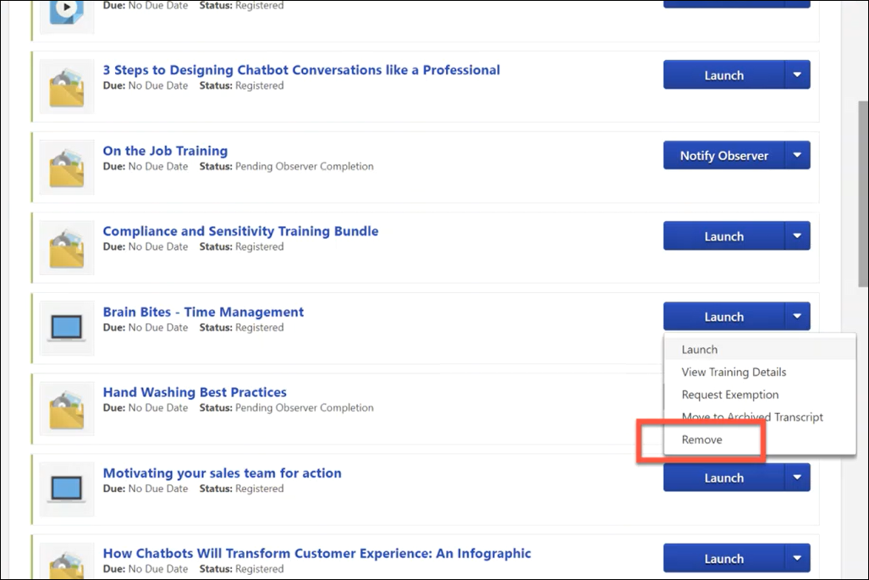
Remove
After a manager has assigned training to one of their employees, the manager can, if needed, remove that training by navigating to the employee's transcript and selecting the Options drop-down menu to the right of the training. If the manager has permission to remove assigned training, a Remove link is available in the drop-down. The manager can click the Remove link to remove the training from their employee's transcript. This opens the Remove Training pop-up, in which the manager must populate the following fields:
- Select Reason - Select the reason for removing the training. This is required. Note: Reasons appear in the user's display language, when available. If the user's display language is not available, then the reason appears in the reason's default language.
- Comments - In the field, enter additional comments regarding the training removal. Depending on the selected reason, this may be required.
When the manager has finished populating the above fields, they can click the Submit button, and the training item will be removed from the user's transcript. If the user does not wish to finalize the training removal, they can click the Cancel button and return to the Transcript page, and the training will not be removed.
Considerations
- Managers can remove training they assigned to a user from the user's transcript even if the training was versioned after the manager assigned it, or even if the training has multiple registration numbers since its initial assignment, if all registrations were from the training being directly-assigned or self-requested. If previous registrations were from the Learning Assignment Tool or an administrator assignment, managers will not be able to remove the training.
- Managers cannot remove training when the training is later assigned to the learner by an administrator.

Training - Restore to Transcript
There are two methods to restore removed training to a user's transcript.
Note: When restoring an online course for which a new version has been created, the new version automatically replaces the previous version if the course is not in an In Progress status on the Removed tab when the course is restored. If the course is in an In Progress status, the version of the course that was current at the time the course was removed from the user's transcript is the version that is restored. In this case, the new version would need to be added to the user's transcript, or the user would need to request the new version.
Permissions
PERMISSION NAME | PERMISSION DESCRIPTION | CATEGORY

Universal Profile - User Record - View Users | Grants ability to view user records in the system. Administrators can view the Modification History page for user records within their constraints. The administrator must have additional permissions to view specific fields on the user record. This permission can be constrained by OU, User's OU, User's Self, User Self and Subordinates, and User. This is an administrator permission. | Core Administration

Users - View | Grants the ability to search for and view summary information about users in the portal via the Admin/Users screen. This permission can be constrained by OU, User's OU, User Self and Subordinates, and Users. If multiple constraints are added, these constraints are considered OR statements. This is an administrator permission. | Core Administration

View Transcript Item | Grants ability to view details of learning objects that appear on the transcript (training record), by clicking on the name of the learning object. Users must also have the Bio About - View permission in order to access the transcript within Universal Profile. This permission can be constrained by OU, User's OU, User Self and Subordinates, User, or User's Self. This is an end user permission. | Learning - Administration
Manual
A manual restoration of a training item results in the Due Date remaining the same as the Due Date that was defined by the original assignment or request of that training.
- On the user's transcript, select Removed from the Training Category filter.
- Click the Restore to Transcript link to reverse action and move the training item back to the users active transcript
Automated
Learning Assignment, Inventory Assignment, User Request Training or License Management.
- Learning Assignment - If an LO was removed from a user's transcript via training removal tool, dynamic removal, or manually removal by an administrator, and then that same LO is assigned via a learning assignment and the user meets the assignment criteria, the LO will be restored. Whatever due date previously existed will be replaced by the assignment's defined due date/no due date.
- Assign Subordinate - If an LO was removed from a user's transcript, via dynamic removal or manual removal, if that same LO is assigned by the user's manager from the Assign Training page, the LO will be restored with a new due date or no due date as defined by the manager.
- User Requests - If an LO was removed from a user's transcript and the user later requests the same training, the LO will be restored and replaced with No Due Date. (The Catalog does not define Due Dates for requested training.)
  - If a user has requested training and that training has no due date, the user can still be assigned that training via proxy, inventory, or manager assignment. If assignment occurs after a request and the training is in any status before Complete that LO will be refreshed with a Due Date as defined by the assignment. Assignment Due Dates override requested training lack of due dates.
- Inventory Assignment (Pre-Purchases training) - If a user requested training, and then is given training via Inventory assignment, any Due Date defined by the Inventory Assignment will apply.
- License Management - When a removed item is being restored though license management and a due date is entered, all restored items due dates get updated. Note: When a removed item is restored though license management and there is NO due date, all restored items will have their due dates removed or replaced.

Transcript - Download Offline Learning
Users with the permission for downloading Offline Learning can download the Offline Learning application from their learning transcript page.
To download the Offline Learning application, go to Learning > View Your Transcript.
Permissions
PERMISSION NAME | PERMISSION DESCRIPTION | CATEGORY

Offline Learning - Download application file from Transcript | Grants ability to view the Download Offline Learning link on the transcript. This is an end user permission. | Learning - Administration
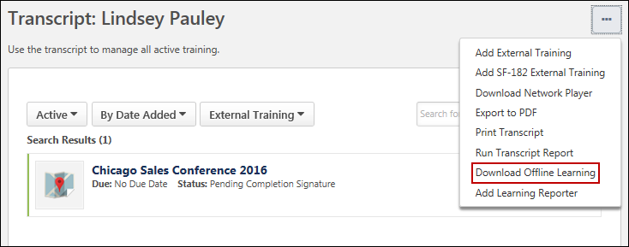
Download Offline Learning
After navigating to the transcript, click the Options drop-down menu. Click the Download Offline Learning link. The Offline Learning application will begin downloading. Once finished downloading, the application can be installed, and users can use the application to download courses which can then be completed offline. See Offline Player Application Overview for more information on using the application.
Use Case
Rita works in sales at ABC Corporation. As part of her role, Rita frequently travels to meet with potential clients. Rita spends many hours on flights, where no or very poor internet connectivity is available, but she wishes she could take training during this time.
Rita opens the company portal and accesses to her transcript. From the Options menu, she downloads the Offline Learning application to her laptop and installs it. She can download relevant courses and make them available for offline consumption and optimize the time she spends flying.

Transcript - On the Job Training
Material learning objects can be configured as On the Job Training (OJT) items by administrators, which provides end users with additional options for managing On the Job Training from the learning transcript. A Pending Observer Completion transcript status is available for OJT material LOs, and a new Notify Observer option is available to users for managing their OJT items.
Permissions
PERMISSION NAME | PERMISSION DESCRIPTION | CATEGORY

On the Job Training - Notify Observers | Grants access for users to select On The Job Training Observers. This is an end user permission. | Learning - Administration
Notify Observer
After becoming registered for an OJT material LO, the OJT displays to the user in a Pending Observer Completion status. A new Notify Observer option also displays for the OJT. When the user feels confident in their knowledge and experience with the skills taught by the OJT, the user can click the Notify Observer option to notify a qualified instructor that they are ready to be observed and evaluated on the OJT skills. This triggers the Observer Notification email trigger, if enabled, but this step is optional. Regardless of whether the user chooses to notify the observers, as soon as the OJT is in a status of Pending Observer Approval, ALL observers associated with the OJT are able to observe the user for any part of the OJT.
Note: The In Progress status usually available for material LOs is NOT available for OJT material LOs.
The Pending Observer Completion status and the Notify Observer option are available for OJT accessed from the following system areas:
- Learning Transcript (New)
- Learning Transcript (Old)
- Curricula
- Curricula Details
- Cohorts
- Welcome Page Widgets
- Custom Page Widgets
- Universal Profile - Action Items
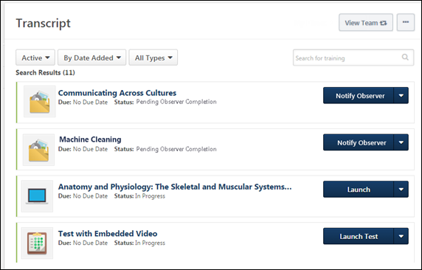
Select Observer
Clicking the Notify Observer option opens the Select Observer pop-up window. Using this window, users can search for and select the name of the specific qualified observer by whom they wish to be evaluated. After selecting the name of an observer, a confirmation message appears to confirm their selection. Note: The observer most recently selected by the user is saved as the observer so the user can quickly notify the same observer in the future, if needed.
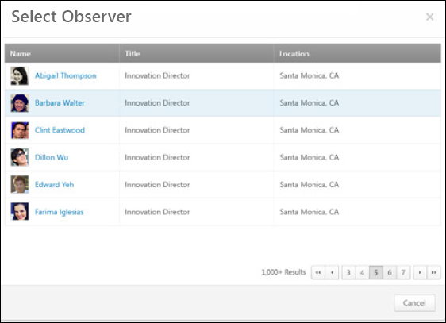
On The Job Training Completion
If the observer marks the user as completed for the OJT, the OJT item moves to a status of Completed on the user’s transcript. If the observer marks the user as failed for the OJT, the OJT item remains in a status of Pending Observer Completion. The user can select the Notify Observer option again when they are ready to make another completion attempt. Note: The Mark Complete option normally available to users for material LOs is NOT available for OJT material LOs.

Transcript Statuses
Below is a list of all available learning transcript statuses, their definitions, and the training types to which they are applicable.
Transcript Status | Definition | Applicable Training Types
Activated | This status appears for child training items that have been activated in a curriculum. An Activate link appears to users in the Options column, which allows them to activate the LO if it is in a status of Not Activated. Note: The Activate link appears in the Options column if the administrator does not check the Auto-Register box when configuring the LO within the curriculum. | Curriculum
Approved | Training was approved by the approver. This status is accompanied by the Register option. For approved events, the Select Session option appears. | All
Approved/Past Due | The user receives this status when training has been approved for the user, but the due date has passed and the user has not yet completed the training. | All
Available [MM/DD/YYYY] | When a user is assigned a learning object (LO) for which an available date is configured, the Status column displays "Available [Available Date in MM/DD/YYYY format or in date format for user's culture]." | Curriculum, Library, Online Course, Posting, Quick Course, Video
Cancelled | User was registered for an ILT session that was cancelled. This status is accompanied by the Select Session option. | ILT Session
Cancelled/Past Due | User was registered for an ILT session that was cancelled, and the date of the registered session has passed. | ILT Session
Completed | The training is complete and all required evaluations and acknowledgments are complete. For Webex sessions, a status of Completed is achieved if:  - The session is ongoing, but the user has completed enough parts for completion to occur and an administrator submits the roster for completed users.  - The user has completed all attendance/part requirements, and an administrator submits the roster. | Cohort, Curriculum, External Training, ILT Session, Material, Online Course, Posting, Quick Course, Test, Video, xAPI Learning Records
Completed Equivalent | The user completed equivalent training before requesting this training. | Cohort, Curriculum, ILT Session, Material, Online Course, Posting, Quick Course, Test, Video, xAPI Learning Records
Completion Approval Denied | The user receives this status for training if ALL the following conditions are true:  - Completion approval is required for the training, either as a default setting for a training type or at the individual training item level.  - The training has been completed by the user.  - The user's approver has denied the completion approval request for the training item. | Cohort, Curriculum, ILT Session, Material, Online Course, Posting, Quick Course, Test, Video, xAPI Learning Records
Completion Approval Denied/Past Due | The user receives this status for training if ALL the following conditions are true:  - Completion approval is required for the training, either as a default setting for a training type or at the individual training item level.  - The training has been completed by the user.  - The user's approver has denied the completion approval request for the training item.  - The due date for the training item has passed. | Cohort, Curriculum, ILT Session, Material, Online Course, Posting, Quick Course, Test, Video, xAPI Learning Records
Denied | The user receives this status for training if ONE of the following are true:  - Approval is required for the training item requested by the user and the training request was denied by the approver.  - The user was in a Pending Payment status for the LO and then cancelled the training request.  - The user was denied a license for the LO.  Note: This status is accompanied by the Request Again option when the request was denied by an approver (except for events).  Certification Considerations:  If the Approval required for enrollment in certification option is enabled on the General tab when the certification is created, approval is required in order for the user to register for the certification. If the owner of the certification denies the certification request via the View Certification Requests page, the user receives a Denied status for the certification. | All
Denied/Past Due | The user receives this status for training when the conditions for Denied training (described above) are met and the due date for the training has passed. | All
Disapproved | A training item in Disapproved status indicates the content has been deactivated by Cornerstone Content Operating. This occurs for content for which the licensing may have expired. Training in Disapproved status does not appear in the Course Catalog and cannot be searched for by end users. It can only be viewed in reporting.
Discontinued | This is an extended enterprise course status. With extended enterprise, courses can be marked as discontinued. Courses which have been marked as discontinued display this status on the user's transcript. | Extended enterprise courses
Discontinued/Past Due | The extended enterprise course has been marked as discontinued and the due date for the course has passed. | Extended enterprise courses
Exempt | The user receives this training status when they have been granted an exemption from the training. | All
Exempt-Internal | This status is never visible in the Transcript, but it is available in Reporting.
Exception Requested | This applies to training that was requested by a user who has either not completed the necessary prerequisite or did not have availability for this class. This status is accompanied by the Withdraw option. | Curriculum or ILT Session
Exception Requested/Past Due | The above conditions for Exception Requested are met, and the due date for the training has passed. | Curriculum or ILT Session
Exception Requested/Waitlisted | The above conditions for Exception Requested are met, and the user is also on a waitlist for the session. | ILT Session
Exception Requested/Waitlisted/Past Due | The above conditions for Exception Requested are met, the user is on a waitlist for the session, and the due date for the training has passed. | ILT Session
Expired | This status appears when the training's assigned due date has expired. | All
Expired/Past Due | The training's assigned due date has both expired and passed. | All
Failed | The user receives this status when failing a test. | Test
Failed/Past Due | The user receives this status when failing a test and the due date for the training has also passed. | Test
Inactive
Incomplete | This may mean either that the course was marked complete and the user did not pass or attend all the required parts, or a test was failed but more attempts are allowed. | All (except Video)
Incomplete/Past Due | This status displays when the above conditions for the Incomplete status are met, and the due date for the training has passed. | All (except Video)
In Progress | This status appears when a training item is currently in progress. If the training is a curriculum or library, this appears once any of the included training items is registered. ILT sessions display this status after the roster has been submitted if the user has not completed the required pre/post work. | Cohort, Curriculum, ILT Session, Library, Online Course, Posting, Quick Course, Test
In Progress/Past Due | The user receives this training status when the above conditions for In Progress training are met and the due date for the training has also passed. | Cohort, Curriculum, ILT Session, Library, Online Course, Posting, Quick Course
None | None appears when the training is completed or the user withdrew from the training. This also appears for denied Events or Sessions that are a No Show. | Event, External Training, or ILT Session
No Show | User did not attend any of the parts for an ILT session and the roster was submitted. | ILT Session
No Show/Past Due | The user did not attend any parts for an ILT session and the roster was submitted, and the due date for the session has also passed. | ILT Session
Not Activated | This status appears for LOs that have not yet been activated in a curriculum. An Activate link appears in the Options column, which allows you to activate the LO. Note: The Activate link appears in the Options column if the administrator does not check the Auto-Register box when configuring the LO within the curriculum. | Curriculum
Not Available
Not Started | The training has not yet been launched or opened by the user. | All
Not Started/Past Due | This status appears when the training has not yet been launched or opened by the user and the due date for the training has passed. | All
Old Version | This status appears when the user was registered for an online course that was reversioned in the content upload tool. This status indicates that the user does not currently have the latest version of the training. | Online Course
Past Due | The due date has passed and the training is not completed. | All
Payment Denied | The user receives this status for training if the user attempted to pay for training with a purchase order and the payment was denied by an administrator. | All
Payment Denied/Past Due | The conditions for the Payment Denied status is true, and the due date for the training has also passed. | All
Payment Refunded | This status only appears on a user's Removed Transcript, and it appears when an administrator issues a refund for the training via the Order History page. | All
Payment Refunded/Past Due | This status appears when the above conditions for Payment Refunded are met and the due date for the training has passed. | All
Pending
Pending Acknowledgment | The user receives this status for training if the training is complete but an acknowledgment form is required (configured in Course Catalog) and has not yet been completed by a user. | Cohort, Curriculum, ILT Session, Online Course, Quick Course, Video
Pending Acknowledgment/ Past Due | The user receives this training status when the above conditions for Pending Acknowledgment are met, and the due date for the training has passed. | Cohort, Curriculum, ILT Session, Online Course, Quick Course, Video
Pending Approval | The user receives this status for training if the training requires approval before the user can be registered for it. | All
Pending Approval/Past Due | The user receives this status for training when the above conditions for Pending Approval are met, and the training due date has passed. | All
Pending Approval/Waitlisted | The user receives this status for training when the above conditions for Pending Approval are met, and the user is currently on a waitlist for the training. | ILT session
Pending Approval/Waitlisted/Past Due | The user receives this status for training when the above conditions for Pending Approval are met, the user is currently on a waitlist for the training, and the training due date has passed. | ILT session
Pending Completion Approval | Training requires completion approval and is waiting for completion approval. | All
Pending Completion Approval/Past Due | The user receives this status for training when the above conditions for Pending Completion Approval are met, and the training due date has passed. | All
Pending Completion Signature | The user receives this status for training if ALL the following conditions are met:  - The training is configured to require a completion signature before it can be marked complete (this can be configured as a default for an LO type or for an individual LO via Course Catalog).  - The user has completed the training and has not yet provided a completion signature. | All
Pending Completion Signature/Past Due | This status appears when the above conditions for Pending Completion Signature are met and the due date for the training has passed. | All
Pending Evaluation | The user receives this status for training in any of the following cases:  - A level one evaluation is enabled for the training and also required.  - A level two evaluation is enabled and required for the training AND the user has not yet started the training.  - A level three evaluation is enabled and required for the training AND the user has not yet started the training.  Note: Training with required level two and three evaluations does not display the Pending Evaluation status after the user has started the training. | Curriculum, ILT Session, Online Course, Quick Course, Video
Pending Evaluation/Past Due | This status displays when one of the above conditions for Pending Evaluation are met and the due date for the training has passed. | Curriculum, ILT Session, Online Course, Quick Course, Video
Pending Grade | This status appears when the training requires a grade in order to be marked complete on the user's transcript, and the grader has not yet provided a grade. | Tests
Pending Grade/Past Due | This status appears when the conditions for Pending Grade are met and the due date for the training has passed. | Tests
Pending Observer Completion | The user receives this status for training if ALL the following conditions are met:  - On the Job Training is enabled for the material LO.  - Observers are specified for the OJT material.  - The user has been registered for the OJT material and has not yet been marked complete by an OJT observer. | Materials
Pending Observer Completion / Not Available |  | Materials
Pending Observer Completion / Not Available / Past Due | This status displays when the above conditions are met for Pending OJT Completion/Not Available are met and the due date for the training has passed. | Materials
Pending Observer Completion / Past Due | The above conditions for Pending OJT Completion are met, and the training's due date has also passed. | Materials
Pending Payment | This status occurs if the administrator has enabled the Payment Pending preference and the user is subject to the pending payment status. User has ordered training using the Request Bill payment method and the must reconcile the purchase prior to accessing the training. The user cannot access the training until the payment is received. There are no options available for this status until the transaction is reconciled. If the order is cancelled, the status moves to Denied. | All
Pending Post-Work | The user receives this status for training when the training is complete, but there is post-work associated with the training that must be completed.  Note: Post-work is follow-up training that is done after the completion of the previous training. Post-work can be an online course, material, test, etc. If the status of the training on the user's transcript is Pending Post Work, then the user is required to complete the post-work in order for the training to be in a Completed status. Users may also need to register for the post-work. Users can view post-work on the Training Details page of the training. | All
Pending Post-Work/Past Due | The user receives this status for training when the above conditions for Pending Post-Work are met, and the due date for the training has passed. | All
Pending Pre-Work | The user receives this status for training when the training is complete, but there is pre-work associated with the training that must be completed. | Online Class, Quick Course, Material, Test, Video, Session
Pending Pre-Work/Past Due | The user receives this status for training when the above conditions for Pending Pre-Work are met, and the due date for the training has passed. | All
Pending Prerequisite | The user receives this status for training when the user is registered training that requires prerequisite training that the user has not yet completed. | All
Pending Prerequisite/Past Due | The user receives this status when the above conditions for Pending Prerequisite are met and the due date for the training has passed. | All
Pending Prior Training
Pending SF-182 Form Approval | This status appears when a user has submitted an SF-182 request form for a training item, and the request is still pending the approval of an approver (applicable to government organizations only). | All
Registered | The user receives this status for training when training has been added to their transcript (either via a request or assignment), and no further actions are required prior to taking the training. | All (except events)
Registered/Past Due | The above conditions for Registered are met, and the due date for the training has also passed. | ILT Session
Registered/Not Available
Registered/Not Available/Past Due | This status appears when the above conditions for Registered/Not Available are met and the due date for the training has passed.
Registration Closed | This status appears if the user was in an Approved or Registration Pending status for an ILT Session and then the registration deadline passed. | ILT Session
Registration Pending | The user receives this training status if the user has been granted an opening from the waitlist for an ILT session but has not yet registered for the session. | ILT Session
Registration Pending/Past Due | The user receives this status if the above conditions for Registration Pending are met, and the due date for the training has passed.
Renew License | Access to a learning object (LO) can be controlled based on the number of registrations or a certain date using Course Catalog License functionality. Users can also be given the opportunity to renew their license for an LO. When the Renew License status appears, the user can select the Renew License option to renew their license. See Course Catalog - License. | All
Revoked | The user receives this certification status if the certification is revoked from their transcript by the certification owner. | Certifications
SF-182 Form Denied | This status appears when the user has submitted an SF-182 training request, which was subsequently denied by the form approver (applicable only to government organizations). | All
Subscription Expired | Subscriptions are packages of training that are typically provided to an organization's external clients. This status appears for training items included in a subscription which has expired. See Manage Subscriptions. | All
Upload and Verify | The user receives this curriculum status when ALL the following are true:  - A curriculum is created with the Curricula Player option enabled, and the curriculum contains a material LO in its structure.  - The backend settings for curriculum authentication and curriculum signatures ARE enabled, AND the backend setting for curricula player is NOT enabled.  - The user has launched the material contained within the curriculum and the material is in an In Progress status. | Curriculum
Waitlisted | The user receives this training status for an ILT session when they request a session which has no more available seats. The user remains on a waitlist until a seat becomes available.  If the training is not an ILT event or session, this status indicates the user is on a waitlist for a license for this course and cannot register because there are no licenses available. See Course Catalog - License. | ILT Session or Library
Waitlisted/Past Due | The above conditions for Waitlisted are met, and the due date for the training has passed. | ILT Session or Library
Waitlist Expired | This status appears if a user was on a session waitlist when it expired. This expiration date is either explicitly stated in the session details, or it automatically occurs at the session start date. | ILT Session
Waitlist Expired/Past Due | The above conditions for Waitlist Expired are met and the due date for the session has passed. | ILT Session
Withdrawn | The user withdrew or was withdrawn from an ILT session or external training item. | External Training, ILT Session
Withdrawn/Past Due | The user withdrew or was withdrawn from an ILT session or external training item, and the due date for the training has passed. | External Training, ILT Session

Training - Open Overview
Training can be opened by the user in multiple ways.

Training - Open from LO Details Page
Certain learning object (LO) types may be launched from the LO Details page without navigating to the Transcript page.
To enable this functionality, contact Global Customer Support.
See LO Details Page - LO Actions.
Learning Details Redesign
With the February 2019 release, a redesigned Learning Details page was released as an Early Adopter project. As of the August 2020 release, this project is no longer in an Early Adopter status and is now generally available. The Learning Details page is available for the following training types if enabled by your system administrator:
- Curricula
- Events and Sessions
- External Content
- Materials
- Online Content
- Online Courses
- Tests
- Videos
More features will be added to the Learning Details page in future releases. For more information about the redesigned Learning Details page: See Learning Details Page .

Training - Open from Transcript
To open a training item from your transcript:
- Click the View Your Transcript link. This link can be accessed from the Home page or the Learner Home page.
- Select the appropriate option to the right of the training item. Depending on the training type and the current status of the training item, the name of the link to initiate the item will vary. Online courses open in a new window. If the Network Player is enabled, you may have the option to Launch Locally or Launch Online. See Network Player Transcript Options on page 89 for additional information.
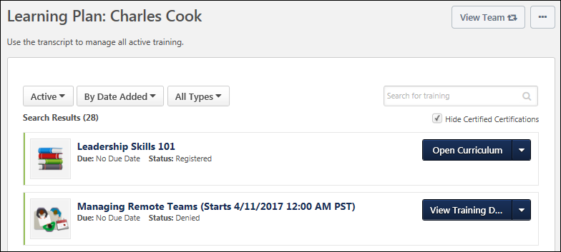
- Note: For events within the Curriculum Player, the Select Session link does not display if restricted by the administrator. You can still view the details of the event by clicking the View Details icon but cannot select a session.
- Note: If a training item within a library is already activated outside the library, the Activate link does not work. If you experience the Activate link not working within a library, search for the training item on your transcript and access it directly.
- Loading Note: For issues with opening a training item, such as an online course, that continues to remain in a loading state, contact the system administrator for your organization for help with troubleshooting the issue.
Webex Virtual Sessions
For Webex virtual sessions, you can launch multiple active parts as they become available based on the learning object's approval status on the transcript. The date of the session for which you are registered displays in parentheses next to the event title and is followed by the date of the next upcoming part.
Depending on the Webex settings, the part may not be accessible until a certain number of minutes prior to the start time. If the host has not yet started the meeting, the following notification displays:
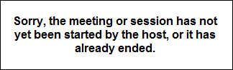

New Online Course Version Available - Notifications
If desktop notifications are enabled in your portal, users can opt to allow desktop notifications from the system to display, when available. Regardless of whether desktop notifications are enabled, a Javascript notification will always appear to users in the online course window if they are assigned a new version of the training while they are viewing the course. See Notifications Preferences for information about enabling desktop notifications.
Allow or Block Notifications
After notifications have been enabled in the portal, the first time the user accesses either the Welcome page or their Transcript page in the portal, they receive a pop-up requesting permission to display notifications. The pop-up reads, "Cornerstone wants to show notifications." The user can choose from the following options:
- Allow - If the user clicks the Allow button, they will see any available desktop notifications from the system. For example, if a new course version becomes available while they are currently viewing the course, the user will receive a desktop notification that a new course version is available.
- Block - If the user clicks the Block button, the will not see any available desktop notifications from the system. The user will not be shown the pop-up again. If they later wish to enable these notifications, they can do so via their browser settings.
The user can close out of the pop-up without selecting either option by clicking the X icon in the upper-right corner of the pop-up.
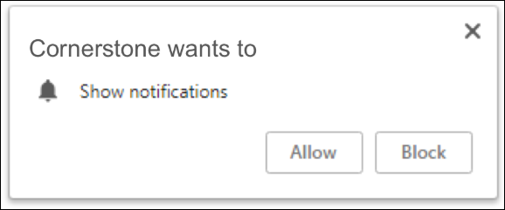
Course Updated Notification
When a user has opted to allow notifications, if a new online course version is assigned to them while they are viewing the online course, a desktop notification appears. The notification alerts the user that a new version of the training is available and provides the user with a link that redirects them to the page from which they launched the course so they can access the new version.
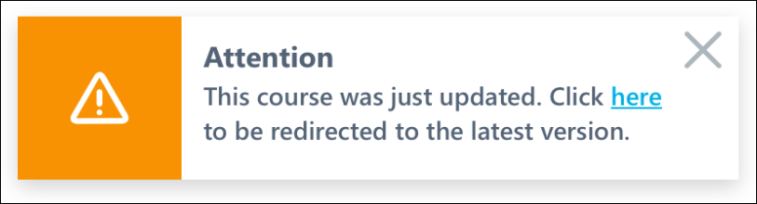
If desktop notifications are NOT enabled, a Javascript notification appears in the upper-right corner of the online course window, which alerts the user that a new version of training is available and provides the user with a link to the page from which they launched the course. This notification appears regardless of whether or not the user opted to allow desktop notifications. This Javascript notification cannot be disabled or configured.
Note: If the user continues to complete the older version of the online course, they will NOT receive completion credit for the course. On their transcript, only the progress they made on the course prior to receiving the new version notification is saved.
New Version Available
When the user is redirected to the page from which they launched the online course, a notification displays, informing the user that a new version of the online course is available. The notification also instructs them to launch the new version that was assigned to them. To close the notification, the user can click the OK button.
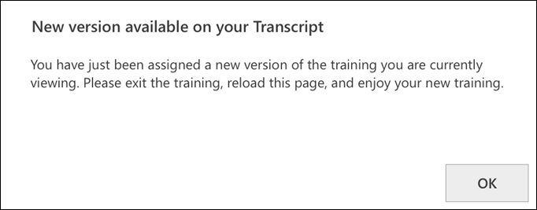

Training - Register from Transcript
To register for online training, go to Learning > View Your Transcript. Select the Register option for the training. The system automatically processes the registration and the Launch option becomes available. Click the Launch option to launch the course.
This process differs when registering for an instructor led session. See Session - Register on page 58 for additional information.

Transcript Lockdown - Administrator Overview
Organizations have the option to lock the data that is related to a training course on a user's transcript and certification transcript once the course is completed. Once a course is completed, the transcript data and the data on the Training Details page will not change for the course. This applies even if the course is moved to the Archived or Removed tabs or training categories of the transcript. This prevents administrators from changing information related to a course (e.g., title, description), which would, in turn, update a user's transcript even after the course is completed. This enhancement enables organizations to better maintain compliance with 21 CFR Part 11 regulations. This functionality applies to all learning object (LO) types.
The Transcript Lockdown functionality is effective as soon as the functionality is enabled. This functionality cannot capture course data prior to the date on which the functionality is enabled.
This functionality is controlled by a backend setting and is disabled by default, so organizations can choose to not lock course data. To enable this functionality, contact Global Customer Support.
Considerations
- This functionality does not include custom fields. Custom fields are always locked upon course completion, regardless of enablement of Transcript Lockdown.
- New Connect does not currently support the Transcript Lockdown functionality. This tool currently displays the current or updated LO details.
- If the Transcript Lockdown functionality is enabled, the Edit Transcript Items permission is disabled. Users with this permission are not able to edit transcript items.
- For recurring LOs, each recurrence is locked upon completion. If an LO is reverted to a previous instance, the details at the time of completion for the previous instance are available and are displayed on the user's transcript. The instance that is removed is no longer available in the system.
- If data is updated in the system from the backend, any course completion data is not captured as a result of the backend changes. When data loads populate completed course data into the system via the Training Update Tool, the system captures the course information at the time the course is loaded to the system.
- When a user is assigned a course via a learning assignment with a Completed status, the course information is captured at the time the assignment is processed.
- When an administrator marks a course as Completed, the course information is captured at the time the administrator marks the course as Completed.
- LO attachment information is locked only if the attachment is visible to registered users. Attachments that are limited to administrators, owners, or instructors are not locked.
- When both the Print to PDF option and the Transcript Lockdown feature are enabled, the PDF print output contains the locked course data that is visible on the Certification Training Details page.
- When the Data Merge feature merges completed training information that has been locked from one user’s account to another user’s account, the locked Certification training details are carried over as part of the merge.
Certifications
Support
- When viewing the details for a completed LO in a current certification period, the locked transcript details are displayed.
- LOs completed in the previous period for a certification are included in the Completed tab of a user's transcript. Clicking the LO title displays the locked transcript details.
- The locked information for LOs in previous periods are stored in the database if Transcript Lockdown is enabled at the time the course is completed. These details can be retrieved, if necessary.
Considerations
- Completed LOs in completed certification periods display the real-time course title in the transcript.
- When a certification is printed or when the progress is viewed, the real-time course information is displayed.
Use Case - Transcript
An organization needs to be compliant with 21 CFR Part 11 regulations. Because of this, the organization needs to be sure that the training information that displays on a user's transcript does not change after the user has completed the course. This organization enables the Transcript Lockdown functionality.
- On December 1, 2013, User 1 completes an online course titled Effective Listening Skills.
- On March 1, 2014, an administrator updates the course description in the course catalog for Effective Listening Skills.
- On March 2, 2014, User 2 completes Effective Listening Skills.
For User 1, the original description displays on the Training Details page for the Effective Listening Skills course.
For User 2, the updated course description displays on the Training Details page for the Effective Listening Skills course.
Scenarios
Scenario 1:
- On July 1, 2013, the Transcript Lockdown functionality is enabled.
- On July 4, 2013, a user completes a test titled Independence Day Test 2013.
- On July 5, 2013, an administrator updates the name of the test to Independence Day Test 2014.
- Result: The user's transcript displays the test title as Independence Day Test 2013.
Scenario 2:
- On July 1, 2013, a user completes a test titled Independence Day Test 2013.
- On July 4, 2013, the Transcript Lockdown functionality is enabled.
- On July 5, 2013, an administrator updates the name of the test to Independence Day Test 2014.
- Result: The user's transcript displays the test title as Independence Day Test 2014.
Scenario 3:
- On July 1, 2013, a user completes a test titled Independence Day Test 2013.
- On July 4, 2013, the Transcript Lockdown functionality is disabled.
- On July 5, 2013, an administrator updates the name of the test to Independence Day Test 2014.
- Result: The user's transcript displays the test title as Independence Day Test 2014.
Scenario 4:
- On July 1, 2013, the Transcript Lockdown functionality is disabled.
- On July 4, 2013, a user completes a test titled Independence Day Test 2013.
- On July 5, 2013, an administrator updates the name of the test to Independence Day Test 2014.
- Result: The user's transcript displays the test title as Independence Day Test 2014.
Use Cases - Certification Transcript
Use Case 1
An organization needs to be compliant with 21 CFR Part 11 regulations. They need to ensure that training information that displays on a user’s Certification transcript does not change after the user has completed the certification. To achieve compliance, they enabled the new Transcript Lockdown functionality.
Use Case 2
- On December 1, 2013, User 1 completes an online course that is a required training item in his Leadership Certification.
- On March 1, 2014, an administrator updates the course title in Course Catalog.
- On March 2, 2014, User 2 completes the same online course.
- On the Certification transcript for User 1, the original title for the online course displays.
- On the Certification transcript for User 2, the updated course title displays.
Scenarios
Scenario 1:
- On July 1, 2013, the Transcript Lockdown functionality is enabled.
- On July 4, 2013, a user completes a test titled Independence Day Test 2013.
- On July 5, 2013, an administrator updates the name of the test to Independence Day Test 2014.
- Result: The user's transcript displays the test title as Independence Day Test 2013.
Scenario 2:
- On July 1, 2013, a user completes a test titled Independence Day Test 2013.
- On July 4, 2013, the Transcript Lockdown functionality is enabled.
- On July 5, 2013, an administrator updates the name of the test to Independence Day Test 2014.
- Result: The user's transcript displays the test title as Independence Day Test 2014.
Scenario 3:
- On July 1, 2013, a user completes a test titled Independence Day Test 2013.
- On July 4, 2013, the Transcript Lockdown functionality is disabled.
- On July 5, 2013, an administrator updates the name of the test to Independence Day Test 2014.
- Result: The user's transcript displays the test title as Independence Day Test 2014.
Scenario 4:
- On July 1, 2013, the Transcript Lockdown functionality is disabled.
- On July 4, 2013, a user completes a test titled Independence Day Test 2013.
- On July 5, 2013, an administrator updates the name of the test to Independence Day Test 2014.
- Result: The user's transcript displays the test title as Independence Day Test 2014.
Security
The following permission is disabled when the Transcript Lockdown functionality is enabled. This prevents users from editing transcript details by disabling the Edit Transcript Details link and the Edit icon on the Training Details page.
PERMISSION NAME | PERMISSION DESCRIPTION | CATEGORY

Edit Transcript Items | Grants ability to modify training due dates, statuses, and scores on other user's transcripts (training records) when viewing training details for particular learning objects on the transcript. User must also have permission to add external training in order to add or edit another user's external training. This permission can be constrained by OU, User's OU, User Self and Subordinates, User, and User's Self.  Note: Users with this permission also will also see the Add SF-128 link on the transcript. | Learning - Administration
User Transcript - Completed Tab/Training Category
Organizations can lock the data related to a training course on a user's transcript once the course is completed. Once a course is completed, the transcript data will not change for the course. This applies even if the course is moved to the Archived or Removed tabs or training categories of the transcript. This functionality applies to all learning object (LO) types.
- If the Transcript Lockdown functionality is disabled and was not enabled at the time the user completed the LO, then the user's transcript displays the LO information based on the current values in the Course Catalog.
- If the Transcript Lockdown functionality is enabled or was enabled at the time the user completed the LO, then the user's transcript always displays the LO information from the time the user completed the LO.
Training Details Page - Completed Learning Object
Organizations can lock the data related to a training course on the Training Details page once the course is completed. Once a course is completed, the data on the Training Details page will not change for the course. This applies even if the course is moved to the Archived or Removed tabs of the transcript. This functionality applies to all learning object (LO) types. Note: This enhancement does not include custom fields. Custom fields are always locked upon course completion, regardless of enablement of Transcript Lockdown..
- If the Transcript Lockdown functionality is enabled, the Edit Transcript Items permission is disabled. Users with this permission are not able to edit transcript items from the Transcript Details page. This includes the Edit Transcript Details link and the Edit icon that appears next to the Due Date.
- If the Transcript Lockdown functionality is disabled and was not enabled at the time the user completed the LO, then the Training Details page displays the LO information based on the current values in the Course Catalog.
- If the Transcript Lockdown functionality is enabled or was enabled at the time the user completed the LO, then the Transcript Details page always displays the LO information from the time the user completed the LO.

Transcript - Transcript Report
Users are able to run the Transcript Report from the Universal Profile - Transcript page.
To run the Transcript Report from the Universal Profile - Transcript page, select the Run Transcript Report option from the Options drop-down menu.
Permissions
PERMISSION NAME | PERMISSION DESCRIPTION | CATEGORY

View Transcript Item | Grants ability to view details of learning objects that appear on the transcript (training record), by clicking on the name of the learning object. Users must also have the Bio About - View permission in order to access the transcript within Universal Profile. This permission can be constrained by OU, User's OU, User Self and Subordinates, User, or User's Self. This is an end user permission. | Learning - Administration
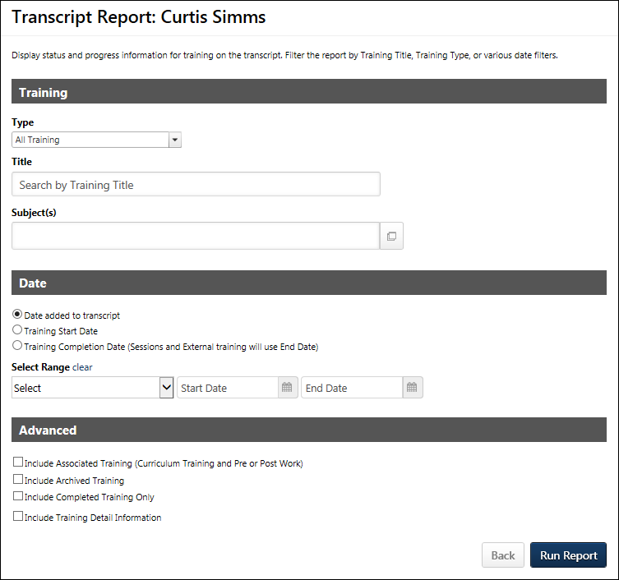
Training Criteria
The Training section enables users to filter the report results by learning object (LO) type, training title, or one or more subjects. These filters apply to top-level (standalone) training only.
Filter Name | Filter Description
Type | From the drop-down menu, select each of the training types that should appear in the Transcript Report. At least one training type must be selected. All training types are checked by default. Unselecting an option removes it from the report output. In the report output, training types are sorted in alphabetical order. Events are only included when they are standalone training items.
Title | Enter a training title to filter the report by a specific training title. The report only contains training items that have a title that matches the search keywords.
Subject(s) | Click the Select icon  to open the Select Subject pop-up, which is a Single Item Select pop-up. See Single Item Select Pop-up for additional information. Select one or more subjects with which to filter. Once a subject is selected, it appears in the Subject(s) field. Additional subjects can be added by clicking the Select icon again. On the report output, subjects display in alphabetical order.
Date Criteria
The Date section enables users to filter the report based on a date range.
Filter Name | Filter Description
Date Field | Select one of the following options:  - Date Added to Transcript - Select this option to filter the results by the date on which the training was added to the user's transcript. When selected, the report output displays training items in the order in which they were added to the transcript.  - Training Start Date - Select this option to filter the results by the date on which a training item started. Note: The Date Range field is required when this option is selected. Also, the Include Completed Training Only option is checked by default and not editable. The start date is configured as follows:  - Event/Session - The date on which the session starts.  - External Training - The date on which the external training starts.  - Material - The date on which the user registers for the material.  - Test - The date on which the user clicks Start to begin the test. For multiple instances of a test, the start date is configured as each subsequent instance that the Start button is clicked.  - Online Course, Quick Course, Curriculum, Library, Posting - The date on which the training achieves a status of In Progress.  - Training Completion Date (Session and External training will use End Date) - Select this option to filter the results by the date on which a training item ended. Note: The Date Range field is required and the Include Completed Training Only option is checked by default and not editable when this option is selected. Also, training items must be in a status of Completed in order to appear in the report output when this option is selected. The end date is configured as follows:  - Event/Session - The date on which the session ended; not the date on which the roster was submitted.  - External Training - The date on which the external training ended; not the date on which the training was marked complete.  - Material - The date on which the material was marked complete.  - Online Course, Quick Course, Curriculum, Library, Posting, Test - The date on which the training achieved a status of Completed.
Date Range | Click on Calendar icon to select a Start and End Date, or enter a date range to filter the report by date. The End Date cannot be before the Start Date and it cannot be after today's date.  - If the Start Date is left blank, then the report returns all records that occurred at any point before the End Date.  - If the End Date is left blank, then the report returns all records that occurred at any point after the Start Date.
Advanced Criteria
The Advanced section enables users to define additional criteria to include in the report results.
Filter Name | Filter Description
Include Associated Training (Curriculum Training and Pre or Post Work) | Select this option to include training details from curricula or pre and post work from an event.
Include Archived Training | Select this option to include training that has been archived.
Include Required Training Information | Select this option to include a Required and Requirements column in the report. The Required column displays whether the training is required. The Requirements column displays what requirements are covered by the assigned training.  This option is only available if Required Training Tagging is activated in Feature Activation Preferences.
Include Completed Training Only | Select this option to include only completed training. When this option is selected, the following additional options are available:  - Show most recent completion - Selecting this option displays only the most recently completed LO. If selected, on the report output, the Completed Training Only field displays "Yes, Show only the most recent instance of completion."  - Show all completions if the user has completed more than one instance - Selecting this option displays all LOs that are in a status of Completed. This includes training items on the Completed and Archived tabs. If selected, on the report output, the Completed Training Only field displays "Yes, Show all historical instances of completion if user has completed more than one instance."
Include Training Detail Information | Select this option to include training detail information. When checked standard and training custom field filters appear. The following standard field filters may appear:  - Credits - This option displays the number of credits associated with the LO.  - Price - This option is only available if pricing is enabled in the portal. This option displays the price associated with the LO.  - If the user has not yet registered for the Learning Object, then this value is the price as it is defined for the LO.  - If the user has a status of registered or a status after registered, then this value displays what the user was charged for the training.  - Provider (Vendor) - This option displays the LO provider or vendor, if applicable.  - Training Hours - This option displays the LO training hours. A value does not display if the training hours have not been defined for the LO.  - Version - This option displays the LO version, if the LO can be versioned. A value does not display for a LO if the LO cannot have multiple versions.  - Custom Fields - Custom fields also display in alphabetical order.
Back or Run Report
Click Back to return to the Universal Profile - Transcript page. Or, click Run Report to generate the report in Excel in a new window.
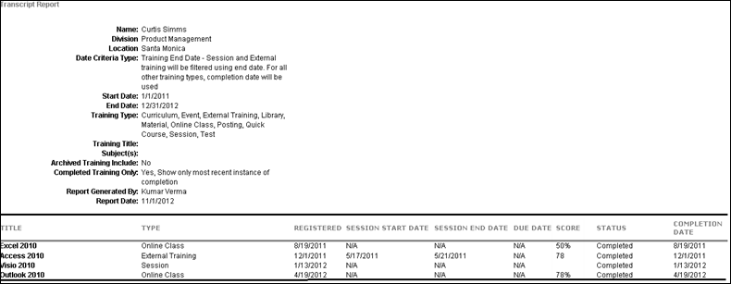

Course Troubleshooting Guide
Cornerstone's Learning Management System (LMS) provides organizations with comprehensive functionality for uploading and allowing access to online courses. Due to the complexities of online course and LMS workflows and processes, sometimes unexpected issues may arise. In this document, we will review some of the more common problems that can occur and what can be done to avoid or fix them.
Common Bugs
In most cases, the root cause for content defects is course file-related issues. The first step is to test your courses in SCORM Cloud in Frameset mode, using the Rustici website, to ensure your course functions as expected. This is an industry standard online course testing platform available to everyone that emulates a LMS.
The following types of issues may be prevented by testing your course in SCORM Cloud prior to publishing it within the Cornerstone LMS:
- Content issues affecting user experience
- Administrator is not familiar with LMS/SCORM guidelines and practices
Course Completion Issues
Most course completion issues (where a user believes they have completed the course but the course is not showing as "Completed" on their transcript) arise from the course being architected or published out of the authoring tool incorrectly. Since there are so many different authoring tools available commercially, troubleshooting this particular issue can be problematic. However, there are a few rules of thumb that clients can follow to avoid this issue:
- LMS Reporting - When publishing a course from the authoring tool, many tools provide a choice of “reporting status” to the LMS. For example, a course building tool may provide options for LMS reporting, such as “Passed/Incomplete,” “Passed/Failed," "Completed/Incomplete," and “Completed/Failed.” We have found that options which include the terms "Passed" and "Failed" could introduce completion issues on users' transcripts, so in this instance we recommend the use of the "Passed/Incomplete" option.
- Course Architecture - There will be cases where the authoring tool being used doesn’t provide insight into when exactly course/LMS communication will occur. With tools like Articulate Presenter, Articulate Storyline, Adobe Presenter, and other rapid development tools, the black-box nature of the tool does not give visibility into the LMS calls that are triggered from the course. In these situations, organizations need to be careful to build the course in such a way as to ensure these communications take place. Since doing this is so dependent on the course structure and tool used, there isn’t a standard way of implementing proper communication. However, we can provide the following guidance:
  - Test the course using SCORM Cloud in Frameset mode to ensure your course functions as expected.
  - Always provide a way for the user to easily exit the course. This is usually implemented in the form of an Exit button or link that's always available in the course shell.
  - Ensure that any actions or triggers on the current page in the course occur when the user exits the course. For example, if you've built a page in the course that takes user input which subsequently gets stored in the LMS, you want to make sure you provide a mechanism, such as a "Next Page" action or a suspend call to the LMS, that reads that data before the course is exited.
  - Ensure you are marking the correct method for tracking progress and completion in the course reporting and tracking options. Whether using a number or percentage of slides viewed or using the results of a quiz within the course, make it clear to your users what is expected from them to complete the course.
Note: The below image is an example of some tracking options, but your tool's options may be different depending on the tool and the version being used. Be sure to review the documentation and support provided by your tool's vendor.
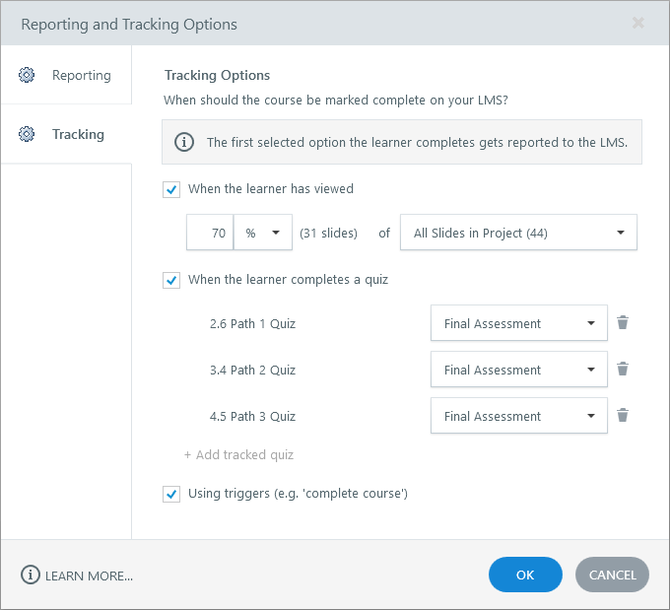
- Completion Criteria - Even if a course is built correctly, the course still relies on the user to interact with it properly in order for the course to be completed and for the completion to be passed to the LMS and register on the user's transcript. It is important that users are aware of what they need to do to complete the course. For example, if there is a minimum amount of time that the user must spend viewing each slide or a minimum quiz score that must be obtained in order to complete the course, then the user should be aware of these criteria. Otherwise, the user may think there is an issue with the course and contact their manager or system administrator.
- Leverage Your Tool's Support - The information provided in this guide includes general guidelines. For the most up-to-date information related to your tool, please leverage the documentation and support provided by your content authoring tool's vendor. This will provide you with information that is specific to the tool and version that you are using. Some examples of course authoring tool vendors include Articulate, Adobe, Lectora, and Captivate.
Additional Resources
How Cornerstone Learning Handles Completion and Success Statuses Sent from Courses

Curriculum Player Overview
The Curriculum Player enables users to launch and complete learning objects (LOs) within a curriculum. The Curriculum Player guides users through the curriculum sections and allows users to track their progress.
The Curriculum Player can be opened for a curriculum in the following ways:
- From the redesigned LO Details page for the curriculum, click the Open Curriculum Player button. See Learning Object (LO) Details Page for additional information.
- From the Transcript, click the Open Curriculum option for the appropriate curriculum.
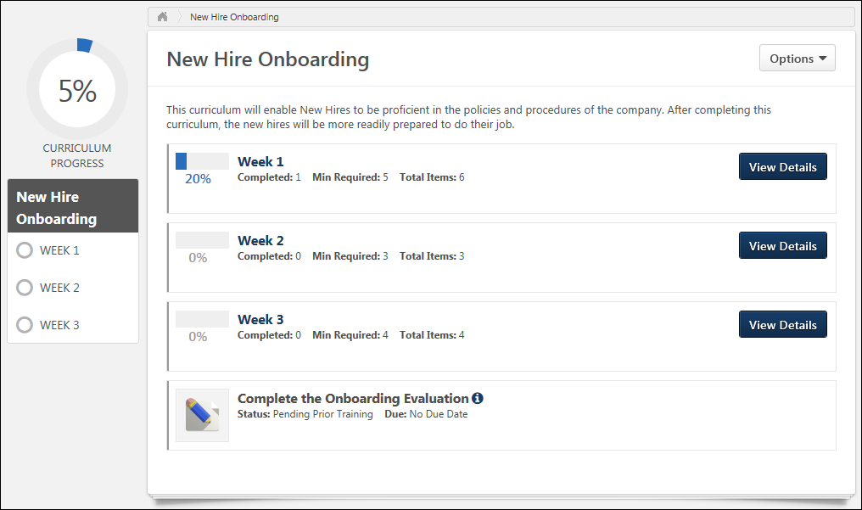
Breadcrumbs
At the top of the page, the breadcrumbs for the page are displayed. Users can click the links within the breadcrumbs to navigate to those pages. Note: The page to which the Home icon is linked is configured by the administrator in Navigation Tabs and Links.
Title and Description
Below the breadcrumbs, the curriculum title is displayed.
If a description is provided for the curriculum, then it appears below the curriculum title.
Options
The following options may be available from the Options drop-down:
- View Completion Page - This opens the Training Completion page for the curriculum. This option is only available once the user has completed all of the required LOs for the curriculum. Also, this option is only available if a Training Completion page is enabled for the curriculum. See Training Completion Page on page 118 for additional information.
- Training Details - This option opens the Training Details page for the curriculum. The Training Details page enables the user to view the entire curriculum in a single view. See Training Details - View on page 124 for additional information.
Overall Progress
The overall progress for the curriculum is displayed as a percentage and as a graphic in the upper-left corner of the Curriculum Player. Administrators have the option to hide the overall progress throughout the curriculum. If the progress is hidden, then the overall progress does not appear in the upper-left corner of the Curriculum Player.
Curriculum progress is displayed incrementally based on LO completion. That is, each time a required LO is completed, the section and overall curriculum completion percentage is incrementally increased. See Curriculum Player - Progress Display on page 244 for additional information.
If a curriculum is configured so that no sections are required, then the overall progress is automatically set to 100%.
Curriculum Player - Section Navigation
On the left side of the Curriculum Player, the navigation menu displays all sections along with their completion status. Users can navigate through sections of the curriculum by clicking the appropriate section or subsection. If a curriculum has no sections, then the navigation menu does not appear. See Curriculum Player - Sections on page 239 for additional information.
Curriculum/Section Details
Users can click a curriculum title to view the details of the curriculum. Users can click a section title in the navigation menu to view the section overview. The curriculum or section overview displays the section information, progress, and contents. The order in which items are displayed is dependent on the curriculum structure, which is set by the administrator.
- Curriculum Overview Page - The overview page for the entire curriculum displays the sections and LOs that are at the root-level of the curriculum.
- Section Overview Page - The overview page for a section within the curriculum displays the sections and LOs that are contained within the section. However, a section summary header is displayed at the top of the page.
See Curriculum Player - Curriculum/Section Details on page 241 for additional information.

Curriculum Player - Sections
On the left side of the Curriculum Player, the navigation menu displays all sections along with their completion status. Users can navigate through sections of the curriculum by clicking the appropriate section or subsection. If a curriculum has no sections, then the navigation menu does not appear.
Section Navigation
When a section is selected, the section is expanded within the navigation menu to display any subsections within the section. The Curriculum Player displays all learning objects (LOs) within the selected section. See Curriculum Player - Curriculum/Section Details on page 241 for additional information.
Any sections that have subsections are indicated with an arrow that points to the right . When a section is expanded, the arrow points downward . The section hierarchy that displays in the navigation panel is limited to three levels. If the curriculum contains more than three levels of sections, the navigation panel displays the top three levels, and the user can navigate further through the curriculum by clicking the section titles. See Curriculum Player - Curriculum/Section Details on page 241 for additional information.
If there are many sections and subsections within the curriculum, then a scroll bar is available within the navigation panel so that users can scroll through all sections.
Section Statuses
The icon to the left of the section title indicates the section status:
- Incomplete Section - If a section is not started or is in progress, then this section appears with an empty circle .
- Completed Section - If a section is completed, it appears with a white check mark within a colored circle . A section is considered complete when the requirements for the section are fulfilled.
- Incomplete Subsection - If a subsection is not started or is in progress, then no icon appears to the left of the subsection name.
- Completed Subsection - If a subsection is completed, it appears with a colored checkmark icon . A subsection is considered complete when the requirements for the subsection are fulfilled.
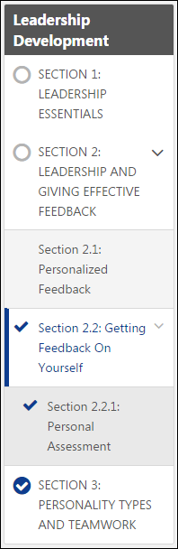

Curriculum Player - Curriculum/Section Details
Users can click a curriculum title to view the details of the curriculum. Users can click a section title in the navigation menu to view the section overview. The curriculum or section overview displays the section information, progress, and contents. The order in which items are displayed is dependent on the curriculum structure, which is set by the administrator.
- Curriculum Overview Page - The overview page for the entire curriculum displays the sections and LOs that are at the root-level of the curriculum.
- Section Overview Page - The overview page for a section within the curriculum displays the sections and LOs that are contained within the section. However, a section summary header is displayed at the top of the page.
Section Item Details
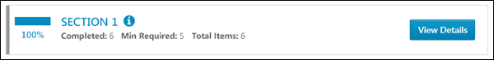
For section items within a curriculum, the following information is displayed:
- Color Strip - The left edge of the curriculum item is color coded to represent the proximity to the due date of the item. For example, if the item due date is past due, then the color strip is red to indicate that item is due immediately. If an item due date is not eminent, then the color strip is green to indicate that item is not due immediately. See the Color Strip Key section below for additional information.
- Section Completion Percentage - This displays the section progress. The maximum value is 100%. Administrators have the option to hide section progress throughout the curriculum. If section progress is hidden, the section progress does not appear to the left of the section title. See Curriculum Player - Progress Display on page 244 for additional information.
- Section Title - This displays the section title. Users can click the section title to view the section details. The page refreshes and displays the section header and the contents of the section. The navigation panel is also updated to indicate which section has been selected.
- Section Information Icon - Click this icon to view the section instructions in a pop-up. This icon is only available if there are instructions for the section.
- Completed - This displays the number of items within the section that have been completed.
- Min Required - This displays the minimum number of items that must be completed in order to complete the section.
- Total Items - This displays the total number of items that are available within the section.
- View Details - Users can click this button to view the section details. The page refreshes and displays the section header and the contents of the section. The navigation panel is also updated to indicate which section has been selected.
Training Item Details
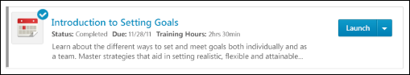
For learning objects (LOs) within a curriculum, the following information is displayed:
- Color Strip - The left edge of the curriculum item is color coded to represent the proximity to the due date of the item. For example, if the item due date is past due, then the color strip is red to indicate that item is due immediately. If an item due date is not eminent, then the color strip is green to indicate that item is not due immediately. See the Color Strip Key section below for additional information.
- Icon - An LO icon is displayed to indicate the type of LO. Each LO type is represented by a unique icon. When a LO is completed, a checkmark icon appears in the upper-right corner of the LO icon.
- Title - This displays the LO title. Click the LO title to open the Training Details page for the LO. This action is only available once the LO is activated. See Training Details - View on page 124 for additional information.
- LO Information Icon - Click this icon to view the LO instructions in a pop-up. This icon is only available if there are instructions for the LO.
- Status - This displays the current status of the LO.
- Excused - If a user is excused from the LO, then this is displayed to the right of the Status. If a user is not excused from the LO, then this field does not appear. When a user is excused from the LO, they can complete the LO, but it does not count towards the section or curriculum progress. Note: Excused is not a transcript status and therefore does not prevent the user from being required to complete the LO if it is required in another curriculum, cohort, or somewhere else on the transcript. It only excuses the user from the version of the LO that is active in the curriculum or cohort in which it has been marked excused. If the LO is later reversioned, it will no longer be Excused. This is different from Exempt, which is a transcript status and exempts the LO anywhere it is required on the transcript.
- Due - This displays the LO due date. When a user views the Due Date field for a training item with a status of Past Due and a due date set in the future from any of the following system locations, an icon with due date information displays to the user. If the user hovers over the Due Date help icon for a training item that has a future due date but also a status of Past Due, the icon displays the message, "This training is on your transcript with an earlier Due Date of mm/dd/yyyy." This allows the user to see when they must actually complete the training.
- Training Hours - This displays how long the training will take to complete. If there are no training hours, then this field does not display.
- Description - The LO description is displayed below the LO status, due date, and training hours. Up to two lines of the description is displayed.
- Action drop-down - This drop-down enables users to perform actions on the LO based on the LO status. Click the left side of the drop-down to perform the displayed action. Or, click the drop-down arrow to select a secondary action. By default, the Action drop-down displays the primary action for the LO. See Transcript (Universal Profile) - Status and Options on page 96 for additional information.
Color Strip Key
The following colors are used to represent the proximity of training items to their respective due dates:
- Red - Due today or past due
- Yellow- Due within the next seven days, not including today
- Green - Due after seven days
- Gray - The color strip is gray for all items that do not meet the criteria for the other states (Red, Yellow, Green). The color strip for sections is always gray.

Curriculum Player - Progress Display
Curriculum progress is displayed incrementally based on LO completion. That is, each time a required LO is completed, the section and overall curriculum completion percentage is incrementally increased.
Completion percentages always round up for all numbers up to 99%. Once 99% completion is reached, the completion percentage remains at 99% until exactly 100% completion is reached. Then, the completion percentage is updated to 100%. 100% is the maximum completion percentage for a curriculum.
If a curriculum or a section do not have any required items (e.g., 0 of 3 items are required), then the progress for the corresponding curriculum or section is automatically 100%.
- The completion of a child section that has no required items does not contribute to the completion percentage of its parent section or curriculum unless the parent section or curriculum is 100% completed by the child section. For example, if Section 1.1 is a subsection of Section 1, and Section 1.1 has zero required items, then Section 1.1 is automatically 100%. If the completion of Section 1.1 results in Section 1 being completed (i.e., all other requirements for Section 1 have been completed), then Section 1 is 100% complete. However, if Section 1 has other requirements that have not yet been completed, then the progress for Section 1 does not include Section 1.1.
Note: LOs that are not within a section behave as sections when calculating progress.
Curriculum Progress Calculation Details
The examples in this section use the following curriculum as an example:
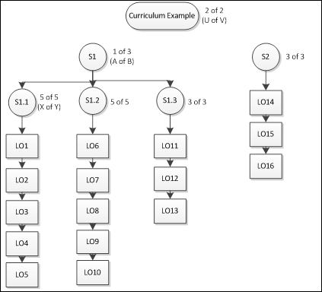
Calculation Rules
When calculating the completion progress for a section that contains only LOs (e.g., section S1.1 in the image), then the section progress is dependent upon the number of LOs that are required to be completed within the section. For example, in section S1.1 in the image there are a total of five LOs in the section, and all five LOs must be completed to complete the section (i.e., 5 of 5, or X of Y).
- Completion Progress = (Number of LOs completed in section / Number of items required for section)
- For example, S1.1 requires 5 of 5 LOs. If 3 have been completed, then the section progress equals (3/5), or 60%.
When calculating the completion progress for a section that contains only subsections (e.g., section S1 in the image), then the section progress is dependent upon the number of subsections that are required to be completed within the section. For example, in section S1 in the image there are three subsections in the section, and one subsection must be completed to complete the section (i.e., 1 of 3 or A of B).
- Completion Progress = Sum of highest progress percentages from required subsections / Number of required subsections
- For example, S1 requires 1 of 3 subsections. If S1.1 is 40% complete, S1.2 is 20% complete, and S1.3 is 34% complete, then the progress for S1 is 40%/1, or 40%. If S1 required 2 of 3 subsections, then the progress for S1 would be (40%+34%)/2, or 37%.
If a curriculum or a section does not have any required LOs, then the progress for the corresponding curriculum or section is automatically 100%.
- The completion of a child section that has no required items does not contribute to the completion percentage of its parent section or curriculum unless the parent section or curriculum is 100% completed by the child section.
Use Case 1
LO Completed | Subsection Completion % | Section Completion % | Overall Completion % | Notes
LO1 | S1.1: (1/5)=20%  S1.2: (0/5)=0%  S1.3: (0/3)=0% | S1: 20%/1=20%  S2: 0%/1=0% | Overall % = (S1+S2)/2  (20%+0%)/2=10%
LO6 | S1.1: (1/5)=20%  S1.2: (1/5)=20%  S1.3: (0/3)=0% | S1: 20%/1=20%  S2: 0%/1=0% | (20%+0%)/2=10% | Overall progress is unchanged because progress for S1.1 and S1.2 are the same.
LO2 | S1.1: (2/5)=40%  S1.2: (1/5)=20%  S1.3: (0/3)=0% | S1: 40%/1=40%  S2: 0%/1=0% | (40%+0%)/2=20%
LO7 | S1.1: (2/5)=40%  S1.2: (2/5)=40%  S1.3: (0/3)=0% | S1: 40%/1=40%  S2: 0%/1=0% | (40%+0%)/2=20% | Overall progress is unchanged because progress for S1.1 and S1.2 are the same.
LO3 | S1.1: (3/5)=60%  S1.2: (2/5)=40%  S1.3: (0/3)=0% | S1: 60%/1=60%  S2: 0%/1=0% | (60%+0%)/2=30%
LO4 | S1.1: (4/5)=80%  S1.2: (2/5)=40%  S1.3: (0/3)=0% | S1: 80%/1=80%  S2: 0%/1=0% | (80%+0%)/2=40%
LO5 | S1.1: (5/5)=100%  S1.2: (2/5)=40%  S1.3: (0/3)=0% | S1: 100%/1=100%  S2: 0%/1=0% | (100%+0%)/2=50%
Use Case 2
LO Completed | Subsection Completion % | Section Completion % | Overall Completion % | Notes
LO11 | S1.1: (0/5)=0%  S1.2: (0/5)=0%  S1.3: (1/3)=34% | S1: 34%/1=34%  S2: 0%/1=0% | Overall % = (S1+S2)/2  (34%+0%)/2=17%
LO6 | S1.1: (0/5)=0%  S1.2: (1/5)=20%  S1.3: (1/3)=34% | S1: 34%/1=34%  S2: 0%/1=0% | (34%+0%)/2=17% | Section S1 and Overall progress are unchanged because progress for S1.3 is higher than progress for S1.2 and only one subsection is required for S1.
LO1 | S1.1: (1/5)=20%  S1.2: (1/5)=20%  S1.3: (1/3)=34% | S1: 34%/1=34%  S2: 0%/1=0% | (34%+0%)/2=17% | Section S1 and Overall progress are unchanged because progress for S1.3 is higher than progress for S1.1 and only one subsection is required for S1.
LO12 | S1.1: (1/5)=20%  S1.2: (1/5)=20%  S1.3: (2/3)=67% | S1: 67%/1=67%  S2: 0%/1=0% | (67%+0%)/2=34%
LO13 | S1.1: (1/5)=20%  S1.2: (1/5)=20%  S1.3: (3/3)=100% | S1: 100%/1=100%  S2: 0%/1=0% | (100%+0%)/2=50%
Use Case 3
In this Use Case, the requirement for S1 is increased to 2 of 3.
LO Completed | Subsection Completion % | Section Completion % | Overall Completion % | Notes
LO1 | S1.1: (1/5)=20%  S1.2: (0/5)=0%  S1.3: (0/3)=0% | S1: (20%+0%)/2=10%  S2: 0%/1=0% | Overall % = (S1+S2)/2  (10%+0%)/2=5%
LO6 | S1.1: (1/5)=20%  S1.2: (1/5)=20%  S1.3: (0/3)=0% | S1: (20%+20%)/2=20%  S2: 0%/1=0% | (20%+0%)/2=10% | Since S1.1 and S1.2 are the two highest progress subsections in S1, they both count towards section S1 and Overall progress.
LO2 | S1.1: (2/5)=40%  S1.2: (1/5)=20%  S1.3: (0/3)=0% | S1: (40%+20%)/2=30%  S2: 0%/1=0% | (30%+0%)/2=15% | Since S1.1 and S1.2 are the two highest progress subsections in S1, they both count towards section S1 and Overall progress.
LO7 | S1.1: (2/5)=40%  S1.2: (2/5)=40%  S1.3: (0/3)=0% | S1: (40%+40%)/2=40%  S2: 0%/1=0% | (40%+0%)/2=20% | Since S1.1 and S1.2 are the two highest progress subsections in S1, they both count towards section S1 and Overall progress.
LO11 | S1.1: (2/5)=40%  S1.2: (2/5)=40%  S1.3: (1/3)=34% | S1: (40%+40%)/2=40%  S2: 0%/1=0% | (40%+0%)/2=20% | Since S1.1 and S1.2 remain the two highest progress subsections in S1, they both count towards section S1 and Overall progress.
LO12 | S1.1: (2/5)=40%  S1.2: (2/5)=40%  S1.3: (2/3)=67% | S1: (67%+40%)/2=54%  S2: 0%/1=0% | (54%+0%)/2=27% | Now S1.3 and S1.1 are the two highest subsections in S1.
LO3 | S1.1: (3/5)=60%  S1.2: (2/5)=40%  S1.3: (2/3)=67% | S1: (67%+60%)/2=64%  S2: 0%/1=0% | (64%+0%)/2=32% | Since S1.3 and S1.1 remain the two highest progress subsections in S1, they both count towards section S1 and Overall progress.
LO4 | S1.1: (4/5)=80%  S1.2: (2/5)=40%  S1.3: (2/3)=67% | S1: (67%+80%)/2=74%  S2: 0%/1=0% | (74%+0%)/2=37% | Since S1.3 and S1.1 remain the two highest progress subsections in S1, they both count towards section S1 and Overall progress.
LO5 | S1.1: (5/5)=100%  S1.2: (2/5)=40%  S1.3: (2/3)=67% | S1: (67%+100%)/2=84%  S2: 0%/1=0% | (84%+0%)/2=42% | Since S1.3 and S1.1 remain the two highest progress subsections in S1, they both count towards section S1 and Overall progress.
LO13 | S1.1: (5/5)=100%  S1.2: (2/5)=40%  S1.3: (3/3)=100% | S1: (100%+100%)/2=100%  S2: 0%/1=0% | (100%+0%)/2=50% | Since S1.3 and S1.1 remain the two highest progress subsections in S1, they both count towards section S1 and Overall progress.
Use Case 4
In this Use Case, the requirement for S1 is increased to 3 of 3.
LO Completed | Subsection Completion % | Section Completion % | Overall Completion % | Notes
LO1 | S1.1: (1/5)=20%  S1.2: (0/5)=0%  S1.3: (0/3)=0% | S1: (20%+0%+0%)/3=7%  S2: 0%/1=0% | Overall % = (S1+S2)/2  (7%+0%)/2=4% | All three subsections within S1 count towards section S1 and Overall progress.
LO6 | S1.1: (1/5)=20%  S1.2: (1/5)=20%  S1.3: (0/3)=0% | S1: (20%+20%+0%)/3=12%  S2: 0%/1=0% | (12%+0%)/2=6%
LO2 | S1.1: (2/5)=40%  S1.2: (1/5)=20%  S1.3: (0/3)=0% | S1: (40%+20%+0%)/3=20%  S2: 0%/1=0% | (20%+0%)/2=10%
LO7 | S1.1: (2/5)=40%  S1.2: (2/5)=40%  S1.3: (0/3)=0% | S1: (40%+40%+0%)/3=27%  S2: 0%/1=0% | (27%+0%)/2=14%
LO3 | S1.1: (3/5)=60%  S1.2: (2/5)=40%  S1.3: (0/3)=0% | S1: (60%+40%+0%)/3=34%  S2: 0%/1=0% | (34%+0%)/2=17%
LO4 | S1.1: (4/5)=80%  S1.2: (2/5)=40%  S1.3: (0/3)=0% | S1: (80%+40%+0%)/3=40%  S2: 0%/1=0% | (40%+0%)/2=20%
LO5 | S1.1: (5/5)=100%  S1.2: (2/5)=40%  S1.3: (0/3)=0% | S1: (100%+40%+0%)/3=47%  S2: 0%/1=0% | (47%+0%)/2=24%
LO8 | S1.1: (5/5)=100%  S1.2: (3/5)=60%  S1.3: (0/3)=0% | S1: (100%+60%+0%)/3=54%  S2: 0%/1=0% | (54%+0%)/2=27%
LO9 | S1.1: (5/5)=100%  S1.2: (4/5)=80%  S1.3: (0/3)=0% | S1: (100%+80%+0%)/3=60%  S2: 0%/1=0% | (60%+0%)/2=30%
LO10 | S1.1: (5/5)=100%  S1.2: (5/5)=100%  S1.3: (0/3)=0% | S1: (100%+100%+0%)/3=67%  S2: 0%/1=0% | (67%+0%)/2=34%
LO11 | S1.1: (5/5)=100%  S1.2: (5/5)=100%  S1.3: (1/3)=34% | S1: (100%+100%+34%)/3=78%  S2: 0%/1=0% | (78%+0%)/2=39%
LO12 | S1.1: (5/5)=100%  S1.2: (5/5)=100%  S1.3: (2/3)=67% | S1: (100%+100%+67%)/3=89%  S2: 0%/1=0% | (89%+0%)/2=45%
LO13 | S1.1: (5/5)=100%  S1.2: (5/5)=100%  S1.3: (3/3)=100% | S1: (100%+100%+100%)/3=100%  S2: 0%/1=0% | (100%+0%)/2=50%

Curriculum Player 2.0
The Curriculum Player 2.0 is an improvement on the legacy Curriculum Player that provides users with a straightforward path to completing their curriculum. It is fine-tuned to offer a modern user interface while addressing complex workflows. The Curriculum Player 2.0 is now available to enable in production portals as early adopters.
The key features of Curriculum Player 2.0 include:
- Support for Event and Sessions
- Notes
- Handling additional transcript statuses
- Incorporating Beta feedback
- New and improved UI/UX with color-coordinated indicators for completed and past-due training.
- Support for Online Content (OCLO), Observation Checklists, Forms.
- Saving user context (which training the learner was last on) when re-launching a curriculum.
- Support for manager and administrator actions when viewing a learner’s curriculum.
When the Curriculum Player 2.0 feature is enabled for the portal, administrators can activate the Curriculum Player 2.0 for any curricula in any environment when creating or editing the curriculum.
Curriculum Player 2.0 User Interface and User Experience
Curriculum Player 2.0 has the following features:
- Icons to denote different training types.
- Color-coordinated indicators to express when training is completed (green checkmark) or past due (red exclamation point.)
- Information icon for section instructions.
- Tags that denote how many trainings are required per section.
- A modal that displays curriculum description upon launching a curriculum.
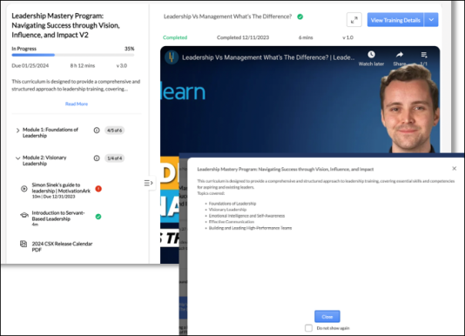
Support for Online Content
- Curriculum Player 2.0 supports subscription-based Online Content (OCLO).
Support for Observation Checklists
- Observation Checklists are supported.
- Checklist contents are displayed inline.
- Clicking ‘View Checklist’ or ‘Validate Checklist’ redirects users to the existing UI to complete validation.
Support for Forms
- Forms can be completed and submitted inline in Curriculum Player 2.0.
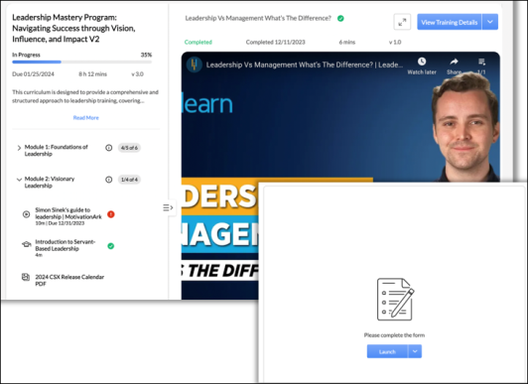
Saving User Context
- Upon re-launching a curriculum, the last training that the learner accessed is opened by default.
Manager and Admin Action Support
- Managers and Admins can view learner’s curricula and see relevant transcript actions.
- Support for ‘Record Observation’ action that redirects observers to the observation checklist verifier page.
- Support for ‘Review’ action for tests that redirects to the test attempt page, where admins can manage attempts.
- Ability to mark training as Exempt using a fly-out.
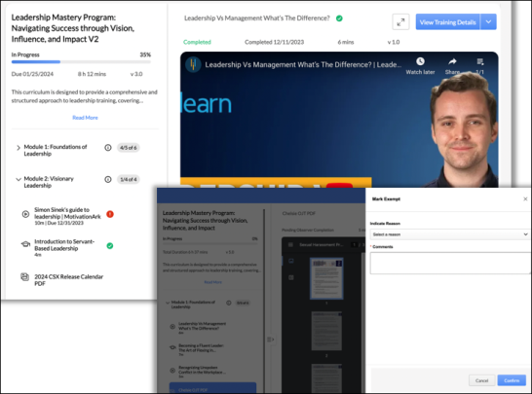

Assign Training
To assign training from the Training Details page, search for the learning object (LO). Then, click the Assign button. See Search for Training on page 305 for additional information.
The Assign button is not be visible if the user does not have Assign Training with Constraints or Assign Training permission. Also, the training needs to be within user constraints for the Assign button to be visible.
Users without managerial or approver roles can also assign trainings. See Assign Training Without Managerial or Approver Roles on page 268 for additional information.
Managers and training approvers may be able to assign training from inventory. See Assign Training to Users from Inventory on page 265 for additional information.
Permissions
PERMISSION NAME | PERMISSION DESCRIPTION | CATEGORY

Assign Training | Grants ability to assign learning objects to the transcripts of those for whom the user is the assigned manager, approver or cost center approver. This is a manager/approver permission. | Learning

Training Equivalency - View | Allow users to view equivalent training items when searching for training. This is an end user permission. | Learning - Administration

Assign Training with Constraints | This permission grants any Role, User, or Organizational Unit (standard and custom, including groups) the ability to assign training to other users. This permission, along with its constraints, seamlessly integrates with the existing Assign Training permission. Users with either the new permission or both will be redirected to a new interface and will use the constraints associated with the Assign Training with Constraints permission. This permission can be constrained by the following:  - User's direct subordinates  - User's subordinates  - Organizational Units (including Groups) - Standard and Custom  - Provider  - Training Type  - Training Item (specific training)  Multiple constraints on the permission between User/OU and LO are treated as AND constraints, whereas constraints between User/OU are treated as OR constraints. | Learning - Administration
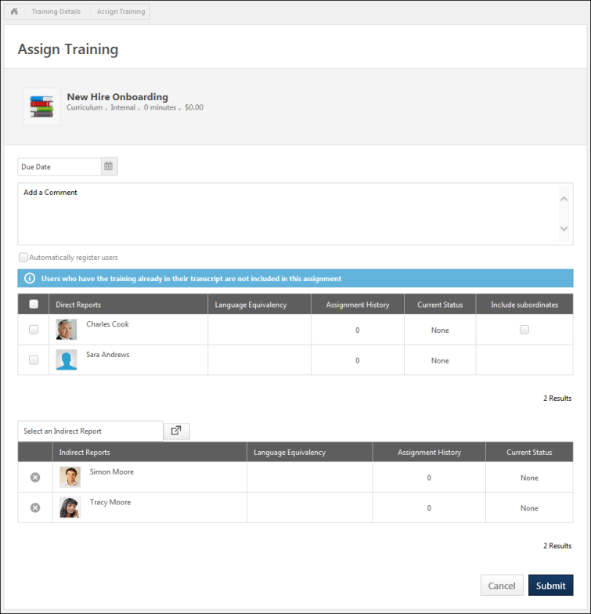
Summary
At the top of the page, a summary of the learning object (LO) details is displayed, which includes the following information:
- Training Type icon - The icon that is displayed corresponds with the LO type (e.g., certification, curriculum, event, library, online course). Hover your cursor over the icon to view the LO type.
- Training Title - The training title is displayed to the right of the training type icon.
- Training Type - The training type is displayed below the training title.
- Provider - This field displays the name of the training provider.
- Duration - This field displays the duration of the training in hours and minutes.
- Cost - This displays the cost to assign the LO in both currency and training units, as configured for the LO.
- Star Rating - This displays the course rating.
- Number of Ratings/Reviews - This displays the number of ratings for the LO.
- Equivalent Training - If the manager has permission to view language equivalents for the training, then any of the LO's language equivalents are displayed.
Select Session
When assigning an event, if the administrator has configured the event so that users cannot select sessions, then a session cannot be selected from the LO Details page and the user cannot select a session from their transcript once the event is assigned.
When assigning an event to a user, the Assign Training page includes a Select Session button, which provides the manager the option to select a specific session to assign to the user. This button is only available if the event is configured to allow managers to select sessions for the event.
When the manager clicks the Select Session button, they are directed to the Training Details page for the event where they can assign a specific session. After selecting a session, they are redirected back to the Assign Training page.
Due Date
If applicable, select a due date by clicking on the Calendar icon . This option may not be available if the due date is predetermined within the LO.
Comments
In the Add a comment field, enter any comments or instructions related to the assignment. This is optional. The assignee can see the comments in the Training Item history in their transcript. For certifications, comments are displayed in the Comment section of the Certificate player.
Automatically Register Users
If applicable, select the Automatically register users option to assign the training in a registered status, eliminating the user's need to click the Register option.
If the seat reservation option is enabled in ILT Preferences, a View Available Seats link is available to the right of the Automatically register users option. Click the link to open the Seats Available pop-up, which displays the seat allocation details.
The following information displays in the Seats Available pop-up:
Session Details
The Session Details section displays the following:
- Locator Number - This field displays the locator number of the associated session.
- Subject - This field displays the subjects that are defined for the session at the event level.
- Training Hours - This field displays the number of training hours associated with the entire session. If the session has multiple parts, then the field displays the total number of training hours for all of the parts.
- Credits - This field displays the number of credits associated with the session, as defined at the session level.
- Price - This field displays the price of the session.
Organizational Units
The Organizational Units section displays all of the OUs for which seats are reserved, as well as the number of seats available and reserved. The following columns display:
- Organizational Unit(s) - This column displays the OUs for which seats are reserved. The OUs appear in the order in which they are defined at the session level.
- Seats Available - This column displays the number of seats that are currently open to the users in the OU. Note: If a user who was occupying a reserved seat is withdrawn from the session or withdraws voluntarily, then the reserved seat is returned to the OU from which the seat was reserved.
- Seats Reserved - This column displays the number of seats that are reserved for each OU.
- Inventory Seats - If applicable, this column displays the number of pre-purchased training inventory seats for each OU. This column only appears if the number of pre-purchased seats is greater than zero for the session. See Purchase Training Inventory.
- All Employees (based on availability) - This row displays the number of seats in a session that are not reserved. The Seats Available column displays the number of general seats that are currently available for the session. The Seats Reserved column displays the total number of general seats for the session.
- Total - This row displays the total number of seats that are currently available for the session in the Seats Available column. The Seats Reserved column displays the maximum registration number for the session.
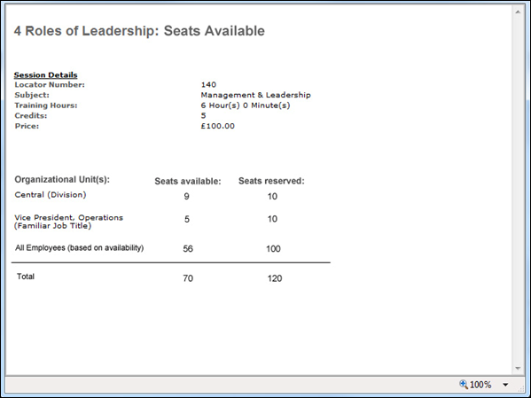
Direct and Indirect Reports
In the Direct Reports section, a list of the manager’s direct reports and any users for whom they are the approver display. By default, no users are displayed in the Indirect Reports table.
Direct/Indirect Reports Tables
In the Direct/Indirect Reports table, the following information is displayed for each direct or indirect report:
- Direct/Indirect Report - This displays the user's full name and photograph.
- Language Equivalents - This column only displays if language equivalents are enabled. If the LO has language equivalents and the user is assigned one of those language equivalents, then they are displayed.
- Assignment History - If the user has been assigned the LO in the past, then this column displays the number of times the user has been assigned the LO. If the manager is reassigning the training, then they will overwrite the current instance of the training, including any progress the user has made.
- Current Status - If the user currently has the LO on their transcript, then this column displays the user's LO status.
- Include Subordinates - Select this option to assign the LO to the direct report's subordinates. This option is only available in the Direct Reports table and only appears if the direct report has subordinates. When this option is selected, the direct report's subordinates are automatically added to the Indirect Reports table.
Assign Direct Reports
- To assign the LO to a direct report, select the checkbox to the left of the user's name.
- To select all direct reports, select the checkbox to the left of the Direct Reports column heading. If there are multiple pages of direct reports, then this option selects all users across all pages.
- To also assign the LO to a direct report's subordinates, select the Include Subordinates checkbox to the right of the corresponding user.
Assign Indirect Reports, Indirect Shared Reports, or Cost Center Users
To assign an indirect report, click the Select an Indirect Report field.
Indirect shared reports are indirect reports of the manager who delegated shared permission to the assigner. To assign an indirect shared report, click the Select an Indirect Shared Report field.
An administrator may be able to assign training as a cost center approver. To assign a user from cost center that you approve, click the Select a User from a Cost Center I Approve field.
When one of these fields is clicked, the Select a User pop-up opens. See Select User Pop-up.
When selecting indirect reports, if recurrence is not supported by the LO and one or more of the selected users already has the selected LO on their transcript, then they are not included in the assignment. Click the view details link to view the excluded users.
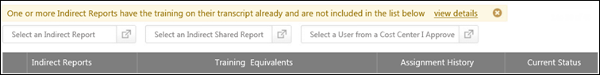
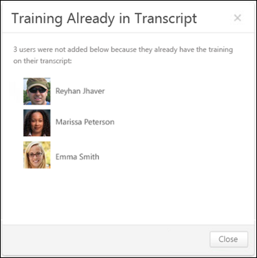
Remove Indirect Report
Once an indirect report is selected, the user appears in the Indirect Reports table. To remove an indirect report, click the Remove icon to the left of the user's name.
Assignment Considerations
The following considerations apply when assigning a training item:
- If the training is available for reassignment, you can assign the initial or subsequent assignments to subordinates. The checkbox next to the direct report's name is always clickable when the LO is set to allow reassignment, except for events and sessions where the user has already requested or been assigned the LO because recurrence is not available for sessions and events. If a user has an Assignment History of 0, this indicates that the user has never been assigned or requested the LO.
- If a user already has the item in their transcript and the LO is not available for reassignment, or if the user has already requested or been assigned the event or session, then the checkbox is disabled and cannot be clicked.
- If the LO is not available for reassignment, then any user that has the LO on their transcript cannot be selected.
Direct/Indirect/Shared Reports Pagination
If more than ten users are available, pagination options appear in the lower-right corner of the section.
- Click a specific page number to go directly to that page.
- To move one page forward or backward, click the right or left arrow icon.
- To move to the first or last page, click the double left or double right arrow icon.
Submit or Cancel
Click Submit to submit the assignment. You returned to the page from which you accessed the Assign Training page. Note: For certifications, the users must still register for the certification and receive approval if required.
- Confirm Enrollment - When submitting an assignment, if one or more of the selected users already has the selected LO on their transcript, reassigning the training would overwrite the current instance of the training, including any progress the user has made. The Confirm Enrollment pop-up appears to confirm the assignment.
  - Click Save to submit the assignment and reassign the training, or click Cancel to cancel the assignment and return to the Assign Training page to modify the assignment.
- Increase Seats - When submitting an assignment for an ILT session, if the total number of users exceeds the number of available seats for the session and the manager has permission to edit the session, the manager can select to increase the session's available seats or add remaining users to the waitlist. This also applies if a selected user matches an organizational unit (OU) that has reserved seats but there are not enough reserved seats available for the OU. See the Increase Seats Pop-up section below for additional information.
- Add to Waitlist - When submitting an assignment for an ILT session, if the total number of users exceeds the number of available seats for the session and the manager does not have permission to edit the session, the manager can choose to add the remaining users to the waitlist. This also applies if a selected user matches an organizational unit (OU) that has reserved seats but there are not enough reserved seats available for the OU. See the Add to Waitlist Pop-up section below for additional information.
- Seats Not Available - When submitting an assignment for an ILT session, if the total number of users exceeds the number of available seats for the session, but the manager does not have permission to edit the session and waitlists are not enabled for the session, then the Seats Not Available pop-up opens.
  - Click Close to return to the Assign Training page and modify the assignment.
- Users Not Assigned Training - In some cases, selected users may not be assigned the training due to waitlists being full, etc. When there are one or more users who are not assigned the training, the Users Not Assigned Training pop-up opens.
  - Click Close to close the pop-up.
Or, click Cancel to cancel the assignment and return to the page from which you accessed the Assign Training page.
Increase Seats Pop-up
When submitting an assignment for an ILT session, if the total number of users exceeds the number of available seats for the session and the manager has permission to edit the session, the manager can select to increase the session's available seats or add remaining users to the waitlist. This also applies if a selected user matches an organizational unit (OU) that has reserved seats but there are not enough reserved seats available for the OU.
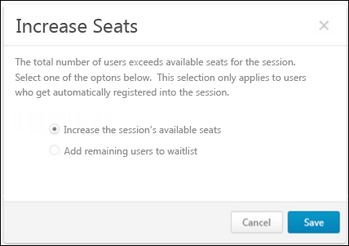
The following options are available:
- Increase the session's available seats - Select this option to increase the total number of available seats or reserved seats for the OU by the number of matching users that are added to the session. Note: You must have permission to edit sessions in order to increase the number of seats available in the session.
- Add remaining users to waitlist - Select this option to add the additional users to the waitlist. The waitlist options that are configured for the session apply.
Click Save to implement the selected option, or click Cancel to cancel the assignment and return to the Assign Training page to modify the assignment.
The following considerations apply when adding users to the waitlist:
- Even if a user on the waitlist matches criteria for an OU that has reserved seats, the user is granted the first available opening. The opening could be a reserved seat for their matching OU or a general availability seat, whichever opens first.
- If a reserved seat is the first available seat for multiple users on the waitlist that match the OU's criteria, then the user that is highest on the waitlist is granted the first available reserved seat for their matching OU if the Allow Auto-Management of Waitlist option is configured for the session.
Add to Waitlist Pop-up
When submitting an assignment for an ILT session, if the total number of users exceeds the number of available seats for the session and the manager does not have permission to edit the session, the manager can choose to add the remaining users to the waitlist. This also applies if a selected user matches an organizational unit (OU) that has reserved seats but there are not enough reserved seats available for the OU.
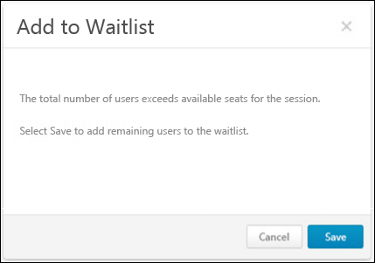
Click Save to add the additional users to the session waitlist, or click Cancel to cancel the assignment and return to the Assign Training page to modify the assignment.
The following considerations apply when adding users to the waitlist:
- Even if a user on the waitlist matches criteria for an OU that has reserved seats, the user is granted the first available opening. The opening could be a reserved seat for their matching OU or a general availability seat, whichever opens first.
- If a reserved seat is the first available seat for multiple users on the waitlist that match the OU's criteria, then the user that is highest on the waitlist is granted the first available reserved seat for their matching OU if the Allow Auto-Management of Waitlist option is configured for the session.

Assign Training to Users from Inventory
This allows the assignor to assign a user to a specific learning object that was pre-purchased. The employees that display are dependent by the constraints associated with the user's permission to manage inventory. A user with permission to manage inventory can access the Training Inventory page to manage their inventory. The available inventory is displayed in the upper-right corner of the Assign Training page.
To access the Assign Training from Training Inventory page:
- Go to My Account > Order History. Then, click the View Inventory button. In the Options column for the associated training item, click the Assign Inventory icon.
Permissions
PERMISSION NAME | PERMISSION DESCRIPTION | CATEGORY

Assign Training | Grants ability to assign learning objects to the transcripts of those for whom the user is the assigned manager, approver or cost center approver. This is a manager/approver permission. | Learning

Inventory - Manage | Grants ability to purchase multiple learning object licenses with the intent to assign that training to other users at a later time. This permission can be constrained by OU and User's OU. | eCommerce
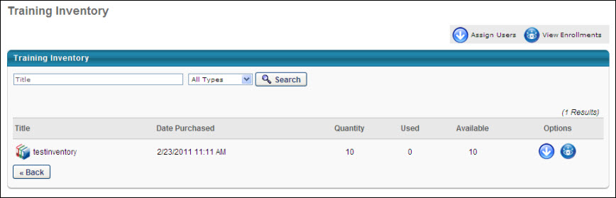
Select the users to which you are assigning training by clicking the check box next to the user name. You can check all or uncheck all users by checking the box next to the Name heading.
- Use the search feature to search for an employee by first or last name to assign training.
- From the drop-down list, select the OU or group to which you are assign training. You can also create a new group by clicking the Create New Group link.
When assigning a curriculum, the following Subscription Options are now available above the Due Date if either automatic or manual subscription renewal is available for the curriculum:
- Assign a new instance of this curriculum to users. All progress will be refreshed. This option assigns the LO to the user, but clears their progress.
- Extend user's subscription to this curriculum. - This option maintains the user's progress.
When assigning a session that has reserved seats, administrators and managers can only assign reserved seats for organizational units (OU) that are within their permission constraints.
Click here to view the workflow for assigning a reserved seat from the training inventory.
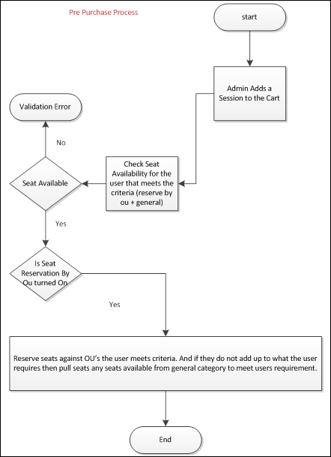
In the Due Date field, select a due date for the assignment. Setting a due date for the assignment is optional.
In the list of user names, the following information In the list of names, if Link LO Expiration Date is enabled, the Access Link Expiration Date column appears in the user table. If the link expiration date is set for the LO, this column displays the next expiration date.
Click Submit to complete the assignment process. This action sends the training item to the assigned user's transcript; it also changes the Used and Available count on the Inventory page.
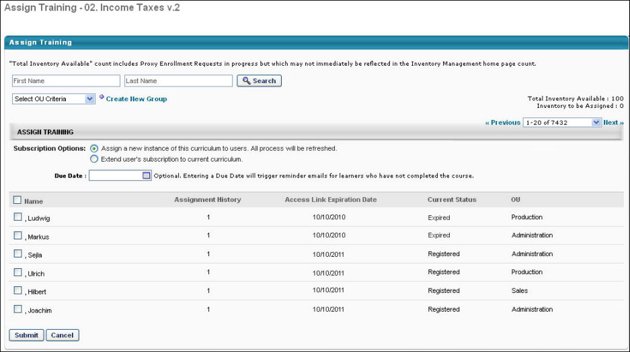

Assign Training Without Managerial or Approver Roles
You can assign training to other users without having a managerial or approval role.
To assign training:
- Search for the learning object (LO) and then, click Assign. See Search for Training on page 305 for additional information.
- Select the users and click Continue to details.
  - User Selection: A checkbox near the Employee column allows the selection of all users on a specific page. A maximum of 1000 users can be selected, and a notification appears if the selection exceeds this limit. You can search for users by first name, last name, division, position, location, and manager's name.
  - Show Selected: This toggle, when activated, shows only the users selected for the training assignment.
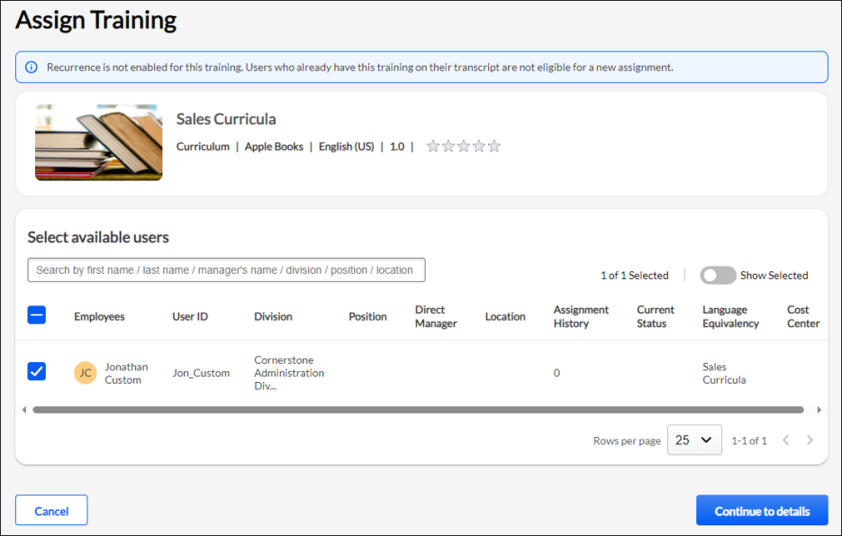
- Provide the following information, and click Submit.
  - Training Purpose: A dropdown is available with training purposes from the Course Catalog.
  - Due Date: A calendar icon is provided for selecting a due date.
  - Add a Comment: Allows users to input comments or instructions related to the training assignment.
  - Automatically Register Users: Selecting this checkbox automatically registers users for training in a Registered status. This feature is disabled for Events, as automatic registration is not possible. Additionally, it is disabled when the training has an associated price, requiring payment before registering.
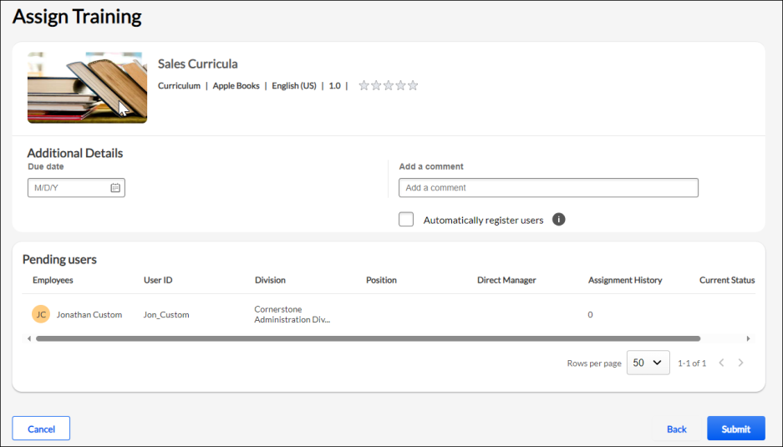
Training is assigned to the users, and you are redirected to the Learning Details page for the assigned training.
Permissions
PERMISSION NAME | PERMISSION DESCRIPTION | CATEGORY

Assign Training with Constraints | This permission grants any Role, User, or Organizational Unit (standard and custom, including groups) the ability to assign training to other users. This permission, along with its constraints, seamlessly integrates with the existing Assign Training permission. Users with either the new permission or both will be redirected to a new interface and will use the constraints associated with the Assign Training with Constraints permission. This permission can be constrained by the following:  - User's direct subordinates  - User's subordinates  - Organizational Units (including Groups) - Standard and Custom  - Provider  - Training Type  - Training Item (specific training)  Multiple constraints on the permission between User/OU and LO are treated as AND constraints, whereas constraints between User/OU are treated as OR constraints. | Learning - Administration

Assigning Session - Use Cases
Assigning Session without Session - Edit Permission without Waitlist
If the user assigning training does not have the Session - Edit permission and the waitlist is not enabled for the session, a notification "The total number of users exceeds available seats for the session. Please reduce the number of selected users or choose a new session." will be shown during the assignment process when the following occurs:
- The number of selected users exceeds the available seats for the session.
- The selected users belong to an organizational unit (OU) with reserved seats, but there are not enough reserved seats available for that OU.
- There are reserved seats setup in Instructor Led Training (ILT) Administration, and the maximum number of reserved seats has already been allotted.
The Continue to details button will be disabled if the number of selected users is greater than the seats available.
Assigning Session without Session - Edit Permission with Waitlist
If the user assigning training does not have the Session - Edit permission and the waitlist is enabled for the session, a notification "The total number of users exceeds available seats for the session." will be shown during the assignment process when the following occurs:
- The number of selected users exceeds the available seats for the session.
- The selected users belong to an organizational unit (OU) with reserved seats, but there are not enough reserved seats available for that OU.
- There are reserved seats, and the maximum number of users is already registered for the session.
The notification will also be displayed under the Additional Details section along with a disabled checkbox titled "Add additional users to the waitlist”. This checkbox cannot be unchecked.
Assigning Session with Session - Edit Permission without Waitlist
If the user assigning training has the Session - Edit permission and the waitlist is not enabled for the session, a notification "The total number of users exceeds available seats for the session." will be shown during the assignment process when the following occurs:
- The number of selected users exceeds the available seats for the session.
- The selected users belong to an organizational unit (OU) with reserved seats, but there are not enough reserved seats available for that OU.
- There are reserved seats, and the maximum number of users is already registered for the session.
The notification will also be displayed under the Additional Details section along with a disabled checkbox titled "Increase the session's available seats”. This checkbox cannot be unchecked.
Assigning Session with Session - Edit Permission with Waitlist
If the user assigning training has the Session - Edit permission and the waitlist is enabled for the session, a notification "The total number of users exceeds available seats for the session." will be shown during the assignment process when the following occurs:
- The number of selected users exceeds the available seats for the session.
- The selected users belong to an organizational unit (OU) with reserved seats, but there are not enough reserved seats available for that OU.
- There are reserved seats, and the maximum number of users is already registered for the session. In this case, maximum seat allotted can be increased or users can be added to the waitlist.
The notification will also be displayed under the Additional Details section along with a message: "The total number of users exceeds available seats for the session. Select one of the options below". This selection only applies to users who are automatically registered into the session. Two radio buttons will be available:
- Increase the session’s available seats
- Add remaining users to the waitlist
Assign Training Without Managerial or Approver Roles - FAQs
What happens if I try to select more than 1000 users for a training assignment?
You will be notified that the maximum number of selected users (1000) has been reached. No more users can be selected at this time. You will need to reduce your selection to 1000 or less.
Why can’t I click on the Assign button?
The Assign button will not be visible if the user does not have Assign Training with Constraints or Assign Training permission. Also, the training needs to be within user constraints for the Assign button to be visible.
Why can’t I click on the Continue to details button?
Continue to details button will be disabled if:
- No user is selected for the training assignment.
- The number of users selected is equal to or greater than 1000.
- The number of selected users are greater than the seats available.
Why do I see spinner when I click on Assign button or Submit button?
When loading training details and user information, it may take some time to display the information on the page. Similarly, when submitting a list of users for assignments, there might be a delay. The spinner is displayed while training and user data are loaded in the background or until the training assignment is processed.
How can I see the seat availability while assigning the session, provided I have the relevant permissions?
If enrollment reservations or restrictions are configured for the session being assigned, then View seat availability link button will be displayed. Clicking View seat availability will open a modal with additional seat information.
How will training with recurrence be assigned to users who already have the same training In Progress on their transcript?
When a training has recurrence enabled, and learners are selected for reassignment, a notification will be displayed on the 'Select users' screen to notify the assignor that progress will be overwritten. If the users that are in an In Progress status are deselected, then the notification will disappear.
Notification text: One or more users previously started this training. Re-assignment will reset any work in progress.
Which training statuses are considered as In Progress?
The following statuses are considered In Progress and the notification will be displayed if one or more users selected have the following status for their current registration.
- Completion Approval Denied
- Completion Approval Denied / Past Due
- Failed
- Failed / Past Due
- In Progress
- In Progress / Past Due
- Incomplete
- Incomplete / Past Due
- Past Due
- Pending Acknowledgement
- Pending Acknowledgment / Past Due
- Pending Completion Approval
- Pending Completion Signature
- Pending Completion Signature /Past Due
- Pending Evaluation
- Pending Evaluation / Past Due
- Pending Grade
- Pending Grade / Past Due
- Pending Observer Completion
- Pending Observer Completion
- Pending Observer Completion / Past Due
- Pending Post-Work
- Pending Post-Work/Past Due
- Pending SF-182 Form Approval
- SF-182 Form Denied
What will be the Transcript delivery method when training is assigned using new permission?
Transcript Delivery Method field in Reporting 2.0 will display Direct Assignment when training is assigned using the new permission.
How shall I assign training if the number of users exceeds 1000?
Use the Learning Assignment Tool (LAT) to assign training in bulk to large groups of users.
How is Transcript history updated when training is assigned, reassigned or a newer version of training is assigned?
The following are the details on how transcript history updated when training is assigned, reassigned or a newer version of training is assigned.
Training Status |  |  |  |  |  | Automatically register users checkbox | Final status | Comments Added? | Entries* | Transcript history entries (will be localized and sorted by date with the most recent entry at the top)
Assigned |  |  |  |  |  | Not checked | Approved | No | 1 | Assigned by User First Name and Last Name (User ID) on mm/dd/yyyy hh:mm:ss AM/PM Comments: Initial Request
Assigned |  |  |  |  |  | Not checked | Approved | Yes | 1 | Assigned by User First Name and Last Name (User ID) on mm/dd/yyyy hh:mm:ss AM/PM Comments: ()
Assigned |  |  |  |  |  | Checked | Registered | No | 2 | - Assigned by User First Name and Last Name (User ID) on mm/dd/yyyy hh:mm:ss AM/PM Comments: Initial Request  - Registered by User First Name and Last Name (User ID) on mm/dd/yyyy hh:mm:ss AM/PM
Assigned |  |  |  |  |  | Checked | Registered | Yes | 2 | - Assigned by User First Name and Last Name (User ID) on mm/dd/yyyy hh:mm:ss AM/PM Comments: ()  - Registered by User First Name and Last Name
Re-assigned** |  |  |  |  |  | Not checked | Approved | No | 1 | Assigned by User First Name and Last Name (User ID) on mm/dd/yyyy hh:mm:ss AM/PM
Re-assigned** |  |  |  |  |  | Not checked | Approved | Yes | 1 | Assigned by User First Name and Last Name (User ID) on mm/dd/yyyy hh:mm:ss AM/PM Comments: ()
Re-assigned** |  |  |  |  |  | Checked | Registered | No | 2 | - Assigned by User First Name and Last Name (User ID) on mm/dd/yyyy hh:mm:ss AM/PM  - Registered by User First Name and Last Name (User ID) on mm/dd/yyyy hh:mm:ss AM/PM Comments: Automatic registration upon training assignment
Re-assigned** |  |  |  |  |  | Checked | Registered | Yes | 2 | - Assigned by User First Name Last Name (User ID) on mm/dd/yyyy/ hh:mm:ss AM/PM Comments: ()  - Approved by User First Name Last Name (User ID) on mm/dd/yyyy/ hh:mm:ss AM/PM  - Registered by User First Name and Last Name (User ID) on mm/dd/yyyy hh:mm:ss AM/PM Comments: ()
Newer version assigned** |  |  |  |  |  | Not checked | Approved | No | 1 | Assigned by User First Name Last Name (User ID) on mm/dd/yyyy/ hh:mm:ss AM/PM Comments: Initial Request
Newer version assigned** |  |  |  |  |  | Not checked | Approved | Yes | 1 | Assigned by User First Name Last Name (User ID) on mm/dd/yyyy/ hh:mm:ss AM/PM Comments: ()
Newer version assigned** |  |  |  |  |  | Checked | Registered | No | 2 | - Assigned by User First Name Last Name (User ID) on mm/dd/yyyy/ hh:mm:ss AM/PM Comments: Initial Request  - Approved by User First Name Last Name (User ID) on mm/dd/yyyy/ hh:mm:ss AM/PM  - Registered by User First Name and Last Name (User ID) on mm/dd/yyyy hh:mm:ss AM/PM
Newer version assigned** |  |  |  |  |  | Checked | Registered | Yes | 2 | - Assigned by User First Name Last Name (User ID) on mm/dd/yyyy/ hh:mm:ss AM/PM Comments: ()  - Approved by User First Name Last Name (User ID) on mm/dd/yyyy/ hh:mm:ss AM/PM  - Registered by User First Name and Last Name (User ID) on mm/dd/yyyy hh:mm:ss AM/PM Comments: ()
* Entries in Transcript History
** Training is already on user’s transcript

Assign Training - Add to Waitlist Pop-up

Assign Training - Confirm Enrollment Pop-up

Assign Training - Increase Seats Pop-up

Assign Training - Seats Available Pop-up

Assign Training - Seats Not Available Pop-up

Assign Training - Training Already in Transcript Pop-up

Assign Training - Users Not Assigned Training

Training Enrollments - View
This page allows the user to view the names of users to whom they have assigned pre-purchased training. The user can print a list of the names of users who are assigned the training, view the assignment date and the date that the user registered for the training, as well as a due date if one was given.
To access the Training Enrollments page, go to My Account > Order History. Then, click the View Inventory button.
In the Options column for the associated training item, click the View Enrollments option. The following information displays:
- Registered Date - This displays the registered date or assignment date, since the user is automatically registered when the training was assigned.
- Due Date - This displays the due date, if applicable.
- Options - Click the View Training Progress icon to view detailed training progress.
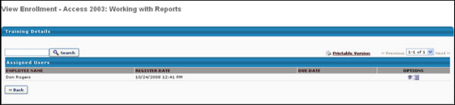

Browse/Search/Request Training Overview
- For information about exploring training via the machine learning platform, Learner Home, See Learner Home - End User View Overview.

Browse for Training Overview
The Browse for Training page enables users to browse for training by subject, date, training type, and rating. Users can also use additional filters to find the necessary training items.
For a complete overview of the Browse for Training page, See Browse for Training on page 292 for additional information.
See the links below for a complete list of documentation for Browse for Training. Clicking a link from this list opens a related help article for the listed topic:
Troubleshooting Information
The following page contains a quick reference card to guide you through the process of using the Browse for Training page:
- See Browse for Training Quick Reference Card on page 304 for additional information.
Browse for Training Landing Page
The Browse for Training landing page is only available if enabled by the system administrator in Browse for Training Preferences.
The Browse for Training landing page displays targeted training that is specific to the user's training interests. This page can also be configured to display featured or suggested training, the most popular training, and the newest training.
To access the Browse for Training landing page, go to Learning > Browse for Training.
Troubleshooting Information
The following page contains a quick reference card to guide you through the process of using the Browse for Training page:
- See Browse for Training Quick Reference Card on page 304 for additional information.
Upcoming Sessions Notification
When viewing the Browse for Training landing page, if a user is registered for a session that is upcoming, the system displays a notification at the top of the page. Click the view all link to navigate to the Events Calendar. See Events Calendar on page 307 for additional information.
Browse for Training Banner
At the top of the Browse for Training landing page, the Browse for Training banner allows organizations to configure an optional HTML banner to market their training. The maximum size of the banner is 960 x 250 pixels. The Browse for Training banner is optional and is configured by the administrator in Browse for Training Preferences.
Browse All
Click the Browse All button to open the Browse for Training page and browse for training using many different filters, such as LO type, location, subject, etc.
Training Details
For each available training item, the following information is displayed:
- Image - An image is displayed to represent the training or training type. If the training does not have a set image, then a randomly selected default image is displayed. Click the image to view the Training Details page.
- Training Type - In the lower-right corner of the image, the training type displays.
- Title - Below the image, the training title displays. Click the title to view the LO Details page.
- Rating - If ratings are enabled, then the training rating displays. Click the rating to view the Ratings tab of the LO Details page.
- Price - If pricing is enabled, then the training price displays.
Training Sections
The following training sections may be available if enabled by the administrator in Browse for Training Preferences:
- Top Picks for [User] - This section appears for the user with the user's name and training related to the user's previous training selections. For example, when Tasha navigates to the Browse for Training page, she will see a section called "Top Picks for Tasha," automatically populated with training recommendations based on training she has taken previously. Up to 40 courses will display. Note: If no course recommendations are available for the user, the Top Picks for [User] link does not display.
- My Subjects - This section displays training that is associated with the user's favorite training subjects. Users can define their favorite training subjects on the Bio: About page. The most recently created or updated training is displayed first.
- Featured - This section displays all featured training that is available to the user. The most recently created or updated training is displayed first. A training item is designated as Featured by administrators via Course Catalog.
- Suggested - This section displays all suggested training that is available to the user. The most recently created or updated training is displayed first. A training item is designated as Suggested by administrators via Course Catalog. Note: Marking a LO as Suggested is considered an update to the LO.
- Popular - This section displays the most popular training items that are available to the user. The system determines popularity by the number of registered users within the previous 14 days.
- Newest - This section displays the newest training items that are available to the user. The most recently created or updated training is displayed first.
- Subscriptions - This section allows users to quickly view and access learning objects that are part of a subscription. This section displays at the bottom of the Browse for Training page.
Up to four learning objects (LOs) display in a section at once. To view additional LOs in the section, click the arrow to the right of the section. This displays the next four LOs. Up to 40 LOs may be available in each section.
To view all LOs in the training section, click the See All link in the lower-right corner of the section. This opens the Browse for Training page with the selected training filter applied.
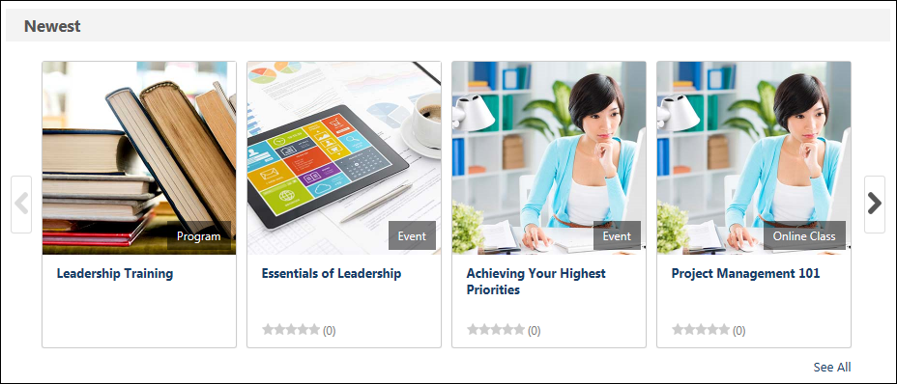
Browse for Training
The Browse for Training page enables users to browse for training by subject, date, training type, and rating. Users can also use additional filters to find the necessary training items.
Users are only able to view the training items that are available to them, based on the availability of the learning objects (LOs).
To access the Browse for Training page, go to Learning > Browse for Training.
Permissions
PERMISSION NAME | PERMISSION DESCRIPTION | CATEGORY

Browse For Training | Grants access to the Browse For Training Page. This is an end user permission. | Learning

Browse for Training Preferences - Manage | Grants ability to configure the Browse for Training features, including which subjects appear in the Browse for Training widget. This permission can be constrained by OU and User's OU. This is an administrator permission. | Learning - Administration
The sections below describe the various features available on the Browse for Training page, with clickable links to related documentation:
Troubleshooting Information
The following page contains a quick reference card to guide you through the process of using the Browse for Training page:
- See Browse for Training Quick Reference Card on page 304 for additional information.
Upcoming Sessions Notification
When viewing the Browse for Training page, if a user is registered for a session that is upcoming, the system displays a notification at the top of the page. Click the view all link to navigate to the Events Calendar. See Events Calendar on page 307 for additional information.
Browse for Training Banner
At the top of the Browse for Training page, the Browse for Training banner allows organizations to configure an optional HTML banner to market their training. The maximum size of the banner is 960 x 250 pixels. The Browse for Training banner is optional and is configured by the administrator in Browse for Training Preferences.
Change View: Tile or List
The Tile View and List View options are only available if Tile View is enabled by the administrator in Browse for Training Preferences.
In the upper-right corner of the page, users can change the view between Tile View and List View. The selected option appears dark gray. The default view is controlled by the administrator in Browse for Training Preferences.
- Tile View - This view displays training items more visually as tiles or images. Up to three items are displayed in each row.
- List View - This view displays training items more textually in a list format.
Training Filter
Using the filters in the Training section, users are able to browse recommended, featured, suggested, popular, and newest training. By default, the Training filter is not applied. See Browse for Training - Training Filter on page 303 for additional information.
Subject Filter
On the left side of the Browse for Training page, users can browse for training by subject. The subjects which appear in the list of subjects is configured by the administrator via Browse for Training Preferences. See Browse for Training - Subject Filter on page 302 for additional information.
Note: Subjects are expected to be missing on the Browse for Training page if the portal has over 1000 subjects. The Browse for Training hierarchy utilizes 1000 subjects, so if portal has over 1000 subjects, some subjects will not appear in the Subject side panel. If vital subjects are missing from the panel, either reduce the number of subjects available in the portal or switch from Browse for Training to Learner Home, which does not limit subject usage.
Training Type Filter
Using the Training Type filter, users are able to filter training items by training type. When a filter is selected, the training results are filtered to only display available training items with the selected training types. See Browse for Training - Training Type Filter on page 299 for additional information.
Date Range Filter
Using the Date Range filter, users are able to browse for events and sessions by date. When browsing by date, only events and sessions that occur within the selected date criteria are displayed on the Browse for Training page. See Browse for Training - Date Range Filter on page 298 for additional information.
Rating Filter
Using the Rating filter, users are able to filter training items by rating. Note: This filter is not available if course ratings and reviews are not enabled for a portal. See Browse for Training - Rating Filter on page 301 for additional information.
Location Filter
Using the Location filter, users can filter events and sessions by location. When browsing by location, only events and sessions associated with the selected location display on the Browse for Training page. See Browse for Training - Location Filter on page 300 for additional information.
Filter Breadcrumbs
At the top of the Browse for Training page, the Filter Breadcrumbs display all of the filters that are currently in use and limiting the number of available training that is displayed.
To remove a filter via the Filter Breadcrumbs, click the Remove icon to the right of the filter name to remove the filter. The filter is removed from the breadcrumb list, the training results are updated with the removed filter, and the filter is removed from the left panel.
Sort Results
The options that are available in the Sort by drop-down list are configured by the administrator in Browse for Training Preferences. Additionally, the administrator can configure the option names and select the default sort option.
The Sort by drop-down list enables users to sort the available training using the following options:
- By Title - This option sorts the results alphabetically in ascending order.
- By Most Recent - This option sorts the results by the date on which they were added to the system, with the newest training appearing first.
- By Duration - This option sorts the results by training length, with the shortest training appearing first.
- By Price: High to Low - This option sorts the training by price, with the most expensive training appearing first. Note: When custom pricing is enabled for a portal, this sort option is not available.
- By Price: Low to High - This option sorts the training by price, with the least expensive training appearing first. Note: When custom pricing is enabled for a portal, this sort option is not available.
- By Popularity - This option sorts the training by popularity, with the training with the most registered users per training session appearing first.
- By Rating - This option sorts the training by star rating in descending order. Note: This option is not available if course ratings and reviews are not enabled for the user's organizational unit (OU).
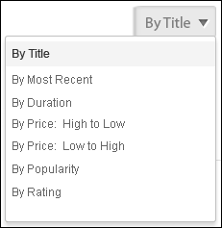
Training Details - Tile View
In tile view, the following information is displayed for each available training item:
- Image - An image is displayed to represent the training or training type. If the training does not have a set image, then a default image is displayed. Click the image to view the LO Details page.
- Training Type - In the lower-right corner of the image, the training type is displayed.
- Title - Below the image, the training title is displayed. Click the title to view the LO Details page.
- Rating - If ratings are enabled, then the training's rating is displayed. Click the rating to view the Ratings tab of the LO Details page.
- Price - If pricing is enabled, then the training's price is displayed.
Training Details - List View
In list view, the following information is displayed for each available training item:
- Training Icon - The icon that is displayed corresponds with the type of training. For example, if the training is an online course, then the Online Course icon is displayed.
- Training Title - This is the title of the training. Click the training title to view the LO Details page.
- Training Type
- Provider
- Price
- Rating - If course ratings and reviews are enabled, then the course rating is displayed. In addition, the number of ratings that have been submitted is displayed. Click the number of ratings to open the LO Details page.
- Training Units - If the training has a price and can be purchased using training units, the price in training units displays.
- Description
Up to 1,000 training results can be displayed.
Tile View
List View
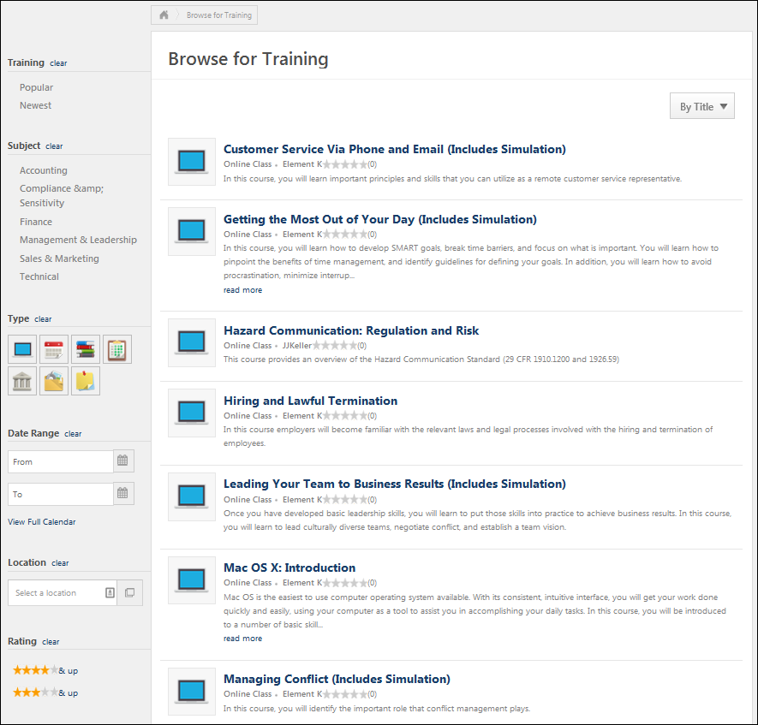
Dynamic Filters
As the user selects filters, the available filters dynamically update to display only the filters that are associated with training available to the user.
When a filter is set, the other filters dynamically update based on the results. The user should only see filter options that will further refine the results. However, the most recently active filter is not dynamically updated so that the user can change the criteria for that filter to find the desired training. Note: The Training and Date Range filters do not dynamically update.
Browse for Training - Date Range Filter
Using the Date Range filter, users are able to browse for events and sessions by date. When browsing by date, only events and sessions that occur within the selected date criteria are displayed on the Browse for Training page. The Date Range filter only appears on the Browse for Training page if the user has at least one event available to them.
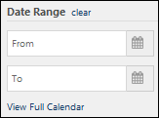
Browse Training by Date
To browse training by date, using From and To fields, select a To date and a From date. Users can click the Calendar icon to display the date-selection calendar. Both dates are required. When a date range is selected, the training results are automatically filtered to display only events and sessions that occur within the selected date range. Note: Dates cannot be in the past.
Users can click the clear link to remove this filter.
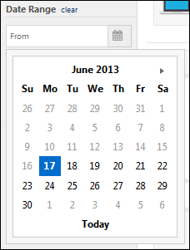
Clear Date Range Selection
When a date range is selected in the Date Range widget, then only events and sessions that occur within the selected date range are displayed. To clear the date range selection, click the clear link to the right of the Date Range heading. This updates the Browse for Training page with the Date Range criterion removed.
View the Events Calendar
To navigate to the Events Calendar, either click the View Full Calendar link.
Browse for Training - Training Type Filter
Using the Training Type filter, users are able to filter training items by training type. When a filter is selected, the training results are filtered to only display available training items with the selected training types. By default, the Training Type filter displays only the LO types that are associated with training the user has permission to view. Multiple LO types can be selected. Users can hover their cursor over an icon to view the training type.
To deselect a training type filter, click the selected filter.
Clear Training Type Filter Selection
When a training type filter is selected, then only training items that are associated with the selected filter display. To clear the filter, click the clear link to the right of the Type heading. This updates the Browse for Training page with the LO type filter removed.
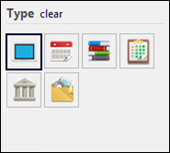
Browse for Training - Location Filter
Using the Location filter, users can filter events and sessions by location. When browsing by location, only events and sessions associated with the selected location display on the Browse for Training page. The Location filter only appears on the Browse for Training page if the user has at least one event available to them. In addition, the only locations that are available to select are locations that are associated with events and sessions the user has permission to view.
This filter enables users to filter events and sessions by location. Only one location can be selected at a time.
- Users can enter a location name in the Select a location field. As the user enters a location, predictive search results appear below the field. The user can click a predictive search result to select the location.
- Users can click the pop-up icon to select a location.
After a location is selected, it appears in the Location filter.
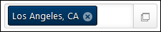
To remove the Location filter, the user can click the Remove icon to the right of the location. The user can also click the pop-up icon to select a new location.
Browse for Training - Rating Filter
Using the Rating filter, users are able to filter training items by rating. Note: This filter is not available if course ratings and reviews are not enabled for a portal. When a filter is selected, the training results are filtered to only display available training items with the selected rating or higher. By default, the Rating filter displays only the ratings that are associated with training the user has permission to view. The following filters are available:
- Five stars
- Four stars and up
- Three stars and up
Clear Rating Filter Selection
When a rating filter is selected, then only training items that have a matching rating are displayed. To clear the rating filter, click the clear link to the right of the Rating heading. This updates the Browse for Training page with the Rating filter removed.
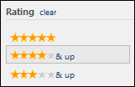
Browse for Training - Subject Filter
On the left side of the Browse for Training page, users can browse for training by subject. The subjects which appear in the list of subjects is configured by the administrator via Browse for Training Preferences. By default, the Subject filter displays the first ten available subjects that are configured in Browse for Training Preferences. The system only displays subjects that are associated with training the user has permission to view.
If more than ten subjects are associated with training the user has permission to view, then a View all link is displayed below the list. Users can click this link to view all of the subjects that are associated with training the user has permission to view.
The Browse by Subject widget displays up to the first four levels of parent and child subjects. However, results from all available child subjects always appear in the search results, even if an organization has configured more than four levels of child subjects.
Note: When adding subjects to the Browse for Training page as an administrator from the Browse for Training Preferences page, subjects may take 15-20 minutes to appear in Browse for Training.
Select a Subject
When the Browse for Training page is initially loaded, no subject filters are selected. To browse for training by a particular subject, click the appropriate subject. The Browse for Training page displays all training that is associated with the selected subject and is also within the user's availability. In addition, the selected subject becomes highlighted in the Browse by Subject widget and is added to the Filter Breadcrumbs at the top of the page. If the selected subject has child subjects, then the child subjects are displayed below the parent subject.
Note: Subjects are expected to be missing on the Browse for Training page if the portal has over 1000 subjects. The Browse for Training hierarchy utilizes 1000 subjects, so if portal has over 1000 subjects, some subjects will not appear in the Subject side panel. If vital subjects are missing from the panel, either reduce the number of subjects available in the portal or switch from Browse for Training to Learner Home, which does not limit subject usage.
Clear Subject Selection
When a subject is selected in the Browse by Subject widget, then only training items that are associated with the selected subject is displayed. To clear the subject selection, click the clear link to the right of the Subjects heading. This updates the Browse for Training page with the Subject criterion removed.
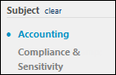
Browse for Training - Training Filter
Using the filters in the Training section, users are able to browse recommended, featured, suggested, popular, and newest training. By default, the Training filter is not applied. When a training filter is applied, the Browse for Training page is updated to display only training that corresponds with the selected filter. In addition, all other filters on the Browse for Training page (e.g., Subject, Date) are cleared.
The following training filters are available:
- All - This filter displays all training. This is the default training filter.
- Top Picks for [User] - After clicking the Top Picks for [User] link in this panel, the Browse for Training page refreshes to display course recommendations for the user. Up to 40 courses will display. Note: If no course recommendations are available for the user, the Top Picks for [User] link does not display.
- My Subjects - This filter is only available if the Subjects section is enabled via Bio About Preferences. This filter displays training that is associated with the user's favorite training subjects. Users can define their favorite training subjects on the Bio: About page. The most recently created or updated training is displayed first.
- Featured - This filter displays all featured training that is available to the user. A training item is designated as Featured by administrators via Course Catalog. This filter is not available if there are no training items designated as Featured.
- Suggested - This filter displays all suggested training that is available to the user. A training item is designated as Suggested by administrators via Course Catalog. This filter is not available if there are no training items designated as Suggested.
- Popular - This filter displays the 50 most popular training items that are available to the user. The system determines popularity by the number of registered users per training session within the previous 14 days.
- Newest - This filter displays the 50 newest training items that are available to the user. The system determines newness using the date on which the training item was created.
Clear Training Filter Selection
When a training filter is selected, then only training items that are associated with the selected filter are displayed. To clear the training filter, click the clear link to the right of the Training heading. This updates the Browse for Training page with the Training filter removed.
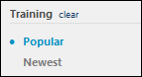
Browse for Training Quick Reference Card
Select the following link to download a Quick Reference Card that guides you through the process of using the Browse for Training page: Browse for Training Quick Reference Card

Search for Training
The search area of the system enables you to search for training, events, curricula, postings, tests, libraries, online courses, quick courses, materials, and forms. There are several ways a user can search for training. You can search for training in the following areas:
- Learning Search
- Learner Home
- Global Search (located in the upper-right corner of most system pages)
- Browse for Training by subjects
- Events Calendar
When searching for training, the results you receive will differ depending on whether you are using Learning Search or Global Search. For more information about the differences between these two tools: See Learning Search vs. Global Search.
Permissions
PERMISSION NAME | PERMISSION DESCRIPTION | CATEGORY

Browse For Training | Grants access to the Browse For Training Page. This is an end user permission. | Learning

Events Calendar | Grants access to view Events Calendar page. This permission also makes the Event Calendar button on the Learning Search page visible. This is an end user permission. | Learning

Global Search - People | Grants ability to search for people via Global Search. If this permission is constrained to a specific OU, then that constraint is automatically applied within Global Search, including search filters and search results. This is an end user permission. The availability of this permission is controlled by a backend setting.  Note: In Universal Profile > Bio > Career Preferences, this permission is required for users to search for jobs. | Core

Global Search - Training | Grants ability to search for training via Global Search. This permission also grants users the ability to view Subjects in Learner Home. If this permission is constrained to a specific OU, then that constraint is automatically applied within Global Search, including search filters and search results. This is an end user permission. The availability of this permission is controlled by a backend setting. | Learning

Learner Home | Grants access to the Learner Home and the Learning Search page. This is an end user permission. This permission cannot be constrained. | Learning
Search Widget
In the upper-right corner of the window, there is a Search field. This field may use either Global Search logic or Learning search logic, depending on Search Preference settings. Global Search is powered by Cornerstone's original search engine. This engine contains a predetermined ranking model which recommends training based on a combination of title, description, and other matches also driven by the user’s search string. Global Search returns predictive results as users type, which is powered by the engine of Learning Search.See Global Search Overview for additional information.
Learning Search
The Learning Search page allows users to search for and filter training in the system. The robust filter options make it easy for users to find training. Learning Search is accessed via the Learner Home page, and is fully optimized for both desktop and mobile browsers. Learning Search is powered by Cornerstone’s newest search engine. This engine indexes and intelligently surfaces training based on a number of variables, powered by the user’s search string. It is designed to surface relevant training in an expeditious manner. See Learning Search.
Learner Home
The Learner Home serves as a learning hub which facilitates a seamless learning experience for users, allowing them to browse for and request relevant training, search and filter for specific training, and helps ensure compliance by helping you prioritize and take action on training you must complete. The Learner Home includes several features which enable learners to easily select subjects of interest, discover training based on machine learning, and quickly access and request new training. See Learner Home - End User View Overview.
Browse for Training
The Browse for Training page enables users to browse for training by subject, date, training type, and rating. Users can also use additional filters to find the necessary training items. See Browse for Training on page 292 for additional information.
Select a Learning Object
Click the title of the training to view additional details or to request or assign the training. When a learner views training from any browsing page and the training does not require approval, the Launch option will display as the primary action available for the training. The user can click the Launch option to immediately launch the training if the training does not require approval, has no incomplete prerequisites, or a price.
Events Calendar
The Events Calendar allows users to view upcoming instructor-led training (ILT) events in a calendar format. Various filter options are available to help users find training that aligns with their interests and schedule. See Events Calendar on page 307 for additional information.

Events Calendar
The Events Calendar allows users to view upcoming instructor-led training (ILT) events in a calendar format. Various filter options are available to help users find training that aligns with their interests and schedule. To access the calendar, go to Learning > Events Calendar.
Permissions
PERMISSION NAME | PERMISSION DESCRIPTION | CATEGORY

Events Calendar | Grants access to view Events Calendar page. This permission also makes the Event Calendar button on the Learning Search page visible. This is an end user permission. | Learning
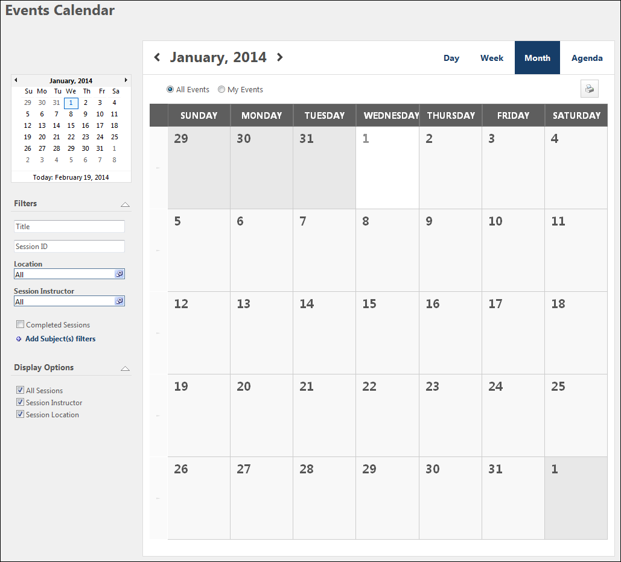
Calendar Navigation
At the top of the Event Calendar, the user can use the navigation arrows on both sides of the month and year to page forward and backward through the calendar. The following calendar display options are also available:
- Day
- Week
- Month
- Agenda
Above the calendar, the following view options are available:
- All Events - Select this radio button to view all upcoming events available to you.
- My Events - Select this radio button to view only events that are on your transcript.
Filters
Depending on the filters made available as controlled by ILT Preferences, when expanded the Location, Session Contact, Instructor filters, and completed sessions will be available. The following filters are available by default:
- Event Title - To search by title, enter a full or partial title in the Title field. Then, click outside the field to refresh the page. Only items that match the filter criteria appear in the calendar. Note: Once the filter terms are entered, avoid clicking a calendar date or the arrow at the start of each week, as this does not refresh the page. Rather, it changes the calendar view to Day or Week.
- Session ID - To search by session ID, enter a full or partial ID in the Session ID field. Then, click outside the field to refresh the page. Only items that match the filter criteria appear in the calendar. Note: Once the filter terms are entered, avoid clicking a calendar date or the arrow at the start of each week, as this does not refresh the page. Rather, it changes the calendar view to Day or Week.
- Subject - The Add Subject(s) filters link enables you to select from a list of available subjects from which to filter. To filter by subject:
  - Click the Add Subject(s) filters link. This opens the Find Subject pop-up.
  - Select one or more subjects from the Subjects table by clicking the blue plus sign to the left of the subject. View child subjects by clicking the black plus sign to the left of the parent subject. When a parent subject or child subject is selected, the Selected Subject(s) table opens and the subject is placed in the table. You can delete subjects from the Selected Subject(s) table by clicking the Delete icon to the left of the subject.
  - Click Done.
The subject filters appear below the Add Subject(s) filters link. The Events Calendar page automatically refreshes to display only items associated with the selected subjects. If no items match the selected subjects, the calendar is blank. You can delete subjects from the Subjects filter by clicking the Delete icon to the left of the subject. Upon deletion, the page refreshes to display only items associated with the remaining subjects.
Display Options
Depending on the display options made available as controlled by ILT Preferences, when expanded the following options may display.
- All Sessions
- Session Contact
- Session Location
- Session Instructor
- Part Name and Description
Calendar
You may page back or forward in one month increments. The available view displays are Day, Week, Month, or Agenda. The following information displays for each event.
- Start Time
- Event Name - Click the event name to view the LO Details page.
- Specific dates on the calendar can be clicked and act as a short cut to the Day View of the corresponding day.
Note: Daylight saving time (DST) time zones are supported in ILT for events and sessions.
Note: If the administrator configures the session to display the start and end times in the user's time zone, the Events Calendar displays the session start and end time in the user's time zone.
Note: If two or more sessions share the same start time, they are sorted alphabetically on the Events Calendar page.
Note: Advanced Registration is not checked on the Events Calendar, meaning it is possible to see sessions with Advanced Registration settings otherwise not visible on the Learning Details page.
Hover Details
Hovering over an Event name opens the Hover Details. Clicking the event window will close the hover details and open the session details pop-up. You can see a combination of session/event information depending on preferences. Up to 3 parts for a session can appear with all preferences (session part name, location, contact, and instructor information) in addition to the event/session description.
Note: If the administrator configures the session to display the start and end times in the user's time zone, then the Events Calendar displays the session start/end time displays in the user's time zone.
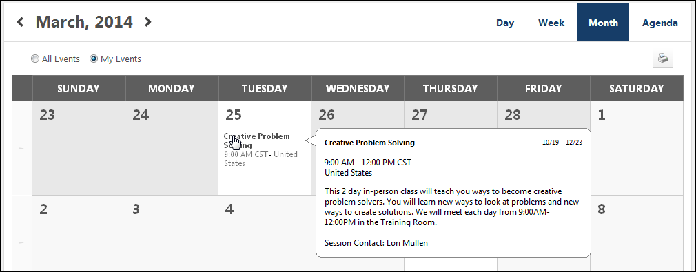

Request Training
Users may be able to request training from Global Search, Learner Home, Learning Search, the Events Calendar, and other system areas, which automatically solicits the necessary approvals and initiates the appropriate registration process. Training approvals, waitlists, prerequisites, pre-work, interest tracking, and registrations all begin when training is requested. If the option to re-request training has been turned on for your organization, you may request training that was previously completed.
When a learner views training from any browsing page and the training does not require approval, the Launch option displays as the primary action available for the training. The user can click the Launch option to immediately launch the training.
Training Purpose
If Training Purpose functionality is active in the portal and at least one training purpose has been configured for the learning object (LO), the Purpose field displays on the Learning Details page. If only one training purpose is available for the LO, the purpose is preselected and read-only. If two or more training purposes are available, you are required to select a training purpose from the Purpose drop-down. Note: The Training Purposing functionality tracks the context in which a user requests training by identifying a purpose for the training.
Online Course, Test, Quick Course or Material
To request an online course, test, quick course, or material:
- Search for training in any system area that allows you to browse or search for training.
- Click on the title of a training item.
- Click Request to request the training. The Assign button is visible only if you have direct reports, and this allows a manager to assign training. If you have already completed this training, you may see the additional message to re-request the training and click the Yes link.
- The training request is automatically entered into your transcript and, if required, routed to your manager for approval.
Curriculum or Library
To request a curriculum or library:
- Search for training in any system area that allows you to browse or search for training.
- Click the title of a training item.
- Click Request to request the training. The Assign button is visible only if you have direct reports, and this allows a manager to assign training.
- The training request is automatically entered into your transcript and, if required, routed to your manager for approval.
Posting
To request a posting:
- Search for training in any system area that allows you to browse or search for training.
- Click the title of a training item.
- Click Request to request the training. The Assign button is visible only if you have direct reports, and this allows a manager to assign training.
- The training request is automatically entered into your transcript and, if required, routed to your manager for approval.
Events & Sessions
Sessions
- Search for sessions using the Events Calendar or any other system area that allows you to browse or search for training. Note: If the event is configured by the administrator to restrict users from selecting sessions, you will not be able to select a session. In this case, the word "None" displays in the Options column. You can still view the details of the session by clicking the link under the Sessions column but cannot select a session. The session needs to be selected by a manager or administrator.
- Click the title of the training.
- Click Request This Training.
  - If approval is required, the training request will be routed to the user's designated Approver or Manager. If the training is set to Pre-Approved, the user is automatically approved for the course. The training item will be listed on the transcript with the corresponding Pending or Approved status.
Reserved Seats
When a session is configured with reserved seats for a specific organizational unit (OU), then when a user in the associated OU views the LO Details pop-up for the session, the Seats Available column displays only the number of seats available for the user's OU.
For users that match the criteria for multiple OUs, the Seats Available column displays the total number of seats available for all of the OUs to which the user matches the criteria.
If a user that matches the criteria for multiple OUs registers for a reserved seat in a session, then their reservation is deducted from the seats available in the following order:
- From the matching OU that has the highest number of available seats.
- From the matching OU that has the highest number of available reserved seats.
- From the matching OU that appears closest to the top of the list of OUs under the Reserve Seats by Organizational Unit option on the Session Details page.
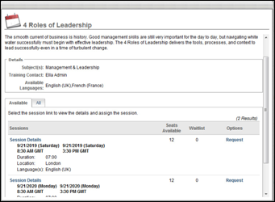
Events
To request an event:
- Search for training in any system area that allows you to browse or search for training.
- Click the title of a training item.
- Click the Request link or click Details icon to see additional information and then click Request.
  - You also can request to be notified when sessions are scheduled at another location or time by clicking on the I would like to be notified when sessions at another location or time are schedule link.
- If no sessions are scheduled, you can check other locations or request to be notified when sessions are scheduled.
Interest Tracking
Interest tracking allows you to be notified when a new session is scheduled for the event. To add yourself to the interest tracking list:
- Location - Click the pop-up icon and chose your preferred training location.
- Comments - Enter any relevant comments
- Notify me when sessions are scheduled in any location - Select this option to be notified if a session is scheduled in the selected location or any other location.
- Click on the Submit button. An email will be sent when the session is scheduled.
Note: If users are restricted from selecting a session for the event, managers can express interest on a user's behalf by clicking the Notify me when sessions are scheduled link. This opens the Interest Tracking pop-up from which the manager can express interest. Interest Tracking notifications are sent to the manager instead of the user.
Waitlist
When no seats are available for a session, you may be able to add yourself the a waitlist for the session. Follow these steps to add yourself to a waitlist:
- Click on the Request link.
- You will see a message stating, "This class is currently full. If you proceed with your request, you will be put into a waitlist for this class. Do you want continue?"
- Click No to cancel your request.
- Click Yes to be put on the waitlist.
- If approval is required, the training request will be routed to the designated Approver or Manager. If the training is set to Pre-Approved, then the training item will be listed on the Transcript with the Waitlisted status.
Exception Requested
If a session has prerequisites, you must complete the following steps before you can register for the session.
- Click on the Details link to view prerequisites.
- Click on the Request link.
- You will see a message stating, - "This class requires prerequisites to be completed before your request. If you proceed with your request, you will be put into exception request. Do you want continue?"
- Click No to cancel your request (if you want to request and complete the prerequisite before requesting this class).
- Click Yes to be request the class.
- If approval is required, the training request will be routed to the designated approver or manager. If the training is set to Pre-Approved, then the training item will be listed on the Transcript with the Exception Requested status.
- To manage the prerequisites, click on the title of the training from your transcript.
- Click Activate under the Options column.
- Click Launch to view the training.
- After you complete the prerequisite, you will be able to register for the class.
Certification
To request a certification, follow these steps:
- Search for a certification from any system location that allows you to browse or search for training. See Global Search Overview for additional information.
- Click the certification title to view the certification details and click the Request button to request the certification.
  - If the certificate has prerequisites that you have not satisfied, the Request button is not available unless the administrator has enabled the ability to request prerequisite exceptions. If prerequisite exceptions are enabled, you are alerted that the certification has prerequisites that you have not satisfied and that by requesting the certification you are also requesting an exception from the prerequisite. Click Yes to request the certification. The status for the certification is set to Pending Prerequisite.
- The certification owner must first approve the request prior to accessing the certification.
External Training
To add external training to your transcript, a different request process is required. See the following help topic:
- Submit External Training Request

Selecting this option enables you to choose an employee relationship as defined by the administrator on the Employee Relationship page.
Selecting this option enables you to choose one or more positions as approver criteria. Positions are defined by the administrator in Position Management.
: An approval workflow has four steps. Each step has multiple approvers. Adam Mueller is defined as an approver in all four steps. Adam approves Step 1 before any of the other approvers in Step 1 record an approval decision. This means that the entire workflow is now approved, and the user moves to an Approved status.

