Standard Recruiting Reports March 2024

Table of Contents
Recruitment Reports 1
Applicant Compliance Report 2
Applications by Source and Status Report 6
Cost per Hire Report 12
Custom Form Data Report 17
Hires by Source Report 19
Recruiting Agency Statistics Report 22
Referral Statistics Report 29
Requisition Details Report 34
Saved Applicant Searches Report 38
Scheduled Interviews Report 40

Recruitment Reports

Applicant Compliance Report
The Applicant Compliance Report tracks applicants' self-reported responses to gender, race, ethnicity, and EEO questions.
Note: The results that are available for the Applicant Compliance report are dependent upon the Compliance Enablement Preferences settings for the associated Location OU.
Note: The results may include information from candidates who have not completed their application. As a result, some candidates may appear in the Applicant Compliance Report but are not visible elsewhere in the system.
To access the Applicant Compliance report, go to Standard Reports > Recruitment.
Permissions
PERMISSION NAME | PERMISSION DESCRIPTION | CATEGORY

Applicant Compliance Report | Grants access to the Applicant Compliance Report, which tracks applicants' self-reported responses to disability, gender, race, ethnicity, and EEO questions. | Reports - Recruiting
Criteria
Feature | Description
Date Criteria | Select the date range for the report from the drop-down list or enter specific dates in the From and To fields.
Advanced Criteria | Limit report output to the following:  - Requisition Owner - Select requisition owners from standard OUs.  - Division - Use the default value of "All" or select one or more Division OUs.  - Location - Use the default value of "All" or select one or more Location OUs.  - Job Title - Use the default value of "All" or select one or more Position OUs. Note: The job title criterion does not use the display job title defined on the requisition.  - Requisition ID - Enter the requisition ID, which can be found on the Manage Job Requisitions page. Only one ID can be used, and the ID must match exactly. Note: Entering a Requisition ID supersedes all other criteria.  Multiple values can be selected for each criterion except Requisition ID. The report only runs within the defined constraints for the user running the report. If the user's permission to run the report is not constrained, at least one criterion must be selected. If the user's permission to run the report has at least one constraint and no criterion is selected, the report is run for all available advanced criteria.
Display Options | The Display Options section enables you to select a template for the report output from the Report output template field and also configure specific fields to appear on the report from the Compliance Questions and Other Fields sections. At least one Display Options field must be selected.  The following are the display option templates:  - Custom Output - With this template, you can select the fields that will appear in the output. There are no fields checked by default.  - EEO-C - With this template, all fields in the Compliance Questions section are checked by default. In the Other Fields section, the Job Category field is checked by default.  - Applicant Flow Log - With this template, all fields are checked by default in the Other Fields section except Requisition ID, Interview Date, Source, and Job Division.  Compliance Questions  The Compliance Questions section enables you to determine which compliance questions appear on the report. Both default and custom questions can be selected, depending on the questions that are available for the user's organizational unit (OU).  The questions that are available to select are dependent upon the Compliance Enablement Preferences settings for the requisition. For this reason, the report may include requisitions for which a specific question was not included as part of the application. If a question is not asked as part of the application but is included in the report, the value for the field is "Not asked."  Other Fields  The following fields are available to select in the Other Fields section and will appear on the report if selected:  - Applicant Name  - Requisition ID  - Job Title  - Job Category - This field displays the EEO job category that is associated with the requisition for each application record. If the report includes a requisition for which this field was not completed, the value for the field is "Not defined."  - Job Division - This field displays the division associated with the requisition for each application.  - Hiring Manager  - Requisition Owner  - Date of Application - This field displays the application submission date associated with each application.  - Source  - Qualified Applicant - This field replaces the Applicant Pool field. This field indicates whether the application record is defined as qualified. The value is "Yes" if the application has a candidate date. The value is "No" if the application does not have a candidate date.  - Interview - This field indicates whether the applicant has completed the Interview status, either "Yes" or "No." This field displays in the report output even if at least one applicant who meets the report criteria has not reached an Interview status type for the requisition.  - Interview Date - This field indicates the date on which the applicant completed the Interview status. The date displays in MM/DD/YYYY format. This field displays in the report output even if at least one applicant who meets the report criteria has not reached an Interview status type for the requisition.  - Action Taken - This field indicates whether the applicant was hired. The value is "Hired" if the applicant achieved a Hired status. The value is "Not Hired" if the applicant did not achieve a Hired status.  - Action Date - This field displays the date on which the applicant achieved a status of Hired or Closed. The field is blank if the applicant has a status of anything other than Hired or Closed.  - Disposition - This field displays the disposition associated with each application that has a status of Closed. If the applicant has an active status or if the status is Hired, then the field is blank.
Report Title | Enter a title for the report. If no title is entered, the report title defaults to the report name. The title appears on both the report output and in the Processed Reports list.
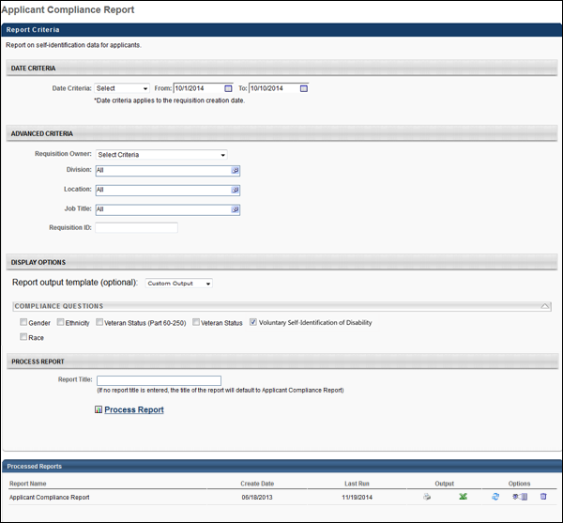
Output
If Compliance Enablement Preferences are configured to only include applicants who meet the minimum qualifications for the requisition, then the report output only includes applicants who have a candidate date. If this setting is not configured in Compliance Enablement Preferences, then all application records for the requisition are included in the report output, regardless of the candidate date.
For compliance questions included in the report, the value that was selected for the field by the applicant displays in the report.
Note: Because Compliance Enablement Preferences are configured by Location OU, the report output could contain requisitions from different locations with different settings. If this occurs, application records display in results for each requisition in accordance with the settings for each requisition.

Applications by Source and Status Report
The Applications by Source and Status report is used to report on the source data for all applications. The report breaks sources into the following categories in a pie chart on the report page:
- Career Center
- Career Sites
- Employee Referrals
- External Referrals
- Job Boards
- Other
Additionally, there are detail reports for each individual source, displaying the number of applications that reached specific statuses.
Note: The Agency Portal functionality must be enabled in order for recruiting agency source data to be available for the report.
To access the Applications by Source and Status report, go to Standard Reports > Recruitment.
Permissions
PERMISSION NAME | PERMISSION DESCRIPTION | CATEGORY

Applications by Source and Status Report | Grants access to the Applications by Source and Status report, which displays source data for all applications. | Reports - Recruiting
Criteria
Feature | Description
Date Criteria | Select the date range for the report from the drop-down list or enter specific dates in the From and To fields.
Advanced Criteria | You can limit report output to the following:  - Requisition Owner - Select requisition owners from standard OUs.  - Division - Use the default value of "All" or select one or more Division OUs.  - Location - Use the default value of "All" or select one or more Location OUs.  - Job Title - Use the default value of "All" or select one or more Position OUs. Note: The job title criterion uses the position title defined in the Position OUs, rather than the display job title defined on the requisition.  - Requisition ID - Enter the requisition ID, which can be found on the Manage Job Requisitions page. Only one ID can be used, and the ID must match exactly. Note: Entering a Requisition ID supersedes all other criteria.  Multiple values can be selected for each criterion except Requisition ID. The report only runs within the defined constraints for the user running the report. If the user's permission to run the report is not constrained, at least one criterion must be selected. If the user's permission to run the report has at least one constraint and no criterion is selected, the report is run for all available advanced criteria.
Display Options | The report must be filtered by at least one of the following statuses:  - Unqualified Submissions - This field includes all submissions that are not qualified in the report. Unqualified submissions are submissions that do not have a candidate date. When selected, the Failed Pre-Screening field is checked and disabled.  - Failed Pre-Screening - This status filter includes all applicants that submitted an application, failed the pre-screening questions, and have an applicant status of Closed. Note: Such applicants are only visible on the requisition's Requisition Snapshot page. These applicants were never considered a new submission because their first and only applicant status was Closed and their disposition reason was Failed Pre-Screening.  - Qualified Applicants - Select this option to include all submissions that have a candidate date.  - All applicants that have submitted an application and are in any applicant status except Closed and Hired. Note: All custom statuses are included in this category.  - All applicants that have an applicant status of Closed and whose immediate preceding status was any applicant status.  - Hired - All applicants that have an applicant status of Hired.
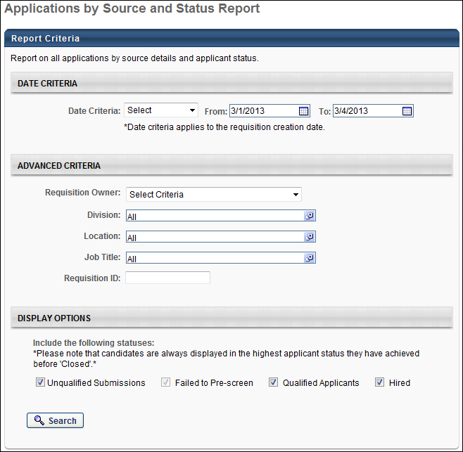
Output
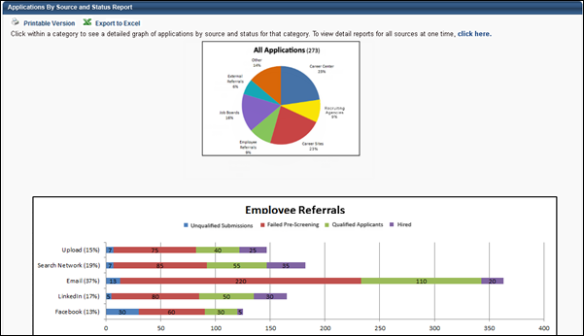
The summary view of the report is a pie chart that shows the percentage of applications by source. Click on any pie segment to open a details graph of the segment. The number in parentheses in the pie chart header represents the total number of applications included in the report data.
The details graph displays below the pie chart. In the y-axis, a colored bar displays, showing the name and percentage of applications from that source within the overarching source. Each bar is split into the number of applicants that are using each source.
Note: A "Recruiting Agencies" bar graph displays if the "Recruiting Agencies" segment is selected in the pie chart or if all source sections are expanded. The graph displays all recruiting agency submissions.
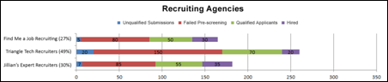
The printable version displays the details graph for each piece of the pie chart. The Excel version does not display either the pie chart or the details graph.
Printable Version Output
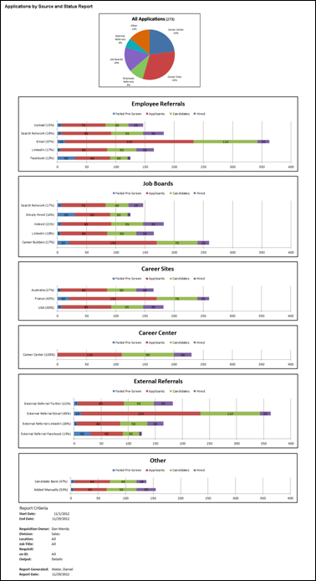
Excel Output
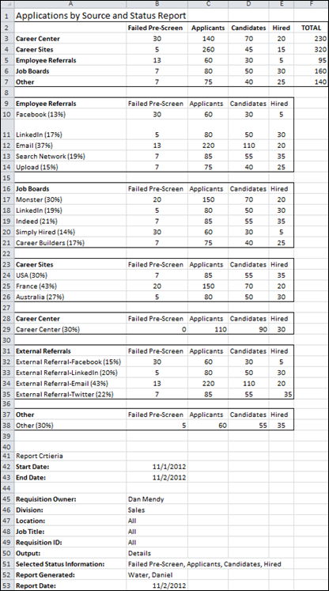

Cost per Hire Report
The Cost per Hire report enables you to report on the various costs associated with hiring for a requisition. The results of the report can be used to gauge the effectiveness of the recruiting management process. The report provides details about costs that are tracked manually by recruiters and automatically by the system.
Use Case
A human resources manager is tasked with determining why the IT department's overall referral costs are lower than any other department, despite the fact that their referral bonuses are the highest in the company. He runs a Cost per Hire report and sees that all of the IT department's referral fees are internal costs because all hires within the past six months have been internal referrals. The department's internal referral costs are 70% lower than the process of hiring externally, which the report indicates is the general practice of all other departments. He proposes a cross-functional project designed to increase internal referrals and reduce overall hiring costs.
To access the Cost per Hire report, go to Standard Reports > Recruitment.
Permissions
PERMISSION NAME | PERMISSION DESCRIPTION | CATEGORY

Cost per Hire Report | Grants access to the Cost per Hire report, which displays the costs tracked for recruiting. This permission cannot be constrained. | Reports - Recruiting
Criteria
Feature | Description
Date Criteria | Select the date range for the report from the drop-down list or enter specific dates in the From and To fields.
Date Based On | You must select one of the following options to define how the date range criteria is determined:  - Date Incurred - Select this option to base the date on the value in the Date Incurred field for the cost.  - Date Modified - Select this option to base the date on the date on which the cost was most recently modified.
Advanced Criteria | Limit report output to the following:  - Requisition Owner - Select requisition owners from standard OUs.  - Division - Use the default value of "All" or select one or more Division OUs.  - Location - Use the default value of "All" or select one or more Location OUs.  - Job Title - Use the default value of "All" or select one or more Position OUs. Note: The job title criterion does not use the display job title defined on the requisition.  - Requisition ID - Enter the requisition ID, which can be found on the Manage Job Requisitions page. Only one ID can be used, and the ID must match exactly. Note: Entering a Requisition ID supersedes all other criteria.  Multiple values can be selected for each criterion except Requisition ID. The report only runs within the defined constraints for the user running the report. If the user's permission to run the report is not constrained, at least one criterion must be selected. If the user's permission to run the report has at least one constraint and no criterion is selected, the report is run for all available advanced criteria.
Display Options | Select one of the following display options:  - Cost per Hire - Select this option to display the requisition and applicant level costs.  - Applicant Cost Details - Select this option to display the applicant cost details.
Display Options - Include the following cost fields | The cost fields that display are the default cost fields, as well as the custom cost fields created by the administrator in Cost Field Management. See Cost Field Management for additional information.  All boxes are checked by default, and the section is expanded by default. On the report output, each criterion appears in a separate column.
Display Options - Include the following classifications | Select one or both of the following cost field classifications:  - External - Select this option to include cost fields that are classified as "External" in Cost Field Management.  - Internal - Select this option to include cost fields that are classified as "Internal" in Cost Field Management.  Both boxes are checked by default, and the section is expanded by default.
Report Title | Enter a title for the report. If no title is entered, the report title defaults to the report name. The title appears on both the report output and in the Processed Reports list.
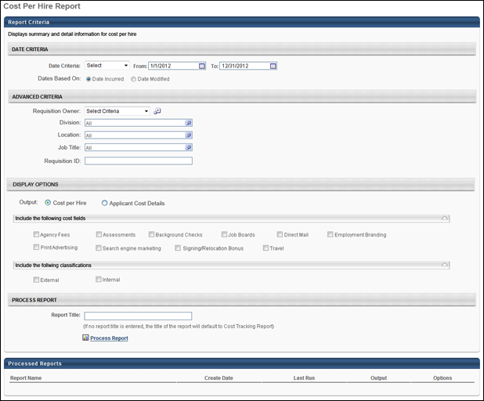
When the Process Report link is clicked, the report is run based on the selected criteria. The report output is stored in the Processed Reports table.
The administrator can choose the following actions and options for each report in the Processed Report table:
- Click the Excel icon to generate an Excel output of the report.
- Click the Refresh icon to refresh the report results.
- Click the View Details to view the filter criteria for the report.
- Click the Delete icon to delete the report.
Output - Cost per Hire
In the Cost per Hire display output, all costs are grouped by currency and display in alphabetical order by job title. For requisitions that have costs in more than one currency due to currency inconsistencies, the requisition appears in all applicable currencies.
At the top of the report, all currencies that appear in the output display in a list below the Currency field. To the right of the Currency field, the Cost Per Hire field displays the sum of all of the costs for each currency. The sum is calculated by adding the requisition level costs and the applicant level costs.
The report criteria display below the report details. All criteria defined for the report display, as well as the user who generated the report and the date on which the report was generated.
The following information appears in the output:
- Job Title - This column displays the title of the requisition.
- Requisition ID - This column displays the ID of the requisition.
- Owner - This column displays the owner of the requisition.
- Division - This column displays the division of the requisition.
- Location - This column displays the location of the requisition.
- # Openings - This column displays the total number of openings defined for the requisition.
- # Hires - This column displays the total number of hired candidates for the requisition.
- # Total Submissions - This column displays the total number of submissions for the requisition.
- # Applicants - This column displays the total number of applicants for the requisition.
- Default Currency -This column displays the currency defined for the requisition.
- [Custom Cost Fields] - If custom cost fields are included in the report output, each cost field displays as a separate column.
- Total - This column displays the total of all the cost fields included in the report output.
- Number of Hires in Period - This field displays the number of candidates moved to a Hired status within the dates defined for the report.
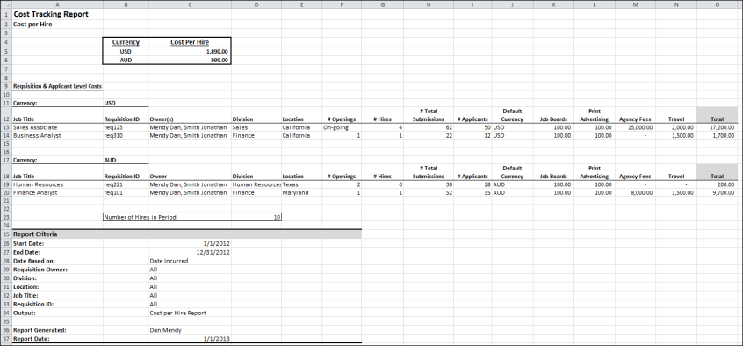
Output - Applicant Cost Details
With this display output, all costs are grouped by currency and display in alphabetical order by applicant last name. For applicants who have incurred costs in multiple currencies, the applicants appear in each applicable currency group.
The report criteria display below the report details. All criteria defined for the report display, as well as the user who generated the report and the date on which it was generated.
The following information appears in the output:
- Applicant Last Name - This column displays the applicant's last name.
- Applicant First Name - This column displays the applicant's first name.
- Requisition - This column displays the title of the requisition to which the applicant applied.
- Requisition ID - This column displays the ID of the requisition.
- Candidate Status - This column displays the status of the candidate for the requisition.
- [Custom Cost Fields] - If custom cost fields are included in the report output, each cost field displays as a separate column. Note: If requisition level costs are included in the report, then the value of the requisition level costs is zero for all applicants.
- Total - This column displays the total cost for all of the monetary cost fields in a given row.
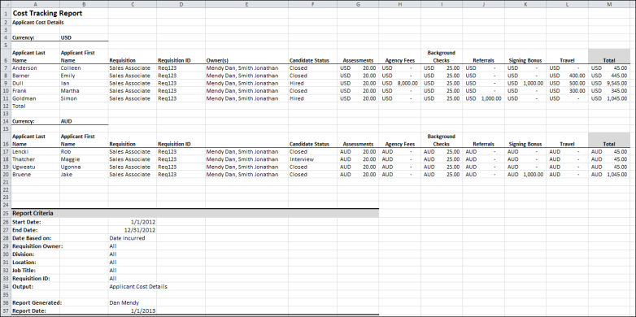

Custom Form Data Report
The Custom Form Data Report tracks data for the Form Management functionality. This report is only available for portals with the Form Management functionality enabled.
To access the Custom Form Data Report, go to Reports > Standard Reports > Track Employees. Then, click the Custom Form Data link.
Permissions
PERMISSION NAME | PERMISSION DESCRIPTION | CATEGORY

Custom Form Data Report | Grants access to the Custom Form Data Report, which displays data collected through forms. This permission can be constrained by OU and User's OU. | Reports - Recruiting
Criteria
Filter Name | Description
User Criteria | Select the users for whom you would like to view form data by selecting the appropriate OU or individual user from the drop-down. If user criteria are not defined, then the report runs for the entire available population.
Date Filters | Select the date range for the report from the drop-down list or enter specific dates in the From and To fields.
Advanced Filters | Limit report output to the following:  - Select Form - This is a required field. Click the Select icon in the Select Form field. This opens the Select Form pop-up. Select the form from the list of available forms. This closes the pop-up and populates the Select Form field with the form title.  - Submission Type - This field allows the recruiter to filter the report output based on how the form was submitted. The options that are available are dependent upon how users submitted the report selected in the Select Form field.  - Select Task - This field allows the recruiter to filter the report output based on tasks. Click the Select icon in the Select Task field. This opens the Select Task pop-up. Select one or more tasks from the list, and then click Done. This closes the pop-up and populates the Select Task field with the tasks.
Report Title
Enter a title for the report in the Report Title field. If no title is entered, the report title defaults to the report name. The title appears on both the report output and in the Processed Reports table.
Process Report
Click the Process Report link to run the report based on the selected criteria. The report output is stored in the Processed Reports table.
Processed Reports Table
The Processed Reports table displays the three most recently run reports. The following options are available for each report in the table:
- Click the Print icon to view a printable version of the report. The report can also be printed from the printable version.
- Click the Excel icon to generate an Excel output of the report.
- Click the Refresh icon to refresh the report results.
- Click the View Details icon to view and modify the filter criteria for the report.
- Click the Delete icon to delete the report.
Output
The report output includes the report criteria, as well as the following report data:
- First Name - This column displays the first name of the user who submitted the form.
- Last Name - This column displays the last name of the user who submitted the form.
- [User Criteria Columns] - These columns display the organizational units and/or users defined in the User Criteria section of the report.
- Submission Source - This column displays the source of the submitted form.
- Task Title - This column displays the title of the task associated with the form, if available.
- Task Description - This column displays the description of the task associated with the form, if available.
- Task Assigned - This column displays the date on which the task associated with the form was assigned, if available.
- Task Due - This column displays the date on which the task associated with the form is due.
- Date Submitted - This column displays the date on which the form was submitted.
- [Form Fields] - The column title is based on the fields included on the form. These columns display the value entered for the field.

Hires by Source Report
The Hires by Source Report enables you to track the sources through which new hires applied for a requisition. The report includes a bar graph that categorizes sources by the following:
- Job Board
- Career Site
- Career Center
- Referral
- Other
To access the Hires by Source report, go to Standard Reports > Recruitment.
Permissions
PERMISSION NAME | PERMISSION DESCRIPTION | CATEGORY

Hires By Source Report | Grants access to the Hires by Source report, which tracks the sources through which new hires applied for a requisition. | Reports - Recruiting
Criteria
Feature | Description
Date Criteria | Select the date range for the report from the drop-down list or enter specific dates in the From and To fields.
Advanced Criteria | Limit report output to the following:  - Requisition Owner - Select requisition owners from standard OUs.  - Division - Use the default value of "All" or select one or more Division OUs.  - Location - Use the default value of "All" or select one or more Location OUs.  - Job Title - Use the default value of "All" or select one or more Position OUs. Note: The job title criterion does not use the display job title defined on the requisition.  - Requisition ID - Enter the requisition ID, which can be found on the Manage Job Requisitions page. Only one ID can be used, and the ID must match exactly. Note: Entering a Requisition ID supersedes all other criteria.  Multiple values can be selected for each criterion except Requisition ID. The report only runs within the defined constraints for the user running the report. If the user's permission to run the report is not constrained, at least one criterion must be selected. If the user's permission to run the report has at least one constraint and no criterion is selected, the report is run for all available advanced criteria.
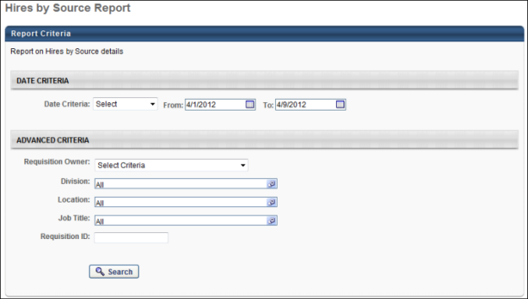
Output Summary
The source categories display on the Y-axis. If a source category has no results, then the source category does not appear on the summary. The X-axis displays the total number of applications that fall within each source category. The column increments increase as necessary to accommodate the number of applicants that fall into each source category.
The percent of total is calculated by dividing the total number of new hires that applied through the source by the total number of new hires returned in the report results.
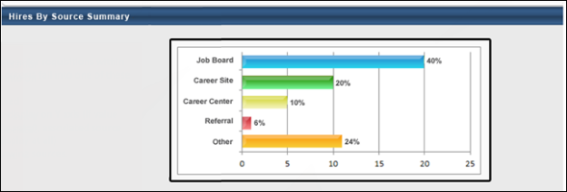
Note: A "Recruiting Agencies" bar displays in the graph the Agency Portal functionality is enabled and at least one recruiting agency is a source.
Output Details
The Hires by Source Details table is sorted by the % of Hires column, with the highest percentage displaying first. The following source data is included in the report output:
Field | Description
Source | The source through which a new hire applied for a requisition. If a source category has no results, then the source category does not appear in the Details table.  Note: If the Agency Portal functionality is enabled and a recruiting agency is a source, then "Recruiting Agency" displays as a source in the Source column. The name of the recruiting agency displays in the Details column.
Details | For Job Board and Career Site, the name of the job board or career site displays. For Career Center and Other, the cell is blank. For Referral, the email address of the referrer displays.
# of Hires | The total number of applicants hired from the source.
% of Hires | The percentage of new hires that derived from the source. The percentage is calculated by dividing the total number of new hires that applied through the source by the total number of new hires returned in the report results.
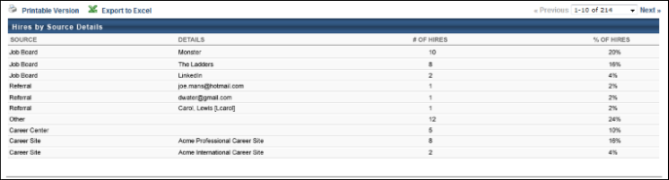

Recruiting Agency Statistics Report
The Recruiting Agency Statistics report is a new report that enables you to report on agency statistics and cost. This report enables you to track where agency costs are being spent and determine which agencies are the best performers. The information in this report can also help organizations understand and track the cost of recruiting new employees.
To access the Recruiting Agency Statistics report, go to Reports > Standard Reports > Recruitment.
Permissions
PERMISSION NAME | PERMISSION DESCRIPTION | CATEGORY

Recruiting Agency Statistics Report | Grants access to the Recruiting Agency Statistics report, which displays recruiting agency submission details. This permission cannot be constrained. | Reports - Recruiting
Criteria
Feature | Description
Date Criteria | - Date Criteria - Select the date range for the report from the drop-down list or enter specific dates in the From and To fields.  - Dates Based On - Select one of the following options on which to base the date range defined in the Date Criteria fields:  - Requisition Creation - This option returns results based on the date that the requisition was created.  - Agency Submission - This option returns results based on the date that the recruiting agency submitted the applicant.
Advanced Criteria | You can limit report output to the following:  - Requisition Owner - Select requisition owners from standard OUs.  - Division - Use the default value of "All" or select one or more Division OUs.  - Location - Use the default value of "All" or select one or more Location OUs.  - Job Title - Use the default value of "All" or select one or more Position OUs. Note: The job title criterion uses the position title defined in the Position OUs, rather than the display job title defined on the requisition.  - Requisition ID - Enter the requisition ID, which can be found on the Agency Portal - My Jobs page. Only one ID can be used, and the ID must match exactly. Note: Entering a Requisition ID supersedes all other criteria.  - Recruiting Agency - Click the plus icon to add one or more agencies. Both active and inactive agencies can be selected. If no agency is selected, then all agencies are included in the report.  - Agency User - Select the user criteria from the drop-down. Then, click the Select icon to select the users from the Select pop-up. The users available to select are users that have been defined as agency users for at least one recruiting agency. If no agency user is selected, then all agency users are included in the report.  - Applicant Status - Select one of the following options:  - Only 'Hired' status included in report - Select this option to only include submissions that have a Hired applicant status.  - All statuses included in report - Select this option to include all submissions regardless of their current status.  - Minimum days since hire - This option enables you to filter the results of submissions that have a Hired status by the number of days since they achieved a Hired status. Select a number from the drop-down, between 0 and 365. This is a required field.  Multiple values can be selected for each criterion except Requisition ID. The report only runs within the defined constraints for the user running the report. If the user's permission to run the report is not constrained, at least one criterion must be selected. If the user's permission to run the report has at least one constraint and no criterion is selected, the report is run for all available advanced criteria.
Display Options | Select one of the following options to determine how the report displays:  - Summary - Select this option to display the report in the summary output view.  - Details - Select this option to display the report in the detail output view. If selected, the following additional options are available:  - Submission Full Name - This column displays the full name of the applicant.  - Application Date - This column displays the date that the applicant completed the application. Note: This is not the date that the applicant was submitted by the recruiting agency.  - Applicant Status - This column displays the current status of the applicant at the time the report is processed.  - Hire Date - This column displays the date that the applicant's status changed to Hired.  - Days Since Hire - This column displays the number of days that have passed since the applicant's status last changed to Hired.  - Accepted as Applicant Date - This column displays the date on which the new submission received an active applicant status.  - Interviewed Date - This column displays the date of the earliest scheduled interview for the applicant. If the applicant does not have any interview sessions scheduled, then the column is blank. If the applicant does not have a scheduled interview with a date, then the column is blank in the report output. Interview credit is defined as the first time that the applicant is moved into the Scheduled Interview applicant status that is defined as the status type Interview.  - Agency Cost - This column displays the cost associated with each submission.  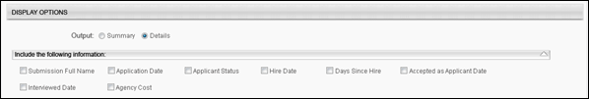
Report Title | Enter a title for the report. If a title is not entered, the report title defaults to the report name. The title appears on both the report output and in the Processed Reports list.
When the Process Report link is clicked, the report is run based on the selected criteria. The report output is stored in the Processed Reports table.
The administrator can choose the following actions and options for each report in the Processed Report table:
- Click the Excel icon to generate an Excel output of the report.
- Click the Refresh icon to refresh the report results.
- Click the View Details to view the filter criteria for the report.
- Click the Delete icon to delete the report.
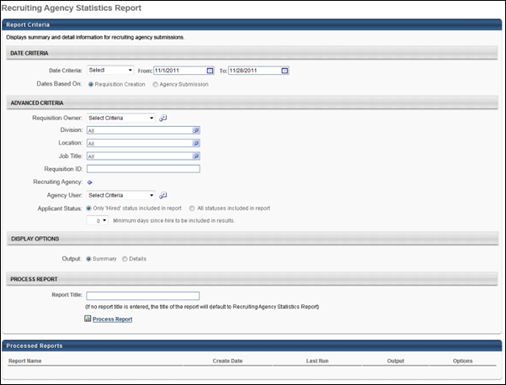
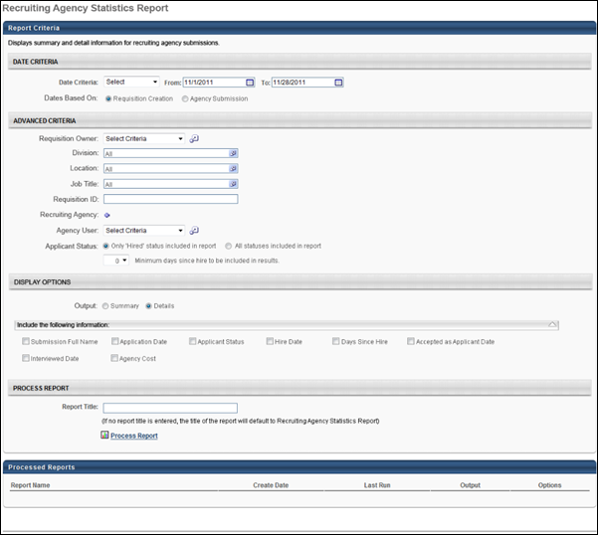
Output - Summary
The summary view of the report is an Excel table with a bar graph included.
Graph
- X Axis - This axis displays the name of the recruiting agency.
- Y Axis - This axis displays percentages, from 0 to 100 in 10 percent increments.
- Bar 1 - This bar displays the percent of accepted applicants. The percentage is calculated by dividing the total number of accepted applicants for the agency by the total number of submissions to the agency. Note: An "accepted" applicant is an applicant that has a candidate date.
- Bar 2 - This bar displays the percent of applicants interviewed. The percentage is calculated by dividing the total number of applicants interviewed for the agency by the total number of submissions to the agency. The value for total number of applicants interviewed is dependent upon completion of the Interview status. Applicants achieve completion the first time that the applicant is moved into the Scheduled Interview applicant status that is defined as the status type Interview.
- Bar 3 - This bar displays the percent of applicants hired. The percentage is calculated by dividing the total number of applicants hired for the agency by the total number of submissions to the agency.
Table
Each recruiting agency displays in a separate table. Agencies appear in the report in alphabetical order. All submissions within an agency are grouped by agency user. The following columns display:
- Agency User Full Name - This column displays the name of the agency user.
- # of Submissions - This column displays the total number of submissions per agency user.
- # of Accepted Applicants - This column displays the total number of accepted applicants per agency user.
- # of Interviewed Applicants - This column displays the total number of applicants interviewed per agency user. The value for total number of applicants interviewed is dependent upon completion of the Interview status. Applicants achieve completion the first time that the applicant is moved into the Scheduled Interview applicant status that is defined as the status type Interview.
- # Hired - This column displays the total number of applicants hired per agency user.
- Submission to Hired Rate - This column displays the hired ratio. The ratio is calculated per agency user by dividing the total number of applicants hired by the total number of applicants submitted.
- Agency Cost - This column displays the total agency cost per agency user.
- Total - This row displays the totals for each column.
- Grand Total - This row displays the totals for all of the agencies included in the report.
Note: The information that displays in the report is the information that meets the report criteria.
Report Criteria
The Report Criteria section displays the criteria values configured for the report.
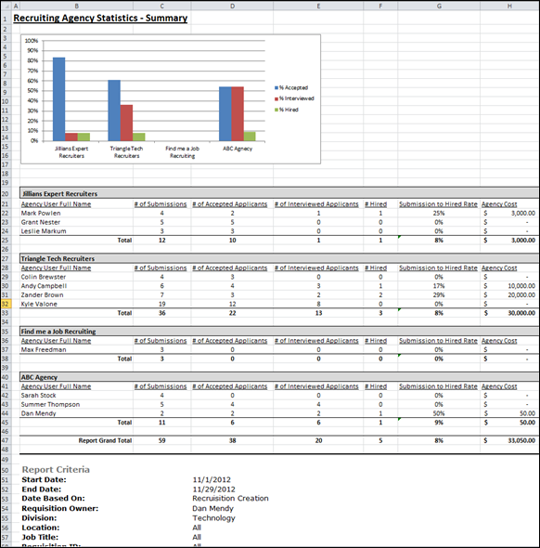
Output - Details
The details view of the report is an Excel table that displays the columns selected in the Display Options section when configuring the report. If Agency Cost is selected in the Display Options section, then the following associated columns appear:
- Agency Cost Total - This column displays the total agency cost for the submission.
- Agency Cost for Submission - This column displays the agency cost of each submission.
- Agency Cost for Interview - This column displays the agency cost per interview.
- Agency Cost for Salary Flat Rate - This column displays the agency cost per salary hire flat rate.
- Agency Cost for Salary Percentage - This column displays the agency cost per salary percentage.
- Agency Cost for Hourly Flat Rate - This column displays the agency cost per hourly flat rate.
- Agency Cost for Hourly Percentage - This column displays the agency cost per hourly percentage.
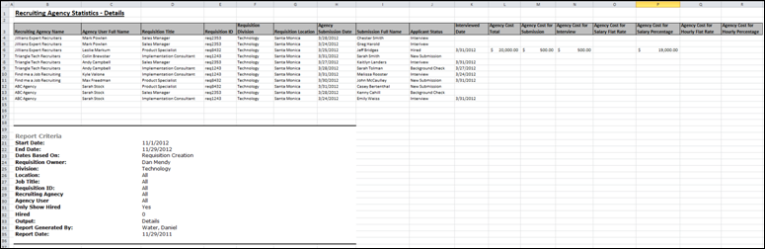

Referral Statistics Report
The Referral Statistics Report enables you to view and compare referrers and their referral statistics. Essentially, the report allows you to ascertain the success of referrals by employee. You can view the number of referrals that an employee has made and if they qualify for a referral bonus.
Permissions
PERMISSION NAME | PERMISSION DESCRIPTION | CATEGORY

Referral Statistics Report | Grants access to Referral Statistics report, which displays summary or detailed information on referrals by users and whether a bonus is owed on referrals. | Reports - Recruiting
Criteria
Feature | Description
Date Criteria | Select the date range for the report from the drop-down list or enter specific dates in the From and To fields.
Advanced Criteria | You can limit report output to the following:  - Requisition Owner - Select requisition owners from standard OUs.  - Division - Use the default value of "All" or select one or more Division OUs.  - Location - Use the default value of "All" or select one or more Location OUs.  - Job Title - Use the default value of "All" or select one or more Position OUs. Note: The job title criterion uses the position title defined in the Position OUs, rather than the display job title defined on the requisition.  - Requisition ID - Enter the requisition ID, which can be found on the Manage Job Requisitions page. Only one ID can be used, and the ID must match exactly. Note: Entering a Requisition ID supersedes all other criteria.  - Requisition Referrer - Select one or more OU criteria for the referrer.  Multiple values can be selected for each criterion except Requisition ID. The report only runs within the defined constraints for the user running the report. If the user's permission to run the report is not constrained, at least one criterion must be selected. If the user's permission to run the report has at least one constraint and no criterion is selected, the report is run for all available advanced criteria.
Display Options | The report must be filtered by at least one of the following values:  - Referrer Name - The full name of the employee who made the referral.  - Requisition Referred - The requisition that the employee referred.  - Requisition ID - The requisition ID of the position that the employee referred.  - Requisition Division - The division of the position that the employee referred.  - Requisition Location - The location of the position that the employee referred.  - Referral Name - The name of the applicant who submitted a referral.  - Referral Method - The method the employee used to refer the job. The following are the only possible referral method values:  - Referral-Facebook  - Referral-LinkedIn  - Referral-Email  - Referral-Search Network  - Referral-Suggested  - Referral-Other  - Date Applied - The date the referral applicant submitted an application for the position.  - Applicant Status - The current status of the applicant on the day the report is processed.  - Hire Date - The day (MM/DD/YYYY) that the applicant's status changed to Hired.  - Days Since Hire - If the applicant status is Hired, this value shows the number of days that have passed since the status was last changed to Hired.  - Bonus Amount - If applicable, this value shows the bonus amount and currency associated with the requisition.  Each value selected displays in its own column on the report.
Report Title | Enter a title for the report. If no title is entered, the report title defaults to the report name. The title appears on both the report output and in the Processed Reports list.
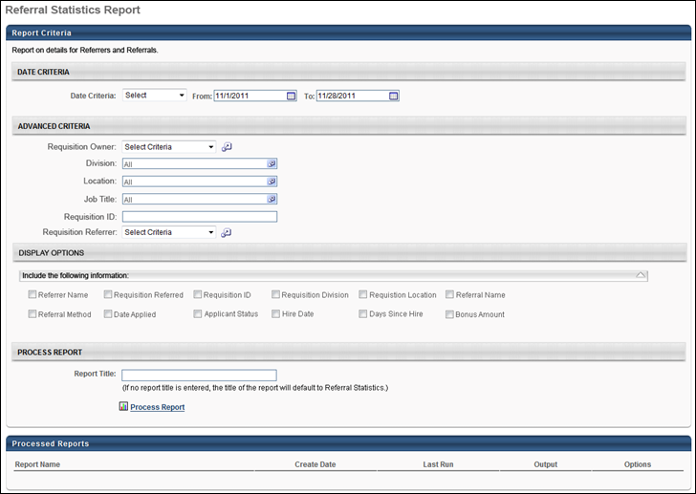
Output
The summary view of the report is an Excel table that shows referral statistics by employee. Details about the specific requisitions or applicants that were referred does not display in the summary view.
The following columns appear as the last three columns on the report:
- Number of Existing Referrals - The total number of referral applications that are credited to the employee. Applicants that have a Hired status are included.
- Number of Hired Referrals - The total number of referral applications that are credited to the employee and that currently have an applicant status of Hired.
- Referral Success Rate - The percentage of referrals that resulted in a hire. The referral success rate is calculated by dividing the total number of hired referrals by the total number of existing referrals.
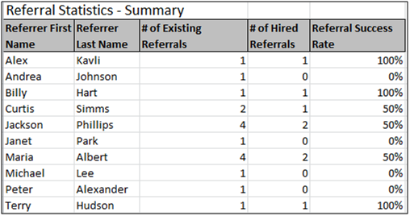
The details view is also an Excel table and shows referral statistics for each requisition that is referred.
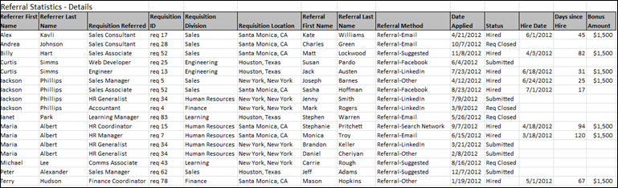
Printable Version Output
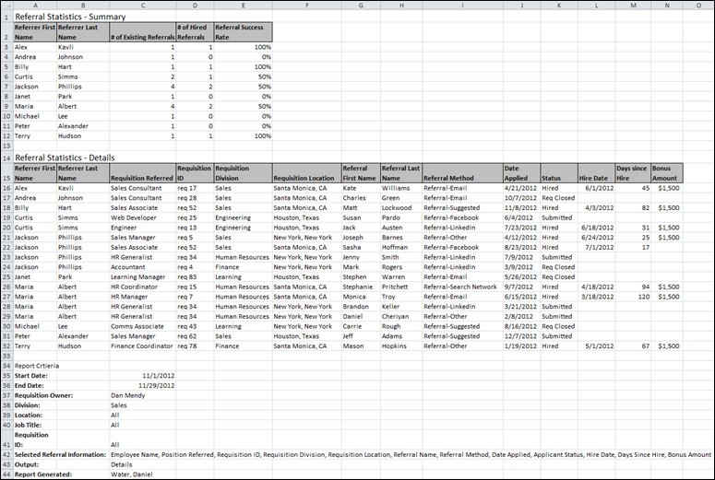

Requisition Details Report
The Requisition Details Report enables you to report on the requisitions in your portal. Applicant details can be included, such as name, contact information, and status. Position OU custom fields can also be included, if configured in Requisition and Applicant Preferences.
To access the Requisition Details Report, go to Standard Reports > Recruitment.
Permissions
PERMISSION NAME | PERMISSION DESCRIPTION | CATEGORY

Requisition Details Report | Grants access to the Requisition Details report, which displays details of requisitions in the portal. This permission cannot be constrained. | Reports - Recruiting
Criteria
Feature | Description
Date Criteria | Select the date range for the report from the drop-down list or enter specific dates in the From and To fields.
Advanced Criteria | Limit report output to the following:  - Requisition Owner - Select requisition owners from standard OUs.  - Division - Use the default value of "All" or select one or more Division OUs.  - Location - Use the default value of "All" or select one or more Location OUs.  - Job Title - Use the default value of "All" or select one or more Position OUs. Note: The job title criterion does not use the display job title defined on the requisition.  - Requisition ID - Enter the requisition ID, which can be found on the Manage Job Requisitions page. Only one ID can be used, and the ID must match exactly. Note: Entering a Requisition ID supersedes all other criteria.  Multiple values can be selected for each criterion except Requisition ID.
Display Options - Include Custom Fields | All custom Position OU fields for which you have availability display. Check the box for each custom OU to include in the report. All boxes are unchecked by default, and the section is expanded by default. On the report output, custom fields appear as the last columns, with each custom field in a separate column. Note: Custom fields only display if configured in Requisition Preferences; they appear on the Requisition Details Report page in the order in which they are configured in Requisition Preferences.
Display Options - Include Submission Information | The following applicant information can be included:  - Full Name - The applicant's first and last name.  - Email Address - The applicant's email address.  - Phone Number - The applicant's phone number.  - Source - The source through which the applicant applied.  - Applicant Status - The most recent status of the applicant.  - Application Date - The date on which the application was submitted.  - Time to Fill - Time to Fill is calculated based on a requisition to be filled. The formula for the calculation is as follows:  Time to Fill = [Fill Date] – [Date Requisition Status Changes to Open] – [Days Requisition Is on Hold]  Once all the openings are filled for the requisition, then the system updates time to fill value.  - Time to Offer - This field displays the number of days from the date on which a requisition is posted to the date on which the first offer is extended to a candidate for the requisition. The following calculation is used to determine the value for the field:  Time to Offer = [Date First Offer Extended to Candidate] - [Date Requisition Status Changes to Open] - [Days Requisition Is on Hold]  - Qualified Applicant - Select this option to include applicants that have a candidate date. This field appears as a separate column on the report.  All boxes are unchecked by default, and the section is expanded by default. On the report output, each criterion appears in a separate column.  In the Group By field, the No Grouping radio button is selected by default and displays all requisitions on the report in alphabetical order by job title. Select the Requisition Division radio button to group the report output by the division configured for the requisition. Divisions are listed on the report in alphabetical order, and then each requisition appears below in alphabetical order.
Report Title | Enter a title for the report. If no title is entered, the report title defaults to the report name. The title appears on both the report output and in the Processed Reports list.
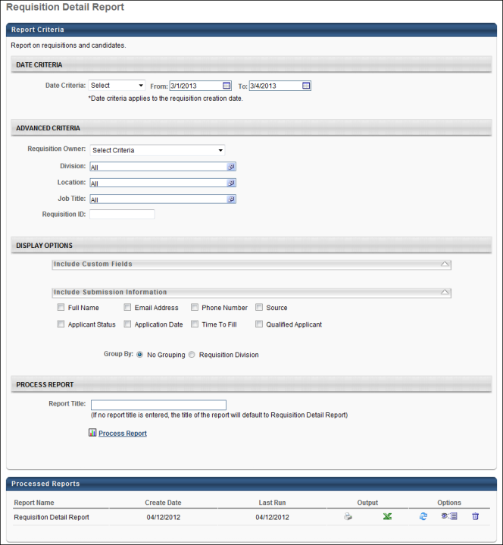
Output Grouped by None
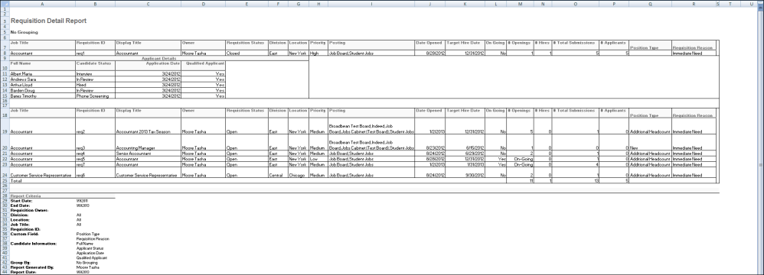
Output Grouped by Division
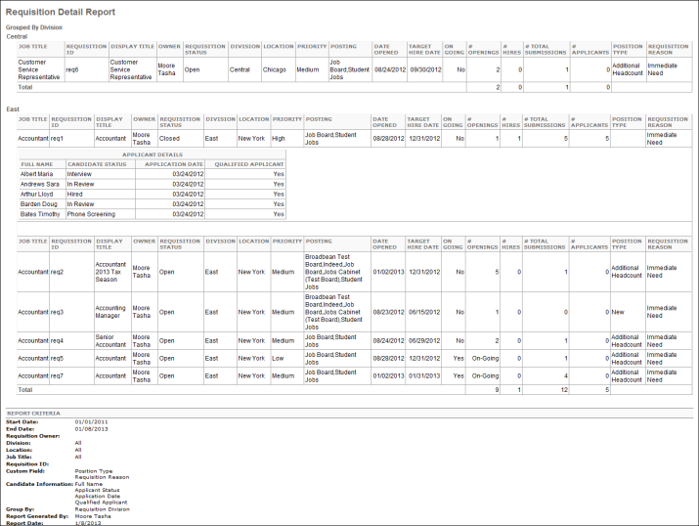

Saved Applicant Searches Report
The Saved Applicant Searches report enables you to report on saved applicant searches.
To access the Saved Applicant Searches report, go to Standard Reports > Recruitment.
Permissions
PERMISSION NAME | PERMISSION DESCRIPTION | CATEGORY

Saved Applicant Searches Report | Grants access to the Saved Applicant Searches report, which displays saved applicant search details. | Reports - Recruiting
Criteria
Feature | Description
Date Criteria | Select the date range for the report from the drop-down list or enter specific dates in the From and To fields.
Advanced Criteria | Limit report output to the following:  - Search User - This field reports the user that conducted the search. Click the Select icon to open the Select User pop-up and select a user.  - Search Reason - This field enables you to select a search reason.  - Specific Requisition - Select this option to choose the specific requisition that was used in the search. When selected, the Specific Requisition field appears below.  - Specific Requisition - Select a requisition by clicking the Select icon and then choosing a requisition from the pop-up.  - Other - Select Other to include the value entered by the searcher in the Other field on the Reason for Search pop-up. When selected, the Other field appears below. Enter a value in the Other field. Both full and partial values are accepted.
Once all criteria are configured, click Search. The report results display in the Saved Searches Summary panel. The report can be viewed as a printable version and can be exported to Excel.
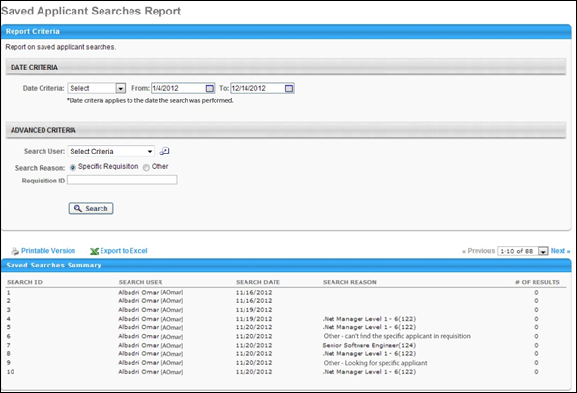
Saved Searches Summary
The following information displays in the Saved Searches Summary table.
Column Name | Description
Search ID | This column displays the unique ID associated with each search. Note: The Search ID is generated when the search is conducted in Search Candidates.
Search User | This column displays the user who conducted the search.
Search Date | This column displays the date on which the search was conducted. This column determines the sort order. The results are sorted by most to least recent.
Search Reason | This column displays the reason specified for executing the search. If the Specific Requisition option was selected when configuring the report, then the column displays the requisition display name and ID. If the Other option was selected, then the column displays "Other - [reason for search]."  Note: If a reason was not required to be selected for the search, then the column displays "Not Available."
Number of Results | This column displays the number of results that were included in the search results.

Scheduled Interviews Report
The Scheduled Interviews report enables you to report on all interviews by date, interviewer, location, and applicant. The report can serve as a complete interview schedule by displaying important scheduling information for recruiters and other users.
Use Case
An organization's front desk personnel would like to view the day's interview schedule. They create a Scheduled Interviews report so that they can plan the interview rooms and ensure that they know when to contact interviewers to inform them that the applicant has arrived.
Note: Live Video, On Demand Video, and Phone interview types are always included in the output. These interview types cannot be filtered out of the report.
To access the Scheduled Interviews report, go to Standard Reports > Recruitment.
Permissions
PERMISSION NAME | PERMISSION DESCRIPTION | CATEGORY

Scheduled Interviews Report | Grants access to the Scheduled Interviews report, which displays scheduled interviews by date, interviewer, location or applicant. This permission cannot be constrained. | Reports - Recruiting
Criteria
Feature | Description
Date Criteria | The Interview Date field allows you to define the interview date on which you would like to report. The report can only be run for one interview date at a time. The default value is the current date. Enter a date in the field or select a date using the calendar feature. This field is required.
Advanced Criteria | Limit report output to the following:  - Interviewer(s) - Click the Select icon to select one or more interviewers to include in the output. This opens the Select User pop-up. Select the interviewers, and then click Done. This adds the interviewers to the filter. Note: The interviewer must be defined as an interviewer for at least one requisition in order to appear in the output.  - Interview Location(s) - Click the Select icon to select one or more locations. This opens the Select Location pop-up. Select the locations, and then click Done. This adds the locations to the filter. If a location has child locations, then all child locations are included.  - Applicant(s) - Click the Select icon to select one or more internal or external applicants to include in the output. This opens the Select User pop-up. Select the applicants, and then click Done. This adds the applicants to the filter.  Multiple values can be selected for each criterion. The Advanced Criteria fields are not required.
Report Title | Enter a title for the report. If no title is entered, the report title defaults to the report name. The title appears on both the report output and in the Processed Reports list.
When the Process Report link is clicked, the report is run based on the selected criteria. The report output is stored in the Processed Reports table.
The administrator can choose the following actions and options for each report in the Processed Report table:
- Click the Print icon to generate a printable version of the report. Note: Excel output is not available for this report.
- Click the Refresh icon to refresh the report results.
- Click the View Details icon to view the filter criteria for the report.
- Click the Delete icon to delete the report.
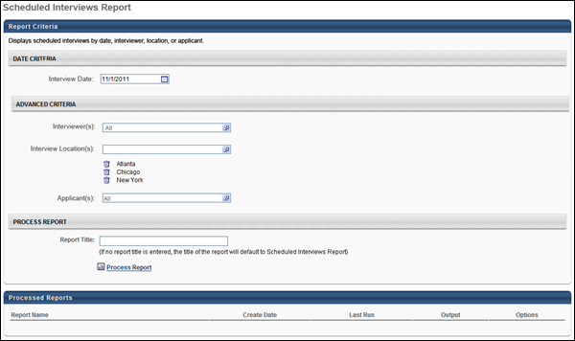
Output
The following information displays in the output:
- Interview Scheduled Date - This displays the date selected in the Interview Date field.
- Time - This column displays the interview start and end time. The time zone for the interview displays in parentheses to the right of the time. The time displays in the time zone of the report creator. This column defines the sort order, from earliest to latest start time.
- Applicant - This column displays the full name of the applicant, requisition title, requisition ID, and applicant phone number.
- Interviewer(s) - This column displays the full name, position title, and phone number for each interviewer. If there are multiple interviewers for the same interview session, then the interviewers are listed in the order in which they are defined on the Interview Scheduler page.
- Location - This column displays the location of the interview. The information that displays is dependent upon the interview type:
  - In Person - Physical location of interview
  - Phone - Phone number for interview
  - Live Video - "Live Video Interview" (Note: This displays for both Live Video interviews and On Demand Video interviews.)
  - Virtual - "Virtual Interview".
