Sourcing March 2024

Table of Contents
Sourcing Overview 1
Agency Management Overview 2
Recruiting Agency Management 3
Create Recruiting Agency 5
Agency Portal Overview 12
Applicant Sources 20
Append URL Parameter 21
Applicant Sources - Add Custom Applicant Source 23
Applicant Sources 24
Application Source Values 26
Broadbean or Other Job Distribution 29
Broadbean Job Posting Configuration in Edge 30
Online Help Topics Related to Broadbean 32
Connect With Us 33
Connect With Us Page 34
Add Connect With Us Link to a Standard Career Site 41
Create and Edit Job Postings 47
Job Posting Page 48
Talent Pools Overview 62
Talent Pool - Manage 63
Talent Pool - Share 65
Talent Pool - View 67

Sourcing Overview

Agency Management Overview

Recruiting Agency Management
The Recruiting Agency Management page enables administrators to create, view, copy, and edit all recruiting agencies configured for the portal. For organizations that work with multiple recruiting agencies, this page provides easy access to all configured agencies.
Recruiting agency users can submit candidates to job requisitions that have been posted to the agency. Agency users cannot create and manage job requisitions or requisition templates from the agency portal. They can only access and manage other areas of the Applicant Tracking System (ATS) if they have the specific permissions necessary to access and manage those areas. However, they cannot access other areas of the ATS from within the agency portal.
To access the Recruiting Agency Management page, go to Admin > Tools > Recruit > Recruiting Agencies.
Permissions
PERMISSION NAME | PERMISSION DESCRIPTION | CATEGORY

Recruiting Agencies - Manage | Grants ability to manage the Manage Recruiting Agencies page. This is an administrator permission. This permission cannot be constrained. | Recruiting Administration
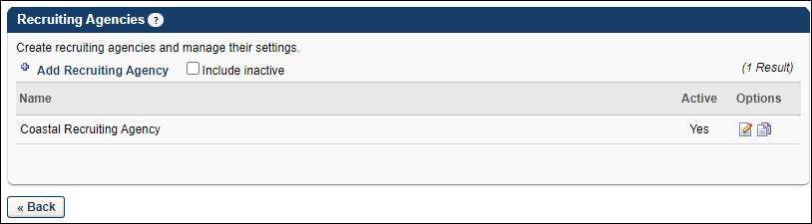
Add Recruiting Agency
Click the link to create a new recruiting agency. See Create Recruiting Agency on page 5 for additional information.
Include Inactive
Check the box to display inactive recruiting agencies in the Recruiting Agencies table. The page automatically refreshes when the box is checked.
Recruiting Agencies Table
The following information appears for each agency:
- Name - This column displays the name of the agency. Agencies are ordered alphabetically by name. This column is sortable.
- Active - This column displays the active status of the agency. If "Yes," the agency is active. If "No," the agency is inactive. Active agencies appear as a value in the Select Recruiting Agency pop-up on the External Postings page when creating or editing a job requisition. The active status is defined when configuring the recruiting agency.
  - If an agency is inactivated after a requisition is posted to the agency, submissions for the inactivated agency are not affected.
  - If an inactivated agency is removed when editing a job requisition in Manage Job Requisitions, then the inactivated agency cannot be re-added to the requisition unless the agency is reactivated
- Options - The following options are available for each agency:
  - Edit - Click the Edit icon to edit the agency. See Create Recruiting Agency on page 5 for additional information.
  - Copy - Click the Copy icon to copy the agency. The values in all fields are copied.
  - Remove - Click the trash can icon to delete the agency. Only agencies that have never been used in a requisition can be deleted.

Create Recruiting Agency
The Create Recruiting Agency page enables you to create new recruiting agencies. Administrators can configure each recruiting agency according to each individual contract. The users associated with an agency, the agency ownership settings, and agency costs can all be managed from the Recruiting Agency settings page.
To access the Create Recruiting Agency page, go to Admin > Tools > Recruit > Recruiting Agencies. Then, select the Add Recruiting Agency link.
Permissions
PERMISSION NAME | PERMISSION DESCRIPTION | CATEGORY

Recruiting Agencies - Manage | Grants ability to manage the Manage Recruiting Agencies page. This is an administrator permission. This permission cannot be constrained. | Recruiting Administration
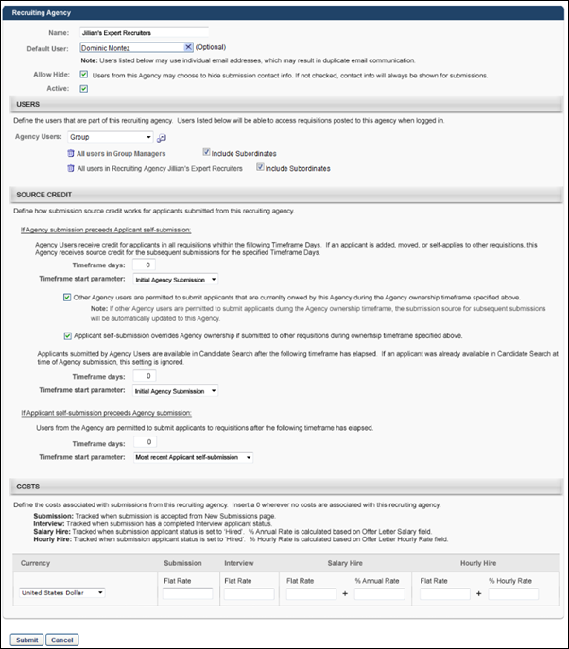
General Information
Complete the following fields in the general information section:
- Name - Enter a name for the agency, up to 250 characters. This is a required field.
- Default User - Click the Select icon to select the user who will be the default user for the agency. The user's email address may be used in email triggers when emails are sent to the agency.
- Allow Hide - Check or uncheck the box to allow or not allow users from the agency to hide a submission's contact information. When checked, the Submission Details pop-up in the agency's portal displays a Hide contact info on submission option that can be selected to hide the submission's contact information. The option does not appear on the pop-up if Allow Hide is unchecked.
Note: A submission's contact information cannot be hidden after it is unhidden.
Note: This option works in conjunction with the self-submission option in the Source Credit section. If the Applicant self-submission overrides Agency ownership option is checked and an applicant submits an application for a different requisition after their contact information has been hidden, then their contact information is no longer hidden. If the override option is not checked and an applicant submits an application for a different requisition after their contact information has been hidden, then their contact information remains hidden.
- Active - Check or uncheck the Active box to activate or inactivate an agency. Active agencies appear as a value in the Select Recruiting Agency pop-up on the External Postings page when creating or editing a job requisition.
  - If an agency is inactivated after a requisition is posted to the agency, submissions for the inactivated agency are not affected.
  - If an inactivated agency is removed when editing a job requisition in Manage Job Requisitions, then the inactivated agency cannot be re-added to the requisition unless the agency is reactivated.
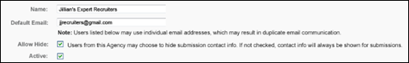
Users
In the Users section, define the users for the agency. Select an OU from the Agency Users drop-down. Then, click the Select icon to open the Select Users pop-up and choose which users will be part of the agency. When requisitions are posted to the agency, only users that meet the criteria in the Agency Users field can access the requisition.
You can remove an OU or user from the agency by clicking the Trash Can icon to the left of the OU or user's name.
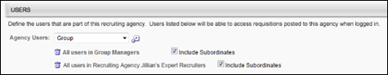
Source Credit
The Source Credit section enables you to configure how the source for the submission is defined.
If Agency Submission Precedes Applicant Self-Submission
Complete the following fields in this section:
- Timeframe days - This option defines how long the agency receives credit for submissions. Enter up to six positive whole numbers. If the value is 0, then the agency only receives credit for requisitions that the applicant applies to directly from the agency's portal. If the candidate is moved, added, or self-applies to another requisition, then the recruiting agency is not credited for the submission. This field is required.
If the value is greater than 0, then the agency receives credit for the submission and is listed as the source for the submission for the time period specified.
If the source credit is updated by the system, then the original source is tracked, and the "Source Updated" event is added to the Applicant Profile page for the associated applicant.
If the timeframe value is changed, then all existing and future submissions to the agency's portal are affected, meaning that the agency receives credit for a shorter or longer duration, depending on the timeframe value.
- Timeframe start parameter - This option defines the start date on which the agency begins receiving credit for a submission. The following start date options are available in the drop-down:
  - Initial Agency Submission - If this option is selected, the agency receives credit for the submission from the date on which the submission is first submitted for an applicant.
  - Most recent Agency Submission - If this option is selected, the agency receives credit for the submission from the date on which the most recent application is submitted for an applicant.
If the timeframe start parameter value is changed, then all existing and future submissions to the agency's portal are affected. This means that the agency begins receiving credit at a different start time, depending on the value selected.
- Other Agency users are permitted to submit applicants - Select this option to allow other agencies to submit applicants that are owned by your agency. The source for the submission is Other Recruiting Agency, and the agency that owns the applicant does not receive submission credit. If this option is not selected, then other agencies cannot submit your applicants.
- Applicant self-submission overrides Agency ownership - Select this option to allow applicants that the agency owns to be listed as the source when they apply to requisitions that are not owned by the agency. If this option is not selected, the agency is listed as the source when an applicant that they own applies for a position that the agency does not own.
- Applicants submitted by users in this Agency are available in Candidate Search - This option enables you to define when a candidate that you own is available to appear in the search results in Search Candidates after submission. In the Timeframe days field, enter a positive whole number of up to six characters.
The default value is 0. The default value enables candidates to be available to appear in the search results immediately after submission.
If the timeframe value is changed, then all existing and future submissions to the agency's portal are affected, meaning that the candidate is available beginning on a sooner or later date, depending on the timeframe value.
- Timeframe start parameter - This option defines the point at which the submission is available to appear in the search results in Search Candidates. The following options are available in the drop-down:
  - Initial Agency Submission - If this option is selected, the submission is available to appear in the search results in Search Candidates from the date on which the submission is first submitted for an applicant.
  - Most recent Agency Submission - If this option is selected, the submission is available to appear in the search results in Search Candidates from the date on which the most recent application is submitted for an applicant.
If the timeframe start parameter value is changed, then all existing and future submissions to the agency's portal are affected. This means that the agency begins receiving credit at a different start time, depending on the value selected.
If Applicant Self-Submission Precedes Agency Submission
For applicants that are not owned by any agency, this section enables you to define when an agency's users can submit such applicants for requisitions that are owned by the agency.
Complete the following fields:
- Timeframe days - With this option, you can decide when an agency is allowed to submit applicants that are not owned by any agency. Enter up to six positive whole numbers in the Timeframe days field. The default value is 0. The default value enables agencies to submit an applicant that is not owned by any agency immediately after the applicant first applies to a requisition. The agency is credited as the source for the submission. This field is required.
If the value is greater than 0, then the agency cannot submit an applicant that is not owned by any agency until the specified timeframe has passed.
If the timeframe value is changed, then all existing and future submissions to the agency's portal are affected, meaning that the agency can submit applicants beginning on a sooner or later date, depending on the timeframe value.
- Timeframe start parameter - This option defines the start date on which the agency can begin submitting an applicant that is not owned by any agency to requisition that are posted to the agency's portal. The following start date options are available in the drop-down:
  - Initial Agency Submission - If this option is selected, the agency can begin submitting applicants that are not owned by any agency from the date on which the applicant first submits an application for a requisition.
  - Most recent Agency Submission - If this option is selected, the agency can begin submitting applicants that are not owned by any agency from the date on which the applicant most recently submitted an application.
If the timeframe start parameter value is changed, then all existing and future submissions to the agency's portal are affected. This means that the agency can begin submitting the applicant on a sooner or later date, depending on the value selected.
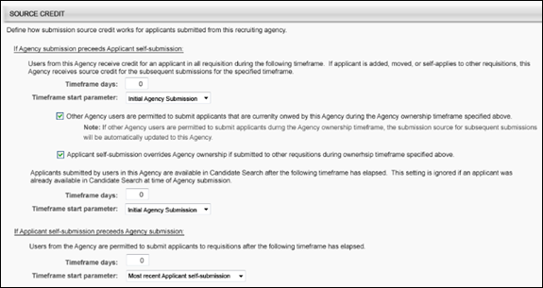
Costs
Complete the following fields in the Costs section:
- Currency - Select a currency from the drop-down. The selected currency will be associated with all cost settings configured for the agency in Recruiting Agency Management. This is a required field.
- Submission - The value in the Flat Rate field is the amount that is granted to the agency for each submission. Enter a positive whole number, up to six characters. The default value is 0. This is a required field. In order for the cost to be applied, a submission must have a candidate date in the system.
- Interview - The value in the Flat Rate field is the amount that is granted to the agency for each submission that results in an interview. Enter a positive whole number, up to six characters. The default value is 0. This is a required field. In order for the cost to be applied, the submission must have a completed date for the Interview applicant status.
- Salary Hire - This option defines the hiring bonus amount for salaried hires. A flat amount can be configured or you can configure the bonus to be a percentage of the hire's annual salary.
  - Flat Rate - Enter a positive whole number, up to six characters. The default value is 0. This is a required field. This value is only tracked when a final offer letter is created.
  - Percent Annual - Enter a positive whole number between 0 and 100, up to three characters. The default value is 0. This is a required field. The percentage is calculated based on the value in the Annual Salary field on the offer letter. This value is only tracked when a final offer letter is created.
- Hourly Hire - This option defines the hiring bonus amount for hourly hires. A flat amount can be configured or you can configure the bonus to be a percentage of the hire's hourly rate.
  - Flat Rate - Enter a positive whole number, up to six characters. The default value is 0. This is a required field. This value is only tracked when a final offer letter is created.
  - Percent Hourly Rate - Enter a positive whole number between 0 and 100, up to three characters. The default value is 0. This is a required field. The percentage is calculated based on the value in the Hourly Rate field on the offer letter. This value is only tracked when a final offer letter is created.
If the value in any of these fields is modified, the change is applied to all current and existing agencies.
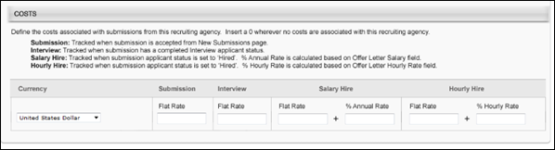

Once all settings are configured, click Submit to save the settings.

Agency Portal Overview
The Agency Portal page is the primary page for a recruiting agency's users. From this page, agency users can do the following:
- View all requisitions that are visible to the user
- View all candidates that have been submitted by the user
- View the details of a job requisition
- Submit applicants to job requisitions that have been posted to the agency
The page is divided into two tabs: My Jobs and My Submissions. The My Jobs tab displays all requisitions that have been posted to the agency. The My Submissions tab displays all applicants that the agency user has submitted to requisitions.
To access the Agency Portal page, go to Recruit > Agency Portal.
Permissions
PERMISSION NAME | PERMISSION DESCRIPTION | CATEGORY

Agency Portal | Grants access to manage the Agency Portal page. This permission cannot be constrained. | Recruiting
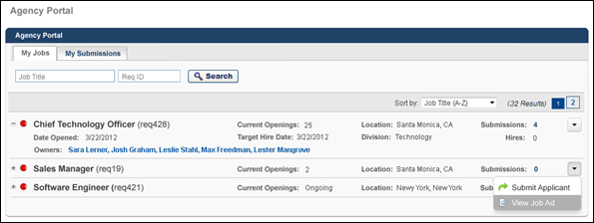
See also:
- My Jobs
- My Submissions
- Manage Submissions
Agency Portal - Manage Submissions
The Manage Submissions page displays all submissions for a specific requisition that have been submitted by the agency user. From this page, the agency user can view submissions, withdraw submissions, and share hidden contact information.
To access the Manage Submissions page, go to Recruit > Agency Portal > My Submissions. Then, click the requisition display name in the Requisition column on the My Submissions tab.
Permissions
PERMISSION NAME | PERMISSION DESCRIPTION | CATEGORY

Agency Portal | Grants access to manage the Agency Portal page. This permission cannot be constrained. | Recruiting
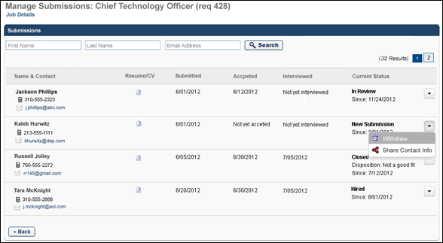
Job Details
The Job Details link at the top of the page allows for quick access to the job description and job qualifications for the requisition. Clicking the link opens the Job Details pop-up. The pop-up displays the requisition's internal and external job description, minimum qualifications, and ideal qualifications.
                - For portals with multiple languages enabled, this displays in the user's language if available. If the user's language is not available, then this displays in the language of the user who defined it.
Note: The fields on the pop-up are not editable from the pop-up.
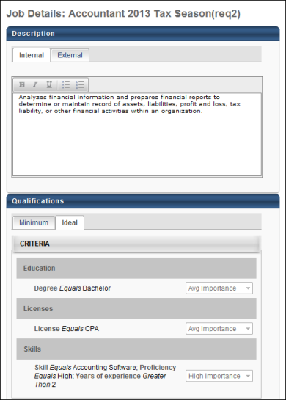
Search
Use the search filter options to limit the submissions that display in the My Submissions table. Enter filter criteria in the First Name, Last Name, and Email Address fields. Once all criteria are entered, click Search to display the results in the Manage Submissions table.
Note: When using the Email Address field, the search feature only returns results that match the exact value in the field.
Manage Submissions Table
The Manage Submissions table displays all submissions that the agency user has submitted to the requisition. By default, submissions are sorted by the submission date, from most to least recent.
The following information appears for each submission:
- Name & Contact - This column displays the applicant's name, phone number, and linked email address. Click the email address to email the applicant using your organization's email provider.
- Resume/CV - This column displays a linked document icon that opens the resume that was attached as part of the applicant's submission.
- Submitted - This column displays the date of the submission.
- Accepted - This column indicates whether a submission has been added to the applicant pool. If the submission has been accepted, the column displays the date on which the submission was accepted. This is considered to be the candidate date. If the submission has not yet been accepted, then "Not yet accepted" displays.
- Interviewed - This column displays the date on which the applicant completed the Interview status. If an applicant has not yet completed the Interview status, then "Not yet interviewed" displays.
- Current Status - This column displays the submission's current status and the date on which the submission achieved the status. If the status is Closed, the disposition for the submission displays below the status, as well as the date of the status change.
- Options - The following options are available in the Options drop-down:
  - Withdraw - Click the trash can icon to withdraw the submission. This opens a confirmation pop-up. Click Yes on the pop-up to confirm the withdrawal. Once the submission is withdrawn, the submission's status changes to Closed, and the disposition is "Voluntary Withdrawal."
  - Share Contact Info - The Share Contact Info option only displays if the submission's contact information is currently hidden. Click the link to show the submission's phone number and email address. This opens a confirmation pop-up. Click Yes on the pop-up to confirm that you would like to show the submission's contact information.
Archived Applicants
Applicants can be archived in the Applicant Tracking System. When an applicant is archived, their name no longer displays on the Manage Submissions page in the Agency Portal, and their associated data is hidden.
The following occurs on the Manage Submissions page when an applicant is archived:
- Archived applicants cannot be searched in the First Name, Last Name, and Email Address filters.
- "Archived" displays in the Name & Contact column in place of the applicant's name and contact information.
- The Resume/CV column is blank.
- The Withdraw and Share Contact Info options in the drop-down are hidden.
- All other columns display the archived applicant's data.
Agency Portal - My Submissions
The My Submissions tab on the Agency Portal page displays all submissions that the agency user has submitted to requisitions.
To access the My Submissions tab, go to Recruit > Agency Portal > My Submissions.
Permissions
PERMISSION NAME | PERMISSION DESCRIPTION | CATEGORY

Agency Portal | Grants access to manage the Agency Portal page. This permission cannot be constrained. | Recruiting
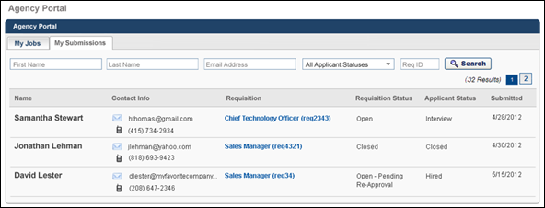
Search Filters
Use the search filter options to limit the submissions that display in the My Submissions table. Enter filter criteria in the First Name, Last Name, and Email Address fields. Select one or more statuses from the Applicant Status drop-down, which displays all applicant statuses that are available for the user's submissions. Enter a requisition ID in the Req ID field. Once all criteria are entered, click Search to display the results in the My Submissions table.
Note: When using the Email Address and Req ID fields, the search feature only returns results that match the exact value in the field.
Submissions Table
The My Submissions table displays all submissions that the agency user has submitted to requisitions. By default, submissions are sorted by the submission date, from most to least recent. All columns are sortable except the Contact Info column. If an applicant is submitted to more than one requisition, then the applicant appears separately for each submission.
The following information appears for each submission:
- Name - This column displays the applicant's name.
- Contact Info - This column displays the contact's email address and phone number.
- Requisition - This column displays the job title and requisition ID. For portals with multiple languages enabled, this displays in the user's language if available. If the user's language is not available, then this displays in the language of the user who defined it.
Click the linked job title to open the Manage Submissions page for the requisition.
Note: When accessing the Manage Submissions page, only the selected applicant appears for the requisition. The applicant's email address automatically populates the Email Address search filter option so that only that applicant appears in the Manage Submissions table.
Note: When sorting, this column sorts by requisition display name and does not sort by requisition ID.
- Requisition Status - This column displays the current status of the requisition.
- Applicant Status - This column displays the current status of the applicant.
- Submission Date - This column displays the date of the submission.
Archived Applicants
When an applicant has been archived in Recruiting, their name no longer displays on the My Submissions page in the Agency Portal and their associated data is hidden.
The following occurs on the My Submissions page when an applicant is archived:
- Archived applicants cannot be searched in the First Name, Last Name, and Email Address filters.
- Archived applicants can be searched in the status filter based on their most current status.
- "Archived" displays in the Name & Contact column in place of the applicant's name and contact information.
- The Contact Info column is blank.
- All other columns display the archived applicant's data.
Agency Portal FAQs
The following are frequently asked questions about the Agency Portal functionality:
What is a recruiting agency portal?
A recruiting agency portal is an internal recruiting agency to which job requisitions can be posted for the purpose of submitting applicants. Agency portals can only be accessed by the users that are configured for the portal in Recruiting Agency Management. From the portal, agency users can browse open requisitions and submit applicants.
Applicants that are submitted to requisitions from a recruiting agency are owned by the agency. Similarly, applicants that apply to jobs via an invitation from a recruiting agency are owned by the agency.
What does applicant ownership mean?
Agencies can be configured to limit the availability of their applicants in order to maintain ownership of high quality prospects. Applicants that are owned by a recruiting agency cannot be submitted to requisitions by anyone other than the agency. This allows the agency to receive credit for all applications that the applicant submits.
What does it mean when an agency receives credit for a submission?
When an applicant applies to a requisition via an invitation from an agency, the agency is listed in the Applicant Tracking System as the source of the submission. Thus, the agency is credited with the submission.
How does the system determine the application completed date?
The application completed date is considered the date on which the applicant submitted an application to the requisition. This date is not considered the date on which the applicant started the application. The following are the possible methods by which the application completed date is determined:
- Applicant directly submits an application to the requisition
- Applicant is uploaded to the requisition by HDL
How does the system determine the submission date?
The submission date is the date that the applicant first appears in the system with an association to a specific requisition. The date may or may not be the same date that an application was completed by an applicant. The following are the possible methods by which the submission date is determined:
- Applicant directly submits an application to the requisition
- Applicant is moved to the requisition from another requisition
- Applicant is added to the requisition from another requisition
- Applicant is manually uploaded into the requisition
- Applicant is added to the requisition from the Candidate Bank
- Applicant is submitted to the requisition by a recruiting agency
- Applicant is uploaded to the requisition by HDL
What is the "candidate date?"
The candidate date is the date on which the applicant is moved from New Submission into an active status. The following are the possible methods by which the candidate date is determined:
- Applicant is moved into an active status from Manage Candidates
- Applicant is manually moved into an active status from the Applicant Profile page
- Applicant is manually moved into an active status by being moved into the requisition from another requisition
- Applicant is manually moved into an active status when being added to the requisition from another requisition
- Applicant is manually moved into an active status by being added to the requisition from the Candidate Bank
- Applicant is manually moved into an active status by being manually uploaded from the Add Applicant page
What is the difference between an agency portal and a career site?
The difference is that one is internal and the other is external.
An agency portal is an internal page in your portal. The Agency Portal functionality requires additional backend settings in order to be enabled. Agency portals are accessed by internal users (i.e., recruiters) who are specifically configured to have access to the portal. An agency's users access the portal for the purpose of submitting applicants to jobs that have been posted to the agency.
A career site is an external Web page that external applicants access for the purpose of browsing and applying to your organization's open jobs.
Is there a difference between an agency portal and a recruiting agency?
No. An agency portal and recruiting agency are the same thing. However, when the term Agency Portal is capitalized, it refers to the Agency Portal functionality or the Agency Portal page.

Applicant Sources

Append URL Parameter
For Standard career sites, the URL parameter that is generated for a custom applicant source can be appended to the URL for a ‘Default Career Site URL’ under the Career Sites on the External Posting page.
For mobile-friendly career sites, you can append the URL and create a link that can be posted for applicants to click.
When an applicant applies to the requisition by accessing it from the location to which you posted the URL, the applicant source will be tracked to that location.
To access Applicant Sources, go to Admin > Tools > Recruit > Sourcing > Applicant Sources.
To manage career site pages, go to Admin > Tools > Recruit > Career Site.
Permissions
PERMISSION NAME | PERMISSION DESCRIPTION | CATEGORY

Applicant Sources - Manage | Grants ability to access and manage the Applicant Sources page. This permission cannot be constrained. | Recruiting Administration

Career Site - Manage | Grants ability to access and manage Career Site Management. This permission can be constrained by OU and User's OU. This is an administrator permission. | Recruiting Administration

Career Site - View | Grants ability to access and view Career Site Management. This permission can be constrained by OU and User's OU. This is an administrator permission. | Recruiting Administration
Standard Career Sites
To append the URL and create a link that will be posted to the desired location for applicants:
- Copy the URL from the URL column on the Career Site Administration page for the desired career site. See Career Site Management.
- Paste the URL into a text editor, such as Microsoft Word or Notepad.
- Copy the URL parameter from the Applicant Sources page. See Applicant Sources on page 24 for additional information.
- Paste the URL parameter to the end of the URL in the text editor.
- Copy the full URL with the appended URL parameter.
- Post the URL to the desired location. The location is the place from which you would like applicants to be able to see and click the link. This becomes the applicant source.
Mobile-Friendly Career Sites
To append the URL and create a link that will be posted to the desired location for applicants:
- Copy the URL from the Career Site Administration page for the desired career site.
- Paste the URL into a text editor, such as Microsoft Word or Notepad.
- Copy the URL parameter from the Applicant Sources page.
- Paste the URL parameter in the URL as follows
- Sample Link to Search Page: https://sample.csod.com/ux/ats/careersite/1/home?c=sample&source=jobboardname#/
- Sample Link to Job Details Page: https://sample.csod.com/ux/ats/careersite/1/home?c=sample&source=jobboardname#/requisition/1
- Copy the full URL with the added URL parameter.
- Post the URL to the desired location. The location is the place from which you would like applicants to be able to see and click the link. This becomes the applicant source.

Applicant Sources - Add Custom Applicant Source
Custom applicant sources can be added to the Applicant Sources page so that the custom source can be used to track where an applicant applied to the job. A custom source can be attributed to any applicant who applies to a job from the career site to which the custom source corresponds.
To access Applicant Sources, go to Admin > Tools > Recruit > Sourcing > Applicant Sources.
Permissions
PERMISSION NAME | PERMISSION DESCRIPTION | CATEGORY

Applicant Sources - Manage | Grants ability to access and manage the Applicant Sources page. This permission cannot be constrained. | Recruiting Administration
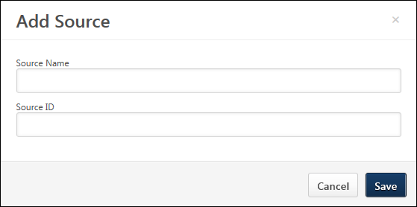
To add a custom source:
- Click Add Source on the Applicant Sources page. This opens the Add Source pop-up.
- Enter the name of the custom applicant source in the Name field, up to 250 characters. This is a required field.
- Enter a unique ID in the ID field, up to 50 alphanumeric characters with no spaces. The ID is the value that will appear as the source from which an applicant applied to the job. This is a required field.
- Click Add. This generates a URL parameter for the source and adds the source to the Applicant Sources page.

Applicant Sources
The Applicant Sources page allows administrators to configure custom applicant sources. The URL parameter that is generated for a custom source can be appended to the URL for a career site so that the custom applicant source will be attributed to any applicants who apply to jobs from the associated career site.
For instructions on appending the URL parameter, see the Append URL Parameter topic in Online Help. See Append URL Parameter on page 20 for additional information.
To access Applicant Sources, go to Admin > Tools > Recruit > Sourcing > Applicant Sources.
Permissions
PERMISSION NAME | PERMISSION DESCRIPTION | CATEGORY

Applicant Sources - Manage | Grants ability to access and manage the Applicant Sources page. This permission cannot be constrained. | Recruiting Administration
Use Case
- Brianna is a Recruiting Manager and Administrator. She wants her team of recruiters to try posting engineering jobs on an external career site called, EngineeringJobs, so that they can attract more engineers to apply.
- Brianna does not want her team to create and maintain a separate career site just to track the source of applicants from EngineeringJobs.
- Instead, Brianna goes into Applicant Sources and adds EngineeringJobs as a source.
- She generates a URL parameter for EngineeringJobs.
- She notifies her recruiters to append “EngineeringJobs” to the end of the URLs for jobs posted to the external EngineeringJobs career site.
- Brianna and her recruiting team will be able to see the applicant source indicate EngineeringJobs for applicants who apply via the URLs to which the “EngineeringJobs” URL parameter was appended.
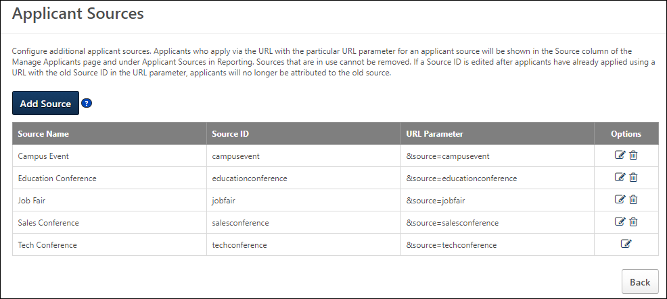
Add Source
Click Add Source to add a custom applicant source. See Applicant Sources - Add Custom Applicant Source on page 23 for additional information.
Applicant Sources Table
The applicant sources table displays your portal's custom applicant sources. The sources appear in alphabetical order.
The following information displays for sources:
- Source Name - This is the name of the applicant source.
- Source ID - This is the ID of the source.
- URL Parameter - The URL parameter is automatically generated when a custom applicant source is created. The parameter is configured as &source=[Source ID].
The URL parameter can be copied from the Applicant Sources page and pasted to the end of the URL for a career site so that when a career site link is sent directly to an applicant and the applicant applies to a job from the career site, the applicant's source will be the custom source that was created in Applicant Sources.
- Options - The following options are available:
  - Edit - Click Edit icon to edit the source. This opens the Edit Source pop-up. Both the Name and Source ID fields can be modified. Click Save in the pop-up to save the changes. Then, click Save on the Applicant Sources page to save the changes to the page. Only sources that have been added to Applicant Sources can be edited.
  - Delete - Click the Delete icon to remove the custom source. Then, click Save on the Applicant Sources page to save the changes to the page. Applicant sources that are in use cannot be deleted.
Save/Cancel
Click Save to save the custom source settings.
Click Cancel to return to the Admin > Tools > Recruit page.

Application Source Values
Application sources are tracked to reflect how an applicant applies for a requisition, either via referral, job board, Career Center, career site, the Candidate Bank, or by being added manually. An application source is automatically applied, based on how the applicant comes into the Applicant Tracking System (ATS). Applicant sources cannot be manually created.
The following are the available application source values (Note: The Referral Suite application sources may also be referred to as referral methods.):
- [Job Board Name]
- [Career Site Name]
- Added Manually
- Broadbean Search
- Candidate bank
- Career Center (Note: This is the legacy Career Center.)
- External Referral-Email
- External Referral-Facebook
- External Referral-LinkedIn
- Internal Career Site
- LinkedIn Recruiter System Connect
- Other - Invited to Apply
- Referral-Email
- Referral-Facebook
- Referral-LinkedIn
- Referral-Search Network
- Referral-Suggested
- Referral-Other
- Talent Pool
The following are the pages on which an application source displays:
- Manage Candidates
- Job Details
- Applicant Profile
- Candidate Search
Note: The application source also appears in standard and custom reporting.
Information Pop-Up
For portals with Referral Suite enabled, when the curser is placed over an internal application source, the Referrer Information pop-up is displayed.
The pop-up displays the user associated with the referral and includes the referrer's photo, name, position, and phone number, as well as a linked email address. Clicking the email address allows you to compose and send the referrer an email.
The following are the internal application sources:
- Referral-Email
- Referral-Facebook
- Referral-LinkedIn
- Referral-Suggested
- Referral-Other
For portals with Agency Portal enabled, when the cursor is placed over the application source, the information pop-up displays the following information:
- The name of the user that submitted the applicant.
- The submitter's job title.
- The submitter's phone number.
- The submitter's email address. Click the email address to send the submitter an email.
Use Cases
The following use cases identify the source value that displays in the Source field depending on how the applicant initially applies to the requisition:
Action | Applicant Pathway | Applicant Applied to Requisition A from: | Source to Display in ATS
Administrator posts to Career Site | N/A | Career Site A | Career Site A
Administrator posts to Job Board | Job Board (Monster.com, etc.) | Career Site A | Job Board A
Administrator posts to Career Center | Career Center | Career Site A | Career Center
Candidate added from talent pool | N/A | N/A | Talent Pool
Candidate added via Broadbean Search | N/A | N/A | Broadbean Search
Candidate invited to apply by a recruiter | N/A | Email Link | Other – Invited to Apply
Candidate Profile imported via LinkedIn Recruiter System Connect | N/A | N/A | LinkedIn Recruiter System Connect
Employee emails application link | Email Message | Career Site A | Referral-Email
Employee posts Facebook link | Facebook Post | Career Site A | Referral-Facebook
Employee posts LinkedIn link | LinkedIn Post | Career Site A | Referral-LinkedIn
Employee uploads resume to specific requisition | Invitation to Apply email sent from Recruiter | Career Site A | Referral-Suggested
External emailed application link | Email message | Career Site A | External Referral-Email
External posted Facebook link | Facebook Post | Career Site A | External Referral-Facebook
External posted LinkedIn link | LinkedIn Post | Career Site A | External Referral-LinkedIn
Source changed automatically (by system) or manually (from Applicant Profile page) | Referral-Other | N/A | Referral-Other
Employee added from Candidate Search | Candidate Bank | N/A | Candidate Bank
Employee added manually by recruiter | Added Manually | N/A | Added Manually
Added/moved from another requisition | Added Manually | N/A | Added Manually

Broadbean or Other Job Distribution

Broadbean Job Posting Configuration in Edge
Cornerstone and Broadbean Technology have collaborated to deliver a seamlessly integrated job posting solution. From Cornerstone Recruiting, organizations can use the Broadbean integration to post jobs to over 4,500 job boards, social media sites such as LinkedIn, Twitter, and Facebook, and other recruitment channels. Through this integration, organizations can harness the power of internal and external sourcing within Cornerstone Recruiting and distribute job postings to the most popular job boards and eliminate the duplicative administrative burden to post jobs on individual job board sites.
Requirements
In addition to being required to have a Broadbean administrator account (along with a secret key), you are required to create a separate account in the Edge Integration Center for each user that will use Broadbean.
Implementation
This integration is available for all organizations using Recruiting. This integration is available for free via Edge Marketplace. Additional instructions for enabling and configuring the integration are available on the Setup tab of the integration in Edge.
Frequently Asked Questions (FAQs)
Why are users seeing this message and what can I do to fix it: "Error No Account Configured for User in Integration Center."
Because the user does not have an individual account configured on Edge. Individual user accounts need to be configured via Administrator > Tools > Edge Integration.
Does every user need their own unique individual account?
Yes. Individual user accounts need to be configured via Administrator > Tools > Edge Integration.
I have many users that need individual accounts, is there a way to bulk upload them?
No, there is not a way to bulk upload individual accounts.
When I am setting up the Broadbean integration in Edge, can I map several users to the same Broadbean user ID?
No.
What is the Candidate Profile field on the Settings page?
The qualifications in the Minimum Qualifications field for a job requisition can be sent to Broadbean's Candidate Profile field. It is important to note that in order to use the Candidate Profile field, you must confirm with your Broadbean representative that your integration can use this field. When the field is toggled to on, Broadbean will then independently choose to which specific job boards the Candidate Profile will be sent. It will be necessary for clients to work with Broadbean directly to select the job boards to which they would like to send the Candidate Profile field data. The benefit to a customer that enables this feature is that a requisition's minimum qualifications will be sent to Broadbean's Candidate Profile field for distribution to specific job boards.
In addition, when the field is toggled on, you can determine whether to send the Job Description field or the job ad in Cornerstone to map to the Detailed Job Description field in Broadbean. The benefit of having the ability to choose which field to send is that the content in the job ad in Cornerstone tends to duplicate information in the Minimum Qualifications field, which is mapped to the Candidate Profile field in Broadbean. For example, if you have the Candidate Profile option enabled in Edge for the Broadbean Job Posting integration, and you also include the JOB.MINIMUM.QUALIFICATIONS tag in the job ad, the minimum qualifications information will appear twice when applicants view the job via a Broadbean job board because it appears in both the Detailed Job Description and the Candidate Profile field.
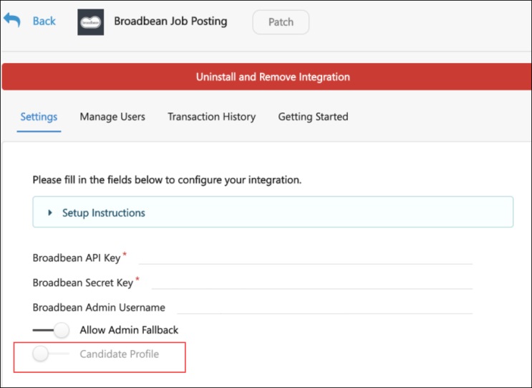

Online Help Topics Related to Broadbean
The following topics in Online Help provide information about the configuration and functionality for the Broadbean Job Posting integration:
- Broadbean Configuration in Edge - This topic provides instructions for configuring Broadbean in Edge. See Broadbean Job Posting Configuration in Edge on page 29 for additional information.
- Broadbean OFCCP Integration - This topic provides information about the Broadbean OFCCP integration. See Broadbean OFCCP Integration.
- My Account - Social - This topic explains how to connect your user account to Broadbean so that you are already connected to Broadbean when posting jobs on the Job Postings page. See My Account - Social.
- Edit Job Board Cost - This topic covers job board costs related to Broadbean. See Edit Job Board Cost.
- Create Job Requisition - General - This topic mentions that jobs posted via Broadbean will only show the primary location for the job, rather than any additional locations that are configured for the requisition. See Create Job Requisition - General.
- Job Posting Page - This topic covers external job postings. See Job Posting Page on page 47 for additional information.
- Requisition Level Costs - This topic provides information about requisition level costs. See Requisition Level Costs.
- Edit Job Requisition - For Broadbean postings, this topic provides information about the impact of the Canceled and Closed status on Broadbean postings. See Edit Job Requisition.
- Create job Requisition - Job Ad - For Broadbean integrations, this topic provides information on how the Job Postings page is populated with available jobs. See Create Job Requisition - Job Ad.

Connect With Us

Connect With Us Page
Connect With Us enables applicants to apply directly to a company instead of applying to a specific requisition. Often, qualified applicants cannot find the ideal position on a career site. Connect With Us enables organizations to capture the information from these applicants and find those applicants via a candidate search query.
On the Connect With Us administration page, you can create a form that applicants complete to apply directly to your organization. The form is created for a single career site and can be branded with a page title and background image.
Once the form is created, the form can only be made visible on a Standard career site by adding a link to the form via an HTML widget. For mobile-friendly career sites, the form is added via the Connect With Us URL option when configuring the mobile-friendly career site.
To access the Connect With Us page, go to Admin > Tools > Recruit > Career Site. Then, click the connect with is icon in the Options column.
Permissions
PERMISSION NAME | PERMISSION DESCRIPTION | CATEGORY

Career Site - Manage | Grants ability to access and manage Career Site Management. This permission can be constrained by OU and User's OU. This is an administrator permission. | Recruiting Administration

Career Site - View | Grants ability to access and view Career Site Management. This permission can be constrained by OU and User's OU. This is an administrator permission. | Recruiting Administration
Use Cases
- Mike is an applicant who is navigating through ACME's career site and does not see any open positions that would be a good fit for him, even though he is a highly qualified applicant. He needs a way to submit his basic information, including resume and area of interest, so that he can be notified by ACME when a position opens that matches his interest.
- Lauren is a recruiter who needs to find applicants like Mike to fill her recently open positions and to build her talent pools. Lauren needs a way to search for applicants like Mike and segregate those applicants based on different criteria, such as area of interest and location.
Considerations for External Applicants
For portals that assign external applicants a specific organizational unit (OU) when they apply to a job, it is important to note that the Connect With Us functionality does not assign an OU when applicants apply via Connect With Us.
Duplicate Applicant Prevention
To reduce the possibility of duplicate applicants, the Connect With Us form does not allow applicants to apply using an email address that is already in use in the career site. The Email field on the Connect With Us form is a standard field that applicants must complete before applying via Connect With Us.
In addition, for existing applicants who already have a profile in the career site but who attempt to apply using their LinkedIn or Seek profile via Connect With Us, a message will display to indicate that they are already connected with the organization. This prevents applicants from creating duplicate profiles in the career site using a social network profile.
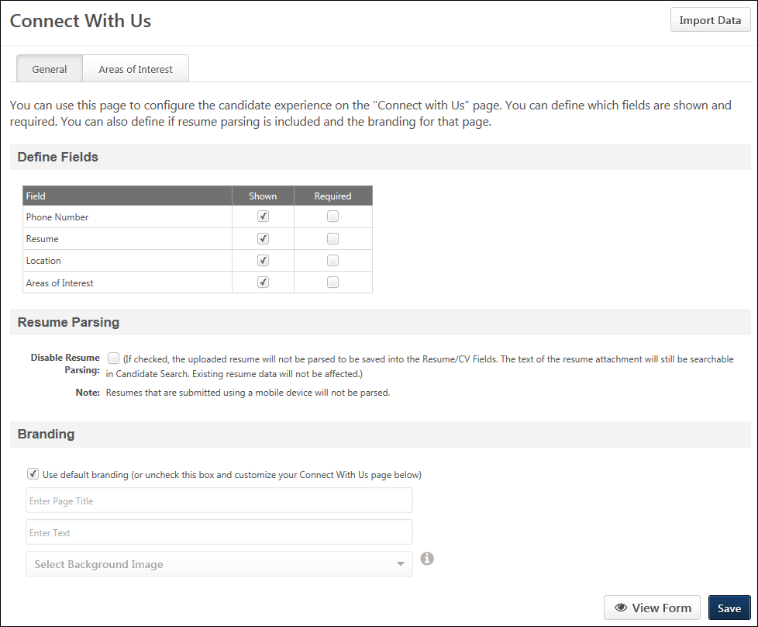
Import Data
The Import Data option lets you to import the Connect With Us settings from another Connect With Us form that was created for a different career site. This is a quicker way to create a form and can be helpful when the configurations on the other form are similar or identical to the configurations you want to make for the form for this career site.
To import the data from another form:
- Click Import Data. This opens the Import data from another Connect With Us form pop-up.
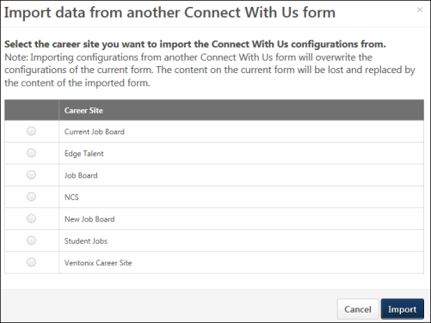
- Select the career site from which you would like to import the settings.
- Click Import. This will overwrite any existing settings on your form, and those existing settings cannot be retrieved.
Note: You can undo the import action by not clicking Save on the Connect With Us page.
General Tab
From the General tab, you can configure the contact fields and areas of interest that will appear on the form, as well as brand the form with a page title and background image. You can also enable or disable resume parsing.
Define Fields
This section allows you to define the fields that display on the Connect With Us form on the career site in addition to the default first name, last name, and email address fields. The fields that display on the form help recruiters find applicants when searching in Candidate Search Query.
The following fields can be included:
- Phone Number - This field allows applicants to enter a phone number.
- Resume - This field allows applicants to submit a resume.
- Location - This field allows applicants to provide their location.
- Areas of Interest - This field allows applicants to select their areas of interest.
Check the Shown box in the Shown column to display the field on the Connect With Us form for applicants. This option is checked by default for all fields. When unchecked, the field does not display for applicants. Note: If you have made changes to the Shown column and would like to preview the form, then you must first click Save at the bottom of the page in order for the changes to be visible in the preview.
Check the Required box in the Required column to make the field required.
Resume Parsing
In this section, you can select to enable or disable resume parsing. The Disable Resume Parsing option is unchecked by default. When unchecked, applicant resumes are parsed when they apply via Connect With Us. When checked, applicants will need to manually enter resume data.
Applicants that are submitted via a mobile device will not be parsed, even if resume parsing is enabled.
Branding
In this section, you can select to use the default branding for the Connect With Us form. Or, you can define a custom page title, description, and background image so that you brand the form to your organization.
To define your own branding, uncheck the Use default branding option, and then complete the following fields:
- Enter Page Title - Enter a title for the page, up to 50 characters.
- Enter Text - Enter a page description, up to 1000 characters.
- Select Background Image - Click the drop-down to select an image. The images that are available to select are images that have already been uploaded for the portal. The background image displays directly behind the Connect With Us form. A default system image displays if you do not configure a background image.
Note: You can upload a new background image on the Corporate Preferences page, depending on your permissions. Then, you can return to the Connect With Us page and select the image from the drop-down. The maximum file size for images is 1MB. The maximum pixel size is 1024px.
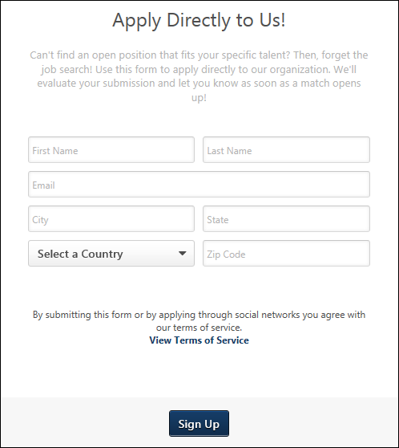
Areas of Interest Tab
From the Areas of Interest tab on the Connect With Us page, you can configure the interests that display for applicants when applying for a job via Connect With Us. Each area of interest that you would like to display on the Connect With Us form must be made active in order for any interests appear.
Interest Bank
The Interest Bank displays the areas of interest that you have created. You can activate and inactivate areas of interest and create/delete interests.
The Interest Bank is the same for all the career sites. You can activate/deactivate each interest on each career site if you want to customize the interest list for a particular career site.
When applicants view the areas of interest on the career site, the list displays in alphabetical order.
Add Areas of Interest
At least one area of interest must be added to the Interest Bank section of this page and made active in order for interests to display on the Connect With Us form.
To add interests:
- Enter an interest in Interest Name field, up to 50 characters.
- Click Add.
If multiple languages are enabled for your portal, select the Translate icon to translate the field into other available languages.
Activate/Inactivate Interests
Areas of interest are inactive by default. To activate an area of interest, check the box in the Active column.
To inactivate an area of interest, deselect the box in the Active column. Inactive areas of interest do not display on the Connect With Us form for applicants. If the area of interest has been selected by an applicant in the career site, the interest remains visible when viewing the applicant's areas of interest.
Delete Interests
To delete an area of interest, click the Delete button to the right of the interest. This opens a confirmation pop-up. Click Confirm to delete the area of interest. This removes it from the Interest Bank and across all career sites. The interest will no longer be available in Candidate Search Query, and will also be removed for the applicant from their Applicant Profile page.
Localize Interests
If multiple languages are enabled for your portal, select the Translate icon to translate the field into other available languages.
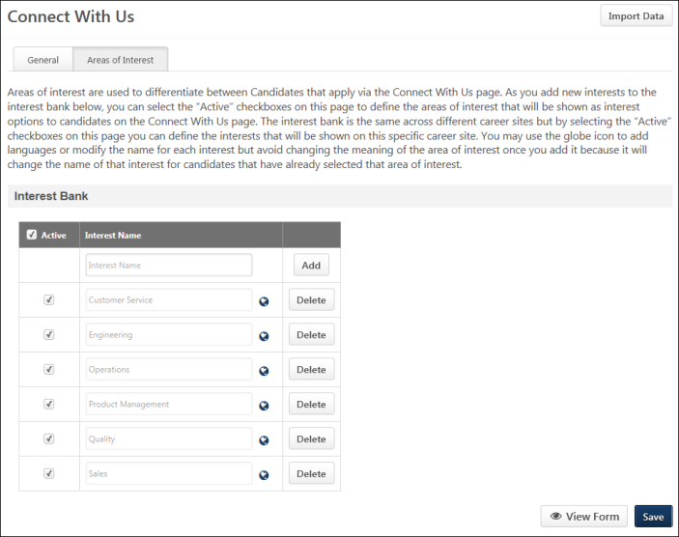
View Form
Click View Form to view the form. The form opens in a new tab. When making changes to the form, the changes must be saved before they will appear when viewing the form.
Save
Click Save to save the Connect With Us settings. This opens a pop-up to indicate that your changes have been saved successfully. Click OK in the pop-up to return to the Connect With Us page. Or, click Back to return to the Career Site Management page.

Add Connect With Us Link to a Standard Career Site
In order for the Connect With Us form to be available on a Standard career site for applicants, a "Connect With Us" link to the form must be added as an HTML widget from the Career Site Settings page.
Mobile-Friendly Career Sites Note: To add a Connect With Us link to a mobile-friendly career site, use the Connect With Us URL option when configuring the mobile-friendly career site. See Create Mobile-Friendly Career Site (Early Adopter).
To access the Connect With Us page, go to Admin > Tools > Recruit > Career Site. Then, click the Edit Connect With Us option in the Options column.
Permissions
PERMISSION NAME | PERMISSION DESCRIPTION | CATEGORY

Career Site - Manage | Grants ability to access and manage Career Site Management. This permission can be constrained by OU and User's OU. This is an administrator permission. | Recruiting Administration
To add the Connect With Us link:
- Open the career site settings page. For existing career sites, the settings page is accessed by clicking the Edit icon on the Career Site Management page. If you are creating a new career site, the settings page is accessed by clicking the Add Career Site link on the Career Site Management page.
- Click the Edit Layout icon toward the bottom of the Career Site Settings page.
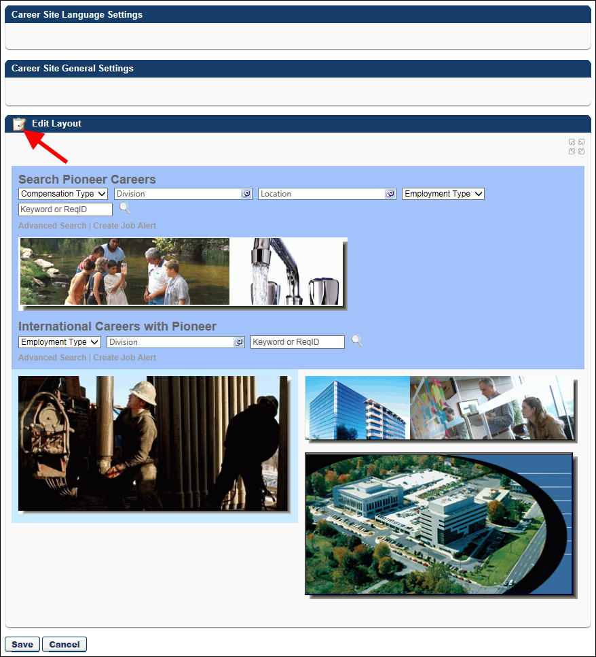
- Clicking the Edit Layout icon opens a pop-up window from which you can add the HTML widget. Note: For more information about the HTML widget, see the HTML Widget topic in Online Help.
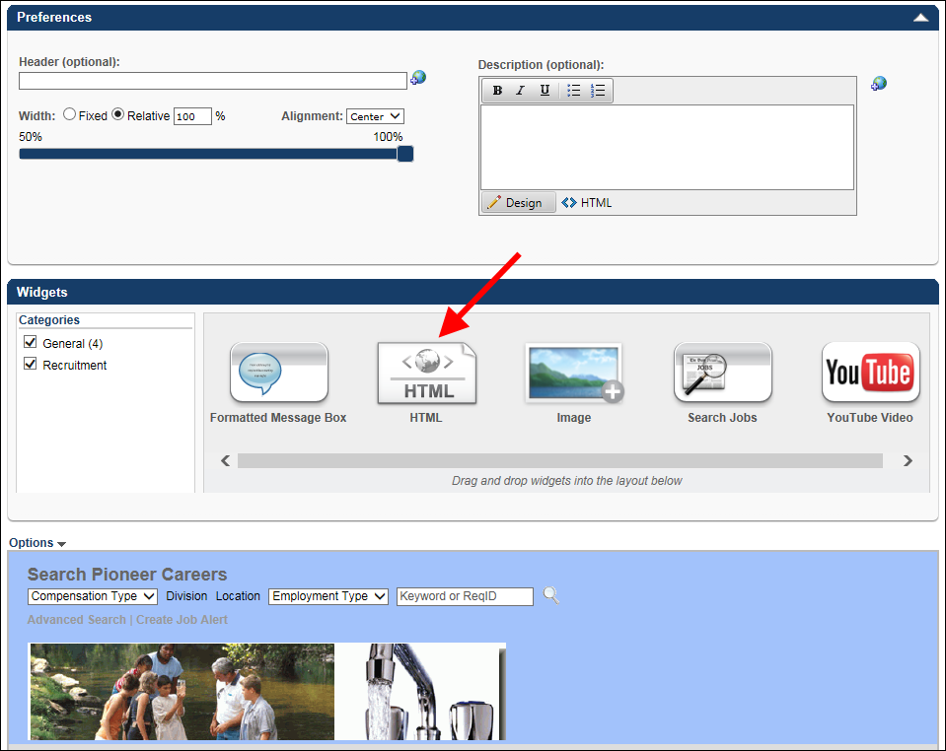
- Drag and drop the HTML widget into the widgets section. This opens the Widget Settings pop-up that includes the Connect With Us link.
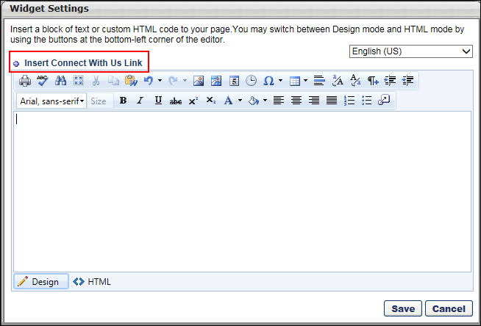
- Click the Insert Connect With Us Link in the pop-up. This adds the link to the widget. It is not necessary to add any other text to the widget.
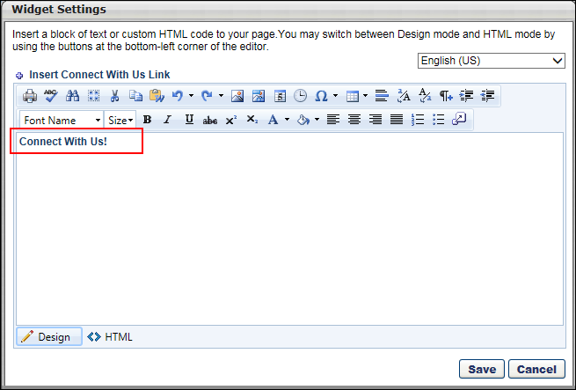
- Click Save in the pop-up. This closes the pop-up, and the link displays in the widgets section.
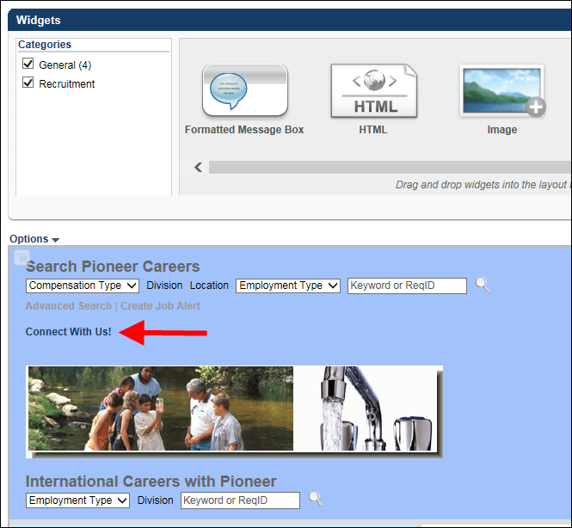
Once you save the career site settings, the link will be visible to applicants on the career site.

Create and Edit Job Postings

Job Posting Page
The Job Posting page appears as a separate page outside of the Create/Edit/Copy Requisition pages in the Applicant Tracking System (ATS). From this page, you can post jobs to career sites, job boards, recruiting agencies, and the Career Center, as well as post jobs as smart referrals.
Separating the job posting functionality from the requisition provides greater flexibility in the job creation process. You can create requisitions and complete a requisition approval workflow while holding off on posting the requisition until the organization is ready for the job to be visible.
Requisition Status Note: The requisition must be in a status of Open, Pending Approval, or Pending Re-Approval in order to post the job. Posting options will be read-only if the requisition is in a different status.
To access the job posting page, click Edit Postings from the options drop-down for a requisition on the Manage Requisitions page.
Permisisons
PERMISSION NAME | PERMISSION DESCRIPTION | CATEGORY

Career Center - View | Enables users to view the Career Center, including Career Pathing and Job Search, depending on enabled components and preferences. This permission enables users to view the Internal Job Search widget on the Welcome Page and custom pages. This permission is also required to post a requisition to an internal career site. This is an end user permission. | Talent/Succession

Requisition: Edit Postings | Grants ability to edit the Job Postings page for a job requisition. In addition, this permission enables users to store user-level credentialing information for job board aggregation partners on Edge. This permission cannot be constrained. | Recruiting

Requisition: Manage | Grants ability to access and manage all requisitions regardless of ownership (constraints permitting). This permission also grants read-only access to the Applicant Review tab when creating or editing a job requisition. This permission can be constrained by OU, User's OU, and Grade. | Recruiting

Requisition: Owner | Enables owner to access requisitions and applicants for requisitions for which they are an owner. This permission also grants read-only access to video interviews that are completed by applicants via HireVue. For portals with Referral Suite enabled, this permission also enables requisition owners to edit the referral source on the Applicant Profile page. This permission cannot be constrained.  Note: This is a dynamically assigned permission that is not available in Security Role Administration. If the user is removed as an owner, the permission is revoked for the associated requisition. This permission cannot be manually assigned. Also, if a user has both the permission necessary to manage requisitions and be a requisition owner, the constraints of the Requisition: Manage permission overrule those of the Requisition: Owner permission. For requisition owners that do not also have permission to manage requisitions, only certain fields are editable when editing a requisition. | Recruiting

Requisition: Reviewer | Enables reviewer to access requisitions and applicants for requisitions for which they are a reviewer. This permission cannot be constrained.  Note: This is a dynamically assigned permission that is not available in Security Role Administration. Once a requisition is in a Closed or Cancelled status or if the user is removed as a reviewer, the permission is revoked for the associated requisition. This permission cannot be manually assigned.  Note: If an applicant reviewer is removed as a reviewer via the Applicant Profile page, the Requisition: Reviewer permission is revoked for the associated requisition. However, if the reviewer was also added as a reviewer via the General tab when creating, editing, or copying the requisition, the reviewer still appears on the In Review panel as a duplicate reviewer and retains access to the requisition and applicants from the Requisition: Reviewer permission. See Applicant Profile Page Overview for more information about duplicate reviewer instances. | Recruiting

Requisition: Select Recruiting Agency | Grants access to manage the Agency Postings workspace on the Requisition - External Postings page. This permission cannot be constrained. | Recruiting
Permissions Note: Users must have the Career Center - View permission to post a requisition to an internal career site. Users must have the Requisition: Edit Postings permission to edit postings on the job posting page. For users without this permission, the job posting page is read-only.
Use Case
- Peter, a recruiter, has heard from the Chief Technology Officer (CTO) that the company needs to hire more engineers. However, the budget for the engineering headcount is only approved for the fourth quarter, and it is currently September.
- Peter creates a requisition and fills out all of the details, including creating a job ad and defining the applicant workflows and steps an applicant will go through during the review process.
- Because it is only September, Peter cannot officially post the job and open the requisition yet. Peter saves the requisition and submits it for approval.
- In October, Peter opens the job posting page to post the job and ensures that both internal and external applicants can apply for the job.
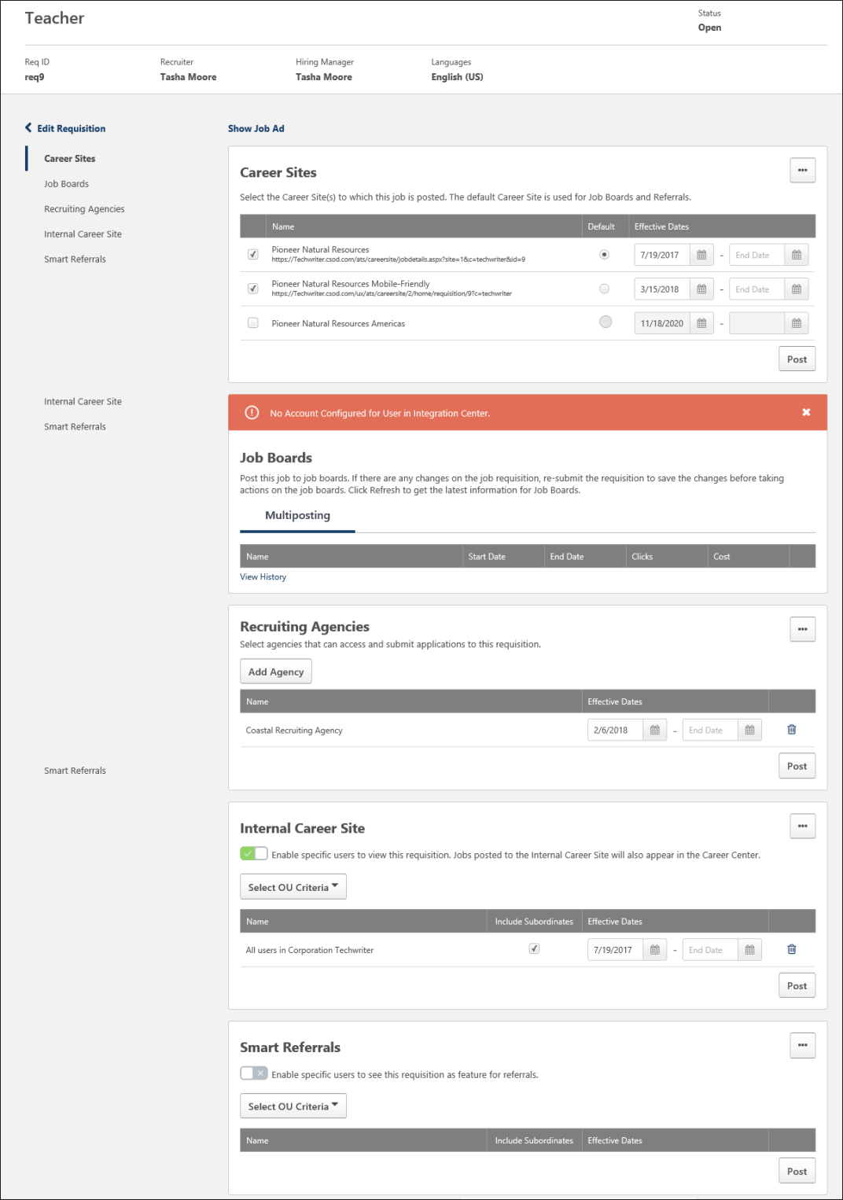
Edit Requisition
Click the Edit Requisition button to open the editing pages of the job requisition. From there, you can make changes to the requisition.
If there are changes to the General tab and approval is required for the requisition, then the requisition will need to go through the approval workflow before the changes are visible on the job posting page.
General Requisition Information
The following general requisition information, as defined on the General tab when configuring the requisition, displays in the upper portion of the page.
- Job Title - The display job title appears at the top of the postings page. The display job title is defined in the Display Job Title field on the requisition.
- Req ID - This displays the requisition ID.
- Recruiter - This displays the name of the primary requisition owner.
- Hiring Manager - This displays the name of the hiring manager.
- Languages - This displays the languages for the requisition.
Show Job Ad
Click the Show Job Ad link to view the job ad for the requisition. The page includes tabs to view the external, internal, and mobile job ads.
The languages that are configured for the requisition display at the top of the page. You can change the language in which you are viewing the job ad by selecting a different language from the language drop-down in the upper-right corner of the page.
When you are done viewing the job ad, click Done to close the ad.
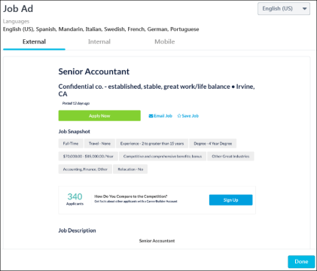
Post Job
The posting options that are available depend on the functionality that is enabled in your portal. Note: When posting a job requisition to a mobile-friendly career site, the posting can take up to 20 minutes to appear.
The following posting options may display:
Post to Career Site
From the Career Sites section, you can post the job to career sites that are configured for the portal. This section displays for all portals with Recruiting enabled.
Note: Career sites are configured by the administrator in Career Site Management.
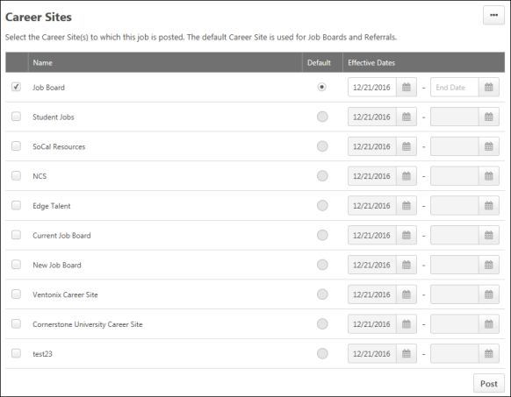
The list of career sites that are configured and active for the portal displays in the table. The following information displays in the table:
- Name - This column displays the name of the career site and the URL for the job posted on the career site. The URL only appears once the job has been posted to the career site, otherwise, the URL is hidden.
- Default - This column defines the default requisition URL, as well as the default career site that is used for referrals and job boards. You can select one career site to be the default site. If only one career site is listed, then the radio button for that site is selected automatically and cannot be deselected.
The information that appears to the right of the career site name is dependent upon the requisition's approval status. The following are the potential scenarios for what displays for the default requisition URL:
  - Scenario 1 - If the requisition is not approved and is in an Open or Open - Pending Re-Approval status, then the following text displays below the career site name: "This requisition must be approved in order to generate the default requisition URL."
  - Scenario 2 - If the requisition is approved but a default career site is not selected and the requisition is in an Open or Open - Pending Re-Approval status, then the following text displays below the career site name: "Select a default CareerSite to generate default requisition URL." Once a default career site is selected, the Default Requisition URL field refreshes to display the URL for the selected default career site.
  - Scenario 3 - If the requisition is approved and a default career site is selected and is in an Open or Open - Pending Re-Approval status, then the URL that is generated for the specific Job Details page on the default career site displays below the career site name. You can double-click the URL to copy it. If you change which default career site is selected in the Default column of the Career Site panel, then the Default Requisition URL field refreshes to display the updated URL for the career site. If you deselect all career sites in the Select column of the Career Site panel, then the Default Requisition URL field refreshes to display the text from Scenario 2
- Effective Dates - The dates in this column determine the date on which the posting appears and the posting's end date. By default, the current date displays as the effective date. The requisition does not appear on the career site until a start date is set.
Further, a requisition that has an approval workflow does not appear on a career site until the requisition is approved. If an end date is provided, the requisition will close at midnight, UTC (Coordinated Universal Time), the day before the specified date, or when all openings for the job are filled. For example, if an expiration date of January 2, 2019 is entered, the posting will be visible at 23:59:59 UTC on January 1, 2019. However, the posting will no longer be visible at 00:00:00 UTC on January 2, 2019. Note: If a date is not entered, the posting does not expire until an end date is entered, or the job opening is filled, or the requisition is in a Closed or Canceled status.
Note: If applicants are directed to a Job Details page that is not currently open or is in an Open - Pending Re-Approval status, then "Sorry, this job is not currently available" appears on the Job Details page. This text also appears on the Job Details page if the requisition is in a Closed or Cancelled status. The Apply Now and Apply with LinkedIn buttons and any referral options are not available in this case.
To post to a career site:
- Check the box to the left of the career site name. Multiple career sites can be selected to post at one time.
- Enter the start date for the posting. You can also enter an end date, but this is not required.
- Click Post. This posts the job to the career sites on the start date entered in the Effective Dates column.
Note: The number of career sites to which a requisition is posted is reflected in the Postings column on the Manage Job Requisitions page. The postings count also factors in the number of job boards to which the requisition is posted. See Conditional Display 5 in the Job Boards section below for more information on the postings count in relation to job boards.
More Options
The following options are available when clicking the More Options icon :
Change All Dates
You can change the start and end posting dates for all career sites by clicking Change All Dates from the More Options icon . This opens Start Date and End Date fields. Enter the start and end posting dates, then click Change. The dates for all career sites will be updated to the new dates.
Configure SEO
Click the Configure SEO option to define the meta page title and description. Click Save to save the changes.
Meta Page Title
Enter a meta page title, up to 50 characters. For portals with multiple languages enabled, use the language drop-down to change the language. When applicants search for the job in search engines, the search results will display the job in the applicant's language, if available.
Meta Page Description
Enter a meta page description, up to 150 characters. For portals with multiple languages enabled, use the language drop-down to change the language. When applicants search for the job in search engines, the search results will display the job in the applicant's language, if available.
Canceled/Closed Requisitions
If the requisition is in a Canceled or Closed status, then the posting is automatically deleted.
Edit Career Site Posting Dates
You can change the start/end date of a posting by selecting new dates in the Effective Dates column. Once the changes are saved, the career site posting will be updated immediately.
Post to Job Board
Posting Note: In order to post to a job board, the job must first be posted to at least one career site.
From the Job Boards section, you can post jobs via the integrations that are enabled for your portal. This section displays for all portals with Recruiting enabled. You can post, edit, refresh, and delete the posting using the Job Boards section. At least one job board must be enabled in the portal in order for the Job Boards section to have a job board available for posting.
To post the job to a job board that is configured for your portal, click Post below the name of the job board. This posts the job to the job board. If changes are made to the job, click Refresh. This re-enables the Post button so that you can re-post the job.
To remove the posting, click the trash can icon to the right of the posting. This removes the job from individual job boards.
View Job Board History
Click View History for a job board vendor to view deleted or expired job boards for that vendor. This provides you with a place to see job boards that are no longer current for the job.
The Job Board History page displays the following information for the job:
- Name - This column displays the name of the job board. The status and the date of the status change display below the job board name.
For Broadbean postings, once the job is posted, you can click the name of the name of the posting to view the posting. You can also click Refresh to update the posting names into a clickable link that will open the Broadbean posting. Broadbean postings that are in a Pending status are not linked.
- Language - This column display the language of the job on the job board. This option is only available for Broadbean integrations.
- Start Date - This column displays the date on which the job was posted.
- End Date - This column displays the date on which the job posting ended.
- Clicks - This column displays the number of clicks the posting received.
- Cost - This column displays the cost of the posting.
Click Done to close the Job Board History page.
Error Messages
If there is an error when posting your job to the job board, an error message will display indicating that an error occurred.
Canceled/Closed Requisitions
If the requisition is in a Canceled or Closed status, then the job board posting is automatically deleted.
Post to Recruiting Agencies
Visibility Note: The Recruiting Agencies section is controlled by a backend setting. If the setting is not enabled, then the section will not appear on the job posting page. To enable this setting, contact Global Customer Support.
Note: Recruiting agencies must first be created by the administrator in Recruiting Agency Management in order for recruiting agencies to be available to add in the Recruiting Agencies section.
From the Recruiting Agencies section, users with permission to select recruiting agencies can post the job to recruiting agencies that are configured for the portal. This section displays for all portals with the Recruiting Agencies functionality enabled within Recruiting.
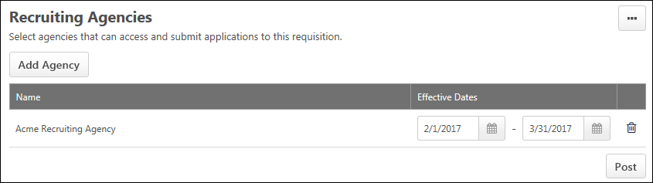
To post to a recruiting agency:
- Click Add Agency. This opens the list of recruiting agencies.
- Check the box to the left of the agency name. Multiple agencies can be selected to post at one time.
- Click select. This adds the agency to the agencies table.
- Enter the effective dates in the Effective Dates column. The dates in this column determine the date on which the posting appears and the posting's end date. By default, the current date displays as the effective date. The requisition does not appear on the career site until a start date is set.
Further, a requisition that has an approval workflow does not appear on a career site until the requisition is approved. If an end date is provided, the requisition will close at midnight, UTC (Coordinated Universal Time), the day before the specified date, or when all openings for the job are filled. For example, if an expiration date of January 2, 2019 is entered, the posting will be visible at 23:59:59 UTC on January 1, 2019. However, the posting will no longer be visible at 00:00:00 UTC on January 2, 2019. Note: If a date is not entered, the posting does not expire until an end date is entered, or the job opening is filled, or the requisition is in a Closed or Canceled status.
- Click Post. This posts the job to the recruiting agency on the effective date.
The following information displays in the agencies table:
- Title - This column displays the title of the agencies.
- Start Date - The date in this field determines the date on which the requisition appears on the career site. This is a required field. The requisition does not appear on the career site until a start date is set. Further, a requisition that has an approval workflow does not appear on a career site until the requisition is approved.
- End Date - The date in this field determines the date on which the requisition posting expires. The end date must be after the start date. This is not a required field.
- Delete - Click the Delete icon to the right of the posting date to delete the posting to the agency. The posting will no longer be available through the agency postings.
Change All Start/End Dates
You can change the start and end posting dates for all agencies by clicking Change All Dates from the More Options icon . This opens Start Date and End Date fields. Enter the start and end posting dates, then click Change. The dates for all agencies will be updated to the new dates.
Considerations
- When a requisition has expired or is no longer posted to the agency, the agency's associated users can still view the applicants that applied to the job from their Agency Portal - My Submissions page.
- Changes to the Recruiting Agencies panel do not require re-approval for job requisitions that have an approval workflow.
Post to Career Center
This section allows you to post the job to the Explore Open Jobs tab in the Career Center.
Note: The SMP Career Center must be active in your portal in order to post jobs to Career Center.
To post to the Career Center:
- Check Enable specific users to view this requisition from the Career Center.
- Select an organizational unit (OU) from the Select OU Criteria drop-down and click Add to add the OU. The OUs that display are the OUs for which you meet the availability criteria.
- Check the box in the Include Subordinates column to include subordinate OUs. This option is checked by default.
- Enter the effective dates in the Effective Dates column. The dates in this column determine the date on which the posting appears and the posting's end date. By default, the current date displays as the effective date. The requisition does not appear on the career site until a start date is set.
Further, a requisition that has an approval workflow does not appear on a career site until the requisition is approved. If an end date is provided, the requisition will close at midnight, UTC (Coordinated Universal Time), the day before the specified date, or when all openings for the job are filled. For example, if an expiration date of January 2, 2019 is entered, the posting will be visible at 23:59:59 UTC on January 1, 2019. However, the posting will no longer be visible at 00:00:00 UTC on January 2, 2019. Note: If a date is not entered, the posting does not expire until an end date is entered, or the job opening is filled, or the requisition is in a Closed or Canceled status.
- Click Save. This will post the job to the Career Center on the date defined.
To add additional OUs, repeat the steps and click Save to save the posting settings.
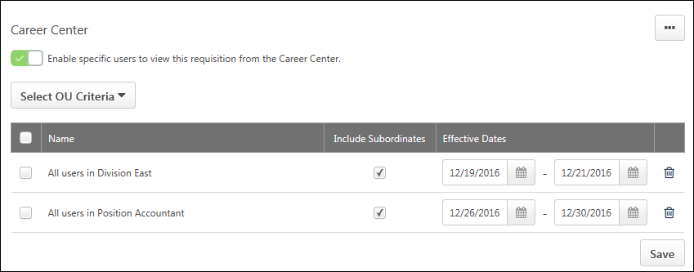
Delete Organizational Unit Posting
You can remove an OU's posting by clicking the Delete icon to the right of the posting date. The posting will no longer be visible in the Career Center for users who meet the criteria for that OU.
Change All Start/End Dates
You can change the start and end posting dates for all OUs by clicking Change All Dates from the More Options icon . This opens Start Date and End Date fields. Enter the start and end posting dates, then click Change. The dates for all OUs will be updated to the new dates.
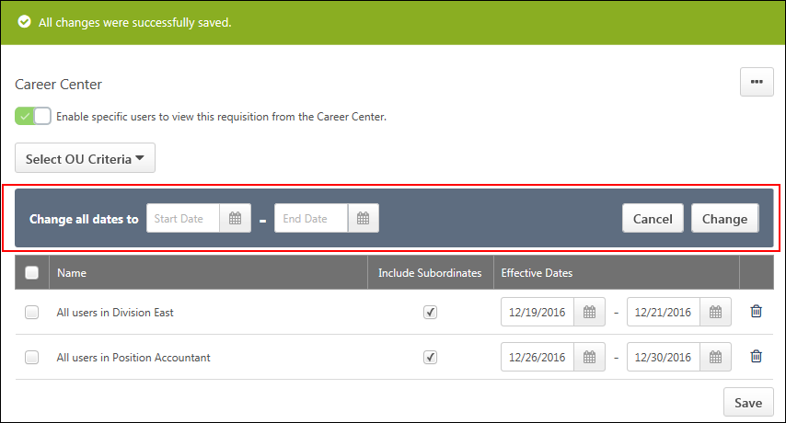
Troubleshooting
Issue: The job does not appear on the career site.
If the job does not appear on the career site, check the following:
- See if the requisition is approved. A requisition must be approved in order to appear on a career site.
- See if the requisition is within the effective and expiration dates. A requisition does not appear on a career site until the effective date begins. A requisition no longer appears on a career site after the expiration date.
- See if the career site is selected on the Job Postings page. If the career site is not selected in the Career Sites panel on the Job Postings page, the requisition does not appear on the career site.
Post as Smart Referral
This section allows you to post the job as a smart referral in the Career Center. Smart referrals are referrals that are targeted by the administrator toward a specific OU. For example, a sales position might be targeted to a Sales division.
When a job is designated as Smart, the job appears in the Refer Your Friends panel on the Refer Jobs tab in Career Center for all users in the selected OU. Note: Users outside of the OU that is set for the Smart referral can still refer the job to their contacts through Career Center.
Note: The SMP Career Center must be active in your portal in order to post jobs to Career Center.
To post as a smart referral:
- Check Enable specific users to see this requisition as feature for referrals.
- Select an organizational unit (OU) from the Select OU Criteria drop-down and click Add to add the OU. The OUs that display are the OUs for which you meet the availability criteria.
- Check the box in the Include Subordinates column to include subordinate OUs. This option is checked by default.
- Enter the effective dates in the Effective Dates column. The dates in this column determine the date on which the posting appears and the posting's end date. By default, the current date displays as the effective date. The requisition does not appear on the career site until a start date is set.
Further, a requisition that has an approval workflow does not appear on a career site until the requisition is approved. If an end date is provided, the requisition will close at midnight, UTC (Coordinated Universal Time), the day before the specified date, or when all openings for the job are filled. For example, if an expiration date of January 2, 2019 is entered, the posting will be visible at 23:59:59 UTC on January 1, 2019. However, the posting will no longer be visible at 00:00:00 UTC on January 2, 2019. Note: If a date is not entered, the posting does not expire until an end date is entered, or the job opening is filled, or the requisition is in a Closed or Canceled status.
- Click Save. This will post the job to the Career Center on the date defined.
To add additional OUs, repeat the steps and click Save to save the posting settings. The list of OUs in the table displays in order of least to most recently added.
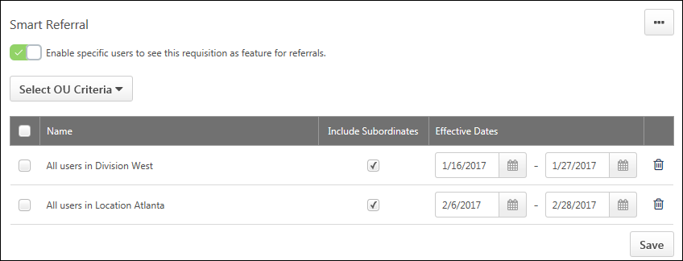
Delete Smart Referral
You can remove an OU's posting by clicking the Delete icon to the right of the posting date. The posting will no longer be visible in the Career Center for users who meet the criteria for that OU.
Change All Start/End Dates
You can change the start and end posting dates for all OUs by clicking Change All Dates from the More Options icon . This opens Start Date and End Date fields. Enter the start and end posting dates, then click Change. The dates for all OUs will be updated to the new dates.
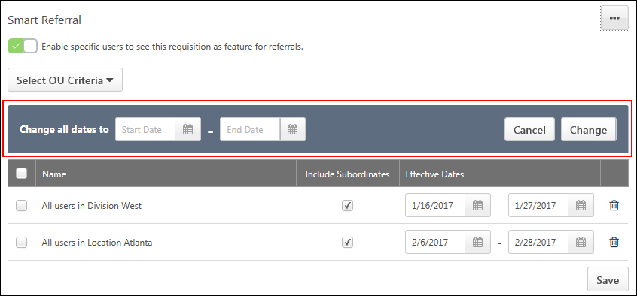

Talent Pools Overview

Talent Pool - Manage
Use the Manage Talent Pools page to view the talent pools you created or have been shared with you. You can view and edit, share, and delete talent pools.
To access the Manage Talent Pools page, select Manage Talent Pools from the sublink in the navigation tab to which the link has been added. Administrators can add the Manage Talent Pools sublink in Navigation Tabs and Links Preferences. See Navigation Tabs and Links.
Permissions
PERMISSION NAME | PERMISSION DESCRIPTION | CATEGORY

Talent Pools - Manage | Grants ability to create and manage Talent Pools. This permission also grants access the ability to add candidates to a job requisition. This permission can be constrained by OU and User's OU. This is an administrator permission. | Talent/Succession - Administration
Create Talent Pool
The Create Talent Pool option allows you to add a new talent pool. To create a talent pool:
- Click Create Talent Pool. This opens the Create Talent Pool pop-up.
- Enter a name for the talent pool, up to 50 characters.
- Click Save. This adds the talent pool to your list of talent pools.
Note: For portals with Recruiting enabled, see the View Talent Pool topic in Online Help for information about adding candidates to a talent pool.
Talent Pools List
Talent pools display in order of most to least recently added. The following information displays for the talent pools:
- Name - The name of the talent pool is a clickable link. Click the name to view and edit the talent pool.
- Date Created - This field displays the date on which the talent pool was created.
- Creator - This field displays the name of the talent pool creator.
- Options - The following options are available from the drop-down to the right of the talent pool:
  - Edit - Click Edit to view the talent pool and make changes to it, such adding users, changing the talent pool name, or creating a nomination list. This opens the talent pools page for the talent pool.
  - Share - Talent pools can be shared so that other users can provide their input in managing and promoting the users in the talent pool. This option does not display for users with whom a talent pool has been shared. See Talent Pool - Share on page 65 for additional information.
  - Delete - This option only displays for the talent pool creator. Click Delete to delete the talent pool. This opens the Delete Talent Pool pop-up. Click Yes to delete the talent pool. This removes it from the creator and any users with whom the talent pool has been shared. Or, click No to close the pop-up without deleting the talent pool.

Talent Pool - Share
Use the Manage Talent Pools page to view or edit the talent pools you created or shared with you. You can also share and delete talent pools.
- To access the Manage Talent Pools page, select Manage Talent Pools from the sublink in the navigation tab. Administrators can add the Manage Talent Pools sublink in Navigation Tabs and Links Preferences. See Navigation Tabs and Links.
- To share a talent pool, select the Options drop-down menu to the right of the talent pool, and select Share. This opens the Share Talent Pool pop-up. Search for and select the users with whom to share the pool. Once the users have been selected, click Done. This shares the talent pool with the selected users.
Permissions
PERMISSION NAME | PERMISSION DESCRIPTION | CATEGORY

Talent Pools - Manage | Grants ability to create and manage Talent Pools. This permission also grants access the ability to add candidates to a job requisition. This permission can be constrained by OU and User's OU. This is an administrator permission. | Talent/Succession - Administration
View Shared Talent Pool Users
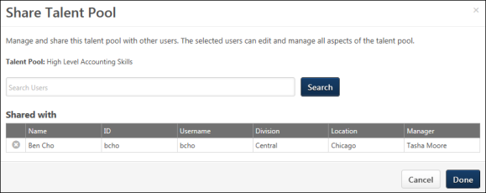
To view the users with whom a talent pool is shared, click the Share option in the drop-down to the right of the talent pool on the Manage Talent Pools page. This opens the Share Talent Pool pop-up. The list of users displays in a Shared with section at the bottom of the pop-up.
View Shared Talent Pools
For users with whom a talent pool is shared, view the talent pool by clicking the Manage Talent Pools sublink from the navigation drop-down. This opens the Manage Talent Pools page, from which they can see a list of all talent pools that have been shared with them. They can also see who shared the talent pool with them and view the details of each talent pool by clicking the name of the talent pool.
Edit Shared Talent Pools
For users with whom the talent pool is shared, edit the talent pool by clicking the edit icon in the drop-down to the right of the talent pool name. This opens the details page for the talent pool. See Talent Pool - View on page 67 for additional information.

Talent Pool - View
Use the talent pool page to view the candidates in the talent pool and perform actions for the candidates, such as adding them to a job requisition. You can also view their status in the talent pool and create and manage nomination lists.
The options that are available will differ for portals that only have Succession or only have Recruiting. For portals that have both Succession and Recruiting, the full functionality of talent pools will be available.
Users must have permission to manage talent pools in order to view the Manage Talent Pools page and have access to the features and functionality for talent pools. For portals with Recruiting and Succession, recruiters and hiring managers must have permission to manage talent pools in order to access and manage the Manage Talent Pools page.
Permissions
PERMISSION NAME | PERMISSION DESCRIPTION | CATEGORY

Applicants: Add/Move to Requisition | Grants ability to add or move applicants to requisitions the applicant did not apply for. This permission can be constrained by OU, User's OU, and Grade. | Recruiting

Assign OU Development Plans | Grants ability to create and assign Development Plans to all users within specified organizational units or custom groups. This is an administrator permission. | Performance - Administration

Snapshot - Development Plans | Enables user to view the Development Plans widget and subpage within the Universal Profile - Snapshot page for users within their permission constraints. This permission can be constrained by OU, User's OU, User Self and Subordinates, User, User's Self, User's Manager, User's Superiors, User's Subordinates, User's Direct Reports, and Employee Relationship. Best Practice: For most users, this permission should be constrained by User Self and Subordinates. | Universal Profile

Talent Pools - Manage | Grants ability to create and manage Talent Pools. This permission also grants access the ability to add candidates to a job requisition. This permission can be constrained by OU and User's OU. This is an administrator permission. | Talent/Succession - Administration
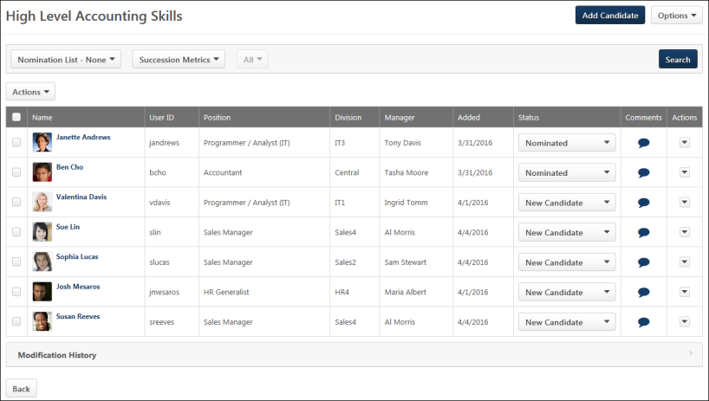
Add Candidate
The Add Candidate button allows you to add internal candidates to the talent pool. Note: External candidates can be added to a talent pool via Candidate Search Query or from the Manage Applicants page.
To add candidates:
- Click the Add Candidate button. This opens the Add Candidate pop-up.
- Search for candidates using the search option.
- Select candidates from the Available Users table.
- Click Done. This adds the candidates to the talent pool. The status of the candidates is New Candidate.
Add Nominee
The Add Nominee button allows you to add nominees to the nomination list. Nomination lists allow you to categorize candidates by a certain qualification or skill. When nominees are added to a nomination list but are not currently in the talent pool, they are only added to the nomination list and are not also added to the talent pool.
The Add Nominee button only displays if the talent pool is filtered by a nomination list. Filtering by a nomination list changes the name of the Add Candidate button to Add Nominee.
To add a nominee to the nomination list:
- Click the Add Nominee button. This opens the Add Nominee pop-up.
- Search for candidates using the search option.
- Select candidates from the Available Users table.
- Click Done. This adds the candidates to the nomination list. The status of the candidates changes to Nominated.
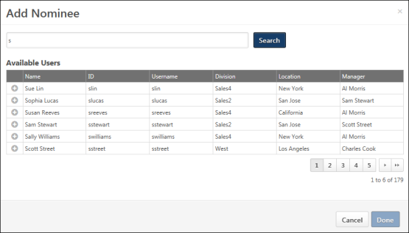
Options
The following options are available in the Options drop-down:
- Edit Name - Click Edit Name to change the name of the talent pool. This opens the Edit Name pop-up. Enter the changes into the text field, and then click Save. This saves the changes to the name.
Filters
The following filters are available:
- Nomination List Status - Select a nomination list status to filter the candidates by their status in the nomination list. The page is updated to show only the candidates who are in the selected nomination list status. The filter is disabled if a nomination list has not yet been created. When filtered by a nomination list, only the Assign Dev Plan, Create Group/Add to Group, and Remove options are available in the Actions column.
- Succession Metrics - Select a succession metric to filter the candidates by a specific metric. The metrics that display are the metrics that are available to the user.
- Metric Rating - Once the metric is selected, you can also filter by the metric rating. Select the rating from the drop-down to the right of the metric. The All option is selected by default. Only active metric ratings display in the filter. If a candidate does not have a rating but meets the metric criteria, then the candidate will display in the list.
Once the filters are defined, click Search. This updates the table to display the candidates that match the criteria.
Actions
The Actions drop-down allows you to apply actions to candidates, such as adding to groups and adding to a requisition. You can perform bulk actions by using the Actions drop-down above the candidates table. Or, you can perform actions on individual candidates from the drop-down in the Actions column in the table.
Note: The Assign Dev Plan action is only available for portals with Succession. The Add to Requisition action is only available for portals with Recruiting.
Note: The Create Group option displays if there a group has not yet been created for the talent pool. Once a group has been created, the Create Group option is replaced by the Add to Group option.
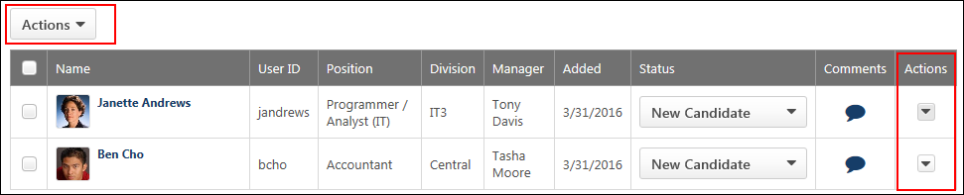
Nominate
The Nominate action allows you to add candidates to an existing nomination list. Or, you can create a new nomination list to which to add the selected candidates.
To add candidates to a nomination list:
- Select one or more candidates.
- Click the Nominate option from the Actions drop-down. This opens the Nominate Candidate pop-up.
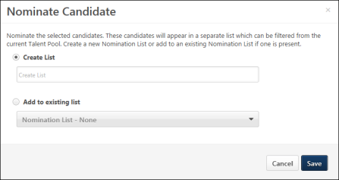
- Create a new nomination list by entering a name for the list in the Create List field, up to 50 characters.
- Or, select the Add to existing list option to add the candidates to an existing list. Then, select the list from the drop-down.
- Click Save. This saves the new list and adds the candidates to the list. Or, this saves the candidates to the existing list.
Once a nomination list is created, the list cannot be deleted.
Assign Dev Plan
The Assign Dev Plan option allows you to assign a development plan to candidates in the talent pool to help candidates move to next level positions in the organization. This option is only available for portals that also have Succession.
To assign a development plan:
- Select one or more candidates.
- Click the Assign Dev Plan option from the Actions drop-down. This opens the Select Dev Plan Template pop-up.
- Click the plus icon to the left of the development plan to select the plan. Only one plan can be selected.
- Click Save. This adds the development for the candidates. The candidates' status in the talent pool changes to In Development.
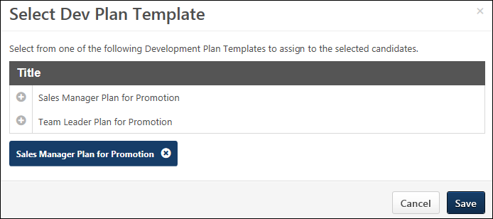
Assign Dev Plan - Redesigned Development Plans
For portals using the redesigned development plans functionality, the workflow for assigning a dev plan is enhanced. A Preview option is available in the Development Plan Templates pop-up so that the manager can preview the development plan template prior to assigning it to ensure that the correct template is selected.
In addition, the system confirms that all of the selected users are within the manager's permission to create and assign a development plan, and all of the selected users are automatically added to the Assignment section of the development plan. If a manager does not have permission to create a development plan for a particular user, the Assign Development Plan option does not appear in the drop-down menu for that user.
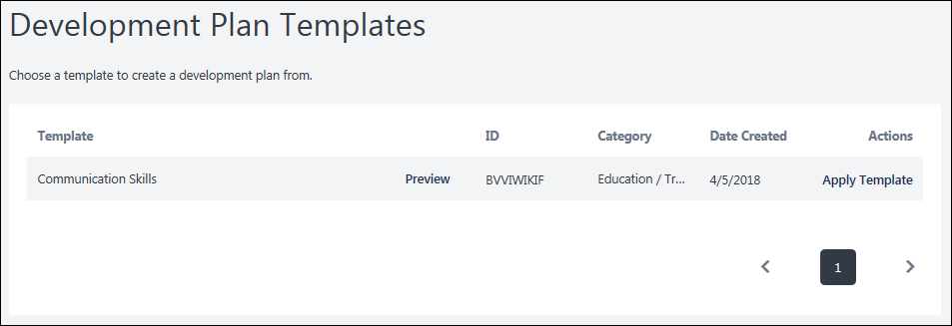
Create Group/Add to Group
You can add candidates to a Group organizational unit (OU) so that other actions within the system can be applied to the OU.
Create Group
The Create Group option displays if at least one group has not yet been created in Manage Talent Pools. Only one Group OU can be created at the talent pool level, and only one Group OU can be created per nomination list. For example, if a talent pool has two nomination lists, then up to three groups can be created. One group can be created for the talent pool and one can be created for each nomination list.
To create a group and add candidates to the group:
- Select one or more candidates.
- Click Create Group in the Actions drop-down above the candidates table or the actions drop-down to the right of the candidate in the candidates table. This opens the Add to Group pop-up.
- Enter the group name in the Group Name field, up to 50 characters.
- Click Save. This creates the group and adds the selected candidates to the group.
Add to Group
The Add to Group option displays if at least one group has been created in Manage Talent Pools. To add candidates to an existing group:
- Select one or more candidates.
- Click Add to Group in the Actions drop-down above the candidates table or the actions drop-down to the right of the candidate in the candidates table. This opens the Add to Group pop-up. When at least one group already exists for the talent pool, you cannot create another group. The pop-up displays the name of the group to which you can add the candidates.
- Click Save to add the candidates to the group.
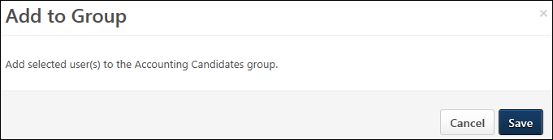
Note: The Add to Group option is hidden if a Group OU that was previously created for the talent pool or nomination list is inactive.
Add to Requisition
The Add to Requisition option allows you to add candidates to a job requisition. This option is only available for portals that also have Recruiting.
To add candidates to a requisition:
- Select one or more candidates.
- Click Add to Requisition from the Actions drop-down. This opens the Add to Requisition pop-up.
- Search for and select the job requisition to which to add the candidates.
- Once the job requisition is selected, configure the following options for adding the candidates:
  - Add As - In the Add As column, select the New Submission option to add the submission directly into a New Submission status for the requisition. Select the Applicant option to add the submission directly to the Manage Candidates and Manage Applicants pages for the requisition. If the Applicant option is selected, the applicant's status will be the first status in the status workflow for the requisition, and the date in the Current Status column is the date on which the applicant was manually added to the requisition. Note: If the Skip New Submission Status option is enabled by the administrator in Requisition and Applicant Preferences, then the option to add an applicant as a new submission does not display for the Add to Requisition and Move to Requisition action items. The New Submission option in the Add to Requisition pop-up is hidden. The Applicant option is then selected by default.
  - Send Email To - In the Send Email To column, check the box to send an email to the requisition owner and/or the potential applicant, notifying them that the applicant has been added to the requisition. Both boxes are unchecked by default. Note: If the new requisition requires applicants to complete certain steps prior to submitting their application, the email can be configured in Email Management to include a link for the applicant to apply directly to the requisition. Further, the application materials for the new job are pre-populated with the applicant's existing information.
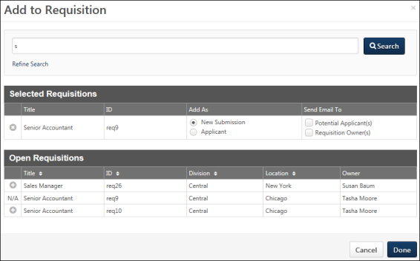
Delete
The Delete action allows the talent pool creator or a candidate with whom the talent pool was shared to remove a candidate from the talent pool. To delete a candidate:
- Click Delete from the Actions drop-down. This opens the Remove User/Candidate pop-up.
- Click Yes to remove the candidate. This removes the candidate from the talent pool.
- Click No to close the pop-up without deleting the candidate.
Candidates Table
The candidates table lists all users who are in the talent pool. You can perform actions on an individual user and also change the user's status in the talent pool. You can also access the user's Universal Profile > Bio page.
Select All Checkbox
Select the checkbox in the header row to perform bulk actions from the Actions drop-down on all of the selected candidates.
Select Individual User
Select the checkbox to the left of each candidate's name to perform actions from the Actions drop-down
Table
The following information displays in the table:
- Photo - The candidate's photo displays, if available.
- Name - This column displays the candidate's name as a link. For internal user, clicking the name opens their Universal Profile > Bio page or My Team page. For portals with Recruiting, clicking the name of an external candidate opens their Applicant Profile page.
- User ID - This column displays the candidate's user ID.
- Position - This column displays the candidate's current Position organizational unit (OU). If there is no value available, then "N/A" displays.
- Division - For internal candidates, this column displays their current Division OU. For external candidates, this column displays "External."
- Manager - This column displays the name of the candidate's manager. If there is no value available, then "N/A" displays.
- Added - This column displays the candidate's date on which the candidate was added to the talent pool.
- [Metric Filter] - The name of this column is the name of the metric selected in the metric filter. The column displays the rating for the metric. If a candidate has no rating for the metric, then the column displays "N/A."
- Status - This column displays the candidate's status in the talent pool. You can manually change the status by selecting a status from the drop-down, which helps you to better manage the candidate's lifecycle in the talent pool. The following statuses display:
  - New Candidate - This status is assigned automatically when a candidate is added to the talent pool. indicates that the candidate has been added to the talent pool.
  - In Development - This status is assigned automatically when a development plan is added for the candidate.
  - Nominated - This status is assigned automatically when a candidate is added to a nomination list.
  - Placed - This status is assigned manually and indicates that a candidate has been promoted or placed in a position.
Note: Changing a candidate's status when viewing the candidate in a nomination list does not change their status in the main talent pool.
- Comments - The Comments option allows you to add a comment about the candidate, as well as view the comments that others have added. Click the icon to open the Comments pop-up. Enter a comment in the text box. Only one comment can be added per user, up to 3000 characters. If comments have been added by other users, then the comments display below the text box. Any comments you enter can be viewed by the users with whom the talent pool is shared. You can edit your own comment by opening the Comments pop-up and changing the comment in the text box. To delete your comment, you can remove all text in the text box and click Save.
- Actions - This column displays the actions that can be performed for the individual candidate. To perform an action, it is not necessary to check the box in the far left column of the table. The following actions are available from the drop-down:
  - Nominate - See the Nominate section above for more information.Note: This option is not available when the table is filtered by a nomination list.
  - Assign Dev Plan - See the Assign Dev Plan section above for more information.
  - Create Group/Add to Group - See the Create Group/Add to Group section above for more information.
  - Add to Requisition - See the Add to Requisition section above for more information.
  - Remove - See the Delete section above for more information.
Modification History
The Modification History section displays the changes made to the talent pool or the nomination list. The section is collapsed by default.
The changes that display are based on the user's availability. If a user is not able to view a specific candidate due to permission constraints, then the change associated with the candidate does not display in the modification history.
The following changes display in the Modification History section:
- Talent Pool Created
- Nomination List Created
- Candidate Added to Talent Pool
- Candidate Added to Nomination List
- Candidate Removed from Talent Pool
- Candidate Removed from Nomination List
