Requisitions March 2024

Table of Contents
Requisitions Overview 1
Recruiting Permissions 2
Manage Job Requisitions 18
New Submissions 27
Place Requisition in On Hold Status 37
Requisition Approval Status Pop-Up 40
Requisition History Pop-up 43
Job Requisition - Overview 46
Create Job Requisition - General 47
Create Job Requisition - Job Ad 68
Create Job Requisition - Application Workflow 74
Create Job Requisition - Applicant Review Tab 79
Create Related Job Requisition 115
Create Related Requisition (Apply to Multiple Jobs) 119
Edit Job Requisition 122
Manage Remaining Applicants Pop-Up 157
Recruiting Approvals Overview 159
Recruiting Approvals - Requisitions 161
Requisition Requests Overview 166
Requisition Request Preferences 168
Requisition Requests Overview 172
Requisition Requests Page for Reviewers - Overview 183
Requisition Snapshot 190
Requisition Snapshot - Submission Details Tab 195
Add Submission 200
Requisition Snapshot - Cost Details Tab - Overview 207
Requisition Templates Overview 242
Requisition Templates Page 244
Requisition Template - Create 246
Default Requisition Template Preferences 313
Feature Activation Preferences 317
General Preferences (by Division) 323
Referral Preferences 327
Requisition and Applicant Preferences 335
Requisition and Applicant Preferences - Applicant Custom Fields 341
Requisition and Applicant Preferences - Application Custom Fields 343
Requisition and Applicant Preferences - Applicant Profile Background Image 345
Requisition and Applicant Preferences - Compensation Types 346
Requisition and Applicant Preferences - Dispositions 348
Requisition and Applicant Preferences - Duplicate Applicants Management 352
Requisition and Applicant Preferences - Employment Types 357
Requisition and Applicant Preferences - Requisition Custom Fields 358
Requisition and Applicant Preferences - Requisition Field-Level Access 361
Custom Field Admin - Organizational Units 366
Cost Field Management 368
Add Cost Field 371
Edit Cost Field 373
Recruiting and Onboarding Integrations Overview 374
Recruiting and Onboarding Integrations 375
Recruiting Integrations - Edge 378
Other Requisition Functionality Overview 379
Job Requisition Form Status Workflow 380
Recruiting Roles 381
Rehired Employees 386

Requisitions Overview

Recruiting Permissions
The following permissions relate to the Recruiting functionality and appear under the Recruitment category in Security Administration:
Permissions
PERMISSION NAME | PERMISSION DESCRIPTION | CATEGORY

Agency Portal | Grants access to manage the Agency Portal page. This permission cannot be constrained. | Recruiting

Applicant and Application Custom Fields – Edit Values | Grants ability to edit Applicant custom field values on the Custom Fields tab of the Applicant Profile Snapshot page. Grants ability to edit the Application custom field values on the Summary tab of the Applicant Profile page. This permission cannot be constrained. This is an administrator permission. | Recruiting Administration

Applicant Compliance Report | Grants access to the Applicant Compliance Report, which tracks applicants' self-reported responses to disability, gender, race, ethnicity, and EEO questions. | Reports - Recruiting

Applicant Flags Preferences - Manage | Grants ability to access and manage Applicant Flags Preferences. This permission cannot be constrained. | Recruiting Administration

Applicants: Access Sensitive Statuses | Grants ability to access the applicant statuses that are configured as sensitive. | Recruiting

Applicants: Ad Hoc Anonymization | Grants ability to anonymize an external candidate from their Applicant Profile. Administrators and recruiters must also have permission to access the applicant's profile. This permission cannot be constrained. | Recruiting

Applicants: Add to Talent Pool | Grants ability to add applicants to talent pools. | Recruiting

Applicants: Add/Move to Requisition | Grants ability to add or move applicants to requisitions the applicant did not apply for. This permission can be constrained by OU, User's OU, and Grade. | Recruiting

Applicants: Assign Assessment Integration | Grants access to manage assessment integrations from the Applicant Profile page. This applies to assessments that have been configured in the integration center. This permission cannot be constrained. This permission is only available for portals that have an active assessments integration.  This is the highest level of permission for this functionality. In addition to being able to assign assessments, users with this permission will be able to view the assessment status and assessment details. | Recruiting

Applicants: Assign Competency Assessment | Grants ability to assign competency assessments to candidates. | Recruiting

Applicants: Assign SHL Assessments | Grants ability to assign SHL assessments to applicants from the Manage Applicants and Applicant Profile pages. This permission cannot be constrained. | Recruiting

Applicants: Assign Training | Grants ability to assign training to candidates. | Recruiting

Applicants: Assign Video Interview Integration | Allows user to assign video interview integrations from Manage Candidates. This permission cannot be constrained. | Recruiting

Applicants: Comments - Manage | Grants ability to view and manage comments for applicants.  This permission also defines whether comments posted when an interviewer submits an interview recommendation are posted to the Comments section on the Applicant Profile tab. Note: Interview recommendation comments for interviewers who have this permission display on the Applicant Profile tab. For interviewers who do not have this permission, the comments do not display on the Applicant Profile tab. | Recruiting

Applicants: Comments - View | Grants ability to view comments for applicants. | Recruiting

Applicants: Compare Candidates | Grants ability to compare candidates against each other | Recruiting

Applicants: Edit Contact Details | Grants ability to edit the applicant details, including the name, phone, address, and photo on the Applicant Profile page. This permission cannot be constrained. | Recruiting

Applicants: Edit Matching Criteria | Grants ability to edit the Position Criteria section on the New Submissions page in Manage Job Requisitions used to evaluate new submissions. | Recruiting

Applicants: Manage Flags | Grants ability to add and remove applicant (user) and application flags. This permission also grants ability to use applicant flags in Search Candidates. This permission cannot be constrained. | Recruiting

Applicants: Manage Hired Applicants | Grants ability to access and manage Manage Hired Applicants and also access the Users page and the Add/Edit User page via the Manage Hired Applicants page. This permission can be constrained by OU. This is an administrator permission. | Recruiting

Applicants: Manage HireRight Background Checks | Grants access to manage HireRight background checks from the Applicant Profile page. This permission cannot be constrained. | Recruiting

Applicants: Manage Interviews | Grants ability to manage and schedule interviews for applicants. This permission cannot be constrained. | Recruiting

Applicants: Onboarding Notifications - Manage | Grants ability to send Onboarding Notification for all applicants in the Hired status. This permission cannot be constrained. | Recruiting

Applicant Sources - Manage | Grants ability to access and manage the Applicant Sources page. This permission cannot be constrained. | Recruiting Administration

Applicants: Ratings - Manage | Grants ability to view and manage ratings for applicants. | Recruiting

Applicants: Ratings - View | Grants ability to view ratings for applicants. | Recruiting

Applicants: Reset Candidate Password | Grants ability to change a candidate's password. This permission controls the ability to see the Reset Candidate Password option in the Options drop-down on the Applicant Profile page. The option is only visible to users with this permission. This permission cannot be constrained. | Recruiting

Applicants: Send Customizable Email | Grants access to create and send adhoc emails to applicants (both individual and batch emails to group of applicants). The link Send Customizable Email from the Summary tab (within the Applicant Profile) and from the drop-down Action menu (within the Manage Applicants page) is available for users with this permission. This permission cannot be constrained. | Recruiting

Applicants: Send Email | Grants ability to send email to candidates. | Recruiting

Applicants: View Assessment Integration Status | Allows user to view the assessment integration check status on the Applications tab of the Applicant Profile page. The user cannot view the link to the detailed report of the assessment. This permission cannot be constrained. This permission is only available for portals that have an active assessments integration.  This is the lowest level of permission for this functionality. Users with this permission can only view the assessment status; they cannot assign assessments or view assessment details. | Recruiting

Applicants: View Assessment Integration Status and Details Link | Allows user to view the assessment integration status and view link to access the assessment report from the Applications tab of the Applicant Profile page and from the associated column on the Manage Applicants page. This permission cannot be constrained. This permission is only available for portals that have an active assessments integration.  This is the second highest level of permission for this functionality. Users with this permission will be able to view the assessment status and assessment details but will not be able to assign assessments. | Recruiting

Applicants: Status Change | Grants ability to change applicant status for any applicant to whom the user already has access. This permission cannot be constrained. | Recruiting

Applicant Status Bank - Manage | Grants ability to access and manage Applicant Status Bank. | Recruiting Administration

Applicants: View Compliance Question Response | Grants ability to view compliance question responses from applicants. | Recruiting

Applicants: View Email Tab | Grants access to view the Email tab within the Applicant Profile page and all of its content. This permission cannot be constrained. | Recruiting

Applicants: View SHL Assessment Results | Grants applicants the ability to view assessment results. This permission cannot be constrained. This is an end user permission. | Recruiting

Applicants: View Video Interview Integration Status and Details Link | Allows user to view the video interview integration status and details link to access the video interview. This permission cannot be constrained. | Recruiting

Applicants: Un-hide Hidden Contact Info | Grants access to un-hide hidden contact information on the Applicant Profile page. This permission cannot be constrained. | Recruiting

Applications by Source and Status Report | Grants access to the Applications by Source and Status report, which displays source data for all applications. | Reports - Recruiting

Application Custom Fields – Manage | Grants ability to create and edit custom fields used for Applicant and Application. This permission also grants access to the Applicant Custom Fields and Application Custom Fields sections of the Requisition and Applicant Preferences page. This permission cannot be constrained. This is an administrator permission. | Recruiting Administration

Application Workflow Template - Manage | Grants ability to access and manage Application Workflow Templates. This permission can be constrained by OU and User’s OU. This is an administrator permission. | Recruiting Administration

Application Workflow Template - View | Grants ability to access and view Application Workflow Templates. | Recruiting Administration

Career Site - Manage | Grants ability to access and manage Career Site Management. This permission can be constrained by OU and User's OU. This is an administrator permission. | Recruiting Administration

Career Site - View | Grants ability to access and view Career Site Management. This permission can be constrained by OU and User's OU. This is an administrator permission. | Recruiting Administration

Compliance Enablement Preferences - Manage | Grants ability to access and manage Compliance Enablement Preferences. This permission can be constrained by OU and User's OU. This is an administrator permission. | Recruiting Administration

Compliance Question - Manage | Grants ability to access and manage Compliance Question Bank. This permission cannot be constrained. This is an administrator permission. | Recruiting Administration

Config: Cost Field Management - Manage | Grants ability to access and manage the Cost Field Management page. This permission cannot be constrained. This is an administrator permission. | Recruiting Administration

Cost per Hire Report | Grants access to the Cost per Hire report, which displays the costs tracked for recruiting. This permission cannot be constrained. | Reports - Recruiting

CRM Integration - Manage | Grants ability to manage Recruitment Marketing actions on the Manage Requisitions page. This permission cannot be constrained. This is an administrator permission. | Recruiting Administration

Custom Recruiting Report - Access Historical Status Section | Grants ability to view and access fields from the Historical Status section of Custom Recruiting reports. This permission can be constrained by Division, Position, and Location. | Reports - Analytics

Custom Recruiting Report - Create | Grants ability to create and edit Custom Recruiting reports. This permission can be constrained by Division, Position, Location, and User's Direct Subordinates. | Reports - Analytics

Custom Recruiting Report - View | Grants ability to view results of Custom Recruiting reports created by self or shared by others. This permission can be constrained by Division, Position, Location, and User's Direct Subordinates. | Reports - Analytics

Default Requisition Template – Manage | Grants access to manage Default Requisition Template Preferences. This permission can be constrained by OU and User's OU. This is an administrator permission. | Recruiting Administration

Hires By Source Report | Grants access to the Hires by Source report, which tracks the sources through which new hires applied for a requisition. | Reports - Recruiting

Hiring Dashboard: Manage | Grants the ability to access the Hiring Dashboard. Access to the Hiring Dashboard is dynamically assigned when the user is a Requisition Owner or Applicant Reviewer (including Hiring Manager).  This permission is only assigned to the Hiring Manager/Applicant Reviewer when there is a qualified candidate for the requisition. A qualified candidate is any candidate that is past the New Submission stage. Until that point, the Hiring Dashboard will not be visible to recruiters who are dynamically assigned this permission who do not already have access to the Hiring Dashboard through another requisition. | Recruiting

Hiring Dashboard: View Other Dashboards | Grants the ability to view other users' dashboards. While viewing another user's dashboard, no actions can be taken on behalf of the dashboard owner. User also needs access to their own Hiring Dashboard before accessing other dashboards using this permission. This permission can be constrained by OU, User's OU, User, and User's Subordinates. | Recruiting

Internal Career Site | Enables users to view the internal career site. Assigned by default to the default security role, System Administrator, Cornerstone Administrator, and the Recruiting Administrator. | Recruiting

Interview Events - Manage | Grants access to create and edit interview events and sessions regardless of owner. The menu selection "Interview Events & Sessions" from the Recruit drop-down is available for users with this permission. This permission cannot be constrained. This is an administrator permission.  Note: Any administrator with this permission has access to all interview events, regardless of the organizational unit(s) to which they belong. | Recruiting Administration

Interview Guide – Manage | Grants ability to access and manage Interview Guide Management. This permission can be constrained by User. This is an administrator permission. | Recruiting Administration

Interview Management Preferences – Manage | Grants ability to access and manage Interview Management Preferences. This permission can be constrained by OU and User's OU. This is an administrator permission. | Recruiting Administration

Localization: Default language | Grants access to change the default languages for a job requisition. This permission cannot be constrained. | Recruiting

Manage Internal Career Site Preferences | Grants access to set preferences for the Internal Career Site. Assigned by default to the System Administrator, Cornerstone Administrator, and the Recruiting Administrator. This is an administrator permission. | Recruiting

Offer: Edit Letter Content | Grants ability to access and manage the Offer Letter step when creating or editing a job requisition. Grants ability to edit the offer letter content and settings on the Applicant Profile page. To manage offer letter content on a job requisition, this permission must be used in conjunction with the Requisition: Manage permission. To manage offer letter content on the Applicant Profile page, this permission must be used in conjunction with the Offer: Manage Offers permission. This permission cannot be constrained. | Recruiting

Offer: Manage Offers | Grants ability to manage all functionality available in the Offer Letter Management table of an applicant's profile, as well as view offer letters on the Documents tab of the Applicant Profile page. This permission must be used in conjunction with the Requisition: Manage or Requisition: Owner permission. This permission cannot be constrained.  Note: Users must also be assigned the Offer: Edit Letter Content permission in order to edit offer letters that are generated from a template.  Note: Users must also be assigned the Offer: Select Letter Template permission to change the template that is used when generating offer letters.  - If an offer letter template is defined at the Requisition Level, then users without the Offer: Select Letter Template permission can only use the template defined at the requisition level when configuring the offer letter at the Applicant Level.  - If an offer letter template is not defined at the requisition level, then users must have the Offer: Select Letter Template permission in order to use a template at the applicant level.  Note: Users must also be assigned the Applicants: Access Sensitive Statuses permission to access offer letters that are defined as sensitive. | Recruiting

Offer Letter Custom Fields – Manage | Grants access to manage Offer Letter custom fields within Custom Field Administration. This permission cannot be constrained. This is an administrator permission. | Recruiting Administration

Offer Letter Preferences - Manage | Grants ability to access and manage Offer Letter Preferences. This permission cannot be constrained. This is an administrator permission. | Recruiting Administration

Offer Letter Template Management - Manage | Grants ability to access and manage Offer Letter Template Management. This permission can be constrained by OU and User's OU. Creator constraints apply. This is an administrator permission. | Recruiting Administration

Offer Letter Template Management - View | Grants ability to access and view Offer Letter Template Management. This permission can be constrained by OU and User's OU. Creator constraints apply. This is an administrator permission. | Recruiting Administration

Offer: Select Letter Template | Grants ability to select, edit, and modify the offer letter template that is used when generating an offer letter on the Applicant Profile page. This permission must be used in conjunction with the Offer: Manage Offers permission. Users that do not also have the Offer: Manage Offers permission cannot change the template used when generating offer letters. This permission can be constrained by OU and User's OU. Creator constraints apply. | Recruiting

Preboarding Organizational Units - Manage | Grants ability to access and manage Preboarding OU Configurations. This permission cannot be constrained. This is an administrator permission. | Employee Onboarding - Administration

Pre-Screening Question Bank - Manage | Grants ability to access and manage Pre-Screening Question Bank. | Recruiting Administration

Recruiter: Share Saved Searches | Allows users to view and manage the Availability column on the Saved Searches Page. This permission can be constrained by OU and User's OU. | Recruiting

Recruiting Agencies - Manage | Grants ability to manage the Manage Recruiting Agencies page. This is an administrator permission. This permission cannot be constrained. | Recruiting Administration

Recruiting Feature Activation Preferences - Manage | Grants ability to access and manage Feature Activation Preferences in Recruiting. This permission cannot be constrained. This is an administrator permission. | Recruiting

Recruiting Forms - Assign | Grants access to assign forms in Recruiting. This permission cannot be constrained. | Recruiting

Recruiting General Preferences - Manage | Grants ability to access and manage Recruitment General Preferences. | Recruiting Administration

Recruiting Integrations - Manage | Grants ability to access and manage the Recruiting Integrations Preferences page. This is an administrator permission. This permission cannot be constrained. | Recruiting Administration

Recruiting Manager Dashboard | Grants access to the Recruiting Manager Dashboard page. This permission cannot be constrained. | Recruiting

Recruiting: Search Candidates | Grants ability to access Candidate Search page for recruiting, which enables searching for internal candidates and external candidates who have applied for open positions. This permission also enables the Invite to Apply action item to appear in the Actions drop-down on the Search Candidates - Search Results page. This permission can be constrained by OU and User's OU. | Recruiting Administration

Referral Preferences - Manage | Grants ability to access and manage Referral Preferences. In addition, this permission enables administrators to view and access the Referrals widget in Welcome Page Preferences and Manage Custom Pages. | Recruiting Administration

Referral Statistics Report | Grants access to Referral Statistics report, which displays summary or detailed information on referrals by users and whether a bonus is owed on referrals. | Reports - Recruiting

Request Candidate Feedback Search | Grants users the ability to utilize the Request Candidate feature to search for users to share candidates. This permission can be constrained and is connected to the user OU service. | Recruiting

Request Reference Letter | Grants access to request references from an applicant and assign a reference letter form in Manage Applicants. This permission cannot be constrained. | Recruiting

Requisition: Edit Applicant Review | Grants ability to edit the Applicant Review tab of the Edit Requisition page. This permission cannot be constrained. | Recruiting

Requisition: Edit Application Workflow | Grants ability to access and create the application workflow for job requisitions. This applies to external, internal, and recruiting agency submissions. For users without this permission, the Application Workflow tab only allows removal of items that are included in the application workflow that is used for the requisition. This permission cannot be constrained. | Recruiting Administration

Requisition: Edit Approvals | Grants ability to edit the requisition approval section for requisitions. | Recruiting

Requisition: Edit Attachments | Grants ability to add and delete attachments to requisitions and requisition templates. This permission cannot be constrained. Note: This permission does not grant access to remove attachments on the Applicant Profile page that are submitted by the applicant. | Recruiting

Requisition: Edit Cost Details | Grants ability to add and edit costs on the Cost Details tab of the Requisition Snapshot page. This permission must be used in conjunction with the Requisition: Manage permission or the dynamically assigned Requisition: Owner permission. This permission cannot be constrained. | Recruiting

Requisition Details Report | Grants access to the Requisition Details report, which displays details of requisitions in the portal. This permission cannot be constrained. | Reports - Recruiting

Requisition: Edit Description | Grants ability to edit the internal and external descriptions for requisitions. This permission cannot be constrained. This permission must be used in conjunction with the Requisition: Manage permission. Note: For requisition owners and managers who do not have this permission, when editing a job requisition, the requisition description section is read-only. | Recruiting

Requisition: Edit Interviewers | Grants ability to edit the requisition interviewers section for requisitions. Users with this permission can also edit the interviewers for Interview status types from the Applicant Profile page. This permission can be constrained by OU. Note: If OU constraints are applied, then the only users who recruiters can add as interviewers are the users who they can view based on the OU constraints. | Recruiting

Requisition: Edit Job Ad | Grants ability to edit the Job Ad tab of the Edit Requisition page. This permission cannot be constrained. | Recruiting

Requisition: Edit Owners | Grants ability to edit the owners section for requisitions. This permission can be constrained by OU and User's OU. | Recruiting

Requisition: Edit Postings | Grants ability to edit the Job Postings page for a job requisition. In addition, this permission enables users to store user-level credentialing information for job board aggregation partners on Edge. This permission cannot be constrained. | Recruiting

Requisition: Edit Qualifications | Grants ability to edit the minimum and ideal qualifications for requisitions. This permission cannot be constrained. This permission must be used in conjunction with the Requisition: Manage permission. Note: For requisition owners and managers who do not have this permission, when editing a job requisition, the requisition description section is read-only. | Recruiting

Requisition: Edit Reviewers | Grants ability to edit the requisition reviewers section for requisitions. This permission can be constrained by OU. | Recruiting

Requisition: Localization Delete | Grants access to delete languages for a requisition. This permission cannot be constrained. | Recruiting

Requisition: Manage | Grants ability to access and manage all requisitions regardless of ownership (constraints permitting). This permission also grants read-only access to the Applicant Review tab when creating or editing a job requisition. This permission can be constrained by OU, User's OU, and Grade. | Recruiting

Requisition Preferences - Manage | Grants ability to access and manage Requisition and Applicant Preferences. This permission cannot be constrained.  Note: Users with the Requisition: Manage permission will not be affected by Field Level Access settings. | Recruiting Administration

Requisition Request Preferences - Manage | Grants ability to edit the Requisition Requests Preferences page. This permission cannot be constrained. | Recruiting Administration

Requisition Request: Select Users | Grants ability to select requisition owners, reviewers, and interviewers when creating requisition requests. This permission can be constrained by OU and User's OU. The constraints define which users are available when selecting users for requisition requests. | Recruiting

Requisition: Select Recruiting Agency | Grants access to manage the Agency Postings workspace on the Requisition - External Postings page. This permission cannot be constrained. | Recruiting

Requisition: Submit Request | Grants ability to create requisition requests. This permission can be constrained by OU and User's OU. | Recruiting

Saved Applicant Searches Report | Grants access to the Saved Applicant Searches report, which displays saved applicant search details. | Reports - Recruiting

Requisition Template – Application Workflow Template - Manage | Grants ability to set and edit Application Workflow Templates when editing Requisition Templates. This permission can be constrained by OU and User’s OU. This is an administrator permission. | Recruiting Administration

Requisition Template - Manage | Grants ability to access and view Requisition Templates. This permission cannot be constrained. This is an administrator permission. | Recruiting Administration

Requisition Template – Offer Letter Template - Manage | Grants ability to access and manage the Offer Letter step when creating or editing a job requisition template. This permission must be used in conjunction with the Requisition Template - Manage permission. Creator constraints apply; administrators with this permission can only access offer letter templates that are available to them based on the creator constraint. This is an administrator permission. Note: For administrators that do not have this permission, the Offer Letter step is read-only when creating or editing a job requisition template. | Recruiting Administration

Requisition Template - View | Grants ability to access and view Requisition Templates. This is an administrator permission. | Recruiting Administration

Requisition: View/Edit Salary Range | Grants ability to view and edit the salary range on a requisition and also grants visibility to the COMPENSATION.RANGE, JOB.COMPENSATION.RANGE.MAX, and JOB.COMPENSATION.RANGE.MIN tags within the Recruiting functionality. This permission cannot be constrained. | Recruiting

Scheduled Interviews Report | Grants access to the Scheduled Interviews report, which displays scheduled interviews by date, interviewer, location or applicant. This permission cannot be constrained. | Reports - Recruiting

Selection Custom Reports | Grants the user Reporting 2.0 access to applicant scores from the Cornerstone Selection module for Reporting 2.0 reports. This permission cannot be constrained. | Recruiting

View Private Comments | Grants ability to read all advance/do not advance feedback when reviewing candidates in Manage Candidates. | Recruiting
Dynamically Assigned Permissions
The following permissions relate to the Recruiting functionality and are dynamically assigned. These permissions cannot be assigned in Security Administration. Instead, they are assigned by the system when a user meets the criteria for the permissions. For example, when a user is defined as an owner in the Hiring Team section on the General tab for job requisition templates and job requisitions, the Requisition: Owner permission is assigned to the user. Similarly, when a user is defined as an interviewer in the Applicant Interviewer(s) section for job requisition templates and job requisitions, the Requisition: Interviewer permission is assigned to the user.
PERMISSION NAME | PERMISSION DESCRIPTION | CATEGORY

Interview Event - Owner | Grants ability to access interview events for which user is listed as an owner. This permission cannot be constrained. This is an administrator permission.  Note: This is a dynamically assigned permission that is not available in Security Role Administration. Users must also have the Applicants: Manage Interviews permission in order to schedule events on the Interview Scheduler page. | Recruiting Administration

Offer: Approver | Grants ability to access and approve/deny offer letters and include comments for offers for which the user is listed as an approver. Grants ability to access pages related to requisitions for which the user is listed as an approver, including read-only access to all tabs of the Edit Requisition page in Manage Job Requisitions. This permission cannot be constrained. Note: This is a dynamically assigned permission that is not available in Security Role Administration. This permission cannot be constrained. Once assigned, the permission is never removed dynamically, which enables approvers to revisit offer letters that they have already approved or denied. If an approver is removed from an offer that is in a Pending Offer status, the approver can no longer access that version of the offer letter in their Pending tab. If an approver is removed from a past version of an offer, the approver's access to the past offer remains. This permission cannot be manually assigned. | Recruiting

Requisition: Approver | Enables approver to access and approve/deny requisitions for which they are an approver. This permission cannot be constrained. Note: This is a dynamically assigned permission. If the user is removed as an approver for an offer that is in a Pending Offer status, the user can no longer access that version of the offer. This permission cannot be manually assigned. | Recruiting

Requisition: Hiring Manager | Grants ability to view requisitions and applicants for jobs for which user is listed as a Hiring Manager. This permission cannot be constrained.  Note: This is a dynamically assigned permission that is not available in Security Role Administration. If the user is removed as a hiring manager, the permission is revoked for the associated requisition. This permission cannot be manually assigned. | Recruiting

Requisition: Interviewer | Grants ability to access and view past and future interviews and record interviewee recommendations. This permission cannot be constrained.  Note: This is a dynamically assigned permission that is not available in Security Role Administration. Once a user is scheduled as an interviewer for an applicant, the user will always have permission to view the interview details on the Interview Manager page. Users with this permission can do the following:  - Access the Interview Manager page.  - View the resume and cover letter for applicants for whom they are an interviewer.  - View the applicant profile for applicants for whom they are an interviewer.  - View the interview guide for the requisition for which they are listed as an interviewer.  - Recommend that an applicant be advanced or not advanced. | Recruiting

Requisition: Owner | Enables owner to access requisitions and applicants for requisitions for which they are an owner. This permission also grants read-only access to video interviews that are completed by applicants via HireVue. For portals with Referral Suite enabled, this permission also enables requisition owners to edit the referral source on the Applicant Profile page. This permission cannot be constrained.  Note: This is a dynamically assigned permission that is not available in Security Role Administration. If the user is removed as an owner, the permission is revoked for the associated requisition. This permission cannot be manually assigned. Also, if a user has both the permission necessary to manage requisitions and be a requisition owner, the constraints of the Requisition: Manage permission overrule those of the Requisition: Owner permission. For requisition owners that do not also have permission to manage requisitions, only certain fields are editable when editing a requisition. | Recruiting

Requisition: Reviewer | Enables reviewer to access requisitions and applicants for requisitions for which they are a reviewer. This permission cannot be constrained.  Note: This is a dynamically assigned permission that is not available in Security Role Administration. Once a requisition is in a Closed or Cancelled status or if the user is removed as a reviewer, the permission is revoked for the associated requisition. This permission cannot be manually assigned.  Note: If an applicant reviewer is removed as a reviewer via the Applicant Profile page, the Requisition: Reviewer permission is revoked for the associated requisition. However, if the reviewer was also added as a reviewer via the General tab when creating, editing, or copying the requisition, the reviewer still appears on the In Review panel as a duplicate reviewer and retains access to the requisition and applicants from the Requisition: Reviewer permission. See Applicant Profile Page Overview for more information about duplicate reviewer instances. | Recruiting

Manage Job Requisitions
From the Manage Job Requisitions page, administrators can manage applicants, view new applicant submissions, view requisition details, and create, edit, or copy job requisitions.
To manage job requisitions, go to Recruit > Manage Requisition.
Permissions
PERMISSION NAME | PERMISSION DESCRIPTION | CATEGORY

Requisition: Manage | Grants ability to access and manage all requisitions regardless of ownership (constraints permitting). This permission also grants read-only access to the Applicant Review tab when creating or editing a job requisition. This permission can be constrained by OU, User's OU, and Grade. | Recruiting

Requisition: Owner | Enables owner to access requisitions and applicants for requisitions for which they are an owner. This permission also grants read-only access to video interviews that are completed by applicants via HireVue. For portals with Referral Suite enabled, this permission also enables requisition owners to edit the referral source on the Applicant Profile page. This permission cannot be constrained.  Note: This is a dynamically assigned permission that is not available in Security Role Administration. If the user is removed as an owner, the permission is revoked for the associated requisition. This permission cannot be manually assigned. Also, if a user has both the permission necessary to manage requisitions and be a requisition owner, the constraints of the Requisition: Manage permission overrule those of the Requisition: Owner permission. For requisition owners that do not also have permission to manage requisitions, only certain fields are editable when editing a requisition. | Recruiting

Requisition: Reviewer | Enables reviewer to access requisitions and applicants for requisitions for which they are a reviewer. This permission cannot be constrained.  Note: This is a dynamically assigned permission that is not available in Security Role Administration. Once a requisition is in a Closed or Cancelled status or if the user is removed as a reviewer, the permission is revoked for the associated requisition. This permission cannot be manually assigned.  Note: If an applicant reviewer is removed as a reviewer via the Applicant Profile page, the Requisition: Reviewer permission is revoked for the associated requisition. However, if the reviewer was also added as a reviewer via the General tab when creating, editing, or copying the requisition, the reviewer still appears on the In Review panel as a duplicate reviewer and retains access to the requisition and applicants from the Requisition: Reviewer permission. See Applicant Profile Page Overview for more information about duplicate reviewer instances. | Recruiting

Requisition: Interviewer | Grants ability to access and view past and future interviews and record interviewee recommendations. This permission cannot be constrained.  Note: This is a dynamically assigned permission that is not available in Security Role Administration. Once a user is scheduled as an interviewer for an applicant, the user will always have permission to view the interview details on the Interview Manager page. Users with this permission can do the following:  - Access the Interview Manager page.  - View the resume and cover letter for applicants for whom they are an interviewer.  - View the applicant profile for applicants for whom they are an interviewer.  - View the interview guide for the requisition for which they are listed as an interviewer.  - Recommend that an applicant be advanced or not advanced. | Recruiting
Requisition owners who do not have the permission necessary to manage requisitions can only manage a job requisition for which they are an owner. The permission to review or approve a job requisition grants users view access to the requisition. Note: The requisition displays on the owner's My Jobs tab on the Manage Job Requisitions page. Owners do not have permission to create new job requisitions.
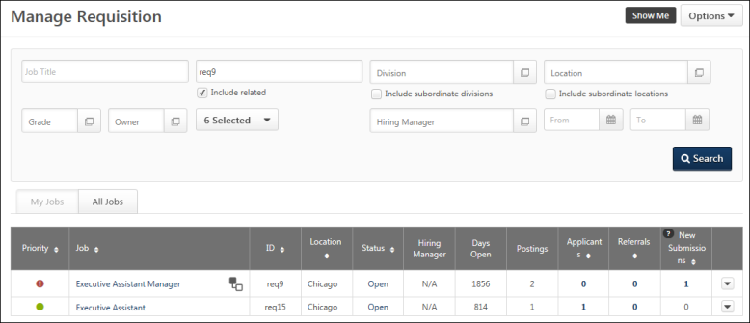
Options
The following options are available from the Options drop-down in the upper-right corner of the page:
Add Requisition
Click Add Requisition create a new job requisition. See Job Requisition - Overview on page 46 for additional information.
Note: This option is only available if you have the permission necessary to manage requisitions and if the permission constraints grant access to at least one position.
Requisition Requests
Click the Requisition Requests link in the Options button drop-down in the upper-right corner to open the Requisition Requests page, which displays all requests that are available for the reviewer. The number of pending requests displays in parentheses to the right of the link.
See Requisition Requests Page for Reviewers - Overview on page 183 for additional information.
Search Filters
You can filter the results in the Job Requisitions table by the following:
- Job Title - Select this option to filter requisitions by the job title that is set in the job requisition. You can hit Enter on your keyboard from within this filter to update the job requisitions tab. The field accepts % as a wildcard at the beginning of your search term.
- Req ID - Select this option to filter requisitions by the requisition ID. You can hit Enter on your keyboard from within this filter to update the job requisitions tab. Note: The job must match the ID exactly in order to appear in the search results.
- Division - Select this option to filter requisitions by the division associated with the job requisition. Check the Include Subordinates box to include subordinate divisions.
- Location - Select this option to filter requisitions by the location associated with the job requisition. Check the Include Subordinates box to include subordinate locations.
- Owner - Select this option to filter requisitions by the job requisition owner.
- Include Related - This option is unselected by default. This option allows recruiters to include child requisitions in the job requisition search results. This option is only available if the Related Requisitions option is enabled by the administrator in Requisition and Applicant Preferences.
- Requisition Status - This option allows the recruiter to filter requisitions by one or more job requisition statuses. The following are the available options:
  - All Statuses
  - Cancelled
  - Closed
  - Denied - This option is selected by default but can be unchecked.
  - Draft - This option is selected by default but can be unchecked.
  - Open - This option is selected by default but can be unchecked.
  - Open - Pending Re-Approval - This option is selected by default but can be unchecked.
  - Pending Approval - This option is selected by default but can be unchecked.
- Hiring Manager - This filter allows recruiters to filter the Manage Requisitions table by the selected hiring manager. To select a hiring manager, click the Select icon, and then select a user from the Select a user pop-up.
- Date Range - This option searches for job requisition by initial creation date. The search returns job requisitions initially created (saved or submitted) within the specified date range.
These filters work together so that only the requisitions that match all criteria are displayed when the Search button is clicked.
The requisition statuses selected for the last search will remain selected, even after you log out of the portal, so that you do not need to reset the selections. Note: If you deselect all statuses, then the default statuses will be automatically selected upon returning to the page. Note: If you deselect all statuses, then the default statuses will be automatically selected upon returning to the page.
Note: The positions that display are the positions that are within the user’s constraints defined for the permission to manage requisitions.
My Jobs and All Jobs Tabs
Administrators and job requisition owners can select one of the following tabs:
- My Jobs - View all job requisitions for which they are identified as the owner or co-owner.
- All Jobs - View all job requisitions that are visible to the user as defined by the permissions granting access to this page. Note: This tab only displays for users with the permission necessary to manage requisitions.
Job Requisitions Table
The job requisitions table displays the requisitions that are available to the recruiter. The sortable columns can be sorted by clicking the column name or by using the sorting arrows to the right of the column name.
The following information is displayed for existing job requisitions:
- Priority - The Priority status light indicates the priority status of the job requisition. The available statuses are:
  - - High
  - - Medium
  - - Low
- Job - This column displays the linked job title that is set in the job requisition. Click the job title to open the Edit Requisition page. If the title is longer than the space allows, hover over the title to view the full title.
- ID - The job requisition ID.
- Parent - This column displays if the Related Requisitions option is enabled by the administrator in Requisition and Applicant Preferences This column displays a Parent Requisition icon for requisitions that are defined as parent requisitions. Clicking the icon refreshes the Job Requisitions table to display all child requisitions associated with the parent, in order of highest to lowest requisition ID. The Include Children option is automatically selected in the filter options, and the Req ID field displays the requisition ID of the parent requisition.
The Parent Requisition icon only displays if the Do Not Allow to Apply option is not selected for the parent requisition. In addition, this column is only available for recruiters who have permission to view the parent requisition and at least one of the child requisitions. This column displays on both the My Jobs and All Jobs tabs.
For parent requisitions that have one or more Related Requisitions (Apply to Multiple Jobs), an icon displays to the right of the job title in the Job column. Clicking the icon refreshes the page to display only the parent requisition and any Related Requisitions (Apply to Multiple Jobs). In order for the icon to display, recruiters must have permission to view the requisition and must be part of the hiring team for the requisition.
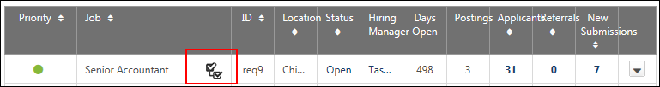
- Location - Each job requisition is associated with one or more Location OUs, and the Location OU that is selected must have an address entered on the job requisition. The city and state for that address is the location that is displayed in this table. If there are locations configured for the requisition that are in addition to the primary location, then the number of locations displays in parentheses to the right of the primary location. Hover over the number to view a tooltip with the complete list of locations. The primary location also displays in the tooltip and is indicated by the word "(Primary)" to the right of the location.
- Status - This column displays the status of the job requisition (Draft, Pending Approval, Approval Denied, On Hold, Open, Open-Pending Re-Approval, Closed, and Canceled). For all statuses except Draft, the status displays as a link. Clicking the link opens the Requisition Approval Status pop-up, which displays the details of the approval status or approval history for the requisition. The pop-up also displays comments included by the approver. See Requisition Approval Status Pop-Up on page 40 for additional information.
- Hiring Manager - The Hiring Manager column displays the first and last name of the hiring manager configured for the requisition as a link. Clicking the link opens the User Details pop-up, which displays the hiring manager's photo, name, position, and phone number, as well as a linked email address. Clicking the email address allows you to compose and send the hiring manager an email.
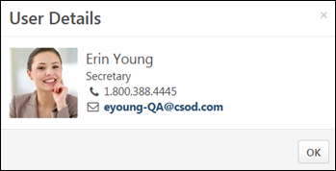
- Days Open - The total number of days that the job requisition has had a status of Open. If approval is required, then it is calculated from the date the requisition is approved and is then given the status of Open.
- Postings - The current number of active (not expired) job board postings for the system job board, internal job boards, and external job boards.
- Applicants - The number of applicants for the job requisition. If this number is greater than zero, then the value is a link which links to the ManageCandidates page. Note: If the Do Not Allow to Apply option is not selected for a parent requisition, then this column displays "0" in place of a value for the number of applicants.
- Referrals - The number of suggested referrals. Clicking the linked number opens the Managed Candidates page.
Note: If the Do Not Allow to Apply option is not selected for a parent requisition, then this column displays "0" in place of a value for the number of applicants.
Note: The number of suggested referrals on Manage Candidates may differ from the number of suggested referrals that appear on Manage Requisitions. On Manage Candidates, if a candidate is a suggested referral for a requisition but also applies for the requisition before the suggested referral is processed, a single record associated with the candidate's application will appear (the suggested referral will not appear). This is different from Manage Requisitions. On Manage Requisitions, a suggested referral that has not been declined or invited to apply will continue to appear in the count of suggested referrals, even if the candidate applies to the job directly.
- New Submissions - The number of application submissions to be considered for the job. Clicking the linked number opens a filtered view of the Manage Candidates page that shows all candidates in a New Submissions status for the requisition.
Note: If the Do Not Allow to Apply option is not selected for a parent requisition, then this column displays "0" in place of a value for the number of applicants.
Actions Drop-Down
An options icon appears at the end of the row for each requisition. The following options are available in the drop-down:
- Edit - Edit the job requisition. When editing a requisition, the Additional Location(s) field can be modified, depending on the status of the requisition. If the requisition is in a Pending Approval status, the field cannot be modified. Note: You must have the permission necessary to manage requisitions to edit a job requisition regardless of ownership. Requisition owners that do not have the permission necessary to manage requisitions can only edit a job requisition for which they are an owner. If the user does not have one of those permissions, then the View Settings icon appears. See Create Job Requisition for additional information.
- Copy - Copy the job requisition. When copying parent job requisitions, the child requisitions are not copied. When copying a requisition that has multiple locations, all locations are copied. The primary location is also copied. Note: You must have permission to manage requisitions in order to copy a job requisition, regardless of ownership. See Create Job Requisition for additional information.
- Edit Postings - Click Edit Postings to open the Postings page, from which you can configure job postings for a requisition.
- View Settings - View a read-only version of the job requisition. This option is only available if the user does not have permission to edit the job requisition.
- View History - View the requisition history. See Requisition History Pop-Up for additional information.
- Snapshot - Open the Requisition Snapshot page to view the details of the job requisition. See Requisition Snapshot for additional information.
- Message Users - The Message Users option enables an email to be sent to the following recipients that are associated with the job requisition:
  - Owners
  - Reviewers
  - Recruiting agencies
All recipients are blind carbon copied so that their name is not visible to other recipients.
Note: Candidates and applicants cannot be emailed via this feature.

To message users:
  - Click the Message Users link in the Options drop-down. This opens the Message Users pop-up.
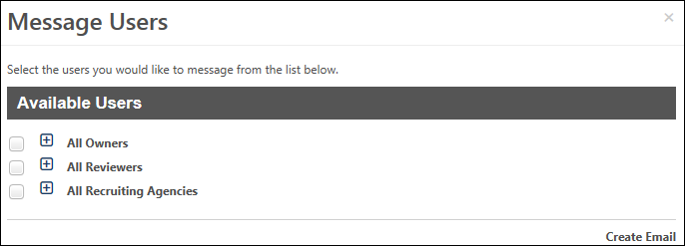
  - Check the box to the left of the users you would like to email. Click the Expand icon to view individual owners, reviewers, or recruiting agencies. Note: If the Do Not Allow to Apply option is not selected for a parent requisition, then the All Recruiting Agencies checkbox is hidden.
  - Click the Create Email button. This opens an email window using your portal's email provider. All recipients appear in the blind carbon copy field. User email addresses are pulled from the recipients' user record. The recruiting agency email address is the default email address defined in Recruiting Agency Management. See Recruiting Agency Management for additional information.
- Reopen - Recruiters with the Requisition: Reopen permission can reopen a closed or cancelled requisition to make changes. To reopen a requisitions, in the Action drop-down, select Reopen. This option is only visible if the requisition is closed or cancelled. Once reopened, the status on the Managed Requisition page changes to Open and this change is displayed in the Requisition History. See Requisition History Pop-up on page 43 for additional information.
- Comments - Recruiters with appropriate permissions can view and create comments for the selected requisitions. To add a requisition comment, in the Action drop-down, select Comments. The Comments page opens. Type comments in the Comments box and select post. Comments cannot exceed 1000 characters.
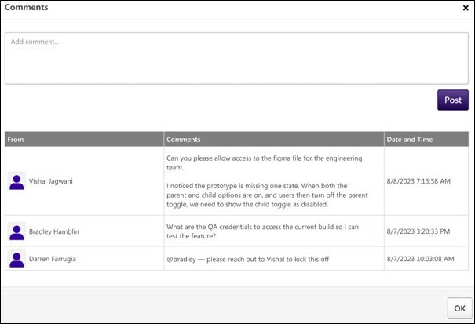
Frequently Asked Questions (FAQs)
Why can't I see a requisition on the Manage Job Requisitions page?
- Requisitions are visible for the following users:
  - Hiring Manager - Hiring managers are dynamically assigned permission to act as the hiring manager for a specific requisition. The permission is dynamically assigned when a user is defined as the hiring manager in the Approvals section on the General tab of the requisition.
  - Requisition Approver - Requisition approvers are dynamically assigned permission to act as an approver for a specific requisition. The permission is dynamically assigned when a user is defined as an approver in the Reviewer(s) field on the General tab of the requisition.
  - Requisition Manager - Requisition managers need permission to manage requisitions. A requisition manager can view all requisitions that fall within their permission constraints. If their permission to manage requisitions has no constraints, then a requisition manager can view all requisitions in the portal.
  - Requisition Owner - Requisition owners are dynamically assigned permission to act as an owner of a specific requisition. The permission is dynamically assigned when a user is defined as the primary owner of the requisition or as an owner (in the Owner(s) field on the General tab of the requisition).
  - Requisition Reviewer - Requisition reviewers are dynamically assigned permission to act as a reviewer for a specific requisition. The permission is dynamically assigned when a user is defined as a reviewer in the Reviewer(s) field on the General tab of the requisition.

New Submissions
Manage Remaining Applicants Pop-Up
When all openings for a requisition are filled or you close a requisition, the Manage Remaining Applicants pop-up appears so that you can quickly change the status of all remaining applicants can be changed to Closed at the same time. You also have the option to assign all applicants a single disposition when the applicants are closed.
Note: The ability to manage remaining applicants must be enabled by the administrator in the Dispositions section of Requisition and Applicant Preferences.
The following scenarios trigger the Manage Remaining Applicants pop-up:
- Edit Requisition > Applicant Review Tab - If the requisition status is changed to Closed or Cancelled in the Requisition Status field on the General tab of the requisition, the pop-up appears upon clicking Re-Submit on the Applicant Review tab.
- Manage Candidates, Manage Applicants, Applicant Profile - If an applicant's status is changed to Hired and there are no remaining openings for the requisition.
Manage Remaining Applicants
The pop-up indicates that the requisition is either closed or that all openings have been filled. In addition, the number of remaining applicants displays. The number includes all applicants that are not in a status of Closed or Hired and also includes new submissions that have not yet been moved into an active applicant status.
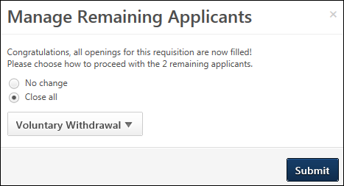
The following options are available in the pop-up:
- No change - Select this option to maintain the current status of all remaining applicants. When selected, the disposition drop-down is hidden.
- Close all - This option is selected by default. When selected, the status of all remaining applicants is changed to the selected disposition.
- Disposition - This option only displays when the Close all option is selected. By default, the name that appears in the drop-down button is the name of the first disposition in the list. Select the disposition from the drop-down, which will apply to all remaining applicants. The dispositions that are available are configured by the administrator in Requisition and Applicant Preferences.
To close all remaining applicants, select Close all. Then, select the disposition from the drop-down. Then, click Submit. This changes the status of all remaining applicants to the selected disposition. If No change is selected, then there are no changes to the status of the remaining applicants when you click Submit.
Emails Associated with Dispositions
The dispositions that are available when changing an applicant's status may have an associated email, based on the administrator's configuration of the disposition in Requisition and Applicant Preferences. Clicking Submit will trigger the email.
If the disposition does not have an associated email, then an email will not be sent when you click Submit.
Close Pop-Up Without Making a Selection
If you decide that you no longer wish to proceed with the options in the Manage Remaining Applicants pop-up, you can close the pop-up by clicking the "X" in the upper-right corner. This returns you to the Applicant Review tab, Manage Candidates, Manage Applicants, or the Applicant Profile without committing any selections in the pop-up.
Resume/CV Review Page
The Resume/CV Review page allows recruiters to review the resume/CV for multiple applicants at a time. Recruiters can also advance or pass applicants.
Permissions
PERMISSION NAME | PERMISSION DESCRIPTION | CATEGORY

Requisition: Manage | Grants ability to access and manage all requisitions regardless of ownership (constraints permitting). This permission also grants read-only access to the Applicant Review tab when creating or editing a job requisition. This permission can be constrained by OU, User's OU, and Grade. | Recruiting

Requisition: Owner | Enables owner to access requisitions and applicants for requisitions for which they are an owner. This permission also grants read-only access to video interviews that are completed by applicants via HireVue. For portals with Referral Suite enabled, this permission also enables requisition owners to edit the referral source on the Applicant Profile page. This permission cannot be constrained.  Note: This is a dynamically assigned permission that is not available in Security Role Administration. If the user is removed as an owner, the permission is revoked for the associated requisition. This permission cannot be manually assigned. Also, if a user has both the permission necessary to manage requisitions and be a requisition owner, the constraints of the Requisition: Manage permission overrule those of the Requisition: Owner permission. For requisition owners that do not also have permission to manage requisitions, only certain fields are editable when editing a requisition. | Recruiting

Requisition: Reviewer | Enables reviewer to access requisitions and applicants for requisitions for which they are a reviewer. This permission cannot be constrained.  Note: This is a dynamically assigned permission that is not available in Security Role Administration. Once a requisition is in a Closed or Cancelled status or if the user is removed as a reviewer, the permission is revoked for the associated requisition. This permission cannot be manually assigned.  Note: If an applicant reviewer is removed as a reviewer via the Applicant Profile page, the Requisition: Reviewer permission is revoked for the associated requisition. However, if the reviewer was also added as a reviewer via the General tab when creating, editing, or copying the requisition, the reviewer still appears on the In Review panel as a duplicate reviewer and retains access to the requisition and applicants from the Requisition: Reviewer permission. See Applicant Profile Page Overview for more information about duplicate reviewer instances. | Recruiting
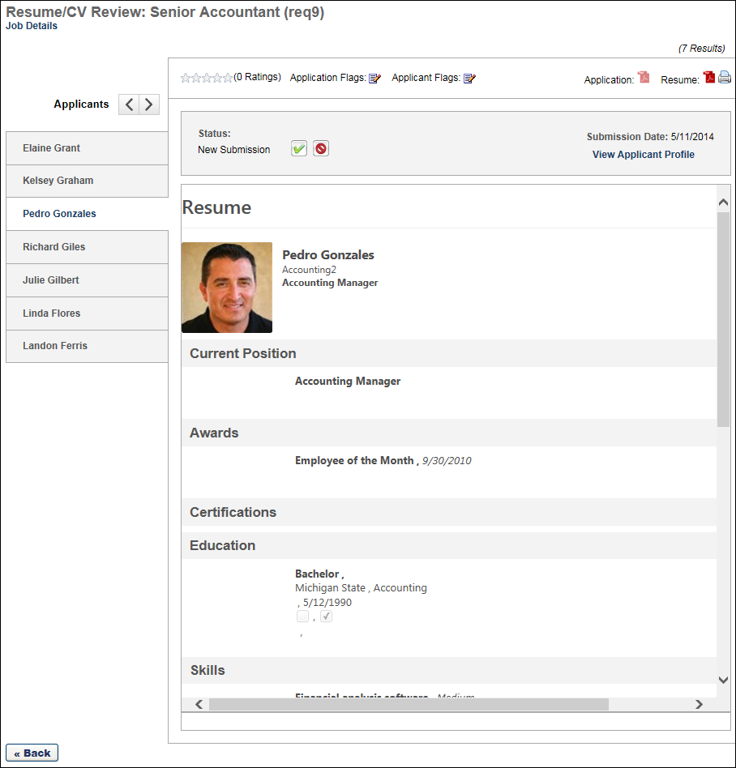
Requisition Name
The name of the job requisition displays at the top of the page. The requisition ID displays in parentheses to the right of the name.
Job Details
The Job Details link at the top of the page allows for quick access to the job description and job qualifications for the requisition. Clicking the link opens the Job Details pop-up. The pop-up displays the requisition's internal and external job description, minimum qualifications, and ideal qualifications.
                - For portals with multiple languages enabled, this displays in the user's language if available. If the user's language is not available, then this displays in the language of the user who defined it.
Note: The fields on the pop-up are not editable from the pop-up.
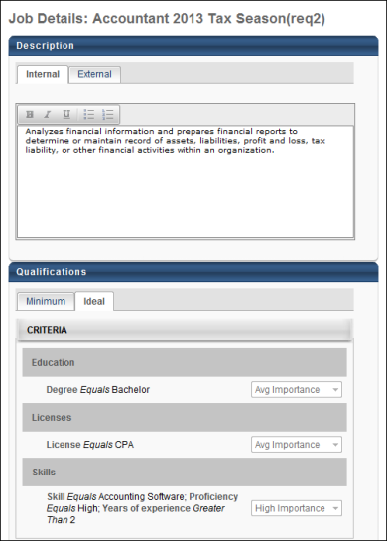
Applicant Name
The list of applicants displays in the Name panel on the far left of the Resume/CV Review page. The list is sorted based on the page from which you accessed the Resume/CV Review page. If you access the page from Manage Applicants, then the list of applicants is sorted using the same sorting method chosen on the Manage Applicants page; if no sorting method was selected, then the default sort for the Manage Applicants page will be used on the Resume/CV Review page.
The applicant's full name displays in the panel. The applicants that display are the applicants that are manually selected by the recruiter.
To view an applicant's resume/CV, select the applicant from the Name panel. This opens the resume/CV in the display pane. The resume/CV opens in the application in which it was submitted.
Note: For anonymous applicants, a system defined number displays in the Name panel in place of the applicant's name.
Resume/CV Toolbar Options
The following options are available in the toolbar menu above the resume/CV display pane:
Feature | Description
Ratings | The applicant's rating and total number of ratings. If more than one user has rated the applicant, the rating displays as an average of the total number of ratings.  If the applicant has not yet been rated by any user, all stars are gray. By clicking the appropriate star, you can rate an applicant from 1-5 or edit ratings you have given. Note: If you have already rated the applicant, a message appears when you hover over the stars, indicating that you have already given a rating. However, you can still change your rating.
Download Application | Clicking the download option opens the PDF version of the application.
Submission Date | This displays the date on which the application was submitted.
Status | The Status option enables recruiters to change the applicant's status. The drop-down displays the applicant's current status by default.  To change the applicant's status:  - Click the Status drop-down.  - Select a status from the drop-down. As with current functionality, required statuses cannot be skipped. If the selected status is a required status, select the Mark all required statuses as complete option. This marks all required statuses as complete for the applicant and allows the recruiter to select any status in the drop-down.  - Click Submit. This commits the status change. Note: Submitting a status change does not close the Resume/CV Review page.
Date | The date selector field, which displays to the right of the Status field, allows you to manually adjust the date on which an applicant's status is changed. The date can be changed by entering a date in the numeric text box or using the calendar to select a date. The date can be the current date or a past date. The date cannot be in the future and also cannot be prior to the most recent status change date.  This field only displays if enabled by the administrator in General Preferences.
Advance/Pass for Applicant Reviewers | Applicant reviewers can advance or pass an applicant as part of the applicant review process.  Advance Applicant  To advance an applicant, meaning that you think they should remain in consideration, click the Advance button . Then, click Submit. Your feedback will appear in the Manage Applicants > Reviewers Feedback column. It will also appear on the Applicant Profile > Summary tab in the Reviewer Feedback field.  Once feedback is submitted for an applicant, the applicant no longer appears on the Resume/CV Review page for the reviewer.  Pass Applicant  To pass on an applicant, meaning that you think they should be removed from consideration, click the Pass button . Then, click Submit. Your feedback will appear in the Manage Applicants > Reviewers Feedback column. It will also appear on the Applicant Profile > Summary tab in the Reviewer Feedback field.  Once feedback is submitted for an applicant, the applicant no longer appears on the Resume/CV Review page for the reviewer.
Disposition | This field only displays when the Closed status is selected in the Status drop-down. Select a disposition from the Disposition drop-down to indicate the reason for changing the applicant's status to Closed. Then, click Submit. This commits the disposition and Closed status change.
Process All | When at least one applicant has been selected to advance or pass, a Process All button displays at the bottom of the Resume/CV Review page. Clicking the button opens the Process Submissions page, from which recruiters can process the applicants selected to advance or pass.
Submit | The Submit button commits status changes. When the Closed status is selected in the Status drop-down, clicking Submit commits the status change and the disposition. This option only applies to changing an applicant's status and defining the disposition for the status change.
Download | Click the Download icon to download the applicant's resume/CV. The file opens in the application in which it was submitted.  The Download option is only enabled if a resume/CV is available for the applicant. The option is not available for LinkedIn resumes/CV.
Print | Click the Print icon  to print the applicant's resume/CV. This option prints the resume/CV that is visible in the display pane.
Previous | Click the Previous  icon to view the previous applicant's resume/CV.
Next | Click the Next  icon to view the next applicant's resume/CV.
Resume/CV Display
The applicant's resume/CV appears in the display pane in the center of the page. The resume/CV displays in the application in which it was submitted.
For a resume/CV submitted via LinkedIn, a resume/CV appears in a widget in the display pane. The widget displays the user's name, most recent job, and location. A View Profile button also displays, which opens the applicant's full LinkedIn profile on the LinkedIn site.
For a resume/CV submitted via Seek, the applicant's Seek resume data displays.
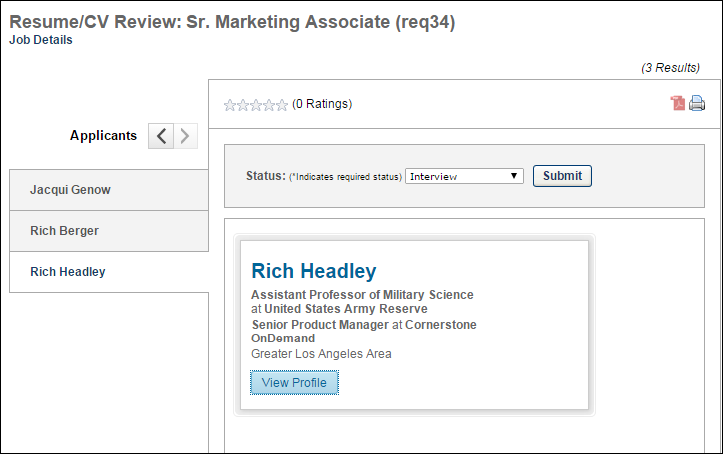
For internal applicants who used their Career Center or Universal Profile resume when applying to the requisition, the applicant's internal resume displays.
For applicants who have been archived, the resume/CV does not display. The display pane includes a notification message that indicates the resume/CV is unable to be displayed.
Back
Click the Back button below the Name panel to return to the Manage Applicants page. The page to which the recruiter returns is dependent upon the page from which they accessed the Resume/CV Review page.

Place Requisition in On Hold Status
Job requisitions that are in an Open or Open Pending Re-Approval status can be placed in an On Hold status. Requisitions that are on hold are removed from career sites, Career Center, and agency portals, but are not removed from job boards. Only requisition managers and owners can place a requisition on hold and reopen the requisition.
Approval is not required for the On Hold status, even if Requisition and Applicant Preferences are configured to require approval for requisitions.
Permissions
PERMISSION NAME | PERMISSION DESCRIPTION | CATEGORY

Requisition: Manage | Grants ability to access and manage all requisitions regardless of ownership (constraints permitting). This permission also grants read-only access to the Applicant Review tab when creating or editing a job requisition. This permission can be constrained by OU, User's OU, and Grade. | Recruiting

Requisition: Owner | Enables owner to access requisitions and applicants for requisitions for which they are an owner. This permission also grants read-only access to video interviews that are completed by applicants via HireVue. For portals with Referral Suite enabled, this permission also enables requisition owners to edit the referral source on the Applicant Profile page. This permission cannot be constrained.  Note: This is a dynamically assigned permission that is not available in Security Role Administration. If the user is removed as an owner, the permission is revoked for the associated requisition. This permission cannot be manually assigned. Also, if a user has both the permission necessary to manage requisitions and be a requisition owner, the constraints of the Requisition: Manage permission overrule those of the Requisition: Owner permission. For requisition owners that do not also have permission to manage requisitions, only certain fields are editable when editing a requisition. | Recruiting
Place Requisition On Hold
To place a requisition on hold, select the On Hold option from the Requisition Status drop-down on the General tab when editing a requisition. Once the option is selected, the requisition must be resubmitted from the External Postings tab. Clicking Re-Submit opens a confirmation pop-up. Click Yes to place the requisition on hold. Or, click No to cancel the on-hold action.
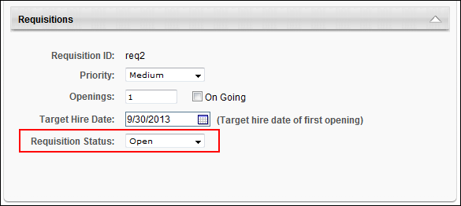
Reopen Requisition
Requisitions can be removed from the On Hold status by clicking Re-Open Requisition in the Requisition Status field. This opens a confirmation pop-up that indicates the requisition must be resubmitted in order to be reopened. Click OK to close the pop-up. This enables all editable fields in the requisition.
To resubmit the requisition, navigate to the External Postings page and click Re-Submit. This reopens the requisition. The requisition status changes to its former status, either Open or Open Pending Re-Approval.
If any fields in the requisition are edited prior to resubmitting, and the changes require approval, then the requisition status changes to Open Pending Re-Approval. The requisition is reopened, but the changes to the fields that require approval must be approved per the existing approval workflow functionality.
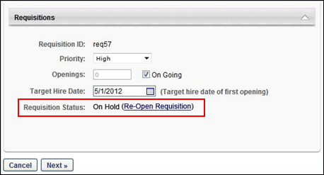
Impact of On Hold Status
Placing a requisition on hold has the following impact:
- All pending edits to the requisition are removed. The pending edits cannot be recovered.
- All career site and Career Center postings are removed. The postings can be restored by reopening the requisition.
- The requisition can be viewed, but all fields on the requisition are grayed out and not editable.
- The On Hold status is tracked on the Requisition History pop-up.
- The following areas of the Recruiting functionality that display a requisition's status display the requisition as being in an On Hold status:
  - Manage Job Requisitions page
  - Job Requisition - General tab
  - Requisition Snapshot
  - Requisition History pop-up
  - Agency portals
  - Requisition Details Report
  - Custom reporting
- The timer for the Days Open column on the Manage Job Requisitions page and Time to Fill are stopped while the requisition is on hold. The timers start again from where they stopped once the requisition is reopened. For example, a requisition is opened on January 1 and is placed on hold on January 5. The requisition is reopened on January 10. On January 15, the Days Open and Time to Fill value is 10. Note: The Time to Fill field is a reporting field found in standard and custom Recruiting reports.

Requisition Approval Status Pop-Up
The Requisition Approval Status pop-up displays the details of the approval workflow, including the approvers, comments, and approval decisions. This enables users to view the progress of the approval workflow for the requisition, as well as gain insight into the reason for a particular approver's decision.
The Requisition Approval Status pop-up can be accessed in the following ways:
- The linked status in the Status column on the Manage Job Requisitions page.
- The View Approval Status link on the General tab when creating, editing, or copying a job requisition. Note: When creating or copying a requisition, the Requisition Approval Status pop-up is only used to preview the approval workflow, since the Status, Decision, and Comments columns will be blank.
Permissions
PERMISSION NAME | PERMISSION DESCRIPTION | CATEGORY

Requisition: Approver | Enables approver to access and approve/deny requisitions for which they are an approver. This permission cannot be constrained. Note: This is a dynamically assigned permission. If the user is removed as an approver for an offer that is in a Pending Offer status, the user can no longer access that version of the offer. This permission cannot be manually assigned. | Recruiting
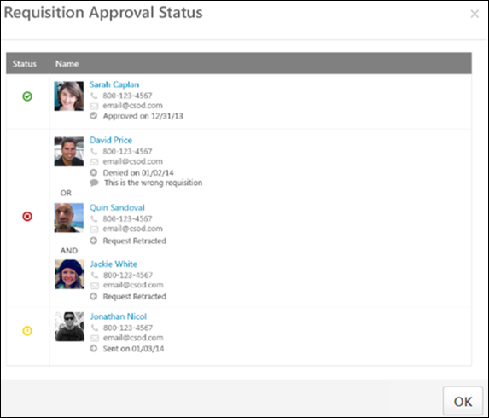
The layout of the Requisition Approval Status pop-up is dependent upon the configuration of the approval workflow for the job requisition, whether sequential, concurrent, or sequential/concurrent. Note: If the approval workflow is edited on the requisition, then the workflow that displays in the pop-up is the most current workflow available when the requisition was last submitted for approval. Any information from a previous approval will no longer be visible in the pop-up. If the requisition is created but is not yet submitted, then the pop-up is blank.
In addition, approval workflows may have OR rules and AND rules. For approval steps that have an OR or AND rule or both, the approvers appear in the same row on the Requisition Approval Status pop-up.
- For approval steps with an OR rule, only the approval decision of the first approver to approve or deny the requisition is counted. The approval request for the other approvers is automatically retracted.
- For approval steps with AND rules, all approvers have the opportunity to approve the requisition, unless at least one of the approvers denies the requisition. As soon as at least one approver denies the requisition, the system automatically retracts the approval request for the other approvers who have not yet recorded an approval decision. For the approvers in the step that have already approved the requisition, their decision remains in the system.
The following information displays in the pop-up:
Status
This column displays an icon of the approver's final decision. The following are the possible values:
- Approved - The Approved status indicates that the requisition is approved for this approval workflow step.
- Cancelled - This status indicates that the approval workflow has been cancelled. Note: If an approval workflow is cancelled, only the approval steps that are in a Sent status at the time of cancellation are cancelled. For approvers that submitted an approval decision, their decision and any comments entered remain on the View Details pop-up.
- Denied - This status indicates that the requisition is denied for this approval workflow step.
- Pending - This status indicates the decision is pending.
- Sent - This status indicates that the approver has not yet responded to the approval request.
Name
This column displays the approver details and the approval decision.
Approver Details
The following information appears for each approver:
- Photo, if available; ghost image displays if no photo is available
- Full name
- Primary phone number
- Email address link
Decision
The approval decision for each approver displays as the bottom line of the approver details. The following are the possible values:
- Approved on [date approved]
- Denied on [date denied]
- Sent on [date approval request was sent to approver]
- Cancelled on [date approval workflow was cancelled]
- Request Retracted - This value displays for approvers that are part of an OR or AND rule and did not submit an approval decision.
Comments
This column displays the comments written by the approver when making the approval decision. If the approver did not include a comment, then the comment box does not display for the approver.
Note: Comments are not visible for approval decisions that are in a Sent status.
Note: For requisitions for which an approval workflow is not configured, the Requisition Approval Status pop-up displays "No Approvals defined."

Requisition History Pop-up
The Requisition History pop-up enables you to view the events that have taken place for the requisition, as well as the user who took the action.
To access the Requisition History pop-up, go to Recruit > Manage Requisitions. On the Manage Requisitions page, locate the requisition, and then click the View History icon in the Options column for the requisition.
Permissions
PERMISSION NAME | PERMISSION DESCRIPTION | CATEGORY

Requisition: Manage | Grants ability to access and manage all requisitions regardless of ownership (constraints permitting). This permission also grants read-only access to the Applicant Review tab when creating or editing a job requisition. This permission can be constrained by OU, User's OU, and Grade. | Recruiting
Requisition owners that do not have the permission necessary to manage requisitions can only view the requisition history for a job requisition for which they are an owner.
Requisition reviewers that do not have the permission necessary to manage requisitions can only view the requisition history for a job requisition for which they are a reviewer.
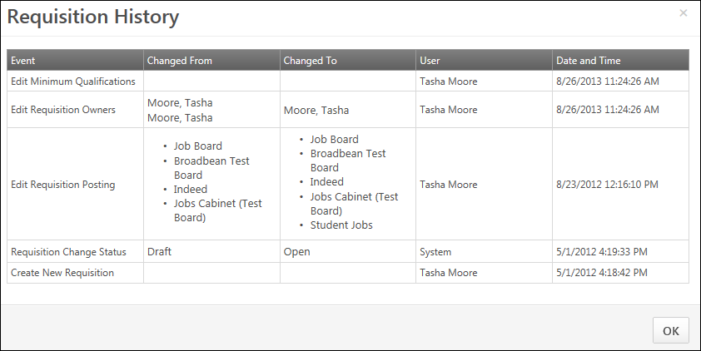
The following columns display in the Requisition History pop-up:
Event
Displays the title of each tracked history event. The following are the possible event titles and their triggers:
- Applicant Hired - Logged when the applicant's status is changed to Hired.
- Application Workflow Changes - Changes made to Application Workflow tab of a job requisition can be viewed from the Requisition History pop-up.
- Approval Response - Logged when approvers respond to a requisition approval request.
- Create New Requisition - Logged when a user clicks Save or Submit for the first time for a new requisition.
- Edit Applicant Interviewers - This event is logged when a change to the Applicant Interviewer(s) section on the General tab of the job requisition is saved.
- Edit Ideal Qualifications - This event is logged when a change to the Ideal Qualifications tab on the job requisition is saved.
- Edit [Internal/External] Description - This event is logged when a change to the Description field on the job requisition is saved.
- Edit Minimum Qualifications - This event is logged when a change to the Minimum Qualifications tab on the job requisition is saved.
- Edit Referral Bonus - This event is logged when a change to the Referral Bonus field on the job requisition is saved.
- Edit Requisition Job Ad - Logged when a Job Ad is edited. Note: The content of the edit is not included in the Requisition History pop-up.
- Edit Requisition Job Posting - Logged when a job posting is edited.
- Edit Requisition [general discreet field] - Logged when any field on the General tab is edited.
- Edit Requisition Target Hire Date - This event is logged when a change to the Target Hire Date on the job requisition is saved. The date displays in the time zone of the logged-in user.
- 1st Submission Received - Logged when the first submission for a requisition is received.
- Related Requisition Added [Related Requisition Job Title (Related Requisition ID)] - Logged when a standard related requisition or Related Requisition (Apply to Multiple Jobs) is added for a parent requisition. The event is logged when the related requisition is saved or submitted. The event only displays for the parent requisition history.
- Requisition Change Status - Logged when the status of a requisition changes.
- Send Approvals - Logged when requisition approval requests are sent to approvers. The Changed To column displays the user name for all approvers included in the approval workflow.
Changed From
Displays the value from which the item was changed. The following fields will never have a Changed From value:
- Applicant Hired
- Approval Response
- Create New Requisition
- Edit Job Ad
- 1st Submission Received
- Related Requisition (Apply to Multiple Jobs)
- Send Approvals
Note: For the Edit Ideal Qualifications and Edit Minimum Qualifications events, if the Ideal Qualifications tab is being completed for the first time after the requisition is saved, then the Changed From column displays "Added."
Note: For the Edit Applicant Interviewers event, if the Applicant Interviewer(s) section on the General tab is being completed for the first time after the requisition is saved, then the Changed From column displays "Added."
Changed To
Displays the value to which the item was changed. The following fields will never have a Changed To value:
- Applicant Hired
- 1st Submission Received
- Edit Job Ad
- Create New Requisition
Note: For the Edit Ideal Qualifications event, if the value in the tab is deleted and is not replaced with a new value, then the Changed From column displays "Removed."
Note: For the Edit Applicant Interviewers event, if the value in the Applicant Interviewer(s) section on the General tab is deleted and is not replaced with a new value, then the Changed To column displays "Removed."
User
Displays the name of the user associated with the event.
- Requisition Change Status event - "System" displays in the User column when the requisition changes to a status of Closed after a candidate is hired or when the status is changed from Pending Approval to Open.
- Submission Received event - The User column is always blank because no users are associated with this type of event.
Date and Time
Displays the date and time that each event occurred.
Click ok to close the Requisition History pop-up.

Job Requisition - Overview
Job requisitions consist of all of the settings and information for the job as well as the job ad and job postings. You can create and edit job requisitions.
- To create a job requisition, go to Recruit > Manage Requisitions. Click the Options drop-down, and select Add Requisition.
- To edit a job requisition, go to Recruit > Manage Requisitions. On the Manage Requisition page, select the appropriate item in the Job column to open the Edit Requisition page.
A job requisition contains the following pages:
- General - See Create Job Requisition - General on page 47 for additional information.
- Job Ad - See Create Job Requisition - Job Ad on page 68 for additional information.
- Application Workflow - See Create Job Requisition - Application Workflow on page 74 for additional information.
- Applicant Review - See Create/Edit Requisition - Applicant Review Tab Overview on page 79 for additional information.
- Job Postings - See Job Posting Page.
Note: Once a job requisition is created, whether it is submitted or still in a Draft status, you cannot delete it. If the requisition is changed to a Cancelled status, it is still visible on the Manage Requisitions page.
Permissions
PERMISSION NAME | PERMISSION DESCRIPTION | CATEGORY

Requisition: Manage | Grants ability to access and manage all requisitions regardless of ownership (constraints permitting). This permission also grants read-only access to the Applicant Review tab when creating or editing a job requisition. This permission can be constrained by OU, User's OU, and Grade. | Recruiting
Default Language Requirement
For portals with multiple languages enabled, when configuring localized values in the Translate pop-up, a value must be entered for the default language in order to save the localized values in the pop-up. For example, if the Display Job Title field is translated into French (France), and the default language is English (UK), then the English (UK) field cannot be blank. A translated value must always be included for the default language. Note: The default language is the language of the user creating the job requisition or requisition template.

Create Job Requisition - General
The Create Job Requisition - General step enables recruiters to configure the following information for the requisition:
- The job title that is displayed to the applicant.
- Metadata and custom field values.
- The approval requirements and people who approve the job requisition.
- The people who review and interview new applicants.
In addition, if enabled by the administrator in Requisition and Applicant Preferences, recruiters can create hierarchical relationships between job requisitions by adding child requisitions. From the Requisition section of the General tab, recruiters can also decide whether or not to allow applicants to apply to the parent requisition. Child requisitions can be created once the requisition is submitted the Applicant Review step.
When creating a job requisition, the job title and requisition template must be selected before the additional fields can be completed. After selecting the position and requisition template for which you are creating the job requisition, the form is populated with the values set in the job requisition template for the position. The information can then be modified as needed.
Permissions
PERMISSION NAME | PERMISSION DESCRIPTION | CATEGORY

Localization: Default language | Grants access to change the default languages for a job requisition. This permission cannot be constrained. | Recruiting

Requisition: Localization Delete | Grants access to delete languages for a requisition. This permission cannot be constrained. | Recruiting

Requisition: Edit Interviewers | Grants ability to edit the requisition interviewers section for requisitions. Users with this permission can also edit the interviewers for Interview status types from the Applicant Profile page. This permission can be constrained by OU. Note: If OU constraints are applied, then the only users who recruiters can add as interviewers are the users who they can view based on the OU constraints. | Recruiting

Requisition: Edit Attachments | Grants ability to add and delete attachments to requisitions and requisition templates. This permission cannot be constrained. Note: This permission does not grant access to remove attachments on the Applicant Profile page that are submitted by the applicant. | Recruiting

Requisition: Edit Description | Grants ability to edit the internal and external descriptions for requisitions. This permission cannot be constrained. This permission must be used in conjunction with the Requisition: Manage permission. Note: For requisition owners and managers who do not have this permission, when editing a job requisition, the requisition description section is read-only. | Recruiting

Requisition: Edit Job Ad | Grants ability to edit the Job Ad tab of the Edit Requisition page. This permission cannot be constrained. | Recruiting

Requisition: Edit Qualifications | Grants ability to edit the minimum and ideal qualifications for requisitions. This permission cannot be constrained. This permission must be used in conjunction with the Requisition: Manage permission. Note: For requisition owners and managers who do not have this permission, when editing a job requisition, the requisition description section is read-only. | Recruiting

Requisition: Edit Reviewers | Grants ability to edit the requisition reviewers section for requisitions. This permission can be constrained by OU. | Recruiting

Requisition: Hiring Manager | Grants ability to view requisitions and applicants for jobs for which user is listed as a Hiring Manager. This permission cannot be constrained.  Note: This is a dynamically assigned permission that is not available in Security Role Administration. If the user is removed as a hiring manager, the permission is revoked for the associated requisition. This permission cannot be manually assigned. | Recruiting

Requisition: Manage | Grants ability to access and manage all requisitions regardless of ownership (constraints permitting). This permission also grants read-only access to the Applicant Review tab when creating or editing a job requisition. This permission can be constrained by OU, User's OU, and Grade. | Recruiting
General Tab Sections
The following sections display on the General tab:
General
The following fields appear in the general information section:
Job Title
The Job Title field determines which requisition templates are available to select. A job title must have at least one active requisition template in order to be used in a requisition. Until a job title is selected, all other fields on the requisition are grayed out and not selectable. Note: Requisition templates are configured by the administrator in Requisition Templates. See Requisition Template - Create on page 246 for additional information.
To select a job title:
- Click the Select icon in the Job Title field. This opens the Search Position pop-up.
- Select a position from the list. You can use the Title and ID fields to filter the list. Note: The Search Position pop-up only displays positions that are within the user's constraints defined for the Requisition: Manage permission.
- Once a position is selected, the pop-up closes and the Job Title field is populated with the position.
Selecting a job title enables only the Requisition Template field.
Note: If there is only one active template that is configured for the position, then selecting the job title automatically populates the Requisition Template field and activates all other fields.
Considerations
- If you change the selection in the Job Title field after modifying on the requisition, any information entered in the fields prior to changing the selection is lost. A new requisition template may need to be selected, depending on the templates that are active for the new job title. If the same template is active for the job title, then the same template can be used but the field values may or may not be the same as those for the previous job title.
- If you click the Remove icon in the Job Title field and then reselect the same job title and template, any information entered in the fields prior to removing the job title reappears and is not lost.
Requisition Template
Once a job title is selected, the active templates for the job are available in the Requisition Template field. Note: All fields below the Requisition Template field are disabled until a template is selected.
To select a template:
- Click the Select icon in the Requisition Template field. This opens the Select Requisition Template pop-up from which to select the template.
- Select a template from the list. This closes the pop-up and populates the Requisition Template field.
Or, if a default requisition template is available, then the Default Requisition Template link displays at the top of the pop-up. Clicking the link selects the default template and closes the pop-up. The Requisition Template field is populated with the default template. Note: A default template must be defined for the recruiter's organizational unit (OU) in order for a default template to be available to select. In addition, the Default Requisition Template link only displays if the Default Requisition Template option is selected by the administrator in Requisition and Applicant Preferences. See Requisition and Applicant Preferences on page 335 for additional information.
Once a template is selected, all other fields are enabled on the General tab. This also populates the fields that have been configured for the template.
Note: When editing the Requisition Template field for a job requisition, if a default template is not defined for the recruiter's OU, then the Default Requisition Template link does not display in the Select Requisition Template pop-up. The link does not display even if a default template was defined for the requisition prior to editing the requisition. In addition, if a recruiter from a different OU edits the Requisition Template field, then the default template defined for the OU of the recruiter editing the requisition replaces the previous default template.
Considerations
- If you change the selection in the Requisition Template field after modifying the requisition, any information entered in the fields prior to changing the selection is lost.
- If you change the selection in the Requisition Template field after the requisition has been approved, the requisition does not require re-approval. Changes made to the field are tracked in the Requisition History pop-up. See Requisition History Pop-up on page 43 for additional information.
- The Requisition Template field is inactive when the requisition is in a status of Open, Pending Approval, Open Pending Re-approval, or Cancelled.
- When editing a job requisition, the Job Title and Requisition Template fields must contain valid values. It is also important to note that changing the Job Title field always refreshes all fields on the page.
Hidden Fields
When configuring the requisition template (including the default requisition template), the administrator may have hidden some of the fields that would normally be visible on the General tab. Fields that were hidden are not visible when configuring a requisition that uses a template with hidden fields. See Requisition Template - Create - General Tab on page 248 for additional information.
The following lists the fields can be hidden in each section of the requisition:
Details Section
The following fields can be hidden in the Details section and will not appear if they were hidden:
- Additional Location(s)
- Grade
- Cost Center
- Contact Phone
- Range
- Referral Bonus
- Custom Fields
Even if a field is hidden from the requisition, the administrator may have filled in the field on the requisition template. The value in the field will not be visible when viewing the requisition.
Special Note about the EEO Category Field
The EEO Category field will only display on the requisition if the administrator has enabled the following in Compliance Enablement Preferences and the relevant OU is selected:
- The Require OFCCP Compliance Enablement functionality field is checked. Or,
- The Record EEO field is checked.
Description and Qualifications Section
The following fields can be hidden in the Description and Qualifications section and will not appear if they were hidden:
- Minimum Qualifications
- Ideal Qualifications
- Keywords
Even if a field is hidden from the requisition, the administrator could still have filled in the field on the requisition template. The value in the field will not be visible when viewing the requisition.
Hiring Team
The following fields can be hidden in the Hiring Team section and will not appear if they were hidden:
- Owner(s) - (Note: For requisition requests, this field appears in the Requisition Owner(s) section.)
- Hiring Manager
- Reviewer(s)
Even if a field is hidden from the requisition, the administrator could still have filled in the field on the requisition template. The value in the field will not be visible when viewing the requisition.
Attachments Section
The entire Attachments section can be hidden by the administrator when configuring the requisition template. If the section is hidden, then it will not be visible on the General tab of the requisition.
Even if the Attachments section is hidden from the requisition, the administrator could still have added attachments on the requisition template. In such cases, any attachments added by the administrator would not be visible on the requisition.
Approvals Section
The entire Approvals section can be hidden by the administrator when configuring the requisition template. If the section is hidden, then it will not be visible on the General tab of the requisition.
Even if the Approvals section is hidden, it may have been filled out by the administrator on the requisition template. In such cases, the requisition will be placed into a Pending Approval status and an approval workflow will need to be completed by the approvers once the requisition is submitted.
Note: This section does not apply to requisition requests.
Requisition Section
The following fields can be hidden in the Requisition section and will not appear if they were hidden:
- Do Not Allow to Apply - (Note: This field does not apply to requisition requests.)
- Target Hire Date
Note: The Do Not Allow to Apply and Target Hire Date fields do not appear on requisition templates. However, they do appear in the Manage Field Visibility pop-up when configuring the requisition template, and the administrator can choose to hide them by checking the box on the pop-up.
Copying the Requisition
When copying a requisition, any fields that were hidden on the requisition template for the requisition will be hidden on the copied requisition.
Localization Options
Note: The localization fields (View In, Default, Localized Languages) only display for portals with multiple languages enabled.
Use Case
Sven is a recruiter in Germany whose portal language is set to German. Sven edits a job requisition that has a default language of English (UK). Sven wants to edit the English (UK) language values. Also, he does not want the requisition to exist in his German language. Sven needs a way to see the default language of the requisition, as well as edit the requisition in English (UK).
When editing the job requisition, Sven clicks the Localized Languages link. This opens the Requisition Languages pop-up. He clicks the Delete option to the left of German, and then clicks Save. This deletes the translated German values from the Display Job Title field, the Description and Qualifications section, and the Job Ad step.
Next, he clicks the English (UK) option in the View In field. He makes changes to the job ad and the description and qualifications. Then, with English (UK) still selected in the View In field, he checks the Set As Default box to set English (UK) as the new default language.
Finally, he saves the job requisition. The requisition now has a new default language of English (UK), and there are no fields translated into German.
View In
The View In field allows you to select a language from a new drop-down, and then edit the requisition in the selected language.
To view and edit the requisition in a specific language:
- Click the View In drop-down. The language that displays at the top of the list in the drop-down is the user's portal language. The additional languages are the languages that are enabled for the portal. Even if a language does not have a translated value, the language still appears in the drop-down.
- Select a language from the drop-down.
- Enter translated values in the localizable fields for the requisition. If a field currently has a translated value, as defined on the requisition template, then the value displays in the field and can be modified.
Once the translations are made in one language, you can select another language from the drop-down and translate the fields into that language. The values are saved when toggling between languages. Editing Note: This field can be modified when editing the requisition.
Default/Set as Default
The Default/Set As Default option allows you to change the default language of the requisition. The field name displays as Default when only one language is configured for the requisition. Once you select a different language from the View In field, the field name changes to Set as Default to allow you to set the selected language as the default for the requisition.
To change the default language:
- Select the new default language from the View In field.
- Check the Set As Default box. This changes the default language to the selected language.
- If there are any required fields that have not been completed in the default language, enter translated values into the fields. The job requisition cannot be saved until all required fields are completed in the new default language.
- Click Save to save the requisition.
Note: When the existing default language is selected in the View In field, the Set As Default option is disabled.
Editing Note: The default language for a requisition can be changed when editing the requisition.
Localized Languages
The Localized Language option allows you to remove all localized data for a particular language.
To remove a language from the requisition:
- Click the Localized Language option. This opens the Requisition Languages pop-up. The pop-up displays the languages that are currently present in one or more fields within the requisition. The default language displays at the top of the list and cannot be deleted.
- Click the Delete icon to the left of the language that you would like to delete. This opens a confirmation pop-up that indicates that deleting a language removes all translations from all fields in which the language has been translated. Click Yes to delete the language. Click cancel to close the pop-up without deleting the language. Note: The Delete icon only displays for users with permission to delete localized languages from job requisitions. In addition, if the Allow Minimum Qualifications modification after a Requisition is opened option is enabled in Compliance Enablement Preferences, then languages cannot be deleted. See Compliance Enablement Preferences.
- Click Save. This saves the changes to the languages. Note: The language data is not removed from the requisition template, the copied job requisition, or the application workflow.
Editing Note: The languages can be deleted when editing the requisition.
Details
Enter the following information in this section:
- Display Job Title - In this field, enter the job title that is displayed to potential applicants in the job ad. The character limit for this field is 100. If multiple languages are enabled for your portal, select the Translate icon to translate the field into other available languages.
  - Use Case: Sometimes an organization has a different naming convention for its jobs that is not appropriate when publishing to an external site (e.g., a job title with a job code or job number). A job title that is less specific is more appropriate for a job ad.
- Description - In this field, enter a description for the job. This field has standard formatting options and accepts HTML. This field has no character limit. An internal and external job description is required and you can toggle between descriptions by selecting the appropriate radio button. By default, the description is set to the position OU description that is set in the system.
  - Internal - The internal job description is for the purpose of posting the job requisition to an internal career board where the audience is the organization's employee base.
  - External - The external job description is for the purpose of posting the job requisition to an external career board, where the audience is people outside the organization.
- Division - Click the field to select the division that is associated with the position. This is a required field.
- Primary Location - This field automatically displays the value in the Location field on the requisition template. This is a required field.
Note: The Location OU in the Primary Location field determines which compliance questions appear in the Compliance Questions section on the application workflow, if an application workflow is configured for the templates.
Note: If the primary location is changed to one of the locations in the Additional Location(s) field, then the location will no longer appear in the Additional Location(s) field.
- Primary Location Address - Displays the physical address of the location indicated in the Location field. Note: Accurate address information must be provided in the Address field in order for job searches by geographical location to function properly on the career site. Requisitions that do not have valid facility location addresses will not be returned in the geolocation search on the career site.
Note: Modifying the facility address does not modify or define any address that is defined for the Location OU.
- Additional Locations - This field allow you to add additional locations to the requisition. Adding more locations allows the requisition to appear in search results for applicants who are executing searches near the various locations.
To add locations, click Add Location(s). This opens the Select Locations pop-up.Select one or more Location OUs from the pop-up. There is no limit to the number of locations that can be added.Click add. This adds the locations to the Additional Location(s) field.
Use Case
Scott, an applicant on the career site, is a sales executive who is interested in positions covering the North America region. He lives in Los Angeles but would be willing to relocate to another American city if required to do so.
Veronica, a Recruiter, is a Requisition Owner for the North America Sales Director requisition. She needs to post the requisition in several cities in the United States and Canada so that prospective applicants can find the requisition when they do a location search on the career site. Rather than spend time creating multiple parent-child requisitions and managing multiple applicant pools, she wants to post one requisition with all of the locations so that all applicants for this position are in the same applicant pool. She may later want to search this applicant pool for candidates from Los Angeles for another Los Angeles-based requisition.
Considerations
  - Email tags will only show the primary location
  - JOB.AD tag will only show the primary location
  - Referral email will only show the primary location
  - Invitation to Apply email will only show the primary location
  - Broadbean and eQuest integrations will only show the primary location
  - Agency Portal will only show the primary location
  - Review Applicants page will only show the primary location
  - The requisition information in the mobile app will only show the primary location
- Additional Locations Address - You can add/edit the address of the additional locations. The address you enter will not change the address for the Location OU in Manage Organizational Unit Hierarchies.To edit the address, click Edit , and then complete the address fields in the Facility Location pop-up. Click the Delete icon to delete the location from the requisition.
- Grade - This field enables you to limit access to the template by Grade OU. Only one Grade OU can be defined for the template. Defining a Grade OU is not required.
To define the Grade OU, click the Select icon in the Grade field. This opens the Grade OU pop-up. Select the Grade OU. This closes the pop-up and adds the Grade OU to the Grade field.
Note: The Grade field is read-only for users who do not have permission to view Grade OUs. The field does not display for portals that do not have Grade OUs enabled.
- Cost Center - This field allows you to select a cost center for the requisition template. This is not a required field.
- Contact Phone - In this field, enter the phone number that will be used as the internal contact for the job requisition. This phone number does not display to applicants.
- EEO Category - Note: This option is only available if the Record EEO option is selected in Requisition Preferences. From the drop-down list, select the appropriate equal employment opportunity category for the position. Note: The EEO Category field is only required if the Require EEO Job Category box is checked on the Compliance Enablement Preferences page. See Compliance Enablement Preferences for additional information.
- Employment Type - From the drop-down list, select the appropriate employment type. The available employment types are defined in Requisition Preferences. After selecting the employment type, select whether the requisition is a full time or part time position, using the radio buttons.
- Currency - From the drop-down list, select the currency in which the job is compensated. This information can be used in reporting, but not posting. If a currency is selected, entering a range in the Range fields is not required.
- Compensation - Note: This option is only available if there are active compensation types defined in Requisition Preferences.
  - Compensation - From the drop-down list, select the appropriate compensation type for the job requisition (e.g., hourly, salary, contract). This information can be included when posting to an external job board as well as when reporting on the status of job requisitions. The options that are available are defined in Requisition Preferences.
  - Range - The Range field is only visible for users with permission to view and edit the salary range. In the two text fields, enter the potential compensation range for the position. This indicates the potential compensation an applicant can receive if they are selected for the position. The lower range value is entered in the first field and the higher range value is entered in the second field. The lower range value must be lower than or equal to the higher range value. Note: If a range is provided, you must also select a currency in the Currency field.
- Referral Bonus - In this field, define the default value for the referral bonus by entering a positive whole number. This field does not accept commas or decimals. This is not a required field and only appears if Referral Suite is enabled in the portal. Note: The currency is determined by the value in the Currency field.
- [Custom Field Name] - Any Requisition custom fields that are created for the Position OU may be available on the job requisition. The custom fields that appear on the requisition are created in Custom Field Administration and are selected in Requisition and Applicant Preferences. The custom fields may or may not be required, depending on the Required setting in Custom Field Administration.
If a field has been defined by the administrator as read-only in Requisition and Applicant Preferences, then "Read Only" displays in parentheses to the right of the field name. The value in the field can be modified on the requisition template, but it cannot be modified in job requisitions or requisition requests.
If a value for the custom field has been configured by the administrator for the Position OU in Manage Organizational Unit Hierarchy, then the value displays on the requisition template.
Description and Qualifications
Language
This field displays for portals with multiple languages enabled and allows you to localize the internal and external description and the minimum qualifications. To localize the fields, select the language from the drop-down, and then enter the translated text into the fields.
To translate the fields into additional languages, select a different language from the drop-down and enter the translated text into the fields.
Note: If there is no content for the default language of the description on the Internal and External tabs of the job requisition, then a notification displays when clicking Next. As a best practice, the descriptions should be translated into the default language for the requisition.
Note: The Ideal Qualifications section is defined by the administrator when configuring the Position OU and is therefore not localizable from the requisition template.
Description
This section allows you to enter a description for the job for internal applicants and external applicants. The text box has standard formatting options and accepts HTML. There is no character limit for the text box. An internal and external job description is required. By default, the description is set to the position OU description that is set in the system.
- Internal - The internal job description is for the purpose of posting the job requisition to an internal career board where the audience is the organization's employee base.
- External - The external job description is for the purpose of posting the job requisition to an external career board, where the audience is people outside the organization.
If the description is edited and the requisition has an approval workflow, then the requisition must be re-approved after editing. Changes made to the field are tracked in the Requisition History pop-up.
Clone External Description
The Clone External Description option enables you to use the external description as the internal description. The box is checked by default. When checked, the description from the External tab is added to the Internal tab.
You can modify and add to the description. The changes to the description on the Internal tab do not impact the External tab.
Important Note: If you clone the external description after entering an internal description, the internal description text will not be recoverable.
JOB.DESCRIPTION Tag
The JOB.DESCRIPTION tag displays the content that is in the Internal or External tab in the Description and Qualifications > Description section on the General tab of the requisition. If you include the JOB.DESCRIPTION tag on the job ad, then the internal or external description will display for applicants when they view the job.
If you do not want this information to appear for applicants, then be sure that the job ad does not include the JOB.DESCRIPTION tag.
Qualifications
The Qualifications section enables administrators to define the minimum qualifications necessary to be considered for the position, as well as ideal qualifications. These are not required fields.
Minimum Qualifications
On the Minimum Qualifications tab, enter the minimum qualifications that an applicant must have in order to be considered for the position. The contents of this field are used throughout the recruiting process to convey the minimum qualifications for the position. There is no character limit.
Note: If the value in the Minimum Qualifications tab is edited after the requisition is submitted, the requisition requires re-approval.
Note: When the requisition is in an Open status, the value in the Minimum Qualifications tab cannot be edited unless the administrator enables editing via Compliance Enablement Preferences.
Ideal Qualifications
On the Ideal Qualifications tab, define the qualifications that you prefer an applicant has in order to be considered for the position. The contents of this field are used to determine the ideal matching criteria for job requisitions that are created with this template. However, only resume attributes that are mapped as Applicant Tracking System (ATS) resume sections will be evaluated for ideal matching criteria. See Add Resume Section - Applicant Resume for more information about mapping attributes to ATS.
The Ideal Qualifications tab displays the position's attributes and their criteria as defined in the Attributes section for the position. Each attribute can be added, edited, or deleted. Note: Changes to attributes at the requisition template level do not affect the attributes for the position in Position Management.
The Criteria table displays the following:
Feature | Description
Add Attributes | Click the plus icon to the left of the Criteria heading to add attributes, which enables you to further define the ideal qualifications. See Position Management - Position OU for more information about adding attributes.
Edit | Click the Edit icon to edit the attribute. Changes to the attributes control an applicant's match percentage.
Delete | Click the Trash Can icon to delete the attribute.
Importance | Click the Importance drop-down to change the importance for the attribute. The following Importance options are available:  - Low  - Average  - High
If ideal qualifications are not configured for the requisition, then ideal matching criteria on all associated pages for the requisition is 0 of 0.
Note: If the value in the Ideal Qualifications tab is edited on the requisition after the requisition is submitted, the requisition requires re-approval.
Keywords
Enter keywords into the Keywords field, up to 1000 characters. Separate each keyword by a comma, and then a space.
The keywords can be localized by selecting the desired language from the View In drop-down. Then, enter the translated keywords in the Keywords field.
Keyword Searchability Note: The Keyword or ReqID field must be selected as a search field when configuring the Search Jobs widget settings for the career site, and the box in the Display Field column must also be checked for the Keyword or ReqID field. See Search Jobs Widget.
Refresh from Position
Clicking Refresh from Position from the Description area replaces the current Internal and External descriptions for the template with the current description (General tab) from Position Management.
Clicking Refresh from Position from the Ideal Qualifications tab replaces the current ideal qualifications with the current attributes (Attributes and Competencies tabs) from Position Management.
Once refreshed, the previous descriptions or attributes cannot be recovered.
View in Full Screen
Click the Toggle Full Screen Mode icon to view the Description or Qualifications section in full screen mode. Click the icon again to return to the default view.
When viewing in full screen, you must be in the Design mode in order to exit the full screen view.
Hiring Team
The Hiring Team panel displays all users that are associated with the requisition. There are four types of users that can be associated with a requisition: primary owner, owners, reviewers, and interviewers. In addition, a hiring manager can be selected.
Requisition Owner(s)
Primary Owner
This field displays the user who is defined as the primary owner of the requisition. This is a required field that cannot be left blank. By default, this field is populated with the requisition creator. The primary owner can be changed by selecting a different user.
Note: The approval workflow for job requisition is associated with the user defined in the Primary Owner field.
To select a different primary owner:
- Click the Remove icon in the Primary Owner field. This enables the Select icon .
- Click the Select icon in the Primary Owner field. This opens the Select Primary Owner pop-up.
- Select a user from the list. This closes the pop-up and populates the Primary Owner field with the selected user. The user who was previously listed as the primary owner is now included as an owner in the Owner(s) field.
Owners
Default requisition owners may appear in this field if configured on the requisition template. Job requisitions are required to have at least one requisition owner. Which users are available for selection is determined by the constraints applied to the permission to manage requisitions. The user who is defined as the primary owner cannot also be defined as an owner in the Owner(s) field.
If a user who is listed as an owner in the Owner(s) field is added as the primary owner in the Primary Owner field, then the user is automatically removed from the Owner(s) field.
Requisition owners are dynamically assigned the Requisition: Owner permission for the associated requisition.
To add a requisition owner:
- Click the Add Owner(s) link. This opens the Select User pop-up.
- Select one or more users. Note: The user who is listed in the Primary Owner field will be available to select in the Select User pop-up. But, if the primary owner is selected to be an owner, then the user is moved from the Primary Owner field to the Owner field. The primary owner cannot also be an owner.
- Click Done. This adds the user to the Requisition Owners section.
Applicant Reviewer(s)
Hiring Manager
A default hiring manager may already appear in the Applicant Reviewers section, if configured on the requisition template. This is not a required field. Job requisitions can only have one hiring manager.
The hiring manager is considered a reviewer and is dynamically assigned the hiring manager permission and the permission to review requisitions. The hiring manager can access the Review Applicants page, which allows them to view the profiles of applicants for the job requisition. The hiring manager is also sent any emails that are configured with "Hiring Manager" as a recipient.
For more information about the Hiring Manager role, see the Recruiting Roles topic in Online Help.
To add a hiring manager:
- Click the Add Hiring Manager link. This opens the Select User pop-up.
- Select one or more users.
- Click Done. This adds the hiring manager to the Applicant Reviewers section.
Reviewers
Default applicant reviewers may already appear in the Applicant Reviewers section, if configured on the requisition template. Reviewers are dynamically assigned the Requisition: Reviewer permission to review applicants that apply to the associated requisition.
Reviewers can access the requisition and also past, present, and future applicants. This access level can only be granted at the Requisition Level and not at the Applicant Level. If a reviewer is deleted at the requisition level, they can no longer access the requisition or any of the requisition's applicants.
Note: If an applicant reviewer is added at the requisition level but the applicant has not yet begun the In Review process, the Review Applicant email is not sent until the applicant's status changes to In Review. If an applicant reviewer is added at the requisition level but the applicant has already completed the In Review process, then the Review Applicant email is not sent to reviewers that are added after the applicant has completed the In Review process. The Review Applicant email is sent to applicant reviewers that are added before the applicant has completed the In Review process and is triggered upon requisition submit or re-submit.
To add an applicant reviewer:
- Click the Add Reviewer(s) link. This opens the Select User pop-up.
- Select one or more users.
- Click Done. This adds the reviewer to the Applicant Reviewers section.
Applicant Interviewers
Interviewers can be configured as part of the hiring team. Interviewers selected in the Applicant Interviewer(s) section within the hiring team are in turn available for selection on the Applicant Review tab for any applicant status that is designated as a status type of Interview. The selected interviewers can review all applicants that are in the associated interview status type.
From the Applicant Interviewer(s) section, administrators can add and remove interviewers, as well as create a list of interviewers by copying the list of applicant reviewers. The Applicant Interviewer(s) section is not required.
Note: When editing a job requisition, changes made to the Applicant Interviewer(s) section are not applied to interviews that are already scheduled for the interviewers. In addition, changes to the section do not require re-approval of the requisition if an approval workflow is configured for the requisition.
Add Interviewers
To add interviewers:
- Click the Add Interviewer(s) link. This opens the Select User pop-up.
- Select one or more users. The users that are available to select are based on the constraints applied to the permission to edit interviewers.
- Click Add. This adds the users to the Applicant Interviewer(s) section.
Interviewers are listed in the order in which they are added.
Note: The Add Interviewer(s) link only displays for users who have permission to edit interviewers. For users who do not have permission to edit interviewers, the list of interviewers displays but cannot be modified.
Copy Applicant Reviewers
The Copy from Applicant Reviewers icon in the Applicant Interviewers section provides a one-click option to quickly create a list of interviewers by copying the applicant reviewers and hiring manager. Clicking the icon adds the applicant reviewers and hiring manager to the Applicant Interviewers section. The icon only displays for users who have permission to edit interviewers.
If interviewers have already been defined in the Applicant Interviewers section, then clicking the Copy from Applicant Reviewers icon overwrites the existing interviewers without warning.
Note: If there are no applicant reviewers defined, then clicking the Copy from Applicant Reviewers icon has no functionality.
Remove User
Requisition owners, the hiring manager, applicant reviewers, and interviewers can be removed by clicking the Trash Can icon to the left of the user's name. This includes default users added via the requisition template. The default requisition owner (job requisition creator) can also be deleted.
Note: Job requisitions must have at least one requisition owner.
Note: Removing an interviewer from the job requisition does not remove the interviewer from an interview that has already been scheduled.
Information Pop-Up
Additional information appears for owners, the hiring manager, reviewers, and interviewers by hovering over the user's name. An information pop-up appears, displaying the following information about the user:
- Photo; ghost image displays if no photo is available
- Name
- Position title
- Phone number
- Email address link
Attachments
The Attachments section enables administrators to attach up to 10 documents to the job requisition. Note: If attachments are added to the template that is used for the job requisition, then the documents appear in the Attachments section on the job requisition and can be deleted by the user. Additional attachments can be added to the job requisition.
Users must be assigned the Requisition: Edit Attachments permission in order to add and delete attachments. It is important to note, however, that all users with permission to access the job requisition can view and download any associated attachments, regardless of whether or not they have the Requisition: Edit Attachments permission.
Add Attachment
In the Attachments panel, up to 10 documents can be added. The ability to add attachments is available to all users who have permission to edit attachments.
To add an attachment:
- Click the Add Attachment link. This opens the Upload Attachment pop-up.
- Enter a title for the attachment in the Title field, up to 99 characters. This is a required field.
- Browse for and select the file to upload. The field accepts a maximum file size of 5MB and the following file types: .doc, .docx, .xls, .xlsx, and .pdf. Once a file is selected, the Browse button changes to Upload.
- Click Upload. This uploads the attachment.
- Click Save. This adds the attachment to the Attachments table. Or, click Cancel to cancel adding the attachment.
Once the maximum of 10 attachments has been reached, clicking the Add Attachment link opens the Attachment Limit Reached pop-up. This pop-up indicates that at least one document must be removed before additional documents can be added.
Note: Edits to the Attachments section do not require re-approval of the job requisition.
Attachments Table
The Attachments table displays all attachments that have been uploaded to the requisition. The table is sorted in order of the most recently to least recently attached document.
The following information displays for each attachment in the table:
Column | Description
Document Title | This column displays the title of the document.
Upload User | This column displays the full name and user ID of the user who uploaded the document.
Upload Date | This column displays the date on which the document was uploaded.
Options | The following options are available in the Options column:  - View Attachment - Click the icon to open the document. Uploaded documents open in the format in which the document was attached, such as .pdf or .docx. The ability to view attachments is available for all users who have access to the requisition.  - Delete Attachment - Click the Delete icon to delete the attachment. This opens the Confirm Delete pop-up. Click Continue to delete the attachment permanently. Or, click Cancel to cancel the delete action. Note: The Delete icon only appears for users who have permission to delete attachments.
Approvals
The Approvals section enables administrators to set the approval workflow for the job requisition. Administrators can determine which approval steps are included in the approval workflow as well as whether the approval steps occur at the same time or in a certain order.
View Approval Status
Clicking the View Approval Status link opens the Requisition Approval Status pop-up. When creating or copying a requisition, the pop-up is used to preview the approval workflow, since the Status, Decision, and Comments columns will be blank. When editing a requisition, the pop-up displays the details of the approval workflow, including the approvers, comments, and approval decisions. See Requisition Approval Status Pop-Up on page 40 for additional information.
Add Approver
To add an approver to the approval workflow, click the plus icon to the right of the Approvals heading. The Select Approvers pop-up appears. The available approval options are:
- Manager - This is the job requisition owner's manager. This option can only be selected once as an approval requirement.
- Next Level Manager - This is the job requisition owner's indirect manager. This option can be selected multiple times, as multiple indirect managers can be included.
- Corporation Approver - This is the person defined as the approver on the Requisition Preferences page.
- Hiring Manager - This is the person defined as the Hiring Manager on the Requisition Preferences page for the job requisition owner's OU. This option can only be selected once as an approval requirement.
- User - This allows the administrator to select a specific user in the approval process. This option can be selected multiple times, as multiple users can be included.
After selecting the appropriate approvers, click Done in the pop-up. The selected approvers are added to the Approvals section. For dynamic roles, such as Manager and Next Level Manager, the name of the user who represents the role displays in parentheses to the right of the dynamic role. If a user is not defined for a role, then "None Defined" displays in parentheses. In addition, if a user is not defined for a role, then the step is skipped and assumed "Approved."
All approval steps are required to approve the requisition form.
Define Approval Step Order
The administrator can define the order of approvals. In the text box to the left of the approval step, enter the sequence in which the approval steps should occur. The step with the sequence number of "1" occurs first, followed by 2, 3, 4, etc. The approval process will follow the sequence defined here. For example, Approver #2 does not receive an approval request until Approver #1 has approved.
If multiple steps are given the same sequence number, then those two approval steps occur concurrently. All steps can occur sequentially, concurrently, or a combination of both where some steps occur sequentially and others occur concurrently. When there are concurrent approval steps, if one of the concurrent approvers denies the request, then the job requisition is denied even though the other approvers have not yet responded. The remaining approvers' request remains and their responses are recorded even though it has no impact.
If a User approval step is added, click the User field to select a specific user. The selected user will receive the job requisition approval request.
For User approval steps only, the administrator has the option of adding a secondary approver to the approval step by clicking the plus icon to the right of the User field. When a secondary approver is added to the approval step, a second User field appears to the right of the first User field, separated by "OR." This indicates that either of the two users can approve the job requisition. Both users specified in the approval step receive the approval request at the same time, but only one of them is required to approve the request. As soon as one of the users approve or deny the request, then the other user's response has no impact on the approval status of the job requisition. Even though only the response that is submitted first impacts the approval, both responses are recorded.
Delete Approval Step
Administrators can remove any approval step from the workflow by clicking the Delete icon to the left of the approval step.
Approver Required
If the Require Approver option is enabled by the administrator in Requisition Preferences, then at least one approver must be configured for the requisition. The approver can be the user who is submitting the requisition, but only if there is at least one other approver configured for the requisition.
Requisition
Enter the following information in this section:
Field Name | Description
Requisition ID | This is a read-only, system generated ID that is created each time a job requisition form is created and saved. The ID value is not recorded until the requisition form is saved.
Priority | From the drop-down, select the priority status of the job requisition (High, Medium, Low). This priority status is displayed on the Manage Job Requisitions page.
Openings | Enter the number of openings that are available for the job requisition, which is also the number of persons the organization intends to hire. Each time a person is hired, the Openings value is decremented by one. When the number of hires is greater than or equal to the number of openings, the requisition status is changed to Closed. Unless the requisition is On Going. The maximum value is 999.
On Going | Select this option if the hiring for this job requisition is on-going, meaning that the organization is always hiring for the job requisition. This allows the job requisition to not be closed as a result of hiring a target number of openings. Instead, each time someone is hired, a child requisition ID is recorded in the system, but the parent requisition remains open on the Manage Job Requisitions page until it is manually canceled.
Target Hire Date | Using the calendar tool, select the date by which the organization intends to fill the open positions. The date that is selected will be in the time zone of the logged-in user.  If there are multiple openings or if the job requisition is on-going, then this date is cleared after the first hire is complete and must be redefined for subsequent hires.  After the initial Target Hire Date passes, this value is no longer required.
Requisition Status | Select the job requisition form status (Draft, Open, Canceled, Closed, On Hold). This is a required field.  - When creating a new job requisition form, the available option is Draft.  - When editing a job requisition form that is in Draft status, the available option is Canceled.  - When editing a job requisition form that is in Pending Approval status, the available options are Draft and Canceled.  - When editing a job requisition form that is in Denied status, the available options are Draft and Canceled.  - When editing a job requisition form that is in Open status, the available options are Canceled and Closed.  - When editing a job requisition form that is in Pending Re-Approval status, the available options are Open, Canceled, and Closed.  - When editing a job requisition form that is in Canceled or Closed status, there are no available options.  Note: For job requisitions that are posted to Broadbean, if the requisition is put into a Canceled or Closed status, then the requisition is removed from Broadbean.
Calculate Candidate Matching Score | The Calculate Candidate Matching Score option lets you enable matching score calculations on a requisition. Unchecking disables this functionality.  Note: Matching scores are calculated only if this checkbox is checked and Enable Candidate Skills Match is enabled for the primary location OU of the requisition.
Do Not Allow to Apply | The Do Not Allow to Apply option allows recruiters to decide whether or not applicants can apply to the parent requisition. This option is unchecked by default. This option is not available for child requisitions that are associated with the parent. Once the parent requisition is submitted, the Do Not Allow to Apply option is disabled and cannot be modified when editing the parent requisition.  Option Checked - Applicants Not Allowed to Apply to Parent Requisition  When the Do Not Allow to Apply option is checked, applicants cannot apply to the parent requisition. The Recruiting Agency tab is hidden on the Application Workflow tab when the option is not selected, and the Recruiting Agencies section on the Job Postings tab indicates that the posting is not available for recruiting agency users. In addition, the parent requisition is not available on the career site until at least one of the child requisitions is posted.  The following occurs in the Applicant Tracking System when the option is selected:  - Applicants cannot be added to the parent requisition.  - Applicants cannot be moved to the parent requisition.  - Applicants cannot apply to the requisition on the career site or in Career Center.  - A referral bonus cannot be configured.  The following occurs for applicants when the option is selected:  - The parent requisition displays on the career site's job search page.  - Applicants select the parent requisition from the list of jobs on the career site.  - When the parent is selected, applicants are taken to a landing page for the parent requisition.  - The parent requisition landing page displays the list of associated child requisitions to which the applicant can apply.  - The applicant selects a child requisition and is taken the child requisition's job details page, from which they can apply to the child requisition.  Option Unchecked - Applicants Allowed to Apply to Parent Requisition  When the Do Not Allow to Apply option is unchecked, applicants can apply to the parent requisition. The parent requisition is listed on the career site's job search page and can be accessed and applied to the same as any other stand-alone requisition. In addition, applicants can be added/moved to the parent requisition from the Manage Applicants page and the Search Results page in Search Candidates.  This option does not display for child requisitions.
Next/Save/Cancel
After completing all sections, click Next to validate that all required information is entered on this page and proceed to the next step. Or, click Save to save any changes made to any of the steps. Or, click Cancel to return to the Manage Job Requisitions page without saving the requisition.
Submit Changes
When editing a requisition that has been submitted for approval, a Submit Changes button is available. Click this button to save the changes made on all pages of the requisition and submit the requisition for re-approval.
Submit/Submit and Manage Postings Buttons
Once all mandatory fields are completed you can use the following buttons:
- Submit - Submits the requisition.
- Submit and Manage Postings - Submits the requisition and opens the Manage Posting page.
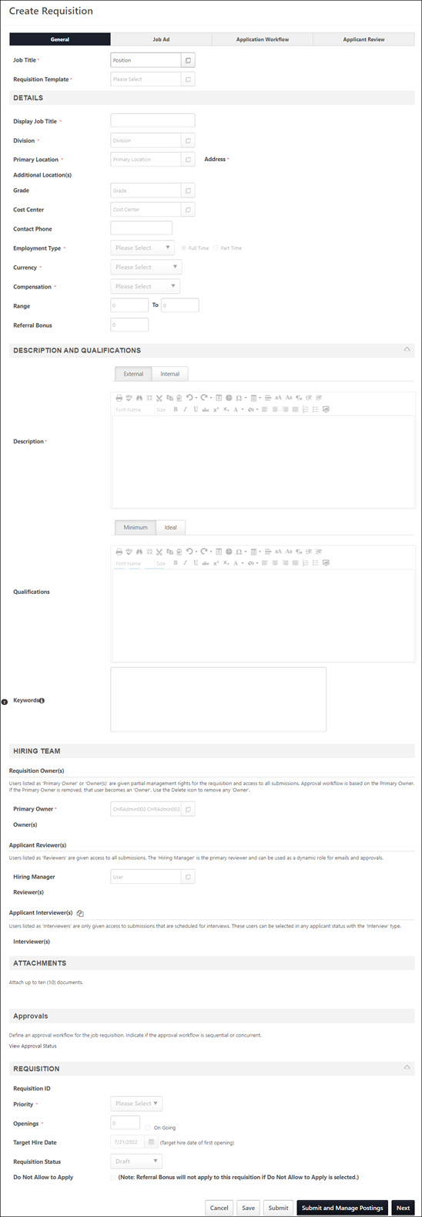

Create Job Requisition - Job Ad
The Create Job Requisition - Job Ad step enables the administrator to define the appearance of the job ad. Two job ads are defined for the job requisition:
- External Site - This job ad is for the purpose of posting the job requisition to an external career board, where the audience is people outside the organization.
- Internal Site - This job ad is for the purpose of posting the job requisition to an internal career board, where the audience is the organization's employee base.
- Mobile - This job ad is for the purpose of posting the job requisition to mobile optimized career sites. Note: As part of the deprecation process for Standard career sites, for clients whose portals were created prior to the May '19 release, when the Enable Mobile Site option on the Career Site Settings page for Standard career sites has been unchecked from all Standard career sites, the Mobile Job Ad tab will be hidden when configuring job requisitions.
To switch between editing the External Site job ad and Internal Site job ad, click the appropriate tab at the top of the editor.
There is no limit to the number of characters that can be entered in the external or internal job ads; however, a maximum of 30,000 characters can be entered in the Mobile job ad.
Permissions
PERMISSION NAME | PERMISSION DESCRIPTION | CATEGORY

Requisition: Edit Job Ad | Grants ability to edit the Job Ad tab of the Edit Requisition page. This permission cannot be constrained. | Recruiting

Requisition: Manage | Grants ability to access and manage all requisitions regardless of ownership (constraints permitting). This permission also grants read-only access to the Applicant Review tab when creating or editing a job requisition. This permission can be constrained by OU, User's OU, and Grade. | Recruiting
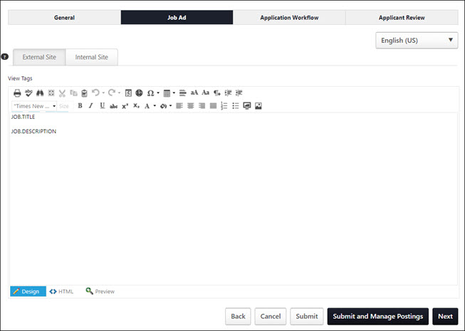
Language
The language option allows you to localize the job ad for external and internal sites, as well as mobile. Tags are also localized. Note: When viewing the Job Ad page, the language in the language drop-down is the most recently selected language in the View In field on the General tab.
To localize the job ad, select the language from the drop-down, and then enter the translated text into the job ad.
To translate the job ad into additional languages, select a different language from the drop-down and enter the translated text into the job ad.
When the job ad is viewed, the ad displays in the language of the viewer. If a translation is not available in their language, then the ad displays in the language of the user who created the ad.
Job Ad Editor
When creating or editing a job ad, a Telerik RadEditor is used. For additional information about the editor, visit http://www.telerik.com/help/aspnet-ajax/editor-toolbar-intro.html.
In the editor, there are two editing modes: Design and HTML. When in Design mode, you can use the standard editing tools to format your text, similar to your word processor application. When in HTML mode, the standard editing tools are disabled and you are able to view and modify the HTML code that is used to design the ad. To switch between modes, click the appropriate tab in the lower-left corner of the editor. The system only accepts certain customizable HTML elements in the WYSIWYG Editor. Elements that are not acceptable display as text. See Safe Listed Customizable Elements.
View in Full Screen
Click the Toggle Full Screen Mode icon to view the Description or Qualifications section in full screen mode. Click the icon again to return to the default view.
When viewing in full screen, you must be in the Design mode in order to exit the full screen view.
Job Ad Tags
To view the available tags for the ad, click the View Tags link in the upper-left corner. This includes all available standard tags and custom field tags that may exist in your portal. To use one of the tags, copy and paste the tag into the editor. All custom fields must be referenced in all capital letters. The field name must be placed within square brackets ("[ ]"). The following custom fields are available:
- [COMPENSATION.CURRENCY] - Currency type defined on job requisition form.
- [COMPENSATION.RANGE] - Payment range for the job. Note: This tag is only available to users who have permission to view and edit the salary range for requisitions. For users who do not have salary range permission, the tag is not visible in the tags pop-up.
- [COMPENSATION.TYPE] - Compensation type selected on job requisition form.
- [EMPLOYMENT.TYPE] - Employment type defined on job requisition form.
- [JOB.DESCRIPTION] - External or internal job description defined on job requisition form.
- [JOB.MINIMUM.QUALIFICATIONS) - Minimum qualifications defined for the job requisition.
- [JOB.OPENINGS] - Number of job openings defined on job requisition form.
- [JOB.OU.GRADE.TITLE] - Displays the Grade OU associated with the requisition. Note: The tag is only available for portals that have Grade OUs enabled. In addition, the tag is only visible to users who have permission to view Grade OUs.
- [JOB.REFERRAL.BONUS] - Referral bonus defined for the job requisition. Note: Referral Suite must be enabled.
- [JOB.RESPONSIBILITIES] - Job responsibilities defined for the position OU.
- [JOB.TITLE] - Display job title defined on job requisition form.
- [OU.DIVISION] - Division selected on job requisition form.
- [OU.LOCATION] - Location selected on job requisition form.
- [OU.LOCATION.ADDRESS] - Facility address defined for the location on job requisition form.
- [REQUISITION.ADDRESS] - Displays the location address defined in the Address field on the General tab of the template.
- [REQUISITION.ID] - Displays the requisition ID.
- [TARGET.HIRE.DATE] - Target hire date defined on job requisition form.
JOB.DESCRIPTION Tag
The JOB.DESCRIPTION tag displays the content that is in the Internal or External tab in the Description and Qualifications > Description section on the General tab of the requisition. If you include the JOB.DESCRIPTION tag on the job ad, then the internal or external description will display for applicants when they view the job.
If you do not want this information to appear for applicants, then be sure that the job ad does not include the JOB.DESCRIPTION tag.
Custom Recruiting Fields
Custom fields for Recruiting can be added to the Job Ad. The custom fields are added via tags, which can be viewed by clicking the View Tags link. This opens the View Tags pop-up. The custom fields that display in the tags pop-up are the fields for which the administrator meets the availability criteria. If the user does not have availability to see the custom field, the tag is hidden in the tags pop-up.
Clone External Site
When viewing the Internal Site tab, the job ad on the External Site tab can be cloned by checking the Clone External Site option. This allows the requisition creator to easily duplicate content from the External Site job ad to the Internal Site job ad without having to copy and paste the content. Because this option is selected by default, the content is duplicated automatically for users who wish to use the same content for both sites.
The Clone External Site option only appears on the Internal Site tab.
- When selected, the Internal Site job ad content is an exact clone of the External Site job ad and the job ad field cannot be edited. If the Clone External Site option is deselected and then later selected again, any content that is in the Internal Site job ad field is discarded and is replaced with the External Site job ad content.
- When deselected, the Internal Site job ad may contain different content than the External Site job ad. Both job ads can be edited.
Mobile Tab
                - Note: As part of the deprecation process for Standard career sites, for clients whose portals were created prior to the May '19 release, when the Enable Mobile Site option on the Career Site Settings page for Standard career sites has been unchecked from all Standard career sites, the Mobile Job Ad tab will be hidden when configuring job requisitions.
From the Mobile tab, a mobile job ad can be created. When a mobile job ad is defined, the ad displays on mobile optimized career sites. If an ad is not defined on the Mobile tab, then the job description and job details display as the mobile job ad.
To create the job ad, enter the job ad in the editor, up to 30,000 characters. If the ad is copied and pasted from another source, the editor only accepts up to 3000 of the pasted characters.
For mobile ads, the following editing options are available:
- Bold
- Italics
- Underline
- Bullets
- Numbering
Tags can also be included in mobile job ads. Available tags can be viewed by selecting the View Tags link.
Back/Cancel/Save/Next
After completing all sections, click Next to validate that all required information is entered on this page and proceed to the next step. Or, click Save to save any changes made to any of the steps. Or, click Cancel to return to the Manage Job Requisitions page without saving the requisition.
Click Back to return to the previous step of the requisition.
Note: With integration with Broadbean, clicking Next executes the Call Channels API call to Broadbean to populate the Postings page with available jobs.
Submit/Submit and Manage Postings Buttons
Once all mandatory fields are completed you can use the following buttons:
- Submit - Submits the requisition.
- Submit and Manage Postings - Submits the requisition and opens the Manage Posting page.
Submit Changes
When editing a requisition that has been submitted for approval, a Submit Changes button is available. Click this button to save the changes made on all pages of the requisition form and resubmit the requisition for approval.

Frequently Asked Questions
I have a simple change to the job ad, such as correcting a typo. But, my requisition has an approval workflow. How can I make this change without having to get re-approval?
When making your changes to the job ad, you can also delete all of the approvers on the General tab. When you click Submit, the changes will not require re-approval. Immediately after, you can add the approvers back into the requisition, and that action will not require re-approval.

Create Job Requisition - Application Workflow
When creating or copying a job requisition, recruiters can configure the application workflow. The workflow can only be configured when the requisition is in a Draft status. In addition, the workflow cannot be edited after the requisition is submitted.
To access Manage Job Requisitions, go to Recruit > Manage Requisitions.
Permissions
PERMISSION NAME | PERMISSION DESCRIPTION | CATEGORY

Requisition: Edit Application Workflow | Grants ability to access and create the application workflow for job requisitions. This applies to external, internal, and recruiting agency submissions. For users without this permission, the Application Workflow tab only allows removal of items that are included in the application workflow that is used for the requisition. This permission cannot be constrained. | Recruiting Administration

Requisition: Manage | Grants ability to access and manage all requisitions regardless of ownership (constraints permitting). This permission also grants read-only access to the Applicant Review tab when creating or editing a job requisition. This permission can be constrained by OU, User's OU, and Grade. | Recruiting

Requisition: Owner | Enables owner to access requisitions and applicants for requisitions for which they are an owner. This permission also grants read-only access to video interviews that are completed by applicants via HireVue. For portals with Referral Suite enabled, this permission also enables requisition owners to edit the referral source on the Applicant Profile page. This permission cannot be constrained.  Note: This is a dynamically assigned permission that is not available in Security Role Administration. If the user is removed as an owner, the permission is revoked for the associated requisition. This permission cannot be manually assigned. Also, if a user has both the permission necessary to manage requisitions and be a requisition owner, the constraints of the Requisition: Manage permission overrule those of the Requisition: Owner permission. For requisition owners that do not also have permission to manage requisitions, only certain fields are editable when editing a requisition. | Recruiting
Note: Configuring the application workflow for a job requisition is the same as configuring the workflow on a requisition template.
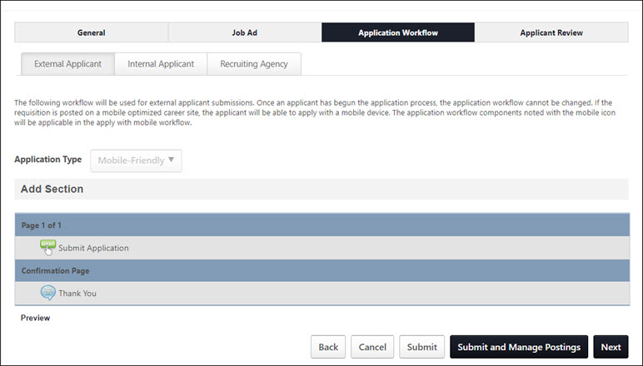
External Applicant
The External Applicant tab is the default tab that opens when viewing the Application Workflow step. This tab enables administrators to create an applicant workflow that is specific to external applicants.
Create Applicant Workflow
When setting the application workflow, there are three approaches that can be taken:
- Configure a custom application workflow without using an existing application workflow template. See Create Application Workflow Template.
- Select an existing application workflow template. Note: Templates are created in Application Workflow Templates. This populates the template below. If the selected template is later modified via the Application Workflow Template page, then those changes are automatically applied to this Job Requisition Template.
- Select an existing application workflow and make modifications. Any modifications that are made to the template do not affect the original application workflow template. The changes only apply to the job requisition template you are creating. If the selected template is later modified via the Application Workflow Template page, then those changes only affect the template in Application Workflow Templates. See Create Application Workflow Template.
To select an existing application workflow template, from the Select Template drop-down list, select the appropriate template and click Apply. This populates the template below. When selecting the template, for portals with multiple languages enabled, the template name displays in the user's language if available. If the user's language is not available, then the name displays in the language of the administrator who created the template. Note: If you are building a new workflow, and then you select a template from the drop-down list and click Apply, the workflow you were building is lost.
When selecting an existing application workflow template, the availability of templates is dependent upon the constraints of the template creator. When an administrator creates an application workflow template, only users within the template creator's permission constraints for managing application workflow templates have access to the template.
Edit Translated Values
For portals with multiple languages enabled, when configuring the application workflow, the translated values can be edited or deleted. This allows administrators to customize the workflow. This also applies to the Internal Applicant and Recruiting Agency tabs and custom workflows.
Internal Applicant
The Internal Applicant tab enables administrators to create an application workflow that is specific to internal applicants. See the Create Applicant Workflow section in the External Applicant section above for information on creating an application workflow.
Administrators can also choose to clone the external workflow by selecting the Clone External Applicant Workflow option. A warning pop-up opens, indicating that checking the clone option erases any existing configurations on the Internal Workflow tab and replaces them with the configurations from the External Workflow tab. The option is checked by default. For portals with multiple languages enabled, translated values are copied when cloning the external application workflow.
If the clone option is unchecked, then the external workflow configurations remain but can be edited, and items can be deleted.
Recruiting Agency
The Recruiting Agency tab enables you to create the workflow that is completed by the recruiters associated with a recruiting agency. Creating a recruiting agency workflow is similar to creating an external and internal workflow. However, the following action items are not available for recruiting agency workflows:
- Competency Assessment
- External Assessment
- Training
When selecting a template for the workflow, the only templates that are available to select are templates that do not contain a Competency Assessment, External Assessment, or Training action item. This is because recruiters do not complete assessments or training items for the applicants they submit.
Currently, all agency applications appear in the Standard workflow, even if they are mobile-friendly supported.
See the Create Applicant Workflow section in the External Applicant section above for more information about building an application workflow.
Preview
At the bottom of the template structure, click Preview to preview the application workflow. This opens the preview in a pop-up, allowing the administrator to preview the navigation bar, content, and progress bar.
For action items that have no content preview available, "Preview Unavailable" is displayed in the preview.
For portals with multiple languages enabled, any translated fields display in the preview in the language of the administrator, if the administrator's language is available. If the administrator's language is not available, then the preview displays in the language of the administrator who created the application workflow.
Note: When previewing application workflows that include an integration action item, the step displays the action item title and instructions, as well as an inactive Launch button.
Note: When previewing application workflows that include an integration and/or Note action item in the Submit Application section, the number of steps within the section displays in the upper-right corner of the preview page.
Compliance Questions
When previewing the template, the Compliance Questions section displays all compliance questions, regardless of the settings in Compliance Enablement Preferences. This is because the questions that appear for the applicant are dependent upon the preference settings for the associated location OU.
Veteran Status Question
The following options appear:
- Part 60-250 - This option is selected by default. The following values are available to select:
  - I am a veteran of the Vietnam era.
  - I am a special disabled veteran.
  - I am a recently separated veteran.
  - I am an other protected veteran.
  - I am not a veteran.
  - Decline to Specify.
- Part 60-300 - The following values are available to select:
  - I am a disabled veteran.
  - I am a recently separated veteran.
  - I am an other protected veteran.
  - I am an Armed Forces service medal veteran.
  - I am not a veteran.
  - Decline to Specify.
Disability Question
The following options appear:
- I have a disability and would like to be considered under the affirmative action program.
- I do not have a disability or would not like to be considered under the affirmative action program.
- Decline to Specify.
Note: The Veteran Status options relate to disabled veterans, veterans of the Vietnam Era, recently separated veterans, other protected veterans, and armed forces service medal veterans.
Related Requisition (Apply to Multiple Jobs)
When configuring Related Requisitions (Apply to Multiple Jobs), the application workflow defined on the External and Internal tabs is shared with the parent requisition and any other Related Requisitions (Apply to Multiple Jobs) that are associated to the parent.
Next/Save/Cancel
After completing all sections, click Next to validate that all required information is entered on this page and proceed to the next step. Or, click Save to save any changes made to any of the steps. Or, click Cancel to return to the Manage Job Requisitions page without saving the requisition.
Edit Application Workflow After Requisition Is Posted
The Application Workflow tab for job requisitions can be edited after the requisition is posted but only before at least one application has been started.
To edit the application workflow, click the Edit Workflow button. This button does not appear once at least one application has been started for the job.
Once you have made the changes to the application workflow, click Save Workflow Changes, which will only save changes to the Application Workflow tab. Or, click Cancel Workflow Changes to cancel the edits. Note: If an applicant starts an application while you are editing the workflow, then you will not be able to save the changes to the workflow.
Submit/Submit and Manage Postings Buttons
Once all mandatory fields are completed you can use the following buttons:
- Submit - Submits the requisition.
- Submit and Manage Postings - Submits the requisition and opens the Manage Posting page.

Create Job Requisition - Applicant Review Tab
Create/Edit Requisition - Applicant Review Tab Overview
From the Applicant Review tab, administrators can customize and configure the functionality related to the applicant statuses that are defined on the requisition template. Users can be added to statuses to associate users with the functionality that is related to the status.
The Applicant Review tab displays all of the applicant statuses that are defined from the General tab of the requisition template. Each status displays as an individual panel in the order in which the status appears on the General tab of the requisition template. In addition, each panel displays the status type, which is defined for the status in Applicant Statuses. Status change emails can also be configured for each status type. See Status Change Emails on page 310 for additional information.
From the Applicant Review tab, you can also submit the requisition.
To access Manage Job Requisitions, go to Recruit > Manage Requisitions.
Permissions
PERMISSION NAME | PERMISSION DESCRIPTION | CATEGORY

Requisition: Edit Applicant Review | Grants ability to edit the Applicant Review tab of the Edit Requisition page. This permission cannot be constrained. | Recruiting

Requisition: Manage | Grants ability to access and manage all requisitions regardless of ownership (constraints permitting). This permission also grants read-only access to the Applicant Review tab when creating or editing a job requisition. This permission can be constrained by OU, User's OU, and Grade. | Recruiting

Requisition: Owner | Enables owner to access requisitions and applicants for requisitions for which they are an owner. This permission also grants read-only access to video interviews that are completed by applicants via HireVue. For portals with Referral Suite enabled, this permission also enables requisition owners to edit the referral source on the Applicant Profile page. This permission cannot be constrained.  Note: This is a dynamically assigned permission that is not available in Security Role Administration. If the user is removed as an owner, the permission is revoked for the associated requisition. This permission cannot be manually assigned. Also, if a user has both the permission necessary to manage requisitions and be a requisition owner, the constraints of the Requisition: Manage permission overrule those of the Requisition: Owner permission. For requisition owners that do not also have permission to manage requisitions, only certain fields are editable when editing a requisition. | Recruiting
Note: The permission to review or approve a job requisition grants users view access to the requisition.
Note: For users with permission to access job requisitions but who do not have permission to edit the Applicant Review tab, the tab can be accessed but cannot be modified.
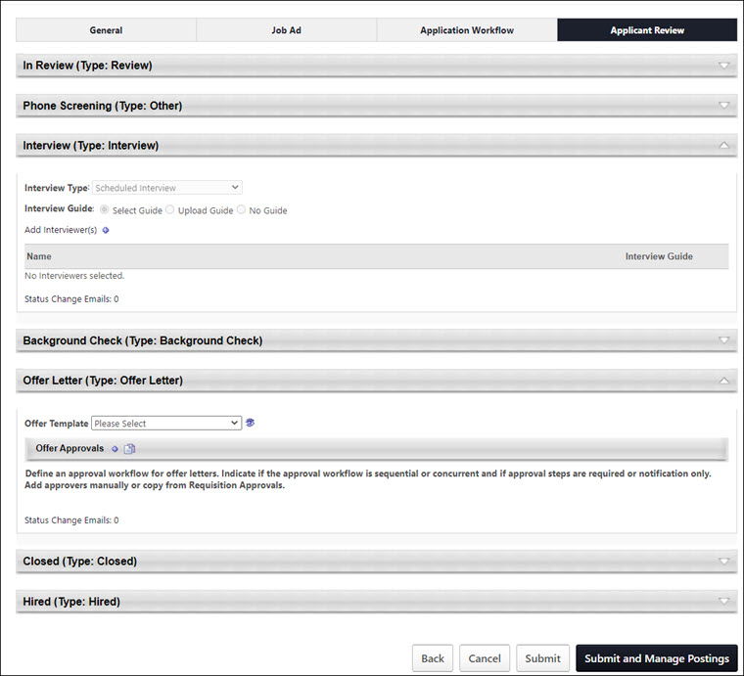
Status Types
See the following for information about the various status types on the Applicant Review tab:
- See Applicant Review Tab - Review Status Type on page 90 for additional information.
- See Applicant Review Tab - Interview Status Type Overview on page 92 for additional information.
- See Applicant Review Tab - Other Status Type on page 104 for additional information.
- See Applicant Review Tab - Background Check Status Type on page 84 for additional information.
- See Applicant Review Tab - Offer Letter Status Type on page 94 for additional information.
- See Applicant Review Tab - Closed Status Type on page 86 for additional information.
- See Applicant Review Tab - Hired Status Type on page 88 for additional information.
Submit/Re-Submit
Standard Requisitions
Clicking the Submit button submits the requisition for approval, if an approval workflow is configured for the requisition. If an approval workflow is not configured for the requisition, then clicking Submit submits the requisition and posts it to the designated locations when configured to be posted.
Parent/Related Requisitions
If the Do Not Allow to Apply option is not selected on the General tab, then clicking the Submit button submits the requisition and posts it to the designated locations when configured to be posted. Applicants can apply to the requisition once it is posted.
For parent requisitions that do not yet have any associated child requisitions, if the Do Not Allow to Apply option is not selected on the General tab, then clicking the Submit button submits the requisition and returns the recruiter to the Manage Job Requisitions page.
Note: The Submit button does not display for parent requisitions that are in a Closed status. The requisition cannot be submitted again, and related requisitions cannot be added.
Submit and Manage Postings
Clicking the Submit and Manage Postings button submits the requisition and takes you to the Job Postings page.
Submit and Add Related Requisitions
For parent requisitions, the Submit and Add Related Requisition button only displays if related requisitions are enabled by the administrator in Requisition and Applicant Preferences. In addition, the option only displays for requisitions that are in an Draft status. Clicking the Submit and Add Related Requisition button opens the Related Requisition Type pop-up.
Note: The Submit and Add Related Requisition button does not display for parent requisitions that are in a Closed status. The requisition cannot be submitted again, and related requisitions cannot be added.
Related Requisition Type Pop-Up
The Related Requisition Type pop-up allows recruiters to add either a related requisition or a related requisition that allows applicants to apply to multiple locations. Select one of the following options in the pop-up:
- Related Requisition - This option is selected by default. When selected, recruiters can add a standard related requisition. With this related requisition type, applicants can only apply to one requisition at a time. In addition, the requisition template can be modified, which allows for multiple application workflows, depending on the configuration of the selected template.
- Related Requisition (Apply to Multiple Jobs) - This option is unselected by default. When selected, recruiters can add related requisitions that allow applicants to apply at one time to each of the related requisitions associated to the parent requisition. In addition, the job title and requisition template cannot be modified, which means that each related requisition will have the same application workflow as the parent requisition.
Once the selection is made, click Done. This closes the pop-up and navigates the recruiter to the General tab of the related requisition.
When the requisition is submitted, the recruiter is taken to the General tab of the create job requisition process to enable the recruiter to create a child requisition. All fields from the parent requisition are copied to the child requisition.
Note: When resubmitting a job requisition that has already been submitted, the name of the submission button changes to Re-Submit and Add Related Requisition.
Post Jobs
Jobs are posted via the Job Postings page. Click the button to open the Job Postings page. See Job Postings Page.
Submit/Submit and Manage Postings Buttons
Once all mandatory fields are completed you can use the following buttons:
- Submit - Submits the requisition.
- Submit and Manage Postings - Submits the requisition and opens the Manage Posting page.
Applicant Review Tab - Background Check Status Type
The Background Check status type panel on the Applicant Review tab of the job requisition is a placeholder for this step in the applicant status workflow. The panel displays the name of the status as the panel heading. The status type of Background Check displays in parentheses to the right of the status name. The panel is not expandable or collapsible. See Statuses Tab - Background Check Status Type in the Applicant Profile section of Online Help for information about configuring background checks.
For background checks that have a validity period, the background check results appear in the status type panel during the validity period across all non-closed requisitions that are applicable for the candidate.
Status change emails can be configured for the Background Check status type panel. See Status Change Emails on page 310 for additional information.
Note: The visibility of the Background Check status is controlled by a backend setting that is disabled by default. To enable this functionality, contact Global Customer Support.
To access Manage Job Requisitions, go to Recruit > Manage Requisitions.
Permissions
PERMISSION NAME | PERMISSION DESCRIPTION | CATEGORY

Requisition: Edit Applicant Review | Grants ability to edit the Applicant Review tab of the Edit Requisition page. This permission cannot be constrained. | Recruiting

Requisition: Manage | Grants ability to access and manage all requisitions regardless of ownership (constraints permitting). This permission also grants read-only access to the Applicant Review tab when creating or editing a job requisition. This permission can be constrained by OU, User's OU, and Grade. | Recruiting

Requisition: Owner | Enables owner to access requisitions and applicants for requisitions for which they are an owner. This permission also grants read-only access to video interviews that are completed by applicants via HireVue. For portals with Referral Suite enabled, this permission also enables requisition owners to edit the referral source on the Applicant Profile page. This permission cannot be constrained.  Note: This is a dynamically assigned permission that is not available in Security Role Administration. If the user is removed as an owner, the permission is revoked for the associated requisition. This permission cannot be manually assigned. Also, if a user has both the permission necessary to manage requisitions and be a requisition owner, the constraints of the Requisition: Manage permission overrule those of the Requisition: Owner permission. For requisition owners that do not also have permission to manage requisitions, only certain fields are editable when editing a requisition. | Recruiting
Note: The permission to review or approve a job requisition grants users view access to the requisition.
Note: For users with permission to access job requisitions but who do not have permission to edit the Applicant Review tab, the tab is visible but cannot be modified.
Background Checks with Validity Periods
Validity periods can be configured for background check integrations when configuring the integration in Edge. See Background Check - Settings.
On the Applicant Profile > Statuses tab, the date on which the background check expires displays in the Expiration Date field below the request details. The expiration date is not calculated until results are returned from the background check vendor.
In addition, the original requisition where the background check was requested is also visible, both when the background check is in an In Progress status and when results have been returned.
If an applicant has applied to other requisitions, then the background check results will be visible for those requisitions, as well, during the background check's validity period.
Sensitive Statuses
Recruiters who have permission to view sensitive statuses will be able to see background check results across all requisitions for which they have access when the candidate was in a sensitive status for the background check.
Recruiters who do not have the sensitive statuses permission will not have access to background check results that were submitted when the status the candidate was in was defined as sensitive.
Applicant Review Tab - Closed Status Type
The Closed status type panel on the Applicant Review tab of the job requisition is a placeholder for this step in the applicant status workflow. The panel displays the name of the status as the panel heading. The status type of Closed displays in parentheses to the right of the status name. The panel is not expandable or collapsible.
Status change emails can be configured for the Closed status type panel. See Status Change Emails on page 310 for additional information.
Note: There are no configurable options in the panel when applicants reach the status during the applicant status workflow. However, when an applicant is placed into a Closed status, their status can be changed by using the Change Status options on the Manage Applicants page or their Applicant Profile page.
To access Manage Job Requisitions, go to Recruit > Manage Requisitions.
Permissions
PERMISSION NAME | PERMISSION DESCRIPTION | CATEGORY

Requisition: Edit Applicant Review | Grants ability to edit the Applicant Review tab of the Edit Requisition page. This permission cannot be constrained. | Recruiting

Requisition: Manage | Grants ability to access and manage all requisitions regardless of ownership (constraints permitting). This permission also grants read-only access to the Applicant Review tab when creating or editing a job requisition. This permission can be constrained by OU, User's OU, and Grade. | Recruiting

Requisition: Owner | Enables owner to access requisitions and applicants for requisitions for which they are an owner. This permission also grants read-only access to video interviews that are completed by applicants via HireVue. For portals with Referral Suite enabled, this permission also enables requisition owners to edit the referral source on the Applicant Profile page. This permission cannot be constrained.  Note: This is a dynamically assigned permission that is not available in Security Role Administration. If the user is removed as an owner, the permission is revoked for the associated requisition. This permission cannot be manually assigned. Also, if a user has both the permission necessary to manage requisitions and be a requisition owner, the constraints of the Requisition: Manage permission overrule those of the Requisition: Owner permission. For requisition owners that do not also have permission to manage requisitions, only certain fields are editable when editing a requisition. | Recruiting
Note: The permission to review or approve a job requisition grants users view access to the requisition.
Note: For users with permission to access job requisitions but who do not have permission to edit the Applicant Review tab, the tab is visible but cannot be modified.
Applicant Review Tab - Hired Status Type
The Hired status type panel on the Applicant Review tab of the job requisition is a placeholder for this step in the applicant status workflow. The panel displays the name of the status as the panel heading. The status type of Hired displays in parentheses to the right of the status name. The panel is not expandable or collapsible.
Status change emails can be configured for the Hired status type panel. See Status Change Emails on page 310 for additional information.
Note: The functionality associated with the Hired status type is configured on the Applicant Profile page when an applicant is in the Hired status.See Statuses Tab - Hired Status Type for additional information.
To access Manage Job Requisitions, go to Recruit > Manage Requisitions.
Permissions
PERMISSION NAME | PERMISSION DESCRIPTION | CATEGORY

Requisition: Edit Applicant Review | Grants ability to edit the Applicant Review tab of the Edit Requisition page. This permission cannot be constrained. | Recruiting

Requisition: Manage | Grants ability to access and manage all requisitions regardless of ownership (constraints permitting). This permission also grants read-only access to the Applicant Review tab when creating or editing a job requisition. This permission can be constrained by OU, User's OU, and Grade. | Recruiting

Requisition: Owner | Enables owner to access requisitions and applicants for requisitions for which they are an owner. This permission also grants read-only access to video interviews that are completed by applicants via HireVue. For portals with Referral Suite enabled, this permission also enables requisition owners to edit the referral source on the Applicant Profile page. This permission cannot be constrained.  Note: This is a dynamically assigned permission that is not available in Security Role Administration. If the user is removed as an owner, the permission is revoked for the associated requisition. This permission cannot be manually assigned. Also, if a user has both the permission necessary to manage requisitions and be a requisition owner, the constraints of the Requisition: Manage permission overrule those of the Requisition: Owner permission. For requisition owners that do not also have permission to manage requisitions, only certain fields are editable when editing a requisition. | Recruiting
Note: The permission to review or approve a job requisition grants users view access to the requisition.
Note: For users with permission to access job requisitions but who do not have permission to edit the Applicant Review tab, the tab is visible but cannot be modified.
Applicant Review Tab - Review Status Type
The Review status type panel on the Applicant Review tab of the job requisition is a placeholder for this step in the applicant status workflow. The panel displays the name of the status as the panel heading. The status type of Review displays in parentheses to the right of the status name. The panel is not expandable or collapsible. See Statuses Tab - Review Status Type in the Applicant Profile section of Online Help for information about the functionality associated with the Review status type.
Status change emails can be configured for the Review status type panel. See Status Change Emails on page 310 for additional information.
Note: When viewing statuses of the type Review on the Applicant Profile page for the applicant, only the first instance of a status of the type Review displays the applicant review functionality, which includes the list of applicant reviewers, the date the Review Request was sent, the Reviewed checkbox, and the Add Reviewer option. All subsequent instances of a status of the type Review do not display the applicant review functionality. Instead, they display the name of the status as the panel heading and the status type of Review in the Type field within the panel, and the panels are not expandable or collapsible.
To access Manage Job Requisitions, go to Recruit > Manage Requisitions.
Permissions
PERMISSION NAME | PERMISSION DESCRIPTION | CATEGORY

Requisition: Edit Applicant Review | Grants ability to edit the Applicant Review tab of the Edit Requisition page. This permission cannot be constrained. | Recruiting

Requisition: Manage | Grants ability to access and manage all requisitions regardless of ownership (constraints permitting). This permission also grants read-only access to the Applicant Review tab when creating or editing a job requisition. This permission can be constrained by OU, User's OU, and Grade. | Recruiting

Requisition: Owner | Enables owner to access requisitions and applicants for requisitions for which they are an owner. This permission also grants read-only access to video interviews that are completed by applicants via HireVue. For portals with Referral Suite enabled, this permission also enables requisition owners to edit the referral source on the Applicant Profile page. This permission cannot be constrained.  Note: This is a dynamically assigned permission that is not available in Security Role Administration. If the user is removed as an owner, the permission is revoked for the associated requisition. This permission cannot be manually assigned. Also, if a user has both the permission necessary to manage requisitions and be a requisition owner, the constraints of the Requisition: Manage permission overrule those of the Requisition: Owner permission. For requisition owners that do not also have permission to manage requisitions, only certain fields are editable when editing a requisition. | Recruiting
Note: The permission to review or approve a job requisition grants users view access to the requisition.
Note: For users with permission to access job requisitions but who do not have permission to edit the Applicant Review tab, the tab is visible but cannot be modified.
Emails
EMAIL NAME | EMAIL DESCRIPTION | ACTION TYPE

Review Applicant | This email is triggered when an applicant is moved into a Review status type. The email is also triggered when a new reviewer has been added, and the applicant is already in a Review status type.  This is a Notification type email and can be sent to External Applicant, Hiring Manager, Internal Applicant, OU Approver, Requisition Owner, or Requisition Reviewer.  The Availability setting for this email can be configured so that the email triggers for external candidates. The system checks the indirect OU designations for external candidates and sends the appropriate emails for which they meet the availability criteria.  When configuring this email, you can include the REVIEW.APPLICANT.RESUME.LINK tag. This tag displays the applicant's full name as a link that opens the Resume/CV Review page.  Use Case: Use this email to send notifications to reviewers and hiring managers when an applicant is ready to be reviewed. | Recruiting
Applicant Review Tab - Interview Status Type Overview
When creating or editing a job requisition, Interview status type panels on the Applicant Review tab enable administrators to define an interview process for the status. The name of the status displays as the panel name.
When a status has a status type of Interview, all of the options that are available for the Interview status type appear in the panel. The panel is expanded by default. Completing the fields in the Interview status type panel is not required on the requisition template.
Status change emails can be configured for the Interview status type panel. See Status Change Emails on page 310 for additional information.
Note: There are many scenarios in which an organization may prefer to define a status other than Interview as an Interview status type. For example, if an organization requires all applicants to have a phone screening, then the organization can create a custom status named Phone Screening and select the status type as Interview. This enables the administrator to configure interview functionality for the custom Phone Screening status.
Note: When editing the panel, the changes do not impact applicants that are currently in the status.
To access Manage Job Requisitions, go to Recruit > Manage Requisitions.
Permissions
PERMISSION NAME | PERMISSION DESCRIPTION | CATEGORY

Requisition: Edit Applicant Review | Grants ability to edit the Applicant Review tab of the Edit Requisition page. This permission cannot be constrained. | Recruiting

Requisition: Manage | Grants ability to access and manage all requisitions regardless of ownership (constraints permitting). This permission also grants read-only access to the Applicant Review tab when creating or editing a job requisition. This permission can be constrained by OU, User's OU, and Grade. | Recruiting

Requisition: Owner | Enables owner to access requisitions and applicants for requisitions for which they are an owner. This permission also grants read-only access to video interviews that are completed by applicants via HireVue. For portals with Referral Suite enabled, this permission also enables requisition owners to edit the referral source on the Applicant Profile page. This permission cannot be constrained.  Note: This is a dynamically assigned permission that is not available in Security Role Administration. If the user is removed as an owner, the permission is revoked for the associated requisition. This permission cannot be manually assigned. Also, if a user has both the permission necessary to manage requisitions and be a requisition owner, the constraints of the Requisition: Manage permission overrule those of the Requisition: Owner permission. For requisition owners that do not also have permission to manage requisitions, only certain fields are editable when editing a requisition. | Recruiting
Note: The permission to review or approve a job requisition grants users view access to the requisition.
Note: For users with permission to access job requisitions but who do not have permission to edit the Applicant Review tab, the tab is visible but cannot be modified.
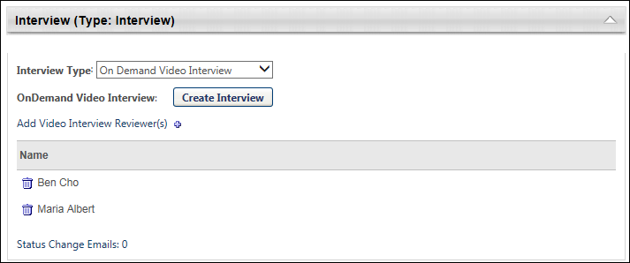
Interview Type
The Interview Type drop-down enables you to determine the kind of interview that is available for the status. The following interview types are available:
- Scheduled Interview - A scheduled interview can be an In Person, Phone, or Live Video interview. Live Video interviews are video interviews that are conducted in real-time between one or more interviewers and the applicant, and are available through HireVue. The Scheduled Interview option is selected by default in the Interview Type field. When this option is selected, the Interview Guide field displays.
- On Demand Video Interview - An On Demand Video interview is an interview that is conducted asynchronously by the applicant in HireVue.
Applicant Review Tab - Offer Letter Status Type
The panel for the default status type of Offer Letter enables administrators to select the offer letter template and define the approval workflow that will display on the Applicant Review tab for the status type when creating or editing a job requisition.
The status panel of the type Offer Letter on the Applicant Review tab displays the name of the status as the panel heading. The status type of Offer Letter displays in parentheses to the right of the status name. This panel is expanded by default.
Status change emails can be configured for the Offer Letter status type panel. See Status Change Emails on page 310 for additional information.
Note: If the panel was configured for the template selected on the General tab for the requisition, then the default configurations display in the panel on the Applicant Review tab.
Note: When editing the panel, the changes do not impact applicants that are currently in the status.
To access Manage Job Requisitions, go to Recruit > Manage Requisitions.
Permissions
PERMISSION NAME | PERMISSION DESCRIPTION | CATEGORY

Requisition: Edit Applicant Review | Grants ability to edit the Applicant Review tab of the Edit Requisition page. This permission cannot be constrained. | Recruiting

Requisition: Manage | Grants ability to access and manage all requisitions regardless of ownership (constraints permitting). This permission also grants read-only access to the Applicant Review tab when creating or editing a job requisition. This permission can be constrained by OU, User's OU, and Grade. | Recruiting

Requisition: Owner | Enables owner to access requisitions and applicants for requisitions for which they are an owner. This permission also grants read-only access to video interviews that are completed by applicants via HireVue. For portals with Referral Suite enabled, this permission also enables requisition owners to edit the referral source on the Applicant Profile page. This permission cannot be constrained.  Note: This is a dynamically assigned permission that is not available in Security Role Administration. If the user is removed as an owner, the permission is revoked for the associated requisition. This permission cannot be manually assigned. Also, if a user has both the permission necessary to manage requisitions and be a requisition owner, the constraints of the Requisition: Manage permission overrule those of the Requisition: Owner permission. For requisition owners that do not also have permission to manage requisitions, only certain fields are editable when editing a requisition. | Recruiting
Note: The permission to review or approve a job requisition grants users view access to the requisition.
Note: For users with permission to access job requisitions but who do not have permission to edit the Applicant Review tab, the tab is visible but cannot be modified.
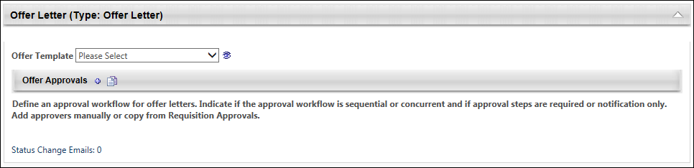
Offer Template
Select a template from the Offer Template drop-down. The offer letter templates that are available to select are the templates that have been configured for the Location Organizational Unit (OU) selected in the Location field on the General tab. Templates by OU are defined by the administrator when configuring offer letter templates.
To preview the template, click the Preview icon to the right of the Offer Template field. Within the preview, click the PDF icon to view the letter in Adobe Acrobat®.
Selecting a template is not required. If a template is selected, then any changes made to the offer letter settings on the job requisition are not changed on the requisition template.
Note: The Preview icon only displays after an offer letter template is selected.
Note: If tags are used in the template, the tags appear in preview mode as tags because the template is not connected to a position or candidate.
Offer Approvals
The Offer Approvals panel enables administrators to define an approval workflow for the offer letter. Defining an approval workflow is not required. If an approval workflow is defined on the template, then a default approval workflow appears in the Offer Approvals panel.
For dynamically assigned roles at the requisition level, the name of the user in the role appears in parentheses to the left of the role. If a user is not defined for a role, then "None Defined" appears in parentheses.
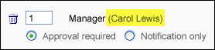
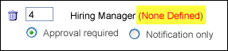
Note: If a user is not defined for a role, then the step is skipped and the offer letter is assumed Approved for that step.
Define Approval Workflow
To define an approval workflow:
- Click the plus icon to the right of the Offer Approvals header. This opens the Select Approvers pop-up.
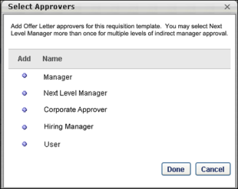
- Select an approver from the following options:
  - Manager - This is the requisition owner's manager. This option can only be selected once as an approver.
  - Next Level Manager - This is the indirect manager at each level of the user hierarchy. This option can be selected repeatedly as an approver.
  - <OU Type> Approver - This is the person defined as the <OU Type> Approver in Requisition and Applicant Preferences.
  - Hiring Manager - This is the person defined as the hiring manager on the General step of the requisition template.
  - User - This option enables administrators to select a specific user as an approver. This option can be selected repeatedly as an approver and also added as an OR rule.
- Click Done. This closes the pop-up and adds the approvers to the Offer Approvals panel.
Approval Workflow Order
Once all approvers are selected, define the approval order. The order can be sequential, concurrent, or both. To define the approval order, enter the step number in the numeric text box to the left of the approver. There must be at least one step with a "1" entered.
Sequential Approval Workflow
For a sequential approval workflow, approval notifications are sent in numeric order. For example, Approver B (Janette Andrews) is sent the Pending Approval Notification email after the user's manager approves the request.
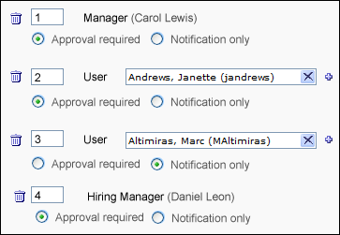
Concurrent Approval Workflow
For a concurrent approval workflow, approval notifications are sent at the same time to all approvers. For example, if a "1" is entered for the user’s Manager, Janette Andrews Hiring Manager, then the Pending Approval Notification email is sent to each of them at the same time.
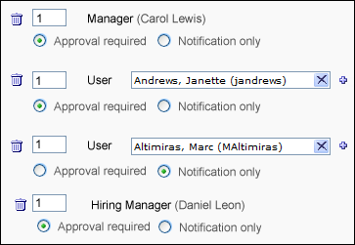
If at least one of the approvers in a concurrent approval workflow denies the offer letter, then the offer letter is denied, even if the other approvers have not yet responded. For the other approvers in the step, the approval request is automatically retracted.
Note: A concurrent approval workflow creates an AND rule. When viewing the workflow on the Applicant Profile page, the approvers are displayed in the same row.
Sequential/Concurrent Approval Workflow
For a sequential/concurrent approval workflow, some approval steps are in numeric order and some steps are marked with the same number. For example, a "1" is entered for Approvers A and B, a "2" is entered for Approver C, and a "3" is entered for Approver D. In this example, if Approvers A or B deny the offer letter, then the Pending Approval Notification email is not sent to Approvers C and D.
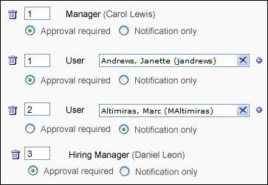
Note: A sequential/concurrent approval workflow could create an OR and AND rule within the same approval step. (OR logic is explained in the subsequent section.) When viewing the workflow on the Applicant Profile page, the approvers are displayed in the same row. If one of the approvers in the step denies the offer letter, then the step is placed into a Denied status and the system automatically retracts the approval request for all other approvers in the step who have not yet recorded an approval decision.
Adding OR Rules
For approval steps that are configured for a specific user, more than one user can be added as an approver. This creates an OR rule (e.g., Approver A or Approver B can approve the offer letter for that approval step). Only one OR rule can be created for an approval step. The Pending Approval Notification email is sent to both approvers at the same time, but only one of them is required to approve the offer letter. If one of the approvers denies the offer letter, then the other approver's response is recorded but has no impact on the approval step.
To create an OR rule:
- Click the plus icon to the right of the approver box. This opens the Select Approver pop-up.
- Select a user.
- Click Done. The second approver is added to the right of the first approver in the approval step.
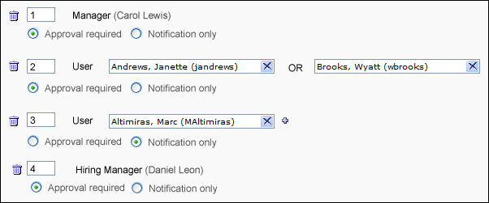
Note: In a step that contains both an OR rule and an AND rule, it is possible for two or more approvers to submit an approval decision for the offer letter. This is only possible if the approvers approve the offer letter. As soon as one approver in the step denies the offer letter, the step's status is Denied. For the approvers that approved the offer letter, their decision remains in the system.
Approval Required or Notification Only
The Approval required and Notification only options enable administrators to define whether or not the approver is required to approve the offer letter before the offer letter moves to the next step in the approval workflow.
- Approval required - If this option is selected, the approver must approve the offer letter in order for the offer letter to move to the next step in the workflow. If configured in Email Management, the Pending Approval Notification email is sent to the approver in the corresponding approval step to notify them that they are required to approve the offer letter.
- Notification only - If this option is selected and if configured in Email Management, the Pending Approval Notification email is sent to the approver in the corresponding approval step for notification purposes only. Such approvers do not have approval/denial options on the Recruiting Approvals page and are skipped in the approval process. For example, if the Notification only option is selected for the approver in the last row of the approval workflow, then the offer letter is approved when the last required approver completes their approval step.
Remove Approval Workflow Step
Approval steps can be removed by clicking the Trash Can icon to the left of the step. The entire step is deleted. If a step includes an OR rule, then both approvers for the step are removed.
Copy Approval Workflow
If a requisition approval workflow is created in the Approvals panel on the General tab, then the workflow can be copied to the Offer Approvals workflow. To copy an approval workflow, select the Copy Approval icon . The requisition approval workflow from the General tab appears in the Offer Approvals panel. By default, the Approval Required option is selected for each approver.
If an approval workflow is not configured on the General step, then the Copy Approval icon has no function.
Important Note: Clicking the Copy Approval icon overwrites any existing approval workflow without warning. This means that if you have configured an approval workflow in the Offer Approvals panel and then you click the Copy Approval icon, the workflow you created is replaced with the workflow from the General step and the existing approval workflow is not saved.
Interview Status Type - On Demand Video Interview
An on demand video interview is a video interview that the applicant conducts on their own time using HireVue. The applicant is displayed a list of questions, which they answer by recording themselves responding to the questions in HireVue. Once the applicant completes the video interview, the interviewers can access the video and review the applicant's responses.
Status change emails can be configured for the Interview status type panel. See Status Change Emails on page 310 for additional information.
Note: The ability to conduct video interviews is controlled by backend settings that are disabled by default. To enable this functionality, contact Global Customer Support.
Note: If the panel was configured for the template selected on the General tab for the requisition, then the default configurations display in the panel on the Applicant Review tab.
To access Manage Job Requisitions, go to Recruit > Manage Requisitions.
Permissions
PERMISSION NAME | PERMISSION DESCRIPTION | CATEGORY

Requisition: Edit Applicant Review | Grants ability to edit the Applicant Review tab of the Edit Requisition page. This permission cannot be constrained. | Recruiting

Requisition: Manage | Grants ability to access and manage all requisitions regardless of ownership (constraints permitting). This permission also grants read-only access to the Applicant Review tab when creating or editing a job requisition. This permission can be constrained by OU, User's OU, and Grade. | Recruiting

Requisition: Owner | Enables owner to access requisitions and applicants for requisitions for which they are an owner. This permission also grants read-only access to video interviews that are completed by applicants via HireVue. For portals with Referral Suite enabled, this permission also enables requisition owners to edit the referral source on the Applicant Profile page. This permission cannot be constrained.  Note: This is a dynamically assigned permission that is not available in Security Role Administration. If the user is removed as an owner, the permission is revoked for the associated requisition. This permission cannot be manually assigned. Also, if a user has both the permission necessary to manage requisitions and be a requisition owner, the constraints of the Requisition: Manage permission overrule those of the Requisition: Owner permission. For requisition owners that do not also have permission to manage requisitions, only certain fields are editable when editing a requisition. | Recruiting
Note: The permission to review or approve a job requisition grants users view access to the requisition.
Note: For users with permission to access job requisitions but who do not have permission to edit the Applicant Review tab, the tab is visible but cannot be modified.
Interview Type
Select the On Demand Video Interview type from the drop-down in the Interview Type field. When this option is selected, the Create Interview button displays.
Note: The "On Demand Video Interview" option may have already been selected in the Interview Type field on the requisition template.
Create Interview
Click Create Interview to configure the On Demand Video interview. This opens HireVue from which you can select questions for the interview. Note: You must have a valid email address and a HireVue account in order to create an interview in HireVue.
Once the interview is created in HireVue, the Create Interview button in the Interview status type panel changes to Edit Interview. You can click the Edit Interview button to open HireVue and edit the interview.
Add Video Interview Reviewers
Interviewers are added to the Video Interview Reviewers table by clicking the plus icon to the right of Add Video Interview Reviewer(s). This opens the Add pop-up. The pop-up displays the interviewers that were added to the Applicant Interviewer(s) section on the General tab. Click the plus icon to the left of each interview reviewer you would like to add. Then, click Done. The interview reviewers are added to the Video Interview Reviewers table.
Note: Interview reviewers only display in the Add pop-up if interviewers are defined in the Applicant Interviewer(s) section of the General tab for the template. Interviewers that are added to the Applicant Interviewer(s) section are not automatically added to the Video Interview Reviewers table. Interview reviewers must be added manually using the Add Video Interview Reviewer(s) feature.
Note: The same interview reviewer can be added to multiple Interview type status panels.
Note: On Demand Video interview reviewers must have a valid email address. If a valid email address is not defined for one or more interview reviewers, then an error message displays when the Save button is clicked to save the requisition template or when the administrator attempts to navigate to another tab.
Video Interview Reviewers Table
The Video Interview Reviewers table displays the interviewers and the option to remove interview reviewers.
The following information appears in the table:
Column Name | Description
Remove | Click the Trash Can icon to the left of the interview reviewer's name either in the Video Interview Reviewers table or in the Add pop-up. This removes the interview reviewer from the table.  Note: When removing interview reviewers from the Add pop-up, click Done to complete the removal action.
Name | This column displays the name of the interview reviewer.
Applicant Review Tab - Other Status Type
When a status is defined as the Other status type, the panel on the Applicant Review tab of the requisition template is a placeholder for this step in the applicant status workflow. The panel displays the name of the status as the panel heading. The status type of Other displays in parentheses to the right of the status name. The panel is not expandable or collapsible.
Status change emails can be configured for the Other status type panel. See Status Change Emails on page 310 for additional information.
Note: There are no configurable options in the panel when applicants reach the status during the applicant status workflow.
To access Manage Job Requisitions, go to Recruit > Manage Requisitions.
Permissions
PERMISSION NAME | PERMISSION DESCRIPTION | CATEGORY

Requisition: Edit Applicant Review | Grants ability to edit the Applicant Review tab of the Edit Requisition page. This permission cannot be constrained. | Recruiting

Requisition: Manage | Grants ability to access and manage all requisitions regardless of ownership (constraints permitting). This permission also grants read-only access to the Applicant Review tab when creating or editing a job requisition. This permission can be constrained by OU, User's OU, and Grade. | Recruiting

Requisition: Owner | Enables owner to access requisitions and applicants for requisitions for which they are an owner. This permission also grants read-only access to video interviews that are completed by applicants via HireVue. For portals with Referral Suite enabled, this permission also enables requisition owners to edit the referral source on the Applicant Profile page. This permission cannot be constrained.  Note: This is a dynamically assigned permission that is not available in Security Role Administration. If the user is removed as an owner, the permission is revoked for the associated requisition. This permission cannot be manually assigned. Also, if a user has both the permission necessary to manage requisitions and be a requisition owner, the constraints of the Requisition: Manage permission overrule those of the Requisition: Owner permission. For requisition owners that do not also have permission to manage requisitions, only certain fields are editable when editing a requisition. | Recruiting
Note: The permission to review or approve a job requisition grants users view access to the requisition.
Note: For users with permission to access job requisitions but who do not have permission to edit the Applicant Review tab, the tab is visible but cannot be modified.
Interview Status Type - Scheduled Interview
A scheduled interview, also called a live interview, is an interview that is conducted live by one or more interviewers. Unlike On Demand Video interviews, scheduled interviews are conducted in real-time.
The following are the types of scheduled interviews:
- In Person
- Phone
- Live Video - A Live Video scheduled interview refers to an interview that is conducted via HireVue video between one or more interviewers and the applicant. This does not refer to an On Demand Video interview, which is an interview that is conducted by the applicant on their own time via HireVue video.
Note: Configuring an interview as an On Demand Video interview is done by selecting "On Demand Video Interview" in the Interview Type field in the Interview status type panel. On Demand Video interviews are then assigned to applicants from the Statuses tab on the Applicant Profile page when the applicant reaches the applicable Interview status type.
- Vitual
Status change emails can be configured for the Interview status type panel. See Status Change Emails on page 310 for additional information.
Note: The Live Video option is only available if the Enable 'Video Interview' as available interview type option is selected in Interview Management Preferences for the scheduling user’s OU.
Note: The ability to conduct video interviews is controlled by a backend setting that is disabled by default. To enable this functionality, contact Global Customer Support.
Note: Responses for the fields in the Interview status type panel are optional.
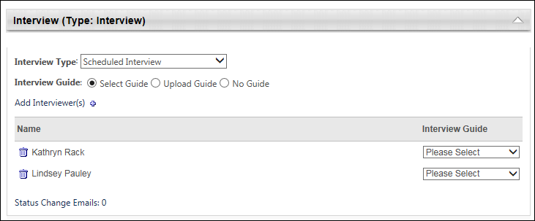
To access Manage Job Requisitions, go to Recruit > Manage Requisitions.
Permissions
PERMISSION NAME | PERMISSION DESCRIPTION | CATEGORY

Requisition: Edit Applicant Review | Grants ability to edit the Applicant Review tab of the Edit Requisition page. This permission cannot be constrained. | Recruiting

Requisition: Manage | Grants ability to access and manage all requisitions regardless of ownership (constraints permitting). This permission also grants read-only access to the Applicant Review tab when creating or editing a job requisition. This permission can be constrained by OU, User's OU, and Grade. | Recruiting

Requisition: Owner | Enables owner to access requisitions and applicants for requisitions for which they are an owner. This permission also grants read-only access to video interviews that are completed by applicants via HireVue. For portals with Referral Suite enabled, this permission also enables requisition owners to edit the referral source on the Applicant Profile page. This permission cannot be constrained.  Note: This is a dynamically assigned permission that is not available in Security Role Administration. If the user is removed as an owner, the permission is revoked for the associated requisition. This permission cannot be manually assigned. Also, if a user has both the permission necessary to manage requisitions and be a requisition owner, the constraints of the Requisition: Manage permission overrule those of the Requisition: Owner permission. For requisition owners that do not also have permission to manage requisitions, only certain fields are editable when editing a requisition. | Recruiting
Note: The permission to review or approve a job requisition grants users view access to the requisition.
Note: For users with permission to access job requisitions but who do not have permission to edit the Applicant Review tab, the tab is visible but cannot be modified.
Interview Type
The Scheduled Interview option is selected by default in the Interview Type field. When this option is selected, the Interview Guide field displays.
Note: If the field was configured on the requisition template, then the template configuration displays but is editable.
Interview Guide
The Interview Guide field enables you to include an interview guide for interviewers. For example, an interview guide could explain best practices for conducting an interview or provide interviewers with a list of required questions to ask during the interview. This field also gives you the option not to include an interview guide for interviewers. The option selected in the Interview Guide field determines what appears in the Interview Guide column in the Interviewer table.
Note: If the field was configured on the requisition template, then the template configuration displays but is editable.
The following interview guide options are available:
- Select Guide - This option is selected by default. When selected, the Interview Guide column displays a drop-down for each interviewer that enables you to select from all available guides. Note: Interview guides are created in Interview Guide Management.
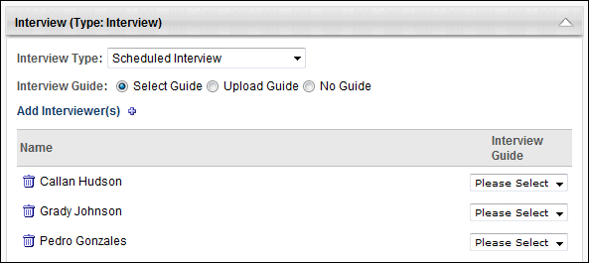
- Upload Guide - When selected, the Interview Guide column displays a plus icon that enables you to upload an interview guide. This allows you to include an interview guide that is not available in Interview Guide Management.
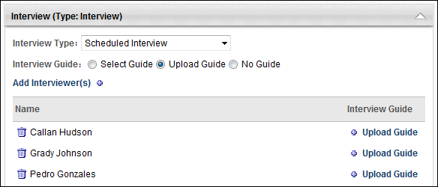
- No Guide - Select this option to not include an interview guide for interviewers.
Add Interviewers
Interviewers are added to the Interviewers table by clicking the plus icon to the right of Add Interviewer(s). This opens the Add pop-up. The pop-up displays the interviewers that were added to the Applicant Interviewer(s) section on the General tab of the template. Click the plus icon to the left of each interviewer you would like to add. Then, click Done. The interviewers are added to the Interviewers table.
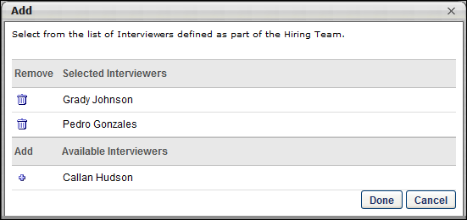
Note: Interviewers only display in the Add pop-up if they are defined in the Applicant Interviewer(s) section of the General tab for the requisition. Interviewers that are added to the Applicant Interviewer(s) section are not automatically added to the Interviewers table. Interviewers must be added manually using the Add Interviewer(s) feature.
Note: The same interviewer can be added to multiple Interview type status panels.
Interviewers Table
The Interviewers table displays the interviewers and the interview guide option for the interviewers.
The following information appears in the table:
Column Name | Description
Remove | Click the Trash Can icon to the left of the interviewer's name either in the Interviewers table or in the Add pop-up. This removes the interviewer and the interview guide from the table.  When editing or copying a requisition, interviewers can be removed from the requisition even if they are already scheduled for an interview. The interview that is scheduled is not modified.  Note: When removing interviewers from the Add pop-up, click Done to complete the removal action.
Name | This column displays the name of the interviewer.
Interview Guide | This column displays one of the following, depending on the option selected in the Interview Guide field:  - Select drop-down - A Select drop-down displays if the Select Guide option is selected in the Interview Guide field. Select a guide from the drop-down. The guides that are available to select are created in Interview Guide Management. You can delete the guide by clicking the Trash Can icon to the left of the guide.  - Attach Guide - This option displays if the Upload Guide option is selected in the Interview Guide field. Click the plus icon to upload a file. This opens the Upload Guide pop-up. In the Title field, enter the title that will display to interviewers, up to 250 characters. Click the Browse button to locate and select the file. Then, click Upload. This adds a link to the guide in the Interview Guide column. You can delete the guide by clicking the Trash Can icon to the left of the guide. The maximum file size is 1MB. The acceptable file types are .doc, .docx, .xls, .xlsx, .pdf, .txt, and .rtf.  - No Guide - This text displays if the No Guide option is selected in the Interview Guide field.
Create Job Requisition - Applicant Review Tab - SHL Assessment Status Type
From the SHL Assessment Type Status panel, administrators with permission to edit the Applicant Review tab can define the assessment that will be available to applicants for that step in the application workflow. The name of the status displays in the panel header.
Only one assessment can be added to each SHL Assessment status type panel.
Note: The configurations in the SHL Assessment status type panel do not remain available if the backend settings for the assessment functionality are disabled after the configurations are saved. The title of the status is also removed from the panel header.
Add Assessment
To add an assessment:
- Click the Add Assessment link. This opens the Select External Assessment pop-up.
- Select an assessment from the list of assessments. This closes the pop-up and adds the assessment to the status type panel. Note: If the assessment vendor requires that only one solutionID can be associated per requisition, and an assessment has already been associated with the requisition (either in the application workflow or applicant review settings), then the only assessments that are available to select are the assessments that share the same solutionID.
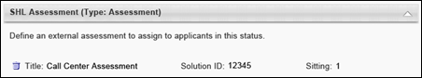
Once the assessment is added to the status type panel, the following information displays for the assessment:
- Delete - Click the Trash Can icon to the left of the assessment title to delete the assessment. This removes the assessment from the panel and enables the Add Assessment link to reappear.
- Title - This field displays the title of the assessment.
- Solution ID - This field displays the solutionID for the assessment. See Add Assessment for additional information about solutionIDs.
- Sitting - This field displays the sitting number for the solutionID. See Add Assessment for additional information about solutionIDs.
Status Change Emails
As with existing functionality, Applicant Status Change emails can be configured for the status type. See Status Change Emails on page 112 for additional information.
Status Change Emails
The Status Change Emails option is available for all status types when creating, editing, and copying job requisitions. This option enables administrators to include one or more Applicant Status Change emails to each status in the applicant status workflow. When included for a status, the emails trigger when an applicant moves into the associated status. Configuring applicant status emails for job requisitions helps ensure that the right people are notified of changes to an applicant's status.
To access Manage Job Requisitions, go to Recruit > Manage Requisitions.
Permissions
PERMISSION NAME | PERMISSION DESCRIPTION | CATEGORY

Requisition: Edit Applicant Review | Grants ability to edit the Applicant Review tab of the Edit Requisition page. This permission cannot be constrained. | Recruiting

Requisition: Manage | Grants ability to access and manage all requisitions regardless of ownership (constraints permitting). This permission also grants read-only access to the Applicant Review tab when creating or editing a job requisition. This permission can be constrained by OU, User's OU, and Grade. | Recruiting

Requisition: Owner | Enables owner to access requisitions and applicants for requisitions for which they are an owner. This permission also grants read-only access to video interviews that are completed by applicants via HireVue. For portals with Referral Suite enabled, this permission also enables requisition owners to edit the referral source on the Applicant Profile page. This permission cannot be constrained.  Note: This is a dynamically assigned permission that is not available in Security Role Administration. If the user is removed as an owner, the permission is revoked for the associated requisition. This permission cannot be manually assigned. Also, if a user has both the permission necessary to manage requisitions and be a requisition owner, the constraints of the Requisition: Manage permission overrule those of the Requisition: Owner permission. For requisition owners that do not also have permission to manage requisitions, only certain fields are editable when editing a requisition. | Recruiting
Note: The permission to review or approve a job requisition grants users view access to the requisition.
Note: For users with permission to access job requisitions but who do not have permission to edit the Applicant Review tab, the tab is visible but cannot be modified.
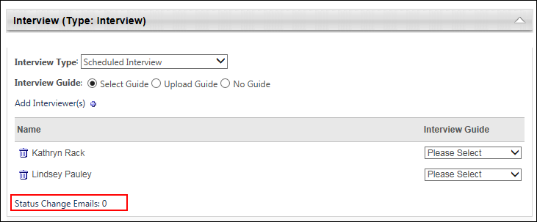
Status Change Emails Option
All status panels include an option to add one or more Applicant Status Change emails to the status. Administrators can define which emails are triggered for each status in the applicant status workflow. The selected Applicant Status Change emails are triggered when the applicant moves into the associated status. Selecting Applicant Status Change emails for a status is not required.
Use Case
An applicant is currently in a status of Phone Interview. The applicant completes the phone interview, and the recruiter updates her status to Onsite Interview. When the Phone Interview status is changed to Onsite Interview, the Applicant Status Change email that is defined for the Onsite Interview status is triggered. The email is sent to all users who are defined as interviewers for the onsite interview.
Define Applicant Status Change Email
To select the status change emails:
- Click Status Change Emails in the status panel. This opens the Status Change Emails pop-up. The pop-up displays the list of email templates that are defined for the associated status. Note: The email templates in the pop-up are configured by the administrator in Email Management.
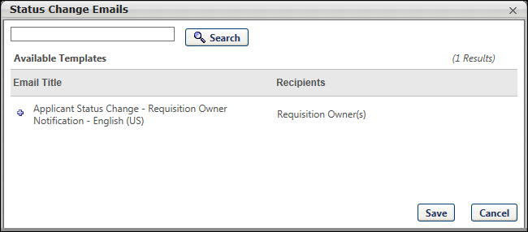
- Select one or more email templates. The selected emails display in the Selected Templates table in the pop-up. You can delete an email from the Selected Templates table by clicking the Delete icon to the left of the template name.
- Click Save. This adds the email templates to the status. Note: The content of the emails cannot be modified from the requisition template. The emails can only be modified by the administrator in Email Management.
Once the emails are added to the status, the number of emails that are added displays to the right of the Status Change Emails link.

Create Related Job Requisition
If enabled by the administrator in Requisition and Applicant Preferences, recruiters can create hierarchical relationships between job requisitions by adding child requisitions. Once a parent requisition is created, child requisitions can be added to the parent on the Create Requisition Family page. This page includes most of the same options that are available for the parent requisition but also includes an option to select the parent. In addition, since child requisitions must have the same job title as the parent, the Job Title field is disabled when creating child requisitions.
Note: The Related Requisitions functionality is not available at this time for career sites that are created using Mobile-Friendly Candidate Experience.
Use Case
An organization in Madrid, Spain would like to create one job requisition in multiple languages and post the job to a job board. The recruiter creates a parent requisition in Spanish, and then creates standard related requisitions in German, French (France), and Dutch. In the related requisitions, the recruiter makes sure to enter the translated information in the appropriate fields that are visible to applicants. For example, all text fields that are visible to applicants are written in French (France) for the job that is at the Paris, France office. In addition, the recruiter selects a requisition template that has been written in French (France) so that the application workflow (the job application that the applicant will complete) is also in French (France). The recruiter posts the requisitions to the job board.
An applicant who speaks French (France) views the organization's jobs on the job board. She reads the job description for the job that is written in French (France) and applies.
To create a related job requisition, navigate to the General tab of an existing requisition and click Add Related Requisition. See Create Job Requisition - General on page 47 for additional information.
Permissions
PERMISSION NAME | PERMISSION DESCRIPTION | CATEGORY

Requisition: Manage | Grants ability to access and manage all requisitions regardless of ownership (constraints permitting). This permission also grants read-only access to the Applicant Review tab when creating or editing a job requisition. This permission can be constrained by OU, User's OU, and Grade. | Recruiting
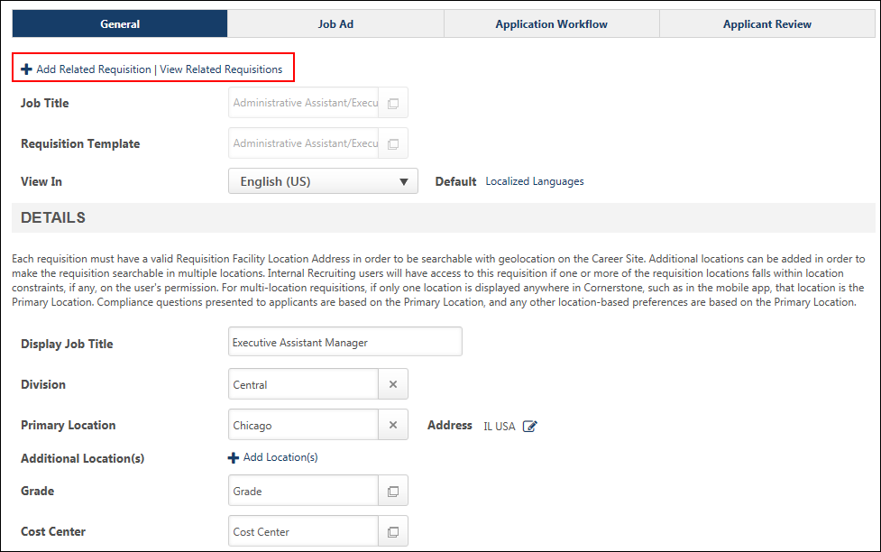
When creating a child requisition, all fields from the parent requisition are copied to the child. The parent requisition is automatically selected and displays in the Job Title field. The parent requisition to which the child requisition is associated cannot be changed. In addition, the Job Title field is disabled and cannot be modified.
Create Exact Copy of Parent Requisition
The child requisition can be created as an exact copy of the parent. To create an exact copy, keep all fields the same as the parent and submit the requisition from the External Postings tab.
Create Modified Copy of Parent Requisition
To create a modified version of the parent requisition, change any of the fields that can be changed on any of the tabs. Then, submit the requisition from the External Postings tab.
Add Related Requisition
When creating a child requisition, an Add Related Requisition link displays at the top of each page. This option allows recruiters to create additional child requisitions to associate to the parent requisition. This option is enabled once the child requisition is saved or submitted. The option displays on all tabs of the requisition and is available for recruiters with permission to view the parent requisition.
Clicking the Add Related Requisition link opens the Related Requisition Type pop-up.
Related Requisition Type Pop-Up
The Related Requisition Type pop-up allows recruiters to add either a related requisition or a related requisition that allows applicants to apply to multiple locations. Select one of the following options in the pop-up:
- Related Requisition - This option is selected by default. When selected, recruiters can add a standard related requisition. With this related requisition type, applicants can only apply to one requisition at a time. In addition, the requisition template can be modified, which allows for multiple application workflows, depending on the configuration of the selected template.
- Related Requisition (Apply to Multiple Jobs) - This option is unselected by default. When selected, recruiters can add related requisitions that allow applicants to apply at one time to each of the related requisitions associated to the parent requisition. In addition, the job title and requisition template cannot be modified, which means that each related requisition will have the same application workflow as the parent requisition.
Once the selection is made, click Done. This closes the pop-up and navigates the recruiter to the General tab of the related requisition. Any settings configured for the currently open requisition are saved. For the new child requisition, all settings configured for the parent requisition display for the child.
The Add Related Requisition link is only available for requisitions that are in an Open, Pending Approval, Open - Pending Re-Approval, or On-hold status.
View Related Requisitions
A View Related Requisitions link displays to the right of the Add Related Requisition link. This option is only available for recruiters with permission to view the parent requisition. This option is enabled once the child requisition is saved or submitted and does not display if there are no child requisitions created for the parent.
Clicking the View Related Requisitions link opens the Related Requisitions pop-up. The pop-up lists all requisitions related to the parent, in ascending order of requisition ID. The child requisition's requisition ID displays, as well as the location. If the child requisition has been saved, the pop-up displays the status as Draft. Recruiters can select a child requisition to navigate to the General tab of the selected requisition.
Save
To save the child requisition without submitting it, click the Save button. This saves the child requisition as a draft.
Next
Click Next to complete the next step of creating the child requisition.
Cancel
Click Cancel to cancel creating the child requisition.
Submit
To submit the child requisition, click the Submit button on the Applicant Review tab. This submits the requisition and makes it available for applicants once the child is posted, based on the settings configured for internal and external postings. See Create/Edit Requisition - Applicant Review Tab Overview on page 79 for additional information.
If applicants are not allowed to apply to the parent requisition, then submitting the child requisition also enables the parent requisition to be available on the career site's job search page so that applicants can select the parent requisition from the job search page, and then access the list of associated child requisitions to which they can apply.
Note: The Submit button and the Submit and Add Related Requisition button do not display on the Applicant Review tab for parent requisitions that are in a Closed status. The requisition cannot be submitted again, and related requisitions cannot be added.

Create Related Requisition (Apply to Multiple Jobs)
Recruiters can add a type of related requisition that allows applicants to apply for multiple requisitions related to the parent during a single application experience. This type of related requisition is similar to standard related requisitions in that it is related to the parent requisition. However, for this type of related requisition, applicants select multiple jobs to which they would like to apply, and then complete the application process one time for all of the selected jobs. Once completed, the application is tied to all related requisitions to which the applicant applied.
This feature is only available for requisitions that are posted to Standard career sites.
Note: A Related Requisition (Apply to Multiple Jobs) cannot be added to a parent requisition for which standard related requisitions have already been added.
Note: If an approval process has been configured for the parent requisition, then a Related Requisition (Apply to Multiple Jobs) cannot be added until the parent requisition is approved.
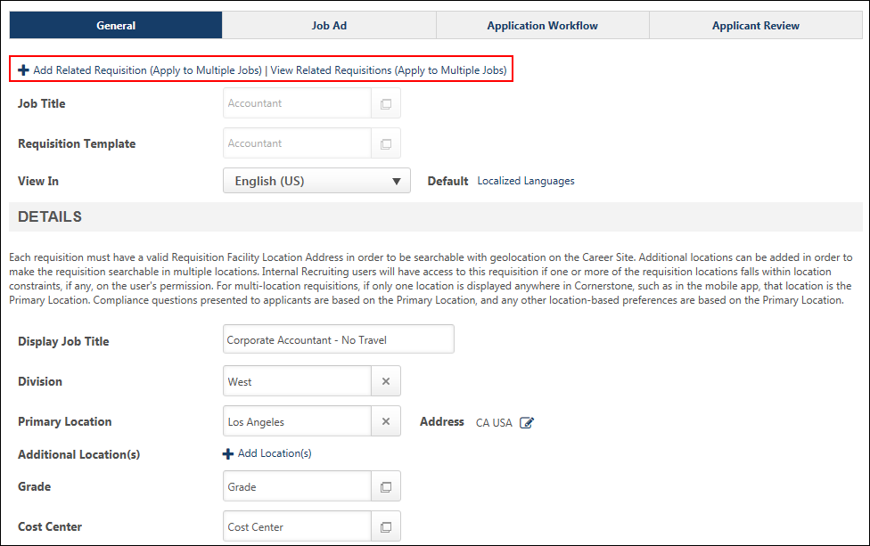
Add Requisition
Recruiters can add a Related Requisition (Apply to Multiple Jobs) by doing one of the following:
- Click the Submit and Add Related Requisition Button - This option displays on the Applicant Review tab. This option is available for the parent requisition and on the Applicant Review tab for related requisitions.
- Click the Add Related Requisition (Apply to Multiple Jobs) Link - After at least one Related Requisition (Apply to Multiple Jobs) has been added, this option displays as a link on all pages of the requisition, including the parent requisition. The link is only enabled when at least one Related Requisitions (Apply to Multiple Jobs) has been saved. This option does not display for recruiters who do not have permission to view the parent requisition and for recruiters who do not have permission to manage job requisitions.
Clicking one of the above options opens the Related Requisition Type pop-up. Recruiters select the type of related requisition to add, and then click Done. This closes the pop-up and navigates the recruiter to the General tab of the related requisition. All fields of the parent requisition are copied.
If the parent requisition has not yet been submitted, then clicking Done submits the parent requisition.
Parent Requisition Fields Copied
When adding a Related Requisition (Apply to Multiple Jobs), all fields of the parent requisition are copied. Recruiters can modify most fields except for the Job Title and Requisition Template fields. The application workflow is inherited from the parent requisition and cannot be changed, since a different requisition template cannot be selected.
Standard Career Sites
In order for related requisitions to be available on the career site for the parent requisition, the related requisitions must be configured to be posted to the same career site as the parent.
Note: The ability for applicants to apply to multiple related requisitions is only available for requisitions that are posted to Standard career sites.
Requisition Status
The status for newly submitted Related Requisition (Apply to Multiple Jobs) is automatically defined as Open.
Pending Changes to Parent Requisition
If there are pending changes to the parent requisition, the changes are not saved to the parent when adding a Related Requisition (Apply to Multiple Jobs) by clicking the Add Related Requisition (Apply to Multiple Jobs) link.
Submit Requisition
Clicking the Submit button submits the Related Requisition (Apply to Multiple Jobs) for posting. The posting dates are dependent upon the dates defined on the Internal Posting and External Posting tabs.
Submit and Add Related Requisition
Clicking the Submit and Add Related Requisition button submits the Related Requisition (Apply to Multiple Jobs) for posting and allows the recruiters to add another Related Requisition (Apply to Multiple Jobs). When Submit and Add Related Requisition is clicked, the recruiter is directed to the General page of the new requisition.
Note: The Related Requisition Type pop-up does not display, since standard related requisitions cannot be added to a parent requisition that already has at least one Related Requisition (Apply to Multiple Jobs).
Save Requisition
Clicking the Save button saves the settings on the Related Requisition (Apply to Multiple Jobs) but does not submit the requisition. When Save is clicked, the user is directed to the Manage Job Requisitions page.
View Related Requisitions
A View Related Requisitions link displays to the right of the Add Related Requisition link. This option is only available for recruiters with permission to view the parent requisition. This option is enabled once the child requisition is saved or submitted and does not display if there are no child requisitions created for the parent.
Clicking the View Related Requisitions link opens the Related Requisitions pop-up. The pop-up lists all requisitions related to the parent, in ascending order of requisition ID. The child requisition's requisition ID displays, as well as the location. If the child requisition has been saved, the pop-up displays the status as Draft. Recruiters can select a child requisition to navigate to the General tab of the selected requisition.

Edit Job Requisition
In some instances, you may need to edit an existing requisition. There are a number of reasons why a requisition may need to be edited, such as correcting errors and incorporating edits from hiring managers. The General, Applicant Review, and Job Ad pages of a requisition can be edited on the Edit Requisition page. However, editable fields are defined by the requisition's current status. Non-editable fields are grayed out and not selectable.
Fields are also editable on the Job Postings page for users with permission to edit postings.
To access the Edit Requisition page, go to Recruit > Manage Requisition. On the Manage Job Requisitions page, locate the requisition that you would like to edit, and then click the Edit link in the options drop-down for the requisition.
Permissions
PERMISSION NAME | PERMISSION DESCRIPTION | CATEGORY

Requisition: Edit Approvals | Grants ability to edit the requisition approval section for requisitions. | Recruiting

Requisition: Edit Owners | Grants ability to edit the owners section for requisitions. This permission can be constrained by OU and User's OU. | Recruiting

Requisition: Edit Job Ad | Grants ability to edit the Job Ad tab of the Edit Requisition page. This permission cannot be constrained. | Recruiting

Requisition: Edit Postings | Grants ability to edit the Job Postings page for a job requisition. In addition, this permission enables users to store user-level credentialing information for job board aggregation partners on Edge. This permission cannot be constrained. | Recruiting

Requisition: Edit Reviewers | Grants ability to edit the requisition reviewers section for requisitions. This permission can be constrained by OU. | Recruiting

Requisition: Manage | Grants ability to access and manage all requisitions regardless of ownership (constraints permitting). This permission also grants read-only access to the Applicant Review tab when creating or editing a job requisition. This permission can be constrained by OU, User's OU, and Grade. | Recruiting

Requisition: Owner | Enables owner to access requisitions and applicants for requisitions for which they are an owner. This permission also grants read-only access to video interviews that are completed by applicants via HireVue. For portals with Referral Suite enabled, this permission also enables requisition owners to edit the referral source on the Applicant Profile page. This permission cannot be constrained.  Note: This is a dynamically assigned permission that is not available in Security Role Administration. If the user is removed as an owner, the permission is revoked for the associated requisition. This permission cannot be manually assigned. Also, if a user has both the permission necessary to manage requisitions and be a requisition owner, the constraints of the Requisition: Manage permission overrule those of the Requisition: Owner permission. For requisition owners that do not also have permission to manage requisitions, only certain fields are editable when editing a requisition. | Recruiting

Requisition: Reviewer | Enables reviewer to access requisitions and applicants for requisitions for which they are a reviewer. This permission cannot be constrained.  Note: This is a dynamically assigned permission that is not available in Security Role Administration. Once a requisition is in a Closed or Cancelled status or if the user is removed as a reviewer, the permission is revoked for the associated requisition. This permission cannot be manually assigned.  Note: If an applicant reviewer is removed as a reviewer via the Applicant Profile page, the Requisition: Reviewer permission is revoked for the associated requisition. However, if the reviewer was also added as a reviewer via the General tab when creating, editing, or copying the requisition, the reviewer still appears on the In Review panel as a duplicate reviewer and retains access to the requisition and applicants from the Requisition: Reviewer permission. See Applicant Profile Page Overview for more information about duplicate reviewer instances. | Recruiting
Requisition owners that do not have the permission to manage requisitions can only edit a job requisition for which they are an owner. Requisition owners and users with the permission to manage requisitions can edit all tabs of a requisition with the following restrictions:
To select a position in the Job Title field and edit the Division and Location fields, you must have the permission to manage requisitions. For users that do not have the associated permission, these fields are read-only.
To edit the Requisition Owner field on the General step of the Edit Requisition page, you must have the necessary permission. For users that do not have this permission, the field is read-only. This permission must be used in conjunction with the permission to manage requisitions. Or, if a user is dynamically assigned the permission necessary to be a requisition owner and also has the permission needed to edit the Requisition Owner field on the General step of the Edit Requisition page, the field is editable.
For users that do not have the permission needed to edit the Approvals section on the General step of the Edit Requisition page, the field is read-only. This permission must be used in conjunction with the permission to manage requisitions. Or, if a user is dynamically assigned the permission necessary to be a requisition owner and also has the permission needed to edit the Approvals section on the General step of the Edit Requisition page, the field is editable.
For users that do not have the permission needed to edit the Applicant Reviewers section on the General step of the Edit Requisition page, the field is read-only. This permission must be used in conjunction with the permission to manage requisitions. Or, if a user is dynamically assigned the permission necessary to be a requisition owner and also has the permission needed to edit the Applicant Reviewers section on the General step of the Edit Requisition page, the field is editable.
For users that do not have the permission needed to edit the Job Ad step of the Edit Requisition page, the fields are read-only. This permission must be used in conjunction with the permission to manage requisitions. Or, if a user is dynamically assigned the permission necessary to be a requisition owner and also has the permission needed to edit the Job Ad step of the Edit Requisition page, the fields are editable.
For users that do not have the permission needed to edit the Job Postings page, the fields are read-only. This permission must be used in conjunction with the permission to manage requisitions. Or, if a user is dynamically assigned the permission necessary to be a requisition owner and also has the permission needed to edit the Job Postings page, the fields are editable.
Requisition reviewers that do not have the permission to manage requisitions can only access the Edit Requisition pages of a job requisition for which they are a reviewer. Note: All fields on all Edit Requisition pages are read-only for reviewers that only have the permission to be a requisition reviewer.
Editable Fields Based on Requisition Status
As noted previously, the fields that are editable depend on which status the requisition is in at the time of editing. The following tables define the editable status of all fields on the job requisition based on the requisition's status:
Draft Status
Field Name | Editable | Requires Approval | Commits Changes to Requisition | Audit Value History | Notes
Job Title | Yes | No | On Save/Submit | On Status Changes | When in Draft, the Job Title field is always editable.
Requisition Template | Yes | No | N/A | N/A | Changing the template in the Requisition Template field deletes all values from all fields on the requisition that are tied to the template.  Note: When editing the Requisition Template field for a job requisition, if a default template is not defined for the recruiter's organizational unit (OU), then the Default Requisition Template link does not display in the Select Requisition Template pop-up. The link does not display even if a default template was defined for the requisition prior to editing the requisition. In addition, if a recruiter from a different OU edits the Requisition Template field, then the default template defined for the OU of the recruiter editing the requisition replaces the previous default template.
Display Job Title | Yes | No | On Save/Submit | On Status Changes | Edits to field affect associated tag on Save/Submit.
Division | Yes | No | On Save/Submit | On Status Changes | Edits to field affect associated tag on Save/Submit.
Location | Yes | No | On Save/Submit | On Status Changes | Edits to field affect associated tag on Save/Submit.
Address | Yes | No | On Save/Submit | On Status Changes | Edits to field affect associated tag on Save/Submit.
Contact Phone | Yes | No | On Save/Submit | On Status Changes | Edits to field affect associated tag on Save/Submit.
EEO Category | Yes | No | On Save/Submit | On Status Changes | Edits to field affect associated tag on Save/Submit.
Employment Type | Yes | No | On Save/Submit | On Status Changes | Edits to field affect associated tag on Save/Submit.
Full Time vs. Part Time | Yes | No | On Save/Submit | On Status Changes | Edits to field affect associated tag on Save/Submit.
Currency | Yes | No | On Save/Submit | On Status Changes | Edits to field affect associated tag on Save/Submit.
Compensation | Yes | No | On Save/Submit | On Status Changes | Edits to field affect associated tag on Save/Submit.
Range Low | Yes | No | On Save/Submit | On Status Changes | Edits to field affect associated tag on Save/Submit.
Range High | Yes | No | On Save/Submit | On Status Changes | Edits to field affect associated tag on Save/Submit.
Referral Bonus | Yes | No | On Save/Submit | On Status Changes | Edits to field affect associated tag on Save/Submit.
Custom Fields | Yes | No | On Save/Submit | On Status Changes
Description Internal | Yes | No | On Save/Submit | On Status Changes | Edits to field affect associated tag on Save/Submit.
Description External | Yes | No | On Save/Submit | On Status Changes | Edits to field affect associated tag on Save/Submit.
Qualifications Minimum | Yes | No | On Save/Submit | On Status Changes | Edits to field affect associated tag on Save/Submit.
Qualifications Ideal | Yes | No | On Save/Submit | On Status Changes | Edits to field affect associated tag on Save/Submit.
Requisition Owner(s) | Yes | No | On Save/Submit | On Status Changes | Edits to field affect associated email recipients on Save/Submit.
Applicant Reviewer(s) | Yes | No | On Save/Submit | On Status Changes | Edits to field affect associated email recipients on Save/Submit.
Applicant Interviewer(s) | Yes | No | On Save/Submit | On Status Changes | Edits to field affect associated email recipients on Save/Submit.
Approvals | Yes | No | On Save/Submit | On Status Changes | Edits to field affect associated email recipients on Save/Submit.
Requisition ID | No | N/A | N/A | N/A
Priority | Yes | No | On Save/Submit | On Status Changes
Openings | Yes | No | On Save/Submit | On Status Changes
On Going | Yes | No | On Save/Submit | On Status Changes
Target Hire Date | Yes | No | On Save/Submit | On Status Changes | Edits to field affect associated tag on Save/Submit.
Requisition Status | Yes | No | On Save/Submit | On Status Changes | When the requisition is in Draft status, the status can be changed to the following:  - Cancelled  - Open  - Pending Approval - Note: The requisition cannot be changed to this status from the Requisition Status field.
Job Ad External | Yes | No | On Save/Submit | On Status Changes
Job Ad Internal | Yes | No | On Save/Submit | On Status Changes
Clone External Site | Yes | No | On Save/Submit | On Status Changes
Application Workflow | Yes | No | On Save/Submit | On Status Changes
Applicant Review - Interview Status Type - Interview Type | Yes | No | On Save/Submit | On Status Changes
Applicant Review - Interview Status Type Scheduled - Interview Guide | Yes | No | On Save/Submit | On Status Changes
Applicant Review - Interview Status Type Scheduled - Add Interviewers | Yes | No | On Save/Submit | On Status Changes
Applicant Review - Interview Status Type Scheduled - Interview Guide Column | Yes | No | On Save/Submit | On Status Changes
Applicant Review - Interview Status Type OnDemand Video - Create Interview | Yes | No | On Save/Submit | On Status Changes
Applicant Review - Interview Status Type OnDemand Video - Add Video Interview Reviewer(s) | Yes | No | On Save/Submit | On Status Changes
Job Postings - Smart Referral - Enable Smart Referral Checkbox | Yes | No | On Save/Submit | On Status Changes
Job Postings - Smart Referral - Select OU Criteria | Yes | No | On Save/Submit | On Status Changes
Job Postings - Smart Referral - Delete OU Criteria | Yes | No | On Save/Submit | On Status Changes
Job Postings - Smart Referral - Create New Group | Yes | No | On Save/Submit | On Status Changes
Job Postings - Smart Referral - Effective Date | Yes | No | On Save/Submit | On Status Changes
Job Postings - Smart Referral - Expiration Date | Yes | No | On Save/Submit | On Status Changes
Job Postings - Career Center - Enable Career Center Checkbox | Yes | No | On Save/Submit | On Status Changes
Job Postings - Career Center - Select OU Criteria | Yes | No | On Save/Submit | On Status Changes
Job Postings - Career Center - Delete OU Criteria | Yes | No | On Save/Submit | On Status Changes
Job Postings - Career Center - Create New Group | Yes | No | On Save/Submit | On Status Changes
Job Postings - Career Center - Effective Date | Yes | No | On Save/Submit | On Status Changes
Job Postings - Career Center - Expiration Date | Yes | No | On Save/Submit | On Status Changes
Job Postings - Recruiting Agencies - Add Recruiting Agency | Yes | No | On Save/Submit | On Status Changes
Job Postings - Recruiting Agencies - Delete Recruiting Agency | Yes | No | On Save/Submit | On Status Changes
Job Postings - Recruiting Agencies - Effective Date | Yes | No | On Save/Submit | On Status Changes
Job Postings - Recruiting Agencies - Expiration Date | Yes | No | On Save/Submit | On Status Changes
Job Postings - Career Sites - Effective Date | Yes | No | On Save/Submit | On Status Changes
Job Postings - Career Sites - Expiration Date | Yes | No | On Save/Submit | On Status Changes
Job Postings - Career Sites - Name Checkbox Select Individual | Yes | No | On Save/Submit | On Status Changes
Job Postings - Career Sites - Default Radio Button | Yes | No | On Save/Submit | On Status Changes
Job Postings - Job Boards - Delete Job Board | Yes | No | On Save/Submit | On Status Changes
Canceled Status
Field Name | Editable | Requires Approval | Commits Changes to Requisition | Audit Value History | Notes
Job Title | No | N/A | N/A | N/A
Requisition Template | No | N/A | N/A | N/A
Display Job Title | No | N/A | N/A | N/A
Division | No | N/A | N/A | N/A
Location | No | N/A | N/A | N/A
Address | No | N/A | N/A | N/A
Contact Phone | No | N/A | N/A | N/A
EEO Category | No | N/A | N/A | N/A
Employment Type | No | N/A | N/A | N/A
Full Time vs. Part Time | No | N/A | N/A | N/A
Currency | No | N/A | N/A | N/A
Compensation | No | N/A | N/A | N/A
Range Low | No | N/A | N/A | N/A
Range High | No | N/A | N/A | N/A
Referral Bonus | No | N/A | N/A | N/A
Custom Fields | No | N/A | N/A | N/A
Description Internal | No | N/A | N/A | N/A
Description External | No | N/A | N/A | N/A
Qualifications Minimum | No | N/A | N/A | N/A
Qualifications Ideal | No | N/A | N/A | N/A
Requisition Owner(s) | No | N/A | N/A | N/A
Applicant Reviewer(s) | No | N/A | N/A | N/A
Applicant Interviewer(s) | No | N/A | N/A | N/A
Approvals | No | N/A | N/A | N/A
Requisition ID | No | N/A | N/A | N/A
Priority | No | N/A | N/A | N/A
Openings | No | N/A | N/A | N/A
On Going | No | N/A | N/A | N/A
Target Hire Date | No | N/A | N/A | N/A
Requisition Status | Yes | No | On Status Change | On Status Changes | When the requisition is in Cancelled status, the status cannot be changed.
Job Ad External | No | N/A | N/A | N/A
Job Ad Internal | No | N/A | N/A | N/A
Clone External Site | No | N/A | N/A | N/A
Application Workflow | No | N/A | N/A | N/A
Applicant Review - Interview Status Type - Interview Type | No | N/A | N/A | N/A
Applicant Review - Interview Status Type Scheduled - Interview Guide | No | N/A | N/A | N/A
Applicant Review - Interview Status Type Scheduled - Add Interviewers | No | N/A | N/A | N/A
Applicant Review - Interview Status Type Scheduled - Interview Guide Column | No | N/A | N/A | N/A
Applicant Review - Interview Status Type OnDemand Video - Create Interview | No | N/A | N/A | N/A
Applicant Review - Interview Status Type OnDemand Video - Add Video Interview Reviewer(s) | No | N/A | N/A | N/A
Job Postings - Smart Referral - Enable Smart Referral Checkbox | No | N/A | N/A | N/A
Job Postings - Smart Referral - Select OU Criteria | No | N/A | N/A | N/A
Job Postings - Smart Referral - Delete OU Criteria | No | N/A | N/A | N/A
Job Postings - Smart Referral - Create New Group | No | N/A | N/A | N/A
Job Postings - Smart Referral - Effective Date | No | N/A | N/A | N/A
Job Postings - Smart Referral - Expiration Date | No | N/A | N/A | N/A
Job Postings - Career Center - Enable Career Center Checkbox | No | N/A | N/A | N/A
Job Postings - Career Center - Select OU Criteria | No | N/A | N/A | N/A
Job Postings - Career Center - Delete OU Criteria | No | N/A | N/A | N/A
Job Postings - Career Center - Create New Group | No | N/A | N/A | N/A
Job Postings - Career Center - Effective Date | No | N/A | N/A | N/A
Job Postings - Career Center - Expiration Date | No | N/A | N/A | N/A
Job Postings - Recruiting Agencies - Add Recruiting Agency | No | N/A | N/A | N/A
Job Postings - Recruiting Agencies - Delete Recruiting Agency | No | N/A | N/A | N/A
Job Postings - Recruiting Agencies - Effective Date | No | N/A | N/A | N/A
Job Postings - Recruiting Agencies - Expiration Date | No | N/A | N/A | N/A
Job Postings - Career Sites - Effective Date | No | N/A | N/A | N/A
Job Postings - Career Sites - Expiration Date | No | N/A | N/A | N/A
Job Postings - Career Sites - Name Checkbox Select Individual | No | N/A | N/A | N/A
Job Postings - Career Sites - Default Radio Button | No | N/A | N/A | N/A
Job Postings - Job Boards - Delete Job Board | No | N/A | N/A | N/A
Pending Approval Status
Field Name | Editable | Requires Approval | Commits Changes to Requisition | Audit Value History | Notes
Job Title | No | N/A | N/A | N/A
Requisition Template | No | N/A | N/A | N/A
Display Job Title | No | N/A | N/A | N/A
Division | No | N/A | N/A | N/A
Location | No | N/A | N/A | N/A
Address | No | N/A | N/A | N/A
Contact Phone | No | N/A | N/A | N/A
EEO Category | No | N/A | N/A | N/A
Employment Type | No | N/A | N/A | N/A
Full Time vs. Part Time | No | N/A | N/A | N/A
Currency | No | N/A | N/A | N/A
Compensation | No | N/A | N/A | N/A
Range Low | No | N/A | N/A | N/A
Range High | No | N/A | N/A | N/A
Referral Bonus | No | N/A | N/A | N/A
Custom Fields | No | N/A | N/A | N/A
Description Internal | No | N/A | N/A | N/A
Description External | No | N/A | N/A | N/A
Qualifications Minimum | No | N/A | N/A | N/A
Qualifications Ideal | No | N/A | N/A | N/A
Requisition Owner(s) | No | N/A | N/A | N/A
Applicant Reviewer(s) | No | N/A | N/A | N/A
Applicant Interviewer(s) | No | N/A | N/A | N/A
Approvals | No | N/A | N/A | N/A
Requisition ID | No | N/A | N/A | N/A
Priority | No | N/A | N/A | N/A
Openings | No | N/A | N/A | N/A
On Going | No | N/A | N/A | N/A
Target Hire Date | No | N/A | N/A | N/A
Requisition Status | Yes | No | On Status Change | On Status Changes | When the requisition is in Pending Approval status, the status can be changed to the following:  - Draft - Note: When the status is changed to Draft, any existing approval/denial responses are removed, as well as any pending approval/denial responses.  - Cancelled
Job Ad External | No | N/A | N/A | N/A
Job Ad Internal | No | N/A | N/A | N/A
Clone External Site | No | N/A | N/A | N/A
Application Workflow | No | N/A | N/A | N/A
Applicant Review - Interview Status Type - Interview Type | No | N/A | N/A | N/A
Applicant Review - Interview Status Type Scheduled - Interview Guide | No | N/A | N/A | N/A
Applicant Review - Interview Status Type Scheduled - Add Interviewers | No | N/A | N/A | N/A
Applicant Review - Interview Status Type Scheduled - Interview Guide Column | No | N/A | N/A | N/A
Applicant Review - Interview Status Type OnDemand Video - Create Interview | No | N/A | N/A | N/A
Applicant Review - Interview Status Type OnDemand Video - Add Video Interview Reviewer(s) | No | N/A | N/A | N/A
Job Postings - Smart Referral - Enable Smart Referral Checkbox | No | N/A | N/A | N/A
Job Postings - Smart Referral - Select OU Criteria | No | N/A | N/A | N/A
Job Postings - Smart Referral - Delete OU Criteria | No | N/A | N/A | N/A
Job Postings - Smart Referral - Create New Group | No | N/A | N/A | N/A
Job Postings - Smart Referral - Effective Date | No | N/A | N/A | N/A
Job Postings - Smart Referral - Expiration Date | No | N/A | N/A | N/A
Job Postings - Career Center - Enable Career Center Checkbox | No | N/A | N/A | N/A
Job Postings - Career Center - Select OU Criteria | No | N/A | N/A | N/A
Job Postings - Career Center - Delete OU Criteria | No | N/A | N/A | N/A
Job Postings - Career Center - Create New Group | No | N/A | N/A | N/A
Job Postings - Career Center - Effective Date | No | N/A | N/A | N/A
Job Postings - Career Center - Expiration Date | No | N/A | N/A | N/A
Job Postings - Recruiting Agencies - Add Recruiting Agency | No | N/A | N/A | N/A
Job Postings - Recruiting Agencies - Delete Recruiting Agency | No | N/A | N/A | N/A
Job Postings - Recruiting Agencies - Effective Date | No | N/A | N/A | N/A
Job Postings - Recruiting Agencies - Expiration Date | No | N/A | N/A | N/A
Job Postings - Career Sites - Effective Date | No | N/A | N/A | N/A
Job Postings - Career Sites - Expiration Date | No | N/A | N/A | N/A
Job Postings - Career Sites - Name Checkbox Select Individual | No | N/A | N/A | N/A
Job Postings - Career Sites - Default Radio Button | No | N/A | N/A | N/A
Job Postings - Job Boards - Delete Job Board | No | N/A | N/A | N/A
Denied Status
Field Name | Editable | Requires Approval | Commits Changes to Requisition | Audit Value History | Notes
Job Title | No | N/A | N/A | N/A
Requisition Template | No | N/A | N/A | N/A
Display Job Title | No | N/A | N/A | N/A
Division | No | N/A | N/A | N/A
Location | No | N/A | N/A | N/A
Address | No | N/A | N/A | N/A
Contact Phone | No | N/A | N/A | N/A
EEO Category | No | N/A | N/A | N/A
Employment Type | No | N/A | N/A | N/A
Full Time vs. Part Time | No | N/A | N/A | N/A
Currency | No | N/A | N/A | N/A
Compensation | No | N/A | N/A | N/A
Range Low | No | N/A | N/A | N/A
Range High | No | N/A | N/A | N/A
Referral Bonus | No | N/A | N/A | N/A
Custom Fields | No | N/A | N/A | N/A
Description Internal | No | N/A | N/A | N/A
Description External | No | N/A | N/A | N/A
Qualifications Minimum | No | N/A | N/A | N/A
Qualifications Ideal | No | N/A | N/A | N/A
Requisition Owner(s) | No | N/A | N/A | N/A
Applicant Reviewer(s) | No | N/A | N/A | N/A
Applicant Interviewer(s) | No | N/A | N/A | N/A
Approvals | No | N/A | N/A | N/A
Requisition ID | No | N/A | N/A | N/A
Priority | No | N/A | N/A | N/A
Openings | No | N/A | N/A | N/A
On Going | No | N/A | N/A | N/A
Target Hire Date | No | N/A | N/A | N/A
Requisition Status | Yes | No | On Status Change | On Status Changes | When the requisition is in Denied status, the status can be changed to the following:  - Draft - Note: When the status is changed to Draft, approvals are reset.  - Cancelled
Job Ad External | No | N/A | N/A | N/A
Job Ad Internal | No | N/A | N/A | N/A
Clone External Site | No | N/A | N/A | N/A
Application Workflow | No | N/A | N/A | N/A
Applicant Review - Interview Status Type - Interview Type | No | N/A | N/A | N/A
Applicant Review - Interview Status Type Scheduled - Interview Guide | No | N/A | N/A | N/A
Applicant Review - Interview Status Type Scheduled - Add Interviewers | No | N/A | N/A | N/A
Applicant Review - Interview Status Type Scheduled - Interview Guide Column | No | N/A | N/A | N/A
Applicant Review - Interview Status Type OnDemand Video - Create Interview | No | N/A | N/A | N/A
Applicant Review - Interview Status Type OnDemand Video - Add Video Interview Reviewer(s) | No | N/A | N/A | N/A
Job Postings - Smart Referral - Enable Smart Referral Checkbox | No | N/A | N/A | N/A
Job Postings - Smart Referral - Select OU Criteria | No | N/A | N/A | N/A
Job Postings - Smart Referral - Delete OU Criteria | No | N/A | N/A | N/A
Job Postings - Smart Referral - Create New Group | No | N/A | N/A | N/A
Job Postings - Smart Referral - Effective Date | No | N/A | N/A | N/A
Job Postings - Smart Referral - Expiration Date | No | N/A | N/A | N/A
Job Postings - Career Center - Enable Career Center Checkbox | No | N/A | N/A | N/A
Job Postings - Career Center - Select OU Criteria | No | N/A | N/A | N/A
Job Postings - Career Center - Delete OU Criteria | No | N/A | N/A | N/A
Job Postings - Career Center - Create New Group | No | N/A | N/A | N/A
Job Postings - Career Center - Effective Date | No | N/A | N/A | N/A
Job Postings - Career Center - Expiration Date | No | N/A | N/A | N/A
Job Postings - Recruiting Agencies - Add Recruiting Agency | No | N/A | N/A | N/A
Job Postings - Recruiting Agencies - Delete Recruiting Agency | No | N/A | N/A | N/A
Job Postings - Recruiting Agencies - Effective Date | No | N/A | N/A | N/A
Job Postings - Recruiting Agencies - Expiration Date | No | N/A | N/A | N/A
Job Postings - Career Sites - Effective Date | No | N/A | N/A | N/A
Job Postings - Career Sites - Expiration Date | No | N/A | N/A | N/A
Job Postings - Career Sites - Name Checkbox Select Individual | No | N/A | N/A | N/A
Job Postings - Career Sites - Default Radio Button | No | N/A | N/A | N/A
Job Postings - Job Boards - Delete Job Board | No | N/A | N/A | N/A
Open Status
Field Name | Editable | Requires Approval | Commits Changes to Requisition | Audit Value History | Notes
Job Title | No | N/A | N/A | N/A
Requisition Template | No | N/A | N/A | N/A
Display Job Title | Yes | Yes | On Save/Submit | On Approval | - Applies changes to internal postings on approval.  - Applies changes to external postings on approval.  - Applies changes to associated tag on approval.
Division | Yes | Yes | On Save/Submit | On Approval | - Applies changes to internal postings on approval.  - Never applies changes to external postings.  - Applies changes to associated tag on approval.
Location | Yes | Yes | On Save/Submit | On Approval | - Applies changes to internal postings on approval.  - Never applies changes to external postings.  - Applies changes to associated tag on approval.
Address | Yes | No | On Save/Submit | On Status Changes | - Applies changes to internal postings on Save/Submit.  - Never applies changes to external postings.  - Applies changes to associated tag on Submit.
Contact Phone | Yes | No | On Save/Submit | On Status Changes | - Applies changes to internal postings on Save/Submit.  - Never applies changes to external postings.  - Applies changes to associated tag on Submit.
EEO Category | Yes | No | On Save/Submit | On Status Changes | - Applies changes to internal postings on Save/Submit.  - Never applies changes to external postings.  - Applies changes to associated tag on Submit.
Employment Type | Yes | No | On Save/Submit | On Status Changes | - Applies changes to internal postings on Save/Submit.  - Never applies changes to external postings.  - Applies changes to associated tag on Submit.
Full Time vs. Part Time | Yes | No | On Save/Submit | On Status Changes | - Applies changes to internal postings on Save/Submit  - Never applies changes to external postings.  - Applies changes to associated tag on Submit.
Currency | Yes | Yes | On Save/Submit | On Approval | - Applies changes to internal postings on approval.  - Never applies changes to external postings.  - Applies changes to associated tag on approval.
Compensation | Yes | Yes | On Save/Submit | On Approval | - Applies changes to internal postings on approval.  - Never applies changes to external postings.  - Applies changes to associated tag on approval.
Range Low | Yes | Yes | On Save/Submit | On Approval | - Applies changes to internal postings on approval.  - Never applies changes to external postings.
Range High | Yes | Yes | On Save/Submit | On Approval | - Applies changes to internal postings on approval.  - Never applies changes to external postings.
Referral Bonus | Yes | No | On Save/Submit | On Approval | - Applies changes to internal postings on approval.  - Never applies changes to external postings.  - Applies changes to associated tag on approval.
Custom Fields | Yes | Yes | On Save/Submit | On Approval | - Applies changes to internal postings on approval.  - Never applies changes to external postings.
Description Internal | Yes | Yes | On Save/Submit | On Approval | - Applies changes to internal postings on approval.  - Never applies changes to external postings.  - Applies changes to associated tag on approval.
Description External | Yes | Yes | On Save/Submit | On Approval | - Never applies changes to internal postings.  - Applies changes to external postings on approval.  - Applies changes to associated tag on approval.
Qualifications Minimum | Yes | Yes | On Save/Submit | On Status Changes
Qualifications Ideal | Yes | Yes | On Save/Submit | On Status Changes
Requisition Owner(s) | Yes | No | On Save/Submit | On Status Changes | - Never applies changes to internal postings.  - Never applies changes to external postings.  - Edits to field affect associated email recipients on Save/Submit.
Applicant Reviewer(s) | Yes | No | On Save/Submit | On Approval | - Edits to field affect associated email recipients on Save/Submit.  - Modifying reviewers only affects submissions that are advanced after the date/time of modification.
Applicant Interviewer(s) | Yes | No | On Save/Submit | On Status Changes
Approvals | Yes | No | On Save/Submit | On Status Changes | - Edits to field affect associated email recipients on Save/Submit.  - Modifying reviewers only affects submissions that are advanced after the date/time of modification.
Requisition ID | No | N/A | N/A | N/A
Priority | Yes | No | On Save/Submit | On Status Changes
Openings | Yes | Yes | On Save/Submit | On Approval
On Going | Yes | Yes | On Save/Submit | On Approval
Target Hire Date | Yes | No | On Save/Submit | On Status Changes
Requisition Status | Yes | No | On Save/Submit | On Status Changes | When the requisition is in Draft status, the status can be changed to the following:  - Cancelled  - Open  - Pending Approval - Note: The requisition cannot be changed to this status from the Requisition Status field.
Job Ad External | Yes | Yes | On Save/Submit | On Approval | - Never applies changes to internal postings.  - Applies changes to external postings on approval.  - Applies changes to associated tag on approval.
Job Ad Internal | Yes | Yes | On Save/Submit | On Approval | - Applies changes to internal postings on approval.  - Never applies changes to external postings.  - Applies changes to associated tag on approval.
Clone External Site | Yes | No | On Save/Submit | On Approval
Application Workflow | No | N/A | N/A | N/A
Applicant Review - Interview Status Type - Interview Type | No | No | On Save/Submit | On Status Changes
Applicant Review - Interview Status Type Scheduled - Interview Guide | No | No | On Save/Submit | On Status Changes
Applicant Review - Interview Status Type Scheduled - Add Interviewers | No | No | On Save/Submit | On Status Changes
Applicant Review - Interview Status Type Scheduled - Interview Guide Column | No | No | On Save/Submit | On Status Changes
Applicant Review - Interview Status Type OnDemand Video - Create Interview | No | No | On Save/Submit | On Status Changes
Applicant Review - Interview Status Type OnDemand Video - Add Video Interview Reviewer(s) | No | No | On Save/Submit | On Status Changes
Job Postings - Smart Referral - Enable Smart Referral Checkbox | Yes | No | On Save/Submit | On Save/Submit | Applies changes to internal postings on Save/Submit.
Job Postings - Smart Referral - Select OU Criteria | Yes | No | On Save/Submit | On Save/Submit | Applies changes to internal postings on Save/Submit.
Job Postings - Smart Referral - Delete OU Criteria | Yes | No | On Save/Submit | On Save/Submit | Applies changes to internal postings on Save/Submit.
Job Postings - Smart Referral - Create New Group | Yes | No | On Save/Submit | On Save/Submit | Applies changes to internal postings on Save/Submit.
Job Postings - Smart Referral - Effective Date | Yes | No | On Save/Submit | On Save/Submit | Applies changes to internal postings on Save/Submit.
Job Postings - Smart Referral - Expiration Date | Yes | No | On Save/Submit | On Save/Submit | Applies changes to internal postings on Save/Submit.
Job Postings - Career Center - Enable Career Center Checkbox | Yes | No | On Save/Submit | On Save/Submit | Applies changes to internal postings on Save/Submit.
Job Postings - Career Center - Select OU Criteria | Yes | No | On Save/Submit | On Save/Submit | Applies changes to internal postings on Save/Submit.
Job Postings - Career Center - Delete OU Criteria | Yes | No | On Save/Submit | On Save/Submit | Applies changes to internal postings on Save/Submit.
Job Postings - Career Center - Create New Group | Yes | No | On Save/Submit | On Save/Submit | Applies changes to internal postings on Save/Submit.
Job Postings - Career Center - Effective Date | Yes | No | On Save/Submit | On Save/Submit | Applies changes to internal postings on Save/Submit.
Job Postings - Career Center - Expiration Date | Yes | No | On Save/Submit | On Save/Submit | Applies changes to internal postings on Save/Submit.
Job Postings - Recruiting Agencies - Add Recruiting Agency | Yes | No | On Save/Submit | On Save/Submit | Applies changes to external postings on Save/Submit.
Job Postings - Recruiting Agencies - Delete Recruiting Agency | Yes | No | On Save/Submit | On Save/Submit | Applies changes to external postings on Save/Submit.
Job Postings - Recruiting Agencies - Effective Date | Yes | No | On Save/Submit | On Save/Submit | Applies changes to external postings on Save/Submit.
Job Postings - Recruiting Agencies - Expiration Date | Yes | No | On Save/Submit | On Save/Submit | Applies changes to external postings on Save/Submit.
Job Postings - Career Sites - Effective Date | Yes | No | On Save/Submit | On Save/Submit | Applies changes to external postings on Save/Submit.
Job Postings - Career Sites - Expiration Date | Yes | No | On Save/Submit | On Save/Submit | Applies changes to external postings on Save/Submit.
Job Postings - Career Sites - Name Checkbox Select Individual | Yes | No | On Save/Submit | On Save/Submit | Applies changes to external postings on Save/Submit.
Job Postings - Career Sites - Default Radio Button | Yes | No | On Save/Submit | On Save/Submit | Applies changes to external postings on Save/Submit.
Job Postings - Job Boards - Delete Job Board | Yes | No | On Save/Submit | On Save/Submit | Applies changes to external postings on Save/Submit.
Open - Pending Re-Approval Status
Field Name | Editable | Requires Approval | Commits Changes to Requisition | Audit Value History | Notes
Job Title | No | N/A | N/A | N/A
Requisition Template | No | N/A | N/A | N/A
Display Job Title | No | N/A | N/A | N/A
Division | No | N/A | N/A | N/A
Location | No | N/A | N/A | N/A
Address | No | N/A | N/A | N/A
Contact Phone | No | N/A | N/A | N/A
EEO Category | No | N/A | N/A | N/A
Employment Type | No | N/A | N/A | N/A
Full Time vs. Part Time | No | N/A | N/A | N/A
Currency | No | N/A | N/A | N/A
Compensation | No | N/A | N/A | N/A
Range Low | No | N/A | N/A | N/A
Range High | No | N/A | N/A | N/A
Referral Bonus | No | N/A | N/A | N/A
Custom Fields | No | N/A | N/A | N/A
Description Internal | No | N/A | N/A | N/A
Description External | No | N/A | N/A | N/A
Qualifications Minimum | No | N/A | N/A | N/A
Qualifications Ideal | No | N/A | N/A | N/A
Requisition Owner(s) | No | N/A | N/A | N/A
Applicant Reviewer(s) | No | N/A | N/A | N/A
Applicant Interviewer(s) | No | N/A | N/A | N/A
Approvals | No | N/A | N/A | N/A
Requisition ID | No | N/A | N/A | N/A
Priority | No | N/A | N/A | N/A
Openings | No | N/A | N/A | N/A
On Going | No | N/A | N/A | N/A
Target Hire Date | No | N/A | N/A | N/A
Requisition Status | Yes | No | On Status Change | On Status Changes | When the requisition is in Open - Pending Re-Approval status, the status can be changed to the following:  - Cancelled  - Closed  - Open
Job Ad External | No | N/A | N/A | N/A
Job Ad Internal | No | N/A | N/A | N/A
Clone External Site | No | N/A | N/A | N/A
Application Workflow | No | N/A | N/A | N/A
Applicant Review - Interview Status Type - Interview Type | No | N/A | N/A | N/A
Applicant Review - Interview Status Type Scheduled - Interview Guide | No | N/A | N/A | N/A
Applicant Review - Interview Status Type Scheduled - Add Interviewers | No | N/A | N/A | N/A
Applicant Review - Interview Status Type Scheduled - Interview Guide Column | No | N/A | N/A | N/A
Applicant Review - Interview Status Type OnDemand Video - Create Interview | No | N/A | N/A | N/A
Applicant Review - Interview Status Type OnDemand Video - Add Video Interview Reviewer(s) | No | N/A | N/A | N/A
Job Postings - Smart Referral - Enable Smart Referral Checkbox | No | N/A | N/A | N/A
Job Postings - Smart Referral - Select OU Criteria | No | N/A | N/A | N/A
Job Postings - Smart Referral - Delete OU Criteria | No | N/A | N/A | N/A
Job Postings - Smart Referral - Create New Group | No | N/A | N/A | N/A
Job Postings - Smart Referral - Effective Date | No | N/A | N/A | N/A
Job Postings - Smart Referral - Expiration Date | No | N/A | N/A | N/A
Job Postings - Career Center - Enable Career Center Checkbox | No | N/A | N/A | N/A
Job Postings - Career Center - Select OU Criteria | No | N/A | N/A | N/A
Job Postings - Career Center - Delete OU Criteria | No | N/A | N/A | N/A
Job Postings - Career Center - Create New Group | No | N/A | N/A | N/A
Job Postings - Career Center - Effective Date | No | N/A | N/A | N/A
Job Postings - Career Center - Expiration Date | No | N/A | N/A | N/A
Job Postings - Recruiting Agencies - Add Recruiting Agency | No | N/A | N/A | N/A
Job Postings - Recruiting Agencies - Delete Recruiting Agency | No | N/A | N/A | N/A
Job Postings - Recruiting Agencies - Effective Date | No | N/A | N/A | N/A
Job Postings - Recruiting Agencies - Expiration Date | No | N/A | N/A | N/A
Job Postings - Career Sites - Effective Date | No | N/A | N/A | N/A
Job Postings - Career Sites - Expiration Date | No | N/A | N/A | N/A
Job Postings - Career Sites - Name Checkbox Select Individual | No | N/A | N/A | N/A
Job Postings - Career Sites - Default Radio Button | No | N/A | N/A | N/A
Job Postings - Job Boards - Delete Job Board | No | N/A | N/A | N/A
Closed Status
When a requisition is in a Closed status, no fields are editable. Note: A requisition for which candidates are currently in consideration cannot be changed to Closed. All candidates must be changed to a status of Closed before the requisition can be changed to Closed.
If the Requisition Status field is changed to Closed (either when editing the requisition or when the system automatically changes the status to Closed), any corresponding job postings are removed from the posting site, and any career site postings are marked as not currently available and made unsearchable.
In addition, the status of all remaining applicants can be changed to Closed at the same time after the requisition closes. See Manage Remaining Applicants Pop-Up on page 27 for additional information.
Note: For job requisitions that are posted to Broadbean, if the requisition is put into a Canceled or Closed status, then the requisition is removed from Broadbean.
Requisitions that Require Approval
If a requisition has an approval workflow, edits to the requisition are not applied until the requisition is re-approved. Edits to requisitions that do not have an approval workflow are applied upon clicking Re-Submit on the Applicant Review tab. Edits to requisitions posted to an external job board are applied upon 1) clicking Re-Submit on the Applicant Review tab, or 2) once all fields have been completed on the Additional Fields page, or 3) upon re-approval.
Approver Required
If the Require Approver option is enabled by the administrator in Requisition and Applicant Preferences, then at least one approver must be configured for the requisition. The approver can be the user who is editing the requisition, but only if there is at least one other approver configured for the requisition.
For example, if the user who is editing the requisition removes the approval workflow but the Require Approver option is enabled by the administrator in Requisition Preferences, then the requisition cannot be submitted. The user must add at least one approver in the Approvals section of the General page in order for the requisition to be submitted.
Pending Re-Approval
For requisitions that have an approval workflow, when editing a requisition from the Edit Requisition page, edits are not applied until the requisition is re-approved. The re-approval workflow functions similarly to the original approval workflow; however, the requisition changes to a status of Open - Pending Re-Approval. See Requisition Approvals for more information on the approval process.
When a requisition that has a status of Open - Pending Re-Approval is changed to a status of Open, you have the option to cancel all pending changes for the requisition. The Cancel Pending Changes pop-up appears, alerting you that changing the status to Open removes all pending changes. Clicking Accept removes all pending changes and changes the status to Open. Clicking Cancel keeps the pending changes and the status remains Open - Pending Re-Approval.
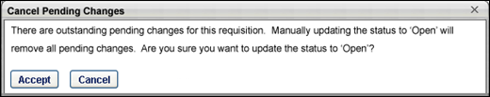
Editing Parent Requisitions
When editing parent requisitions, if the Do Not Allow to Apply option is not selected when the requisition is created, then the option is disabled when editing the parent requisition. If the Do Not Allow to Apply option is selected when the requisition is created, then the option can be modified when editing the parent requisition.
In addition, when editing parent requisitions, the following additional fields are available on the General tab:
- Add Related Requisition - The Add Related Requisition option allows recruiters to add child requisitions to the parent requisition. Selecting the option opens the General tab of a new child requisition for configuration.
- View Related Requisitions - The View Related Requisitions link allows recruiters to view the associated child requisitions. Selecting the option opens the Related Requisitions pop-up, which displays the child requisitions and allows recruiters to view the requisitions.

Manage Remaining Applicants Pop-Up
When all openings for a requisition are filled or you close a requisition, the Manage Remaining Applicants pop-up appears so that you can quickly change the status of all remaining applicants can be changed to Closed at the same time. You also have the option to assign all applicants a single disposition when the applicants are closed.
Note: The ability to manage remaining applicants must be enabled by the administrator in the Dispositions section of Requisition and Applicant Preferences.
The following scenarios trigger the Manage Remaining Applicants pop-up:
- Edit Requisition > Applicant Review Tab - If the requisition status is changed to Closed or Cancelled in the Requisition Status field on the General tab of the requisition, the pop-up appears upon clicking Re-Submit on the Applicant Review tab.
- Manage Candidates, Manage Applicants, Applicant Profile - If an applicant's status is changed to Hired and there are no remaining openings for the requisition.
Manage Remaining Applicants
The pop-up indicates that the requisition is either closed or that all openings have been filled. In addition, the number of remaining applicants displays. The number includes all applicants that are not in a status of Closed or Hired and also includes new submissions that have not yet been moved into an active applicant status.
The following options are available in the pop-up:
- No change - Select this option to maintain the current status of all remaining applicants. When selected, the disposition drop-down is hidden.
- Close all - This option is selected by default. When selected, the status of all remaining applicants is changed to the selected disposition.
- Disposition - This option only displays when the Close all option is selected. By default, the name that appears in the drop-down button is the name of the first disposition in the list. Select the disposition from the drop-down, which will apply to all remaining applicants. The dispositions that are available are configured by the administrator in Requisition and Applicant Preferences.
To close all remaining applicants, select Close all. Then, select the disposition from the drop-down. Then, click Submit. This changes the status of all remaining applicants to the selected disposition. If No change is selected, then there are no changes to the status of the remaining applicants when you click Submit.
Emails Associated with Dispositions
The dispositions that are available when changing an applicant's status may have an associated email, based on the administrator's configuration of the disposition in Requisition and Applicant Preferences. Clicking Submit will trigger the email.
If the disposition does not have an associated email, then an email will not be sent when you click Submit.
Close Pop-Up Without Making a Selection
If you decide that you no longer wish to proceed with the options in the Manage Remaining Applicants pop-up, you can close the pop-up by clicking the "X" in the upper-right corner. This returns you to the Applicant Review tab, Manage Candidates, Manage Applicants, or the Applicant Profile without committing any selections in the pop-up.

Recruiting Approvals Overview
The Recruiting Approvals page displays pending and past requisition approvals. For portals with the offer letter management functionality enabled, the Recruiting Approvals page also displays pending and past offer letter approvals.
- Recruiting Approvals - Requisitions
- Recruiting Approvals - Offer Letters
For both requisitions and offer letters, the number of pending approvals displays in parentheses to the right of the tab name.
Note: The Offer Letters page is only available for portals with the offer letter management functionality enabled.
To access the Requisitions Pending Approval page, go to Recruit > Recruiting Approvals.
Permissions
PERMISSION NAME | PERMISSION DESCRIPTION | CATEGORY

Offer: Approver | Grants ability to access and approve/deny offer letters and include comments for offers for which the user is listed as an approver. Grants ability to access pages related to requisitions for which the user is listed as an approver, including read-only access to all tabs of the Edit Requisition page in Manage Job Requisitions. This permission cannot be constrained. Note: This is a dynamically assigned permission that is not available in Security Role Administration. This permission cannot be constrained. Once assigned, the permission is never removed dynamically, which enables approvers to revisit offer letters that they have already approved or denied. If an approver is removed from an offer that is in a Pending Offer status, the approver can no longer access that version of the offer letter in their Pending tab. If an approver is removed from a past version of an offer, the approver's access to the past offer remains. This permission cannot be manually assigned. | Recruiting

Requisition: Approver | Enables approver to access and approve/deny requisitions for which they are an approver. This permission cannot be constrained. Note: This is a dynamically assigned permission. If the user is removed as an approver for an offer that is in a Pending Offer status, the user can no longer access that version of the offer. This permission cannot be manually assigned. | Recruiting
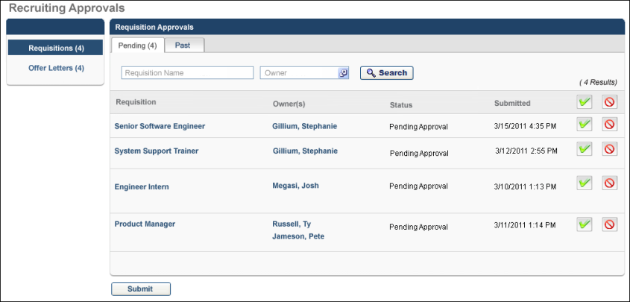

Recruiting Approvals - Requisitions
The Recruiting Approvals - Requisitions page displays pending and past requisition approvals for which you are an owner. From this page, you can edit requisitions, communicate with requisition owners, approve/deny requisitions individually or as a batch, and view past requisition approvals.
The permission to approve requisitions, which is needed to access the Requisitions tab of the Recruiting Approvals page, is automatically assigned to users who are selected as approvers for the requisition. The permission cannot be manually added to a security role. Requisition owners can also access this page.
Note: Pending approvals only appear for an approver when it is their turn to make an approval decision. For example, if an approver is Step 3 in the approval workflow for the requisition, then the requisition does not appear on the Pending tab until Steps 1 and 2 in the approval workflow are completed.
To access the Recruiting Approvals - Requisitions page, go to Recruit > Recruiting Approvals > Requisitions.
Permissions
PERMISSION NAME | PERMISSION DESCRIPTION | CATEGORY

Requisition: Approver | Enables approver to access and approve/deny requisitions for which they are an approver. This permission cannot be constrained. Note: This is a dynamically assigned permission. If the user is removed as an approver for an offer that is in a Pending Offer status, the user can no longer access that version of the offer. This permission cannot be manually assigned. | Recruiting
Important Note: Navigating between the Pending and Past tabs does not save approval decisions and comments entered on the Pending tab. If you are on the Pending tab and have recorded an approval decision and entered comments, you must click Submit to save your decision and comments. If you navigate to the Past tab before clicking Submit, then your work will be lost.
Pending Tab
The Pending tab displays job requisitions that are pending an approval decision. By default, pending approvals are sorted by oldest submission date first. All columns are sortable.
Requisitions that require approval remain in a Pending Approval status until approved or denied by at least one approver or when the last approver in the approval workflow approves or denies it. Approved requisitions change to a status of Open; denied requisitions change to Denied.
Note: For a requisition to be changed from Pending Approval to Open, it must be approved by all approvers. If at least one approver denies the requisition, the status is changed to Denied.
A Comments drop-down arrow only appears next to the Approve/Deny button if 1) there are no pending requisitions on the Requisitions Pending Approval page or 2) a pending requisition is marked as either Approve or Deny.
Search Filters
When you access the Pending tab on the Requisitions page, the Requisition Approvals table displays the requisitions pending approval for which you are the owner. However, you can use the Search fields to filter the requisitions either by requisition name, owner, or both.
To search for a requisition:
- Enter the requisition name in the Requisition Name field. Both full and partial names can be searched. There is no character limit.
- Click the Select icon in the Owner field.
- The User Selection pop-up opens from which you can select a requisition owner. Only one owner can be selected and searched at a time.
- The search results display in the Requisitions Pending Approval table. Note: The results that display are dependent upon your permission constraints.
Requisition Approvals Table
The following columns display in the Requisition Approvals table:
Requisition
The display name of the requisition. Hovering over the name displays the position title. Clicking the name opens the General step of the Requisition Management page on which you can edit the requisition. Note: Editable fields are defined by the requisition's status. See Edit Job Requisition for more information. Visibility of custom fields on the Requisition Management page depends on the field's Availability setting in Custom Field Administration.
From the General step of Requisition Management, click Save to save your changes and return to the Approvals page. Click Back to return to the Approvals page without saving your changes.
Owner(s)
Displays the name of the requisition owner. Hovering over the owner's name opens a pop-up that displays the following:
- Photo, if available; ghost image displays if no photo is available
- Full name
- Current position
- Primary phone number
- Email address link
Status
Displays the current status of the requisition.
Submitted
Displays the date and time at which the user became the owner.
Approve or Deny/Add Comment
The Approve or Deny/Add Comment column enables you to approve pending requisitions and add comments. The Approve/Deny buttons at the top of the column enable you to batch approve or deny every requisition on the page.
Batch Approve/Deny Requisition
Click the Approve or Deny button in the column header to batch approve or deny every requisition for which you are an approver. Unclick the button to undo the action.
Approve/Deny a Single Requisition
The Approve/Deny buttons next to each requisition enable you to make approval/denial selections for individual requisitions. Click the button to approve or deny a requisition. Unclick the button to undo the action.
Add Comment
Once the Approve or Deny button is selected, a drop-down arrow displays next to the button to enable you to enter a comment about the approval decision.
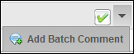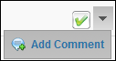
To add a batch comment:
- Click the drop-down arrow next to the button.
- The Add Batch Comment link displays.
- Click the link to open the Add/Edit Comment box.
- Enter a new comment or edit an existing comment. The Comment box accepts formatted HTML and also includes bold, italic, underline, and bulleting options.
- Click Save to save the comment.
To add a comment for an individual requisition:
- Click the drop-down arrow next to the button.
- The Add Comment link displays.
- Click the link to open the Add/Edit Comment box.
- Enter a new comment or edit an existing comment. The Comment box accepts formatted HTML and also includes bold, italic, underline, and bulleting options.
- Click Save to save the comment.
Note: You can only edit comments that you have entered. Once the Submit button is clicked on the Requisitions Pending Approval page, comments can no longer be edited.
Submit Approvals/Denials
Once you have made your selections, a Submit button appears below the table. Click Submit to process any approvals/denials and save comments.
Once submitted and there are no additional approvers, the requisition's status changes to Open. Denied requisitions change to a status of Canceled. Upon submission, the Requisition Approval Final Status email is triggered, if the email is configured in Email Administration.
If there is at least one additional approver in the approval workflow, the requisition is moved to the next approver in the workflow.
Pending Re-Approval
If edits are made to an approved requisition that has an approval workflow, the requisition changes to a status of Pending Re-Approval.
To re-approve a requisition:
- Navigate to the Pending tab on the Requisitions page.
- Click the name of the requisition in the Job field.
- The Requisition Review page opens.
- At the top of the page, the Pending Changes table displays, highlighting each edit to the requisition. The table is expanded by default. The following columns display in the Pending Changes table:
  - Field - Displays the name of the field to which edits were made.
  - Current Value - Displays the value in the field prior to the edit.
  - Pending Value - Displays the edits to the field.
- Click Next to navigate through the tabs of the requisition.
- Click Back to return to the Pending tab on the Requisitions page.
Past Tab
The Past tab displays all past approved/denied job requisition requests that are available for the approver to view. Past requisitions are sorted by most recent to least recent decision date. All columns are sortable except the Comments column.
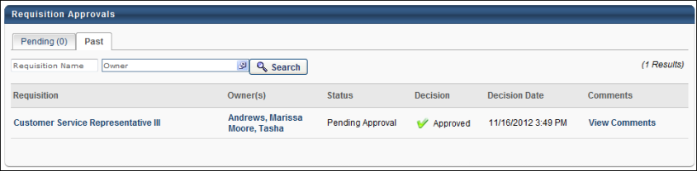
Column | Description
Requisition | This column displays the display name of the requisition. Hovering over the name displays the position title. Clicking the name opens the General step of the Edit Requisition page. All fields on the requisition are read-only, unless you are a requisition owner. Requisition owners that are also approvers can edit the Requisition Status field. Approvers can navigate through each page of the requisition by clicking Next.  To return to the Approvals page, click Back from the General step of the requisition. For requisition owners, click Save if you edited the Requisition Status field, which saves your changes and returns you to the Approvals page.  Note: Visibility of custom fields on the General step of the requisition depends on the field's Availability setting in Custom Field Administration.
Owner(s) | This column displays the name of the requisition owner. Hovering over the owner's name opens a pop-up that displays the following:  - Photo, if available; ghost image displays if no photo is available  - Full name  - Current position  - Primary phone number  - Email address link
Status | This column displays the current status of the requisition.
Decision | This column displays the approval decision, either Approved or Denied.
Decision Date | This column displays the date on which the approver submitted the approval decision and also determines the sort order. If the Decision column displays "Notification Only," then no date appears in the Decision Date column.
Comments | Click the View Comments link to open the View Comment pop-up. The pop-up displays the comment the approver entered for the approval decision.

Requisition Requests Overview
Requisition requests are essentially job proposals. Hiring Managers submit them as a formal method for asking that the request becomes a job requisition that is posted for applicants. Requests can only be created by users who have permission to submit requests.
Once a requisition request is submitted, it is reviewed and processed. The request will either be accepted or declined, based on the reviewer's decision. A request that is Accepted becomes a job requisition but may or may not be posted to applicants. A request that is declined will not become a job requisition.
To access requisition requests, go to Recruit > Requisition Requests.
Note: To approve or deny submitted requests, see the Submitted Requisition Requests page.
Permissions
PERMISSION NAME | PERMISSION DESCRIPTION | CATEGORY

Requisition: Submit Request | Grants ability to create requisition requests. This permission can be constrained by OU and User's OU. | Recruiting
Requisition Request Workflow
Requisition requests have the following workflow:
- Hiring manager creates and submits the request. See Create/Copy Requisition Request - Overview on page 174 for additional information.
- Request is reviewed by a recruiting manager. See Requisition Requests Page for Reviewers - Overview on page 183 for additional information.
- Recruiting manager accepts or declines the request. See Review/Decline/Accept Requisition Request on page 186 for additional information.
  - Accepted Request - A request that is Accepted will become a job requisition. However, the date on which the requisition is posted to applicants is ultimately decided by the reviewer (or other requisition reviewers, depending on the approval process of the requisition). The reviewer can also modify any of the job field settings that you configured on the request. An email is automatically sent to you to indicate that the request has been accepted, provided that the email has been configured by the administrator.
  - Declined Request - A request that is declined will not become a job requisition. An email is automatically sent to you to indicate that the request has been declined, provided that the email has been configured by the administrator. The reviewer may include comments about their decision. You can view the comments from the Requisition Requests page.
Requisition Requests Page for Submitters
To access the Requisition Requests page, go to Recruit > Requisition Requests. This will open the Requisition Requests page, from which you can create new requests and view the existing requests that you have created. This page also allows you to track the status of your requests.
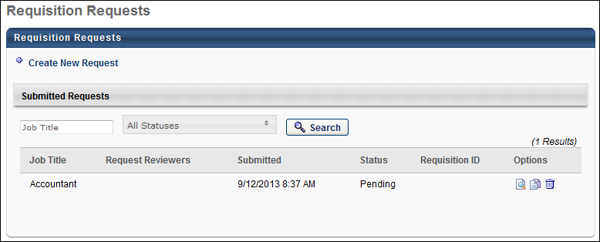
Create New Requisition Requests
To create requisition requests, click the Create New Request link on the Requisition Requests page. This will open the Create Request - General page, from which you can complete the request fields, and then submit the request for review.

Requisition Request Preferences
Requisition Request Preferences enable administrators to define the fields that display on requisition requests, as well as define the request instructions and reviewers.
To access Requisition Request Preferences, go to Admin > Tools > Recruit > Requisition Requests.
Permissions
PERMISSION NAME | PERMISSION DESCRIPTION | CATEGORY

Requisition Request Preferences - Manage | Grants ability to edit the Requisition Requests Preferences page. This permission cannot be constrained. | Recruiting Administration
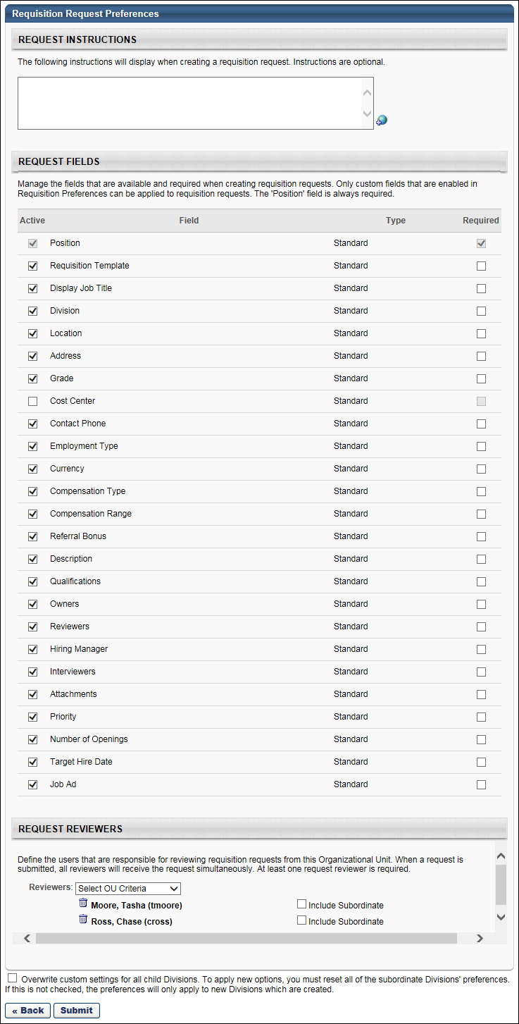
Request Instructions
In the Request Instructions section, administrators can provide instructions for completing the request. The instructions display for hiring managers at the top of the Requisition Request page when creating a request.
The Request Instructions section is optional. The instructions box accepts up to 2000 characters. If multiple languages are enabled for your portal, select the Translate icon to translate the field into other available languages. The default language is the language of the administrator configuring the preferences settings.
Request Fields
In the Request Fields section, administrators can view and define the standard and custom job requisition fields to that display on the request. Administrators can also determine which fields are required to complete. Note: The standard job requisition fields are the fields that display for recruiters when creating, editing, and copying job requisitions. Custom job requisition fields are defined by the administrator on the Organizational Unit Custom Fields page, and then enabled by the administrator in Requisition Preferences.
The following information displays in the Request Fields table:
Active
This column enables administrators to determine which fields will display on requisition requests. Check the box in the Active column for each desired field. By default, all standard job requisition fields are checked. Custom fields are unchecked by default.
The Position field is active by default and cannot be inactivated. This field correlates to the Job Title field on a job requisition.
The Job Ad field correlates to the Job Ad tab on a job requisition. Activating this field displays the Job Ad tab on the request and enables hiring managers to enter job ad information on the tab.
Field
This column displays the name of all standard and custom requisition fields.
Custom fields display in the order in which they are defined in Requisition Preferences. If changes are made to custom fields in Requisition Preferences, the changes are automatically applied to the custom fields on the Requisition Request Preferences page. For example, if a custom field is active on the Requisition Request Preferences page but is later inactivated in Requisition Preferences, then the Active box for the field on the Requisition Request Preferences page is automatically unchecked.
Type
This column displays the requisition field type. The following are the field types:
- Standard - Standard fields are the system-defined fields that always display on job requisitions.
- Custom - Custom fields are the requisition fields that are defined and enabled by the administrator.
Required
This column enables administrators to determine which fields the hiring manager is required to complete on requisition requests. Check the box in the Required column for each desired field. By default, all standard job requisition fields are checked. Custom fields are unchecked by default.
The Position field is required by default, which cannot be modified.
Note: The checkbox in the Required column is only enabled for fields that are active. For fields that are not active, the checkbox is grayed out and not selectable.
Request Reviewers
In the Request Reviewers section, administrators must select at least one reviewer to review requests. When a hiring manager submits a requisition request, all reviewers receive the request simultaneously.
To define the request reviewers:
- Select the OU from the Reviewers drop-down.
- Click the Select icon to select the OU or a specific user. The selection appears below the Reviewers drop-down. Multiple OUs and users can be added.
Once the reviewers are selected, you can choose to include subordinates of the OU or users. Check Include Subordinates to include subordinates.
Remove Reviewers
Reviewers can be removed by clicking the Remove icon to the left of the reviewer's name. Note: Removing a reviewer at the preferences level does not remove the reviewer from existing requests.
Overwrite Settings
Select this option to overwrite custom settings for child division OUs. If you overwrite custom settings for child division OUs, the selected settings are applied to both new and existing child OUs. Any previously customized child OUs are updated with the selected settings.
- If there are no customizations to the child OU, then the parent OU customizations are applied to all child OUs.
- Overwrite custom settings checkbox setting
  - If this option is selected, all child OU customizations are deleted from the database, which means the parent OU customizations will be applied to new and existing child OUs.
  - If this option is unselected, all existing child OU customizations will remain unchanged, and any new child OUs will inherit the parent OU customizations by default.
- If a child OU has been customized to display any widgets, then regardless of the parent OU customizations, the child OU customizations are applied.
- If a child OU has been customized to hide all widgets, then parent OU customizations will take precedence and will be applied.
Save
Once all preference settings are completed, click Save to save the settings.

Requisition Requests Overview
Requisition requests are essentially job proposals. Hiring Managers submit them as a formal method for asking that the request becomes a job requisition that is posted for applicants. Requests can only be created by users who have permission to submit requests.
Once a requisition request is submitted, it is reviewed and processed. The request will either be accepted or declined, based on the reviewer's decision. A request that is Accepted becomes a job requisition but may or may not be posted to applicants. A request that is declined will not become a job requisition.
To access requisition requests, go to Recruit > Requisition Requests.
Note: To approve or deny submitted requests, see the Submitted Requisition Requests page.
Permissions
PERMISSION NAME | PERMISSION DESCRIPTION | CATEGORY

Requisition: Submit Request | Grants ability to create requisition requests. This permission can be constrained by OU and User's OU. | Recruiting
Requisition Request Workflow
Requisition requests have the following workflow:
- Hiring manager creates and submits the request. See Create/Copy Requisition Request - Overview on page 174 for additional information.
- Request is reviewed by a recruiting manager. See Requisition Requests Page for Reviewers - Overview on page 183 for additional information.
- Recruiting manager accepts or declines the request. See Review/Decline/Accept Requisition Request on page 186 for additional information.
  - Accepted Request - A request that is Accepted will become a job requisition. However, the date on which the requisition is posted to applicants is ultimately decided by the reviewer (or other requisition reviewers, depending on the approval process of the requisition). The reviewer can also modify any of the job field settings that you configured on the request. An email is automatically sent to you to indicate that the request has been accepted, provided that the email has been configured by the administrator.
  - Declined Request - A request that is declined will not become a job requisition. An email is automatically sent to you to indicate that the request has been declined, provided that the email has been configured by the administrator. The reviewer may include comments about their decision. You can view the comments from the Requisition Requests page.
Requisition Requests Page for Submitters
To access the Requisition Requests page, go to Recruit > Requisition Requests. This will open the Requisition Requests page, from which you can create new requests and view the existing requests that you have created. This page also allows you to track the status of your requests.
Create New Requisition Requests
To create requisition requests, click the Create New Request link on the Requisition Requests page. This will open the Create Request - General page, from which you can complete the request fields, and then submit the request for review.
Create/Copy Requisition Request - Overview
From the Create Requisition Request page, hiring managers can create new requisition requests. The page includes the following two tabs:
- General Tab - This tab includes the general fields to complete for the request. The General tab always displays for requests and will always includes the Job Title field.
- Job Ad Tab - This tab allows you to configure the job ad for the request. The Job Ad tab only displays if activated by the administrator in Requisition Request Preferences.
Any additional fields that display on the request are defined by the administrator in Requisition Request Preferences.
Note: Requisition requests can only be created if preferences are defined for the user's OU in Requisition Request Preferences.
To access the Create New Request page, click Create New Request from the Requisition Requests page.
Permissions
PERMISSION NAME | PERMISSION DESCRIPTION | CATEGORY

Requisition Request: Select Users | Grants ability to select requisition owners, reviewers, and interviewers when creating requisition requests. This permission can be constrained by OU and User's OU. The constraints define which users are available when selecting users for requisition requests. | Recruiting

Requisition: Submit Request | Grants ability to create requisition requests. This permission can be constrained by OU and User's OU. | Recruiting
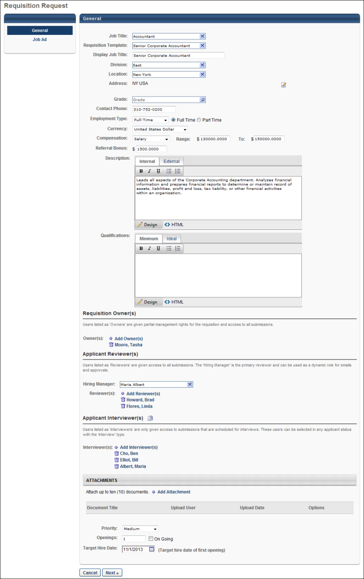
Create/Copy Requisition Request - General
When creating or copying a requisition request, the General tab enables hiring managers to complete the general information for the request.
See Create/Copy Requisition Request - Job Ad on page 181 for additional information.
To access the Create New Request page, click Create New Request from the Requisition Requests page.
Permissions
PERMISSION NAME | PERMISSION DESCRIPTION | CATEGORY

Requisition Request: Select Users | Grants ability to select requisition owners, reviewers, and interviewers when creating requisition requests. This permission can be constrained by OU and User's OU. The constraints define which users are available when selecting users for requisition requests. | Recruiting

Requisition: Submit Request | Grants ability to create requisition requests. This permission can be constrained by OU and User's OU. | Recruiting
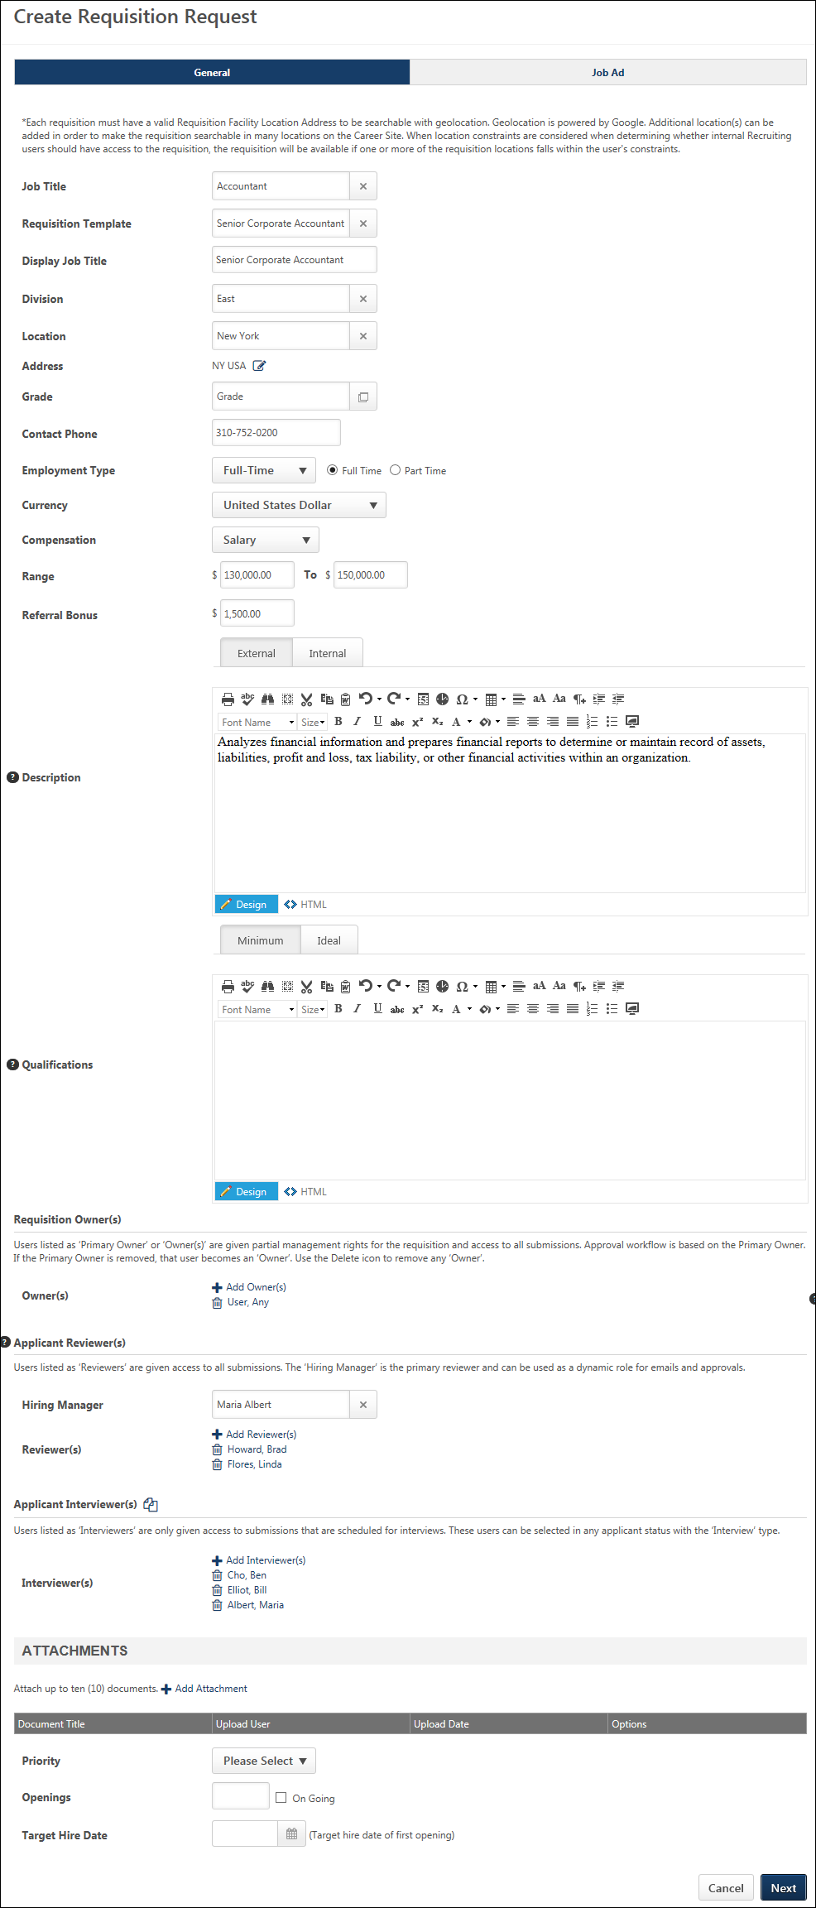
Instructions
If the administrator defined instructions for requisition requests in Requisition Request Preferences, then the instructions display above the general information fields. If there are no instructions, then the administrator did not define them in preferences.
If a translation is available for the user's language, then the instructions display in the user's language. If the user's language is not available, then the instructions display in the creator's language.
Job Title
The Job Title field always displays on the General tab. This field is used to define the position for which you are requesting the requisition.
To define the position:
- Click the Select icon in the Job Title field. This opens a pop-up from which to select the position.
- Select the position from the pop-up.
Once the position is selected, the pop-up closes, and the position displays in the Job Title field. Note: Hiring managers can only view the Position organizational units (OU) that are within the constraints of the permission to submit requisition requests.
Additional Fields
All additional fields that display on the General tab are determined by the administrator in Requisition Request Preferences. The fields that are available to display are the standard and custom fields that display on the General tab for job requisitions.
See Create Job Requisition - General on page 47 for additional information.
Requisition Template Field
If the Requisition Template field displays, then selecting a template populates all fields on the request with the template values. It is important to note that the template values replace any existing values that have been entered in the fields, and the existing values cannot be recovered.
As with current functionality for job requisitions, the Requisition Template field, if included by the administrator, is disabled until the Job Title field is completed. In addition, the templates that are available to select are the templates defined for the Position OU that is selected in the Job Title field.
If a default requisition template is available, then the default template can be selected. Note: A default template must be defined for the user's OU in order for a default template to be available to select. In addition, the Default Requisition Template link only displays in the Select Requisition Template pop-up if the Default Requisition Template option is selected by the administrator in Requisition and Applicant Preferences.
OU Selection Fields
If the Division, Location, Grade, and Cost Center fields display, then the organizational units (OU) available to select are dependent upon the constraints placed on the permission to submit requisition requests.
Note: The Address field must be set to active in Requisition Request Preferences for the address information to populate automatically when creating a requisition from a requisition request. See Requisition Request Preferences on page 168 for additional information.
Select User Fields
If the Owners, Reviewers, and Hiring Manager fields display, then users can only be added to the fields if the hiring manager has permission to select users for requisition requests. In addition, the users that are available to select are dependent upon the constraints placed on the permission to select users for requisition requests.
Required Fields
One or more fields that display on the request may be required, if indicated by the administrator in Requisition Request Preferences. Required fields must be completed in order to submit the request. The required fields must also be completed prior to navigating from the General tab to the Job Ad tab, if the Job Ad tab is included by the administrator.
Custom Fields
For custom fields included by the administrator for requisition requests, hiring managers can only view the custom fields for which they meet the availability criteria.
If the administrator has configured requisition custom fields as read-only in Requisition and Applicant Preferences, then the value in the field cannot be modified on requisition requests. The field will display as read-only.
Next/Submit Buttons
The Next button displays if the Job Ad tab is activated by the administrator for requisition requests. The request can only be submitted by clicking Next to submit the request from the Job Ad tab. If required fields have not yet been completed on the General tab, then the fields must be completed prior to navigating to the Job Ad tab.
The Submit Request button displays if the Job Ad tab is not activated by the administrator for requisition requests. In this case, the request is submitted from the General tab.
Submit Request
To submit the requisition request, click the Submit Request button. This triggers the Requisition Request Submitted email, if configured by the administrator. Once submitted, the request status is Pending. The request is reviewed by one or more reviewers, who are defined by the administrator in Requisition Request Preferences. The reviewers determine whether to accept or decline the request.
Accepted Requests
If the request is accepted, then the status of the request changes to Accepted. A requisition ID is automatically generated for the request. The ID displays in the Requisition ID column on the Requisition Requests page.
In addition, accepted requests indicate that a job requisition has been created for the position. However, the creation of a job requisition does not automatically indicate that a job requisition has been submitted for the request. When the reviewer creates the requisition, the requisition can be saved without being submitted. The Requisition Requests page does not indicate whether or not a job requisition has been submitted for requests that are in an Accepted status.
Declined Requests
If the request is declined, then the status of the request changes to Declined. A requisition ID is not generated for declined requests. The reviewer may have entered comments to explain their decision. The comments can be reviewed by clicking the View Comments icon in the Options column on the Requisition Requests page.
Cancel
Click Cancel to cancel the creation of the request.
Create/Copy Requisition Request - Job Ad
When creating or copying a requisition request, the Job Ad tab enables hiring managers to create the job ad for the position. It is important to note that the tab only displays if activated by the administrator in Requisition Request Preferences.
All fields and options on the Job Ad tab for the request are the same as the fields and options on the Job Ad tab for job requisitions. See Create Job Requisition - Job Ad on page 68 for additional information.
To access the Create New Request page, click Create New Request from the Requisition Requests page.
Permissions
PERMISSION NAME | PERMISSION DESCRIPTION | CATEGORY

Requisition: Submit Request | Grants ability to create requisition requests. This permission can be constrained by OU and User's OU. | Recruiting
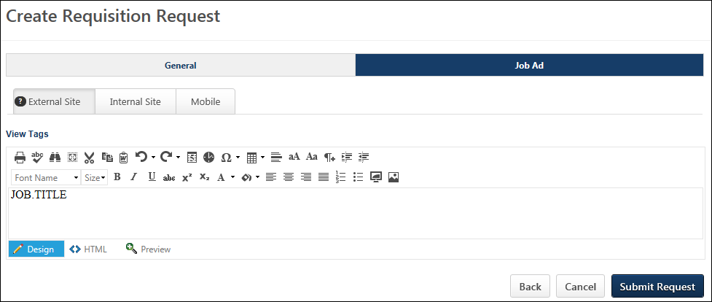
Back
Click Back to navigate to the General tab. The General tab can also be accessed by clicking the tab name in the left navigation panel.
Cancel
Click Cancel to cancel the creation of the request.
Submit Request
To submit the requisition request, click Submit Request. This triggers the Requisition Request Submitted email, if configured by the administrator. Once submitted, the request status is Pending. The request is reviewed by one or more reviewers, who are defined by the administrator in Requisition Request Preferences. The reviewers determine whether to accept or decline the request.
Accepted Requests
If the request is accepted, then the status of the request changes to Accepted. A requisition ID is automatically generated for the request. The ID displays in the Requisition ID column on the Requisition Requests page.
In addition, accepted requests indicate that a job requisition has been created for the position. However, the creation of a job requisition does not automatically indicate that a job requisition has been submitted for the request. When the reviewer creates the requisition, the requisition can be saved without being submitted. The Requisition Requests page does not indicate whether or not a job requisition has been submitted for requests that are in an Accepted status.
Declined Requests
If the request is declined, then the status of the request changes to Declined. A requisition ID is not generated for declined requests. The reviewer may have entered comments to explain their decision. The comments can be reviewed by clicking the View Comments icon in the Options column on the Requisition Requests page.

Requisition Requests Page for Reviewers - Overview
Requisition request reviewers can review requests from the Submitted Requisition Requests page. The page displays all requests that are available to the reviewer. Unlike hiring managers, the request reviewer cannot create new requisition requests from this page.
To access the Submitted Requisition Requests page, go to Recruit > Manage Requisitions. Then, select Requisition Requests from the Options button.
Permissions
PERMISSION NAME | PERMISSION DESCRIPTION | CATEGORY

Requisition: Manage | Grants ability to access and manage all requisitions regardless of ownership (constraints permitting). This permission also grants read-only access to the Applicant Review tab when creating or editing a job requisition. This permission can be constrained by OU, User's OU, and Grade. | Recruiting

Requisition: Owner | Enables owner to access requisitions and applicants for requisitions for which they are an owner. This permission also grants read-only access to video interviews that are completed by applicants via HireVue. For portals with Referral Suite enabled, this permission also enables requisition owners to edit the referral source on the Applicant Profile page. This permission cannot be constrained.  Note: This is a dynamically assigned permission that is not available in Security Role Administration. If the user is removed as an owner, the permission is revoked for the associated requisition. This permission cannot be manually assigned. Also, if a user has both the permission necessary to manage requisitions and be a requisition owner, the constraints of the Requisition: Manage permission overrule those of the Requisition: Owner permission. For requisition owners that do not also have permission to manage requisitions, only certain fields are editable when editing a requisition. | Recruiting
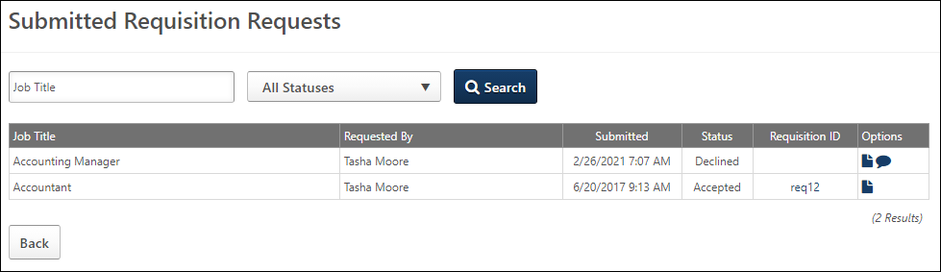
Filter Requisition Requests
Filter the Requisition Requests table by job title or request status. To filter by job title, enter a partial or full title in the Job Title field. To filter by request status, click the drop-down in the Request Status field to select one or more statuses. The available statuses are Accepted, Pending, and Declined. Click Search to update the results in the table.
Requisition Requests Table
The following information displays in the table:
- Job Title - This column displays the position name that was selected for the request. This column is not sortable.
- Requested By - This column displays the name of the user who submitted the request. This column is not sortable. Hovering over the user's name opens the Information pop-up, which displays the following information for the user:
  - Photo, if available
  - Name
  - Job title
  - Phone number
  - Email address - Click the email address to email the requester.
- Submitted - This column displays the date and time at which the request was submitted by the hiring manager. By default, requests display in the Requisition Requests table in order of most to least recently submitted. This column is not sortable.
- Status - This column displays the current status of the request. This column is not sortable. The following are the possible statuses:
  - Accepted - This status displays for requests for which a job requisition has been created. Note: A job requisition has not necessarily been submitted for requests that are in an Accepted status. The requisition may have only been saved rather than submitted.
  - Declined - This status displays for requests that have been denied.
  - Pending - This status displays for requests for which a response has not yet been received from the reviewer.
- Requisition ID - When a request is in an Accepted status and a job requisition has been created for the request, a requisition ID displays in the Requisition ID column.
  - For users who are designated on the requisition as being an owner, reviewer, hiring manager, or interviewer, the ID displays as a link. Clicking the link opens the Review Applicants page, which is pre-filtered to only display the applicants for the associated requisition.
  - For users who are not designated one of the aforementioned roles, the ID displays as static text.
- Options - The following options are available in the Options column:
  - View Request - Click the View Request icon to view the request. This opens the Create Requisition Request page as read-only, displaying all fields that were completed by the hiring manager. Fields that were not completed do not display when viewing the request. From this page, reviewers can accept the request by creating a requisition from the request, or they can choose to decline the request. See Review/Decline/Accept Requisition Request on page 186 for additional information.
  - View Comments - This icon only displays for requests that are in a Declined status. Click the View Comments icon to view the comments submitted by request reviewers when declining a request. This opens the Comments pop-up, which displays the comments, the user who submitted the comments, and the date and time at which the comments were submitted. Both request submitters and reviewers can view comments.
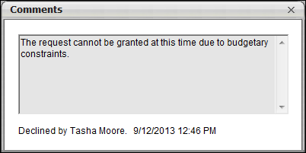
Back Button
Click Back to return to the Manage Requisitions page.
Review/Decline/Accept Requisition Request
From the Requisition Request page, reviewers can view requests and accept or decline the request. When accepting a request, a job requisition is created from the request. When declining a request, reviewers can enter comments to explain why the request is declined.
To access the accept/decline page, click the View Request icon in the Options column of the Submitted Requisition Requests page.
Permissions
PERMISSION NAME | PERMISSION DESCRIPTION | CATEGORY

Requisition: Manage | Grants ability to access and manage all requisitions regardless of ownership (constraints permitting). This permission also grants read-only access to the Applicant Review tab when creating or editing a job requisition. This permission can be constrained by OU, User's OU, and Grade. | Recruiting

Requisition: Owner | Enables owner to access requisitions and applicants for requisitions for which they are an owner. This permission also grants read-only access to video interviews that are completed by applicants via HireVue. For portals with Referral Suite enabled, this permission also enables requisition owners to edit the referral source on the Applicant Profile page. This permission cannot be constrained.  Note: This is a dynamically assigned permission that is not available in Security Role Administration. If the user is removed as an owner, the permission is revoked for the associated requisition. This permission cannot be manually assigned. Also, if a user has both the permission necessary to manage requisitions and be a requisition owner, the constraints of the Requisition: Manage permission overrule those of the Requisition: Owner permission. For requisition owners that do not also have permission to manage requisitions, only certain fields are editable when editing a requisition. | Recruiting
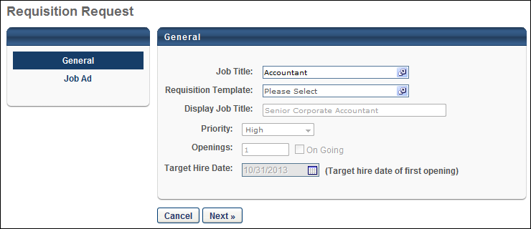
General
The General tab displays all fields that the hiring manager completed when creating the request. All fields except the Requisition Template field are read-only.
Note: The fields that are available for hiring managers to complete on a request are defined by the administrator in Requisition Request Preferences.
Requisition Template Field
The Requisition Template field always displays for reviewers, even if the field was not available for the hiring manager when creating the request. This field must be completed in order to accept the request.
If the field was completed by the hiring manager when creating the request, then the field displays the value selected by the hiring manager. The reviewer can change the value by selecting a different template.
If the field was not included by the administrator for requisition requests, then the field is blank for the reviewer. The reviewer must select a template in order to accept the request and create a requisition from the request. Once selected, the template does not update the fields on the request with the template values.
If a default requisition template is available, then the default template can be selected. Note: A default template must be defined for the recruiter's OU in order for a default template to be available to select. In addition, the Default Requisition Template link only displays in the Select Requisition Template pop-up if the Default Requisition Template option is selected by the administrator in Requisition and Applicant Preferences.
The Requisition Template field is not required to complete when declining a request.
Job Ad
The Job Ad tab only displays if the tab is included on requisition requests by the administrator. The tab displays the job ad that the hiring manager created for the request.
Next
If the Job Ad tab was included by the administrator for requisition requests, then the Next button displays at the bottom of the General tab. Click Next to navigate to the Job Ad tab to decline the request.
The Next button does not display if the General tab is the only tab that displays for the request.
Cancel
Click Cancel to return to the Requisition Requests page without accepting or declining the request.
Decline Request
If the Job Ad tab was not included by the administrator for requisition requests, then the Decline Request button displays at the bottom of the General tab. If the Job Ad tab displays for the request, then the reviewer must navigate to the Job Ad tab to decline the request.
To decline a requisition request:
- Click Decline Request. This opens the Decline Request pop-up.
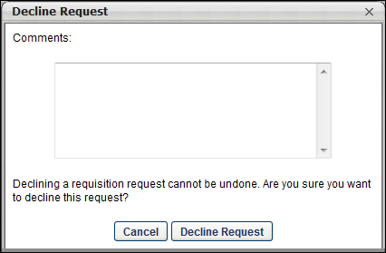
- Enter comments in the Comments box, up to 2000 characters. This is not a required field. Note: Comments are visible to the requester.
- Click Decline Request. This places the request in a Declined status, which cannot be reversed.
- Click Cancel to cancel the decline action.
Declining a request triggers the Requisition Request Response email, if configured by the administrator.
Create Requisition (Accept Request)
If the Job Ad tab was not included by the administrator for requisition requests, then the Create Requisition button displays at the bottom of the General tab. If the Job Ad tab displays for the request, then the reviewer must navigate to the Job Ad tab to accept the request. Accepting a request automatically creates a job requisition from the request.
To accept a request, click Create Requisition. This opens the General tab of the Create Requisition page. All completed fields from the request populate on the requisition. The Requisition Template field can be modified. If a different template is selected, then the template updates all fields on the requisition, per current functionality. All values from the requisition request are lost and cannot be recovered.
The reviewer can modify all fields and tabs on the requisition in order to create a completed job requisition. Once all fields are completed, the reviewer can submit the requisition from the External Postings tab.
Or, the reviewer can choose to save the requisition without submitting it, per existing functionality. See Job Requisition - Overview on page 46 for additional information.
Submitting or saving the requisition updates the request status to Accepted. A requisition ID is automatically generated and displays in the Requisition ID column on the Requisition Requests page. Accepting a request triggers the Requisition Request Response email, if configured by the administrator.

Requisition Snapshot
The Requisition Snapshot page for a job requisition is divided into the following tabs:
- Submission Details - This tab displays an overview of all submissions related to the job requisition. This includes all applicants who were prescreened out due to incorrect prescreening question responses. From this page, you can also add candidates to the requisition. The Submission Details tab opens by default when accessing the Requisition Snapshot page.
- Cost Details - This tab displays information associated with requisition and applicant level costs.
To access the snapshot, go to Recruit > Manage Requisition. Click Snapshot from the drop-down in the Actions column.
Permissions
PERMISSION NAME | PERMISSION DESCRIPTION | CATEGORY

Requisition: Manage | Grants ability to access and manage all requisitions regardless of ownership (constraints permitting). This permission also grants read-only access to the Applicant Review tab when creating or editing a job requisition. This permission can be constrained by OU, User's OU, and Grade. | Recruiting

Requisition: Owner | Enables owner to access requisitions and applicants for requisitions for which they are an owner. This permission also grants read-only access to video interviews that are completed by applicants via HireVue. For portals with Referral Suite enabled, this permission also enables requisition owners to edit the referral source on the Applicant Profile page. This permission cannot be constrained.  Note: This is a dynamically assigned permission that is not available in Security Role Administration. If the user is removed as an owner, the permission is revoked for the associated requisition. This permission cannot be manually assigned. Also, if a user has both the permission necessary to manage requisitions and be a requisition owner, the constraints of the Requisition: Manage permission overrule those of the Requisition: Owner permission. For requisition owners that do not also have permission to manage requisitions, only certain fields are editable when editing a requisition. | Recruiting
Requisition owners that do not have the permission necessary to manage requisitions can only view the details of a job requisition for which they are an owner.
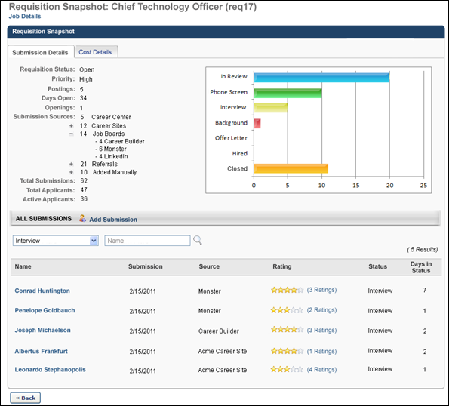
Job Details
The Job Details link at the top of the page allows for quick access to the job description and job qualifications for the requisition. Clicking the link opens the Job Details pop-up. The pop-up displays the requisition's internal and external job description, minimum qualifications, and ideal qualifications.
                - For portals with multiple languages enabled, this displays in the user's language if available. If the user's language is not available, then this displays in the language of the user who defined it.
Note: The fields on the pop-up are not editable from the pop-up.
Requisition Snapshot
In the upper left portion of the Requisition Snapshot page, the following information is displayed for the job requisition:
- Requisition Status - This field displays the status of the job requisition (Draft, Pending Approval, Approval Denied, Open, Open-Pending Re-Approval, Closed, and Cancelled).
- Priority - This field displays the priority status of the job requisition (Critical to Fill, Normal, and On-going).
- Postings - This field displays the number of currently active postings for the job requisition.
- Days Open - This field displays the total number of days that have passed since the job requisition was given a status of Open.
- Openings - This field displays the number of current openings. If the requisition is on- going, then "On-Going" appears instead of a number. Note: The number of openings defined for the job requisition does not change when a candidate is hired.
- Submission Sources - This field displays the number of submissions that were received from each source. Submissions are grouped into primary and secondary source groups. Primary source groups are collapsed by default and always appear even if there are no submissions to the group. The following are the primary source groups and the order in which they appear in the field.
  - Career Center
  - Career Sites
  - Job Boards
  - Agency Submissions
  - Referrals
  - Added Manually
The Career Sites, Job Boards, and Referrals groups can be expanded or collapsed to display their secondary groups by clicking the Expand icon and the Collapse icon . The secondary groups are the career sites, job boards, and referrals associated with the primary source group. Note: The Expand and Collapse icons are not mathematical symbols.
For the Agency Submissions source, the number of applications submitted to all agency portals displays to the left of the "Agency Submissions" source. If the organization has multiple agencies, then an expand icon to the left of the number of submissions enables you to view the number of submissions for each individual agency.
Applicants who submit their application via Connect With Us are counted as submissions for the career site from which they applied.
The sources display even after the posting expires for the job board.
- Total Submissions - This field displays the total number of submissions for the requisition, including all submissions from each possible source. Note: If the same person applies for the requisition more than once, each instance is added to the total.
- Total Applicants - This field displays the total number of submissions that have appeared on the Manage Applicants page for the requisition.
- Active Applicants - This field displays the total number of applicants that have an active status.
Status Bar Chart
In the upper-right corner of the Requisition Snapshot panel, the bar chart graphically displays the status breakdown for submissions that reach the status of In Review. The statuses in the chart appear in the order that is defined for the job requisition.
All Submissions
The All Submissions panel displays all submissions for the requisition. From this panel, you can view applicant information, rate applicants, and add submissions.
Add Submission
To manually add a submission to the job requisition, click the Add Submission link to the right of the All Submissions heading. This opens the Add Submissions page, from which you can add submissions to the requisition. See Add Submission on page 200 for additional information.
The option to manually add submissions is only available for requisitions with a status of Open or Open Pending Re-Approval. Note: To manually add a submission, you must have the permission necessary to manage requisitions or be dynamically assigned the permission necessary to be a requisition owner in order.
Administrators and recruiters can search for a submission by job requisition status or name. To search by requisition status, select the appropriate status from the drop-down list. To search by applicant name, enter the applicant's name in the Name search field. First names, last names, or the partial beginning of a first or last name can be entered. After specifying the search criteria, click the Search icon. The search criteria work in combination so only candidates matching both search criteria are returned.
Submissions Table
In the submissions table, the following information is displayed for each submission:
- Name - The job applicant's full name. Click the applicant's name to view the applicant's profile page. Note: Users with the permission necessary to manage requisitions can view an applicant's profile regardless of job requisition ownership. Requisition owners that do not have the permission necessary to manage requisitions can only view an applicant's profile for a job requisition for which they are an owner. Requisition reviewers that do not have the permission necessary to manage requisitions can only access the Applicant Profile page and review applicants for a job requisition for which they are a reviewer. See Applicant Profile Page for additional information.
- Submission - The date on which the application was submitted. By default, submissions are sorted by their submission date with the newest submissions listed first.
- Source - The source by which the applicant applied for the position. For applications that originated from a mobile device from a mobile device, the Source column displays a mobile icon to the right of the career site source name. Note: The agency portal name in the Source column displays as a link. Clicking the link opens an information pop-up that includes the name of the user that submitted the applicant, the submitter's job title, the submitter's phone number, and the submitter's email address. Click the email address to send the submitter an email.
- Rating - The applicant's average rating. To the right of the rating, the number of ratings that have been made is displayed. This option is only available if the "Allow reviewer ratings" option in General Preferences is selected.
  - To rate an applicant, click the appropriate number of stars in the Rating column. Five stars is the highest possible rating. Ratings can also be made from the Applicant Profile page and the View Details page. You can change your rating by selecting the new rating, which overwrites the previous rating. See Applicant Profile Page for additional information.
  - Click the ratings link to view all of the ratings that have been submitted along with contact information for each user that has rated the applicant.
- Status - The applicant's current status as it relates to the job requisition.
- Days in Status - The number of days the applicant has been in their current status.
Click Back to return to the Manage Requisitions page.

Requisition Snapshot - Submission Details Tab
The Submission Details tab displays an overview of all submissions related to the job requisition. This includes all applicants who were prescreened out due to incorrect prescreening question responses. From this page, you can also add candidates to the requisition. The Submission Details tab opens by default when accessing the Requisition Snapshot page.
To access the snapshot, go to Recruit > Manage Requisition. Click Snapshot from the drop-down in the Actions column.
Permissions
PERMISSION NAME | PERMISSION DESCRIPTION | CATEGORY

Requisition: Manage | Grants ability to access and manage all requisitions regardless of ownership (constraints permitting). This permission also grants read-only access to the Applicant Review tab when creating or editing a job requisition. This permission can be constrained by OU, User's OU, and Grade. | Recruiting

Requisition: Owner | Enables owner to access requisitions and applicants for requisitions for which they are an owner. This permission also grants read-only access to video interviews that are completed by applicants via HireVue. For portals with Referral Suite enabled, this permission also enables requisition owners to edit the referral source on the Applicant Profile page. This permission cannot be constrained.  Note: This is a dynamically assigned permission that is not available in Security Role Administration. If the user is removed as an owner, the permission is revoked for the associated requisition. This permission cannot be manually assigned. Also, if a user has both the permission necessary to manage requisitions and be a requisition owner, the constraints of the Requisition: Manage permission overrule those of the Requisition: Owner permission. For requisition owners that do not also have permission to manage requisitions, only certain fields are editable when editing a requisition. | Recruiting
Requisition owners that do not have the permission necessary to manage requisitions can only view the details of a job requisition for which they are an owner.
Requisition Details Summary
In the upper left portion of the Submission Details tab, the following information is displayed for the job requisition:
- Requisition Status - This field displays the status of the job requisition (Draft, Pending Approval, Approval Denied, Open, Open-Pending Re-Approval, Closed, and Cancelled).
- Priority - This field displays the priority status of the job requisition (Critical to Fill, Normal, and On-going).
- Postings - This field displays the number of currently active postings for the job requisition.
- Days Open - This field displays the total number of days that have passed since the job requisition was given a status of Open.
- Openings - This field displays the number of current openings. If the requisition is on- going, then "On-Going" appears instead of a number.
- Submission Sources - This field displays the number of submissions that were received from each source. Submissions are grouped into primary and secondary source groups. Primary source groups are collapsed by default and always appear even if there are no submissions to the group. The following are the primary source groups and the order in which they appear in the field.
  - Career Center
  - Career Sites
  - Job Boards
  - Agency Submissions
  - Referrals
  - Added Manually
The Career Sites, Job Boards, and Referrals groups can be expanded or collapsed to display their secondary groups by clicking the Expand icon and the Collapse icon . The secondary groups are the career sites, job boards, and referrals associated with the primary source group. Note: The Expand and Collapse icons are not mathematical symbols.
For the Agency Submissions source, The number of applications submitted to all agency portals displays to the left of the "Agency Submissions" source. If the organization has multiple agencies, then an expand icon to the left of the number of submissions enables you to view the number of submissions for each individual agency.
The sources display even after the posting expires for the job board.
- Total Submissions - This field displays the total number of submissions for the requisition, including all submissions from each possible source. Note: If the same person applies for the requisition more than once, each instance is added to the total.
- Total Applicants - This field displays the total number of submissions that have appeared on the Manage Applicants page for the requisition.
- Active Applicants - This field displays the total number of applicants that have an active status.
Status Bar Chart
In the upper-right corner of the Submission Details tab, the bar chart graphically displays the status breakdown for submissions that reach the status of In Review. The statuses in the chart appear in the order that is defined for the job requisition.
All Submissions
The All Submissions panel displays all submissions for the requisition. From this panel, you can view applicant information, rate applicants, and add submissions.
Add Submission
To manually add a submission to the job requisition, click Add Submission. This opens the Add Submissions page, from which you can add submissions to the requisition. See Add Submission on page 200 for additional information.
The option to manually add submissions is only available for requisitions with a status of Open or Open Pending Re-Approval. Note: To manually add a submission , you must have the permission necessary to manage requisitions or be dynamically assigned the permission necessary to be a requisition owner in order.
Administrators and recruiters can search for a submission by job requisition status or name. To search by requisition status, select the appropriate status from the drop-down list. To search by applicant name, enter the applicant's name in the Name search field. First names, last names, partial names, or full names can be entered. After specifying the search criteria, click the Search icon. The search criteria work in combination so only candidates matching both search criteria are returned.
Anonymous Applicants Note: When the Anonymize personal applicant data for New Submissions option is selected in Compliance Enablement Preferences for a Location OU, the he Search by Name functionality supports numeric searches, as anonymous applicants display as a number.
Submissions Table
In the submissions table, the following information is displayed for each submission:
- Name - The job applicant's full name. Click the applicant's name to view the applicant's profile page.
Note: Users with the permission necessary to manage requisitions can view an applicant's profile regardless of job requisition ownership. Requisition owners that do not have the permission necessary to manage requisitions can only view an applicant's profile for a job requisition for which they are an owner. Requisition reviewers that do not have the permission necessary to manage requisitions can only access the Applicant Profile page and review applicants for a job requisition for which they are a reviewer. See Applicant Profile Page for additional information.
Note: Applicants who have been merged do not display in the All Submissions table. The name of the applicant with whom the applicant has been merged displays instead. The applicant profile for merged applicants can only be accessed from the Applicant Profile page of the target profile.
Anonymous Applicants Note: When the Anonymize personal applicant data for New Submissions option is selected in Compliance Enablement Preferences for a Location OU, the value in the Name column for applicants in a New Submission status is replaced with the applicant's requisition number and applicant ID. The applicant ID is scrambled so that the applicant remains anonymous. Clicking the link opens the applicant's Snapshot page in their applicant profile. In addition, when sorting the Name column, the applicant ID for anonymous applicants is sorted numerically. Once the anonymous applicant is no longer in a New Submission status, the applicant's name is visible.
- Submission - The date on which the application was submitted. By default, submissions are sorted by their submission date with the newest submissions listed first.
- Source - The source by which the applicant applied for the position. Note: The agency portal name in the Source column displays as a link. Clicking the link opens an information pop-up that includes the name of the user that submitted the applicant, the submitter's job title, the submitter's phone number, and the submitter's email address. Click the email address to send the submitter an email.
- Rating - The applicant's average rating. To the right of the rating, the number of ratings that have been made is displayed. This option is only available if the "Allow reviewer ratings" option in General Preferences is selected.
  - To rate an applicant, click the appropriate number of stars in the Rating column. Five stars is the highest possible rating. Ratings can also be made from the Applicant Profile page and the View Details page. You can change your rating by selecting the new rating, which overwrites the previous rating. See Applicant Profile Page for additional information.
  - Click the ratings link to view all of the ratings that have been submitted along with contact information for each user that has rated the applicant.
- Status - The applicant's current status as it relates to the job requisition. Note: For the Closed status, the disposition reason displays in parentheses to the right of the Closed status. This helps recruiters quickly identify the reason an applicant's status was changed to Closed.
- Days in Status - The number of days the applicant has been in their current status.
Archived Applicants
Applicants can be archived in the Applicant Tracking System. When an applicant is archived, their name no longer displays on the Submission Details tab of the Requisition Snapshot page, and their associated data is partially hidden.
The following occurs on the Submission Details tab when an applicant is archived:
- Archived applicants are included in the status chart that displays in upper portion of the page based on their most current status.
- Archived applicants are considered inactive on the Snapshot page.
- Archived applicants cannot be added as a new submission or applicant.
- Archived applicants can be searched in the status filter based on their most current status.
- Archived applicants cannot be searched in the Name filter, as the name for archived applicants is hidden.
- "Archived" displays in the Name column in place of the applicant's name.
- The submission date displays in the Submission column, as with current functionality.
- The source is hidden in the Source column.
- The rating is hidden in the Rating column.
- The status displays in the Status column, as with current functionality.
- The number of days in the status displays in the Days in Status column.
Click Back to return to the Manage Job Requisitions page.

Add Submission
The Add Submission page enables you to add an applicant to a requisition to which they did not apply. You can also create applicants that do not already exist in the Applicant Bank and upload their resume. Further, you can select users from the Applicant Bank to be considered for the requisition.
Use Case
A recruiter is emailed a resume from someone he would like to include as an applicant for a requisition. He can submit the applicant via the Add Submission page.
To access the Add Submission page, go to Recruit > Manage Job Requisitions > Snapshot. Then, click Add Submission in the All Submissions panel. Note: The Add Submission link only displays if a requisition is in an Open or Open Pending Re-approval status.
Permissions
PERMISSION NAME | PERMISSION DESCRIPTION | CATEGORY

Requisition: Manage | Grants ability to access and manage all requisitions regardless of ownership (constraints permitting). This permission also grants read-only access to the Applicant Review tab when creating or editing a job requisition. This permission can be constrained by OU, User's OU, and Grade. | Recruiting

Requisition: Owner | Enables owner to access requisitions and applicants for requisitions for which they are an owner. This permission also grants read-only access to video interviews that are completed by applicants via HireVue. For portals with Referral Suite enabled, this permission also enables requisition owners to edit the referral source on the Applicant Profile page. This permission cannot be constrained.  Note: This is a dynamically assigned permission that is not available in Security Role Administration. If the user is removed as an owner, the permission is revoked for the associated requisition. This permission cannot be manually assigned. Also, if a user has both the permission necessary to manage requisitions and be a requisition owner, the constraints of the Requisition: Manage permission overrule those of the Requisition: Owner permission. For requisition owners that do not also have permission to manage requisitions, only certain fields are editable when editing a requisition. | Recruiting
Requisition owners that do not have the permission necessary to manage requisitions can only add submissions to a job requisition for which they are an owner.
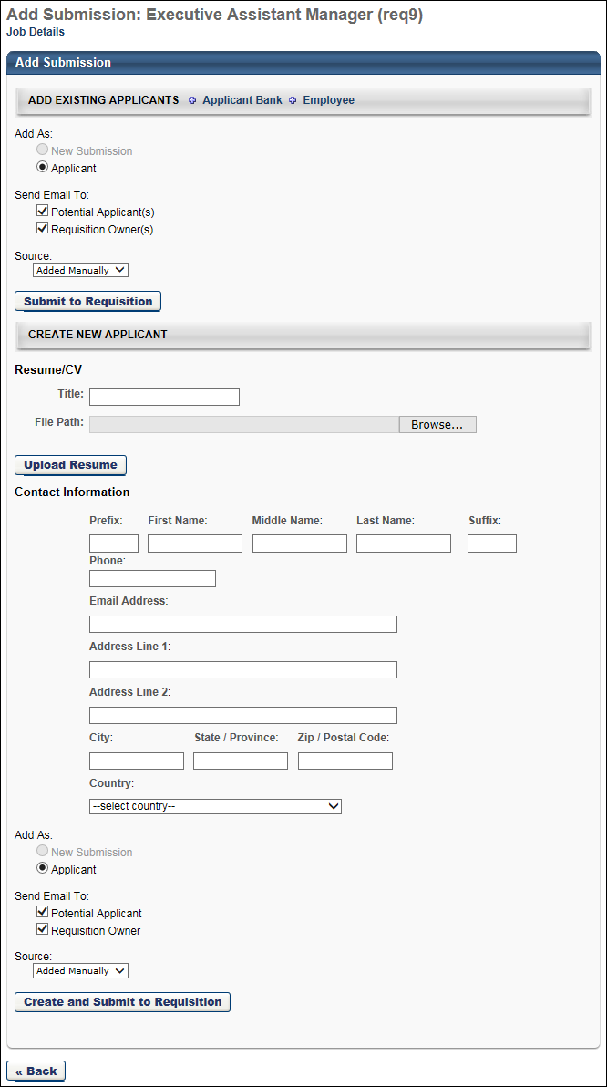
Job Details
The Job Details link at the top of the page allows for quick access to the job description and job qualifications for the requisition. Clicking the link opens the Job Details pop-up. The pop-up displays the requisition's internal and external job description, minimum qualifications, and ideal qualifications.
                - For portals with multiple languages enabled, this displays in the user's language if available. If the user's language is not available, then this displays in the language of the user who defined it.
Note: The fields on the pop-up are not editable from the pop-up.
Add Existing Applicants
In the Add Existing Applicants section, you can search the Applicant Bank for candidates to add to the requisition. Or, you can add any user in the portal by using the Employee link.
Add Applicant from Applicant Bank
To add an applicant from the Applicant Bank:
- Click Applicant Bank. This opens the Select Employee pop-up. Only applicants within the Applicant Bank are available to select. Note: Archived applicants and merged applicants are not available to select.See Compliance Enablement Preferences for additional information about archiving applicants.
- Locate the applicant and click Add.
The applicant's name displays in the Add Candidates table on the Select Employee pop-up. You can remove the applicant by clicking the Remove icon to the left of the applicant's name.
Add Employee
To add a user:
- Click Employee. This opens the Select Employee pop-up.
- Select the user and click Add.
The user's name displays in the Add Candidates table. You can remove the user by clicking the trash can icon to the left of the user's name.
Add As
The Add As section enables you to define how the submission is added to the requisition. Select New Submission to add the candidate as a new submission. Or, select Applicant to add the submission as an applicant to Manage Candidates or Manage Applicants, which places the candidate into the first status in the status workflow.
Note: If Skip New Submission Status is enabled by the administrator in Requisition and Applicant Preferences, then the New Submission option is disabled when adding applicants on the Add Submission page. The Applicant option is then selected by default.
Send Email To
The following options are available in the Send Email To section:
- Potential Applicant(s) - Check the box to trigger the Add Applicant email to be sent to the applicant when Create and Submit to Requisition is clicked. The email includes a link that allows the applicant to apply to the requisition. When the applicant clicks the link and opens the login page, their email address is pre-populated in the Username field. If the applicant already has a profile on the site, they can enter their password and access the requisition. If the applicant does not have a profile, the applicant will need to create a password.Note to administrators: When creating the Add Applicant email, the PASSWORD.RESET.URL tag must be included in order to direct applicants, who do not have a profile on the career site, to the password creation page. This page prompts the applicant to define a password.
- Requisition Owner(s) - Check the box to trigger the Add Applicant email to be sent to all owners of the requisition.
Once all required data has been provided, click Submit to Requisition.
Note: If the user is already an applicant for the requisition, they cannot be added. An error message displays when you click Submit to Requisition, indicating the user is already an applicant.
Note: If Archive applicant data after a period of inactivity is configured by the administrator in Compliance Enablement Preferences, then the period of inactivity for applicants added to a requisition begins when Submit to Requisition is clicked.
Source
The Source option allows you to select the source for an applicant who is being manually added to the requisition.
To select the source:
- Click the Source drop-down. The only source options that are available to select are the sources that have been created in Applicant Sources. Other sources, such as a specific career site or job board, are not available to select.
- Select the source.
- Click Submit to requisition.
Note: Requisition owners can also change an applicant's source on the Applicant Profile page. For portals with Referral Suite or recruiting agencies, the source can be changed on the Applicant Profile page to a referral or a recruiting agency.
Use Cases
- Kathy the Recruiter needs to add a new applicant to a requisition but does not want her source to be added manually. Kathy wants to be able to specify another source name when adding this applicant to the requisition.
- Billy the Recruiter is navigating on the Applicant Profile page and notices that an applicant has an incorrect source. Billy needs a quick way to change the source.
Create New Applicant
In the Create New Applicant section, you can create a new applicant to add to the requisition. You can also determine whether to submit the applicant as a new submission or as an applicant.
Contact Information
In the Contact Information section, enter the following contact details for the applicant:
- Prefix - Accepts up to 10 characters.
- First Name - This is a required field; accepts up to 200 characters.
- Middle Name - Accepts up to 200 characters.
- Last Name - This is a required field; accepts up to 200 characters.
- Suffix - Accepts up to 10 characters.
- Phone - Accepts up to 30 characters.
- Email Address - This is a required field; accepts up to 120 characters. The email address entered must be valid and cannot be the same as another applicant's in the Applicant Bank.
- Address Line 1 - This field accepts up to 110 characters.
- Address Line 2 - This field accepts up to 110 characters.
- City - This field accepts up to 35 characters.
- State/Province - This field accepts up to 30 characters.
- ZIP/Postal Code - This field accepts up to 20 characters.
- Country - This field displays a drop-down of countries from which to select.
Note: For internal applicants, the fields are pre-populated from the user record, if available.
Resume/CV
In the Resume/CV section, complete the following for the applicant:
- Title - Enter a title for the document, up to 30 characters.
- File Path - This is a required field. Add a resume/CV by clicking Browse, and then locate and select the file to upload. The file path displays in the Browse field. The character limit for the file name is 50 characters.
Add As
The Add As section enables you to define how the submission is added to the requisition. Select New Submission to add the candidate as a new submission. Select Applicant to add the submission as an applicant to Manage Candidates or Manage Applicants, which places the candidate into the first status in the status workflow.
Send Email To
The following options are available in the Send Email To section:
- Potential Applicant(s) - Check the box to trigger the Add Applicant email to be sent to the applicant when Create and Submit to Requisition is clicked. The email includes a link that allows the applicant to apply to the requisition. When the applicant clicks the link and opens the login page, their email address is pre-populated in the Username field. If the applicant already has a profile on the site, they can enter their password and access the requisition. Note to administrators: When creating the Add Applicant email, the PASSWORD.RESET.URL tag must be included in order to direct applicants, who do not have a profile on the career site, to the password creation page. This page prompts the applicant to define a password.
- Requisition Owner(s) - Check the box to trigger the Add Applicant email to be sent to all owners of the requisition.
Once all required data has been entered, click Create and Submit to Requisition. This creates a user record for the applicant. The user's email address will be their username, and an 8-character alphanumeric password is automatically generated for them.
Note: If the person you are adding is already a user in the portal, they cannot be added. An error message displays when you click Create and Submit Candidate, indicating the user is already in the system. You can still add the applicant to the requisition by using the Add Existing Applicants feature, which is detailed above.
Note: If Anonymize applicant data after a period of inactivity is configured by the administrator in Compliance Enablement Preferences, then the period of inactivity for applicants added to a requisition begins when Submit to Requisition is clicked.See Compliance Enablement Preferences for additional information about defining the period of inactivity for applicants.
Back Button
Clicking Back at the bottom of the Add Submission page returns you to the Requisition Snapshot page without committing any changes.
Applicant Profile Page - History Tab Events
Adding a submission on the Add Submission page generates an event on the History tab of the Applicant Profile page. The following are the possible events and their details:
Event | Details | User | Date and Time
Applicant Status Changed | From: [blank]  To: [first status in status workflow] | [user who added the submission] | [date and time submission was added]
Application Received | Source: "Added Manually" | This field is blank until the submission submits their application. At that point, the column displays the submission's name. | This field is blank until the submission submits their application. At that point, the column displays the date and time the application was received.
Document Attached | ; when clicked, the document opens in the associated software | [user that added the document] | [date and time the document was added]
Email Sent | [title of email trigger] | [user that added the submission] | [date and time the submission was added]

Requisition Snapshot - Cost Details Tab - Overview
The Cost Details tab enables recruiters to view and manage the costs associated with the requisition. The system automatically tracks costs that are associated with job board postings through Broadbean, agency fees through agency portals, and referral fees via the Referral Suite. Custom cost field data is also tracked on the Cost Details tab.
To access the Cost Details tab, go to Recruit > Manage Requisition. Click Snapshot from the drop-down in the Actions column. Then, click the Cost Details tab on the Requisition Snapshot page.
Permissions
PERMISSION NAME | PERMISSION DESCRIPTION | CATEGORY

Requisition: Edit Cost Details | Grants ability to add and edit costs on the Cost Details tab of the Requisition Snapshot page. This permission must be used in conjunction with the Requisition: Manage permission or the dynamically assigned Requisition: Owner permission. This permission cannot be constrained. | Recruiting

Requisition: Manage | Grants ability to access and manage all requisitions regardless of ownership (constraints permitting). This permission also grants read-only access to the Applicant Review tab when creating or editing a job requisition. This permission can be constrained by OU, User's OU, and Grade. | Recruiting

Requisition: Owner | Enables owner to access requisitions and applicants for requisitions for which they are an owner. This permission also grants read-only access to video interviews that are completed by applicants via HireVue. For portals with Referral Suite enabled, this permission also enables requisition owners to edit the referral source on the Applicant Profile page. This permission cannot be constrained.  Note: This is a dynamically assigned permission that is not available in Security Role Administration. If the user is removed as an owner, the permission is revoked for the associated requisition. This permission cannot be manually assigned. Also, if a user has both the permission necessary to manage requisitions and be a requisition owner, the constraints of the Requisition: Manage permission overrule those of the Requisition: Owner permission. For requisition owners that do not also have permission to manage requisitions, only certain fields are editable when editing a requisition. | Recruiting
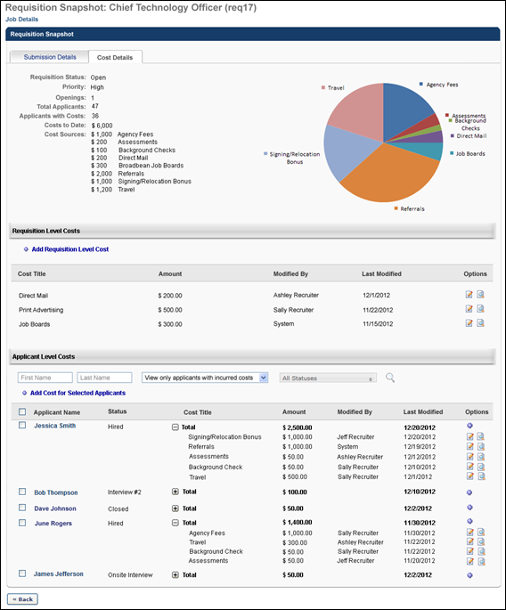
The Cost Details tab is divided into the following sections:
- Cost Details Summary
- Requisition Level Costs
- Applicant Level Costs
Add Applicant Level Cost
Applicant costs are the costs accumulated by applicants during the hiring process, such as travel and meal costs for interviews. Applicant costs are added from the Cost Details tab of the Requisition Snapshot.
Note: Applicant level cost fields must first be defined by the administrator on the Cost Field Management page.
To access the Cost Details tab, go to Recruit > Manage Requisition. Click Snapshot from the drop-down in the Actions column. Then, click the Cost Details tab on the Requisition Snapshot page.
Permissions
PERMISSION NAME | PERMISSION DESCRIPTION | CATEGORY

Requisition: Edit Cost Details | Grants ability to add and edit costs on the Cost Details tab of the Requisition Snapshot page. This permission must be used in conjunction with the Requisition: Manage permission or the dynamically assigned Requisition: Owner permission. This permission cannot be constrained. | Recruiting

Requisition: Manage | Grants ability to access and manage all requisitions regardless of ownership (constraints permitting). This permission also grants read-only access to the Applicant Review tab when creating or editing a job requisition. This permission can be constrained by OU, User's OU, and Grade. | Recruiting

Requisition: Owner | Enables owner to access requisitions and applicants for requisitions for which they are an owner. This permission also grants read-only access to video interviews that are completed by applicants via HireVue. For portals with Referral Suite enabled, this permission also enables requisition owners to edit the referral source on the Applicant Profile page. This permission cannot be constrained.  Note: This is a dynamically assigned permission that is not available in Security Role Administration. If the user is removed as an owner, the permission is revoked for the associated requisition. This permission cannot be manually assigned. Also, if a user has both the permission necessary to manage requisitions and be a requisition owner, the constraints of the Requisition: Manage permission overrule those of the Requisition: Owner permission. For requisition owners that do not also have permission to manage requisitions, only certain fields are editable when editing a requisition. | Recruiting
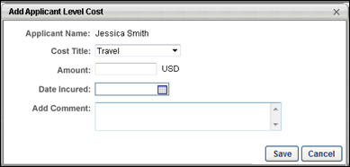
Add Applicant Cost
To add an applicant cost:
- Click the plus icon in the Options column for the applicant in the Applicant Level Costs panel on the Cost Details tab. Or, select one or more applicants and click Add Cost for Selected Applicants. This opens the Add Applicant Level Cost pop-up.
- Complete the following fields in the pop-up:
  - Cost Title - Select a cost from the drop-down. This is a required field. The costs that are available to select are defined by the administrator on the Cost Field Management page. For portals with multiple languages enabled, the cost title displays in the user's display language, if configured for the cost by the administrator. If additional languages are not configured by the administrator, then the cost title displays in the cost field's default language. Note: If there are no costs configured by the administrator in Cost Field Management, then there are no costs to select in the drop-down.
  - Amount - Enter the numerical amount of the cost. The value can include either a decimal point or comma. The maximum character limit is 13 numbers. If the Amount field is blank when the modifications are saved, the value for the amount is zero by default. Note: The character limit does not count the decimal point or comma.
To the right of the Amount field, the requisition currency displays. If the selected cost has a currency that is different from the requisition's currency, then the value in the Amount field should be converted to the requisition currency.
  - Date Incurred - Select the date on which the cost was incurred. This is a required field.
  - Add Comment - Enter a comment about the cost, up to 200 characters.
- Click Save. The cost displays in the Applicant Level Costs panel on the Cost Details tab of the Requisition Snapshot. The modification history for the cost is updated. Click Cancel to cancel adding the cost.
Add Cost for Multiple Applicants
Applicant level costs can be added for multiple applicants at the same time from the Cost Details tab of the Requisition Snapshot. Note: Applicant level cost fields must first be defined by the administrator on the Cost Field Management page.
To access the Cost Details tab, click the tab name from the Requisition Snapshot page.
Permissions
PERMISSION NAME | PERMISSION DESCRIPTION | CATEGORY

Requisition: Edit Cost Details | Grants ability to add and edit costs on the Cost Details tab of the Requisition Snapshot page. This permission must be used in conjunction with the Requisition: Manage permission or the dynamically assigned Requisition: Owner permission. This permission cannot be constrained. | Recruiting

Requisition: Manage | Grants ability to access and manage all requisitions regardless of ownership (constraints permitting). This permission also grants read-only access to the Applicant Review tab when creating or editing a job requisition. This permission can be constrained by OU, User's OU, and Grade. | Recruiting

Requisition: Owner | Enables owner to access requisitions and applicants for requisitions for which they are an owner. This permission also grants read-only access to video interviews that are completed by applicants via HireVue. For portals with Referral Suite enabled, this permission also enables requisition owners to edit the referral source on the Applicant Profile page. This permission cannot be constrained.  Note: This is a dynamically assigned permission that is not available in Security Role Administration. If the user is removed as an owner, the permission is revoked for the associated requisition. This permission cannot be manually assigned. Also, if a user has both the permission necessary to manage requisitions and be a requisition owner, the constraints of the Requisition: Manage permission overrule those of the Requisition: Owner permission. For requisition owners that do not also have permission to manage requisitions, only certain fields are editable when editing a requisition. | Recruiting
To add an applicant level cost for multiple applicants:
- Click the Add Cost for Selected Applicant link in the Applicant Level Costs panel on the Cost Details tab. This opens the Add Cost for Multiple Applicants pop-up. The number of selected applicants displays in the Applicant Name field at the top of the pop-up.
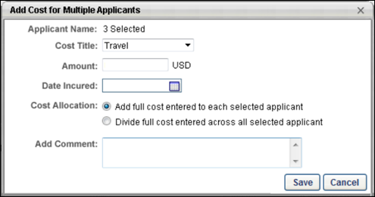
- Complete the following fields in the pop-up:
  - Cost Title - Select a cost from the drop-down. This is a required field. The costs that are available to select are defined by the administrator on the Cost Field Management page. For portals with multiple languages enabled, the cost title displays in the user's display language, if configured for the cost by the administrator. If additional languages are not configured by the administrator, then the cost title displays in the cost field's default language. Note: If there are no costs configured by the administrator in Cost Field Management, then there are no costs to select in the drop-down.
  - Amount - Enter the numerical amount of the cost. The value can include either a decimal point or comma. The maximum character limit is 13 numbers. If the Amount field is blank when the modifications are saved, the value for the amount is zero by default. Note: The character limit does not count the decimal point or comma.
To the right of the Amount field, the requisition currency displays. If the selected cost has a currency that is different from the requisition's currency, then the value in the Amount field should be converted to the requisition currency.
  - Date Incurred - Select the date on which the cost was incurred. This is a required field.
  - Cost Allocation - Select one of the following options:
    - Add full cost - Select this option to add the full value from the Amount field to each of the selected users. This option is selected by default.
    - Divide full cost - Select this option to divide the value from the Amount field equally among the selected users. Note: If the amount does not divide equally, then the remaining amount is distributed equally in the order of the selected applicants until the amount is fully distributed.
  - Add Comment - Enter a comment about the cost, up to 200 characters.
- Click Save to save the cost. The cost displays in the Applicant Level Costs panel on the Cost Details tab of the Requisition Snapshot. The modification history for the cost is updated. Click Cancel to cancel adding the cost.
Add Requisition Level Cost
Requisition level costs are costs accumulated as part of the requisition. For example, if the requisition is part of a job fair, the costs associated with the job fair are considered a requisition cost. Requisition costs are added from the Cost Details tab of the Requisition Snapshot.
Note: Requisition level costs must first defined by the administrator on the Cost Field Management page.
To access the Cost Details tab, go to Recruit > Manage Requisition. Click Snapshot from the drop-down in the Actions column. Then, click the Cost Details tab on the Requisition Snapshot page.
Permissions
PERMISSION NAME | PERMISSION DESCRIPTION | CATEGORY

Requisition: Edit Cost Details | Grants ability to add and edit costs on the Cost Details tab of the Requisition Snapshot page. This permission must be used in conjunction with the Requisition: Manage permission or the dynamically assigned Requisition: Owner permission. This permission cannot be constrained. | Recruiting

Requisition: Manage | Grants ability to access and manage all requisitions regardless of ownership (constraints permitting). This permission also grants read-only access to the Applicant Review tab when creating or editing a job requisition. This permission can be constrained by OU, User's OU, and Grade. | Recruiting

Requisition: Owner | Enables owner to access requisitions and applicants for requisitions for which they are an owner. This permission also grants read-only access to video interviews that are completed by applicants via HireVue. For portals with Referral Suite enabled, this permission also enables requisition owners to edit the referral source on the Applicant Profile page. This permission cannot be constrained.  Note: This is a dynamically assigned permission that is not available in Security Role Administration. If the user is removed as an owner, the permission is revoked for the associated requisition. This permission cannot be manually assigned. Also, if a user has both the permission necessary to manage requisitions and be a requisition owner, the constraints of the Requisition: Manage permission overrule those of the Requisition: Owner permission. For requisition owners that do not also have permission to manage requisitions, only certain fields are editable when editing a requisition. | Recruiting
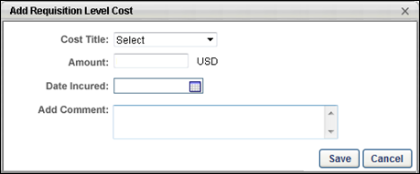
Add Requisition Cost
To add a requisition cost:
- Click Add Requisition Level Cost in the Requisition Level Costs panel on the Cost Details tab. This opens the Add Requisition Level Cost pop-up.
- Complete the following fields in the pop-up:
  - Cost Title - Select a cost from the drop-down. This is a required field. The costs that are available to select are defined by the administrator on the Cost Field Management page. Costs available are those defined as requisition level and as custom. Fields provided by default are not provided for this drop-down. For portals with multiple languages enabled, the cost title displays in the user's display language, if configured for the cost by the administrator. If additional languages are not configured by the administrator, then the cost title displays in the cost field's default language. Note: If there are no cost fields configured by the administrator in Cost Field Management, then there are no cost fields to select in the drop-down.
  - Amount - Enter the numerical amount of the cost. The value can include either a decimal point or comma. The maximum character limit is 13 numbers. If the Amount field is blank when the modifications are saved, the value for the amount is zero by default. Note: The character limit does not count the decimal point or comma.
To the right of the Amount field, the requisition currency displays. If the selected cost has a currency that is different from the requisition's currency, then the value in the Amount field should be converted to the requisition currency. Example:
  - Date Incurred - Select the date on which the cost was incurred. This is a required field.
  - Add Comment - Enter a comment about the cost, up to 200 characters.
- Click Save to save the cost. The cost displays in the Requisition Level Costs panel on the Cost Details tab of the Requisition Snapshot. The modification history for the cost is updated. Click Cancel to cancel adding the cost.
Applicant Level Costs
The Applicant Level Costs panel displays all applicant level costs that have an associated value for the requisition. From this panel, you can also manage and add applicant level costs.
To access the Cost Details tab, click the tab name from the Requisition Snapshot page.
Permissions
PERMISSION NAME | PERMISSION DESCRIPTION | CATEGORY

Requisition: Edit Cost Details | Grants ability to add and edit costs on the Cost Details tab of the Requisition Snapshot page. This permission must be used in conjunction with the Requisition: Manage permission or the dynamically assigned Requisition: Owner permission. This permission cannot be constrained. | Recruiting

Requisition: Manage | Grants ability to access and manage all requisitions regardless of ownership (constraints permitting). This permission also grants read-only access to the Applicant Review tab when creating or editing a job requisition. This permission can be constrained by OU, User's OU, and Grade. | Recruiting

Requisition: Owner | Enables owner to access requisitions and applicants for requisitions for which they are an owner. This permission also grants read-only access to video interviews that are completed by applicants via HireVue. For portals with Referral Suite enabled, this permission also enables requisition owners to edit the referral source on the Applicant Profile page. This permission cannot be constrained.  Note: This is a dynamically assigned permission that is not available in Security Role Administration. If the user is removed as an owner, the permission is revoked for the associated requisition. This permission cannot be manually assigned. Also, if a user has both the permission necessary to manage requisitions and be a requisition owner, the constraints of the Requisition: Manage permission overrule those of the Requisition: Owner permission. For requisition owners that do not also have permission to manage requisitions, only certain fields are editable when editing a requisition. | Recruiting
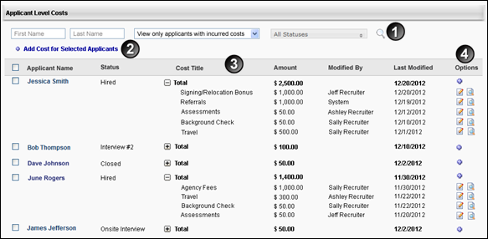
Feature | Description
1 | Search - The search options allow you to filter the applicant results by first name, last name, and requisition status. You can also use the drop-down to filter by the following options:  - View all applicants - Select this option to view all applicants for the requisition.  - View only applicants with incurred costs - Select this option to view all applicants that have a positive cost value. This is the default value for the drop-down. Applicants do not display if they do not have any costs tracked or if their all costs that are associated with the applicant have a value of zero.  - View only applicants with currency inconsistencies - Select this option to display all applicants with costs that have been tracked by the system but have a currency that does not match the currency defined for the requisition. See Currency Inconsistencies on page 226 for additional information.  Once all search filters are configured, click the Search icon to view the results in the Applicant Level Costs table.
2 | Add Cost for Selected Applicants - Click the Add Cost for Selected Applicants link to add a cost for one or more applicants. The link only displays for users with permission to edit cost details. See Add Applicant Level Cost on page 209 for additional information.
3 | Applicant Level Costs Table - The following information appears in the table:  - Select All - Check the select all box to the left of the Applicant Name column to select all applicants on the page. This option is used to add a cost for the selected applicants. The select all boxes are unchecked by default. Once checked, you can also filter the checked applicants by defining criteria in the filter options and clicking the Search icon. Note: The select all option only selects the applicants that are visible on the page. If the Applicant Level Costs table has more than one page of applicants, then the select all option must be checked on each page of the table in order to select additional applicants for the requisition.  - Applicant Name - This column displays the applicant's name as a link. Click the link to open the applicant's profile. This column also defines the default sort order for the table. Applicants display in the table alphabetical order. This column is sortable.  - Status - This column displays the applicant's status. This column is sortable.  - Cost Title - This column displays the costs associated with the applicant that have a value greater than zero. To view the title of the costs, click the expand icon to the left of "Total." Costs display in order of most to least recently modified, as defined in the Last Modified column. If the applicant's cost total is zero, then the Cost Title column does not display an expand/collapse option.  - Amount - The top row of this column displays the total amount for the costs associated with the applicant. When expanded, the column displays the amount for each individual cost. To view the amount for individual costs, click the expand icon to the left of "Total" in the Cost Title column. If the applicant's cost total is zero, then "0" displays in the top row of the Amount column. Costs display in order of most to least recently modified, as defined in the Last Modified column. This column is sortable. When sorted, if currency inconsistencies exist, then the costs that have inconsistencies display at the top of the sort order.  - Modified By - This column displays the name of the user who last modified the cost. If the cost has not been modified since being created, then the column displays the user who created the cost. If the cost is a system-tracked cost, then "System" displays in the column. Cost fields display in order of most to least recently modified, as defined in the Last Modified column. This column is not sortable. Note: The total row for the Modified By column is blank and does not display a user who modified the cost.  - Last Modified - The top row of this column displays the date of the most recent cost modification. When expanded, this column displays the most recent modification date for each individual cost. The dates display in order of most to least recent. For applicants that do not have any associated costs, the column is blank.
4 | Options - The following options are available in the Options column:  - Add Cost - The Add Cost icon displays in the top row of the Options column. Clicking the icon allows you to add a cost for the applicant. The icon only displays for users with permission to edit cost details.  - Edit - The Edit icon displays when the costs for an applicant are expanded in the Cost Title, Amount, or Last Modified column. Clicking the Edit icon allows you to edit the cost. The icon only displays for users with permission to edit cost details. Costs can be edited by any user with permission to edit the cost details for the requisition. Therefore, editing is not constrained to the user who created the cost. See Edit Applicant Level Cost on page 233 for additional information. See Edit Agency Fees Cost on page 229 for additional information.  - History - Click the History icon to view the modification history. Each change to the field is recorded. The date and time that the change was made is recorded, as well as the user who made the change. See Cost Modification History - Applicant Level Cost on page 222 for additional information.
Default Applicant Level Costs
The Agency Fees and Referral Fees applicant level costs are automatically added to the Applicant Level Costs table, provided that the Agency Portal and Referral Suite functionality are enabled and these default fields are active. In addition, the costs are automatically updated by the system. For example, if the Agency Fees cost field is associated with the requisition, then when an applicant's application is submitted to a requisition, the submission fee cost is updated.
For the Referral Fees cost, the cost is updated when an applicant who has been referred to the requisition accepts an offer letter.
Note: If a candidate's status changes to Interview, the Agency Fees cost is only updated for interviews that are not On Demand Video interviews. Scheduled video interviews are stored as an interview instance.
Archived Applicants
Applicants can be archived in the Applicant Tracking System. When an applicant is archived, their name no longer displays on the Cost Details tab, and their associated data is partially hidden.
The following occurs in the Applicant Level Costs panel when an applicant is archived:
- The checkbox to add a cost for the applicant does not display. Costs cannot be added to archived applicants.
- "Archived" displays in the Name column in place of the applicant's name.
Cost Details Tab - Cost Details Summary
The Cost Details summary on the Cost Details tab displays general requisition information, as well as a breakdown of the requisition's associated costs.
To access the Cost Details tab, go to Recruit > Manage Requisition. Click Snapshot from the drop-down in the Actions column. Then, click the Cost Details tab on the Requisition Snapshot page.
Permissions
PERMISSION NAME | PERMISSION DESCRIPTION | CATEGORY

Requisition: Edit Cost Details | Grants ability to add and edit costs on the Cost Details tab of the Requisition Snapshot page. This permission must be used in conjunction with the Requisition: Manage permission or the dynamically assigned Requisition: Owner permission. This permission cannot be constrained. | Recruiting

Requisition: Manage | Grants ability to access and manage all requisitions regardless of ownership (constraints permitting). This permission also grants read-only access to the Applicant Review tab when creating or editing a job requisition. This permission can be constrained by OU, User's OU, and Grade. | Recruiting

Requisition: Owner | Enables owner to access requisitions and applicants for requisitions for which they are an owner. This permission also grants read-only access to video interviews that are completed by applicants via HireVue. For portals with Referral Suite enabled, this permission also enables requisition owners to edit the referral source on the Applicant Profile page. This permission cannot be constrained.  Note: This is a dynamically assigned permission that is not available in Security Role Administration. If the user is removed as an owner, the permission is revoked for the associated requisition. This permission cannot be manually assigned. Also, if a user has both the permission necessary to manage requisitions and be a requisition owner, the constraints of the Requisition: Manage permission overrule those of the Requisition: Owner permission. For requisition owners that do not also have permission to manage requisitions, only certain fields are editable when editing a requisition. | Recruiting
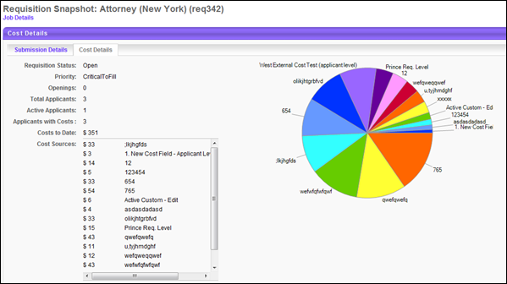
Details Summary
The following summary information is available for the cost details on the upper portion of the Cost Details tab:
- Requisition Status - This field displays the status of the job requisition (Draft, Pending Approval, Approval Denied, Open, Open-Pending Re-Approval, Closed, or Cancelled).
- Priority - This field displays the priority status of the job requisition (Critical to Fill, Normal, or On-going).
- Openings - This field displays the number of current openings. If the requisition is On-going, then "On-Going" appears instead of a number.
- Total Applicants - This field displays the total number of submissions that have appeared on the Manage Applicants page for the requisition.
- Active Applicants - This field displays the total number of applicants that have an active status. Note: An active status indicates that the submission has been advanced from a submission to an applicant or has been manually moved into or added to the requisition. To be considered an active applicant, these prospects must also not be in a closed or hired status.
- Applicants with Costs - This field displays the number of applicants with positive costs associated with their candidacy for the requisition. If the only costs associated with an applicant have a value of zero, then the applicant is not counted.
- Costs to Date - This field displays the sum of the requisition level costs and applicant level costs. The sum is rounded to the nearest whole number.
- Cost Sources - This field displays the requisition's costs in alphabetical order by cost title. For portals with multiple languages enabled, the cost title appears in the user's display language. The cost amount is rounded to the nearest whole number.
  - If a cost has a value of zero, then the cost does not display.
  - If the requisition does not have any costs entered or tracked, then the Cost Sources field displays "None."
  - If there are more than 15 cost fields that have a positive value, then the list of cost fields displays in a scrolling box.
Details Pie Chart
The pie chart to the right of the summary information displays a graphical breakdown of the costs in the Cost Sources field. Each pie piece indicates the percentage of the pie that each cost represents, based on a 100 percent scale. If the requisition does not have any costs entered or tracked, then the pie chart does not display.
If any of the costs associated with the requisition have a currency inconsistency, then a currency inconsistency message displays in place of the pie chart. See Currency Inconsistencies on page 226 for additional information.
Archived Applicants
Applicants can be archived in the Applicant Tracking System. Applicants who are archived are included in both the details summary statistics and the details pie chart.
Cost Modification History - Applicant Level Cost
The modification history for an applicant level cost displays details about the changes that are made to the cost.
To access the modification history, click the History icon in the Options column of the Applicant Level Costs table. This opens the Modification History pop-up.
Permissions
PERMISSION NAME | PERMISSION DESCRIPTION | CATEGORY

Requisition: Manage | Grants ability to access and manage all requisitions regardless of ownership (constraints permitting). This permission also grants read-only access to the Applicant Review tab when creating or editing a job requisition. This permission can be constrained by OU, User's OU, and Grade. | Recruiting

Requisition: Owner | Enables owner to access requisitions and applicants for requisitions for which they are an owner. This permission also grants read-only access to video interviews that are completed by applicants via HireVue. For portals with Referral Suite enabled, this permission also enables requisition owners to edit the referral source on the Applicant Profile page. This permission cannot be constrained.  Note: This is a dynamically assigned permission that is not available in Security Role Administration. If the user is removed as an owner, the permission is revoked for the associated requisition. This permission cannot be manually assigned. Also, if a user has both the permission necessary to manage requisitions and be a requisition owner, the constraints of the Requisition: Manage permission overrule those of the Requisition: Owner permission. For requisition owners that do not also have permission to manage requisitions, only certain fields are editable when editing a requisition. | Recruiting
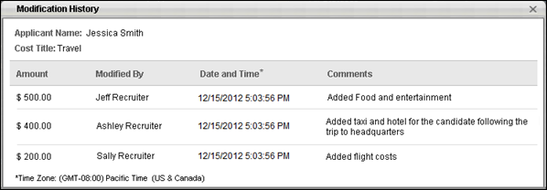
At the top of the Modification History pop-up, the first and last name of the applicant for whom the cost is associated displays. Below the applicant's name, the cost title displays. For portals with multiple languages enabled, the cost title appears in the user's display language.
The following additional information appears for each cost:
Column | Description
Amount | This column displays the amount of the cost. Note: If the amount has a currency inconsistency, then "Currency Inconsistency" displays instead of the value for the amount. See Currency Inconsistencies on page 226 for additional information.
Modified By | This column displays the name of the user who modified the cost.
Date and Time | This column displays the date and time at which the modification to the cost was saved. This column also defines the sort order for the modifications. The table is sorted by most to least recent modification.  The asterisk to the right of the column name references the time zone, which displays at the bottom of the table. The time zone displays in the time zone of the user viewing the Modification History pop-up.
Comments | This column displays the comments that were entered by the user when the cost was modified.
Cost Modification History - Requisition Level Cost
The modification history for a requisition level cost displays details about the changes that are made to the cost.
To access the Cost Details tab, go to Recruit > Manage Requisition. Click Snapshot from the drop-down in the Actions column. Then, click the Cost Details tab on the Requisition Snapshot page. To access the modification history, click the History icon in the Options column of the Requisition Level Costs table. This opens the Modification History pop-up.
Permissions
PERMISSION NAME | PERMISSION DESCRIPTION | CATEGORY

Requisition: Manage | Grants ability to access and manage all requisitions regardless of ownership (constraints permitting). This permission also grants read-only access to the Applicant Review tab when creating or editing a job requisition. This permission can be constrained by OU, User's OU, and Grade. | Recruiting

Requisition: Owner | Enables owner to access requisitions and applicants for requisitions for which they are an owner. This permission also grants read-only access to video interviews that are completed by applicants via HireVue. For portals with Referral Suite enabled, this permission also enables requisition owners to edit the referral source on the Applicant Profile page. This permission cannot be constrained.  Note: This is a dynamically assigned permission that is not available in Security Role Administration. If the user is removed as an owner, the permission is revoked for the associated requisition. This permission cannot be manually assigned. Also, if a user has both the permission necessary to manage requisitions and be a requisition owner, the constraints of the Requisition: Manage permission overrule those of the Requisition: Owner permission. For requisition owners that do not also have permission to manage requisitions, only certain fields are editable when editing a requisition. | Recruiting
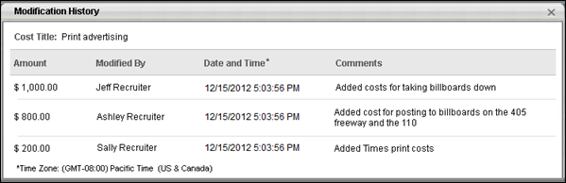
The cost title displays at the top of the pop-up. For portals with multiple languages enabled, the cost title appears in the user's display language.
The following additional information appears for each cost:
- Amount - This column displays the amount of the cost.
- Modified By - This column displays the name of the user who modified the cost. If the cost was automatically populated by the system, then "System" displays in the column.
- Date and Time - This column displays the date and time at which the modification to the cost was saved. This column also defines the sort order for the modifications. The table is sorted by most to least recent modification.
The asterisk to the right of the column name references the time zone, which displays at the bottom of the table. The time zone displays in the time zone of the user viewing the Modification History pop-up.
- Comments - This column displays the comments that were entered by the user when the cost was modified.
Currency Inconsistencies
For costs that are automatically tracked and updated by the system, currency inconsistencies can occur if the cost has a different currency than the requisition currency. In such cases, the system cannot automatically update the field. The recruiter is prompted on the Cost Details tab to match the currency of the cost with the requisition currency, as identified in the warning message that displays in place of the cost details summary pie chart. Costs for which an inconsistency exists display on the Cost Details tab in red.
Note: Currency inconsistencies do not impact reporting. Cost values are still available to display in reporting, regardless of an inconsistency with the currency.
To access the Cost Details tab, go to Recruit > Manage Requisition. Click Snapshot from the drop-down in the Actions column. Then, click the Cost Details tab on the Requisition Snapshot page.
Permissions
PERMISSION NAME | PERMISSION DESCRIPTION | CATEGORY

Requisition: Edit Cost Details | Grants ability to add and edit costs on the Cost Details tab of the Requisition Snapshot page. This permission must be used in conjunction with the Requisition: Manage permission or the dynamically assigned Requisition: Owner permission. This permission cannot be constrained. | Recruiting

Requisition: Manage | Grants ability to access and manage all requisitions regardless of ownership (constraints permitting). This permission also grants read-only access to the Applicant Review tab when creating or editing a job requisition. This permission can be constrained by OU, User's OU, and Grade. | Recruiting

Requisition: Owner | Enables owner to access requisitions and applicants for requisitions for which they are an owner. This permission also grants read-only access to video interviews that are completed by applicants via HireVue. For portals with Referral Suite enabled, this permission also enables requisition owners to edit the referral source on the Applicant Profile page. This permission cannot be constrained.  Note: This is a dynamically assigned permission that is not available in Security Role Administration. If the user is removed as an owner, the permission is revoked for the associated requisition. This permission cannot be manually assigned. Also, if a user has both the permission necessary to manage requisitions and be a requisition owner, the constraints of the Requisition: Manage permission overrule those of the Requisition: Owner permission. For requisition owners that do not also have permission to manage requisitions, only certain fields are editable when editing a requisition. | Recruiting
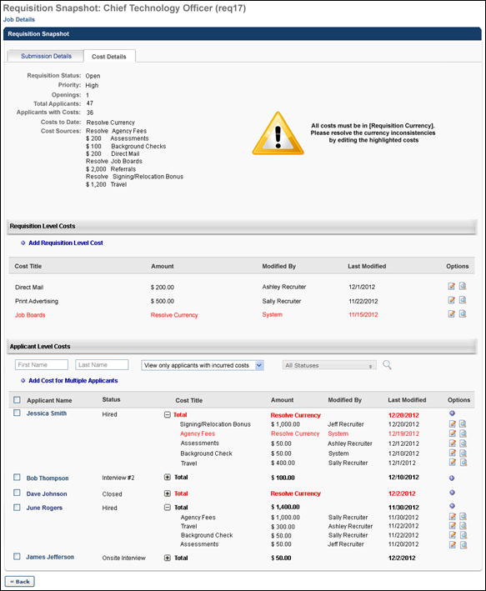
When inconsistencies occur, the following information can no longer display on the Cost Details tab until the inconsistencies are corrected:
- The amount in the Costs to Date field in the cost details summary. In place of the value, "Resolve Currency" displays.
- The amount in the Cost Sources field in the cost details summary. In place of the value, "Resolve" displays.
- The details pie chart to the right of the cost details summary. In place of the value, a warning message appears, indicating that a currency inconsistency exists.
- The cost value in the Amount column in the Requisition Level Costs table. In place of the value, "Resolve Currency" displays.
- The cost sum in the Amount column in the Applicant Level Costs table. In place of the value, "Resolve Currency" displays.
Correct a Currency Inconsistency
To correct a currency inconsistency:
- Click the Edit icon in the Options column of the Requisition Level Costs table or the Applicant Level Costs table for the cost. This opens the Edit Requisition Level Cost pop-up or Edit Applicant Level Cost pop-up, respectively. All amount fields for which a currency inconsistency exists display in red.
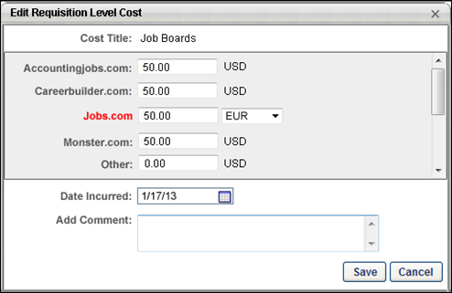
- Select the requisition's currency from the currency drop-down, which displays to the right of the amount. Note: The currency drop-down displays both the requisition currency and the existing currency. The requisition currency must be selected in order to correct the inconsistency.
- Enter a comment in the Add Comment field. This is not a required field. Note: It is a recommended best practice to enter a comment to indicate that the cost was modified to correct a currency inconsistency.
- Click Save to save the changes. Or, click Cancel to cancel the changes.
The currency is updated in the Requisition Level Costs table or the Applicant Level Costs table. The modification history for the cost is also updated.
Edit Agency Fees Cost
Permissions
PERMISSION NAME | PERMISSION DESCRIPTION | CATEGORY

Requisition: Edit Cost Details | Grants ability to add and edit costs on the Cost Details tab of the Requisition Snapshot page. This permission must be used in conjunction with the Requisition: Manage permission or the dynamically assigned Requisition: Owner permission. This permission cannot be constrained. | Recruiting

Requisition: Manage | Grants ability to access and manage all requisitions regardless of ownership (constraints permitting). This permission also grants read-only access to the Applicant Review tab when creating or editing a job requisition. This permission can be constrained by OU, User's OU, and Grade. | Recruiting

Requisition: Owner | Enables owner to access requisitions and applicants for requisitions for which they are an owner. This permission also grants read-only access to video interviews that are completed by applicants via HireVue. For portals with Referral Suite enabled, this permission also enables requisition owners to edit the referral source on the Applicant Profile page. This permission cannot be constrained.  Note: This is a dynamically assigned permission that is not available in Security Role Administration. If the user is removed as an owner, the permission is revoked for the associated requisition. This permission cannot be manually assigned. Also, if a user has both the permission necessary to manage requisitions and be a requisition owner, the constraints of the Requisition: Manage permission overrule those of the Requisition: Owner permission. For requisition owners that do not also have permission to manage requisitions, only certain fields are editable when editing a requisition. | Recruiting
Agency fees costs are applicant level costs. When editing agency fees costs, the Edit Applicant Level Cost pop-up displays additional fields and options than when editing other applicant level costs.
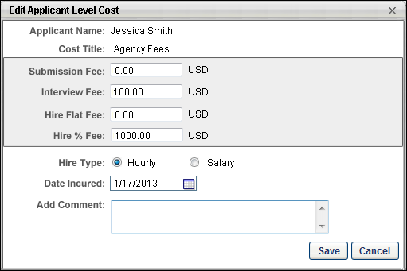
Field | Description
Applicant Name | This field displays the first and last name of the applicant for whom the cost is being edited.
Cost Title | This field displays the title of the cost.
Submission Fee | The submission fee is the amount granted to the agency for each submission. The value is configured by the administrator in Recruiting Agency Management.  The cost is logged the first time the applicant moves past the New Submission status. If the applicant subsequently moves into and out of the status, the cost is not logged.  The value in the Submission Fee field can be edited by entering a different numerical value in the field. The value can include either a decimal point or comma. The maximum character limit is 13 numbers. If the Amount field is blank when the modifications are saved, the value for the amount is zero by default. Note: The character limit does not count the decimal point or comma.
Interview Fee | The interview fee is the amount granted to the agency for each submission that results in an interview. The value is configured by the administrator in Recruiting Agency Management.  The cost is logged when the Interview status is marked complete on the applicant's profile. If the applicant subsequently moves into and out of the status, the cost is not logged.  The value can be edited by entering a different numerical value in the field. The value can include either a decimal point or comma. The maximum character limit is 13 numbers. If the Amount field is blank when the modifications are saved, the value for the amount is zero by default. Note: The character limit does not count the decimal point or comma.
Hire Flat Fee | The hire flat fee defines the hiring bonus amount for the candidate as a flat amount. The value is configured by the administrator in Recruiting Agency Management.  The cost is logged when the applicant moves into the Hired status. If the applicant subsequently moves into and out of the status, the cost is not updated.  The value can be edited by entering a different numerical value in the field. The value can include either a decimal point or comma. The maximum character limit is 13 numbers. If the Amount field is blank when the modifications are saved, the value for the amount is zero by default. Note: The character limit does not count the decimal point or comma.  When this field is edited on the Edit Applicant Level Cost pop-up, the value for the field also changes on the candidate's employment offer.
Hire % Fee | The hire percent fee defines the hiring bonus amount for the candidate as a percentage of the salary or hourly rate. The value is configured by the administrator in Recruiting Agency Management.  The cost is logged when the applicant moves into the Hired status. If the applicant subsequently moves into and out of the status, the cost is not updated.  The value can be edited by entering a different numerical value in the field. The value can include either a decimal point or comma. The maximum character limit is 13 numbers. If the Amount field is blank when the modifications are saved, the value for the amount is zero by default. Note: The character limit does not count the decimal point or comma.  When this field is edited on the Edit Applicant Level Cost pop-up, the value for the field also changes on the candidate's employment offer.
Currency | The currency that displays to the right of the amount is the requisition currency.  If the amount has a different currency than the requisition, then this results in a currency inconsistency. See Currency Inconsistencies on page 226 for additional information.
Hire Type | The hire type defines whether the applicant has been hired as an hourly employee or a salaried employee. Note: Whatever is defined for the hire type will be overwritten when an offer letter is sent via through the offer letter functionality to the candidate. At this point, the system will select "hourly" or "salary" based on the compensation type in the offer letter. A user can subsequently change this, which will overwrite the selection made by the system. When a candidate is in a Hired status, changing the hire type in the Edit Applicant Level Cost pop-up overwrites the selection on the offer letter.  Select one of the following options:  - Hourly - This option is selected by default. This option defines the applicant's earnings as hourly.  - Salary - Select this option to define the applicant's earnings as salaried.
Date Incurred | This field displays the date on which the agency fees were first recorded. This field cannot be blank.
Add Comment | Enter a comment in the Add Comment field. It is a recommended best practice to enter a comment that explains the modification to the cost. The field accepts up to 200 characters.
Once all changes are made, click Save. The cost is updated in the Applicant Level Costs table on the Cost Details tab of the Requisition Snapshot. The modification history for the cost is also updated.
Click Cancel to cancel the modifications to the cost.
Edit Applicant Level Cost
Editing an applicant level cost is similar to adding an applicant level cost, with the exception of the following:
- The Cost Title field cannot be edited. Note: The cost title can only be edited in Cost Field Management. For portals with multiple languages enabled, the cost title displays in the user's display language, if configured for the cost by the administrator.
- When accessing the Edit Applicant Level Cost pop-up, the Amount field displays the most recent value for the cost amount.
To access the Cost Details tab, go to Recruit > Manage Requisition. Click Snapshot from the drop-down in the Actions column. Then, click the Cost Details tab on the Requisition Snapshot page.
Permissions
PERMISSION NAME | PERMISSION DESCRIPTION | CATEGORY

Requisition: Edit Cost Details | Grants ability to add and edit costs on the Cost Details tab of the Requisition Snapshot page. This permission must be used in conjunction with the Requisition: Manage permission or the dynamically assigned Requisition: Owner permission. This permission cannot be constrained. | Recruiting

Requisition: Manage | Grants ability to access and manage all requisitions regardless of ownership (constraints permitting). This permission also grants read-only access to the Applicant Review tab when creating or editing a job requisition. This permission can be constrained by OU, User's OU, and Grade. | Recruiting

Requisition: Owner | Enables owner to access requisitions and applicants for requisitions for which they are an owner. This permission also grants read-only access to video interviews that are completed by applicants via HireVue. For portals with Referral Suite enabled, this permission also enables requisition owners to edit the referral source on the Applicant Profile page. This permission cannot be constrained.  Note: This is a dynamically assigned permission that is not available in Security Role Administration. If the user is removed as an owner, the permission is revoked for the associated requisition. This permission cannot be manually assigned. Also, if a user has both the permission necessary to manage requisitions and be a requisition owner, the constraints of the Requisition: Manage permission overrule those of the Requisition: Owner permission. For requisition owners that do not also have permission to manage requisitions, only certain fields are editable when editing a requisition. | Recruiting
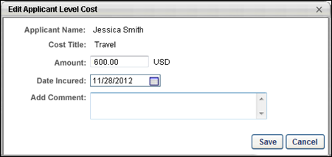
Edit Cost
To edit an applicant level cost, click the Edit icon in the Options column of the Applicant Level Costs table. This opens the Edit Applicant Level Cost pop-up.
When editing an applicant level cost, it is a best practice to enter a comment in the Add Comment field to indicate the changes that were made to the cost.
When Save is clicked, the cost is updated in the Applicant Level Costs table on the Cost Details tab of the Requisition Snapshot. The modification history for the cost is also updated.
Edit Job Board Cost
Permissions
PERMISSION NAME | PERMISSION DESCRIPTION | CATEGORY

Requisition: Edit Cost Details | Grants ability to add and edit costs on the Cost Details tab of the Requisition Snapshot page. This permission must be used in conjunction with the Requisition: Manage permission or the dynamically assigned Requisition: Owner permission. This permission cannot be constrained. | Recruiting

Requisition: Manage | Grants ability to access and manage all requisitions regardless of ownership (constraints permitting). This permission also grants read-only access to the Applicant Review tab when creating or editing a job requisition. This permission can be constrained by OU, User's OU, and Grade. | Recruiting

Requisition: Owner | Enables owner to access requisitions and applicants for requisitions for which they are an owner. This permission also grants read-only access to video interviews that are completed by applicants via HireVue. For portals with Referral Suite enabled, this permission also enables requisition owners to edit the referral source on the Applicant Profile page. This permission cannot be constrained.  Note: This is a dynamically assigned permission that is not available in Security Role Administration. If the user is removed as an owner, the permission is revoked for the associated requisition. This permission cannot be manually assigned. Also, if a user has both the permission necessary to manage requisitions and be a requisition owner, the constraints of the Requisition: Manage permission overrule those of the Requisition: Owner permission. For requisition owners that do not also have permission to manage requisitions, only certain fields are editable when editing a requisition. | Recruiting
Job board costs are requisition level costs. If the organization uses Broadbean to post jobs to external job boards, then the job board costs are tracked by the system. The costs are automatically updated in the Requisition Level Costs table on the Cost Details tab of the Requisition Snapshot.
When editing job board costs that are associated with Broadbean, the Edit Requisition Level Cost pop-up displays different fields than when editing job board costs that are not associated with Broadbean. To open the Edit Requisition Level Cost pop-up, click the Edit icon in the Options column of the Requisition Level Costs table.
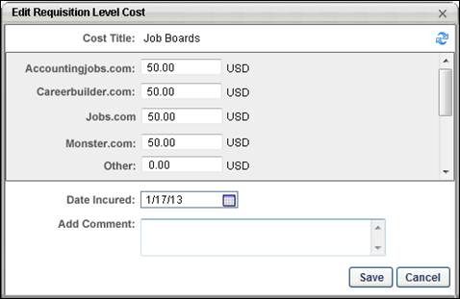
Field | Description
Cost Title | This field displays the title of the cost.
Refresh | Click the Refresh icon  in the upper-right corner of the pop-up to get the most current value for the cost that is incurred through Broadbean. Clicking Refresh only applies to job board costs that have not been edited by the user. Refresh does not overwrite job board costs that have been edited by a user.
Job Board | This field displays the name of the job board that is associated with the cost. The "Other" job board is a miscellaneous job board cost. This field has a value of zero by default. Note: If a requisition is posted multiple times through Broadbean, each posting displays as a single line item in the Requisition Level Costs table, with the cost added to the cost for any existing Broadbean postings. The postings do not display in the table as separate costs.
Amount | This field displays the amount of the cost. The cost value for each job board is automatically updated by the system. The value can be edited by entering a different numerical value in the field. The value can include either a decimal point or comma. The maximum character limit is 13 numbers. If the Amount field is blank when the modifications are saved, the value for the amount is zero by default. Note: The character limit does not count the decimal point or comma.
Currency | The currency that displays to the right of the amount is the requisition currency.If the cost of the job board posting has a different currency than the requisition, then this results in a currency inconsistency. See Currency Inconsistencies on page 226 for additional information.
Date Incurred | This field displays the date on which the requisition was posted to the job boards. The date can be edited by selecting a different date using the Calendar icon or entering a different date in the field. This field cannot be blank.
Add Comment | Enter a comment in the Add Comment field. It is a recommended best practice to enter a comment that explains the modification to the cost. The field accepts up to 200 characters.
Once all changes have been made, click Save. The cost is updated in the Requisition Level Costs table. The modification history for the cost is also updated.
Click Cancel to cancel the modifications to the cost.
Edit Requisition Level Cost
Editing a requisition level cost is similar to adding a requisition level cost, with the exception of the following:
- The Cost Title field cannot be edited. Note: The cost title text can only be edited in Cost Field Management. For portals with multiple languages enabled, the cost title displays in the user's display language, if configured for the cost by the administrator.
- When accessing the Edit Requisition Level Cost pop-up, the Amount field displays the most recent value for the cost amount.
To edit a requisition level cost, click the Edit icon in the Options column of the Requisition Level Costs table. This opens the Edit Requisition Level Cost pop-up.
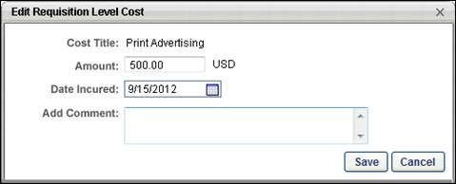
When editing a requisition level cost, it is a best practice to enter a comment in the Add Comment field to indicate the changes that were made to the cost.
When Save is clicked, the cost is updated in the Requisition Level Costs table on the Cost Details tab of the Requisition Snapshot. The modification history for the cost is also updated.
Note: When editing job board costs that are associated with Broadbean, the Edit Requisition Level Cost pop-up includes different fields. See Edit Job Board Cost on page 235 for additional information.
Permissions
PERMISSION NAME | PERMISSION DESCRIPTION | CATEGORY

Requisition: Edit Cost Details | Grants ability to add and edit costs on the Cost Details tab of the Requisition Snapshot page. This permission must be used in conjunction with the Requisition: Manage permission or the dynamically assigned Requisition: Owner permission. This permission cannot be constrained. | Recruiting

Requisition: Manage | Grants ability to access and manage all requisitions regardless of ownership (constraints permitting). This permission also grants read-only access to the Applicant Review tab when creating or editing a job requisition. This permission can be constrained by OU, User's OU, and Grade. | Recruiting

Requisition: Owner | Enables owner to access requisitions and applicants for requisitions for which they are an owner. This permission also grants read-only access to video interviews that are completed by applicants via HireVue. For portals with Referral Suite enabled, this permission also enables requisition owners to edit the referral source on the Applicant Profile page. This permission cannot be constrained.  Note: This is a dynamically assigned permission that is not available in Security Role Administration. If the user is removed as an owner, the permission is revoked for the associated requisition. This permission cannot be manually assigned. Also, if a user has both the permission necessary to manage requisitions and be a requisition owner, the constraints of the Requisition: Manage permission overrule those of the Requisition: Owner permission. For requisition owners that do not also have permission to manage requisitions, only certain fields are editable when editing a requisition. | Recruiting
Requisition Level Costs
The Requisition Level Costs panel displays all requisition level costs that have an associated value for the requisition. From this panel, you can also manage and add requisition level costs, as well as view job board costs, which are automatically tracked by the system.
To access the Cost Details tab, go to Recruit > Manage Requisition. Click Snapshot from the drop-down in the Actions column. Then, click the Cost Details tab on the Requisition Snapshot page.
Permissions
PERMISSION NAME | PERMISSION DESCRIPTION | CATEGORY

Requisition: Edit Cost Details | Grants ability to add and edit costs on the Cost Details tab of the Requisition Snapshot page. This permission must be used in conjunction with the Requisition: Manage permission or the dynamically assigned Requisition: Owner permission. This permission cannot be constrained. | Recruiting

Requisition: Manage | Grants ability to access and manage all requisitions regardless of ownership (constraints permitting). This permission also grants read-only access to the Applicant Review tab when creating or editing a job requisition. This permission can be constrained by OU, User's OU, and Grade. | Recruiting

Requisition: Owner | Enables owner to access requisitions and applicants for requisitions for which they are an owner. This permission also grants read-only access to video interviews that are completed by applicants via HireVue. For portals with Referral Suite enabled, this permission also enables requisition owners to edit the referral source on the Applicant Profile page. This permission cannot be constrained.  Note: This is a dynamically assigned permission that is not available in Security Role Administration. If the user is removed as an owner, the permission is revoked for the associated requisition. This permission cannot be manually assigned. Also, if a user has both the permission necessary to manage requisitions and be a requisition owner, the constraints of the Requisition: Manage permission overrule those of the Requisition: Owner permission. For requisition owners that do not also have permission to manage requisitions, only certain fields are editable when editing a requisition. | Recruiting
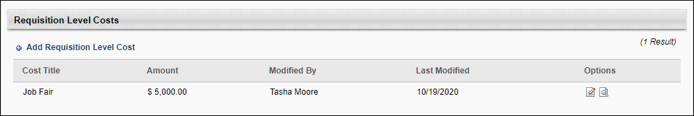
Add Requisition Level Cost
Click the Add Requisition Level Cost link to add a requisition level cost. See Add Requisition Level Cost on page 213 for additional information.
Requisition Costs Table
The following requisition cost information and options are available:
- Cost Title - This column displays the title of the cost. The Requisition Level Costs table is sorted alphabetically by cost title. For portals with multiple languages enabled, the cost title appears in the user's display language. This column is sortable. Note: The same cost field may appear in the table more than once.
For portals that use Broadbean to post jobs to external job boards, the costs associated with the job board are tracked in the Job Boards cost field. You can view the associated costs by clicking the Edit icon in the Options column.
- Amount - This column displays the amount of the cost. For job board costs, the value that displays is the fee that is logged when the requisition is posted externally through Broadbean. This column is sortable. Note: If the currency for the value in the column is different than the requisition currency, then a currency inconsistency has occurred. See Currency Inconsistencies on page 226 for additional information.
- Modified By - This column displays the user who most recently modified the cost. For agency fees, job boards, and referral costs that have been tracked by the system and have not been manually updated, the column displays "System." If a user modifies the value for a system-defined cost, then the column displays the user who modified the cost. This column is not sortable.
- Last Modified - This column displays the date on which the cost was most recently modified. If the cost has not been modified since it was created, then the column displays the user who created the cost. For job board costs that are tracked by the system and have not been manually updated, the column displays "System." This column is sortable.
- Options - The following options are available in the Options column:
  - Edit - Click the Edit icon to edit the cost. Visibility of the Edit icon requires permission to edit cost details. Costs can be edited by any user with permission to edit the cost details for the requisition. Editing is not constrained to the user who created the cost. See Add Requisition Level Cost on page 213 for additional information.See Edit Job Board Cost on page 235 for additional information.
  - History - Click the History icon to view the modification history. See Cost Modification History - Requisition Level Cost on page 224 for additional information.

Requisition Templates Overview
Requisition templates enable an organization to predefine many of the information fields and preferences that make up a job requisition form, as well as control the experience had by a job applicant applying for a job opening. Templates also enable organizations to enforce a standard set of procedures across the organization as it relates to the job requisition management and hiring process.
Requisition templates are managed at the Position OU level. Because of this, the requisition templates functionality is integrated with the Manage Position OU functionality. Requisition templates are created and accessed from the Options column on the Manage Position page.
To access the Manage Position page, go to Admin > Tools > Recruitment > Job Requisition Templates.
Permissions
PERMISSION NAME | PERMISSION DESCRIPTION | CATEGORY

Requisition Template - Manage | Grants ability to access and view Requisition Templates. This permission cannot be constrained. This is an administrator permission. | Recruiting Administration

Requisition Template - View | Grants ability to access and view Requisition Templates. This is an administrator permission. | Recruiting Administration

OU Hierarchy - Manage | Grants ability to create and update/edit organizational units. This permission grants access to all OU types, both standard and custom. This permission can be constrained by OU and User's OU. This is an administrator permission. | Core Administration
Note: Additional position management functionality is available for users with the Manage OU Hierarchy permission.
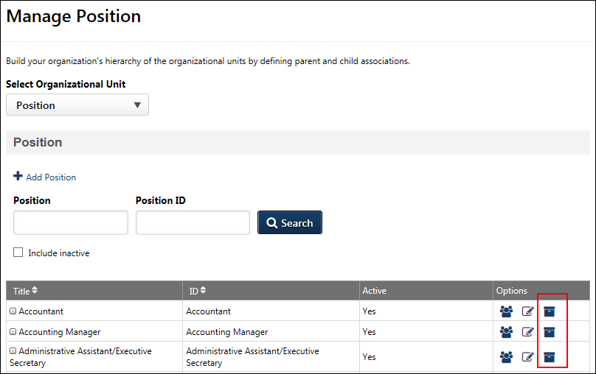
Create/Edit Requisition Template
To create or edit a requisition template, click the Manage Requisition Template icon . This opens the Requisition Templates page, from which you can create a new requisition template or edit or copy an existing template for a single position.
For information about creating requisition templates, see Create Job Requisition Template.
Note: The permission to manage requisition templates is needed in order to create requisition templates. Depending on the constraints of the view and manage requisition templates permissions, it is possible that an administrator can only view the template for one position and manage another position.

Requisition Templates Page
The Requisition Templates page enables administrators to create and manage multiple requisition templates for a position. Each requisition template can have its own unique title and description. In addition, templates can be indicated as active or inactive and can be copied, edited, or deleted.
To access the Requisition Templates page, go to Admin> Tools > Recruit > Requisition Templates. This opens the Manage Position page, which is part of Organizational Units (OU). From the Manage Position page, click the Manage Requisition Template icon in the Options column for the Position organizational unit (OU).
The Requisition Templates page is only available once at least one requisition template has been created for a Position OU.
Permissions
PERMISSION NAME | PERMISSION DESCRIPTION | CATEGORY

Requisition Template - Manage | Grants ability to access and view Requisition Templates. This permission cannot be constrained. This is an administrator permission. | Recruiting Administration

Requisition Template - View | Grants ability to access and view Requisition Templates. This is an administrator permission. | Recruiting Administration

OU Hierarchy - Manage | Grants ability to create and update/edit organizational units. This permission grants access to all OU types, both standard and custom. This permission can be constrained by OU and User's OU. This is an administrator permission. | Core Administration
Note: Additional position management functionality is available for users with the Manage OU Hierarchy permission.
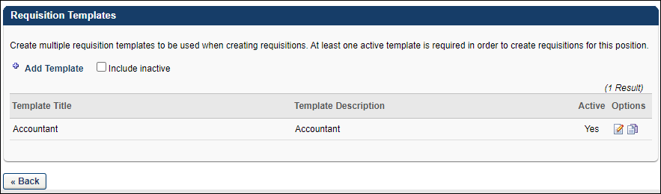
Add Template
Create Add Template to create a template. This opens the Create Requisition Template page. See Requisition Template - Create on page 246 for additional information.
Note: To create requisition templates, you must have the permission to manage requisition templates.
Note: The Add Template option is not used to create the first requisition template for a position. The first template is created by clicking the light gray Manage Requisition Template icon in the Options column on the Manage Position page.
Include Inactive
Check Include Inactive to display inactive templates in the Requisition Templates table.
Note: If there are no templates in the Requisition Templates table, then the existing templates are inactive. You must check Include Inactive to view the existing templates for the position.
Requisition Templates Table
The following information appears for each template:
- Template Title - This column displays the title of the requisition template. By default, templates display in alphabetical order.
- Template Description - This column displays the description of the requisition template.
- Active - This column indicates whether the template is active or inactive. The column displays "Yes" for active and "No" for inactive. Note: A template's active status is managed on the General tab of the Create/Edit Requisition Template page. See Requisition Template - Create - General Tab on page 248 for additional information.
Options
The following options are available in the Options column:
- Edit - Click the Edit icon to edit the template.
- Copy - Click the Copy icon to copy the template. All fields from the source template are copied, except the Active field. Copied templates are active by default. For portals with multiple languages enabled, when copying a requisition template, all localized values are copied from the template if localized values are defined for the template.
- Remove - Click the trash can icon to delete the requisition template. Templates can only be deleted if they have not been used in a job requisition. Deleted templates cannot be restored.
Click Back to return to the Manage Position page.

Requisition Template - Create
Requisition templates enable an organization to predefine many of the information fields and preferences that make up a job requisition form as well as control the experience had by a job applicant applying for a job opening. Templates also enable organizations to enforce a standard set of procedures across the organization as it relates to the job requisition management and hiring process.
Templates are added to Position organizational units (OU), which are found on the Manage Position page. Multiple templates can be added to each Position OU.
To access requisition templates, go to Admin > Tools > Recruit > Requisition Templates. Then, click the Manage Requisition Template icon in the Options column for the Position organizational unit (OU). This opens the Requisition Templates page for a Position OU for which at least one template has been created.
Note: If the Manage Requisition Template icon is gray , this means a requisition template has not yet been created for the Position OU. Clicking the icon when it is gray opens a blank requisition template to create for the Position OU. Once the template is saved, you are redirected to the Requisition Templates page.
Permissions
PERMISSION NAME | PERMISSION DESCRIPTION | CATEGORY

Requisition Template - Manage | Grants ability to access and view Requisition Templates. This permission cannot be constrained. This is an administrator permission. | Recruiting Administration

Requisition Template - View | Grants ability to access and view Requisition Templates. This is an administrator permission. | Recruiting Administration

OU Hierarchy - Manage | Grants ability to create and update/edit organizational units. This permission grants access to all OU types, both standard and custom. This permission can be constrained by OU and User's OU. This is an administrator permission. | Core Administration
Note: Additional position management functionality is available for users with the Manage OU Hierarchy permission.
To create a requisition template:
- Go to Admin > Tools > Recruit > Requisition Templates.
- In the Options column to the right of the appropriate Position OU, click the Manage Requisition Template icon .
- The following are the steps for creating a requisition template:
  - General - See Requisition Template - Create - General Tab on page 248 for additional information.
  - Job Ad - See Requisition Template - Create - Job Ad Tab on page 274 for additional information.
  - Application Workflow - See Requisition Template - Create - Application Workflow Tab on page 278 for additional information.
  - Applicant Review - See Requisition Template - Create - Applicant Review Tab on page 282 for additional information.
Requisition Template - Create - General Tab
The General tab of the requisition template enables the administrator to configure the following:
- The job title that is displayed to the applicant
- Metadata and custom field values
- Applicant status options available for an applicant
- The approval requirements and people who approve the job requisition
- The people who review and interview new applicants
- Auto assignment of pre-employment verifications
- Auto progression of statuses (located in the Status List section)
- Auto disposition for statuses (located in the Status List section)
Templates are added to Position organizational units (OU), which are found on the Manage Position page. Multiple templates can be added to each Position OU.
To access requisition templates, go to Admin > Tools > Recruit > Requisition Templates. Then, click the Manage Requisition Template icon in the Options column for the Position organizational unit (OU). This opens the Requisition Templates page for a Position OU for which at least one template has been created.
Note: If the Manage Requisition Template icon is gray , this means a requisition template has not yet been created for the Position OU. Clicking the icon when it is gray opens a blank requisition template to create for the Position OU. Once the template is saved, you are redirected to the Requisition Templates page.
Permissions
PERMISSION NAME | PERMISSION DESCRIPTION | CATEGORY

Grades - View | Grants ability to view the Grade Organizational Unit throughout the system, such as in availability drop down selectors, when editing users, etc. Those without this permission do not see the Grade OU on any screen. This is primarily an administrator permission, although organizational policy should determine whether the Grade OU should be visible to end users on reporting screens, etc. | Core Administration

Requisition Template - Manage | Grants ability to access and view Requisition Templates. This permission cannot be constrained. This is an administrator permission. | Recruiting Administration

Requisition Template - View | Grants ability to access and view Requisition Templates. This is an administrator permission. | Recruiting Administration

OU Hierarchy - Manage | Grants ability to create and update/edit organizational units. This permission grants access to all OU types, both standard and custom. This permission can be constrained by OU and User's OU. This is an administrator permission. | Core Administration
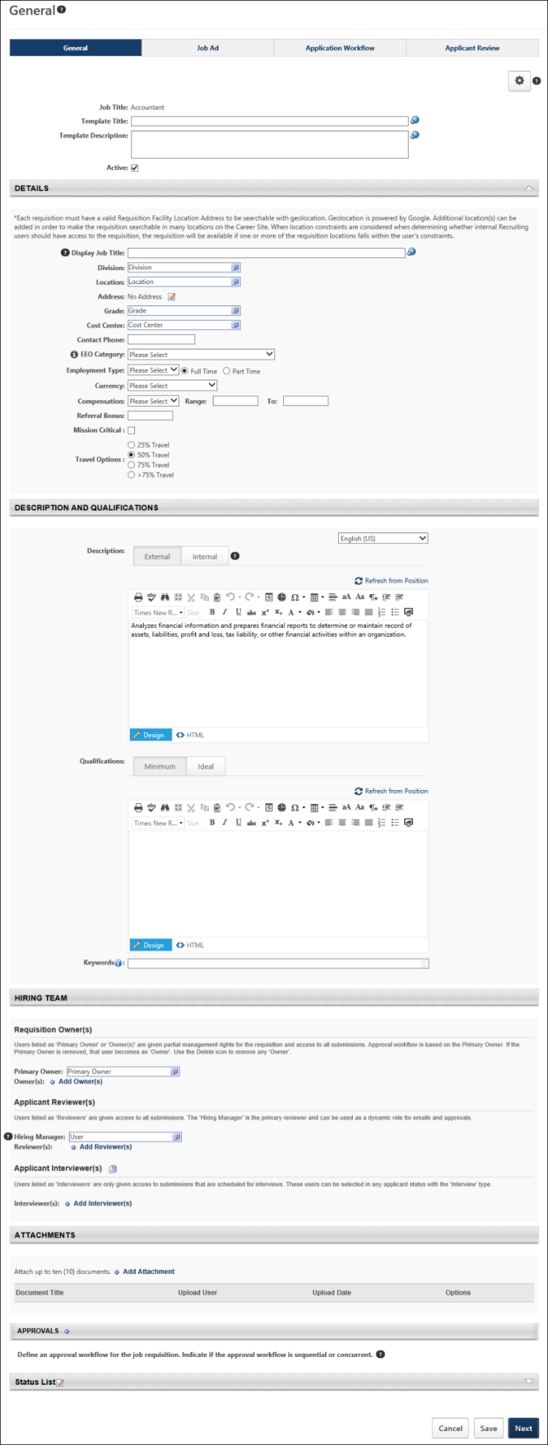
General Tab Sections
Manage Field Visibility
The Manage Field Visibility option displays in the top-right corner of the page. This option enables administrators to select the standard and custom fields that they would like to hide on the job requisition. The purpose of hiding fields is to ensure that the requisition only includes fields that are relevant to the position.
Hiding fields is not required.
Use Case
- Hector wants to streamline the requisition creation process for Acme’s recruiters, while ensuring alignment with local business and compliance needs.
- Hector reviews Acme’s requisition templates.
- To minimize work for recruiters, he pre-populates fields with default information, as available.
- He also configures each template so that fields that are not relevant to the position will be hidden on the requisition.
- Jill Davis is a recruiter at Acme Co. who recruits for roles around the world.
- When Jill goes to create a requisition, she now only sees the relevant, necessary fields, minimizing the work she has to do and ensuring requisitions are created properly.
To hide fields:
- Click the Manage Field Visibility option . This opens the Manage Field Visibility pop-up. The pop-up lists all of the standard and custom fields that can be hidden. By default, all fields and sections are visible.
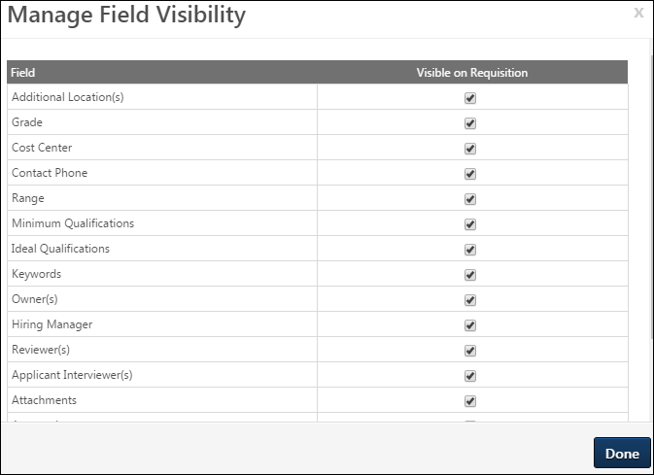
- Uncheck the box in the Visible on Requisition column for the fields and sections that you would like to hide.
- Click Done.
The fields that were hidden will still display on the requisition template and are identified by a Field Hidden on Requisition icon to the left of the field name to indicate that the field is hidden. You can still enter a value in a hidden field, but the value will not be visible to recruiters.
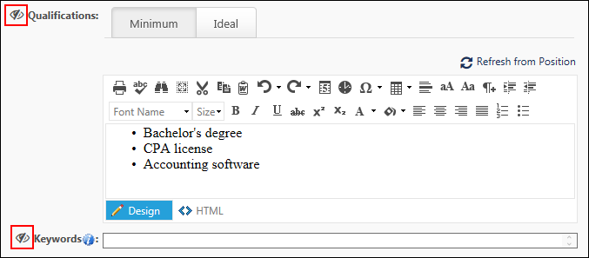
Once the template is saved, the hidden fields will not appear on newly created requisitions that use the template.
Fields that Can Be Hidden
The following fields can be hidden on the General tab of the template. The fields that are available to you are dependent upon your permissions and portal settings.
Details Section
The following fields can be hidden in the Details section:
- Additional Location(s)
- Grade
- Cost Center
- Contact Phone
- Range
- Referral Bonus
- Custom Fields
Description and Qualifications Section
The following fields can be hidden in the Description and Qualifications section:
- Minimum Qualifications
- Ideal Qualifications
- Keywords
Hiring Team
The following fields can be hidden in the Hiring Team section:
- Owner(s)
- Hiring Manager
- Reviewer(s)
Attachments Section
The entire Attachments section can be hidden. If the section is hidden, then it will not be visible on the General tab of the requisition.
Approvals Section
The entire Approvals section can be hidden. If the section is hidden, then it will not be visible on the General tab of the requisition.
However, this section will respect the preference in Requisition and Applicant Preferences to require at least one approver in order to save the requisition. If the Approvals section is hidden, but an approver is required, then the approver must be defined on the requisition template. Once the job requisition is submitted, the approval workflow will still need to be completed, even though the Approvals section did not appear on the job requisition.
Requisition Section
The following fields can be hidden in the Requisition section:
- Target Hire Date
- Do Not Allow to Apply
EEO Category Field
The EEO Category field can be hidden. However, the visibility is dependent upon the settings you configure in Compliance Enablement Preferences and is not available to hide in the Manage Field Visibility pop-up.
Impact to Existing Requisitions
Existing requisitions are not impacted by this enhancement. If field visibility settings are changed on the requisition template that is being used by an existing requisition, the template's field visibility settings are not changed on the existing requisition.
This is also true for requisitions that are in a Draft status at the time of implementation of this enhancement.
EEO Category Exception
If the visibility of the EEO Category field is changed after a requisition is created, the new settings will be applied when a requisition is edited. For example, a requisition was created for a Location Organizational Unit (OU) where the EEO Category field was visible. If the preference for the Location OU is updated to make the field not visible for the location, then when the requisition is edited, the EEO Category field will no longer be visible and any previously entered values will be removed.
Note: The EEO Category field only appears on the template and requisition if the Record EEO option is enabled in Compliance Enablement Preferences and the relevant OU is selected. Also, if the Require OFCCP Compliance Enablement functionality box is checked in Compliance Enablement Preferences, then the EEO Category field cannot be hidden.
Impact to Standard and Custom Reports
Any fields that are not populated via the requisition template or requisition will be blank in reporting.
- Even if a field is hidden on the requisition, any populated values will still be accessible in reporting.
- If a user has permission to view requisition fields in reporting, they will be able to see values.
Field Level Access
If a field is configured as hidden on a template, it will not be visible on the requisition. If the field is visible on the requisition, existing Field Level Access settings will be applied.
Copy Requisition Template
When copying a template that has hidden fields, the hidden fields settings will be copied.
General Information
Enter the following information:
- Job Title - This is a read-only field that displays the position OU that corresponds to the template.
- Template Title - Enter a title for the template. There is no character limit. This is a required field. If multiple languages are enabled for your portal, select the Translate icon to translate the field into other available languages.
- Template Description - Enter a description for the template. There is no character limit. This is a required field. If multiple languages are enabled for your portal, select the Translate icon to translate the field into other available languages.
- Active - Check or uncheck the box to activate or inactivate the template. When creating or copying a template, this box is checked by default. This is not a required field, but if the template is not active, it cannot be used by recruiters to create job requisitions.
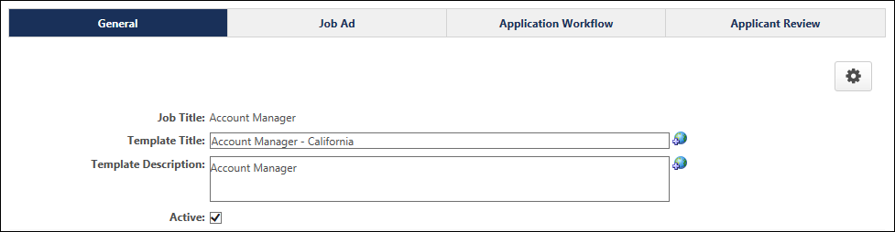
Details
- Display Job Title - In this field, enter the job title that is displayed to potential applicants in the job ad. The character limit for this field is 100. If multiple languages are enabled for your portal, select the Translate icon to translate the field into other available languages.
  - Use Case: Sometimes an organization has a different naming convention for its jobs that is not appropriate when publishing to an external site (e.g., a job title with a job code or job number). A job title that is less specific is more appropriate for a job ad.
- Division - Click the field to select the division that is associated with the position, if applicable.
- Location - Click the field to select the location that is associated with the position, if applicable. If the location has a defined facility address, it appears below the location. The facility address can be edited by clicking the Edit icon to the right of the address. Note: Modifying the facility address does not modify or define any address that is defined for the location OU.
- Address - Displays the physical address of the location indicated in the Location field.
- Grade - This field enables administrators to limit access to the template by Grade OU. Only one Grade OU can be defined for the template. Defining a Grade OU is not required.
To define the Grade OU, click the Select icon in the Grade field. This opens the Grade OU pop-up. Select the Grade OU. This closes the pop-up and adds the Grade OU to the Grade field.
Note: The Grade field is read-only for users who do not have permission to view Grade OUs. The field does not display for portals that do not have Grade OUs enabled.
- Cost Center - This field allows you to select a cost center for the requisition template. This is not a required field.
- Contact Phone - In this field, enter the phone number that will be used as the internal contact for the job requisition. This phone number does not display to applicants.
- EEO Category - From the drop-down list, select the appropriate equal employment opportunity category for the position.
Note: This option is always visible on the requisition template. However, the visibility of this field on the requisition depends on which OU is selected when creating the requisition, and whether the Record EEO preference is checked for that OU [Note: Compliance Enablement Preferences may be tied to Location, Division, or Position]. If a requisition is created from a template that has an EEO Category value, but the Location [or other OU] does not have the Record EEO preference checked, then EEO Category will not appear on the requisition and no EEO Category value will be saved to the requisition.
- Employment Type - From the drop-down list, select the appropriate employment type. The available employment types are defined in Requisition Preferences. After selecting the employment type, select whether the requisition is a full time or part time position, using the radio buttons.
- Currency - From the drop-down list, select the currency in which the job is compensated. This information can be used in reporting, but not posting.
- Compensation - Note: This option is only available if there are active compensation types defined in Requisition Preferences.
  - Compensation - From the drop-down list, select the appropriate compensation type for the job requisition (e.g., hourly, salary, contract). This information can be included when posting to an external job board as well as when reporting on the status of job requisitions. The options that are available are defined in Requisition Preferences.
  - Range - In the two text fields, enter the potential compensation range for the position. This indicates the potential compensation an applicant can receive if they are selected for the position. The lower range value is entered in the first field and the higher range value is entered in the second field.
- Referral Bonus - In this field, define the default value for the referral bonus by entering a positive whole number. Commas and up to two decimal places are accepted. This is not a required field and only appears if Referral Suite is enabled in the portal. Note: The currency is determined by the value in the Currency field.
- [Custom Field Name] - Any Requisition custom fields that are created for the Position OU may be available on the requisition template. The custom fields that appear on the template are created in Custom Field Administration and are selected in Requisition and Applicant Preferences. The custom fields are not required on the template page, regardless of the Required setting in Custom Field Administration.
If a field has been defined by the administrator as read-only in Requisition and Applicant Preferences, then "Read Only" displays in parentheses to the right of the field name. The value in the field can be modified on the requisition template, but it cannot be modified in job requisitions or requisition requests.
If a value for the custom field has been configured by the administrator for the Position OU in Manage Organizational Unit Hierarchy, then the value displays on the requisition template.
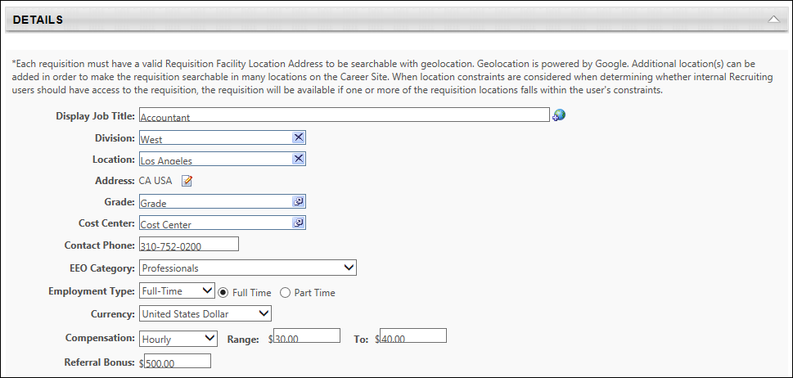
Description and Qualifications
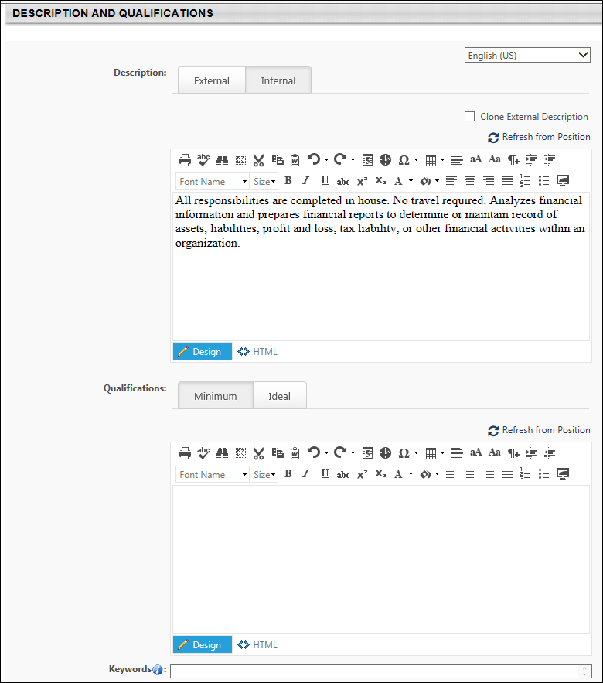
Language
This field displays for portals with multiple languages enabled and allows you to localize the internal and external description and the minimum qualifications. To localize the fields, select the language from the drop-down, and then enter the translated text into the fields.
To translate the fields into additional languages, select a different language from the drop-down and enter the translated text into the fields.
Note: The Ideal Qualifications section is defined by the administrator when configuring the Position OU and is therefore not localizable from the requisition template.
Description
This section allows you to enter a description for the job for internal applicants and external applicants. The text box has standard formatting options and accepts HTML. There is no character limit for the text box. An internal and external job description is required. By default, the description is set to the position OU description that is set in the system.
- External - The external job description is for the purpose of posting the job requisition to an external career board, where the audience is people outside the organization.
- Internal - The internal job description is for the purpose of posting the job requisition to an internal career board where the audience is the organization's employee base.
Qualifications
The Qualifications section enables administrators to define the minimum qualifications necessary to be considered for the position, as well as ideal qualifications. These are not required fields.
Minimum Qualifications
On the Minimum Qualifications tab, enter the minimum qualifications that an applicant must have in order to be considered for the position. The contents of this field are used throughout the recruiting process to convey the minimum qualifications for the position. There is no character limit.
Ideal Qualifications
On the Ideal Qualifications tab, define the qualifications that you prefer an applicant has in order to be considered for the position. The contents of this field are used to determine the ideal matching criteria for job requisitions that are created with this template. However, only resume attributes that are mapped as Applicant Tracking System (ATS) resume sections will be evaluated for ideal matching criteria. See Add Resume Section - Applicant Resume.
The Ideal Qualifications tab displays the position's attributes and their criteria as defined in the Attributes section for the position. Each attribute can be added, edited, or deleted. Note: Changes to attributes at the requisition template level do not affect the attributes for the position in Position Management.
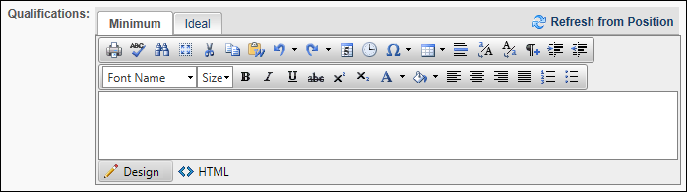
The Criteria table displays the following:
- Add Attributes - Click the plus icon to the left of the Criteria heading to add attributes, which enables you to further define the ideal qualifications. See Position OU - Create - Step 1 - General.
- Edit - Click the Edit icon to edit the attribute. Changes to the attributes control an applicant's match percentage.
- Delete - Click the Trash Can icon to delete the attribute.
- Importance - Click the Importance drop-down to change the importance for the attribute. The following Importance options are available:
  - Low
  - Average
  - High
Refresh from Position
Clicking Refresh from Position from the Minimum Qualifications tab replaces the current internal and external descriptions for the template with the current description pulled from the position.
Clicking Refresh from Position from the Ideal Qualifications tab replaces the current ideal qualifications with the current attributes from Position Management.
Once refreshed, the previous descriptions or attributes cannot be recovered.
Clone External Description
The Clone External Description option enables you to use the external description as the internal description. The box is checked by default. When checked, the description from the External tab is added to the Internal tab.
You can modify and add to the description. The changes to the description on the Internal tab do not impact the External tab.
Note: If you clone the external description after entering an internal description, the internal description text will not be recoverable.
Note: The checked or unchecked state of the Clone External Description box will carryover to the job requisition. However, you can choose to check or uncheck the Clone External Description box on the job requisition.
Keywords
Enter keywords into the Keywords field, up to 1000 characters. Separate each keyword by a comma, and then a space.
The keywords can be localized by selecting the desired language from the language drop-down in the upper-right corner of the Description and Qualifications section. Then, enter the translated keywords in the Keywords field.
Hiring Team
The Hiring Team panel displays all users that are associated with the requisition. There are three types of users that can be associated with a requisition: primary owner, owners, and reviewers. In addition, a hiring manager can be selected.
Primary Owner
This field displays the user who is defined as the primary owner of the requisition. This is a required field that cannot be left blank. By default, this field is populated with the requisition creator. The primary owner can be changed by selecting a different user.
Note: The approval workflow for requisition templates is associated with the user defined in the Primary Owner field.
To select a different primary owner:
- Click the Remove icon in the Primary Owner field. This enables the Select icon .
- Click the Select icon in the Primary Owner field. This opens the Select Primary Owner pop-up.
- Select a user from the list. This closes the pop-up and populates the Primary Owner field with the selected user. The user who was previously listed as the primary owner is now included as an owner in the Owner(s) field.
Edit Primary Owner Field
When editing a requisition template, the Primary Owner field can only be modified when the template is in a Draft or Open status. The field cannot be modified when the template is in one of the following statuses:
- Cancelled
- Closed
- Denied
- Open - Pending Re-Approval
- Pending Approval
Requisition Owners
Job requisitions are required to have at least one requisition owner. When a job requisition is created from this template, the selected co-owners are pre-populated on the job requisition form.
Which users are available for selection is determined by the constraints applied to the permission needed to manage requisition templates. The user who is defined as the primary owner cannot also be defined as an owner in the Owner(s) field.
If a user who is listed as an owner in the Owner(s) field is added as the primary owner in the Primary Owner field, then the user is automatically removed from the Owner(s) field.
Requisition owners are dynamically assigned the permission to be an owner of the associated requisition.
To add a requisition owner:
- Click Add Owner(s). This opens the Select User pop-up.
- Select one or more users.
- Click Done. This adds the user to the Requisition Owners section.
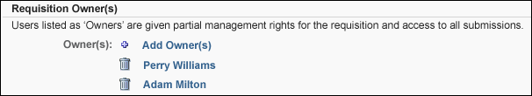
Applicant Reviewers
Hiring Manager
The hiring manager is considered a reviewer and is dynamically assigned the permission to review requisitions. The hiring manager is also sent any emails that are configured with "Hiring Manager" as a recipient. This is not a required field. Requisition templates can only have one hiring manager.
To add a hiring manager:
- Click Add Hiring Manager. This opens the Select User pop-up.
- Select one or more users.
- Click Done. This adds the hiring manager to the Applicant Reviewers section.
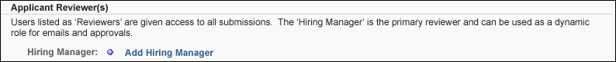
Reviewers
Reviewers are dynamically assigned the permission to review requisitions that apply to the associated requisition.
To add an applicant reviewer:
- Click Add Reviewer(s). This opens the Select User pop-up.
- Select one or more users.
- Click Done. This adds the reviewer to the Applicant Reviewers section.
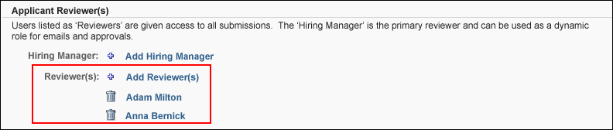
Applicant Interviewers
Interviewers can be configured as part of the hiring team. Interviewers selected in the Applicant Interviewer(s) section within the hiring team are in turn available for selection on the Applicant Review tab for any applicant status that is designated as a status type of Interview. The selected interviewers can review all applicants that are in the associated interview status type.
From the Applicant Interviewer(s) section, administrators can add and remove interviewers, as well as create a list of interviewers by copying the list of applicant reviewers. The Applicant Interviewer(s) section is not required.
Note: When editing a requisition template, changes made to the Applicant Interviewer(s) section do not apply to job requisitions that use the template.
Copy Applicant Reviewers
The Copy from Applicant Reviewers icon in the Applicant Reviewers section provides a one-click option to quickly create a list of interviewers by copying the applicant reviewers and hiring manager. Clicking the icon adds the applicant reviewers and hiring manager to the Applicant Interviewers section. The icon only displays for users who have permission to edit interviewers.
If interviewers have already been defined in the Applicant Interviewers section, then clicking the Copy from Applicant Reviewers icon overwrites the existing interviewers without warning.
Note: If there are no applicant reviewers defined, then clicking the Copy from Applicant Reviewers icon has no functionality.
Add Interviewers
To add interviewers:
- Click the Add Interviewer(s) link. This opens the Select User pop-up.
- Select one or more users. The users that are available to select are based on the constraints applied to the permission to edit interviewers.
- Click Add. This adds the users to the Applicant Interviewer(s) section.
Interviewers are listed in the order in which they are added.
Note: The Add Interviewer(s) link only displays for users who have permission to edit interviewers. For users who do not have permission to edit interviewers, the list of interviewers displays but cannot be modified.
Remove User
Requisition owners, the hiring manager, applicant reviewers, and interviewers can be removed by clicking the trash can icon to the left of the user's name.
Note: Requisition templates must have at least one requisition owner.
Note: If an interviewer is removed from a requisition template that is associated with a job requisition, the interviewer is not removed from the job requisition.
Information Pop-Up
Additional information appears for owners, the hiring manager, reviewers, and interviewers by hovering over the user's name. An information pop-up appears, displaying the following information about the user:
- Photo; shadow image displays if no photo is available
- Name
- Position title
- Phone number
- Email address link
Attachments
The Attachments section enables administrators to attach up to 10 documents to the template. When using the template for job requisitions, the documents appear in the Attachments section on the job requisition and can be deleted by the user.
It is important to note that all users with permission to access the requisition template can add, delete, view, and download any associated attachments.
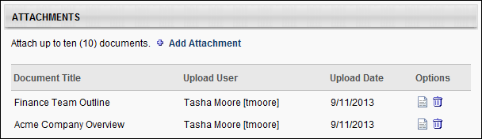
Add Attachment
In the Attachments panel, up to 10 documents can be added. The ability to add attachments is available to all users who have permission to access requisition templates.
To add an attachment:
- Click Add Attachment. This opens the Upload Attachment pop-up.
- Enter a title for the attachment in the Title field, up to 99 characters. This is a required field.
- Browse for and select the file to upload. The field accepts a maximum file size of 5MB and the following file types: .doc, .docx, .xls, .xlsx, and .pdf. Once a file is selected, Browse changes to Upload.
- Click Upload. This uploads the attachment.
- Click Save. This adds the attachment to the Attachments table. Or, click Cancel to cancel adding the attachment.
Once the maximum of 10 attachments has been reached, clicking the Add Attachment link opens the Attachment Limit Reached pop-up. This pop-up indicates that at least one document must be removed before additional documents can be added.
Attachments Table
The Attachments table displays all attachments that have been uploaded to the template. The table is sorted in order of the most recently to least recently attached document.
The following information displays for each attachment in the table:
- Document Title - This column displays the title of the document.
- Upload User - This column displays the full name and user ID of the user who uploaded the document.
- Upload Date - This column displays the date on which the document was uploaded.
- Options - The following options are available in the Options column:
  - View Attachment - Click the View Attachment icon to open the document. Uploaded documents open in the format in which the document was attached, such as .pdf or .docx. The ability to view attachments is available for all users who have access to the requisition template.
  - Delete Attachment - Click the trash can icon to delete the attachment. This opens the Confirm Delete pop-up. Click Continue to delete the attachment permanently. Or, click Cancel to cancel the delete action. Note: The Delete icon appears for all users who have permission to manage or view requisition templates.
Approvals
The Approvals section enables administrators to set the approval workflow for the job requisition. Administrators can determine which approval steps are included in the approval workflow as well as whether the approval steps occur at the same time or in a certain order.
To add an approver to the approval workflow, click the plus icon to the right of the Approvals heading. The Select Approvers pop-up appears. The available approval options are:
- Manager - This is the job requisition primary owner's manager. This option can only be selected once as an approval requirement.
- Next Level Manager - This is the job requisition owner's indirect manager. This option can be selected multiple times, as multiple indirect managers can be included.
- Corporation Approver - This is the person defined as the approver in the Corporation Approver field on the Requisition Preferences page.
- Hiring Manager - This is the person defined as the Hiring Manager on the Requisition Preferences page for the job requisition owner's OU. This option can only be selected once as an approval requirement.
- User - This allows the administrator to select a specific user in the approval process. This option can be selected multiple times, as multiple users can be included.
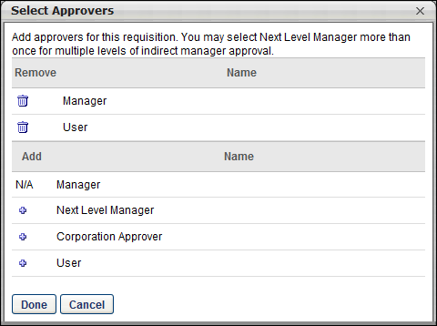
After selecting the appropriate approvers, click Done in the pop-up. The selected approvers are added to the Approvals section. All approval steps are required to approve the requisition form.
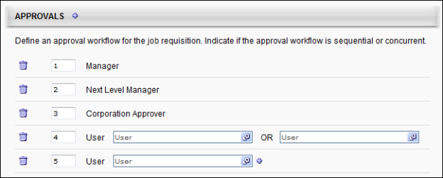
The administrator can define the order of approvals. In the text box to the left of the approval step, enter the sequence in which the approval steps should occur. The step with the sequence number of "1" occurs first, followed by 2, 3, 4, etc. The approval process will follow the sequence defined here. For example, Approver #2 does not receive an approval request until Approver #1 has approved.
If multiple steps are given the same sequence number, then those two approval steps occur concurrently. All steps can occur sequentially, concurrently, or a combination of both where some steps occur sequentially and others occur concurrently. When there are concurrent approval steps, if one of the concurrent approvers denies the request, then the job requisition is denied even though the other approvers have not yet responded. The remaining approvers' request remains and their responses are recorded even though it has no impact.
If a User approval step is added, click the User field to select a specific user. The selected user will receive the job requisition approval request.
For User approval steps only, the administrator has the option of adding a secondary approver to the approval step by clicking the plus icon to the right of the User field. When a secondary approver is added to the approval step, a second User field appears to the right of the first User field, separated by "OR." This indicates that either of the two users can approve the job requisition. Both users specified in the approval step receive the approval request at the same time, but only one of them is required to approve the request. As soon as one of the users approve or deny the request, then the other user's response has no impact on the approval status of the job requisition. Even though only the response that is submitted first impacts the approval, both responses are recorded.
Administrators can remove any approval step from the workflow by clicking the Delete icon to the left of the approval step.
Status List
The Status List section determines the statuses through which a job applicant progresses in the process of applying for a job. In this section, determine the status list by adding and removing statuses from the list, reordering the list, and making certain statuses required. The Closed and Hired statuses appear in the status list by default.
While the default status list is used for the template, the status list is dynamically updated as changes are made to the default status list. If the status list for the template is modified and the template is saved, the status list is no longer dynamically updated as changes are made to the default status list. Note: The default status list is defined from the Default Status List page.See Default Status List for additional information.
For portals with the auto assignment/progression/disposition functionality enabled (via Feature Activation Preferences), the Status List section will include Auto Assign Pre-Employment Verification, Auto Progression, and Auto Disposition columns. These options let you auto-assign pre-employment verifications, as well as set auto-progression and auto-disposition for statuses.
Add Status
To add statuses from the list, click the Edit icon to the right of the Status List heading. The Edit Status List pop-up opens.
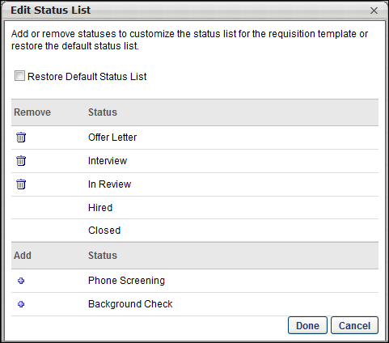
To set the status list to the default status list, select the Restore Default Status List checkbox. If this option is selected when Done is clicked, the default status list is copied from the administrator's corresponding OU preference level. This replaces any status that may have been listed in the Status List section. See Default Status List for additional information.
In the upper portion of the pop-up, all of the statuses that are currently in the status list are displayed.
- To remove a status from the default status list, in the upper portion of the pop-up, click the Remove icon to the left of the status name. The status that is removed is moved to the lower portion of the pop-up. This will also remove the status from the Status List section for the template. Note: The Closed and Hired statuses cannot be removed.
In the lower portion of the pop-up, all of the active statuses that are not in the status list are displayed.
- To add a status to the status list, in the lower portion of the pop-up, click the Add icon to the left of the status name. The status that is added is moved to the upper portion of the pop-up at the top of the list. The status order can be reordered in the Status List section.
From the pop-up, click Done to apply any changes that are made within the pop-up, such as adding or removing statuses. If the Restore Default Status option is selected when Done is clicked, all other changes that are made in the pop-up are ignored.
Reorder Statuses
The order in which the statuses appear in the list is the order in which the statuses will appear on the Applicant Profile page.
To reorder the statuses:
- Hover over a status to enable the drag and drop icon to appear.
- Drag and drop the status to the desired position in the list.
Note: The position of the Closed and Hired statuses cannot be reordered. Statuses cannot be moved below the Closed status.
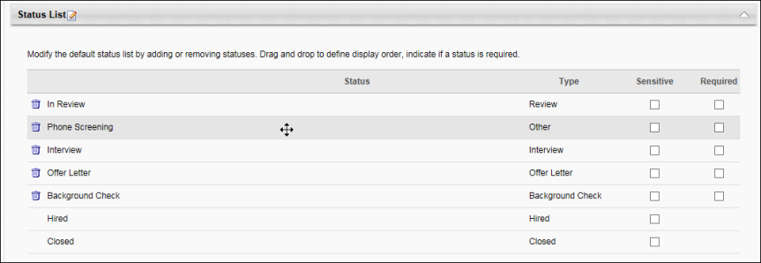
Remove Status
Statuses can be removed directly from the Status List panel. To remove a status from the list, click the Remove icon to the left of the status name. If necessary, the status can be added back to the list by clicking the Edit icon to the right of the Status List heading. Note: The Closed and Hired statuses cannot be removed. You can also remove statuses by deleting them in the Edit Status List pop-up. See the Add Status section above for more information about the Edit Status List pop-up.
Type
The Type column displays the status type. For custom statuses, the status type is defined when the administrator creates or modifies the status in Applicant Statuses. For default statuses, the status type is system-defined. The status type cannot be modified on the requisition template.
Designate Status as Sensitive
Statuses that are configured as sensitive in Manage Applicant Statuses appear as sensitive by default on the Status List panel. Check or uncheck the Sensitive option to configure a status as sensitive.
During the application process, sensitive statuses can only be accessed by users with permission to view sensitive statuses. The corresponding status panel on the Applicant Profile page is visible to the user but is not expandable. Note: For users that do not have permission to view sensitive statuses, the expand/collapse arrow does not appear for sensitive statuses on the Applicant Profile page.
First Advantage Integrations
For portals with First Advantage enabled for background checks, if the custom FADV custom applicant status is part of the default status list, then the status must be configured as sensitive in order to restrict access to the status.
Designate Status as Required
To make a status required, select the Required option for the status. When the Required option is selected for a status on this page, the status is required during the application process and cannot be skipped. A recruiter cannot change an applicant's status to a status that occurs after the required status until the required status is complete. Note: The Closed and Hired statuses cannot be indicated as required.
Auto Assign/Progress/Disposition (Early Adopter)
Note: This functionality is in the Early Adopter phase and must be self-enabled in Feature Activation Preferences.
Auto assign/progress/disposition features are available for statuses when the functionality is self-activated in Feature Activation Preferences. Once activated, the Status List section on the General tab for requisition templates and the default requisition template will include Auto Assign Pre-Employment Verification, Auto Progression, and Auto Disposition columns. These options let you auto-assign pre-employment verifications, as well as set auto-progression and auto-disposition for statuses.
For a list of considerations, exclusions, and frequently asked questions, see Frequently Asked Questions topic for this feature in Online Help.
Use Case
- Sarah is a recruiter and has to manage 40 requisitions, each receiving 1,000 applicants. Sarah does not have time to manually assign assessments and background checks individually to each candidate.
- With auto-assignment configured, she doesn’t need to individually assign each pre-employment verification. The pre-employment verifications are sent automatically when the candidates reach the appropriate status.
- With auto-progression, candidates get moved from In Review to Interview after getting a “Pass” from the pre-employment verification. Auto-progression provides a quick way for Sarah to see that all candidates ready to be interviewed have passed the initial assessment.
- With auto-disposition, candidates can be dispositioned automatically so that Sarah can easily see that all candidates who failed the assessment are in a closed status and have a disposition reason of "Failed Initial Assessment." Auto-disposition allows Sarah to focus only on qualified applicants, without needing to close out candidates who do not pass an assessment or background check.
- When candidates are assigned a pre-employment verification, either an assessment or background check, Sarah has to review the results. By having the results both reportable and available on the Manage Applicants page, Sarah can easily see the details of the candidate’s pre-employment verification—including integration status or integration score, or integration results. Sarah can then quickly compare candidates without needing to go into each individual applicant profile page. This is also helpful, if Sarah needs to review results of an assessment or background check before progressing or dispositioning a candidate.
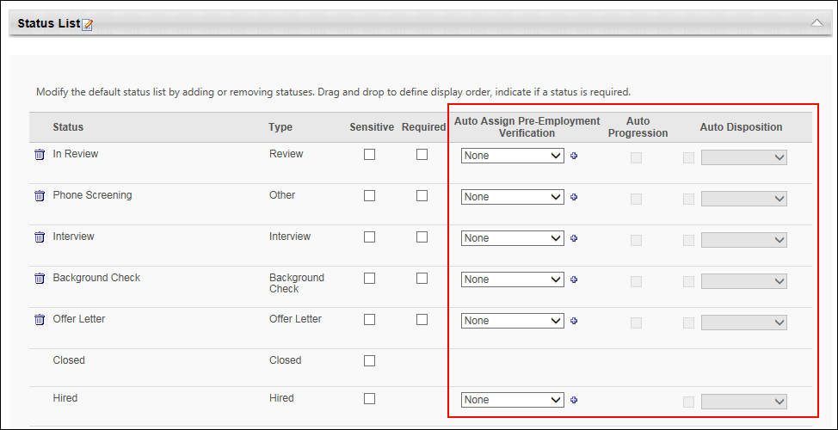
Auto Assign Pre-Employment Verification
Auto-assignment of pre-employment verifications removes the step of having to assign assessments or background checks manually to candidates once they reach a status. Candidates will be assigned the pre-employment verification as soon as they reach the status in which the pre-employment verification has been added.
To set an auto assignment for a status:
- Navigate to the Status List section on either a requisition template or a default requisition template.
- Click the drop-down in the Auto Trigger Pre-Employment Verification column. The drop-down lists all your available integrations that have been configured via Edge Integrations. An integration can only be used once in the status workflow.
- Select one of the integrations to set it as a pre-employment verification. A checkmark will appear to the left of the selected option.
You can add additional pre-employment verifications for the same status by doing the following:
- Click the plus icon to the right of the drop-down.
- This adds another drop-down below the first one.
- Select a different option from the drop-down. Additional pre-employment verifications trigger at the same time as other pre-employment verifications within the status.
Auto-assigned pre-employment verifications can be accessed by candidates in the following ways:
- Career Site > My Profile page
- Assign Integration Assessment Email - This email is available in Email Administration and must be configured by an administrator. The APPLICANT.INTEGRATION.ASSESSMENT.LINK email tag must be included in the email in order for the candidate to access the assessment from the email.
Note: The status list cannot be modified at the job requisition level.
Note: If a selected integration becomes inactive, the integration will no longer be available to select and will not be assigned to candidates.
Note: You can still manually assign pre-employment verifications from the Manage Applicants page. If manually assigned before the auto-assigned step in the status workflow, then the auto-assigned verification will not be triggered.
Auto Progression
This column lets you configure auto-progression for each status. Auto-progression moves candidates automatically to the next status in the workflow once they have completed the pre-employment verification and gotten a “Pass” result.
Check the box in the Auto-Progression section to set auto-progression for the status. Any candidate who gets a “Pass” result from the pre-employment verification will be moved automatically to the next status in the workflow. You will not need to move the candidate manually. If there are other items that need to happen in your organization for a status before the candidate should be moved forward, we would not recommend using that status for auto-progression. For example, if you have an assessment during “In Person Interview” status, but the candidate passes the assessment prior to completing their interview, the candidate would be auto-progressed to the next status regardless of whether they completed their in-person interview.
Note: If auto-progression is configured for a particular pre-employment verification, but the pre-employment verification is triggered early, the candidate will not be auto-progressed to an earlier status. Essentially, the auto-progression will no longer happen, as the candidate is receiving that integration prior to the expected workflow and the recruiter will still want to be able to move the candidate through other statuses.
Auto Disposition
This column lets you configure auto-disposition for each status. Check the box in the Auto Disposition column to set auto-disposition for the status. The drop-down will list all active disposition reasons for the portal. A disposition reason is required in order to use auto-disposition.
When auto-disposition is configured for the status, then candidates are automatically dispositioned if they receive a Fail value for the pre-employment verification.
Note: If auto-disposition is configured for a particular pre-employment verification, but the pre-employment verification is triggered early, the candidate will be auto-dispositioned upon a “Fail” result from the vendor at the time of receiving the “Fail” result.
Considerations for Data Load Wizard
When loading individual requisitions via the Data Load Wizard (DLW), if the requisition template that is used for the requisitions has auto options, then those options will be inherited so that you can bulk upload requisitions to utilize auto-progression features.
Workflow:
- Client must load requisition templates via Edge Import.
- Client manually modifies the templates for auto-progression.
- Client then loads the individual requisitions via Edge Import load or feed.
Considerations for Background Checks with Validity Periods
For portals that have the validity period functionality enabled via the Background Check Connector in Edge, the following applies to auto-assignment of background checks and auto-progression of applicant statuses:
- Auto-Assignment - A background check will not be auto-assigned again for the same candidate once the candidate has already been assigned a background check. The initial background check request and result will apply to all requisitions to which the candidate applied and will remain valid until the expiration date of the background check.
- Auto-Progression - Candidates who have a “Pass” result for a background check package will be automatically auto-progressed for all requisitions for which this is configured (and the candidate is in the status configured for auto-progression). However, if the candidate is not in a status for which auto-progression is configured, the candidate will not jump statuses and will remain in their current status.
- Auto-Disposition - Candidates who have a “Fail” result for a background check package will be automatically dispositioned in requisitions for which auto-disposition is configured.
Cancel/Save/Next
After completing all sections, click Next to validate that all required information is entered on this page and proceed to the next step. Or, click Save to save any changes made to any of the steps. Or, click Cancel to return to the Requisition Templates page without saving the template.
Requisition Template - Create - Job Ad Tab
The Job Ad tab of the requisition template enables the administrator to create and define the appearance of the job ad. The following job ads can be defined for the job requisition template:
- External Site - This job ad is for the purpose of posting the job requisition to an external career board, where the audience is people outside the organization.
- Internal Site - This job ad is for the purpose of posting the job requisition to an internal career board, where the audience is the organization's employee base.
- Mobile - This job ad is for the purpose of posting the job requisition to a mobile optimized career site.
Templates are added to Position organizational units (OU), which are found on the Manage Position page. Multiple templates can be added to each Position OU.
To access requisition templates, go to Admin > Tools > Recruit > Requisition Templates. Then, click the Manage Requisition Template icon in the Options column for the Position organizational unit (OU). This opens the Requisition Templates page for a Position OU for which at least one template has been created.
Note: If the Manage Requisition Template icon is gray , this means a requisition template has not yet been created for the Position OU. Clicking the icon when it is gray opens a blank requisition template to create for the Position OU. Once the template is saved, you are redirected to the Requisition Templates page.
Permissions
PERMISSION NAME | PERMISSION DESCRIPTION | CATEGORY

Requisition Template - Manage | Grants ability to access and view Requisition Templates. This permission cannot be constrained. This is an administrator permission. | Recruiting Administration

Requisition Template - View | Grants ability to access and view Requisition Templates. This is an administrator permission. | Recruiting Administration
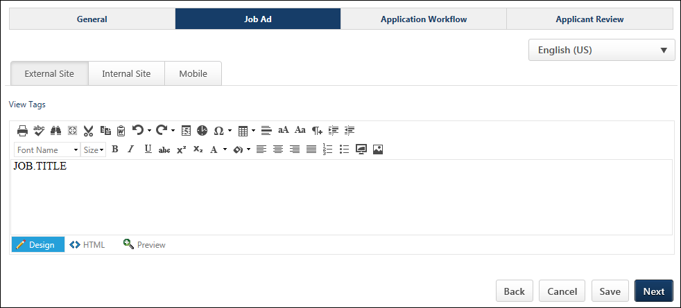
Language
The language option allows you to localize the job ad for external and internal sites, as well as mobile. Tags are also localized.
To localize the job ad, select the language from the drop-down, and then enter the translated text into the job ad.
To translate the job ad into additional languages, select a different language from the drop-down and enter the translated text into the job ad.
When the job ad is viewed, the ad displays in the language of the viewer. If a translation is not available in their language, then the ad displays in the language of the user who created the ad.
Create External/Internal Job Ad
A job ad can be created for external applicants and internal applicants, or the same job ad can be used for both types of applicants.
To switch between editing the External Site job ad and Internal Site job ad, click the External or Internal tab at the top of the editor.
To create the job ad, enter the text into the editor. The job ad editor is a Telerik RadEditor, which provides enhanced editing options, such as adding images and using HTML. For additional information about the Telerik RadEditor, visit http://www.telerik.com/help/aspnet-ajax/editor-toolbar-intro.html.
Design/HTML Modes
In the editor, there are two editing modes: Design and HTML. When in Design mode, you can use the standard editing tools to format your text, similar to your word processor application. When in HTML mode, the standard editing tools are disabled and you are able to view and modify the HTML code that is used to design the ad. To switch between modes, click the appropriate tab in the lower-left corner of the editor. The system only accepts certain customizable HTML elements in the WYSIWYG Editor. Elements that are not acceptable display as text. See Safe Listed Customizable Elements.
View in Full Screen
Click the Toggle Full Screen Mode icon to view the Description or Qualifications section in full screen mode. Click the icon again to return to the default view.
When viewing in full screen, you must be in the Design mode in order to exit the full screen view.
View Tags
To view the available tags for the ad, click the View Tags link in the upper-left corner. This includes all available standard tags and custom field tags that may exist in your portal. To use one of the tags, copy and paste the tag into the editor. All custom fields must be referenced in all capital letters. The field name must be placed within square brackets ("[ ]"). The following custom fields are available:
- [COMPENSATION.CURRENCY] - Currency type defined on job requisition form.
- [COMPENSATION.RANGE] - Payment range for the job. Note: This tag is only available to users who have permission to view and edit the salary range for requisitions. For users who do not have salary range permission, the tag is not visible in the tags pop-up.
- [COMPENSATION.TYPE] - Compensation type selected on job requisition form.
- [EMPLOYMENT.TYPE] - Employment type defined on job requisition form.
- [JOB.DESCRIPTION] - External or internal job description defined on job requisition form.
- [JOB.MINIMUM.QUALIFICATIONS] - Minimum qualifications defined for the job requisition.
- [JOB.OPENINGS] - Number of job openings defined on job requisition form.
- [JOB.OU.GRADE.TITLE] - Displays the Grade OU associated with the requisition template. Note: The tag is only available for portals that have Grade OUs enabled. In addition, the tag is only visible to users who have permission to view Grade OUs.
- [JOB.REFERRAL.BONUS] - Referral bonus defined for the job requisition. Note: Referral Suite must be enabled.
- [JOB.RESPONSIBILITIES] - Job responsibilities defined for the position OU.
- [JOB.TITLE] - Display job title defined on job requisition form.
- [OU.DIVISION] - Division selected on job requisition form.
- [OU.LOCATION] - Location selected on job requisition form.
- [OU.LOCATION.ADDRESS] - Facility address defined for the location on job requisition form.
- [REQUISITION.ADDRESS] - Displays the location address defined in the Address field on the General tab of the template.
- [REQUISITION.ID] - Displays the requisition ID.
- [TARGET.HIRE.DATE] - Target hire date defined on job requisition form.
Custom Recruiting Fields
Custom fields for Recruiting can be added to the Job Ad. The custom fields are added via tags, which can be viewed by clicking View Tags. This opens the View Tags pop-up. The custom fields that display in the tags pop-up are the fields for which the administrator meets the availability criteria. If the user does not have availability to see the custom field, the tag is hidden in the tags pop-up.
Note: Custom recruiting tags are created in the Organizational Units section of Custom Field Administration. The custom fields that are available to select are defined by the administrator in Requisition and Applicant Preferences.
Clone External Site for Internal Job Ad
When viewing the Internal Site job ad, the External Site job ad can be cloned. This allows the requisition creator to easily duplicate content from the External Site job ad to the Internal Site job ad without having to copy and paste the content. Because this option is selected by default, the content is duplicated automatically for users who wish to use the same content for both sites.
The Clone External Site option only appears on the Internal Site tab.
- When selected, the Internal Site job ad content is an exact clone of the External Site job ad and the job ad field cannot be edited. If the Clone External Site option is deselected and then later selected again, any content that is in the Internal Site job ad field is discarded and is replaced with the External Site job ad content.
- When deselected, the Internal Site job ad may contain different content than the External Site job ad. Both job ads can be edited.
Mobile Tab
From the Mobile tab, a mobile job ad can be created. When a mobile job ad is defined, the ad displays on mobile optimized career sites. If an ad is not defined on the Mobile tab, then the job description and job details display as the mobile job ad.
To create the job ad, enter the job ad in the editor, up to 30,000 characters. If the ad is copied and pasted from another source, the editor only accepts up to 3000 of the pasted characters.
For mobile ads, the following editing options are available:
- Bold
- Italics
- Underline
- Bullets
- Numbering
Tags can also be included in mobile job ads. Available tags can be viewed by selecting View Tags.
Cancel/Save/Next
After completing all sections, click Next to validate that all required information is entered on this page and proceed to the next step. Or, click Save to save any changes made to any of the steps. Or, click Cancel to return to the Requisition Templates page without saving the template.
Requisition Template - Create - Application Workflow Tab
The Application Workflow tab of the requisition template enables the administrator to define the application workflow. An application workflow defines the application experience a job applicant has when applying for a job. Separate workflows can be created for external and internal applicants, or the internal applicant workflow can be an exact copy of the external applicant workflow.
For portals with the Agency Portal functionality enabled, a Recruiting Agency tab also displays. This tab enables administrators to create a separate application workflow for a recruiting agency's users.
Templates are added to Position organizational units (OU), which are found on the Manage Position page. Multiple templates can be added to each Position OU.
To access requisition templates, go to Admin > Tools > Recruit > Requisition Templates. Then, click the Manage Requisition Template icon in the Options column for the Position organizational unit (OU). This opens the Requisition Templates page for a Position OU for which at least one template has been created.
Note: If the Manage Requisition Template icon is gray , this means a requisition template has not yet been created for the Position OU. Clicking the icon when it is gray opens a blank requisition template to create for the Position OU. Once the template is saved, you are redirected to the Requisition Templates page.
Permissions
PERMISSION NAME | PERMISSION DESCRIPTION | CATEGORY

Requisition Template – Application Workflow Template - Manage | Grants ability to set and edit Application Workflow Templates when editing Requisition Templates. This permission can be constrained by OU and User’s OU. This is an administrator permission. | Recruiting Administration

Requisition Template - Manage | Grants ability to access and view Requisition Templates. This permission cannot be constrained. This is an administrator permission. | Recruiting Administration

OU Hierarchy - Manage | Grants ability to create and update/edit organizational units. This permission grants access to all OU types, both standard and custom. This permission can be constrained by OU and User's OU. This is an administrator permission. | Core Administration
For administrators without the permission needed to manage the Application Workflow step, the Application Workflow step is read-only.
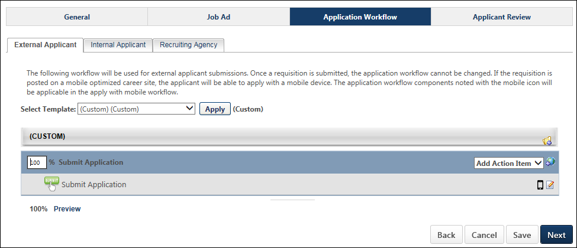
External Applicant
The External Applicant tab is the default tab that opens when viewing the Application Workflow step. This tab enables administrators to create an applicant workflow that is specific to external applicants.
Create Applicant Workflow
When setting the application workflow, there are three approaches that can be taken:
- Configure a custom application workflow without using an existing application workflow template. See Create Application Workflow Template.
- Select an existing application workflow template. Note: Templates are created in Application Workflow Templates. This populates the template below. If the selected template is later modified via the Application Workflow Template page, then those changes are automatically applied to this Job Requisition Template.
- Select an existing application workflow and make modifications. Any modifications that are made to the template do not affect the original application workflow template. The changes only apply to the job requisition template you are creating. If the selected template is later modified via the Application Workflow Template page, then those changes only affect the template in Application Workflow Templates. See Create Application Workflow Template.
To select an existing application workflow template, from the Select Template drop-down list, select the appropriate template and click Apply. This populates the template below. When selecting the template, for portals with multiple languages enabled, the template name displays in the user's language if available. If the user's language is not available, then the name displays in the language of the administrator who created the template. Note: If you are building a new workflow, and then you select a template from the drop-down list and click Apply, the workflow you were building is lost.
When selecting an existing application workflow template, the availability of templates is dependent upon the constraints of the template creator. When an administrator creates an application workflow template, only users within the template creator's permission constraints for managing application workflow templates have access to the template.
Edit Translated Values
For portals with multiple languages enabled, when configuring the application workflow, the translated values can be edited or deleted. This allows administrators to customize the workflow. This also applies to the Internal Applicant and Recruiting Agency tabs and custom workflows.
Internal Applicant
The Internal Applicant tab enables administrators to create an application workflow that is specific to internal applicants. See the Create Applicant Workflow section in the External Applicant section above for information on creating an application workflow.
Administrators can also choose to clone the external workflow by selecting the Clone External Applicant Workflow option. A warning pop-up opens, indicating that checking the clone option erases any existing configurations on the Internal Workflow tab and replaces them with the configurations from the External Workflow tab. The option is checked by default. For portals with multiple languages enabled, translated values are copied when cloning the external application workflow.
If the clone option is unchecked, then the external workflow configurations remain but can be edited, and items can be deleted.
Recruiting Agency
The Recruiting Agency tab enables you to create the workflow that is completed by the recruiters associated with a recruiting agency. Creating a recruiting agency workflow is similar to creating an external and internal workflow. However, the following action items are not available for recruiting agency workflows:
- Competency Assessment
- External Assessment
- Training
When selecting a template for the workflow, the only templates that are available to select are templates that do not contain a Competency Assessment, External Assessment, or Training action item. This is because recruiters do not complete assessments or training items for the applicants they submit.
Currently, all agency applications appear in the Standard workflow, even if they are mobile-friendly supported.
See the Create Applicant Workflow section in the External Applicant section above for more information about building an application workflow.
Preview
At the bottom of the template structure, click Preview to preview the application workflow. This opens the preview in a pop-up, allowing the administrator to preview the navigation bar, content, and progress bar.
For action items that have no content preview available, "Preview Unavailable" is displayed in the preview.
For portals with multiple languages enabled, any translated fields display in the preview in the language of the administrator, if the administrator's language is available. If the administrator's language is not available, then the preview displays in the language of the administrator who created the application workflow.
Note: When previewing application workflows that include an integration action item, the step displays the action item title and instructions, as well as an inactive Launch button.
Note: When previewing application workflows that include an integration and/or Note action item in the Submit Application section, the number of steps within the section displays in the upper-right corner of the preview page.
Compliance Questions
When previewing the template, the Compliance Questions section displays all compliance questions, regardless of the settings in Compliance Enablement Preferences. This is because the questions that appear for the applicant are dependent upon the preference settings for the associated location OU.
Veteran Status Question
The following options appear:
- Part 60-250 - This option is selected by default. The following values are available to select:
  - I am a veteran of the Vietnam era.
  - I am a special disabled veteran.
  - I am a recently separated veteran.
  - I am an other protected veteran.
  - I am not a veteran.
  - Decline to Specify.
- Part 60-300 - The following values are available to select:
  - I am a disabled veteran.
  - I am a recently separated veteran.
  - I am an other protected veteran.
  - I am an Armed Forces service medal veteran.
  - I am not a veteran.
  - Decline to Specify.
Disability Question
The following options appear:
- I have a disability and would like to be considered under the affirmative action program.
- I do not have a disability or would not like to be considered under the affirmative action program.
- Decline to Specify.
Note: The Veteran Status options relate to disabled veterans, veterans of the Vietnam Era, recently separated veterans, other protected veterans, and armed forces service medal veterans.
After configuring the application workflow, click Save to validate and save the template.
Requisition Template - Create - Applicant Review Tab
The Applicant Review tab of the requisition template displays all of the applicant statuses that are defined on the General tab of the template. Each status displays as an individual panel in the order in which the status appears on the General tab. In addition, each panel has a status type, which is defined for the status in Applicant Statuses.
From this tab, administrators can customize and configure the functionality related to the applicant statuses that are defined for a requisition template. Users can also be added to statuses to associate users with the functionality that is related to the status type. Status change emails can also be configured for each status.
Templates are added to Position organizational units (OU), which are found on the Manage Position page. Multiple templates can be added to each Position OU.
To access requisition templates, go to Admin > Tools > Recruit > Requisition Templates. Then, click the Manage Requisition Template icon in the Options column for the Position organizational unit (OU). This opens the Requisition Templates page for a Position OU for which at least one template has been created.
Note: If the Manage Requisition Template icon is gray , this means a requisition template has not yet been created for the Position OU. Clicking the icon when it is gray opens a blank requisition template to create for the Position OU. Once the template is saved, you are redirected to the Requisition Templates page.
Permissions
PERMISSION NAME | PERMISSION DESCRIPTION | CATEGORY

Requisition Template - Manage | Grants ability to access and view Requisition Templates. This permission cannot be constrained. This is an administrator permission. | Recruiting Administration

Requisition Template - View | Grants ability to access and view Requisition Templates. This is an administrator permission. | Recruiting Administration

OU Hierarchy - Manage | Grants ability to create and update/edit organizational units. This permission grants access to all OU types, both standard and custom. This permission can be constrained by OU and User's OU. This is an administrator permission. | Core Administration
Note: Additional position management functionality is available for users with the permission to manage OU hierarchy.
Emails
EMAIL NAME | EMAIL DESCRIPTION | ACTION TYPE

Applicant Status Change | This email is triggered when an applicant's status changes. The Applicant Status Change email must be defined for the associated status in order to trigger. When the email is sent, the recipient will receive the email in their language, if available for the portal. Note: The email is defined by the administrator or recruiter when configuring the requisition template or job requisition, respectively.  The email can be sent to Applicant Interviewer(s), Applicant Reviewer(s), External Applicant, Hiring Manager, Internal Applicant, Requisition Owner(s), or a specific user. This email can be configured as a Notification type email. This email is active by default and can be found in the Recruitment action type section of Email Management.  Frequently Asked Questions  How do I define a status change email for the associated applicant status?  Status change emails can be selected for each applicant status on the Applicant Review tab in requisition templates and the default requisition template, as well as when creating and editing job requisitions. See Status Change Emails on page 310 for additional information. | Recruiting
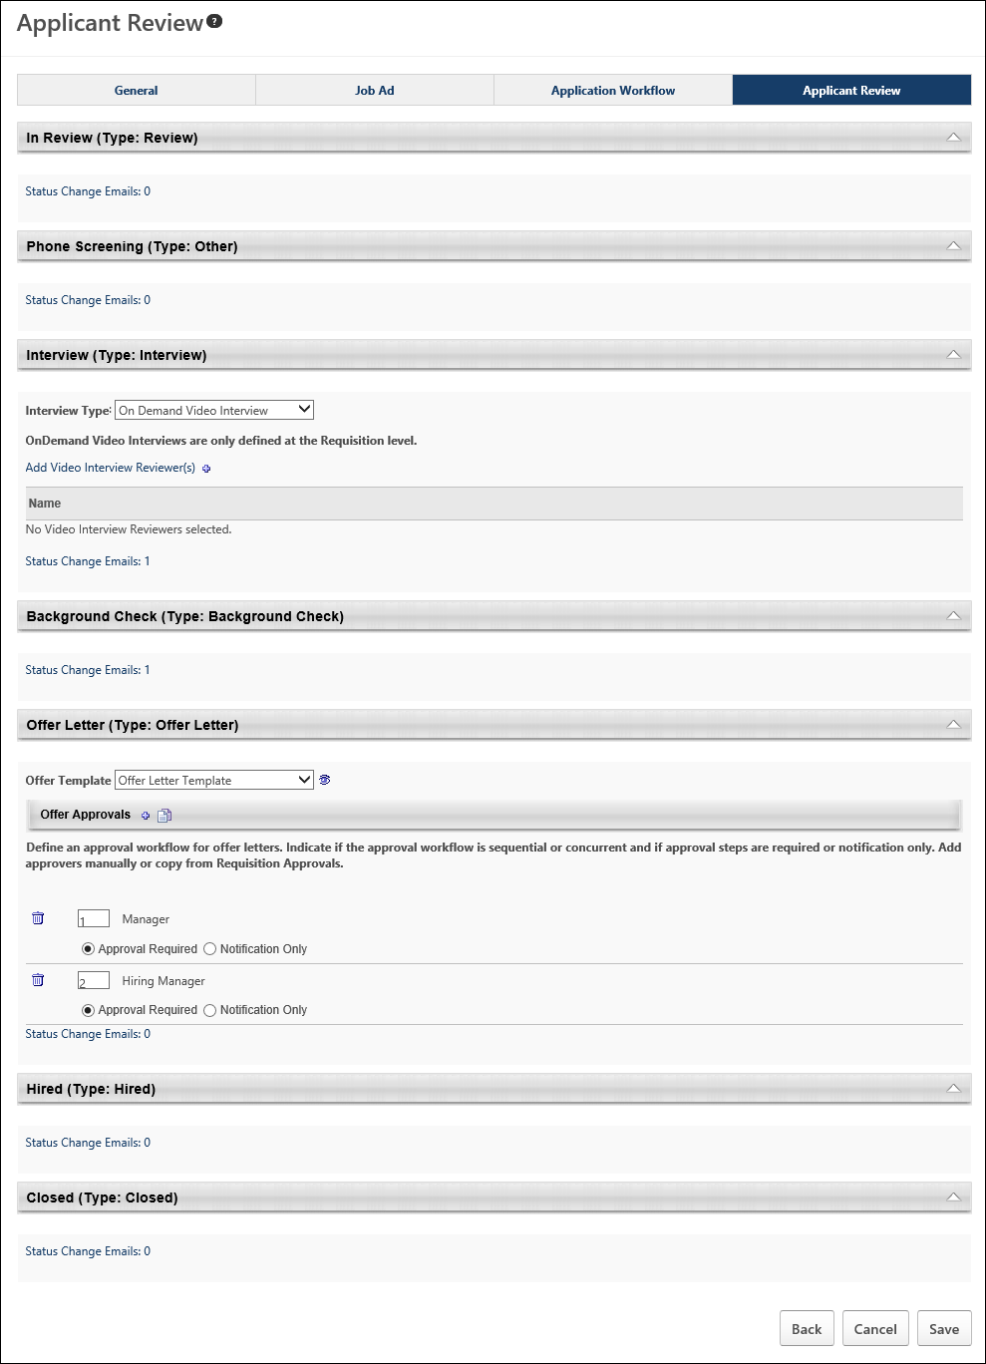
Status Types
Each status has an associated status type. The status type determines the functionality that is available in the status panel. The same status type can appear multiple times for an applicant. See the following topics for more information about each status type:
- Background Check
- Closed
- Hired
- Interview
- Offer Letter
- Other
- Review
- SHL Assessment - This status type is only available for portals with the assessment vendor functionality enabled.
Status Change Emails
Status change emails can be configured for each status type. See Status Change Emails on page 310 for additional information.
Applicant Review Tab - Background Check Status Type
The Background Check status type panel on the Applicant Review tab of the requisition template is a placeholder for this step in the applicant status workflow. The panel displays the name of the status as the panel heading. The status type of Background Check displays in parentheses to the right of the status name. The panel is not expandable or collapsible.
Status change emails can be configured for the Background Check status type panel. See Status Change Emails on page 310 for additional information.
Note: The visibility of the Background Check status is controlled by a backend setting that is disabled by default. To enable this functionality, contact Global Customer Support.
To access requisition templates, go to Admin > Tools > Recruit > Requisition Templates. Then, click the Manage Requisition Template icon in the Options column for the Position organizational unit (OU). This opens the Requisition Templates page for a Position OU for which at least one template has been created.
Note: If the Manage Requisition Template icon is gray , this means a requisition template has not yet been created for the Position OU. Clicking the icon when it is gray opens a blank requisition template to create for the Position OU. Once the template is saved, you are redirected to the Requisition Templates page.
Permissions
PERMISSION NAME | PERMISSION DESCRIPTION | CATEGORY

Requisition Template - Manage | Grants ability to access and view Requisition Templates. This permission cannot be constrained. This is an administrator permission. | Recruiting Administration

Requisition Template - View | Grants ability to access and view Requisition Templates. This is an administrator permission. | Recruiting Administration

OU Hierarchy - Manage | Grants ability to create and update/edit organizational units. This permission grants access to all OU types, both standard and custom. This permission can be constrained by OU and User's OU. This is an administrator permission. | Core Administration
Note: Additional position management functionality is available for users with the permission to manage OU hierarchy.
Applicant Review Tab - Closed Status Type
The Closed status type panel on the Applicant Review tab of the requisition template is a placeholder for this step in the applicant status workflow. The panel displays the name of the status as the panel heading. The status type of Closed displays in parentheses to the right of the status name. The panel is not expandable or collapsible.
Status change emails can be configured for the Closed status type panel. See Status Change Emails on page 310 for additional information.
Note: There are no configurable options in the panel when applicants reach the status during the applicant status workflow.
To access requisition templates, go to Admin > Tools > Recruit > Requisition Templates. Then, click the Manage Requisition Template icon in the Options column for the Position organizational unit (OU). This opens the Requisition Templates page for a Position OU for which at least one template has been created.
Note: If the Manage Requisition Template icon is gray , this means a requisition template has not yet been created for the Position OU. Clicking the icon when it is gray opens a blank requisition template to create for the Position OU. Once the template is saved, you are redirected to the Requisition Templates page.
Permissions
PERMISSION NAME | PERMISSION DESCRIPTION | CATEGORY

Requisition Template - Manage | Grants ability to access and view Requisition Templates. This permission cannot be constrained. This is an administrator permission. | Recruiting Administration

Requisition Template - View | Grants ability to access and view Requisition Templates. This is an administrator permission. | Recruiting Administration

OU Hierarchy - Manage | Grants ability to create and update/edit organizational units. This permission grants access to all OU types, both standard and custom. This permission can be constrained by OU and User's OU. This is an administrator permission. | Core Administration
Note: Additional position management functionality is available for users with the permission to manage OU hierarchy.
Applicant Review Tab - Hired Status Type
The Hired status type panel on the Applicant Review tab of the requisition template is a placeholder for this step in the applicant status workflow. The panel displays the name of the status as the panel heading. The status type of Hired displays in parentheses to the right of the status name. The panel is not expandable or collapsible.
Status change emails can be configured for the Hired status type panel. See Status Change Emails on page 310 for additional information.
Note: The functionality associated with the Hired status type is configured on the Applicant Profile page when an applicant is in the Hired status. See Statuses Tab - Hired Status Type for additional information.
To access requisition templates, go to Admin > Tools > Recruit > Requisition Templates. Then, click the Manage Requisition Template icon in the Options column for the Position organizational unit (OU). This opens the Requisition Templates page for a Position OU for which at least one template has been created.
Note: If the Manage Requisition Template icon is gray , this means a requisition template has not yet been created for the Position OU. Clicking the icon when it is gray opens a blank requisition template to create for the Position OU. Once the template is saved, you are redirected to the Requisition Templates page.
Permissions
PERMISSION NAME | PERMISSION DESCRIPTION | CATEGORY

Requisition Template - Manage | Grants ability to access and view Requisition Templates. This permission cannot be constrained. This is an administrator permission. | Recruiting Administration

Requisition Template - View | Grants ability to access and view Requisition Templates. This is an administrator permission. | Recruiting Administration

OU Hierarchy - Manage | Grants ability to create and update/edit organizational units. This permission grants access to all OU types, both standard and custom. This permission can be constrained by OU and User's OU. This is an administrator permission. | Core Administration
Note: Additional position management functionality is available for users with the permission to manage OU hierarchy.
Applicant Review Tab - Interview Status Type Overview
Interview status type panels on the Applicant Review tab of the requisition template enable administrators to define an interview process for the status. The name of the status displays as the panel name.
When a status has a status type of Interview, all of the options that are available for the Interview status type appear in the panel. The panel is expanded by default. Completing the fields in the Interview status type panel is not required on the requisition template.
Status change emails can be configured for the Interview status type panel. See Status Change Emails on page 310 for additional information.
Note: There are many scenarios in which an organization may prefer to define a status other than Interview as an Interview status type. For example, if an organization requires all applicants to have a phone screening, then the organization can create a custom status named Phone Screening and select the status type as Interview. This enables the administrator to configure interview functionality for the custom Phone Screening status.
To access requisition templates, go to Admin > Tools > Recruit > Requisition Templates. Then, click the Manage Requisition Template icon in the Options column for the Position organizational unit (OU). This opens the Requisition Templates page for a Position OU for which at least one template has been created.
Note: If the Manage Requisition Template icon is gray , this means a requisition template has not yet been created for the Position OU. Clicking the icon when it is gray opens a blank requisition template to create for the Position OU. Once the template is saved, you are redirected to the Requisition Templates page.
Permissions
PERMISSION NAME | PERMISSION DESCRIPTION | CATEGORY

Requisition Template - Manage | Grants ability to access and view Requisition Templates. This permission cannot be constrained. This is an administrator permission. | Recruiting Administration

Requisition Template - View | Grants ability to access and view Requisition Templates. This is an administrator permission. | Recruiting Administration

OU Hierarchy - Manage | Grants ability to create and update/edit organizational units. This permission grants access to all OU types, both standard and custom. This permission can be constrained by OU and User's OU. This is an administrator permission. | Core Administration
Note: Additional position management functionality is available for users with the permission to manage OU hierarchy.
Interview Type
The Interview Type drop-down enables you to determine the kind of interview that is available for the status. The following interview types are available:
- Scheduled Interview - A scheduled interview can be an In Person, Phone, or Live Video interview. Live Video interviews are video interviews that are conducted in real-time between one or more interviewers and the applicant, and are available through HireVue. The Scheduled Interview option is selected by default in the Interview Type field. When this option is selected, the Interview Guide field displays.
- On Demand Video Interview - An On Demand Video interview is an interview that is conducted asynchronously by the applicant in HireVue.
Applicant Review Tab - Offer Letter Status Type
The panel for the default status type of Offer Letter on the Applicant Review tab of the requisition template enables administrators to select the offer letter template and define the approval workflow that will display on the Applicant Review tab for the status type when creating or editing a job requisition.
The status panel of the type Offer Letter on the Applicant Review tab displays the name of the status as the panel heading. The status type of Offer Letter displays in parentheses to the right of the status name. This panel is expanded by default.
Status change emails can be configured for the Offer Letter status type panel. See Status Change Emails on page 310 for additional information.
To access requisition templates, go to Admin > Tools > Recruit > Requisition Templates. Then, click the Manage Requisition Template icon in the Options column for the Position organizational unit (OU). This opens the Requisition Templates page for a Position OU for which at least one template has been created.
Note: If the Manage Requisition Template icon is gray , this means a requisition template has not yet been created for the Position OU. Clicking the icon when it is gray opens a blank requisition template to create for the Position OU. Once the template is saved, you are redirected to the Requisition Templates page.
Permissions
PERMISSION NAME | PERMISSION DESCRIPTION | CATEGORY

Requisition Template - Manage | Grants ability to access and view Requisition Templates. This permission cannot be constrained. This is an administrator permission. | Recruiting Administration

Requisition Template - View | Grants ability to access and view Requisition Templates. This is an administrator permission. | Recruiting Administration

OU Hierarchy - Manage | Grants ability to create and update/edit organizational units. This permission grants access to all OU types, both standard and custom. This permission can be constrained by OU and User's OU. This is an administrator permission. | Core Administration
Note: Additional position management functionality is available for users with the permission to manage OU hierarchy.
Offer Template
Select a template from the Offer Template drop-down. This is not a required field. The offer letter templates that are available to select are the templates that have been configured for the Location Organizational Unit (OU) selected in the Location field on the General tab. Templates by OU are defined by the administrator when configuring offer letter templates.
To preview the template, click the Preview icon to the right of the Offer Template field. Within the preview, click the PDF icon to view the template in Adobe Acrobat®.
Note: The Preview icon only displays after an offer letter template is selected.
Note: If tags are used in the template, the tags appear as tags because the template is not connected to a position or candidate.
Offer Approvals
The Offer Approvals panel enables administrators to define an approval workflow for the offer letter. Defining an approval workflow is not required.
Define Approval Workflow
To define an approval workflow:
- Click the plus icon to the right of the Offer Approvals header. This opens the Select Approvers pop-up.
- Select an approver. Initially, approvers are listed in the order in which they are selected, but the order can be modified in the Offer Letter panel. The following approver options are available:
  - Manager - This is the requisition owner's manager. This option can only be selected once as an approver.
  - Next Level Manager - This is the indirect manager at each level of the user hierarchy. This option can be selected repeatedly as an approver.
  - <OU Type> Approver - This is the person defined as the <OU Type> Approver in Requisition and Applicant Preferences.
  - Hiring Manager - This is the person defined as the hiring manager on the General step of the requisition template.
  - User - This option enables administrators to select a specific user as an approver. This option can be selected repeatedly as an approver and also added as an OR rule.
- Click Done. This closes the pop-up and adds the approvers to the Offer Approvals panel.
Approval Workflow Order
Once all approvers are selected, the approval order can be defined. The order can be sequential, concurrent, or both. To define the approval order, enter the step number in the numeric text box to the left of the approver. There must be at least one step with a "1" entered.
Sequential Approval Workflow
For a sequential approval workflow, approval requests are sent in numeric order. For example, Approver B (Janette Andrews) is sent the Pending Approval Notification email after the user's manager has approved the request.
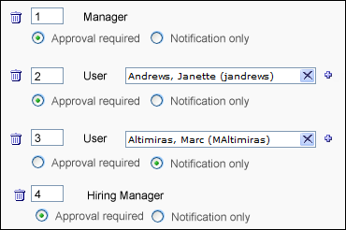
Concurrent Approval Workflow
For a concurrent approval workflow, approval notifications are sent at the same time to all approvers that have the same workflow number. For example, if a "1" is entered for the user's manager, Janette Andrews Hiring Manager, then the Pending Approval Notification email is sent to each of them at the same time.
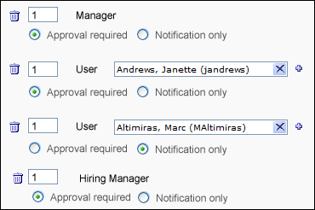
If at least one of the approvers in a concurrent approval workflow denies the offer letter, then the offer letter is denied, even if the other approvers have not yet responded. For the other approvers in the step, the approval request is automatically retracted.
Note: A concurrent approval workflow creates an AND rule. When viewing the workflow on the Applicant Profile page, the approvers are displayed in the same row.
Sequential/Concurrent Approval Workflow
For a sequential/concurrent approval workflow, some approval steps are in numeric order and some steps are marked with the same number. For example, a "1" is entered for Approvers A and B, a "2" is entered for Approver C, and a "3" is entered for Approver D. In this example, if Approvers A or B deny the offer letter, then the Pending Approval Notification email is not sent to Approvers C and D.
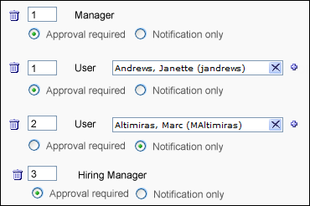
Note: A sequential/concurrent approval workflow could create an OR and AND rule within the same approval step. (OR logic is explained in the subsequent section.) When viewing the workflow on the Applicant Profile page, the approvers are displayed in the same row. If one of the approvers in the step denies the offer letter, then the step is placed into a Denied status and the system automatically retracts the approval request for all other approvers in the step who have not yet recorded an approval decision.
Adding OR Rules
For approval steps that are configured for a specific user, more than one user can be added as an approver. This creates an OR rule (e.g., Approver A or Approver B can approve the offer letter for that approval step). Only one OR rule can be created per approval step. The Pending Approval Notification email is sent to both approvers at the same time, but only one of them is required to approve the offer letter. If one of the approvers denies the offer letter, then the entire step is placed into a Denied status and the system automatically retracts the other user's approval request.
To create an OR rule:
- Click the plus icon to the right of the approver box. This opens the Select Approver pop-up.
- Select a user.
- Click Done. The second approver is added to the right of the first approver in the approval step.
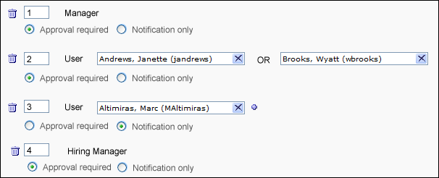
Note: In a step that contains both an OR rule and an AND rule, it is possible for two or more approvers to submit an approval decision for the offer letter. This is only possible if the approvers approve the offer letter. As soon as one approver in the step denies the offer letter, the step's status is Denied. For the approvers that approved the offer letter, their decision remains in the system.
Approval Required or Notification Only
The Approval required and Notification only options enable administrators to define whether or not the approver is required to approve the offer letter before the offer letter moves to the next step in the approval workflow.
- Approval required - If this option is selected, the approvers must approve the offer letter in order for the offer letter to move to the next step in the workflow. If configured in Email Management, the Pending Approval Notification email is sent to approvers in the corresponding approval step to notify them that they are required to approve the offer letter.
- Notification only - If this option is selected and if configured in Email Management, the Pending Approval Notification email is sent to approvers in the corresponding approval step for notification purposes only. Such approvers do not have approval/denial options on the Recruiting Approvals page and are skipped in the approval process. For example, if the Notification only option is selected for the approver in the last row of the approval workflow, then the offer letter is approved when the last required approver completes their approval step.
Remove Approval Workflow Step
Approval steps can be removed by clicking the trash can icon to the left of the step. The entire step is deleted. If a step includes an OR rule, then both approvers for the step are removed.
Copy Approval Workflow
If a requisition approval workflow is created in the Approvals panel on the General tab, then the workflow can be copied to the Offer Approvals workflow. To copy an approval workflow, select the Copy Approval icon . The requisition approval workflow from the General tab appears in the Offer Approvals panel. By default, the Approval Required option is selected for each approver.
If an approval workflow is not configured on the General step, then the Copy Approval icon has no function.
Note: Clicking the Copy Approval icon overwrites any existing approval workflow without warning. This means that if you have configured an approval workflow in the Offer Approvals panel and then you click the Copy Approval icon, the workflow you created is replaced with the workflow from the General step and the existing approval workflow is not saved.
Interview Status Type - On Demand Video Interview
An on demand video interview is a video interview that the applicant completes on their own time using HireVue. The applicant is sent a unique link to the interview via email. They can also access the interview from their My Profile page. The applicant is displayed a list of questions, which they answer by recording themselves responding to the questions in HireVue. Once the applicant completes the video interview, the interview reviewers can access the video and review the applicant's responses.
Status change emails can be configured for the Interview status type panel. See Status Change Emails on page 310 for additional information.
Note: The ability to conduct On Demand Video interviews is controlled by backend settings that are disabled by default. To enable this functionality, contact Global Customer Support.
Note: Responses for the fields in the Interview status type panel are optional.
To access requisition templates, go to Admin > Tools > Recruit > Requisition Templates. Then, click the Manage Requisition Template icon in the Options column for the Position organizational unit (OU). This opens the Requisition Templates page for a Position OU for which at least one template has been created.
Note: If the Manage Requisition Template icon is gray , this means a requisition template has not yet been created for the Position OU. Clicking the icon when it is gray opens a blank requisition template to create for the Position OU. Once the template is saved, you are redirected to the Requisition Templates page.
Permissions
PERMISSION NAME | PERMISSION DESCRIPTION | CATEGORY

Requisition Template - Manage | Grants ability to access and view Requisition Templates. This permission cannot be constrained. This is an administrator permission. | Recruiting Administration

Requisition Template - View | Grants ability to access and view Requisition Templates. This is an administrator permission. | Recruiting Administration

OU Hierarchy - Manage | Grants ability to create and update/edit organizational units. This permission grants access to all OU types, both standard and custom. This permission can be constrained by OU and User's OU. This is an administrator permission. | Core Administration
Note: Additional position management functionality is available for users with the permission to manage OU hierarchy.
Interview Type
Select the On Demand Video Interview type from the drop-down in the Interview Type field. When this option is selected, the Interview Template option displays.
Interview Template
Interview templates are only defined at the job requisition level. When setting up an On Demand Video Interview status type within a requisition template, there is no configuration available for the On Demand Video Interview template.
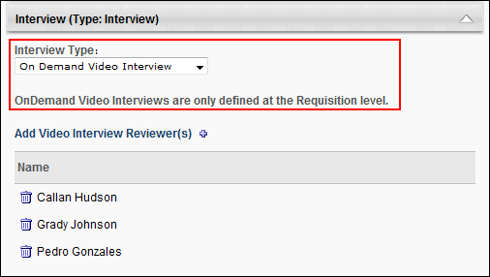
Add Video Interview Reviewers
On Demand Video Interview reviewers are added to the Video Interview Reviewers table by clicking the plus icon to the right of Add Video Interview Reviewer(s). This opens the Add pop-up. The pop-up displays the interviewers that were added to the Applicant Interviewer(s) section on the General tab of the template. Click the plus icon to the left of each interview reviewer you would like to add. Then, click Done. The interview reviewers are added to the Video Interview Reviewers table.
Note: On Demand Video interview reviewers only display in the Add pop-up if interviewers are defined in the Applicant Interviewer(s) section of the General tab for the template. Interviewers that are added to the Applicant Interviewer(s) section on the General tab are not automatically added to the Video Interview Reviewers table. Interview reviewers must be added manually using the Add Video Interview Reviewer(s) feature.
Note: The same interview reviewer can be added to multiple Interview type status panels.
Note: Interview reviewers must have a valid email address defined in the system in order to be included as On Demand Video interview reviewers. If a valid email address is not defined for one or more interview reviewers, then an error message displays when Save is clicked to save the requisition template or when the administrator attempts to navigate to another tab in the template.
Remove Interview Reviewer
Within the Add pop-up, you can remove interview reviewers. To remove an interview reviewer, click the trash can icon to the left of the interview reviewer's name. Then, click Done. This removes the interview reviewer from the pop-up and the Video Interview Reviewers table. Removing them from within the pop-up does not remove them as an interviewer on the General tab.
Video Interview Reviewers Table
The Video Interview Reviewers table displays the interview reviewers and the option to remove interview reviewers. The following information appears in the table:
- Remove - Click the Trash Can icon to the left of the interview reviewer's name. This removes the interview reviewer from the table.
- Name - This column displays the name of the interview reviewer.
Applicant Review Tab - Other Status Type
When a status is defined as the Other status type, the panel on the Applicant Review tab of the requisition template is a placeholder for this step in the applicant status workflow. The panel displays the name of the status as the panel heading. The status type of Other displays in parentheses to the right of the status name. The panel is not expandable or collapsible.
Status change emails can be configured for the Other status type panel. See Status Change Emails on page 310 for additional information.
Note: There are no configurable options in the panel when applicants reach the status during the applicant status workflow.
To access requisition templates, go to Admin > Tools > Recruit > Requisition Templates. Then, click the Manage Requisition Template icon in the Options column for the Position organizational unit (OU). This opens the Requisition Templates page for a Position OU for which at least one template has been created.
Note: If the Manage Requisition Template icon is gray , this means a requisition template has not yet been created for the Position OU. Clicking the icon when it is gray opens a blank requisition template to create for the Position OU. Once the template is saved, you are redirected to the Requisition Templates page.
Permissions
PERMISSION NAME | PERMISSION DESCRIPTION | CATEGORY

Requisition Template - Manage | Grants ability to access and view Requisition Templates. This permission cannot be constrained. This is an administrator permission. | Recruiting Administration

Requisition Template - View | Grants ability to access and view Requisition Templates. This is an administrator permission. | Recruiting Administration

OU Hierarchy - Manage | Grants ability to create and update/edit organizational units. This permission grants access to all OU types, both standard and custom. This permission can be constrained by OU and User's OU. This is an administrator permission. | Core Administration
Note: Additional position management functionality is available for users with the permission to manage OU hierarchy.
Applicant Review Tab - Review Status Type
The Review status type panel on the Applicant Review tab of the requisition template is a placeholder for this step in the applicant status workflow. The panel displays the name of the status as the panel heading. The status type of Review displays in parentheses to the right of the status name. The panel is not expandable or collapsible. See Statuses Tab - Review Status Type in the Applicant Profile section of Online Help for information about the functionality associated with the Review status type.
Status change emails can be configured for the Review status type panel. See Status Change Emails on page 310 for additional information.
Note: When viewing statuses of the type Review on the Applicant Profile page for the applicant, only the first instance of a status of the type Review displays the applicant review functionality, which includes the list of applicant reviewers, the date the Review Request was sent, the Reviewed checkbox, and the Add Reviewer option. All subsequent instances of a status of the type Review do not display the applicant review functionality. Instead, they display the name of the status as the panel heading and the status type of Review in the Type field within the panel, and the panels are not expandable or collapsible.
To access requisition templates, go to Admin > Tools > Recruit > Requisition Templates. Then, click the Manage Requisition Template icon in the Options column for the Position organizational unit (OU). This opens the Requisition Templates page for a Position OU for which at least one template has been created.
Note: If the Manage Requisition Template icon is gray , this means a requisition template has not yet been created for the Position OU. Clicking the icon when it is gray opens a blank requisition template to create for the Position OU. Once the template is saved, you are redirected to the Requisition Templates page.
Permissions
PERMISSION NAME | PERMISSION DESCRIPTION | CATEGORY

Requisition Template - Manage | Grants ability to access and view Requisition Templates. This permission cannot be constrained. This is an administrator permission. | Recruiting Administration

Requisition Template - View | Grants ability to access and view Requisition Templates. This is an administrator permission. | Recruiting Administration

OU Hierarchy - Manage | Grants ability to create and update/edit organizational units. This permission grants access to all OU types, both standard and custom. This permission can be constrained by OU and User's OU. This is an administrator permission. | Core Administration
Note: Additional position management functionality is available for users with the permission to manage OU hierarchy.
Interview Status Type - Scheduled Interview
A scheduled interview, also called a live interview, is an interview that is conducted live by one or more interviewers. Unlike On Demand Video interviews, scheduled interviews are conducted in real-time.
The following are the types of scheduled interviews:
- In Person
- Phone
- Live Video - A Live Video scheduled interview refers to an interview that is conducted via HireVue video between one or more interviewers and the applicant. This does not refer to an On Demand Video interview, which is an interview that is conducted by the applicant on their own time via HireVue video.
Note: Configuring an interview as an On Demand Video interview is done by selecting "On Demand Video Interview" in the Interview Type field in the Interview status type panel. On Demand Video interviews are then assigned to applicants from the Statuses tab on the Applicant Profile page when the applicant reaches the applicable Interview status type.
- Vitual
Status change emails can be configured for the Interview status type panel. See Status Change Emails on page 310 for additional information.
Note: The Live Video option is only available if the Enable 'Video Interview' as available interview type option is selected in Interview Management Preferences for the scheduling user’s OU.
Note: The ability to conduct video interviews is controlled by a backend setting that is disabled by default. To enable this functionality, contact Global Customer Support.
To access requisition templates, go to Admin > Tools > Recruit > Requisition Templates. Then, click the Manage Requisition Template icon in the Options column for the Position organizational unit (OU). This opens the Requisition Templates page for a Position OU for which at least one template has been created.
Note: If the Manage Requisition Template icon is gray , this means a requisition template has not yet been created for the Position OU. Clicking the icon when it is gray opens a blank requisition template to create for the Position OU. Once the template is saved, you are redirected to the Requisition Templates page.
Permissions
PERMISSION NAME | PERMISSION DESCRIPTION | CATEGORY

Requisition Template - Manage | Grants ability to access and view Requisition Templates. This permission cannot be constrained. This is an administrator permission. | Recruiting Administration

Requisition Template - View | Grants ability to access and view Requisition Templates. This is an administrator permission. | Recruiting Administration

OU Hierarchy - Manage | Grants ability to create and update/edit organizational units. This permission grants access to all OU types, both standard and custom. This permission can be constrained by OU and User's OU. This is an administrator permission. | Core Administration
Note: Additional position management functionality is available for users with the permission to manage OU hierarchy.
Interview Type
The Scheduled Interview option is selected by default in the Interview Type field. When this option is selected, the Interview Guide field displays.
Interview Guide
The Interview Guide field enables you to include an interview guide for interviewers. For example, an interview guide could explain best practices for conducting an interview or provide interviewers with a list of required questions to ask during the interview. This field also gives you the option not to include an interview guide for interviewers. The option selected in the Interview Guide field determines what appears in the Interview Guide column in the Interviewer table.
For portals with multiple languages enabled, the interview guide name displays in the user's language if available. If the user's language is not available, then the name displays in the language of the administrator who created the interview guide.
The following interview guide options are available:
- Select Guide - This option is selected by default. When selected, the Interview Guide column displays a drop-down for each interviewer that enables you to select from all available guides. Note: The interview guides for this option are created in Interview Guide Management.
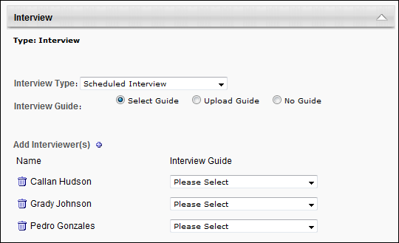
- Upload Guide - When selected, the Interview Guide column displays a plus icon that enables you to upload an interview guide. This allows you to include an interview guide that is created outside the system.
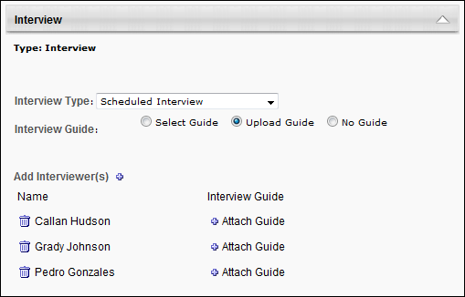
- No Guide - Select this option to not include an interview guide for interviewers.
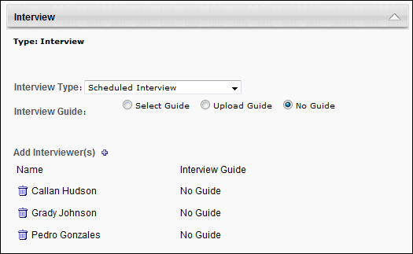
Add Interviewers
Interviewers are added to the Interviewers table by clicking the plus icon to the right of Add Interviewer(s). This opens the Add pop-up. The pop-up displays the interviewers that were added to the Applicant Interviewer(s) section on the General tab of the template. Click the plus icon to the left of each interviewer you would like to add. Then, click Done. The interviewers are added to the Interviewers table.
Note: Interviewers only display in the Add pop-up if they are defined in the Applicant Interviewer(s) section of the General tab for the template. Interviewers who are added to the Applicant Interviewer(s) section on the General tab are not automatically added to the Interviewers table for Interview type status panels. Interviewers must be added manually using the Add Interviewer(s) feature.
Note: The same interviewer can be added to multiple Interview type status panels.
Remove Interviewer - Add Pop-Up
Within the Add pop-up, you can remove interviewers. To remove an interviewer, click the Trash Can icon to the left of the interviewer's name. Then, click the Done button. This removes the interviewer from the pop-up and the Interviewers table. Removing them from within the pop-up does not remove them as an interviewer on the General tab.
Interviewers Table
The Interviewers table displays the interviewers and the interview guide option for the interviewers. The following information appears in the table:
- Remove - Click the trash can icon to the left of the interviewer's name. This removes the interviewer and the interview guide from the table.
When editing or copying a requisition template, interviewers can be removed from the template even if they are already scheduled for an interview. The interview that is scheduled is not modified.
- Name - This column displays the name of the interviewer.
- Interview Guide - This column displays one of the following, depending on the option selected in the Interview Guide field:
  - Select drop-down - A Select drop-down displays if the Select Guide option is selected in the Interview Guide field. Select a guide from the drop-down. The guides that are available to select are created in Interview Guide Management. You can delete the guide by clicking the Trash Can icon to the left of the guide.
  - Attach Guide - This option displays if the Upload Guide option is selected in the Interview Guide field. To upload a file:
    - Click the plus icon to upload a file. This opens the Upload Guide pop-up.
    - In the Title field, enter the title that will display to interviewers, up to 250 characters.
    - Click Browse to locate and select the file. The maximum file size is 1MB. The acceptable file types are .doc, .docx, .xls, .xlsx, .pdf, .txt, and .rtf.
    - Click Upload. This adds a link to the guide in the Interview Guide column. You can delete the guide by clicking the Trash Can icon to the left of the guide.
  - No Guide - This text displays if the No Guide option is selected in the Interview Guide field.
Applicant Review Tab - SHL Assessment Status Type
SHL Assessment status type panels on the Applicant Review tab of the requisition template enable administrators to define an SHL assessment for the status. Only one assessment can be added to each SHL Assessment status type panel. The name of the status displays as the panel name.
When a status has a status type of SHL Assessment, all of the options that are available for the SHL Assessment status type appear in the panel. The panel is expanded by default. Completing the fields in the SHL Assessment status type panel is not required on the requisition template.
Note: The configurations in the SHL Assessment status type panel do not remain available if the backend settings for the assessment functionality are disabled after the configurations are saved. The title of the status is also removed from the panel header. However, the Status Change Email option remains in the panel.
To access requisition templates, go to Admin > Tools > Recruit > Requisition Templates. Then, click the Manage Requisition Template icon in the Options column for the Position organizational unit (OU). This opens the Requisition Templates page for a Position OU for which at least one template has been created.
Note: If the Manage Requisition Template icon is gray , this means a requisition template has not yet been created for the Position OU. Clicking the icon when it is gray opens a blank requisition template to create for the Position OU. Once the template is saved, you are redirected to the Requisition Templates page.
Permissions
PERMISSION NAME | PERMISSION DESCRIPTION | CATEGORY

Requisition Template - Manage | Grants ability to access and view Requisition Templates. This permission cannot be constrained. This is an administrator permission. | Recruiting Administration

Requisition Template - View | Grants ability to access and view Requisition Templates. This is an administrator permission. | Recruiting Administration

OU Hierarchy - Manage | Grants ability to create and update/edit organizational units. This permission grants access to all OU types, both standard and custom. This permission can be constrained by OU and User's OU. This is an administrator permission. | Core Administration
Note: Additional position management functionality is available for users with the permission to manage OU hierarchy.
Add Assessment
To add an assessment:
- Click Add Assessment. This opens the Select External Assessment pop-up.
- Select an assessment from the list of assessments. This closes the pop-up and adds the assessment to the status type panel. Note: If the assessment vendor requires that only one solutionID can be associated per requisition, and an assessment has already been associated with the requisition (either in the application workflow or applicant review settings), then the only assessments that are available to select are the assessments that share the same solutionID.
Once the assessment is added to the status type panel, the following information displays for the assessment:
- Delete - Click the trash can icon to the left of the assessment title to delete the assessment. This removes the assessment from the panel and enables the Add Assessment link to reappear.
- Title - This field displays the title of the assessment.
- Solution ID - This field displays the solutionID for the assessment. See the Add Assessment topic in Online Help for additional information about solutionIDs.
- Sitting - This field displays the sitting number for the solutionID. See the Add Assessment topic in Online Help for additional information about solutionIDs.
Status Change Emails
Applicant Status Change emails can be configured for the status type. See Status Change Emails on page 112 for additional information.
Status Change Emails
The Status Change Emails option is available for all status types when creating, editing, and copying requisition templates. This option enables administrators to include one or more Applicant Status Change emails to each status in the applicant status workflow. When included for a status, the emails trigger when an applicant moves into the associated status. Configuring applicant status emails for requisition templates helps ensure that the right people are notified of changes to an applicant's status.
To access requisition templates, go to Admin > Tools > Recruit > Requisition Templates. Then, click the Manage Requisition Template icon in the Options column for the Position organizational unit (OU). This opens the Requisition Templates page for a Position OU for which at least one template has been created.
Note: If the Manage Requisition Template icon is gray , this means a requisition template has not yet been created for the Position OU. Clicking the icon when it is gray opens a blank requisition template to create for the Position OU. Once the template is saved, you are redirected to the Requisition Templates page.
Permissions
PERMISSION NAME | PERMISSION DESCRIPTION | CATEGORY

Requisition Template - Manage | Grants ability to access and view Requisition Templates. This permission cannot be constrained. This is an administrator permission. | Recruiting Administration

Requisition Template - View | Grants ability to access and view Requisition Templates. This is an administrator permission. | Recruiting Administration

OU Hierarchy - Manage | Grants ability to create and update/edit organizational units. This permission grants access to all OU types, both standard and custom. This permission can be constrained by OU and User's OU. This is an administrator permission. | Core Administration
Note: Additional position management functionality is available for users with the permission to manage OU hierarchy.
Status Change Emails Option
All status panels include an option to add one or more Applicant Status Change emails to the status. Administrators can define which emails are triggered for each status in the applicant status workflow. The selected Applicant Status Change emails are triggered when the applicant moves into the associated status. Selecting Applicant Status Change emails for a status is not required.
Use Case
An applicant is currently in a status of Phone Interview. The applicant completes the phone interview, and the recruiter updates her status to Onsite Interview. When the Phone Interview status is changed to Onsite Interview, the Applicant Status Change email that is defined for the Onsite Interview status is triggered. The email is sent to all users who are defined as interviewers for the onsite interview.
Define Applicant Status Change Email
To select the status change emails:
- Click Status Change Emails in the status panel. This opens the Status Change Emails pop-up. The pop-up displays the list of email templates that are defined for the associated status. Note: The email templates in the pop-up are configured by the administrator in Email Management.
- Select one or more email templates. The selected emails display in the Selected Templates table in the pop-up. You can delete an email from the Selected Templates table by clicking the Delete icon to the left of the template name.
- Click Save. This adds the email templates to the status. Note: The content of the emails cannot be modified from the requisition template. The emails can only be modified by the administrator in Email Management.
Once the emails are added to the status, the number of emails that are added displays to the right of the Status Change Emails link.

Default Requisition Template Preferences
Default Requisition Template Preferences enable administrators to create default requisition templates by Division Organizational Unit (OU). The default template can be used in place of an existing requisition template. Similar to creating a requisition template, preferences for default requisition templates are defined for the following standard requisition template tabs:
- General
- Applicant Review
- Job Ad
- Application Workflow
To access Default Requisition Template Preferences, go to Admin > Tools > Recruit > Default Requisition Templates.
Permissions
PERMISSION NAME | PERMISSION DESCRIPTION | CATEGORY

Default Requisition Template – Manage | Grants access to manage Default Requisition Template Preferences. This permission can be constrained by OU and User's OU. This is an administrator permission. | Recruiting Administration
Note: Administrators must have permission constrained to their OU in order to access Default Requisition Template Preferences for their OU.
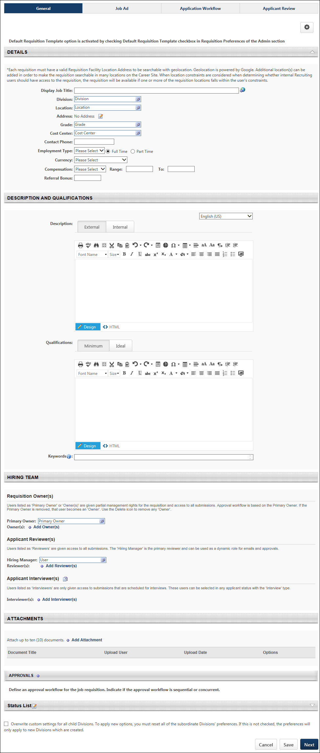
General Tab
See Requisition Template - Create - General Tab on page 248 for additional information.
The following fields are not available when configuring the General tab settings on the default requisition template:
- Job Title
- Template Title
- Template Description
- Active
The following are additional considerations when configuring the default requisition template:
- As with existing functionality, the EEO Category field only displays if enabled in Requisition and Applicant Preferences.
- In the Description and Qualifications section, the Refresh from Position option is not available.
Applicant Review Tab
See Requisition Template - Create - Applicant Review Tab on page 282 for additional information.
All fields on the Applicant Review tab for default requisition templates are identical to the fields on the Applicant Review tab for requisition templates.
Job Ad Tab
See Requisition Template - Create - Job Ad Tab on page 274 for additional information.
All fields on the Job Ad tab for default requisition templates are identical to the fields on the Job Ad tab for requisition templates.
Application Workflow Tab
See Requisition Template - Create - Application Workflow Tab on page 278 for additional information.
All fields on the Application Workflow tab for default requisition templates are identical to the fields on the Application Workflow tab for requisition templates.
Overwrite Settings
Select this option to overwrite custom settings for child division OUs. If you overwrite custom settings for child division OUs, the selected settings are applied to both new and existing child OUs. Any previously customized child OUs are updated with the selected settings.
- If there are no customizations to the child OU, then the parent OU customizations are applied to all child OUs.
- Overwrite custom settings checkbox setting
  - If this option is selected, all child OU customizations are deleted from the database, which means the parent OU customizations will be applied to new and existing child OUs.
  - If this option is unselected, all existing child OU customizations will remain unchanged, and any new child OUs will inherit the parent OU customizations by default.
- If a child OU has been customized to display any widgets, then regardless of the parent OU customizations, the child OU customizations are applied.
- If a child OU has been customized to hide all widgets, then parent OU customizations will take precedence and will be applied.
Cancel/Save/Next
Click Cancel to cancel the default template without saving the settings.
Click Save to the save the default template.
Click Next to move to the next tab in the template.

Feature Activation Preferences
The Feature Activation Preferences page provides top-level system administrators and recruiting administrators the option to self-activate Recruiting functionality.
To access Feature Activation Preferences, go to Admin > Tools > Recruit > Feature Activation Preferences.
Permissions
PERMISSION NAME | PERMISSION DESCRIPTION | CATEGORY

Recruiting Feature Activation Preferences - Manage | Grants ability to access and manage Feature Activation Preferences in Recruiting. This permission cannot be constrained. This is an administrator permission. | Recruiting
Activate Auto-Assignment, Auto-Progression, and Auto-Disposition (Early Adopter)
The Auto-Assignment, Auto-Progression, and Auto-Disposition (Early Adopter) features lets administrators auto-assign a pre-employment verifications (third-party EDGE assessment or background check), such as a background checks, at the time a candidate enters a specific status. In addition, administrators can configure statuses to auto-progress or auto-disposition candidates based on a Pass/Fail result from a pre-employment verification vendor.
Click here for frequently asked questions about the Automated Candidate Progression features, as well as considerations and exclusions.
Activate
To activate this functionality, click Activate in the Auto-Assignment, Auto-Progression, and Auto-Disposition section. The functionality is now activated.
Once the functionality is activated, the Status List section on the General tab for new and existing requisition templates and the default requisition template will include auto-assignment, auto-progression, and auto-disposition sections. These sections let administrators select the pre-employment verifications that will be auto-assigned or that will trigger auto-progression or auto-disposition of a candidate whey they reach the associated status.
Deactivate
You can disable this functionality by clicking Deactivate on the Feature Activation Preferences page. The Deactivate button appears after activation.
Once the functionality is deactivated, new requisition templates and the default requisition template will no longer display auto options.
Deactivation will halt all auto-assignment, auto-progression, and auto-disposition of integrations. For example, if an auto-assignment of Assessment ABC is triggered upon a candidate reaches In Review status, and the feature is deactivated, the candidate will not automatically be sent Assessment ABC upon reaching In Review status.
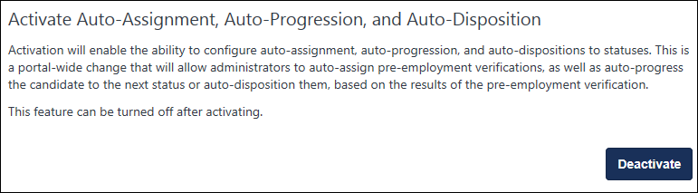
Use Case
- Sarah is a recruiter and has to manage 40 requisitions, each receiving 1,000 applicants. Sarah does not have time to manually assign assessments and background checks individually to each candidate.
- With auto-assignment configured, she doesn’t need to individually assign each pre-employment verification. The pre-employment verifications are sent automatically when the candidates reach the appropriate status.
- With auto-progression, candidates get moved from In Review to Interview after getting a “Pass” from the pre-employment verification. Auto-progression provides a quick way for Sarah to see that all candidates ready to be interviewed have passed the initial assessment.
- With auto-disposition, candidates can be dispositioned automatically so that Sarah can easily see that all candidates who failed the assessment are in a closed status and have a disposition reason of "Failed Initial Assessment." Auto-disposition allows Sarah to focus only on qualified applicants, without needing to close out candidates who do not pass an assessment or background check.
- When candidates are assigned a pre-employment verification, either an assessment or background check, Sarah has to review the results. By having the results both reportable and available on the Manage Applicants page, Sarah can easily see the details of the candidate’s pre-employment verification—including integration status or integration score, or integration results. Sarah can then quickly compare candidates without needing to go into each individual applicant profile page. This is also helpful, if Sarah needs to review results of an assessment or background check before progressing or dispositioning a candidate.
Should my organization be an Early Adopter of Automated Candidate Progression?
Consider the following when determining whether being an Early Adopter for Manage Candidates is right for your organization:
- My organization uses EDGE assessments and background checks.
  - In order to adopt auto-progression or auto-disposition, the EDGE vendor must be able to pass "PASS" or "FAIL" values. Assessment vendors will likely already be set up with the "PASS" or "FAIL" values on EDGE.
  - The integration should not require the recruiter to take a step prior to launching the integration. For example, if a recruiter should be adding an account number to launch each integration, that integration would not be a good fit.
- My organization wants to automate assigning EDGE assessments or background checks, due to high volume of candidates applying for requisitions.
- My organization wants to eliminate the need for custom integration statuses in requisitions in order to assign assessments within other statuses that better reflect the recruiting process in their organization .
- My organization allows all recruiters to ad hoc assign integrations.
Considerations, Exclusions, and FAQs
For a list of considerations, exclusions, and frequently asked questions, see Frequently Asked Questions topic for this enhancement in Online Help. See Frequently Asked Questions - Automated Candidate Progression.
Activate Modular Offer Letters (Early Adopter)
The Modular Offer Letters (Early Adopter) functionality is a simplified approach to offer letters, providing a new user interface (UI) for creating both templates and offer letters. Administrators can create custom snippets of text and add the sections to templates. This lets recruiters pick and choose relevant content when creating offer letters and provides pre-formatted content to suit unique scenarios and serve general offer letter needs.
Administrators should see a reduction in the amount of offer letter templates they need to maintain, and recruiters should find the new process more intuitive, resulting in an improved experience for both.
The Modular Offer Letters functionality must be self-activated on the Feature Activation Preferences page.
To activate this functionality, click Activate in the Activate Modular Offer Letters section. This activates the functionality and cannot be undone.
Reset Candidate Password
The Reset Candidate Password functionality provides an alternative workflow for recovering candidate accounts by allowing recruiters who have the appropriate permission to reset a candidate's password.
The password is reset using the Reset Candidate Password option that appears on the Applicant Profile page when the Reset Candidate Password functionality is active. This option only appears for recruiters who have permission to reset an applicant's password. The temporary password expires after 48 hours.
To activate this functionality, click Activate in the Reset Candidate Password section. The functionality is now enabled.
You can deactivate this feature by clicking Deactivate in the Reset Candidate Password section. The deactivation option only displays after activating the feature.
Considerations
- Candidates will not be informed that the password expires in 48 hours. This information can be included in the Admin Password Change email. See Email Triggers.
- The career site will not include messaging that candidates can contact the career site administrator to have their password reset.
- If a candidate's duplicate accounts are merged as a result of resetting the password, some users may not be able to log in with the temporary password because their primary account was deleted during the merging.
Activate Internal Career Site
The Internal Career Site functionality must be self-enabled on Feature Activation Preferences. To activate, click the Activate button in the Internal Career Site section.
When this feature is active, the internal career site is enabled in the portal. In addition, permissions to manage and view the internal career site are applied to the System Administrator and the Recruiting Administrator roles. These administrators can assign these permissions to other users.
Activate Candidate Email Verification
With the Candidate Email Verification feature, administrators can choose to require candidates to verify their email address before gaining access to sensitive application materials via My Profile on the career site. Verification is performed when the candidate clicks a verification link in a system-generated email that is automatically sent when they create their account on the career site. The link opens the career site, where a message appears indicating whether the verification was successful. From here, candidates can quickly access the job search page and their My Profile page.
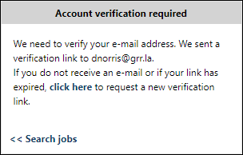
If a candidate attempts to verify their email using an invalid verification link, or if they attempt to verify after the link has expired, they will see a message informing them that their verification was unsuccessful. They will be able to request a new verification link by clicking a link in the message.
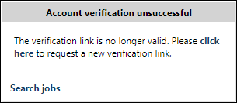
To activate this functionality, click Activate in the Candidate Email Verification section. The functionality is now enabled.
You can deactivate this feature by clicking Deactivate. The deactivation option only displays after activating the feature.
Note: The email that is sent to the candidate is not customizable. This is a system-generated email. In order for the email to fire, a default "from" email address must be present in a backend setting. The backend setting can be configured by contacting Global Customer Support.
Use Case
Karen is a Recruiting Admin at Acme. She wants to ensure her candidates' application data is secure, so she enables the Candidate Email Verification functionality on her portal.
Tim applies for a job on the Acme career site. Upon completing his application, Tim has the option to create a profile. Tim chooses to create a profile, and after entering the required information he sees a message letting him know that an email has been sent to him so he can verify his email address. Tim receives the email, clicks the link inside it, and is taken to a verification page. Tim sees a message letting him know his email has been successfully verified, and he can now access his profile. Tim reviews his profile and sees his application information.
Applicants Links on Manage Requisition Page Direct to Manage Candidates
This feature is on by default and enables the redirect to Manage Candidates in Production and Pilot portals when the Applicants count is clicked from Manage Requisitions.
However, you can disable this feature if the redirect to Manage Candidates impedes your recruiting practices. When disabled, clicking the Applicants count from the Manage Requisitions page in Production and Pilot portals will open Manage Applicants instead of Manage Candidates.
Activate Email on Manage Candidates
The Email on Manage Candidates feature must be self-activated in Feature Activation Preferences. When enabled, the Send Email option is available on Manage Candidates.
Click Activate to activate the functionality. Once activated, you can deactivate this feature by clicking Deactivate.
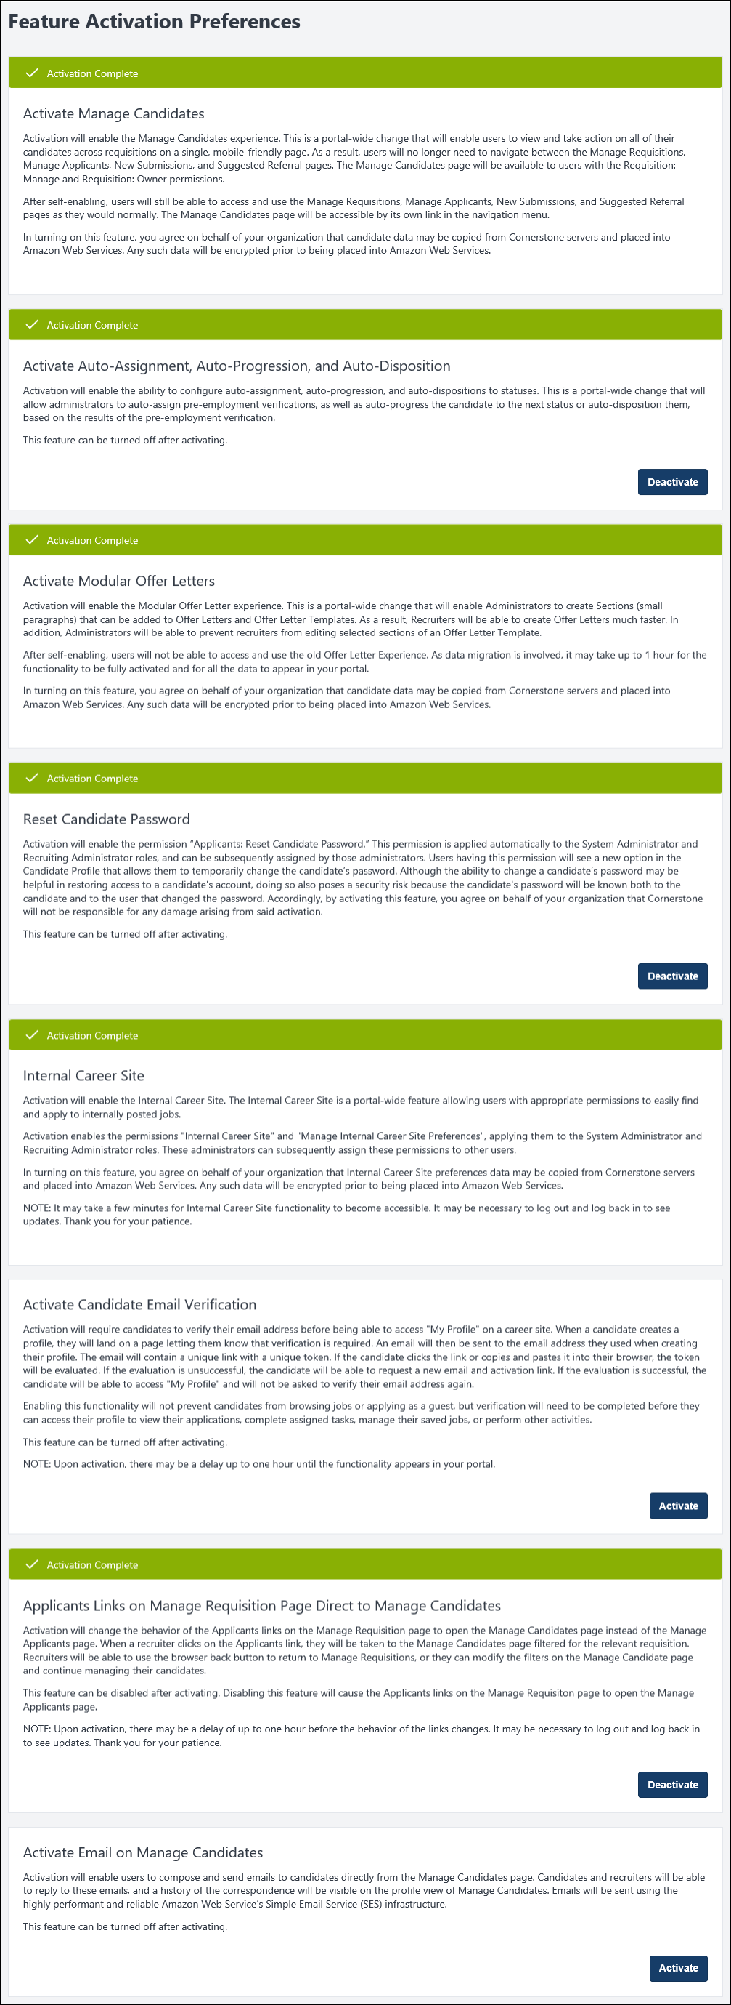

General Preferences (by Division)
The General Preferences (by Division) page allows administrators to define settings for candidate photos and reviews, application resubmission, and applying with LinkedIn.
To access General Preferences (by Division), go to Admin > Tools > Recruit > General Preferences > storage destination.
Permissions
PERMISSION NAME | PERMISSION DESCRIPTION | CATEGORY

Recruiting General Preferences - Manage | Grants ability to access and manage Recruitment General Preferences. | Recruiting Administration
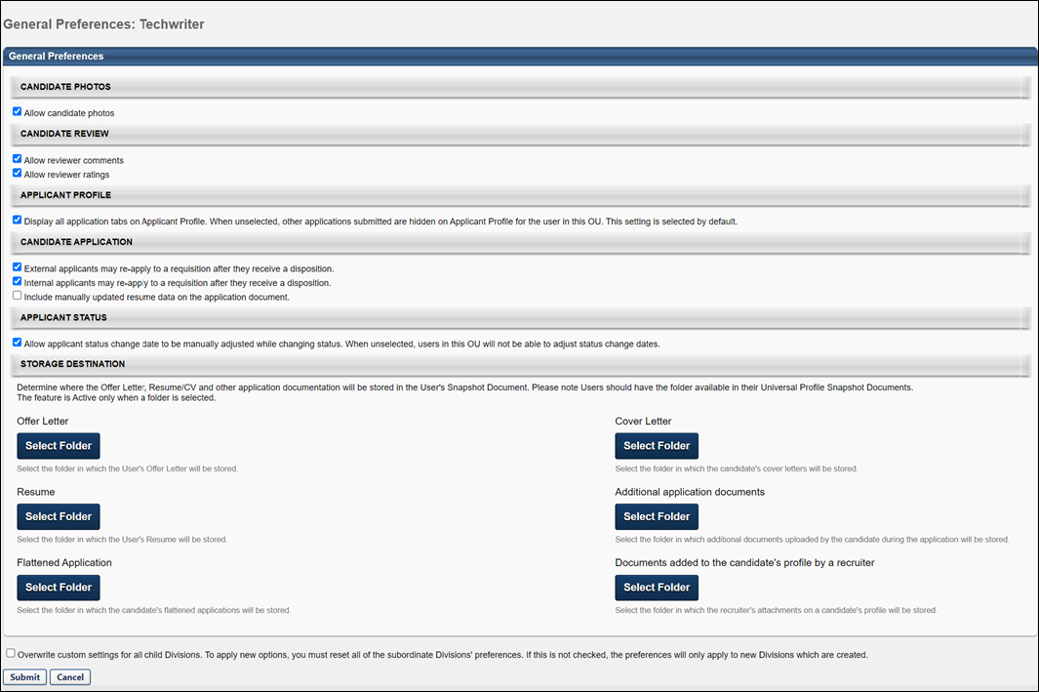
Candidate Photos
The Candidate Photos section enables administrators to control whether or not the applicant photos area is available to recruiters during the applicant process, within the selected OU. This field is checked by default. If checked, applicant photos display on all pages on which a photo is associated with an applicant. If unchecked, a ghost image displays for the applicant.
Note: This setting does not affect the Upload Image and Remove Image controls on the My Profile page of the application; applicants can always upload an image to their profile.
Candidate Review
The Candidate Review section allows administrators to enable the comments and ratings feature. The following options are available:
Allow Reviewer Comments
This option is checked by default. When checked, users can view and edit comments about an applicant on the Applicant Profile page. If unchecked, the Comments section does not display on the Applicant Profile page.
Allow Reviewer Ratings
This option is checked by default. When checked, users can view ratings and rate applicants on the Applicant Profile, View Requisition Details, Process Submissions, and Manage Candidates pages. If unchecked, users cannot view ratings or rate applicants, and the stars control is hidden on all pages.
Applicant Profile
The Display all application tabs on Applicant Profile option in the Applicant Profile section allows administrators to determine whether to display the list of other jobs to which the applicant has applied.
This option is checked by default for the top level organizational unit (OU) and all child OUs. When checked, an applicant's other jobs display on the Applicant Profile page.
When unchecked, then the following occurs on the Applicant Profile page when accessing the applicant profile from Manage Candidates, Manage Applicants (Legacy), Requisition Snapshot, Candidate Search, or Search Candidates (Legacy) results pages:
- The list of other jobs in the left navigation panel is hidden. Note: If the applicant applied to the same requisition multiple times, then the only requisition that displays is the requisition that the recruiter accessed from the Manage Applicants, New Submission, Requisition Snapshot, or Search Candidates results pages.
Use Case
An internal employee applies to multiple requisitions within their organization. The employee's manager is a reviewer and has access to the employee's Applicant Profile page. When the manager views the employee's Applicant Profile page, she sees that the employee has applied to other jobs at the company without informing her of their interest in leaving their current position. If the list of other jobs were hidden, then the manager would not have access to the employee's application data for other jobs.
- The Applicant Snapshot link is hidden.
- The Potential Duplicate Applicant flag is hidden, if enabled.
Candidate Application
The Candidate Application section allows administrators to define settings for reapplying to open requisitions and applying through LinkedIn for internal applicants. The following options are available:
External applicants may re-apply to a requisition after they receive a disposition
This option is checked by default. When checked, external applicants can reapply to open positions to which they have already applied, providing that they do not currently have an active status for the position. If unchecked, they cannot reapply and in place of an Apply Now button, the statement "You applied on M/D/YYYY" displays.
Internal applicants may re-apply to a requisition after they receive a disposition
This option is checked by default. When checked, internal applicants can reapply to open positions to which they have already applied, providing that they do not currently have an active status for the position. If unchecked, they cannot reapply and in place of an Apply button, the statement "You applied on M/D/YYYY" displays.
Allow Internal to apply with Seek (from Career Center)
This option is checked by default. When checked, internal applicants can use their Seek profile to apply to jobs. This option only displays for portals with the Apply with Seek integration enabled.
Note: The Apply with Seek integration is available as a free integration from the Edge Marketplace.
Allow Internal to apply with LinkedIn (from Career Center)
This option is checked by default. When checked, an Apply with LinkedIn button displays in the Resume/CV section on the Upload Page of the Application Experience, allowing internal applicants to apply with their LinkedIn profile information. If unchecked, the button does not display. Note: Visibility of the Apply with LinkedIn button for external applicants is controlled in Admin > Selection Management > Career Site Management.See Marketplace - Browse Edge Integrations.
Include manually updated resume data on the application document
This option is unchecked by default. Select this option to display manually entered resume data on the PDF version of the application. This option is unchecked by default.
Applicant Status
The Allow applicant status change date to be manually adjusted preference setting enables the applicant status change date to be adjusted manually. The field is unchecked by default. When checked, a date picker option will be available on all system pages that allow applicant status changes so that users can manually adjust the applicant's status change date.
Note: Since General Preferences settings are available to users within the applicant organizational unit (OU), the ability to adjust an applicant's status change date is dependent on whether or not they meet the OU criteria for OUs that have the preference enabled.
Storage Destination
The Storage Destination section allows administrators to select the folders where the candidate's offer letter(s) and resume(s) are automatically uploaded to the user's Universal Profile Documents tab.
To select a folder:
- Click the Select Folder button under the appropriate document type. The Select Folder window opens.
- Search for or select a folder name. The selected folder must be available on the user's Universal Profile Snapshot Document tab.
The selected folder names appear in the Storage Destination section.
Only one folder can be selected per document type.
Note: The end user must have appropriate permission to view the selected folders.
If a user or admin:
- Removes the snapshot folder configuration, the folder is no longer visible in this location. The actual folder remains on the Applicant Profile page.
- Deletes documents from the Snapshot folder, the documents are not retrievable on the Universal Profile. A work order is required to retrieve deleted documents. The actual documents remain on the applicant's profile page.
- Removes or deselects Snapshot folders from the Storage Destination section, the folders are no longer visible in the Storage Destination section, but the folders remain on the user's Snapshot page.
Overwrite Settings
Select this option to overwrite custom settings for child division OUs. If you overwrite custom settings for child division OUs, the selected settings are applied to both new and existing child OUs. Any previously customized child OUs are updated with the selected settings.
- If there are no customizations to the child OU, then the parent OU customizations are applied to all child OUs.
- Overwrite custom settings checkbox setting
  - If this option is selected, all child OU customizations are deleted from the database, which means the parent OU customizations will be applied to new and existing child OUs.
  - If this option is unselected, all existing child OU customizations will remain unchanged, and any new child OUs will inherit the parent OU customizations by default.
- If a child OU has been customized to display any widgets, then regardless of the parent OU customizations, the child OU customizations are applied.
- If a child OU has been customized to hide all widgets, then parent OU customizations will take precedence and will be applied.
Submit/Cancel
Once all changes have been made to the General Preferences page, click Submit. Changes are not saved unless you click Submit.
Click Cancel to cancel the changes to the settings.

Referral Preferences
Referral Preferences enable administrators to configure settings related to referrals in Career Center (Legacy). These settings determine whether employees are allowed to refer jobs to others and the methods for referral. In addition, the referral relationships employees can select when referring jobs are also configured.
Note: Referral preferences for the internal career site are configured on Internal Career Site Preferences. See Internal Career Site Preferences.
To access Referral Preferences, go to Admin > Tools > Recruit > Referrals.
Permissions
PERMISSION NAME | PERMISSION DESCRIPTION | CATEGORY

Referral Preferences - Manage | Grants ability to access and manage Referral Preferences. In addition, this permission enables administrators to view and access the Referrals widget in Welcome Page Preferences and Manage Custom Pages. | Recruiting Administration
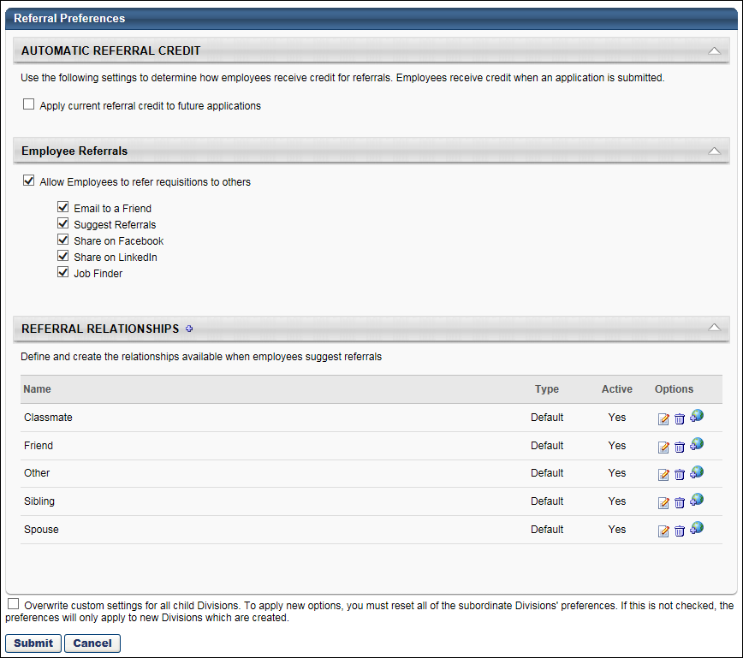
Automatic Referral Credit
In the Automatic Referral Credit panel, administrators determine how users are credited for referrals. Users can be credited on a requisition by requisition basis, or credit can be given each time the applicant they referred applies to a requisition over a specified time period.
Requisition Based Credit
With this type of credit, users receive referral credit only for the requisition to which the applicant they referred applies. This occurs when the Apply current referral credit to future applications option is not checked. The employee who refers the job will only be credited for the requisition to which the applicant they referred applies.
Note: The user to whom the referral is credited can be changed manually by the requisition owner. Manual changes to referral credit are done on the Summary tab of the Applicant Profile page by editing the agency/referral source in the Source field. If the referral credit is changed, then the referral method changes to Referral-Other.
Candidate Based Credit
With this type of credit, users receive referral credit each time the applicant they referred applies to a requisition over a specified time period, regardless of how the applicant applies to subsequent requisitions during that time period. This occurs when the Apply current referral credit to future applications option is checked. Referrals are credited only to the first user whose requisition the applicant applies to and only over a specified time period. Even if the applicant applies to subsequent referrals, only the initial referrer is credited. This allows organizations to keep track of to which user to award a referral bonus.
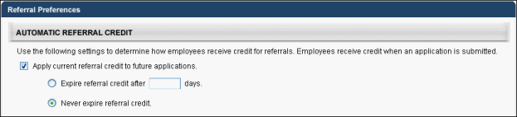
Additionally, the Apply current referral credit to future applications option is checked, the following options appear, which enables administrators to specify a time period for the referral credit:
- Expire referral credit after [numeric text box] days - By checking this option, the initial referrer will be listed as the referral source for an applicant for the number of listed days. Entering the number of days is required if this option is selected.
Note: After the entered time period has passed, the initial referrer still receives referral credit for applications that were submitted within that time period. Any applications submitted AFTER the time period will not have the initial referrer listed as the referral source.
To set the date, enter a whole number between 1 and 999998 in the text box. If 0 is entered, a referral credit is not applied. If 999999 is entered, the referral credit does not expire. The expiration time is 11:59:59pm on the last day of the referral credit period. Note: Referral credit begins on the date the applicant applies, not the referral date. Days are calculated in calendar days.
If an applicant applies to subsequent referrals during the specified time period, the system checks to see if there is an existing referral credit.
  - If there is no existing credit, then the user that referred the applicant receives the referral credit.
  - If there is an existing referral credit, then the system automatically changes the referral method for the new requisition to Referral-Other. The user that is currently being credited for referrals for that applicant receives the referral credit, even though they did not refer the applicant for the new requisition. Referral method changes are recorded on the History tab of the Applicant Profile page. See Applicant Profile Page - History Tab for additional information.
Note: On the Overview tab of the Applicant Profile page, the requisition owner can change to whom the referral is credited. However, the user the system automatically selects initially to receive referral credit cannot be changed.
When a referral credit expires, the user that was initially credited for the referral remains as the referral source for the requisition (unless the requisition owner changed the referral credit to a different user). However, subsequent requisitions to which the applicant applies are no longer credited to that user.
- Never expire referral credit - By checking this option, the referral credit never expires. The first user to receive credit for referring the applicant continues to receive credit indefinitely for all subsequent applications from the applicant. If the applicant applies for additional jobs during the referral credit period, the system automatically changes the referral method for all subsequent applications to Referral-Other and gives credit to the employee who was the initial referrer
Referral Credit Use Cases
Referral Credit Granted on a per Requisition Basis
Jane applies for the position of Sales Manager at Acme Corporation, using a link in an email sent to her by Bob, an Acme employee. Jane's application source for the position is Referral-Email, and the referral is credited to Bob.
The next day, Jane applies for the position of Accountant at Acme, using a Facebook link from Acme employee, Sarah. Jane's application source for the position is Referral-Facebook, and the referral is credited to Sarah.
Later that day, Jane applies for the position of Financial Analyst at Acme, using a LinkedIn message sent by Acme employee, Tom. Jane's application source for the position is Referral-Search Network, and the referral is credited to Tom.
Note: Jane's application source is never changed automatically by the system to Referral-Other because Referral Preferences are configured to allow referral credit on a per requisition basis.However, the user to whom the referral is credited can still be changed manually by the requisition owner.
Referral Credit with Expiration Date of 30 Days
Jane applies for the position of Sales Manager at Acme Corporation, using a link in an email sent to her by Bob, a current Acme employee. Jane's application source for the position is Referral-Email, and the referral is credited to Bob.
The next day, Jane applies for the position of Accountant at Acme, using a Facebook link from Acme employee, Sarah. Jane's application source for the position is first defined as Referral-Facebook, and the referral is credited to Sarah. However, because the referral credit has an expiration of 30 days, the source is changed automatically to Referral-Other and is credited to Bob.
On the 31st day after Jane applies for the Sales Manager position, an Acme recruiter manually adds her to the position of Consulting Manager through Candidate Bank. Jane's application source for the position is Candidate Bank, and there is no referral credit because the 30 days have passed and there is no user to whom the credit can be applied.
On the 34th day after Jane applies for the Sales Manager position, she applies for the position of Financial Analyst, using a LinkedIn referral from current Acme employee Tom. Jane's application source for the position is Referral-LinkedIn, and the referral is credited to Tom. The referral credit applies for the next 30 days.
Note: The user to whom the referral is credited for a specific requisition can be changed manually by the requisition owner.
Referral Credit with No Expiration Date
Jane applies for the position of Sales Manager at Acme Corporation, using a link in an email sent to her by Bob, a current Acme employee. Jane's application source for the position is Referral-Email, and the referral is credited to Bob.
One year later, Jane applies for the position of Accountant at Acme, using a Facebook link from Acme employee, Sarah. Jane's application source for the position is initially Referral-Facebook, and the referral is credited to Sarah. Then, because of the referral preferences, it is changed to Referral-Other and is credited to Bob.
Three years later, Jane applies for the position of Financial Analyst, using a LinkedIn referral from current Acme employee Tom. Jane's application source for the position is Referral-LinkedIn, and the referral is credited to Tom. Then, because of the referral preferences, it is changed to Referral-Other and is credited to Bob.
Note: With the Never expire referral credit preference setting, any position at Acme to which Jane applies is credited to Bob for an indefinite time period because there is no expiration date specified for referral credit. However, the user to whom the referral is credited can be changed manually by the requisition owner.
Changes to Automatic Referral Credit Preferences
Changes to Automatic Referral Credit preferences only apply to applications that are received after the changes take effect. All applications that are submitted before changes are made to the preferences are unaffected.
Inactive Users
If a referral credit applies to a user that becomes inactive during the referral credit period, the user receives credit for the referral for as long as the preference specifies.
Employee Referrals
In the Employee Referrals panel, administrators select whether or not to allow employees to refer requisitions, as well as the types of referrals they are allowed to make.
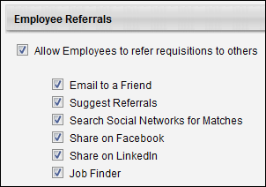
When the Allow Employees to refer requisitions to others option is checked, referral options are enabled in Career Center. Further, a list of referral types appears below to enable administrators to determine the types of referrals that users can make. Each option is checked by default. Also, when this option is selected, the Referral Relationships panel appears below the referral types. The following are the referral types:
- Email to a Friend - This option enables employees to email a job to a friend. This setting does not apply to email referral options on external career sites.
- Suggest Referrals - This option enables employees to suggest a contact for a requisition. Note: If this option is unchecked, the Referral Relationships panel is no longer visible in Referral Preferences.
- Share on Facebook - This option enables employees to share a requisition with contacts from their Facebook network. This setting does not apply to Facebook referral options on external career sites.
- Share on LinkedIn - This option enables employees to share a requisition with contacts from their LinkedIn network. This setting does not apply to LinkedIn referral options on external career sites.
- Job Finder - This option enables employees to find open jobs for a specific friend by uploading their resume.
If the Allow Employees to refer requisitions to others option is not checked, referral options are not available to employees for that OU. Further, the Refer and Share columns are hidden on the applicable tabs in Career Center.
Considerations
- If Email to a Friend and Suggest Referrals are unchecked, then the Refer column is hidden on the following pages:
- Career Center > Search Other Jobs > Job Details
- Career Center > Refer Jobs
- If Share on Facebook and Share on LinkedIn are both unchecked, the Share column is hidden on the following pages:
- Career Center > Search Other Jobs > Job Details
- Career Center > Refer Jobs
Note: The Job Details page is accessed by clicking a job title from the search results on the Search Other Jobstab in Career Center.
Referral Relationships
The Referral Relationships panel appears when the Allow Internal Candidates to refer requisitions to others option is checked in the Candidate Referrals section. In this panel, administrators manage the options from which internal users select when defining their relationship with a referral. Note: Users select the relationship in the Suggest a Referral pop-up in Career Center.
Default relationships are available and can be modified and deleted. You can also create additional referral relationships.
Note: A referral relationship, whether default or added manually, can only be deleted if it has not been used in a suggested referral. Also, at least one relationship must be in the Referral Relationships panel if the Suggest Referral option is checked in Candidate Referrals.
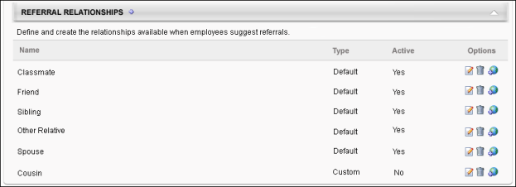
Default Relationships
The following are the five default referral relationships, each of which can be edited, localized, or deleted:
- Classmate
- Friend
- Sibling
- Spouse
- Other
Add New Relationships
To create a new referral relationship:
- Click the Add icon to the right of Referral Relationships heading. This opens the Add Relationship pop-up.
- Enter the relationship name in the Name field, up to 50 characters.
- Check the Active box to activate the relationship. If unchecked, the relationship is not available in the Relationship drop-down on the Suggest Referral pop-up in Career Center. Inactivating a relationship does not affect referrals currently using the relationship. Note: Relationships display in alphabetical order in the Relationship drop-down on the Suggest Referral pop-up.
- Click Save. The relationship appears in the Referral Relationships table.
Referral Relationships Table
The following information appears in the Referral Relationships table:
- Name - The name of the referral relationship.
- Type - The type of referral relationship.
- Active - If the relationship is active, the Active column displays "Yes." If the relationship is inactive, the column displays "No."
- Options - The following options are available in the Options column:
  - Edit - Click the Edit icon to edit the relationship name.
    - If a relationship has never been used in a suggested referral, then the Edit Referral Relationship pop-up opens. Here, you change the name and activate or deactivte the relationship. Click Save in the pop-up to save your changes.
Note: Changes to a relationship name affect both current and future referrals. For this reason, edits should only be made to correct spelling errors. Avoid making edits that change the meaning of the relationship.
    - If a relationship has been used in a suggested referral, then a warning pop-up opens first. The warning indicates that the relationship is currently in use and that any edits to the relationship affect both current and future referrals. Click Continue to open the Edit Referral Relationship pop-up. Click Cancel to cancel the action of editing the referral relationship
  - Remove - Click the Remove icon to delete a referral relationship. Only relationships that have never been used in a referral can be removed.
  - Translate - For portals with multiple languages enabled, localize the relationship name by clicking the Translate icon . For internal users, the name appears in their display language. If the name is not available in a user's display language, the name appears in the language of the relationship creator. Note: The relationship's default language is the language of the relationship creator.
Overwrite custom settings for all child divisions - If you choose to overwrite custom settings for child divisions, the selected settings are applied to both new and existing child OUs. Any previously customized child OUs are updated with the selected settings.
- If this option is unselected, then only the child OUs that do not have customized settings will be updated, as well as any OUs that are added in the future.
- A child OU that has not been customized always inherits from the parent, regardless of whether this option is selected.
- An OU is considered customized if its preference or performance settings have been changed.
Once all preferences are set, click Submit. Preference settings are not saved unless you click Submit.

Requisition and Applicant Preferences
Requisition and Applicant Preferences allow administrators to define field values for job requisition templates, job requisitions, the job search page, compensation types, and reasons for passing on an applicant. Custom fields can be defined to display on the job requisition form and the Applicant Profile page. Administrators can also set the corporation approver for Recruiting and define a default date range for the search criteria for the Manage Job Requisitions page. They can also determine whether or not to display Equal Employment Opportunity (EEO) categories on the job requisition form and in the application workflow.

Note: Changes to Requisition and Applicant Preferences are only saved once the Submit button is clicked at the bottom of the page.
To access Requisition and Applicant Preferences, go to Admin > Tools > Recruit > Requisition and Applicant Preferences.
Permissions
PERMISSION NAME | PERMISSION DESCRIPTION | CATEGORY

Requisition Preferences - Manage | Grants ability to access and manage Requisition and Applicant Preferences. This permission cannot be constrained.  Note: Users with the Requisition: Manage permission will not be affected by Field Level Access settings. | Recruiting Administration
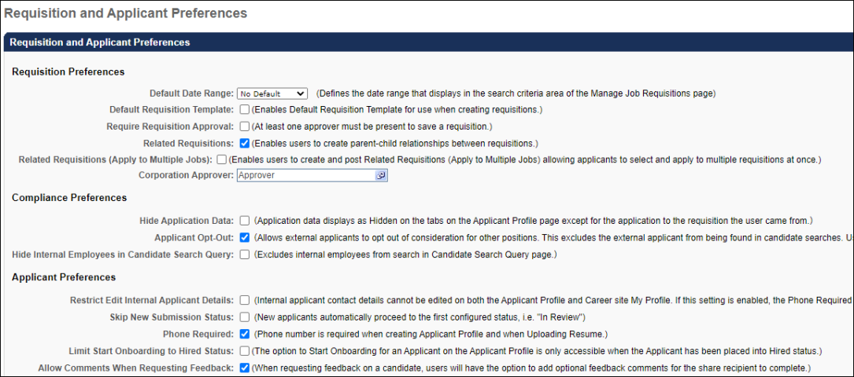
Requisition Preferences Section
The following options are available in this section:
Default Date Range
This option defines the default date range that displays in the search criteria area of the Manage Job Requisitions page. The default value is "No Default," which displays all requisitions owned by the user, regardless of date, on the Manage Job Requisitions page. Changes to Requisition and Applicant Preferences cannot be saved if the value in the Default Date Range field is "Please Select."
Default Requisition Template
This option is unchecked by default. Checking the option enables the Default Requisition Template link to display in the Select Requisition Template pop-up when configuring job requisitions and requisition requests, as well as when reviewing requisition requests.
If the option is not checked, then the recruiters, hiring managers, and requisition request reviewers cannot select the default requisition template for the position for job requisitions and requisition requests.
Require Approver
The Require Approver option is unchecked by default. When checked, all new requisitions and changes to requisitions require at least one approver. The approver is defined at the requisition template level but can be changed at the job requisition level. When changing the approver at the job requisition level, the approver field cannot be blank. In addition, the user submitting the requisition cannot designate themselves as the approver.
If Require Approver is not checked, then requisitions may be submitted without any approval.
Use Case
A recruiter creates a job requisition seeking additional headcount for the stores in his division. He has not sought approval for the requisition, but his data shows that at least two new employees are needed. He sets up interviews with candidates and includes the Human Resources (HR) Manager as an interviewer. When the HR Manager receives the interview request, she contacts the recruiter to let him know that he cannot proceed with the interviews because the additional headcount would exceed the current budget. The requisition is cancelled. The HR Manager contacts the Recruiting Administrator to ensure that all new job requisitions require approval.
Related Requisitions
This option allows recruiters to create hierarchical relationships between job requisitions by adding a single level of associated child requisitions to the parent requisition. The option is unchecked by default. When unchecked, recruiters cannot create hierarchical relationships between job requisitions.
If Related Requisitions is unchecked after the option has been checked and the preference setting saved, then a warning message appears. The message indicates that unchecking the option prevents recruiters from being able to create new parent-child relationships for job requisitions. Existing parent-child relationships are preserved. Click Yes to deselect the option, or click No to keep the option selected.
Related Requisitions (Apply to Multiple Jobs)
This option allows recruiters to create related requisitions and have applicants apply to multiple requisitions within a single applicant experience. This option is unchecked by default. This option is only available if Related Requisitions is checked.
When Related Requisitions (Apply to Multiple Jobs) is checked, recruiters can select the type of related requisition they want to add, either a related requisition or a related requisition to which applicants can apply to multiple jobs within the requisition.
If the option is unchecked after the selection is saved in Requisition and Applicant Preferences, then any related requisitions to which the applicant can apply are preserved. However, the option to Submit and Add Related button no longer displays on the Applicant Review tab when configuring job requisitions. See Create/Edit Requisition - Applicant Review Tab Overview on page 79 for additional information.
Corporation Approver
This field is optional and defines the user that can be included as part of the applicant approval process as the "Corporation Approver." The "Corporation Approver" is an approver type that can be selected from the Select Approvers pop-up in the Approvals section when creating requisition templates and job requisitions.
Note: This approver is not a default approver for your entire portal. This approver is only used within the Applicant Tracking System (ATS).
To select an approver, click the Select icon in the Corporation Approver field and choose a user from the Select pop-up. Only one user can be selected.
See Create Job Requisition Template - General for more information on where the Corporation Approver value is used in the ATS. Note: If this field is not defined in Requisition and Applicant Preferences but the Corporation Approver field is part of the approval workflow, the system automatically approves this step during the approval workflow.
Compliance Preferences Section
The following options are available in this section:
Hide Application Data
The Hide Application Data option defines whether or not application data is hidden on the Applicant Profile page. The option is unchecked by default. When unchecked, the applicant's other jobs in the left navigation panel display as a link and can be viewed by clicking the link.
When the option is checked, recruiters who do not have permission to manage requisitions or who are not part of the hiring team for the job requisition can see the list of other jobs but cannot access them. The other jobs grayed out and not selectable.
Use Case
In order to satisfy compliance requirements, an organization disables access to application data for recruiters who do not have permission to manage requisitions or are not part of the hiring team for a requisition. For such recruiters, the list of other jobs to which the applicant has applied still displays on the Applicant Profile page but is disabled and not selectable.
Record EEO
This option enables the EEO Category drop-down to display on the General step when creating a job requisition template or job requisition. The field is unchecked by default and not required. When unchecked, the EEO Category drop-down field does not display. Changes to this setting only affect new requisitions created from the job requisition template; existing job requisitions retain their EEO Category value.
Use Case
The United States federal government requires organizations with > 1000 employees to report Equal Opportunity Employment data such as gender and ethnicity.
Applicant Opt-Out
Note: This option only applies to external applicants.
When this option is unchecked, the opt-out option does not appear on the Applicant Profile page or the Submit Application step of the application workflow. Any applicants who opted out before the option was disabled will remain opted out. Any applicants who previously opted out can decide to opt in on their Career Site > My Profile page (when the opt-out option is disabled by the administrator, the unchecked box is still visible on their profile). If the applicant decides to opt in while the administrator setting has been disabled, the applicant will not be able to change their opt-in selection while the administrator has the opt-out option disabled in Requisition and Applicant Preferences.
Hide Internal Employees in Candidate Search Query
This option is unchecked by default. When checked, internal employees are excluded from the search in Candidate Search Query and the Internal Employees option is hidden in the User Types filter.
Note: Candidates with any application in a Hired status will continue to be searchable in Candidate Search Query until they become an internal employee on their start date.
Applicant Preferences Section
The following options are available in this section:
Restrict Edit Internal Applicant Details
This option enables administrators to disable the ability to modify personal applicant data on the career site and Applicant Profile page. This option is unchecked by default. When unchecked, applicant data can be modified on the career site and the Applicant Profile page by recruiters with permission to edit applicant contact details.
When this option is checked, the following occurs:
- Requisition and Applicant Preferences - The selection in the Phone Required field in the Applicant Preferences section is ignored. Applicants cannot be required to provide a phone number.
- Applicant Profile page - The Edit Contact Details option is hidden in the Options drop-down on the Applicant Profile page for internal applicants. See Applicant Profile Page Overview.
- Career Site My Profile page - The Edit Profile link is hidden on the My Profile page on the career site. See My Profile - View and Edit Profile Information.
- Applicant Experience - For internal applicants using the legacy Career Center, the Contact Information section is hidden on the Resume - Upload and Review page when completing the application. For internal applicants using the Internal Career Site, the Contact Information section is not hidden on the Resume - Upload and Review page, but the edits made on that section are not saved.. See Upload Attachments - Review Page.
Skip New Submission Status
This option enables administrators to bypass the New Submission status for applicants. When bypassed, applicants are placed directly into the first status configured for the applicant status workflow.
The option is unchecked by default. Check the option to enable the New Submission status to be bypassed. Leave the option unchecked to maintain the New Submission process.
Anonymize Personal Data for New Submissions
When Skip New Submission Status is checked in Requisition and Applicant Preferences, the Anonymize personal applicant data for New Submissions option in Compliance Enablement Preferences is disabled and hidden. The option is hidden at the top level organizational unit (OU) and all child OUs.
Phone Required
This field is unchecked by default. When checked, applicants are required to enter a phone number on the Upload Attachments step of the application process before they can move to the next step in the application workflow. The phone number provided is then accessible in the applicant's record.
Use Case
A recruiter reviews a highly qualified applicant's resume and would like to quickly contact the applicant by phone to schedule an initial interview. However, the applicant did not include a phone number anywhere on their application. The recruiter attempts to email the applicant, but the applicant's email address contains an error and the email is returned. When the applicant is finally contacted by mail, the applicant has already accepted a position elsewhere.
The recruiter contacts the Recruiting administrator to enable the Phone Required option in Requisition and Applicant Preferences to ensure that qualified applicants are not lost due to missing contact information.
Limit Start Onboarding to Hired Status
This option is unchecked by default. When checked, the Start Onboarding option only appears in the Options drop-down on the Applicant Profile page if the applicant is in a Hired status. Onboarding will not be able to be started for applicants in any other status.
Allow Comments When Requesting Feedback
This option is unchecked by default. When checked, an Allow comments option appears on the Request Candidate Feedback flyout in Manage Candidates, allowing users to enter comments about a candidate when completing feedback. If this option is not checked, then the users from whom feedback is being requested will not be able to enter comments when submitting their feedback.
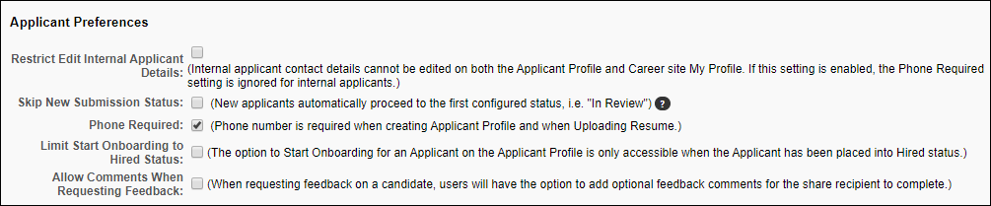
Submit
Once all changes have been made to the Requisition and Applicant Preferences page, click Submit. Changes are not saved until you click Submit.
See Also:
See the following for detailed information about the additional preferences available for Requisition and Applicant Preferences:
- Duplicate Applicants Management - See Requisition and Applicant Preferences - Duplicate Applicants Management on page 352 for additional information.
- Employment Types - See Requisition and Applicant Preferences - Employment Types on page 357 for additional information.
- Compensation Types - See Requisition and Applicant Preferences - Compensation Types on page 346 for additional information.
- Dispositions - See Requisition and Applicant Preferences - Dispositions on page 348 for additional information.
- Applicant Custom Fields - See Requisition and Applicant Preferences - Applicant Custom Fields on page 341 for additional information.
- Application Custom Fields - See Requisition and Applicant Preferences - Application Custom Fields on page 343 for additional information.
- Requisition Custom Fields - See Requisition and Applicant Preferences - Requisition Custom Fields on page 358 for additional information.
Training Resources
Visit the Cornerstone Recruiting page in the Success Center to access more training resources, from curriculum to playlists to live training registrations.

Requisition and Applicant Preferences - Applicant Custom Fields
The Applicant Custom Fields section enables administrators to add User Record custom fields. User Record custom fields are created and managed in the User Record section of Custom Field Administration. Fields that are added to the Applicant Custom Fields section display on the Custom Fields tab of the Applicant Profile Snapshot page.
Note: The visibility of the Applicant Custom Fields section is controlled by a backend setting. To enable this section to display, contact Global Customer Support.
To access Requisition and Applicant Preferences, go to Admin > Tools > Recruit > Requisition and Applicant Preferences.
Permissions
PERMISSION NAME | PERMISSION DESCRIPTION | CATEGORY

Requisition Preferences - Manage | Grants ability to access and manage Requisition and Applicant Preferences. This permission cannot be constrained.  Note: Users with the Requisition: Manage permission will not be affected by Field Level Access settings. | Recruiting Administration
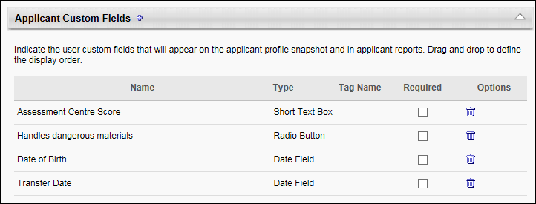
Add Applicant Custom Field
To add a field:
- Click the Add icon to the right of the section name. This opens the Select Applicant Custom Field pop-up.
- Select a field from the list. The only fields that display are the fields for which the administrator meets the availability.
- Once the field is selected, the pop-up closes. The field appears in the Applicant Custom Fields table.
Create Custom Field
You can create a new custom field from within the Select Applicant Custom Field pop-up. To create a new custom field, click New Custom Field in the pop-up. This opens the Custom Field Administration > User > Define Field page. See User Record and Self Registration Custom Fields for detailed information about creating custom fields.
Applicant Custom Fields Table
The following information displays in the table:
- Name - The name of the custom field.
- Type - The type of custom field.
- Required - The Required option is checked by default. When checked, the field is required to be completed. When unchecked, the field is optional.
- Options - The Options column displays a Delete icon to delete the field. Deleting the field removes it from the table and the Applicant Profile Snapshot page for the applicant. The field can be re-added at any time by clicking the Add icon and selecting the field from the pop-up.

Requisition and Applicant Preferences - Application Custom Fields
The Application Custom Fields section enables administrators to add application-level custom fields. Application-level custom fields are created and managed in the Application section of Custom Field Administration.
Note: The visibility of the Application Custom Fields section is controlled by a backend setting. To enable this section to display, contact Global Customer Support.
To access Requisition and Applicant Preferences, go to Admin > Tools > Recruit > Requisition and Applicant Preferences.
Permissions
PERMISSION NAME | PERMISSION DESCRIPTION | CATEGORY

Requisition Preferences - Manage | Grants ability to access and manage Requisition and Applicant Preferences. This permission cannot be constrained.  Note: Users with the Requisition: Manage permission will not be affected by Field Level Access settings. | Recruiting Administration
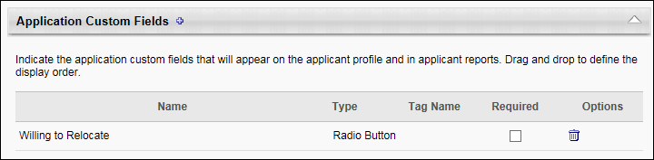
Add Application Custom Field
To add a field:
- Click the plus icon to the right of the section name. This opens the Select Application Custom Field pop-up.
- Select a field from the list. The only fields that display are the fields for which the administrator meets the availability.
- Once the field is selected, the pop-up closes. The field appears in the Application Custom Fields table.
Create Custom Field
You can create a new custom field from within the Select Applicant Custom Field pop-up. To create a new custom field, click New Custom Field in the pop-up. This opens the Custom Field Administration > Application > Define Field page. See Custom Field Admin - Application for detailed information about creating custom fields.
Application Custom Fields Table
The following information displays in the table:
- Name - The name of the custom field.
- Type - The type of custom field.
- Required - The Required option is checked by default. When checked, the field is required to be completed. When unchecked, the field is optional.
- Options - The Options column displays a Delete icon to delete the field. Deleting the field removes it from the table and the Applicant Profile page for the applicant. The field can be re-added at any time by clicking the Add icon and selecting the field from the pop-up.

Requisition and Applicant Preferences - Applicant Profile Background Image
The Applicant Profile Background Image section enables administrators to select a background image that will display on the Applicant Profile page. By default, the corporate color appears as the background on the Applicant Profile page.
To access Requisition and Applicant Preferences, go to Admin > Tools > Recruit > Requisition and Applicant Preferences.
Permissions
PERMISSION NAME | PERMISSION DESCRIPTION | CATEGORY

Requisition Preferences - Manage | Grants ability to access and manage Requisition and Applicant Preferences. This permission cannot be constrained.  Note: Users with the Requisition: Manage permission will not be affected by Field Level Access settings. | Recruiting Administration
Select Background Image
To select an image:
- Click the drop-down. This displays a list of the available images.
- Select an image from the drop-down. The recommended image size is 1000 pixels by 200 pixels.
- Click Submit at the bottom of the page to submit the preference changes. This adds the image as the background on the Applicant Profile page.
Images that are larger than the size of the space on the Applicant Profile page will be truncated. Smaller images will be centered, and the remaining white space is filled in with the corporate color.
Note: The corporate color is defined by organizational unit (OU) in the Primary Color field in Display Preferences. The color may vary by OU.

Requisition and Applicant Preferences - Compensation Types
Compensation types can be added to display in the Compensation Type field on the General step when creating/editing a job requisition template or job requisition.
To access Requisition and Applicant Preferences, go to Admin > Tools > Recruit > Requisition and Applicant Preferences.
Permissions
PERMISSION NAME | PERMISSION DESCRIPTION | CATEGORY

Requisition Preferences - Manage | Grants ability to access and manage Requisition and Applicant Preferences. This permission cannot be constrained.  Note: Users with the Requisition: Manage permission will not be affected by Field Level Access settings. | Recruiting Administration
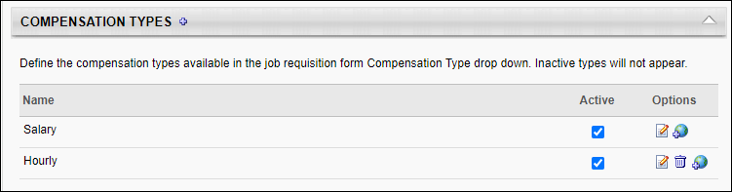
Add Compensation Types
To add compensation types:
- Click the Add icon . This opens the Add Compensation Type pop-up.
- Enter the compensation type in the Name field, up to 50 characters.
- Click Save.
Note: Compensation types display on the job requisition template or job requisition in the order in which they are entered; the order cannot be modified.
The Active box is checked by default and enables the type to display in the Compensation Type drop-down on the General step when creating a job requisition template or a job requisition. If unchecked, the type is hidden from users. Changing the active status only affects future instances of creating/editing job requisition templates or job requisitions.
In the Options column, the following options are available:
- Edit - Click the Edit icon to open the Edit Compensation Type pop-up and edit the type name. Edits to the name affect all instances of the compensation type currently in use on a job requisition template or job requisition as well as future use of the compensation type, which also impacts reporting. As a best practice, edits to the name should be reserved for minor corrections to spelling or grammar only.
- Delete - Types can only be deleted if they have not been selected on a job requisition template. Click the Delete icon to delete the compensation type.
- Translate - If multiple languages are available for your portal, you can click the Translate icon to translate the name into the other available languages, up to 50 characters. If a translation is not available for a user's display language, the name appears in the default language defined by the employment type creator.

Requisition and Applicant Preferences - Dispositions
The Dispositions panel displays the list of reasons that are available to select when passing on an applicant from the Process Submissions page, Manage Applicants page, and Applicant Profile page when applicable. There are default dispositions that are system configured, and administrators can also add dispositions.
To access Requisition and Applicant Preferences, go to Admin > Tools > Recruit > Requisition and Applicant Preferences.
Permissions
PERMISSION NAME | PERMISSION DESCRIPTION | CATEGORY

Requisition Preferences - Manage | Grants ability to access and manage Requisition and Applicant Preferences. This permission cannot be constrained.  Note: Users with the Requisition: Manage permission will not be affected by Field Level Access settings. | Recruiting Administration
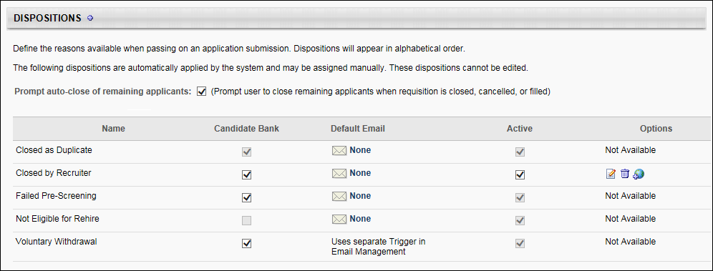
Default Dispositions
The default dispositions are system-defined and cannot be removed or inactivated. The following are the default dispositions:
- Closed as Duplicate - This disposition indicates that the application was automatically closed because the system defined the submission as a duplicate applicant. This disposition applies to duplicate applications submitted to the same job requisition. The submission(s) that is not closed is dependent upon the selection in the Target Profile field in the Duplicate Applicants Management section.
- Failed Pre-Screening - If an applicant answers one or more pre-screening questions incorrectly, their applicant status changes automatically to "Closed" with a disposition of "Failed Pre-Screening." This disposition is active by default and cannot be inactivated. The Active checkbox appears grayed out and is not selectable. There are no options available in the Options column for this disposition. Note: This disposition is assigned automatically by the system and can also be assigned manually.
- Not Eligible for Rehire - This disposition automatically removes applicants from the hiring process if they are previous employees but are not eligible to be rehired. This disposition is active by default and cannot be inactivated. The Active checkbox appears grayed out and is not selectable. No emails are configured by default but can be configured using the email options in the Default Email column. Note: A former employee is not eligible for rehire if the Eligible for Rehire field on their user record is unchecked. When the field is unchecked, and the former employee applies for a job, their application is automatically dispositioned by the "Not Eligible for Rehire" disposition because the system deems them ineligible for rehire.
- Voluntary Withdrawal - This disposition is assigned automatically when an applicant manually withdraws from a requisition and can also be assigned manually. This disposition is active by default and cannot be inactivated. The Active checkbox appears grayed out and is not selectable. This disposition uses a separate email trigger that is configured in Email Management. The email trigger can only be edited in Email Management. There are no options available in the Options column for this disposition.
Note: An applicant's disposition may appear as "Moved to another requisition." This disposition is now defunct but remains on an application if the disposition was selected for the applicant prior to the removal of the disposition. The "Moved to another requisition" disposition indicates that the applicant was moved from one requisition to another.
Prompt Auto-Close of Applicants
The Prompt auto-close of remaining applicants option is unchecked by default. Selecting the option enables the Manage Remaining Applicants pop-up, which allows the status of all remaining applicants for a requisition to be changed to Closed after the requisition closes or when all openings for a requisition are filled.
Add Disposition
Additional dispositions can be added. To add a disposition:
- Click the Add icon . This opens the Add Disposition Type pop-up.
- Enter the disposition type in the Name field, up to 50 characters.
- Click Save.
Dispositions Table
The Dispositions table displays the dispositions in alphabetical order. The following information displays in the table:
Name
The Name column displays the default dispositions and the dispositions that have been added by the administrator.
Candidate Bank
When the Candidate Bank option is checked, applicants with the associated status are stored in the Candidate Bank, can be searched for in candidate search, and appear on the Manage Candidates page. When unchecked, candidates with the associated status are not included in the Candidate Bank, cannot be found during candidate search, and do not appear on the Manage Candidates page. Applicants with an Unqualified status do not appear in the search results but can apply to requisitions and will display in requisitions for which they are already an applicant.
For the Closed as Duplicate default disposition, the Candidate Bank option is disabled by default. The option is checked and grayed out.
Default Email
You can choose to trigger an email for each disposition. If configured, when a disposition is selected from any of the Disposition drop-downs, an email is sent to the applicant. The default option is "None."
To configure the default email setting:
- Click the None link. This opens the Edit Email - [Disposition Name] pop-up.
- The following options are available in the Email Options section:
  - None - No emails trigger for the associated disposition.
  - Default - Any Disposition emails configured for the associated disposition are sent when triggered. Once the setting is saved, the link name in the Default Email column changes to Default.
  - Default with Custom Message - When this option is selected, a Custom Message field displays. Here, you can create and localize the message that will appear in place of the EMAIL.CUSTOM.MESSAGE tag in the Disposition email. Note: The Disposition email is configured by the administrator in Email Administration and is sent when dispositioning an applicant. The administrator must include the EMAIL.CUSTOM.MESSAGE tag in the Disposition email in order for your custom message to appear in the email when a candidate is dispositioned.
To add a custom message, enter the message in the Custom Message field. The field has no character limit and is not required. Click Save. Once the email is saved, the link name in the Default Email column changes to Custom. Note: The custom message cannot be modified when dispositioning an applicant. Instead, the Disposition email is sent automatically (if configured and active in Email Administration).
Email tags cannot be used in the Custom Message field. If you include an email tag, it will appear as the tag itself in the custom message, instead of being replaced with the text that would be associated with the tag. For example, if you include the JOB.TITLE tag, the text "JOB.TITLE" will appear in the custom message in the Disposition email.
If setting in the Default Email column for the disposition is changed (i.e., you change the setting to None or Default after saving the Default with Custom Message setting), the text in the Custom Message field is retained and will be available if the setting is changed back to Default with Custom Message. As noted above, if the EMAIL.CUSTOM.MESSAGE tag is not included by the administrator in the Disposition email in Email Administration, then the custom message does not display for the recipient when the email is triggered.
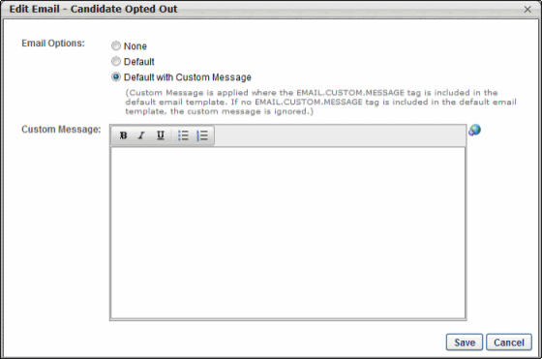
- Click Save at the bottom of Requisition and Applicant Preferences to save the default email settings or click Cancel to cancel changes to the settings.
Active
The Active box is checked by default and enables the disposition to display in the Disposition drop-down when passing on an applicant on the Process Submissions page, Manage Candidates page, and Applicant Profile page. When inactivated, the disposition does not display in the drop-down.
Changing the active status only affects future instances of selecting the disposition when passing on an applicant. Default dispositions cannot be inactivated.
Options
The following options are available in the Options column:
- Edit - Click the Edit icon to open the Edit Disposition Type pop-up and edit the disposition type name. Edits to the name affect all instances of the disposition currently in use and future use of the disposition, which also impacts reporting. As a best practice, edits to the name should be reserved for minor corrections to spelling or grammar only.
- Delete - Disposition types can only be deleted if they have not been selected for an applicant. Click the Delete icon to delete the disposition type. Default disposition types cannot be deleted.
- Translate - If multiple languages are available for your portal, you can click the Translate icon to translate the name into the other available languages, up to 50 characters. If a translation is not available for a user's display language, the name appears in the default language defined by the employment type creator.

Requisition and Applicant Preferences - Duplicate Applicants Management
The Duplicate Applicants Management section enables administrators to define the parameters that the system will use to identify and auto-merge duplicate applicants. The Prevent Duplicates and Flag Potential Duplicates options are only enabled if the Phone Required option is selected in the Applicant Preferences section. Additional duplicate applicant options are enabled if the Flag Potential Duplicates option is selected.
Duplicate applicants often occur as the result of a single applicant who applies to the same or multiple jobs using various email addresses. Such applicants can increase recruiting costs by taking multiple assessments that would otherwise only be completed once by a single applicant. Duplicate applicants also create disorganization in the ATS, triggering an unnecessary number of email triggers, requiring repeated applicant reviews, and loading the system with multiple applicant profiles. Checking for and flagging duplicate applicants allows recruiters to locate duplicates, and then change their status to Closed so that the duplicates are no longer considered part of the applicant pool for a given requisition.
Mobile-Friendly Candidate Experience Note: Merging duplicate applicants is not currently supported on mobile-friendly application workflows.
To access Requisition and Applicant Preferences, go to Admin > Tools > Recruit > Requisition and Applicant Preferences.
Permissions
PERMISSION NAME | PERMISSION DESCRIPTION | CATEGORY

Requisition Preferences - Manage | Grants ability to access and manage Requisition and Applicant Preferences. This permission cannot be constrained.  Note: Users with the Requisition: Manage permission will not be affected by Field Level Access settings. | Recruiting Administration
Use Cases
- An applicant applies to a job using his personal email address. The application requires completion of an external assessment that the organization uses to gather general information about applicants. All applicants, regardless of the requisition to which they apply, are required to complete the assessment. However, the assessment should only be completed once by a single applicant.
The applicant completes the assessment, for which the organization is charged by the vendor. One week later, the same applicant applies to the same job using his university email address. He takes the same assessment, and the organization is charged a second time by the vendor.
A recruiter checks the ATS for duplicate applicants and sees that the applicant has applied to the same job twice and completed the assessment twice. She enables the Prevent Duplicates option in Requisition and Applicant Preferences so that in the future, applicants can no longer create duplicate profiles in the career site. This eliminates the possibility that the same applicant will complete the general assessment more than once. This also reduces assessment costs.
- An applicant creates multiple profiles on an organization's career site. The applicant applies to multiple jobs and is rejected each time as an unqualified applicant. A recruiter checks the ATS for duplicate applicants and sees that the applicant has applied to various jobs and been rejected over and over. The system has automatically flagged each additional profile as a duplicate. In order to ensure that the applicant does not continue to be reviewed and is no longer in consideration for any of the requisitions, she updates the applicant's status to Closed for each profile.
Considerations
- Candidates who are in a Hired status cannot be merged.
- If an applicant's submission is merged, the applicant can no longer log in to the career site using the login credentials for that submission. The applicant can only log in to the career site using the login credentials for the target profile.
- Once an applicant is merged, the resume and any documents are moved from the merged applicant profile to the target profile.
- Merged profiles can still be accessed, but, as noted above, the application materials associated with the profile are moved to the target profile.
- When a submission is merged, only the target profile is used within the Applicant Tracking System (ATS). For example, the merged profile is not accessible from the Interview Manager, Requisition Snapshot, Manage Applicants, and Manage Candidates pages.
- Upon implementation, applicants who already exist in the ATS are not impacted by this enhancement. The system does not merge applicants retroactively.
- If there are no other potential duplicate applicants associated with an applicant who has been flagged with the Potential Duplicate Applicant flag, then when the applicant is merged into the target profile, the Potential Duplicate Applicant flag is removed from the merged profile. The system then flags the target profile with the Merged Duplicate Applicants flag.
- The Potential Duplicate Applicant flag remains on the target profile if there are other potential duplicate applicants.
- For merged applicants who are in an Offer Letter status type, the approval status of the offer letter is not impacted.
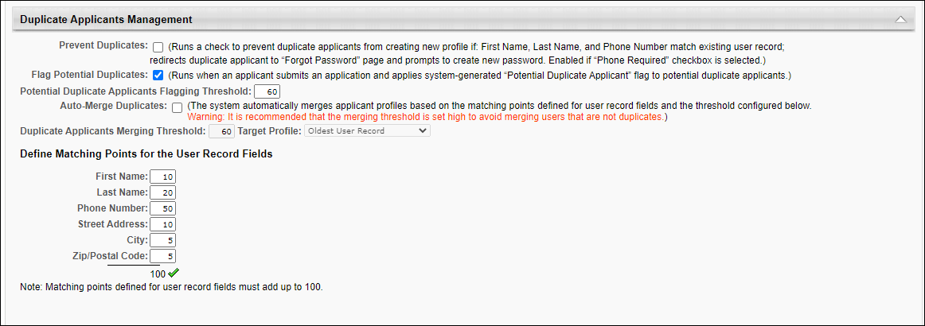
The following options are available in the Duplicate Applicants Management section:
Prevent Duplicates
When checked, this setting prevents external applicants from creating a duplicate profile on the career site. When an applicant creates a profile, if their phone number and first and last name exactly match an existing user record, then the match is considered a duplicate applicant. The match prompts the Forgot Password pop-up to open for the applicant so that they can log in to the career site with their existing profile to apply to the job. The duplicate check is also performed when a recruiting agency submits an applicant. If a duplicate applicant is found, a Forgot Password pop-up appears for the agency user.
If this setting is not checked, then applicants can inadvertently create duplicate profiles by using the same phone number and name but a different email address.
Flag Potential Duplicates
When checked, Flag Potential Duplicates enables applicants to be flagged automatically when a potential duplicate is found in the Applicant Tracing System (ATS). The system checks for an exact match of User Record fields for the applicant. If the similarity threshold reaches 60, then the applicant is flagged as a potential duplicate using the system default applicant flag Potential Duplicate Applicant.
The following similarity weights are applied to the matching criteria that are checked for potential duplicate applicants:
Field | Weight
First Name | 10
Last Name | 20
Phone Number | 30
Street Address | 20
City | 10
Zip/Postal Code | 10
Threshold | 60
If Flag Potential Duplicates is not checked, then the system does not automatically check for potential duplicates.
If Flag Potential Duplicates is checked and then is later unchecked, then the Potential Duplicate Applicant flag is hidden from the following areas of the ATS:
- Manage Candidates Flags filter
- Manage Applicants Applicant (User) Flag filter
- Applicant Profile page of flagged applicants
- Potential Duplicate Applicant option on the Candidate Search page
In addition, checking Flag Potential Duplicates enables the following in the Duplicate Applicants Management section:
- Potential Duplicate Applicants Flagging Threshold field
- Auto-Merge Duplicates field
- Define Matching Points for the User Record Fields section
Deselecting Flag Potential Duplicates disables these options but preserves the values in the Define Matching Points section.
Potential Duplicate Applicants Flagging Threshold
This field is unchecked by default. This field is only enabled and is also required when Flag Potential Duplicates is checked.
This field displays the threshold for automatically flagging applicants with the Potential Duplicate Applicant flag. The system uses the threshold number to identify duplicate applicants. Applicants who are at or above the threshold are considered duplicates and are automatically flagged with the Potential Duplicate Applicant flag.
This field displays the system defined threshold of 60. To change the value, enter a new threshold, up to 100. Decimals are not accepted.
Note: Previously, administrators did not have the ability to configure the threshold. The threshold was system defined.
Auto-Merge Duplicates
This field is unchecked by default. This field is only enabled if Flag Potential Duplicates is checked.
When this field is selected, the system automatically merges duplicate applicants based on the point values configured in the Define Matching Points section.
In addition, checking this field enables the Duplicate Applicants Merging Threshold and Target Profile fields.
Note: Unchecking Auto-Merge Duplicates after at least one duplicate applicant has been auto-merged does not impact the auto-merged applicant. The applicant remains auto-merged.
Duplicate Applicant Merging Threshold
This field is only enabled and required if Auto-Merge Duplicates is checked. This is a required field if Auto-Merge Duplicates is checked.
This field displays the threshold for the matching points that are defined in the Define Matching Points section. The system uses this number to identify duplicate applicants. Applicants who are at or above the threshold are considered duplicates and are automatically flagged with the Potential Duplicate Applicant flag.
To define the threshold, enter a value up to 100. Decimals are not accepted. The value must be greater than or equal to the value in the Flag Potential Duplicates field.
Note: If Auto-Merge Duplicates is deselected, the Duplicate Applicants Merging Threshold field is disabled and the value is grayed out and cannot be modified. The Auto-Merge Duplicates field must be checked again in order to modify the threshold value.
Target Profile
This field is only enabled if Auto-Merge Duplicates is checked.
This field determines which Applicant Profile the system will use to compile all duplicate applications. If a submission meets the merging threshold criteria based on its match to the selection in the Target Profile field, then the submission is considered a duplicate. Note: The selection in the Target Profile field does not signify which duplicate profile will be closed with the Closed as Duplicate disposition. The profile that is farthest in the application process is always the profile with which the duplicate applicant is merged. This only applies if duplicate applicants have applied to the same job requisition and their applications are active.
The following options are available in the Target Profile drop-down:
- Oldest User Record - This option is selected by default. This option uses the first application submitted as the target submission. This means that subsequent submissions that meet the merging threshold criteria are compared to this applicant.
- Last Submitted Application - This option uses the most recently submitted application as the target submission. Note: Applicants who have created a profile but who have not yet submitted an application for the job requisition are not included.
- Newest User Record - This option uses the most recently created user record as the target submission.
Define Matching Points for the User Record Fields
This section is only enabled if Flag Potential Duplicates is checked.
The fields in this section allow administrators to define the weights used in the flagging threshold. The following similarity weights can be defined:
- First Name
- Last Name
- Phone Number
- Street Address
- City
- Zip/Postal Code
Each field in the section displays the default system defined values. To change the values, enter a value in the fields, up to three numeric characters.
The total of the weights displays at the bottom of the list. The values must add up to 100.

Requisition and Applicant Preferences - Employment Types
Employment types can be added to display in the Employment Types field on the General step when creating/editing a job requisition template or job requisition.
To access Requisition Preferences, go to Admin > Tools > Recruit > Requisition and Applicant Preferences.
To access Requisition and Applicant Preferences, go to Admin > Tools > Recruit > Requisition and Applicant Preferences.
Permissions
PERMISSION NAME | PERMISSION DESCRIPTION | CATEGORY

Requisition Preferences - Manage | Grants ability to access and manage Requisition and Applicant Preferences. This permission cannot be constrained.  Note: Users with the Requisition: Manage permission will not be affected by Field Level Access settings. | Recruiting Administration
Add Employment Types
To add employment types:
- Click the Add icon . This opens the Add Employment Type pop-up.
- Enter the employment type in the Name field, up to 50 characters.
- Click Save.
Note: Employment types display on the job requisition template or job requisition in the order in which they are entered in Requisition Preferences; the order cannot be modified.
The Active box is checked by default and enables the type to display in the Employment Type dropdown on the General step when creating a job requisition template or a job requisition. If unchecked, the type is hidden from users. Changing the active status only affects future instances of creating/editing job requisition templates or job requisitions.
In the Options column, the following options are available:
- Edit - Click the Edit icon to open the Edit Employment Type pop-up and edit the type name. Edits to the name affect all instances of the employment type currently in use on a job requisition template or job requisition as well as future use of the employment type, which also impacts reporting. As a best practice, edits to the name should be reserved for minor corrections to spelling or grammar only.
- Delete - Types can only be deleted if they have not been selected on a job requisition template. Click the Delete icon to delete the employment type.
- Translate - If multiple languages are available for your portal, you can click the Translate icon to translate the name into the other available languages. If a translation is not available for a user's display language, the name appears in the default language defined by the employment type creator.

Requisition and Applicant Preferences - Requisition Custom Fields
The Requisition Custom Fields section enables you to add "Position" OU Type custom fields that are configured in Custom Field Administration. The custom fields display on the General step when creating/editing a job requisition template or job requisition. The fields can also be used as tags in offer letters, job ads, and Recruiting and Offer Letter emails.
Note: Inserting tags into modular offer letters requires additional configuration. See Custom Field Admin - Offer Letter.
To access Requisition and Applicant Preferences, go to Admin > Tools > Recruit > Requisition and Applicant Preferences.
Permissions
PERMISSION NAME | PERMISSION DESCRIPTION | CATEGORY

Requisition Preferences - Manage | Grants ability to access and manage Requisition and Applicant Preferences. This permission cannot be constrained.  Note: Users with the Requisition: Manage permission will not be affected by Field Level Access settings. | Recruiting Administration
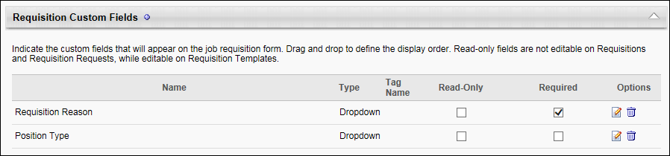
Add Custom Field
To add an OU custom field:
- Click the Add icon . This opens the Select Requisition Custom Field pop-up. The pop-up displays all "Position" OU Type custom fields that are available to you. If a custom field has already been selected, it does not display in the pop-up. You can also narrow the list by using the keyword search option.
- Click the name of the custom field. This adds the custom field and closes the pop-up.
Create Custom Field
You can create a new custom field from within the Select Requisition Custom Field pop-up. To create a new custom field, click New Custom Field in the pop-up. This opens the Custom Field Administration > Organizational Units > Define Field page. See Custom Field Admin - Organizational Units on page 366 for additional information.
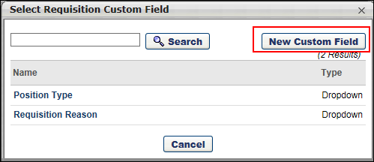
Reorder Fields
You can reorder the fields by dragging and dropping them to the desired position. If the fields are not reordered, they display on the job requisition template or job requisition in the order in which they are added to Requisition Preferences.
Requisition Custom Fields Table
The following columns display in the Requisition Custom Fields table:
- Name - The name of the custom field.
- Type - The value selected in the Type field in OU Custom Field Administration.
- Tag Name - This column displays the tag for the custom field. Requisition custom fields are not available as tags in offer letters, job ads, and Recruiting emails unless a tag name is defined. All tag names automatically begin with CUSTOM., which cannot be modified. Adding a tag for custom fields is not required. Each tag name must be unique. Requisition custom field tags are not available in modular offer letters. Custom fields must first be configured in Custom Field Administration.
- Read-Only - This field is unchecked by default. When unchecked, the requisition custom field can be modified when used in a requisition. When checked, the field cannot be modified when creating and editing job requisitions and requisition requests. Note: Even if the custom field is defined as read-only, the value in the field can still be modified when configuring requisition templates and default requisition templates.
- Required - The box in the Required column is checked by default. Unchecking the box makes the field optional, but the field still displays on the General step when creating/editing a job requisition template or job requisition.
- Options - The following options display in the Options column:
  - Edit - Click the Edit icon to add or edit the tag name.
    - Add Tag Name - If the custom field does not yet have a tag name, then clicking the Edit icon opens the Edit Tag Name pop-up. The Name field displays the name of the custom field.
To add a tag, enter the tag name in the Email Tag field, up to 50 characters. The tag must be entered in all capital letters, with a period after each word except the last word. The field accepts all characters.
Once the tag is entered, click Save. This adds the tag to the Tag Name column, with "CUSTOM." at the beginning of the tag. Then, click Submit to save the tag to the Requisition Preferences page.
    - Edit Tag Name - If the custom field already has a tag name, then clicking the Edit icon opens a warning pop-up that indicates editing the tag name affects all areas in which the tag is currently used. Click No to cancel the edit action and close the pop-up.
Click Yes to edit the tag name. This opens the Edit Tag Name pop-up. Enter the changes in the Email Tag field. Once the changes are entered, click Save. This updates the tag in the Tag Name column. Then, click Submit to save the update to the Requisition Preferences page.
Note: When changes are made to a requisition custom field tag name in Custom Field Administration, the system does not automatically update the tag name in areas of the system where the tag is being used. The tag name must be manually updated to the new tag name in all places in which the tag appears.
  - Delete - The Delete icon displays if the custom field has never been selected on a job a requisition template. Deleting a custom field removes it from all existing requisition templates.

Requisition and Applicant Preferences - Requisition Field-Level Access
The Requisition Field-Level Access section on the Requisition and Applicant Preferences page allows administrators to select standard fields and Requisition custom fields that appear on a job requisition and define the access level of the field for requisition owners, requisition approvers, applicant reviewers, and hiring managers. The following access levels are available, depending on the field:
- Edit
- Hidden
- Read-Only
To access Requisition and Applicant Preferences, go to Admin > Tools > Recruit > Requisition and Applicant Preferences.
Permissions
PERMISSION NAME | PERMISSION DESCRIPTION | CATEGORY

Requisition Preferences - Manage | Grants ability to access and manage Requisition and Applicant Preferences. This permission cannot be constrained.  Note: Users with the Requisition: Manage permission will not be affected by Field Level Access settings. | Recruiting Administration
Use Cases
- Summer is a Hiring Manager and Approver on the approval workflow for a Product Manager requisition that she requested. She only needs to have access to certain fields that she cares about when reviewing her requisition before and after it is posted.
- Veronica is a Requisition Owner for the Product Manager requisition that Summer requested. Veronica needs to review the requisition, since Veronica is also an Approver. In the process of creating the requisition, Veronica also needs to fill out additional fields that Summer cannot see or edit.
- Brianna is a Recruiting Manager and the Recruiting Administrator in the ATS. She wants to determine which requisition fields Summer and Veronica can see and/or edit before and after the requisition is created.
Important Considerations
- If a user does not fall into any of the hiring roles on the requisition, then the permissions defined in Security Role Administration will determine what the user has access to for requisitions.
- Requisition field level access rules only applies when editing or viewing a requisition. This is to ensure that when creating or copying a requisition, all required fields are completed. Requisition field level access will not give users more access than what is currently given based on the existing permissions on the requisition fields. For an example, if a user does not have permission to the Salary Range field, the user will not be able to access that field.
- Requisition field level access is an additional layer of access rules on top of the availability for Requisition Custom Fields. Users still need to be defined in the availability for the custom field in order to get access to the custom field.
- The Read-Only setting for custom fields will continue to be respected. If a custom field is defined as read-only, a user who has edit access for requisition field level access will not be able to edit the field.
- If a requisition field is read-only based on the current requisition status, a user defined with edit access for requisition field level access will not be able to edit the field.
Job Requisition Fields that Can Be Restricted
The access for the following standard fields for job requisitions can be regulated from Requisition and Applicant Preferences:
- Applicant Interviewer(s)
- Applicant Reviewer(s)
- Attachments
- Compensation
- Contact Phone
- Cost Center
- Currency
- Display Title
- Division
- Do Not Allow to Apply
- EEO Category
- Employment Type
- Grade
- Hiring Manager
- Keywords
- Openings
- Primary Location (includes Additional Location(s) added as part of Multiple Locations enhancement for the October ’16 release)
- Priority
- Qualifications (includes Minimum & Ideal tabs)
- Referral Bonus
- Requisition Approvals (includes Approvals sub-section)
- Requisition Description (includes Internal and External tabs)
- Requisition ID
- Requisition Owner(s) (includes Primary Owner and Owners)
- Requisition Status
- Salary Range
- Target Hire Date
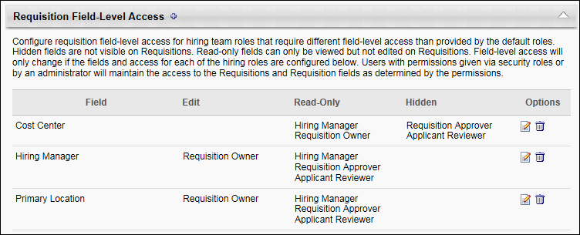
Define Field-Level Access
This section allows administrators to define the access level for certain fields on a job requisition. The administrator can select a field from a list, and then determine the access level for requisition owners, requisition approvers, applicant reviewers, and hiring managers.
To define field-level access:
- Click the plus sign icon to the right of the Requisition Field-Level Access section header. This opens the Configure Requisition Field-Level Access pop-up.
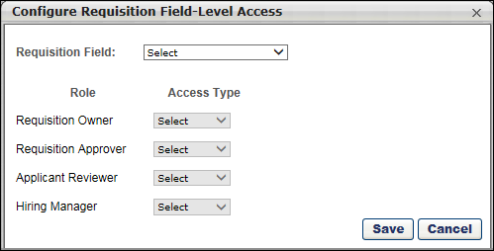
- Complete the following fields in the pop-up:
  - Requisition Field - This drop-down displays the list of fields for which access can be defined. The fields appear on the General tab of the job requisition. Select the field from the drop-down. Some fields will display additional instructional text below the drop-down to indicate special circumstances about the field. For example, if the EEO Category field is selected, then text appears to indicate that the field only applies for requisitions that fall under the Division organizational unit (OU) for which this field appears.
Note: The pop-up does not identify fields as standard fields or as Requisition custom fields. Standard fields that are not available to select in the pop-up are fields for which visibility is determined by the user's security permissions.
  - Requisition Owner - This field allows you to select the owner-level access. The following options are available:
    - Edit - When this option is selected, the Requisition Owner can edit the field.
    - Read-Only - When this option is selected, the field displays as read-only.
    - Hidden - When this option is selected, the field is hidden from the user.
  - Requisition Approver - This field allows you to select the access for requisition approvers. The following options are available:
    - Read-Only - When this option is selected, the field displays as read-only.
    - Hidden - When this option is selected, the field is hidden from the user.
  - Applicant Reviewer - This field allows you to select the access for applicant reviewers. The following options are available:
    - Read-Only - When this option is selected, the field displays as read-only.
    - Hidden - When this option is selected, the field is hidden from the user.
  - Hiring Manager - This field allows you to select the access for hiring managers. The following options are available:
    - Read-Only - When this option is selected, the field displays as read-only.
    - Hidden - When this option is selected, the field is hidden from the user.
- Click Save to save the settings. This closes the pop-up, and the field and access settings display in the table.
- Click Submit at the bottom of the Requisition and Applicant Preferences page to submit the preferences changes.
EEO Category Field
The EEO Category field only appears in the Requisition Field drop-down the in the Configure Requisition Field-Level Access pop-up if the Record EEO preference is enabled. The Record EEO field is enabled in the Compliance Preferences section on the Requisition and Applicant Preferences page.
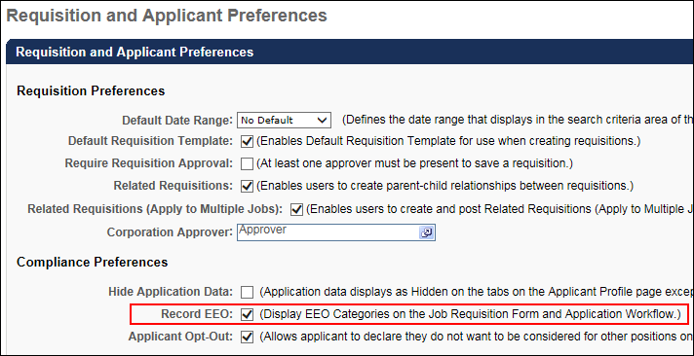
Requisition Field-Level Access Table
The table in the Requisition and Field-Level Access section displays the fields for which you have configured field-level access. The following information displays for each field:
- Field - This column displays the name of the field.
- Edit - This column displays the role that has edit access to the field.
- Read-Only - This column displays the role that has read-only access to the field.
- Hidden - This column displays the role for which the field is hidden.
- Options - The following options are available in the Options column:
  - Edit - Click the Edit icon to edit the field-level access. This opens the Configure Requisition Field-Level Access pop-up, from which you can edit the access for any of the roles. Note: The selection in the Requisition Field drop-down cannot be modified.
  - Delete - Click the Delete icon to remove the field from the table. This opens a confirmation pop-up. Click Yes to delete the field, or click No to cancel the delete action.
Note: Custom fields that are deleted from the Requisition Custom Fields section are automatically deleted from the Requisition Field-Level Access section in Requisition and Applicant Preferences. Even if field-level access has been configured for the custom field, the field is still deleted if it is deleted from the Requisition Custom Fields section.

Custom Field Admin - Organizational Units
Once the OU Type is set up, the implementation manager or the system administrator can add custom fields to the OU Type. To change the feed and add these new custom fields, contact the Technical Consulting team.
Creating an OU custom field does not automatically map the field to your OU data feed. If you want your data feed to populate the OU custom field, you must first create the custom field and then contact your Global Customer Support to make the necessary arrangements to have the field added to your feed.
For portals with Recruiting enabled, Position OU fields can be created via the Organizational Units tab in Custom Field Administration. These fields can be used as Requisition Custom Fields for job requisitions by adding them to the Requisition Custom Fields section in Requisition and Applicant Preferences. These fields can also be used as tabs in offer letters, job ads, and Recruiting and Offer Letter emails.
To manage custom fields, go to Admin > Tools > Core Functions > Custom Field Administration. Then select the appropriate tab on the left.
Permissions
PERMISSION NAME | PERMISSION DESCRIPTION | CATEGORY

Organizational Unit Custom Fields - Manage | Grant Access to create and edit custom fields for Org Units. This is an administrator permission. | Core Administration
Search for a Field
The following filters are available to search for an existing custom field:
- Name - Enter search terms in the filter. The field displays results for a partial or exact match to the search terms.
- Field Type - Select a field type from the drop-down.
- Include Inactive - Check the box to include inactive custom fields in the search.
Once all filters are defined, click Search. This refreshes the fields table with the filtered results.
Add Custom Field
To create a custom field, click the Add Field icon. This opens the Define field page. From here, you can select the type of field you want to create and define the options for the field if applicable. Information about how to create the specific types of custom fields (i.e., branched dropdown, checkbox, etc.) is available on the "Custom Field Type Options" page in Online Help. See Custom Field Admin - Custom Field Type Options.
Fields Table
This table displays all existing custom fields for the field area. The table is sorted in alphabetical order by name. The Title and Created By columns are sortable. The following information displays in the table:
- Title - This column displays the title of the custom field.
- Type - This column displays the field type, such as radio button or short text box.
- Created By - This column displays the name of the administrator who created the field by last name, first name.
- Active - This column defines the active status of the field. To activate the field, check the box in the Active column. To inactivate the field, uncheck the box.
When active, the custom field is available to use by administrators who meet the field's availability requirements. Inactive custom fields are not available to use.
- Options - The following options are available in the Options column:
  - Edit - Click the Edit icon to edit the field. The field type cannot be modified when editing the field. See Custom Field Admin - Custom Field Type Options.
  - Delete - Click the Trash Can icon to delete the field. This option is only available if the custom field has not been used. If a field has been used, then it cannot be deleted and the Trash Can icon does not display. There is no audit history available to view custom fields that were deleted. Please reach out to Global Customer Support if additional details are needed for a deleted custom field.
Add Fields
To add a new custom field, follow these steps:
- Select the Add Field icon .
- Name - Enter a name for the custom field that will be visible to end user. If multiple languages are enabled for your portal, select the Translate icon to translate the field into other available languages.
- Type - Select the appropriate custom field type from the drop-down menu. For organizational units, Checkbox, Date, Drop-down, Numeric, Radio Button, Scrolling Text Box, and Short Text Box type fields can be created. See Custom Field Admin - Custom Field Type Options for information about the options available when creating and editing custom fields.
- OU Type - Select the type of organizational unit for which this custom field will be visible.
- Active - Select this option to make the field active.
- Availability - Define which users have the ability to view and access the custom field. The administrator must set the availability of the field if the field is to appear for other administrators and end users in the application. If availability is not set, then the field will not appear in administrator and end user areas of the application. See Setting Availability Overview for additional information.
- Click Save. After the custom field is created, it will available when creating and editing an OU. See Create Organizational Unit for additional information.

Cost Field Management
Applicant Cost Tracking enables organizations to track the cost in the recruiting process. Organizations can gain visibility into how costs are appropriated across the various cost sources, such as travel, interviewing, and recruiting agencies. Costs that are tracked within the system, such as job board posting fees through Broadbean integration, are automatically tracked and updated. Costs can also be added for requisitions and applicants. Reporting capabilities allow recruiters to understand the total recruitment costs for a requisition, the cost per applicant, and the cost per hire.
Recruiting costs are defined at the requisition level and the applicant level. Requisition level costs are typically associated with candidate sourcing for a requisition and generally do not scale with the number of applicants. Examples of requisition level costs are candidate job board posting fees and other advertising expenses. Applicant level costs are directly associated with applicants and can increase depending on the number of applicants and hires. Examples of applicant level costs are background checks, referral fees, applicant travel expenses, and signing bonuses.
With Applicant Cost Tracking, the costs appropriated for each step of the recruiting process can be assessed and measured to better manage an organization's hiring practices.
The Cost Field Management page displays all applicant and requisition level cost fields. From this page, administrators can add, edit, delete, and inactivate cost fields. Once cost fields are created in Cost Field Management, recruiters and applicant reviewers associate costs to the fields. In addition, certain cost fields are provided by default.
To access the Cost Field Management page, go to Admin > Tools > Recruit > Cost Fields.
Permissions
PERMISSION NAME | PERMISSION DESCRIPTION | CATEGORY

Config: Cost Field Management - Manage | Grants ability to access and manage the Cost Field Management page. This permission cannot be constrained. This is an administrator permission. | Recruiting Administration
Use Case
A recruiter for the Sales Recruiting Agency would like to reduce external hiring costs. She evaluates the meal expenses submitted by applicants during the interview process and discovers that the cost of hotel room service meals expensed by applicants is 60% higher than the meal expenses incurred by internal sales recruiters when interviewing applicants, such as catered lunches and offsite dinners. She implements a policy to ensure that the organization provides all meals for onsite interviews.
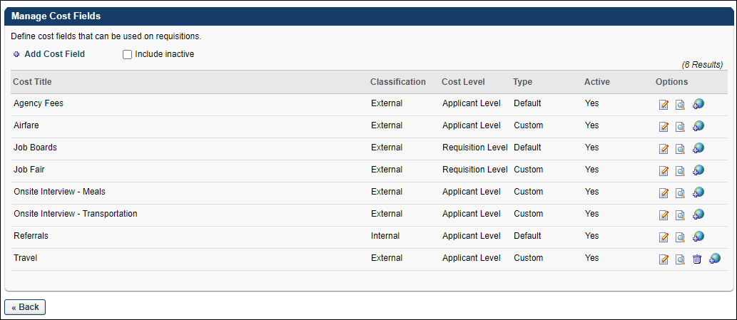
- Add Cost Field - Click Add Cost Field to add a cost field. See Add Cost Field on page 371 for additional information.
- Include Inactive - Check Include Inactive to display inactive cost fields in the Manage Cost Fields table.
- Manage Cost Fields Table - The following information displays for each cost field:
  - Cost Title - This column displays the title of the cost field. Cost fields are sorted alphabetically by title. This column is sortable.
  - Classification - This column displays the classification of the cost field, either External or Internal. This column is not sortable.
  - Cost Level - This column displays the cost level of the cost field, either Requisition Level or Applicant Level. Requisition level costs are typically associated with candidate sourcing for a requisition and do not increase with the number of applicants. Examples of requisition level costs are candidate sourcing fees and other advertising expenses. Applicant level costs are directly associated with applicants and can increase depending on the number of applicants and hires. Examples of applicant level costs are background checks, referral fees, applicant travel expenses, and signing bonuses. This column is sortable.
  - Type - This column displays the cost field type, either Default or Custom. Default cost fields are the system defined cost fields. Custom cost fields are the cost fields that are created by the administrator. This column is not sortable.
  - Active - This column displays the active status of the cost field, either Yes for active or No for inactive. This column is not sortable.
- Options - The following options are available in the Options column:
  - Edit - Click the Edit icon to edit the cost field. See Edit Cost Field on page 373 for additional information.
  - History - Click the History icon to view the modification history. Note: Each individual change to the field is not recorded. The date and time that the change was made is recorded, as well as the user who made the change.See Cost Modification History - Requisition Level Cost on page 224 for additional information.See Cost Modification History - Applicant Level Cost on page 222 for additional information.
  - Delete - Click the Trash Can icon to delete the cost field. A cost field can only be deleted if it is a custom field that does not yet have any associated costs. Default fields cannot be deleted.
  - Translate - For portals with multiple languages enabled, click the Translate icon to translate the cost title.
- Back - Click Back to return to the Recruitment page.
Default Cost Fields
The Manage Cost Fields table on the Cost Field Management page includes default cost fields. These fields cannot be deleted but can be edited, translated, and inactivated. The modification history for the costs can also be viewed. Note: The system automatically tracks default cost fields.
- Agency Fees - This is an applicant level external cost field that tracks agency fees. The Agency Fees cost field is tracked automatically by the system via the Agency Portal functionality, provided that the functionality is enabled. This field is active by default if enabled during the Recruiting module implementation. When costs are associated to the Agency Fees cost field, the costs are automatically updated each time an applicable cost is incurred, such as a submission fee or interview fee.
Note: The Agency Fees field is enabled by a backend setting. To enable the field, contact Global Customer Support. If the field is disabled, agency fees are tracked on the Cost Details tab of the Requisition Snapshot page for existing requisitions, but agency fees are not tracked for requisitions created after the field is disabled.
- Agency fees are tracked at the following points during the application process:
  - A submission is advanced to an applicant by moving past the New Submission status. The interview fee cost is logged when the Interview status is marked complete on the applicant's profile. If the applicant subsequently moves into and out of the status, the cost is not logged. Note: The Interview status does not apply to the On Demand Video interview status. Interview costs are only stored for Live Video interview types; they are stored for In Person or Phone interview types.
  - An applicant's status changes to Hired.
- Job Boards - This is a requisition level external cost field that tracks job board posting fees. For job boards associated with Broadbean, the cost is tracked by the system. The cost is automatically updated each time the requisition is posted externally. This field is active by default.
- Referrals - This is an applicant level internal cost field that tracks referral costs. The Referral cost field is tracked automatically by the system via the Referral Suite functionality. Referral costs are logged by the system the first time a referred applicant moves into the Hired status for the associated requisition. This field is active by default if enabled during the Recruiting module implementation.
Note: The Referrals field is enabled by a backend setting. To enable the field, contact Global Customer Support. If the field is disabled after being enabled, agency fees are tracked on the Cost Details tab of the Requisition Snapshot page for existing requisitions, but agency fees are not tracked for requisitions created after the field is disabled.
Related Topics

Add Cost Field
Cost fields can be added from the Cost Field Management page. All cost fields that are added by the administrator are considered custom cost fields. Note: Custom cost fields are not considered custom fields in Custom Field Administration and cannot be managed via the Custom Fields functionality.
To access Cost Field Management, go to Admin > Tools > Recruit > Cost Fields.
Permissions
PERMISSION NAME | PERMISSION DESCRIPTION | CATEGORY

Config: Cost Field Management - Manage | Grants ability to access and manage the Cost Field Management page. This permission cannot be constrained. This is an administrator permission. | Recruiting Administration
To add a cost field:
- Click Add Cost Field. This opens the Add Cost Field pop-up.
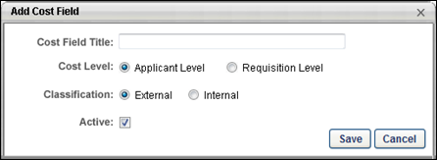
- Enter a title in the Cost Field Title field, up to 50 characters. This is a required field.
- Select a cost level in the Cost Level field. This is a required field.
  - Applicant Level - If this option is selected, then costs can be associated with this field at the applicant level in the Add Applicant Level Cost pop-up. Note: Costs are added to the field from the Cost Details tab on the Requisition Snapshot page.
  - Requisition Level - If this option is selected, then costs can be associated with this field at the requisition level in the Add Requisition Level Cost pop-up. Typically, requisition level costs are costs that are associated with candidate sourcing, such as job posting or advertising fees. Note: Costs are added to the field from the Cost Details tab on the Requisition Snapshot page.
- Select a classification in the Classification field. This is a required field.
  - External - If this option is selected, then all costs associated with the cost field are considered external costs. External costs are cost incurred externally to the client’s organization. These can include applicant travel, background checks, job fairs, entertainment, assessments, etc. Most costs are external costs.
  - Internal - If this option is selected, then all costs associated with the cost field are considered internal costs. Internal costs are costs incurred internally to the organization. These are typically referral fees or other expenses that are paid out internally in the hiring process.
- Define the active status of the cost field by checking or unchecking the Active box. The box is checked by default. When active, costs can be added to the field at the requisition or applicant level. When inactive, costs cannot be added to the field.
Important Note: If a default cost field is inactivated, then the system no longer automatically populates the cost field with the requisition and applicant level costs that are incurred in association with the field. The system retains data associated with costs that have already been stored for the Agency Fees and Job Boards cost fields. However, future costs are not stored. If the Job Boards cost field is inactivated, the option is no longer available to refresh job board posting fees in the Edit Requisition Level Cost pop-up from the Cost Details tab on the Requisition Snapshot page.
- Click Save to add the field. Click Cancel to close the pop-up without adding the field.

Edit Cost Field
Permissions
PERMISSION NAME | PERMISSION DESCRIPTION | CATEGORY

Config: Cost Field Management - Manage | Grants ability to access and manage the Cost Field Management page. This permission cannot be constrained. This is an administrator permission. | Recruiting Administration
A cost field can be edited before or after a cost is associated with it.
To edit a cost field, go to Admin > Tools > Recruit > Cost Fields. Then, click the Edit icon in the Options column in the Manage Cost Fields table. This opens the Edit Cost Field pop-up, from which you can edit the field. Editing a cost field is similar to adding a cost field. See Add Cost Field on page 371 for additional information.
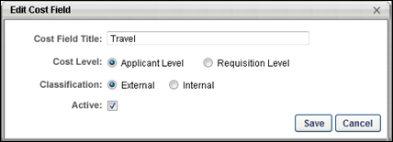
When editing a default cost field, only the title and active status can be edited. All other fields in the pop-up are grayed out and not selectable.
Confirm Edit Pop-Up
If a cost field has at least one associated cost, then the Confirm Edit pop-up opens when the Edit icon is selected. The pop-up indicates that editing a cost field that has at least one associated cost applies the changes to all requisitions to which the cost field is associated. You must click Continue to open the Edit Cost Field pop-up, or click Cancel to cancel the editing of the cost field.
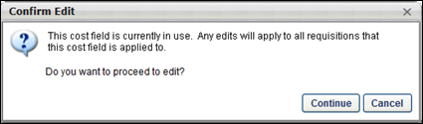

Recruiting and Onboarding Integrations Overview

Recruiting and Onboarding Integrations
The Recruiting and Onboarding Integrations page enables administrators to manage custom Recruiting integrations. From this page, administrators can view, manage, and edit all custom integrations configured for their portal.
To access Recruiting and Onboarding Integrations, go to Admin > Tools > Recruit. Then, click Recruiting and Onboarding Integrations under General Recruitment.
Permissions
PERMISSION NAME | PERMISSION DESCRIPTION | CATEGORY

Onboarding Integrations - Manage | Grants administrator ability to manage Recruiting and Onboarding Integrations. This permission cannot be constrained. This is an administrator permission. | Employee Onboarding - Administration

Recruiting Integrations - Manage | Grants ability to access and manage the Recruiting Integrations Preferences page. This is an administrator permission. This permission cannot be constrained. | Recruiting Administration
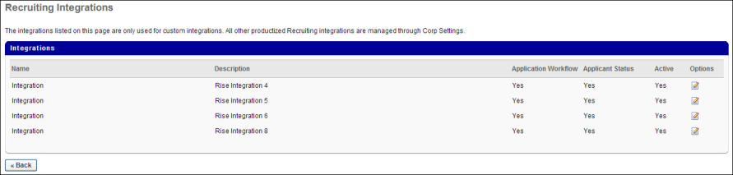
The following information appears in the Integrations table for each custom integration:
- Name - This column displays the name of the integration.
- Description - This column displays the description of the integration.
- Application Workflow - This column indicates whether or not the integration can be included in application workflows, either "Yes" or "No."
- Applicant Status - This column indicates whether or not the integration can be used in Applicant Statuses, either "Yes" or "No."
- Onboarding Workflows - This column indicates whether or not an integration provider is available for onboarding workflows. The column displays "Yes" if the an integration provider is available, or "No" if a provider is not available.
- Active - This column indicates the active status of the integration, either "Yes" or "No."
- Options - An edit option is available in the Options column. Clicking the Edit icon opens the Integration Settings pop-up to edit the configuration settings for the custom integration. See Recruiting and Onboarding Integrations Preferences - Edit Integration on page 376 for additional information.
Recruiting and Onboarding Integrations Preferences - Edit Integration
The configuration settings for custom integrations can be managed by administrators with permission to manage recruiting integrations. The Integration Settings pop-up enables administrators to define the settings for integrations.
Permissions
PERMISSION NAME | PERMISSION DESCRIPTION | CATEGORY

Recruiting Integrations - Manage | Grants ability to access and manage the Recruiting Integrations Preferences page. This is an administrator permission. This permission cannot be constrained. | Recruiting Administration
To define or edit a custom Recruiting integration:
- Click the Edit icon in the Options column on the Recruiting and Onboarding Integrations Preferences page. This opens the Integration Settings pop-up.
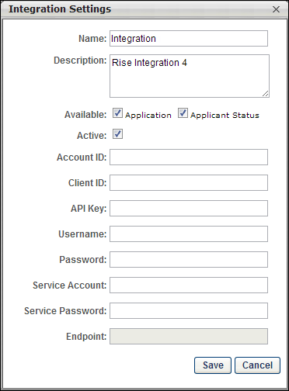
- Configure the following fields in the pop-up:
  - Name - This is a required field. Enter the name of the integration, up to 200 characters.
  - Description - This is a required field. Enter a description for the integration, up to 200 characters.
  - Available - The following options are available for this field:
    - Application - Check this option to enable the integration to be used in application workflows.
    - Applicant Status - Check this option to enable the integration to be used in applicant statuses.
    - Onboarding Workflow - Selecting this option indicates that the integration provider is available for the onboarding workflow. This option only displays for administrators with permission to manage onboarding integrations.
  - Active - When an integration has been implemented and is functioning correctly, the Active box is unchecked. When an integration has not yet been implemented for the portal and needs to be activated, check the Active box.
Note: When the Active box is unchecked, this does not mean that the integration is inactive or not functioning. This means that the integration is working properly and does not need to be activated. Integrations that need to be activated are integrations that are not yet running in the portal and need to have the connections made between the portal and the third party integration provider. Therefore, the Active box needs to be checked to indicate that the integration needs to be activated.
  - API Key - Enter the API key. The API key is used for authentication purposes.
  - Username - Enter the administrator user name that is used to access the third party application, up to 256 characters.
  - Password - Enter the administrator password that is used to access the third party application, up to 256 characters.
- Click Save to save the changes. Or, click Cancel to close the pop-up without saving the changes.
Note: The administrator user name and password are not used by applicants when completing custom Recruiting integration steps in the application process.

Recruiting Integrations - Edge
For information about Recruiting Integrations that are configurable in Edge, see the Recruiting Integrations section in See Integrations Overview..

Other Requisition Functionality Overview

Job Requisition Form Status Workflow
The following diagram outlines the workflow for the status of a job requisition form:
Note: The "On Hold" status is not included in this workflow. For more information about putting a requisition in an On Hold status, see the in Online Help.
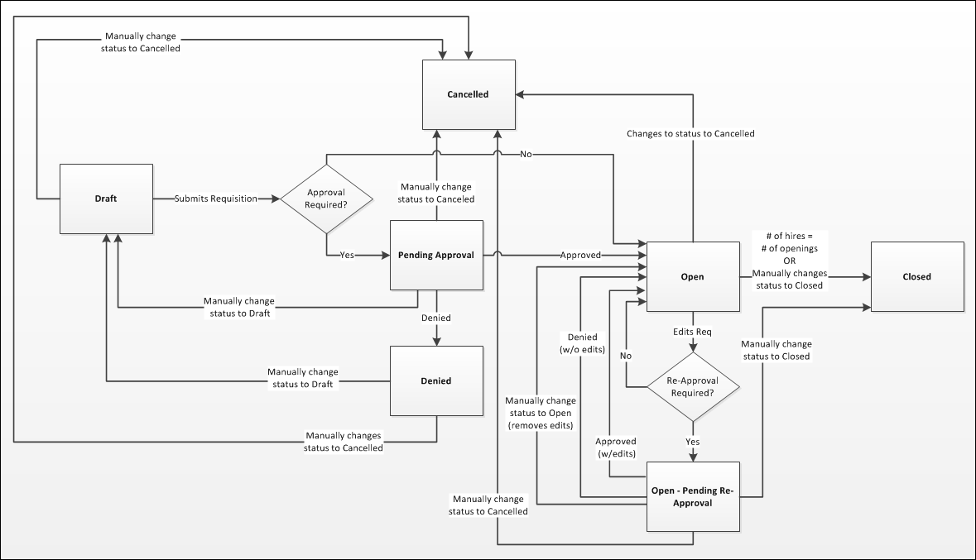

Recruiting Roles
The following roles are available for Recruiting in Security Administration:
Role | Description
Recruiting - Admin | This role contains the following permissions, with no constraints:  - Applicant and Application Custom Fields - Edit Values  - Applicant Compliance Report  - Applicant Flags Preferences  - Applicants: Access Sensitive Statuses  - Applicants: Add/Move to Requisition  - Applicants: Add to Talent Pool  - Applicants: Ad Hoc Anonymization  - Applicants: Assessment Results - View  - Applicants: Assign Competency Assessment  - Applicants: Assign Training  - Applicants: Comments - Manage  - Applicants: Compare Candidates  - Applicants: Manage Background Checks  - Applicants: Manage Flags  - Applicants: Manage Interviews  - Applicant Sources - Manage  - Applicants: Ratings - Manage  - Applicants: Send Email  - Applicant Status Bank - Manage  - Applicants: Un-hide Hidden Contact Info  - Application Custom Fields - Manage  - Applications by Source and Status Report  - Application Workflow Template - Manage  - Career Site - Manage  - Compliance Enablement Preferences - Manage  - Compliance Question - Manage  - Cost Field Management - Manage  - Cost per Hire Report  - Custom Recruiting Report: Create  - Custom Recruiting Report: View  - Default Requisition Template - Manage  - Hires By Source Report  - Interview Events - Manage  - Interview Guide - Manage  - Interview Management Preferences - Manage  - Offer: Edit Letter Content  - Offer Letter Custom Fields - Manage  - Offer Letter Preferences - Mange  - Offer Letter Template Management - Mange  - Offer: Manage Offers  - Offer: Select Letter Template  - Pre-screening Questions Bank - Manage  - Recruiting Agencies - Manage  - Recruiting General Preferences - Manage  - Recruiting Integrations - Manage  - Recruiting: Search Candidates  - Referral Preferences - Manage  - Referral Statistics Report  - Requisition Details Report  - Requisition: Edit Applicant Review  - Requisition: Edit Application Workflow  - Requisition: Edit Approvals  - Requisition: Edit Attachments  - Requisition: Edit Description  - Requisition: Edit Interviewers  - Requisition: Edit Job Ad  - Requisition: Edit Offer Letter  - Requisition: Edit Owners  - Requisition: Edit Postings  - Requisition: Edit Qualifications  - Requisition: Edit Reviewers  - Requisition: Manage  - Requisition Preferences - Manage  - Requisition Request Preferences - Manage  - Requisition Request: Submit Request  - Requisition: Select Recruiting Agency  - Requisition Template - Application Workflow Template - Manage  - Requisition Template - Manage  - Requisition Template - Offer Letter Template - Manage  - Scheduled Interviews Report  - Requisition: View/Edit Salary Range
Recruiting - Recruiter | This role contains the following permissions, with no constraints:  - Applicant and Application Custom Fields - Edit Values  - Applicants: Add/Move to Requisition  - Applicants: Add to Talent Pool  - Applicants: Assessment Results - View  - Applicants: Assign Competency Assessment  - Applicants: Assign Training  - Applicants: Comments - Manage  - Applicants: Compare Candidates  - Applicants: Edit Matching Criteria  - Applicants: Manage Flags  - Applicants: Manage Interviews  - Applicants: Onboarding Notifications - Manage  - Applicants: Ratings - Manage  - Applicants: Ratings - View  - Applicants: Send Email  - Recruiting: Search Candidates  - Requisition: Edit Applicant Review  - Requisition: Edit Application Workflow  - Requisition: Edit Approvals  - Requisition: Edit Attachments  - Requisition: Edit Cost Details  - Requisition: Edit Description  - Requisition: Edit Interviewers  - Requisition: Edit Job Ad  - Requisition: Edit Owners  - Requisition: Edit Postings  - Requisition: Edit Qualifications  - Requisition: Edit Reviewers  - Requisition: Manage  - Requisition Request: Submit Request  - Requisition: Select Recruiting Agency  - Scheduled Interviews Report
Recruiting - Recruiter Manager | This role contains the following permissions, with no constraints:  - Applicant and Application Custom Fields - Edit Values  - Applicant Compliance Report  - Applicants: Access Sensitive Statuses  - Applicants: Add/Move to Requisition  - Applicants: Add to Talent Pool  - Applicants: Assessment Results - View  - Applicants: Assign Competency Assessment  - Applicants: Assign Training  - Applicants: Comments - Manage  - Applicants: Compare Candidates  - Applicants: Manage Background Checks  - Applicants: Manage Flags  - Applicants: Manage Interviews  - Applicants: Onboarding Notifications - Manage  - Applicants: Ratings - Manage  - Applicants: Send Email  - Cost per Hire Report  - Custom Recruiting Report: Create  - Custom Recruiting Report: View  - Hires by Source Report  - Recruiting: Search Candidates  - Requisition Details Report  - Requisition: Edit Applicant Review  - Requisition: Edit Application Workflow  - Requisition: Edit Approvals  - Requisition: Edit Attachments  - Requisition: Edit Description  - Requisition: Edit Cost Details  - Requisition: Edit Interviewers  - Requisition: Edit Job Ad  - Requisition: Edit Owners  - Requisition: Edit Postings  - Requisition: Edit Qualifications  - Requisition: Edit Reviewers  - Requisition: Manage  - Requisition Request: Submit Request  - Requisition: Select Recruiting Agency  - Requisition: View/Edit Salary Range
Recruiting - Recruiting Agency | - Agency Portal
Recruiting - Reviewer | This role contains the following permissions, with no constraints:  - Applicants: Add/Move to Requisition  - Applicants: Add to Talent Pool  - Applicants: Assign Competency Assessment  - Applicants: Assign Training  - Applicants: Comments - Manage  - Applicants: Compare Candidates  - Applicants: Ratings - Manage  - Applicants: Send Email  - Recruiting: Search Candidates
Hiring Manager Role
The Hiring Manager role is assigned in the Applicant Tracking System (ATS) by selecting the user in the Hiring Manager field on the General tab when configuring a job requisition. Hiring managers who are only hiring managers can access many areas of the ATS, including all pages of the job requisition from the Hiring Manager Dashboard, but they cannot edit the job requisition.
Hiring managers are dynamically assigned the hiring manager permission and the permission to review requisitions. See the Security Permissions topic in Online Help for more information about the dynamic hiring manager and requisition reviewer permissions.
Note: For users who are only hiring managers (i.e., they have no other role in the ATS), the Recruit tab does not appear for them until there is at least one applicant for the requisition. Once the Recruit tab appears, the only sublinks in the tab will be Review Applicants and Hiring Dashboard.
Hiring Manager Access and Capabilities
Hiring Managers can do the following in the ATS for applicants who are part of the applicant pool for the requisition:
- Review Applicants Page - Access the Review Applicants page and use all functionality on the page
- Applicant Profile Page - Access the Applicant Profile page with limited functionality:
  - Hiring managers cannot change the status of an applicant
  - Hiring managers cannot add or view comments on the Comments tab
  - Hiring managers can add attachments to the Documents tab
- Hiring Dashboard - Access the Hiring Dashboard page and use all functionality on the page. This includes being able to access all pages of the job requisition as read-only via the Requisitions widget.
- Manage Applicants Page - Access the Manage Applicants page via the Review Applicants page with limited functionality:
  - Hiring managers can access the Applicant Profile page for an applicant
  - Hiring managers can access the Resume/CV Review page via the Actions drop-down
  - Hiring managers can send a Resume/CV Review link via the Actions drop-down
  - Hiring managers cannot perform any other actions via the Actions drop-down or perform any other functions on the page, such as sending an applicant an email

Rehired Employees
The Recruiting functionality enables you to rehire former employees using the rehire features throughout the system. You can indicate in the user record that an employee is eligible for rehire, and when they apply for an open position, the system will recognize them as eligible rather than dispositioning them from the applicant pool.
How Do I Make a Former Employee Eligible for Rehire?
When an employee leaves the organization, they will need to be identified as eligible for rehire in order for the system to recognize them in the future if they apply to the company again. To identify an employee as eligible:
- Ensure that you have permission to view users, as well as edit users type and status.
- Navigate to the user's User Record page.
- In the Employment Status field in the User Type and Employment Status section, the status must be set to "Terminated" in order for the Eligible for Rehire field to appear.
- In the Eligible for Rehire field, select "Eligible."
- Click Save to save the changes to the user record.
Note: Current employees should not be marked as eligible for rehire. This should only be done for employees who leave the company.
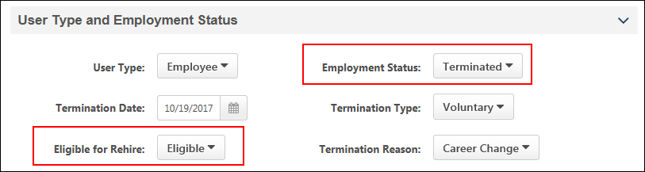
How Do I Make a Former Employee Ineligible for Rehire?
Former employees can be identified on their user record as being ineligible for rehire. When they are marked as ineligible in the Eligible for Rehire field and they subsequently apply for a job with the organization, the Not Eligible for Rehire disposition (configured in Requisition and Applicant Preferences) is used to remove the ineligible former employee from the applicant pool.
Former employees are recognized by the system based on the personal email address they use to access the career site and apply for jobs. The personal email address is defined in the Contact section on the former employee's user record.
What Happens in the System When a Former Employee Is Rehired?
Onboarding
When onboarding rehired employees through the Start Onboarding process on the Applicant Profile page, the following occurs in the system:
- The user record is marked as Rehired Employee.
- The Eligible for Rehire field on the user record is no longer checked once the user changes from Terminated to Onboarding.
- The user's organizational units and employee relationships are reset based on the values defined during onboarding.
If onboarding is canceled, the above are reverted.
Manage Hired Applicants
Since rehired applicants will have a user record in the system, you can update their user record via Manage Hired Applicants by clicking Update from the Employee Info column. The following occurs in the system:
- The user is identified as a rehired applicant in the new Rehire column on the Manage Applicants page. The column displays "Yes" for rehired applicants and displays "No" for non-rehired applicants.
- The user's organizational units and employee relationships are reset based on the values defined in the user record.
- The user's security roles are reset. Note: For former employees who are rehired, their previous security roles will be removed, and they will once again be placed into security roles like any other new user.
- The user record will be populated with the values from the job requisition for which the user was hired.
- Effective dating records are maintained for portals with Cornerstone HR enabled.
- The Rehired Employee field is preset on the user record.
- The user's personal email address that was used on the career site is populated in the Email field.
How Does the Personal Email Address Field Impact the Rehire Process?
The personal email address on the user record is necessary so that when a former employee applies for a job using the same personal email address, the former employee is associated with that user record. The system will recognize that they are eligible for rehire provided that the Eligible for Rehire field was configured as "Eligible" for the user on their user record.
The personal email address helps former employees log in to the career site as a candidate and apply to a job without having to create a new account. The career site account will be associated with the candidate's user record via their personal email address that remained on file with the organization.
This personal email address is also used in the following other areas of Recruiting for former employees:
- Add to Requisition - When a former employee is manually added to a requisition (via Manage Applicants or Candidate Search Query), the email address that the applicant provides when submitting their application via the career site will be populated on their user record.
- Recruiting Agency Submission - When a former employee is submitted via a recruiting agency, the email address that is entered in the Email Address field on the Submission Details pop-up when submitting the applicant will be populated on their user record.
- Career Site - The personal email address that the former employee uses on the career site will also populate the Email field and the Personal Email Address field on the user record. If a former employee is hired, then when the Email field on the user record is populated with the hired employee's company email address, their personal email address will still be available on the user record.
Having a personal email address on the user record also helps recruiters when trying to contact former employees regarding open jobs.
How Is a Former Employee Converted to an External Applicant?
When the system detects that there is activity in the career site for a terminated user, a backend setting is used to convert the terminated inactive user back to an external applicant user.
Note: If the user is ineligible for rehire, they are automatically dispositioned by the Not Eligible for Rehire disposition.
User Record - Effective Dating for Rehires
Effective dating records for rehired employees are maintained through multiple cycles of employment. This enables you to maintain a full record for the employee over time.
The employee's record is maintained when onboarding is started. If onboarding is canceled for a rehired employee, records of effective dated changes that have already taken place will not be removed.
Note: Effective Dating features are only available for portals with Cornerstone HR enabled.
Candidate Search Query
When past employees apply for a job, they can be searched for on Candidate Search Query via the Include eligible for rehire field. The field is selected by default and enables past employees to appear in the search results. The field is available on the Quick Search and Advanced Search tabs, as well as on the search results page.
Having former employees in the search results helps recruiters when they want to reach out to these former employees to apply to open jobs.
Search Results
If users in the search results are eligible for rehire, they are identified by an Eligible for Rehire field in their user card.
Note: Users who are not eligible for rehire do not appear in the search results.
Email/Invite to Apply/Add to Requisition/Add to Talent Pool
When taking actions on candidates who are former employees and are identified as eligible for rehire, the candidate is converted to an external candidate. This means that the candidate will be treated in the system like any other external candidate.
Their personal email address will be copied to their profile page in the career site.
Saved Searches
When saving searches that include the eligible for rehire criteria, the criteria displays in the criteria list for the saved search.
Consideration for Compliance Enablement Preferences
If the Hide internal users that have not completed an application in Candidate Search option is enabled in Compliance Enablement Preferences, then employees who are eligible for rehire are not included in the search results.
How Do I Know if an Applicant Is Eligible for Rehire?
When past employees apply for a job, the Applicant Profile page displays an Eligible for Rehire field if the user has been marked as eligible to rehire on their user record. This helps identify when an applicant is a past employee.
The field will indicate "Yes" when eligible for rehire.
Frequently Asked Questions (FAQs)
What happens when a former employee is dispositioned from a related requisition?
If a former employee applies to related requisitions and is dispositioned from one of them, they are also dispositioned from the other requisitions to which they applied.
How do former employees access the career site to apply for jobs as former employees?
When former employees attempt to access the career site, they will be sent an email to reset their password. This allows them to access the career site and apply for jobs using their previous applicant information.
How does the system know an applicant is a former employee?
- The former employee is marked as "Eligible" for rehire in the Eligible for Rehire field on the user record.
- The former employee access the career site using the same personal email address that is on their user record and applies for the job via that account on the career site.
Does the former employee's personal email address that they use to apply to jobs get added to their user record when they are hired?
Yes. The personal email address that the former employee uses on the career site will also populate the Email field and the Personal Email Address field on the user record. If a former employee is hired, then when the Email field on the user record is populated with the hired employee's company email address, their personal email address will still be available on the user record.
What happens when a former employee applies to a job using Apply with Seek or LinkedIn?
Former employees who apply via Seek or LinkedIn using the same email address that matches a previous email address in the system will be informed that they already have an existing account in the career site. This prevents the creation of duplicate applicants.

Requisition level refers to the job requisition in Manage Job Requisitions. Changes made to a job requisition are referred to as being made at the "requisition level." Applicant reviewers added to a job requisition after the requisition is created are referred to as being added at the "requisition level." An offer letter template added to a job requisition is referred to as being added at the "requisition level." This term applies to the Recruiting functionality. This is a Recruiting term.
Applicant level refers to the applicant's profile. Changes made to an applicant's profile are referred to as being made at the "applicant level." Access granted to an applicant's profile is referred to as being granted at the "applicant level." This term applies to the Recruiting functionality. This is a Recruiting term.
Requisition level refers to the job requisition in Manage Job Requisitions. Changes made to a job requisition are referred to as being made at the "requisition level." Applicant reviewers added to a job requisition after the requisition is created are referred to as being added at the "requisition level." An offer letter template added to a job requisition is referred to as being added at the "requisition level." This term applies to the Recruiting functionality. This is a Recruiting term.
Applicant level refers to the applicant's profile. Changes made to an applicant's profile are referred to as being made at the "applicant level." Access granted to an applicant's profile is referred to as being granted at the "applicant level." This term applies to the Recruiting functionality. This is a Recruiting term.
An organization in Australia has put up billboards in the San Francisco, California area to advertise that the company is hiring for technical positions at their Sydney, Australia headquarters. The requisition currency is AUD, but the cost was incurred in USD. Therefore, the value entered in the Amount field would need to be a value that has been converted to AUD in order to match the requisition currency.

