Reporting 2-0 March 2024

Table of Contents
Reporting 2.0 Overview 1
Reporting 2.0 Field Descriptions 6
Reporting 2.0 Permissions 7
Reporting 2.0 Homepage 14
Reporting 2.0 - Aggregate Values and Totals 18
Reporting 2.0 - Aliasing 21
Reporting 2.0 - Calculated Fields Overview 24
Create Calculated Field 26
Edit, Copy, or Delete Calculated Field 42
View My Calculated Fields 44
View Global Calculated Fields 46
Shared Reports with Calculated Fields 48
Reporting 2.0 - Charting 49
Reporting 2.0 - Create Report 56
Create Curriculum Transcript Report in Reporting 2.0 70
Reporting 2.0 - Publish to Dashboards 76
Reporting 2.0 - Delivery and Scheduling 78
Reporting 2.0 - Dual Reports 86
Exception Reporting 90
Folders in Reporting 2.0 97
Reporting 2.0 - Report Types 102
Reporting 2.0 - Report Viewer 104
Reporting 2.0 - Share Report 108
Reporting 2.0 - Sort Report 112
Reporting 2.0 - Summarize Report 115
Reporting 2.0 - System Templates 119

Reporting 2.0 Overview
Reporting 2.0 provides a simple and intuitive way to build and use report templates to gather and deliver the information that matters most to every level of the organization.
Reporting 2.0 Use Case
Anna Administrator
- As Anna Administrator, I build and maintain reports for my organization.
- I am most interested in the filter properties because I can:
  - Make it easier for Viewers to know which criteria to set.
  - Hide confusing filters.
  - Limit how Viewers interact with filters.
- I build reports and bring in my favorite standard and custom fields.
- I share reports with other users and let them know they have a new report.
- I spend the most time making sure the filter logic is correct and easy to use.
Vicky Viewer
- As Vicky Viewer, I run reports for my team.
- I do not have the create permission, thankfully, because I am too busy to learn how to build reports.
- I love running report templates others have built for me. I change a couple filters like date.
- If I need something complex changed in the report, I will talk to Anna Administrator and ask her to change it for me.
Considerations/Exclusions
With support for Succession, this includes the following custom fields:
- User Career Preferences
- Incumbent (Incumbent and User Succession Metrics)
- Successor (Successor, Successor Fields, and Successor Succession Metrics)
- Position Criteria
- Job Pool Task
The following features are not yet available:
- Exception Reports on custom fields
- System Templates for standard reports not explicitly listed
- Custom Fields for:
  - SF-182
  - Folders
- Succession Comment Log
Maximum Number of Records
The maximum number of records that can be returned in the report is 1,000,000.
Implementation
This functionality is automatically enabled in all portals.
Permissions
The granular model uses the Reporting 2.0 permissions to allow you to create more specific reports by report field. For this reason, permissions are at more of a granular level with this functionality.
The permissions are broken down by the main product level permission, section level, and then at the field level. For example, if you wanted to report on Instructor Led Training (ILT) in the system, you would need:
- The Reporting - Manage permission to create reports.
- The Reporting - View permission to preview reports and view reports.
- The top-level product specific permission to create reports related to that product.
  - e.g. Reporting - Learning - Manage
- The section specific permission to create reports for that feature within the product.
  - e.g. Reporting - Learning - ILT - Manage
- The field level permissions to be able to create reports with the specific fields for that feature within the product.
  - e.g. Reporting - Learning - ILT - ILT Facility - Manage
If a user does not have each level of permission, then they may not have access to the report builder, or the section may not be visible, or the fields within the section may not be visible. Also, if a user does not have the top-level product permission, then none of the fields for that product will be visible, such as the fields for LMS reports.
The power of this granularity of permissions is that you can give access to as many or as few fields as necessary for your users. For example, you may give users access to the User section but not give them access to the User Identifier section if that contains sensitive data for your portal.
If a user has all relevant permissions, but the backend setting for a particular area is set to FALSE, any fields related to that section will still appear blank in a report. An example where this could occur is SCORM 2004 quiz data.
Note: When a user has a top-level, section, or field level permission, it is not necessary to also assign the Reporting - Manage or Reporting - View permissions since the more granular product specific permissions will give the user access to Reporting 2.0.
Note: Due to sensitivity, users who need to report on Gender, Ethnicity and Grade information, would need the following permissions in addition to the reporting permissions:
- For Gender: User Upload - Gender
- For Ethnicity: User Upload - Ethnicity
- For Grades: View Grades
List of Permissions
For the full list of permissions and their relationships, see the permissions spreadsheet.
Apply Owner Constraints Permission
The Reporting - Apply Owner Constraints permission grants the ability to turn on the Apply Owner Constraints setting for reports in the Report Properties panel. This setting affects shared users, delivery, and reports published to dashboards.
When the setting is enabled, the report owner's constraints are applied to the report, and users that run the report will see the report with the report owner's constraints instead of their own. For reports published to dashboards the owner constraints are only applied if the underlying report is also shared with the user. If just the dashboard is shared, but not the report itself, the users own constraints are applied even though the toggle is set to apply owner constraints.
Due to the possibility of unintended user data becoming visible to a user viewing a report with the report owner's constraints, it is recommended that filters be added to the report to restrict data visibility. It is also recommended that the report owner test the report prior to sharing to ensure the data visibility is appropriate and intended.
Download Permission
The Reporting - Download permission grants users the ability to download Reporting 2.0 reports. This permission cannot be constrained; however, when users download a report, any Reporting - View constraints are applied. Users with the permission see the download option on the Report Home and the Report Viewer.
For clients that have already opted in and previously activated Reporting 2.0, this new permission is added automatically to the System Administrator role and to any security role that currently has at least one Reporting - View permission.
For clients that are opting in and activating Reporting 2.0 for the first time with the August ’18 Release, this new permission is available to administrators in the System Administrator role who can then add the permission to other roles at their discretion. Users without this permission will not see any download options in the Report Home or the while Viewing Reporting 2.0 reports.
Email Delivery Permission
The Reporting - Email Delivery permission grants the ability to deliver reports in Reporting 2.0. Users must also have permission to view reports. The permission can be used in conjunction with the various product, section, and field level permissions. Users must have permission to view Reporting 2.0 in order to have access to a report that is delivered to them. If they do not have view access, then the Reporting 2.0 navigation sublink will not display for them.
Users who have permission to manage Reporting 2.0 can edit a report that is delivered to them. They can also copy the delivered report.
The following constraints are available for this permission:
- OU
- User’s OU
- User Self and Subordinates
- User
- User's Self
- User's Manager
- User's Superiors
- User’s Subordinates
- User’s Direct Subordinates
- Employee Relationship
FTP Delivery Permission
The Reporting - FTP Delivery permission grants the ability to schedule delivery of Reporting 2.0 reports to an FTP directory. This permission cannot be constrained.
This permission is used in conjunction with the view permission for Reporting 2.0 and can also be used in conjunction with the various product, section, and field level permissions. Users must have permission to view Reporting 2.0 in order to have access to a report that is delivered to them. If they do not have view access, then the Reporting 2.0 navigation sublink will not display for them.
Users who have permission to manage Reporting 2.0 can edit a report that is delivered to them. They can also copy the delivered report.
Global Calculated Fields Permission
The Reporting - Manage Global Calculated Fields permission grants the ability to publish calculated fields to all users. This permission cannot be constrained.
Note: Calculated fields can be created by all users who have permission to create reports in Reporting 2.0. However, in order to publish the calculated field globally, a user needs permission to manage global calculated fields.
Manage Custom Recruiting Integrations Permission
The Reporting - Recruiting - Custom Integrations - Manage permission grants access to build and manage reports in the Custom Integrations section. This permission cannot be constrained.
View Custom Recruiting Integrations Permission
The Reporting - Recruiting - Custom Integrations - View permission grants access to view the Custom Integrations section in reporting. This permission cannot be constrained.
Share Reports Permission
The option for sharing reports is only visible to users who have the Reporting - Share permission. Users without the permission can still receive shared reports, but constraints (for other permissions, such as Reporting - Core permissions) will be respected. For example, if you share a report that contains data around Location A and the user receiving the report is constrained to only see data for Location B, the report would not contain any records.
The following constraints are available for this permission:
- OU
- User’s OU
- User Self and Subordinates
- User’s Direct Report
- User
- User's Self
- User's Manager
- User's Superiors
- User’s Subordinates
- User’s Direct Subordinates
- Relationship
System Templates Permission
The Reporting - System Templates permission grants users the ability to use all system templates. System templates are available for generating certain Learning, Core, and Performance data.
This permission works in conjunction with other Reporting 2.0 permissions. For example, users without the Reporting - Learning - View permission will not see any templates for Learning.
This permission is automatically added to the Cornerstone Administrator and System Administrator security roles in all portals that have self-enabled Reporting 2.0.
Sharing Reports Created with a System Template
When you share a report that was created using a template, the shared users will be able to view the report without needing to be granted the Reporting - System Templates permission. The permission is only needed for administrators who should distribute templates to their users.
Permission Constraints
Constraints exist at the section level for permissions. The following constraints are available:
- OU
- User’s OU
- User Self and Subordinates
- User’s Direct Report
- User
- Learning-specific constraints:
  - Provider
  - Training Item
  - Training Type
- Requisition-specific constraints:
  - User's Division
  - User's Position
  - User's Location
  - Division
  - Position
  - Location
Note: Constraints are applied differently for Recruiting reports. Multiple criteria for the same OU type use the OR logic (e.g., only constraints for Location OU), while inter-OU type criteria use AND logic (e.g., a constraint for Location OU and a constraint for Division OU).
For all other reports, the regular constraint logic is applied. See this Knowledge Article for more details about the general constraint logic: https://cornerstoneondemand.my.site.com/s/articles/Several-constraints-added-to-permission-work-as-OR-statements.

Reporting 2.0 Field Descriptions
Click here to download the list of Reporting 2.0 report types and field descriptions, updated March 20, 2024. This Excel spreadsheet provides descriptions for the report types and fields in Reporting 2.0. This list is updated when there are changes to existing fields or new fields are added. Currently, the list is in English only. Note that it may be necessary to scroll through the sheets on the Excel spreadsheet in order to access the first sheet.

Reporting 2.0 Permissions
There are two reporting models: Reporting 2.0 Granular Permission Model and Reporting 2.0 Report Level Permission Model. The granular model is more complex and can sometimes be confusing, as it can be difficult to understand which permissions and constraints apply to which reports, and which need to be assigned to users to allow them to see the appropriate reports and data. For customers with less complex reporting needs, the Reporting 2.0 Report Level Permission Model provides a simpler option. Customers can choose whether to keep the granular permission model, or to migrate to the report level permission model.
Granular Model vs. Report Level Model Overview
- Reporting 2.0 Granular Permission Model
  - Provides customers a lot of flexibility
  - Allows for complex permission configurations
  - Hundreds of permissions
- Reporting 2.0 Report Level Permission Model
  - Two permissions per report type: View and Manage
  - Each Report type permission has its own set of constraints
  - A user having permission for a report type can see any reports shared with them that match the report type
Granular Permission Model
The granular model uses the Reporting 2.0 permissions to allow you to create more specific reports by report field. For this reason, permissions are at more of a granular level with this functionality.
The permissions are broken down by the main product level permission, section level, and then at the field level. For example, if you wanted to report on Instructor Led Training (ILT) in the system, you would need:
- The Reporting - Manage permission to create reports.
- The Reporting - View permission to preview reports and view reports.
- The top-level product specific permission to create reports related to that product.
  - e.g. Reporting - Learning - Manage
- The section specific permission to create reports for that feature within the product.
  - e.g. Reporting - Learning - ILT - Manage
- The field level permissions to be able to create reports with the specific fields for that feature within the product.
  - e.g. Reporting - Learning - ILT - ILT Facility - Manage
If a user does not have each level of permission, then they may not have access to the report builder, or the section may not be visible, or the fields within the section may not be visible. Also, if a user does not have the top-level product permission, then none of the fields for that product will be visible, such as the fields for LMS reports.
The power of this granularity of permissions is that you can give access to as many or as few fields as necessary for your users. For example, you may give users access to the User section but not give them access to the User Identifier section if that contains sensitive data for your portal.
If a user has all relevant permissions, but the backend setting for a particular area is set to FALSE, any fields related to that section will still appear blank in a report. An example where this could occur is SCORM 2004 quiz data.
Note: When a user has a top-level, section, or field level permission, it is not necessary to also assign the Reporting - Manage or Reporting - View permissions since the more granular product specific permissions will give the user access to Reporting 2.0.
Note: Due to sensitivity, users who need to report on Gender, Ethnicity and Grade information, would need the following permissions in addition to the reporting permissions:
- For Gender: User Upload - Gender
- For Ethnicity: User Upload - Ethnicity
- For Grades: View Grades
List of Permissions
For the full list of permissions and their relationships, see the permissions spreadsheet.
Apply Owner Constraints Permission
The Reporting - Apply Owner Constraints permission grants the ability to turn on the Apply Owner Constraints setting for reports in the Report Properties panel. This setting affects shared users, delivery, and reports published to dashboards.
When the setting is enabled, the report owner's constraints are applied to the report, and users that run the report will see the report with the report owner's constraints instead of their own. For reports published to dashboards the owner constraints are only applied if the underlying report is also shared with the user. If just the dashboard is shared, but not the report itself, the users own constraints are applied even though the toggle is set to apply owner constraints.
Due to the possibility of unintended user data becoming visible to a user viewing a report with the report owner's constraints, it is recommended that filters be added to the report to restrict data visibility. It is also recommended that the report owner test the report prior to sharing to ensure the data visibility is appropriate and intended.
Download Permission
The Reporting - Download permission grants users the ability to download Reporting 2.0 reports. This permission cannot be constrained; however, when users download a report, any Reporting - View constraints are applied. Users with the permission see the download option on the Report Home and the Report Viewer.
For clients that have already opted in and previously activated Reporting 2.0, this new permission is added automatically to the System Administrator role and to any security role that currently has at least one Reporting - View permission.
For clients that are opting in and activating Reporting 2.0 for the first time with the August ’18 Release, this new permission is available to administrators in the System Administrator role who can then add the permission to other roles at their discretion. Users without this permission will not see any download options in the Report Home or the while Viewing Reporting 2.0 reports.
Email Delivery Permission
The Reporting - Email Delivery permission grants the ability to deliver reports in Reporting 2.0. Users must also have permission to view reports. The permission can be used in conjunction with the various product, section, and field level permissions. Users must have permission to view Reporting 2.0 in order to have access to a report that is delivered to them. If they do not have view access, then the Reporting 2.0 navigation sublink will not display for them.
Users who have permission to manage Reporting 2.0 can edit a report that is delivered to them. They can also copy the delivered report.
The following constraints are available for this permission:
- OU
- User’s OU
- User Self and Subordinates
- User
- User's Self
- User's Manager
- User's Superiors
- User’s Subordinates
- User’s Direct Subordinates
- Employee Relationship
FTP Delivery Permission
The Reporting - FTP Delivery permission grants the ability to schedule delivery of Reporting 2.0 reports to an FTP directory. This permission cannot be constrained.
This permission is used in conjunction with the view permission for Reporting 2.0 and can also be used in conjunction with the various product, section, and field level permissions. Users must have permission to view Reporting 2.0 in order to have access to a report that is delivered to them. If they do not have view access, then the Reporting 2.0 navigation sublink will not display for them.
Users who have permission to manage Reporting 2.0 can edit a report that is delivered to them. They can also copy the delivered report.
Global Calculated Fields Permission
The Reporting - Manage Global Calculated Fields permission grants the ability to publish calculated fields to all users. This permission cannot be constrained.
Note: Calculated fields can be created by all users who have permission to create reports in Reporting 2.0. However, in order to publish the calculated field globally, a user needs permission to manage global calculated fields.
Manage Custom Recruiting Integrations Permission
The Reporting - Recruiting - Custom Integrations - Manage permission grants access to build and manage reports in the Custom Integrations section. This permission cannot be constrained.
View Custom Recruiting Integrations Permission
The Reporting - Recruiting - Custom Integrations - View permission grants access to view the Custom Integrations section in reporting. This permission cannot be constrained.
Share Reports Permission
The option for sharing reports is only visible to users who have the Reporting - Share permission. Users without the permission can still receive shared reports, but constraints (for other permissions, such as Reporting - Core permissions) will be respected. For example, if you share a report that contains data around Location A and the user receiving the report is constrained to only see data for Location B, the report would not contain any records.
The following constraints are available for this permission:
- OU
- User’s OU
- User Self and Subordinates
- User’s Direct Report
- User
- User's Self
- User's Manager
- User's Superiors
- User’s Subordinates
- User’s Direct Subordinates
- Relationship
System Templates Permission
The Reporting - System Templates permission grants users the ability to use all system templates. System templates are available for generating certain Learning, Core, and Performance data.
This permission works in conjunction with other Reporting 2.0 permissions. For example, users without the Reporting - Learning - View permission will not see any templates for Learning.
This permission is automatically added to the Cornerstone Administrator and System Administrator security roles in all portals that have self-enabled Reporting 2.0.
Sharing Reports Created with a System Template
When you share a report that was created using a template, the shared users will be able to view the report without needing to be granted the Reporting - System Templates permission. The permission is only needed for administrators who should distribute templates to their users.
Permission Constraints
Constraints exist at the section level for permissions. The following constraints are available:
- OU
- User’s OU
- User Self and Subordinates
- User’s Direct Report
- User
- Learning-specific constraints:
  - Provider
  - Training Item
  - Training Type
- Requisition-specific constraints:
  - User's Division
  - User's Position
  - User's Location
  - Division
  - Position
  - Location
Note: Constraints are applied differently for Recruiting reports. Multiple criteria for the same OU type use the OR logic (e.g., only constraints for Location OU), while inter-OU type criteria use AND logic (e.g., a constraint for Location OU and a constraint for Division OU).
For all other reports, the regular constraint logic is applied. See this Knowledge Article for more details about the general constraint logic: https://cornerstoneondemand.my.site.com/s/articles/Several-constraints-added-to-permission-work-as-OR-statements.
Report Level Permission Model
The report level permission model is ideal for customers with less complex reporting needs, and allows the ability to quickly grant access by report type.
Permissions for Report Level Permission Model
There are permissions for the report level model, listed here:
View | Manage
Reporting - Compensation - CompensationReport - View | Reporting - Compensation - CompensationReport - Manage
Reporting - Connect - CommunityReport - View | Reporting - Connect - CommunityReport - Manage
Reporting - Connect - ConnectCommunitiesReport - View | Reporting - Connect - ConnectCommunitiesReport - Manage
Reporting - Connect - ConnectReport - View | Reporting - Connect - ConnectReport - Manage
Reporting - Connect - TopicReport - View | Reporting - Connect - TopicReport - Manage
Reporting - Core - CapabilitiesReport - View | Reporting - Core - CapabilitiesReport - Manage
Reporting - Core - MultiModuleReport - View | Reporting - Core - MultiModuleReport - Manage
Reporting - Core - UserReport - View | Reporting - Core - UserReport - Manage
Reporting - Engage - EngageResponseReport - View | Reporting - Engage - EngageResponseReport - Manage
Reporting - Extended Enterprise - TrainingUnitDistributorReport - View | Reporting - Extended Enterprise - TrainingUnitDistributorReport - Manage
Reporting - Forms - FormsReport - View | Reporting - Forms - FormsReport - Manage
Reporting - Form Tasks - Form Tasks - View | Reporting - Form Tasks - Form Tasks - Manage
Reporting - Learning - AssignmentReport - View | Reporting - Learning - AssignmentReport - Manage
Reporting - Learning - CompetencyReport - View | Reporting - Learning - CompetencyReport - Manage
Reporting - Learning - CurriculumTrainingReport - View | Reporting - Learning - CurriculumTrainingReport - Manage
Reporting - Learning - CurriculumTranscriptReport - View | Reporting - Learning - CurriculumTranscriptReport - Manage
Reporting - Learning - EvaluationsReport - View | Reporting - Learning - EvaluationsReport - Manage
Reporting - Learning - PlaylistReport - View | Reporting - Learning - PlaylistReport - Manage
Reporting - Learning - SubjectReport - View | Reporting - Learning - SubjectReport - Manage
Reporting - Learning - TestReport - View | Reporting - Learning - TestReport - Manage
Reporting - Learning - TrainingCapabilityReport - View | Reporting - Learning - TrainingCapabilityReport - Manage
Reporting - Learning - TrainingFormManagementReport - View | Reporting - Learning - TrainingFormManagementReport - Manage
Reporting - Learning - TrainingFormsCurriculaReport - View | Reporting - Learning - TrainingFormsCurriculaReport - Manage
Reporting - Learning - TrainingPlanReport - View | Reporting - Learning - TrainingPlanReport - Manage
Reporting - Learning - TrainingReport - View | Reporting - Learning - TrainingReport - Manage
Reporting - Learning - TransactionReport - View | Reporting - Learning - TransactionReport - Manage
Reporting - Learning - TranscriptReport - View | Reporting - Learning - TranscriptReport - Manage
Reporting - NASD - NASDUserReport - View | Reporting - NASD - NASDUserReport - Manage
Reporting - Observation Checklist - ObservationChecklistReport - View | Reporting - Observation Checklist - ObservationChecklistReport - Manage
Reporting - Onboarding - OnboardingReport - View | Reporting - Onboarding - OnboardingReport - Manage
Reporting - Performance - Check-InsReport - View | Reporting - Performance - Check-InsReport - Manage
Reporting - Performance - GoalsReport - View | Reporting - Performance - GoalsReport - Manage
Reporting - Performance - PerformanceReport - View | Reporting - Performance - PerformanceReport - Manage
Reporting - Performance - PerformanceReviewReport - View | Reporting - Performance - PerformanceReviewReport - Manage
Reporting - Performance - SharedGoalReport - View | Reporting - Performance - SharedGoalReport - Manage
Reporting - Recruiting - RecruitingReport - View | Reporting - Recruiting - RecruitingReport - Manage
Reporting - Resume - ResumeReport - View | Reporting - Resume - ResumeReport - Manage
Reporting - Succession - JobPoolSuccessionReport - View | Reporting - Succession - JobPoolSuccessionReport - Manage
Reporting - Succession - SuccessionReport - View | Reporting - Succession - SuccessionReport - Manage
Reporting - Talent Pool - TalentPoolReport - View | Reporting - Talent Pool - TalentPoolReport - Manage
Reporting - Development Plan - DevelopmentPlanReport - View | Reporting - Development Plan - DevelopmentPlanReport - Manage
Reporting - Extended Enterprise - TrainingUnitKeyCodeReport - View | Reporting - Extended Enterprise - TrainingUnitKeyCodeReport - Manage
Reporting - Learning - CertificationReport - View | Reporting - Learning - CertificationReport - Manage

Reporting 2.0 Homepage
The Reporting 2.0 homepage lists all the reports you have created, as well as any reports that have been shared with you. From this page, you can view your existing reports and create new reports. You can also create folders for your reports and organize your reports into the desired folder location.
To access Reporting 2.0, go to Reports > Reporting 2.0.
Permissions
For more information about Reporting 2.0 permissions, see the following:
- Permissions in Reporting 2.0 - This provides detailed information about Reporting 2.0 permissions.
- Permissions List - This provides the list of permissions and their relationships so that you know which permissions users need to have to create and view reports.
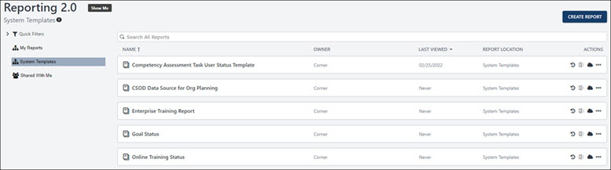
Create Report
You can create new reports by clicking the Create Report button. For more information about creating reports, See Reporting 2.0 - Create Report on page 56 for additional information.
Quick Filters
The Quick Filters section lets you access your recently viewed reports, favorites, and system templates. To view any of these areas, expand the Quick Filters drop-down and select the desired option.
- Select Recently Viewed to sort your list of reports in order from most to least recently viewed.
- Select Favorites to view only reports you have favorited.
My Reports
This section is for your own folder hierarchy. You can customize the organization of reports you have created as you wish, and you can move reports into your folders to create the organization that best fits your needs. See Folders in Reporting 2.0. See Folders in Reporting 2.0 on page 97 for additional information.
System Templates
Reporting 2.0 includes system report templates that are modeled after the most commonly-generated reports so that you can quickly and easily create reports that contain essential Learning, Core, and Performance data. See Reporting 2.0 - System Templates on page 119 for additional information.
Shared With Me
Click Shared With Me to update the list of reports to show only reports that have been shared with you.
- If the user edits the report, you automatically receive the updates.
- If the user deletes the report, then the report is automatically removed for you.
- If a folder is shared with you, then any changes the user makes to the reports or the folder automatically appear for you.
- If the user deletes the folder, then the folder and any reports in the folder are removed for you.
Note: This option does not filter by reports you have shared with others.
Note: Users who select Reporting 2.0 to access the Reporting 2.0 homepage, and have view only permissions, are directed to the Shared with me folder on the Reporting 2.0 Homepage. If no reports are available, users will see the following message: No reports have been shared with you yet. You may have reports available in other report folders, shown on the left side of this page.
Search Reports
The search bar lets you filter the list of reports by keywords or by report ID so that you can find specific reports within a long list. To search by keyword, enter search terms in the search bar, up to 200 characters. The results update as you type. The search is limited to the report name. To search by report ID, enter the ID in the search bar. The report ID must have an exact match to return search results. To locate the report ID you can hover over the report title and see the ID in brackets after the report name. You can also see the report ID under the report title on the individual report page. A benefit of searching by report ID is the ability to quickly locate the report you want since multiple reports may have the same or similar titles, searching by keyword may return multiple results.
List of Reports
The main section on the homepage lists all of the reports that you have created or that have been shared with you. You can search for reports using the search bar.
The following information displays for each report:
- Name - This column displays the name of the report. Hover over the report name to see the Report ID. Click the name to open the report viewer.
- Owner - This column displays the owner of the report. An icon will appear if the report has been shared.
- Last Viewed - This column displays the date that you last viewed the report. You can sort this column by Last Viewed or Last Updated.
- Report Location - This column displays the folder in which the report is located. If "My Reports" displays, then the report has not been placed into a specific folder.
- Actions - The following options are available in the Actions column:
  - Schedule for Now - Extract reports with user's preferences. When ready, the report is downloaded in the preferred format.
  - Edit - Click Edit icon to edit the report. This option is only available for users with permission to manage reports.
  - Export to Excel - Click the Export report to Excel file icon to generate a new report snapshot. The maximum number of records that can be returned in the report is one million. If more than one million rows match your criteria, the rows included will be randomly selected.
    - Upon completion, the newly generated snapshot is automatically downloaded in excel format.
    - The newly generated snapshot is also available through the snapshot pop-up behind the cloud icon.
    - If a user navigates away from or closes the window while the process is still in progress, the snapshot is completed and available in the snapshot pop-up behind the cloud icon. The Excel output is delivered as the session has been closed, but the user can still download the snapshot to excel through the snapshot pop-up.
Note: When exporting to Excel, report details appear in the top section of cells and include the report title, date/time generated, record count, etc. These details cross several columns at the top of the Excel spreadsheet. Report filters are also included, based on the filter settings in report builder and report viewer.. Because of this, it may be necessary to delete the report details in order to take actions in the report data columns, such as if you would like to sort the report.
  - Download/schedule your report (cloud icon) - Click the cloud icon or Download option in options menu to open a snapshot pop-up to:
    - View/download your previously scheduled snapshots (if any). A maximum three snapshots are available per user per report. If cloud icon is solid, no snapshots are available for the report. If cloud icon contains an arrow, snapshots are available.
    - Schedule and generate a new snapshot by clicking the SCHEDULE FOR NOW button available in a snapshot pop-up.
    - Activate / deactivate the email notification a user receives when the snapshot is ready for download. The email notification is enabled by default.
    - Select the maximum number of records to include in the snapshot. The range is from one to one million. By default, the number is set to 200K.
Download snapshots in the following formats when the number of records in the snapshot is 10,000 or less:
    - CSV
    - Excel
    - HTML
    - PDF
    - TXT PIPE
    - TXT TAB
    - HTML
Each report that appears in the snapshot pop-up has one of the following icons next to it:
    - Hand icon - Indicates the report was generated manually.
    - Calendar icon - Indicates the report was generated on a schedule
If more records exist than the maximum number of row count for the selected report output, the records included will be randomly selected.
Note that formats CSV, TXT (Pipe), and TXT (Tab) do not support all Reporting 2.0 features. If you did include features such as column summary in your report and extract this report as CSV, the not-supported feature will be ignored for your report output.
  - Copy - Click this option in the More Options dotted line drop-down to copy the report.
  - Move - This option in the More Options dotted line drop-down lets you move the report to a different folder. Clicking Move opens a Move Report pop-up. In the pop-up, select the folder to which you would like to move the report. Then, click Move to the move the report.
  - Delete - Click this option in the More Options dotted line drop-down to delete the report in the My Reports section and all folders.
  - Share - Click this option in the More Options dotted line drop-down to share the report. For more information about sharing reports, see the Share Report topic in Online Help.
  - Favorite - Click this option in the More Options dotted line drop-down to favorite the report. You can un-favorite a report by clicking Unfavorite from the actions drop-down.
  - Viewer - Click this option in the More Options dotted line drop-down to go to the Report Viewer page. See Reporting 2.0 - Report Viewer on page 104 for additional information.
  - Download - Click this option in the More Options dotted line drop-down to open the snapshot pop-up.
Note: The following actions are disabled when a report query is in progress:
  - Schedule for Now
  - Export report to Excel file
  - Download your report

Reporting 2.0 - Aggregate Values and Totals
Aggregation operators in Reporting 2.0 enable users to total their reports by applying count and count unique. Additionally users can apply average, minimum, maximum, or sum to selected columns. Reporting 2.0 delivers aggregations for the entire data set and outputs the result in the last line of the report.
Aggregation operators are available from the Column Header Properties panel, which is accessed by clicking the icon to the right of a field name in the Table Columns section.
Aggregate values display for each segment of a summarized report. In addition, a grand summary appears as the last row in a summarized report.
Note: Group aggregation is available by summarizing the report. See Reporting 2.0 - Summarize Report on page 115 for additional information.
To access Reporting 2.0, go to Reports > Reporting 2.0.
Permissions
For more information about Reporting 2.0 permissions, see the following:
- Permissions in Reporting 2.0 - This provides detailed information about Reporting 2.0 permissions.
- Permissions List - This provides the list of permissions and their relationships so that you know which permissions users need to have to create and view reports.
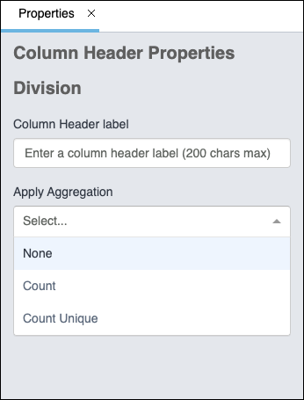
Aggregate Operators
The type of operator that is available for a field depends on the field type. All fields can be aggregated by count and count unique, but only numeric fields can be aggregated by sum, average, minimum, and maximum.
Aggregate values are displayed for each segment of a summarized report.
To access aggregation operators, click the icon to the right of the field name in the Table Columns section. This opens the column properties panel. The available operators appear in the Apply Aggregation section:
Aggregation Operators for Numeric Data Types
The following aggregation operators are available for numeric data types:
Sum
This displays the sum of all values for the field. When selected, the column name changes to <Sum [Field Name]>. To remove the sum function, select Remove Sum from the drop-down.
Average
This option is available for numeric fields only. This displays the average of all values for the field.
Minimum
This option is available for numeric fields only. This displays the minimum value for the field.
Max
This option is available for numeric fields only. This displays the maximum value for the field.
Multiple aggregations may be added for the same field as long as they are different aggregate values. For example, the field Training Hours can be added to a report multiples times with all possible aggregations: Min, Max, Avg, and Sum. The system will automatically select the next available aggregate for you, but it may be changed from the column properties after it has been added.
Aggregation Operators for All Data Types
The following aggregation operators are available for all data types:
Count
This option gives you a total count of the values within a field. When you select the Count option, the word "Count" is added to the title of the column.
For example, you are creating a Transaction Custom Report and would like to know the total number of credit and debit transactions in your portal. You add the Transaction User field and the Transaction Type field to the report. You apply the Count option to the Transaction User field, and then you open the Preview panel. The report previews an aggregate of the number of transactions within each transaction type. You return to the Builder tab and filter the Transaction Type field by "Credit" and "Debit." Back on the Preview panel, you find that the report is filtered to show only credit and debit transactions. The count operator at the bottom of the report gives you the total number of credit and debit transactions in your portal.
Count Unique
This option gives you a total count of the unique values within a field. When you select the Count Unique option, the words "Count Unique" are added to the title of the column.
For example, you are creating a Training Custom Report and would like to know the total number of training items that are in each training type. This will help you see which training types have the most training items and which training types have the least training items. To do this, you add the Training Type field and the Training Title field to the report. For the Training Title field, you apply the Count Unique option from the aggregation operators in the column properties panel. You go to the Preview panel and find that the report shows a list of each training type, along with the number of training items within each training type.
Both the Count and Count Unique aggregates can be added to the same field. The system will automatically select the next available aggregate for you, based on what has already been chosen. For example, if you have added the field Training Title with the aggregate Count, if you add the Training Title field again, the system will automatically apply the Count Unique aggregate.

Reporting 2.0 - Aliasing
Aliasing lets you create reports with Manager, Indirect Manager, and Successor and Incumbent data that goes beyond simply the manager's name, email, and user ID. These user relationships are added as aliases so that you can pull in other user fields for them, such as the User Address of the manager or indirect manager.
Note: Successor custom fields continue to follow Successor custom field availability, and Incumbent custom fields continue to follow User custom field availability.
To access Reporting 2.0, go to Reports > Reporting 2.0.
Permissions
For more information about Reporting 2.0 permissions, see the following:
- Permissions in Reporting 2.0 - This provides detailed information about Reporting 2.0 permissions.
- Permissions List - This provides the list of permissions and their relationships so that you know which permissions users need to have to create and view reports.
How to Use Aliasing
With the Aliasing feature, you will see the following sections under the User section:
- Manager
- Indirect Manager
In addition, users with Succession will now see the following new field groups:
- Incumbent
- Successor
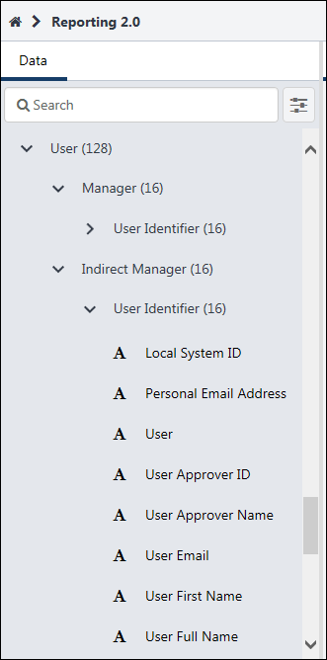
The Manager and Indirect Manager sections will only include fields from the User Identifier section. The Incumbent and Successor sections will contain all standard and custom User fields.
When you add fields from these sections, the data will automatically apply to users who are identified for these sections. For example, if you would like the names and email addresses of all managers, you can add fields such as User Full Name and User Email from the User Identifier section. Since these fields are within the overall Manager section, they will only return results for users who are Managers.
Permission Considerations
Some Aliases will obey Reporting - Core - User permissions. For example, if someone does not have the Reporting - Core - User Identifier - Manage permission, they would not see the User > User Identifier section or the User > Manager > User Identifier section. For details on when the Reporting - Core - User permissions are required, see the permission documentation linked in the Permissions section above.

Reporting 2.0 - Calculated Fields Overview
Calculated fields enable organizations to generate aggregated reports based on totals of data. This functionality helps administrators, managers, and analysts to create simple, custom calculations of their reporting data without having to export and manipulate that data in a different tool.
Calculated fields can be:
- Added as a field to the report
- Added as a filter
- Added as chart criteria
- Aggregated
- Used in summarizing a report
- Used in sorting a report
When creating calculated fields, numerous calculation functions are available, and every function includes use examples. In addition, use cases are available in Support Central to help you in configuring and using calculated fields.
With calculated fields, you can also:
- Create fields that contain a mix of text, math, date, and logical functions/operators to enhance your reporting capabilities
- Follow a guided user experience for leveraging the calculated fields feature
- Import your existing custom reports containing calculated fields
Permissions
Any user with permission to create reports in Reporting 2.0 can create calculated fields. However, in order to publish a field globally, the user needs permission to manage global calculated fields.
The following permission applies to this functionality:
PERMISSION NAME | PERMISSION DESCRIPTION | CATEGORY

Reporting - Manage Global Calculated Fields | Grants the ability to publish calculated fields to all users. This permission cannot be constrained.  Note: Calculated fields can be created by all users who have permission to create reports in Reporting 2.0. However, in order to publish the calculated field globally, a user needs permission to manage global calculated fields. | Reporting
For more information about Reporting 2.0 permissions, see the following:
- Permissions in Reporting 2.0 - This provides detailed information about Reporting 2.0 permissions.
- Permissions List - This provides the list of permissions and their relationships so that you know which permissions users need to have to create and view reports.
Note: If one of the fields included in a Calculated Fields is set to inactive, the Calculated Field won't be displayed.

Create Calculated Field
All users who have permission to create reports in Reporting 2.0 can create calculated fields. Fields are created from the Calculated Fields area of the Data panel in the report builder. See View My Calculated Fields on page 44 for additional information.
However, to publish fields globally, users must have permission to manage global calculated fields. If a user does not have that permission, then the option to publish the field globally cannot be toggled on.
Permissions
PERMISSION NAME | PERMISSION DESCRIPTION | CATEGORY

Reporting - Manage Global Calculated Fields | Grants the ability to publish calculated fields to all users. This permission cannot be constrained.  Note: Calculated fields can be created by all users who have permission to create reports in Reporting 2.0. However, in order to publish the calculated field globally, a user needs permission to manage global calculated fields. | Reporting
To create a calculated field, click the plus icon to the right of the Calculated Fields section in the report builder. This opens the calculated field editor. Inline help text appears for some fields on the editor when you hover over the field.
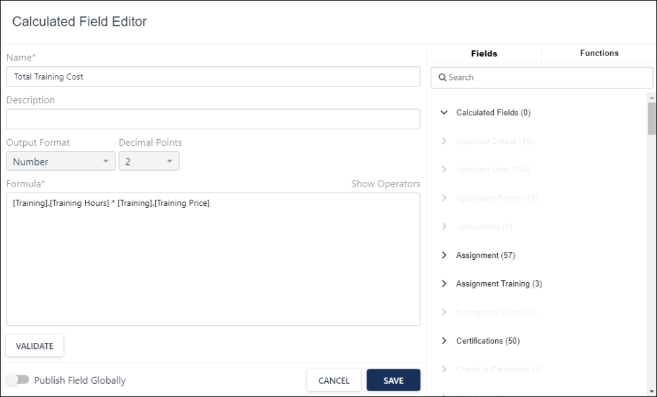
Step 1 - Enter Name/Description
Enter a name for the field in the Name field, up to 80 characters.
Enter a description in the Description field, up to 500 characters. Note: The description will be visible to all users if the field is a global field.
Step 2 - Select Output Type
The output type is the data type of the field. Select one of the following in the Output Type field:
- Boolean
- Datetime - When you select this option, you can also disable the Localize time zone toggle under Date Format. The toggle is enabled by default, which applies the report user’s local time zone automatically. When the toggle is disabled, Reporting 2.0 applies UTC time zone to date and time values in the calculated field.
- Number - When this option is selected, you can also define a decimal point value between 0 and 10. The default value is None. Note: Selecting "None" in the Decimal Point drop-down means that no rounding should be applied.
- String
Step 3 - Create Formula
The Formula field is where you create your formula for the calculation.
Add Fields to Formula
Standard and custom report fields, as well as existing calculated fields, are available to add from the Fields section. Sometimes, a standard report field and a custom report field may have nearly identical names. In such cases, the calculated field recognizes and includes the exact field that is selected by the report owner. The fields that display are based on the current state of the report, so some fields will not be available to include because they are not available for the type of report you are creating.
You can filter the fields by entering field names to narrow down your search.
Add a field to your formula by clicking the field. The field appears in the formula and will have curly brackets around it.
Note: When adding a calculated field to the formula, the field description displays at the bottom of the Fields tab. Calculated fields can only be referenced up to one level.
Note: When both standard and custom fields have the exact same names, the calculated field includes the standard field value by default.
Add Operators to Formula
Operators are used to perform a calculation using the fields you have added to your formula (e.g., ({Training.Training Hours} * {Training.Training Price})).
Click Show Operators to view the operators. The operator will be added to the current position of the cursor within the Formula field. If the cursor is not currently within the Formula field, the operator is added either to the beginning of the formula or to the previous location of the cursor within the Formula field.
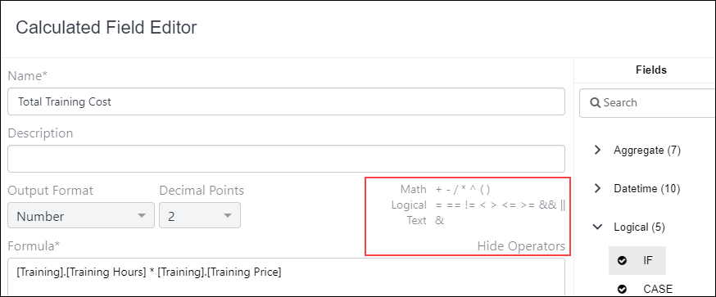
Note: When using parentheses, for each open parenthesis (i.e., "("), you must also include a closed parenthesis (i.e., ")").
The following operators are available and must be entered into the formula manually:
Math Operators |  |  | Logical Operators |  |  | Text Operators
Add |  | + | Equal |  | = and == | Concatenate |  | &
Subtract |  | - | Not Equal |  | <> and !=
Multiply |  | * | Less than |  | <
Divide |  | / | Greater than |  | >
Parentheses |  | ( ) | Less than or Equal |  | <=
Power of (e.g., 2^3 = 2x2x2 = 8) |  | ^ | Greater than or Equal |  | >=
 |  |  | AND |  | &&
 |  |  | OR |  | ||
Add Functions to Formula
Functions are organized into categories based on math, logic, date, and text. Selecting a function shows its description at the bottom of the Functions tab.
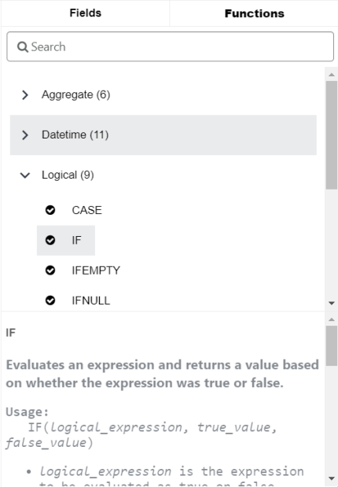
To add a function, double click it or select it and hit the Enter key. The function is added at the cursor's position in the Formula field, and then the cursor is repositioned at the end of the object and is followed by a space.
If the function takes at least one argument, then the function is added to the Formula field at the cursor's position, then the Formula field cursor is repositioned between the function's parentheses.
You can also nest one function within another function up to five levels in the Formula field, except for an aggregate function which can be nested up to one level within another non-aggregate function.
- Aggregate functions cannot be nested within another aggregate function.
- Aggregate functions can only be nested up to one level with non-aggregate functions (e.g., logical, numeric functions).
How to View Help Text for Functions
Help text is included for each function. To view the help text, click a function. The explanation of the function appears at the bottom of the Functions tab.
The following functions are available:
Aggregate
Function | Description | How to Use | Example
GMAX | Returns the highest numeric value of the field in the report. If the report is summarized, it returns the highest numeric value of the field in each group. | MAX(numeric_field) | MAX(salary)
GMIN | Returns the lowest numeric value of the field in the report. If the report is summarized, it returns the lowest numeric value of the field in each group. | MIN(numeric_field) | MIN(salary)
GCOUNT | Returns the aggregated number of field values in the report. If the report is summarized, it returns the number of field values in each group. | GCOUNT(field) | GCOUNT(User Name)
GCOUNTUNIQUE | Returns the aggregated number of unique field values in the report. If the report is summarized, it returns the number of unique field values in each group. | GCOUNTUNIQUE(field) | GCOUNTUNIQUE(User Name)
GSUM | Returns the aggregated sum for all rows of a given numeric field. If the report is summarized, it returns the aggregated sum for each group of a given numeric field. | SUM(numeric_field) | SUM(salary)
GAVG | Returns the aggregated average for all rows of a given numeric field. If the report is summarized, it returns the aggregated average for each group of a given numeric field. | AVG(numeric_field) | AVG(salary)
Date/Time Functions
Function | Description | How to Use | Example
DATE | Returns a date value from the year, month, and day values you enter. | DATE(year,month,day)  - Year must be 4 digits  - Month must be 2 digits  - Day must be 2 digits | DATE(2020,02,25) returns 02/25/2020 as Date type
DATEADD | Returns a date by adding the specified number of intervals to the specified date. | DATEADD(interval, number, date, time)  Note: Interval determines which part of the date will be added. The following inputs can be used: Year, Quarter, Month, Day, Week, Hour, Minute, and Second. | - DATEADD(Hour, 1, "01/27/2020 11:24:00") returns 01/27/2020 12:24:00  - DATEADD(Minute, 2, "01/27/2020 11:24:00") returns 01/27/2020 12:26:00  - DATEADD(Second, 3, "01/27/2020 11:24:00") returns 01/27/2020 12:26:03
DATEDIFF | Returns the difference between two dates. | DATEDIFF(interval, date1, date2)  - Interval determines what part of the date will be subtracted. The following inputs can be used: Year, Quarter, Month, Dayofyear, Day, Week.  - Date and time values can be entered as MM/DD/YYYY or YYYY-MM-DD. | - DATEDIFF(Day,01/25/2020,01/27/2020) returns 2 as Numeric type  - DATEDIFF(Day,01/27/2020,01/25/2020) returns -2 as Numeric type  - DATEDIFF(Year,12/31/2020,01/01/2021) returns 1 as Numeric type
DATEVALUE | Returns the date value of a given Date/Time or Expression. | DATEVALUE(expression) | - DATEVALUE(“01/25/2020”) returns 01/25/2020 as Date type  - DATEVALUE(“01/25/2020 08:25:59.248”) returns 01/25/2020 as Date type
DATETIMEVALUE | Returns the Date & Time value of a given Date/Time or Expression. | DATETIMEVALUE(expression) | - DATEVALUE(“01/25/2020”) returns 01/25/2020 00:00:00.000 as Date/Time type  - DATEVALUE(“01/25/2020 08:25:59.248”) returns 01/25/2020 08:25:59.248 as Date/Time type
DAY | Returns a day of the month as a numeric value. | DAY(date) | - If the value of Transcript_Due_Date is 01/25/2020, DAY(Transcript_Due_Date) generates 25 as Numeric type  - DAY(DATEVALUE(“01/25/2020”)) returns 25 as Numeric type  - If the current day is 01/07/2020, DAY(TODAY()) returns 7 as Numeric type
MONTH | Returns the month of a year. The number corresponds to each month of the year from 1 (January) to 12 (December). | MONTH(date) | - If the value of Transcript_Due_Date is 05/14/2020, MONTH(Transcript_Due_Date) generates 5 as Numeric type  - MONTH(DATEVALUE(“02/27/2020”)) returns 2 as Numeric Type  - If the current day is 07/23/2020, MONTH(TODAY()) returns 7 as Numeric type
HOUR | Returns the hour of the DateTime specified. | HOUR(datetime) | HOUR(DATEVALUE("1/25/2020 08:25:59.248"))returns 8
NOW | Returns the Date/Time value of the current moment | NOW() | For the following examples, the current date is 01/25/2020 and current time is 08:25:59.248  - NOW() returns 01/25/2020 08:25:59.248 as Date/Time type  - DAY(NOW()) returns 25 as Numeric type  - MONTH(NOW()) returns 1 as Numeric type
TODAY | Returns the current date | TODAY() | For the following examples, the current date is 07/18/2020 and current time is 10:54:38.885  - TODAY() returns 07/18/2020 as Date/Time type  - DAY(TODAY()) returns 18 as Numeric type  - MONTH(TODAY()) returns 7 as Numeric type
YEAR | Returns the year of a given date | YEAR(date) | - If the value of Transcript_Due_Date is 02/24/2019, YEAR(Transcript_Due_Date) generates 2019 as Numeric Type  - YEAR(DATEVALUE(“08/12/2021”)) returns 2021 as Numeric Type  - If the current day is 07/23/2020, YEAR(TODAY()) returns 2020 as Numeric Type
Logical Functions
Function | Description | How to Use | Example
IF | Evaluates an expression and returns a value based on whether the expression was True or False. | IF(logical_expression, trueValue, falseValue)  - logical_expression is the expression to be evaluated as true or false  - trueValue is the return value if the expression was true  - falseValue is the return value if the expression was false  Note: trueValue and falseValue must be the same data type. | - IF(DATEDIFF(Day,Transcript_Due_Date,TODAY()) < 7, "Due Soon","Not Due Soon") Evaluates whether Transcript_Due_Date is less than 7 days from today:  - Returns Due Soon as Text type for records that are less than 7 days  - Returns Not Due Soon as Text type if not less than 7 days  - IF(DATEDIFF(Day,Transcript_Due_Date,TODAY()) < 7,1,2)  - Returns 1 as Numeric Type for records that are less than 7 days  - Returns 2 as Numeric Type if not less than 7 days
CASE | Evaluates an expression against multiple values and returns a corresponding result for any matches. Returns a default value if there were no matches. | CASE(expression,value1,result1,value2,result2,...,elseResult)  - value is value being compared to expression  - result: Return value if the expression was equal to its corresponding value  - elseResult: Return value if there was no matched value  Notes:  - All values should be the same data type  - All results should be the same data type  - Returns #ERROR! if any expression in the function gives an error | CASE(Transcript_Status,"Not Started",1,"In Progress",2,"Completed",3,4) Evaluates Transcript_Status and:  - returns 1 as Numeric Type if status was Not Started  - returns 2 as Numeric Type if status was In Progress  - returns 3 as Numeric Type if status was Completed  - returns 4 as Numeric Type if status was anything else
IFNULL | Checks if an expression has a value and returns a set expression if does not. Otherwise, it returns the original value. | IFNULL(expression, setExpression)  - setExpression: the replacement value if the result of the expression was null  Notes:  - A field is not null if it contains a zero or blank spaces  - expression and setExpression must contain the same data types | IFNULL(New_Division_2, "Not Assigned") evaluates New_Division_2 and:  - returns the value of New_Division_2 as Text type if there was a value  - returns Not Assigned as Text type for null values
ISNULL | Checks if an expression has a value and returns Yes if it does, and returns No if it does not. | ISNULL(expression) | ISNULL(New_Division_2) evaluates New_Division_2 and:  - returns Yes as Boolean type if there is a value  - returns No as Boolean type it was null
ISNUMBER | Checks if a text value is a number and returns Yes if it is, otherwise returns No. Returns Nofor blank values. | ISNUMBER(text) | - ISNUMBER("2539") returns Yes as Boolean type  - ISNUMBER("25 39") returns No as Boolean type  - ISNUMBER("2,539") returns No as Boolean type  - ISNUMBER("25.39") returns Yes as Boolean type
IFEMPTY | Checks if an expression has empty value and returns a set expression if it does. Otherwise, it returns the original value. | IFEMPTY(expression, setExpression)  - setExpression: the replacement value if the result of the expression is empty  Notes:  - expression and setExpression must contain the same data types | IFEMPTY([User].[Division], "Not Assigned") Evaluates [User].[Division] and:  - returns the value of [User].[Division] as Text type if it is not empty  - returns "Not Assigned" as Text type for empty values
IFNULLOREMPTY | Checks if an expression has null or empty value and returns a set expression if it does. Otherwise, it returns the original value. | IFNULLOREMPTY(expression, setExpression)  - setExpression: the replacement value if the result of the expression is null or empty  Notes:  - expression and setExpression must contain the same data types | IFNULLOREMPTY([User].[Division], "Not Assigned") Evaluates [User].[Division] and:  - returns the value of [User].[Division] as Text type if it is neither null nor empty  - returns "Not Assigned" as Text type for null or empty values
ISEMPTY | Checks if an expression is empty and returns Yes if it is, and returns No if it is not. | ISEMPTY(expression) | ISEMPTY([User].[Division]) Evaluates [User].[Division] and:  - returns No as Boolean type if expression is not empty  - returns Yes as Boolean type if it is empty
ISNULLOREMPTY | Checks if an expression is null or empty and returns Yes if it is, and returns No if it is not. | ISNULLOREMPTY(expression) | ISNULLOREMPTY([User].[Division]) Evaluates [User].[Division] and:  - returns No as Boolean type if expression is neither null nor empty  - returns Yes as Boolean type for null or empty values
Numeric Functions
Function | Description | How to Use | Examples
ABS | Returns the absolute value of a number. The absolute value of a number is always the positive value of the number. | ABS(number) | - ABS(-2539) returns 2539 as Numeric type  - ABS({Transcript.FinalGrade}) returns the absolute value of a Final Grade field
FLOOR | Returns a number rounded down to the nearest whole number. If the number is negative, the number is rounded towards zero. | FLOOR(number) | - FLOOR(8.9) returns 8 as Numeric type  - FLOOR(8.9) returns --8-9 as Numeric type  - FLOOR(9.1) returns 9 as Numeric type  - FLOOR(9.1) returns 9 -10 as Numeric type
CEILING | Returns a number rounded up to the nearest whole number. If the number is negative, the number is rounded away from zero. | CEILING(number) | - CEILING(8.9) returns 9 as Numeric type  - CEILING(8.9) returns 9-8 as Numeric type  - CEILING(9.1) returns 10 as Numeric type  - CEILING(9.1) returns 10 -9 as Numeric type
ROUND | Returns a number that is rounded to a specified number of digits. | ROUND(number,decimals) | - ROUND(71.4684,0) returns 71 as Numeric type  - ROUND(71.4684,2) returns 71.47 as Numeric type  - ROUND(71.4684,3) returns 71.478 as Numeric type
Text Functions
Function | Description | How to Use | Examples
Contains | Compares two text values and returns True if the first value contains the second value, otherwise it returns False. | CONTAINS(text1,text2) | - CONTAINS("Not Started","Started") returns True as Boolean type  - CONTAINS("Not Started","started") returns False as Boolean Type  - CONTAINS("Not Started","ot") returns True as Boolean type
LEFT | Returns a set number of characters starting from the beginning of a text value. | LEFT(textValue,number)  - number specifies the number of characters to return from textValue | - LEFT("Reporting",6) returns Report as Text type  - LEFT("Reporting",4) returns Repo as Text type  - LEFT("Reporting",2) returns Re as Text type  - LEFT("Reporting",0) returns Blank
MID | Returns a set number of characters from a specified starting point of a text value. | MID(textValue,num1,num2)  - num1 specifies the number of characters from the left to use as the starting point  - num2 specifies the number of characters to return from textValue | - MID("Reporting",2,4) returns port as Text type  - MID("Reporting",0,4) returns Repo as Text type  - MID("Reporting",5,3) returns rti as Text type  - MID("Reporting",4,0) returns Blank
RIGHT | Returns a set number of characters starting from the end of a text value. | RIGHT(textValue,number)  - number specifies the number of characters to return from textValue | - RIGHT("Reporting",6) returns orting as Text type  - RIGHT("Reporting",4) returns tingasText type  - RIGHT("Reporting",2) returns ngasText type  - RIGHT("Reporting",0) returns Blank
TEXT | Returns any specified value as a text value. | TEXT(anyValue) | - TEXT(5) returns 5 as Text type  - TEXT(Current_Compensation) returns the current_compensation value as Text type
TRIM | Removes any spaces that come before or after a text value. | TRIM(textValue) | - TRIM(" Reporting Fun") returns Reporting Fun as Text type  - TRIM("Reporting Fun ") returns Reporting Fun as Text type  - TRIM("Reporting Fun") returns Reporting Fun as Text type
CONCAT | Concatenates multiple text values. | CONCAT(text1,text2, ...) | - CONCAT("Reporting","Is","Great") returns ReportingIsGreat as Text type  - CONCAT("Reporting ","Is ","Great") returns Reporting Is Great as Text type  - CONCAT("Transcript due date is ",TEXT(DATEDIFF(Day,Transcript_Due_Date,TODAY())), " days away") returns Transcript due date is 3 days away as Text type
UPPER | Converts any letter in a specified text value to be uppercase. | UPPER(textValue) | - UPPER("Reporting Fun") returns REPORTING FUN as Text type  - UPPER("Reporting 5") returns REPORTING 5 as Text type
LOWER | Converts any letter in a specified text value to be lowercase. | LOWER(textValue) | - LOWER("Reporting Fun") returns reporting fun as Text type  - LOWER("Reporting 5") returns reporting 5 as Text type
LEN | Returns the number of characters in a specified text string. | LEN(textValue) | - LEN("Reporting Fun") returns 13 as Numeric type  - LEN("Reporting 5") returns 11 as Numeric type  - LEN("A C") returns 3 as Numeric type  - LEN("AC") returns 2 as Numeric type
Step 4 - Publish Field Globally
This option is visible to users who have permission to manage global calculated fields. This option is off by default. Toggle it to on to set the field to publish globally once the field is saved.
A field that is published globally appears in the Global Fields section. Any user with permission to view the fields that were used to create the calculated field can:
- See the calculated field in the Global Fields section.
- Use the calculated field in a report.
- View the calculated field's data within the constraints of their permissions.
See View Global Calculated Fields on page 46 for additional information.
Once a field is published globally, the field cannot be unpublished. The field can be deleted. See Edit, Copy, or Delete Calculated Field on page 42 for additional information.
Step 5 - Validate and Save
You can validate your formula while building it or when the calculated field is saved. The Calculated Field Editor performs validations to ensure correctness and successful generation of reports with calculated fields.
To validate your formula while building it, click Validate. This prompts the following to occur:
- The formula is checked for errors.
- If the validation fails, an error message displays with the reason and suggestions for correcting the formula.
- If the validation succeeds, a "Success" message displays.
Click Save to save the field. If you have not yet validated your formula, the validation process will occur when you click Save.

Edit, Copy, or Delete Calculated Field
Users with permission to manage global calculated fields can edit, copy, or delete the fields they create. These options are available in both the My Fields section and the Global Fields section for users with this permission.
The My Fields and Global Fields sections are available in the Calculated Fields area of the Data panel in the report builder.
See View Global Calculated Fields on page 46 for additional information.
See View My Calculated Fields on page 44 for additional information.
Permissions
PERMISSION NAME | PERMISSION DESCRIPTION | CATEGORY

Reporting - Manage Global Calculated Fields | Grants the ability to publish calculated fields to all users. This permission cannot be constrained.  Note: Calculated fields can be created by all users who have permission to create reports in Reporting 2.0. However, in order to publish the calculated field globally, a user needs permission to manage global calculated fields. | Reporting
Edit Calculated Field
To make changes to the field:
- Hover over the menu to the right of the field in the My Fields section. A list of actions displays.
- Click Edit. This opens the calculated fields builder.
- Make any changes to any configuration.
- Click Save.
The changes automatically appear for any users with whom the field is shared.
For global calculated fields, the changes appear automatically.
Copy Calculated Field
Users with permission to manage global calculated fields can copy the fields they create. Users with access to a global field can copy the global field.
To copy a field:
- Hover over the menu to the right of the field in the My Fields section. A list of actions displays.
- Click Copy. This opens the calculated field builder, with all configurations copied.
- Configure the field as desired.
- Click Save.
Copying a field does not overwrite the existing field.
Delete Calculated Field
To delete a field:
- Hover over the menu to the right of the field in the My Fields section. A list of actions displays.
- Click Delete. This opens a confirmation pop-up.
- Click Confirm to delete the field. Or, click Cancel to keep the field.
Deleted fields are:
- Removed from all reports in which the field has been used, even if the report is currently in use.
- Removed from the My Fields section for the field creator.
- Removed from the Global Fields section, if the field was published globally.
Note: When running a report that includes a deleted calculated field, the report will still run. However, once it runs, the calculated field is automatically removed from the report.
Note: a calculated field cannot apply aggregate function at formula level and column level at the same time.

View My Calculated Fields
For users with permission to manage global calculated fields, you can view the calculated fields you created by going to Calculated Fields > My Fields in the Data panel on the report builder. This section is only visible to users who have created at least one calculated field. See Create Calculated Field on page 26 for additional information.
The fields that display in the Calculated Fields section are only available to the type of report that is being created. For example, if the calculated field includes fields that are specific to Learning, then the field will not be available to use in a report that focuses on Recruiting.
Permissions
PERMISSION NAME | PERMISSION DESCRIPTION | CATEGORY

Reporting - Manage Global Calculated Fields | Grants the ability to publish calculated fields to all users. This permission cannot be constrained.  Note: Calculated fields can be created by all users who have permission to create reports in Reporting 2.0. However, in order to publish the calculated field globally, a user needs permission to manage global calculated fields. | Reporting
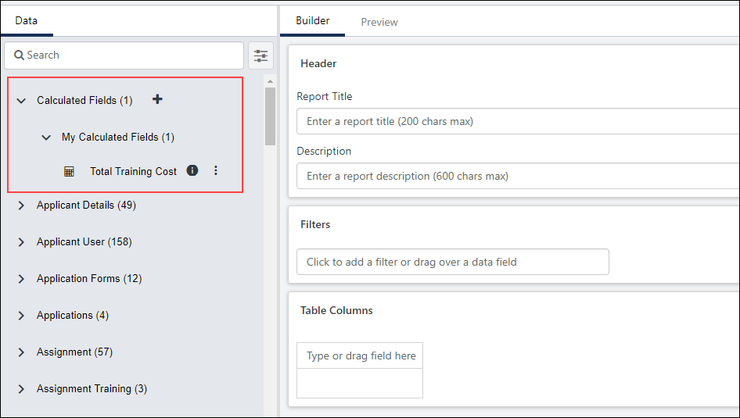
The My Fields section shows the following information for each field:
- Field type:
  - Date
  - Numeric
  - Text
  - Yes/No
- Field name
- Description when hovering over the information icon
- Creator's name when hovering over the information icon
- Globe icon to show a field has been published globally and is available in the Global Fields section -
- Options to edit, copy, or delete fields - See Edit, Copy, or Delete Calculated Field on page 42 for additional information.
See View Global Calculated Fields on page 46 for additional information.

View Global Calculated Fields
Global calculated fields are calculated fields that are created by the administrator and published to all users. The visibility of a global field is dependent upon a user's permissions and availability settings.
For information about viewing calculated fields you created, See View My Calculated Fields on page 44 for additional information.
Note: If one of the fields included in a Calculated Fields is set to inactive, the Calculated Field is not displayed.
Permissions
PERMISSION NAME | PERMISSION DESCRIPTION | CATEGORY

Reporting - Manage Global Calculated Fields | Grants the ability to publish calculated fields to all users. This permission cannot be constrained.  Note: Calculated fields can be created by all users who have permission to create reports in Reporting 2.0. However, in order to publish the calculated field globally, a user needs permission to manage global calculated fields. | Reporting
Visibility of Global Fields
Global fields must be published globally in order to be available in the Global Fields section. The visibility of these fields is controlled by a user's permissions and constraints related to the fields that were used to create the calculated field. If a user does not have permission to view the fields that were used in the calculated field, then the calculated field does not appear for the user in the Global Fields section.
In addition, the fields that display in this section are dependent upon the type of report that is being created. For example, if the calculated field includes fields specific to Learning, then the calculated field will not be available to use in a report that focuses on Recruiting.
Use a Global Field in a Report
Users who can view a global field can include the field in a report in the same way that the field creator can include the field. This includes the following actions:
- Add as a field to the report
- Add as a filter
- Add as chart criteria
- Use in aggregation
- Use in summarizing a report
- Use in sorting a report
Users who do not have permission to manage global calculated fields cannot edit or delete the field, but they can copy the field. See Edit, Copy, or Delete Calculated Field on page 42 for additional information.
View Global Field Description and Creator
Users can hover over the tool-tip to the right of the field name to view the following:
- Field description
- Field creator's name
- Last edited by
- Time edited
Options for Global Field Creator
The creator of a global field can edit, copy, and delete the field from within the Global Fields section. See Edit, Copy, or Delete Calculated Field on page 42 for additional information.
- Editing a Global Field - When edited, the changes are updated for all users.
- Copying a Global Field - When copying a global field, the field appears in the creator's My Fields section and must be published globally in order to appear in the Global Fields section. Users who do not have permission to manage global calculated fields can copy the field.
- Deleting a Global Field - When deleted, the field is removed for all users. The field is also removed from all reports that include the field.

Shared Reports with Calculated Fields
Reports that include calculated fields can be shared. The field appears in the report table and can be seen by all shared users, regardless of whether the field is a global field. See View Global Calculated Fields on page 46 for additional information.
The following rules apply to the visibility of calculated field data in the report:
- Users can only view calculated field data if they have permission to view the report fields that are used in the calculated field.
- Users can only view the calculated field data that is within their permission constraints.
Global calculated fields can contain unpublished (non-global) calculated fields within the formula. When a global calculated field references a non-global calculated field in its formula, it behaves as if a shared user is missing permissions or availability to that global calculated field. Shared users can view the intended calculated field output in the report output only. The global calculated field is not visible to shared users in the report designer data folders until all underlying non-global calculated fields are published globally. This restriction ensures that when a report is copied by a shared user, the global calculated field remains as a private calculated field when non-global calculated fields are referenced in the formula.
When a user tries to publish a calculated field globally which references a non-global calculated field by enabling the Publish Field Globally toggle and saving the field, a warning message is displayed.
- If the user selects Yes, the field is published globally.
- If the user selects No, the Publish Field Globally toggle for the calculated field that references the non-global calculated field is disabled, and the field is not published globally.
If Shared users have edit permissions for the report they can remove a calculated field from the report, even if the field is not a global field.
Calculated fields that are not global fields are not visible to shared users in the Calculated Fields > My Fields section. See View My Calculated Fields on page 44 for additional information.

Reporting 2.0 - Charting
The Chart panel on the Builder page lets you create charts in order to display data visually. Charting lets you create pie, line, bar, and column charts that can be exported as images. You can also define the X and Y axis of the chart by using the Summarize by and Measure fields.
To access Reporting 2.0, go to Reports > Reporting 2.0.
Permissions
For more information about Reporting 2.0 permissions, see the following:
- Permissions in Reporting 2.0 - This provides detailed information about Reporting 2.0 permissions.
- Permissions List - This provides the list of permissions and their relationships so that you know which permissions users need to have to create and view reports.
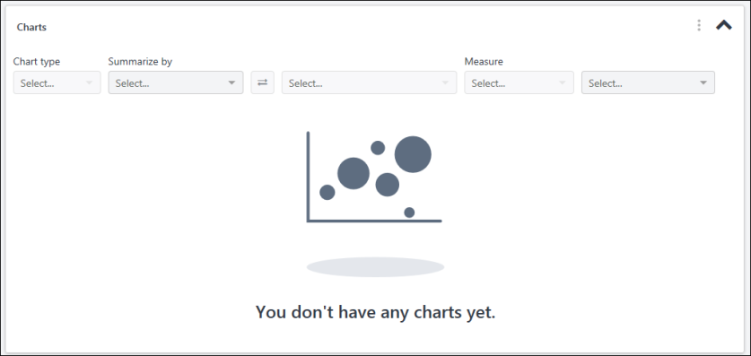
Chart Type
Multiple chart types are supported in the chart designer. The type of chart that can be created depends on the combination of fields that are added as dimensions (via the Summarize by field) and as the measure. The Chart Type drop-down is grayed out and not selectable until dimensions and measures are added to the chart.
The following chart types are supported:
- Bar - This chart type displays as horizontal bars and compares multiple values with each other.
- Column - This chart type displays as vertical lines and compares values across a range.
- Line - This chart type displays as a line graph and shows trending over time.
- Pie - This chart type displays as a pie chart and compares proportions of data and how they contribute to a whole. Note: Pie charts may reflect an 'Other' section. This is a collection of pie slices that are less than 1%. When there are many slices below 1%, the slices are collected into one pie slice so that the labels do not overlap.
Once dimensions and measures are added for the chart, the chart type is selected automatically. If a different chart type is available based on the combination of fields, then you can select a different chart type from the drop-down.
Recommended Chart Types and Field Combinations
Each chart type has a recommended set of field types that can be added as summarization and measure fields. Although the Builder will not prevent you from using any field type combinations for creating charts, the field combinations specified in the table below are the suggested field combinations for specific chart types.
Note about Pie Charts: Pie charts can only be generated with a first level summary. If two summarization fields are added to a chart, a pie chart will not be available as a chart option in the chart type drop-down. Small slices of data of less than 1% will be grouped into an "Other" category.
Note about Date Fields: The date format in the chart is based on the user's culture, which matches the report output.
Field Type Selected as First Summary | Field Type Selected as Second Summary | Field Type Selected as Measure | Legend | Default Chart | Recommended Chart Types
Date | N/A | Numeric Field: SUM, Average, MIN, MAX  String Field: Count, Count Distinct | No Legend | Column | Column, Line, Side Bar
Date | Numeric | Numeric Field: SUM, Average, MIN, MAX  String Field: Count, Count Distinct | Second Summary Field | Column | Line
Date | Text or Yes/No | Numeric Field: SUM, Average, MIN, MAX  String Field: Count, Count Distinct | Second Summary Field | Column | Column, Line, Side Bar
Numeric | N/A | Numeric Field: SUM, Average, MIN, MAX  String Field: Count, Count Distinct  Note: Summary and Measure Fields can be the same field. | First Summary Field | Pie | Pie
Text or Yes/No | N/A | Numeric Field: SUM, Average, MIN, MAX  String Field: Count, Count Distinct | First Summary Field | Column | Column, Pie, Side Bar
Text or Yes/No | Text or Yes/No | Numeric Field: SUM, Average, MIN, MAX  String Field: Count, Count Distinct | Second Summary Field | Column | Column, Side Bar
Summarize by
The Summarize by field is used to define the dimensions for the chart, which display as the X axis. The dimensions are the fields that summarize the chart. Up to two dimensions can be included in the chart. Any field type can be added to the Summarize by field.
To add dimensions:
- Click and drag a column from the Table Columns panel to the Summarize by field. Or,
- Search for and select a dimension in the Summarize by field.
- Follow the above steps to select a second dimension.
Swap Dimensions
The swap button , which is located between the two dimensions, will swap the order of the dimensions in the chart. This option is available when there are two string field types added as dimensions.
Summary Options for Date Fields
When summarizing by date fields, additional summary options are available. A calendar icon appears to the right of the Summarize by field and includes the following additional summary options:
- Day
- Month
- Year
- Calendar Quarter
- Calendar Year
Note about Date Fields: The date format in the chart is based on the user's culture, which matches the report output.
Measure/Aggregate
A measure is any string or numeric field that can be measured. The measure is the Y axis of the chart. The Measure option is grayed out and not selectable until at least one dimension is added. Date and Boolean fields cannot be used as measures.
To add a measure:
- Click and drag a column from the Table Columns panel to the second box in the Measure field. Or,
- Search for and select a measure in the second box of the Measure field.
Aggregates
The first drop-down in the Measure field displays the aggregates. An aggregate is automatically defined by the system when selecting the field to measure, depending on the field type added to the measure option.
You can change the aggregate if a different aggregate is available for the measure.
The maximum aggregation is 200,000 records.
The following aggregates apply to each field type:
Field Type | Aggregates
Numeric | Numeric fields are measured by summation or averages. The following aggregates are used for numeric fields:  - Summation - This aggregate is selected by default when adding numeric fields. This is the sum of the numeric values of the field.  - Average - This is the sum of the numeric value of the field divided by the number of fields.  - Min - This is the lowest value in the range for the measure.  - Max - This is the highest value in the range for the measure.  - Count - This is a count of all the values for the field selected.  - Count Unique - This is a count of all unique values returned for a field.
String | String fields are measured by count or count unique. The following aggregates are used for string fields:  - Count - This aggregate is selected by default when adding string fields. This is a count of all the values for the field selected. For example, if User ID is added as the measure, then the chart shows the number of users with user IDs on the Y axis in relation to the field or fields that are used to summarize the chart.  - Count Unique - This is a count of all unique values returned for a field. For example, a user creates a report to show the training status for an online course. The report output returns 100 records. The training statuses for the course are Completed, In Progress, and Not Started. The training status Count for the report is 100. The training status Count Unique is 3, which represents the total number of training statuses.  As another example, a user would like to chart the number of training hours per training type. The user adds the Training Type field as the dimension and adds the Training Hours field as the measure. The chart will be summarized by each training type, and then the training types are measured by the expected training hours for each training type.
Chart Options
The following options are available in the Chart Options kabob menu:
Show/Hide Labels
This option lets you show/hide the plot point labels in the chart. The labels display as follows for each report type:
- Pie - The labels display the name, count, and percentage for each pie slice.
- Column - The labels display the count for each bar.
- Line - The labels display the count at each data point in the line.
- Bar - The labels display the count for each side bar.
Remove the Chart
This option lets you remove the chart from your report.
Hide/Show Legend
This option is helpful when the legend takes up too much space on the chart viewer, and you would like to show only the data on the chart. When the legend is hidden or shown, the selection is also reflected when the chart is downloaded. For Column, Bar, and Line charts this option is only available when a chart has more than one dimension. For Pie charts this option is always available.
Color Selection
This option lets you customize the colors in your charts. You can select from pre-configured colors or customize every color in your chart.
For categories with no value, the default color is black in charts and a user cannot change it from the color palette. For example, a shared user who is constrained to "Restrict to Subordinates" will only see data and chart colors for subordinates and they will see blank values and the default black color for the rest of the data.
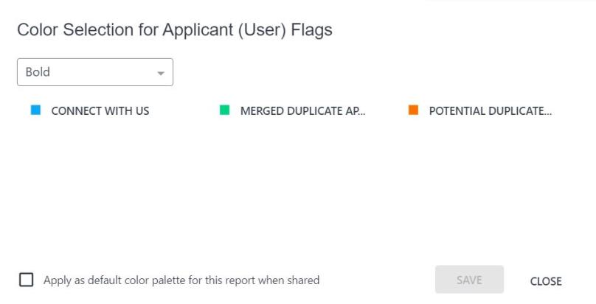
Select Preconfigured Colors
To use a preconfigured color palette:
- Click Color selection from the kebab menu in the upper-right hand corner of the chart, or click the paint palette icon . This opens the Color Selection pop-up.
- Select a color palette from the drop-down.
- Click Save.
Customize Color Palette
You can customize the colors for every color in your chart. Starting with a preconfigured palette, you can select any of the colors and change them.
To customize a color:
- Click Color selection from the kebab menu in the upper-right hand corner of the chart, or click the paint palette icon . This opens the Color Selection pop-up.
- Click a color. This opens a color palette pop-up.
- From the Pick Palette Color tab, click a preconfigured color in the palette. This automatically closes the color palette pop-up.
- Or, click the More Colors tab and enter the Hex or RGB value. You can also click anywhere in the color box or slide the bar to change the color.
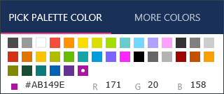
- Check Apply as default color palette for this report when shared to share the selected color palette for the report with shared users. When you select this checkbox, the report owner’s defined chart color palette is only applied to fields in the shared report, and it does not affect shared user’s color preference for the same fields in other reports. If you do not select the checkbox, the shared users will see their own defined colors or the default color assigned by the application.
- Click Save to save the changes to your colors.
Note:
- The shared color palette for the specific shared report cannot be edited by shared users with view only access.
- The checkbox is visible for all users. Users with edit rights can view and edit the checkbox. Users with view only permissions can only view the checkbox.
Color palettes apply per dimension, per user. For example, if Training Status is your dimension and you change the color palette, once you save the changes, the colors you have chosen for Training Status are saved for your account. The same color palette will now reflect in all of the widgets using Training Status or any new report generated with Training Status. If you then choose a different color palette for Training Status and save, the previously chosen palette will be overwritten with a new one.
Chart Legend/Values
Charts show up to 50 plot points in a one dimension chart and up to 2,500 chart points for a two dimension chart. The chart legend displays to the right of the chart. The legend lists each plot point of the chart in order from highest to lowest value.
Column, Line, and Bar charts that only have one dimension and one measure will not have a legend. Pie charts always have a legend.
You can also view the dimensions and measure name by hovering over the colored section of the chart.
Publish to Dashboards
Charts that are created for a report in Reporting 2.0 can be published as dashboards. See Reporting 2.0 - Publish to Dashboards on page 76 for additional information.
Refresh
When you click Refresh to view the chart, a report type pop-up What type of report are you building? may appear, depending on the fields you have included in the report. Select the report type from the drop-down in the pop-up. Then, click Apply. See Reporting 2.0 - Report Types on page 102 for additional information.
The chart preview shows up to 1,000 results. When viewing the chart on the Report Viewer, the chart shows up to 2,000 results.
Note: Chart values always display starting from zero in the user interface. When exporting the chart, the export format adjusts based on the format and data, which could result in starting from a value other than zero.

Reporting 2.0 - Create Report
Reports are created by clicking the Create Report button on the Reporting homepage. This will open the Create Report page for Reporting 2.0.
Note: Users who belong to the LXP_Admin and LXP_Manager groups can only create reports by using the System Templates.
To access Reporting 2.0, go to Reports > Reporting 2.0.
Permissions
For more information about Reporting 2.0 permissions, see the following:
- Permissions in Reporting 2.0 - This provides detailed information about Reporting 2.0 permissions.
- Permissions List - This provides the list of permissions and their relationships so that you know which permissions users need to have to create and view reports.
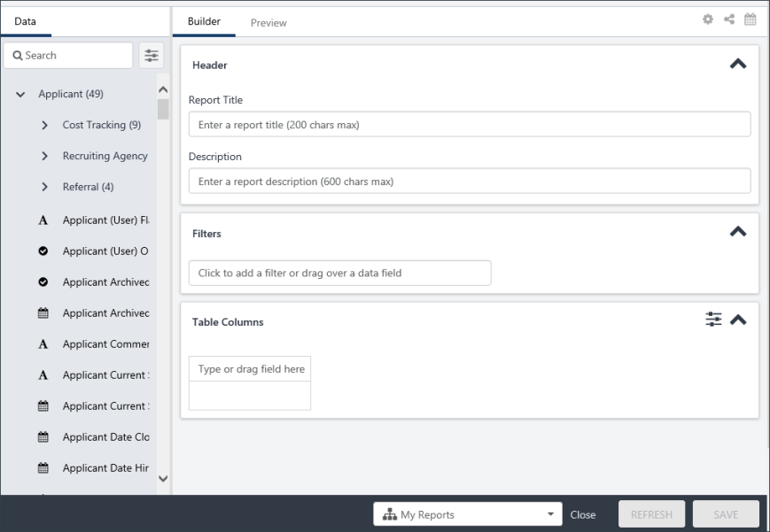
Hide/Display Builder Tab Sections
You can hide or display any section in the Builder tab. To do this, click the Show/Hide Report Options icon in the upper-right corner of the Builder tab. Then, toggle on or off the Header, Filters, or Charts options in the Designer Options section.
Compensation Field Currency Conversion
The currency conversion option is available when using Compensation fields so that you can convert the currency. The option only displays when a Compensation field is added to the report. Fields from the following sections will enable the option to display:
- Compensation
- Compensation Task
- Compensation Task Approval
- Current Compensation
Convert Currency
To convert the currency in the report:
- Click the currency conversion icon in the top-right of the header. This opens the Currency panel. When available, the currency conversion icon is displayed in between Properties and the Share Report icons.
- Select one of the following options:
  - Original Currency - Select this option to keep the currency as is. The original currency in the report will not change.
  - User's Currency - Select this option to change the currency to the currency of each user in the report. For example, you are reporting on salary data for users in the United States and France. Selecting the User's Currency option will display a France user's currency as EUR and a United States user's currency as USD. Note: An employee's currency is defined in Employee Salary Management. See Employee Salary Management.
  - Pick a currency - Select this option to set the report to a specific currency from the drop-down. All currencies available in your portal appear in the drop-down.
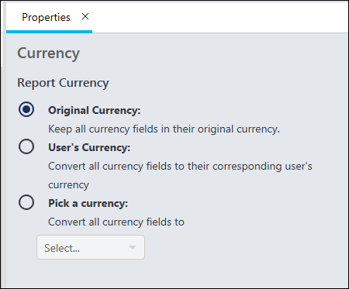
Share Report
For information about the share report option, which is available by clicking the icon in the upper-right corner of the Builder tab, see the Share Report topic in Online Help.
Report Delivery and Scheduling
For information about the report delivery and scheduling options, which are available by clicking the icon in the upper-right corner of the Builder tab, see the Report Delivery and Scheduling topic in Online Help.
Data Panel
The Data panel lists the report fields that are available to you based on your permissions. The fields are grouped into sections and are sorted alphabetically. The only groups that display are the groups for which you have permission to view. The fields that are available within each group are the fields for which you have permission to view.
Search
You can search for fields in the search bar. Results will begin to show as you type, broken down by the field groups. If your search doesn’t apply to a specific Field Group, the group will be hidden.
Clicking the fields Properties button to the right of the search bar will give you field filter options if you know the exact field type(s) you want to search for. You can also filter by a specific field group, such as Learning, to only view fields related to Learning.
Add Fields to Report
To add fields to a report, expand a report group and click the name of the field. This adds the field to the "Type or drag field here" area of the report builder. You can also drag and drop fields to the report builder, or you can type directly into the Type or drag field here area.
Note:
- If a feature/field has not been used and no data has ever been generated the field cannot be included in the report. Fields that have no data generated will not appear in the data panel.
- If a new custom field has been created and added to the report before the data warehouse has updated, report creators may see a message "Server Responded with failed to render report." In this situation, save the report and refresh and preview at a later time. The data warehouse normally refreshes every 15 minutes.
Builder Tab
The Builder tab is where the report is built. Fields are added to this section, as well as filters and the report name.
The following sections display:
Header
In the Header section, enter the report title in the Report Title field. The field accepts up to 200 characters. You can also enter a description for the report in the Description field, which accepts up to 600 characters.
Filters
In the Filters section, you can add filters to the report fields. To add a filter:
- Type a field name into the text box and select a field from the list. Or, drag and drop a field from the Table Columns section or the Data panel. Once a field is added, an operator drop-down and value field automatically appear to the right of the field name.
- Select an operator, and then enter a value. The options for the operator and value differ, depending on the field.
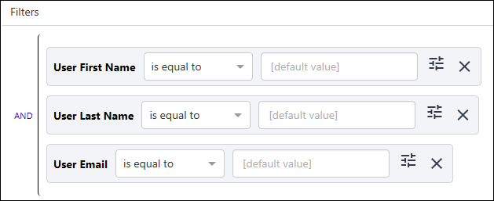
You can delete a filter by clicking the X to the right of the filter value.
Note: Filters allow a forward slash "/" to be used as a filter value and in a filter label. This lets you search for training that includes a forward slash in the title.
Dynamic Date Filters
Dynamic date filters are available when creating reports that have date filters, such as the Transcript Assigned Date field. The following date filters are available:
- This - Note: In this case, "this" indicates "current."
  - Week - Sunday 00:00:00 to Saturday 23:59:59 of this week
  - Month - First to last date of this month
  - Quarter - First to end of the following segments: Jan - Mar, Apr - Jun, Jul - Sep, Oct - Dec
  - Year - First to last date of this year
- Last - Note: In this case, "last" indicates "previous."
  - Day - 00:00:00 to 23:59:59 of yesterday
  - Week - Sunday 00:00:00 to Saturday 23:59:59 of last week
    - “Last 1 week” = the previous week (If this week is Week 23 of the current year, the filter period is Week 22 between Sunday 00:00:00 to Saturday 23:59:59.)
    - “Last 4 weeks” = the previous 4 weeks (If this week is Week 23 of the current year, the filter period is Week 19 at Sunday 00:00:00 to Week 22 at Saturday 23:59:59).
  - Month - First to last date of last month
    - Example: “Last 1 month” = the previous month (If today is in June, the filter period is May 1 to May 31)
    - Example: “Last 2 months” = the 2 previous months (If today is in June, the filter period is April 1 to May 31)
  - Quarter - First to end of the following segments: Jan - Mar, Apr - Jun, Jul - Sep, Oct - Dec
  - Year - First to last date of the year
- Next - Note: In this case, "next" indicates "after" (i.e., the day after today, the week after this week, etc.).
  - Day - 00:00:00 to 23:59:59 of the next day
  - Week - Sunday 00:00:00 to Saturday 23:59:59 of next week
  - Month - First to last date of next month
  - Quarter - First to end of the following segments: Jan - Mar, Apr - Jun, Jul - Sep, Oct - Dec
  - Year - First to last date of the year
- Yesterday
- Today
- Tomorrow
Note: When a report with relative date filter using Yesterday, Today, or Tomorrow is shared with another user, the filter is applied with respect to time zone of the shared user (e.g., the owner’s report will apply ‘Yesterday’ relative to the owner's time zone, and the shared user's report will apply ‘Yesterday’ relative to the shared user's time zone.).
For the Last filter option, you can configure the number of days, weeks, months, quarters, or years to which you would like the data to go back.
For the Next filter option, you can configure the number of days, weeks, months, quarters, or years to which you would like the data to go forward.
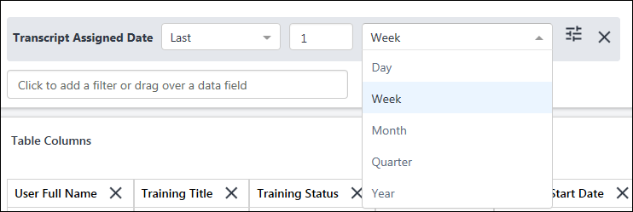
Date/Time Fields
When filtering date/time fields, a clock icon is available so that you can filter by a specific time. For example, when filtering by the date a training is due, you can select a specific time on the due date so that you can further narrow the report results.
Note: Please be aware that if the report creator switches timezones, the date filters will continue to work with the prior timezone values until the report is saved again. Upon re-saving the report, the new timezone changes are reflected.
AND/OR
When at least two fields are added, you can use AND/OR logic. By default, it will be an AND statement, but you can change it to an OR by simply clicking the word AND.
Filter Sub Groups and AND/OR Statements
Once you have at least two filters, you can create filter sub groups. Filter groups are not required for reports but let you create advanced logic.
To create a filter group:
- Drag a field over a filter. The filter appears in the corp color with no letters, giving you a preview of where your new filter will go.
- Drop the new filter on top of the existing filter. This creates a sub filter below the existing filter. This allows you to refine the report so that when you want to report on a limited amount of data, you can do so using filter groups.
You might want to create a sub group to combine AND/OR statements. For example, you might want to report on a specific Training Type, but add a sub filter group that includes training that has a Due Date during a specific period, or was Assigned during a specific period. You would add the Training Type filter, then add the Transcript Due Date and Training Assigned Date filters as a filter group, then change the sub filter Group logic to OR. Thus, the results would only include the specific Training Type selected AND training that was assigned during a specific date OR due on a specific date.
Filter Blank Values in Report Data
Reporting 2.0 has the following filter operators that account for blank fields:
- Empty - This indicates the data exists but does not contain a value. For example, an empty string value (i.e., text value) is represented as "".
- Null - This indicates the data does not exist.
Depending on the module on which you are reporting, empty and null values can represent something different in the data.
In Reporting 2.0, empty and null are available as the following filter operators:
- Is empty - This filter operator only includes empty string values in your report.
- Is null - This filter operator only includes null records in your report.
- Is empty or null - This filter operator includes any blank values in your report, combining both empty and null records.
- Is not empty - This filter operator excludes any blank values from your report, excluding both empty and null records.
- Is not null - This filter operator excludes any null values from your report.
Note for Custom Reports (Legacy) Users - The filter operators "is empty” or “is not empty" in Custom Reports would always include both empty and null records. To achieve the same result in Reporting 2.0, customers using these filters should use the “is empty or null” or “is not empty” filters. This is because Reporting 2.0 facilitates inclusion of both empty and null values to provide more control and granularity for segmenting report data.
Past Due Aging Filter
The Past Due Aging field can be added as a filter. This filter lets you report on users who are X number of days past due on training, which is important data for compliance purposes.
This filter is available for Learning reports.
Training Provider Filter
If ILT Preferences are configured to allow the vendor to be changed on events, then when one or more sessions for an event are tied to one provider, and one or more sessions of the event are tied to another provider, some sessions will not appear in reporting if the report is filtered by Training Provider and does not include all providers in the filter.
To ensure all providers are included in a report when filtering by Training Provider, be sure to add all providers to the filter.
Or you can choose not to filter by Training Provider to ensure data for all providers of an event or session is included in the report. This would include data for all providers available within your constraints.
Training Title Filter
When a Training Title is added to the Filter section, and the Training Title filter is set to is one of or is not one of, click Select Training to open the Select Training flyout. In the flyout, you can search for and select the relevant training titles on the SEARCH tab. Once you have selected one or more trainings, click the SELECTED tab to view all the selected training titles. The training titles have a Show all versions checkbox. When this option is checked, the report includes all versions of the training. If you clear the checkbox, the report will include only the latest version of the training.
When you select an Event in the Select Training flyout, Sessions will not display in the report output.
Enhanced Search is used to deliver results based on relevance. For more information on Enhanced Search, see Enhanced Search.
User/OU Flyout Filters
When a User or Organizational Unit (OU) field is added to the Filter section, you are able to use the Select Users and Select Org Units buttons to open up a flyout. The flyout lets you easily select the user or OU by which you would like to filter. Once a user or OU is selected, you can include or exclude subordinates and review and remove selections from the Selected tab.
With these flyouts, the following operators are available:
- Is one of - This restricts the data to the selected users or OUs.
- Is not one of - This restricts the data to users or OUs that are not one of the selected users or OUs.
- Starts with - This restricts the data to users or OUs that start with the search criteria. At least three characters must be entered.
- Is not empty - This will show all users and OUs that have a user or OU value.
- Is empty - This will show all users without a value for that OU.
- Is empty or null - This will filter out all empty and null values.
Filter Properties
Filter properties are optional and let you control the shared user’s experience of the filter. For example, you can determine in the filter properties if shared users should be able to remove or adjust the filters you have added when they use the report as their own. For example, if you set the Transcript Due Date field as hidden after you share the report with other users, they will not be able to see or interact with the filter because it is hidden. If you did not mark the other filters as hidden, then users with the ability to view those fields would be able to interact with those filters before previewing data or downloading results.
The changes made in filter properties can be viewed in both the Preview and Viewer.
Click the filter properties icon to open the filter property panel for the field. At the top of the panel, the name of the field displays. Also, the field is highlighted in the Filters section. This lets you easily see what filter you are adjusting.
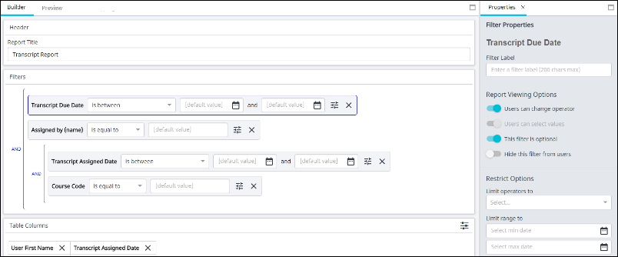
The Filter Label text box lets you rename the filter within this report. Changes made here will appear in both Preview and Viewer mode of this report. Changes will not apply to the Table Column if the field has been brought into the report. By default, the Users can change operator and This filter is optional are toggled ON.
Reporting View Options
The available Reporting View options include:
- Users can change operator - This option determines whether users can change the operator of the filter. When ON, users can change operators. When OFF, users cannot change operators. For example, if the option is OFF, users must use the operator chosen by the report builder.
- Users can select values - This option determines whether users can change the value of the filter. When ON, users can change the value. When OFF, users cannot change the value. For example, if the option is OFF, users must use the operator chosen by the report builder.
- This filter is optional - This option determines whether users are required to fill out the filter. When ON, users are not required to fill out the filter. When OFF, users are required to fill out the filter. For example, if the option is OFF, users would be required to use the selected filter.
- Hide this filter from users - This option determines whether users can see the filter in Viewer. When ON, users cannot see the filter. When OFF, users can see the filter. For example, if the option is ON, users cannot see the filter because the filter criteria they need is already set.
Restrict Options
The available Restrict Options include:
- Limit Operators To - These let report builders control which operators that shared users can select.
  - The Users can change operator field must be ON in order to limit operators.
  - The available operators in the drop-down list will reflect the field type selected.
  - Multiple operators can be selected.
  - Remove an operator by clicking the X icon.
- Limit Date Select To - These let report builders limit the date filter values. The available options are Yesterday, Today, Tomorrow, and Select Date.
- Limit Values To - These let report builders control which values that shared users can select. You can type in values here by which a user would be able to filter.
- Limit Range To - These let report builders limit the date criteria that shared users can select between.
Note: The operators, values, and date fields will differ based on the field by which you are filtering. For example, if you filter by a Date field, you will see the Limit range to option. If you filter by a Title field, you will not see the Limit range to, but instead will see the Limit values to.
Note: If you limit the values available in a filter, shared users can still remove these values entirely. This means they could view the entire, unfiltered report. The output of the report will always be based on the applicable constraints.
Table Columns
The fields you add to the report display in this section. Each field will display as a column in the report. You can add fields to this section by left-clicking on the field or dragging and dropping them from the Data panel.
Or, if you know what you want your column header to be, you can quickly add column headers directly from the Table Columns section. To do this, start typing the name of the field you want in the column. You’ll see suggested values appear based on the text you have entered. To make it easier to find the right column, fields are prefixed with the field group (e.g., Applicant or Assignment).
You can delete a field by clicking the X to the right of the field name.
You can re-order fields by clicking and dragging to a different column position.
Customize Name of Column Headers
Reporting 2.0 lets you change the name of your column headers to make it easier to identify the data you are running in a report. This is also helpful when sharing a report so that users are able to understand more easily the data you are providing in each report column.
To change the name of a column header:
- Click the icon to the right of the field name in the Table Columns section. This opens the Column Header Properties icon.
- Enter a new column name in the Column Header label field.
- Click Save at the bottom of the page. This saves the setting to the report. Note: If you only click Refresh after changing the column header name, the Preview tab will show the change, but the setting is not saved to the report.
The new column name is not visible on the Builder tab but is visible on the Preview tab.
The name change applies to charts and filters, as well as to the exported report and exception reports. However, you can opt to change the name of a filter and/or chart axis if you do not want to use the updated column header name.
Shared users will also see the name change.
Report Properties
Show/Count Unique Rows
To enable or disable Show/count unique rows only feature, click the Show/Hide Report Options icon in the upper-right corner of the Builder tab, which opens the Report Properties panel.
Toggle the Show/count unique rows only option On to filter the summarized report results so that rows are not repeated when they display identical summarized information. For example, if a Transcript report only contains the field User Full Name, and the report results include 50 different users with the name "Sample User," then checking Show/count unique rows only will only display one row of name "Sample User" in the report. Note: This is an advanced feature and should be left on in most portals, which is the default value.
Show Field Prefixes
This option lets you show or hide the name of the section for each field in the report. This helps to avoid confusion when fields in different sections have the same or similar names. For example, the User Full Name field exists for User, Successor, and Incumbent sections. When the Show Field Prefixes option is toggled off, the field displays as “User Full Name,” regardless of the section in which it appears. However, when the option is on, the field displays as "User - User Full Name,” which provides the name of the section before the field name.
You can enable or disable this feature by toggling it on or off in the Properties panel. If there are multiple fields with the exact same name in your report (e.g., User Full Name from the User section and User Full Name from the Manager section), this feature is on by default and cannot be turned off.
Publish to Dashboards
Charts that are created for a report in Reporting 2.0 can be published as dashboards. See Reporting 2.0 - Publish to Dashboards on page 76 for additional information.
Apply Owner Constraints
When you use the Apply Owner Constraints option, you can enable other users to view the report with the same constraints that you have. This lets report viewers see any data in the report, chart, and dashboard to which your constraints give you access. This also applies to shared reports and reports that are scheduled for delivery.
You can still limit what users see by using the Filters section on the Builder tab. This lets you add filters that restrict the data that appears in the report. Note: Shared users can remove the filter values defined in limit values, which provides them the full output following the report owners constraints.
Users must have the Reporting - Share - Apply Owner Constraints permission in order to have access to use this option.
To apply owner constraints:
- Click the Show/Hide Report Options icon on the Builder tab of the report. This opens the Properties tab.
- Toggle the Apply Owner Constraints option to on. This opens a confirmation pop-up.
- Click Confirm in the confirmation pop-up. This confirms that you are running the report with your constraints, meaning that users who view the report will see the same data that you see.
Use Case
An executive is viewing a report you created. She can only see data that is within her constraints. However, she needs to see data for all users in her Division Organizational Unit (OU).
You toggle the Apply Owner Constraints option to On and confirm the change. You open the report in View mode to make sure the report only contains data that she should be able to see.
By applying owner constraints, you do not need to manage other permissions and constraints to allow her access to the report data she needs. You also do not need to bother changing the user's permissions and constraints back to their previous state once she is done with the report. Further, because you have not removed constraints completely, the user is not able to see all data; they only see what you as the report owner can see.
How do I limit the data users see when I enable Apply Owner Constraints?
To make sure users don't see more data than intended, it is advised to:
- Set report filters in the Filters section on the Builder tab
- Control what users can see when they run the report by setting the Report Viewing Options in the Filter Properties panel; make sure users are not able to remove/change filters in the Report Viewer that would allow them to see more data than intended
- Limit filter criteria
- Open the report in View mode and test the filter settings before sharing the report
I want to share the report with Apply Owner Constraints. What do my shared users see?
The users with whom you share the report will see what is visible within your owner constraints. They can copy the report but will not have the ability to waive your constraints.
Hide Report Header
- If the Hide Report Header option is toggled on, the header rows that usually appear at the top of a report are not included when the report is exported.
- If the Hide Report Header toggle is set to "Off" for a report, users can view the following details from the downloaded report:
  - Report Title
  - Report Generated by
  - Report Generated Date/Time
  - Report Count
  - Report Count Limit
  - Report Source - Portal address is displayed as a URL
Display Filter Criteria
The Display Filter Criteria option lets you include the filter criteria used in the report. To enable the filter criteria to display, toggle on the option.
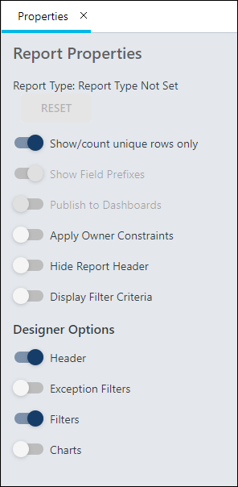
Table Properties
The following options may be available in the Table Properties:
- Only Show Summary Rows
- Merge Summary Rows - When the toggle is enabled, the output file will merge the matching rows in summarized columns. This is the default setting. When the toggle is disabled, summarized columns are populated in each row separately. The toggle is only be accessible if at least one column summary has been added.
- Show Grand Summary
- Show Summarized Hierarchy Output - When this toggle is enabled, hierarchy summary shows all the levels of hierarchy in one column. This is the default setting. When this toggle is disabled, hierarchy summary shows the levels of hierarchy in individual columns. Note: The toggle impacts only the Microsoft Excel output format.
Reports can be sorted and summarized using the options in the Column sorting and Column summary sections. See the following for information on how to sort and summarize:
- Column Sorting - The sort feature lets you define the sort order of the fields you selected for the report. By sorting the report fields, you can define which column displays first, and so forth, in the report output. See Reporting 2.0 - Sort Report on page 112 for additional information.
- Column Summary - The summarize feature lets you summarize the data in the report based on certain fields. See Reporting 2.0 - Summarize Report on page 115 for additional information.
My Reports Folder Option
Pre-Step Note: You must have at least one folder created on the homepage in order to add the report to a specific folder other than adding it to the My Reports area. Folders cannot be created from within the Report Builder.
The My Reports option at the bottom of the Report Builder lets you determine the folder you want the report to be stored in when creating or editing a report. Folders let you organize and manage the distribution of your reports, and you can share the folders with others. Also, you can group reports together based on your own criteria or themes, enabling you to easily find the reports you need.
To add the report to a folder, click the My Reports drop-down. Select the desired folder from the drop-down, then click Save when you are ready to save the report.
After the report has been saved, it will save to the selected folder and remain in the folder for as long as you own the folder. If the folder is one that has been shared with you, the system will save the report to My Reports by default.
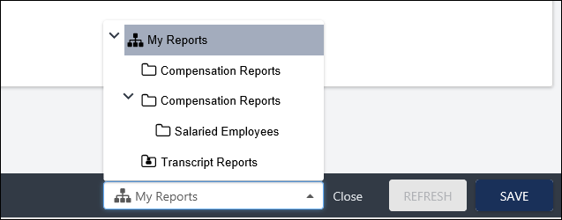
Preview Tab
Clicking the Preview tab for the first time will refresh your report and provide you with a preview of the report you have built. If you make additional changes after previewing, you will need to click the Refresh button.
Preview data shows 1,000 rows of data, which will be randomly selected. Any filters you have hidden in Properties will remain hidden in the preview, as well as any restrictions made.
Sort from the Preview Tab
You can sort the report directly from the Preview tab, in addition to being able to sort from the Report Properties panel. However, changes you make to the columns will overwrite the sort order you created in the Sort panel. For this reason, it is a best practice to use the Sort panel to sort the report.
To sort from the Preview tab:
- Click the name of a column (the field name) to sort the report by that field.
- The sort order automatically changes to sort by the column you selected. Notice that the column sorting information in the Sort panel changes to show the column name you selected. If you had a sort order already configured in the Sort panel, those settings are overwritten by manually changing the sort order on the Preview tab.
- The sort order is Ascending by default. Click the column name or click the arrow to the right of the column name to change the sort order to Descending.
Note: A different number of records may be seen when viewing the report data in Edit - Preview, View, and Excel and Download modes. This occurs because the different ways of viewing the data use a different top number of records.
- Preview uses the top 1000 records
- View uses the top 2000 records
- Download (view cloud icon, schedule for now) uses the top 200,000 records
Reference article: https://cornerstoneondemand.my.site.com/s/articles/Report-Values-Discrepancy-in-Excel-vs-View-or-Edit-mode-Reporting-2-0
Save and Close Report
At the bottom of the page is the Save and Close bar. The bar is responsive, meaning that as you adjust the size of your browser window or scroll up and down the page, the Save and Close buttons are always visible. Click Save or Close to save your report. When Close is selected, you are brought back to the report landing page.

Create Curriculum Transcript Report in Reporting 2.0
The Curriculum Transcript report can be created using Reporting 2.0 and allows administrators and managers to report on curricula and child learning objects (LOs) within curricula as they exist on users' transcripts. This report allows administrators to generate a clear output of the curriculum data available on users’ transcripts. The following information is available only in this report:
- The statuses of child training items within curricula (Not activated and Pending Prior Training)
- Learning Assignment Tool assignment information for child training within curricula
- The specific due dates of child training within curricula (instead the earliest due date)
- The latest version of the training within the transcript for curricula and child training within curricula
To create a Curriculum Transcript report, go to Reports > Reporting 2.0 and click the Create Report button. When refreshing or previewing the report and prompted for a report type choose Curriculum Transcript Report from the drop-down menu.
Permissions
See Reporting 2.0 Permissions on page 7 for additional information.
Curriculum Fields
This section is the ONLY section that should be used to filter for curriculum information related to the below listed fields. For example, to filter a report by a curriculum's course code, the administrator should use the Course Code (Curriculum) field within the Curriculum Transcript Report.
The following fields are included in the Curriculum section of the Curriculum Transcript report:
Field Name | Field type | Field Description
Course Code (Curriculum) | Text | This is the Course Code associated with the curriculum.
Created By (Name) (Curriculum) | Text | This is the full name of the user who created the curriculum.
Created By (User ID) (Curriculum) | Text | This is the user ID of the user who created the curriculum.
Curriculum Section Title (Curriculum) | Text | This is the title of the section within a curriculum.
Curriculum Title (Curriculum) | Text | This is the title of the curriculum.
Curriculum Version (Curriculum) | Numeric | This is the version number of the curriculum.
Keywords (Curriculum) | Text | This field returns the search keywords associated with the curriculum.
Language (Curriculum) | Text | This is the language in which the curriculum is available.
Last Modified By (Curriculum) | Text | This is the full name of the user who last made edits to the curriculum.
Last Modified By (User ID) (Curriculum) | Text | This is the user ID of the user who last made edits to the curriculum.
Last Modified Date (Curriculum) | Date | This is the date on which the curriculum was last modified.
Training Active (Curriculum) | Text | This field displays whether or not the curriculum is active.
Training Deactivation Date (Curriculum) | Date | This is the deactivation date provided for the curriculum, if applicable.
Training Description (Curriculum) | Text | This is the description of the curriculum.
Training Object ID (Curriculum) | Text | This is the unique, auto-generated ID associated with the curriculum.
Training Purpose (Curriculum) | Text | This field returns the training purpose(s) associated with the curriculum.
Training Status (Curriculum) | Text | This field displays the current status of the curriculum or its child training items on the user's transcript.
Training Subject (Curriculum) | Text | This is the subject(s) associated with the curriculum.
Training Type (Curriculum) | Text | This field displays the type of learning object (curriculum or the training type of child training items within the curriculum)
Training Version Effective Date (Curriculum) | Date | This is the effective date of the curriculum version.
Report Field Section Considerations
Some exclusions and considerations apply to the report field sections that are included in the Curriculum Transcript report.
Assignment Section
The following considerations apply to the Assignment report field section within the Curriculum Transcript report:
- Fields in the Curriculum Assignment section track the activation of curricula on users' transcripts, but not the individual activation dates of child training within curricula. The activation information for a curriculum is copied down to all of its child training items.
Training Section
The following fields in the Training fields section should NOT be used when the Training section is accessed via the Curriculum Transcript report:
- Curriculum Section Title (Training)
- Curriculum Title (Training)
- Curriculum Version (Training)
- Inside Curriculum
Using the above Training fields instead of the new corresponding fields in the Curriculum fields section will result in unexpected and potentially inaccurate report results.
Transcript Section
The following fields in the Transcript fields section should NOT be used when the Transcript section is accessed via the Curriculum Transcript report:
- Curriculum Section Title (Transcript)
- Curriculum Title (Transcript)
- Curriculum Version (Transcript)
Using the above Training fields instead of the new corresponding fields in the Curriculum fields section will result in unexpected and potentially inaccurate report results.
Curriculum Transcript Statuses Considerations
Use the Transcript Status field to report on the curriculum status, because when using the new Transcript Status (from Curriculum) field, any statuses before Registration return a blank value.
Curriculum Transcript Report Examples
In the table below, fields for creating a basic Curriculum Transcript report are listed:
Field Name or Type | Explanation
User Information | Any fields from the User field section can be used to identify the users (for example, User ID, User Last Name, etc.).
Training Type | Use the Training Type field from the Training field section to report on the types of training within a curriculum.
Training Type (Curriculum) | This field will always generate an output of Curriculum for curricula included in the report. Using this field helps administrators easily identify curricula in the report.
Curriculum Title (Curricula) | This field can help administrators see when the titles of curriculum versions have differences.
Training Title | This field from the Training field section can be used to display the names of child training items within a curriculum.
Curriculum Version | Child training inherits the version number of the curriculum for better filtering capabilities. Use this field when you need to report on a specific curriculum version.
Training Version | This field from the Training field section displays the training version within the curriculum on the transcript.
Transcript Status (from Curriculum) | This field must be used to report on Not Activated and Pending Prior Training statuses of training within a curriculum.
Transcript Status | Use this field from the Transcript field section to display curriculum statuses before Registration (Please see the consideration for the Transcript Section, listed on the previous page.).
Transcript Due Date (from Curriculum) | This field displays the due dates of training within the curriculum.
Transcript Due Date | Use this field from the Transcript field section ONLY if you want to due dates with the Transcript Due Date field from the Curriculum section, to see if there is another due date for the training.
Assignment Fields | Use any assignment-related fields from the User field section to help identify the assignment at the curriculum level.
Use Case #1: Reviewing Learners' Progress on Curricula
An administrator wants to report on the current version of a curriculum on a user's transcript. The administrator adds the following fields to the report:
- User Full Name
- Training Type
- Curriculum Title (Curriculum)
- Training Title
- Training Version
- Transcript Status (from Curriculum)
- Transcript Due Date (Curriculum)
- Assignment Title
- Assignment ID
- Assignment Created By (User ID)
- Curriculum Latest Registration?
The administrator sets the following filters for the report:
- Curriculum Title (Curriculum): Curriculum Title starts with "May 2018"
- Curriculum Latest Registration: Curriculum Latest Registration? is True.
When the administrator generates the report, they are able to view the child training items within the curriculum that are on a user's transcript, the version of the curriculum, the versions of the child training items, the transcript statuses of the child training and curriculum, whether the training is the current registration, and more.
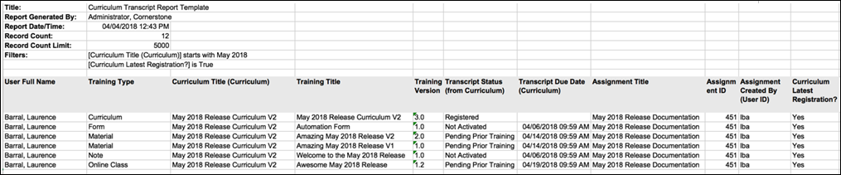
Use Case #2: Reporting on All Registrations or Versions of Curriculum Completion
An administrator wants to report on all versions and assignments of a curriculum on a user's transcript. The administrator adds the following fields to the report:
- User Full Name
- Training Type
- Curriculum Title (Curriculum)
- Training Title
- Curriculum Version (Curriculum)
- Training Version
- Transcript Status
- Transcript Due Date (Curriculum)
- Assignment Title
- Assignment ID
- Assignment Created By (User ID)
- Curriculum Latest Registration?
The administrator applies the following filter to the report:
- Curriculum Title (Curriculum): Curriculum Title starts with "May 2018"
After generating the report, the administrator can easily view which versions of the curriculum and its child training items are on a user's transcript, when they are due, what learning assignment the training was contained in, whether the curriculum is the latest registration, and more.
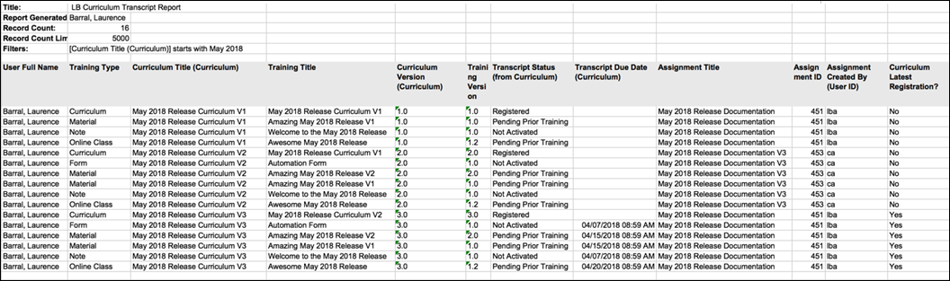
Use Case #3: Auditors Request Specific Curriculum Version Completion
An administrator wants to provide proof that a user has completed Version 2 of a curriculum that was assigned to the user via a learning assignment. The administrator adds the following fields to the report:
- User Full Name
- Training Type
- Curriculum Title (Curriculum)
- Training Title
- Curriculum Version (Curriculum)
- Training Version
- Transcript Status (from Curriculum)
- Transcript Due Date (Curriculum)
- Assignment Title
- Assignment ID
- Assignment Created By (UserID)
- Curriculum Latest Registration?
The administrator applies the following filters to the report:
- Curriculum Title (Curriculum): Curriculum Title starts with "May 2018"
- Curriculum Version (Curriculum): Curriculum version starts with "2"
When the administrator generates the report, they are able to view Version 2 of the curriculum and its associated child training items on a user's transcript, along with the assignment in which the training was assigned and other relevant information.
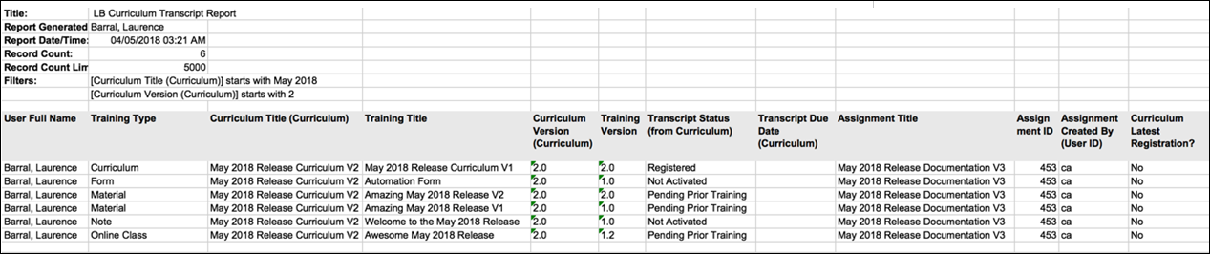

Reporting 2.0 - Publish to Dashboards
Charts that are created for a report in Reporting 2.0 can be published as dashboards. Dashboards are used for a variety of data to provide a quick, graphical view of report information for budgetary, investigative, compliance, and other process improvement purposes. Being able to compare the reports in one view lets you perform discovery across the data and monitor information in real time.
The dashboard will be housed in the Reports > Dashboards area of your portal.
To access Reporting 2.0, go to Reports > Reporting 2.0.
Permissions
For more information about Reporting 2.0 permissions, see the following:
- Permissions in Reporting 2.0 - This provides detailed information about Reporting 2.0 permissions.
- Permissions List - This provides the list of permissions and their relationships so that you know which permissions users need to have to create and view reports.
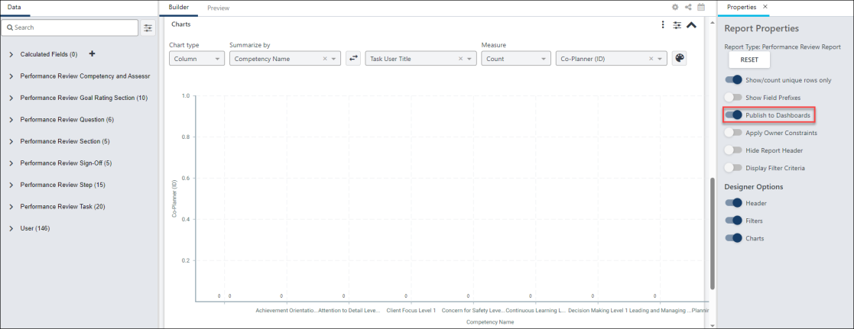
Publish Chart as Dashboard
To publish a chart as a dashboard:
- Create a chart for your report.
- Click the Show/Hide Report Options icon in the upper-right corner of the Builder tab, which opens the Report Properties panel.
- Toggle the Publish to Dashboards option to On. This automatically adds the chart as a widget to the Reporting 2.0 tab in Dashboards.
To view the dashboard, go to Reports > Dashboards. See Reporting 2.0 Widgets.
For more detailed information about dashboards, See Dashboard Reports Overview.
Reporting 2.0 Dashboard Use Cases
As an administrator or manager, there are many reasons you might want to create dashboards. The following are common use cases:
- Compliance - As a manager for a manufacturing company, I created a dashboard that shows me which workers are at risk for being unable to work due to compliance reasons.
- Remote Employees - My organization has high levels of serviced-based employees (e.g., healthcare, customer service, sales, billing, accounting), telecommuting has risen. As a policy-maker and Talent Management leader, I created dashboards to interpret the comparison between remote and non-remote workers so that I could understand who completes goals better, finishes compliance training faster, and is promoted more often.
- Performance Scores - As a member of the Talent Management team, I had numerous requests for reports that tell leadership which department has the highest percentage of positive performance scores. They also wanted to compare those numbers to total compensation and find out if higher performance vs. compensation correlated to a higher completion of development plans each year. I created a dashboard that provided this information and shared it with the leadership team.
- Hiring Sources - As a recruiter, I want to know which hiring sources are being used the most, as well as how those sources compare to performance for those new hires. I discovered that referrals are more efficient than external sources because they reduce the overall hiring cost and number of interviews, as well as increase the quality of candidates. I was also able to compare the data between hiring source and performance in different departments and determine how to encourage better hires in lower-performing areas.
- Compensation vs. Goal Completion - As a manager, I want to compare my team's current compensation with their progress toward year-end goals. I also want to compare the results to their succession task results. I want to use this information to help me make compensation recommendations to the Talent team during our performance review period.

Reporting 2.0 - Delivery and Scheduling
The Delivery option lets you send the report to yourself and other users via email and to an FTP folder. You can also schedule report delivery once, daily, weekly, or monthly. Reporting delivery must be enabled and configured in Report Delivery Preferences. See Report Delivery Preferences.
To access Reporting 2.0, go to Reports > Reporting 2.0.
Permissions
In addition to general permissions for creating and viewing reports in Reporting 2.0, users also need the following permission to deliver reports:
PERMISSION NAME | PERMISSION DESCRIPTION | CATEGORY

Reporting - Email Delivery | Grants ability to deliver reports via email in Reporting 2.0. This permission can be constrained by OU, User's OU, User, User Self and Subordinates, User's Self, User's Manager, User's Superiors, User’s Subordinates, User’s Direct Subordinates, and Employee Relationship.  This permission is used in conjunction with the view permission for Reporting 2.0 and can also be used in conjunction with the various product, section, and field level permissions.  Note about Constraints: The constraints for this permission determine to whom you can deliver the report. The constraints do not pertain to the data you can see in the report. | Reporting

Reporting - FTP Delivery | Grants ability to schedule delivery of Reporting 2.0 reports to an FTP directory. This permission cannot be constrained.  This permission is used in conjunction with the view permission for Reporting 2.0 and can also be used in conjunction with the various product, section, and field level permissions. Users must have permission to view Reporting 2.0 in order to have access to a report that is delivered to them. If they do not have view access, then the Reporting 2.0 navigation sublink will not display for them.  Users who have permission to manage Reporting 2.0 can edit a report that is delivered to them. They can also copy the delivered report. | Reporting

Reporting - Share | Grants access to share reports in Reporting 2.0. This permission can be constrained by OU, User's OU, User, User Self and Subordinates, User's Self, User's Manager, User's Superiors, User’s Subordinates, User’s Direct Subordinates, and Relationship.  This permission is used in conjunction with the view permission for Reporting 2.0 and can also be used in conjunction with the various product, section, and field level permissions. Users must have permission to view Reporting 2.0 in order to have access to a report that is shared with them. If they do not have view access, then the Reporting 2.0 navigation sublink will not display for them.  Users who have permission to manage Reporting 2.0 can edit a report that is shared with them. They can also copy the shared report.  Note about Constraints: The constraints for this permission determine who you can share the report with. The constraints do not pertain to the data you can see in the report. | Reporting
Note: If a change has been made to permissions and constraints for anyone involved in a scheduled report, it will take up to 48 hours for these changes to take effect. To make the changes take effect faster, it is recommended that you stop the current schedule for the report and then reconfigure the schedule. This will trigger all parameters to be re-checked immediately.
Queue this report on a schedule
When this option is enabled, users can queue reports on a schedule both for themselves, and on behalf of shared users. The report owner and any shared users included in automation are then able to download the queued report following the scheduled run.
To set the report schedule, use the options in the Schedule Parameters section to set the time, date, and frequency on which you want the report to run.
Once the report is scheduled, a snapshot of the report can be found in the Report Queue interface on the Reporting 2.0 homepage at the scheduled time.
If the report has been published to dashboards, the widgets that are using this report will also be refreshed automatically.
If you are sharing the report with other users and would like the snapshot and dashboard for these shared users to be refreshed automatically as well, you will need to check the Include Automation option, which is available on the Selected tab of the Select Org Units flyout.
- Note: The snapshot is available by clicking the queue report icon for a report on the Reporting 2.0 homepage.
- Note: The Select Org Units flyout is accessed by clicking the Share icon in the upper-right corner of the report creation page.
- Note: By default, the shared users’ own constraints are applied to the scheduled report. If the report owner and the shared user have the exact same constraints, they will receive the same snapshot. If the constraints are different each user will receive their own snapshot, matching their own constraints. Report owners with the Apply Owner Constraints Permission could also choose to share their constraints while sharing a report.
The system tracks the last accessed date for each scheduled snapshot of all owners and shared users associated with the report. If a scheduled report snapshot has not been accessed within the last 30 calendar days by any of the associated users, the system will automatically disable the schedule associated with it.
- This only applies to reports scheduled to run daily without any email or FTP delivery associated with it.
- When a scheduled report is disabled due to inactivity, the Queue this report on a schedule option is turned off.
- When a user accesses the snapshot for a report with a schedule that has been turned off, the system automatically enables the schedule for that specific report, ensuring that the enabling and disabling of schedules is based on user interactions. Users with edit access to the report can manually set up the scheduling options again.
- A report snapshot is considered accessed when any of the following occurs:
  - The scheduled snapshot is downloaded
  - A dashboard associated with the report is accessed
  - A dashboard widget associated with the report is refreshed, downloaded, or chart details are viewed
- A report snapshot is not considered accessed when the report is viewed in the Report Viewer or when a non-scheduled snapshot for the report is manually generated or downloaded.
Report Delivery via Email
To set report delivery via email, toggle on the Deliver to Email option. This enables the Delivery Parameters section to appear at the bottom of the panel.
To set the delivery schedule, use the options in the Schedule Parameters section to set the time, date, and frequency of the report schedule. See Report Scheduling on page 83 for additional information.
Select the output format in the Report Output Format section In Delivery Parameters and choose whether to check the Send as Zip file option.
Use the Email Recipients options to send the report to yourself or select the Add Users button to select additional users. The Add Users button is only available to users who have the Reporting - Email Delivery and Reporting - Share permissions.
When sending the report to additional users, you can choose to include the users in automated running of the report by selecting the following option in the Select Users flyout:
- Include in Automation - When this option is checked, automation for report queuing will run on behalf of up to 20 shared users, which means the shared users will automatically receive a refreshed report whenever the report is scheduled to run. This option is not available for organizational units (OU) or for users who are subordinates of the shared user. This option only functions if the Queue this report on a schedule option is toggled on in the Automation Settings panel.
The report is delivered to the user's email that is in their user record. You can remove users by clicking the X to the left of the user's name.
Email that come from the Stage and Pilot environments only, include the environment name in the Subject line of the Report Delivery as follows:
- [Stage] Division Report​
- [Pilot] User Report
Notifications from the Production environment do not have an environment name in the Subject line. ​
When using the scheduled report delivery, the email that is sent will contain the following information.
Email Subject: Report [Report Name] generated successfully
Body:
You may either find the report attached with this email or, you need to click on below link to access the Reporting 2.0 home page to download the report from the snapshot pop-up behind the cloud icon. You may locate the report using the Report name or Report ID in search filter.
Report Title
Report ID
Report Created By
Report Generated Date/Time
Record Count
Report Source
This is an automated email notification. - please do not reply
Example:
Report Test Delivery Report generated successfully
You may either find the report attached with this email or, you need to click on below link to access the Reporting 2.0 home page to download the report from the snapshot pop-up behind the cloud icon. You may locate the report using the Report name or Report ID in search filter.
Report Title : Test delivery report
Report ID: 1809
Report Created By : Tatu, Debbie
Report Generated Date/Time : 11/6/2023 10:25:15 PM
Record Count : 1289
Report Source : abcportal.csod.com
This is an automated email notification. - please do not reply
When using Schedule Now, an email is also sent and an example of this email is included below.
You may either find the report attached with this email or, you need to click on below link to access the Reporting 2.0 home page to download the report from the snapshot pop-up behind the cloud icon. You may locate the report using the Report name or Report ID in search filter.
Report Title : My Report
Report ID: 24
Report Created By : Tatu, Debbie
Report Generated Date/Time : 11/7/2023 8:09:44 PM
Record Count : 7
Report Source : abcportal.csod.com
https://abcportal.csod.com/Analytics/ReportBuilder/index.aspx?tab_page_id=-880000#/
Note: If the report exceeds 25 MB, a link to download the report is sent to the recipient automatically. The report is available to download via the link for 21 days. SSO is not supported for the link. Customers who wish to receive a download link for smaller reports instead of the default file delivery can request a lower limit to be defined through a work order.
Report Delivery to FTP
To schedule report delivery to your FTP folder, toggle on the Deliver to FTP option. Note: If you have appropriate permissions, the File Name Time Stamp 24hr toggle appears when you enable the Deliver to FTP option.
In the Schedule Parameters section, set the time, date, and frequency of the report schedule. See Report Scheduling on page 83 for additional information.
Select the output format in the drop-down and choose whether to check the Send as a Zip file option.
Note: For details about the rows limits, see Reporting 2.0 Matrix.
Report Name
The following naming convention is used for reports delivered to the FTP folder:
[Report Title]_[UTC Time in format yyyymmdd_hh_mm_ss]
Note: The UTC Date/Time in the report name is the UTC date and time on which the report was created in yyyymmdd_hh_mm_ss format.
24hr File Naming
The File Name Time Stamp 24hr toggle manages the timestamp for reports delivered to FTP.
- If toggle is disabled (default), the report is named: [Report Title]_[UTC Time in format YYYYMMDD_HH_mm_ss AM/PM].
- If toggle is enabled, the report is named: [Report Title]_[UTC Time in format YYYYMMDD_HH_mm_ss].
The Custom Reports Migration tool is also adjusted to continue to use 24-hour time stamps for migrated reports.
Note: This toggle is only visible to users with Reporting 2.0 Manage permissions and FTP Delivery permissions.
Report Scheduling
Note: When setting up delivery via email, if you would also like to deliver via FTP, the schedule will be the same for both. Email scheduling cannot be set up separately from FTP scheduling.
You can also schedule a one-time delivery or deliver the report daily, weekly, or monthly.
Schedule One-Time Report
- Click the Once option in the frequency drop-down.
- Enter the time of day in the Time of Day field. You can also use the clock to select a time.
- From the drop-down, select the time zone in which to run the report. The default setting is the time zone of the user configuring the report.
- Enter a start date in the Start Date field. You can also use the calendar option to select a date. By default, the start date is the current date.
The report will be delivered at the specified date and time.
Schedule Daily Report
Click the Daily option in the frequency drop-down. This enables the options to display below the drop-down for creating a report that runs daily. Complete the following fields:
- Every - This field enables you to determine the report interval. For example, if "3" is the value in the field, then the report runs every three days. Enter the number of days in the Every field. The default value is "1." This is a required field.
- Time of Day - Enter the time of day in the Time of Day field. You can also use the clock to select a time.
- Time Zone - From the drop-down, select the time zone in which to run the report. The default setting is the time zone of the user configuring the report.
- Start Date - Enter a start date in the Start Date field. You can also use the calendar option to select a date. By default, the start date is the current date.
- End Date - Enter the date on which to stop running the report. Or, you can leave this field blank, and the report schedule will not have an end date.
Schedule Weekly Report
Click the Weekly option in the frequency drop-down. This enables the options to display below the drop-down for creating a report that runs weekly. Complete the following fields:
- Every - This field enables you to determine the report interval. For example, if "3" is the value in the field, then the report runs every three weeks. Enter the number of weeks in the Every field. The default value is "1."
- On - Select the day of the week on which the report will repeat.
- Time of Day - Enter the time of day in the Time of Day field. You can also use the clock to select a time.
- Time Zone - From the drop-down, select the time zone in which to run the report. The default setting is the time zone of the user configuring the report.
- Start Date - Enter a start date in the Start Date field. You can also use the calendar option to select a date. By default, the start date is the current date.
- End Date - Enter the date on which to stop running the report. Or, you can leave this field blank, and the report schedule will not have an end date.
Schedule Monthly Report
Click the Monthly option in the frequency drop-down. This enables the options to display below the drop-down for creating a report that runs monthly. Complete the following fields:
- Every - This field enables you to determine the report interval. For example, if "3" is the value in the field, then the report runs every three months. Enter the number of months in the Repeat Every field. The default value is "1."
- On - This field allows you to configure when the report will run.
  - Day - Select "Day" from the drop-down to run the report on a specific day of the month. This enables a numeric text box to display to the right of the drop-down. In the text box, enter the day of the month on which the report will run.
  - First - Select "First" from the drop-down to run the report on the first <Sunday, Monday, Tuesday, Wednesday, Thursday, Friday, Saturday> of the month.
  - Second - Select "Second" from the drop-down to run the report on the second <Sunday, Monday, Tuesday, Wednesday, Thursday, Friday, Saturday> of the month.
  - Third - Select "Third" from the drop-down to run the report on the third <Sunday, Monday, Tuesday, Wednesday, Thursday, Friday, Saturday> of the month.
  - Fourth - Select "Fourth" from the drop-down to run the report on the fourth <Sunday, Monday, Tuesday, Wednesday, Thursday, Friday, Saturday> of the month.
  - Last - Select "Last" from the drop-down to run the report on the last <Sunday, Monday, Tuesday, Wednesday, Thursday, Friday, Saturday> of the month. Note: The "Last" option does not mean the report can be scheduled on the last day of a month. This option lets you select the last instance a day of the week occurs in the month.
- Time of Day - From the drop-down, select the time at which to run the report. The default setting is one hour from the current time.
- Time Zone - From the drop-down, select the time zone in which to run the report. The default setting is the time zone of the user configuring the report.
- Start Date - By default, the date on which the report starts running is the current date. You can modify the start date by entering a different date in the field.
- End Date - Enter the date on which to stop running the report. Or, you can leave this field blank, and the report schedule will not have an end date.
Edit Report Schedule
When you update the schedule for a previously scheduled report, the old schedule will no longer apply. The report will be delivered to any users who are included in the delivery settings based on the new schedule. This prevents duplicate reports from being sent.
Note: If you update the schedule while the report is currently processing for delivery, then it is possible that two reports will be sent. The report that is based on the first schedule will send once it is done processing. Then, the report will be sent again at the updated delivery time. However, once the updated report is sent, the report will no longer be sent at the old delivery time.
Deadbox Settings
Report delivery will respect Deadbox Settings in Pilot and Stage environments when a deadbox has been configured on the backend. Report delivery will stop for inactive users. When the report owner is inactive, report delivery will stop for all report recipients.
Report delivery is resumed when/if the user or report owner becomes active again.
Note: A "deadbox" is an email address that can be set up as a global override for all users so that all system emails are sent to the deadbox address.
Note: If deadbox settings are set in a portal, all users who are part of a delivery schedule will have their reports delivered there. This will mean that multiple copies of same report could be delivered to deadbox.

Reporting 2.0 - Dual Reports
Dual reports can be created for certain report types. Dual reports are similar to multi-module reports in Custom Reports, allowing you to build a report that includes fields from two different report types.
Dual report types are user centric and combine data from the differing tables through an “inner join,” which means that a row in the report is created for each user that meets the report conditions and has data in both of the two tables. For example, when a “Transcript and Performance Reviews” report type is run, the report will show every record where a user is associated with both a transcript record and a performance review task. Any user that does not have both a transcript record and performance review task will not be displayed.
The following dual report types can be created:
- Performance Reviews and Compensation
- Recruiting and Onboarding
- Transcript and Performance Reviews
Permissions
To have the ability to create a dual report, users must have Core - User permissions and at least one permission for both report types.
Core - User Permissions
- Reporting - Core - User - Contact Information - View
- Reporting - Core - User - Details - View
- Reporting - Core - User - Security - View
- Reporting - Core - User - User Billing - View
- Reporting - Core - User - User Identifier - View
- Reporting - Core - User - User Status Information - View
Permissions for Performance Reviews and Compensation Reports
Compensation Permissions
- Reporting - Compensation - Compensation - View
- Reporting - Compensation - Compensation Task - Details - View
- Reporting - Compensation - Compensation Task - Comments - View
- Reporting - Compensation - Compensation Task - Hourly - View
- Reporting - Compensation - Compensation Task Approval Workflow - View
- Reporting - Compensation - Current Compensation - View
Performance Review Permissions
- Reporting - Performance - Performance Review Competency and Assessment Sections - View
- Reporting - Performance - Performance Review Task - View
- Reporting - Performance - Performance Review Step - View
- Reporting - Performance - Performance Review Section - View
- Reporting - Performance - Performance Review Question - View
- Reporting - Performance - Performance Review Sign-Off - View
- Reporting - Performance - Performance Review Task - View
Permissions for Recruiting and Onboarding Reports
Recruiting Permissions
- Reporting - Recruiting - Applicant - Applicant - View
- Reporting - Recruiting - Applicant - Cost Tracking - View
- Reporting - Recruiting - Applicant - Recruiting Agency - View
- Reporting - Recruiting - Applicant - Referral - View
- Reporting - Recruiting - Application Forms - View
- Reporting - Recruiting - Applications - Applications - View
- Reporting - Recruiting - Background Check - View
- Reporting - Recruiting - Compliance Questions - View
- Reporting - Recruiting - External Assessments - View
- Reporting - Recruiting - External Vendor(s) - View
- Reporting - Recruiting - Historical Status - View
- Reporting - Recruiting - Interview Management and Scheduling - On Demand Video Interview - View
- Reporting - Recruiting - Interview Management and Scheduling - Scheduled Interview - View
- Reporting - Recruiting - Interview Management and Scheduling - Details - View
- Reporting - Recruiting - Offer Letter - Offer Letter Approval - View
- Reporting - Recruiting - Offer Letter - Offer Letter Salary - View
- Reporting - Recruiting - Offer Letter - Offer Letter Communication - View
- Reporting - Recruiting - Offer Letter - Offer Letter - View
- Reporting - Recruiting - Pre-Screening Questions - View
- Reporting - Recruiting - Requisition - Details - View
- Reporting - Recruiting - Requisition - Location - View
- Reporting - Recruiting - Selection - View
- Reporting - Talent Pool - Talent Pool - Modification History - View
- Reporting - Talent Pool - Talent Pool - Details - View
- Reporting - Recruiting - Applicant User - View
- Reporting - Recruiting - Applicant User - View
- Reporting - Recruiting - Applicant User - View
- Reporting - Recruiting - Applicant User - View
- Reporting - Recruiting - Applicant User - View
- Reporting - Recruiting - Applicant User - View
Onboarding Permissions
- Reporting - Forms - Forms - Form Attributes - View
- Reporting - Forms - Forms - Form Approvals - View
- Reporting - Forms - Forms - Form Fields - View
- Reporting - Onboarding - Onboarding - Task - View
- Reporting - Onboarding - Onboarding - Details - View
- Reporting - Onboarding - Onboarding - Future - View
Permissions for Transcript and Performance Reviews
Transcript Permissions
- Reporting - Learning - Assignment - View
- Reporting - Learning - Assignment - Transcript - View
- Reporting - Learning - Course Interaction - View
- Reporting - Learning - ILT - Part Details - View
- Reporting - Learning - ILT - ILT Seat Allocation - View
- Reporting - Learning - ILT - ILT Facility - View
- Reporting - Learning - ILT - ILT Part Instructors - View
- Reporting - Learning - ILT - Part Location - View
- Reporting - Learning - ILT Preferred Instructor - View
- Reporting - Learning - On the Job Training & Express Class - View
- Reporting - Learning - SCO Data - View
- Reporting - Learning - SCORM 2004 Quiz Data - View
- Reporting - Learning - SF-182 Request - SF-182 Details - View
- Reporting - Learning - SF-182 Request - Organization Contact Information - View
- Reporting - Learning - SF-182 Request - Training Location Information - View
- Reporting - Learning - SF-182 Request - Vendor Contact Information - View
- Reporting - Learning - Training - Training Details - View
- Reporting - Learning - Training - Training Reviews - View
- Reporting - Learning - Training - Tests - View
- Reporting - Learning - Training - Training Provider - View
- Reporting - Learning - Training - Curriculum - View
- Reporting - Learning - Training Request Forms - View
- Reporting - Learning - Transcript - View
Performance Review Permissions
- Reporting - Performance - Performance Review Competency and Assessment Sections - View
- Reporting - Performance - Performance Review Task - View
- Reporting - Performance - Performance Review Step - View
- Reporting - Performance - Performance Review Section - View
- Reporting - Performance - Performance Review Question - View
- Reporting - Performance - Performance Review Sign-Off - View
- Reporting - Performance - Performance Review Task - View

For more information about Reporting 2.0 permissions, see the following:
- Permissions in Reporting 2.0 - This provides detailed information about Reporting 2.0 permissions.
- Permissions List - This provides the list of permissions and their relationships so that you know which permissions users need to have to create and view reports.
Create Dual Report
To create a dual report:
- Add at least one field from a field section for one of the available dual report types.
- Click Preview, Refresh, or Save. This opens the select report type pop-up so that you can select the dual report.
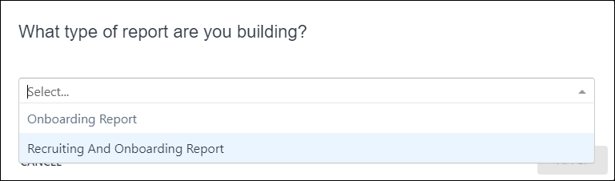
- Select the report type that includes both types of reports you want to create. For example, if you are creating a report with both Recruiting fields and Onboarding fields, select Recruiting and Onboarding Report.
- Click Apply in the pop-up. This makes all fields for both report types available in the Data panel.
- Continue building the report as usual.

Exception Reporting
Exception filters are supported for several report types within Reporting 2.0. With exception filters, you can include or leave out certain data so that your report provides the results you need. For example, you can generate a list of every user in the system and find out whether or not they completed a specific training.
To access Reporting 2.0, go to Reports > Reporting 2.0.
Permissions
Exception filters are only available to users who have the Reporting 2.0 permissions needed for User, Training, Transcript, Performance, or Development Plan reports.
For more information about Reporting 2.0 permissions, see the following:
- Permissions in Reporting 2.0 - This provides detailed information about Reporting 2.0 permissions.
- Permissions List - This provides the list of permissions and their relationships so that you know which permissions users need to have to create and view reports.
What Is the Benefit of Exception Filters?
The majority of reports let you combine user data with other data, such as finding out who has taken what training. This makes it difficult to find out who has not taken training or to find other information that is not yet on the user record. Other reports, such as the Training Report, do not contain any user data. Exception filters let you create reports to find the exceptions, i.e., people who have or have not done something.
Exception filters are also beneficial for compliance purposes. A common use case for reporting is to find out who has and has not completed training. Prior to this enhancement, it was necessary to create two separate reports to obtain this information. Then, the report results needed to be compared in Excel in order to get a complete picture. With exception filters for Transcript reports, you can now get this information in a single report.
What Exception Filters Are Available?
The Exception Filters section has a preset list of standard fields that are available to use as an exception, such as Training Title.
Performance Review Fields
The following Performance Review fields are available as exception filters:
- Competency Name
- Completion Date
- Expiration Date
- Goal Assignment
- Goal Rating Score
- Goal Rating Title
- Goal Target Date
- Goal Title
- Performance Review Due Date
- Reopened
- Review Period Start Date
- Section Name
- Sign-off Declined
- Step Reviewer ID
- Step Reviewer Name
- Step Status
- Step Title
- Task Final Rating
- Task Final Rating Text
- Task Name
- Task Raw Rating
- Task Raw Rating Text
- Task Status
- Task User Title
Development Plan Fields
The following Development Plan fields are available as exception filters:
- Dev Plan Action Step
- Dev Plan Action Step Due Date
- Dev Plan Action Step Progress
- Dev Plan Activity Type
- Dev Plan Approval Date
- Dev Plan Category
- Dev Plan Date Created
- Dev Plan Description
- Dev Plan Due Date
- Dev Plan Is Primary
- Dev Plan Objective
- Dev Plan Objective Progress
- Dev Plan Progress
- Dev Plan Status
- Dev Plan Template Title at Plan Creation
- Dev Plan Title
Training Fields
The following Training fields are available as exception filters:
- Course Code
- Course Publication Title
- Created By (Name)
- Created By (User ID)
- Curriculum Title (Training)
- Curriculum Version (Training)
- DMS Status
- Equivalent Subject
- Equivalent Training Object ID
- Equivalent Training Title
- Equivalent Training Version
- Event Number
- Inside Curriculum
- Interest Tracking Allowed
- Keyword
- Language Equivalent Training Object ID
- Language Equivalent Training Title
- Language Equivalent Training Version
- Last Modified By
- Last Modified By (User ID)
- Last Modified Date
- Latest Version
- Material Type Active
- Material Type Name
- Material URL
- Max score
- Mobile Compatible
- Multiple Session Enrollment Allowed
- Number of Attempts Allowed (Tests)
- Product/Commodity Code
- Session Cost
- Session Cost Type
- Training Created Date
- Training Deactivation Date
- Training Description
- Training End Date
- Training Hours
- Training ID
- Training Locator Number
- Training Max Registration
- Training Min Registration
- Training Object ID
- Training Provider
- Training Purpose
- Training Reference Number
- Training Reg Deadline
- Training Start Date
- Training Status
- Training Subject
- Training Title
- Training Type
- Training Version
Transcript Fields
The following Transcript fields are available as exception filters:
- Archived from Transcript?
- Assigned
- Available Date
- Cancellation Reason
- Completed SCOs %
- Curriculum Completion Percentage
- Exempted By(ID)
- Curriculum Latest Registration?
- Curriculum Title (Transcript)
- Curriculum Version (Transcript)
- Exemption Date
- From Training Plan?
- Greatest Registration Number
- Last Transcript Status Change Date
- Latest Registration Number?
- Registration Number
- Removal Reason
- Removed from Transcript?
- Required
- Session Withdrawal Date
- Suggested
- Transcript Assigned Date
- Transcript Completed Date
- Transcript Due Date
- Transcript Due Date (Curriculum)
- Transcript Edited By (User ID)
- Transcript Edited Date
- Transcript Last Modified Date
- Transcript Registration Date
- Transcript Removed Date
- Transcript Score
- Transcript Status
- Transcript Status (from Curriculum)
- Transcript Status Group
- Transcript Time in training (min)
- User's Course Review
- Withdrawal Reason
Where Can I Find the Exception Filters Section?
To use exception filters, you will need to add the Exception Filters section to the Builder tab each time you would like to add exception filters to a new report. To do this:
- Make sure you are building a report type that has exception filters available, which includes Transcript, Performance Review, and Development Plan reports.
- Make sure you have not added any fields from any other field group to your report, as you will not be able to build an exception report until you have removed these fields.
- Click the cog wheel on the Builder tab.
- Check the Exception Reports box from the drop-down. The Exception Filters section will now appear on the Builder tab.
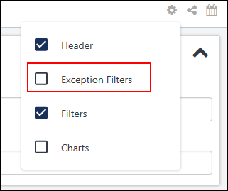
How Do I Add Fields to the Exception Filters Section?
You can add fields as exception filters by doing one of the following:
- Click the box in the Exception Filters section and select a filter from the list. You can enter keywords in the box to search for the filter you need.
- Drag and drop a field from the Table Columns section to the Exception Filters section.
- Drag and drop a field from the Data panel to the Exception Filters section.
How Do I Configure Exception Filters?
With exception filters, you can narrow down your report results by finding who has and/or has not taken training.
Just like the filters in the Filters section, you can select an operator for each individual filter and define the value or values for the filters. For example, if you would like to find out which users completed a certain online course, you can:
- Add the Training Title exception filter
  - Select the "is one of" operator
  - Select the specific training on which you want to report
- Add the Transcript Status exception filter
  - Select the "is one of" operator
  - Select "Completed" and any other transcript status you would like to include
- Add the User Full Name, Training Title, and Transcript Status fields to the report
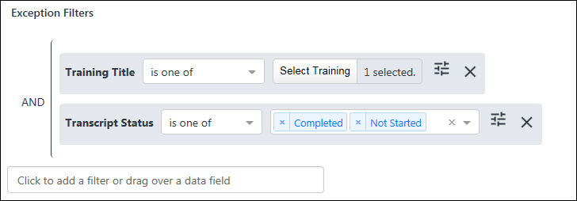
Properties for Exception Filters
Additional options are available in the Report Properties panel for exception filters.
The following options are available:
- Exception only - Select this option to only include users who have NOT taken the training.
- Exception and All - Select this option to include both users who have not taken the training AND who have taken the training.
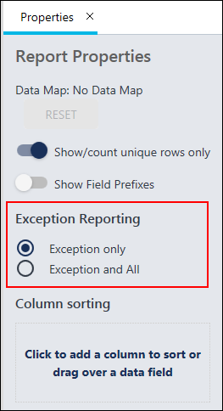

Folders in Reporting 2.0
Folders in Reporting 2.0 lets you organize and manage the distribution of your reports, and you can share the folders with others. Also, you can group reports together based on your own criteria or themes, enabling you to easily find the reports you need.
Folders are created and managed in the My Reports section of the Reporting 2.0 homepage. This section is for your own folder hierarchy. You can customize the organization of your reports as you wish, and you can move reports into your folders to create the organization that best fits your needs.
Use Cases
Reporting Users
As a user, I would like a way to organize reports available to me to create a more personalized experience for myself. Creating folders also enables me to decrease the steps/effort in my current workflow when navigating reports.
Reporting Administrators
As an Administrator, I need a space to collaborate with other administrators in order to organize and maintain a single repository of reports. Currently, I have to share each report individually. By using folders, I can put all the reports into one folder and simply share the folder. All my shared users will be able to view all the reports and sub-folders within that parent folder, given they have the appropriate permissions to access Reporting 2.0 turned on within the system. When I add or remove reports from the folder, my shared users will automatically get the changes so that I do not need to re-share the folder with the updates.
This same behavior applies with folders that reside within the parent folder. Users will receive viewing capabilities for all sub-folders and the reports within those sub-folders.
Talent Managers
As a Talent Manager, I need to organize, maintain, and update multiple sets of reports on a daily basis to ensure employees have finished compliance tasks/training. If an employee is not compliant, they may not be allowed to do their job. I need to share these reports with multiple managers across different organizational units (OUs). By putting the reports into folders and sharing the folder, all my shared users will automatically get the reports and any daily updates to the reports.
To access Reporting 2.0, go to Reports > Reporting 2.0.
Permissions
For more information about Reporting 2.0 permissions, see the following:
- Permissions in Reporting 2.0 - This provides detailed information about Reporting 2.0 permissions.
- Permissions List - This provides the list of permissions and their relationships so that you know which permissions users need to have to create and view reports.
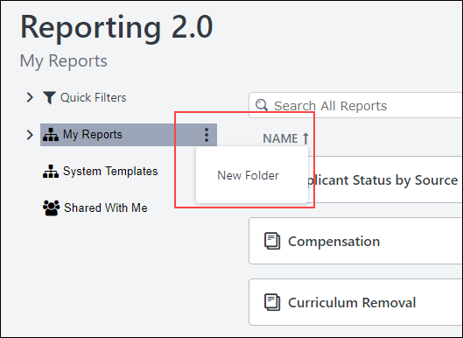
Create Folders
To create a folder:
- Click the My Reports three-dot options menu icon, and select New Folder. A text box appears below My Reports.
- Enter a title for your folder.
- Press Enter/Return on your keyboard, or click anywhere on the page outside the text box to save the folder.
You can view the reports in a folder by clicking the folder name. To return to your full list of reports, click My Reports.
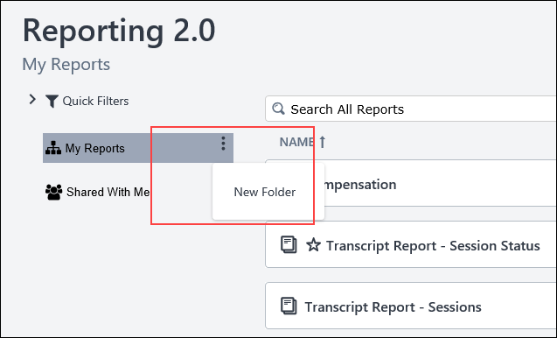
Create Subfolders
You can add subfolders to existing folders by clicking New Folder from the 3-dot options drop-down to the right of the folder name. This opens the text box that lets you enter a name for the subfolder. Save the folder by pressing Enter/Return on your keyboard or by clicking anywhere on the page outside the text box.
Add Report to Folder
You can add reports to folders by using the option on the homepage or from within the Report Builder.
Add from Homepage
To add a report to a folder from the Reporting 2.0 homepage:
- Click Move from the three-dot options icon for the report on the Reporting 2.0 homepage. A Move Report pop-up opens.
- Select the folder to which you would like to move the report.
- Click Move.
Add from Report Builder
Pre-Step Note: You must have at least one folder created on the homepage in order to add the report to a specific folder other than adding it to the My Reports area. Folders cannot be created from within the Report Builder.
In the Report Builder, you can determine the folder you want the report to be stored in when creating or editing a report. Within the report builder, a reports drop-down has been added to the bottom of the page. Select the desired folder from the drop-down, then click Save when you are ready to save the report.
After the report has been saved, it will save to the selected folder as long as you own the folder. If the folder is one that has been shared with you, the system will save the report to My Reports by default.
Rename a Folder
To change the name of a folder:
- Hover over the three-dot options menu icon for the folder.
- Click Rename from the drop-down.
- Enter a different title for your folder in the text box.
- Press Enter/Return on your keyboard, or click anywhere on the page outside the text box to save the change.
Share Folders
Sharing folders lets you share a folder with other users. Any reports and sub-folders within the folder are also shared.
When users share folders, the sharing recipient can view all reports within that folder, given they have the appropriate permissions to access Reporting 2.0 turned on within the system. The folder being shared appears under the "Shared with Me" hierarchy for the sharing recipient, and that user is able to view to all reports if they have the appropriate permissions. Because folder sharing is dynamic, reports can continue to be added or removed from the folder and will be available to the shared user automatically.
To share a folder:
- Click Share from the three-dot options menu icon to the right of My Reports. The Select Org Units flyout opens.
- Search for and select the users with whom you would like to share the report.
- Click Save.
Once you have shared a folder with someone, you can view the shared users by clicking the Selected tab on the Select Org Units flyout. From here, you can remove shared users by clicking the X to the right of their name.
Note: Users who select Reporting 2.0 to access the Reporting 2.0 homepage, and have view only permissions, are directed to the Shared with me folder on the Reporting 2.0 Homepage. If no reports are available, users will see the following message: No reports have been shared with you yet. You may have reports available in other report folders, shown on the left side of this page.
Editing Reports in Shared Folders
When you edit a report that has been shared, your shared users will automatically get the updates. You will not need to re-share the report or the folder for the report.
Move Folders
You can move a folder into another folder by clicking Move from the three-dot options menu icon for the folder. This opens a Move Folder pop-up. Select the folder to which you would like to move the folder, and then click Move.
Delete Folders
To delete a folder or subfolder, click Delete from the three-dot options menu icon for the folder.

Reporting 2.0 - Report Types
Report types let you create reports based on the type of report you want to create. This is an intelligent feature that lets you start building reports without picking a category. As you build, the system narrows down the choices of report types available. For most reports, you will not need to choose a report type because the fields you have included in the report only have one associated report type.
Click here to download the list of Reporting 2.0 report types and field descriptions, updated March 20, 2024. This Excel spreadsheet provides descriptions for the report types and fields in Reporting 2.0. This list is updated when there are changes to existing fields or new fields are added. Currently, the list is in English only. Note that it may be necessary to scroll through the sheets on the Excel spreadsheet in order to access the first sheet.
To access Reporting 2.0, go to Reports > Reporting 2.0.
Permissions
For more information about Reporting 2.0 permissions, see the following:
- Permissions in Reporting 2.0 - This provides detailed information about Reporting 2.0 permissions.
- Permissions List - This provides the list of permissions and their relationships so that you know which permissions users need to have to create and view reports.
Report Type Visibility Is Permission-Based
Users only see a report type when they have the permission to view at least one of its sections. For example, a user with permissions for Reporting, Transcript, and Training can view fields for Assignment, Certification, and Training, but not fields for Compensation or Performance, etc.
Users can only see field columns based on their permissions.
Selecting Report Type
When more than one report type is available for your report based on the fields you have added, you will be prompted to choose one. For example, if you add fields that apply to more than one report type (e.g., User Full Name and Training Title apply to both Certification and Transcript reports), then you are prompted to choose the report type when you click the Preview tab, the Refresh or the Save button for the first time.
Workflow for Selecting Report Type
- Add fields to the report.
- Click the Preview tab, or click the Save or the Refresh button.
- A report type pop-up opens asking which type of report are you building.
- Select a report type from the drop-down. The options display in alphanumeric order.
- Click Apply.
Once you click Apply, the report type is applied. The report type will update the list of fields that are available in the Data panel so that the only fields that appear are the fields that are relevant to that report type.
The report type will appear in the Report Properties panel.
Note: Users with "Can View" and "Edit" ability as well as Reporting - Manage permissions can change the report type when accessing the report.
Reset Report
Once you set the report type, you can choose to reset the report. Resetting the report deselects the current report type and re-populates the list of fields to choose from on the left based on fields already selected for use in the report. A new report type can then be selected based on the new field choices that are made.
Click Reset to reset the report. The list of fields in the Data panel will update to display all fields. The fields and filters you have added to the report will not be lost.
Copy Report
When copying a report that has a report type defined, the report type is copied. Users can remove the report type by clicking Reset so that a different report type can be selected.

Reporting 2.0 - Report Viewer
After a report is saved, you can click the report title on the My Reports page to open the report viewer. When clicking the report for the first time, the report automatically refreshes. The viewer shows the first 2,000 rows of data, which will be randomly selected. Filter properties will be applied if filters were used in the report. If a Chart is included in the Report, the chart will be generated based on the first 2,000 rows of data as well.
To access the report viewer page, go to Reports > Reporting 2.0. Then, click the name of a report to open the report viewer.
For more information about Reporting 2.0 permissions, see the following:
- Permissions in Reporting 2.0 - This provides detailed information about Reporting 2.0 permissions.
- Permissions List - This provides the list of permissions and their relationships so that you know which permissions users need to have to create and view reports.
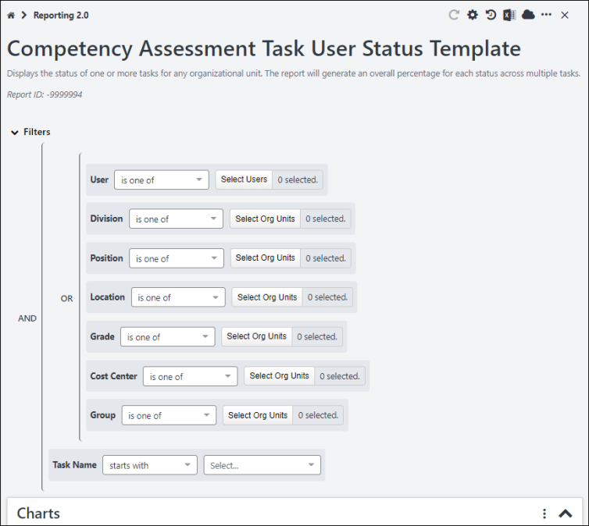
The following options are available when viewing reports in the viewer:
- Refresh icon - Click the refresh icon to update the report with the latest data. It is important to refresh after making changes to the filters.
- Configure your Report Properties - Click the properties icon to open the Report Output Properties panel. You can also set the maximum number of records to generate. The range is from one to one million. By default the number of records is set to 200K.
- Schedule for Now - Click the clock icon to extract reports with user's preferences. When ready, the report is downloaded in the preferred format.
- Export report to Excel file - Click this icon to generate a new report snapshot. The maximum number of records that can be returned in the report is one million. If more than one million rows match your criteria, the rows included will be randomly selected.
- Download/schedule your report icon - Click the cloud icon to open the snapshots screen to view, generate, and schedule snapshots for download. You can also:
  - Set the maximum number of records to generate. The range is from one to one million. By default the number of records is set to 200K.
  - Click Notify me through email when the report is ready for download to receive notification by email when the snapshot is generated.
- Edit - Click the dotted line to enable the Edit option to appear. Then, click Edit to edit the report. This opens the report builder, where you can modify the report as needed. Then, click Save to save the changes.
- Copy - Click the dotted line to enable the Copy option to appear. Then, click Copy to copy the report. This opens the report builder, where you can modify the report as needed. Then, click Save to save the copied report.
- Delete - Click the dotted line to enable the Delete option to appear. Then, click Delete to delete the report.
- Expand/Collapse - When viewing a summary and hierarchy report, an Expand/Collapse option is available so that you can expand and collapse all levels.
- Reset Filters - Click the dotted line to discard the user-defined filter preferences, and returns to the Report Owner filter settings.
- Close - Click the X icon to close this window and return to the Reporting 2.0 Home Page.
Note: The following actions are disabled when a report query is in progress:
- Refresh this report
- Schedule for Now
- Export report to Excel file
- Download your report
- Field filters
Note: The options available in the kebab menu depend on your permissions.
The following user-defined preferences are automatically saved and are re-applied the next time the user visits the Reporting 2.0 Viewer page or extracts the report:
- Report Viewer Properties
  - Show/hide Filters
  - Show/hide Chart
  - Show/hide Chart labels
  - Show/hide Data
- Report Data Output Related
  - Filter criteria/values
  - Show Grand Summary
  - Column sorting
  - Snapshot completion notification on/off
  - Number of records in snapshot output from 1 to 1 million
Configure Report Properties
Click the properties icon to enable or disable the following report output and viewer properties:
- Hide Report Header
  - If the Hide Report Header toggle is disabled for a report, users can view the following details from the downloaded report:
    - Report Generated Date/Time
    - Report Source - Portal address is displayed as a URL
- Display Filter Criteria
- Notify me for report completion
- Maximum number of records - The range is from one to one million. By default the number is set to 200K.
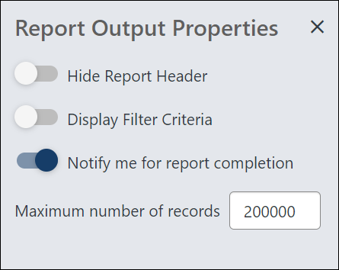

Reporting 2.0 - Share Report
The feature for sharing reports is located in the upper-right corner of the Builder tab. The option is only visible to users who have permission to share reports.
Users without permission to share reports can still receive shared reports, but constraints for other permissions will be respected. For example, if you share a report that contains data around Location A and the user receiving the report is constrained to only see data for Location B, the report would not contain any records.
To access Reporting 2.0, go to Reports > Reporting 2.0.
Permissions
In addition to general permissions for creating and viewing reports in Reporting 2.0, users also need the following permission to share reports:
PERMISSION NAME | PERMISSION DESCRIPTION | CATEGORY

Reporting - Share | Grants access to share reports in Reporting 2.0. This permission can be constrained by OU, User's OU, User, User Self and Subordinates, User's Self, User's Manager, User's Superiors, User’s Subordinates, User’s Direct Subordinates, and Relationship.  This permission is used in conjunction with the view permission for Reporting 2.0 and can also be used in conjunction with the various product, section, and field level permissions. Users must have permission to view Reporting 2.0 in order to have access to a report that is shared with them. If they do not have view access, then the Reporting 2.0 navigation sublink will not display for them.  Users who have permission to manage Reporting 2.0 can edit a report that is shared with them. They can also copy the shared report.  Note about Constraints: The constraints for this permission determine who you can share the report with. The constraints do not pertain to the data you can see in the report. | Reporting
Share a Report
- Click the Share icon in the upper-right corner of the Builder tab to open the sharing flyout.
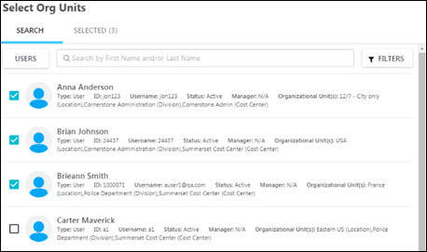
- Search for the users and OUs with whom you would like to share the report.
- Select the box to the left of the users and OUs with whom you would like to share the report. There is no limit to the number of users with whom you can share the report.
- Select the Selected tab in the flyout. This tab displays the users and OUs you have selected and allows you to determine their view and edit access for the report, include or exclude subordinates, include or exclude automation, and include or exclude from email delivery. This tab also displays any users with whom the report is shared via folder sharing; no action can be taken for these users.
  - Selecting the Include in e-mail delivery option will also add the user as an e-mail delivery recipient for a report upon save, and the checkbox will be automatically selected if the recipient is added via report builder schedule properties (i.e., it will be synced in both the ways). This option is disabled if the “Deliver to email” toggle is OFF in report builder or if the user does not have the relevant permissions to share reports via email.
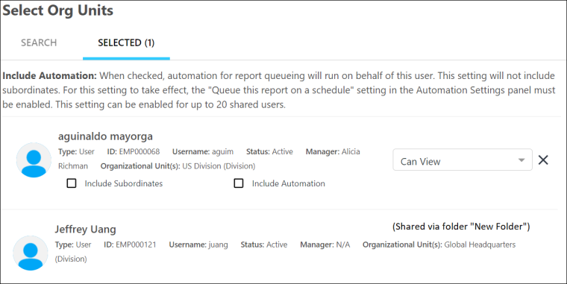
- Set the view and edit access by clicking the viewing options drop-down to the right of the user or OU details. The following options are available:
  - Can View - This option is selected by default. Users will only be able to view the shared report and cannot edit it.
  - Can View and Edit - Select this option to allow users to view and edit the shared report. If a user receives edit access, they will have access to make changes to the master copy of the report. This means that any edits a shared user makes are also reflected in the original report.
- Click Select to save the share settings. Then, click Save on the report to save and share the report.
Note: Include automation will include the shared user into scheduled delivery. This is supported for up to 20 recipients. See Reporting 2.0 - Delivery and Scheduling on page 78 for additional information.
Note: If a shared user does not have the necessary permissions for fields used in a filter, the field values used in the filter are not visible to the shared user. The filter names are visible but non-interactive. Shared users cannot edit or modify these filters, regardless of whether they have edit report sharing permissions. Shared users can delete these filters if they have edit permissions for the shared report.
Frequently Asked Questions
Can shared users share the report with other users?
The users with whom you share the report can only view the report, provided they have all of the necessary permissions to view the report. Or, if they have "Can View and Edit" access, then they can also edit the report if they have all of the necessary permissions for editing the report.
Can a shared user delete the report?
No. Shared users cannot delete a report that is shared with them.
What happens if the report owner deletes the report?
The report will no longer be available to the shared users. Even if a shared user had edit access, the report is still deleted for that user.
However, if a user copied the report, their copy of the shared report will not be deleted.
Which color palette applies when the report owner shares a report that includes a Chart?
If the report owner has set a color palette, the same color palette applies across all reports for the owner if the same column is used, whether the Apply as default color palette for this report when shared checkbox is checked or not. To set a color palette, check Apply as default color palette for this report when shared. When this option is selected, the report owner’s defined chart color palette is only applied to fields in the shared report, and it will not affect shared user’s color preference for same fields in other reports. For more information, See Reporting 2.0 - Charting on page 49 for additional information.
Which color palette applies when the shared user with edit rights edits the color palette of shared report?
If a shared user with edit rights updates the color palette of the shared report, the user who edits the report will see that color across all reports where the column is used, and the report owner will see this new color only for this specific report. The new color will also be visible for all shared users for this specific report. For more information, See Reporting 2.0 - Charting on page 49 for additional information.

Reporting 2.0 - Sort Report
The sort feature lets you define how the data in your report should be sorted. By adding sorting to the report fields, you can define which column the data should be sorted on first, and so forth, in the report output. You can add up to five columns to sort on.
The report can be sorted by using the option in the Sort panel or by sorting from the Preview tab.
To access Reporting 2.0, go to Reports > Reporting 2.0.
Permissions
For more information about Reporting 2.0 permissions, see the following:
- Permissions in Reporting 2.0 - This provides detailed information about Reporting 2.0 permissions.
- Permissions List - This provides the list of permissions and their relationships so that you know which permissions users need to have to create and view reports.
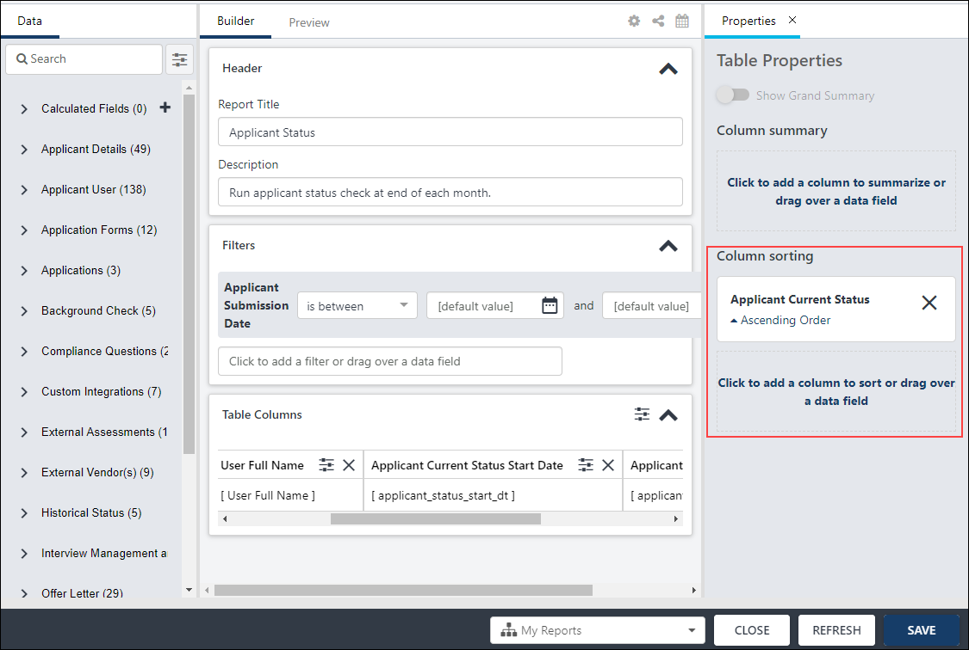
Sort from Table Properties > Column Sorting
Sorting the report from the Column sorting section in Table Properties is the recommended method for creating a sort order for your report.
To sort the report:
- Click the Show Table Properties icon in the upper-right corner of the Table Columns section. This opens the Table Properties panel.
- Add up to five fields by which you want to sort the report. You can do this by dragging a field from the Table Columns section. Or, click Click to add a column to sort. This opens a search fields option, where you can search for and select the fields by which you would like to sort the report. Once selected, the fields appear above the search option.
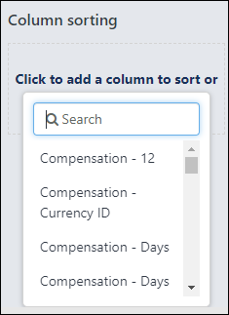
- Keep the data sorted in ascending order, or click the arrow to the left of Ascending Order to switch to descending order.
  - Change the sort order by clicking and dragging the field below or above another field in the sort order. This is optional.
  - Remove a field from the sort by clicking the X to the right of the field. This is optional.
- Click Refresh to refresh the data in the report.
Once you are finished sorting, click Save to save the report.
Sort from the Preview Tab
You can also sort the report directly from the Preview tab. However, changes you make to the columns will overwrite the sort order you created in the Sort panel. For this reason, it is a best practice to use the Sort panel to sort the report.
To sort from the Preview tab:
- Click the name of a column (the field name) to sort the report by that field.
- The sort order automatically changes to sort by the column you selected. Notice that the column sorting information in the Sort panel changes to show the column name you selected. If you had a sort order already configured in the Sort panel, those settings are overwritten by manually changing the sort order on the Preview tab.
- The sort order is Ascending by default. Click the column name or click the arrow to the right of the column name to change the sort order to Descending.
- Click the column name three times to remove the column from the sort.
Once you are finished sorting, click Save to save the report.
Tip: You can also use the Shift key on your keyboard to add up to 5 columns to sort. Click a column header, hold the shift key, and click another column header to add it as the next level. Remember that the 3rd click will remove that column from sort. All changes to sort from Table Columns will be reflected in the Sort Panel.

Reporting 2.0 - Summarize Report
The summarize feature lets you summarize the data in the report based on certain fields. For example, you may want to summarize a report to make the data easier to read, or you may prefer to have information summarized so that it appears in groups of data rather than as a list of data.
This feature is similar to the summarizing feature that is available from the Summary tab when configuring Custom Reports.
To access Reporting 2.0, go to Reports > Reporting 2.0.
Permissions
For more information about Reporting 2.0 permissions, see the following:
- Permissions in Reporting 2.0 - This provides detailed information about Reporting 2.0 permissions.
- Permissions List - This provides the list of permissions and their relationships so that you know which permissions users need to have to create and view reports.
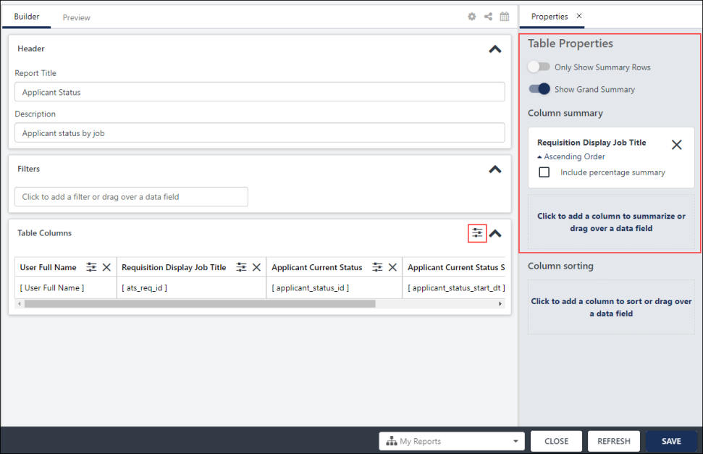
Use Cases
Use Case 1 - Report Administrator
A report administrator wants to present their data in an easily digestible and understandable way. She wants to be able to summarize the information by specific fields to compare specific values against a particular field. For example, she wants to build a report to show the training record status for a specific organizational unit (OU) or department to cross-reference which users have the risk of being out of compliance. The summary feature lets administrators, key stakeholders, and users more easily view their data and take actions on the information straight from Reporting 2.0, without the need to export the data or view it in a different program.
Use Case 2 - Director
A user (Director) wants to understand which locations are completing the specific training module on time. For example, he views a report to summarize by user location to better understand which regional sales representatives are staying up to date with new product offerings. He can summarize by percentages to understand the relative amount of completions per division. Since the training is for new products, he can understand which sales representatives are keeping up to date on their assigned curriculum. This will give him better information to use in one-on-ones with his direct reports about their team's targets and metrics.
Use Case 3 - Pick Date Ranges
An administrator wants to sort her report by specific date ranges, because she needs to be able to find specific data during specific time periods. She uses the drop-down in the Column Summary section to select a data range. This option is available for the field because it is a Date type field.
Use Cases - General Scenarios
- As a report administrator, I want to summarize my reports by various fields, such as different divisions, departments, or OUs to understand the complexities of the data and create meaning within the reports.
- As Senior Vice President, I want to have a chart summarized by Division OU so that I can view average performance ratings by division.
- As a manager, I want to summarize a report by User so that I can see each member of my team and their performance ratings as visual groups that I can expand and collapse within the report.
- As a manager, I want to summarize a report by Location OU so that I can view the data in location groups.
- As a report viewer, I want to change the summary so that I can understand the data better as it relates to my job function, team, or responsibilities. For example, I want to summarize the number of team members who have not completed a specific training or learning object (LO) type to show me who is out of compliance and needs to complete a specific training.
Add Fields to Summarize
You can summarize the report by up to five levels. To add fields to summarize the report:
- Click the Show Table Properties icon in the upper-right corner of the Table Columns section. This opens the Table Properties panel.
- Click and drag a field from the Table Columns section to the Column summary section on the Table Properties panel. Or, click Click to add a column to summarize to search for and select a field.
  - You can summarize the report by fields that are not in the report by selecting a field from the Click to add a column to summarize option on the Table Properties panel, then delete the field from the Table Columns section on the Builder panel. Note: By default, summarizing by a field adds the field to the report twice: once as summarized column and once with the raw data. You can remove the raw data column from the report if you do not want the field included in the output twice.
  - A field can only appear once in the summary.
  - A field in the Column sorting section cannot be used to summarize the report.
- Keep the summarized data in ascending order, or click the arrow to the left of Ascending Order to switch to descending order.
  - Date Field Types - When summarizing by date fields, a drop-down is available in the Column Summary section to let you pick the type of order, including Day, Week, Month, Calendar Quarter, and Calendar Year.
- Check or uncheck the option to View as hierarchy. This option lets you report on a user or OU hierarchy and will automatically display your report data in a hierarchical manner. Note: This option is only available when you summarize by an OU or OU ID field (includes standard and custom OUs).
- Check or uncheck Include percentage summary to display percentages relative to the parent level in the hierarchy or summary. This option is unchecked by default.
The percentages are flexible in that they are configurable at different levels of the report. For example, if Division A has a transcript status of Completed, then the percentages are calculated based on the total number at the Division level. If Division A has 500 people and 50 of them have a training item in a Completed status, then the hierarchical percentages are calculated out of 500 people (10%).
- Show Summarized Hierarchy Output - When this toggle is enabled, hierarchy summary shows all the levels of hierarchy in one column. This is the default setting. When this toggle is disabled, hierarchy summary shows the levels of hierarchy in individual columns. This toggle is only available when "View as Hierarchy" has been selected. The toggle impacts only the Microsoft Excel output format.
Only Show Summary Rows
When the Only Show Summary Rows option is toggled on, the report output will only show summarized and aggregated fields, and it will not include the rows for the underlying data in the report.
Considerations for Charts
When using the Only Show Summary Rows option in combination with a chart, the aggregation is driven by the selection made on the field in Column Header Properties. With that the aggregation operation for the measure field on the Chart is also no longer shown. If you have defined a chart before, but the Chart Measure and Field Aggregation are not in sync, the Only Show Summary Rows will be disabled until the two are in sync. For example, if you chose Count in the Apply Aggregation field on the Column Header Properties panel, then Count would need to be selected in the Measure field on the chart to get the fields in sync and enable the Only Show Summary Rows option.
Note: If one of the fields included in a calculated fields is set to inactive, the calculated field will not be displayed.
Show Grand Summary
When the Show Grand Summary option is toggled on, the report displays the grand summary for a summarized report.
Remove Summary Fields
You can remove fields from the "Column summary" section by clicking the X to the right of the field name.
Preview Summarized Report
When viewing a summarized report, the summarized data groups display in the first column on the Preview tab. The data can be viewed by expanding each section in the summarized column.
If you selected to include the percentage summary, this information appears as the last column in the report.
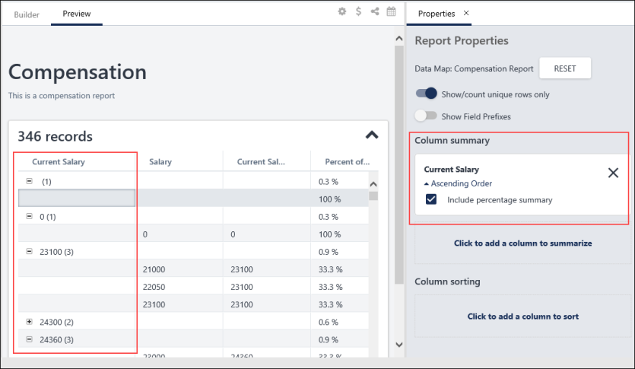
Export Hierarchically Summarized Report to Excel
When you have summarized your report and selected the View as hierarchy option, your output in excel will look slightly different. The report data will show in a table format with row grouping on the left-hand side.
You can use the grouping to collapse and expand your data. The cells are merged to create an easier view. This allows the hierarchical summaries to be grouped with less text.
If you would like to use filters to see only the rows belonging to a specific criteria, then it is recommended that you filter by that specific value in the data column and use the grouping on the left-hand side to expand/collapse all rows belonging to that value.
Charts in Summarized Reports
When using charts in summarized reports, the fields used in the summary no longer link automatically to the chart. This provides more flexibility in how you create and organize your charts, while still having the ability to determine separately how you want your table data to be summarized.

Reporting 2.0 - System Templates
Reporting 2.0 includes system report templates that are modeled after the most commonly-generated reports so that you can quickly and easily create reports that contain essential Learning, Core, and Performance data. Each template answers similar business questions as the standard report after which it was modeled. Templates are not exactly rebuilt standard reports; they are modern templates that answer similar business questions as the standard reports after which they were modeled.
These templates are intended to be a starting place for managers or administrators to copy and customize to meet the needs of their organization.
- Templates cannot be deleted or edited. Templates can be copied, and once the template is copied, you can edit the settings such as fields and filters.
- Templates will show Cornerstone Administrator as the owner.
To access Reporting 2.0, go to Reports > Reporting 2.0.
Permissions
PERMISSION NAME | PERMISSION DESCRIPTION | CATEGORY

Reporting - System Templates | Grants users the ability to use all pre-built templates in Reporting 2.0. Pre-built templates are available for generating certain Learning, Core, and Performance data. Users with this permission will also be able to use any new templates that are added in future releases, provided that they still have the permission.  This permission works in conjunction with other Reporting 2.0 permissions. For example, users without the Reporting - Learning - View permission will not see any pre-built templates for Learning. | Reporting
For more information about Reporting 2.0 permissions, see the following:
- Permissions in Reporting 2.0 - This provides detailed information about Reporting 2.0 permissions.
- Permissions List - This provides the list of permissions and their relationships so that you know which permissions users need to have to create and view reports.
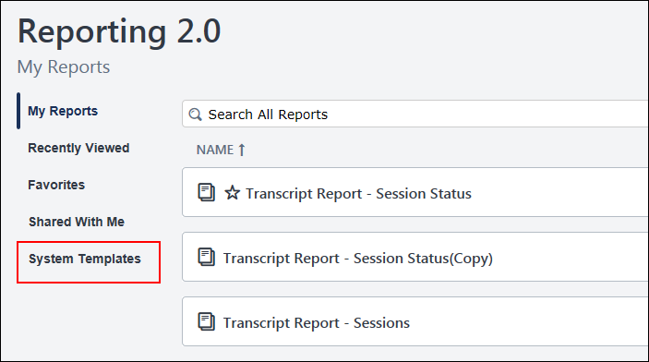
Available Templates
The following templates are available:
Learning
- Enterprise Training
- Online Training Status
- Past Due
- Records (Transcript)
- Training Progress Summary Pie Chart
- Transcript Status
Core
- Records (User)
Performance
- Goal Status
- Task User Status (Competency)
- Task User Status (Performance)
How to Use Templates
Pre-built templates are available from the Reporting 2.0 homepage by clicking the System Templates link. This will open a list of templates that are available to you.
Users must have the Reporting - System Templates permission in order to create templates. All templates will be available for users with this permission, based on the functionality that is enabled in the portal. For example, Performance templates are only available in portals that have Performance enabled.
Pre-built templates are similar to the Standard Report that each template is modeled after. Many of the fields and filters will be the same as what you would find in the Standard Report.
To use a template, simply open the template from the System Templates page, and the report results will display at the bottom of the page. The fields and filter values will be pre-populated.
The following images show the Past Due report template. The pre-selected filters display at the top, and the report results automatically populate at the bottom of the page.
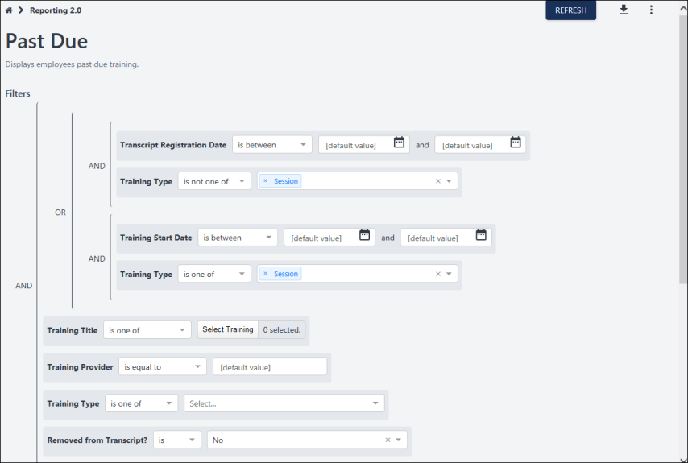
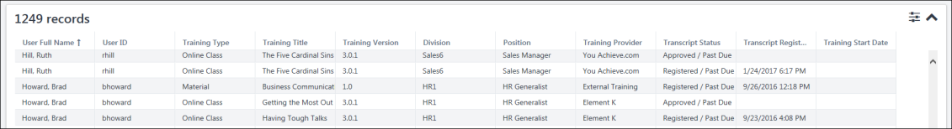
Frequently Asked Questions
How can I make changes to the fields in a template?
The templates themselves cannot be modified, meaning that the fields cannot be deleted and new fields cannot be added. Filters cannot be added or deleted. The name and description cannot be changed.
However, you can copy the template, which will essentially create a new report and allow you to modify the new report by adding/removing fields and filters and making any other desired changes.
Can users I share the template report with make changes to the template?
No. The report you share that was created using a template cannot be modified by shared users.
What if I never want to customize a template by copying it?
If you will not need to customize templates and would like all users to have the latest version of the template (depending on enhancements as part of quarterly and patch releases), you can:
- Share the template with other users.
- Grant the Reporting - System Templates permission to users who should have access to all templates.

