Online Courses March 2024

Table of Contents
Online Courses Overview 1
Content Uploader 2
Create New Online Course 3
Online Course Versioning and Modifying 18
Course Publisher (Legacy) - Overview 48
Course Publisher (Legacy) Overview 49
Course Publisher (Legacy) - Create New Course/Publication 52
Course Publisher (Legacy) - Update a Course 57
Course Publisher (Legacy) - Modify Individual SCORM Files 74

Online Courses Overview

Content Uploader

Create New Online Course
Content Uploader - Create an Online Course - Overview
Using the Content Uploader, you can upload new online courses to the system and then use the Course Catalog and Course Console to configure the metadata for the course.
Content Uploader can be self-activated in Feature Activation Preferences. To activate, ADMIN > TOOLS > LEARNING > LEARNING PREFERENCES > FEATURE ACTIVATION PREFERENCES. In the Activate Content Publishing Features for Online Courses section, click Activate.
Help Documentation
Click the following links for related help articles:
- Create an online course - See Content Uploader - Upload Files on page 7 for additional information.
- View an audit of a course's uploads - See Content Uploader - Online Course Upload History on page 16 for additional information.
- Different ways to update an online course - See Online Course Versioning vs. Modifying - Overview on page 18 for additional information.
Use Case 1: Upload Online Courses
William is a content developer at ABC Corporation. He completed the development of ten different IT Security Policy courses and wants to upload them to the system. William opens the Content Uploader, then drags and drops the files he wants to upload into the upload box. He can track the upload progress and see if the courses were uploaded successfully. Once the files have been uploaded successfully, drafts are automatically created for each course in the Course Catalog.
Use Case 2: Edit and Publish Draft Courses
William sees that one of his courses was uploaded successfully to the system, and now he wants to edit and publish the course. He accesses the Course Catalog and opens the draft course. He previews the course and finds that it works as expected, so he edits the course metadata and publishes it. If needed, he can continue to edit other fields directly from the Course Catalog.
Permissions
The following permissions apply to this functionality:
PERMISSION NAME | PERMISSION DESCRIPTION | CATEGORY

Assignment Tool - Standard and Dynamic - Recurrence | Grants ability to create Standard (one-time) and Dynamic (continuous) Learning Assignments to directly assign training to users. Also grants ability to enable/disable Recurrence when creating a Dynamic Learning Assignment. This permission can be constrained by OU, Provider, Training Item, Training Type, User, User Self and Subordinates, and User's OU. If this permission is constrained by Location, Provider, Training Type, or Training Item, then they can only assign training within the constraints. If this permission is constrained by OU, User, User Self and Subordinates, or User's OU, then they can only assign to and view assignments created by users within the constraints. This is an administrator permission. | Learning - Administration

Assignment Tool - Standard and Dynamic - Recurrence | Grants ability to create Standard (one-time) and Dynamic (continuous) Learning Assignments to directly assign training to users. Also grants ability to enable/disable Recurrence when creating a Dynamic Learning Assignment. This permission can be constrained by OU, Provider, Training Item, Training Type, User, User Self and Subordinates, and User's OU. If this permission is constrained by Location, Provider, Training Type, or Training Item, then they can only assign training within the constraints. If this permission is constrained by OU, User, User Self and Subordinates, or User's OU, then they can only assign to and view assignments created by users within the constraints. This is an administrator permission. | Learning - Administration

Course Catalog - Update | Grants ability to manage and edit training items listed in the Course Catalog and also grants access to the Course Console, where training can also be managed and edited. This permission also grants access to the Popular Requests and Highest Rated widgets on the Learning Admin Console (in conjunction with the Learning Admin Console - View permission). This permission also allows administrators to reversion online courses via the Course Console page. This permission also allows administrators to access an Edit Training option for training items included as objectives in Development plans.  This permission can be constrained by OU, User's OU, Training Type, Training Item, Provider, ILT Provider, User's ILT Provider, User, User Self and Subordinates, and User's LO Availability. This is an administrator permission.  Note: Adding an OU constraint and a provider constraint to this permission results in an "AND" statement. | Learning - Administration

Course Catalog - View | Grants access to view the learning objects in the course catalog and enables administrators to view the Course Console and the Popular Requests and Highest Rated widgets on the Learning Admin Console (in conjunction with the Learning Admin Console - View permission). This permission can be constrained by OU, User's OU, Training Type, Training Item, Provider, ILT Provider, User's ILT Provider, and User's LO Availability. This is an administrator permission.  Adding an OU constraint and a provider constraint to this permission results in an "AND" statement. | Learning - Administration

Online Class - Modify | Grants ability to modify an online class without creating a new version of the online class. | Learning - Administration

Online Class - Publish | Grants access to two pieces of functionality:  - Publish button on the Course Console, allowing administrator to publish a draft online class  - Upload section of the online class versioning workflow | Learning - Administration

Online Class - Upload | Grants access to the Content Uploader where an administrator can upload zip packages to create draft online classes. In addition, this permission grants the ability to upload a new zip package as part of the online class versioning process. This permission does NOT grant the ability to publish online classes. Without the permission to publish online classes, administrators with the permission to upload online classes can only upload and save online classes, which then must be published by administrators with the relevant permission.  As of November 10, 2017, this is the only permission which provides access to the Content Uploader page. | Learning - Administration

Online Class Version - Publish | Grants ability to upload and publish new online class versions. This permission works in conjunction with the permission for uploading online classes. This permission can be constrained by OU, User's OU, Users, and Providers. This is an administrator permission. | Learning - Administration

Content Uploader - Manage Uploads with Undefined Providers. | Allows administrators to view and manage uploads with undefined providers on the Uploads History page. | Learning - Administration

Upload History - View | Grants ability to view the Upload History page. | Learning - Administration
Content Uploader - Upload Files
The Content Uploader page allows administrators to easily upload and track online course files. The Content Uploader page allows administrators to upload multiple course files at one time, view upload statuses, access the Upload History page, and bulk publish courses. The following Content Uploader sections indicate the current status of the uploaded course files and allow the administrator to take action on the files:
- Upload Files
- Processing
- Needs Provider
- Draft Ready
Note: If no files meet the criteria for the Processing, Needs Provider, or Draft Ready sections, the associated section does not display on the page.
To access the Content Uploader, go to Admin > Tools > Learning and click the Content Uploader link.
Note: Content Publisher functionality is only available after it has been activated in your portal. To access Content Activation Preferences, go to Admin > Tools > Learning > Learning Preferences and click the Feature Activation Preferences link.
Permissions
PERMISSION NAME | PERMISSION DESCRIPTION | CATEGORY

Course Catalog - Update | Grants ability to manage and edit training items listed in the Course Catalog and also grants access to the Course Console, where training can also be managed and edited. This permission also grants access to the Popular Requests and Highest Rated widgets on the Learning Admin Console (in conjunction with the Learning Admin Console - View permission). This permission also allows administrators to reversion online courses via the Course Console page. This permission also allows administrators to access an Edit Training option for training items included as objectives in Development plans.  This permission can be constrained by OU, User's OU, Training Type, Training Item, Provider, ILT Provider, User's ILT Provider, User, User Self and Subordinates, and User's LO Availability. This is an administrator permission.  Note: Adding an OU constraint and a provider constraint to this permission results in an "AND" statement. | Learning - Administration

Course Catalog - View | Grants access to view the learning objects in the course catalog and enables administrators to view the Course Console and the Popular Requests and Highest Rated widgets on the Learning Admin Console (in conjunction with the Learning Admin Console - View permission). This permission can be constrained by OU, User's OU, Training Type, Training Item, Provider, ILT Provider, User's ILT Provider, and User's LO Availability. This is an administrator permission.  Adding an OU constraint and a provider constraint to this permission results in an "AND" statement. | Learning - Administration

Content Uploader - Manage Uploads with Undefined Providers. | Allows administrators to view and manage uploads with undefined providers on the Uploads History page. | Learning - Administration

Online Class - Publish | Grants access to two pieces of functionality:  - Publish button on the Course Console, allowing administrator to publish a draft online class  - Upload section of the online class versioning workflow | Learning - Administration

Online Class - Upload | Grants access to the Content Uploader where an administrator can upload zip packages to create draft online classes. In addition, this permission grants the ability to upload a new zip package as part of the online class versioning process. This permission does NOT grant the ability to publish online classes. Without the permission to publish online classes, administrators with the permission to upload online classes can only upload and save online classes, which then must be published by administrators with the relevant permission.  As of November 10, 2017, this is the only permission which provides access to the Content Uploader page. | Learning - Administration

Upload History - View | Grants ability to view the Upload History page. | Learning - Administration
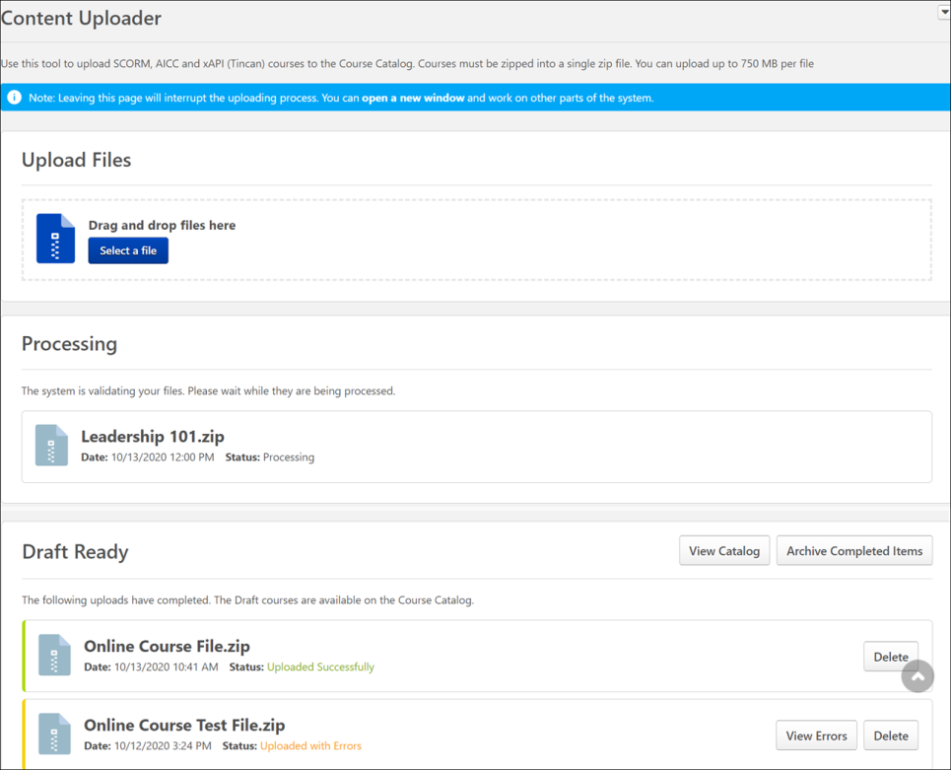
Options
The Options drop-down menu in the upper-right corner of the Content Uploader page allows you to both refresh the page and view the Content Uploader's upload history:
- Upload History - Click this link to navigate to the Upload History page. For more information about Upload History, See Content Uploader - Online Course Upload History on page 16 for additional information.
- Refresh- Click this link to refresh the page and view updated upload statuses.
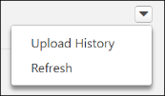
Upload Files
To upload a new set of course files:
- Drag and drop your zipped SCORM or AICC course files into the Upload Files box, or click the Add Files button and select the zipped course files from your computer. Note: Courses must be zipped into a single zip file. Any zip file must contain only one standard (AICC or SCORM or xAPI). You can upload up to 750 MB per file.
- After the course files have been added, they will begin uploading. A progress bar below the files displays the ongoing upload progress for the files. Each set of files displays the following information:
  - File Name
  - File Type
  - Status (i.e., Uploading, Critical Error)
- If there are problems with the upload, the status changes to Critical Error, and you can click the View Error Report button to view the reasons for the upload errors and address any issues. Once the files successfully finish uploading, they are transferred to the Processing section. Continue managing the upload from the Processing section.
If needed, you can delete a set of course files from the Upload Files section by clicking the Delete upload button.
Processing
Uploaded files move to the Processing section while the system checks the files for errors. You can select the Refresh option from the drop-down in the upper-right corner of the page to refresh the page.
If needed, you can delete a set of course files from the Processing section by clicking the Delete upload button.
Needs Provider
If the course provider still needs to be selected for the course files after they finish processing, the files appear in the Needs Provider section. To select a provider for a course:
- Click the Select Provider button. A flyout opens.
- The system's providers appear in the paginated flyout, with up to twenty providers per page. To search for a specific provider, the administrator can either enter the provider's name into the Provider Name search bar and clicking the Search button, or they can page through the list of providers to find the correct provider. Select a provider and then click the Done button to close the flyout and add the provider to the course.
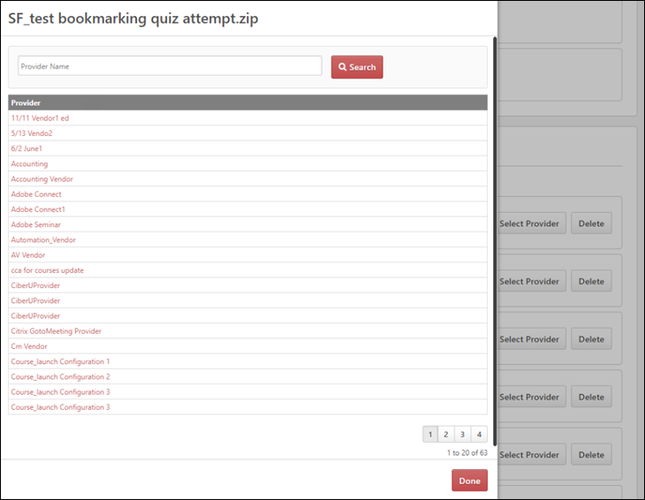
Once a provider is selected, the course files automatically move to the Draft Ready section, and a draft is created automatically in the Course Catalog.
Draft Ready - Publish via the Course Catalog
Once a set of course files moves to the Draft Ready section, its status changes to Uploaded Successfully, and it is available in the Course Catalog as a draft.
Using the Course Catalog, you can configure the metadata for the new online course and also preview the Training Details page for the course. Click the View Catalog button to be redirected to the Course Catalog search page, where you can configure the metadata for the course, such as the title, keywords, approval workflows, pricing, and more. When you access the Course Catalog from the Content Uploader page, the Course Catalog is pre-filtered to display only online courses in a Draft status. See Course Catalog Search - New.
You can click the course title or select Edit from the Actions drop-down menu to edit the course metadata and publish the course. See Course Console - Details.
If needed, you can archive items in the Draft Ready section by clicking the Archive Completed Items button. Archived courses are then only accessible either via the Upload History page or as draft courses in Course Catalog. You can also delete uploaded files from the Content Uploader by clicking the Delete upload button.
Draft Ready - Bulk Publish
Administrators can also bulk publish all or selected publication courses in one click after uploading them in Content Uploader. Apart from the Date, Status of upload, and Delete, the Content Uploader page also includes the Number of Courses, Provider, and the View Course(s) button.
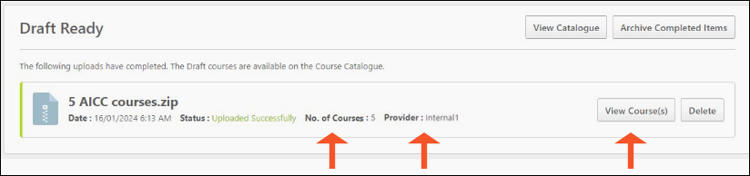
Click View Course(s) to go inside the course file. The View Course(s) page displays the following features:
- A field for Search & Filtering​
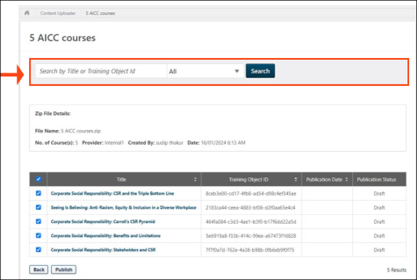
- Zip File Details
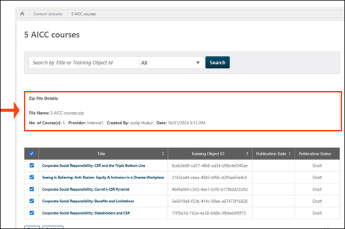
- List of Courses​
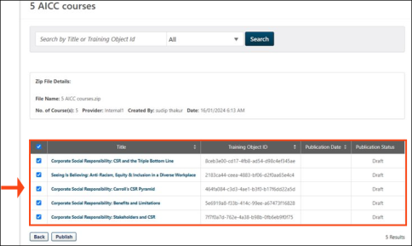
- Publish button
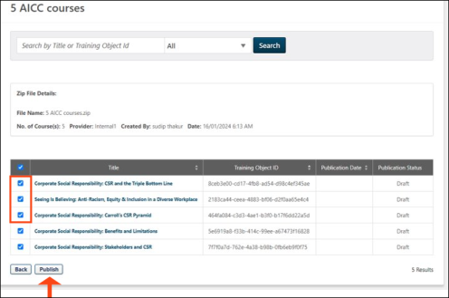
Once published, the publication status is shown as per the below image:
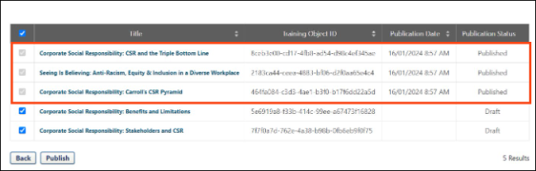
You can also access View Course(s) via Upload History.
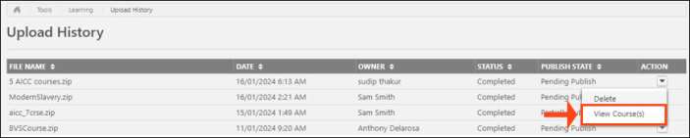
The Users with existing “Online Class - Publish” permission can see the “View Course(s)” option in Content Uploader and Upload History. The same constraints will apply as the user’s “Online Class - Publish” constraints.
Note: Only courses uploaded as part of the same Publication can be published in bulk via the View Courses page.
Online Course - View Errors
If a set of course files uploads with errors, you can click the View Errors button to open a flyout which displays error details. The View Errors flyout displays for files in upload statuses of both Failed and Completed with Comments.
The View Errors flyout displays the following information:
- Title - The title of the course files.
- Critical Errors section - Displays the severe errors, each on a separate row. Each error displays the following information:
  - Error description
  - File name in which the error occurred
- Warning section - Displays the non-severe errors, each on a separate row. Each error displays the following information:
  - Error description
  - File name in which the error occurred
  - Path
When finished viewing the error report, click the Done button to close the flyout.
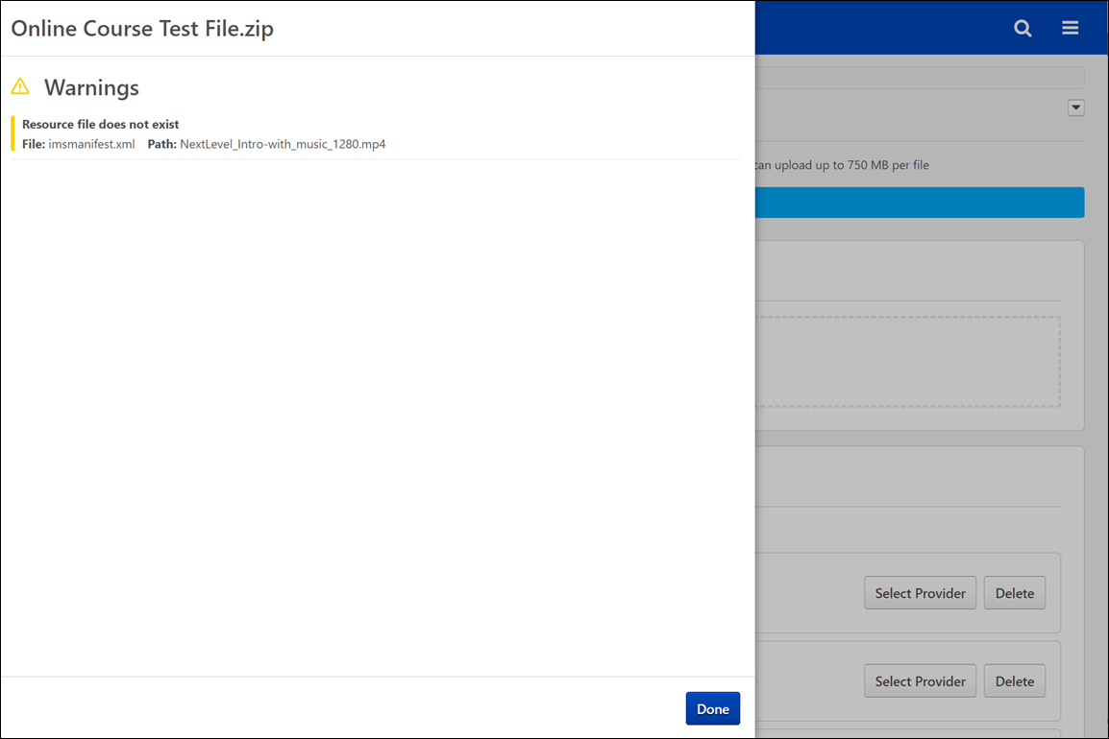
Content Uploader - Online Course Upload History
The Upload History page provides information about sets of course files which were uploaded to the Content Uploader by the administrators in your system, such as the owner of the files and what status the files are in.
To access the Upload History page, go to Admin > Tools > Learning and click the Upload History link. Alternatively, you can access the Upload History page via the Upload History link in the Options drop-down menu on the Content Uploader page.
Permissions
PERMISSION NAME | PERMISSION DESCRIPTION | CATEGORY

Content Uploader - Manage Uploads with Undefined Providers. | Allows administrators to view and manage uploads with undefined providers on the Uploads History page. | Learning - Administration

Upload History - View | Grants ability to view the Upload History page. | Learning - Administration
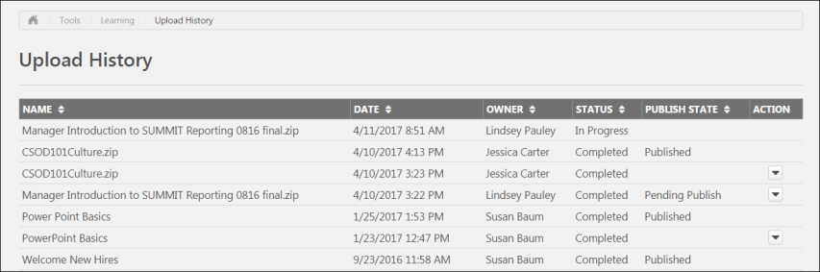
Upload History
The Upload History page displays the following information for each previously uploaded set of course files:
- Name - The title of the uploaded course files
- Date - The date the course files were uploaded to the Course Uploader
- Owner - The name of the administrator who uploaded the course files
- Status - The status of the upload. Available statuses include:
  - In Progress
  - Completed
  - Partially Completed
  - Completed with Comments
  - Failed
- Publish State - This field displays what stage of the publishing process the course files are currently in. Available publish states include:
  - Pending Publish
  - Published
  - Partially Published
- Actions - The Actions drop-down menu next to course files that are Published or Pending Publish allows administrators to take the following actions, if available:
  - Delete
  - View Errors
Note: You can sort uploads by Name, Date, Owner, Status, and Publish State by clicking the column header for the desired sort criteria.

Online Course Versioning and Modifying
Online Course Versioning vs. Modifying - Overview
There are two ways to make updates to an online course. When an online course requires updates, the administrator can either reversion the course or modify the course:
- Reversion - Reversioning a course creates a new version of the online course, with a new version number.
- Modify - Modifying a course allows administrators to make minor modifications to an online course WITHOUT creating a new version.
Note: Content Uploader functionality is only available after it has been activated in your portal. To access Content Activation Preferences, go to Admin > Tools > Learning > Learning Preferences and click the Content Activation Preferences link.
When should you reversion a class vs. modify a course?
Online Class Update method | type of update
Reversion | The versioning process is the appropriate choice for major changes to an online class, and administrators can control who receives the new version of the online class.
Modify | The online class modification process allows administrators to make updates to an online class without creating a new version. Within the legacy Course Publisher functionality, the process similar to modifying a class is referred to as "Replace Files."
Online Course Update Scenarios
Examples of Needed Changes | Appropriate update method | Use Cases
The following changes are examples of major online course changes which require you to reversion the course:  - Replacing a segment of the course  - Making substantive updates to the course content  - Adding or removing a quiz  - Removing or adding resources such as audio, video, animations, pdfs, etc.  This list of examples is not an exhaustive list of changes which necessitate a new online course version. | Reversion the online course | Holly, an instructional designer and learning administrator at Ventonix, is responsible for creating online courses and uploading them to her organization's portal. Following a quarterly release, Holly needs to update a collection of online courses about Ventonix's product in order to keep the courses up-to-date. She needs to replace the quizzes in two classes, add a few lines of audio to one course, and add sections to two more courses.  Once Holly makes all these changes to her online courses, each class' files structure is changed from its original structure, which means changes are needed to each manifest file, and she is required to reversion each of the five courses.  She uses the Create Version option on the Course Console pages for the courses, uploads her new course files, configures versioning options, and decides who will receive the new course versions on their transcripts, ensuring that people continue to receive accurate information from the online course collection.
The following changes are examples of online course changes which can be accomplished using the option to modify the course:  - Fixing typos in the online course closed captioning  - Removing background noise from an audio clip  - Making edits to a slide's graphics or text  Administrators may make select updates to the course manifest without triggering a new course version. The fields that may be modified in the course manifest without triggering a new version include:  - Mastery score  - Href/launch location  - Files under "Resources"  - Title  - Description  - Keywords  - Duration  There is no exhaustive list of "minor changes" that are allowed. The only validation that prevents you from using the Modify Content option is that there cannot be any changes to the manifest file. Beyond that, you can change other files in the course package at your own risk. Administrators should do sufficient testing to ensure they've maintained backward compatibility with their changes; users who are in progress on the pre-modified course, with saved "suspend data," need to be able to resume the modified course without issue.  Note: Any changes made to the metadata of the online course via the Course Catalog or Course Console, such as description, keywords, and subjects, DO NOT trigger a new version of the class. | Modify the online course | Andy, an instructional designer and learning administrator at ACME Corp, is responsible for creating online courses and uploading them to the portal. He has just noticed a typo in the closed captioning text for one of the slides in his Employee Benefits online course. He wants to quickly fix this minor typo without having to create a whole new version of the online course.  Andy incorporates the fix into his course files and then navigates to the Course Console for the course and clicks the Modify Content option in the Content section.  He is able to upload his zipped files and seamlessly fix the course typo without generating a new version.
Online Course Versioning
The course reversioning process is comprised of two steps:
- Training Content - See Online Course - Create Version - Training Content (Step 1) on page 22 for additional information.
- Versioning Options - See Online Course - Create Version - Versioning Options (Step 2) on page 26 for additional information.
When reversioning a course, you can either replace the original version or append the original version:
- Replace Behavior - See Online Course - Replace Versioning Behavior on page 35 for additional information.
- Append Behavior - See Online Course - Append Versioning Behavior on page 33 for additional information.
Reversioning an online course impacts any curricula the course is contained within:
- See Online Course - Curricula Auto Reversioning on page 36 for additional information.
Online Course Modification
For information about modifying an online course to make a simple change, See Modify an Online Course on page 40 for additional information.
Online Course - Create Version - Training Content (Step 1)
During the first step of creating a new version of an online course, upload the new course files.
To create a new version of an online course, go to Admin > Tools > Learning > Catalog Management and click the Course Catalog link. Find the online coursein the Course Catalog and then click the course title. From the Course Console page, click the Options drop-down menu and click the Create Version option.
Permissions
PERMISSION NAME | PERMISSION DESCRIPTION | CATEGORY

Course Catalog - Update | Grants ability to manage and edit training items listed in the Course Catalog and also grants access to the Course Console, where training can also be managed and edited. This permission also grants access to the Popular Requests and Highest Rated widgets on the Learning Admin Console (in conjunction with the Learning Admin Console - View permission). This permission also allows administrators to reversion online courses via the Course Console page. This permission also allows administrators to access an Edit Training option for training items included as objectives in Development plans.  This permission can be constrained by OU, User's OU, Training Type, Training Item, Provider, ILT Provider, User's ILT Provider, User, User Self and Subordinates, and User's LO Availability. This is an administrator permission.  Note: Adding an OU constraint and a provider constraint to this permission results in an "AND" statement. | Learning - Administration

Online Class - Upload | Grants access to the Content Uploader where an administrator can upload zip packages to create draft online classes. In addition, this permission grants the ability to upload a new zip package as part of the online class versioning process. This permission does NOT grant the ability to publish online classes. Without the permission to publish online classes, administrators with the permission to upload online classes can only upload and save online classes, which then must be published by administrators with the relevant permission.  As of November 10, 2017, this is the only permission which provides access to the Content Uploader page. | Learning - Administration

Online Class Version - Publish | Grants ability to upload and publish new online class versions. This permission works in conjunction with the permission for uploading online classes. This permission can be constrained by OU, User's OU, Users, and Providers. This is an administrator permission. | Learning - Administration
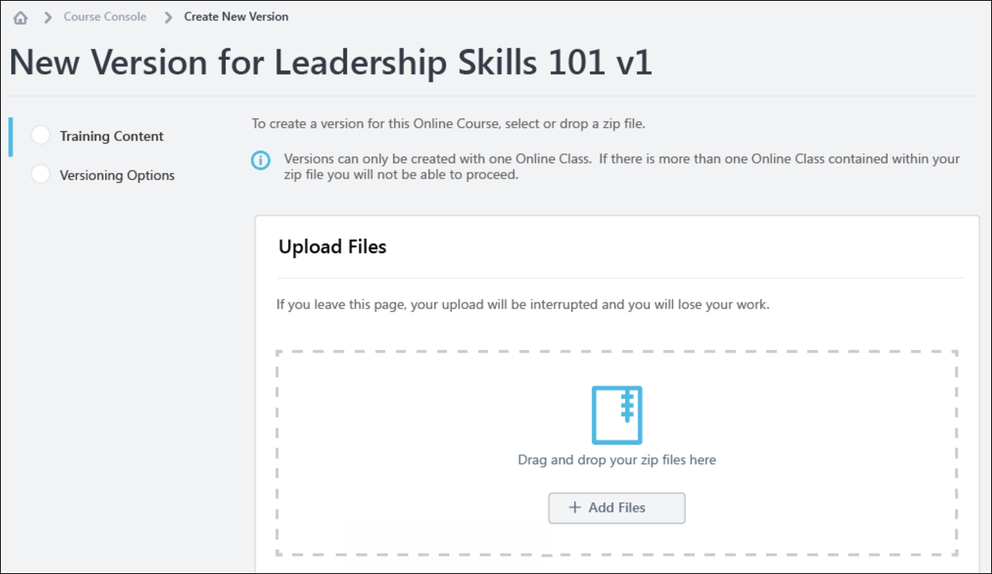
Training Content
Upload Files
To upload a new set of course files:
- Drag and drop your zipped SCORM or AICC course files into the Upload Files box, or click the Add Files button and select the zipped course files from your computer. Note: Courses must be zipped into a single zip file. You can upload up to 750 MB per file.
- After the course files have been added, they will begin uploading. Click the Refresh Status button to view the most current status of the upload. A progress bar below the files displays the ongoing upload progress for the files. Each set of files displays the following information:
  - File name
  - File Type
  - Status (i.e. Uploading, Critical Error)
- If there are problems with the upload, the status changes to Critical Error, and you can click the View Error Report button to view the reasons for the upload errors and address any issues. See Online Course - View Errors on page 15 for additional information.. Note: You cannot use content that is uploaded with a critical error, but you can use content that is uploaded with errors. Once the files successfully finish uploading, they are transferred to the Processing section. Continue managing the upload from the Processing section.
Note: It is recommended that you always preview your uploaded files to ensure the new version will play as expected once published.
Training Information
Once the files have finished uploading, you can preview the course by clicking the Preview button next to the files. If needed, you can delete the files and upload a new set of course files by clicking the Delete icon. If the course previews as expected, populate the following fields for the new version of the course:
- Training Title - Enter the title for the new online course version. By default, the title for the previous course version is populated. This field is required.
- Training Description - Enter the description for the new online class version. Formatting options are available for the training description. By default, the description for the previous course version is populated. This field is limited to 5000 characters.
- Training Hours - Enter the number of training hours received for completion of the online course. The training hours from the manifest of the new version populate in this field automatically.
- Provider - This field displays the provider of the online course. This field is read-only and is automatically populated from the original course version.
- Enable for Mobile App - Choose the Yes option to enable this online class version for the mobile app. Choose the No option if the online course should not be available through the mobile app.
Save and Cancel
Once ready to proceed to the next step in the online course versioning process, click the Save button and continue to the Versioning Options page. See Online Course - Create Version - Versioning Options (Step 2) on page 26 for additional information.
To leave this page without saving any uploads or selections you have made, click the Cancel button.
Considerations
- If an upload is currently in progress for the online course when an administrator navigates to the Course Console page, a notification displays at the top of the Content section, alerting them to the in progress upload. If the administrator wishes to view the in progress upload, they can click the Resume button which displays in the notification. This directs the administrator to the versioning workflow. To resume the upload, click the Resume Upload button. Note: Clicking the Resume option will erase any edits made to the Training Information section. Always preview the upload BEFORE editing the Training Information
- Multi-standard course packages are not allowed for versioning.
Online Course Reversioning - Course Catalog Settings
When an online course is reversioned, the following Course Catalog settings are copied to the new version from the previous version:
- Approval Workflow
- Attempts allowed
- Badges
- Competencies
- Custom OU pricing
- Enable Default Completion Message
- Exclude from Recommendations
- Is Mobile? checkbox
- Points
- Recommended courses
- Recurrence
- Signature Message
- Skills
- Training Purpose
- Thumbnail Image
- Training Units
Online Course - Create Version - Versioning Options (Step 2)
On the second step of reversioning an online course, select versioning options. Default options for this page are configured via Online Course Versioning Preferences, and may be configured as read-only by the administrator. See Online Course Versioning Preferences.
To create a new version of an online course, go to Admin > Tools > Learning > Catalog Management and click the Course Catalog link. Find the online course in the Course Catalog and then click the course title. From the Course Console page, click the Options drop-down menu and click the Create Version option.
Permissions
PERMISSION NAME | PERMISSION DESCRIPTION | CATEGORY

Assignment Tool - Standard and Dynamic | Grants ability to create Standard (one-time) and Dynamic (continuous) Learning Assignments to directly assign training to users. This permission can be constrained by OU, Provider, Training Item, Training Type, User, User Self and Subordinates, and User's OU. If this permission is constrained by Location, Provider, Training Type, or Training Item, then they can only assign training within the constraints. If this permission is constrained by OU, User, User Self and Subordinates, or User's OU, then they can only assign to and view assignments created by users within the constraints. This is an administrator permission. | Learning - Administration

Assignment Tool - Standard and Dynamic - Recurrence | Grants ability to create Standard (one-time) and Dynamic (continuous) Learning Assignments to directly assign training to users. Also grants ability to enable/disable Recurrence when creating a Dynamic Learning Assignment. This permission can be constrained by OU, Provider, Training Item, Training Type, User, User Self and Subordinates, and User's OU. If this permission is constrained by Location, Provider, Training Type, or Training Item, then they can only assign training within the constraints. If this permission is constrained by OU, User, User Self and Subordinates, or User's OU, then they can only assign to and view assignments created by users within the constraints. This is an administrator permission. | Learning - Administration

Course Catalog - Update | Grants ability to manage and edit training items listed in the Course Catalog and also grants access to the Course Console, where training can also be managed and edited. This permission also grants access to the Popular Requests and Highest Rated widgets on the Learning Admin Console (in conjunction with the Learning Admin Console - View permission). This permission also allows administrators to reversion online courses via the Course Console page. This permission also allows administrators to access an Edit Training option for training items included as objectives in Development plans.  This permission can be constrained by OU, User's OU, Training Type, Training Item, Provider, ILT Provider, User's ILT Provider, User, User Self and Subordinates, and User's LO Availability. This is an administrator permission.  Note: Adding an OU constraint and a provider constraint to this permission results in an "AND" statement. | Learning - Administration

Online Class - Publish | Grants access to two pieces of functionality:  - Publish button on the Course Console, allowing administrator to publish a draft online class  - Upload section of the online class versioning workflow | Learning - Administration

Online Class - Upload | Grants access to the Content Uploader where an administrator can upload zip packages to create draft online classes. In addition, this permission grants the ability to upload a new zip package as part of the online class versioning process. This permission does NOT grant the ability to publish online classes. Without the permission to publish online classes, administrators with the permission to upload online classes can only upload and save online classes, which then must be published by administrators with the relevant permission.  As of November 10, 2017, this is the only permission which provides access to the Content Uploader page. | Learning - Administration

Online Class Version - Publish | Grants ability to upload and publish new online class versions. This permission works in conjunction with the permission for uploading online classes. This permission can be constrained by OU, User's OU, Users, and Providers. This is an administrator permission. | Learning - Administration
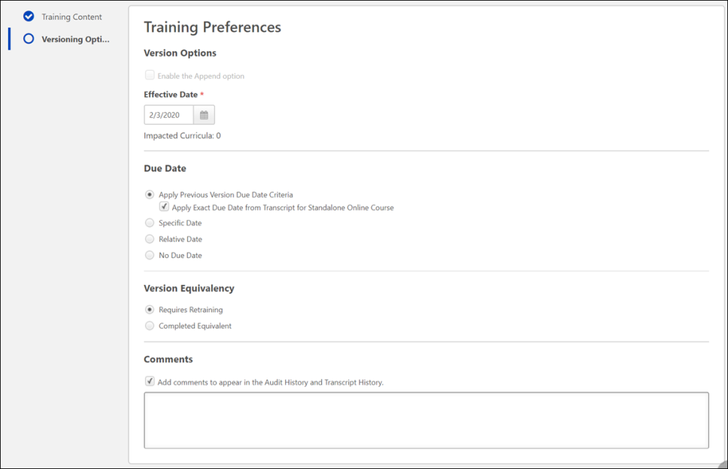
Versioning Options
Select Training Preferences and User Filter Preferences options for the online course version, if editable.
Training Preferences
In the Training Preferences section, configure the following versioning options:
Version Option - In this section, define the criteria for upgrading users and decide who should be upgraded:
  - Append Enablement - Checking this option allows two versions of the online course to exist in the portal at the same time. Both versions can be assigned to users. If this option is enabled, the version uses the Append option, meaning it will require a start date and allow two versions of the same online course to be available at the same time on users' transcripts. If not selected, the new course version replaces the previous version on the effective date. The previous version becomes the old version or expires. Note: This option is only available when the first version of a course is being created. Once a version is created of a certain version type (Append/Replace), following versions must be of that type. For more information about append versioning behavior, See Online Course - Append Versioning Behavior on page 33 for additional information.
- Effective Date - Select the date that the new online course version will be effective in the system.
- Start Date - Select the date that the new online course version can be started by users. This option is only available if Append Enablement has been selected.
- Impacted Curricula - This field displays the number of curricula that are impacted by the online course reversioning.
- Due Date - In this section, select a due date option for reversioned courses. Available options include:
  - Apply Previous Version Due Date Criteria - The following behaviors result from this selection:
    - The due date criteria from the previous version is applied to the new version. So, if the criteria was set to "10 days from Date Assigned" for the previous version, the new due date would be the versioning date plus 10 days.
    - This logic also applies to online courses within a curriculum.
    - The Apply Exact Due Date sub-option becomes available:
      - Apply Exact Due Date - To apply an exact due date from the previous version to the new standalone online course version, also select the Apply Exact Due Date from Transcript for Standalone Online Course sub-option.
  - Specific Date - The following behaviors result from this selection:
    - If the online course is standalone, the new version receives a fixed due date.
    - If the online course is within a curriculum, the new class version displays a fixed date in its structure.
  - Relative Date - The following behaviors result from this selection:
    - If the online course is standalone, the new version receives a relative due date.
    - If the online course is within a curriculum, the new class version displays a relative due date in its structure.
  - No Due Date - The following behaviors result from this selection:
    - If the online course is standalone, the new version will show no due date.
    - If the online course is within a curriculum, the new course version does not display a due date in its structure.
- Version Equivalency - In this section, choose an equivalence option for reversioned training. Available options include:
  - Requires retraining (New training version will be Registered)
  - Completed Equivalent (New training version will be Completed Equivalent based on previous version completion)
- Comments - In the Comments text box, enter any text that should appear in the Audit History and Transcript History for the reversioned course.
All of the options listed above will have default selections, as configured by an administrator via the Online Course Versioning Preferences page. Some options may be read-only if the administrator chose not to allow modification of any or all versioning options.
User Filter Preferences
In the User Filter Preferences section, configure the following user filter options, to determine which users receive the new version:
- Training Version - This drop-down filters the users according to the version of the course in which they are currently enrolled. The list of versions displays the current versions available on the users' transcripts. This enables administrators to easily assign the new online course version to users who are currently enrolled in a specific version of the course. Administrators can select one of the existing versions of the course or all versions. For example, if All Versions is selected, then users who have any version of the course on their transcript are displayed in the User List section.
- Training Status - In this section, select which training statuses will be replaced or appended by the new version of an online course. See Online Course Versioning - Training Status Equivalents on page 47 for additional information.. Available statuses include:
  - Not Started
  - In Progress
  - Completed
- Assignment Type - In this section, select which users receive new versions of an online course. Available options include:
  - Select Users with a previous version - Selecting this option includes all users, regardless of the assignment method (Requested, assigned, or via learning assignment)
  - Select Users assigned by Dynamic Assignment - Selecting this option only includes users who were dynamically assigned the course. Permissions for dynamic and dynamic recurring learning assignments and their associated constraints apply to this option.
  - Select Users by OUs - This option allows the administrator assign the new version to specific organizational units (OUs), such as divisions, locations, groups, etc. If no OUs are selected, then no users receive the new version.
User List
The User List section displays users who have a version of the online course on their transcript. The users that display in the user list are controlled by the constraints applied to the permission for publishing online course versions.
If you make any changes to the User Filter Preference selections in the section above, click the Refresh User List button to view an updated user list. To remove any user from the user list and prevent them from receiving the new version of the online course, uncheck the box next to the user's name. Note: This option is not available if the Effective Date is in the future. The system automatically recalculates the users impacted from the filter selection when the version becomes effective.
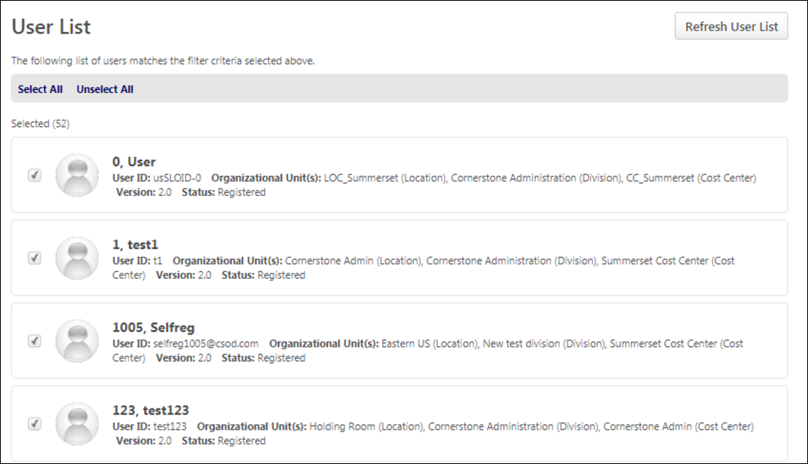
Publish
After configuring all versioning options and verifying that the user list applies to the number of users expected, click the Publish button to publish the new online course version, which will be applied to users as specified in the User Filter Preferences section. After clicking the Publish button, you are redirected to the Course Console page for the online course, and a notification displays at the top of the page, stating, "New version has been created. Please wait while the version is being published."
When the new version is successfully published, the version number and the Last Modified Date are updated on the Course Console page, and the new online course version is active in the portal. Further modifications to the online course can be made on the Course Console page and via Course Catalog. Note: When the online course is reversioned, all metadata from the original course is copied to the new version EXCEPT for the following:
  - Pricing - Prices must be configured for the new version.
  - Approval Workflows - Any applicable approval workflows must be configured for the new version.
  - Training Equivalencies - Any applicable training equivalencies must be configured for the new version.
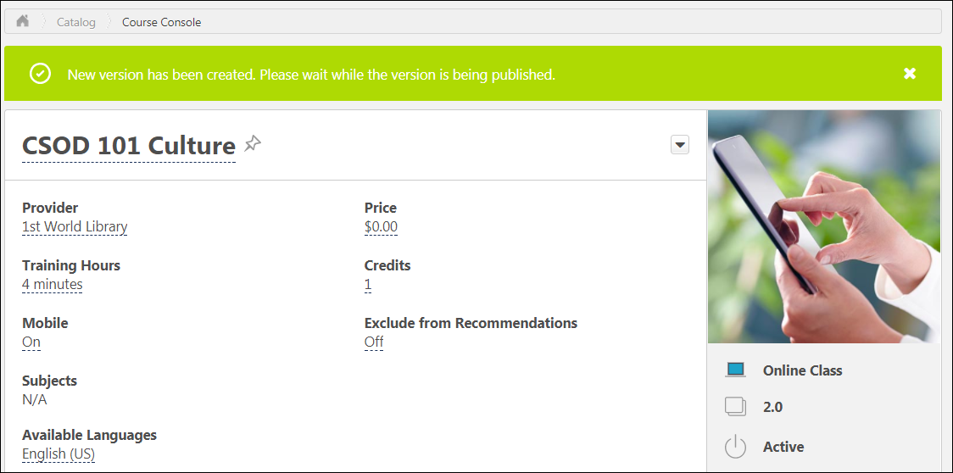
To return to the previous page in the online course versioning process, you can click the Previous button. To exit the process without saving the uploaded files or any options, click the Cancel button.
Online Course - Append Versioning Behavior
Using the Append option when reversioning an online course, two versions of an online course can be active at a time. This selection is only available when the first version of a course is being created. Once a version is created of a certain version type (Append/Replace), following versions must be of that type. Note: No more than two versions can be in a Published status at once.
When an online course is reversioned with the Append option enabled, the new version exhibits the following behaviors:
- Users can have two active versions of the online course on their transcripts, depending on the options selected by the administrator during the reversioning process.
- Two versions of the online course may be included in curricula containing the online course. See Online Course - Curricula Auto Reversioning on page 36 for additional information.
- The Effective Date is either immediate or in the future, depending on the options selected by the administrator who reversioned the course. Users only receive the new version when the effective date is reached.
- The Start Date for the online course can be left blank when reversioning an online course, but needs to be populated in order to deactivate the previous version.
- The new version of the online course is active in the portal either until its end date.
- When one version is inactivated, the other active version also becomes inactivated. For example: Both version 1.0 and version 2.0 would become inactive if one or the other is inactivated.
Use Case - Two Versions on User's Transcript
Sylvia is an administrator, and she is responsible for all compliance training at ACME Inc. On August 15, 2017, Sylvia receives an email from the Chief Compliance Officer informing her that a new factory procedure for 2018 is available. All employees working in the factory should be able to start being trained on September 1, 2017, as the new procedure will be effective on January 1, 2018. The same factory procedure for 2017 should also be available until December 31, 2017.
Sylvia creates a new version of the Factory Procedure for 2017 using the online class Create Version functionality. She uses the Append option because she wants two versions of the class to be available on users' transcripts at the same time. Sylvia alsoadds an Effective Date of January 1, 2018 for the new procedure. She then assigns the new version to all employees at ACME Inc. who have the previous version of the course on their transcript. The Factory Procedure for 2017 will be automatically deactivated when the Factory Procedure for 2018 starts.
John is working in the factory at ACME Inc. He sees the 2017 and the 2018 version of the Factory Procedure on his transcript. John can access both versions of the procedure from September 1, 2017 until January 1, 2018. On January 1, 2018, only the 2018 version is available.
Append Versioning Behavior with the Learning Assignment Tool
When an online course assigned via the Learning Assignment Tool has been reversioned and appended, the following learning assignment behaviors apply:
- If there are two active versions of an online course in a learning assignment, both are assigned to users.
- If a user has two active versions of an online course assigned via a learning assignment, and the user leaves the criteria for the assignment, both course versions are removed when Dynamic Removal is enabled for the assignment. If the user later meets the assignment criteria again, both versions are reassigned to the user.
Scenario | Assignment behavior
Version 1 is active, and the administrator is assigning Version 1 via the Learning Assignment Tool (LAT). | Version 1 is assigned to users.
Version 1 and Version 2 of the online course are active, and the administrator is assigning Version 1 via the LAT. | Version 1 and Version 2 are assigned.
Version 1 and Version 2 of the online course are active, and the administrator is assigning Version 2 via the LAT. | Version 1 and Version 2 are assigned.
Version 2 and Version 3 of the online course are active, and the administrator is assigning Version 1. | Version 2 and Version 3 are assigned.
The administrator creates an assignment with two active versions (Version 2 and Version 3), and assigns both versions with the Assign New Occurrence option. | Both Version 2 and Version 3 are assigned as new occurrences on users' transcripts.
Version 1 and Version 2 are active, and Version 1 is already on users' transcripts. The administrator assigns Version 1 with the Assign New Occurrence option. | Version 1 is assigned as a new occurrence, and users are also assigned Version 2.
Version 1 and Version 2 are active, and Version 1 is already on users' transcripts. The administrator assigns Version 1, but does NOT user the Assign New Occurrence option. | Users only receive Version 2.
Version 1 and Version 2 are active, and Version 1 has been removed from users' transcripts. The administrator assigns Version 1 using a learning assignment. | Version 2 is assigned to users, and Version 1 is also restored to users' transcripts.
Version 1 and Version 2 are active, and both versions are on users' transcripts. The administrator removes the online course from users' transcripts. | Version 1 and Version 2 are both removed from users' transcripts.
Considerations
The Learning Assignment Tool only assigns more than one version if an appended version of the online course exists.
Online Course - Replace Versioning Behavior
When the Append option is NOT enabled for a versioned online course, only one version of the online course can be in a Published status in the portal, and the new version replaces the previous version on selected users' transcripts when the effective date is reached.
When an online course is versioned WITHOUT the Append option enabled, the new version exhibits the following behaviors:
- Only one version of the online course can be on a user's transcript.
- The Effective Date is either immediate or in the future.
- The Start Date and End Date only apply when the online course is appended. They do not apply when the course is replaced.
Note: After choosing to either append or replace a version of an online course, any subsequent versionings default to the same versioning option originally chosen (Append or Replace).
Use Case - One Version on User's Transcript
David is an administrator responsible for all management training at ACME Inc. On August 15, 2017, David receives a call from the Legal Manager informing him that a new anti-harassment policy is available for the State of California, and it is immediately applicable. All managers working in California should be assigned the new online course version of the policy, and the previous version is obsolete.
David creates a new version of the Anti-Harassment Policy using the online course versioning functionality. He does not enable the Append option because he wants only the new version of the course to be available on users' transcripts. David adds an Effective Date of August 15, 2017 for the new policy. He assigns the new version to all managers in California at ACME Inc. When the new version is created, the previous version of the Anti-Harassment Policy class is still Active but its Training Status changes to Epired.
Sam is working in California as a manager at ACME Inc. Before August 15, 2017, Sam can access the previous version of the Anti-Harassment Policy. On August 15, 2017, Sam can only access the new version of the Anti-Harassment Policy. The previous version is automatically made inactive on his transcript.
Online Course - Curricula Auto Reversioning
When an online course is reversioned via Content Uploader functionality available via the Course Console, curricula which contain the online course are automatically reversioned as well. In addition, when a previous version of an online course expires, the previous version is automatically removed from any curricula it is contained within. If an online course contained within a curriculum is reversioned, the new version of the online course is automatically updated within the newest version of the curriculum that contains the course. When this occurs, the curriculum is reversioned. The effective date of the new curriculum version is set to the effective date of the new online course version. The comments for the new curriculum version are the same as the new online course version. This occurs even if there are no users enrolled in the curriculum. Note: Administrators can view the dynamic or dynamic recurring learning assignments for curricula containing any version of the online course.
Important: To maintain compliance, administrators must have the permission for online course versioning AND the permission for curriculum versioning . If an administrator creates a new version of a child material or child online course but does NOT have permission to version curricula, the curriculum will not be updated and version updates cannot be maintained.
- If the new online course version replaces the previous version, the new version maintains the same settings within the curriculum as the previous version (i.e., item sequence, number of required items, pay upfront, pre-approved, auto-register).
- If the new online course version appends the previous version, then the behavior depends on whether there are already two versions of the course within the curriculum.
  - If there is currently only one version of the online course in the curriculum, then the new version is added with the same sequence number as the previous version. If all items in the section are required, then the new version is also required. If not all items in the section are required, then the number of required items for the section is unchanged. The new version has the same pay upfront, pre-approved, and auto-register settings.
  - If there are currently two versions of the online course in the curriculum, then the new version replaces the expired version in the curriculum. The new version is added with the same sequence number as the expired version. The number of required items for the section is unchanged. The new version has the same pay upfront, pre-approved, and auto-register settings.
- Because two versions of an online course may exist in a curriculum, one of the versions within the curriculum may expire, leaving only one active version. When this occurs, the sequence is unaffected, because both versions had the same sequence number. The number of required items in the section returns to its value prior to adding the appended version.
See the table below for curriculum behaviors resulting from various online course reversioning selections:
Replace or Append? | Reversion Behavior | Setup | Sequence | required | Pre-Approved/Pay Upfront/Register
Replace |  | Yes | Same sequence as Version 1 of online course | The same number of items are required for curriculum section completion after the online course and curriculum are reversioned. | The pre-approved/pay upfront/register selections are copied from the previous version to the new version.
Replace |  | No | Same sequence as Version 1 of online course | The same number of items are required for curriculum section completion after the online course and curriculum are reversioned. | The pre-approved/pay upfront/register selections are copied from the previous version to the new version.
Append | When two versions are appended | Yes | Same sequence as Version 1 of online course | -When zero items in the section are required, zero items are required after the reversion. For example, if 0/3 items were required prior to reversioning, 0/4 items are required after the reversioning.  -When all items in the section are required, all items are required after the reversion. For example, if 3/3 items were required prior to the reversioning, 4/4 items are required after the reversioning.  -When not all items in the section are required, the reversioned course becomes optional within the section. For example, if 2/4 items in the section were required prior to the reversioning, 2/5 items in the section will be required after reversioning. | The pre-approved/pay upfront/register selections are copied from the previous version to the new version.
Append | When two versions are appended | No | Same sequence as Version 1 of online course | The same number of training items are required for curriculum completion after the online course and curriculum are reversioned. | The pre-approved/pay upfront/register selections are copied from the previous version to the new version.
Append | When the new version replaces the old version | Yes | Same sequence as Version 1 of online course | -When zero items in the section are required, zero items are required after the reversion. For example, if 0/3 items were required prior to the course reversioning, 0/4 items will be required after reversioning.  -When all items in the section are required, all items are required after the reversion. For example, if 3/3 items were required prior to the course reversioning, 4/4 items are required after reversioning.  -When not all items in the section are required, the reversioned course becomes optional in the section. For example, if 2/4 items in the section were required prior to the course reversioning, 2/5 items in the section are required after reversioning. | The pre-approved/pay upfront/register selections are copied from the previous version to the new version.
Append | When the new version replaces the old version | No | Same sequence as Version 1 of online course | The same number of items are required for curriculum section completion after the online course and curriculum are reversioned. | The pre-approved/pay upfront/register selections are copied from the previous version to the new version.
Modify an Online Course
When an online course only requires minor updates, you can replace the files without creating a new version of the online course, using the Modify Content option available on the Course Console page for the class. Administrators can make select minor updates to the course manifest without triggering a new course version. The fields that may be modified in the course manifest without triggering a new version include:
- Mastery score
- Href/launch location
- Files under "Resources"
- Title
- Description
- Keywords
- Duration
To create or modify the course files for an online course, go to Admin > Tools > Learning > Catalog Management and click the Course Catalog link. Find the online class in the Course Catalog and then click the course title. From the Course Console page, click the Options drop-down menu in the Content section and click the Modify Content option.
Permissions
PERMISSION NAME | PERMISSION DESCRIPTION | CATEGORY

Course Catalog - Update | Grants ability to manage and edit training items listed in the Course Catalog and also grants access to the Course Console, where training can also be managed and edited. This permission also grants access to the Popular Requests and Highest Rated widgets on the Learning Admin Console (in conjunction with the Learning Admin Console - View permission). This permission also allows administrators to reversion online courses via the Course Console page. This permission also allows administrators to access an Edit Training option for training items included as objectives in Development plans.  This permission can be constrained by OU, User's OU, Training Type, Training Item, Provider, ILT Provider, User's ILT Provider, User, User Self and Subordinates, and User's LO Availability. This is an administrator permission.  Note: Adding an OU constraint and a provider constraint to this permission results in an "AND" statement. | Learning - Administration

Online Class - Modify | Grants ability to modify an online class without creating a new version of the online class. | Learning - Administration

Upload History - View | Grants ability to view the Upload History page. | Learning - Administration
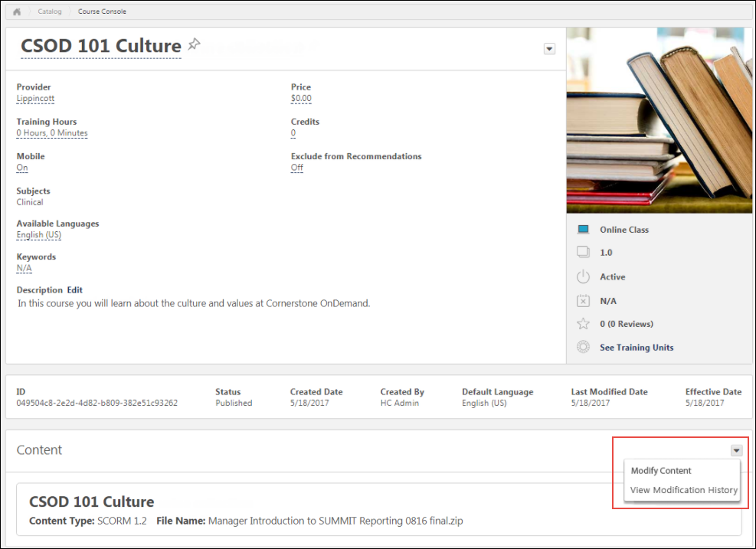
Modify Content
To modify the course files of an existing course, click the Modify Content option in the Content section. This directs you to the Modify Content page, where you can upload the modified course files.
To upload a modified set of course files or publications:
- Drag and drop your zipped SCORM or AICC course files into the Upload Files box, or click the Add Files button and select the zipped course files from your computer. If the replacement files are substantially different from the original files, you will need to reversion the course instead. Note: Courses must be zipped into a single zip file. You can upload up to 750 MB per file.
- After the course files have been added, they will begin uploading. A progress bar below the files displays the ongoing upload progress for the files. Each set of files displays the following information:
  - File name
  - File Type
  - Status (i.e., Uploading, Critical Error)
- If there are problems with the upload, the status changes to Critical Error or Completed with Comments, and you can click the VIEW ERROR REPORT button to view the reasons for the upload errors and address any issues. If the new files are too different from the original files, the upload results in an error. Once the files successfully finish uploading, they are transferred to the Processing section. Continue managing the upload from the Processing section. Available errors:
  - SCORM Courses
    - Severe Error: Manifest change - Only Resources element changes are permitted on the manifest
    - Severe Error: Manifest Location Change - Relative path
    - Warning: HTML/ JS / SWF files have been modified - Check different file size and content
  - AICC Courses
    - Severe Error: AU, CRS, CST, DES files changed - Check different file size and content
    - Severe Error: AU, CRS, CST, DES files Location changed - Relative path
    - Warning: HTML/ JS / SWF files have been modified - Check different file size and content
If needed, you can delete a set of course files from the Upload Files section by clicking the Delete upload button.
Processing
Uploaded files move to the Processing section while the system checks the files for errors.
When a set of course files is transferred to the Processing section, click the Provider drop-down menu and select the provider for the course. After a provider has been selected, the set of course files moves to the Draft Ready section once processing is completed.
If needed, you can delete a set of course files from the Processing section by clicking the Delete upload button.
Needs Provider
If the course provider still needs to be selected for the course files after they finish processing, the files appear in the Needs Provider section. Select a course provider from the Select Provider drop-down menu. Once a provider is selected, the course files automatically move to the Draft Ready section.
Draft Ready
Once a set of course files moves to the Draft Ready section, its status changes to Uploaded Successfully, and it is available in the Course Catalog as a draft. Select a provider for the online course using the drop-down menu next to the uploaded course files.
Using the Course Catalog, you can configure the metadata for the new online course. Click the Modify content button to replace the original online course files with the new files. After clicking the Modify Content button, a pop-up window appears, saying, "Modifying the content will overwrite the current files. You will not be able to undo this action. Are you sure you want to proceed?" If you wish to proceed, click the Modify Content button in the pop-up window. You will be redirected to the Course Console page.
To view information about the online course's modification history, click the Review Content Modification button. This opens a flyout which displays the following information for the course files in the Draft Ready section:
- Title
- File Name
- Current Size
- New Size
If you do not want to modify the content, click the Cancel button to close the pop-up without publishing the new files.
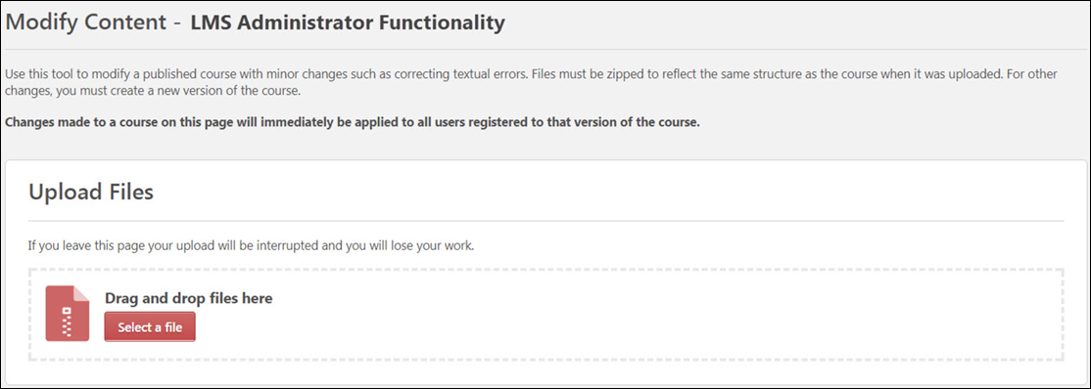
View Modification History
Clicking the View Modification History option from the Content section of the Course Console opens a flyout window with information about the online course's modification history.
Considerations
- If an upload is currently in progress for the online course when an administrator navigates to the Course Console page, a notification displays at the top of the Content section, alerting them to the in progress upload. If the administrator wishes to view the in progress upload, they can click the Resume button which displays in the notification. This directs the administrator to the Modify Content page. To resume the upload, click the Resume Upload button.
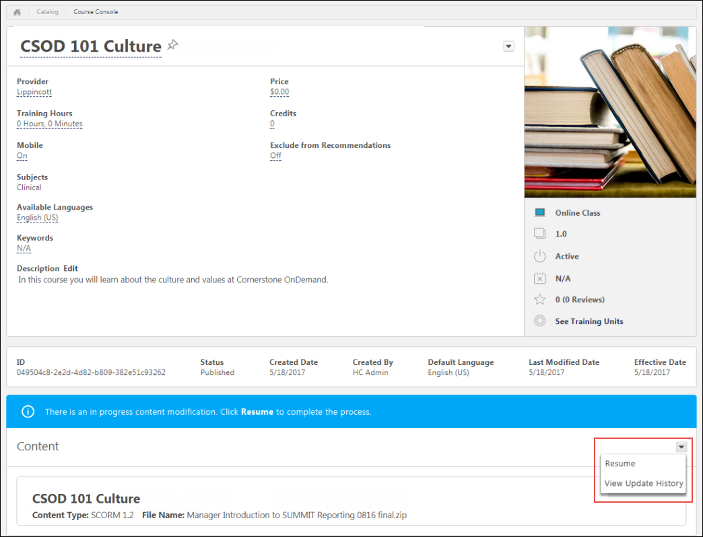
- When an administrator accesses the Modify Content page for a course that is part of a multi-package publication, a notification appears, warning the user that modifying the content for the course will impact other courses within the publication.
Validation Messages
The following validation messages may appear when modifying an online course:
For SCORM Courses
- 1. Severe Errors:
  - a. Manifest change - Only Resources element changes are permitted on the manifest.
  - b. Manifest Location Change - Relative path.
- 2. Warnings
  - a. HTML/ JS / SWF files have been modified - Checking different file size and content.
For AICC Courses
- 1. Severe Error:
  - a. AU, CRS, CST, DES files changed - Checking different file size and content.
  - b. AU, CRS, CST, DES files Location changed - Relative path.
- 2. Warning
  - a. HTML/ JS / SWF files have been modified - Checking different file size and content.
Online Course - Modification History
In the Content section of the Course Console page for an online course, the Options drop-down provides access to the Modification History page. When the View Modification History link is clicked, the Modification History flyout appears. The Modification History flyout displays separate tile for each instance of course modification. Each tile displays the following information:
- Title
- Date of Modification
- Username of the user who modified the online course
- Options drop-down menu - Clicking the Options drop-down opens the File List flyout. The File List flyout displays the following information:
  - Title - The title of the course
  - Back - Clicking this link returns the user to the Modification History flyout
  - Date of Modification
  - Username of the user who modified the online course
  - File Name - The name of the uploaded course files
  - Action - Whether the course files were updated or deleted
  - File Size
Online Course Versioning - Training Status Equivalents
Depending on the administrator's training status selections when reversioning an online class, users with the previous version of the class in statuses of Not Started, In Progress, and Completed, and statuses equivalent to these statuses, can automatically receive the new version.
The following statuses are treated as equivalent to Not Started when an online course is reversioned:
- Not Activated
- Pending Prior Training
- Registered
- Registered/Past Due
- Registered/Not Available
- Registered/Not Available/Past Due
- Approved
- Approved/Past Due
- Pending Prerequisite
- Pending Prerequisite/Past Due
The following statuses are treated as equivalent to In Progress when an online course is reversioned:
- Failed
- In Progress
- In Progress/Past Due
- Pending Observer Completion
- Pending Observer Completion/Past Due
- Pending Completion Approval
- Pending Completion Approval/Past Due
- Pending Evaluation
- Pending Evaluation/Past Due
- Pending Acknowledgment
- Pending Acknowledgment/Past Due
- Pending Pre-work
- Pending Pre-work/Past Due
- Pending Post-work
- Pending Post-work/Past Due
- Pending Completion Signature
- Pending Completion Signature/Past due
The following statuses are treated as equivalent to Completed when an online course is reversioned:
- Completed
- Completed Equivalent
- Exempt

Course Publisher (Legacy) - Overview

Course Publisher (Legacy) Overview
The Course Publisher functionality allows administrators to effectively manage content by uploading, validating, and integrating it into the Cornerstone Learning Management System (LMS). The Course Publisher allows administrators to upload a new course, upload a new version of a course, and replace files in existing courses.
Deprecation Note: With the November 2023 release, Cornerstone has announced the deprecation of Course Publisher and upgrading all clients to use the Content Uploader. With the July '24 Release, Course Publisher will be disabled in all customer portals and Content Uploader will be enabled in all customer portals.
This topic relates to the legacy Course Publisher functionality. Your organization may be using the Content Uploader. See Content Uploader - Create an Online Course - Overview on page 2 for additional information.
Important: The page description and instructions that are displayed at the top of this page can be edited and customized via Navigation Tabs and Links.
To access Course Publisher, go to Content > Course Publisher or Admin > Tools > Learning > Catalog Management > Course Publisher.
Administrators can only access the Course Publisher if they have been granted a content license and they have the proper permissions. A content license can be granted on the Manage Licenses page. See Manage Licenses.
Permissions
PERMISSION NAME | PERMISSION DESCRIPTION | CATEGORY

Course Publisher | Grants access to LCMS Course Publisher, which enables upload and publishing of SCORM and AICC compliant online courses, created either in the LCMS Course Builder, or from a third party course building tool. Administrators must also be granted a content license from the Manage Licenses page. This is an administrator permission.  After Content Publisher is activated in the system, users with this permission are automatically granted the permissions to upload and publish online classes via the Content Publisher, and also the permission to view the Upload History page. | Learning - Administration

Course Publisher Update | Grants ability to update existing online training courses previously published via the course publisher. Administrators must also be granted a content license from the Manage Licenses page. This is an administrator permission.  With the Oct '17 release, after the Content Publisher is activated in the system, users with this permission are automatically granted the permission to modify online classes. | Learning - Administration

Edit Online Course Providers | Grants ability to edit the Provider field for an online course via the Course Catalog and Course Console. User must also have permission to view the Course Catalog. This permission cannot be constrained. This is an administrator permission. | Learning - Administration
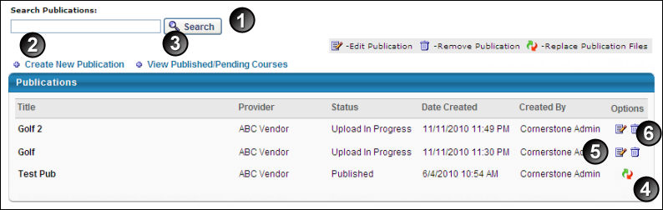
- Search Publication - Search for existing publication. A publication can be a SCORM 1.2 course, SCORM 2004 course, AICC course, or a group of SCORM or AICC courses.
- Create New Publication - Create a new publication. Up to 100 AICC courses or 250MB of SCORM courses can be zipped together and uploaded. See Course Publisher (Legacy) - Create New Course/Publication on page 52 for additional information.
- View Published/Pending Courses - View published or pending courses
- Replace Publication Files - Replace a publication. See Course Publisher (Legacy) - Minor Course Changes - Replace Files on page 63 for additional information.
- Edit - Edit existing publication. See Course Publisher (Legacy) - Edit Course Before Publishing on page 59 for additional information.
- Remove Publication - Remove a publication that has not been published
Update a Course
When updating a course, it is important to understand what types of changes you are making to the course. To help determine which process is best for your course changes, See Course Publisher (Legacy) - Update a Course on page 57 for additional information.
Helpful Hints - Document Types and Size
If a user has permission to update a publication via Course Publisher, then that administrator will be able to view the directory list of files included in a publication to replace or append to those files. If files for an existing publication are modified, then all users registered in that course will see those changes immediately.
Helpful Hints - Replace/Reversion
- Replace Publication Files - The course's publication files are replaced if the course has the exact same file structure as the original publication, for example correcting a spelling error or changing text. This process simply overwrites the previous version with the new files you upload and updates the course in a user's transcript. You can check to see if the course files were uploaded by clicking on the View Updates History link that is available after you click the Replace Publication Files icon .
  - When replacing a course, the old course files are overwritten and the new course files and are immediately applied to all users in any status, including users in a Completed status.
  - Publication files can only be replaced if the uploaded course has an identical manifest to the existing course. If the manifests are not exactly the same, then you cannot replace the publication files. Instead, you must reversion the course.
- Reversion - The course is reversioned if you are changing the structure from the previous version, for example adding a page or a new section.
  - When a new version is created, the version number is increased.
  - The course will then be added to the Course Catalog. You can search for it, just make sure you check the radio button for All Versions.
  - Because this is considered a different course and uploaded as a new publication, if a user has this in their transcript they will not automatically get the new course.
  - The new version will not overwrite the course for any users who currently have the course in their transcript, however new users will get the reversioned course.

Course Publisher (Legacy) - Create New Course/Publication
An online course or publication is an electronic learning course that can be completed asynchronously within the system or offline using the Offline Player. An online course is comprised of SCORM or AICC compliant files that are bundled into a zip file.
This topic relates to the legacy Course Publisher functionality. Your organization may be using the Content Uploader. See Content Uploader - Create an Online Course - Overview on page 2 for additional information.
All uploaded files must be SCORM 1.2, SCORM 2004, or AICC compliant and in a zip file. Note: Currently, SCORM 2004 3rd edition is implemented. Backward compatibility is generally expected, and thus courses published in 2nd edition is likely to work properly, but it is advised that courses are created using SCORM 2004 3rd edition.
Up to 100 AICC courses or 250MB of SCORM courses can be zipped together and uploaded. Individual SCORM courses which exceed 250 MB in size may require upload by Cornerstone. Consult Global Customer Support about creating a work order request.
To create a new online course:
- Go to Content > Course Publisher or Admin > Tools > Learning > Catalog Management > Course Publisher. Then, click the Create New Publication link.
- Go to Admin > Tools > Learning > Learning Admin Console. Then, click the Create button and click the Online Class link.
Administrators can only access the Course Publisher if they have been granted a content license and they have the proper permissions. A content license can be granted on the Manage Licenses page. See Manage Licenses.
Permissions
PERMISSION NAME | PERMISSION DESCRIPTION | CATEGORY

Course Publisher | Grants access to LCMS Course Publisher, which enables upload and publishing of SCORM and AICC compliant online courses, created either in the LCMS Course Builder, or from a third party course building tool. Administrators must also be granted a content license from the Manage Licenses page. This is an administrator permission.  After Content Publisher is activated in the system, users with this permission are automatically granted the permissions to upload and publish online classes via the Content Publisher, and also the permission to view the Upload History page. | Learning - Administration

Course Publisher Update | Grants ability to update existing online training courses previously published via the course publisher. Administrators must also be granted a content license from the Manage Licenses page. This is an administrator permission.  With the Oct '17 release, after the Content Publisher is activated in the system, users with this permission are automatically granted the permission to modify online classes. | Learning - Administration
Process to Create a New Course
The process of creating a new course is a multi-step process. Prior to using Course Publisher to configure and publish your course, a course provider must first author the course and package it into one of the accepted protocols (AICC, SCORM) as a zip file.
Once you have a zip file that contains the course files, follow these steps to configure and publish your course:
- On the Publication Information page, enter the basic information for the course. See the Publication Information section below for additional information.
- Browse for and upload the zip file that contains the course files. See the Upload Publication File section below for additional information.
- Click the Edit Publication icon from the Course Publisher page. See Course Publisher (Legacy) - Edit Course Before Publishing on page 59 for additional information.
- Click Publish to publish the course.
- Configure the course in Course Catalog. When a new course is published, it is added to the Course Catalog, but no availability, evaluations, subjects, skills, or competencies are associated with that course by default. This information is configured by editing the course in Course Catalog. See Course Catalog Overview for additional information.
Troubleshooting Information
See Course Troubleshooting Guide.
See QUICK START GUIDE - Uploading Courses via Course Publisher.
Publication Information
Enter the following information about your Online Course:
- Title - Enter title for publication (required). The title entered here is not the course title the user will see. This title labels the publication files for the administrator. The course title is created from the metadata from the zipped file. If multiple languages are enabled for the portal, click the Translate icon to localize the title into other available languages. The character limit is 500.
- Description - Enter description for publication. This is not the description for the course. The course description can be entered in Course Catalog after the published. If multiple languages are enabled for the portal, click the Translate icon to localize the description into other available languages.
- Default Language - This displays the default language for the course. This is the language that displays for users if a translation is not available for the publication title. The default language is set as the language of the administrator at the time they create the publication. This cannot be edited.
- Provider - To select a provider, click the search icon . This is required. Providers can be viewed within the Providers administration page. See Training Providers Overview.
- Click Next.
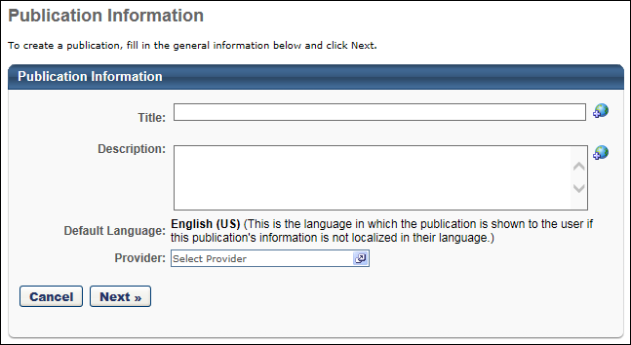
Upload Publication File
- Browse - Click this button to locate and select the zipped course file. Multiple courses can be uploaded in a publication, but must be uploaded in a single zipped file. Up to 100 AICC courses or 250MB of SCORM courses can be zipped together and uploaded.
Important: The Course Publisher cannot unzip multiple zipped files packaged within a single zipped file.
- Upload File - Click to upload file. Upload time is dependent on the size of your course files and your internet connectivity transfer rate for uploading. It is not uncommon for large course files to take up to an hour to load. If you navigate away from the page when uploading a course, the upload terminates.
  - A pop-up window will open with progress indicator and will close when file has uploaded.
  - You will be directed to a confirmation page after upload. Note: If course code functionality has been activated in your portal, a course code is automatically generated for the LO immediately after the administrator saves the new LO.
  - Status will be Upload In Progress. When the status changes to Pending Publish, course can be viewed or published.
  - Click OK and it will redirect you back to the Course Publisher page.
- Click the Edit Publication icon from the Course Publisher page. See Course Publisher (Legacy) - Edit Course Before Publishing on page 59 for additional information.
- Click Publish to publish the course. When a new course is published, it is added to the Course Catalog, but no availability, evaluations, subjects, skills, or competencies are associated with that course by default. This information is configured by editing the course in Course Catalog. See Course Catalog Overview for additional information.
Note: When creating a SCORM 2004 course, the Use SSL preference in Content Launching Preferences must be selected in order for the content to load and function properly.
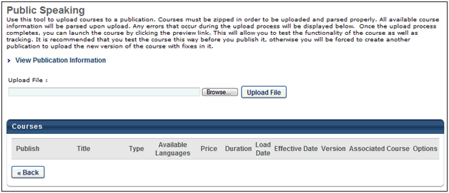
Helpful Hints - Score Calculation
- When creating a new course or publication in which a score is calculated, in order for the system to calculate and display a score on the Training Details page, the maximum score must be defined (i.e., greater than zero) in the SCORM wrapper (max_score) and the user score must be defined (i.e., not equal to null).
  - If the Score field does not appear on the Training Details page, then the maximum score is not defined in the SCORM wrapper.
  - If the Score label does appear, but there is no value, then the user's score is not defined.
Helpful Hints - Weighted Scoring
- Weighted scoring can be applied for multi-sco SCORM courses.
- Weighted sections can be configured for a multi-sco SCORM course regardless of when the course was published.
- If weighted scoring is configured for existing courses, the changes apply for all users that are currently registered for the course and have not yet completed it.
- If various SCOs have different weights, the different weights are included when calculating the user's score to determine if a user has earned a passing score
- When a user completes part of an online course, the score that is displayed is weighted. For example, an online course has three sections. Section 1 is worth 50% of the total score. Section 2 is worth 25% of the total score. Section 3 is worth 25% of the total score. A user completes Section 1 and answers all of the questions correctly. They will have a score of 50%, even though they only completed one sections of the course.
- Once a user completes a multi-sco SCORM course with weighted scoring, their score is recorded and does not change if the user re-takes the course. In order for the user to receive a new score, they must complete a new instance of the course.
Note: The ability to apply weighted scoring for multi-sco SCORM courses is controlled by a backend setting that is turned off by default. To enable the setting for your portal, contact Global Customer Support.
Helpful Hints - SCORM 2004 Table of Contents
When the table of contents (TOC) is being used for SCORM courses, each SCO displays the learner’s progress. One green check mark indicates that the user passed the SCO, and a second green check mark indicates the SCO has been completed. These check marks allow learners to easily view which SCOs have already been completed so they don't need to re-open any chapters they have already completed.
In addition, a refresh mechanism ensures the SCOs are shown in their correct and updated state (enabled or disabled).
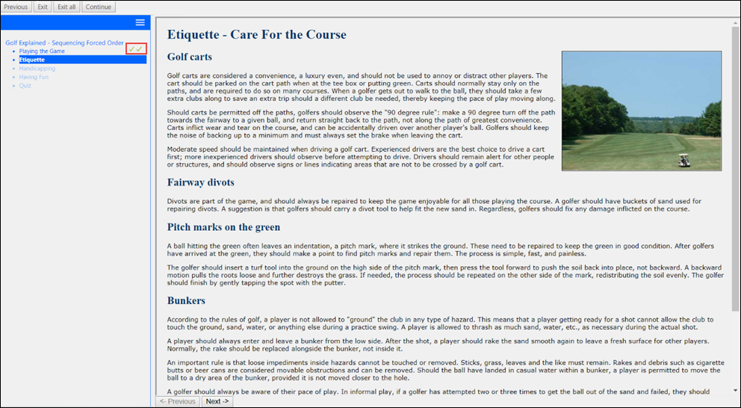

Course Publisher (Legacy) - Update a Course
When updating a course, it is important to understand what types of changes you are making to the course. Review the infographic below to determine which process is best for your changes.
- Edit Course Before Publishing - If you have not yet published your course, you can edit the course to publish the course, replace the publication files, or change the details of the course. See Course Publisher (Legacy) - Edit Course Before Publishing on page 59 for additional information.
- Minor Course Changes - Replace Files - If you have published the course and need to make minor changes to the course, such as text changes, you can replace the publication files. See Course Publisher (Legacy) - Minor Course Changes - Replace Files on page 63 for additional information.
- Major Course Changes - Reversion Course - If you have published the course and need to make major modifications to the course, such as replacing a segment of the course or adding or removing a SCO (Shareable Content Object), you can create a new version of the course. See Course Publisher (Legacy) - Major Course Changes - Reversion Course on page 68 for additional information.
This topic relates to the legacy Course Publisher functionality. Your organization may be using the Content Uploader.
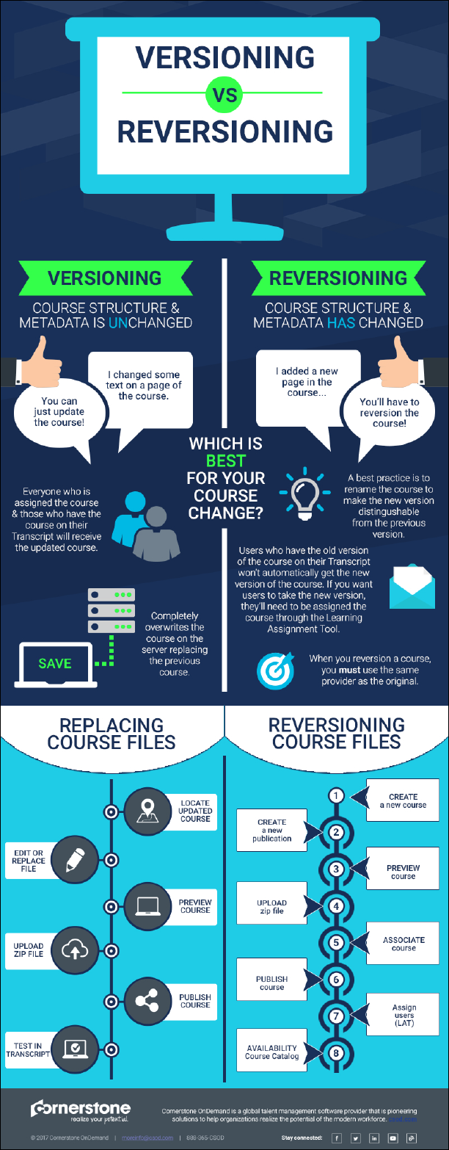

Course Publisher (Legacy) - Edit Course Before Publishing
When modifying a course that has not yet been published, administrators are able to publish the course, replace publication files, or change the course information.
This topic relates to the legacy Course Publisher functionality. Your organization may be using the Content Uploader. See Modify an Online Course on page 40 for additional information.
Administrators can only access the Course Publisher if they have been granted a content license and they have the proper permissions. A content license can be granted on the Manage Licenses page. See Manage Licenses.
To edit a course, go to Content > Course Publisher or Admin > Tools > Learning > Catalog Management > Course Publisher. Then, select one of the following options in the Options column:
- Replace Publication Files - This option is available if the course has been published. See Course Publisher (Legacy) - Minor Course Changes - Replace Files on page 63 for additional information.
- Edit Course - This option is available if the course has not yet been published.
Permissions
PERMISSION NAME | PERMISSION DESCRIPTION | CATEGORY

Course Publisher | Grants access to LCMS Course Publisher, which enables upload and publishing of SCORM and AICC compliant online courses, created either in the LCMS Course Builder, or from a third party course building tool. Administrators must also be granted a content license from the Manage Licenses page. This is an administrator permission.  After Content Publisher is activated in the system, users with this permission are automatically granted the permissions to upload and publish online classes via the Content Publisher, and also the permission to view the Upload History page. | Learning - Administration

Course Publisher Update | Grants ability to update existing online training courses previously published via the course publisher. Administrators must also be granted a content license from the Manage Licenses page. This is an administrator permission.  With the Oct '17 release, after the Content Publisher is activated in the system, users with this permission are automatically granted the permission to modify online classes. | Learning - Administration
View Publication Information
To view and edit the publication information (i.e., Title, Description, Provider), click the View Publication Information link. This information was set when the publication was created.
View Upload History
To see the history of the publication including File, Uploaded By and Uploaded Date, click View Upload History link.
Upload File
This feature allows you to upload a file, which replaces previously uploaded course files.
To replace the publication files for a published course, follow these steps:
- Click Browse to find replacement course files.
- Click Upload to upload the file.
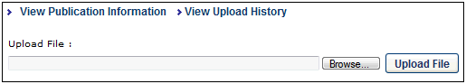
Select Publishing Format
In the Publish column, when a course file is uploaded that contains multiple formats, you can select which course formats to publish. Courses that are not selected are not published.
Preview Course
Click the Preview Course icon in the Options column to preview and test the course.
Edit Course Details
Click the Edit icon to edit the course details. You can edit the following fields:
- Title - Modify the course title. The character limit is 500. If multiple languages are enabled for your portal, select the Translate icon to translate the field into other available languages.
- Description - Modify the course description. This field has no character limit. If multiple languages are enabled for your portal, select the Translate icon to translate the field into other available languages.
- Type - This displays the type of course (e.g., SCORM 1.2, SCORM 2004).
- Available Languages - Determine the languages in which the course is available.
- Price - Set the price for users to take the course.
- Duration - Specify the duration of the course.
- Allow Download - If this option is selected, the corresponding course can be downloaded via the Course Catalog. Note: This option is only available if the Network Player is enabled.
- Load Date - This field is not editable. This field displays the date and time at which the course was uploaded.
- Effective Date - This field displays the date on which the course is effective. This field is only editable when creating another version of an existing course. Using the calendar tool, select the date on which the course is effective.
- Version - This defaults to the version number in the metadata from the uploaded course. It can be updated to another version number that is not in use for the associated course.
- Associated Course - If the course has associated courses, the course names are listed.
- Compatibility Mode - The Internet browser compatibility mode for an online course determines which compatibility mode, if any, is applied when the online course is launched. From the drop-down menu, select the compatibility mode for the online course. The default value for this setting is set in Content Launching Preferences. Note: This option only affects users using Internet Explorer; users using other browsers (e.g., Chrome, Firefox) are unaffected.
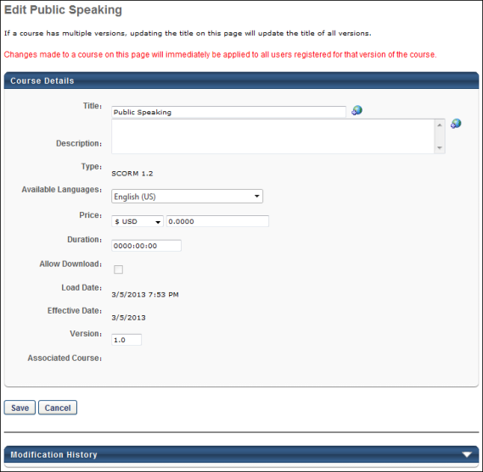
Save/Publish
Click Save to save your modifications.
Click Publish to publish the course. When a new course is published, it is added to the Course Catalog, but no availability, evaluations, subjects, skills, or competencies are associated with that course by default. This information is configured by editing the course in Course Catalog. See Course Catalog Overview for additional information.

Course Publisher (Legacy) - Minor Course Changes - Replace Files
Administrators are able to modify a published course in order to make changes within the course. This option should be used only if minor changes are being made to the course, such as correcting textual errors.
This topic relates to the legacy Course Publisher functionality. Your organization may be using the Content Uploader. See Modify an Online Course on page 40 for additional information.
To edit a course, go to Content > Course Publisher or Admin > Tools > Learning > Catalog Management > Course Publisher. Then, select one of the following options in the Options column:
- Replace Publication Files - This option is available if the course has been published.
- Edit Course - This option is available if the course has not yet been published. See Course Publisher (Legacy) - Edit Course Before Publishing on page 59 for additional information.
Administrators can only access the Course Publisher if they have been granted a content license and they have the proper permissions. A content license can be granted on the Manage Licenses page. See Manage Licenses.
Permissions
PERMISSION NAME | PERMISSION DESCRIPTION | CATEGORY

Course Publisher | Grants access to LCMS Course Publisher, which enables upload and publishing of SCORM and AICC compliant online courses, created either in the LCMS Course Builder, or from a third party course building tool. Administrators must also be granted a content license from the Manage Licenses page. This is an administrator permission.  After Content Publisher is activated in the system, users with this permission are automatically granted the permissions to upload and publish online classes via the Content Publisher, and also the permission to view the Upload History page. | Learning - Administration

Course Publisher Update | Grants ability to update existing online training courses previously published via the course publisher. Administrators must also be granted a content license from the Manage Licenses page. This is an administrator permission.  With the Oct '17 release, after the Content Publisher is activated in the system, users with this permission are automatically granted the permission to modify online classes. | Learning - Administration
Replace Course Files vs. Create New Version
When updating a course, you may have the option to replace the publication files of the existing course or create a new version of the existing course.
- Replace Publication Files - This option can only be used if the new course has an identical file structure and manifest to the old course. If the file structure is different (For example, if you first loaded a course with one SCO and now you are replacing with acourse with two SCOs) you will not be able to replace the course files. SCOs are Sharable Content Objects. These are what you are creating with your authoring tool when building SCORM courses. It is important that you know how many SCOs your course files contain before you try to replace course files. You also cannot replace functionality, such as mastery scores, maximum score, launch URL's, etc. The option to Replace Publication Files is initiated from the Course Publisher Overview page.
- Create New Version - This option is used if the new course does not have an identical file structure or manifest to the old course. This option should be used if non-minor changes are being made to the course. This option is initiated by uploading the new course files as a new course and then associating the new course with the old course prior to publishing. NOTE: The file type must be the same when creating a new version. For example, if you originally loaded the course as SCORM 1.2, you cannot create a new version of the course as SCORM 2004. If you do so, your users will receive an error when they try to launch the course. Instead, publish a new course file for the new SCORM 2004 course.
See Course Publisher (Legacy) - Major Course Changes - Reversion Course on page 68 for additional information.
Do users get the new course files automatically?
When a course file is replaced, the following users automatically receive the updated course:
- Users who are registered for that version of the course, including users in the following statuses: Registered, In Progress, Completed
- Users who request the course after the course is updated
Updating Courses Quick Start Guide
See QUICK START GUIDE - Updating Courses via Course Publisher.
View Upload History
To see the history of the publication including File, Uploaded By and Uploaded Date, click View Upload History link.
View Updates History
To see the history of updates to the publication including Action, Done By, Action Date, Acted On and the Item Value, click View Updates History link.
This can be used to verify whether new course files were uploaded for the course.
Replace Course/Publication Files
When replacing a course file, the structure of the course that is being replaced must be exactly the same as the course that is being loaded. This includes the file structure and the manifest. For example, if the original course has one SCO (Shareable Content Object), then the new course must have only one SCO.
If the manifests are not exactly the same, then you cannot replace the publication files. Instead, you must reversion the course. See Course Publisher (Legacy) - Major Course Changes - Reversion Course on page 68 for additional information.
Note: AICC courses cannot be replaced through the traditional method in the course publisher and must be replaced in the back end.
To replace the publication files for a published course, follow these steps:
- On the Course Publisher page, click the Replace Publication Files icon.
- Click Browse to find replacement course files. Up to 100 AICC courses or 250MB of SCORM courses can be zipped together and uploaded.
- Click Upload to upload the file.
- While the file is being uploaded, the Uploading Course Files page appears. This page indicates that the files are being processed and that the publication status will be Upload In Progress until the file is fully uploaded. Click OK.
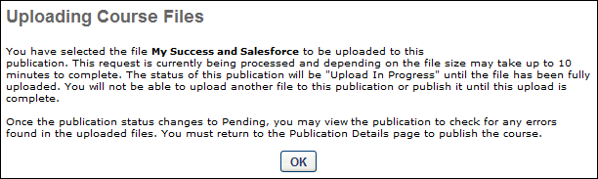
- On the Course Publisher page, the publication appears in the Upload in Progress status until the file is fully uploaded. The following options appear in the Options column:
  - Edit - Click this icon to edit the publication information. See the Edit Published Course Information section below for additional information.
  - Cancel Publication Update - Click this icon to discard the newly uploaded publication files. The previously existing files remain.
- Once the publication files are fully uploaded, the publication status is changed to Pending Update. Click the Edit icon for the publication, and then click the Update button to update the files. Replacing course files immediately overwrites previous files and is applied to all users registered for that version of the course.
  - Best Practice: Although the files are immediately replaced, it may take up to four hours for the new course files to be pushed to users who already have the course on their transcript. As a best practice, confirm that the changes have been implemented using a user who does not currently have the training on their transcript. If the course changes did not occur, the course modifications may be too significant to be implemented using this method, and the course may need to be reversioned in order to implement the changes. See Course Publisher (Legacy) - Major Course Changes - Reversion Course on page 68 for additional information.
Edit Published Course Information
Click the Edit icon to edit the course. Edits to title, price, or duration are immediately applied to all users regardless of status for that version of the course.
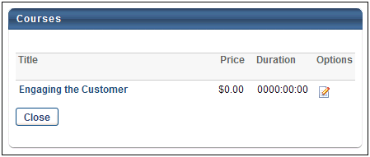
The following fields can be edited:
- Title - Modify the course title. The character limit is 500. If multiple languages are enabled for your portal, select the Translate icon to translate the field into other available languages.
- Description - Modify the course description. This field has no character limit. If multiple languages are enabled for your portal, select the Translate icon to translate the field into other available languages.
- Price - Set the price for users to take the course.
- Duration - Specify the duration of the course.
- Allow Download - If this option is selected, the corresponding course can be downloaded via the Course Catalog. Note: This option is only available if the Network Player is enabled.
- Compatibility Mode - The Internet browser compatibility mode for an online course determines which compatibility mode, if any, is applied when the online course is launched. From the drop-down menu, select the compatibility mode for the online course. The default value for this setting is set in Content Launching Preferences.Note: This option only affects users using Internet Explorer; users using other browsers (e.g., Chrome, Firefox) are unaffected.
After editing the appropriate information, click Save.
Note: The provider selected when the course was created cannot be edited. In order to change the provider for a course, a new course would need to be created with a different provider selected. See Course Publisher (Legacy) - Create New Course/Publication on page 52 for additional information.
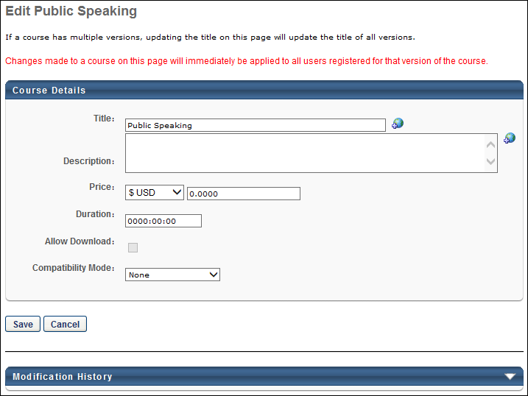
Modification History
The Modification History panel tracks changes that are made to the title and description for published courses, as well as the initial creation of the title and description. Changes made to unpublished courses are not tracked in this panel.
The initial creation and changes to the title and description display in the panel as follows:
- Title at Initial Creation - <Learning Object Type> created with <Language of Title> Title "<Title>" by <User Full Name> (<User ID>) on <Date/Time of Creation>.
- Description at Initial Creation - <Learning Object Type> created with <Language of Description> Description of "<Description>" by <User Full Name> (<User ID>) on <Date/Time of Creation>.
- Change to Title - Title in <Language of Title> was changed to "<New Title>" by <User Full Name> (<User ID>) on <Date/Time of Creation>.
- Change to Description - Description in <Language of Description> was changed to "<New Description>" by <User Full Name> (<User ID>) on <Date/Time of Creation>.
- Title/Description Translation Change - Title/Description in <Language> "<New Title/Description>" was added by <User Full Name> (<User ID>) on <Date/Time of Creation>.

Course Publisher (Legacy) - Major Course Changes - Reversion Course
Administrators are able to create a new version of a course in order to make major modifications to a published course, such as modifications to the file structure. Administrators may choose to create a new version of a course in the following scenarios:
- Making non-minor changes to the course, such as replacing a segment of the course or making significant updates to the course content.
- Modifying the course structure, such as adding or removing a SCO (Shareable Content Object).
This topic relates to the legacy Course Publisher functionality. Your organization may be using the Content Uploader. See Online Course Versioning vs. Modifying - Overview on page 18 for additional information.
As a best practice, a course should not be reversioned when making minor changes such as correcting text errors. Instead, the course publication files should be replaced. See Course Publisher (Legacy) - Minor Course Changes - Replace Files on page 63 for additional information.
When creating a new version of a course, you must first upload the new version as though you are creating a new course. Prior to publishing the new course, you have the option to create a new version of an existing course.
To create a new online course, go to Content > Course Publisher or Admin > Tools > Learning > Catalog Management > Course Publisher. Then, click the Create New Publication link.
Administrators can only access the Course Publisher if they have been granted a content license and they have the proper permissions. A content license can be granted on the Manage Licenses page. See Manage Licenses.
Permissions
PERMISSION NAME | PERMISSION DESCRIPTION | CATEGORY

Course Publisher | Grants access to LCMS Course Publisher, which enables upload and publishing of SCORM and AICC compliant online courses, created either in the LCMS Course Builder, or from a third party course building tool. Administrators must also be granted a content license from the Manage Licenses page. This is an administrator permission.  After Content Publisher is activated in the system, users with this permission are automatically granted the permissions to upload and publish online classes via the Content Publisher, and also the permission to view the Upload History page. | Learning - Administration

Course Publisher Update | Grants ability to update existing online training courses previously published via the course publisher. Administrators must also be granted a content license from the Manage Licenses page. This is an administrator permission.  With the Oct '17 release, after the Content Publisher is activated in the system, users with this permission are automatically granted the permission to modify online classes. | Learning - Administration
Replace Course Files vs. Create New Version
When updating a course, you may have the option to replace the publication files of the existing course or create a new version of the existing course.
- Replace Publication Files - This option can only be used if the new course has an identical file structure and manifest to the old course. If the file structure is different (For example, if you first loaded a course with one SCO and now you are replacing with acourse with two SCOs) you will not be able to replace the course files. SCOs are Sharable Content Objects. These are what you are creating with your authoring tool when building SCORM courses. It is important that you know how many SCOs your course files contain before you try to replace course files. You also cannot replace functionality, such as mastery scores, maximum score, launch URL's, etc. The option to Replace Publication Files is initiated from the Course Publisher Overview page.
- Create New Version - This option is used if the new course does not have an identical file structure or manifest to the old course. This option should be used if non-minor changes are being made to the course. This option is initiated by uploading the new course files as a new course and then associating the new course with the old course prior to publishing. NOTE: The file type must be the same when creating a new version. For example, if you originally loaded the course as SCORM 1.2, you cannot create a new version of the course as SCORM 2004. If you do so, your users will receive an error when they try to launch the course. Instead, publish a new course file for the new SCORM 2004 course.
See Course Publisher (Legacy) - Minor Course Changes - Replace Files on page 63 for additional information.
Do users get the new version automatically?
When a course is reversioned, the following users automatically receive the updated course:
- Users who request the course after the course is reversioned
Creating a new version of a course does not overwrite the course for any users who currently have the course in their transcript. If you want the new version to replace the previous version on users' transcripts, you must assign the new version to the users. See Create Learning Assignment - Overview.
Updating Courses Quick Start Guide
See QUICK START GUIDE - Updating Courses via Course Publisher.
View Publication Information
To view and edit the publication information (i.e., Title, Description, Provider), click the View Publication Information link. This information was set when the publication was created.
View Upload History
To see the history of the publication including File, Uploaded By and Uploaded Date, click View Upload History link.
Create New Version of Course
To create a new version of an existing course, follow these steps:
- Upload the new version as though you are creating a new course. Up to 100 AICC courses or 250MB of SCORM courses can be zipped together and uploaded. See Course Publisher (Legacy) - Create New Course/Publication on page 52 for additional information.
- Once an unpublished course is uploaded, from the Course Publisher screen, click the Edit icon .
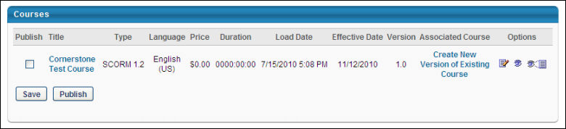
- In the Associated Course column, click the Create New Version of Existing Courses link to select the existing course for which you would like to create a new version. This opens the Select Course to Upgrade pop-up window, displaying all of the courses from the same provider that were uploaded with the Course Publisher.
- Search for the appropriate course, and select it by clicking the Add icon. The selected course is listed in the Associated Course field. When the course is published, it is saved as a new version of the course to which it is associated.
- Click Publish. This automatically creates a new version of the course, and the course version number is created.
- Configure the availability and other settings for the new course version via the Course Catalog. When a new course is published, it is added to the Course Catalog, but no availability, evaluations, subjects, skills, or competencies are associated with that course. The course's availability, evaluations, subjects, skills, competencies, and other information are modified in the Course Catalog. See Course Catalog Overview.
Creating a new version of a course does not overwrite the course for any users who currently have the course in their transcript. If you want the new version to replace the previous version on users' transcripts, you must assign the new version to the users. See Create Learning Assignment - Overview.
Reversioning a Course that Is Part of a Curriculum
When a course that is inside a curriculum is reversioned, users who have the curriculum on their transcript or who have previously requested the curriculum do not receive the new version of the course. Users who have never requested or completed the curriculum will receive the new version of the course if they request or are assigned the curriculum.
- If you change the name of the course, such as adding a version number to the name, the curriculum does not show the new name in Curricula Administration or immediately in the user's transcript. The user will not see the new name until they launch the course, and then the curriculum in their transcript will update with the new course name.
- If it is necessary for all impacted users to receive the new version of the course, you can run a Transcript Status report in Standard Reports that provides all users that currently have the course in an In Progress or Completed status. There are two options for ensuring these affected users receive the new course version:
  - If you run a forced learning assignment of the reversioned LO to push the latest version to a user, it is expected that you will see a stand-alone instance of the LO on the user's transcript. The stand-alone instance and the instance nested under the curriculum will share transcript status. When one instance is completed, the other instance will be completed. Once an LO has been made into a stand-alone LO, this cannot be undone.
  - To prevent duplicated listings of the course on the user's transcript, create a new online course using the content you were going to use to reversion the online course. Name this new course in a manner that indicates it is a new version of an old course. Remove the old online course from the curriculum and add the new online course to the curriculum. The curriculum will reversion. Select the option to push the reversion to applicable users. This action removes the old version from the curriculum and makes it a stand-alone online course on the transcript. This online course can then be removed. You may wish to utilize the Training Removal Tool functionality if multiple users are affected.
Expired Appended Training
When a material or online course is versioned with Append logic, you have the option to choose the start date of the new version. Once the start date is reached, the old version expires and becomes inactive. Expired child training items are hidden by default. The expiration of the previous training version is captured on the Structure History page for curricula, which is accessible from the Course Console.
An option to expose and hide expired training in a curriculum is available on both the Training Details page and on the Curriculum Player page for the curriculum.
Reversioning a Course that Is Part of a Dynamic Learning Assignment
When a course that is part of a dynamic learning assignment is reversioned, the new version of the course is automatically updated for users.
- During the versioning of a material, the user criteria logic of the Users Assigned by Dynamic Proxy option will consider users who meet the following criteria:
  - Are currently in the assignment criteria at the time of versioning
  - Currently have the training on their transcript as a result of the LAT assignment
- For users, if the previous version of the course is in an In Progress status on their transcript, they will not get the new version of the course. Even if they complete the previous version, the new version will not appear in the curriculum on their transcript unless the learning assignment is a recurring assignment, in which case they will receive the new version with the next recurrence of the learning assignment.
Validation Messages
Walidation messages may appear if the Start Date and Effective Date of a versioned online course are too close to each other.
Validation Message #1: Creation of Online Course when Effective Date and Start Date are within [H] hours (H value defined by a backend setting)
For most portals, the time difference between the Start Date and Effective Date which triggers validation messages is set to two hours, meaning that H hours = 2 hours. If an administrator versions an online course and the Start Date and Effective Date are within two hours of one another, the following warning message will trigger:
“The Effective Date and Start Date are too close for the new version to process. By clicking Accept, you are acknowledging that the previous version will expire immediately."
If the administrator clicks Accept, the old version of the training is immediately deactivated.
Note: Select portals have been configured with an H value other than two, so these portals will trigger the above validation message when the value between the Start Date and Effective Date is at or below the H value defined by the portal's backend setting.
Materials/DMS Materials/Online Courses Concurrency
When an administrator reversions an online course, material, or DMS material using Versioning with Append, and the Start Date and Effective Date very close to each other, a confirmation pop-up window appears to the administrator. The time difference value which triggers this pop-up is determined by a backend setting. If an administrator clicks the Accept button in the pop-up window, the old version of the material or online course expires immediately.
In addition, administrators are not able to edit the Start Date of the appended version if the difference between the time the administrator is updating the training and the Effective Date is within the number of hours configured in the backend setting.
Validation Messages
A validation message appears if the Start Date and Effective Date of a versioned material or online course are too close to each other.
Validation Message #1: Creation of Material or Online Course when Effective Date and Start Date are within [H] hours (H value defined by a backend setting)
For most portals, the time difference between the Start Date and Effective Date which triggers validation messages is set to two hours, meaning that H hours = 2 hours. If an administrator versions a material or online course and the Start Date and Effective Date are within two hours of one another, the following warning message will trigger:
“The Effective Date and Start Date are too close for the new version to process. By clicking Accept, you are acknowledging that the previous version will expire immediately."
If the administrator clicks Accept, the old version of the training is immediately deactivated.
Note: Select portals have been configured with an H value other than two, so these portals will trigger the above validation message when the value between the Start Date and Effective Date is at or below the H value defined by the portal's backend setting.

Course Publisher (Legacy) - Modify Individual SCORM Files
This topic relates to the legacy Course Publisher functionality. Your organization may be using the Content Uploader. See Modify an Online Course on page 40 for additional information.
Permissions
PERMISSION NAME | PERMISSION DESCRIPTION | CATEGORY

Course Publisher | Grants access to LCMS Course Publisher, which enables upload and publishing of SCORM and AICC compliant online courses, created either in the LCMS Course Builder, or from a third party course building tool. Administrators must also be granted a content license from the Manage Licenses page. This is an administrator permission.  After Content Publisher is activated in the system, users with this permission are automatically granted the permissions to upload and publish online classes via the Content Publisher, and also the permission to view the Upload History page. | Learning - Administration

Course Publisher Update | Grants ability to update existing online training courses previously published via the course publisher. Administrators must also be granted a content license from the Manage Licenses page. This is an administrator permission.  With the Oct '17 release, after the Content Publisher is activated in the system, users with this permission are automatically granted the permission to modify online classes. | Learning - Administration
Administrators only have access to Course Publisher if they have a content license, which can be granted on the Manage Licenses page. See Manage Licenses.
- Go to Content > Course Publisher
- Click Replace Publication Files
- Click Get Directory List link
- Delete Files:
  - Check files
  - Click Delete
- Upload individual files to replace deleted files. See Course Publisher (Legacy) - Minor Course Changes - Replace Files on page 63 for additional information.
The course's availability, evaluations, subjects, skills, competencies, and other information are modified in the Course Catalog. See Course Catalog Overview for additional information.

