Networking Issues March 2024

Table of Contents
Networking Issues Overview 2
FTP Account Access 1
FTP Account - Reset Password 3
FTP Account - Modification History 5
General Minimum Requirements 7
Trust Site 12

Networking Issues Overview

FTP Account Access
Administrators with the appropriate permissions may connect to FTP folders, reconfigure passwords for FTP accounts, and view modification history for FTP accounts associated with their portals. Some users may have access to the account list page, but not other account options for the accounts, as some options are controlled by different permissions.
To manage FTP accounts, go to Admin > Tools > Core and click the FTP Account Access link.
Permissions
PERMISSION NAME | PERMISSION DESCRIPTION | CATEGORY

Access FTP Account - View | Grants access to the FTP account landing page where the available accounts are displayed. Currently, this permission cannot be constrained. | Core Administration

Connect FTP Folders - Manage | Grants ability to connect to an FTP folder from the FTP Account Access page. This permission can be constrained by FTP Account. When constraining this permission, administrators can select any FTP account that has been associated with the portal. The constraints on this permission determine to which FTP accounts the administrator can connect. This is an administrator permission. | Core

Reset Password and Public Keys - Manage | Grants ability to manage FTP account login password and public keys when applicable. Currently, this permission cannot be constrained. | Core Administration
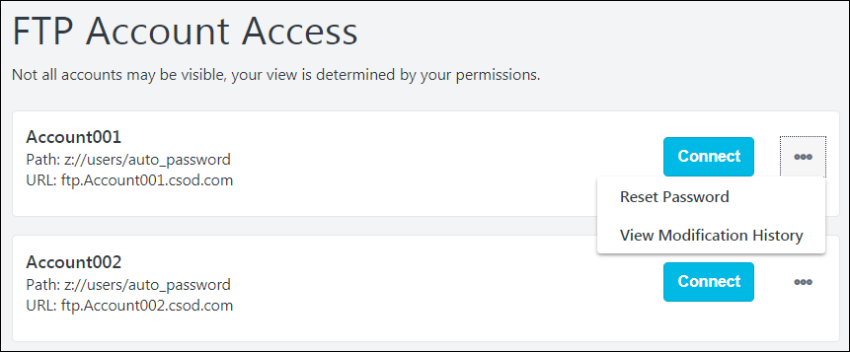
FTP Troubleshooting
The following file types cannot be uploaded to FTP due to security concerns, and attempting to upload one of these file types will result in an error:
*.ade, *.adp, *.app, *.asp, *.aspx, *.asx, *.bas, *.bat, *.cer, *.chm, *.cmd, *.cnt, *.com, *.cpl, *.crt, *.csh, *.der, *.diagcab, *.eml, *.exe, *.fxp, *.gadget, *.grp, *.hlp, *.hpj, *.hta, *.htc, *.inf, *.ins, *.isp, *.its, *.jar, *.jnlp, *.js, *.jse, *.ksh, *.lnk, *.mad, *.maf, *.mag, *.mam, *.maq, *.mar, *.mas, *.mat, *.mau, *.mav, *.maw, *.mcf, *.mda, *.mdb, *.mde, *.mdt, *.mdw, *.mdz, *.msc, *.msh, *.msh1, *.msh2, *.mshxml, *.msh1xml, *.msh2xml, *.msi, *.msp, *.mst, *.msu, *.ops, *.osd, *.pcd, *.pif, *.pl, *.plg, *.prf, *.prg, *.printerexport, *.ps1, *.ps1xml, *.ps2, *.ps2xml, *.psc1, *.psc2, *.psd1, *.psdm1, *.pst, *.py, *.pyc, *.pyo, *.pyw, *.pyz, *.pyzw, *.reg, *.scf, *.scr, *.sct, *.shb, *.shs, *.theme, *.tmp, *.url, *.vb, *.vbe, *.vbp, *.vbs, *.vhd, *.vhdx, *.vsmacros, *.vsw, *.webpnp, *.website, *.ws, *.wsc, *.wsf, *.wsh, *.xbap, *.xll, *.xnk
FTP Accounts
The FTP Account Access page displays the FTP accounts to which the administrator has access. Each account displays with the name, partial folder path, and login URL.
If there is no FTP mapped to a portal, the following message will appear: "An FTP account has not been set up and synced to this portal. If you believe this is an error, please reach out to Global Customer Support to set up."
Connect
Select this button to connect to the FTP folder in a new window outside of the Cornerstone portal. This button is only available to administrators who have permission to connect to an FTP account from this page. The FTP account must also be within their permission constraints.
Because the FTP folder opens outside of the Cornerstone portal, a confirmation pop-up opens. Select the Continue button to open the FTP folder, or select Cancel to cancel the action.
Because the FTP folder opens in a new window outside of the Cornerstone portal, it is important to ensure your pop-up blocker is disabled.
Options
The following options may be available within the options menu for each FTP account.
- Reset Password - Select this option to reset the password for the FTP account. This impacts people who need to log in to the FTP account from outside the portal. This does not impact users who access the FTP account using the Connect button. See FTP Account - Reset Password on page 3 for additional information.
- View Modification History - Select this option to view the history of the FTP account. This includes the password modification history and which users have connected to the account using the Connect button. This option is only available to administrators who have permission to reset passwords and public keys for the FTP account. See FTP Account - Modification History on page 5 for additional information.

FTP Account - Reset Password
Administrators with the appropriate permissions are able reset the password for an FTP account. This action updates the login credential of the FTP account. People who log in to this account from outside the portal are affected.
When updating the FTP account password, it is important to ensure all concerning parties are properly informed in advance to avoid issues such as data feed failure.
To reset the password for an FTP account, go to Admin > Tools > Core > FTP Account Access. Then, select the Options menu for the appropriate FTP account and select the Reset Password option.
Permissions
PERMISSION NAME | PERMISSION DESCRIPTION | CATEGORY

Access FTP Account - View | Grants access to the FTP account landing page where the available accounts are displayed. Currently, this permission cannot be constrained. | Core Administration

Reset Password and Public Keys - Manage | Grants ability to manage FTP account login password and public keys when applicable. Currently, this permission cannot be constrained. | Core Administration
On the Reset Password page:
- Enter the new password in the Create New Password field. Ensure the new password conforms to the password standards described on the page. Note: The password standards that display are configured by Cornerstone for the FTP server.
- Enter the new password again in the Confirm New Password field. If the two passwords do not match, you will receive an error and will need to re-enter your password in one or both fields to ensure they are the same.
- Click the Proceed button. This causes a validation message to appear.
- In the "Read Before You Proceed" pop-up message, ensure you understand the ramifications of your password change, and then enter a reason for changing the account's password. This field is required. If you wish to exit the Reset Password process without changing the account's password, you can click the Cancel link.
- Click the Submit button after entering a reason for the change. The new password will be applied to the FTP account.

FTP Account - Modification History
The View Modification History page enables administrators to view the password reset history for an FTP account.
To view the modification history for an FTP account, go to: Admin > Tools > Core Functions > FTP Account Access. Then, select the Options icon for the account, and select View Modification History.
Permissions
PERMISSION NAME | PERMISSION DESCRIPTION | CATEGORY

Access FTP Account - View | Grants access to the FTP account landing page where the available accounts are displayed. Currently, this permission cannot be constrained. | Core Administration

Reset Password and Public Keys - Manage | Grants ability to manage FTP account login password and public keys when applicable. Currently, this permission cannot be constrained. | Core Administration
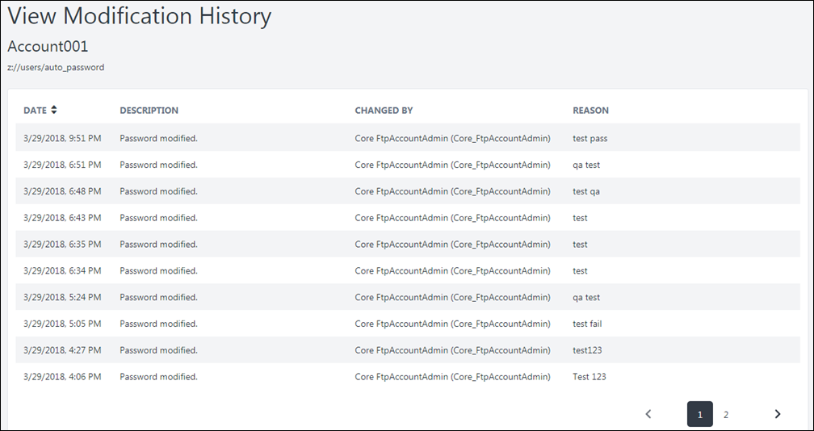
Modification Details
Modifications are displayed in reverse chronological order so that the most recent modifications are displayed first.
The following information is displayed for each modification:
- Date - This displays the date and time at which the modification occurred.
- Description - This displays the description of the modification.
- Changed By - This displays the user who initiated the modification.
- Reason - This displays the reason for change that was provided when the modification occurred.

General Minimum Requirements
What are the desktop requirements for using Cornerstone products?
As a SaaS (Software as a Service) application, there are no hosting hardware requirements. Clients do not maintain the software or provide network administration. In the on-demand delivery model, there are no requirements for server-side resources and minimal requirements for end users.
Computer | Display Resolution | Display Color | Network and Connectivity
Minimum 1 GB of RAM, 1 GHz Processor.  Soundcard required only for courses delivered in audio. | A resolution of 1024x768 or higher is recommended. | Minimum color quality requirement is 16 bit.  Optimal color quality is 32 bit. | Minimum 128 kbps.  256 kbps or higher is recommended.
Plug-Ins
- The Performance and Succession Platforms require Adobe Acrobat Reader to view reports that export to PDF. Adobe Acrobat Reader is also required to view training completion certificates.
- Additional plug-ins may need to be enabled for users to access e-learning courses hosted on Cornerstone, such as Shockwave, Java, etc.
- Check with your e-learning vendor or online course software vendor for their recommended minimum requirements.
Additional Software Considerations
- The core application requires Adobe Acrobat Reader for reports that export to PDF, and/or Microsoft Excel 2007 or higher although not all users necessarily need these capabilities.
- The SMP PowerPoint Template report requires Microsoft PowerPoint 2007 or higher or PowerPoint 2003 with the Microsoft Office 2007 software converter add-on.
What are the system requirements for using Inline Help?
Select the below link to download the latest system requirements for using Inline Help.
- Inline Help - Technical Requirements
What browsers are supported by Cornerstone products?
Browser Versions Supported:
- Microsoft Edge for Windows 10 (Microsoft Edge Chromium)
  - Note: Cornerstone does not support the use of IE Mode.
  - As of the July ’21 Release, Cornerstone no longer supports Microsoft Edge Legacy and Internet Explorer 11 browsers.
- Latest stable browser version of Apple Safari
- Latest stable browser version of Mozilla Firefox
- Latest stable browser version of Google Chrome
- Browsers must be installed in vendor supported environments.
About Internet Explorer Compatibility Mode
As a default setting, Internet Explorer 11 automatically displays Intranet sites in Compatibility Mode. This means that the page is displayed in Internet Explorer 7 Compatibility Mode, which is not supported.
To change this default setting, follow these steps:
- Open Internet Explorer.
- In the menu bar, go to Tools > Compatibility View settings.
- Uncheck the Display intranet sites in Compatibility View option and close the pop-up.
Browser Compatibility Settings and Security Requirements
Cornerstone does NOT require any specific compatibility settings aside from:
- Support for Transport Layer Security (TLS 1.1 or 1.2) (Must support 256 or 128 bit TLS encryption).
- Cookies and JavaScript are required to be enabled.
- Pop-up blocker must be disabled for the Cornerstone application.
What should I do about third-party cookies?
Third-Party Cookies Access Deprecation in Google Chrome and Firefox Browsers
Google is planning to end third-party cookies for Chrome users in 2024. In Q1 2024, Chrome is beginning to phase out third-party cookies access to approximately 1% of its users, with up to 100% phase out planned for Q3 2024 and beyond. Firefox browser has already been restricting third-party cookies access in its default settings.
What are third-party cookies and how are they used?
They are cookies in a user’s browser which are from a domain other than the one the user is currently on. They are primarily used for tracking and targeting users with advertisements, but they are also used for seamless transitioning of users between sites.
Impacts on Cornerstone applications
Unless steps are taken on the customer side, this deprecation can be disruptive to existing features that were previously acceptable such as content progress tracking with third party vendors, custom pages and features like CSX Welcome and Login pages, and facilitating integrations between sites (e.g. LXP integration between CSX and Edcast).
Customer action is required
Due to these new third-party cookie enhancements in Chrome and Firefox, customer action is required to prevent disruption of functionality in Cornerstone’s platforms. Customers should partner with their IT teams to review the deprecation’s potential impact and implement a corrective course of action.
Cornerstone is recommending the following approach
Customers should configure the browser privacy preference for Google Chrome and Firefox to allow their Cornerstone hostname(s) and necessary third-party domains/sites in users’ browsers to access third-party cookies. This allows customers to control the domains/sites they want to allow and provides users with a seamless experience. This requires customer effort to configure their users’ machines.
Chrome - when this feature is enabled in Chrome at your organization, follow these instructions.
- On Chrome press the three dots in the top right
- Then go to Settings
- In the Search
- Go to Privacy and Security
- Then Tracking Protection
- Scroll down page and click Add next to Sites allowed to use Third-party cookies
- In the pop up enter one or more of the following:
  - [*.]csod.com
  - [*.]edcast.com
  - [*.]sabacloud.com
Firefox - you can specify which websites have Enhanced Tracking Protection turned off. Type the exact address of the site you want to manage and then click Add Exception.
- On Firefox press the hamburger menu in the top right to open the application menu
- Then go to Settings
- On the left sidebar menu, click Privacy & Security
- Under Enhanced Tracking Protection, click Manage Exceptions… to open the Exceptions for Enhanced Tracking Protection pop-up window
- In the pop-up window enter your fully qualified Cornerstone domain name in the Address of website field (e.g., https://companya.csod.com)
  - https://<portalname>.csod.com
  - https://<portalname>.edcast.com
  - https://<portalname>.sabacloud.com
- Click Add Exception
- Click Save Changes
Learn more
- Google
  - https://blog.google/products/chrome/privacy-sandbox-tracking-protection/
- Firefox
  - https://support.mozilla.org/en-US/kb/enhanced-tracking-protection-firefox-desktop
  - https://support.mozilla.org/en-US/kb/third-party-cookies-firefox-tracking-protection
What should I do if my Cornerstone portal is running slowly (experiencing latency)?
Please perform some troubleshooting steps, and submit the results to Cornerstone by creating a case with Global Customer Support.
Select this link to view troubleshooting steps and gather information to submit a case, if necessary.
Why are Cornerstone-generated emails being delivered to the SPAM filter?
IP Addresses and Domains
- The IT department may need to safe list the IP addresses of content coming from Cornerstone.
- A list of IP addresses can be found in the Client Email Configuration document. See the Client Email Configuration section below to access this document.
- In addition, users may need to add the Cornerstone domains (csod.com or cornerstoneonedemand.com) to their email client or SPAM filter Safe Senders list.
Dead Box
- If users are working in Stage or Pilot environments, a dead box maybe enabled which will send all email traffic to a specific email account within their organization.
- Please contact Global Customer Support if you require a confirmation or change of your dead box information.
What mobile devices are compatible with Cornerstone products?
Cornerstone supports the native mobile application for the three most recent versions of Android and the most recent versions of iOS. In order to use the Cornerstone CSX app, users' devices must use one of the three most recent versions of Android or the most recent version of iOS.
Cornerstone is mobile browser accessible via the latest version of native browsers in the latest version of iOS and the three most recent versions of Android.
Is the Cornerstone system compliant with Section 508 of the Rehabilitation Act of 1973?
The user pages of the Cornerstone system are generally compliant with Section 508 of the Rehabilitation Act of 1973, depending on the features used and the way the client has configured its portal.
The Cornerstone system is compliant with Web Content Accessibility Guidelines (WCAG) 2.0 Level AA. This ensures that all user features are accessible to people with disabilities. Cornerstone maintains support for the latest version of JAWS screen reading software.
What versions of SCORM or AICC does Cornerstone support?
- Cornerstone currently supports SCORM 1.2, 2004 (3rd edition) and AICC. Note: Currently, SCORM 2004 3rd edition is implemented. Backward compatibility is generally expected, and thus courses published in 2nd edition is likely to work properly, but it is advised that courses are created using SCORM 2004 3rd edition.
- Support for next-generation standards will be posted when confirmed and certified.
What online learning course software does Cornerstone recommend?
Cornerstone does not mandate use of any particular online learning course software. However, if publishing to SCORM 2004, the software should optimally be 3rd edition conformant to avoid issues with course navigation, bookmarking, or reporting of completion status.
If it is intended to use the Cornerstone app to allow users to access online courses, please check the requirements of the mobile device vendor to ensure publishing is the supported format for that device's operating system.
Example:
- Non-Flash based content for iOS devices.
Client Email Configuration
The Client Email Configuration document details the email configuration requirements to improve email delivery rates, including Email Server Safe Listing.
Note: These emails will come from these senders:
customers@cornerstoneondemand.com and Customers@autoreply.cornerstoneondemand.com
Click here to download the Client Email Configuration document.
Akamai CAC List & Update Schedule
To view the latest Akamai CAC list and Cornerstone's Akamai update schedule, select the following link. This topic is only available to clients to whom the information is relevant.
https://clients.csod.com/phnx/driver.aspx?routename=Social/Topic/TopicDetails&Topic=795&Root=83
If you receive an error when accessing this topic, it is because your organization is not utilizing this functionality. If you feel this is incorrect, please reach out to your Client Executive.
Cornerstone newsletters and release information
Please visit this link to learn how to subscribe to Cornerstone newsletters and release information: Link

Trust Site
The Cornerstone Trust Site provides the ability to view Cornerstone OnDemand's global system status. The performance dashboard displays real-time system status by Swimlane and is updated to reflect any production issues.
Trust Site displays the occurrence of an incident within 10 minutes of the incident.
Trust Site can be accessed in the following manners:
- Go to http://status.csod.com.
- Within the Success Center, go to Learn > Resources. Then, click the Trust Cornerstone widget at the bottom of the page.
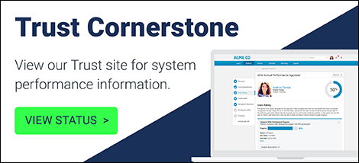
Subscribe to Updates
Select the Subscribe to Updates button at the top of the page to receive regular status updates.
System Dashboard
On the System Dashboard, the status of each swimlane is displayed for the past 90 days, including the current system status.
The following information is displayed for each swimlane:
- Swimlane - The swimlane name is displayed above the status.
- Current Status - The Current Status displays the most recent system conditions. If an incident occurs or is resolved, the current status of a swimlane is updated within 10 minutes of the incident or the incident resolution.
- Historical Statuses - The status of each swimlane for the past 90 days is displayed.
View Status Details
Hover the cursor over a status bar to view the system availability that corresponds with the status. Click a status bar to view any available details on the swimlane status.
Scheduled Maintenance
This section displays any upcoming or recent scheduled maintenance.
Past Incidents
This section displays any issues that have occurred and any information associated with the issues.

A swimlane refers to the server on which your organization's portal resides. There are swimlanes dedicated for different environments, which are Production, Pilot, and Stage. Thus, each environment has its own swimlane.

