My Account March 2024

Table of Contents
My Account 1
My Account - Preferences 3
My Account - Preferences - Manage Photo 6
My Account - Preferences - Settings 9
My Account - Preferences - Print QR Code 14
My Account - Preferences - Payment Methods 16
My Account - Preferences - Payment Methods - Manage Billing Information 21
My Account - Preferences - Payment Methods - Manage Secondary Address 24
My Account - Preferences - Payment Methods - Manage Tax Information 26
My Account - Preferences - Payment Methods - Purchase Training Units 28
My Account - Orders 31
My Account - Orders - Order Details (Redesigned) 34
My Account - Orders - Order Details - Edit Information (Redesigned) 37
My Account - Orders - Order Details (Old) 40
My Account - Order History Details (Legacy) - Edit Order Information 44
My Account - Order History Details (Old) - Refunds/Price Adjustments 45
My Account - Reviews 49
My Account - Social 51
My Account - Devices 53
Share Permissions 57
Share Permissions - Add Delegates 60
Share Permissions - Define Access by Permission 62

My Account
My Account allows users to modify their preferences, manage social accounts, manage mobile devices, manage course reviews, and view order history.
To access My Account:
- Select the Settings icon in the screen's upper-right corner and select the My Account link.
- Select the Navigation icon in the screen's upper-right corner and select the My Account link.
Some of the options that are visible within My Account can be customized by the administrator on the My Account Preferences page. If a field is configured by the administrator to display as read-only, it cannot be edited.
Permissions
PERMISSION NAME | PERMISSION DESCRIPTION | CATEGORY

Share Manager/Approver Permissions | Enables managers and approvers to delegate certain types of approvals and MyTeam viewing permissions to others. This permission is only relevant to managers and approvers. | Core

User - Edit My Account Preferences | Allow users to view and modify their preferences on the My Account screen. This permission cannot be constrained. This is an end user permission. | Core
My Account Sections
The following sections may be available:
- Preferences - Manage your general preferences as a user. See My Account - Preferences on page 3 for additional information.
- Orders - View the details of past orders and invoices. See My Account - Orders on page 31 for additional information.
- Reviews - View all of your submitted course reviews. See My Account - Reviews on page 49 for additional information.
- Social - Connect your social profiles with your account. See My Account - Social on page 51 for additional information.
- Devices - Register your mobile device, tablet, or computer for use with the Cornerstone Learn application. See My Account - Devices on page 53 for additional information.
The My Account sections can be renamed by the administrator.
Options
The Options drop-down only displays on My Account - Preferences pages. Also, the drop-down only displays if there is at least one option available to the user. The following options may be available in the drop-down, depending on the user's permissions and the preferences configured by the administrator:
- Change Email Address - Select this option to change your system email address. This email address is used to send notifications and reminders from the system. You must enter the new email address twice to ensure it is entered correctly. Note: If this option is not available, it is because it is not enabled by the system administrator in Email Preferences.
- Change Password - Select this option to change your system password. A pop-up appears with the system password requirements. You must first enter your current password, and then enter your new password. You must enter the new password twice to ensure it is entered correctly. Note: If this option is not available, it is because it is not enabled by the system administrator in Password Preferences.
- Edit Security Questions - Select this option to edit your security question responses. These responses are used to verify your identity when resetting your system password.
- Share Permissions - This option is only available to managers and administrators. Select this link to share managerial permissions with others. See Share Permissions on page 57 for additional information.

My Account - Preferences
From the Preferences tab of My Account, users may be able to do the following:
- View their own details, such as their name and and primary and secondary organizational units (OU)
- Upload and manage photo, which appears to others in the Universal Profile, user record, and other system pages
- Change email address
- Change password
- Change security question responses
- Share permissions
- Access and view the Settings tab - See My Account - Preferences - Settings on page 9 for additional information.
- Access and view the Payment Methods tab - See My Account - Preferences - Payment Methods on page 16 for additional information.
To access My Account:
- Select the Settings icon in the screen's upper-right corner and select the My Account link.
- Select the Navigation icon in the screen's upper-right corner and select the My Account link.
Select the Preferences tab on the left.
The tab name may appear differently in your portal, depending on the display name configured by the administrator in My Account Preferences.
Note: Users must have permission to manage My Account in order to have access to the Preferences tab.
Permissions
PERMISSION NAME | PERMISSION DESCRIPTION | CATEGORY

My Account - Manage | Allow users to view and modify their preferences on the My Account screen. The user must have this permission to access My Account. This permission cannot be constrained. This is an end user permission. | Core

Share Manager/Approver Permissions | Enables managers and approvers to delegate certain types of approvals and MyTeam viewing permissions to others. This permission is only relevant to managers and approvers. | Core

Tax Exemption - User Edit | Grants ability to edit Tax Exemption and Exemption Certificate for users on their Payment Methods in My Account. This permission cannot be constrained. | eCommerce

Tax Exemption - View | Grants ability to view Tax Exemption and Exemption Certificate for users on their Payment Methods in My Account. This permission cannot be constrained. | eCommerce

Tax Override - View | Grants ability to view the Override value for users on their Payment Methods in My Account. This permission cannot be constrained. | eCommerce

User - Edit Absent Status on My Account Page | Allows user to change absent status on My Account page. This is an end user permission. | Core

User Upload Photo | Enables users to upload their photo to their user record, via the My Account screen. This is an end user permission. | Core

VAT Number - User Edit | Grants ability to add and edit the VAT number for users on their Payment Methods in My Account. This permission cannot be constrained. | eCommerce

VAT Number - View | Grants ability to view the VAT number for users on their Payment Methods in My Account. This permission cannot be constrained. | eCommerce
Options
The Options drop-down only displays on My Account - Preferences pages. Also, the drop-down only displays if there is at least one option available to the user. The following options may be available in the drop-down, depending on the user's permissions and the preferences configured by the administrator:
- Change Email Address - Select this option to change your system email address. This email address is used to send notifications and reminders from the system. You must enter the new email address twice to ensure it is entered correctly. Note: If this option is not available, it is because it is not enabled by the system administrator in Email Preferences.
- Change Password - Select this option to change your system password. A pop-up appears with the system password requirements. You must first enter your current password, and then enter your new password. You must enter the new password twice to ensure it is entered correctly. Note: If this option is not available, it is because it is not enabled by the system administrator in Password Preferences.
- Edit Security Questions - Select this option to edit your security question responses. These responses are used to verify your identity when resetting your system password.
- Share Permissions - This option is only available to managers and administrators. Select this link to share managerial permissions with others. See Share Permissions on page 57 for additional information.
User Information
The user's full name and primary and secondary OUs display to the right of the photo. This information cannot be modified by the user.
Upload/Change/Delete Photo
Within My Account, the user's photo displays to the left of their name and organizational information. If the user has not uploaded a photo, a ghost image displays in the corporate color.
Users with the appropriate permissions are able to upload, edit, or remove their photo from the Preferences tab within My Account.
See My Account - Preferences - Manage Photo on page 6 for additional information.

My Account - Preferences - Manage Photo
Within My Account, the user's photo displays to the left of their name and organizational information. If the user has not uploaded a photo, a ghost image displays in the corporate color.
Users with the appropriate permissions are able to upload, edit, or remove their photo from the Preferences tab within My Account.
To access My Account:
- Select the Settings icon in the screen's upper-right corner and select the My Account link.
- Select the Navigation icon in the screen's upper-right corner and select the My Account link.
Select the Preferences tab on the left.
The tab name may appear differently in your portal, depending on the display name configured by the administrator in My Account Preferences.
Note: Users must have permission to manage My Account in order to have access to the Preferences tab.
Permissions
PERMISSION NAME | PERMISSION DESCRIPTION | CATEGORY

My Account - Manage | Allow users to view and modify their preferences on the My Account screen. The user must have this permission to access My Account. This permission cannot be constrained. This is an end user permission. | Core

User Upload Photo | Enables users to upload their photo to their user record, via the My Account screen. This is an end user permission. | Core
Change Photo
To manage the photo:
- Hover over the upper-right corner of the photo to enable the options drop-down to appear. Important: You must have permission to upload a photo in order to manage your photo in My Account. If you need to update your photo and you do not have the necessary permission, please contact your manager or system administrator.
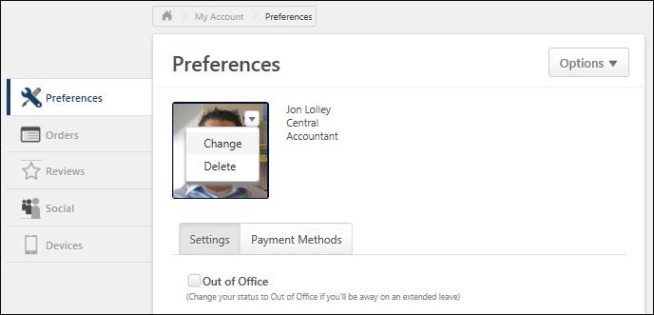
- Select the Change link. This opens the Upload Photo pop-up.
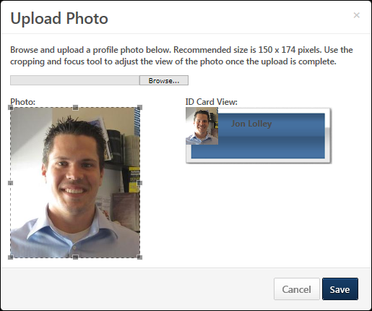
- Select the Browse button to select the photo. Once the file is selected, an Upload button displays to the right of the Browse button. The acceptable file types are .png, .gif, .jpg, or .bmp.
- Select Upload. This uploads the photo.
- Select Save. This updates the photo image on the Preferences tab.
Delete Photo
To delete your photo:
- Hover over the upper-right corner of the photo to enable the options drop-down to appear.
- Select the Delete link. This deletes the photo. Note: The Delete option only displays once a photo has been uploaded.

My Account - Preferences - Settings
The Settings tab on the My Account > Preferences page opens by default when accessing My Account.
The Settings tab displays the following information, depending on the settings configured by the administrator:
- Absent setting
- Manager
- Approver
- Time Zone
- Display Language
- Signature
- Opt Out of Shopping Cart Notification
- Instructor Password
- Contact Information and Custom Fields
- Additional custom fields in the Additional Information section
To access My Account:
- Select the Settings icon in the screen's upper-right corner and select the My Account link.
- Select the Navigation icon in the screen's upper-right corner and select the My Account link.
Select the Preferences tab on the left. Then, select the Settings tab.
The tab name may appear differently in your portal, depending on the display name configured by the administrator in My Account Preferences.
Note: Users must have permission to manage My Account in order to have access to the Preferences page.
Permissions
PERMISSION NAME | PERMISSION DESCRIPTION | CATEGORY

My Account - Manage | Allow users to view and modify their preferences on the My Account screen. The user must have this permission to access My Account. This permission cannot be constrained. This is an end user permission. | Core

User - Edit Absent Status on My Account Page | Allows user to change absent status on My Account page. This is an end user permission. | Core
Emails
EMAIL NAME | EMAIL DESCRIPTION | ACTION TYPE

Unpurchased Items in Shopping Cart | This email is triggered when a user adds at least one item to their shopping cart. When the email is triggered, any existing items in the shopping cart that can no longer be purchased are removed. The email can be sent to Shopping Cart Owner or a specific user. This email can be configured as a Reminder type email. This email is active by default and can be found in the Billing action type section of Email Administration.  Users may receive this email multiple times, depending on the configuration in Email Administration. For example, the administrator configures two emails, one that triggers three days after the user adds an item to their cart without purchasing the item, and another email that triggers seven days after the unpurchased item is added to the cart.  This email trigger is reset each time the shopping cart is emptied or when a purchase is complete.  Use Case: Use this email to remind users that there are unpurchased items in their shopping cart.  Note: The email is not triggered if all of the unpurchased training in the shopping cart is expired. | Billing
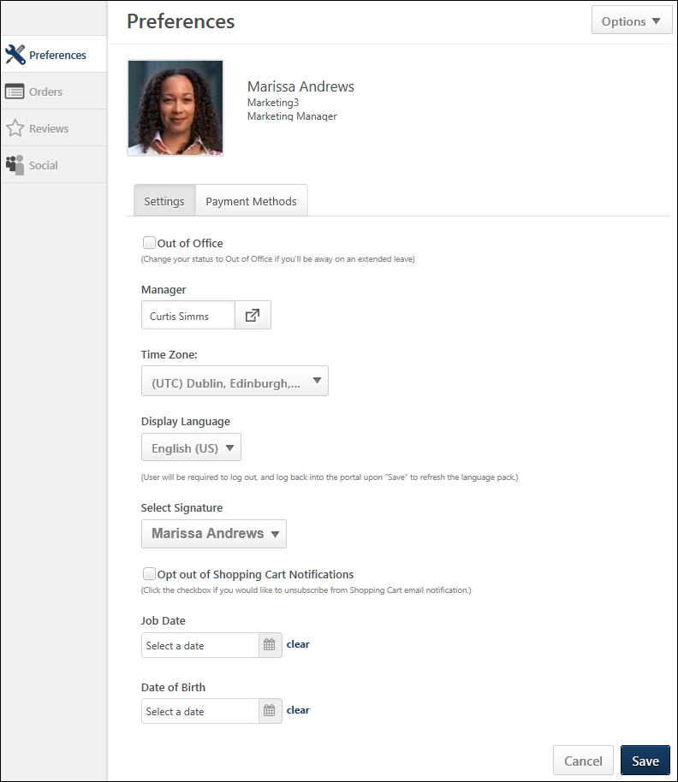
Options
The Options drop-down only displays on My Account - Preferences pages. Also, the drop-down only displays if there is at least one option available to the user. The following options may be available in the drop-down, depending on the user's permissions and the preferences configured by the administrator:
- Change Email Address - Select this option to change your system email address. This email address is used to send notifications and reminders from the system. You must enter the new email address twice to ensure it is entered correctly. Note: If this option is not available, it is because it is not enabled by the system administrator in Email Preferences.
- Change Password - Select this option to change your system password. A pop-up appears with the system password requirements. You must first enter your current password, and then enter your new password. You must enter the new password twice to ensure it is entered correctly. Note: If this option is not available, it is because it is not enabled by the system administrator in Password Preferences.
- Edit Security Questions - Select this option to edit your security question responses. These responses are used to verify your identity when resetting your system password.
- Share Permissions - This option is only available to managers and administrators. Select this link to share managerial permissions with others. See Share Permissions on page 57 for additional information.
Absent Setting
The name of this option in your portal is dependent on the configuration by the administrator. For example, this option may be named "Out of Office" or "On Vacation." Select or deselect the box to indicate your absent status. Also, this option is not available unless you have permission to edit the Absent Status.
Select this option to indicate that you are out of the office or absent for an extended leave. This notifies the system that you are absent and cannot access the system. If the Absent functionality is selected and the user is a manager/approver with training requests to approve, the approval request is routed to the next person in the approval chain if the approval process is required. This functionality only pertains to training requests, not other functions requiring approval.
When this option is selected, when you log in to the system again you have the option to remove your On Vacation status or leave it activated.
Manager
This option enables you to select your manager. Select the icon to open the Select User pop-up to find and select your manager. See Select a User Pop-up for additional information.
Approver
This option enables you to select your approver. Select the icon open the Select User pop-up to find and select your approver. See Select a User Pop-up for additional information.
Time Zone
This option enables you to select your time zone from the drop-down. This affects how time is displayed to you in the system, such as the time at which a training session begins. Note: If this option is not available, it is because it is not enabled by the system administrator in Timezone Preferences.
When a user sets their time zone, this time zone is set on their User Record.
The time zone that is applied to a user is dependent on a set of rules. See Time Zone Application Rules for additional information.
Display Language
If multiple languages are available for your portal, this option enables you to select their display language from the drop-down. When another language is selected, the system fields and labels are translated into the appropriate language. Note: If you change your Display Language and save your preferences, you will be required to log out and log back in to the system to implement the new display language.
Select Signature
This option enables you to select the font in which your electronic signature will appear. This signature font is utilized when signing items such as review tasks.
Opt Out of Shopping Cart Notifications
Note: This option is only available for portals with Shopping Cart enabled.
This option is unchecked by default. When unchecked, you will receive the Unpurchased Items in Shopping Cart email whenever you add an item to your shopping cart and have not purchased the item(s) in your shopping cart for a period of time specified by the administrator when configuring the email.
Checking the option unsubscribes you from the email, and the email is no longer sent to you.
Instructor Password
This option only displays if you are defined in the portal as an instructor for a Citrix provider and if Citrix is configured for the portal. This option enables you to manage your instructor password for Citrix tools.
This displays whether or not your Citrix credentials are stored within the system. Select the Update my GotoMeeting credentials link to enter your GoToMeeting credentials. This opens the GoToMeeting authentication page. After entering your username and password, you are returned to the My Account - My Preferences page. A message is displayed to indicate whether or not your credentials were accepted. You can update your GoToMeeting credentials at any time using this functionality.
Contact Information and Custom Fields
Contact information and custom fields display below standard fields if the administrator configured them to display.
Additional Information
This section displays custom fields that the user may be required to complete, if configured as required by the administrator. Some fields may display as read-only.
This section only displays if the administrator configured them to display.

My Account - Preferences - Print QR Code
Users can print their own personal QR codes via the My Account page in the Learning Management System (LMS). Users can print their own unique QR code, which instructors can scan to track their session attendance. Administrators and instructors can print the QR code for individual session parts.
To access My Account:Select the Settings icon in the screen's upper-right corner and select the My Account link.Select the Navigation icon in the screen's upper-right corner and select the My Account link.
Permissions
PERMISSION NAME | PERMISSION DESCRIPTION | CATEGORY

My Account - Manage | Allow users to view and modify their preferences on the My Account screen. The user must have this permission to access My Account. This permission cannot be constrained. This is an end user permission. | Core
Print QR Code from My Account
Every user can access a QR code specific to them via their My Account page. If needed, the user can print the QR code. To print the QR code from the My Account page:
- Click the My Account link located either at the bottom of the portal's navigation menu or under the Gear icon in the upper-right corner of portal.
- Click the Print QRCode link which displays under the QR code image on the right side of the My Account-Preferences page.
- A printable version of the session's QR code downloads from the browser, allowing the user to open the download and print the QR code. The QR code displays with the user's name and position. This QR code can be presented to the instructor of a session the user is registered for if the session has been configured to track attendance via QR code.
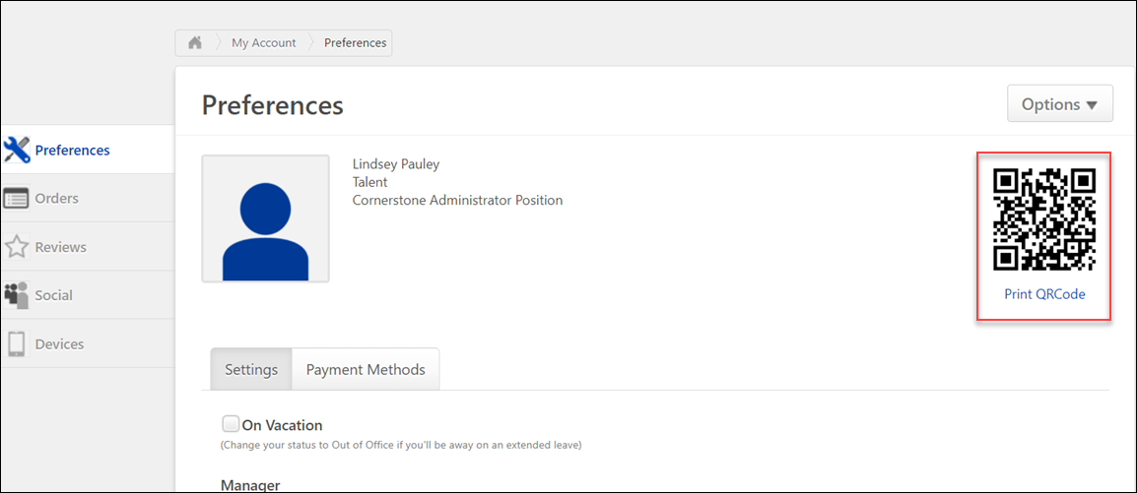
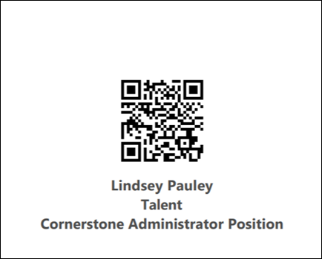

My Account - Preferences - Payment Methods
The Payment Methods tab within the My Account > Preferences page enables users to view and manage their billing information and payment methods.
The Payment Methods tab is available to a user if any of the following are true:
- The administrator enables the option to view the training unit balance or purchase training units.
- The administrator enables the option to view the training unit keycode balance or purchase training unit keycodes.
- The administrator enables the option for users to store credit card information in My Account.
- At least one payment type is specified by the administrator in User Payment Preferences.
- The administrator enables the option in User Payment Preferences to collect the user's secondary address.
- The user has permission for at least one of the following:
  - View tax override
  - Edit VAT number
  - View VAT number
  - Edit tax exemption
  - View tax exemption
To access My Account:
- Select the Settings icon in the screen's upper-right corner and select the My Account link.
- Select the Navigation icon in the screen's upper-right corner and select the My Account link.
Select the Preferences tab on the left. Then, select the Payment Methods tab.
The tab name may appear differently in your portal, depending on the display name configured by the administrator in My Account Preferences.
Note: Users must have permission to manage My Account in order to have access to the Preferences tab.
Permissions
PERMISSION NAME | PERMISSION DESCRIPTION | CATEGORY

My Account - Manage | Allow users to view and modify their preferences on the My Account screen. The user must have this permission to access My Account. This permission cannot be constrained. This is an end user permission. | Core

Tax Exemption - User Edit | Grants ability to edit Tax Exemption and Exemption Certificate for users on their Payment Methods in My Account. This permission cannot be constrained. | eCommerce

Tax Exemption - View | Grants ability to view Tax Exemption and Exemption Certificate for users on their Payment Methods in My Account. This permission cannot be constrained. | eCommerce

Tax Override - View | Grants ability to view the Override value for users on their Payment Methods in My Account. This permission cannot be constrained. | eCommerce

VAT Number - User Edit | Grants ability to add and edit the VAT number for users on their Payment Methods in My Account. This permission cannot be constrained. | eCommerce

VAT Number - View | Grants ability to view the VAT number for users on their Payment Methods in My Account. This permission cannot be constrained. | eCommerce
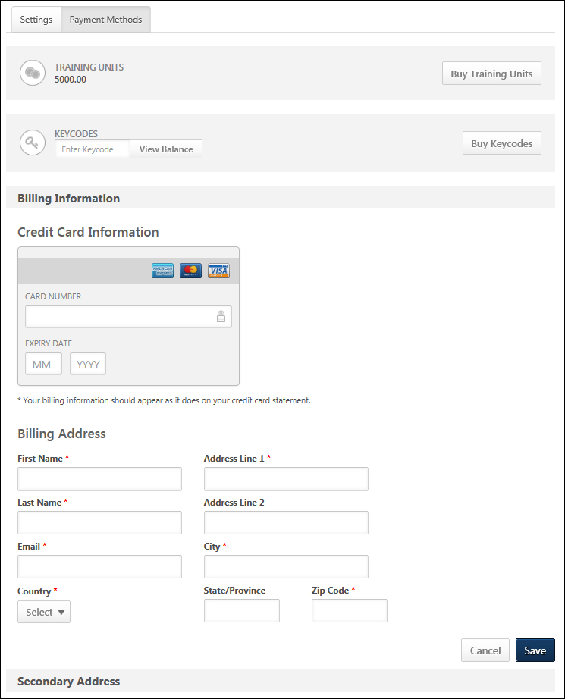
Options
The Options drop-down only displays on My Account - Preferences pages. Also, the drop-down only displays if there is at least one option available to the user. The following options may be available in the drop-down, depending on the user's permissions and the preferences configured by the administrator:
- Change Email Address - Select this option to change your system email address. This email address is used to send notifications and reminders from the system. You must enter the new email address twice to ensure it is entered correctly. Note: If this option is not available, it is because it is not enabled by the system administrator in Email Preferences.
- Change Password - Select this option to change your system password. A pop-up appears with the system password requirements. You must first enter your current password, and then enter your new password. You must enter the new password twice to ensure it is entered correctly. Note: If this option is not available, it is because it is not enabled by the system administrator in Password Preferences.
- Edit Security Questions - Select this option to edit your security question responses. These responses are used to verify your identity when resetting your system password.
- Share Permissions - This option is only available to managers and administrators. Select this link to share managerial permissions with others. See Share Permissions on page 57 for additional information.
Training Units
The following training unit information displays on the Payment Methods tab:
- Training Unit Balance - The training unit balance displays below the Training Units heading. The balance only displays if enabled by the administrator.
- Buy Training Units - The option to buy training units displays to the right of the training unit balance. This option is only available if enabled by the administrator. See My Account - Preferences - Payment Methods - Purchase Training Units on page 28 for additional information.
Keycodes
The following keycode information displays on the Payment Methods tab:
- Training Unit Keycode Balance - This option is only available if enabled by the administrator. To view the keycode balance, enter the keycode in the Enter Keycode field. Then, click View Balance. This displays the keycode balance below the text box. With this enhancement, monetary keycode balances display if the balance is monetary instead of training units. If users are not allowed to view the keycode balance, then an error message displays when users attempt to view the balance.
- Purchase Training Unit Keycodes - This option is only available if enabled by the administrator. To purchase a keycode, click the Buy Keycode button. This opens the Buy Training Units pop-up. The user can specify the number of training units they wish to purchase. Clicking Checkout takes them to the checkout page. Users cannot add additional items to this purchase.
Billing Information
The Billing Information section enables users to manage their credit card information for training purchases. This section is only available if enabled by the administrator.
Entering billing information allows users to store credit card information to allow faster checkout and enable users to utilize recurring billing and subscription renewals for learning objects. Note: If you intend to utilize the curriculum subscription functionality with auto-renewal, you must establish a billing profile.
Credit card information is hosted by CyberSource to ensure the information is stored securely. Also, the CVV code is not stored in the billing profile, so it must be entered each time to ensure you are the credit card owner.
Only one credit card can be stored for each user.
See My Account - Preferences - Payment Methods - Manage Billing Information on page 21 for additional information.
Secondary Address
The Secondary Address section enables users to edit their secondary address which is used for billing purposes. This section is only available if it is enabled for at least one payment type in User Payment Preferences for the user's OU. By default, the information displays as read-only. See My Account - Preferences - Payment Methods - Manage Secondary Address on page 24 for additional information.
Tax Information
The Tax Information section enables users to view and edit the VAT number, as well as manage tax exemption information. See My Account - Preferences - Payment Methods - Manage Tax Information on page 26 for additional information.

My Account - Preferences - Payment Methods - Manage Billing Information
The Billing Information section enables users to manage their credit card information for training purchases. This section is only available if enabled by the administrator.
Entering billing information allows users to store credit card information to allow faster checkout and enable users to utilize recurring billing and subscription renewals for learning objects. Note: If you intend to utilize the curriculum subscription functionality with auto-renewal, you must establish a billing profile.
Credit card information is hosted by CyberSource to ensure the information is stored securely. Also, the CVV code is not stored in the billing profile, so it must be entered each time to ensure you are the credit card owner.
Only one credit card can be stored for each user.
To access My Account:
- Select the Settings icon in the screen's upper-right corner and select the My Account link.
- Select the Navigation icon in the screen's upper-right corner and select the My Account link.
Select the Preferences tab on the left. Then, select the Payment Methods tab.
The tab name may appear differently in your portal, depending on the display name configured by the administrator in My Account Preferences.
Permissions
PERMISSION NAME | PERMISSION DESCRIPTION | CATEGORY

My Account - Manage | Allow users to view and modify their preferences on the My Account screen. The user must have this permission to access My Account. This permission cannot be constrained. This is an end user permission. | Core

Tax Exemption - User Edit | Grants ability to edit Tax Exemption and Exemption Certificate for users on their Payment Methods in My Account. This permission cannot be constrained. | eCommerce

Tax Exemption - View | Grants ability to view Tax Exemption and Exemption Certificate for users on their Payment Methods in My Account. This permission cannot be constrained. | eCommerce

Tax Override - View | Grants ability to view the Override value for users on their Payment Methods in My Account. This permission cannot be constrained. | eCommerce

VAT Number - User Edit | Grants ability to add and edit the VAT number for users on their Payment Methods in My Account. This permission cannot be constrained. | eCommerce

VAT Number - View | Grants ability to view the VAT number for users on their Payment Methods in My Account. This permission cannot be constrained. | eCommerce
Edit Billing Information
By default, the information displays as read-only. The fields can be edited by selecting the down arrow in the upper-right corner of the section to open the options drop-down. Select the Edit option in the drop-down. This enables all fields in the section to be editable.
After editing the information, select the Save button.
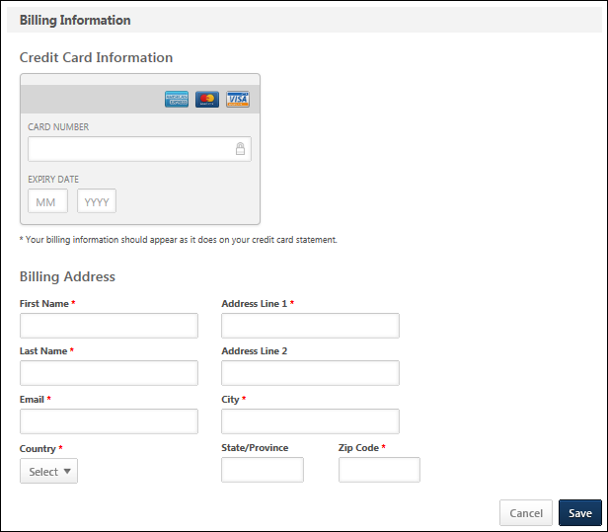
Delete Billing Information
To delete all values in the section, select the Delete option in the options drop-down. This opens a confirmation pop-up. Select Delete to delete all information in the section. Or, select Cancel to cancel the delete action.
When billing information is deleted, all information is removed and cannot be recovered. You will then have to enter new profile information in order to utilize the billing profile features such as recurring billing and subscription renewals for learning objects. You can delete the value in an individual field by using the Edit option.

My Account - Preferences - Payment Methods - Manage Secondary Address
The Secondary Address section enables users to edit their secondary address which is used for billing purposes. This section is only available if it is enabled for at least one payment type in User Payment Preferences for the user's OU. By default, the information displays as read-only. Note: The Secondary Address label can be customized in Billing Information Preferences.
To access My Account:
- Select the Settings icon in the screen's upper-right corner and select the My Account link.
- Select the Navigation icon in the screen's upper-right corner and select the My Account link.
Select the Preferences tab on the left. Then, select the Payment Methods tab.
The tab name may appear differently in your portal, depending on the display name configured by the administrator in My Account Preferences.
Note: Users must have permission to manage My Account in order to have access to the Preferences tab.
Permissions
PERMISSION NAME | PERMISSION DESCRIPTION | CATEGORY

My Account - Manage | Allow users to view and modify their preferences on the My Account screen. The user must have this permission to access My Account. This permission cannot be constrained. This is an end user permission. | Core
Edit Secondary Address
The fields can be edited by selecting the down arrow in the upper-right corner of the section to open the options drop-down. Select the Edit option in the drop-down. This enables all fields in the section to be editable.
- First Name - The character limit for this field is 30.
- Last Name - The character limit for this field is 30.
- Email - The character limit for this field is 50.
- Country
- Address Line 1 - The character limit for this field is 60.
- Address Line 2 - The character limit for this field is 60.
- City - The character limit for this field is 50.
- State/Province
- Zip Code - The character limit for this field is 10.
- Company Name - The character limit for this field is 100. This field is only available if enabled by the administrator in Billing Information Preferences.
- Phone Number - The character limit for this field is 30. This field is only available if enabled by the administrator in Billing Information Preferences.
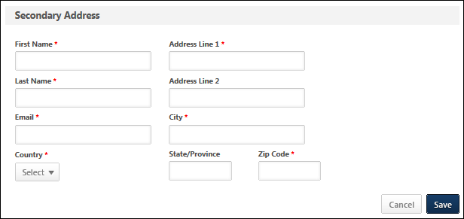
Delete Secondary Address
To delete all values in the section, select the Delete option in the options drop-down. This opens a confirmation pop-up. Select Delete to delete all information in the section. Or, select Cancel to cancel the delete action.
Note: When you delete the secondary address, all information is removed and cannot be recovered. You can delete the value in an individual field by using the Edit option.

My Account - Preferences - Payment Methods - Manage Tax Information
The Tax Information section enables users to view and edit the VAT number, as well as manage tax exemption information.
This section is only available if enabled by the administrator and the user has permission to do at least one of the following:
- View tax override
- Edit VAT number
- View VAT number
- Edit tax exemption
- View tax exemption
To access My Account:
- Select the Settings icon in the screen's upper-right corner and select the My Account link.
- Select the Navigation icon in the screen's upper-right corner and select the My Account link.
Select the Preferences tab on the left. Then, select the Payment Methods tab.
The tab name may appear differently in your portal, depending on the display name configured by the administrator in My Account Preferences.
Note: Users must have permission to manage My Account in order to have access to the Preferences tab.
Administrator Note: The Tax Information section appears if at least one CCH account has been configured for the portal.
Permissions
PERMISSION NAME | PERMISSION DESCRIPTION | CATEGORY

My Account - Manage | Allow users to view and modify their preferences on the My Account screen. The user must have this permission to access My Account. This permission cannot be constrained. This is an end user permission. | Core

Tax Override - View | Grants ability to view the Override value for users on their Payment Methods in My Account. This permission cannot be constrained. | eCommerce

VAT Number - User Edit | Grants ability to add and edit the VAT number for users on their Payment Methods in My Account. This permission cannot be constrained. | eCommerce

VAT Number - View | Grants ability to view the VAT number for users on their Payment Methods in My Account. This permission cannot be constrained. | eCommerce
Edit Tax Information and Tax Exemption
By default, the information displays as read-only. The fields can be edited by selecting the down arrow in the upper-right corner of the section to open the options drop-down. Select the Edit option in the drop-down. This enables all fields in the section to be editable.
- VAT Number - This field displays the user's VAT (value added tax) number. This field is only visible to users with the appropriate permissions. This field can only be edited or deleted by users with the appropriate permissions.
- Override Amount - This field displays the user's tax override amount, which is a user specific tax amount or tax rate. The override tax amount or rate is applied to each taxable item in the transaction. This field is only visible to users with the appropriate permissions. Note: The Override Amount field is always read-only.

My Account - Preferences - Payment Methods - Purchase Training Units
Users may be able to purchase training units from the Payment Methods tab within the My Account > Preferences page.
To access My Account:
- Select the Settings icon in the screen's upper-right corner and select the My Account link.
- Select the Navigation icon in the screen's upper-right corner and select the My Account link.
Select the Preferences tab on the left. Then, select the Payment Methods tab.
The tab name may appear differently in your portal, depending on the display name configured by the administrator in My Account Preferences.
Note: Users must have permission to manage My Account in order to have access to the Preferences tab.
Permissions
PERMISSION NAME | PERMISSION DESCRIPTION | CATEGORY

My Account - Manage | Allow users to view and modify their preferences on the My Account screen. The user must have this permission to access My Account. This permission cannot be constrained. This is an end user permission. | Core
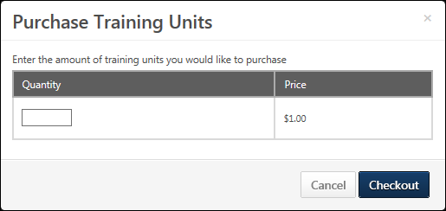
Purchase Training Units
The option to buy training units displays to the right of the training unit balance. This option is only available if enabled by the administrator.
To purchase training units:
- Select the Buy Training Units button. This opens the Buy Training Units pop-up.
- The pricing information is displayed and you can specify the number of training units you wish to purchase.
- Select the Checkout button to open the checkout page. You cannot add additional items to this purchase. See Checkout - Step 1 - Payment.
Training Unit Keycode FAQs
What is a training unit key code?
A training unit key code is a unique, 10-digit, auto-generated number that is used to store a user's training units. The key code number is confidential but can be viewed on the Manage Training Unit Key Code page.
The key code is entered during the checkout process when purchasing training. The system checks the key code balance to determine if there are enough training units to purchase the training item. If there are enough training units, then the user can check out using their key code. If there are not enough training units, then the user can request to be billed, if the administrator has configured the payment process to allow billing. If the payment process is not configured to allow users to be billed, then the user must either select a different payment method or they cannot check out.
How does the user receive the key code?
Once checkout is completed for the training unit key code purchase, the key code is sent to the user via the Monthly Training Unit Balance email, if the email is configured by the administrator.
Can a user refill their key code?
No. For key codes, training units can only be refilled by assigning training units to the key code. Only users with the appropriate permissions can assign training units.
Can the auto-generated monetary value for the key code be changed using the Customize Training Unit Keycode feature?
Yes. However, changing the auto-generated value will create inaccuracies in reporting, since the user has already paid for the training unit key code using their OU's monetary value.
Who is the training unit key code contact?
The user that purchases the training unit key code is automatically identified as the training unit key code contact. Note: Training unit key code contacts can be added from the Manage Training Unit Key Code page by clicking the Edit icon in the Options column.See Training Unit (Key Code) Management.
Is the key code amount adjustable?
Yes. The key code amount can be adjusted when editing the key code from the Manage Training Unit Key Code page. See Training Unit (Key Code) Management.
If a coupon is used to purchase a key code, what price displays for the key code in reporting?
Reporting displays the discounted price.
What emails are associated with the purchase of a key code?
- Shopping Cart Purchase - If configured by the administrator, this email is triggered when the key code purchase is completed. This email serves as the transaction receipt.
- Monthly Training Unit Balance - If configured by the administrator, this email is triggered on the date the key code is purchased and on the last day of each month. This email provides the user with the number of available training units on their key code. Best Practice: If Training Unit Preferences are configured not to allow users to view their training unit key code balance in My Account, then it is a best practice to configure the Monthly Training Unit Balance email. Otherwise, end users do not have a way to view their key code balance.

My Account - Orders
The Order History tab allows users to view the details of their past orders and print invoices. The Orders tab is only available if eCommerce is enabled.
From the Orders tab, users can do the following:
- View orders
- View inventory of pre-purchased training
- View training unit transactions
The tab name may appear differently in your portal, depending on the display name configured by the administrator in My Account Preferences.
To access My Account:
- Select the Settings icon in the screen's upper-right corner and select the My Account link.
- Select the Navigation icon in the screen's upper-right corner and select the My Account link.
Select the Orders tab on the left.
Note: The Orders tab only displays for users who have permission to view the tab.
Permissions
PERMISSION NAME | PERMISSION DESCRIPTION | CATEGORY

Inventory - Manage | Grants ability to purchase multiple learning object licenses with the intent to assign that training to other users at a later time. This permission can be constrained by OU and User's OU. | eCommerce

My Account Orders - View | Grants ability to view the Orders page in My Account. This permission cannot be constrained. This is an end user permission. | eCommerce

Order History Details - Edit | Grants ability to edit the Order History Details page of My Account, which displays all of the details for orders, including transaction date, transaction ID, payment method, reference number, order status, secondary address, and the details of each item purchased. Users with this permission can edit their own transaction information. This permission can be constrained by User's OU. This is an end user permission. | eCommerce

Order History Details - View | Grants access to Order History Details page of My Account, which displays all of the details for orders, including transaction date, transaction ID, payment method, reference number, order status, and the details of each item purchased. This permission cannot be constrained. This is an end user permission. | eCommerce
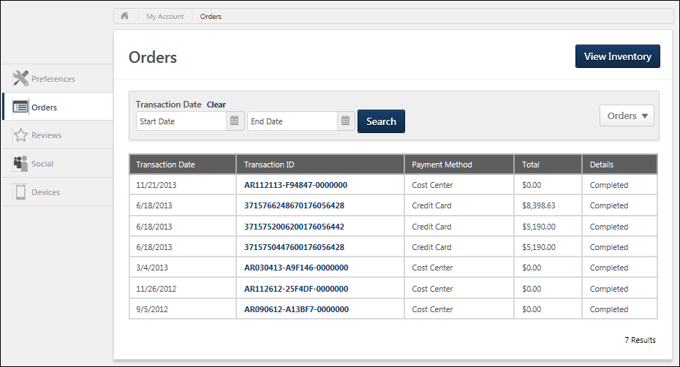
View Inventory
To view the inventory of pre-purchased training, select the View Inventory button. This opens the Training Inventory page. See Training Inventory Administration.
Note: The View Inventory option is only available for users who have permission to manage the inventory.
Orders Filter
The Orders drop-down menu enables users to filter the list of transactions by training units and orders. This option is only available if the administrator has enabled the preference to allow users to track training unit history in My Account.
Filtering by Training Units displays transactions related to the following:
- Purchasing of training units
- Training purchased with training units
- Training units revoked
- Training units issued
Filtering by Orders only displays transactions that are related to the purchasing of training items. The transactions do not include training units that have been distributed or revoked.
Transactions Table
The following information displays in the table:
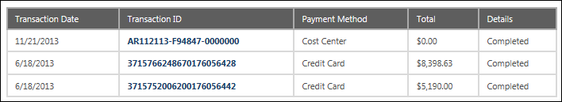
- Transaction Date - This column displays the date on which the transaction was completed. For transactions that are part of a Subscription, the transaction number in the Transaction ID column is not clickable. The user cannot view any subscription details for the transaction.
- Transaction ID - This column displays the transaction ID. The ID is system generated and unique to each transaction. For users with permission to view or edit the order history details, the transaction ID displays as a link to the Order Details page. See My Account - Orders - Order Details (Redesigned) on page 34 for additional information.
  - If the column displays "Not Available," this indicates that the transaction was for training units that were issued or revoked for the user. For transactions for revoked training units, an information icon displays to the right of "Not Available." Select the icon to open the Revoked Training Units Details pop-up.
- Payment Method - This column displays the method of payment used to complete the transaction. For transactions that are part of a Subscription, the Payment Method column displays "Subscription" as the payment method.
- Total - This column displays the total amount of the transaction. The total may display as a monetary amount or as training units.
- Details - This column displays the status of the transaction. The following are the possible statuses:
  - Completed - Note: The "Completed" status also displays for transactions that are for issued or revoked training units.
  - DeniedPending Payment

My Account - Orders - Order Details (Redesigned)
The Order Details page displays all of the details for the order, including transaction date, transaction ID, payment method, order status, and the details of each item purchased.
To access My Account:
- Select the Settings icon in the screen's upper-right corner and select the My Account link.
- Select the Navigation icon in the screen's upper-right corner and select the My Account link.
Select the Orders tab on the left. Then, select the Transaction ID for a page to view the Order Details page for the order.
Note: When accessing the order history from the Manage Transactions page, the Order Details page is not renamed and the UI is not updated. This only applies to accessing order history from My Account.
Permissions
PERMISSION NAME | PERMISSION DESCRIPTION | CATEGORY

Order History Details - Edit | Grants ability to edit the Order History Details page of My Account, which displays all of the details for orders, including transaction date, transaction ID, payment method, reference number, order status, secondary address, and the details of each item purchased. Users with this permission can edit their own transaction information. This permission can be constrained by User's OU. This is an end user permission. | eCommerce

Order History Details - View | Grants access to Order History Details page of My Account, which displays all of the details for orders, including transaction date, transaction ID, payment method, reference number, order status, and the details of each item purchased. This permission cannot be constrained. This is an end user permission. | eCommerce
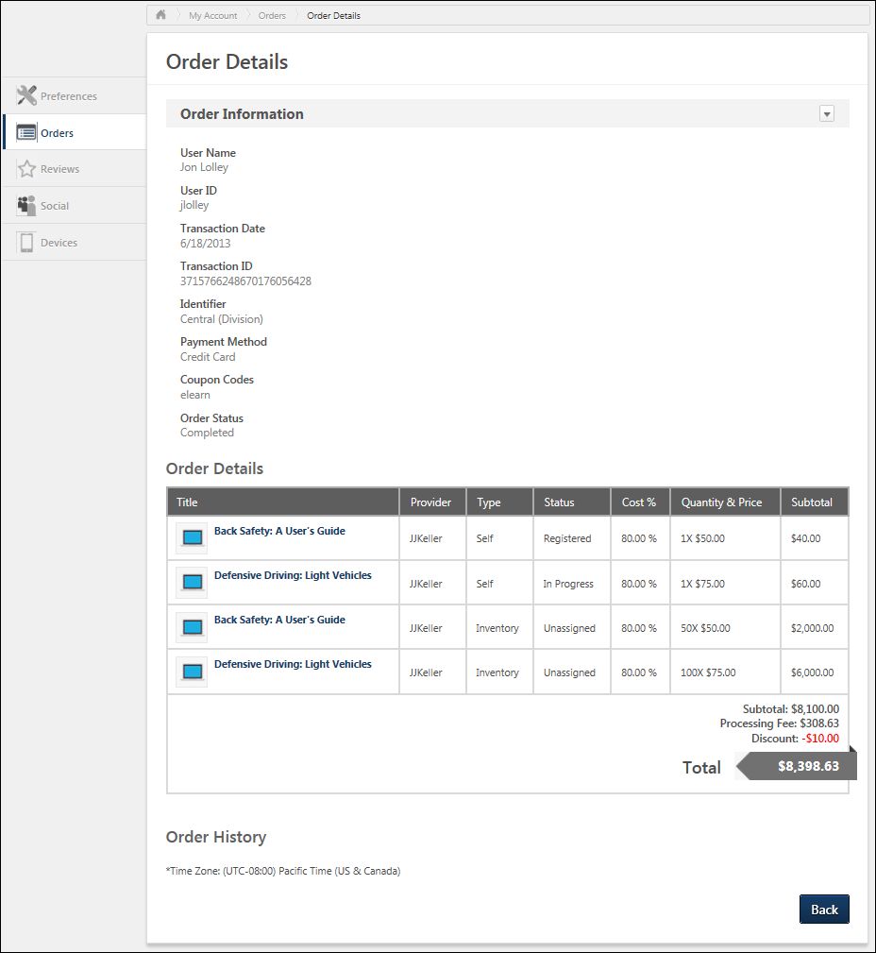
Edit
The Edit option in the Options drop-down in the upper-right corner of the page allows users to edit the secondary address information. Selecting Edit opens the secondary address fields in edit mode. Enter the changes, and then click Save. Note: The secondary address fields are only available if enabled by the administrator. See My Account - Orders - Order Details - Edit Information (Redesigned) on page 37 for additional information.
Print
The Print option in the Options drop-down in the upper-right corner of the page allows users to print the details of the order. There are no functionality changes to the print feature.
Order Information
The Order Information section displays the overall information for the order.
Note: The Reference Number field only displays if the payment method selected during checkout is Purchase Order. The field is read only and displays even if the user does not enter a purchase order number in the Reference Number field during checkout. See Checkout - Payment - Send Bill/Purchase Order for additional information.
Subscriptions Training Note: For transactions that are part of a Subscription, a Subscription field displays. This field displays the name of the subscription.
Custom Transaction Fields
Custom transaction fields may display below the system fields if they have been configured by the administrator.
- Administrators may set the visibility and availability settings for custom Transaction fields in the Transaction Details section when configuring the fields. See Custom Transaction Field - Add.
- The fields display below the system fields in the Order Information section in the order in which they are configured on the Set Field Order page. See Custom Transaction Field - Set Field Order.
If the administrator defined the custom Transaction field as editable, then the field can be modified.
If the field was not required on the Payment page when checking out, and the user did not enter a value, then the field is blank. If the administrator defined the field as required, and the field was only added to the Order History Details page, then a value must be entered into the field but can only be entered by users with permission to manage transactions.
Note: If the field is required and was also added to the Payment page of the shopping cart, then the user completing the transaction would have been required to enter a value prior to completing the purchase.
Details
The Details section displays the details of each item within the order.
Note: For transactions that are part of a Subscription, the unit price for the training item will be zero. The actual price for the training will be recorded for reporting purposes.
Assigned Learning Objects
If the order contains a learning object that has been assigned, then an Expand icon displays to the left of the transaction. Click the icon to view the assignment details.
Order History
The Order History section displays the history of the order, including when the order was made and if any modifications have been made to the order.

My Account - Orders - Order Details - Edit Information (Redesigned)
From the My Account - Orders - Order Details page, users can edit the order information. Note: The secondary address fields are only available if enabled by the administrator.
To access My Account:
- Select the Settings icon in the screen's upper-right corner and select the My Account link.
- Select the Navigation icon in the screen's upper-right corner and select the My Account link.
Select the Orders tab on the left. Then, select the Transaction ID for a page to view the Order Details page for the order.
To edit the order information, select the Edit option in the Options drop-down next to the Order Information section heading.
Permissions
PERMISSION NAME | PERMISSION DESCRIPTION | CATEGORY

Order History Details - Edit | Grants ability to edit the Order History Details page of My Account, which displays all of the details for orders, including transaction date, transaction ID, payment method, reference number, order status, secondary address, and the details of each item purchased. Users with this permission can edit their own transaction information. This permission can be constrained by User's OU. This is an end user permission. | eCommerce

Order History Details - View | Grants access to Order History Details page of My Account, which displays all of the details for orders, including transaction date, transaction ID, payment method, reference number, order status, and the details of each item purchased. This permission cannot be constrained. This is an end user permission. | eCommerce
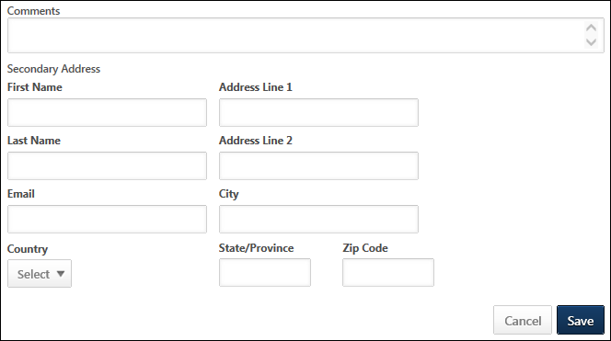
Selecting the Edit option enables the following fields:
- Comments
- Secondary Address - The secondary address fields may be required, depending on the Billing Information Preferences and User Payment Preferences that are set for the user's OU at the time the fields are edited. Note: The Secondary Address label can be customized in Billing Information Preferences.The Secondary Address label is captured at the time of the transaction. Any modifications that are made to the Secondary Address label after the transaction are not reflected on this page.
  - First Name - The character limit for this field is 30.
  - Last Name - The character limit for this field is 30.
  - Email - The character limit for this field is 50.
  - Country
  - Address Line 1 - The character limit for this field is 60.
  - Address Line 2 - The character limit for this field is 60.
  - City - The character limit for this field is 50.
  - State/Province
  - Zip Code - The character limit for this field is 10.
  - Company Name - The character limit for this field is 100. This field is only available if enabled by the administrator in Billing Information Preferences.
  - Phone Number - The character limit for this field is 30. This field is only available if enabled by the administrator in Billing Information Preferences.
After making the appropriate changes, select Save to save the changes, or select Cancel to discard any unsaved changes.

My Account - Orders - Order Details (Old)
This page is only available when accessed via the Manage Transactions page. When accessed via My Account, the redesigned Order Details page is opened. See My Account - Orders - Order Details (Redesigned) on page 34 for additional information.
The Order History Details page displays all of the details for the order, including transaction date, transaction ID, payment method, reference number, order status, and the details of each item purchased.
Note: The Reference Number field only displays if the payment method selected during checkout is Purchase Order. The field is read only and displays even if the user does not enter a purchase order number in the Reference Number: field during checkout. See Checkout - Payment - Send Bill/Purchase Order for additional information.
Administrators also have the ability to modify a Payment Pending status, adjust prices, issue refunds, and enter comments.
Permissions
PERMISSION NAME | PERMISSION DESCRIPTION | CATEGORY

Order History Details - View | Grants access to Order History Details page of My Account, which displays all of the details for orders, including transaction date, transaction ID, payment method, reference number, order status, and the details of each item purchased. This permission cannot be constrained. This is an end user permission. | eCommerce

Transaction Manager - Manage | Grants ability to access the Manage Transaction page and also create and edit transactions. On the Order History Details page, the administrator can edit the order status, adjust prices, issue refunds, or enter comments. This permission can be constrained by User's OU. This is an administrator permission. | eCommerce - Administration
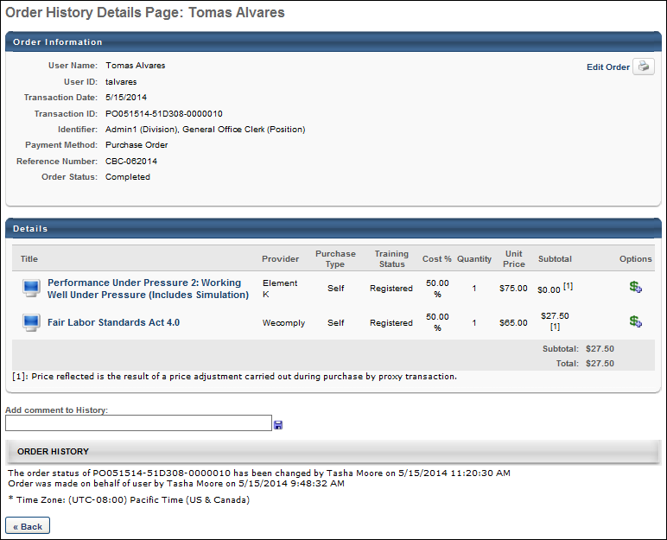
Custom Invoices
For transactions using a custom invoice, the following changes are applied:
- The Transaction ID field is renamed Tax Invoice.
- The ABN field is available. This displays the Australian business number that is specified for the custom invoice in Invoice Preferences. If the Australian business number is not provided, then this field is empty.
- If tax is being collected, tax is renamed GST.
- The Subtotal column is renamed Amount Payable in the Details table.
- The Total row is renamed Amount Payable in the Details table.
Purchase by Proxy Price Override
When creating a purchase by proxy, administrators with the appropriate permission can override the price for a training item on the Shopping Cart page. Adjustments to the unit price of a training item are reflected in the Subtotal column on the Order History Details page. The adjustment is represented by a superscript [1] to the right of the unit price. The adjustment details display at the bottom of the Details panel to indicate that the unit price was adjusted during a purchase by proxy transaction.
When printing the transaction, the printed version includes the adjustment explanation text.
Note: The Discount field displays cart-level price adjustments, such as coupon discounts. This field does not reflect unit price adjustments for purchase by proxy transactions.
Reference Number
If the user paid by Purchase Order, a read-only Reference Number field displays, showing the purchase order number. The field only displays if a user selects Purchase Order in the Payment Method field during the checkout process and the Show Reference number input box field is checked in User Payment Preferences. If the user is not required to enter a purchase order number and leaves the field blank, the Reference Number field still displays.
Edit Order Status and Comments
If the order status is Pending Payment, the administrator can reconcile the payment and change the payment status. To edit the order status, next to the Pending Payment status, click the Edit icon . The available status options are Pending Payment, Complete, and Denied. Select the appropriate option and click the Save icon.
- When an order status is changed to Completed, the option to edit the status is no longer available.
Comments can be entered in the Add comment to History box. The field displays for all payment methods and accepts up to 200 characters. Clicking the Save icon commits the comments and displays them in the Price Adjustment History section. Comments are only visible to the administrator. An unlimited number of comments can be added, but they cannot be edited or deleted once saved.
Refunds and Price Adjustments
On the Order History Details page for the transaction, the administrator is able to initiate refunds and adjust prices. Note: Refunds are not available if the item was purchased entirely by the user's cost center. See My Account - Order History Details (Old) - Refunds/Price Adjustments on page 45 for additional information.
Edit Order Information
To edit the order information, click the Edit Order Information link in the upper-right corner of the Order Information section. See My Account - Order History Details (Legacy) - Edit Order Information on page 44 for additional information.

My Account - Order History Details (Legacy) - Edit Order Information
This page is only available when accessed via the Manage Transactions page. When accessed via My Account, the redesigned page is opened. See My Account - Orders - Order Details - Edit Information (Redesigned) on page 37 for additional information.
From the Order History Details page, administrators can edit the order information.
To edit the order information, click the Edit Order Information link in the upper-right corner of the Order Information section. Clicking the link enables the following fields:
- Reference Number
- Secondary Address - The secondary address fields may be required, depending on the Billing Information Preferences and User Payment Preferences that are set for the user's OU at the time the fields are edited. Note: The Secondary Address label can be customized in Billing Information Preferences.The Secondary Address label is captured at the time of the transaction. Any modifications that are made to the Secondary Address label after the transaction are not reflected on this page.
  - First Name - The character limit for this field is 30.
  - Last Name - The character limit for this field is 30.
  - Company Name - The character limit for this field is 100. This field is only available if enabled by the administrator in Billing Information Preferences.
  - Phone Number - The character limit for this field is 30. This field is only available if enabled by the administrator in Billing Information Preferences.
  - Country
  - Address Line 1 - The character limit for this field is 60.
  - Address Line 2 - The character limit for this field is 60.
  - City - The character limit for this field is 50.
  - State/Province
  - Zip Code - The character limit for this field is 10.
  - Email - The character limit for this field is 50.
- Comments
After making the appropriate changes to the secondary address, click Save to save the changes, or click Cancel to discard any unsaved changes.

My Account - Order History Details (Old) - Refunds/Price Adjustments
This page is only available when accessed via the Manage Transactions page.
On the Order History Details page for the transaction, the administrator is able to initiate refunds and adjust prices. Note: Refunds are not available if the item was purchased entirely by the user's cost center.
All price adjustments and refunds are tracked in the Price Adjustment History section.
See Refunds Overview for the business rules related to refunds and processing fees.
To add a refund or adjust the price for an item, in the Options column, click the Add Refund icon . This opens the price adjustment pop-up for that item.
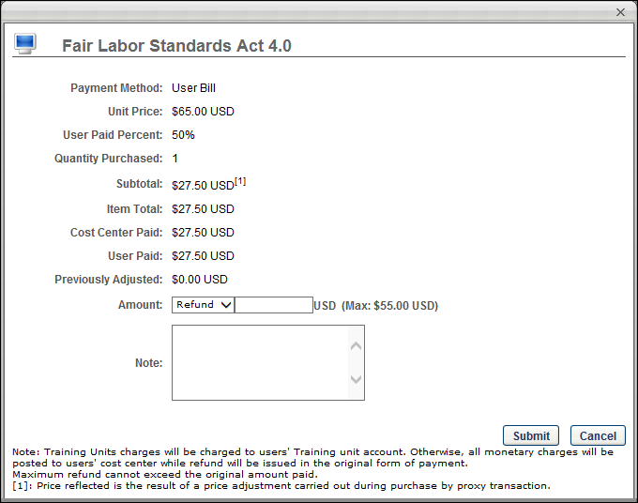
Order Details
The details of the order display above the Amount field. The details list the payment method, unit price, etc.
If a price override was included in the transaction, then the adjustment is represented by a superscript [1] to the right of the unit price. The adjustment details display at the bottom of the pop-up to indicate that the unit price was adjusted during a purchase by proxy transaction.
The maximum available refund for the user reflects the actual price the user paid for the training item, not the unit price of the training prior to the price adjustment.
Note: The Discount field displays cart-level price adjustments, such as coupon discounts. This field does not reflect unit price adjustments for purchase by proxy transactions.
Amount
From the Amount drop-down list, select whether you are issuing a refund or adding an additional charge to the transaction.
In the field, enter the amount that is being refunded or charged. Note: The currency displayed is always the currency in which it was purchased.
If a user withdraws from a session that has a withdrawal penalty, the penalty amount is a percentage of the final amount paid by the user or a currency amount.
Considerations
- If the transaction was paid for by credit card AND cost center, any price adjustment will be charged to the user's cost center. This can be verified by using the Billing - Enterprise standard report.
- In the case that there is an issue when refunding to a credit card, the user's cost center will be refunded.
Estimated Tax/Estimated Refund Total
For portals with sales tax functionality enabled, Estimated Tax and Estimated Refund Total fields display below the Amount field.
- The Estimated Tax field is only visible and active when the Refund option is selected in the Amount field. This field displays the estimate of the refunded tax. The amount is an estimate since the actual amount calculated may vary slightly from the estimate. The estimate calculates dynamically when an amount is entered in the Amount field. Note: If the line item price is adjusted to a higher amount, tax is not charged for the additional amount.
- The Estimated Refund Total field is only visible and active when the Refund option is selected in the Amount field. This field displays the total refund amount, which includes the estimate of the refunded tax.
Note: The amount in the Max field does not include the tax charged to the user at the time of transaction. This field only displays the maximum amount available for the refund based on the unit price minus discounts and transaction fees.
Note
In the Note field, you may enter any notes regarding the adjustment.
Submit
Click the Submit button to submit the refund.
Note: For portals with an integration with CCH, once the Submit button is clicked to submit the refund, CCH calculates the actual tax. If the connection to the CCH integration fails at the time the refund is submitted, then no tax amount is refunded. The failure to refund tax is logged in the record.
Adjustments
Any adjustments that are done display in the Price Adjustment History section for the order.
Use Cases
The following use cases apply to refunds for which tax was calculated. Portals must have the sales tax functionality enabled in order to calculate tax.
Use Case 1
A user purchases a curriculum with a credit card. For the user’s Division organizational unit (OU), the Cost Center pays 40% of the purchase price and the user pays 60%.
For the refund, the following applies to the tax calculation:
- Tax is calculated on the amount the user pays.
- Tax is not calculated on the amount the Cost Center pays.
- If a coupon is used, the coupon amount is deducted from the amount the user pays and tax is calculated after the deduction.
- After the tax is calculated, the processing fee charged for using a credit card is added to the purchase amount.
Use Case 2
An administrator refunds a user $15.00 on a line item from the manage transactions page. In the original purchase, the user purchased a curriculum with a credit card. For the user’s Division OU, the cost center paid 40% and the user paid the remaining 60%.
For the refund, the following applies to the tax calculation:
- The $15.00 refunded by the administrator is divided equally between the user and the cost center; $7.50 goes to each payment source.
- Tax is calculated on the $7.50 refunded to the user.
- The user’s total refund amount is $7.50 plus the applicable tax.
- The rules above apply for both full and partial refunds.
Use Case 3
A user purchases a curriculum with a credit card. For the user’s Division OU, the cost center pays 40% and the user pays 60%. After the user has completed the transaction, the administrator increases the line item amount by $10.00 from the Manage Transactions page. After the price adjustment, the administrator gives the user a full refund from the Manage Transactions page.
For a full refund after a price adjustment, the following applies to the tax calculation:
- The system first refunds the adjusted amount of $10.00.
- No tax was charged for the adjustment; therefore, no tax is calculated when refunding the adjustment to the cost center.
- Once the full amount of the adjustment is refunded, the remaining amount for the line item is refunded.
- The amount refunded by the administrator is divided equally between the user and the Cost Center; half goes to each payment source.
- The tax is calculated on the amount that is refunded to the user.
- The user’s total refund amount is half of the refunded amount plus the applicable tax.
Use Case 4
A user purchases a curriculum with a credit card. For the user’s Division OU, the cost center pays 40% and the user pays 60%. After the user has completed the transaction, the administrator increases the line item amount by $10.00 from the Manage Transactions page. After the price adjustment, the administrator gives the user a refund of $5.00.
For a partial refund after a price adjustment, the following applies to the tax calculation:
- The system first refunds the adjusted amount of $5.00.
- No tax was charged for the adjustment; therefore, no tax is calculated when refunding the adjustment to the cost center.
Use Cases Workflow
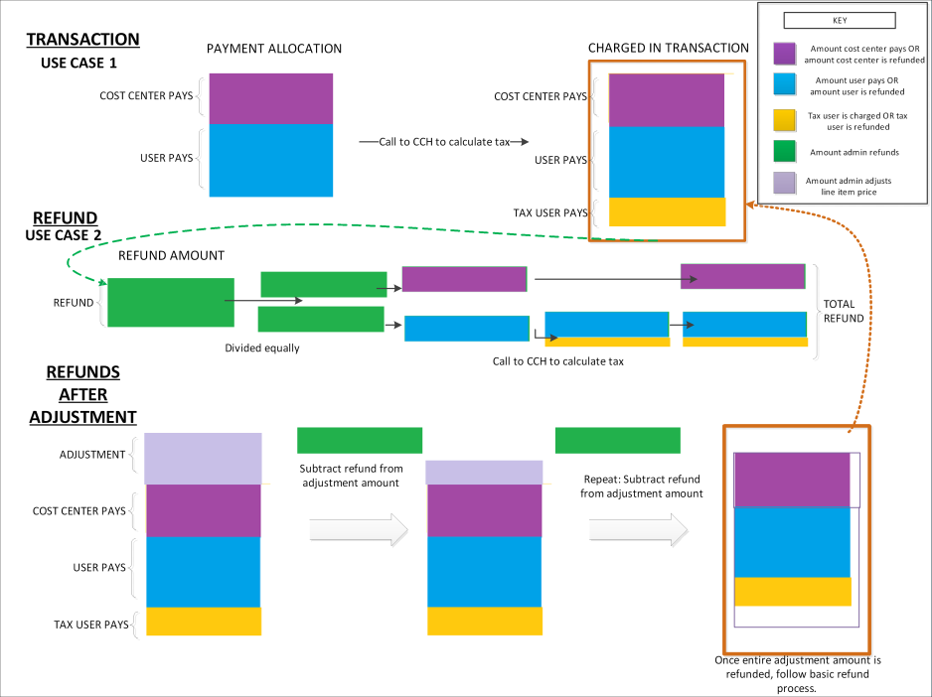

My Account - Reviews
Within the My Account section, the Reviews page displays all of the course reviews that you have submitted.
To access My Account:
- Select the Settings icon in the screen's upper-right corner and select the My Account link.
- Select the Navigation icon in the screen's upper-right corner and select the My Account link.
Select the Reviews tab on the left.
The tab name may appear differently in your portal, depending on the display name configured by the administrator in My Account Preferences.
Note: The Reviews tab only displays if enabled by the administrator.
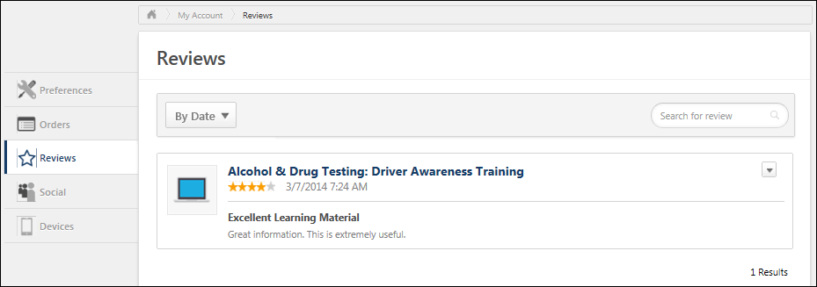
View Reviews
Each of the course reviews you have written are displayed on the Reviews page. By default, they are sorted by date.
Sort Reviews
The sort options now display in a drop-down. Click the drop-down to sort the reviews by date or rating.
Search Reviews
To search for a review by review title or review text, enter the search text in the Search for review field and select the Search icon. All reviews with the matching text in the review title or review text are displayed.
View LO Details
Selecting the name of the training opens the Ratings & Reviews tab of the LO Details page.
- Legacy Learning Details Page - See Learning Details Page (Legacy) - Ratings and Reviews Tab.
- New Learning Details Page - See Learning Details Page .
Edit Review
Users have the option to edit one of their reviews. To edit a review, click the drop-down and select the Edit option. Changes to the review potentially affect the overall rating for the course and the review displayed throughout the system.
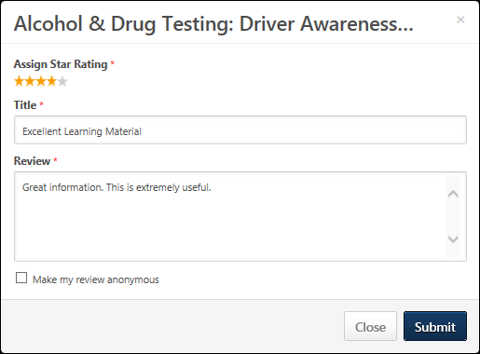
Delete Review
Users have the option to delete one of their reviews. To delete a review, click the drop-down and select the Delete option. This removes the review and updates the overall rating for the course.

My Account - Social
The Social tab is available on the My Account page and allows users to connect their Facebook profile with their user account.
To access My Account:
- Select the Settings icon in the screen's upper-right corner and select the My Account link.
- Select the Navigation icon in the screen's upper-right corner and select the My Account link.
Note: This tab only appears if it is enabled by your administrator. As the tab name is configurable by the administrator, the name may appear differently in your portal.
Permissions
PERMISSION NAME | PERMISSION DESCRIPTION | CATEGORY

Requisition: Edit Postings | Grants ability to edit the Job Postings page for a job requisition. In addition, this permission enables users to store user-level credentialing information for job board aggregation partners on Edge. This permission cannot be constrained. | Recruiting

User - Edit My Account Preferences | Allow users to view and modify their preferences on the My Account screen. This permission cannot be constrained. This is an end user permission. | Core
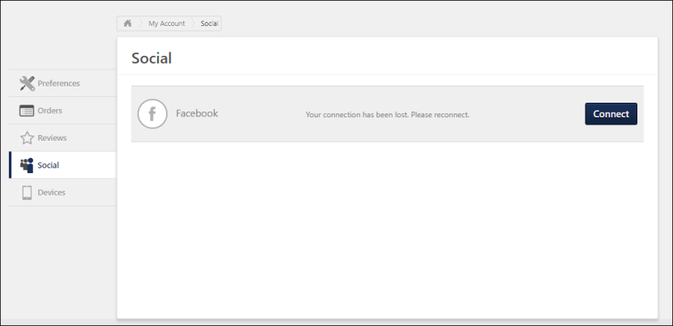
Connections
The following information is displayed for each available connection:
- Connection Logo - The logo for the connection displays to the left of the connection name. If the user is connected to the application, then the icon displays in color. If the user is not connected, then the icon displays in gray.
- Connection Name - This column displays the name of the connection, such as "Facebook."
- Connection Status - This column displays the status of the connection, indicating whether or not the user is connected. When the user is connected, the status displays the name under which the user is connected. If the user is not connected, then the column displays "Your connection has been lost. Please reconnect."
Connect to a Social Application
To connect to one of the available social applications on your My Account > Social page, select the Connect button to the right of the account name. If this button is not available, then this indicates that you are already connected to this application.
You are required to enter your credentials for the application to enable the connection between the social application and your portal.
With certain applications, the system is granted access to certain information:
- Facebook:
  - Your public profile
  - Your friends list - This allows for quick identification of common connections between a user's friend list and current employees.
  - Your email address associated with the account
Connection Options
The following options are available in the Options drop-down for any application to which you are already connected:
- Refresh - Select Refresh to refresh the connection.
- Disconnect - Select Disconnect to disconnect the connection.

My Account - Devices
The Devices tab of My Account enables users to register their mobile phones, tablets or computer. Users must register their mobile phone, tablet, or computer on this page in order to log in to the Cornerstone CSX application using a unique device key. Users can also disconnect devices from the Offline Player and mobile application.
To access My Account:
- Select the Settings icon in the screen's upper-right corner and select the My Account link.
- Select the Navigation icon in the screen's upper-right corner and select the My Account link.
Select the Devices tab on the left.
The tab name may appear differently in your portal, depending on the display name configured by the administrator in My Account Preferences.
Note: The Devices tab only displays if enabled by the administrator.
Permissions
PERMISSION NAME | PERMISSION DESCRIPTION | CATEGORY

My Account Devices - Manage | Grants ability to access the Devices tab of My Account. The Devices tab enables users to register their mobile devices with the Cornerstone application. This permission cannot be constrained. This is an end user permission. | Mobile
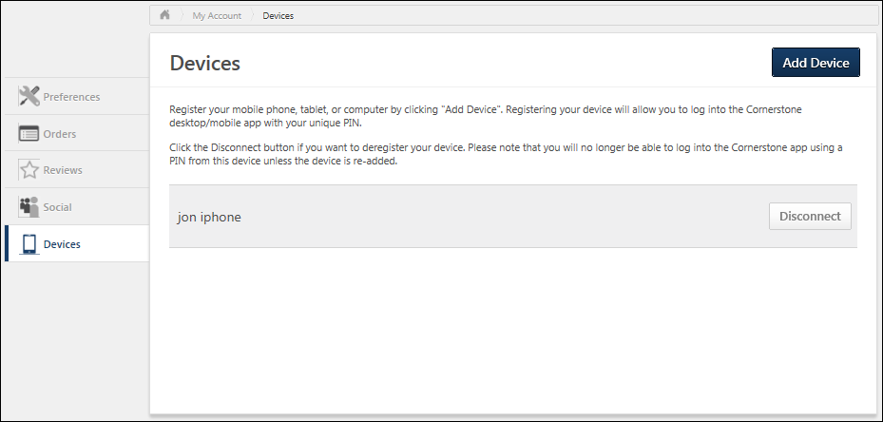
Add Device
To register a device, select the Add a Device button. The Add Device pop-up appears.
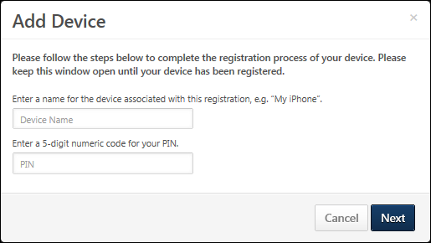
- In the first field, enter a name for the device. For example, if it is a mobile phone, you may enter "Mobile Phone" or the brand of mobile phone. Note: The Device Name entered here does not persist on the Devices page after a user’s initial login to the Cornerstone CSX app.
- In the second field, enter a temporary five-digit numeric PIN. This PIN must be five numbers, and it will be used during the Device Registration workflow, before configuring a permanent six-digit PIN which will be used to log into the Cornerstone CSX app from then on.
- Select Next to proceed to the next step.
- The next step displays instructions that must be completed within the Cornerstone CSX app. Do not close the pop-up until the registration process is complete within the Cornerstone CSX app because the Device Key and Temporary PIN information is required to register the mobile device within the app. The portal name will be pre-populated. After completing the registration process, select the CLOSE button. The registered mobile device appears in the Devices page.
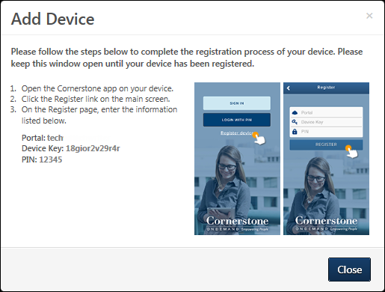
Add Device Via the Cornerstone CSX App
To finish registering your device to the Cornerstone CSX app:
- Open the Cornerstone CSX app on your device.
- Enter your portal name.
- Tap the Alternative Login Method link on the main screen.
- Tap Register Device and populate the following information:
  - Portal
  - Device Key
  - Temporary PIN
Disconnect a Registered Device
To disconnect a registered device, in the Devices table, select the Disconnect button next to the appropriate device. This opens a confirm pop-up. Select OK to disconnect, or select Cancel to stay connected.
After removing your device, you will not be able to log in using that device again, and a new pairing must be created.
Device Entries on the Devices Page
Users are asked to name their device in the initial step of the Device Registration process. This device name does not persist on the Devices page of My Account after the user’s initial login to the Cornerstone CSX app. Rather, users can expect to see a maximum of device entries, per user, per registered device.
Why are there two device entries?
Primary and backup device entries are created when a user registers their device. A backup entry is created, allowing users to log into the Cornerstone CSX app while offline.
How do these device entries appear?
After initial login, the device name input by the user will be replaced by two subsequent device entries: One will be the user’s first and last name. The other entry will be the user’s first and last name, appended with a 7-digit number. Within the latter entry, it is expected that digits change with each login, as a new session is generated each time the user logs in.

Share Permissions
The Share Permissions page enables managers to delegate certain types of approvals and abilities to other users in the system. Note: Only certain permissions can be shared, and some permissions can only be shared if certain conditions are met. See Share Permissions - Define Access by Permission on page 62 for additional information.
The Share Permissions page can be accessed in the following ways:
- My Account - Select the Settings icon in the upper-right corner of the screen, and select the My Account link. Then, from the Options drop-down menu, select Share Permissions.
- My Team - From the My Team page, place the computer cursor over the black arrow of your ID card on the left. From the list of options that appears to the right, select Share Permissions.
Permissions
PERMISSION NAME | PERMISSION DESCRIPTION | CATEGORY

Share Manager/Approver Permissions | Enables managers and approvers to delegate certain types of approvals and MyTeam viewing permissions to others. This permission is only relevant to managers and approvers. | Core
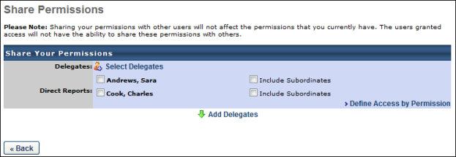
On the Share Permissions page, the manager can click the Select Delegates link to select the users to whom they are delegating manager permissions.
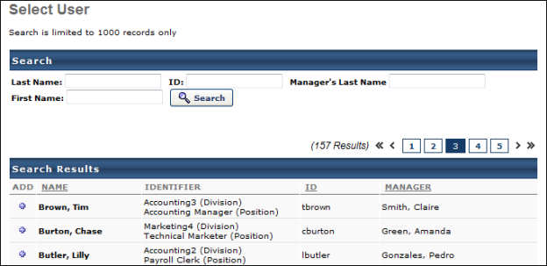
The users that are available in the Select User pop-up is determined by the constraints upon the Share Manager/Approver Permissions permission. The manager can search for delegates by Last Name, First Name, User ID, or Manager's Last Name. The manager can add as many users as necessary by clicking the Add icon to the left of the user's name. After selecting the appropriate delegates, click the Done button in the pop-up. The selected delegates appear in the Delegates section.
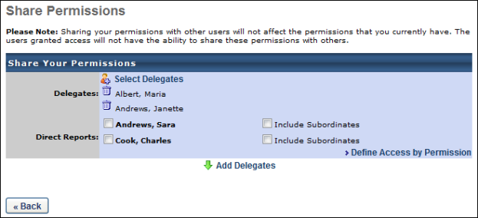
The manager then has two options to delegate manager permissions to the selected delegates:
- Add Delegates - Click the Add Delegates link to delegate all of the available permissions for all of the manager's selected direct reports to the selected delegates. See Share Permissions - Add Delegates on page 60 for additional information.
- Define Access by Permission - Click the Define Access by Permission link to select which permissions are delegated for which of the manager's employees to the selected delegates. See Share Permissions - Define Access by Permission on page 62 for additional information.

Share Permissions - Add Delegates
On the Share Permissions page, managers can delegate manager permissions to select delegates for certain direct reports. By default, all manager permissions are delegated.
The Share Permissions page can be accessed in the following ways:
- My Account - Select the Settings icon in the upper-right corner of the screen, and select the My Account link. Then, from the Options drop-down menu, select Share Permissions.
- My Team - From the My Team page, place the computer cursor over the black arrow of your ID card on the left. From the list of options that appears to the right, select Share Permissions.
Permissions
PERMISSION NAME | PERMISSION DESCRIPTION | CATEGORY

Share Manager/Approver Permissions | Enables managers and approvers to delegate certain types of approvals and MyTeam viewing permissions to others. This permission is only relevant to managers and approvers. | Core
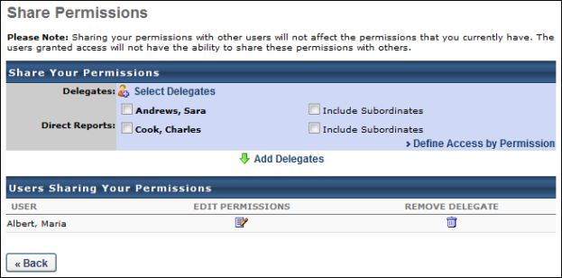
To utilize the Add Delegates functionality:
- From the Share Permissions page, click the Select Delegates link to select the delegates to which you are delegating permissions. At least one delegate must be selected. See Share Permissions on page 57 for additional information.
- In the Direct Reports section, select the direct reports for which you are delegating permissions. You may also delegate manager permissions for a direct report's subordinates by selecting the Include Subordinates option to the right of the direct report. At least one direct report or direct report's subordinates must be selected. The delegates selected in Step 1 will have all manager permissions for the selected direct reports.
- Click the Add Delegates link. The selected delegates are moved to the Users Sharing Your Permissions section. You may edit their permissions by clicking the Edit Permissions icon. This opens the Define Access by Permission page with all of the permissions selected. See Share Permissions - Define Access by Permission on page 62 for additional information.

Share Permissions - Define Access by Permission
On the Share Permissions page, managers can select which permissions are delegated to the selected delegates for each of the manager's direct and indirect reports.
The Share Permissions page can be accessed in the following ways:
- My Account - Select the Settings icon in the upper-right corner of the screen, and select the My Account link. Then, from the Options drop-down menu, select Share Permissions.
- My Team - From the My Team page, place the computer cursor over the black arrow of your ID card on the left. From the list of options that appears to the right, select Share Permissions.
Permissions
PERMISSION NAME | PERMISSION DESCRIPTION | CATEGORY

Share Manager/Approver Permissions | Enables managers and approvers to delegate certain types of approvals and MyTeam viewing permissions to others. This permission is only relevant to managers and approvers. | Core
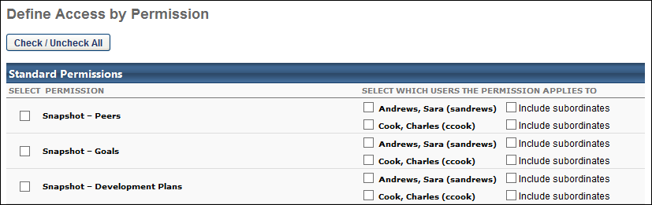
To utilize the Define Access by Permission functionality:
- From the Share Permissions page, click the Select Delegates link to select the delegates to which you are delegating permissions. At least one delegate must be selected. See Share Permissions on page 57 for additional information.
- From the Share Permissions page, click the Define Access by Permission link. This opens the Define Access by Permission page.
- In the Select Permission column, select the permissions that are being delegated to the selected delegates. At least one permission must be selected.
- In the Select which users the permission applies to column, select the direct reports for which you are delegating the permission. You may also delegate manager permissions for a direct report's subordinates by selecting the Include Subordinates option. At least one direct report or direct report's subordinates must be selected for each selected permission.
- After making the appropriate selections, click the Save button at the bottom of the page.
The following permissions can be shared:
PERMISSION NAME | PERMISSION DESCRIPTION | CATEGORY

Bio About - View | Enables user to view the Bio page for users within their permission constraints. This permission must be enabled to view the Transcript page within Universal Profile. If a user does not have this permission and they click a person's name or user photo within the Universal Profile, then the Bio page will not open.  On the Learner Home page, this permission also allows end users to view the Completions & Hours field, the training sidebar, and the Continue Learning carousel.  This permission can be constrained by Employee Relationship, OU, User's OU, User's Direct Reports, User Self and Subordinates, and User. Note: For security purposes, this permission is constrained to User Self and Subordinates by default. However, the permission constraints can be modified to allow users to view the Bio About page for other users. | Universal Profile

Bio Career Preferences - View | Grants ability to view the Bio - Career Preferences page for users within the permission constraints. This permission can be constrained by Employee Relationship, OU, User's OU, User Self and Subordinates, User's Direct Reports, User's Self, and User. | Universal Profile

Bio Resume - View | Enables user to view the Bio - Resume page for users within their permission constraints. If a user does not have permission to view the Bio - Resume page, then the Resume tab is not available. This permission can be constrained by Employee Relationship, OU, User's OU, User Self and Subordinates, User's Direct Reports, User's Self, and User. | Universal Profile

Employee Transcripts - Manager/Approver Access | Grants access to transcript (training record) screen of those for whom user is designated manager, approver or cost center approver. System administrators can access all user transcripts from this page. Link to this screen appears under Standard Reports/Track Employees. This is a manager/approver permission. This permission can be constrained by Employee Relationship and User's Direct Subordinates.  Note: The Employee Relationship constraint allows administrators to constrain the permission to a user’s custom employee relationship. For example, an administrator can select to restrict the Matrix Manager relationship to viewing user data for users who have that Matrix Manager indicated on their user record.  Note: The User's Direct Subordinates constraint allows administrators to constrain the data that a user can view to only the data for their direct reports. The user will not be able to view their own data with this constraint.  Note: By design, for any Track Employees report permission that is included in the Manager default security role, all of the manager's direct and indirect reports are included in the constraints, even if they are not selected in the permission constraints for the role. | Reports - Track Employee

Feedback Details - View | Enables user to view the Feedback Details page and provide feedback when they are requested to provide feedback. This permission cannot be constrained. This is an end user permission. | Universal Profile

Feedback - View and Post | Enables user to view the Feedback page of the Universal Profile and to post feedback. Users can only view the Feedback page for users within their permission constraints. Similarly, users can only post feedback for users within their permission constraints. This permission can be constrained by OU, User's OU, User Self and Subordinates, User's Self, and Employee Relationship. This is an end user permission. | Universal Profile

MyTeam Comments - Manage | Grants ability for manager (or others depending on constraints) to view Comments previously entered about their direct and indirect reports and also create new comments as well as attach files to comments. This permission can be constrained by OU, User's OU, User's Direct Reports, User, and User Self and Subordinates. The permission constraints determine for which users the Comments tab is available when viewing a user in My Team. Note: By design, for any My Team permission that is included in the Manager default security role, all of the manager's direct and indirect reports are included in the constraints, even if they are not selected in the permission constraints for the role. Note: If the user's permission is also constrained by User Self and Subordinates, then this overrides the User's Direct Reports constraint. | Core

MyTeam Competency Assessment - Manage | Grants access to MyTeam Competency Assessments page for subordinates (and other users depending on constraints). This is primarily a manager permission. This permission can be constrained by OU, User's OU, User's Direct Reports, User, and User Self and Subordinates. The permission constraints determine for which users the Competencies tab is available when viewing a user in My Team. Note: By design, for any My Team permission that is included in the Manager default security role, all of the manager's direct and indirect reports are included in the constraints, even if they are not selected in the permission constraints for the role. Note: If the user's permission is also constrained by User Self and Subordinates, then this overrides the User's Direct Reports constraint. | Performance

MyTeam Development Plans | Grants ability for manager (or others depending on constraints) to view and manage progress of development plans via MyTeam and Talent Profile. Managers can also edit a subordinate's development plan. This permission can be constrained by OU, User's OU, User's Direct Reports, User, and User Self and Subordinates. The permission constraints determine for which users the Dev Plans tab is available when viewing a user in My Team. Note: By design, for any My Team permission that is included in the Manager default security role, all of the manager's direct and indirect reports are included in the constraints, even if they are not selected in the permission constraints for the role. Note: If the user's permission is also constrained by User Self and Subordinates, then this overrides the User's Direct Reports constraint.  For organizations using the Redesigned Development Plans functionality, this permission enables the user to access the Development Plans List page. | Performance

MyTeam Goals | Grants ability for manager (or others depending on constraints) to view, edit and manage progress of Goals for their direct and indirect reports via MyTeam and Talent Profile. This permission can be constrained by OU, User's OU, User's Direct Reports, User, Employee Relationships, and User Self and Subordinates. The permission constraints determine for which users the Goals tab is available when viewing a user in My Team.  Note: By design, for any My Team permission that is included in the Manager default security role, all of the manager's direct and indirect reports are included in the constraints, even if they are not selected in the permission constraints for the role.  Note: If the user's permission is also constrained by User Self and Subordinates, then this overrides the User's Direct Reports constraint.  Note: If this permission is constrained by Employee Relationships, assigned co-planners can create, view, and approve goals. | Performance

MyTeam Performance Reviews | Grants ability for manager (or others depending on constraints) to view Performance Review results for their direct and indirect reports, via MyTeam and Talent Profile. This permission can be constrained by OU, User's OU, User's Direct Reports, User, and User Self and Subordinates. The permission constraints determine for which users the Reviews tab is available when viewing a user in My Team. Note: By design, for any My Team permission that is included in the Manager default security role, all of the manager's direct and indirect reports are included in the constraints, even if they are not selected in the permission constraints for the role. Note: If the user's permission is also constrained by User Self and Subordinates, then this overrides the User's Direct Reports constraint. | Performance

MyTeam Resume - Manage | Grants access to My Team Resume page for subordinates (and other users depending on constraints). This is primarily a manager permission. This permission can be constrained by OU, User's OU, User's Direct Reports, User, and User Self and Subordinates. The permission constraints determine for which users the Resume tab is available when viewing a user in My Team. Note: By design, for any My Team permission that is included in the Manager default security role, all of the manager's direct and indirect reports are included in the constraints, even if they are not selected in the permission constraints for the role. Note: If the user's permission is also constrained by User Self and Subordinates, then this overrides the User's Direct Reports constraint. | Talent/Succession

MyTeam To Do's - Manage | Grant's access for manager (or others depending on constraints) to view "to do" tasks for their team and also create new to do's and manage progress on behalf of the user. This permission can be constrained by OU, User's OU, User's Direct Reports, User, and User Self and Subordinates. The permission constraints determine for which users the Create To Do's action link and To Do's section is available when viewing a user in My Team. Note: By design, for any My Team permission that is included in the Manager default security role, all of the manager's direct and indirect reports are included in the constraints, even if they are not selected in the permission constraints for the role. Note: If the user's permission is also constrained by User Self and Subordinates, then this overrides the User's Direct Reports constraint. | Performance

Past Training Requests Report | Grants access to Past Requests, an interactive report that displays training requests the user has already approved, deferred, or denied. The user may change the approval decision for training that an employee has not yet registered for. This is an approver permission.  Note: By design, for any Track Employees report permission that is included in the Manager default security role, all of the manager's direct and indirect reports are included in the constraints, even if they are not selected in the permission constraints for the role. | Reports - Track Employee

Snapshot - Competencies | Enables user to view the Competencies widget and subpage within the Universal Profile - Snapshot page for users within their permission constraints. This permission can be constrained by OU, User's OU, User Self and Subordinates, User, User's Self, User's Manager, User's Superiors, User's Subordinates, User's Direct Reports, and Employee Relationship. Best Practice: For most users, this permission should be constrained by User Self and Subordinates. | Universal Profile

Snapshot - Development Plans | Enables user to view the Development Plans widget and subpage within the Universal Profile - Snapshot page for users within their permission constraints. This permission can be constrained by OU, User's OU, User Self and Subordinates, User, User's Self, User's Manager, User's Superiors, User's Subordinates, User's Direct Reports, and Employee Relationship. Best Practice: For most users, this permission should be constrained by User Self and Subordinates. | Universal Profile

Snapshot Goals - Manage | Enables user to manage their own goals, and others public goals, using the Goals widget and subpage within the Universal Profile - Snapshot page, for users within their permission constraints. This permission can be constrained by Employee Relationship, OU, User's OU, User Self and Subordinates, User, User's Self, User's Manager, User's Superiors, User's Subordinates, and User's Direct Reports.  Best Practice: For most users, this permission should be constrained by User Self and Subordinates. | Universal Profile

Snapshot - Peers | Grants ability to view the Peers widget within the Universal Profile - Snapshot page. This permission can be constrained by OU, User's OU, User's Self and Subordinates, User, User's Self, User's Subordinates, and User's Direct Reports. This is an end user permission. | Universal Profile

Snapshot - Reviews | Enables user to view the Reviews widget and subpage within the Universal Profile - Snapshot page for users within their permission constraints. This permission can be constrained by OU, User's OU, User Self and Subordinates, User, User's Self, User's Manager, User's Superiors, User's Subordinates, User's Direct Reports, and Employee Relationship. Best Practice: For most users, this permission should be constrained by User Self and Subordinates. | Universal Profile

Snapshot Main - View | Enables user to view the Snapshot page for users within their permission constraints. This permission can be constrained by Employee Relationship, OU, User's OU, User Self and Subordinates, User, User's Self, User's Manager, User's Superiors, User's Subordinates, and User's Direct Reports. Best Practice: For most users, this permission should be constrained by User Self and Subordinates. | Universal Profile

Snapshot Succession – Manage | Enables user to view the Succession widget and subpage within the Universal Profile - Snapshot page for users within their permission constraints. On this page, users can view and manage successors and successor ratings. Users cannot view their own Succession widget and subpage, regardless of permissions. This permission can be constrained by OU, User's Subordinates, User's Direct Subordinates, and Employee Relationship. | Universal Profile
Only users who are in the system-defined Manager role can share the following permissions, and they are only able to share these permissions if the system-defined Manager role contains these permissions:
PERMISSION NAME | PERMISSION DESCRIPTION | CATEGORY

Approve Training by Manager | Grants ability to approve training requests of those for whom the user is the designated manager.  Note: Delegating this permission only applies when "Manager" is designated in the Approval Workflow. If the Approval Workflow contains a custom employee relationship - even if the Manager happens to fill that role - the approval will not flow to the delegate. | Learning

Assign Training | Grants ability to assign learning objects to the transcripts of those for whom the user is the assigned manager, approver or cost center approver. This is a manager/approver permission. | Learning

