Learning Assignment Tool March 2024

Table of Contents
Learning Assignment Tool - Overview 1
Learning Assignment Tool Preferences 6
Enforcing Prerequisites for Learning Assignment Tool - FAQ 11
Manage Assignments Page 13
Create Learning Assignment - Overview 19
Create Learning Assignment - Overview 23
Create Learning Assignment - Setup 27
Create Learning Assignment - Options 34
Create Learning Assignment - Schedule 43
Create Learning Assignment - Users 53
Create Learning Assignment - Confirm 70
Copy Learning Assignment 76
Create Draft Learning Assignment 80
Learning Assignment Use Cases 81
Standard Learning Assignment - Create 82
Dynamic Learning Assignment - Create 90
Dynamic Recurring Learning Assignment - Create 100
Use Cases - Common Uses for Dynamic Removal 109
Learning Assignment Tool - Due Date Use Cases 111
Assignment Summary Page 114
Modification History 129
Dynamic Reassignment Overview 130
Dynamic Reassignment Overview 133
Dynamic Reassignment - Assignment Summary Page 136
Dynamic Reassignment - Emails 139
Dynamic Removal 140
Batch Update Dynamic Assignment Tool 145

Learning Assignment Tool - Overview
The Learning Assignment Tool (LAT) allows administrators to easily create learning assignments and deliver training to users, organizational units (OUs) and groups. Administrators can also track and manage assignments via the Manage Assignments Page, and view data related to specific assignments via the Assignment Summary page.
Use Cases
- See Standard Learning Assignment - Create on page 81 for additional information.
- See Dynamic Learning Assignment - Create on page 90 for additional information.
- See Dynamic Recurring Learning Assignment - Create on page 100 for additional information.
Permissions
PERMISSION NAME | PERMISSION DESCRIPTION | CATEGORY

Assignment Tool - Dynamic Reassignment | Grants ability to enable/disable Dynamic Re-assignment for an assignment after submission. When Dynamic Re-assignment is enabled, users that meet the User Criteria again (after previously being dynamically removed) are re-assigned. This permission is dependent on the Assignment - Standard, Dynamic - Standard and Dynamic, and Dynamic Assignment - Standard and Dynamic - Recurrence permissions. This permission cannot be constrained. This is an administrator permission. | Learning - Administration

Assignment Tool Preferences | Grants access to Assignment Tool Preferences where an administrator can activate the new Assignment Tool and configure the processing options and settings to create Learning Assignments. This permission cannot be constrained. This is an administrator permission. | Learning - Administration

Assignment Tool - Training Start Date | Grants ability to configure a Training Start Date when creating a Standard Learning Assignment. The Training Start Date is the date that users will be able to start the training. This permission is dependent on the Assignment Tool - Standard, Assignment Tool - Standard and Dynamic, and Assignment Tool - Standard and Dynamic - Recurrence permissions. This permission cannot be constrained. This is an administrator permission. | Learning - Administration

Assignment Tool - Bypass User Payment | Grants ability to bypass user payment when creating a Learning Assignment. When user payment is bypassed, users are automatically registered into the training regardless of whether or not payment is required. This permission is dependent on the Assignment Tool - Standard, Assignment Tool - Standard and Dynamic, and Assignment Tool - Standard and Dynamic - Recurrence permissions. This permission cannot be constrained. This is an administrator permission. | Learning - Administration

Assignment Tool - Dynamic Removal | Grants ability to enable/disable Dynamic Removal from within the Learning Assignment create workflow and/or the Assignment Summary page. When Dynamic Removal is enabled, users that no longer meet the User Criteria are removed from the Learning Assignment. This permission is dependent on the Assignment Tool - Standard, Assignment Tool - Standard and Dynamic and Assignment Tool - Standard and Dynamic - Recurrence permissions. This permission cannot be constrained. This is an administrator permission. | Learning - Administration

Assignment Tool - Email Settings - Manage | Grants ability to manage email settings when creating a Learning Assignment. This includes the ability to select all four email settings, set up Custom Emails (create new emails and set existing emails as active/inactive), set up Ad-Hoc Emails, and enable/disable Assign Training and Register Training email triggers when Training Specific Emails is selected. This permission is dependent on the Assignment Tool - Standard, Assignment Tool - Standard and Dynamic, and Assignment Tool - Standard and Dynamic - Recurrence permissions. This permission can be constrained by OU, User, User Self and Subordinates, and User's OU. If this permission is constrained, then only users within the constraints will receive the emails. This is an administrator permission. | Learning - Administration

Assignment Tool - Email Settings - View | Grants ability to view and select email settings when creating a Learning Assignment. This includes the ability to select Training Specific Emails, Custom Emails, or No Emails but does not grant ability to manage the actual Email Settings (cannot configure Custom Emails or Ad-Hoc Email and cannot enable/disable Assign Training and Register Training email triggers when Training Specific Emails is selected). This permission is dependent on the Assignment Tool - Standard, Assignment Tool - Standard and Dynamic, and Assignment Tool - Standard and Dynamic - Recurrence permissions. This permission can be constrained by OU, User, User Self and Subordinates, and User's OU. If this permission is constrained, then only users within the constraints will receive the emails. This is an administrator permission. | Learning - Administration

Assignment Tool - Processing Start Time | Grants ability to configure a Processing Start Time when creating Learning Assignments and/or Certification Proxy Enrollments. The Processing Start Time is the time of day that users will start being processed. For Learning Assignments, this permission is dependent on the Assignment - Standard, Assignment - Standard and Dynamic, Assignment - Standard and Dynamic - Recurrence permissions. For Certification Proxy Enrollments, this permission is dependent on the Proxy Enrollment for Certification - Create Dynamic and Proxy Enrollment for Certification - Create Standard permissions. This permission cannot be constrained. This is an administrator permission. | Learning - Administration

Assignment Tool - Restrict to Users' LO Availability | This permission does not grant ability to any specific functionality and can only be constrained by Users' LO Availability. If this permission is constrained, then the user creating the Learning Assignment can only select and assign training that is within the users own availability. This permission is dependent on the Assignment Tool - Standard, Assignment Tool - Standard and Dynamic, and Assignment Tool - Standard and Dynamic - Recurrence permissions. This is an administrator permission. | Learning - Administration

Assignment Tool - Session Seat Increase | Grants ability to increase the number of seats for an Instructor Led Training Session when creating a Learning Assignment if there are not enough seats available. This option to increase seats only appears if a Session is selected for the Assignment. This permission is dependent on the Assignment Tool - Standard, Assignment Tool - Standard and Dynamic, and Assignment Tool - Standard and Dynamic - Recurrence permissions. This permission cannot be constrained. This is an administrator permission. | Learning - Administration

Assignment Tool - Standard and Dynamic - Recurrence | Grants ability to create Standard (one-time) and Dynamic (continuous) Learning Assignments to directly assign training to users. Also grants ability to enable/disable Recurrence when creating a Dynamic Learning Assignment. This permission can be constrained by OU, Provider, Training Item, Training Type, User, User Self and Subordinates, and User's OU. If this permission is constrained by Location, Provider, Training Type, or Training Item, then they can only assign training within the constraints. If this permission is constrained by OU, User, User Self and Subordinates, or User's OU, then they can only assign to and view assignments created by users within the constraints. This is an administrator permission. | Learning - Administration

Assignment Tool - Standard and Dynamic | Grants ability to create Standard (one-time) and Dynamic (continuous) Learning Assignments to directly assign training to users. This permission can be constrained by OU, Provider, Training Item, Training Type, User, User Self and Subordinates, and User's OU. If this permission is constrained by Location, Provider, Training Type, or Training Item, then they can only assign training within the constraints. If this permission is constrained by OU, User, User Self and Subordinates, or User's OU, then they can only assign to and view assignments created by users within the constraints. This is an administrator permission. | Learning - Administration

Assignment Tool - Standard | Grants ability to create Standard (one-time) Learning Assignments to directly assign training to users. This permission can be constrained by OU, Provider, Training Item, Training Type, User, User Self and Subordinates, and User's OU. If this permission is constrained by Location, Provider, Training Type, or Training Item, then they can only assign training within the constraints. If this permission is constrained by OU, User, User Self and Subordinates, or User's OU, then they can only assign to and view assignments created by users within the constraints. This is an administrator permission. | Learning - Administration

Assignment Tool - Upload CSV File | Grants ability to upload a .csv file as the User Criteria when creating a Learning Assignment. This permission is dependent on the Assignment Tool - Standard, Assignment Tool - Standard and Dynamic, and Assignment Tool - Standard and Dynamic - Recurrence permissions. This permission cannot be constrained. This is an administrator permission. | Learning - Administration

Self Registration Groups - View | Grants ability to view Self Registration Groups when selecting Availability (for Training, Tasks, learning assignments, etc.) or User Criteria (for Learning Assignments). This permission can be constrained by OU and User's OU. This is an administrator permission. | Core Administration
Considerations
The Learning Assignment Tool is not available in the following system areas:
- Training Plan Assignment
- Certification Proxy Enrollment
- Curricula Versioning
- Material Versioning
- ILT Roster

Learning Assignment Tool Preferences
The Learning Assignment Tool Preferences page allows administrators to configure default settings for Dynamic Reassignment options and the High User Count warning.
To access the Assignment Preferences page, go to Admin > Tools > Learning > Learning Preferences and click the Assignment Tool Preferences link under General Learning Preferences.
Permissions
PERMISSION NAME | PERMISSION DESCRIPTION | CATEGORY

Assignment Tool - Dynamic Reassignment | Grants ability to enable/disable Dynamic Re-assignment for an assignment after submission. When Dynamic Re-assignment is enabled, users that meet the User Criteria again (after previously being dynamically removed) are re-assigned. This permission is dependent on the Assignment - Standard, Dynamic - Standard and Dynamic, and Dynamic Assignment - Standard and Dynamic - Recurrence permissions. This permission cannot be constrained. This is an administrator permission. | Learning - Administration

Assignment Tool Preferences | Grants access to Assignment Tool Preferences where an administrator can activate the new Assignment Tool and configure the processing options and settings to create Learning Assignments. This permission cannot be constrained. This is an administrator permission. | Learning - Administration
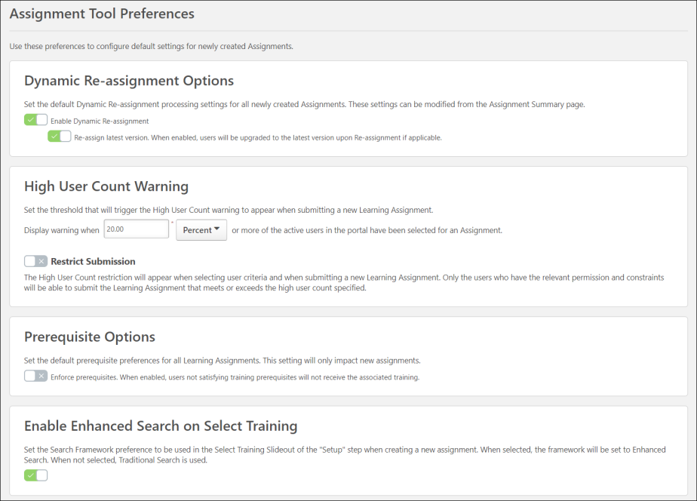
Dynamic Re-assignment Options
The Dynamic Re-assignment Options section provides the following options:
Enable Dynamic Re-assignment - This option is turned off by default. To enable this option, toggle the switch to the On (green) position. When enabled, all newly created assignments will have Dynamic Re-Assignment functionality on by default, even if the administrator creating the assignment does not have the permission to configure this setting from the Assignment Summary page. When this setting is enabled, assignments will re-process users who were previously dynamically removed from the assignment but now meet the user criteria for the assignment again and automatically re-assign the training to them if it was on the removed tab of their transcript. For more information,
See Dynamic Reassignment Overview on page 133 for additional information.
If this setting is enabled, an additional option becomes available:
- Upgrade users to the latest version upon re-assignment - This sub-option will appear when the Dynamic Re-assignment option is turned ON. To enable this option, toggle the switch to the On position. This option is turned off by default. When enabled, users being re-assigned will receive the latest version the learning object (LO) if it has been reversioned between the time it was removed and the time it is reassigned. For example, if in January 2016 a user was initially assigned Compliance Training (Version 1), and the training was upgraded two times during the year, when the user is reassigned the Compliance Training in January 2017, they will automatically receive Compliance Training (Version 3) on their transcripts.
High User Count Warning
Administrators may set a threshold percentage or number of users which will trigger the High User Count warning to appear on the Confirm step of the learning assignment creation process.
- When this is set by percentage, then the warning is triggered when the percentage of the active user population who are included in the learning assignment is equal to or higher than the specified percentage.
- When this is set by users, then the warning is triggered when the number of users who are included in the learning assignment is equal to or higher than the specified number.
Example: If the threshold percentage is set to 30%, a warning message will appear for administrators on the Confirm step of the Learning Assignment Tool if they have set user criteria which includes more than 30% of the active users in their portal.
To set a threshold percentage or number of users:
- Select whether the warning is triggered by a percentage or number of users.
- Specify the appropriate percentage or number of users that should trigger the warning.
- Select the Save button at the bottom of the Assignment Tool Preferences page.
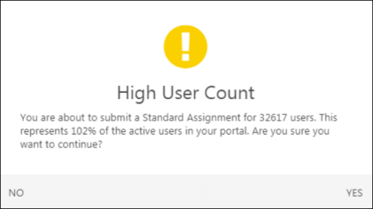
Restrict Submission
When this option is enabled, only administrators who have the Assignment Tool - Submit Draft permission can submit a learning assignment if it exceeds the High User Count threshold. If an administrator who does not have one of these permissions creates an assignment that exceeds the High User Count threshold, the administrator can save their assignment as a draft, but they cannot submit the assignment for processing. A draft assignment must be reviewed and approved by an administrator who has permission to submit draft assignments.
When this option is not enabled, then any learning assignment that exceeds the High User Count threshold will trigger a warning, but the assignment can still be submitted.
Prerequisite Options
The Prerequisite Options section allows you to determine whether or not training prerequisite requirements will be respected for all learning assignments. To enforce prerequisites globally:
- Toggle the Prerequisites Enforced switch to the On (green) position. Alternatively, if you do not want all learning assignments to enforce prerequisites, leave this switch toggled to the Off (gray) position.
- Click the Save button at the bottom of the screen to save and apply any changes made to the Assignment Tool Preferences page. Changes will only apply to new assignments created in the future. Existing assignments will not be effected by any changes.
Once the option to enforce prerequisites has been enabled and saved, learning assignments created after that point will NOT assign training to users who have not yet completed any required prerequisites for the training included in the assignment, unless the administrator creating the assignment alters this setting at the learning assignment level, OR unless an administrator with the permission to manage Assignment Tool Preferences disables the Prerequisites Enforced setting again globally.
See Enforcing Prerequisites for Learning Assignment Tool - FAQ on page 11 for additional information.
Use Case: Prerequisites Enforced Globally
Bradley is a Learning and Compliance manager at ABC Electric, and he notices that many of his employees are being assigned to tasks and shifts they are not trained for, creating a safety and regulatory risk. He discovers that some of his administrators are incorrectly assigning training by bypassing required prerequisites through the Learning Assignment Tool.
To remedy the problem, Bradley enables the Enforce Prerequisites option on the Assignment Tool Preferences page. This allows his administrators to easily create learning assignments which obey prerequisite requirements and NOT assign training to users who have not yet completed the training's required prerequisites.
Use Case: Prerequisite Requirements Obeyed by Assignment
Jackie is a learning administrator for ABC Electric. Jackie creates a dynamic learning assignment to assign the Advanced Transformer Repair curriculum to all New York employees. Because the Enforce Prerequisites option is enabled, any user who does not meet the prerequisite requirements for the curriculum will not be assigned the curriculum.
Henry, an employee in the New York division, was included in the assignment, but he does not receive the Advanced Transformer Repair curriculum because he has not yet taken the prerequisite curriculum which is required for the Advanced Transformer Repair curriculum. Weeks later, Henry completes the prerequisite training, and the next time the dynamic learning assignment processes, he receives the Advanced Transformer Repair Curriculum because the assignment recognizes that he now meets the prerequisite requirements for the training.
Enable Enhanced Search on Select Training
With this option enabled, administrators can use Enhanced Search engine in the Search Training Modal within the Create Assignment Workflow. To read more, See Create Learning Assignment - Setup on page 27 for additional information.
The Enhanced Search supports all the filters in the Search Training Modal except for the Description filter. The Enable Enhanced Search on Select Training is enabled by default. Administrators can switch back to Traditional Search (SQL) by turning off this option.
Note: Unlike Enhanced Search in other pages, the Enhanced Search in Search Training Modal only considers the Title when completing a search.
Considerations:
- The current search results are sorted alphabetically. However, the Enhanced Search results are displayed by Relevance by default.​
- The Enhanced Search prioritizes learning objects localized to the language you currently have set up as the display language.
- In most cases, a newly created or updated learning object is updated within Enhanced Search results in 15 minutes or less with few exceptions.
  - Training was included as a part of a large data ingestion, or a large bulk update was completed. In this case, the time for the update to be made available within search results may depend on the amount or the size of the change.
  - The training was created or updated at the exact moment of an update to the data set. In this case, we would expect the learning object to be available beyond the base 15-minute time-frame.
Save
Click the Save button at the bottom of the screen to save and apply any changes made to the Assignment Tool Preferences page. Changes will only apply to new assignments created in the future. Existing Assignments will not be effected by any changes.

Enforcing Prerequisites for Learning Assignment Tool - FAQ
All questions and example scenarios described below assume that the Enforce Prerequisites setting is enabled via Assignment Tool Preferences.
Example 1: Prerequisite is Included in Dynamic Recurring Learning Assignment
Q: Training A is a prerequisite for Training XYZ, and Training A is also included in a dynamic learning assignment which is set to recur on a yearly basis. John, an employee, has completed Training A and has been reassigned the training due to recurrence. If Training XYZ is later assigned to John and the Enforce Prerequisites option is enabled in his portal, will John receive Training XYZ?
A: No, John will not receive Training XYZ. Although he previously completed the prerequisite Training A, he has been assigned a new instance of the training and has not completed this instance prior to the assignment processing. Once John completes the prerequisite, he will be assigned Training XYZ.
Example 2: Prerequisites Added to Training Before Assignment Processes
Q: Heather created a learning assignment which is set to process on a future date, and the training included in the assignment did not have any prerequisites selected when Heather originally created the assignment. If she later adds a prerequisite to the training BEFORE the assignment processes, will the assignment enforce the newly added prerequisite?
A: Yes. Because the assignment has not yet processed, any changes made to the training will be applied to the assignment when it does process.
Example 3: User Completes Prerequisite After Dynamic Assignment Initially Processes
Q: A dynamic recurring learning assignment includes training with an associated prerequisite, and the assignment is set to process on a daily basis. If a user has not completed the prerequisite at the time the assignment processes but later completes the prerequisite training, will they receive the training in the assignment?
A: Yes. If the user meets the user criteria for the assignment, once they complete the prerequisite training, they will be assigned the training within the assignment the next time the assignment processes.
Example 4: Is User Notified They Did Not Receive Assignment Due to Incomplete Prerequisite?
Q: A user has not received an assignment because they failed to complete a prerequisite for the training included in the assignment. How will they know that they should have received the training but did not due to the incomplete prerequisite? Will they see the training on their transcript with a Pending Prerequisite status?
A: No. This functionality is not intended to be a tool used to manage prerequisites within the Learning Assignment Tool. This functionality is designed to prevent administrators from creating assignments that ignore prerequisite requirements. The training will not be assigned at all and will not be seen on the user’s transcript.
Example 5: Is the Enforce Prerequisites Option Copied When Copying an Assignment?
Q: If an administrator copies a learning assignment, is the Enforce Prerequisites option copied to the new assignment?
A: No. When copying a learning assignment, the Enforce Prerequisites option will NOT be copied to the new assignment. This setting respects default value set on the Assignment Tool Preferences page.
Troubleshooting Use Case
A new administrator at ACME Corp examines a dynamic learning assignment which has been active for a few months, and the administrator has just realized that some users haven’t been receiving the assignment. This administrator uses custom reporting to identify the users that have not received the training and determine whether or not these users completed the prerequisite training for the assignment.

Manage Assignments Page
The Manage Learning Assignments page allows administrators to easily search for and manage previously created learning assignments, as well as create new learning assignments. This page is also the landing page for the Learning Assignment Tool.
To access the Manage Learning Assignments page, go to Admin > Tools > Learning and click the Assignment Tool link.
Permissions
PERMISSION NAME | PERMISSION DESCRIPTION | CATEGORY

Assignment Tool - Delete Draft | Grants ability to delete any draft learning assignment. This includes drafts that were submitted for override, drafts created by self, or any other unneeded drafts created by other administrators. This permission can be constrained by OU, User's OU, and User's Corporation. This is an administrator permission.  Administrators can only delete drafts that were created by administrators who are within the constraints on this permission. | Learning - Administration

Assignment Tool - Standard and Dynamic - Recurrence | Grants ability to create Standard (one-time) and Dynamic (continuous) Learning Assignments to directly assign training to users. Also grants ability to enable/disable Recurrence when creating a Dynamic Learning Assignment. This permission can be constrained by OU, Provider, Training Item, Training Type, User, User Self and Subordinates, and User's OU. If this permission is constrained by Location, Provider, Training Type, or Training Item, then they can only assign training within the constraints. If this permission is constrained by OU, User, User Self and Subordinates, or User's OU, then they can only assign to and view assignments created by users within the constraints. This is an administrator permission. | Learning - Administration

Assignment Tool - Standard and Dynamic | Grants ability to create Standard (one-time) and Dynamic (continuous) Learning Assignments to directly assign training to users. This permission can be constrained by OU, Provider, Training Item, Training Type, User, User Self and Subordinates, and User's OU. If this permission is constrained by Location, Provider, Training Type, or Training Item, then they can only assign training within the constraints. If this permission is constrained by OU, User, User Self and Subordinates, or User's OU, then they can only assign to and view assignments created by users within the constraints. This is an administrator permission. | Learning - Administration

Assignment Tool - Standard | Grants ability to create Standard (one-time) Learning Assignments to directly assign training to users. This permission can be constrained by OU, Provider, Training Item, Training Type, User, User Self and Subordinates, and User's OU. If this permission is constrained by Location, Provider, Training Type, or Training Item, then they can only assign training within the constraints. If this permission is constrained by OU, User, User Self and Subordinates, or User's OU, then they can only assign to and view assignments created by users within the constraints. This is an administrator permission. | Learning - Administration

Assignment Tool - Submit Draft | Grants ability to create and submit a learning assignment that exceeds the High User Count threshold even if the Restrict Submission toggle is enabled in Assignment Tool Preferences. Administrators with this permission can also resume and submit a draft learning assignment that was created by another administrator that exceeded the High User Count threshold. This permission can be constrained by OU, User's OU, and User's Corporation. This is an administrator permission.  Administrators can only submit learning assignments that were created by administrators who are within the constraints on this permission. | Learning - Administration

Assignment Tool - View all Drafts | Grants ability to view any learning assignment draft. This includes both drafts that need an override and drafts created by other administrators.​ This permission can be constrained by OU, User's OU, and User's Corporation. This is an administrator permission.  Administrators can only view drafts that were created by administrators who are within the constraints on this permission. | Learning - Administration

Proxy Enrollment for Certification - Create Dynamic | Grants administrator ability to create dynamic proxy enrollments for certifications. This is an administrator permission. | Learning - Administration

Proxy Enrollment for Certification - Create Standard | Grants administrator ability to create standard proxy enrollments for certifications. This is an administrator permission. | Learning - Administration
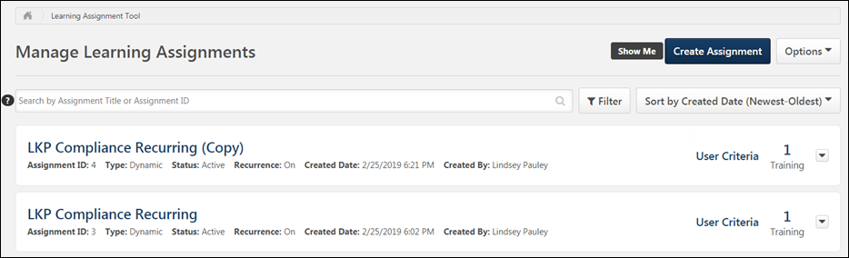
Create Assignment
Click the Create Assignment button to begin creating a new learning assignment. For detailed information about creating a new assignment, See Create Learning Assignment - Overview on page 23 for additional information.
Options
The Options button allows administrators with the appropriate permissions to access the Certification Proxy Enrollment features, if applicable. However, the Learning Assignment Tool functionality does not apply to these features. Certification assignments must be managed using the proxy enrollment functionality. The following link is available in the Options drop-down menu:
- Certification Enrollments - Click this link to navigate to the Proxy Enrollment page for certifications. See Certification Proxy Enrollment Overview.
Search Assignments
Existing learning assignments can be searched for and filtered using a variety of criteria. You can find learning assignments using any of the following search features:
- Search bar - Type an assignment title or assignment ID into this search bar to find learning assignments based on the title or ID. Press Enter on your keyboard or click the search glass icon to process search results according to the criteria you input.
- Filter - Click this button for an advanced list of filters. An additional section appears on the page, and the following filter options are available:
  - Training Title - Enter a training title into this field to search for learning assignments by the title of the training assigned within the learning assignment. Old proxy enrollments that were converted to learning assignments display their training title as the assignment title, but they cannot be searched for using their assignment title. To search for these old proxy enrollments, enter the training title for the proxy enrollment/assignment into this Training Title field.
  - Created By - Enter the name of a user to search for learning assignments created by that user. This includes users who created a draft assignment.
  - Course Code - Enter a course code to search for learning assignments with training associated with that course code. Note: If your portal does not have the course code feature enabled, this field will be hidden.
  - Created Date - Select a date range from the drop-down menu or enter a custom date range within which the assignment(s) was created. The Last 120 Days option is selected by default.
  - Type - Use this drop-down menu to select standard learning assignments, dynamic learning assignments, or both.
  - Status - Use this drop-down menu to select one or more learning assignment statuses.
  - Recurrence - Use this drop-down menu to filter by dynamic learning assignments that are recurring or not recurring.
  - Requirement - Click Select Requirement and select a requirement from the Select Requirement flyout. Requirement is only available if Required Training Tagging is active in the portal. The assignments set as required are marked with a Required indicator. See Required Training Tagging Overview.
  - User Criteria - Use the User Criteria drop-down menu to filter learning assignments by assigned user criteria.
  - Source - Use this drop-down menu to filter by how the training was assigned to users. Filter options include:
    - Created with Learning Assignment Tool - This indicates the training was assigned to users via a learning assignment from the Learning Assignment Tool.
    - Created with API - This indicates the training was assigned to users via an API.
    - Created with ILT Roster - This indicates that users were assigned to a session using the Upload Bulk Users option on the Roster page for the session.
Click the Reset Filters link to remove any filters you have selected and reset them to their default values. Click the Apply Filters button to process search results according to your selected filters.
- Sort By drop-down menu - Select sorting criteria from this drop-down menu. The learning assignments that display below will automatically refresh and redisplay according to the new Sort criteria. Available sorting criteria includes:
  - Created Date (Newest - Oldest)
  - Created Date (Oldest - Newest)
  - Assignment Title (A-Z)
  - Assignment Title (Z-A)
  - Created By (A-Z)
  - Created By (Z-A)
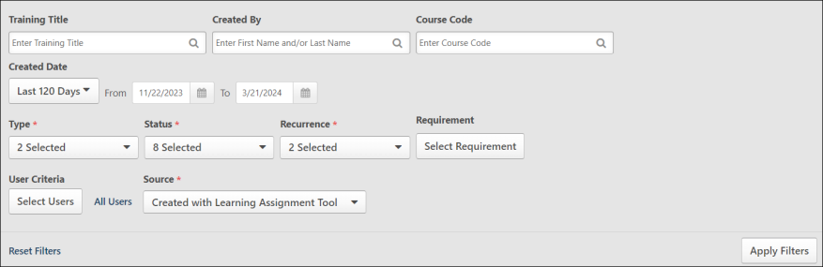
Learning Assignment Cards
Each previously created learning assignment displays in a card with basic information about the assignment, and options may be available for each assignment depending on its current status and assignment type. The information that displays for each past learning assignment includes:
- Assignment Title - This field displays the title provided by the assignment creator. Click this title to open the Assignment Summary page for assignments that have been submitted. For assignments in the Draft status, click the title to open the create workflow and resume the draft. Note: Proxy enrollments that were created prior to the activation of the Learning Assignment Tool use the title of their learning object (LO) when they are converted to learning assignments.
- Assignment ID - This field displays a unique Assignment ID that was auto-generated for submitted assignments. Note: Proxy enrollments that were created prior to the activation of the Learning Assignment Tool do NOT receive Assignment IDs when they are converted to learning assignments.
- Type - This field displays whether the assignment is standard or dynamic.
- Status - This field displays the current status of the assignment. For standard assignments, statuses include: Queued, Processed, Cancelled, and Draft. For dynamic assignments, statuses include: Active, Inactive, and Draft.
- Status Indicators - Indicators are available to help administrators more easily identify their own drafts and drafts needing review.
  - Review Required - This icon indicates that the draft learning assignment must be reviewed before submission.
  - My Draft - This icon indicates that the draft learning assignment was created by the administrator who is viewing the page.
- Recurrence - This field displays whether or not the dynamic assignment is recurring. Note: This field only displays for dynamic assignment types.
- Created Date - This field displays the date and time the assignment was submitted. If the assignment is a draft, it displays the date the draft was started.
- Created By - This field displays the first and last name of the user who created the assignment.
- Draft Created By - This field displays the first and last name of the user who created the draft of the assignment.
- Description - This field displays the assignment description provided by the creator of the assignment, if applicable.
- Number of training items - This field displays the number of training items selected for the assignment.
The actions available for each learning assignment are accessible from different locations on the assignment tile. Available actions include:
- Assignment Title - If the assignment status is an unsubmitted draft, clicking the title will redirect the user to the process for creating the learning assignment. If the assignment status is in any status other than Draft, clicking the title redirects the user to the Assignment Summary page for the assignment.
- User Criteria - To quickly view the user criteria selected for an assignment, click the User Criteria link in the assignment's tile. Clicking the User Criteria link opens a flyout on the left side of the page.
- Number of Training Items - This linked field displays the number of training items selected for the learning assignment. Click the linked number to view the selected training items in a flyout menu.
Assignment Options
Different actions are available in each assignment's drop-down menu, located in the top right of the Assignment card, depending on whether the learning assignment is a draft or has been submitted. The following action is available for learning assignments in the Draft status:
- Resume Draft - Clicking this option navigates you to the creation process for the learning assignment, with all previously saved selections populated. You can continue configuring and submit the assignment. Administrators with the appropriate permission can view all draft assignments that were created by administrators who are within their permission constraints. However, administrators can only resume an assignment they created.
- Delete Draft - Administrators with the appropriate permission can delete a draft assignment. Administrators with this permission can only delete drafts that were created by administrators who are within their permission constraints. Administrators must also have this permission to delete their own draft assignments.
The following actions are available for submitted learning assignments:
- Copy - This option allows you to quickly create a new assignment by copying an existing assignment. Clicking the Copy option redirects you to the Setup step of the create assignment workflow. See Copy Learning Assignment on page 76 for additional information.
- View Summary - Click this option to be redirected to the Assignment Summary page for the assignment. See Assignment Summary Page on page 114 for additional information.
- Cancel - This option is only available for standard assignments in a Queued status when the assignment date is set in the future. Clicking this option causes a Cancel Confirmation pop-up window to appear. If the user proceeds with the cancellation, the status of the assignment will change to Cancelled, and this action cannot be undone. Note: If the cancellation confirmation pop-up window is open, but the assignment finishes queuing and processes, the assignment will not be cancelled.

Create Learning Assignment - Overview
Administrators can create new learning assignments via the Learning Assignment Tool's create workflow to assign training to individuals or groups of users at one time.
To begin creating a new learning assignment, go to Admin > Tools > Learning and click the Assignment Tool link. From the Manage Learning Assignments page, click the Create Assignment button.
Permissions
PERMISSION NAME | PERMISSION DESCRIPTION | CATEGORY

Assignment Tool - Dynamic Removal | Grants ability to enable/disable Dynamic Removal from within the Learning Assignment create workflow and/or the Assignment Summary page. When Dynamic Removal is enabled, users that no longer meet the User Criteria are removed from the Learning Assignment. This permission is dependent on the Assignment Tool - Standard, Assignment Tool - Standard and Dynamic and Assignment Tool - Standard and Dynamic - Recurrence permissions. This permission cannot be constrained. This is an administrator permission. | Learning - Administration

Assignment Tool - Standard and Dynamic - Recurrence | Grants ability to create Standard (one-time) and Dynamic (continuous) Learning Assignments to directly assign training to users. Also grants ability to enable/disable Recurrence when creating a Dynamic Learning Assignment. This permission can be constrained by OU, Provider, Training Item, Training Type, User, User Self and Subordinates, and User's OU. If this permission is constrained by Location, Provider, Training Type, or Training Item, then they can only assign training within the constraints. If this permission is constrained by OU, User, User Self and Subordinates, or User's OU, then they can only assign to and view assignments created by users within the constraints. This is an administrator permission. | Learning - Administration

Assignment Tool - Standard and Dynamic | Grants ability to create Standard (one-time) and Dynamic (continuous) Learning Assignments to directly assign training to users. This permission can be constrained by OU, Provider, Training Item, Training Type, User, User Self and Subordinates, and User's OU. If this permission is constrained by Location, Provider, Training Type, or Training Item, then they can only assign training within the constraints. If this permission is constrained by OU, User, User Self and Subordinates, or User's OU, then they can only assign to and view assignments created by users within the constraints. This is an administrator permission. | Learning - Administration

Assignment Tool - Standard | Grants ability to create Standard (one-time) Learning Assignments to directly assign training to users. This permission can be constrained by OU, Provider, Training Item, Training Type, User, User Self and Subordinates, and User's OU. If this permission is constrained by Location, Provider, Training Type, or Training Item, then they can only assign training within the constraints. If this permission is constrained by OU, User, User Self and Subordinates, or User's OU, then they can only assign to and view assignments created by users within the constraints. This is an administrator permission. | Learning - Administration

Assignment Tool - Training Start Date | Grants ability to configure a Training Start Date when creating a Standard Learning Assignment. The Training Start Date is the date that users will be able to start the training. This permission is dependent on the Assignment Tool - Standard, Assignment Tool - Standard and Dynamic, and Assignment Tool - Standard and Dynamic - Recurrence permissions. This permission cannot be constrained. This is an administrator permission. | Learning - Administration

Assignment Tool - Bypass User Payment | Grants ability to bypass user payment when creating a Learning Assignment. When user payment is bypassed, users are automatically registered into the training regardless of whether or not payment is required. This permission is dependent on the Assignment Tool - Standard, Assignment Tool - Standard and Dynamic, and Assignment Tool - Standard and Dynamic - Recurrence permissions. This permission cannot be constrained. This is an administrator permission. | Learning - Administration

Assignment Tool - Email Settings - Manage | Grants ability to manage email settings when creating a Learning Assignment. This includes the ability to select all four email settings, set up Custom Emails (create new emails and set existing emails as active/inactive), set up Ad-Hoc Emails, and enable/disable Assign Training and Register Training email triggers when Training Specific Emails is selected. This permission is dependent on the Assignment Tool - Standard, Assignment Tool - Standard and Dynamic, and Assignment Tool - Standard and Dynamic - Recurrence permissions. This permission can be constrained by OU, User, User Self and Subordinates, and User's OU. If this permission is constrained, then only users within the constraints will receive the emails. This is an administrator permission. | Learning - Administration

Assignment Tool - Email Settings - View | Grants ability to view and select email settings when creating a Learning Assignment. This includes the ability to select Training Specific Emails, Custom Emails, or No Emails but does not grant ability to manage the actual Email Settings (cannot configure Custom Emails or Ad-Hoc Email and cannot enable/disable Assign Training and Register Training email triggers when Training Specific Emails is selected). This permission is dependent on the Assignment Tool - Standard, Assignment Tool - Standard and Dynamic, and Assignment Tool - Standard and Dynamic - Recurrence permissions. This permission can be constrained by OU, User, User Self and Subordinates, and User's OU. If this permission is constrained, then only users within the constraints will receive the emails. This is an administrator permission. | Learning - Administration

Assignment Tool - Processing Start Time | Grants ability to configure a Processing Start Time when creating Learning Assignments and/or Certification Proxy Enrollments. The Processing Start Time is the time of day that users will start being processed. For Learning Assignments, this permission is dependent on the Assignment - Standard, Assignment - Standard and Dynamic, Assignment - Standard and Dynamic - Recurrence permissions. For Certification Proxy Enrollments, this permission is dependent on the Proxy Enrollment for Certification - Create Dynamic and Proxy Enrollment for Certification - Create Standard permissions. This permission cannot be constrained. This is an administrator permission. | Learning - Administration

Assignment Tool - Restrict to Users' LO Availability | This permission does not grant ability to any specific functionality and can only be constrained by Users' LO Availability. If this permission is constrained, then the user creating the Learning Assignment can only select and assign training that is within the users own availability. This permission is dependent on the Assignment Tool - Standard, Assignment Tool - Standard and Dynamic, and Assignment Tool - Standard and Dynamic - Recurrence permissions. This is an administrator permission. | Learning - Administration

Assignment Tool - Upload CSV File | Grants ability to upload a .csv file as the User Criteria when creating a Learning Assignment. This permission is dependent on the Assignment Tool - Standard, Assignment Tool - Standard and Dynamic, and Assignment Tool - Standard and Dynamic - Recurrence permissions. This permission cannot be constrained. This is an administrator permission. | Learning - Administration

Self Registration Groups - View | Grants ability to view Self Registration Groups when selecting Availability (for Training, Tasks, learning assignments, etc.) or User Criteria (for Learning Assignments). This permission can be constrained by OU and User's OU. This is an administrator permission. | Core Administration
Navigation Panel
On the left-hand side of the page, all the steps in the learning assignment creation process display in a navigation panel, with the current step in the process indicated with a vertical line. As each step is completed, a checkmark appears next to the step. You can click any completed step in the panel to return to that step and make changes. The process for creating a learning assignment is comprised of five steps:
- Setup - See Create Learning Assignment - Setup on page 27 for additional information.
- Options -See Create Learning Assignment - Options on page 34 for additional information.
- Schedule - See Create Learning Assignment - Schedule on page 43 for additional information.
- Users - See Create Learning Assignment - Users on page 53 for additional information.
- Confirm - See Create Learning Assignment - Confirm on page 70 for additional information.
Footer
Along the bottom of each page in the process, there is a footer which provides access to different actions, depending on from which step of the learning assignment process you access the footer.
- Cancel - Click this button to exit the create workflow and return to the Manage Learning Assignments page. No progress will be saved.
- Save Draft - Click this button to save specific data you have configured for the learning assignment and return to the Manage Learning Assignments page. Your draft assignment can then be accessed and completed later.
- Previous - This button only appears after you have progressed past the Setup page. Clicking this button returns you to the previous page of the workflow.
- Next - Click this button to progress to the next page of the process.
- Submit - This button only appears on the Confirm step. Clicking this button triggers a pop-up window which allows you to confirm and submit your learning assignment.
Use Cases
- See Standard Learning Assignment - Create on page 81 for additional information.
- See Dynamic Learning Assignment - Create on page 90 for additional information.
- See Dynamic Recurring Learning Assignment - Create on page 100 for additional information.

Create Learning Assignment - Overview
Administrators can create new learning assignments via the Learning Assignment Tool's create workflow to assign training to individuals or groups of users at one time.
To begin creating a new learning assignment, go to Admin > Tools > Learning and click the Assignment Tool link. From the Manage Learning Assignments page, click the Create Assignment button.
Permissions
PERMISSION NAME | PERMISSION DESCRIPTION | CATEGORY

Assignment Tool - Dynamic Removal | Grants ability to enable/disable Dynamic Removal from within the Learning Assignment create workflow and/or the Assignment Summary page. When Dynamic Removal is enabled, users that no longer meet the User Criteria are removed from the Learning Assignment. This permission is dependent on the Assignment Tool - Standard, Assignment Tool - Standard and Dynamic and Assignment Tool - Standard and Dynamic - Recurrence permissions. This permission cannot be constrained. This is an administrator permission. | Learning - Administration

Assignment Tool - Standard and Dynamic - Recurrence | Grants ability to create Standard (one-time) and Dynamic (continuous) Learning Assignments to directly assign training to users. Also grants ability to enable/disable Recurrence when creating a Dynamic Learning Assignment. This permission can be constrained by OU, Provider, Training Item, Training Type, User, User Self and Subordinates, and User's OU. If this permission is constrained by Location, Provider, Training Type, or Training Item, then they can only assign training within the constraints. If this permission is constrained by OU, User, User Self and Subordinates, or User's OU, then they can only assign to and view assignments created by users within the constraints. This is an administrator permission. | Learning - Administration

Assignment Tool - Standard and Dynamic | Grants ability to create Standard (one-time) and Dynamic (continuous) Learning Assignments to directly assign training to users. This permission can be constrained by OU, Provider, Training Item, Training Type, User, User Self and Subordinates, and User's OU. If this permission is constrained by Location, Provider, Training Type, or Training Item, then they can only assign training within the constraints. If this permission is constrained by OU, User, User Self and Subordinates, or User's OU, then they can only assign to and view assignments created by users within the constraints. This is an administrator permission. | Learning - Administration

Assignment Tool - Standard | Grants ability to create Standard (one-time) Learning Assignments to directly assign training to users. This permission can be constrained by OU, Provider, Training Item, Training Type, User, User Self and Subordinates, and User's OU. If this permission is constrained by Location, Provider, Training Type, or Training Item, then they can only assign training within the constraints. If this permission is constrained by OU, User, User Self and Subordinates, or User's OU, then they can only assign to and view assignments created by users within the constraints. This is an administrator permission. | Learning - Administration

Assignment Tool - Training Start Date | Grants ability to configure a Training Start Date when creating a Standard Learning Assignment. The Training Start Date is the date that users will be able to start the training. This permission is dependent on the Assignment Tool - Standard, Assignment Tool - Standard and Dynamic, and Assignment Tool - Standard and Dynamic - Recurrence permissions. This permission cannot be constrained. This is an administrator permission. | Learning - Administration

Assignment Tool - Bypass User Payment | Grants ability to bypass user payment when creating a Learning Assignment. When user payment is bypassed, users are automatically registered into the training regardless of whether or not payment is required. This permission is dependent on the Assignment Tool - Standard, Assignment Tool - Standard and Dynamic, and Assignment Tool - Standard and Dynamic - Recurrence permissions. This permission cannot be constrained. This is an administrator permission. | Learning - Administration

Assignment Tool - Email Settings - Manage | Grants ability to manage email settings when creating a Learning Assignment. This includes the ability to select all four email settings, set up Custom Emails (create new emails and set existing emails as active/inactive), set up Ad-Hoc Emails, and enable/disable Assign Training and Register Training email triggers when Training Specific Emails is selected. This permission is dependent on the Assignment Tool - Standard, Assignment Tool - Standard and Dynamic, and Assignment Tool - Standard and Dynamic - Recurrence permissions. This permission can be constrained by OU, User, User Self and Subordinates, and User's OU. If this permission is constrained, then only users within the constraints will receive the emails. This is an administrator permission. | Learning - Administration

Assignment Tool - Email Settings - View | Grants ability to view and select email settings when creating a Learning Assignment. This includes the ability to select Training Specific Emails, Custom Emails, or No Emails but does not grant ability to manage the actual Email Settings (cannot configure Custom Emails or Ad-Hoc Email and cannot enable/disable Assign Training and Register Training email triggers when Training Specific Emails is selected). This permission is dependent on the Assignment Tool - Standard, Assignment Tool - Standard and Dynamic, and Assignment Tool - Standard and Dynamic - Recurrence permissions. This permission can be constrained by OU, User, User Self and Subordinates, and User's OU. If this permission is constrained, then only users within the constraints will receive the emails. This is an administrator permission. | Learning - Administration

Assignment Tool - Processing Start Time | Grants ability to configure a Processing Start Time when creating Learning Assignments and/or Certification Proxy Enrollments. The Processing Start Time is the time of day that users will start being processed. For Learning Assignments, this permission is dependent on the Assignment - Standard, Assignment - Standard and Dynamic, Assignment - Standard and Dynamic - Recurrence permissions. For Certification Proxy Enrollments, this permission is dependent on the Proxy Enrollment for Certification - Create Dynamic and Proxy Enrollment for Certification - Create Standard permissions. This permission cannot be constrained. This is an administrator permission. | Learning - Administration

Assignment Tool - Restrict to Users' LO Availability | This permission does not grant ability to any specific functionality and can only be constrained by Users' LO Availability. If this permission is constrained, then the user creating the Learning Assignment can only select and assign training that is within the users own availability. This permission is dependent on the Assignment Tool - Standard, Assignment Tool - Standard and Dynamic, and Assignment Tool - Standard and Dynamic - Recurrence permissions. This is an administrator permission. | Learning - Administration

Assignment Tool - Upload CSV File | Grants ability to upload a .csv file as the User Criteria when creating a Learning Assignment. This permission is dependent on the Assignment Tool - Standard, Assignment Tool - Standard and Dynamic, and Assignment Tool - Standard and Dynamic - Recurrence permissions. This permission cannot be constrained. This is an administrator permission. | Learning - Administration

Self Registration Groups - View | Grants ability to view Self Registration Groups when selecting Availability (for Training, Tasks, learning assignments, etc.) or User Criteria (for Learning Assignments). This permission can be constrained by OU and User's OU. This is an administrator permission. | Core Administration
Navigation Panel
On the left-hand side of the page, all the steps in the learning assignment creation process display in a navigation panel, with the current step in the process indicated with a vertical line. As each step is completed, a checkmark appears next to the step. You can click any completed step in the panel to return to that step and make changes. The process for creating a learning assignment is comprised of five steps:
- Setup - See Create Learning Assignment - Setup on page 27 for additional information.
- Options -See Create Learning Assignment - Options on page 34 for additional information.
- Schedule - See Create Learning Assignment - Schedule on page 43 for additional information.
- Users - See Create Learning Assignment - Users on page 53 for additional information.
- Confirm - See Create Learning Assignment - Confirm on page 70 for additional information.
Footer
Along the bottom of each page in the process, there is a footer which provides access to different actions, depending on from which step of the learning assignment process you access the footer.
- Cancel - Click this button to exit the create workflow and return to the Manage Learning Assignments page. No progress will be saved.
- Save Draft - Click this button to save specific data you have configured for the learning assignment and return to the Manage Learning Assignments page. Your draft assignment can then be accessed and completed later.
- Previous - This button only appears after you have progressed past the Setup page. Clicking this button returns you to the previous page of the workflow.
- Next - Click this button to progress to the next page of the process.
- Submit - This button only appears on the Confirm step. Clicking this button triggers a pop-up window which allows you to confirm and submit your learning assignment.
Use Cases
- See Standard Learning Assignment - Create on page 81 for additional information.
- See Dynamic Learning Assignment - Create on page 90 for additional information.
- See Dynamic Recurring Learning Assignment - Create on page 100 for additional information.

Create Learning Assignment - Setup
On the Setup page of the learning assignment tool process, enter general information for the new learning assignment and select the training that will be assigned to users.
To begin creating a new learning assignment, go to Admin > Tools > Learning and click the Assignment Tool link. From the Manage Learning Assignments page, click the Create Assignment button.
Permissions
PERMISSION NAME | PERMISSION DESCRIPTION | CATEGORY

Assignment Tool - Restrict to Users' LO Availability | This permission does not grant ability to any specific functionality and can only be constrained by Users' LO Availability. If this permission is constrained, then the user creating the Learning Assignment can only select and assign training that is within the users own availability. This permission is dependent on the Assignment Tool - Standard, Assignment Tool - Standard and Dynamic, and Assignment Tool - Standard and Dynamic - Recurrence permissions. This is an administrator permission. | Learning - Administration

Assignment Tool - Standard and Dynamic - Recurrence | Grants ability to create Standard (one-time) and Dynamic (continuous) Learning Assignments to directly assign training to users. Also grants ability to enable/disable Recurrence when creating a Dynamic Learning Assignment. This permission can be constrained by OU, Provider, Training Item, Training Type, User, User Self and Subordinates, and User's OU. If this permission is constrained by Location, Provider, Training Type, or Training Item, then they can only assign training within the constraints. If this permission is constrained by OU, User, User Self and Subordinates, or User's OU, then they can only assign to and view assignments created by users within the constraints. This is an administrator permission. | Learning - Administration

Assignment Tool - Standard and Dynamic | Grants ability to create Standard (one-time) and Dynamic (continuous) Learning Assignments to directly assign training to users. This permission can be constrained by OU, Provider, Training Item, Training Type, User, User Self and Subordinates, and User's OU. If this permission is constrained by Location, Provider, Training Type, or Training Item, then they can only assign training within the constraints. If this permission is constrained by OU, User, User Self and Subordinates, or User's OU, then they can only assign to and view assignments created by users within the constraints. This is an administrator permission. | Learning - Administration

Assignment Tool - Standard | Grants ability to create Standard (one-time) Learning Assignments to directly assign training to users. This permission can be constrained by OU, Provider, Training Item, Training Type, User, User Self and Subordinates, and User's OU. If this permission is constrained by Location, Provider, Training Type, or Training Item, then they can only assign training within the constraints. If this permission is constrained by OU, User, User Self and Subordinates, or User's OU, then they can only assign to and view assignments created by users within the constraints. This is an administrator permission. | Learning - Administration

Assignment Tool - Dynamic Reassignment | Grants ability to enable/disable Dynamic Re-assignment for an assignment after submission. When Dynamic Re-assignment is enabled, users that meet the User Criteria again (after previously being dynamically removed) are re-assigned. This permission is dependent on the Assignment - Standard, Dynamic - Standard and Dynamic, and Dynamic Assignment - Standard and Dynamic - Recurrence permissions. This permission cannot be constrained. This is an administrator permission. | Learning - Administration

Assignment Tool Preferences | Grants access to Assignment Tool Preferences where an administrator can activate the new Assignment Tool and configure the processing options and settings to create Learning Assignments. This permission cannot be constrained. This is an administrator permission. | Learning - Administration
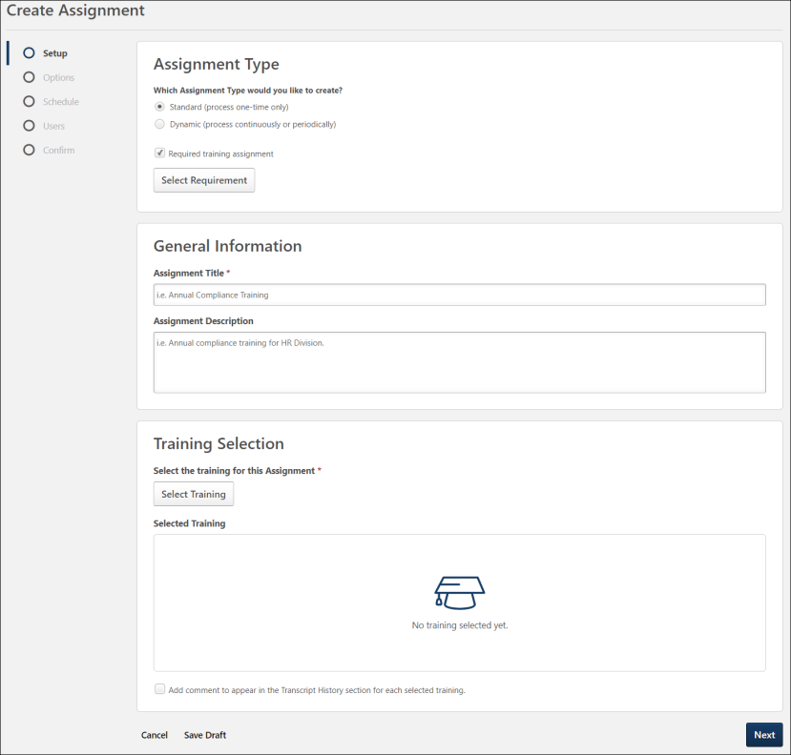
Assignment Type
In the Assignment Type section, determine whether the learning assignment will be a standard assignment or a dynamic assignment.
- Standard - This is a one-time assignment for the users who meet the defined criteria of the learning assignment. This assignment will process one time only. This option is selected by default.
- Dynamic - A dynamic learning assignment processes daily or one time per year and attempts to assign the learning objects to users who newly meet the criteria set for the assignment. Selecting this option causes a Dynamic Removal section to appear on the Options page. Administrators must have permission to create dynamic learning assignments in order to see this option. Note: This option is not available for assigning cohorts.
With the Required Training Tagging activated, an additional option Required training assignment is available to tag the assignment as a required training. Tagging the assignment as a required training assignment makes the selection of a requirement for that assignment mandatory to continue with the creation of the assignment. To know more about Required Training Tagging, See Required Training Tagging Overview.
Select Required training assignment checkbox. Click Select Requirements. It opens the Select Requirements modal. The administrator can search for the requirement via a keyword in the Search for a requirement or category. Select the requirement you want to tie to this assignment; only one requirement can be tied to an assignment.
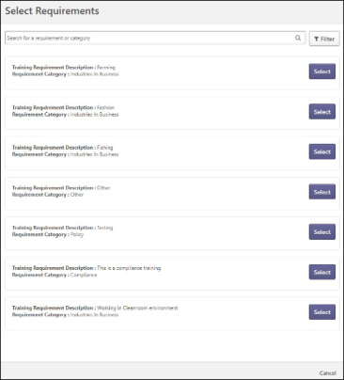
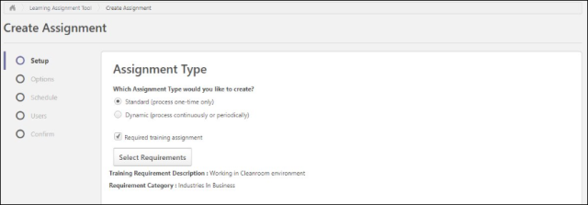
General Information
The General Information section contains the following fields:
- Assignment Title - Enter a title for the learning assignment. This title will display for the assignment on the Manage Learning Assignment page after you either submit the assignment or save it as a draft. All LOs you select will be grouped under this title on the Manage Assignments page. This field is required.
- Assignment Description - Enter a description for the new assignment. This description is visible to administrators when viewing the details of the assignment after it has been saved as a draft or submitted.
Training Selection
In the Training Selection section, search for and select the training that will be assigned via the learning assignment. To add training to the assignment:
- Click the Select Training button. The Select Training flyout appears.
- Using the available search fields and filters, search for learning objects (LOs) to add to the assignment. The search uses Enhanced Search as the default search engine. You can also use Traditional Search engine by disabling Enhanced Search in Assignment Tool Preferences (See Learning Assignment Tool Preferences on page 6 for additional information.). Enter a full or partial training title into the search bar and press Enter on your keyboard to process search results. When Enhanced Search is enabled, Enhanced Search only considers the Title field. Filters can also be applied. Available filter options include:
  - Training Type - Select a training type from the drop-down menu.
  - Course Code - Enter the course code of the desired LO. This field is only available for portals with Course Code enabled.
  - Provider - Click the Search icon. A flyout appears. Select a provider from the flyout.
  - Languages - Select a language from the drop-down menu.
  - Locator Number - Enter the locator number of the desired session LO.
  - Location - Click the Search icon. A flyout appears. Select a location from the flyout.
  - Description - Enter words that are present in the description of the desired LO. The Description Filter is not available when Enhanced Search is used.
  - Reset Filters - To remove any filters that have been selected, click this link.
  - Apply Filters - Click this button to apply any filters you have selected and receive relevant search results.
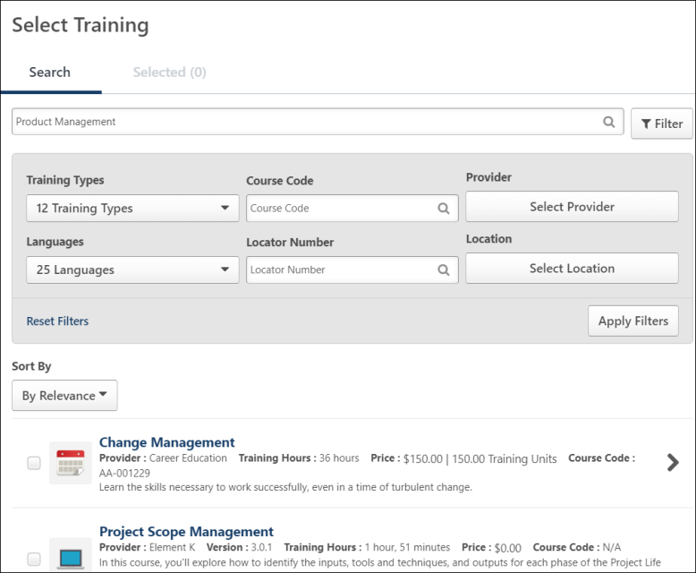
- Sort search results by relevance or title with the help of the Sort By dropdown. The default state of the dropdown is By Relevance, but you can also sort the search results alphabetically by selecting the By Title option. The dropdown disappears if Enable Enhanced Search on Select Training is turned off in Assignment Tool Preferences.
- Check the boxes next to LOs you wish to add to the assignment. If you wish to view more information about an LO, you can click the LO's title. For event LOs, a clickable arrow allows you to view and select sessions of that event, if needed. You can click the Selected tab in the Select Training pop-up to view only training that has been selected for the assignment. On the Selected tab, you can remove any selected training by clicking the Remove icon to the right of the LO.
- Click the Select button after all needed training has been selected. The selected training will be added to the learning assignment. Review your training selections. Your training selections will be paginated if more than six LOs have been selected, and you can navigate to pages of additional results. If needed, you can click the X icon on the training card to remove training that is not needed, or select more training by clicking the Select Training button again.
- If applicable, select a training purpose from the Training Purpose drop-down menu. Training Purpose considerations:
  - If all selected training items have the same training purpose, and none of the training has more than one training purpose, then the training purpose field in the Learning Assignment Tool is auto-populated and read-only.
  - If the selected training items have more than one common training purpose, then the training purpose drop down appears with all possible common options.
  - If a training item is added to the assignment and it does NOT share a common training purpose, then the field is hidden from the Learning Assignment Tool because it no longer applies.
- If desired, add a comment to the learning assignment by checking the Add Comment checkbox and entering text into the comment box that appears. This comment will appear in both the audit history for the assignment and also in users' transcript histories.
- Click the Next button at the bottom of the page to advance to the Options step once all necessary selections have been made on the Setup step.See Create Learning Assignment - Options on page 34 for additional information.
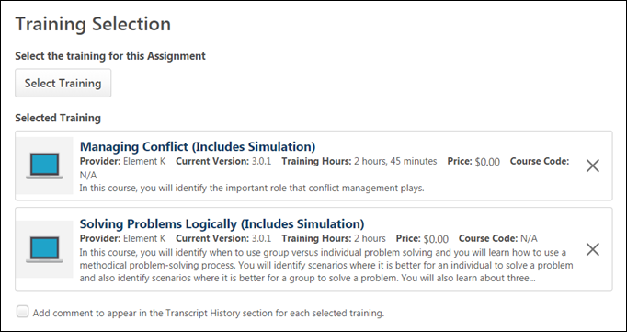

Create Learning Assignment - Options
On the Options page of the create workflow, configure the training assignment workflow and email settings. Administrators accessing this page are not able to view or manage options for which they do not have appropriate permission.
To begin creating a new learning assignment, go to Admin > Tools > Learning and click the Assignment Tool link. From the Manage Learning Assignments page, click the Create Assignment button.
Permissions
PERMISSION NAME | PERMISSION DESCRIPTION | CATEGORY

Assignment Tool - Dynamic Removal | Grants ability to enable/disable Dynamic Removal from within the Learning Assignment create workflow and/or the Assignment Summary page. When Dynamic Removal is enabled, users that no longer meet the User Criteria are removed from the Learning Assignment. This permission is dependent on the Assignment Tool - Standard, Assignment Tool - Standard and Dynamic and Assignment Tool - Standard and Dynamic - Recurrence permissions. This permission cannot be constrained. This is an administrator permission. | Learning - Administration

Assignment Tool - Email Settings - Manage | Grants ability to manage email settings when creating a Learning Assignment. This includes the ability to select all four email settings, set up Custom Emails (create new emails and set existing emails as active/inactive), set up Ad-Hoc Emails, and enable/disable Assign Training and Register Training email triggers when Training Specific Emails is selected. This permission is dependent on the Assignment Tool - Standard, Assignment Tool - Standard and Dynamic, and Assignment Tool - Standard and Dynamic - Recurrence permissions. This permission can be constrained by OU, User, User Self and Subordinates, and User's OU. If this permission is constrained, then only users within the constraints will receive the emails. This is an administrator permission. | Learning - Administration

Assignment Tool - Email Settings - View | Grants ability to view and select email settings when creating a Learning Assignment. This includes the ability to select Training Specific Emails, Custom Emails, or No Emails but does not grant ability to manage the actual Email Settings (cannot configure Custom Emails or Ad-Hoc Email and cannot enable/disable Assign Training and Register Training email triggers when Training Specific Emails is selected). This permission is dependent on the Assignment Tool - Standard, Assignment Tool - Standard and Dynamic, and Assignment Tool - Standard and Dynamic - Recurrence permissions. This permission can be constrained by OU, User, User Self and Subordinates, and User's OU. If this permission is constrained, then only users within the constraints will receive the emails. This is an administrator permission. | Learning - Administration

Assignment Tool - Bypass User Payment | Grants ability to bypass user payment when creating a Learning Assignment. When user payment is bypassed, users are automatically registered into the training regardless of whether or not payment is required. This permission is dependent on the Assignment Tool - Standard, Assignment Tool - Standard and Dynamic, and Assignment Tool - Standard and Dynamic - Recurrence permissions. This permission cannot be constrained. This is an administrator permission. | Learning - Administration

Assignment Tool - Standard and Dynamic - Recurrence | Grants ability to create Standard (one-time) and Dynamic (continuous) Learning Assignments to directly assign training to users. Also grants ability to enable/disable Recurrence when creating a Dynamic Learning Assignment. This permission can be constrained by OU, Provider, Training Item, Training Type, User, User Self and Subordinates, and User's OU. If this permission is constrained by Location, Provider, Training Type, or Training Item, then they can only assign training within the constraints. If this permission is constrained by OU, User, User Self and Subordinates, or User's OU, then they can only assign to and view assignments created by users within the constraints. This is an administrator permission. | Learning - Administration

Assignment Tool - Standard and Dynamic | Grants ability to create Standard (one-time) and Dynamic (continuous) Learning Assignments to directly assign training to users. This permission can be constrained by OU, Provider, Training Item, Training Type, User, User Self and Subordinates, and User's OU. If this permission is constrained by Location, Provider, Training Type, or Training Item, then they can only assign training within the constraints. If this permission is constrained by OU, User, User Self and Subordinates, or User's OU, then they can only assign to and view assignments created by users within the constraints. This is an administrator permission. | Learning - Administration

Assignment Tool - Standard | Grants ability to create Standard (one-time) Learning Assignments to directly assign training to users. This permission can be constrained by OU, Provider, Training Item, Training Type, User, User Self and Subordinates, and User's OU. If this permission is constrained by Location, Provider, Training Type, or Training Item, then they can only assign training within the constraints. If this permission is constrained by OU, User, User Self and Subordinates, or User's OU, then they can only assign to and view assignments created by users within the constraints. This is an administrator permission. | Learning - Administration

Updated Training | Training has been updated to a new version, or pre-work, post-work, or a prerequisite is has been updated or added to the LO.  This is triggered by the user getting automatically updated to a new version of a LO. This email is only triggered by updates to LOs that are versioned, such as an online course, material, test, or curriculum. This email will not trigger for child LOs when they are versioned; in case of child LO versioning, the email will only trigger for the curriculum on the user's transcript.  The TITLE tag enables email recipients to know which learning object (LO) is updated. This tag displays the name of the LO.  The MATERIAL.START.DATE tag displays the material's start date. If the material has multiple versions, then this tag is specific to the material version. If this field is not defined for the training, then this tag is not included in the email.  The MATERIAL.END.DATE tag displays the material's end date. If the material has multiple versions, then this tag is specific to the material version. If this field is not defined for the training, then this tag is not included in the email. | System Administration
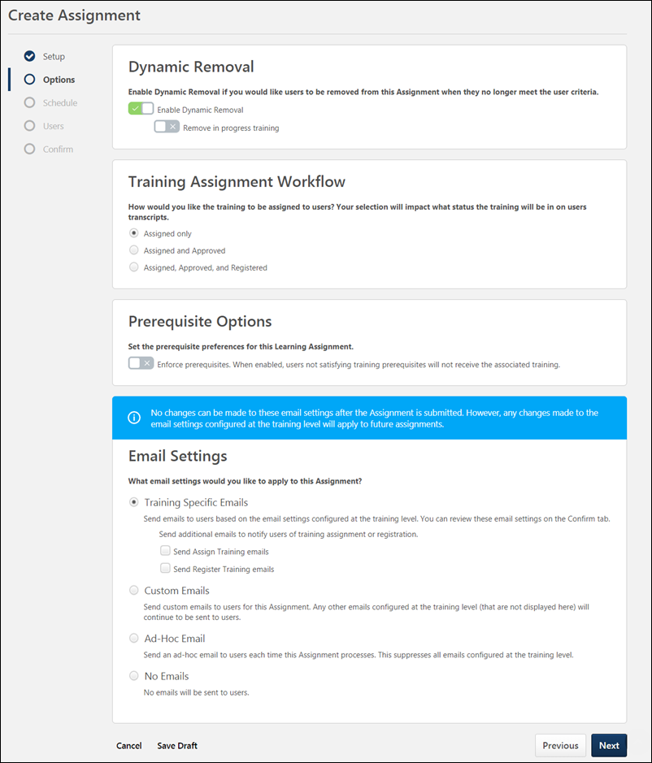
Dynamic Removal
The Dynamic Removal section only appears if Dynamic has been selected as the assignment type and the administrator has permission to manage dynamic removal. If a learning assignment is dynamic, you have the option to allow training (in certain statuses) assigned via the learning assignment to be automatically removed from users' transcripts if the users no longer meet the assignment criteria. The Dynamic Removal option is turned off by default. To turn dynamic removal on, toggle the Enable Dynamic Removal switch to the On position.
Note: If a user has previously completed a version of training included in a dynamic learning assignment, they will be included in the reassignment if they re-enter the assignment criteria again in the future if the following are true:
- Dynamic Removal is enabled for the assignment
- Dynamic Reassignment is enabled for the assignment
- The Re-assigned Latest Version option is enabled for the assignment
If dynamic removal is enabled, additional options for dynamic training removal appear. Available options include:
- Remove In Progress Training - By default, training that is already in an In Progress status on users' transcripts will not be removed by dynamic removal, even if the user no longer meets the criteria for the assignment. To allow the dynamic removal rule to remove training that has already been started, in addition to training that has not been started, toggle this option to the On position. This option is disabled by default.
- Remove Training within Curricula - By default, when a curriculum is removed from users' transcripts via dynamic removal, all child learning objects (LOs) from the curriculum remain as stand-alone LOs on users' transcripts. Selecting this option allows these child LOs to ALSO be removed from users' transcripts when removing a curriculum via dynamic removal. This option is disabled by default.
Dynamic Learning Assignment - Dynamic Removal for In Progress Training
To enable the dynamic removal of training that is currently in progress on users' transcripts:
- Select Dynamic as the Assignment Type for the learning assignment. Additional options become available on the Options page of the Create Assignment process.
- Toggle the Enable Dynamic Removal switch to the On (green) position. The option to remove in-progress training will become available after this option is selected.
- Toggle the Include removing training that is in progress switch to the On (green) position. After the learning assignment is submitted and processed, if users who have been assigned the training no longer meet the assignment criteria, the training in this assignment will be removed from their transcripts whether it is not started or in progress (or equivalent statuses). For a list of equivalent statuses, please see the training status equivalents below.
Note: If users paid for training and then the training is later removed from their transcripts via dynamic removal, the training price is refunded to the user.
Training Assignment Workflow
In the Training Assignment Workflow section, determine how the training should be assigned. Your selection will impact what status the training will be in on users' transcripts and may override any availability or approval workflows configured at the training level within the Course Catalog. Available options include:
- Assigned Only - When selected, the training will only be assigned and may still require the user to receive approval and register for the training before they are able to access the training. This option is selected by default. Note: If the creator of the assignment is also the required approver for the assigned training, their approval will automatically be applied to the assigned training.
- Assigned and Approved - When selected, the training will be automatically approved. No approval will be necessary before users are allowed to take the training, regardless of any configured approval workflows, but users may still need to register for the training.
- Assigned, Approved, and Registered - When selected, the training will be automatically approved and registered. No approval and no registration will be required before the users are allowed to access the training. If this option is selected, an additional option to bypass user payment appears:
  - Bypass User Payment - Enabling this option will prevent users from being prompted to pay for training. The training will be placed on their transcripts and no payment is needed from the user. This setting is disabled by default.
- Completed - This option is only available when assigning a session which occurs in the past. The session will be added to users' transcripts in a status of Completed. If any other training items are being assigned with the session, this option is not available.
Note: The above selections may override any training-specific workflows configured at the training level. However, some training-specific workflows are still respected if applicable to the workflow. For example, If the Assigned and Approved option is selected, but the Register upon Approval option is selected at the training level, then the training is placed on the user's transcript in a status of Registered, which respects both settings.
Prerequisite Options
On the Options page of the learning assignment creation process, the Prerequisite Options section provides access to the Enforce Prerequisites switch. The setting of this switch defaults to the configurations set in Assignment Tool Preferences (enabled or disabled), and the administrator creating the assignment can use this toggle switch to change the prerequisite settings for just the assignment they are creating. To enforce prerequisites at the assignment level:
- Toggle the Prerequisites Enforced switch to the On (green) position. Alternatively, if you do not want the learning assignment to enforce prerequisites, toggle this switch to the Off (gray) position.
- Continue creating the rest of the learning assignment as desired. See Create Learning Assignment - Overview on page 23 for additional information.
If the assignment is configured to enforce prerequisites, users who do not meet the prerequisite requirements for the training in the assignment will NOT receive the training. If the learning assignment is dynamic and the user later completes the prerequisite requirements, the user will receive the training the next time the dynamic assignment processes.
Use Case: Prerequisites Enforced Globally
Bradley is a Learning and Compliance manager at ABC Electric, and he notices that many of his employees are being assigned to tasks and shifts they are not trained for, creating a safety and regulatory risk. He discovers that some of his administrators are incorrectly assigning training by bypassing required prerequisites through the Learning Assignment Tool.
To remedy the problem, Bradley enables the Enforce Prerequisites option on the Assignment Tool Preferences page. This allows his administrators to easily create learning assignments which obey prerequisite requirements and NOT assign training to users who have not yet completed the training's required prerequisites.
Use Case: Prerequisite Requirements Obeyed by Assignment
Jackie is a learning administrator for ABC Electric. Jackie creates a dynamic learning assignment to assign the Advanced Transformer Repair curriculum to all New York employees. Because the Enforce Prerequisites option is enabled, any user who does not meet the prerequisite requirements for the curriculum will not be assigned the curriculum.
Henry, an employee in the New York division, was included in the assignment, but he does not receive the Advanced Transformer Repair curriculum because he has not yet taken the prerequisite curriculum which is required for the Advanced Transformer Repair curriculum. Weeks later, Henry completes the prerequisite training, and the next time the dynamic learning assignment processes, he receives the Advanced Transformer Repair Curriculum because the assignment recognizes that he now meets the prerequisite requirements for the training.
Email Settings
In the Email Settings section, configure emails for the learning assignment. Select the radio button for your chosen email option. Available options include:
- Training Specific Emails - This option uses the default email settings found at the learning object (LO) level, which can be configured in the Course Catalog. This email option is selected by default. When using training-specific emails, the LO level email settings display on the Confirm tab in the Setup tile. Two additional options are also available for Training Specific emails:
  - Send Assign Training Emails - Toggle this switch to the On position if Assign Training emails configured at the LO level should be sent for the training in this assignment. By default, this option is turned off.
  - Send Register Training Emails - Toggle this switch to the On position if Register Training emails configured at the LO level should be sent for the training in this assignment. By default, this option is turned off. Note: The default value of this option is defined by a backend setting.
- Custom Emails - This option allows you to create a unique set of emails for this learning assignment only. Any other emails configured at the learning object (LO) level (that are not displayed here) will continue to be sent to users. If this option is selected, you can click the Set Custom Emails button. A pop-up window will open, in which you can configure custom emails for the assignment. All other emails for the available triggers will be suppressed, whether they are set up at the main Email Administration area or at the Email by LO level.
  - Note: This option is not available when assigning a session or cohort LO in addition to a different LO type.
  - Note: If the LO selected is set to No Emails via its own email settings, the system will not use emails created in Email Administration.
- Ad-Hoc Email - This option allows you to create one email which will be sent with this learning assignment at the time it processes. This suppresses all emails configured at the training level. If this option is selected, you can click the SET AD-HOC EMAIL button. A pop-up window opens, in which you can configure the email that will be sent when the learning assignment processes. Note: The Add-Hoc email will be sent for EACH training item in the assignment.
- No Emails - This option suppresses all emails that can be customized for the assignment from being sent. The list of customizable emails can be viewed in the Custom Emails section. Any other emails configured at the learning object (LO) level that are not displayed in the Custom Emails section will continue to be sent to users.
- Curricula with Auto-Registration - If the assignment includes one or more curriculum, this option appears. This setting gives the administrator the ability to suppress Register Training emails that are configured for the training within the Curriculum that is set to auto-register when the user is registered for the curriculum. Note: This setting does not apply to training that is set to auto-register upon completion of the preceding training.
  - Send Register Training emails - This option defines whether or not Register Training emails are sent to users (if child LOs are set to auto-register upon registration of the curriculum). If toggled to the on position, any related Register Training emails will be sent to users. This option is turned off by default.
Note: The above email settings do NOT apply to Observation Checklists. Any Observation Checklists (within a curriculum) will send emails based on their default email settings configured in Email Administration.
Note: Email digests respect the No Emails setting when configured either at the LO level or from within a learning assignment. Either the Custom Emails option or the Training Specific Emails option must be selected. If the Training is Due email digest section is enabled, the Training is Due email trigger must be inactive to prevent the training emails from firing. Otherwise, the user will receive both an email digest AND an individual email.
- When setting up a Learning Assignment and selecting Training Specific emails, even if there are no emails set for the system emails or at the learning object level but a learning email digest is configured, the learning digest will include the users from the learning assignment when the digest email is sent. An email digest would be sent for this scenario.
Note: No changes can be made to these email settings after the assignment is submitted. However, any changes made to the email settings configured at the training level will apply to future assignments.
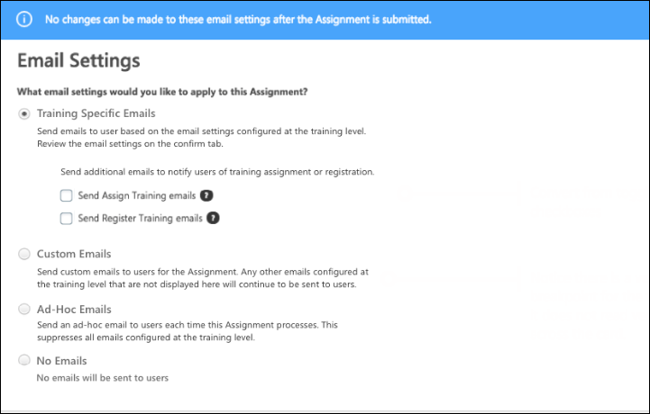
Next
Click the Next button to progress to the Schedule step of the create workflow. See Create Learning Assignment - Schedule on page 43 for additional information.

Create Learning Assignment - Schedule
On the Scheduling page, configure settings for when the learning assignment should initially process and assign the training to users and when the training should be due. Administrators accessing this page are not able to view or manage options for which they do not have appropriate permission.
To begin creating a new learning assignment, go to Admin > Tools > Learning and click the Assignment Tool link. From the Manage Learning Assignments page, click the Create Assignment button.
Permissions
PERMISSION NAME | PERMISSION DESCRIPTION | CATEGORY

Assignment Tool - Training Start Date | Grants ability to configure a Training Start Date when creating a Standard Learning Assignment. The Training Start Date is the date that users will be able to start the training. This permission is dependent on the Assignment Tool - Standard, Assignment Tool - Standard and Dynamic, and Assignment Tool - Standard and Dynamic - Recurrence permissions. This permission cannot be constrained. This is an administrator permission. | Learning - Administration

Assignment Tool - Standard and Dynamic - Recurrence | Grants ability to create Standard (one-time) and Dynamic (continuous) Learning Assignments to directly assign training to users. Also grants ability to enable/disable Recurrence when creating a Dynamic Learning Assignment. This permission can be constrained by OU, Provider, Training Item, Training Type, User, User Self and Subordinates, and User's OU. If this permission is constrained by Location, Provider, Training Type, or Training Item, then they can only assign training within the constraints. If this permission is constrained by OU, User, User Self and Subordinates, or User's OU, then they can only assign to and view assignments created by users within the constraints. This is an administrator permission. | Learning - Administration

Assignment Tool - Standard and Dynamic | Grants ability to create Standard (one-time) and Dynamic (continuous) Learning Assignments to directly assign training to users. This permission can be constrained by OU, Provider, Training Item, Training Type, User, User Self and Subordinates, and User's OU. If this permission is constrained by Location, Provider, Training Type, or Training Item, then they can only assign training within the constraints. If this permission is constrained by OU, User, User Self and Subordinates, or User's OU, then they can only assign to and view assignments created by users within the constraints. This is an administrator permission. | Learning - Administration

Assignment Tool - Standard | Grants ability to create Standard (one-time) Learning Assignments to directly assign training to users. This permission can be constrained by OU, Provider, Training Item, Training Type, User, User Self and Subordinates, and User's OU. If this permission is constrained by Location, Provider, Training Type, or Training Item, then they can only assign training within the constraints. If this permission is constrained by OU, User, User Self and Subordinates, or User's OU, then they can only assign to and view assignments created by users within the constraints. This is an administrator permission. | Learning - Administration

Proxy Enrollment/Assignment Schedule Time - Manage | Grants ability to configure a Processing Start Time when creating a Proxy Enrollment/Assignment for Training and/or for Certifications. The Processing Start Time is the time of day that the Proxy Enrollment/Assignment will start to process users. This is an administrator permission. | Learning - Administration
Standard Learning Assignment Schedule
Standard learning assignments provide administrators with three different scheduling sections. For standard assignments, you can set a processing start date, training start date, and training due date.
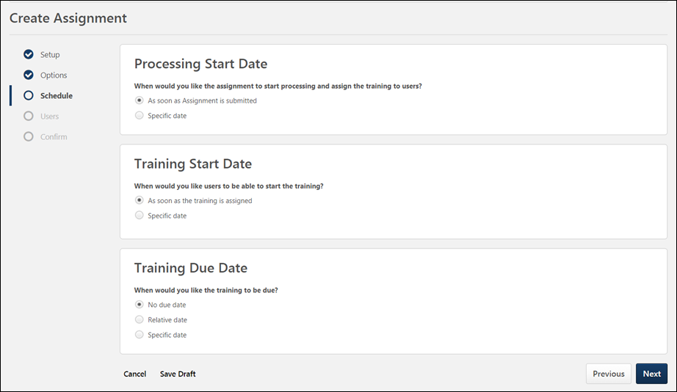
Processing Start Date
Determine when the learning assignment should start to process. After the assignment finishes processing, the training will appear on users' transcripts. Available processing start date options include:
- As soon as assignment is submitted - If this option is selected, as soon as you submit your learning assignment, the assignment begins processing. Training will appear on users' transcripts immediately after processing is completed. Note: If you have selected a high number of users, the assignment may take longer to process.
- As soon as Assignment is submitted, but assign the training relative to - If this option is selected, the assignment processes as soon as the assignment is submitted, but training is actually assigned at a time relative to selected criteria, such as date of birth, hire date, or transfer date. This option is available for dynamic learning assignments. Note: If Hire Date is selected, and a user's Last Hire Date field is empty, the user's original Hire Date will be used.
- Specific date - If this option is selected, a date picker and time picker appear, allowing you to select a specific future date and time, at which point the assignment will begin to process. The assignment will not process until the selected date and time, and training will not appear on users' transcripts until the assignment finishes processing. Standard assignments appear in a Queued status until processing completed. Note: The time is based on the time zone of the user who is creating the learning assignment.
Note: Dynamic learning assignments process at the same time of their initial processing each day or year, depending on your processing frequency selections. Daylight savings adjustments are not observed, due to processing times being stored in UTC time.
Training Start Date
It is possible to assign training to users' transcripts without making it immediately available for the users to begin. The Training Start Date options allow you to specify when the training added to users' transcripts may be launched and completed. Available training start date options include:
- As soon as the training is assigned - If this option is selected, users can launch and complete the training as soon as it is added to their transcripts.
- Specific date - If this option is selected, a date picker appears, which allows you to select a specific future date on which the training can be launched by users from their transcripts. When this option is selected, users will be able to see the training on their transcripts immediately after it has been assigned, but it cannot be launched until the set date. Note: This option is only available for standard assignment types.
Training Due Date
In the Training Due Date section, determine when, if ever, the training assigned to users via the learning assignment will be due. Available due date options include:
- No due date - If this option is selected, the assigned training will not have a due date. Users can complete the training at their leisure.
- Relative due date - If this option is selected, you can set a due date that is relative to a selected reference point. For example, you can set the training to be due 30 days after it is assigned. To set a relative due date, enter a number in the blank field, then select days, months, or years from the first drop-down menu, and then choose a reference point from the second drop-down menu.
- Specific date - If this option is selected, a date picker will appear, which allows you to select a specific future date for the training to be due. Click the calendar icon to choose a date.
Dynamic Learning Assignment Schedule
Dynamic assignments provide administrators with four different scheduling settings to configure. For dynamic assignments, you can set a processing frequency, processing start date, training due date, and recurrence.
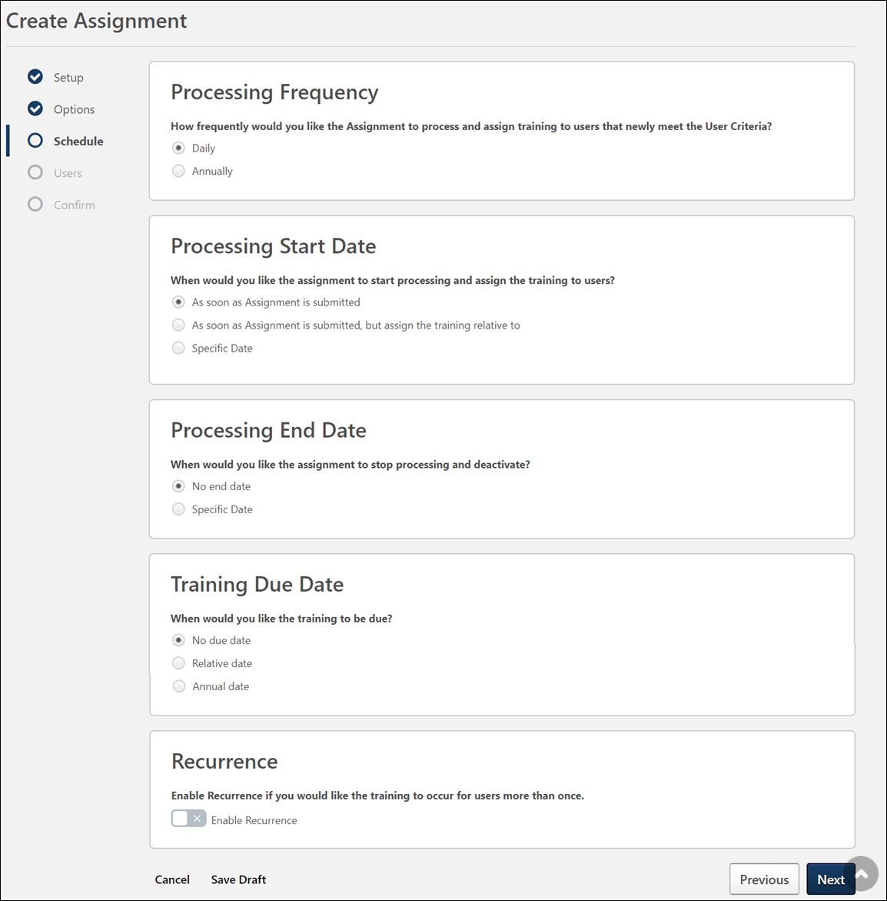
Processing Frequency
In the Processing Frequency section, determine how often the dynamic learning assignment will process and assign the training to users who newly meet the selected user criteria. The following frequency options are available:
- Daily - Selecting this option causes the learning assignment to process each day and assign training to any new users who meet the assignment criteria. Note: Dynamic learning assignments process at the same time of their initial processing each day in this case. Daylight savings adjustments are not observed, due to processing times being stored in UTC time.
- Annually - Selecting this option causes the learning assignment to process only once per year to assign training to any new users who meet the assignment criteria. Note: Dynamic learning assignments process at the same time of their initial processing each year in this case. Daylight savings adjustments are not observed, due to processing times being stored in UTC time.
Processing Start Date
Determine when the learning assignment should initially process. After the assignment initially processes, the training will appear on selected users' transcripts. After that point, the dynamic learning assignment will process daily or annually to assign the training to any new users who meet the assignment criteria. Depending on whether the assignment processes daily or annually, different options are available.
Available processing start date options for assignments that process daily include:
- As soon as assignment is submitted - If this option is selected, as soon as you submit your learning assignment, the assignment begins processing. Training will appear on users' transcripts immediately after processing is completed.
- As soon as assignment is submitted, but assign the training relative to - If this option is selected, relative criteria and a time picker appear. When selected, the assignment begins to process as soon as it is submitted, but users will not see the training on their transcript until they have met the specified relative criteria. Training is added to users' transcripts relative to a selected reference point, such as hire date or date of birth. Set the number of days, months, or years after the selected reference point the training should be assigned, and then select a time from the drop-down menu. For example, you can set an assignment with a new hire curriculum to process three days after users' hire date at 12 PM. The learning assignment processes immediately and every day after at 12 PM, but training is not assigned to users until three days after their hire date.
- Specific date - If this option is selected, a date picker and time picker appear, which allow you to select a specific future date and time, at which point the assignment will process. The assignment will not process until the selected time, and training will not appear on users' transcripts until the assignment finishes processing. Each day the assignment processes at the configured time.
Available processing start date options for assignments that process annually include:
- When would you like the assignment to start processing and assign training to users? - Using the date picker and time picker, select a date and time at which the assignment will begin to process. The assignment will process annually on this date and time. This is the only option available for annual assignments.
Processing End Date
In the Processing End Date section, any administrator with permission to create dynamic assignments can select options for the dynamic assignment's processing end date. This section is only available for dynamic learning assignments. The following options are available:
- No End Date - Select this option if the dynamic assignment should not end automatically. The assignment will continue processing until it is manually deactivated by an administrator.
- Specific Date - Select this option to select a specific date on which the dynamic assignment will end. The date is selected from a calendar pop-up. On the specified date, the assignment will no longer process and no users will be added to the assignment criteria or assigned training in the future. Note: The processing end date cannot be modified after the assignment has been submitted. The assignment can, however, be manually deactivated at any time via the Assignment Summary page
If needed, an administrator can manually reactivate the dynamic assignment from the Assignment Summary page. If the assignment is reactivated, the end date is cleared and the dynamic assignment will continue processing until manually deactivated again. See Assignment Summary Page on page 114 for additional information.
When will the last processing occur?
If a processing end date has been set for a dynamic assignment, the date and time of the final processing are impacted by the processing start date configured for the assignment:
- If a specific date and time were chosen for the Processing Start Date field - The last processing will be the day prior to the defined end date, near the designated time. For example, Arun submits a new dynamic assignment with Processing Frequency configured as Daily, a Processing Start Date of 4/21/2020 at 2:00PM, and a Processing End Date of 4/30/2020. The assignment will process every day close to 2:00PM. The last processing will be close to 2:00PM on 4/29/2020.
- If the As soon as Assignment Is Submitted option was chosen for the Processing Start Date field - The last processing will be the day prior to the defined end date, relative to the time of submission. For example, Carin submits a new dynamic assignment at 6:00AM with Processing Frequency configured as Daily, a Processing Start Date of As soon as Assignment Is Submitted, and a Processing End Date of 5/15/2020. The assignment will process every day around 6:00AM. The last processing will be around 6:00AM on 5/14/2020.
Training Due Date
In the Training Due Date section, determine when, if ever, the training assigned to users via the learning assignment will be due. Available due date options include:
- No due date - If this option is selected, the assigned training will not have a due date. Users can complete the training at their leisure.
- Relative due date - If this option is selected, you can set a due date that is relative to a selected reference point. For example, you can set the training to be due 30 days after it is assigned. To set a relative due date, enter a number in the blank field, then select days, months, or years from the first drop-down menu, and then choose a reference point from the second drop-down menu.
- Annual Date - If this option is selected, additional options appear, which allow you to select a specific annual date for the training to be due each year. Click the calendar icon to choose a date.
To read how due date calculations remain consistent across different use cases to ensure that learners do not miss due dates and maintain compliance, see See Learning Assignment Tool - Due Date Use Cases on page 111 for additional information.
Recurrence
In the Recurrence section, determine if you would like the training in the learning assignment to be assigned to users more than once. For example, you may wish to reassign compliance training to users on an annual basis. This setting is only available for dynamic assignments. Note: If a curriculum which does not allow recurrence has been selected for the assignment, this option does not appear.
Note: Recurrence for dynamic assignments will be based on training completion or the completion of any final required evaluation, if required evaluation(s) are configured.
To enable recurrence for the assignment, toggle the Enable Recurrence switch to the On position. Once enabled, additional recurrence options become available:
First, determine when you would like training to recur. You can select from the following recurrence rule types:
- Relative Date - Select this option to configure the learning assignment to recur on a date relative to a selected reference point, such as date assigned or date completed. For example, you can set the assignment to recur 18 months after the last instance of training was completed. To set a relative date, enter a number in the blank field, choose days, months, or years from the time interval drop-down menu, and then select a reference point from the last drop-down menu. When selected, a sub-option appears:
  - Recur only if the previous occurrence is complete - If enabled, the training will not recur until the user has completed it. This option is disabled by default. Note: The Relative Date option is not available for dynamic assignments configured with an annual processing frequency.
- Annually - Select this option to configure the learning assignment to recur annually. When this option is selected, the recurrence date is automatically the same as the processing start date.
Lastly, determine when you would like your recurrence rule to end for the learning assignment. Available options include:
- Never - If this option is selected, the assignment recurrence behavior will continue indefinitely or until the assignment is made inactive. This option is selected by default.
- Specific Date - If this option is selected, a date picker appears, which allows you to select a specific date in the future, on which the assignment recurrence behavior will automatically terminate.
- Specific Number of occurrences on user's transcript - If this option is selected, you can enter the number of times a user can be assigned the recurring training before recurrence is automatically terminated for the user. For example, if you set this field to three, the user will be assigned the training initially and then reassigned the training two more times before the assignment ceases to recur.
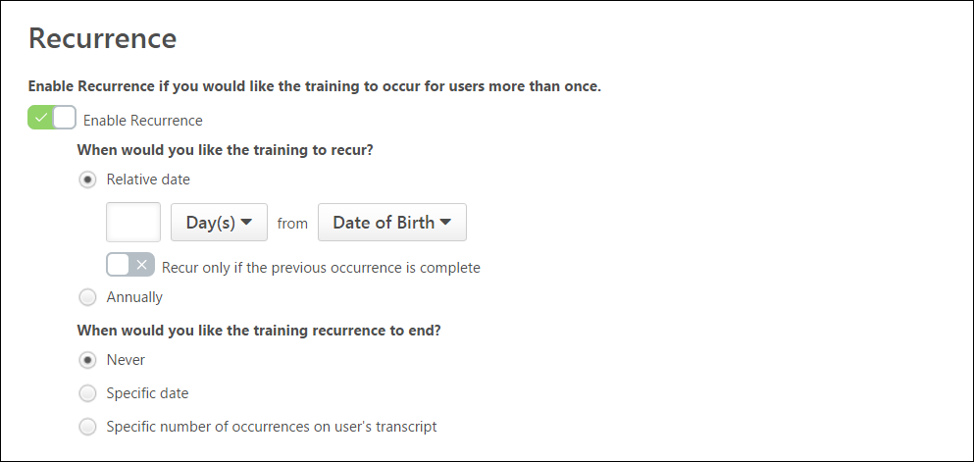
With the Activate Recurrence Fix to include Greater than Consideration for Dynamic Recurring Learning Assignments feature enabled, the training is assigned to users who have surpassed the recurrence date criteria of dynamic assignments but still satisfy the training assignment criteria. It also enables Learning Assignments to search for all users who have missed the recurrence date of trainings in the past.
The recurrence is assigned to the users under the following scenarios:
- If a learner is on leave during the assignment recurrence, they will be assigned the recurrence upon their return.
- If a learner leaves a group associated with the assignment during the assignment recurrence, they will be assigned the recurrence if they return to the group associated with the assignment.
- If the Cornerstone system is down during an assignment recurrence, the users will be assigned the recurrence next time when the assignment is scheduled to run.
If the following scenario occurs, the user will be associated with the learning assignment but will not be assigned the recurrence:
- A user has completed training that was assigned via Edge Import or Express Class, etc. The user is then assigned training with recurrence via the Learning Assignment Tool but the Recurrence Date is before the Learning Assignment Tool Association Date.
Considerations
- Inactive Dynamic Learning Assignments are out of scope, but later when the Learning Assignment becomes active, it will be considered for recurrence.
- Catching up with past users who missed Dynamic recurring Learning Assignments may take some time based on the initial load on the system. For example, if the initial user load is high, missed users will get the training assigned over the span of 2-3 days.
Next
After configuring options for your chosen learning assignment, click the Next button to continue to the Users step of the learning assignment creation process. See Create Learning Assignment - Users on page 53 for additional information.

Create Learning Assignment - Users
On the Users step, select the criteria that will define who will be included in the assignment and be assigned the training. The Users step also provides options for forcing reassignment for users who already have the training on their transcript, if needed. Once the criteria are defined, you can review the list of users that meet the criteria. Administrators accessing this page are not able to view or manage options for which they do not have appropriate permission.
To begin creating a new learning assignment, go to Admin > Tools > Learning and click the Assignment Tool link. From the Manage Learning Assignments page, click the Create Assignment button.
Permissions
PERMISSION NAME | PERMISSION DESCRIPTION | CATEGORY

Assignment Tool - Standard and Dynamic - Recurrence | Grants ability to create Standard (one-time) and Dynamic (continuous) Learning Assignments to directly assign training to users. Also grants ability to enable/disable Recurrence when creating a Dynamic Learning Assignment. This permission can be constrained by OU, Provider, Training Item, Training Type, User, User Self and Subordinates, and User's OU. If this permission is constrained by Location, Provider, Training Type, or Training Item, then they can only assign training within the constraints. If this permission is constrained by OU, User, User Self and Subordinates, or User's OU, then they can only assign to and view assignments created by users within the constraints. This is an administrator permission. | Learning - Administration

Assignment Tool - Standard and Dynamic | Grants ability to create Standard (one-time) and Dynamic (continuous) Learning Assignments to directly assign training to users. This permission can be constrained by OU, Provider, Training Item, Training Type, User, User Self and Subordinates, and User's OU. If this permission is constrained by Location, Provider, Training Type, or Training Item, then they can only assign training within the constraints. If this permission is constrained by OU, User, User Self and Subordinates, or User's OU, then they can only assign to and view assignments created by users within the constraints. This is an administrator permission. | Learning - Administration

Assignment Tool - Standard | Grants ability to create Standard (one-time) Learning Assignments to directly assign training to users. This permission can be constrained by OU, Provider, Training Item, Training Type, User, User Self and Subordinates, and User's OU. If this permission is constrained by Location, Provider, Training Type, or Training Item, then they can only assign training within the constraints. If this permission is constrained by OU, User, User Self and Subordinates, or User's OU, then they can only assign to and view assignments created by users within the constraints. This is an administrator permission. | Learning - Administration

Assignment Tool - Submit Draft | Grants ability to create and submit a learning assignment that exceeds the High User Count threshold even if the Restrict Submission toggle is enabled in Assignment Tool Preferences. Administrators with this permission can also resume and submit a draft learning assignment that was created by another administrator that exceeded the High User Count threshold. This permission can be constrained by OU, User's OU, and User's Corporation. This is an administrator permission.  Administrators can only submit learning assignments that were created by administrators who are within the constraints on this permission. | Learning - Administration

Assignment Tool - Upload CSV File | Grants ability to upload a .csv file as the User Criteria when creating a Learning Assignment. This permission is dependent on the Assignment Tool - Standard, Assignment Tool - Standard and Dynamic, and Assignment Tool - Standard and Dynamic - Recurrence permissions. This permission cannot be constrained. This is an administrator permission. | Learning - Administration

Self Registration Groups - View | Grants ability to view Self Registration Groups when selecting Availability (for Training, Tasks, learning assignments, etc.) or User Criteria (for Learning Assignments). This permission can be constrained by OU and User's OU. This is an administrator permission. | Core Administration
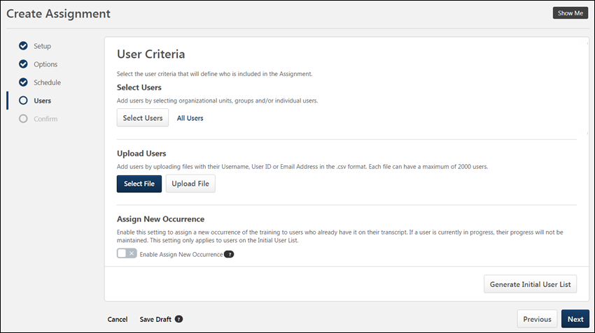
Select User Criteria
The User Criteria section on the User tab allows administrators to easily select users or OUs. Administrators can either upload a file of individual users in the Upload Users section, or they can search for and select users or OUs from the Select Users section. To configure user criteria in the Select Users section:
- Click the Select Users button. This opens a Select Users flyout.
- From the drop-down menu, select the user criteria type. Available types include:
  - Cost Center
  - Division
  - Grade
  - Group
  - Location
  - Position
  - Self Registration Group
  - Custom OUs
  - Users
- Use search fields to find the desired OU (organizational unit) or users. Available filters differ for OUs and users:
  - OU search filters:
    - OU Title
    - OU ID
    - OU Owner First Name or Last Name
    - OU Description
  - User search filters:
    - User First Name or Last Name
    - User ID
    - Username
    - Manager's First Name or Last Name
    - Position
    - Division
    - Location
- Up to twenty search results display on each page of the Select Users flyout. To view additional pages of search results, click a page number or the navigation arrows near the bottom of the flyout.
- Filter the search results if needed. For a list of available search filters, please see the Filters section above.
- Each relevant user or OU appears in the search results as a tile with related information about the user or OU. If the OU has any child OUs, you can view them by clicking the arrow on the right side of the tile.
- Check the box on the left side of the tile for the user or OU you wish to add to the assignment. You may switch between user criteria type using the drop-down and then multi-select as many OUs or users as needed.
- If you wish to review your selections before adding them to your assignment, click the Selected tab at the top of the flyout.
- Click the Select button at the bottom of the flyout.
- The selected OU(s) or user(s) appear as tiles in the Select User section. To include subordinate OUs of a selected OU, check the Include Subordinates box. To delete criteria, click the Delete icon on the right side of the criteria tile.
All Users
To add all system users to an assignment, click the All Users link in the Select Users section. All active system users will be added to the assignment.
Note: If an administrator selects All Users but has restrictions for who they are able to assign training to, then only the users within the administrator's restriction parameters will receive the assignment.
Upload Users
Alternatively, you can assign training to a list of individual users, uploaded via a .CSV file, by clicking the Select File button and selecting a file of email addresses, usernames or user IDs from your computer. Click the Add File button after the file has been selected. A maximum of 2000 users may be uploaded per file, and any user over 2000 will be ignored. There is no limit on the number of files which may be uploaded.
- Note: If any inactive users or invalid users are included in the file upload, a warning message appears, alerting the administrator that inactive or invalid users from the file will note be added to the assignment.
- Note: The file name of the .CSV file is limited to 50 characters, including the file extension.
Assign New Occurrence
Switch the Enable Assign New Occurrence toggle to the On position to include users who meet the defined user criteria and already have the training selected for the assignment on their transcript. When this option is turned on, users who have already completed the training will receive a new occurrence of the training and need to take it again. Additionally, users who have the training on their transcript in any status other than Complete may be forced to restart and receive a new due date, according the due date configurations. However, when the Enable Assign New Occurrence toggle is turned off, the users are credited with a session completion inside the curriculum if they have ever completed the session contained in the curriculum. The users receive credit for a completed session despite having another non-completed registration.
For example, if an administrator selects the Sales division and enables the Enable Assign New Occurrence toggle, all users in that division, regardless of whether they have the training on their transcript or not, are assigned the training. Conversely, if the admin does NOT enable the Enable Assign New Occurrence toggle, only users in the Sales division who do not have the training on their transcript are assigned the training. Also, the users in the Sales division who have previously completed the training receive credit for their completion; therefore, they are not assigned the training. WARNING: Using this option WILL overwrite any progress users have made on the training being assigned. Users who have already completed the training will lose their Completed status for the training.
Enable Assign New Occurrence rules
When a curriculum is assigned, the session with the greatest registration number is mapped to the event under the curriculum. If a curriculum is assigned with ANO turned on (Maintain Progress can be on or off,) then a session with the greatest registration number is mapped to the curriculum during a curriculum assignment. If a curriculum is assigned with ANO turned off, then any session completion counts towards the event completion inside the curriculum.
LAT Setting | Rule
Curriculum assigned with ANO off | Any session completion is considered and propagated to the event inside the curriculum.
Curriculum assigned with ANO on + MP on | Session associated with event’s greatest registration is propagated to the event inside the curriculum. ​
Curriculum assigned with ANO on + MP off | ​Session associated with event’s greatest registration is propagated to the event inside the curriculum.
Note: The Assign New Occurrence option will attempt to assign the training every time users enter the dynamic assignment criteria. Users who enter the assignment availability with the previous version on their transcripts will continue to receive the latest version of the training. If Maintain Progress is also enabled, users with the same version completed on their transcript will not be assigned a new occurrence and due date is not updated. For scenario’s where the due-date needs to be updated, see the Override All Prior Due Dates section below.
Example: ABC Corp assigns safety compliance training annually, and requires all employees to retake the training each year. They create a dynamic recurring learning assignment to assign the same training every year, and they use the Enable Assign New Occurrence toggle to ensure that everyone must take the training again to receive credit, whether they completed the training last year or not.
- Note: This option is only available for curricula when the curriculum has recurrence enabled at the Learning Object (LO) level, which allows the curriculum to be assigned to the same user more than once. This is set on the Structure page when creating or editing the curriculum.
- Note: When the Enable Assign New Occurrence toggle is enabled, any training equivalents configured for the training being assigned are bypassed by that learning assignment except for version equivalence. The maintain toggle as described in a separate section doesn’t have any impact on the behavior.
  - If a training equivalence exists, let’s say training A is being assigned, but users who have completed training B get training equivalence. When training A is assigned with Assign New Occurrence enabled users will need to take training A or one of its training equivalences if available.
  - If a version equivalence exists, let’s say between training A version 3 and 4 (Material or Online course). And the learner has completed version 3 before the assignment and you are now assigning version 4 (as stand-alone or within a curriculum), with or without maintain progress on the learner will get a completed version equivalent status on version 4 as he has previously completed version 3 which is version equivalent. This behavior is only valid with the initial assignment and is the expected behavior. If the learner has a status of completed “version” equivalent on version 4 and you assign version 4 with assign new occurrence without maintain progress than the learner will get a new occurrence assigned.
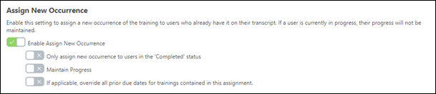
When the Enable Assign New Occurrence toggle is switched to the On position, additional options appear:
Only Assign New Occurrence to Users in the Completed Status
Toggle the Only assign new occurrence to users in the 'Complete' status switch to the On position to assign a new occurrence of the training only to the users who are currently in a completed status. This means that if a user already has the assignment training on their transcript and then they receive a new occurrence of the training, the due date of the new assignment will override the due date(s) of the previous instance of the training on the user's transcript. Selecting this option will only target completed users - it cannot be combined with Maintain Progress as described below
Maintain Progress
Important: All existing learning assignments with the Assign New Occurrence option enabled will have the Maintain Progress feature turned ON. This is meant to alleviate the impact of updated Assign New Occurrence new behavior on existing assignments. You can always deactivate this option on the Learning Assignment Summary page by turning the Maintain Progress toggle OFF.
If the Enable Assign New Occurrence setting is turned on, an additional option is available, which allows users to maintain their progress when they are assigned a new occurrence of the same version of training on their transcript. To allow users who receive new occurrences of the curriculum to maintain their curriculum progress on that version, toggle the Maintain Progress option to the On (green) position. This setting applies only to the first assignment. If this option is not enabled, users who receive new occurrences of a training item via the learning assignment will NOT retain their curriculum progress. If the user’s previous occurrence is in Completed status, this status will also be maintained, and the user will receive a new occurence.Note: The Maintain Progress option is ONLY available if the following conditions are met:
- The administrator has selected the Assigned, Approved, and Registered option on the Options step of the learning assignment creation process.
- The Only Assign New Occurrence to Users in the Completed Status option is NOT selected.
Considerations
- This new option does not increase the registration number for users who previously had the training on their transcript, so that their progress can be maintained. These users will still be associated with the learning assignment and receive all options associated with that learning assignment, such as recurrence settings, removal, and reassignment. Note: This option will always associate the users and training to the latest learning assignment the users entered. This is the existing behavior for users who meet multiple assignment availability criteria.
- Users with a previous version of training on their transcript with maintained progress will see the new assignment in the Transcript History section of their transcript. The label in the history is “Associated Date,” to help differentiate it from “Assigned Date” when the Maintain Progress option is not selected for users entering the assignment availability.
- The Maintain Progress option only works for the same training and same version. If the user has a previous version of the training and the Maintain Progress option is turned ON, the user will receive the LATEST version of the training. This also means that if the training you are assigning is a curriculum, they will receive the latest version of the curriculum including all child LO’s. In short "maintain progress" only applies to the same version of the LO. For example, if the user completed LO1 v1 and you assign LO1 v1 with Maintain Progress ON, the user will remain in a completed status. If you assign LO1 v2 with Maintain Progress ON, the user will be registered.
- The Assign New Occurrence option with the Maintain Progress option enabled will NOT apply to users if the training is in a status other than Registered, In Progress, Completed (or an equivalent status). For example, if the user is assigned training in an Approved status through a standard learning assignment, and then the user is captured by the group associated with a dynamic learning assignment with these settings turned on, the user will be skipped for the dynamic assignment.
Assignment with Assign New Occurrence and maintain progress impact on the transcript
When you re-assign a course to a user that already completed the course with Assign New Occurrence and Maintain Progress, the impact on the user's Transcript will be in the Transcript History and everything else remains the same.
The Transcript History will show Associated with new assignment with previous progress maintained by Learning Assignment Tool (assignment id).
Curriculum Reassignment Behavior
Curriculum reassignment will always provide users with the latest version of all child training contained within the curriculum.
Important: To maintain compliance, administrators must have the permissions for material versioning (either the replace permission or the version with append permission), the permission for online course versioning AND the permission for curriculum versioning (see the Permissions list above). If an administrator creates a new version of a child material or child online course but does NOT have permission to version curricula, the curriculum will not be updated and version updates cannot be maintained.
Use Case for Curriculum Reassignment Behavior
Users should always receive the correct version of child training within a curriculum when a child training item or curriculum is reversioned.
Step 1: Course Catalog contains the following curriculum:
- Curriculum V1 (containing the following child training items):
  - Material A V1
  - Material B V2
  - Online Course C V1
Step 2: Lisa, a user, is assigned Curriculum V1, and her transcript statuses for all related training items are as follows:
- Curriculum V1 - In Progress
- Material A V1 - Completed
- Material B V2 - Registered
- Online Course C V1 - Registered
Step 3: Laurence, an administrator, creates a new version of Material AV1, which is called Material AV2, but does not push the new material version to any users. Curriculum V2 will be created and the structure of the curriculum will be:
- Curriculum V2
  - Material A V2
  - Material B V2
  - Online Course C V1
Lisa's transcript is not changed or impacted.
Step 4: Later, Laurence the administrator creates a new version of Online Course C V1, which is called Online Course C V2, and she decides to push that new version to all users with previous version on their transcript. The curriculum version updates, and the structure of the curriculum in the Course Catalog is:
- Curriculum V3
  - Material A V2
  - Material B V2
  - Online Course C V2
Step 5: Lisa the user receives the updated curriculum, and her transcript statuses are as follows:
- Curriculum V3 – In Progress
- Material A V2 – Registered
- Material B V2 - Registered
- Online Course C V2 – Registered
Note: Progress of child training items is not maintained if the child training items are reassigned to the user within another curriculum.
Override All Prior Due Dates
If the Enable Assign New Occurrence setting is turned on, an additional option is available which allows the learning assignment to override all prior due dates for child training within a curriculum contained in the assignment. This means that if a user already has the child training on their transcript and then they receive a new occurrence of the training, the due date of the new assignment will override the due date(s) of the previous instance of the child training on the user's transcript. To allow the assignment to override previous due dates for child training in a curriculum, toggle the Override All Prior Due Dates switch to the On (green) position.
Note: This setting does not override the due date that displays for child training that viewed from inside the Curriculum Details page when the due date for a child training item is manually updated via the worksheet.
Additionally, for the child LO due dates:
- If it is the same curriculum the above applies.
- If I’m assigning the same child LOs but in another curriculum the override will not override.
Assign New Occurrence with Required Training Tagging Active
If the Enable Assign New Occurrence toggle is turned off, only users who do not have the training on their transcript will get the training and the requirement. To know about Required Training Tagging, See Required Training Tagging Overview.
if the Enable Assign New Occurrence toggle turned on, but Maintain Progress toggle is turned off, the users get a new occurrence with the requirement.
- The previous registration number had requirement or not and was completed. The new registration number has a requirement from the new assignment.
- The previous registration number had a requirement and was not completed. The new registration number has the requirement from the previous registration number and the requirement from the new assignment.
if the Enable Assign New Occurrence and the Maintain Progress toggle turned on, the users get a new occurrence if the training (same version) is not yet on their transcript.
- The previous registration number had a requirement and was completed or not completed. Current registration number requirements are appended with the requirement of the new assignment.
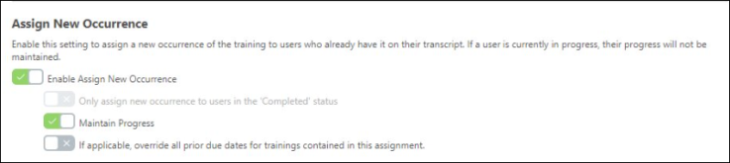
Generate Initial User List
After selecting user criteria, click the Generate Initial User List button to generate a list of users who meet the assignment criteria. Each eligible user displays with the training that will be assigned to them via the learning assignment, along with the following information in their user card:
- User Picture/Default User Icon
- First and Last Name
- User ID
- Organizational Units - All OUs (division, group, position, location, etc.) to which the user is assigned.
Each assigned training item below a user's card displays the following information:
- Training Title
- Occurrence - The number of times the user has previously been assigned or requested the training item.
- Status - The status the training is currently in on the user's transcript.
Generate Initial User List with Required Training Tagging Active
After configuring Assign New Occurence, click Generate Initial User List. The user card information displays the current registration number along with the requirement assigned by the previous assignment. This is applicable only when Required Training Tagging is active in the portal. See Required Training Tagging Overview.
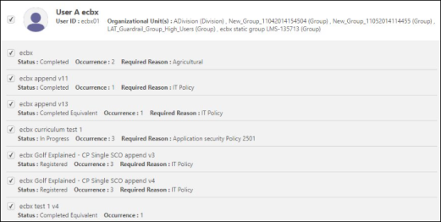
Exclude/Include
Next to each user and each user's individual assigned training items, there is a checkbox. Uncheck the box next to a user's name to exclude them from the learning assignment. Uncheck the box next to a user's specific training item to prevent the user from being assigned that training item.
This checkbox is automatically checked or unchecked depending on the settings configured within the Assign New Occurrence sub-section of the User Criteria section on the Users tab.
Note: For standard assignments, excluded users never show on the Assignment Summary page within the Transcript History section. For dynamic assignments, all users that meet the user criteria always show in the Transcript History section. However, for users who were excluded, the ‘Assigned By’ metadata displays by whom and how they were originally assigned training.
Considerations
Depending on the assignment settings and selections, the checkboxes next to the users and training assigned to users may be either clickable or read-only.
In the following scenario, for dynamic learning assignments, the checkboxes are NOT visible:
- The learning assignment is dynamic and the Assign New Occurrence option is NOT enabled and the Only assign new occurrence to users in the 'Complete' status option is NOT enabled.
  - In this scenario, only users who have zero occurrences on their transcript are assigned the training. However, ALL users display on the Assignment Summary page, and if the dynamic assignment is recurring, all users are included in the recurrence.
In the following scenarios for Dynamic Learning Assignments, the checkboxes are read-only or automatically checked/unchecked:
- The learning assignment is dynamic, the Assign New Occurrence option IS enabled, and the Only assign new occurrence to users in the 'Complete' status option is NOT enabled. In this scenario:
  - Checkboxes are automatically checked and read-only for training with zero occurrences.
  - Checkboxes are automatically checked and clickable for users and training with 1+ occurrences, in any status. You may manually uncheck these users or training to exclude users from being assigned the training again. See the Assign New Occurrence section above for additional details.
In the following scenario, the learning assignment is dynamic, the Assign New Occurrence option IS enabled, and the Only assign new occurrence to users in the 'Complete' status option IS enabled:
- Checkboxes are automatically checked and read-only for training for users with zero occurrences.
- Checkboxes are automatically checked and clickable for users with 1+ occurrences in the completed status only. You can manually uncheck these users or training to exclude users from being assigned the training again. See the Assign New Occurrence section above for additional details.
- Checkboxes are automatically unchecked and clickable for users with 1+ occurrences in any status other than complete. You may manually check these users or training to include them in the assignment and force users to restart the training. See Assign New Occurrence section above for additional details.
In the following scenarios for standard learning assignments, the checkboxes are automatically checked/unchecked:
- The learning assignment is standard, the Assign New Occurrence option is NOT enabled, and the Only assign new occurrence to users in the 'Complete' status option is NOT enabled. In this scenario:
  - Checkboxes are automatically checked and clickable for users and training with zero occurrences. You may manually uncheck these users and trainings to exclude users from being assigned the training.
  - Checkboxes are automatically unchecked and clickable for users and training with 1+ occurrences, in any status. You may manually check these users to include them in the assignment and force them to restart the training or take it again. See Assign New Occurrence section above for additional details.
- The learning assignment is standard, the Assign New Occurrence option IS enabled, and the Only assign new occurrence to users in the 'Complete' status option is NOT enabled. In this scenario:
  - Checkboxes are automatically checked and clickable for users with zero occurrences. You can manually uncheck users and trainings to exclude them from being assigned the training.
  - Checkboxes are automatically checked and clickable for users with 1+ occurrences, in any status. You can manually uncheck these users and trainings to exclude them from being assigned the training again. See the Assign New Occurrence section above for additional details.
- The learning assignment is standard, the Assign New Occurrence option IS enabled, and the Only assign new occurrence to users in the 'Complete' status option IS enabled. In this scenario:
  - Checkboxes are automatically checked and clickable for users with zero occurrences. You may manually uncheck these users and trainings to exclude users from being assigned the training.
  - Checkboxes are automatically checked and clickable for users with 1+ occurrences in a completed status only. You can manually uncheck these users and trainings to exclude users from being assigned the training again. See the Assign New Occurrence section above for additional details.
  - Checkboxes are automatically unchecked and clickable for users with 1+ occurrences in any status other than complete. You can manually check these users and trainings to include them in the assignment and force them to restart the training. See the Assign New Occurrence section above for additional details.
For standard assignments, users and training for users that are excluded from the assignment do NOT appear in the Transcript History section on the Assignment Summary page, and they are not calculated into the page data.
For dynamic assignments, users and training for users that are excluded DO appear in the Transcript History section on the Assignment Summary page and are calculated into the page data.
Automatic Reset
The generated user list resets automatically if changes are made to any of the following items:
- Selected training
- Assignment type
- OU/User/.CSV File selection
- Include Subordinates checkbox
- Assign New Occurrence option
- Only assign new occurrence to users in the 'Completed' status sub-option
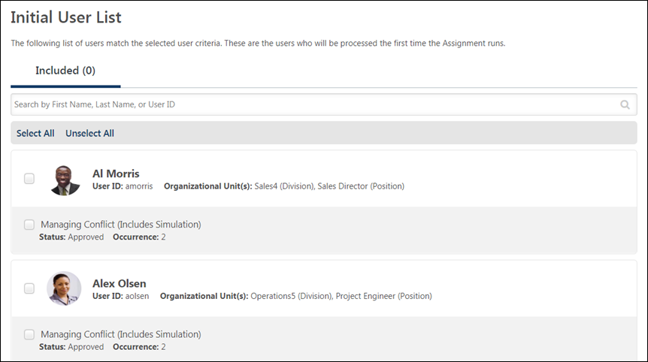
Next
After configuring and reviewing your user list, click the Next button to advance to the Confirm step of the create workflow. See Create Learning Assignment - Confirm on page 70 for additional information.
Warnings
When an administrator has added user criteria to the Users page of the assignment creation process, and then the administrator clicks the Next button, the user will receive a warning flag if the system identifies a potential issue with the user criteria:
- Low user count (This warning appears if the administrator has created a learning assignment that will be assigned to zero users)
- High user count (This warning appears if the administrator has created a learning assignment that will be assigned to a very high percentage of the system's users)
- Group not processed (This warning appears when the group selected as user criteria has not yet processed)
- Group processed with 0 users (This warning appears when the group selected is processed but resulted in zero users)
After receiving a warning flag, the administrator can return to the assignment creation process to review and correct any problems related to their selected user criteria.
High User Count Warning - Administrator Has Submit Draft Permission
When creating a learning assignment that exceeds the High User Count threshold set in Assignment Tool Preferences, the warning behavior depends on the administrator's permissions and whether the Restrict Submission toggle is enabled in Assignment Tool Preferences.
The Assignment Tool - Submit Draft permission gives administrators permission to submit a learning assignment that exceeds the High User Count threshold regardless of whether the Restrict Submission toggle is enabled.
Administrators who have the Assignment Tool - Submit Draft permission can submit a learning assignment that exceeds the High User Count threshold regardless of whether the Restrict Submission toggle is enabled in Learning Assignment Tool Preferences. These administrators will receive the High User Count warning, and they will be given the option to submit the learning assignment with the high user count.
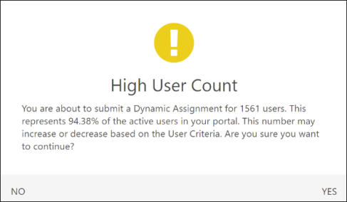
High User Count Warning - Administrator Does Not Have Submit Draft Permission
If the Restrict Submission toggle is enabled in Learning Assignment Tool Preferences, administrators who do not have the Assignment Tool - Submit Draft permission cannot submit a learning assignment that exceeds the High User Count threshold. These administrators will receive the High User Count warning, and they will be given the option to save the learning assignment as a draft.
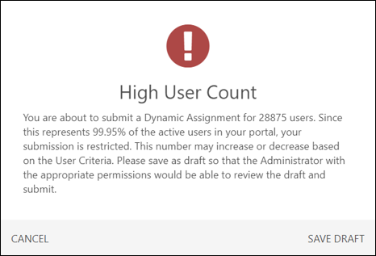
If the Restrict Submission toggle is not enabled in Learning Assignment Tool Preferences, administrators can submit a learning assignment that exceeds the High User Count threshold regardless of whether they have the Assignment Tool - Submit Draft permission. These administrators will receive the High User Count warning, and they will be given the option to submit the learning assignment with the high user count.
Low User Count Warning
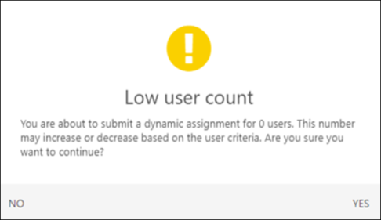
Group Not Processed Warning
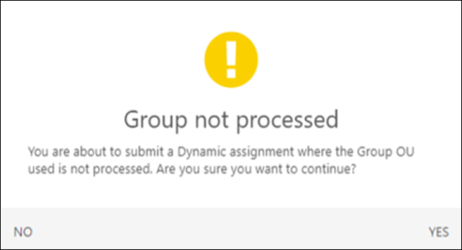
Group Processed with 0 Users
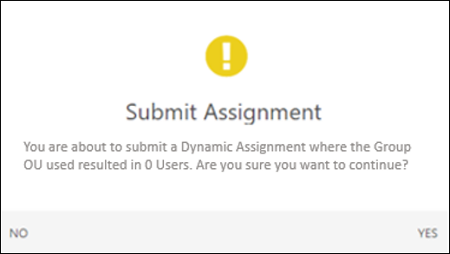

Create Learning Assignment - Confirm
On the Confirm step, review your selections from previous steps to ensure all configurations are correct, and then submit the assignment for processing.
To begin creating a new learning assignment, go to Admin > Tools > Learning and click the Assignment Tool link. From the Manage Learning Assignments page, click the Create Assignment button.
Permissions
PERMISSION NAME | PERMISSION DESCRIPTION | CATEGORY

Assignment Tool - Standard and Dynamic - Recurrence | Grants ability to create Standard (one-time) and Dynamic (continuous) Learning Assignments to directly assign training to users. Also grants ability to enable/disable Recurrence when creating a Dynamic Learning Assignment. This permission can be constrained by OU, Provider, Training Item, Training Type, User, User Self and Subordinates, and User's OU. If this permission is constrained by Location, Provider, Training Type, or Training Item, then they can only assign training within the constraints. If this permission is constrained by OU, User, User Self and Subordinates, or User's OU, then they can only assign to and view assignments created by users within the constraints. This is an administrator permission. | Learning - Administration

Assignment Tool - Standard and Dynamic | Grants ability to create Standard (one-time) and Dynamic (continuous) Learning Assignments to directly assign training to users. This permission can be constrained by OU, Provider, Training Item, Training Type, User, User Self and Subordinates, and User's OU. If this permission is constrained by Location, Provider, Training Type, or Training Item, then they can only assign training within the constraints. If this permission is constrained by OU, User, User Self and Subordinates, or User's OU, then they can only assign to and view assignments created by users within the constraints. This is an administrator permission. | Learning - Administration

Assignment Tool - Standard | Grants ability to create Standard (one-time) Learning Assignments to directly assign training to users. This permission can be constrained by OU, Provider, Training Item, Training Type, User, User Self and Subordinates, and User's OU. If this permission is constrained by Location, Provider, Training Type, or Training Item, then they can only assign training within the constraints. If this permission is constrained by OU, User, User Self and Subordinates, or User's OU, then they can only assign to and view assignments created by users within the constraints. This is an administrator permission. | Learning - Administration
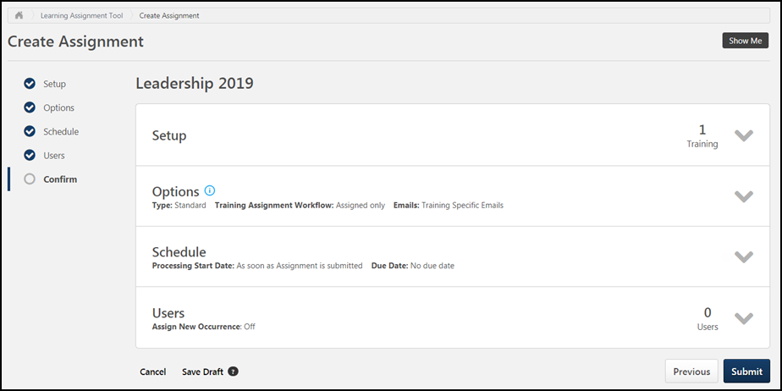
Details for each of the creation steps appear in separate expandable tiles on the Confirm page. Each tile provides a basic overview of its corresponding section's settings. To expand a tile and show more settings details, click the drop-down arrow on the right side of the tile. To collapse the panel, click the drop-down arrow again.
Note: All information displayed is read-only. To make changes, navigate back to the section you wish to edit.
Setup
Before expanding, the Setup tile displays the number of learning objects (LOs) which have been added to the learning assignment. After expanding, each LO displays in its own tile with details about the training, in addition to the other options configurable in the Setup section. The read-only information that displays for each LO includes:
- LO Type icon - This icon visually represents the LO type, such as online course, material, test, etc.
- Title - The title of each LO is clickable and opens the Training Details page for the LO in a new tab when clicked.
- Provider - The provider set for the LO.
- Version - The version of the LO that was assigned.
- Training Hours - The number of training hours associated with the LO.
- Price - The price of the LO, if applicable.
- Course Code - The unique course code generated for the LO. This field will be hidden if Course Codes are not enabled for your portal.
- Email Settings - The email configurations set at the LO level for the training item. This will only appear if you have selected the Training Specific Emails setting on the Options page.
If you provided a comment when adding to the training or selected a training purpose, they display under the selected training in the Setup section.
If Required Training Tagging is active in the portal and a requirement is selected in the Setup, then expand the Setup tile by clicking the drop-down arrow on the right side of the tile to see the selected requirement and the requirement category. See Required Training Tagging Overview.
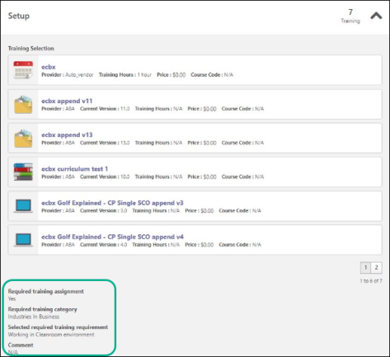
Options
Before expanding, the Options tile displays an overview of the assignment type, training assignment workflow, and email options configured for the learning assignment. After expanding, the following detailed information displays:
- Type - The learning assignment type that was selected for the assignment (standard or dynamic).
- Dynamic Removal - Whether Dynamic Removal is on or off.
- Remove in progress training - Whether the option to remove in-progress training is on or off.
- Remove training within Curricula - Displays whether the setting to automatically remove child LOs within a dynamically removed curricula is on or off.
- Training Assignment Workflow - The assignment workflow setting for each training you selected.
- Email Settings - The email settings selection you made when configuring emails for the assignment. Depending on your selection, additional details about your selections may also appear in this section.
Schedule
Before expanding, the Schedule tile displays an overview of the assignment's scheduling selections, including the processing start date and due date. After expanding, the following read-only information displays:
- Processing Start Date
- Processing Frequency
- Processing End Date
- Training Start Date and Due Date
- Recurrence Setting
Users
Before expanding, the Users tile displays the number of users who will be assigned the training contained in the learning assignment and also the assignment's Force Re-Assignment status. After expanding, the selected user criteria, Force Initial Assignment, and Only Force "Completed" Status settings will display.
Submit
After reviewing all your learning assignment configurations and ensuring all selections are correct, you can click the Submit button to submit the new learning assignment. The learning assignment will process and assign training according to your scheduling selections.
- Note: The assignment settings, with the exception of the title, certain dynamic processing-related settings, and the due date (for dynamic assignments only) cannot be altered once the assignment has been submitted.
- Note: If needed, training that was assigned with the Learning Assignment Tool can be removed from users' transcripts via the Assignment Summary page. See Assignment Summary Page on page 114 for additional information.
High User Count
If the assignment is configured to assign training to more than 20% of the active users in the entire portal, a High User Count warning message appears after clicking the Submit button. If you wish to proceed with the submission, click Yes. If you want to cancel the submission and revise your assignment, click No.
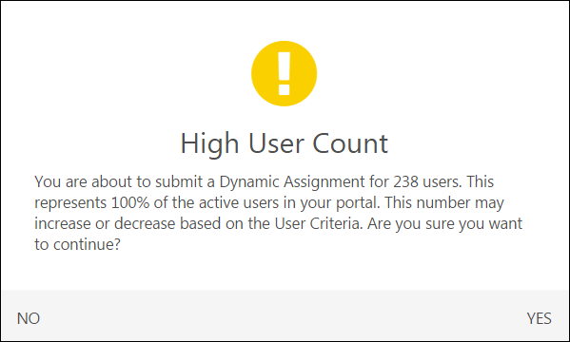
Insufficient Session Seats
When assigning users to a session via a learning assignment, if the number of users selected for the assignment exceeds the number of seats available in the session, the administrator receives an Insufficient Session Seats notification after navigating to the Confirm step of the learning assignment creation process and clicking Submit. The Insufficient Session Seats pop-up notification provides two options for this scenario:
- Increase the session's available seats - Selecting this option and submitting the learning assignment causes the number of available seats, or Maximum Registration, for the session to automatically increase to accommodate all the users in the assignment. Note: Session seats will only increase if the Assign, Approve, and Register option was selected for the assignment.
- Add users that exceed the number of available seats to the waitlist - Selecting this option and submitting the learning assignment causes any users for whom a session seat was not available to be automatically added to the waitlist for the session.
Click the OK button in the bottom right of the pop-up to confirm your Insufficient Session Seats option selection and continue creating the learning assignment, or click the Cancel button in the bottom left of the pop-up to return to the learning assignment without making a decision and revise your assignment selections.
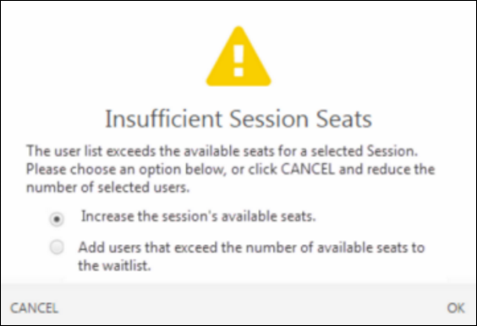
Considerations
Important: When assigning a large curriculum to a high volume of users, the assignment may take longer to process because it must process every child LO inside the curriculum against each user’s transcript. This means you may see a standard assignment in the Queued status, or a dynamic assignment’s summary page that has not yet populated, for a longer period of time than normal. This is more apparent when assigning several large curricula to a high volume of users.
Tip: When an Assignment has not finished processing and you are assigning multiple curricula, you can see which curricula have been processed and assigned by looking directly at a user’s transcript history. As the curriculum is assigned to each user, the transcript history for that user is updated.

Copy Learning Assignment
Administrators can use the Copy option on the Manage Learning Assignments page to quickly create a new assignment by copying an existing assignment. Clicking the Copy option from the Options drop-down menu next to an existing assignment redirects the administrator to the Setup step of the create assignment workflow, with many settings already populated with the selections from the original assignment. To ensure all copied fields are still valid, administrators must click through the entire create workflow before submitting the assignment copy.
To navigate to the Manage Assignments page, where you can copy assignments, go to Admin > Tools > Learning > Learning Assignment Tool.
Permissions
PERMISSION NAME | PERMISSION DESCRIPTION | CATEGORY

Assignment Tool - Training Start Date | Grants ability to configure a Training Start Date when creating a Standard Learning Assignment. The Training Start Date is the date that users will be able to start the training. This permission is dependent on the Assignment Tool - Standard, Assignment Tool - Standard and Dynamic, and Assignment Tool - Standard and Dynamic - Recurrence permissions. This permission cannot be constrained. This is an administrator permission. | Learning - Administration

Assignment Tool - Bypass User Payment | Grants ability to bypass user payment when creating a Learning Assignment. When user payment is bypassed, users are automatically registered into the training regardless of whether or not payment is required. This permission is dependent on the Assignment Tool - Standard, Assignment Tool - Standard and Dynamic, and Assignment Tool - Standard and Dynamic - Recurrence permissions. This permission cannot be constrained. This is an administrator permission. | Learning - Administration

Assignment Tool - Processing Start Time | Grants ability to configure a Processing Start Time when creating Learning Assignments and/or Certification Proxy Enrollments. The Processing Start Time is the time of day that users will start being processed. For Learning Assignments, this permission is dependent on the Assignment - Standard, Assignment - Standard and Dynamic, Assignment - Standard and Dynamic - Recurrence permissions. For Certification Proxy Enrollments, this permission is dependent on the Proxy Enrollment for Certification - Create Dynamic and Proxy Enrollment for Certification - Create Standard permissions. This permission cannot be constrained. This is an administrator permission. | Learning - Administration

Assignment Tool - Restrict to Users' LO Availability | This permission does not grant ability to any specific functionality and can only be constrained by Users' LO Availability. If this permission is constrained, then the user creating the Learning Assignment can only select and assign training that is within the users own availability. This permission is dependent on the Assignment Tool - Standard, Assignment Tool - Standard and Dynamic, and Assignment Tool - Standard and Dynamic - Recurrence permissions. This is an administrator permission. | Learning - Administration

Assignment Tool - Standard and Dynamic - Recurrence | Grants ability to create Standard (one-time) and Dynamic (continuous) Learning Assignments to directly assign training to users. Also grants ability to enable/disable Recurrence when creating a Dynamic Learning Assignment. This permission can be constrained by OU, Provider, Training Item, Training Type, User, User Self and Subordinates, and User's OU. If this permission is constrained by Location, Provider, Training Type, or Training Item, then they can only assign training within the constraints. If this permission is constrained by OU, User, User Self and Subordinates, or User's OU, then they can only assign to and view assignments created by users within the constraints. This is an administrator permission. | Learning - Administration

Assignment Tool - Standard and Dynamic | Grants ability to create Standard (one-time) and Dynamic (continuous) Learning Assignments to directly assign training to users. This permission can be constrained by OU, Provider, Training Item, Training Type, User, User Self and Subordinates, and User's OU. If this permission is constrained by Location, Provider, Training Type, or Training Item, then they can only assign training within the constraints. If this permission is constrained by OU, User, User Self and Subordinates, or User's OU, then they can only assign to and view assignments created by users within the constraints. This is an administrator permission. | Learning - Administration

Assignment Tool - Standard | Grants ability to create Standard (one-time) Learning Assignments to directly assign training to users. This permission can be constrained by OU, Provider, Training Item, Training Type, User, User Self and Subordinates, and User's OU. If this permission is constrained by Location, Provider, Training Type, or Training Item, then they can only assign training within the constraints. If this permission is constrained by OU, User, User Self and Subordinates, or User's OU, then they can only assign to and view assignments created by users within the constraints. This is an administrator permission. | Learning - Administration
Copy
To create a copy of an existing learning assignment from the Manage Assignments page:
- Locate the existing assignment you wish to copy. Note: Draft assignments cannot be copied.
- Click the Options drop-down to the right of the assignment.
- Click the Copy link from the drop-down menu. You will be redirected to the Setup step of the create assignment workflow. Assignment fields and settings will be pre-populated with data from the original assignment (for exceptions to this behavior, see the Exceptions section below).
- Progress sequentially through all steps in the workflow, checking to ensure all copied fields are relevant to the assignment you are creating.
- Submit the new assignment.
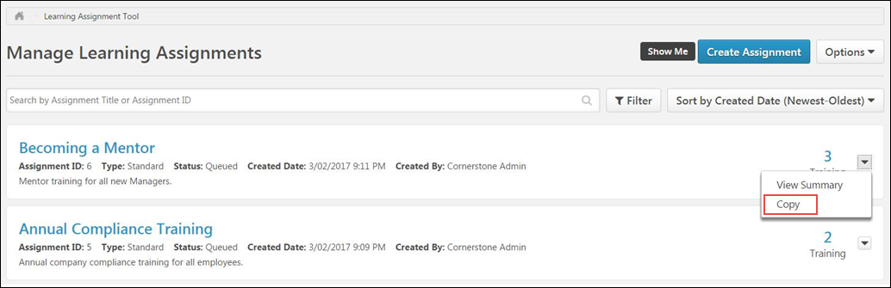
Exceptions
When a learning assignment is copied, all data from the existing assignment is pre-populated as-is in the copy, with the following exceptions:
- Assignment ID - Assignment ID is never copied.
- Title - The title of the original assignment is copied to the Title field of the assignment copy, with "(Copy)" added to the end of the title text. Example: Compliance Training 2017 (Copy).
- Training - If the copied training item is not available to the administrator who is copying the assignment, the training is still copied. However, if the administrator removes the training and then attempts to search for the training to add it again, the training will not be available in the search results. The availability of training when searching and selecting training for an assignment is determined by the permission for restricting users to their own learning object (LO) availability. Note: If a user copies an assignment with an inactive LO, the LO will still be copied.
- Assignment Options - If the administrator adds a type of training that is not compatible with the copied assignment's original settings, some assignment options may no longer be copied and must be redefined by the administrator. For example, if an Administrator copies a dynamic assignment with recurrence, and then adds a curriculum that does not support recurrence, the recurrence setting will not copy or be available for the copied assignment.
- Bypass User Payment - If the administrator does not have the permission to manage this option, the option is not copied to the assignment or available to select.
- Specific Date - If a Specific Date was selected for the original assignment, the date will be copied to the assignment copy. However, if the date is now in the past, the user will receive an error message when navigating through the workflow.
- Relative Date - If a Relative Date was selected for the original assignment, the date will be copied to the assignment copy. However, if the relative option selected for the original assignment no longer exists, the Relative Date will not be copied.
- Processing Start Time - If the user does not have the permission for Processing Start Time, the Processing Start Time configured in the for the original assignment using the time selector will not be copied, and the default processing time applies (the time at which the assignment is submitted).
- Training Start Date - If the user does not have the permission for Available Date/Training Start Date, the Training Start Date configuration will not be available or copied to the assignment copy.
- Assignment Type - If the user does not have permission to create the assignment type of the assignment being copied, the assignment type is not copied or available.
- Recurrence - If the user does not have the permission to create recurring learning assignments, the recurrence option is not copied or available.

Create Draft Learning Assignment
It is possible to save a draft of a learning assignment that you began configuring but did not submit. To save a draft of an assignment you have begun to create, click the Save Draft button at the bottom of any page in the create assignment workflow. The draft will be saved, and you will be redirected to the Manage Learning Assignments page. Your draft assignment can then be accessed and completed later.
To access a draft learning assignment from the Manage Learning Assignments page, either click the title of the draft learning assignment or click the Options drop-down arrow to the right of the draft and click the Resume Draft link.
- Note: You are only able to view draft learning assignments that you have created.
- Note: The selected assignment criteria, Enable Assign New Occurrence option selection, and the If applicable, override all prior due dates for trainings contained in this assignment option selection will be saved, but the Only assign new occurrence to users in the 'Completed' status option selection, as well as email settings selected for the draft assignment will not be saved and will need to be reselected when the draft is resumed..
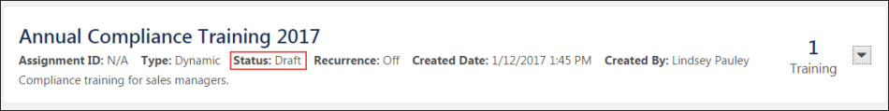

Learning Assignment Use Cases

Standard Learning Assignment - Create
Standard assignments process one time only, and they are based on the user list that was generated when the assignment was created. This means users must be in the availability at the time the assignment is submitted in order to be assigned the selected training. If they are not, they will not receive the assignment.
Note: This also applies to standard assignments that are scheduled to process at a future time. If the users are added to the assignment availability criteria (such as a group) after the assignment is submitted but before the assignment is scheduled to process, they still will NOT be included in the assignment. If the assignment should process daily and assign the training to users who newly meet the criteria, you must create a dynamic learning assignment instead.
To create a new standard learning assignment, go to Admin > Tools > Learning and click the Learning Assignment Tool link. Then, click the Create Assignment button.
Permissions
PERMISSION NAME | PERMISSION DESCRIPTION | CATEGORY

Assignment Tool - Training Start Date | Grants ability to configure a Training Start Date when creating a Standard Learning Assignment. The Training Start Date is the date that users will be able to start the training. This permission is dependent on the Assignment Tool - Standard, Assignment Tool - Standard and Dynamic, and Assignment Tool - Standard and Dynamic - Recurrence permissions. This permission cannot be constrained. This is an administrator permission. | Learning - Administration

Assignment Tool - Restrict to Users' LO Availability | This permission does not grant ability to any specific functionality and can only be constrained by Users' LO Availability. If this permission is constrained, then the user creating the Learning Assignment can only select and assign training that is within the users own availability. This permission is dependent on the Assignment Tool - Standard, Assignment Tool - Standard and Dynamic, and Assignment Tool - Standard and Dynamic - Recurrence permissions. This is an administrator permission. | Learning - Administration

Assignment Tool - Email Settings - Manage | Grants ability to manage email settings when creating a Learning Assignment. This includes the ability to select all four email settings, set up Custom Emails (create new emails and set existing emails as active/inactive), set up Ad-Hoc Emails, and enable/disable Assign Training and Register Training email triggers when Training Specific Emails is selected. This permission is dependent on the Assignment Tool - Standard, Assignment Tool - Standard and Dynamic, and Assignment Tool - Standard and Dynamic - Recurrence permissions. This permission can be constrained by OU, User, User Self and Subordinates, and User's OU. If this permission is constrained, then only users within the constraints will receive the emails. This is an administrator permission. | Learning - Administration

Assignment Tool - Email Settings - View | Grants ability to view and select email settings when creating a Learning Assignment. This includes the ability to select Training Specific Emails, Custom Emails, or No Emails but does not grant ability to manage the actual Email Settings (cannot configure Custom Emails or Ad-Hoc Email and cannot enable/disable Assign Training and Register Training email triggers when Training Specific Emails is selected). This permission is dependent on the Assignment Tool - Standard, Assignment Tool - Standard and Dynamic, and Assignment Tool - Standard and Dynamic - Recurrence permissions. This permission can be constrained by OU, User, User Self and Subordinates, and User's OU. If this permission is constrained, then only users within the constraints will receive the emails. This is an administrator permission. | Learning - Administration

Assignment Tool - Standard | Grants ability to create Standard (one-time) Learning Assignments to directly assign training to users. This permission can be constrained by OU, Provider, Training Item, Training Type, User, User Self and Subordinates, and User's OU. If this permission is constrained by Location, Provider, Training Type, or Training Item, then they can only assign training within the constraints. If this permission is constrained by OU, User, User Self and Subordinates, or User's OU, then they can only assign to and view assignments created by users within the constraints. This is an administrator permission. | Learning - Administration
Setup
The first step for creating a standard learning assignment is providing some basic information about the assignment and selecting the training that will be assigned. In this example, an administrator is assigning all users in their organization a course called "Harassment in the Workplace." On the Setup page:
- Select the assignment type. For a standard assignment, select the Standard option. This means the assignment will process only one time, and training will only be assigned to users who meet the availability criteria for the assignment at the time it processes.
- Enter a descriptive title for the standard learning assignment. In this example, the assignment title will be "Harassment in the Workplace - May 2021."
- Enter a description for the assignment which will help other administrators understand the purpose of the assignment.
- Click the Select Training button to add training to the assignment.
- In the flyout, search for and select the course, and then click the Select button at the bottom of the flyout. The training is added to the assignment.
- Click the Next button to advance to the Options step of the learning assignment creation process.
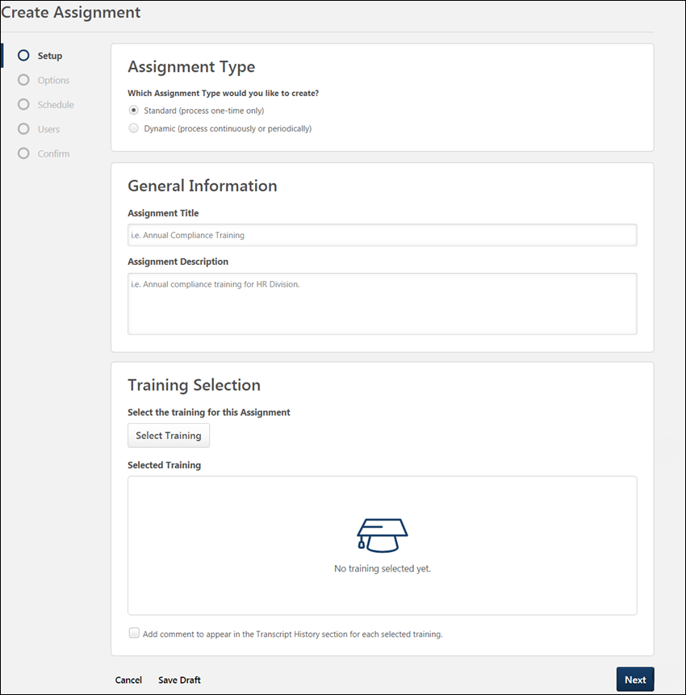
For more details about all the options available on the Setup page, See Create Learning Assignment - Setup on page 27 for additional information.
Options
On the Options step, configure the assignment workflow and email options. For a standard assignment:
- Decide what status the training will display in on the user's transcript after it is assigned. Be aware that availability settings for the learning object itself may also affect the transcript status following assignment. For example, if the LO availability is configured as pre-approved with register upon approval, the user’s transcript status will be Registered upon assignment, even if one of the first two below options is selected in the learning assignment. Available options include:
  - Assigned Only - This option places the learning objects onto the user's transcript, but will still require the standard approvals. Once approved, the user must still click the Register link on their transcript.
  - Assigned and Approved - This option places the learning objects in an Approved status on the user's transcript, bypassing the normal approval process. The user must still click the Register link on their Transcript.
  - Assigned, Approved, and Registered - This option assigns, approves, and registers users directly into the training. This bypasses both the approval and registration process as long as the user is not required to pay for the training. The user is only required to launch or complete the training.
    - Bypass User Payment - If the Bypass User Payment option is selected and the training has a cost that is payable by the user, the enrolled users no longer go to the payment page and are automatically enrolled in training item. This option is only available if the Assigned, Approved, and Registered option is selected above.
      - If the user has already paid for a previous version of the training, the user will not pay for the newly assigned version.
      - If Assign New Occurrence is enabled, it does not override the registration workflow for previous versions of the same training; it only applies to the current version of the training. If a user already paid for training and is assigned the same version of that training with this setting, they will need to pay for the training again if Bypass User Payment is not checked.
- Set prerequisite options for the assignment, if needed.
- Select email options for the learning assignment. You can choose to use the default training-specific email templates configured in the Course Catalog, create a custom set of emails for the assignment, send a one-time email, or use no emails at all. All the learning assignment email options are suitable for a standard learning assignment.
- Once all options have been configured for the standard learning assignment, click the Next button to advance to the Schedule step.
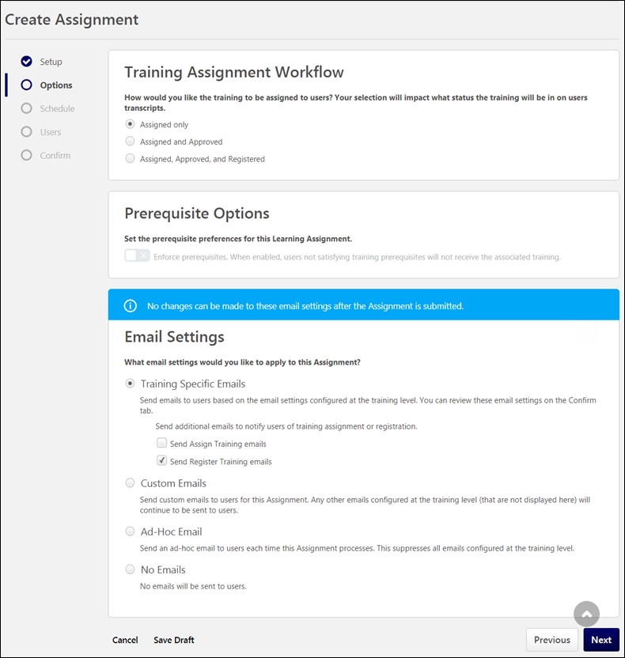
For more details about all the options available on the Options page,See Create Learning Assignment - Options on page 34 for additional information.
Schedule
On the Schedule page, determine when the standard learning assignment will process, and when training will be due for users who are assigned the training. For standard assignments:
- Select a Processing Start Date. Standard assignments can either process immediately upon submission of the assignment or on a selected future date. When the assignment processes, training will be assigned to users.
- Specify a Training Start Date, if applicable. Users can either be allowed to start the training as soon as it is assigned or on a specific date selected by the administrator.
- Specify a Training Due Date, if applicable. Standard assignments can be created with no due date, a relative date (such as 30 day from the date assigned), or a specific due date. All three due date options are suitable for standard learning assignments.
- Click the Next button at the bottom of the page to advance to the Users step.
For more details about all the options available on the Schedule page, See Create Learning Assignment - Schedule on page 43 for additional information.
Users
On the Users step, determine which system users will receive the training in the assignment.
- To add users to the assignment, you can select user criteria (such as a division, location, etc.), you can add all system users to the assignment, or you can upload a .csv file of usernames or user IDs. Any of these options are suitable for standard learning assignments, because standard assignments process only once. In this example, the administrator will assign the course to all users in the system by clicking the All Users link.
- Decide whether or not to enable the Assign New Occurrence feature. Switching the Enable Assign New Occurrence toggle to the On position will include users who meet the defined user criteria and already have the training selected for the assignment on their transcript. When enabled, users who have already completed the training will receive a new occurrence of the training and need to take it again.
- Click the Generate Initial User List button to view a list of users who will be assigned the training, based on your user criteria selections. Using the check boxes in each user's tile, you can opt to not include certain users or certain training items for users if needed.
- After configuring the correct user criteria, click the Next button at the bottom of the page to advance to the Confirm step.
For more details about all the options available on the Users page, See Create Learning Assignment - Users on page 53 for additional information.
Confirm
On the Confirm page, review your learning assignment selections by expanding the tiles for each section of the process. You can return to previous pages by clicking the name of a section in the navigation panel on the left side of the page.
After reviewing all your learning assignment configurations and ensuring all selections are correct, you can click the Submit button to submit the new learning assignment. The learning assignment will process and assign training according to your scheduling selections. Note: Once submitted, the learning assignment cannot be stopped or reversed.
For more details about all the options available on the Confirm page,See Create Learning Assignment - Confirm on page 70 for additional information.

Dynamic Learning Assignment - Create
The dynamic learning assignment type allows you to choose one or more learning objects (LOs) and select the users who will be assigned the training on their transcript. Dynamic learning assignments process every day and allow you to assign training on an ongoing basis to users who meet specific criteria. For example, you can create a dynamic learning assignment which checks every day to see if any new users were hired, then assigns those users new hire orientation training.
Note: Prior to creating a dynamic learning assignment for new hires, it would be necessary to first create a dynamic group which was configured to search the system for newly hired users each day and add them to the group. For more information about creating a dynamic new hire group, see Use Case - Create a Dynamic New Hire Group.
To create a new dynamic learning assignment, go to Admin > Tools > Learning and click the Learning Assignment Tool link. Then, click the Create Assignment button.
Permissions
PERMISSION NAME | PERMISSION DESCRIPTION | CATEGORY

Assignment Tool - Training Start Date | Grants ability to configure a Training Start Date when creating a Standard Learning Assignment. The Training Start Date is the date that users will be able to start the training. This permission is dependent on the Assignment Tool - Standard, Assignment Tool - Standard and Dynamic, and Assignment Tool - Standard and Dynamic - Recurrence permissions. This permission cannot be constrained. This is an administrator permission. | Learning - Administration

Assignment Tool - Restrict to Users' LO Availability | This permission does not grant ability to any specific functionality and can only be constrained by Users' LO Availability. If this permission is constrained, then the user creating the Learning Assignment can only select and assign training that is within the users own availability. This permission is dependent on the Assignment Tool - Standard, Assignment Tool - Standard and Dynamic, and Assignment Tool - Standard and Dynamic - Recurrence permissions. This is an administrator permission. | Learning - Administration

Assignment Tool - Email Settings - Manage | Grants ability to manage email settings when creating a Learning Assignment. This includes the ability to select all four email settings, set up Custom Emails (create new emails and set existing emails as active/inactive), set up Ad-Hoc Emails, and enable/disable Assign Training and Register Training email triggers when Training Specific Emails is selected. This permission is dependent on the Assignment Tool - Standard, Assignment Tool - Standard and Dynamic, and Assignment Tool - Standard and Dynamic - Recurrence permissions. This permission can be constrained by OU, User, User Self and Subordinates, and User's OU. If this permission is constrained, then only users within the constraints will receive the emails. This is an administrator permission. | Learning - Administration

Assignment Tool - Email Settings - View | Grants ability to view and select email settings when creating a Learning Assignment. This includes the ability to select Training Specific Emails, Custom Emails, or No Emails but does not grant ability to manage the actual Email Settings (cannot configure Custom Emails or Ad-Hoc Email and cannot enable/disable Assign Training and Register Training email triggers when Training Specific Emails is selected). This permission is dependent on the Assignment Tool - Standard, Assignment Tool - Standard and Dynamic, and Assignment Tool - Standard and Dynamic - Recurrence permissions. This permission can be constrained by OU, User, User Self and Subordinates, and User's OU. If this permission is constrained, then only users within the constraints will receive the emails. This is an administrator permission. | Learning - Administration

Assignment Tool - Standard and Dynamic | Grants ability to create Standard (one-time) and Dynamic (continuous) Learning Assignments to directly assign training to users. This permission can be constrained by OU, Provider, Training Item, Training Type, User, User Self and Subordinates, and User's OU. If this permission is constrained by Location, Provider, Training Type, or Training Item, then they can only assign training within the constraints. If this permission is constrained by OU, User, User Self and Subordinates, or User's OU, then they can only assign to and view assignments created by users within the constraints. This is an administrator permission. | Learning - Administration
Setup
The first step for creating a dynamic learning assignment is providing some basic information about the assignment and selecting the training that will be assigned. In this example, an administrator is assigning newly hired employees a course called "New Hire Orientation."
- Begin by selecting the assignment type. To create a dynamic learning assignment, select the Dynamic assignment type.
- If Required Training Tagging is active in the portal, the Required training assignment checkbox appears. Click Select Requirements, and select a requirement from the Select Requirements modal.
- Enter a descriptive title for the dynamic learning assignment. In this example, the assignment title will be "New Hire Orientation 2017."
- Enter a description for the assignment which will help other administrators understand the purpose of the assignment.
- Click the Select Training button to add training to the assignment.
- In the flyout, search for and select the course, and then click the Select button at the bottom of the flyout. The training is added to the assignment.
- Click the Next button to advance to the Options step of the learning assignment creation process.
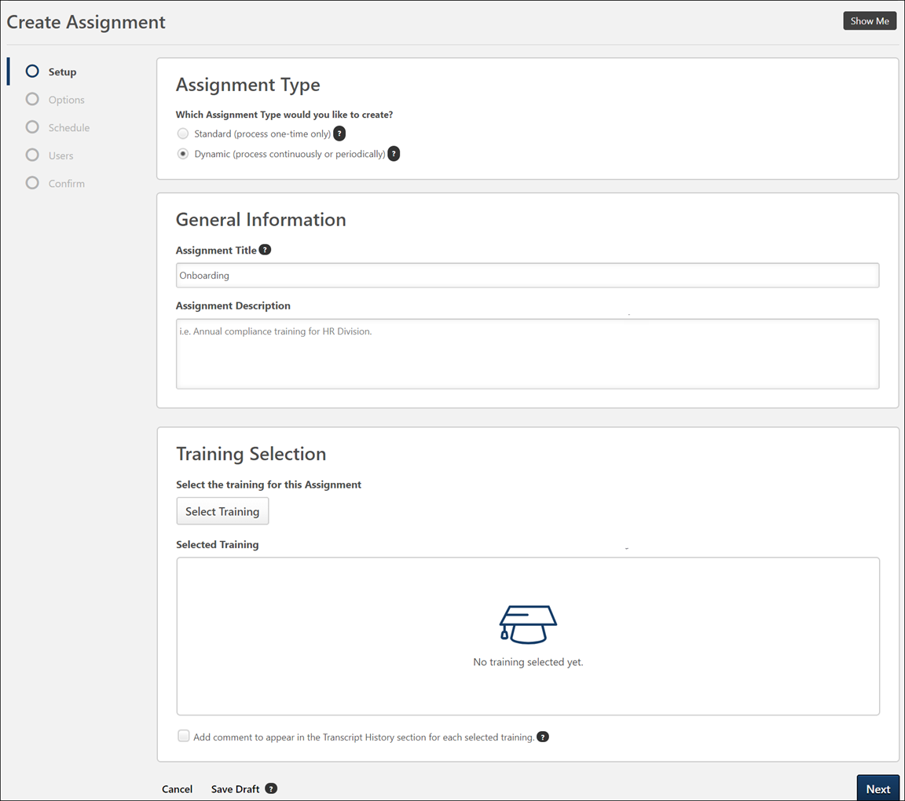
For more details about all the options available on the Setup page, See Create Learning Assignment - Setup on page 27 for additional information.
Options
On the Options step, configure the assignment workflow and email options. For a dynamic assignment:
- Decide whether or not to enable Dynamic Removal. If enabled, users will be automatically removed from the assignment when they no longer meet the user criteria. For this example, Dynamic Removal will not be enabled, because the assignment will be assigned to new hires, and there is no reason a new employee would be removed from a new hire group.
- Decide what status the training will display in on the user's transcript after it is assigned. Be aware that availability settings for the learning object itself may also affect the transcript status following assignment. For example, if the LO availability is configured as pre-approved with register upon approval, the user’s transcript status will be Registered upon assignment, even if one of the first two below options is selected in the learning assignment. Available options include:
  - Assigned Only - This option places the learning objects onto the user's transcript, but will still require the dynamic approvals. Once approved, the user must still click the Register link on their transcript.
  - Assigned and Approved - This option places the learning objects in an Approved status on the user's transcript, bypassing the normal approval process. The user must still click the Register link on their Transcript.
  - Assigned, Approved, and Registered - This option assigns, approves, and registers users directly into the training. This bypasses both the approval and registration process as long as the user is not required to pay for the training. The user is only required to launch or complete the training.
    - Bypass User Payment - If the Bypass User Payment option is selected and the training has a cost that is payable by the user, the enrolled users no longer go to the payment page and are automatically enrolled in training item. This option is only available if the Assigned, Approved, and Registered option is selected above.
      - If the user has already paid for a previous version of the training, the user will not pay for the newly assigned version.
      - If Assign New Occurrence is enabled, it does not override the registration workflow for previous versions of the same training; it only applies to the current version of the training. If a user already paid for training and is assigned the same version of that training with this setting, they will need to pay for the training again if Bypass User Payment is not checked.
- Set prerequisite options for the assignment, if applicable.
- Select email options for the learning assignment. You can choose to use the default training-specific email templates configured in the Course Catalog, create a custom set of emails for the assignment, send a one-time email, or use no emails at all.
- Once all options have been configured for the dynamic learning assignment, click the Next button to advance to the Schedule step.
For more details about all the options available on the Options page,See Create Learning Assignment - Options on page 34 for additional information.
Schedule
On the Schedule page, determine when the dynamic learning assignment will process, and when training will be due for users who are assigned the training. For dynamic assignments:
- Select a Processing Frequency. Dynamic assignments can either process daily or annually. In this example, the assignment will process daily so any new employees will receive the new hire training as soon as they are added to the system.
- Select a Processing Start Date. You can decide whether the dynamic assignment will process immediately upon submission, on a relative date, or on a specific date. This assignment is set to process immediately.
- If needed, select a Processing End Date. The dynamic assignment will stop processing automatically on the chosen date, and no more users will be assigned the training after that time.
- Specify a Training Due Date, if applicable. For dynamic assignments which process daily, it is recommended to either select no due date or configure a relative date. The Annual Date option is usually only applicable to dynamic assignments which process annually.
- Leave the Recurrence setting in the Off position. For a use case for dynamic recurring learning assignments, See Dynamic Recurring Learning Assignment - Create on page 100 for additional information.
- Click the Next button at the bottom of the page to advance to the Users step.
For more details about all the options available on the Schedule page, See Create Learning Assignment - Schedule on page 43 for additional information.
Users
On the Users step, set user criteria for the assignment. In this example, the administrator previously created a group called "New Hires," which is configured to include users with a hire date on or after January 1, 2017. For information about how to create a dynamic new hire group, see Use Case - Create a Dynamic New Hire Group.
- To add users to the assignment, you can select user criteria (such as a division, location, etc.), you can add all system users to the assignment, or you can upload a .csv file of usernames or user IDs. For dynamic assignments, it is recommended that you choose dynamic criteria (such as a division, location, group, etc). Selecting specific users by name is not recommended for dynamic assignments. In this example, the administrator has selected the group, "New Hires."
- Decide whether or not to enable the Assign New Occurrence feature. Switching the Enable Assign New Occurrence toggle to the On position will include users who meet the defined user criteria and already have the training selected for the assignment on their transcript. When enabled, users who have already completed the training will receive a new occurrence of the training and need to take it again. For this example, the Assign New Occurrence option is not enabled, as employees should not receive new hire training more than once.
- Click the Generate Initial User List button to view a list of users who will be assigned the training, based on your user criteria selections. Using the check boxes in each user's tile, you can opt to not include certain users or certain training items for users if needed.
- After configuring the correct user criteria, click the Next button at the bottom of the page to advance to the Confirm step.
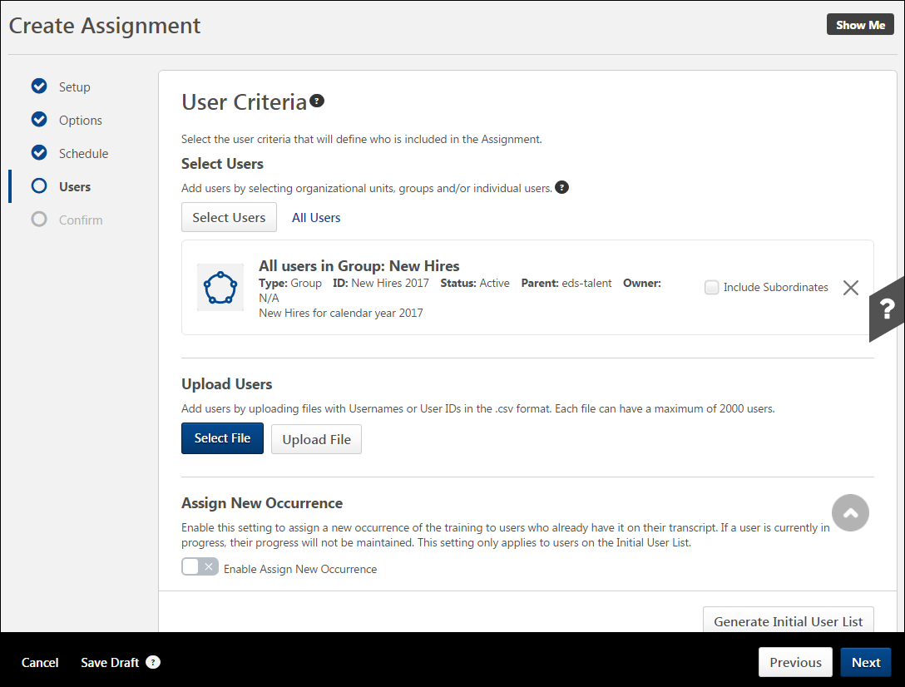
For more details about all the options available on the Users page, See Create Learning Assignment - Users on page 53 for additional information.
Confirm
On the Confirm page, review your learning assignment selections by expanding the tiles for each section of the process. You can return to previous pages by clicking the name of a section in the navigation panel on the left side of the page.
After reviewing all your learning assignment configurations and ensuring all selections are correct, you can click the Submit button to submit the new learning assignment. The learning assignment will process and assign training according to your scheduling selections. Note: Once submitted, the learning assignment cannot be stopped or reversed. It is only possible to stop a dynamic learning assignment from continuing to process in the future.
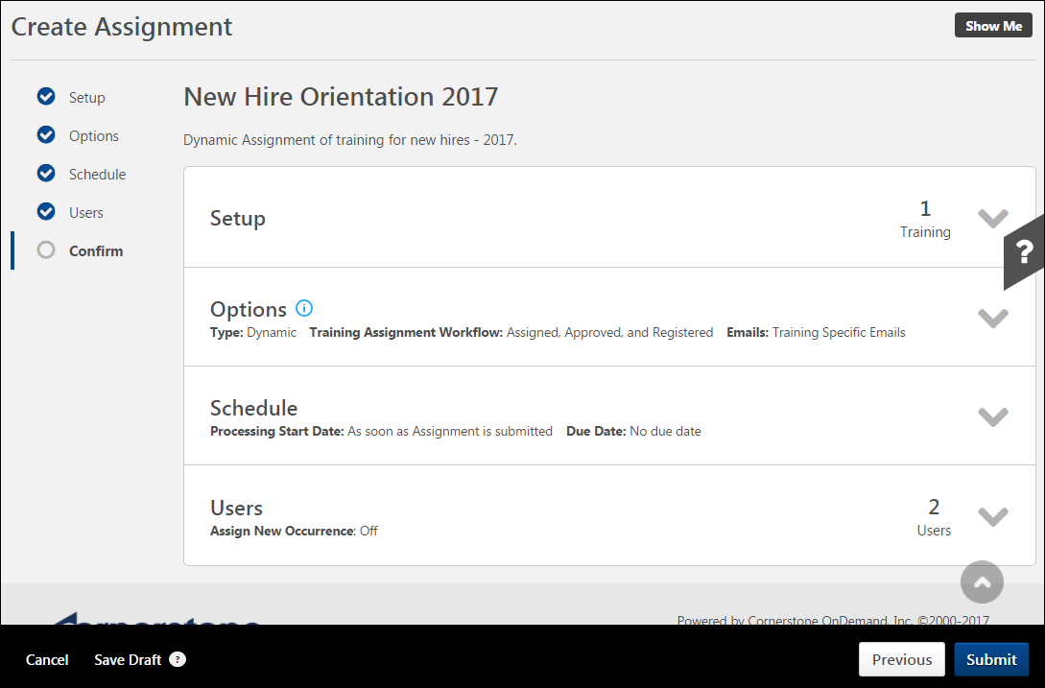
For more details about all the options available on the Confirm page,See Create Learning Assignment - Confirm on page 70 for additional information.
Editing Existing Dynamic Learning Assignments with Required Training Tagging Active​​
The “Required” tag and requirement can be updated on existing dynamic learning assignments. Editing the “Required” tag and requirement uses the same logic as updating the due date settings of an existing dynamic assignment. The update impacts:
- Users who join the dynamic assignment from that moment on.
- Users impacted by versioning of the training assigned by the dynamic assignment.
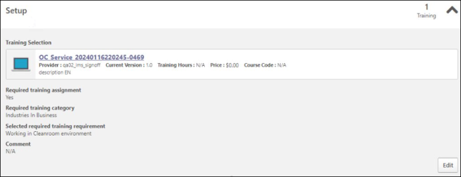
All changes in “is required” and “requirement” are tracked in the Modification History section. Please note that the modification displays a maximum of 20 entries, the submission, and the last 19 changes. To know more about Required Training Tagging, See Required Training Tagging Overview.

Dynamic Recurring Learning Assignment - Create
The dynamic recurring learning assignment type allows you to choose one or more learning objects (LOs) and select the users who will be assigned the training on their transcript repeatedly, at a frequency you specify. Dynamic learning assignments process every day and allow you to assign training on an ongoing basis to users who meet specific criteria, and enabling recurrence allows the training to be reassigned to users more than once. For example, you can create a dynamic recurring learning assignment which reassigns compliance training to all employees on an annual basis.
To create a new dynamic recurring learning assignment, go to Admin > Tools > Learning and click the Learning Assignment Tool link. Then, click the Create Assignment button.
Permissions
PERMISSION NAME | PERMISSION DESCRIPTION | CATEGORY

Assignment Tool - Training Start Date | Grants ability to configure a Training Start Date when creating a Standard Learning Assignment. The Training Start Date is the date that users will be able to start the training. This permission is dependent on the Assignment Tool - Standard, Assignment Tool - Standard and Dynamic, and Assignment Tool - Standard and Dynamic - Recurrence permissions. This permission cannot be constrained. This is an administrator permission. | Learning - Administration

Assignment Tool - Restrict to Users' LO Availability | This permission does not grant ability to any specific functionality and can only be constrained by Users' LO Availability. If this permission is constrained, then the user creating the Learning Assignment can only select and assign training that is within the users own availability. This permission is dependent on the Assignment Tool - Standard, Assignment Tool - Standard and Dynamic, and Assignment Tool - Standard and Dynamic - Recurrence permissions. This is an administrator permission. | Learning - Administration

Assignment Tool - Email Settings - Manage | Grants ability to manage email settings when creating a Learning Assignment. This includes the ability to select all four email settings, set up Custom Emails (create new emails and set existing emails as active/inactive), set up Ad-Hoc Emails, and enable/disable Assign Training and Register Training email triggers when Training Specific Emails is selected. This permission is dependent on the Assignment Tool - Standard, Assignment Tool - Standard and Dynamic, and Assignment Tool - Standard and Dynamic - Recurrence permissions. This permission can be constrained by OU, User, User Self and Subordinates, and User's OU. If this permission is constrained, then only users within the constraints will receive the emails. This is an administrator permission. | Learning - Administration

Assignment Tool - Email Settings - View | Grants ability to view and select email settings when creating a Learning Assignment. This includes the ability to select Training Specific Emails, Custom Emails, or No Emails but does not grant ability to manage the actual Email Settings (cannot configure Custom Emails or Ad-Hoc Email and cannot enable/disable Assign Training and Register Training email triggers when Training Specific Emails is selected). This permission is dependent on the Assignment Tool - Standard, Assignment Tool - Standard and Dynamic, and Assignment Tool - Standard and Dynamic - Recurrence permissions. This permission can be constrained by OU, User, User Self and Subordinates, and User's OU. If this permission is constrained, then only users within the constraints will receive the emails. This is an administrator permission. | Learning - Administration

Assignment Tool - Standard and Dynamic - Recurrence | Grants ability to create Standard (one-time) and Dynamic (continuous) Learning Assignments to directly assign training to users. Also grants ability to enable/disable Recurrence when creating a Dynamic Learning Assignment. This permission can be constrained by OU, Provider, Training Item, Training Type, User, User Self and Subordinates, and User's OU. If this permission is constrained by Location, Provider, Training Type, or Training Item, then they can only assign training within the constraints. If this permission is constrained by OU, User, User Self and Subordinates, or User's OU, then they can only assign to and view assignments created by users within the constraints. This is an administrator permission. | Learning - Administration
Setup
The first step for creating a dynamic recurring learning assignment is providing some basic information about the assignment and selecting the training that will be assigned. In this example, an administrator is assigning newly hired employees a course called "Data Privacy Training."
- Enter a descriptive title for the dynamic learning assignment. In this example, the assignment title will be "Annual Compliance Training."
- Enter a description for the assignment which will help other administrators understand the purpose of the assignment.
- Click the Select Training button to add training to the assignment.
- In the flyout, search for and select the course, and then click the Select button at the bottom of the flyout. The training is added to the assignment.
- Click the Next button to advance to the Options step of the learning assignment creation process.
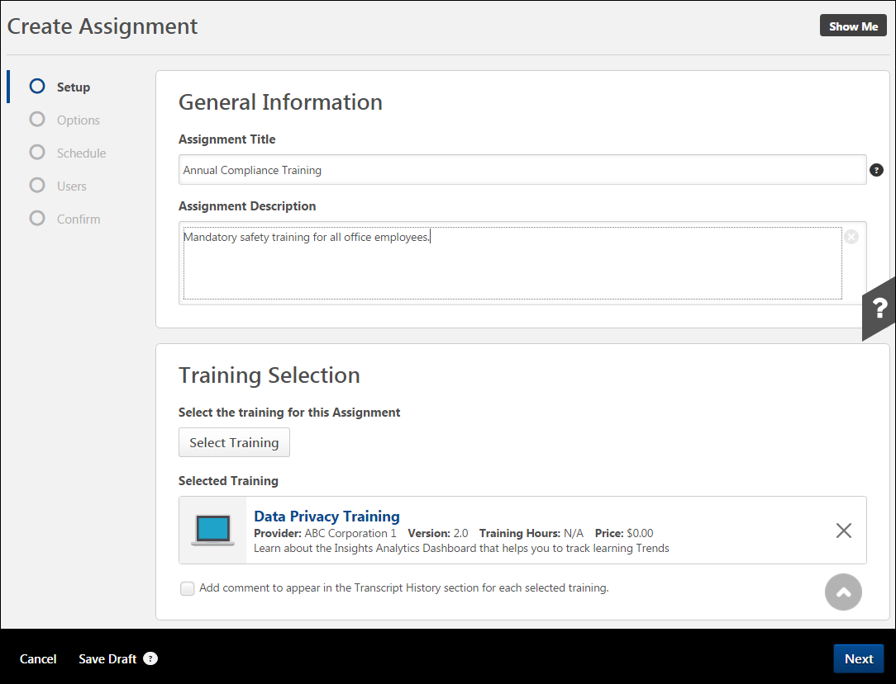
For more details about all the options available on the Setup page, See Create Learning Assignment - Setup on page 27 for additional information.
Options
- On the Options step, select the assignment type and configure the assignment workflow and email options. For a dynamic assignment:
- Select the Dynamic option. This causes the assignment to process every day and assign training to any new users who meet the availability criteria set for the assignment. Additional options become available when Dynamic is selected. The option to make the dynamic assignment recurring is located later in the process.
- Decide whether or not to enable Dynamic Removal. If enabled, users will be automatically removed from the assignment when they no longer meet the user criteria. For this example, Dynamic Removal will not be enabled.
- Decide what status the training will display in on the user's transcript after it is assigned. Be aware that availability settings for the learning object itself may also affect the transcript status following assignment. For example, if the LO availability is configured as pre-approved with register upon approval, the user’s transcript status will be Registered upon assignment, even if one of the first two below options is selected in the learning assignment. Available options include:
  - Assigned Only - This option places the learning objects onto the user's transcript, but will still require the dynamic approvals. Once approved, the user must still click the Register link on their transcript.
  - Assigned and Approved - This option places the learning objects in an Approved status on the user's transcript, bypassing the normal approval process. The user must still click the Register link on their Transcript.
  - Assigned, Approved, and Registered - This option assigns, approves, and registers users directly into the training. This bypasses both the approval and registration process as long as the user is not required to pay for the training. The user is only required to launch or complete the training.
    - Bypass User Payment - If the Bypass User Payment option is selected and the training has a cost that is payable by the user, the enrolled users no longer go to the payment page and are automatically enrolled in training item. This option is only available if the Assigned, Approved, and Registered option is selected above.
      - If the user has already paid for a previous version of the training, the user will not pay for the newly assigned version.
      - If Assign New Occurrence is enabled, it does not override the registration workflow for previous versions of the same training; it only applies to the current version of the training. If a user already paid for training and is assigned the same version of that training with this setting, they will need to pay for the training again if Bypass User Payment is not checked.
- Select email options for the learning assignment. You can choose to use the default training-specific email templates configured in the Course Catalog, create a custom set of emails for the assignment, send a one-time email, or use no emails at all.
- Once all options have been configured for the dynamic learning assignment, click the Next button to advance to the Schedule step.
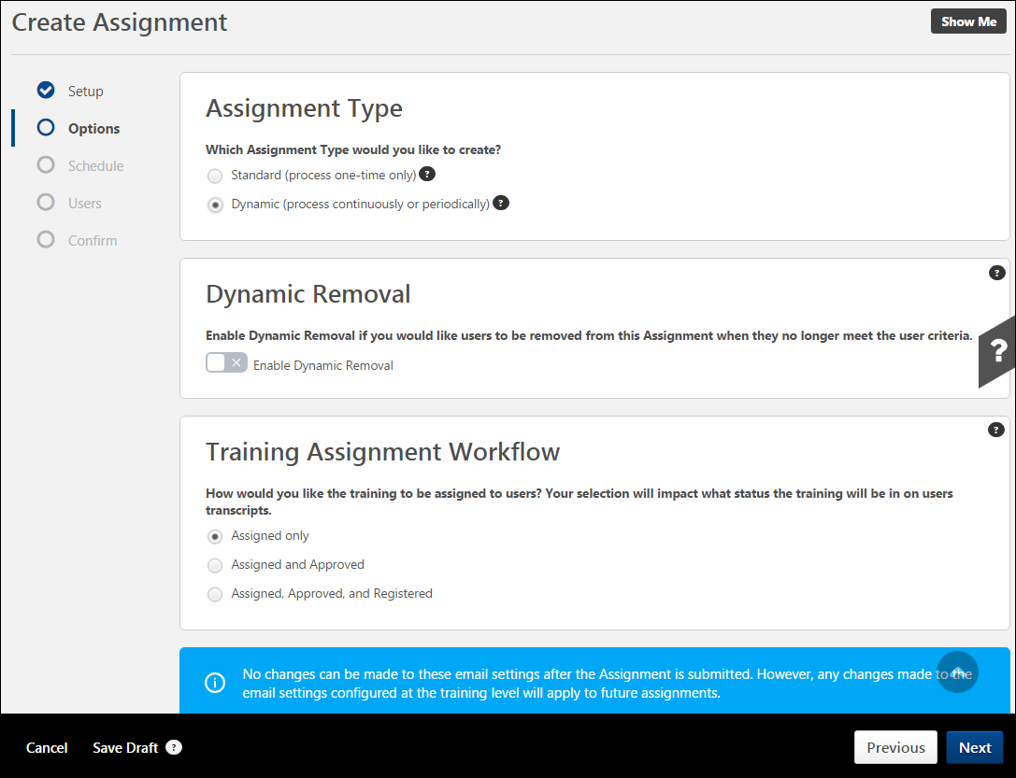
For more details about all the options available on the Options page,See Create Learning Assignment - Options on page 34 for additional information.
Schedule
On the Schedule page, determine when the dynamic learning assignment will process, and when training will be due for users who are assigned the training. For dynamic assignments:
- Select a Processing Frequency. Dynamic assignments can either process daily or annually. In this example, the assignment will process daily. Any employees that have been newly added to the selected OU or group before the daily processing time will be processed and receive the compliance training.
- Select a Processing Start Date. You can decide whether the dynamic assignment will process immediately upon submission, on a relative date, or on a specific date. This assignment is set to process immediately.
- Specify a Training Due Date, if applicable. For dynamic assignments which process daily, it is recommended to either select no due date or configure a relative date. The Annual Date option is usually only applicable to dynamic assignments which process annually.
- To create a dynamic recurring assignment, toggle the Recurrence switch to the On position. Additional recurrence settings become available.
- Determine when the training will recur. The training can either recur on a relative date or annually. In this example, the training will recur annually on May 12. Regardless of when employees received their first instance of training (which is set to be assigned as soon as users are added to the system), they will need to retake the training each year on May 12.
- Determine when, if ever, the recurrence rule will end. The recurrence rule can be set to never end, to end after a certain date, or to end after a certain number of recurrence cycles. Note: Recurrence is based on the most recent assignment date.
- Click the Next button at the bottom of the page to advance to the Users step.
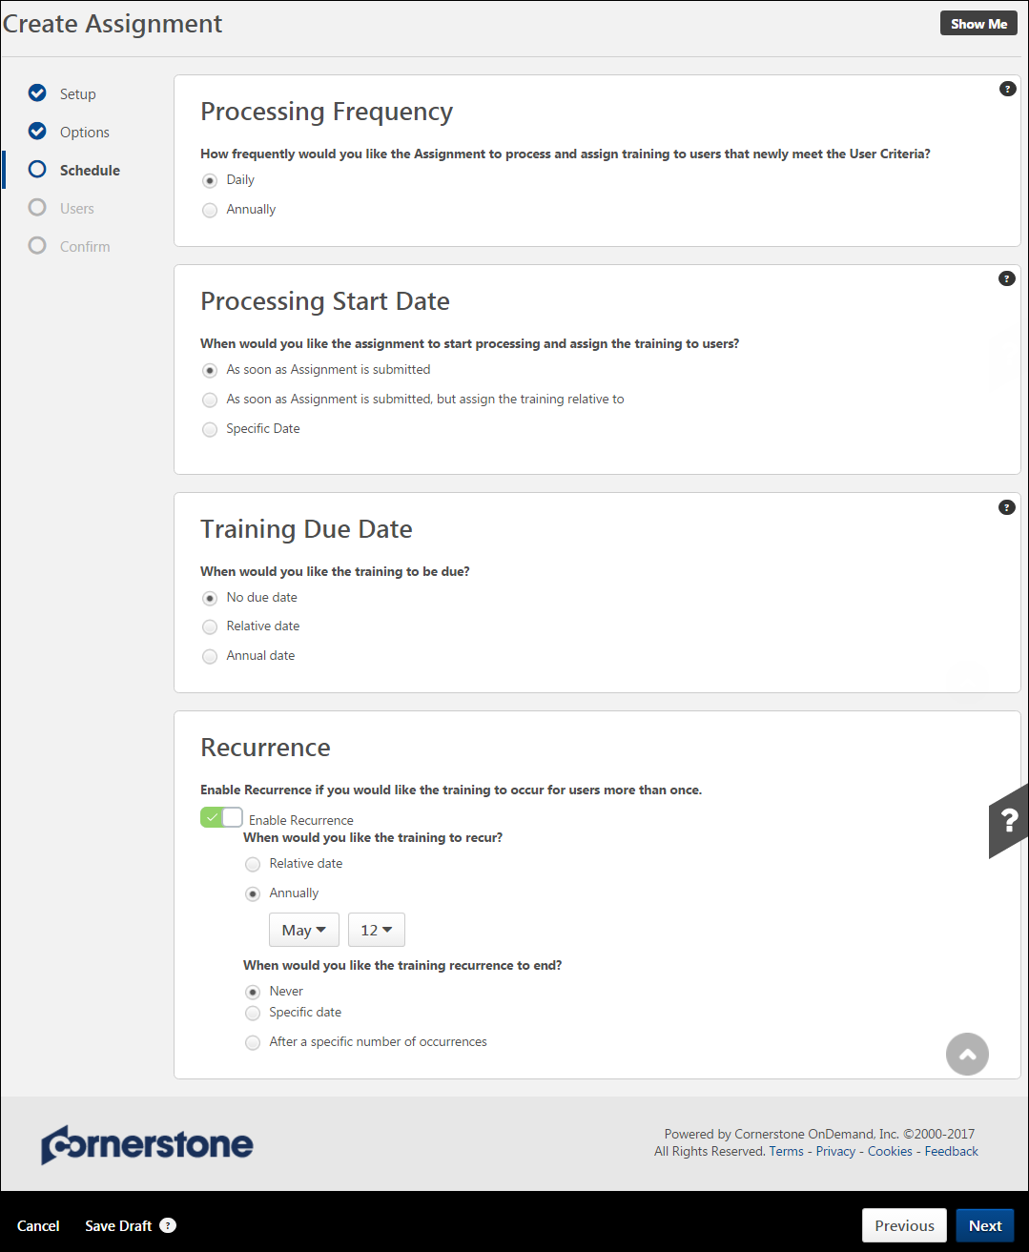
For more details about all the options available on the Schedule page, See Create Learning Assignment - Schedule on page 43 for additional information.
Users
On the Users step, determine who will receive the training.
- To add users to the assignment, you can select user criteria (such as a division, location, etc.), you can add all system users to the assignment, or you can upload a .csv file of usernames or user IDs. For dynamic assignments, it is recommended that you choose dynamic criteria (such as a division, location, group, etc). Selecting specific users by name is not recommended for dynamic assignments. In this example, the availability is set to All Users.
- Decide whether or not to enable the Assign New Occurrence feature. Switching the Enable Assign New Occurrence toggle to the On position will include users who meet the defined user criteria and already have the training selected for the assignment on their transcript. When enabled, users who have already completed the training will receive a new occurrence of the training and need to take it again. For this example, the Assign New Occurrence is enabled, because the administrator recently updated the compliance training and wants all users to receive a new instance of the course. The administrator also opts to override all prior due dates.
- Click the Generate Initial User List button to view a list of users who will be assigned the training, based on your user criteria selections. Using the check boxes in each user's tile, you can opt to not include certain users or certain training items for users if needed.
- After configuring the correct user criteria, click the Next button at the bottom of the page to advance to the Confirm step.
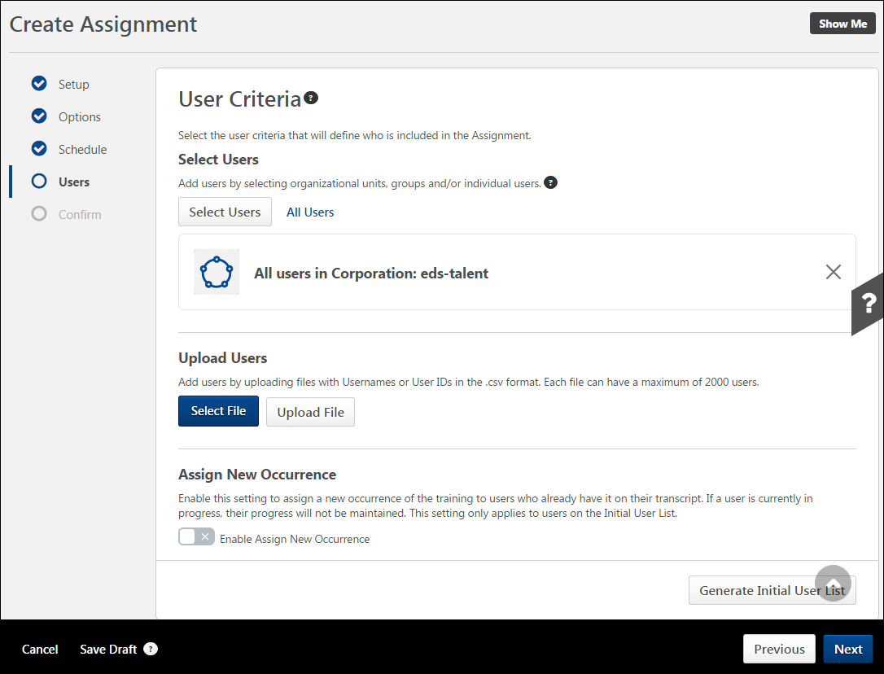
For more details about all the options available on the Users page, See Create Learning Assignment - Users on page 53 for additional information.
Confirm
On the Confirm page, review your learning assignment selections by expanding the tiles for each section of the process. You can return to previous pages by clicking the name of a section in the navigation panel on the left side of the page.
After reviewing all your learning assignment configurations and ensuring all selections are correct, you can click the Submit button to submit the new learning assignment. The learning assignment will process and assign training according to your scheduling selections. Note: Once submitted, the learning assignment cannot be stopped or reversed. It is only possible to stop a dynamic learning assignment from continuing to process in the future.
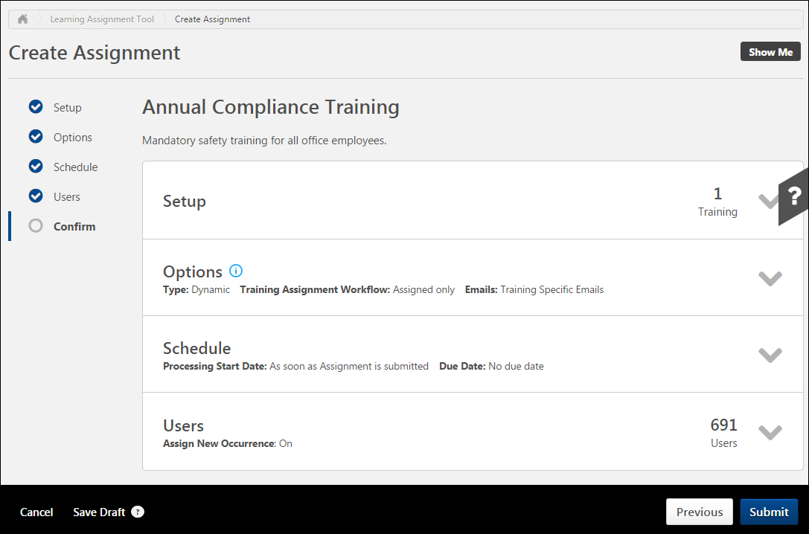
For more details about all the options available on the Confirm page,See Create Learning Assignment - Confirm on page 70 for additional information.

Use Cases - Common Uses for Dynamic Removal
In these examples, an organization uses the dynamic removal tool to remove certain assigned training from the transcripts of users who no longer meet the learning assignment criteria.
- Scenario 1: Removing safety training from the transcript of a user who moved from the warehouse to the sales department of his company
- Scenario 2: Removing California-specific compliance training from the transcript of a user who transferred from the Los Angeles office to the Chicago office
- Scenario 3: Removing management training from the transcript of a user who was mistakenly added to a project management group
Scenario 1: Removing training from a user who moved to a different department
This use case involves removing safety training from the transcript of a user who moved from the warehouse to the sales department of his company.
- Annual safety training is dynamically assigned to all warehouse workers on the anniversary of their hire date at ABC Company. To do this, administrators created a dynamic recurring learning assignment, which is set up to assign, approve, and register the same online course to all users who are part of the Warehouse Employees group.
- After creating the dynamic recurring learning assignment for the warehouse safety training course, administrators turned Dynamic Removal on for that assignment.
- Joe, a warehouse employee, has recently been transferred to the sales department of ABC Company, and he will no longer be required to complete the registered safety training currently on his transcript, and it will never be assigned to him again. Previously completed instances of this training will remain on Joe’s Completed transcript.
- When Joe was originally hired at the warehouse, he was automatically added to a dynamic group called Warehouse Employees, which is set up to gather all users with Warehouse listed as the department on their user record, who were hired after 2010.
- After his transfer, Joe’s user record was changed to reflect his new department (Sales). This caused him to be automatically removed from the dynamic Warehouse Employees group, which processes each day in order to both add new users who meet the criteria of the group, and also remove users who no longer meet the criteria of the group.
- The next time the recurring dynamic learning assignment for the warehouse safety training processes, Joe will no longer meet the criteria for the learning assignment. Due to this, he will not be assigned the safety training in the future.
- Because Dynamic Removal is turned on for the learning assignment, if the training currently exists on Joe’s transcript in any of the following statuses, it will be removed: Pending Approval, Registration Pending, Approved, Registered, Pending Prerequisite, and Past Due (If Not Started). If Joe has already started the training, it will remain on his transcript, but the assigned due dates will be removed. This allows Joe to still complete the assigned training if he wishes, but he will not receive reminders regarding that training.
Scenario 2: Removing training from a user who transferred to a different location
This use case involves removing California-specific compliance training from the transcript of a user who transferred from the Los Angeles office to the Chicago office.
- Annual compliance training is dynamically assigned to all California-based employees at Z-Corp on January 15th of every year. To do this, administrators created a dynamic recurring learning assignment, which is set up to assign the same document to all users whose location is listed as California (or any of its subordinate locations) on their user record. Administrators turned Dynamic Removal on for this learning assignment.
- Sara, an employee originally hired in Santa Monica, has accepted a transfer to Z-Corp’s Chicago office.
- After her transfer, Sara’s user record was changed to reflect her new location. The next time the recurring dynamic learning assignment for the California compliance document processes, Sara will no longer meet the criteria for the assignment. Due to this, she will not be assigned the compliance document in the future.
- However, Sara was transferred to the Chicago office on January 18, three days after the California compliance training was assigned for 2016, but she has not yet started the training. Because Dynamic Removal is turned on for the learning assignment, and the LO is in a Registered status, the training will be automatically removed from Sara’s transcript. If Sara has already started the training, it will remain on her transcript, but the assigned due dates will be removed. This allows Sara to still complete the assigned training if she wishes, but she will not receive reminders regarding that training.
Scenario 3: Removing training from a user who was mistakenly added to a group
This use case involves removing management training from the transcript of a user who was mistakenly added to a project management group.
- Every 180 days, management training is dynamically assigned to all project managers at Transikon. To do this, administrators created a dynamic recurring learning assignment, which is set up to deploy the same online course to all users who have been individually added to a dynamic group called Project Managers every 180 days from the date of the original assignment. Administrators turned Dynamic Removal on for this learning assignment.
- Julie, an administrative assistant, was accidentally added to the Project Managers group, and was erroneously assigned the management course. It is currently on her transcript in an Approved status because the learning assignment was set to Assign and Approve training for all users included in the assignment.
- After realizing the mistake, an administrator accessed the Project Managers group and removed Julie from the list of group criteria.
- The next time the learning assignment processes, Julie will no longer meet the user criteria. Because Dynamic Removal is turned on for the assignment, and the LO is in an Approved status, the training will be automatically removed from Julie’s transcript. If Julie had already accessed the training, and it was in an In Progress status, dynamic removal would NOT remove the course from her transcript. It would be necessary to manually remove the training from her transcript.

Learning Assignment Tool - Due Date Use Cases
Use Case 1: Consider Override Due Date Maintain Progress is On
Curriculum A has a child learning object (LO) called Material M1. Material M1 due date is set to 21 days from the most recent assignment. Curriculum A is now assigned through Dynamic Learning Assignment to Learner 1 and Learner 2. Material M1 is now removed from the structure of Curriculum A causing the Curriculum to version to Curriculum A version 2. Material M1 is now removed from the Learner transcript by an administrator. Now a new Curriculum B is created which includes Material 1 in its structure and Material 1 due date is set 30 days from the most recent assignment. Now Curriculum B is assigned through a new Dynamic Learning Assignment to Learner with Assign New Occurrence ON, Maintain Progress ON, and Override Prior Due Date ON.
Before the enhancement: Learner was retaining the previous due date for Material 1.
After the enhancement: Learner gets the new due date as per Curriculum B assignment for Material 1.
Use Case 2: Reset Due Date when re-assigning Removed Child LO​
Curriculum A Version 1 (V1) has a Material 1 Version 1 (V1) and a note. The due date for Material 1 V1 is set to 21 days from the initial assignment date in the Curriculum A V1 structure. Curriculum A V1 is now assigned through a Learning Assignment to a Learner. The Child LO Material 1 V1 is removed from the structure of the Curriculum A creating a new version of Curriculum A V2 and the Child LO is now standalone on Learner’s transcript (Any configurations can be selected during versioning). The Standalone Child LO Material 1 V1 is manually removed from Learners’ transcript either by transcript removal or using Training removal tool. Now a Curriculum B V1 is created having Material 1 V1 with due date set to 25 days from the initial assignment date in the structure. Now Curriculum B V1 is assigned through Learning Assignment to the Learner with Assign New Occurrence ON, Maintain Progress ON, and Override Prior Due Date OFF.
Before the enhancement: Learner was retaining the previous due date for Material 1 V1.
After the enhancement: Learner gets the new due date for Material V1 as per new due date criteria (25 days from initial assignment).
Conclusion: If a Learning Object (LO) with a due date is removed from a Learner transcript and then re-assigned, the learner receives a new due date regardless of override prior due date configuration.
Use Case 3: New Due Date email not triggering after removed LO is restored​
Learner is assigned a Material A through Dynamic Learning Assignment with a due date. Material A is now dynamically or manually removed from the Learner transcript. Material A is re-assigned through standard or dynamic learning assignment with a new due date with Assign New Occurrence ON, Maintain Progress ON, and Override Prior Due Date ON.
Before the enhancement: Learner was not receiving an email as per new due date.
After the enhancement: Learner receives an email as per the new due date.
Use Case 4: Due date not updated with Dynamic Assignment Re-versioning
When “Apply Previous Version Due Date Criteria” is selected, 'No Due Date' is assigned if the associated previous version was assigned via a Learning Assignment that had no due date set. The due date is only recalculated if that Learning Assignment had a due date criteria set as 'Relative to Assigned Date'. For other criteria such as 'Relative to Hire Date/Custom Field', the due date is copied from the previous version.
Append version with no due date LAT criteria:
- Create a Material 1 version 1 (M1V1).
- Assign M1V1 to Learner 1 via Learning Assignment Tool (LAT). Do not set the Due Date in LAT.
- Go to Learner 1 transcript and set the Due Date for M1V1.
- Version M1V1 in append mode. Select all versions, all statuses, and previous version Due Date Criteria.
Before the enhancement: Due Date from M1V1 is copied to M1V2.
After the enhancement: No Due Date for M1V2.
Append version with no LAT:
- Create a Material 1 version 1 (M1V1).
- Assign M1V1 directly to Learner 1.
- Go to Learner 1 transcript and set the Due Date for M1V1.
- Version M1V1 in append mode. Select all versions, all statuses, and Previous Version Due Date Criteria.
Before the enhancement: Due Date from M1V1 is copied to M1V2.
After the enhancement: No Due Date for M1V2.
Append version with Due date in Curriculum structure and Training Removal Tool:
- Create a Material 1 version 1 (M1V1).
- Create a Curriculum 1 version 1 (C1V1). Add M1V1 to C1V1. Add the due date for M1V1 inside the Curriculum.
- Assign C1V1 to Learner 1 via LAT.
- Use the Training Removal Tool (TRT) to remove C1V1 from Learner 1 Transcript. Clear the "Remove training within Curricula" option.
- Version M1V1 in append mode. Select all versions, all statuses, and Previous Version Due Date Criteria.
Before the enhancement: Due Date from M1V1 is copied to M1V2.
After the enhancement: No Due Date for M1V2.
Append version with Due date in Curriculum structure:
- Create a Material 1 version 1 (M1V1).
- Create a Curriculum 1 version 1 (C1V1).
- Add M1V1 to C1V1. Add the due date for M1V1 inside the Curriculum.
- Assign M1V1 via Dynamic LAT to Learner 1.
- Version M1V1 in append mode. Select all versions, all statuses, and Previous Version Due Date Criteria.
- Assign C1V1 to Learner 1 via Standard LAT or Direct Assignment.
- Version M1V2 in append mode. Expire M1V1 in the popup.
- Select all versions, all statuses, Users Assigned by Dynamic LAT, and Previous Version Due Date Criteria.
Before the enhancement: Due Date from M1V2 is copied to M1V3.
After the enhancement: No Due Date for M1V3.

Assignment Summary Page
The Assignment Summary page provides administrators a central location for tracking and managing learning assignments. This page presents a high level view of the assignment, including the assignment configurations, how many users were assigned training, and a Transcript History section which includes:
- An audit view of how and when training was delivered to users (via a new assignment, an old assignment, direct assignment from a manager, or via direct request from the user)
- A detailed view of the training status and completion date
- A flyout for viewing the history of any different occurrences of training for each user
To access the Assignment Summary page for a learning assignment, go to Admin > Tools > Learning > Learning Assignment Tool and click on the title of the learning assignment for which you want to view the Assignment Summary page.
Permissions
PERMISSION NAME | PERMISSION DESCRIPTION | CATEGORY

Assignment Tool - Dynamic Removal | Grants ability to enable/disable Dynamic Removal from within the Learning Assignment create workflow and/or the Assignment Summary page. When Dynamic Removal is enabled, users that no longer meet the User Criteria are removed from the Learning Assignment. This permission is dependent on the Assignment Tool - Standard, Assignment Tool - Standard and Dynamic and Assignment Tool - Standard and Dynamic - Recurrence permissions. This permission cannot be constrained. This is an administrator permission. | Learning - Administration

Assignment Tool - Edit Assignment Due Date | This permission grants the administrator the ability to edit the due date of dynamic learning assignments via the Assignment Summary page for the assignment. This permission can be constrained by the following:  - OUs​  - User’s OUs​ | Learning - Administration

Assignment Tool - Edit Assignment Title | This permission grants the administrator the ability to edit the title of both standard and dynamic learning assignments via the Assignment Summary page for the assignment. This permission can be constrained by the following:  - OUs​  - User’s OUs​ | Learning - Administration

Assignment Tool - Force Removal | Grants ability to force the removal of training assigned by a standard or dynamic learning assignment on the Assignment Summary page. This is an administrator permission. This permission can be constrained by OU and Users, and the user can be limited to only being able to use this functionality for assignments they created. | Learning - Administration

Assignment Tool - Standard and Dynamic - Recurrence | Grants ability to create Standard (one-time) and Dynamic (continuous) Learning Assignments to directly assign training to users. Also grants ability to enable/disable Recurrence when creating a Dynamic Learning Assignment. This permission can be constrained by OU, Provider, Training Item, Training Type, User, User Self and Subordinates, and User's OU. If this permission is constrained by Location, Provider, Training Type, or Training Item, then they can only assign training within the constraints. If this permission is constrained by OU, User, User Self and Subordinates, or User's OU, then they can only assign to and view assignments created by users within the constraints. This is an administrator permission. | Learning - Administration

Assignment Tool - Standard and Dynamic | Grants ability to create Standard (one-time) and Dynamic (continuous) Learning Assignments to directly assign training to users. This permission can be constrained by OU, Provider, Training Item, Training Type, User, User Self and Subordinates, and User's OU. If this permission is constrained by Location, Provider, Training Type, or Training Item, then they can only assign training within the constraints. If this permission is constrained by OU, User, User Self and Subordinates, or User's OU, then they can only assign to and view assignments created by users within the constraints. This is an administrator permission. | Learning - Administration

Assignment Tool - Standard | Grants ability to create Standard (one-time) Learning Assignments to directly assign training to users. This permission can be constrained by OU, Provider, Training Item, Training Type, User, User Self and Subordinates, and User's OU. If this permission is constrained by Location, Provider, Training Type, or Training Item, then they can only assign training within the constraints. If this permission is constrained by OU, User, User Self and Subordinates, or User's OU, then they can only assign to and view assignments created by users within the constraints. This is an administrator permission. | Learning - Administration
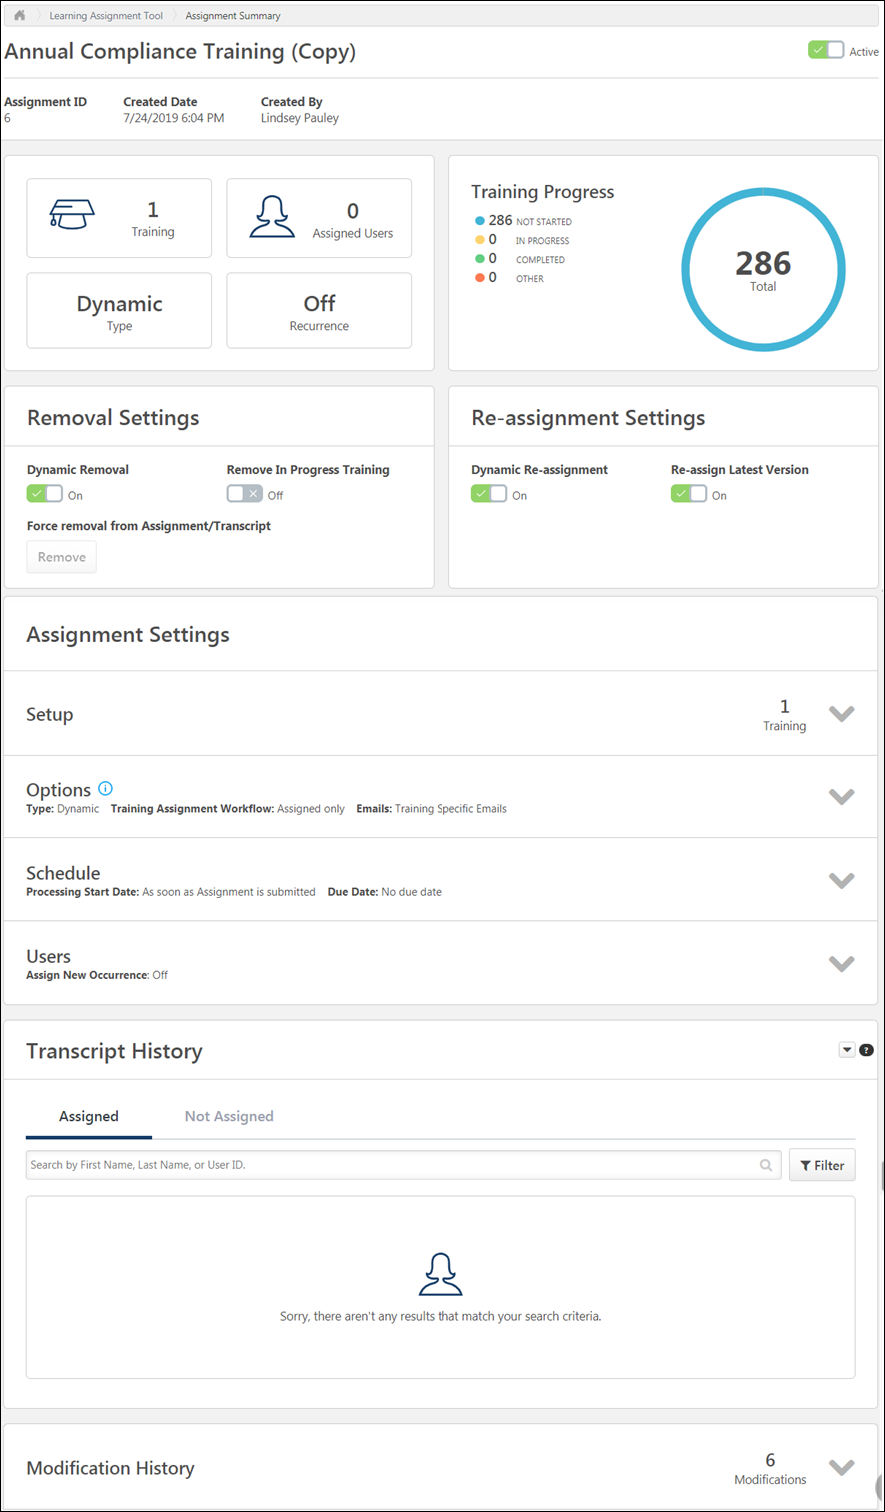
General Information
In the top section of the Assignment Summary page, basic information about the creation and configuration of the assignment displays. The following general information is available:
- Assignment Title - The title given to the learning assignment. Administrators with the permission to edit assignment titles can edit the titles of standard and dynamic assignments by clicking the Title field on the Assignment Summary page. This opens an inline editing pop-out window, and you can enter a different title for the assignment. To confirm and save the new title, click the green checkmark icon in the pop-out window. To discard the edits to the title field without saving, click the red X icon.
- Active/Inactive - This toggle switch is only available for dynamic learning assignments. When toggled to the Active position, the assignment is active and continues to process at the frequency specified by the creator of the assignment. When toggled to the Off position, the assignment no longer processes, and no new users who meet the assignment's criteria are assigned the training.
  - Note: When the the Active/Inactive switch is toggled mid-dynamic assignment, the assignment stops processing. All users in the availability that were processed before toggling to "Off" will receive the assignment. For these users, use the Training Removal Tool to remove any assignments made in error.
  - Note: There may be up to a ten minute delay between inactivation and the termination of the assignment process.
- Assignment Description - The description provided for the learning assignment.
- Assignment ID - A unique, auto-generated ID code associated with the learning assignment.
- Created Date - The date the learning assignment was submitted.
- Created By - The system user who created the assignment.
- Training - This field displays how many training items were selected in the learning assignment.
- Assigned Users - This field displays how many users from the user criteria selected in the learning assignment meet the assignment's criteria.
- Type - This field displays the learning assignment type (standard or dynamic).
- Recurrence - This field only displays for dynamic learning assignments, and indicates whether recurrence is turned off or on for the learning assignment.
- Status - This field only displays for standard learning assignments, and it displays the learning assignment's current status (i.e. Processed, Queued, or Cancelled). If the assignment is in a Queued status, a Stop Processing option is available. See the Stop Processing section in this help topic for more information.
- Remove from Transcript - This option allows you to remove the training from the assignment from users' transcripts. See the section below for more information about this option.
Force Removal from Standard Assignments
For standard assignments, a Remove from Transcript button is available in the Processed section of the Assignment Summary page. Click the Remove from Transcript button to remove the training from the assignment from users' transcripts.
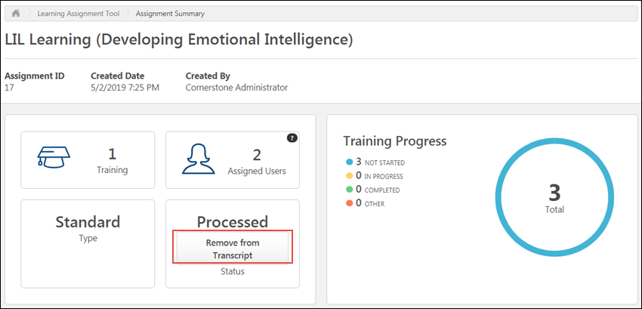
A pop-up appears, warning the administrator that this action cannot be undone. If the administrator clicks the Remove from Transcript button in the pop-up, the training will be removed from users' transcripts and the assignment can no longer be activated again. If the administrator decides not to remove the training, they can click the Cancel button to return to the Assignment Summary page.
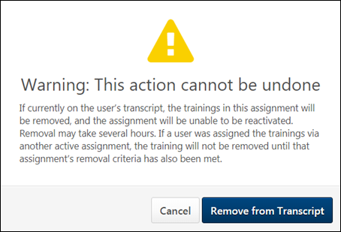
When the administrator clicks the Remove from transcript button, the process to remove the assignment's training from users' transcripts begins. This process may take several hours to complete, depending on how many users were included in the assignment.
The time and date on which the Remove from transcript button was clicked is recorded in the Modification History section of the Assignment Summary page.
Remove from Transcript Considerations
The following considerations apply to this functionality:
- If learners were assigned or requested the training separately, the training may not be removed from their transcript until that learner meets the removal criteria of all assignments.
- This option applies to all learners in the assignment. Individual learners cannot be included or excluded.
Stop Processing
When a standard learning assignment is submitted by an administrator, the assignment queues and processes. It may take several minutes for the assignment's training to be assigned to all the users selected for the assignment. During this time, it is possible to stop the assignment from processing, if required. When processing is stopped, the assignment immediately stops assigning the training to any users who have not yet received the training.
To stop a standard learning assignment from processing:
- Click the title of the processing assignment from the Manage Assignments page. You will be navigated to the Assignment Summary page.
- In the Queued widget, click the Stop Processing link. This link is only available if the assignment is currently processing. A Stop Processing pop-up appears.
- Confirm that you want to stop the processing by clicking the Stop button. Processing will be immediately stopped, and no more users will receive the training. If you do not wish to stop the processing, you can click the Cancel button in the pop-up instead.
Note: The Stop Processing option is only available for standard learning assignments.
Training Progress
In the Training Progress section, status information about the training assigned via the learning assignment displays.
- Training Progress drop-down menu - From this drop-down menu, you can choose a specific training item or all training items, for which graphical progress data will display. Note: Training types that support versioning will have the Version Number appended to the training title in the drop-down. Sessions will have the Locator Number appended to the training title in the drop-down. This list of training correlates to the training listed in the Transcript History. It represents that training that was assigned to the user.
- Training Progress chart - This chart displays a breakdown of how much training is in each possible training status (Not Started, In Progress, Completed, Other). Refer to the Training Progress key to see which colors represent which training status. The total number of transcript records for the selected training title(s) displays in the center of the chart.
- Training Progress key - This color-coded key provides a numeric breakdown of how many transcript records selected training item(s) are in each status. The colors correlate with the Training Progress chart colors.
- Total is the number of learners who have the training present in the transcript.
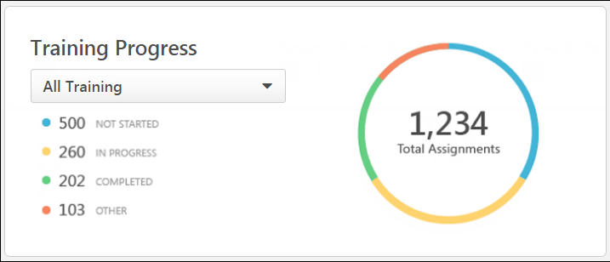
Removal Settings
Administrators can turn Dynamic Removal on and off in the Removal Settings section, along with Dynamic Removal sub options.
Note that any changes in the Removal Settings, with the exception of Force Removal from Assignment/Transcript, only apply to users who fall out of the assignment availability after the settings are updated. Users who have already left the availability prior to updating the settings will not be impacted by the new settings.
The following options are available in the Removal Settings section of the Assignment Summary page:
- Dynamic Removal - This field only is only editable if the dynamic learning assignment is active. It displays whether dynamic removal is currently turned on or off for the assignment. You can toggle the switch to the on or off position to enable or disable dynamic removal for the assignment.
- Remove In Progress Training - Toggling this option to the On position enables the removal of in-progress training from users' transcripts if the users are removed from the assignment via dynamic removal. If users who have been assigned the training no longer meet the assignment criteria, the training in this assignment will be removed from their transcripts whether it is not started or in progress (or equivalent statuses).
- Remove Child LOs - Toggling this option to the On position allows child LOs of an assigned curriculum to also be removed from a user's transcript if the curriculum is removed from the user's transcript via dynamic removal. If there is no curriculum selected for an assignment, this option is not visible.
- Force Removal from Assignment/Transcript - A Remove button is visible under the Force Removal from Assignment/Transcript field to users with the appropriate permission. If the assignment is dynamic, the Remove button is grayed out and is not clickable if the dynamic assignment is currently active. To use the Remove button, deactivate the assignment by toggling the Active switch in the upper-right corner of the Assignment Summary page to the Inactive position. This step is not necessary for standard assignments.
  - When the assignment is inactive, the Remove button is clickable. To remove the training from the assignment from users' transcripts, click the Remove button.
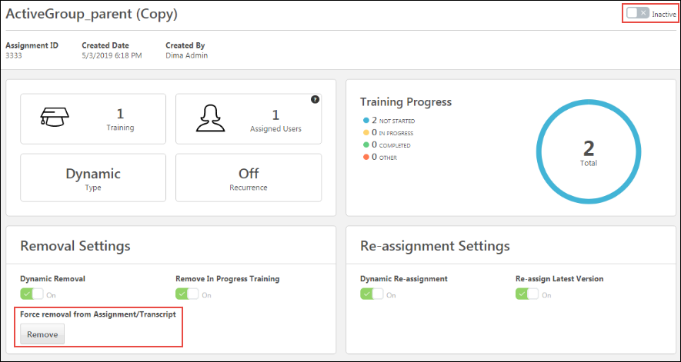
A pop-up appears, warning the administrator that this action cannot be undone. If the administrator clicks the Remove button in the pop-up, the training will be removed from users' transcripts and the assignment can no longer be activated again. If the administrator decides not to remove the training, they can click the Cancel button to return to the Assignment Summary page.
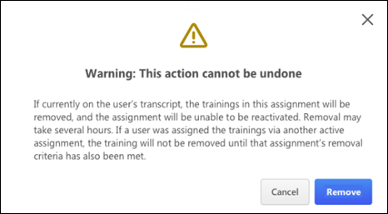
When the administrator clicks the Remove button, the process to remove the assignment's training from users' transcripts begins. This process may take several hours to complete, depending on how many users were included in the assignment.
The time and date on which the Remove button was clicked is recorded in the Modification History section of the Assignment Summary page.
Note: If the administrator accessing the Assignment Summary page does not have permission to manage dynamic removal settings, these fields are read-only.
Remove from Transcript Considerations
The following considerations apply to this functionality:
- If learners were assigned or requested the training separately, the training may not be removed from their transcript until that learner meets the removal criteria of all assignments.
- This option applies to all learners in the assignment. Individual learners cannot be included or excluded.
- Dynamic assignments cannot be reactivated again after training has been removed.
Re-assignment Settings
The following configurable fields in the Re-assignment Settings widget only display for dynamic learning assignments:
Dynamic Re-assignment - This field is only editable if the dynamic learning assignment is active. It displays whether dynamic reassignment is currently turned On or Off for the assignment. You can toggle the switch to the On or Off position to enable or disable dynamic reassignment for the assignment. See Dynamic Reassignment - Assignment Summary Page on page 136 for additional information.
Re-assign Latest Version - This field is only editable if the dynamic assignment is active and Dynamic Re-assignment is On. It displays whether or not users will be upgraded to the latest version of training upon reassignment. You can toggle the switch to the on or off position to enable or disable upgrading users to latest version upon reassignment for the assignment.
Assignment Settings
The learning assignment settings configured within the create workflow display in expandable tiles beneath the Training Progress. Each tile provides a basic overview of its corresponding section's settings. To expand a tile and show more settings details, click the drop-down arrow on the right-hand side of the tile. To collapse the panel, click the drop-down arrow again.
Setup
Before expanding, the Setup tile displays the number of learning objects (LOs) which have been added to the learning assignment. After expanding, each LO displays in its own tile with details about the training. The information that displays for each LO includes:
- LO Type icon - This icon visually represents the LO type, such as online course, material, test, etc.
- Title - The title of each LO is clickable and opens the Training Details page for the LO in a new tab when clicked.
- Provider - The provider set for the LO.
- Version - The version of the LO.
- Training Hours - The number of training hours associated with the LO.
- Price - The price associated with the LO, if applicable.
- Course Code - The unique course code generated for the LO. This field will be hidden if Course Codes are not enabled in your portal.
- Email Settings - The email configurations set at the LO level for the training item. This will only appear if you have selected the Training Specific Emails setting on the Options page.
If you provided a comment when adding to the training or selected a training purpose, they will display under the selected training in the Setup section.
Options
Before expanding, the Options tile displays an overview of the assignment type, the selected transcript status, and email settings configured for the learning assignment. After expanding, the following information displays:
- Type - The learning assignment type that was selected for the assignment (standard or dynamic).
- Dynamic Removal - Whether Dynamic Removal is On or Off displays. This setting will update as it is turned on or off from the top of the summary page.
- Remove in progress training - This field displays whether the option to Remove in progress training is on or off. This will never change once set.
- Remove training within Curricula - This field displays whether the option to Remove training within Curricula is on or off. This will never change once set.
- Training Assignment Workflow - This field displays how the training will be assigned to users.
- Enforce Prerequisites - This field displays whether or not users are required to complete any related prerequisite training before accessing the training included in the assignment.
- Email Settings - The email settings selection you made when configuring emails for the assignment. Depending on your selection, additional details about your selections may also appear in this section.
Schedule
Before expanding, the Schedule tile displays an overview of the assignment's scheduling selections, including the processing date, training start date, and due date. After expanding, the following information displays:
- Processing - This section displays the start date and frequency configured for the assignment, if applicable.
- Training - This section displays the start date (if applicable) and due date for the training.
- Recurrence - This section displays the start setting and the end setting for the assignment's recurrence configurations, if applicable.
Edit Due Date
Administrators with the permission to edit assignment due dates can edit the due date of a dynamic assignment via the Schedule section. The administrator can make edits to the selected due date option or select from the following due date options:
- No Due Date
- Relative Date
- Annual Date
When the administrator initiates an edit of the assignment's due date, a Save button and a Cancel button appear below the due date options. Click the Save button to save your due date modifications, or click the Cancel button to discard your due date modifications without saving them to the assignment.
Note: The ability to edit an assignment's due date is not currently available for standard learning assignments.
Note: Learners assigned the training before the due was changed in the assignment will not have their due dates updated. Once the due date is changed in the dynamic assignment, this new due date applies to learners assigned the training after the due date changed.
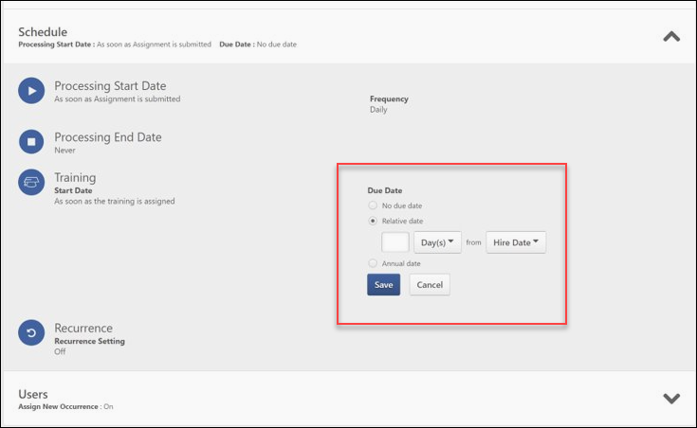
Users
Before expanding, the Users tile displays the number of users who will be assigned the training contained in the learning assignment. After expanding, details about the user criteria you selected display, and you can view whether or not you opted to include subordinates of the selected criteria. You can also view whether the Assign New Occurrence option was turned on or off.
A Maintain Progress toggle switch is available on the Assignment Summary page for active dynamic learning assignments. To allow users who receive new occurrences of the assignment to maintain their version progress, toggle the Maintain Progress option to the On (green) position. If this option is not enabled, users who receive new occurrences of training via the learning assignment will NOT retain their progress.
Transcript History
The Transcript History section allows you to search for and view individual users, as well as their individual progress made on their assigned training. The entire transcript history for the learning assignment can be exported by clicking the drop-down arrow in the upper-right corner of the Transcript History section and clicking the Export link. A maximum of 2000 users can be exported.
If a requirement is added to the assignment, the Transcript History section displays it.
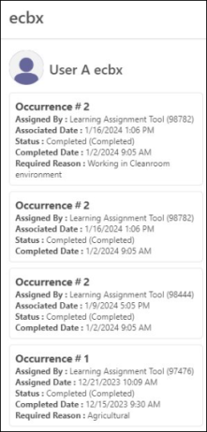
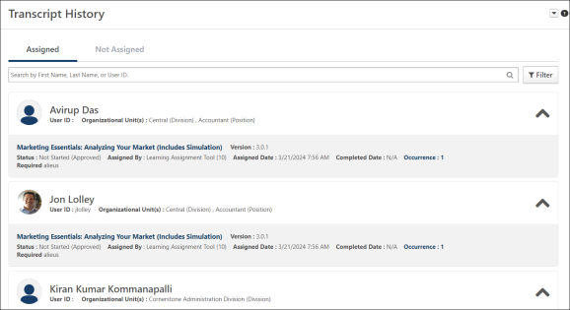
Search
To search for a specific user, you can enter their first name, last name, or User ID into the search field and click the Search icon. Clicking the Filter button allows you to filter your results by assigned training item or transcript status group. Note: These filters will apply to the Export option.
User Cards
Each user tile that displays in the Transcript History section provides the following information about the user:
- Name
- Profile Photo
- User ID
- Organizational Units - The organizational unit listed on the user's user record.
- Removed from Assignment - This tag displays on the User Card when the user has been dynamically removed from the learning assignment. Note: This tag only displays for dynamic learning assignments with dynamic removal and also for standard assignment when Remove from Transcript is selected.
If a user no longer meets the criteria of an assignment in which they were previously included, the Removed from Assignment tag appears to the right of their name in the Transcript History section. If one of the training items they were assigned by the learning assignment was removed from their transcript, the Removed from Transcript tag appears to the right of the training item itself.
Training Cards
All training items assigned to the user via the learning assignment display in the training cards nested beneath the User Card. Training items can be hidden or made visible by clicking the expand/collapse drop-down arrow in the right corner of each User Card. The following information displays for each training item:
- Training Title - This field is clickable and navigates you to the Training Details page on the user's transcript.
- Version - The version of the training that was assigned to the user. Note: This field only displays for training that supports versioning.
- Locator Number - The locator number of the session that was assigned to the user. Note: This field only displays for sessions.
- Removed from Transcript - This tag displays on the Training Card when the training has been removed from the user’s transcript. Note: This tag can display for both dynamic and standard learning assignments. It will display for all removal methods (via training removal tool, dynamic removal, or manually via the transcript)
- Status - The current status of the training on the user's transcript, including the new status group and actual transcript status.
- Assigned By - The user or tool that assigned the training to the user. Note: This field displays as Requested By if the training was requested by the user.
  - Learning Assignment Tool (Assignment ID) - Indicates that the training was assigned by a new learning assignment and includes the ID of the learning assignment.
  - Learning Assignment Tool (User Name) - Indicates that the training was assigned by an old learning assignment (i.e. proxy enrollment) and includes the name of the user that created the old learning assignment.
  - Assigned By: User Name (User ID) - Indicates that the training was assigned by a user via manager assignment, and includes the name and ID of the user.
  - Requested By: User Name (User ID) - Indicates that the training was requested by the user.
- Associated Date - The date the training was assigned to the user. Note: This field displays as Requested Date if the training was requested by the user.
- Completed Date - The date the user completed the training item (N/A displays if the item has not yet been completed).
- Occurrence - The number of times the user has taken the training. Note: This field is clickable and opens the Occurrence Flyout.
Occurrence Flyout
The occurrence flyout displays a history of the different occurrences of training for the user. This includes all previous occurrences regardless of whether or not the occurrence was assigned by the specific learning assignment. The following information displays:
- Training Title
- Name
- Profile Photo
- Occurrence Number
- Assigned By - The user or tool that assigned the training to the user. Note: This field displays as ‘Requested By’ if the training was requested by the User.
  - Learning Assignment Tool (Assignment ID) - Indicates that the training was assigned by a new learning assignment, and includes the ID of the learning assignment.
  - Learning Assignment Tool (User Name) - Indicates that the training was assigned by an old learning assignment (i.e. proxy enrollment) and includes the name of the user that created the old learning assignment.
  - Assigned By: User Name (User ID) - Indicates that the training was assigned by a user via manager assignment and includes the name and ID of the user.
  - Requested By: User Name (User ID) - Indicates that the training was requested by the user.
- Associated Date - The date the training was associated with the user's transcript.
- Status - The current status of the training on the user's transcript including the new status group and actual transcript status.
- Completed Date - The date the user completed the training item (N/A displays if the item has not yet been completed).
If the learner was assigned the same training by another learning assignment, and the learner was removed from that other assignment, the Removed from Assignment tag appears in the Occurrence flyout and displays at the occurrence level.

Modification History
From the moment the assignment is submitted, all changes to the learning assignment are tracked in the modification history. This section shows up to 20 entries.

Dynamic Reassignment Overview
Dynamic Reassignment functionality allows dynamic learning assignments to reassign training that a user may have had on their transcript previously, before it was removed.
When a user changes organizational units (OUs), that user can be re-assigned the same training that a dynamic assignment has already attempted to assign to the user in the past, as long as they meet the assignment criteria. For example, when users transfer from one OU to another, and then transfer back to the original OU, the training that was originally assigned to them is restored to their transcript via dynamic reassignment.
The dynamic reassignment default can be set at the portal level, and if enabled, administrators have the option of turning dynamic reassignment off and on for individual dynamic assignments.
- For information about managing the Dynamic Reassignment setting on the Assignment Summary page, see Dynamic Reassignment - Assignment Summary.
- For information about the impact of the Dynamic Reassignment setting on learning assignment email behavior, see Dynamic Reassignment - Emails.
Permissions
PERMISSION NAME | PERMISSION DESCRIPTION | CATEGORY

Assignment Tool - Dynamic Reassignment | Grants ability to enable/disable Dynamic Re-assignment for an assignment after submission. When Dynamic Re-assignment is enabled, users that meet the User Criteria again (after previously being dynamically removed) are re-assigned. This permission is dependent on the Assignment - Standard, Dynamic - Standard and Dynamic, and Dynamic Assignment - Standard and Dynamic - Recurrence permissions. This permission cannot be constrained. This is an administrator permission. | Learning - Administration

Assignment Tool Preferences | Grants access to Assignment Tool Preferences where an administrator can activate the new Assignment Tool and configure the processing options and settings to create Learning Assignments. This permission cannot be constrained. This is an administrator permission. | Learning - Administration

Assignment Tool - Standard and Dynamic - Recurrence | Grants ability to create Standard (one-time) and Dynamic (continuous) Learning Assignments to directly assign training to users. Also grants ability to enable/disable Recurrence when creating a Dynamic Learning Assignment. This permission can be constrained by OU, Provider, Training Item, Training Type, User, User Self and Subordinates, and User's OU. If this permission is constrained by Location, Provider, Training Type, or Training Item, then they can only assign training within the constraints. If this permission is constrained by OU, User, User Self and Subordinates, or User's OU, then they can only assign to and view assignments created by users within the constraints. This is an administrator permission. | Learning - Administration

Assignment Tool - Standard and Dynamic | Grants ability to create Standard (one-time) and Dynamic (continuous) Learning Assignments to directly assign training to users. This permission can be constrained by OU, Provider, Training Item, Training Type, User, User Self and Subordinates, and User's OU. If this permission is constrained by Location, Provider, Training Type, or Training Item, then they can only assign training within the constraints. If this permission is constrained by OU, User, User Self and Subordinates, or User's OU, then they can only assign to and view assignments created by users within the constraints. This is an administrator permission. | Learning - Administration

Assignment Tool - Standard | Grants ability to create Standard (one-time) Learning Assignments to directly assign training to users. This permission can be constrained by OU, Provider, Training Item, Training Type, User, User Self and Subordinates, and User's OU. If this permission is constrained by Location, Provider, Training Type, or Training Item, then they can only assign training within the constraints. If this permission is constrained by OU, User, User Self and Subordinates, or User's OU, then they can only assign to and view assignments created by users within the constraints. This is an administrator permission. | Learning - Administration
Considerations
Reassignment of training via dynamic reassignment only occurs when the original training was removed by dynamic removal.
Dynamic reassignment does NOT occur if training was removed by one of the following methods:
- Training was removed directly from user's transcript by a user
- Training was removed using the Training Removal Tool
Dynamic reassignment also does NOT occur if training is in one of the following statuses:
- Approved
- Assigned
- Pending Registration
- Denied
When a training item that was assigned to a user via a learning assignment is dynamically removed and then reassigned via another assignment, the latest version of the training is added to the user’s transcript and the user is processed by the new learning assignment. This functionality applies to dynamic and dynamic recurring assignments and ensures that any users from any previous assignments are reassigned the latest version of training items and child training items.
When a training item is reassigned via dynamic reassignment, the due date of the training is then set by the reassigning assignment. Depending on what type of due date is chosen, the training is reassigned with one of the following behaviors:
- No Due Date - The training is re-assigned with no due date.
- Fixed Date - If the fixed date is in the past, the system adds a year or more to the new assignment, to use a future instance of the fixed date (such as January 1).
- Relative Date - The system adds the relative time to the base date specified in the assignment to define a new due date. For example, if the assignment has a due date of 30 days from the assignment date, the training receives a due date 30 days from when the training is reassigned.
Note: If a relative date is set based on a hire date or custom field, these will be calculated and not changed if they are in the past.
Note: If the reassigned training is a child learning object within a curriculum, the due date will be calculated based on the original assignment date.
Dynamic Reassignment Use Case
Clara is an employee at ACME Shipping, in the Northwest Division. Andrew, a learning administrator, assigns Clara the course, "Lifting with Care," Version 1 via a dynamic learning assignment which is configured to assign training to the Northwest Division. Dynamic Removal is enabled for the assignment. Later, Clara leaves the Northwest Division, and “Lifting with Care” is removed from her transcript.
Andrew later deactivates the dynamic learning assignment due a change in requirements, and then he creates a new dynamic learning assignment using the same availability. Andrew also creates a new version of “Lifting with Care” so the training is updated for the new year.
After a few months, Clara returns to the Northwest Division and enters the availability of the new learning assignment. She is reassigned “Lifting with Care" and receives the newest version of the training.

Dynamic Reassignment Overview
Dynamic Reassignment functionality allows dynamic learning assignments to reassign training that a user may have had on their transcript previously, before it was removed.
When a user changes organizational units (OUs), that user can be re-assigned the same training that a dynamic assignment has already attempted to assign to the user in the past, as long as they meet the assignment criteria. For example, when users transfer from one OU to another, and then transfer back to the original OU, the training that was originally assigned to them is restored to their transcript via dynamic reassignment.
The dynamic reassignment default can be set at the portal level, and if enabled, administrators have the option of turning dynamic reassignment off and on for individual dynamic assignments.
- For information about managing the Dynamic Reassignment setting on the Assignment Summary page, see Dynamic Reassignment - Assignment Summary.
- For information about the impact of the Dynamic Reassignment setting on learning assignment email behavior, see Dynamic Reassignment - Emails.
Permissions
PERMISSION NAME | PERMISSION DESCRIPTION | CATEGORY

Assignment Tool - Dynamic Reassignment | Grants ability to enable/disable Dynamic Re-assignment for an assignment after submission. When Dynamic Re-assignment is enabled, users that meet the User Criteria again (after previously being dynamically removed) are re-assigned. This permission is dependent on the Assignment - Standard, Dynamic - Standard and Dynamic, and Dynamic Assignment - Standard and Dynamic - Recurrence permissions. This permission cannot be constrained. This is an administrator permission. | Learning - Administration

Assignment Tool Preferences | Grants access to Assignment Tool Preferences where an administrator can activate the new Assignment Tool and configure the processing options and settings to create Learning Assignments. This permission cannot be constrained. This is an administrator permission. | Learning - Administration

Assignment Tool - Standard and Dynamic - Recurrence | Grants ability to create Standard (one-time) and Dynamic (continuous) Learning Assignments to directly assign training to users. Also grants ability to enable/disable Recurrence when creating a Dynamic Learning Assignment. This permission can be constrained by OU, Provider, Training Item, Training Type, User, User Self and Subordinates, and User's OU. If this permission is constrained by Location, Provider, Training Type, or Training Item, then they can only assign training within the constraints. If this permission is constrained by OU, User, User Self and Subordinates, or User's OU, then they can only assign to and view assignments created by users within the constraints. This is an administrator permission. | Learning - Administration

Assignment Tool - Standard and Dynamic | Grants ability to create Standard (one-time) and Dynamic (continuous) Learning Assignments to directly assign training to users. This permission can be constrained by OU, Provider, Training Item, Training Type, User, User Self and Subordinates, and User's OU. If this permission is constrained by Location, Provider, Training Type, or Training Item, then they can only assign training within the constraints. If this permission is constrained by OU, User, User Self and Subordinates, or User's OU, then they can only assign to and view assignments created by users within the constraints. This is an administrator permission. | Learning - Administration

Assignment Tool - Standard | Grants ability to create Standard (one-time) Learning Assignments to directly assign training to users. This permission can be constrained by OU, Provider, Training Item, Training Type, User, User Self and Subordinates, and User's OU. If this permission is constrained by Location, Provider, Training Type, or Training Item, then they can only assign training within the constraints. If this permission is constrained by OU, User, User Self and Subordinates, or User's OU, then they can only assign to and view assignments created by users within the constraints. This is an administrator permission. | Learning - Administration
Considerations
Reassignment of training via dynamic reassignment only occurs when the original training was removed by dynamic removal.
Dynamic reassignment does NOT occur if training was removed by one of the following methods:
- Training was removed directly from user's transcript by a user
- Training was removed using the Training Removal Tool
Dynamic reassignment also does NOT occur if training is in one of the following statuses:
- Approved
- Assigned
- Pending Registration
- Denied
When a training item that was assigned to a user via a learning assignment is dynamically removed and then reassigned via another assignment, the latest version of the training is added to the user’s transcript and the user is processed by the new learning assignment. This functionality applies to dynamic and dynamic recurring assignments and ensures that any users from any previous assignments are reassigned the latest version of training items and child training items.
When a training item is reassigned via dynamic reassignment, the due date of the training is then set by the reassigning assignment. Depending on what type of due date is chosen, the training is reassigned with one of the following behaviors:
- No Due Date - The training is re-assigned with no due date.
- Fixed Date - If the fixed date is in the past, the system adds a year or more to the new assignment, to use a future instance of the fixed date (such as January 1).
- Relative Date - The system adds the relative time to the base date specified in the assignment to define a new due date. For example, if the assignment has a due date of 30 days from the assignment date, the training receives a due date 30 days from when the training is reassigned.
Note: If a relative date is set based on a hire date or custom field, these will be calculated and not changed if they are in the past.
Note: If the reassigned training is a child learning object within a curriculum, the due date will be calculated based on the original assignment date.
Dynamic Reassignment Use Case
Clara is an employee at ACME Shipping, in the Northwest Division. Andrew, a learning administrator, assigns Clara the course, "Lifting with Care," Version 1 via a dynamic learning assignment which is configured to assign training to the Northwest Division. Dynamic Removal is enabled for the assignment. Later, Clara leaves the Northwest Division, and “Lifting with Care” is removed from her transcript.
Andrew later deactivates the dynamic learning assignment due a change in requirements, and then he creates a new dynamic learning assignment using the same availability. Andrew also creates a new version of “Lifting with Care” so the training is updated for the new year.
After a few months, Clara returns to the Northwest Division and enters the availability of the new learning assignment. She is reassigned “Lifting with Care" and receives the newest version of the training.

Dynamic Reassignment - Assignment Summary Page
If dynamic reassignment has been activated in your portal, dynamic reassignment is enabled by default for all newly created dynamic learning assignments. Learning Assignments that were converted from Proxy Enrollments are NOT included in this behavior (these have dynamic reassignment turned off by default). Administrators with the appropriate permission have the ability to turn dynamic reassignment off and on for individual dynamic learning assignments AFTER the assignment has processed, via the Assignment Summary page.
To access the Assignment Summary page for a learning assignment, go to Admin > Tools > Learning > Learning Assignment Tool and click on the title of the learning assignment for which you want to view the Assignment Summary page.
Permissions
PERMISSION NAME | PERMISSION DESCRIPTION | CATEGORY

Assignment Tool - Dynamic Reassignment | Grants ability to enable/disable Dynamic Re-assignment for an assignment after submission. When Dynamic Re-assignment is enabled, users that meet the User Criteria again (after previously being dynamically removed) are re-assigned. This permission is dependent on the Assignment - Standard, Dynamic - Standard and Dynamic, and Dynamic Assignment - Standard and Dynamic - Recurrence permissions. This permission cannot be constrained. This is an administrator permission. | Learning - Administration

Assignment Tool - Standard and Dynamic - Recurrence | Grants ability to create Standard (one-time) and Dynamic (continuous) Learning Assignments to directly assign training to users. Also grants ability to enable/disable Recurrence when creating a Dynamic Learning Assignment. This permission can be constrained by OU, Provider, Training Item, Training Type, User, User Self and Subordinates, and User's OU. If this permission is constrained by Location, Provider, Training Type, or Training Item, then they can only assign training within the constraints. If this permission is constrained by OU, User, User Self and Subordinates, or User's OU, then they can only assign to and view assignments created by users within the constraints. This is an administrator permission. | Learning - Administration

Assignment Tool - Standard and Dynamic | Grants ability to create Standard (one-time) and Dynamic (continuous) Learning Assignments to directly assign training to users. This permission can be constrained by OU, Provider, Training Item, Training Type, User, User Self and Subordinates, and User's OU. If this permission is constrained by Location, Provider, Training Type, or Training Item, then they can only assign training within the constraints. If this permission is constrained by OU, User, User Self and Subordinates, or User's OU, then they can only assign to and view assignments created by users within the constraints. This is an administrator permission. | Learning - Administration

Assignment Tool - Standard | Grants ability to create Standard (one-time) Learning Assignments to directly assign training to users. This permission can be constrained by OU, Provider, Training Item, Training Type, User, User Self and Subordinates, and User's OU. If this permission is constrained by Location, Provider, Training Type, or Training Item, then they can only assign training within the constraints. If this permission is constrained by OU, User, User Self and Subordinates, or User's OU, then they can only assign to and view assignments created by users within the constraints. This is an administrator permission. | Learning - Administration
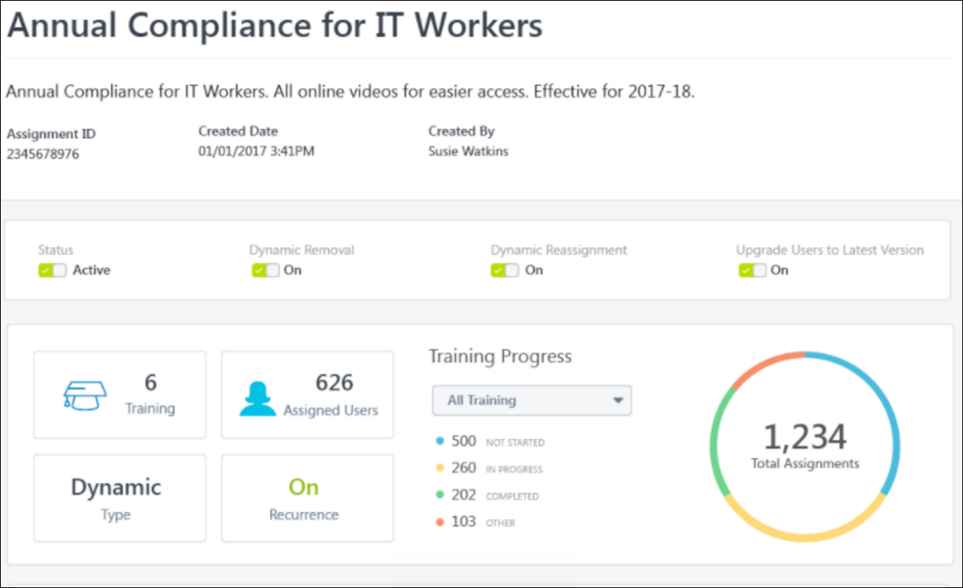
Assignment Summary - Dynamic Reassignment Options
On the Assignment Summary page, there are two options related to dynamic reassignment which are configurable on the learning assignment level by administrators:
- Dynamic Re-assignment - If dynamic reassignment is enabled in the portal via Assignment Preferences, this setting is turned on by default. While enabled, the training in the assignment can be dynamically reassigned to users who meet the criteria of the assignment. By default, users who are reassigned training receive the training in the same progress status. To disable this option, toggle the switch to the Off position.
- Upgrade Users to Latest Version - If this setting is enabled in the portal via Assignment Preferences, it is turned on for all dynamic learning assignments by default. While enabled, users who are reassigned training via a dynamic learning assignment are automatically upgraded to the latest version of the learning object (LO). For example, if in January 2016 a user was initially assigned Compliance Training (Version 1), and the training was upgraded two times during the year, when the user is reassigned the Compliance Training in January 2017, they will automatically receive Compliance Training (Version 3) on their transcripts. To disable this option, toggle the switch to the Off position.
Considerations
For online courses versioned through Course Publisher, the following reassignment rules apply:
- If the upgraded user was in a pre-registered status when their training was removed, the user will be upgraded to the new course version upon registration, after they have been re-assigned.
- If the upgraded user was in a post-registered status when their training was removed, the user will not receive the upgraded course version upon re-assignment.

Dynamic Reassignment - Emails
When training is reassigned to a user via dynamic reassignment, the behavior of the emails that deploy for the reassignment is dependent on the email options originally selected for the dynamic assignment. Emails for the reassignment deploy according to the following logic configured for each email option type:
- Training Specific Emails - Any email triggers that are set to fire for actions and events which occur after the training is reassigned will fire, but email triggers that were set to fire for actions and events which occurred prior to the reassignment will not fire retroactively. In addition, because the reassigned instance of training is restored to the user's transcript in the same progress status as the original assignment, no additional Training Assigned email will be sent to notify the user that the training has been reassigned.
- Custom Emails - Any email triggers that are set to fire for actions and events which occur after the training is reassigned will fire, but email triggers that were set to fire for actions and events which occurred prior to the reassignment will not fire retroactively. In addition, because the reassigned instance of training is restored to the user's transcript in the same progress status as the original assignment, no additional Training Assigned email will be sent to notify the user that the training has been reassigned.
- Ad-Hoc: The ad-hoc email configured for the dynamic proxy enrollment will be re-sent upon reassignment, and the learner will receive the email immediately after the reassignment processes.
- No Emails - No emails will be sent for the reassignment.

Dynamic Removal
Administrators can enable the removal of training via dynamic removal from the Options step of the Learning Assignment creation process. The Dynamic Removal option is only available if Dynamic is selected as the assignment type. For information on creating a learning assignment in general, See Create Learning Assignment - Overview on page 23 for additional information.
Permissions
PERMISSION NAME | PERMISSION DESCRIPTION | CATEGORY

Assignment Tool - Dynamic Removal | Grants ability to enable/disable Dynamic Removal from within the Learning Assignment create workflow and/or the Assignment Summary page. When Dynamic Removal is enabled, users that no longer meet the User Criteria are removed from the Learning Assignment. This permission is dependent on the Assignment Tool - Standard, Assignment Tool - Standard and Dynamic and Assignment Tool - Standard and Dynamic - Recurrence permissions. This permission cannot be constrained. This is an administrator permission. | Learning - Administration

Assignment Tool - Standard and Dynamic - Recurrence | Grants ability to create Standard (one-time) and Dynamic (continuous) Learning Assignments to directly assign training to users. Also grants ability to enable/disable Recurrence when creating a Dynamic Learning Assignment. This permission can be constrained by OU, Provider, Training Item, Training Type, User, User Self and Subordinates, and User's OU. If this permission is constrained by Location, Provider, Training Type, or Training Item, then they can only assign training within the constraints. If this permission is constrained by OU, User, User Self and Subordinates, or User's OU, then they can only assign to and view assignments created by users within the constraints. This is an administrator permission. | Learning - Administration

Assignment Tool - Standard and Dynamic | Grants ability to create Standard (one-time) and Dynamic (continuous) Learning Assignments to directly assign training to users. This permission can be constrained by OU, Provider, Training Item, Training Type, User, User Self and Subordinates, and User's OU. If this permission is constrained by Location, Provider, Training Type, or Training Item, then they can only assign training within the constraints. If this permission is constrained by OU, User, User Self and Subordinates, or User's OU, then they can only assign to and view assignments created by users within the constraints. This is an administrator permission. | Learning - Administration

Assignment Tool - Standard | Grants ability to create Standard (one-time) Learning Assignments to directly assign training to users. This permission can be constrained by OU, Provider, Training Item, Training Type, User, User Self and Subordinates, and User's OU. If this permission is constrained by Location, Provider, Training Type, or Training Item, then they can only assign training within the constraints. If this permission is constrained by OU, User, User Self and Subordinates, or User's OU, then they can only assign to and view assignments created by users within the constraints. This is an administrator permission. | Learning - Administration
Dynamic Removal
The Dynamic Removal section only appears if Dynamic has been selected as the assignment type and the administrator has permission to manage dynamic removal. If a learning assignment is dynamic, you have the option to allow training (in certain statuses) assigned via the learning assignment to be automatically removed from users' transcripts if the users no longer meet the assignment criteria. The Dynamic Removal option is turned off by default. To turn dynamic removal on, toggle the Enable Dynamic Removal switch to the On position.
If dynamic removal is enabled, additional options for dynamic training removal appear. Available options include:
- Remove In Progress Training - By default, training that is already in an In Progress status on users' transcripts will not be removed by dynamic removal, even if the user no longer meets the criteria for the assignment. To allow the dynamic removal rule to remove training that has already been started, in addition to training that has not been started, toggle this option to the On position. This option is disabled by default.
- Remove Training within Curricula - By default, when a curriculum is removed from users' transcripts via dynamic removal, all child learning objects (LOs) from the curriculum remain as stand-alone LOs on users' transcripts. Selecting this option allows these child LOs to ALSO be removed from users' transcripts when removing a curriculum via dynamic removal. This option is disabled by default. Note: The entire curriculum, including its child training, remains intact when removed via the Training Removal Tool, Learning Assignment Tool, or by manual transcript removal. This preserves the structure of the removed curriculum and eliminates the need for transcript cleanup. Upon reassignment, the intact curriculum moves to the Active tab of the user's transcript. Important: This behavior only applies to curriculum child training items which are in a non-completed status. In other words, if a curriculum child training is in a Completed, Completed Equivalent, or Exempt status, it will not remain intact within the curriculum; it will remain as a standalone completed training item on the Completed tab of the user's transcript. Similarly, upon reassignment of the curriculum, these completed training items will remain as standalone items on the Completed tab.
In the case of multiple associations with more than one learning assignment, dynamic removal only removes the training from the user's transcript when the user has been removed from all of the associated learning assignments that have the same occurrence or registration number.
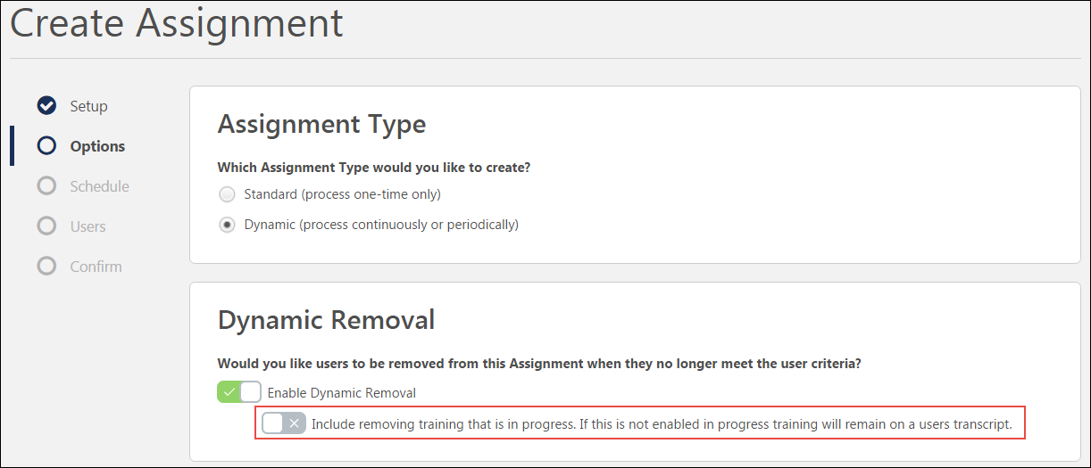
Dynamic Learning Assignment - Dynamic Removal for In Progress Training
To enable the dynamic removal of training that is currently in progress on users' transcripts:
- Select Dynamic as the Assignment Type for the learning assignment. Additional options become available on the Options page of the Create Assignment process.
- Toggle the Enable Dynamic Removal switch to the On (green) position. The option to remove in-progress training will become available after this option is selected.
- Toggle the Include removing training that is in progress switch to the On (green) position. After the learning assignment is submitted and processed, if users who have been assigned the training no longer meet the assignment criteria, the training in this assignment will be removed from their transcripts whether it is not started or in progress (or equivalent statuses). For a list of equivalent statuses, please see the training status equivalents below.
Note: If users paid for training and then the training is later removed from their transcripts via dynamic removal, the training price is refunded to the user.
Training Status Equivalents
Using dynamic removal functionality, training in Not Started (and equivalent) statuses and In Progress (and equivalent) statuses can be removed from users' transcripts when they no longer meet the criteria for a dynamic learning assignment.
The following transcript statuses are treated as equivalent to the Not Started status for the purposes of dynamic removal:
- Approved
- Approved/Past Due
- Cancelled
- Cancelled/Past Due
- Denied
- Denied/Past Due
- Exception Requested
- Exception Requested/Waitlisted
- Exception Requested/Past Due
- Exception Requested/Waitlisted/Past Due
- Not Available
- No Show
- No Show/Past Due
- Not Activated
- Not Started/Past Due
- Not Started/Past Due
- Payment Denied
- Payment Denied/Past Due
- Payment Refunded
- Payment Refunded/Past Due
- Pending Approval
- Pending Approval/Waitlisted
- Pending Approval/Past Due
- Pending Approval/Waitlisted/Past Due
- Pending Prerequisite
- Pending Prerequisite/Past Due
- Pending Prior Training
- Pending Payment
- Pending Payment/Past Due
- Pending Pre-Work
- Pending Pre-Work/Past Due
- Registration Pending
- Registration Pending/Past Due
- Registered
- Registered/Past Due
- Registered/Not Available
- Registered/Not Available/Past Due
- Waitlisted
- Waitlisted/Past Due
- Waitlist Expired
- Waitlist Expired/Past Due
- Withdrawn
The following transcript statuses are treated as equivalent to the In Progress status for the purposes of dynamic removal:
- Completion Approval Denied
- Completion Approval Denied/Past Due
- Failed
- Failed/Past Due
- In Progress/Past Due
- Incomplete
- Incomplete/Past Due
- Past Due
- Pending Acknowledgment
- Pending Acknowledgment/Past Due
- Pending Completion Approval
- Pending Completion Approval/Past Due
- Pending Completion Signature
- Pending Completion Signature/Past Due
- Pending Evaluation
- Pending Evaluation/Past Due
- Pending Grade
- Pending Grade/Past Due
- Pending Observer Completion
- Pending Observer Completion/Past Due
- Pending Observer Completion/Not Available
- Pending Observer Completion/Not Available/Past Due
- Pending Post-Work
- Pending Post-Work/Past Due
- Pending SF-182 Form Approval
- SF-182 Form Denied
- Subscription Expired
The following training statuses are NEVER removed from the transcript, regardless of whether the Remove In Progress Training option is enabled or disabled.
- Completed
- Equivalent
- Completed Equivalent
- Exempt-Internal
- Exempt
- Expired
- Discontinued
- Expired/Past Due
- Discontinued/Past Due
- Old Version

Batch Update Dynamic Assignment Tool
Certain options for existing dynamic learning assignments can be updated in bulk via a case submission to Global Customer Support. This allows organizations to use various new learning assignment features for all assignments without needing to individually update each learning assignment created prior to the release of the Learning Assignment Tool.
Considerations
The following batch updates may be made to existing learning assignments via a Global Customer Support case:
- Dynamic Removal - The Dynamic Removal option for dynamic learning assignments can be turned on for existing learning assignments in bulk.
- Remove In Progress Training - For learning assignments with the Dynamic Removal option enabled, the option to include in progress training in the dynamic removal can be turned on in bulk.
- Remove Training Within Curricula - For learning assignments with the Dynamic Removal option enabled, the option to remove training within a curriculum when a curriculum is removed via dynamic removal can be turned on in bulk. Note: The entire curriculum, including its child training, remains intact when removed via the Training Removal Tool, Learning Assignment Tool, or by manual transcript removal. This preserves the structure of the removed curriculum and eliminates the need for transcript cleanup. Upon reassignment, the intact curriculum moves to the Active tab of the user's transcript. Important: This behavior only applies to curriculum child training items which are in a non-completed status. In other words, if a curriculum child training is in a Completed, Completed Equivalent, or Exempt status, it will not remain intact within the curriculum; it will remain as a standalone completed training item on the Completed tab of the user's transcript. Similarly, upon reassignment of the curriculum, these completed training items will remain as standalone items on the Completed tab.
- Dynamic Re-assignment - The Dynamic Re-assignment option for dynamic learning assignments can be turned on for existing learning assignments in bulk.
- Upgrade to Latest Version - For learning assignments with the Dynamic Re-assignment option enabled, the option to also upgrade users to the latest version of training can be turned on in bulk.
Note: This feature may only be used to turn these options on. The options listed above cannot be turned off using this feature.
For more information about these learning assignment options, please See Create Learning Assignment - Options on page 34 for additional information.
Implementation
Organizations can apply batch updates to their existing dynamic learning assignments by submitting a case to Global Customer Support.

