Learning Administration March 2024

Table of Contents
Learning Administration Overview 1
Learning Custom Fields 2
Learning Compliance 1
Recent Updates to Learning Compliance 2
Add Maintain Progress Toggle to Assignment Summary Page 11
Compliance - Curricula 13
Compliance - Curriculum Reassignment 23
Compliance Enhancements - Launch Completed Equivalent Training 27
Compliance Enhancements - Learning Assignment Tool 28
Compliance Enhancements - Training Removal Tool 34
Compliance - Session Completion Date 36
Compliance - Track Completed Equivalent 38
Compliance - Transcript Delivery Method 42
Compliance - Users with Latest Version 46
Curriculum Training Report 47
Display "Transcript Delivery Method" in Transcript Details 53
Enhanced Custom Field Auditing - Additional Fields 55
Learning Assignment Tool Enhancements 56
Learning Compliance - Assignment Summary Page Enhancements 61
Material Versioning - Due Date Criteria Enhancement 66
Online Course Versioning 70
"Pending Prior Training" and "Not Activated" Statuses Added to "Not Started" Status Group for Material and Online Course Versioning 77
Persist Settings During Versioning - Material, Online Course, Curriculum, Test 79
Populate Correct Transcript Status During Versioning 82
Push New Curriculum Version to Dynamic Recurring Assignment 83
Reporting - Progress Maintained 85
Reporting - Last Transcript Status Change Date 87
Sync Start of New Version and End Date of Previous Version during Material Versioning (With Append) 88
Test Engine Enhancement - Version Equivalency 89
Training Removal Enhancements 91
Version Numbers Available in Curriculum Administration Structure 94
Learning Preferences Overview 96
Administrative Action Justifications Overview 97
Approval Workflow Preferences Overview 132
Certificates Preferences Overview 151
Standard Tag Behavior 162
Custom Field Tag Behavior 163
Content Preferences Overview 166
Curricula Preferences 176
General Learning Preferences Overview 179
ILT Preferences Overview 284
Training Completion Signature Preferences Overview 303
Transcript Preferences Overview 310

Learning Administration Overview

Learning Custom Fields
The following custom field types are available for the Learning module:
- Request Forms - See Custom Field Admin - Request Forms for additional information.
- SF-182 - See Custom Field Admin - SF-182 for additional information.
- Training - See Custom Field Admin - Training for additional information.
- Transaction - See Custom Field Admin - Transaction for additional information.
- Vendors - See Custom Field Admin - Vendors for additional information.

Learning Compliance

Recent Updates to Learning Compliance
Beginning in 2018, Cornerstone began a multi-staged initiative to enhance system features related to Learning Compliance. This initiative is ongoing, with more enhancements and new features coming in future releases. For clarity on the Learning Compliance enhancements which have already been made during this process, please see the table below:
Feature Name | Original Release Date | Description
Push New Curriculum Version to Dynamic Recurring Assignment | Sept 7 2018 patch | New curricula versions can be applied to dynamic and dynamic recurring learning assignments during the curriculum reversioning process, and a new filter and column have been added to the Assignments table to identify the assignment type.
Learning Assignment Tool Enhancements | November 30 2018 patch (Stage) and the January 4 2019 patch (Production) | The following compliance enhancements have been made to the Learning Assignment Tool:  - The Enable Assign New Occurrence setting will be updated to push the assignment training EVERY time users enter the assignment criteria for a dynamic learning assignment.  - A new Maintain Transcript Progress option will allow users to maintain their training progress when they are included in the availability for an assignment of the same version of a training item on their transcript.  - Curriculum reassignment will provide users with the latest version of all child training contained within the curriculum.
Training Removal Tool Enhancements | Dec 14 2018 patch (Stage) and Jan 4 2019 patch (Production) | Following this enhancement, administrators can use the Training Removal Tool to remove sessions the following transcript statuses:  - Incomplete  - Cancelled  - No Show  - Not Started  - Pending OJT Completion
Add Maintain Progress Toggle to Assignment Summary Page | Jan 4 2019 patch | With this enhancement, a Maintain Progress toggle switch is available on the Assignment Summary page for standard learning assignments and active dynamic learning assignments.
Curriculum Reassignment | Feb 2019 Release | With this enhancement, two curriculum due date options have been renamed, and when a curriculum is versioned or reassigned, the correct due date is calculated based on the most recent assignment date.
Session Completion Date | Feb 2019 Release | With this enhancement, the Session Completion Date configuration set in ILT Preferences is now applicable to equivalencies. The configurations set for the Session Completion Date option in ILT preferences determine how the completion date is calculated for equivalencies.
Track Completed Equivalent | Feb 2019 Release | With this enhancement, it is now possible to track which equivalent training item caused a user to receive a Completed Equivalent status. All equivalencies are visible and reportable. This enhancement applies to both Custom Reporting and Reporting 2.0.  In addition to reporting, the following enhancements are also supported:  - The training that triggered the Completed Equivalent status is also visible when viewing the Transcript History of the Completed Equivalent training inside a user’s transcript.  - The completion date logic of a training with a Completed Equivalent status has been updated to match the completion date of the training that triggered Completed Equivalent status.  - Due to the sensitive nature these records, the historical completion dates will not be retroactively updated for the February 2019 release. This means that the logic for Completion Dates of trainings with ‘Completed Equivalent’ status prior to February 8, 2019 will be different than the logic after the release. Please refer to the Considerations section for more details.  If Transcript Lockdown is enabled for a portal, the Completion Date will NOT be updated with this new behavior for past data. However, this updated Completed Equivalent behavior applies to all new completion equivalencies.
Transcript Delivery Method | Feb 2019 Release | With this enhancement, administrators have access to a new report field which shows the transcript delivery method of training. This enhancement applies to both Custom Reporting and Reporting 2.0.
Users with Latest Version | Feb 2019 Release | With this enhancement, the list of users who receive with latest version of training during the versioning process is accurate. Only users who actually received a previous version of the training via dynamic learning assignment are included in the list generated during the versioning process of users who will receive the new version when the administrator specifies that the new version should be pushed to users who received the training via dynamic assignment.
Assignment Summary Page Enhancements | May 2019 Release | With the May 2019 release, several enhancements have been made to the Learning Assignment Tool Assignment Summary page to help facilitate learning compliance. The following updates have been made to the Assignment Summary page:  - Administrators can view which users in the assignment availability were assigned training and which users were NOT assigned training, using new Assigned and Not Assigned tabs on the Assignment Summary page.  - A Modification History section is available in the Assignment Summary.  - Administrators can view the current training version assigned via the Assignment Summary.  - The Assigned Users calculation for dynamic assignments on the Assignment Summary only includes users who were successfully assigned the training.
Curriculum Training Report | May 2019 Release | With this enhancement, the Curriculum Training custom report is available in Reporting 2.0. The Curriculum Training custom report allows administrators to report on details from a curriculum structure, curriculum details from the Course Catalog, and curriculum version information from the user's transcript. Administrators can use the report to compare curriculum data from multiple system areas.
Persist Settings During Versioning | May 2019 Release | With this enhancement, more settings automatically persist from the old version to the new version when an administrator reversions a curriculum, material, online course, or test.
Populate Correct Transcript Status During Versioning | May 2019 Release | The issue of transcript statuses populating incorrectly for materials or online courses as a result of the following scenario has been fixed: the material or online course is versioned and set as "Version Equivalent" to the prior version. After getting the new version in a Completed Equivalent status, the user re-requests or is re-assigned a new registration of the material or online course by a manager. With this enhancement, the training status will be correctly populated as Registered (NOT as Completed Equivalent).
Reporting - Progress Maintained | May 2019 Release | With this enhancement, a Maintain Progress toggle status field is available in Reporting 2.0. Standard and dynamic learning assignments offer administrators the ability to allow users to maintain their training progress when assigned a new instance of a training item, and this new report field allows the value of this setting to be discoverable when using Reporting 2.0.
Reporting - Last Transcript Status Change Date | May 2019 Release | With this enhancement, the Last Transcript Status Change Date field has been fixed and generates data reliably.Note: The visibility of this field is controlled by a backend setting.  Note: This field is not automatically available in all portals. You may need to request its enablement.
Display "Transcript Delivery Method" in Transcript Details | May 2019 Release | With this enhancement, the method by which training was delivered to a user's transcript displays in the Assignment History section of their transcript. The Assignment History section is dynamically renamed to the Assignment and Version History section if the training has been reversioned. This section also indicates which training is the latest active registration.
Version Numbers Available in Curriculum Administration Structure | May 2019 Release | With this enhancement, the version numbers of materials, online courses, and tests are visible within the structure of a curriculum, for both existing and new curricula. This allows administrators to quickly and easily ascertain which versions of child training items are contained within a curriculum.
Learning Assignment Tool Enhancements | July 16 2019 Patch | The following enhancements have been made to the Learning Assignment Tool:  - Training assigned by a learning assignment can be easily removed from user's transcripts after the assignment is made inactive  - Administrators can force standard learning assignments to stop processing
Material Versioning - Due Date Criteria Enhancement | July 16 2019 Patch | With this enhancement, the Apply Previous Version Due Date option has been updated to Apply Previous Version Due Date Criteria. If the Apply Previous Version Due Date Criteria option is selected, the new version considers whether the previous material version was assigned via the Learning Assignment Tool with a due date relative to the date assigned. If the previous material version was assigned with a due date that was relative to the date the material was assigned, that relative due date is applied to the new version if the administrator selects this option during the material versioning process.
"Pending Prior Training" and "Not Activated" Statuses Added to "Not Started" Status Group for Material and Online Course Versioning | Aug 2019 Release | With this enhancement, the Pending Prior Training and Not Activated statuses are included in the Not Started training status group, which means users with materials or online courses in these statuses will be included in the User List when the materials or online courses are reversioned. Selecting these users in the User List allows them to receive the latest version of the training after the versioning process is complete.
Test Engine Enhancement - Version Equivalency | Aug 2019 Release | With this enhancement, when creating a new version of a test, the administrator can specify whether the new test version must be completed again by users, or whether the new test version will be considered a Completed Equivalent of the previous version, allowing users to retain their Completed status for the test inside a curriculum without needing to compete it again. These Version Equivalency settings only apply to tests within a curriculum; this behavior does not apply to standalone tests.
Training Removal Enhancements | Aug 2019 Release | With this enhancement, the following enhancements have been made to the Training Removal Tool:  - Completion propagation to removed curricula is fixed.  - Training in a Completed status can now be removed using the Training Removal Tool (a new permission is needed for this ability). The following consideration applies to this enhancement:  - If the training selected within the Training Removal Tool is a curriculum, any child training items that exist within that curriculum in Completed, Completed Equivalent, or Exempt status is not removed. These child training items continue to persist as standalone trainings on the users’ active transcripts in the Completed tab.  - This behavior occurs regardless of whether the Remove child items option is selected.  - Once the child items become standalone, they can also be removed as long as the user has the new Training Removal - Remove Completed permission.
Launch Completed Equivalent Training | Oct 26 2019 Release | With this enhancement, even when an online course, video or material training item is in a Completed Equivalent status on the user's transcript, the user can launch the training from their transcript and the following other locations:  - Curriculum Player page  - Curriculum Details page  - Certification Details page  - Training Details page  - Transcript Details page  - Cohort Details page  - Cohort Player page  - Learner Home
Enhanced Custom Field Auditing - Additional Fields | Oct 26 2019 Release | With this enhancement, ALL the following custom field types can be audited:  - Short Text Box  - Date  - Radio Button  - Dropdown  - Checkbox  - Multiple Checkbox  - Numeric  - Scrolling text  - Conditional Numeric (new)  - Branched Dropdown (new)  - Hierarchy (new)
Sync Start and End Date During Material Versioning | Oct 26 2019 Release | With this enhancement, when an administrator creates a new version of a material using Versioning with Append, the Start Date time of the new version matches the End Date time of the previous version, so that both versions cannot coexist at the same time.
Curriculum Versioning Enhancements | Feb 7 2020 Release | With the February 2020 release, the following enhancements have been made to improve the curriculum versioning workflow:  - New auditing capabilities  - A new Structure History page accessible from the Course Console for curricula captures versioning and structural updates  - A new Structure History page accessible from the transcript displays user-specific curriculum updates  - Due date recalculation logic - Due dates are only recalculated for curriculum child training items that are versioned or added to the curriculum structure (this logic is applied when the Due X Days After Most Recent Assignment Date option is selected for the child training in the curriculum structure  - Expired appended training enhancement - Expired appended materials are hidden from the curriculum structure instead of remaining unactionable  - If a newer version of child training exists, the user will be upgraded to the new version instead of retaining the progress from a prior version, regardless of the child training item's sequence.
Online Course Versioning - Due Date Criteria Enhancement | Feb 7 2020 Release | Prior to this enhancement, when versioning an online course, administrators could select the Apply Previous Version Due Date option when configuring due date criteria, which would simply apply the exact due date for the prior version to the new version. For example, if the previous version had a due date of Feb 1, the new version would also receive a due date of Feb 1. Relative due date criteria, such as "10 days from Date Assigned," could NOT be applied to the new version using this option.  With this enhancement, administrators can still apply an exact due date from the previous online course version to the new version if desired, but they can also apply relative due date criteria to the new online course version by selecting the new Apply Previous Version Due Date Criteria option. This more dynamic due date setting provides increased flexibility when configuring due dates for reversioned online courses.  Note: This project is part of the largermulti-release Learning Compliance Scalability Initiative. The release of this project concludes the Learning Compliance Scalability Initiative.

Add Maintain Progress Toggle to Assignment Summary Page
With this enhancement, a Maintain Progress toggle option is visible on the Assignment Summary page for standard learning assignments and dynamic learning assignments. For active dynamic learning assignments, this option can be modified from the Assignment Summary page.
In addition, a Maintain Progress setting is available for standard learning assignments when using the Learning Assignment Tool.
To access the Assignment Summary page for a learning assignment, go to ADMIN > TOOLS > LEARNING > LEARNING ASSIGNMENT TOOL and click on the title of the learning assignment for which you want to view the Assignment Summary page.
Permissions
PERMISSION NAME | PERMISSION DESCRIPTION | CATEGORY

Assignment Tool - Standard and Dynamic - Recurrence | Grants ability to create Standard (one-time) and Dynamic (continuous) Learning Assignments to directly assign training to users. Also grants ability to enable/disable Recurrence when creating a Dynamic Learning Assignment. This permission can be constrained by OU, Provider, Training Item, Training Type, User, User Self and Subordinates, and User's OU. If this permission is constrained by Location, Provider, Training Type, or Training Item, then they can only assign training within the constraints. If this permission is constrained by OU, User, User Self and Subordinates, or User's OU, then they can only assign to and view assignments created by users within the constraints. This is an administrator permission. | Learning - Administration
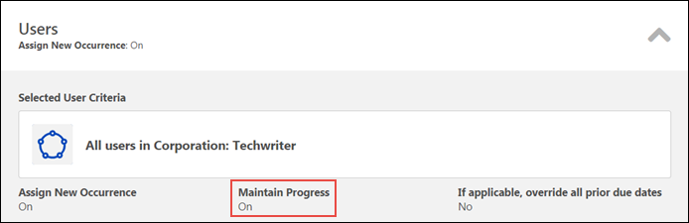
Maintain Progress
A Maintain Progress setting is visible in the Assignment Settings section of the Assignment Summary page for standard learning assignments and dynamic learning assignments. To view the Maintain Progress setting, expand the Users section. If the creator of the assignment enabled this setting, the Maintain Progress field displays a value of On, and users who receive new occurrences of the training will maintain their version progress. If this setting was not enabled for the assignment when it was created, users who receive new occurrences of training via the learning assignment will NOT retain their progress. This setting is not editable for standard learning assignments or inactive dynamic learning assignments.
For active dynamic assignments only, to allow users who receive new occurrences of the assignment to maintain their version progress, toggle the Maintain Progress option to the On (green) position. If this option is not enabled, users who receive new occurrences of training via the learning assignment will NOT retain their progress.
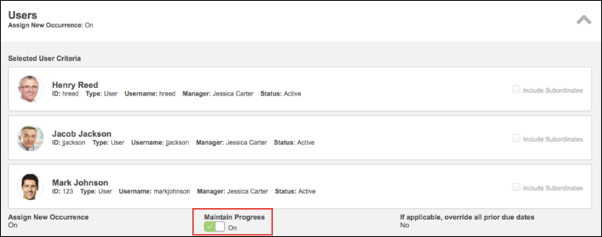

Compliance - Curricula
Curriculum Versioning Enhancements - Overview
With the February 2020 release, the following enhancements have been made to improve the curriculum versioning workflow:
- New auditing capabilities
  - A new Structure History page accessible from the Course Console for curricula captures versioning and structural updates
  - A new Structure History page accessible from the transcript displays user-specific curriculum updates
- Due date recalculation logic - Due dates are only recalculated for curriculum child training items that are versioned or added to the curriculum structure (this logic is applied when the Due X Days After Most Recent Assignment Date option is selected for the child training in the curriculum structure
- Expired appended training enhancement - Expired appended materials are hidden from the curriculum structure instead of remaining unactionable
- If a newer version of child training exists, the user will be upgraded to the new version instead of retaining the progress from a prior version, regardless of the child training item's sequence.
This enhancement was made available on Jan 23 2020.
Note: This project is part of the larger, multi-release Learning Compliance Scalability Initiative. The release of this project concludes the Learning Compliance Scalability Initiative.
Implementation
This functionality is auto-enabled in Stage. Pilot and Production will be opt-in using Learning Feature Activation Preferences. Administrators should test this functionality in Stage before enabling in Production.
Permissions
The following existing permissions apply to this functionality:
PERMISSION NAME | PERMISSION DESCRIPTION | CATEGORY

Course Catalog - Update | Grants ability to manage and edit training items listed in the Course Catalog and also grants access to the Course Console, where training can also be managed and edited. This permission also grants access to the Popular Requests and Highest Rated widgets on the Learning Admin Console (in conjunction with the Learning Admin Console - View permission). This permission also allows administrators to reversion online courses via the Course Console page. This permission also allows administrators to access an Edit Training option for training items included as objectives in Development plans.  This permission can be constrained by OU, User's OU, Training Type, Training Item, Provider, ILT Provider, User's ILT Provider, User, User Self and Subordinates, and User's LO Availability. This is an administrator permission.  Note: Adding an OU constraint and a provider constraint to this permission results in an "AND" statement. | Learning - Administration

Course Catalog - View | Grants access to view the learning objects in the course catalog and enables administrators to view the Course Console and the Popular Requests and Highest Rated widgets on the Learning Admin Console (in conjunction with the Learning Admin Console - View permission). This permission can be constrained by OU, User's OU, Training Type, Training Item, Provider, ILT Provider, User's ILT Provider, and User's LO Availability. This is an administrator permission.  Adding an OU constraint and a provider constraint to this permission results in an "AND" statement. | Learning - Administration

View Transcript Item | Grants ability to view details of learning objects that appear on the transcript (training record), by clicking on the name of the learning object. Users must also have the Bio About - View permission in order to access the transcript within Universal Profile. This permission can be constrained by OU, User's OU, User Self and Subordinates, User, or User's Self. This is an end user permission. | Learning - Administration
Feature Activation
In order for the curriculum compliance features included in this enhancement to be available in Production portals, it is necessary to activate the functionality via the Learning Feature Activation Preferences page.
Important: Do not activate curriculum compliance functionality in Production until you have thoroughly tested it in Stage. Once this functionality is activated, it cannot be deactivated. This functionality is automatically enabled in Stage portals for testing.
To access Learning Feature Activation Preferences, go to: Admin > Tools > Learning > Learning Preferences and click the Feature Activation Preferences link.
Permissions
PERMISSION NAME | PERMISSION DESCRIPTION | CATEGORY

Learning Features Self Activation | Grants access to the Feature Activation Preferences page, where an administrator can activate new features associated with Learning, Connect and Extended Enterprise. | Learning - Administration
Activate Curriculum Compliance Functionality
In order for the curriculum compliance features in this enhancement to be available in Production portals, an administrator must activate them. To activate this functionality in your portal:
- Click the Activate button in the Curriculum Compliance section. A warning message appears, asking if you are certain you want to activate this functionality in the portal.
- Click the Activate button to complete the activation of curriculum compliance features in the portal. Once activated, this functionality cannot be deactivated. To exit without activating this functionality, click the Cancel button.
- Log out of the portal and log in again to receive the permissions associated with the new functionality and begin using the new curriculum compliance.
After the feature has been activated, the orange header for the section turns green to indicate the activation was successful. The Activate button is no longer available once the feature has been activated.
Child Training Due Date Recalculation
Prior to this enhancement, when a child training item within a curriculum was versioned, and the Due X Days After Most Recent Assignment Date option was selected for child training within that curriculum structure, ALL child training due dates in the curriculum were recalculated using the versioning date as the most recent assignment date. This due date recalculation behavior also applied when a training item was added to a curriculum structure, causing the curriculum to be versioned.
With this enhancement, when a child training item within a curriculum is versioned, and the Due X Days After Most Recent Assignment Date option is chosen for child training within that curriculum structure, only the versioned training item's due date is recalculated using the versioning date as the most recent assignment date. All other training items that have not been versioned will retain their due date.
This due date recalculation protocol also applies to when a child training item is added to a curriculum structure, causing the curriculum to be versioned. Only the added training item will receive a relative due date that uses the versioning date as the most recent assignment date. Child training that was already inside the curriculum and not modified will retain its due date.
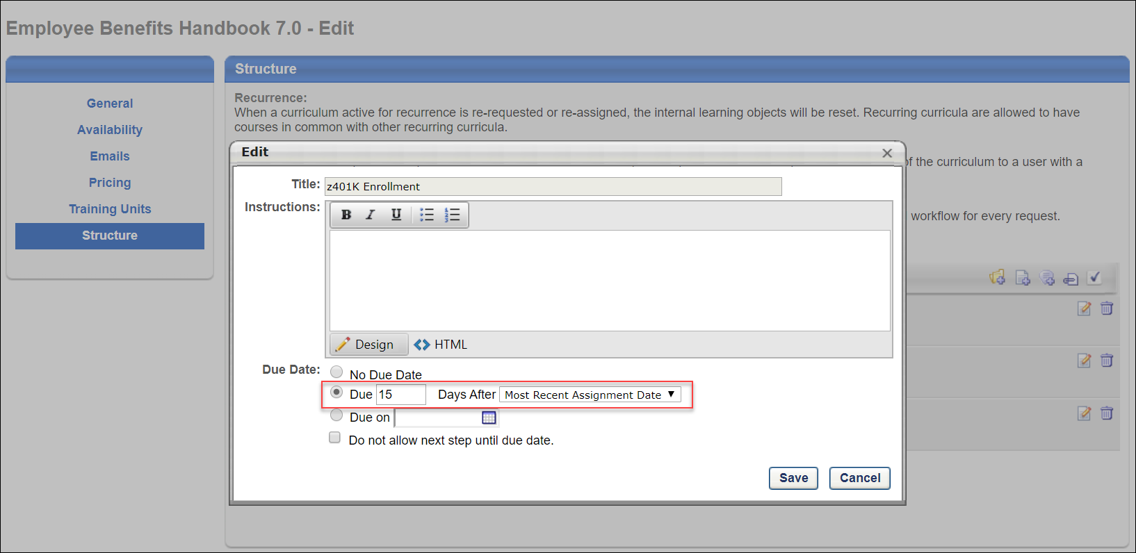
Expired Appended Training
Prior to this enhancement, if a material inside a curriculum was versioned with append, both the previous version and the new version displayed in the curriculum structure. When the effective date of the new version started, the previous material version expired and was not actionable, yet it remained in the curriculum.
With this enhancement, if a material inside a curriculum is versioned with append, the previous version is hidden from the curriculum once expired, and is no longer visible on the user's transcript page by default. There is an option on both the Curriculum Player page and Training Details page to expose the expired training when needed. The expiration of the previous material version is captured on the Structure History page for curricula, which is accessible from the Course Console and the Training Details page for the curriculum.
An option to expose and hide expired training in a curriculum is available on both the Training Details page and on the Curriculum Player page for the curriculum.
Upgrade Child LOs
Prior to this enhancement, when versioning a curriculum with the Maintain Progress option, child training items with a sequence of 1 within the curriculum structure were upgraded to new versions (if available) when the parent curriculum was versioned. Child training items that were in sequence 2 or greater were auto-completed with the previous version upon activation if the previous version was completed.
With this enhancement, if a newer version of child training exists, the user will be upgraded to the new version instead of retaining the progress from a prior version, regardless of the child training item's sequence. When the option to maintain progress when versioning a curriculum is selected, users maintain completions for child training items that do not have a newer version available. Child training items that have newer versions will be upgraded when they are assigned the new curriculum version.
Example
- Sue has Curriculum V1 on her Completed transcript.
- Curriculum V1 contains both Material A V1 (sequence 1) in a Completed status and Material B V1 (sequence 2) in a Completed status.
- Material A V1 is versioned to Material A V2, but Sue does not receive the upgraded version because the Completed status was not selected by the administrator during versioning.
- Material B V1 is versioned to Material B V2, but Sue does not receive the upgraded version because the Completed status was not selected by the administrator during versioning.
- Curriculum is now V3 because two child training items within the curriculum were versioned.
- The administrator adds Online Course V1 (sequence 3) to the curriculum, and Curriculum V3 is versioned to V4 because of this addition. The versioning options selected include: All Versions, All Statuses, and Maintain Progress.
- Sue receives Curriculum V4 with Material A V2 in a Registered status, with Material B V2 in a Pending Prior Training status, and Online Course V1 in a Pending Prior Training status.
- With this enhancement, once Sue completes Material A V2, Material B V2 is in Registered status.
Considerations
- If the administrator selected that Material A V2 requires retraining (from Material A V1), the user will receive the new version because it requires retraining. Thus, the user will be in a Registered status for Material A V2.
- If Material A V2 is set as equivalent to Material A V1, then once the user is upgraded to V2, they will auto-complete to a Completed Equivalent status.
Structure Modification History Page
A new Structure Modification History page is accessible from both the Course Console page and the Transcript Details page for curricula. The Structure Modification History page captures an audit trail of changes made to the curriculum's structure.
Important: This change impacts new and existing curricula, but for the existing curricula, the Structure Modification History page is only available if the curriculum has been reversioned after the Feb 7 2020 release. Note: The Structure History page will populate audits for curriculum structure changes made post-activation. Historical audits made prior to activation will not display.
Permissions
PERMISSION NAME | PERMISSION DESCRIPTION | CATEGORY

Course Catalog - Update | Grants ability to manage and edit training items listed in the Course Catalog and also grants access to the Course Console, where training can also be managed and edited. This permission also grants access to the Popular Requests and Highest Rated widgets on the Learning Admin Console (in conjunction with the Learning Admin Console - View permission). This permission also allows administrators to reversion online courses via the Course Console page. This permission also allows administrators to access an Edit Training option for training items included as objectives in Development plans.  This permission can be constrained by OU, User's OU, Training Type, Training Item, Provider, ILT Provider, User's ILT Provider, User, User Self and Subordinates, and User's LO Availability. This is an administrator permission.  Note: Adding an OU constraint and a provider constraint to this permission results in an "AND" statement. | Learning - Administration

Course Catalog - View | Grants access to view the learning objects in the course catalog and enables administrators to view the Course Console and the Popular Requests and Highest Rated widgets on the Learning Admin Console (in conjunction with the Learning Admin Console - View permission). This permission can be constrained by OU, User's OU, Training Type, Training Item, Provider, ILT Provider, User's ILT Provider, and User's LO Availability. This is an administrator permission.  Adding an OU constraint and a provider constraint to this permission results in an "AND" statement. | Learning - Administration

View Transcript Item | Grants ability to view details of learning objects that appear on the transcript (training record), by clicking on the name of the learning object. Users must also have the Bio About - View permission in order to access the transcript within Universal Profile. This permission can be constrained by OU, User's OU, User Self and Subordinates, User, or User's Self. This is an end user permission. | Learning - Administration
Structure History from Course Console
To access the Structure History from the curriculum's Course Console page, the administrator must have permission to access Course Console. To view the Structure History page, click the Options drop-down at the top of the Course Console page and click the Structure History link.
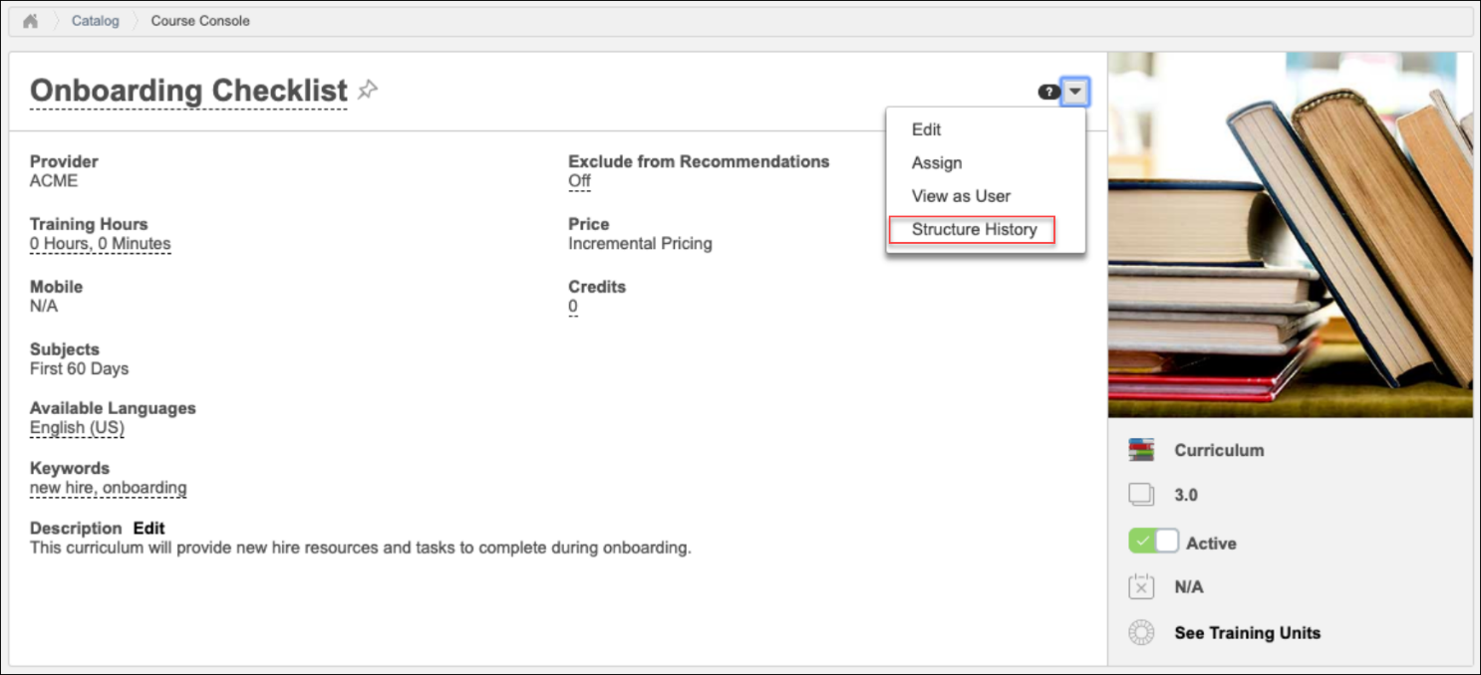
Structure History from Transcript Details
To access the Structure History from the Transcript Details page for a curriculum, the user must have permission to view transcript items. To view the Structure History page from the Transcript Details page, click the Structure History link located next to the curriculum version number.
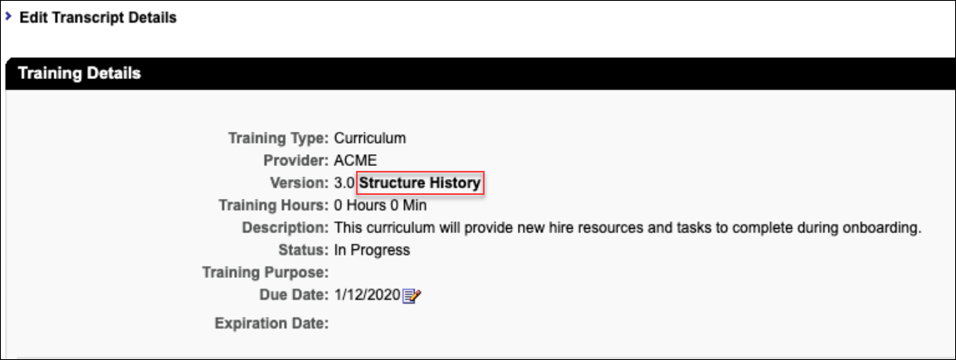
Structure Modification History Page
The following features are available on the Structure Modification History page:
- Search Bar - Type the name of a training item included in the curriculum into the search bar to search for modification records related to that item.
- Export - Click the Export button to export the information from the Structure Modification History page in PDF format.
- Table of modifications - The following information displays for each structure modification item in the table:
  - Curriculum Version
  - Training Title
  - Training Version
  - Training Object ID
  - Course Code
  - Effective Date (i.e. the date when a version becomes active or effective. For training types that do not version, the Effective Date will be the date the training was created)
  - Date of Change
  - Changed By
  - Change Description

Compliance - Curriculum Reassignment
With this enhancement, two curriculum due date options have been renamed, and when a curriculum is versioned or reassigned, the correct due date is calculated based on the most recent assignment date.
Use Cases
Use Case #1: Initial Assignment Date (Formerly "Assigned Date of Training Item")
Stanley, an employee at ACME Photography in the Europe division, is assigned the curriculum "Introduction to Photojournalism," on November 5th via a dynamic learning assignment, with Dynamic Removal enabled. The curriculum contains a material called, "What is Photojournalism?" In the curriculum structure, the material is set to have relative due date of ten days from the initial assignment date, giving it a due date of November 15th.
Stanley leaves the Europe division after being assigned this training, and the curriculum and material are removed from his transcript. On February 1st of the following year, Stanley returns to the Europe division and is reassigned the curriculum, "Introduction to Photojournalism," containing the material called, "What is Photojournalism?" The due date of November 15th is maintained because the Initial Assignment Date option is selected as the Due Date criteria for the curriculum.
Use Case #2: Most Recent Assignment Date (Formerly "Most Recent Version Date")
Veronica, an employee at ACME Photography in the South America division, is assigned the curriculum, "Introduction to Photojournalism" on November 5th via a dynamic learning assignment, with Dynamic Removal enabled. The curriculum contains a material called, "What is Photojournalism?" In the curriculum structure, the material is set to have relative due date of ten days from the most recent assignment date, giving it a due date of November 15th.
Veronica leaves the South America division after being assigned the training, and the curriculum and material are removed from her transcript. On March 1st of the following year, Veronica returns to the South America division and is reassigned the curriculum, "Introduction to Photojournalism," containing the material called, "What is Photojournalism?" A new due of March 6th is recalculated, as the Most Recent Assignment Date option is selected as the date criteria for the curriculum.
Edit Child Training - Due Date
When a curriculum is reversioned, the child training contained within a curriculum recalculates its due date based on its Due Date settings in the curriculum structure.
To view or modify the Due Date settings for child training in a curriculum, go to ADMIN > TOOLS > LEARNING > CATALOG MANAGEMENT > CURRICULA. Advance to the Structure page of the curriculum, and then click the Edit icon next to a child training item contained in the curriculum structure.
Permissions
PERMISSION NAME | PERMISSION DESCRIPTION | CATEGORY

Curricula Admin - Manage | Grants ability to create new and edit/update existing curricula. This permission can be constrained by OU, User's OU, Provider, and User's LO Availability. This is an administrator permission.  Adding an OU constraint and a provider constraint to this permission results in an "AND" statement.  Tip: Do not constrain this permission to your entire corporation; it can cause long page load times and timeout errors. Applying this constraint is functionally the same as leaving the permission unconstrained, but omitting this constraint does not cause the system to do the unnecessary constraint checks as in the former scenario. | Learning - Administration

Curriculum Admin - View | Grants view only access to curriculum details via Curriculum Administration screen. Does not include ability to view details of users enrolled in curricula. This permission can be constrained by Provider, OU, User's OU, and User's LO Availability.  Adding an OU constraint and a provider constraint to this permission results in an "AND" statement.  Tip: Do not constrain this permission to your entire corporation; it can cause long page load times and timeout errors. Applying this constraint is functionally the same as leaving the permission unconstrained, but omitting this constraint does not cause the system to do the unnecessary constraint checks as in the former scenario. | Learning - Administration
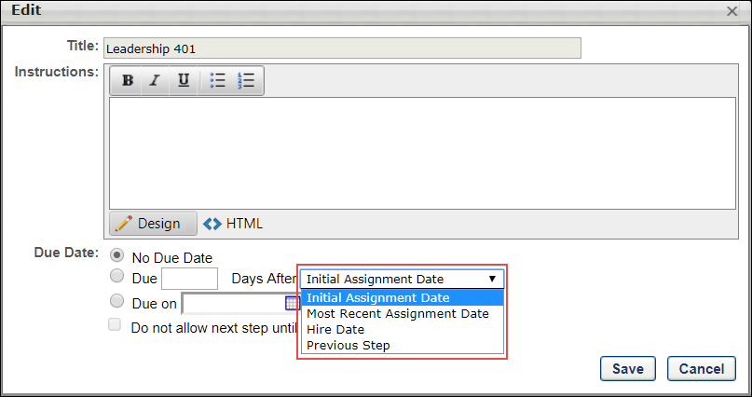
Due Date
When a curriculum is reversioned, the due dates of the child training item recalculate based on the selection made by the curriculum creator in the Due Date section. The following Due Date options have been updated:
- Initial Assignment Date - This option has been renamed. Previously, the Initial Assignment Date option was called, "Assigned Date of Training Item." When a curriculum is reversioned, any child training with a relative due date set by the Initial Assignment Date option will continue to display a relative due date based on the first time the user received the curriculum. When this option is selected, the training is due a certain number of days after the training was first assigned to the user. This allows the relative due date to be maintained, based on the date the curriculum was originally assigned to the user, even if the curriculum is reversioned. The assigned date does not change, and the due date remains the same.
Example: Curriculum XYZ includes Material A, and the curriculum structure is configured with a relative due date of five days after the Initial Assignment Date. The curriculum is assigned via dynamic learning assignment, and dynamic removal is enabled.
Sequence of Actions | Material Due Date
The user is assigned the curriculum on Jan 1 2019, via the dynamic learning assignment. | The material is due five days after the assignment (Jan 5 2019).
The user switches departments and is no longer included in the assignment. Because dynamic removal is enabled for the assignment, the curriculum and its child material are removed from the user's transcript. | The material is removed from the user's transcript and is no longer due.
On July 1, the user returns to their original department and is included in the learning assignment criteria again. They are reassigned the curriculum, including the curriculum's child material. | The original relative due date for the child material is sustained, and the due date is listed as Jan 5 2019.
- Most Recent Assignment Date - This option has been renamed. Previously, the Most Recent Assignment Date option was called, "Most Recent Version Date." When a curriculum is reversioned, any child training with a relative due date set by the Most Recent Assignment Date will recalculate a new due date based on the most recent time the user received the curriculum. The assignment of a new version is also considered a new assignment and triggers a recalculation of due dates, meaning the due dates will update for all child training items that are configured with a relative due date.
Example: Curriculum XYZ contains Material A, and the curriculum structure is configured with a relative due date of five days from the Most Recent Assignment Date. The curriculum is assigned via dynamic learning assignment, and dynamic removal enabled.
Sequence of Actions | Material Due Date
The user is assigned the curriculum on Jan 1 2019, via dynamic learning assignment. | The material is due five days after the assignment (Jan 5 2019).
The user switches departments and is no longer included in the assignment. Because dynamic removal is enabled for the assignment, the curriculum and its child material are removed from the user's transcript. | The material is removed from the user's transcript and is no longer due.
On July 1, the user returns to their original department and is included in the learning assignment criteria again. They are reassigned the curriculum, including the curriculum's child material. | The material is due five days after the new assignment date (July 5 2019).
The other relative Due Date options have not been modified, but when a curriculum is reversioned, the due dates for the child training are recalculated based on whichever relative Due Date option has been selected.

Compliance Enhancements - Launch Completed Equivalent Training
Prior to this enhancement, it was not possible for users with online courses, videos, or materials in a Completed Equivalent status to launch these items from their transcripts or any other location where training can be accessed.
With this enhancement, even when an online course, video or material training item is in a Completed Equivalent status on the user's transcript, the user can launch the training from their transcript and the following other locations:
- Curriculum Player page
- Curriculum Details page
- Certification Details page
- Training Details page
- Transcript Details page
- Cohort Details page
- Cohort Player page
- Learner Home
To access your own transcript page, to go: Learning > View Your Transcript.
Permissions
PERMISSION NAME | PERMISSION DESCRIPTION | CATEGORY

View Transcript Item | Grants ability to view details of learning objects that appear on the transcript (training record), by clicking on the name of the learning object. Users must also have the Bio About - View permission in order to access the transcript within Universal Profile. This permission can be constrained by OU, User's OU, User Self and Subordinates, User, or User's Self. This is an end user permission. | Learning - Administration
Launch Material, Video, or Online Course
To open a material, video or online course in a Completed Equivalent status from the transcript, located the training item and click the Options drop-down menu to the right of the training item. Click the Launch link to launch the material or online course.
Note: This functionality works retroactively, meaning that any training on a user's transcript in a Completed Equivalent status, whether added to the transcript prior to or after the October 2018 release, can be launched by the user.

Compliance Enhancements - Learning Assignment Tool
This functionality was released on November 30 2018 in Stage and on January 4 2019 in Production.
The behaviors of some fields available during the Learning Assignment Tool creation process have been updated, and new options are also available. Curriculum reassignment behavior has also been streamlined for learning assignments, including learning assignments with the Maintain Progress option enabled and assignments with curriculum, material, and online course versioning. Curriculum reassignment behavior also applies when users re-request curricula.
With this enhancement, the following training behaviors have been updated in the Learning Assignment Tool:
- The Assign New Occurrence setting pushes the assignment training every time users enter the dynamic assignment criteria. Users who enter the assignment availability with previous version on their transcripts will continue to receive the latest version of the training.
- A new option enables users to maintain their progress on all assigned training, provided the assignment was created with the Assigned, Approved, and Registered option selected.
- Curriculum reassignment provides users with the latest version of all child training contained within the curriculum.
To begin creating a new learning assignment, go to ADMIN > TOOLS > LEARNING and click the Learning Assignment Tool link. From the Manage Learning Assignments page, click the CREATE ASSIGNMENT button.
Permissions
PERMISSION NAME | PERMISSION DESCRIPTION | CATEGORY

Assignment Tool - Dynamic Reassignment | Grants ability to enable/disable Dynamic Re-assignment for an assignment after submission. When Dynamic Re-assignment is enabled, users that meet the User Criteria again (after previously being dynamically removed) are re-assigned. This permission is dependent on the Assignment - Standard, Dynamic - Standard and Dynamic, and Dynamic Assignment - Standard and Dynamic - Recurrence permissions. This permission cannot be constrained. This is an administrator permission. | Learning - Administration

Curricula Version - Manage | The constraints on this permission determine for which users the administrator can assign a new version of a curriculum when reversioning the curriculum. This permission works in conjunction with the Curricula Admin - Manage permission. The constraints on this permission determine for which users the administrator can assign a new version of a curriculum when reversioning a material that is contained within a curriculum. This permission can be constrained by OU, User's OU, and User. This is an administrator permission. | Learning - Administration

Material Version - Replace Only - Manage | Grants ability to assign a new version of a material to a user. The constraints on this permission determine to which users the administrator can assign a new version of a material. This permission works in conjunction with the Materials Management permission. Without this permission, administrators cannot upload new material source files. This permission can be constrained by OU, User's OU, and Users. This is an administrator permission.  This permission only applies to organizations that are using Simplified Versioning for materials. | Learning - Administration

Material Version with Append - Manage | Grants ability to create versions of a material. This permission works in conjunction with the Materials Management permission. This permission can be constrained by OU, User's OU, and Users.  This permission only applies to organizations that are using Versioning with Append for materials. | Learning - Administration

Online Class Version - Publish | Grants ability to upload and publish new online class versions. This permission works in conjunction with the permission for uploading online classes. This permission can be constrained by OU, User's OU, Users, and Providers. This is an administrator permission. | Learning - Administration
Assign New Occurrence
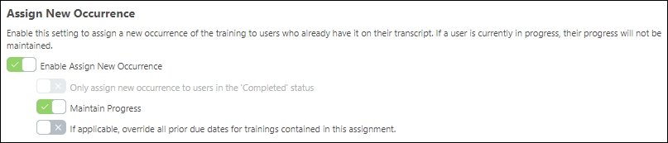
Enable Assign New Occurrence
The Enable Assign New Occurrence setting is updated to push the assignment training EVERY time users enter the dynamic assignment criteria. Users who enter the assignment availability with a previous version on their transcripts continue to receive the latest version of the training.
Example: Lauren from the Sales division at the California office receives the Sales Curriculum from a dynamic learning assignment that assigns training to sales employees in California. The next year, Lauren transfers to the Arizona office and no longer meets the availability of the California Sales Curriculum assignment. However, she now meets the criteria of an existing learning assignment created for the Sales employees in Arizona. Because the Assign New Occurrence option is enabled for the assignment, Lauren receives the Sales Curriculum for Arizona on her transcript.
Maintain Progress
Important: All existing learning assignments with the Assign New Occurrence option enabled will have the Maintain Progress feature turned ON. This is meant to alleviate the impact of updated Assign New Occurrence new behavior on existing assignments. You can always deactivate this option on the Learning Assignment Summary page by turning the Maintain Progress toggle OFF.
If the Enable Assign New Occurrence setting is turned on, an additional option is available, which allows users to maintain their progress when they are assigned a new occurrence of the same version of training on their transcript. To allow users who receive new occurrences of the curriculum to maintain their curriculum progress on that version, toggle the Maintain Progress option to the On (green) position. If this option is not enabled, users who receive new occurrences of a training item via the learning assignment will NOT retain their curriculum progress. Note: The Maintain Progress option is ONLY available if the following conditions are met:
- The administrator has selected the Assigned, Approved, and Registered option on the Options step of the learning assignment creation process.
- The Only Assign New Occurrence to Users in the Completed Status option is NOT selected.
Considerations
- This new option does not increase the registration number for users who previously had the training on their transcript, so that their progress can be maintained. These users will still be associated with the learning assignment and receive all options associated with that learning assignment, such as due dates, emails, recurrence settings, removal, and reassignment. Note: This option will always associate the users and training to the latest learning assignment the users entered. This is the existing behavior for users who meet multiple assignment availability criteria.
- Users with a previous version of training on their transcript with maintained progress will see the new assignment in the Transcript History section of their transcript. The label in the history is “Associated Date,” to help differentiate it from “Assigned Date” when the Maintain Progress option is not selected for users entering the assignment availability.
- The Maintain Progress option only works for the same training and same version. If the user has a previous version of the training and the Maintain Progress option is turned ON, the user will receive the LATEST version of the training.
Scenario 1: Overwrite Due Dates and Maintain Progress
If the user already has the assignment training on their transcript and an administrator uses the below settings, the due date of the new assignment overwrites the due date of the previous instance of the training on the user’s transcript. In this scenario, the progress of the training is also maintained.
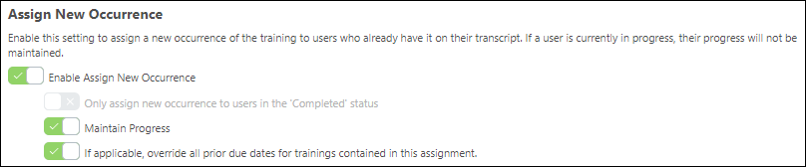
- Enable Assign New Occurrence = On
- Maintain Progress = On
- If applicable override all prior due dates for training contained in this assignment = On
Scenario 2: Overwrite Due Dates and Reset Progress
If the user already has the assignment training on their transcript and an administrator uses the below settings, the due date of the new assignment overrides the due date of the previous instance of the training on the user’s transcript. In this scenario, the progress of the training is NOT maintained.
In this scenario, if the training in the assignment is a curriculum, the due dates of the child training items inside the curriculum are not impacted.
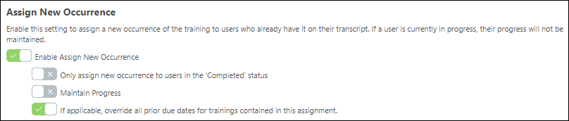
- Enable Assign New Occurrence = On
- Maintain Progress = Off
- If applicable override all prior due dates for training contained in this assignment = On
Deactivate Maintain Progress on Learning Assignment Summary Page
After a Learning Assignment is created, the Maintain Progress option can be deactivated within the Users section of the Learning Assignment Summary page by toggling the Maintain Progress setting. See Assignment Summary Page.
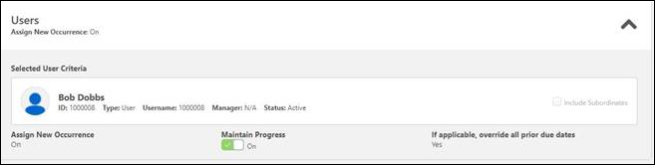
Curriculum Reassignment Behavior
Curriculum reassignment will always provide users with the latest version of all child training contained within the curriculum.
Important: To maintain compliance, administrators must have the permissions for material versioning (either the replace permission or the version with append permission) and online course versioning AND the permission for curriculum versioning (see the Permissions list above). If an administrator creates a new version of a child material or child online course but does NOT have permission to version curricula, the curriculum will not be updated and version updates cannot be maintained.
Use Case for Curriculum Reassignment Behavior
Users always receive the correct version of child training within a curriculum.
Step 1: Course Catalog contains the following curriculum:
- Curriculum V1 (containing the following child training items):
  - Material A V1
  - Material B V2
  - Online Course C V1
Step 2: Lisa, a user, is assigned Curriculum V1, and her transcript statuses for all related training items are as follows:
- Curriculum V1 – In Progress
- Material A V1 – Completed
- Material B V2 - Registered
- Online Course C V1 - Registered
Step 3: Laurence, an administrator, creates a new version of Material AV1, which is called Material AV2, but does not push the new material version to any users. Curriculum V2 will be created and the structure of the curriculum will be:
- Curriculum V2
  - Material A V2
  - Material B V2
  - Online Course C V1
Lisa's transcript is not changed or impacted.
Step 4: Later, Laurence the administrator creates a new version of Online Course C V1, which is called Online Course C V2, and she decides to push that new version to all users with previous version on their transcript. Now, the curriculum version updates, and the structure of the curriculum in the Course Catalog is:
- Curriculum V3
  - Material A V2
  - Material B V2
  - Online Course C V2
Step 5 (New Behavior): Lisa the user receives the updated curriculum, and her transcript statuses are as follows:
- Curriculum V3 – In Progress
- Material A V2 – Registered
- Material B V2 - Registered
- Online Course C V2 – Registered
Override All Prior Due Dates
If the Enable Assign New Occurrence setting is turned on, an additional option is available which allows the learning assignment to override all prior due dates for child training in a curriculum contained in the assignment. This means that if a user already has the child training on their transcript and then they receive a new occurrence of the training, the due date of the new assignment will override the due date(s) of the previous instance of the child training on the user's transcript. To allow the assignment to override previous due dates of child training contained in curricula, toggle the Override All Prior Due Dates switch to the On (green) position.
Note: This setting does not override the due date that displays for child training that viewed from inside the Curriculum Details page when the due date for a child training item is updated.

Compliance Enhancements - Training Removal Tool
This enhancement will be released with the Dec 14 2018 patch.
Prior to this enhancement, administrators were unable to remove instructor-led training (ILT) sessions which were in the following statuses:
- Incomplete
- Cancelled
- No Show
- Not Started
- Pending OJT Completion
Following this enhancement, administrators can use the Training Removal Tool to remove sessions the following transcript statuses:
- Incomplete
- Cancelled
- No Show
- Not Started
- Pending OJT Completion
To create a new training removal job, go to Admin > Tools > Learning > Training Tools > Training Removal Tool. Then, click the Create New Training Removal Job link. Advance to the Status step to select the transcript statuses the Training Removal Tool can remove from users' transcripts.
Permissions
PERMISSION NAME | PERMISSION DESCRIPTION | CATEGORY

Bulk Training Removal - Manage | Grants ability to bulk remove training from users’ transcripts. This permission can be constrained by OU and User's OU. Creator constraints also apply. This is an administrator permission. | Learning - Administration
Status
Using the Training Removal Tool, training in the following transcript statuses can be removed from users' transcripts:
- Approved
- Cancelled (new)
- Denied
- Incomplete (new)
- In Progress
- No Show (new)
- Pending Approval
- Pending OJT Completion (new)
- Pending Payment
- Registered
- Withdrawn
See Training Removal Job - Create - Step 3 - Status for more information about the Status step of creating a training removal job.

Compliance - Session Completion Date
Previously, the Session Completion Date setting configured via ILT Preferences did not apply to equivalencies, so all calculations were based on the roster submission date.
Currently, the Session Completion Date configuration set in ILT Preferences is applicable to equivalencies. The configurations set for the Session Completion Date option in ILT preferences determine how the completion date is calculated for equivalencies.
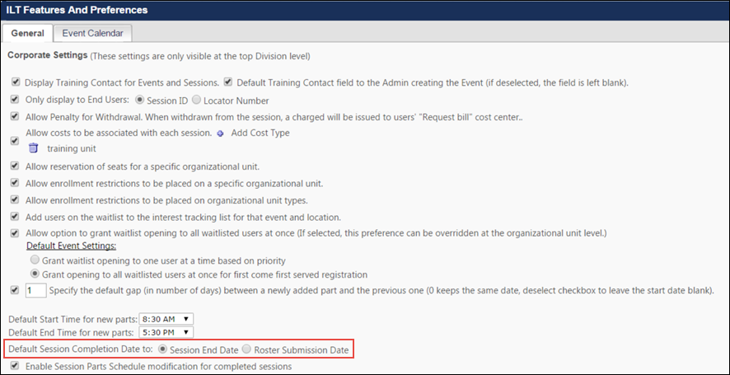
Expected Behaviors
This enhancement ensures that events always inherit the session completion date based on ILT preference settings. See the below use cases for more information about expected behaviors of this functionality:
- If the session includes required post-work, the completion of the session moves the session to a Pending Post-work status. After the post-work is completed by the user, the session is marked complete based on the post-work's completion date.
- If a session has a required post-work item that the user has already completed, the completion of the session marks the event with completion date of the session based on ILT preferences.
- If the user completes the pre-work for a session, the completion of the session marks the event with the completion date of the session based on ILT preferences.
- If a session requires a signature, the completion of the session changes the session status to Pending Signature, and once the user signs, the event is marked complete with a completion date based the signature date.
- If the event has two or more sessions, and the first session is completed, the first session's completion date is mapped to the completion date of the Event. When the second session is completed, the event will be marked complete for the second registration with the same completion date as the second session.
Note: The following section of considerations applies to equivalencies. Equivalencies can only be configured at the event level.
- If an event has an equivalent training and is bidirectional, and the session is registered and on a user's transcript, the session completion marks the event complete with the session completion date. When the training equivalency is in a Registered status on the user’s transcript, it will inherit the session completion date.
- If an event is equivalent to Training A, and a user has Training A and a session of the event in a Registered status on their transcript, when Training A is completed, the event will be marked complete with Training A's completion date, and the session will have a second registration and inherit the session completion date. The event will inherit the session completion date according to ILT preferences.
- When an event is equivalent to a training item, and the event is registered on the user’s transcript, when the equivalent training is completed, the event is marked completed with the training equivalent's completion date.
Example: Multiple Equivalencies for the Same Training
If Event A is equivalent to both Material B and Test C, and the user completes Material B and then completes Test C, when the user registers for Event A, the completion date of Material B is associated with Event A.
For more information about the compliance enhancements made to Equivalencies:
Exclusions
If a session is the last item in a curriculum or a certification structure, the session completion date will NOT propagate to the curriculum's or certification's completion date at this time.
For more information about ILT Preferences: See ILT Preferences - General on page 289 for additional information.

Compliance - Track Completed Equivalent
Prior to this enhancement, when a user received a Completed Equivalent status, it was not possible to track which equivalent training triggered that Completed Equivalent status on the user’s transcript.
With this enhancement, it is now possible to track which equivalent training item caused a user to receive a Completed Equivalent status. All equivalencies are visible and reportable. This enhancement applies to both Custom Reporting and Reporting 2.0.
In addition to reporting, the following enhancements are also supported:
- The training that triggered the Completed Equivalent status is also visible when viewing the Transcript History of the Completed Equivalent training inside a user’s transcript.
- The completion date logic of a training with a Completed Equivalent status has been updated to match the completion date of the training that triggered Completed Equivalent status.
  - Due to the sensitive nature these records, the historical completion dates will not be retroactively updated for the February 2019 release. This means that the logic for Completion Dates of trainings with ‘Completed Equivalent’ status prior to February 8, 2019 will be different than the logic after the release. Please refer to the Considerations section for more details.
If Transcript Lockdown is enabled for a portal, the Completion Date will NOT be updated with this new behavior for past data. However, this updated Completed Equivalent behavior applies to all new completion equivalencies.
Examples
See the following table for examples of updated Completed Equivalent behavior:
Training title | Training Version | Transcript Status | Completed Equivalent Training Title | Completed Equivalent Training Object ID | Completed Equivalent Training Type
Microsoft Word 101 | 1.0 | Completed
Microsoft Word 101 | 2.0 | Completed Equivalent | Microsoft Word 101 (This is the training which triggered the Completed Equivalent status) | 1.0 | Version Equivalent
Microsoft Word 101 (UK) | 1.0 | Completed Equivalent | Microsoft Word 101 (This is the training which triggered the Completed Equivalent status) | 1.0 | Language Equivalent
Intro to Microsoft Word | 1.0 | Completed Equivalent | Microsoft Word 101 (This is the training which triggered the Completed Equivalent status) | 1.0 | Training Equivalent
Reporting
New fields have been added to the Transcript report field section in custom reporting, allowing administrators to report on more data related to Completed Equivalents. The following new fields have been added to custom reporting:
Field Name | Report Section | Field Description | Field Type | affected reports
Completed Equivalent Training Object ID | Transcript | This field displays the Training Object ID of the training that triggered Completed Equivalent status. | Text | Certification Report, Compliance Report, Curriculum Transcript Report, Evaluation Report, Assignment Report, Test Report, Transaction Report, User Report
Completed Equivalent Training Title | Transcript | This field displays the title of the training that triggered Completed Equivalent status. | Text | Certification Report, Compliance Report, Curriculum Transcript Report, Evaluation Report, Assignment Report, Test Report, Transaction Report, User Report
Completed Equivalent Training Version | Transcript | This field displays the version number of the training that triggered Completed Equivalent status. | Numeric | Certification Report, Compliance Report, Curriculum Transcript Report, Evaluation Report, Assignment Report, Test Report, Transaction Report, User Report
Completed Equivalent Training Equivalency Type | Transcript | This field displays the type of equivalency that exists between the training with the Completed status and the training for which it triggered the Completed Equivalent status. Possible output values for this field include:  - Training Equivalency  - Version Equivalency  - Language Equivalency  Note: If a portal has had historical data imported, for which the equivalency type is unknown, this field may return an output of "Unknown." | Text | Certification Report, Compliance Report, Curriculum Transcript Report, Evaluation Report, Assignment Report, Test Report, Transaction Report, User Report
Considerations
The following considerations apply to this functionality:
- The training that triggers the completion equivalency is the earliest instance on a user's transcript if multiple Completed training items are equivalent to the training that is marked as Completed Equivalent.
Completion Date Logic Overview
Following the February 8, 2019 release, the completion date of training with a Completed Equivalent status on a user’s transcript is equal to the completion date of the training that triggered the Completed Equivalent status. If there are multiple equivalent training items on a user’s transcript with a status of Completed, the trigger is the training with the earliest completion date.
Example:
In this example report, assume all three of the following training items are bidirectionally equivalent.
Training Title | Status | Completed Equivalent Training Title | Completion Date
Operating a Forklift | Completed Equivalent | Fun with Forklifts | April 6 2016
Forklift Safety | Completed |  | Jan 5 2017
Fun with Forklifts | Completed |  | April 6 2016
Transcript History
The training which triggered a Completed Equivalent status displays in the Transcript History for the equivalent training. The training which triggered the Completed Equivalent status displays in the Transcript History section as:
TRAINING TITLE - VERSION - (COURSE CODE) on DATE TIME
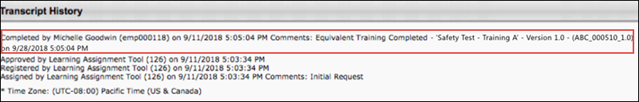

Compliance - Transcript Delivery Method
Prior to this enhancement, it was not possible to easily track the method by which training was delivered to a user's transcript. For example, if an organization wanted to know how many users self-requested training, or how many users were assigned training by their manager, it was necessary for administrators to report on assigned training and then filter the results.
With this enhancement, administrators have access to a new report field which shows the transcript delivery method of training. This enhancement applies to both Custom Reporting and Reporting 2.0.
Permissions
PERMISSION NAME | PERMISSION DESCRIPTION | CATEGORY

Custom Assignment Report - Create | Grants ability to create and edit custom Assignment reports. This permission can be constrained by OU, User's OU, User Self and Subordinates, and Provider. | Reports - Analytics

Custom Assignment Report - View | Grants ability to view custom Assignment reports. This permission can be constrained by OU, User's OU, User Self and Subordinates, and Provider. | Reports - Analytics

Custom Certification Report - Create | Grants ability to create and edit Custom Certification reports. This permission can be constrained by OU, User's OU, User Self and Subordinates, User, and User's Direct Subordinates. | Reports - Analytics

Custom Certification Report - View | Grants ability to view results of Custom Certification reports created by self or shared by others. This permission can be constrained by OU, User's OU, User Self and Subordinates, User, and User's Direct Subordinates. | Reports - Analytics

Custom Compliance Report - Create | Grants ability to create and edit Custom Compliance Reports. This permission should only be enabled if a client has not yet converted compliance certifications to the new certifications module. | Limited Use/Obsolete

Custom Compliance Report - View | Grants ability to view results of custom compliance reports created by self or others. This permission should only be enabled if a client has not yet converted compliance certifications to the new certifications module. | Limited Use/Obsolete

Custom Curriculum Transcript Report - Create | Grants ability to view results of custom Curriculum Transcript reports created by self or shared by others. This permission can be constrained by OU, User's OU, User, User Self and Subordinates, User's Direct Reports. | Reports - Analytics

Custom Curriculum Transcript Report - View | Grants ability to create and edit custom Curriculum Transcript reports. This permission can be constrained by OU, User's OU, User, User Self and Subordinates, User's Direct Reports. | Reports - Analytics

Custom Evaluations Reports - Create | Grants ability to create and edit custom Evaluation reports (training evaluation levels 1, 2, and 3). This permission can be constrained by OU, User's OU, and User's Direct Subordinates. | Reports - Analytics

Custom Evaluations Reports - View | Grants ability to view results of custom Evaluation reports (training evaluation levels 1, 2, and 3) created by self or shared by others. This permission can be constrained by OU, User's OU, and User's Direct Subordinates. | Reports - Analytics

Custom Test Reports - Create | Grants ability to create and edit custom Test reports (Test Engine data). This permission can be constrained by OU, User's OU, User Self and Subordinates, and User's Direct Subordinates. | Reports - Analytics

Custom Test Reports - View | Grants ability to view results of custom Test reports (Test Engine data) created by self or shared by others. This permission can be constrained by OU, User's OU, User Self and Subordinates, and User's Direct Subordinates. | Reports - Analytics

Custom Transaction Reports - Create | Grants ability to create and edit Custom Transaction (Billing) reports. | Reports - Analytics

Custom Transaction Reports - View | Grants ability to view results of Custom Transaction (Billing) reports created by self or shared by others. | Reports - Analytics

Custom Transcript Reports - Create | Grants ability to create and edit Custom Transcript (Training Record) reports. This permission can be constrained by OU, User's OU, User Self and Subordinates, and User's Direct Subordinates. | Reports - Analytics

Custom Transcript Reports - View | Grants ability to view results of Custom Transcript (Training Record) reports created by self or shared by others. This permission can be constrained by OU, User's OU, User Self and Subordinates, and User's Direct Subordinates. | Reports - Analytics
Transcript Delivery Method
The Transcript Delivery Method field is available in the Transcript report field section.
Field Name | Report Section | Field Description | Field Type | affected reports
Transcript Delivery Method | Transcript | This field displays the method by which a training item was added to the user's transcript. Possible values include:  - Self-Requested  - System Assignment (LAT)  - Direct Assignment  - Training was assigned directly (for example by a manger to a user)  - Training was submitted via ILT Roster Submission  - Express Class  - External Progress  - Assignment* (This category is representative of historical data records prior to the Feb '19 release which are not reliable and therefore have been contained separately to preserve data quality. Over time, this category will be deprecated.  - Other  - The Other status appears for all other miscellaneous transcript delivery cases, including:  - Assignment via Inventory  - Added by Training Plan  - Historical Data Loads (except in certain cases described in above values)  - Data Load Wizard | Text | Assignment Report, Certification Report, Compliance Report, Curriculum Transcript Report, Transcript Report
Considerations
The following considerations apply to this functionality:
- For training items that have been versioned, the Transcript Delivery Method for the most recent version, prior to the latest version, will define the Transcript Delivery Method of the latest version.
- Curriculum parent and child training items should have the same Transcript Delivery Method.
- Events and session training items should have the same Transcript Delivery Method.
- Learners and managers cannot remove training when the training is later assigned to the learner by an administrator.

Compliance - Users with Latest Version
Prior to this enhancement, during the versioning process, when the administrator specified that users who had received a previous version of the training via dynamic assignment should receive the updated version, the list of users generated by the system who would receive the new version was not entirely correct. Previously, any user who had been included in the dynamic assignment would be included in the list of users who should receive the new training version, even if the users did NOT actually receive the previous version as a result of the dynamic assignment.
With this enhancement, the list of users who receive with latest version of training during the versioning process is accurate. Only users who actually received a previous version of the training via dynamic learning assignment are included in the list generated during the versioning process of users who will receive the new version when the administrator specifies that the new version should be pushed to users who received the training via dynamic assignment.
Note: If the Assign New Occurrence option is turned off for the dynamic learning assignment, users with a previous version of the training on their transcript do not receive the training from the assignment. This enhancement ensures that only users assigned training by the learning assignment are given the latest version of the training when the filter is set to select users assigned by a dynamic learning assignment.

Curriculum Training Report
Organizations can create a Curriculum Training report in Reporting 2.0. The Curriculum Training report allows administrators to report on details from a curriculum structure, curriculum details from the Course Catalog, and curriculum version information from the user's transcript. Administrators can use the report to compare curriculum data from multiple system areas.
To access Reporting 2.0, go to Reports > Reporting 2.0.
Permissions
For more information about Reporting 2.0 permissions, see the following:
- Permissions in Reporting 2.0 - This provides detailed information about Reporting 2.0 permissions.
- Permissions List - This provides the list of permissions and their relationships so that you know which permissions users need to have to create and view reports.
Curriculum Training
The Curriculum Training report type includes the following two report field sections:
- Curriculum
- Training
Curriculum Section
This section is the ONLY section that should be used to filter for curriculum information related to the below listed fields. For example, to filter the report according to a curriculum's title, use the Curriculum Title (Curriculum) field within the Curriculum Training report. The Curriculum section includes the following fields:
Field Name | Report Section | Field Description | Field Type | affected reports
Course Code (Curriculum) | Curriculum | This is the Course Code of the curriculum. | Text | Curriculum Training Report
Created By (Name) (Curriculum) | Curriculum | This is the name of the user who created the curriculum. | Text | Curriculum Training Report
Created By (User ID) (Curriculum) | Curriculum | This is the User ID of the user who created the curriculum. | Text | Curriculum Training Report
Curriculum Title (Curriculum) | Curriculum | This is the title of the curriculum. | Text | Curriculum Training Report
Curriculum Version (Curriculum) | Curriculum | This is the version number of the curriculum. | Numeric | Curriculum Training Report
Keywords (Curriculum) | Curriculum | This field displays the keywords associated with the curriculum via the Course Catalog. | Text | Curriculum Training Report
Language (Curriculum) | Curriculum | This field displays the language(s) in which the curriculum is available. | Text | Curriculum Training Report
Latest Curriculum Version? | Curriculum | This field displays a yes/no value, indicating whether or not the curriculum is the latest version. | Yes/No | Curriculum Training Report
Last Modified By (Curriculum) | Curriculum | This is the name of the user who last modified the curriculum. | Text | Curriculum Training Report
Last Modified By (User ID) (Curriculum) | Curriculum | This is the User ID of the user who last modified the curriculum. | Text | Curriculum Training Report
Last Modified Date (Curriculum) | Curriculum | This is the date on which the curriculum was last modified. | Date | Curriculum Training Report
Training Active (Curriculum) | Curriculum | This field displays whether or not the training is currently active. | Yes/No | Curriculum Training Report
Training Description (Curriculum) | Curriculum | This is the description of the curriculum. | Text | Curriculum Training Report
Training Deactivation Date (Curriculum) | Curriculum | This is the deactivation date set for the curriculum (if applicable). | Date | Curriculum Training Report
Training Object ID (Curriculum) | Curriculum | This is the Object ID of the training. The Object ID will be propagated to all child training and curriculum sections to aid in filtering. | Text | Curriculum Training Report
Training Purpose (Curriculum) | Curriculum | This is the Training Purpose associated with the curriculum (if available). | Text | Curriculum Training Report
Training Status (Curriculum) | Curriculum | This is the training status of the curriculum. | Text | Curriculum Training Report
Training Subject (Curriculum) | Curriculum | This field displays the subjects that are associated with the curriculum via Course Catalog. | Text | Curriculum Training Report
Training Type (Curriculum) | Curriculum | This field displays the training type. | Text | Curriculum Training Report
Training Version Effective Date (Curriculum) | Curriculum | This is the training version effective date of the curriculum (if available). |  | Curriculum Training Report
Training Section
The Training report field section that is included in the Curriculum Training report contains the following new fields:
Field Name | Report Section | Field Description | Field Type | affected reports
Section Parent | Training | This field displays the section title for the training, indicating what training belongs to which section. If a training item does not have sections, the curriculum title will display. | Text | Curriculum Training Report
Required Training per Section | Training | This field displays the number of required training items per section. | Numeric | Curriculum Training Report
Display Sequence | Training | This field is not visible in the field section and cannot be added as a report column, but administrators can use this field as a sorting option. It allows administrators to organize the report according to the order in which the sections and child training items are configured in the curriculum structure. | Numeric | Curriculum Training Report
Sequence | Training | This field displays the order of training items within the curriculum structure. | Numeric | Curriculum Training Report
Pay-Upfront | Training | This field displays a yes/no value, indicating whether or not the Pay-Upfront option was selected for the training. | Yes/No | Curriculum Training Report
Pre-Approved | Training | This field displays a yes/no value, indicating whether or not the Pre-Approved option was selected for the training. | Yes/No | Curriculum Training Report
Auto-Register | Training | This field displays a yes/no value, indicating whether or not the Auto-Register option was selected for the training. | Yes/No | Curriculum Training Report
Auto-Launch | Training | This field displays a yes/no value, indicating whether or not the Auto-Launch option was selected for the training. | Yes/No | Curriculum Training Report
Reassign Curriculum | Training | This field displays a yes/no value, indicating whether or not the Reassign Curriculum Upon Test Failure option was selected for the training. | Yes/No | Curriculum Training Report
Max Attempts | Training | This field displays the maximum number of times a user may attempt a test. | Numeric | Curriculum Training Report
Due Date Criteria | Training | This field displays the due date option selected at the training level. There are six possible values for this field:  - No Due Dates  - Relative to Initial Assignment Date  - Relative to Most Recent Assignment Date  - Relative to Hire Date  - Relative to Previous Step  - Fixed Date | Text | Curriculum Training Report
Fixed Due Date | Training | This field displays the fixed date selected for the training. The date will display with its time stamp. | Date | Curriculum Training Report
Relative Days (Due Date) | Training | This field displays the number of days configured for each relative due date options, such as Initial Assignment Date, Most Recent Assignment Date, Hire Date, Previous Step, etc. | Numeric | Curriculum Training Report
Training Latest Version? | Training | This field displays a yes/no value to indicate whether or not training items in the curriculum are the latest versions from the Course Catalog. | Yes/No | Curriculum Training Report
Updates to the Training Section
The following fields have been removed from the Training section:
- Curriculum Section Title (Training)
- Curriculum Title (Training)
- Curriculum Version (Training)
The following field has been removed from the Training section only for the Curriculum Training custom report:
- Inside Curriculum
Considerations
- The Training section in this report is not intended to display information for the curricula on users' transcripts; it is meant to report on training items within the curriculum. To report on data at the curriculum level, use the Reporting 2.0 or the Transcript custom report.
- In the Training Type field, section type does not display.
Best Practice
To optimize this report, sort the report by Curriculum Version and then by Display Sequence.
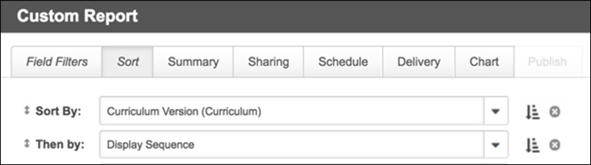
Basic Curriculum Training Report Example
See the table below for the fields recommended for a basic Curriculum Training report, along with additional considerations and recommendations.
Field Name | Explanation
Curriculum Title (Curriculum) | This is the curriculum title that will propagate to all child training items and sections, for filtering purposes.
Training Object ID (Curriculum) | This is the Curriculum Object ID that will propagate to all child training items and sections, for filtering purposes.
Display Sequence | The display sequence allows administrators to view the exact display order of the training in the curriculum structure. It is recommended that administrators use the Display Sequence as a secondary filter for the report.
Training Title | Use this field to display the training title of the child training or the section.
Training Object ID | Use this field to display the Training Object ID of the child training
Training Version | This field shows the training version for each child training item in the curriculum. Note: This is an existing field contained within the Training section.
Training Type | Use this field to show the training type of the child training. Note: A blank values indicates the item is a section.
Training Latest Version? | Use this field to quickly check if the training items inside the curriculum structure are the latest versions from the Course Catalog.
Section Parent | This field displays the parent section title. First-level sections and training without a section are tied to the curriculum training title.
Required Training per Section | This field displays the number of required training items in a section. This field is only populated for sections.
Sequence | This field displays the order in which training items are configured in the curriculum structure.
Pay-Upfront | This field only displays for child training, observation checklists, forms, and notes. Sections return a blank value.
Pre-Approved | This field only displays for child training, observation checklists, forms, and notes. Sections return a blank value.
Auto-Register | This field only displays for child training, observation checklists, forms, and notes. Sections return a blank value.
Auto-Launch | This field only displays for child training, observation checklists, forms, and notes. Sections return a blank value.
Max Attempts | This field only returns a value for tests.
Reassign Curriculum | This field only returns a value for tests.
Due Date Criteria | This field only displays for child training, observation checklists, forms, and notes.
Relative Days (Due Date) | This field is only populated if the due date criteria is relative.
Fixed Due Date | This field is only populated if the due date criteria is fixed.
Latest Curriculum Version? | This field propagates the yes/no value indicating whether or not training is the latest version from the Course Catalog to all child training items. To only receive report results with the latest version, set this field to a value of Yes.

Display "Transcript Delivery Method" in Transcript Details
With this enhancement, the method by which training was delivered to a user's transcript displays in the Assignment History section of their transcript. The Assignment History section is dynamically renamed to the Assignment and Version History section if the training has been reversioned. This section also indicates which training is the latest active registration.
To view the Assignment and Version History section for a training item on a user's transcript, navigate to the user's transcript and click the title of the training item.
Permissions
PERMISSION NAME | PERMISSION DESCRIPTION | CATEGORY

View Transcript Item | Grants ability to view details of learning objects that appear on the transcript (training record), by clicking on the name of the learning object. Users must also have the Bio About - View permission in order to access the transcript within Universal Profile. This permission can be constrained by OU, User's OU, User Self and Subordinates, User, or User's Self. This is an end user permission. | Learning - Administration
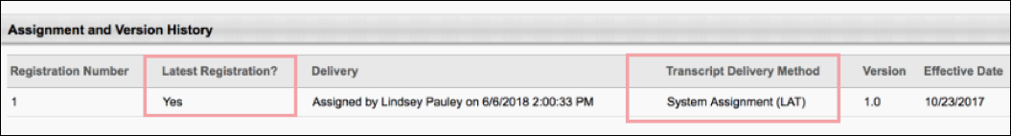
Assignment History/Assignment and Version History Section
In the Assignment History/Assignment and Version History section, the following new columns display:
- Latest Registration? - In the Latest Registration column, a Yes/No value displays, indicating whether or not the training registration is the latest active registration on the user's transcript.
- Transcript Delivery Method - In the Transcript Delivery Method section, the method by which the training registration was delivered to the user's transcript displays. Possible values include:
  - Self-Requested
  - System Assignment (LAT)
  - Direct Assignment
    - Training was assigned directly (for example by a manger to a user)
    - Training was submitted via ILT Roster Submission
  - Express Class
  - Assignment* (This category is representative of historical data records prior to the Feb '19 release which are not reliable and therefore have been contained separately to preserve data quality. Over time, this category will be deprecated.
Other
  - The Other status appears for all other miscellaneous transcript delivery cases, including:
    - Assignment via Inventory
    - Added by Training Plan
    - Historical Data Loads (except in certain cases described in above values)
    - Data Load Wizard
Considerations
  - The Assignment and Version History section is called "Assignment History" if the training has not yet been versioned. This is preexisting functionality.
  - There may be multiple entries within the Assignment and Version History section that are considered the Latest Registration. This is preexisting functionality that occurs when a training is versioned using Append versioning.
  - If training is versioned after an Express Class completion, the Transcript Delivery Method for users with this training on their transcript displays as "Self Request" or "Direct Assignment".
  - Learners and managers cannot remove training when the training is later assigned to the learner by an administrator. See the use case below:
Use Case: Transcript Delivery Method Behavior
  - Training is requested by a learner or assigned by a manager.​
  - The same training is assigned via the Learning Assignment Tool (LAT) with the Maintain Progress option selected by the administrator.​
  - The Transcript Delivery Method displays as “LAT” instead of the initial request or assignment, and the initial requesting learner or assigning manager are not able to remove this training from the transcript.

Enhanced Custom Field Auditing - Additional Fields
Prior to this enhancement, only the following custom field types could be audited:
- Short Text Box
- Date
- Radio Button
- Dropdown
- Checkbox
- Multiple Checkbox
- Numeric
- Scrolling text
With this enhancement, ALL the following custom field types can be audited:
- Short Text Box
- Date
- Radio Button
- Dropdown
- Checkbox
- Multiple Checkbox
- Numeric
- Scrolling text
- Conditional Numeric (new)
- Branched Dropdown (new)
- Hierarchy (new)
With these additional auditing capabilities, organizations can more effectively ensure compliance.
Implementation
This functionality is NOT automatically enabled. In order to utilize these enhanced auditing capabilities, a GTS project to allow auditing via an outbound data feed must be initiated. Please contact Global Customer Support or your Account Manager to initiate a GTS project. A cost may be associated with this process.

Learning Assignment Tool Enhancements
With the Aug 2019 release, the following enhancements have been made to the Learning Assignment Tool:
- Training assigned by a learning assignment can be easily removed from user's transcripts after the assignment is made inactive
- Administrators can force standard learning assignments to stop processing
This enhancement is not available at the start of UAT. These updates are targeted for the July 16th Stage deployment.
To access the Assignment Summary page for an assignment and access these new options, go to: Admin > Tools > Learning and click the Learning Assignment Tool link. Click the title of the assignment for which you want to view the Assignment Summary page. Note: Options available on the Assignment Summary page vary depending on whether the assignment is standard or dynamic.
Permissions
PERMISSION NAME | PERMISSION DESCRIPTION | CATEGORY

Assignment Tool - Force Removal | Grants ability to force the removal of training assigned by a standard or dynamic learning assignment on the Assignment Summary page. This is an administrator permission. This permission can be constrained by OU and Users, and the user can be limited to only being able to use this functionality for assignments they created. | Learning - Administration

Assignment Tool - Standard | Grants ability to create Standard (one-time) Learning Assignments to directly assign training to users. This permission can be constrained by OU, Provider, Training Item, Training Type, User, User Self and Subordinates, and User's OU. If this permission is constrained by Location, Provider, Training Type, or Training Item, then they can only assign training within the constraints. If this permission is constrained by OU, User, User Self and Subordinates, or User's OU, then they can only assign to and view assignments created by users within the constraints. This is an administrator permission. | Learning - Administration

Assignment Tool - Standard and Dynamic | Grants ability to create Standard (one-time) and Dynamic (continuous) Learning Assignments to directly assign training to users. This permission can be constrained by OU, Provider, Training Item, Training Type, User, User Self and Subordinates, and User's OU. If this permission is constrained by Location, Provider, Training Type, or Training Item, then they can only assign training within the constraints. If this permission is constrained by OU, User, User Self and Subordinates, or User's OU, then they can only assign to and view assignments created by users within the constraints. This is an administrator permission. | Learning - Administration

Assignment Tool - Standard and Dynamic - Recurrence | Grants ability to create Standard (one-time) and Dynamic (continuous) Learning Assignments to directly assign training to users. Also grants ability to enable/disable Recurrence when creating a Dynamic Learning Assignment. This permission can be constrained by OU, Provider, Training Item, Training Type, User, User Self and Subordinates, and User's OU. If this permission is constrained by Location, Provider, Training Type, or Training Item, then they can only assign training within the constraints. If this permission is constrained by OU, User, User Self and Subordinates, or User's OU, then they can only assign to and view assignments created by users within the constraints. This is an administrator permission. | Learning - Administration
Force Removal from Standard Assignments
For standard assignments, a Remove from Transcript button is available in the Processed section of the Assignment Summary page. Click the Remove from Transcript button to remove the training from the assignment from users' transcripts.
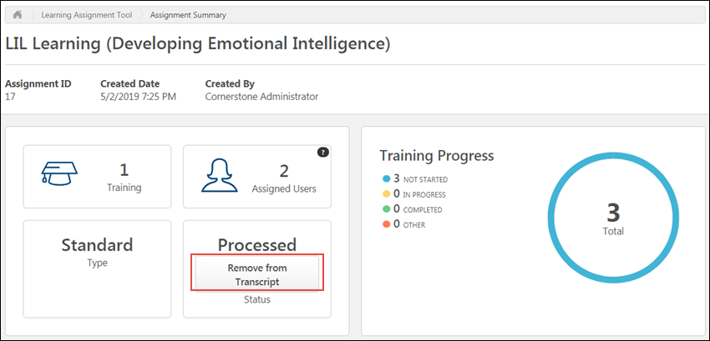
A pop-up appears, warning the administrator that this action cannot be undone. If the administrator clicks the Remove from Transcript button in the pop-up, the training will be removed from users' transcripts and the assignment can no longer be activated again. If the administrator decides not to remove the training, they can click the Cancel button to return to the Assignment Summary page.
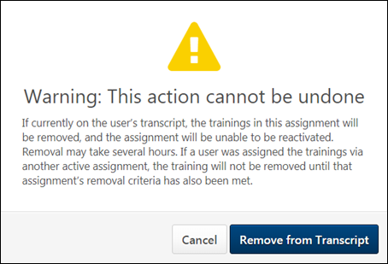
When the administrator clicks the Remove from transcript button, the process to remove the assignment's training from users' transcripts begins. This process may take several hours to complete, depending on how many users were included in the assignment. Note: Completed training is not removed from users' transcripts.
The time and date on which the Remove from transcript button was clicked is recorded in the Modification History section of the Assignment Summary page.
Stop Processing
When a standard learning assignment is submitted by an administrator, the assignment queues and processes. It may take several minutes for the assignment's training to be assigned to all the users selected for the assignment. During this time, it is possible to stop the assignment from processing, if required. When processing is stopped, the assignment immediately stops assigning the training to any users who have not yet received the training.
To stop a standard learning assignment from processing:
- Click the title of the processing assignment from the Manage Assignments page. You will be navigated to the Assignment Summary page.
- In the Queued widget, click the Stop Processing link. This link is only available if the assignment is currently processing. A Stop Processing pop-up appears.
- Confirm that you want to stop the processing by clicking the Stop button. Processing will be immediately stopped, and no more users will receive the training. If you do not wish to stop the processing, you can click the Cancel button in the pop-up instead.
Note: The Stop Processing option is only available for standard learning assignments.
Force Removal from Dynamic Assignments
In the Removal Settings section of the Assignment Summary page, a Remove button is visible under the Force Removal from Assignment/Transcript field to users with the appropriate permission. If the assignment is dynamic, the Remove button is grayed out and is not clickable if the dynamic assignment is currently active. To use the Remove button, deactivate the assignment by toggling the Active switch in the upper-right corner of the Assignment Summary page to the Inactive position. This step is not necessary for standard assignments.
When the assignment is inactive, the Remove button is clickable. To remove the training from the assignment from users' transcripts, click the Remove button.
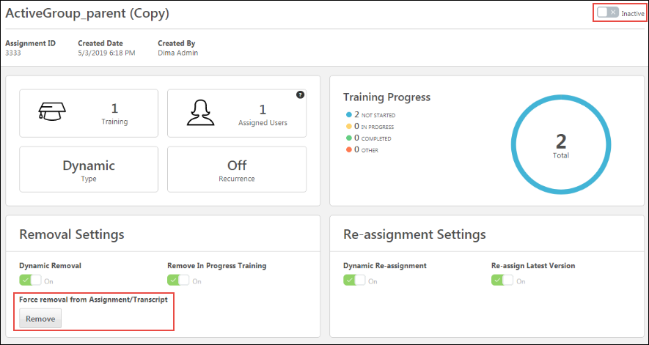
A pop-up appears, warning the administrator that this action cannot be undone. If the administrator clicks the Remove button in the pop-up, the training will be removed from users' transcripts and the assignment can no longer be activated again. If the administrator decides not to remove the training, they can click the Cancel button to return to the Assignment Summary page.
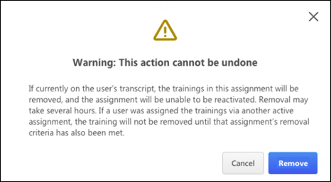
When the administrator clicks the Remove button, the process to remove the assignment's training from users' transcripts begins. This process may take several hours to complete, depending on how many users were included in the assignment.
The time and date on which the Remove button was clicked is recorded in the Modification History section of the Assignment Summary page. Note: Completed training is not removed from users' transcripts.
Considerations
The following considerations apply to this training removal functionality:
- If learners were assigned or requested the training separately, the training may not be removed from their transcript until that learner meets the removal criteria of all assignments.
- This option applies to all learners in the assignment. Individual learners cannot be included or excluded.
- Dynamic assignments cannot be reactivated again after training has been removed.
- Completed training cannot be removed from users' transcripts
High User Count Warning
The administrator can set a threshold percentage which triggers the High User Count warning to appear on the Confirm step of the learning assignment creation process, via the Learning Assignment Tool Preferences page. With the August 16th patch, this percentage can include up to two decimal points. For example, the High User Count warning threshold percentage may be set to 50.01%. In that case, if a user creates an assignment which is configured to assign training to 50.01% or more of the entire system's users, the High User Count warning message will appear before the administrator can fully submit the assignment for processing.
For more information about setting the High User Count warning percentage: See Learning Assignment Tool Preferences.

Learning Compliance - Assignment Summary Page Enhancements
With the May 2019 release, several enhancements have been made to the Learning Assignment Tool Assignment Summary page to help facilitate learning compliance. The following updates have been made to the Assignment Summary page:
- Administrators can view which users in the assignment availability were assigned training and which users were NOT assigned training, using new Assigned and Not Assigned tabs on the Assignment Summary page.
- A Modification History section is available in the Assignment Summary.
- Administrators can view the current training version assigned via the Assignment Summary.
- The Assigned Users calculation for dynamic assignments on the Assignment Summary only includes users who were successfully assigned the training.
To access the Assignment Summary page for a learning assignment, go to: ADMIN > TOOLS > LEARNING > LEARNING ASSIGNMENT TOOL and click on the title of the learning assignment for which you want to view the Assignment Summary page.
Permissions
PERMISSION NAME | PERMISSION DESCRIPTION | CATEGORY

Assignment Tool - Standard | Grants ability to create Standard (one-time) Learning Assignments to directly assign training to users. This permission can be constrained by OU, Provider, Training Item, Training Type, User, User Self and Subordinates, and User's OU. If this permission is constrained by Location, Provider, Training Type, or Training Item, then they can only assign training within the constraints. If this permission is constrained by OU, User, User Self and Subordinates, or User's OU, then they can only assign to and view assignments created by users within the constraints. This is an administrator permission. | Learning - Administration

Assignment Tool - Standard and Dynamic - Recurrence | Grants ability to create Standard (one-time) and Dynamic (continuous) Learning Assignments to directly assign training to users. Also grants ability to enable/disable Recurrence when creating a Dynamic Learning Assignment. This permission can be constrained by OU, Provider, Training Item, Training Type, User, User Self and Subordinates, and User's OU. If this permission is constrained by Location, Provider, Training Type, or Training Item, then they can only assign training within the constraints. If this permission is constrained by OU, User, User Self and Subordinates, or User's OU, then they can only assign to and view assignments created by users within the constraints. This is an administrator permission. | Learning - Administration

Assignment Tool - Standard and Dynamic - Recurrence | Grants ability to create Standard (one-time) and Dynamic (continuous) Learning Assignments to directly assign training to users. Also grants ability to enable/disable Recurrence when creating a Dynamic Learning Assignment. This permission can be constrained by OU, Provider, Training Item, Training Type, User, User Self and Subordinates, and User's OU. If this permission is constrained by Location, Provider, Training Type, or Training Item, then they can only assign training within the constraints. If this permission is constrained by OU, User, User Self and Subordinates, or User's OU, then they can only assign to and view assignments created by users within the constraints. This is an administrator permission. | Learning - Administration
Assigned Users
Prior to this enhancement, the Assigned Users reporting widget on the Assignment Summary page for dynamic enhancements displayed the total number of users who were included in the assignment's availability criteria. This meant the number would fluctuate depending on how many users currently met the criteria. With this enhancement, the Assigned Users widget calculates assigned users based on how many users were successfully assigned the assignment training. This provides administrators with a more accurate overview of the assignment.
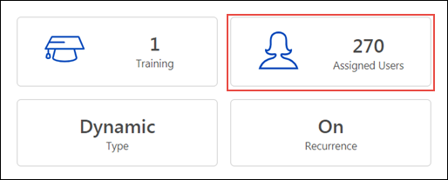
Recommended Tests for Assigned Users
It is recommended that you perform the following tests with this new functionality in your portal:
- Check that Assigned Users calculation for an assignment matches the Transcript History list on the Assigned tab (without removed users)
Current Version
In the Assignment Settings section of the Assignment Summary page, the administrator can expand the different sections of learning assignment settings to view information about the assignment's configuration. To view which version of training is included in the assignment, click the Setup section to expand it. Any training items included in the assignment display in the Setup section with a Current Version field. The Current Version field displays which version of the training item is included in the assignment.
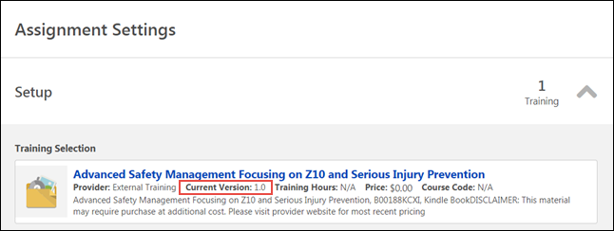
Recommended Tests for Current Version
It is recommended that you perform the following tests with this new functionality in your portal:
- On the Assignment Summary page, check training versions that have been versioned since the assignment creation and make sure the correct version number displays.
Assigned and Not Assigned Tabs
In the Transcript History section of the Assignment Summary page, the users who were included in the assignment's availability are categorized on two different tabs: Assigned and Not Assigned. When viewing the Assigned tab, the administrator can view all the users included in the assignment's availability who were successfully assigned the training by the assignment being viewed. When viewing the Not Assigned tab, the administrator will see the users who were included in the assignment's availability but were NOT assigned the training by the assignment being viewed. Note: If a user was assigned the same training by another assignment, but not by the assignment being viewed from this page, that user will appear on the Not Assigned tab.

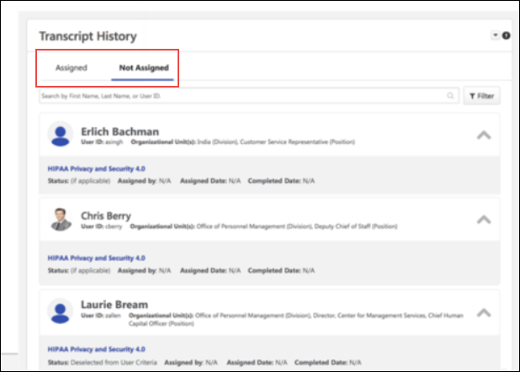
For more information about the Transcript History section: See Assignment Summary Page.
Recommended Tests for Assigned and Not Assigned Tabs
It is recommended that you perform the following tests with this new functionality in your portal:
- Assign a training item to a group of users with and without the training on their transcript, with the Assign New Occurrence option turned off.
- Assign a training item to a group of users and deselect users on the user list.
- Assign a training item to a group of users, some who do and some who do not have a Completed status for the training. Select the option to only assign a new occurrence to users in the with a Completed status.
Modification History
Below the Transcript History section, a section called Modification History is available. The Modification History section displays a log of the changes that have been made to the learning assignment. The information recorded in this section includes:
- Name of user who made the change
- Date and time the change was made
- A description of the change
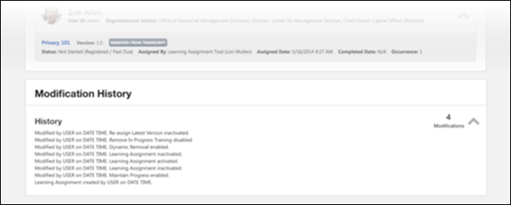
Recommended Tests for Modification History
It is recommended that you perform the following tests with this new functionality in your portal:
- On the Assignment Summary page, make changes to the following settings and then check the Modification History section:
  - Dynamic Removal
  - Dynamic Reassignment
  - Active/Inactive setting
  - Any other setting that is configurable via the Assignment Summary page

Material Versioning - Due Date Criteria Enhancement
With this enhancement, the Apply Previous Version Due Date option has been updated to Apply Previous Version Due Date Criteria. If the Apply Previous Version Due Date Criteria option is selected, the new version considers whether the previous material version was assigned via the Learning Assignment Tool with a due date relative to the date assigned. If the previous material version was assigned with a due date that was relative to the date the material was assigned, that relative due date is applied to the new version if the administrator selects this option during the material versioning process.
If the administrator does NOT want a relative due date that the previous version of the material received from a learning assignment to propagate to the new version of the material on users' transcripts, it is necessary to select the Apply Exact Due Date from Transcript for Standalone Materials option.
This enhancement is not available at the start of UAT. It is targeted for the July 16th Stage deployment.
- To reversion a material, go to Admin > Tools > Learning > Catalog Management > Materials. Next to the material, click the Create Version icon.
OR
- For organizations using Simplified Versioning, a new material version is created by editing the material. To access Materials Management, go to Admin > Tools > Learning > Catalog Management > Materials.
Permissions
PERMISSION NAME | PERMISSION DESCRIPTION | CATEGORY

Materials Management | Grants ability to view the Material Administration page and create, edit, and copy materials. Once created, these "materials" can be managed like other learning objects via the course catalog. This permission can be constrained by OU, User's OU, and Provider. The constraints on this permission determine which materials the administrator is able to view, edit, copy, and create. This is an administrator permission. | Learning - Administration

Material Version - Replace Only - Manage | Grants ability to assign a new version of a material to a user. The constraints on this permission determine to which users the administrator can assign a new version of a material. This permission works in conjunction with the Materials Management permission. Without this permission, administrators cannot upload new material source files. This permission can be constrained by OU, User's OU, and Users. This is an administrator permission.  This permission only applies to organizations that are using Simplified Versioning for materials. | Learning - Administration

Material Version with Append - Manage | Grants ability to create versions of a material. This permission works in conjunction with the Materials Management permission. This permission can be constrained by OU, User's OU, and Users.  This permission only applies to organizations that are using Versioning with Append for materials. | Learning - Administration
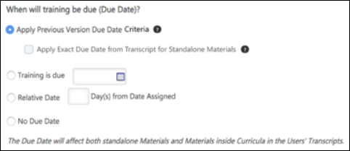
When will training be due (Due Date)?
During the material reversioning process, the administrator is asked when the new version of the material should be due for users who already have the previous version. If the administrator selects the Apply Previous Version Due Date Criteria option, if the previous material version was assigned via a learning assignment with a due date that was relative to the date the material was assigned, that relative due date is applied to the new version.
If the administrator does NOT want the new version of the material to consider whether the previous version was assigned with a relative date via the Learning Assignment Tool, they must select the Apply Exact Due Date from Transcript for Standalone Materials option. The Apply Exact Due Date from Transcript for Standalone Materials option causes ONLY the specific due date for the previous material version on the user's transcript to be applied to the new material version.
FAQs
See below for a list of frequently-asked questions about this functionality:
Q: Does this enhancement impact reversioned materials which exist as child training items within a curriculum?
A: No. If a material exists as a child item within a curriculum, the due date calculation is based on the due date criteria defined in the curriculum structure. This is existing behavior.
Q: What happens when a material exists as a standalone item on a user's transcript and also as a child item within a curriculum on the same user's transcript?
A: The due date of the child material within the curriculum will take precedence and override the standalone material due date.
Q: Is there a due date recalculation for users who received the prior material version from a learning assignment with a fixed due date, or for an assignment from a manager that was assigned with a fixed due date?
A: No, this enhancement only applies when the Learning Assignment Tool assignment's due date was configured to be relative to the date the material was assigned.
Q: If a user has received the prior training via multiple learning assignments, which learning assignment will be selected and used for the due date criteria recalculation?
A: The learning assignment associated with the most recent date that the training was assigned will be used for the due date criteria recalculation.
Q: Will the users included in the user versioning criteria who did NOT receive the prior version via the learning assignment tool with a due date relative to date assigned be impacted (such as users who received the training via manager assignment)?
A: No, these users will not receive an updated due date.
Examples
When the Apply Previous Version Due Date Criteria is selected during the versioning process, the following outcomes are expected:
User | Prior version due Date | Due Date Source | Due Date for New Version
Sabeen | Feb 5 | Learning Assignment, Fixed Due Date | Feb 5
Andy | Jan 19 | Learning Assignment, Fixed Due Date | Jan 19
Helen | Mar 1 | Learning Assignment, Training Due 5 Days After Assignment | Effective Date + 5 days
Nadir | Mar 1 | Learning Assignment, Training Due 5 Days After Assignment | Effective Date + 5 days
Greg | April 5 | Learning Assignment, Training Due 5 Days After Assignment | Effective Date + 5 days
Benjamin | April 13 | Manager Assignment | April 13
Iesha | No due date | N/A | No due date
Arya | No due date | N/A | No due date
Considerations
Portals using a DMS integration are NOT currently impacted by this enhancement.

Online Course Versioning
Apply Previous Version Due Date Criteria Option
On the second step of versioning an online course, the administrator selects versioning options. The Apply Previous Version Due Date Criteria option is located on this page.
To create a new version of an online course, go to Admin > Tools > Learning > Catalog Management and click the Course Catalog link. Find the online course in the Course Catalog and then click the course title. From the Course Console page, click the Options drop-down menu and click the Create Version option. Proceed to the Versioning Options step of the process to configure due date criteria.
Permissions
PERMISSION NAME | PERMISSION DESCRIPTION | CATEGORY

Assignment Tool - Standard and Dynamic | Grants ability to create Standard (one-time) and Dynamic (continuous) Learning Assignments to directly assign training to users. This permission can be constrained by OU, Provider, Training Item, Training Type, User, User Self and Subordinates, and User's OU. If this permission is constrained by Location, Provider, Training Type, or Training Item, then they can only assign training within the constraints. If this permission is constrained by OU, User, User Self and Subordinates, or User's OU, then they can only assign to and view assignments created by users within the constraints. This is an administrator permission. | Learning - Administration

Assignment Tool - Standard and Dynamic - Recurrence | Grants ability to create Standard (one-time) and Dynamic (continuous) Learning Assignments to directly assign training to users. Also grants ability to enable/disable Recurrence when creating a Dynamic Learning Assignment. This permission can be constrained by OU, Provider, Training Item, Training Type, User, User Self and Subordinates, and User's OU. If this permission is constrained by Location, Provider, Training Type, or Training Item, then they can only assign training within the constraints. If this permission is constrained by OU, User, User Self and Subordinates, or User's OU, then they can only assign to and view assignments created by users within the constraints. This is an administrator permission. | Learning - Administration

Course Catalog - Update | Grants ability to manage and edit training items listed in the Course Catalog and also grants access to the Course Console, where training can also be managed and edited. This permission also grants access to the Popular Requests and Highest Rated widgets on the Learning Admin Console (in conjunction with the Learning Admin Console - View permission). This permission also allows administrators to reversion online courses via the Course Console page. This permission also allows administrators to access an Edit Training option for training items included as objectives in Development plans.  This permission can be constrained by OU, User's OU, Training Type, Training Item, Provider, ILT Provider, User's ILT Provider, User, User Self and Subordinates, and User's LO Availability. This is an administrator permission.  Note: Adding an OU constraint and a provider constraint to this permission results in an "AND" statement. | Learning - Administration

Online Class - Upload | Grants access to the Content Uploader where an administrator can upload zip packages to create draft online classes. In addition, this permission grants the ability to upload a new zip package as part of the online class versioning process. This permission does NOT grant the ability to publish online classes. Without the permission to publish online classes, administrators with the permission to upload online classes can only upload and save online classes, which then must be published by administrators with the relevant permission.  As of November 10, 2017, this is the only permission which provides access to the Content Uploader page. | Learning - Administration

Online Class Version - Publish | Grants ability to upload and publish new online class versions. This permission works in conjunction with the permission for uploading online classes. This permission can be constrained by OU, User's OU, Users, and Providers. This is an administrator permission. | Learning - Administration
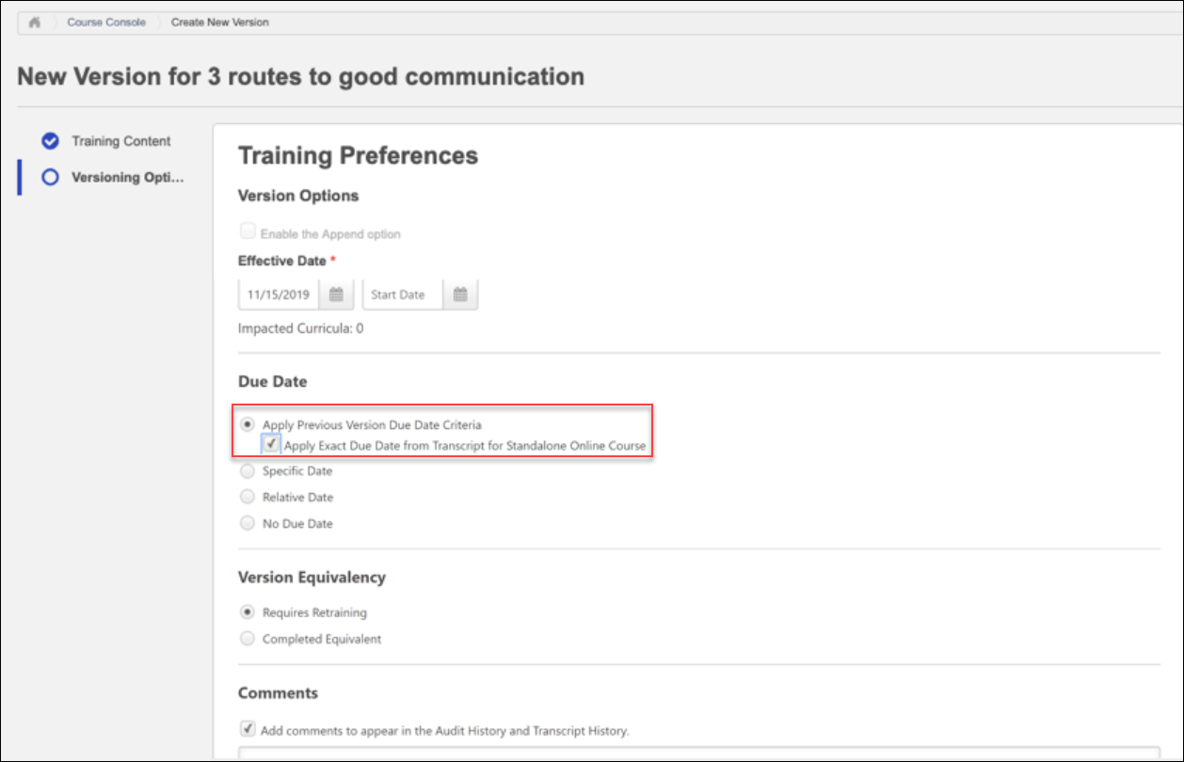
Apply Previous Version Due Date Criteria
To apply the due date criteria of the previous course version to the new course version, including dynamic due date criteria such as "10 days from Date Assigned," select the Apply Previous Version Due Date Criteria option from the Due Date section. To apply an exact due date from the previous version to the new standalone online course version, also select the Apply Exact Due Date from Transcript for Standalone Online Course sub-option.
If relative due date criteria from the previous version is applied to the new version, the new version's due date will be the specified number of days after the new version's effective date.
For additional information about online course versioning options: See Online Course - Create Version - Versioning Options.
Example
- Victor, an administrator, assigns Michelle, an employee, an online course called “Hand Washing Best Practices” V1 via the Learning Assignment Tool (LAT) on January 1st. The course has a relative due date of "1 month from date assigned," so Michelle receives "Hand Washing Best Practices" V1 on her transcript with a due date of February 1st.
- Victor reversions the online course, "Hand Washing Best Practices" V1 to V2 on March 1st with an effective date of March 15th. He includes Michelle in the user versioning criteria and selects the Requires Retraining option for her. For the due date criteria, he selects the Apply Previous Version Due Date Criteria option.
- Michelle receives the online course, "Hand Washing Best Practices" V2 on her transcript with a due date of April 15th (1 month after the effective date of the new version).
Online Course Versioning - Due Date Criteria Enhancement - Overview
Prior to this enhancement, when versioning an online course, administrators could select the Apply Previous Version Due Date option when configuring due date criteria, which would simply apply the exact due date for the prior version to the new version. For example, if the previous version had a due date of Feb 1, the new version would also receive a due date of Feb 1. Relative due date criteria, such as "10 days from Date Assigned," could NOT be applied to the new version using this option.
With this enhancement, administrators can still apply an exact due date from the previous online course version to the new version if desired, but they can also apply relative due date criteria to the new online course version by selecting the new Apply Previous Version Due Date Criteria option. This more dynamic due date setting provides increased flexibility when configuring due dates for reversioned online courses.
Note: This project is part of the largermulti-release Learning Compliance Scalability Initiative. The release of this project concludes the Learning Compliance Scalability Initiative.
Implementation
This functionality is automatically enabled in all portals using the Learning module.
Permissions
The following existing permissions apply to this functionality:
PERMISSION NAME | PERMISSION DESCRIPTION | CATEGORY

Assignment Tool - Standard and Dynamic | Grants ability to create Standard (one-time) and Dynamic (continuous) Learning Assignments to directly assign training to users. This permission can be constrained by OU, Provider, Training Item, Training Type, User, User Self and Subordinates, and User's OU. If this permission is constrained by Location, Provider, Training Type, or Training Item, then they can only assign training within the constraints. If this permission is constrained by OU, User, User Self and Subordinates, or User's OU, then they can only assign to and view assignments created by users within the constraints. This is an administrator permission. | Learning - Administration

Assignment Tool - Standard and Dynamic - Recurrence | Grants ability to create Standard (one-time) and Dynamic (continuous) Learning Assignments to directly assign training to users. Also grants ability to enable/disable Recurrence when creating a Dynamic Learning Assignment. This permission can be constrained by OU, Provider, Training Item, Training Type, User, User Self and Subordinates, and User's OU. If this permission is constrained by Location, Provider, Training Type, or Training Item, then they can only assign training within the constraints. If this permission is constrained by OU, User, User Self and Subordinates, or User's OU, then they can only assign to and view assignments created by users within the constraints. This is an administrator permission. | Learning - Administration

Course Catalog - Update | Grants ability to manage and edit training items listed in the Course Catalog and also grants access to the Course Console, where training can also be managed and edited. This permission also grants access to the Popular Requests and Highest Rated widgets on the Learning Admin Console (in conjunction with the Learning Admin Console - View permission). This permission also allows administrators to reversion online courses via the Course Console page. This permission also allows administrators to access an Edit Training option for training items included as objectives in Development plans.  This permission can be constrained by OU, User's OU, Training Type, Training Item, Provider, ILT Provider, User's ILT Provider, User, User Self and Subordinates, and User's LO Availability. This is an administrator permission.  Note: Adding an OU constraint and a provider constraint to this permission results in an "AND" statement. | Learning - Administration

Online Class - Publish | Grants access to two pieces of functionality:  - Publish button on the Course Console, allowing administrator to publish a draft online class  - Upload section of the online class versioning workflow | Learning - Administration

Online Class - Upload | Grants access to the Content Uploader where an administrator can upload zip packages to create draft online classes. In addition, this permission grants the ability to upload a new zip package as part of the online class versioning process. This permission does NOT grant the ability to publish online classes. Without the permission to publish online classes, administrators with the permission to upload online classes can only upload and save online classes, which then must be published by administrators with the relevant permission.  As of November 10, 2017, this is the only permission which provides access to the Content Uploader page. | Learning - Administration
Online Course Versioning Preferences - Due Date Options
Administrators can set default options for the online course versioning process and specify whether these options are editable via the Online Course Versioning Preferences page. The Apply Previous Version Due Date Criteria option is included as a default due date option.
To set online course versioning preferences, go to Admin > Tools > Learning > Learning Preferences and click the Online Course Versioning Preferences link. Online course versioning preferences are set by division, so choose the division for which you want to set preferences.
Permissions
PERMISSION NAME | PERMISSION DESCRIPTION | CATEGORY

Online Class Versioning Preferences | Grants ability to set default options for the online class versioning process. This is an administrator permission. | Learning - Administration
Due Date
In the Due Date section, select a default due date option for reversioned courses. Available options include:
- Apply Previous Version Due Date Criteria (new)
  - Apply Exact Due Date from Transcript for Standalone Online Course (not selected by default)
- Specific Date
- Relative Date
- No Due Date
For more information about online course versioning preferences: See Online Course Versioning Preferences on page 254 for additional information.

"Pending Prior Training" and "Not Activated" Statuses Added to "Not Started" Status Group for Material and Online Course Versioning
Prior to this enhancement, when a curriculum structure required child training to be completed in a sequence, the child training would display a status of Pending Prior Training in users' transcripts. When the curriculum required child training to be activated, the child training in the curriculum structure would display a status of Not Activated in users' transcripts. These two statuses were not included in the Not Started training status group during Material or Online Course versioning, meaning that users with training in a Pending Prior Training status or a Not Activated status would not be selectable during the versioning workflow, and could not be assigned the latest version of the training.
With this enhancement, the Pending Prior Training and Not Activated statuses are included in the Not Started training status group, which means users with materials or online courses in these statuses will be included in the User List when the materials or online courses are reversioned. Selecting these users in the User List allows them to receive the latest version of the training after the versioning process is complete.
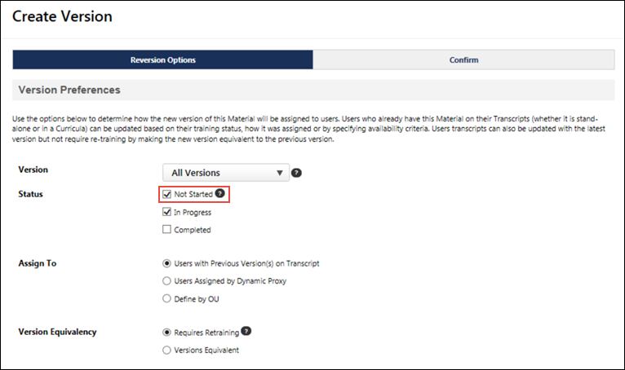
Considerations
If a curriculum contains a material or online course with a status of Pending Prior Training or Not Activated, and then the material or online course is reversioned, the curriculum will also be reversioned to include the latest version of the material or online course.
Permissions
The following existing permissions apply to this functionality:
PERMISSION NAME | PERMISSION DESCRIPTION | CATEGORY

Curricula Version - Manage | The constraints on this permission determine for which users the administrator can assign a new version of a curriculum when reversioning the curriculum. This permission works in conjunction with the Curricula Admin - Manage permission. The constraints on this permission determine for which users the administrator can assign a new version of a curriculum when reversioning a material that is contained within a curriculum. This permission can be constrained by OU, User's OU, and User. This is an administrator permission. | Learning - Administration

Material Version - Replace Only - Manage | Grants ability to assign a new version of a material to a user. The constraints on this permission determine to which users the administrator can assign a new version of a material. This permission works in conjunction with the Materials Management permission. Without this permission, administrators cannot upload new material source files. This permission can be constrained by OU, User's OU, and Users. This is an administrator permission.  This permission only applies to organizations that are using Simplified Versioning for materials. | Learning - Administration

Material Version with Append - Manage | Grants ability to create versions of a material. This permission works in conjunction with the Materials Management permission. This permission can be constrained by OU, User's OU, and Users.  This permission only applies to organizations that are using Versioning with Append for materials. | Learning - Administration

Online Class Version - Publish | Grants ability to upload and publish new online class versions. This permission works in conjunction with the permission for uploading online classes. This permission can be constrained by OU, User's OU, Users, and Providers. This is an administrator permission. | Learning - Administration

Persist Settings During Versioning - Material, Online Course, Curriculum, Test
With this enhancement, more settings automatically persist from the old version to the new version when an administrator reversions a curriculum, material, online course, or test.
Also included with the May ’19 Release, a change has been made to the Start Date field, which appears during material creation and versioning. Previously, the Start Date field displayed during material creation and material replacement versioning workflows. However, the field was not functional in these workflows, which created some confusion. With the May ’19 Release, the Start Date field no longer appears during material creation and material replacement versioning workflows. However, the Start Date field still applies during the material append versioning workflow. The Append option must be selected in this case.
Curricula - Persisted Settings
With this enhancement, the following additional settings persist to the new version when a curriculum is reversioned:
- Approval Workflows
- Badges
- Competencies
- Custom OU Pricing
- Enable Default Completion Message
- Evaluations
- Exclude from Course Recommendations
- Points
- Recommended courses
- Recurrence
- Required Electronic Signature
- Signature Message
- Skills
- Thumbnail Image
- Training Units
Materials - Persisted Settings
With this enhancement, the following additional settings persist to the new version when a material is reversioned, either using Simplified Versioning or Versioning with Append:
- Approval Workflow
- Badges
- Competencies
- Custom OU pricing
- Enable Default Completion Message
- Exclude from Recommendations
- Is Mobile? checkbox
- Points
- Recommended courses
- Recurrence
- Signature Message
- Skills
- Thumbnail image
- Training Units
Considerations
For versioned materials, the following are NOT supported:
- Language equivalencies
- Training Equivalencies
Online Courses - Persisted Settings
With this enhancement, the following additional settings persist to the new version when an online course is versioned, either using Replace Versioning or Versioning with Append:
- Approval Workflow
- Attempts allowed
- Badges
- Competencies
- Custom OU pricing
- Enable Default Completion Message
- Exclude from Recommendations
- Is Mobile? checkbox
- Points
- Recommended courses
- Recurrence
- Signature Message
- Skills
- Training Purpose
- Thumbnail Image
- Training Units
Considerations
Online courses versioned using Course Publisher are not in scope.
For versioned online courses, the following are NOT supported:
- Language equivalencies
- Training Equivalencies
The following considerations apply when a training purpose is persisted to a new version of a curriculum, material, or online course:
- Inactive training purposes do not appear for training in the Course Catalog, but inactive training purposes are still copied for new versions of materials and curricula, and will appear in the Course Catalog for a new curriculum, material, or online course version when the training purpose is activated again.
- Inactive training purposes still display on users' transcripts and are copied during versioning for curricula, materials, and online courses. Approvals are bypassed.
Test - Persisted Settings
With this enhancement, the following additional settings persist to the new version when a test is versioned.
- Approval Workflow
- Badges
- Competencies
- Enable Default Completion Message
- Exclude from Course Recommendations
- Points
- Recommended courses
- Signature Message
- Skills
- Thumbnail Image
Recommended Tests
It is recommended that you perform the following tests with this new functionality in your portal:
- All settings copied over should be tested with all Training Types
- Test scenario based on your portal configuration should be performed on:
  - Recurrence
  - Approval workflows
  - Custom OU pricing (if using training plans or pricing in the Course Catalog)

Populate Correct Transcript Status During Versioning
The issue of transcript statuses populating incorrectly for materials or online courses as a result of the following scenario has been fixed: the material or online course is versioned and set as "Version Equivalent" to the prior version. After getting the new version in a Completed Equivalent status, the user re-requests or is re-assigned a new registration of the material or online course by a manager. With this enhancement, the training status will be correctly populated as Registered (NOT as Completed Equivalent).
Implementation
This functionality is automatically enabled in all portals using the Learning module.
Recommended Tests
It is recommended that you perform the following tests with this new functionality in your portal:
- Test training that can be requested or assigned by managers with this version equivalency behavior
- Perform additional versioning and test multiple completion equivalency on versions three and four of training

Push New Curriculum Version to Dynamic Recurring Assignment
As of the Sept 7 2018 patch, new curricula versions can be applied to dynamic and dynamic recurring learning assignments during the curriculum reversioning process, and a new filter and column have been added to the Assignments table to identify the assignment type.
To edit a curriculum, go to Admin > Tools > Learning > Catalog Management > Curricula. Next to the curriculum, click the Edit icon. If the modifications warrant a new version, the Reversion Options page opens when the curriculum is saved. On the Reversion Options page,
Permissions
PERMISSION NAME | PERMISSION DESCRIPTION | CATEGORY

Curricula Admin - Manage | Grants ability to create new and edit/update existing curricula. This permission can be constrained by OU, User's OU, Provider, and User's LO Availability. This is an administrator permission.  Adding an OU constraint and a provider constraint to this permission results in an "AND" statement.  Tip: Do not constrain this permission to your entire corporation; it can cause long page load times and timeout errors. Applying this constraint is functionally the same as leaving the permission unconstrained, but omitting this constraint does not cause the system to do the unnecessary constraint checks as in the former scenario. | Learning - Administration

Curricula Version - Manage | The constraints on this permission determine for which users the administrator can assign a new version of a curriculum when reversioning the curriculum. This permission works in conjunction with the Curricula Admin - Manage permission. The constraints on this permission determine for which users the administrator can assign a new version of a curriculum when reversioning a material that is contained within a curriculum. This permission can be constrained by OU, User's OU, and User. This is an administrator permission. | Learning - Administration

Curriculum Owner | Grants ability for those designated as owner of one or more existing curricula to make edits/updates to those curricula. This is an administrator permission. | Learning - Administration

Assignment Tool - Standard and Dynamic | Grants ability to create Standard (one-time) and Dynamic (continuous) Learning Assignments to directly assign training to users. This permission can be constrained by OU, Provider, Training Item, Training Type, User, User Self and Subordinates, and User's OU. If this permission is constrained by Location, Provider, Training Type, or Training Item, then they can only assign training within the constraints. If this permission is constrained by OU, User, User Self and Subordinates, or User's OU, then they can only assign to and view assignments created by users within the constraints. This is an administrator permission. | Learning - Administration
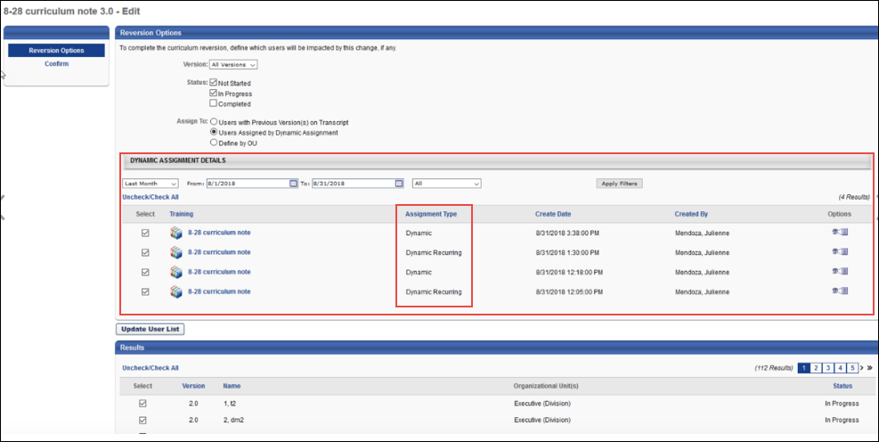
Dynamic Assignment Details
Check the box next to the learning assignment to which the new curriculum version should be applied. The Assignment Type column displays each assignment's type (Dynamic, Dynamic Recurring).
For more information about reversioning curricula: See Curriculum - Reversion - Reversion Options.

Reporting - Progress Maintained
With this enhancement, a Maintain Progress toggle status field is available in Reporting 2.0. Standard and dynamic learning assignments offer administrators the ability to allow users to maintain their training progress when assigned a new instance of a training item, and this new report field allows the value of this setting to be discoverable when using Reporting 2.0.
To create a custom report in Reporting 2.0, go to: Reports > REPORTING 2.0 and click the Create Report button to create a new report.
Permissions
PERMISSION NAME | PERMISSION DESCRIPTION | CATEGORY

Custom Assignment Report - Create | Grants ability to create and edit custom Assignment reports. This permission can be constrained by OU, User's OU, User Self and Subordinates, and Provider. | Reports - Analytics

Custom Assignment Report - View | Grants ability to view custom Assignment reports. This permission can be constrained by OU, User's OU, User Self and Subordinates, and Provider. | Reports - Analytics

Custom Curriculum Transcript Report - Create | Grants ability to view results of custom Curriculum Transcript reports created by self or shared by others. This permission can be constrained by OU, User's OU, User, User Self and Subordinates, User's Direct Reports. | Reports - Analytics

Custom Curriculum Transcript Report - View | Grants ability to create and edit custom Curriculum Transcript reports. This permission can be constrained by OU, User's OU, User, User Self and Subordinates, User's Direct Reports. | Reports - Analytics

Custom Transcript Reports - Create | Grants ability to create and edit Custom Transcript (Training Record) reports. This permission can be constrained by OU, User's OU, User Self and Subordinates, and User's Direct Subordinates. | Reports - Analytics

Custom Transcript Reports - View | Grants ability to view results of Custom Transcript (Training Record) reports created by self or shared by others. This permission can be constrained by OU, User's OU, User Self and Subordinates, and User's Direct Subordinates. | Reports - Analytics
New Assignment Field
The following new field is available in the Transcript report field section for ONLY the Assignment custom report type:
Field Name | Report Section | Field Description | Field Type | affected reports
Progress Maintained? | Assignment | This field displays a yes/no value depending on whether or not the Maintain Progress setting was enabled for the standard or dynamic learning assignment. | Yes/No | Assignment Report, Curriculum Transcript Report, Transcript Report
New Transcript Field
Field Name | Report Section | Field Description | Field Type | affected reports
Progress Maintained | Transcript | This field indicates whether users were assigned the training via a Learning Assignment Tool using the Maintain Progress option. | Yes/No | Curriculum Transcript Report, Transcript Report

Reporting - Last Transcript Status Change Date
Prior to this enhancement, there were instances in which the Last Transcript Status Change Date field failed to populate in custom reporting, which led to missing field values.
With this enhancement, the Last Transcript Status Change Date field has been fixed and generates data reliably.Note: The visibility of this field is controlled by a backend setting.
Note: This field is not automatically available in all portals. You may need to request its enablement.
Recommended Tests
It is recommended that you perform the following tests with this new functionality in your portal:
- Run a report including the Last Transcript Status Change Date field and ensure the output meets expectations. Run the report again 20-60 minutes later and check the output again.

Sync Start of New Version and End Date of Previous Version during Material Versioning (With Append)
With this enhancement, when an administrator creates a new version of a material using Versioning with Append, the Start Date time of the new version matches the End Date time of the previous version, so that both versions cannot coexist at the same time. This helps organizations ensure compliance when reversioning materials.
See Material Reversioning Behaviors (Versioning with Append) for more information about material versioning behavior.

Test Engine Enhancement - Version Equivalency
Prior to this enhancement, creating a new version of any test would require all users who already had the test in a curriculum on their transcript to take the test again to receive a Completed status.
With this enhancement, when creating a new version of a test, the administrator can specify whether the new test version must be completed again by users, or whether the new test version will be considered a Completed Equivalent of the previous version, allowing users to retain their Completed status for the test inside a curriculum without needing to compete it again. These Version Equivalency settings only apply to tests within a curriculum; this behavior does not apply to standalone tests.
Permissions
PERMISSION NAME | PERMISSION DESCRIPTION | CATEGORY

Test Engine - Manage | Grants ability to create and edit/manage tests via the Test Engine. This permission can be constrained by OU, User’s OU, User, User’s Self, and User’s Subordinates. This is an administrator permission. | Learning - Administration
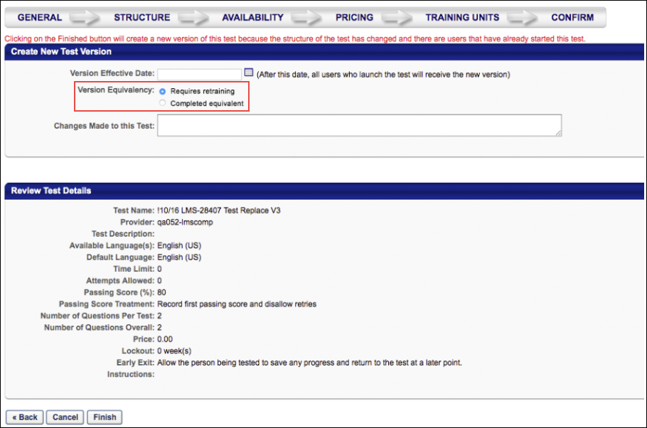
Version Equivalency
When the administrator makes a change to a test which triggers a new version, the Create New Test Version section displays on the Confirm step of the test editing workflow. In this section, the administrator can select from the following version equivalency options:
- Requires Retraining - Select this option to require users with this test on their Completed transcript to retake the test in order to retain their Completed status for the test. This is the existing behavior. This behavior only applies to tests contained within a curriculum.
- Completed Equivalent - Select this option to set the new test version as a Completed Equivalent of the previous version, allowing users to retain their Completed status for the test without needing to complete the new version. This is new behavior. This behavior only applies to tests contained within a curriculum.
After selecting a version equivalency option, click the Finish button to finish creating the new test version.
Use Cases
Use Case #1: Test Version Equivalency
Richard, a learning administrator at ACME Corp, creates version 2.0 of the Company Compliance Test from the previous 1.0 version. This new test version must be reflected on all users' transcripts, but the users who have already completed the previous 1.0 version should not need to retake the test in order to retain their Completed status.
When reversioning the test, Richard selects the Equivalent Version option so that users who have already completed version 1.0 of the test do not need to complete version 2.0 in order to retain their Completed status for the test.
Use Case #2: Test Version Equivalency Removal
Richard, a learning administrator at ACME Corp, creates version 2.0 of the Company Compliance Test from the previous 1.0 version. This new test version must be reflected on all users' transcripts, but the users who have already completed the previous 1.0 version should not need to retake the test in order to retain their Completed status. However, after a few weeks, ACME adopts a new regulation which states this test must be retaken by all employees. Richard removes the new test version's version equivalency using the Course Console so that the users who complete the test in the future will need to retake the training.
To create a new version of a test, go to: Admin > Tools > Learning > Catalog and click the Tests link. On the Test Engine page, click the Edit icon next to the test you want to reversion. For more information about creating a new version of a test: See Test - Edit.

Training Removal Enhancements
With this enhancement, the following enhancements have been made to the Training Removal Tool:
- Completion propagation to removed curricula is fixed.
- Training in a Completed status can now be removed using the Training Removal Tool (a new permission is needed for this ability). The following consideration applies to this enhancement:
  - If the training selected within the Training Removal Tool is a curriculum, any child training items that exist within that curriculum in Completed, Completed Equivalent, or Exempt status is not removed. These child training items continue to persist as standalone trainings on the users’ active transcripts in the Completed tab.
    - This behavior occurs regardless of whether the Remove child items option is selected.
    - Once the child items become standalone, they can also be removed as long as the user has the new Training Removal - Remove Completed permission.
To create a new training removal job, go to Admin > Tools > Learning > Training Tools > Training Removal Tool. Then, click the Create New Training Removal Job link. Advance to the Status step to select the transcript statuses the Training Removal Tool can remove from users' transcripts.
Permissions
PERMISSION NAME | PERMISSION DESCRIPTION | CATEGORY

Bulk Training Removal - Manage | Grants ability to bulk remove training from users’ transcripts. This permission can be constrained by OU and User's OU. Creator constraints also apply. This is an administrator permission. | Learning - Administration

Training Removal - Remove Completed | Grants administrators the ability to bulk remove training in Completed, Completed (Equivalent), and Exempt statuses from users' transcripts. This permission can be constrained by OU and User's OU. This is an administrator permission. | Learning - Administration
Completion Propagation to Removed Curricula
With this fix, completed curricula that are removed from users' Completed transcripts via the Training Removal Tool are fully removed. This will prevent the need for administrators to perform cleanup due to curricula not being removed as expected.
Previous system behavior propagated training completions from the Active tab to the Removed tab in users' transcripts. Even if a curriculum was on the Removed tab, its structure was still impacted by any completion of identical training from the Active tab.
With this fix, completion of training will not be propagated to the Removed tab.
The following considerations apply to this functionality:
- Statuses are still synced on the Removed tab
- Completion propagation from the Active to the Removed tab has been prevented for the following training types:
  - Any training in the curriculum on the Active tab
  - Any training completed as a prerequisite of a training item within a curriculum on the Removed tab
  - Any training completed as pre-work or post-work for a training item within a curriculum in the Removed tab
  - Training completed by equivalent
The following exceptions apply to this functionality:
- When the child training status is Pending Prerequisite and the prerequisite is completed, the child training is not moved to a Registered status even if the auto registered setting is selected for the curriculum structure.
- Statuses are not synced for training in a Pending Post-work status. Child training remains in a Pending Post-work” status under a removed curriculum.
Note: It is NOT possible to remove child training within a curriculum using the Training Removal Tool.
Remove Completed Statuses
The Training Removal Tool can be used to remove training in completed statuses from users' transcripts. Training in the following completed statuses can be removed using the Training Removal Tool:
- Completed
- Completed (Equivalent)
- Exempt
The following consideration applies to this enhancement:
- If the training selected within the Training Removal Tool is a curriculum, any child training items that exist within that curriculum in Completed, Completed Equivalent, or Exempt status is not removed. These child training items continue to persist as standalone trainings on the users’ active transcripts in the Completed tab.
  - This behavior occurs regardless of whether the Remove child items option is selected.
  - Once the child items become standalone, they can also be removed as long as the user has the new Training Removal - Remove Completed permission.
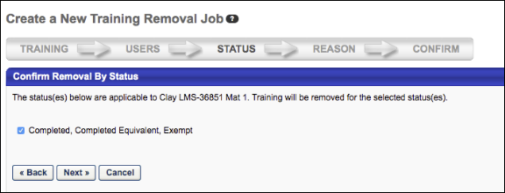
See Training Removal Job - Create - Step 3 - Status for more information about the Status step of creating a training removal job.

Version Numbers Available in Curriculum Administration Structure
Prior to this enhancement, the only way administrators could view the version numbers of materials, online courses, and tests within the structure of a curriculum was by running a report.
With this enhancement, the version numbers of materials, online courses, and tests are visible within the structure of a curriculum, for both existing and new curricula. This allows administrators to quickly and easily ascertain which versions of child training items are contained within a curriculum.
For more information about curriculum structures: See Curriculum - Create - Step 6 - Structure.
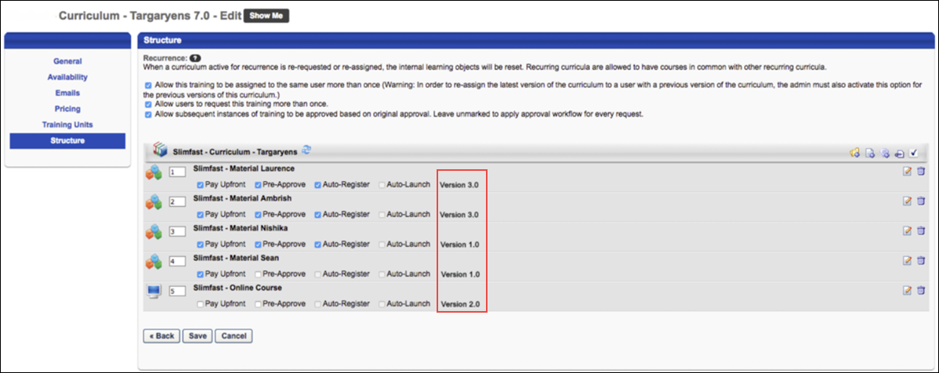
Implementation
This functionality is automatically enabled in all portals using the Learning module.
Permissions
The following existing permission applies to this functionality:
PERMISSION NAME | PERMISSION DESCRIPTION | CATEGORY

Curricula Admin - Manage | Grants ability to create new and edit/update existing curricula. This permission can be constrained by OU, User's OU, Provider, and User's LO Availability. This is an administrator permission.  Adding an OU constraint and a provider constraint to this permission results in an "AND" statement.  Tip: Do not constrain this permission to your entire corporation; it can cause long page load times and timeout errors. Applying this constraint is functionally the same as leaving the permission unconstrained, but omitting this constraint does not cause the system to do the unnecessary constraint checks as in the former scenario. | Learning - Administration

Learning Preferences Overview

Administrative Action Justifications Overview
Activate Session Cancellation Reasons Preferences
The Activate Session Cancellation Reasons Preferences page allows administrators to determine which session cancellation reasons are active. When activated, these reasons are available to administrators when canceling a session.
To access the Activate Session Cancellation Reasons Preferences page, go to Admin > Configuration Tools > Preferences. Click the Activate Session Cancellation Reasons Preferences (by Division) link in the Learning Preferences section.
Permissions
PERMISSION NAME | PERMISSION DESCRIPTION | CATEGORY

Activate Session Cancellation Reasons Preferences | Grants ability to activate Session Cancellation Reasons by organizational unit. When activated, these reasons are available to administrators when canceling a session. This permission can be constrained by OU and User's OU. This is an administrator permission. | Learning - Administration
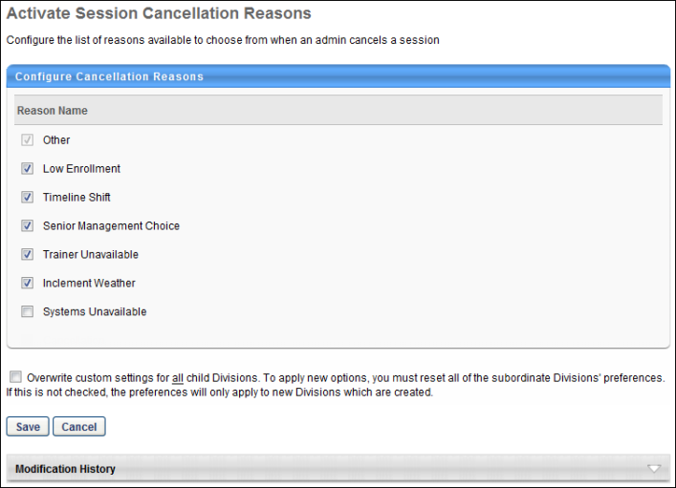
Activate a Reason
By default, the Other option is a required reason. This reason cannot be deactivated and is always available for users to select as a reason.
To activate a reason, check the box in the Active column for the corresponding reason. Deactivate a reason by unchecking the box. Active reasons appear in the Select Reason drop-down on the Cancel Session page.
Overwrite Settings
Select this option to overwrite custom settings for child division OUs. If you overwrite custom settings for child division OUs, the selected settings are applied to both new and existing child OUs. Any previously customized child OUs are updated with the selected settings.
- If there are no customizations to the child OU, then the parent OU customizations are applied to all child OUs.
- Overwrite custom settings checkbox setting
  - If this option is selected, all child OU customizations are deleted from the database, which means the parent OU customizations will be applied to new and existing child OUs.
  - If this option is unselected, all existing child OU customizations will remain unchanged, and any new child OUs will inherit the parent OU customizations by default.
- If a child OU has been customized to display any widgets, then regardless of the parent OU customizations, the child OU customizations are applied.
- If a child OU has been customized to hide all widgets, then parent OU customizations will take precedence and will be applied.
Save or Cancel
Clicking Save commits the changes. Clicking Cancel returns the user to the Preferences page and does not save changes made to the page.
Modification History
The Modification History section displays a record of each time a reason is activated or deactivated. This includes the reason name, reason ID, language, administrator username, and date stamp.

Activate Exempt Training Reason Preferences (by Division)
Activate Exempt Training Reason Preferences (by Division) allow administrators to activate the exempt training reasons configured in Exempt Training Reason Preferences. "Other" is active by default and cannot be inactivated. All other reasons are inactive by default and must be checked to activate.
If localized, the reason appears in the administrator's display language. If the administrator's display language is not available, it displays in the language of the administrator who created it. If the creator's language is not available, then the reason displays in the portal's default language.
Clicking Save adds each activated reason to the Mark Exempt, Exemption Request, and Exempt Response pop-ups.
To access Activate Exempt Training Reason Preferences, go to Admin > Configuration Tools > Preferences, and then click Activate Exempt Training Reason Preferences (by Division) in the Learning Preferences section.
Permissions
PERMISSION NAME | PERMISSION DESCRIPTION | CATEGORY

Activate Exempt Reason Preferences | Grants ability to choose which exempt training reasons will be available to choose when requesting exemption from training or when administrator marks a user exempt from completing a learning object. This is an administrator permission. | Learning - Administration
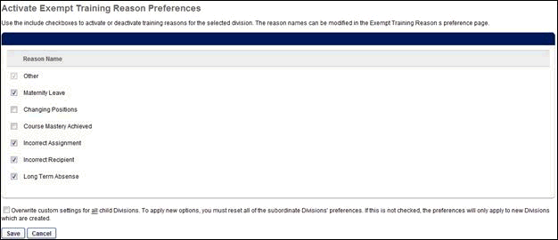
Activate Reasons for Training Removal Preferences
On the Activate Reasons for Training Removal Preferences page, administrators manage the active status of the training removal reasons that are created in Training Reason Preferences. See Training Reasons Preferences - Removals on page 110 for additional information.
To access Activate Reasons for Training Removal Preferences, go to Admin > Configuration Tools > Preferences. Then, click the Activate Reasons for Training Removal Preferences (by Division) link in the Learning Preferences column.
Permissions
PERMISSION NAME | PERMISSION DESCRIPTION | CATEGORY

Activate Training Removal Reasons Preferences | Grants ability to activate Training Removal Reasons by organizational unit. When activated, these reasons are available to administrators when removing training from a transcript. | Learning - Administration
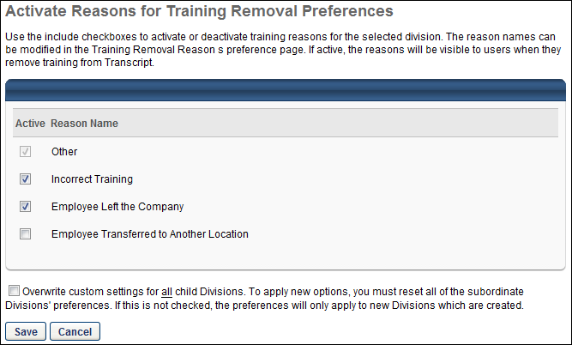
Activate a Reason
By default, the Other option is configured as active. This reason cannot be inactivated and is always available for users to select as a reason.
To activate or inactivate a reason, check the box in the Active column for the corresponding reason. Deactivate a reason by unchecking the box. Active reasons appear in the Select Reason drop-down on the Remove Training page. Note: Inactivating a reason only affects future training removal actions. If a reason that is currently in use is inactivated, the reason still appears in the Approval History section of the user's Training Details page and is available in reporting.
Overwrite Settings
Select this option to overwrite custom settings for child division OUs. If you overwrite custom settings for child division OUs, the selected settings are applied to both new and existing child OUs. Any previously customized child OUs are updated with the selected settings.
- If there are no customizations to the child OU, then the parent OU customizations are applied to all child OUs.
- Overwrite custom settings checkbox setting
  - If this option is selected, all child OU customizations are deleted from the database, which means the parent OU customizations will be applied to new and existing child OUs.
  - If this option is unselected, all existing child OU customizations will remain unchanged, and any new child OUs will inherit the parent OU customizations by default.
- If a child OU has been customized to display any widgets, then regardless of the parent OU customizations, the child OU customizations are applied.
- If a child OU has been customized to hide all widgets, then parent OU customizations will take precedence and will be applied.
Save or Cancel
Clicking Save commits the changes. Clicking Cancel returns the user to the Preferences page and does not save changes made to the page.
Activate Session Withdrawal Reasons Preferences
The Activate Session Withdrawal Reasons Preferences page allows administrators to determine which session withdrawal reasons are active. When activated, these reasons are available to users when withdrawing from a session and to administrators when withdrawing a user from a session. Note: When an administrator withdraws a user from a session, the available session withdrawal reasons are based on the Activate Session Withdrawal Reasons Preferences for the administrator's organizational unit (OU).
To access the Activate Session Withdrawal Reasons Preferences page, go to Admin > Configuration Tools > Preferences. Click the Activate Session Withdrawal Reasons Preferences (by Division) link in the Learning Preferences section.
Permissions
PERMISSION NAME | PERMISSION DESCRIPTION | CATEGORY

Activate Session Withdrawal Reasons Preferences | Grants ability to activate Session Withdrawal Reasons by organizational unit. When activated, these reasons are available to users when withdrawing from a session and to administrators when withdrawing a user from a session. This permission can be constrained by OU and User's OU. This is an administrator permission. | Learning - Administration
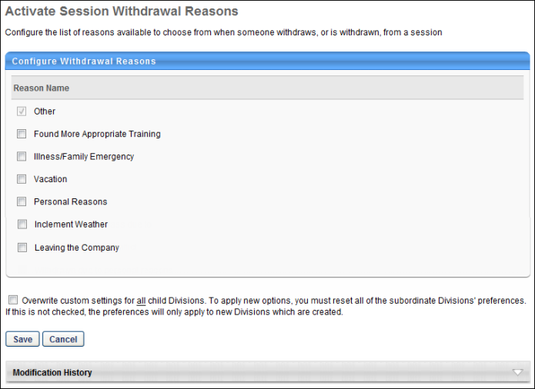
Activate a Reason
By default, the Other option is a required reason. This reason cannot be deactivated and is always available for users to select as a reason.
To activate a reason, check the box in the Active column for the corresponding reason. Deactivate a reason by unchecking the box. Active reasons appear in the Select Reason drop-down on the Withdraw Registration page. Note: Inactivating a reason only affects future session cancel actions. If a reason that is currently in use is inactivated, the reason still appears in the Approval History section of the user's Training Details page and is available in reporting.
Overwrite Settings
Select this option to overwrite custom settings for child division OUs. If you overwrite custom settings for child division OUs, the selected settings are applied to both new and existing child OUs. Any previously customized child OUs are updated with the selected settings.
- If there are no customizations to the child OU, then the parent OU customizations are applied to all child OUs.
- Overwrite custom settings checkbox setting
  - If this option is selected, all child OU customizations are deleted from the database, which means the parent OU customizations will be applied to new and existing child OUs.
  - If this option is unselected, all existing child OU customizations will remain unchanged, and any new child OUs will inherit the parent OU customizations by default.
- If a child OU has been customized to display any widgets, then regardless of the parent OU customizations, the child OU customizations are applied.
- If a child OU has been customized to hide all widgets, then parent OU customizations will take precedence and will be applied.
Save or Cancel
Clicking Save commits the changes. Clicking Cancel returns the user to the Preferences page and does not save changes made to the page.
Modification History
The Modification History section displays a record of each time a reason is activated or deactivated. This includes the reason name, reason ID, language, administrator username, and date stamp.
Training Reasons Preferences
The Training Reasons Preferences page enables administrators to configure the reasons that are available when performing any of the following training actions:
- Training Exemption
- Training Removal
- Session Withdrawal
- Session Cancellation
To access the Training Reasons Preferences page, go to Admin > Configuration Tools > Preferences. Then click the Training Reasons Preferences link in the Learning Preferences section.
Permissions
PERMISSION NAME | PERMISSION DESCRIPTION | CATEGORY

Exempt Reason Preferences | Grants ability to create and edit/update bank of Training Exempt Reasons that can be used across the portal. This permission can be constrained by OU and User's OU. This is an administrator permission. | Learning - Administration

Training Reasons Preferences - Cancellations Tab - Manage | Grants access to the Cancellations tab on the Training Reason Preferences page. This permission can be constrained by OU and User's OU. This is an administrator permission. | Learning - Administration

Training Reasons Preferences - Withdrawals Tab - Manage | Grants access to the Withdrawals tab on the Training Reason Preferences page. This permission can be constrained by OU and User's OU. This is an administrator permission. | Learning - Administration

Training Removal Reasons - Manage | Grants ability to add and edit/update Training Removal Reasons, which can then be made to appear or not appear at the organizational unit level to administrators when removing Training from user transcripts. This permission can be constrained by OU and User's OU. This is an administrator permission. | Learning - Administration
An administrator must have at least one of the above permissions to access the Training Reasons Preferences page.
Training Reasons Preferences Configuration
The Training Reasons Preferences page is comprised of four tabs:
- Exemptions - See Training Reasons Preferences - Exemptions on page 108 for additional information.
- Removals - See Training Reasons Preferences - Removals on page 110 for additional information.
- Withdrawals - See Training Reasons Preferences - Withdrawals on page 112 for additional information.
- Cancellations - See Training Reasons Preferences - Cancellations on page 114 for additional information.
Training Reasons Preferences - Exemptions
The Exempt Training Reasons Preferences page enables administrators to configure a list of common reasons for a user to be exempt from training. When activated, these reasons display in the Indicate Reason field on the Mark Exempt, Exemption Request, and Exempt Response pop-ups. "Other" is available as an exemption reason by default and cannot be edited or deleted.
To access the Exemptions Training Reasons Preferences page, go to Admin > Configuration Tools > Preferences. Click the Training Reasons Preferences link in the Learning Preferences section. Then, click the Exemptions tab.
Permissions
PERMISSION NAME | PERMISSION DESCRIPTION | CATEGORY

Exempt Reason Preferences | Grants ability to create and edit/update bank of Training Exempt Reasons that can be used across the portal. This permission can be constrained by OU and User's OU. This is an administrator permission. | Learning - Administration
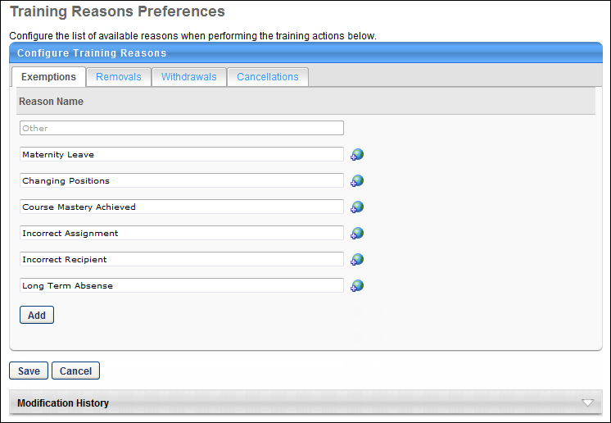
Note: "Other" is a required reason and cannot be made inactive. The active status of a reason is configured within Activate Exempt Training Reason Preferences.
Add a Reason
The maximum number of reasons that can be added per Training Reasons is 20. To add a reason, click the Add button. A blank text field displays at the bottom of the list (character limit of 100). The new field can be cancelled by clicking the trash can icon. If multiple languages are enabled for your portal, the field can be localized by clicking the translate icon.
Delete a Reason
A reason can be deleted if it has not yet been used in the system for a training action. However, text for existing reasons can always be edited. To delete a reason, click the trash can icon next to the reason.
Save or Cancel
Clicking Save commits the changes. Clicking Cancel returns the user to the Preferences page and does not save changes made to the page.
Modification History
The Modification History section displays a record of each time a reason is added, deleted, or modified. This includes the reason name, reason ID, language, administrator username, and date stamp.
Training Reasons Preferences - Removals
The Removals Training Reasons Preferences page enables administrators to configure a list of common reasons for removing training. When activated, these reasons appear in the Select Reason drop-down on the Remove Training page. Administrators can also configure removal reasons to require comments. "Other" is available as a removal reason by default and cannot be edited or deleted.
To access the Removals Training Reasons Preferences page, go to Admin > Configuration Tools > Preferences. Click the Training Reasons Preferences link in the Learning Preferences section. Then, click the Removals tab.
Permissions
PERMISSION NAME | PERMISSION DESCRIPTION | CATEGORY

Training Removal Reasons - Manage | Grants ability to add and edit/update Training Removal Reasons, which can then be made to appear or not appear at the organizational unit level to administrators when removing Training from user transcripts. This permission can be constrained by OU and User's OU. This is an administrator permission. | Learning - Administration
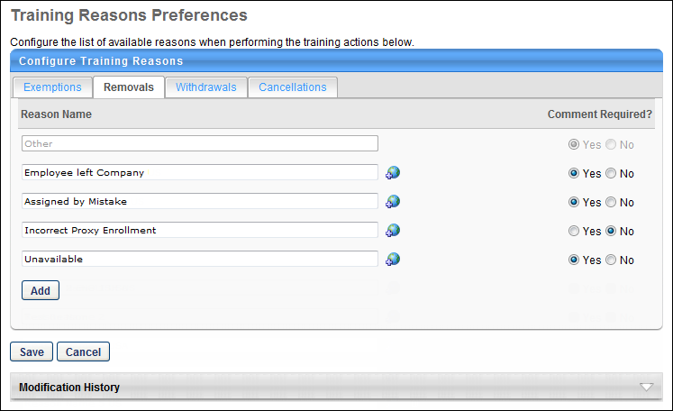
Note: "Other" is a required reason and cannot be made inactive. The active status of a reason is configured within Activate Reasons for Training Removal Preferences.
Add a Reason
The maximum number of reasons that can be added per Training Reasons is 20. To add a reason, click the Add button. A blank text field displays at the bottom of the list (character limit of 100). The new field can be cancelled by clicking the trash can icon. If multiple languages are enabled for your portal, the field can be localized by clicking the translate icon.
Comment Required?
In the Comment Required? column, select whether or not a user is required to enter a comment when removing training. "Yes" is selected by default.
Delete a Reason
A reason can be deleted if it has not yet been used in the system for a training action. However, text for existing reasons can always be edited. To delete a reason, click the trash can icon next to the reason.
Save or Cancel
Clicking Save commits the changes. Clicking Cancel returns the user to the Preferences page and does not save changes made to the page.
Modification History
The Modification History section displays a record of each time a reason is added, deleted, or modified. This includes the reason name, reason ID, language, administrator username, and date stamp.
Training Reasons Preferences - Withdrawals
The Withdrawals Training Reasons Preferences page enables administrators to configure a list of common reasons for withdrawing from a training session. When activated, these reasons are available to users when withdrawing from a session and to administrators when withdrawing a user from a session. "Other" is available as a withdrawal reason by default and cannot be edited or deleted.
To access the Withdrawals Training Reasons Preferences page, go to Admin > Configuration Tools > Preferences. Click the Training Reasons Preferences link in the Learning Preferences section. Then, click the Withdrawals tab.
Permissions
PERMISSION NAME | PERMISSION DESCRIPTION | CATEGORY

Training Reasons Preferences - Withdrawals Tab - Manage | Grants access to the Withdrawals tab on the Training Reason Preferences page. This permission can be constrained by OU and User's OU. This is an administrator permission. | Learning - Administration
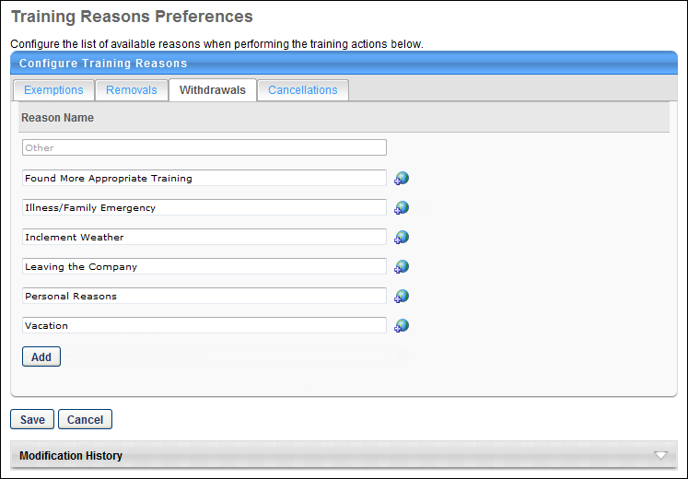
Note: "Other" is a required reason and cannot be made inactive. The active status of a reason is configured within Activate Session Withdrawal Reasons Preferences.
Add a Reason
The maximum number of reasons that can be added per Training Reasons is 20. To add a reason, click the Add button. A blank text field displays at the bottom of the list (character limit of 100). The new field can be cancelled by clicking the trash can icon. If multiple languages are enabled for your portal, the field can be localized by clicking the translate icon.
Delete a Reason
A reason can be deleted if it has not yet been used in the system for a training action. However, text for existing reasons can always be edited. To delete a reason, click the trash can icon next to the reason.
Save or Cancel
Clicking Save commits the changes. Clicking Cancel returns the user to the Preferences page and does not save changes made to the page.
Modification History
The Modification History section displays a record of each time a reason is added, deleted, or modified. This includes the reason name, reason ID, language, administrator username, and date stamp.
Training Reasons Preferences - Cancellations
The Cancellations Training Reasons Preferences page enables administrators to configure a list of common reasons for canceling a training session. When activated, these reasons are available to administrators when canceling a session. "Other" is available as a cancellation reason by default and cannot be edited or deleted.
To access the Cancellations Training Reasons Preferences page, go to Admin > Configuration Tools > Preferences. Click the Training Reasons Preferences link in the Learning Preferences section. Then, click the Cancellations tab.
Permissions
PERMISSION NAME | PERMISSION DESCRIPTION | CATEGORY

Training Reasons Preferences - Cancellations Tab - Manage | Grants access to the Cancellations tab on the Training Reason Preferences page. This permission can be constrained by OU and User's OU. This is an administrator permission. | Learning - Administration
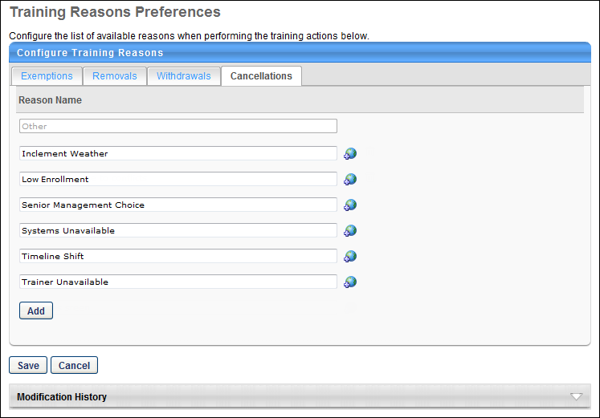
Note: "Other" is a required reason and cannot be made inactive. The active status of a reason is configured within Activate Session Cancellation Reasons Preferences.
Add a Reason
The maximum number of reasons that can be added per Training Reasons is 20. To add a reason, click the Add button. A blank text field displays at the bottom of the list (character limit of 100). The new field can be cancelled by clicking the trash can icon. If multiple languages are enabled for your portal, the field can be localized by clicking the translate icon.
Delete a Reason
A reason can be deleted if it has not yet been used in the system for a training action. However, text for existing reasons can always be edited. To delete a reason, click the trash can icon next to the reason.
Save or Cancel
Clicking Save commits the changes. Clicking Cancel returns the user to the Preferences page and does not save changes made to the page.
Modification History
The Modification History section displays a record of each time a reason is added, deleted, or modified. This includes the reason name, reason ID, language, administrator username, and date stamp.
Required Training Tagging
The Required Training Tagging allows organizations to create and monitor required training assignments better.
See below for links to related Required Training Tagging documentation:
- Required Training Tagging Overview - See Required Training Tagging Overview on page 117 for additional information.
- Manage Training Requirements - See Manage Training Requirements on page 120 for additional information.
- Activate Requirements for Required Training Assignments - See Activate Requirements for Required Training Assignments on page 125 for additional information.
- Requirements on Learner's Transcript - See Requirements on Learner's Transcript on page 127 for additional information.
- Transcript Behavior with Required Training Tagging Active - See Transcript Behavior with Required Training Tagging Active on page 130 for additional information.
Required Training Tagging Overview
Required Training Tagging allows organizations to monitor required training assignments better. Administrators can tag training as needed while assigning it to learners and tie it to a requirement to ensure better visibility and tracking. The purpose is to recommend a learner to take a training deemed "required." The requirements descriptions are client-specific and give learners and managers a better understanding of why the training is assigned.
The Required Training Tagging feature offers the following functionalities:
- Ability to create and manage a client-specific “requirements” catalog.
- Ability to create learning assignments and tie them to the new requirements.
- Ability to edit existing learning assignments and tie requirements to them.
- Enhanced visibility of required training on the Learner Home and Transcript.
- Ability to integrate a dedicated widget on the welcome page.
- Fields in reporting and reporting logic for required training.
Permissions
PERMISSION NAME | PERMISSION DESCRIPTION | CATEGORY

Activate Required Training Requirements Preferences | Grants ability to activate Required Training Requirements by organizational unit. This permission can be constrained by OU and User. When activated, these reasons are available to administrators when assigning training from Learning Assignment Tool (LAT). | Learning - Administration

Assignment Tool - Edit Required Training TAG and reason | Grants the administrator the ability to edit the Required Training reason and TAG of dynamic learning assignments via the Assignment Summary page for the assignment. This permission can be constrained by OU and User's OU. | Learning - Administration

Required Training Requirements Manage | Grants ability to add and edit/update Requirements, which can then be made to appear or not appear at the organizational unit level to administrators when setting up Required Training Learning Assignments. This is an administrator permission. | Learning - Administration

Remove Required Training | Grants ability to remove required trainings if user has another training removal permission. This permission can be constrained by OU, User's OU, User's Corporation, User Self and Subordinates, User's Self, User's Direct Subordinates, and User. This is an administrator permission. | Learning

Learning Features Self Activation | Grants access to the Feature Activation Preferences page, where an administrator can activate new features associated with Learning, Connect and Extended Enterprise. | Learning - Administration
Important: Versioning scenarios are not fully supported at the start of user acceptance testing (UAT). Customers who use versioning should not self-activate Required Training Tagging until versioning scenarios are fully supported. This is targeted, but not confirmed, for UAT 3. Please watch for further updates regarding support for versioning scenarios.
Getting Started with Required Training Tagging
The Required Training Tagging requires activation via Feature Activation Preferences. To do this, go to ADMIN > TOOLS > LEARNING > LEARNING PREFERENCES > FEATURE ACTIVATION PREFERENCES. In the Activate Required Training Tagging section, click ACTIVATE.
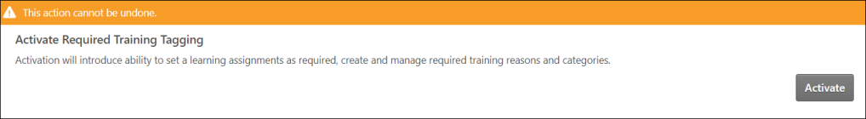
Note: It is advised to test this first in stage or pilot before activating this in the production environment, as this action cannot be undone. If you have custom inbound data feeds bringing in transcript registration and completions, please connect with your account team, as these feeds need to be updated on the Cornerstone side.
What are Requirements and what do they represent
- A requirement is typically something that is used to track to understand if the learner has fulfilled the requirement. The requirement identifies training assigned for a particular purpose, job, or activity. For example, being qualified to sell insurance, perform first aid, or work on a specific manufacturing line.
- The requirement is visible on the learner’s transcript. The Learner has direct links to a filtered view of the transcript from Learner Home, and a widget is available for the welcome page. The learner can filter on required training in general and one or more requirements via additional filter options on the transcript.
- These same filters are available to anyone looking at the learner's transcript. All of this is also available in Reporting 2.0, allowing administrators to easily track assigned training by requirement easily and to see which assignments cover which requirement.
The Required Training Tagging provides additional features as part of the Learning product suite. Activating the Required Training Tagging brings in a new type of administrative justification called “Requirement.” The requirements are used in the Learning Assignment System (LAT) and visible on the user's transcript and reporting.
Activating the Required Training Tagging introduces the following features under the Learning Preferences page:
- Activate Requirements for Required Training Assignments
- Manage Training Requirements
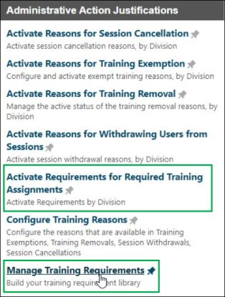
The starting point is to build your “Requirements” catalog. Your business case will dictate requirements. Create categories that makes it easier to organize, manage, and report on requirements. A category could represent a location or a business area; it is up to you to determine their best use. The objective is constantly identifying and monitoring.
It is recommended to have the categories in place before creating large numbers of requirements. An admin can always move a requirement from one category to another if needed. There is only 1 level of categories; sub-categories are not supported.
Considerations
- More information on this Required Training Tagging can be found in the Client Success Center, Cornerstone Beta Community, Learning.
- Required Training Tagging does not replace the availability type “Required,” which is not used for assignments.
- Required Training Tagging only impacts the learner’s transcript via the Learning Assignment Tool; it means the training is assigned as needed.
Manage Training Requirements
Manage Training Requirements allows administrators to create new requirements and categories. After making a requirement, tie it to an existing category or create a new category via the Manage Categories page. Update existing requirements and categories or edit requirements and categories and provide localization. You can deactivate or reactivate requirements and categories and delete the ones that are not in use.
Permissions
PERMISSION NAME | PERMISSION DESCRIPTION | CATEGORY

Activate Required Training Requirements Preferences | Grants ability to activate Required Training Requirements by organizational unit. This permission can be constrained by OU and User. When activated, these reasons are available to administrators when assigning training from Learning Assignment Tool (LAT). | Learning - Administration

Assignment Tool - Edit Required Training TAG and reason | Grants the administrator the ability to edit the Required Training reason and TAG of dynamic learning assignments via the Assignment Summary page for the assignment. This permission can be constrained by OU and User's OU. | Learning - Administration

Required Training Requirements Manage | Grants ability to add and edit/update Requirements, which can then be made to appear or not appear at the organizational unit level to administrators when setting up Required Training Learning Assignments. This is an administrator permission. | Learning - Administration

Remove Required Training | Grants ability to remove required trainings if user has another training removal permission. This permission can be constrained by OU, User's OU, User's Corporation, User Self and Subordinates, User's Self, User's Direct Subordinates, and User. This is an administrator permission. | Learning

Learning Features Self Activation | Grants access to the Feature Activation Preferences page, where an administrator can activate new features associated with Learning, Connect and Extended Enterprise. | Learning - Administration
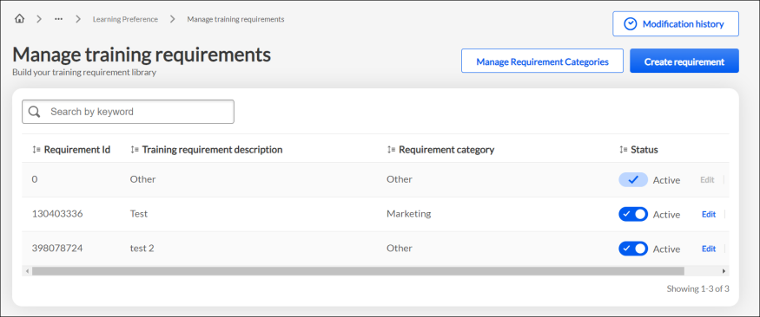
Create and Manage Requirements
Create Requirement in the Manage training requirements page allows you to create a requirement, assign an existing category or create a new category on the flow, and specify requirement description.
Creating a requirement
- To create a requirement, go to Admin > Tools > Learning > Learning Preferences > Manage Training Requirements > Create requirement.
- In the Create requirement dialog box, enter a category name in the Requirement category field. While entering a category name, the Requirement category field identifies whether the category already exists or is a new one. If the category name is a new one, it provides an option to create a new category. Click on the new category name to create a new category instantly. Alternately, you can create a category via Manage requirement categories page. See Create and Manage Categories on page 122 for additional information.
- Enter requirement description in the Training requirement description field.
- Turn on the Add Translation toggle to translate the Training requirement description texts with available translations in the portal. Turning the toggle off results in your translations getting lost.
- Click Save.
- Search for the newly created or existing requirements via the Search option in the Manage training requirements page.
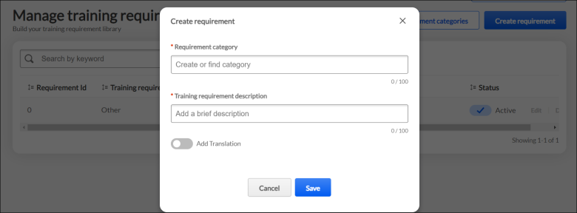
Managing a requirement
In the Manage training requirements page, you can search for a requirement, edit, activate, or deactivate a requirement by using the following features:
- Search by keyword - Search for a newly created or an existing requirement or category by entering the name in the search field and click Enter to perform a search.
- Requirement Id - This field displays the requirement Id which is assigned to a new requirement after its creation. Click on the sort icon beside Requirement Id to sort by numerically ascending order or recently added requirement.
- Training requirement description - This field displays the training requirement description. Click on the sort icon beside Training requirement description to sort by alphabetically ascending order or recently added requirement.
- Requirement category - This field displays a list of categories assigned to the requirements. Click on the sort icon beside Requirement category to sort by alphabetically ascending or descending order.
- Status - This field displays the status of requirements. The following options are available in the Status column:
  - Active - The Active toggle can be turned off and on to deactivate or reactivate a requirement. When the toggle is turned off, it returns a message, "By making this requirement inactive, it cannot be used for future training assignments. Assigned trainings already using this reason will stay the same until changes are made." Click Update to continue. When a toggle is turned on, it returns a message, "By making this requirement active, it will be an available option to use for training assignments." Click Update to continue.
  - Edit - Click Edit to open the Edit requirement dialog box where you can edit the Requirement category, Training requirement description, and change Add Translation setting.
  - Delete - Click Delete to delete a requirement. A requirement once deleted, cannot be recovered. Click Yes, Delete to continue.
Create and Manage Categories
Create Category in the Manage requirement categories page allows you to create a category.
Creating a category
Click Create Category to open Create Category dialog box. In the Requirement category field, add a brief description. Turn on the Add Translation toggle to translate the Requirement category texts with available translations in the portal. Turning the toggle off results in your translations getting lost. Click Add.
In the Manage requirement categories page, you can search, edit, activate, or deactivate a category by using the following features:
- Search by keyword - Search for a newly created or an existing category by entering the name in the search field and click Enter to perform a search.
- Category Id - This field displays the category Id which is assigned to a new category after its creation. Click on the sort icon beside Category Id to sort by numerically ascending order or recently added category.
- Requirement category - This field displays the list of categories assigned to the requirements. Click on the sort icon beside Requirement category to sort by alphabetically ascending or descending order.
- Status - This field displays the status of categories. The following options are available in the Status column:
  - Active - The Active toggle can be turned off and on to deactivate or reactivate a category. When the toggle is turned off, it returns a message, "By making this category inactive, it cannot be used for future training assignments. Assigned trainings already using this category will stay the same until changes are made." Click Update to continue. When a toggle is turned on, it returns a message, "By making this category active, it will be an available option to use for training assignments." Click Update to continue.
  - Edit - Click Edit to open the Edit category dialog box where you can edit the Requirement category and change Add Translation setting.
  - Delete - Click Delete to delete a category. A category once deleted, cannot be recovered. Click Yes, Delete to continue. Note: Once a category is assigned to a requirement, it cannot be deleted. It can only be deleted if the associated requirement is deleted before it.
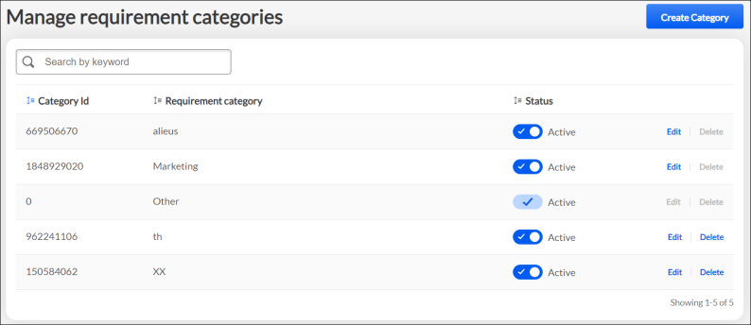
Modification history
For portals with multiple languages enabled, if the translation of the description is modified, the Modification History panel displays the change.
The Modification history shows the following changes:
- History Id
- Effective Date
- Change Type
- Description
- User
Activate Requirements for Required Training Assignments
The Activate Requirements for Required Training Assignments allows administrators to activate training requirements by Organizational Units.
Permissions
PERMISSION NAME | PERMISSION DESCRIPTION | CATEGORY

Activate Required Training Requirements Preferences | Grants ability to activate Required Training Requirements by organizational unit. This permission can be constrained by OU and User. When activated, these reasons are available to administrators when assigning training from Learning Assignment Tool (LAT). | Learning - Administration

Assignment Tool - Edit Required Training TAG and reason | Grants the administrator the ability to edit the Required Training reason and TAG of dynamic learning assignments via the Assignment Summary page for the assignment. This permission can be constrained by OU and User's OU. | Learning - Administration

Required Training Requirements Manage | Grants ability to add and edit/update Requirements, which can then be made to appear or not appear at the organizational unit level to administrators when setting up Required Training Learning Assignments. This is an administrator permission. | Learning - Administration

Remove Required Training | Grants ability to remove required trainings if user has another training removal permission. This permission can be constrained by OU, User's OU, User's Corporation, User Self and Subordinates, User's Self, User's Direct Subordinates, and User. This is an administrator permission. | Learning

Learning Features Self Activation | Grants access to the Feature Activation Preferences page, where an administrator can activate new features associated with Learning, Connect and Extended Enterprise. | Learning - Administration
Activating Requirements for Required Training Assignments
Activate or deactivate the requirements you want to add or remove from the availability. To activate a requirement, select the checkbox under the Active column for the corresponding requirement. Deactivate a requirement by clearing the box. Active requirements appear in the select requirement flyout when creating or editing a learning assignment in the Learning Assignment Tool.
When using the search, enter the keyword you are looking for. Click Show All to see all the active and inactive requirements. Click Check/Uncheck all to select or clear all the requirements.
Select Overwrite custom settings previously saved for child Divisions. If unchecked, the preferences are still applied to any child Divisions that are either new or currently inherit the parent settings.
Click Save to save the configuration.
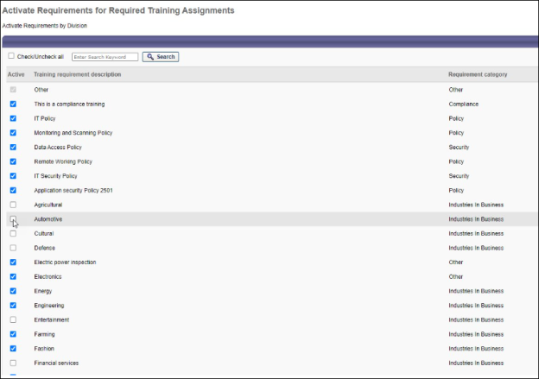
Requirements on Learner's Transcript
On the learner's Transcript, sort the training status by using the following filters:
- Active
- Required
- Past due
- Due soon
- Assigned/No Due Date
The Filter by Training Requirement lets you filter one or more requirements using categories.
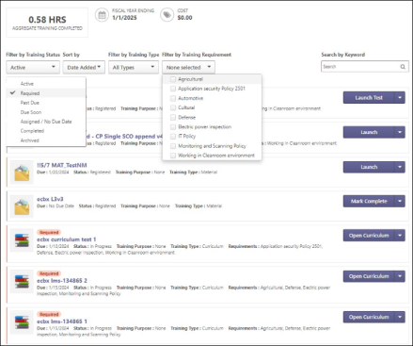
The Training assigned as required is tagged as “Required” on the learner’s transcript. The color of the tag is dependent on the due date status which are:
- Red - Past due
- Orange - Due Soon
- Grey - Assigned/No Due Date
The requirements associated with trainings (overlapping assignments) are all shown.
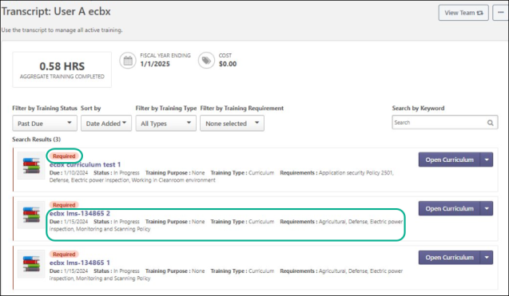
The requirements on the learner’s transcript are also visible on the Learning details page for the learner.
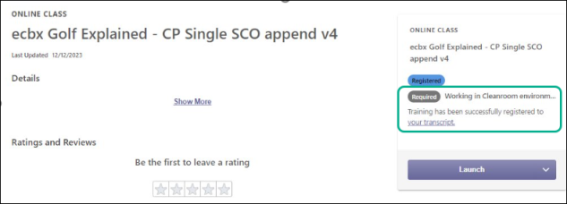
Requirements are displayed on the following transcript details:​
- Current registration​
- Past registrations​
- Transcript modification history
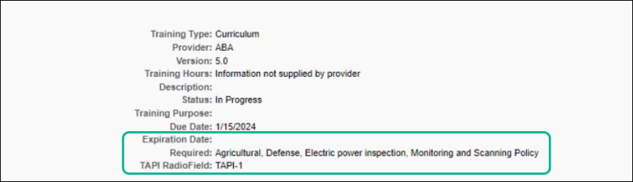
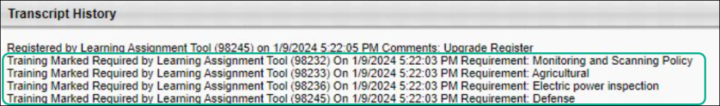
Transcript Behavior with Required Training Tagging Active
To activate Required Training Tagging, See Required Training Tagging Overview on page 117 for additional information.
Express Class
When an Express Class is used, the Requirements sitting on the previous registration number are carried over to the new Express Class registration number, independent of the status of the previous registration number.
Request Training
When training is self-requested, it does not influence the completion of the requirements sitting on the previous completed registration number of the training.
Direct Assign
When the manager assigns training, it does not influence the completion of the requirements sitting on the previous completed registration number of the training.
Assign Session with Requirement
If a Session is assigned via LAT with a requirement, this requirement is shown. If an Event is assigned with a requirement and a session is selected by the learner, or the learner is booked on a Session via any other means, the requirement of the Event is shown. Completing a Session completes the corresponding registration number of the Event and sets the Requirement on the Event as completed.
Training Equivalence
- If completion by training equivalence is applied, the requirement of the originally assigned LO is set to completed.
- If completion by language equivalence is applied, the requirement of the originally assigned LO is set to completed.
- If version equivalence is applied, the requirement on the new version is set to completed.
Remove Training from Transcript
An administrator cannot remove assigned required training without specific permission to remove “Required assigned” training from the transcript. Removal via transcript or removal tool of assigned required training is not recommended; the removal is performed via the LAT.
Unremoved Training
Un-removing the training ties the registration number to the requirements of the set as “Required” Dynamic assignments for which:
- The learner receives the training by a new assignment
- The learner again becomes a member (re-entering)
- The learner has received the training and is still a member of
Versioning​
When versioning training, the following rules apply:
- All users with the previous version on their transcript or users by OU:
  - Requirements of previous registration number and dynamic assignments the user is part of are carried forward.
- Dynamically assigned:
  - Requirements of all selected dynamic assignments are carried forward.
    - In some cases, you can select some and not all dynamic assignments, and then only the requirements of the selected dynamic assignments are carried forward.​

Approval Workflow Preferences Overview

Default Approval Requirements by Division
The Default Approval Preferences by Division page allows administrators to set the default learning object approval preferences by division. The preferences set here apply to the Division of the user who is assigned the training. These preferences allow you to determine by learning object if the training is pre-approved and/or if the training is registered upon approval by default. For external training and Connect postings, you can set the default number of approvals required for each. These settings can be changed at the Learning Object level.
When determining the approval requirements for a learning object, the system first checks the User Record - Required Training Approvals field, then the Learning Object setting, and finally the Approval Requirement for the Training Type.
To manage default approval requirements, go to Admin > Tools > Learning > Learning Preferences > Preferences > Default Approval Requirements.
Permissions
PERMISSION NAME | PERMISSION DESCRIPTION | CATEGORY

Default Approval Requirements by Training Type | Grants ability to set Default Approval Requirements by Training Type that apply when users request training. Defaults may be overridden at learning object level by those who create and manage the learning objects. This is an administrator permission. | Learning - Administration
The preferences are divided into the following sections. Select the appropriate settings in each section:
- Standard Training Types
- External Training
- Connect Posting
Custom Relationships as Approvers
If custom relationships or miscellaneous users or groups are added as approvers in a custom approval workflow template, those users must have the Approve Training by Manager permission in order to access those pending approvals. This permission should be added to the corresponding custom relationship role, and approvers outside of a standard or custom relationship also need the permission via one of their security roles. The easiest overall solution to this is to add the Approve Training by Manager permission in the default user role. This has no impact if a user is not a designated approver or manager. Having this permission is necessary, however, if the user becomes part of a population of training approvers via a custom training approval workflow template.
Overwrite Settings
Select this option to overwrite custom settings for child division OUs. If you overwrite custom settings for child division OUs, the selected settings are applied to both new and existing child OUs. Any previously customized child OUs are updated with the selected settings.
- If there are no customizations to the child OU, then the parent OU customizations are applied to all child OUs.
- Overwrite custom settings checkbox setting
  - If this option is selected, all child OU customizations are deleted from the database, which means the parent OU customizations will be applied to new and existing child OUs.
  - If this option is unselected, all existing child OU customizations will remain unchanged, and any new child OUs will inherit the parent OU customizations by default.
- If a child OU has been customized to display any widgets, then regardless of the parent OU customizations, the child OU customizations are applied.
- If a child OU has been customized to hide all widgets, then parent OU customizations will take precedence and will be applied.
Save
Click Save to save the selected preferences.
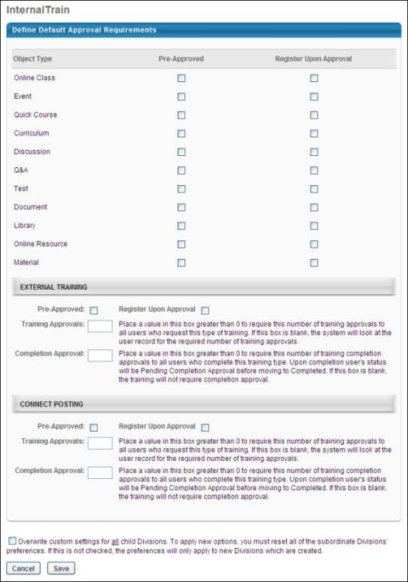

Default Approval Requirements - Standard Training Types
The standard training types section of the Default Approval Requirements page enables administrators to define the default settings for adding availability criteria of a course in Catalog Management, Test Engine, ILT Manage Sessions and Events, Curricula Administration, and Manage Materials. This section also enables administrators to select the default approval workflow and default completion approval workflow for each learning object (LO) type.
To manage default approval requirements, go to Admin > Tools > Learning > Learning Preferences > Preferences > Default Approval Requirements.
Permissions
PERMISSION NAME | PERMISSION DESCRIPTION | CATEGORY

Default Approval Requirements by Training Type | Grants ability to set Default Approval Requirements by Training Type that apply when users request training. Defaults may be overridden at learning object level by those who create and manage the learning objects. This is an administrator permission. | Learning - Administration
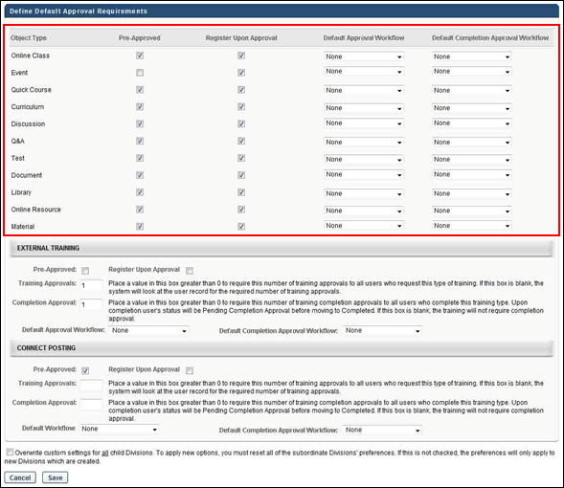
Object Type
This column displays the name of the learning object (LO).
Pre-Approved
This column allows administrators to define the default setting for pre-approval for the LO.
Register Upon Approval
This column allows administrators to define the default setting that determines whether the LO is placed into a Registered status upon approval.
Default Approval Workflow and Default Completion Approval Workflow
In these columns, the administrator can select a default approval workflow and default completion approval workflow for the LO type. The selected workflow is used as the default workflow for all approvals and completions associated with that LO. The LO types and the templates available for the administrator to select are dependent on the administrator's permission constraints. Note: The default approval workflow can be overridden at the individual LO level.
The default value for all LO types in both columns is "System-Generated Template." This is the default approval workflow that is defined for the portal.
The same template can be defined for multiple LO types.
- Note: You must create at least one approval workflow template in order for an option in addition to "None" and "System-Generated Template" to appear in the drop-down.
- Note: If the value in the column is a template that is outside of the administrator's permission constraints and the administrator changes the value for the LO type, then after the administrator saves the change, they cannot change the value back to the previous value that is outside of their permission constraints.
- Note: Approval workflow templates are created by the administrator in Approval Workflow Templates.
Once all settings are completed, click Save to save the settings.
See also:
- Default Approval Requirements - External Training
- Default Approval Requirements - Connect
The following image displays the Pre-Approved and Register Upon Approval settings on the Availability tab in Course Catalog:
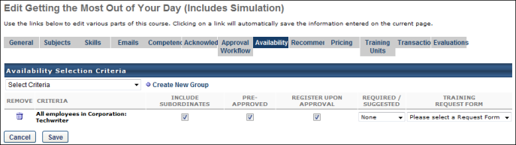
The following image displays the approval workflow settings in Course Catalog:
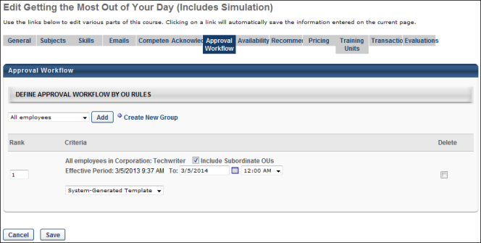

Default Approval Requirements - External Training
In the External Training section, the administrator can set the Pre-Approved and Register Upon Approval default settings for external training. In addition, the number of training and completion approvals can be configured, as well as the approval and completion approval workflows.
Note: External training is not a standard learning object, and cannot be managed in Catalog Management.
To manage default approval requirements, go to Admin > Tools > Learning > Learning Preferences > Preferences > Default Approval Requirements.
Permissions
PERMISSION NAME | PERMISSION DESCRIPTION | CATEGORY

Default Approval Requirements by Training Type | Grants ability to set Default Approval Requirements by Training Type that apply when users request training. Defaults may be overridden at learning object level by those who create and manage the learning objects. This is an administrator permission. | Learning - Administration
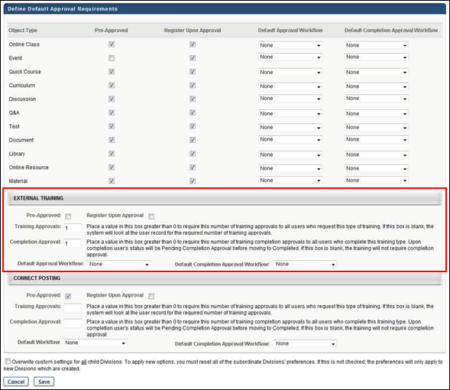
Pre-Approved
Select the Pre-Approved option to pre-approve external training.
Register Upon Approval
Select the Register Upon Approval option to define the default setting that determines whether the external training is placed into a Registered status upon approval.
Training Approvals
In the Training Approvals field, set the number of approvals required for external training. The system compares this number with the user record setting. If both the user record and Training Approvals are set to greater than 0, the higher number of the two is the number of approvals required for external training for the user. If the user record is set to 0, the user record setting overwrites the Training Approvals field setting and training does not require approval. If both are set to zero, training does not require approval.
Completion Approval
In the Completion Approvals field, set the number of approvals required for external training completion. If this number is set to zero, the user does not require approval for external training completion. When external training requires completion approvals and a user marks an external training as complete, the status of the external training is Pending Completion Approval until the number of required approvals is reached.
Best Practice: Because external training details are entered by the user, completion approval should be required so that the details of the external training are reviewed before the external training is considered complete.
Default Workflow
The Default Approval Workflow field enables administrators to define a default approval workflow for external training. Select an approval workflow template from the drop-down. When selected, the template is used as the default approval workflow for all external training.
The default value is "System-Generated Template." This is the default approval workflow for the portal.
Default Completion Approval Workflow
The Default Completion Approval Workflow field enables administrators to define a default approval workflow for external training completion. Select an approval workflow template from the drop-down. When selected, the template is used as the default approval workflow for all external training completions.
The default value is "System-Generated Template." This is the default approval workflow for the portal.
SF-182 Post Training Approvals
For SF-182 forms, post-training (completion) approvals can be configured via the Default Approval Workflow Templates page and the Default Approval Requirements for External Training page. The first approver who approves displays in Section F on SF-182 forms.
Section F allows for the printing of the following fields:
- Full name
- Title
- Email address
- Phone
- Approval date
- Signature box with full name displayed
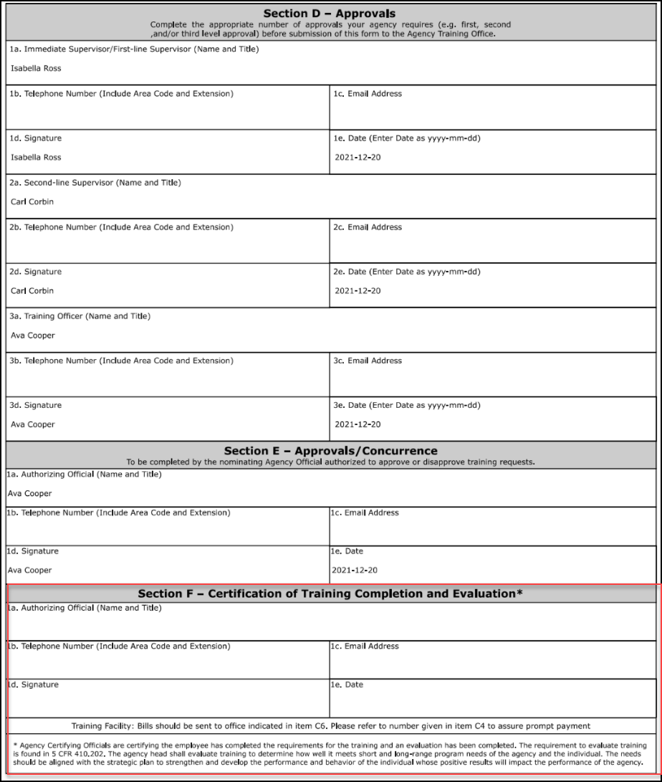

Default Approval Requirements - Connect Posting
In the Connect Postings section, the administrators can set the Pre-Approved and Register Upon Approval default settings for Connect postings. In addition, the number of training and completion approvals can be configured, as well as the approval and completion approval workflows.
Note: A Connect posting is not a standard learning object, and cannot be managed in Catalog Management.
To manage default approval requirements, go to Admin > Tools > Learning > Learning Preferences > Preferences > Default Approval Requirements.
Permissions
PERMISSION NAME | PERMISSION DESCRIPTION | CATEGORY

Default Approval Requirements by Training Type | Grants ability to set Default Approval Requirements by Training Type that apply when users request training. Defaults may be overridden at learning object level by those who create and manage the learning objects. This is an administrator permission. | Learning - Administration
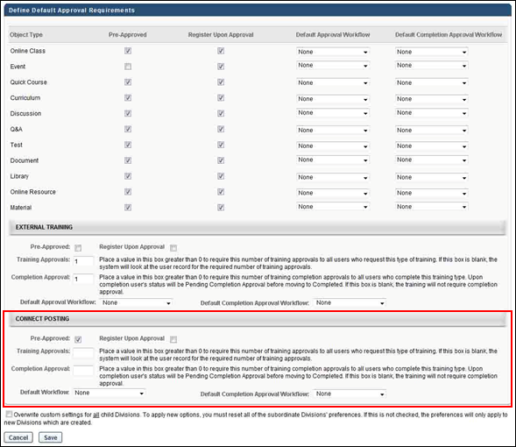
Pre-Approved
Select the Pre-Approved option to pre-approve connect postings.
Register Upon Approval
Select the Register Upon Approval option to define the default setting that determines whether the connect posting is placed into a Registered status upon approval.
Training Approvals
In the Training Approvals field, set the number of approvals required for Connect postings. The system compares this number with the user record setting. The higher number of the two is the number of approvals required for Connect postings for the user. If both are set to zero, Connect postings do not require approval.
Completion Approval
In the Completion Approvals field, set the number of approvals required for Connect posting item completion. If this number is set to zero, the user does not require approval for Connect posting item completion. When a Connect posting item requires completion approvals and a user marks a Connect posting item as complete, the status of the Connect posting is Pending Completion Approval until the number of required approvals is reached.
Default Workflow
The Default Workflow field enables administrators to define a default approval workflow for Connect postings. Select an approval workflow template from the drop-down. When selected, the template is used as the default approval workflow for all Connect postings.
The default value is "System-Generated Template." This is the default approval workflow for the portal.
Default Completion Approval Workflow
The Default Completion Approval Workflow field enables administrators to define a default approval workflow for Connect postings completion. Select an approval workflow template from the drop-down. When selected, the template is used as the default approval workflow for all Connect postings completions.
The default value is "System-Generated Template." This is the default approval workflow for the portal.
Default Approval Workflow Templates
The Approval Workflow Templates page enables administrators to create approval workflow templates for learning objects (LO). Upon implementation, a system-generated default template appears on the Approval Workflow Templates page for all portals and contains the approval workflow that exists at the time of the implementation of this enhancement.
To access the Approval Workflow Templates page, go to Admin > Tools > Learning > Learning Preferences > Default Approval Workflow Templates.
Permissions
PERMISSION NAME | PERMISSION DESCRIPTION | CATEGORY

Approval Template Administration - Manage | Grants ability to manage approval templates that can be applied to learning objects. Defaults must be overridden at the learning object level by those who create and manage them. This permission can be constrained by OU, User's OU, and Training Type. This is an administrator permission. | Learning - Administration

Approval Template Administration - View | Grants ability to view approval templates that can be applied to learning objects. Defaults must be overridden at the learning object level by those who create and manage them. This permission can be constrained by OU, User's OU, and Training Type. This is an administrator permission. | Learning - Administration
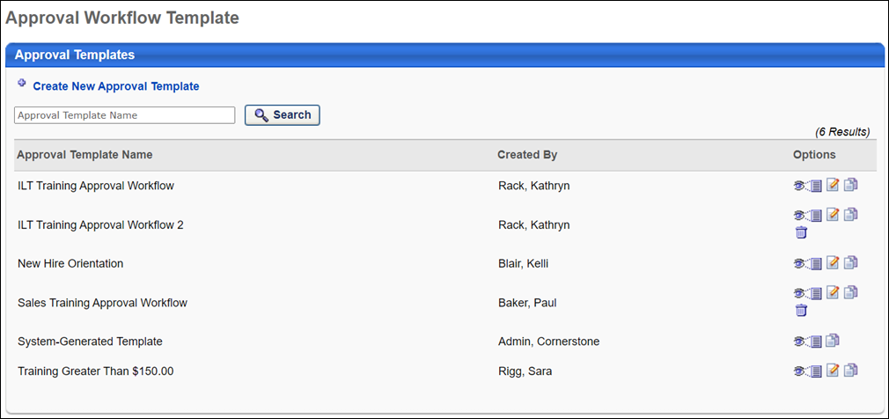
Approval Workflow Template
The following features and fields are available on the Approval Workflow Template page:
- Create New Approval Template - Click this link to create a new approval workflow template. You must have permission to manage approval workflow templates in order to create new templates.
- Search - Filter the results in the Approval Template table by entering a template name in the search field and clicking Search. The field accepts up to 100 characters.
- Approval Templates table - The following columns display in this table:
  - Approval Template Name - This column displays the template name. This column also displays the portal's system-generated template. For portals with multiple languages, template names display in the administrator's localized language. If a translation is not configured, the template name displays in the language of the template creator. This column is sortable.
  - Created By - This column displays the name of the administrator who created the template.
  - Options - The following options may be available for each approval template:
    - View Template - Click this icon to view the template as read-only.
    - Edit Template - Click this icon to edit the template. You must have permission to manage approval workflow templates in order to edit templates.
    - Copy Template - Click this icon to copy the template. All fields are copied except the Approval Template Name field. You must have permission to manage approval workflow templates in order to copy templates.
    - Delete Template - Click the Trash Can icon to delete the template. Then, click the Save button at the bottom-right of the page to save the deletion. Templates cannot be deleted if they are defined as the default template for a LO or have ever been assigned to a LO.
Once all changes are made to the Approval Workflow Templates page, such as deleting a template, click Save at the bottom-right of the page to save the changes. Click Cancel to cancel the changes.
System-Generated Template
The system-generated template on the Approval Workflow Templates page contains the default approval workflow. This template cannot be edited or deleted. Until a workflow is defined for a LO type, the system-generated template is used as the approval workflow.
If a template is never defined for a LO type or for an individual LO, then the system-generated template is always used as the approval workflow.
Note: When additional templates are added, the system-generated template is still available to select when defining an approval workflow at either the LO type or individual LO level.
Localization
For portals with multiple languages enabled, the title "System-Generated Template" can be localized. To localize the title:
- Click the View Template icon in the Options column. This opens the Define Approval Template page.
- Click the Translate icon in the Approval Template Name field. This opens the Translate pop-up.
- Enter localized text into the desired language fields.
- Click Save.
SF-182 Post Training Approvals
For SF-182 forms, post-training (completion) approvals can be configured via the Default Approval Workflow Templates page and the Default Approval Requirements for External Training page. The first approver who approves displays in Section F on SF-182 forms.
Section F allows for the printing of the following fields:
- Full name
- Title
- Email address
- Phone
- Approval date
- Signature box with full name displayed
Define Approval Template
The Define Approval Template page enables administrators to create and edit approval workflow templates.
To access the Approval Workflow Templates page, go to Admin > Tools > Learning > Learning Preferences > Default Approval Workflow Templates.
To access the Define Approval Template page, click the Create New Approval Template link from the Approval Workflow Templates page. Or, click the Edit Template or Copy Template icon from the Options column on the Approval Workflow Templates page.
Permissions
PERMISSION NAME | PERMISSION DESCRIPTION | CATEGORY

Approval Template Administration - Manage | Grants ability to manage approval templates that can be applied to learning objects. Defaults must be overridden at the learning object level by those who create and manage them. This permission can be constrained by OU, User's OU, and Training Type. This is an administrator permission. | Learning - Administration
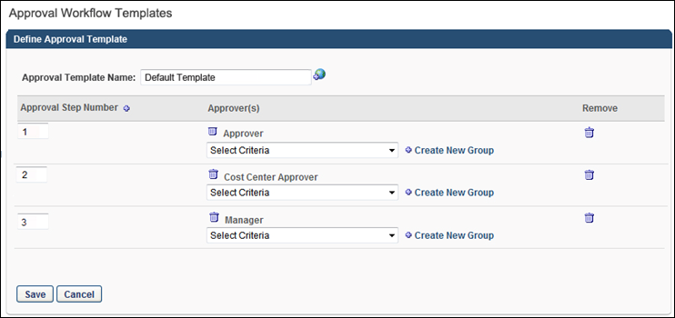
Create New Template
Approval Template Name
When creating a new template, the first step is to enter a name in the Approval Template Name field, up to 100 characters. This is a required field. For portals with multiple languages enabled, click the Translate icon to localize the template name.
Approval Step Number
The Approval Step Number column displays the step number that is associated with the approver in the Approver(s) column. The step number is automatically populated when a new step is created. You can edit the step number by entering up to three positive whole numbers in the field.
Multiple steps can have the same step number. Steps with the same number occur simultaneously during the approval process. Approval from any approver in either step approves the step. The other approvers in the step can still enter their approval decision, but their decision does not impact the step. If all approvers in the step deny approval, then the step is denied. See the Considerations section below for more information about the approval process for steps.
Add Approval Step
When creating a new template, the second step is to add an approval step. At least one step must be added. Click the Plus icon to the right of the Approval Step Number column name to add an approval step. This adds a new step to the Define Approval Template table.
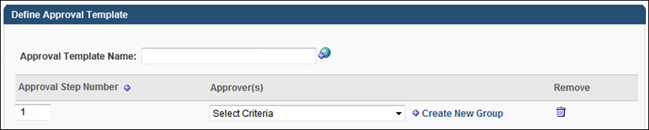
Approver(s)
When creating a new template, the third step is to define the approver criteria. Multiple approvers can be defined for each step.
To define criteria for the approval step, select an employee relationship, familiar job title, organizational unit (OU), or specific user from the Criteria drop-down. Once selected, the approver type appears in the Approver(s) column. Approval from any approver defined for the step approves the step. The other approvers in the step can still enter their approval decision, but their decision does not impact the step. The Approval History section on the Training Details page for the user displays the name of the approver that approved the user and also the OU or group from which the approval was granted.
Considerations
- If an approval is not obtained after going through all of the steps in an approval workflow template, the system automatically approves the training. Therefore, it is always a best practice to ensure that the number of steps in the approval process is greater than the largest number of approvals needed for a user or LO.
- If the final approver in the approval workflow defers approval, then the step is considered approved. The user's status changes to Approved.
- If the same approver is added to multiple steps, then approving any one of the steps counts as approval for all of the steps for which they are an approver. Example
- If one approver in the step denies the step, then the LO is denied and the workflow is complete.
- If all approvers in the step defer the step, then the step is deferred and moves to the next step in the workflow. Note: In this case, if the user is approved at a later step, then the Approval History section on the Training Details page for the user displays the OU or group that approved the user.
- If all approvers in the step are vacant for the user, then the approval moves to the next step in the workflow. If an approval is not obtained after going through all steps, the system automatically approves the training.
- If the Required Training Approvals field on the user record is set to zero, then no training approvals are ever required for the user, regardless of any training approvals that are set anywhere in the system.
Remove
Click the Trash Can icon to remove the criteria defined for the step.
Save or Cancel
Once all fields are completed, click the Save button. This saves the template and returns you to the Approval Workflow Templates page. Click Cancel to cancel creation of the template and return to the Approval Workflow Templates page.
Edit/Copy Template
The process for editing or copying a template is similar to creating a new template. See the Create New Template section above for more information.

Certificates Preferences Overview

Manage Custom Certificate Defaults
The Manage Default Certificates by LO Type page enables administrators to assign a certificate as a default certificate for an LO type. If a default certificate is set for an LO type, then the default certificate is issued to a user when they complete any LO within the LO type (e.g., Online Course, Curriculum), as long as the completed LO is not individually associated with a certificate on the Manage Certificates page. This enables an administrator to create a single certificate for all LOs within an LO type, rather than create a certificate for each specific LO.
If no default certificate is associated to the training type and the specific LO within the LO type does not have a certificate, then when a user completes the LO, no certificate is issued to the user.
Once the user completes the training, the certificate is available on the Training Details page for the LO. Users can view and print the certificate from this page. Managers and administrators can also view and print the certificate when accessing the user's transcript.
To access the Manage Default Certificates by LO Type page, go to Admin > Tools > Learning > Learning Preferences > Custom Certificate Defaults.
Permissions
PERMISSION NAME | PERMISSION DESCRIPTION | CATEGORY

Custom Certificate Management | Grants ability to create custom certificates of completion for training. This permission can be constrained by OU and user's OU. This is an administrator permission. | Learning - Administration
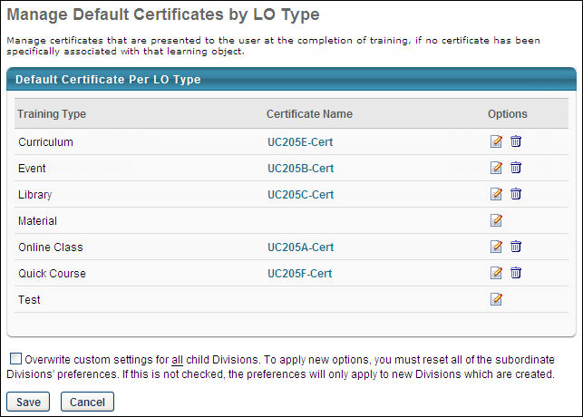
A default certificate can be added for each LO type. The available LO types are curriculum, event, library, material, online course, quick course, and test.
To add a default certificate to the LO type, in the Options column, click the Edit icon. This opens the Select Certificate pop-up with all of the available certificates listed in alphabetical order. Click the certificate name to select it.
- Only the certificates that are available to the administrator are displayed. All certificates created at this OU level or any parent OU level are available. The OU for which the certificate was created is displayed to the right of the certificate title.
- Administrators can search for a certificate by title.
Once a certificate is associated with a training type, it appears in the Certificate Name column.
- Administrators can click the certificate title to preview the certificate.
- To disassociate a certificate from a training type, click the Remove icon in the Options column.
Overwrite Settings
Select this option to overwrite custom settings for child division OUs. If you overwrite custom settings for child division OUs, the selected settings are applied to both new and existing child OUs. Any previously customized child OUs are updated with the selected settings.
- If there are no customizations to the child OU, then the parent OU customizations are applied to all child OUs.
- Overwrite custom settings checkbox setting
  - If this option is selected, all child OU customizations are deleted from the database, which means the parent OU customizations will be applied to new and existing child OUs.
  - If this option is unselected, all existing child OU customizations will remain unchanged, and any new child OUs will inherit the parent OU customizations by default.
- If a child OU has been customized to display any widgets, then regardless of the parent OU customizations, the child OU customizations are applied.
- If a child OU has been customized to hide all widgets, then parent OU customizations will take precedence and will be applied.
Save or Cancel
- Click Save to save any changes made to the default certificates.
- Click Cancel to cancel any changes made to the default certificates.

Custom Certificates Overview
Certificates are presented within the system to users who have completed a certain set of training. Organizations can create, edit, and manage multiple certificates themselves using an advanced HTML editor within the system. Custom tags can be used in the certificates. Organizations can then associate any certificate with any learning object (LO) at the OU level. Default certificates can be set for each LO type if an LO does not have a specific certificate assigned.
Once the user completes the training, the certificate is available on the Training Details page for the LO. Users can view and print the certificate from this page. Managers and administrators can also view and print the certificate when accessing the user's transcript.
All certificates that were created prior to the Custom Certificates functionality are converted to the new format and can be modified within the system. If a previously created certificate is set up for localization, then this certificate should not be modified once it is converted to the new format. If the localized certificate is modified, then the localization feature is removed from the certificate. Users are prompted if they attempt to modify one of these certificates.
A backend setting is available that suppresses child certificates. If this setting is enabled and the same certificate is associated with the parent LO and the child LO (e.g., a curriculum and an online class), then the certificate is only issued to the user once. However, if a different certificate is associated with the parent LO and the child LO, then the user receives both certificates.
To manage custom certificates, go to Admin > Tools > Learning > Learning Preferences > Custom Certificates.
Permissions
PERMISSION NAME | PERMISSION DESCRIPTION | CATEGORY

Custom Certificate Management | Grants ability to create custom certificates of completion for training. This permission can be constrained by OU and user's OU. This is an administrator permission. | Learning - Administration

Manage Custom Certificates
The Manage Certificates page enables administrators to
- Create and edit certificates using the advanced certificate editor.
- Copy, delete, print, or deactivate certificates.
- Associate certificates with an LO.
Note: You must click the Save button on the Manage Certificates page after creating, editing, copying, deleting, deactivating, or associating LOs with a certificate. If you do not click Save, no changes are saved.
Note: Once the user completes the training, the certificate is available on the Training Details page for the LO. Users can view and print the certificate from this page. Managers and administrators can also view and print the certificate when accessing the user's transcript.
To access the Manage Certificates page, go to Admin > Tools > Learning > Learning Preferences > Custom Certificates.
Permissions
PERMISSION NAME | PERMISSION DESCRIPTION | CATEGORY

Custom Certificate Management | Grants ability to create custom certificates of completion for training. This permission can be constrained by OU and user's OU. This is an administrator permission. | Learning - Administration
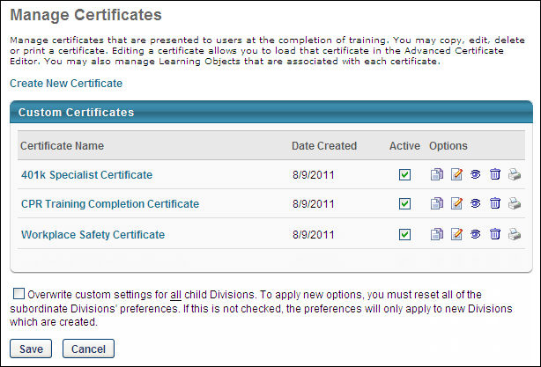
To create a new custom certificate, click the Create New Certificate link. After creating a certificate, be sure to click Save on the Manage Certificates page; otherwise, the new certificate is not saved. See Create Custom Certificates on page 159 for additional information.
In the Custom Certificates table, all of the custom certificates are displayed for the OU or any parent OU. The certificate name and date created are displayed for each certificate.
Click the certificate name to preview the certificate.
A certificate can be deactivated by deselecting the Active option for the certificate. When a certificate is deactivated, the certificate does not appear to users who have completed that training course. This applies to users who have completed the training in the past and users that complete it in the future. After deactivating a certificate, be sure to click Save on the Manage Certificates page; otherwise, the certificate is not deactivated.
The following options are available in the Options column:
- Copy - Copy the certificate. This loads the advanced certificate editor with the identical certificate name and HTML. After copying a certificate, be sure to click Save on the Manage Certificates page; otherwise, the new certificate is not saved. When copying a certificate, be aware of the following:
  - Only the certificate is copied, not the LO associations.
  - The name of the certificate is copied to the new certificate. To avoid confusion, be sure to rename the new certificate before saving it.
- Edit - Edit the certificate. This opens the certificate editor where you can modify the HTML and certificate name. After editing a certificate, be sure to click Save on the Manage Certificates page; otherwise, the changes are not saved.
- View Details - View the LO associations for the certificate. This opens the Learning Object Associations page where you can associate LOs with the certificate. After editing the associations of a certificate, be sure to click Save on the Manage Certificates page; otherwise, the changes are not saved. See Manage Learning Object Associations on page 164 for additional information.
- Delete - Delete the certificate. If a certificate is deleted, any LO associations are also deleted. After deleting a certificate, be sure to click Save on the Manage Certificates page; otherwise, the certificate is not deleted.
- Print - Print the certificate.
Overwrite Settings
Select this option to overwrite custom settings for child division OUs. If you overwrite custom settings for child division OUs, the selected settings are applied to both new and existing child OUs. Any previously customized child OUs are updated with the selected settings.
- If there are no customizations to the child OU, then the parent OU customizations are applied to all child OUs.
- Overwrite custom settings checkbox setting
  - If this option is selected, all child OU customizations are deleted from the database, which means the parent OU customizations will be applied to new and existing child OUs.
  - If this option is unselected, all existing child OU customizations will remain unchanged, and any new child OUs will inherit the parent OU customizations by default.
- If a child OU has been customized to display any widgets, then regardless of the parent OU customizations, the child OU customizations are applied.
- If a child OU has been customized to hide all widgets, then parent OU customizations will take precedence and will be applied.
Save or Cancel
- Click Save to save any changes made to the HTML of any certificate, LO associations of any certificate, or the Active status for any certificate.
- Click Cancel to cancel any changes made to the HTML of any certificate, LO associations of any certificate, or the Active status for any certificate.

Create Custom Certificates
When creating or editing a custom certificate, a Telerik HTML editor is used. For additional information about the editor, visit http://demos.telerik.com/aspnet-ajax/editor/examples/default/defaultcs.aspx.
Once the user completes the training, the certificate is available on the Training Details page for the LO. Users can view and print the certificate from this page. Managers and administrators can also view and print the certificate when accessing the user's transcript.
To create a custom certificate, Admin > Tools > Learning > Learning Preferences > Custom Certificates. Then, click the Create New Certificate link.
Permissions
PERMISSION NAME | PERMISSION DESCRIPTION | CATEGORY

Custom Certificate Management | Grants ability to create custom certificates of completion for training. This permission can be constrained by OU and user's OU. This is an administrator permission. | Learning - Administration
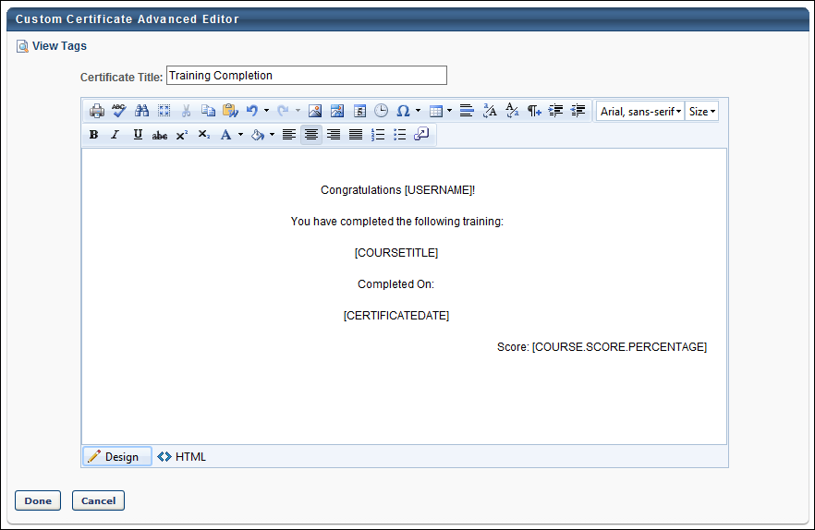
In the Certificate Title field, enter a title for the certificate. This title should describe the purpose of the certificate. This is required and the character limit is 300.
Best Practice: When editing a certificate, it is a best practice to change the certificate name each time. This is because when a certificate from a parent OU is modified, the certificate from the parent OU remains available along with the modified version of the certificate. If these two certificates are named the same, it is difficult to distinguish them.
Editing Modes
In the editor, there are two editing modes: Design and HTML. When in Design mode, you can use the standard editing tools to format your text, similar to your word processor application. When in HTML mode, the standard editing tools are disabled and you are able to view and modify the HTML code that is used to design the certificate. To switch between modes, click the appropriate tab in the lower-left corner of the editor. The system only accepts certain customizable HTML elements in the WYSIWYG Editor. Elements that are not acceptable display as text. See Safe Listed Customizable Elements.
Images
When adding an image to a custom certificate, the image must be uploaded to the Image Manager in order to appear properly in the certificate. However, there are currently no constraints available, so any image that is loaded can be viewed by any user with permission to manage custom certificates. To open the Image Manager, click the Image Manager icon . This opens the Image Manager. Click the Upload button to select the image to upload. The maximum file size is 1,024KB, and the accepted file types are .gif, .xbm, .xpm, .png, .ief, .jpg, .jpe, .jpeg, .tiff, .tif, .rgb, .g3f, .wxd, .pict, .ppm, .pgm, .pbm, .pnm, .bmp, .ras, .pcd, .cgm, .mil, .cal, .fif, .dsf, .cmx, .wi, .dwg, .dxf, .svf.
Note: When previewing the certificate, .tif and .tiff images are not supported.
Tags
To view the available tags for the certificate, click the View Tags link in the upper-left corner. This includes all available standard tags and custom field tags that may exist in your portal. To use one of the tags, you can copy and paste the tag into the editor or use the 'Import Filed' tool in the WYSIWYG editor (see below).
Both Training and User Record Custom Fields are available as certificate tags if they are Date Fields, Numerical Fields, Short Text Boxes, or Scrolling Text Boxes. Custom Training field tags begin with "[CUSTOM_LO_". Custom User Record tags begin with "[CUSTOM_USER_". Custom field tags must be referenced in all capital letters, and the field name must be placed within square brackets ("[ ]").
The Standard certificate tags are as follows:
- [USERNAME] - User's Full Name
- [USERFIRSTNAME] - User First Name
- [USERLASTNAME] - User Last Name
- [COURSETITLE] - Course Title
- [COURSEPROVIDER] - Course Provider
- [COURSE.SCORE.PERCENTAGE] - Course score as a percentage
- [COURSE.SCORE.RATIO] - Course score as a ratio
- [COURSEDESCRIPTION] - Course Description
- [CERTIFICATEDATE] - Course Completion Date
- [CERTIFICATELONGDATE] - Course Completion Long Date
- [OBJECTTYPE] - Course Type
- [LOGO] - Logo
- [ILT.OBJECTIVES] - Event/Session Objectives
- [OBJDURATION] - Course Duration
- [OBJCREDITS] - Course Credits
- [MANAGER] - Manager Name
- [SESSIONCITY] - Session City
- [SESSIONSTATE] - Session State
- [SESSIONSTARTDATE] - Session Start Date
- [SESSIONSTARTLONGDATE] - Session Start Long Date
- [SESSIONENDDATE] - Session End Date
- [USERPHOTO.SMALL] - User's profile photo in 48 x 48 pixel size
- [USERPHOTO.MEDIUM] - User's profile photo in 100 x 100 pixel size
- [USERPHOTO.LARGE] - User's profile photo in 200 x 200 pixel size
- [USERPHOTO.XLARGE] - User's profile photo in 400 x 400 pixel size
Import Field
All certificate fields are available. All training custom fields are available if they are Date Fields, Numerical Fields, Short Text Boxes, or Scrolling Text Boxes.
As previously stated, in Design mode, the standard editing tools are available to format the text. The final option in the bottom right corner of the editing toolbar is the Import Field option . Click this option to view and import the available custom fields.
Considerations

Standard Tag Behavior
If a learning object is associated with a Training Certificate before the LO is completed:
- The training certificate will always display the values of the standard tags as they were at the time of completion.
- If the learner’s display language changes, standard tags on the Training Certificate will display based on the language that was set at the time of completion.
If a learning object is associated with a Training Certificate after the LO is completed:
- The certificate will fetch the current values for the standard tags every time the certificate is generated.
- If the learner’s display language changes, standard tags on the Training Certificate will display based on the current language.

Custom Field Tag Behavior
If a learning object is associated with a Training Certificate before the LO is completed, the following rules apply:
- If a Training Custom Field was populated or blank in the Course Catalog when the LO was completed, that value is passed to the Training Details of the LO on the user’s transcript. After completion, edits made to the Training Custom Fields in the Course Catalog are not passed to the user’s Training Details or the Training Certificate tags.
- If a Training Custom Field is configured to be editable on the user’s transcript, editing the value on the User’s transcript will change the value in the Training Details but will not change the Training Certificate tags.
- If the Training Certificate contains User Record Custom Fields, edits to those fields on the User Record will not change the value in the Training Certificate Tags.
- If the user’s display language changes after completion, custom date fields will display in the format specific to the user’s language in the Training Details but not on the Training Certificate. Custom text fields will display in the language set at the time of completion both in the Training Details and the Training Certificate.
If a learning object is associated with a Training Certificate after completion, the following rules apply:
- If a Training Custom Field was populated in the Course Catalog when the LO was completed, that value is passed to the Training Details of the LO on the user’s transcript. Edits made to the Training Custom Fields in the Course Catalog after completion are not passed to the user’s Training Details or the Training Certificate tags.
- If a Training Custom Field was blank in the Course Catalog when the LO was completed, edits made to the Training Custom Field in the Course Catalog after completion are visible in the Training Details and the Training Certificate tags.
- If a Training Custom Field is configured to be editable on the user’s transcript, editing the User’s transcript will change the value in the Training Details and the Training Certificate tags.
- If the Training Certificate contains User Record Custom Fields, edits to those fields on the User Record will change the value in the Training Certificate Tags.
- If the user’s display language changes after completion, custom date fields will display in the format specific to the user’s new language in the Training Details and on the Training Certificate. Custom text fields will display in the language set at the time of completion both in the Training Details and the Training Certificate.
Note:
Training completions loaded via Edge, Express Class, or the Training Update Tool behave the same as if the learning object was associated with a Training Certificate after completion.
If an Event is associated with a Training Certificate, a child session's training certificate behaves the same as if the learning object was associated with a Training Certificate after completion.

Manage Learning Object Associations
The Learning Object Associations page enables administrators to manage the LOs that are associated with a certificate. When a certificate is associated with an LO, the certificate is issued to users who complete the LO.
To access the Learning Object Associations page, go to Admin > Tools > Learning > Learning Preferences > Custom Certificates. Then, to the right of the appropriate certificate, click the View Details icon.
Important: After modifying the learning object associations on this page, click Done. Then, on the Manage Certificates page, click Save. If you do not click Save, your LO associations are not saved.
Permissions
PERMISSION NAME | PERMISSION DESCRIPTION | CATEGORY

Custom Certificate Management | Grants ability to create custom certificates of completion for training. This permission can be constrained by OU and user's OU. This is an administrator permission. | Learning - Administration
Any specific LO associated with a certificate overrides the certificate defaults. For example, Certificate A is the default certificate for all Online Class LOs, and LO A is an Online Class, but Certificate B is specifically associated with LO A in Learning Object Associations. When a user completes LO A, they receive Certificate B, because the LO Association overrides the defaults if available.
To set the custom certificate defaults, you must go to the Custom Certificate Defaults page. See Manage Custom Certificate Defaults on page 152 for additional information.
If an LO is associated with a certificate and then associated with another certificate, the newest association is saved and the previous association is automatically deleted.
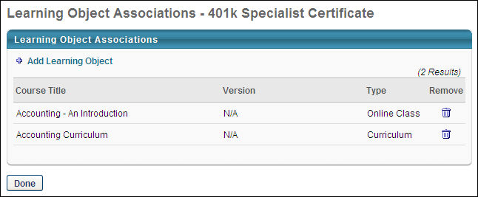
To associate a learning object with a certificate, click the Add Learning Object link. This opens the Search for Training pop-up. In the pop-up, you can search for LOs by title, description, language, provider, and LO type. After selecting the necessary LOs, click Done to close the pop-up. The selected LOs are added to the list of LO associations.
Administrators can associate a certificate with as many LOs as necessary.
The following information is displayed for each associated LO:
- Course Title
- Version
- Type
To remove an associated LO, click the Remove icon.
After setting the necessary associations, click Done. Then, on the Manage Certificates page, click Save. If you do not click Save, the associated LOs are not saved.
LO Versioning Rules
There can only be one custom certificate associated with an LO. However, this does not mean that all versions of the LO display the certificate; some versions may not display a certificate or they may display the default certificate, depending on the configuration.
- When a certificate is associated with an LO, the current version of that LO displays the certificate, but previous versions do not.
  - If previous versions were associated with a default certificate, then they continue to show the default certificate.
  - If previous versions had no certificate, then they continue to not have a certificate.
- When a new version of the LO is created, the LO is automatically associated with certificate that the previous version was associated with.

Content Preferences Overview

Content Launching Preferences
Content Launching Preferences define how online course content launches on a user's desktop. These preferences allow administrators to delineate the data encryption associated with the course launch and how the system is to react to plug-ins, such as Shockwave. In addition, administrators can configure a disclaimer to appear when training is launched.
To access Content Launching Preferences, go to Admin > Tools > Learning > Learning Preferences > Content Launching Preferences.
Permissions
PERMISSION NAME | PERMISSION DESCRIPTION | CATEGORY

Content Launching Preference - Manage | Grants ability to configure Content Launching Preferences which defines how online course content launches on users' desktops. These preferences allow administrators to delineate the data encryption associated with the course launch and how the system is to react to plug-ins (e.g., Shockwave). This permission can be constrained by OU, User's OU, or User's Corporation. This is an administrator permission. | Learning - Administration
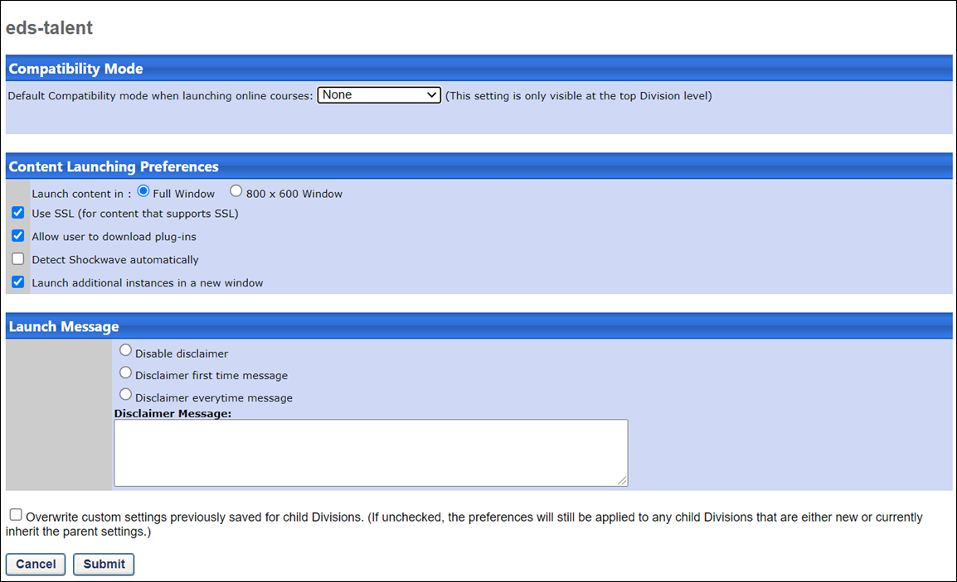
The Content Launching Preferences page is divided into the following sections:
- Compatibility Mode
- Content Launching Preferences
- Launch Message
Compatibility Mode
The Internet browser compatibility mode for an online course determines which compatibility mode, if any, is applied when the online course is launched.
From the drop-down menu, select the default compatibility mode for newly uploaded courses. The selected option is set for newly uploaded courses. Administrators can choose to modify the compatibility mode in either Course Publisher or Course Catalog. Note: This setting only affects newly uploaded online courses. Also, this option only affects users using Internet Explorer; users using other browsers (e.g., Chrome, Firefox) are unaffected.
The following options are available:
- None
- IE9 Compatibility
- IE10 Compatibility
This setting is only available when configuring Content Launching Preferences at the top division level. When configuring Content Launching Preferences for a division other than the top division level, the Compatibility Mode setting is not available.
Content Launching Preferences
The following options are available in the Content Launching Preferences section:
- Launch content in - Select how content is launched.
  - Full Window - When this option is selected, content is launched in a full browser window based on the user's screen resolution.
  - 800 x 600 Window - When this option is selected, content is launched in a browser window that is 800 pixels by 600 pixels.
- Use SSL - SSL stands for Secure Sockets Layer and is a protocol that provides secure communications on the Internet for data transfers. Selecting this option enables content that supports SSL to send information securely over the Internet. Note: When creating a SCORM 2004 course, this option must be selected in order for the content to load and function properly.
- Allow user to download plug-ins - A plug-in is a computer program that interacts with your Web browser to provide a very specific function. Flash player and Shockwave are typical examples plug-ins. Selecting this option enables users to load plug-ins to play their course.
- Detect Shockwave automatically - If this option is selected, then when the user launches the training, the system automatically checks to see if the Shockwave plug-in is needed. If the user does not have the plug-in, they are prompted to download the plug-in.
- Launch additional instances in a new window - This option enables administrators to define how multiple instances of the same course are launched. When checked, new instances of the same course launch in a new window. When this option is unchecked and a user launches a new instance of the same course, the course reloads within the window in which the course is currently open.
Launch Message
The following options are available in the Launch Message section:
- Disable disclaimer - Selecting this option disables the launch message.
- Disclaimer first time message - Selecting this option displays the disclaimer message one time prior to the course start.
- Disclaimer everytime message - Selecting this option displays the disclaimer message each time prior to the course start.
- Disclaimer Message - Enter a message in the field. The field is HTML friendly, and the character limit is 2000.
Overwrite Settings
Select this option to overwrite custom settings for child division OUs. If you overwrite custom settings for child division OUs, the selected settings are applied to both new and existing child OUs. Any previously customized child OUs are updated with the selected settings.
- If there are no customizations to the child OU, then the parent OU customizations are applied to all child OUs.
- Overwrite custom settings checkbox setting
  - If this option is selected, all child OU customizations are deleted from the database, which means the parent OU customizations will be applied to new and existing child OUs.
  - If this option is unselected, all existing child OU customizations will remain unchanged, and any new child OUs will inherit the parent OU customizations by default.
- If a child OU has been customized to display any widgets, then regardless of the parent OU customizations, the child OU customizations are applied.
- If a child OU has been customized to hide all widgets, then parent OU customizations will take precedence and will be applied.
Submit
Once all preferences are set, click Submit.

Content Request Preferences by Position
Content Requesting Preferences enables administrators to configure whether a manager or approver can assign a training item to their subordinates even if their subordinates are not within the training item's availability. In addition, administrators may choose to display a pop-up with configurable messaging when a user requests an online course.
Content Requesting Preferences are set by position.
To access Content Request Preferences, go to Admin > Tools > Learning > Learning Preferences > Content Requesting Preferences.
Permissions
PERMISSION NAME | PERMISSION DESCRIPTION | CATEGORY

Content Request Preferences - Manage | Grants ability to set learning Content Requesting Preferences, which enables administrators to configure whether a manager or approver can assign a training item to their subordinates even if their subordinates are not within the training item's availability. This permission can be constrained by OU and User's OU. This is an administrator permission. | Learning - Administration
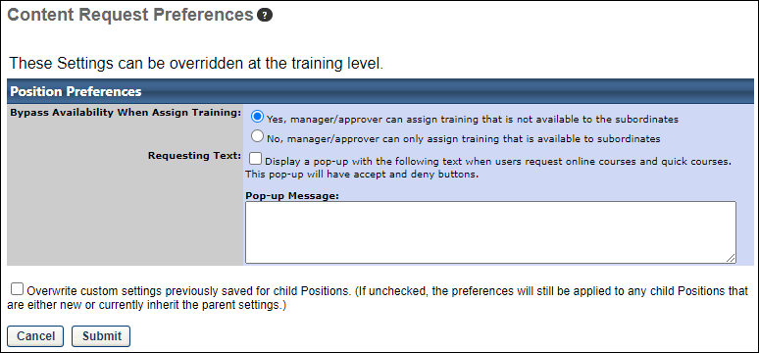
The following options are available:
- Bypass Availability When Assign Training
  - Yes - When this option is selected, a manager or approver can assign training that is not available to their subordinates.
  - No - When this option is selected, a manager or approver can only assign training that is available to subordinates
- Requesting Text - Check this option to display a message that will appear after a user clicks Request for an online course. This message will appear before the Training Request Form (if training request form is enabled).
  - Pop-Up Message - Enter message to appear. This is HTML friendly and accommodates 2000 characters.
Click Submit.
Overwrite Settings
Select this option to overwrite custom settings for child division OUs. If you overwrite custom settings for child division OUs, the selected settings are applied to both new and existing child OUs. Any previously customized child OUs are updated with the selected settings.
- If there are no customizations to the child OU, then the parent OU customizations are applied to all child OUs.
- Overwrite custom settings checkbox setting
  - If this option is selected, all child OU customizations are deleted from the database, which means the parent OU customizations will be applied to new and existing child OUs.
  - If this option is unselected, all existing child OU customizations will remain unchanged, and any new child OUs will inherit the parent OU customizations by default.
- If a child OU has been customized to display any widgets, then regardless of the parent OU customizations, the child OU customizations are applied.
- If a child OU has been customized to hide all widgets, then parent OU customizations will take precedence and will be applied.
Submit or Cancel
To save and submit your changes, click the Submit button. If you wish to discard your changes without saving, click the Cancel button.
Offline Preferences
The Offline Preferences page enables administrators to configure mobile offline player availability and offline learning for the Cornerstone Mobile® application and the Cornerstone Learn app.
To access Offline Preferences, go to Admin > Tools > Learning > Learning Preferences > Offline Preferences.
Permissions
PERMISSION NAME | PERMISSION DESCRIPTION | CATEGORY

Offline Content Administration | Grants ability to access and manage the Offline Preferences page. This permission also enables the administrator to select which learning objects are available for use with the new Offline Player via the Course Catalog. This permission cannot be constrained. This is an administrator permission. | Mobile

Offline Content | Grants ability to download and complete training items offline via a mobile device or the new Offline Player. This permission cannot be constrained. This is an end user permission. | Mobile
The following options are available:
- Enable Mobile Offline Logins - This option enables users to complete certain learning objects (LOs) when their mobile device is not connected to the Internet. If this option is not selected, the user's mobile device must be connected to the Internet in order to complete training via the Cornerstone Mobile® application. The administrator can limit the number of days the user can complete LOs offline before they must connect to the Internet and log in to the Cornerstone Mobile® application.
  - Infinite - When this option is selected, the user can complete LOs offline for an unlimited number of days. After downloading the necessary LOs, the user is not required to connect to the Internet and log in to the Cornerstone Mobile® application.
  - Number of days - When this option is selected, the user is limited in the number of days during which the user can complete LOs offline without connecting to the Internet and logging in to the Cornerstone Mobile® application. The administrator must specify the number of days a user can complete LOs offline without logging in to the Cornerstone Mobile® application.
- Enable Offline Learning - This option enables users to complete the selected LO types offline via the Cornerstone Mobile® application, the Cornerstone Learn app, and Cornerstone Offline Player. Each LO must also be individually designated as available offline in Course Catalog in order for users to be able to complete the LO offline.
  - Offline Courses - Select this option to allow offline courses to be completed offline via the Cornerstone Mobile® application. Each LO must also be individually designated as available offline in Course Catalog in order for users to be able to complete the LO offline.
    - Infinite - When this option is selected, the user can complete offline courses for an unlimited number of days. After downloading the necessary LOs, the user is not required to connect to the Internet and sync the LO with the system via the Cornerstone Mobile® application. This option does not apply to the Cornerstone Learn app.
    - Number of days - When this option is selected, the user is limited in the number of days during which the user can complete offline courses without connecting to the Internet and syncing the LO with the system via the Cornerstone Mobile® application. The administrator must specify the number of days a user can complete LOs offline without syncing the LO with the system via the Cornerstone Mobile® application. This option does not apply to the Cornerstone Learn app.
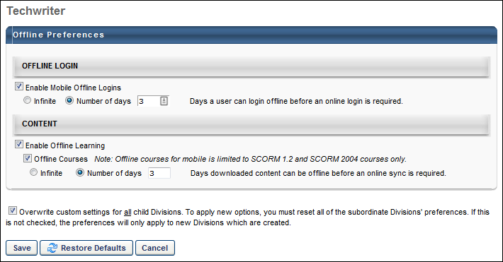
Set Network Player Download Paths
The local network paths that are used for downloading and launching content are set at the OU level via Set Network Player Download Paths preferences. Up to four network paths can be defined. The organizational unit (OU) that is used to define Local Network Player download paths is set during implementation. See Local Network Player Overview for additional information.
Note: This page is only available if the Local Network Player is enabled.
To access the Set Network Player Download Paths preferences, go to Admin > Tools > Learning > Preferences > Network Player Download Paths.
Permissions
PERMISSION NAME | PERMISSION DESCRIPTION | CATEGORY

Local Network Player - Set Network Player Download Paths Preference | Grants ability to set the preference that allows administrators to set the download paths to which users can choose to download courses. This permission is controlled by a backend setting. This permission can be constrained by OU or User's OU. This permission is recommended for local trainers and LMS administrators. | Learning
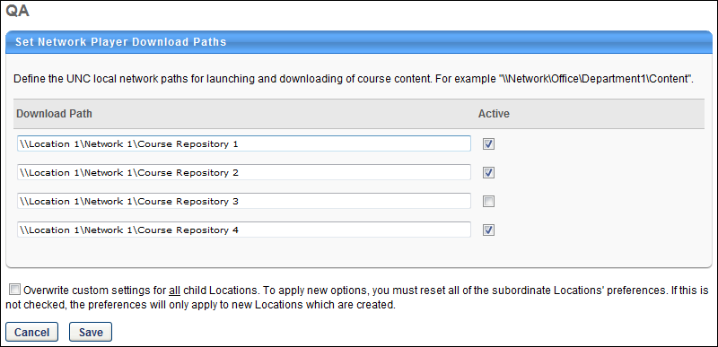
To define a download path, enter the appropriate path in one of the available Download Path fields. The character limit is 5000. An active network path that is defined for an OU will be available for an administrator when downloading a course via the course catalog or for a user when launching a course offline via their transcript.
Select the Active option to make the download path active and available for use. If a download path is not active, then it cannot be used for launching or downloading courses.
Overwrite Settings
Select this option to overwrite custom settings for child division OUs. If you overwrite custom settings for child division OUs, the selected settings are applied to both new and existing child OUs. Any previously customized child OUs are updated with the selected settings.
- If there are no customizations to the child OU, then the parent OU customizations are applied to all child OUs.
- Overwrite custom settings checkbox setting
  - If this option is selected, all child OU customizations are deleted from the database, which means the parent OU customizations will be applied to new and existing child OUs.
  - If this option is unselected, all existing child OU customizations will remain unchanged, and any new child OUs will inherit the parent OU customizations by default.
- If a child OU has been customized to display any widgets, then regardless of the parent OU customizations, the child OU customizations are applied.
- If a child OU has been customized to hide all widgets, then parent OU customizations will take precedence and will be applied.

Curricula Preferences
The Curricula Preferences page enables administrators to configure whether or not a learning object (LO) can be added to multiple recurring curricula.
To manage Curricula Preferences page, go to Admin > Tools > Learning > Learning Preferences > Curricula Preferences.
Permissions
PERMISSION NAME | PERMISSION DESCRIPTION | CATEGORY

Curricula Preferences | Grants ability to configure Curricula Preferences, which grants the ability to allow or disallow the same learning object (LO) from being added to multiple recurring curricula. This permission cannot be constrained. This is an administrator permission. | Learning - Administration
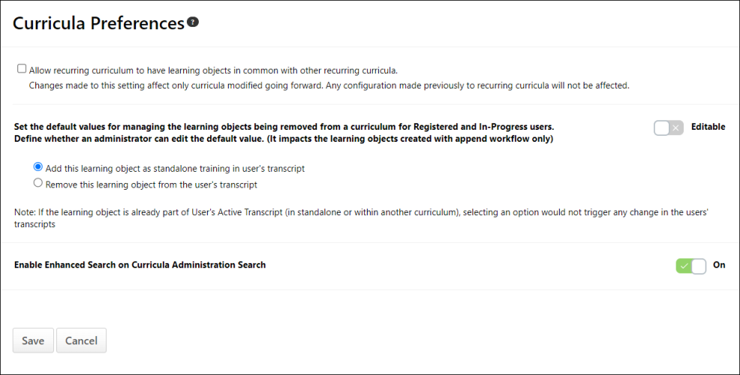
Allow Recurring Curriculum to Have Learning Objects in Common with Other Recurring Curricula
- Allow recurring curriculum to have learning objects in common with other recurring curricula - When this option is selected, a LO can be added to more than one recurring curricula. When this option is not selected, the system prevents administrators from saving a recurring curriculum that contains a LO that exists within another recurring curriculum.
  - This preference only impacts curricula that are created or modified after the preference is modified. For example, this option is selected and multiple curricula are created which contain one or more of the same LOs. Later, this option is deselected. The existing recurring curricula continue to contain the same LOs. However, if one of the recurring curricula is modified, then the new preference setting is enforced, and the LO that appears in other recurring curricula must be removed before the curriculum can be saved.
  - The availability of this preference is controlled by a backend setting. If the backend setting is disabled, this preference is no longer available to be modified. However, the preference setting is still enforced.
  - There is no need to enable this setting if your organization does not use recurrence functionality, or if there is no need to share LOs between multiple recurring curricula.
  - Enabling this preference adds a layer of complexity to the portal, as the preference cannot be constrained. If enabled, any administrator with the ability to create curricula can create curricula with LOs in common with other recurring curricula.
Action on Removal of Older Version LO (for Append Workflow) from a Curriculum
Two options are available for how child training is handled when a material or online course contained within a curriculum is versioned with append versioning, and then the material or online course is removed from the curriculum structure:
- Keep as standalone Learning Object on transcript - If this option is selected, child training is kept as standalone training on the learner’s transcript when it is versioned with append and removed from the curriculum structure. This option is selected by default.
- Remove Assignment of old version of Learning Object - If this option is selected, the old version of the child training versioned with append is removed from learners' transcripts.
Editable
In addition to the above options, an Editable toggle is available. When the Editable toggle is enabled, the default setting selected from the Action on Removal of Older Version LO section can be overridden at the curricula level at the time of the child training's removal.
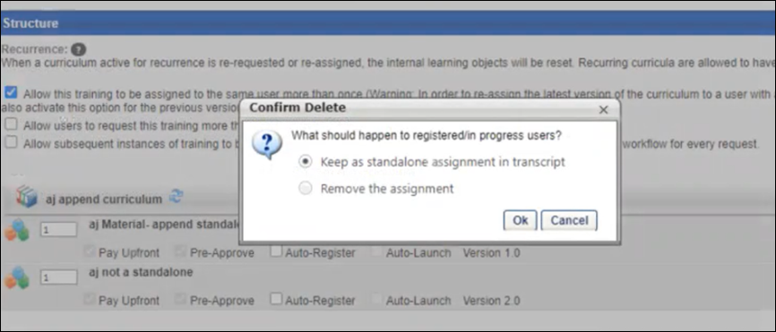
If the Editable toggle is not enabled, administrators cannot modify this setting at the curricula level at the time of the child training's removal. The Editable toggle is disabled by default.
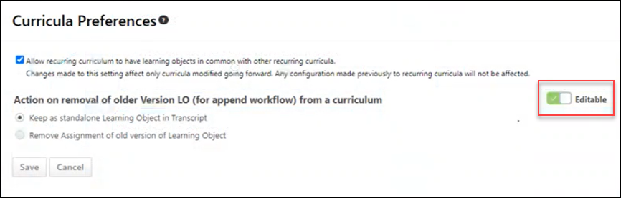
Enable Enhanced Search on Curricula Administration Search
The Enable Enhanced Search on Curricula Administration Search is turned on by default, which means the Curricula Administration is using Enhanced Search as the default search setting. You can turn off the toggle to switch to Traditional Search as the search setting in Curricula Administration. See Curricula Administration.

General Learning Preferences Overview
Badge & Point Preferences
Organizations can use rewards and recognition to make the learning experience more engaging and encourage employees to complete training.
The Badges tab of the Badge & Point Preferences page enables administrators to create and configure the badges that can be awarded to a user, including the points that are awarded when the user receives the badge. See Badge & Point Preferences - Badges on page 181 for additional information.
The Points tab of the Badge & Point Preferences page enables administrators to configure the Leaderboard page that exists within Universal Profile: Snapshot. See Badge & Point Preferences - Points on page 184 for additional information.
To manage Badges and Points:
- Go to Admin > Tools > Core Functions > Core Preferences > Badges & Points.
- Go to Admin > Tools > Learning > Learning Preferences > Badges & Points.
Permissions
PERMISSION NAME | PERMISSION DESCRIPTION | CATEGORY

Badge & Point Preferences - Manage | Enables user to access and edit preferences on the Badge & Point Preferences page. The availability of this permission is controlled by a backend setting. This permission can be constrained by OU and User's OU. This is an administrator permission. | Core Administration.
Badge Image Recommendations
For badge images, the acceptable file types are .png, .jpeg, and .gif. Badge images should be square with a recommended size of 100 x 100 pixels. To have a square badge image display properly on the My Badges page, use a 66 x 66 pixel image centered on a white square that is 100 x 100 pixels.
Next Steps
After a badge is created, it is awarded to a user via the Universal Profile: Feedback page. You can also associate it with a learning object (LO) so that it is automatically awarded when a user completes the associated LO.
- See Badge - Give to Employee.
- See Course Catalog - General.
Badge & Point Preferences - Badges
Badges are a form of employee recognition awarded when a user receives positive feedback or when a user completes training. Badges may have an associated point value. Based on portal configuration, you may be able to view badges through a widget on the Universal Profile - Snapshot page.
The Badges tab of the Badge & Point Preferences page enables administrators to create and configure the badges that can be awarded to a user, including the points that are awarded when the user receives the badge.
Note: Badge & Point Preferences should only be configured by the Division Organizational Unit (OU) type. If Badge & Point Preferences are configured by a different OU type, then the badges will not be available to users to select and grant to others.
To manage Badges and Points:
- Go to Admin > Tools > Core Functions > Core Preferences > Badges & Points.
- Go to Admin > Tools > Learning > Learning Preferences > Badges & Points.
Permissions
PERMISSION NAME | PERMISSION DESCRIPTION | CATEGORY

Badge & Point Preferences - Manage | Enables user to access and edit preferences on the Badge & Point Preferences page. The availability of this permission is controlled by a backend setting. This permission can be constrained by OU and User's OU. This is an administrator permission. | Core Administration.
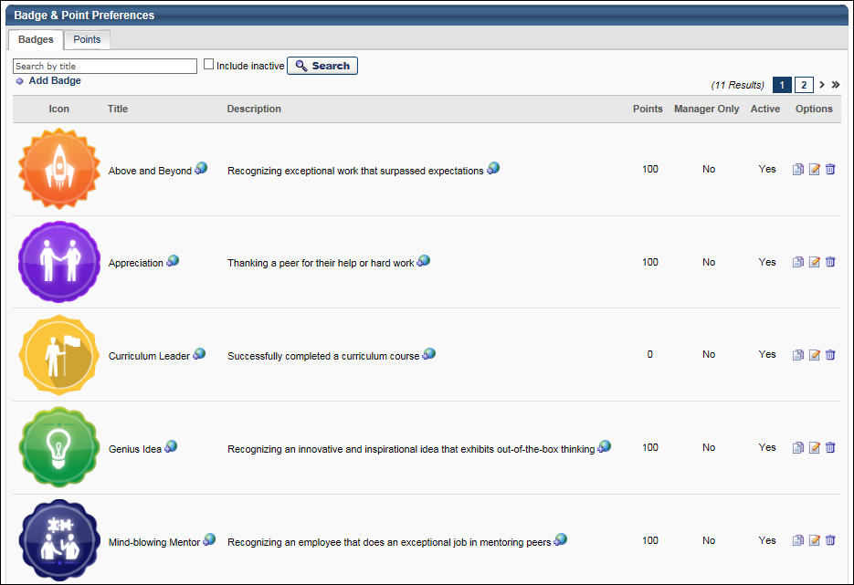
Badge - Search
To search for a badge by title, enter the badge title in the search field and click the Search button. Select the Include Inactive option to also search for inactive badges.
Badge - Add
To add a new badge, click the Add Badge link. See Badge - Add/Edit on page 186 for additional information.
Badge Table
The following information is displayed for each badge in the table:
- Icon - This displays the image that is associated with the badge.
- Title - This displays the badge title.
- Description - This displays the badge description.
- Points - This displays the point value that is associated with the badge. Note: Currently, the badge point values are being stored in the system. However, there is no functionality associated with the point values.
- Manager Only - This displays whether the badge is only available to be given by managers. If a badge is manager only, then only managers are able to give the badge to their subordinates.
- Active - This displays whether the badge is currently active. When a badge is active, then it is available to be given to users.
Badge Options
The following options are available in the Options column:
- Localize - If multiple languages are enabled, click the Globe icon to localize the badge title and description.
- Copy - Click this icon to duplicate the badge. A Copy Badge pop-up is opened, in which the administrator can edit the badge details prior to saving the badge. See Badge - Add/Edit on page 186 for additional information.
- Edit - Click this icon to edit the badge details. See Badge - Add/Edit on page 186 for additional information.
- Delete - Click this icon to delete the badge. See the Deleting or Deactivating Badges section for additional information.
Deleting or Deactivating Badges
Administrators are able to delete badges or make them inactive.
Learning Badges:
- Deactivate Badge:
  - The badge will still display on LO Details or the Course Catalog (if already associated to an existing LO).
  - The badge will no longer display in the Badge Search Results (admins cannot associate to LOs via the Course Catalog).
  - Any users who completed training (and were awarded the badge) will not be impacted; the badge will still display on the Training Completion page and on the Badges widget.
  - Any users who have not yet completed the training (with the badge associated to it) will still be awarded the badge when they complete the training.
- Delete Badge:
  - The badge will no longer display on LO Details or the Course Catalog (if already associated to an existing LO).
  - Any users who completed training (and were awarded the badge) will not be impacted; the badge will still display on the Training Completion page and on the Badges widget.
  - Any users who have not yet completed the training (with the badge associated to it) will not be awarded the badge when they complete the training.
Feedback Badges:
- The badge no longer displays in the results when attempting to award a badge via Feedback (i.e., users cannot award that badge to other users).
- The badge will continue to display in Feedback and the Badges widget (if it was already awarded to a user).
Badge Image Recommendations
For badge images, the acceptable file types are .png, .jpeg, and .gif. Badge images should be square with a recommended size of 100 x 100 pixels. To have a square badge image display properly on the My Badges page, use a 66 x 66 pixel image centered on a white square that is 100 x 100 pixels.
Badge & Point Preferences - Points
A user may receive points for completing training. Also, when a user receives a badge, they are also awarded any points that are associated with the badge. Depending on the portal configuration, users may be able to view their points and a points leaderboard via a widget on the Universal Profile - Snapshot page.
The Points tab of the Badge & Point Preferences page enables administrators to configure the Leaderboard page that exists within Universal Profile: Snapshot.
To manage Badges and Points:
- Go to Admin > Tools > Core Functions > Core Preferences > Badges & Points.
- Go to Admin > Tools > Learning > Learning Preferences > Badges & Points.
Permissions
PERMISSION NAME | PERMISSION DESCRIPTION | CATEGORY

Badge & Point Preferences - Manage | Enables user to access and edit preferences on the Badge & Point Preferences page. The availability of this permission is controlled by a backend setting. This permission can be constrained by OU and User's OU. This is an administrator permission. | Core Administration.
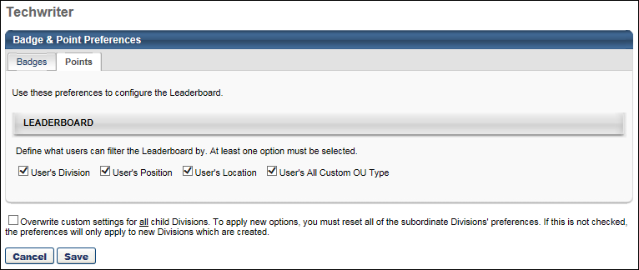
Leaderboard
This section enables administrators to define which filter options are available to the user when viewing the Leaderboard. When an option is selected, the corresponding filter option is able to select on the Leaderboard page. The various organizational unit (OU) filter options enable the user to compare their points totals with other users from the same OU. The following options are available:
- User's Division
- User's Position
- User's Location
- User's All Custom OU Type - If a user has more than one custom OU type configured for their user record, then all applicable custom OU types are available in the filter.
By default, User's Division is selected, and all other options are not selected. At least one option must be selected.
Overwrite Settings
Select this option to overwrite custom settings for child division OUs. If you overwrite custom settings for child division OUs, the selected settings are applied to both new and existing child OUs. Any previously customized child OUs are updated with the selected settings.
- If there are no customizations to the child OU, then the parent OU customizations are applied to all child OUs.
- Overwrite custom settings checkbox setting
  - If this option is selected, all child OU customizations are deleted from the database, which means the parent OU customizations will be applied to new and existing child OUs.
  - If this option is unselected, all existing child OU customizations will remain unchanged, and any new child OUs will inherit the parent OU customizations by default.
- If a child OU has been customized to display any widgets, then regardless of the parent OU customizations, the child OU customizations are applied.
- If a child OU has been customized to hide all widgets, then parent OU customizations will take precedence and will be applied.
Note: This option only applies to the Points tab.
Save/Cancel
Click Save to commit any unsaved changes. Or, click Cancel to discard any unsaved changes.
Badge - Add/Edit
Badges are a form of employee recognition awarded when a user receives positive feedback or when a user completes training. Badges may have an associated point value. Based on portal configuration, you may be able to view badges through a widget on the Universal Profile - Snapshot page.
Note: Badges can only be edited from the division in which they are created. For example, if you create a badge for the California division, the Edit option will only be available for that badge when you access the California division's Badge and Point Preferences. If you access the Los Angeles division's Badge and Point Preferences, the badge that was created for the California division is NOT editable. Either return to the division where the badge was created, or copy the badge to the child division and edit the copy.
To add a new badge, click the Add Badge link on the Badge Preferences page.
Permissions
PERMISSION NAME | PERMISSION DESCRIPTION | CATEGORY

Badge & Point Preferences - Manage | Enables user to access and edit preferences on the Badge & Point Preferences page. The availability of this permission is controlled by a backend setting. This permission can be constrained by OU and User's OU. This is an administrator permission. | Core Administration.
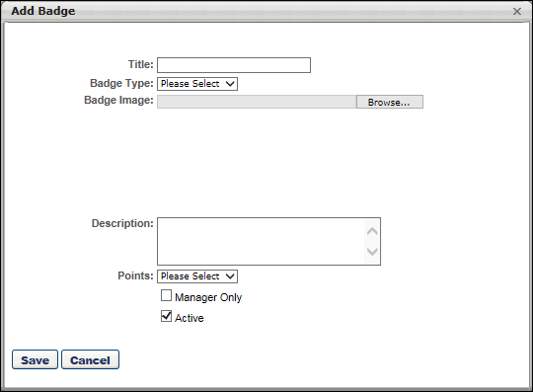
To add/edit a badge:
- Complete or edit the following fields:
  - Title - The purpose of the badge. When editing a badge, modifications to the badge title are reflected on the Training Completion page and Snapshot: Badges sub-page for users who have already completed training and earned the badge. 50 characters maximum.
  - Badge Type - The purpose of the badge. This will determine in which scenarios the badge can be awarded. When editing a badge, you cannot modify the badge type. Options are:
    - Feedback - Select this type when the badge should only be used when awarding feedback.
    - Learning - Select this type when the badge should only be used when a user completes training.
  - Badge Image - The image that represents the badge. Click the Browse button to select an image file. When uploading an image file, the character limit for the file name is 91. When editing a badge, modifications to the badge image are reflected on the Training Completion page and Snapshot: Badges sub-page for users who have already completed training and earned the badge. For badge images, the acceptable file types are .png, .jpeg, and .gif. Badge images should be square with a recommended size of 100 x 100 pixels. To have a square badge image display properly on the My Badges page, use a 66 x 66 pixel image centered on a white square that is 100 x 100 pixels.
  - Description - The description of the badge, up to 150 characters. This should describe the purpose of the badge in detail. When editing an existing badge, changes to this field are applied to all past instances of this badge.
  - Points - The point value associated with the badge. A user's badge points are visible on the Universal Profile Snapshot page and on the Points Leaderboard. When editing an existing badge, changes to this field are only applied to future instances of this badge. The points that are associated with badges already awarded will not be changed.
  - Manager Only - Whether the badge is only available to be awarded by managers. When this option is selected, only direct or indirect managers are able to award this badge, and they can only award it to their direct or indirect reports. When editing an existing badge, changes to this field are only applied to future instances of this badge. This option is only available when the Badge Type is set to Feedback.
  - Active - Whether the badge is active. When editing an existing badge, changes to this field are only applied to future instances of this badge. See the Deleting or Deactivating Badges section of the Badge & Point Preferences - Badges topic for additional information. See Badge & Point Preferences - Badges on page 181 for additional information.
- Click Save.
After a badge is created, it is awarded to a user via the Universal Profile: Feedback page. You can also associate it with a learning object (LO) so that it is automatically awarded when a user completes the associated LO.
- See Badge - Give to Employee.
- See Course Catalog - General.
Browse for Training Preferences
The Browse for Training Preferences page allows administrators to configure the Browse for Training landing page, the sort options that are available on the Browse for Training page, the subjects that are available in the Browse by Subject widget, and an optional HTML banner that appears at the top of the Browse for Training page.
To access the Browse for Training Preferences page, go to Admin > Tools > Learning > Learning Preferences. Then, click the Browse for Training link under Learning Preferences.
Permissions
PERMISSION NAME | PERMISSION DESCRIPTION | CATEGORY

Browse for Training Preferences - Manage | Grants ability to configure the Browse for Training features, including which subjects appear in the Browse for Training widget. This permission can be constrained by OU and User's OU. This is an administrator permission. | Learning - Administration
The Browse for Training Preferences page is divided into the following sections:
Enable Browse for Training Landing Page and Tile View
This option is unselected by default.
When this option is selected, the Browse for Training landing page is enabled for users. This page enables administrators to display more targeted and interesting content to users. Also, the Tile View option is available on the Browse for Training page, which enables users to view training as tiles or in a list.
- If this option is selected, any Browse for Training navigation links automatically directs users to the Browse for Training landing page. The regular Browse for Training page can be added as an additional navigation link, if needed.
- If this option is unselected and there are links to the Browse for Training landing page, then these links now direct users to the Browse for Training page.
When Tile View is enabled, an additional option is available, which enables administrators to determine the default view for the Browse for Training page, though users are able to change the view at any time. The Tile view option is selected by default.
Default Thumbnail Images Note: On the Browse for Training landing page and in Tile View, a thumbnail image is displayed for each LO that is displayed. Administrators can configure which image is associated with a LO on the Course Catalog - General page. If the training does not have a set image, then a randomly selected default image is displayed. Administrators can download all of the default images from within Online Help on the Course Catalog - General topic. The link to download these images is in the description for the Thumbnail Image field. See Course Catalog - General.
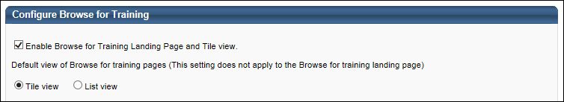
Sort Options
This section enables administrators to configure the sort options that are available on the Browse for Training page.
- Sorted by - This column displays the sort options that are available in the Sort by drop-down list on the Browse for Training page. Administrators are able to configure these sort options. However, they cannot add additional sort options.
- Display Name - This column enables administrators to configure the name for each sort option. The display name is what is displayed to users in the Sort by drop-down list on the Browse for Training Page. To customize the display name, in the Display Name field, enter the name that displays for the sort option. This field is required for all active sort options. If multiple languages are enabled for your portal, select the Translate icon to translate the field into other available languages.
- Description - This column provides a description for each sort option.
- Active - This column enables administrators to make a sort option active or inactive. When the Active option is checked, the sort option is active and appears in the Sort by drop-down list on the Browse for Training page. If all sort options are inactive, then the Sort by drop-down list does not appear on the Browse for Training page, and training items are sorted by title.
- Default - This option enables administrators to select a sort option as the default sort option on the Browse for Training page. Only one sort option can be set as the default sort option. Only active sort options can be selected as the default sort option.
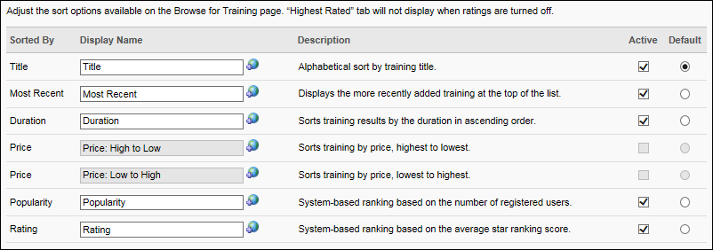
Browse by Subject
This section enables administrators to configure the subjects that appear in the Browse by Subject widget on the Browse for Training page. Child subjects of a selected parent subject only display to users if there is training available to that user that is associated with that subject. The Browse for Training page initially displays the first 10 subjects. Note: Administrators can create additional subjects from the Course Catalog. See Subject Management for additional information.
To add a subject, click the Add Subject link. Then, select the appropriate subjects from the pop-up.
In the Subjects table, configure the order in which subjects appear in the Browse by Subject widget. In the Order field, enter the order in which the subjects should appear. For example, a subject with an order value of 1 appears first in the Browse by Subject widget.
To remove a subject from the Browse by Subject widget, click the Trash Can icon in the Remove column.
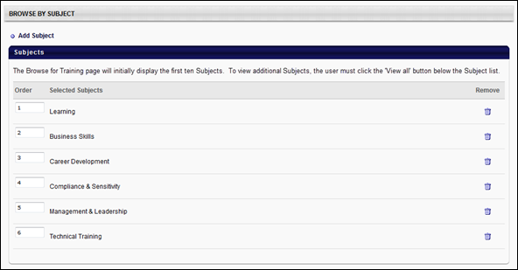
Configure Browse for Training Landing Page
This section enables administrators to configure the order in which the filter options appear in the Training filter on both the Browse for Training landing page and the Browse for Training main page. This section also enables administrators to configure what types of content appear on the Browse for Training landing page and the order in which they appear.
The following filters are available:
- Top Picks for User - When the Top Picks for [User] section is active in the portal and a user navigates to the Browse for Training landing page, a Top Picks for [User] section appears for the user with the user's name and training related to the user's previous training selections.
- My Subjects - This filter displays training that is associated with the user's favorite training subjects. Users can define their favorite training subjects on the Bio: About page. The most recently created or updated training is displayed first. This filter is only available if the Subjects section is enabled in Bio About Preferences.
- Featured - This filter displays all featured training that is available to the user. The most recently created or updated training is displayed first. A training item is designated as Featured by administrators via Course Catalog.
- Suggested - This filter displays all suggested training that is available to the user. The most recently created or updated training is displayed first. A training item is designated as Suggested by administrators via Course Catalog. Note: Marking a LO as Suggested is considered an update to the LO.
- Popular - This filter displays the most popular training items that are available to the user. The system determines popularity by the number of registered users within the previous 14 days.
- Newest - This filter displays the newest training items that are available to the user. The most recently created training is displayed first.
The filter options are organized in a table, and the following information displays for each filter:
- Order - Enter the order in which the sections should appear on the Browse for Training landing page. For example, a filter option with an order value of 1 appears first on the Browse for Training landing page.
- Filter By - This column displays the name of the filter.
- Description - This column displays a description of the filter.
- Visible on Landing Page - This option is selected by default. If this option is selected, the filter option also appears as a section on the Browse for Training landing page. For example, if the Featured filter option is visible on the landing page, then a Featured section displays training that are marked as featured for the user. All sections that are visible on the landing page appear in the defined order.
- Select Subjects Pop-up Title - Users are able to select their favorite training subjects on the Universal Profile - Bio page. Enter the title that should appear in the Select Subjects pop-up in which users select their favorite training subjects. The default value is "Select Subjects." The character limit for this field is 25. If multiple languages are enabled for your portal, select the Translate icon to translate the field into other available languages.
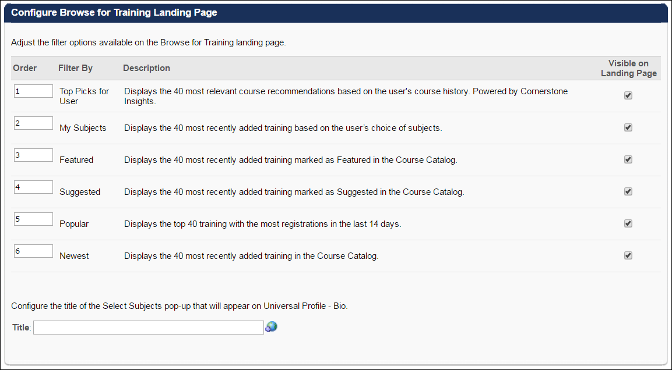
Browse for Training Banner
This section enables administrators to configure the HTML banner that is displayed at the top of the Browse for Training page. This banner is optional and can be used to market certain training items.
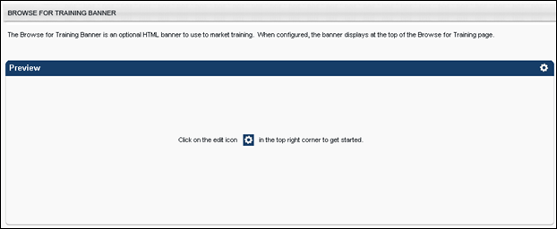
By default, no banner is configured. To configure an HTML banner for the Browse for Training page, click the Edit icon in the upper-right corner of the Preview panel. This opens the Browse for Training Banner pop-up, in which the user can enter the appropriate HTML code for the banner.
In the editor, there are two editing modes: Design and HTML. When in Design mode, you can use the standard editing tools to format your text, similar to your word processor application. When in HTML mode, the standard editing tools are disabled and you are able to view and modify the HTML code that is used to design the certificate. To switch between modes, click the appropriate tab in the lower-left corner of the editor. The system only accepts certain customizable HTML elements in the WYSIWYG Editor. Elements that are not acceptable display as text. See Safe Listed Customizable Elements.
Note: Because of the security risks associated with JavaScript, it is disabled in this editor by default. To embed JavaScript within this widget, contact Global Customer Support. Global Customer Support does not troubleshoot Java or HTML issues.
Click Save to save the changes and close the pop-up. A preview of the banner is displayed in the Preview panel.
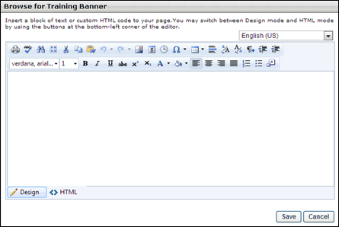
Overwrite Settings
Select this option to overwrite custom settings for child division OUs. If you overwrite custom settings for child division OUs, the selected settings are applied to both new and existing child OUs. Any previously customized child OUs are updated with the selected settings.
- If there are no customizations to the child OU, then the parent OU customizations are applied to all child OUs.
- Overwrite custom settings checkbox setting
  - If this option is selected, all child OU customizations are deleted from the database, which means the parent OU customizations will be applied to new and existing child OUs.
  - If this option is unselected, all existing child OU customizations will remain unchanged, and any new child OUs will inherit the parent OU customizations by default.
- If a child OU has been customized to display any widgets, then regardless of the parent OU customizations, the child OU customizations are applied.
- If a child OU has been customized to hide all widgets, then parent OU customizations will take precedence and will be applied.
Cancel or Submit
After configuring the Browse for Training Preferences page, click Cancel to discard any unsaved changes, or click Submit to finalize the selected settings.

Configure External Training by Division
The Configure External Training screen enables administrators to define the fields that appear within the Add External Training pop-up. The Add External Training custom fields can be customized at the OU level. In addition, you can choose whether users are able to enter a grade when marking the external training complete. You may also enable the user to link the external training to competencies. The comments field which is available to users and administrators when editing the external training is a configurable option; you can choose whether to display it and can also make it required.
To configure external training by OU, go to Admin > Tools > Learning > Learning Preferences. In the General Learning Preferences section, select the Configure External Training link.
Permissions
PERMISSION NAME | PERMISSION DESCRIPTION | CATEGORY

Configure External Training | Grants ability to configure external training preferences at global/OU level. This is an administrator permission. | Learning - Administration
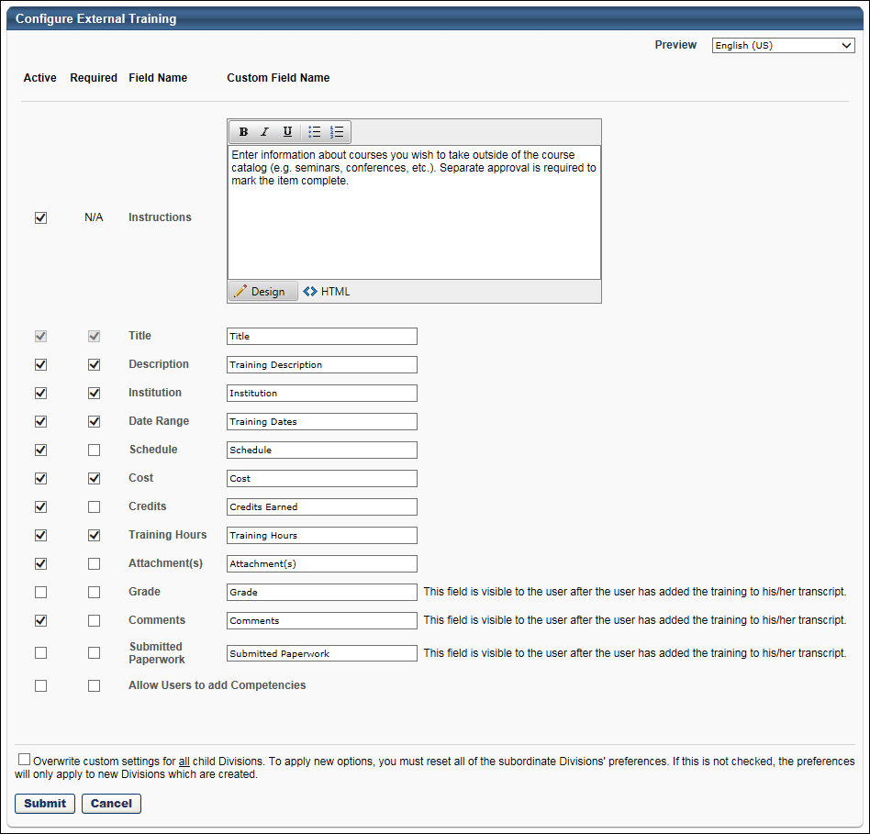
The settings on the Configure External Training page apply to the Add External Training screen.
- Old Transcript - See External Training - Add from Transcript for additional information.
- Universal Profile - Transcript - See Universal Profile - Options - Add External Training for additional information.
The following options are available on this page:
- Active - For each available field name, select whether or not the field is active using the Active option boxes. If this option is selected for a field, the field will appear in the Add External Training window.
- Required - Select whether or not the field is required using the Required option boxes. If this option is selected for a field, users must enter a value for the field when adding external training.
- Custom Field Name - For each available field, you can customize the field name in the Custom Field Name fields. If no custom field name is provided, the standard field name is used. The character limit for field names is 1000 characters.
The available standard fields are:
- Instructions - The character limit for this field is 2000. Administrators can utilize HTML when configuring the instructions. Any HTML that is added is applied when previewing the Add External Training page.
- Title - This field is always required. The character limit for this field is 50.
- Description - The character limit for this field is 50.
- Institution - The character limit for this field is 50.
- Schedule - The character limit for this field is 50.
- Cost - The character limit for this field is 50.
- Credits - The character limit for this field is 50.
- Attachments - The character limit for this field is 50.
- Training Hours (Previously Duration) - The character limit for this field is 50.
- Grade - The character limit for this field is 50.
- Comments - The character limit for this field is 50.
- Submitted Paperwork - This is a memo type field that can be used as a substitute for adding attachments. The character limit for this field is 50.
- Allow user to add Competencies - When active, this enables the Add Competency link in the Add External Training window. When required, users must add at least one competency to the external training.
To preview the Add External Training window with the selected settings, click the Preview link in the upper-right corner.
To localize the field names to other available languages, select the appropriate language from the Language drop-down in the upper-right corner. Custom field names that are entered correspond to the selected language.
Overwrite Settings
Select this option to overwrite custom settings for child division OUs. If you overwrite custom settings for child division OUs, the selected settings are applied to both new and existing child OUs. Any previously customized child OUs are updated with the selected settings.
- If there are no customizations to the child OU, then the parent OU customizations are applied to all child OUs.
- Overwrite custom settings checkbox setting
  - If this option is selected, all child OU customizations are deleted from the database, which means the parent OU customizations will be applied to new and existing child OUs.
  - If this option is unselected, all existing child OU customizations will remain unchanged, and any new child OUs will inherit the parent OU customizations by default.
- If a child OU has been customized to display any widgets, then regardless of the parent OU customizations, the child OU customizations are applied.
- If a child OU has been customized to hide all widgets, then parent OU customizations will take precedence and will be applied.
Submit or Cancel
To save and submit your changes, click the Submit button. If you wish to discard your changes without saving, click the Cancel button.
Course Code Preferences
Enabling course codes in your portal allows the system to auto-generate unique learning object (LO) IDs, which makes organizing and searching for training easier. Course Code Preferences can be set by administrators with the appropriate permissions. Once set, most course code configurations for a portal cannot be modified.
To set course code preferences, go to Admin > Tools > Learning > Learning Preferences, and click the Course Code link.
Permissions
PERMISSION NAME | PERMISSION DESCRIPTION | CATEGORY

Course Code -Edit | Grants ability to edit Training Course Codes. This is an administrator permission. | Learning - Administration

Course Code - Manage | Grants ability to access and manage the Course Code Preferences. This is an administrator permission. | Learning - Administration

Course Code - View | Grants ability to view Training Course Codes. This is an administrator permission. | Learning - Administration

Learning Preferences | Grant access to Learning Preferences. This permission must be combined with other permissions in order for specific preference links to appear. This is an administrator permission. | Learning - Administration
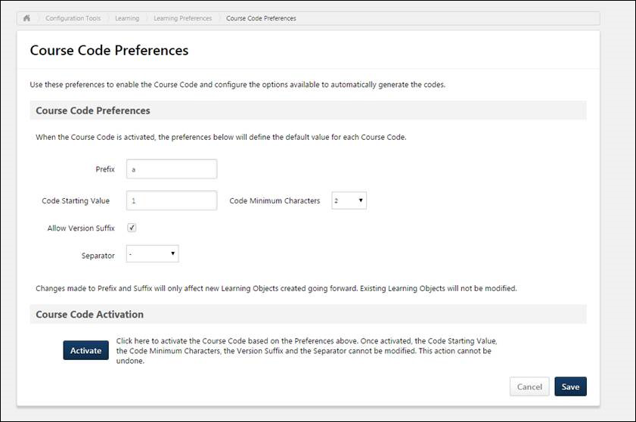
Course Code Preferences
The Course Code Preferences section allows administrators to configure the format that the system will use to automatically generate course codes for LOs. Administrators may configure the following fields:
- Prefix - Administrators may specify the course code prefix for their portal in Course Code Preferences, to ensure the course code naming convention aligns with their company’s organization standards. Set a course code prefix for the portal by entering up to 20 alphanumeric and special characters into the optional Prefix field, which is blank by default. Note: Spaces are not allowed at the beginning or end of the prefix.
- Course Code Starting Value - Enter the course code number that the system should begin with when course codes are activated in the portal. This field allows administrators to continue the course code naming convention used in a previous Learning Management System. This field is limited to 10 characters.
- Code Minimum Characters - From this drop-down menu, select the minimum number of characters each auto-generated course code must contain (E.g. If the starting value is 123 and the Code Minimum Characters field is set to 6, the auto-generated course code is 000123).
- Allow Version Suffix - Administrators can determine whether or not a version suffix is included in the course code, which causes the system to add a version number after the course code for all LOs that can be reversioned (i.e. Online Courses, Tests, Curricula, and Materials). This optional field is not selected by default. Check the Allow Version Suffix field to include the version number in the suffix of course codes for versionable LOs.
- Separator - If needed, the administrator can opt to include a separator in the course code formula, which can help maintain consistency when importing training from an old system to the Cornerstone system. This field is optional, and no separator is selected by default. If separator has already been used while loading course codes prior to the feature activation by GTS, a validation message displays that reads, "Separator is already used and must be [X]."
To include a separator between the prefix, code, and suffix of a course code, select a character from the Separator drop-down menu. Available options include:
- None
- :
- -
- _
- /
- \
- .
Note: Once the course code has been activated in the portal by an administrator, the Code Starting Value, Code Minimum Characters, Version Suffix, and Separator options are no longer editable. If a change must be made, this can only be done via work order.
Course Code Activation
The administrator can finalize the course code preferences they have selected and start auto-generating course codes in the portal by clicking the ACTIVATE button. Activating the course code preferences prohibits all administrators from making changes to the Code Starting Value, Code Minimum Characters, Version Suffix, and Separator. To activate course codes in your portal:
- Check to ensure all course code preferences have been set as desired. Once course codes are activated, no changes may be made to course code preferences. Click the Activate button in the Course Code Activation section.
- A pop-up window appears, stating, “You are about to activate Course Codes for your portal. Before activating, ensure the Course Code Preferences are properly configured. This action cannot be undone.” Below this message, there are two options: Activate and Cancel. Click the Activate button to finalize course code preferences and make course codes active in your portal.
- The system will redirect you to the Learning Preferences page. If you access the Course Code Preferences page again, the preference fields on the page will no longer be editable.
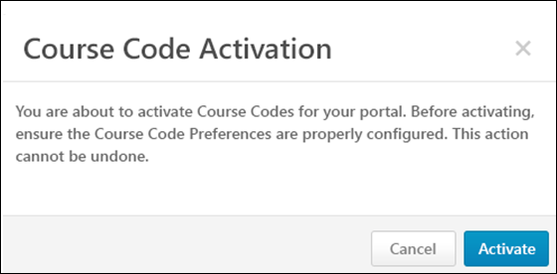
Cancel
To discard any changes made to the Course Code Preferences page without saving and without activating course codes in the portal, click Cancel. Note: Once course codes have been activated, changes made to the Course Code Preferences page may not be canceled.
Save
To save any changes made to the Course Code Preferences page, click Save. Note: Saving changes made to the Course Code Preferences page does not automatically activate course codes in the portal.
Course Code Auto-Generation
When an administrator creates and saves a new LO in a portal with active course code preferences, an alpha-numeric LO ID code is automatically generated for the LO. This code adheres to the preferences set in Course Code Preferences, and no duplicate codes can be generated. Course codes are automatically generated for the following LO types:
- Certifications
- Curricula
- Events and Sessions
- Materials (including DMS materials)
- Online Courses
- Programs and Cohorts
- Tests
- Videos
Course codes generated for learning objects are visible to the administrator via the General tab of the Course Catalog when editing a learning object.
Copy Learning Object with Course Code
If an administrator copies an existing learning object which supports course codes, a new course code is automatically generated for the LO copy. The course code generated for the copied LO will be unique. Duplicate course codes CANNOT be generated.

Course Ratings Preferences
The Course Ratings Preferences page enables administrators to enable and configure the reviews and ratings functionality.
To manage Course Ratings Preferences, go to Admin > Tools > Learning > Learning Preferences > Course Ratings.
Permissions
PERMISSION NAME | PERMISSION DESCRIPTION | CATEGORY

Course Reviews and Ratings Preference - Manage | Grants ability to configure course reviews and ratings functionality by division. This is an administrator permission. | eCommerce - Administration
This functionality is disabled by default. To enable this functionality, contact Global Customer Support.
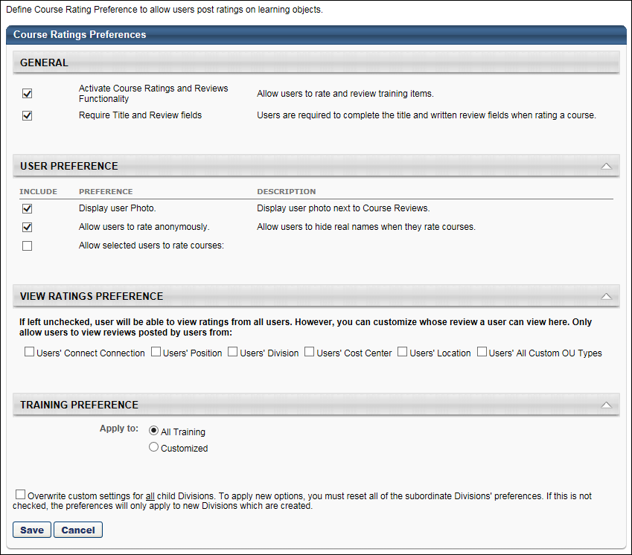
Note: In the View Ratings Preference section, the Users' Connect Connection option is only available if Connect is not enabled for the organization.
The following preferences are available:
General
Activate Course Ratings and Reviews Functionality - Select this option to activate course ratings and reviews for the division. When this option is selected, all of the functionality associated with reviews and ratings are also enabled. All users within the associated division are able to view course ratings.
Require Title and Review fields - This option enables administrators to configure whether or not users are required to provide a review title and review text when rating a course. This option is selected by default.
- When this option is not selected, users can provide a rating for the course without providing a review.
- When this option is selected, users are required to provide a review when rating the course, including a review title and review text.
User Preference
- Display user photo - Select this option to include the user's photo when they rate and review a course.
- Allow users to rate anonymously - Select this option to allow users to hide their identity when rating a course. The option to rate a course anonymously may lead users to rate a course more honestly.
- Allow selected users to rate courses - Select this option to enable users to rate and review courses. After selecting this option, you must then select which users are able to rate courses. The available options are:
  - All Users - All users are able to rate a course, regardless of their registration status.
  - Registered Users Only - Only users who have registered for the course can rate the course. Users can rate the course as soon as they have registered for the course, even if they have not started or completed the course. The Rate Course option is not available unless they have registered for the course.
    - Users in the following course statuses are able to rate the course: Completed, Past Due, Failed, Registered, In Progress, Pending Acknowledgement, Pending Evaluation, Pending Completion Approval, Cancelled, Incomplete, No Show, Withdrawn
    - Users in the following course statuses cannot rate the course: Denied, Completed (Equivalent), Exception Requested, Approved, Pending Approval, Pending Payment, Pending Prerequisite, Registration Pending, Waitlisted
  - Completed Users Only - Only users who have completed the course can rate the course. The Rate Course option is not available unless they have completed the course.
    - Users in the following course statuses are able to rate the course: Completed
View Ratings Preference
By default, users can view ratings that are made by all users in the system. In this section, you can customize whose reviews a user can view. Select the options to only allow users to view reviews made by the selected users. For example, if you select "Users' Division" then a user can only view reviews left by users that are in their division. If a review is left by a user outside their division, then they cannot view it.
- The available options are: Users' Connect Connection, Users' Position, Users' Division, Users' Cost Center, Users' Location, and Users' All Custom OU Types.
  - Note: The Users' Connect Connection option is only available if Connect is not enabled for the organization.
- If no options are selected, then users can view ratings made by all users in the system.
Training Preference
Apply to - Select the types of training that are able to be rated.
- All Training - Allow all training types to be rated.
- Customized - Select this option to customize which LOs can be rated. Additional options are available when this option is selected.
  - Training Type - Select the various training types that can be rated. If a training type is not selected, then all training items of that type cannot be rated.
  - Excluded Training Titles - Select this option to exclude specific training titles from ratings. When this option is selected, a pop-up icon appears. Click the pop-up icon to select specific titles to exclude from ratings.
  - Provider - Click the Add Provider link to select specific training providers that are eligible for ratings. All LOs associated with the selected providers can be rated unless specifically excluded in the Exclude Training Titles section.
  - Subject - Click the Add Subject link to select specific training subjects that are eligible for ratings. All LOs associated with the selected subjects can be rated unless specifically excluded in the Exclude Training Titles section.
Default Training Image Preferences
The Default Training Images Preferences page allows administrators to configure default thumbnail images for different training types. The thumbnail images set here are applied to any training that does not have a custom thumbnail image set for it via the Course Catalog. This means that the random image logic will no longer apply. These new default images apply to the following pages:
- Browse for Training landing page and tile view
- Course Console pages
- Course Recommendations on Training Completion page
- Learner Home
- Learning Search Tiles
To access the Default Training Images Preferences page, go to Admin > Tools > Learning > Learning Preferences > Default Training Image Preferences. The preferences set on this page are portal-wide preferences. Default training image preferences cannot be set by division.
To download a zipped file of the default learning object (LO) thumbnails used in the system, click the link below:
Default LO Thumbnail Images
Permissions
PERMISSION NAME | PERMISSION DESCRIPTION | CATEGORY

Default Training Image Preferences | Grants access to Default Training Image Preferences page where an administrator can configure custom default images for training by type. This permission cannot be constrained. This is an administrator permission. | Learning - Administration
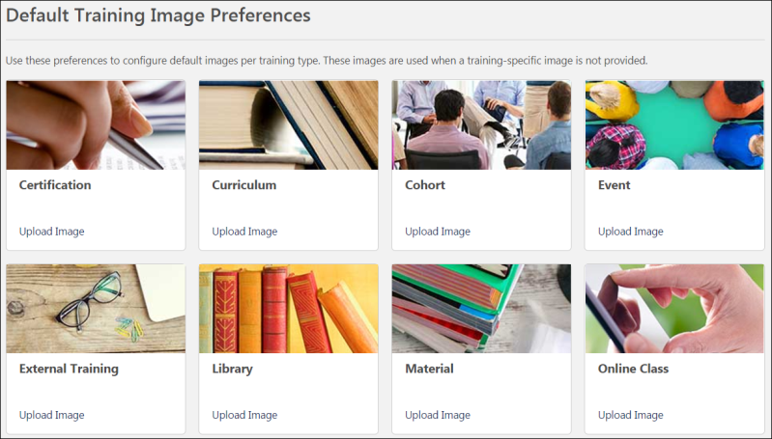
Default Training Image Preferences
Default training image preferences can be set for the following training types:
- Certification
- Curriculum
- Cohort
- Event
- External Training
- External Content
- Library
- Material
- Online Class
- Posting
- Program
- Quick Course
- Session
- Test
- Video
To configure a default image for a training type:
- Click the Upload Image link for the desired training type. This opens a flyout on the left side of the page.
- Either click the Select an Image button to search for and select an image from your computer, or drag and drop an image from your computer desktop into the image upload zone in the flyout.
- After uploading an image, click the See Preview link to preview the image in the Preview section.
- Click the Save button to save the new image as the default image for training type, or click the Cancel button to discard the image without affecting the default image settings for the training type.
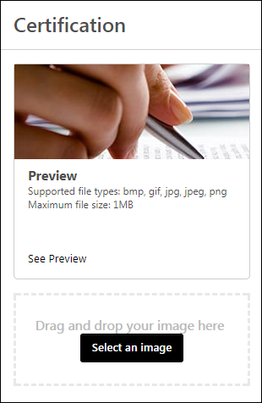
To reset the default image for a training type back to the Cornerstone provided image:
- Click the Reset link for the desired training type. This opens a modal on the page. Note: This option only appears if a custom default image has been uploaded for the training type (i.e. not the image provided by the system).
- Click the YES button to reset back to the default image for the training type, or click the NO button to return to the Default Training Image Preferences page without affecting the default image settings for the training type.
Note: Resetting to the default image discards the previous image that was uploaded for the training type. It cannot be restored.
Image Specifications
- Recommended image dimensions: Aspect ratio of 2:1.
- Supported image file types: bmp, gif, jpg, jpeg, png
- Maximum image file size: 1MB

Define Custom Fields for Training
When you click the Define Custom Fields for Training link, this opens the Custom Fields Administration for Training page.
Search for a Field
The following filters are available to search for an existing custom field:
- Name - Enter search terms in the filter. The field displays results for a partial or exact match to the search terms.
- Field Type - Select a field type from the drop-down.
- Include Inactive - Check the box to include inactive custom fields in the search.
Once all filters are defined, click Search. This refreshes the fields table with the filtered results.
Add Custom Field
To create a custom field, click the Add Field icon. This opens the Define field page. From here, you can select the type of field you want to create and define the options for the field if applicable. Information about how to create the specific types of custom fields (i.e., branched dropdown, checkbox, etc.) is available on the "Custom Field Type Options" page in Online Help. See Custom Field Admin - Custom Field Type Options.
Fields Table
This table displays all existing custom fields for the field area. The table is sorted in alphabetical order by name. The Title and Created By columns are sortable. The following information displays in the table:
- Title - This column displays the title of the custom field.
- Type - This column displays the field type, such as radio button or short text box.
- Created By - This column displays the name of the administrator who created the field by last name, first name.
- Active - This column defines the active status of the field. To activate the field, check the box in the Active column. To inactivate the field, uncheck the box.
When active, the custom field is available to use by administrators who meet the field's availability requirements. Inactive custom fields are not available to use.
- Options - The following options are available in the Options column:
  - Edit - Click the Edit icon to edit the field. The field type cannot be modified when editing the field. See Custom Field Admin - Custom Field Type Options.
  - Delete - Click the Trash Can icon to delete the field. This option is only available if the custom field has not been used. If a field has been used, then it cannot be deleted and the Trash Can icon does not display. There is no audit history available to view custom fields that were deleted. Please reach out to Global Customer Support if additional details are needed for a deleted custom field.
Note: Deleting a custom field permanently deletes the field from the system and any data associated with the field is lost. To remove a custom field from a learning object (LO), but keep the data, a best practice is to edit the custom field and remove visibility from all training types.
- Display event fields to end-users on the session details page - Select this option to have custom fields for events automatically display on the sessions for the corresponding event as well.
- Define LO Type and Order - Click this link to define the display order of existing custom fields and view for which types of learning object the custom fields will display.
To create a Training custom field:
- Click Add Field icon .
- Name - Enter the name of custom field that will be visible to end user. If multiple languages are enabled, click the Translate icon to the right of the field to localize the values to the other available languages.
- Email Tag - Enter the name for the email tag to be associated with this field, and use it to retrieve the value of this field in email communications. The tag must be written in capital letters without spaces. Periods (.) can be used instead of spaces. For example, PROFIT.NET is an acceptable email tag.
  - Custom tags are prefixed with the word CUSTOM. For example, for a custom field called Profit Net, the administrator can create the tag, PROFIT.NET, and the system will convert this to CUSTOM.PROFIT.NET.
- Type - From the drop-down list, select the type of field you are creating. The following options are available. See Custom Field Admin - Custom Field Type Options for additional information.
  - Branched Dropdown
  - Checkbox
  - Conditional Numeric Field - See below for Conditional Numeric Field validation options.
  - Date field
  - Dropdown
  - Hierarchy
  - Multiple Checkbox
  - Numeric Field
  - Radio Button
  - Scrolling Text Box
  - Short Text Box
- Available Languages - From the drop-down list, select the languages in which the custom field is available. The available languages are mainly used for searching purposes and they are independent of the LO's default language. At least one language must be selected. At the top of the drop-down list, all selected languages are displayed. The drop-down list only displays the languages that are available to the user. Select the All Languages option to select all available languages. When a language is selected, the custom field is associated with that language.
- Fields Details for Each Training Type - Select the various options for the custom field for each LO type. Select the Check All option to select each option for all LOs. The following options are available:
  - Active Training Type - Select the types of learning objects for which this custom field is visible.
  - Response Required - Select whether administrators who are creating these learning objects must set a value in the custom field.
  - Editable on Transcript by Admin - Select whether an administrator can change the value of this field for individual users by accessing their transcript. An example of when this might be used is for a credit field where you might change the credits a user received for this learning object.
  - Visible to End User on Transcript - Select whether end users can see this field with the value the administrator selected when the administrator created the LO. This applies to the Learning Details and Training Details on Transcript. If this option is deselected, then only the administrator can see the field.
  - Editable on Transcript by End User - Select this option to allow editing and changing of the value for the field. This can be useful when creating custom fields for external training, in which users are entering information about the training. Note: This field is only available if the Visible to End User option is selected for the training type. If a field is available for external training, it is a best practice to make the field visible and editable by end user to ensure the end user can use the field when adding their external training.
- Active - Select this option to make the field active.
- Availability - Define which users have the ability to view and access the custom field. See Setting Availability Overview for additional information. The administrator must set the availability of the field if the field is to appear for other administrators and end users in the application. If availability is not set, then the field will not appear in administrator and end user areas of the application.
- Click Save.
Lock History Rules
A user's transcript history and course completion certificate information is locked once the learning object's (LO) status is Complete. Updates to custom Training fields do not influence the transcript history or certificate when the user achieves the status of Complete, even if a custom field is removed.
Considerations and Exceptions
- Transcript Custom Fields - If no value is set for a custom field within user's Transcript Details, the default value saved for the field in the Course Catalog is displayed. If no such value is set for the training, then the default value set in Custom Field Administration is displayed.
- Historical Certificates - When printing historical certificates, the certificate shows the custom field value at the time the user achieved a Complete status for the LO. If the custom field value changes, then the change displays on the certificate.
- Learning Assignment - Assign New Occurrence simulates recurrence. If a user is assigned a new occurrence of training, the Transcript Details page shows a new instance of the training. If the value of the custom field changes, then the Transcript Details page displays the new value. For certificates, the historical value of the custom field is preserved. Note: Because only one instance of the value is stored, the old value is removed. For reporting, the new value displays if a second instance exists.
- Transcript Details Page - If the value in a custom field is removed after the user achieves a status of Complete, the custom field still displays on the Transcript Details page and certificate but is a blank field.
- Inactivated Custom Field - If a custom field is inactivated, the field does not display on the user's Transcript Details page when the LO has a status of Complete. Only active items display on the page. Certificates display all items that are active at the time the user achieved a status of Complete.
- Reporting - Users can only report on currently existing and active custom fields.
- Ordering - Custom field options appear to users in the order in which the options were added and display on Custom Field Administration page. For example, if "Colorado" is added before the option "Alaska" in a dropdown custom field, the options will display in this order.
- Event and Session Custom Fields -
  - If a custom field is only active for events (and not for sessions), reporting will only show a value for the custom field when reporting on an event training type. When reporting on session training type, the value for the custom field will be blank.
  - Updating a session custom field at the session level will not sync with the user transcript. For example, if an administrator updates the custom field value from the user's transcript (e.g., CV1) and then later updates the same field to a different value (e.g., CV2) at the session level, the system will still display CV1 in the user transcript.
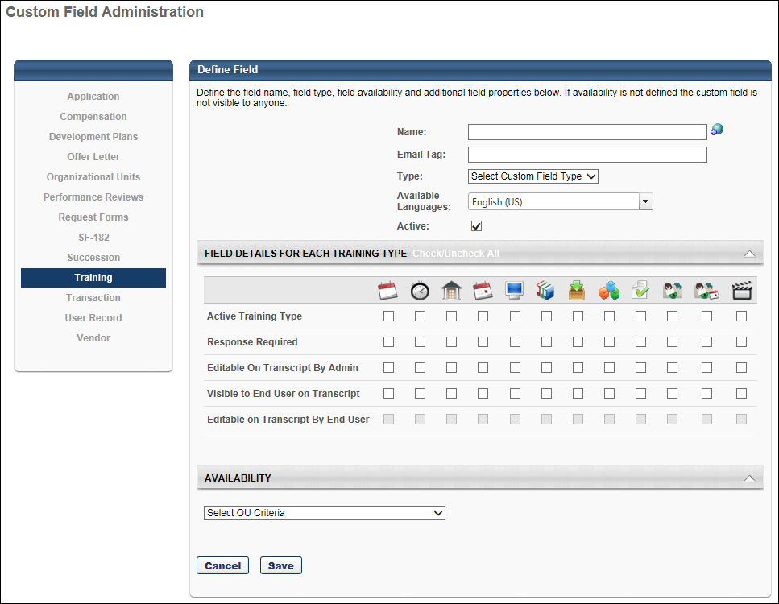

Evaluation Preferences
The Evaluation Preferences page enables administrators to set preferences for each evaluation level and define the default Likert scale used for evaluation questions. The Evaluation functionality enables you to create and deploy Level 1 through 3 evaluations for your learners and managers.
Evaluation Availability: With most learning objects (LOs), the evaluation is available to the user after the LO is completed. However, when an evaluation is used with an event session, the evaluation is only available to the user at the session start time. In the case of a multi-part session, the evaluation is only available at the session start time of the final part.
To manage Evaluation Preferences, go to Admin > Tools > Learning > Learning Preferences > Evaluations.
Permissions
PERMISSION NAME | PERMISSION DESCRIPTION | CATEGORY

Evaluation Preferences - Manage | Grants ability to manage Evaluation Preferences, which includes configuring options for each evaluation level and defining the default Likert scale used for evaluation questions. This is an administrator permission. | Learning - Administration

Level 1 Evaluation Administration | Grant Access to create and manage level 1 (reaction) evaluations associated with learning objects. This permission cannot be constrained. This is an administrator permission. | Learning - Administration

Level 1 Evaluations - Manage | Grants ability to create and edit Level 1 (Reaction) learning evaluations that can be associated with learning objects. When viewing Course Console, this permission also grants the ability to view the status of Level 1 Evaluations. This permission works in conjunction with the Level 1 Evaluation Administration, Course Catalog - Update, and Course Catalog - View permissions. This permission cannot be constrained. This is an administrator permission. | Learning - Administration

Level 2 Evaluations - Manage | Grants ability to create and edit Level 2 learning evaluations that can be associated with learning objects. When viewing Course Console, this permission also grants the ability to view the status of Level 2 Evaluations. This permission works in conjunction with the Level 2 Evaluation Administration (knowledge and scored), Course Catalog - Update, and Course Catalog - View permissions. This permission cannot be constrained. This is an administrator permission. | Learning - Administration

Level 2 Knowledge (Non-Scored) Evaluation Administration | Grant Access to create and manage level 2 knowledge (non-scored) evaluations associated with learning objects. This permission cannot be constrained. This is an administrator permission. | Learning - Administration

Level 2 Scored Evaluation Administration | Grant Access to create and manage level 2 (scored) evaluations associated with learning objects. This permission cannot be constrained. This is an administrator permission. | Learning - Administration

Level 3 Evaluation - Manage | Grants ability to create and edit Level 3 (Behavior) learning evaluations that can be associated with learning objects. When viewing Course Console, this permission also grants the ability to view the status of Level 3 Evaluations. This permission works in conjunction with the Level 3 Evaluation Administration, Course Catalog - Update, and Course Catalog - View permissions. This permission cannot be constrained. This is an administrator permission. | Learning - Administration

Level 3 Evaluation Administration | Grant Access to create and manage level 3 (behavior) evaluations associated with learning objects. This permission cannot be constrained. This is an administrator permission. | Learning - Administration
Level 1 (Reaction) Evaluations
- Allow level 1 evaluations - Select this option to enable level 1 evaluations for learning objects. If unchecked, the administrators will not be able to associate level 1 evaluations with learning objects.
  - Assign default level 1 evaluation to all courses - Select the learning types for which you want to associate a default evaluation. Note: You can select the specific default evaluation to be associated with each learning type. See Evaluation Defaults for additional information.
- Enter the number of days after which the level 1 evaluations expire - Select this option to set an expiration period, after which evaluate link will not appear for the end user.
  - Expiration Period - Enter the number of days the end user will have to access the evaluation. After the evaluation expires, the user's transcript status is changed to Completed, and the user no longer has the option to evaluate the LO. Note: The expiration of the evaluation form for ILT is counted from the end date of the session as the evaluation form becomes available at from the start of the last part of the session. Roster updates submitted after the evaluation expiration will immediately move to a Completed status.
For troubleshooting information regarding Level 1 evaluations: See Troubleshooting Guide - Level 1 Evaluations.
Level 2 (Learning) Evaluations
- Allow level 2 evaluations - Check to allow level 2 evaluations for learning objects. If unchecked, the administrators will not be able to associate level 2 evaluations to learning objects.
  - Include option for pre-training evaluations - Check to allow a level 2 pre-training for learning objects. If unchecked, the administrators will not be able to associate level 2 pre-training evaluations to learning objects.
- Assign default level 2 evaluations to all courses - Check learning types for which you want to associate a default evaluation. Note: You can select the specific default evaluation to be associated with each learning type. See Evaluation Defaults for additional information.
Level 3 (Behavior) Evaluations
- Allow level 3 evaluations - Check to allow level 3 evaluations for learning objects. If unchecked, the administrators will not be able to associate level 3 evaluations to learning objects.
  - Include option for pre-training evaluations - Check to allow a level 3 pre-training for learning objects. If unchecked, the administrators will not be able to associate level 3 pre-training evaluations to learning objects.
- Assign default level 3 evaluations to all courses - Check learning types for which you want to associate a default evaluation. Note: You can select the specific default evaluation to be associated with each learning type. See Evaluation Defaults for additional information.
Default Likert Scale
Enter values for 5 point Likert Scale which will appear as a default for new questions created for evaluations. Note: Likert Scale values can be changed when creating evaluation questions. For portals with multiple languages enabled, localize the field by using the Translate icon to enter localized text.
Cancel/Submit
Click Cancel to discard any unsaved changes. Or, click Submit to save any unsaved changes.
Evaluation Availability: With most learning objects (LOs), the evaluation is available to the user after the LO is completed. However, when an evaluation is used with an event session, the evaluation is only available to the user at the session start time. In the case of a multi-part session, the evaluation is only available at the session start time of the final part.
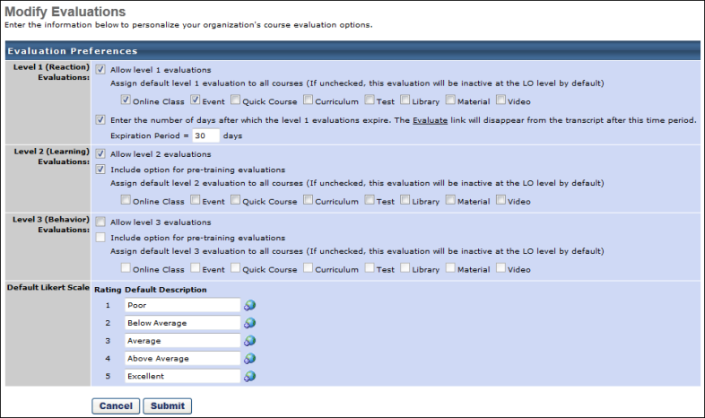
Helpful Hints
- If making an evaluation required for completion of the learning object, set an expiration period. When the evaluation period expires the course status changes from Pending Evaluation to Completed.
Express Class Preferences
On the Express Class Preferences page, administrators can configure a default provider for material training items created through Express Class.
To access Express Class Preferences, go to: Admin > Tools > Learning > Learning Preferences and click the Express Class Preferences link. Express Class Preferences are set by division.
Permissions
PERMISSION NAME | PERMISSION DESCRIPTION | CATEGORY

Express Class Preferences | Grants ability access the Express Class Preferences page, which allows administrators to set a default provider for material training items created through Express Class. | Learning - Administration
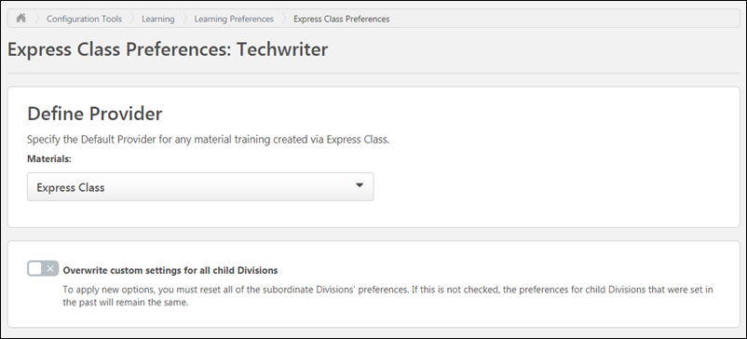
Define Provider
For material training items created via Express Class, a default provider can be specified. To select a default provider, click the drop-down menu in the Define Provider section and select one of the available providers. When a new Express Class material is created, it receives the default provider defined on this page.
For more information about training providers: See Training Providers Overview.
Overwrite Settings
Select this option to overwrite custom settings for child division OUs. If you overwrite custom settings for child division OUs, the selected settings are applied to both new and existing child OUs. Any previously customized child OUs are updated with the selected settings.
- If there are no customizations to the child OU, then the parent OU customizations are applied to all child OUs.
- Overwrite custom settings checkbox setting
  - If this option is selected, all child OU customizations are deleted from the database, which means the parent OU customizations will be applied to new and existing child OUs.
  - If this option is unselected, all existing child OU customizations will remain unchanged, and any new child OUs will inherit the parent OU customizations by default.
- If a child OU has been customized to display any widgets, then regardless of the parent OU customizations, the child OU customizations are applied.
- If a child OU has been customized to hide all widgets, then parent OU customizations will take precedence and will be applied.
Save
After making any changes to the Express Class Preferences page, click the Save button at the bottom of the screen to apply your changes to the portal.
Learning Feature Activation Preferences
The Feature Activation Preferences page allows administrators to self-enable different system features.
To access Learning Feature Activation Preferences, go to: Admin > Tools > Learning > Learning Preferences and click the Feature Activation Preferences link.
Permissions
PERMISSION NAME | PERMISSION DESCRIPTION | CATEGORY

Learning Features Self Activation | Grants access to the Feature Activation Preferences page, where an administrator can activate new features associated with Learning, Connect and Extended Enterprise. | Learning - Administration
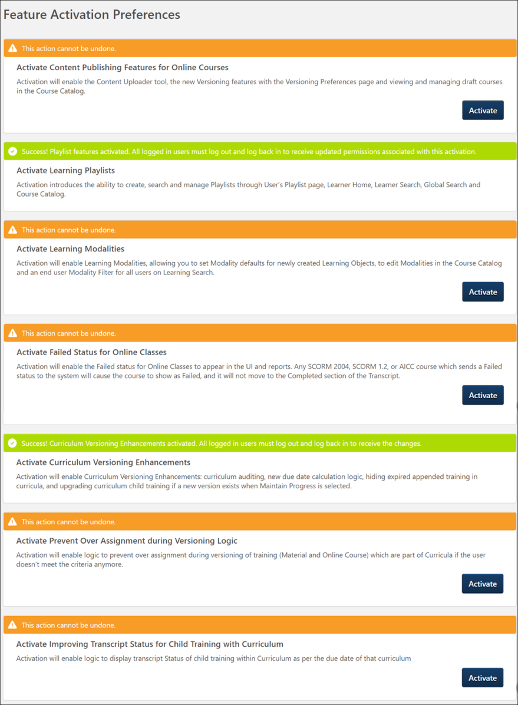
Activate Content Publisher Features for Online Courses
In order for Content Publishing functionality to be accessible in the portal, an administrator must activate it. To activate Content Publishing functionality for online courses in your portal:
- Click Activate in the Activate Content Publisher Features section. A warning message appears, asking if you are certain you want to activate Content Publishing functionality in the portal.
- Click Activate to complete the activation of Content Publishing features in the portal. Once activated, this functionality cannot be deactivated, and the old Course Publisher is no longer active or accessible. To exit without activating Content Publishing functionality, click the Cancel button.
- Log out of the portal and log in again to receive the permissions associated with the new functionality and begin using the Content Publisher.
After the feature has been activated, the orange header for the section turns green to indicate the activation was successful. The Activate button is no longer available once the feature has been activated.
For more information about creating online courses using Content Publisher, see Create an Online Course - Overview.
For more information about versioning and modifying online courses using Content Publisher, see Online Course Versioning vs. Modifying - Overview.
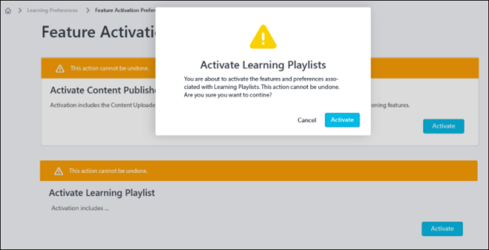
Activate Curriculum Player 2.0 radio button option in Curricula Administration
This setting is only available after the March 26, 2024 hotfix deployment.
This setting controls whether the Curriculum Player 2.0 radio button option is available in the Curriculum Player setting when creating or editing a curriculum in Curricula Administration. This setting is enabled by default.
Activate Learning Playlists
Learning Playlists functionality will be released in a post-February release patch. Once the functionality is available, administrators can activate playlists using the following steps:
- Click Activate in the Activate Learning Playlists section. A warning message appears, asking if you are certain you want to activate Learning Playlists functionality in the portal.
- Click Activate to complete the activation of Learning Playlists in the portal. Once activated, this functionality cannot be deactivated. To exit without activating playlists, click Cancel.
- Log out of the portal and log in again to receive the permissions associated with the new functionality and begin using playlists.
After the feature has been activated, the orange header for the section turns green to indicate the activation was successful. The Activate button is no longer available once the feature has been activated.
Note: Documentation for Learning Playlists will be made available when the functionality is released.
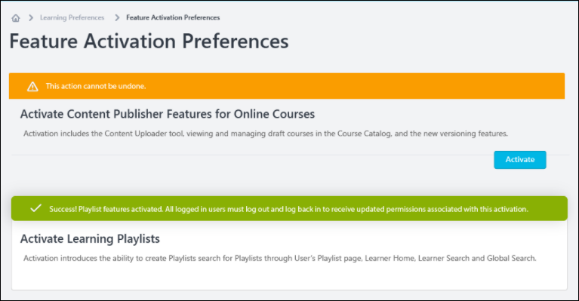
Activate Learning Modalities
In order for Learning Modalities functionality to be accessible in the portal, an administrator must activate it. To activate modalities in your portal:
- Click Activate in the Learning Modalities section. A warning message appears, asking if you are certain you want to activate Learning Modalities functionality in the portal.
- Click Activate to complete the activation of Learning Modalities features in the portal. Once activated, this functionality cannot be deactivated. To exit without activating Learning Modalities, click Cancel.
- Log out of the portal and log in again to receive the permissions associated with the new functionality and begin using Learning Modalities.
After the feature has been activated, the orange header for the section turns green to indicate the activation was successful. The Activate button is no longer available once the feature has been activated.
Learning Modalities functionality will be available in the following system areas after the activation:
- Learning Search
- Learning Search Preferences (learning modalities can be modified for individual organizational units (OUs) here)
- Course Catalog
- Course Console
- Modality Preferences
Activate Failed Status for Online Classes
In order for the Failed status to be available for online classes in a portal, an administrator must activate it. To activate this functionality in your portal:
- Click Activate in the Activate Failed Status for Online Classes section. A warning message appears, asking if you are certain you want to activate this functionality in the portal.
- Click Activate to complete the activation of curriculum compliance features in the portal. Once activated, this functionality cannot be deactivated. To exit without activating this functionality, click Cancel.
- Log out of the portal and log in again to receive the new functionality and begin using the Failed status for online classes.
After the feature has been activated, the orange header for the section turns green to indicate the activation was successful. The Activate button is no longer available once the feature has been activated.
Activate Prevent Over Assignment During Versioning Logic
To activate the logic that prevents the overassignment of versioned materials and online courses, click Activate in the Activate Prevent Over Assignment During Versioning Logic section of the Learning Feature Activation Preferences page. Note: Once this logic has been activated in a portal, it cannot be deactivated.
This setting prevents the unintended overassignment of versioned materials and online courses in the following scenarios:
The material or online course was versioned, and the Assign To option is set to Users Assigned by Dynamic Assignment. Then:
- The versioned material or online course was contained within a curriculum that was assigned to the learner in the past, but the material or online course is no longer part of that curriculum, and the learner has already completed the material or online course.
- A child material or online course contained within multiple curricula is assigned to a learner via different assignment criteria and the learner completes both curricula. If the learner is removed from one of the assignment criteria and the child training is versioned, the learner receives both curricula even though they are not part of all the assignment criteria anymore.
Activate Improving Transcript Status for Child Training with Curriculum
When this logic is enabled, the transcript status of child training will be in sync with the due date displayed in the curriculum that the user is currently viewing. For example, if the curriculum's minimum due date is in the past and the user views a training item within the curriculum whose due date is in the future, the user will see the child training item in a status of Registered. The minimum due date of the curriculum does not cause child training items to display as Past Due. This updated behavior will also be accurately reflected in reporting. Click the Activate button for this option to activate the logic.
When this logic is NOT enabled, when viewing child training in a curriculum on a learner’s transcript, the curriculum transcript status of the child training is based on the earliest due date for that child training in all the curricula on that learner’s transcript, even if the due date for the child training is set to a future due date inside of this curriculum. For example, if a curriculum's minimum due date was in the past and the user views a training item within the curriculum whose due date is in the future, the user will see the child training item in a status of Registered/Past Due.
Activate Retention of the Applicable Due Date for Child Training Object Upon Removal
A preference that will cause the due date of completed training items within one or more curricula to be retained when the curriculum is removed from the user's transcript can be activated on the Learning Feature Activation Preferences page. Click Activate to enable the due date retention behavior for child training items contained within one or more curricula. Once activated, this preference cannot be deactivated. For more information: See Curriculum Child Training - Retain Due Date Upon Removal.
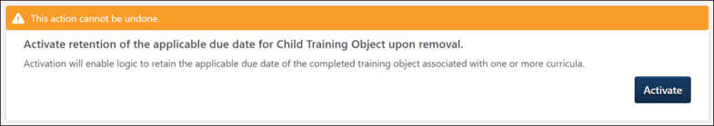
User Interface Modifications
By default, the UI Modifications and Enhancements functionality is disabled for all organizations.
The preference can be enabled and disabled, if necessary, to change whether the portal uses the updated interface or the legacy interface. However, the user must log out, then log in for the change to take effect.
This setting impacts the following areas:
- Course Catalog
- Curricula - Edit and Create
- Deep Links Administration
- ILT Create and Edit New Sessions and Events
- Materials Administration
- Training Request Approval
Note: The new user interfaces for the above pages will be automatically enabled in production, stage, and pilot portals with the Q3 2024 Release and the legacy user interface pages will no longer be available. Therefore, the User Interface Modifications feature activation may no longer exist after Q3 2024 release.
How does customization and branding work with the updated designs?
Any customer with a custom theme and logo set in Display Preferences should expect their portal to work normally with this update. However, certain customers utilizing custom code or branding, such as Google Tag Manager, cannot utilize the new designs at this time.
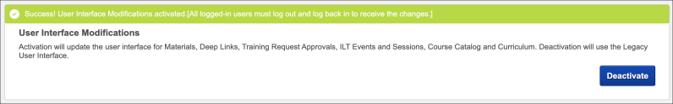
Disable Auto-Populating Results in Administrative Search
This preference is enabled by default. When the preference is enabled, various administrative search pages display an “empty state” upon initial load. It helps the administrators to search faster as they are not forced to wait for all the results to load before they can perform a search. The administrators can still search for the full catalog by conducting an “empty search.” Click deActivate to enable the initial loading time of learning administration pages with a large amount of training objects.
The list of administrative pages includes the following:
- Manage Sessions​
- Curriculum Administration​
- Material Administration​
- Test Administration​
- Question Administration​
- Certification Administration​
- Video Administration​
Note: The Manage Events page is not affected by the functionality of the preference.
Disable Auto Populating Results in Administrative Search - Learning Assignment Tool - Manage Assignments
This preference is disabled by default. Click activate to enable this preference. When the preference is enabled, the Manage Learning Assignment page within the Learning Assignment Tool displays an “empty state” upon initial load.
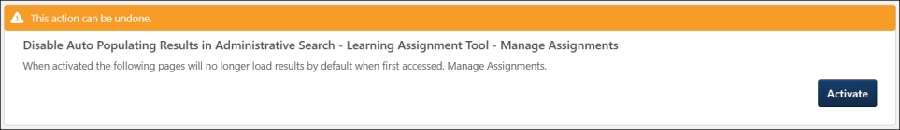​
Activate New Versioning Enhancements
Click Activate to ensure that Curriculum Versioning workflows are consistent and reliable whenever a Curriculum Child LO is versioned, or Curriculum structure is modified simultaneously so that the right users get the right training at the right time maintaining compliance for tracking training completions. ​
Activate Learning Transcript Deletion Mechanism for Compliance
Note: This functionality is off by default. Contact Global Customer Support (GCS) to enable.
Click Activate to automatically delete User Transcript Data based on a defined retention period for inactive users in accordance with various regulations, such the EU GDPR and the Right to be Forgotten policy. After activation, the following applies:
- Data deletion respects the retention rule set at the Legal Entity Organizational Unit (OU) which users are part of at the time of the deletion.
- Automatic deletion applies to the transcript of inactive users who are terminated.
The following transcript data is deleted:
Deleted Data
The following Essential Transcript Data is deleted:
Transcript Peripheral Data | Transcript Core Data
Training Certificates​ ​ | Transcript data for the transcript of the User (LO id, LO Title, subject, version etc.)​
​ Attachments (OJT/ Express Class)​ | Transcript status (not started, pending approval, in progress, completed, etc.) and eventual scores​
Comments (entered when assigning, approving/ denying, marking complete, updating transcript, exempting, removing, etc.)​ | Dates (assignment date, due date, completion date, etc.)​
Evaluations | ​ Active, Completed, Archived , Removed Transcript
Reporting
Time-based Data Deletion
The following applies to time-based data deletion:
- Before opting-in for this process Customers must request via GCS one-time historical data cleanup for previously anonymized/ deleted Users if they already use User anonymization/ deletion mechanism in their portal.
- Time-based deletion occurs automatically after a certain period. The execution itself is triggered on daily basis for Inactive User’s Learning Transcript Data based on the User’s termination date.
- The user must belong to a Legal Entity OU and must be inactive. Users should be assigned to the Legal Entity before their termination date.
- Data is erased permanently from the database and cannot be recovered. Data is also removed from the Reports.
- Customers must enable User data anonymization/ deletion prior to Time based activation for Transcript for each Legal Entity OU.
User Interface Modifications - ILT Roster pages
Click Activate to activate or deactivate the new user interface for the ILT Roster pages, ILT administrator waitlist pages, and the ILT administrator exception request pages.
Note: The new user interface for ILT Roster pages will be automatically enabled in production, stage, and pilot portals with the Q3 2024 Release and the legacy user interface pages will no longer be available. Therefore, the User Interface Modifications - ILT Roster pages feature activation may no longer exist after Q3 2024 release.
Test Administration User Interface Modifications
Click Activate to activate or deactivate the new user interface for the Test Engine Administration pages.
Note: The new user interface for Test Administration will be automatically enabled in production, stage, and pilot portals with the Q3 2024 Release and the legacy user interface pages will no longer be available. Therefore, the Test Administration User Interface Modifications feature activation may no longer exist after Q3 2024 release.
Activate Required Training Tagging
Click activate to introduce the ability to set a learning assignments as required, create and manage required training reasons and categories. Once activated, this preference cannot be deactivated.
Activate Recurrence Fix to include Greater than Consideration for Dynamic Recurring Learning Assignments
With this feature enabled, the Learning Assignment Tool (LAT) assigns the training to users who have surpassed the recurrence date criteria of dynamic assignments but still satisfy the training assignment criteria, if dynamically recurring Learning Assignments have the recurrence date set as “Relative” or “Annually”. It also allows Learning Assignments to search for all users who have missed the recurrence date of trainings in the past.
Certification Administration User Interface Modifications
Click Activate to activate or deactivate the new user interface for the Certification Administration pages.
Note: The new user interface for Certification Administration will be automatically enabled in production, stage, and pilot portals with the Q3 2024 Release and the legacy user interface pages will no longer be available. Therefore, the Certification Administration User Interface Modifications feature activation may no longer exist after Q3 2024 release.
Activate Video Auto-Completion
Click Activate to activate the video auto-completion feature. When enabled, it allows videos to auto-complete without any user involvement after the user has watched the entire video. Enabling this functionality removes the ‘Mark Complete’ button from the following areas to maintain consistency:
- The ellipsis menu on the user transcript page.
- The Learning Details page when the video is already on the learner’s transcript.
- The “Continue Learning” carousel and training side panel in the Learner Home.
The auto-completion feature adds a supporting text under the video player to inform learners that the video automatically marks as complete once watched until the end. The text message is displayed in standalone videos and is localized based on the learner’s display language.
​
Here are the points to consider when enabling auto-completion feature:
- This is a portal-wide setting. When enabled, the auto-completion logic applies to all existing and new videos. It cannot be configured separately for individual videos.
- This feature encompasses both standalone videos and videos within curricula. (Curriculum Player 2.0 is currently not in scope).
- Videos in Programs and Cohorts are excluded and must be manually marked as complete.
- Auto-completion does not prevent fast-forwarding.
- The percentage viewed to achieve a completion cannot be configured. Once the video's progress time in the progress bar reaches the video duration, the video is automatically marked as complete.
- This enhancement does not include video auto-completions within the Cornerstone CSX app.
Note: No activation is required if the video auto-completion functionality is already enabled.
Allow Revert for Sessions which are part of Curricula
Click Activate to activate the Allow Revert for Sessions which are part of Curricula feature. When enabled, it allows administrators to revert ILT session completions where the session is part of one or more curricula. Reverting sessions, that are part of curricula, can impact Curriculum transcript status and recalculate progress.
Note: This functionality only supports the ability to revert a session completion where sessions are part of the curricula. It does not revert session completions if the session relates to prework, postwork, prerequisites, programs, cohorts, or certifications.
Activate Version Equivalence Alignment - Materials And Online Course
This preference is activated by default. Click activate to enable this preference. When enabled, users who have completed the previous version, have a version equivalence received for the previous version, or should be entitled to have received one can get a version equivalence status for the newly created version. This feature enables the enhanced version equivalence flow for online courses and materials always to respect the basic business logic of applying version equivalence with the previous version. Once activated, this preference cannot be deactivated.

Learner Home Preferences
On the Learner Home Preferences page, administrators can set the display order of Learner Home content and add custom banners and cover images to the Learner Home page. Learner Home Preferences are set by division.
To access Learner Home Preferences, go to Admin > Tools > Learning > Learning Preferences > Learner Home Preferences. Select the division for which you want to configure preferences.
Note: It is possible to set Learner Home preferences by an organizational unit (OU) other than division, but this is not self-configurable. Contact Global Customer Support to set Learner Home preferences using a different OU type, such as Position, Location, etc.
Permissions
PERMISSION NAME | PERMISSION DESCRIPTION | CATEGORY

Learner Home Preferences | Grants access to the Learner Home Preferences, where the administrator can configure the arrangement of content on Learner Home, as well as other settings. This permission also grants access to the Learning Search Preferences page, where the administrator can configure Learning Search options. This permission can be constrained by organizational unit (OU) and User's OU. This is an administrator permission. | Learning - Administration
Cover Image Configuration
To upload a cover image for the Learner Home page:
- Drag and drop your prepared image file into the image upload zone in the Cover Image Configuration section, or click the Select an Image button and search for and select the image file from your computer.
- When the image finishes uploading, the file name displays in the Cover Image Configuration section with a thumbnail version of the image. To preview the image as it will appear on the Learner Home page, click the See Preview link. Note: The image preview only displays the image based on the recommended dimensions of 1920 x 130. The uploaded image is NOT cropped to fit Learner Home. To ensure proper fit, it is necessary to upload a custom cover image that meets the system's recommended dimensions.
- The Content Image Configuration section refreshes to display a full size version of the uploaded image. Review the image to ensure it displays as expected. If the image does not appear as desired, you can click the Reset link above the image preview, which restores the Cover Image Configuration section to default settings.
- Once the cover image displays as expected, click the Save button at the bottom of the Learner Home Preferences page.
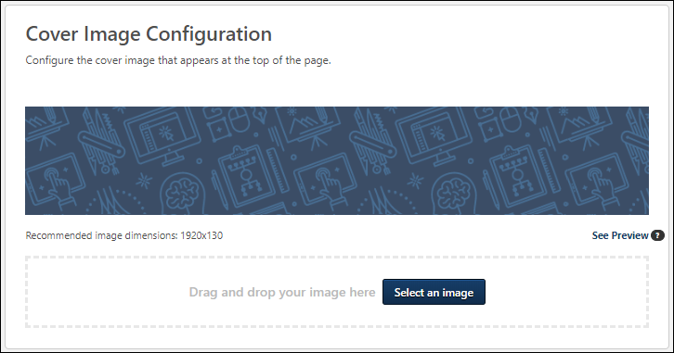
Image Specifications
The following image specifications apply to cover images:
- Supported file types: bmp, gif, jpg, jpeg, png
- Maximum file size: 5 MB
- Recommended Dimensions: 1920x130
  - Note: These dimensions provide the best balance between image resolution and size. Depending on browser window size and screen resolution, the image may not span the entirety of the page.
Learner Home Content Arrangement
In the Learner Home Content Arrangement section, you can rename, rearrange, and deactivate content carousels, if needed. The sections you can configure include:
- Custom Banner
- Continue Learning
- Saved for Later
- Top Picks for User
- Trending for User
- Inspired by Your Subjects
- Playlists for User
- Most Popular
- Featured
- Suggested
- Required
- Based on Skills You Want to Develop
- Based on Your Critical Skills
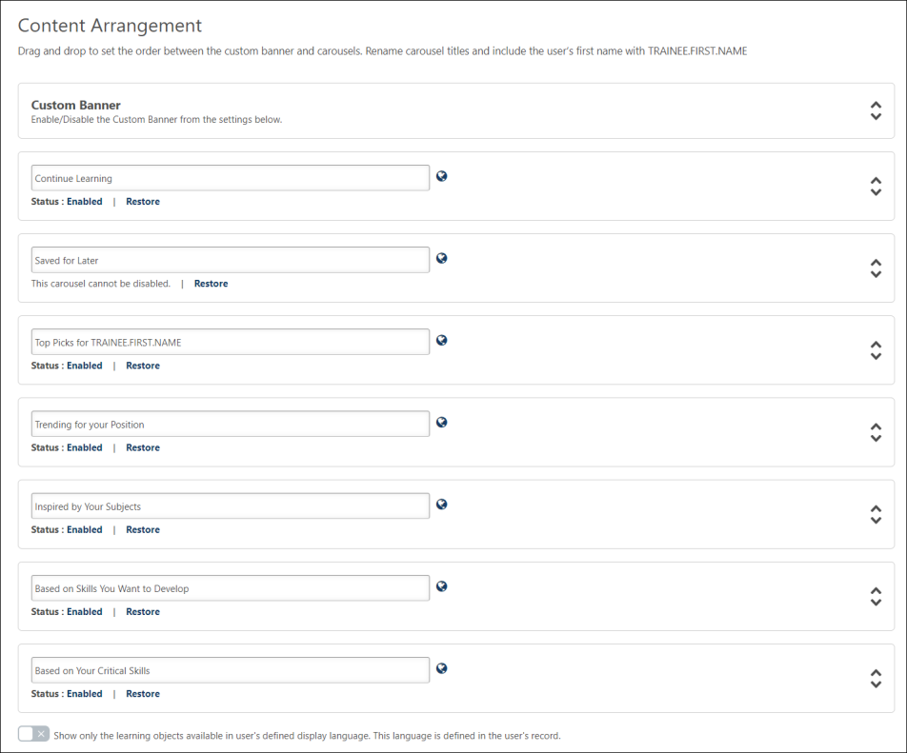
Rename Carousels
To change the header name of a training carousel:
- Place your cursor in the text field for a carousel.
- Enter an alternate carousel name. Names are limited to 40 characters.
- Click the Save button at the bottom of the Learner Home Preferences page to ensure your updates to preferences are saved and applied.
To revert an altered carousel name back to its default name, you can click the Restore link. The Restore link is only available for carousels with customized names or translations.
To localize a carousel name into other languages:
- Click the Globe icon next to the carousel name. This opens the Rename Carousel pop-up window.
- Enter an alternate carousel name for any language enabled in your portal. Names are limited to 40 characters.
- Click the OK button in the pop-up.
- Click the Save button at the bottom of the Learner Home Preferences page to ensure your updates to preferences are saved and applied.
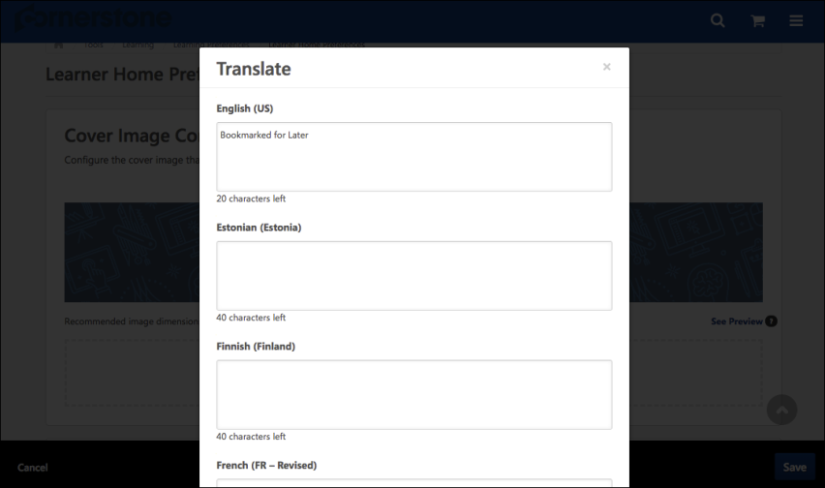
The alternate names you have provided will display to users on Learner Home if you provided an alternate name in the user's display language.
Considerations
The following tag can be used in carousel names:
- [TRAINEE.FIRST.NAME]
Using this tag causes the system to insert the user's first name into the carousel title. No other tags can be used with carousel headers.
Example: "Suggestions for [TRAINEE.FIRST.NAME]" becomes" "Suggestions for Jon" when the carousel is viewed by a user named Jon.
Enable/Disable Carousels
Below each carousel title, a Status field displays, alerting the administrator to whether the carousel is enabled or disabled.
- If the Enabled link displays as a carousel's status, the carousel is active on the Learner Home, and if needed you can click the Enabled link to disable the carousel. The link then changes to Disabled.
- If the Disabled link displays as a carousel's status, the carousel is NOT active on the Learner Home, and if needed you can click the Disabled link to enable the carousel. The link then changes to Enabled.
Note: The Saved for Later section cannot be disabled.
Display Language toggle
This option allows administrators to configure the Learner Home page to only show content available in the user's display language. To prevent users from being recommended training that is not available in their display language, toggle this switch to the On (green) position. If this toggle is in the Off position, users may see training available in other languages in their Learner Home carousels.
The Display Language option does not apply to the training recommendations contained within the following Learner Home carousels:
- Continue Learning
- Saved for Later
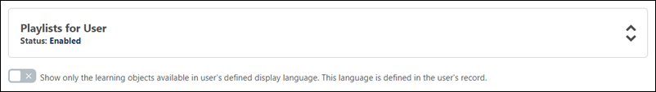
Enable or Disable Subjects Banner
To disable the Subjects banner and prevent it from displaying to users on the Learner Home page, toggle the Subjects Banner switch to the Off position. The Subjects banner is enabled by default but can be deactivated at any time. If an administrator re-enables the Subjects banner after it has been disabled, users will again see the Subjects banner on their Learner Home page unless the user has already added subjects or has previously dismissed the Subjects banner by clicking the X icon within the banner.
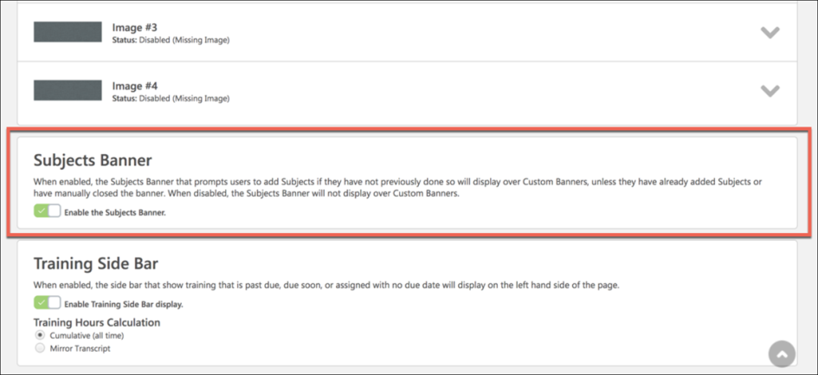
Enable Training Side Bar
The Training Side Bar is the portion of Learner Home which displays information about training that is past due, due soon, and assigned on a user's transcript. To disable the training side bar for both the web and mobile version of Learner Home, toggle the Enable Training Side Bar switch to the Off position. To enable the training sidebar, toggle the Enable Training Side Bar option to the On position.
If the training sidebar is enabled, the following Training Hours Calculation options are available:
- Cumulative (all time) - Training hours will be calculated based on the training completed on a user's transcript for all time.
- Mirror Transcript - Training hours will be calculated the same way as the training hours are calculated on the user's transcript, which is often based on the portal's fiscal year settings.
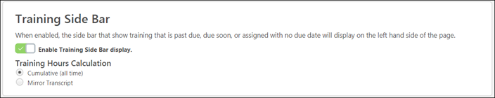
Save
To rearrange the display order of the different sections, you can click and drag any section to a new place in the order. You MUST click the Save button at the bottom of the browser window to save any changes you have made to this section before navigating away from the page.
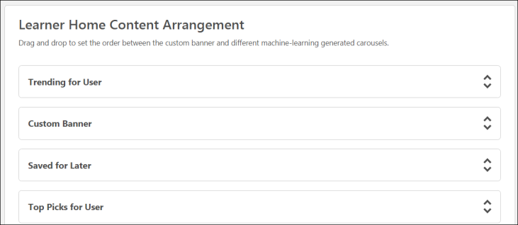
Custom Banner Configuration
In the Custom Banner Configuration section, you can upload up to four banner images which will be rotated in the Learner Home banner carousel. Each of the banner images displays in a drop-down with the following information:
- Thumbnail preview image - A small version of the uploaded banner image displays, if a banner image has been uploaded.
- Image Number - This field displays the banner number. Up to four banner images can be displayed in the banner carousel.
- Status - This field displays whether the banner image is enabled or disabled. If no image has been uploaded, or the administrator does not want to show the configured banner in the carousel, the banner's status is Disabled. If the banner has been configured for the carousel and the admin wants to show it in the carousel, its status is Enabled. Clicking on the Enabled or Disabled status allows the administrator to toggle between the two options.
- Display Text - This field only displays if the Enable Display Text option was enabled for the image. If enabled, this field shows the display text entered for the image.
- Button Text - This field only displays if the Enable Action Button option was enabled for the image. If enabled, this field shows the button text provided for the button.
- Link URL - This field only displays if the Enable Action Button option was enabled for the image. If enabled, this field shows the URL provided for the button.
Configure Banner
To configure a banner image for the carousel:
- Click the Expand icon for one of the image drop-downs. You can either change an existing image or expand a drop-down for a disabled image to add a new image to the carousel.
- For each banner image, you may upload three different versions of the image:
  - Default - The first image is the default image that is displayed on standard screen sizes.
  - Mobile (Portrait) - This image is displayed in Cornerstone Learn on phones and tablets in portrait mode. If no image is uploaded in this section, then the web default banner image is displayed in the Cornerstone Learn app on mobile phones.
  - Mobile (Landscape) - This image is displayed in Cornerstone Learn on tablets in landscape mode. If no image is uploaded in this section, then the web default banner image is displayed in the Cornerstone Learn app on mobile phones.
- Either click the Select Image button and choose a banner image from your computer, or drag and drop a banner image from your computer desktop into the uploading zone. After the image uploads, a thumbnail version of the image appears above the uploading zone. If needed, you can click the Delete icon next to the thumbnail to remove the image and upload a new one. The following specifications apply:
  - Recommended image dimensions:
    - Default - 915x280 (if using an image with padding) or 814 x 280 (if using an image with NO padding)
    - Mobile (Portrait) - 750x560
    - Mobile (Landscape) - 1640x570
  - Supported image file types: bmp, gif, jpg, jpeg, png
  - Maximum image file size: 5MB
- If desired, you can add additional features to the banner image. Available features you can add to the banner image include:
  - Enable Display Text - Check this box to add text that will display over the banner image in the Learner Home banner carousel. When the box is checked, you can enter text into the text field. There is a limit of 140 characters for this field.
  - Enable Action Button - Check this box to add a button to the banner that will navigate users to a system location of your choice when clicked. When the box is checked, you can enter button text in the text field and provide a link to the page users will be navigated if they click the button. The button text is limited to 20 characters. For example, to allow users to navigate quickly to their learning transcript, you could create an action button for the banner using text that says "My Transcript" and the URL for the learning transcript page. When the Action Button is enabled, the following options are also available:
    - Use Entire Image as Link - Check the Use entire image as link option to make the entire uploaded banner image function as a link for users. When this option is selected, if a user clicks anywhere on the banner image, they will be navigated to the URL provided in the URL field.
    - Open Link in New Window - If you would like the button to open the link for a page in a new window instead of navigating the user to the page using the current browser window, you can check the Open Link in New Window option.
Note: The text and button for the banner images do not support localization.
- Click the See Preview link to preview the banner as it will appear on the Learner Home page. Note: Any configured display text and action button will not be shown in this preview and can only be previewed via the Learner Home page.
- Configure up to four banner images for the Learner Home banner carousel. After configuring the Learner Home banner images for the selected division, you MUST click the SAVE button at the bottom of the browser window to save any changes you have made to this section before navigating away from the page.
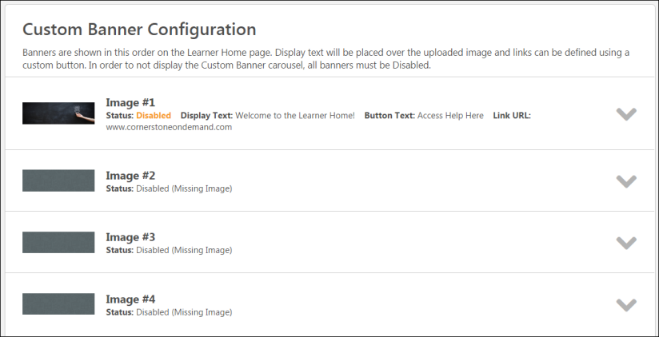
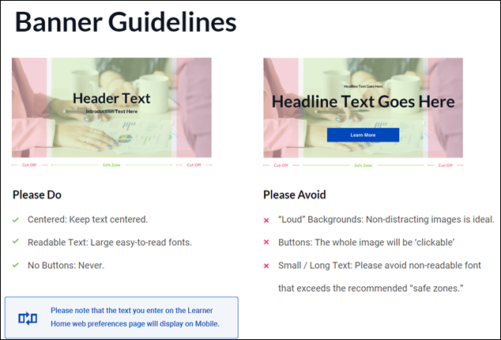
Overwrite Custom Settings
Choose whether or not to enable the setting to overwrite custom settings for child division organizational units (OUs). If you choose to overwrite custom settings for child division OUs, the selected settings are applied to both new and existing child OUs. Any previously customized child OUs are updated with the selected settings.
- If this option is toggled to the On position, then only the child OUs that do not have customized settings will be updated, as well as any OUs that are added in the future.
- A child OU that has not been customized always inherits from the parent, regardless of whether this option is selected.
- An OU is considered customized if its preferences or settings have been changed.
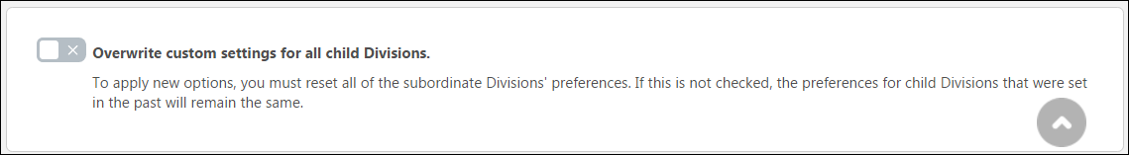
Save or Cancel
To save any changes made to this preferences page, you MUST click the Save button at the bottom of the browser window. To leave this page without saving any changes, you can either click Cancel or navigate away from the page.
Learning Search Preferences
The option to allow users to filter by Duration, Types, Modality, Subjects, Rating, Provider, Language, Skills (Capabilities), and Mobile Enabled on the Learning Search page is available on the Learning Search Preferences page. The administrators can enable the filters which are used in their portals or divisions and disable those filters which are rarely used. The ability to enable or disable filters gives the administrators greater customization capabilities in Learning Search page.
To access the Learning Search Preferences page, go to: Admin > Tools > Learning > Learning Preferences and click the Learning Search Preferences link.
Note: The permission for managing Learner Home Preferences also grants access to the Learning Search Preferences page.
Permissions
PERMISSION NAME | PERMISSION DESCRIPTION | CATEGORY

Learner Home Preferences | Grants access to the Learner Home Preferences, where the administrator can configure the arrangement of content on Learner Home, as well as other settings. This permission also grants access to the Learning Search Preferences page, where the administrator can configure Learning Search options. This permission can be constrained by organizational unit (OU) and User's OU. This is an administrator permission. | Learning - Administration
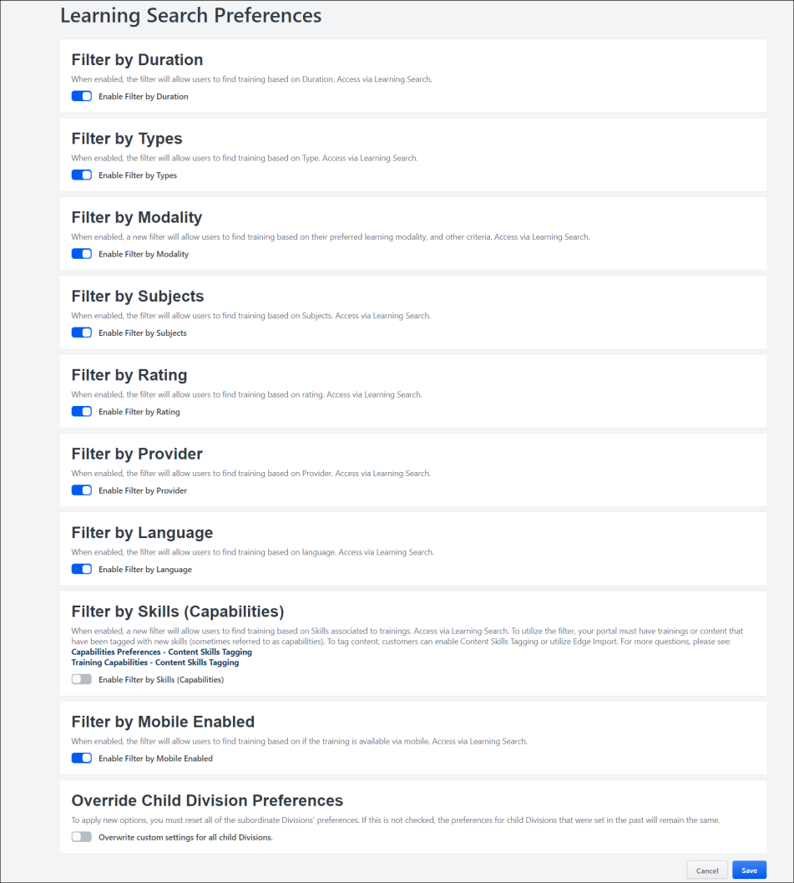
Filter by Duration
When enabled, the filter will allow users to find training based on Duration.
Filter by Types
When enabled, the filter will allow users to find training based on Type.
Filter by Modality
To enable the Modality options in the Learning Search filter panel, which allows users to select different modality types as filters while searching for training:
- Toggle the Enable Filter by Modality switch to the On position.
- Click the Save button at the bottom of the page. The Modality section will then be available to users in the filter panel on the Learning Search page.
The different modality types are not currently configurable. As a result of user feedback, the following default modality types are available in the Modality section of the Learning Search filter panel:
- Attend (includes events)
- Collections (includes curricula, playlists, external content, and programs)
- Listen (includes none by default)
- Practice (includes tests)
- Read (includes materials)
- Watch (includes online courses and videos)
Users can select these modality filters to filter the Learning Search page for training mapped to those modality types. For more information about using the Learning Search page: See Learning Search.
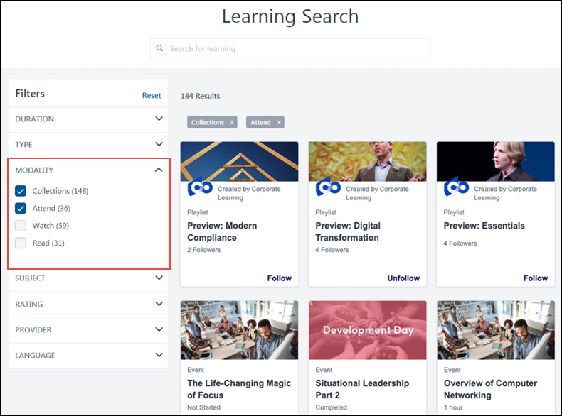
Filter by Subjects
When enabled, the filter will allow users to find training based on Subjects.
Filter by Rating
When enabled, the filter will allow users to find training based on rating.
Filter by Provider
When enabled, the filter will allow users to find training based on Provider.
Filter by Language
When enabled, the filter will allow users to find training based on language.
Filter by Skills (Capabilities)
When enabled, the Skills (Capabilities) will allow users to find training based on Skills associated to trainings. Access via Learning Search. To utilize the filter, your portal must have trainings or content that have been tagged with new skills (sometimes referred to as capabilities). To tag content, customers can enable Content Skills Tagging or utilize Edge Import. For more questions:
See Capabilities Preferences - Content Skills Tagging.
See Training Capabilities - Content Skills Tagging.
Filter by Mobile Enabled
When enabled, the filter will allow users to find training based on if the training is available via mobile. Access via Learning Search.
Considerations
- All filters, except Skills (Capabilities), continue to be enabled by default. If the portal has already configured a filter to be enabled or disabled, the system will continue to respect that configuration.
- Customers cannot disable all filters at the same time. At least one filter must be enabled.
- When a filter is disabled, any link to the search page with that filter already applied will no longer display the filter and the filter will not be applied.
Machine Learning Preferences
The Machine Learning Preferences page allows administrators to customize whether the portal's training recommendation carousels filter required training.
To access the Machine Learning Preferences page, go to: Admin > Tools > Learning > Learning Preferences and click the Machine Learning Preferences link.
Permissions
PERMISSION NAME | PERMISSION DESCRIPTION | CATEGORY

Machine Learning Preferences | Grants ability to access the Machine Learning Preferences page. This is an administrator permission. | Learning - Administration
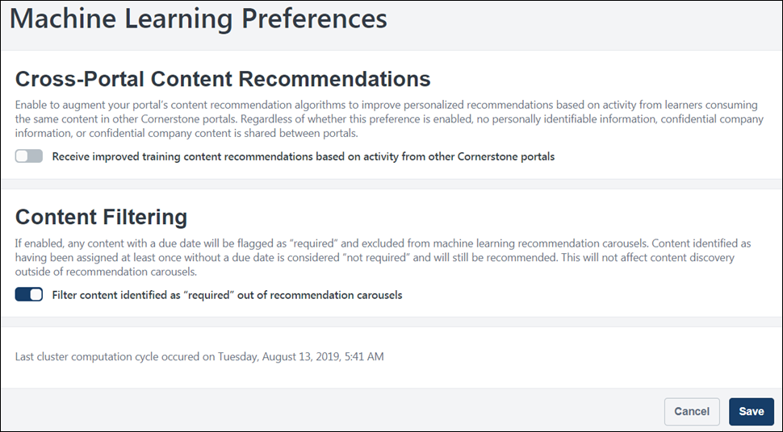
Cross-Portal Content Recommendations
Cross-portal content recommendations can be used to augment your portal's content recommendation algorithms and improve personalized recommendations based on activity from users consuming the same content in other Cornerstone portals. Note: No personally identifiable information, confidential company information, or confidential company content is shared between portals, regardless of whether or not cross-portal content recommendations are enabled.
The Cross-Portal Content Recommendations setting is enabled by default. To disable this setting, toggle the switch to the Off position. To re-enable this setting, toggle the switch to the On position.
- Note: The Inspired by Your Subjects carousel is NOT affected by the Cross-Portal Content Recommendations preference.
- Note: This option is NOT available for CDG4 organizations.
Content Filtering
The Content filtering setting causes any training content assigned 100% of the time with a due date to be flagged as Required and excluded from machine learning recommendation carousels.
- Note: Content that has been assigned at least once without a due date is NOT considered Required, and will still be recommended.
- Note: This setting does NOT prevent users from discovering content outside of recommendation portals.
The Content Filtering setting is enabled by default. To disable this setting, toggle the switch to the Off position.
Last Cluster Computation Cycle
The date and time of the last cluster computation cycle displays at the bottom of the Machine Learning Preferences page. This information is read-only.
Save
To save any changes made to the Machine Learning Preferences page and apply your settings to the portal, click the Save button at the bottom of the page.
Modality Preferences (Early Adopter)
Administrators can configure which training types and which modalities can be used by users on the Learning Search page. Administrators can configure modality preferences via the Modality Preferences page.
To access the Modality Preferences page, go to: Admin > Tools > Learning > Learning Preferences and click the Modality Preferences link.
Permissions
PERMISSION NAME | PERMISSION DESCRIPTION | CATEGORY

Modality Preferences | Grants access to Modality Preferences, where an administrator can configure settings related to learning object (LO) modalities. This is an administrator permission. | Learning - Administration
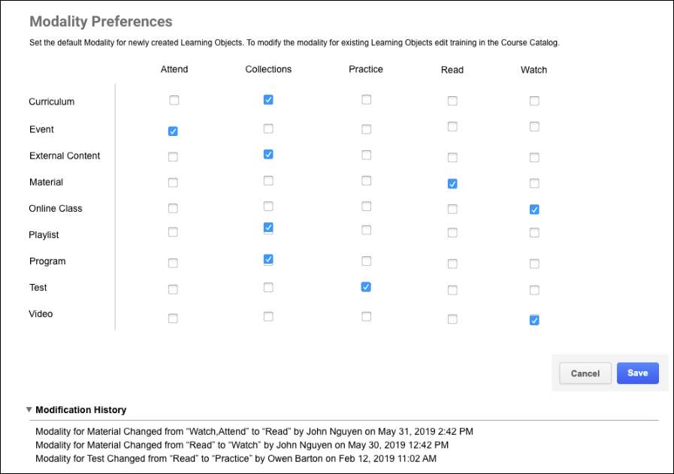
Configure Modalities
On the Modality Preferences page, the different training types available in the system display in the left-hand column, and the available learning modalities display in columns next to the training types. To enable a modality for a training type, check the box for that modality in the training type's row.
Click the Save button at the bottom of the page. The Modality section will then be available to users in the filter panel on the Learning Search page. If you wish to discard any changes you have made to the Modality Preferences page, click the Cancel button. Your changes will not be saved.
The modality types are not currently configurable. As a result of user feedback, the following default modality types are available in the Modality section of the Learning Search filter panel:
- Attend (includes events)
- Collections (includes curricula, playlists, external content, and programs)
- Listen (includes none by default)
- Practice (includes tests)
- Read (includes materials)
- Watch (includes online courses and videos)
Users can select these modality filters to filter the Learning Search page for training mapped to those modality types. For more information about using the Learning Search page: See Learning Search.
In addition to the default training types associated with different modalities, administrators can manually associate modalities with specific training items.
Online Course Versioning Preferences
Administrators can set default options for the online course versioning process and specify whether these options are editable via the Online Course Versioning Preferences page.
To set online course versioning preferences, go to Admin > Tools > Learning > Learning Preferences and click the Online Course Versioning Preferences link. Online course versioning preferences are set by division, so choose the division for which you want to set preferences.
Permissions
PERMISSION NAME | PERMISSION DESCRIPTION | CATEGORY

Online Class Versioning Preferences | Grants ability to set default options for the online class versioning process. This is an administrator permission. | Learning - Administration
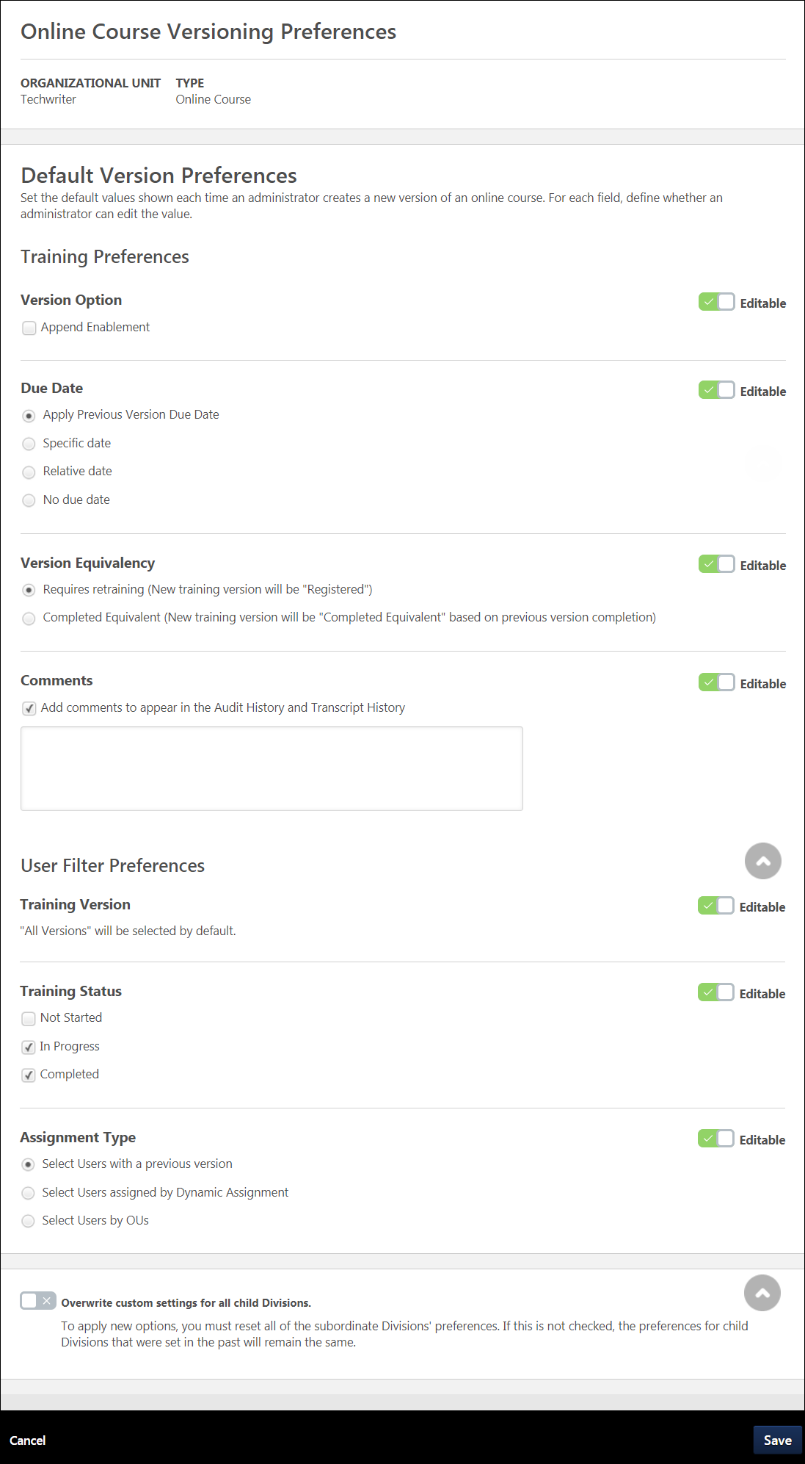
Online Course Versioning Preferences
The Online Course Versioning Preferences page allows you to set default training and user filter preferences for online classes that are reversioned in the portal. At the top of the Online Course Versioning Preferences page, the organizational unit (OU) for which you are setting preferences displays, along with the training type you are setting preferences for.
Training Preferences
In the Training Preferences section, set default values for the following training reversioning fields:
- Version Option - In this section, set default versioning options:
  - Append Enablement - Checking this option allows two versions of the online course to exist in the portal at the same time. Both versions can be assigned to users. For more information about append versioning behavior, See Online Course - Append Versioning Behavior.
- Due Date - In this section, select a default due date option for reversioned courses. Available options include:
  - Apply Previous Version Due Date Criteria
    - Apply Exact Due Date from Transcript for Standalone Online Course (not selected by default)
  - Specific Date
  - Relative Date
  - No Due Date
- Version Equivalence - In this section, choose a default equivalence option for reversioned training. Available options include:
  - Requires retraining (New training version will be "Registered")
  - Completed Equivalent (New training version will be "Completed Equivalent" based on previous version completion)
- Comments - In the Comments text box, enter any text that should appear by default in the Audit History and Transcript History for the reversioned course.
If any of the above fields should NOT be editable by administrators who are reversioning online courses, toggle the Editable switch to the Off position. The default options you have selected on this page will be selected when other users reversion online courses, and these options will be read only. By default, all fields in this section are configured as editable.
User Filter Preferences
- Training Version - By default, the All Versions option is selected when an administrator reversions an online course. Administrators are allowed to change these selections unless this default is configured to be non editable.
- Training Status - In this section, select which training statuses will be replaced or appended by the new version of an online course. Available statuses include:
  - Not Started
  - In Progress
  - Completed
- Assignment Type - In this section, select which assignment option will be selected by default. Available options include:
  - Select Users with a previous version - All users will be selected by default
  - Select Users assigned by Dynamic Assignment - All users who were assigned the course via dynamic learning assignment or via dynamic recurring reassignment are selected
  - Select Users by OUs - No users are selected by default, and the administrator must select specific organizational units (OUs) which will receive the new online course version
Overwrite Settings
Select this option to overwrite custom settings for child division OUs. If you overwrite custom settings for child division OUs, the selected settings are applied to both new and existing child OUs. Any previously customized child OUs are updated with the selected settings.
- If there are no customizations to the child OU, then the parent OU customizations are applied to all child OUs.
- Overwrite custom settings checkbox setting
  - If this option is selected, all child OU customizations are deleted from the database, which means the parent OU customizations will be applied to new and existing child OUs.
  - If this option is unselected, all existing child OU customizations will remain unchanged, and any new child OUs will inherit the parent OU customizations by default.
- If a child OU has been customized to display any widgets, then regardless of the parent OU customizations, the child OU customizations are applied.
- If a child OU has been customized to hide all widgets, then parent OU customizations will take precedence and will be applied.
Save
Click the Save button at the bottom of the page to save and apply your preference settings.
Playlist Preferences
Administrators can configure the following features for learning playlists via the Playlist Preferences page:
- Creator Information
- Follower Information
- External Content
To access the Playlist Preferences page, go to: Admin > Tools > Learning > Learning Preferences and click the Playlists link.
Important: Learner Home must be enabled in the portal in order for Playlist and External Content functionality to be available.
Permissions
PERMISSION NAME | PERMISSION DESCRIPTION | CATEGORY

Playlist Preferences | Grants access to the Learning Playlist Preferences, where administrators can configure settings for the Playlist feature. | Learning - Administration
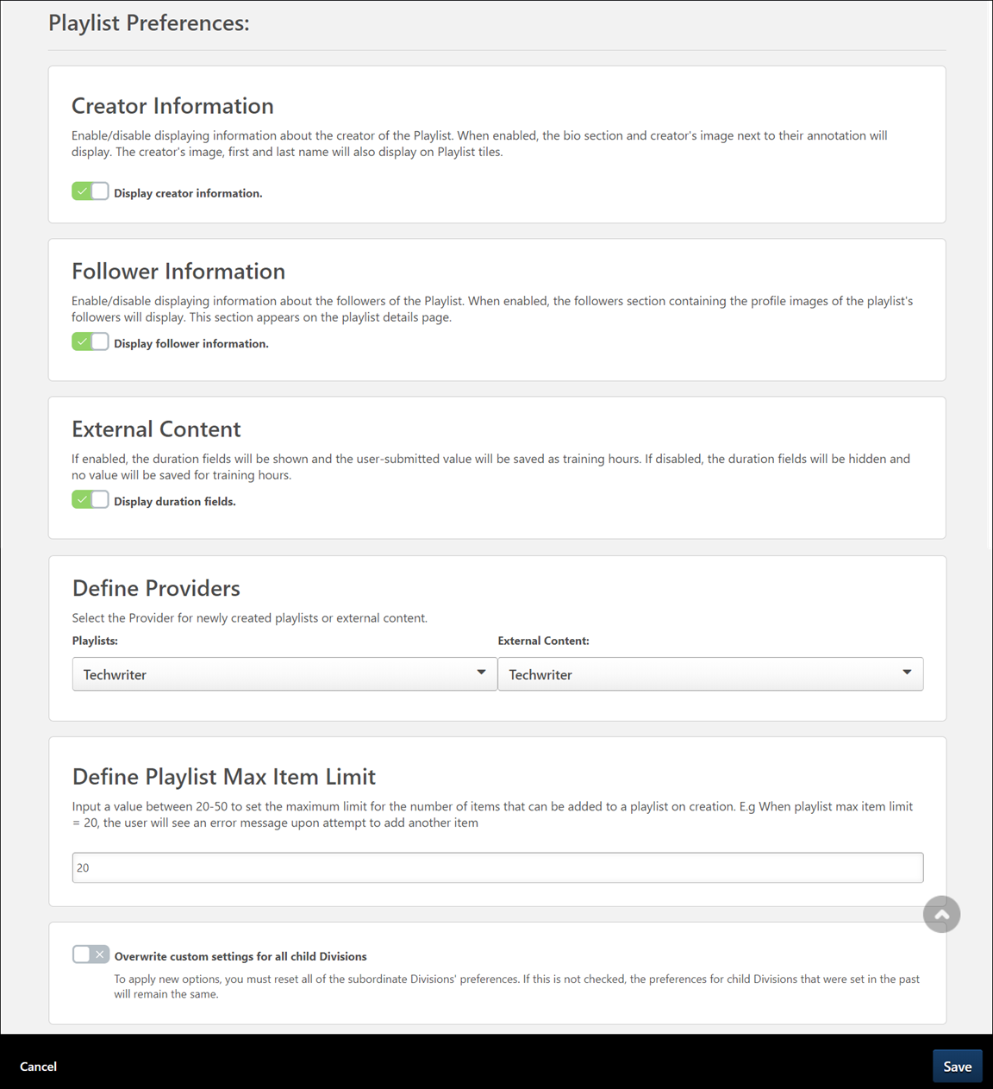
Creator Information
In the Creator Information section of the Playlist Preferences page, administrators can use the Display creator information toggle switch to enable or disable the display of creator information on playlists. To allow the playlist creator's image and biography summary to display with their playlists, leave the switch in the On (green) position. To prevent the playlist creator's image and biography summary from displaying with their playlists, toggle the switch to the Off (gray) position.
Follower Information
The Display Follower Information setting determines whether or not follower information displays on the Playlist Details page of a playlist. Information included about followers includes the followers' names, profile photos, and positions. To allow follower information to display on the Playlist Details page for playlists, leave the Display Follower Information switch toggled to the On position. To prevent follower information from displaying, toggle the switch to the Off position. Note: The number of followers displays on the Playlist Details page and playlist tiles regardless of this preference setting.
External Content
External content can be added to playlists. Using the Enable Duration Fields setting, external content can be accompanied by Duration fields, which playlist creators can use to indicate the duration time of the external content. To allow creators to populate the duration for external content they have added to playlists, leave the Enable Duration Fields switch toggled to the On position. To hide the Duration fields for external content, toggle this switch to the Off position.
Define Providers
You can select default providers for both playlists and playlist external content in the Define Providers section. To set a default provider for either content type:
- Select the drop-down menu for the content type for which you want to define a default provider.
- Scroll through the system providers until you find the desired provider, then click the provider name.
- Click the Save button at the bottom of the page to save your changes. Your chosen default provider will be applied to the content type to which you made changes.
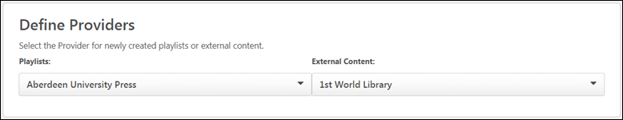
Define Playlist Max Item Limit
In the Define Playlist Max Item Limit section, enter a value between 20 and 50. The specified value will be treated as the maximum number of items which playlist creators can add to their playlists.
If a playlist creator attempts to add more than the specified maximum number of items to a playlist, they receive an error stating, "You reached the maximum number of items for a playlist. Remove a few before adding more." The playlist creator will not be able to add more items to the playlist until they have removed enough items to be at or below the maximum value set via Playlist Preferences.
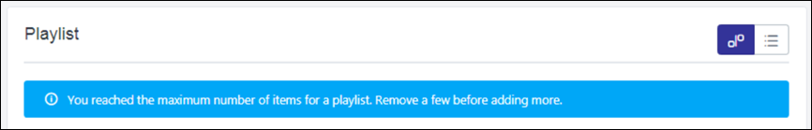
Overwrite Settings
Select this option to overwrite custom settings for child division OUs. If you overwrite custom settings for child division OUs, the selected settings are applied to both new and existing child OUs. Any previously customized child OUs are updated with the selected settings.
- If there are no customizations to the child OU, then the parent OU customizations are applied to all child OUs.
- Overwrite custom settings checkbox setting
  - If this option is selected, all child OU customizations are deleted from the database, which means the parent OU customizations will be applied to new and existing child OUs.
  - If this option is unselected, all existing child OU customizations will remain unchanged, and any new child OUs will inherit the parent OU customizations by default.
- If a child OU has been customized to display any widgets, then regardless of the parent OU customizations, the child OU customizations are applied.
- If a child OU has been customized to hide all widgets, then parent OU customizations will take precedence and will be applied.
Save
Click the Save button at the bottom of the page to save any changes you have made to Playlist Preferences.
SF-182 Preferences Overview
Set SF-182 Preferences Overview
The SF-182 Preferences page enables administrators to configure preferences for the SF-182 functionality, including the following actions:
- Configure the fields that appear on the SF-182 request form.
- Configure the approval process for the request form.
- Activate or inactive the reasons for approving or denying a request. Note: Approval and denial reasons are configured in SF-182 Reason Preferences.
- Set miscellaneous preferences, such as visibility of the Add Regular External Training link on the Transcript page.
To access SF-182 Preferences, go to Admin > Configuration Tools > Preferences. Then, click the Set SF-182 Preferences (by Division) link.
Permissions
PERMISSION NAME | PERMISSION DESCRIPTION | CATEGORY

Set SF-182 Preferences | Grants ability to configure SF-182 preferences for standard fields, approvers and reasons. (Governmental clients). This is an administrator permission. | Limited Use/Obsolete
SF-182 Preferences Configuration
SF-182 Preferences is comprised of four tabs:
- Configure Fields - See Set SF-182 Preferences - Configure Fields on page 264 for additional information.
- Set Approvals - See Set SF-182 Preferences - Set Approvals on page 270 for additional information.
- Activate Reasons - See Set SF-182 Preferences - Activate Reasons on page 278 for additional information.
- Miscellaneous - See Set SF-182 Preferences - Miscellaneous on page 280 for additional information.
Set SF-182 Preferences - Configure Fields
The Configure Fields tab enables administrators to define preferences for the sections on the SF-182 request form. The tab is separated into the following sections:
- Section A: Trainee Information
- Section B: Training Course Data
- Section C: Costs and Billing Information
Within each section, custom fields can also be configured. You can reorder the fields in the Custom Fields panels by clicking and dragging the field to the desired location. The fields can only be reordered within their respective Custom Fields panels.
Sections A, B, and C
The fields that appear in each section are configured by default and cannot be removed. However, some fields can be hidden so that they do not appear on the SF-182 request form. You can determine whether or not to set fields as required and allow users to edit the field. You can also define a default value for the field. Note: The default value for some custom fields can only be defined in the SF-182 area of Custom Field Administration.
The following information appears in the sections:
- Field Name - This is the name of the SF-182 request form field.
- Required - This option enables you to set certain fields as required. Required fields must be completed on the SF-182 request form before the form can be submitted.
All fields are required by default. To deselect all fields as required, check the Deselect All option (the blank checkbox to the right of the Select All box).
Or, you can set individual fields as required or not required by checking or unchecking the Select box in the Required column for the desired fields.
- User Editable - This option enables you to allow users to edit the field's value on the form. Non-editable fields display on the form as read-only. This option is only available in Section A. Note: If a default value is not set for the field and you mark the field as not editable, users will not be able to enter a value in the field and the field will be blank on the request form.
All fields are editable by default. To deselect all fields as editable, check the Deselect All option (the blank checkbox to the right of the Select All box).
Or, you can set individual fields as editable or not editable by checking or unchecking the Select box in the User Editable column for the desired fields.
- Hidden - This option enables you to hide certain or all fields in the section. Hidden fields do not appear on the SF-182 request form. This option is only available in Section A.
All fields are visible by default. Check the Select All box in the header row to set all fields in the section as hidden. Check the Deselect All option (the blank checkbox to the right of the Select All box) to deselect all fields as hidden.
Or, set individual fields as hidden or visible by checking or unchecking the Select box in the Hidden column for the desired fields.
The settings in the Hidden column affect the settings in the Required and User Editable columns. The settings are affected as follows:
- If a field is hidden, then the settings in the Required and User Editable columns are deselected and no longer selectable. The Hidden option must be deselected to make the Required and User Editable options selectable.
- If all fields are hidden, then all fields in the Required and User Editable column are deselected and disabled. You must deselect all the fields one by one or click the Deselect All option in the Hidden column to enable the Required and User Editable options.
Note: While hidden fields do not appear while completing an SF-182 request form, they do appear on the printable version of the form. If a default value is set for the field, the value appears on the printable version even if the field is set to Hidden in SF-182 Preferences.
- Display on Transcript - This option enables you to define which fields appear on the Training Details page of the user's transcript. This option is only available in Sections B and C.
All fields are visible on the Training Details page by default. To deselect all fields as visible, check the Deselect All option (the blank checkbox to the right of the Select All box).
Or, set the visibility of individual fields by checking or unchecking the Select box next to the desired fields.
- Default Value View Tags - This option enables you to define the default value that appears for the field on the SF-182 request form. The default value is entered in the form of a tag. All fields are blank by default. When users create a request, the fields are pre-populated with the default values. Note: Fields that are configured to be hidden can still have a default value set.
The default values in Section A apply to administrators and managers when creating an SF-182 request on behalf of a user. For sections B and C, the default values are applied based on the administrator's divisional preferences. The values in Step 3 or Section A are applied based on the user's divisional preferences.
To enter a tag:
- Click the View Tags link in the column name. This opens the List of Email Tags pop-up.
- Copy the tag from the Tag Name column. The tag must be copied exactly, with no spaces before or after the tag name.
- Paste the tag into the Default Value field. Note: You can also type the tag name directly into the field.
On the request form, if a value is not available to replace the tag, then the field is blank.
Custom Fields (Advanced Section)
The custom fields that appear on the Configure Fields tab are system-defined and available by default. Additional custom fields can be added to a section if they are configured in Custom Field Administration and active for the specific section to which you would like it added.
Note: When a custom field is added and saved in SF-182 Preferences for any division for which the field is configured, the field can no longer be deleted in Custom Field Administration.
To add custom fields:
- Click the Add icon in the Custom Fields panel header. This opens the Select Custom Field pop-up.
- Select the Add icon to the left of the field name. This closes the pop-up and adds the field to the list.
Note: If you select a custom field that has already been added to the section, an error message appears indicating that the field is already in the section.
The following information appears in the Custom Fields panels:
- Custom Field Name - The name of the custom field.
- Type - The type of custom field. For example, the field type may be a drop-down, numeric field, or radio button.
- Required - This option enables you to set certain or all custom fields as required to be completed. Required fields must be completed on the SF-182 request form before the form can be submitted.
All fields are required by default. To deselect all fields as required, check the Deselect All option (the blank checkbox to the right of the Select All box).
Or, you can set individual fields as required or not required by checking or unchecking the Select box in the Required column for the desired fields.
- User Editable - This option enables you to allow users to edit the field's default value, provided a default value is available and configured in the Default Value View Tags column. Non-editable fields display on the form as read-only. This option is only available in Section A.
All fields are editable by default. To deselect all fields as editable, check the Deselect All option (the blank checkbox to the right of the Select All box).
Or, you can set individual fields as editable or not editable by checking or unchecking the Select box in the User Editable column for the desired fields.
- Hidden - This option enables you to hide certain or all custom fields. Hidden fields do not appear on the SF-182 request form. This option is only available in Section A.
All fields are visible by default. Check the Select All box in the header row to set all fields in the section as hidden. Check the Deselect All option (the blank checkbox to the right of the Select All box) to deselect all fields as hidden.
Or, set individual fields as hidden or visible by checking or unchecking the Select box in the Hidden column for the desired fields.
The settings in the Hidden column affect the settings in the Required and User Editable columns. The settings are affected as follows:
- If a field is hidden, then the settings in the Required and User Editable columns are deselected and no longer selectable. The Hidden option must be deselected to make the Required and User Editable options selectable.
- If all fields are hidden, then all fields in the Required and User Editable column are deselected and disabled. You must deselect all the fields individually or click the Deselect All option in the Hidden column to enable the Required and User Editable options.
Note: While hidden fields do not appear while completing an SF-182 request form, they do appear on the printable version of the form. If a default value is set for the field, the value appears on the printable version even if the field is set to Hidden in SF-182 Preferences.
- Display on Transcript - This option enables you to define which fields appear on the Training Details page of the user's transcript. This option is only available in Sections B and C.
All fields are visible on the Training Details page by default. To deselect all fields as visible, check the Deselect All option (the blank checkbox to the right of the Select All box).
Or, set the visibility of individual fields by checking or unchecking the Select box next to the desired fields.
- Default Value View Tags - This option enables you to define the default value that appears for the field on the SF-182 request form. The default value is entered in the form of a tag. All fields are blank by default. When users create a request, the fields are pre-populated with the default values. Note: Fields that are configured to behidden can still have a default value set.
The default values in Section A apply to administrators and managers when creating an SF-182 request on behalf of a user. For sections B and C, the default values are applied based on the administrator's divisional preferences. The values in Step 3 or Section A are applied based on the user's divisional preferences.
All fields in the column are blank by default. The value you enter is a user record custom field tag.
To enter a tag:
- Click the View Tags link. This opens the List of Email Tags pop-up.
- Copy the tag from the Tag Name column. The tag must be copied exactly, with no spaces before or after the tag name.
- Paste the tag into the Default Value field. Note: You can also type the tag name directly into the field.
On the request form, if a value is not available to replace the tag, then the field is blank.
Note: For some custom fields, a default value cannot be set in SF-182 Preferences. In this case, you can set the default value in Custom Field Administration.
- Remove - Click the Trash Can icon to remove the field from the form.
Overwrite Settings
Select this option to overwrite custom settings for child division OUs. If you overwrite custom settings for child division OUs, the selected settings are applied to both new and existing child OUs. Any previously customized child OUs are updated with the selected settings.
- If there are no customizations to the child OU, then the parent OU customizations are applied to all child OUs.
- Overwrite custom settings checkbox setting
  - If this option is selected, all child OU customizations are deleted from the database, which means the parent OU customizations will be applied to new and existing child OUs.
  - If this option is unselected, all existing child OU customizations will remain unchanged, and any new child OUs will inherit the parent OU customizations by default.
- If a child OU has been customized to display any widgets, then regardless of the parent OU customizations, the child OU customizations are applied.
- If a child OU has been customized to hide all widgets, then parent OU customizations will take precedence and will be applied.
Save
Once all preferences are set, click Save. Preference settings are not saved unless you click Save. This returns you to the Preferences page.
Or, to set preferences for another SF-182 Preferences tab before saving, click the tab name and configure the preferences. Then, click Save.
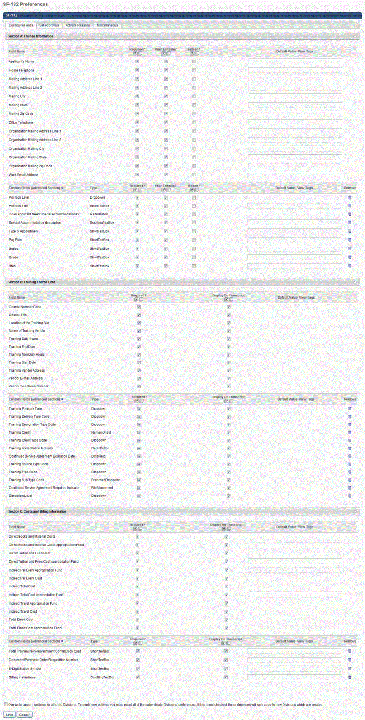
Set SF-182 Preferences - Set Approvals
The Set Approvals tab enables administrators to define the approval workflow for the SF-182 request process.
- Defining an approval workflow is not required.
- One approval step appears on the tab by default but is not defined.
- The workflow can have a maximum of five steps.
- If an approval workflow is defined, each step must have a minimum of one approver, either a relation type, user, or group.
Note: In order to allow the successful submission of SF-182 requests, you are required to configure approval steps.
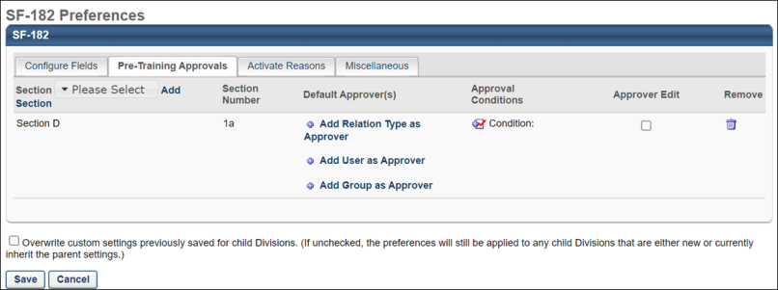
Sections
Section D 1a appears on the tab by default but is not configured. You can add Section D 2a. Section D 3a, and Section E 1a by clicking the Add icon next to the Approval Step Number column name. Each subsequent step appears in sequential order, as shown in the image below.
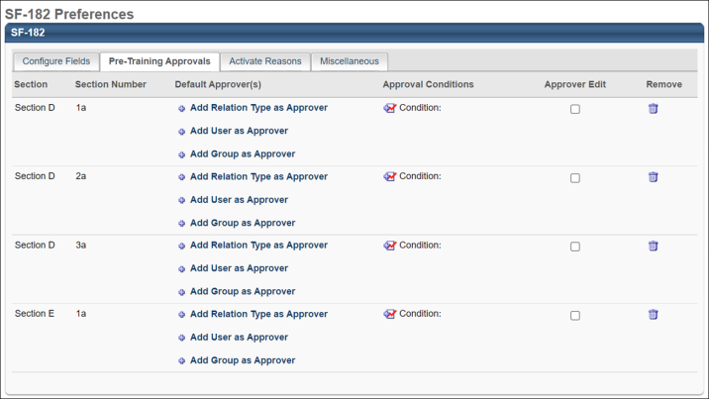
Section D
Section D allows for the printing of the following fields:
- Full name
- Title
- Email address
- Phone
- Approval date
- Signature box with full name displayed
Approvers can be set for Section D-1a, Section D-2a, and Section D-3a. These approver selections determine the approvers who will be printed on the form for those sections.
Section E
Section E allows for the printing of the following fields:
- Full name
- Title
- Email address
- Phone
- Approval date
- Signature box with full name displayed
Approvers can be set for Section E-1a. This approver selection determines the approvers who will be printed on the form for Section E-1a.
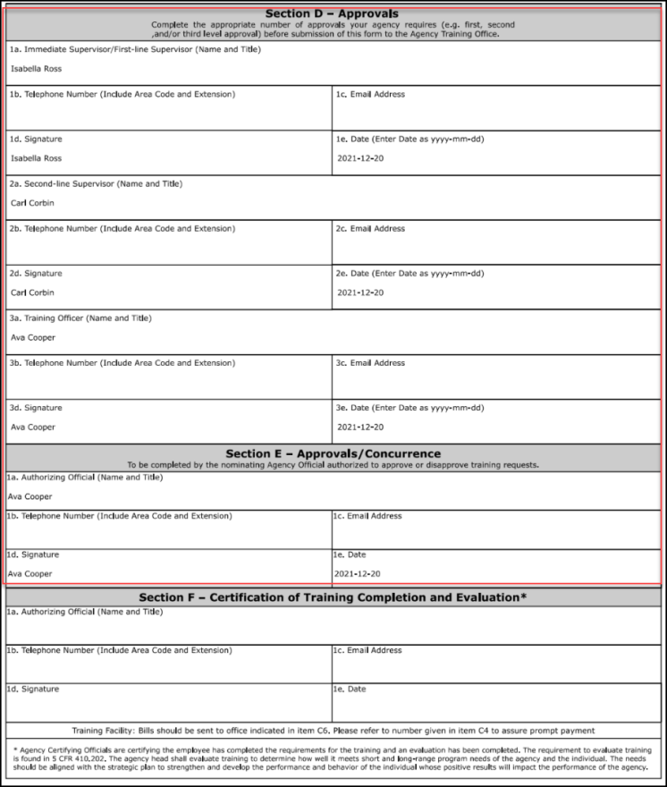
Section F
Post-training (completion) approvals can be configured via the Default Approval Workflow Templates page and the Default Approval Requirements for External Training page. The first approver who approves will now display in Section F on SF-182 forms.
Section F allows for the printing of the following fields:
- Full name
- Title
- Email address
- Phone
- Approval date
- Signature box with full name displayed
See Default Approval Requirements - External Training on page 139 for additional information.
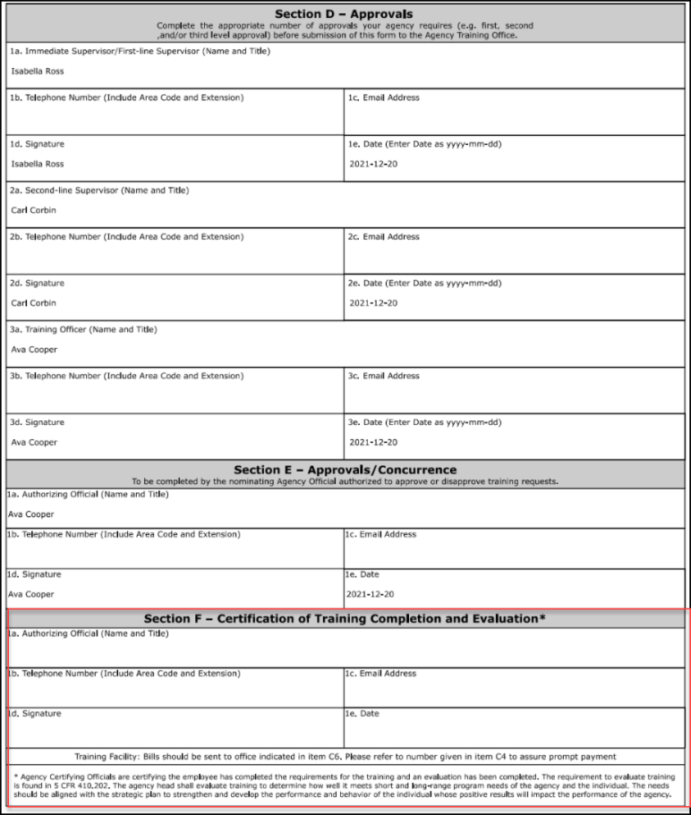
Default Approvers
The options in the Default Approvers column enable you to configure the approvers for the step. You can have relation types, groups, and users as approvers, but there must be at least one approver added.
Relation Type as Approver
A relation type approver is an approver that has a system-defined relationship to the user that submitted the form, as configured in the user record. For example, a relation type approver could be the user's manager or their indirect manager. Note: When an administrator or manager submits an SF-182 request on behalf of a user, the relation type approver is based on the user record of the user and not that of the administrator or manager.
To configure a relation type approver:
- Click the Add Relation Type as Approver link. This opens the Select Approvers pop-up. One or more of the following relation types can be selected for each step:
- Self
- Manager
- Indirect Manager - This is the user's indirect manager (i.e., the manager's manager). This is a dynamic relationship that can only be added once to each step, and it will keep traversing the user's manager hierarchy.
- Cost Center Approver
- Cost Center Owner
- User (Note: Selecting User allows you to pick a specific user.)
- Click the Add icon in the Add column for each relation type approver you would like to add.
If you select "User," this opens the Select User pop-up from which you can select one or more users. Once you have selected the desired users, click Add. This closes the Select User pop-up but does not close the Select Approvers pop-up.
- Click Done on the Select Approvers pop-up.
The approvers appear below the Add Relation Type as Approver link in the order in which they are added. The order in which the approvers appear does not impact the order of the approval workflow. Any of the approvers can approve the step.
User as Approver
You can select specific users to be approvers. To configure a user as an approver:
- Click the Add User as Approver link. This opens the Select User pop-up.
- Click the Add icon in the Add column for each user you would like to add. Note: Approvers that are deactivated before the SF-182 request is submitted are not sent the approval notification email. If all users that are selected as approvers are deactivated after the request is submitted, the approval step is skipped.
- Click Add.
The approvers appear below the Add User as Approver link in the order in which they are added. The order in which the approvers appear does not impact the order of the approval workflow. Any of the approvers can approve the step.
Group as Approver
To add a group as an approver:
- Click the Add Group as Approver link for the relevant step. This opens the Select Approvers pop-up window.
- Click the Add icon in the Add column for each group you would like to add.
- Click the Add button.
The group(s) you selected will be added as approvers for the step. Any user in the group can approve the step.
- Note: There is no limit on the number of users in groups or the number of groups that can be added, but only up to 100 users will display in the Training Details for Sections D and E.
- Note: Only users that were part of the group at the time of the form submission will be added as approvers for the form. Users added to the group after form submission are NOT automatically added as approvers.
Approval Conditions
The Approval Conditions option enables you to set conditions under which the approval step appears in the workflow. If the conditions are not met, the approval step does not appear in the approval workflow for the request.
To set approval conditions:
- Click the Condition icon in the Approval Conditions column. This opens the Define Approval Condition pop-up.
- Select one of the following condition types from the condition type drop-down:
- Indirect Total Cost (from Step 2 of SF-182 request)
- Total Direct Cost (from Step 2 of SF-182 request)
- Training Non Duty Hours (from Step 1 of SF-182 request)
- Training Duty Hours (from Step 1 of SF-182 request)
- Select one of the following conditions from the condition drop-down:
- Greater than
- Greater than or equal to
- Less than
- Less than or equal to
- In between
- Enter the condition's numeric value in the text box. Punctuation is not accepted. Note: For the "In between" condition, two text boxes appear in which to enter a range. For example, Total Direct Cost is between $500 and $1000. Both boxes must include a valid value in order to save the condition.
- Click Save. The condition appears in the Approval Conditions column.
To remove a condition:
- Click the Condition icon in the Approval Conditions column. This opens the Define Approval Condition pop-up.
- Click Remove. This closes the pop-up and removes the condition from the step.
Approver Edit
The Approver Edit option enables you to allow approvers to edit the request before they approve it. Check the Approver Edit option to allow approvers to edit the request.
Remove
The Remove option enables you to delete an approval step. To delete a step, click the Trash Can icon.
- If only one step is configured, clicking Remove deletes the contents of the step but not the step itself. Once you click Save or navigate to a different tab and then return to the Set Approvals tab, the default data in each column reappears for Step 1.
- If more than one step is configured, removing a step moves up all of the subsequent steps.
Overwrite Settings
Select this option to overwrite custom settings for child division OUs. If you overwrite custom settings for child division OUs, the selected settings are applied to both new and existing child OUs. Any previously customized child OUs are updated with the selected settings.
- If there are no customizations to the child OU, then the parent OU customizations are applied to all child OUs.
- Overwrite custom settings checkbox setting
  - If this option is selected, all child OU customizations are deleted from the database, which means the parent OU customizations will be applied to new and existing child OUs.
  - If this option is unselected, all existing child OU customizations will remain unchanged, and any new child OUs will inherit the parent OU customizations by default.
- If a child OU has been customized to display any widgets, then regardless of the parent OU customizations, the child OU customizations are applied.
- If a child OU has been customized to hide all widgets, then parent OU customizations will take precedence and will be applied.
Save
Once all preferences are set, click Save. Preference settings are not saved unless you click Save. This returns you to the Preferences page.
Or, to set preferences for another SF-182 Preferences tab before saving, click the tab name and configure the preferences. Then, click Save.
Set SF-182 Preferences - Activate Reasons
The Activate Reasons tab enables administrators to activate and deactivate the approval and denial reasons that are configured in SF-182 Reason Preferences. See SF-182 Reason Preferences on page 282 for additional information. Active reasons appear in the Indicate Reason drop-down on the Approve/Deny SF-182 Request page. Approval and denial reasons are inactive by default.
To activate an approval or denial reason, check the box to the left of the reason. To deactivate a reason, uncheck the box.
Overwrite Settings
Select this option to overwrite custom settings for child division OUs. If you overwrite custom settings for child division OUs, the selected settings are applied to both new and existing child OUs. Any previously customized child OUs are updated with the selected settings.
- If there are no customizations to the child OU, then the parent OU customizations are applied to all child OUs.
- Overwrite custom settings checkbox setting
  - If this option is selected, all child OU customizations are deleted from the database, which means the parent OU customizations will be applied to new and existing child OUs.
  - If this option is unselected, all existing child OU customizations will remain unchanged, and any new child OUs will inherit the parent OU customizations by default.
- If a child OU has been customized to display any widgets, then regardless of the parent OU customizations, the child OU customizations are applied.
- If a child OU has been customized to hide all widgets, then parent OU customizations will take precedence and will be applied.
Once all preferences are set, click Save. Preference settings are not saved unless you click Save. This returns you to the Preferences page.
Or, to set preferences for another SF-182 Preferences tab before saving, click the tab name and configure the preferences. Then, click Save.
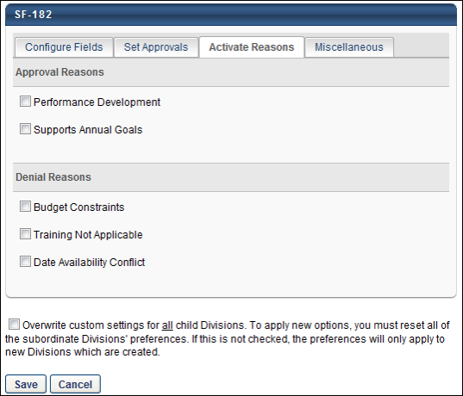
Set SF-182 Preferences - Miscellaneous
The Miscellaneous tab enables administrators to configure miscellaneous preference settings related to the SF-182 functionality.
The following options can be configured on the tab:
- Regular External Training - Checking this option enables the Add Regular External Training link to appear on the Transcript page. This option is unchecked by default. Note: With this enhancement, the name of the link to add external training on the Transcript page is changed from Add External Training to Add Regular External Training.
- Display Approval Queue - This option enables the approval queue to display on the Training Details page. This option is checked by default.
- Digital Signature - When selected, this option allows digital signatures to be captured on SF-182 forms. Note: Digital signatures can only be used for SF-182 forms if single sign-on (SSO) has been enabled in the portal.
- Allow Edit of Approved Forms - This setting is NOT selected by default. If this setting is selected, approved SF-182 forms will be editable from the SF-182 request management page and the learner's transcript. Selecting this setting prompts the approver with a message: "This form has been previously approved. Allow the learner to edit and re-submit the form from their transcript?." If the approver clicks YES, it allows the learner to edit and re-submit the form. If the approver clicks NO, it saves the changes, but the learner cannot edit the form from their transcript. If this setting is unselected, approved SF-182 forms will not be editable from the SF-182 request management page.
Note: Selecting this setting allows learners to edit and re-submit the form without impacting existing approvals. If the form is re-submitted after the edit, it will not go through the approval workflow again and remain in the approved status with the original workflow.
Note: The approver can also cancel and not save any changes when editing an SF-182 form. In such a case, the form does not undergo the approval workflow again and retains existing approvals.
- Allow Edit of Completed Forms - This setting is NOT selected by default. If this setting is unselected, completed SF-182 forms will not be editable from the SF-182 request management page. If this setting is selected, then completed SF-182 forms will be editable from the SF-182 request management page.
- Form Instructions - This option enables you to upload instructions for completing the SF-182 request form. The instructions can be downloaded by users from any step of the request form.
To upload instructions, click the Upload link. This opens the Upload File pop-up. Click Browse to search for and select the document. Click Upload. The attachment appears below the Form Instructions option. Only one attachment is accepted. The maximum file size is 10MB. The acceptable file types are .pdf, .doc, and .docx.
You can remove an attachment by clicking the Trash Can icon to the left of the attachment name.
Overwrite Settings
Select this option to overwrite custom settings for child division OUs. If you overwrite custom settings for child division OUs, the selected settings are applied to both new and existing child OUs. Any previously customized child OUs are updated with the selected settings.
- If there are no customizations to the child OU, then the parent OU customizations are applied to all child OUs.
- Overwrite custom settings checkbox setting
  - If this option is selected, all child OU customizations are deleted from the database, which means the parent OU customizations will be applied to new and existing child OUs.
  - If this option is unselected, all existing child OU customizations will remain unchanged, and any new child OUs will inherit the parent OU customizations by default.
- If a child OU has been customized to display any widgets, then regardless of the parent OU customizations, the child OU customizations are applied.
- If a child OU has been customized to hide all widgets, then parent OU customizations will take precedence and will be applied.
Save
Once all preferences are set, click Save. Preference settings are not saved unless you click Save. This returns you to the Preferences page.
Or, to set preferences for another SF-182 Preferences tab before saving, click the tab name and configure the preferences. Then, click Save.
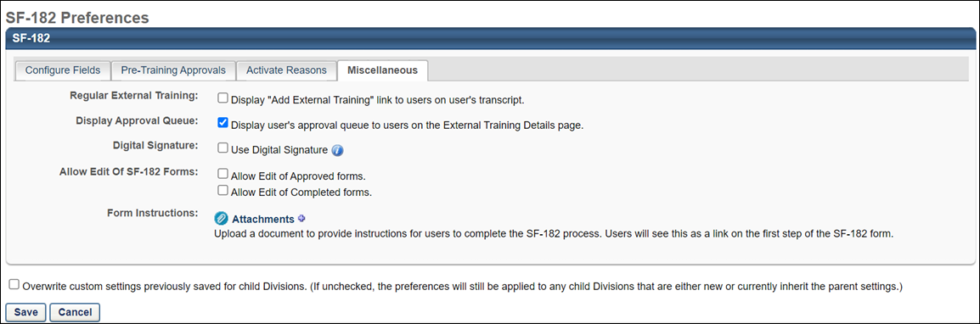
SF-182 Reason Preferences
The SF-182 Approval/Denial Reason Preferences page enables administrators to create up to 15 common reasons for approving or denying an SF-182 request.
Note: As part of the initial setup for the SF-182 functionality, at least one approval or denial reason must be available for each user that can approve or deny SF-182 requests.
To access SF-182 Reason Preferences, go to Admin > Configuration Tools > Preferences. Then, click the Set SF-182 Reason Preferences link.
Permissions
PERMISSION NAME | PERMISSION DESCRIPTION | CATEGORY

Set SF-182 Reason Preferences | Grants ability to create and edit/update SF-182 reasons for users to select when approving or denying an SF-182 request. (Governmental clients). This is an administrator permission. | Limited Use/Obsolete
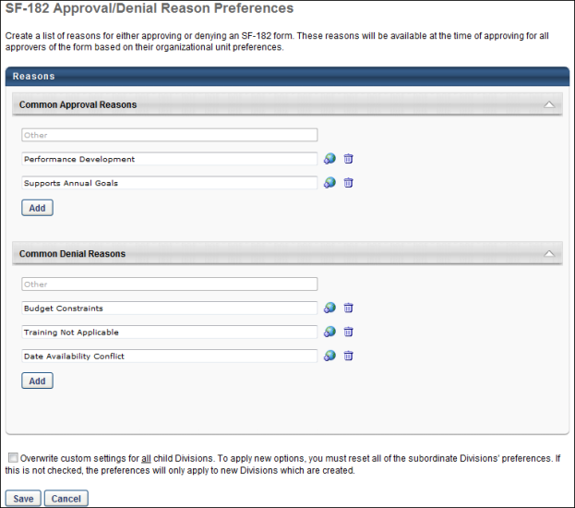
Reasons
By default, "Other" is configured as a common approval and denial reason. This reason cannot be edited, deleted, or localized. This reason always appears in the Indicate Reason drop-down on the Approve/Deny SF-182 Request page.
To create a common approval or denial reason:
- Click Add. A blank row appears in the corresponding panel.
- Enter the reason in the text box. For portals with multiple languages enabled, click the Translate icon to enter localized text.
All reasons except for "Other" are inactive by default. Note: The active status of a reason is configured on the Activate Reasons tab in SF-182 Preferences.
You can edit a reason by changing the text in the text box. You can delete a reason by clicking the Trash Can icon to the right of the text box.
Overwrite Settings
Select this option to overwrite custom settings for child division OUs. If you overwrite custom settings for child division OUs, the selected settings are applied to both new and existing child OUs. Any previously customized child OUs are updated with the selected settings.
- If there are no customizations to the child OU, then the parent OU customizations are applied to all child OUs.
- Overwrite custom settings checkbox setting
  - If this option is selected, all child OU customizations are deleted from the database, which means the parent OU customizations will be applied to new and existing child OUs.
  - If this option is unselected, all existing child OU customizations will remain unchanged, and any new child OUs will inherit the parent OU customizations by default.
- If a child OU has been customized to display any widgets, then regardless of the parent OU customizations, the child OU customizations are applied.
- If a child OU has been customized to hide all widgets, then parent OU customizations will take precedence and will be applied.
Save
Once all preferences are set, click Save. Preference settings are not saved unless you click Save. This returns you to the Preferences page.

ILT Preferences Overview
Citrix Portal Preferences
The Citrix Preferences page allows administrators to configure settings for the GotoMeeting integration.
To access Citrix Portal Preferences, go to Admin > Tools > Learning > Learning Preferences > Citrix Preferences.
Permissions
PERMISSION NAME | PERMISSION DESCRIPTION | CATEGORY

Citrix Portal Preferences - GotoMeeting - Manage | Grants ability to manage GotoMeeting Preferences within Citrix Portal Preferences. This permission cannot be constrained. This is an administrator permission. | Learning - Administration
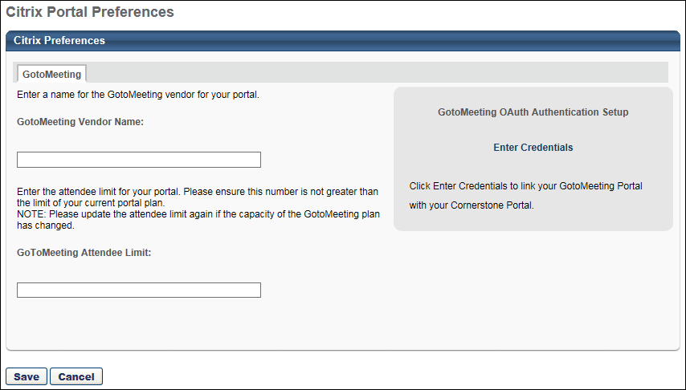
Citrix Preferences
The following fields are available on this page:
- GotoMeeting Vendor Name - In this field, enter the name of the GotoMeeting vendor for your portal.
- GoToMeeting Attendee Limit - This field enables administrators to limit the number of attendees for their GoToMeeting sessions. Administrators should be sure to enter a value that is within the limit of their current Citrix account. The maximum value for this field is 250. If no value is entered, then this field defaults to 25.
Click the Save button at the bottom of the page to save your changes. If you wish to discard your changes without saving, click the Cancel button instead.

ILT Preferences by Division
ILT Preferences by division allow administrators to set settings for Instructor Led Training. Some ILT preference settings are set only at the top node division and others can be set for each individual division.
To configure ILT Preferences, go to Admin > Tools> Learning > Learning Preferences > ILT Preferences. Select the division for which you are configuring preferences. ILT Preferences is comprised of two tabs:
- General Tab - See ILT Preferences - General on page 289 for additional information.
- Event Calendar Tab - See ILT Preferences - Event Calendar on page 299 for additional information.
Permissions
PERMISSION NAME | PERMISSION DESCRIPTION | CATEGORY

ILT Preferences - Manage | Grants ability to configure a variety of default settings that apply to new instructor led training events and sessions. This permission can be constrained by OU and User's OU. This is an administrator permission. | Learning - Administration
ILT Preferences Propagation
- Please see the Propagation chart below to track how ILT Preferences are propagated to the subordinate OUs, and events & sessions.
= Setting can be overridden = Setting cannot be overridden
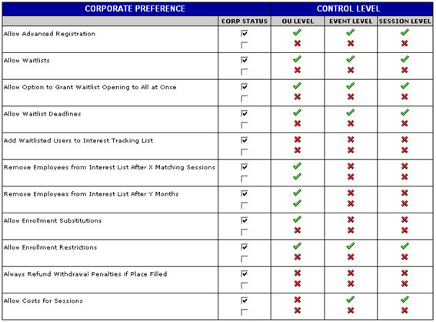
The following fields will only appear on the ILT Preferences page for a subordinate OU if these options were specified as allowed on the ILT Preferences page for the corporate OU. The default settings for these fields are also specified on the Corporate ILT Preferences page:
  - Allow instructors to create events with advanced registration
  - Allow instructors to create events with waitlists
    - The Grant Waitlist Opening radio button under the Auto-Management checkbox will only appear if the Allow option to grant opening to all waitlisted users at once for first come first served registration box was checked on the Corporate ILT Preferences page.
    - If this radio button does not appear, openings will always be granted one at a time to the person at the top of the waitlist.
  - Allow waitlist deadlines - You can set the default period of time that waitlisted users have to register for the session. A default number for each box can be configured at the event level.
    - Time students have to register - Set the number of days and hours waitlisted users have to register.
    - Waitlist expires XX days and XX hours before session start date - Set when the waitlist expires in relation to the session start date.
  - Allow managers and administrator to perform enrollment substitutions
The following fields will only appear on the Session Defaults page or the Session Details page, if these options were specified as allowed on the ILT Preferences page, for the session scheduler's organizational unit. If these options were not selected, then users within that organizational unit will not see these fields when they are creating events or sessions. The default settings for these fields are also specified on the ILT Preferences page:
  - Advanced Registration
  - Cost per Session
    - This field is either on or off for the entire corporation. The option appears on the Corporate ILT Preferences page.
    - The cost types that appear in the Select Cost Type drop-down are specified on the Corporate ILT Preferences page.
  - Enrollment Restrictions
  - Waitlists
    - The radio button under the Auto-Management box will not appear if the Allow option to grant opening to all waitlisted users at once for first come first served registration box was not checked on the ILT Preferences page.
    - If this radio button does not appear, openings will always be granted one at a time to the person at the top of the waitlist.
  - Waitlist Deadlines
- The Apply these settings to events created in the past checkbox on the ILT Preferences page only applies to Events, not Sessions.
- Sessions always inherit the fields from the Event, so a new session created will always have all the fields that the event has, regardless of whether they are selected.
  - Sessions created in the past may have settings different from their event if the ILT Preferences for that event's OU have changed and were retroactively applied.

ILT Preferences - General
On the General tab of ILT Preferences, administrators can configure the general default settings for ILT events and sessions.
To configure ILT Preferences, go to Admin > Tools > Learning > Learning Preferences > ILT Preferences.
Permissions
PERMISSION NAME | PERMISSION DESCRIPTION | CATEGORY

ILT Preferences - Manage | Grants ability to configure a variety of default settings that apply to new instructor led training events and sessions. This permission can be constrained by OU and User's OU. This is an administrator permission. | Learning - Administration
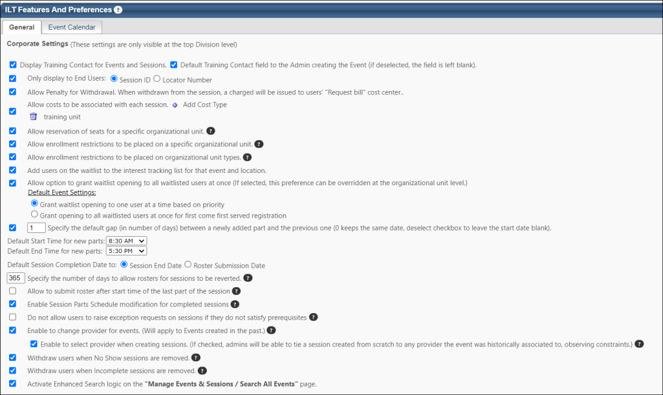
Corporate Preferences (These settings are only visible at the top Division level)
This section contains corporate settings which are available to be modified on the ILT Preference page when modifying ILT Preferences for the very top division.
- Display Training Contact for Events and Sessions - Check to display Training contact on events and sessions for users.
- Default Training Contact field to the Admin creating the Event - This box is checked by default. When checked, the Training Contact field on the Properties step when creating/copying an event automatically populates with the name and email address of the administrator creating/copying the event. When unchecked, the Training Contact field displays the Select icon from which administrators can manually select a training contact. If the Display Training Contact for Events and Sessions box is unchecked, the Default Training Contact field to the Admin creating the Event checkbox is not selectable. Note: On the Properties step when creating a new event, even if the Training Contact field is populated with a default training contact, the Select icon is still available from which a different training contact can be selected. Only one training contact can be selected.
- Only display to End Users - Select Session number or Locator number to display to user.
- Allow penalty for withdrawal - If this option is selected, administrators can specify a Penalty for Withdrawal when setting up an ILT event.
- Allow costs to be associated with each session - Select this option to add the ability to detail session costs in a field on the Session Details page when creating a session. Session costs are only for reporting purposes and are not displayed to users.
  - Click on Add Cost Type.
  - Enter a cost type into the text box.
  - Click the Save icon.
  - Repeat the above steps to add another cost types
  - Remove cost type by clicking Remove icon.
- Allow reservation of seats for a specific organizational unit - This option allows seats to be reserved by organizational unit for instructor-led training or virtual instructor-led training sessions. This option is unselected by default. Selecting the option enables the Reserve Seats by Organizational Unit option to appear on the Create Event - Session Defaults page and the Create Session - Details page.
  - See ILT Event - Create - Step 5 - Session Defaults for additional information.
  - See Create Session - Details for additional information.
- Allow enrollment restrictions to be placed on a specific organizational unit - Select this option to allow administrators to place enrollment restrictions by a specific OU. Checking this option adds a field to the Enrollment Restrictions section of the Details step of creating, editing, or copying a session that allows administrators to place enrollment restrictions by a specific OU. Note: If left unchecked, when creating, editing, or copying a session, the Enrollment Restrictions section only displays if the Allow enrollment restrictions to be placed on organizational unit types field is checked.
- Allow enrollment restrictions to be placed on organizational unit types - Select this option to allow sessions to enforce OU enrollment restrictions. Enrollment restrictions when selected at the session level will limit number of potential registrants from each OU (of the selected type).
- Add users on the waitlist to the interest tracking list for that event and location - When this option is selected, if a user joins a waitlist for a session, then the user is automatically added to the Interest Tracking list for the corresponding event and location. Users on the Interest Tracking list may be eligible for an early registration period when a new session is created, depending on the ILT Preferences.
- Allow option to grant waitlist opening to all waitlisted users at once - Select this option to allow sessions and events to have the option to grant the waitlist openings to the entire group of waitlisted users at once. Allowing this option does not deny the ability to grant a seat to one user at a time; it simply makes the radio button for the option appear. If this option is not allowed then all waitlist opening are granted to one user at a time. Note: The preferences below are Dynamic Preferences. If the parent division has checked these preferences, then the child division may view and manage these preferences.
  - Grant waitlist opening to one user at a time based on priority - Check to grant waitlist opening to one user at a time
  - Grant opening to all waitlisted users at one for first come first served basis - Check to grant waitlist opening to all waitlisted users at once
- Specify the number of days that the date for every added part defaults to from the last part - This box is checked by default and displays a value of "1" in the text field. The value in the text field represents a number of days and is used to determine the date on which every part added to a session begins and ends. The date is calculated by adding the value in the text field to the end date of the most recently added part. By default, the start and end date are the same but can be modified.
If a value of "0" is entered in the text field in ILT Preferences and there is at least one existing part for a session, the Start Date and End date fields when adding a part will be the same date as the most recently added part.
When the box is unchecked, the text field in ILT Preferences is not editable, and the Start Date and End date fields when adding a new part are blank. The dates must be selected manually.
  - Default End Time for new parts - The default value is 5:30 PM. Changing the value in ILT Preferences changes the default end time on the first instance of adding a part to a session. The default end time for subsequent parts will be the end time of the most recently added part.
  - Default Start Time for new parts - The default value is 8:30 AM. Changing the value in ILT Preferences changes the default start time on the first instance of adding a part to a session. The default start time for subsequent parts will be the start time of the most recently added part.
- Default Session Completion Date to - This option enables administrators to select the method for calculating the session completion date. The selected method will be implemented for all sessions that are created after the setting is saved. These settings also apply to equivalencies. See the Session Completion Date behaviors section below for more information about this option. Note: This setting only impacts sessions that are created after this preference is changed. Existing sessions are not impacted. The following methods are available:
  - Session End Date - This option is selected by default. When this option is selected, all new sessions that are created will have the session completion date automatically set to the session end date. The session end date is the latest date of the last session part.
  - Roster Submission Date - When this option is selected, all new sessions that are created will have the session completion date automatically set to the date on which the session roster is submitted.
Session Completion Date Behaviors
Events always inherit the session completion date based on Default Session Completion Date settings. See the below use cases for more information about expected behaviors of this functionality:
  - If the user completes pre-work for a session, the completion of the session will mark the event as completed with the session completion date, based on ILT preferences.
  - ILT Preference settings are respected for post-work that is already completed or not required. The post work completion date is respected for required post work.
  - The e-signature completion date is respected, if applicable.
  - If the session includes required post-work, the completion of the session moves the session to a Pending Post-work status. After the post-work is completed by the user, the session is marked complete based on ILT preference settings for session, and the event is marked complete.
  - If a session has a required post-work item that the user has already completed, the completion of the session marks the event with completion date of the session based on ILT preferences.
  - If the user completes the pre-work for a session, the completion of the session marks the event with the completion date of the session based on ILT preferences.
  - If a session requires a signature, the completion of the session changes the session status to Pending Signature, and once the user signs, the event is marked complete with completion date based on session ILT Preferences.
  - If a session requires a signature, the completion of the session changes the session status to Pending Signature. Once the user signs, the event is marked complete, with the completion date being based on session ILT Preferences.
  - If the event has two or more sessions, and the first session is completed, the first session's completion date is mapped to the completion date of the Event. When the second session is completed, the event will be marked complete for the second registration with the same completion date as the second session.
Note: The following section of considerations applies to equivalencies. Equivalencies can only be configured at the event level.
  - If an event has an equivalent training and is bidirectional, and the session is registered and on a user's transcript, the session completion marks the event complete with the session completion date. When the training equivalency is in a Registered status on the user’s transcript, it will inherit the session completion date.
  - If an event is equivalent to Training A, and a user has Training A and a session of the event in a Registered status on their transcript, when Training A is completed, the event will be marked complete with Training A's completion date, and the session will have a second registration and inherit the session completion date. The event will inherit the session completion date according to ILT preferences.
  - When an event is equivalent to a training item, and the event is registered on the user’s transcript, when the equivalent training is completed, the event is marked completed with the training equivalent's completion date.
- Specify the number of days to allow rosters for sessions to be reverted - This option enables the administrators to configure the time frame (in days) to allow session reverts. The minimum value is 1 day, which means the ‘Revert’ is allowed for only 1 day after the session is completed.​ The maximum value can be set to 731 days, and the ​default value will be set to 365 days.​ This preference applies to the revert timeframe for both standalone sessions and sessions within curricula. Note: This preference is only visible when the Allow Revert for Sessions which are part of Curricula is enabled in Feature Activation Preferences.​
- Allow to submit roster after start time of the last part of the session - This option allows the roster to be submitted at the start of the last part of the session. When this option is checked in ILT Preferences, the Submit Roster button appears on the Attendance and Scoring tab of the session after the start time of the last part of the session. This option is unchecked by default. If this option is not checked, users cannot submit the roster until after the last session part ends. See Session Roster - Attendance and Scoring Tab.
- Enable Session Parts Schedule modification for completed sessions - If this option is enabled, administrators are not able to modify date, instructor, or location information for the session after the session has been completed. For administrators with the ability to modify session attempts or to edit a completed session, the location, date, and instructor fields for the session are grayed out and read-only if this option is enabled.
- Do not allow users to raise exception requests on sessions if they do not satisfy prerequisites. This option is unchecked by default. When this option is checked, users cannot submit exception requests when they request a session for which they have not yet satisfied a required prerequisite. The configuration of this option in ILT Preferences affects the configuration of the same option that is being added to events as part of this enhancement.
If checked in ILT Preferences, then the Do not allow users to raise exception requests on sessions if they do not satisfy prerequisites option will be checked by default for all events created after the preference setting is saved. If this option is not checked in ILT Preferences, then this option is also not checked by default for events created after the preference setting is saved. See ILT Event - Create - Session Defaults - Prerequisites.
Note: The Do not allow users to raise exception requests on sessions if they do not satisfy prerequisites option is always visible in the Prerequisites section on the Session Defaults page of the event and the Details page of the session, regardless of whether or not the option is selected in ILT Preferences.
- Enable to change provider for events. (Will apply to Events created in the past.) - This option is unchecked by default. When checked, this option enables administrators to edit the primary and secondary vendor on events. When unchecked, the vendor cannot be changed on events. This preference applies to all existing events (i.e., not only to future events created after the preference is enabled). Checking this option also allows the Enable to select provider when creating sessions option to display.
  - Enable to select provider when creating sessions - This option only displays if the Enable to change provider for events option is checked. This option is unchecked by default. When checked, administrators can select the provider when creating new sessions from scratch (i.e., not by copying an existing session). When unchecked, new sessions created from scratch will be tied to the current primary or secondary provider on the event. This is the existing functionality for sessions.
- Withdraw users when No Show sessions are removed - If this option is NOT selected on the ILT Preferences page, the session will be removed from the user's transcript, but the user will not be withdrawn from the session. The session will retain its No Show status on the Removed tab of the transcript. If the Withdraw users when No Show sessions are removed option IS selected on the ILT Preferences page, the user will be withdrawn from the session and the session will be removed from the user's transcript. The removed session will have a transcript status of Withdrawn and will moved to the Removed tab of the transcript. Note: The Removed tab is not visible to the user.
- Withdraw users when Incomplete sessions are removed - If this option is NOT selected on the ILT Preferences page, the session will be removed from the user's transcript, but the user will not be withdrawn from the session. The session will retain its Incomplete status on the Removed tab of the transcript. If the Withdraw users when Incomplete sessions are removed option IS selected on the ILT Preferences page, the user will be withdrawn from the session and the session will be removed from the user's transcript. The removed session will have a transcript status of Withdrawn and will be moved to the Removed tab of the transcript. Note: The Removed tab is not visible to the user.
- Activate Elastic Search Logic on the "Manage Events & Sessions / Search All Events" Page - Administrators can choose whether the Learning (elastic) Search engine is active on the Manage Events and Sessions page. To activate the elastic search engine, select this option. This option is unselected by default.
General (Settings are visible for all Divisions)
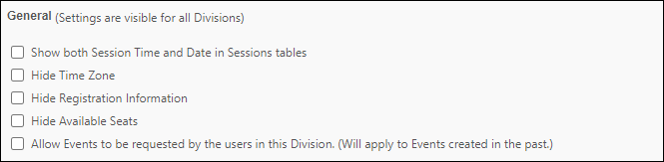
These preferences always display for all ILT Preferences pages regardless if the Division is a child division or parent division.
- Show both Session Time and Date in Sessions tables - When this option is selected, the session date and time is displayed on the Sessions tables within Manage Events and Sessions. This applies when searching for all sessions and when viewing all sessions within a specific event. This option is unchecked by default.
- Hide Time Zone - If checked will not display on the Session Details pop-up, Events Details Pop-up, Events Calendar or in the schedule section of the Session Training Details page. It does not impact ILT Schedule Email Tags.
- Hide Registration Information - If checked the registration information Registration Deadline, Max Registration, and Currently Registered will not display on the Session Details pop-up, and Training Details page (Sessions).
- Hide Available Seats - If checked the Seats Available column title and the numerical value will be hidden. If this preference is checked and the Hide Registration preference is checked, the entire table will be hidden on the Session Details Pop-up.
- Allow Events to be requested by the users in this Division (Will apply to Events created in the past) - Select this option to allow users to request events. When this option is selected, a Request button appears on the LO Details page. This setting does not affect a user's ability to request a session.
Advanced Registration
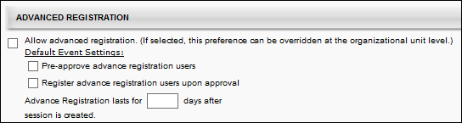
Allow advanced registration - Check box to allow events to have advanced registration. If this is activated at the event level, then all sessions for that event will by default have an early registration period only available to users on the interest tracking list for that event and location. This setting may be overridden at the session level. If this is not activated at the event level, then by default there will be no advanced registration period for sessions of the event.
Note: The preferences below are Dynamic Preferences. If the parent division has checked these preferences, then the child division may view and manage these preferences.
- Pre-approve advanced registration users - check to bypass approval requirements for users
- Register advanced registration users upon approval - check to bypass registration requirements
- Advanced Registration lasts for XX days after session is created - enter number of days for advanced registration period. Advanced Registration period begins when session is created.
Waitlist
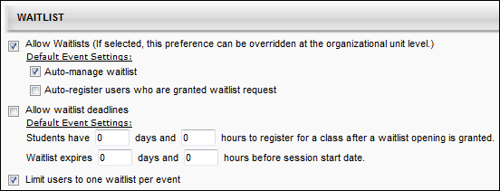
- Allow Waitlists - Check box to allow waitlists for sessions. Note: The preferences below are Dynamic Preferences. If the parent division has checked these preferences, then the child division may view and manage these preferences.
  - Auto-manage waitlist - Check to set the default event and session settings so that the system automatically grants seats to users on the waitlist as seats become available.
  - Auto-register users who are granted waitlist request - Check to auto-register users granted waitlist openings by default.
- Allow waitlist deadlines - Check to allow sessions to have waitlist deadlines. Note: This option is only available if the Allow Waitlists option is selected.
  - Students have - Enter number of Days and Hours that users have to register for the session if granted an opening.
  - Waitlist expires - Enter number of Days and Hours before registration deadline that waitlist expires.
- Limit users to one waitlist per event - When this option is selected, users can only add themselves to one waitlist per event. If this option is selected and a user attempts to add themselves to more than one waitlist per event, then a message is displayed, indicating that they can only be on the waitlist for one session in the selected event. Note: This option is only visible if the Allow Waitlists option is selected.
  - When this option is selected, it limits users for all waitlist requests after the preferences are saved. The system does not remove users from any waitlists if they have previously been added to multiple waitlists for an event. However, if this option is enabled, a user is already added to multiple waitlists for a single event, and the user requests to be added to an additional waitlist for the same event, then the user must be removed from all other session waitlists for the event in order for the request to be granted.
Enrollment
Allow enrollment substitutions within organizational units - check to allow managers, approvers, cost center approvers, and administrators to replace registered users with another user without incurring withdrawal penalties or opening the seat to the waitlist.
Note: The preferences below are Dynamic Preferences. If the parent division has checked these preferences, then the child division may view and manage these preferences.
Payment Preference
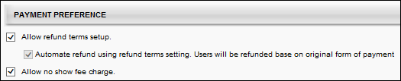
- Allow Refund terms setup - Select this option to enable administrators to set up refund terms when setting up an ILT event.
  - Automate refund using refund terms setting. Users will be refunded based on original form of payment. - This option is only available if the "Allow Refund terms setup" option is selected. Select this option to automatically issue refunds.
- Allow no show fee charge - Select this option to enable administrators to set up no show fees when setting up an ILT event.
Interest Tracking
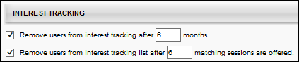
- Remove users from interest tracking after months - check to automatically remove users from the interest tracking list after a specific number of months. Standard/General Preferences - these preferences will always display for all ILT Preferences pages regardless if the Division is a child division or parent division.
  - Enter number of months after which users should be removed from interest tracking
  - If both Remove users from interest tracking list after XX matching sessions are offered and Remove users from interest tracking after XX months are checked then users will be removed from this list after the specified number of matching session or after the specified time period, whichever comes first.
- Remove users from interest tracking list after matching session - check to automatically remove users from the interest tracking list after they have been offered the chance to register for a certain number of session in their location preference
  - Enter number of sessions after which users should be removed from interest tracking
QR Code
To make QR Code functionality available during the ILT session creation process, select the Enable QR Code feature to be visible during session creation option. Enabling this option allows administrators and instructors to generate a QR code for the session part, which is then available on the Roster page and via email. Users can scan the QR code for a session using the Learn app.
To configure QR codes for an ILT session: See Create Session - Details.
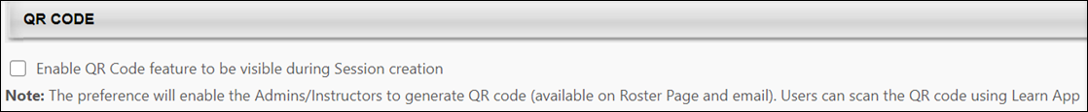
Overwrite Settings
Select this option to overwrite custom settings for child division OUs. If you overwrite custom settings for child division OUs, the selected settings are applied to both new and existing child OUs. Any previously customized child OUs are updated with the selected settings.
- If there are no customizations to the child OU, then the parent OU customizations are applied to all child OUs.
- Overwrite custom settings checkbox setting
  - If this option is selected, all child OU customizations are deleted from the database, which means the parent OU customizations will be applied to new and existing child OUs.
  - If this option is unselected, all existing child OU customizations will remain unchanged, and any new child OUs will inherit the parent OU customizations by default.
- If a child OU has been customized to display any widgets, then regardless of the parent OU customizations, the child OU customizations are applied.
- If a child OU has been customized to hide all widgets, then parent OU customizations will take precedence and will be applied.
Apply these settings to events created in the past
Check to apply these settings to events that were created before this change since the system doesn't grandfather in any existing events in the system that didn't carry the preference before.
Note that the adjustment of existing events is only impacting the following settings:
- Allow Waitlists (If selected, this preference can be overridden at the organizational unit level.)
- Auto-manage waitlist
- Auto-register users who are granted waitlist request
- Grant opening to all waitlisted users at once for first come first served registration
- Allow waitlist deadlines
- Students have ____ days and ____ hours to register for a class after a waitlist opening is granted.
- Waitlist expires ___ days and ____ hours before session start date.
- Limit users to one waitlist per event
- Allow advanced registration. (If selected, this preference can be overridden at the organizational unit level.)
- Pre-approve advance registration users
- Register advance registration users upon approval
- Advance Registration lasts for ___ days after session is created.
Save
Click the Save button to save your changes to ILT Preferences.

ILT Preferences - Event Calendar
On the Event Calendar tab of ILT Preferences, administrators can configure default settings for the Event Calendar.
To configure ILT Preferences, go to Admin > Tools> Learning > Learning Preferences > ILT Preferences. Select the Event Calendar tab to modify preferences for the Event Calendar.
Permissions
PERMISSION NAME | PERMISSION DESCRIPTION | CATEGORY

ILT Preferences - Manage | Grants ability to configure a variety of default settings that apply to new instructor led training events and sessions. This permission can be constrained by OU and User's OU. This is an administrator permission. | Learning - Administration
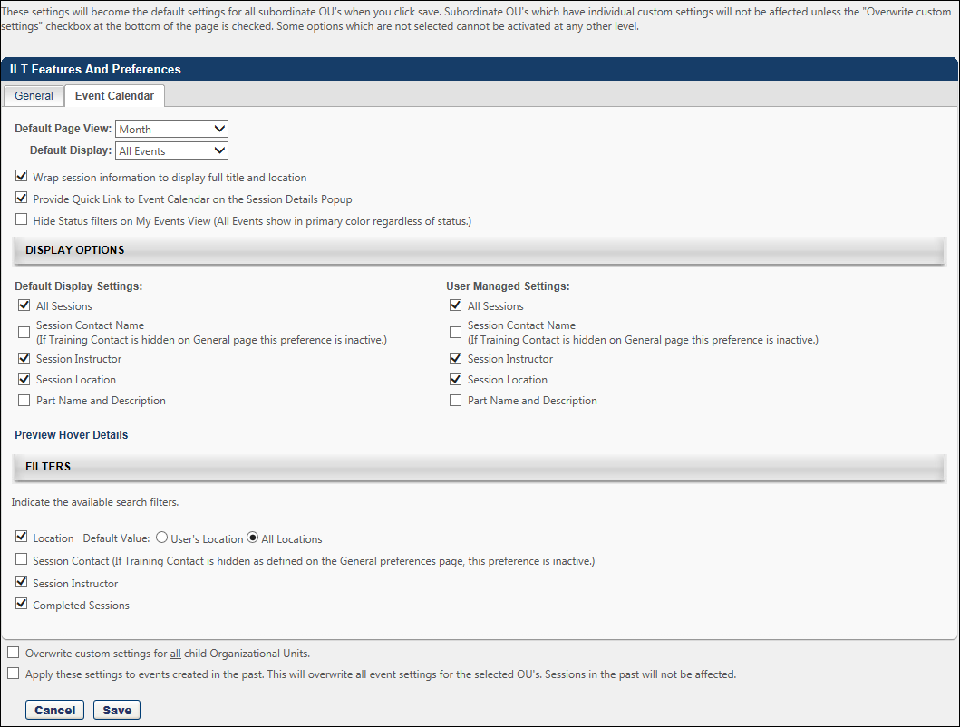
General Options
- Default Page View -allows you to define which view is displayed when a user navigates to the Event Calendar. The default view selected (Month, Week, Day or Agenda) will be applied from the access points Sub Link Event Calendar (Visibility controlled from Navigation Tabs and Links).
- Default Display - allows you to define whether the default view is All Events or My Events when Month, Week, or Day is being viewed by the user. The default view selected (My Events or All Events) will be applied from the access points Sub Link Event Calendar (Visibility controlled from Navigation Tabs and Links).
- Wrap session information to display full title and location - allows you to select the preference to wrap the session information on the event calendar Month, Week, and Day view. If the preference is unchecked, the event/session information will truncate to not exceed two lines on the event calendar Month, Week and Day view. If the option to wrap is selected in Event Calendar preferences, the rows of the calendar will expand to fit up to 3 events/sessions per day. If there are more than three a clickable arrow continues to display to provide access to a day view. The selection of display preference All Sessions would further expand the rows to fit all sessions existing for a day. The row height does not have a limit, but results in the page lengthening.
- Provide Quick Link to Event Calendar on the Session Details Popup - if this preference is checked, Session Details pop-ups will display a link Calendar View. The link is a short cut back to the Event Calendar view automatically returning the Day view with My Events for the day that the associated session starts on. Important: When the redesigned Learning Details page is active in the portal, the enablement of this preference option no longer has any effect on the portal.
- Hide Status filers on My Events View (All Events show in primary colors regardless of status.) - if this preference is checked, for the My Events view of Month, Week, and Day, the status filters will be hidden and the Event/Session name links will display as they display on the All Events view.
Display Options
Default Display Settings
The Default Display Settings control whether all sessions or only sessions available to the user are displayed and control the hover details pop-up for the end user on the Events Calendar. These settings also control what information is displayed in the Hover Details pop-up.
- All Sessions - If checked, all sessions available to the user for each date display. If unchecked, only the first three sessions available to the user for each date display, and any additional sessions are accessible through a clickable down arrow displayed in the lower right corner of the date.
- Session Contact Name (If Training Contact is hidden on the General page this preference is inactive.) - if checked the Contact Name displays on the Event Calendar only in the Hover details.
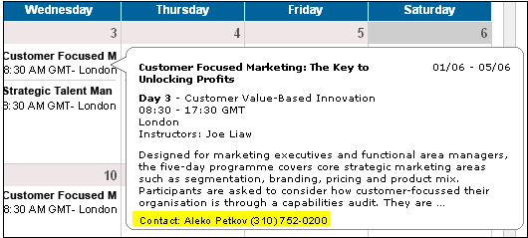
- Session Instructor - If this option is selected, the session instructors are displayed on the Event Calendar, but only in the Hover Details pop-up. If there are multiple instructors for a part, only as many that can fit in the Instructor line of the hover details will display. Depending on name length, 3 to 4 instructor names may fit.
- Session Location
- Part Name and Description - If this option is selected, the session part name and description are available to display in the Hover details.
- Preview Hover Details - When this link is selected, a preview of the Hover Details pop-up is displayed as configured. The session description will only display up to 300 characters of the description as defined in ILT Administration.
User Managed Settings
The User Managed Settings control which Event Calendar settings and filters are available to end users when viewing the Events Calendar.
- All Sessions - if checked allows the user to control the filters regardless of the default filter preferences
- Session Contact Name (If Training Contact is hidden on the General page this preference is inactive.) - if checked allows the user to check and un-check the filter from the Event Calendar view
- Session Instructor - if checked allows the user to check and un-check the filter from the Event Calendar view
- Session Location -if checked allows the user to check and un-check the filter from the Event Calendar view
- Part Name and Description - if checked allows the user to check and un-check the filter from the Event Calendar view
Filters
- Location - Select the default value for the Location filter. This preference is impacted by a backend setting.
- Session Contact (Training Contact is hidden as defined on the General page this preference is inactive.) - if checked allows the user to filter/search events on the Event Calendar by filtering by Session Contact
- Session Instructor - if checked allows the user to filter/search events on the Event Calendar by filtering by Session Instructor
- Completed Sessions - if checked allows the user to check and un-check the filter from the Event Calendar view
Overwrite Settings
Select this option to overwrite custom settings for child division OUs. If you overwrite custom settings for child division OUs, the selected settings are applied to both new and existing child OUs. Any previously customized child OUs are updated with the selected settings.
- If there are no customizations to the child OU, then the parent OU customizations are applied to all child OUs.
- Overwrite custom settings checkbox setting
  - If this option is selected, all child OU customizations are deleted from the database, which means the parent OU customizations will be applied to new and existing child OUs.
  - If this option is unselected, all existing child OU customizations will remain unchanged, and any new child OUs will inherit the parent OU customizations by default.
- If a child OU has been customized to display any widgets, then regardless of the parent OU customizations, the child OU customizations are applied.
- If a child OU has been customized to hide all widgets, then parent OU customizations will take precedence and will be applied.
Apply these settings to events created in the past
Check to apply these settings to events that were created before this change since the system doesn't grandfather in any existing events in the system that didn't carry the preference before
Click Save.

Training Completion Signature Preferences Overview
Default Training Completion Signature Preferences
An electronic signature (e-signature) is a signature that is provided electronically via the system. A training completion e-signature is provided by a user to confirm or indicate that they have completed the training. Users may be required to provide a training completion e-signature before a learning object (LO) is completed.
When e-signature is enabled via Training Completion Electronic Signature Preferences, this page enables administrators to configure the default setting for requiring training completion e-signatures by LO type. In addition, this page enables administrators to choose when their portal switches from controlling e-signature requirements at the OU level to controlling them at the LO level.
To manage Default Training Completion Signature Preferences, go to Admin > Tools > Learning > Learning Preferences > Default Training Completion Signature.
Permissions
PERMISSION NAME | PERMISSION DESCRIPTION | CATEGORY

Default Training Completion Signature Preferences | Grants ability to manage Default Training Completion Signature preferences at the portal level. This enables the administrator to set the default setting for whether an electronic training completion signature is required. This permission can be constrained by OU and User's OU. This is an administrator permission. | Learning - Administration
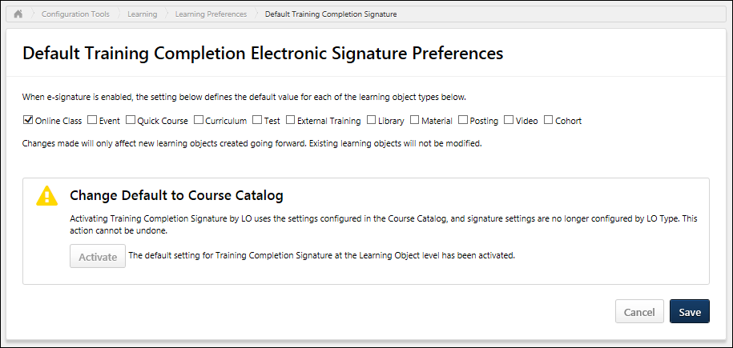
Require Training Completion E-signature by LO Type
Training completion e-signatures can be required at the LO level, and this is configured in the Course Catalog.
When e-signature is enabled via Training Completion Electronic Signature Preferences, this section enables the administrator to configure the default setting for requiring training completion e-signature by LO type. For example, if the Curriculum option is selected, then when a new curriculum is created, the Required Electronic Signature option is selected by default for the curriculum on the General page of the Course Catalog.
Select which LO types require the e-signature for completion by default. All LO types are unselected by default. Administrators can choose to enable or disable the e-signature requirement for each individual LO via the Course Catalog. This setting only determines the default configuration.
- For online courses, the default setting is applied when the course is published.
- For events, the default setting is applied to the event when the event is created. Any changes to this setting do not impact existing events. When a session is created for an event, the session inherits the signature requirement directly from the event.
- For programs, the default setting is applied to the program when the program is created. Any changes to this setting do not impact existing programs. When a cohort is created for a program, the cohort inherits the signature requirement directly from the program.
- For external training, any external training that is added throughout the system will inherit this setting. This setting cannot be changed for the external training once it is created.
Any changes to these default settings only impact newly created LOs. Any existing LOs are not impacted by changes to these settings.
Change Default to Course Catalog
This section enables administrators to choose when their portal switches from controlling e-signature requirements by LO type at the OU level to controlling them at the LO level.
Because e-signatures play a significant role in certain compliance workflows, it is important that organizations configure all of their LOs within the Course Catalog prior to enabling this functionality to ensure that there are no compliance issues or disruptions to existing workflows.
To enable the system to transition from managing e-signature requirements by LO type to controlling e-signature requirements at the LO level, click the Activate button. This opens a confirmation pop-up that explains the implications of activating this functionality. To confirm the activation, click the Activate button within the pop-up. This action cannot be undone.
- Before Activation - The system utilizes the e-signature settings within the Training Completion Electronic Signature Preferences. These settings are visible on the Training Completion Electronic Signature Preferences page, but they are disabled and cannot be modified. These settings control e-signature requirements by LO type at the OU level.
- After Activation - The system utilizes the e-signature setting within the Course Catalog. This setting controls e-signature requirements at the LO level. The settings by LO type on the Training Completion Electronic Signature Preferences page are no longer visible.
Save/Cancel
Click Save to commit any unsaved changes. Or, click Cancel to discard any unsaved changes. Note: Activating the transition to managing e-signature requirements via Course Catalog is automatically implemented as soon as it is activated. This occurs regardless of whether the Save button is clicked.
Training Completion Electronic Signature Preferences
An electronic signature (e-signature) is a signature that is provided electronically via the system. A training completion e-signature is provided by a user to confirm or indicate that they have completed the training. Users may be required to provide a training completion e-signature before a learning object (LO) is completed.
On the Training Completion Signature preferences, the administrator has the ability to:
- Configure whether electronic signature is required for course completion for the organizational unit (OU)
- Select a signature type and font
- Require users to re-enter their user name and password in order to apply the electronic signature
- Specify the terminology that is displayed for the signature section of the Training Details page
- Customize the default message that displays above the sign-off action
When e-signature requirements are controlled at the LO level, then electronic signature is only required for a user when completing a LO if the following are both true:
- The Electronic Signature option is selected for the user's OU within Training Completion Electronic Signature Preferences.
- The Required Electronic Signature option is selected for the LO within Course Catalog.
To manage Training Completion Signature Preferences, go to Admin > Tools > Learning > Learning Preferences > Training Completion Signature.
Permissions
PERMISSION NAME | PERMISSION DESCRIPTION | CATEGORY

Training Completion Signature Preferences | Grants ability to manage Training Completion Signature preferences, to configure a required electronic training completion signature. This permission works in conjunction with the Learning Preferences permission. This permission can be constrained by OU and User's OU. This is an administrator permission. | Learning - Administration
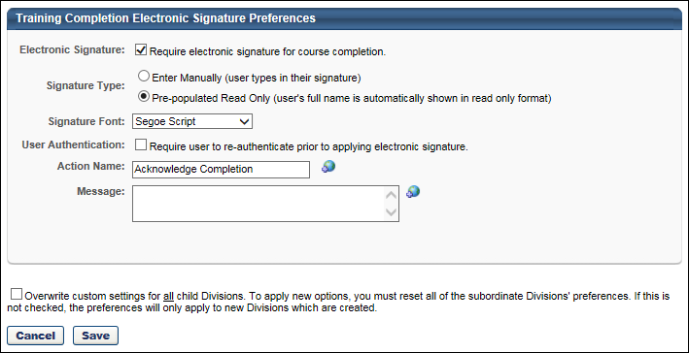
The following preference options are available from the Training Completion Signature Preferences page:
Electronic Signature
When e-signature requirements are controlled at the LO level, then electronic signature is only required for a user when completing a LO if the following are both true:
- The Electronic Signature option is selected for the user's OU within Training Completion Electronic Signature Preferences.
- The Required Electronic Signature option is selected for the LO within Course Catalog.
Select this option to require users to provide an electronic signature on the Training Details page for a LO in order to reach a status of Complete for that course. When this option is selected, after a user completes all components of a course, the course status is Pending Completion Signature. Once the electronic signature is completed, the status becomes Completed.
- If a LO is completed prior to electronic signature being required for the LO, the training item does not require a signature.
- If electronic signature is not required when the user completes a LO, then electronic signature is not required.
- If a signature is provided for a LO and later electronic signatures are not required for the LO, the user's signature is still visible.
Note: When the Electronic Signature option is enabled to require electronic signature for course completion and the User Authentication checkbox is selected, the Authentication Preferences are applied for training completion signatures. If the Electronic Signature and User Authentication options are disabled, then the Authentication Preferences are not applied because training completion signatures are not required. See Authentication Preferences for additional information.
The following options are available if the Electronic Signature option is selected:
Signature Type
This field enables the administrator to determine how an electronic signature is captured within the system when a user completes a LO. The following options are available:
- Enter Manually - When this option is selected, users must manually enter their full name and click the Sign button to submit their electronic signature.
- Pre-populated Read Only - This is the default value. When this option is selected, the system displays the user's full name, and users must click the Sign button to submit their electronic signature. Users cannot modify their name. This eliminates the risk of users entering an inaccurate signature.
Signature Font
This field enables the administrator to select the font in which a user's electronic signature is displayed. The following fonts are available: Segoe Script, French Script MT, Edwardian Script ITC, Viner Hand ITC, Monotype Corsiva, and Lucinda Calligraphy. If the selected font is not available to the user, then the default signature font is Arial. The default value for this field is Segoe Script.
Active Learning Object
With the April '16 release, administrators can require a training completion electronic signature (e-signature) for specific learning objects (LOs). In addition, a Default Training Completion Signature Preferences page is available, which enables administrators to set the default setting for requiring training completion e-signature by LO type.
Before the system transitions from managing e-signature requirements at the OU level to controlling e-signature requirements at the LO level, an administrator must manually activate the transition via the Default Training Completion Signature Preferences page. See Default Training Completion Signature Preferences on page 304 for additional information.
- Before the transition is activated, the system utilizes the e-signature settings within Training Completion Electronic Signature Preferences. These settings are visible on the Training Completion Electronic Signature Preferences page, but they are disabled and cannot be modified. These settings control e-signature requirements by LO type at the OU level.
- After the transition is activated, the system utilizes the e-signature setting within the Course Catalog. This setting controls e-signature requirements at the LO level. The OU-level settings on the Training Completion Electronic Signature Preferences page are no longer visible.
Considerations
If the preference "Change Default to Course Catalog" is not activated, the system utilizes the e-signature settings within Training Completion Electronic Signature Preferences. These settings are visible on the Training Completion Electronic Signature Preferences page, but they are disabled and cannot be modified. For the settings within Training Completion Electronic Signature Preferences, the following must have been true prior to the February 2016 Release for a user to receive the E-Signature page:
- Configured such that: Signature is required for the Learning Object AND
- Configured such that: Signature is required for the OU of the user AND
- Configured such that: Signature is required for the Learning Object type.
User Authentication
Select this option to require users to re-enter their username/UserID and password prior to completing the electronic signature. If this option is not selected, users can provide an electronic signature without entering their username/UserID and password.
Note: When the Electronic Signature option is enabled to require electronic signature for course completion and the User Authentication checkbox is selected, the Authentication Preferences are applied for training completion signatures. If the Electronic Signature and User Authentication options are disabled, then the Authentication Preferences are not applied because training completion signatures are not required. See Authentication Preferences for additional information.
Action Name
In this field, enter the header name that should appear for the section on the Training Details page in which users submit their electronic signature. The character limit for this field is 100 and defaults to Acknowledge Completion. This field is required. If multiple languages are enabled for your portal, select the Translate icon to translate the field into other available languages.
Message
In this field, enter an optional default message that appears on the electronic signature section on the Training Details page as well as in the Comment section of the Signed By history stamp. This field is blank by default and is optional. The character limit for this field is 500. Note: After a training item is electronically signed, the message is removed and is only displayed in the History section. If multiple languages are enabled for your portal, select the Translate icon to translate the field into other available languages.
Overwrite Settings
Select this option to overwrite custom settings for child division OUs. If you overwrite custom settings for child division OUs, the selected settings are applied to both new and existing child OUs. Any previously customized child OUs are updated with the selected settings.
- If there are no customizations to the child OU, then the parent OU customizations are applied to all child OUs.
- Overwrite custom settings checkbox setting
  - If this option is selected, all child OU customizations are deleted from the database, which means the parent OU customizations will be applied to new and existing child OUs.
  - If this option is unselected, all existing child OU customizations will remain unchanged, and any new child OUs will inherit the parent OU customizations by default.
- If a child OU has been customized to display any widgets, then regardless of the parent OU customizations, the child OU customizations are applied.
- If a child OU has been customized to hide all widgets, then parent OU customizations will take precedence and will be applied.
Save or Cancel
Clicking Save commits the changes. Clicking Cancel returns the user to the Preferences page and does not save changes made to the page.

Transcript Preferences Overview

Define Fiscal Year
Administrators can select the month and date the hours should be calculated for the fiscal year end.
To define the fiscal year, go to Admin > Tools > Learning > Learning Preferences > Define Fiscal Year.
Permissions
PERMISSION NAME | PERMISSION DESCRIPTION | CATEGORY

Define Fiscal Year | Grants ability to set the fiscal year for aggregating annual training hours completed by users for display on the transcript page. This is an administrator permission. | Core Administration
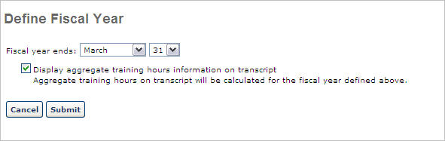
Define Fiscal Year Settings
Define fiscal year settings using the following steps:
- Fiscal year ends - Determine the ending date for the fiscal year for which the aggregate training hours will reflect
- Display aggregate training hours information on transcript - Check to enable users to view their aggregate training hours for the year on their transcript page.
  - Aggregate total hours is the total of all Completed hours for any activity that has training hours associated with it (online class, quick class, session, external training, etc.) and the dollar amount based on one year as determined by the end date.
  - The fiscal year is automatically calculated as follows; 12 months + 1 day = Fiscal Year Start Date. Example: Current Year is 2008. Fiscal Year ends 12/31, and then the start date is 1/1/2008.
  - If a fiscal year is selected that is less than the current date, then the fiscal end date will be for the following year and not the current year.
- Click the Submit button.
Training Completion Page Preferences
Administrators have the ability to enable a Completion page, which will be available for a user once they have completed the training.
The Training Completion Page Preferences page enables administrators to configure the default behavior for training completion pages, including whether a completion page is enabled by default for each learning object (LO) type and the default completion message that appears on the Training Completion page.
To manage Training Completion Page Preferences, go to Admin > Tools > Learning > Learning Preferences > Training Completion Page.
Permissions
PERMISSION NAME | PERMISSION DESCRIPTION | CATEGORY

Training Completion Page Preferences - Manage | Grants ability to access and edit the Training Completion Page Preferences where the administrator can configure the default behavior for training completion pages, including whether a completion page is enabled by default for each learning object (LO) type and the default completion message that appears on the Training Completion page. This permission cannot be constrained. This is an administrator permission. | Learning - Administration
Settings by Learning Object Type
This section enables administrators to set the default behaviors for each LO type that can be configured in the Course Catalog. See Course Catalog - General.
The following options can be set for each available LO type:
- Enable Training Completion Page - A Training Completion page is a page that is available for a user when they complete the training. Depending on the configuration of the training and the portal, the Training Completion page may display any points or badges that were awarded, the opportunity to rate and review the training, and the option to view their certificate of completion. When this option is selected, the Training Completion page is enabled by default for the corresponding training type. Administrators can choose to enable or disable the Training Completion page for each individual LO via the Course Catalog. This setting only determines the default configuration.
Course Recommendations
This section allows you to specify whether training recommendations should display to users at the bottom of their Training Completion page, when available. If the Display Course Recommendations option is selected, the Training Completion page displays training that is recommended to the user based on what other users with similar course histories have completed. For example, if there is a user who has completed similar training, then the system will recommend other training that the similar user has completed.
To disable course recommendations on the Training Completion page, uncheck the Display Course Recommendations option.
Completion Message
This section enables administrators to configure the default completion message that is displayed to users on the Training Completion page when they complete a LO. When editing a LO via the Course Catalog, administrators can choose to utilize the default completion message or they can create a custom completion message for the LO. This setting only determines the default completion message. See Course Catalog - General.
To view a list of all of the tags that can be used in the default completion message, click the List of Available Tags link. To use one of the tags, copy the tag from the pop-up and paste it into the custom message editor. Be sure to copy the brackets on both sides of the tag name.
To edit the default completion message, click the Gear icon in the upper-right corner of the Preview panel. This opens an HTML editor, in which a custom message can be configured using HTML. See HTML Safe List.
The Preview panel displays a preview of the message as it is currently configured. If tags are used in the message, then the tag is displayed with brackets in the preview.
Overwrite Custom Completion Page Settings
Choose whether or not to overwrite custom training completion page settings for all LOs. If you choose to overwrite custom settings for all LOs, the selected settings are applied to both new and existing LOs. Any previously customized LOs are updated with the selected settings.
- If this option is unselected, then only the LOs that do not have customized settings will be updated, as well as any LOs that are created in the future.
- A LO that has not been customized always inherits from the default settings, regardless of whether this option is selected.
- A LO is considered customized if its settings have been changed via the Course Catalog.
Save/Cancel
Click Save to commit any unsaved changes, or click Cancel to discard any unsaved changes.
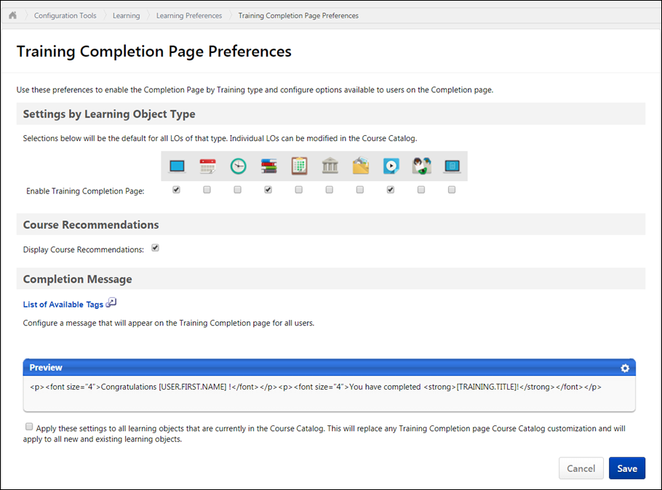

Selecting this option enables you to choose an employee relationship as defined by the administrator on the Employee Relationship page.
Selecting this option enables you to choose one or more positions as approver criteria. Positions are defined by the administrator in Position Management.
: An approval workflow has four steps. Each step has multiple approvers. Adam Mueller is defined as an approver in all four steps. Adam approves Step 1 before any of the other approvers in Step 1 record an approval decision. This means that the entire workflow is now approved, and the user moves to an Approved status.

