Language and Translations March 2024

Table of Contents
Language and Translations Overview 1
Globalization Overview 2
Language Cultures vs Language Packs 5
Organizational Unit Localization 6
Learning Management System Localization 8
Localize Specific Fields 9
Language Preferences 10
Modify Available Languages 12

Language and Translations Overview

Globalization Overview
The Cornerstone system can be displayed in various languages. This allows users to access the many features of the site in the language of their choice. With the globalization of Cornerstone, your organization can effectively offer all of Cornerstone's functionality and training in a user's home language, making the experience and training relevant and meaningful for your users, regardless of their location.
Language Packs require activation at an additional charge. Cornerstone also provides support for Conversion Rates, Currency, and international date formats. If you are interested in these options, first contact your Client Sales Representative to purchase one or more language packs. Once purchased, submit a case to Global Customer Support to activate the newly purchased language packs.
Permissions
PERMISSION NAME | PERMISSION DESCRIPTION | CATEGORY

Available Languages - Modify | Grants access to choose what languages to which learning objects may be associated when users search for training. This is an administrator permission. | Core Administration

Language Preferences - Manage | Grants ability to set default language for portal/OU and set whether end users may adjust their own portal display language. This is an administrator permission. | Core Administration

Users - Edit Users Language | Enables administrator to modify the portal display language for a user via the admin/users screen. This permission only works when used in conjunction with the Users - View permission. | Core Administration
Language Packs and Language Cultures
Language packs are available in the following languages:
- Arabic
- Armenian
- Basque (Spain)
- Bulgarian (Bulgaria)
- Catalan (Spain)
- Chinese (Simplified)
- Chinese (Traditional) - Note: Cornerstone does not currently have a Chinese (Taiwan) language pack. Organizations that are using Chinese (Traditional) as a substitute should not request adjustments to this language pack.
- Croatian (Croatia)
- Czech (Czech Republic)
- Danish (Denmark)
- Dutch (Netherlands)
- English (Australia)
- English (United Kingdom)
- English (United States)
- Estonian (Estonia)
- Finnish (Finland)
- French (Canada)
- French (France)
- German (Germany)
- Greek (Greece)
- Hebrew (Israel)
- Hungarian (Hungary)
- Indonesian (Indonesia)
- Italian (Italy)
- Japanese (Japan)
- Korean (Korea)
- Latvian (Latvia)
- Lithuanian (Lithuania)
- Malay (Malaysia) also known as Bahasa (Malaysia)
- Norwegian (Bokml)
- Polish (Poland)
- Portuguese (Brazil)
- Portuguese (Portugal)
- Romanian (Romania)
- Russian
- Serbian (Latin)
- Slovak (Slovakia)
- Slovenian (Slovenia)
- Spanish (Latin America)
- Spanish (Spain)
- Swedish (Sweden)
- Thai (Thailand)
- Turkish (Turkey)
- Ukrainian (Ukraine)
- Vietnamese (Vietnam)
Language cultures are available in the following languages in addition to the standard language pack:
- Afrikaans (South Africa)
- Belarusian (Belarus)
- Bosnian (Cyrillic)
- Burmese (Myanmar)
- Dutch (Belgium)
- Hindi (India)
- Icelandic (Iceland)
- Khmer (Cambodia)
- Lao (Lao)
- Macedonian (Macedonia)
- Malayalam (India)
- Punjabi (India)
- Tamil (India)
- Urdu (Pakistan)
Terms
- Globalization - The ability of the application to be viewed in multiple language and the support for multi-language administration.
- Translation - The process of converting from one language to another. The translation of the Cornerstone application is referred to as a Language Translation Pack.
- Localization - The process of culturally adapting content. This is mostly executed in combination with translation when training is converted into a local language.
- Language Translation Packs - All static text in the system is translated and allows for localization.
- Language Cultures - Static text in the system is not translated. Language cultures are used only for training language and user record. Language cultures can be enabled through a Global Customer Support request.
See Language Cultures vs Language Packs on page 5 for additional information.
Language Pack Rules
When a language pack is purchased and enabled, the following rules apply:
- All static text is translated into the available language selected when purchased.
- Manually entered (dynamic) text must be translated and entered by the client. The option to translate text in the system is often noted with a Translate icon .
- Cornerstone supports foreign characters and text but does not automatically display these characters unless configured.
- Browse for Training Subjects have equivalencies so that new subjects can be created in other languages. Courses already in the English version of the subject automatically map to the new subject.
- System searches default to user's language preference, but searches may be expanded to include other languages.

Language Cultures vs Language Packs
Language Packs
A language pack fully translates the text that appears on the system and it allows for localization.
A language pack is used to set a user's language and the language associated with a training item.
Use case for language packs:
- Company A has users who speak only French or only English.
- Company A purchases and enables the French (FR-FR) language pack.
- User A speaks French, so the administrator assigns French as the default language for User A.
- User A logs in to the Cornerstone portal, and everything is translated to French.
Language Cultures
Language cultures are similar to language packs, except the system text is not translated. When a language culture is enabled, users who logs in with the assigned language culture will see the page in English (EN-US). The date format, number format, and currency format throughout the system will correctly match the selected language culture.
A language culture is used to set the language associated with a training item and to filter training by language.
Use case for language cultures:
- Company A has users who speak French and English, and the French speaking users can also speak English.
- Company A wants to have courses in French for English speaking users to learn French.
- Company A enables the French (FR-FR) language culture.
- The administrator selects French as a training language for the “French 101” course.
- Users can search for the “French 101” course with the French training language filter.
Language Cultures vs Language Packs
 | Language Packs | Language Cultures
Fully translated | X
Allows localization on UI | X | X
Assign as training language | X | X
Assign as user language | X | X
Proper language related formats | X | X
Free to use |  | X

Organizational Unit Localization
Administrators may be able to add localized translations for all standard and custom Organizational Units (OUs) within the portal. This enables organizations to maintain a single OU structure globally while ensuring that users always see the appropriate value based on their preferred language. As a result, organizations are able to more easily build, maintain, and support their organizational structure within the system.
Additional Details
For OUs, the Name and Description fields are eligible for translation. In addition, any OU custom fields that are short text box or scrolling text box are also eligible for translation. Specifically for Self-registration Groups, Description is not supported, so only the Name field is eligible for translation.
Because OU names are displayed throughout the system, any page that displays the name or description of an OU can display a localized translation of the OU name or description.
Custom reports display the localized values for OU names in the User/OU Filters tab, the Sharing tab, and the report outputs. Standard reports, however, display the default translation of the OU.
Implementation
Because OUs are the underlying foundation of data structures, there are significant considerations for existing clients who are thinking about using this feature. To enable this functionality, contact Global Customer Support.
Upon enabling this functionality, all existing OUs and groups only have a translation for the OU or group's default language. Administrators must edit all existing OUs and groups to add localized translations in order to have the OUs and groups display in each user's preferred language.
- For OUs that are created after OU Localization is enabled, the OU's default language is set to the preferred language of the administrator who creates the OU. This is set at the time the OU is created.
- For OUs that are created before OU Localization is enabled, the OU's default language is set to the default language of the portal's top-level OU. This is typically the Corporate Language, and it is set when OU Localization is enabled.
End User Experience
When an administrator or user is viewing any page in the system that includes an OU name or description, the name or description should be displayed in the user's preferred language. If a translation is not available for the user's preferred language, then the name or description is displayed in the OU's default language.
The localization of OUs and their display throughout the application follows this logic. To assist organizations with the understanding of the functionality and where the impacts of enabling OU Localization will be seen, many of the places OUs are displayed throughout the application are described in these release notes.
Searching by OU
When searching for an OU or group, an OU or group is only included in the search results if the OU or group name matches the search query for the user's preferred language. If a translation is not defined for the user's preferred language, the OU or group is included in the search results if the default translation matches the search query.
Search Results Example
A user with a preferred language of English (US) is searching for positions by name. The user enters "pro" in the Search field and presses [Enter].
The following results are displayed:
- “Junior Project Analyst” - Default translation is English (US), and no other translations are defined.
- “Associate Project Analyst” - Default translation is English (US), and Spanish (Latin America) and French (France) translations are defined.
- “Project Manager” - An English (US) translation is defined, and the default language is French (France).
- “Chef de projet senior” - The default translation is French (France), and no English (US) translation is defined.
The following results are not returned:
- “Software Engineer” - The English (US) translation does not match the search criteria. The default translation (“Programador”) matches the search criteria, but it is Spanish, which is not the user's configured language.
- "Analyste adjointe de projet" - This is the French (France) translation for the "Associate Project Analyst" OU. The French translation is not returned because the English (US) translation also matches the search query, and English (US) is the user's preferred language.

Learning Management System Localization
The Learning Management module supports translation and localization for learning elements throughout the system. If multiple languages are enabled for a portal, organizations can create a single object that can be translated to support the multiple languages that are used across the workforce. This eliminates the need to create multiple instances of an object for each language.
A user's default language is set in the My Account settings for the user. See My Account - Preferences - Settings.
Administrators
If an administrator creates an object, the default language for that object is that administrator's default language at the time the object is created.
All other administrators view the metadata and editable fields for the object in their own language, if available. If the data is not available in their language, they view the data in the object's default language. For example, if a custom field is created by English administrator, a Spanish administrator views the field in English if a Spanish translation does not exist.
If an administrator edits an object, all of the editable fields shown are copied to that administrator's translation, even if the translations did not exist previously. For example, for a field created by an English administrator, a Spanish administrator automatically edits the Spanish translation. If there was previously no Spanish translation, they see the English translation, but their edits are saved as the Spanish translation.
For a required field, the default language translation must be populated. It cannot be empty.
Users
If a localizable field is required and does not have a translation for a user's language, the user views the field in the default language of the administrator who last saved the field. For example, if a Spanish translation is not available for Task Name and the administrator who last saved the field is an English user, a Spanish user sees the English translation for Task Name. In this case, English is the default translation.
If a localizable field is not required and does not have a translation for a user's language, the field is populated with the default language translation.

Localize Specific Fields
You can change the language of many field names to match your organization's default language.
Fields that are available for localization display a globe icon.
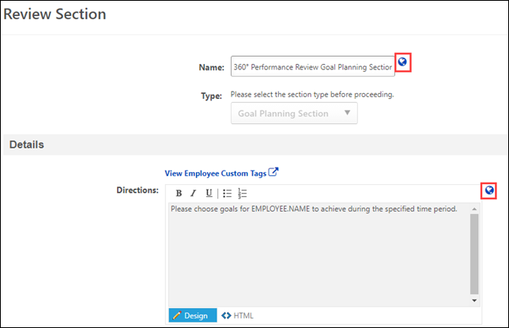
To localize a field:
- Click the globe icon for the appropriate field. The Translate page opens.
- Locate the appropriate language field and enter the field name as you want it to appear.
- Click Save. The translated text is saved and is visible for the selected field.

Language Preferences
The Language Preferences is used to select a default language for users. Additionally, administrators can choose whether users are able to change the language in which their portal is displayed.
To manage Language Preferences, go to Admin > Tools > Core Functions > Core Preferences > Languages.
Permissions
PERMISSION NAME | PERMISSION DESCRIPTION | CATEGORY

Language Preferences - Manage | Grants ability to set default language for portal/OU and set whether end users may adjust their own portal display language. This is an administrator permission. | Core Administration
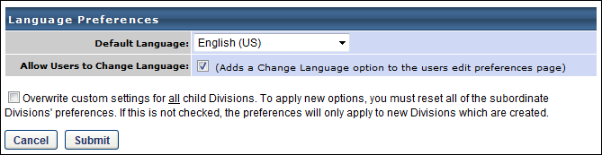
Default Language
From the drop-down menu, select the default language for the portal or organizational unit (OU).
Allow Users to Change Language
Select this option to allow users to change their portal language. When enabled, users can change their display language from the Preferences tab within My Account. See My Account - Preferences - Settings.
Available Languages
A list of all available languages is available within Online Help. See Globalization Overview on page 2 for additional information.
Overwrite Settings
Select this option to overwrite custom settings for child division OUs. If you overwrite custom settings for child division OUs, the selected settings are applied to both new and existing child OUs. Any previously customized child OUs are updated with the selected settings.
- If there are no customizations to the child OU, then the parent OU customizations are applied to all child OUs.
- Overwrite custom settings checkbox setting
  - If this option is selected, all child OU customizations are deleted from the database, which means the parent OU customizations will be applied to new and existing child OUs.
  - If this option is unselected, all existing child OU customizations will remain unchanged, and any new child OUs will inherit the parent OU customizations by default.
- If a child OU has been customized to display any widgets, then regardless of the parent OU customizations, the child OU customizations are applied.
- If a child OU has been customized to hide all widgets, then parent OU customizations will take precedence and will be applied.
Submit
Select the Submit button to save any changes to the Language Preferences.

Modify Available Languages
The Modify Available Languages or Modify Language Preferences page is used to determine which languages are available for searching and training association in most areas of your system. Though you may be able to associate objects to a language, the system language pack must be purchased for the full static text conversion to that language. See Globalization Overview on page 2 for additional information.
Note: Learning Search displays languages based on learning object (LO) availability. A given language will display as a filter if it is associated as an Available Language for an LO available to the user.
This page does not determine which languages are available for translation or for display throughout the system. Administrators can determine the default display language for users by division via Language Preferences. See Language Preferences on page 10 for additional information.
Note: Cornerstone does not currently have a Chinese (Taiwan) language pack. Organizations that are using Chinese (Traditional) as a substitute should not request adjustments to this language pack.
To modify the available languages for the portal, go to Admin > Tools > Core Functions > Core Preferences > Modify Available Languages.
Permissions
PERMISSION NAME | PERMISSION DESCRIPTION | CATEGORY

Available Languages - Modify | Grants access to choose what languages to which learning objects may be associated when users search for training. This is an administrator permission. | Core Administration
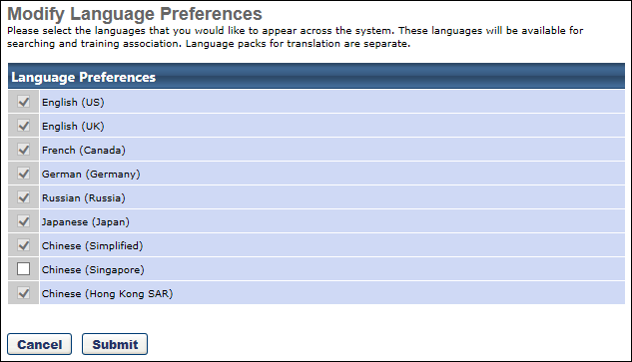
To enable a language for searching and training association:
- Select the checkbox to the left of the language name.
- Select Submit.

