Job Application March 2024

Table of Contents
Job Application Overview 1
Apply with LinkedIn (with Apply Starters) - Overview 2
Add/Move LinkedIn Candidates to Another Requisition 5
Applicant Experience - Apply with LinkedIn (with Apply Starters) 6
Compliance Question Bank - Overview 8
Compliance Question Bank - Overview 11
Compliance Question Bank - Add Question 14
Google Analytics - Applicant Workflow 16
Job Application API (Early Adopter) - Overview 17
Job Application API (Early Adopter) - Overview 20
Enable Job Application API 23
Job Application API - Candidate Experience 25
Application Workflow Templates 26
Create Application Workflow Template 28
Pre-Screening Question Bank - Overview 64
Pre-Screening Question Bank - Categories Tab 68
Pre-Screening Question Bank - Questions Tab 71
Resume Administration 82
Add Resume Section (Career Center) 85
Add Resume Section - Applicant Resume 88
Application Workflow Templates 95
Create Application Workflow Template 97
Application Source Values 147

Job Application Overview

Apply with LinkedIn (with Apply Starters) - Overview
Apply with LinkedIn (with Apply Starters) is a plugin that you can implement on your career site, enabling candidates to apply with their LinkedIn profiles in the application workflow. When applying with LinkedIn, a job seeker's profile information instantly populates the resume fields and gets sent directly to the Applicant Tracking System (ATS) upon submission. This makes for a fast and easy candidate experience.
Recruiters can easily view an applicant's LinkedIn profile, getting access to valuable information that cannot always be found on a resume.
Apply with LinkedIn (with Apply Starters) is an evolution to the original plugin and differs from the previous Apply with LinkedIn integration in two significant ways:
- Connect with Applicants Who Start an Application - Candidates who start but do not complete the application are surfaced as an “Apply Starter” in LinkedIn Recruiter. These candidates have a significantly higher InMail response rate. Recruiters can connect with interested job seekers by messaging those who have started but not completed an application.
- Increased Conversion Rate - In the previous version of Apply with LinkedIn, candidates would need to log in to their LinkedIn account to “authenticate” on that customer’s career page, which led to drop-off. With the new Apply with LinkedIn, this additional step of logging in to LinkedIn to complete the application is removed if they have an active LinkedIn cookie ties to their session. This update to Apply with LinkedIn ensures a higher rate of completed applications.
Features of Apply with LinkedIn (with Apply Starters)
When a candidate clicks apply with linkedin: | old integration | new integration
Prefill resume with LinkedIn profile | Yes | Yes
Create account with LinkedIn email and password | Yes | No
Option to “create account” on Thank You page | No | Yes
Available on Standard Application Workflow | Yes | No
Available on Mobile-Friendly Application Workflow | Yes (Until the end of 2018) | Yes
Use Cases
- As an administrator who has a LinkedIn Recruiter contract, I would like the ability to support the new LinkedIn integration in my mobile-friendly application workflow so that more applicants complete the application.
- As an administrator who has both the new and old Apply with LinkedIn integration, I would like to use the new integration on mobile-friendly application workflows and the old integration on standard application workflows because that is what is supported.
- As an administrator who only has the new Apply with LinkedIn (with Apply Starters) integration, I would like to know that it is only functional on mobile-friendly experiences in the career site settings so that I know all dependencies.
- As a candidate, I would like the ability to upload my resume in an application via my LinkedIn profile so that it saves me multiple steps in the application and makes it easier to submit my application.
- As a candidate, I would like my LinkedIn profile to prefill my resume details so that I can quickly complete and submit the application.
- As an administrator, I would like to know why I cannot move an applicant to a new requisition on their profile so that I know the system is not broken. There will be a notification that says this applicant has applied with LinkedIn.
- As a recruiter, if I try to move multiple candidates at once to a new requisition, I will be notified that the LinkedIn candidates were not moved. An explanation will be included that lets me know that candidates who apply with LinkedIn cannot be added or moved to another requisition.
- As a candidate who has applied via Apply with LinkedIn (with Apply starters), when I return to the career site to check the progress of my application, I will have to either sign in with LinkedIn or create a password through the Forgot Passsword or Create Password user flow.
Implementation
Apply with LinkedIn (with Apply Starters) is available for Recruiting clients who also have LinkedIn Recruiter and/or active LinkedIn Job Slots. The plugin is available without cost to those clients. The plugin must be enabled from the Edge Marketplace. For questions about the plugin, please reach out to your LinkedIn representative. Additional instructions for enabling and configuring the integration are available on the Setup tab of the integration in Edge.
When enabling Apply with LinkedIn (with Apply Starters) in Edge, you will need to use the LinkedIn account that is tied to LinkedIn Recruiter or the active Job Slots. If an administrator tries to enable Apply with LinkedIn (with Apply Starters) with their personal LinkedIn account, they will receive an error.
Once Apply with LinkedIn (with Apply Starters) is installed via Edge, you will then need to enable it on an individual career site basis in Career Site Settings. The plugin is only compatible with mobile-friendly application workflows through the mobile-friendly candidate experience.
Considerations
Can all clients use the integration?
No. The Apply with LinkedIn (with Apply Starters) integration is only available for those with LinkedIn Recruiter and/or LinkedIn Jobs.
Will the integration be supported on both standard and mobile-friendly workflows?
No, this will only be supported on mobile-friendly workflows.
Can candidates who applied with Apply with LinkedIn (with Apply Starters) be added or moved to other requisitions?
Yes. Candidates who apply with LinkedIn can be added to other requisitions via Manage Candidates, Manage Applicants, Candidate Search, and the Applicant Profile. They can be moved to another requisition from Manage Candidates and Manage Applicants.
What if the candidate does not have an active LinkedIn cookie?
If a candidate does not have an active LinkedIn cookie, they will click the LinkedIn button twice: once to sign in to LinkedIn, and then again to populate their resume. In addition, LinkedIn candidates will be asked if they want to create an account on the Thank You page.
Permissions
The following permissions apply to this functionality:
PERMISSION NAME | PERMISSION DESCRIPTION | CATEGORY

Career Site - Manage | Grants ability to access and manage Career Site Management. This permission can be constrained by OU and User's OU. This is an administrator permission. | Recruiting Administration

Career Site - View | Grants ability to access and view Career Site Management. This permission can be constrained by OU and User's OU. This is an administrator permission. | Recruiting Administration

Edge Integrations - Manage | Grants access to the Integrations service for Edge Integrate, where the administrator can configure, enable, and disable their third-party integrations used within the Cornerstone system. This permission cannot be constrained. This is an administrator permission. | Edge

Edge Marketplace - Manage | Grants access to the Marketplace service for Edge Integrate, where the administrator can browse integrations that can be used to extend the Cornerstone system. This permission cannot be constrained. This is an administrator permission. | Edge

Add/Move LinkedIn Candidates to Another Requisition
Candidates who apply with LinkedIn can be added or moved to other requisitions via Manage Candidates, Manage Applicants, Candidate Search, and the Applicant Profile.
Manage Applicants Deprecation: Cornerstone is deprecating Manage Applicants in Q1 2024. See Manage Applicants Overview.
Add LinkedIn Candidates to Another Requisition
To add LinkedIn candidates to another requisition, see the instructions on the following pages:
- Applicant Profile
- Candidate Search
- Manage Applicants
- Manage Candidates
Move LinkedIn Candidates to Another Requisition
To move LinkedIn candidates to another requisition, see the instructions on the following pages:
- Manage Applicants
- Manage Candidates

Applicant Experience - Apply with LinkedIn (with Apply Starters)
Applicants can apply with Apply with LinkedIn (with Apply Starters) on mobile-friendly career sites by clicking the Apply with LinkedIn button on the application workflow. The applicant's contact information and resume details are automatically prefilled on the application once they apply with LinkedIn. This saves applicants time in filling out application fields so that they can quickly apply to the job.
Once the applicant applies with LinkedIn, recruiters can view their profile by clicking the LinkedIn icon that appears by the applicant's name when viewing applicant details in Recruiting.
Note: If resume parsing is not enabled but contact information parsing is enabled, then the contact information will still populate but resume details are not prefilled. If no parsing is enabled, then there are no fields that are prefilled.
Account Creation on Career Site
When an applicant applies with Apply with LinkedIn (with Apply Starters), they are prompted on the Thank You page of the application to create a profile. This allows LinkedIn applicants to set a user name and password for the career site.
With the previous experience with Apply with LinkedIn 1.0, an account was created automatically when applicants applied with LinkedIn. Their LinkedIn user name and password were used to set up the account. This resulted in numerous password resets for applicants when they did not remember (or realize) that their LinkedIn login credentials were used to create the account.
Visibility on Non-Mobile-Friendly Career Sites
For mobile-friendly applications that are on a career site that is not mobile-friendly, the Apply with LinkedIn (with Apply Starters) and Apply with Seek options do not appear on the job details page. All social media buttons for mobile-friendly application workflows now live on the Application Workflow page.
Offer Letters for Apply with LinkedIn (with Apply Starters) Candidates
For security reasons, when an applicant who has applied with LinkedIn, and has not created an account, accepts or declines an offer letter, they will need to create a password with Cornerstone to submit their responses.
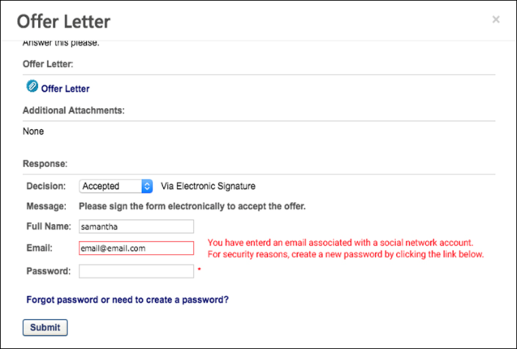

Compliance Question Bank - Overview
The Compliance Question Bank enables administrators to view, create, edit, and preview custom compliance questions. In addition, the default compliance questions also display and can be previewed and inactivated.
To access the Compliance Question Bank, go to Admin > Tools > Recruit > Compliance Question Bank.
Permissions
PERMISSION NAME | PERMISSION DESCRIPTION | CATEGORY

Compliance Question - Manage | Grants ability to access and manage Compliance Question Bank. This permission cannot be constrained. This is an administrator permission. | Recruiting Administration
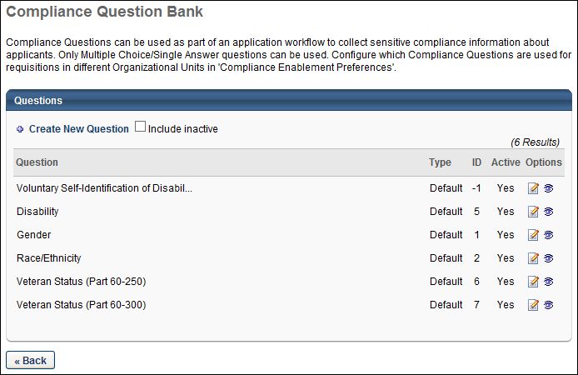
Create New Question
Click Create New Question to create a new compliance question. See Compliance Question Bank - Add Question on page 14 for additional information.
Important Note: Questions cannot be deleted from the question bank. In addition, once a question is created, the text of the question cannot be modified. If a change is needed to the question text, then the best practice is to inactivate the existing question and create a new question with the desired text.
Include Inactive
Check Include Inactive to display inactive questions in the Compliance Question Bank table.
Compliance Question Bank Table
The following information displays in the table:
- Question - This column displays the full text of the question. Note: Once a question is created, responses can be viewed via the Preview option on the Compliance Question Bank page or from the Preview option in Compliance Enablement Preferences.
- Type - This column displays the question type, either default or custom.
- ID - This column displays the question ID. The question ID is a system-generated number.
- Active - This column displays the question's active status, either "Yes" or "No." Note: Inactive questions only display in the table if the Include Inactive option is checked.
- Options - The following options are available in the Options column:
  - Edit - Click the Edit icon to edit the active status of default and custom questions. This opens the Edit Question pop-up. Check or uncheck the Active box to activate or inactivate the question.
    - The question content cannot be modified once the question is created. Only the active status can be modified.
    - If the question is currently being used for at least one organizational unit, then a confirmation pop-up opens. The pop-up indicates that edits to the active status do not affect existing requisitions.
    - When deactivating default questions, the questions can be deactivated but will still display for applicants in the application workflow if the Require OFCCP Compliance Enablement functionality option is checked in Compliance Enablement Preferences.
  - Preview - Click the Preview icon to preview the question. This opens the Question Preview pop-up. The language, question text, and responses display. Both default and custom questions can be previewed.For portals with multiple languages enabled, select the language in the Language field in which the display the question and responses.
Click Back to return to the Recruitment page.
Default Compliance Questions
Default compliance questions are the standard Office of Federal Contract Compliance Program questions.
Edit Default Questions
The content and response choices for default questions cannot be modified. Only the active status can be modified.
Edit Active Status
The active status can be modified by clicking the Edit icon for the question. When a default question is inactivated, the question is no longer available for use when creating, editing, and copying application workflows, requisition templates, and job requisitions. If the question is currently being used in a workflow, template, or requisition, the question can be inactivated but remains in the workflow until the question is removed. Once removed, the inactive question can no longer be re-added until the question is re-activated.
Note: The default response for all questions is "Please Select." This response displays to applicants but is not visible or editable when configuring questions.

Compliance Question Bank - Overview
The Compliance Question Bank enables administrators to view, create, edit, and preview custom compliance questions. In addition, the default compliance questions also display and can be previewed and inactivated.
To access the Compliance Question Bank, go to Admin > Tools > Recruit > Compliance Question Bank.
Permissions
PERMISSION NAME | PERMISSION DESCRIPTION | CATEGORY

Compliance Question - Manage | Grants ability to access and manage Compliance Question Bank. This permission cannot be constrained. This is an administrator permission. | Recruiting Administration
Create New Question
Click Create New Question to create a new compliance question. See Compliance Question Bank - Add Question on page 14 for additional information.
Important Note: Questions cannot be deleted from the question bank. In addition, once a question is created, the text of the question cannot be modified. If a change is needed to the question text, then the best practice is to inactivate the existing question and create a new question with the desired text.
Include Inactive
Check Include Inactive to display inactive questions in the Compliance Question Bank table.
Compliance Question Bank Table
The following information displays in the table:
- Question - This column displays the full text of the question. Note: Once a question is created, responses can be viewed via the Preview option on the Compliance Question Bank page or from the Preview option in Compliance Enablement Preferences.
- Type - This column displays the question type, either default or custom.
- ID - This column displays the question ID. The question ID is a system-generated number.
- Active - This column displays the question's active status, either "Yes" or "No." Note: Inactive questions only display in the table if the Include Inactive option is checked.
- Options - The following options are available in the Options column:
  - Edit - Click the Edit icon to edit the active status of default and custom questions. This opens the Edit Question pop-up. Check or uncheck the Active box to activate or inactivate the question.
    - The question content cannot be modified once the question is created. Only the active status can be modified.
    - If the question is currently being used for at least one organizational unit, then a confirmation pop-up opens. The pop-up indicates that edits to the active status do not affect existing requisitions.
    - When deactivating default questions, the questions can be deactivated but will still display for applicants in the application workflow if the Require OFCCP Compliance Enablement functionality option is checked in Compliance Enablement Preferences.
  - Preview - Click the Preview icon to preview the question. This opens the Question Preview pop-up. The language, question text, and responses display. Both default and custom questions can be previewed.For portals with multiple languages enabled, select the language in the Language field in which the display the question and responses.
Click Back to return to the Recruitment page.
Default Compliance Questions
Default compliance questions are the standard Office of Federal Contract Compliance Program questions.
Edit Default Questions
The content and response choices for default questions cannot be modified. Only the active status can be modified.
Edit Active Status
The active status can be modified by clicking the Edit icon for the question. When a default question is inactivated, the question is no longer available for use when creating, editing, and copying application workflows, requisition templates, and job requisitions. If the question is currently being used in a workflow, template, or requisition, the question can be inactivated but remains in the workflow until the question is removed. Once removed, the inactive question can no longer be re-added until the question is re-activated.
Note: The default response for all questions is "Please Select." This response displays to applicants but is not visible or editable when configuring questions.

Compliance Question Bank - Add Question
Administrators with the appropriate permission can add questions to the Compliance Question Bank. For portals with multiple languages enabled, the question text and responses can be localized. The available question type is single response drop-down.
Important Note: Questions cannot be deleted from the question bank. In addition, once a question is created, the text of the question and the response options cannot be modified. If a change is needed to the question text, then the best practice is to inactivate the existing question and create a new question with the desired text.
Important Note: Custom HTML is not supported. At this point in time, custom HTML is reformatted and visible as though it is part of the question.
To access the Compliance Question Bank, go to Admin > Tools > Recruit > Compliance Question Bank.
Permissions
PERMISSION NAME | PERMISSION DESCRIPTION | CATEGORY

Compliance Question - Manage | Grants ability to access and manage Compliance Question Bank. This permission cannot be constrained. This is an administrator permission. | Recruiting Administration
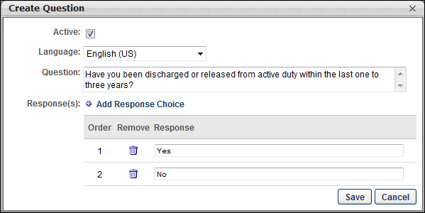
Create Question
To create a question, click Create New Question on the Compliance Question Bank page. This opens the Create Question pop-up. Complete the following fields in the pop-up:
Active
Check or uncheck the Active box to activate or inactivate the question. Active questions are available for use when creating, editing, and copying application workflows, requisition templates, and job requisitions. Inactive questions are not available for use unless they are reactivated.
Language
The Language field is used to define the language in which the question is written in the Question field. For portals with multiple languages enabled, select the language from the drop-down that defines the language in which the question will be written in the Question field. By default, the administrator's language displays in the drop-down.
Question
This is a required field. Enter the text of the question in the Question field. This field accepts up to 2000 characters. For portals with multiple languages enabled, write the question in the language that is selected in the Language field.
Important Note: Custom HTML is not supported. At this point in time, custom HTML is reformatted and visible as though it is part of the question.
Response(s)
This is a required field. Click Add Response Choice to add a response choice. This enables the Response table to appear by adding a blank row below the Response(s) field.
Response Table
The following information displays in the Response table:
- Order - This column displays the order in which the response appears in the drop-down for applicants.
- Remove - Click the Remove icon to delete the response. Note: Responses cannot be removed once the question is saved.
- Response - Enter the text of the response, up to 150 characters. For portals with multiple languages enabled, write the response in the language that is selected in the Language field. The responses display for applicants in drop-down format.
Note: The default response for all questions is "Please Select." This response displays to applicants but is not visible or editable when configuring questions.
Note: Once a question is created, responses can be viewed via the Preview option on the Compliance Question Bank page or in Compliance Enablement Preferences.
Re-Order Responses
The responses in the Response table can be reordered by dragging and dropping the responses into the desired order. The order in which the responses appear in the table is the order in which they appear for applicants.
Save/Cancel
Once all required fields are completed, click Save to save the question. Or, click Cancel to return to the Compliance Question Bank without creating the question.

Google Analytics - Applicant Workflow
Organizations can use Google Analytics to track applicants as they are going through career sites, job postings, and application workflows. This allows organizations to include tracking in their applicant-facing pages.
Google Analytics
Implementing Google Analytics in Recruiting can help recruiters figure out which devices people are using to visit career pages and the source they used to reach the career site or job posting, such as via a search engine. Google Analytics can also track the time spent on the career pages and where applicants made it to in the application workflow and more. Recruiters can then build more targeted campaigns over time to attract the type of applicants they want, as well as optimize career sites and application workflows to make sure they are maximizing the number of applications submitted.
When enabled, the recruiter can view analytics information for career sites, job postings, and application workflows.
Use Case
- A recruiter is trying to hire social media marketers and lawyers. She has built a career site with a generic application workflow for social media and law positions.
- The recruiter notices that she is getting a lot of applications for her law positions but is not getting very many for her social media positions.
- She has Google Analytics implemented on the career site, as well as on the application workflow.
- The recruiter analyzes the data in Google Analytics and realizes that people interested in the social media positions tend to access the career site via a mobile device and try to apply via mobile, but they cannot easily navigate the career site nor get through the application workflow on a mobile device.
- The recruiter quickly optimizes the career site and enables the Apply with Mobile feature with a simpler application workflow. Following this change, she starts to see more social media marketing applicants.
Implementation
This functionality is controlled by backend settings, which are disabled by default. To enable this feature, contact Global Customer Support. You will need to provide your Google Analytics and Google Universal Analytics tracking numbers for the accounts. You will also need to specify whether you are enabling Classic Analytics or Universal Analytics.

Job Application API (Early Adopter) - Overview
The Job Application API delivers a seamless candidate experience with the ability to send job board application data to Cornerstone, enabling candidates to apply directly to requisitions using their information from job boards.
Job boards are a key way to source candidates. If a candidate wants to apply to a position from a job board, they are typically redirected to a career site, which can interrupt the candidate experience and decrease conversion rates. The Job Application API is a user-centric interface that allows job seekers to “one-click” apply using their resume details from the job board without having to visit the career site.
The Job Application API includes the following service:
- Create - Create new job applications, facilitating a one-click apply use case in a job board by allowing candidates to apply to jobs directly from the job board.
Is being an Early Adopter right for my organization?
- My organization uses job boards to post jobs
- My organization has simple application workflows. Note: Prescreening questions are targeted to be available for a one-click apply workflow when this enhancement is ready for General Availability (GA).
- My organization would like to see the source of the application, even if the candidate is rerouted to the job board.
- The job board I work with is willing to build to our Job Application API
Considerations
The Job Application API will be generic so that other job boards can use it, in addition to Stepstone job boards.
Frequently Asked Questions
What is a job application API?
An API for job applications connects application data from a job board to your Cornerstone portal. When a candidate applies for a job that was posted to a job board from your Cornerstone Recruiting post jobs page, and the job board is configured for one-click apply functionality, the candidate's data is passed from the external job board to your Cornerstone portal. The candidate is added to the candidate pool, and their resume and contact information are also passed to your portal.
What is a job board?
A job board is a hosting site for your jobs. A job board also lets candidates create an account and store their resume on the site. When a candidate goes onto the job board and finds your jobs, they can apply directly from the job board, without having to be redirected to your career site.
This provides a complete application experience that reduces the amount of time applicants need to spend applying to your jobs.
How do job boards, search engines, and career sites differ in the job search and application process?
- A job board lets candidates apply to your jobs directly from the job board.
- A search engine displays your jobs, but it does not provide an application process. Candidates must apply via your career site.
- A career site can display your jobs and provide a complete application process. However, if a career site is the only place your jobs are listed, then candidates will not have as many opportunities to find your jobs.
What types of action items are eligible for the Job Application API?
- Only contact information, resume, and additional attachments are currently eligible for the Job Application API.
- The following fields are available:
  - First name
  - Last name
  - Primary language
  - Email
  - Phone number
  - Address fields
  - Line 1
  - Line 2
  - Postal Code
  - City
  - State or Province
  - Country Code
  - Resume/CV
  - Cover letter
  - Additional Attachments
What happens to a candidate, if my application has pre-screening questions or any other unsupported action item?
If an application has pre-screening questions, assessments, or other non-supported action items, the application cannot be completed with a one-click experience. Instead, candidates are taken to the client’s career site to continue their application, where they can answer the pre-screening questions and to take assessments.
If the application is utilizing the Mobile-Friendly Candidate Experience, they are taken to the application where their information from the job board is pre-populated in the application fields. Their resume and cover letter are also passed to your portal. The pre-population of fields is only available for Mobile-Friendly application workflows.
What authentication mechanism does the API implement?
OAuth 2.0
Does the API support SSO into the Cornerstone application?
No. If a candidate is redirected to your career site, they will need to create an account or log in before they can proceed with the application process. However, any data passed by the job board through the API will be pre-populated in the application, provided that the application is a mobile-friendly application.
Does the API support sending multiple applications at once?
No. If multiple applications are sent over at one time, the API will send a “INVALID_REQUEST” or “TECHNICAL_ERROR” response.
What happens if I submit the same candidate for different requisitions?
A candidate can only submit one application at a time. The API supports a candidate applying to multiple requisitions, but not at the same time.
If a candidate has multiple phone numbers, can I submit comma separated values for each phone number?
No, this is not supported.
If a candidate has multiple email addresses, can I submit comma separated values for each email address?
No, this is not supported.
Implementation
Job Application API is in the Early Adopter phase and is only available for organizations using Recruiting. For enablement information, See Enable Job Application API on page 23 for additional information.
Permissions
The following permissions apply to this functionality:
PERMISSION NAME | PERMISSION DESCRIPTION | CATEGORY

External Job Application API: Manage | Grants access to manage the Job Application API. This permission is automatically enabled upon enabling either the Cornerstone API bundle or the One-Click Apply with Stepstone integration. Only available if enabled by a backend setting. | Edge

Edge Develop - API Explorer | Grants access to the API Explorer, which provides access to help documentation for various API applications. | Edge

Edge Integrations - Manage | Grants access to the Integrations service for Edge Integrate, where the administrator can configure, enable, and disable their third-party integrations used within the Cornerstone system. This permission cannot be constrained. This is an administrator permission. | Edge

Edge Marketplace - Manage | Grants access to the Marketplace service for Edge Integrate, where the administrator can browse integrations that can be used to extend the Cornerstone system. This permission cannot be constrained. This is an administrator permission. | Edge

Job Application API (Early Adopter) - Overview
The Job Application API delivers a seamless candidate experience with the ability to send job board application data to Cornerstone, enabling candidates to apply directly to requisitions using their information from job boards.
Job boards are a key way to source candidates. If a candidate wants to apply to a position from a job board, they are typically redirected to a career site, which can interrupt the candidate experience and decrease conversion rates. The Job Application API is a user-centric interface that allows job seekers to “one-click” apply using their resume details from the job board without having to visit the career site.
The Job Application API includes the following service:
- Create - Create new job applications, facilitating a one-click apply use case in a job board by allowing candidates to apply to jobs directly from the job board.
Is being an Early Adopter right for my organization?
- My organization uses job boards to post jobs
- My organization has simple application workflows. Note: Prescreening questions are targeted to be available for a one-click apply workflow when this enhancement is ready for General Availability (GA).
- My organization would like to see the source of the application, even if the candidate is rerouted to the job board.
- The job board I work with is willing to build to our Job Application API
Considerations
The Job Application API will be generic so that other job boards can use it, in addition to Stepstone job boards.
Frequently Asked Questions
What is a job application API?
An API for job applications connects application data from a job board to your Cornerstone portal. When a candidate applies for a job that was posted to a job board from your Cornerstone Recruiting post jobs page, and the job board is configured for one-click apply functionality, the candidate's data is passed from the external job board to your Cornerstone portal. The candidate is added to the candidate pool, and their resume and contact information are also passed to your portal.
What is a job board?
A job board is a hosting site for your jobs. A job board also lets candidates create an account and store their resume on the site. When a candidate goes onto the job board and finds your jobs, they can apply directly from the job board, without having to be redirected to your career site.
This provides a complete application experience that reduces the amount of time applicants need to spend applying to your jobs.
How do job boards, search engines, and career sites differ in the job search and application process?
- A job board lets candidates apply to your jobs directly from the job board.
- A search engine displays your jobs, but it does not provide an application process. Candidates must apply via your career site.
- A career site can display your jobs and provide a complete application process. However, if a career site is the only place your jobs are listed, then candidates will not have as many opportunities to find your jobs.
What types of action items are eligible for the Job Application API?
- Only contact information, resume, and additional attachments are currently eligible for the Job Application API.
- The following fields are available:
  - First name
  - Last name
  - Primary language
  - Email
  - Phone number
  - Address fields
  - Line 1
  - Line 2
  - Postal Code
  - City
  - State or Province
  - Country Code
  - Resume/CV
  - Cover letter
  - Additional Attachments
What happens to a candidate, if my application has pre-screening questions or any other unsupported action item?
If an application has pre-screening questions, assessments, or other non-supported action items, the application cannot be completed with a one-click experience. Instead, candidates are taken to the client’s career site to continue their application, where they can answer the pre-screening questions and to take assessments.
If the application is utilizing the Mobile-Friendly Candidate Experience, they are taken to the application where their information from the job board is pre-populated in the application fields. Their resume and cover letter are also passed to your portal. The pre-population of fields is only available for Mobile-Friendly application workflows.
What authentication mechanism does the API implement?
OAuth 2.0
Does the API support SSO into the Cornerstone application?
No. If a candidate is redirected to your career site, they will need to create an account or log in before they can proceed with the application process. However, any data passed by the job board through the API will be pre-populated in the application, provided that the application is a mobile-friendly application.
Does the API support sending multiple applications at once?
No. If multiple applications are sent over at one time, the API will send a “INVALID_REQUEST” or “TECHNICAL_ERROR” response.
What happens if I submit the same candidate for different requisitions?
A candidate can only submit one application at a time. The API supports a candidate applying to multiple requisitions, but not at the same time.
If a candidate has multiple phone numbers, can I submit comma separated values for each phone number?
No, this is not supported.
If a candidate has multiple email addresses, can I submit comma separated values for each email address?
No, this is not supported.
Implementation
Job Application API is in the Early Adopter phase and is only available for organizations using Recruiting. For enablement information, See Enable Job Application API on page 23 for additional information.
Permissions
The following permissions apply to this functionality:
PERMISSION NAME | PERMISSION DESCRIPTION | CATEGORY

External Job Application API: Manage | Grants access to manage the Job Application API. This permission is automatically enabled upon enabling either the Cornerstone API bundle or the One-Click Apply with Stepstone integration. Only available if enabled by a backend setting. | Edge

Edge Develop - API Explorer | Grants access to the API Explorer, which provides access to help documentation for various API applications. | Edge

Edge Integrations - Manage | Grants access to the Integrations service for Edge Integrate, where the administrator can configure, enable, and disable their third-party integrations used within the Cornerstone system. This permission cannot be constrained. This is an administrator permission. | Edge

Edge Marketplace - Manage | Grants access to the Marketplace service for Edge Integrate, where the administrator can browse integrations that can be used to extend the Cornerstone system. This permission cannot be constrained. This is an administrator permission. | Edge

Enable Job Application API
What Is Needed?
- Designated Cornerstone user record
- API Key
- API Secret
- External Job Application API - Manage permission
Permissions
PERMISSION NAME | PERMISSION DESCRIPTION | CATEGORY

Edge Develop - API Explorer | Grants access to the API Explorer, which provides access to help documentation for various API applications. | Edge

Edge Integrations - Manage | Grants access to the Integrations service for Edge Integrate, where the administrator can configure, enable, and disable their third-party integrations used within the Cornerstone system. This permission cannot be constrained. This is an administrator permission. | Edge

Edge Marketplace - Manage | Grants access to the Marketplace service for Edge Integrate, where the administrator can browse integrations that can be used to extend the Cornerstone system. This permission cannot be constrained. This is an administrator permission. | Edge

External Job Application API: Manage | Grants access to manage the Job Application API. This permission is automatically enabled upon enabling either the Cornerstone API bundle or the One-Click Apply with Stepstone integration. Only available if enabled by a backend setting. | Edge
Steps to Enable
To enable the Job Application API:
- Navigate to Admin > Tools > Edge > Integrations > Manage APIs to retrieve the API Key and API Secret.
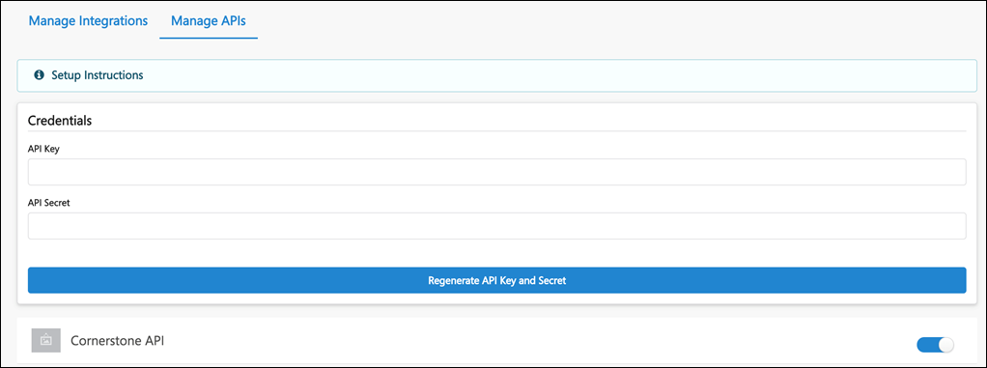
- Create a user record that will function as the Service Account for the job board vendor when the vendor integrations with Cornerstone using the Job Application API. This user is only used to provision the session token during the API authentication process.
- Assign a security role with the External Job Application API - Manage permission, which is needed to access the API.
- Navigate to Admin > Tools > Edge > API Explorer and select Cornerstone Job Application Services. Review the documentation to build the API.
Steps After Enabling
- Set up an integration with a third party job board vendor.
- Provide the job board vendor with the API Key and Secret, as well as the user name for the user record created in Step 2. You will not need to provide the password for the user record because the vendor will not be logging in to your Cornerstone portal.

Job Application API - Candidate Experience
Candidates can apply to your jobs on job boards provided that you have an integration with the job board. You will also need to have Job Application API enabled in your Cornerstone portal in order to pass candidate data from the job board to your portal.
Candidates cannot apply to a job more than once by using the same email address.
One-Click Experience
When candidates apply to your jobs on job boards, they will have a one-click experience when the application only requires basic contact information and a resume.
Once they submit their application, they become an applicant for the job and are visible in job's applicant pool in your portal.
Applications with Prescreening Questions or Assessments - Redirect to Your Career Site
If an application has prescreening questions, assessments, or other non-supported action items, the application cannot be completed with a one-click experience. Candidates are given an option to continue their application on your career sight, where they can answer the prescreening questions and to take assessments.
Candidates will have to log in to the career site or create an account if they do not yet have one. If the application is utilizing the Mobile-Friendly Candidate Experience, they are taken to the application, where their information from the job board is prepopulated into the application fields. Their resume and cover letter are also passed to your portal.
Candidate's Preferred Language
The candidate's preferred language will be respected when their data is passed to your portal.
Candidate Can Re-Apply
Candidates can re-apply to your jobs on Stepstone job boards if you allow applicants to reapply. See General Preferences (by Division).

Application Workflow Templates
The Application Workflow Templates page enables administrators to view and manage standard and mobile-friendly application workflows. Administrators can create, edit, copy, delete, activate, or deactivate application workflow templates from this page.
An application workflow defines the experience a job applicant has when applying for a job. As a result of creating templates, when configuring a job requisition template or creating a job requisition, the administrator can select from the workflow templates that are created on this page.
To access the Application Workflow Templates page, go to Admin > Tools > Recruitment > Application Workflow Templates.
- Create Mobile-Friendly Application Workflow Template - See Create Mobile-Friendly Application Workflow.
- Create Standard Application Workflow Template - See Create Application Workflow Template on page 97 for additional information.
Permissions
PERMISSION NAME | PERMISSION DESCRIPTION | CATEGORY

Application Workflow Template - Manage | Grants ability to access and manage Application Workflow Templates. This permission can be constrained by OU and User’s OU. This is an administrator permission. | Recruiting Administration

Application Workflow Template - View | Grants ability to access and view Application Workflow Templates. | Recruiting Administration
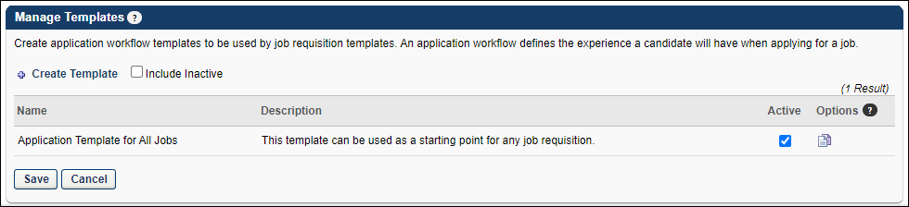
Create Template
To create a new application workflow template, click the Create Template link. Note:This option is only available if you have permission to create application workflow templates. See Create Application Workflow Template for additional information.
Include Inactive
To include inactive templates in the display, select the Include Inactive option. If this option is deselected, only active templates appear in the table.
Application Workflow Templates Table
The following information is displayed for existing application workflow templates:
- Name - The template name. Templates are displayed in alphabetical order by name.
- Description - The template description.
- Active - When this option is selected, the template is active. Deselect this option to make the template inactive. When a template is made inactive and the changes are saved, the inactive template is hidden from the table unless the Include Inactive option is selected. When a template is made inactive, job requisitions that were created from the inactive template are not affected.
Options
The following options are available in the Options column:
- Edit - Click the Edit icon to edit the template. Application workflow templates cannot be edited once in use. If an application workflow template is in use, it can only be copied, not edited. See Create Application Workflow Template for additional information about configuring the template. Note: You must have the necessary permission to edit a template. In addition, administrators can only edit templates that they created or that were created by other administrators who exist within the constraints applied to this permission.
  - Job requisitions that are using the application workflow template are not affected by any changes.
  - If a job requisition template has applied the application workflow template and has made no changes to the structure, then any edits to the template at the application workflow template level are reflected in the job requisition template.
  - If a job requisition template has applied the application workflow template and has made changes to the structure at the job requisition template level, then any changes to the application workflow template level are not reflected in the job requisition template.
- Copy - Click the Copy icon to copy the template. See Create Application Workflow Template for additional information.
Note: Any scoring and weight settings that are configured for Prescreen Question action items are copied to the application workflow.
Note: For portals with multiple languages enabled, any translated values are also copied.
- Delete - Delete the application workflow template. This option is only available if the application workflow template has never been used. Note: You must have the necessary permission to delete a template.
Save/Cancel
Click Save to implement any changes made to the Active column on the Application Workflow Templates page.
Click Cancel to disregard any changes made to the Active column on the Application Workflow Templates page.

Create Application Workflow Template
An application workflow defines the application experience a job applicant has when applying for a job. As a result of creating templates, when configuring a job requisition template or creating a job requisition, the administrator can select from the application workflow templates that are created on this page. When creating a job requisition template, after selecting the application workflow template, the administrator can then customize the application workflow template at the job requisition template level without affecting the original application workflow template.
To create an application workflow template, go to Admin > Tools > Recruit > Application Workflow Templates. Then click Create Template.
Permissions
PERMISSION NAME | PERMISSION DESCRIPTION | CATEGORY

Application Workflow Template - Manage | Grants ability to access and manage Application Workflow Templates. This permission can be constrained by OU and User’s OU. This is an administrator permission. | Recruiting Administration

Application Workflow Template - View | Grants ability to access and view Application Workflow Templates. | Recruiting Administration
Administrators can only edit templates that they created or that were created by other administrators who exist within the constraints applied to this permission.
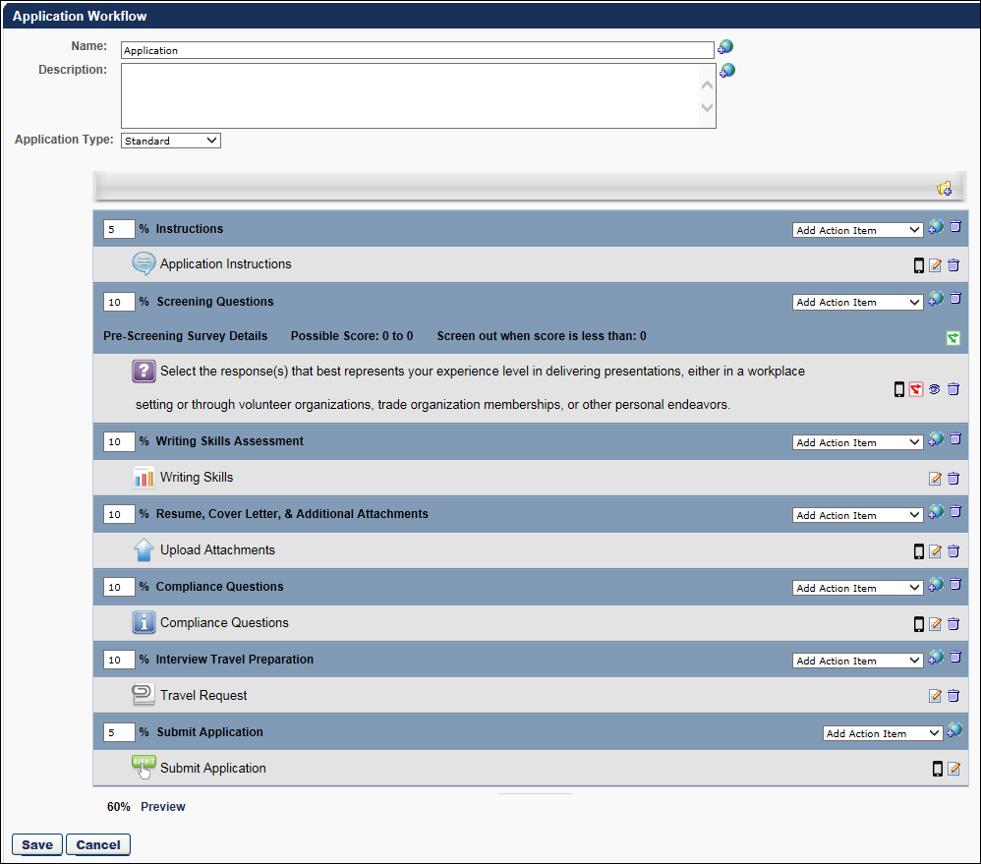
Name
In the Name field, enter a descriptive name for the application workflow template, which is displayed on the Application Workflow Templates page and when selecting a template. The character limit for this field is 50.
To localize the name:
- Click the Translate icon. This opens the Translate pop-up.
- Enter the translated name in the desired language.
- Click Save. This saves the translated name. When recruiters select a workflow template for a job requisition or view the workflow on the Application Workflow tab, the name displays in their language if a translation is configured. If a translation is not configured for the recruiter's language, then the name displays in the default language of the administrator who created the workflow.
Description
In the Description field, enter a description for the application workflow template, which is displayed on the Application Workflow Templates page and is used to identify the template. The character limit for this field is 100.
To localize the description:
- Click the Translate icon. This opens the Translate pop-up.
- Enter the translated name in the desired language.
- Click Save. This saves the translated name. When recruiters select a workflow template for a job requisition or view the workflow on the Application Workflow tab, the description displays in their language if a translation is configured. If a translation is not configured for the recruiter's language, then the description displays in the default language of the administrator who created the workflow.
Application Type
The Application Type option enables you to create either a mobile-friendly template or a standard template. When creating new application workflows, the Mobile-Friendly option is selected by default.
- Mobile-Friendly - Mobile-friendly templates can be created as a single page or multiple pages. The following action items can be added to mobile-friendly workflows:
  - Notes
  - Compliance Questions
  - Prescreen Questions
  - Upload Attachments
  - Disclaimer
- Standard - Standard templates will have the existing application workflow template functionality. All action item types can be added to standard templates. The application will appear as a series of steps, and the mobile-friendly features will be limited.
Change Application Type for Existing Template
If you would like an existing standard application workflow template to be mobile-friendly, copy the template, and then change the Application Type field to Mobile-Friendly.
Add Section
In the application structure builder, the administrator can build the application structure by adding sections to the structure and then adding action items to the sections. Sections allow administrators to group and organize the action items that are included in the application workflow.
By default, all new application workflow templates begin with the Submit Application action item and the Submit Application section. Both items are locked at the bottom of the structure builder and cannot be removed. Also, action items may not be added to the Submit Application section.
To add a section to the structure, click the Add Section icon to the right of the Add Section heading in the structure builder. This opens the Add Section pop-up.
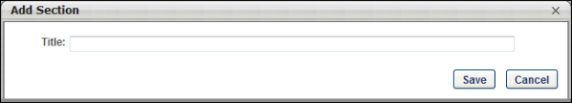
Enter the following information for the section:
- Title - Enter a descriptive title for the section. The character limit for this field is 50.
Click Save to save the new section. When a new section is added, it is added as the last section in the structure, prior to the Submit Application section.
Localization
For portals with multiple languages enabled, to localize a section title:
- Click the Add Section icon. This opens the Add Section pop-up.
- Enter the section title.
- Click Save. This adds the section to the workflow.
- Click the Translate icon to the right of the Add Action Item drop-down for the section. This opens the Translate pop-up.
- Enter the translated title in the desired language.
- Click Save. This saves the translated title. When applicants complete the application, the section titles display in their language if a translation is configured. If a translation is not configured for the applicant's language, then the section titles display in the default language for the workflow section.
Action Items
For all sections, an Add Action Item drop-down displays to the right of the section title. For the Submit Application section, the only action available is Edit.
When an action item is added to a section, it appears at the top of the section above all existing action items. The following are the available action items:
- Add Assessment - See Application Workflow - Add Assessment on page 116 for additional information.
- Add Compliance Questions - See Application Workflow - Add Compliance Questions on page 103 for additional information.
- Add Disclaimer - See Application Workflow - Add Disclaimer on page 105 for additional information.
- Add Form - See Application Workflow - Add Form on page 107 for additional information.
- Add Integration - See Application Workflow - Add Integration on page 109 for additional information.
- Add Note - See Application Workflow - Add Note on page 111 for additional information.
- Add Prescreen Questions - See Application Workflow - Prescreen Questions on page 124 for additional information.
- Add Training - See Application Workflow - Add Training on page 114 for additional information.
- Submit Application - See Application Workflow - Submit Application on page 138 for additional information.
- Upload Attachments - See Application Workflow - Upload Attachments on page 143 for additional information.
Mobile Icon
The mobile icon that displays in the right column on the Application Workflow page indicates that the action item is compatible with mobile devices. When included in the application workflow, applicants filling out an application on a mobile optimized career site can access and complete this action item directly from their mobile device.
Edit Section
Click the Edit icon to edit the section title. Click Save to save the changes.
Delete Section
Click the Delete Section icon to delete the section from the application structure. Note: The Submit Application section is mandatory and cannot be deleted.
Section Percentages
To the left of each section title, a percentage field is displayed. This percentage represents the completion percentage that is achieved by completing the section, which is displayed to the applicant. This is intended to be a visual indication to the applicant of the length of each step of the application process. For example, if the Resume section percentage is set to 20%, then when the applicant completes the Resume section, their application completion percentage is increased by 20%. The percentages should roughly represent the percentage of time and effort required by the applicant to complete the application workflow.
All percentages must be positive, whole numbers and must total 100%. The current total is displayed at the bottom of the Add Section table. After modifying the percentages, the total at the bottom of the table automatically refreshes with the new percentages total.
Preview
At the bottom of the template structure, click Preview to preview the application workflow. This opens the preview in a pop-up, allowing the administrator to preview the navigation bar, content, and progress bar.
For Upload Attachments actions, when the Disable Resume Parsing option is checked on the Edit Action Item pop-up, the resume sections on the Upload and Review steps are hidden on the application workflow preview.
For Prescreen Question sections, scoring information does not display in the preview. Also, the response that is identified as the correct response is not indicated in the preview.
For portals with multiple languages enabled, any translated fields display in the language of the administrator, if the administrator's language is available. If the administrator's language is not available, then the preview displays elements in the languages of the administrators who created the application workflow.
Considerations
- For action items that have no content preview available, "Preview Unavailable" is displayed in the preview.
- For application workflow templates, the preview for the Compliance Questions action item is not available. The action item page in the preview now displays "Preview Unavailable."
- For requisition templates and job requisitions, if questions are defined for the organizational unit (OU), then the Compliance Questions action item page in the preview displays the questions for the OU.
- For requisition templates and job requisitions, if questions are not defined for the OU, then the Compliance Questions action item page in the preview displays "Preview Unavailable."
Save
At the bottom of the page, click Save to save the structure of the page, the section information, and action item information.
Application Workflow - Add Compliance Questions
The Compliance Questions action item enables administrators to add compliance questions to the section. This action item can only be used once within a section.
The questions that appear in the Compliance Questions section are determined by the Compliance Enablement Preferences settings for the Location organizational unit (OU) in which the requisition is posted. Depending on the preferences set for the Location OU in which the requisition is posted, the following compliance questions may appear if the Compliance Questions section is included in the application workflow template:
- Disability
- Ethnicity
- Gender
- Race
- Veteran Status
- Voluntary Self-Identification of Disability
The questions always appear in the above order.
Note: If compliance questions are included on an application workflow template but the requisition's Location OU does not have compliance questions configured in Compliance Enablement Preferences, then the compliance questions section is skipped during the application process.
To create an application workflow template, go to Admin > Tools > Recruit > Application Workflow Templates. Then click Create Template.
Permissions
PERMISSION NAME | PERMISSION DESCRIPTION | CATEGORY

Application Workflow Template - Manage | Grants ability to access and manage Application Workflow Templates. This permission can be constrained by OU and User’s OU. This is an administrator permission. | Recruiting Administration

Application Workflow Template - View | Grants ability to access and view Application Workflow Templates. | Recruiting Administration
Administrators can only edit templates that they created or that were created by other administrators who exist within the constraints applied to this permission.
Use Case
Organizations in the United States are required to report to the federal government Equal Opportunity information such as gender and ethnicity. To help collect this information, many organizations allow the job applicant to enter the information when applying for a job. These questions are always optional for job applicants.
Add Action Item
Click Compliance Questions in the Add Action Item drop-down on the Application Workflow page. This opens the Add Compliance Question pop-up. Enter the following information in the pop-up:
- Title - Enter a title for the question. The default title is "Compliance Questions." This is required and the character limit is 50.
- Instructions - Enter the Compliance Question instructions. This field is required. This field accepts HTML and there is no character limit. JavaScript is not supported.
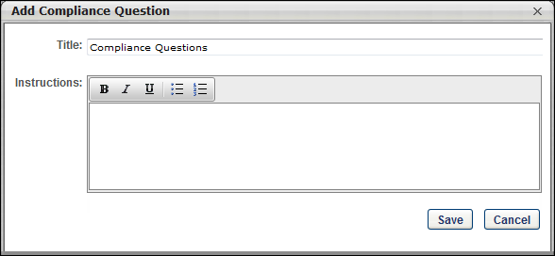
Once the action item is added to the section, the icon is not available unless the action item is removed from the section.
Mobile Icon
The mobile icon that displays in the right column on the Application Workflow page indicates that the action item is compatible with mobile devices. When included in the application workflow, applicants filling out an application on a mobile optimized career site can access and complete this action item directly from their mobile device.
Edit Action Item
Click the Edit icon for the action item to define the instructions for the action item. In the Instructions field, HTML is accepted and there is no character limit.
Delete Action Item
Click the Delete icon to delete the action item.
Application Workflow - Add Disclaimer
The Disclaimer action item is used for applicants and agencies to accept terms when completing an application. This action item can be used multiple times within an application workflow.
To create an application workflow template, go to Admin > Tools > Recruit > Application Workflow Templates. Then click Create Template.
Permissions
PERMISSION NAME | PERMISSION DESCRIPTION | CATEGORY

Application Workflow Template - Manage | Grants ability to access and manage Application Workflow Templates. This permission can be constrained by OU and User’s OU. This is an administrator permission. | Recruiting Administration

Application Workflow Template - View | Grants ability to access and view Application Workflow Templates. | Recruiting Administration
Administrators can only edit templates that they created or that were created by other administrators who exist within the constraints applied to this permission.
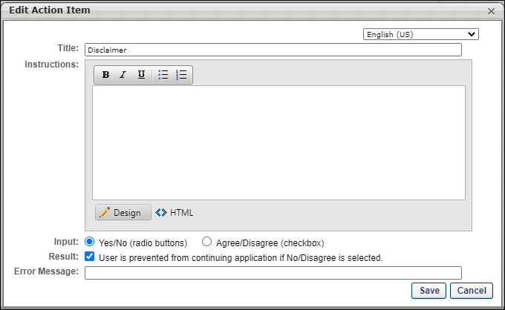
Add Disclaimer
To add a disclaimer:
- Click Disclaimer in the Add Action Item drop-down on the Application Workflow page. This opens the Edit Action Item pop-up.
- Select a language from the language drop-down, for portals with multiple languages. The language selected defines the language in which the fields will be translated. Before saving the action item, you can provide a translation for as many languages as desired based on the languages available. Selecting a different language preserves each translation that has been entered into the fields, even if you have not yet saved the action item.
- Enter a title in the Title field, up to 100 characters. This is a required field.
- Enter the disclaimer text in the Disclaimer field. There is no character limit. This field is required and accepts HTML. JavaScript is not supported.
- Select an Input option, either Yes/No or Agree/Disagree. This determines the answer options that display for applicants when choosing to accept or not accept the terms of the disclaimer.
- Select the User is prevented from continuing option to require applicants to agree to the disclaimer before continuing with the application.
If the option is unchecked, applicants can proceed with the application regardless of how they respond to the disclaimer.
- Enter the error message that appears for the applicant if they attempt to continue without agreeing to the disclaimer. This is a required field and it accepts up to 250 characters.
- Click Save. Or, if you would like to provide translations for additional languages, you can select another language from the language drop-down. This clears the fields and allows you to enter a new translation.
Mobile Icon
The mobile icon that displays in the right column on the Application Workflow page indicates that the action item is compatible with mobile devices. When included in the application workflow, applicants filling out an application on a mobile optimized career site can access and complete this action item directly from their mobile device.
Edit Action Item
Click the Edit icon for the action item to edit the title, instructions, and note. Click Save to save the changes.
Delete Action Item
Click the Delete icon to delete the action item.
Application Workflow - Add Note
The Note action item enables administrators to add a note to the section. The note contains a title, note text, and optional instructions.
To create an application workflow template, go to Admin > Tools > Recruit > Application Workflow Templates. Then click Create Template.
Permissions
PERMISSION NAME | PERMISSION DESCRIPTION | CATEGORY

Application Workflow Template - Manage | Grants ability to access and manage Application Workflow Templates. This permission can be constrained by OU and User’s OU. This is an administrator permission. | Recruiting Administration

Application Workflow Template - View | Grants ability to access and view Application Workflow Templates. | Recruiting Administration
Administrators can only edit templates that they created or that were created by other administrators who exist within the constraints applied to this permission.
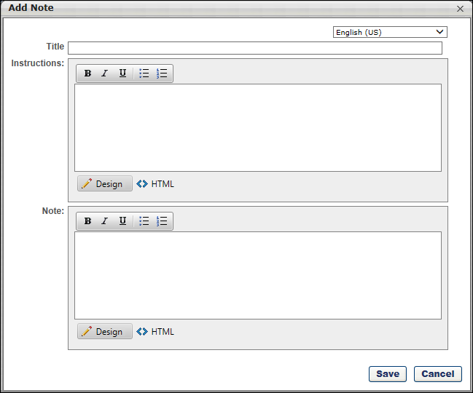
Add Note
- Click Note in the Add Action Item drop-down on the Application Workflow page. This opens the Add Note pop-up.
- Enter the following information in the pop-up:
  - Language - This option only displays for portals with multiple languages enabled. Select a language from the language drop-down, for portals with multiple languages. The language selected defines the language in which the fields will be translated. Before saving the action item, you can provide a translation for as many languages as desired based on the languages available. Selecting a different language preserves each translation that has been entered into the fields, even if you have not yet saved the action item.
  - Title - Enter a title for the note. This is required and the character limit is 50.
  - Instructions - Enter instructions for the note if applicable. This field is optional. This field accepts HTML and there is no character limit. JavaScript is not supported.
  - Note - Enter the note text. This field is required. This field accepts HTML and there is no character limit. JavaScript is not supported.
Click Save to save the changes. Or, if you would like to provide translations for additional languages, you can select another language from the language drop-down. This clears the fields and allows you to enter a new translation.
Note: We do not support script tags in the HTML for Title, Instruction, and Text fields of the action items.
Mobile Icon
The mobile icon that displays in the right column on the Application Workflow page indicates that the action item is compatible with mobile devices. When included in the application workflow, applicants filling out an application on a mobile optimized career site can access and complete this action item directly from their mobile device.
Edit Action Item
Click the Edit icon for the action item to edit the title, instructions, and note. Click Save to save the changes.
Delete Action Item
Click the Delete icon to delete the action item.
Application Workflow - Prescreen Questions
The Prescreen Questions action item enables administrators to add pre-screening questions to the section.
To create an application workflow template, go to Admin > Tools > Recruit > Application Workflow Templates. Then click Create Template.
Note: JavaScript is not supported for pre-screening questions.
Permissions
PERMISSION NAME | PERMISSION DESCRIPTION | CATEGORY

Application Workflow Template - Manage | Grants ability to access and manage Application Workflow Templates. This permission can be constrained by OU and User’s OU. This is an administrator permission. | Recruiting Administration

Application Workflow Template - View | Grants ability to access and view Application Workflow Templates. | Recruiting Administration
Administrators can only edit templates that they created or that were created by other administrators who exist within the constraints applied to this permission.
Use Case
Prescreening questions are commonly used to prescreen and remove applicants that do not meet the minimum requirements of a job. If an applicant completing the application process answers at least one of the questions incorrectly, then the system excludes that person from the list of submissions for the recruiter to review.
A user who answers the prescreening question wrong is not prevented from completing the application process. The system may be configured to send an email to the applicant after their submission to inform them that their application did not meet the job qualifications.
Add Pre-Screening Questions
To add pre-screening questions to the Pre-Screen Questions action item, click Prescreen Questions in the Add Action Item drop-down on the application workflow page. This opens the Add Questions pop-up.
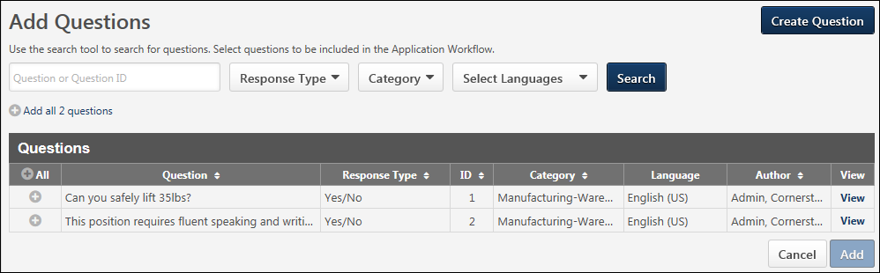
The following information and options are available in the Add Questions pop-up:
Create Question
This option allows you to create a new pre-screening question. Clicking the Create Question button opens the Create Question steps within the Add Question pop-up. Once the question is added, the question is available to select for Prescreen Question sections on the application workflow.
The button only displays with permission to manage the Pre-Screening Question Bank. New Questions are saved to the Pre-Screening Question Bank.
Best Practice: It is a best practice to search through existing questions before creating a new question so that similar or nearly identical questions are not created.
Filters
The following filters are available for searching for questions and filtering the Questions table:
- Question or Question ID - Enter the question name or ID by which to filter the results.
- Response Type - Select a response type from the drop-down.
- Category - Select a pre-screening question category from the drop-down.
- Language - Select a question language from the drop-down.
Once all desired filters are configured, click Search. This updates the table with questions that match the filter criteria.
Add All Questions
Click the Add All option to add all the pre-screening questions that are available to the Prescreen Question action item.
Questions Table and Add Question
The following columns display in the table:
- All - This column displays an Add icon. Click the icon to add the question. This enables the Selected Questions section to display above the list of questions and adds the question to the Selected Questions section. Once a question is added, the column displays "N/A" for the question.
- Question - This column displays the question.
- Response Type - This column displays the response type configured for the question.
- ID - This column displays ID for the question.
- Category - This column displays the category defined for the question.
- Language - This column displays language for the question.
- Author - This column displays user who created the question.
- View - This column displays a View link to view the question. When viewing questions, the UI for the preview window is updated to match current styles.
Once all desired questions are selected, click Add. This adds the pre-screening questions to the workflow in the designated section.
Pre-Screening Survey Details
When a Prescreen Question action item is added to the workflow, a Pre-Screening Survey Details bar displays for the section.
Note: A "survey" is considered to be the group of questions in a Prescreen Question action item section.
Note: The Pre-Screening Survey Details bar does not display for Prescreen Question action items that only include Free Form (Essay) questions.
Note about Date Questions: Questions that are the Date type cannot be scored.
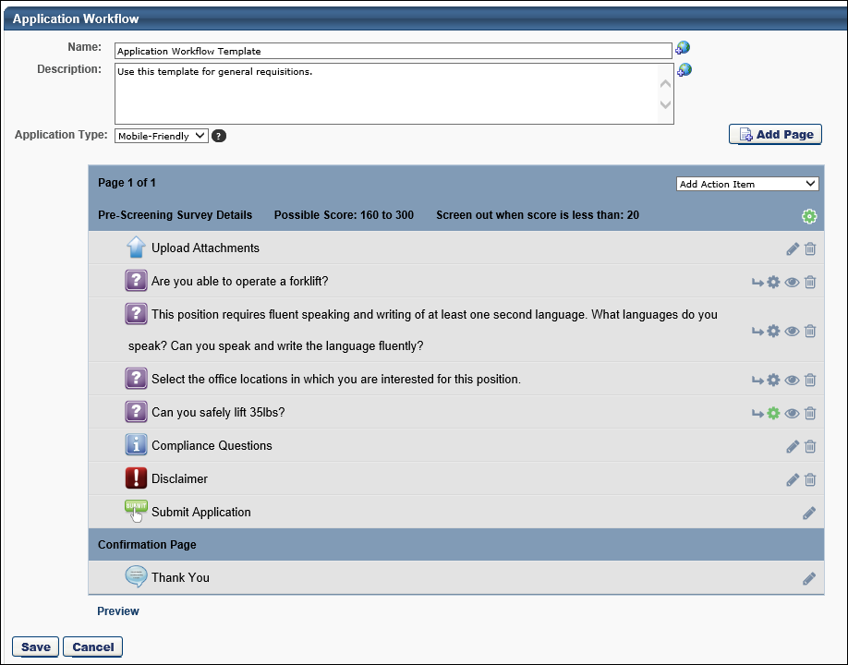
The following information displays in the bar:
Possible Score
This field helps administrators see the total possible score that an applicant can receive for all of the scored questions that are included in the section. The score displays as [Minimum Score Value (the response option with the smallest score value)] to [Maximum Score Value (the sum of the response option(s) that are marked as correct)]. The value is updated automatically when changes are made to the response option scores on the Screening Options pop-up.
Screen out when score is less than
This field displays the screen out score that removes an applicant from the application process if the applicant receives a score that is less than the screen out number. The number is defined on the Survey Options pop-up. The value changes dynamically when questions are added or removed from the section.
Survey Options
Click the Survey Options icon in the Pre-Screening Survey Details header to open the Survey Options pop-up. See below for more details about this feature. When the icon is gray, this indicates that the screen out option is inactive ("No" is selected in the Screen Out field in the Survey Options pop-up). When the icon is green, this indicates that the screen out option is active ("Yes" is selected in the Screen Out field in the Survey Options pop-up). By default, the screen out option is inactive.
Create Branched Questions
For portals that have self-enabled the Mobile-Friendly Candidate Experience, you can create branched prescreening questions. This option lets you show or hide follow-up questions based on a candidate’s answer to the previous question. For example, if a candidate answers “Have you worked at this organization before?” with “Yes,” then you can ask them follow-up questions such as “In what department?”, “What dates were you at the company?”, and more.
This custom logic creates a strong user experience and can help to improve your candidate conversion rate. Because candidates are only answering questions that pertain to them, the application will be simpler and easy to complete. Such multi-part questions help you elicit greater detail about a candidate's profile or experience without hurting the candidate experience. This feature not only enables a streamlined application workflow but also equips you with the tools necessary to get as much information as possible on a candidate upfront, which subsequently saves time in the recruiting funnel. You can dig deeper into a candidate's experiences and qualifications right on the application, rather than waiting until the interview step.
Candidates also appreciate branched questions because they have the opportunity to provide additional information or explain an answer in more detail.
Use Cases
Administrator
- Andrew is an administrator at ACME. Andrew would like to start using branched prescreening questions, so he begins by enabling the Mobile-Friendly Candidate Experience.
- Andrew creates a new application workflow and adds four prescreening questions to the workflow: True/False, Yes/No, Multiple Choice/Single Answer, and Multiple Choice/Multiple Answer question types.
- Andrew sees a new arrow icon for all questions except Multiple Choice/Multiple Answer.
- Andrew clicks the arrow icon for the first True/False question because it supports branching. Upon clicking the arrow, a second line appears directly under the parent question. It reads If Answer Is and has a drop-down that is defaulted to True. To the right it is a Then Show button with the option to select a child prescreening question from the question bank.
- Andrew clicks the arrow icon for the same True/False question. Another line item appears, reading "If Answer Is: False" "Then Show." It defaults to False because the answer option True is already selected. Because there are no more answers to branch off of, the arrow icon disappears from the parent question. If Andrew deletes the conditional logic for True or False, then the arrow reappears.
- Andrew clicks Select from Prescreening Question Bank to add a child question. This opens the Prescreening Question bank in a modal.
- Prescreening questions can only appear once in a workflow. So if a prescreening question has already been added, it cannot be added as a child question.
- Andrew adds a prescreening question with the ID 12345. After clicking Add, the child question appears within Then show drop-down. It is part of the drop-down in case Andrew would like to change the child question and select a new one from the question bank.
- Andrew would like to show multiple child questions when a candidate answers True, so he clicks the plus sign to the right of the first child question.
- Andrew clicks Select from Prescreening Question Bank and opens the modal again.
- Andrew adds multiple questions from the question bank. Any type of prescreening question can be added as a child question, and multiple questions can be added at once. When he saves and closes the question bank, all added questions will appear with a Then Show drop-down before the question. All the questions appear after a candidate answers the parent question with True.
- Andrew follows the same steps and adds conditional logic to the Multiple Choice/Single Answer prescreening question type. The question asks, "How long were you employed by your previous employer?" The answers are A. Less than 1 month, B. 2 months to a year, C. 1-2 years, and D. 3+ years.
- If a candidate answers with A, Andrew would like to ask the candidate a follow-up multiple choice question, "Why did you leave within a month?" The answer options are A. Because I did not like the organization, B. Because I did not like my position's responsibilities, and C. I was asked to leave. Andrew marks this child question required because it is very important to understand why a candidate left their prior employer so quickly.
- Not only does Andrew mark the question required, but he also adds knockout functionality to the child question. If a candidate answers with C, Andrew selects to have the candidate automatically dispositioned.
- Andrew also configures a point value for answers A and B, which will be added to the candidate's total score.
- After configuring the application, Andrew would like to preview it to guarantee everything is formatted correctly. If Andrew clicks the eyeball icon to the right of a question, Andrew will see the question in a pop up. If Andrew clicks “Preview” at the bottom of the application, he can answer parent questions to see the branched child questions.
Candidate
- Aaron is applying to ACME and begins the application Andrew just published. While completing the application, he answers the True/False question with True. After answering True, he sees multiple child follow-up questions.
- Aaron changes his mind and selects False. After selecting False, all child questions disappear.
- Aaron gets to the following question, "How long were you employed by your previous employer?" and selects A. Less than 1 month.
- Upon answering this question, he sees a child question, "Why did you leave within a month?" He selects "C. I was asked to leave." Upon completing the application, Aaron is screened out and not considered for the position.
Question Types that Can Be Parent Questions
The following question types can be parent questions for branched questions:
- Multiple Choice/Single Answer
- True/False
- Yes/No
The following question types cannot be parent questions:
- Date
- Free Form (Essay)
- Free Form (Short Text)
- Multiple Choice/Multiple Answer
- Numeric Value
- Title and Instructions
Question Types that Can Be Child Questions
Any question type can be used to create child questions. There is no limit to the number of child questions added to a parent question.
Create Branches for the Question
To create a branched question:
- Click the arrow icon to the right of the parent question in the workflow. This opens the branching options below the parent.
  - Select an answer in the if answer is drop-down. The options that are available are dependent upon the question type. For example, for True/False question types, if you selected True in the first answer option, then False appears by default in the second answer option. Note: If there are no more answer options, then the arrow icon no longer appears for the question.
  - Next, click Select Question in the then show drop-down to select the child question. This opens the Add Question pop-up, which lists the available prescreening questions.
  - Select one or more questions from the pop-up and click Add. This adds the questions as child questions to the parent. Each of these questions appear if the candidate selects the associated response from the if answer is drop-down. Questions appear in the order in which they are added.
- Add more branching logic to the parent question by clicking the arrow icon for the parent question.
- Add additional child questions to answers by clicking the plus icon to the right of the last child question.
- For Multiple Choice/Single Answer prescreening questions, you can show the same child questions for multiple answer options by clicking the plus icon to the right of the answer drop-down. This will show “OR” and allow you to select another answer from the drop-down.
Note: When you create a branched question, the question must have at least one child question.
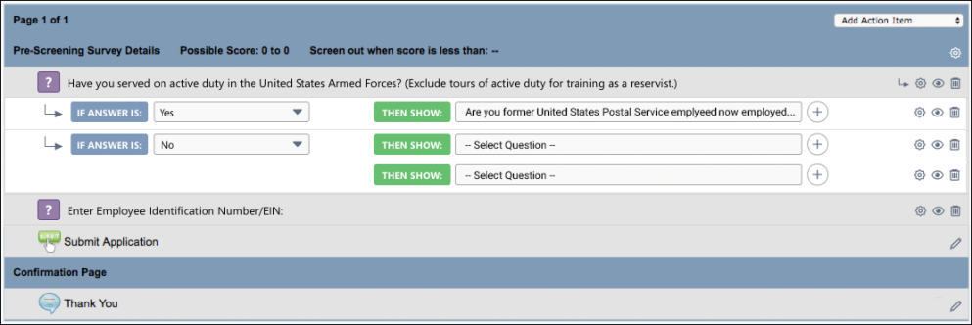
Considerations
- You can create as many branched questions as you want to the workflow.
- You can create as many branches as you want within a parent question, up to the maximum response options available for a question.
- Prescreening questions can only appear once in the workflow. If you would like a question with the exact same wording to appear more than once (e.g., Please explain in more detail), then it needs to be created as a separate question in the prescreening question bank. This gives the question a unique ID.
- The child questions of a parent question cannot be added as separate columns on the Manage Applicants page.
- Copying an application workflow template copies all parent and child questions.
- A candidate’s flattened application (the PDF version) only displays child questions that were presented to the candidate based on their answers to parent questions.
Reorder Questions
You can drag and drop individual branches of a question.
You can also move a parent question to a different order in the workflow. This will move all the child questions, as well.
Removing Branched Logic
For a Yes/No or True/False question, clicking the minus sign to the right of a child question removes the question from the application workflow and the branched logic. If there are multiple child questions for the same answer, clicking the minus icon removes the question from the application but not from the branched logic. Before deleting any question, a confirmation pop-up appears to ensure you would like to delete the question.
For a Multiple Choice/Single Answer question with branched logic, you can display the same child questions for more than one answer. By clicking the minus sign to the right of an answer with multiple options, you will delete that answer but not the entire branching logic.
Delete Parent Question
Click the trash can icon to the right of the question to delete a parent question. This opens a confirmation pop-up to ensure you would like to delete the question. Deleting a parent question also deletes all of its child questions.
Delete Child Question
Click the trash can icon to the right of the question to delete a child question. If that is the only child question, then this deletes the branched logic and the question from the application. If there are multiple child questions, then this deletes the child question but keeps the branched logic.
Conditional Child Questions
You can mark any child question as required. However, the question is only required if the question displays for the candidate.
You can also set up screen out and scoring options for any child question. See Application Workflow - Prescreen Questions on page 124 for additional information.
Child questions are included in the Survey Options pop-up when configuring question weight, screen out options, and scoring for a prescreening section in an application workflow.
Preview Application Workflow
When previewing the workflow, child questions will appear in the preview.
Survey Options Pop-Up
In the Survey Options pop-up, configure the weight and screen out settings that will apply to all of the questions in the Prescreen Question section.
Note About Questions Without a Correct Answer: If a correct answer is not defined for a pre-screening question, then the question cannot be used to screen out an applicant. You will only be able to screen out applicants based on the total score.
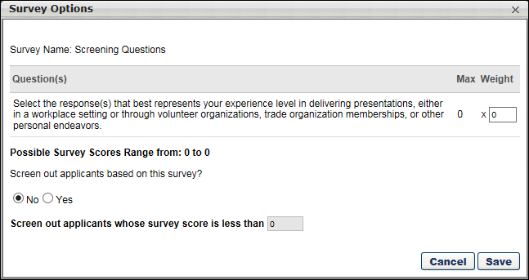
The following information and options are available in the Survey Options pop-up:
Questions Table
The following columns display in the table:
- Question(s) - This column displays the pre-screening question.
- Max - This column displays the maximum score for the question.
- Weight - You can define the weight for a question to customize its importance in that particular application workflow. Weights act as multipliers against response option scores. Enter a value from 0-100. This is a required field.
Best Practice: When using question and survey scoring, it is a best practice to first configure scores for response options within the question(s), and then configure question weights within the survey(s).
Possible Survey Scores Range
The values in this field are automatically calculated based on the minimum and maximum possible scores for questions in the survey. The minimum score is the single lowest response option. The maximum score for True/False, Yes/No, and Multiple Choice Single Answer question types is the correct response option with the highest value. The maximum score for Multiple Choice Multiple Answer question types is the sum of the correct responses.
Screen Out Applicants Based on This Survey
By default, No is selected, which indicates that applicants are not screened out based on their responses to the questions in the survey. The survey score option is grayed out and not selectable.
Select Yes to screen out applicants based on their responses to the questions in the survey. This enables the survey score field. Applicants will not be able to continue with the application if they score less than the value in the survey score field.
Screen Out Applicants Whose Survey
Based on the value in this field, any applicant who scores below the indicated threshold will be screened out based on their survey score, regardless of whether they answered individual pre-screening questions correctly or incorrectly. The value in the survey score field must be less than the maximum score for the survey. This option is required if Yes is selected in the enable screen out field above.
View Question
The View icon displays in the set of options to the right of each pre-screening question. Questions that are added to the section can be previewed so that the administrator can view the text of the question and the response options. Click the View icon to preview the question.
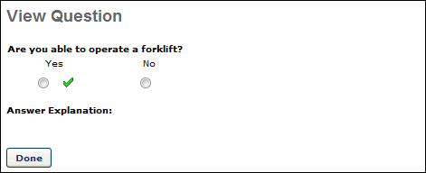
Screening Option - Pre-Screening Questions
Note: The user interface (UI) for Standard application workflows is slightly different, with different icons. In addition, prescreening questions are either always required or always optional, depending on the question type.
The Screening Options icon displays in the set of options to the right of each pre-screening question. When the option is inactive for a question, the icon is gray . When the option is enabled for a question, the icon is green .
Clicking the icon opens the Screening Options pop-up, which allows the administrator to enable the screening feature, as well as select whether or not to hide the indication that applicant responses to pre-screening questions are correct or incorrect. Scoring options may also be available if configured for the question.
Note about Date Questions: Questions that are the Date type cannot be scored.
Note about Questions without a Correct Answer: If a correct answer is not defined for a pre-screening question, then the question cannot be used to screen out an applicant. You will only be able to screen out applicants based on the total score.
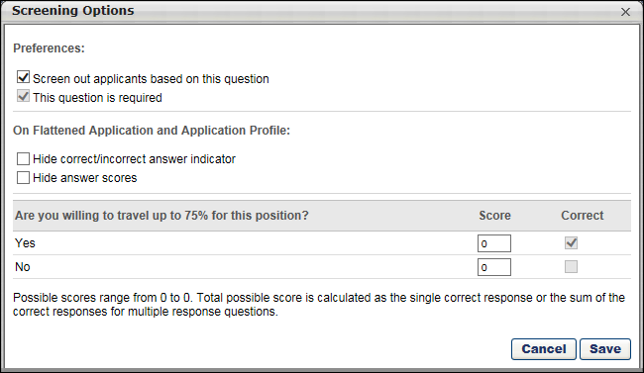
The following information and options are available in the Screening Options pop-up:
Screen Out Applicants Based on This Question
This option allows administrators to enable the screening feature. Check the box to enable the feature. When the Screening Options feature is enabled for a question, applicants who fail to answer the question correctly are automatically moved into a Closed status. Note: Checking the box also makes the question required.
If the box is left unchecked, the feature is not enabled. Applicants who answer a question incorrectly are not automatically moved dispositioned.
The Screening Options feature is available for the following question types:
- Multiple Choice - Multiple Answer
- Multiple Choice - Single Answer
- True/False
- Yes/No
This question is required
This option lets you mark prescreening questions as required or leave the questions as optional, with the exception of the Title and Instructions question type. The Title and Instructions question type is not configurable, since there are no response options.
Check the box to mark the question as required. If the box is not checked, the question is optional. Questions are optional by default.
When the Screen out applicants based on this question option is checked, the This question is required option is automatically checked and cannot be unchecked.
Use Case - Administrator
- Max needs to create a new workflow template for a requisition. In the workflow, he needs to add critical open text field questions like, "Please list any other name(s) used for prior employment, education or professional licensure." This is a critical question in the application because the position will require a background check. Max needs to make sure he submits the pre-employment verifications under the correct name or else it could cause a delay in the candidate's start date.
- Max goes to Admin > Tools > Recruiting > Application Workflow Templates and finds and edits an existing mobile-friendly template.
- Max creates a Free Form (Short Text) question and adds it to the workflow. After adding it to the workflow, he clicks the gear icon and sees a new "Preferences" option with a new check box item reading "This question is required." (Note: By default, this option is unselected for all new questions.) Max checks the box to mark the question required because he wants to guarantee the candidate will answer the question.
- Next, Max adds a Title and Instructions question to the workflow to create a new section. Max does not see the gear icon on that line item because this question type cannot be marked required or optional. Title and Instructions questions always appear when added to an application workflow.
- Max then adds a Yes/No prescreening question to the workflow. After selecting the gear icon for the Yes/No question, he selects the checkbox "Knock out applicants based on this answer." When this is selected, the follow-up checkbox "Mark this question required" is automatically selected. To unselect the Required/Optional checkbox, Max must first deselect the knock out option checkbox. Max saves the workflow with both checkboxes selected.
- Upon returning to the application workflow, the gear icon for the question is now green because the question knocks candidates out of the workflow if answered in a specific way.
- Max would like to preview the workflow to gauge the candidate experience. When Max selects the eye icon to the right of the Yes/No question, he does not see an asterisk, even though the question was marked required. However, when Max previews the workflow, he sees the asterisks for all required questions, which ensures that critical questions must be answered before the application can be submitted.
- Because he is editing a workflow, all questions added prior to the edits will honor the old logic. Yes/No, True/False, Multiple Choice/Single Answer, Multiple Choice/Multiple Answer, and Date will be required. Free Form (Essay), Free Form (Short Text), and Numeric Value questions will be optional. Only questions added to a workflow for the first time will be optional by default.
- Max saves the workflow and applies it while building a new requisition.
Use Case - Candidate
- Sarah Smith is looking for a job at ACME and comes across a job that was just posted.
- Sarah begins the application on her phone and finds it very easy to answer all questions because the application is mobile-friendly. Sarah answers the question, "Please list any other name(s) used for prior employment, education or professional licensure." Sarah enters her maiden name.
- Sarah skips the Yes/No question because she is in a rush and is completing the application on her commute to school. When she tries to progress to the next page, she is scrolled back to the Yes/No question that she skipped and is given a disclaimer that indicates the question is required. Sarah answers the question and progresses to the next page.
- There are a few optional questions Sarah leaves blank because she is in such a rush.
- Sarah submits her application and is excited for the new opportunity.
Use Case - Recruiter
- Ian is a recruiter at ACME and is reviewing Sarah's application. Ian has access to all critical pieces of information, and he adds a note to her profile with her maiden name. This will be referenced in case she progresses to the background status.
- When looking at Sarah's flattened application, he can see which optional questions were left blank because they are marked with, "This question was not answered."
- Ian passes her resume to the hiring manager because she looks like a great fit for the role.
Why would I want to make a question required?
Making a question required ensures that you capture critical information from candidates. If you keep questions optional, such as an open text question, you risk not getting the information you need to make smart recruiting decisions.
Not getting answers to specific prescreening questions could also lengthen the time it takes to convert a candidate to employee. For example, a candidate used a different name for prior employment and did not provide this information on their application because the question was optional. When a background check was assigned to this candidate, their current name was used by the background check vendor rather than the candidate's former name. This resulted in additional days of back and forth communication, delaying the new employee’s start date.
Marking important application questions as required ensures that candidates include pertinent information when submitting the application, rather than having to obtain this information during a later step in the hiring process.
Hide Correct/Incorrect Answer Indicator
The Hide correct/incorrect answer indicator field is unchecked by default. When unchecked, applicant responses to the pre-screening question indicate whether or not the question was answered correctly or incorrectly.
When the option is checked, the following occurs:
- PDF of Application - When viewing a PDF of the application, the correct/incorrect indication is hidden for responses to the question in the Prescreen Questions step of the application workflow.
- Applicant Profile page - The Application tab on the Applicant Profile page displays "N/A" in the Correct column for the question. In addition, the "Yes" and "No" fields that indicate whether or not the applicant answered the question correctly are hidden.
Note: This feature does not apply to Free Form (Essay)/(Short Text) questions, as they do not have correct/incorrect responses.
Hide Answer Scores
This option is part of the pre-screening question scoring functionality. This option is unchecked by default. Check the box to prevent recruiters and hiring managers from viewing the score for a question. When unchecked, the score is visible to recruiters and hiring managers when viewing the application.
Scoring Section
The scoring section displays the pre-screening question and enables the administrator to view/modify the score. To change the score for a response, enter a different whole number from 0-100 in the Score column for the response. The option in the Correct Response column cannot be modified.
Note: When editing a job requisition that has been submitted, the Score column cannot be modified.
Best Practice: As a best practice, when configuring scores for Multiple Choice/Multiple Response questions, set the responses that are incorrect to 0.
Possible Score Range
The possible score range displays below the question, when you scroll down toward the bottom of the Screening Options pop-up. The range displays the range from the minimum score value to the maximum score value. For True/False, Yes/No, and Multiple Choice Single Answer question types, the total possible score value is defined as the single correct response score value. For Multiple Choice Multiple Answer question types, the total possible score value is calculated as the sum of the correct score responses. The values update automatically based on the changes you make to the Score column.
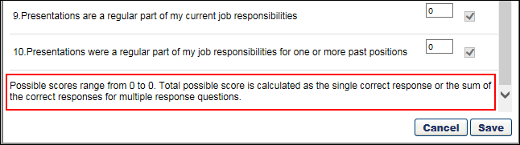
Free Form (Essay) Questions
Free Form (Essay) questions provide greater diversity in the kinds of questions that can be asked and allow applicants to provide greater depth in their responses. The following applies to Free Form (Essay) questions when included in the Prescreen Questions panel:
- The questions always appear at the bottom of the questions list in the Prescreen Questions panel.
- The Screening Option icon is disabled and not available.
- The drag and drop feature is only available for dragging and dropping one Free Form (Essay) question above or below the same question type.
- The questions are optional for applicants to complete.
Delete Action Item
Click the Delete icon to delete the action item.
Frequently Asked Questions
Can I change an applicant's answer to a pre-screening question?
No. An applicant's response to a pre-screening question cannot be changed, either by the applicant once the application is submitted or by a member of the hiring team for the requisition, such as the Hiring Manager or Requisition Primary Owner.
What if I changed the wording of the question to make it easier to understand? Can I change an applicant's answer to the question, especially if the answer they gave automatically removed them from the applicant pool because the question was a knockout question?
No. The applicant's response to a pre-screening question can never be changed once the application is submitted. Also, if a pre-screening question is modified, and the question is being used on at least one application workflow, the question will not be updated on the requisition.
How do I change the status of an applicant who failed the pre-screening?
When an applicant fails the pre-screening, you might decide that you would still like to keep the applicant in consideration for the job. You can do this by manually changing the applicant's status on Manage Candidates, Manage Applicants, or the Applicant Profile.
Can Date type questions be scored?
No. Questions that are configured as the Date type cannot be scored.
However, you can sort candidates on the Manage Applicants page based on their responses to pre-screening date questions. In addition, you can consider using other pre-screening question types if scoring or screen out functionality are required. For example, instead of asking “When were you born?”, one could ask “Are you currently 18 years or older?” as a Yes/No question with scoring or screen out functionality.
Application Workflow - Submit Application
The Submit Application action item is a mandatory step in the application workflow and automatically appears in the Submit Application section. This action item allows the applicant to submit their application. Add Note and Add Integration action items can be included in the Submit Application section.
The Submit Application action item cannot be deleted and cannot be moved to any other position in the workflow template.
To create an application workflow template, go to Admin > Tools > Recruit > Application Workflow Templates. Then click Create Template.
Note: JavaScript is not supported for pre-screening questions.
Permissions
PERMISSION NAME | PERMISSION DESCRIPTION | CATEGORY

Application Workflow Template - Manage | Grants ability to access and manage Application Workflow Templates. This permission can be constrained by OU and User’s OU. This is an administrator permission. | Recruiting Administration

Application Workflow Template - View | Grants ability to access and view Application Workflow Templates. | Recruiting Administration
Administrators can only edit templates that they created or that were created by other administrators who exist within the constraints applied to this permission.
Mobile Icon
The mobile icon that displays in the right column on the Application Workflow page indicates that the action item is compatible with mobile devices. When included in the application workflow, applicants filling out an application on a mobile optimized career site can access and complete this action item directly from their mobile device.
Edit Action Item
Click the Edit icon for the action item to edit the title and define instructions for the Submit Application action item. In the Title field, the character limit is 2000. In the Instructions field, HTML is accepted and there is no character limit.
Add Note/Add Integration Action Items
Add Note and Add Integration action items can be included in the Submit Application section. The action items can be included in any order by dragging and dropping them above or below the Submit Application action item.
Application Workflow - Thank You Page
A Thank You page can be added to the application workflow so that when applicants submit their application, the Thank You page appears. The page can be helpful by letting applicants know that their application was submitted successfully and thanking the applicant for applying. The page can be added on the application workflow template, requisition template, default requisition template, or requisition and child requisition.
For Mobile-Friendly workflow types, you can also add tags to a custom Thank You page so that recruiters can use the data gathered from the tracking pixel to connect hired candidates to the data that is tracked. See Create Mobile-Friendly Application Workflow (Early Adopter).
The Thank You page appears for applicants after they click Submit on the application. The page cannot be removed from mobile-friendly application workflows.
To create an application workflow template, go to Admin > Tools > Recruit > Application Workflow Templates. Then click Create Template.
Permissions
PERMISSION NAME | PERMISSION DESCRIPTION | CATEGORY

Application Workflow Template - Manage | Grants ability to access and manage Application Workflow Templates. This permission can be constrained by OU and User’s OU. This is an administrator permission. | Recruiting Administration

Application Workflow Template - View | Grants ability to access and view Application Workflow Templates. | Recruiting Administration
Administrators can only edit templates that they created or that were created by other administrators who exist within the constraints applied to this permission.
Thank You Action Item
The Thank You action item is only available for the Submit Application section. This action item always appears as the last step of the application and cannot be moved to a different location in the workflow.
To add a Thank You page:
- Click Thank You from the Add Action Item drop-down. This opens the Add Thank You pop-up.
- Select the language for the page in the language drop-down. This option is only available for portals with multiple languages enabled.
- Enter a Title in the Title field.
- Enter instructions for the page in the Instructions field. The instructions appear above the Thank You page text. The Instructions field accepts HTML. JavaScript is not supported.
- Enter the text of the Thank You page in the Text field. HTML is accepted. JavaScript is not supported.
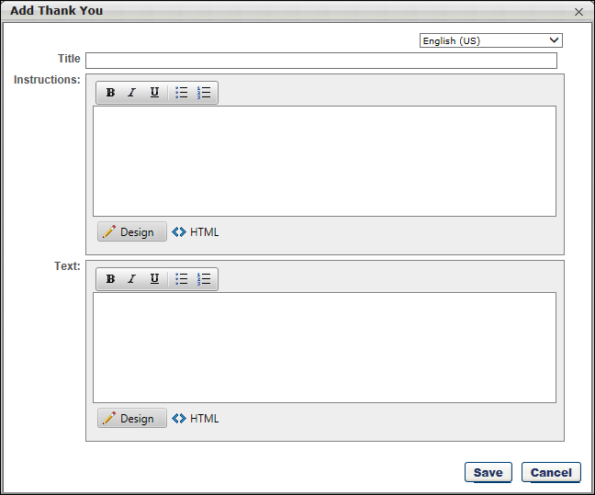
Preview Thank You Page
You can preview the Thank You page by clicking Preview at the bottom of the application workflow. This opens the application and allows you to click through to the Thank You page to see how it will look for applicants and determine if changes are needed.
Progress Recorded For Added/Moved Applicants
When adding or moving an applicant to a different requisition that has a Thank You page configured, the system will track the applicant's progress once they are added or moved.
In addition, applicants will not need to complete a Notes section when applying to the requisition to which they were moved if the text of the note is the same for both requisitions.
How to Add a Third-Party Partner’s Tracking Pixel to an Application
Recruiting helps you understand the effectiveness of third-party solutions utilized to advertise your jobs across the Web. Many third-party solutions, such as Indeed and Glassdoor, offer tracking features to capture real-time applicant conversions. This section explains how to embed a third-party tracking pixel into the Thank You page of your application workflow, enabling you to track the number of job seekers who successfully convert to an applicant as a result of visiting your jobs.
Step 1 | Application Workflow  Every job application in Recruiting has a default Thank You page immediately following the Submit action item. Candidates see the Thank You page after successfully submitting their application. | 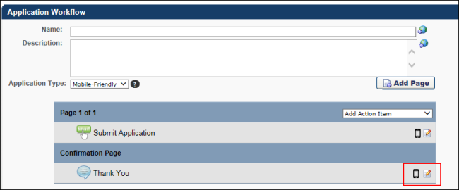
Step 2 | Unselect Default Thank You Page  Without editing the Thank You action item, your application will always display the default Thank You page. To embed a third-party pixel, unselect the “Use the default thank you page” option. This will allow you to add custom HTML to the page. | 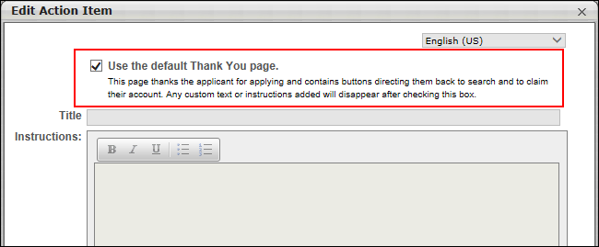
Step 3 | Select “HTML” Option in Text  Add your own content to the Title and Instructions fields then select the HTML option on the text portion of the modal. This is where you can paste any third-party HTML snippet. The snippet will be provided to you by your third-party partner.  Each tracking pixel will fire upon the loading of the Thank You page. The tracking pixel provider may provide you with a full image tag: <img height="1" width="1" src="https://example.com/trackingpixel.gif">  This would be copied and pasted into the HTML text body.  Work closely with your partner to guarantee conversions are being tracking properly. | 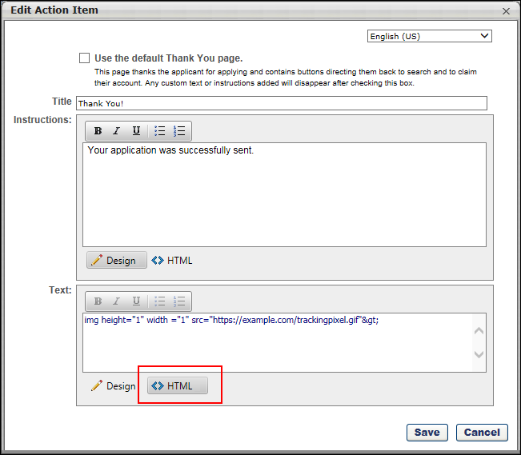
Application Workflow - Upload Attachments
The Upload Attachments action item enables administrators to add the ability for job applicants to upload attachments. Job applicants can upload their resume to the application and then edit the fields that it populates via the resume parser. This action item can only be used once in an application workflow template.
To create an application workflow template, go to Admin > Tools > Recruit > Application Workflow Templates. Then click Create Template.
Permissions
PERMISSION NAME | PERMISSION DESCRIPTION | CATEGORY

Application Workflow Template - Manage | Grants ability to access and manage Application Workflow Templates. This permission can be constrained by OU and User’s OU. This is an administrator permission. | Recruiting Administration

Application Workflow Template - View | Grants ability to access and view Application Workflow Templates. | Recruiting Administration
Administrators can only edit templates that they created or that were created by other administrators who exist within the constraints applied to this permission.
Add Upload Attachments Action Item
To add the action item, click Upload Attachments in the Add Action Item drop-down on the Application Workflow page. This adds the Upload Attachments action item to the section. You can edit the options for this action item by clicking the Edit icon . See Edit Action Item on page 143 for additional information.
Once the action item is added to the section, the option is no longer available unless the action item is removed from the workflow.
Mobile Icon
The mobile icon that displays in the right column on the Application Workflow page indicates that the action item is compatible with mobile devices. When included in the application workflow, applicants filling out an application on a mobile optimized career site can access and complete this action item directly from their mobile device.
Edit Action Item
Click the Edit icon to define the title, instructions, and optional resume preference for the Upload Attachments action item.
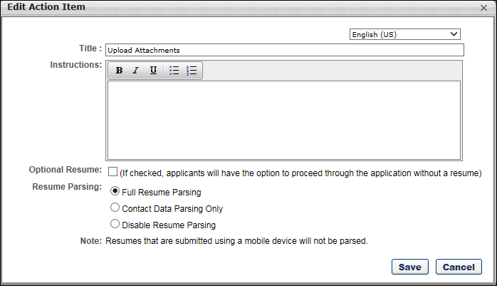
Complete the following fields in the pop-up:
- Title - Enter a title in the Title field.
- Instructions - Enter instructions for the action item in the Instructions field. There is no character limit. This field does not accept HTML. JavaScript is not supported.
- Optional Resume - This option is unchecked by default. Selecting this option enables a No Resume/CV option to appear on the Upload Attachments page during the application process. Applicants can select the No Resume/CV option to proceed through the application workflow without adding a resume. Note: Applicants are required to include a resume if the No Resume/CV option is not checked.
- Resume Parsing - Resume parsing automatically enters the applicable values from an applicant's resume into the resume fields on the application. This is a helpful feature for applicants so that they do not have to enter information manually into the application.
  - Full Resume Parsing - This option displays all resume sections to applicants (i.e. Work Experience). Once the applicant uploads a resume file, the content from the file will be parsed (populated) on the application workflow in order to help the applicant fill in the resume sections. To see more information about configuring Resume sections, See Add Resume Section - Applicant Resume on page 88 for additional information. Additionally, enabling this option in an Internal applicant workflow allows internal candidates to use their Universal Profile resume rather than having to upload a separate document.
  - Contact Data Parsing Only - This option only applies to the Apply as Guest functionality. When the Contact Data Parsing Only option is selected, only the data entered on the Contact Information page for applicants who apply as a guest is parsed. The resume data will not be visible to the applicant in the application workflow. Instead, they can only view and modify their contact information and will not be able to view or modify their resume data.
Note: If the Contact Data Parsing Only option is enabled when configuring the Upload Attachments action item, there will be no matching criteria with resume parsing for the applicant, since the Universal Profile resume populates upon hire.
  - Disable Resume Parsing - The Disable Resume Parsing option is unchecked by default. When unchecked, the resume parsing functionality is enabled for all applicants in the application workflow. When the option is checked, the resume parsing step of the application workflow is skipped for all applicants in the application workflow. In addition, the search by resume/CV functionality is not supported when the Disable Resume Parsing option is checked. Note: When the Disable Resume Parsing option is checked, the resume sections on the Upload and Review steps are hidden on the application workflow preview.
Once all fields are defined, click Save. This saves the settings and closes the pop-up.
Mobile-Friendly Application Workflows
When configuring the Upload Attachments action item for a mobile-friendly application workflow, the Edit Action Item pop-up includes options to show or hide the Cover Letter section, as well as configure additional attachments.
Additional Attachments
An Additional Attachments section appears on the application by default for career sites configured via the Mobile-Friendly Candidate Experience that include an Upload Attachment action item in the workflow. The default section can be removed by the administrator when configuring the Upload Attachments section in the application workflow template and can also be made required.
Additional Attachments sections are added via the Edit Action Item pop-up for the Upload Attachments action item. This section is only available for mobile-friendly application workflows.
The Additional Attachments section allows you to create up to 10 attachment options or requirements for applicants. Attachments can be a maximum of 10 MB.
To create an attachment:
- Click the Add Additional Attachment link. This expands the Additional Attachments section.
- Enter a title in the Title field, up to 500 characters. This text will also populate the upload button that applicants see on the application.
- Enter instructions in the Instructions field. HTML is accepted. There is no character limit. JavaScript is not supported.
- Check the Required Field box to make the attachment required. If the attachment is required, applicants will not be able to submit the application unless they upload the required attachment.
- Click Save to save the action item. Or, click Add Additional Attachment again to create another attachment.
You can delete attachment sections by clicking the Delete Section icon to the right of the attachment section.
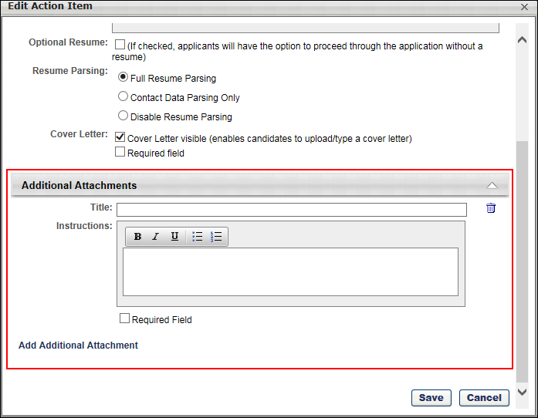
Cover Letter
The Cover Letter field lets you show or hide the Cover Letter option on the application. This option is only available for mobile-friendly application workflows.
The following options are available:
- Cover Letter visible - Check the box to make the Cover Letter option visible on the Upload Attachments section of the application. If the box is not checked, then the option will not be visible to applicants on the application.
- Required field - Check the box to make the field required. Applicants will have to include a cover letter, either by uploading the cover letter or typing it into the text box.

Pre-Screening Question Bank - Overview
During the application process, recruiters are able to use pre-screening questions to eliminate unqualified submissions from the candidate pool without being reviewed by a recruiter. If a candidate answers one or more of the pre-screening questions incorrectly, their applicant status is automatically changed to Closed with a disposition of Failed Pre-Screening, which eliminates them from the New Submission and Manage Applicants page. The applicant is still visible on the View Requisition Details page. Depending on the settings for the Failed Pre-Screening status, the candidate may be eliminated from the Candidate Bank.
To manage pre-screening questions, go to Admin > Tools > Recruit > Pre-Screening Question Bank.
Permissions
PERMISSION NAME | PERMISSION DESCRIPTION | CATEGORY

Pre-Screening Question Bank - Manage | Grants ability to access and manage Pre-Screening Question Bank. | Recruiting Administration
Use Case 1
A shipping/freight company may have a requirement for a specific job that the applicant must be able to lift 35lbs above their head safely. If a candidate cannot lift 35 lbs above their head safely, the recruiter may not even want to look at the candidate's application. This automatic elimination of the applicant is accomplished with pre-screening questions.
Use Case 2
Administrator
- Smith is an admin at Acme Co.
- Smith needs to create a new mobile friendly application workflow template for a new role at Acme Co.
- Smith adds pre-screening questions to the same page as the "Submit" action item.
- Smith then creates multiple new question types to the application workflow.
- Smith adds a title question type named "References."
- Smith adds a short field question type named "Reference Name."
- Smith adds a numeric value question type named "Reference's phone number."
- Smith adds all three question types to the workflow template.
- Smith saves the application workflow template and adds it to a requisition template.
Recruiter
- Tim is a recruiter at Acme Co.
- Tim has created and published a new requisition with the template Smith previously created.
- Tim looks at applicants and sees that the applicants have listed reference names and phone numbers.
Candidate
- Aaron is a candidate completing an Acme Co. application.
- Aaron completes the reference questions on his mobile device.
- These questions are on the same page as all other questions in the application workflow.
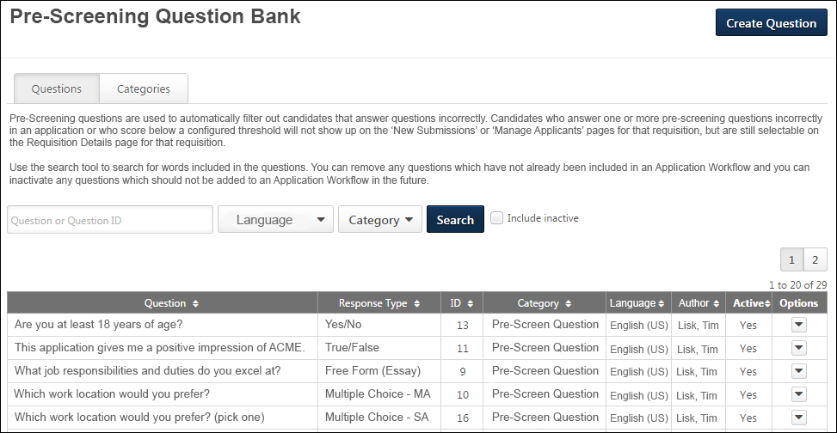
Questions Tab
From the Questions tab, you can create, view, and manage pre-screening questions. See Pre-Screening Question Bank - Questions Tab on page 71 for additional information.
Categories Tab
                - From the Categories tab, you can create, view, and manage question categories. Previously, categories were managed via the Question Categories pop-up. See Pre-Screening Question Bank - Categories Tab on page 68 for additional information.
Create Question
To create a new pre-screening question, click Create Question. This opens the Create Question page, from which you can select the field type and configure the question. See the following for more information:
- See Pre-Screening Question Bank - Create Question - Select Field Type on page 80 for additional information.
- See Pre-Screening Question Bank - Create Question - Question Properties on page 73 for additional information.
FAQs
What is the benefit of adding pre-screening questions to the application workflow?
Pre-screening questions are added to application workflows to better manage the application process and the number of applications that recruiters receive. Applicants are screened out when they select an incorrect answer for a pre-screening question for which the screen out option is enabled. This helps reduce the number of applicants to only those who meet the requirements for the job.
Are pre-screening questions automatically configured to screen out applicants?
Yes. When a pre-screening question is added to an application workflow template, the option to use the question to screen out applicants is automatically enabled. However, the screen out option can be disabled for each individual question when configuring the application workflow template.
Are all pre-screening questions used to screen out applicants?
No. The option to use the question to screen out applicants can be disabled for each individual question. The option can be disabled by the administrator when configuring pre-screening questions on the application workflow template.
How do I disable the option to use the question to screen out applicants?
To disable the screen out feature for a question, select the No option in the Screening Options pop-up.
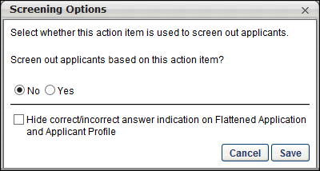
Do I have to create categories before I can create questions?
Yes. At least one category must be defined before creating questions. A category must be selected when creating a question in order to save the question, so at least one category must be available to select when creating questions.
What are some of the ways I can use pre-screening questions to screen out applicants?
There are many ways that pre-screening questions can be used to screen out applicants that do not meet the minimum requirements of the job. The following are some examples:
Screen Out Reason | Sample Category | Sample Question
Approval required for internal employees to apply to an internal job | Internal Employee Questions | Employees are required to receive manager approval prior to applying to internal job opportunities. Did you receive manager approval before applying to this job?
Education | Education Requirements | Do you have an undergraduate degree?  Do you have a master's degree?  This internship requires students to be at a junior level or higher by the internship start date. Check the box to indicate your status as of the expected position start date.
Minimum requirements related to a specific job | Job-Specific Questions | Are you able to lift [minimum lifting amount]?  Do you have a minimum of five years experience as an X-ray technician?  Do you have a current Commercial Driver License (CDL)?
Travel requirements | Travel | Are you willing to travel up to 75% for this position?  Are you willing to travel internationally on a regular basis for this position?
How do I add a pre-screening question to a requisition template?
Pre-screening questions can be added to a requisition template by adding them to a section on the Application Workflow. For more information about adding pre-screening questions to a requisition template, see the Job Requisition Template - Create - Application Workflow Tab topic.
How do I add a pre-screening question to a job requisition?
Pre-screening questions can be added to a job requisition by adding them to a section on the Application Workflow tab. The Application Workflow tab can only be modified when the requisition is in Draft status. For more information about adding pre-screening questions to a requisition, see the Create Job Requisition - Application Workflow topic.

Pre-Screening Question Bank - Categories Tab
From the Categories tab, you can create, view, and manage question categories.
Note: Once a category is created, it can be inactivated but not deleted. To inactive a category, click Edit in the Options column for the category.
To manage categories, go to Admin > Recruit > Pre-Screening Question Bank. Then, click the Categories tab.
Permissions
PERMISSION NAME | PERMISSION DESCRIPTION | CATEGORY

Pre-Screening Question Bank - Manage | Grants ability to access and manage Pre-Screening Question Bank. | Recruiting Administration
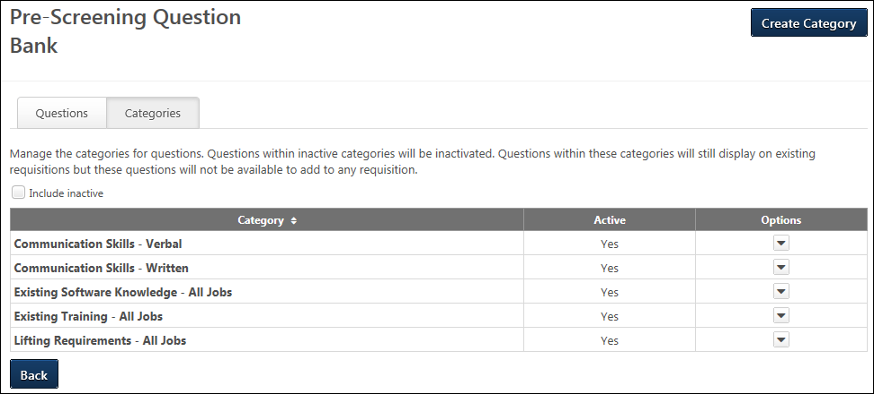
Create Category
Categories are used to organize and filter pre-screening questions by subject area. Pre-screening questions cannot be created until at least one category is created. See Pre-Screening Question Bank - Create Category on page 70 for additional information.
Categories Table
The categories table displays all of the active pre-screening question categories. If Include Inactive is checked, then the table also displays inactive categories. By default, the categories display in alphabetical order.
The following information displays for each category:
- Category - This column displays the name of the category. This column is sortable.
- Active - This column displays the active status of the category. The active status for an individual question can be managed by clicking Edit in the Options column.
- Options - The following option is available in the Options column:
  - Edit - Click Edit to edit the category. This opens the Edit Category pop-up. The category name and active status can be modified. Click Save to save the changes.
Back
Click Back to return to the Questions tab. You can also click the Questions tab to open the tab.
Pre-Screening Question Bank - Create Category
Categories are used to organize and filter pre-screening questions by subject area. Pre-screening questions cannot be created until at least one category is created.
To create a category, click Create Category on the Categories tab of the Pre-Screening Question Bank page.
Permissions
PERMISSION NAME | PERMISSION DESCRIPTION | CATEGORY

Pre-Screening Question Bank - Manage | Grants ability to access and manage Pre-Screening Question Bank. | Recruiting Administration
To create a category:
- Click Create Category on the Categories tab. This opens the Create Category pop-up.
- Enter the category name in the Name field, up to 50 characters. If multiple languages are enabled for your portal, select the Translate icon to translate the field into other available languages.
- Check or uncheck the Active box to define the active status of the category. When checked, the category is active and questions within the category can be added to application workflows. When unchecked, the category is inactive and questions within the category cannot be added to application workflows.
- Click Save to save the category. Or, click Cancel to close the pop-up without saving the category.
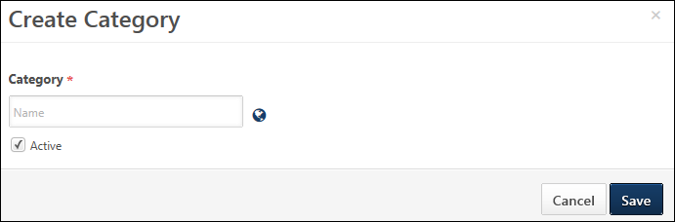

Pre-Screening Question Bank - Questions Tab
From the Questions tab, you can create, view, and manage pre-screening questions.
To manage pre-screening questions, go to Admin > Recruit > Pre-Screening Question Bank. The Questions tab opens by default.
Permissions
PERMISSION NAME | PERMISSION DESCRIPTION | CATEGORY

Pre-Screening Question Bank - Manage | Grants ability to access and manage Pre-Screening Question Bank. | Recruiting Administration
Create Question
To create a new pre-screening question, click Create Question. This opens the Create Question page, from which you can select the field type and configure the question. See the following for more information:
- See Pre-Screening Question Bank - Create Question - Select Field Type on page 80 for additional information.
- See Pre-Screening Question Bank - Create Question - Question Properties on page 73 for additional information.
Filters
Administrators can search existing pre-screening questions by question text, question category, and language. These filters work together so that only the questions that match all criteria are displayed when the Search button is clicked. The following filters are available:
- Question/Question ID - Enter question keywords or the question ID.
- Language - Select a language from the drop-down.
- Category - Select a category from the drop-down.
- Include Inactive - This is a new option. Check the box to display inactive questions in the questions table.
Once the desired filters are defined, click Search. This updates the Questions table to display matching questions.
Questions Table
The table displays all active pre-screening questions. If Include Inactive is checked, then the table also displays inactive questions. By default, the questions display in alphabetical order.
The following information display for each question:
- Question - Displays the question text in alphabetical order.
- Response Type - Displays the response type associated with the question.
- ID - Displays the unique question ID associated with the question. The question ID is automatically assigned by the system.
- Category - Displays the question category associated with the question.
- Language - Displays the language associated with the question.
- Author - Displays the name of the user that authored the question.
- Active - If this option is selected, the question is active and can be included in a job requisition form. If this option is not selected, the question is inactive and is not available for job requisition forms. If this option is modified, the changes are implemented immediately and do not require saving.
- Options - The following options are available in the Options drop-down:
  - Edit - Click this option to edit the question. This opens the Create Question page. When editing a question, a warning message appears if the question has been used in an application workflow to indicate that the meaning of the question should not be changed. See Create Pre-Screening Question for additional information.
  - Copy - Click this option to copy the question. The Copy Question pop-up appears. See Create Pre-Screening Question for additional information.
  - Preview - Click this option to preview the question. The preview options as a pop-up. Note: When previewing the questions, scoring information does not display. The response that is identified as the correct response is not indicated in the preview.
  - Delete - Click this option to delete the question. This option is only available if the question has never been used in an application workflow.
Pre-Screening Question Bank - Create Question - Question Properties
When creating a pre-screening question, the second step is to configure the question properties. This allows you to define the text of the question and configure the response options.
To create a question, click Create Question on the Questions tab of the Pre-Screening Question Bank page.
Permissions
PERMISSION NAME | PERMISSION DESCRIPTION | CATEGORY

Pre-Screening Question Bank - Manage | Grants ability to access and manage Pre-Screening Question Bank. | Recruiting Administration
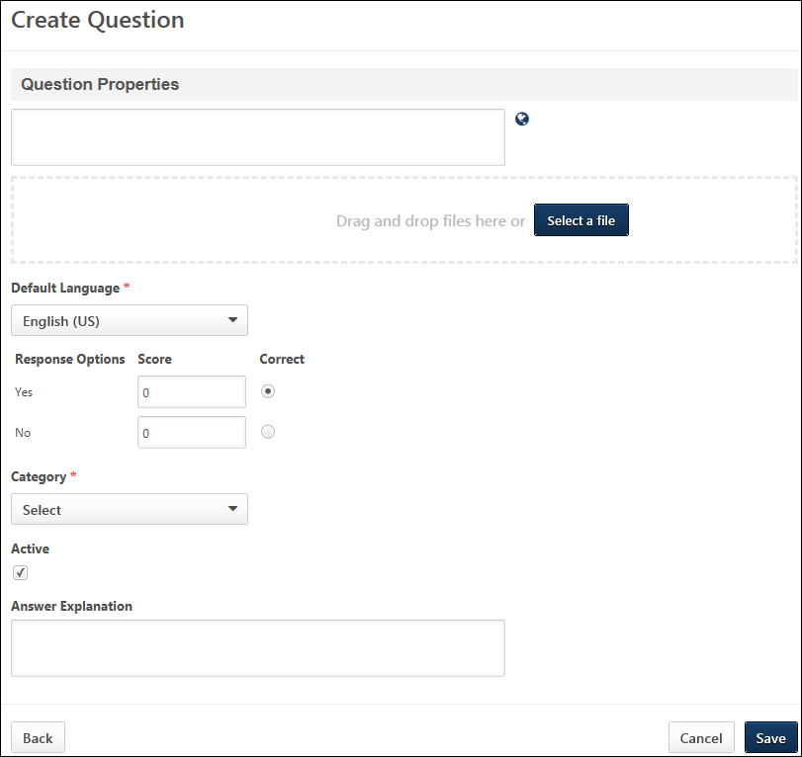
The following configuration options are available for questions:
Question
This is a required field. Enter the question, up to 4000 characters.
The question should be descriptive and include all of the details necessary for the responder to understand what is expected. If an image or video is included, you should explain what the responder should be looking for or analyzing in the image or video.
You can click and drag the text box to resize the box. If multiple languages are enabled for your portal, select the Translate icon to translate the field into other available languages.
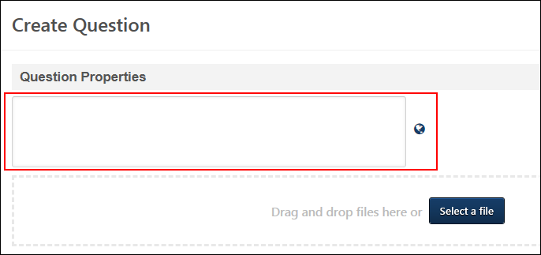
Attachments
This field enables administrators to attach an image to the question.
To attach a file, drag and drop the file to the field or click Select a file to search for and select a file from your computer. The following file types are accepted:
- .bmp
- .gif
- .jpg
- .png
The maximum file size is 50 MB. If an image is added to a question and at least one user completes the question, the image cannot be edited.
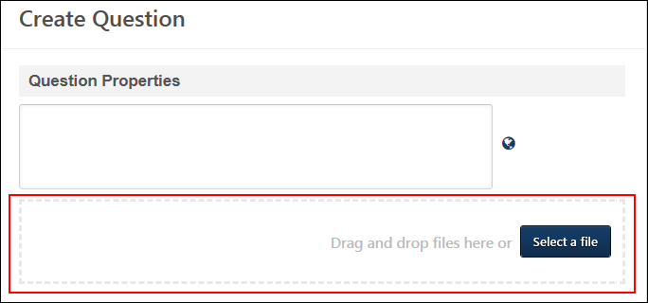
Default Language
Select the default language for the question from the drop-down. The default language is the language in which the item will be presented to the applicant.
Example
The default language for a question is English (US). The administrator has also specified German and Japanese translations for the question and response items. When an applicant completes the application in English (US), German, or Japanese, the applicant will see the corresponding translation. Applicants who are completing the assessment in any other language will see the default English (US) version of the question and response options.
Response Options
This section allows you to define the response options that will be available for applicants to selected when answering the question. Questions are not required to have a correct or incorrect answer.
Note: This field does not display for Date or Free Form (Essay)/(Short Text) question types.
Yes/No and True/False Question Types
For Yes/No and True/False question types, the following information and options display:
- Response Options - This column displays the Yes/No and True/False response options for applicants.
- Score - This field allows you to enter a score for the question. Enter a whole number between 0 and 100. This is not a required field.
- Correct - Select this option if you would like to designate a response choice as the correct response. The first response is selected by default. When an applicant selects a response that is defined as the correct response and the screen out option is enabled for the question in the application workflow, then the applicant remains in the applicant pool. If the applicant selects the other response and the screen out option is enabled for the question in the application workflow, then the applicant is removed from the applicant pool. If you choose not to designate a correct answer, then the question cannot be used to screen out an applicant. The screen out option will not be available for the question when configuring application workflow templates.
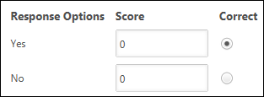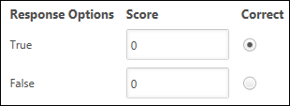
Multiple Choice/Single Response and Multiple Choice/Multiple Response
For Multiple Choice/Single Response and Multiple Choice/Multiple Response question types, the following information and options display:
- Order - Enter a number to order the responses. A response with the order of 1 is displayed at the top, followed by 2, then 3, and so on.
- Response Options - These are the multiple choice options that are displayed to the user. Enter the response text for each option you would like to include (e.g., for the question "What colors are in a rainbow?" possible response choice text may be Red, Blue, Green, Purple, Orange, Yellow, White, Black). The field accepts up to 250 characters.
- Translate - If multiple languages are enabled for your portal, select the Translate icon to translate the field into other available languages.
- Add - Click the Add icon to add response options.
- Delete - Click the Delete icon to delete the response option.
- Score - This field allows you to enter a score for the question. Enter a whole number between 0 and 100. This is a required field.
Best Practice: As a best practice, when configuring scores for Multiple Choice/Multiple Response questions, set the responses that are incorrect to 0.
Best Practice: When using question and survey scoring, it is a best practice to first configure scores for response options within the question(s), and then configure question weights within the survey(s).
- Correct - Select this option if you would like to designate a response choice as the correct response. Multiple correct answers may be selected. If more than one answer is marked correct, and an applicant answers at least one correct, their response will be "Correct." If "None of the above" is included as an option, you may select that as the correct response.
The first response is selected by default.
Screen Out Options
When an applicant selects a response that is defined as the correct response and the screen out option is enabled for the question in the application workflow, then the applicant remains in the applicant pool.
  - If the applicant selects an incorrect response and the screen out option is enabled for the question in the application workflow, then the applicant is removed from the applicant pool.
  - If the screen out option is disabled for the question in the application workflow, the Correct status is ignored.
  - If you choose not to designate a correct answer, then the question cannot be used to screen out an applicant. The screen out option will not be available for the question when configuring application workflow templates.
- Always Display - Check the box to always display this option as a response choice. This field is only applicable if you select the Display Subset of Responses option in the Advanced Options section, in which not all response choices are displayed.
If the Correct box is checked for the response option, then the Always Display box is grayed out and not selectable. If the Correct box is unchecked, then the Always Display box is automatically unchecked.
- Include 'None of the above' - Select this option to include a 'None of the above' response option for the question. This adds the response to the list of response options. You can define the order and score for the response and can also select it as the correct response and have it always display.
- Include 'All of the above' - Select this option to include an 'All of the above' response option for the question. This adds the response to the list of response options. You can define the order and score for the response and can also select it as the correct response and have it always display.
Advanced Options
The following advanced options are available:
- Randomize Response Option Order - When this option is selected, the order in which response options are displayed to applicants is random/unique for each applicant. When this option is unchecked, response options are presented in the order indicated in the Order column. Note: For a randomized response order, the 'None of the above' and 'All of the above' options are always the second to last and last options respectively. This order cannot be modified.
- Display Subset of Responses - Check the box to only display the specified number of response options to each applicant. Enter the number of responses to display in the numeric text box. The number cannot be greater than the total number of responses and must be greater than or equal to the number of responses that are selected to always display. If this option is not selected, then all response options to display to applicants.
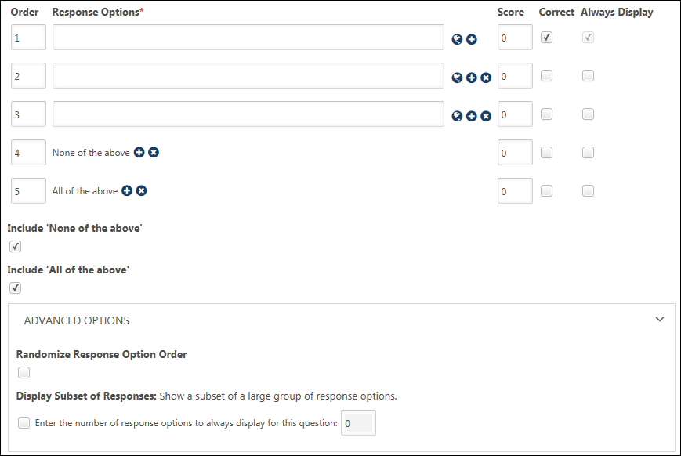
Category
Select the appropriate category for the question from the drop-down. This is used to organize and filter the questions by subject area. The categories that are available to select are the active categories for pre-screening questions.
Active
Questions are active by default. When active, the question can be used in application workflows. Uncheck the box to inactivate the question. Inactive questions cannot be used in application workflows. If a question is inactivated after it has been used on an application workflow, the question remains on the existing workflow but cannot be added to new workflows.
Answer Explanation
Enter the explanation for the correct answer, up to 4000 characters. Providing an answer explanation serves as an internal note for administrators working on the question. This field is not visible to the applicant. You can click and drag the text box to resize the box.
Back/Save/Cancel
Click Back to return to the Select Field Type page.
Click Save to save the question.
Click Cancel to close the Create Question page without saving the question.
Edit Question
When editing pre-screening questions, all fields are editable unless the question has been used in an application workflow. If the question has been used, then the Language, Order, Correct, Always Display, Include 'None of the above', Include 'All of the above', and the fields in the Advanced Options section cannot be edited.
Copy Question
When copying questions, the Question field is copied, and "- Copy" is appended to the end of the question.
Delete Question
You can delete the question from the main Pre-Screening Question Bank administration page if the question has not yet been used in an application workflow.
To delete the question, click Delete in the options drop-down for the question on the Questions tab of the Pre-Screening Question Bank page. See Pre-Screening Question Bank - Questions Tab on page 71 for additional information.
Pre-Screening Question Bank - Create Question - Select Field Type
When creating a pre-screening question, the first step is to select the field type. This allows you to define the kind of field for the question and also determines the options that will be available when configuring the question properties.
To create a question, click Create Question on the Questions tab of the Pre-Screening Question Bank page.
Permissions
PERMISSION NAME | PERMISSION DESCRIPTION | CATEGORY

Pre-Screening Question Bank - Manage | Grants ability to access and manage Pre-Screening Question Bank. | Recruiting Administration
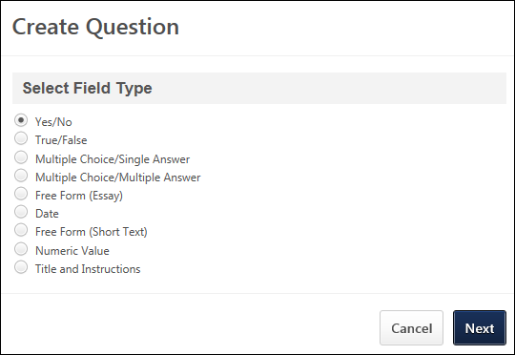
To define the field type, you must select one of the following field types for the question:
- Yes/No - This question type lets you create questions with a yes/no answer option.
- True/False - This question type lets you create questions with a true/false answer option.
- Multiple Choice/Single Answer - This question type lets you create questions that are configured to have one correct answer within multiple answer choices.
- Multiple Choice/Multiple Answer - This question type lets you create questions that are configured to have multiple correct answers within multiple answer choices.
- Free Form (Essay) - This question type lets you create questions with a long text response. When the question appears on an application, a long text box appears so that the applicant can enter their written answer to the question.
- Date - This question type lets you create questions with a date answer option.
- Free Form (Short Text) - This question type lets you create questions with a short text response, rather than the longer text response that is available in the Free Form (Essay) question type. When the question appears on an application, a short text box appears so that the applicant can enter their written answer to the question.
- Numeric Value - This question type lets you create questions that only need a numeric value entered. For example, you would like applicants to enter their preferred start date. You can create a Numeric Value question type in which applicants can enter the date. When the question appears on an application, a numeric text box appears so that the applicant can enter the value for the question.
- Title and Instructions - This question type lets you add a header with optional notes before or inbetween prescreening questions. For example, if you would like to ask for an applicant’s references, you can add a title for the section called “References” with instructions that read, “Please complete personal information for at least 3 references below.” Then, you would add a Free Form (short text) question type for Reference Name, Reference Email, and Reference Role. If you create a new pre-screening question category type called “References,” you can add all questions at once when building your application workflow.
Click Next to go to the Question Properties step of creating questions. See Pre-Screening Question Bank - Create Question - Question Properties on page 73 for additional information.

Resume Administration
The Resume page allows you to configure the default and custom sections that display on the Resume tab in Career Center or in Universal Profile: Bio. The attachments section allows users to upload attachments to the Resume. Custom fields can be added to all resume sections. You can order and inactivate sections.
The Applicant Resume column appears only if Recruiting is enabled for the portal. This section displays the name of the Applicant Resume section to which the corresponding resume section is mapped. If the resume section is not mapped to an Applicant Resume section, nothing is displayed in this column.
Note: It is a recommended best practice to activate either the Previous Positions section or the Internal Positions section, but not both. Since the Previous Positions section allows users to enter previous positions manually and the Internal Positions section performs a similar task automatically (if Organizational Units are configured for the section), users might be confused by having both sections on the Resume tab.
When adding a field to a section on the Define Section page, the field is active by default.
To access the Resume Administration page, go to Admin > Tools > Succession Management > Resume.
Permissions
PERMISSION NAME | PERMISSION DESCRIPTION | CATEGORY

Resume Administration | Grants access to resume administration, which enables configuration of resume sections, including custom resume fields. This permission cannot be constrained. This is an administrator permission. Note: This permission does not apply to the Universal Profile - Resume functionality. | Talent/Succession - Administration
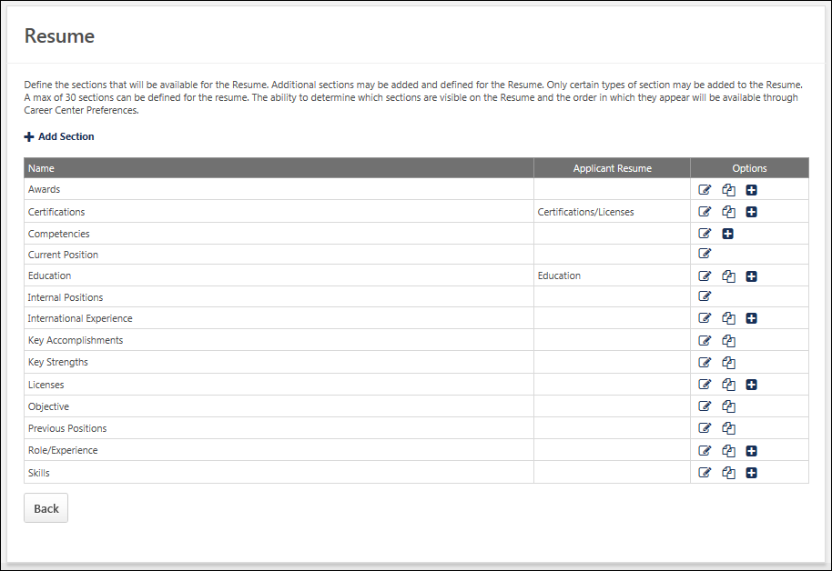
Add Section
To add a resume section, click the Add Section link. The Resume can contain up to 30 sections. The process for adding a section varies if Universal Profile - Resume is enabled:
- Universal Profile is enabled - See Resume - Add Section for additional information.
- Universal Profile is not enabled - See Add Resume Section (Career Center) on page 85 for additional information.
Options
The following options may be available in the Options column:
- Edit - Click this icon to edit the section.
- Define Attributes - You can define custom attributes for "Attribute List" field types by clicking this icon. The Define Attributes icon only displays if at least one field is configured as an "Attribute List" field type on the Define Section page.
- Copy - Click this icon to copy the section. This option is only available if Universal Profile - Resume is enabled.
- Delete - Sections that do not have a Delete icon in the Options column are default sections and cannot be deleted but can be inactivated.
Custom Fields
- A maximum of 10 fields can be available for the section, including static and custom fields. Custom fields will appear in the order they were added.
- The available field types for custom fields for all Resume sections are:
  - Numeric (output allows for character limit: 5, including 2 decimal points)
  - Short Text Box (output allows for character limit: 100)
  - Drop-down (output allows for character limit: 50 per attribute)
  - Date Field
  - Checkbox
Helpful Hints - Career Center Administration
- If the require date checkbox is not checked and then is checked later, all the dates that have already been entered on the Career Center will default to the first day of the month.
- If a category is active, then is deactivated, and then activated again, the information that was previously entered by the user for that category will reappear. The user will not need to re-enter the information.
- If the name of a category type is edited by the administrator then all items of that type that have been added to the user's Career Center will be updated with the new name.
Helpful Hints - Integration with Other Parts of the System
- Administrators can search on users based on the attributes they have entered on their Career Center through the Team Builder or Candidate Search functionality. This search is done to create teams of users with appropriate experience and credentials or to find individual candidates for open positions with appropriate experience or credentials.
- The Universal Profile - Bio functionality draws Skills data from the Career Center.
- A user's willingness to relocate entered on the Career Preferences page is displayed in the Succession Management Plan (SMP) task in the Individual Profile section.

Add Resume Section (Career Center)
This functionality applies to the Career Center - Resume page. This functionality is not used if Universal Profile - Bio - Resume is enabled.
To add a resume section, go to Admin > Tools > Succession Management > Resume. Then, click the Add Section link.
Permissions
PERMISSION NAME | PERMISSION DESCRIPTION | CATEGORY

Resume Administration | Grants access to resume administration, which enables configuration of resume sections, including custom resume fields. This permission cannot be constrained. This is an administrator permission. Note: This permission does not apply to the Universal Profile - Resume functionality. | Talent/Succession - Administration
Choose either Awards, Background and Experience/Expertise, Key Accomplishments, Licenses, Roles/Experience, Skills, and Special Training/Development. Click the title of the section to add. When a custom section is added, the custom section will be inactive by default. The administrator will have to activate the section under Career Center Preferences for the OUs. If the administrator chooses to remove the custom section, it will be removed from all user Resumes. All corresponding user data for that section will be removed.
- If Universal Profile - Bio - Resume is not enabled, a maximum of 20 sections can be available for the Resume, including the existing sections.
- If Universal Profile - Bio - Resume is enabled, a maximum of 30 sections can be available for the Resume, including the existing sections. See Resume - Add Section.
- Title - Enter title. Click Translate icon to enter translated text if applicable.
- Directions - Enter directions. Click Translate icon to enter translated text if applicable.
- Applicant Resume - This option only appears if Recruiting is enabled for the portal. See Add Resume Section - Applicant Resume on page 88 for additional information.
- Minimum number of required resume section entries - This option lets you set the minimum number of entries that a candidate must be filled out in the resume section before being able to submit the application. To set the minimum number of required entries for a resume section, enter a numeric value in the field. The resume section must be mapped to the application by using the options in the Applicant Mapping column. See Mapping Resume Fields (Universal Profile).
By setting the number of fields that must be completed within a resume section, administrators ensure that candidates supply the necessary information when submitting their application. This eliminates the need for recruiters to spend additional time tracking down required information for a requisition.
If this field is left blank, then the corresponding section on the resume will have no minimum number of entries required. Candidates will be able to submit their application without entering any data into the fields in that section.
Use Case
ABC Company requires that all candidates provide at least two prior work entries, as they want to ensure all candidates have prior work experience. In their current application workflow, Sally, who is an ABC Company recruiter, must follow up with candidates who do not expand the work experience section when filling out their application and therefore leave important entries blank. This will cost Sally at least a few hours every day.
With the ability to set a minimum number of entries as part of this enhancement, Sally will get the information she needs without needing to follow up with candidates.
- To add a field, click the plus icon to the right of the Fields heading.
  - Choose Language from drop-down menu if applicable.
  - Field Name - Enter field name.
  - Field Type - Select field type from drop-down menu. Note: When adding a drop-down field, you can add a maximum of 20 options to the drop-down list field.
  - Click Save.
- Applicant Mapping - This option only appears if Recruiting is enabled for the portal and if an option is selected from the Applicant Resume drop-down list. See Add Resume Section - Applicant Resume on page 88 for additional information.
- Required - Select this option to make the field required.
- Active - Select this option to make the field active.
- The following options are available in the Options column:
  - Options - Click to edit existing entry.
  - Delete - Click to remove existing entry.
- Click Save.
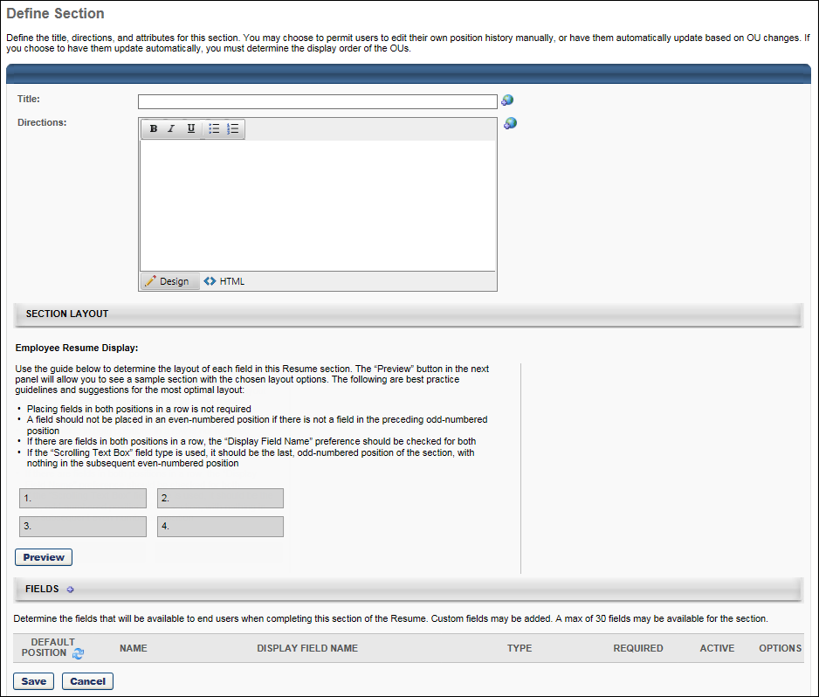

Add Resume Section - Applicant Resume
When applicants upload resumes to their application, resume information is collected and is stored to the user's Resume profile in the system. This is done by mapping resume sections to a defined set of applicant resume sections and mapping resume fields to a defined list of applicant resume fields.
Administrators must map at least one Applicant Resume section in order for the Resume section of the Upload Attachments action item to display in the application workflow.
Administrators must map at least one Applicant Mapping field per section in order for the section to be included in the application workflow. The maximum number of fields that can be mapped is 20.
Note: This functionality is only available for organizations with Applicant Tracking and Succession enabled.
To add a resume section, go to Admin > Tools > Succession Management > Resume. Then click the Add Resume Section link.
To edit a resume section, go to Admin > Tools > Succession Management > Resume. Then click the Edit icon to the right of the appropriate section.
Permissions
PERMISSION NAME | PERMISSION DESCRIPTION | CATEGORY

Resume Administration | Grants access to resume administration, which enables configuration of resume sections, including custom resume fields. This permission cannot be constrained. This is an administrator permission. Note: This permission does not apply to the Universal Profile - Resume functionality. | Talent/Succession - Administration
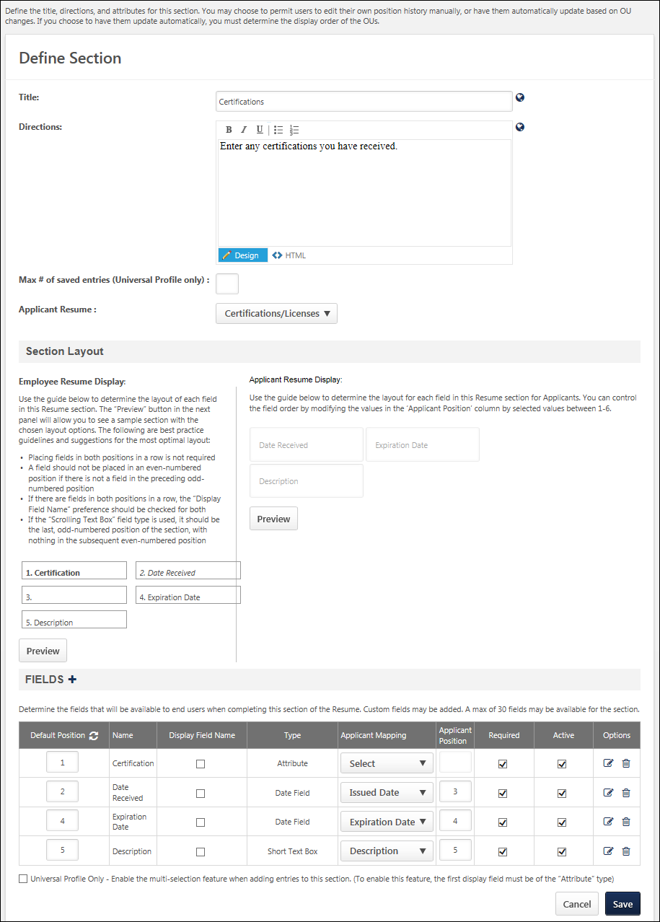
Applicant Resume Field
The Applicant Resume drop-down list enables administrators to select the applicant resume section to which the current section is mapped. At least one resume section must be mapped to an applicant resume section in order for the Resume section of the Upload Attachments action item to be available. Only one of each applicant resume section may be mapped. Administrators cannot select the same applicant resume section for more than one section.
The following resume section types cannot be mapped to an ATS Resume section and as a result, the Applicant Resume drop-down list is not available:
- Competency
- Current Position
From the Applicant Resume section, select one of the following Applicant Resume sections:
- Experience
- Education
- Certifications/Licenses
- Skills
Applicant Mapping Column
When an option is selected from the drop-down list, the Applicant Mapping column appears after the Type column. This drop-down enables administrators to select to which field each Applicant Resume field maps. If a Resume section is selected from the Applicant Resume drop-down, administrators must map at least one Applicant Mapping field for the section. Also, only one of each applicant mapping item may be selected, except for the "Not Parsed" option. Administrators cannot select the same applicant mapping item for more than one field, except for the "Not Parsed" option.
The Applicant Mapping options that are available are dependent on the type of section and field. The following list outlines the available mapping types for each field type:
Applicant Resume Type | Field Type | Applicant Mapping Options (Value from Parser)
Experience | Attribute List | - Position (Employment Record - Position 1)  - Organization (Employment Record - Company Name)  - Description (Employment Record - Description)  - Start Date (Employment Record - Start Date)  - End Date (Employment Record - End Date)  - Current (Employment Record - Current)
 | Checkbox | - Current
 | Date Field | - Description  - Start Date  - End Date
 | Drop Down | - Position  - Organization  - Description  - Start Date  - End Date  - Current
 | Numeric Field | - Description  - Current
 | Short Text Box | - Position  - Organization  - Description  - Start Date  - End Date  - Current
 | Scrolling Text Box | - Position  - Organization  - Description  - Start Date  - End Date  - Current
Education | Attribute List | - Area of Study (Educational Record - Major)  - Minor (Educational Record - Minor)  - Institution (Educational Record - School Name)  - Degree (Educational Record - Degree)  - Grade (Educational Record - Grade)  - Graduation Date (Educational Record - End Date)
 | Checkbox | There are no Applicant Mapping options for this field type.
 | Date Field | - Graduation Date
 | Drop Down | - Area of Study  - Minor  - Institution  - Degree  - Grade  - Graduation Date
 | Numeric Field | - Grade
 | Short Text Box | - Area of Study  - Minor  - Institution  - Degree  - Grade  - Graduation Date
 | Scrolling Text Box | - Area of Study  - Minor  - Institution  - Degree  - Grade  - Graduation Date
Certifications/ Licenses | Attribute List | - Name (?)  - Organization (?)  - Issued Date (?)  - Expiration Date (?)  - Description (?)
 | Checkbox | There are no Applicant Mapping options for this field type.
 | Date Field | - Issued Date  - Expiration Date  - Description
 | Drop Down | - Name  - Organization  - Issued Date  - Expiration Date  - Description
 | Numeric Field | - Description
 | Short Text Box | - Name  - Organization  - Issued Date  - Expiration Date  - Description
 | Scrolling Text Box | - Name  - Organization  - Issued Date  - Expiration Date  - Description
Skills | Attribute List | - Name (Skill Edit - Name)  - Type (Skill Edit - Group)  - Level (Skill Edit - Level)  - Experience (Skill Edit - Experience)  - Description (Skill Edit - Description)
 | Checkbox | There are no Applicant Mapping options for this field type.
 | Date Field | - Description
 | Drop Down | - Name  - Type  - Level  - Experience  - Description
 | Numeric Field | - Level  - Description
 | Short Text Box | - Name  - Type  - Level  - Experience  - Description
 | Scrolling Text Box | - Name  - Type  - Level  - Experience  - Description
"Not Parsed" Option
A "Not Parsed" option is available for all field types. This option always displays as the last option in the Applicant Mapping drop-down.
When the option is selected, non-parsed fields display for applicants during the application process, but the fields are not populated by parsing during the Applicant Review step of an application. Instead, applicants must manually enter a value in the fields. For example, a recruiter would like to include Manager's Name and Manager's Phone Number fields on the application. This can be done by adding the fields to the resume section and defining them as non-parsed. Applicants will then be able to enter the manager information on the application.
The "Not Parsed" option can be selected for multiple fields in a resume section.
Applicant Position Column
The Applicant Position column only displays if a valid Applicant Resume value is defined for the resume section. Note: The value in the Applicant position column does not affect the sort order of the fields on the Define Section page.
The Applicant Position column requires administrators to define the order of each field in the resume section that appears for applicants on the career site. The fields appear sorted from left to right. The lowest number displays as the left most column, while the highest number displays as the right most column.
When an option is selected in the Applicant Mapping column drop-down, a default value appears in the Application Position column. This value can be modified. The field accepts a maximum of one character. The character must be an integer greater than zero and between one and six. Each number can only be used once. A value of zero can be entered for fields that are not mapped to the application. Note: The default value may be zero. In such cases, the value must be changed to a value between one and 20.

Application Workflow Templates
The Application Workflow Templates page enables administrators to view and manage standard and mobile-friendly application workflows. Administrators can create, edit, copy, delete, activate, or deactivate application workflow templates from this page.
An application workflow defines the experience a job applicant has when applying for a job. As a result of creating templates, when configuring a job requisition template or creating a job requisition, the administrator can select from the workflow templates that are created on this page.
To access the Application Workflow Templates page, go to Admin > Tools > Recruitment > Application Workflow Templates.
- Create Mobile-Friendly Application Workflow Template - See Create Mobile-Friendly Application Workflow.
- Create Standard Application Workflow Template - See Create Application Workflow Template on page 28 for additional information.
Permissions
PERMISSION NAME | PERMISSION DESCRIPTION | CATEGORY

Application Workflow Template - Manage | Grants ability to access and manage Application Workflow Templates. This permission can be constrained by OU and User’s OU. This is an administrator permission. | Recruiting Administration

Application Workflow Template - View | Grants ability to access and view Application Workflow Templates. | Recruiting Administration
Create Template
To create a new application workflow template, click the Create Template link. Note:This option is only available if you have permission to create application workflow templates. See Create Application Workflow Template for additional information.
Include Inactive
To include inactive templates in the display, select the Include Inactive option. If this option is deselected, only active templates appear in the table.
Application Workflow Templates Table
The following information is displayed for existing application workflow templates:
- Name - The template name. Templates are displayed in alphabetical order by name.
- Description - The template description.
- Active - When this option is selected, the template is active. Deselect this option to make the template inactive. When a template is made inactive and the changes are saved, the inactive template is hidden from the table unless the Include Inactive option is selected. When a template is made inactive, job requisitions that were created from the inactive template are not affected.
Options
The following options are available in the Options column:
- Edit - Click the Edit icon to edit the template. Application workflow templates cannot be edited once in use. If an application workflow template is in use, it can only be copied, not edited. See Create Application Workflow Template for additional information about configuring the template. Note: You must have the necessary permission to edit a template. In addition, administrators can only edit templates that they created or that were created by other administrators who exist within the constraints applied to this permission.
  - Job requisitions that are using the application workflow template are not affected by any changes.
  - If a job requisition template has applied the application workflow template and has made no changes to the structure, then any edits to the template at the application workflow template level are reflected in the job requisition template.
  - If a job requisition template has applied the application workflow template and has made changes to the structure at the job requisition template level, then any changes to the application workflow template level are not reflected in the job requisition template.
- Copy - Click the Copy icon to copy the template. See Create Application Workflow Template for additional information.
Note: Any scoring and weight settings that are configured for Prescreen Question action items are copied to the application workflow.
Note: For portals with multiple languages enabled, any translated values are also copied.
- Delete - Delete the application workflow template. This option is only available if the application workflow template has never been used. Note: You must have the necessary permission to delete a template.
Save/Cancel
Click Save to implement any changes made to the Active column on the Application Workflow Templates page.
Click Cancel to disregard any changes made to the Active column on the Application Workflow Templates page.

Create Application Workflow Template
An application workflow defines the application experience a job applicant has when applying for a job. As a result of creating templates, when configuring a job requisition template or creating a job requisition, the administrator can select from the application workflow templates that are created on this page. When creating a job requisition template, after selecting the application workflow template, the administrator can then customize the application workflow template at the job requisition template level without affecting the original application workflow template.
To create an application workflow template, go to Admin > Tools > Recruit > Application Workflow Templates. Then click Create Template.
Permissions
PERMISSION NAME | PERMISSION DESCRIPTION | CATEGORY

Application Workflow Template - Manage | Grants ability to access and manage Application Workflow Templates. This permission can be constrained by OU and User’s OU. This is an administrator permission. | Recruiting Administration

Application Workflow Template - View | Grants ability to access and view Application Workflow Templates. | Recruiting Administration
Administrators can only edit templates that they created or that were created by other administrators who exist within the constraints applied to this permission.
Name
In the Name field, enter a descriptive name for the application workflow template, which is displayed on the Application Workflow Templates page and when selecting a template. The character limit for this field is 50.
To localize the name:
- Click the Translate icon. This opens the Translate pop-up.
- Enter the translated name in the desired language.
- Click Save. This saves the translated name. When recruiters select a workflow template for a job requisition or view the workflow on the Application Workflow tab, the name displays in their language if a translation is configured. If a translation is not configured for the recruiter's language, then the name displays in the default language of the administrator who created the workflow.
Description
In the Description field, enter a description for the application workflow template, which is displayed on the Application Workflow Templates page and is used to identify the template. The character limit for this field is 100.
To localize the description:
- Click the Translate icon. This opens the Translate pop-up.
- Enter the translated name in the desired language.
- Click Save. This saves the translated name. When recruiters select a workflow template for a job requisition or view the workflow on the Application Workflow tab, the description displays in their language if a translation is configured. If a translation is not configured for the recruiter's language, then the description displays in the default language of the administrator who created the workflow.
Application Type
The Application Type option enables you to create either a mobile-friendly template or a standard template. When creating new application workflows, the Mobile-Friendly option is selected by default.
- Mobile-Friendly - Mobile-friendly templates can be created as a single page or multiple pages. The following action items can be added to mobile-friendly workflows:
  - Notes
  - Compliance Questions
  - Prescreen Questions
  - Upload Attachments
  - Disclaimer
- Standard - Standard templates will have the existing application workflow template functionality. All action item types can be added to standard templates. The application will appear as a series of steps, and the mobile-friendly features will be limited.
Change Application Type for Existing Template
If you would like an existing standard application workflow template to be mobile-friendly, copy the template, and then change the Application Type field to Mobile-Friendly.
Add Section
In the application structure builder, the administrator can build the application structure by adding sections to the structure and then adding action items to the sections. Sections allow administrators to group and organize the action items that are included in the application workflow.
By default, all new application workflow templates begin with the Submit Application action item and the Submit Application section. Both items are locked at the bottom of the structure builder and cannot be removed. Also, action items may not be added to the Submit Application section.
To add a section to the structure, click the Add Section icon to the right of the Add Section heading in the structure builder. This opens the Add Section pop-up.
Enter the following information for the section:
- Title - Enter a descriptive title for the section. The character limit for this field is 50.
Click Save to save the new section. When a new section is added, it is added as the last section in the structure, prior to the Submit Application section.
Localization
For portals with multiple languages enabled, to localize a section title:
- Click the Add Section icon. This opens the Add Section pop-up.
- Enter the section title.
- Click Save. This adds the section to the workflow.
- Click the Translate icon to the right of the Add Action Item drop-down for the section. This opens the Translate pop-up.
- Enter the translated title in the desired language.
- Click Save. This saves the translated title. When applicants complete the application, the section titles display in their language if a translation is configured. If a translation is not configured for the applicant's language, then the section titles display in the default language for the workflow section.
Action Items
For all sections, an Add Action Item drop-down displays to the right of the section title. For the Submit Application section, the only action available is Edit.
When an action item is added to a section, it appears at the top of the section above all existing action items. The following are the available action items:
- Add Assessment - See Application Workflow - Add Assessment on page 116 for additional information.
- Add Compliance Questions - See Application Workflow - Add Compliance Questions on page 34 for additional information.
- Add Disclaimer - See Application Workflow - Add Disclaimer on page 36 for additional information.
- Add Form - See Application Workflow - Add Form on page 107 for additional information.
- Add Integration - See Application Workflow - Add Integration on page 109 for additional information.
- Add Note - See Application Workflow - Add Note on page 38 for additional information.
- Add Prescreen Questions - See Application Workflow - Prescreen Questions on page 41 for additional information.
- Add Training - See Application Workflow - Add Training on page 114 for additional information.
- Submit Application - See Application Workflow - Submit Application on page 55 for additional information.
- Upload Attachments - See Application Workflow - Upload Attachments on page 60 for additional information.
Mobile Icon
The mobile icon that displays in the right column on the Application Workflow page indicates that the action item is compatible with mobile devices. When included in the application workflow, applicants filling out an application on a mobile optimized career site can access and complete this action item directly from their mobile device.
Edit Section
Click the Edit icon to edit the section title. Click Save to save the changes.
Delete Section
Click the Delete Section icon to delete the section from the application structure. Note: The Submit Application section is mandatory and cannot be deleted.
Section Percentages
To the left of each section title, a percentage field is displayed. This percentage represents the completion percentage that is achieved by completing the section, which is displayed to the applicant. This is intended to be a visual indication to the applicant of the length of each step of the application process. For example, if the Resume section percentage is set to 20%, then when the applicant completes the Resume section, their application completion percentage is increased by 20%. The percentages should roughly represent the percentage of time and effort required by the applicant to complete the application workflow.
All percentages must be positive, whole numbers and must total 100%. The current total is displayed at the bottom of the Add Section table. After modifying the percentages, the total at the bottom of the table automatically refreshes with the new percentages total.
Preview
At the bottom of the template structure, click Preview to preview the application workflow. This opens the preview in a pop-up, allowing the administrator to preview the navigation bar, content, and progress bar.
For Upload Attachments actions, when the Disable Resume Parsing option is checked on the Edit Action Item pop-up, the resume sections on the Upload and Review steps are hidden on the application workflow preview.
For Prescreen Question sections, scoring information does not display in the preview. Also, the response that is identified as the correct response is not indicated in the preview.
For portals with multiple languages enabled, any translated fields display in the language of the administrator, if the administrator's language is available. If the administrator's language is not available, then the preview displays elements in the languages of the administrators who created the application workflow.
Considerations
- For action items that have no content preview available, "Preview Unavailable" is displayed in the preview.
- For application workflow templates, the preview for the Compliance Questions action item is not available. The action item page in the preview now displays "Preview Unavailable."
- For requisition templates and job requisitions, if questions are defined for the organizational unit (OU), then the Compliance Questions action item page in the preview displays the questions for the OU.
- For requisition templates and job requisitions, if questions are not defined for the OU, then the Compliance Questions action item page in the preview displays "Preview Unavailable."
Save
At the bottom of the page, click Save to save the structure of the page, the section information, and action item information.
Application Workflow - Add Compliance Questions
The Compliance Questions action item enables administrators to add compliance questions to the section. This action item can only be used once within a section.
The questions that appear in the Compliance Questions section are determined by the Compliance Enablement Preferences settings for the Location organizational unit (OU) in which the requisition is posted. Depending on the preferences set for the Location OU in which the requisition is posted, the following compliance questions may appear if the Compliance Questions section is included in the application workflow template:
- Disability
- Ethnicity
- Gender
- Race
- Veteran Status
- Voluntary Self-Identification of Disability
The questions always appear in the above order.
Note: If compliance questions are included on an application workflow template but the requisition's Location OU does not have compliance questions configured in Compliance Enablement Preferences, then the compliance questions section is skipped during the application process.
To create an application workflow template, go to Admin > Tools > Recruit > Application Workflow Templates. Then click Create Template.
Permissions
PERMISSION NAME | PERMISSION DESCRIPTION | CATEGORY

Application Workflow Template - Manage | Grants ability to access and manage Application Workflow Templates. This permission can be constrained by OU and User’s OU. This is an administrator permission. | Recruiting Administration

Application Workflow Template - View | Grants ability to access and view Application Workflow Templates. | Recruiting Administration
Administrators can only edit templates that they created or that were created by other administrators who exist within the constraints applied to this permission.
Use Case
Organizations in the United States are required to report to the federal government Equal Opportunity information such as gender and ethnicity. To help collect this information, many organizations allow the job applicant to enter the information when applying for a job. These questions are always optional for job applicants.
Add Action Item
Click Compliance Questions in the Add Action Item drop-down on the Application Workflow page. This opens the Add Compliance Question pop-up. Enter the following information in the pop-up:
- Title - Enter a title for the question. The default title is "Compliance Questions." This is required and the character limit is 50.
- Instructions - Enter the Compliance Question instructions. This field is required. This field accepts HTML and there is no character limit. JavaScript is not supported.
Once the action item is added to the section, the icon is not available unless the action item is removed from the section.
Mobile Icon
The mobile icon that displays in the right column on the Application Workflow page indicates that the action item is compatible with mobile devices. When included in the application workflow, applicants filling out an application on a mobile optimized career site can access and complete this action item directly from their mobile device.
Edit Action Item
Click the Edit icon for the action item to define the instructions for the action item. In the Instructions field, HTML is accepted and there is no character limit.
Delete Action Item
Click the Delete icon to delete the action item.
Application Workflow - Add Disclaimer
The Disclaimer action item is used for applicants and agencies to accept terms when completing an application. This action item can be used multiple times within an application workflow.
To create an application workflow template, go to Admin > Tools > Recruit > Application Workflow Templates. Then click Create Template.
Permissions
PERMISSION NAME | PERMISSION DESCRIPTION | CATEGORY

Application Workflow Template - Manage | Grants ability to access and manage Application Workflow Templates. This permission can be constrained by OU and User’s OU. This is an administrator permission. | Recruiting Administration

Application Workflow Template - View | Grants ability to access and view Application Workflow Templates. | Recruiting Administration
Administrators can only edit templates that they created or that were created by other administrators who exist within the constraints applied to this permission.
Add Disclaimer
To add a disclaimer:
- Click Disclaimer in the Add Action Item drop-down on the Application Workflow page. This opens the Edit Action Item pop-up.
- Select a language from the language drop-down, for portals with multiple languages. The language selected defines the language in which the fields will be translated. Before saving the action item, you can provide a translation for as many languages as desired based on the languages available. Selecting a different language preserves each translation that has been entered into the fields, even if you have not yet saved the action item.
- Enter a title in the Title field, up to 100 characters. This is a required field.
- Enter the disclaimer text in the Disclaimer field. There is no character limit. This field is required and accepts HTML. JavaScript is not supported.
- Select an Input option, either Yes/No or Agree/Disagree. This determines the answer options that display for applicants when choosing to accept or not accept the terms of the disclaimer.
- Select the User is prevented from continuing option to require applicants to agree to the disclaimer before continuing with the application.
If the option is unchecked, applicants can proceed with the application regardless of how they respond to the disclaimer.
- Enter the error message that appears for the applicant if they attempt to continue without agreeing to the disclaimer. This is a required field and it accepts up to 250 characters.
- Click Save. Or, if you would like to provide translations for additional languages, you can select another language from the language drop-down. This clears the fields and allows you to enter a new translation.
Mobile Icon
The mobile icon that displays in the right column on the Application Workflow page indicates that the action item is compatible with mobile devices. When included in the application workflow, applicants filling out an application on a mobile optimized career site can access and complete this action item directly from their mobile device.
Edit Action Item
Click the Edit icon for the action item to edit the title, instructions, and note. Click Save to save the changes.
Delete Action Item
Click the Delete icon to delete the action item.
Application Workflow - Add Form
The Add Form action item is available for Standard application workflows and enables administrators to add Training forms to the section. Training forms are configured by an administrator in Training Forms Administration. See Training Forms Administration.
The training form that you would like to add must already be configured in Training Forms Administration in order for the form to be available for the Add Form action.
To create an application workflow template, go to Admin > Tools > Recruit > Application Workflow Templates. Then click Create Template.
Permissions
PERMISSION NAME | PERMISSION DESCRIPTION | CATEGORY

Application Workflow Template - Manage | Grants ability to access and manage Application Workflow Templates. This permission can be constrained by OU and User’s OU. This is an administrator permission. | Recruiting Administration

Application Workflow Template - View | Grants ability to access and view Application Workflow Templates. | Recruiting Administration
Administrators can only edit templates that they created or that were created by other administrators who exist within the constraints applied to this permission.
Use Case
If an organization does not want to use the resume parser to upload resumes and pre-populate user data, then a form can be used to allow a job applicant to fill in an application's fields and at the same time capture data that will populate the user record in the system.
Add Form
To add a Training form to the application workflow:
- Click Form from the Add Action Item drop-down in the section in which you would like to add the form. This opens the Find Form pop-up.
- Click the name of the form from the list of Training forms. You can search for forms by name and language.
- Click the name of the form. This adds the form to the application workflow.
Edit Action Item
Click the Edit icon for the action item to define the instructions for the action item. In the Instructions field, HTML is accepted and there is no character limit.
Delete Action Item
Click the Delete icon to delete the action item.
Apply as Guest Consideration
Form action items that are used in the application workflow will not preserve responses from previous guests who may have used the same email address.
Frequently Asked Questions
How do I add a form from Form Management to my application workflow?
Forms from Form Management functionality cannot be added directly to the application workflow. Instead, once an applicant has applied for the job, you can assign the form via the Assign Form action on Manage Candidates or Manage Applicants. See Manage Candidates - Assign Forms. See Manage Applicants - Assign Form.
- For external applicants, the form will appear on their My Profile page in the career site.
- For internal applicants, the form will appear on their My Jobs page on the internal career site or Applications tab in the Career Center.
E-Signature Note: Be sure that the form you would like to assign does not include an e-signature field. If you try to add a form that has an e-signature, an error message will appear.
Application Workflow - Add Integration
The Add Integration action item can be included in any section, including the Submit Application section.
Note - Mobile-Friendly Candidate Experience Application Workflows: Adding custom integrations to mobile-friendly application workflows does not guarantee that each integration will be responsive on the application workflow. For an integration to be responsive, it is necessary that the technology for that specific integration is also responsive.
To create an application workflow template, go to Admin > Tools > Recruit > Application Workflow Templates. Then click Create Template.
Permissions
PERMISSION NAME | PERMISSION DESCRIPTION | CATEGORY

Application Workflow Template - Manage | Grants ability to access and manage Application Workflow Templates. This permission can be constrained by OU and User’s OU. This is an administrator permission. | Recruiting Administration

Application Workflow Template - View | Grants ability to access and view Application Workflow Templates. | Recruiting Administration
Administrators can only edit templates that they created or that were created by other administrators who exist within the constraints applied to this permission.
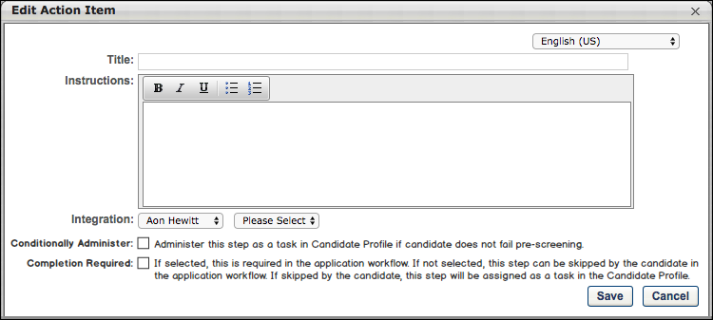
Add Integration
To add the action item:
- Click Add Integration from the Add Action Item option on the Application Workflow page. This opens the Edit Action Item pop-up.
- Complete the following fields in the pop-up:
  - Title - This is a required field. Enter a title, up to 50 characters.
  - Instructions - Enter instructions for the action item. This field is optional. This field accepts HTML, and there is no character limit.
  - Integration - Select the integration from the drop-down. The drop-down displays integrations that are defined as active and available to select for application workflows.
  - Conditionally Administer - When this option is selected, the assessment step does not appear in the application workflow. Instead, the assessment is only available to the applicant if they do not fail the pre-screening step. In such cases, the assessment is automatically assigned to them and can be accessed from the My Profile > Pending Tasks section page on the career site. This will trigger the Assign Integration Assessment email to be sent to the recipients that are configured for the email, provided that the email is active in Email Administration.
However, if the applicant fails the pre-screening step, the assessment will not be assigned to them at all.
Also, when the Conditionally Administer option is selected, the Completion Required option is disabled and no longer selectable.
  - Completion Required - Select this option to require applicants to complete the integration step before moving to the next step in the application workflow. Completion occurs when the integration step has received a response from the third party integration partner.
If this option is not selected, then the applicant can skip the assessment when completing their application. Once their application is submitted, the assessment is automatically assigned to them and can be accessed on their My Profile page on the career site.
Use Cases
Assessment Required
- Robert is applying to an entry level job that does not require experience.
- He answers a question in the application saying that he meets the minimum requirement that he has graduated from college.
- Robert then has to complete an assessment if he is determined to be qualified after his application is submitted.
Assessment Not Required
- Robert also applied to a cashier’s job.
- He answers a question in the application saying that he does not have prior experience handling transactions as a cashier.
- Robert does not have to complete an assessment for the cashier’s job.
Optional Assessments
- Robert has been submitting job applications all day and is tired. He simply wants to get a job after he’s graduated from college.
- Some application processes are way too long and he does not want to finish them if it requires him to complete a long assessment.
- Robert would much rather just skip the assessment and submit the rest of his application first.
- Only if the organization is interested in him will Robert dedicate time to complete the assessment at a later time.
Application Workflow - Add Note
The Note action item enables administrators to add a note to the section. The note contains a title, note text, and optional instructions.
To create an application workflow template, go to Admin > Tools > Recruit > Application Workflow Templates. Then click Create Template.
Permissions
PERMISSION NAME | PERMISSION DESCRIPTION | CATEGORY

Application Workflow Template - Manage | Grants ability to access and manage Application Workflow Templates. This permission can be constrained by OU and User’s OU. This is an administrator permission. | Recruiting Administration

Application Workflow Template - View | Grants ability to access and view Application Workflow Templates. | Recruiting Administration
Administrators can only edit templates that they created or that were created by other administrators who exist within the constraints applied to this permission.
Add Note
- Click Note in the Add Action Item drop-down on the Application Workflow page. This opens the Add Note pop-up.
- Enter the following information in the pop-up:
  - Language - This option only displays for portals with multiple languages enabled. Select a language from the language drop-down, for portals with multiple languages. The language selected defines the language in which the fields will be translated. Before saving the action item, you can provide a translation for as many languages as desired based on the languages available. Selecting a different language preserves each translation that has been entered into the fields, even if you have not yet saved the action item.
  - Title - Enter a title for the note. This is required and the character limit is 50.
  - Instructions - Enter instructions for the note if applicable. This field is optional. This field accepts HTML and there is no character limit. JavaScript is not supported.
  - Note - Enter the note text. This field is required. This field accepts HTML and there is no character limit. JavaScript is not supported.
Click Save to save the changes. Or, if you would like to provide translations for additional languages, you can select another language from the language drop-down. This clears the fields and allows you to enter a new translation.
Note: We do not support script tags in the HTML for Title, Instruction, and Text fields of the action items.
Mobile Icon
The mobile icon that displays in the right column on the Application Workflow page indicates that the action item is compatible with mobile devices. When included in the application workflow, applicants filling out an application on a mobile optimized career site can access and complete this action item directly from their mobile device.
Edit Action Item
Click the Edit icon for the action item to edit the title, instructions, and note. Click Save to save the changes.
Delete Action Item
Click the Delete icon to delete the action item.
Application Workflow - Add Training
The Add Training action item is available for Standard application workflows and enables administrators to add either online courses or tests to the application. One or more training items can be added.
To create an application workflow template, go to Admin > Tools > Recruit > Application Workflow Templates. Then click Create Template.
Permissions
PERMISSION NAME | PERMISSION DESCRIPTION | CATEGORY

Application Workflow Template - Manage | Grants ability to access and manage Application Workflow Templates. This permission can be constrained by OU and User’s OU. This is an administrator permission. | Recruiting Administration

Application Workflow Template - View | Grants ability to access and view Application Workflow Templates. | Recruiting Administration
Administrators can only edit templates that they created or that were created by other administrators who exist within the constraints applied to this permission.
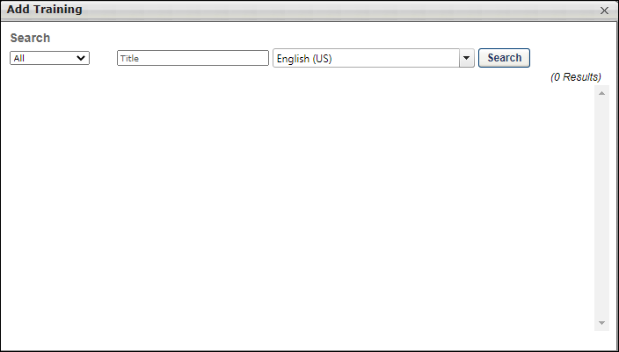
Add Training
To add the action item:
- Click Add Training from the Add Action Item drop-down on the Application Workflow page. This opens the Add Training pop-up.
- Search for and select the training. You can search for either online courses or tests by training type, title, and language.
- Click the plus icon to the left of the training title. Multiple training items can be added.
- Click Done. This closes the pop-up and adds the training to the application.
Edit Action Item
Click the Edit icon for the action item to define instructions for the training action item. The title of the training item cannot be edited. In the Instructions field, HTML is accepted and there is no character limit.
Delete Action Item
Click the Delete icon to delete the action item.
Application Workflow - Add Assessment
The Add Assessment action item is available for Standard application workflows and enables administrators to add a competency assessment or an external assessment to the section.
Note: The External Assessment option is only available if enabled by backend settings.
To create an application workflow template, go to Admin > Tools > Recruit > Application Workflow Templates. Then click Create Template.
Permissions
PERMISSION NAME | PERMISSION DESCRIPTION | CATEGORY

Application Workflow Template - Manage | Grants ability to access and manage Application Workflow Templates. This permission can be constrained by OU and User’s OU. This is an administrator permission. | Recruiting Administration

Application Workflow Template - View | Grants ability to access and view Application Workflow Templates. | Recruiting Administration
Administrators can only edit templates that they created or that were created by other administrators who exist within the constraints applied to this permission.
Use Case
Including a competency assessment as part of the application process can be done to measure an applicant's personality and judgment.
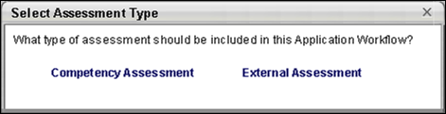
Add Competency Assessment
To add a competency assessment:
- Click Add Assessment from the Add Action Item option on the application workflow page. This opens the Select Competency Assessment pop-up. Note: If the external assessment feature is enabled, then the Select Assessment Type pop-up opens.
- Select Competency Assessment. This opens the Select Competency Assessment pop-up.
- Search for the appropriate competency assessment task. You can search for competency assessment tasks by title and language.
- Select the name of the assessment. This closes the pop-up and adds the assessment to the application.
Edit Action Item
Click the Edit icon for the action item to define instructions for the competency assessment action item. In the Instructions field, HTML is accepted and there is no character limit.
Add External Assessment
To add an external assessment:
- Click Add Assessment from the Add Action Item option on the application workflow page. This opens the Select Assessment Type pop-up.
- Click External Assessment. This opens the Select External Assessment pop-up. Note: If the competency assessment feature is not enabled, then the Select External Assessment pop-up opens when clicking the Add Assessment icon.
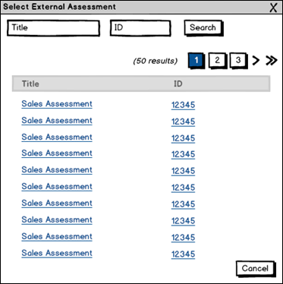
- Select an assessment. All assessments that are available display in the pop-up. The Title column displays the name of the assessment. The ID column displays the solutionID number of the assessment, which is defined by the third party assessment provider. If an assessment does not have an ID, then the column is blank. Both columns are sortable. Note: The assessments are created and maintained by a third party. If the assessment provider mandates that only one solutionID can be used per requisition, then see Third Party Single SolutionID below for information about the different options in the Select External Assessment pop-up.
- Once selected, the pop-up closes, and the assessment is added to the section.
Third Party Single SolutionID Requirement
If the third party assessment provider mandates that only one solutionID can be used per requisition, then all assessments that are selected for a requisition must have the same solutionID. This applies to both the internal and external application workflows. Assessments are not available for recruiting agency application workflows.
Select External Assessment
The solutionID displays in the ID column on the Select External Assessment pop-up. For such providers, an additional column, "Sitting," displays as the last column in the pop-up. The Sitting column numbers the assessments that are available for each solutionID. One or more of the assessments within a single solutionID can be included in the application workflow.
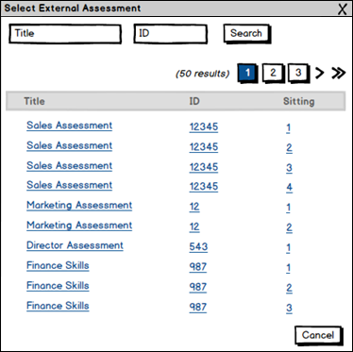
The application workflow can be configured with external assessments in the following areas of the Applicant Tracking System:
- Application Workflow Templates
- Requisition Templates - Application Workflow tab
- Job Requisitions - Application Workflow tab
Edit External Assessment
If the third party assessment provider mandates that only one solutionID can be used per requisition, then the Assessment field displays the assessment number to the right of the assessment name. The number displays as "Sitting [number]." A different assessment can be selected by clicking the Edit link.
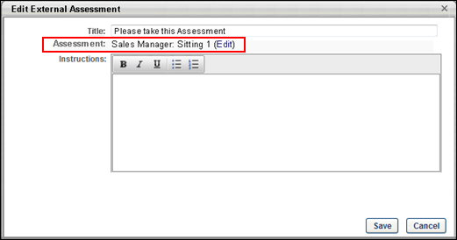
If the user attempts to select an external assessment that is associated with a different solutionID, then an error message displays. The message indicates that all assessments selected for the application workflow must have the same solutionID.
See the Considerations section below for information about the assessments that will be available to select in the Edit External Assessment pop-up, depending on whether or not an external assessment is already configured in a different step of the application workflow.
Considerations
When viewing the Select External Assessment pop-up for the application workflow, the following considerations apply:
- If there are no other external assessments configured for the workflow, then all available assessments display for all solutionID's.
- If at least one external assessment has been added to the workflow, then the pop-up only displays the assessments that are available for the solutionID associated with the previously selected external assessment. This is displayed in the image below:
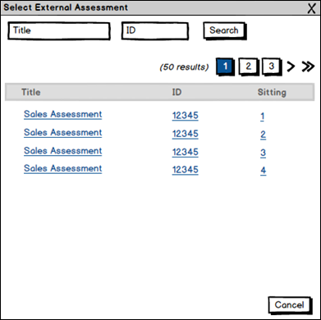
- The same assessment cannot be added more than once in an application workflow section.
- In order to select an assessment from a different solutionID, all assessments in all other steps of the workflow must be removed. This will reset the Select External Assessment pop-up.
Application Workflow with Pre-Screening and External Assessment - Conditionally Administer
If an application workflow is configured with a Prescreen Questions action item that occurs before an external assessment, then the administrator can determine whether or not applicants must pass the pre-screening questions in order to be allowed to take the assessment.
Selecting Yes in the Conditionally Administer option allows applicants to complete the assessment even if they fail the pre-screening questions. This option is selected by default. Selecting No does not allow applicants to complete the assessment if they fail the pre-screening questions. In such cases, the External Assessment step is skipped for applicants who do not pass the pre-screening questions.
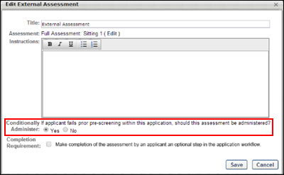
The application workflow can be configured with both a Prescreen Questions action item and an external assessment in the following areas of the Applicant Tracking System:
- Application Workflow Templates
- Requisition Templates - Application Workflow tab
- Job Requisitions - Application Workflow tab
Screening Option - External Assessments
The Screening Option icon displays in the set of options to the right of each external assessment. When the option is inactive for an assessment, the icon is green . When the option is activated for an assessment, the icon is red . Clicking the icon opens the Screening Options pop-up. Select No in the pop-up to disable the screening feature, which also hides the Screening Threshold option.
Select Yes in the pop-up to enable the screening feature. Enter a screening threshold percentage in the Screen out threshold field, between 0 and 100. This field is required when Yes is selected. Applicants who score below the percentage are automatically moved to a Closed status with a disposition of Failed Pre-Screening. The applicant's profile is updated with the failed external assessment event on the History tab.
Click Save to save the settings. Or, click Cancel to cancel the settings without saving.
Considerations
- If the screening option is enabled, and a connection cannot be established with the third party assessment vendor but the applicant fails the assessment, then the screening option setting is ignored and the applicant continues through the application process.
- If a score is not returned from the third party assessment vendor, then the screening option does not apply for the application workflow.
- Once the application is submitted without having received a response from the third party assessment vendor, a failed assessment response received from the vendor at a later time does not impact the submitted application.
- The Conditionally Administer option is respected for external assessments. If No is selected in the Conditionally Administer option for a workflow step that has at least one pre-screening questions step before the external assessment step, then the applicant does not reach the assessment step if they fail the pre-screening step.
Edit External Assessment Action Item
The External Assessment action item can be edited by clicking the Edit icon. This opens the Edit External Assessment pop-up.
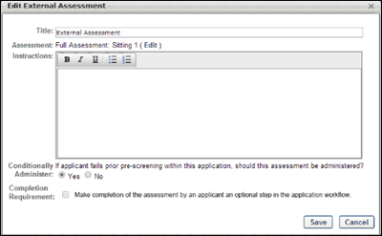
The following information displays in the pop-up:
- Title - By default, this field displays "External Assessment" as the title. The title can be changed. Enter a maximum of 50 characters. The title displays for applicants in the application workflow.
- Assessment - This field displays the assessment as a link and enables the administrator to change the assessment selection. Click the link to open the Select External Assessment pop-up. Selecting a different assessment closes the pop-up and replaces the existing assessment.
- Instructions - Enter the instructions that will display to applicants when taking the assessment. There is no character limit.
- Conditionally Administer - See the "Application Workflow with Pre-Screening and External Assessment - Conditionally Administer" section above for additional information.
- Completion Optional - Administrators can define an external assessment as optional when configuring the application workflow. The Completion Optional option displays at the bottom of the Add External Assessment pop-up and allows administrators to define the assessment as either optional or required.
The Completion Optional field is unchecked by default. Check the box to make the assessment optional. Leave the box unchecked to require applicants to complete the assessment in order for the application to be considered complete. Best Practice: When making the assessment optional, it is a best practice to indicate in the Instructions field that the assessment is optional. The instructions display for the applicant and can help them determine whether or not they need to take the assessment in order to complete the application.
Considerations
  - Screening Options - If the assessment is optional but the screening option is enabled for the assessment, the assessment can still be used to screen out applicants who choose to complete the assessment. Applicants who score below the screening threshold percentage are automatically moved to a Closed status and are therefore no longer in consideration for the position.
  - Assessment Limits per Requisition - If the third party assessment vendor requires that only one solutionID can be used per job requisition, then the selection in the Completion Optional field will be the same for all assessments associated with that solutionID. For example, if an administrator makes the Sales Assessment (solutionID 12345, sitting number 1) optional, then all other assessments with solutionID 12345 are also optional because the Completion Optional field selection carries over to all assessments that have the same solutionID.
After editing the fields, click Save. Or, click Cancel to cancel the changes.
Note: The assessment itself cannot be edited. The assessments are created and maintained by the third party assessment provider.
Delete External Assessment Action Item
To delete an External Assessment action item, click the Delete icon. This opens a confirmation pop-up. Click Yes to delete the action item from the section. Click No to cancel the removal action. Note: If the third party deletes the assessment from their system, the assessment must be removed manually from the application workflow. If it is not removed, then the action item remains in the workflow, but the assessment will not be accessible by the applicant. The assessment page will display "The assessment is no longer available. You may continue with the application."
Application Workflow - Prescreen Questions
The Prescreen Questions action item enables administrators to add pre-screening questions to the section.
To create an application workflow template, go to Admin > Tools > Recruit > Application Workflow Templates. Then click Create Template.
Note: JavaScript is not supported for pre-screening questions.
Permissions
PERMISSION NAME | PERMISSION DESCRIPTION | CATEGORY

Application Workflow Template - Manage | Grants ability to access and manage Application Workflow Templates. This permission can be constrained by OU and User’s OU. This is an administrator permission. | Recruiting Administration

Application Workflow Template - View | Grants ability to access and view Application Workflow Templates. | Recruiting Administration
Administrators can only edit templates that they created or that were created by other administrators who exist within the constraints applied to this permission.
Use Case
Prescreening questions are commonly used to prescreen and remove applicants that do not meet the minimum requirements of a job. If an applicant completing the application process answers at least one of the questions incorrectly, then the system excludes that person from the list of submissions for the recruiter to review.
A user who answers the prescreening question wrong is not prevented from completing the application process. The system may be configured to send an email to the applicant after their submission to inform them that their application did not meet the job qualifications.
Add Pre-Screening Questions
To add pre-screening questions to the Pre-Screen Questions action item, click Prescreen Questions in the Add Action Item drop-down on the application workflow page. This opens the Add Questions pop-up.
The following information and options are available in the Add Questions pop-up:
Create Question
This option allows you to create a new pre-screening question. Clicking the Create Question button opens the Create Question steps within the Add Question pop-up. Once the question is added, the question is available to select for Prescreen Question sections on the application workflow.
The button only displays with permission to manage the Pre-Screening Question Bank. New Questions are saved to the Pre-Screening Question Bank.
Best Practice: It is a best practice to search through existing questions before creating a new question so that similar or nearly identical questions are not created.
Filters
The following filters are available for searching for questions and filtering the Questions table:
- Question or Question ID - Enter the question name or ID by which to filter the results.
- Response Type - Select a response type from the drop-down.
- Category - Select a pre-screening question category from the drop-down.
- Language - Select a question language from the drop-down.
Once all desired filters are configured, click Search. This updates the table with questions that match the filter criteria.
Add All Questions
Click the Add All option to add all the pre-screening questions that are available to the Prescreen Question action item.
Questions Table and Add Question
The following columns display in the table:
- All - This column displays an Add icon. Click the icon to add the question. This enables the Selected Questions section to display above the list of questions and adds the question to the Selected Questions section. Once a question is added, the column displays "N/A" for the question.
- Question - This column displays the question.
- Response Type - This column displays the response type configured for the question.
- ID - This column displays ID for the question.
- Category - This column displays the category defined for the question.
- Language - This column displays language for the question.
- Author - This column displays user who created the question.
- View - This column displays a View link to view the question. When viewing questions, the UI for the preview window is updated to match current styles.
Once all desired questions are selected, click Add. This adds the pre-screening questions to the workflow in the designated section.
Pre-Screening Survey Details
When a Prescreen Question action item is added to the workflow, a Pre-Screening Survey Details bar displays for the section.
Note: A "survey" is considered to be the group of questions in a Prescreen Question action item section.
Note: The Pre-Screening Survey Details bar does not display for Prescreen Question action items that only include Free Form (Essay) questions.
Note about Date Questions: Questions that are the Date type cannot be scored.
The following information displays in the bar:
Possible Score
This field helps administrators see the total possible score that an applicant can receive for all of the scored questions that are included in the section. The score displays as [Minimum Score Value (the response option with the smallest score value)] to [Maximum Score Value (the sum of the response option(s) that are marked as correct)]. The value is updated automatically when changes are made to the response option scores on the Screening Options pop-up.
Screen out when score is less than
This field displays the screen out score that removes an applicant from the application process if the applicant receives a score that is less than the screen out number. The number is defined on the Survey Options pop-up. The value changes dynamically when questions are added or removed from the section.
Survey Options
Click the Survey Options icon in the Pre-Screening Survey Details header to open the Survey Options pop-up. See below for more details about this feature. When the icon is gray, this indicates that the screen out option is inactive ("No" is selected in the Screen Out field in the Survey Options pop-up). When the icon is green, this indicates that the screen out option is active ("Yes" is selected in the Screen Out field in the Survey Options pop-up). By default, the screen out option is inactive.
Create Branched Questions
For portals that have self-enabled the Mobile-Friendly Candidate Experience, you can create branched prescreening questions. This option lets you show or hide follow-up questions based on a candidate’s answer to the previous question. For example, if a candidate answers “Have you worked at this organization before?” with “Yes,” then you can ask them follow-up questions such as “In what department?”, “What dates were you at the company?”, and more.
This custom logic creates a strong user experience and can help to improve your candidate conversion rate. Because candidates are only answering questions that pertain to them, the application will be simpler and easy to complete. Such multi-part questions help you elicit greater detail about a candidate's profile or experience without hurting the candidate experience. This feature not only enables a streamlined application workflow but also equips you with the tools necessary to get as much information as possible on a candidate upfront, which subsequently saves time in the recruiting funnel. You can dig deeper into a candidate's experiences and qualifications right on the application, rather than waiting until the interview step.
Candidates also appreciate branched questions because they have the opportunity to provide additional information or explain an answer in more detail.
Use Cases
Administrator
- Andrew is an administrator at ACME. Andrew would like to start using branched prescreening questions, so he begins by enabling the Mobile-Friendly Candidate Experience.
- Andrew creates a new application workflow and adds four prescreening questions to the workflow: True/False, Yes/No, Multiple Choice/Single Answer, and Multiple Choice/Multiple Answer question types.
- Andrew sees a new arrow icon for all questions except Multiple Choice/Multiple Answer.
- Andrew clicks the arrow icon for the first True/False question because it supports branching. Upon clicking the arrow, a second line appears directly under the parent question. It reads If Answer Is and has a drop-down that is defaulted to True. To the right it is a Then Show button with the option to select a child prescreening question from the question bank.
- Andrew clicks the arrow icon for the same True/False question. Another line item appears, reading "If Answer Is: False" "Then Show." It defaults to False because the answer option True is already selected. Because there are no more answers to branch off of, the arrow icon disappears from the parent question. If Andrew deletes the conditional logic for True or False, then the arrow reappears.
- Andrew clicks Select from Prescreening Question Bank to add a child question. This opens the Prescreening Question bank in a modal.
- Prescreening questions can only appear once in a workflow. So if a prescreening question has already been added, it cannot be added as a child question.
- Andrew adds a prescreening question with the ID 12345. After clicking Add, the child question appears within Then show drop-down. It is part of the drop-down in case Andrew would like to change the child question and select a new one from the question bank.
- Andrew would like to show multiple child questions when a candidate answers True, so he clicks the plus sign to the right of the first child question.
- Andrew clicks Select from Prescreening Question Bank and opens the modal again.
- Andrew adds multiple questions from the question bank. Any type of prescreening question can be added as a child question, and multiple questions can be added at once. When he saves and closes the question bank, all added questions will appear with a Then Show drop-down before the question. All the questions appear after a candidate answers the parent question with True.
- Andrew follows the same steps and adds conditional logic to the Multiple Choice/Single Answer prescreening question type. The question asks, "How long were you employed by your previous employer?" The answers are A. Less than 1 month, B. 2 months to a year, C. 1-2 years, and D. 3+ years.
- If a candidate answers with A, Andrew would like to ask the candidate a follow-up multiple choice question, "Why did you leave within a month?" The answer options are A. Because I did not like the organization, B. Because I did not like my position's responsibilities, and C. I was asked to leave. Andrew marks this child question required because it is very important to understand why a candidate left their prior employer so quickly.
- Not only does Andrew mark the question required, but he also adds knockout functionality to the child question. If a candidate answers with C, Andrew selects to have the candidate automatically dispositioned.
- Andrew also configures a point value for answers A and B, which will be added to the candidate's total score.
- After configuring the application, Andrew would like to preview it to guarantee everything is formatted correctly. If Andrew clicks the eyeball icon to the right of a question, Andrew will see the question in a pop up. If Andrew clicks “Preview” at the bottom of the application, he can answer parent questions to see the branched child questions.
Candidate
- Aaron is applying to ACME and begins the application Andrew just published. While completing the application, he answers the True/False question with True. After answering True, he sees multiple child follow-up questions.
- Aaron changes his mind and selects False. After selecting False, all child questions disappear.
- Aaron gets to the following question, "How long were you employed by your previous employer?" and selects A. Less than 1 month.
- Upon answering this question, he sees a child question, "Why did you leave within a month?" He selects "C. I was asked to leave." Upon completing the application, Aaron is screened out and not considered for the position.
Question Types that Can Be Parent Questions
The following question types can be parent questions for branched questions:
- Multiple Choice/Single Answer
- True/False
- Yes/No
The following question types cannot be parent questions:
- Date
- Free Form (Essay)
- Free Form (Short Text)
- Multiple Choice/Multiple Answer
- Numeric Value
- Title and Instructions
Question Types that Can Be Child Questions
Any question type can be used to create child questions. There is no limit to the number of child questions added to a parent question.
Create Branches for the Question
To create a branched question:
- Click the arrow icon to the right of the parent question in the workflow. This opens the branching options below the parent.
  - Select an answer in the if answer is drop-down. The options that are available are dependent upon the question type. For example, for True/False question types, if you selected True in the first answer option, then False appears by default in the second answer option. Note: If there are no more answer options, then the arrow icon no longer appears for the question.
  - Next, click Select Question in the then show drop-down to select the child question. This opens the Add Question pop-up, which lists the available prescreening questions.
  - Select one or more questions from the pop-up and click Add. This adds the questions as child questions to the parent. Each of these questions appear if the candidate selects the associated response from the if answer is drop-down. Questions appear in the order in which they are added.
- Add more branching logic to the parent question by clicking the arrow icon for the parent question.
- Add additional child questions to answers by clicking the plus icon to the right of the last child question.
- For Multiple Choice/Single Answer prescreening questions, you can show the same child questions for multiple answer options by clicking the plus icon to the right of the answer drop-down. This will show “OR” and allow you to select another answer from the drop-down.
Note: When you create a branched question, the question must have at least one child question.
Considerations
- You can create as many branched questions as you want to the workflow.
- You can create as many branches as you want within a parent question, up to the maximum response options available for a question.
- Prescreening questions can only appear once in the workflow. If you would like a question with the exact same wording to appear more than once (e.g., Please explain in more detail), then it needs to be created as a separate question in the prescreening question bank. This gives the question a unique ID.
- The child questions of a parent question cannot be added as separate columns on the Manage Applicants page.
- Copying an application workflow template copies all parent and child questions.
- A candidate’s flattened application (the PDF version) only displays child questions that were presented to the candidate based on their answers to parent questions.
Reorder Questions
You can drag and drop individual branches of a question.
You can also move a parent question to a different order in the workflow. This will move all the child questions, as well.
Removing Branched Logic
For a Yes/No or True/False question, clicking the minus sign to the right of a child question removes the question from the application workflow and the branched logic. If there are multiple child questions for the same answer, clicking the minus icon removes the question from the application but not from the branched logic. Before deleting any question, a confirmation pop-up appears to ensure you would like to delete the question.
For a Multiple Choice/Single Answer question with branched logic, you can display the same child questions for more than one answer. By clicking the minus sign to the right of an answer with multiple options, you will delete that answer but not the entire branching logic.
Delete Parent Question
Click the trash can icon to the right of the question to delete a parent question. This opens a confirmation pop-up to ensure you would like to delete the question. Deleting a parent question also deletes all of its child questions.
Delete Child Question
Click the trash can icon to the right of the question to delete a child question. If that is the only child question, then this deletes the branched logic and the question from the application. If there are multiple child questions, then this deletes the child question but keeps the branched logic.
Conditional Child Questions
You can mark any child question as required. However, the question is only required if the question displays for the candidate.
You can also set up screen out and scoring options for any child question. See Application Workflow - Prescreen Questions on page 124 for additional information.
Child questions are included in the Survey Options pop-up when configuring question weight, screen out options, and scoring for a prescreening section in an application workflow.
Preview Application Workflow
When previewing the workflow, child questions will appear in the preview.
Survey Options Pop-Up
In the Survey Options pop-up, configure the weight and screen out settings that will apply to all of the questions in the Prescreen Question section.
Note About Questions Without a Correct Answer: If a correct answer is not defined for a pre-screening question, then the question cannot be used to screen out an applicant. You will only be able to screen out applicants based on the total score.
The following information and options are available in the Survey Options pop-up:
Questions Table
The following columns display in the table:
- Question(s) - This column displays the pre-screening question.
- Max - This column displays the maximum score for the question.
- Weight - You can define the weight for a question to customize its importance in that particular application workflow. Weights act as multipliers against response option scores. Enter a value from 0-100. This is a required field.
Best Practice: When using question and survey scoring, it is a best practice to first configure scores for response options within the question(s), and then configure question weights within the survey(s).
Possible Survey Scores Range
The values in this field are automatically calculated based on the minimum and maximum possible scores for questions in the survey. The minimum score is the single lowest response option. The maximum score for True/False, Yes/No, and Multiple Choice Single Answer question types is the correct response option with the highest value. The maximum score for Multiple Choice Multiple Answer question types is the sum of the correct responses.
Screen Out Applicants Based on This Survey
By default, No is selected, which indicates that applicants are not screened out based on their responses to the questions in the survey. The survey score option is grayed out and not selectable.
Select Yes to screen out applicants based on their responses to the questions in the survey. This enables the survey score field. Applicants will not be able to continue with the application if they score less than the value in the survey score field.
Screen Out Applicants Whose Survey
Based on the value in this field, any applicant who scores below the indicated threshold will be screened out based on their survey score, regardless of whether they answered individual pre-screening questions correctly or incorrectly. The value in the survey score field must be less than the maximum score for the survey. This option is required if Yes is selected in the enable screen out field above.
View Question
The View icon displays in the set of options to the right of each pre-screening question. Questions that are added to the section can be previewed so that the administrator can view the text of the question and the response options. Click the View icon to preview the question.
Screening Option - Pre-Screening Questions
Note: The user interface (UI) for Standard application workflows is slightly different, with different icons. In addition, prescreening questions are either always required or always optional, depending on the question type.
The Screening Options icon displays in the set of options to the right of each pre-screening question. When the option is inactive for a question, the icon is gray . When the option is enabled for a question, the icon is green .
Clicking the icon opens the Screening Options pop-up, which allows the administrator to enable the screening feature, as well as select whether or not to hide the indication that applicant responses to pre-screening questions are correct or incorrect. Scoring options may also be available if configured for the question.
Note about Date Questions: Questions that are the Date type cannot be scored.
Note about Questions without a Correct Answer: If a correct answer is not defined for a pre-screening question, then the question cannot be used to screen out an applicant. You will only be able to screen out applicants based on the total score.
The following information and options are available in the Screening Options pop-up:
Screen Out Applicants Based on This Question
This option allows administrators to enable the screening feature. Check the box to enable the feature. When the Screening Options feature is enabled for a question, applicants who fail to answer the question correctly are automatically moved into a Closed status. Note: Checking the box also makes the question required.
If the box is left unchecked, the feature is not enabled. Applicants who answer a question incorrectly are not automatically moved dispositioned.
The Screening Options feature is available for the following question types:
- Multiple Choice - Multiple Answer
- Multiple Choice - Single Answer
- True/False
- Yes/No
This question is required
This option lets you mark prescreening questions as required or leave the questions as optional, with the exception of the Title and Instructions question type. The Title and Instructions question type is not configurable, since there are no response options.
Check the box to mark the question as required. If the box is not checked, the question is optional. Questions are optional by default.
When the Screen out applicants based on this question option is checked, the This question is required option is automatically checked and cannot be unchecked.
Use Case - Administrator
- Max needs to create a new workflow template for a requisition. In the workflow, he needs to add critical open text field questions like, "Please list any other name(s) used for prior employment, education or professional licensure." This is a critical question in the application because the position will require a background check. Max needs to make sure he submits the pre-employment verifications under the correct name or else it could cause a delay in the candidate's start date.
- Max goes to Admin > Tools > Recruiting > Application Workflow Templates and finds and edits an existing mobile-friendly template.
- Max creates a Free Form (Short Text) question and adds it to the workflow. After adding it to the workflow, he clicks the gear icon and sees a new "Preferences" option with a new check box item reading "This question is required." (Note: By default, this option is unselected for all new questions.) Max checks the box to mark the question required because he wants to guarantee the candidate will answer the question.
- Next, Max adds a Title and Instructions question to the workflow to create a new section. Max does not see the gear icon on that line item because this question type cannot be marked required or optional. Title and Instructions questions always appear when added to an application workflow.
- Max then adds a Yes/No prescreening question to the workflow. After selecting the gear icon for the Yes/No question, he selects the checkbox "Knock out applicants based on this answer." When this is selected, the follow-up checkbox "Mark this question required" is automatically selected. To unselect the Required/Optional checkbox, Max must first deselect the knock out option checkbox. Max saves the workflow with both checkboxes selected.
- Upon returning to the application workflow, the gear icon for the question is now green because the question knocks candidates out of the workflow if answered in a specific way.
- Max would like to preview the workflow to gauge the candidate experience. When Max selects the eye icon to the right of the Yes/No question, he does not see an asterisk, even though the question was marked required. However, when Max previews the workflow, he sees the asterisks for all required questions, which ensures that critical questions must be answered before the application can be submitted.
- Because he is editing a workflow, all questions added prior to the edits will honor the old logic. Yes/No, True/False, Multiple Choice/Single Answer, Multiple Choice/Multiple Answer, and Date will be required. Free Form (Essay), Free Form (Short Text), and Numeric Value questions will be optional. Only questions added to a workflow for the first time will be optional by default.
- Max saves the workflow and applies it while building a new requisition.
Use Case - Candidate
- Sarah Smith is looking for a job at ACME and comes across a job that was just posted.
- Sarah begins the application on her phone and finds it very easy to answer all questions because the application is mobile-friendly. Sarah answers the question, "Please list any other name(s) used for prior employment, education or professional licensure." Sarah enters her maiden name.
- Sarah skips the Yes/No question because she is in a rush and is completing the application on her commute to school. When she tries to progress to the next page, she is scrolled back to the Yes/No question that she skipped and is given a disclaimer that indicates the question is required. Sarah answers the question and progresses to the next page.
- There are a few optional questions Sarah leaves blank because she is in such a rush.
- Sarah submits her application and is excited for the new opportunity.
Use Case - Recruiter
- Ian is a recruiter at ACME and is reviewing Sarah's application. Ian has access to all critical pieces of information, and he adds a note to her profile with her maiden name. This will be referenced in case she progresses to the background status.
- When looking at Sarah's flattened application, he can see which optional questions were left blank because they are marked with, "This question was not answered."
- Ian passes her resume to the hiring manager because she looks like a great fit for the role.
Why would I want to make a question required?
Making a question required ensures that you capture critical information from candidates. If you keep questions optional, such as an open text question, you risk not getting the information you need to make smart recruiting decisions.
Not getting answers to specific prescreening questions could also lengthen the time it takes to convert a candidate to employee. For example, a candidate used a different name for prior employment and did not provide this information on their application because the question was optional. When a background check was assigned to this candidate, their current name was used by the background check vendor rather than the candidate's former name. This resulted in additional days of back and forth communication, delaying the new employee’s start date.
Marking important application questions as required ensures that candidates include pertinent information when submitting the application, rather than having to obtain this information during a later step in the hiring process.
Hide Correct/Incorrect Answer Indicator
The Hide correct/incorrect answer indicator field is unchecked by default. When unchecked, applicant responses to the pre-screening question indicate whether or not the question was answered correctly or incorrectly.
When the option is checked, the following occurs:
- PDF of Application - When viewing a PDF of the application, the correct/incorrect indication is hidden for responses to the question in the Prescreen Questions step of the application workflow.
- Applicant Profile page - The Application tab on the Applicant Profile page displays "N/A" in the Correct column for the question. In addition, the "Yes" and "No" fields that indicate whether or not the applicant answered the question correctly are hidden.
Note: This feature does not apply to Free Form (Essay)/(Short Text) questions, as they do not have correct/incorrect responses.
Hide Answer Scores
This option is part of the pre-screening question scoring functionality. This option is unchecked by default. Check the box to prevent recruiters and hiring managers from viewing the score for a question. When unchecked, the score is visible to recruiters and hiring managers when viewing the application.
Scoring Section
The scoring section displays the pre-screening question and enables the administrator to view/modify the score. To change the score for a response, enter a different whole number from 0-100 in the Score column for the response. The option in the Correct Response column cannot be modified.
Note: When editing a job requisition that has been submitted, the Score column cannot be modified.
Best Practice: As a best practice, when configuring scores for Multiple Choice/Multiple Response questions, set the responses that are incorrect to 0.
Possible Score Range
The possible score range displays below the question, when you scroll down toward the bottom of the Screening Options pop-up. The range displays the range from the minimum score value to the maximum score value. For True/False, Yes/No, and Multiple Choice Single Answer question types, the total possible score value is defined as the single correct response score value. For Multiple Choice Multiple Answer question types, the total possible score value is calculated as the sum of the correct score responses. The values update automatically based on the changes you make to the Score column.
Free Form (Essay) Questions
Free Form (Essay) questions provide greater diversity in the kinds of questions that can be asked and allow applicants to provide greater depth in their responses. The following applies to Free Form (Essay) questions when included in the Prescreen Questions panel:
- The questions always appear at the bottom of the questions list in the Prescreen Questions panel.
- The Screening Option icon is disabled and not available.
- The drag and drop feature is only available for dragging and dropping one Free Form (Essay) question above or below the same question type.
- The questions are optional for applicants to complete.
Delete Action Item
Click the Delete icon to delete the action item.
Frequently Asked Questions
Can I change an applicant's answer to a pre-screening question?
No. An applicant's response to a pre-screening question cannot be changed, either by the applicant once the application is submitted or by a member of the hiring team for the requisition, such as the Hiring Manager or Requisition Primary Owner.
What if I changed the wording of the question to make it easier to understand? Can I change an applicant's answer to the question, especially if the answer they gave automatically removed them from the applicant pool because the question was a knockout question?
No. The applicant's response to a pre-screening question can never be changed once the application is submitted. Also, if a pre-screening question is modified, and the question is being used on at least one application workflow, the question will not be updated on the requisition.
How do I change the status of an applicant who failed the pre-screening?
When an applicant fails the pre-screening, you might decide that you would still like to keep the applicant in consideration for the job. You can do this by manually changing the applicant's status on Manage Candidates, Manage Applicants, or the Applicant Profile.
Can Date type questions be scored?
No. Questions that are configured as the Date type cannot be scored.
However, you can sort candidates on the Manage Applicants page based on their responses to pre-screening date questions. In addition, you can consider using other pre-screening question types if scoring or screen out functionality are required. For example, instead of asking “When were you born?”, one could ask “Are you currently 18 years or older?” as a Yes/No question with scoring or screen out functionality.
Application Workflow - Submit Application
The Submit Application action item is a mandatory step in the application workflow and automatically appears in the Submit Application section. This action item allows the applicant to submit their application. Add Note and Add Integration action items can be included in the Submit Application section.
The Submit Application action item cannot be deleted and cannot be moved to any other position in the workflow template.
To create an application workflow template, go to Admin > Tools > Recruit > Application Workflow Templates. Then click Create Template.
Note: JavaScript is not supported for pre-screening questions.
Permissions
PERMISSION NAME | PERMISSION DESCRIPTION | CATEGORY

Application Workflow Template - Manage | Grants ability to access and manage Application Workflow Templates. This permission can be constrained by OU and User’s OU. This is an administrator permission. | Recruiting Administration

Application Workflow Template - View | Grants ability to access and view Application Workflow Templates. | Recruiting Administration
Administrators can only edit templates that they created or that were created by other administrators who exist within the constraints applied to this permission.
Mobile Icon
The mobile icon that displays in the right column on the Application Workflow page indicates that the action item is compatible with mobile devices. When included in the application workflow, applicants filling out an application on a mobile optimized career site can access and complete this action item directly from their mobile device.
Edit Action Item
Click the Edit icon for the action item to edit the title and define instructions for the Submit Application action item. In the Title field, the character limit is 2000. In the Instructions field, HTML is accepted and there is no character limit.
Add Note/Add Integration Action Items
Add Note and Add Integration action items can be included in the Submit Application section. The action items can be included in any order by dragging and dropping them above or below the Submit Application action item.
Application Workflow - Thank You Page
A Thank You page can be added to the application workflow so that when applicants submit their application, the Thank You page appears. The page can be helpful by letting applicants know that their application was submitted successfully and thanking the applicant for applying. The page can be added on the application workflow template, requisition template, default requisition template, or requisition and child requisition.
For Mobile-Friendly workflow types, you can also add tags to a custom Thank You page so that recruiters can use the data gathered from the tracking pixel to connect hired candidates to the data that is tracked. See Create Mobile-Friendly Application Workflow (Early Adopter).
The Thank You page appears for applicants after they click Submit on the application. The page cannot be removed from mobile-friendly application workflows.
To create an application workflow template, go to Admin > Tools > Recruit > Application Workflow Templates. Then click Create Template.
Permissions
PERMISSION NAME | PERMISSION DESCRIPTION | CATEGORY

Application Workflow Template - Manage | Grants ability to access and manage Application Workflow Templates. This permission can be constrained by OU and User’s OU. This is an administrator permission. | Recruiting Administration

Application Workflow Template - View | Grants ability to access and view Application Workflow Templates. | Recruiting Administration
Administrators can only edit templates that they created or that were created by other administrators who exist within the constraints applied to this permission.
Thank You Action Item
The Thank You action item is only available for the Submit Application section. This action item always appears as the last step of the application and cannot be moved to a different location in the workflow.
To add a Thank You page:
- Click Thank You from the Add Action Item drop-down. This opens the Add Thank You pop-up.
- Select the language for the page in the language drop-down. This option is only available for portals with multiple languages enabled.
- Enter a Title in the Title field.
- Enter instructions for the page in the Instructions field. The instructions appear above the Thank You page text. The Instructions field accepts HTML. JavaScript is not supported.
- Enter the text of the Thank You page in the Text field. HTML is accepted. JavaScript is not supported.
Preview Thank You Page
You can preview the Thank You page by clicking Preview at the bottom of the application workflow. This opens the application and allows you to click through to the Thank You page to see how it will look for applicants and determine if changes are needed.
Progress Recorded For Added/Moved Applicants
When adding or moving an applicant to a different requisition that has a Thank You page configured, the system will track the applicant's progress once they are added or moved.
In addition, applicants will not need to complete a Notes section when applying to the requisition to which they were moved if the text of the note is the same for both requisitions.
How to Add a Third-Party Partner’s Tracking Pixel to an Application
Recruiting helps you understand the effectiveness of third-party solutions utilized to advertise your jobs across the Web. Many third-party solutions, such as Indeed and Glassdoor, offer tracking features to capture real-time applicant conversions. This section explains how to embed a third-party tracking pixel into the Thank You page of your application workflow, enabling you to track the number of job seekers who successfully convert to an applicant as a result of visiting your jobs.
Step 1 | Application Workflow  Every job application in Recruiting has a default Thank You page immediately following the Submit action item. Candidates see the Thank You page after successfully submitting their application.
Step 2 | Unselect Default Thank You Page  Without editing the Thank You action item, your application will always display the default Thank You page. To embed a third-party pixel, unselect the “Use the default thank you page” option. This will allow you to add custom HTML to the page.
Step 3 | Select “HTML” Option in Text  Add your own content to the Title and Instructions fields then select the HTML option on the text portion of the modal. This is where you can paste any third-party HTML snippet. The snippet will be provided to you by your third-party partner.  Each tracking pixel will fire upon the loading of the Thank You page. The tracking pixel provider may provide you with a full image tag: <img height="1" width="1" src="https://example.com/trackingpixel.gif">  This would be copied and pasted into the HTML text body.  Work closely with your partner to guarantee conversions are being tracking properly.
Application Workflow - Upload Attachments
The Upload Attachments action item enables administrators to add the ability for job applicants to upload attachments. Job applicants can upload their resume to the application and then edit the fields that it populates via the resume parser. This action item can only be used once in an application workflow template.
To create an application workflow template, go to Admin > Tools > Recruit > Application Workflow Templates. Then click Create Template.
Permissions
PERMISSION NAME | PERMISSION DESCRIPTION | CATEGORY

Application Workflow Template - Manage | Grants ability to access and manage Application Workflow Templates. This permission can be constrained by OU and User’s OU. This is an administrator permission. | Recruiting Administration

Application Workflow Template - View | Grants ability to access and view Application Workflow Templates. | Recruiting Administration
Administrators can only edit templates that they created or that were created by other administrators who exist within the constraints applied to this permission.
Add Upload Attachments Action Item
To add the action item, click Upload Attachments in the Add Action Item drop-down on the Application Workflow page. This adds the Upload Attachments action item to the section. You can edit the options for this action item by clicking the Edit icon . See Edit Action Item on page 143 for additional information.
Once the action item is added to the section, the option is no longer available unless the action item is removed from the workflow.
Mobile Icon
The mobile icon that displays in the right column on the Application Workflow page indicates that the action item is compatible with mobile devices. When included in the application workflow, applicants filling out an application on a mobile optimized career site can access and complete this action item directly from their mobile device.
Edit Action Item
Click the Edit icon to define the title, instructions, and optional resume preference for the Upload Attachments action item.
Complete the following fields in the pop-up:
- Title - Enter a title in the Title field.
- Instructions - Enter instructions for the action item in the Instructions field. There is no character limit. This field does not accept HTML. JavaScript is not supported.
- Optional Resume - This option is unchecked by default. Selecting this option enables a No Resume/CV option to appear on the Upload Attachments page during the application process. Applicants can select the No Resume/CV option to proceed through the application workflow without adding a resume. Note: Applicants are required to include a resume if the No Resume/CV option is not checked.
- Resume Parsing - Resume parsing automatically enters the applicable values from an applicant's resume into the resume fields on the application. This is a helpful feature for applicants so that they do not have to enter information manually into the application.
  - Full Resume Parsing - This option displays all resume sections to applicants (i.e. Work Experience). Once the applicant uploads a resume file, the content from the file will be parsed (populated) on the application workflow in order to help the applicant fill in the resume sections. To see more information about configuring Resume sections, See Add Resume Section - Applicant Resume on page 88 for additional information. Additionally, enabling this option in an Internal applicant workflow allows internal candidates to use their Universal Profile resume rather than having to upload a separate document.
  - Contact Data Parsing Only - This option only applies to the Apply as Guest functionality. When the Contact Data Parsing Only option is selected, only the data entered on the Contact Information page for applicants who apply as a guest is parsed. The resume data will not be visible to the applicant in the application workflow. Instead, they can only view and modify their contact information and will not be able to view or modify their resume data.
Note: If the Contact Data Parsing Only option is enabled when configuring the Upload Attachments action item, there will be no matching criteria with resume parsing for the applicant, since the Universal Profile resume populates upon hire.
  - Disable Resume Parsing - The Disable Resume Parsing option is unchecked by default. When unchecked, the resume parsing functionality is enabled for all applicants in the application workflow. When the option is checked, the resume parsing step of the application workflow is skipped for all applicants in the application workflow. In addition, the search by resume/CV functionality is not supported when the Disable Resume Parsing option is checked. Note: When the Disable Resume Parsing option is checked, the resume sections on the Upload and Review steps are hidden on the application workflow preview.
Once all fields are defined, click Save. This saves the settings and closes the pop-up.
Mobile-Friendly Application Workflows
When configuring the Upload Attachments action item for a mobile-friendly application workflow, the Edit Action Item pop-up includes options to show or hide the Cover Letter section, as well as configure additional attachments.
Additional Attachments
An Additional Attachments section appears on the application by default for career sites configured via the Mobile-Friendly Candidate Experience that include an Upload Attachment action item in the workflow. The default section can be removed by the administrator when configuring the Upload Attachments section in the application workflow template and can also be made required.
Additional Attachments sections are added via the Edit Action Item pop-up for the Upload Attachments action item. This section is only available for mobile-friendly application workflows.
The Additional Attachments section allows you to create up to 10 attachment options or requirements for applicants. Attachments can be a maximum of 10 MB.
To create an attachment:
- Click the Add Additional Attachment link. This expands the Additional Attachments section.
- Enter a title in the Title field, up to 500 characters. This text will also populate the upload button that applicants see on the application.
- Enter instructions in the Instructions field. HTML is accepted. There is no character limit. JavaScript is not supported.
- Check the Required Field box to make the attachment required. If the attachment is required, applicants will not be able to submit the application unless they upload the required attachment.
- Click Save to save the action item. Or, click Add Additional Attachment again to create another attachment.
You can delete attachment sections by clicking the Delete Section icon to the right of the attachment section.
Cover Letter
The Cover Letter field lets you show or hide the Cover Letter option on the application. This option is only available for mobile-friendly application workflows.
The following options are available:
- Cover Letter visible - Check the box to make the Cover Letter option visible on the Upload Attachments section of the application. If the box is not checked, then the option will not be visible to applicants on the application.
- Required field - Check the box to make the field required. Applicants will have to include a cover letter, either by uploading the cover letter or typing it into the text box.

Application Source Values
Application sources are tracked to reflect how an applicant applies for a requisition, either via referral, job board, Career Center, career site, the Candidate Bank, or by being added manually. An application source is automatically applied, based on how the applicant comes into the Applicant Tracking System (ATS). Applicant sources cannot be manually created.
The following are the available application source values (Note: The Referral Suite application sources may also be referred to as referral methods.):
- [Job Board Name]
- [Career Site Name]
- Added Manually
- Broadbean Search
- Candidate bank
- Career Center (Note: This is the legacy Career Center.)
- External Referral-Email
- External Referral-Facebook
- External Referral-LinkedIn
- Internal Career Site
- LinkedIn Recruiter System Connect
- Other - Invited to Apply
- Referral-Email
- Referral-Facebook
- Referral-LinkedIn
- Referral-Search Network
- Referral-Suggested
- Referral-Other
- Talent Pool
The following are the pages on which an application source displays:
- Manage Candidates
- Job Details
- Applicant Profile
- Candidate Search
Note: The application source also appears in standard and custom reporting.
Information Pop-Up
For portals with Referral Suite enabled, when the curser is placed over an internal application source, the Referrer Information pop-up is displayed.
The pop-up displays the user associated with the referral and includes the referrer's photo, name, position, and phone number, as well as a linked email address. Clicking the email address allows you to compose and send the referrer an email.
The following are the internal application sources:
- Referral-Email
- Referral-Facebook
- Referral-LinkedIn
- Referral-Suggested
- Referral-Other
For portals with Agency Portal enabled, when the cursor is placed over the application source, the information pop-up displays the following information:
- The name of the user that submitted the applicant.
- The submitter's job title.
- The submitter's phone number.
- The submitter's email address. Click the email address to send the submitter an email.
Use Cases
The following use cases identify the source value that displays in the Source field depending on how the applicant initially applies to the requisition:
Action | Applicant Pathway | Applicant Applied to Requisition A from: | Source to Display in ATS
Administrator posts to Career Site | N/A | Career Site A | Career Site A
Administrator posts to Job Board | Job Board (Monster.com, etc.) | Career Site A | Job Board A
Administrator posts to Career Center | Career Center | Career Site A | Career Center
Candidate added from talent pool | N/A | N/A | Talent Pool
Candidate added via Broadbean Search | N/A | N/A | Broadbean Search
Candidate invited to apply by a recruiter | N/A | Email Link | Other – Invited to Apply
Candidate Profile imported via LinkedIn Recruiter System Connect | N/A | N/A | LinkedIn Recruiter System Connect
Employee emails application link | Email Message | Career Site A | Referral-Email
Employee posts Facebook link | Facebook Post | Career Site A | Referral-Facebook
Employee posts LinkedIn link | LinkedIn Post | Career Site A | Referral-LinkedIn
Employee uploads resume to specific requisition | Invitation to Apply email sent from Recruiter | Career Site A | Referral-Suggested
External emailed application link | Email message | Career Site A | External Referral-Email
External posted Facebook link | Facebook Post | Career Site A | External Referral-Facebook
External posted LinkedIn link | LinkedIn Post | Career Site A | External Referral-LinkedIn
Source changed automatically (by system) or manually (from Applicant Profile page) | Referral-Other | N/A | Referral-Other
Employee added from Candidate Search | Candidate Bank | N/A | Candidate Bank
Employee added manually by recruiter | Added Manually | N/A | Added Manually
Added/moved from another requisition | Added Manually | N/A | Added Manually

