Grovo Create Tool March 2024

Table of Contents
Create Tool - Overview 1
Create Tool - Manage Courses 4
Create Tool - Create Course 7
Create Tool - Embed Videos 13
Create Tool - Launch Course 14
Create Tool - Personalized Branding 15
Create Tool - Quizzes 16
Create Tool - FAQ 19
Create Tool - Change Language 20
Create Tool - Add Collaborators 22
Create Tool - Auto Transcription 25

Create Tool - Overview
The Create Tool allows users to create and manage learning content using a content authoring solution that is directly integrated with the Course Catalog.
See below for links to related Create Tool documentation:
- Create Courses - See Create Tool - Create Course on page 7 for additional information.
- Manage Courses - See Create Tool - Manage Courses on page 4 for additional information.
- Launch Courses - See Create Tool - Launch Course on page 14 for additional information.
- Create Quizzes - See Create Tool - Quizzes on page 16 for additional information.
- Embed Videos - See Create Tool - Embed Videos on page 13 for additional information.
- Personalized Branding - See Create Tool - Personalized Branding on page 15 for additional information.
- FAQ - See Create Tool - FAQ on page 19 for additional information.
- Add Collaborators - See Create Tool - Add Collaborators on page 22 for additional information.
- Auto Transcription - See Create Tool - Auto Transcription on page 25 for additional information.
To access the Create Tool, go to: Admin > Tools > Learning > Catalog Management and click the Create Tool link.
Permissions
PERMISSION NAME | PERMISSION DESCRIPTION | CATEGORY

Course Catalog - Update | Grants ability to manage and edit training items listed in the Course Catalog and also grants access to the Course Console, where training can also be managed and edited. This permission also grants access to the Popular Requests and Highest Rated widgets on the Learning Admin Console (in conjunction with the Learning Admin Console - View permission). This permission also allows administrators to reversion online courses via the Course Console page. This permission also allows administrators to access an Edit Training option for training items included as objectives in Development plans.  This permission can be constrained by OU, User's OU, Training Type, Training Item, Provider, ILT Provider, User's ILT Provider, User, User Self and Subordinates, and User's LO Availability. This is an administrator permission.  Note: Adding an OU constraint and a provider constraint to this permission results in an "AND" statement. | Learning - Administration

Course Catalog - View | Grants access to view the learning objects in the course catalog and enables administrators to view the Course Console and the Popular Requests and Highest Rated widgets on the Learning Admin Console (in conjunction with the Learning Admin Console - View permission). This permission can be constrained by OU, User's OU, Training Type, Training Item, Provider, ILT Provider, User's ILT Provider, and User's LO Availability. This is an administrator permission.  Adding an OU constraint and a provider constraint to this permission results in an "AND" statement. | Learning - Administration

Create Tool | Grants access to Create Tool for content authoring. This permission cannot be constrained. | Learning - Administration

Create Tool Admin | Grants the administrators access to Create Tool. Administrators must also have the Create Tool permission. Administrators can manage content created by anyone in the organization. This permission cannot be constrained. | Learning
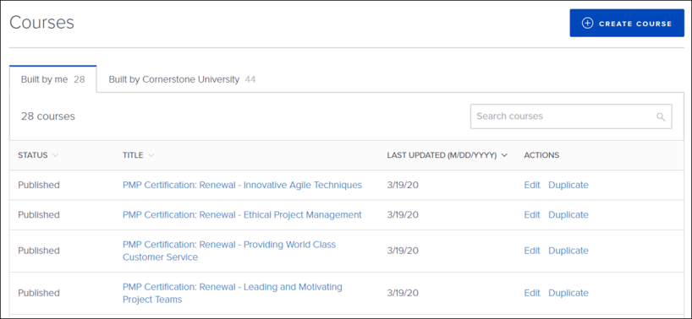
Use Cases
Use Case 1: Creating New Content:
Victoria is an Instructional Designer at ACME Studios. Her objective is to fill knowledge gaps in her organization. Once her organization purchases the Create Tool, she is able to create new courses directly within the Cornerstone system and publish it directly to the Course Catalog, allowing Victoria to do her job more quickly and efficiently.
Use Case 2: Revising Pre-made Content:
Leon is an Instructional Designer at Apollo Enterprises. He is looking for ways to provide his organization with more robust learning content. His organization is subscribed to Cornerstone's Content Anytime subscriptions, which feature Grovo courses. The Grovo courses fit nearly all of the requirements for his organization, but he would like to rewrite some of the quiz questions to be company-specific. Once his organization purchases Create Tool, he is able to edit existing Grovo content and include revised content prior to publishing it to the Course Catalog.
Considerations
- The Create Tool does not support SCORM courses. It only supports AICC courses.
- The Create Tool is currently only available in English. However, it can be used to create content in other languages.
- Content created using the Create Tool is mobile-responsive, but the Create Tool itself is NOT mobile responsive.
- Answers to quizzes within courses created with the Create Tool are not available in reporting.
- Organizations already using the Create Tool through Grovo will NOT have any existing courses they have already created through Grovo migrated to the Cornerstone system.
Implementation
Licenses for this functionality are available for an additional cost to organizations using the Learning module. The Create Tool can only be accessed by license holders, and additional enablement must be done in order for the Create Tool to be accessible to license holders in the portal. The Create Tool has a cost associated with it. For more information about pricing, please contact your Account Manager.
Once the Create Tool is made available in a portal, it can be added as a link in a navigation tab via Navigation Tabs & Links.

Create Tool - Manage Courses
On the Courses page, you can view and manage courses created by you, courses created by your organization, and courses created by Grovo.
To access the Create Tool, go to: Admin > Tools > Learning > Catalog Management and click the Create Tool link.
Permissions
PERMISSION NAME | PERMISSION DESCRIPTION | CATEGORY

Create Tool | Grants access to Create Tool for content authoring. This permission cannot be constrained. | Learning - Administration
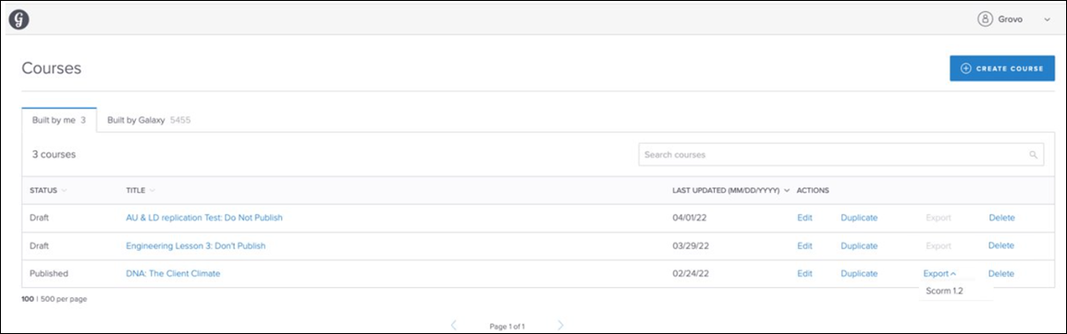
Courses
The Courses page allows the user to view existing courses from three different sources, as well as initiate the process for creating a new course.
To create a new course, you can click the Create Course button. For more information:
Existing courses display on three different tabs:
- Built by Me - These are courses that you created via the Create Tool.
- Built by Your Organization - These are courses that were created by creators within your organization.
- Built by Grovo - The Built by Grovo tab displays any Grovo courses your organization has purchased. Grovo courses can be managed and also remixed from this tab. Built by Grovo courses are only available if your organization purchases a full or partial content package which includes Grovo courses to supplement the Create Tool. If interested, please contact your Client Executive for pricing.
On each tab, courses display with the following informational columns:
- Status - This column displays the current status of the course, such as Draft, Published, or In Revision.
- Title - This column displays the title of the course.
- Last Updated - This column displays the date and time at which the course was last modified.
- Actions - The following actions may display for lessons on any tab, though some actions may not be available for courses in certain statuses:
  - Edit - Click the Edit link to remix (modify) the course. Any edits you make will be applied to the existing version of the course. organizations can remix the Grovo courses included in content packages they have purchased. Organizations which have purchased Content Anytime or any other partial content package which includes Grovo courses will be able to remix the Grovo courses within that package using the Create Tool.
  - Duplicate - Click the Duplicate link to make a copy of a course. You will be able to make modifications to the copy and save it independently of the original course.
  - Export - To export a Create Tool course in SCORM 1.2 format:
    - Click the Actions drop-down menu to the right of the course.
    - Click the SCORM 1.2 option from the menu. A loading image appears and the zip files begin processing.
    - After the zip package is created, the package downloads to the user's computer. The zip package contains an index.html file, which links asset files along with the standard SCORM 1.2 resources required to play the courses.​
  - Delete - To delete a course that you or someone at your organization has created, click the Delete link to the right of the course. Note: Courses that were built by Grovo cannot be deleted. For more information about deleting a course from the Create Tool, see the Delete Course section below.
A maximum of 100 or 500 courses can display per page of results on each tab, depending on your selection. If there are more courses than can fit on a single page of the tab, the tab paginates, and the user can navigate to additional pages of results.
To search for a specific course, you can enter search text into the Search Courses search bar and press the Enter key on your keyboard.
User Options
The drop-down icon next to your name provides access to the following options:
- Change Language - The Create Tool automatically displays to users in their own display language if the user's display language is a language supported by the Create Tool, but users can also manually switch the Create Tool to another supported language if needed. Click the Change Language option to change your Create Tool display language. For more information: See Create Tool - Change Language on page 20 for additional information.
- Log Out - Click this option to log out of the Create Tool.
Delete Course
Clicking the Delete link causes the Delete Lesson pop-up to appear, asking if you are sure you want to delete the course. You can click the Delete button to confirm the deletion and remove the course from the Create Tool. If needed, you can click the Go to Course Console button to access the Course Console page for the course. You can click the Cancel link and return to the Create Tool without deleting the course. Deleted courses cannot be restored.
Deleting a published course from the Create Tool results in the following:
- The course will be removed from all objectives which included the course.
- The course is automatically made inactive in the Course Catalog of the Learning Management System (LMS) and users can no longer access the course from their transcript or any other system location.
- The course remains in any assignments which include the course. To remove the course from these assignments, cancel the assignments and recreate the assignments without the deleted Create Tool course.
- If the course has been exported to another LMS, the course will no longer be accessible within that LMS.
Note: If an administrator wants to make a course unavailable to users but does not want to delete it from the Create Tool, they can set availability for that course via the Course Catalog and Course Console.
Deleting a draft course from the Create Tool results in the following:
- The course is removed from the Create Tool and this action cannot be undone.
- Because the draft course has not been made available in the system or to learners, the draft course was never included in objectives, added to users' transcripts, or included in any assignments.
Create Course
To create a new lesson, click the Create Course button in the upper-right corner of the page.
For more information about creating a new course using the Create Tool: See Create Tool - Create Course on page 7 for additional information.
FAQ
Q: How long will it take to see changes in the Create Tool after a client purchases a new content package that includes more Grovo courses?
A: The courses visible in Create Tool will be updated within 24 hours.
Q: What will happen to an organization's course access in the Create Tool if they downgrade their content package?
A: If an organization chooses to downgrade their content package from the full Grovo library to a partial library or no content package at all, they will retain access to their previously remixed course content. Courses visible in the Built by Grovo tab will be updated accordingly to match the their content subscription within 24 hours.

Create Tool - Create Course
Using the Create Tool, administrators with the associated permission can quickly create new learning content and publish it seamlessly to the Course Catalog.
Note: The Create Tool does not support SCORM courses. It only supports AICC courses.
To access the Create Tool, go to: Admin > Tools > Learning > Catalog Management and click the Create Tool link.
Permissions
PERMISSION NAME | PERMISSION DESCRIPTION | CATEGORY

Create Tool | Grants access to Create Tool for content authoring. This permission cannot be constrained. | Learning - Administration
Create New Lesson
To begin creating learning content, click the Create Course button on the Courses page.
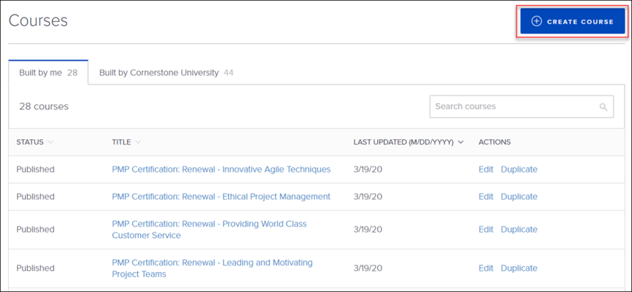
Choose a Course Outline
First, you will be asked to select a course outline. Guided outlines make it easy to produce effective micro-learning content. The following outline options are available:
- Blank Lesson - Choose this option if you would like to build a course entirely from scratch with only blank cards.
- Explain a Concept - Choose this option if you would like to build a course using a pre-made collection of cards which provide prompts and preset images for explaining a concept. You can modify all existing cards and selections; the template serves as a starting point to help you build a course which explains a new concept quickly.
- Teach a Skill - Choose this option if you would like to build a course using a pre-made collection of cards which provide prompts and preset images for teaching a skill. You can modify all existing cards and selections; the template serves as a starting point to help you build a course which teaches a new skill quickly.
- Introduce a Topic - Choose this option if you would like to build a course using a pre-made collection of cards which provide prompts and preset images for introducing a topic. You can modify all existing cards and selections; the template serves as a starting point to help you build a course which introduces a new topic.
Alternatively, you also have the option to upload your own content and convert that content into a course instead of selecting a template. To import your own content, click into the Import Your Own Content zone and select a PowerPoint file from your computer. The file will upload to the system, and the slides in the PowerPoint presentation will be converted to cards. It is not possible to modify the contents of the cards from the PowerPoint import. Only the sequence of the cards may be modified. Note: Only PowerPoint documents are supported by this feature.
PowerPoint Considerations
The following limitations and considerations apply when uploading a PowerPoint presentation to the Create Tool:
- 100 MB is the maximum file size
- Files larger than 50 MB may take up to fifteen minutes to upload
- PowerPoint decks with more than eighty slides may not upload successfully
- Downloads from Google Slides must to be re-saved as .ppt files
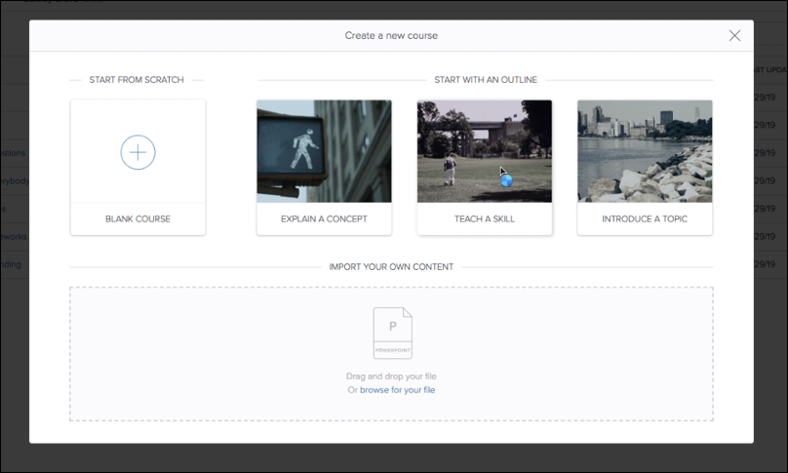
Create Tool
Once you have selected an outline type, you can use the Create Tool to begin building your course. The following features are available when using the Create Tool:
- Card View - A card is a slide in the course you are creating. The card you are currently working on displays on the majority of the screen, and you can use the other options on the page to add other features and content to the card. The first card in the course contains a Course Title field. The title you enter in this field will serve as the name of the course.
- Background - In the background section, you can set colors and images for the card background. The following options are available for the card background:
- Color - Click the Color field to select a color for the card. You can either select a color from the spectrum tool or enter a hex code. Note: If you are using an image or GIF as the card background, a background color cannot be selected.
- Image - In the Image section, you can either upload an image or select a GIF to use as the card background:
  - Upload - To upload an image to the card background, click the Upload button and then select the image file from your computer. The image will be displayed on the card background. If necessary, you can remove the uploaded image by clicking the Delete icon next to the Upload button. The ideal dimensions for background images are 1920x1080 (16:9 aspect ratio).
    - Hotspot - You can add a hotspot to an image. A hotspot is an area on an image that opens to another screen or provides additional information. To create a hotspot, click Add Hotspot and click and drag over the area where you want to add the hotspot. Enter a text description of the hotspot and click Done.
  - Giphy - To add a GIF to the card background, click the Giphy button and then search for and select the GIF file from the collection. The GIF will be displayed on the card background. If necessary, you can remove the uploaded GIF by clicking the Delete icon.

- Layout - In the Layout section, you can configure the following layout options for the card:
  - Show White Box Behind Text - Select this option to add a white box behind the text you have added to the card. Depending on your text color and the card's background image, adding a white box may make the text easier to read.
  - Add Inline Image - Select the Add Inline Image checkbox to add an image or GIF next to the text in the card. Once the image zone has been added to the card, click the Browse for Your File link to select an image from your computer or click the Insert Animated GIF link to search for and select a GIF from the collection. The recommended image size for the inline image is 500x500px.
  - Adjust Text Box Layout - Click the Show link next to this option to see all the available card layout options. Click an option to adjust the location of the text box on the card. To collapse the layout options again, you can click the Hide link.
- Image Settings - In the Image Settings section, you can provide alt text for the slide.
  - Alt Text - To provide alt text for an image on a slide, place your cursor in the Alt Text text box and type the desired alt text. The text you provide will be associated with the image, and vision-impaired learners that navigate courses using assistive technology will be able to discern the content of the image.
- Voiceover - In the Voiceover section, you can add audio to the card. Click the Start Recording button to record voiceover with your computer. You can use your computer's built-in microphone or add an external microphone to your computer to enhance audio quality. After clicking the Start Recording button, your audio will be recorded for the lesson card, up to three minutes. Click the Stop button to stop recording. If your recording is acceptable, no further action is required after the recording has stopped. If you need to try again, click the Delete icon, then click the Start Recording button again and start over.
- Closed Captioning - To add closed captioning to a slide, click the Upload button in the Closed Captioning section of the panel on the right side of the screen. Select the .vtt file from your computer. Once the .vtt file has been uploaded to the slide, the closed captioning is attached and will display to users with this course slide. If needed, you can change the .vtt file by clicking the Change button and uploading a new file from your computer, or you can remove the closed captioning entirely by clicking the Delete icon in the Closed Captioning section.
- Delete Card - To delete a card from the course entirely, click the Delete Card link. All your selections and content for the card will be lost.
- Course Summary Panel - The bar on the bottom of the page displays thumbnails of your lesson cards and provides access to other information and options:
  - Course Name - The name of the course that you defined on the course title card displays. This field is informational only and is not editable.
  - Saved Status - The Saved status field displays whether or not all your modifications have been saved. If your changes are currently being saved, this field changes to "Saving..." and updates to Saved again when the changes have been saved successfully. If your internet connection is interrupted, your changes will not be saved until the connection is restored. If saving was not possible, the status changes to Error Saving.
  - Collapse Icon - To collapse the bottom panel and view more of the current card, you can click the arrow icon in the top center of the panel. To expand the panel again, you can click the arrow icon again.
  - Get Link - Click the Get Link button to access a link to your course as a preview or directly to the course within the Create Tool. You can choose which type of link you want to copy using the drop-down menu. If your course is in a draft status, you can access a link for the draft course. If the course is published, you can access a link for the published course. The user will be able to play the course using a link provided for the draft or published course. If you opted to receive a link for the Create Tool, the user who accesses the course using your link will be able to open the course in the course builder window and make edits to the course, provided they have the appropriate permission.
  - Preview - Click the Preview button to open the preview window and view the course from a learner's perspective. You can toggle between the desktop and mobile previews by clicking the Desktop and Mobile icons at the top of the preview window. Use the navigation arrows in the bottom-right corner of the preview window to navigate forward and backward in the course. When you are finished previewing the course, click the X icon in the upper-right corner of the preview window.
  - Publish - To publish your course, click the Publish button. If a part of the course is not yet finished, the course will not yet be available for publishing, and a link to edit any unfinished cards displays in a pop-up window. Click the Edit links for any unfinished items to navigate to the relevant card and resolve any issues. Once the course is ready for publishing and you click the Publish button, the course will be published as an online course to the Course Catalog. See the Publish Lesson section below for more information.
  - Add New Card button - To add a new card to the course, click the Add New Card button.
  - Course Sequence - The display ribbon at the bottom of the page displays thumbnails of your course cards. You can click on a thumbnail to access and make edits to that card, and you can click and drag cards in the ribbon into a different display order.
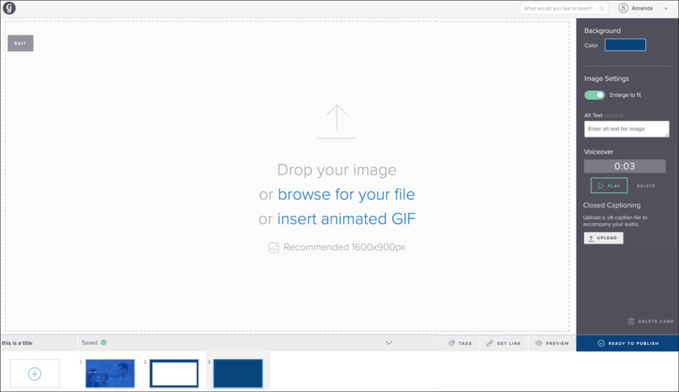
- Change fonts - Use fonts to emphasize important information and provide consistency across content. Select text on any card to change the font. To change fonts, add a Text card to your course. Click and drag to select the text you want to format. Formatting options appear. Click the font name to change the font.
Add Hints to Questions
Reinforce important information by adding hints to multiple choice questions. Once a learner selects an option that has a hint, they can learn more about why their selected option is incorrect and/or see information about the right answer.
To add hints to questions:
- Add a Question card to your course.
- Enter your question.
- Enter answer choices along with the hint for each choice.
Publish Course
After clicking the Publish button, a notification appears, alerting you that you must continue configuring the new content via the Course Catalog or Course Console in order to make the content available to users and add metadata such as keywords, subjects, and more. When the course is published to the catalog, it becomes an online course in the system. Click the Go to Course Console button to be navigated to the Course Console page for the content you just published. If you would like to continue editing the content from the Create Tool before accessing the Course Console, you can click the Continue to Edit button instead.
For more information about configuring training metadata via the Course Catalog and Course Console, please see the following resources:
- Course Catalog - See Catalog Management - Course Catalog Overview.
- Course Console - See Course Console - Overview.
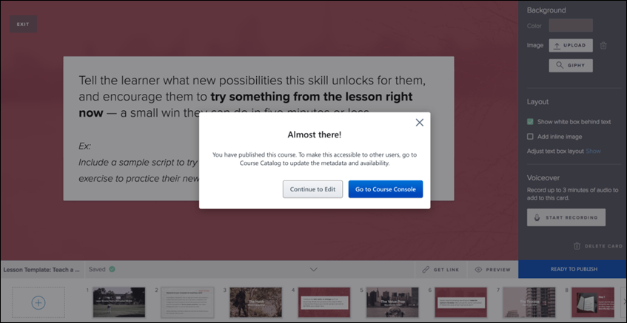
Versioning
Administrator-initiated versioning is not available with the Create Tool. However, when a learner launches a Create Tool course, they will receive the specific published version that was active at time of launch. This allows the progress of the course to be maintained and tracked.
Based on this functionality, it is possible for different learners to view different published versions of the same course. It is recommended that any substantial changes to a course be handled by duplicating the course within Create Tool and publishing a new instance of the course.
Export content as SCORM 1.2
Organizations can download their proprietary content to post on extranet sites or external systems.
To export content, on the landing page, click Export to download the course in SCORM 1.2.
Note: Only published courses that are not duplicated from a Grovo course are available to export. All other courses are greyed out.

Create Tool - Embed Videos
Embed externally hosted videos from the web to quickly create engaging content by leveraging already existing materials.
To access the Create Tool, go to ADMIN > TOOLS > LEARNING > CATALOG MANAGEMENT > CREATE TOOL and click the Create Tool link.
Permissions
PERMISSION NAME | PERMISSION DESCRIPTION | CATEGORY

Create Tool | Grants access to Create Tool for content authoring. This permission cannot be constrained. | Learning - Administration
To embed videos, copy the embed code of a video from the web and insert the copied embed code into the video card. Change the link anytime or delete the video to upload a video file instead.
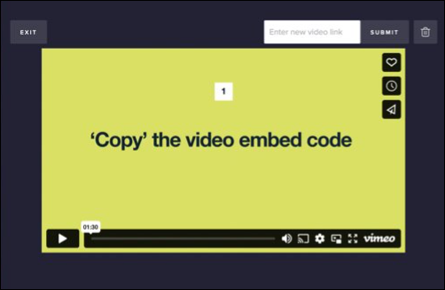
Authors can create more engaging content by utilizing embedding videos from the web and users can have a more dynamic engaging medium for visual learning.

Create Tool - Launch Course
Once a course has been published using the Create Tool and the administrator has used the Course Console or Course Catalog to make the online course available to users, users can search for and launch the online course from the following locations:
- Learner Home
- Learning Search
- Transcript
- Global Search
- Browse for Training
Courses created using the Create Tool launch in a separate window. After the user has viewed the last card of the course and exits the course window, the course is automatically marked as completed on their transcript.
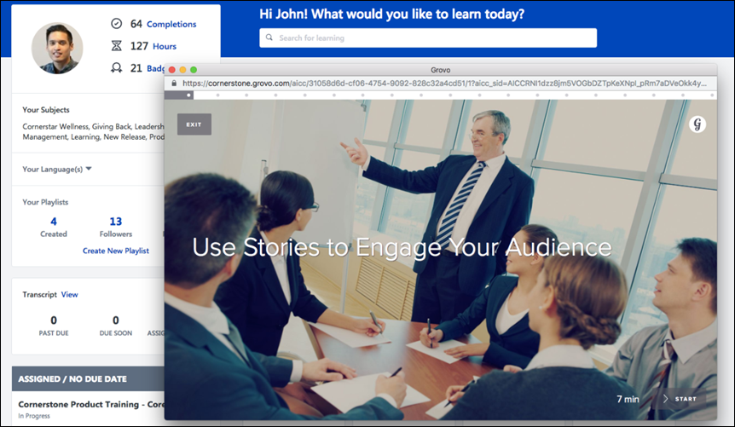

Create Tool - Personalized Branding
The administrators can change default logos and set primary colors at the portal level to apply to all content. Making changes here automatically applies the change in logo to all new and previously published courses.
Permissions
PERMISSION NAME | PERMISSION DESCRIPTION | CATEGORY

Create Tool | Grants access to Create Tool for content authoring. This permission cannot be constrained. | Learning - Administration
To access the Create Tool, go to ADMIN > TOOLS > LEARNING > CATALOG MANAGEMENT > CREATE TOOL and click the Create Tool link.
To set a primary color, follow the steps:
- Navigate to Profile > Settings.
- Upload an image to be used as a logo.
- Set the primary color for buttons.
Personalized Branding elevates your content across the portal with personalized branding options.

Create Tool - Quizzes
Create interactive quizzing options to allow for more learner engagement throughout the course and knowledge checks which contribute to more effective and efficient learning outcomes.
To access the Create Tool, go to ADMIN > TOOLS > LEARNING > CATALOG MANAGEMENT > CREATE TOOL and click the Create Tool link.
Permissions
PERMISSION NAME | PERMISSION DESCRIPTION | CATEGORY

Create Tool | Grants access to Create Tool for content authoring. This permission cannot be constrained. | Learning - Administration
How to add a Quiz
- Start with creating a course.
- Choose any of the quiz cards available to the course.
- After selecting the type of quiz, add the prompts and responses.
Ranking Quizzes
Ranking quizzes are beneficial to determine the relative importance, priority, or sequence of items. This type of quiz assesses the ability to prioritize or order items based on specific criteria.
- The authors can define options and set the correct ranking order.
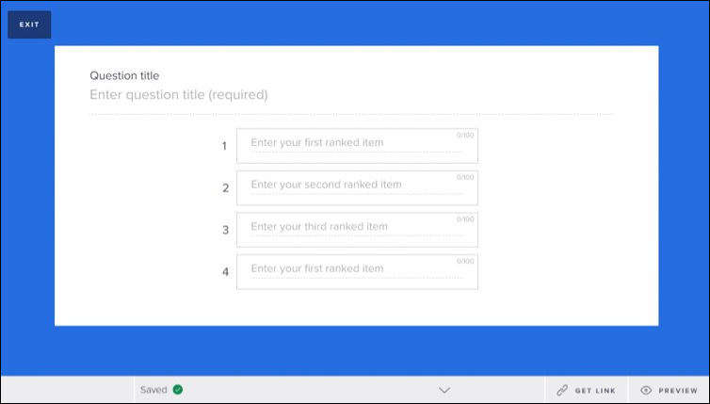
- The options are presented to learners in random order. The learners can click and drag jumbled options in the right order.
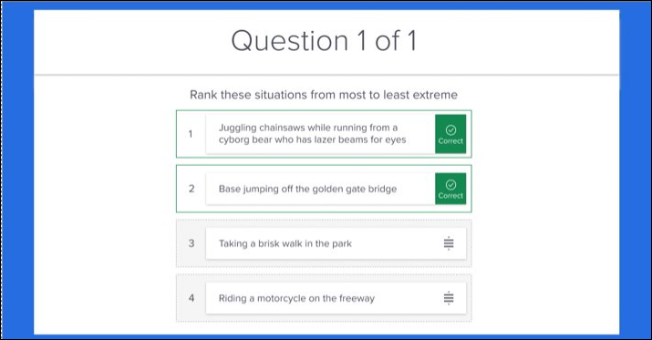
Matching Quizzes
Matching quizzes are beneficial for testing and reinforcing associations between different items or concepts.
- The authors can define options with the right match.
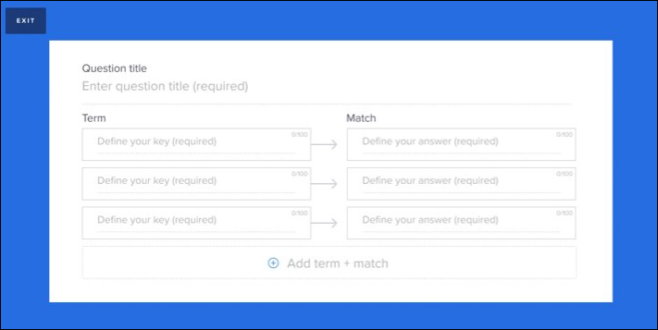
- The options are presented to learners in random order. The learners can click and drag jumbled options to match the values.
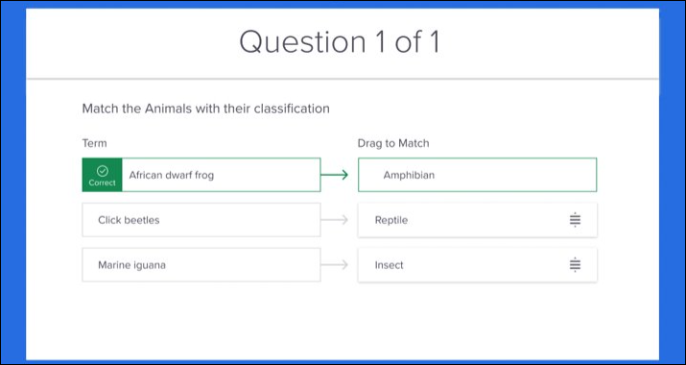
The ranking and matching of quizzes are also optimized for mobile browsers.

Create Tool - FAQ
Q: Do all organizations have access to the Create Tool?
A: The Create Tool requires that a license be purchased. Administrators should reach out to their Client Executive for more information on pricing. The Create Tool is only available in Production environments and is not currently available in Stage or Pilot.
Q: Can you export courses created in the Create Tool?
A: You cannot currently export courses created in the Create Tool. The courses will be contained only within Cornerstone.
Q: Is the course duration determined by the Create Tool?
A: Course duration must be manually defined in the Course Console after publishing.
Q: Is it possible to report on question responses?
A: It is not currently possible to report on question responses.
Q: What question types are available?
A: Multiple Choice is currently the only question type available.
Q: What format is the published course?
A: The published course is in a Cornerstone-specific AICC format. The Create Tool does not support SCORM courses.
Q: Can the course be reversioned, similar to other online courses?
A: Versioning is not currently supported.
Q: Can you input your own custom background?
Yes, you can customize the background for your courses.
Q: Can you input your own logo?
A: The logo may be customized to match your organization's corporate logo by submitting ticket with Global Customer Support. Please include the image URL or image file of the logo from your portal's Display Preferences page in your request. For more information about the Display Preferences page: See Display Preferences .

Create Tool - Change Language
The Create Tool automatically displays to users in their own display language if the user's display language is a language supported by the Create Tool, but users can also manually switch the Create Tool to another supported language if needed.
To access the Create Tool, go to: Admin > Tools > Learning > Catalog Management and click the Create Tool link.
Permissions
PERMISSION NAME | PERMISSION DESCRIPTION | CATEGORY

Create Tool | Grants access to Create Tool for content authoring. This permission cannot be constrained. | Learning - Administration
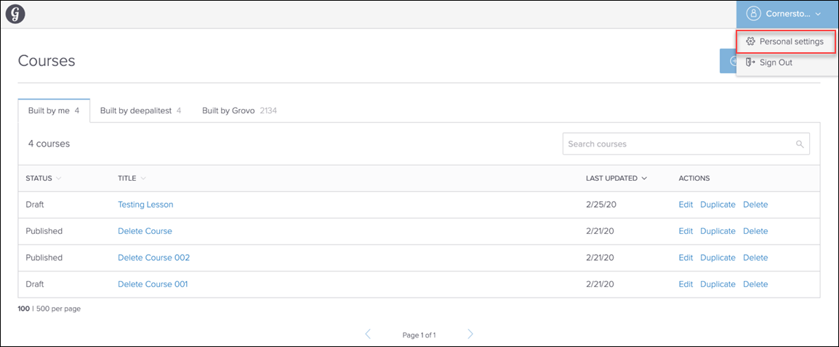
Personal Settings
To manually change the language of the Create Tool:
- Click the drop-down icon next to your username in the upper-right corner of the page.
- On the Personal Settings page, click the Preferred Language in Create Tool drop-down menu and select another supported language.
- Click the Save Changes button at the bottom of the page.
The entire Create Tool, including the Lessons page and the Create Lesson workflow, will display in the language selected on the user's Personal Settings page. The user can change the language of the Create Tool at any time. Note: If a user manually changes their preferred language for the Create Tool and then later updates their preferred language for the Cornerstone system, the language selected for the Create Tool does NOT change.
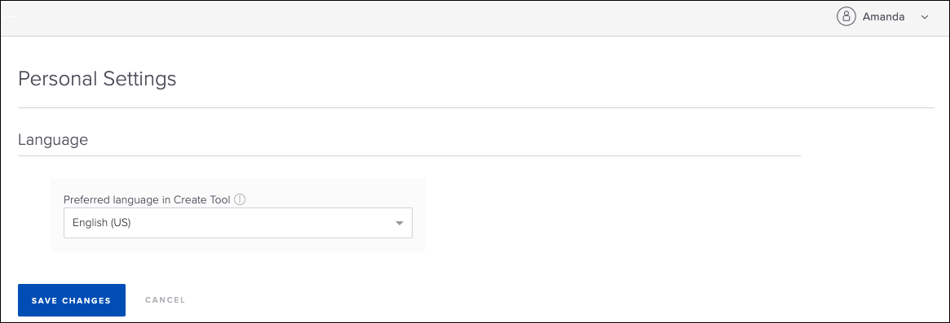

Create Tool - Add Collaborators
Use the Add Collaborators functionality to limit editing capabilities on your content and collaborate only with the chosen users. As a content author, you can add collaborators from the existing Create Tool user base to your content. As a collaborator, you can edit the content in a separate view. The administrators can continue to edit or manage all contents for better governance while retaining authenticity.
Design Note: An updated interface is available for this page to add collaborators.
To access the Create Tool, go to ADMIN > TOOLS > LEARNING > CATALOG MANAGEMENT > CREATE TOOL and click the Create Tool link.
Permissions
PERMISSION NAME | PERMISSION DESCRIPTION | CATEGORY

Create Tool | Grants access to Create Tool for content authoring. This permission cannot be constrained. | Learning - Administration

Create Tool Admin | Grants the administrators access to Create Tool. Administrators must also have the Create Tool permission. Administrators can manage content created by anyone in the organization. This permission cannot be constrained. | Learning
How to add collaborators
- On the Create Tool landing page, under the Built by me tab, click collaborators.
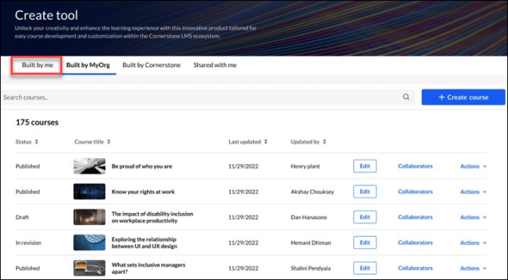
- In the Assign Collaborators window, add collaborators from a list of users.
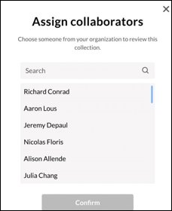
- As a collaborator, edit content by going to the Shared with me section.
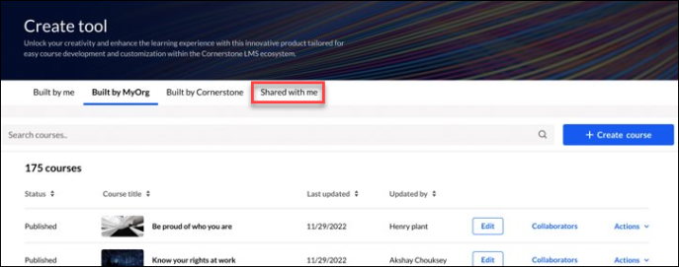
- Administrators with the 'Create Tool Admin' permission can edit and manage all the content created by the users within an organization.
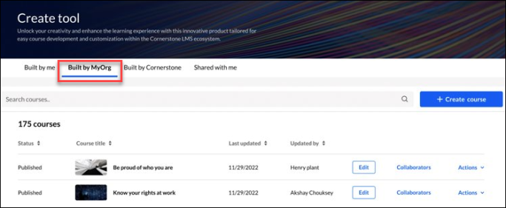
Note: You can add, remove, and view collaborators by clicking collaborators.
Considerations
- All users with the Create Tool permission have access to the Create Tool feature. However, the editing rights are limited to the content they created, with the ability to add collaborators.​
- Users must access Create Tool at least once to appear in the ‘Assign Collaborator’ list.​
- The permission 'Create Tool Admin' allows administrators to edit or manage content created by all users.

Create Tool - Auto Transcription
Transcribe all uploaded videos in the Create Tool automatically with Auto Transcription feature. The transcription appears as closed captioning to learners during video playback. Auto transcription saves time and resources by using automatic transcription to generate closed captioning and also speeds up content creation.

