Edge Integrations March 2024

Table of Contents

Edge Integrations Overview

Cornerstone Edge Integrate Overview
Cornerstone Edge Integrate enables organizations to quickly and easily integrate their Cornerstone system with other workforce systems. This includes recruiting tools, learning tools , social tools, and others.
Cornerstone Edge Integrate has two components:
- Marketplace - The Edge Marketplace enables administrators to conveniently browse and discover all available integrations.
- Integrations - Once an integration is purchased or enabled, the Integrations service enables administrators to configure, enable, and disable their integrations. This greatly simplifies the implementation process by reducing implementation times and enabling administrators to enable and configure the integrations.
Available Integrations
Several types of integrations are available for the Cornerstone system:
- Cornerstone Built - This option displays integrations that are built by Cornerstone.
- Partner Built - This option displays integrations that are built by Cornerstone partners using Cornerstone connectors and APIs.
- Build Your Own - This option displays APIs and Connectors that your organization can use to build custom integrations.
Use Cases
- Michael is an administrator at Acme Corp. He accesses the Marketplace from his Pilot portal to view which integrations are available.
- Michael notices that an integration is available for a third-party tool that Acme Corp currently uses. He views the details of the integration and realized that this integration will add valuable functionality to his Cornerstone portal.
- Michael decides to enable a free 30-day trial of the integration in the Pilot portal. He accesses the Integrations page and quickly configures and enables the integration.
- After a week of using the integration in non-production environments, Michael decides that this integration is valuable to Acme Corp. He contacts his Cornerstone Account Manager to purchase the integration.
- Michael accesses the Integrations page and configures the integration by choosing to copy the configuration settings from the Pilot portal.
- After configuring the integration, Michael enables the integration, and it is automatically available in his production portal.
Considerations
In order to support the use of Edge Integrate, a new user is added to the system in the Cornerstone Administrator security role. The Username and User ID for this user is edgeuser, and this user is available when searching users from the Admin > Users page. In order for the Edge Integrate service to function properly, this user must remain active.
The Marketplace displays all available integrations, including integrations that are associated with Cornerstone modules that the organization may not have purchased.
Administrators can initiate a 30-day trial period for an integration in all non-production environments.
- During a trial period, the integration can only be enabled in non-production environments.
- Only one trial period is permitted for each integration.
- Trial periods cannot be extended.
- At the end of the trial period, the functionality is disabled until the integration is purchased.
When a free trial is initiated or when an integration is purchased, the integrations must be configured and enabled before the functionality is available within the portal. Even though an integration may be installed in multiple environments, the integration must be configured and enabled in each environment in order for the functionality to be available in the environment.
All integration fees are charged annually.
Implementation
Edge Integrate is only available for organizations whose portals are supported by Cornerstone. For these portals, Edge Integrate is automatically enabled. For organizations that are supported by a Cornerstone reseller, Edge Integrate is disabled and it is not available.
The Edge Marketplace - Manage and Edge Integrations - Manage permissions are automatically added to the default System Administrator role.
For organizations that have a previous integration that is now offered as an Edge integration, the integration appears as Purchased in the Marketplace, and administrators can update the integration settings via Integrations. When the organization's contract ends, the organization must accept the new recurring fee for the integration in order to continue using it.
Glossary
- Marketplace (Edge) - The Edge Marketplace enables administrators to conveniently browse and discover all available integrations.
- Integrations (Edge) - Once an integration is purchased or enabled, the Integrations service enables administrators to configure, enable, and disable their integrations. This greatly simplifies the implementation process by reducing implementation times and enabling administrators to enable and configure the integrations.
Security
The following permissions apply to this functionality:
PERMISSION NAME | PERMISSION DESCRIPTION | CATEGORY

Edge Integrations - Manage | Grants access to the Integrations service for Edge Integrate, where the administrator can configure, enable, and disable their third-party integrations used within the Cornerstone system. This permission cannot be constrained. This is an administrator permission. | Edge

Edge Marketplace - Manage | Grants access to the Marketplace service for Edge Integrate, where the administrator can browse integrations that can be used to extend the Cornerstone system. This permission cannot be constrained. This is an administrator permission. | Edge

Integrations - View and Manage My Edge Integrations
Once an integration is purchased or enabled, the Integrations service enables administrators to configure, enable, and disable their integrations. This greatly simplifies the implementation process by reducing implementation times and enabling administrators to enable and configure the integrations.
To configure and enable the Edge integrations that have been purchased for your portal, go to Admin > Tools > Edge > Integrations. The Integrations page opens in a new browser tab.
When using any of the Edge services, such as Marketplace or Integrations, administrators can navigate between the services by clicking the Menu icon in the upper-right corner of the page and selecting the desired service:
- Marketplace - See Marketplace - Browse Edge Integrations.
- Integrations - See Integrations - View and Manage My Edge Integrations on page 5 for additional information.
Permissions
PERMISSION NAME | PERMISSION DESCRIPTION | CATEGORY

Edge Integrations - Manage | Grants access to the Integrations service for Edge Integrate, where the administrator can configure, enable, and disable their third-party integrations used within the Cornerstone system. This permission cannot be constrained. This is an administrator permission. | Edge
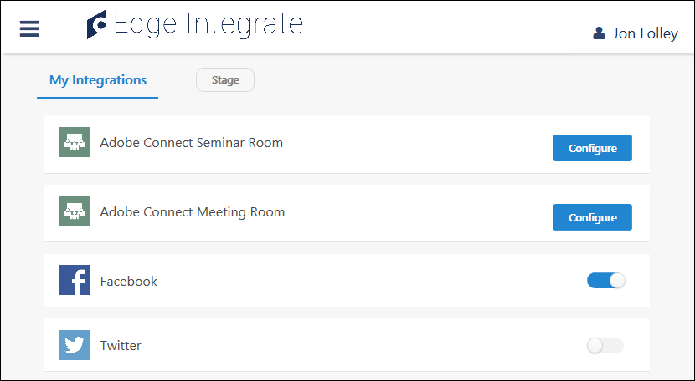
Available Integrations
The Integrations page displays all of the integrations that have been purchased or are within a trial period.
To the right of the My Integrations tab, the portal type is displayed. The portal type determines which integrations are available:
- Production Environment - When accessing Integrations from a Production portal, administrators can configure and enable Edge integrations that have been purchased.
- Non-production Environment - When accessing Integrations from a non-production environment, such as a Pilot or Stage portal, administrators can configure and enable Edge integrations that have been purchased or integrations that they have installed at no cost for testing purposes.
Prior to configuring an integration for Production portals, the integration must be purchased. For other non-Production portals, the integration can be installed for no cost and configured for testing purposes. This is done from the Marketplace. See Marketplace - Browse Edge Integrations.
Configure
If an Edge integration has configuration settings, then the integration cannot be enabled until it is configured. In addition, the option to enable or disable the configuration is only available after the integration is configured.
To configure an integration, select the Configure button. See Edge Integration - Configure on page 11 for additional information.
Edit Configuration
After an integration is configured, the Configure button is hidden and an Enable/Disable toggle switch is available.
To edit the configuration settings for an integration that has already been configured, select the integration title. This opens the Configuration page. See Edge Integration - Configure on page 11 for additional information.
Enable or Disable
An Edge integration can be enabled or disabled from the Integrations page in the following scenarios:
- The integration has already been configured. After an integration is configured, the Configure button is hidden and an Enable/Disable toggle switch is available.
- The integration does not have configuration settings.
If an integration has configuration settings, then the Enable/Disable toggle switch is not available until the integration is configured.
To enable or disable an integration for the current portal, select the toggle switch to the right of the integration. Note: Enabling or disabling an integration only impacts the current portal. If the integration should be enabled or disabled in all portals, than this must be done separately within each portal. The current portal type is displayed at the top of the page.
- Enabled - The integration is enabled when the slider is positioned on the right side of the toggle switch.
- Disabled - The integration is disabled when the slider is positioned on the left side of the toggle switch.

Edge Integration - Purchase an Integration
The Edge Marketplace enables administrators to conveniently browse and discover all available integrations.
Administrators must contact their Account Manager to purchase or enable an integration for a Production portal. This applies to all integrations, regardless of whether they have a cost. Once the integration is purchased or enabled, administrators must then configure the integration from the Integrations configuration center.
To purchase or enable an integration for a Production portal, contact your Account Manager. This is required for all integrations, regardless of whether they have a cost.
When using any of the Edge services, such as Marketplace or Integrations, administrators can navigate between the services by clicking the Menu icon in the upper-right corner of the page and selecting the desired service:
- Marketplace - See Marketplace - Browse Edge Integrations.
- Integrations - See Integrations - View and Manage My Edge Integrations on page 5 for additional information.
Permissions
PERMISSION NAME | PERMISSION DESCRIPTION | CATEGORY

Edge Marketplace - Manage | Grants access to the Marketplace service for Edge Integrate, where the administrator can browse integrations that can be used to extend the Cornerstone system. This permission cannot be constrained. This is an administrator permission. | Edge

Edge Integration - Try it Free
The Edge Marketplace enables administrators to conveniently browse and discover all available integrations.
When accessing Marketplace from a non-production environment, such as a Pilot or Stage portal, administrators can enable the integration in their non-Production portal for no cost, for testing purposes. To enable an integration in Production portals, customers must contact their Account Managers, regardless of whether the integration has a cost. The integration must be configured in each environment from the Integrations configuration center.
To enable an integration in a non-Production portal for no cost, go to Admin > Tools > Edge > Marketplace. From the Marketplace page, select the appropriate integration. Then, from the Integration Details page, select the Install button.
When using any of the Edge services, such as Marketplace or Integrations, administrators can navigate between the services by clicking the Menu icon in the upper-right corner of the page and selecting the desired service:
- Marketplace - See Marketplace - Browse Edge Integrations.
- Integrations - See Integrations - View and Manage My Edge Integrations on page 5 for additional information.
Permissions
PERMISSION NAME | PERMISSION DESCRIPTION | CATEGORY

Edge Marketplace - Manage | Grants access to the Marketplace service for Edge Integrate, where the administrator can browse integrations that can be used to extend the Cornerstone system. This permission cannot be constrained. This is an administrator permission. | Edge
Install Integration in Pilot or Stage
After selecting the Install button on the integration page, read the terms and conditions of the no-cost trial and check the acknowledgment box. Then, select the Install button at the bottom of the page. The integration will be installed at no cost for use with your Pilot, Stage, and Demo portals. You can configure the integration by selecting the Configure Now button in the confirmation pop-up.
After configuration, your organization can test the integration and determine whether it will meet the organization's needs, with no time constraints. If the integration is suitable for your organization, it can be purchased for use with your Production portal.
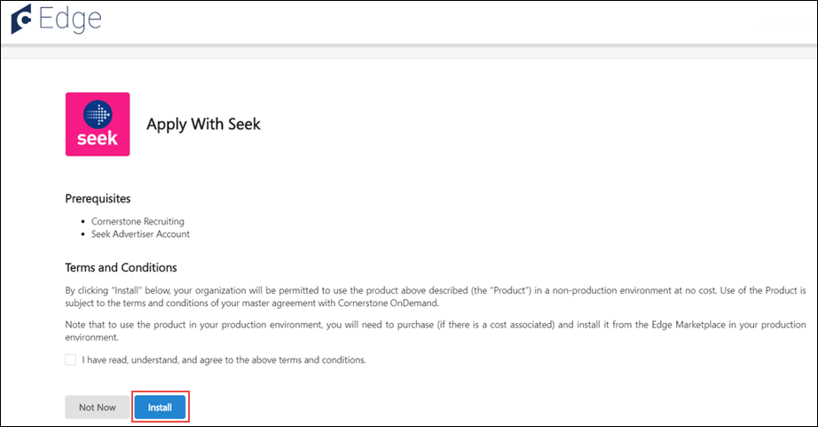

Edge Integration - Configure
Once an integration is purchased or enabled, the Integrations service enables administrators to configure, enable, and disable their integrations. This greatly simplifies the implementation process by reducing implementation times and enabling administrators to enable and configure the integrations.
To configure an Edge integration, go to Admin > Tools > Edge > Integrations. Then from the Integrations page, select the Configure button to the right of the appropriate Edge integration.
When using any of the Edge services, such as Marketplace or Integrations, administrators can navigate between the services by clicking the Menu icon in the upper-right corner of the page and selecting the desired service:
- Marketplace - See Marketplace - Browse Edge Integrations.
- Integrations - See Integrations - View and Manage My Edge Integrations on page 5 for additional information.
Permissions
PERMISSION NAME | PERMISSION DESCRIPTION | CATEGORY

Edge Integrations - Manage | Grants access to the Integrations service for Edge Integrate, where the administrator can configure, enable, and disable their third-party integrations used within the Cornerstone system. This permission cannot be constrained. This is an administrator permission. | Edge
Setup Instructions
The Setup Instruction section contains detailed information regarding how to configure the integration.
To view the setup instructions, click the Setup Instructions link. The section expands to display the instructions.
Configuration Settings
Complete all of the fields to configure the integration. For information on the configuration fields, click the Setup Instructions link.
Important: The configuration settings only apply to the current portal. If the integration is used in multiple portals, then the integration must be configured and enabled in each portal. The current portal type is displayed at the top of the page.
Save Settings
After completing the configuration fields or copying the configuration settings from another environment, click the Save Settings button at the bottom of the page to save any changes to the settings.
Important: After saving the configuration settings, the integration must be enabled on the Integrations page before the functionality is available in the portal. See Integrations - View and Manage My Edge Integrations on page 5 for additional information.
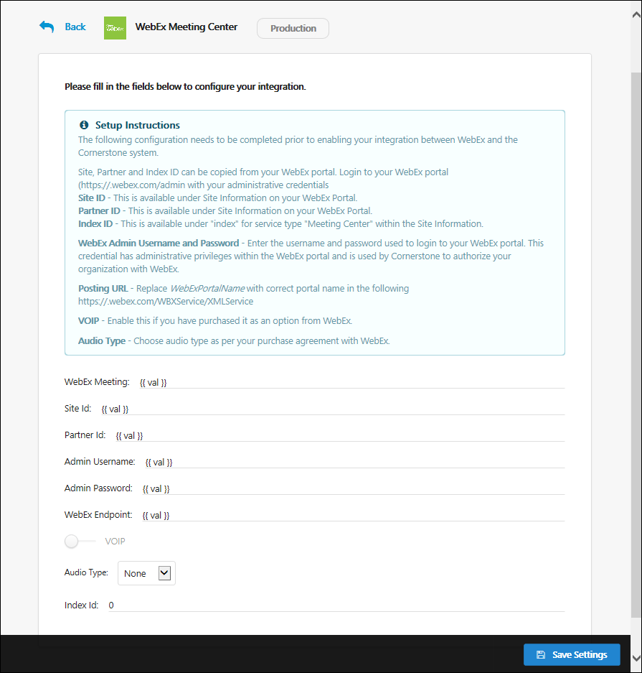

Edge Integrate - Activity Log
On the Settings tab for each Edge integration, administrators can access the Activity section, which provides modification history information for both the integration's Settings Tab and Manage Users tab.
To access the Settings tab for an integration, go to Admin > Tools > Edge and click the Integrations link. Then, click an integration and click on either the integration's Settings tab or the Manage Users tab.
Permissions
PERMISSION NAME | PERMISSION DESCRIPTION | CATEGORY

Edge Integrations - Manage | Grants access to the Integrations service for Edge Integrate, where the administrator can configure, enable, and disable their third-party integrations used within the Cornerstone system. This permission cannot be constrained. This is an administrator permission. | Edge
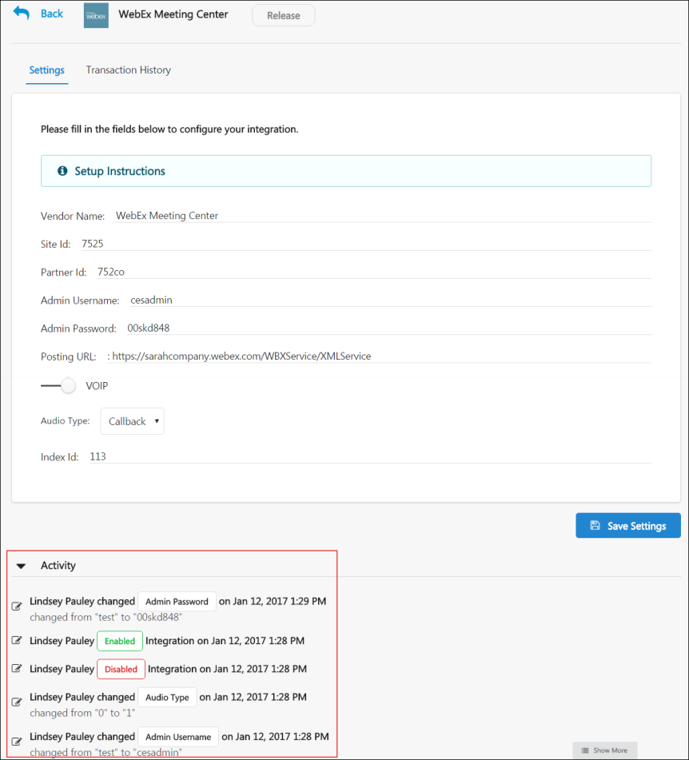
Activity
To view the modification history and activity for the integration, click the Activity drop-down which displays under the available settings options. All previous activity related to the enhancement settings will be expanded. Each instance of modification displays with the following information:
- Name - This field displays the name of the administrator who made the modification to the settings or users of the integration.
- Changed Setting - This field displays the setting or user information that was changed . If applicable, the original value of the setting displays along with the new value of the setting.
- Date and Time - This fields the date and time at which the modifications were saved to the integration.
If needed, click the Show More button to load additional modification history information to the Activity section.

Edge Integrate - Manage Users
User mapping for Edge integrations is managed from a separate tab on the Edge Integrate page. On the Manage Users tab, administrators can add new users and modify the information for existing users.
To access the Manage Users tab, go to Admin > Tools > Edge and click an integration which supports user mapping. Click the Manage Users tab.
Permissions
PERMISSION NAME | PERMISSION DESCRIPTION | CATEGORY

Edge Integrations - Manage | Grants access to the Integrations service for Edge Integrate, where the administrator can configure, enable, and disable their third-party integrations used within the Cornerstone system. This permission cannot be constrained. This is an administrator permission. | Edge
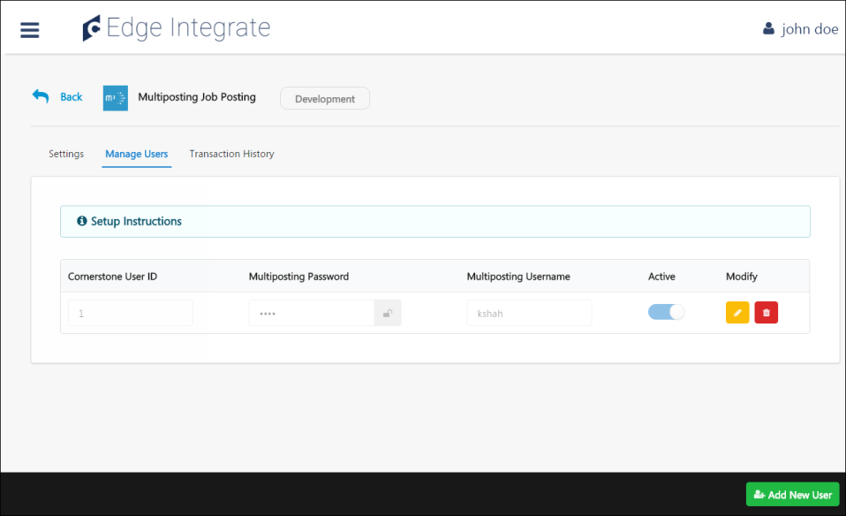
Manage Users Tab
The Manage Users tab of the Edge Integrate portal allows you to map users to an integration. From this page, administrators can view, modify, and delete existing users, and they can also add new users and save any setting modifications.
Setup Instructions
Different enhancements require different user setup procedures. For detailed instructions on adding users to a specific enhancement, click the Setup Instructions link on the Manage Users tab.
Add New User
Administrators can add new users to the integration from the Manage Users page. Users must have an account with the integration software and also be added to the integration from the Manage Users page in order to use that integration's functionality in the system.
The Add New User button in the bottom right corner of the Manage Users page allows you to add a new user to the integration after supplying all the required information for the user.
For more information about configuring users for specific enhancements, click the Setup Instructions link on the Manage Users tab for the enhancement.
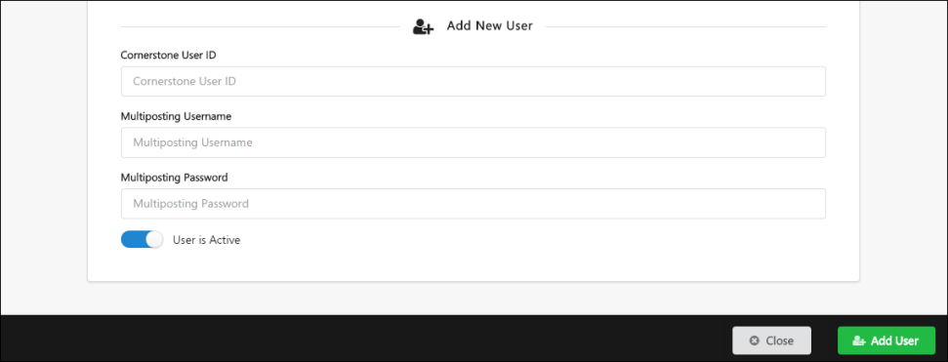
Save Settings
To save the settings made to the Manage Users page, click the Save Settings button.

Edge Integrate - Transaction History
The Transaction History tab shows transaction history information for all purchases and trials of the integration.
To access the Purchase History tab, go to Admin > Tools > Edge > INTEgrations. Click on an integration, then click the Purchase History tab for the integration.
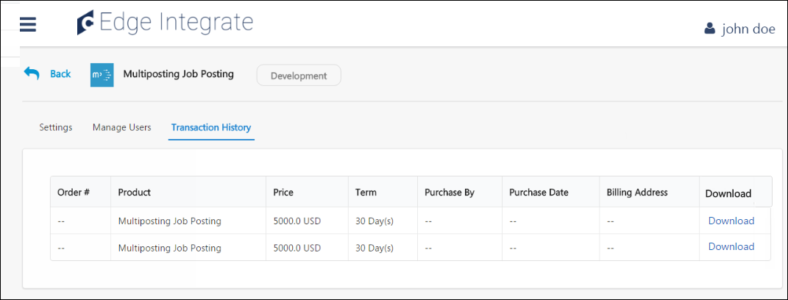
Transaction History
The Transaction History tab allows administrators to view each instance that a specific integration was purchased and trialed. Transactions display chronologically and may be downloaded by clicking the Download link.
The purchase history table includes the following fields:
- Order # - This column shows the unique, auto-generated alphanumeric code used to identify the transaction, if the transaction was a purchase. If the transaction was a trial download, this column displays the word, “Trial.” The order number is clickable and allows the administrator to download the Record of Order document for that transaction. Note: The Record of Order is a new document with this enhancement. See the Record of Order section below for more information.
- Product - This column displays the name of the integration purchased.
- Price - This column shows the amount paid for the integration.
- Term - This column shows the amount of time for which the integration is active for the purchaser, per the terms of the purchase.
- Purchase By - This column displays the name, phone number, and email address of the purchaser, as provided by the purchaser in the Company Contact Information section of the checkout process.
- Purchase Date - This column displays the date the transaction occurred.
- Billing Address - This column displays the purchaser’s billing address, as provided by the purchaser in the Billing Information section of the checkout process.
- Download - This column provides a Download link which allows administrators to download the Record of Order document for each transaction.
Record of Order
The Record of Order document includes the following information:
- Order Number
- Order Date
- Terms and Conditions
- Integration Prerequisite Information
- Integration Name
- Price of Integration
- Currency of Price
- Portal Name
- First and Last Name of Purchaser
- Billing Contact Name
- Billing Address
- Billing Email Address
- Billing Phone Number

Content (non-CCA) Integrations - Overview
To enable a Content Provider integration listed below, please reach out to your Account Manager and complete a signed Order Form. 1:1 Online Content integrations are currently available for the following providers:
- GetAbstract
- GLOBIS
- Teach on Mars
- Udemy for Business

Core Integrations Overview

Organizational Planning Integrations - Overview
Org Planning Integration Single Sign On via SAML 2.0 (Early Adopter)
By integrating with Org Planning, a product added to the Cornerstone portfolio as part of the Saba acquisition, organizations can easily visualize, plan, and model organizational data.
- Organizations must activate the Org Planning Integration via the Edge Integrate Marketplace.
- To request the new Org Planning Integration, go to Admin > Tools > Edge > Marketplace and select the Org Planning tile.
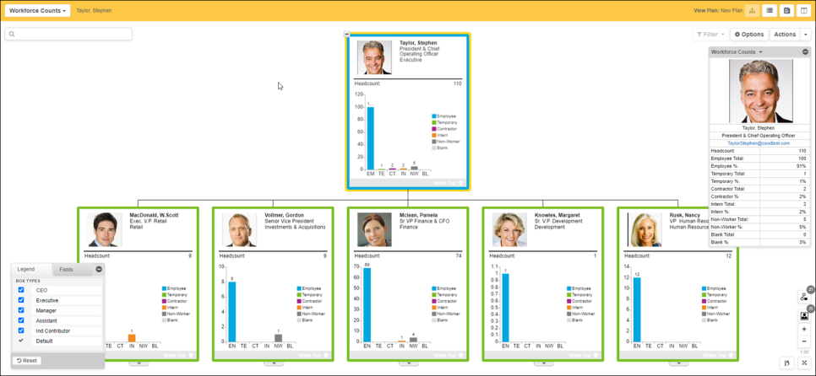
Key features
- Conditional formatting – Configure chart views using conditional formatting capability. These views can be based on the direct feed from Cornerstone and calculated fields defined in Org Planning.
- HR Metrics – Create unique chart styles using formula fields.
- Dynamic Chart Filtering - Highlight specific parts of the chart or exclude those that are less relevant.
- Plan and modeling feature – Create snapshots and simulate org changes along with impact analysis. Analysis can be done using any information available in your views
- Drag and drop restructuring - Drag and drop entire branches, easily add new managers or subordinates.
- Planning against business goals – Delegate plans to individuals or teams and include dedicated business goals.
- Track changes log – Track plan changes with a granular track changes log.
- Smart Search/Smart Lists/Comparing – Narrow information down to view only what is necessary for the specific task.
- Archiving – Keep track of how an organization evolved over time. Also for compliance use cases.
- Upcoming Roadmap Features – Manage new features that may be part of new releases.
- Printing – Publish org charts to Adobe (.pdf), PowerPoint (.ppt), or Excel (xls).
Cornerstone also provides a daily data refresh of employee data and photographs into Org Planning.
Self-service extensions via flexible field mapping UI
Org Planning provides self-service flexibility to customize the scope of fields that fit into organizational planning as follows:
- Reporting 2.0 – A dedicated report to include/exclude selected fields as part of the data exchange.
- Org Planning Domain Fields – Enables these fields and defines processing.
Getting Started
To get organizations up-and-running right away, the following is provided:
- A set of best practice views and profile cards:
  - An employee directory
  - Spans and layers
  - Workforce counts
- A pre-defined security model for admin, managers, and individual contributor roles.
Integration Guide
Click here to view the Org Planning Integration Single Sign On via SAML 2.0 Guide.
How Does this Enhancement Benefit My Organization?
- Org Planning delivers value to your entire workforce with secure, up-to-date org charts for every manager and employee, showing just the data appropriate to their position and role.
- Org Planning brings together information for a holistic view of your workforce.
- Org Planning provides a powerful visualization solution to give executives, managers, and human resources the power to thoroughly understand the organization, along with metrics and key performance indicators as a basis for critical organizational decision making.
Implementation
- This integration is enabled upon request. For additional information and assistance, click the "Get Started" button inside the Org Planning Integration tile in Edge Marketplace and complete the form. A Cornerstone representative will contact you.
- Org Planning is only available in the Production environment.
- Single Sign On is available in the Org Planning (Early Adopter) phase. Org Planning can be integrated as a Service Provider application within a SAML 2.0 Framework. This functionality works best for customers who can extend their existing Identity Provider implementation.
- Org Planning works with the following browsers:
  - Windows OS: Chrome, Edge Chromium, Firefox
  - Mac OS: Safari (excluding administration features)

Single Sign-On (SSO) Integrations - Overview
ADP Workforce Now (WFN) Single Sign-On (SSO)
The ADP Workforce Now Single Sign-On integration is available from the Edge Marketplace. This enables organizations to quickly purchase, configure, and enable the integration.
Note: Organizations that have already implemented SSO from ADP to Cornerstone do not need to purchase and enable this integration.
Configuration
When configuring the integration, enter the following information:
- ADP Client ID
Implementation
The ADP Workforce Now Single Sign-On integration is available to try or to purchase via the Edge Marketplace. To access the Edge Marketplace, go to Admin > Tools > Edge > Marketplace.
This integration is available to all organizations. Organizations must have an existing ADP Workforce Now contract. Organizations that have an existing SSO integration from ADP to Cornerstone do not need to install this integration or migrate.
Security
The following existing permissions apply to this functionality:
PERMISSION NAME | PERMISSION DESCRIPTION | CATEGORY

Edge Integrations - Manage | Grants access to the Integrations service for Edge Integrate, where the administrator can configure, enable, and disable their third-party integrations used within the Cornerstone system. This permission cannot be constrained. This is an administrator permission. | Edge

Edge Marketplace - Manage | Grants access to the Marketplace service for Edge Integrate, where the administrator can browse integrations that can be used to extend the Cornerstone system. This permission cannot be constrained. This is an administrator permission. | Edge
Cornerstone Learning Single Sign-On (SSO) for ADP Workforce Now® (ADP Marketplace Canada)
This self-service integration is built especially for the Canadian ADP Marketplace, and it provides the ability to access Cornerstone CSX from within ADP Workforce Now, without having to enter Cornerstone credentials.
Considerations
- This SSO integration is available to organizations whose portals reside on the LAX or U.S. data center.
- Organizations subscribing to Cornerstone Learning Connector for ADP Workforce Now® (ADP Marketplace Canada) will automatically be subscribed to SSO in ADP Marketplace. It is not available to be purchased independently.
- Deep link and mobile are not supported.
Implementation
This integration is only available for LAX or U.S. Swimlanes.
This integration is available for self-activation via the Edge Marketplace for organizations using Workforce Now with access to the Canadian ADP Marketplace.
Enablement involves two parts:
- Purchase on ADP Marketplace.
- Purchase on Edge Marketplace.
Security
The following existing permissions apply to this functionality:
PERMISSION NAME | PERMISSION DESCRIPTION | CATEGORY

Edge Integrations - Manage | Grants access to the Integrations service for Edge Integrate, where the administrator can configure, enable, and disable their third-party integrations used within the Cornerstone system. This permission cannot be constrained. This is an administrator permission. | Edge

Edge Marketplace - Manage | Grants access to the Marketplace service for Edge Integrate, where the administrator can browse integrations that can be used to extend the Cornerstone system. This permission cannot be constrained. This is an administrator permission. | Edge
Cornerstone Learning Single Sign-On (SSO) for ADP Workforce Now® (ADP Marketplace U.S.)
This self-service integration provides the ability to access Cornerstone CSX from within ADP Workforce Now, without having to enter Cornerstone credentials. This unidirectional SSO from ADP Workforce Now to Cornerstone CSX is separate from the existing ADP Workforce Now (WFN) SSO integration which requires organizations to work with their ADP Client Services Team to enable the SSO in ADP.
Considerations
- This SSO integration is available to organizations whose portals reside on the LAX or U.S. data center.
- For organizations with an existing subscription to Cornerstone Learning Connector for ADP Workforce Now® (ADP Marketplace U.S.), the SSO app is available as an add-on subscription in the U.S. ADP Marketplace. It is not available to be purchased independently. Organizations subscribing to the Cornerstone Learning Connector for ADP Workforce Now® (ADP Marketplace U.S.) will automatically be subscribed to SSO in the ADP Marketplace.
- Deep link and mobile are not supported.
Implementation
This integration is only available for LAX or U.S. Swimlanes.
This integration is available for self-activation via the Edge Marketplace for the U.S. ADP Marketplace organizations using the ADP Workforce Now platform.
Enablement steps will depend on whether or not an organization has an existing subscription to Cornerstone Learning Connector for ADP Workforce Now® (ADP Marketplace U.S.) and involves two parts:
- Purchase on ADP Marketplace.
- Purchase on Edge Marketplace.
Security
The following existing permissions apply to this functionality:
PERMISSION NAME | PERMISSION DESCRIPTION | CATEGORY

Edge Integrations - Manage | Grants access to the Integrations service for Edge Integrate, where the administrator can configure, enable, and disable their third-party integrations used within the Cornerstone system. This permission cannot be constrained. This is an administrator permission. | Edge

Edge Marketplace - Manage | Grants access to the Marketplace service for Edge Integrate, where the administrator can browse integrations that can be used to extend the Cornerstone system. This permission cannot be constrained. This is an administrator permission. | Edge
Google OAuth Inbound SSO
The Google OAuth Inbound SSO (Single Sign-on) connection is available to customers for a seamless user login experience to their Cornerstone CSX portal. This self-configurable connection is available in the user interface under the Single Sign-On menu in Edge.
This integration includes the following features:
- Hassle-free login experience
- Supports deep link feature
- User-friendly configuration
- Default or customizable Error, Timeout, and Logout URLs
How Does this Enhancement Benefit My Organization?
This feature provides a self-service plug-and-play SSO connection with less maintenance.
Implementation
There is a two-step process to purchase this functionality:
- Purchase from Google Marketplace. This requires contacting Google directly to purchase, install, and configure with Google.
- Contact your Account Manager to purchase the service.
After purchase, the service can be self-activated via Edge (Admin > Tools > Edge > Single Sign On). Select the new oAuth option and click “Add” to get to the setup screen. The setup requires Client ID and Client Secret parameters from Google. This connection does not support E-signature and mobile app connectivity.
Field Configuration Details - General Properties
Field name | Field Description | Required?
SSO ID | Pre-filled with the next available OUID on the portal. This can be updated to another available value. | Yes
Client ID | Provided by Google | Yes
Client Secret | Provided by Google | Yes
Error URL | The Cornerstone error URL (common/ssoerror.aspx) is configured by default. A custom URL is also accepted. | If left blank, this defaults to the Cornerstone URL.
Logout URL | The Cornerstone logout URL (common/ssologout.htm) is configured by default. A custom URL is also accepted. | If left blank, this defaults to the Cornerstone URL.
Timeout URL | The Cornerstone timeout URL (common/ssotimeout.htm) is configured by default. A custom URL is also accepted. | If left blank, this defaults to the Cornerstone URL.
Skew (seconds) | The default value is -10, and the maximum value is -20. | Yes
Field Configuration Details - Contacts
Field name | Field Description | Required?
Name | Update the customer’s Technical and System Administrator name. | Yes
Email | Update the customer’s Technical and System Administrator email address. | Yes
InCommon SSO
InCommon provides a secure and privacy-preserving trust fabric for research and higher education organizations and their partners in the United States. This new service allows for a seamless Single Sign On (SSO) integration with higher-ed clients. Organizations need to exchange the Entity ID in InCommon, and the metadata is imported directly for SSO setup. Certificate management for SSO automatically picks up changes when they are published by InCommon Federation.
Implementation
To enable this functionality via a paid technical project, contact Global Customer Support.
UKG Pro™ Single Sign-on to Cornerstone
The UKG Pro™ Single Sign-on to Cornerstone integration allows organizations to provide a seamless experience to their employees via Single Sign-on (SSO). Simply set up an outbound data feed from UKG to Cornerstone or the UKG Pro™ User & OU Data Inbound Integration and enable this integration to allow your employees to log in to Cornerstone from UKG.
Integration Settings
When configuring the UKG Pro™ Single Sign-on to Cornerstone integration, organizations must provide their UKG Pro™ Client ID. This value can be obtained by contacting the Ultimate Software Account Manager.
Implementation
The UKG Pro™ Single Sign-on to Cornerstone integration is available to try or to purchase via the Edge Marketplace. To access the Edge Marketplace, go to Admin > Tools > Edge > Marketplace.
This integration is available to all organizations. Organizations must have an existing UKG Pro™ contract. Organizations that have an existing SSO integration from UKG Pro™ to Cornerstone do not need to install this integration or migrate.
Security
The following existing permissions apply to this functionality:
PERMISSION NAME | PERMISSION DESCRIPTION | CATEGORY

Edge Integrations - Manage | Grants access to the Integrations service for Edge Integrate, where the administrator can configure, enable, and disable their third-party integrations used within the Cornerstone system. This permission cannot be constrained. This is an administrator permission. | Edge

Edge Marketplace - Manage | Grants access to the Marketplace service for Edge Integrate, where the administrator can browse integrations that can be used to extend the Cornerstone system. This permission cannot be constrained. This is an administrator permission. | Edge

Tag Management Integrations - Overview
Google Tag Manager Integration
Organizations can use the Google Tag Manager integration to deploy code snippets at their own convenience, without the intervention of Cornerstone's development or services teams. The Google Tag Manager tool is separate from Google Analytics and can be used to set up code from any provider or source. Once the integration has been enabled in the Cornerstone system, administrators can add code snippets to system pages and track user behavior on those pages using the features available.
Administrators can self-activate this integration via Edge.
Use Cases
Use Case #1: Adding Tracking Tags
Helen is a business process owner and system administrator at Ventonix, which is a well known provider of learning content that anyone can purchase online. She uses Google Analytics to track the behavior of potential customers, but is currently limited to page level insights. She would like to be able to determine which courses get the most inquiries.
Helen uses the Google Tag Manager integration to add new tracking tags to her pages. After a week, she checks her analytics dashboard and discovers that the Finance Fundamentals course receives the most inquiries. She notices that the training details for this page haven't been updated and can now work with her marketing team to revisit the content, to improve the company's conversion rates.
Use Case #2: Deploying Custom Code
Uzair is a business process owner and system administrator at ACME Corp. The company has partner guidelines that require them to use Adobe Analytics, which is not supported by Cornerstone. In addition, there are branding guidelines which provide specific styling and messaging that must be used on all end user-facing pages.
Uzair uses the Google Tag Manager integration to add the Adobe Analytics code, as well as custom HTML for styling. He is able to test and deploy this at his own pace, since his code is managed through the Google Tag Manager tool and does not require Cornerstone intervention.
Implementation
The Google Tag Manager integration was made available for User Acceptance Testing (UAT) in Stage portals with the April 19th deployment.
The Google Tag Manager integration can be self-activated via Edge:
- To install the integration, go to: Admin > Tools > Edge and click the Marketplace link. From the Edge Marketplace, you can search for and select the Google Tag Manager integration to access more information about the integration and install it. To install the integration, click the Install button.
- To configure the integration after installing it, go to: Admin > Tools > Edge and click the Integrations link. Click the Google Tag Manager integration from the Integrations page. For Setup instructions, click the Setup tab.
For information about using Google Tag Manager, see the Google Tag Manager Help Center.
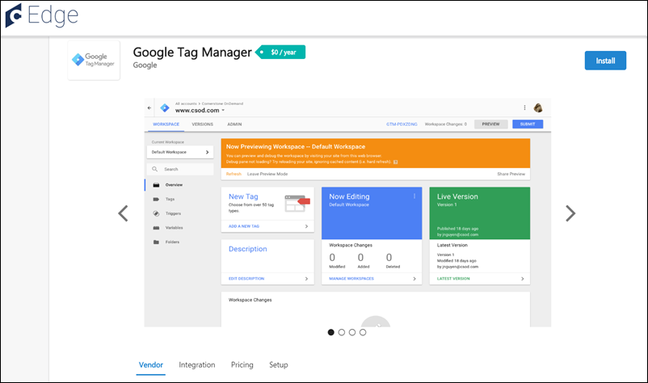
Permissions
The following existing permissions apply to this functionality:
PERMISSION NAME | PERMISSION DESCRIPTION | CATEGORY

Edge Integrations - Manage | Grants access to the Integrations service for Edge Integrate, where the administrator can configure, enable, and disable their third-party integrations used within the Cornerstone system. This permission cannot be constrained. This is an administrator permission. | Edge

Edge Marketplace - Manage | Grants access to the Marketplace service for Edge Integrate, where the administrator can browse integrations that can be used to extend the Cornerstone system. This permission cannot be constrained. This is an administrator permission. | Edge

User and OU Management Integrations - Overview
ADP Decidium Core Data Inbound Integration
The ADP Decidium Core Data Inbound Integration provides a one-way synchronization of users and organizational unit (OU) data from ADP Decidium to a Cornerstone portal.
The integration provides the following features:
- Facilitates User and OU sync from ADP to the Cornerstone portal by providing basic information
- Provides options to run on Full Sync or Delta Sync mode
- Supports sync of either User or OU or both
- User friendly OU mapping
- Email Notification with summary after the sync
How Does this Enhancement Benefit My Organization?
This integration provides centralized management of user and OU data in ADP Decidium to avoid redundant data entry work.
Implementation
This integration is available for self-activation.
- Only available in ADP French Marketplace.
- Only available in Edge Marketplace for FRA and EU swim lanes.
Enablement is a two-step process:
- Purchase the integration via the ADP French Referral Marketplace. This requires contacting ADP directly to purchase, install, and configure.
- Purchase, install, and configure the integration in Edge Marketplace via the ADP Decidium Core Data Inbound Integration tile.
ADP Link Core Data for ADP French Marketplace
The new ADP Link Core Data Inbound Integration for French Marketplace provides a one-way synchronization of users and organizational unit (OU) data from your ADP Link Portal to your Cornerstone Portal. Use this integration to synchronize data on a daily schedule or on-demand.
The following OU types are supported: Division, Cost Center, Location, Position
The following User fields are supported: User ID, Username, First Name, Middle Name, Last Name, Email, Phone, Country Code, Address Line 1, Postal Code, Last Hire Date, Original Hire Date, Manager, Division, Cost Center, Location, Position, Required Approval
How Does this Enhancement Benefit My Organization?
This integration enables organizations to eliminate duplicate data maintenance in ADP and Cornerstone portals.
Starter Guide
Click here to download the ADP Link Core Data Inbound Integration Starter Guide.
Considerations
Standard user and OU fields are synchronized, custom fields are not synchronized.
Implementation
Enablement for this integration is a two-step process:
- Purchase the integration via the ADP French referral Marketplace. This requires contacting ADP directly to purchase, install, and configure the integration.
- Purchase, install, and configure the integration in Edge Marketplace via the ADP Link Core Data Inbound Integration tile.
This integration is only available on the ADP French Marketplace to customers with the ADP Link Product.
This integration is only available in LHR, CDG, and FRA swim lanes.
The integration tile is expected to be available in the Edge Marketplace the week of May 16.
Permissions
The following existing permissions apply to this functionality:
PERMISSION NAME | PERMISSION DESCRIPTION | CATEGORY

Edge Integrations - Manage | Grants access to the Integrations service for Edge Integrate, where the administrator can configure, enable, and disable their third-party integrations used within the Cornerstone system. This permission cannot be constrained. This is an administrator permission. | Edge

Edge Marketplace - Manage | Grants access to the Marketplace service for Edge Integrate, where the administrator can browse integrations that can be used to extend the Cornerstone system. This permission cannot be constrained. This is an administrator permission. | Edge
Aquera Identity Directory Sync Bridge for Cornerstone OnDemand
The Aquera Identity Directory Sync Bridge for Cornerstone OnDemand imports and synchronizes the worker information in Cornerstone OnDemand with your identity access or governance platforms and directories. When used in conjunction with your Identity Platform (IDP), end-to-end IT automation of onboarding and offboarding of workers from downstream applications is now possible.
BambooHR User & OU Inbound Integration
The integration between Cornerstone CSX and BambooHR provides a seamless process of creating and updating users and organizational units in CSX. This is achieved through an automated data sync which simplifies data management and eliminates redundant work. BambooHR remains the system of record for user and OU data.
This is a one-way integration from BambooHR to CSX​. The integration runs nightly at a pre-defined schedule for both OU and user syncs and can also be triggered ad hoc. ​
Implementation
The BambooHR User & OU Inbound Integration tile is available in Edge Marketplace that allows customers to install, configure, and enable the integration.
Permissions
The following existing permissions apply to this functionality:
PERMISSION NAME | PERMISSION DESCRIPTION | CATEGORY

Edge Integrations - Manage | Grants access to the Integrations service for Edge Integrate, where the administrator can configure, enable, and disable their third-party integrations used within the Cornerstone system. This permission cannot be constrained. This is an administrator permission. | Edge

Edge Marketplace - Manage | Grants access to the Marketplace service for Edge Integrate, where the administrator can browse integrations that can be used to extend the Cornerstone system. This permission cannot be constrained. This is an administrator permission. | Edge
Banner Core Data Inbound Integration (Early Adopter)
Cornerstone integrates with the Ellucian Banner platform to provide a seamless process for creating and updating Users and OUs in Cornerstone. Banner will remain the system of record for User and OU data. This API based integration provides an automated data sync to simplify data management and eliminate duplicate data entry.
Clients can configure custom organizational unit (OU) mappings within the Edge Configuration page for the Banner Core Data Inbound Integration. As part of being able to map custom OUs, users tied to these OUs will also have their custom OUs populated, if applicable.
This functionality is currently an Early Adopter integration.
Implementation
This integration is available for self-Activation via the Banner Core Data Inbound Integration tile in Edge Marketplace. This integration is for organizations that use Banner HR as a source of HR data. Once the integration is available, please refer to the Banner Core Data Inbound Integration Starter Guide document under the Getting Started tab for details on how to enable the integration in your portal. There is an annual cost of USD $5,000 for this integration.
The following permissions apply to this functionality:
PERMISSION NAME | PERMISSION DESCRIPTION | CATEGORY

Edge Integrations - Manage | Grants access to the Integrations service for Edge Integrate, where the administrator can configure, enable, and disable their third-party integrations used within the Cornerstone system. This permission cannot be constrained. This is an administrator permission. | Edge

Edge Marketplace - Manage | Grants access to the Marketplace service for Edge Integrate, where the administrator can browse integrations that can be used to extend the Cornerstone system. This permission cannot be constrained. This is an administrator permission. | Edge
Ceridian Dayforce Core Data Inbound Integration
The Ceridian Dayforce Core Inbound Data Integration is a flexible unidirectional sync to load the user and organizational unit (OU) data from Dayforce to Cornerstone CSX portals. This integration provides access to real-time User and OU data in Cornerstone and Ceridian Dayforce. This integration can pave the way for upcoming solutions between Cornerstone and Ceridian Dayforce.
This integration includes the following features:
- Facilitates User and OU sync from Ceridian Dayforce to the Cornerstone CSX portal by providing configuration details
- Provides options to run on Full or Delta mode
- Supports sync of User, OU, or both
- User-friendly OU mapping
- Email notification with a summary after the sync
Frequently Asked Questions (FAQs)
Can the scheduled run time be modified? ​
The integration run time is currently not configurable.
I’ve copied the configurations from my Pilot environment. Why did the integration fail in production when it worked on the Pilot environment? ​
Each environment is assigned a unique “Username” and “Password.” Be sure to use the correct values.
How can I ensure no duplicate records are created in my Cornerstone portal? ​
The integration compares existing User and OU IDs in the Cornerstone portal with the Xrefcode ID in the Ceridian Dayforce portal to update records in Cornerstone. This prevents any duplicate records from being added.
Does the integration support future terminations? ​
The integration currently does not support future termination.
Implementation
Enablement is a two-step process:
- Customers should contact their Ceridian Dayforce team to enable the Cornerstone Data Connector on their Dayforce Portal. Customers should receive a client ID and client secret details from the Dayforce team to configure the Integration in their Cornerstone portal.
- Purchase the integration in Edge Marketplace in Cornerstone.
Cornerstone Learning Connector for ADP Workforce Now® Next Generation
The Cornerstone Learning Connector for ADP Workforce Now® Next Generation includes the following key features:
- Cornerstone Learning Connector for ADP Workforce Now Next Generation - This is a one-way integration that synchronizes user and organizational unit (OU) data from ADP Workforce Now Next Generation to CSX. The integration runs nightly at a pre-defined schedule for both OU and user syncs. Syncs can also be triggered ad hoc.
- Cornerstone Learning Single Sign-on for ADP Workforce Now Next Generation - This provides a unidirectional SSO from ADP Workforce Now Next Generation to CSX (deep link and mobile are not supported). SSO is available to all users.
Considerations
- The following ADP Workforce Now Next Generation implementations are not supported:
  - Employees that belong to multiple companies with different positions, locations, etc.
  - Employees that belong to multiple companies and have identical OU codes within the same OU type
- Additional exceptions will be documented in the starter guide
Implementation
These integrations are available for self-activation in the Edge Marketplace.
Two new tiles are available in Edge Marketplace that allow customers to install, configure, and enable the integration:
- Cornerstone Learning Connector for ADP Workforce Now Next Generation
- Cornerstone Learning Single Sign-on for ADP Workforce Now Next Generation
Both tiles must be installed on the Edge Marketplace to run the core data inbound and SSO integrations. Set-up details will be provided in the starter guide. Integrations are only available to customers in LAX swim lanes.
Enablement is a two-step process:
- Purchase the app on ADP Marketplace. The core data inbound and SSO integrations are bundled into one app on ADP Marketplace.
- Install the integrations on the Edge Marketplace. Integrations are only available to customers with an ADP Workforce Now Next Generation account. Those with a legacy ADP Workforce Now account are not able to purchase the app from ADP Marketplace.
Permissions
The following existing permissions apply to this functionality:
PERMISSION NAME | PERMISSION DESCRIPTION | CATEGORY

Edge Integrations - Manage | Grants access to the Integrations service for Edge Integrate, where the administrator can configure, enable, and disable their third-party integrations used within the Cornerstone system. This permission cannot be constrained. This is an administrator permission. | Edge

Edge Marketplace - Manage | Grants access to the Marketplace service for Edge Integrate, where the administrator can browse integrations that can be used to extend the Cornerstone system. This permission cannot be constrained. This is an administrator permission. | Edge
Cornerstone Learning Connector for ADP Workforce Now® (ADP Marketplace Canada)
The integration between Cornerstone CSX and ADP Workforce Now for the Canadian storefront provides a seamless process of creating and updating users and organizational units (OU) in Cornerstone CSX. This is achieved through an automated data sync which simplifies data management and eliminates redundant work. ADP Workforce Now remains the system of record for user and OU data.
Considerations
- This integration is available to organizations whose portals reside on the LAX or U.S. data center.
Implementation
This integration is only available for LAX U.S. Swimlanes.
This integration is available for self-activation via the Edge Marketplace for organizations with access to the Canadian ADP Marketplace.
Enablement involves two parts:
- Purchase on ADP Marketplace.
- Purchase on Edge Marketplace.
Security
The following existing permissions apply to this functionality:
PERMISSION NAME | PERMISSION DESCRIPTION | CATEGORY

Edge Integrations - Manage | Grants access to the Integrations service for Edge Integrate, where the administrator can configure, enable, and disable their third-party integrations used within the Cornerstone system. This permission cannot be constrained. This is an administrator permission. | Edge

Edge Marketplace - Manage | Grants access to the Marketplace service for Edge Integrate, where the administrator can browse integrations that can be used to extend the Cornerstone system. This permission cannot be constrained. This is an administrator permission. | Edge
Cornerstone Learning Connector for ADP Workforce Now® (ADP Marketplace U.S.)
For organizations using ADP Workforce Now as their system of record for Human Resources data, the Cornerstone Learning Connector for ADP Workforce Now® (ADP Marketplace U.S.) is a solution that allows management of employee and organizational unit (OU) data in Cornerstone CSX when there are changes to employee and OU records in ADP Workforce Now. This integration is hosted in Edge for a simple enablement experience that organizations can configure and manage. This is an API-based integration and does not require files to be exchanged between the two systems.
Considerations
- Data flow is unidirectional; new and updated user or OU records are transmitted from ADP Workforce Now to Cornerstone CSX.
- This integration does not support user or OU timezone data.
- The following ADP Workforce Now implementations are not supported:
  - Employees that belong to multiple companies with different positions, locations, etc.
  - Employees that belong to multiple companies that have identical OU codes within the same OU type.
Implementation
The Cornerstone Learning Connector for ADP Workforce Now® (ADP Marketplace U.S.) is available to try or to purchase via the Edge Marketplace. To access the Edge Marketplace, go to Admin > Tools > Edge > Marketplace.
This functionality is available to CSX portals that reside in the LAX or U.S. data center. Organizations must also have a ADP Workforce Now account.
Security
The following existing permissions apply to this functionality:
PERMISSION NAME | PERMISSION DESCRIPTION | CATEGORY

Edge Integrations - Manage | Grants access to the Integrations service for Edge Integrate, where the administrator can configure, enable, and disable their third-party integrations used within the Cornerstone system. This permission cannot be constrained. This is an administrator permission. | Edge

Edge Marketplace - Manage | Grants access to the Marketplace service for Edge Integrate, where the administrator can browse integrations that can be used to extend the Cornerstone system. This permission cannot be constrained. This is an administrator permission. | Edge
UKG Pro™ User & OU Data Inbound Integration
For organizations using UKG Pro™ as their system of record for Human Resources data, the Core Data Integration is a solution that allows management of employee and organizational unit (OU) data in Cornerstone when there are changes to employee and OU records in UKG Pro™. This integration, which previously existed outside of Edge, is now hosted in Edge for a simple enablement experience that organizations can configure and manage. This integration is API based and no longer require flat files.
The default language preference that is set in UKG Pro™ is passed to Cornerstone, which is used when a user is created in Cornerstone; if the user's language is later updated in Cornerstone, the default language does not overwrite the user's new language setting. If the UKG Pro™ default language preference is not available or enabled in Cornerstone, then the Cornerstone portal default language is used for the user.
Considerations
- Data is only sent from UKG Pro™ to Cornerstone. User record data and Organizational Unit (OU) data is not sent from Cornerstone to UKG Pro™ if users or OUs are updated or added in Cornerstone.
- OU and user data is synced from UKG Pro™ to Cornerstone nightly. OU data is synced from UKG Pro™ at 3:00 AM PST, and User data is synced at 4:00 AM PST.
- UKG's Employee APIs refresh every three hours. As a result, a force sync only syncs all users when the UKG API is refreshed with all changes.
- Only standard fields are sent from UKG Pro™ to Cornerstone. Custom fields are currently not supported.
- Timezone data is not sent from UKG Pro™ to Cornerstone for OUs or users. It must be configured as a system property.
- UKG Pro™ implementations that have multiple companies, positions, and locations are not supported by this integration.
- Any existing users and OUs that were created prior to enabling this integration would be updated by UKG Pro™ if they exist in UKG Pro™.
Implementation
The UKG Pro™ User & OU Data Inbound Integration is available to try or to purchase via the Edge Marketplace. To access the Edge Marketplace, go to Admin > Tools > Edge > Marketplace.
This functionality is available to all organizations. Organizations must also have an UKG Pro™ account.
Security
The following existing permissions apply to this functionality:
PERMISSION NAME | PERMISSION DESCRIPTION | CATEGORY

Edge Integrations - Manage | Grants access to the Integrations service for Edge Integrate, where the administrator can configure, enable, and disable their third-party integrations used within the Cornerstone system. This permission cannot be constrained. This is an administrator permission. | Edge

Edge Marketplace - Manage | Grants access to the Marketplace service for Edge Integrate, where the administrator can browse integrations that can be used to extend the Cornerstone system. This permission cannot be constrained. This is an administrator permission. | Edge

Universal Profile - User Record - View Users | Grants ability to view user records in the system. Administrators can view the Modification History page for user records within their constraints. The administrator must have additional permissions to view specific fields on the user record. This permission can be constrained by OU, User's OU, User's Self, User Self and Subordinates, and User. This is an administrator permission. | Core Administration
UKG Ready™ User & OU Data Inbound Integration
Cornerstone integrates with UKG Ready™ to provide a seamless process for creating and updating users and OUs in Cornerstone. This is achieved through an automated data sync which simplifies data management and eliminates redundant work. With this integration, UKG Ready™ remains the system of record for user and organizational unit (OU) data. This integration supports standard and custom fields.
Organizations can exclude users from being created/updated in their Cornerstone portal by specifying the exclusion criteria using user custom fields and OUs.
Organizations can also pass their UKG Jobs (HR) cost center data into Cornerstone. The Jobs (HR) cost center data is passed into Cornerstone as OU data.
- Jobs (HR) cost centers can be mapped to standard or custom OUs in Cornerstone.
- Jobs (HR) does not support parent-child relationships in UKG Ready™.
- If the Visible checkbox for the Jobs (HR) cost center is NOT selected, then the corresponding OU type in Cornerstone is deactivated.
Implementation
To enable the UKG Ready™ User & OU Data Inbound Integration, contact your Account Manager. This integration is for organizations that use UKG Ready™ as a source of HR data. Once the integration is available, please refer to the Integration Guide under the Getting Started tab for details on how to enable the integration in your portal. There is no additional cost for this integration.
The following permissions apply to this functionality:
PERMISSION NAME | PERMISSION DESCRIPTION | CATEGORY

Edge Integrations - Manage | Grants access to the Integrations service for Edge Integrate, where the administrator can configure, enable, and disable their third-party integrations used within the Cornerstone system. This permission cannot be constrained. This is an administrator permission. | Edge

Edge Marketplace - Manage | Grants access to the Marketplace service for Edge Integrate, where the administrator can browse integrations that can be used to extend the Cornerstone system. This permission cannot be constrained. This is an administrator permission. | Edge
Workday Core Data Inbound Integration
The Workday Core Data Inbound integration is for organizations using Workday as the source for their HCM data. This integration enables organizations to manage organizational units (OUs) and users in Workday, and have those changes flow into the Cornerstone system automatically. The inbound integration runs nightly (US-Pacific) and can be triggered on demand.
This integration includes the following functionality:
- One-way transfer of OUs and users from Workday to Cornerstone
- Ability to trigger the integration on-demand
- Map Workday Organization Types to Cornerstone Standard and Custom OUs
- Define the Workday Hierarchy to use for a Standard OU
- Deliver Summary Notification Emails to a subscribed list
- Differentiate between Contingent workers and Employees via Custom OU
- Use Workday's Eligibility Criteria to filter which user records are sent to the Cornerstone system
- Configure User Record custom text fields
- Populate user termination dates.
- Ability to select the name preference, Legal or Preferred, to populate in Cornerstone from Workday. Preferred name is the default value.
- Organizations have the option to override the pre-mapped configuration of first name, last name, and prefix. This is helpful for organizations that need to accommodate for family name prefix, such as organizations in Germany, Netherlands, and Belgium. This is also helpful for organizations using English and Chinese names.
- Allow contingent workers to sync into Cornerstone on their hire date or one week prior to their hire date, depending on the defined setup on the Settings page.
- Organizations have the option to sync organizational units (OUs) only, users only, or both OUs and Users.
The following validations are supported:
- The system validates Override Field Mapping and Custom Field Mapping configurations; if invalid data is detected, an error message is displayed upon saving the Settings page, and an email notification is sent.
- An email notification is sent when invalid OU configuration/settings are detected at start of OU sync run.
- If the User sync fails, the system automatically attempts to sync unprocessed user records in the next successful sync. This does not include user records that failed to sync due to a validation error, such as missing a required field.
How Does this Enhancement Benefit My Organization?
This integration provides seamless management of employee and organizational unit (OU) data in Cornerstone through Workday.
Implementation
It is recommended to implement the integration on your test environment prior to production environment.
The integration is available to install in the Edge Marketplace for a fee.
For organizations that are using the previously existing, legacy Workday Core Data Inbound integration, enablement information is available in the Resources section above.
For new integrations, this integration is available for self-activation via Edge Marketplace and Integrations. Organizations must have an existing contract with Workday. Starter Guides and Migration instructions are included with the integration in Edge Marketplace.
Security
The following existing permissions apply to this functionality:
PERMISSION NAME | PERMISSION DESCRIPTION | CATEGORY

Edge Integrations - Manage | Grants access to the Integrations service for Edge Integrate, where the administrator can configure, enable, and disable their third-party integrations used within the Cornerstone system. This permission cannot be constrained. This is an administrator permission. | Edge

Edge Marketplace - Manage | Grants access to the Marketplace service for Edge Integrate, where the administrator can browse integrations that can be used to extend the Cornerstone system. This permission cannot be constrained. This is an administrator permission. | Edge

Non-Edge Integrations
CSX and EdCast Skills Integration
Customers leveraging both CSX and EdCast can now have an integrated experience for skills with consistent skills libraries and the ability to modify user Skill Profiles in either platform, keeping both in sync.
With this integration, administrators no longer need to administer skills in CSX and EdCast separately. The CSX and EdCast integration simplifies the administrator and end-user experiences by synchronizing appropriate data between systems. This results in easier adoption, greater data integrity, and a consistent and intuitive user experience.
This integration provides the following features:
- One-way synchronization of skills from the CSX Capability Library to EdCast via Skills Studio
- Bi-directional sync of user-related skills data, such as declared and developing skills and self-ratings, between CSX and EdCast
Skill library synchronization includes the unique skill ID, title, description, created or modified user, date and time of creation or modification, source, localizations, status, and categories.
User profile synchronization includes the unique user ID, skill ID, and action (declared, developing, removed).
Skill rating synchronization consists of the user who received and shared the rating and the rating level.
Implementation
Existing customers leveraging CSX and EdCast can submit a case to customer support to enable the integration. Integrations for existing customers will be managed on a case-by-case basis. There may be added complexity if skills are already in use in both systems, especially if different skills taxonomies are enabled in each.
This integration is not available in stage portals.

Integrations for Cornerstone HR

Absence Management Integrations - Overview
e-days Absence Management Integration
For organizations using e-days for absence management, the Absence Management Integration allows organizations to provide a seamless experience to their employees via Single Sign-On (SSO). Users can log in to e-days and access and manage their absence balances from within their Cornerstone Universal Profile.
In addition, basic user and organizational unit (OU) information is synchronized from the Cornerstone HR system to e-days user profiles. When a new user or OU is added to the Cornerstone HR system, the user or OU will automatically be added to the organization's e-days system as well. When an existing user or OU is updated in the Cornerstone HR system, the user or OU is updated in the organization's e-days system.
This functionality is only available to organizations using Cornerstone HR.
Considerations
- Data is only sent from Cornerstone to e-days. User record data and OU data is not sent from e-days to Cornerstone if users or OUs are updated or added in e-days.
- Only active OUs and users are synced with e-days. Candidates and inactive users and OUs are not synced.
- OU data is only synced from Cornerstone HR to e-days if the integration is configured to do so and if the OU is active in the portal. In addition, the integration syncs with the portal's default culture.
- A user can only SSO in to e-days from their Universal Profile if their user record has already been established in e-days.
- The system begins syncing users after the integration is enabled.
e-days Absence Management Integration Enablement
To enable the e-days Absence Management integration:
- Log in to e-days and go to Admin > Users) to navigate to the Users page.
- Edit the Admin account.
- Select the Roles tab.
- In the Account Type field, select Api Client.
- Note the Client ID and Client Secret. These values will be needed when configuring the integration. Note: The Client Secret is displayed only once. If a new Client Secret is regenerated, the old one is no longer valid.
- Log in to your Cornerstone portal and go to(Admin > Tools > Edge > Marketplace) to navigate to Open the Edge Marketplace .
- Search for and install the e-days Absence Management Integration.
- Review the terms and agreements and select the checkbox.
- Select Install then select Configure Now. The Settings page opens.
- Go to Admin > Tools > Edge > Integrations to activate the integration via Edge Integrate.
- Complete the following fields:
  - Client ID - Enter your e-days Client ID. This is provided by your e-days implementation team.
  - Client Secret - Enter your e-days Client Secret. This is provided by your e-days implementation team.
  - e-days portal URL: e-days application URL.
  - e-days Assertion Consumer Service URL - This URL is required if using the IdP SSO functionality that comes with this integration. This endpoint will be provided by your e-days implementation team.
  - Third Party IdP - Enable the toggle switch if you are using a third party federated IdP SSO provider. Note: Enabling the toggle disables the IdP SSO functionality that comes with this integration.
  - If Third Party IdP is enabled, ID to use for SSO User ID - Allows you to define which Cornerstone user identifier should be passed to e-days if "Third Party IdP" is enabled in your portal. Options are User ID, Username, Email Address, and Cornerstone Internal User ID.
  - User Filter- Allows you to exclude users from being created/updated in e-days. To define the users to exclude from the sync, select the user custom field from the drop-down. If no selection is made, all users in your Cornerstone portal will be created/updated in e-days. Note the following:
    - The drop-down options only include active user custom fields of type checkbox. If made available, the user custom field checkbox is visible on the User Profile page.
    - If the checkbox is selected, the user is created/updated in e-days.
    - If the checkbox is NOT selected, the user will be excluded from the sync.
  - Notification email - Enter the email address(es) where error notifications should be sent. If entering multiple emails, separate each by a comma.
  - Standard OU Sync - Allows you to define which standard OUs will be created/updated in e-days as Group types. To add a standard OU, click on the + Add New Standard OU Sync button and select an OU from the Standard OU Type drop-down. The Comment field is optional. The list below is standard OUs supported with this integration:
    - Division
    - Position
    - Grade
    - Cost Center
    - Location
Note: A backend setting can be enabled to skip the auto setup of authorizers of the integration. This setting gives customers the option to bypass the auto setup step so administrators can log in to e-days and define the authorizers for their users. Open a Global Customer Support (GCS) case to enable the setting.
Manage Absences via e-days
When the e-days Absence Management integration is enabled for a portal, users can quickly log in to their e-days account from within Cornerstone.
To log in to e-days from the Cornerstone portal:
- Navigate to the Universal Profile.
- From the Options drop-down menu, select Absence Management (e-days).
The user's credentials are passed to e-days and the user is logged in to e-days without having to enter their username and password. There, the user can access and manage their absences within the e-days system.
User Sync with e-days
When the e-days Absence Management integration is enabled for a portal, basic user profile information is synchronized from the Cornerstone HR system to e-days user profiles. When a new user is added to the Cornerstone HR system, the user will automatically be added to the organization's e-days system as well. In addition, when an existing user is updated in the Cornerstone HR system, the user's profile is updated in the organization's e-days system.
To add a new user record, go to Admin > Tools > Core Functions > Users. Then, select the Add User link.
Edit a user's user record in one of the following ways:
- Go to Admin > Tools > Core Functions > Users and select the name of the appropriate user.
- Navigate to the user's Universal Profile. Select the User Record tab from the Universal Profile navigation. Then, select the Edit Record button.
User Sync Fields
The following user fields are synced from Cornerstone to e-days:
- First Name
- Last Name
- Email
- Last Hire Date
- Active Status
- User's manager (as Authoriser in e-days)
- User ID
Please note the following:
- User custom fields are not sent over to e-days as part of this integration. This includes user custom fields created for Rota, Work Schedule, and FTE.
- User is placed into the appropriate Division, Position, Grade, Cost Center, and Location organizational units (OU) (Group in e-days). This is true only if the OU type is active AND configured to sync on the Settings page.
- The employee's manager is set as the Authoriser in e-days.
- e-days does not support multiple names/value for different cultures. As part of the integration, Cornerstone will only send names/values based on the portal's default culture.
OU Sync with e-days
When the e-days Absence Management integration is enabled for a portal, basic OU information is synchronized from the Cornerstone HR system to e-days group. When a new OU is added to the Cornerstone HR system, the OU will automatically be added as a group to the organization's e-days system as well. In addition, when an existing OU is updated in the Cornerstone HR system, the OU is updated as a group in the organization's e-days system.
The integration supports both standard and custom OUs. Cornerstone OUs are created as Groups in e-days. The list below shows standard OUs created in e-days:
- Division
- Position
- Grade
- Cost Center
- Location
To create an OU:
- Go to Admin > Tools > Core Functions > Organizational Units.
- Click the Manage Organizational Unit Hierarchy link.
- Select the appropriate OU type from the Select Organizational Unit drop-down list.
- Click the Add [OU] link (e.g., Add Division, Add Position, Add Location).
  - Custom OU Sync: This table allows you to define which custom OUs are created/updated in e-days as Group types.
- To add a custom OU, click the + Add New Custom OU Sync button and select an OU from the Custom OU Type drop-down. The Comment field is optional.
OU Sync Fields
The following OU fields are synced from Cornerstone to e-days:
Cornerstone Field
OU ID
OU Name
OU Creation/Modification
Sync Error Handling
If the e-days Absence Management integration is enabled and an error occurs when the Cornerstone HR system submits a user record or OU to the e-days system for synchronization, the Cornerstone HR system generates an email to the e-days integration email address. This email contains the error messages that were indicated by e-days. The email address to which these error emails are sent is the email address that is configured to receive notification messages in the event of sync failures.
One failure notification email is generated for each user record or OU that fails to sync.
Implementation
The e-days integration is available to try or purchase via the Edge Marketplace. During this process, the administrator must provide their pre-existing e-days account credentials. To access the Edge Marketplace, go to Admin > Tools > Edge > Marketplace.
This integration is only available to organizations using Cornerstone HR. Organizations must also have an e-days account.
Permissions
The following permissions apply to this functionality:
PERMISSION NAME | PERMISSION DESCRIPTION | CATEGORY

Edge Integrations - Manage | Grants access to the Integrations service for Edge Integrate, where the administrator can configure, enable, and disable their third-party integrations used within the Cornerstone system. This permission cannot be constrained. This is an administrator permission. | Edge

Edge Marketplace - Manage | Grants access to the Marketplace service for Edge Integrate, where the administrator can browse integrations that can be used to extend the Cornerstone system. This permission cannot be constrained. This is an administrator permission. | Edge

Employee Data Integrations - Overview
Employee Record Change Outbound Feed
An Employee Record Change Outbound Feed integration is available in the Edge Marketplace. Once this feed is enabled, administrators can schedule a daily outbound feed of all changes made to the employee master data in the last 24 hours when Cornerstone is the system of record. Feeds are available in the CSV - comma and pipe delimited formats.
Install Feed
To access the Employee Record Change Outbound Feed tile, go to ADMIN > TOOLS > EDGE > MARKETPLACE and search for "Employee Record Change Outbound Feed". Click the tile, and then click Install.
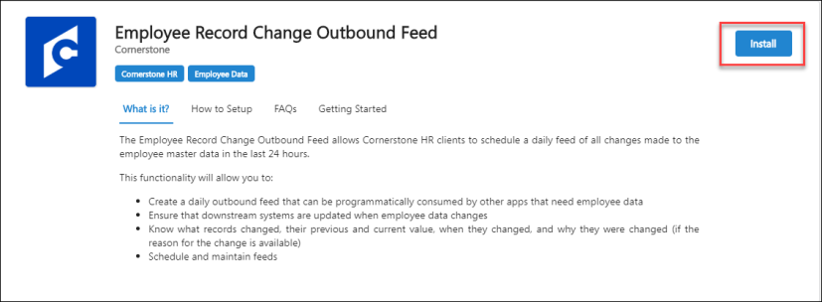
Once installed, the Edge Integrations page opens so that you can select the settings for your outbound feed. For specific information about each field, click Setup Instructions. Once you are done, click Save Settings. Your outbound feed will run at the scheduled time.
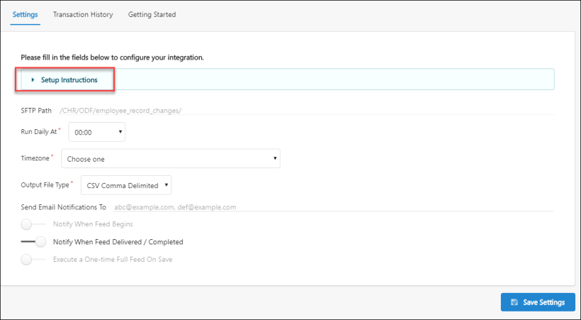
This integration includes the following functionality:
- Daily feeds can only run once a day.
- The first time you run the Employee Record Change Outbound Feed, the file includes all audit records from the last time Effective Dating was enabled. Subsequent runs include all audit records created after the last run, including future dated records and current changes.
- The feed contains 2 types of data files, modification_history and completed_scheduled changes. The Modification history includes all changes made to the employee record including schedule future changes. The completed_scheduled_changes file contains a list of scheduled changes completed since the last feed was delivered.
- Data files can contain up to 1 million rows each, and any data that is over this limit will result in an additional file being added. For example, if the feed file has 2 million rows, 2 files will be created. The files will be named numerically starting at 1, for example for a .csv feed, files are named modification_history_1.csv and modification_history_2.csv. The size of the feed determines how long it takes to complete.
- Data and metadata files are processed and packaged in a zip file that also includes the metadata read.me file and the schema file.
- Feeds are stored in a Cornerstone FTP folder based on the type of feed. Your scheduled daily feeds are delivered to the "/CHR/ODF/employee_record_changes/scheduled" folder. The optional one-time full feeds are delivered to the "/CHR/ODF/employee_record_changes/ondemand" folder. To access the files, users need valid credentials and permission, and an FTP viewer, such as Filezilla. Files are retained for a maximum of 21 days before they are automatically removed from the FTP folder.
- The data feed is limited to employee user records. All Standard Identifiable Information fields (i.e. date of birth, SSN) are excluded from the feed.
- The table header for the data feed output file is not localized. The localized values and details are provided in an accompanying file.
- If multiple administrators make changes to the configuration page, only the latest changes are observed.
- An administrator can run a one-time full feed on-demand. A full feed may be necessary to sync changes, or to add a new application that requires employee data.
Stop or Pause a Feed
If you need to stop or pause a feed, go to ADMIN > TOOLS > EDGE > Integration, locate "Employee Record Change Outbound Feed", and toggle the on/off button.
How Does This Enhancement Benefit My Organization?
This integration allows Cornerstone HR clients to effortlessly update downstream systems when employee data changes, eliminating the need to run and export multiple reports or manually import changes.
Implementation
- This functionality is available for all CHR clients who have access to the Edge Marketplace. Enable the data feed in the Edge Marketplace and configure and manage the feed in the Edge Integration Center.
- It is recommended that you implement this integration in your test environment before you implement it in your production environment.
Permissions
The following existing permissions apply to this functionality:
PERMISSION NAME | PERMISSION DESCRIPTION | CATEGORY

Edge Marketplace - Manage | Grants access to the Marketplace service for Edge Integrate, where the administrator can browse integrations that can be used to extend the Cornerstone system. This permission cannot be constrained. This is an administrator permission. | Edge

Edge Integrations - Manage | Grants access to the Integrations service for Edge Integrate, where the administrator can configure, enable, and disable their third-party integrations used within the Cornerstone system. This permission cannot be constrained. This is an administrator permission. | Edge

Users – Effective Dating: Manage | Enables administrator to make effective dated changes to the user record. This permission only works when used in conjunction with the Users - Edit General Information permission. This permission cannot be constrained. This is an administrator permission. | Core Administration

Time & Attendance Integrations - Overview
UKG Ready™ Time & Attendance Integration
The UKG Ready™ Time & Attendance Integration integration allows organizations to provide a seamless experience to their employees via Single Sign-On (SSO). Simply setup an outbound data feed from your Cornerstone portal to UKG Ready™ and enable this integration to allow your employees to log in to UKG Ready™ and access their time and attendance information from within their Cornerstone Universal Profile.
In addition, basic user profile information and organizational unit (OU) data is synchronized from the Cornerstone HR system to UKG Ready™. When a new user or OU is added to the Cornerstone HR system, the user or OU is automatically be added to the organization's UKG Ready™ system as well. In addition, when an existing OU or user is updated in the Cornerstone HR system, the OU or user's profile is updated in the organization's UKG Ready™ system.
This functionality is only available to organizations using Cornerstone HR.
User Sync Field Mapping
The following fields are synced from Cornerstone to UKG Ready™:
Cornerstone Field | UKG Ready™ Field
Username | Username (required)
User ID | Employee ID
GUID | External ID
First Name | First Name (required)
Middle Name | Middle Name
Last Name | Last Name (required)
SSN | SSN
Email | Primary Email
Home Phone | Home Phone
Country | Country
Address Line 1 | Address Line 1
Address Line 2 | Address Line 2
City | City
State | State
Zip Code | Postal Code
Last Hire Date | Date Hired (required)
Division | Cost Center Trees (mapping based on value provided in integration setup)
Position | Cost Center Trees (mapping based on value provided in integration setup)
Cost Center | Cost Center Trees (mapping based on value provided in integration setup)
Grade | Cost Center Trees (mapping based on value provided in integration setup)
Location | Cost Center Trees (mapping based on value provided in integration setup)
Manager ID | Manager Information (mapping based on value provided in integration setup)
Considerations
- The integration does not sync from UKG Ready™ to Cornerstone HR, meaning that if a user is added or updated in UKG Ready™, these users are not added or updated in Cornerstone HR.
- The system begins syncing OUs and users after the integration is enabled. Any existing Cornerstone HR users must be added in bulk via the UKG Ready™ solution. User data sync between UKG Ready™ and Cornerstone is not real-time because it uses the outbound or inbound data feed.
- Cornerstone HR does not share any Sensitive Personally Identifiable Information (SPII) with UKG Ready™. Sensitive Personally Identifiable Information (SPII) fields cannot be included in a data load feed. Only manual data loads are supported.
- User record custom fields in Cornerstone cannot be shared with UKG Ready™ with this integration.
- Custom fields on the OU are not currently shared with UKG Ready™.
- Custom OUs are not currently shared with UKG Ready™.
Implementation
To enable the UKG Ready™ Time & Attendance Integration, contact your Account Manager. During the configuration process, the administrator must provide their pre-existing UKG Ready™ account credentials. To access the Edge Marketplace, go to Admin > Tools > Edge > Marketplace.
This integration is only available to organizations using Cornerstone HR. Organizations must also have a UKG Ready™ account. Also, this integration requires that organizations have purchased and configured an outbound or inbound data feed. In order to purchase a data feed, please contact your Sales or Client Executive.
Security
The following existing permissions apply to this functionality:
PERMISSION NAME | PERMISSION DESCRIPTION | CATEGORY

Edge Integrations - Manage | Grants access to the Integrations service for Edge Integrate, where the administrator can configure, enable, and disable their third-party integrations used within the Cornerstone system. This permission cannot be constrained. This is an administrator permission. | Edge

Edge Marketplace - Manage | Grants access to the Marketplace service for Edge Integrate, where the administrator can browse integrations that can be used to extend the Cornerstone system. This permission cannot be constrained. This is an administrator permission. | Edge

Integrations for Learning Overview

Content (non-CCA) Integrations - Overview
To enable a Content Provider integration listed below, please reach out to your Account Manager and complete a signed Order Form. 1:1 Online Content integrations are currently available for the following providers:
- GetAbstract
- GLOBIS
- Teach on Mars
- Udemy for Business
Cornerstone for Salesforce Integration
The Cornerstone for Salesforce (CFS) integration is available in the Edge Marketplace. Once this integration is enabled, learners are empowered to interact with content within their flow-of-work by seamlessly surfacing Learner Home content in Salesforce. Administrators can add Cornerstone transcripts, learning carousels, and search components to any Force.com page or use the out-of-the box CFS Learner Home page. End users can view their full transcript, learning carousels and followed playlists. Additionally, end users can search for, launch, and complete learning, - all without leaving Salesforce.
Note: CFS is only available on the Salesforce Lightning platform.
Permissions
PERMISSION NAME | PERMISSION DESCRIPTION | CATEGORY

Learner Home | Grants access to the Learner Home and the Learning Search page. This is an end user permission. This permission cannot be constrained. | Learning

Edge Marketplace - Manage | Grants access to the Marketplace service for Edge Integrate, where the administrator can browse integrations that can be used to extend the Cornerstone system. This permission cannot be constrained. This is an administrator permission. | Edge

Edge Integrations - Manage | Grants access to the Integrations service for Edge Integrate, where the administrator can configure, enable, and disable their third-party integrations used within the Cornerstone system. This permission cannot be constrained. This is an administrator permission. | Edge

Access Partner Authorization - Manage | Grants ability to manage partner authorized access to portal via Partner Access Administration. This permission cannot be constrained. This is an administrator permission. | Core Administration

Note: To view CFS components, users need the Cornerstone User permission. To manage CFS components, users need Cornerstone Admin permission. You assign these permissions in Salesforce.
Install and Configure CFS
Install and configure CFS in the Edge Marketplace. To access the CFS Edge tile, go to ADMIN > TOOLS > EDGE > MARKETPLACE. Search for "Cornerstone for Salesforce", click the tile, and then click the Getting Started link for installation and configuration instructions.
Administrators can use the Lightning App Builder in Salesforce to add transcript, carousel, and search components to any page on Force.com. You can also move components around and delete them. Once the page configuration is done, activate the page so that users can access it.
Open the Lightning App Builder
- In Salesforce, click Setup. In the Quick Find box, type Lightning App Builder, and then click Lightning App Builder in the results. The Lightning App Builder page opens.
- In the Lightning App Builder, select one of the following options:
  - Create a new page - To create a new page, click New, select a page type and click Next. Enter a Label, select an Object (if visible) and click the Next button. Select a page format, and then click finish Note: If you are creating a new Home Page, for best results use the Console: Pinned Header and Left Sidebar (3 regions) or Console: Pinned Left Sidebar (3 regions)page template.
  - Edit an existing page - To modify an existing CFS home page, click Edit for the appropriate page.
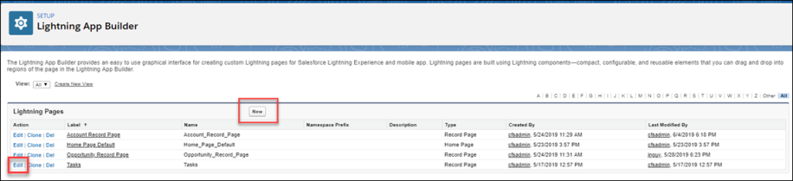
The Lightning Components page opens.
Add Components - Drag and Drop
Drag and drop CFS components onto any Force.com page to customize the end user's learner experience. You can also delete and move components. See Delete or Move a CFS Component on page 75 for additional information.
In the Lightning App Builder, in the left pane, select a CFS component and drag and drop it into a designated area.
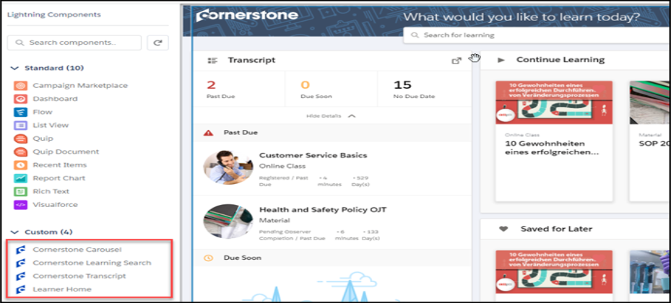
Cornerstone Carousel
Use the Cornerstone Carousel component to add a carousel to the Learner Home page. You can drag, drop, move, delete, and rename the Cornerstone Carousel.
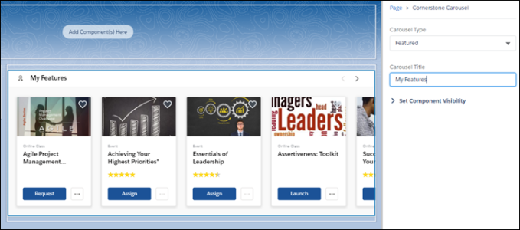
- Carousel Type - Select the type of carousel you want to create. Options are:
  - Subjects
  - Position
  - Popularity
  - Saved For Later
  - Continue Learning
  - Featured
  - Suggested
  - Required
  - Playlists
  - Followed Playlists
- Carousel Title - Enter the name for this carousel.
Cornerstone Learning Search
Use the Cornerstone Learning Search component to add the search feature to the Learner Home page. You can drag and drop, move and delete this component.
Note: You cannot rename this component in the Lightning App Builder.
Cornerstone Transcript
Use the Cornerstone Transcript component to add a Transcript section to the Learner Home page. You can drag and drop, move, delete and set the collapse option for this component. If you select Collapsed by Default, users see only the basic transcript information until they click Show Details. If you uncheck Collapsed by Default, users see full transcript details by default under the transcript box. You cannot rename this component in the Lightning App Builder. Note: For best results, we recommend that you use the smaller component box for the transcript component.
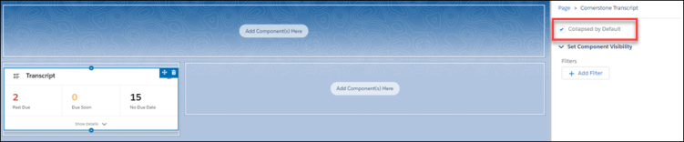
Learner Home
Use the Learner Home component to create a home page on a blank Force.com page. This is an out-of-the-box page that is not configurable and displays the users current Cornerstone Learner Home page.
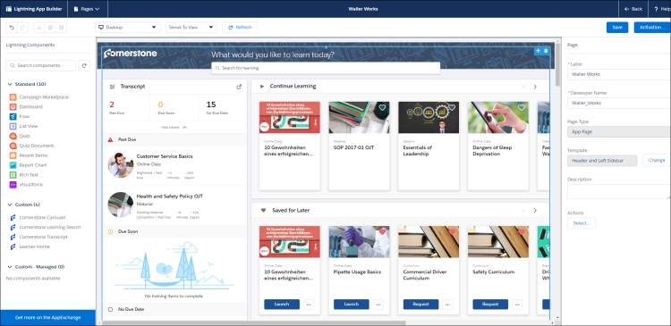
Save
Click Save to save your changes.
Activate
Click Activate to activate this page. Only active pages are available to users.

Activate and Assign Home Pages
Once the page is configured, administrators can activate a page and select it as the organizational default, set it for specific Lightning apps, or set it for different user profiles when using particular apps.
- On the completed home page, click the Activation button. The Activation page opens.
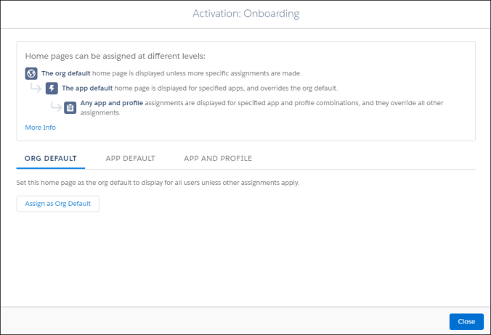
- Select one of the following options:
- Set the organizational default home page - Click Org Default, and then click the Assign as Org Default button. On the Set as Org Default page, review the selected options.
- Set a home page as the default for specific Lightning apps - Click App Default, and then click the Assign to Apps button. On the Select Apps page, check all of the Lightning apps that will have access to this page. On the Review Assignments page, review the selected options.
- Set a home page for selected user profiles for specific apps - Click App and Profile, and then click the Assign to Apps and Profiles button. On the Select Apps page, check the appropriate apps and click the Next button. On the Select Profiles page, check the profiles that will display the selected home page. On the Review Assignments page, review the selected options.
- Click the Save button. Based on their permissions and the selected options, users will see the appropriate learning home page.
Delete or Move a CFS Component
- To delete a component, hover over the upper right corner of the appropriate component and click the delete option. The component is removed from the page.
- To move a component, hover over the upper right-corner of the appropriate component, click the move icon and drag and drop the component to the new location.
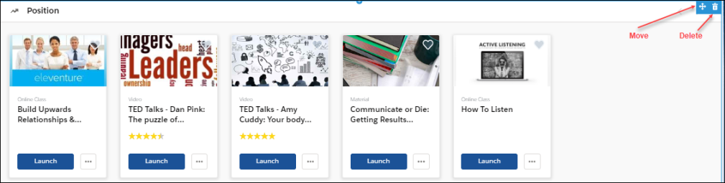
View the End-User Home Page
Once the Learner Home content is configured, end users can view and manage their learning options in Salesforce.
Users can perform the following tasks for each component:
- Transcript  - View the number of items in the user transcript.  - Click on any transcript item to view its details.  - If not visible by default, click View Details to view full transcript details and launch training. | 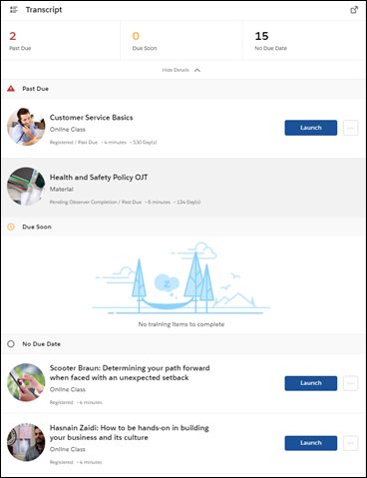
- Carousels  - Launch, request, and assign learning. Mark as a favorite by clicking the heart. Favorites appear in the Saved for Later carousel.  - Hover over a carousel item to view quick details and launch or assign training. | 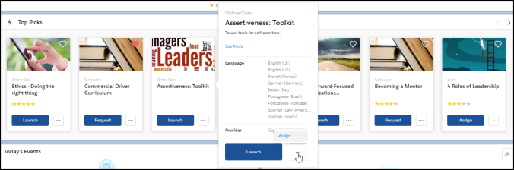
- Search bar  - Search for training by typing in search bar.  - While typing into search bar, relevant suggestions display (up to 10 suggestions).  - Click Enter or Search to open a page that displays all search results | 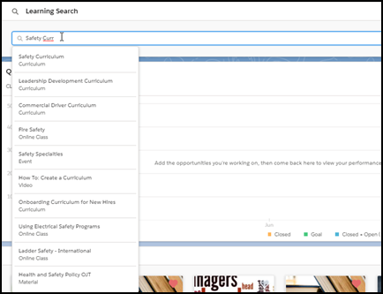
Coursera for Business Integration - Overview
The Cornerstone OnDemand and Coursera for business integration enables organizations to manage their Coursera content within the Cornerstone Learning Management System (LMS). With this integration, Coursera courses can be automatically synchronized to the LMS catalog, where they can be managed like other system training types.
The Coursera integration provides access to the following functionality:
- Catalog Synchronization
  - Automatic daily synchronization of content from Coursera to the Learning Management System catalog (Coursera content is classified as online content in the catalog)
  - The synchronization captures all purchased content from Coursera
  - Synchronized content added to the catalog with a Provider of Coursera
  - Loaded Coursera content is mobile-ready
  - Administrators can manage loaded Coursera content in the same manner they manage other training in the Learning Management System (e.g., set availability, set keywords, add to a curriculum, assign training to a learner)
- Content Launching
  - When a learner launches Coursera content from the Learning Management System, they are redirected to a Coursera pop-up window to complete the training, and no login is required
  - The learner’s training progress is recorded on their transcript page in the Learning Management System
- Report Completion
  - The learner’s training progress is recorded on their transcript page in the Learning Management System
- Single Sign-On (SSO)
  - The integration supports SMAL SSO implementation (IDP). No additional integration is required to enable the Cornerstone and Coursera for Business integration.
Considerations
The following considerations apply to this enhancement:
- Content disablement is required if your Learning Management System contains existing Coursera content.
- This integration is NOT a data-feed based integration.
- If your organization has an existing integration with Coursera and would like to enable the new integration, contact both Cornerstone Global Customer Support and the Coursera team to disable the existing integration.
Training Launched from Integrated Provider's Site
Progress data for externally launched content is supported by the Cornerstone Connector that is utilised by edX for this integration, but as it stands this feature is not implemented by edX, and therefore it is not supported by the "edX for Business" integration.
- Only the following two training statuses are supported by this behavior:
  - In Progress
  - Completed
- A Completed status cannot be reverted back to an In Progress status. Any progress data communicated after the online content completion will update all values except completion status and completion date.
Implementation
For organizations using the Learning module, this integration can be self-enabled via the Edge Marketplace. The Cornerstone OnDemand and Coursera for Business integration is available for a cost. Please contact your Account Manager for additional information.
Permissions
The following existing permissions apply to this functionality:
PERMISSION NAME | PERMISSION DESCRIPTION | CATEGORY

Course Catalog - Update | Grants ability to manage and edit training items listed in the Course Catalog and also grants access to the Course Console, where training can also be managed and edited. This permission also grants access to the Popular Requests and Highest Rated widgets on the Learning Admin Console (in conjunction with the Learning Admin Console - View permission). This permission also allows administrators to reversion online courses via the Course Console page. This permission also allows administrators to access an Edit Training option for training items included as objectives in Development plans.  This permission can be constrained by OU, User's OU, Training Type, Training Item, Provider, ILT Provider, User's ILT Provider, User, User Self and Subordinates, and User's LO Availability. This is an administrator permission.  Note: Adding an OU constraint and a provider constraint to this permission results in an "AND" statement. | Learning - Administration

Edge Integrations - Manage | Grants access to the Integrations service for Edge Integrate, where the administrator can configure, enable, and disable their third-party integrations used within the Cornerstone system. This permission cannot be constrained. This is an administrator permission. | Edge

Edge Marketplace - Manage | Grants access to the Marketplace service for Edge Integrate, where the administrator can browse integrations that can be used to extend the Cornerstone system. This permission cannot be constrained. This is an administrator permission. | Edge
Cornerstone OnDemand and Coursera for Business Integration - Configure in Edge
The Cornerstone OnDemand and Coursera for Business integration can be enabled via the Edge Marketplace and configured using Edge Integrations.
To access the Edge Marketplace, go to: Admin > Tools > Edge and click the Marketplace link.
Permissions
PERMISSION NAME | PERMISSION DESCRIPTION | CATEGORY

Edge Integrations - Manage | Grants access to the Integrations service for Edge Integrate, where the administrator can configure, enable, and disable their third-party integrations used within the Cornerstone system. This permission cannot be constrained. This is an administrator permission. | Edge

Edge Marketplace - Manage | Grants access to the Marketplace service for Edge Integrate, where the administrator can browse integrations that can be used to extend the Cornerstone system. This permission cannot be constrained. This is an administrator permission. | Edge
Coursera Integration - Edge Marketplace
In the Edge Marketplace, you can find the Coursera integration by searching or browsing. To learn more about the Coursera integration or begin the enablement and configuration process, click the Coursera integration tile.
The page for the Coursera integration provides access to the following tabs for learning more about and managing the integration:
- Vendor - This tab provides information about the vendor that provides the integration. Here, you can view more information about Coursera.
- Integration - This tab provides information about the integration itself and how it can be used with the learning management system (LMS).
- Pricing - This tab provides information about the costs associated with the integration. Note: The Coursera integration has an annual cost.
- Setup - This tab provides information about how to configure the integration once enabled. The integration can be configured via Edge Integrations.
Coursera Integration - Edge Integrations
Once the Coursera integration has been added through the Edge Marketplace, the integration can be managed and configured from Edge Integrations. The Integrations page for the integration provides access to setup options which the administrator can use to customize the behavior of the Coursera integration. See the Setup tab for the Coursera integration in the Edge Marketplace for more information about the configuration options available.
Coursera - Catalog Synchronization
The Learning Management System (LMS) course catalog is synchronized on a daily basis. New courses and course updates are communicated from Coursera to the Learning Management System using oAuth 2.0 as the authentication protocol. Coursera courses are available within 24 hours of enabling the integration, and are classified as online content in the Learning Management System.
Content delivered to the system via the Coursera integration is categorized as the online content training type. Because online content is updated via automatic synchronization, any manual changes made to online content metadata may be overridden in the Course Catalog and Course Console. For more information about how the online content training type behaves in the Course Catalog and Course Console, see the following:
- See Course Catalog - Online Content.
- See Course Console - Online Content.
Note: Only purchased courses are synchronized to the Learning Management System catalog.
Note: All courses are automatically defined as available for mobile consumption and can be used on the Cornerstone Learn app.
Permissions
PERMISSION NAME | PERMISSION DESCRIPTION | CATEGORY

Course Catalog - Update | Grants ability to manage and edit training items listed in the Course Catalog and also grants access to the Course Console, where training can also be managed and edited. This permission also grants access to the Popular Requests and Highest Rated widgets on the Learning Admin Console (in conjunction with the Learning Admin Console - View permission). This permission also allows administrators to reversion online courses via the Course Console page. This permission also allows administrators to access an Edit Training option for training items included as objectives in Development plans.  This permission can be constrained by OU, User's OU, Training Type, Training Item, Provider, ILT Provider, User's ILT Provider, User, User Self and Subordinates, and User's LO Availability. This is an administrator permission.  Note: Adding an OU constraint and a provider constraint to this permission results in an "AND" statement. | Learning - Administration
Training Data
The Cornerstone OnDemand and Coursera for Business integration can communicate the following metadata fields to the Learning Management System catalog:
Field | Description
ID | The unique ID of the course
Title | The course title
URL | The course URL (used to redirect users to the provider’s course)
IsActive | Specifies whether the course is available in the Coursera catalog. When a course is no longer available, it is defined as inactive in the Learning Management System catalog
Description | The description of the course
Thumbnail | The course thumbnail image
Languages | The list of available languages for the course
LastModifiedUTC | The time of the last modification made to a course (UTC)
Duration | The course duration
Subjects | The list of subjects, mapped to the Learning Management System subject taxonomy
Subjects Mapping
Coursera’s subjects are mapped to Cornerstone’s Subject Taxonomy. See the table below for the list of subjects communicated to the Learning Management System catalog as part of the integration.
Subject | Coursera Domains
Business Skills | Business
Technology | Computer-science, Data-science, Information-technology, Physical-science-and-engineering
Continuing Education & Certifications | Language-learning, Social-sciences, Math-and-logic
Health & Wellness | Life-sciences
Personal Development | Personal-development
Creative | Arts-and-humanities
View Courses Loaded to the Course Catalog
To view courses which have been loaded to the Course Catalog using the integration:
- Navigate to Admin > Tools > Learning > Catalog Management and click the Course Catalog link.
- Click the Refine your search link on the Course Catalog search page.
- Click the Provider filter and choose the Coursera provider as the filter.
- Click the Search button. The courses that are returned in the search are courses that were loaded via the integration.
Learner Progress Data
When a learner completes a training item, their training completion is automatically recorded on their Learning Management System transcript. Training progress data is communicated by the User Progress API, protected by the oAuth 2.0 protocol.
The following data is communicated to Coursera when learners launch Coursera courses:
Parameter | Description
userGuid | The user’s identifier in the Learning Management System
sessionToken | The current session token that is used to authenticate the call to the Learning Management System when Basic Access Authentication is used
callbackUrl | The Progress API callback path
subdomain | Cornerstone’s portal name. Example: company.csod.com
registrationNumber | The current user registration number
The following data is communicated back from Coursera:
JSON Value | Description
userGuid | The userGuid the Learning Management System communicated when launching the course
courseId | The unique ID of the course
status | Shows whether the course is in a status of In Progress or Completed
userScore | Shows the course score between 0 and 100
totalTime | The total time the user spent viewing the course (HHHH:MM:SS)
timesAccessed | The number of times accessed (total). Minimum value: 1
completionDate | The date and time the course was completed
lastTimeAccessed | The last date and time the user accessed the course
successStatus | Indicates whether the user passed or failed the course
bookmark | The last location the user reached in the content file
suspendData | Additional user experience data
progress | The percentage of a course the user completed (integer between 0 and 100)
registrationDate | The date and time the user was registered for the course
Online content metadata can be edited via the Course Catalog. The following fields may be overridden when Coursera sends course updates:
- Course Title
- Course Description
- Duration
- Available Languages
- Thumbnail
- Subjects (Only Coursera subjects are overridden. Subjects added by the administrator are not affected)
Considerations
- Only courses launched from the Learning Management System can be tracked by the integration.
- Custom fields are defined with an empty value for Coursera courses.
- A notification appears at the top of Coursera courses on the Course Console page, alerting the administrator that it is external content which may be updated via automatic synchronization, and manual changes may be overridden.
- The Active button is disabled for Coursera courses and can be only edited by Coursera via catalog synchronization
- This integration supports SMAL SSO implementation (IDP). No additional integration is required to enable the Cornerstone and Coursera for Business integration, because the following process is implemented:
  - Security Assertion Markup Language (SAML) metadata is exchanged and set up in advance to establish the trust relationship between the Learning Management System and Coursera.
  - The learner launches the course from their Learning Management System portal.
  - The learner is then redirected to either the course URL or the Learning Management System’s outbound SSO endpoint.
edX for Business Integration - Overview
The Cornerstone on Demand (CSOD) and edX for Business integration enables organizations to manage their edX content within the Cornerstone learning management system (LMS). With this integration, edX courses can be automatically synchronized to the LMS catalog, where they can be managed like other system training types.
The edX integration provides access to the following functionality:
- Catalog Synchronization
  - Automatic daily synchronization of content from edX to the LMS catalog (edX content is classified as online content in the catalog)
  - The synchronization captures all purchased content from edX
  - Synchronized content added to the catalog with a Provider of edX
  - Loaded edX content is mobile-ready
  - Administrators can manage loaded edX content in the same manner they manage other training in the LMS (e.g. set availability, set keywords, add to a curriculum, assign training to a learner)
- Content Launching
  - When a learner launches edX content from the LMS, they are redirected to an edX pop-up window to complete the training, and no login is required
  - The learner’s training progress is recorded on the their transcript page in the LMS
- Report Completion
  - The learner’s training progress is recorded on the their transcript page in the LMS
- Single Sign-On (SSO)
  - The integration supports SMAL SSO implementation (IDP). No additional integration is required to enable the Cornerstone and edX for Business integration
Considerations
The following considerations apply to this enhancement:
- Content disablement is required if your LMS contains existing edX content.
- This integration is NOT a data-feed based integration.
- If your organization has an existing integration with edX and would like to enable the new integration, contact both Cornerstone Global Customer Support and the edX team to disable the existing integration.
Training Launched from Integrated Provider's Site
Progress data for externally launched content is supported by the Cornerstone Connector that is utilised by edX for this integration, but as it stands this feature is not implemented by edX, and therefore it is not supported by the "edX for Business" integration.
- Only the following two training statuses are supported by this behavior:
  - In Progress
  - Completed
- A Completed status cannot be reverted back to an In Progress status. Any progress data communicated after the online content completion will update all values except completion status and completion date.
Implementation
For organizations using the Learning module, this integration can be self-enabled via the Edge Marketplace. The Cornerstone OnDemand edX for Business integration costs $5000 per year.
Permissions
The following existing permissions apply to this functionality:
PERMISSION NAME | PERMISSION DESCRIPTION | CATEGORY

Course Catalog - Update | Grants ability to manage and edit training items listed in the Course Catalog and also grants access to the Course Console, where training can also be managed and edited. This permission also grants access to the Popular Requests and Highest Rated widgets on the Learning Admin Console (in conjunction with the Learning Admin Console - View permission). This permission also allows administrators to reversion online courses via the Course Console page. This permission also allows administrators to access an Edit Training option for training items included as objectives in Development plans.  This permission can be constrained by OU, User's OU, Training Type, Training Item, Provider, ILT Provider, User's ILT Provider, User, User Self and Subordinates, and User's LO Availability. This is an administrator permission.  Note: Adding an OU constraint and a provider constraint to this permission results in an "AND" statement. | Learning - Administration

Edge Integrations - Manage | Grants access to the Integrations service for Edge Integrate, where the administrator can configure, enable, and disable their third-party integrations used within the Cornerstone system. This permission cannot be constrained. This is an administrator permission. | Edge

Edge Marketplace - Manage | Grants access to the Marketplace service for Edge Integrate, where the administrator can browse integrations that can be used to extend the Cornerstone system. This permission cannot be constrained. This is an administrator permission. | Edge
Cornerstone OnDemand and edX for Business Integration - Enable in Edge
The Cornerstone OnDemand and edX for Business integration can be enabled via the Edge Marketplace and configured using Edge Integrations.
To access the Edge Marketplace, go to: Admin > Tools > Edge and click the Marketplace link.
Permissions
PERMISSION NAME | PERMISSION DESCRIPTION | CATEGORY

Edge Integrations - Manage | Grants access to the Integrations service for Edge Integrate, where the administrator can configure, enable, and disable their third-party integrations used within the Cornerstone system. This permission cannot be constrained. This is an administrator permission. | Edge

Edge Marketplace - Manage | Grants access to the Marketplace service for Edge Integrate, where the administrator can browse integrations that can be used to extend the Cornerstone system. This permission cannot be constrained. This is an administrator permission. | Edge
edX Integration - Edge Marketplace
In the Edge Marketplace, you can find the edX integration by searching or browsing. To learn more about the edX integration or begin the enablement and configuration process, click the edX integration tile.
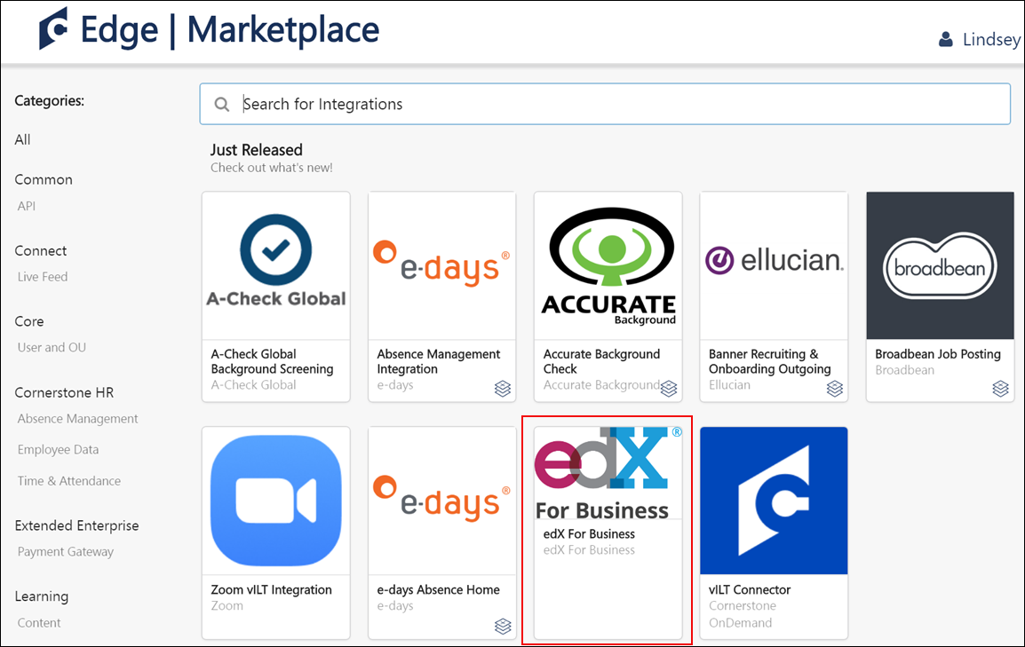
The page for the edX integration provides access to the following tabs for learning more about and managing the integration:
- Vendor - This tab provides information about the vendor that provides the integration. Here, you can view more information about edX.
- Integration - This tab provides information about the integration itself and how it can be used with the learning management system (LMS).
- Pricing - This tab provides information about the costs associated with the integration. Note: The edX integration costs $5000 annually.
- Setup - This tab provides information about how to configure the integration once enabled. The integration can be configured via Edge Integrations.
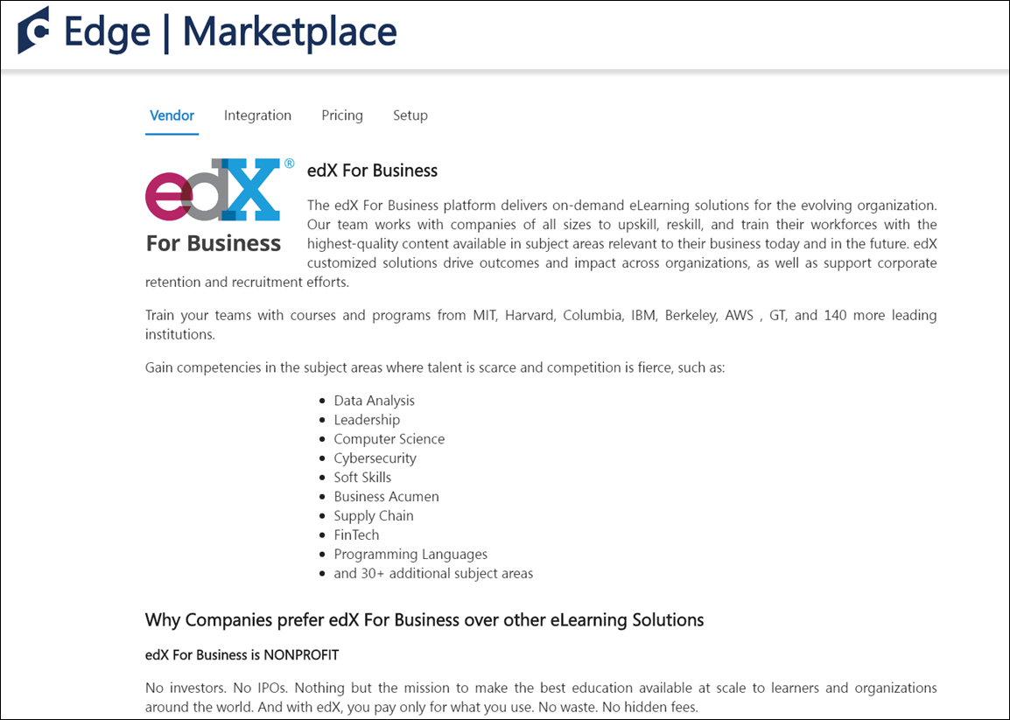
edX Integration - Edge Integrations
Once the edX integration has been added through the Edge Marketplace, the integration can be managed and configured from Edge Integrations. The Integrations page for the integration provides access to setup options which the administrator can use to customize the behavior of the edX integration. See the Setup tab for the edX integration in the Edge Marketplace for more information about the configuration options available.
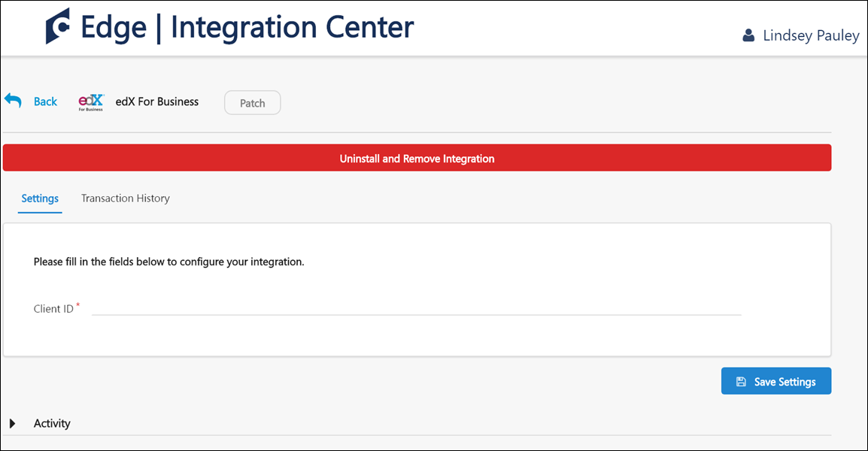
Cornerstone OnDemand and edX for Business Integration - Catalog Synchronization
The learning management system (LMS) course catalog is synchronized on a daily basis. New courses and course updates are communicated from edX to the LMS using oAuth 2.0 as the authentication protocol. edX courses are available within 24 hours of enabling the integration, and are classified as online content in the LMS.
Content delivered to the system via the edX integration is categorized as the online content training type. Because online content is updated via automatic synchronization, any manual changes made to online content metadata may be overridden in the Course Catalog and Course Console. For more information about how the online content training type behaves in the Course Catalog and Course Console, see the following:
- See Course Catalog - Online Content.
- See Course Console - Online Content.
Note: Only purchased courses are synchronized to the LMS catalog.
Note: All courses are automatically defined as available for mobile consumption and can be used on the Cornerstone Learn app.
Permissions
PERMISSION NAME | PERMISSION DESCRIPTION | CATEGORY

Course Catalog - Update | Grants ability to manage and edit training items listed in the Course Catalog and also grants access to the Course Console, where training can also be managed and edited. This permission also grants access to the Popular Requests and Highest Rated widgets on the Learning Admin Console (in conjunction with the Learning Admin Console - View permission). This permission also allows administrators to reversion online courses via the Course Console page. This permission also allows administrators to access an Edit Training option for training items included as objectives in Development plans.  This permission can be constrained by OU, User's OU, Training Type, Training Item, Provider, ILT Provider, User's ILT Provider, User, User Self and Subordinates, and User's LO Availability. This is an administrator permission.  Note: Adding an OU constraint and a provider constraint to this permission results in an "AND" statement. | Learning - Administration
Training Data
The Cornerstone OnDemand and edX for Business integration can communicate the following metadata fields to the LMS catalog:
Field | Description
ID | The unique ID of the course
Title | The course title
URL | The course URL (used to redirect users to the provider’s course)
IsActive | Specifies whether the course is available in the edX catalog. When a course is no longer available, it is defined as inactive in the LMS catalog
Description | The description of the course
Thumbnail | The course thumbnail image
Languages | The list of available languages for the course
LastModifiedUTC | The time of the last modification made to a course (UTC)
Duration | The course duration
Subjects | The list of subjects, mapped to the LMS subject taxonomy
Online content metadata can be edited via the Course Catalog. The following fields may be overridden when edX sends course updates:
- Course Title
- Course Description
- Duration
- Available Languages
- Thumbnail
- Subjects (Only edX subjects are overridden. Subjects added by the administrator are not affected)
View Courses Loaded to the Course Catalog
To view courses which have been loaded to the Course Catalog using the integration:
- Navigate to Admin > Tools > Learning > Catalog Management and click the Course Catalog link.
- Click the Refine your search link on the Course Catalog search page.
- Click the Provider filter and choose the edX provider as the filter.
- Click the Search button. The courses that are returned in the search are courses that were loaded via the integration.
Learner Progress Data
When a learner completes a training item, their training completion is automatically recorded on their LMS transcript. Training progress data is communicated by the User Progress API, protected by the provider's authentication.
The following data is communicated to edX when learners launch edX courses:
Parameter | Description
userGuid | The user’s identifier in the LMS
sessionToken | The current session token that is used to authenticate the call to the LMS when Basic Access Authentication is used
callbackUrl | The Progress API callback path
subdomain | Cornerstone’s portal name. Example: company.csod.com
registrationNumber | The current user registration number
Considerations
- Only courses launched from the LMS can be tracked by the integration.
- Custom fields are defined with an empty value for edX courses.
- The Active button is disabled for edX courses and can be only edited by edX via catalog synchronization
LinkedIn Learning Integration
The LinkedIn Learning integration allows LinkedIn Learning content to be synchronized with the Learning Management System (LMS). Learners can launch LinkedIn Learning content from the LMS or their LinkedIn portal and have their progress tracked in their LMS transcripts.
To access the Edge Marketplace, go to: Admin > Tools > Edge and click the Marketplace link.
Permissions
PERMISSION NAME | PERMISSION DESCRIPTION | CATEGORY

Edge Integrations - Manage | Grants access to the Integrations service for Edge Integrate, where the administrator can configure, enable, and disable their third-party integrations used within the Cornerstone system. This permission cannot be constrained. This is an administrator permission. | Edge

Edge Marketplace - Manage | Grants access to the Marketplace service for Edge Integrate, where the administrator can browse integrations that can be used to extend the Cornerstone system. This permission cannot be constrained. This is an administrator permission. | Edge
Use Cases
Use Case #1: Manage LinkedIn Content via Course Catalog
Brenda is a learning administrator at ACME Corp, which uses the LinkedIn Learning integration. She uses the Course Catalog to manage the courses offered by LinkedIn Learning. This content appears in the form of online courses within the Course Catalog.
Use Case #2: Launch and Complete LinkedIn Content in LMS
Lisa is an employee of ACME Corp. She browses for courses on Learner Home and decides to take a LinkedIn Learning course she finds. After launching the course, a new window opens with the course, and she does not need to provide additional login credentials. After she completes the course, it is added to her transcript in a Completed status.
Use Case #3: Sync LinkedIn Content with LMS Transcript
Lisa logged into the LinkedIn Learning site and completed a course for which she was not registered in the LMS. Because her learning administrator enabled the Bypass Registration option for the LinkedIn Learning integration, this completed course is synced to Lisa's transcript in the LMS.
Considerations
The following considerations apply to this functionality:
- When the LinkedIn Learning integration is enabled, LinkedIn Learning content is synced with the LMS on a nightly basis. Note: All synced content is flagged as Mobile Ready if the corresponding option on the Edge Configuration page for the integration is selected.
- Administrators can configure a Bypass Registration option for the integration. If enabled, when a learner completes a course on LinkedIn Learning, even if they are not registered for the course in the LMS, the course appears in a Completed status on their transcript and can be reported on. If this option is disabled, in the same scenario, the course appears in a Completed status in the form of a learning record, which is NOT reportable.
- The learning content progress report available through LinkedIn Learning is limited to training completions at this time. Other than completions, no other progress data is recorded in the LMS, meaning no percentage of progress or time spent in course is recorded.
- LinkedIn Learning courses cannot have their progress reset by assigning a new registration. If a new registration will be made, the information will be reset in the interface, but upon launch, progress made in the course will remain.
- While progress sent from LinkedIn Learning courses typically occurs in near real-time, in some cases it might take up to 24 hours for the progress to be sent back to Cornerstone CSX. This means that the course status and detail history might take up to 24 hours to be updated in the CSX system.
Implementation
This integration is available for no additional cost via the Edge Marketplace . Additional information about the LinkedIn Learning integration and its configuration options is also available through the Edge Marketplace.
Organizations currently using Lynda.com or LinkedIn Learning AICC courses will need a migration to be able to use this new integration. However, this migration is not yet available. Further information will be shared with organizations using Lynda.com or LinkedIn Learning AICC courses once the migration becomes available.
For more information about the LinkedIn Learning platform, see: LinkedIn Learning
LinkedIn Learning - Edge Marketplace
In the Edge Marketplace, you can find the LinkedIn Learning integration by searching or browsing. To learn more about the LinkedIn Learning integration or begin the enablement and configuration process, click the LinkedIn Learning integration tile.
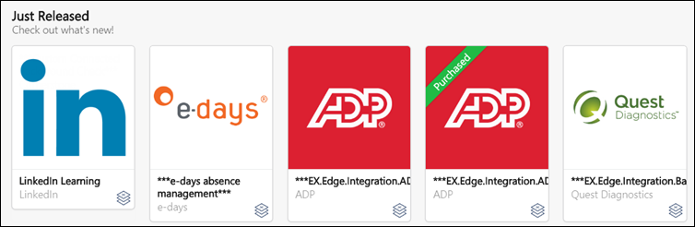
The page for the LinkedIn Learning integration provides access to the following tabs for learning more about and managing the integration:
- Vendor - This tab provides information about the vendor that provides the integration. Here, you can view more information about the LinkedIn Learning platform.
- Integration - This tab provides information about the integration itself and how it can be used with the learning management system (LMS).
- Pricing - This tab provides information about the costs associated with the integration. Note: There is no cost associated with the LinkedIn Learning integration. This integration is free to enable.
- Setup - This tab provides information about how to configure the integration once enabled. The integration can be configured via Edge Integrations.
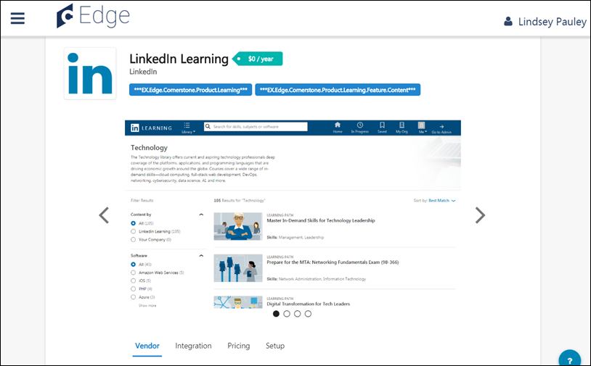
LinkedIn Learning - Edge Integrations
Once the LinkedIn Learning integration has been added through the Edge Marketplace, the integration can be managed and configured from Edge Integrations. The Integrations page for the integration provides access to setup options which the administrator can use to customize the behavior of the LinkedIn Learning integration. See the Setup tab for the LinkedIn Learning integration in the Edge Marketplace for more information about the configuration options available.
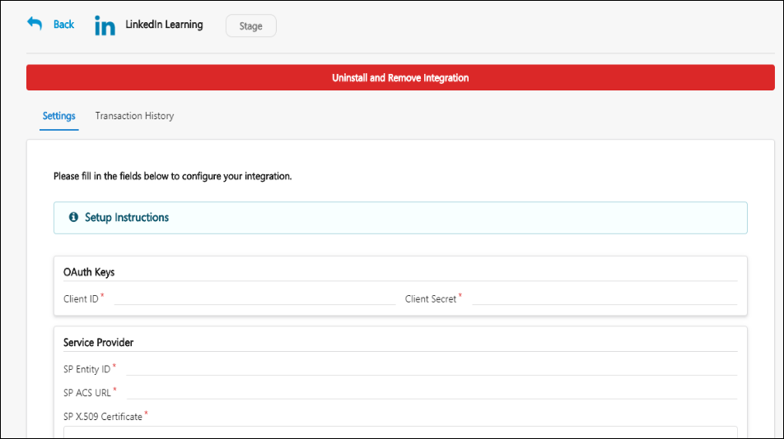
LinkedIn Learning - Course Catalog
LinkedIn Learning content that has been synced to the LMS appears in the Course Catalog as online courses, with a Provider name of LinkedIn Learning, and these courses can be managed through the Course Catalog by administrators. LinkedIn Learning content displays with its original language and course duration time in the system.
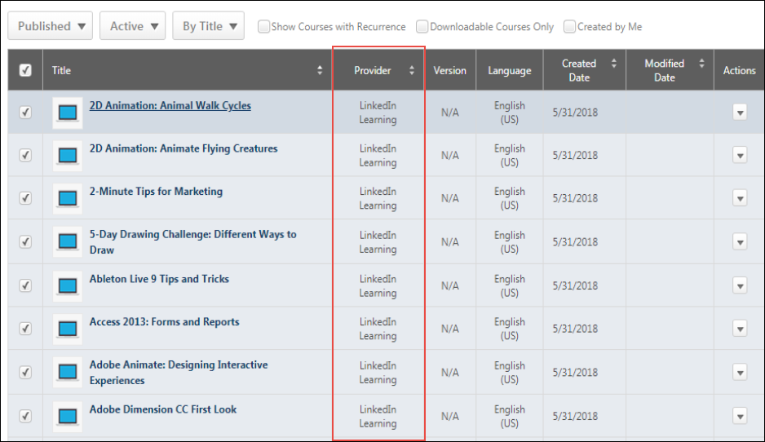
rapidRoster Integration
The rapidRoster Integration enables organizations to automate roster and attendance management by leveraging company badges, barcodes, or mobile devices for classroom registration, attendance, and completion.
How Does this Enhancement Benefit My Organization?
This integration enables organizations to eliminate paper-based rosters and automate roster management.
Implementation
This integration is available for Self-Activation in Edge Marketplace. Learning customers must also have an account with the integration vendor.
This integration is not currently available. The availability date is not determined.
Skillsoft Percipio Integration
Using this integration, an organization’s Percipio content can be automatically synchronized with the Cornerstone CSX Learning Management System (LMS) Course Catalog on a daily basis, and the synchronized content can be managed by administrators in the same manner as content created manually within the LMS. Synced Percipio courses include pre-populated metadata, such as keywords, descriptions, modalities, thumbnail images, and more. Percipio courses are also automatically configured as mobile-ready and can be accessed by learners via the Cornerstone Learn app.
When learners launch Percipio content from their portal, the training can be completed from a pop-up window with no additional login required. The learner's progress is tracked in their transcript and can be reported on using Reporting 2.0 when it is launched from the Cornerstone portal.
The following sync functionality is included with the integration:
- Synchronization of new and updated Percipio courses
- Synchronization of retired Percipio courses
- Embedded SAML SSO
Considerations
The following considerations apply to this functionality:
- Percipio courses are loaded to the portal designated as the online content training type
- Percipio courses are loaded to the portal with Percipio-US or Percipio-EU specified as the training provider
- Percipio courses include the Percipio course type as part of the course title (Channel, Audiobook, Linked Content, etc.)
- Subjects are not currently supported by the integration
- Custom Fields are assigned no value when Percipio courses are synced. Organizations can manually update the custom field with the relevant values. Custom fields are NOT overwritten by course synchronizations
- Only Percipio courses launched from the Cornerstone LMS are tracked
Training Launched from Integrated Provider's Site
Progress data for externally launched content is supported by the Cornerstone Connector that is utilised by edX for this integration, but as it stands this feature is not implemented by edX, and therefore it is not supported by the "edX for Business" integration.
- Only the following two training statuses are supported by this behavior:
  - In Progress
  - Completed
- A Completed status cannot be reverted back to an In Progress status. Any progress data communicated after the online content completion will update all values except completion status and completion date.
Prerequisites
Before enabling the integration, contact your Skillsoft account team to discuss your requirements for setting up the environment and configure it with SSO, metadata feed preferences, and the tracking connector. This process may take a few weeks.
Enable the integration on the CSOD side using the Edge Marketplace will only work when your Percipio environment is enabled on Skillsoft side.
Implementation
The Percipio integration can be purchased for an additional cost via the Edge Marketplace. Once purchased, the integration can be configured by an administrator via Edge Integrate. Percipio courses will be available within 24 hours after enabling the integration.Note: Edge integrations can be enabled for no cost in Pilot and Stage portals, allowing organizations to test the integration prior to purchasing.
Two Percipio integration tiles are available in the Edge Marketplace:
- Percipio-US - This version of the integration is for US-based organizations
- Perciptio-EU - This version of the integration is for European Union or global companies (including US-based) which have employees located in Europe
Note: If an existing Percipio integration exists for the organization, it must be disabled prior to enabling the new integration.
Permissions
The following existing permissions apply to this functionality:
PERMISSION NAME | PERMISSION DESCRIPTION | CATEGORY

Admin Search Preferences - Manage | Grants ability to configure preferences for Global Search and Course Catalog within Search Preferences. The constraints of this permission are inherited from the Global Search Preferences - Manage permission. This is an administrator permission. | Learning - Administration

Global Search Preferences - Manage | Grants ability to configure Global Search Preferences. This is an administrator permission. The availability of this permission is controlled by a backend setting. This permission can be constrained by OU and User's OU. By default, this permission is constrained to the organization. | Core Administration

Course Catalog - Update | Grants ability to manage and edit training items listed in the Course Catalog and also grants access to the Course Console, where training can also be managed and edited. This permission also grants access to the Popular Requests and Highest Rated widgets on the Learning Admin Console (in conjunction with the Learning Admin Console - View permission). This permission also allows administrators to reversion online courses via the Course Console page. This permission also allows administrators to access an Edit Training option for training items included as objectives in Development plans.  This permission can be constrained by OU, User's OU, Training Type, Training Item, Provider, ILT Provider, User's ILT Provider, User, User Self and Subordinates, and User's LO Availability. This is an administrator permission.  Note: Adding an OU constraint and a provider constraint to this permission results in an "AND" statement. | Learning - Administration

Course Catalog - View | Grants access to view the learning objects in the course catalog and enables administrators to view the Course Console and the Popular Requests and Highest Rated widgets on the Learning Admin Console (in conjunction with the Learning Admin Console - View permission). This permission can be constrained by OU, User's OU, Training Type, Training Item, Provider, ILT Provider, User's ILT Provider, and User's LO Availability. This is an administrator permission.  Adding an OU constraint and a provider constraint to this permission results in an "AND" statement. | Learning - Administration

Edge Integrations - Manage | Grants access to the Integrations service for Edge Integrate, where the administrator can configure, enable, and disable their third-party integrations used within the Cornerstone system. This permission cannot be constrained. This is an administrator permission. | Edge

Edge Marketplace - Manage | Grants access to the Marketplace service for Edge Integrate, where the administrator can browse integrations that can be used to extend the Cornerstone system. This permission cannot be constrained. This is an administrator permission. | Edge
Q&A
Q: After enabling the integration, how long will it take for my Percipio content to be available in my Cornerstone Course Catalog?
A: After your Percipio account is enabled for the integration, you may begin seeing Percipio courses in the Course Catalog as soon as one hour after the enablement. The full catalog synchronization will be complete after 24 hours.
Q: Should I create a specific provider for this integration?
A: No, the provider is automatically created in your portal. The provider’s name can be either Percipio-EU or Percipio-US, based on the selected integration.
Q: Can I change the provider’s name?
A: You can request a provider name change from Cornerstone’s Global Customer Support. However, you will not be able to replace the provider with another existing or new provider.
Q: What type of courses will be created as part of the integration?
A: All courses from Percipio are classified as the online content training type in the Cornerstone Course Catalog.
Enable and Configure Percipio via Edge Marketplace and Edge Integrate
The Percipio integration can be purchased for an additional cost via the Edge Marketplace. Once purchased, the integration can be configured by an administrator via Edge Integrate. Percipio courses will be available within 24 hours after enabling the integration. Note: Edge integrations can be enabled for no cost in Pilot and Stage portals, allowing organizations to test the integration prior to purchasing.
Note: If an existing Percipio integration exists for the organization, it must be disabled prior to enabling the new integration.
Permissions
PERMISSION NAME | PERMISSION DESCRIPTION | CATEGORY

Edge Integrations - Manage | Grants access to the Integrations service for Edge Integrate, where the administrator can configure, enable, and disable their third-party integrations used within the Cornerstone system. This permission cannot be constrained. This is an administrator permission. | Edge

Edge Marketplace - Manage | Grants access to the Marketplace service for Edge Integrate, where the administrator can browse integrations that can be used to extend the Cornerstone system. This permission cannot be constrained. This is an administrator permission. | Edge
Edge Marketplace
To enable the Percipio integration in Edge, go to: Admin > Tools > Edge > Marketplace. The Marketplace opens in a new browser tab.
Search or browse for the Percipio integration. Two Percipio integration tiles are available in the Edge Marketplace:
- Percipio-US - This version of the integration is for US-based organizations
- Percipio-EU - This version of the integration is for European Union or global companies (including US-based) which have employees located in Europe
To enable the Percipio integration, click the Percipio tile that is relevant to your organization. Then, click the Install button to enable the integration for your organization. Purchase is required when enabling the integration for a Production portal. Please contact your Account Manager for pricing information.
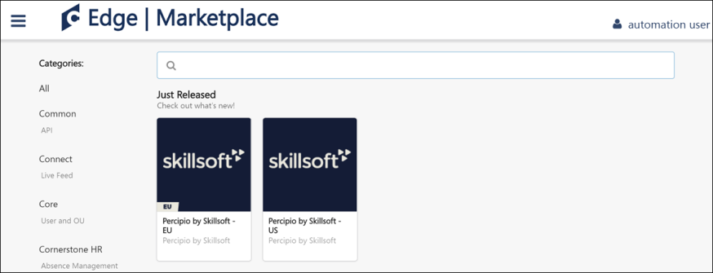
Edge Integrate
After enabling the integration, an administrator can configure the integration by doing the following:
- Add the Account ID as provided by Skillsoft to the Settings page for the integration in Edge Integrate and click the Save Settings button. Only when the Account ID is active from Skillsoft’s side will courses will be synchronized to the Course Catalog.
- Communicate the Client ID and Client Secret field values to Skillsoft's team. These credentials should be configured on Skillsoft’s side to enable the communication of progress reporting back to Cornerstone’s platform.
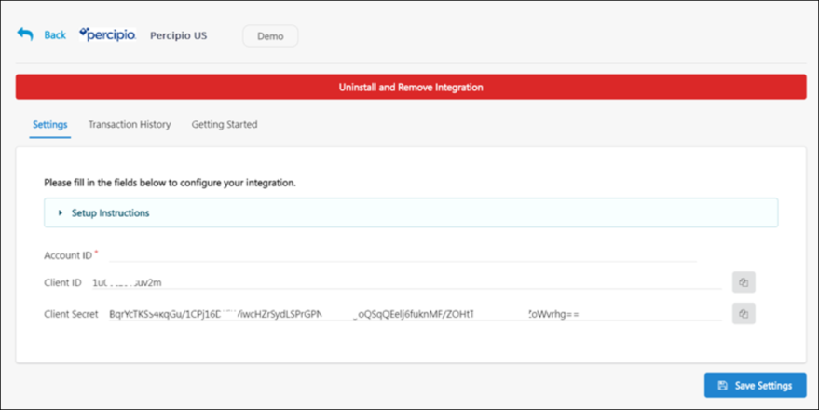
Percipio - Training Search Preferences
The Subscription filter and the online content training type are automatically enabled for portals using a content subscription. However, if your organization has defined specific search options by hierarchy level, the Subscription filter and the online content training type will not be visible, and your organization's search preferences will need to be updated manually.
To access the Search Preferences - Training page, go to ADMIN > TOOLS > CORE FUNCTIONS > CORE PREFERENCES > SEARCH. Then, select the Training tab on the left navigation bar.
Permissions
PERMISSION NAME | PERMISSION DESCRIPTION | CATEGORY

Admin Search Preferences - Manage | Grants ability to configure preferences for Global Search and Course Catalog within Search Preferences. The constraints of this permission are inherited from the Global Search Preferences - Manage permission. This is an administrator permission. | Learning - Administration

Global Search Preferences - Manage | Grants ability to configure Global Search Preferences. This is an administrator permission. The availability of this permission is controlled by a backend setting. This permission can be constrained by OU and User's OU. By default, this permission is constrained to the organization. | Core Administration
Enable Subscription Filter
To enable the Subscription filter, scroll to the Filters section and check the boxes for the Subscription filter to enable the filter for end user pages and administrator pages. Click the Save button at the bottom of the page to apply your changes to the portal.
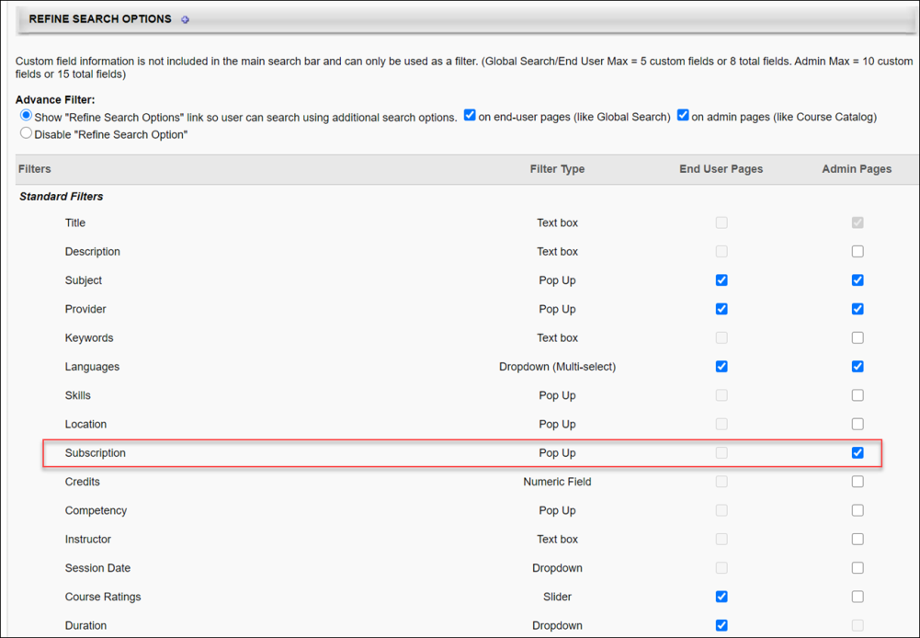
Enable Online Content Training Type
To enable the online content training type, check the Available for Searching checkbox for the Online Content type in the Training Types section. Click the Save button at the bottom of the page to apply your changes to the portal.
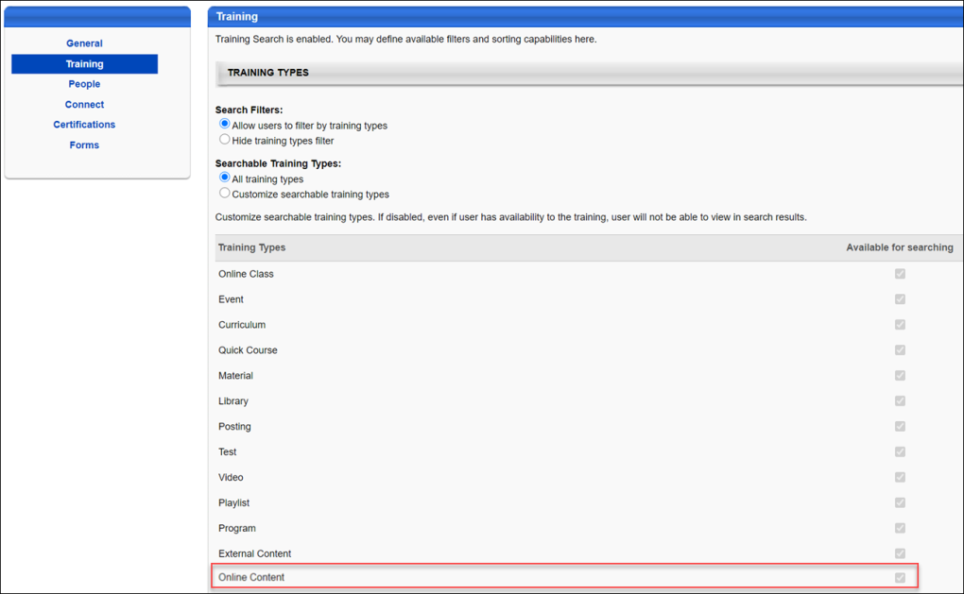
Percipio - Course Syncing
When the Percipio integration has been enabled for a portal, your organization's Percipio content is synced with the learning management system (LMS) Course Catalog on a daily basis. When Percipio content is synced, the following metadata fields are communicated to the Course Catalog:
- ID - The unique ID of the course
- Title - The course title
- URL - The course URL, which is used to redirect users to the provider’s course
- Active - Specifies whether the course is active in the Course Catalog (when a course is no longer available, it is defined as Inactive in the Course Catalog)
- Description - The course description
- Thumbnail - The thumbnail image associated with the course
- Languages - A list of available languages for the course
- Last Modified - The time the course was last modified (UTC)
- Duration - The course duration time
- Modalities - The tagged modality associated with the course (Read, Listen, Watch, Collection)
- Keywords - Words or phrases associated with the course, which allow users to search for training associated with various keywords
To access the Course Catalog, go to Admin > Tools > Learning > Catalog Management > Course Catalog.
Permissions
PERMISSION NAME | PERMISSION DESCRIPTION | CATEGORY

Course Catalog - Update | Grants ability to manage and edit training items listed in the Course Catalog and also grants access to the Course Console, where training can also be managed and edited. This permission also grants access to the Popular Requests and Highest Rated widgets on the Learning Admin Console (in conjunction with the Learning Admin Console - View permission). This permission also allows administrators to reversion online courses via the Course Console page. This permission also allows administrators to access an Edit Training option for training items included as objectives in Development plans.  This permission can be constrained by OU, User's OU, Training Type, Training Item, Provider, ILT Provider, User's ILT Provider, User, User Self and Subordinates, and User's LO Availability. This is an administrator permission.  Note: Adding an OU constraint and a provider constraint to this permission results in an "AND" statement. | Learning - Administration

Course Catalog - View | Grants access to view the learning objects in the course catalog and enables administrators to view the Course Console and the Popular Requests and Highest Rated widgets on the Learning Admin Console (in conjunction with the Learning Admin Console - View permission). This permission can be constrained by OU, User's OU, Training Type, Training Item, Provider, ILT Provider, User's ILT Provider, and User's LO Availability. This is an administrator permission.  Adding an OU constraint and a provider constraint to this permission results in an "AND" statement. | Learning - Administration
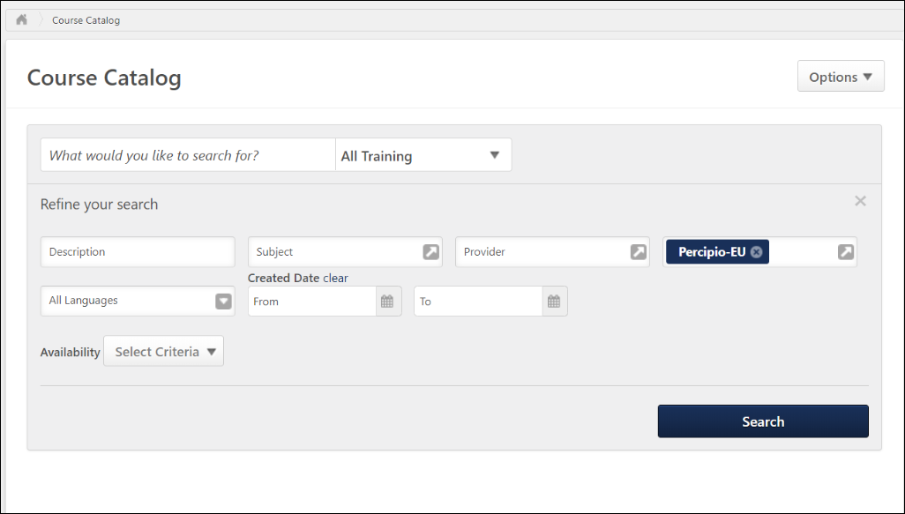
View Percipio Courses in the Course Catalog
To view Percipio courses which have been synced to the Course Catalog, click the Refine Search link on the Course Catalog search page. Then, select Percipio-US or Percipio-EU from the Subscription filter, depending on which version of the integration your organization has enabled. Click the Search button to view all the synced Percipio content in the Course Catalog. Note: Courses synced from Percipio are classified as the online content training type in the Cornerstone system.
Modality Mapping
Modalities are automatically associated with Percipio courses based on the Percipio content type. The following modalities are set to be associated with the listed Percipio content types:
- Collections - Channels
- Listen - Audio books, audio summaries
- Practice - Linked content labs
- Read - Books, book summaries
- Watch - Courses, linked content, videos
Percipio - End User Experience
Learners can search for, browse, and consume Percipio training synced to the learning management system (LMS) in the same manner as other training types created within the LMS. On the Learner Home page, Percipio content displays with the Percipio content type listed in the description to help users quickly identify relevant Percipio courses.
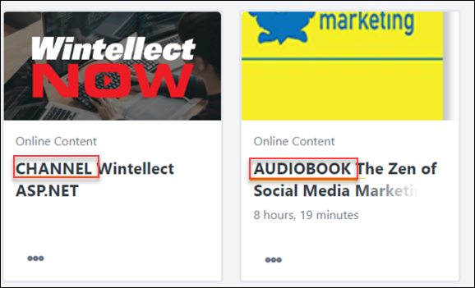
Percipio Integration - FAQ
Please see below for helpful questions and answers about the Percipio integration:
Q: Can I change the provider name for courses synced from Percipio?
A: Yes. To do this, open a ticket with Global Customer Support and request a change to the provider name. It is not recommended to change the provider name to Skillsoft if your organization already has a Skillsoft provider in the portal.
Q: My organization has existing SSO with Skillsoft - Percipio. Is it possible to keep this and not use the embedded SSO?
A: Some existing SSO configurations may be also used with the new integration. However, this requires a customization project aligned with the Global Integration Service (GIS) team. Please work with your CSM to create a custom request.
Q: Our organization already has Percipio content in the portal. Can we enable the new integration?
A: Enabling the new integration when Percipio courses are already in your system's Course Catalog may lead to content duplication. The new integration includes the activation of the online content LO, and old courses cannot be migrated to it. Before enabling the new integration, deactivate the old Percipio courses or submit a request to Global Customer Support to remove the old Percipio courses.

Learning in the Flow of Work Integrations - Overview
Microsoft Teams Learning in the Flow of Work Integration Overview
The "Learning in the Flow of Work" integration brings the Cornerstone Learning catalog directly to learners in their key productivity application. With this enhancement, Microsoft Teams users can add a chatbot to Teams that lets them search for and share training, all linked to the Cornerstone portal. Learners can also receive notifications about training with upcoming due dates.
This integration enables users to interact with learning content from within Teams and includes the ability to:
- Receive a welcome message with instructions on how to use the Learn Bot
- Search for, find, and access relevant content directly within the Learn Bot
- Search for relevant content directly from any message thread with a new Teams message extension
- Stay up-to-date on outstanding training via proactive nudges
- Launch learning content directly from the bot
For portals with single sign-on enabled, any links to training take the user directly to the learning details page without the user needing to log in to the portal if they are already logged in.
Search Logic
@Learn Search returns training results based on the phrase entered in the title, keywords, and description. Results are prioritized first by the phrase in the title of the training, then in the training keywords, and then in the description of the training. This is the same logic used by Learning Search.
Additional Information
Implementation
The Microsoft Teams Learning in the Flow of Work integration is available for Production portals only.
Upon implementation, the integration is available for portals with Learning and that also have a Microsoft Office 365 license with Teams. Administrators with permission to manage Edge Marketplace can enable the integration in Edge Marketplace. The administrator will need the organization’s Office 365 environment Tenant ID as well as access to their Cornerstone portal’s Single Sign-On configuration if they are utilizing Single Sign-On. Once the integration is enabled, individual users can complete installation through Microsoft Teams.
Additional instructions for enabling and configuring the integration will be available in Edge once the integration tile has been added.
Note: You may also be considering creating a subset of users to test the integration. This can be done through Microsoft Teams Custom App Management, which lets you enable the integration for test users. More information about this can be found in the starter guide.
Permissions
The following existing permissions apply to this functionality:
PERMISSION NAME | PERMISSION DESCRIPTION | CATEGORY

Edge Integrations - Manage | Grants access to the Integrations service for Edge Integrate, where the administrator can configure, enable, and disable their third-party integrations used within the Cornerstone system. This permission cannot be constrained. This is an administrator permission. | Edge

Edge Marketplace - Manage | Grants access to the Marketplace service for Edge Integrate, where the administrator can browse integrations that can be used to extend the Cornerstone system. This permission cannot be constrained. This is an administrator permission. | Edge
Microsoft Teams Learning in the Flow of Work - Using the Learn Bot
Microsoft Teams users can add a chatbot to Microsoft Teams that lets them search for and share training, all linked to the Cornerstone portal. Learners can also receive notifications about training with upcoming due dates.
This integration enables users to interact with learning content from within Teams and includes the ability to:
- Receive a welcome message with instructions on how to use the Learn Bot
- Search for, find, and access relevant content directly within the Learn Bot
- Search for relevant content directly from any message thread with a new Teams message extension
- Stay up-to-date on outstanding training via proactive nudges
- Launch learning content directly from the Learn Bot
For portals with Single Sign-On enabled, any links to training take the user directly to the learning details page without the user needing to log in to the portal if they are already logged in.
For customers with multiple Microsoft tenants or that use a specific regional app, see the Microsoft Teams Integration - Starter Guide for information about how to configure the integration for one of these scenarios.
Add the Chatbot
Users can add the chatbot in Teams through the Apps page. Click the name of the app, and then click Add.
Once the chatbot is added, it can be accessed by clicking Learn in the left panel of the Microsoft Teams page.
Welcome Message
A welcome message appears as the first chat with the bot. The message explains how users can find content and stay on top of their assigned training.
The message remains at the top of the chat.
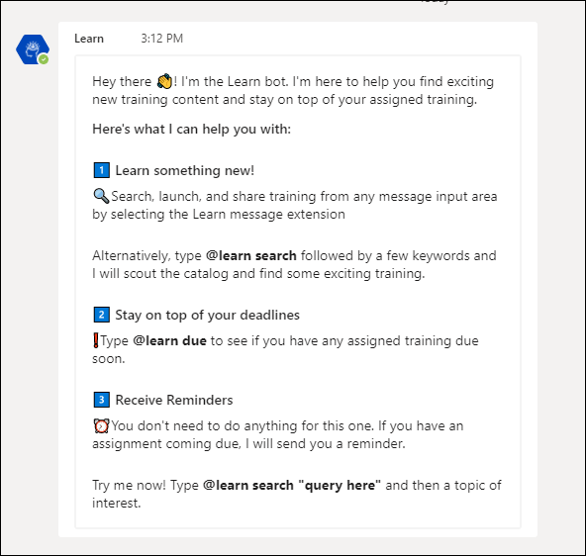
Search for and Launch Content
Within the Learn Bot, to search for content, enter @learn search "query here" followed by keywords. The bot displays the top five trainings that match the search and includes a description of the content if available.
To view the details of the training, simply click the training title or the View Detail button. This takes the user directly to the learning details page, from which they can launch the training.
Note: The keyword used in the search must be a minimum of three characters.
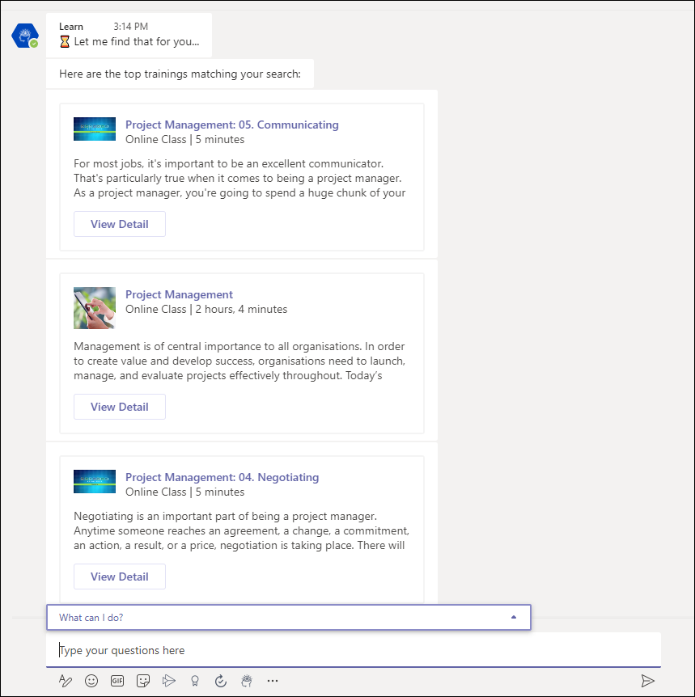
See What Training Is Due
To search for training that is due, enter @learn due, and then click the send icon . The bot searches for any outstanding training and displays a list of the training. A with a link that takes the user directly to the learning details so that they can complete the training.
If "Launch" action is available, a Launch button displays and users can click the button to launch the training content directly from Teams.
Training Is Due Reminders
Training is due reminders appear automatically in the chat on a daily basis to let learners know what training they have due and how soon it needs to be completed. Reminders are sent for trainings with due dates within seven days, either in the future or in the past.
The message includes a link directly to the learning details for quick access to complete the training.
Note: The messaging feature must be enabled by the administrator on the integration's configuration page in Edge by toggling on Enable Proactive Messaging.
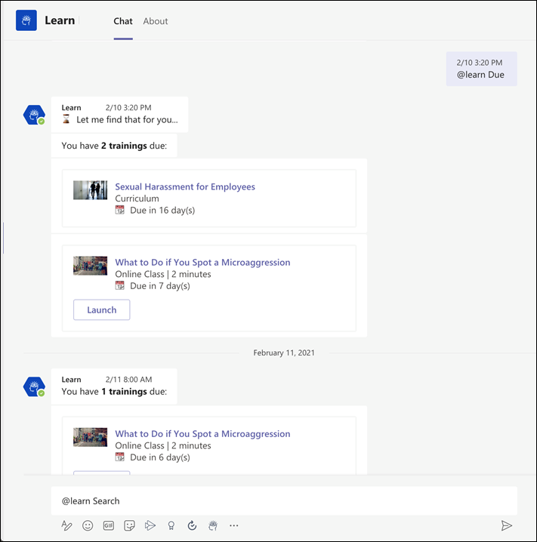
Share Training
Within any message thread with another user or group, users can search for and share Cornerstone training directly. To share training:
- Click the Learn Bot icon in the message extension bar. This will open a search modal.
- Enter any search query within the modal and click Search. The top five search results will be returned.
- Select Insert to add the training to their message input box or select View Detail to be taken to the Learning Details page of the training.
Invalid Commands
If a user enters an invalid command to the Learn Bot, the bot will return a message indicating the command was not recognized. The bot provides a refresher of how to use the app, similar to the Welcome message.
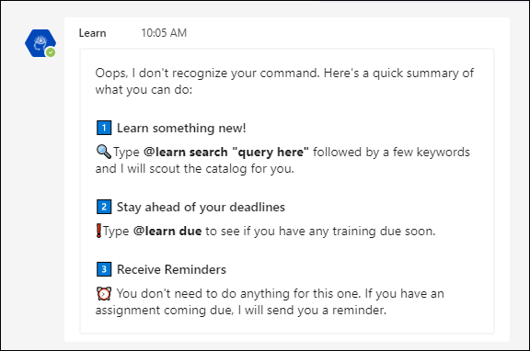
Slack Integration (Learning in the Flow of Work)
Learners often juggle between many applications that they must use for their day-to-day work. To simplify this experience and encourage learning, Cornerstone CSX can now integrate with Slack. When an organization installs the integration, a Slack chatbot pushes training reminders to learners in Slack, an app that they are already using.
Using the Slack chatbot, Learners can do the following:
- Search the Cornerstone training catalog using keywords
- Ask for a list of training due or past due (max 10 trainings returned)
- Launch and mark training complete
- Receive daily notifications (Monday - Friday) of past due and coming due training (up to 7 days)
The chatbot in Slack is easy to use. It has a Home tab where learners can view available commands and a Messages tab to send commands and view notifications received by the chatbot.
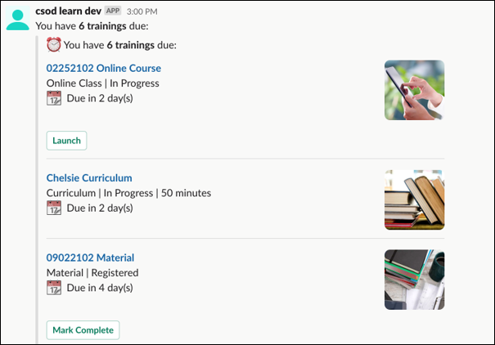
How Does this Enhancement Benefit My Organization?
This integration brings learning where your employees are while helping them remain up to date on required training. With this integration, learners gain self-service access to their CSX learning catalog and required training from within Slack.
Implementation
This integration is available for self-activation in Edge Marketplace.
This integration is not available for the Pilot environment.

Payment Gateway Integrations - Overview
Adyen Payment Gateway
Cornerstone's Extended Enterprise product was built on the Cybersource payment gateway, requiring organizations to solely use that service to accept payment for training sold via the Learning Management System (LMS). This has remained largely unchanged over time, with the exception of enabling PayPal as an additional payment processor.
The Adyen Payment Gateway payment processor is available for credit and debit card payments.
Use Case
Symone is a system administrator for an EMEA organization. Her organization has been using the Cybersource payment gateway for several years, but would prefer to use Adyen as their payment vendor.
- First, Symone contacts Cornerstone Customer Support to have the Adyen Payment Gateway enabled in the portal, and then she contacts Adyen and creates an Adyen merchant account. During her account setup, she obtains a username, password, and an API key to enable Adyen for extended enterprise in her Stage portal.
- She then populates her organization's merchant account information in the Cornerstone portal, allowing her to test the functionality.
- Once satisfied the functionality works as expected, she generates this same information for her Production portal and configures the payment account.
After setup, her users can seamlessly make purchases as they did before, but now all transactions are facilitated by Adyen instead of Cybersource.
Implementation
Administrators can enable the Adyen Payment Processor via the Edge Marketplace.
Please contact Adyen to create Adyen merchant account.
Administrators can test the Adyen Payment Gateway in a test portal if desired, but a separate set of Adyen credentials must be generated through Adyen's interface for use with the test portal.
No other changes, beyond the additional options available on the Define Payment Account page, have been made to Cornerstone's Extended Enterprise functionality as a result of this enhancement. The user's checkout experience will remain the same, except Adyen will be available as a payment method, if enabled.
Considerations
- Costs are associated with the creation of an Adyen merchant account, and these fees are charged by Adyen. Cornerstone is not responsible for any costs incurred through Adyen. The enablement of the Adyen Payment Gateway within the Cornerstone system, however, has no associated costs.
- The Cybersource Payment Gateway and the Adyen Payment Gateway cannot be enabled at the same time in the same portal. Enabling the Adyen Payment Gateway will disable the Cybersource Payment Gateway. The PayPal Payment Gateway, however, CAN be used in conjunction with either the Cybersource or Adyen Payment Gateways.
- Credit and debit card payments are supported through the Adyen Payment Gateway.
Permissions
The following existing permission applies to this functionality:
PERMISSION NAME | PERMISSION DESCRIPTION | CATEGORY

Payment Account - Modify | Grants ability to create payment profiles to determine the routing of users' payments. This permission cannot be constrained. This is an administrator permission. | eCommerce - Administration
Adyen Payment Processor - Enable in Edge
The Adyen Payment Processor integration can be enabled via the Edge Marketplace.
To access the Edge Marketplace, go to: Admin > Tools > Edge and click the Marketplace link.
Permissions
PERMISSION NAME | PERMISSION DESCRIPTION | CATEGORY

Edge Integrations - Manage | Grants access to the Integrations service for Edge Integrate, where the administrator can configure, enable, and disable their third-party integrations used within the Cornerstone system. This permission cannot be constrained. This is an administrator permission. | Edge

Edge Marketplace - Manage | Grants access to the Marketplace service for Edge Integrate, where the administrator can browse integrations that can be used to extend the Cornerstone system. This permission cannot be constrained. This is an administrator permission. | Edge
Adyen - Edge Marketplace
To enable the Adyen Payment Processor:
- Search for and select the Adyen tile in the Edge Marketplace.
- Then, click the Install button for the Adyen integration.
- Review the terms and conditions of using the Adyen integration and check the acknowledgment box to confirm that you read, understood, and agree to the terms and conditions.
- Click the Install button. The integration will be installed.
- Enable the Adyen tile in Edge in order to activate the payment processor. The Active toggle is switched to the Off position by default.
Account details for your Adyen account must be added within the Cornerstone system, via the Define Payment Account page. See Adyen Payment Gateway - Define Payment Account on page 126 for additional information.
Adyen Payment Gateway - Define Payment Account
On the Define Payment Account page, administrators can configure the payment account for their Adyen merchant account.
To access the Define Payment Account preferences page, go to ADMIN > TOOLS > Learning > Learning PREFERENCES > E-Commerce and click the Modify Payment Account link. In the Payment Account section, click the Add icon to add a new payment account.
Permissions
PERMISSION NAME | PERMISSION DESCRIPTION | CATEGORY

Payment Account - Modify | Grants ability to create payment profiles to determine the routing of users' payments. This permission cannot be constrained. This is an administrator permission. | eCommerce - Administration
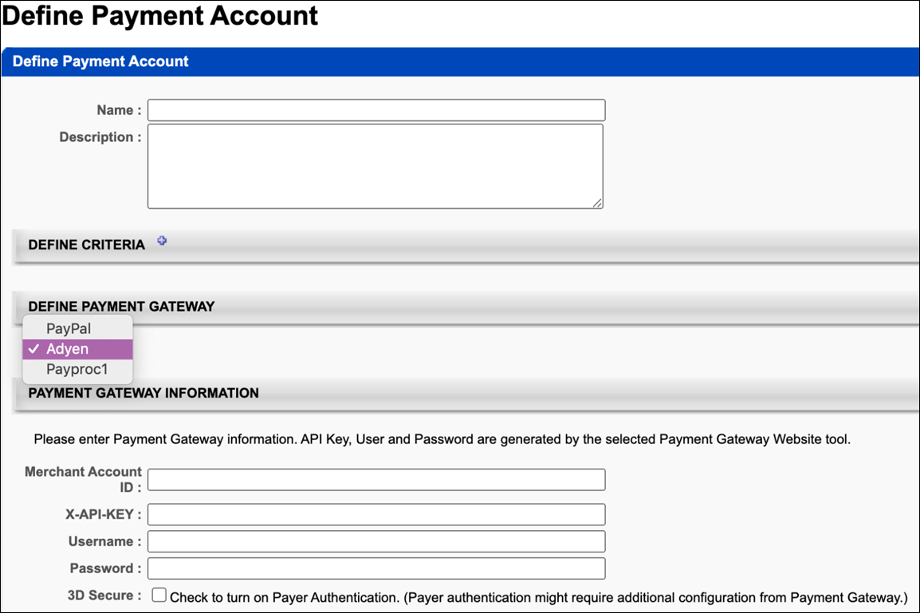
Define Payment Gateway
To define the Adyen Payment Gateway, complete the following steps:
- In the Define Payment Gateway section, select Adyen from the drop-down menu. Note: This option is only available if Cornerstone Customer Support has enabled the Adyen Payment Gateway in your portal.
- In the Payment Gateway Information section, populate the following fields with the API credentials obtained from Adyen:
  - Merchant Account ID - This is obtained from your Adyen account and displays on the API Credentials page in Adyen.
  - X-API-KEY - This is the API key generated through Adyen. This must be copied at the time it is generated, as it will be obfuscated in the Adyen account after creation.
  - Username - This is the username generated from within your Adyen account. Note: This is NOT the username used to log into your Adyen account; it is a username associated with the API key when it is generated. This data will display on the details page for the merchant account.
  - Password - This is the password generated from within your Adyen account. Note: This is not the password used to log into your Adyen account; it is a password associated with the API key it is generated. This password must be copied at the time it is generated, as it will be obfuscated in the Adyen account after creation.
  - 3D Secure - This setting, if enabled, must also be configured in your Adyen account in order to function. Without first configuring this option in Adyen, errors will occur when attempting to perform transactions in the Cornerstone portal. This option should only be selected AFTER it has first been configured via Adyen.
- Click the Save button to finish configuring the Adyen payment account. This account will then be available for users who meet the specified user criteria defined for the account. Note: More than one account can be defined for the portal.
For more information about generating API credentials, please see Adyen's documentation: Adyen Help Documentation.
For more information about creating a payment account: See Create Payment Account.
Save/Cancel
Click Save to save the payment account. Or, click Cancel to cancel creating the payment account.
NIC Colorado Payment Processor
The NIC Colorado Payment Gateway has been made available to help support US government customers. This new payment gateway has been implemented to support transactions including:
- Credit card and e-check payment methods
- Processing fee calculation, calculated as:
  - Percentage applied over the purchase order total value
  - Fixed value
  - Formula (using the purchase order total value)
Exclusions
The following features are not supported by this integration:
- Recurring billing
- Transactions with 3D Secure
- Partial refunds (only full refunds are supported)
- Save credit card
- Tax calculation
Considerations
- Only one payment processor may be enabled in a portal at a time, with the exception of the PayPal Payment Processor. The PayPal Payment Processor may be enabled in addition to one other payment processor, such as the NIC Colorado Payment Processor.
- Costs are associated with the creation of a NIC Colorado merchant account, and these fees are charged by NIC Colorado. Cornerstone is not responsible for any costs incurred through NIC Colorado.
- The enablement of the NIC Colorado Payment Gateway within the Cornerstone system has an associated cost. For more details, please contact your Account Manager.
Implementation
For organizations using the Learning module, this integration can be self-enabled via the Edge Marketplace. See NIC Colorado Payment Processor - Enable in Edge on page 130 for additional information.
Please contact NIC Colorado to create a NIC Colorado merchant account.
Edge Guide
Click here for the NIC Colorado Payment Gateway Edge Guide!
Permissions
The following existing permissions apply to this functionality:
PERMISSION NAME | PERMISSION DESCRIPTION | CATEGORY

Edge Integrations - Manage | Grants access to the Integrations service for Edge Integrate, where the administrator can configure, enable, and disable their third-party integrations used within the Cornerstone system. This permission cannot be constrained. This is an administrator permission. | Edge

Edge Marketplace - Manage | Grants access to the Marketplace service for Edge Integrate, where the administrator can browse integrations that can be used to extend the Cornerstone system. This permission cannot be constrained. This is an administrator permission. | Edge

Payment Account - Modify | Grants ability to create payment profiles to determine the routing of users' payments. This permission cannot be constrained. This is an administrator permission. | eCommerce - Administration
NIC Colorado Payment Processor - Enable in Edge
The NIC Colorado Payment Processor integration can be enabled via the Edge Marketplace.
To access the Edge Marketplace, go to: Admin > Tools > Edge and click the Marketplace link.
Permissions
PERMISSION NAME | PERMISSION DESCRIPTION | CATEGORY

Edge Integrations - Manage | Grants access to the Integrations service for Edge Integrate, where the administrator can configure, enable, and disable their third-party integrations used within the Cornerstone system. This permission cannot be constrained. This is an administrator permission. | Edge

Edge Marketplace - Manage | Grants access to the Marketplace service for Edge Integrate, where the administrator can browse integrations that can be used to extend the Cornerstone system. This permission cannot be constrained. This is an administrator permission. | Edge
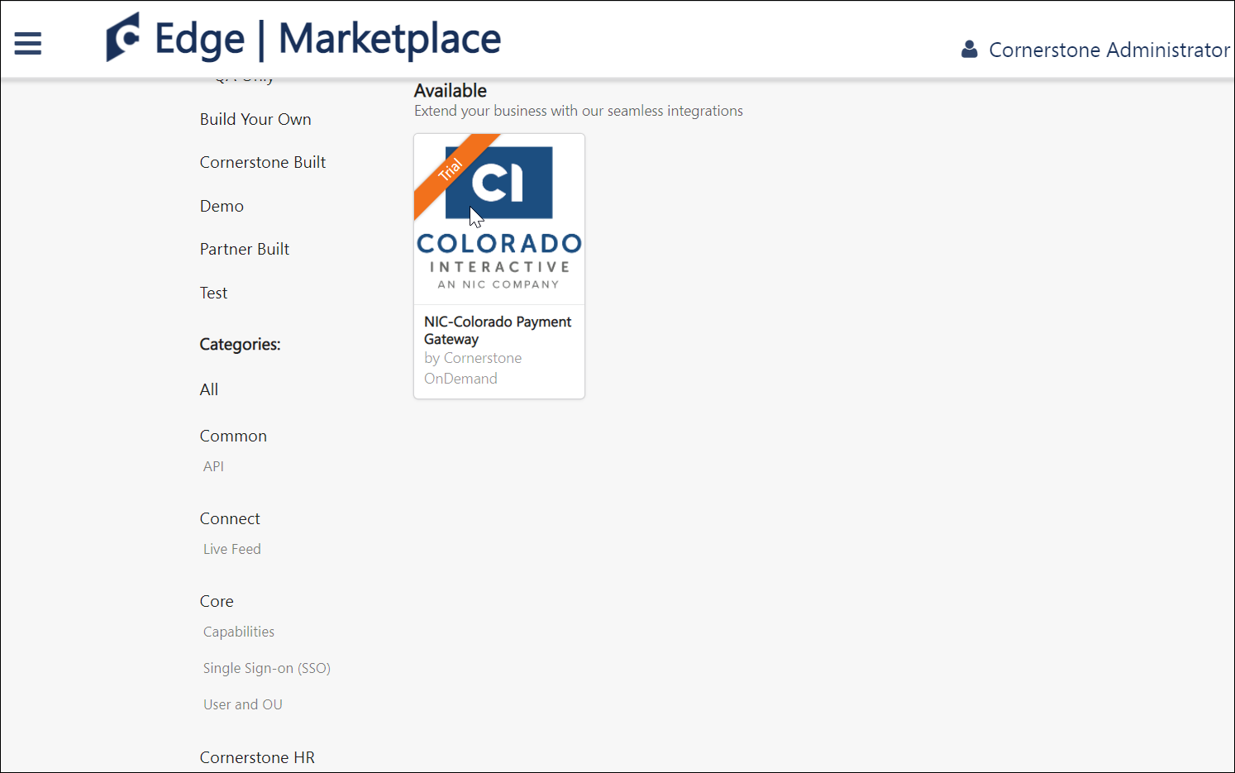
NIC Colorado - Edge Marketplace
To enable the NIC Colorado Payment Processor:
- Search for and select the NIC Colorado tile in the Edge Marketplace.
- Then, click the Install button for the NIC Colorado integration.
- Review the terms and conditions of using the NIC Colorado integration and check the acknowledgment box to confirm that you read, understood, and agree to the terms and conditions.
- Click the Install button. The integration will be installed.
- Enable the NIC Colorado tile in Edge in order to activate the payment processor. The Active toggle is switched to the Off position by default.
Account details for your NIC Colorado account must be added within the Cornerstone system, via the Define Payment Account page. See NIC Colorado Payment Processor - Define Payment Account on page 132 for additional information.
NIC Colorado Payment Processor - Define Payment Account
On the Define Payment Account page, administrators can configure the payment account for their NIC Colorado merchant account.
To access the Define Payment Account preferences page, go to ADMIN > TOOLS > Learning > Learning PREFERENCES > E-Commerce and click the Modify Payment Account link. In the Payment Account section, click the Add icon to add a new payment account.
Permissions
PERMISSION NAME | PERMISSION DESCRIPTION | CATEGORY

Payment Account - Modify | Grants ability to create payment profiles to determine the routing of users' payments. This permission cannot be constrained. This is an administrator permission. | eCommerce - Administration
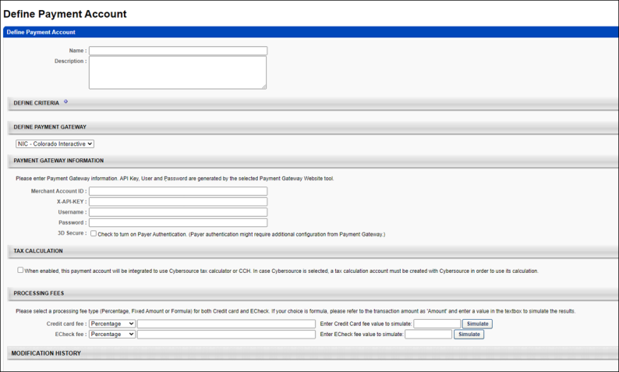
Define Payment Gateway
To define the NIC Colorado Payment Gateway, complete the following steps:
- In the Define Payment Gateway section, select NIC Colorado from the drop-down menu. Note: This option is only available if you have enabled the NIC Colorado Payment Gateway via Edge.
- Enter the following information for the payment account:
  - Name - Character limit is 50.
  - Description - This is for administrator use only. It is not displayed anywhere. Character limit is 250.
  - Define Criteria - At least one criteria is required and constraints do not apply to the available selections. The available attribute types are:
    - Currency
    - Provider
    - OU
    - LO
- The remaining fields that the administrator must populate depend on the payment processor selected for the portal. In the Payment Gateway Information section, populate the following fields with the API credentials obtained from NIC Colorado:
  - Merchant Account ID
  - API Key
  - Username
  - Password
  - 3D Secure
Note: The above fields can be obtained from NIC Colorado after you have created an account with NIC Colorado.
Save/Cancel
Click Save to save the payment account. Or, click Cancel to cancel creating the payment account.
PayPal Payment Gateway Integration Enablement
The PayPal Payment Gateway integration supports transaction management features, eliminating the need to perform additional bookkeeping for refunds. This functionality includes automatic refunds for users who withdraw from sessions.
Permissions
PERMISSION NAME | PERMISSION DESCRIPTION | CATEGORY

Edge Integrations - Manage | Grants access to the Integrations service for Edge Integrate, where the administrator can configure, enable, and disable their third-party integrations used within the Cornerstone system. This permission cannot be constrained. This is an administrator permission. | Edge

Edge Marketplace - Manage | Grants access to the Marketplace service for Edge Integrate, where the administrator can browse integrations that can be used to extend the Cornerstone system. This permission cannot be constrained. This is an administrator permission. | Edge

Payment Account - Modify | Grants ability to create payment profiles to determine the routing of users' payments. This permission cannot be constrained. This is an administrator permission. | eCommerce - Administration

Transaction Manager - Manage | Grants ability to access the Manage Transaction page and also create and edit transactions. On the Order History Details page, the administrator can edit the order status, adjust prices, issue refunds, or enter comments. This permission can be constrained by User's OU. This is an administrator permission. | eCommerce - Administration
To enable the PayPal Payment Gateway integration for your organization:
- Add the PayPal Payment Gateway integration from the Edge Marketplace. To access the Edge Marketplace and specific information about the integration, go to: Admin > Tools > Edge and click the Marketplace link.
- Configure the integration via Edge Integrate. To access Edge Integrate, go to: Admin > Tools > Edge and click the Integrate link.
- Create a PayPal business account. See Create PayPal Business Account.
- Add PayPal as a payment account in the learning management system (LMS). See PayPal Payment Gateway - Define Payment Account on page 156 for additional information.
- Enable PayPal as a payment method in User Payment Preferences. See PayPal - User Payment Preferences on page 142 for additional information.
Note: The backend setting for the PayPal Payment Gateway must be turned on in your portal in order for PayPal to be used as a payment method. This setting is automatically enabled when you install and configure the PayPal Payment Gateway integration.
Permissions
The following existing permissions apply to this functionality:
PERMISSION NAME | PERMISSION DESCRIPTION | CATEGORY

Edge Integrations - Manage | Grants access to the Integrations service for Edge Integrate, where the administrator can configure, enable, and disable their third-party integrations used within the Cornerstone system. This permission cannot be constrained. This is an administrator permission. | Edge

Edge Marketplace - Manage | Grants access to the Marketplace service for Edge Integrate, where the administrator can browse integrations that can be used to extend the Cornerstone system. This permission cannot be constrained. This is an administrator permission. | Edge

Payment Account - Modify | Grants ability to create payment profiles to determine the routing of users' payments. This permission cannot be constrained. This is an administrator permission. | eCommerce - Administration

Transaction Manager - Manage | Grants ability to access the Manage Transaction page and also create and edit transactions. On the Order History Details page, the administrator can edit the order status, adjust prices, issue refunds, or enter comments. This permission can be constrained by User's OU. This is an administrator permission. | eCommerce - Administration
Dynamic Tax Calculator - Cybersource
Dynamic Tax Calculator with Cybersource - Overview
Administrators can enable the PayPal Payment Gateway (Early Adopter) integration to calculate taxes dynamically using the Cybersource Tax Calculator integration.
Use Cases
Use Case 1: Existing Tax Calculation User
Flinn is the business process owner and administrator at ACME Corporation, which is a well-known provider of software engineering courses. They are using Extended Enterprise to sell the content. ACME is required to collect varying taxes on most of their sales. Their catalog has been configured to work with Cybersource as the payment gateway.
With the PayPal tax calculator, Flinn enables the PayPal Payment Gateway integration to accept payments, with confidence that ACME's complex tax rules will be respected.
Use Case 2: New Tax Calculation User
Khalil is the business process owner and administrator of Ventonix Enterprises, which is a well known provider of training content. Ventonix wants to sell content to the public, but must be compliant with various tax rules in order to do so. Because the PayPal Payment Gateway integration can be configured to dynamically calculate taxes, Khalil is able to create a new account with Cybersource, configure tax rules, and then enable the PayPal Payment Gateway integration to accept payments.
Considerations
- Organizations using the PayPal Payment Gateway integration who wish to use the dynamic tax calculator are responsible for contracting with Cybersource to establish a Tax Calculation account. See: https://www.cornerstoneondemand.com/marketplace/cybersource
- If Tax Calculation with Cybersource is enabled, organizations using the PayPal Payment Gateway integration are responsible for disabling any PayPal tax rules that have already been configured.
- Your organization will need a PayPal business account in order to use the Cybersource Tax Calculator.
- Organizations will need to have Cybersource enabled in two different environments:
  - Cybersource Test is linked to CSOD Stage, Pilot
  - Cybersource Live is linked to CSOD Production
- Tax fields for PayPal transactions will flow to Standard Reports, Custom Reports, and Reporting 2.0.
Implementation
In order to utilize this functionality, the PayPal Payment Gateway integration must be enabled, and your organization must create an account with Cybersource.
- For more information about configuring the PayPal Payment Gateway integration: See PayPal Payment Gateway Integration Enablement on page 134 for additional information.
- For more information about creating a Cybersource account: https://www.cornerstoneondemand.com/marketplace/cybersource
Dynamic Tax Calculation - Define Payment Account
On the Define Payment Account page, administrators can configure the Cybersource Tax Calculator integration.
To access the Define Payment Account preferences page, go to ADMIN > TOOLS > Learning > Learning PREFERENCES > E-Commerce and click the Modify Payment Account link. In the Payment Account section, click the Add icon to add a new payment account.
Permissions
PERMISSION NAME | PERMISSION DESCRIPTION | CATEGORY

Payment Account - Modify | Grants ability to create payment profiles to determine the routing of users' payments. This permission cannot be constrained. This is an administrator permission. | eCommerce - Administration
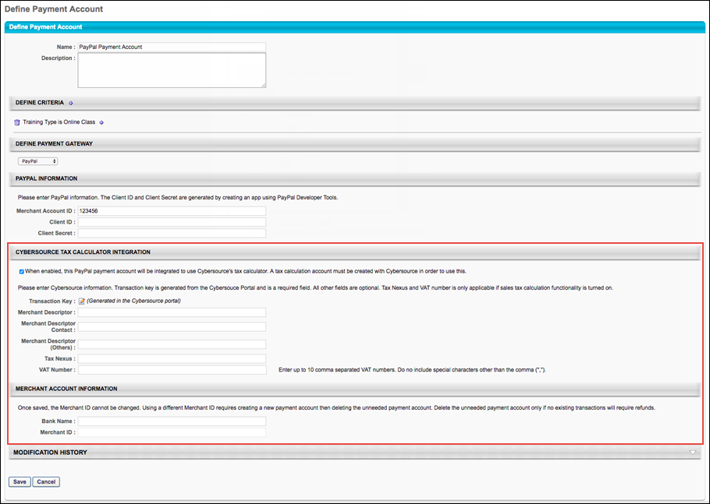
Cybersource Tax Calculator Integration
In the Cybersource Tax Calculator Integration section, administrators enable the setting which allows the PayPal Payment Gateway integration to use an existing Cybersource account to dynamically calculate taxes for PayPal transactions.
To enable this setting, toggle the Cybersource Tax Calculator Integration toggle to the On position. If you do not wish to enable the Cybersource Tax Calculator, leave this switch toggled to the Off position. Note: You must create a Cybersource account prior to enabling this option in order to allow the PayPal Payment Gateway integration to dynamically calculate taxes.
If the Cybersource Tax Calculator Integration has been enabled, the administrator can configure the following fields which appear on the page:
- Transaction Key - The Transaction Key is generated from the Cybersource portal and is a required field.
- Merchant Descriptor
- Merchant Descriptor Contact
- Merchant Descriptor (Others)
- Tax Nexus
- VAT Number
- Merchant ID
Dynamic Tax Calculator - Billing Address
In order to dynamically calculate taxes during the checkout process, a billing address must be collected from the user. If the Cybersource Tax Calculator integration has been enabled and the user has selected PayPal as the payment method, the user is prompted to populate the following billing address fields during the first step of the checkout process when purchasing training:
- Email
- First Name
- Last Name
- Address Line 1
- Address Line 2
- City
- Country
- State/Province
- Zip Code
This information allows Cybersource to dynamically calculate tax for the purchase.
- If enabled in User Payment Preferences, users can also opt to provide a secondary address if their billing address is separate from their shipping address. Providing a secondary address can be configured as required via User Payment Preferences, if needed. If preferences are set to collect a secondary address, the user will see the following options during checkout:
- Use the billing address as my shipping address?
  - No - If the user selects this option, the user's billing address will be the same as their shipping address.
  - Yes - If the user selects this option, the user will be prompted to complete the following fields for the secondary address:
    - Email
    - First Name
    - Last Name
    - Address Line 1
    - Address Line 2
    - City
    - Country
    - State/Province
    - Zip Code
For more information about the checkout process: See Checkout - Step 1 - Payment.
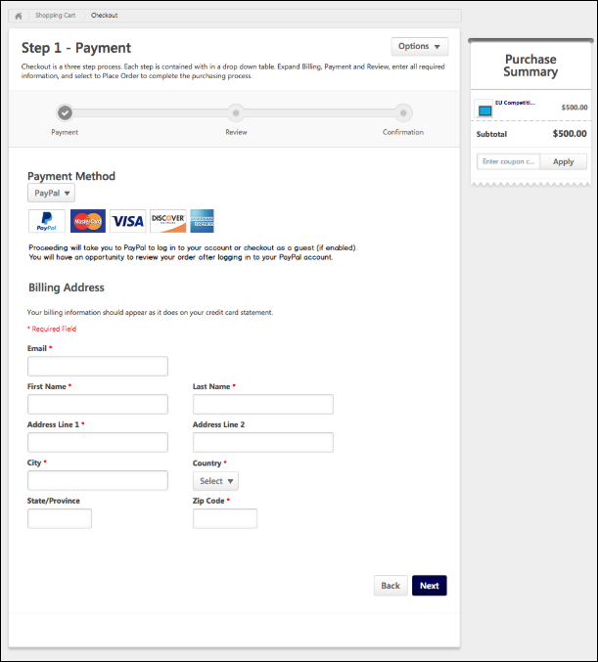
PayPal - User Payment Preferences
If the PayPal Payment Gateway is enabled in Payment Preferences, additional options to allow or require the collection of a secondary billing address are available to the administrator.
To manage User Payment preferences, go to ADMIN > TOOLS LEARNING > E-COMMERCE > PAYMENT METHODS.
Permissions
PERMISSION NAME | PERMISSION DESCRIPTION | CATEGORY

User Payment Preferences - Manage | Grants ability to manage user payment preferences, which includes determining the payment methods allowed and percentage of overall price that users must pay when purchasing learning content. This permission can be constrained by OU and User's OU. This is an administrator permission. | eCommerce - Administration
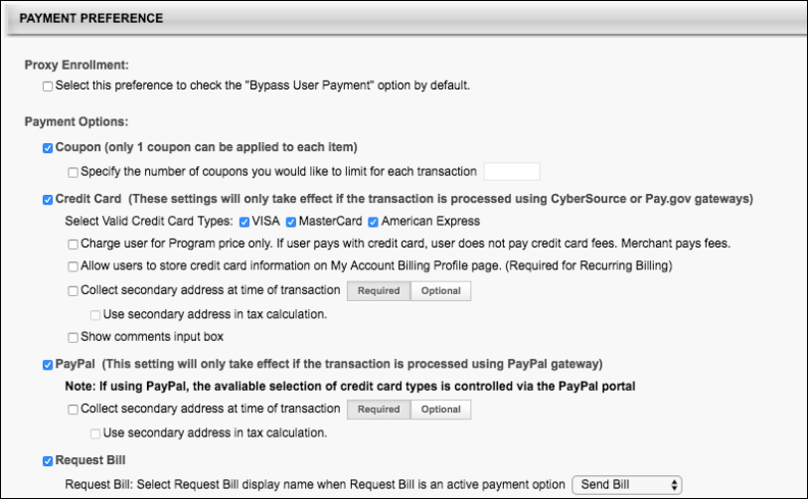
Payment Preference
When the PayPal option in the Payment Preference section is enabled, the following additional options can be configured:
- Collect secondary address at time of transaction - Select this option to allow users to enter a secondary address for the payment during the checkout process. When this option is selected, a Required/Optional toggle is enabled, which allows the administrator to determine whether the secondary address fields are required or optional. If the secondary address is optional, then all fields within the secondary address are optional, regardless of the Billing Information Preferences.
- Use Secondary Address in Tax Calculation - This field is enabled when the Collect secondary address field is selected and defined as required. This field only displays if at least one learning object (LO) is selected on the Tax Preferences page to indicate tax collection by LO.
Checkout with PayPal
When PayPal has been added as a payment method in a system using Extended Enterprise, users can pay for training using PayPal. After adding training to the shopping cart, the user can begin the checkout process. Please note that the PayPal integration only supports PayPal checkout and does not support any other PayPal products, such as Venmo or Braintree.
Step 1 - Payment
On the Payment step of the checkout process, the user can select PayPal from the Payment Method drop-down menu. After selecting PayPal as the payment method, click the Next button. Note: PayPal can only be used as the payment method if ALL items in the cart can be purchased using one payment method. PayPal cannot be used to purchase training units.
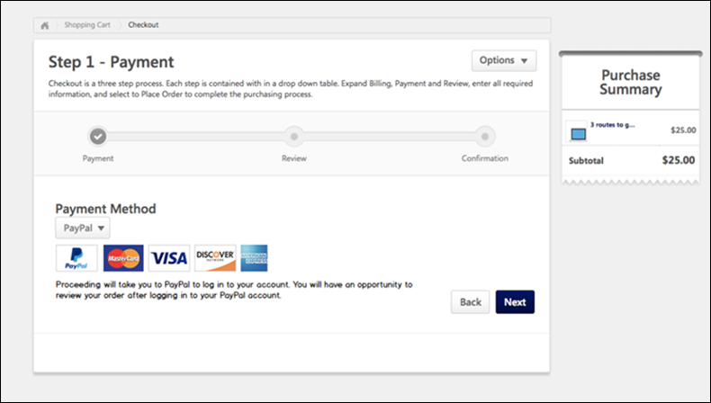
Checkout with PayPal
After selecting PayPal as the payment method and clicking the Next button, the user is redirected to PayPal's payment page. The user will be prompted to pay for the training in the cart using one of PayPal's supported payment methods. See PayPal.com for more information about creating a PayPal account and PayPal's checkout process.
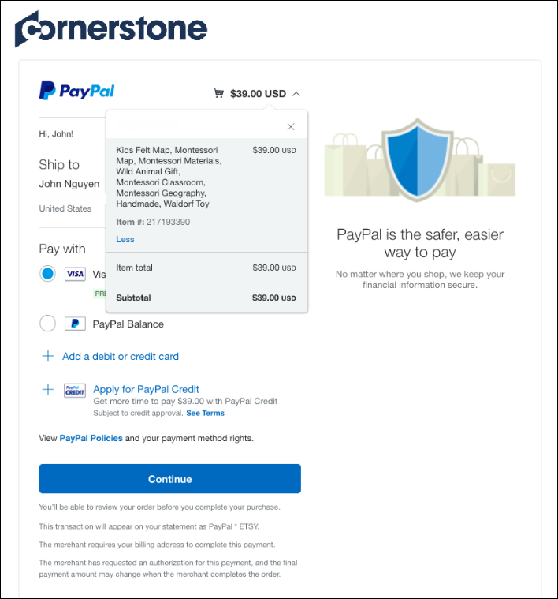
After completing the PayPal checkout process, PayPal provides the user with a receipt for their purchase on the screen and via email, and the user is navigated back transcript.
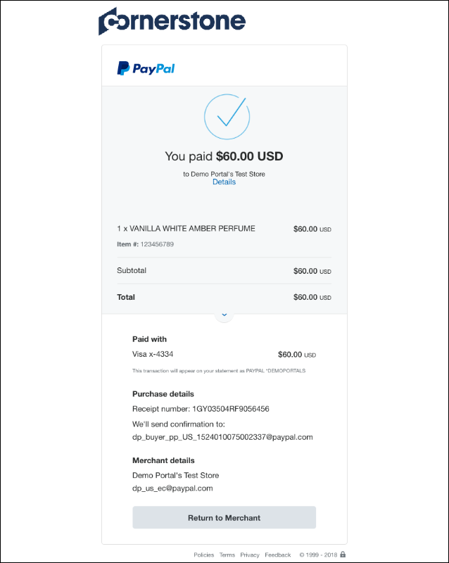
If payment was successful, the training is added to the user's transcript.
Order History
After the order has been processed, the user can view the transaction on the Order History tab of their My Account page. If the user paid for the order using PayPal, the Payment Method column displays a value of PayPal. For more information about the Order History page: See My Account - Orders - Order Details (Redesigned).
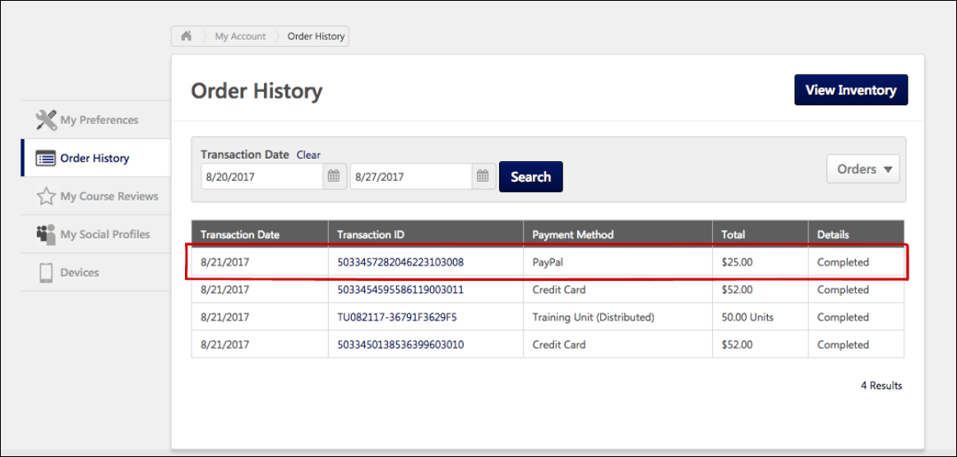
Manage PayPal Transactions
Transactions completed with PayPal can be viewed and managed by administrators via the Manage Transactions page, along with transactions completed with other payment methods.
To access the Manage Transactions page, go to Admin > Tools > Learning > E-Commerce > Manage Transactions.
Permissions
PERMISSION NAME | PERMISSION DESCRIPTION | CATEGORY

Transaction Manager - Manage | Grants ability to access the Manage Transaction page and also create and edit transactions. On the Order History Details page, the administrator can edit the order status, adjust prices, issue refunds, or enter comments. This permission can be constrained by User's OU. This is an administrator permission. | eCommerce - Administration

Transaction Manager - View | Grants ability to view the Manage Transaction page where the administrator can review the transactions that meet their permission constraints. This permission can be constrained by User's OU. This is an administrator permission. | eCommerce - Administration
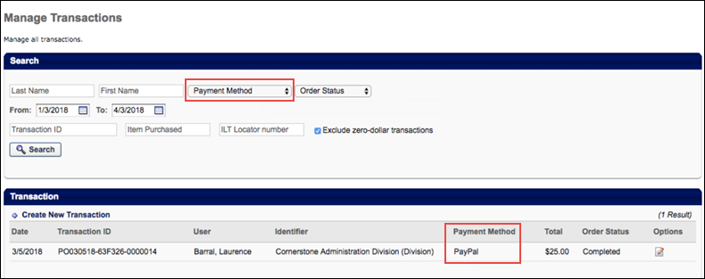
Manage Transactions
On the Manage Transactions page, you can search specifically for transactions that were completed with PayPal, and you can easily determine the payment method used for each transaction.
For general information about the Manage Transactions page: See Manage Transactions Overview.
Search
To search for only transactions which were completed using PayPal as the payment method, select the PayPal option from the Payment Method drop-down menu in the Search section and click the Search button. After the page refreshes, only transactions completed with PayPal will display in the Transaction section.
Transaction
In the Transaction section, view the Payment Method section to determine what payment method was used to complete each transaction. Transactions completed using PayPal display a value of PayPal in the Payment Method column. You can click the Details icon next to the transaction to view the Order Details page for the transaction. On the Order Details page for transactions completed with PayPal, the Payment Method field will display a value of PayPal.
Obtain Client ID and Client Secret from PayPal
Prior to configuring the PayPal Payment Gateway integration, an organization must have a PayPal business account. To retrieve the Client ID and Client Secret values required for configuring a payment account in Cornerstone:
- Go to: https://developer.paypal.com/developer/applications/ and log in with your PayPal business account credentials.
- Navigate to the My Apps & Credentials tab and click the Create App button in the REST API Apps section. This allows the Cornerstone system to authenticate with PayPal and process refunds.
- Name the application (this does not impact the integration) and associate the sandbox test account.
- Click the Create App button.
- The App will be created and the administrator can copy the Client ID and Secret from this page for the sandbox environment into the Modify Payment accounts page in their Cornerstone Stage environment. Note: These values do not expire, but they can be disabled by an administrator if needed.
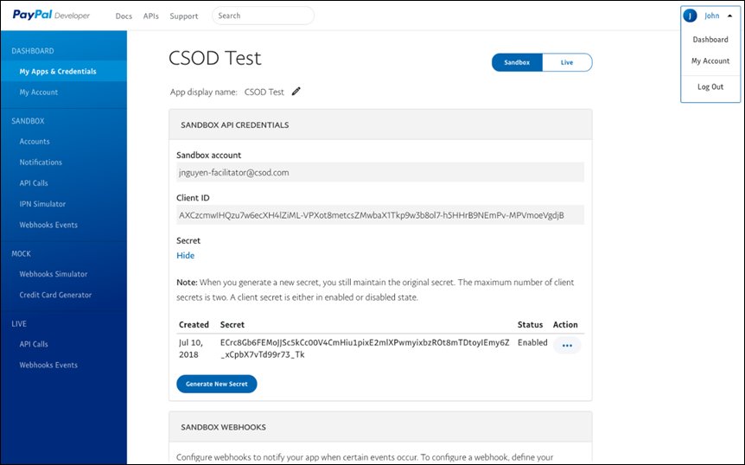
In order to view the Client ID and Secret values for the Cornerstone Production environment, click the Live tab in the upper-right of the PayPal business account page and repeat step four in the Cornerstone Production environment.
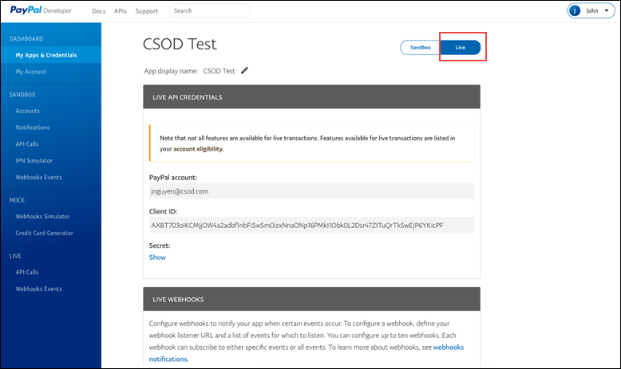
PayPal - Automatic Refunds
If a session was purchased using PayPal, and the Automate Refund Using Refund Terms option is enabled, existing system refund logic is respected and the session is automatically refunded due to the user withdrawing from the session.
If the refund is successful, the related refund information is reflected in the following locations:
- Manage Transactions page
- Order History
- Custom Reports
- Emails
To enable automatic refunds for PayPal transactions, go to: Admin > Tools > Learning > Learning Preferences > ILT Preferences.
Permissions
PERMISSION NAME | PERMISSION DESCRIPTION | CATEGORY

ILT Preferences - Manage | Grants ability to configure a variety of default settings that apply to new instructor led training events and sessions. This permission can be constrained by OU and User's OU. This is an administrator permission. | Learning - Administration
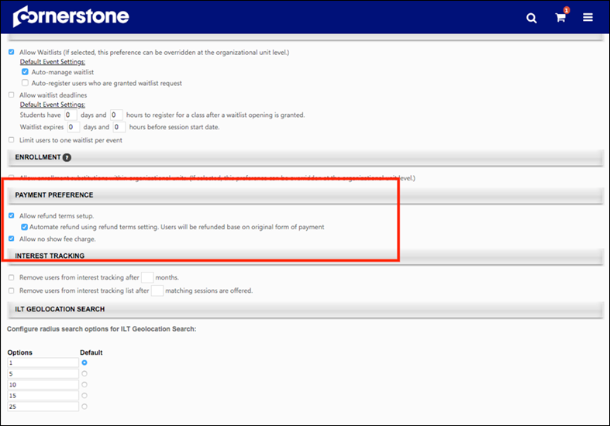
The following existing refund options are available in the Payment Preference section of ILT Preferences - General:
- Allow Refund terms setup - Select this option to enable administrators to set up refund terms when setting up an ILT event.
  - Automate refund using refund terms setting. Users will be refunded based on original form of payment. - This option is only available if the "Allow Refund terms setup" option is selected. Select this option to automatically issue refunds.
- Allow no show fee charge - Select this option to enable administrators to set up no show fees when setting up an ILT event.
See ILT Preferences - General for more information about ILT Preferences.
See Refunds Overview for more information about refunds.
PayPal - Manual Refunds
Administrators can manually initiate full and partial refunds for PayPal transactions via the Manage Transactions page.
To access the Manage Transactions page, go to Admin > Tools > Learning > E-Commerce > Manage Transactions. Then, click on the order you want to refund.
Permissions
PERMISSION NAME | PERMISSION DESCRIPTION | CATEGORY

Transaction Manager - Manage | Grants ability to access the Manage Transaction page and also create and edit transactions. On the Order History Details page, the administrator can edit the order status, adjust prices, issue refunds, or enter comments. This permission can be constrained by User's OU. This is an administrator permission. | eCommerce - Administration

Transaction Manager - View | Grants ability to view the Manage Transaction page where the administrator can review the transactions that meet their permission constraints. This permission can be constrained by User's OU. This is an administrator permission. | eCommerce - Administration
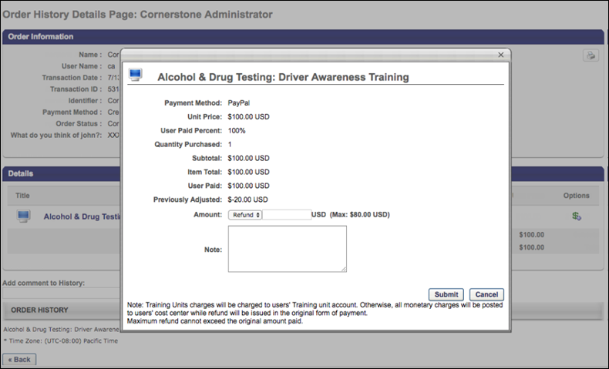
Manual Refund
To initiate a manual refund:
- Click the Refund icon in the Options column next to the training you are refunding. A pop-up window appears.
- In the pop-up, review the refund information and select a refund amount. Then add a note in the Note field explaining the refund.
- Click the Submit button to submit the refund.
If the refund is successful, the related refund information is reflected in the following locations:
- Manage Transactions page
- Order History
- Custom Reports
- Emails
See Refunds Overview for more information about refunds.
Considerations
- If tax was applied to the transaction by PayPal, during the refund process the administrator should specify the pre-tax amount to refund to the customer. The maximum refundable amount to a customer is the sub-total amount. Once the refund is triggered, PayPal refunds the tax proportional to the amount refunded.
- If tax is not applied to the transaction, the amount refunded is not changed.
PayPal Payment Gateway - Define Payment Account
On the Define Payment Account page, administrators can configure the payment account for their PayPal business account.
To access the Define Payment Account preferences page, go to ADMIN > TOOLS > Learning > Learning PREFERENCES > E-Commerce and click the Modify Payment Account link. In the Payment Account section, click the Add icon to add a new payment account.
Permissions
PERMISSION NAME | PERMISSION DESCRIPTION | CATEGORY

Payment Account - Modify | Grants ability to create payment profiles to determine the routing of users' payments. This permission cannot be constrained. This is an administrator permission. | eCommerce - Administration
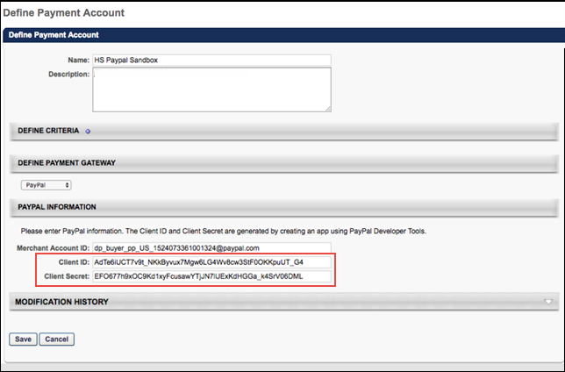
PayPal Information
In the PayPal Information section, the administrator can populate the following fields:
- Merchant Account ID - Provide the email address or merchant account ID associated with your organization's PayPal business account. This field is required.
- Client ID - Provide the Client ID associated with your organization's PayPal business account. This field is required.
- Client Secret - Provide the Client Secret associated with your organization's PayPal business account. This field is required.
Access your PayPal information from the My Apps & Credentials tab of your PayPal Developer account. See Obtain Client ID and Client Secret from PayPal on page 150 for additional information.
Click the Save button to finish configuring the PayPal payment account.
For more information about creating a payment account: See Create Payment Account.
Transaction Reporting - PayPal
The Transaction Payment Method field, available in Reporting 2.0, can generate an output of PayPal, in addition to the existing other potential payment method outputs.
PayPoint Payment Processor
The PayPoint Payment Gateway supports transactions including:
- Credit card and e-check payment methods
- Tax calculation
- Processing fee calculation, calculated as:
  - Percentage applied over the purchase order total value
  - Fixed value
  - Formula (using the purchase order total value)
Exclusions
The following features are not supported by this integration:
- Recurring billing
- Transactions with 3D Secure
Considerations
- Only one payment processor may be enabled in a portal at a time, with the exception of the PayPal Payment Processor. The PayPal Payment Processor may be enabled in addition to one other payment processor, such as the PayPoint Payment Processor.
- For tax calculation, a Cybersource or CCH account is required. PayPoint does not calculate taxes.
- Costs are associated with the creation of a PayPoint merchant account, and these fees are charged by PayPoint. Cornerstone is not responsible for any costs incurred through PayPoint.
- The enablement of the PayPoint Payment Gateway within the Cornerstone system has an associated cost. For more details, please contact your Account Manager.
Implementation
For organizations using the Learning module, this integration can be self-enabled via the Edge Marketplace. See PayPoint - Enable in Edge on page 161 for additional information.
Please contact PayPoint (Fiserv) to create a PayPoint merchant account.
Edge Guide
Click here for the PayPoint Payment Gateway Edge Guide!
Permissions
The following existing permissions apply to this functionality:
PERMISSION NAME | PERMISSION DESCRIPTION | CATEGORY

Edge Integrations - Manage | Grants access to the Integrations service for Edge Integrate, where the administrator can configure, enable, and disable their third-party integrations used within the Cornerstone system. This permission cannot be constrained. This is an administrator permission. | Edge

Edge Marketplace - Manage | Grants access to the Marketplace service for Edge Integrate, where the administrator can browse integrations that can be used to extend the Cornerstone system. This permission cannot be constrained. This is an administrator permission. | Edge

Payment Account - Modify | Grants ability to create payment profiles to determine the routing of users' payments. This permission cannot be constrained. This is an administrator permission. | eCommerce - Administration
PayPoint - Enable in Edge
The PayPoint Payment Processor integration can be enabled via the Edge Marketplace.
To access the Edge Marketplace, go to: Admin > Tools > Edge and click the Marketplace link.
Permissions
PERMISSION NAME | PERMISSION DESCRIPTION | CATEGORY

Edge Integrations - Manage | Grants access to the Integrations service for Edge Integrate, where the administrator can configure, enable, and disable their third-party integrations used within the Cornerstone system. This permission cannot be constrained. This is an administrator permission. | Edge

Edge Marketplace - Manage | Grants access to the Marketplace service for Edge Integrate, where the administrator can browse integrations that can be used to extend the Cornerstone system. This permission cannot be constrained. This is an administrator permission. | Edge
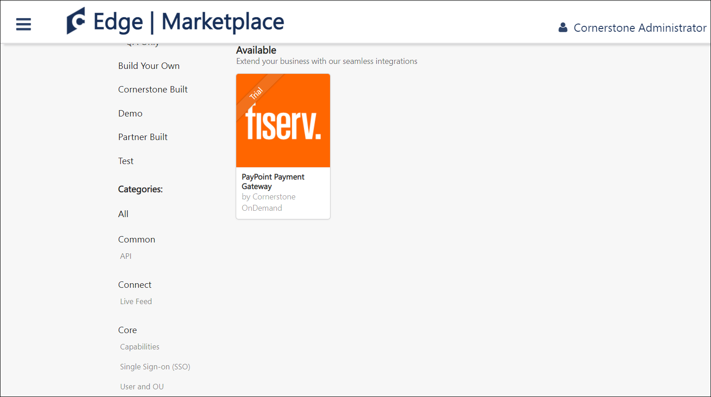
PayPoint - Edge Marketplace
To enable the PayPoint Payment Processor:
- Search for and select the PayPoint (Fiserv) tile in the Edge Marketplace.
- Then, click the Install button for the PayPoint integration.
- Review the terms and conditions of using the PayPoint integration and check the acknowledgment box to confirm that you read, understood, and agree to the terms and conditions.
- Click the Install button. The integration will be installed.
- Enable the PayPoint (Fiserv) tile in Edge in order to activate the payment processor. The Active toggle is switched to the Off position by default.
Account details for your PayPoint account must be added within the Cornerstone system, via the Define Payment Account page. See PayPoint - Define Payment Account on page 163 for additional information.
PayPoint - Define Payment Account
On the Define Payment Account page, administrators can configure the payment account for their PayPoint merchant account.
To access the Define Payment Account preferences page, go to ADMIN > TOOLS > Learning > Learning PREFERENCES > E-Commerce and click the Modify Payment Account link. In the Payment Account section, click the Add icon to add a new payment account.
Permissions
PERMISSION NAME | PERMISSION DESCRIPTION | CATEGORY

Payment Account - Modify | Grants ability to create payment profiles to determine the routing of users' payments. This permission cannot be constrained. This is an administrator permission. | eCommerce - Administration
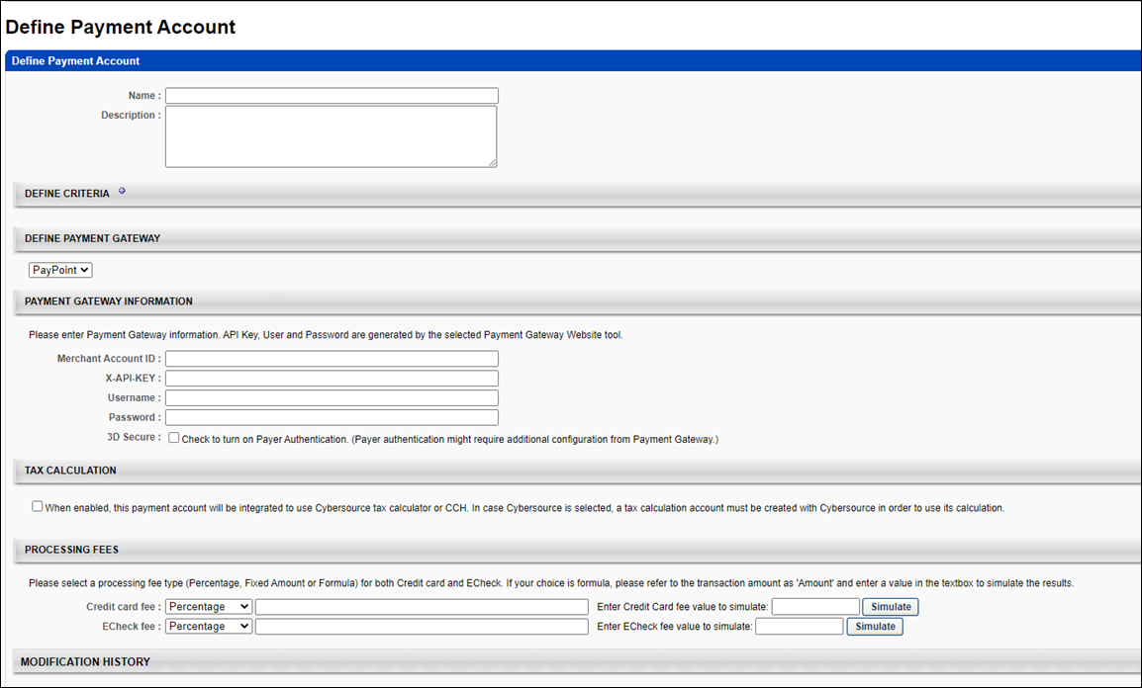
Define Payment Gateway
To define the PayPoint Payment Gateway, complete the following steps:
- In the Define Payment Gateway section, select PayPoint from the drop-down menu. Note: This option is only available if you have enabled the PayPoint Payment Gateway via Edge.
- Enter the following information for the payment account:
  - Name - Character limit is 50.
  - Description - This is for administrator use only. It is not displayed anywhere. Character limit is 250.
  - Define Criteria - At least one criteria is required and constraints do not apply to the available selections. The available attribute types are:
    - Currency
    - Provider
    - OU
    - LO
- The remaining fields that the administrator must populate depend on the payment processor selected for the portal. In the Payment Gateway Information section, populate the Payment Gateway information with the API credentials obtained from PayPoint.
Note: These fields can be obtained from PayPoint after you have created an account with PayPoint.
Save/Cancel
Click Save to save the payment account. Or, click Cancel to cancel creating the payment account.
Stripe Payment Gateway - Overview
The Stripe Payment Gateway integration with Cornerstone Learning is an API-based solution that provides users the ability to purchase courses offered through the e-commerce functionality available as part of the Extended Enterprise module (EXE).
Stripe provides the following key features:
- Transparent fee structure
- Fee calculation can be defined for each supported payment method as follows:
  - Percent applied over the purchase order total value
  - Fixed value
  - Formula, using the purchase order total value
- Easy administrator setup via Edge Marketplace
- High standards for fraud prevention
- 3DS/3DS2 Authentication
- Tax calculations
- Refunds
Considerations
- Customers must reach out to Stripe to create their account and request the following settings:
  - Stripe Account ID
  - Secret key
- The following features are not supported:
  - Recurring billing
Note: For tax calculations, a Cybersource account is required.
Implementation
Please contact your account manager to enable this integration.
Stripe Payment Gateway - Define Payment Account
On the Define Payment Account page, administrators can configure the payment account for their Stripe business account.
To access the Define Payment Account preferences page, go to ADMIN > TOOLS > Learning > Learning PREFERENCES > E-Commerce and click the Modify Payment Account link. In the Payment Account section, click the Add icon to add a new payment account.
Permissions
PERMISSION NAME | PERMISSION DESCRIPTION | CATEGORY

Payment Account - Modify | Grants ability to create payment profiles to determine the routing of users' payments. This permission cannot be constrained. This is an administrator permission. | eCommerce - Administration
Define Stripe Payment Account
Before you begin
Contact Stripe to create an account and request your Stripe Account ID and Secret Key.
- Complete the Name and Description fields.
- In the Define Payment Gateway drop-down, select Stripe.
- In theStripe Information section, enter your Client ID and Client Secret information.
- Click Save to save the changes.
Access your Stripe information from the My Apps & Credentials tab of your Stripe Developer account.
For more information about creating a payment account: See Create Payment Account.
Stripe Payment Processor - Refunds
The administrators can initiate refunds directly using the CSX Extended Enterprise module for payment transactions that were executed via the Stripe Payment gateway. This process does not require manual login to the Stripe account by the administrator. Refunds can be initiated by the user from the CSX user’s Transcript page itself if allowed by the Learning Object (LO) settings. For more information, See Stripe Payment Gateway - Define Payment Account on page 166 for additional information.
Permissions
PERMISSION NAME | PERMISSION DESCRIPTION | CATEGORY

Refund Training | Grants ability to issue a refund for a training item while removing it from the user's transcript. This is an administrator permission. | eCommerce - Administration

Remove Training | Grants ability to remove training from other users' transcripts (training records) when viewing their transcript. This permission can be constrained by OU, User's OU, User's Corporation, User Self and Subordinates, User's Self, User's Direct Subordinates, and User. This is an administrator permission. | Learning - Administration

Transaction Manager - Manage | Grants ability to access the Manage Transaction page and also create and edit transactions. On the Order History Details page, the administrator can edit the order status, adjust prices, issue refunds, or enter comments. This permission can be constrained by User's OU. This is an administrator permission. | eCommerce - Administration

Transaction Manager - View | Grants ability to view the Manage Transaction page where the administrator can review the transactions that meet their permission constraints. This permission can be constrained by User's OU. This is an administrator permission. | eCommerce - Administration
Refunds can be initiated by any user authorized to do so such as administrators, user’s managers, etc. using the Manage Transactions page. To initiate a refund, follow these steps.
- Go to Admin > Tools > Learning > E-Commerce > Manage Transactions. Find a transaction and click Options.
- In the Order History Details Page, click the Options icon under the Details section.
- In the Pricing Test, enter the refund amount beside the Amount option. Make sure to select Refund from the Amount drop-down.
- Type a note in the Notes section if required and click Submit to initiate the refund.
- View refund details under the Order History section on the Order History Details Page. You can also check the order status in your Stripe account.
Stripe Payment Gateway - Tax
Customers using the Stripe payment gateway can automatically collect tax from their end users during the transactions made via CSX EXE. Stripe Tax lets you calculate, collect, and report tax on global payments with a single integration. You can easily register with Stripe and access the reports within Stripe to file returns. There is no need for a separate tax account with Stripe. It is easy to define the specific regions within Stripe for tax calculation.
​
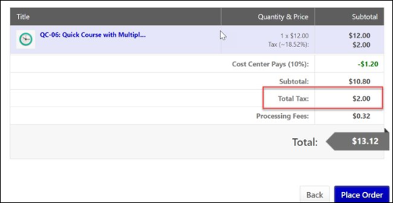
Permissions
PERMISSION NAME | PERMISSION DESCRIPTION | CATEGORY

Payment Account - Modify | Grants ability to create payment profiles to determine the routing of users' payments. This permission cannot be constrained. This is an administrator permission. | eCommerce - Administration
To enable Stripe Tax Calculation, go to ADMIN > TOOLS > LEARNING > LEARNING PREFERENCES > E-COMMERCE and click Modify Payment Account. In the Define Payment Account page, select Enable Stripe Tax Calculation check box.
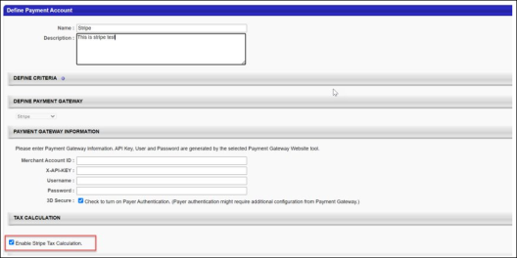
To select the Learning Objects (LOs) that are eligible for tax calculation, go to admin > tools > learning > e-commerce > taxes > tax preferences and select the LOs. Now go to the pricing section of an eligible LO and select Apply sales tax check box.
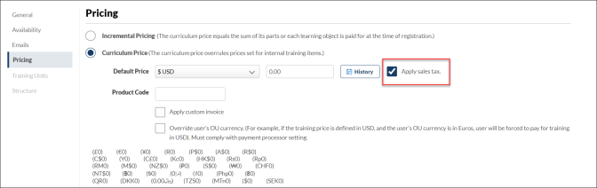
Note: Stripe Tax is an enhancement to the existing Stripe Payment Gateway and it is not available for other payment gateways.
Frequently Asked Questions (FAQs)
Can Stripe tax be used for tax calculation when the payment gateway provider is not Stripe?​
No. As of now, Stripe tax can only be used when Stripe is the payment processor for the transactions.
If a given LO does not have the pricing tab, can tax be calculated for that particular LO?​
No. Apply sales tax checkbox under the pricing tab of a given LO should be checked for Tax calculation. If the pricing tab is unavailable, tax cannot be calculated for that LO.
Stripe Tax Service - Other Payment Gateways
Customers who use other payment gateways within CSX EXE (like Adyen, Paypoint, etc.) to sell courses and want an additional Tax service can use the Stripe tax feature to add the sales tax to the purchase price of the products they sell through CSX EXE during the transaction. It is a standalone feature and is independent of the Stripe payment gateway.
Note: To enable this functionality, please contact your account manager to allow the Tax Stripe feature within CSX EXE.
Permissions
PERMISSION NAME | PERMISSION DESCRIPTION | CATEGORY

Payment Account - Modify | Grants ability to create payment profiles to determine the routing of users' payments. This permission cannot be constrained. This is an administrator permission. | eCommerce - Administration
The following key functionalities accompany this feature:
- Easy to register with Stripe.
- Automatically collect the right amount of Tax.
- Customers can easily access the reports within Stripe to file returns.
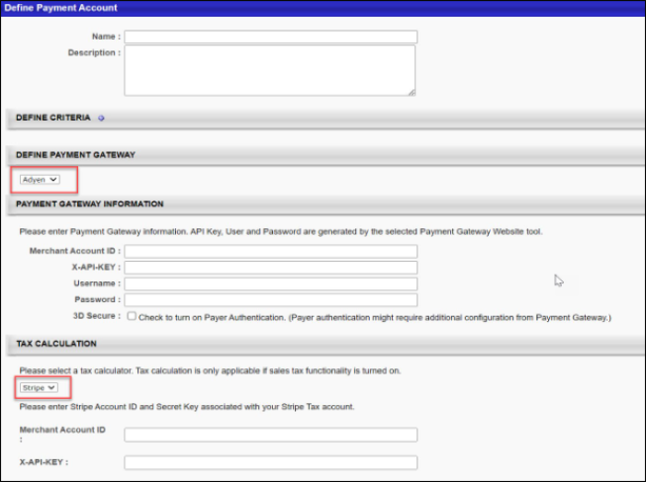
Note: Cybersource no longer provides Tax services to other payment gateways.
Setting up Stripe Tax in CSX user interface
To avail the Stripe Tax service, the customers must have a Stripe account. Set up the regions within your Stripe Account for which the sales tax needs to be calculated. Your Stripe Account ID and secret key are required to complete the setup in CSX EXE under the “Modify Payment Gateway” page.
In CSX EXE, Stripe Tax needs to be enabled via the “Define Payment Account” page. See Stripe Payment Gateway - Define Payment Account on page 166 for additional information.
In the “Define Payment Account” page, under the Tax Calculator section, select “Stripe” from the dropdown and enter your Stripe Account ID and secret key that Stripe provided. For more information, See Stripe Payment Gateway - Tax on page 168 for additional information.
Considerations​
- Stripe tax is now available for Adyen, NIC Colorado, and PayPoint Payment gateways.
- Stripe tax was already available for Stripe Payment Gateways users.
- Stripe tax is not available for Cybersource and PayPal payment gateways.
- Customers need a Stripe payment gateway account to use the Stripe tax service.
- Customers need to set up the regions in their Stripe account for which they want to collect Sales Tax.
- Stripe Tax can be calculated based on the billing address only.

Transcript Integrations - Overview
eeds - Continuing Medical Education Integration
The eeds integration allows organizations to view and track CME credits imported from eeds within learners' transcripts in the Cornerstone Learning Management System (LMS). Using this integration, learners and learning administrators are able to search, find, and confirm CME credits on the learner's transcript.
Use Case
ACME Hospital schedules a weekly session of Cardiology Grand Rounds. Dr. Smith would like to see the upcoming schedule, so she searches for Cardiology Grand Rounds in the Cornerstone LMS, finds the event, and clicks a link in the description to see the schedule for the event.
On May 8th, Dr. Smith is able to sign into the Cardiology Grand Rounds session via the eeds app or on the website. After she completes the various requirements for the course, such as an evaluation and post-test, the attendance data is sent to the Cornerstone LMS.
Dr. Smith logs into the LMS the next day and can view her transcript with the TEDMED event information. She can also view her certificate by clicking on the eeds Certificate link in the training details for the event. With the help of the eeds integration, Dr. Smith is able to take training, view training details, and complete associated actions all through one system.
Exclusions
The following exceptions apply to the eeds integration:
- CME/CEU credits will not be aggregated. If an organization needs a sum of the CME/CEU credits, they must go to eeds-CME via the certificate link or access a training report via the LMS and export to excel.
- Training hours, which refers to the actual hours and minutes of an event, appears on the user's transcript and will be aggregated with other learning objects (LOs).
- Historical data is not reflected on the transcript. eeds-CME will be the sole system of record for historical (i.e. pre-integration) data. Note: eeds-CME can send historical data as an add-on.
Implementation
For organizations using the Learning module, the eeds integration is available for an additional cost. To get started, access the Edge Marketplace by going to ADMIN > TOOLS > EDGE and clicking the Marketplace link.
Search for and select the eeds - Continuing Medical Education informational tile available in the Edge Marketplace and review the Vendor, Integration, and Setup tabs for the integration. When ready to proceed, click the GET STARTED button for the integration.
After you complete and submit the form, an eeds expert will contact you with pricing and setup steps.
Permissions
The following existing permissions apply to this functionality:
PERMISSION NAME | PERMISSION DESCRIPTION | CATEGORY

Course Catalog - Update | Grants ability to manage and edit training items listed in the Course Catalog and also grants access to the Course Console, where training can also be managed and edited. This permission also grants access to the Popular Requests and Highest Rated widgets on the Learning Admin Console (in conjunction with the Learning Admin Console - View permission). This permission also allows administrators to reversion online courses via the Course Console page. This permission also allows administrators to access an Edit Training option for training items included as objectives in Development plans.  This permission can be constrained by OU, User's OU, Training Type, Training Item, Provider, ILT Provider, User's ILT Provider, User, User Self and Subordinates, and User's LO Availability. This is an administrator permission.  Note: Adding an OU constraint and a provider constraint to this permission results in an "AND" statement. | Learning - Administration

Events - Create | Grants ability to create new instructor led training events. This permission works in conjunction with Events - View permission. This permission can be constrained by OU, User's OU, ILT Provider, and User's ILT Provider. This is an administrator permission. | Learning - Administration

Express Class - Manage | Grants the ability to create and add users to an Express Class for a facilitated training session. This permission can be constrained by OU, User, User Self and Subordinates, and User's OU. This is an end user permission. | Learning - Administration

Materials Management | Grants ability to view the Material Administration page and create, edit, and copy materials. Once created, these "materials" can be managed like other learning objects via the course catalog. This permission can be constrained by OU, User's OU, and Provider. The constraints on this permission determine which materials the administrator is able to view, edit, copy, and create. This is an administrator permission. | Learning - Administration

Training Custom Fields | Grants ability to create and edit custom fields to be used for one or more learning object types. This is an administrator permission. | Learning - Administration
ServiceNow Integration
A ServiceNow integration is available through the Edge Marketplace, meaning that organizations that rely on Cornerstone to train their employees can now directly integrate their Cornerstone Learning solution with their ServiceNow® HR Service Delivery solution.
Considerations
In order to use the ServiceNow integration, your organization must first meet the dependencies outlined here: Spoke Dependencies
Implementation
To get started with the ServiceNow integration, click the Get Started button for the integration tile in the Edge Marketplace. To access the Edge Marketplace, go to: Admin > Tools > Edge and click the Marketplace link.
To enable the ServiceNow integration via the Edge Marketplace:
- Search for and click the ServiceNow integration tile.
- Click the Install button to install the integration.
- Review and Accept the terms and conditions of the integration and click the Install button.
- Click the Configure Now button.
- Configure the integration on the Settings tab and click the Save button.
- Navigate to the Edge Integration Center, find the ServiceNow integration, and toggle the Enablement switch for the integration to the On position to complete the enablement.
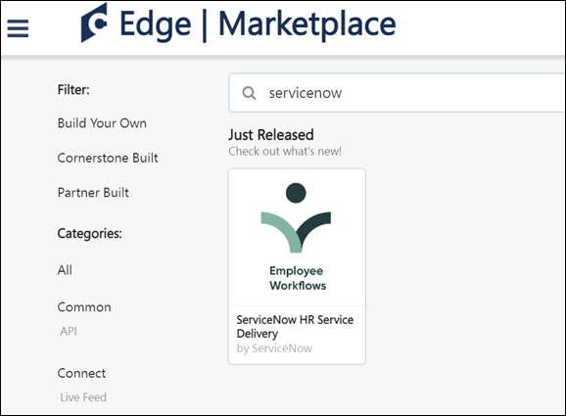
Integrate your Cornerstone application with your ServiceNow instance. Register an OAuth application in Cornerstone and authenticate requests from ServiceNow using the following documentation: Set Up the Cornerstone Spoke
Permissions
The following existing permissions apply to this functionality:
PERMISSION NAME | PERMISSION DESCRIPTION | CATEGORY

Edge Integrations - Manage | Grants access to the Integrations service for Edge Integrate, where the administrator can configure, enable, and disable their third-party integrations used within the Cornerstone system. This permission cannot be constrained. This is an administrator permission. | Edge

Edge Marketplace - Manage | Grants access to the Marketplace service for Edge Integrate, where the administrator can browse integrations that can be used to extend the Cornerstone system. This permission cannot be constrained. This is an administrator permission. | Edge
UKG Pro™ Transcript Data Outbound Integration
Eliminate the need for duplicate data entry and centralize transcript management by integrating Cornerstone’s Learning Platform and UKG Pro™. Cornerstone’s integration with UKG Pro™ provides a seamless process for managing user transcripts between systems. It automatically transfers completed transcripts for active users from Cornerstone to UKG Pro™.
UKG Pro Workforce Management™ Employee Dashboard Tile
The UKG Pro Workforce Management™ Employee Dashboard Tile in Edge automatically creates a Cornerstone tile on organizations' UKG Pro Workforce Management™ tenant. This tile provides learners with basic information about their Cornerstone training that is past due, assigned, in progress, and completed. It also allows learners to be redirected to their Cornerstone transcript if the learner has an active Cornerstone session.
Use Cases
Use Case 1: User views training transcript details on UKG Pro Workforce Management™ employee dashboard and navigates to Cornerstone transcript page
Lisa is an Acme Company employee, and she uses the Cornerstone Learning system. Lisa has added the Cornerstone Learning tile to her UKG Pro Workforce Management™ employee dashboard. She logs into Acme's UKG Pro Workforce Management™ tenant to access the employee dashboard page. She wants to know the number of training items assigned to her that are past due, so she views the Cornerstone Learning tile for a summary of her transcript details.
Lisa wants to complete one of her past due training items, so she clicks the View My Transcript link on the tile. Because Lisa has an active Cornerstone session, she is taken directly to her Cornerstone transcript page to complete her training.
Use Case 2: User views transcript details on UKG Pro Workforce Management™ employee dashboard and navigates to Cornerstone login page
Jessie is an employee at Acme Company and uses the Cornerstone Learning system. Jessie has added the Cornerstone Learning tile to her UKG Pro Workforce Management™ employee dashboard. She logs into Acme's UKG Pro Workforce Management™ tenant to access the employee dashboard page. She wants to know the number of training items that are in progress on her transcript, so she views the Cornerstone Learning tile to access her transcript details.
Jessie wants to complete one of her in progress training items, so she clicks the View My Transcript link on the tile. Because Jessie does not have an active Cornerstone session, she is taken to Acme's Cornerstone portal login page and is prompted to enter her credentials. After entering her credentials, she is navigated to her transcript page to complete her training.
Considerations
The following considerations apply to this integration:
- Certifications are not supported by this integration.
- SSO is supported for organizations which have an IDP SSO configured in both UKG Pro Workforce Management™ and in Cornerstone.
- This integration is only offered in English.
Implementation
To enable the UKG Pro Workforce Management™ Employee Dashboard Tile integration, contact your Account Manager. There is no additional cost associated with this integration.
Permissions
The following existing permissions apply to this functionality:
PERMISSION NAME | PERMISSION DESCRIPTION | CATEGORY

Edge Integrations - Manage | Grants access to the Integrations service for Edge Integrate, where the administrator can configure, enable, and disable their third-party integrations used within the Cornerstone system. This permission cannot be constrained. This is an administrator permission. | Edge

Edge Marketplace - Manage | Grants access to the Marketplace service for Edge Integrate, where the administrator can browse integrations that can be used to extend the Cornerstone system. This permission cannot be constrained. This is an administrator permission. | Edge
Workday Transcript Outbound Integration
The Workday Transcript Outbound integration is for organizations that are using the Learning module and using Workday as the source for their HCM data. This integration is a one-way sync of completed transcripts from Cornerstone to Workday. The outbound integration runs nightly (US-Pacific) and can be triggered on demand.
The following notes apply to this functionality:
- The following training types are supported: Online Course, Event, Session, Curriculum, Test, External Training, Material, Video.
- Only completed transcripts of active users are synced.
- Transcript sync may include Contingent Workers.
- Organizations can exclude users based on a user's OU and/or user custom field value is included.
- Organizations can exclude transcripts for certain training through a training custom field of type checkbox.
- Sync summary and log are emailed to a subscription list.
How Does this Enhancement Benefit My Organization?
This integration provides an Edge solution to synchronize completed transcript data from Cornerstone to Workday.
Implementation
It is recommended to implement the integration on your test environment prior to production environment.
The integration is available to install in the Edge Marketplace for a fee.
For organizations that are using the previously existing, legacy Workday Transcript Outbound integration, enablement information is available in the Resources section above.
For new integrations, this integration is available for self-activation via Edge Marketplace and Integrations. Organizations must have an existing contract with Workday. Starter Guides and Migration instructions are included with the integration in Edge Marketplace.
Security
The following existing permissions apply to this functionality:
PERMISSION NAME | PERMISSION DESCRIPTION | CATEGORY

Edge Integrations - Manage | Grants access to the Integrations service for Edge Integrate, where the administrator can configure, enable, and disable their third-party integrations used within the Cornerstone system. This permission cannot be constrained. This is an administrator permission. | Edge

Edge Marketplace - Manage | Grants access to the Marketplace service for Edge Integrate, where the administrator can browse integrations that can be used to extend the Cornerstone system. This permission cannot be constrained. This is an administrator permission. | Edge

vILT (Virtual Instructor Led Training) Integrations - Overview
Adobe Connect Meeting Room Integration
The Adobe Connect Meeting Room integration allows for seamless creation of virtual meetings that can host up to 100 meeting participants. The integration gives users the ability ot execute on all phases of the meeting setup and execution from within Cornerstone's Learning Management System (LMS). This vILT integration allows Learning Administrators to add instructors, create and manage sessions, and track attendance from within Cornerstone. Adobe Connect sessions can be launched from Cornerstone directly into Adobe Connect.
When an instructor is selected for an Adobe Connect vILT session, the instructor is automatically designated as a host for the Adobe Connect session.
Use Case
- An administrator working inside the LMS is setting up webinar training that will be attended by the entire company. She creates the session inside the LMS and assigns an instructor. The assigned instructor is automatically designated as a host for the session.
- Because there will be less than 100 attendees, she decides to use one of her company's licensed Meeting Rooms with Adobe Connect.
- One of the facilities inside of the LMS is mapped to the appropriate Meeting Room in Adobe Connect. The administrator makes sure that the location of the session is using a location with that facility so that the meeting will be held inside the Meeting Room.
- The webinar is assigned to the entire company and when it comes time for the session to start, the attendees launch the webinar directly from their transcripts and are taken directly into the Meeting Room inside of Adobe Connect.
Considerations
Webinars and Adobe Webinar licenses are not supported.
Implementation
The Adobe Connect Meeting Room integration requires purchase through Edge Marketplace. This integration requires Cornerstone Learning and at least one Adobe Connect administrator account.
Once the integration has been purchased, the functionality is not available until the integration is configured and enabled via Edge Integrations.
Adobe Connect Seminar Room
The Adobe Connect Seminar Room integration allows for seamless creation of virtual meetings from within Cornerstone Learning using the Adobe Connect API. This vILT integration allows Learning Administrators to add instructors, and create and manage sessions from within Cornerstone. Adobe Connect sessions can be launched from Cornerstone directly into Adobe Connect.
When an instructor is selected for an Adobe Connect vILT session, the instructor is automatically designated as a host for the Adobe Connect session.
Use Case
- An administrator working inside the Learning Management System (LMS) is setting up webinar training that will be attended by the entire company. She creates the session inside the LMS and assigns an instructor. The assigned instructor is automatically designated as a host for the session.
- Because there will be over 100 attendees, she decides to use one of her company's licensed Seminar Rooms with Adobe Connect.
- One of the facilities inside of the Learning Management System is mapped to the appropriate Seminar Room in Adobe Connect. The administrator makes sure that the location of the session is using a location with that facility so that the meeting will be held inside the Seminar Room.
- The webinar is assigned to the entire company and when it comes time for the session to start, the attendees launch the webinar directly from their transcripts and are taken directly into the Seminar Room inside of Adobe Connect.
Considerations
Webinars and Adobe Webinar licenses are not supported.
The Adobe Connect API does not support the passing back of attendance data from Adobe Connect to the Learning Management System.
The system enables administrators to move an ILT session into a seminar room. However, seminar rooms must be created and managed within Adobe Connect.
Implementation
The Adobe Connect Seminar Room integration requires Cornerstone Learning and an Adobe Connect Seminar Room account.
This integration is available in the Edge Marketplace. Once the integration has been purchased, the functionality is not available until the integration is configured and enabled via Edge Integrations.
Troubleshooting
Error type | Where found | Typical Cause | Possible Solution
Name cannot begin with the ' ' character, hexadecimal value 0x20. Line 15, position 32. | Creating an instructor. | Adobe Connect URL is incorrect. | Make sure the Adobe Connect URL in the Edge tool ends with /api/xml.
Object reference not set to an instance of an object. | Creating an instructor. | Site Administrator details are incorrect. | Check the Adobe Connect URL, make sure this has https not http, and ends with /api/xml. Also confirm the username and password are correct.
Session not created in the expected meeting template in Adobe Connect. | In Adobe Connect after the session is created. | Location of session in Cornerstone does not have the IT matching the meeting template’s SCO ID. | Make sure the ID of the location the session is being held in is either blank (will go to the General meeting template), or is the SCO ID of a specific meeting template in Adobe Connect.
When host launches Adobe Connect meeting, they join as a participant. | Launching a session. | Not enough host licenses in Adobe Connect for the user to be added as a Host. | Purchase more host licenses in Adobe Connect or remove a host license from a user who is no longer using it.
Move Session to Adobe Connect Seminar Room
The system enables administrators to move an ILT session into an Adobe Connect seminar room. However, seminar rooms must be created and managed within Adobe Connect.
To move an ILT session into a seminar room, first, create an ILT Facility that matches the name or ID of the shared seminar room in Adobe Connect. Second, create an ILT session. On the Parts Schedule page for the session, set the session location as the facility that corresponds to the Adobe Connect seminar room. This ensures the session is associated with the correct seminar room in Adobe Connect.
Permissions
PERMISSION NAME | PERMISSION DESCRIPTION | CATEGORY

Facilities - Create | Grants ability to create new facilities (locations) via ILT/Facilities and Resources. This is an administrator permission. | Learning - Administration

Sessions - Create | Grants ability to create new instructor led training sessions. This permission works in conjunction with Events - View and Sessions - View permissions. Administrators can only create sessions for events for which they have the availability to view. When adding users to a session in which the session roster is full, this permission grants the ability to increase the session's available seats. This permission can be constrained by OU, User's OU, Instructor, User as Instructor, Facility, Facilities Owned by User, ILT Provider, User's ILT Provider, User, and User Self and Subordinates. This is an administrator permission.  Note: The "Restrict to User as Instructor" constraint is available, but it does not actually constrain the permission. | Learning - Administration
Create Seminar Room Facility
To create a seminar room facility, go to ILT > Facilities and Resources. Then, click the Add Facility link.
The following information must be entered for the seminar room facility in order to map it to the seminar room in Adobe Connect:
- Name - Enter the Adobe Connect Seminar Room name. This is required.
- ID - Enter the Adobe Connect Seminar Room ID. This is required.
- Description - Enter an optional description for the seminar room facility.
- Active - Select this option to make facility active.
- Facility Type - Select the appropriate facility type from the drop-down list.
- In the address fields, enter the address of the seminar room, if applicable.
For more information about creating facilities: See Facility - Add.
Create Session with Seminar Room Facility
To create an ILT Event Session, go to ILT > Manage Events & Sessions. Search for the appropriate event and in the Options column next to the event, click the View Sessions icon . To create a new session, you can do so via one of the following options:
- Click Create New Session to create a new session.
- Click Copy icon to create a copy of an existing session which can be changed or edited and saved as a new session.
- Click Edit icon to modify an existing session.
The following information must be entered for the session on the Parts Schedule page in order to utilize the Adobe Connect seminar room facility:
- Name - Enter the session name.
- Description - Enter the session description.
- Location - Select the Seminar Room Facility.
For more information about creating sessions:
Cisco Webex Meetings SSO
The Cisco Webex integration enables organizations to utilize the Webex Single Sign On (SSO) functionality. When Webex SSO is enabled, Webex instructors are not required to enter their passwords when creating and launching meetings.
This integration includes Webex SSO Partner Delegated Authentication (PDA), which enables organizations to use their own SSO provider or have no SSO provider for their Webex portal.
Considerations
Organizations can use SSO for the Webex Administrator account. However, it is NOT supported to enable MFA (Multi-Factor-Authentication) in Webex for this account.
The Webex SSO (PDA) functionality only follows the "Launch Meeting as Instructor" workflow and does not support the creation of meetings or instructors.
Migration is not supported for this functionality. Webex SSO (PDA) only works for sessions that are created after the configuration. Sessions created prior to SSO (PDA) setup still require the integration to use instructor passwords.
Webex only allows one SAML certificate to authenticate users. This means that if SSO is set up between Cornerstone and Webex, the organization can only access Webex via the Cornerstone system. In this scenario, the organization cannot use SSO from multiple platforms into the same Webex account.
Implementation
- This functionality is disabled by default. Contact Global Customer Support to enable via a Billable Work Order across environments.
- Prior to enabling Webex SSO within the Cornerstone portal, organizations must request SSO from Webex and have the SAML metadata imported to their Webex support site.
Content
The following information is available within the this folder. Click a link to navigate directly to the appropriate topic:

Webex SSO: Webex Support Site
Prior to enabling Webex SSO within the Cornerstone portal, organizations must request SSO from Webex.
After SSO is enabled by Webex, organizations must have the SAML metadata imported to their Webex support site. This can be done via the SSO Configuration page within the Webex support site.
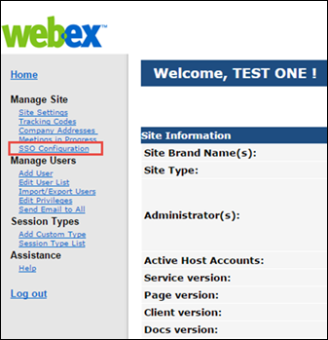
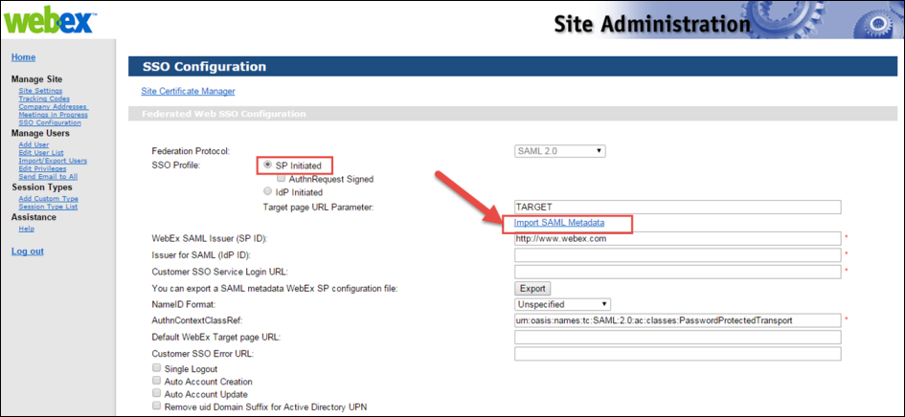
Webex SSO: Instructor Passwords
When Webex SSO is enabled, Webex instructor passwords are no longer necessary. Because of this, they are no longer stored within the Cornerstone portal.
When viewing the Instructor Details pop-up for a Webex instructor, the pop-up does not display password information if Webex SSO is enabled.
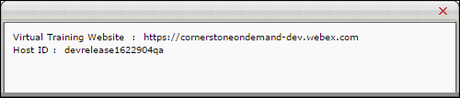
Microsoft Teams vILT Integration
A Microsoft Teams vILT integration is available in the Edge Marketplace. The Microsoft Teams vILT integration provides the following features:
- When administrators create, update, or cancel a single or multi-part session in the Learning Management System (LMS), its corresponding Teams meeting will be created, updated, or cancelled through the integration
- End users and instructors can launch MS Teams sessions through the Learning Management System
- Attendance information can be retrieved
- Ability to add Co-organizers to MS Teams session for support
- Support for Extended Options
- Recreating a session in MS Teams when the Primary Instructor is updated. If the Primary Instructor is changed, the existing session is deleted, and a new one is created. When fields like dates, time zone, or session part name are updated, and the Primary Instructor remains the same, the existing session is not deleted and re-created in Teams.
- Multi-part sessions are created with each session part as a separate meeting in MS Teams
- Manage virtual meetings for multiple accounts
- Mark attendance based on time (%) present in virtual session
- Support for the "Organizer" role for instructors and for Break Out rooms via the Organizer role when using Application authentication
- Support for Break Out rooms via the Organizer role when using Application authentication
- Support for multiple Microsoft Teams tenants when customer has several Microsoft Team accounts
- This integration attempts to map the instructor using the email address listed for the instructor in Cornerstone and their Azure unique UPN. If these two values do not match, an attempt will be made to map to the instructor's email address listed in Microsoft Azure.
Note: SSO is not built into the Microsoft Teams vILT integration. Customers who enable this integration will not automatically have SSO enabled in their portal. This integration is independent of any SSO solution. Click here to access a Knowledge article about how the email tags INSTRUCTOR.LAUNCH.SESSION.LINK and LAUNCH.SESSION.LINK behave with and without SSO using the MS Teams vILT Integration.
Considerations
The attendance formula for Microsoft Teams vILT sessions is calculated based on the actual run time of the session.
- Example 1: If the session was scheduled for 60 minutes but then actually lasted for 75 minutes, and then the user left the session after 50 minutes, the user would receive a calculated completion percentage of only 66%. The user would not be marked as completed, because 66% attendance is not enough to earn completion for a session.
- Example 2: If the session was scheduled for 60 minutes but then actually lasted for 45 minutes, and the user attended the whole session, the user would receive a calculated completion percentage of 100%. The user is marked as completed because they attended the full 45 minutes that the session actually lasted.
Exclusions
The following features are NOT supported by the Microsoft Teams vILT integration:
- Teams Live events
- Adding or updating instructors (internal or external)
- The option to set up a Teams channel or team
- Migration of scheduled sessions with another virtual meeting provider to MS Teams
- Sessions (single or multi-part) with multiple primary instructors
Implementation
Administrators can enable and configure the Microsoft Teams vILT integration via the Edge Marketplace and Edge Integrate. Some prerequisite setup is required through your organization's Azure portal. Details will be provided in the Starter Guide for this enhancement.
Permissions
The following existing permissions apply to this functionality:
PERMISSION NAME | PERMISSION DESCRIPTION | CATEGORY

Edge Integrations - Manage | Grants access to the Integrations service for Edge Integrate, where the administrator can configure, enable, and disable their third-party integrations used within the Cornerstone system. This permission cannot be constrained. This is an administrator permission. | Edge

Edge Marketplace - Manage | Grants access to the Marketplace service for Edge Integrate, where the administrator can browse integrations that can be used to extend the Cornerstone system. This permission cannot be constrained. This is an administrator permission. | Edge

Events - Create | Grants ability to create new instructor led training events. This permission works in conjunction with Events - View permission. This permission can be constrained by OU, User's OU, ILT Provider, and User's ILT Provider. This is an administrator permission. | Learning - Administration

Events - Edit | Grants ability to edit/update existing instructor led training events. This permission works in conjunction with Events - View permission. This permission can be constrained by OU, User's OU, ILT Provider, and User's ILT Provider. This is an administrator permission. | Learning - Administration

Events - View | Grants view-only access to instructor led training events, enabling the user to view all details/options that were selected when the event was created. This permission can be constrained by OU, User's OU, User's ILT Provider, and ILT Provider. This is an administrator permission. | Learning - Administration

ILT Schedule Part Occurrence | Allows the admin to create more than one ILT session schedule part at the same time using a part occurrence schedule wizard. This is an administrator permission. | Learning - Administration

ILT Vendors - Create | Grants ability to create new training Vendors (Providers). This permission works in conjunction with the Vendors - View permission. This is an administrator permission. | Learning - Administration

ILT Vendors - Update | Grants ability to edit/update existing training Vendors (Providers). This permission works in conjunction with the Vendors - View permission. This is an administrator permission. | Learning - Administration

ILT Vendors - View | Grants view only access to instructor led training vendors (providers), via the ILT Vendors and Instructors screen. This is an administrator permission. | Learning - Administration

Roster - Manage | Grants ability to manage instructor led training session rosters, including updating attendance, and marking the ILT session complete to update student transcripts. A variety of other features are available depending upon additional roster permissions. This permission works in conjunction with Events - View, Sessions - View, and Roster - View permissions. This permission can be constrained by Instructor, User as Instructor, ILT Provider, and User's ILT Provider. This is an administrator permission. | Learning - Administration

Roster - View | Grants view-only access to instructor led training session rosters. This permission works in conjunction with Events - View and Sessions - View permissions. This permission can be constrained by Instructor, ILT Provider, User's ILT Provider, and User as Instructor. This is an administrator permission. | Learning - Administration

Sessions - Cancel | Grants ability to cancel instructor led training sessions. This permission works in conjunction with Events - View and Sessions - View permissions. This is an administrator permission. | Learning - Administration

Sessions - Create | Grants ability to create new instructor led training sessions. This permission works in conjunction with Events - View and Sessions - View permissions. Administrators can only create sessions for events for which they have the availability to view. When adding users to a session in which the session roster is full, this permission grants the ability to increase the session's available seats. This permission can be constrained by OU, User's OU, Instructor, User as Instructor, Facility, Facilities Owned by User, ILT Provider, User's ILT Provider, User, and User Self and Subordinates. This is an administrator permission.  Note: The "Restrict to User as Instructor" constraint is available, but it does not actually constrain the permission. | Learning - Administration

Sessions - Edit | Grants ability to edit/update existing instructor led training sessions. This permission works in conjunction with Events - View and Sessions - View permissions. Administrators can only edit sessions for which they have the availability to view and edit. When adding users to a session in which the session roster is full, this permission grants the ability to increase the session's available seats. This permission can be constrained by OU, User's OU, Instructor, User as Instructor, Facility, Facilities Owned by User, ILT Provider, User's ILT Provider, User, and User Self and Subordinates. This is an administrator permission. | Learning - Administration

Sessions - View | Grants view-only access to instructor led training sessions, enabling the user to view all details/options that were selected when the session was created. This permission works in conjunction with the Events - View permission. This permission can be constrained by OU, User's OU, Instructor, Facility, Facilities Owned by User, ILT Provider, User's ILT Provider, User, User as Instructor, and User Self and Subordinates. This is an administrator permission.  Adding an OU constraint and a provider constraint to this permission results in an "AND" statement. | Learning - Administration
Microsoft Teams vILT Integration - Enable in Edge
The Microsoft Teams vILT integration can be enabled via the Edge Marketplace and configured using Edge Integrations.
To access the Edge Marketplace, go to: Admin > Tools > Edge and click the Marketplace link.
Permissions
PERMISSION NAME | PERMISSION DESCRIPTION | CATEGORY

Edge Integrations - Manage | Grants access to the Integrations service for Edge Integrate, where the administrator can configure, enable, and disable their third-party integrations used within the Cornerstone system. This permission cannot be constrained. This is an administrator permission. | Edge

Edge Marketplace - Manage | Grants access to the Marketplace service for Edge Integrate, where the administrator can browse integrations that can be used to extend the Cornerstone system. This permission cannot be constrained. This is an administrator permission. | Edge
Microsoft Teams vILT Integration - Edge Marketplace
In the Edge Marketplace, you can find the Microsoft Teams vILT integration by searching or browsing. To learn more about the integration or begin the enablement and configuration process, click the Microsoft Teams vILT integration tile.
To enable the integration:
- Click the Microsoft Teams vILT integration tile.
- Click the Install button.
- Review and agree to the terms and conditions of the integration.
- Click the Configure Now button.
You will need to configure the settings for the integration before it can be used.
Microsoft Teams vILT Integration - Configure
Once the Microsoft Teams vILT integration has been added through the Edge Marketplace, the integration can be managed and configured. On the Settings tab, configure the following fields:
- Integration Name
- Tenant ID
- App ID
- App Secret
- Username
- Password
- Min. Attendance % - This represents the time in % (max. 100) users need to attend a virtual session before being recognized as completed. Set this to 0 or keep it empty to disable min. attendance tracking. Important: Cornerstone does not recommend a value higher than 80% to balance acceptable deviations.
- Integration ID
- Active - Toggle the Active switch to the On position when you are ready to activate the integration.
Click the Save Settings button to save your configurations.
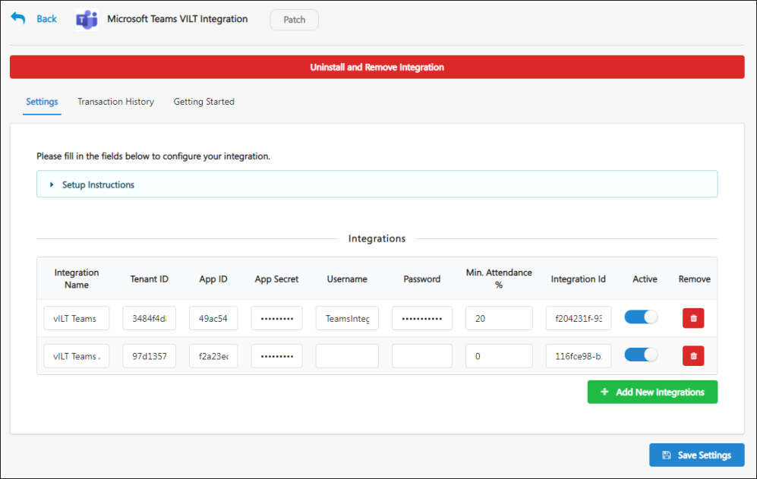
Webex Meeting Center - REST API​
Webex has modernized a set of APIs that impacts the Cornerstone CSX Learning and Webex Meeting Center integration. This integration provides a flexible way of setting up connection between Webex and Cornerstone CSX.
The Webex Meetings REST API enables seamless integration of Webex Meetings into your websites, apps, and services. Use Webex to schedule meetings, invite meeting attendees, update preferences, and more. The APIs used in the integration is replaced in the existing integration so that the transition for the customer is as smooth as possible. The key features are as follows:
- Create, update, and cancel sessions
- Create, update, and delete instructor
- Launch session as instructor and learner
- Report attendance from Webex to CSX
- Extended Options
- A new setting called New Edge Tile
- A new OAuth Workflow to authenticate instructors while using the integration
This functionality is available as a new tile titled ‘Webex Meeting Center – REST API’ for all customers in Edge Marketplace to be added as a Trial in Pilot and Stage environments.
New customers should reach out to their Account Manager to purchase the integration for Production.
For customers already using Webex Meeting Center integration, contact Global Customer Support to enable the Edge Tile in Production. This integration is available as a new integration in Edge Marketplace titled ‘Webex Meeting Center – REST API’.
Frequently Asked Questions (FAQs)
Are customers using multiple accounts supported? Do we have a workaround?
The Webex Meeting Center - REST API integration provides support to add only one Webex Account. As workaround, customers can continue to use the existing setup option available through the Vendors page (ILT > Vendors & Trainers) to add their REST API settings to each of them.
Is SSO supported with the new integration?
With REST API, Webex removes the possibility to authenticate via SSO through the backend to perform some actions on behalf of other users, for instance launching a meeting on behalf of a host. Since authentication through the REST API is done via OAuth, it becomes necessary for instructors (Webex hosts) to go through an OAuth Workflow the first time they launch a meeting from CSX.
Details about Deprecation of XML APIs?
https://developer.webex.com/docs/webex-xml-api-deprecation-announcement.
Webex Meeting Center Integration
Cisco Webex offers an interoperable ecosystem of solutions, each enabling individuals to work together, remotely. While most can be purchased and used alone, Webex products can be combined and customized to your needs.
Cisco Webex Meeting Center allows users to simplify business with online meetings, while keeping their people connected. Online meetings are an easy and cost-effective way to exchange ideas and information with anyone, anywhere, on any device. Whether your goal is to accelerate a project, keep your team on track, or just catch up, Cisco Webex Meeting Center fits your needs.
Integrating Webex Meeting Center with Instructor Led Training in Cornerstone allows the administrator, instructor, and participants to schedule, start, and join webcasts directly from your portal.
Webex Training Center Integration
Cisco Webex offers an interoperable ecosystem of solutions, each enabling individuals to work together, remotely. While most can be purchased and used alone, Webex products can be combined and customized to your needs.
Cisco Webex Training Center allows users to simplify business with online courses and training, while keeping learners connected. Instructors are able to deliver impactful trainings and keep your online learners engaged during and after the sessions. Share presentations, stream videos, and encourage participation using tools like whiteboard and annotation.
Integrating Webex Training Center with Instructor Led Training in Cornerstone allows the administrator, instructor, and participants to schedule, start, and join webcasts directly from your portal.
Zoom Meetings Integration - Overview
The Zoom Virtual Instructor-Led Training (vILT) Integration allows clients and partners to seamlessly integrate with the Cornerstone Learning platform and connect end users to virtual meeting sessions, track attendance, and make scheduling tools available for instructors.
Considerations
- This integration is for Zoom Meetings, NOT Zoom Webinar, which is a separate product.
- Cancel Session is currently not supported by Zoom.
- Extended Options are currently not supported by Zoom.
- Your organization may benefit from this integration if the following are true:
  - Your organization only uses single-part sessions
  - Your organization uses one account for managing virtual training
  - Access to the following vILT workflows is enough to satisfy your organization's vILT needs:
    - Create Instructor
    - Update Instructor
    - Create Session
    - Update Session
    - Get Attendance
    - Launch Session
  - Your organization already uses or is considering using Zoom for instructor-led training or virtual meetings
- Users may experience the below error while adding additional instructors. When this error occurs, the vendor must review the issue and potentially add the email address to the domain safelist.
  - "Error while creating instructors: Partner Error: Your CornerStone email is not in the domain whitelist!"
Implementation
The Zoom vILT integration can be accessed and configured via the Edge Marketplace. In order to use this integration, your organization must be using the Learning module, including instructor-led training (ILT) functionality, and must have access to Edge and a Zoom Pro, Business, or Education account.
Please contact your Account Manager for pricing. The integration cannot be used without a Zoom Pro, Business, or Education account.
Permissions
The following existing permission applies to this functionality:
PERMISSION NAME | PERMISSION DESCRIPTION | CATEGORY

Edge Marketplace - Manage | Grants access to the Marketplace service for Edge Integrate, where the administrator can browse integrations that can be used to extend the Cornerstone system. This permission cannot be constrained. This is an administrator permission. | Edge
Zoom vILT Integration - Setup
The Zoom vILT integration can be accessed and configured via the Edge Marketplace.
To access Integrations in the Edge Marketplace, go to: Admin > Tools > Edge and click the Marketplace link. Search for and click the integration tile. Click the Setup tab for setup instructions for the API.
Permissions
PERMISSION NAME | PERMISSION DESCRIPTION | CATEGORY

Edge Marketplace - Manage | Grants access to the Marketplace service for Edge Integrate, where the administrator can browse integrations that can be used to extend the Cornerstone system. This permission cannot be constrained. This is an administrator permission. | Edge
Zoom vILT Integration Setup
Select this link to learn how to enable and configure the Zoom vILT integration.
https://support.zoom.us/hc/en-us/articles/4417510686861-Using-the-Cornerstone-Learning-Suite-integration

Edge Integrations March 2024

Table of Contents
Edge Integrations Overview 1
Cornerstone Edge Integrate Overview 2
Integrations - View and Manage My Edge Integrations 5
Edge Integration - Purchase an Integration 8
Edge Integration - Try it Free 9
Edge Integration - Configure 11
Edge Integrate - Activity Log 13
Edge Integrate - Manage Users 16
Edge Integrate - Transaction History 18
Content (non-CCA) Integrations - Overview 20
Core Integrations Overview 21
Organizational Planning Integrations - Overview 22
Single Sign-On (SSO) Integrations - Overview 25
Tag Management Integrations - Overview 33
User and OU Management Integrations - Overview 36
Non-Edge Integrations 53
Integrations for Cornerstone HR 55
Absence Management Integrations - Overview 56
Employee Data Integrations - Overview 62
Time & Attendance Integrations - Overview 66
Integrations for Learning Overview 69
Content (non-CCA) Integrations - Overview 70
Learning in the Flow of Work Integrations - Overview 113
Payment Gateway Integrations - Overview 122
Transcript Integrations - Overview 174
vILT (Virtual Instructor Led Training) Integrations - Overview 184
Integrations for Recruiting Overview 1
Apply Integrations - Overview 2
Assessment Integrations - Overview 15
Background Check Integrations - Overview 29
Candidate Recruitment Management Integrations - Overview 120
Chatbot Integrations - Overview 133
Drug Screening Integrations - Overview 135
Interview Scheduling Integrations - Overview 146
Job Distribution Integrations - Overview 149
New Hire Onboarding Integrations - Overview 155
OFCCP Compliance Integrations - Overview 160
Video Interview Integrations - Overview 162
Work Opportunity Tax Credit Integrations - Overview 166
Non-Edge Integrations 207

Integrations for Recruiting Overview

Apply Integrations - Overview
Apply with LinkedIn (with Apply Starters) - Overview
Apply with LinkedIn (with Apply Starters) is a plugin that you can implement on your career site, enabling candidates to apply with their LinkedIn profiles in the application workflow. When applying with LinkedIn, a job seeker's profile information instantly populates the resume fields and gets sent directly to the Applicant Tracking System (ATS) upon submission. This makes for a fast and easy candidate experience.
Recruiters can easily view an applicant's LinkedIn profile, getting access to valuable information that cannot always be found on a resume.
Apply with LinkedIn (with Apply Starters) is an evolution to the original plugin and differs from the previous Apply with LinkedIn integration in two significant ways:
- Connect with Applicants Who Start an Application - Candidates who start but do not complete the application are surfaced as an “Apply Starter” in LinkedIn Recruiter. These candidates have a significantly higher InMail response rate. Recruiters can connect with interested job seekers by messaging those who have started but not completed an application.
- Increased Conversion Rate - In the previous version of Apply with LinkedIn, candidates would need to log in to their LinkedIn account to “authenticate” on that customer’s career page, which led to drop-off. With the new Apply with LinkedIn, this additional step of logging in to LinkedIn to complete the application is removed if they have an active LinkedIn cookie ties to their session. This update to Apply with LinkedIn ensures a higher rate of completed applications.
Features of Apply with LinkedIn (with Apply Starters)
When a candidate clicks apply with linkedin: | old integration | new integration
Prefill resume with LinkedIn profile | Yes | Yes
Create account with LinkedIn email and password | Yes | No
Option to “create account” on Thank You page | No | Yes
Available on Standard Application Workflow | Yes | No
Available on Mobile-Friendly Application Workflow | Yes (Until the end of 2018) | Yes
Use Cases
- As an administrator who has a LinkedIn Recruiter contract, I would like the ability to support the new LinkedIn integration in my mobile-friendly application workflow so that more applicants complete the application.
- As an administrator who has both the new and old Apply with LinkedIn integration, I would like to use the new integration on mobile-friendly application workflows and the old integration on standard application workflows because that is what is supported.
- As an administrator who only has the new Apply with LinkedIn (with Apply Starters) integration, I would like to know that it is only functional on mobile-friendly experiences in the career site settings so that I know all dependencies.
- As a candidate, I would like the ability to upload my resume in an application via my LinkedIn profile so that it saves me multiple steps in the application and makes it easier to submit my application.
- As a candidate, I would like my LinkedIn profile to prefill my resume details so that I can quickly complete and submit the application.
- As an administrator, I would like to know why I cannot move an applicant to a new requisition on their profile so that I know the system is not broken. There will be a notification that says this applicant has applied with LinkedIn.
- As a recruiter, if I try to move multiple candidates at once to a new requisition, I will be notified that the LinkedIn candidates were not moved. An explanation will be included that lets me know that candidates who apply with LinkedIn cannot be added or moved to another requisition.
- As a candidate who has applied via Apply with LinkedIn (with Apply starters), when I return to the career site to check the progress of my application, I will have to either sign in with LinkedIn or create a password through the Forgot Passsword or Create Password user flow.
Implementation
Apply with LinkedIn (with Apply Starters) is available for Recruiting clients who also have LinkedIn Recruiter and/or active LinkedIn Job Slots. The plugin is available without cost to those clients. The plugin must be enabled from the Edge Marketplace. For questions about the plugin, please reach out to your LinkedIn representative. Additional instructions for enabling and configuring the integration are available on the Setup tab of the integration in Edge.
When enabling Apply with LinkedIn (with Apply Starters) in Edge, you will need to use the LinkedIn account that is tied to LinkedIn Recruiter or the active Job Slots. If an administrator tries to enable Apply with LinkedIn (with Apply Starters) with their personal LinkedIn account, they will receive an error.
Once Apply with LinkedIn (with Apply Starters) is installed via Edge, you will then need to enable it on an individual career site basis in Career Site Settings. The plugin is only compatible with mobile-friendly application workflows through the mobile-friendly candidate experience.
Considerations
Can all clients use the integration?
No. The Apply with LinkedIn (with Apply Starters) integration is only available for those with LinkedIn Recruiter and/or LinkedIn Jobs.
Will the integration be supported on both standard and mobile-friendly workflows?
No, this will only be supported on mobile-friendly workflows.
Can candidates who applied with Apply with LinkedIn (with Apply Starters) be added or moved to other requisitions?
Yes. Candidates who apply with LinkedIn can be added to other requisitions via Manage Candidates, Manage Applicants, Candidate Search, and the Applicant Profile. They can be moved to another requisition from Manage Candidates and Manage Applicants.
What if the candidate does not have an active LinkedIn cookie?
If a candidate does not have an active LinkedIn cookie, they will click the LinkedIn button twice: once to sign in to LinkedIn, and then again to populate their resume. In addition, LinkedIn candidates will be asked if they want to create an account on the Thank You page.
Permissions
The following permissions apply to this functionality:
PERMISSION NAME | PERMISSION DESCRIPTION | CATEGORY

Career Site - Manage | Grants ability to access and manage Career Site Management. This permission can be constrained by OU and User's OU. This is an administrator permission. | Recruiting Administration

Career Site - View | Grants ability to access and view Career Site Management. This permission can be constrained by OU and User's OU. This is an administrator permission. | Recruiting Administration

Edge Integrations - Manage | Grants access to the Integrations service for Edge Integrate, where the administrator can configure, enable, and disable their third-party integrations used within the Cornerstone system. This permission cannot be constrained. This is an administrator permission. | Edge

Edge Marketplace - Manage | Grants access to the Marketplace service for Edge Integrate, where the administrator can browse integrations that can be used to extend the Cornerstone system. This permission cannot be constrained. This is an administrator permission. | Edge
Add/Move LinkedIn Candidates to Another Requisition
Candidates who apply with LinkedIn can be added or moved to other requisitions via Manage Candidates, Manage Applicants, Candidate Search, and the Applicant Profile.
Manage Applicants Deprecation: Cornerstone is deprecating Manage Applicants in Q1 2024. See Manage Applicants Overview.
Add LinkedIn Candidates to Another Requisition
To add LinkedIn candidates to another requisition, see the instructions on the following pages:
- Applicant Profile
- Candidate Search
- Manage Applicants
- Manage Candidates
Move LinkedIn Candidates to Another Requisition
To move LinkedIn candidates to another requisition, see the instructions on the following pages:
- Manage Applicants
- Manage Candidates
Applicant Experience - Apply with LinkedIn (with Apply Starters)
Applicants can apply with Apply with LinkedIn (with Apply Starters) on mobile-friendly career sites by clicking the Apply with LinkedIn button on the application workflow. The applicant's contact information and resume details are automatically prefilled on the application once they apply with LinkedIn. This saves applicants time in filling out application fields so that they can quickly apply to the job.
Once the applicant applies with LinkedIn, recruiters can view their profile by clicking the LinkedIn icon that appears by the applicant's name when viewing applicant details in Recruiting.
Note: If resume parsing is not enabled but contact information parsing is enabled, then the contact information will still populate but resume details are not prefilled. If no parsing is enabled, then there are no fields that are prefilled.
Account Creation on Career Site
When an applicant applies with Apply with LinkedIn (with Apply Starters), they are prompted on the Thank You page of the application to create a profile. This allows LinkedIn applicants to set a user name and password for the career site.
With the previous experience with Apply with LinkedIn 1.0, an account was created automatically when applicants applied with LinkedIn. Their LinkedIn user name and password were used to set up the account. This resulted in numerous password resets for applicants when they did not remember (or realize) that their LinkedIn login credentials were used to create the account.
Visibility on Non-Mobile-Friendly Career Sites
For mobile-friendly applications that are on a career site that is not mobile-friendly, the Apply with LinkedIn (with Apply Starters) and Apply with Seek options do not appear on the job details page. All social media buttons for mobile-friendly application workflows now live on the Application Workflow page.
Offer Letters for Apply with LinkedIn (with Apply Starters) Candidates
For security reasons, when an applicant who has applied with LinkedIn, and has not created an account, accepts or declines an offer letter, they will need to create a password with Cornerstone to submit their responses.
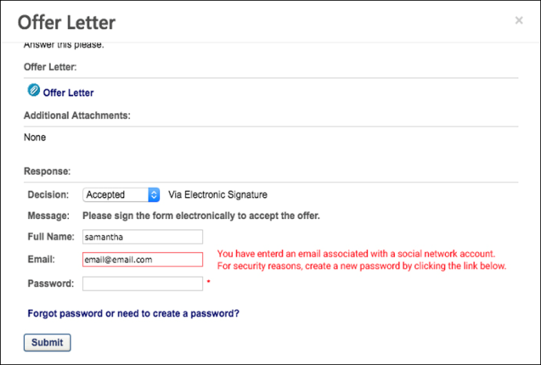
CV-Library Apply Integration
CV-Library has integrated with Cornerstone to provide customers with applicant details directly in their Cornerstone Recruiting system, ensuring recruiters never miss a prospective candidate. CV-Library’s ATS Apply automatically completes application forms and sends recruiters important candidate information, such as their curriculum vitae, directly from the candidate’s CV-Library account, which will be recorded against the job in Cornerstone and source-tracked as coming from CV-Library.
Implementation
The integration will be available to self-enable on 27 September 2021 via Edge Marketplace for all organizations using Recruiting and that also have an account with the integration vendor.
Additional instructions for enabling and configuring the integration are available in Edge. See Edge Integration - Configure on page 11 for additional information.
Permissions
The following existing permissions apply to this functionality:
PERMISSION NAME | PERMISSION DESCRIPTION | CATEGORY

Edge Integrations - Manage | Grants access to the Integrations service for Edge Integrate, where the administrator can configure, enable, and disable their third-party integrations used within the Cornerstone system. This permission cannot be constrained. This is an administrator permission. | Edge

Edge Marketplace - Manage | Grants access to the Marketplace service for Edge Integrate, where the administrator can browse integrations that can be used to extend the Cornerstone system. This permission cannot be constrained. This is an administrator permission. | Edge
One-Click Apply with Stepstone (Early Adopter) - Overview
One-Click Apply with Stepstone delivers a seamless candidate experience with the ability to send job board application data to Cornerstone, enabling candidates to directly apply to requisitions using their information from job boards.
Job boards are a key way to source candidates. If a candidate wants to apply to a position from a job board, they are typically redirected to a career site, which can interrupt the candidate experience and decrease conversion rates. One-Click Apply with Stepstone is a user-centric interface that allows job seekers to apply using their resume details from the job board without having to visit the career site.
How Does this Enhancement Benefit My Organization?
- Increase conversion rates for candidates who would otherwise choose not to apply due to an inconvenient application process.
- Candidates can apply directly from a Stepstone job board, rather than having to be redirected to your career site to apply.
Is being an Early Adopter right for my organization?
- My organization uses Stepstone job boards to post jobs.
- My organization has simple application workflows, which do not include prescreening questions or assessments. Note: Prescreening questions are targeted to be available for a one-click apply workflow when this enhancement is ready for General Availability (GA).
- My organization would like to see the source of the application, even if the candidate is rerouted to the job board.
Use Case - Applicant
- Sally is looking for a project management role in London. Because her role is fairly flexible, she uses job boards so that she can get an aggregate look at companies that are hiring.
- Sally is very busy, so she does not have the time to go to every company's career site to apply to jobs.
- She uploads her resume on Total Jobs, which is one of the Stepstone job boards, and fills out a profile.
- On Total Jobs, Sally finds a few jobs that she is very interested in: Project Manager at ABC Company, Project Manager at DCE Company, and Project Manager at XYZ Company.
- ABC Company and DCE Company both allow their applicants to utilize the "One Click" apply functionality from Stepstone, so the candidate just needs to apply with their curriculum vitae (CV) from their profile.
- Sally easily applies to both companies without leaving the Total Jobs website. However, XYZ Company does not have any integration with a Recruiting product that allows for One-Click Apply, so Sally is redirected to their career site upon clicking Apply.
- Because none of her information is pre-populated, and she sees the application as lengthy, Sally decides she no longer wants to apply for the XYZ Company job.
Considerations
Requisitions with prescreening questions and custom assessments will not be available for a one-click apply workflow. However, for clients using the Mobile-Friendly Candidate Experience, candidates will be directed to the career site where their information is pre-populated in the application workflow, which reduces the time needed to complete the application.
Frequently Asked Questions
Why do I want to post jobs to Stepstone job boards?
The Stepstone job boards not only host your jobs, but they also host your application process. Candidates can apply with one-click by adding their resume to their Stepstone profile and applying to jobs that only require a resume and basic contact information. This saves candidates time in their job search process and may make a candidate more likely to apply when the application process is simple.
Why wouldn't I just want to use the career site that I created in my Cornerstone portal?
For external candidates, your career site can only be accessed from your website. If you only post jobs to your career site, then the reach of your jobs is limited to your website and search engines.
Implementation
This integration is available for all organizations using the Recruiting suite. This integration is available for free via Edge Marketplace. Additional instructions for enabling and configuring the integration are available on the Setup tab of the integration in Edge.
The integration can be accessed and configured via the Edge Marketplace. In order to use this integration, your organization must be using the Recruiting module and must have access to Edge and have an account with the integration vendor. There is no additional cost associated with enabling this integration, but the integration cannot be used without an account with the integration vendor.
Security
The following permissions apply to this functionality:
PERMISSION NAME | PERMISSION DESCRIPTION | CATEGORY

Edge Integrations - Manage | Grants access to the Integrations service for Edge Integrate, where the administrator can configure, enable, and disable their third-party integrations used within the Cornerstone system. This permission cannot be constrained. This is an administrator permission. | Edge

Edge Marketplace - Manage | Grants access to the Marketplace service for Edge Integrate, where the administrator can browse integrations that can be used to extend the Cornerstone system. This permission cannot be constrained. This is an administrator permission. | Edge
One-Click Apply with Stepstone Candidate Experience
Candidates can apply to your jobs on Stepstone job boards provided that you have an integration with Stepstone.
Candidates cannot apply to a job more than once by using the same email address.
One-Click Experience
When candidates apply to your jobs on job boards, they will have a one-click experience when the application only requires basic contact information and a resume.
Once they submit their application, they become an applicant for the job and are visible in job's applicant pool in your portal.
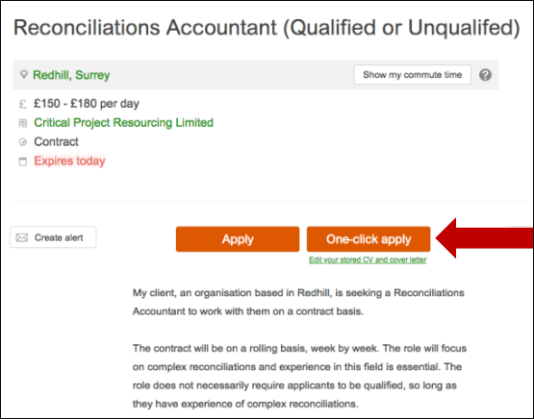
Applications with Assessments - Redirect to Your Career Site
If an application has assessments or other non-supported action items, the application cannot be completed with a one-click experience. Candidates are given an option to continue their application on your career sight, where they can take assessments.
Candidates will have to log in to the career site or create an account if they do not yet have one. If the application is utilizing the Mobile-Friendly Candidate Experience, they are taken to the application, where their information from the job board is prepopulated into the application fields. Their resume and cover letter are also passed to your portal.
Candidates can then complete and submit the application from your career site.
Candidate's Preferred Language
The candidate's preferred language will be respected when their data is passed to your portal.
Candidate Can Re-Apply
Candidates can re-apply to your jobs on Stepstone job boards if you allow reapplication. See General Preferences (by Division).
PitchYou Integration
WhatsApp is the most popular chat app in the world. Candidates need a seamless job application process in chat format that is easily accessible through mobile phones.​
Cornerstone integrates with PitchYou to allow candidates a seamless job application experience using WhatsApp.
Prerequisites
- Customers must have a PitchYou subscription.
- To enable and configure this integration, go to the Edge Marketplace and locate the PitchYou tile. See Marketplace - Browse Edge Integrations.
- Customer can reach out support@pitchyou.de for additional support. ​

Assessment Integrations - Overview
DDI Recruiting Assessment Integration - Overview
The DDI integration enables recruiters to place and track assessment requests. This integration streamlines and improves recruiters' efficacy of their hiring process.
Use Cases
Use Case 1: Activate the DDI integration through Edge
- James is Acme Company's administrator and has been tasked with enabling the integration between Cornerstone and DDI. This will allow Acme to include DDI assessments in their hiring workflow.
- James goes to the Edge Marketplace to purchase and activate the DDI Assessment integration.
- From the Edge Integrate page, James enters Acme's unique Client ID, which is provided by their DDI project team.
- Acme's Cornerstone portal now has an active integration between Cornerstone and DDI.
Use Case 2: Recruiting Administrator configures DDI Assessment action step in Application Workflow
- Allan is the Recruiting administrator for Acme.
- With the integration enabled, Allan is tasked with including DDI assessments in all of Acme's Customer Support requisitions.
- Allan creates a new custom application workflow template that includes an assessment action step, ensuring that DDI assessments is added as a custom integration.
- Allan configures all Customer Support requisitions to include DDI assessments.
- Applicants applying to the Customer Support requisition are now prompted to complete a DDI assessment as part of their application process.
Use Case 3: Recruiter assigns an ad hoc assessment to an applicant
- Lisa, a hiring manager at Acme, is looking to add two new members to her Customer Support team. Before finalizing hiring decisions, she wants to make sure that the candidates are a good fit.
- Lisa goes to the Manage Applicants page for the Customer Support requisition and identifies four potential candidates to assign an assessment to, making sure that all candidates' statuses are assigned to "DDI assessment.”
- While the same candidates are selected, Maria selects the Assign Integration Assessment option from the Actions drop-down. She proceeds to select the assessment to assign to the candidates and clicks Submit.
- The applicants will receive an email with a link that will redirect them to complete the DDI assessment. Note: The Assign Integration Assessment email trigger email will need to be successfully configured by the administrator in Email Administration in order for the applicant to receive the email.
- After the applicant completes the assessment, DDI sends Cornerstone a summary of the candidate’s results which are available for viewing on the Manage Applicants page.
- To further review the assessment results, Lisa clicks the View Report link, which will direct her to DDI to view a detailed report of the assessment results.
Implementation
This functionality is only available for organizations using Recruiting and must be purchased and activated via the Edge Integration Marketplace. It is necessary to have a contract and purchased assessments from DDI to implement the integration. The DDI integration will need to be activated via Edge Integrate, and you will need to provide your company's pre-existing DDI unique identifiers. Additional instructions for enabling and configuring the integration are available on the Setup tab of the integration in Edge.
DDI assessments are not supported on the Cornerstone mobile app.
Permissions
The following permissions apply to this functionality:
PERMISSION NAME | PERMISSION DESCRIPTION | CATEGORY

Applicant Status Bank - Manage | Grants ability to access and manage Applicant Status Bank. | Recruiting Administration

Applicants: Assign Assessment Integration | Grants access to manage assessment integrations from the Applicant Profile page. This applies to assessments that have been configured in the integration center. This permission cannot be constrained. This permission is only available for portals that have an active assessments integration.  This is the highest level of permission for this functionality. In addition to being able to assign assessments, users with this permission will be able to view the assessment status and assessment details. | Recruiting

Applicants: View Assessment Integration Status | Allows user to view the assessment integration check status on the Applications tab of the Applicant Profile page. The user cannot view the link to the detailed report of the assessment. This permission cannot be constrained. This permission is only available for portals that have an active assessments integration.  This is the lowest level of permission for this functionality. Users with this permission can only view the assessment status; they cannot assign assessments or view assessment details. | Recruiting

Applicants: View Assessment Integration Status and Details Link | Allows user to view the assessment integration status and view link to access the assessment report from the Applications tab of the Applicant Profile page and from the associated column on the Manage Applicants page. This permission cannot be constrained. This permission is only available for portals that have an active assessments integration.  This is the second highest level of permission for this functionality. Users with this permission will be able to view the assessment status and assessment details but will not be able to assign assessments. | Recruiting

Application Workflow Template - Manage | Grants ability to access and manage Application Workflow Templates. This permission can be constrained by OU and User’s OU. This is an administrator permission. | Recruiting Administration

Application Workflow Template - View | Grants ability to access and view Application Workflow Templates. | Recruiting Administration

Edge Integrations - Manage | Grants access to the Integrations service for Edge Integrate, where the administrator can configure, enable, and disable their third-party integrations used within the Cornerstone system. This permission cannot be constrained. This is an administrator permission. | Edge

Edge Marketplace - Manage | Grants access to the Marketplace service for Edge Integrate, where the administrator can browse integrations that can be used to extend the Cornerstone system. This permission cannot be constrained. This is an administrator permission. | Edge

Global Email Administration - Manage | Grants ability to manage email trigger templates across all active modules in the portal. Enables creating, editing and deleting email message templates for various system actions and workflows. This permission can be constrained by OU, User's OU, User Self and Subordinates, and User. This is an administrator permission. | Core Administration

Global Email Administration - View | Grants view only access to email templates/triggers and email logs at the global level for the portal. This permission can be constrained by OU, User's OU, User Self and Subordinates, and User. This is an administrator permission. | Core Administration

Requisition: Manage | Grants ability to access and manage all requisitions regardless of ownership (constraints permitting). This permission also grants read-only access to the Applicant Review tab when creating or editing a job requisition. This permission can be constrained by OU, User's OU, and Grade. | Recruiting

Requisition: Owner | Enables owner to access requisitions and applicants for requisitions for which they are an owner. This permission also grants read-only access to video interviews that are completed by applicants via HireVue. For portals with Referral Suite enabled, this permission also enables requisition owners to edit the referral source on the Applicant Profile page. This permission cannot be constrained.  Note: This is a dynamically assigned permission that is not available in Security Role Administration. If the user is removed as an owner, the permission is revoked for the associated requisition. This permission cannot be manually assigned. Also, if a user has both the permission necessary to manage requisitions and be a requisition owner, the constraints of the Requisition: Manage permission overrule those of the Requisition: Owner permission. For requisition owners that do not also have permission to manage requisitions, only certain fields are editable when editing a requisition. | Recruiting

Requisition: Reviewer | Enables reviewer to access requisitions and applicants for requisitions for which they are a reviewer. This permission cannot be constrained.  Note: This is a dynamically assigned permission that is not available in Security Role Administration. Once a requisition is in a Closed or Cancelled status or if the user is removed as a reviewer, the permission is revoked for the associated requisition. This permission cannot be manually assigned.  Note: If an applicant reviewer is removed as a reviewer via the Applicant Profile page, the Requisition: Reviewer permission is revoked for the associated requisition. However, if the reviewer was also added as a reviewer via the General tab when creating, editing, or copying the requisition, the reviewer still appears on the In Review panel as a duplicate reviewer and retains access to the requisition and applicants from the Requisition: Reviewer permission. See Applicant Profile Page Overview for more information about duplicate reviewer instances. | Recruiting
Applicant Statuses - Create Custom Status and Include in Application Workflow
Applicant Experience - DDI Assessment
DDI assessments can be added to the application workflow or assigned via Manage Candidates or Manage Applicants. Applicants complete the assessment using a link in an email or by using the link in the application.
Emails
EMAIL NAME | EMAIL DESCRIPTION | ACTION TYPE

Assign Integration Assessment | This email is triggered when an Edge integration assessment is assigned to an applicant, such as a WOTC assessment. This email can be configured as a notification or a reminder, and it can be sent to External Applicant, Internal Applicant, OU Approver, Hiring Manager, OU Approver, or a specific user.  This email only triggers when a successful response is received from the vendor.  Note: The APPLICANT.INTEGRATION.ASSESSMENT.LINK tag must be included in the email. This tag provides a link that the applicant can click to access the assessment.  Note about Auto-Assignment of Pre-Employment Verifications: This email also applies to auto-assignment of pre-employment verifications, via the Automated Candidate Progression (Early Adopter) functionality. For more information, see Feature Activation Preferences. | Recruiting

Integration Assessment Completed | This email is triggered when an applicant has successfully completed their custom integration task via their My Profile page in the career site or the assessment via the email link. The email can be sent to External Applicant, Hiring Manager, Internal Applicant, OU Approver, and Requisition Owner. This email can be configured as a Notification type email. This email is active by default and can be found in the Recruitment action type section of Email Management. | Recruiting
Application Workflow
When a DDI assessment is included in the application workflow, applicants can complete the assessment when filling out the application. The assessment appears as a step in the workflow. The name of the step is dependent on how the step is named when configuring the requisition.
The applicant clicks Launch on the application workflow step. This will register the applicant with DDI and open the assessment that is associated with the job requisition.
See Application Workflow - Add Integration.
Assign on Manage Candidates
See Manage Candidates - Assign Integrations.
Assign Ad Hoc Assessment on Manage Applicants
DDI assessments can be assigned via Manage Applicants. To assign an assessment:
- Navigate to the Manage Applicants page, and select the applicants to whom the DDI integration assessment should be assigned.
- Ensure that the applicant is in the proper DDI Integration status by selecting the Actions drop-down menu, selecting the Change status to action, selecting the DDI Integration Assessment status, and select Submit.
- While the appropriate applicants are still selected, select the Actions drop-down menu, and select the Assign Integration Assessment action.
- Select the DDI Assessment from the drop-down menu, and select Submit.
- The applicants will receive the Assign Integration Assessment email with a link that directs them to the DDI website. Once the assessment has been completed, the results are available on the Application tab within the Applicant Profile. Note: The Assign Integration Assessment email is only triggered if it is configured in Email Administration.
Note: In order for the vendor to post status/results back to Cornerstone in the QA environment, the vendor's IP address needs to be safe listed.
Manage Applicants Deprecation: Cornerstone is deprecating Manage Applicants in Q1 2024. See Manage Applicants Overview.
DDI Assessment Results
DDI assessment results can be viewed within the DDI application. A link will be provided by DDI so that recruiters can access the results. This information can be accessed from the Application tab on the Applicant Profile page.
Permissions
PERMISSION NAME | PERMISSION DESCRIPTION | CATEGORY

Applicants: Assign Assessment Integration | Grants access to manage assessment integrations from the Applicant Profile page. This applies to assessments that have been configured in the integration center. This permission cannot be constrained. This permission is only available for portals that have an active assessments integration.  This is the highest level of permission for this functionality. In addition to being able to assign assessments, users with this permission will be able to view the assessment status and assessment details. | Recruiting

Applicants: View Assessment Integration Status | Allows user to view the assessment integration check status on the Applications tab of the Applicant Profile page. The user cannot view the link to the detailed report of the assessment. This permission cannot be constrained. This permission is only available for portals that have an active assessments integration.  This is the lowest level of permission for this functionality. Users with this permission can only view the assessment status; they cannot assign assessments or view assessment details. | Recruiting

Applicants: View Assessment Integration Status and Details Link | Allows user to view the assessment integration status and view link to access the assessment report from the Applications tab of the Applicant Profile page and from the associated column on the Manage Applicants page. This permission cannot be constrained. This permission is only available for portals that have an active assessments integration.  This is the second highest level of permission for this functionality. Users with this permission will be able to view the assessment status and assessment details but will not be able to assign assessments. | Recruiting
Emails
EMAIL NAME | EMAIL DESCRIPTION | ACTION TYPE

Assign Integration Assessment | This email is triggered when an Edge integration assessment is assigned to an applicant, such as a WOTC assessment. This email can be configured as a notification or a reminder, and it can be sent to External Applicant, Internal Applicant, OU Approver, Hiring Manager, OU Approver, or a specific user.  This email only triggers when a successful response is received from the vendor.  Note: The APPLICANT.INTEGRATION.ASSESSMENT.LINK tag must be included in the email. This tag provides a link that the applicant can click to access the assessment.  Note about Auto-Assignment of Pre-Employment Verifications: This email also applies to auto-assignment of pre-employment verifications, via the Automated Candidate Progression (Early Adopter) functionality. For more information, see Feature Activation Preferences. | Recruiting

Integration Assessment Completed | This email is triggered when an applicant has successfully completed their custom integration task via their My Profile page in the career site or the assessment via the email link. The email can be sent to External Applicant, Hiring Manager, Internal Applicant, OU Approver, and Requisition Owner. This email can be configured as a Notification type email. This email is active by default and can be found in the Recruitment action type section of Email Management. | Recruiting
Access In-Progress Assessment
After placing a successful assessment order request, DDI will process the request, and the following fields will be available under the Application tab of the Applicant Profile page.
- Assigned - This field displays the date on which the assessment order request is assigned to the applicant.
- Reference ID - This field displays the DDI transaction ID.
- Status - This field displays a status of Acknowledged.
If the assessment order fails, the Status field displays "Error." The error description will be displayed on the user interface.
Note: The assessment results are also available from Manage Candidates. See Manage Candidates Page (Early Adopter).
Access Completed Assessment
When the applicant has completed the assessment, the following fields display in the DDI Assessment panel on the Application tab:
- Assigned - This field displays the date on which the assessment order request is assigned to the applicant.
- Reference ID - This field displays the DDI transaction ID.
- Status - This field displays a status of Completed.
- Details - This field displays the date on which the applicant completed the assessment.
  - Pass
  - Fail
- View Report - This field displays the link that will direct the recruiter to view a more detailed report of the applicant’s assessment results in DDI. Click the View Report link to open the DDI application from which you can view the applicant's assessment results.
If the Integration Assessment Completed email is configured and active in Email Administration, then this email is triggered when the applicant completes the assessment.
Emails
EMAIL NAME | EMAIL DESCRIPTION | ACTION TYPE

Integration Assessment Completed | This email is triggered when an applicant has successfully completed their custom integration task via their My Profile page in the career site or the assessment via the email link. The email can be sent to External Applicant, Hiring Manager, Internal Applicant, OU Approver, and Requisition Owner. This email can be configured as a Notification type email. This email is active by default and can be found in the Recruitment action type section of Email Management. | Recruiting
Assessment Statuses
The results will indicate one of two statuses to indicate that the assessment has been acknowledged or completed.
- Acknowledged - This status indicates that DDI acknowledges that the assessment has been scheduled for the applicant to complete.
- Completed - This status indicates that the applicant has completed the assessment.
Assessment Dates
The results will display the date on which the applicant completed the assessment, as well as the date when the assessment results expire.
pymetrics Talent Management and Screening Integration
The pymetrics Talent Management and Screening integration helps organizations make well-informed hiring decisions—all within the convenience and seamlessness of the Cornerstone recruitment and talent management system you already use. The assessments use data science to predict a candidate's job fit and future performance, rather than only focusing on the skills a candidate has already attained based on their resume.
pymetrics assessments can be included in the application workflow and can also be sent manually by the recruiter outside of the job application.
Implementation
This integration is available for all organizations using the Recruiting suite and that also have an account with the integration vendor. This integration is available in Edge Marketplace. Additional instructions for enabling and configuring the integration are available on the Setup tab of the integration in Edge. There is no additional cost associated with enabling this integration in Edge.
Permissions
The following existing permissions apply to this functionality:
PERMISSION NAME | PERMISSION DESCRIPTION | CATEGORY

Edge Integrations - Manage | Grants access to the Integrations service for Edge Integrate, where the administrator can configure, enable, and disable their third-party integrations used within the Cornerstone system. This permission cannot be constrained. This is an administrator permission. | Edge

Edge Marketplace - Manage | Grants access to the Marketplace service for Edge Integrate, where the administrator can browse integrations that can be used to extend the Cornerstone system. This permission cannot be constrained. This is an administrator permission. | Edge
SHL Talent Assessments Integration
The SHL Talent Assessments integration lets recruiters identify best-fit candidates, using targeted, predicted assessments, and provides an engaging, candidate-centric experience to help you attract the top candidates. This integration is available for clients using SHL TalentCentral.
If you are using the legacy SHL Select2Perform, please reach out to your SHL Account Manager to discuss the upgrade to SHL TalentCentral.
Migration
Both the SHL Talent Assessments and the SHL Select2Perform integrations can be used simultaneously. However, in order to use SHL Talent Assessments it is necessary to be on SHL Talent Central.
If you are using the legacy SHL Select2Perform, it is necessary to work with SHL to migrate. The new integration only works for mobile-friendly workflows and currently only supports one numeric value for the assessment score to be displayed.
Implementation
This integration is available on 23 December 2019. This integration is a vendor-built integration and not by Cornerstone. More information and instructions can be found in Edge Integrate.
Permissions
The following existing permissions apply to this functionality:
PERMISSION NAME | PERMISSION DESCRIPTION | CATEGORY

Edge Integrations - Manage | Grants access to the Integrations service for Edge Integrate, where the administrator can configure, enable, and disable their third-party integrations used within the Cornerstone system. This permission cannot be constrained. This is an administrator permission. | Edge

Edge Marketplace - Manage | Grants access to the Marketplace service for Edge Integrate, where the administrator can browse integrations that can be used to extend the Cornerstone system. This permission cannot be constrained. This is an administrator permission. | Edge
Talent Plus TalentBank Integration
The Talent Plus integrations provides a seamless candidate experience and easy access to Talent Plus assessment recommendations and results.
When a Talent Plus assessment is associated to a job requisition, candidates are taken to Talent Plus to complete the assessment. The Talent Plus system sends the results back to Cornerstone, including the recommendation statement and score, as well as a link to the candidate’s results.
Implementation
This integration is a vendor-built integration and not by Cornerstone. More information and instructions can be found in Edge Integrate.
Security
The following existing permissions apply to this functionality:
PERMISSION NAME | PERMISSION DESCRIPTION | CATEGORY

Edge Integrations - Manage | Grants access to the Integrations service for Edge Integrate, where the administrator can configure, enable, and disable their third-party integrations used within the Cornerstone system. This permission cannot be constrained. This is an administrator permission. | Edge

Edge Marketplace - Manage | Grants access to the Marketplace service for Edge Integrate, where the administrator can browse integrations that can be used to extend the Cornerstone system. This permission cannot be constrained. This is an administrator permission. | Edge

Background Check Integrations - Overview
Accurate Background Check - Overview
The Accurate Background Check integration allows you to place and track background checks for applicants. The integration is available through the Edge Marketplace.
Use Cases
Use Case 1: Activate the Accurate Background integration through Edge
- Barbara is Acme Company's administrator who has been tasked with enabling the integration with Accurate Background. This will allow Acme to include Accurate Background requests within their application workflow.
- Barbara goes to the Edge Marketplace to purchase and activate the Accurate Background integration.
- From the Edge Integrate page, Barbara enters Acme's unique Company ID and API credentials provided by their Accurate Background team.
- Acme's portal now has an active integration with Accurate Background.
Use Case 2: Recruiting Admin creates a custom applicant status
- Katie is the recruiting administrator for Acme Company.
- Ryan, a hiring manager at Acme, is looking to add a new member to his Integration Consulting team.
- With the integration enabled, Katie is tasked with adding a background check status in all of Acme's Integration Consultant requisitions.
- Katie creates a new custom applicant status that is set to a custom integration type under Accurate Background Check.
- Katie has now configured the Integration Consultant requisitions to include Accurate Background.
Use Case 3: Recruiter places a background check request for an applicant
- Dorothy, a recruiter at Acme, has identified John James to be a stellar applicant.
- To ensure a sound hiring decision is made and to protect Acme from potential risks, Dorothy assigns a background check on John by moving the status to Accurate Background Check.
- Dorothy selects the appropriate screening package then submits the request.
- John receives an email from Accurate Background and clicks on the link to complete the screening application request in Accurate Background.
Use Case 4: Recruiter views background check results and its detailed report in Accurate via a link
- Dorothy is eager to find out the results of John's background check status.
- Dorothy navigates to John's Applicant Profile Status page and sees the status on the request.
- To view additional details of the background request, Dorothy clicks on the Check Order Progress link which will direct her to Accurate Background site.
Implementation
The Accurate Background Check integration must be enabled and activated through the Edge Marketplace. Portals must have already purchased Accurate Background Check in order to enable it in Edge. Additional instructions for enabling and configuring the integration are available on the Setup tab of the integration in Edge.
Permissions
The following permissions apply to this functionality:
PERMISSION NAME | PERMISSION DESCRIPTION | CATEGORY

Applicants: Initiate Background Check | This permission grants access to manage background checks from the Applicant Profile page. This applies to background checks that have been configured in the Integration Center. This permission cannot be constrained. Users who have this permission will have an Assign to Applicant link in the background check status type panel on the Applicant Profile page. Once the background check is assigned, the page will display "Assigned - [Date Assigned]." | Recruiting

Applicant Status Bank - Manage | Grants ability to access and manage Applicant Status Bank. | Recruiting Administration

Applicants: View Background Check Status | Allow user to view the background check status. The user cannot view the link to the detailed report. This permission cannot be constrained. | Recruiting

Applicants: View Background Check Status and Details Link | This permission allows users to view the background check status and view a link to access the background check report, which can be found in the background check status type panel on the Applicant Profile page. This permission cannot be constrained. | Recruiting

Edge Integrations - Manage | Grants access to the Integrations service for Edge Integrate, where the administrator can configure, enable, and disable their third-party integrations used within the Cornerstone system. This permission cannot be constrained. This is an administrator permission. | Edge

Edge Marketplace - Manage | Grants access to the Marketplace service for Edge Integrate, where the administrator can browse integrations that can be used to extend the Cornerstone system. This permission cannot be constrained. This is an administrator permission. | Edge

Requisition: Manage | Grants ability to access and manage all requisitions regardless of ownership (constraints permitting). This permission also grants read-only access to the Applicant Review tab when creating or editing a job requisition. This permission can be constrained by OU, User's OU, and Grade. | Recruiting

Requisition: Owner | Enables owner to access requisitions and applicants for requisitions for which they are an owner. This permission also grants read-only access to video interviews that are completed by applicants via HireVue. For portals with Referral Suite enabled, this permission also enables requisition owners to edit the referral source on the Applicant Profile page. This permission cannot be constrained.  Note: This is a dynamically assigned permission that is not available in Security Role Administration. If the user is removed as an owner, the permission is revoked for the associated requisition. This permission cannot be manually assigned. Also, if a user has both the permission necessary to manage requisitions and be a requisition owner, the constraints of the Requisition: Manage permission overrule those of the Requisition: Owner permission. For requisition owners that do not also have permission to manage requisitions, only certain fields are editable when editing a requisition. | Recruiting

Requisition: Reviewer | Enables reviewer to access requisitions and applicants for requisitions for which they are a reviewer. This permission cannot be constrained.  Note: This is a dynamically assigned permission that is not available in Security Role Administration. Once a requisition is in a Closed or Cancelled status or if the user is removed as a reviewer, the permission is revoked for the associated requisition. This permission cannot be manually assigned.  Note: If an applicant reviewer is removed as a reviewer via the Applicant Profile page, the Requisition: Reviewer permission is revoked for the associated requisition. However, if the reviewer was also added as a reviewer via the General tab when creating, editing, or copying the requisition, the reviewer still appears on the In Review panel as a duplicate reviewer and retains access to the requisition and applicants from the Requisition: Reviewer permission. See Applicant Profile Page Overview for more information about duplicate reviewer instances. | Recruiting
Accurate Background Check - Create Custom Status
Accurate Background Check integrations are available and implemented through the Edge Marketplace. The Accurate Background Check integration allows you to place and track background checks for applicants.
Permissions
PERMISSION NAME | PERMISSION DESCRIPTION | CATEGORY

Edge Integrations - Manage | Grants access to the Integrations service for Edge Integrate, where the administrator can configure, enable, and disable their third-party integrations used within the Cornerstone system. This permission cannot be constrained. This is an administrator permission. | Edge

Edge Marketplace - Manage | Grants access to the Marketplace service for Edge Integrate, where the administrator can browse integrations that can be used to extend the Cornerstone system. This permission cannot be constrained. This is an administrator permission. | Edge
To create a custom status for the Accurate Background Check integration, perform the actions listed below.
- Navigate to Admin > Tools > Recruit > Applicant Statuses. Then, select the top level organizational unit (OU).
- Click Create Custom Status. This opens the Create Custom Status pop-up.
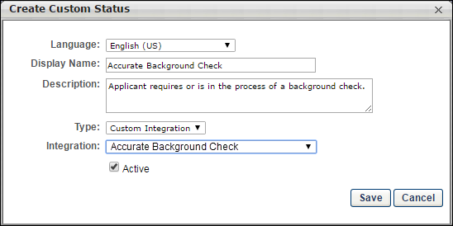
- Complete the fields in the pop-up.
  - Language - If multiple languages are enabled, select the language from the drop down list for which you are entering the status name and description. To localize the status name and description into other available languages, select the appropriate language from the drop-down list and enter the localized name and description in the appropriate fields.
  - Display Name - Enter the status name, which appears throughout the system. The character limit for this field is 50. When the Display Name of an active status is modified after the status is in use or has been used in a job requisition:
    - The new display name appears on the Default Status List page.
    - The new display name appears in the Status list on the job requisition template.
    - Any new job requisitions created after the display name is changed apply the new display name.
    - Job requisitions created before the status display name is changed continue to honor the name that existed at the time the requisition was created.
  - Description - Enter the status description. This should describe the purpose of the status and what is implied when an applicant is in that status. The character limit for this field is 500.
  - Type - Select “Custom Integration” from the drop-down. Note: This field is displayed only when creating a custom status at the top level OU. When creating a custom status for a child OU, the Type field displays the type selected for the parent OU but is not editable.
  - Integration - Select “Accurate Background Check” from the drop down.
  - Active - This field is checked by default. Ensure the field is checked before saving the status so that the status is active for the portal.
- Click Save in the pop-up. This returns you to the Manage Applicant Statuses page.
- Click Save at the bottom of the Manage Applicant Statuses page to save the custom status to the Division OU. If the custom status is not saved on the Manage Applicant Statuses page, the status will be lost once you leave the page.
The custom applicant status will need to be added to the Status List on the requisition template so that it will be included on the job requisition.
Assign Accurate Background Check
The Accurate Background Check integration allows you to place and track background checks for applicants. The integration is available through the Edge Marketplace.
The background check can be assigned via Manage Candidates, Manage Applicants, or the Applicant Profile page.
Manage Applicants Deprecation: Cornerstone is deprecating Manage Applicants in Q1 2024. See Manage Applicants Overview.
To access the Applicant Profile page, click the applicant's name from any of the following pages:
- Manage Job Requisitions >
  - Requisition Snapshot
  - Manage Applicants
- Recruit > Interview Manager
- Recruit > Review Applicants
- Recruit > Manage Candidates (Note:This functionality is in the Early Adopter phase. For more information about availability,see the Overview topic for this functionality.)
Permissions
PERMISSION NAME | PERMISSION DESCRIPTION | CATEGORY

Applicants: Initiate Background Check | This permission grants access to manage background checks from the Applicant Profile page. This applies to background checks that have been configured in the Integration Center. This permission cannot be constrained. Users who have this permission will have an Assign to Applicant link in the background check status type panel on the Applicant Profile page. Once the background check is assigned, the page will display "Assigned - [Date Assigned]." | Recruiting

Applicants: View Background Check Status and Details Link | This permission allows users to view the background check status and view a link to access the background check report, which can be found in the background check status type panel on the Applicant Profile page. This permission cannot be constrained. | Recruiting

Applicants: View Background Check Status | Allow user to view the background check status. The user cannot view the link to the detailed report. This permission cannot be constrained. | Recruiting

Requisition: Manage | Grants ability to access and manage all requisitions regardless of ownership (constraints permitting). This permission also grants read-only access to the Applicant Review tab when creating or editing a job requisition. This permission can be constrained by OU, User's OU, and Grade. | Recruiting

Requisition: Owner | Enables owner to access requisitions and applicants for requisitions for which they are an owner. This permission also grants read-only access to video interviews that are completed by applicants via HireVue. For portals with Referral Suite enabled, this permission also enables requisition owners to edit the referral source on the Applicant Profile page. This permission cannot be constrained.  Note: This is a dynamically assigned permission that is not available in Security Role Administration. If the user is removed as an owner, the permission is revoked for the associated requisition. This permission cannot be manually assigned. Also, if a user has both the permission necessary to manage requisitions and be a requisition owner, the constraints of the Requisition: Manage permission overrule those of the Requisition: Owner permission. For requisition owners that do not also have permission to manage requisitions, only certain fields are editable when editing a requisition. | Recruiting

Requisition: Reviewer | Enables reviewer to access requisitions and applicants for requisitions for which they are a reviewer. This permission cannot be constrained.  Note: This is a dynamically assigned permission that is not available in Security Role Administration. Once a requisition is in a Closed or Cancelled status or if the user is removed as a reviewer, the permission is revoked for the associated requisition. This permission cannot be manually assigned.  Note: If an applicant reviewer is removed as a reviewer via the Applicant Profile page, the Requisition: Reviewer permission is revoked for the associated requisition. However, if the reviewer was also added as a reviewer via the General tab when creating, editing, or copying the requisition, the reviewer still appears on the In Review panel as a duplicate reviewer and retains access to the requisition and applicants from the Requisition: Reviewer permission. See Applicant Profile Page Overview for more information about duplicate reviewer instances. | Recruiting
Assign Background Check
To assign the background check using Accurate Background, perform the following steps:
- Change the status of the applicant to Accurate Background Check (custom applicant status) via Manage Candidates, Manage Applicants, or the Applicant Profile page.
  - The following displays in the Accurate Background Check panel of the Applicant Profile > Statuses tab when the applicant status has been changed:
    - Current Status: Not Assigned to Applicant
    - Assign to Applicant action link
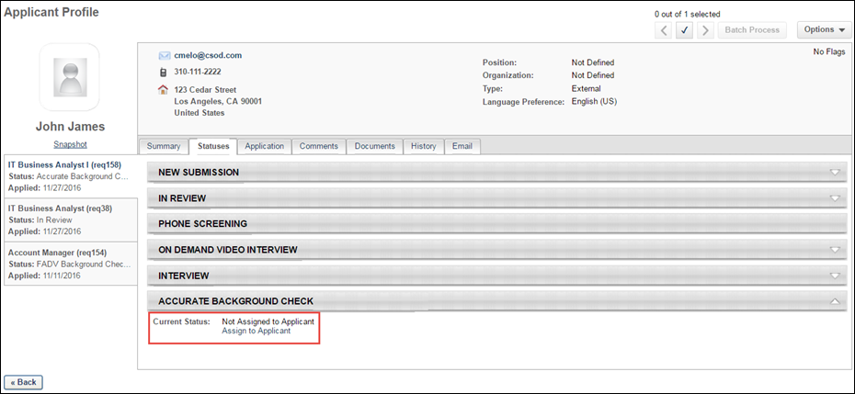
- Assign the background screening to the applicant by clicking Assign to Applicant. This opens the Select Screening Program Option pop-up.
- Complete the following fields in the pop-up:
  - Select Provider - Select Accurate Background in the field.
  - Select Package - Select the package sent by Accurate Background.
- Click Submit. This assigns the background check for the applicant. The date the background check was assigned displays in the panel, as well as a reference ID and the status of Acknowledged. An email is automatically sent to the applicant with a link to complete the screening in Accurate Background. The link is available to the applicant for seven days. The email address of the user launching the integration must exist in the Accurate system. Note: The reference ID is an internal system-defined value.
Background Check Panel
The following information displays in the background check panel on the Applicant Profile > Statuses tab during the background check process:
- Assigned - This status is the date the screening is assigned to the applicant.
- Reference ID - This displays the applicant ID (this is a backend ID within the system).
- Status - This displays the status of the overall transaction. The following are the possible values:
  - Acknowledged
  - In Progress
  - Complete
  - Cancelled
- [Package ID] - This displays the ID of the screening package assigned to the applicant.
- Provider Reference ID - This displays the Search ID from Accurate Background.
- Status - This displays the overall status of the screening request. The following are the possible values.
  - In Progress
  - Completed
  - Cancelled
- Results - The following displays for the results:
  - Percent Complete - This is a numerical value that indicates the progress of the background check.
  - Adjudication Results - This is a text value from Accurate Background. Note: Adjudication results is not a default feature in Accurate Background. Not all portals will have adjudication results.
- Check Order Progress - The link directs users to Accurate Background for a detailed report of the screening request. This option is displayed for screenings that have an In Progress status.
- View Report - A View Report link displays for screenings that have a Completed status.
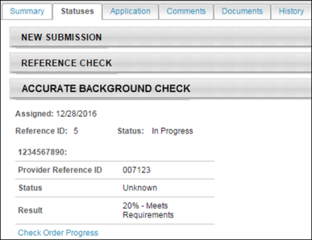
Additional Details
The following fields are sent to Accurate as part of the integration:
- Job requisition Division OU ID (Note: Accurate has a maximum character limit of 25 characters for this field. To ensure that the integration runs successfully, Cornerstone will only send the first 25 characters of the OU ID. Some OU IDs may have identical values in the first 25 characters.)
- Job requisition Location OU ID (Note: Accurate has a maximum character limit of 25 characters for this field. To ensure that the integration runs successfully, Cornerstone will only send the first 25 characters of the OU ID. Some OU IDs may have identical values in the first 25 characters.)
- Candidate first, middle, and last name
- Candidate address (address lines 1 and 2, city, state, zip, country)
- Candidate phone number
- Candidate email address
- Job requisition country
- Job requisition state
- Job requisition city
Applicant References Data
Data on an applicant's references is passed to Accurate Background Check when a background check is performed on the applicant. This means the applicant will not need to enter their references manually when filling out a background check form with Accurate.
Permissions
PERMISSION NAME | PERMISSION DESCRIPTION | CATEGORY

Manage Forms - Manage | Grants access to the Manage Forms functionality. This permission can be constrained by OU and User's OU. This is an administrator permission.  Note: This permission enables access to the Form Management functionality that is part of Cornerstone HR functionality and the Onboarding module. This permission does not grant access to the Training Forms Management functionality. | Forms Management Administration

Question Bank - Manage | Grants access to the Question Bank functionality. This permission can be constrained by OU and User's OU. This is an administrator permission. | Forms Management Administration
How Is the Applicant References Data Retrieved by Accurate?
In order for Accurate to retrieve the applicant's data, specific reference questions will need to be created in the Question Bank in Form Management so that the questions can be added to a form in Form Management that will be used to request the applicant's references.
Field Mapping
The name of the question in Cornerstone does not need to match the name of the field in Accurate, but it must be mapped to the correctly corresponding field in Accurate in order for the data to pass successfully to Accurate.
Question Sets
There are three different sets of these questions, since applicants can submit up to three references. Each set represents one applicant reference. It is necessary to create each set.
If more than three sets are created, any data outside of the first three sets will not be passed to Accurate.
Create Questions
To create the questions:
- Navigate to Admin > Tools > core functions > form management > question bank.
- Click Create Question.
- Select Text as the field type.
- Configure each question separately by entering a name for the question in the Question field and entering the API exactly as it is listed in the right-hand column. The "Field Name in Accurate Background Check" column indicates the exact name of the field in Accurate. You can use the Accurate field name as your question or enter a different name, but the API will need to correspond exactly so that the applicant's data can be transferred successfully.
field name in accurate background check |  | enter this api in the api name field on the create question page
SET 1
Reference Name |  | Accurate_Reference_Name_1
Reference Phone Number |  | Accurate_Reference_Phone1_1
Reference Phone Number 2 |  | Accurate_Reference_Phone2_1
Reference Email |  | Accurate_Reference_Email_1
Reference Relationship |  | Accurate_Reference_Relationship_1
Reference Street |  | Accurate_Reference_Street_1
Reference City |  | Accurate_Reference_City_1
Reference State |  | Accurate_Reference_State_1
Reference Zip Code |  | Accurate_Reference_Zip_1
SET 2
Reference Name |  | Accurate_Reference_Name_2
Reference Phone Number |  | Accurate_Reference_Phone1_2
Reference Phone Number 2 |  | Accurate_Reference_Phone2_2
Reference Email |  | Accurate_Reference_Email_2
Reference Relationship |  | Accurate_Reference_Relationship_2
Reference Street |  | Accurate_Reference_Street_2
Reference City |  | Accurate_Reference_City_2
Reference State |  | Accurate_Reference_State_2
Reference Zip Code |  | Accurate_Reference_Zip_2
SET 3
Reference Name |  | Accurate_Reference_Name_3
Reference Phone Number |  | Accurate_Reference_Phone1_3
Reference Phone Number 2 |  | Accurate_Reference_Phone2_3
Reference Email |  | Accurate_Reference_Email_3
Reference Relationship |  | Accurate_Reference_Relationship_3
Reference Street |  | Accurate_Reference_Street_3
Reference City |  | Accurate_Reference_City_3
Reference State |  | Accurate_Reference_State_3
Reference Zip Code |  | Accurate_Reference_Zip_3
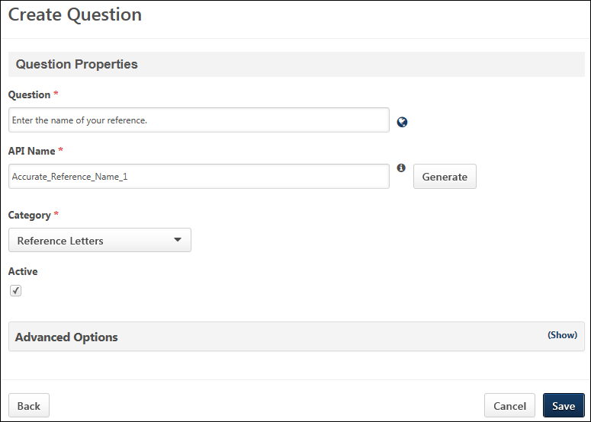
Create Form
Once you have created the questions, navigate to Form Management > Manage Forms and create a form for requesting an applicant's references, making sure to enter Accurate_Reference_Form in the API Name field on the Build tab. The purpose of entering this API name is so that the system knows the correct form to send to Accurate Background Check. See Build Tab - Define General Information.
On the form, add the questions that you created above. The references request form will be assigned to applicants on the Manage Applicants page. The form will be available to the applicant from their My Profile page in the career site, where they can then launch and complete the form.
AccurateAce Background Check Integration - Overview
The AccurateAce Background Check integration is available through the Edge Marketplace. The AccurateAce Background Check integration allows you to place and track background checks for applicants.
Use Cases
Use Case 1: Activate the AccurateAce Background Check integration through Edge
- Barbara is Acme Company's administrator who has been tasked with enabling the integration with AccurateAce Background Check. This will allow Acme to include AccurateAce Background Check requests within their application workflow.
- Barbara goes to the Edge Marketplace to purchase and activate the AccurateAce Background Check integration.
- From the Edge Integrate page, Barbara enters Acme's unique Company ID, which is provided by their AccurateAce project team.
- Acme's portal now has an active integration with AccurateAce.
Use Case 2: Recruiting Admin creates a custom applicant status
- Katie is the recruiting administrator for Acme Company.
- Ryan, a hiring manager at Acme, is looking to add a new member to his Marketing team.
- With the integration enabled, Katie is tasked with adding a background check status in all of Acme's marketing requisitions.
- Katie creates a new custom applicant status that is set to custom integration type AccurateAce Background Check.
- Katie creates a new job requisition that includes that new custom applicant status.
- Katie has now configured the marketing requisitions to include the AccurateAce Background Check custom applicant status.
Use Case 3: Recruiter places a background check request for an applicant
- Dorothy, a recruiter at Acme, has identified John James to be a stellar applicant.
- To ensure a sound hiring decision is made and to protect Acme from potential risks, Dorothy assigns a background check screening on John by moving the status to AccurateAce Background Check.
- Dorothy clicks the Assign to Applicant link on the Statuses tab of the Applicant Profile page, and a pop-up window appears. Dorothy confirms the selected background check provider, and then clicks Submit.
- Dorothy is re-directed to Acme's AccurateAce portal where she will select the appropriate background check package to assign to John.
Use Case 4: Recruiter views background check results and its detailed report in AccurateAce via a link
- Dorothy is eager to find out the results of John's background check status.
- Dorothy navigates to John's Applicant Profile > Statuses page and sees the status on the request.
- To view additional details of the background request, Dorothy clicks on the View Progress link, which will direct her to the AccurateAce site.
Implementation
The AccurateAce Background Check integration must be enabled and activated through the Edge Marketplace. Portals must have already purchased AccurateAce Background Check in order to enable it in Edge.
Security
The following permissions apply to this functionality:
PERMISSION NAME | PERMISSION DESCRIPTION | CATEGORY

Applicants: Initiate Background Check | This permission grants access to manage background checks from the Applicant Profile page. This applies to background checks that have been configured in the Integration Center. This permission cannot be constrained. Users who have this permission will have an Assign to Applicant link in the background check status type panel on the Applicant Profile page. Once the background check is assigned, the page will display "Assigned - [Date Assigned]." | Recruiting

Applicant Status Bank - Manage | Grants ability to access and manage Applicant Status Bank. | Recruiting Administration

Applicants: View Background Check Status | Allow user to view the background check status. The user cannot view the link to the detailed report. This permission cannot be constrained. | Recruiting

Applicants: View Background Check Status and Details Link | This permission allows users to view the background check status and view a link to access the background check report, which can be found in the background check status type panel on the Applicant Profile page. This permission cannot be constrained. | Recruiting

Requisition: Manage | Grants ability to access and manage all requisitions regardless of ownership (constraints permitting). This permission also grants read-only access to the Applicant Review tab when creating or editing a job requisition. This permission can be constrained by OU, User's OU, and Grade. | Recruiting

Requisition: Owner | Enables owner to access requisitions and applicants for requisitions for which they are an owner. This permission also grants read-only access to video interviews that are completed by applicants via HireVue. For portals with Referral Suite enabled, this permission also enables requisition owners to edit the referral source on the Applicant Profile page. This permission cannot be constrained.  Note: This is a dynamically assigned permission that is not available in Security Role Administration. If the user is removed as an owner, the permission is revoked for the associated requisition. This permission cannot be manually assigned. Also, if a user has both the permission necessary to manage requisitions and be a requisition owner, the constraints of the Requisition: Manage permission overrule those of the Requisition: Owner permission. For requisition owners that do not also have permission to manage requisitions, only certain fields are editable when editing a requisition. | Recruiting

Requisition: Reviewer | Enables reviewer to access requisitions and applicants for requisitions for which they are a reviewer. This permission cannot be constrained.  Note: This is a dynamically assigned permission that is not available in Security Role Administration. Once a requisition is in a Closed or Cancelled status or if the user is removed as a reviewer, the permission is revoked for the associated requisition. This permission cannot be manually assigned.  Note: If an applicant reviewer is removed as a reviewer via the Applicant Profile page, the Requisition: Reviewer permission is revoked for the associated requisition. However, if the reviewer was also added as a reviewer via the General tab when creating, editing, or copying the requisition, the reviewer still appears on the In Review panel as a duplicate reviewer and retains access to the requisition and applicants from the Requisition: Reviewer permission. See Applicant Profile Page Overview for more information about duplicate reviewer instances. | Recruiting
Enable AccurateAce Background Check Integration
Applicant Statuses - Create Custom AccurateAce Status
In order for the AccurateAce Background Check status to be available to select for applicants, it is necessary to create a custom integration status in Manage Applicant Statuses.
To create a custom applicant status, go to Admin > Tools > Recruit > Applicant Statuses. Then click the Create Custom Status link.
Permissions
PERMISSION NAME | PERMISSION DESCRIPTION | CATEGORY

Applicant Status Bank - Manage | Grants ability to access and manage Applicant Status Bank. | Recruiting Administration
To create a custom integration status for AccurateAce Background Check:
- Navigate to Admin > Tools > Recruit > Applicant Statuses.
- Click the Create Custom Status link. This opens the Create Custom Status pop-up.
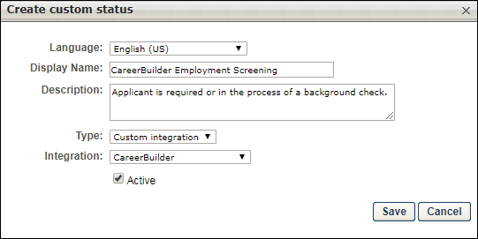
- Complete the following fields in the Create Custom Status pop-up:
  - Language - If multiple languages are enabled, from the drop-down list select the language in which you are entering the status name and description. To localize the status name and description into other available languages, select the appropriate language from the drop-down list and enter the localized name and description in the appropriate fields.
  - Display Name - Enter "AccurateAce Background Check" to identify the status as being specifically for AccurateAce Background Check.
  - Description - Enter a description, up to 500 characters. As a best practice, provide a description that helps recruiters understand the purpose of this status.
  - Type - Select "Custom Integration." The Custom Integration status type mans that the applicant is in an integration step of the status workflow.
  - Integration - Select "AccurateAce" in this field, which will associate the custom status to AccurateAce Background Check.
  - Active - This option is selected by default and means the status will be available to include in status workflows.
- Click Save to save the custom status. Your new custom integration status will be visible in the list of statuses on the Manage Applicant Statuses page.
Map Education and Experience Fields (AccurateAce Background Check)
In order for AccurateAce Background Check to retrieve the applicant's data, specific resume fields will need to be mapped.
Note: When configuring the application workflow template for the requisition, the Upload Attachment action item will need to be included so that the applicant can enter their resume data in the Education and Employment fields that are mapped for AccurateAce when filling out the application.
Education Fields
Education fields must be mapped in Succession > Resume in order for Cornerstone to pass the applicant's data to AccurateAce. The name of the field in Cornerstone (as defined in the Field Name field on the Add Field pop-up on the Resume > Education page) does not need to match the name of the field in AccurateAce, but it must be mapped to the correctly corresponding Applicant Mapping field in your portal in order for the data to pass successfully to AccurateAce.
To map the fields:
- Navigate to Admin > Tools > Succession Management > Resume.
- Select the Edit icon in the Education row.
- Ensure that Education is selected in the Applicant Resume drop-down.
- Configure or create the following fields and select the appropriate mapping option in the Applicant Mapping column:
field name in AccurateAce | select this option in drop-down in applicant mapping column | field type
Institution | Institution | Short Text Box; AccurateAce allows a candidate up to three records
Degree | Degree | Dropdown; AccurateAce allows a candidate up to four entry records
Degree Major | Area of Study | Short Text Box; AccurateAce allows a candidate up to four entry records
Degree Date | Graduation Date | Date Field; AccurateAce allows a candidate up to four entry records
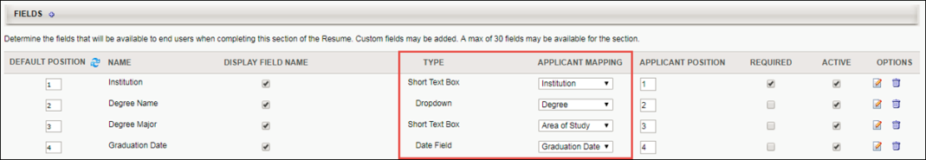
Employment Fields
Employment fields must be mapped in Succession > Resume in order for Cornerstone to pass the applicant's data to AccurateAce. The name of the field in Cornerstone (as defined in the Field Name field on the Add Field pop-up on the Resume > Previous Positions page) does not need to match the name of the field in AccurateAce, but it must be mapped to the correctly corresponding Applicant Mapping field in your portal in order for the data to pass successfully to AccurateAce.
To map the fields:
- Navigate to Admin > Tools > Succession Management > Resume.
- Select the Edit icon in the Previous Positions row.
- Ensure that Experience is selected in the Applicant Resume drop-down.
- Configure or create the following fields and select the appropriate mapping option in the Applicant Mapping column:
field name in AccurateAce | select this option in drop-down in applicant mapping column | field type
Employer Name | Organization | Short Text Box; AccurateAce allows a candidate up to four entry records
Title | Position | Short Text Box; AccurateAce allows a candidate up to four entry records
Start and End Date | Date Range | Date Range Field; AccurateAce allows a candidate up to four entry records
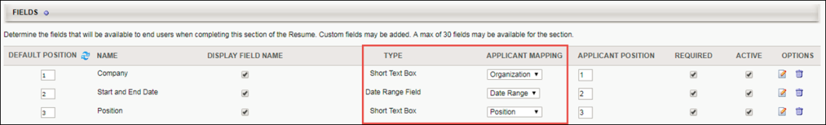
Application Workflow - Upload Attachments (AccurateAce Background Check)
When including the AccurateAce Background Check integration in the applicant statuses for a job requisition, the Upload Attachment action item must also be included in the application workflow. This allows applicants to enter their resume data when filling out the application. Their resume data will be mapped to specific field in AccurateAce during the background check process.
To create an application workflow template, go to Admin > Tools > Recruit > Application Workflow Templates. Then click the Create Template link.
Note: The application workflow can also be configured in requisition templates, the default requisition template, and job requisitions.
Permissions
PERMISSION NAME | PERMISSION DESCRIPTION | CATEGORY

Application Workflow Template - Manage | Grants ability to access and manage Application Workflow Templates. This permission can be constrained by OU and User’s OU. This is an administrator permission. | Recruiting Administration

Application Workflow Template - View | Grants ability to access and view Application Workflow Templates. | Recruiting Administration
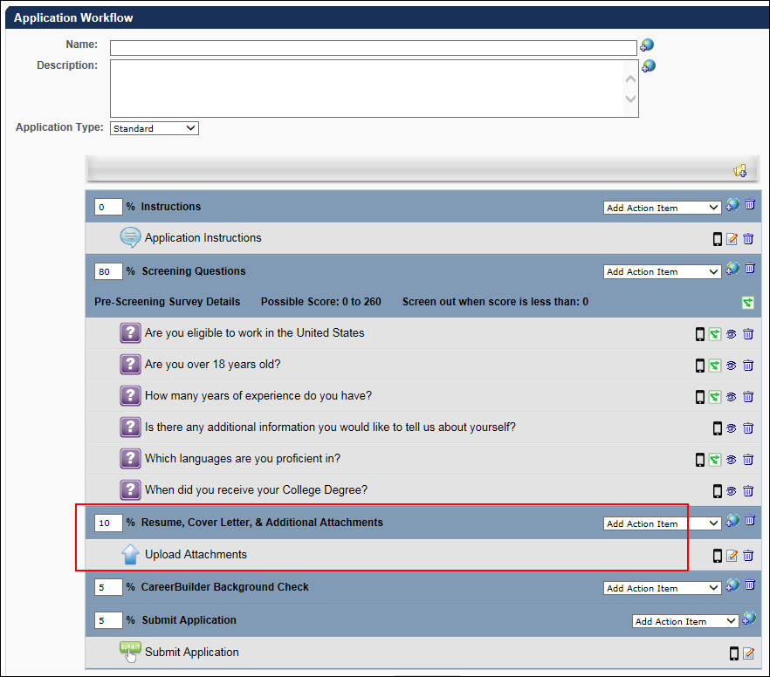
Assign AccurateAce Background Check
The AccurateAce Background Check can be assigned from the Applicant Profile > Statuses tab. The applicant's status must be changed to the custom AccurateAce Background Check status in order for the background screening to be available to assign.
Permissions
PERMISSION NAME | PERMISSION DESCRIPTION | CATEGORY

Applicants: Initiate Background Check | This permission grants access to manage background checks from the Applicant Profile page. This applies to background checks that have been configured in the Integration Center. This permission cannot be constrained. Users who have this permission will have an Assign to Applicant link in the background check status type panel on the Applicant Profile page. Once the background check is assigned, the page will display "Assigned - [Date Assigned]." | Recruiting

Applicants: View Background Check Status and Details Link | This permission allows users to view the background check status and view a link to access the background check report, which can be found in the background check status type panel on the Applicant Profile page. This permission cannot be constrained. | Recruiting

Applicants: View Background Check Status | Allow user to view the background check status. The user cannot view the link to the detailed report. This permission cannot be constrained. | Recruiting

Requisition: Manage | Grants ability to access and manage all requisitions regardless of ownership (constraints permitting). This permission also grants read-only access to the Applicant Review tab when creating or editing a job requisition. This permission can be constrained by OU, User's OU, and Grade. | Recruiting

Requisition: Owner | Enables owner to access requisitions and applicants for requisitions for which they are an owner. This permission also grants read-only access to video interviews that are completed by applicants via HireVue. For portals with Referral Suite enabled, this permission also enables requisition owners to edit the referral source on the Applicant Profile page. This permission cannot be constrained.  Note: This is a dynamically assigned permission that is not available in Security Role Administration. If the user is removed as an owner, the permission is revoked for the associated requisition. This permission cannot be manually assigned. Also, if a user has both the permission necessary to manage requisitions and be a requisition owner, the constraints of the Requisition: Manage permission overrule those of the Requisition: Owner permission. For requisition owners that do not also have permission to manage requisitions, only certain fields are editable when editing a requisition. | Recruiting

Requisition: Reviewer | Enables reviewer to access requisitions and applicants for requisitions for which they are a reviewer. This permission cannot be constrained.  Note: This is a dynamically assigned permission that is not available in Security Role Administration. Once a requisition is in a Closed or Cancelled status or if the user is removed as a reviewer, the permission is revoked for the associated requisition. This permission cannot be manually assigned.  Note: If an applicant reviewer is removed as a reviewer via the Applicant Profile page, the Requisition: Reviewer permission is revoked for the associated requisition. However, if the reviewer was also added as a reviewer via the General tab when creating, editing, or copying the requisition, the reviewer still appears on the In Review panel as a duplicate reviewer and retains access to the requisition and applicants from the Requisition: Reviewer permission. See Applicant Profile Page Overview for more information about duplicate reviewer instances. | Recruiting
Assign from Applicant Profile
To assign from the Applicant Profile page:
- Change the candidate's status to the applicable background check status on either the Manage Applicants page or the Applicant Profile page. This enables a background check to be assigned to a candidate on the Statuses tab of the Applicant Profile page.
- Navigate to the Applicant Profile > Statuses tab.
- Click the Assign to Applicant link in the background check status section. This opens the Select Screening Program Option pop-up.
- Select the AccurateAce Background Check provider from the Select Provider drop-down.
- Click Submit. This redirects the recruiter to the AccurateAce system where the appropriate screening package must be selected and assigned to the candidate. The recruiter has 30 minutes to complete this step before their AccurateAce session times out. Should a timeout occur, a background check will not be assigned to the candidate, and the recruiter will need to start the process again on the Applicant Profile page.
- 7. AccurateAce sends an email to the candidate to collect data for the remaining required fields.
If the screening request is successful and completed, the following information displays on the Applicant Profile page:
- Assigned - This field displays the date that the background screening was assigned to the candidate.
- Reference ID - This field displays the package name selected and assigned to the candidate in AccurateAce.
- Status - This field displays the overall status of the order.
  - If the request is successful, this field displays "Acknowledged."
  - If the request is not successful, this field displays "Error."
  - Once the background check process is started, this field displays "In Progress."
  - Once the background check is finished, this field displays "Completed."
The results of the background check display in the status panel on the Applicant Profile > Statuses tab. You can also view the results from the associated column on the Manage Applicants page.
A-Check Global Background Screening Integration
A-Check Global’s background screening integration with Cornerstone provides an effective resource to help organizations make well-informed hiring decisions—all within the convenience of the hiring management system you already use. A-Check Global provides employment, education, criminal, and other background checks that are required during the hiring process.
Background checks are requested from within your Cornerstone portal and are completed by A-Check Global. You can monitor the status of the background check, and once the request is completed, A-Check Global provides you with a secure link to download the results.
Implementation
This integration is available for all organizations using Recruiting. This integration is available for free via Edge Marketplace. Additional instructions for enabling and configuring the integration are available on the Setup tab of the integration in Edge.
The integration can be accessed and configured via the Edge Marketplace. In order to use this integration, your organization must be using the Recruiting module and must have access to Edge and have an account with the integration vendor. There is no additional cost associated with enabling this integration, but the integration cannot be used without an account with the integration vendor.
Permissions
The following existing permissions apply to this functionality:
PERMISSION NAME | PERMISSION DESCRIPTION | CATEGORY

Edge Integrations - Manage | Grants access to the Integrations service for Edge Integrate, where the administrator can configure, enable, and disable their third-party integrations used within the Cornerstone system. This permission cannot be constrained. This is an administrator permission. | Edge

Edge Marketplace - Manage | Grants access to the Marketplace service for Edge Integrate, where the administrator can browse integrations that can be used to extend the Cornerstone system. This permission cannot be constrained. This is an administrator permission. | Edge
Choice Screening Background Check Integration
The Choice Screening Background Check integration in Edge allows Cornerstone Recruiting clients with a Choice Screening account to seamlessly background check applicants all from within Recruiting.
The following functionality is included:
- Order Background Checks - Assign Choice Screening products and customized packages to applicants from within Cornerstone Recruiting.
- Track Background Check Status - Easily view the real-time status of an applicant’s background screening.
- View Completed Results - Access completed background checks all from within Cornerstone Recruiting.
Implementation
This integration is available for all organizations using the Recruiting suite. This integration is available for free via Edge Marketplace. Additional instructions are available in the Getting Started tab of the integration in Edge.
The Choice Screening Background Check integration can be accessed and configured via the Edge Marketplace. In order to use this integration, your organization must be using the Recruiting module and must have access to Edge and a Choice Screening Background Check account. There is no additional cost associated with enabling this integration, but the integration cannot be used without a Choice Screening Background Check account.
Permissions
The following permissions apply to this functionality:
PERMISSION NAME | PERMISSION DESCRIPTION | CATEGORY

Edge Integrations - Manage | Grants access to the Integrations service for Edge Integrate, where the administrator can configure, enable, and disable their third-party integrations used within the Cornerstone system. This permission cannot be constrained. This is an administrator permission. | Edge

Edge Marketplace - Manage | Grants access to the Marketplace service for Edge Integrate, where the administrator can browse integrations that can be used to extend the Cornerstone system. This permission cannot be constrained. This is an administrator permission. | Edge
First Advantage Background Check and Drug Screening Integration - Overview
First Advantage (FADV) integration provides screenings for background checks and drug screenings. This feature is available via Edge Integrate. Customers must also have an agreement in place with FADV in order to use this integration.
Implementation
This integration is available for all organizations using the Recruiting suite. This integration is available for free via Edge Marketplace. Additional instructions for enabling and configuring the integration are available on the Setup tab of the integration in Edge.
The integration can be accessed and configured via the Edge Marketplace. In order to use this integration, your organization must be using the Recruiting module and must have access to Edge and have an account with the integration vendor. There is no additional cost associated with enabling this integration, but the integration cannot be used without an account with the integration vendor.
Permissions
Portals must create a custom status to assign the background check and must use the Sensitive Status option in order to prevent access to the status.
The following permissions apply to FADV integrations.
PERMISSION NAME | PERMISSION DESCRIPTION | CATEGORY

Applicants: Access Sensitive Statuses | Grants ability to access the applicant statuses that are configured as sensitive. | Recruiting

Applicant Status Bank - Manage | Grants ability to access and manage Applicant Status Bank. | Recruiting Administration

Requisition: Manage | Grants ability to access and manage all requisitions regardless of ownership (constraints permitting). This permission also grants read-only access to the Applicant Review tab when creating or editing a job requisition. This permission can be constrained by OU, User's OU, and Grade. | Recruiting

Requisition: Owner | Enables owner to access requisitions and applicants for requisitions for which they are an owner. This permission also grants read-only access to video interviews that are completed by applicants via HireVue. For portals with Referral Suite enabled, this permission also enables requisition owners to edit the referral source on the Applicant Profile page. This permission cannot be constrained.  Note: This is a dynamically assigned permission that is not available in Security Role Administration. If the user is removed as an owner, the permission is revoked for the associated requisition. This permission cannot be manually assigned. Also, if a user has both the permission necessary to manage requisitions and be a requisition owner, the constraints of the Requisition: Manage permission overrule those of the Requisition: Owner permission. For requisition owners that do not also have permission to manage requisitions, only certain fields are editable when editing a requisition. | Recruiting

Requisition: Reviewer | Enables reviewer to access requisitions and applicants for requisitions for which they are a reviewer. This permission cannot be constrained.  Note: This is a dynamically assigned permission that is not available in Security Role Administration. Once a requisition is in a Closed or Cancelled status or if the user is removed as a reviewer, the permission is revoked for the associated requisition. This permission cannot be manually assigned.  Note: If an applicant reviewer is removed as a reviewer via the Applicant Profile page, the Requisition: Reviewer permission is revoked for the associated requisition. However, if the reviewer was also added as a reviewer via the General tab when creating, editing, or copying the requisition, the reviewer still appears on the In Review panel as a duplicate reviewer and retains access to the requisition and applicants from the Requisition: Reviewer permission. See Applicant Profile Page Overview for more information about duplicate reviewer instances. | Recruiting
Create Custom Applicant Status (FADV)
Administrators must create a new custom applicant status to be used for the First Advantage (FADV) background check integration. One custom status will be used for both background checks and drug screenings.
Permissions
PERMISSION NAME | PERMISSION DESCRIPTION | CATEGORY

Applicants: Access Sensitive Statuses | Grants ability to access the applicant statuses that are configured as sensitive. | Recruiting

Applicant Status Bank - Manage | Grants ability to access and manage Applicant Status Bank. | Recruiting Administration
Create Custom Status
To create a custom applicant status:
- Navigate to the Manage Applicant Statuses page.
- Click Create Custom Status. This opens the Create Custom Status pop-up.
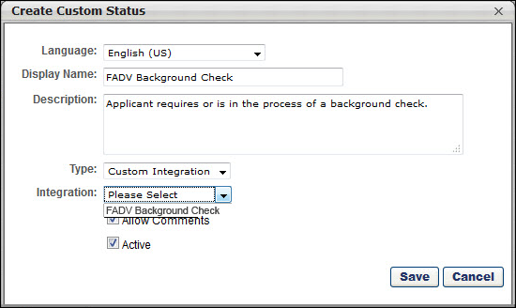
- Complete the following fields in the pop-up:
  - Language - If multiple languages are enabled, from the drop-down list select the language in which you are entering the status name and description. To localize the status name and description into other available languages, select the appropriate language from the drop-down list and enter the localized name and description in the appropriate fields.
  - Display Name - Enter the status name, which appears throughout the system. The character limit for this field is 50. When the Display Name of an active status is modified after the status is in use or has been used in a job requisition:
    - The new display name appears on the Default Status List page.
    - The new display name appears in the Status list on the job requisition template.
    - Any new job requisitions created after the display name is changed apply the new display name.
    - Job requisitions created before the status display name is changed continue to honor the name that existed at the time the requisition was created.
  - Description - Enter the status description. This should describe the purpose of the status and what is implied when an applicant is in that status. The character limit for this field is 500.
  - Type - Select Custom Integration from the drop-down. Note: This field only displays when creating a custom status at the top level OU. When creating a custom status for a child OU, the Type field displays the type selected for the parent OU but is not editable.
  - Integration - Select FADV Background check from the drop-down.
  - Allow Comments - If this option is selected, when an applicant profile has this status, comments can be applied and are tagged with this status. If the Allow Comments option is deselected for an active status, the change is applied to any templates implementing the status; new job requisitions created from the template apply the new behavior, but existing job requisitions are unaffected.
  - Active - This field is checked by default. Ensure the field is checked before saving the status so that the status is active for the portal.
- Click Save in the pop-up. This returns you to the Manage Applicant Statuses page.
- Click Save at the bottom of the Manage Applicant Statuses page to save the custom status to the Division OU. If the custom status is not saved on the Manage Applicant Statuses page, the status will be lost once you leave the page.
The custom applicant status will need to be added to the Status List on the requisition template so that it will be included on the job requisition.
Configure Status as Sensitive
The administrator must configure the FADV custom applicant status as sensitive to restrict access to the status. The status can be designated as sensitive in the following areas of the system:
- Default Status List - If the status is part of the default status list, then check the box in the Sensitive column of the default status list.
- Requisition Template - The status can be designated as sensitive on the General step when configuring job requisition templates. To designate the status as sensitive, check the box in the Sensitive column of the status list in the Status List section.
Note: Only users with permission to view sensitive statuses can view the status in the applicant status workflow.
Map Education Fields for FADV
For the purposes of being included in an applicant screening, an applicant's school type and degree type can be mapped to First Advantage (FADV). In order for FADV to receive the applicant's data, the fields will need to be mapped in Succession Management > Resume > Education.
Note: When configuring the application workflow template for the requisition, the Upload Attachment action item will need to be included so that the applicant can enter their resume data when filling out the application.
Permissions
PERMISSION NAME | PERMISSION DESCRIPTION | CATEGORY

Resume Administration | Grants access to resume administration, which enables configuration of resume sections, including custom resume fields. This permission cannot be constrained. This is an administrator permission. Note: This permission does not apply to the Universal Profile - Resume functionality. | Talent/Succession - Administration
Background Check Prerequisite
It is important to ensure that resume data exists in the system prior to submitting a background check request. Cornerstone will not send the data to FADV after a background check request has been placed.
Mapping Education Fields
The name of the field in Cornerstone (as defined in the Field Name field on the Add Field pop-up on the Resume > Education page) does not need to match the name of the field in FADV, but it must be mapped to the correct Applicant Mapping value noted in the table below.
Note: Users must have permission to access the Resume Administration page in Succession Management.
To map the fields:
- Navigate to Admin > Tools > Succession Management > Resume.
- Select the Edit icon in the Education row.
- Ensure that Education is selected in the Applicant Resume drop-down.
- Create the following fields and select the appropriate mapping option in the Applicant Mapping column:
field name in fadv | drop-down Option in applicant mapping column | field type | drop-down options to add
School Type (Note: A field on the resume in Cornerstone must be mapped to this field in Accurate in order for Accurate to process the data.) | Grade | Dropdown | - other  - highschool  - community  - college  - technicalCollege  - GED  - postGraduate  Note: The options for the dropdown field are case sensitive and must be added in the exact spelling as above in order for the data to map successfully to FADV. For example, do not capitalize "other" and do not add a space between "high" and "school."
Degree | Degree | Dropdown | - highschool  - vocational  - certification  - associates  - bachelors  - masters  - doctorate  - postdoctorate  - professional  - GED  - other  Note: The options for the dropdown field type are case sensitive and must be added in the exact spelling as above in order for the data to map successfully to FADV. For example, do not capitalize "other" and do not add a space between "high" and "school."
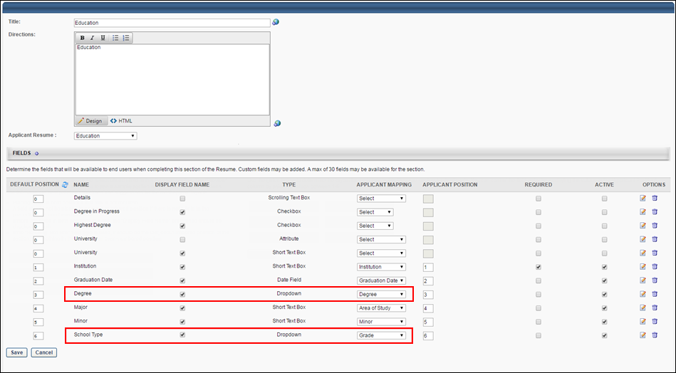
Map Reference Questions for FADV
For the purposes of being included in an applicant screening, an applicant's reference type can be mapped to First Advantage (FADV). In order for FADV to retrieve the applicant's data, a reference type question will need to be created in the Question Bank in Form Management so that the questions can be added to a form in Form Management that will be used to request the applicant's references
The name of the question in Cornerstone does not need to match the name of the field in FADV, but it must be mapped to the correctly corresponding field in FADV in order for the data to pass successfully to FADV.
There are three different sets of these questions, since applicants can submit up to three references. Each set represents one applicant reference. It is necessary to create each set. If more than three sets are created, any data outside of the first three sets will not be passed to FADV.
To access the question bank, go to Admin > Tools > Core Functions > Form Management. Then, click the Question Bank link.
Permissions
PERMISSION NAME | PERMISSION DESCRIPTION | CATEGORY

Manage Forms - Manage | Grants access to the Manage Forms functionality. This permission can be constrained by OU and User's OU. This is an administrator permission.  Note: This permission enables access to the Form Management functionality that is part of Cornerstone HR functionality and the Onboarding module. This permission does not grant access to the Training Forms Management functionality. | Forms Management Administration

Question Bank - Manage | Grants access to the Question Bank functionality. This permission can be constrained by OU and User's OU. This is an administrator permission. | Forms Management Administration
Background Check Prerequisite
It is important to ensure that reference data exists in the system prior to submitting a background check request. Cornerstone will not send the data to FADV after a background check request has been placed.
Create Questions
To create the questions:
- Navigate to Admin > Tools > core functions > form management > question bank.
- Click Create Question.
- Select Dropdown as the field type.
- Configure each question separately by entering a name for the question in the Question field and entering the API exactly as it is listed in the right-hand column.
Note about the FADV Telephone Field: When applicants enter a telephone number, they must enter it in the following format, or FADV will not load the data: +(country code) XXXXXXXXXX OR +(country code) (XXX)XXX-XXXX].
field name in fadv |  |  | field type | enter this api in the api name field on the create question page
SET 1
Given Name |  |  | Text | FADV_GivenName_1
Family Name |  |  | Text | FADV_FamilyName_1
Email Address |  |  | Text | FADV_Email_1
Telephone |  |  | Text | FADV_Phone_1
SET 2
Given Name |  |  | Text | FADV_GivenName_2
Family Name |  |  | Text | FADV_FamilyName_2
Email Address |  |  | Text | FADV_Email_2
Telephone |  |  | Text | FADV_Phone_2
SET 3
Given Name |  |  | Text | FADV_GivenName_3
Family Name |  |  | Text | FADV_FamilyName_3
Email Address |  |  | Text | FADV_Email_3
Telephone |  |  | Text | FADV_Phone_3
Create Form
Once you have created the questions, navigate to Form Management > Manage Forms and create a form for requesting an applicant's references, making sure to enter FADV_Reference_Form in the API Name field on the Build tab. The purpose of entering this API name is so that the system knows the correct form to send to FADV. See Build Tab - Define General Information.
On the form, add the questions that you created above. The references request form will be assigned to applicants on the Manage Applicants page. The form will be available to the applicant from their My Profile page in the career site, where they can then launch and complete the form.
Change Applicant Status to First Advantage
In order for applicants to be assigned the First Advantage (FADV) background check, the applicant's status must be changed to the custom FADV status. The status can be changed on Manage Candidates or by clicking the Change Status action on the Manage Applicants page for the desired applicants.
Manage Applicants Deprecation: Cornerstone is deprecating Manage Applicants in Q1 2024. See Manage Applicants Overview.
Permissions
PERMISSION NAME | PERMISSION DESCRIPTION | CATEGORY

Requisition: Manage | Grants ability to access and manage all requisitions regardless of ownership (constraints permitting). This permission also grants read-only access to the Applicant Review tab when creating or editing a job requisition. This permission can be constrained by OU, User's OU, and Grade. | Recruiting
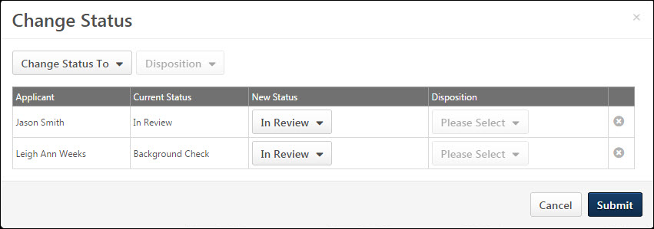
Applicant Profile - Assign First Advantage Screening
The First Advantage (FADV) screening is assigned to applicants from Manage Candidates or the FADV status panel on the Statuses tab on the Applicant Profile page. Applicants must be in the custom FADV status in order to assign the screening.
When applicants complete the screening, data is passed between Cornerstone and FADV, including the following:
- Cost Center OU Name - This is the Cost Center Organizational Unit (OU) associated to the job requisition to which the candidate applied. In FADV this is an alphanumeric field with a character limit of 250.
- Position OU Name - This field maps to the Display Job Title field on the job requisition to which the applicant applied. In FADV this is an alphanumeric field with a character limit of 250.
- Grade OU Name - This field maps to the Grade OU associated on the job requisition to which the applicant applied. In FADV this is an alphanumeric field with a character limit of 250.
For additional details and options available in the First Advantage status type panel, see the Applicant Profile - First Advantage Status Panel topic in Online Help.
Permissions
PERMISSION NAME | PERMISSION DESCRIPTION | CATEGORY

Applicants: Access Sensitive Statuses | Grants ability to access the applicant statuses that are configured as sensitive. | Recruiting

Requisition: Manage | Grants ability to access and manage all requisitions regardless of ownership (constraints permitting). This permission also grants read-only access to the Applicant Review tab when creating or editing a job requisition. This permission can be constrained by OU, User's OU, and Grade. | Recruiting

Requisition: Owner | Enables owner to access requisitions and applicants for requisitions for which they are an owner. This permission also grants read-only access to video interviews that are completed by applicants via HireVue. For portals with Referral Suite enabled, this permission also enables requisition owners to edit the referral source on the Applicant Profile page. This permission cannot be constrained.  Note: This is a dynamically assigned permission that is not available in Security Role Administration. If the user is removed as an owner, the permission is revoked for the associated requisition. This permission cannot be manually assigned. Also, if a user has both the permission necessary to manage requisitions and be a requisition owner, the constraints of the Requisition: Manage permission overrule those of the Requisition: Owner permission. For requisition owners that do not also have permission to manage requisitions, only certain fields are editable when editing a requisition. | Recruiting

Requisition: Reviewer | Enables reviewer to access requisitions and applicants for requisitions for which they are a reviewer. This permission cannot be constrained.  Note: This is a dynamically assigned permission that is not available in Security Role Administration. Once a requisition is in a Closed or Cancelled status or if the user is removed as a reviewer, the permission is revoked for the associated requisition. This permission cannot be manually assigned.  Note: If an applicant reviewer is removed as a reviewer via the Applicant Profile page, the Requisition: Reviewer permission is revoked for the associated requisition. However, if the reviewer was also added as a reviewer via the General tab when creating, editing, or copying the requisition, the reviewer still appears on the In Review panel as a duplicate reviewer and retains access to the requisition and applicants from the Requisition: Reviewer permission. See Applicant Profile Page Overview for more information about duplicate reviewer instances. | Recruiting
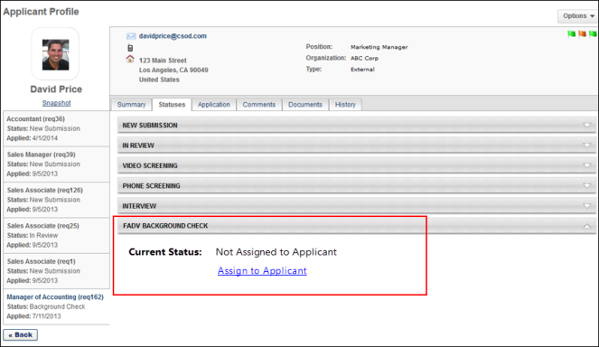
Assign from Manage Candidates
See Manage Candidates - Assign Integrations.
Assign from Applicant Profile
To assign the FADV screening:
- Click Assign to Applicant in the FADV status panel. This opens the Select Screening Program Option pop-up.
- Select the FADV account from the Select Account drop-down. The options in the drop-down are the account values sent by FADV.
- Select the package from the Select Package drop-down. The options in the drop-down are the package values sent by FADV.
- Click Submit to assign the screening. The selected account and package information is sent to FADV, and FADV sends an email to the applicant once the screening is assigned.
Applicant Profile - First Advantage Status Panel
The FADV status panel on the Statuses tab of the Applicant Profile page allows recruiters to assign screenings to applicants and view updates from FADV regarding the applicant's progress on completing the screening.
Permissions
PERMISSION NAME | PERMISSION DESCRIPTION | CATEGORY

Applicants: Access Sensitive Statuses | Grants ability to access the applicant statuses that are configured as sensitive. | Recruiting

Requisition: Manage | Grants ability to access and manage all requisitions regardless of ownership (constraints permitting). This permission also grants read-only access to the Applicant Review tab when creating or editing a job requisition. This permission can be constrained by OU, User's OU, and Grade. | Recruiting

Requisition: Owner | Enables owner to access requisitions and applicants for requisitions for which they are an owner. This permission also grants read-only access to video interviews that are completed by applicants via HireVue. For portals with Referral Suite enabled, this permission also enables requisition owners to edit the referral source on the Applicant Profile page. This permission cannot be constrained.  Note: This is a dynamically assigned permission that is not available in Security Role Administration. If the user is removed as an owner, the permission is revoked for the associated requisition. This permission cannot be manually assigned. Also, if a user has both the permission necessary to manage requisitions and be a requisition owner, the constraints of the Requisition: Manage permission overrule those of the Requisition: Owner permission. For requisition owners that do not also have permission to manage requisitions, only certain fields are editable when editing a requisition. | Recruiting

Requisition: Reviewer | Enables reviewer to access requisitions and applicants for requisitions for which they are a reviewer. This permission cannot be constrained.  Note: This is a dynamically assigned permission that is not available in Security Role Administration. Once a requisition is in a Closed or Cancelled status or if the user is removed as a reviewer, the permission is revoked for the associated requisition. This permission cannot be manually assigned.  Note: If an applicant reviewer is removed as a reviewer via the Applicant Profile page, the Requisition: Reviewer permission is revoked for the associated requisition. However, if the reviewer was also added as a reviewer via the General tab when creating, editing, or copying the requisition, the reviewer still appears on the In Review panel as a duplicate reviewer and retains access to the requisition and applicants from the Requisition: Reviewer permission. See Applicant Profile Page Overview for more information about duplicate reviewer instances. | Recruiting
Screening Not Yet Assigned
When a screening is not yet assigned to the applicant, the FADV status panel displays the following information:
- Current Status - This field displays a status of Not Assigned to Applicant to indicate that the screening is not yet assigned to the applicant.
- Assign to Applicant - The Assign to Applicant link displays below the status to enable recruiters to assign an FADV screening to the applicant. The link only displays if the screening has not yet been assigned to the applicant.
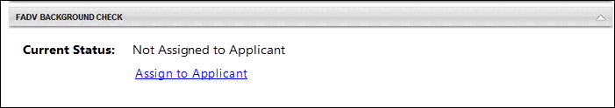
For detailed information about assigning a FADV screening, see the Applicant Profile - Assign First Advantage Screening topic in Online Help.
Screening Assigned
Once the screening is assigned, FADV sends updates to the system as the screening progresses through the various stages and statuses. The FADV status panel displays each status update. The following information displays in the status panel, depending on the stage of the screening process:
- Assigned - This field displays the date on which the screening was assigned.
- Reference ID - This field displays the Cornerstone Reference ID.
- Status - This field displays the status of the screening order (i.e., ordering a background check from FADV for an applicant) as Acknowledge, In Progress, or Completed.
- Background Package - This section displays once the applicant has submitted the screening. The "Background Package" section title in the status panel only displays if the applicant has been assigned a background package. If a background package was not assigned, a different package name will display. The following package information displays in the section:
  - Provider Reference ID - This field displays the reference ID returned from FADV for the order.
  - Status - This field displays the order status as In Progress, Completed, or Cancelled.
  - Result - This field displays the result and score (if applicable) of the screening. The value of the result is dependent upon the type of screening, either background check or drug screening. The following are the possible result values:
    - Background Checks - The following are the possible result or score values:
      - Pass
      - Fail
      - Eligible
      - Ineligible
      - Decisional
    - Drug Screenings - The following are the possible result or score values:
      - Pass
      - Fail
      - Positive
      - Negative
  - Check Order Progress - This option displays for screenings that have an In Progress status. Clicking the Check Order Progress link opens the order progress details on the FADV site. Availability for viewing the order progress is controlled by FADV.
  - View Report - This option displays for screenings that are in a Completed status. Clicking the View Report link opens the FADV site to display details regarding the Screening Report.
Multiple Screenings
If an applicant has multiple screenings, then the status panel displays the information for each screening in the same status panel but as separate sections within the panel.
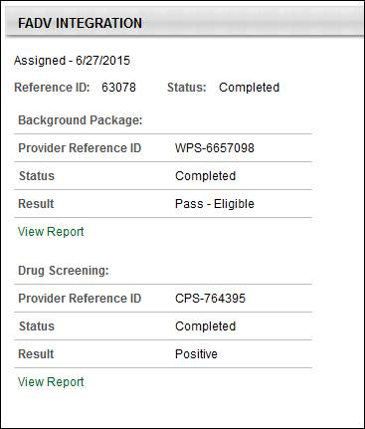
Applicant Profile - History Tab (FADV)
When a First Advantage (FADV) screening is assigned to an applicant or completed by FADV, the History tab on the Applicant Profile page logs the event.
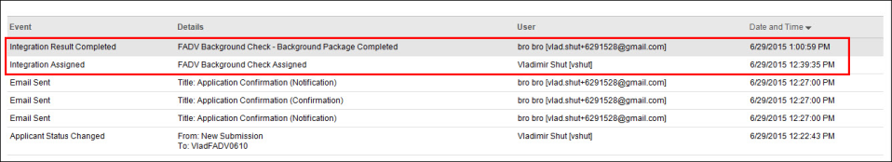
Integration Assigned
The Integration Assigned event is logged when an FADV screening is assigned to an applicant. The following information displays for the event:
- Event Title - This column displays the name of the event as Integration Assigned.
- Details - This column displays "<Integration Name> Assigned."
- User - This column displays the name of the user who executed the event along with their user name if available, as "<Jeremy Johnson [jjohnson]>."
- Date and Time - This column displays the date and time associated with the event.
Integration Result Completed
The Integration Result Completed event is logged when FADV sends the system a Completed status for the screening. The following information displays for the event:
- Event Title - This column displays the name of the event as Integration Assigned.
- Details - This column displays "<Integration Name - [Background Check Package Title] [Drug Screening Package Title] Result> Completed." Note: If the background check or drug screening does not have a title from FADV, then the title displays as the name of the custom FADV applicant status.
- User - This column displays the name of the user who executed the event along with their user name if available, as "<Jeremy Johnson [jjohnson]>."
- Date and Time - This column displays the date and time associated with the event.
Manage Applicants - View First Advantage Results Column
Recruiters can view the status and results of a First Advantage (FADV) screening assignment on Manage Candidates or Manage Applicants.
Note: For users who do not have access to view the data in the column because the custom FADV status is configured as sensitive and the user does not have permission to view sensitive statuses, the column is blank.
Permissions
PERMISSION NAME | PERMISSION DESCRIPTION | CATEGORY

Applicants: Access Sensitive Statuses | Grants ability to access the applicant statuses that are configured as sensitive. | Recruiting

Requisition: Manage | Grants ability to access and manage all requisitions regardless of ownership (constraints permitting). This permission also grants read-only access to the Applicant Review tab when creating or editing a job requisition. This permission can be constrained by OU, User's OU, and Grade. | Recruiting

Requisition: Owner | Enables owner to access requisitions and applicants for requisitions for which they are an owner. This permission also grants read-only access to video interviews that are completed by applicants via HireVue. For portals with Referral Suite enabled, this permission also enables requisition owners to edit the referral source on the Applicant Profile page. This permission cannot be constrained.  Note: This is a dynamically assigned permission that is not available in Security Role Administration. If the user is removed as an owner, the permission is revoked for the associated requisition. This permission cannot be manually assigned. Also, if a user has both the permission necessary to manage requisitions and be a requisition owner, the constraints of the Requisition: Manage permission overrule those of the Requisition: Owner permission. For requisition owners that do not also have permission to manage requisitions, only certain fields are editable when editing a requisition. | Recruiting

Requisition: Reviewer | Enables reviewer to access requisitions and applicants for requisitions for which they are a reviewer. This permission cannot be constrained.  Note: This is a dynamically assigned permission that is not available in Security Role Administration. Once a requisition is in a Closed or Cancelled status or if the user is removed as a reviewer, the permission is revoked for the associated requisition. This permission cannot be manually assigned.  Note: If an applicant reviewer is removed as a reviewer via the Applicant Profile page, the Requisition: Reviewer permission is revoked for the associated requisition. However, if the reviewer was also added as a reviewer via the General tab when creating, editing, or copying the requisition, the reviewer still appears on the In Review panel as a duplicate reviewer and retains access to the requisition and applicants from the Requisition: Reviewer permission. See Applicant Profile Page Overview for more information about duplicate reviewer instances. | Recruiting
View on Manage Candidates
See Manage Candidates Page (Early Adopter).
View on Manage Applicants
On the Manage Applicants page, a column displays in the applicants table to provide updates based on data received from FADV. The column must be configured to display on the Edit Page Layout page.
The column name displays as <Name of Integration>. The following are the possible values in the column:
- <Blank> - If the user does not have permission to view the custom status, then no value displays.
- Not Assigned - This displays if a screening has not yet been assigned to the applicant.
- Assigned - This displays if the screening has been assigned but the applicant has not yet started the application and a status has not been sent from FADV. Note: The term "application" refers to the screening application that the applicant must complete for FADV.
- Status: In Progress - In Progress displays if FADV has not yet returned a final result for the screening.
- Result - The result displays as <Screening Package Title>: <Result Value><Score Value, if applicable>. A result displays for each screening package that has been completed or cancelled and FADV has returned a final result value for the screening. The score displays only if a score has been provided by FADV as part of the type of screening.
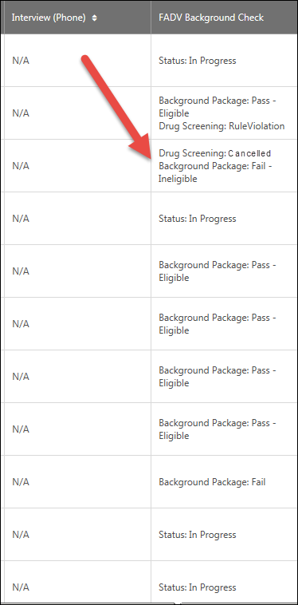
Analytics (FADV)
Reports can be created to report on First Advantage (FADV) data. Fields are available in the External Vendor section to report on the assigned and completed date, as well as the external vendor name, package result, package title, product, product result, product score, and vendor status.
These fields are in addition to the standard fields available for Recruiting reports.
HireRight Global Employment Screening Integration
The HireRight Global Employment Screening integration lets you order any of the HireRight 200+ global background screening and drug testing services directly from within Cornerstone. Status updates are provided in real-time, providing you with fast and reliable visibility into screening orders.
If you are using the legacy HireRight integration, please contact HireRight to begin the migration process.
Migration
If your company has an assigned HireRight Account Manager, contact them directly and they will guide you through the migration process.
If your company does not have an assigned HireRight Account Manager, contact HireRight Customer Support and tell them you want to be migrated to the Cornerstone Edge HireRight integration, and the HireRight Customer Support representative will start the migration process.
Implementation
This integration is available for all organizations using the Recruiting suite. This integration is available for free via Edge Marketplace. Additional instructions for enabling and configuring the integration are available on the Setup tab of the integration in Edge.
The integration can be accessed and configured via the Edge Marketplace. In order to use this integration, your organization must be using the Recruiting module and must have access to Edge and have an account with the integration vendor. There is no additional cost associated with enabling this integration, but the integration cannot be used without an account with the integration vendor.
Permissions
The following permissions apply to this functionality:
PERMISSION NAME | PERMISSION DESCRIPTION | CATEGORY

Edge Integrations - Manage | Grants access to the Integrations service for Edge Integrate, where the administrator can configure, enable, and disable their third-party integrations used within the Cornerstone system. This permission cannot be constrained. This is an administrator permission. | Edge

Edge Marketplace - Manage | Grants access to the Marketplace service for Edge Integrate, where the administrator can browse integrations that can be used to extend the Cornerstone system. This permission cannot be constrained. This is an administrator permission. | Edge
Referoo Integration
Referoo has integrated with Cornerstone to allow Cornerstone users to select candidates and request they complete the Referoo reference check process. Clients can create unlimited packages within the Referoo Application and access them within Cornerstone. Status updates are displayed in Cornerstone and final results and report URL returned to Cornerstone.
Implementation
The integration will be available to self-enable on 23 September 2022 via Edge Marketplace for all organizations using Recruiting and have an account with the integration vendor.
Additional instructions for enabling and configuring the integration are available in Edge. See Edge Integration - Configure on page 11 for additional information.
Permissions
The following existing permissions apply to this functionality:
PERMISSION NAME | PERMISSION DESCRIPTION | CATEGORY

Edge Integrations - Manage | Grants access to the Integrations service for Edge Integrate, where the administrator can configure, enable, and disable their third-party integrations used within the Cornerstone system. This permission cannot be constrained. This is an administrator permission. | Edge

Edge Marketplace - Manage | Grants access to the Marketplace service for Edge Integrate, where the administrator can browse integrations that can be used to extend the Cornerstone system. This permission cannot be constrained. This is an administrator permission. | Edge
Sterling Integration - Overview
The Sterling integration is a background check and drug screening tool. This integration streamlines and improves recruiters' efficacy of their hiring process.
Use Cases
Use Case 1: Activate the Sterling integration through Edge
- James is Acme Company's administrator and has been tasked with enabling the integration between Cornerstone and Sterling . This will allow Acme to include Sterling background checks in their hiring workflow.
- James goes to the Edge Marketplace to purchase and activate the Sterling integration.
- From the Edge Integrate page, James enters Acme's unique Client ID, Auth Key, Account Name, Background Check Names and corresponding IDs. These are provided by the Sterling project team.
- Acme's Cornerstone portal now has an active integration between Sterling and Cornerstone.
Use Case 2: Recruiting Administrator configures Sterling Assessment action step in Application Workflow
- Lisa is the Recruiting administrator for Acme.
- Holly, a hiring manager at Acme, is looking to add a new member to her Marketing team.
- With the integration enabled, Lisa is tasked with adding a background check status in all of Acme's marketing job requisitions.
- Lisa creates a new custom applicant status that is set to a custom integration type under Sterling Background Check.
- Lisa has now configured the Marketing job requisitions to include the Sterling custom status.
Use Case 3: Recruiter assigns background check request for an applicant
- Ashley, a recruiter at Acme, has identified Paul James to be a qualified applicant.
- To ensure a sound hiring decision is made and to protect Acme from potential risks, Ashley assigns a background check for Paul by moving Paul's applicant status to Sterling Background Check.
- Ashley selects the appropriate background screening package, then submits the request.
- Paul receives an email from Sterling and clicks on the link to complete the screening application request in Sterling.
Use Case 4: Recruiter, who does not have an existing account in Sterling, assigns a background check request for an applicant
- Toby is a new recruiter at Acme.
- James, Acme’s administrator for both Cornerstone and Sterling, was tasked with creating a user record for Toby in both systems. James created a user record for Toby in Cornerstone but failed to do so in Sterling.
- Working under the assumption that he can begin working in both systems, Toby was tasked with assigning a background check to the applicant, Dan White.
- Toby selects the appropriate background screening package then submits the request.
- Sterling identifies that Toby does not exist in their system and creates a user record for him. Note: The user must have a valid email address in your Cornerstone portal in order for Sterling to automatically create a user record in the Sterling system.
- Dan White is assigned to a background check successfully and receives an email from Sterling.
Use Case 5: Recruiter views background check results and its detailed report in Sterling via a link
- Ashley is eager to find out the results of Paul's background check status.
- Ashley navigates to Paul's Applicant Profile Status page and sees the status on the request.
- To view additional details of the background request, Ashley clicks on the View Progress link, which will SSO her into Sterling site.
Use Case 6: Hiring manager, who does not have an existing account in Sterling, attempts to view a detailed report in Sterling via a link.
- Holly, one of Acme's hiring managers, does not have permissions in Cornerstone to assign a background check but has permissions to view its results.
- Holly would like to finalize hiring decisions and decides to review Paul's background check results.
- Holly navigates to Paul's Applicant Profile > Statuses page and clicks on the View Progress link. Note: Only the background check order request API has a provision to create a new user. If the user does not have an account in Sterling, the detailed report link will not automatically create a user record in Sterling. In order to allow access to this user, the client administrator should manually create users in Sterling.
- Upon launching the link, Holly receives an SSO error message indicating that she does not have an account in Sterling to view the report.
Implementation
This functionality is only available for organizations using Recruiting and must be purchased and activated via the Edge Integration Marketplace. It is necessary to have a contract and purchased assessments from Sterling Talent Solutions to implement the integration. The Sterling integration will need to be activated via Edge Integrate, and you will need to provide your company's pre-existing Sterling unique identifiers.
Security
The following existing permissions apply to this functionality:
PERMISSION NAME | PERMISSION DESCRIPTION | CATEGORY

Applicants: Initiate Background Check | This permission grants access to manage background checks from the Applicant Profile page. This applies to background checks that have been configured in the Integration Center. This permission cannot be constrained. Users who have this permission will have an Assign to Applicant link in the background check status type panel on the Applicant Profile page. Once the background check is assigned, the page will display "Assigned - [Date Assigned]." | Recruiting

Applicant Status Bank - Manage | Grants ability to access and manage Applicant Status Bank. | Recruiting Administration

Applicants: View Background Check Status | Allow user to view the background check status. The user cannot view the link to the detailed report. This permission cannot be constrained. | Recruiting

Applicants: View Background Check Status and Details Link | This permission allows users to view the background check status and view a link to access the background check report, which can be found in the background check status type panel on the Applicant Profile page. This permission cannot be constrained. | Recruiting

Application Workflow Template - Manage | Grants ability to access and manage Application Workflow Templates. This permission can be constrained by OU and User’s OU. This is an administrator permission. | Recruiting Administration

Application Workflow Template - View | Grants ability to access and view Application Workflow Templates. | Recruiting Administration

Edge Integrations - Manage | Grants access to the Integrations service for Edge Integrate, where the administrator can configure, enable, and disable their third-party integrations used within the Cornerstone system. This permission cannot be constrained. This is an administrator permission. | Edge

Edge Marketplace - Manage | Grants access to the Marketplace service for Edge Integrate, where the administrator can browse integrations that can be used to extend the Cornerstone system. This permission cannot be constrained. This is an administrator permission. | Edge

Manage Forms - Manage | Grants access to the Manage Forms functionality. This permission can be constrained by OU and User's OU. This is an administrator permission.  Note: This permission enables access to the Form Management functionality that is part of Cornerstone HR functionality and the Onboarding module. This permission does not grant access to the Training Forms Management functionality. | Forms Management Administration

Global Email Administration - Manage | Grants ability to manage email trigger templates across all active modules in the portal. Enables creating, editing and deleting email message templates for various system actions and workflows. This permission can be constrained by OU, User's OU, User Self and Subordinates, and User. This is an administrator permission. | Core Administration

Global Email Administration - View | Grants view only access to email templates/triggers and email logs at the global level for the portal. This permission can be constrained by OU, User's OU, User Self and Subordinates, and User. This is an administrator permission. | Core Administration

Requisition: Manage | Grants ability to access and manage all requisitions regardless of ownership (constraints permitting). This permission also grants read-only access to the Applicant Review tab when creating or editing a job requisition. This permission can be constrained by OU, User's OU, and Grade. | Recruiting

Requisition: Owner | Enables owner to access requisitions and applicants for requisitions for which they are an owner. This permission also grants read-only access to video interviews that are completed by applicants via HireVue. For portals with Referral Suite enabled, this permission also enables requisition owners to edit the referral source on the Applicant Profile page. This permission cannot be constrained.  Note: This is a dynamically assigned permission that is not available in Security Role Administration. If the user is removed as an owner, the permission is revoked for the associated requisition. This permission cannot be manually assigned. Also, if a user has both the permission necessary to manage requisitions and be a requisition owner, the constraints of the Requisition: Manage permission overrule those of the Requisition: Owner permission. For requisition owners that do not also have permission to manage requisitions, only certain fields are editable when editing a requisition. | Recruiting

Requisition: Reviewer | Enables reviewer to access requisitions and applicants for requisitions for which they are a reviewer. This permission cannot be constrained.  Note: This is a dynamically assigned permission that is not available in Security Role Administration. Once a requisition is in a Closed or Cancelled status or if the user is removed as a reviewer, the permission is revoked for the associated requisition. This permission cannot be manually assigned.  Note: If an applicant reviewer is removed as a reviewer via the Applicant Profile page, the Requisition: Reviewer permission is revoked for the associated requisition. However, if the reviewer was also added as a reviewer via the General tab when creating, editing, or copying the requisition, the reviewer still appears on the In Review panel as a duplicate reviewer and retains access to the requisition and applicants from the Requisition: Reviewer permission. See Applicant Profile Page Overview for more information about duplicate reviewer instances. | Recruiting

Resume Administration | Grants access to resume administration, which enables configuration of resume sections, including custom resume fields. This permission cannot be constrained. This is an administrator permission. Note: This permission does not apply to the Universal Profile - Resume functionality. | Talent/Succession - Administration
Sterling Integration - Overview
The Sterling integration is a background check and drug screening tool. This integration streamlines and improves recruiters' efficacy of their hiring process.
Use Cases
Use Case 1: Activate the Sterling integration through Edge
- James is Acme Company's administrator and has been tasked with enabling the integration between Cornerstone and Sterling . This will allow Acme to include Sterling background checks in their hiring workflow.
- James goes to the Edge Marketplace to purchase and activate the Sterling integration.
- From the Edge Integrate page, James enters Acme's unique Client ID, Auth Key, Account Name, Background Check Names and corresponding IDs. These are provided by the Sterling project team.
- Acme's Cornerstone portal now has an active integration between Sterling and Cornerstone.
Use Case 2: Recruiting Administrator configures Sterling Assessment action step in Application Workflow
- Lisa is the Recruiting administrator for Acme.
- Holly, a hiring manager at Acme, is looking to add a new member to her Marketing team.
- With the integration enabled, Lisa is tasked with adding a background check status in all of Acme's marketing job requisitions.
- Lisa creates a new custom applicant status that is set to a custom integration type under Sterling Background Check.
- Lisa has now configured the Marketing job requisitions to include the Sterling custom status.
Use Case 3: Recruiter assigns background check request for an applicant
- Ashley, a recruiter at Acme, has identified Paul James to be a qualified applicant.
- To ensure a sound hiring decision is made and to protect Acme from potential risks, Ashley assigns a background check for Paul by moving Paul's applicant status to Sterling Background Check.
- Ashley selects the appropriate background screening package, then submits the request.
- Paul receives an email from Sterling and clicks on the link to complete the screening application request in Sterling.
Use Case 4: Recruiter, who does not have an existing account in Sterling, assigns a background check request for an applicant
- Toby is a new recruiter at Acme.
- James, Acme’s administrator for both Cornerstone and Sterling, was tasked with creating a user record for Toby in both systems. James created a user record for Toby in Cornerstone but failed to do so in Sterling.
- Working under the assumption that he can begin working in both systems, Toby was tasked with assigning a background check to the applicant, Dan White.
- Toby selects the appropriate background screening package then submits the request.
- Sterling identifies that Toby does not exist in their system and creates a user record for him. Note: The user must have a valid email address in your Cornerstone portal in order for Sterling to automatically create a user record in the Sterling system.
- Dan White is assigned to a background check successfully and receives an email from Sterling.
Use Case 5: Recruiter views background check results and its detailed report in Sterling via a link
- Ashley is eager to find out the results of Paul's background check status.
- Ashley navigates to Paul's Applicant Profile Status page and sees the status on the request.
- To view additional details of the background request, Ashley clicks on the View Progress link, which will SSO her into Sterling site.
Use Case 6: Hiring manager, who does not have an existing account in Sterling, attempts to view a detailed report in Sterling via a link.
- Holly, one of Acme's hiring managers, does not have permissions in Cornerstone to assign a background check but has permissions to view its results.
- Holly would like to finalize hiring decisions and decides to review Paul's background check results.
- Holly navigates to Paul's Applicant Profile > Statuses page and clicks on the View Progress link. Note: Only the background check order request API has a provision to create a new user. If the user does not have an account in Sterling, the detailed report link will not automatically create a user record in Sterling. In order to allow access to this user, the client administrator should manually create users in Sterling.
- Upon launching the link, Holly receives an SSO error message indicating that she does not have an account in Sterling to view the report.
Implementation
This functionality is only available for organizations using Recruiting and must be purchased and activated via the Edge Integration Marketplace. It is necessary to have a contract and purchased assessments from Sterling Talent Solutions to implement the integration. The Sterling integration will need to be activated via Edge Integrate, and you will need to provide your company's pre-existing Sterling unique identifiers.
Security
The following existing permissions apply to this functionality:
PERMISSION NAME | PERMISSION DESCRIPTION | CATEGORY

Applicants: Initiate Background Check | This permission grants access to manage background checks from the Applicant Profile page. This applies to background checks that have been configured in the Integration Center. This permission cannot be constrained. Users who have this permission will have an Assign to Applicant link in the background check status type panel on the Applicant Profile page. Once the background check is assigned, the page will display "Assigned - [Date Assigned]." | Recruiting

Applicant Status Bank - Manage | Grants ability to access and manage Applicant Status Bank. | Recruiting Administration

Applicants: View Background Check Status | Allow user to view the background check status. The user cannot view the link to the detailed report. This permission cannot be constrained. | Recruiting

Applicants: View Background Check Status and Details Link | This permission allows users to view the background check status and view a link to access the background check report, which can be found in the background check status type panel on the Applicant Profile page. This permission cannot be constrained. | Recruiting

Application Workflow Template - Manage | Grants ability to access and manage Application Workflow Templates. This permission can be constrained by OU and User’s OU. This is an administrator permission. | Recruiting Administration

Application Workflow Template - View | Grants ability to access and view Application Workflow Templates. | Recruiting Administration

Edge Integrations - Manage | Grants access to the Integrations service for Edge Integrate, where the administrator can configure, enable, and disable their third-party integrations used within the Cornerstone system. This permission cannot be constrained. This is an administrator permission. | Edge

Edge Marketplace - Manage | Grants access to the Marketplace service for Edge Integrate, where the administrator can browse integrations that can be used to extend the Cornerstone system. This permission cannot be constrained. This is an administrator permission. | Edge

Manage Forms - Manage | Grants access to the Manage Forms functionality. This permission can be constrained by OU and User's OU. This is an administrator permission.  Note: This permission enables access to the Form Management functionality that is part of Cornerstone HR functionality and the Onboarding module. This permission does not grant access to the Training Forms Management functionality. | Forms Management Administration

Global Email Administration - Manage | Grants ability to manage email trigger templates across all active modules in the portal. Enables creating, editing and deleting email message templates for various system actions and workflows. This permission can be constrained by OU, User's OU, User Self and Subordinates, and User. This is an administrator permission. | Core Administration

Global Email Administration - View | Grants view only access to email templates/triggers and email logs at the global level for the portal. This permission can be constrained by OU, User's OU, User Self and Subordinates, and User. This is an administrator permission. | Core Administration

Requisition: Manage | Grants ability to access and manage all requisitions regardless of ownership (constraints permitting). This permission also grants read-only access to the Applicant Review tab when creating or editing a job requisition. This permission can be constrained by OU, User's OU, and Grade. | Recruiting

Requisition: Owner | Enables owner to access requisitions and applicants for requisitions for which they are an owner. This permission also grants read-only access to video interviews that are completed by applicants via HireVue. For portals with Referral Suite enabled, this permission also enables requisition owners to edit the referral source on the Applicant Profile page. This permission cannot be constrained.  Note: This is a dynamically assigned permission that is not available in Security Role Administration. If the user is removed as an owner, the permission is revoked for the associated requisition. This permission cannot be manually assigned. Also, if a user has both the permission necessary to manage requisitions and be a requisition owner, the constraints of the Requisition: Manage permission overrule those of the Requisition: Owner permission. For requisition owners that do not also have permission to manage requisitions, only certain fields are editable when editing a requisition. | Recruiting

Requisition: Reviewer | Enables reviewer to access requisitions and applicants for requisitions for which they are a reviewer. This permission cannot be constrained.  Note: This is a dynamically assigned permission that is not available in Security Role Administration. Once a requisition is in a Closed or Cancelled status or if the user is removed as a reviewer, the permission is revoked for the associated requisition. This permission cannot be manually assigned.  Note: If an applicant reviewer is removed as a reviewer via the Applicant Profile page, the Requisition: Reviewer permission is revoked for the associated requisition. However, if the reviewer was also added as a reviewer via the General tab when creating, editing, or copying the requisition, the reviewer still appears on the In Review panel as a duplicate reviewer and retains access to the requisition and applicants from the Requisition: Reviewer permission. See Applicant Profile Page Overview for more information about duplicate reviewer instances. | Recruiting

Resume Administration | Grants access to resume administration, which enables configuration of resume sections, including custom resume fields. This permission cannot be constrained. This is an administrator permission. Note: This permission does not apply to the Universal Profile - Resume functionality. | Talent/Succession - Administration
Sterling Integration Implementation Steps
Setting up the integration includes enabling the integration in Edge and completing pre-steps for mapping resume fields, as well as creating reference forms that can be used to request references.
Permissions
PERMISSION NAME | PERMISSION DESCRIPTION | CATEGORY

Edge Integrations - Manage | Grants access to the Integrations service for Edge Integrate, where the administrator can configure, enable, and disable their third-party integrations used within the Cornerstone system. This permission cannot be constrained. This is an administrator permission. | Edge

Edge Marketplace - Manage | Grants access to the Marketplace service for Edge Integrate, where the administrator can browse integrations that can be used to extend the Cornerstone system. This permission cannot be constrained. This is an administrator permission. | Edge

Manage Forms - Manage | Grants access to the Manage Forms functionality. This permission can be constrained by OU and User's OU. This is an administrator permission.  Note: This permission enables access to the Form Management functionality that is part of Cornerstone HR functionality and the Onboarding module. This permission does not grant access to the Training Forms Management functionality. | Forms Management Administration

Resume Administration | Grants access to resume administration, which enables configuration of resume sections, including custom resume fields. This permission cannot be constrained. This is an administrator permission. Note: This permission does not apply to the Universal Profile - Resume functionality. | Talent/Succession - Administration
Pre-Steps
Note: In order to send resume and/or reference fields to Sterling, Succession Management and Form Management must be available in your portal, respectively. This resume mapping is an optional step.
Configure the following resume sections:
- Education
  - Map a resume section to Applicant Resume "Education"
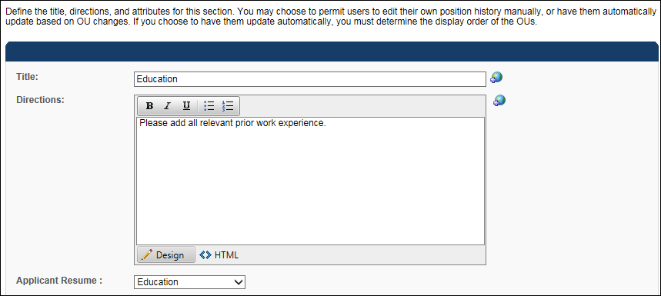
  - Map Sterling's education verification fields as described in the table below:
Sterling Education Verification Field Label | Cornerstone Resume Applicant Mapping | Additional Notes
School - Name | Institution
School - City | Grade
School - Major | Area of Study
School - Degree Earned | Degree | It is recommended that you set up the field as a drop-down, since Sterling only accepts the following values: GED, High School, Certificate, Associate's, Bachelor's, Master's, Doctorate, Other.
School - Date of Graduation | Graduation Date
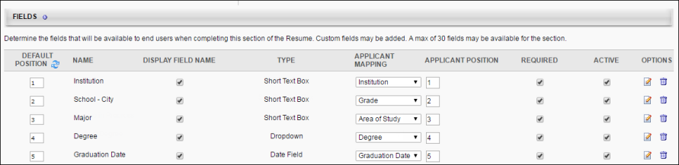
- Previous Position
  - Map a resume section to Applicant Resume "Experience"
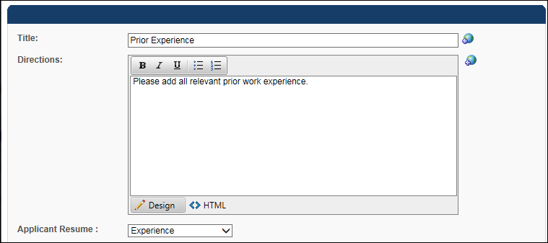
  - Map Sterling's employment verification fields as described in the table below:
Sterling Employment Verification Field Label | Cornerstone Resume Applicant Mapping
Employer - Company Name | Organization
Employer - Employment Start and End Date | Date Range
Employer - Employer Job Title | Position
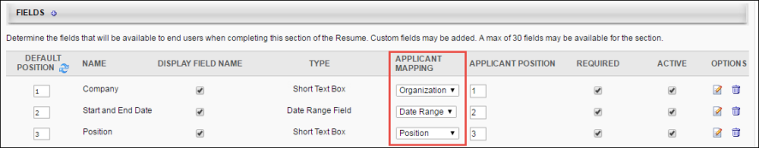
- Create questions and forms in Form Management (Admin > Configuration Tools > Core Functions > Form Management):
  - Create a new category (optional)
  - Create form questions on the Question Bank page. The API name entry must follow the naming convention described in the table below.
Sterling Reference Check Field Label | API Name
Reference Name | - Sterling_Reference_Name_1  - Sterling_Reference_Name_2  - Sterling_Reference_Name_3
Reference Occupation | - Sterling_Reference_Occupation_1  - Sterling_Reference_Occupation_2  - Sterling_Reference_Occupation_3
Reference Phone | - Sterling_Reference_Phone_1  - Sterling_Reference_Phone_2  - Sterling_Reference_Phone_3
Reference Email | - Sterling_Reference_Email_1  - Sterling_Reference_Email_2  - Sterling_Reference_Email_3
Reference Relationship | - Sterling_Reference_Relationship_1  - Sterling_Reference_Relationship_2  - Sterling_Reference_Relationship_3
  - Create a form on the Manage Forms page and include the questions created in step 2B. The form's API Name entry must be set to "Sterling_Reference_Form." The form can include up to three sets of reference fields.
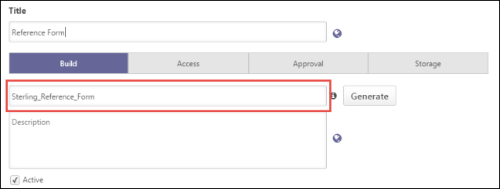
Edge Integrate Steps
In order to include Sterling background checks/drug screenings in the application workflow, the integration must first be enabled via Edge Integrate.
On the Edge Integrate > Settings page, you will enter your client ID, auth key, and account name. An API user name, password, and integration ID must also be entered.
In the Available Background Check Packages section, enter the background check package name and ID.
You can also configure which field is mapped to Sterling’s Reference Code and Access Credential Type fields by making a selection in the drop-down.
- Reference Code - This is a Sterling field that can be mapped to either of the Cornerstone organizational unit (OU) below. This is the OU associated to the job requisition the candidate has applied to. The available OU options are Division, Location, Position, and Grade.
- Access Credential Type - This is a Sterling field that can be mapped to either the username or user ID of the user submitting the background check request in Cornerstone (i.e., user assigning the candidate to a Sterling background check). Sterling uses this value to validate that the submitter has an existing user record in their system. If the submitter's unique identifier does not exist in Sterling, then Sterling will create a record.
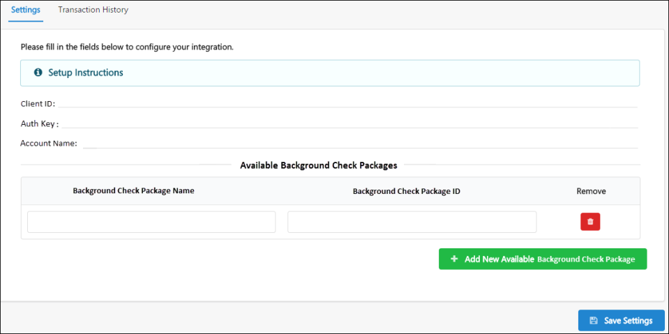
Create Custom Applicant Status for Sterling Background Check
This set up is required when assigning a background check to an applicant:
- Navigate to the Manage Applicant Status page:
  - Navigation: Admin > Tools > Recruit > Applicant Statuses > Select the top level OU
- Click the Create Custom Status link. This opens the Create Custom Status pop-up.
- Complete the following fields in the pop-up:
  - Language - If multiple languages are enabled for the portal, select the language from the drop-down list for which you are entering the status name and description. To localize the status name and description into other available languages, select the appropriate language from the drop-down list and enter the localized name and description in the appropriate fields.
  - Display Name - Enter the status name, which appears throughout the system. The character limit for this field is 50. When the display name of an active status is modified after the status is in use or has been used in a job requisition:
    - The new display name appears on the Default Status List page.
    - The new display name appears in the Status list on the job requisition template.
    - Any new job requisitions created after the display name is changed apply the new display name.
    - Job requisitions created before the status display name is changed continue to honor the name that existed at the time the requisition was created.
  - Description - Enter the status description. This should describe the purpose of the status and what is implied when an applicant is in that status. The character limit for this field is 500. This is not a required field.
  - Type - Select Custom Integration from the drop-down. Note: This field is displayed only when creating a custom status at the top level OU. When creating a custom status for a child OU, the Type field displays the type selected for the parent OU but is not editable.
  - Integration - Select Sterling from the drop-down.
  - Active - This field is checked by default. Ensure the field is checked before saving the status so that the status is active for the portal.
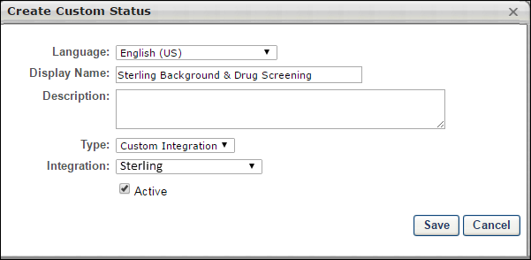
- Click Save to save the custom applicant status.
- Add custom applicant status to a job requisition.
Assign Sterling Background Check
The Sterling background check is assigned to applicants from their Applicant Profile > Statuses tab.
Permissions
PERMISSION NAME | PERMISSION DESCRIPTION | CATEGORY

Applicants: Initiate Background Check | This permission grants access to manage background checks from the Applicant Profile page. This applies to background checks that have been configured in the Integration Center. This permission cannot be constrained. Users who have this permission will have an Assign to Applicant link in the background check status type panel on the Applicant Profile page. Once the background check is assigned, the page will display "Assigned - [Date Assigned]." | Recruiting

Applicants: View Background Check Status | Allow user to view the background check status. The user cannot view the link to the detailed report. This permission cannot be constrained. | Recruiting

Applicants: View Background Check Status and Details Link | This permission allows users to view the background check status and view a link to access the background check report, which can be found in the background check status type panel on the Applicant Profile page. This permission cannot be constrained. | Recruiting

Requisition: Manage | Grants ability to access and manage all requisitions regardless of ownership (constraints permitting). This permission also grants read-only access to the Applicant Review tab when creating or editing a job requisition. This permission can be constrained by OU, User's OU, and Grade. | Recruiting

Requisition: Owner | Enables owner to access requisitions and applicants for requisitions for which they are an owner. This permission also grants read-only access to video interviews that are completed by applicants via HireVue. For portals with Referral Suite enabled, this permission also enables requisition owners to edit the referral source on the Applicant Profile page. This permission cannot be constrained.  Note: This is a dynamically assigned permission that is not available in Security Role Administration. If the user is removed as an owner, the permission is revoked for the associated requisition. This permission cannot be manually assigned. Also, if a user has both the permission necessary to manage requisitions and be a requisition owner, the constraints of the Requisition: Manage permission overrule those of the Requisition: Owner permission. For requisition owners that do not also have permission to manage requisitions, only certain fields are editable when editing a requisition. | Recruiting

Requisition: Reviewer | Enables reviewer to access requisitions and applicants for requisitions for which they are a reviewer. This permission cannot be constrained.  Note: This is a dynamically assigned permission that is not available in Security Role Administration. Once a requisition is in a Closed or Cancelled status or if the user is removed as a reviewer, the permission is revoked for the associated requisition. This permission cannot be manually assigned.  Note: If an applicant reviewer is removed as a reviewer via the Applicant Profile page, the Requisition: Reviewer permission is revoked for the associated requisition. However, if the reviewer was also added as a reviewer via the General tab when creating, editing, or copying the requisition, the reviewer still appears on the In Review panel as a duplicate reviewer and retains access to the requisition and applicants from the Requisition: Reviewer permission. See Applicant Profile Page Overview for more information about duplicate reviewer instances. | Recruiting
To assign the background check:
- Click the Assign to Applicant link in the background check status type panel from the Applicant Profile > Statuses tab.
- This opens a pop-up in which you select the background check provider and package. The options that are available in these fields are dependent upon the integrations you have enabled in Edge Integrate and the settings for those integrations.
- Click Submit. This initiates the Sterling background check process for the applicant. Auto-Creation of User Record Note: If the user assigning the background check does not yet have a user record in the Sterling application, a user record is automatically created, using the user's first and last name, phone number, and email address - all of which are required fields. When Sterling creates the user record for the user who is assigning the background check, Sterling will send an email to that user to indicate that their user record has been created.
If the submission process is successful, the status in the background check status type section will indicate Acknowledged. If the submission is not successful, then an error message displays.
Once the background check is assigned to the applicant, the status will change to Assigned, and Sterling will send an email to the applicant to initiate the background check process.
View Sterling Background Check Results
A high-level summary of the Sterling assessment results is available from the Manage Applicants page and the Applicant Profile > Statuses tab.
To access the Applicant Profile page, click the applicant's name from any of the following pages:
- Manage Job Requisitions > Requisition Snapshot
- Manage Job Requisitions > Manage Applicants
- Recruit > Interview Manager
- Recruit > Review Applicants
- Recruit > Manage Candidates (Note:This functionality is in the Early Adopter phase. For more information about availability,see the Overview topic for this functionality.)
Permissions
PERMISSION NAME | PERMISSION DESCRIPTION | CATEGORY

Applicants: Initiate Background Check | This permission grants access to manage background checks from the Applicant Profile page. This applies to background checks that have been configured in the Integration Center. This permission cannot be constrained. Users who have this permission will have an Assign to Applicant link in the background check status type panel on the Applicant Profile page. Once the background check is assigned, the page will display "Assigned - [Date Assigned]." | Recruiting

Applicants: View Background Check Status and Details Link | This permission allows users to view the background check status and view a link to access the background check report, which can be found in the background check status type panel on the Applicant Profile page. This permission cannot be constrained. | Recruiting

Applicants: View Background Check Status | Allow user to view the background check status. The user cannot view the link to the detailed report. This permission cannot be constrained. | Recruiting

Requisition: Manage | Grants ability to access and manage all requisitions regardless of ownership (constraints permitting). This permission also grants read-only access to the Applicant Review tab when creating or editing a job requisition. This permission can be constrained by OU, User's OU, and Grade. | Recruiting

Requisition: Owner | Enables owner to access requisitions and applicants for requisitions for which they are an owner. This permission also grants read-only access to video interviews that are completed by applicants via HireVue. For portals with Referral Suite enabled, this permission also enables requisition owners to edit the referral source on the Applicant Profile page. This permission cannot be constrained.  Note: This is a dynamically assigned permission that is not available in Security Role Administration. If the user is removed as an owner, the permission is revoked for the associated requisition. This permission cannot be manually assigned. Also, if a user has both the permission necessary to manage requisitions and be a requisition owner, the constraints of the Requisition: Manage permission overrule those of the Requisition: Owner permission. For requisition owners that do not also have permission to manage requisitions, only certain fields are editable when editing a requisition. | Recruiting

Requisition: Reviewer | Enables reviewer to access requisitions and applicants for requisitions for which they are a reviewer. This permission cannot be constrained.  Note: This is a dynamically assigned permission that is not available in Security Role Administration. Once a requisition is in a Closed or Cancelled status or if the user is removed as a reviewer, the permission is revoked for the associated requisition. This permission cannot be manually assigned.  Note: If an applicant reviewer is removed as a reviewer via the Applicant Profile page, the Requisition: Reviewer permission is revoked for the associated requisition. However, if the reviewer was also added as a reviewer via the General tab when creating, editing, or copying the requisition, the reviewer still appears on the In Review panel as a duplicate reviewer and retains access to the requisition and applicants from the Requisition: Reviewer permission. See Applicant Profile Page Overview for more information about duplicate reviewer instances. | Recruiting
The following package information displays on the Statuses tab for the background check:
- Assigned - This field displays the date of when screening is assigned to the applicant.
- Reference ID - This field displays Sterling’s screening ticket ID.
- Status - This field displays the status of the overall package status. The following are the possible values:
  - Acknowledged
  - In Progress
  - Completed
  - Cancelled
- Result - This field displays the candidate’s overall result of the background check request.
- [Background Package Name] - This field displays the name of the screening type.
- Provider Reference ID - This field displays the individual search ID.
- Status - This field displays the status of the screening type.
  - In Progress
  - Completed
  - Cancelled
To view a detailed report of the candidate’s assessment results:
- Click the View Report link in the background check column in the applicants table on the Manage Applicants page. Or, the link is also available from the Applicant Profile > Statuses tab.
- Sterling will authenticate the user who is attempting to view the report.
- If the user has an existing record in Sterling, then the user is deemed valid, and the report details open in the Sterling application.
- If the user does not have an existing record in Sterling, then an error message displays.
Sterling RISQ Background Check Integration
A background screening solution between Cornerstone Recruiting and Sterling’s RISQ platform that frees teams from manual, time consuming tasks related to screening program, while also providing real-time screening results directly into Cornerstone.
- Initiate a background check within Cornerstone Recruiting. The candidate information/required screening package is then automatically sent to Sterling.
- The candidate receives an email containing a link to complete consent, confirm and provide additional information and, if applicable, select a drug test location.
- Status of the background check is shared in real-time in Cornerstone Recruiting.
- Upon completion, the results are posted within Cornerstone Recruiting.
Implementation
This integration is a vendor-built integration and not by Cornerstone. More information and instructions can be found in Edge Integrate.
Permissions
The following existing permissions apply to this functionality:
PERMISSION NAME | PERMISSION DESCRIPTION | CATEGORY

Edge Integrations - Manage | Grants access to the Integrations service for Edge Integrate, where the administrator can configure, enable, and disable their third-party integrations used within the Cornerstone system. This permission cannot be constrained. This is an administrator permission. | Edge

Edge Marketplace - Manage | Grants access to the Marketplace service for Edge Integrate, where the administrator can browse integrations that can be used to extend the Cornerstone system. This permission cannot be constrained. This is an administrator permission. | Edge
Sterling ScreeningDirect Background Check Integration
The Sterling ScreeningDirect Background Check integration provides a pre-built integration between Sterling’s ScreeningDirect platform and Cornerstone’s Recruiting platform.
Background checks are requested from within your Cornerstone portal and are completed by Sterling ScreeningDirect. Candidates receive an email containing a link to consent to the background check, potentially provide additional information to Sterling ScreeningDirect, and select a background check location if applicable to the type of check.
You can monitor the status of the background check within your Cornerstone portal. Once the request is completed, the results are also posted within Cornerstone.
Implementation
This integration on 23 September 2019 is available for all organizations using the Recruiting suite. This integration is available for free via Edge Marketplace. Additional instructions for enabling and configuring the integration are available on the Setup tab of the integration in Edge.
The integration can be accessed and configured via the Edge Marketplace. In order to use this integration, your organization must be using the Recruiting module and must have access to Edge and have an account with the integration vendor. There is no additional cost associated with enabling this integration, but the integration cannot be used without an account with the integration vendor.
Permissions
The following existing permissions apply to this functionality:
PERMISSION NAME | PERMISSION DESCRIPTION | CATEGORY

Edge Integrations - Manage | Grants access to the Integrations service for Edge Integrate, where the administrator can configure, enable, and disable their third-party integrations used within the Cornerstone system. This permission cannot be constrained. This is an administrator permission. | Edge

Edge Marketplace - Manage | Grants access to the Marketplace service for Edge Integrate, where the administrator can browse integrations that can be used to extend the Cornerstone system. This permission cannot be constrained. This is an administrator permission. | Edge
Universal Background Screening Integration - Overview
With this enhancement, Universal Background Screening integrations are now available through the Edge Marketplace. The Universal Background Screening integration allows you to place and track background checks for applicants.
This integration allows organizations to choose a background vendor that fits their needs and budget, get the best satisfaction from the product, and minimize change management within their organization.
Use Cases
Use Case 1: Activate the Universal Background Screening integration through Edge
- Barbara is Acme Company's administrator who has been tasked with enabling the integration with Universal Background. This will allow Acme to include Universal Background Screening requests within their application workflow.
- Barbara goes to the Edge Marketplace to purchase and activate the Universal Background Screening background check integration.
- From the Edge Integrate page, Barbara enters Acme's unique Client Account ID, which is provided by their Universal Background Screening project team.
- Acme's Cornerstone portal now has an active integration between Cornerstone and Universal Background Screening.
Use Case 2: Recruiting Admin creates a custom applicant status
- Katie is the recruiting administrator for Acme Company.
- Ryan, a hiring manager at Acme, is looking to add a new member to his Marketing team.
- With the integration enabled, Katie is tasked with adding the Universal Background Screening status in all of Acme's marketing job requisitions.
- Katie creates a new custom applicant status that is set to a custom integration type under Universal Background Screening.
- Katie creates a new job requisition that includes that new custom applicant status
- Katie has now configured the Marketing job requisitions to include the Universal Background Screening custom applicant status.
Use Case 3: Recruiter assigns a candidate to a background check request
- Dorothy, a recruiter at Acme, has identified James to be a stellar applicant.
- To ensure a sound hiring decision is made and to protect Acme from potential risks, Dorothy assigns a background check screening on John by moving the status to Universal Background Screening.
- Dorothy clicks on the Assign to Applicant link on the Statuses tab, and a pop-up window appears. Dorothy confirms that background check provider then clicks on the Submit button.
- Dorothy is redirected to the Universal Background Screening system where she can select the appropriate background check package to assign to James.
- James receives an email from Universal Background Screening and clicks the link to complete the screening application request in Universal Background Screening
Use Case 4: Recruiter views background check screening updates/results and a detailed report in Universal Background Screening via a link
- Dorothy is eager to find out the results of James's background check status.
- Dorothy navigates to James's Applicant Profile Status page and sees the status on the request.
- To view additional details of the background request, Dorothy clicks on the View Progress link, which will direct her to the Universal Background Screening site.
Implementation
The Universal Background Screening integration must be enabled and activated through the Edge Marketplace. Portals must have already purchased Universal Background Screening in order to enable it in Edge.
During enablement, you will need to provide your pre-existing Universal Background Screening identifiers.
Security
The following existing permissions apply to this functionality:
PERMISSION NAME | PERMISSION DESCRIPTION | CATEGORY

Applicants: Initiate Background Check | This permission grants access to manage background checks from the Applicant Profile page. This applies to background checks that have been configured in the Integration Center. This permission cannot be constrained. Users who have this permission will have an Assign to Applicant link in the background check status type panel on the Applicant Profile page. Once the background check is assigned, the page will display "Assigned - [Date Assigned]." | Recruiting

Applicant Status Bank - Manage | Grants ability to access and manage Applicant Status Bank. | Recruiting Administration

Applicants: View Background Check Status | Allow user to view the background check status. The user cannot view the link to the detailed report. This permission cannot be constrained. | Recruiting

Applicants: View Background Check Status and Details Link | This permission allows users to view the background check status and view a link to access the background check report, which can be found in the background check status type panel on the Applicant Profile page. This permission cannot be constrained. | Recruiting

Requisition: Manage | Grants ability to access and manage all requisitions regardless of ownership (constraints permitting). This permission also grants read-only access to the Applicant Review tab when creating or editing a job requisition. This permission can be constrained by OU, User's OU, and Grade. | Recruiting

Requisition: Owner | Enables owner to access requisitions and applicants for requisitions for which they are an owner. This permission also grants read-only access to video interviews that are completed by applicants via HireVue. For portals with Referral Suite enabled, this permission also enables requisition owners to edit the referral source on the Applicant Profile page. This permission cannot be constrained.  Note: This is a dynamically assigned permission that is not available in Security Role Administration. If the user is removed as an owner, the permission is revoked for the associated requisition. This permission cannot be manually assigned. Also, if a user has both the permission necessary to manage requisitions and be a requisition owner, the constraints of the Requisition: Manage permission overrule those of the Requisition: Owner permission. For requisition owners that do not also have permission to manage requisitions, only certain fields are editable when editing a requisition. | Recruiting

Requisition: Reviewer | Enables reviewer to access requisitions and applicants for requisitions for which they are a reviewer. This permission cannot be constrained.  Note: This is a dynamically assigned permission that is not available in Security Role Administration. Once a requisition is in a Closed or Cancelled status or if the user is removed as a reviewer, the permission is revoked for the associated requisition. This permission cannot be manually assigned.  Note: If an applicant reviewer is removed as a reviewer via the Applicant Profile page, the Requisition: Reviewer permission is revoked for the associated requisition. However, if the reviewer was also added as a reviewer via the General tab when creating, editing, or copying the requisition, the reviewer still appears on the In Review panel as a duplicate reviewer and retains access to the requisition and applicants from the Requisition: Reviewer permission. See Applicant Profile Page Overview for more information about duplicate reviewer instances. | Recruiting
Enable Universal Background Screening in Edge
To enable the Universal Background Screening integration in Edge, perform the actions listed below.
- Select and purchase the Universal Background Screening background check integration through the Edge Marketplace
  - Navigation: Admin > Tools > Edge > Marketplace
- Activate the Universal Background Screening background check integration on Edge Integrations
  - Navigation: Admin > Tools > Edge > Integrations
- Configure the integration on the Edge Settings page
  - Client Account ID - This is the client’s unique identifier that enables Universal Background Screening to authorize background check submissions from Cornerstone. This code is provided by the client’s Universal Background Screening project team.
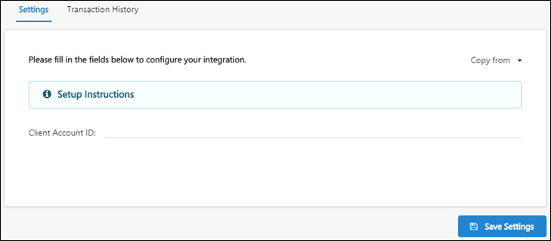
Additional Information
- You must have an existing contract with Universal Background Screening.
- You must work with your Universal Background Screening project team to purchase and configure their screening packages.
- No migration is required.
- The activation of the integration is a one-time activity per environment (Stage, Pilot, Production).
- The integration cannot be purchased independently of a product line.
- The cost will be displayed on Edge when you purchase the integration.
Applicant Statuses - Create Custom Integration Status (Universal Background Screening)
In order for the Universal Background Screening status to be available to select for applicants, it is necessary to create a custom integration status in Manage Applicant Statuses.
To create a custom applicant status, go to Admin > Tools > Recruit > Applicant Statuses. Then click the Create Custom Status link.
Permissions
PERMISSION NAME | PERMISSION DESCRIPTION | CATEGORY

Applicant Status Bank - Manage | Grants ability to access and manage Applicant Status Bank. | Recruiting Administration
To create a custom integration status for Universal Background Screening:
- Navigate to Admin > Tools > Recruit > Applicant Statuses.
- Click the Create Custom Status link. This opens the Create Custom Status pop-up.
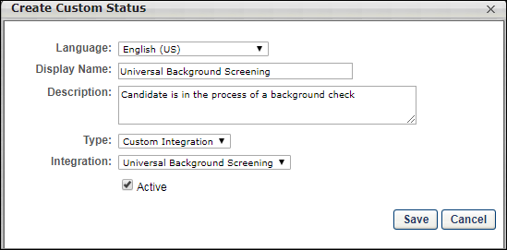
- Complete the following fields in the Create Custom Status pop-up:
  - Language - If multiple languages are enabled, from the drop-down list select the language in which you are entering the status name and description. To localize the status name and description into other available languages, select the appropriate language from the drop-down list and enter the localized name and description in the appropriate fields.
  - Display Name - Enter "Universal Background Screening" to identify the status as being specifically for Universal Background Screening.
  - Description - Enter a description, up to 500 characters. As a best practice, provide a description that helps recruiters understand the purpose of this status.
  - Type - Select "Custom Integration." The Custom Integration status type mans that the applicant is in an integration step of the status workflow.
  - Integration - Select "Universal Background Screening" in this field, which will associate the custom status to Universal Background Screening.
  - Active - This option is selected by default and means the status will be available to include in status workflows.
- Click Save to save the custom status. Your new custom integration status will be visible in the list of statuses on the Manage Applicant Statuses page.
Map Education and Experience Fields (Universal Background Screening)
In order for Universal Background Screening (UBS) to retrieve the applicant's data, specific resume fields will need to be mapped.
Note: When configuring the application workflow template for the requisition, the Upload Attachment action item will need to be included so that the applicant can enter their resume data in the Education and Employment fields that are mapped for UBS when filling out the application.
To access map resume fields, go to Admin > Tools > Succession Management > Resume.
Permissions
PERMISSION NAME | PERMISSION DESCRIPTION | CATEGORY

Resume Administration | Grants access to resume administration, which enables configuration of resume sections, including custom resume fields. This permission cannot be constrained. This is an administrator permission. Note: This permission does not apply to the Universal Profile - Resume functionality. | Talent/Succession - Administration
Education Fields
Education fields must be mapped in Succession > Resume in order for Cornerstone to pass the applicant's data to UBS. The name of the field in Cornerstone (as defined in the Field Name field on the Add Field pop-up on the Resume > Education page) does not need to match the name of the field in UBS, but it must be mapped to the correctly corresponding Applicant Mapping field in your portal in order for the data to pass successfully to UBS.
To map the fields:
- Navigate to Admin > Tools > Succession Management > Resume.
- Select the Edit icon in the Education row.
- Ensure that Education is selected in the Applicant Resume drop-down.
- Configure or create the following fields and select the appropriate mapping option in the Applicant Mapping column:
field name in UBS | select this option in drop-down in applicant mapping column | field type
SchoolName (Note: A field on the resume in Cornerstone must be mapped to this field in UBS in order for UBS to process the data.) | Institution (Note: Be sure to check the box in the Required column for this field.) | Short Text Box
DegreeName | Degree | Dropdown
DegreeMajor | Area of Study | Short Text Box
Degree Date (Note: This field is not required for the integration to run successfully. This field can be left out of the mapping if you do not wish to capture this data.) | Graduation Date | Date Field
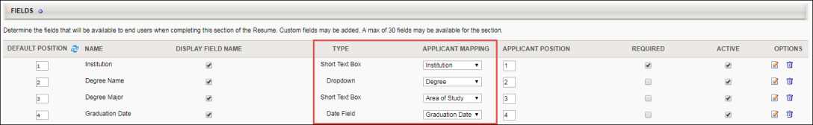
Employment Fields
Employment fields must be mapped in Succession > Resume in order for Cornerstone to pass the applicant's data to UBS. The name of the field in Cornerstone (as defined in the Field Name field on the Add Field pop-up on the Resume > Previous Positions page) does not need to match the name of the field in UBS, but it must be mapped to the correctly corresponding Applicant Mapping field in your portal in order for the data to pass successfully to UBS.
To map the fields:
- Navigate to Admin > Tools > Succession Management > Resume.
- Select the Edit icon in the Previous Positions row.
- Ensure that Experience is selected in the Applicant Resume drop-down.
- Configure or create the following fields and select the appropriate mapping option in the Applicant Mapping column:
field name in UBS | select this option in drop-down in applicant mapping column | field type
EmployerOrgName | Organization | Short Text Box
Title | Position | Short Text Box
Start and End Date (Note: This field is not required for the integration to run successfully. This field can be left out of the mapping if you do not wish to capture this data.) | Date Range | Date Range Field
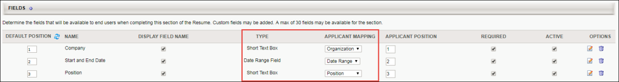
Candidate Reference Data (Universal Background Screening)
In order for Universal Background Screening (UBS) to retrieve the applicant's data, specific reference questions will need to be created in the Question Bank in Form Management so that the questions can be added to a form in Form Management that will be used to request the applicant's references.
The text of the question in Cornerstone does not need to match the name of the field in UBS, but it must be mapped to the correctly corresponding API label in your portal in order for the data to pass successfully to UBS.
There are three different sets of these questions, since applicants can submit up to three references. Each set represents one applicant reference. It is necessary to create each set. If more than three sets are created, any data outside of the first three sets will not be passed to UBS.
To manage forms, go to Admin > Tools > Core Functions > Form Management > Manage Forms.
To access the question bank, go to Admin > Tools > Core Functions > Form Management > Question Bank.
Permissions
PERMISSION NAME | PERMISSION DESCRIPTION | CATEGORY

Manage Forms - Manage | Grants access to the Manage Forms functionality. This permission can be constrained by OU and User's OU. This is an administrator permission.  Note: This permission enables access to the Form Management functionality that is part of Cornerstone HR functionality and the Onboarding module. This permission does not grant access to the Training Forms Management functionality. | Forms Management Administration

Question Bank - Manage | Grants access to the Question Bank functionality. This permission can be constrained by OU and User's OU. This is an administrator permission. | Forms Management Administration
Create Questions
To create the questions:
- Navigate to Admin > Tools > core functions > form management > question bank.
- Click Create Question.
- Select Text as the field type.
- Configure each question separately by entering a name for the question in the Question field and entering the API exactly as it is listed in the right-hand column. The "Field Name in UBS" column indicates the exact name of the field in UBS. You can use the UBS field name as your question or enter a different name, but the API will need to correspond exactly so that the applicant's data can be transferred successfully.
field name in UBS |  | enter this api in the api name field on the create question page | Field Type
SET 1
Person Name |  | Universal_Reference_Name_1 | Text
Formatted Number |  | Universal_Reference_Phone_1 | Text
Relationship |  | Universal_Reference_Relationship_1 | Text
SET 2
Person Name |  | Universal_Reference_Name_2 | Text
Formatted Number |  | Universal_Reference_Phone_2 | Text
Relationship |  | Universal_Reference_Relationship_2 | Text
SET 3
Person Name |  | Universal_Reference_Name_3 | Text
Formatted Number |  | Universal_Reference_Phone_3 | Text
Relationship |  | Universal_Reference_Relationship_3 | Text
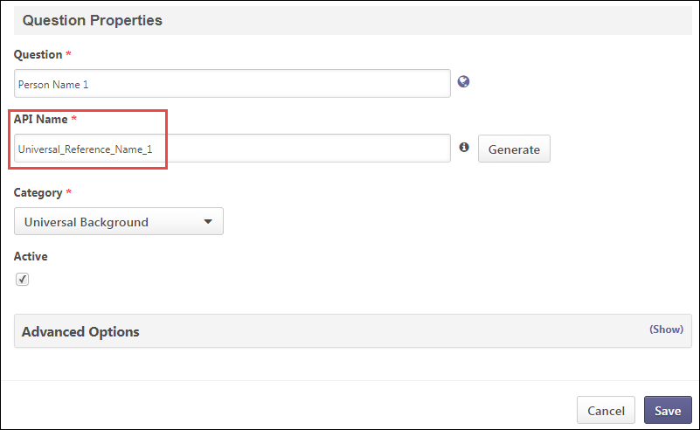
Create Form
Once you have created the questions, navigate to Form Management > Manage Forms and create a form for requesting an applicant's references, making sure to enter Universal_Reference_Form in the API Name field on the Build tab. The purpose of entering this API name is so that the system knows the correct form to send to UBS. See Build Tab - Define General Information.
On the form, add the questions that you created above. The references request form will be assigned to applicants on Manage Candidates or Manage Applicants. The form will be available to the applicant from their My Profile page in the career site, where they can then launch and complete the form.
Assign Universal Background Screening
The Universal Background Screening can be assigned from the Applicant Profile > Statuses tab. The applicant's status must be changed to the custom Universal Background Screening status in order for the background screening to be available to assign.
Permissions
PERMISSION NAME | PERMISSION DESCRIPTION | CATEGORY

Applicants: Initiate Background Check | This permission grants access to manage background checks from the Applicant Profile page. This applies to background checks that have been configured in the Integration Center. This permission cannot be constrained. Users who have this permission will have an Assign to Applicant link in the background check status type panel on the Applicant Profile page. Once the background check is assigned, the page will display "Assigned - [Date Assigned]." | Recruiting

Applicants: View Background Check Status and Details Link | This permission allows users to view the background check status and view a link to access the background check report, which can be found in the background check status type panel on the Applicant Profile page. This permission cannot be constrained. | Recruiting

Applicants: View Background Check Status | Allow user to view the background check status. The user cannot view the link to the detailed report. This permission cannot be constrained. | Recruiting

Requisition: Manage | Grants ability to access and manage all requisitions regardless of ownership (constraints permitting). This permission also grants read-only access to the Applicant Review tab when creating or editing a job requisition. This permission can be constrained by OU, User's OU, and Grade. | Recruiting

Requisition: Owner | Enables owner to access requisitions and applicants for requisitions for which they are an owner. This permission also grants read-only access to video interviews that are completed by applicants via HireVue. For portals with Referral Suite enabled, this permission also enables requisition owners to edit the referral source on the Applicant Profile page. This permission cannot be constrained.  Note: This is a dynamically assigned permission that is not available in Security Role Administration. If the user is removed as an owner, the permission is revoked for the associated requisition. This permission cannot be manually assigned. Also, if a user has both the permission necessary to manage requisitions and be a requisition owner, the constraints of the Requisition: Manage permission overrule those of the Requisition: Owner permission. For requisition owners that do not also have permission to manage requisitions, only certain fields are editable when editing a requisition. | Recruiting

Requisition: Reviewer | Enables reviewer to access requisitions and applicants for requisitions for which they are a reviewer. This permission cannot be constrained.  Note: This is a dynamically assigned permission that is not available in Security Role Administration. Once a requisition is in a Closed or Cancelled status or if the user is removed as a reviewer, the permission is revoked for the associated requisition. This permission cannot be manually assigned.  Note: If an applicant reviewer is removed as a reviewer via the Applicant Profile page, the Requisition: Reviewer permission is revoked for the associated requisition. However, if the reviewer was also added as a reviewer via the General tab when creating, editing, or copying the requisition, the reviewer still appears on the In Review panel as a duplicate reviewer and retains access to the requisition and applicants from the Requisition: Reviewer permission. See Applicant Profile Page Overview for more information about duplicate reviewer instances. | Recruiting
Emails
EMAIL NAME | EMAIL DESCRIPTION | ACTION TYPE

Assign Integration Assessment | This email is triggered when an Edge integration assessment is assigned to an applicant, such as a WOTC assessment. This email can be configured as a notification or a reminder, and it can be sent to External Applicant, Internal Applicant, OU Approver, Hiring Manager, OU Approver, or a specific user.  This email only triggers when a successful response is received from the vendor.  Note: The APPLICANT.INTEGRATION.ASSESSMENT.LINK tag must be included in the email. This tag provides a link that the applicant can click to access the assessment.  Note about Auto-Assignment of Pre-Employment Verifications: This email also applies to auto-assignment of pre-employment verifications, via the Automated Candidate Progression (Early Adopter) functionality. For more information, see Feature Activation Preferences. | Recruiting
Assign from Applicant Profile
To assign from the Applicant Profile page:
Navigate to the Applicant Profile > Statuses tab.
- Click the applicant's status in the Current Status field on the Summary tab.
- Change the status to the applicable background check status. This enables a background check to be assigned to a candidate on the Statuses tab.
- Click the Statuses tab.
- Click the Assign to Applicant link in the background check status section. This opens the Select Provider pop-up.
- Select the Universal Background Screening provider from the Select Provider drop-down.
- Click Submit. This opens the log-in page for Universal Background Screening.
- Log in to the Universal Background Screening site. The page will show the applicant's data passed to Universal Background Screening. The recruiter can enter additional required fields not passed as part of the integration, or the recruiter can select to assign this task to the candidate by selecting Background Check via e-Forms Invitation. If the latter, Universal Background Screening will send an email to the applicant.
If the screening request is successful and completed, the results display in the status panel on the Applicant Profile page. You can also view the results from the associated assessment column on the Manage Applicants page.
Custom Recruiting Reports (Universal Background Screening)
The Universal Background Screening can be reported on in Reporting 2.0 and Custom Recruiting Reports.
The following fields in the Background Check section provide data for the screenings:
- Assigned Date
- Completed Date
The following fields in the External Vendors section provide data for the screenings:
- External Vendor Name
- External Vendor Package Result
- External Vendor Package Title
- External Vendor Product

Candidate Recruitment Management Integrations - Overview
Clinch Talent Integration
Cornerstone and Clinch seamlessly integrate to deliver an optimized candidate experience to help talent acquisition teams recruit more effectively with less manual effort. Covering every step of the candidate journey - from first visit to the careers site all the way through apply, hire and pre-boarding.
Clinch Talent uses Cornerstone's Recruiting APIs to retrieve data from your Cornerstone portal. Requests made by Clinch Talent using these APIs will count toward your overall throttling limit for Cornerstone's APIs. If you have other integrations, including custom integrations, that use Cornerstone's APIs, you will want to ensure that the overall usage across all your integrations is within the throttling limits for Cornerstone's APIs. Throttling limits for Cornerstone's APIs are documented in the API Explorer.
Implementation
This integration is available for all organizations using the Recruiting suite. This integration is available for free via Edge Marketplace. Additional instructions for enabling and configuring the integration are available on the Setup tab of the integration in Edge.
The integration can be accessed and configured via the Edge Marketplace. In order to use this integration, your organization must be using the Recruiting module and must have access to Edge and have an account with the integration vendor. There is no additional cost associated with enabling this integration, but the integration cannot be used without an account with the integration vendor.
Permissions
The following permissions apply to this functionality:
PERMISSION NAME | PERMISSION DESCRIPTION | CATEGORY

Edge Integrations - Manage | Grants access to the Integrations service for Edge Integrate, where the administrator can configure, enable, and disable their third-party integrations used within the Cornerstone system. This permission cannot be constrained. This is an administrator permission. | Edge

Edge Marketplace - Manage | Grants access to the Marketplace service for Edge Integrate, where the administrator can browse integrations that can be used to extend the Cornerstone system. This permission cannot be constrained. This is an administrator permission. | Edge
LinkedIn Recruiter System Connect - Overview
LinkedIn Recruiter System Connect bridges the information gap between Cornerstone Recruiting and LinkedIn Recruiter by making candidate communication, notes, and application information available in both places. With this integration, a recruiter will no longer need to look up a candidate in both systems to get a complete picture of the candidate.
How Does this Integration Benefit My Organization?
Full Candidate Picture in LinkedIn and Recruiting
Drives Quicker and Easier Informed Decisions
Enhances Usability
LinkedIn Recruiter System Connect delivers a holistic view of the candidate in both LinkedIn and Cornerstone Recruiting, giving recruiters the information they need to make informed decisions more quickly.
Without this integration, LinkedIn Recruiter data will only display in LinkedIn Recruiter, and Recruiting information will only display in Recruiting. This means recruiters have to look up the candidate in both applications to get a complete view.
With LinkedIn Recruiter System Connect, recruiters can view all LinkedIn Recruiter information in Recruiting and vice versa, including InMail History, Notes, and Profiles. This provides a candidate picture in both applications. This also saves time and supports more informed decision-making by being able to look up candidate information in whichever application the recruiter is in.
What LinkedIn Recruiter Information Is Available in Cornerstone?
InMail History
A candidate's InMail history will display on the Emails tab of the Applicant Profile page. The date, sender, subject, and message body is included. InMail will appear with “via LinkedIn” next to the name of the user who sent the email. Attachments are not included. InMail history will only be visible to users who have a LinkedIn Recruiter seat on the same contract.
Prospect Notes
Notes that are created in LinkedIn Recruiter will be visible on the Comments tab on the Applicant Profile page. LinkedIn Recruiter notes will appear with "via LinkedIn" next to the name of the user who submitted the comment. Notes will only be visible to users who have a LinkedIn Recruiter seat on the same contract.
LinkedIn Profiles
A candidate's LinkedIn profile will be visible on a new "LinkedIn" tab on the Applicant Profile page. This tab will be available for all portals that enable LinkedIn Recruiter System Connect. Users with a LinkedIn Recruiter seat will be able to see the full LinkedIn profile, including links to save the candidate to a project, send an InMail, or choose to be notified when the candidate updates their LinkedIn profile. Users without a LinkedIn Recruiter seat will see the candidate’s public LinkedIn profile.
Considerations/Exclusions
- Application data can be deleted from LinkedIn. Cornerstone will send deletion requests when triggered by the candidate or after the period of inactivity specified by a client.
- Jobs must meet the following criteria to sync to LinkedIn:
  - "External Description" must contain at least 100 characters.
  - The Primary Location field must include a value for the Country field.
  - The Primary Location field must include a value for either the City field or the State/Province field.
- This integration is only available in Production environments.
Implementation
The option to activate LinkedIn Recruiter is available for all portals with Recruiting enabled. However, a LinkedIn Recruiter subscription is required for activation. LinkedIn Recruiter can be purchased through LinkedIn.
Additional instructions for enabling and configuring the integration are available on the Setup tab of the integration in Edge.
Security
The following permissions apply to this functionality:
PERMISSION NAME | PERMISSION DESCRIPTION | CATEGORY

Edge Integrations - Manage | Grants access to the Integrations service for Edge Integrate, where the administrator can configure, enable, and disable their third-party integrations used within the Cornerstone system. This permission cannot be constrained. This is an administrator permission. | Edge

Edge Marketplace - Manage | Grants access to the Marketplace service for Edge Integrate, where the administrator can browse integrations that can be used to extend the Cornerstone system. This permission cannot be constrained. This is an administrator permission. | Edge

Requisition: Manage | Grants ability to access and manage all requisitions regardless of ownership (constraints permitting). This permission also grants read-only access to the Applicant Review tab when creating or editing a job requisition. This permission can be constrained by OU, User's OU, and Grade. | Recruiting

Requisition: Owner | Enables owner to access requisitions and applicants for requisitions for which they are an owner. This permission also grants read-only access to video interviews that are completed by applicants via HireVue. For portals with Referral Suite enabled, this permission also enables requisition owners to edit the referral source on the Applicant Profile page. This permission cannot be constrained.  Note: This is a dynamically assigned permission that is not available in Security Role Administration. If the user is removed as an owner, the permission is revoked for the associated requisition. This permission cannot be manually assigned. Also, if a user has both the permission necessary to manage requisitions and be a requisition owner, the constraints of the Requisition: Manage permission overrule those of the Requisition: Owner permission. For requisition owners that do not also have permission to manage requisitions, only certain fields are editable when editing a requisition. | Recruiting

Requisition: Reviewer | Enables reviewer to access requisitions and applicants for requisitions for which they are a reviewer. This permission cannot be constrained.  Note: This is a dynamically assigned permission that is not available in Security Role Administration. Once a requisition is in a Closed or Cancelled status or if the user is removed as a reviewer, the permission is revoked for the associated requisition. This permission cannot be manually assigned.  Note: If an applicant reviewer is removed as a reviewer via the Applicant Profile page, the Requisition: Reviewer permission is revoked for the associated requisition. However, if the reviewer was also added as a reviewer via the General tab when creating, editing, or copying the requisition, the reviewer still appears on the In Review panel as a duplicate reviewer and retains access to the requisition and applicants from the Requisition: Reviewer permission. See Applicant Profile Page Overview for more information about duplicate reviewer instances. | Recruiting
Enable LinkedIn Recruiter System Connect
To enable the LinkedIn Recruiter System Connect integration, the client administrator must perform the actions listed below. The activation of the integration is a one-time activity.
To view detailed LinkedIn instructions for enabling the LinkedIn Recruiter System Connect integration, click the Getting Started link on the Setup page. A "LinkedIn Recruiter System Connect Enablement Guide" is available to download.
Additional Information
- You must have an existing LinkedIn Recruiter account with LinkedIn.
- No migration is required.
- The integration comes with Recruiting at no additional cost.
- The integration cannot be purchased independently of a product line.
Applicant Profile - LinkedIn Recruiter System Connect
When LinkedIn Recruiter System Connect is enabled in the portal, a candidate's LinkedIn Recruiter data appears on the Applicant Profile page. You can view InMail history, notes, and the LinkedIn Recruiter profile.
A candidate's Cornerstone data is also available in LinkedIn Recruiter.
InMail History
A candidate's InMail history displays on the Emails tab. The date, sender, and subject are visible to all users with access to the Applicant Profile page in Cornerstone. InMail history will only be visible to users who have a LinkedIn Recruiter seat on the same contract.
Attachments are not included.
Cornerstone Record Creation via InMail
When a LinkedIn recruiter sends an InMail to a candidate, the candidate will be able to respond to the InMail, and in the process can choose to share their contact information with the recruiter. If a candidate chooses to share their contact information, that detail will be passed to Cornerstone.
If the candidate does not have an account in the portal, a new record will be created for the user. The record will not be connected to any specific requisition and can only be found through Candidate Search Query. Note: If the Applicant Opt Out option in Requisition and Applicant Preferences is checked, then the new profile will not be visible in Candidate Search Query by default. The only way to find candidates generated through this InMail Stub Profile is to ensure Applicant Opt-Out is not checked.
If the candidate does have an account in the portal, then the record will be updated with the contact information shared through LinkedIn.
Notes
Notes added on LinkedIn display on the Comments tab. These notes will be distinguished from Recruiting notes by displaying "via LinkedIn" next to the name of the user who submitted the note. Notes will only be visible to users who have a LinkedIn Recruiter seat on the same contract.
Notes that are created in LinkedIn Recruiter and viewed in your Cornerstone portal cannot be edited or deleted in Cornerstone.
LinkedIn Recruiter Profile
A candidate's LinkedIn profile will now be visible on a new "Linkedin" tab on the Applicant Profile page. This tab is only available in portals that have enabled LinkedIn Recruiter System Connect. Users with a LinkedIn Recruiter seat will be able to see the full LinkedIn profile, including links to send an InMail or view the profile in LinkedIn Recruiter. Users without a LinkedIn Recruiter seat will see the candidate’s public LinkedIn profile.
For candidates who do not have a LinkedIn profile, the tab will display "Candidate Not Matched." If the profile being shown does not match the candidate, a Wrong person's profile? link can be clicked to unlink the current profile and select the correct one.
LinkedIn Experience
With LinkedIn Recruiter System Connect, Cornerstone Recruiting data and actions can be viewed on the candidate's LinkedIn Recruiter page.
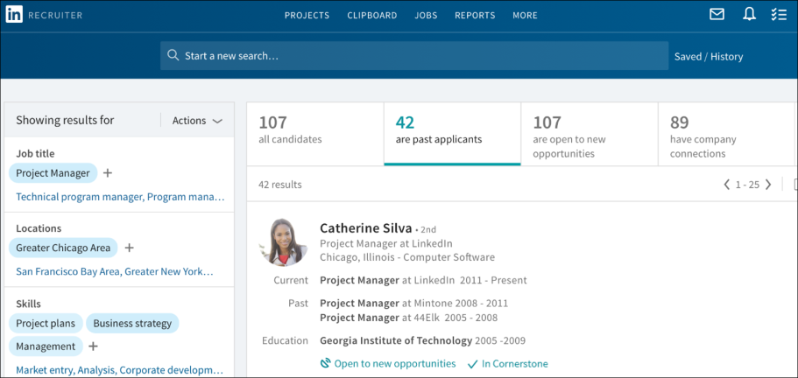
You can view Cornerstone data by clicking In Cornerstone in the candidate's details section on LinkedIn Recruiter. This opens a pop-up that displays their Cornerstone data. Much of the same candidate data that is visible in your Cornerstone portal will also be visible in LinkedIn Recruiter.
For example, you can view status changes and dates so that you know which jobs the candidate applied to, as well as their current and previous status(es) for those jobs. Note: A candidate’s application for a job is not visible until they are moved out of the New Submissions stage.
You can view comments from interviewers and their recommendation. A candidates score does not display.
Comments from recruiters and stakeholders will be visible in LinkedIn Recruiter so that you can use their input to make decisions about what actions to take. If attachments were included in the comment in Cornerstone, the attachment will not be visible in LinkedIn Recruiter.
You can also quickly and easily get to your Cornerstone portal to view the candidate on the Applicant Profile page by clicking the View in Cornerstone link.
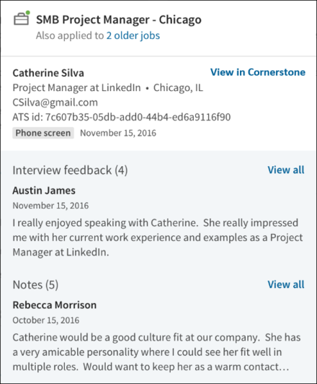
Information for candidates who have been archived, inactivated, or deleted will not display in LinkedIn Recruiter.
InMail Functionality
While viewing a candidate's profile in LinkedIn Recruiter, a recruiter can send an InMail to a candidate.
When responding to the InMail, the candidate will have the option to share their contact information with the recruiter. When the candidate replies, basic information about the candidate is synced from LinkedIn to Cornerstone. If no matching candidate is found in Cornerstone, a basic profile will be created with the candidate's name. No resume/CV information is synced from LinkedIn to Cornerstone. These candidates can now be added to requisitions using the Add Submission functionality on the Requisition Snapshot page, or they can be exported directly to a requisition from LinkedIn (see the "Export Candidate" section below). Approximately an hour after the candidate replies, a link to their Applicant Snapshot page should be visible in LinkedIn Recruiter.
If the candidate chose to share their contact information, the email address and phone number will be visible on the "ATS" tab of the LinkedIn profile approximately an hour after the candidate replied.
Export Candidate
Candidates can be exported from LinkedIn Recruiter to jobs in Cornerstone. To export a candidate:
- Navigate to their profile in LinkedIn Recruiter.
- Click the ellipsis icon and select Export to ATS. This opens the Export to your ATS flyout.
- Click the Job Name field and search for the job by keyword or job ID number. For example, entering "Product" should return options for "Product Manager" or "Associate Product Manager." Similarly, entering "25" will return job requisitions with IDs such as 25, 251, 252, etc. By default, no jobs will appear in the Job Name field. Note: Entering a prefix with the job ID (e.x., Req123) will likely result in no match.
The jobs that display are the jobs to which you have access based on your permission constraints, as well as those that meet the required criteria for syncing to LinkedIn:
  - "External Description" must contain at least 100 characters.
  - The Primary Location field must include a value for the Country field.
  - The Primary Location field must include a value for either the City field or the State/Province field.
Note: A recently created job that meets the criteria listed above may not appear for approximately two hours. The requisition must first be synced to LinkedIn, which occurs roughly every thirty minutes, and a separate list of the users who have access to the requisition must also be synced to LinkedIn, which occurs roughly every two hours.
- Click the job to select it and add it to the Job Name field.
- Click Export. A confirmation appears to indicate the export has been initiated.
To confirm the success of the export, click the ATS tab. An Export Summary section will indicate if the export is in progress, complete, or needs to be retried. This section will also show profile information from Cornerstone, as well as contact information shared by the candidate if they chose to share their contact information in response to an InMail.
When the export occurs, basic information about the candidate is synced from LinkedIn to Cornerstone. If no matching candidate is found in Cornerstone, a basic profile will be created with the candidate's name and a link to their LinkedIn profile. Additionally, an incomplete application for the selected job will be created. No resume/CV information is synced from LinkedIn to Cornerstone. To gain more information about a candidate, a recruiter can visit the LinkedIn tab of the Applicant Profile. Additionally, the recruiter can invite the candidate to apply to the requisition, where they can submit a resume/CV, answer pre-screening questions, and more.
Frequently Asked Questions - LinkedIn Recruiter System Connect
What is the difference between LinkedIn Recruiter and LinkedIn Recruiter System Connect?
LinkedIn Recruiter is the name of the recruiting application within LinkedIn. This application is purchased through LinkedIn and is necessary in order for LinkedIn Recruiter System Connect to be enabled in Cornerstone.
LinkedIn Recruiter System Connect is the name of the integration that can be enabled through Edge in Cornerstone.
Where do I find Cornerstone candidate data in LinkedIn?
Cornerstone candidate data can be viewed in LinkedIn on the candidate's page in LinkedIn Recruiter.
Can I turn off the integration after I enable it?
Yes. You can submit a request to LinkedIn (ltsatsintegrations@linkedin.com) to deactivate the integration.
Will permissions and constraints be respected in LinkedIn?
Yes. Constraints will be synched so that users with LinkedIn Recruiter will only be able to see jobs and application information for requisitions they can access in Cornerstone.
Can application data be deleted from LinkedIn?
Yes. Cornerstone will send deletion requests when triggered by the candidate or after the period of inactivity specified by a client.
How are Notes and InMails from LinkedIn attributed to recruiters in Cornerstone?
When Notes and InMails are synced from LinkedIn, LinkedIn email address of the Note/InMail author is matched with the corresponding email address in Cornerstone . If multiple users in Cornerstone have the same email address, the first matching user (based on ascending user ID) will be labeled as the author of the Note/InMail in Cornerstone.
If the LinkedIn profile displayed on the "LinkedIn" tab of the Applicant Profile page is incorrect, can the proper profile be mapped to the candidate?
Yes. A Not the right candidate? link will appear in the LinkedIn profile. Clicking this link will unlink the current LinkedIn profile. Afterwards, you can search for the correct LinkedIn profile and map the user to the selected profile.
When the profile is unlinked, any InMails and Notes from LinkedIn that are associated with the unlinked profile will be deleted from the candidate's record in Cornerstone. If the recruiter manually links a new LinkedIn profile to the candidate in Cornerstone, then all InMails and Notes from LinkedIn that are associated with the new profile will be synced to the candidate's record in Cornerstone.
Note: The process to sync all historical InMails and Notes for manually linked profiles will run once per day, so please allow up to 24 hours for the new information to appear in Cornerstone.
Note: If multiple candidates are mapped to the same LinkedIn profile, then Notes and InMails from LinkedIn may not sync properly. When new Notes and InMails come in from LinkedIn, they will be assigned to the first matching candidate that is connected to this profile (based on ascending user ID).
Phenom Talent Experience Integration (TXM)
The TXM integration gives mutual customers the benefit of two integrations:
- Job-Sync - The Job-Sync integration facilitates the extraction of requisitions from Cornerstone to Phenom for the purposes of job searching and recruiting scenarios. Upon the creation and publishing of a requisition in Cornerstone, the job will be extracted and posted to the front end of the Phenom platform. Customers need to purchase Phenom’s software for this integration to work. There are no sample workflows to document as this integration is automated. Any requisition published from Cornerstone will be published on the Phenom platform.
- Hiring-Status - The Hiring-Status integration facilitates the extraction and submission of candidate and status details to ensure the correct updated status is reflected in both systems. This sync allows recruiters working in both Cornerstone and Phenom to update candidate statuses and ensure the correct updated status is reflected in both systems. Customers need to purchase Phenom’s software for this integration to work. There are no sample workflows to document as this integration is automated. Any status change within either Phenom or Cornerstone will trigger a change in the other system.
Implementation
The TXM integration is available in Edge Marketplace for all organizations using the Recruiting suite and that also have an account with the integration vendor.
Additional instructions for enabling and configuring the integration are available on the Setup tab of the integration in Edge. There is no additional cost associated with enabling this integration in Edge.
Permissions
The following existing permissions apply to this functionality:
PERMISSION NAME | PERMISSION DESCRIPTION | CATEGORY

Edge Integrations - Manage | Grants access to the Integrations service for Edge Integrate, where the administrator can configure, enable, and disable their third-party integrations used within the Cornerstone system. This permission cannot be constrained. This is an administrator permission. | Edge

Edge Marketplace - Manage | Grants access to the Marketplace service for Edge Integrate, where the administrator can browse integrations that can be used to extend the Cornerstone system. This permission cannot be constrained. This is an administrator permission. | Edge
TimeKO Integration
TimeKO by LINKAVIE, provides best-in-class solutions to facilitate communication with candidates and employees by sending mass text messages and getting real-time categorized positive or negative answer. ​
Cornerstone integrates with TimeKO to provide customers an efficient ad hoc messaging and communication solution.
Prerequisites
- Customers must use Chrome or Firefox to access ATS.
- Customers must be a TimeKO customer to use this integration.
- Contact TimeKO at contact@linkavie.com to get quotes and guidelines to integrate this solution.
Key Features
- Multi-channel communication solution for candidates and employees.​
- Bulk SMS dispatch with automatic categorization of responses. ​
- Schedule messages to send reminders to candidates or employees.
Once enabled, the TimeKo icon appears on the Manage Candidates page. Clicking the icon opens the extension.
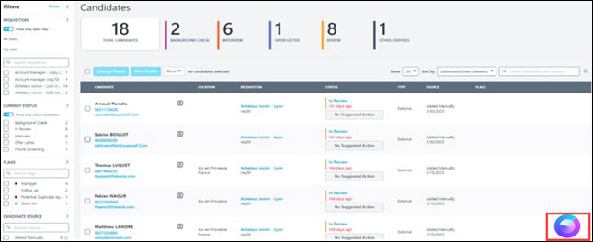

Chatbot Integrations - Overview
Olivia, Your AI Recruiting Assistant - Integration by Paradox
The Olivia integration by Paradox is an FAQ and scheduling powerhouse, pipeline builder, and real-time, mobile-first communication tool. The widget can be placed on a career site for candidates to interact with through an ontology specific to your organization.
The job search integration allows for Paradox to provide requisition information to candidates while searching for a job through a chat. Olivia can guide the candidate through an assisted conversation to search for a job that they are interested in. Through an integration with Cornerstone, Olivia can proactively look up jobs in Cornerstone through the job requisition API and display information on the job to the candidate.
Implementation
The Olivia integration by Paradox is available in Edge Marketplace for all organizations using the Recruiting suite and the Job Requisition API and that also have an account with the integration vendor.
Additional instructions for enabling and configuring the integration are available on the Setup tab of the integration in Edge. There is no additional cost associated with enabling this integration in Edge.
Permissions
The following existing permissions apply to this functionality:
PERMISSION NAME | PERMISSION DESCRIPTION | CATEGORY

Edge Integrations - Manage | Grants access to the Integrations service for Edge Integrate, where the administrator can configure, enable, and disable their third-party integrations used within the Cornerstone system. This permission cannot be constrained. This is an administrator permission. | Edge

Edge Marketplace - Manage | Grants access to the Marketplace service for Edge Integrate, where the administrator can browse integrations that can be used to extend the Cornerstone system. This permission cannot be constrained. This is an administrator permission. | Edge

Drug Screening Integrations - Overview
Quest Diagnostics Drug Screening Integration - Overview
Quest Diagnostics (Quest) is a third party vendor that provides drug screenings for Recruiting.
Use Cases
Use Case 1: Activate the Quest integration through Edge
- James is Acme Company's administrator and has been tasked with enabling the integration between Cornerstone and Quest. This will allow Acme to include Quest drug screenings in their hiring workflow.
- James goes to the Edge Marketplace to purchase and activate the Quest integration.
- From the Edge Integrate page, James enters Acme's unique API credentials, Company/Organization Name, Endpoint URL, Account Name and ID, and Drug Test Name and ID, which are provided by their Quest project team.
- Acme's Cornerstone portal now has an active integration between Cornerstone and Quest.
Use Case 2: Recruiting Administrator creates a custom applicant status
- Lisa is the Recruiting administrator for Acme.
- Holly, a hiring manager at Acme, is looking to add a new member to her Marketing team.
- With the integration enabled, Lisa is tasked with adding a drug screening status in all of Acme's marketing job requisitions.
- Lisa creates a new custom applicant status that is set to a custom integration type Quest Diagnostics.
- Lisa creates a new job requisition that includes that new custom applicant status.
- Lisa has now configured the Marketing job requisitions to include the Quest Diagnostics custom status.
Use Case 3: Recruiter assigns background check request for an applicant
- Ashley, a recruiter at Acme, has identified Paul James to be a stellar applicant.
- To ensure a sound hiring decision is made and to protect Acme from potential risks, Ashley assigns a drug screening test on Paul by moving his status to Quest.
- Ashley selects the appropriate drug test name, then submits the request.
- Paul receives an email from Quest and clicks the link to complete the screening application request in Quest.
Use Case 4: Recruiter views drug screening results and its detailed report in Quest via a link
- Ashley is eager to find out the results of Paul's drug screening status.
- Ashley navigates to Paul's Applicant Profile > Statuses page and sees the status on the request.
- To view additional details of the background request, Ashley clicks the View Progress link, which directs Ashley to the Quest site.
Implementation
This integration is available for all organizations using the Recruiting suite and that also have an account with the integration vendor. This integration is available in Edge Marketplace. Additional instructions for enabling and configuring the integration are available on the Setup tab of the integration in Edge. There is no additional cost associated with enabling this integration in Edge.
It is necessary to have a contract and purchased assessments from Quest to implement the integration.
Security
The following existing permissions apply to this functionality:
PERMISSION NAME | PERMISSION DESCRIPTION | CATEGORY

Applicants: Initiate Background Check | This permission grants access to manage background checks from the Applicant Profile page. This applies to background checks that have been configured in the Integration Center. This permission cannot be constrained. Users who have this permission will have an Assign to Applicant link in the background check status type panel on the Applicant Profile page. Once the background check is assigned, the page will display "Assigned - [Date Assigned]." | Recruiting

Applicants: View Background Check Status | Allow user to view the background check status. The user cannot view the link to the detailed report. This permission cannot be constrained. | Recruiting

Applicants: View Background Check Status and Details Link | This permission allows users to view the background check status and view a link to access the background check report, which can be found in the background check status type panel on the Applicant Profile page. This permission cannot be constrained. | Recruiting

Applicant Status Bank - Manage | Grants ability to access and manage Applicant Status Bank. | Recruiting Administration

Application Workflow Template - View | Grants ability to access and view Application Workflow Templates. | Recruiting Administration

Edge Integrations - Manage | Grants access to the Integrations service for Edge Integrate, where the administrator can configure, enable, and disable their third-party integrations used within the Cornerstone system. This permission cannot be constrained. This is an administrator permission. | Edge

Edge Marketplace - Manage | Grants access to the Marketplace service for Edge Integrate, where the administrator can browse integrations that can be used to extend the Cornerstone system. This permission cannot be constrained. This is an administrator permission. | Edge

Global Email Administration - View | Grants view only access to email templates/triggers and email logs at the global level for the portal. This permission can be constrained by OU, User's OU, User Self and Subordinates, and User. This is an administrator permission. | Core Administration

Requisition: Manage | Grants ability to access and manage all requisitions regardless of ownership (constraints permitting). This permission also grants read-only access to the Applicant Review tab when creating or editing a job requisition. This permission can be constrained by OU, User's OU, and Grade. | Recruiting

Requisition: Owner | Enables owner to access requisitions and applicants for requisitions for which they are an owner. This permission also grants read-only access to video interviews that are completed by applicants via HireVue. For portals with Referral Suite enabled, this permission also enables requisition owners to edit the referral source on the Applicant Profile page. This permission cannot be constrained.  Note: This is a dynamically assigned permission that is not available in Security Role Administration. If the user is removed as an owner, the permission is revoked for the associated requisition. This permission cannot be manually assigned. Also, if a user has both the permission necessary to manage requisitions and be a requisition owner, the constraints of the Requisition: Manage permission overrule those of the Requisition: Owner permission. For requisition owners that do not also have permission to manage requisitions, only certain fields are editable when editing a requisition. | Recruiting

Requisition: Reviewer | Enables reviewer to access requisitions and applicants for requisitions for which they are a reviewer. This permission cannot be constrained.  Note: This is a dynamically assigned permission that is not available in Security Role Administration. Once a requisition is in a Closed or Cancelled status or if the user is removed as a reviewer, the permission is revoked for the associated requisition. This permission cannot be manually assigned.  Note: If an applicant reviewer is removed as a reviewer via the Applicant Profile page, the Requisition: Reviewer permission is revoked for the associated requisition. However, if the reviewer was also added as a reviewer via the General tab when creating, editing, or copying the requisition, the reviewer still appears on the In Review panel as a duplicate reviewer and retains access to the requisition and applicants from the Requisition: Reviewer permission. See Applicant Profile Page Overview for more information about duplicate reviewer instances. | Recruiting
Quest Integration Implementation Steps
To enable the Quest Diagnostics (Quest) drug screening integration, the administrator must configure the items below on the Edge Settings page.
Before you begin, Quest Diagnostics will need to set up/configure their systems to enable this integration. Contact your Quest Diagnostics Drug Screen Account Manager or Sales Representative for more information. If you do not have one assigned, email the Quest Diagnostics Implementation Team at dgxesaccountimplementation@questdiagnostics.com. Due to certain Quest Diagnostics account setups that may already be in place, this integration may not be suitable for all employers.
The activation of the integration is a one-time activity per environment (Stage, Pilot, Production).
Permissions
PERMISSION NAME | PERMISSION DESCRIPTION | CATEGORY

Edge Integrations - Manage | Grants access to the Integrations service for Edge Integrate, where the administrator can configure, enable, and disable their third-party integrations used within the Cornerstone system. This permission cannot be constrained. This is an administrator permission. | Edge

Edge Marketplace - Manage | Grants access to the Marketplace service for Edge Integrate, where the administrator can browse integrations that can be used to extend the Cornerstone system. This permission cannot be constrained. This is an administrator permission. | Edge
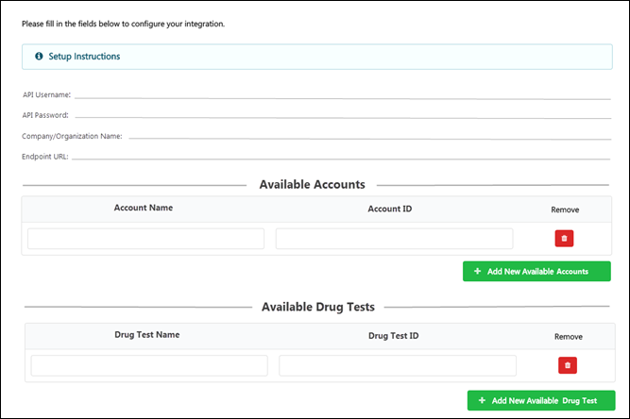
To enable the integration:
- API Username and Password - These credentials authorize Cornerstone to connect to Quest’s API. These credentials are provided by your Quest project team.
  - The API password is a masked field, i.e. the entered password will not appear in plain text.
- Company/Organization Name - This is your unique identifier that enables Quest to authorize background check submissions from Cornerstone. This code is provided by your Quest project team.
- Endpoint URL - This is the Quest endpoint for the API calls. This URL is provided by your Quest project team.
- Account Name and Account ID - These are your available account names and corresponding IDs, which are provided by your Quest project team.
- Drug Test Name and ID - These are provided by your Quest project team. The drug tests entered here will be available to recruiters when assigning a drug screening test to an applicant.
Additional Information
- You must have an existing contract with Quest.
- You must work with your Quest project team to purchase and configure their screening packages.
- No migration is required.
- The activation of the integration is a one-time activity per environment (Stage, Pilot, Production).
- The integration cannot be purchased independently of a product line.
- The cost will be displayed on Edge when you purchase the integration.
Assign and View Quest Drug Screening
To assign the Quest Diagnostics drug screening and view the results, start by creating a custom applicant status, then assigning the screening to the applicant. Once the screening is completed, it can be viewed via the Applicant Profile.
Permissions
PERMISSION NAME | PERMISSION DESCRIPTION | CATEGORY

Applicant Status Bank - Manage | Grants ability to access and manage Applicant Status Bank. | Recruiting Administration
Create Custom Status
- Navigate to the Manage Applicant Status page:
  - Navigation: Admin > Tools > Recruit > Applicant Statuses > Select the top level OU
- Click the Create Custom Status link. This opens the Create Custom Status pop-up.
- Complete the following fields in the pop-up:
  - Language - If multiple languages are enabled for the portal, select the language from the drop-down list for which you are entering the status name and description. To localize the status name and description into other available languages, select the appropriate language from the drop-down list and enter the localized name and description in the appropriate fields.
  - Display Name - Enter the status name, which appears throughout the system. The character limit for this field is 50. When the display name of an active status is modified after the status is in use or has been used in a job requisition:
    - The new display name appears on the Default Status List page.
    - The new display name appears in the Status list on the job requisition template.
    - Any new job requisitions created after the display name is changed apply the new display name.
    - Job requisitions created before the status display name is changed continue to honor the name that existed at the time the requisition was created.
  - Description - Enter the status description. This should describe the purpose of the status and what is implied when an applicant is in that status. The character limit for this field is 500.
  - Type - Select Custom Integration from the drop-down. Note: This field is displayed only when creating a custom status at the top level OU. When creating a custom status for a child OU, the Type field displays the type selected for the parent OU but is not editable.
  - Integration - Select "Quest Diagnostics" from the drop-down.
  - Active - This field is checked by default. Ensure the field is checked before saving the status so that the status is active for the portal.
- Click Save in the pop-up. This returns you to the Manage Applicant Statuses page.
- Click Save at the bottom of the Manage Applicant Statuses page to save the custom status to the Division OU. If the custom status is not saved on the Manage Applicant Statuses page, the status will be lost once you leave the page.
The custom applicant status will need to be added to the Status List on the requisition template so that it will be included on the job requisition.
Assign Screening
Assign the screening by navigating to the Applicant Profile > Statuses tab for the applicant.
- Click the Assign to Applicant link in the Quest status type section. This opens a pop-up.
- Complete the following required fields in the pop-up:
  - Select Provider - Select the background check provider. The options that are available are active integrations that have been enabled in Edge.
  - Select Account Name - Select the account name that the administrator has entered on the Edge Client Settings page.
  - Select Drug Test Name - Select the drug test name that the administrator has entered on the Edge Client Settings page.
- Click Submit.
Quest will send an order acknowledgment response.
View Screening Details and Status
The details and status for the screening is available on the Applicant Profile > Statuses tab. The following information displays:
- Assigned - This field displays the date on which the drug screen test was assigned to the applicant.
- Reference ID - This field displays the User ID value.
- Status - This field displays the overall status of the order. The status "In Progress" displays upon receipt of a successful drug test order. The status is updated automatically when status changes are made by Quest.
- Drug Test Name - This field displays the name of the drug test name assigned to the applicant.
- Provider Reference ID - This field displays the ProviderReferenceId received from Quest.
- Result - This field displays the results received from Quest.
- View Details - Click the View Details link to view the results in Quest. It is not necessary to enter additional credential in order to access Quest and view the results.
You can also view the results on Manage Candidates and Manage Applicants.
Report on Quest Diagnostics Screening
Quest Diagnostics (Quest) drug screenings can be reported on in Reporting 2.0 and Custom Recruiting Reports.
The following fields in the Background Check section provide Quest data:
- Assigned Date
- Completed Date
The following fields in the External Vendors section provide Quest data:
- External Vendor Name
- External Vendor Package Result
- External Vendor Package Title
- External Vendor Product

Interview Scheduling Integrations - Overview
Paradox Interview Scheduling Integration
Paradox Conversational Scheduling automates every type of interview in minutes - from a simple phone screen to a multi-person, multi-location interview day - saving recruiters and hiring managers countless hours, every day.​
Cornerstone integrates with Paradox to allow recruiters and candidates to schedule interviews using the calendar and virtual meeting tools of their choice.
Prerequisites
Customers must have Cornerstone CSX Recruiting licenses and Paradox scheduling licenses.
Customers must be Paradox customers to use the integration.
To enable this functionality, contact Global Customer Support.
Key Features
- Seamless integration from Cornerstone Recruiting pages towards the Paradox browser extension.
- Interview schedule returned to Cornerstone enables the recruiting feedback process.
- Ability to configure the integration in Edge
- Automatic deletion of candidates in Paradox upon anonymization in Cornerstone
- Cancellation of interviews for closed candidates
Benefits from Paradox
- Recruiter defined schedule or candidate selects a time.
- Calendar integrations/Virtual meeting integrations.
- Multi-modal communication with candidates.
- Schedule, reschedule, and cancel interviews.
- Integrate with calendar and virtual meeting tools​​.
- Communicate with candidates through Emails + SMS or WhatsApp (defined at portal level).
- Chat with candidates
Once enabled, the Paradox option appears on the Manage Candidates page:
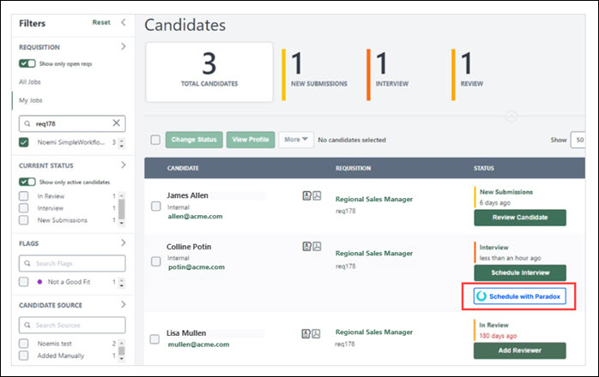
Starter Guide
Click here to view the Paradox Interview Scheduler Integration Starter Guide.

Job Distribution Integrations - Overview
Online Help Topics Related to Broadbean
The following topics in Online Help provide information about the configuration and functionality for the Broadbean Job Posting integration:
- Broadbean Configuration in Edge - This topic provides instructions for configuring Broadbean in Edge. See Broadbean Job Posting Configuration in Edge on page 151 for additional information.
- Broadbean OFCCP Integration - This topic provides information about the Broadbean OFCCP integration. See Broadbean OFCCP Compliance Integration on page 161 for additional information.
- My Account - Social - This topic explains how to connect your user account to Broadbean so that you are already connected to Broadbean when posting jobs on the Job Postings page. See My Account - Social.
- Edit Job Board Cost - This topic covers job board costs related to Broadbean. See Edit Job Board Cost.
- Create Job Requisition - General - This topic mentions that jobs posted via Broadbean will only show the primary location for the job, rather than any additional locations that are configured for the requisition. See Create Job Requisition - General.
- Job Posting Page - This topic covers external job postings. See Job Posting Page.
- Requisition Level Costs - This topic provides information about requisition level costs. See Requisition Level Costs.
- Edit Job Requisition - For Broadbean postings, this topic provides information about the impact of the Canceled and Closed status on Broadbean postings. See Edit Job Requisition.
- Create job Requisition - Job Ad - For Broadbean integrations, this topic provides information on how the Job Postings page is populated with available jobs. See Create Job Requisition - Job Ad.
Broadbean Job Posting Configuration in Edge
Cornerstone and Broadbean Technology have collaborated to deliver a seamlessly integrated job posting solution. From Cornerstone Recruiting, organizations can use the Broadbean integration to post jobs to over 4,500 job boards, social media sites such as LinkedIn, Twitter, and Facebook, and other recruitment channels. Through this integration, organizations can harness the power of internal and external sourcing within Cornerstone Recruiting and distribute job postings to the most popular job boards and eliminate the duplicative administrative burden to post jobs on individual job board sites.
Requirements
In addition to being required to have a Broadbean administrator account (along with a secret key), you are required to create a separate account in the Edge Integration Center for each user that will use Broadbean.
Implementation
This integration is available for all organizations using Recruiting. This integration is available for free via Edge Marketplace. Additional instructions for enabling and configuring the integration are available on the Setup tab of the integration in Edge.
Frequently Asked Questions (FAQs)
Why are users seeing this message and what can I do to fix it: "Error No Account Configured for User in Integration Center."
Because the user does not have an individual account configured on Edge. Individual user accounts need to be configured via Administrator > Tools > Edge Integration.
Does every user need their own unique individual account?
Yes. Individual user accounts need to be configured via Administrator > Tools > Edge Integration.
I have many users that need individual accounts, is there a way to bulk upload them?
No, there is not a way to bulk upload individual accounts.
When I am setting up the Broadbean integration in Edge, can I map several users to the same Broadbean user ID?
No.
What is the Candidate Profile field on the Settings page?
The qualifications in the Minimum Qualifications field for a job requisition can be sent to Broadbean's Candidate Profile field. It is important to note that in order to use the Candidate Profile field, you must confirm with your Broadbean representative that your integration can use this field. When the field is toggled to on, Broadbean will then independently choose to which specific job boards the Candidate Profile will be sent. It will be necessary for clients to work with Broadbean directly to select the job boards to which they would like to send the Candidate Profile field data. The benefit to a customer that enables this feature is that a requisition's minimum qualifications will be sent to Broadbean's Candidate Profile field for distribution to specific job boards.
In addition, when the field is toggled on, you can determine whether to send the Job Description field or the job ad in Cornerstone to map to the Detailed Job Description field in Broadbean. The benefit of having the ability to choose which field to send is that the content in the job ad in Cornerstone tends to duplicate information in the Minimum Qualifications field, which is mapped to the Candidate Profile field in Broadbean. For example, if you have the Candidate Profile option enabled in Edge for the Broadbean Job Posting integration, and you also include the JOB.MINIMUM.QUALIFICATIONS tag in the job ad, the minimum qualifications information will appear twice when applicants view the job via a Broadbean job board because it appears in both the Detailed Job Description and the Candidate Profile field.
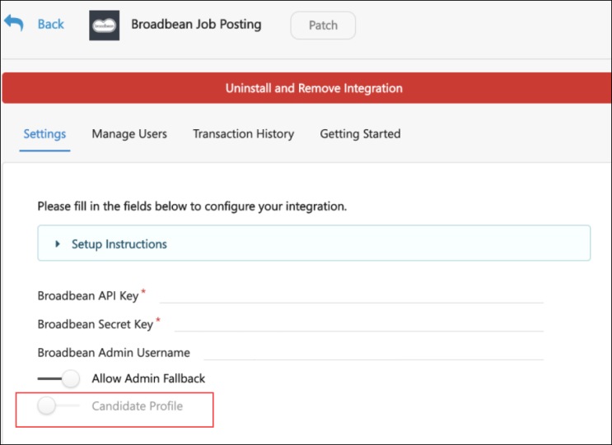
Online Help Topics Related to Broadbean
The following topics in Online Help provide information about the configuration and functionality for the Broadbean Job Posting integration:
- Broadbean Configuration in Edge - This topic provides instructions for configuring Broadbean in Edge. See Broadbean Job Posting Configuration in Edge on page 151 for additional information.
- Broadbean OFCCP Integration - This topic provides information about the Broadbean OFCCP integration. See Broadbean OFCCP Compliance Integration on page 161 for additional information.
- My Account - Social - This topic explains how to connect your user account to Broadbean so that you are already connected to Broadbean when posting jobs on the Job Postings page. See My Account - Social.
- Edit Job Board Cost - This topic covers job board costs related to Broadbean. See Edit Job Board Cost.
- Create Job Requisition - General - This topic mentions that jobs posted via Broadbean will only show the primary location for the job, rather than any additional locations that are configured for the requisition. See Create Job Requisition - General.
- Job Posting Page - This topic covers external job postings. See Job Posting Page.
- Requisition Level Costs - This topic provides information about requisition level costs. See Requisition Level Costs.
- Edit Job Requisition - For Broadbean postings, this topic provides information about the impact of the Canceled and Closed status on Broadbean postings. See Edit Job Requisition.
- Create job Requisition - Job Ad - For Broadbean integrations, this topic provides information on how the Job Postings page is populated with available jobs. See Create Job Requisition - Job Ad.
VONQ Job Post Integration
VONQ Job Post is an automation solution for high volume recruitment that reduces complexity and saves time. This integration simply and automatically distributes jobs to multiple sources, including programmatic advertising. Administrators can use the return on investment reports to make informed decisions about which sources deliver candidates at the lowest cost.
Implementation
This integration is available for self-activation in Edge Marketplace via the VONQ Job Post integration tile. This integration is for Cornerstone customers that also have an account with the integration vendor.
Permissions
The following existing permissions apply to this functionality:
PERMISSION NAME | PERMISSION DESCRIPTION | CATEGORY

Edge Integrations - Manage | Grants access to the Integrations service for Edge Integrate, where the administrator can configure, enable, and disable their third-party integrations used within the Cornerstone system. This permission cannot be constrained. This is an administrator permission. | Edge

Edge Marketplace - Manage | Grants access to the Marketplace service for Edge Integrate, where the administrator can browse integrations that can be used to extend the Cornerstone system. This permission cannot be constrained. This is an administrator permission. | Edge

New Hire Onboarding Integrations - Overview
ADP Workforce Now (WFN) for Recruiting & Onboarding Integration
ADP Workforce Now Recruiting & Onboarding Connector API integration creates new hire data in ADP. This is a one-way integration from Cornerstone to ADP Workforce Now current version (version 2.0 is not supported by API integration). This integration only applies to external new hires, not internal hires. The integration is triggered once the HR Admin saves the new hire’s user record in Cornerstone after going through the Manage Hired Applicants page.
CIC Plus Integration
Through integration with CIC Plus, employers can assign electronic tax withholding forms (W-4 forms) to new hires as part of the Onboarding workflow. New hires can then complete all applicable ho can then electronically complete tax withholding paperwork as part of their onboarding process. Employers are able to track tax withholding form completion, along with other onboarding tasks. This integration provides users access to the forms through a secure, self-service site.
Considerations
A future enhancement to the integration features may include the ability for employees to update existing W-4 forms.
Implementation & Configuration
The CIC Plus integration requires Cornerstone Onboarding and a CIC Plus account. This integration is available in the Edge Marketplace. Once the integration has been purchased, the functionality is not available until the integration is configured and enabled via Edge Integrations. Additional instructions for enabling and configuring the integration are available on the Setup tab of the integration in Edge.
When configuring the integration, the following applies:
- Provide User Refs as unique identifier for users. This helps to ensure that data syncs across Cornerstone, CIC Plus, and their other systems. If this information is not provided, then internal user IDs will be used.
- The target Location OUs for onboarding users must have complete address data, which includes a street address, city, state, ZIP code, and country.
- A parent form task that is assigned to the onboarding employee for the purpose of collecting the employee’s home address information must be configured prior to adding an integration task for completing W-4 forms.
- The W-4 Form (CIC Plus) integration task must be added to Onboarding Workflows as a child task of parent form tasks.
- A setting to collect the user's social security number and date of birth must be configured in CIC Plus.
Use Case
- Prior to issuing a new employee's first paycheck, an employer needs to know how much they need to withhold from an employee's paycheck for taxes. A task to complete the necessary W-4 form(s) needs to be assigned to new hires as an onboarding task.
- Amanda, an administrator, is configuring onboarding workflow tasks for new hire onboarding. She needs to add an integration task for W-4 forms to the onboarding tasks for the new hire. However, as a prerequisite to completing W-4 forms, Amanda needs to ensure that the employer has the most recent address information for the new hire. Amanda configures a form task as a parent task and assigns it to onboarding employees to collect their home address information. She then configures a form task as a child task and assigns it to Mark, a Human Resources (HR) representative, to collect the new hire's work location address. Finally as a child task to the two form tasks, Amanda configures an integration task for W-4 forms though integration partner CIC Plus to be assigned to onboarding employees.
- Vincent has just been hired and has started the onboarding process. He launches and completes a form task and fills out his home address.
- Mark launches and completes a form task to fill out Vincent's work address.
- Vincent is assigned an integration task to complete his W-4 forms. He clicks on his action item in Universal Profile to complete his W-4 forms. Through Single Sign-On (SSO), he is automatically signed into Paperless Employee, a CIC Plus Product, where he sees the W-4 forms he needs to complete. If Vincent still has more forms to complete after he submits a form, he receives a notification telling him how many pending forms he still has to complete. He can access and complete those forms through his original W-4 form action item. After Vincent completes all his pending forms, his W-4 form action items is automatically completed and removed from his list of action items.
- Esther, the HR Director, monitors the progress of onboarding employees. As new hires and HR representatives complete their respective tasks, she can see the completion progress for the new hire when it is updated. In the result column of the W-4 task, Esther can see how many W-4 forms are still pending for the new hire if they have not yet completed all the W-4 forms required for them.
Security
The following permissions apply to this functionality:
PERMISSION NAME | PERMISSION DESCRIPTION | CATEGORY

Action Items - View | Grants ability to view action items on the Action Items page and in the Your Action Items widget. Users without this permission cannot access the Action Items page. This permission can be constrained by Employee Relationship, OU, User's OU, User's Self and Subordinates, and User's Self. This is an end user permission. | Universal Profile

Employee Onboarding: Manage | Grants ability to manage user onboarding in the Onboarding Dashboard and the Onboarding tab on the Universal Profile. This permission can be constrained by OU, User's OU, and User Self and Subordinates. | Employee Onboarding

Action Items - Employee Onboarding | Grants ability to view Onboarding actions via the Universal Profile - Actions page or the Welcome/Custom page Actions widget. This permission cannot be constrained. This is an end user permission. | Universal Profile

Edge Marketplace - Manage | Grants access to the Marketplace service for Edge Integrate, where the administrator can browse integrations that can be used to extend the Cornerstone system. This permission cannot be constrained. This is an administrator permission. | Edge

Employee Onboarding: Manage | Grants ability to manage user onboarding in the Onboarding Dashboard and the Onboarding tab on the Universal Profile. This permission can be constrained by OU, User's OU, and User Self and Subordinates. | Employee Onboarding

Employee Onboarding: View | Grants ability to view the Onboarding Dashboard and the Onboarding tab on the Universal Profile. This permission can be constrained by OU, User's OU, and User Self and Subordinates. | Employee Onboarding

Onboarding Workflows - Manage | Grants ability to access and manage Onboarding Workflows. This permission cannot be constrained. This is an administrator permission. | Employee Onboarding - Administration

Onboarding Integrations - Manage | Grants administrator ability to manage Recruiting and Onboarding Integrations. This permission cannot be constrained. This is an administrator permission. | Employee Onboarding - Administration

Recruiting Integrations - Manage | Grants ability to access and manage the Recruiting Integrations Preferences page. This is an administrator permission. This permission cannot be constrained. | Recruiting Administration

OFCCP Compliance Integrations - Overview
Broadbean OFCCP Compliance Integration
OFCCP Compliance provider with non-government partnerships, which acquires Cornerstone job listings and distributes to state workforce agencies and their technology partners.
Implementation
This integration is a vendor-built integration and not by Cornerstone. More information and instructions can be found in Edge Integrate.
Permissions
The following existing permissions apply to this functionality:
PERMISSION NAME | PERMISSION DESCRIPTION | CATEGORY

Edge Integrations - Manage | Grants access to the Integrations service for Edge Integrate, where the administrator can configure, enable, and disable their third-party integrations used within the Cornerstone system. This permission cannot be constrained. This is an administrator permission. | Edge

Edge Marketplace - Manage | Grants access to the Marketplace service for Edge Integrate, where the administrator can browse integrations that can be used to extend the Cornerstone system. This permission cannot be constrained. This is an administrator permission. | Edge

Video Interview Integrations - Overview
Outmatch Video Interview Integration
The Outmatch Video Interview integration transforms your recruiting process with a video interview platform designed to boost efficiency in the hiring process and create engaging candidate experiences.
Outmatch lets recruiters create engaging recruitment experiences, while still managing, inviting, and reviewing candidates through the Cornerstone platform. Candidates complete the video interview via the Outmatch platform, where they can also experience your brand through engaging media and video content.
Video Interview Workflow
Recruiter Creates Interview > Recruiter Assigns Interview > Candidate Completes Interview > Recruiter Views Interview, Scores, and Status
Create Interview
Video interviews are created in the Outmatch platform. The recruiter will add a list of questions to the interview and save it in Outmatch.
Assign Interview
Video interviews are assigned on Manage Candidates or Manage Applicants, using the Assign Integration or Assign Assessment Task options respectively. Assigning the interview sends an email to the candidate, which will include a link to launch the interview.
For general information about assigning assessments to candidates:
- See Manage Candidates - Assign Integrations.
- See Manage Applicants - Assign Assessment Task.
Launch and Complete Interview
Candidates launch the video interview by clicking a link to the interview from the email sent by the recruiter. The video interview process consists of a series of questions, each of which appear on a new page within the interview. To answer a question, the candidate clicks a button to begin recording their answer. The candidate will be given a time limit for each question, and the recording will stop automatically at the end of the time limit.
Once all answers are recorded, the candidate can submit the interview.
View Interview, Scores, and Status
The interview is available to view from Manage Candidates or Manage Applicants by clicking the View Interview button. Clicking the button opens the Outmatch platform to the interview page, which includes options to view the interview, rate the candidate, and provide comments.
Any scores the candidate received for the interview are sent to Manage Candidates and Manage Applicants. The status of the interview is also available.
Implementation
The Outmatch Video Interview integration will be available on 8 March 2021 via Edge Marketplace for all organizations using Recruiting and that also have an account with the integration vendor.
Additional instructions for enabling and configuring the integration are available on the Setup tab of the integration in Edge. There is no additional cost associated with enabling this integration in Edge.
Permissions
The following existing permissions apply to this functionality:
PERMISSION NAME | PERMISSION DESCRIPTION | CATEGORY

Edge Integrations - Manage | Grants access to the Integrations service for Edge Integrate, where the administrator can configure, enable, and disable their third-party integrations used within the Cornerstone system. This permission cannot be constrained. This is an administrator permission. | Edge

Edge Marketplace - Manage | Grants access to the Marketplace service for Edge Integrate, where the administrator can browse integrations that can be used to extend the Cornerstone system. This permission cannot be constrained. This is an administrator permission. | Edge

Requisition: Manage | Grants ability to access and manage all requisitions regardless of ownership (constraints permitting). This permission also grants read-only access to the Applicant Review tab when creating or editing a job requisition. This permission can be constrained by OU, User's OU, and Grade. | Recruiting

Requisition: Owner | Enables owner to access requisitions and applicants for requisitions for which they are an owner. This permission also grants read-only access to video interviews that are completed by applicants via HireVue. For portals with Referral Suite enabled, this permission also enables requisition owners to edit the referral source on the Applicant Profile page. This permission cannot be constrained.  Note: This is a dynamically assigned permission that is not available in Security Role Administration. If the user is removed as an owner, the permission is revoked for the associated requisition. This permission cannot be manually assigned. Also, if a user has both the permission necessary to manage requisitions and be a requisition owner, the constraints of the Requisition: Manage permission overrule those of the Requisition: Owner permission. For requisition owners that do not also have permission to manage requisitions, only certain fields are editable when editing a requisition. | Recruiting
Visiotalent Assessment Integration
The Visiotalent Assessment integration built by CleverConnect offers cloud-based on-demand and live video interview solutions to uncover a candidate's personality and soft skills while reducing your time-to-hire.
Implementation
The Visiotalent Assessment integration will be available on 21 December 2020 via Edge Marketplace for all organizations using the Recruiting suite and that also have an account with the integration vendor.
Additional instructions for enabling and configuring the integration are available on the Setup tab of the integration in Edge. There is no additional cost associated with enabling this integration in Edge.
Permissions
The following existing permissions apply to this functionality:
PERMISSION NAME | PERMISSION DESCRIPTION | CATEGORY

Edge Integrations - Manage | Grants access to the Integrations service for Edge Integrate, where the administrator can configure, enable, and disable their third-party integrations used within the Cornerstone system. This permission cannot be constrained. This is an administrator permission. | Edge

Edge Marketplace - Manage | Grants access to the Marketplace service for Edge Integrate, where the administrator can browse integrations that can be used to extend the Cornerstone system. This permission cannot be constrained. This is an administrator permission. | Edge

Work Opportunity Tax Credit Integrations - Overview
ADP Work Opportunity Tax Credit Overview
The ADP Work Opportunity Tax Credit (WOTC) Integration provides an additional integration option for assigning WOTC surveys. This integration enables organizations to identify applicants that may qualify for WOTC program tax credits by assigning ADP's WOTC surveys from within Recruiting.
Use Cases
Use Case 1: Activate the ADP WOTC integration through Edge
- James is Acme Company's administrator and has been tasked with enabling the WOTC integration between Cornerstone and ADP. This will allow Acme to include the WOTC survey in their application process and enable ADP to manage the submission process.
- James goes to the Edge Marketplace to purchase and activate the ADP WOTC integration. James will also work with his ADP project team to configure Acme's ADP system.
- From the Edge Integrate page, James enters Acme's Client ID, Client Secret, Company Code, and Authentication Code, which is provided by their ADP project team.
- Acme's Cornerstone portal now has an active WOTC integration between Cornerstone and ADP.
Use Case 2: Recruiting Administrator configures ADP WOTC survey as an action step in Application Workflow
- Allan is the Recruiting administrator for Acme.
- With the integration enabled, Allan is tasked with including a WOTC survey in all of Acme's Customer Support requisitions.
- Allan creates a new custom application workflow template that includes a WOTC action step, ensuring that ADP WOTC is added as a custom integration.
- Allan configures all Customer Support requisitions to include the custom application workflow template, which includes a WOTC action step.
- Applicants applying to the Customer Support requisition are now prompted to complete an ADP WOTC survey as part of their application process.
Use Case 3: Recruiter assigns an ad hoc assessment to an applicant
- Lisa, a hiring manager at Acme, is looking to add two new members to her Customer Support team.
- To help reduce the company's income tax liability, Lisa would like to consider hiring a WOTC eligible candidate.
- Lisa goes to the Manage Applicants page for the Customer Support requisition and identifies four potential candidates to assign a WOTC survey to, making sure that all candidates' statuses are assigned to the custom status ADP WOTC.
- While the same candidates are selected, Lisa selects the Assign Integration Assessment option from the Actions drop-down. She proceeds with the assignment and clicks Submit.
- The applicants will receive an email with a link that will redirect them to complete the ADP WOTC survey. Note: The Assign Integration Assessment email will need to be successfully configured by the administrator in Email Administration in order for the applicant to receive the email.
- Cornerstone runs a batch update to update the candidate's assessment status.
- Lisa can check either the Manage Applicants page or the Applicant Profile page for updates on the applicant's potential eligibility status.
Use Case 4: Recruiter hires a candidate
- Annie the Candidate has accepted Acme's employment offer.
- Lisa updates Annie's status to "Hired," which triggers Cornerstone to send the offer information to ADP.
- Lisa can view updated eligibility information on Annie's Applicant Profile page or the Manage Applicants page. Lisa can also print relevant ADP forms by clicking the View Report link on the Manage Applicants page or the applicable status panel on the Applicant Profile > Statuses tab.
Implementation
This integration is available for all organizations using Recruiting. This integration is available for free via Edge Marketplace. Additional instructions for enabling and configuring the integration are available on the Setup tab of the integration in Edge.
Considerations
- Retroactive Application - WOTC surveys cannot be retroactively applied to requisitions prior to enabling of the integration, even though these requisitions are in open/active status.
- Social Security Number - With this integration, ADP will collect the candidate’s Social Security Number at the time the candidate is completing the WOTC survey.
- Application Workflow Set-Up - ADP WOTC surveys cannot be a required step in the application workflow.
Best Practices for Using WOTC Surveys
As a best practice, display the WOTC survey between an Education Experience section and a section such as EEO Questions.
Permissions
The following permissions apply to this functionality:
PERMISSION NAME | PERMISSION DESCRIPTION | CATEGORY

Applicant Status Bank - Manage | Grants ability to access and manage Applicant Status Bank. | Recruiting Administration

Applicants: Assign Assessment Integration | Grants access to manage assessment integrations from the Applicant Profile page. This applies to assessments that have been configured in the integration center. This permission cannot be constrained. This permission is only available for portals that have an active assessments integration.  This is the highest level of permission for this functionality. In addition to being able to assign assessments, users with this permission will be able to view the assessment status and assessment details. | Recruiting

Applicants: View Assessment Integration Status | Allows user to view the assessment integration check status on the Applications tab of the Applicant Profile page. The user cannot view the link to the detailed report of the assessment. This permission cannot be constrained. This permission is only available for portals that have an active assessments integration.  This is the lowest level of permission for this functionality. Users with this permission can only view the assessment status; they cannot assign assessments or view assessment details. | Recruiting

Applicants: View Assessment Integration Status and Details Link | Allows user to view the assessment integration status and view link to access the assessment report from the Applications tab of the Applicant Profile page and from the associated column on the Manage Applicants page. This permission cannot be constrained. This permission is only available for portals that have an active assessments integration.  This is the second highest level of permission for this functionality. Users with this permission will be able to view the assessment status and assessment details but will not be able to assign assessments. | Recruiting

Application Workflow Template - Manage | Grants ability to access and manage Application Workflow Templates. This permission can be constrained by OU and User’s OU. This is an administrator permission. | Recruiting Administration

Application Workflow Template - View | Grants ability to access and view Application Workflow Templates. | Recruiting Administration

Edge Integrations - Manage | Grants access to the Integrations service for Edge Integrate, where the administrator can configure, enable, and disable their third-party integrations used within the Cornerstone system. This permission cannot be constrained. This is an administrator permission. | Edge

Edge Marketplace - Manage | Grants access to the Marketplace service for Edge Integrate, where the administrator can browse integrations that can be used to extend the Cornerstone system. This permission cannot be constrained. This is an administrator permission. | Edge

Global Email Administration - Manage | Grants ability to manage email trigger templates across all active modules in the portal. Enables creating, editing and deleting email message templates for various system actions and workflows. This permission can be constrained by OU, User's OU, User Self and Subordinates, and User. This is an administrator permission. | Core Administration

Global Email Administration - View | Grants view only access to email templates/triggers and email logs at the global level for the portal. This permission can be constrained by OU, User's OU, User Self and Subordinates, and User. This is an administrator permission. | Core Administration

Requisition: Manage | Grants ability to access and manage all requisitions regardless of ownership (constraints permitting). This permission also grants read-only access to the Applicant Review tab when creating or editing a job requisition. This permission can be constrained by OU, User's OU, and Grade. | Recruiting

Requisition: Owner | Enables owner to access requisitions and applicants for requisitions for which they are an owner. This permission also grants read-only access to video interviews that are completed by applicants via HireVue. For portals with Referral Suite enabled, this permission also enables requisition owners to edit the referral source on the Applicant Profile page. This permission cannot be constrained.  Note: This is a dynamically assigned permission that is not available in Security Role Administration. If the user is removed as an owner, the permission is revoked for the associated requisition. This permission cannot be manually assigned. Also, if a user has both the permission necessary to manage requisitions and be a requisition owner, the constraints of the Requisition: Manage permission overrule those of the Requisition: Owner permission. For requisition owners that do not also have permission to manage requisitions, only certain fields are editable when editing a requisition. | Recruiting

Requisition: Reviewer | Enables reviewer to access requisitions and applicants for requisitions for which they are a reviewer. This permission cannot be constrained.  Note: This is a dynamically assigned permission that is not available in Security Role Administration. Once a requisition is in a Closed or Cancelled status or if the user is removed as a reviewer, the permission is revoked for the associated requisition. This permission cannot be manually assigned.  Note: If an applicant reviewer is removed as a reviewer via the Applicant Profile page, the Requisition: Reviewer permission is revoked for the associated requisition. However, if the reviewer was also added as a reviewer via the General tab when creating, editing, or copying the requisition, the reviewer still appears on the In Review panel as a duplicate reviewer and retains access to the requisition and applicants from the Requisition: Reviewer permission. See Applicant Profile Page Overview for more information about duplicate reviewer instances. | Recruiting
ADP WOTC Integration Implementation Steps
Applicant Statuses - Create Custom ADP WOTC Status
In order for the ADP WOTC status to be available to select for applicants, it is necessary to create a custom integration status in Manage Applicant Statuses.
Permissions
PERMISSION NAME | PERMISSION DESCRIPTION | CATEGORY

Applicant Status Bank - Manage | Grants ability to access and manage Applicant Status Bank. | Recruiting Administration
Emails
EMAIL NAME | EMAIL DESCRIPTION | ACTION TYPE

Assign Integration Assessment | This email is triggered when an Edge integration assessment is assigned to an applicant, such as a WOTC assessment. This email can be configured as a notification or a reminder, and it can be sent to External Applicant, Internal Applicant, OU Approver, Hiring Manager, OU Approver, or a specific user.  This email only triggers when a successful response is received from the vendor.  Note: The APPLICANT.INTEGRATION.ASSESSMENT.LINK tag must be included in the email. This tag provides a link that the applicant can click to access the assessment.  Note about Auto-Assignment of Pre-Employment Verifications: This email also applies to auto-assignment of pre-employment verifications, via the Automated Candidate Progression (Early Adopter) functionality. For more information, see Feature Activation Preferences. | Recruiting
Create Custom Status
To create a custom integration status for ADP WOTC:
- Navigate to Admin > Tools > Recruit > Applicant Statuses.
- Click Create Custom Status. This opens the Create Custom Status pop-up.
- Complete the following fields in the Create Custom Status pop-up:
  - Language - If multiple languages are enabled, from the drop-down list select the language in which you are entering the status name and description. To localize the status name and description into other available languages, select the appropriate language from the drop-down list and enter the localized name and description in the appropriate fields.
  - Display Name - Enter "ADP WOTC" to identify the status as being specifically for ADP WOTC assessments. This field accepts up to 50 characters. If you change the display name after it is in use:
    - The new display name appears on the Default Status List page.
    - The new display name appears in the Status list on the job requisition template.
    - Any new job requisitions created after the display name is changed will apply the new display name.
    - Job requisitions created before the status display name is changed will continue to honor the name that existed at the time the requisition was created.
  - Description - Enter a description, up to 500 characters. As a best practice, provide a description that helps recruiters understand the purpose of this status.
  - Type - Select Custom Integration. The Custom Integration status type mans that the applicant is in an integration step of the status workflow. When creating a custom status for a child organizational unit (OU), the Type field displays the type selected for the parent OU but is not editable.
  - Integration - Select ADP WOTC in this field, which will associate the custom status to ADP WOTC integration.
  - Active - This option is selected by default and means the status will be available to include in status workflows.
- Click Save in the pop-up. This returns you to the Manage Applicant Statuses page.
- Click Save at the bottom of the Manage Applicant Statuses page to save the custom status to the Division OU. If the custom status is not saved on the Manage Applicant Statuses page, the status will be lost once you leave the page.
The custom applicant status will need to be added to the Status List on the requisition template so that it will be included on the job requisition.
Add ADP WOTC Custom Integration Action
When including the ADP WOTC integration in the applicant statuses for a job requisition, the Custom Integration action item must also be included in the application workflow. This allows applicants to complete the assessment during the application process. See Application Workflow - Add Integration.
Note: ADP WOTC assessments can also be assigned to applicants on an ad hoc basis from the Manage Applicants page.
To create an application workflow template, go to Admin > Tools > Recruit > Application Workflow Templates. Then click the Create Template link.
Note: The application workflow can also be configured in requisition templates, the default requisition template, and job requisitions.
Permissions
PERMISSION NAME | PERMISSION DESCRIPTION | CATEGORY

Application Workflow Template - Manage | Grants ability to access and manage Application Workflow Templates. This permission can be constrained by OU and User’s OU. This is an administrator permission. | Recruiting Administration

Application Workflow Template - View | Grants ability to access and view Application Workflow Templates. | Recruiting Administration
Assign ADP WOTC Assessment
ADP WOTC assessments can be included in the application workflow for a job requisition and can also be assigned to applicants from the Manage Applicants page.
- When included in the application workflow, the assessment is part of the process of applying for the job and should be configured as optional to complete.
- When assigned via the Manage Applicants page, recruiters have more flexibility in when they want to assign the assessment and specify the applicants who will receive the assessment.
Assign Assessment in Application Workflow
To include the assessment in the application workflow, the "Custom Integration" action item must be part of the workflow on the job requisition. For more information about including the assessment in the application, see the Application Workflow - Add ADP WOTC Custom Integration Action topic in Online Help.
Applicants click the Launch option on the application workflow step to open and complete the assessment. This registers the applicant with ADP and provides the applicant with access to the WOTC assessment that is part of the job requisition.
Recruiters can view the results on either the Manage Applicants page or the Applicant Profile > Statuses tab. Results are updated every 15 minutes.
Assign Assessment from Manage Candidates
See Manage Candidates - Assign Integrations.
Assign Assessment from Manage Applicants Page
To assign the assessment from the Manage Applicants page:
- Navigate to the Manage Applicants page for the job requisition.
- Select one or more applicants to whom you would like to assign the assessment.
- Click Assign Integration Assessment from the Actions drop-down. This opens the Assign Integration Assessment pop-up.
- Verify that the ADP WOTC assessment is selected.
- Click Submit. This sends the Assign Integration Assessment email to the applicant, which includes a link that directs them to ADP to complete the assessment.
Note: The Assign Integration Assessment email trigger email will need to be successfully configured in Email Administration in order for the applicant to receive the email. See Email Triggers.
Recruiters can view the results on either the Manage Applicants page or the Applicant Profile > Statuses tab. Results are updated every 15 minutes.
Manage Applicants Deprecation: Cornerstone is deprecating Manage Applicants in Q1 2024. See Manage Applicants Overview.
View ADP WOTC Assessment Results
Recruiters can view the results of ADP WOTC assessments on Manage Candidates, Manage Applicants, or the Statuses tab on the Applicant Profile page. Results are updated every 15 minutes.
- Cornerstone will pull updates for candidates whose assessment status is in either In Progress or Incomplete and for those who have an assessment assign date of 60 days or less from the time the scheduler runs.
- Candidates whose assessment status is in either In Progress or Incomplete and have an assessment assign date of 61 days or more (from the time the scheduler runs) will be marked Cancelled.
Once a candidate is in a Hired status, Cornerstone sends an update to ADP to initiate and complete the tax credit paperwork.
The Location OU ID associated with the job requisition should match the work location IDs in ADP.
Manage Applicants Deprecation: Cornerstone is deprecating Manage Applicants in Q1 2024. See Manage Applicants Overview.
First Advantage Work Opportunity Tax Credit Integration - Overview
The First Advantage (FADV) Work Opportunity Tax Credit (WOTC) integration provides an additional integration option for assigning Work Opportunity Tax Credit surveys. This integration enables organizations to identify applicants that may qualify for Work Opportunity Tax Credit program tax credits by assigning First Advantage's Work Opportunity Tax Credit surveys from within the Applicant Tracking System (ATS).
Use Cases
Use Case 1: Activate the First Advantage Work Opportunity Tax Credit integration through Edge
- James is Acme Company's administrator and has been tasked with enabling the Work Opportunity Tax Credit integration between Cornerstone and First Advantage. This will allow Acme to include the Work Opportunity Tax Credit survey in their application process and enable First Advantage to manage the submission process.
- James goes to the Edge Marketplace to purchase and activate the First Advantage Work Opportunity Tax Credit integration.
- From the Edge Integrate page, James enters Acme's Company ID, which is provided by their First Advantage project team.
- Acme's Cornerstone portal now has an active Work Opportunity Tax Credit integration between Cornerstone and First Advantage.
Use Case 2: Recruiting Administrator configures First Advantage Work Opportunity Tax Credit survey as an action step in Application Workflow
- Allan is the Recruiting administrator for Acme.
- With the integration enabled, Allan is tasked with including a Work Opportunity Tax Credit survey in all of Acme's Customer Support requisitions.
- Allan creates a new custom application workflow template that includes a Work Opportunity Tax Credit action step, ensuring that First Advantage Work Opportunity Tax Credit is added as a custom integration.
- Allan configures all Customer Support requisitions to include the custom application workflow template, which includes a Work Opportunity Tax Credit action step.
- Applicants applying to the Customer Support requisition are now prompted to complete a First Advantage Work Opportunity Tax Credit survey as part of their application process.
Use Case 3: Recruiter assigns an ad hoc assessment to an applicant
- Lisa, a hiring manager at Acme, is looking to add two new members to her Customer Support team.
- To help reduce the company's income tax liability, Lisa would like to consider hiring a Work Opportunity Tax Credit eligible candidate.
- Lisa goes to the Manage Applicants page for the Customer Support requisition and identifies four potential candidates to assign a Work Opportunity Tax Credit survey to, making sure that all candidates' statuses are assigned to the custom status First Advantage Work Opportunity Tax Credit.
- While the same candidates are selected, Maria selects the Assign Integration Assessment option from the Actions drop-down. She proceeds with the assignment and clicks Submit.
- The applicants will receive an email with a link that will redirect them to complete the First Advantage Work Opportunity Tax Credit survey. Note: The Assign Integration Assessment email trigger email will need to be successfully configured by the administrator in Email Administration in order for the applicant to receive the email.
- After the applicants complete the survey, First Advantage sends Cornerstone a summary of the candidate’s results, which are available for viewing on the Manage Applicants page or the Application tab on the Applicant Profile page.
- To further review the assessment results, Lisa clicks the View Report link, which will direct her to First Advantage to view a detailed report of the assessment results.
Implementation
This integration is available for all organizations using the Recruiting suite. This integration is available for free via Edge Marketplace. Additional instructions for enabling and configuring the integration are available on the Setup tab of the integration in Edge.
The integration can be accessed and configured via the Edge Marketplace. In order to use this integration, your organization must be using the Recruiting module and must have access to Edge and have an account with the integration vendor. There is no additional cost associated with enabling this integration, but the integration cannot be used without an account with the integration vendor.
Considerations
- Mobile App - This functionality is not available in the mobile app. If the survey is included in a step of the application workflow, the step will be skipped in the mobile app.
- Retroactive Application - Work Opportunity Tax Credit surveys cannot be retroactively applied to requisitions prior to enabling of the integration, even though these requisitions are in open/active status.
- With this integration, First Advantage will collect the candidate’s Social Security Number at the time the candidate is completing the Work Opportunity Tax Credit survey.
Best Practices for Using WOTC Surveys
- Where to Place in Application Workflow - Display WOTC between an Education Experience section and a section such as Equal Employment Opportunity (EEO) Questions.
Permissions
The following permissions apply to this functionality:
PERMISSION NAME | PERMISSION DESCRIPTION | CATEGORY

Applicant Status Bank - Manage | Grants ability to access and manage Applicant Status Bank. | Recruiting Administration

Applicants: Assign Assessment Integration | Grants access to manage assessment integrations from the Applicant Profile page. This applies to assessments that have been configured in the integration center. This permission cannot be constrained. This permission is only available for portals that have an active assessments integration.  This is the highest level of permission for this functionality. In addition to being able to assign assessments, users with this permission will be able to view the assessment status and assessment details. | Recruiting

Applicants: View Assessment Integration Status | Allows user to view the assessment integration check status on the Applications tab of the Applicant Profile page. The user cannot view the link to the detailed report of the assessment. This permission cannot be constrained. This permission is only available for portals that have an active assessments integration.  This is the lowest level of permission for this functionality. Users with this permission can only view the assessment status; they cannot assign assessments or view assessment details. | Recruiting

Applicants: View Assessment Integration Status and Details Link | Allows user to view the assessment integration status and view link to access the assessment report from the Applications tab of the Applicant Profile page and from the associated column on the Manage Applicants page. This permission cannot be constrained. This permission is only available for portals that have an active assessments integration.  This is the second highest level of permission for this functionality. Users with this permission will be able to view the assessment status and assessment details but will not be able to assign assessments. | Recruiting

Application Workflow Template - Manage | Grants ability to access and manage Application Workflow Templates. This permission can be constrained by OU and User’s OU. This is an administrator permission. | Recruiting Administration

Application Workflow Template - View | Grants ability to access and view Application Workflow Templates. | Recruiting Administration

Edge Integrations - Manage | Grants access to the Integrations service for Edge Integrate, where the administrator can configure, enable, and disable their third-party integrations used within the Cornerstone system. This permission cannot be constrained. This is an administrator permission. | Edge

Edge Marketplace - Manage | Grants access to the Marketplace service for Edge Integrate, where the administrator can browse integrations that can be used to extend the Cornerstone system. This permission cannot be constrained. This is an administrator permission. | Edge

Global Email Administration - Manage | Grants ability to manage email trigger templates across all active modules in the portal. Enables creating, editing and deleting email message templates for various system actions and workflows. This permission can be constrained by OU, User's OU, User Self and Subordinates, and User. This is an administrator permission. | Core Administration

Global Email Administration - View | Grants view only access to email templates/triggers and email logs at the global level for the portal. This permission can be constrained by OU, User's OU, User Self and Subordinates, and User. This is an administrator permission. | Core Administration

Requisition: Manage | Grants ability to access and manage all requisitions regardless of ownership (constraints permitting). This permission also grants read-only access to the Applicant Review tab when creating or editing a job requisition. This permission can be constrained by OU, User's OU, and Grade. | Recruiting

Requisition: Owner | Enables owner to access requisitions and applicants for requisitions for which they are an owner. This permission also grants read-only access to video interviews that are completed by applicants via HireVue. For portals with Referral Suite enabled, this permission also enables requisition owners to edit the referral source on the Applicant Profile page. This permission cannot be constrained.  Note: This is a dynamically assigned permission that is not available in Security Role Administration. If the user is removed as an owner, the permission is revoked for the associated requisition. This permission cannot be manually assigned. Also, if a user has both the permission necessary to manage requisitions and be a requisition owner, the constraints of the Requisition: Manage permission overrule those of the Requisition: Owner permission. For requisition owners that do not also have permission to manage requisitions, only certain fields are editable when editing a requisition. | Recruiting

Requisition: Reviewer | Enables reviewer to access requisitions and applicants for requisitions for which they are a reviewer. This permission cannot be constrained.  Note: This is a dynamically assigned permission that is not available in Security Role Administration. Once a requisition is in a Closed or Cancelled status or if the user is removed as a reviewer, the permission is revoked for the associated requisition. This permission cannot be manually assigned.  Note: If an applicant reviewer is removed as a reviewer via the Applicant Profile page, the Requisition: Reviewer permission is revoked for the associated requisition. However, if the reviewer was also added as a reviewer via the General tab when creating, editing, or copying the requisition, the reviewer still appears on the In Review panel as a duplicate reviewer and retains access to the requisition and applicants from the Requisition: Reviewer permission. See Applicant Profile Page Overview for more information about duplicate reviewer instances. | Recruiting
Applicant Statuses - Create Custom Status and Include in Application Workflow
In order for the First Advantage (FADV) Work Opportunity Tax Credit (WOTC) survey status to be available to select for applicants, it is necessary to create a custom integration status in Manage Applicant Statuses. You will also need to include the assessment in the application workflow if you would like the assessment to be part of the application.
Permissions
PERMISSION NAME | PERMISSION DESCRIPTION | CATEGORY

Applicant Status Bank - Manage | Grants ability to access and manage Applicant Status Bank. | Recruiting Administration

Application Workflow Template - Manage | Grants ability to access and manage Application Workflow Templates. This permission can be constrained by OU and User’s OU. This is an administrator permission. | Recruiting Administration

Application Workflow Template - View | Grants ability to access and view Application Workflow Templates. | Recruiting Administration
Emails
EMAIL NAME | EMAIL DESCRIPTION | ACTION TYPE

Assign Integration Assessment | This email is triggered when an Edge integration assessment is assigned to an applicant, such as a WOTC assessment. This email can be configured as a notification or a reminder, and it can be sent to External Applicant, Internal Applicant, OU Approver, Hiring Manager, OU Approver, or a specific user.  This email only triggers when a successful response is received from the vendor.  Note: The APPLICANT.INTEGRATION.ASSESSMENT.LINK tag must be included in the email. This tag provides a link that the applicant can click to access the assessment.  Note about Auto-Assignment of Pre-Employment Verifications: This email also applies to auto-assignment of pre-employment verifications, via the Automated Candidate Progression (Early Adopter) functionality. For more information, see Feature Activation Preferences. | Recruiting
Emails
EMAIL NAME | EMAIL DESCRIPTION | ACTION TYPE

Assign Integration Assessment | This email is triggered when an Edge integration assessment is assigned to an applicant, such as a WOTC assessment. This email can be configured as a notification or a reminder, and it can be sent to External Applicant, Internal Applicant, OU Approver, Hiring Manager, OU Approver, or a specific user.  This email only triggers when a successful response is received from the vendor.  Note: The APPLICANT.INTEGRATION.ASSESSMENT.LINK tag must be included in the email. This tag provides a link that the applicant can click to access the assessment.  Note about Auto-Assignment of Pre-Employment Verifications: This email also applies to auto-assignment of pre-employment verifications, via the Automated Candidate Progression (Early Adopter) functionality. For more information, see Feature Activation Preferences. | Recruiting
Create Custom Status
To create a custom integration status:
- Navigate to Admin > Tools > Recruit > Applicant Statuses. Then, select the top level organizational unit (OU).
- Click Create Custom Status. This opens the Create Custom Status pop-up.
- Complete the following fields in the Create Custom Status pop-up:
  - Language - If multiple languages are enabled, from the drop-down list select the language in which you are entering the status name and description. To localize the status name and description into other available languages, select the appropriate language from the drop-down list and enter the localized name and description in the appropriate fields.
  - Display Name - Enter "First Advantage Work Opportunity Tax Credit" to identify the status as being specifically for First Advantage Work Opportunity Tax Credit assessments. This field accepts up to 50 characters. If you change the display name after it is in use:
    - The new display name appears on the Default Status List page.
    - The new display name appears in the Status list on the job requisition template.
    - Any new job requisitions created after the display name is changed will apply the new display name.
    - Job requisitions created before the status display name is changed will continue to honor the name that existed at the time the requisition was created.
  - Description - Enter a description, up to 500 characters. As a best practice, provide a description that helps recruiters understand the purpose of this status.
  - Type - Select Custom Integration. The Custom Integration status type mans that the applicant is in an integration step of the status workflow. When creating a custom status for a child organizational unit (OU), the Type field displays the type selected for the parent OU but is not editable.
  - Integration - Select First Advantage Work Opportunity Tax Credit in this field, which will associate the custom status to the integration.
  - Active - This option is selected by default and means the status will be available to include in status workflows.
- Click Save in the pop-up. This returns you to the Manage Applicant Statuses page.
- Click Save at the bottom of the Manage Applicant Statuses page to save the custom status to the Division OU. If the custom status is not saved on the Manage Applicant Statuses page, the status will be lost once you leave the page.
The custom applicant status will need to be added to the Status List on the requisition template so that it will be included on the job requisition.
Add to Standard Application Workflow
The assessment can be included in the application workflow template for Standard and Mobile-Friendly applications so that it is considered a step in the application workflow process for applicants. See Application Workflow - Add Integration.
For Standard application workflows:
- Navigate to Admin > Tools > Recruit > Applicant Workflow Templates.
- Click the Create Template link. This action directs the administrator to the Create Template page.
- Complete the fields on the Create Template page. Note: If "Mobile-Friendly" displays in the Application Type field, then you will need to select Standard from the field and restart the application workflow.
  - Name - Enter a descriptive name for the application workflow template. If multiple languages are enabled, select the language from the drop down list for which you are entering the status name and description. To localize the status name and description into other available languages, select the appropriate language from the drop down list and enter the localized name and description in the appropriate fields.
  - Description - Enter a description for the application workflow template. This should describe the purpose of the workflow. The character limit for this field is 100.
  - Add a Section - Click on the Add Section icon . This opens the Add Section pop-up.
    - Title - Enter a descriptive value in the field, which has a character limit of 50.
    - Click Save.
  - Add Action Item - Select Custom Integration from the Add Action Item drop-down. This opens the Edit Action Item pop-up. Complete the following fields in the pop-up:
    - Title - Enter a descriptive value in the Title field which is a required field. This character for this field is 50
    - Instructions - Enter instructions for the action item. This field is optional. It accepts HTML and does not have a character limit.
    - Integration - Select First Advantage Work Opportunity Tax Credit.
    - Please select - Select the appropriate assessment to associate with this application workflow template
    - Completion Required - Select this option to require applicants to complete the integration step before moving to the next step in the application workflow.
  - Click Save to save the action item.
- Click Save to save the application workflow template.
- Configure the job requisition to include the custom application workflow.
Add to Mobile-Friendly Application Workflow
See Create Mobile-Friendly Application Workflow.
Applicant Experience - FADV WOTC Survey
When an First Advantage (FADV) Work Opportunity Tax Credit (WOTC) survey is included in the application workflow, applicants can complete the survey when filling out the application. The survey appears as a step in the workflow. The name of the step is dependent upon how the step is named when configuring the application workflow template associated with the requisition.
Emails
EMAIL NAME | EMAIL DESCRIPTION | ACTION TYPE

Assign Integration Assessment | This email is triggered when an Edge integration assessment is assigned to an applicant, such as a WOTC assessment. This email can be configured as a notification or a reminder, and it can be sent to External Applicant, Internal Applicant, OU Approver, Hiring Manager, OU Approver, or a specific user.  This email only triggers when a successful response is received from the vendor.  Note: The APPLICANT.INTEGRATION.ASSESSMENT.LINK tag must be included in the email. This tag provides a link that the applicant can click to access the assessment.  Note about Auto-Assignment of Pre-Employment Verifications: This email also applies to auto-assignment of pre-employment verifications, via the Automated Candidate Progression (Early Adopter) functionality. For more information, see Feature Activation Preferences. | Recruiting
Launch Survey
The applicant clicks Launch on the application workflow step or from the email that was sent when the survey was assigned via the Manage Applicants page. This will register the applicant with First Advantage and open the Work Opportunity Tax Credit survey that is associated with the job requisition.
The survey opens in a new tab or browser. Upon the candidate completing the survey, First Advantage processes the results and sends an update to Cornerstone.
Initiate Tax Credit Paperwork
When a candidate is hired, Cornerstone sends an update to First Advantage to initiate the client's tax credit paperwork (i.e., when the hired candidate completes the required hours). The results display "Hire status submitted to First Advantage."
View First Advantage Work Opportunity Tax Credit Survey Results
A summary of the results are available in the following areas of Recruiting:
- Manage Candidates
- Manage Applicants
- Applicant Profile > Application tab > First Advantage Work Opportunity Tax Credit integration custom status panel
Manage Applicants Deprecation: Cornerstone is deprecating Manage Applicants in Q1 2024. See Manage Applicants Overview.
Permissions
PERMISSION NAME | PERMISSION DESCRIPTION | CATEGORY

Applicants: Assign Assessment Integration | Grants access to manage assessment integrations from the Applicant Profile page. This applies to assessments that have been configured in the integration center. This permission cannot be constrained. This permission is only available for portals that have an active assessments integration.  This is the highest level of permission for this functionality. In addition to being able to assign assessments, users with this permission will be able to view the assessment status and assessment details. | Recruiting

Applicants: View Assessment Integration Status | Allows user to view the assessment integration check status on the Applications tab of the Applicant Profile page. The user cannot view the link to the detailed report of the assessment. This permission cannot be constrained. This permission is only available for portals that have an active assessments integration.  This is the lowest level of permission for this functionality. Users with this permission can only view the assessment status; they cannot assign assessments or view assessment details. | Recruiting

Applicants: View Assessment Integration Status and Details Link | Allows user to view the assessment integration status and view link to access the assessment report from the Applications tab of the Applicant Profile page and from the associated column on the Manage Applicants page. This permission cannot be constrained. This permission is only available for portals that have an active assessments integration.  This is the second highest level of permission for this functionality. Users with this permission will be able to view the assessment status and assessment details but will not be able to assign assessments. | Recruiting
Survey Results
The results display the following information:
- Status
- Result
- Check Order Progress/View Report link - Click the link to check the progress of the survey processing or view the survey results once they have finished processing.
The results only appear for users with permission to assign and view assessment integrations and view the assessment integration status and details link. For users without these permissions, they can only view the date on which the survey was assigned and the integration order status (Acknowledged, Completed, etc.).
TCC Work Opportunity Tax Credit/TCC Integration - Overview
You can utilize the Tax Credit Co. (TCC) Work Opportunity Tax Credit (WOTC) Integrationto hire candidates that qualify for Work Opportunity Tax credits without having to manage the Tax Credit Co. submission and approval workflows separately. The Tax Credit Co. Work Opportunity Tax Credit integration allows you to leverage Tax Credit Co.'s legally sound Work Opportunity Tax Credit qualifying screening tool as part of your application process.
The Work Opportunity Tax Credit enhancement will need to be purchased and configured in the Cornerstone Edge Marketplace. Once configured, the integration can be enabled/disabled through the Cornerstone Edge portal.
Configuration Methods
Tax Credit Co. Work Opportunity Tax Credit assessments can be configured in the following ways:
- Tax Credit Co.-Work Opportunity Tax Credit Assessments as Part of the Application Workflow - This allows you to include an assessment step in the application workflow for a given job requisition. When an applicant reaches the Work Opportunity Tax Credit assessment step in the application, the assessment is launched in a new window, where the applicant can complete the assessment. When the assessment is completed, Tax Credit Co. sends your portal the eligibility information for the applicant. If the applicant is hired, then their "Hired" status and salary/rate is communicated to Tax Credit Co. Then, Tax Credit Co. processes the tax credit paperwork. Work Opportunity Tax Credit assessment status information is available on the Application tab within the Applicant Profile page. Applicants that complete the assessment as part of the application workflow can view the status of their Work Opportunity Tax Credit assessment from their Career Site > My Profile page by filtering for applications with a status of "Applied."
- Tax Credit Co.-Work Opportunity Tax Credit Assessments that Can Be Assigned on an Ad Hoc Basis - This allows you to assign assessments to applicants as needed. When the assessment is assigned from Manage Candidates or Manage Applicants, the applicant is sent an email with a link that will direct them to the vendor's site, where they can complete the assessment. The assessment is completed independently of the career site and application workflow. When the assessment is completed, Tax Credit Co. sends your portal the eligibility information for the applicant. If the applicant is hired, then the applicant's "Hired" status and salary/rate is communicated to Tax Credit Co. Then, Tax Credit Co. processes the tax credit paperwork. The Work Opportunity Tax Credit assessment status information is available on the Application tab within the Applicant Profile page.
Use Cases
Part 1: Client Engages with Work Opportunity Tax Credit Assessment Partner
- Randal is the Recruiting BPO for Acme Corporation. As a company, Acme provides technical and sales support for Fortune 500 organizations.
- Acme has engaged with Tax Credit Co. to handle the Work Opportunity Tax Credit assessment and submission process for WOTC-qualified applicants.
- Satisfied with the methodology and structure of the assessments, Randal would like to deploy the assessments via an Edge Integration with Tax Credit Co.
Part 2: Corp Admin activates Integration through Edge
- Jennifer is the corporate administrator for Acme.
- Randal has requested that Jennifer activate the integration between the portal and Tax Credit Co. so that Acme can include Tax Credit Co. Work Opportunity Tax Credit assessments in their application workflows.
- As the corporate administrator, Jennifer accesses the Edge Integration Marketplace to activate Acme's Tax Credit Co. Work Opportunity Tax Credit assessment.
- From the Edge Marketplace, Jennifer locates the Tax Credit Co. Work Opportunity Tax Credit integration and enters the credentials given to her by Tax Credit Co.
- Acme's portal now has an active integration with Tax Credit Co. Acme is ready to start distributing Work Opportunity Tax Credit assessments to applicants.
Part 3: Recruiting Admin configures Tax Credit Co. Work Opportunity Tax Credit Assessment action step in Application Workflow
- Roger is the recruiting administrator for Acme.
- With the integration active, Randall asks Roger to include a Tax Credit Co. Work Opportunity Tax Credit assessment in all of Acme's technical and sales support requisitions.
- As the recruiting administrator, Roger creates a new assessment action step, making sure to include Tax Credit Co. Work Opportunity Tax Credit assessment as a custom integration.
- Roger has now configured the Sales and Technical Support requisitions to include a Tax Credit Co. Work Opportunity Tax Credit assessment.
Part 4: Recruiter assigns an ad hoc assessment to an applicant
- Maria, a hiring manager at Acme, is looking to add two new members to her Sales Support team.
- She wants to make sure the candidates are Work Opportunity Tax Credit-eligible before she makes an offer.
- Maria goes to the Manage Applicants page for the Sales Support requisition.
- Maria identifies and selects the candidates to assign them to a Work Opportunity Tax Credit screening assessment.
- Maria then changes the candidates' status to the specific integration assessment and assigns the integration status using the Actions drop-down menu. Note: The Work Opportunity Tax Credit assessment must be added to the default status list.
- Upon assignment, the candidates receive an email with a link that directs them to the Work Opportunity Tax Credit qualifying screening tool. Once complete, the results are available on the Application tab within the Applicant Profile.
Part 5: Recruiting Admin is able to view Work Opportunity Tax Credit screening assessment results within the Applicant Profile
- Once a candidate has completed a Work Opportunity Tax Credit assessment, whether assigned on an ad hoc basis or configured within the Application Workflow, the recruiting admin is able to view assessment results within the Application tab of the Applicant Profile page.
- Once the candidate is hired, the recruiter will need to change that candidate's status to "Hired" in order to provide Tax Credit Co. with the candidate salary and hiring information. At that time, any potential qualifying credits will be finalized for that candidate and reflected in the Application tab within the Application Profile page.
Implementation
This functionality is only available for organizations using Recruiting and must be purchased and activated via the Edge Marketplace. Once purchased and downloaded, provide your pre-existing Tax Credit Co. account credentials, as well as packet IDs related to active Tax Credit Co. assessments. This is done once for the portal but is not needed again once configured. Once the integration has been configured, simply slide the toggle in order to enable/disable the integration.
This enhancement is only available for portals with Recruiting enabled.
Permissions
The following permissions apply to this functionality:
PERMISSION NAME | PERMISSION DESCRIPTION | CATEGORY

Applicants: Assign Assessment Integration | Grants access to manage assessment integrations from the Applicant Profile page. This applies to assessments that have been configured in the integration center. This permission cannot be constrained. This permission is only available for portals that have an active assessments integration.  This is the highest level of permission for this functionality. In addition to being able to assign assessments, users with this permission will be able to view the assessment status and assessment details. | Recruiting

Applicants: View Assessment Integration Status | Allows user to view the assessment integration check status on the Applications tab of the Applicant Profile page. The user cannot view the link to the detailed report of the assessment. This permission cannot be constrained. This permission is only available for portals that have an active assessments integration.  This is the lowest level of permission for this functionality. Users with this permission can only view the assessment status; they cannot assign assessments or view assessment details. | Recruiting

Applicants: View Assessment Integration Status and Details Link | Allows user to view the assessment integration status and view link to access the assessment report from the Applications tab of the Applicant Profile page and from the associated column on the Manage Applicants page. This permission cannot be constrained. This permission is only available for portals that have an active assessments integration.  This is the second highest level of permission for this functionality. Users with this permission will be able to view the assessment status and assessment details but will not be able to assign assessments. | Recruiting
TCC Work Opportunity Tax Credit Assessments Workflow
The following is the general workflow for configuring the TCC Work Opportunity Tax Credit assessment in the application, as well as manually assigning the assessment to applicants via the Manage Applicants page:
- Create a new Custom Applicant Status from the Applicant Statuses page. Select the type as “Custom Integration.” Select your Work Opportunity Tax Credit integration in the Type drop-down. Click Save.
- With the new status created, add the status to either the Default Status List or to the Custom Status List for a requisition template. The status will need to be included in the status list for a requisition template to ensure that related requisitions can include a Work Opportunity Tax Credit status.
- At this point, create a new requisition containing the new status.
- After the requisition has been created, candidates will begin to apply.
- Once candidates have applied, you can also assign Work Opportunity Tax Credit assessments by navigating to the Manage Applicants page for the requisition. From the manage applicants page, use the Assign Integration Assessment action to assign the assessments. Note that it may be necessary to manually change an applicant’s status to the assessment status to make sure they are in the proper status for assigning assessments.
- Applicants are automatically sent the Assign Integration Assessment email containing a link to the Work Opportunity Tax Credit assessment. Applicants can then complete the assessment. Note: This email is only triggered if it is configured in Email Administration.
Assessments can also be assigned from Manage Candidates. See Manage Candidates - Assign Integrations.
Emails
EMAIL NAME | EMAIL DESCRIPTION | ACTION TYPE

Assign Integration Assessment | This email is triggered when an Edge integration assessment is assigned to an applicant, such as a WOTC assessment. This email can be configured as a notification or a reminder, and it can be sent to External Applicant, Internal Applicant, OU Approver, Hiring Manager, OU Approver, or a specific user.  This email only triggers when a successful response is received from the vendor.  Note: The APPLICANT.INTEGRATION.ASSESSMENT.LINK tag must be included in the email. This tag provides a link that the applicant can click to access the assessment.  Note about Auto-Assignment of Pre-Employment Verifications: This email also applies to auto-assignment of pre-employment verifications, via the Automated Candidate Progression (Early Adopter) functionality. For more information, see Feature Activation Preferences. | Recruiting
See these topics in Online Help for information about the functionality associated with the workflow:
- See Create Custom Applicant Status.
- See Default Status List.
- See Create Application Workflow Template.
- See Job Requisition Template - Create.
- See Create Job Requisition.
- See Manage Applicants Overview.
- See Manage Applicants - Change Status.
- See Manage Applicants - Assigned Assessments and Training.
- See Manage Applicants - Applicants Table.
- See Applicant Profile Page - Application Tab.
Application Workflow - Add TCC WOTC Assessment
Portals with an active Tax Credit Co. (TCC) integration can add the Work Opportunity Tax Credit (WOTC) assessment to the application workflow for Mobile-Friendly or Standard applications.
Access Application Workflow
- To access the Application Workflow Templates page, go to Admin > Tools > Recruit. Then, click the Applicant Workflow Templates link in the Applicant Tracking section.
- To access Default Requisition Templates, go to Admin > Tools > Recruit. Then, click the Default Requisition Templates link in the Applicant Tracking section.
- To manage job requisitions, go to Recruit > Manage Requisition.
- To access the Requisition Templates, go to Admin > Tools > Recruit. Then, click the Requisition Templates link in the Applicant Tracking section.
Permissions
PERMISSION NAME | PERMISSION DESCRIPTION | CATEGORY

Application Workflow Template - Manage | Grants ability to access and manage Application Workflow Templates. This permission can be constrained by OU and User’s OU. This is an administrator permission. | Recruiting Administration

Application Workflow Template - View | Grants ability to access and view Application Workflow Templates. | Recruiting Administration

Requisition: Manage | Grants ability to access and manage all requisitions regardless of ownership (constraints permitting). This permission also grants read-only access to the Applicant Review tab when creating or editing a job requisition. This permission can be constrained by OU, User's OU, and Grade. | Recruiting

Requisition: Owner | Enables owner to access requisitions and applicants for requisitions for which they are an owner. This permission also grants read-only access to video interviews that are completed by applicants via HireVue. For portals with Referral Suite enabled, this permission also enables requisition owners to edit the referral source on the Applicant Profile page. This permission cannot be constrained.  Note: This is a dynamically assigned permission that is not available in Security Role Administration. If the user is removed as an owner, the permission is revoked for the associated requisition. This permission cannot be manually assigned. Also, if a user has both the permission necessary to manage requisitions and be a requisition owner, the constraints of the Requisition: Manage permission overrule those of the Requisition: Owner permission. For requisition owners that do not also have permission to manage requisitions, only certain fields are editable when editing a requisition. | Recruiting

Requisition: Reviewer | Enables reviewer to access requisitions and applicants for requisitions for which they are a reviewer. This permission cannot be constrained.  Note: This is a dynamically assigned permission that is not available in Security Role Administration. Once a requisition is in a Closed or Cancelled status or if the user is removed as a reviewer, the permission is revoked for the associated requisition. This permission cannot be manually assigned.  Note: If an applicant reviewer is removed as a reviewer via the Applicant Profile page, the Requisition: Reviewer permission is revoked for the associated requisition. However, if the reviewer was also added as a reviewer via the General tab when creating, editing, or copying the requisition, the reviewer still appears on the In Review panel as a duplicate reviewer and retains access to the requisition and applicants from the Requisition: Reviewer permission. See Applicant Profile Page Overview for more information about duplicate reviewer instances. | Recruiting

Requisition Template – Application Workflow Template - Manage | Grants ability to set and edit Application Workflow Templates when editing Requisition Templates. This permission can be constrained by OU and User’s OU. This is an administrator permission. | Recruiting Administration

Requisition Template - Manage | Grants ability to access and view Requisition Templates. This permission cannot be constrained. This is an administrator permission. | Recruiting Administration

Requisition Template - View | Grants ability to access and view Requisition Templates. This is an administrator permission. | Recruiting Administration
Add to Standard Application Workflow
To add a Work Opportunity Tax Credit assessment to a Standard application workflow:
- Click the Add Section icon to add a section to the application workflow that will include the Work Opportunity Tax Credit assessment. Name the section in the Add Section pop-up. Note: You can also add the assessment to an existing section.
- From within the section, click the Add Action Item drop-down and select the desired Work Opportunity Tax Credit assessment. This opens the Edit Action Item pop-up.
- Enter a title in the Title field, up to 50 characters.
- Enter instructions in the Instructions field. This field accepts HTML and there is no character limit.
- Select "Work Opportunity Tax Credit" from the Integration drop-down.
- Select the packet from the Packet field.
- Check the Completion Required field to require that applicants complete the assessment before moving to the next step in the application workflow. Or, leave the box unchecked to make the assessment optional.
- Click Save. This adds the assessment to the application workflow.
Add to Mobile-Friendly Application Workflow
See Create Mobile-Friendly Application Workflow.
Manage Applicants - TCC Work Opportunity Tax Credit Assessments
IRS Compliance Note: When assigning Work Opportunity Tax Credit (WOTC) assessments on an ad-hoc basis, it is important to ensure that the Work Opportunity Tax Credit survey is assigned and taken before the offer letter is sent in order to ensure IRS compliance.
The Assign Integration Assessment action item is available for portals that have an active Tax Credit Co. (TCC) integration. This action item allows recruiters to assign Work Opportunity Tax Credit assessments to applicants.
Note: Work Opportunity Tax Credit assessments can only be assigned via the Manage Applicants page or added to an application workflow. They cannot be assigned from Candidate Search or through a talent pool.
To access the Manage Applicants page, go to Recruit > Manage Requisition. On the Manage Requisition page, locate the requisition for which you would like to manage applicants. From there, click the linked number of applicants in the Applicants column.
Permissions
PERMISSION NAME | PERMISSION DESCRIPTION | CATEGORY

Applicants: Assign Assessment Integration | Grants access to manage assessment integrations from the Applicant Profile page. This applies to assessments that have been configured in the integration center. This permission cannot be constrained. This permission is only available for portals that have an active assessments integration.  This is the highest level of permission for this functionality. In addition to being able to assign assessments, users with this permission will be able to view the assessment status and assessment details. | Recruiting

Applicants: View Assessment Integration Status and Details Link | Allows user to view the assessment integration status and view link to access the assessment report from the Applications tab of the Applicant Profile page and from the associated column on the Manage Applicants page. This permission cannot be constrained. This permission is only available for portals that have an active assessments integration.  This is the second highest level of permission for this functionality. Users with this permission will be able to view the assessment status and assessment details but will not be able to assign assessments. | Recruiting

Requisition: Manage | Grants ability to access and manage all requisitions regardless of ownership (constraints permitting). This permission also grants read-only access to the Applicant Review tab when creating or editing a job requisition. This permission can be constrained by OU, User's OU, and Grade. | Recruiting

Requisition: Owner | Enables owner to access requisitions and applicants for requisitions for which they are an owner. This permission also grants read-only access to video interviews that are completed by applicants via HireVue. For portals with Referral Suite enabled, this permission also enables requisition owners to edit the referral source on the Applicant Profile page. This permission cannot be constrained.  Note: This is a dynamically assigned permission that is not available in Security Role Administration. If the user is removed as an owner, the permission is revoked for the associated requisition. This permission cannot be manually assigned. Also, if a user has both the permission necessary to manage requisitions and be a requisition owner, the constraints of the Requisition: Manage permission overrule those of the Requisition: Owner permission. For requisition owners that do not also have permission to manage requisitions, only certain fields are editable when editing a requisition. | Recruiting

Requisition: Reviewer | Enables reviewer to access requisitions and applicants for requisitions for which they are a reviewer. This permission cannot be constrained.  Note: This is a dynamically assigned permission that is not available in Security Role Administration. Once a requisition is in a Closed or Cancelled status or if the user is removed as a reviewer, the permission is revoked for the associated requisition. This permission cannot be manually assigned.  Note: If an applicant reviewer is removed as a reviewer via the Applicant Profile page, the Requisition: Reviewer permission is revoked for the associated requisition. However, if the reviewer was also added as a reviewer via the General tab when creating, editing, or copying the requisition, the reviewer still appears on the In Review panel as a duplicate reviewer and retains access to the requisition and applicants from the Requisition: Reviewer permission. See Applicant Profile Page Overview for more information about duplicate reviewer instances. | Recruiting
Assign Work Opportunity Tax Credit Assessment
To assign a Work Opportunity Tax Credit assessment:
- Check the Select All box to assign all applicants an assessment task at once. Or, select individual applicants by checking the box to the left of the applicant's name.
- Ensure that each applicant is in the custom integration status type of Assessment.
- Click Assign Integration Assessment from the Actions drop-down. This opens the Assign Integration Assessment pop-up.
- Select the assessment from the Select Package drop-down.
- Click Submit. This assigns the assessment to the selected applicants. If enabled by the administrator, an email is sent to the applicant, containing a link to the assessment.
Note: As a reminder, when assigning Work Opportunity Tax Credit on an ad-hoc basis, please ensure the Work Opportunity Tax Credit assessment is assigned and taken before the offer letter is sent in order to ensure IRS compliance. Failure to do so results in a non-compliant assessment that violates IRS Form 8850.
Note: An applicant cannot be assigned the same assessment more than once.
Applicant Experience - TCC Work Opportunity Tax Credit Assessment
TCC Work Opportunity Tax Credit (WOTC) assessments can be added to the application workflow or assigned via Manage Candidates or Manage Applicants.
Permissions
PERMISSION NAME | PERMISSION DESCRIPTION | CATEGORY

Applicant Status Bank - Manage | Grants ability to access and manage Applicant Status Bank. | Recruiting Administration

Application Workflow Template - Manage | Grants ability to access and manage Application Workflow Templates. This permission can be constrained by OU and User’s OU. This is an administrator permission. | Recruiting Administration

Application Workflow Template - View | Grants ability to access and view Application Workflow Templates. | Recruiting Administration
Emails
EMAIL NAME | EMAIL DESCRIPTION | ACTION TYPE

Assign Integration Assessment | This email is triggered when an Edge integration assessment is assigned to an applicant, such as a WOTC assessment. This email can be configured as a notification or a reminder, and it can be sent to External Applicant, Internal Applicant, OU Approver, Hiring Manager, OU Approver, or a specific user.  This email only triggers when a successful response is received from the vendor.  Note: The APPLICANT.INTEGRATION.ASSESSMENT.LINK tag must be included in the email. This tag provides a link that the applicant can click to access the assessment.  Note about Auto-Assignment of Pre-Employment Verifications: This email also applies to auto-assignment of pre-employment verifications, via the Automated Candidate Progression (Early Adopter) functionality. For more information, see Feature Activation Preferences. | Recruiting
Application Workflow
When a Work Opportunity Tax Credit assessment is included in the Standard application workflow, then applicants can complete the assessment when filling out the application. The assessment appears as a step in the workflow. The name of the step is dependent on how the step is named when configuring the requisition.
The assessment can also be added to the workflow for Mobile-Friendly applications by adding the assessment as an action item on the workflow.
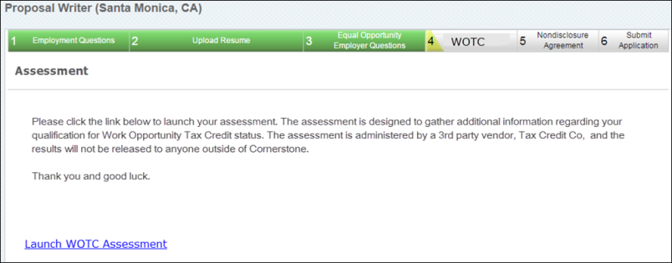
Assign on Manage Applicants
Work Opportunity Tax Credit assessments can be assigned via the Manage Applicants page. To assign an assessment:
- Navigate to the Manage Applicants page, and select the applicants to whom the Work Opportunity Tax Credit integration assessment should be assigned.
- Ensure that the applicant is in the proper Work Opportunity Tax Credit Integration status by selecting the Actions drop-down menu, selecting the Change status to action, selecting the Work Opportunity Tax Credit Integration Assessment status, and select Submit.
- While the appropriate applicants are still selected, select the Actions drop-down menu, and select the Assign Integration Assessment action.
- Select the Work Opportunity Tax Credit Assessment from the drop-down menu, and select Submit.
- The applicants will receive the Assign Integration Assessment email with a link that directs them to the Work Opportunity Tax Credit qualifying screening tool. Once complete, the results are available on the Application tab within the Applicant Profile. Note: This email is only triggered if it is configured in Email Administration.
View TCC Work Opportunity Tax Credit Assessment Results
Recruiters and applicants can view the results of the Work Opportunity Tax Credit (WOTC) assessment for the Tax Credit Co. (TCC) integration.
Recruiters
The results of the Work Opportunity Tax Credit assessment appear on the Application tab of the Applicant Profile page. Users must have permission to view assessment results.
Note: When a candidate who has taken the Work Opportunity Tax Credit assessment is hired, the candidate's status will need to be changed to Hired in order for Tax Credit Co. (TCC) to calculate the final qualifying credits.
Permissions
PERMISSION NAME | PERMISSION DESCRIPTION | CATEGORY

Applicants: View Assessment Integration Status | Allows user to view the assessment integration check status on the Applications tab of the Applicant Profile page. The user cannot view the link to the detailed report of the assessment. This permission cannot be constrained. This permission is only available for portals that have an active assessments integration.  This is the lowest level of permission for this functionality. Users with this permission can only view the assessment status; they cannot assign assessments or view assessment details. | Recruiting

Applicants: View Assessment Integration Status and Details Link | Allows user to view the assessment integration status and view link to access the assessment report from the Applications tab of the Applicant Profile page and from the associated column on the Manage Applicants page. This permission cannot be constrained. This permission is only available for portals that have an active assessments integration.  This is the second highest level of permission for this functionality. Users with this permission will be able to view the assessment status and assessment details but will not be able to assign assessments. | Recruiting
Applicants - View Assessment Status
Applicants can view the status and results of their completed Work Opportunity Tax Credit assessment results from the Completed Applications section on the My Profile page in the career site. The assigned date and status of the assessment will be displayed.
In order for internal applicants to view the results, the applicant must have permission. If the applicant does not have the appropriate permission, then only the status of the assessment displays.
Permissions
PERMISSION NAME | PERMISSION DESCRIPTION | CATEGORY

Applicants: View Assessment Integration Status | Allows user to view the assessment integration check status on the Applications tab of the Applicant Profile page. The user cannot view the link to the detailed report of the assessment. This permission cannot be constrained. This permission is only available for portals that have an active assessments integration.  This is the lowest level of permission for this functionality. Users with this permission can only view the assessment status; they cannot assign assessments or view assessment details. | Recruiting

Applicants: View Assessment Integration Status and Details Link | Allows user to view the assessment integration status and view link to access the assessment report from the Applications tab of the Applicant Profile page and from the associated column on the Manage Applicants page. This permission cannot be constrained. This permission is only available for portals that have an active assessments integration.  This is the second highest level of permission for this functionality. Users with this permission will be able to view the assessment status and assessment details but will not be able to assign assessments. | Recruiting
TCC WOTC Assessment Notified of Hiring
When an applicant who has taken the Work Opportunity Tax Credit (WOTC) assessment has been hired, Tax Credit Co. (TCC) is automatically notified so that you can get an updated estimation of the applicant's benefits. The estimation is visible when viewing the applicant's assessment results on the Manage Applicants page or the Application tab within the Applicant Profile page.

Non-Edge Integrations
HireVue Integration
The HireVue integration delivers a cloud-based solution that modernizes the recruiting process, improves the ability for human resources and business leaders to focus on the best talent, as well as gain clarity and insights into a candidate’s experience, abilities, and personality. The solution enables organizations to view, rate, and share candidate interviews anytime from within the HireVue platform or Cornerstone Recruiting while constructing interviews and capturing feedback in a standardized process. This integrated recruiting solution helps organizations see more candidates and hire more top performers while reducing the amount of time it takes to hire the best people.
With the deep integration to the Recruiting Cloud, recruiters can invite candidates to take HireVue On Demand and Live interviews within Cornerstone with a single click and track their interview completion status within the application history in Cornerstone. Users can capture and share feedback with other team members before bringing in candidates for face-to-face meetings, saving time and money.
Online Help Topics Related to HireVue
The following topics in Online Help provide information about the HireVue integration functionality:
- Applicant Profile - Applications Tab - See Applicant Profile Page - Application Tab.
- Scheduled Interview Session - See Create Interview - Schedule Interview Session.
- Completed Interviews Tab - See Completed Interviews Tab.
- Hiring Dashboard - Interviews Widget - See Hiring Dashboard - Interviews Widget.
- Incomplete Interviews - See Scheduled Interviews Tab - Incomplete Interviews.
- Interview - Scheduled - See Statuses Tab - Interview Status Type - Scheduled Interview.
- Interview - Video - See Statuses Tab - Interview Status Type - On Demand Video Interview.
- Interview Management Preferences - See Interview Management Preferences (by Division).
- Interview Scheduler Overview - See Interview Scheduler Page Overview.
- Job Requisitions - Applicant Review - Interview Status Type - See Applicant Review Tab - Interview Status Type Overview.
- Interview Status - See Applicant Review Tab - Interview Status Type Overview.
- Interview Status - Scheduled Interview - See Interview Status Type - Scheduled Interview.
- Interview Status - Video Interview - See Interview Status Type - On Demand Video Interview.
- Career Site - Completed Tasks - See My Profile - My Completed Tasks.
- Career Site - Pending Tasks - See My Profile - My Pending Tasks.
- Job Requisition - Applicant Review - On Demand Video Interview Status Type - See Interview Status Type - On Demand Video Interview.
- Requisition Templates - Applicant Review - On Demand Video Interview Status Type - See Interview Status Type - On Demand Video Interview.
- Recruiting Cloud Overview - See Recruiting Module Overview.
- Interview Manager - Today's Interviews - See Scheduled Interviews Tab - Today's Interviews.
- Email Tags - See Email Tags.
Opportunity Marketplace
The Opportunity Marketplace offers employees personalized career development with access to open roles, projects, learning content, and mentors. It empowers employees to take ownership of their professional growth and make informed decisions about next steps, so they can find new ways to contribute to the organization and belong. Whether employees are seeking to learn new skills or explore an open role, Opportunity Marketplace provides all the resources they need for career advancement and growth.
We provide a standard integration between Opportunity Marketplace and CSX Recruiting. This allows for job postings to be displayed within Opportunity Marketplace and for a seamless application experience.
USAJOBS Integration
The USAJOBS integration is available for Federal agencies and lets you post your positions from your Cornerstone career site to USAJOBS. U.S. Federal Agencies are required to post open positions to USAJOBS for applicants to review, apply, and track status. Prior to this Edge integration, clients did not have the option to post new openings to USAJOBS. With this Edge integration, Cornerstone meets the minimum federal requirement by providing the ability to post new jobs to USAJOBS from Cornerstone Recruiting, thereby helping clients that are Federal Agencies to stay compliant with federal regulations.
Included:
- Ability to create new requisitions and post to a career site. Cornerstone will then automatically post the job to USAJOBS.
- Ability to map standard and custom fields to USAJOBS fields when setting up the Edge Integration.
- Ability to edit and cancel job requisitions that have been posted on USAJOBS and are within the effective and expiration dates of the job posting. Job requisitions that fall outside of those dates cannot be edited or cancelled.
- Jobs that are posted on USAJOBS can be edited on the Postings page in your Cornerstone portal. This includes the ability to make changes such as modifying the effective and expiration dates.
- Hourly sync will post the job to USAJOBS and send log to emails configured in Edge.
For more information about this integration, see the Getting Started page for the integration in Edge Integrations.
For more information about editing job requisitions, see the Edit Job Requisition topic in Online Help.
For more information about editing job postings, see the Job Posting Page topic in Online Help.
Frequently Asked Questions
How long does it take for changes to appear in my job posting on USAJOBS?
- Same Posting Day Changes - USAJOBS cannot process changes made to a job requisition or job posting on the same day the job is posted to USAJOBS. If you would like to edit the job requisition or posting, the changes must wait until 12:00 a.m. the following day. At that time, you can submit changes to the job requisition or posting in Cornerstone and those changes will be visible in the posting on USAJOBS with their next hourly sync.
- Next Posting Day Changes - Once changes are submitted on the job requisition or job posting in Cornerstone, the changes are reflected in the job posting on USAJOBS in their next hourly sync.
What steps should I take to edit my job requisition and/or job posting on USAJOBS?
Changes to your USAJOBS posting or job requisition are done in your Cornerstone portal. When you need to edit the job requisition and the job posting on the same day, be sure to edit the job posting first and click Post to submit those changes. Then, you can edit the job requisition and submit those changes. USAJOBS will pick up your changes in their next hourly sync.
However, Cornerstone can only process one set of changes per day.
How many changes can I submit per day?
Changes to the job requisition and job posting can only be processed once per day.
For example, on Monday you post changes to the job posting and also submit one or more changes to the job requisition. Those changes are picked up in the next hourly sync by Cornerstone. Later that same day, you submit additional changes to the job requisition. Those changes will not be picked up by USAJOBS on Monday because only one set of changes can be processed per day. If you would like to edit the job requisition or posting again, you must wait until at least the next day (Tuesday) and make your changes, and once the changes are submitted, the changes will get picked up in the next hourly sync by Cornerstone.
Considerations
- Candidates cannot apply for jobs from USAJOBS. Candidates that wish to apply for a job posted through this integration must either email the recruiter or apply on the career site in Cornerstone.
- Reporting applicant status updates back in USAJOBS is not supported with this integration.
- Client are responsible for resolving errors that USAJOBS may return when Cornerstone posts the job.
- Jobs must have a career site posting with an effective date of today in order for the integration to post the job to USAJOBS.
Implementation
This integration is for U.S. Federal Agencies only. To enable this integration, please contact Global Customer Support. There is a $5,000 cost to purchase this integration via Edge Marketplace. Additional instructions are available in the Getting Started tab of the integration in Edge.
Security
The following existing permissions apply to this functionality:
PERMISSION NAME | PERMISSION DESCRIPTION | CATEGORY

Edge Integrations - Manage | Grants access to the Integrations service for Edge Integrate, where the administrator can configure, enable, and disable their third-party integrations used within the Cornerstone system. This permission cannot be constrained. This is an administrator permission. | Edge

Edge Marketplace - Manage | Grants access to the Marketplace service for Edge Integrate, where the administrator can browse integrations that can be used to extend the Cornerstone system. This permission cannot be constrained. This is an administrator permission. | Edge

