Custom Field Administration March 2024

Table of Contents
Custom Fields Overview 1
Custom Field Administration 2
Application Custom Fields 6
Compensation Custom Fields 8
Custom Field Admin - Development Plans 10
Custom Field Admin - Offer Letter 12
Custom Field Admin - Organizational Units 14
Custom Field Admin - Performance Reviews 16
SF-182 18
Custom Field Admin - SF-182 19
SF-182 Custom Field - Add/Edit 22
Default SF-182 Custom Fields 25
Custom Field Administration - Succession 34
Custom Field Admin - Training 36
Custom Field Admin - Training Request Forms 41
Custom Transaction Field Administration 44
Custom Transaction Field - Set Field Order 46
Custom Transaction Field - Add 48
User Record Custom Fields Overview 51
User Record and Self Registration Custom Fields 52
User Record Custom Field - Add/Edit 55
Categories and Display Order - Manage 62
Custom Field Admin - Vendors 66
Custom Field Admin - Custom Field Type Options 68
Custom Field Admin - Encrypted Short Text Box 75

Custom Fields Overview

Custom Field Administration
Custom fields provide information needed by end users, managers, and administrators allowing organizations to create precise reports and gather important data.
Administrators can add an unlimited number of customizable fields. Each custom field has a unique email tag that can be used in system generated email communications.
To view and manage custom fields, go to Admin > Tools > Core Functions > Custom Field Administration.
Permissions
PERMISSION NAME | PERMISSION DESCRIPTION | CATEGORY

Compensation Custom Fields - Manage | Grants ability to define custom fields for the employee compensation statement. This is an administrator permission. | Compensation - Administration

Development Plan Custom Fields - Manage | Grants access to create and edit custom fields used in development plans and templates. This is an administrator permission. | Performance - Administration

Display all Training Custom Fields | Enables display of all training custom field values including blank fields when viewing details of training on transcript. Without this permission, the custom field will only appear if it is populated with a value. This is an end user permission. | Learning

Organizational Unit Custom Fields - Manage | Grant Access to create and edit custom fields for Org Units. This is an administrator permission. | Core Administration

Performance Review Custom Fields - Manage | Grants access to create and edit custom fields for Performance Reviews. This permission can be constrained by OU and User's OU. This is an administrator permission. | Performance - Administration

Self-Registration and User Record Custom Fields - Manage | Grants access to manage custom fields for user Self Registration and the user record in Custom Field Administration. This permission can be constrained by OU and User's OU. This is an administrator permission. | Core Administration

SF-182 Custom Fields - Manage | Grants ability to manage SF-182 Fields (Governmental clients). This is an administrator permission. | Limited Use/Obsolete

Succession Management Plan Templates - Manage | Grants ability to create and edit Succession Management Plan (SMP) templates for use in assessing talent (incumbents and successors) in SMP tasks. This permission cannot be constrained. This is an administrator permission. | Talent/Succession - Administration

Training Custom Fields | Grants ability to create and edit custom fields to be used for one or more learning object types. This is an administrator permission. | Learning - Administration

Training Request Form Custom Fields - Manage | Grants access to create and edit custom fields used for Training Request Forms. This is an administrator permission. | Training Forms Administration

Vendor Custom Fields - Manage | Grants access to manage training vendor (provider) custom fields. | Learning - Administration
Use Case
An organization wants to track the number of interns who have become permanent employees. The administrator creates a User Record custom field titled "Intern" and makes it a checkbox field. The field appears on the user record so that interns can be identified as such. This custom field can then be reported on so that the organization can find out which employees had also been interns.
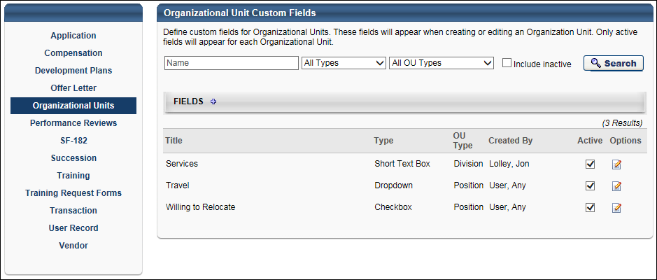
Custom Field Areas
To create a custom field for a specific area, select the link from panel that appears on the left side of the Custom Field Administration page. The following custom field areas are available:
- Application
- Compensation
- Development Plans
- Offer Letter
- Organizational Units
- Performance Reviews
- SF-182
- Succession
- Training
- Training Request Forms
- Transaction
- User Records and Self Registration (Note: The link name in the left panel on the page appears as User Record.)
- Vendor
Search Custom Fields
Administrators can search for an existing custom field by name, field type (e.g., checkbox, short text field), and active status. Depending on the custom field type (e.g., Organizational Units, Training, User Record), additional filters may be available.
Add Field
To add a custom field, click the Add Field icon when viewing the page for the specific custom report area.
Activate or Inactivate Field
To change the Active status of a custom field, select or unselect the Active checkbox in the Active column.
Edit Field
To edit a custom field, select the Edit icon in the Options column for the custom field.
Remove Field
To delete a custom field, select the Remove icon in the Options column for the custom field. Custom fields cannot be deleted if they have been used. For example, if a User Record custom field has been used on at least one user record, the field can no longer be deleted. However, it can be made inactive. When a field is inactive, it remains visible where it has been used, but it is read-only.
Important: If you delete a custom field, it will be permanently deleted in the system and any data associated with this field will also be deleted. Alternatively, you may edit a custom field to remove visibility from all training types to retain data for reporting purposes.
Custom Field Creation Rule
If an administrator is constrained to creating custom fields for a particular OU, that administrator can only view the custom fields they create, if they are in that OU as well. For example, if an administrator A has permission to create custom training fields, and this permission is restricted to Division A, then administrator A can only create custom fields for users who are in Division A. Further, administrator A can only see custom fields within Custom Field Administration which they created or were created by another administrator who is also allowed to create custom fields for Division A. If another administrator has the same permission but is restricted to Division B, the two administrators cannot view the individual custom fields created by each other on the Custom Field Administration page or anywhere else on which the custom field displays.
As a best practice, an administrator's permission to create custom fields should only be restricted to divisions to which they belong. Because an administrator's view of custom fields is restricted by their constraints, if an administrator's permission to create custom fields is restricted to a division in which they are not a part of, that administrator cannot see the custom fields that they create.

Application Custom Fields
The Application section in Custom Field Administration enables administrators to manage application-level custom fields. These fields appear on the Applicant Profile page, provided that the fields are added to the Application Custom Fields section in Requisition and Applicant Preferences. The field displays the value defined for the application. For recruiters with the appropriate permission, the value can be modified.
The Application Custom Fields page displays all existing application-level custom fields. From this page, administrators can create, edit, and delete application-level custom fields. Administrators can also manage the active status of the fields.
When active, an application custom field is available for administrators who meet the availability requirements to add to the Application Custom Fields section in Requisition Preferences. Inactive custom fields are not available to add to Requisition Preferences.
To access application custom fields, go to Admin > Tools > Core Functions > Custom Field Administration. On the Custom Field Administration page, select Application in the left navigation panel.
Permissions
PERMISSION NAME | PERMISSION DESCRIPTION | CATEGORY

Application Custom Fields – Manage | Grants ability to create and edit custom fields used for Applicant and Application. This permission also grants access to the Applicant Custom Fields and Application Custom Fields sections of the Requisition and Applicant Preferences page. This permission cannot be constrained. This is an administrator permission. | Recruiting Administration
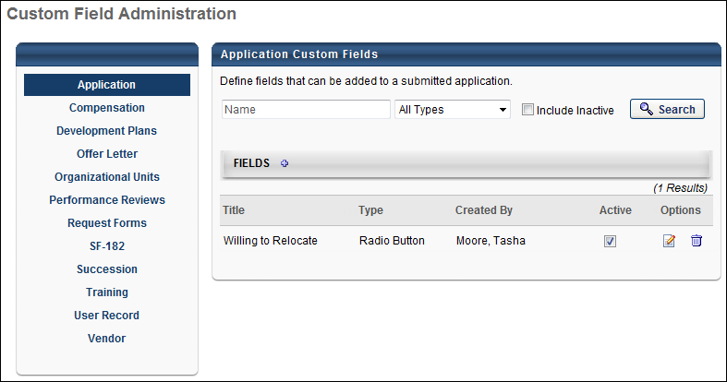
Search Filters
The following search filters are available:
- Name - Enter search terms in the filter. The field displays results for a partial or exact match to the search terms.
- Field Type - Select a field type from the drop-down.
- Include Inactive - Check the box to include inactive custom fields in the search.
Once all filters are defined, click Search. This refreshes the fields table with the filtered results.
Add Application Custom Field
Click the Add Field icon in the Fields panel header to create a new custom field. See Custom Field Admin - Custom Field Type Options on page 68 for additional information.
Custom Fields Table
This table displays all existing custom fields. The table is sorted in alphabetical order by name. The Title and Created By columns are sortable. The following displays for each field:
- Title - This column displays the title of the custom field.
- Type - This column displays the field type, such as radio button or short text box.
- Created By - This column displays the name of the administrator who created the field by last name, first name.
- Active - This column defines the active status of the field. To activate the field, check the box in the Active column. To inactivate the field, uncheck the box.
When active, the custom field is available for administrators to add to the Application Custom Fields section in Requisition Preferences. Inactive custom fields are not available to add to Requisition Preferences.
- Options - The following options are available in the Options column:
  - Edit - Click the Edit icon to edit the field.
  - Delete - Click the Trash Can icon to delete the field. If a field has been used on the Applicant Profile page for an applicant, then it cannot be deleted and the Trash Can icon does not display.

Compensation Custom Fields
Compensation custom fields can be defined by administrators for use in employee compensation statements. Creating compensation custom fields allows administrators to display total rewards information as custom fields on the compensation statement.
These custom fields are only used for the standard employee compensation statement. They cannot be used in custom compensation statements.
Note: Compensation custom fields cannot be loaded via Edge Import. These fields can only be loaded in bulk via a data feed or a work order.
To access compensation custom fields, go to Admin > Tools > Core Functions > Custom Field Administration. On the Custom Field Administration page, select Compensation in the left navigation panel.
Permissions
PERMISSION NAME | PERMISSION DESCRIPTION | CATEGORY

Compensation Custom Fields - Manage | Grants ability to define custom fields for the employee compensation statement. This is an administrator permission. | Compensation - Administration
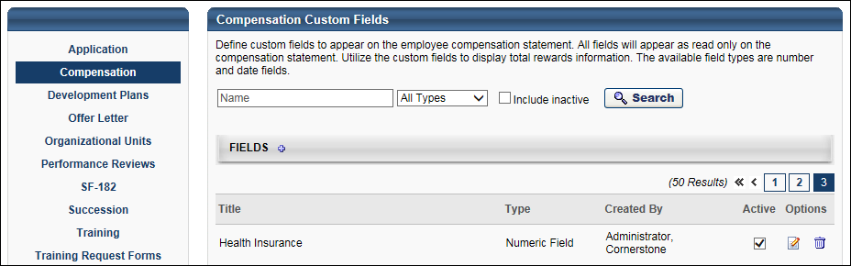
Search for a Field
The following filters are available to search for an existing custom field:
- Name - Enter search terms in the filter. The field displays results for a partial or exact match to the search terms.
- Field Type - Select a field type from the drop-down.
- Include Inactive - Check the box to include inactive custom fields in the search.
Once all filters are defined, click Search. This refreshes the fields table with the filtered results.
Add Custom Field
To create a custom field, click the Add Field icon. This opens the Define field page. From here, you can select the type of field you want to create and define the options for the field if applicable. Information about how to create the specific types of custom fields (i.e., branched dropdown, checkbox, etc.) is available on the "Custom Field Type Options" page in Online Help. See Custom Field Admin - Custom Field Type Options on page 68 for additional information.
Fields Table
This table displays all existing custom fields for the field area. The table is sorted in alphabetical order by name. The Title and Created By columns are sortable. The following information displays in the table:
- Title - This column displays the title of the custom field.
- Type - This column displays the field type, such as radio button or short text box.
- Created By - This column displays the name of the administrator who created the field by last name, first name.
- Active - This column defines the active status of the field. To activate the field, check the box in the Active column. To inactivate the field, uncheck the box.
When active, the custom field is available to use by administrators who meet the field's availability requirements. Inactive custom fields are not available to use.
- Options - The following options are available in the Options column:
  - Edit - Click the Edit icon to edit the field. The field type cannot be modified when editing the field. See Custom Field Admin - Custom Field Type Options on page 68 for additional information.
  - Delete - Click the Trash Can icon to delete the field. This option is only available if the custom field has not been used. If a field has been used, then it cannot be deleted and the Trash Can icon does not display. There is no audit history available to view custom fields that were deleted. Please reach out to Global Customer Support if additional details are needed for a deleted custom field.
Add Custom Field
To add a custom field, follow these steps:
- Select the Add Field icon .
- Name - Enter a name for the custom field that will be visible to end user. If multiple languages are enabled for your portal, select the Translate icon to translate the field into other available languages.
- Type - Select the appropriate custom field type from the drop-down menu. For compensation, only Numeric and Date type fields can be created. See Custom Field Admin - Custom Field Type Options on page 68 for additional information.
- Active - Select this option to make the field active.
- Availability - Define which users have the ability to view and access the custom field. The administrator must set the availability of the field if the field is to appear for other administrators and end users in the application. If availability is not set, then the field will not appear in administrator and end user areas of the application. See Setting Availability Overview for additional information.
- Click Save.

Custom Field Admin - Development Plans
The administrator can define custom fields that can be added to a user's development plan. Administrators can also determine a type for each custom field, i.e. numeric, drop-down, radio button, text. This functionality allows the administrator to create more specific development plan templates for OUs by including certain custom fields. The user also has the flexibility to use the custom fields created and included by the administrator when the user creates their own development plan.
Custom fields must be created in Custom Field Administration before they can be added to a development plan or development plan template.
To manage custom fields, go to Admin > Tools > Core Functions > Custom Field Administration. Then select the Development Plans link on the left.
Permissions
PERMISSION NAME | PERMISSION DESCRIPTION | CATEGORY

Development Plan Custom Fields - Manage | Grants access to create and edit custom fields used in development plans and templates. This is an administrator permission. | Performance - Administration
Note: If you have the permission to manage development plan templates, you will automatically have the permission to manage development plan custom fields.
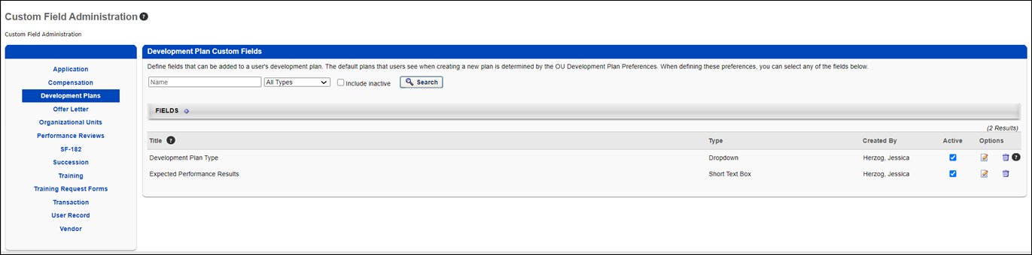
Add Custom Fields
Note: When adding development plan custom fields to development plans, the custom fields are displayed in the order in which they are created in Custom Field Administration.
To add a new custom field:
- Select the Add Field icon . The Define Field page opens.
- Complete the following fields:
  - Name - Enter a name for the custom field that will be visible to end user. The character limit for this field is 50. If multiple languages are enabled for your portal, select the Translate icon to translate the field into other available languages.
  - Type - Select the appropriate custom field type from the drop-down menu. For development plans, Date, Drop-down, Numeric, Radio Button, Scrolling Text Box, and Short Text Box type fields can be created. See Custom Field Admin - Custom Field Type Options on page 68 for additional information..
  - Active - Select this option to make the field active.
  - Availability - Define which users have the ability to view and access the custom field. The administrator must set the availability of the field if the field is to appear for other administrators and end users in the application. If availability is not set, then the field will not appear in administrator and end user areas of the application. See Setting Availability Overview for additional information.
- Click Save.
Search for a Field
The following filters are available to search for an existing custom field:
- Name - Enter search terms in the filter. The field displays results for a partial or exact match to the search terms.
- Field Type - Select a field type from the drop-down.
- Include Inactive - Check the box to include inactive custom fields in the search.
Once all filters are defined, click Search. This refreshes the fields table with the filtered results.
Add Custom Field
To create a custom field, click the Add Field icon. This opens the Define field page. From here, you can select the type of field you want to create and define the options for the field if applicable. Information about how to create the specific types of custom fields (i.e., branched dropdown, checkbox, etc.) is available on the "Custom Field Type Options" page in Online Help. See Custom Field Admin - Custom Field Type Options on page 68 for additional information.
Fields Table
This table displays all existing custom fields for the field area. The table is sorted in alphabetical order by name. The Title and Created By columns are sortable. The following information displays in the table:
- Title - This column displays the title of the custom field.
- Type - This column displays the field type, such as radio button or short text box.
- Created By - This column displays the name of the administrator who created the field by last name, first name.
- Active - This column defines the active status of the field. To activate the field, check the box in the Active column. To inactivate the field, uncheck the box.
When active, the custom field is available to use by administrators who meet the field's availability requirements. Inactive custom fields are not available to use.
- Options - The following options are available in the Options column:
  - Edit - Click the Edit icon to edit the field. The field type cannot be modified when editing the field. See Custom Field Admin - Custom Field Type Options on page 68 for additional information.
  - Delete - Click the Trash Can icon to delete the field. This option is only available if the custom field has not been used. If a field has been used, then it cannot be deleted and the Trash Can icon does not display. There is no audit history available to view custom fields that were deleted. Please reach out to Global Customer Support if additional details are needed for a deleted custom field.

Custom Field Admin - Offer Letter
The Offer Letter section in Custom Field Administration enables administrators to create, edit, and delete offer letter custom fields. The Offer Letter Custom Fields page displays all existing offer letter custom fields.
To manage offer letter custom fields, go to Admin > Tools > Core Functions > Custom Field Administration. Then, select the Offer Letter tab.
Permissions
PERMISSION NAME | PERMISSION DESCRIPTION | CATEGORY

Offer Letter Custom Fields – Manage | Grants access to manage Offer Letter custom fields within Custom Field Administration. This permission cannot be constrained. This is an administrator permission. | Recruiting Administration
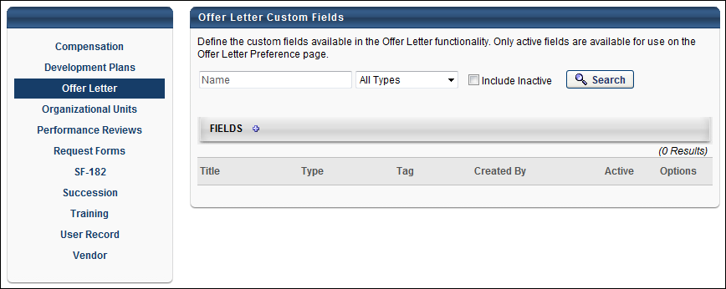
Search Filters
The following search filters are available:
- Name - Enter search terms in the Name filter. The field displays results for a partial or exact match to the search terms.
- Field Type - Select a field type from the drop-down.
- Include Inactive - Check Include Inactive to include inactive custom fields in the search.
Once all filters are defined, click Search. This refreshes the fields table with the filtered results.
Add Field
Click the Add Field icon in the Fields panel header to create a new custom field. See Custom Field Admin - Custom Field Type Options on page 68 for additional information.
Custom Fields Table
This table displays all existing custom fields. The table is sorted in alphabetical order by name. The Title and Created By columns are sortable. The following displays for each field:
- Title - This column displays the title of the custom field.
- Type - This column displays the field type, such as radio button or short text box.
- Tag - This field displays the tag defined in the Tag Name field when creating or editing the custom field. See Custom Field Admin - Custom Field Type Options on page 68 for additional information.
- Created By - This column displays the name of the administrator who created the field by last name, first name.
- Active - This column defines the active status of the field. To activate the field, check the box in the Active column. To inactivate the field, uncheck the box. Note: If a custom field is inactivated after the field is added to the Offer Letter Preferences page, then the field still displays on the preferences page but cannot be used in offer letters and offer letter templates.
- Options - The following options are available in the Options column:
  - Edit - Click the Edit icon to edit the field. See Custom Field Admin - Custom Field Type Options on page 68 for additional information.
  - Delete - Click the trash can icon to delete the field. If a field has been used in an offer letter, then it cannot be deleted and the Trash Can icon does not display

Custom Field Admin - Organizational Units
Once the OU Type is set up, the implementation manager or the system administrator can add custom fields to the OU Type. To change the feed and add these new custom fields, contact the Technical Consulting team.
Creating an OU custom field does not automatically map the field to your OU data feed. If you want your data feed to populate the OU custom field, you must first create the custom field and then contact your Global Customer Support to make the necessary arrangements to have the field added to your feed.
For portals with Recruiting enabled, Position OU fields can be created via the Organizational Units tab in Custom Field Administration. These fields can be used as Requisition Custom Fields for job requisitions by adding them to the Requisition Custom Fields section in Requisition and Applicant Preferences. These fields can also be used as tabs in offer letters, job ads, and Recruiting and Offer Letter emails.
To manage custom fields, go to Admin > Tools > Core Functions > Custom Field Administration. Then select the appropriate tab on the left.
Permissions
PERMISSION NAME | PERMISSION DESCRIPTION | CATEGORY

Organizational Unit Custom Fields - Manage | Grant Access to create and edit custom fields for Org Units. This is an administrator permission. | Core Administration
Search for a Field
The following filters are available to search for an existing custom field:
- Name - Enter search terms in the filter. The field displays results for a partial or exact match to the search terms.
- Field Type - Select a field type from the drop-down.
- Include Inactive - Check the box to include inactive custom fields in the search.
Once all filters are defined, click Search. This refreshes the fields table with the filtered results.
Add Custom Field
To create a custom field, click the Add Field icon. This opens the Define field page. From here, you can select the type of field you want to create and define the options for the field if applicable. Information about how to create the specific types of custom fields (i.e., branched dropdown, checkbox, etc.) is available on the "Custom Field Type Options" page in Online Help. See Custom Field Admin - Custom Field Type Options on page 68 for additional information.
Fields Table
This table displays all existing custom fields for the field area. The table is sorted in alphabetical order by name. The Title and Created By columns are sortable. The following information displays in the table:
- Title - This column displays the title of the custom field.
- Type - This column displays the field type, such as radio button or short text box.
- Created By - This column displays the name of the administrator who created the field by last name, first name.
- Active - This column defines the active status of the field. To activate the field, check the box in the Active column. To inactivate the field, uncheck the box.
When active, the custom field is available to use by administrators who meet the field's availability requirements. Inactive custom fields are not available to use.
- Options - The following options are available in the Options column:
  - Edit - Click the Edit icon to edit the field. The field type cannot be modified when editing the field. See Custom Field Admin - Custom Field Type Options on page 68 for additional information.
  - Delete - Click the Trash Can icon to delete the field. This option is only available if the custom field has not been used. If a field has been used, then it cannot be deleted and the Trash Can icon does not display. There is no audit history available to view custom fields that were deleted. Please reach out to Global Customer Support if additional details are needed for a deleted custom field.
Add Fields
To add a new custom field, follow these steps:
- Select the Add Field icon .
- Name - Enter a name for the custom field that will be visible to end user. If multiple languages are enabled for your portal, select the Translate icon to translate the field into other available languages.
- Type - Select the appropriate custom field type from the drop-down menu. For organizational units, Checkbox, Date, Drop-down, Numeric, Radio Button, Scrolling Text Box, and Short Text Box type fields can be created. See Custom Field Admin - Custom Field Type Options on page 68 for additional information.
- OU Type - Select the type of organizational unit for which this custom field will be visible.
- Active - Select this option to make the field active.
- Availability - Define which users have the ability to view and access the custom field. The administrator must set the availability of the field if the field is to appear for other administrators and end users in the application. If availability is not set, then the field will not appear in administrator and end user areas of the application. See Setting Availability Overview for additional information.
- Click Save. After the custom field is created, it will available when creating and editing an OU. See Create Organizational Unit for additional information.

Custom Field Admin - Performance Reviews
Permissions
PERMISSION NAME | PERMISSION DESCRIPTION | CATEGORY

Performance Review Custom Fields - Manage | Grants access to create and edit custom fields for Performance Reviews. This permission can be constrained by OU and User's OU. This is an administrator permission. | Performance - Administration
Search for a Field
The following filters are available to search for an existing custom field:
- Name - Enter search terms in the filter. The field displays results for a partial or exact match to the search terms.
- Field Type - Select a field type from the drop-down.
- Include Inactive - Check the box to include inactive custom fields in the search.
Once all filters are defined, click Search. This refreshes the fields table with the filtered results.
Add Custom Field
To create a custom field, click the Add Field icon. This opens the Define field page. From here, you can select the type of field you want to create and define the options for the field if applicable. Information about how to create the specific types of custom fields (i.e., branched dropdown, checkbox, etc.) is available on the "Custom Field Type Options" page in Online Help. See Custom Field Admin - Custom Field Type Options on page 68 for additional information.
Fields Table
This table displays all existing custom fields for the field area. The table is sorted in alphabetical order by name. The Title and Created By columns are sortable. The following information displays in the table:
- Title - This column displays the title of the custom field.
- Type - This column displays the field type, such as radio button or short text box.
- Created By - This column displays the name of the administrator who created the field by last name, first name.
- Active - This column defines the active status of the field. To activate the field, check the box in the Active column. To inactivate the field, uncheck the box.
When active, the custom field is available to use by administrators who meet the field's availability requirements. Inactive custom fields are not available to use.
- Options - The following options are available in the Options column:
  - Edit - Click the Edit icon to edit the field. The field type cannot be modified when editing the field. See Custom Field Admin - Custom Field Type Options on page 68 for additional information.
  - Delete - Click the Trash Can icon to delete the field. This option is only available if the custom field has not been used. If a field has been used, then it cannot be deleted and the Trash Can icon does not display. There is no audit history available to view custom fields that were deleted. Please reach out to Global Customer Support if additional details are needed for a deleted custom field.
Add Custom Field
To add a new custom field, follow these steps:
- Select the Add Field icon .
- Name - Enter a name for the custom field that will be visible to end user. The character limit for this field is 50. If multiple languages are enabled for your portal, select the Translate icon to translate the field into other available languages.
- Type - Select the appropriate custom field type from the drop-down menu. For performance reviews, Checkbox, Date, Drop-down, Numeric, Radio Button, Scrolling Text Box, and Short Text Box type fields can be created. See Custom Field Admin - Custom Field Type Options on page 68 for additional information.
  - Note: For Checkbox, Dropdown, and Radio Button field types, if translated values are defined in the Options section, then the translations display in custom Performance Review Reports. The values display in the user's language, if available. If the user's language is not available, then the values display in the default language for the portal. For shared reports, when the report is refreshed, the translated options values for the custom report fields display in the user's language, if available.
- Active - Select this option to make the field active.
- Availability - Define which users have the ability to view and access the custom field. The administrator must set the availability of the field if the field is to appear for other administrators and end users in the application. If availability is not set, then the field will not appear in administrator and end user areas of the application. See Setting Availability Overview for additional information.
- Click Save.

SF-182

Custom Field Admin - SF-182
The SF-182 Custom Fields page enables administrators to manage the custom fields that are available for the SF-182 request form. The fields in Custom Field Administration appear on the Configure Fields tab of SF-182 Preferences, where they can be configured to display on the request form.
Default custom fields are configured for you. For more information: See Default SF-182 Custom Fields on page 25 for additional information.
To manage custom fields, go to Admin > Tools > Core Functions > Custom Field Administration. Then select the appropriate tab from the left-side panel.
Permissions
PERMISSION NAME | PERMISSION DESCRIPTION | CATEGORY

SF-182 Custom Fields - Manage | Grants ability to manage SF-182 Fields (Governmental clients). This is an administrator permission. | Limited Use/Obsolete
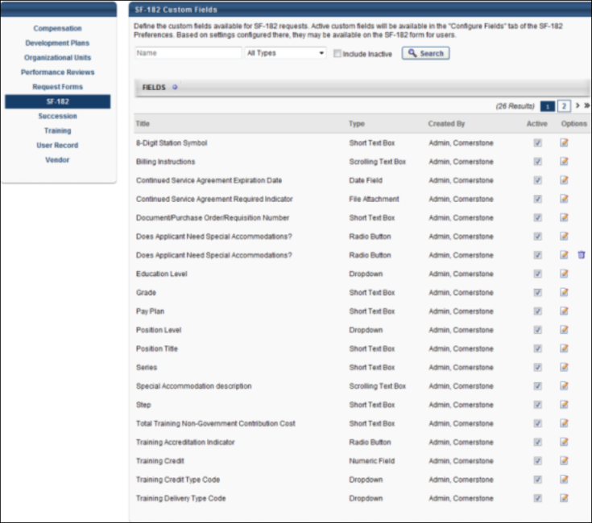
SF-182 Custom Field Administration
The following features are available on this page:
- Search - Enter search filter options in the Name field. Or, select a field type from the Field Type drop-down. Check the Include Inactive option to include inactive custom fields in the search. Click Search.
- Add Field - Click the Add Field icon to create a new custom field.
- Fields table - The following columns display within the Fields table for each SF-182 Custom Field:
  - Title - This column displays the title of the custom field.
  - Type - This column displays the field type, such as radio button or short text box.
  - Created By - This column displays the name of the administrator that created the field by last name, first name.
  - Active - This column displays the active status of the field. Check or uncheck the box to activate or inactivate the field.
  - Options - The following options are available in the Options column:
    - Edit - Click the Edit icon to edit the field.
    - Delete - Click the Trash Can icon to delete the field. If a field has been saved in SF-182 Preferences, then it cannot be deleted and the icon does not display.

SF-182 Custom Field - Add/Edit
Administrators can add and edit SF-182 custom fields on the Define Field page.
Note: For default SF-182 custom fields, only the Name, Email Tag, SF-182 Section, and Active fields can be edited. The field type cannot be modified.
Note: There is no Availability option for default or new custom fields.
To create a custom field, go to Admin > Tools > Core Functions > Custom Field Administration. Then select the appropriate tab from the left-side panel. On the SF-182 Custom Fields page, click the Add Field icon .
Permissions
PERMISSION NAME | PERMISSION DESCRIPTION | CATEGORY

SF-182 Custom Fields - Manage | Grants ability to manage SF-182 Fields (Governmental clients). This is an administrator permission. | Limited Use/Obsolete
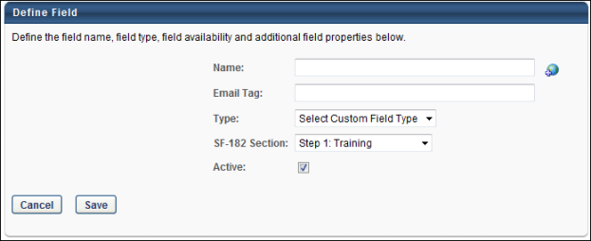
Add SF-182 Custom Field
To add a new custom field:
- Enter a name, up to 100 characters.
- Enter the email tag that will be associated with the field. The tag will also be used to retrieve the value of this field in email communications.
As a best practice, create the tag in all capital letters. All email tags for custom fields are prefaced with the word CUSTOM. For example, a custom field named Response Required could have an email tag named RESPONSE.REQUIRED. The system converts the name to CUSTOM.RESPONSE.REQUIRED.
- Select a field type from the Type drop-down.
- Select the step in the SF-182 Section drop-down to which the field will be associated on the request form. The value selected also determines the section in which the field appears on the Configure Fields tab of SF-182 Preferences.
- Leave the Active box checked to activate the field. Uncheck the box to inactivate the field.
- Click Save.
The field is added to the Fields table on the SF-182 Custom Fields page. If the field is inactive, then it can only be viewed on the SF-182 Custom Fields page by selecting the Include Inactive option and clicking Search.
Add File Attachment Field Type Custom Field
Administrators can use the File Attachment field type to define a specific type of custom field for attachments. When a File Attachment custom field is configured and available on the SF-182 request form, users can attach a file to the field.
To create a File Attachment custom field type:
- Complete steps 1 and 2 in the Add SF-182 Custom Field section above.
- Select "File Attachment" in the Type field. An Options panel appears with additional options that can be configured for the field.
- Complete steps 4 and 5 in the Add SF-182 Custom Field section above.
- Complete the following options in the Options panel:
Upload Form Template
This field is optional and enables you to upload a template of the file for the user. The user can download the template on the SF-182 request form.
To upload a template, click the Upload link. This opens the Upload File pop-up. Click Browse to search for and select the document. Click Upload. The attachment appears below the Upload Form Template option. Only one attachment is accepted. The maximum file size is 10MB. The acceptable file types are .pdf, .doc, .docx, .gif, .jpg, and .jpeg.
You can remove an attachment by clicking the Trash Can icon to the left of the attachment name.
User Attachment Required
This option enables you to require users to upload an attachment to the field. If Yes is checked, users must attach a field and cannot proceed from the corresponding page of the request form until the field is completed. If No is checked, the field appears on the request form but is not required and no attachment can be added.
In the Default column, click the radio button to set the default value of the field as Yes or No. The radio button for Yes is selected by default.
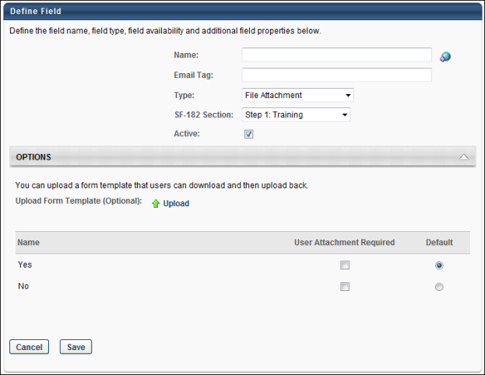
Edit SF-182 Custom Field
Editing an SF-182 custom field is similar to the process of adding an SF-182 custom field. See the Add SF-182 Custom Field section on this page for details.

Default SF-182 Custom Fields
A number of default custom fields are available for use on the SF-182 request form. These fields are system-defined and cannot be deleted. However, they can be edited, inactivated, and hidden on the form. Note: Hiding a field is done on the Configure Fields tab in SF-182 Preferences. Only certain fields can be hidden.
Some default fields also have preconfigured options. These options can be edited by clicking the Edit icon in the Options column on the SF-182 Custom Fields page.
The following are the default SF-182 custom fields and their preconfigured values:
Name | Email Tag | Step # | Type | Options
Training Purpose Type | TRAINING.PURPOSE.TYPE | Step 1: Training | Drop-down | 01 - Program/Mission  02 - New Work Assignment  03 - Improve/Maintain Present Performance  04 - Future Staffing Needs  05 - Develop Unavailable Skills  06 - Retention
Training Type Code | TRAINING.TYPE.CODE | Step 1: Training | Drop-down | 01 - Training Program Area  02 - Developmental Training Area  03 - Basic Training Area
Training Sub-Type Code | TRAINING.SUBTYPE.CODE | Step 1: Training | Branched Drop-down | Training Type Code {01 - Training Program Area}  01 - Legal  02 - Medical and Health  03 - Scientific  04 - Engineering and Agricultural  05 - Human Resources  06 - Budget/Finance Business Administration  07 - Planning and Analysis  08 - Information Technology  9 - Project Management  10 - Acquisitions  11 - Logistic Specialty  12 - Security  13 - Clerical (Non-Supervisory/Clerical/Administrative)  14 - Trade and Craft  15 - Foreign Affairs  16 - Leadership/Manager/Communications Courses  Training Type Code {02 - Developmental Training Area}  01 - Pre-Supervisory Program  02 - Supervisory Program  03 - Management Program  04 - Leadership Development Program  05 - SES Candidate Development  06 - Executive Development  07 - Mentoring Program  08 - Coaching Program  Training Type Code {03 - Basic Training Area}  01 - Employee Orientation  02 - Adult Basic Education  03 - Mandated Training  04 - Work-Life  05 - Soft Skills  06 - Agency Specific
Training Delivery Type Code | TRAINING.DELIVERY.TYPE.CODE | Step 1: Training | Drop-down | 01 – Traditional Classroom (no technology)  02 – On the Job  03 – Technology Based  04 – Conference/Workshop  05 - Blended  06 - Correspondence
Training Designation Type Code | TRAINING.DESIGNATION.TYPE.CODE | Step 1: Training | Drop-down | 01 – Undergraduate Credit  02 – Graduate Credit  03 – Continuing Education Unit  04 – Post Graduate Credit  05 – N/A
Training Credit | TRAINING.CREDIT | Step 1: Training | Numeric | N/A
Training Credit Type Code | TRAINING.CREDIT.TYPE.CODE | Step 1: Training | Drop-down | 01 – Semester Hours  02 – Quarter Hours  03 – Continuing Education Unit
Training Accreditation Indicator | TRAINING.ACCREDITATION.INDICATOR | Step 1: Training | Radio | Yes, No
Continued Service Agreement Required Indicator | CONTD.SERVICE.REQUIRED.INDICATOR | Step 1: Training | File Attachment | Yes, No
Continued Service Agreement Expiration Date | CONTINUED.SERVICE.AGREEMENT.EXPIRATION.DATE | Step 1: Training | Date | N/A
Training Source Type Code | TRAINING.SOURCE.TYPE.CODE | Step 1: Training | Drop-down | 01 – Government Internal  02 – Government External  03 - Non-government  04 – Government State/Local  05 – Foreign Governments and Organizations
Total Training Non-Government Contribution Cost | TOTAL.TRAINING.NON.GOVERNMENT.COST | Step 2: Costs and Billing | Short Text Box | N/A
Document/Purchase Order/Requisition Number | DOCUMENT.PURCHASE.ORDER.REQUISITION.NUMBER | Step 2: Costs and Billing | Short Text Box | N/A
8-Digit Station Symbol | 8.DIGIT.STATION.SYMBOL | Step 2: Costs and Billing | Short Text Box | N/A
Billing Instructions | BILLING.INSTRUCTIONS | Step 2: Costs and Billing | Scrolling Text Box | N/A
Position Level | POSITION.LEVEL | Step 3: Personal Information | Drop-down | Non-Supervisory  Manager  Supervisory  Executive
Position Title | POSITION.TITLE | Step 3: Personal Information | Short Text Box | N/A
Does Applicant Need Special Accommodations? | NEED.SPECIAL.ACCOMODATION | Step 3: Personal Information | Radio | Yes, No
Special Accommodation Description | SPECIAL.ACCOMMODATION.DESCRIPTION | Step 3: Personal Information | Scrolling Text Box | N/A
Type of Appointment | TYPE.OF.APPOINTMENT | Step 3: Personal Information | Short Text Box | N/A
Education Level | EDUCATION.LEVEL | Step 3: Personal Information | Drop-down | 01 - No Formal Education  02 - Elementary School Completed  03 - Some High School  04 - High School Graduate  05 - Terminal Occupational Program - Incomplete  06 - Terminal Occupational Program  07 - Some College - Less Than 1yr  08 - One Year College  09 - Two Years College  10 - Associate Degree  11 - Three Years College  12 - Four Years College  13 - Bachelor's Degree  14 - Post-Bachelor's  15 - First Professional  16 - Post-First Professional  17 - Master's Degree  18 - Post-Master's  19 - Sixth-Year  20 - Post-Sixth Year  21 - Doctorate Degree  22 - Post-Doctorate
Pay Plan | PAY.PLAN | Step 3: Personal Information | Short Text Box | N/A
Series | SERIES | Step 3: Personal Information | Short Text Box | N/A
Grade | GRADE | Step 3: Personal Information | Short Text Box | N/A
Step | STEP | Step 3: Personal Information | Short Text Box | N/A
Default Custom Fields Settings
For all new custom fields, the following default settings are preconfigured for the field when added to the Configure Fields tab in SF-182 Preferences:
- Section A
- Required is selected
- User Editable is selected
- Hidden is selected
- Section B
- Required is selected
- Display on Transcript is selected
- Section C
- Required is selected
- Display on Transcript is selected
The following table lists each field and the default settings that appear on the Configure Fields tab in SF-182 Preferences:
Custom Field Name | Step # | Preference - Order Number | Preference - Required | Preference - Editable | Preference - Hidden | Default option in Custom Field Administration
Training Purpose Type | Step 1: Training | 1 | Yes | Yes | No | Select
Training Type Code | Step 1: Training | 2 | Yes | Yes | No | Select
Training Sub-Type Code | Step 1: Training | 3 | Yes | Yes | No | Select
Training Delivery Type Code | Step 1: Training | 4 | Yes | Yes | No | Select
Training Designation Type Code | Step 1: Training | 5 | Yes | Yes | No | Select
Training Credit | Step 1: Training | 6 | Yes | Yes | No | N/A
Training Credit Type Code | Step 1: Training | 7 | Yes | Yes | No | Select
Training Accreditation Indicator | Step 1: Training | 8 | Yes | Yes | No | No
Continued Service Agreement Required Indicator | Step 1: Training | 9 | Yes | Yes | No | No
Continued Service Agreement Expiration Date | Step 1: Training | 10 | Yes | Yes | No | N/A
Training Source Type Code | Step 1: Training | 11 | Yes | Yes | No | N/A
Total Training Non-Government Contribution Cost | Step 2: Costs and Billing | 1 | Yes | Yes | No | N/A
Document/Purchase Order/Requisition Number | Step 2: Costs and Billing | 2 | Yes | Yes | No | N/A
8-Digit Station Symbol | Step 2: Costs and Billing | 3 | Yes | Yes | No | N/A
Billing Instructions | Step 2: Costs and Billing | 4 | Yes | Yes | No | N/A
Position Level | Step 3: Personal Information | 1 | Yes | Yes | No | Select
Position Title | Step 3: Personal Information | 2 | Yes | Yes | No | N/A
Does Applicant Need Special Accommodations? | Step 3: Personal Information | 3 | Yes | Yes | No | No
Special Accommodation Description | Step 3: Personal Information | 4 | Yes | Yes | No | N/A
Type of Appointment | Step 3: Personal Information | 5 | Yes | Yes | No | N/A
Education Level | Step 3: Personal Information | 6 | Yes | Yes | No | Select
Pay Plan | Step 3: Personal Information | 7 | Yes | Yes | No | N/A
Series | Step 3: Personal Information | 8 | Yes | Yes | No | N/A
Grade | Step 3: Personal Information | 9 | Yes | Yes | No | N/A
Step | Step 3: Personal Information | 10 | Yes | Yes | No | N/A

Custom Field Administration - Succession
Permissions
PERMISSION NAME | PERMISSION DESCRIPTION | CATEGORY

SMP Metrics/Custom SMP Fields - Manage | Grants access to create Succession Management Planning (SMP) metrics and fields to be used for assessing talent incumbents and successors via SMP tasks. This permission can be constrained by OU and User's OU. This is an administrator permission. | Talent/Succession - Administration

Succession Management Plan Templates - Manage | Grants ability to create and edit Succession Management Plan (SMP) templates for use in assessing talent (incumbents and successors) in SMP tasks. This permission cannot be constrained. This is an administrator permission. | Talent/Succession - Administration
Troubleshooting Information
The following page contains a guide for using a Formula Metric field in a Succession template:
- See Configuration Guide - Using a Formula Metric in an SMP Template.
Manage Succession Custom Fields
Search for a Field
The following filters are available to search for an existing custom field:
- Name - Enter search terms in the filter. The field displays results for a partial or exact match to the search terms.
- Field Type - Select a field type from the drop-down.
- Include Inactive - Check the box to include inactive custom fields in the search.
Once all filters are defined, click Search. This refreshes the fields table with the filtered results.
Add Custom Field
To create a custom field, click the Add Field icon. This opens the Define field page. From here, you can select the type of field you want to create and define the options for the field if applicable. Information about how to create the specific types of custom fields (i.e., branched dropdown, checkbox, etc.) is available on the "Custom Field Type Options" page in Online Help. See Custom Field Admin - Custom Field Type Options on page 68 for additional information.
Fields Table
This table displays all existing custom fields for the field area. The table is sorted in alphabetical order by name. The Title and Created By columns are sortable. The following information displays in the table:
- Title - This column displays the title of the custom field.
- Type - This column displays the field type, such as radio button or short text box.
- Created By - This column displays the name of the administrator who created the field by last name, first name.
- Active - This column defines the active status of the field. To activate the field, check the box in the Active column. To inactivate the field, uncheck the box.
When active, the custom field is available to use by administrators who meet the field's availability requirements. Inactive custom fields are not available to use.
- Options - The following options are available in the Options column:
  - Edit - Click the Edit icon to edit the field. The field type cannot be modified when editing the field. See Custom Field Admin - Custom Field Type Options on page 68 for additional information.
  - Delete - Click the Trash Can icon to delete the field. This option is only available if the custom field has not been used. If a field has been used, then it cannot be deleted and the Trash Can icon does not display. There is no audit history available to view custom fields that were deleted. Please reach out to Global Customer Support if additional details are needed for a deleted custom field.
To add a new custom field, follow these steps:
- Click Add Field icon to the right of the Fields heading.
- Enter the following information for the field:
  - Name - Enter name of custom field that will be visible to end users. The character limit for this field is 50. If multiple languages are enabled, click the globe icon to translate the name into other available languages.
  - Type - From the drop-down list, select the type of field you are creating. The following options are available. See Custom Field Admin - Custom Field Type Options on page 68 for additional information.
    - Checkbox
    - Date Field
    - Dropdown
    - Formula Metric
    - Metric Grid
    - Numeric Field
    - OU Field
    - Radio Button
    - Rating Scaling Metric
    - Scrolling Text Box
    - Short Text Box
- Active - Select this option to make the custom field active.
- Availability - Define which users have the ability to view and access the custom field. See Setting Availability Overview for additional information. The administrator must set the availability of the field if the field is to appear for other administrators and end users in the application. If availability is not set, then the field will not appear in administrator and end user areas of the application.
- Click Save.

Custom Field Admin - Training
To manage custom fields, go to Admin > Tools > Core Functions > Custom Field Administration. Then select the appropriate tab on the left.
Permissions
PERMISSION NAME | PERMISSION DESCRIPTION | CATEGORY

Display all Training Custom Fields | Enables display of all training custom field values including blank fields when viewing details of training on transcript. Without this permission, the custom field will only appear if it is populated with a value. This is an end user permission. | Learning

Training Custom Fields | Grants ability to create and edit custom fields to be used for one or more learning object types. This is an administrator permission. | Learning - Administration

Training Request Form Custom Fields - Manage | Grants access to create and edit custom fields used for Training Request Forms. This is an administrator permission. | Training Forms Administration
Search for a Field
The following filters are available to search for an existing custom field:
- Name - Enter search terms in the filter. The field displays results for a partial or exact match to the search terms.
- Field Type - Select a field type from the drop-down.
- Include Inactive - Check the box to include inactive custom fields in the search.
Once all filters are defined, click Search. This refreshes the fields table with the filtered results.
Add Custom Field
To create a custom field, click the Add Field icon. This opens the Define field page. From here, you can select the type of field you want to create and define the options for the field if applicable. Information about how to create the specific types of custom fields (i.e., branched dropdown, checkbox, etc.) is available on the "Custom Field Type Options" page in Online Help. See Custom Field Admin - Custom Field Type Options on page 68 for additional information.
Fields Table
This table displays all existing custom fields for the field area. The table is sorted in alphabetical order by name. The Title and Created By columns are sortable. The following information displays in the table:
- Title - This column displays the title of the custom field.
- Type - This column displays the field type, such as radio button or short text box.
- Created By - This column displays the name of the administrator who created the field by last name, first name.
- Active - This column defines the active status of the field. To activate the field, check the box in the Active column. To inactivate the field, uncheck the box.
When active, the custom field is available to use by administrators who meet the field's availability requirements. Inactive custom fields are not available to use.
- Options - The following options are available in the Options column:
  - Edit - Click the Edit icon to edit the field. The field type cannot be modified when editing the field. See Custom Field Admin - Custom Field Type Options on page 68 for additional information.
  - Delete - Click the Trash Can icon to delete the field. This option is only available if the custom field has not been used. If a field has been used, then it cannot be deleted and the Trash Can icon does not display. There is no audit history available to view custom fields that were deleted. Please reach out to Global Customer Support if additional details are needed for a deleted custom field.
Note: Deleting a custom field permanently deletes the field from the system and any data associated with the field is lost. To remove a custom field from a learning object (LO), but keep the data, a best practice is to edit the custom field and remove visibility from all training types.
- Display event fields to end-users on the session details page - Select this option to have custom fields for events automatically display on the sessions for the corresponding event as well.
- Define LO Type and Order - Click this link to define the display order of existing custom fields and view for which types of learning object the custom fields will display.
To create a Training custom field:
- Click Add Field icon .
- Name - Enter the name of custom field that will be visible to end user. If multiple languages are enabled, click the Translate icon to the right of the field to localize the values to the other available languages.
- Email Tag - Enter the name for the email tag to be associated with this field, and use it to retrieve the value of this field in email communications. The tag must be written in capital letters without spaces. Periods (.) can be used instead of spaces. For example, PROFIT.NET is an acceptable email tag.
  - Custom tags are prefixed with the word CUSTOM. For example, for a custom field called Profit Net, the administrator can create the tag, PROFIT.NET, and the system will convert this to CUSTOM.PROFIT.NET.
- Type - From the drop-down list, select the type of field you are creating. The following options are available. See Custom Field Admin - Custom Field Type Options on page 68 for additional information.
  - Branched Dropdown
  - Checkbox
  - Conditional Numeric Field - See below for Conditional Numeric Field validation options.
  - Date field
  - Dropdown
  - Hierarchy
  - Multiple Checkbox
  - Numeric Field
  - Radio Button
  - Scrolling Text Box
  - Short Text Box
- Available Languages - From the drop-down list, select the languages in which the custom field is available. The available languages are mainly used for searching purposes and they are independent of the LO's default language. At least one language must be selected. At the top of the drop-down list, all selected languages are displayed. The drop-down list only displays the languages that are available to the user. Select the All Languages option to select all available languages. When a language is selected, the custom field is associated with that language.
- Fields Details for Each Training Type - Select the various options for the custom field for each LO type. Select the Check All option to select each option for all LOs. The following options are available:
  - Active Training Type - Select the types of learning objects for which this custom field is visible.
  - Response Required - Select whether administrators who are creating these learning objects must set a value in the custom field.
  - Editable on Transcript by Admin - Select whether an administrator can change the value of this field for individual users by accessing their transcript. An example of when this might be used is for a credit field where you might change the credits a user received for this learning object.
  - Visible to End User on Transcript - Select whether end users can see this field with the value the administrator selected when the administrator created the LO. This applies to the Learning Details and Training Details on Transcript. If this option is deselected, then only the administrator can see the field.
  - Editable on Transcript by End User - Select this option to allow editing and changing of the value for the field. This can be useful when creating custom fields for external training, in which users are entering information about the training. Note: This field is only available if the Visible to End User option is selected for the training type. If a field is available for external training, it is a best practice to make the field visible and editable by end user to ensure the end user can use the field when adding their external training.
- Active - Select this option to make the field active.
- Availability - Define which users have the ability to view and access the custom field. See Setting Availability Overview for additional information. The administrator must set the availability of the field if the field is to appear for other administrators and end users in the application. If availability is not set, then the field will not appear in administrator and end user areas of the application.
- Click Save.
Lock History Rules
A user's transcript history and course completion certificate information is locked once the learning object's (LO) status is Complete. Updates to custom Training fields do not influence the transcript history or certificate when the user achieves the status of Complete, even if a custom field is removed.
Considerations and Exceptions
- Transcript Custom Fields - If no value is set for a custom field within user's Transcript Details, the default value saved for the field in the Course Catalog is displayed. If no such value is set for the training, then the default value set in Custom Field Administration is displayed.
- Historical Certificates - When printing historical certificates, the certificate shows the custom field value at the time the user achieved a Complete status for the LO. If the custom field value changes, then the change displays on the certificate.
- Learning Assignment - Assign New Occurrence simulates recurrence. If a user is assigned a new occurrence of training, the Transcript Details page shows a new instance of the training. If the value of the custom field changes, then the Transcript Details page displays the new value. For certificates, the historical value of the custom field is preserved. Note: Because only one instance of the value is stored, the old value is removed. For reporting, the new value displays if a second instance exists.
- Transcript Details Page - If the value in a custom field is removed after the user achieves a status of Complete, the custom field still displays on the Transcript Details page and certificate but is a blank field.
- Inactivated Custom Field - If a custom field is inactivated, the field does not display on the user's Transcript Details page when the LO has a status of Complete. Only active items display on the page. Certificates display all items that are active at the time the user achieved a status of Complete.
- Reporting - Users can only report on currently existing and active custom fields.
- Ordering - Custom field options appear to users in the order in which the options were added and display on Custom Field Administration page. For example, if "Colorado" is added before the option "Alaska" in a dropdown custom field, the options will display in this order.
- Event and Session Custom Fields -
  - If a custom field is only active for events (and not for sessions), reporting will only show a value for the custom field when reporting on an event training type. When reporting on session training type, the value for the custom field will be blank.
  - Updating a session custom field at the session level will not sync with the user transcript. For example, if an administrator updates the custom field value from the user's transcript (e.g., CV1) and then later updates the same field to a different value (e.g., CV2) at the session level, the system will still display CV1 in the user transcript.
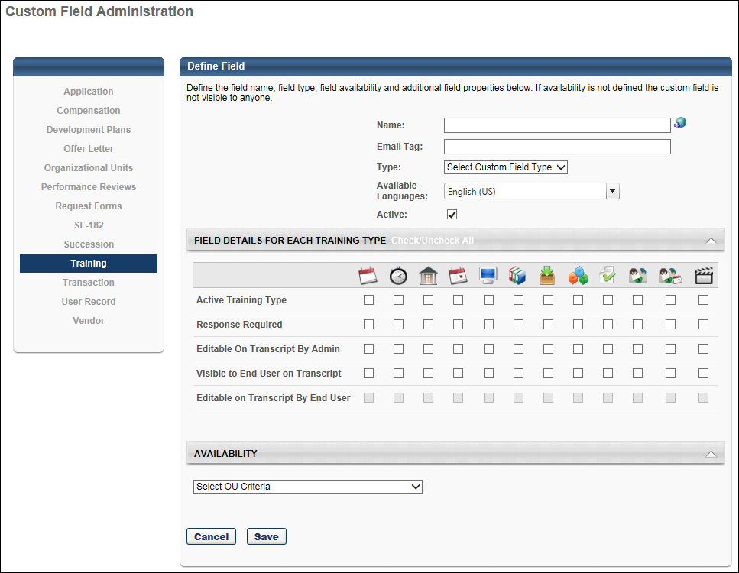

Custom Field Admin - Training Request Forms
To manage training request form custom fields:
- Go to Admin > Tools > Learning > Training Form Management > Manage Training Request Forms. Then, click the Manage Training Request Form Custom Fields link.
- Go to Admin > Tools > Core Functions > Custom Field Administration. Then, click the Training Request Forms tab on the left.
Permissions
PERMISSION NAME | PERMISSION DESCRIPTION | CATEGORY

Training Request Form - Manage | Grant access to create and edit training request forms, manage request form statuses, and manage form statuses for users. This is an administrator permission. | Training Forms Administration

Training Request Form Custom Fields - Manage | Grants access to create and edit custom fields used for Training Request Forms. This is an administrator permission. | Training Forms Administration
Search for a Field
The following filters are available to search for an existing custom field:
- Name - Enter search terms in the filter. The field displays results for a partial or exact match to the search terms.
- Field Type - Select a field type from the drop-down.
- Include Inactive - Check the box to include inactive custom fields in the search.
Once all filters are defined, click Search. This refreshes the fields table with the filtered results.
Add Custom Field
To create a custom field, click the Add Field icon. This opens the Define field page. From here, you can select the type of field you want to create and define the options for the field if applicable. Information about how to create the specific types of custom fields (i.e., branched dropdown, checkbox, etc.) is available on the "Custom Field Type Options" page in Online Help. See Custom Field Admin - Custom Field Type Options on page 68 for additional information.
Fields Table
This table displays all existing custom fields for the field area. The table is sorted in alphabetical order by name. The Title and Created By columns are sortable. The following information displays in the table:
- Title - This column displays the title of the custom field.
- Type - This column displays the field type, such as radio button or short text box.
- Created By - This column displays the name of the administrator who created the field by last name, first name.
- Active - This column defines the active status of the field. To activate the field, check the box in the Active column. To inactivate the field, uncheck the box.
When active, the custom field is available to use by administrators who meet the field's availability requirements. Inactive custom fields are not available to use.
- Options - The following options are available in the Options column:
  - Edit - Click the Edit icon to edit the field. The field type cannot be modified when editing the field. See Custom Field Admin - Custom Field Type Options on page 68 for additional information.
  - Delete - Click the Trash Can icon to delete the field. This option is only available if the custom field has not been used. If a field has been used, then it cannot be deleted and the Trash Can icon does not display. There is no audit history available to view custom fields that were deleted. Please reach out to Global Customer Support if additional details are needed for a deleted custom field.
To create a Training Request Form custom field:
- Click Add Field icon .
- Name - Enter name of custom field that will be visible to end user. The maximum character limit is 100. If multiple languages are enabled, click the Translate icon to the right of the field to localize the values to the other available languages.
- Email Tag - Enter the name for the email tag to be associated with this field, and use it to retrieve the value of this field in email communications. The tag must be written in capital letters without spaces. Periods (.) can be used instead of spaces. For example, PROFIT.NET is an acceptable email tag.
  - Custom tags are prefixed with the word CUSTOM. For example, for a custom field called Profit Net, the administrator can create the tag, PROFIT.NET, and the system will convert this to CUSTOM.PROFIT.NET.
- Type - From the drop-down list, select the type of field you are creating. The following options are available. See Custom Field Admin - Custom Field Type Options on page 68 for additional information.
  - Check box
  - Date Field
  - Dropdown
  - Hierarchy
  - Multiple Checkbox
  - Numeric Field
  - Radio Button
  - Scrolling Text Box
  - Short Text Box
- Active - Check to make the field active.
- Availability - Define which users have the ability to view and access the custom field. See Setting Availability Overview for additional information. The administrator must set the availability of the field if the field is to appear for other administrators and end users in the application. If availability is not set, then the field will not appear in administrator and end user areas of the application.
- Click Save.
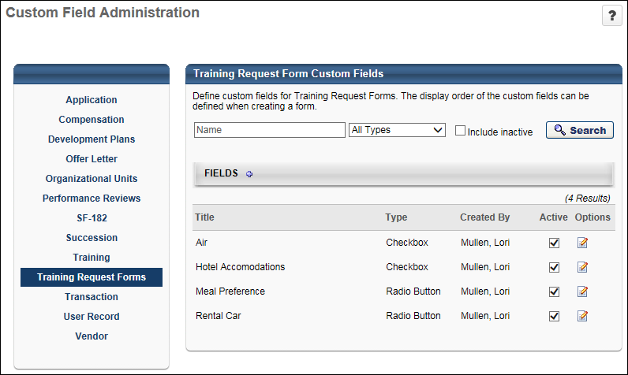

Custom Transaction Field Administration
The Transaction tab in Custom Field Administration enables administrators to create custom fields for transactions and add the fields to the transactions that are created when training is purchased. The fields can be added to the Shopping Cart, My Account, and Manage Transactions functionality.
To access custom Transaction fields, go to Admin > Tools > Core Functions > Custom Field Administration.
Permissions
PERMISSION NAME | PERMISSION DESCRIPTION | CATEGORY

Transaction Custom Fields - Manage | Grants ability to create and edit custom fields to be used with transactions. This permission cannot be constrained. This is an administrator permission. | eCommerce - Administration
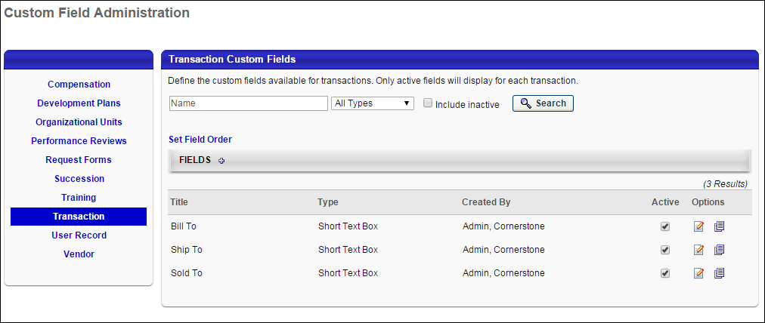
Feature | Description
Search Filters | The following search filters are available:  - Name - Enter search terms in the Name filter. The field displays results for a partial or exact match to the search terms.  - Field Type - Select a field type from the drop-down.  - Include Inactive - Check the Include Inactive option to include inactive custom fields in the search.  Once all filters are defined, click Search. This refreshes the fields table with the filtered results.
Set Field Order | Click the Set Field Order link to open the page, which allows the administrator to rearrange the order in which custom Transaction fields appear to users. See Custom Transaction Field - Set Field Order on page 46 for additional information.
Add Field | Click the Add Field  icon in the Fields panel header to create a new custom field. See Custom Transaction Field - Add on page 48 for additional information.
Custom Fields Table | This table displays all existing custom fields. The table is sorted in alphabetical order by name. The Title and Created By columns are sortable. The following displays for each field:  - Title - This column displays the title of the custom field.  - Type - This column displays the field type, which includes drop-down or short text box.  - Created By - This column displays the name of the administrator who created the field by last name, first name.  - Active - This column defines the active status of the field. To activate the field, check the box in the Active column. To inactivate the field, uncheck the box. Note: If a custom field is inactivated after the field is added to a transaction, then the field still displays on the transaction but is read-only, and the field cannot be used for future transactions until the field is activated.
Options | The following options are available in the Options column:  - Edit - Click the Edit icon to edit the field. The field name, type, email tag, and availability settings can be modified. Also, where the field appears in the system can be modified. See Custom Transaction Field - Add on page 48 for additional information.  - Copy - Click the Copy icon to copy the field. All fields and their values are copied.  - Delete - This option only displays for fields that have not yet been used in a transaction. Click the Trash Can icon to delete the field. When a field is deleted, it no longer appears on the Shopping Cart, Manage Transactions, and My Account pages. In addition, the email tag for the field is not automatically removed from any emails that contain the tag. The tags must be manually removed by the administrator.

Custom Transaction Field - Set Field Order
The Set Field Order page allows administrators to define the order in which the custom Transaction fields appear on the My Account > Order Details page and the Manage Transactions > Order History Details page.
To access the Custom Field Display Order page, click the Set Field Order link on the Transaction tab in Custom Field Administration.
Permissions
PERMISSION NAME | PERMISSION DESCRIPTION | CATEGORY

Transaction Custom Fields - Manage | Grants ability to create and edit custom fields to be used with transactions. This permission cannot be constrained. This is an administrator permission. | eCommerce - Administration
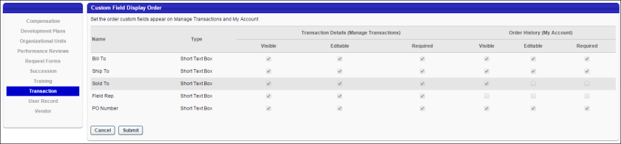
Custom Fields Table
The custom fields table has one column for the Transaction Details (Manage Transactions) options and one column for the Order History (My Account) options. The following information displays in the table for both sections:
- Name - This column displays the name of the field.
- Type - This column displays the type of field, either Dropdown or Short Text Box.
- Visible - This column displays the read-only visibility selection for the field. If the box is checked, then the field was made visible on the Order History Details and/or Order Details pages. If the box is unchecked, then the field was not made visible.
- Editable - This column displays the read-only editable selection for the field. If the box is checked, then the field is editable on the Order History Details and/or Order Details pages. If the box is unchecked, then the field is not editable.
- Required - This column displays the read-only required selection for the field. If the box is checked, then the field is required on the Order History Details and/or Order Details pages. If the box is unchecked, then the field is not required.
Reorder Fields
To reorder the fields in the table, drag and drop the row into the desired position.
Cancel/Submit
Click Cancel to cancel the changes to the field order.
Click Submit to submit the changes to the field order. The fields are reordered on the My Account > Order Details page and the Manage Transactions > Order History Details page.

Custom Transaction Field - Add
The Define Field page allows administrators to create custom Transaction fields in Custom Field Administration. Administrators define the general values for the field, such as the name, email, tag, and type. They will also define where in the system the field displays. Custom Transaction fields can appear in the following areas of the system:
- Shopping Cart Preferences
- My Account > Order Details
- Manage Transactions > Order History Details
Permissions
PERMISSION NAME | PERMISSION DESCRIPTION | CATEGORY

Transaction Custom Fields - Manage | Grants ability to create and edit custom fields to be used with transactions. This permission cannot be constrained. This is an administrator permission. | eCommerce - Administration
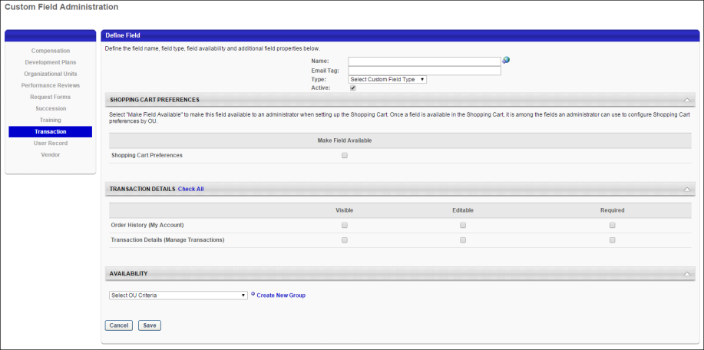
Name
This is a required field. Enter the name of the custom field that will be visible to end users. The character limit for this field is 50. If multiple languages are enabled, click the globe icon to translate the name into other available languages.
Email Tag
This is a required field. Enter the tag name for the field, up to 50 characters. The name must be unique and cannot be used by another tag. All tags automatically begin with "CUSTOM." If a space is entered, the system translates the space into a period.
The tag displays in the View Tags pop-up on the Shopping Cart Preferences and Email Administration.
Editing Note: When editing the custom field, the tag in the Tag Name field cannot be modified.
Type
From the drop-down list, select the type of field you are creating. The following options are available in the drop-down:
- Dropdown
- Short Text Box
Depending on the field type selected, options may be available to configure for the field. See Custom Field Admin - Custom Field Type Options on page 68 for additional information.
Active
The Active box is checked by default. To inactivate the custom field, uncheck the Active box. When active, the custom field displays in the areas of the system in which it is configured to display, including the Shopping Cart, My Account, and Manage Transactions pages.
If a custom field is inactivated after the field is added to a transaction, then the field still displays on the transaction but is read-only, and the field cannot be used for future transactions until the field is activated.
Shopping Cart Preferences
This section allows the administrator to add the custom field to the Shopping Cart Preferences page. To add the field, check the Make Field Available option. This makes the custom field available to an administrator when configuring Shopping Cart Preferences. From the Shopping Cart Preferences page, the administrator can then choose to make the field visible to end users on the Payment or Confirmation/Thank You page during the shopping cart checkout process.
Note: This section only displays for portals that have the Shopping Cart functionality enabled.
Transaction Details
This section allows the administrator to add the custom field to the My Account > Order Details page and the Manage Transactions > Transaction Details page. The administrator can also select to make the field editable and required. The following options are available:
- Check All - Select the Check All option to the right of the Transaction Details header to select all options in the section.
- Visible - Select this option to make the custom field visible on the Order Details (My Account) page and/or Order History Details page in Manage Transactions. Users must have permission to view the order history details in order for the field to be visible on the Order History page. Users must have permission to manage transactions for the field to be visible on the Transaction Details page. If the Editable option is not also selected, then the field is visible but read-only.
- Editable - Select this option to make the custom field editable on the Order Details (My Account) page and/or Order History Details page in Manage Transactions. When this option is selected, the value in the field is editable on the Order History page by users with permission to view the order history details. The field is editable on the Transaction Details page by users with permission to manage transactions. Note: The Visible option is automatically selected when Editable is selected.
- Required - Select this option to make the custom field required on the Order Details (My Account) page and/or Order History Details page in Manage Transactions. If a field is required, then the user must enter a value in the field before saving the page. Note: The Visible and Editable options are automatically selected when Required is selected.
Note: The Order Details (My Account) option only displays for portals that have the Order Details functionality enabled for My Account.
Availability
In the Availability section, set the availability for the custom field to determine which users can see the fields on the My Account > Order Details page and the Manage Transactions > Order History Details page. Select the organizational unit (OU) criteria from the drop-down, and then select the OU or users from the pop-up. This section is required.
The users who meet the availability criteria defined in the Availability section will see the field if the field is made visible in the Transaction Details section. If a custom field is not made visible, then the field does not display for users, even if the users meet the availability criteria.
Considerations
- All custom Transaction fields that are made visible in the Shopping Cart Preferences section are visible on the Shopping Cart Preferences page, regardless of the availability settings defined in the Availability section.
- For Billing emails in Email Administration, all active email tags display in the View Tags pop-up, regardless of the availability settings defined in the Availability section. However, once an email is sent to a recipient, the availability for the field is respected and the system considers whether that field is available to the email recipient before populating the email tag with a value for the custom field.
Cancel/Save
Click Cancel to cancel adding or editing the field.
Click Save to save the field.

User Record Custom Fields Overview

User Record and Self Registration Custom Fields
The User Record and Self Registration Custom Fields page enables administrators to manage the custom fields that may appear on a User Record, on My Account pages, and during the self-registration process.
To manage User Record and Self Registration custom fields, go to Admin > Tools > Core Functions > Custom Field Administration. Then select the User Record tab on the left.
Permissions
PERMISSION NAME | PERMISSION DESCRIPTION | CATEGORY

Self-Registration and User Record Custom Fields - Manage | Grants access to manage custom fields for user Self Registration and the user record in Custom Field Administration. This permission can be constrained by OU and User's OU. This is an administrator permission. | Core Administration

User Record Custom Field Configurable Validations - Manage | Grants ability to manage the configurable validations for user record custom fields within Custom Field Administration. This permission cannot be constrained. This is an administrator permission. This permission is only available to organizations that are using Cornerstone HR. | Core Administration
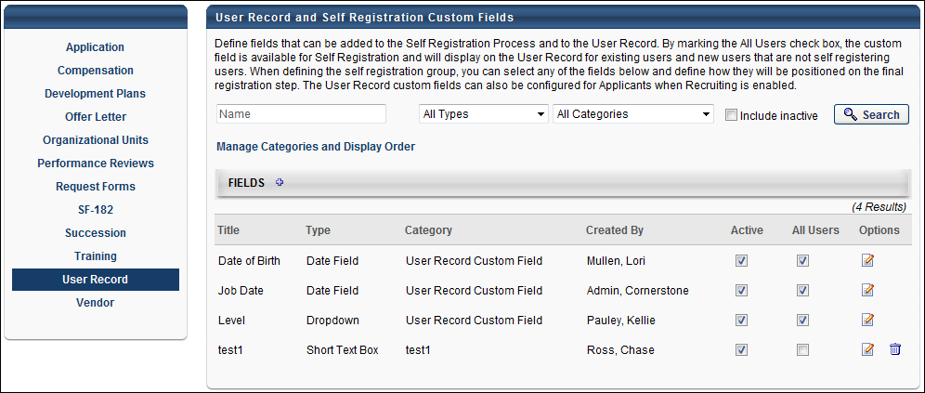
Search for a Field
Administrators can search for a user record custom field using the following search fields:
- Name - This field enables administrators to search for a field by title.
- Field Type - Select a custom field type from the drop-down to view only fields of a specific type. The search parameter "All Types" displays by default.
- Field Category - Select a custom field category from the drop-down to view only fields in a specific category. The search parameter "All Categories" displays by default.
- Include Inactive - Select this checkbox to display inactive custom fields in the search results.
Select the Search button to return your search results.
Manage Categories and Display Order
Select this link to group custom fields into categories and define the order in which the fields are displayed in each category. The custom fields will appear in the selected categories and in the selected order on the User Record. See Categories and Display Order - Manage on page 62 for additional information.
Add Fields
Select the Add Fields icon to navigate to the Add Custom Fields page on which you can add custom fields. See User Record Custom Field - Add/Edit on page 55 for additional information.
The recommended maximum number of user record custom fields is 1,000. If more than 1,000 user record fields are created, this may impact system and reporting performance.
Fields Table
The following fields display on the User Record and Self Registration Custom Fields page:
- Title
- Type
- Category
- Created By - This displays the name of the user who created the category by last name, first name. A Created By name does not display for the User Record Custom Field category, even if the category name is changed.
- Active - This option controls the custom field's active status. Unselecting the box makes the field unavailable in all areas.
- All Users - This option controls whether the field is included on a user's record for a user who is not created via self registration. If this option is selected, the field is available on the user record, in self registration, as a field in custom reports, and as a criteria option when creating a group. If this option is not selected, the field is only available in self registration.
Field Options
The following actions are available under the Options column:
- Edit - Select this option to edit the details of the custom field. The Field Type cannot be edited. See User Record Custom Field - Add/Edit on page 55 for additional information.
- Delete - Select this option to remove the custom field. This option is only available if the custom field has not been used. If the custom field value has been set on at least one user record, this option is not available.
Recruiting Module Considerations
For portals with the Recruiting module enabled, User Record can be used to store data for applicants in the Applicant Tracking System. User Record custom fields that are created in Custom Field Administration can be added by the administrator to the Applicant Custom Fields section in Requisition Preferences.

User Record Custom Field - Add/Edit
User Record custom fields may be made available for User records, forms, My Account, Self-registration and the Data Load Wizard.
The recommended maximum number of user record custom fields is 1,000. If more than 1,000 user record fields are created, this may impact system and reporting performance.
To manage User Record and Self Registration custom fields, go to Admin > Tools > Core Functions > Custom Field Administration and select the User Record tab on the left.
Permissions
PERMISSION NAME | PERMISSION DESCRIPTION | CATEGORY

Self-Registration and User Record Custom Fields - Manage | Grants access to manage custom fields for user Self Registration and the user record in Custom Field Administration. This permission can be constrained by OU and User's OU. This is an administrator permission. | Core Administration

User Record Custom Field Configurable Validations - Manage | Grants ability to manage the configurable validations for user record custom fields within Custom Field Administration. This permission cannot be constrained. This is an administrator permission. This permission is only available to organizations that are using Cornerstone HR. | Core Administration

Required User Custom Fields - Manage | Grants the ability to manage the Required setting for user record custom fields. This permission cannot be constrained. This is an administrator permission. This permission is only available for organizations using Cornerstone for HR. | Core Administration

Users - Edit Secure User Custom Fields - Unmasked | Grants the ability to edit secure user custom field info unmasked. This permission can be constrained by OU, Restrict to User's OU, User Self and Subordinates, User, User's Self, User's Manager, User's Superiors, User's Subordinates, User's Direct Reports, Employee Relationship. This is an administrator permission. | Core Administration

Users - Manage Secure User Custom Fields | Grants the ability to manage the setting secure user custom fields. This permission can be restrained by OU, User's OU, User Self and Subordinates, User, User's Self, User's Manager, User's Superiors, User's Subordinates, User's Direct Reports, Employee Relationship. This is an administrator permission. | Core Administration

Users - View Secure User Custom Fields - Masked | Grants the ability to view secure user custom field info masked. This permission can be constrained by OU, User's OU, User Self and Subordinates, User, User's Self, User's Manager, User's Superiors, User's Subordinates, User's Direct Reports, Employee Relationship. This is an administrator permission. | Core Administration

Users - View Secure User Custom Fields - Unmasked | Grants the ability to view secure user custom field info unmasked. This permission can be constrained by OU, User's OU, User Self and Subordinates, User, User's Self, User's Manager, User's Superiors, User's Subordinates, User's Direct Reports, Employee Relationship. This is an administrator permission. | Core Administration

Users - Manage OU Based Regex | Grants access to manage OU-based Regex patterns for user custom fields. This permission cannot be restrained. This is an administrator permission. | Core Administration

Users - Manage OU Based Applicability | Grants access to manage OU-based Applicability for user record custom fields. This permission cannot be restrained. This is an administrator permission. | Core Administration
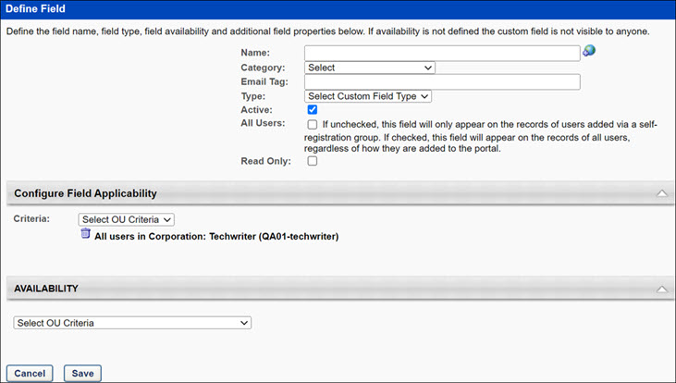
Create User Record
Enter the following information for the custom field:
- Name - Enter name of custom field that will be visible to end user, up to 100 characters. If multiple languages are enabled for your portal, select the Translate icon to translate the field into other available languages.
- Category - Select the category under which to associate the field. All categories available to the administrator display, in addition to a default Select option. Categories display in the order in which they are defined on the User Record Categories page. Note: Populating the Category field with "Select" results in a "Missing Required Field" error. When editing the name of a custom field, by default the field is defined under the default User Record Custom Field category.
- Email Tag - Enter the name for the email tag to be associated with this field, and use it to retrieve the value of this field in email communications. The tag must be written in capital letters without spaces. Periods (.) can be used instead of spaces. For example, PROFIT.NET is an acceptable email tag.
  - Custom tags are prefixed with the word CUSTOM. For example, for a custom field called Profit Net, the administrator can create the tag, PROFIT.NET, and the system will convert this to CUSTOM.PROFIT.NET.
- Type - From the drop-down list, select the type of field you are creating. The following options are available. See Custom Field Admin - Custom Field Type Options on page 68 for additional information.
  - Date field
  - Drop down
  - Hierarchy
  - Multiple Checkbox
  - Numeric field
  - Radio button
  - Scrolling text box
  - Short text box
- Active - This option controls the custom field's active status. Unselecting the box makes the field unavailable in all areas.
- All Users - This option controls whether the field is included on a user's record for a user who is not created via self registration. If this option is selected, the field is available on the user record, in self registration, as a field in custom reports, and as a criteria option when creating a group. If this option is not selected, the field is only available in self registration.
- Read Only - If this option is selected, then the user record custom field cannot be edited by anyone, including administrators. A read-only user record custom field can only be updated by the data feed. Note: Self-registration custom fields are always editable by the user, regardless of the read-only setting.
- Required -This option is only available when Cornerstone HR is enabled. If this option is selected, this user record custom field is required and must be completed before the record is saved. Note: You cannot use this option with checkbox type custom fields.
- Secure - If this option is selected, newly created short text, scrolling text, date, and numeric user custom fields can be configured to appear as secure fields on the user record. Secure custom fields function like Sensitive Personally Identifiable Information (SPII) fields and can be maintained and viewed if the administrator’s IP is part of the IP safe list. The following considerations apply to this option:
  - This option is only available to organizations using Cornerstone HR.
  - If selected, the All Users and Active options must be selected.
  - Required custom fields cannot be set to secure.
  - Secure custom fields cannot be added to My Account.
  - Secure custom fields cannot be maintained via the Data Load Wizard.
  - Secure custom fields cannot be maintained or exposed via the Employee Public API.
  - Secure custom fields cannot be maintained via Forms.
Note: The culture of the administrator will be set as the default culture for the custom field label when creating a new custom field.
Configure Field Validation
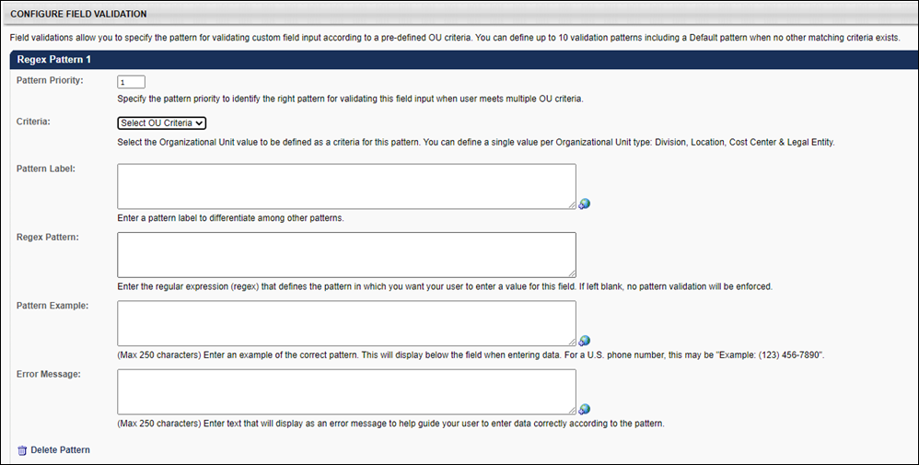
This section is only available to organizations using Cornerstone HR, and it is only available if the administrator has permission to manage user record custom field validations. This section is only available when creating or editing short text box or scrolling text box user record custom fields.
This section enables administrators to define a required format for the custom field. When a required format is defined, any data entered into the custom field must match the required format. This enables organizations to ensure that data is entered into the custom field in the proper format. The required format is defined using a regex pattern.
Enter the following information for the field:
- Regex Pattern - Enter the regular expression that defines the format in which data must be entered in the field. If no regex pattern is entered, then the system does not enforce any additional field validations. The character limit for this field is 4,000. When the custom field is saved, the system validates that the Regex pattern is a valid expression. See the Regex Assistance section below for resources to assist in writing regex expressions. Note: Cornerstone Global Customer Support does not troubleshoot regex issues.
  - Regex pattern based on OU - Select an option in the Criteria drop-down to configure custom field validation setup that allows you to define multiple regex patterns based on OU values. Options are Division, Location, Legal Entity, or Cost Center types. The following rules apply:
    - You can configure up to 10 OU-based regex patterns per User Custom field.
    - Each custom field must have a default regex pattern as a fallback if User's OU values don't match any of the remaining OU criteria.
    - OU-based regex patterns can be created for both Required or Secure custom fields for Short text or Scrolling text and only for Active custom fields with "All Users" checked.
    - Changes to OU values on the User Record triggers validations for matching regex patterns.
- Format Example - Enter text to explain or demonstrate the correct format for the field so that users who complete the field understand the proper way to enter information in the field. This text will appear below the user record custom field when a user is completing the field. The character limit for this field is 250. If multiple languages are enabled for your portal, select the Translate icon to translate the field into other available languages. Note: Formatting rules are enforced in the My Account and Self Registration pages but the formatting example is not visible on those pages.
- Error Message - Enter an error message that will display when a user does not enter data in the correct format. This message should help guide the user to correctly enter the data. The character limit for this field is 250. If multiple languages are enabled for your portal, select the Translate icon to translate the field into other available languages. Note: When creating a new regex format, the culture of the administrator will be set as the default culture for the error message.
If a valid regex Pattern is entered, then the Format Example and Error Message are required.
Configure Field Applicability
Configure applicability for each individual custom field. Administrators can define the OU criteria for each custom field that specifies which custom fields are applicable to a given user. Administrators can define applicability using a combination of the following OUs:
- Cost Center
- Division
- Legal Entity
- Location
Only one criterion can be set per OU type. If several criteria are selected, the OR condition applies.
The applicability setting applies to the User record, Universal profile, the user’s My Account Preference page and Forms. Only the applicable custom fields based on the defined OU type values of the target user display. When the setting is adjusted in the custom field administration page, it is immediately reflected on the appropriate pages.
Availability
Define which users have the ability to view and access the custom field. See Setting Availability Overview for additional information. The administrator must set the availability of the field if the field is to appear for other administrators and end users in the application. If availability is not set, then the field will not appear in administrator and end user areas of the application.
Save
Click Save to create or save the custom field.
Configure Field Validation Considerations and Resources
The Configurable Field Validation section is only available to organizations using Cornerstone HR, and it is only available if the administrator has permission to manage user record custom field validations. This section is only available when creating or editing short text box or scrolling text box user record custom fields.
Regex Assistance
The resources in this section may be used to learn about writing regular expressions, find common regular expressions, and test your regular expressions.
Education / Getting Started
The following resources may help you learn how to write your own regular expressions:
- Microsoft - https://docs.microsoft.com/en-us/dotnet/standard/base-types/regular-expressions
- RegExr - http://regexr.com/
Common Expressions
The following resource allows you to search for common regular expressions that have already been defined for you:
- RegExLib (Regular Expression Library) - http://www.regexlib.com/
Regular Expression Validator
The following resource helps you validate your regular expression before implementing it in the system:
- Regular Expressions 101 - https://regex101.com/
Data Preparation for Configure Field Validations
Configurable field validations are only applied to data that is entered after the custom field validations are applied. Existing data that was entered prior to configuring the field validations is not validated until the existing data is edited.
Cornerstone recommends that organizations use configurable field validations with custom fields that are created following this enhancement. This ensures that all data within the custom field complies with the format defined for that field. However, if an organization wishes to configure field validations for existing user record custom fields, it is best practice to review and clean up all data within the existing custom field BEFORE configuring a validation. The easiest way to ensure all user data for a single field is in the correct format prior to implementing a validation is to extract user data through a report, correctly format all user data for that field, and then upload the correctly formatted data through the Data Load Wizard. After this exercise is complete and all user data for that field is of the same format, then it is safe to configure a field validation.
Considerations for Configure Field Validations
If an organization has a data feed for user record information, then if the organization implements or changes a field validation and any user data in the feed does not pass the validation for the field, then the data feed will not feed any data into the system. Therefore, it is very important that organizations review and clean up all existing data in a user record custom field if a field validation is being added to the field.
Configurable field validations are only available for User Record custom fields that are of the type short text box and scrolling text box.
If a user record custom field with field validations is included in the self-registration process or in My Account, the format example is not displayed.

Categories and Display Order - Manage
The User Record Categories page enables administrators to create and edit categories in which to organize custom fields. Administrators can also delete and translate existing categories, as well as manage the order in which categories display on the User Record page.
To access the User Record Categories page, go to Admin > Tools > Custom Field Administration. Then, click User Record from the left navigation panel. In the User Record and Self Registration Custom Fields table, click the Manage Categories and Display Order link.
Administrators can change the category with which a field is associated. See User Record Custom Field - Add/Edit on page 55 for additional information.
Permissions
PERMISSION NAME | PERMISSION DESCRIPTION | CATEGORY

Self-Registration and User Record Custom Fields - Manage | Grants access to manage custom fields for user Self Registration and the user record in Custom Field Administration. This permission can be constrained by OU and User's OU. This is an administrator permission. | Core Administration
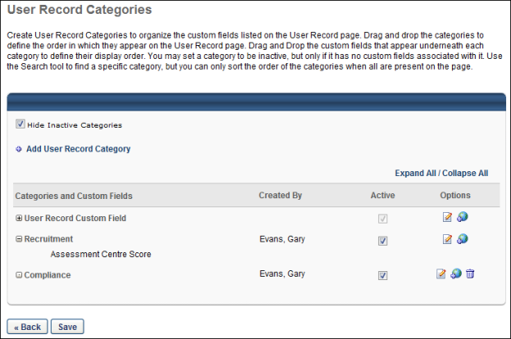
The following fields display on the User Record Categories page:
Feature | Description
Hide Inactive Categories | When checked, only active categories display on the User Record Categories page. Unchecking the box displays both active and inactive categories. The box is checked by default.
Add User Record Category | Allows you to add a new category.
Categories and Custom Fields | Lists the custom field categories and the custom fields within the categories. Custom fields are indented under the category name.
User Record Custom Field | The default user record category. All fields are defined under this category unless configured to be defined under a different category. If no additional categories are configured on the Manage Categories and Display Order page, all fields display under the default category on the User Record page.
Created By | Displays the name of the user who created the category by last name, first name. A Created By name does not display for the User Record Custom Field category, even if the category name is changed.
Active | Indicates the category's active status. The box is checked by default when a new category is added. Unchecking the box inactivates the category, hiding it on the User Record and Self Registration Custom Fields page. If you inactivate a category that contains at least one custom field, the fields contained within the category will then be associated with the User Record Custom Field default category.
Options | The following actions are available under the Options column:  - Edit - Allows you to change the name of the category.  - Translate - If multiple languages are enabled for the portal, you can localize the category name for any of the languages enabled, using the Standard Text Translation pop-up. The language in which the category is created cannot be deleted once saved.  - Delete - Removes the category. Note: The Delete icon does not display for the User Record Custom Field category, as it is a default category that cannot be removed. Also, this option is only available if the category has no custom fields associated with it.
Save | Saves any changes made to the category or custom field order, the Active column, or the deletion of a category. Upon saving, the user is returned to the User Record and Self Registration Custom Fields page. If the user does not click Save, any changes made to these areas will not be saved.
Back | Returns the user to the User Record and Self Registration Custom Fields page.
Add New Category
To add a category:
- Click the Add User Record Category link.
- The Add User Record Category pop-up opens. Enter the category name in the Name field (character limit of 50).
- Click Save to save the category.
- Click Cancel to cancel the action.
Edit Category
- Click the Edit icon.
- The Edit User Record Category pop-up opens, displaying the current name. Edit the name in the Name field (character limit of 50).
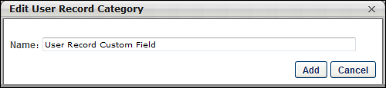
- Click Add to save the changes.
- Click Cancel to cancel the edit action.
Reorder Categories
Categories can be placed in any order. To reorder a category:
- Hover over the row. The mouse changes to a compass view.
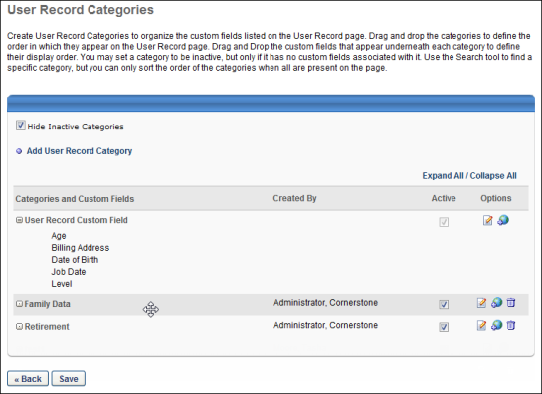
- Drag and drop the row to the desired position. Note: All fields within a category move with it.
Reorder Fields within a Category
Custom fields within a category can be placed in any order. To reorder custom fields within a category:
- Hover over the name of the custom field. The mouse changes to a compass view.
- Drag and drop the field to the desired position. Note: A field can only be reordered within its respective category. A field cannot be moved into a different category by dragging and dropping.

Custom Field Admin - Vendors
Vendor custom fields are available for the vendors and providers that are created for instructor-led training (ILT) in the system.
To view and manage custom fields, go to Admin > Tools > Core Functions > Custom Field Administration. Click the Vendor link in the left-side panel on the page to manage vendor custom fields.
Permissions
PERMISSION NAME | PERMISSION DESCRIPTION | CATEGORY

Vendor Custom Fields - Manage | Grants access to manage training vendor (provider) custom fields. | Learning - Administration
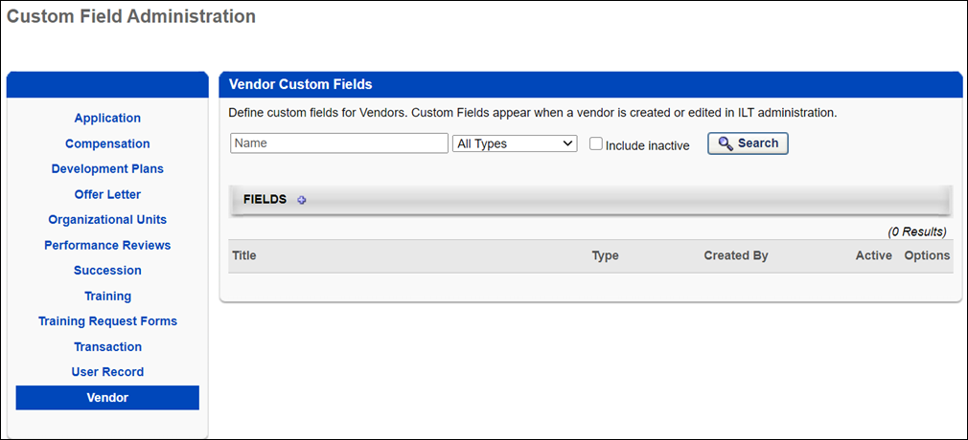
Search for a Field
The following filters are available to search for an existing custom field:
- Name - Enter search terms in the filter. The field displays results for a partial or exact match to the search terms.
- Field Type - Select a field type from the drop-down.
- Include Inactive - Check the box to include inactive custom fields in the search.
Once all filters are defined, click Search. This refreshes the fields table with the filtered results.
Add Custom Field
To create a custom field, click the Add Field icon. This opens the Define field page. From here, you can select the type of field you want to create and define the options for the field if applicable. Information about how to create the specific types of custom fields (i.e., branched dropdown, checkbox, etc.) is available on the "Custom Field Type Options" page in Online Help. See Custom Field Admin - Custom Field Type Options on page 68 for additional information.
Fields Table
This table displays all existing custom fields for the field area. The table is sorted in alphabetical order by name. The Title and Created By columns are sortable. The following information displays in the table:
- Title - This column displays the title of the custom field.
- Type - This column displays the field type, such as radio button or short text box.
- Created By - This column displays the name of the administrator who created the field by last name, first name.
- Active - This column defines the active status of the field. To activate the field, check the box in the Active column. To inactivate the field, uncheck the box.
When active, the custom field is available to use by administrators who meet the field's availability requirements. Inactive custom fields are not available to use.
- Options - The following options are available in the Options column:
  - Edit - Click the Edit icon to edit the field. The field type cannot be modified when editing the field. See Custom Field Admin - Custom Field Type Options on page 68 for additional information.
  - Delete - Click the Trash Can icon to delete the field. This option is only available if the custom field has not been used. If a field has been used, then it cannot be deleted and the Trash Can icon does not display. There is no audit history available to view custom fields that were deleted. Please reach out to Global Customer Support if additional details are needed for a deleted custom field.
Add Custom Fields
To add a new custom field, follow these steps:
- Select the Add Field icon .
- Name - Enter a name for the custom field that will be visible to end user. The character limit for this field is 50. If multiple languages are enabled for your portal, select the Translate icon to translate the field into other available languages.
- Type - Select the appropriate custom field type from the drop-down menu. For vendors, Date, Drop-down, Numeric, Radio Button, Scrolling Text Box, and Short Text Box type fields can be created. See Custom Field Admin - Custom Field Type Options on page 68 for additional information.
- Active - Select this option to make the field active.
- Availability - Define which users have the ability to view and access the custom field. The administrator must set the availability of the field if the field is to appear for other administrators and end users in the application. If availability is not set, then the field will not appear in administrator and end user areas of the application. See Setting Availability Overview for additional information.
- Click Save.

Custom Field Admin - Custom Field Type Options
The following custom field type options are available. Which field types (e.g., drop-down list, hierarchy) are available is dependent on the type of custom field you are creating (e.g., compensation, training).
Branched Dropdown
Contents are contingent on the selected value of a parent drop-down field. This allows you to create a hierarchy of drop-downs which displays information to specific Users. The parent drop-down must be created before creating a branched drop-down. This field type is available for user record and training custom fields.
- Assigned Parent Field - Click to select and associate a Parent field. Parent fields can be either type Dropdown or Branched Dropdown. Parent fields must be the same language as the Branched Dropdown. Available parent fields will be constrained by the Training Custom Field Creator Constraints. Branched Dropdowns with no parent will function as regular Dropdowns. Each option has a limit of 100 characters. Options may have more than one associated parent option. You can drag-and-drop options to re-order them. From an end-use perspective, when creating an LO or submitting external training, Branched Dropdowns are disabled until the parent Dropdown has a value selected.
- Alphabetize Options - Select this option to alphabetize the branched drop-down options.
- Click Options icon to add selections.
- Name - Enter text for drop-down field name. If multiple languages are enabled, click the Translate icon to the right of the field to localize the values to the other available languages.
- Active - Check to make the option active.
- Remove - Click to delete option.
Check Box
This is a field that contains a checkbox, which is unchecked by default.
Conditional Numeric Field
This is a calculation-based numeric field, which can perform IF conditions and mathematical expressions to determine a value. This allows you to set specific calculations. The value is calculated based on an equation which may be contingent on one or more other fields. Both mathematical and logical (IF, THEN, ELSE) conditions are available. Conditional Numeric Fields are available for all LO types (Online Class, Session, Event, etc), as well as for an end user submitting external training. A Calculate link displays for the end user. This field type can be helpful for ensuring accuracy for the submission of external training.
- Equation - Enter an equation. Click the pop-up icon to select a previously created numeric custom field value to include in the equation (e.g., {CPE Credits}*2). Click the Save icon to save the equation.
- To add a condition to the equation, click the Conditions icon. This creates an If, Then, Else equation using the selected custom field. For example, if "Training Hours" is greater than 10.
- You can add additional conditions using the And and Or links.
- Click the Edit icon to the right of the condition to edit the equation.
Conditional Numeric Field Validation
When creating a Conditional Numeric Field type, a validation can be configured to ensure a valid value is entered when a conditional numeric field is completed on the Add/Edit External Training pop-up or the Training Details page. The Validations section can be configured during the create, edit, and copy process for Training custom fields.
To add a validation:
- Click the plus sign to the right of the Validations section header. This opens the validation options.
- The Field column always displays the text "Final Calculated Value." This indicates that the value calculated on the Add/Edit External Training pop-up or the Training Details page must meet the validation criteria entered in the Operator and Value fields.
- In the Operator column, select one of the following operators from the drop-down:
  - Must be equal to
  - Must not be equal to
  - Must be less than
  - Must be less than or equal to
  - Must be greater than
  - Must be greater than or equal to
  - Must be one of
- Enter a numeric value in the Value column. The field is blank by default.
- Enter a custom validation message. The character limit is 500. This is not a required field. For portals with multiple languages enabled, you can localize the message using the Translate icon.
Custom error messages appear in the following format: <Custom Error Message Text>. Calculation used: (<calculation>).
Note: If a custom validation message is not entered, the following standard validation message displays for any instance in which an invalid value is entered for the field: "Error: The final calculated value for this field <operator> <value>. Please adjust your values and try again. Calculation used: (<calculation>)."
- The Remove column allows you to remove the validation by clicking the Delete icon. You can delete a validation at any time. The deletion is only committed when Save is clicked.
Additional validations can be included by clicking the plus sign next to the Validations section header.
Date Field
Create a date field. The format of MM/DD/YYYY or DD/MM/YYYY is determined by the culture settings for the portal. Note: The maximum date supported for custom date fields is November 2077.
Dropdown
This is a field that contains a drop-down list.
To add a drop-down selection, click the Add New Option icon to the right of the Options heading.
- Set "Select" as default option - Select this option to set the default drop-down value as "Select." If this is not selected, a Default column displays and you can select which field is the default value for the drop-down list. When this option is selected, users are required to select a value for the field.
- Name - Enter the text for the drop-down field name. The character limit for this field is 100. If multiple languages are enabled for your portal, select the Translate icon to translate the field into other available languages.
- Active - Select this option to make the drop-down option active.
- Remove - Click this icon to delete the option.
- Sort - If there are two or more options, you can drag and drop the options to order them.
Note: If translated values are defined in the Options section, then the values display in the user's language, if available. If the user's language is not available, then the values display in the default language for the portal.
Encrypted Short Text Box
See Custom Field Admin - Encrypted Short Text Box on page 75 for additional information.
Formula Metric
Formula Metric custom fields enable the ability to combine multiple ratings into a single formula metric custom field. The administrator can combine ratings from numeric user custom fields, performance reviews, competency assessments, and succession rating scale metrics into one rating that can be used to plot users on a metric grid. Formula Metric may be added to individual profile step of template.
See Configuration Guide - Using a Formula Metric in an SMP Template.
Formula Metric - Formula Properties
Click Add icon to select a field. After selecting a field, you must send a percentage value for the field. The total for all percentages must equal 100%.
Formula Metric - Rating Scale
- Scale - Enter the number of values should be in the scale (e.g., 1-5 creates a scale with five scale scores). After entering a value, click the Add button to update the scale. The maximum value is 15.
- Include N/A rating - Select this option to include a Not Applicable or N/A rating in the rating scale. This enables the assessor to select this rating if they feel the question or item does not apply to the assessee.
- Map custom ranges - The availability of this option is controlled by a backend setting. Select this option to map the points on the rating scale to custom ranges of values. See the Range field description below for additional information.
- Points - This column displays each point value on the rating scale.
- Range - This option is only available when the Map custom ranges option is selected. This field enables the administrator to define score ranges that are mapped to points on the rating scale. For example, if a range of 13.55-15.00 is mapped to the 15 point value, then if a user receives a score that is within the 13.55-15.00 range, this score is automatically mapped to the 15 point value.
  - When the administrator defines the rating scale, the system automatically populates the Range values with equal increments based on the size of the rating scale.
  - The left value in the range is known as the range floor and it represents the lowest value that is included in the range.
    - The range floor value is always read-only. If a range ceiling is modified, the range floor for the following range is automatically adjusted to match the previous range ceiling. For example, for the first rating (1.0), the range is set to 0-1.0. The range floor for the following rating (2.0) is automatically set to 1.1 because this is the next possible score. If the range ceiling for the first rating (1.0) is modified from 1.0 to 1.4, the range floor for the following rating (2.0) is automatically updated to 1.5 because this is the next possible score.
    - The first range floor is always set to zero.
  - The right value in the range is known as the range ceiling and it represents the highest value that is included in the range. This value can be modified for all ranges except the final value, which is equal to the highest rating point value.
    - The last range ceiling is always set to the value that is entered for the Rating Scale.
- Active - This option is only available when the Map custom ranges option is selected. This field enables the administrator to make the rating active or inactive for the formula metric. When this option is selected, the corresponding rating scale score is available to assessors when completing a succession task. When this option is deselected, the corresponding rating scale score is not available to assessors and cannot be selected. In addition, when this option is not selected for a rating score, the Score Display and Rating fields are disabled.
- Score Display - Enter the score value that is displayed in the scale. If multiple languages are enabled for your portal, select the Translate icon to translate the field into other available languages.
- Rating - Enter a rating title that describes the rating score (e.g., Exceeds Expectations, Needs Improvement). If multiple languages are enabled for your portal, select the Translate icon to translate the field into other available languages.
- Description - Enter a detailed description for the rating score. The character limit is 1000. If multiple languages are enabled for your portal, select the Translate icon to translate the field into other available languages.
- Select Color - Click this icon to select color that will be associated with the ratings so that reports can be run which color code users by this rating.
Hierarchy
Field that contains options in a parent/child relationship.
- Click Options icon to add selections.
- Order - Drag and drop the options to determine the order in which they appear.
- Add Child - Click to add child filed to parent field.
- Name - Enter text for drop-down field name. If multiple languages are enabled, click the Translate icon to the right of the field to localize the values to the other available languages.
- Active - Check to make the option active.
- Remove - Click to delete the option.
Metric Grid
This is a field that allows the ability to create a box grid. Reporting and analytics capabilities are also available for the box grids.
- X-Axis - Click on the search icon to select field for X-Axis. Can select any performance, competency, succession rating scale, or formula metric field.
- Y-Axis - Click on the search icon to select field for Y-Axis. Can select any performance, competency, succession rating scale, or formula metric field.
- Columns (X) - Enter a number for the X columns.
- Rows (Y) - Enter a number for the Y columns.
- Display Axis Labels - Check to display Axis labels.
- Use Default Trend - This option enables administrators to disable the Trend functionality in Helicopter View for the metric grid field. When this option is selected, the Trend filter and Color Code options are available in Helicopter View. If this option is unselected, the Trend filter and Color Code options are not available in Helicopter View.
Enter a label for each row, column, and grid placement. When defining the grid labels, if multiple languages are enabled, click the globe icon to translate the name into other available languages. Note: Localization may not be available for all types of custom fields.
Editing Note: Once a metric grid field has been used in a template, the field can no longer be edited.
Multiple Checkbox
Field that contains the options to check multiple values.
- Click Options icon to add selections.
- Order - Drag and drop the options to determine the order in which they appear.
- Name - Enter text for option name. If multiple languages are enabled, click the Translate icon to the right of the field to localize the values to the other available languages.
- Active - Check to make the option active.
- Default - Select this option to make the option selected by default.
- Remove - Click to delete the option.
Note: If translated values are defined in the Options section, then the values display in the user's language, if available. If the user's language is not available, then the values display in the default language for the portal.
Numeric Field
This is a text box that accepts numerical characters. The character limit for these text boxes is dependent on the custom field type:
- Application - 15
- Compensation - 15
- Development Plans - 29
- Offer Letter - 15
- Performance Reviews - 10
- Succession - 10
- User Record - 8
OU Field
This is a field that allows the user to search and select an OU from the selected OU type as a value for the field. Groups are not available for selection. This field is available for informational purposes only and not for changing OUs related to the user.
Permission Note: When creating a Users type OU custom field, end users must have the Global Search - People permission in order to search for and select a user from the custom field.
Radio Button
This is a field that contains a radio button.
To add a radio button option, click the Add New Option icon to the right of the Options heading.
- Name - Enter the text for the radio button option. If multiple languages are enabled, click the globe icon to translate the name into other available languages. Note: Localization may not be available for all types of custom fields.
- Active - Select this option to make the radio button option active. When an option is active, then it appears to users.
- Default - Select this option to make the radio button option selected by default.
- Remove - Click this icon to delete the option.
- Sort - If there are two or more options, you can drag and drop the options to order them.
Note: If translated values are defined in the Options section, then the values display in the user's language, if available. If the user's language is not available, then the values display in the default language for the portal.
Rating Scaling Metric
This is a field that allows users to select one rating for the employee being assessed which determines the score for that user.
In the Scale field, enter the number of values should be in the scale (e.g., 1-5 creates a scale with five scale scores). After entering a value, click the Add button to update the scale.
- Include N/A Rating - Check to include N/A rating.
- Score Display - Enter the score value that is displayed in the scale. If multiple languages are enabled, click the globe icon to translate the name into other available languages. Note: Localization may not be available for all types of custom fields.
- Rating - Enter a rating title that describes the rating score (e.g., Exceeds Expectations, Needs Improvement). If multiple languages are enabled, click the globe icon to translate the name into other available languages. Note: Localization may not be available for all types of custom fields.
- Description - Enter a detailed description for the rating score. The character limit is 1000. If multiple languages are enabled, click the globe icon to translate the name into other available languages. Note: Localization may not be available for all types of custom fields.
- Select Color - Click this icon to select color that will be associated with the ratings so that reports can be run which color code users by this rating.
Scrolling Text Box
This text box can accept up to 2500 Characters.
If you go over the maximum number of characters, an error message appears. If you reduce the number of characters and still get an error message, check for hidden characters and remove them.
Short Text Box
This text box can accept up to 100 characters.
Default Value Definition for Custom Fields
A default value can be defined for the following custom field options in the Custom Field Administration:
- Dropdown
- Multiple Checkbox
- Radio Button
By setting a default value for one of these custom field options, the defined value is shown as preselected for that custom field in the user record page.
Note: If a custom field with a default value is created after the creation of a user profile, the default value section of that custom field is not automatically populated in the user record. In such cases, the default value is not reflected in reporting or other outbound interfaces, unless the user record is edited and saved or appropriately updated using APIs or Data Loads. However, the UI may still display the custom field populated with a default value in the user record as it is intended to look like that by design and it should not be confused with the above mentioned scenario.
Custom Field Auditing
All of the following custom field types can be audited via outbound data feed:
- Short Text Box
- Date
- Radio Button
- Dropdown
- Checkbox
- Multiple Checkbox
- Numeric
- Scrolling text
- Hierarchy
- Branched Dropdown
- Conditional Numeric

Custom Field Admin - Encrypted Short Text Box
Encrypted Short Text Box custom fields are available in User Record Custom Fields. Any fields created in this field type are stored and encrypted via a secure encryption protocol. These fields are not accessible by any individuals who do not have the encryption key to access the data. This field type can be used to store sensitive user information, such as social security numbers.
The Encrypted Short Text Box custom field is a short text box with the ability to input alphanumeric values, up to 50 characters. As with other custom field types, these fields can have a set availability.
Encrypted custom fields can be encrypted and sent securely via an outbound data feed.
When entering values for an encrypted custom field, the values being entered are visible until the field is saved. Upon saving the field, the value appears as asterisks (e.g., ******).
When viewing an encrypted custom field within the system, the custom field values appear as asterisks (e.g., ******).
When editing an encrypted custom field, users cannot make partial edits to an existing value. The previous value is removed completely when the field is edited. Upon saving the field, the new value appears as asterisks (e.g., ******).
Considerations
Inbound Data Feeds do not support encrypted custom fields. An inbound data feed cannot be set up to send data to be encrypted for these fields.
The Data Load Wizard User Load does not support encrypted custom fields.
Implementation
The availability of this functionality is controlled by a backend setting and is available by request.
Organizations must create their own public and private keys in order to use this functionality. Usually, the organization's IT department can assist in creating and distributing the public and private keys.
Organizations must provide Cornerstone OnDemand with the public key certificate that is used for encryption in order to have the functionality enabled for their portal. The public key certificate is stored in the organization's database.
Public key certificates must be provided as a file in .crt format.
Once a field is encrypted, Cornerstone OnDemand cannot decrypt any data that is entered.
Encryption
Cornerstone OnDemand uses RSA encryption to encrypt the UTF8 encoded alphanumeric text that is entered in the encrypted custom field. RSA encryption involves a public key and a private key. The public key can be shared and is used for encrypting messages. Messages that are encrypted with the public key can only be decrypted using the private key.
There are multiple ways to generate the public and private keys. Organizations should work with their IT departments to determine the most appropriate way to generate the keys. Cornerstone OnDemand does not support the creation or distribution of public or private keys.
Encryption can only be performed once a public key certificate is added to the organization's system.
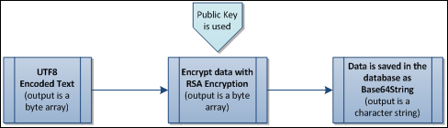
Visibility
Encrypted custom fields are visible in the following areas:
Page | User/Admin | Write/Read Only
User Record | Admin | Write
Requisition Preferences | Admin | Read Only
Applicant Profile | User | Write
My Account | User | Write or Read Only
My Account Preferences | Admin | Write
Analytics | Admin/User | Read Only
Encrypted Fields in Outbound Data Feeds
Organizations are able to create a report or schedule an outbound data feed via Analytics, which can contain encrypted values for any encrypted fields included in the feed. In addition, custom outbound data feeds can be created via work order by request, which can contain encrypted values for any encrypted fields included in the feed. The encryption allows only users with the decryption key to decrypt the data for these data feeds.

