Cornerstone for Salesforce March 2024

Table of Contents
Cornerstone for Salesforce (CFS) 1
Cornerstone for Salesforce Integration 2
Cornerstone for Salesforce Training View 10

Cornerstone for Salesforce (CFS)

Cornerstone for Salesforce Integration
The Cornerstone for Salesforce (CFS) integration is available in the Edge Marketplace. Once this integration is enabled, learners are empowered to interact with content within their flow-of-work by seamlessly surfacing Learner Home content in Salesforce. Administrators can add Cornerstone transcripts, learning carousels, and search components to any Force.com page or use the out-of-the box CFS Learner Home page. End users can view their full transcript, learning carousels and followed playlists. Additionally, end users can search for, launch, and complete learning, - all without leaving Salesforce.
Note: CFS is only available on the Salesforce Lightning platform.
Permissions
PERMISSION NAME | PERMISSION DESCRIPTION | CATEGORY

Learner Home | Grants access to the Learner Home and the Learning Search page. This is an end user permission. This permission cannot be constrained. | Learning

Edge Marketplace - Manage | Grants access to the Marketplace service for Edge Integrate, where the administrator can browse integrations that can be used to extend the Cornerstone system. This permission cannot be constrained. This is an administrator permission. | Edge

Edge Integrations - Manage | Grants access to the Integrations service for Edge Integrate, where the administrator can configure, enable, and disable their third-party integrations used within the Cornerstone system. This permission cannot be constrained. This is an administrator permission. | Edge

Access Partner Authorization - Manage | Grants ability to manage partner authorized access to portal via Partner Access Administration. This permission cannot be constrained. This is an administrator permission. | Core Administration

Note: To view CFS components, users need the Cornerstone User permission. To manage CFS components, users need Cornerstone Admin permission. You assign these permissions in Salesforce.
Install and Configure CFS
Install and configure CFS in the Edge Marketplace. To access the CFS Edge tile, go to ADMIN > TOOLS > EDGE > MARKETPLACE. Search for "Cornerstone for Salesforce", click the tile, and then click the Getting Started link for installation and configuration instructions.
Administrators can use the Lightning App Builder in Salesforce to add transcript, carousel, and search components to any page on Force.com. You can also move components around and delete them. Once the page configuration is done, activate the page so that users can access it.
Open the Lightning App Builder
- In Salesforce, click Setup. In the Quick Find box, type Lightning App Builder, and then click Lightning App Builder in the results. The Lightning App Builder page opens.
- In the Lightning App Builder, select one of the following options:
  - Create a new page - To create a new page, click New, select a page type and click Next. Enter a Label, select an Object (if visible) and click the Next button. Select a page format, and then click finish Note: If you are creating a new Home Page, for best results use the Console: Pinned Header and Left Sidebar (3 regions) or Console: Pinned Left Sidebar (3 regions)page template.
  - Edit an existing page - To modify an existing CFS home page, click Edit for the appropriate page.
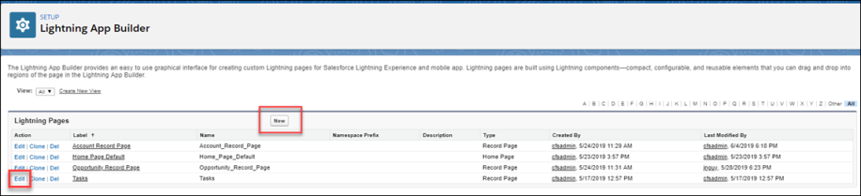
The Lightning Components page opens.
Add Components - Drag and Drop
Drag and drop CFS components onto any Force.com page to customize the end user's learner experience. You can also delete and move components. See Delete or Move a CFS Component on page 7 for additional information.
In the Lightning App Builder, in the left pane, select a CFS component and drag and drop it into a designated area.
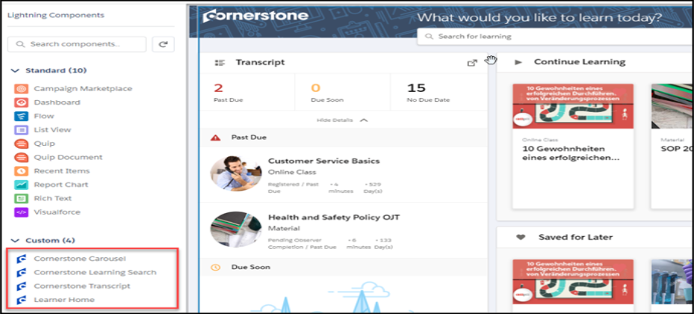
Cornerstone Carousel
Use the Cornerstone Carousel component to add a carousel to the Learner Home page. You can drag, drop, move, delete, and rename the Cornerstone Carousel.
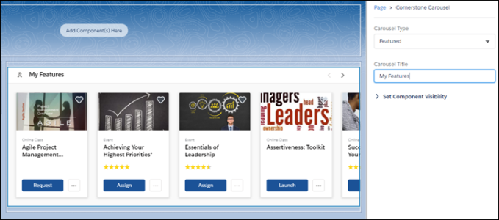
- Carousel Type - Select the type of carousel you want to create. Options are:
  - Subjects
  - Position
  - Popularity
  - Saved For Later
  - Continue Learning
  - Featured
  - Suggested
  - Required
  - Playlists
  - Followed Playlists
- Carousel Title - Enter the name for this carousel.
Cornerstone Learning Search
Use the Cornerstone Learning Search component to add the search feature to the Learner Home page. You can drag and drop, move and delete this component.
Note: You cannot rename this component in the Lightning App Builder.
Cornerstone Transcript
Use the Cornerstone Transcript component to add a Transcript section to the Learner Home page. You can drag and drop, move, delete and set the collapse option for this component. If you select Collapsed by Default, users see only the basic transcript information until they click Show Details. If you uncheck Collapsed by Default, users see full transcript details by default under the transcript box. You cannot rename this component in the Lightning App Builder. Note: For best results, we recommend that you use the smaller component box for the transcript component.
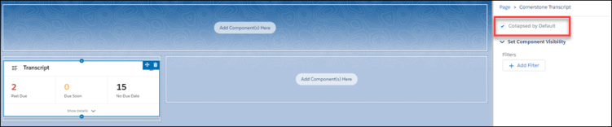
Learner Home
Use the Learner Home component to create a home page on a blank Force.com page. This is an out-of-the-box page that is not configurable and displays the users current Cornerstone Learner Home page.
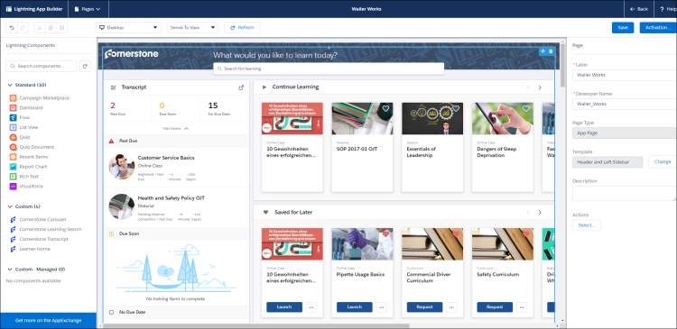
Save
Click Save to save your changes.
Activate
Click Activate to activate this page. Only active pages are available to users.

Activate and Assign Home Pages
Once the page is configured, administrators can activate a page and select it as the organizational default, set it for specific Lightning apps, or set it for different user profiles when using particular apps.
- On the completed home page, click the Activation button. The Activation page opens.
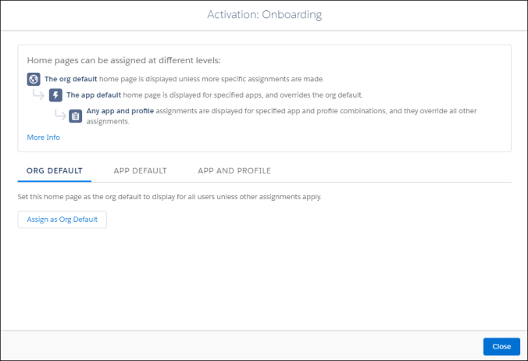
- Select one of the following options:
- Set the organizational default home page - Click Org Default, and then click the Assign as Org Default button. On the Set as Org Default page, review the selected options.
- Set a home page as the default for specific Lightning apps - Click App Default, and then click the Assign to Apps button. On the Select Apps page, check all of the Lightning apps that will have access to this page. On the Review Assignments page, review the selected options.
- Set a home page for selected user profiles for specific apps - Click App and Profile, and then click the Assign to Apps and Profiles button. On the Select Apps page, check the appropriate apps and click the Next button. On the Select Profiles page, check the profiles that will display the selected home page. On the Review Assignments page, review the selected options.
- Click the Save button. Based on their permissions and the selected options, users will see the appropriate learning home page.
Delete or Move a CFS Component
- To delete a component, hover over the upper right corner of the appropriate component and click the delete option. The component is removed from the page.
- To move a component, hover over the upper right-corner of the appropriate component, click the move icon and drag and drop the component to the new location.
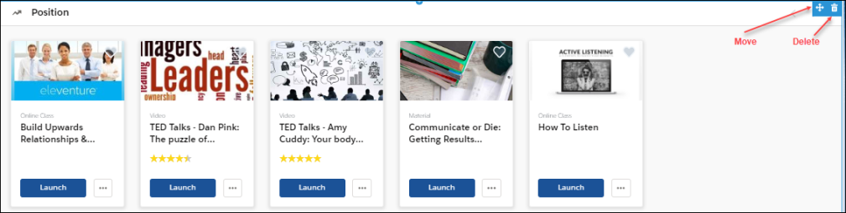
View the End-User Home Page
Once the Learner Home content is configured, end users can view and manage their learning options in Salesforce.
Users can perform the following tasks for each component:
- Transcript  - View the number of items in the user transcript.  - Click on any transcript item to view its details.  - If not visible by default, click View Details to view full transcript details and launch training. | 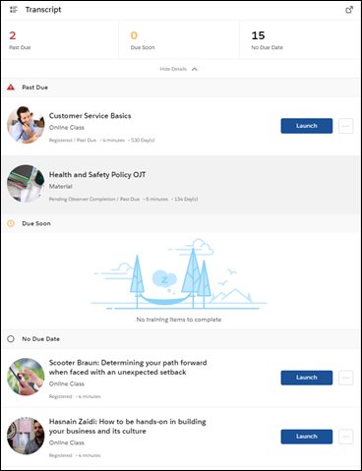
- Carousels  - Launch, request, and assign learning. Mark as a favorite by clicking the heart. Favorites appear in the Saved for Later carousel.  - Hover over a carousel item to view quick details and launch or assign training. | 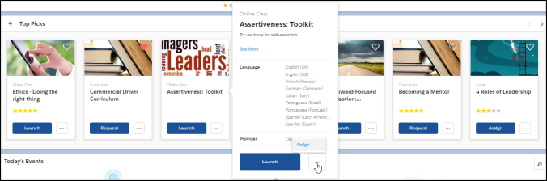
- Search bar  - Search for training by typing in search bar.  - While typing into search bar, relevant suggestions display (up to 10 suggestions).  - Click Enter or Search to open a page that displays all search results | 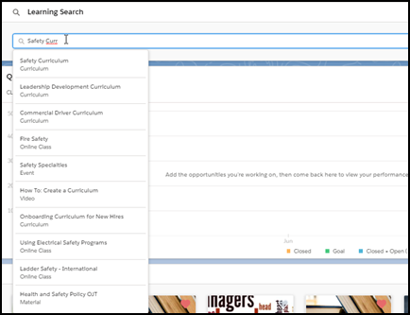

Cornerstone for Salesforce Training View
Cornerstone for Salesforce (CFS) provides components that allow users to see, in Salesforce, an overview of all training completed by a group of users or a single user associated with a specific account.
Use the Lightning App builder to access and add these components to the appropriate Salesforce layout page. Users can add these components to Contact or Account pages only.
Note: CFS is only available on the Lightning platform.
Once you add components, you can delete or move them as necessary. See Cornerstone for Salesforce Integration on page 1 for additional information.
For Administrators:
- To access the Salesforce Contact page, go to Salesforce > Setup > Contact > Page Layouts.
- To access the Salesforce Account page, go to Salesforce > Setup > Account > Page Layouts.
For end-users:
This information appears on the end-user's Account or Contact page with the appropriate permissions.
Note: The information on these pages is not in real-time; there is a 30-minute delay for updates.
Permissions
PERMISSION NAME | PERMISSION DESCRIPTION | CATEGORY

Learner Home | Grants access to the Learner Home and the Learning Search page. This is an end user permission. This permission cannot be constrained. | Learning

Access Partner Authorization - Manage | Grants ability to manage partner authorized access to portal via Partner Access Administration. This permission cannot be constrained. This is an administrator permission. | Core Administration

Note: To view CFS components, users need the Cornerstone User permission. To manage CFS components, users need Cornerstone Admin permission. You assign these permissions in Salesforce.
Open the Lightning App Builder
- In Salesforce, click Setup. In the Quick Find box, type Lightning App Builder, and then click Lightning App Builder in the results. The Lightning App Builder page opens.
- In the Lightning App Builder, select the Account or Contact page where you want to add the new component, and then click Edit.
The Lightning Components page opens.
Add the Account Learning Component to Salesforce
The Account Learning component displays the transcript progress of users associated with the selected page. By default, all users who can access the Account page in Salesforce can view components and related information.
Note: This component will not display if there are no contacts associated with the selected account.
To add the Account Learning component
- In the Lightning App Builder, in the left pane, select the Cornerstone Account Learning component and drag and drop it into a designated area. This view displays the progress of all contacts and users associated with the selected account within the last year.
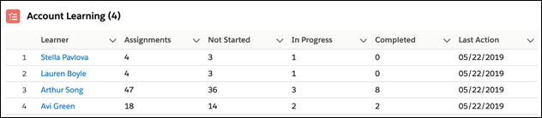
The following options are visible:
- Learner - Displays the name of the person who is assigned the learning. Click a learner to open the contact view for this user.
- Assignments - Displays the number of learnings currently assigned to this user.
- Not Started - Displays the number of learnings this user has not started.
- In Progress - Displays the number of learning in progress for this user.
- Complete - Displays the number of learnings completed by this user.
- Last Launch Date - Displays the last date on which this user opened a learning.
- View All - Click to display a sortable list view of this information.
Note: If a user belongs to the selected account but does not have a CFS license, their training information is blank.
Add the Contact Learning Component to Salesforce
The Contact Learning component displays the transcript progress of a specific user. By default, all users who can access the Contact page in Salesforce can view components and related information. This component can only be dropped on a Contact page. By default, all users who can access their Contact page in Salesforce can view components and related information.
To add the Contact Learning component
- In the Lightning App Builder, in the left pane, select the Cornerstone Contact Learning component and drag and drop it into a designated area. This view displays the progress fora specific user. To display details for a user, the user must be mapped to a Cornerstone User.
Note: If a user belongs to the selected account, but does not have a CFS license, their training information is blank. If a user is not mapped to a Cornerstone user, an error message appears. To map a user, contact your system administrator.
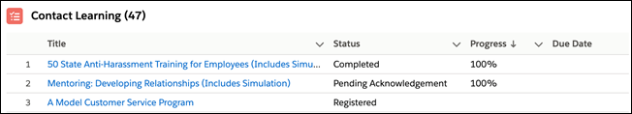
The following options are visible:
- Title - Displays the title of the assigned learning. Click a title to view the details for this learning object.
- Status - Displays the status of the learning assigned to this user.
- Progress - Displays the percent done form this learning.
- Due Date- Displays the date on which the learning is due.
- View All - Click to display a sortable list view of this information.

