Core Preferences March 2024

Table of Contents
Core Preferences Overview 1
Cross-Platform Preferences Overview 2
Badge & Point Preferences 3
Custom Login Pages - Manage 11
Manage Custom Pages 28
Email Preferences 70
Group Preferences 72
Login Message Preferences 74
My Account Preferences 88
Org Chart Preferences 93
Search Preferences 103
View Data Preferences 136
View People Preferences 141
Welcome Page Preferences 150
Display Preferences Overview 160
Corporate Preferences 161
Navigational Tabs and Links 166
Display Preferences 175
Security Preferences Overview 192
IP Whitelist 193
Password Preferences 194
System Preferences Overview 215
Authentication Preferences 216
Duplicate User Management Preferences 218
Employee Recognition Preferences 220
Feature Activation Preferences for Core Functionality 222
Language Preferences 223
Mobile Preferences 225
Modify Available Languages 233
Notifications Preferences 235
Reporting 2.0 View and Manage All Reports 236
Report Delivery Preferences 240
Timezone Preference 243
User Preferences 246

Core Preferences Overview

Cross-Platform Preferences Overview

Badge & Point Preferences
Organizations can use rewards and recognition to make the learning experience more engaging and encourage employees to complete training.
The Badges tab of the Badge & Point Preferences page enables administrators to create and configure the badges that can be awarded to a user, including the points that are awarded when the user receives the badge. See Badge & Point Preferences - Badges on page 4 for additional information.
The Points tab of the Badge & Point Preferences page enables administrators to configure the Leaderboard page that exists within Universal Profile: Snapshot. See Badge & Point Preferences - Points on page 7 for additional information.
To manage Badges and Points:
- Go to Admin > Tools > Core Functions > Core Preferences > Badges & Points.
- Go to Admin > Tools > Learning > Learning Preferences > Badges & Points.
Permissions
PERMISSION NAME | PERMISSION DESCRIPTION | CATEGORY

Badge & Point Preferences - Manage | Enables user to access and edit preferences on the Badge & Point Preferences page. The availability of this permission is controlled by a backend setting. This permission can be constrained by OU and User's OU. This is an administrator permission. | Core Administration.
Badge Image Recommendations
For badge images, the acceptable file types are .png, .jpeg, and .gif. Badge images should be square with a recommended size of 100 x 100 pixels. To have a square badge image display properly on the My Badges page, use a 66 x 66 pixel image centered on a white square that is 100 x 100 pixels.
Next Steps
After a badge is created, it is awarded to a user via the Universal Profile: Feedback page. You can also associate it with a learning object (LO) so that it is automatically awarded when a user completes the associated LO.
- See Badge - Give to Employee.
- See Course Catalog - General.
Badge & Point Preferences - Badges
Badges are a form of employee recognition awarded when a user receives positive feedback or when a user completes training. Badges may have an associated point value. Based on portal configuration, you may be able to view badges through a widget on the Universal Profile - Snapshot page.
The Badges tab of the Badge & Point Preferences page enables administrators to create and configure the badges that can be awarded to a user, including the points that are awarded when the user receives the badge.
Note: Badge & Point Preferences should only be configured by the Division Organizational Unit (OU) type. If Badge & Point Preferences are configured by a different OU type, then the badges will not be available to users to select and grant to others.
To manage Badges and Points:
- Go to Admin > Tools > Core Functions > Core Preferences > Badges & Points.
- Go to Admin > Tools > Learning > Learning Preferences > Badges & Points.
Permissions
PERMISSION NAME | PERMISSION DESCRIPTION | CATEGORY

Badge & Point Preferences - Manage | Enables user to access and edit preferences on the Badge & Point Preferences page. The availability of this permission is controlled by a backend setting. This permission can be constrained by OU and User's OU. This is an administrator permission. | Core Administration.
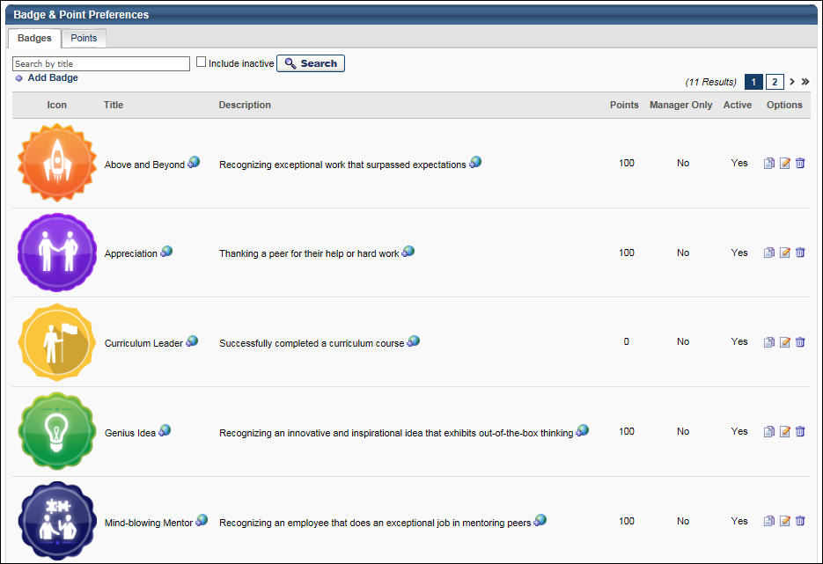
Badge - Search
To search for a badge by title, enter the badge title in the search field and click the Search button. Select the Include Inactive option to also search for inactive badges.
Badge - Add
To add a new badge, click the Add Badge link. See Badge - Add/Edit on page 9 for additional information.
Badge Table
The following information is displayed for each badge in the table:
- Icon - This displays the image that is associated with the badge.
- Title - This displays the badge title.
- Description - This displays the badge description.
- Points - This displays the point value that is associated with the badge. Note: Currently, the badge point values are being stored in the system. However, there is no functionality associated with the point values.
- Manager Only - This displays whether the badge is only available to be given by managers. If a badge is manager only, then only managers are able to give the badge to their subordinates.
- Active - This displays whether the badge is currently active. When a badge is active, then it is available to be given to users.
Badge Options
The following options are available in the Options column:
- Localize - If multiple languages are enabled, click the Globe icon to localize the badge title and description.
- Copy - Click this icon to duplicate the badge. A Copy Badge pop-up is opened, in which the administrator can edit the badge details prior to saving the badge. See Badge - Add/Edit on page 9 for additional information.
- Edit - Click this icon to edit the badge details. See Badge - Add/Edit on page 9 for additional information.
- Delete - Click this icon to delete the badge. See the Deleting or Deactivating Badges section for additional information.
Deleting or Deactivating Badges
Administrators are able to delete badges or make them inactive.
Learning Badges:
- Deactivate Badge:
  - The badge will still display on LO Details or the Course Catalog (if already associated to an existing LO).
  - The badge will no longer display in the Badge Search Results (admins cannot associate to LOs via the Course Catalog).
  - Any users who completed training (and were awarded the badge) will not be impacted; the badge will still display on the Training Completion page and on the Badges widget.
  - Any users who have not yet completed the training (with the badge associated to it) will still be awarded the badge when they complete the training.
- Delete Badge:
  - The badge will no longer display on LO Details or the Course Catalog (if already associated to an existing LO).
  - Any users who completed training (and were awarded the badge) will not be impacted; the badge will still display on the Training Completion page and on the Badges widget.
  - Any users who have not yet completed the training (with the badge associated to it) will not be awarded the badge when they complete the training.
Feedback Badges:
- The badge no longer displays in the results when attempting to award a badge via Feedback (i.e., users cannot award that badge to other users).
- The badge will continue to display in Feedback and the Badges widget (if it was already awarded to a user).
Badge Image Recommendations
For badge images, the acceptable file types are .png, .jpeg, and .gif. Badge images should be square with a recommended size of 100 x 100 pixels. To have a square badge image display properly on the My Badges page, use a 66 x 66 pixel image centered on a white square that is 100 x 100 pixels.
Badge & Point Preferences - Points
A user may receive points for completing training. Also, when a user receives a badge, they are also awarded any points that are associated with the badge. Depending on the portal configuration, users may be able to view their points and a points leaderboard via a widget on the Universal Profile - Snapshot page.
The Points tab of the Badge & Point Preferences page enables administrators to configure the Leaderboard page that exists within Universal Profile: Snapshot.
To manage Badges and Points:
- Go to Admin > Tools > Core Functions > Core Preferences > Badges & Points.
- Go to Admin > Tools > Learning > Learning Preferences > Badges & Points.
Permissions
PERMISSION NAME | PERMISSION DESCRIPTION | CATEGORY

Badge & Point Preferences - Manage | Enables user to access and edit preferences on the Badge & Point Preferences page. The availability of this permission is controlled by a backend setting. This permission can be constrained by OU and User's OU. This is an administrator permission. | Core Administration.
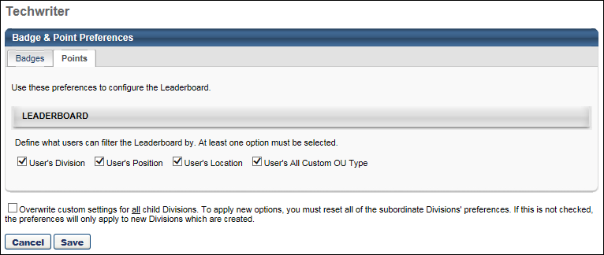
Leaderboard
This section enables administrators to define which filter options are available to the user when viewing the Leaderboard. When an option is selected, the corresponding filter option is able to select on the Leaderboard page. The various organizational unit (OU) filter options enable the user to compare their points totals with other users from the same OU. The following options are available:
- User's Division
- User's Position
- User's Location
- User's All Custom OU Type - If a user has more than one custom OU type configured for their user record, then all applicable custom OU types are available in the filter.
By default, User's Division is selected, and all other options are not selected. At least one option must be selected.
Overwrite Settings
Select this option to overwrite custom settings for child division OUs. If you overwrite custom settings for child division OUs, the selected settings are applied to both new and existing child OUs. Any previously customized child OUs are updated with the selected settings.
- If there are no customizations to the child OU, then the parent OU customizations are applied to all child OUs.
- Overwrite custom settings checkbox setting
  - If this option is selected, all child OU customizations are deleted from the database, which means the parent OU customizations will be applied to new and existing child OUs.
  - If this option is unselected, all existing child OU customizations will remain unchanged, and any new child OUs will inherit the parent OU customizations by default.
- If a child OU has been customized to display any widgets, then regardless of the parent OU customizations, the child OU customizations are applied.
- If a child OU has been customized to hide all widgets, then parent OU customizations will take precedence and will be applied.
Note: This option only applies to the Points tab.
Save/Cancel
Click Save to commit any unsaved changes. Or, click Cancel to discard any unsaved changes.
Badge - Add/Edit
Badges are a form of employee recognition awarded when a user receives positive feedback or when a user completes training. Badges may have an associated point value. Based on portal configuration, you may be able to view badges through a widget on the Universal Profile - Snapshot page.
Note: Badges can only be edited from the division in which they are created. For example, if you create a badge for the California division, the Edit option will only be available for that badge when you access the California division's Badge and Point Preferences. If you access the Los Angeles division's Badge and Point Preferences, the badge that was created for the California division is NOT editable. Either return to the division where the badge was created, or copy the badge to the child division and edit the copy.
To add a new badge, click the Add Badge link on the Badge Preferences page.
Permissions
PERMISSION NAME | PERMISSION DESCRIPTION | CATEGORY

Badge & Point Preferences - Manage | Enables user to access and edit preferences on the Badge & Point Preferences page. The availability of this permission is controlled by a backend setting. This permission can be constrained by OU and User's OU. This is an administrator permission. | Core Administration.
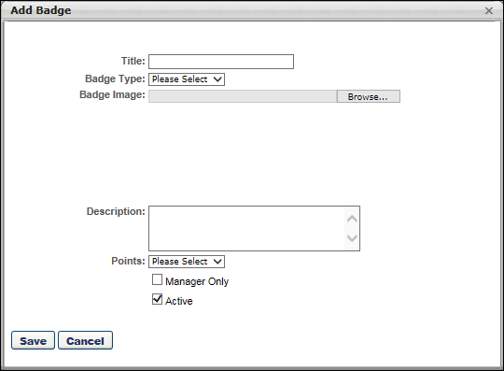
To add/edit a badge:
- Complete or edit the following fields:
  - Title - The purpose of the badge. When editing a badge, modifications to the badge title are reflected on the Training Completion page and Snapshot: Badges sub-page for users who have already completed training and earned the badge. 50 characters maximum.
  - Badge Type - The purpose of the badge. This will determine in which scenarios the badge can be awarded. When editing a badge, you cannot modify the badge type. Options are:
    - Feedback - Select this type when the badge should only be used when awarding feedback.
    - Learning - Select this type when the badge should only be used when a user completes training.
  - Badge Image - The image that represents the badge. Click the Browse button to select an image file. When uploading an image file, the character limit for the file name is 91. When editing a badge, modifications to the badge image are reflected on the Training Completion page and Snapshot: Badges sub-page for users who have already completed training and earned the badge. For badge images, the acceptable file types are .png, .jpeg, and .gif. Badge images should be square with a recommended size of 100 x 100 pixels. To have a square badge image display properly on the My Badges page, use a 66 x 66 pixel image centered on a white square that is 100 x 100 pixels.
  - Description - The description of the badge, up to 150 characters. This should describe the purpose of the badge in detail. When editing an existing badge, changes to this field are applied to all past instances of this badge.
  - Points - The point value associated with the badge. A user's badge points are visible on the Universal Profile Snapshot page and on the Points Leaderboard. When editing an existing badge, changes to this field are only applied to future instances of this badge. The points that are associated with badges already awarded will not be changed.
  - Manager Only - Whether the badge is only available to be awarded by managers. When this option is selected, only direct or indirect managers are able to award this badge, and they can only award it to their direct or indirect reports. When editing an existing badge, changes to this field are only applied to future instances of this badge. This option is only available when the Badge Type is set to Feedback.
  - Active - Whether the badge is active. When editing an existing badge, changes to this field are only applied to future instances of this badge. See the Deleting or Deactivating Badges section of the Badge & Point Preferences - Badges topic for additional information. See Badge & Point Preferences - Badges on page 4 for additional information.
- Click Save.
After a badge is created, it is awarded to a user via the Universal Profile: Feedback page. You can also associate it with a learning object (LO) so that it is automatically awarded when a user completes the associated LO.
- See Badge - Give to Employee.
- See Course Catalog - General.

Custom Login Pages - Manage
From the Custom Login Pages page, administrators can create, edit, manage, and preview custom login pages.
Only login pages created using the Custom Login Page Tool are accessible via the Dashboard. If a custom page has been previously created for your organization by Cornerstone, it will not display.
While you cannot build a single multilingual page, you can instead build multiple pages and fill in the text values in the desired languages.
Note: Custom login pages are not copied during a copy-down.
To manage custom login pages, go to Admin > Tools > Core Functions > Core Preferences > Custom Login Page.
Permissions
PERMISSION NAME | PERMISSION DESCRIPTION | CATEGORY

Custom Login Page - Manage | Grants the ability to create and edit custom login pages for the portal. Administrators with this permission can also enable or disable a custom login page and identify the default login page. This permission cannot be constrained. This is an administrator permission. | Core Administration
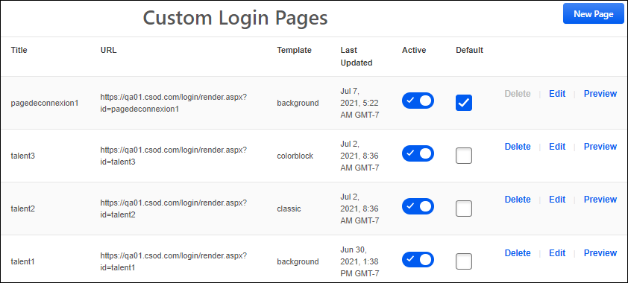
Create Custom Login Page
To create a login page, select the New Page button. See Custom Login Page - Create/Edit on page 13 for additional information.
Custom Login Page Table
The Login Page table displays all the existing login pages with the following information:
- Title - This displays the title that was given for the login page when it was created.
- URL - This displays the URL to access the corresponding login page.
- Template - This displays the template applied to the login page.
- Last Updated - This displays the date and time at which the login page was most recently updated.
Activate or Deactivate Login Page
The Active toggle enables administrators to make a login page active or inactive.
When the toggle is enabled, the login page is accessible to the public. When the toggle is disabled, the corresponding login page is not accessible to the public, and users will receive an error when attempting to use the page URL.
Set Default Login Page
Select the Default checkbox next to the login page that should act as the default for the portal.
The default login page is the page that users will be directed to when they access your portal's core URL, such as www.yourportalname.csod.com.
Delete, Edit, or Preview Login Page
The following actions are available for each login page:
- Delete - Select this option to permanently delete the login page. When this option is selected, a confirmation message is displayed before the page is deleted. This option is not available for the default login page.
- Edit - Select this option to modify the login page. See Custom Login Page - Create/Edit on page 13 for additional information.
- Preview - Select this option to preview the login page in a new browser window. This enables the administrator to see how the login page will appear to the public.
Custom Login Page - Create/Edit
Administrators can create a custom login page by selecting one of the available templates and then customizing the page to align with the organization's login requirements and branding.
Note: Custom Login Pages currently do not support localization.
After designing and saving a login page, it is important to preview and test each page using the Preview option and the page URL on the Custom Login Pages page. Note: If you access and log in to a custom login page, this will log you out of your current session.
To create a custom login page, go to Admin > Tools > Core Functions > Core Preferences > Custom Login Page. Then, select the New Page button.
To edit a custom login page, go to Admin > Tools > Core Functions > Core Preferences > Custom Login Page. Then, select the Edit link for the appropriate page.
Permissions
PERMISSION NAME | PERMISSION DESCRIPTION | CATEGORY

Custom Login Page - Manage | Grants the ability to create and edit custom login pages for the portal. Administrators with this permission can also enable or disable a custom login page and identify the default login page. This permission cannot be constrained. This is an administrator permission. | Core Administration
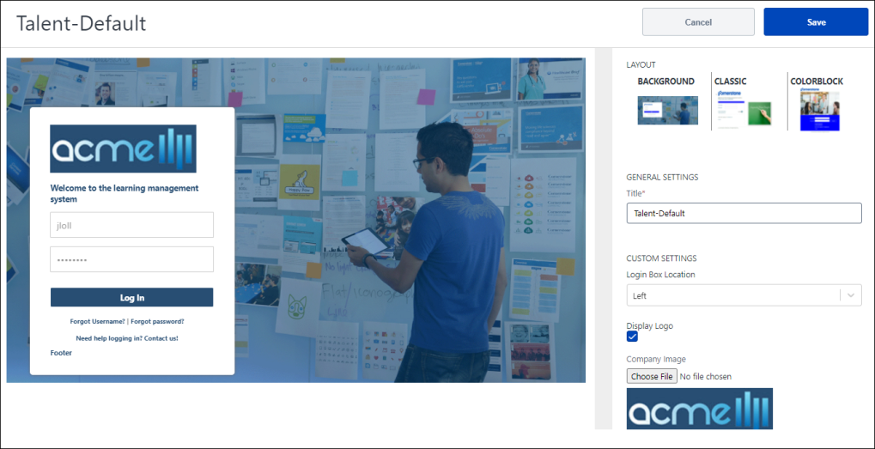
Layout
In the Layout section, select one of the available templates for the login page. As you select a template, the left side of the screen is updated to display a preview of the login page.
Once a template is selected, administrators can customize the features on the page to better reflect the organization's login requirements and branding.
Each template has a different set of settings. Select the appropriate link to view the settings for that layout:
- Background - See Custom Login Page - Create - Background Layout on page 15 for additional information.
- Classic - See Custom Login Page - Create - Classic Layout on page 19 for additional information.
- Colorblock - See Custom Login Page - Create - Colorblock Layout on page 23 for additional information.
Custom Login Page - Create - Background Layout
This page describes how to configure a custom login page with a background layout.
Note: Custom Login Pages currently do not support localization.
To create a custom login page, go to Admin > Tools > Core Functions > Core Preferences > Custom Login Page. Then, select the New Page button.
To edit a custom login page, go to Admin > Tools > Core Functions > Core Preferences > Custom Login Page. Then, select the Edit link for the appropriate page.
Permissions
PERMISSION NAME | PERMISSION DESCRIPTION | CATEGORY

Custom Login Page - Manage | Grants the ability to create and edit custom login pages for the portal. Administrators with this permission can also enable or disable a custom login page and identify the default login page. This permission cannot be constrained. This is an administrator permission. | Core Administration
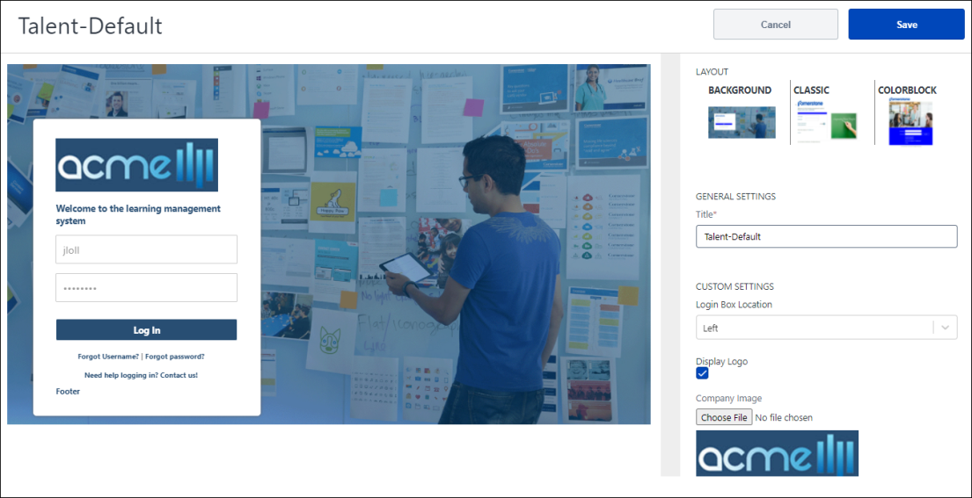
Layout
In the Layout section, select Background. As you select a template, the left side of the screen is updated to display a preview of the login page.
General Settings
In the General Settings section, provide the following information:
- Title - Provide a name for the login page This name should help administrators identify the page and its purpose. It is important to note that the title that you provide will be visible in the page URL (e.g., https://portalname.csod.com/Login/render.aspx?id=TITLE&corpname=portalname). This field accepts up to 20 characters.
Custom Settings
In the Custom Settings section, provide the following information:
Login Box and Logo
- Login Box Location - From the drop-down, select whether the login box is on the left side, right side, or center of the login page.
- Display Logo - Select this checkbox to display a logo image at the top of the login box.
- Company Logo - Select the Choose File button to select an image file from your device to use as the logo image on the login page. The selected image is only displayed if the Display Logo checkbox is selected. Image size should be less than 1MB. You can upload jpg, jpeg, png, or gif file types. Animated gifs are accepted if multiple images are desired.
- Logo Position - From the drop-down, select whether the selected company logo is displayed aligned to the left, right, or center of the login box.
Welcome Message
- Welcome Message - In this field, enter the welcome message that is displayed to users within the login box.
- Welcome Message Color - Select the color in which the welcome message is displayed. You can enter the Hex value in the text field or select the color box to enter RGBA values, Hex values, or manually select a color from the color palate.
Login Page and Login Box Background
- Image - Select the Choose File button to select an image file from your device to use as the background image on the login page. Image size should be less than 1MB. You can upload jpg, jpeg, png, or gif file types. Animated gifs are accepted if multiple images are desired.
- Background Color - Select the background color for the login box. You can enter the Hex value in the text field or select the color box to enter RGBA values, Hex values, or manually select a color from the color palate.
Login Button
- Login Button Text - In this field, enter the text that should appear on the Login button.
- Login Text Color - Select the text color for the login button text. You can enter the Hex value in the text field or select the color box to enter RGBA values, Hex values, or manually select a color from the color palate.
- Login Button Color - Select the color for the login button. You can enter the Hex value in the text field or select the color box to enter RGBA values, Hex values, or manually select a color from the color palate.
Username and Password Fields
- Username - In this field, enter the label for the Username field. This text appears in the Username field before the user enters any information. This text should help prompt the user to enter the appropriate information in the field.
- Password - In this field, enter the label for the Password field. This text appears in the Password field before the user enters any information. This text should help prompt the user to enter the appropriate information in the field.
Forgot Username and Password Links
- Forgot Username - In this field, enter the label for the link that users should select if they have forgotten their username.
- Forgot Username Color - Select the text color for the Forgot Username link. You can enter the Hex value in the text field or select the color box to enter RGBA values, Hex values, or manually select a color from the color palate.
- Forgot Password - In this field, enter the label for the link that users should select if they have forgotten their password.
- Forgot Password Color - Select the text color for the Forgot Password link. You can enter the Hex value in the text field or select the color box to enter RGBA values, Hex values, or manually select a color from the color palate.
Contact Support Message and Email Address
Administrators can configure a message and contact information in the event that users need support logging in to the portal.
- Support Email Pretext - In this field, enter the text that appears before the "Contact Support" link. For example, you may enter "Need help logging in?"
- Support Email Color - Select the text color for the Support Email Pretext. You can enter the Hex value in the text field or select the color box to enter RGBA values, Hex values, or manually select a color from the color palate.
- Support Email Address - In this field, enter the email address that users should contact or URL users should visit if they need support logging in to the portal.
- Email Text - In this field, enter the text that prompts users to contact support. For example, you may enter "Contact us!"
- Support Email Link Color - Select the text color for the link to contact support. You can enter the Hex value in the text field or select the color box to enter RGBA values, Hex values, or manually select a color from the color palate.
Login Box Footer
- Footer Notes, If Any - In this field, enter any text that should appear at the bottom of the login box. This field accepts up to 150 characters.
- Footer Text Color - Select the text color for the footer text. You can enter the Hex value in the text field or select the color box to enter RGBA values, Hex values, or manually select a color from the color palate.
Page Title
- Page Title - In this field, enter the text that will appear in the browser tab when the login page is open. If no value is entered here, then the site name is displayed.
Single Sign-On (SSO)
Single sign-on allows the Cornerstone system to authenticate users into the portal upon their request to access the system. This affords users access to the system without having to log in once the user has been authenticated using their company login or local access network (LAN) password.
- Enable SSO - Select this checkbox to enable an SSO Login button on the login page.
- SSO Button Text - In this field, enter the text that should appear on the SSO Login button.
- SSO Button Text Color - Select the text color for the SSO Login button text. You can enter the Hex value in the text field or select the color box to enter RGBA values, Hex values, or manually select a color from the color palate.
- SSO Button Color - Select the color for the SSO Login button. You can enter the Hex value in the text field or select the color box to enter RGBA values, Hex values, or manually select a color from the color palate.
- SSO Link - In this field, enter the inbound SSO URL for the portal. This is also known as the CSOD ACS URL.
Self Registration
Self-Registration functionality allows administrators to manage new users coming into the system via pre-defined groups. By sending them to a special URL and assigning the users a code, users will get assigned to a group when they register through the Self-Registration page. Each group can then have parameters set which will determine how that user will be classified and handled within the system.
- Enable Self Reg - Select this checkbox to enable a Self Registration button on the login page.
- Self Reg Button Text - In this field, enter the text that should appear on the Self Reg button.
- Self Reg Button Text Color - Select the text color for the Self Reg button text. You can enter the Hex value in the text field or select the color box to enter RGBA values, Hex values, or manually select a color from the color palate.
- Self Reg Button Color - Select the color for the Self Reg button. You can enter the Hex value in the text field or select the color box to enter RGBA values, Hex values, or manually select a color from the color palate.
- Self Reg Link - In this field, enter the Self Registration URL for the portal. This URL can be found on the Guest User Settings tab when managing the corresponding Self Registration Group. See Registration Group - Create - Step 5 - Guest User Settings.
Save/Cancel
After configuring the login page, select the Save button in the upper-right corner of the page. You are redirected to the Custom Login Pages page where you can further test the login page using the URL and Preview option.
Select Cancel to discard your changes.
Custom Login Page - Create - Classic Layout
This page describes how to configure a custom login page with a classic layout.
Note: Custom Login Pages currently do not support localization.
To create a custom login page, go to Admin > Tools > Core Functions > Core Preferences > Custom Login Page. Then, select the New Page button.
To edit a custom login page, go to Admin > Tools > Core Functions > Core Preferences > Custom Login Page. Then, select the Edit link for the appropriate page.
Permissions
PERMISSION NAME | PERMISSION DESCRIPTION | CATEGORY

Custom Login Page - Manage | Grants the ability to create and edit custom login pages for the portal. Administrators with this permission can also enable or disable a custom login page and identify the default login page. This permission cannot be constrained. This is an administrator permission. | Core Administration
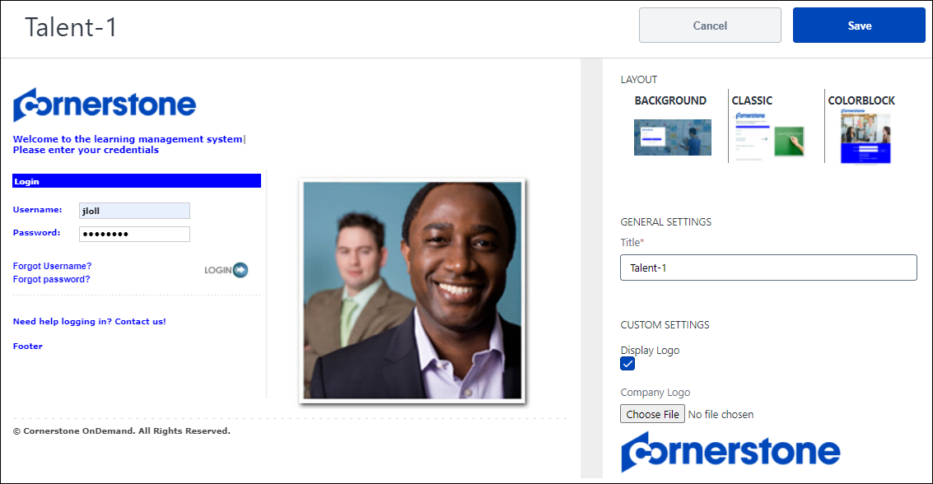
Layout
In the Layout section, select Classic. As you select a template, the left side of the screen is updated to display a preview of the login page.
General Settings
In the General Settings section, provide the following information:
- Title - Provide a name for the login page This name should help administrators identify the page and its purpose. It is important to note that the title that you provide will be visible in the page URL (e.g., https://portalname.csod.com/Login/render.aspx?id=TITLE&corpname=portalname). This field accepts up to 20 characters.
Custom Settings
In the Custom Settings section, provide the following information:
Login Box and Logo
- Display Logo - Select this checkbox to display a logo image at the top of the login box.
- Company Logo - Select the Choose File button to select an image file from your device to use as the logo image on the login page. The selected image is only displayed if the Display Logo checkbox is selected. Image size should be less than 1MB. You can upload jpg, jpeg, png, or gif file types. Animated gifs are accepted if multiple images are desired.
- Logo Position - From the drop-down, select whether the selected company logo is displayed aligned to the left, right, or center of the login box.
Welcome Message
- Welcome Message - In this field, enter the welcome message that is displayed to users within the login box.
- Welcome Message Color - Select the color in which the welcome message is displayed. You can enter the Hex value in the text field or select the color box to enter RGBA values, Hex values, or manually select a color from the color palate.
Login Message and Band
- Login Message - In this field, enter the message that prompts users to enter their credentials. This appears below the Welcome message.
- Login Message Color - Select the color in which the login message is displayed. You can enter the Hex value in the text field or select the color box to enter RGBA values, Hex values, or manually select a color from the color palate.
- Login Band Text - In this field, enter the text that appears in the Login Band, which is displayed between the Login Message and the Login fields.
- Login Text Color - Select the color in which the login band text is displayed. You can enter the Hex value in the text field or select the color box to enter RGBA values, Hex values, or manually select a color from the color palate.
- Login Band Color - Select the color in which the login band is displayed. You can enter the Hex value in the text field or select the color box to enter RGBA values, Hex values, or manually select a color from the color palate.
Login Page Image
- Image - Select the Choose File button to select an image file from your device. This image will appear to the right of the login box. Image size should be less than 1MB. You can upload jpg, jpeg, png, or gif file types. Animated gifs are accepted if multiple images are desired.
Username and Password Fields
- Username - In this field, enter the label for the Username field. This text appears to the left of the Username field. This text should help prompt the user to enter the appropriate information in the field.
- Username Color - Select the text color for the Username field label. You can enter the Hex value in the text field or select the color box to enter RGBA values, Hex values, or manually select a color from the color palate.
- Password - In this field, enter the label for the Password field. This text appears to the right of the Password field. This text should help prompt the user to enter the appropriate information in the field.
- Password Color - Select the text color for the Password field label. You can enter the Hex value in the text field or select the color box to enter RGBA values, Hex values, or manually select a color from the color palate.
Forgot Username and Password Links
- Forgot Username - In this field, enter the label for the link that users should select if they have forgotten their username.
- Forgot Username Color - Select the text color for the Forgot Username link. You can enter the Hex value in the text field or select the color box to enter RGBA values, Hex values, or manually select a color from the color palate.
- Forgot Password - In this field, enter the label for the link that users should select if they have forgotten their password.
- Forgot Password Color - Select the text color for the Forgot Password link. You can enter the Hex value in the text field or select the color box to enter RGBA values, Hex values, or manually select a color from the color palate.
Contact Support Message and Email Address
Administrators can configure a message and contact information in the event that users need support logging in to the portal.
- Support Email Pretext - In this field, enter the text that appears before the "Contact Support" link. For example, you may enter "Need help logging in?"
- Support Email Color - Select the text color for the Support Email Pretext. You can enter the Hex value in the text field or select the color box to enter RGBA values, Hex values, or manually select a color from the color palate.
- Support Email Address - In this field, enter the email address that users should contact or URL users should visit if they need support logging in to the portal.
- Email Text - In this field, enter the text that prompts users to contact support. For example, you may enter "Contact us!"
- Support Email Link Color - Select the text color for the link to contact support. You can enter the Hex value in the text field or select the color box to enter RGBA values, Hex values, or manually select a color from the color palate.
Login Box Footer
- Footer Notes, If Any - In this field, enter any text that should appear at the bottom of the login box. This field accepts up to 150 characters.
- Footer Text Color - Select the text color for the footer text. You can enter the Hex value in the text field or select the color box to enter RGBA values, Hex values, or manually select a color from the color palate.
Page Title
- Page Title - In this field, enter the text that will appear in the browser tab when the login page is open. If no value is entered here, then the site name is displayed.
Single Sign-On (SSO)
Single sign-on allows the Cornerstone system to authenticate users into the portal upon their request to access the system. This affords users access to the system without having to log in once the user has been authenticated using their company login or local access network (LAN) password.
- Enable SSO - Select this checkbox to enable an SSO Login link on the login page.
- SSO Text - In this field, enter the text that should appear before the SSO Login link.
- SSO Text Color - Select the text color for the text that appears before the SSO Login link. You can enter the Hex value in the text field or select the color box to enter RGBA values, Hex values, or manually select a color from the color palate.
- SSO Link Text - In this field, enter the text for the SSO Login link.
- SSO Link Text Color - Select the text color for the SSO Login link text. You can enter the Hex value in the text field or select the color box to enter RGBA values, Hex values, or manually select a color from the color palate.
- SSO Link - In this field, enter the inbound SSO URL for the portal. This is also known as the CSOD ACS URL.
Self Registration
Self-Registration functionality allows administrators to manage new users coming into the system via pre-defined groups. By sending them to a special URL and assigning the users a code, users will get assigned to a group when they register through the Self-Registration page. Each group can then have parameters set which will determine how that user will be classified and handled within the system.
- Enable Self Reg - Select this checkbox to enable a Self Registration link on the login page.
- Self Reg Text - In this field, enter the text that should appear before the Self Reg link.
- Self Reg Text Color - Select the text color for the text that appears before the Self Reg link. You can enter the Hex value in the text field or select the color box to enter RGBA values, Hex values, or manually select a color from the color palate.
- Self Reg Link Text - In this field, enter the text for the Self Reg link.
- Self Reg Link Text Color - Select the text color for the Self Reg link text. You can enter the Hex value in the text field or select the color box to enter RGBA values, Hex values, or manually select a color from the color palate.
- Self Reg Link - In this field, enter the Self Registration URL for the portal. This URL can be found on the Guest User Settings tab when managing the corresponding Self Registration Group. See Registration Group - Create - Step 5 - Guest User Settings.
Save/Cancel
After configuring the login page, select the Save button in the upper-right corner of the page. You are redirected to the Custom Login Pages page where you can further test the login page using the URL and Preview option.
Select Cancel to discard your changes.
Custom Login Page - Create - Colorblock Layout
This page describes how to configure a custom login page with a colorblock layout.
Note: Custom Login Pages currently do not support localization.
To create a custom login page, go to Admin > Tools > Core Functions > Core Preferences > Custom Login Page. Then, select the New Page button.
To edit a custom login page, go to Admin > Tools > Core Functions > Core Preferences > Custom Login Page. Then, select the Edit link for the appropriate page.
Permissions
PERMISSION NAME | PERMISSION DESCRIPTION | CATEGORY

Custom Login Page - Manage | Grants the ability to create and edit custom login pages for the portal. Administrators with this permission can also enable or disable a custom login page and identify the default login page. This permission cannot be constrained. This is an administrator permission. | Core Administration
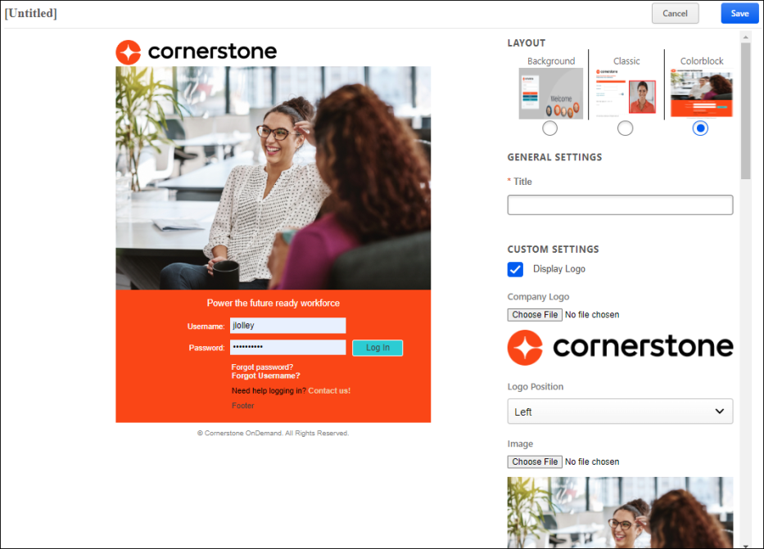
Layout
In the Layout section, select Colorblock. As you select a template, the left side of the screen is updated to display a preview of the login page.
General Settings
In the General Settings section, provide the following information:
- Title - Provide a name for the login page This name should help administrators identify the page and its purpose. It is important to note that the title that you provide will be visible in the page URL (e.g., https://portalname.csod.com/Login/render.aspx?id=TITLE&corpname=portalname). This field accepts up to 20 characters.
Custom Settings
In the Custom Settings section, provide the following information:
Login Box and Logo
- Display Logo - Select this checkbox to display a logo image at the top of the login box.
- Company Logo - Select the Choose File button to select an image file from your device to use as the logo image on the login page. The selected image is only displayed if the Display Logo checkbox is selected. Image size should be less than 1MB. You can upload jpg, jpeg, png, or gif file types. Animated gifs are accepted if multiple images are desired.
- Logo Position - From the drop-down, select whether the selected company logo is displayed aligned to the left, right, or center of the login box.
Login Page and Block Color
- Image - Select the Choose File button to select an image file from your device to use as the image on the login page. Image size should be less than 1MB. You can upload jpg, jpeg, png, or gif file types. Animated gifs are accepted if multiple images are desired.
- Block Color - Select the background color for the login box. You can enter the Hex value in the text field or select the color box to enter RGBA values, Hex values, or manually select a color from the color palate.
Welcome Message
- Welcome Message - In this field, enter the welcome message that is displayed to users within the login box.
- Welcome Message Color - Select the color in which the welcome message is displayed. You can enter the Hex value in the text field or select the color box to enter RGBA values, Hex values, or manually select a color from the color palate.
Username and Password Fields
- Username - In this field, enter the label for the Username field. This text appears to the left of the Username field. This text should help prompt the user to enter the appropriate information in the field.
- Username Color - Select the text color for the Username field label. You can enter the Hex value in the text field or select the color box to enter RGBA values, Hex values, or manually select a color from the color palate.
- Password - In this field, enter the label for the Password field. This text appears to the right of the Password field. This text should help prompt the user to enter the appropriate information in the field.
- Password Color - Select the text color for the Password field label. You can enter the Hex value in the text field or select the color box to enter RGBA values, Hex values, or manually select a color from the color palate.
Login Button
- Login Button Text - In this field, enter the text that should appear on the Login button.
- Login Text Color - Select the text color for the login button text. You can enter the Hex value in the text field or select the color box to enter RGBA values, Hex values, or manually select a color from the color palate.
- Login Button Color - Select the color for the login button. You can enter the Hex value in the text field or select the color box to enter RGBA values, Hex values, or manually select a color from the color palate.
Forgot Username and Password Links
- Forgot Username - In this field, enter the label for the link that users should select if they have forgotten their username.
- Forgot Username Color - Select the text color for the Forgot Username link. You can enter the Hex value in the text field or select the color box to enter RGBA values, Hex values, or manually select a color from the color palate.
- Forgot Password - In this field, enter the label for the link that users should select if they have forgotten their password.
- Forgot Password Color - Select the text color for the Forgot Password link. You can enter the Hex value in the text field or select the color box to enter RGBA values, Hex values, or manually select a color from the color palate.
Contact Support Message and Email Address
Administrators can configure a message and contact information in the event that users need support logging in to the portal.
- Support Email Pretext - In this field, enter the text that appears before the "Contact Support" link. For example, you may enter "Need help logging in?"
- Support Email Color - Select the text color for the Support Email Pretext. You can enter the Hex value in the text field or select the color box to enter RGBA values, Hex values, or manually select a color from the color palate.
- Support Email Address - In this field, enter the email address that users should contact or URL users should visit if they need support logging in to the portal.
- Email Text - In this field, enter the text that prompts users to contact support. For example, you may enter "Contact us!"
- Support Email Link Color - Select the text color for the link to contact support. You can enter the Hex value in the text field or select the color box to enter RGBA values, Hex values, or manually select a color from the color palate.
Login Box Footer
- Footer Notes, If Any - In this field, enter any text that should appear at the bottom of the login box. This field accepts up to 150 characters.
- Footer Text Color - Select the text color for the footer text. You can enter the Hex value in the text field or select the color box to enter RGBA values, Hex values, or manually select a color from the color palate.
Page Title
- Page Title - In this field, enter the text that will appear in the browser tab when the login page is open. If no value is entered here, then the site name is displayed.
Single Sign-On (SSO)
Single sign-on allows the Cornerstone system to authenticate users into the portal upon their request to access the system. This affords users access to the system without having to log in once the user has been authenticated using their company login or local access network (LAN) password.
- Enable SSO - Select this checkbox to enable an SSO Login link on the login page.
- SSO Text - In this field, enter the text that should appear before the SSO Login link.
- SSO Text Color - Select the text color for the text that appears before the SSO Login link. You can enter the Hex value in the text field or select the color box to enter RGBA values, Hex values, or manually select a color from the color palate.
- SSO Link Text - In this field, enter the text for the SSO Login link.
- SSO Link Text Color - Select the text color for the SSO Login link text. You can enter the Hex value in the text field or select the color box to enter RGBA values, Hex values, or manually select a color from the color palate.
- SSO Link - In this field, enter the inbound SSO URL for the portal. This is also known as the CSOD ACS URL.
Self Registration
Self-Registration functionality allows administrators to manage new users coming into the system via pre-defined groups. By sending them to a special URL and assigning the users a code, users will be assigned to a group when they register through the Self-Registration page. Each group can then have parameters set which will determine how that user will be classified and managed within the system.
- Enable Self Reg - Select this checkbox to enable a Self Registration link on the login page.
- Self Reg Text - In this field, enter the text that should appear before the Self Reg link.
- Self Reg Text Color - Select the text color for the text that appears before the Self Reg link. You can enter the Hex value in the text field or select the color box to enter RGBA values, Hex values, or manually select a color from the color palate.
- Self Reg Link Text - In this field, enter the text for the Self Reg link.
- Self Reg Link Text Color - Select the text color for the Self Reg link text. You can enter the Hex value in the text field or select the color box to enter RGBA values, Hex values, or manually select a color from the color palate.
- Self Reg Link - In this field, enter the Self Registration URL for the portal. This URL can be found on the Guest User Settings tab when managing the corresponding Self Registration Group.
Save/Cancel
After configuring the login page, select the Save button in the upper-right corner of the page. You are redirected to the Custom Login Pages page where you can further test the login page using the URL and Preview option.
Select Cancel to discard your changes.

Manage Custom Pages
The Manage Custom Pages page enables administrators to create, view, edit, copy, and delete custom pages.
To manage custom pages, go to Admin > Tools > Core Functions > Core Preferences, and under Cross-Platform Preferences, select Custom Pages.
Permissions
PERMISSION NAME | PERMISSION DESCRIPTION | CATEGORY

Custom Pages - Manage | Grants access to create and edit custom pages for the portal. This permission cannot be constrained. This is an administrator permission. | Core Administration
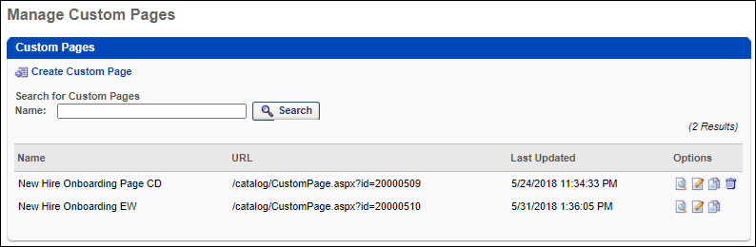
Create Custom Page
To create a new custom page, select the Create Custom Page link. This opens the Custom Page Builder. See Custom Page Builder on page 30 for additional information.
Using Custom Pages
After a custom page is created, it must be added to the Navigation Tabs and Links in order for users to access the page. When a custom page is added to Navigation Tabs and Links for a Division, all users within that Division can access that page, regardless of the user's permissions. See Navigational Tabs and Links on page 166 for additional information.
Search Custom Pages
You can search existing custom pages by page name. The search returns all custom pages with names that contain the search term.
View Existing Custom Pages
The following information is displayed for existing custom pages:
- Name - The custom page name. Custom pages are listed alphabetically by name.
- URL - The URL for the custom page.
- Last Updated - The date on which the custom page was last modified.
Custom Page Options
The following options are available in the Options column:
- Preview - Preview the custom page in a new window.
- Edit - Edit the custom page. This opens the Custom Page Builder.
- Copy - Create a copy of the custom page. This opens the Custom Page Builder.
- Delete - Delete the custom page. Custom pages that are deleted are removed from Navigation Tabs and Links for all OUs. If this creates an empty tab, then the tab is no longer visible to users. Note: This option is not available if the custom page is set to be the home page in Navigation Tabs and Links for one or more divisions.

Custom Page Builder
The Custom Page Builder is used throughout the system to create custom pages, when applicable. The tool is configurable depending on the context in which it is being used and the type of page that is being built.
The Custom Page Builder is available when building:
- Custom Pages
- Welcome Pages
- Guest User Self-Registration Welcome Pages
- Career Sites
Custom pages can be created and managed from the Manage Custom Pages page. See Manage Custom Pages on page 28 for additional information.
To manage custom pages, go to Admin > Tools > Core Functions > Core Preferences, and under Cross-Platform Preferences, select Custom Pages.
Permissions
PERMISSION NAME | PERMISSION DESCRIPTION | CATEGORY

Custom Pages - Manage | Grants access to create and edit custom pages for the portal. This permission cannot be constrained. This is an administrator permission. | Core Administration
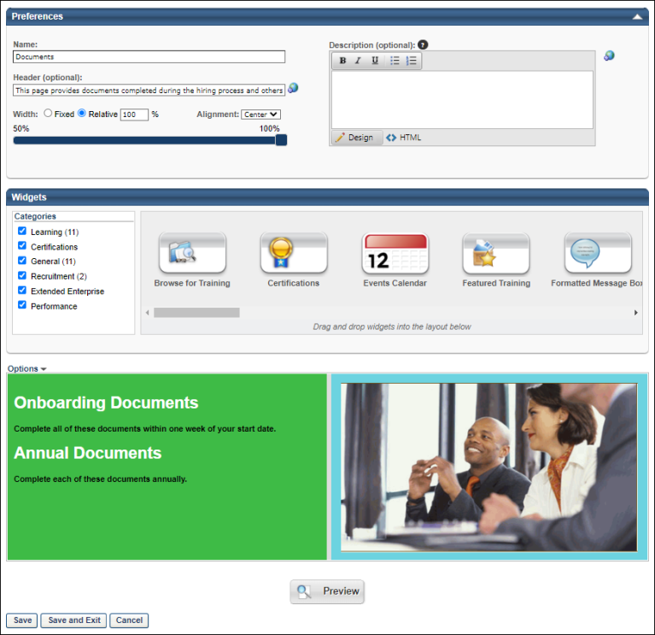
When creating a new custom page, the Configure Layout pop-up opens immediately, enabling administrators to set the initial layout of the custom page, including the number of columns and adding a header and footer row. This pop-up is also available via the Options menu in the Layout Configuration section. See Custom Page Builder - Configure Layout on page 40 for additional information.
The header and page description for the Custom Page Builder can vary depending on the type of page that is being built. For example, for Welcome pages, the header displays the name of the selected Division for which you are creating the Welcome Page, and the page description displays the name of the selected OU or group for which you are creating the custom Welcome Page. If you are creating the Welcome Page for the default division, this is blank.
Preferences
In the Preferences section, specify the following information about the custom page:
- Name - Enter a name for the custom page. The name should indicate the purpose of the page so that it is easily recognizable if multiple custom pages exist. The character limit for this field is 100. If multiple languages are enabled for your portal, select the Translate icon to translate the field into other available languages. If no translation is provided for a language, the field appears in the default language of the administrator that last saved the field. Note: Depending on the page that is being built, this field may be optional, required, or hidden. Also, a default value may be set for this field.
  - For all Welcome pages, this field is hidden.
- Header - Enter a page header or greeting that appears at the top of the page. This field accepts HTML. If no header is entered, no page header is displayed. The character limit for this field is 100. If multiple languages are enabled for your portal, select the Translate icon to translate the field into other available languages. If no translation is provided for a language, the field appears in the default language of the administrator that last saved the field. Note: Depending on the page that is being built, this field may be optional, required, or hidden. Also, a default value may be set for this field.
  - For all Welcome pages, this field is optional.
- Description - Enter a description for the custom page. This field accepts HTML. The description appears at the top of the custom page below the page header. You can use the formatting tools to format the description text. If no header is entered, no page header is displayed. The character limit for this page is 1000. If multiple languages are enabled for your portal, select the Translate icon to translate the field into other available languages. If no translation is provided for a language, then no description is displayed. Note: Depending on the page that is being built, this field may be optional, required, or hidden. Also, a default value may be set for this field.
  - For all Welcome pages, this field is optional.
- Width - Using the radio buttons, select whether the page width is Fixed or Relative.
  - Relative - When this option is selected, the page width is relative to the width of the page window. When the page window width is expanded, the width of the page contents is expanded. In the Width field, enter the appropriate percentage of the page window that the page contents should fill. You can also select the percentage using the slider control. The default percentage is 100%. The acceptable width values are 50-100%.
  - Fixed - When this option is selected, the page width is a specific pixel width, and the page contents do not resize as the page window is increased or decreased. In the Width field, enter the appropriate number of pixels for the page width. You can also select the pixel width using the slider control. The default width is 960 pixels. The accepted values are 600-1920px.
- Alignment - From the drop-down, select whether the custom page contents are aligned to the Left, Right, or Center. The page alignment is Center by default.
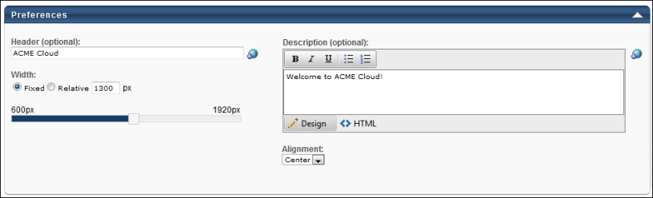
Widgets
Within the Widgets section, you can select and organize the widgets that should appear on the custom page. Note: Depending on the page that is being built, certain widgets may be initially included in the layout by default. In addition, certain widgets may be required and cannot be removed from the layout.
On the left, all of the available widgets are organized by category. To view the widgets available in a category, select the option box to the left of the category name. Multiple categories can be selected, and all widgets within the selected categories are displayed in alphabetical order in the widget browser to the right of the Categories list. Scroll to the left and to the right within the widget browser to view each available widget. If you deselect a category, the widgets within that category are removed from the widget browser. All categories are selected by default.
To view information about a widget within the widget browser, place the mouse cursor over the Info icon in the upper-right corner of the widget. A pop-up appears with a brief description of the widget.
To add a widget to the custom page, drag and drop the widget from the widget browser to the Layout frame below. When a widget is added to the Layout frame, a preview of the widget is displayed in the Layout frame. You may have to configure the widget before it is displayed in the Layout frame. See Custom Page Builder - Available Widgets on page 42 for additional information. You can then customize the organization and layout of the custom page in the Layout frame. Only one instance of each widget can be added to the page, with the exception of the Image, HTML, and Formatted Message Box widget. Once a widget is placed in the Layout frame (with the exception of the HTML widget), it is no longer available in the widget browser unless it is deleted from the Layout frame.
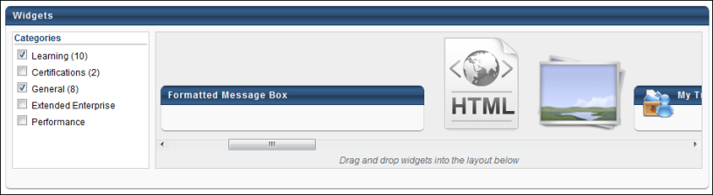
Layout
The Layout frame enables you to customize the structure of the custom page (number and size of columns and rows). When customizing the structure and layout of the custom page, you should follow the following steps:
- Determine the page structure by separating the layout frame into the appropriate number of rows and columns.
- Resize the cells to fit your needs.
- Arrange the widgets within the cells.
- Customize the widget settings for each widget.
By default, the Layout is configured via the Configure Layout pop-up when the page is initially created. The page can be reconfigured if necessary by selecting the Configure Layout option from the Options drop-down list. See Custom Page Builder - Configure Layout on page 40 for additional information.
The page layout can be reset by selecting the Reset option from the Options drop-down list. This undoes all changes that were made to the page after the most recent Save operation. See Custom Page Builder - Configure Layout on page 40 for additional information.
In addition to setting the general page layout via the Options drop-down list, administrators can further configure the layout using the cell menu. To do this, move the mouse cursor over the upper-left corner of a cell to view the Cell Menu icon. Click the Cell Menu icon to view the cell menu options. Note: The Cell Menu is available for all cells in the Layout. The following options appear:
- Vertical Split - The vertical split options add an additional column to the cell. The direction that is selected is the direction in which the existing column is shifted. Note: Depending on the page that is being built, this option may be disabled.
  - Left - This option creates an additional column and shifts the contents of the current cell to the right of the new column.
  - Right - This option creates an additional column and shifts the contents of the current cell to the left of the new column.
- Horizontal Split - The horizontal split options add an additional row to the cell. The direction that is selected is the direction in which the existing row is shifted. Note: Depending on the page that is being built, this option may be disabled.
  - Above - This option creates an additional row and shifts the contents of the current cell below the new row.
  - Below - This option creates an additional row and shifts the contents of the current cell above the new row.
- Background Color - This option enables you to set the background color for the cell. The Select Color pop-up opens, where you can either select a color from the grid or enter the Hex Value for the desired color. Note: Depending on the page that is being built, this option may be disabled. Also, a default value may be set.
- Delete Cell - This deletes the cell along with the contents of the cell. Any widgets that were in the deleted cell must be re-added to the layout if necessary. Any cell can be deleted except for the last cell. Note: Depending on the page that is being built, this option may be disabled.
Once all of the columns and rows are added, you can resize the cells by clicking the edges of the cells and dragging them to the appropriate size. Cells can be resized both vertically and horizontally. Note: Depending on the page that is being built, the ability to resize cells may be disabled.
After setting the columns and rows to the appropriate size, you can arrange the widgets within the cells as necessary by dragging and dropping them into the appropriate cell. You can also dictate the order in which the widgets appear by dragging and dropping the widgets within the cell.
Lastly, after the page is formatted as desired and the widgets are in place, you can customize the widget settings, including the widget title and the number of items that appear in the widget. To set the widget settings, move the mouse cursor over the upper-right corner of the widget to view the Settings icon. Click the Settings icon to view the widget settings pop-up. See Custom Page Builder - Available Widgets on page 42 for additional information.
To delete a widget from a cell, move your mouse cursor over the upper-right corner of the widget and click the Delete icon. The widget can be re-added to the layout if necessary by dragging and dropping it from the widget browser into the appropriate cell. Note: Depending on the page that is being built, certain widgets may be required and cannot be removed from the layout.
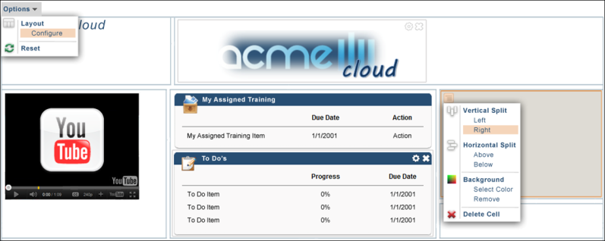
Enhanced Widget Design Options
For portals with enhanced widget design options enabled, you can also define the widget style. A Design option is available from the Options drop-down, which enables you to select from the following widget styles:
- Color - The Color widget design displays with a single-color heading bar. The widget design will retain the corporate colors. Specific color changes for the widget cannot be designed within the widget. This design does not display the widget icons.
- Simple - The Simple widget design displays with a white background for the heading bar. This design does not display the widget icons.
- Gradient - The Gradient widget design displays with a gradient-colored heading bar and a single-color border. The widget design will retain the corporate colors. Specific color changes for the widget cannot be designed within the widget. This design does not display the widget icons.
- Default - The Default style is the existing standard widget design. If the enhanced widget designs feature is enabled, but a widget design has not been selected, then the Default style is automatically selected. The Default style can be modified by selecting one of the new widget styles from the Style drop-down.
Affected Widgets
The following widgets can be configured with the enhanced widget designs:
- Browse for Training
- Certifications
- Formatted Message Box
- My Certifications/Designations/CE
- My Training
- Online Training in Progress
- Order Forms
- Pending Evaluations
- Required Training
- Suggested Training
- To Do's
- Training in Progress
- Training Progress Pie Chart
- Training Status Summary
- Your Action Items
- Your Assigned Training
- Your Inbox
- Your Interest & Waitlist Tracking
- Your Tasks
- Your Upcoming Sessions
Clicking the Design option opens the Widget Design pop-up. The widget styles appear in the Style drop-down. For each design, a sample widget displays to show the design.
Once the design is selected, click Apply in the pop-up to apply the design. The selected design applies to all widgets on the page. A separate design cannot be selected for individual widgets.
Note: The design options only display if enabled by a backend setting that is disabled by default. To enable this functionality, contact Global Customer Support.
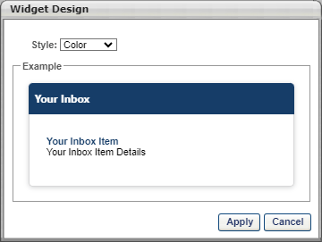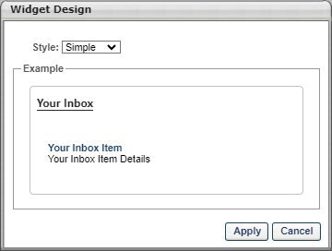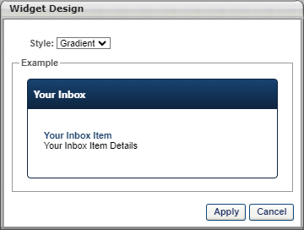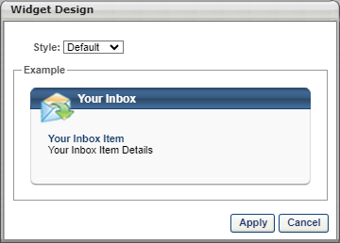
Preview and Save
To preview the custom page, click the Preview button at the bottom of the page. This renders the custom page in a new window as it is currently designed in the Layout frame. All widgets include "Preview" content that is not specific to your portal.
After creating the custom page, click one of the following options:
- Save to save your changes made during the session and remain on the page.
- Save and Exit to save the changes made during the session and return to the previous page. This option is only available for custom pages and Welcome pages, where the page designer is not opened in a pop-up. This returns the admin to the Welcome Page Preferences page. See Welcome Page Preferences - Custom Page Builder on page 155 for additional information.
Once the page is created, it can be added to the navigation tabs and links so that your system users can access and utilize the page. See Navigational Tabs and Links on page 166 for additional information.
Modification History
The Modification History tracks each time a page is created and modified, as well as the creator or modifier and the corresponding time and date stamp.
Custom Page Builder - Configure Layout
The Configure Layout pop-up enables administrators to set the number of columns on the page and add a header and footer row. This pop-up appears when creating a new custom page and can be accessed via the Options menu in the Layout Configuration section.
The Configure Layout options work in conjunction with the Cell Split functionality.
To manage custom pages, go to Admin > Tools > Core Functions > Core Preferences, and under Cross-Platform Preferences, select Custom Pages.
Permissions
PERMISSION NAME | PERMISSION DESCRIPTION | CATEGORY

Custom Pages - Manage | Grants access to create and edit custom pages for the portal. This permission cannot be constrained. This is an administrator permission. | Core Administration
To configure the page layout from the Options menu:
- Click the Options menu in the upper-left corner of the page layout editor.
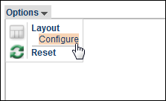
- Select the Configure option. The Configure Layout pop-up opens with the following options:
  - Columns - From the drop-down list, select the number of columns that should appear in the page layout. The available options are 1-4 and the default is 3. When the Columns value is applied, the page is divided into the selected number of columns with each column having an equal width.
  - Include Header Row - Select this option to include a header row at the top of the page layout. The header row appears above the other columns on the page.
  - Include Footer Row - Select this option to include a footer row at the bottom of the page layout. The footer row appears below the other columns on the page.
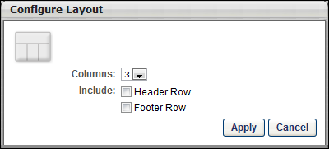
- After selecting the appropriate options, click the Apply button. If any widgets or other content have been added to the page layout already, applying changes within the Configure Layout pop-up will clear the contents of the page layout. A confirmation message appears before the contents are cleared.
- After configuring the layout, the layout can then be further manipulated using the existing Cell Split functionality.
Reset Layout
Within the Options menu, there is a Reset option, which undoes all changes that were made to the page after the most recent Save operation. This includes the name, width, alignment, header, and description fields as well as layout and content changes.
To reset the page layout:
- Click the Options menu in the upper-left corner of the page layout editor.
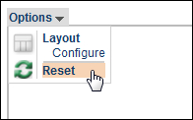
- Select the Reset option. If any changes have been made to the page following the most recent Save, a confirmation message appears before the page is reset.

Custom Page Builder - Available Widgets
This page lists each of the widgets that may be available when building a custom page.
To manage custom pages, go to Admin > Tools > Core Functions > Core Preferences, and under Cross-Platform Preferences, select Custom Pages.
Permissions
PERMISSION NAME | PERMISSION DESCRIPTION | CATEGORY

Custom Pages - Manage | Grants access to create and edit custom pages for the portal. This permission cannot be constrained. This is an administrator permission. | Core Administration
The following widgets are currently available:
General - These widgets are available to all organizations.
- Events Calendar - Displays a calendar with the current month. Users can select a different month using the left and right arrows within the widget. Each day of the month is clickable and redirects users to the new LMS Events Calendar page with the selected day being the day that was clicked by the user. Only one instance of this widget is available per page. Note: This widget is only available when creating custom pages and Welcome pages.
- Formatted Message Box - Displays an HTML friendly message with a formatted title bar. See Formatted Message Box Widget on page 49 for additional information.
- HTML - Enables you to add custom HTML or blocks of text to the page. See HTML Widget on page 50 for additional information.
- Image - Displays an image. See Image Widget on page 52 for additional information.
- Search - Provides a quick search text box, which can be used to search for training, certifications, and volunteer activities. The character limit for the Search field is 100. Only one instance of this widget is available per page. Note: This widget is not available when creating ATS Job Requisition pages. When a user enters a search term in the Search field and presses [Enter], the user is directed to the Global Search page with the search terms populated. See Global Search Overview for additional information.
- Social Feed - Displays the latest Live Feed updates from connections and team members. The widget title bar is not clickable. This widget is only available to organizations using Redesigned Connect. See Social Feed Widget on page 64 for additional information.
- To Do's - Displays a list of To Dos. A To Do is a free form item a must be completed by the user. A To Do item can be added by a manager via My Team or the user via the To Do page. Clicking the widget title bar takes the user to their entire list of To Dos.
- Your Action Items - Displays a list of the user's action items. Clicking the widget title bar takes the user to their Universal Profile > Actions page. This widget is only available when Universal Profile and Universal Profile - Actions are enabled. See Your Action Items Widget on page 66 for additional information.
- Your Inbox - Lists a summary of all of the user's actions items. These are specific categories of action items, such as View Transcript, Approve Training, Approve Goals, Approve User Records, Test Questions Pending Grading, and Announcements. The widget title bar is not clickable.
- YouTube Video - Displays an embedded YouTube video. See YouTube Widget on page 69 for additional information.
Learning - These widgets are only available for organizations using the Learning module.
- Browse for Training - Lists the available subjects the user can browse as defined by the user's division. Clicking the widget title bar takes the user to the Browse for Training page.
- Featured Training - The Featured Training widget displays training items that are configured by the administrator as Featured. Clicking the widget title bar takes the user to the Browse for Training page. Administrators can set a training item to be Featured via the Availability settings within Course Catalog. If the user has completed a featured training item or has the featured training in their Transcript, then that item is not displayed in the widget. If the training item is not available to the user, then it is not displayed in the widget. Note: Playlists are an exception to this behavior. If a playlist is designated as featured, it does NOT display in the Featured Training widget. The featured playlist does, however, display in the Featured carousel on the Learner Home page. See Featured Training Widget on page 48 for additional information.
- My Training - Displays a list of all training for the user, including assigned, required, in-progress, and suggested training. Clicking the widget title bar takes the user to their Active Transcript.
- Online Training in Progress - Lists the user's most recent online training titles that are in progress. Clicking the widget title bar takes the user to their Active Transcript.
- Pending Evaluation - Lists the user's most recent training titles that need evaluations to be completed. The widget title bar is not clickable. Note: This widget appears on the Welcome page regardless of whether the user has a pending evaluation in the system.
- Required Training - Displays a list of the required training for the user. Clicking the widget title bar takes the user to their Active Transcript.
- Suggested Training - Displays a list of the suggested training for the user. The widget title bar is not clickable. Note: The Suggested Training widget is populated by marking a training item as "Suggested" on the Availability tab in Course Catalog. The training item displays in the Suggested Training widget only for the users selected on the Availability tab.
- Training in Progress - Lists the user's most recent training titles that are in progress, including only curricula, online classes, and quick courses. Clicking the widget title bar takes the user to their Active Transcript.
- Your Assigned Training - Lists the user's assigned training in chronological order, beginning with the oldest. This widget also displays training items that are set as Requestable and have the availability type set to Required in the Course Catalog. Clicking the widget title bar takes the user to their Active Transcript.
- Your Interest & Waitlist Tracking - Lists the user's sessions where the user is waitlisted and also events where the user has noted interest. Clicking the widget title bar takes the user to the Interests and Waitlists page to view a full list, including the names of the sessions of indicated interest, waitlist order, etc.
- Your Transcript - Includes the top sorted items from the Active tab of a user's transcript. The widget is capable of displaying all columns from the Active tab of a user's transcript, including the training purpose for each training item. Clicking the widget title bar takes the user to their Active Transcript. See Your Transcript Widget on page 68 for additional information.
- Your Upcoming Sessions - Lists the user's upcoming sessions in chronological order, beginning with the soonest. Clicking the widget title bar takes the user to the Events Calendar.
Performance - These widgets are available to all organizations.
- Your Tasks - Lists the tasks that the user must complete. This includes performance related tasks, Level 3 evaluations, and survey tasks. Clicking the widget title bar takes the user to the Scheduled Tasks page.
Certifications - These widgets are only available for organizations using the Learning module.
- Certifications - This widget enables users to track certification due dates, expiration dates, and status. Clicking the widget title bar takes the user to their Active Transcript. See Certifications Widget on page 47 for additional information.
- My Certifications/Designations/CE - This widget only applies to the legacy certifications functionality (not Certifications 2.0). This widget lists the user's certifications that still need credits or tracking units but are not denied.
Extended Enterprise - These widgets are only available for organizations using the Learning and Extended Enterprise products.
- Order Forms - Displays a list of order forms that are available to the user.
Recruiting - These widgets are only available for organizations using the Recruiting module.
- Internal Job Search - This widget provides users with quick access to search for internal jobs and view a list of featured jobs.
- Referrals - This widget is used to feature Smart Referrals on the Welcome Page and custom pages. See Referrals Widget on page 54 for additional information.
Welcome Pages
All widgets are available when creating custom Welcome pages, with the exception of the Featured Jobs and Search Jobs widgets.
Extended Enterprise Anonymous User Welcome Page
Only the following widgets are available when creating Anonymous User Welcome pages:
Image, Browse for Training, Suggested Training, Formatted Message Box, HTML, and YouTube Video.
Recruiting Career Site
Only the following widgets are available when creating Recruiting career sites:
Image, HTML, Formatted Message Box, and YouTube video.

Widget Settings Overview

Standard Widget
Most available widgets have the same available settings: Widget Title and Items to Show. Other standard widgets only have a Widget Title setting.
In the first field, enter the widget title that is displayed at the top of the widget on the page. The character limit for this field is 100. Changes to the widget title only affect the page you are editing. All other pages within the portal are unaffected. For portals with multiple languages enabled, click the Translate icon to localize the widget title into other available languages. If no translation is provided for a language, the widget title is blank when viewed in that language.
If the "Items to show" drop-down is available, select the maximum number of items that are displayed in the widget. Up to ten items can be displayed. For example, if "3" is selected from the drop-down list, then the widget displays up to three of the user's items for that widget (e.g., training items, certifications, tasks). If the user has less than or equal to the maximum number of items, then the widget displays all of the user's training items. If the user has more than the maximum number, then only the maximum number is displayed and there is a link within the widget to view all of the items.
After selecting the appropriate settings, click the Save button to save the widget settings.
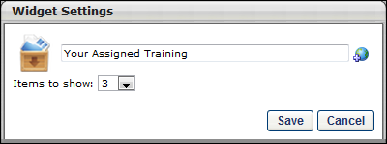
Sample Standard Widget
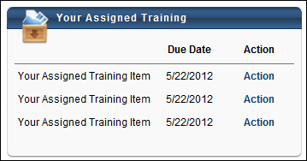
Certifications Widget
This widget only applies to Certifications 2.0 (not legacy certifications). This widget enables users to track certification due dates, expiration dates, and status.
To set Welcome Page Preferences, go to Admin > Tools > Core Functions > Core Preferences, and under Cross-Platform Preferences, select Welcome Page.
To manage custom pages, go to Admin > Tools > Core Functions > Core Preferences, and under Cross-Platform Preferences, select Custom Pages.
Permissions
PERMISSION NAME | PERMISSION DESCRIPTION | CATEGORY

Custom Pages - Manage | Grants access to create and edit custom pages for the portal. This permission cannot be constrained. This is an administrator permission. | Core Administration

Welcome Page Preferences - Manage | Grants ability to configure the look and feel of the Welcome Page that users see upon logging in to the portal. This permission can be constrained by OU and User's OU. This is an administrator permission. | Core Administration
When the Certifications widget is added to the Welcome page or a custom page, the following settings are available for the widget:
- Widget Title
- Hide Certified Certifications - When this option is selected, the widget only displays incomplete certifications for the user. Any certifications in which the user is currently certified are hidden.
- Items to show - The administrator can select any number between 1 and 10. The default number is 3.
After selecting the appropriate settings, click the Save button to save the widget settings.
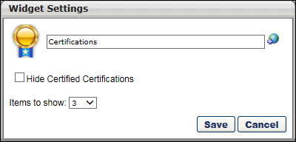
Featured Training Widget
The Featured Training widget displays training items that are configured by the administrator as Featured. Clicking the widget title bar takes the user to the Browse for Training page. Administrators can set a training item to be Featured via the Availability settings within Course Catalog. If the user has completed a featured training item or has the featured training in their Transcript, then that item is not displayed in the widget. If the training item is not available to the user, then it is not displayed in the widget. Note: Playlists are an exception to this behavior. If a playlist is designated as featured, it does NOT display in the Featured Training widget. The featured playlist does, however, display in the Featured carousel on the Learner Home page. See Course Catalog - Availability.
The Featured Training Widget is configured as a standard widget. See Standard Widget on page 46 for additional information.
Helpful Hints
- The order in which featured training appears in this widget cannot be configured.
- If the user has completed a featured training item or has the featured training in their Transcript, then that item is not displayed in the widget.
- Training can only be configured to be Featured via the Availability settings within Course Catalog. Training that cannot be configured via the Course Catalog, such as sessions cannot be configured to be Featured. However, events can be Featured.

Formatted Message Box Widget
The Formatted Message Box widget is identical to the HTML widget with the exception that it has a Title field at the top.
Note: Because of the security risks associated with JavaScript, it is disabled in this editor by default. To embed JavaScript within this widget, contact Global Customer Support. Global Customer Support does not troubleshoot Java or HTML issues.
In the first field, enter the widget title that is displayed at the top of the widget on the page. The character limit for this field is 100. Changes to the widget title only affect the page you are editing. All other pages within the portal are unaffected. For portals with multiple languages enabled, click the Translate icon to localize the widget title into other available languages. If no translation is provided for a language, the widget title is blank when viewed in that language.
See HTML Widget for information on using the HTML editor.
Click Save to save the widget settings and add the widget to the Layout frame. The widget can be added more than once.
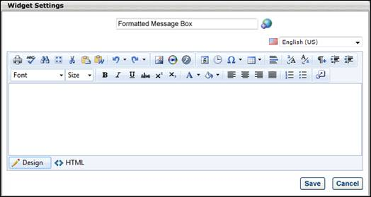

HTML Widget
When you add an HTML Widget to the Layout frame, the Widget Settings pop-up appears with an HTML editor. In the editor, there are two editing modes: Design and HTML. When in Design mode, you can use the standard editing tools to format your text, similar to your word processor application. When in HTML mode, the standard editing tools are disabled and you are able to view and modify the HTML code that is used to design the certificate. To switch between modes, click the appropriate tab in the lower-left corner of the editor.
The system only accepts certain customizable HTML elements in the WYSIWYG Editor. Elements that are not acceptable display as text. See Safe Listed Customizable Elements.
Note: Because of the security risks associated with JavaScript, it is disabled in this editor by default. To embed JavaScript within this widget, contact Global Customer Support. Global Customer Support does not troubleshoot Java or HTML issues.
When adding an image to the widget, the image must be uploaded to the Image Manager in order to appear properly in the certificate. However, there are currently no constraints available, so any image that is loaded can be viewed by any user with permission to manage custom certificates. To open the Image Manager, click the Image Manager icon . This opens the Image Manager. Click the Upload button to select the image to upload. The maximum file size is 1,024KB, and the accepted file types are .gif, .png, .jpg, .bmp. Warning: Files uploaded through the Image or Document Manager are stored on a publicly accessible server.
All custom fields must be referenced in all capital letters. The field name must be placed within brackets ("{ }"). The following custom fields are available:
- {FIRSTNAME} - User First Name
- {LASTNAME} - User Last Name
- User Record Custom Fields
As previously stated, in Design mode, the standard editing tools are available to format the text. The final option in the bottom right corner of the editing toolbar is the Import Field option . Click this option to view and import the available custom fields.
For portals with multiple languages enabled, a language drop-down is available in the upper-right corner. Select the appropriate language to translate the widget text into other available languages. If no translation is provided for a language, the widget title is blank when viewed in that language.
Click Save to save the widget settings and add the widget to the Layout frame. If a script is included in the widget, the script is not applied in the Layout view. It is only run when the page is implemented or previewed. The widget can be added more than once.
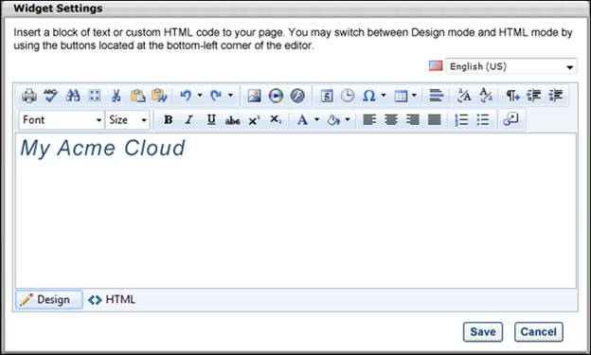

Image Widget
When you add an Image Widget to the Layout frame, the Widget Settings pop-up appears, allowing you to select an existing image or upload an image.
To select an image that was previously uploaded for a custom page and saved in the system, select the Saved Images option. Then, select the appropriate image from the drop-down list to the right of the option.
To select a new image that exists on your computer, select the Upload Image option. Then, click the Browse button to locate and select the image on your computer. Then, click the Upload button to upload the image to the system. The maximum file size is 1,024KB, and the accepted file types are .gif, .png, .jpg, .bmp.
Note: There is currently no way to delete an image that has been uploaded to the Image Manager.
After selecting the appropriate image, a preview of the image is displayed in the pop-up.
Select the following settings for the image:
- Alignment - This setting determines the image alignment within the cell. The available options are Left, Center, and Right. Center is selected by default.
- Link - This setting enables the image to be associated with a link. If an image is associated with a link, users can click the image to navigate to the provided URL.
Click the Save button to save the widget settings. The widget can be added more than once.
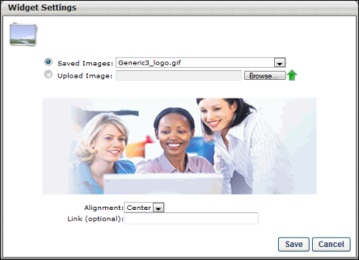
Sample Image Widget
Referrals Widget
The Referrals widget is used to feature Smart Referrals on the Welcome Page and custom pages. The widget allows administrators to feature open requisitions to encourage employee referrals. Users can view the job details and refer the job directly from the Referrals widget.
Use Case
Jane is a recruiter at Acme Corp. She is in charge of creating requisitions and finding the best candidates to fill those openings, such as a new Sales Manager job in Santa Monica. However, Jane does not want to rely solely on external applicants applying through job boards and finding Acme’s career sites. Instead, she wants Acme employees to help her spread the word and even recommend appropriate candidates.
To do this, she edits the associated preferences setting to enable employees to share open requisitions with their friends. She also enables employees to refer candidates via email, by uploading a resume, and by finding a match through their social media networks. To get these opening in front of her employees, Jane adds the Referrals widget to the Welcome Page.
Permissions
PERMISSION NAME | PERMISSION DESCRIPTION | CATEGORY

Custom Pages - Manage | Grants access to create and edit custom pages for the portal. This permission cannot be constrained. This is an administrator permission. | Core Administration

Referral Preferences - Manage | Grants ability to access and manage Referral Preferences. In addition, this permission enables administrators to view and access the Referrals widget in Welcome Page Preferences and Manage Custom Pages. | Recruiting Administration

Welcome Page Preferences - Manage | Grants ability to configure the look and feel of the Welcome Page that users see upon logging in to the portal. This permission can be constrained by OU and User's OU. This is an administrator permission. | Core Administration
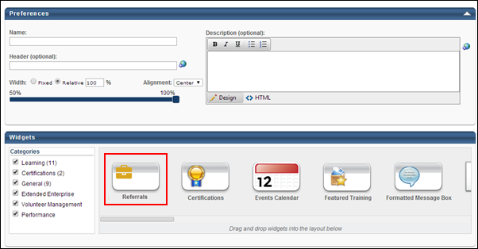
Add Widget
The Referrals widget is available from the Widgets section. To add the widget, drag the widget from the Widgets carousel to the panel.
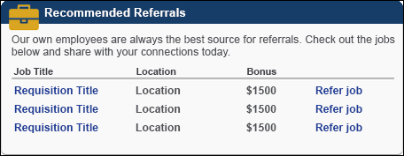
The following information displays in the widget:
- Instructions - The widget instructions displays above the referrals table. The instructions are defined on the Widget Settings pop-up, as noted in the Widget Settings section below.
- Job Title - This column displays the title of the job requisition.
- Location - This column displays the location of the job.
- Bonus - This column displays the referral bonus amount.
- Refer Job - This column displays the Refer Job link. When users select the link, the Refer Job page opens. This page allows users to view the job details and select from the available referral options to refer the job.
Widget Settings
The following settings are available when selecting the Settings icon in the upper-right corner of the widget:
- Title - The default widget title is Referrals. To change the title, enter a different name in the field, up to 100 characters.
- Items to Show - Select the maximum number of items that should appear in the widget, between 1 and 10. The default number is 3.
- Instructions - Enter instructions for the widget, up to 150 characters.
Click Save to save the settings. Or, click Cancel to close the pop-up without saving the settings.
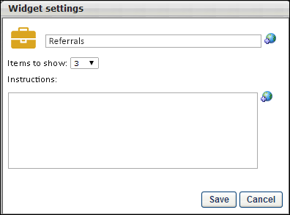
Delete Widget
The widget can be deleted by selecting the Delete icon in the upper-right corner of the widget. This removes the widget from the Welcome or custom page.
Options
Additional configuration options are available from the Options drop-down. For detailed information about configuring the additional options widgets for Welcome and custom pages, see the Custom Page Builder - Configure Layout topic in Online Help.
Search Jobs Widget
The Search Jobs widget enables job seekers to search for and find jobs on a career site. The widget can be configured as a search bar that is editable by the user, a list of jobs that match search criteria that is defined by the administrator, or a combination of the two. When you add a Search Jobs Widget to the Layout frame, the Widget Settings pop-up appears, allowing you to configure the widget. The widget can be added more than once to the career site.
In the first field, enter the widget title that is displayed at the top of the widget on the page. The character limit for this field is 200. The default value for this field is "Search." Changes to the widget title only affect the page you are editing. All other pages within the portal are unaffected. For portals with multiple languages enabled, click the Translate icon to localize the widget title into other available languages. If no translation is provided for a language, the widget title is blank when viewed in that language.
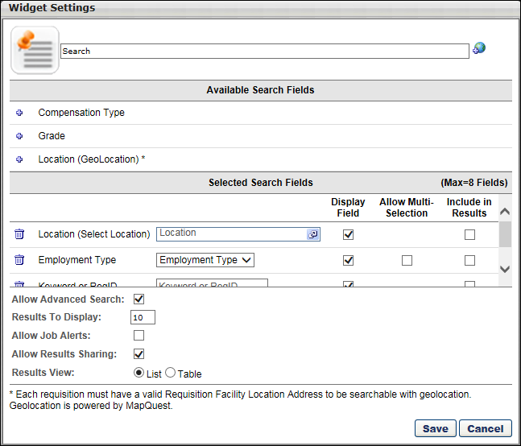
Available Search Fields
The Available Search Fields section displays all available search fields in alphabetical order. This list includes Position custom fields that are defined in Requisition and Applicant Preferences. Only Short Textbox, Drop-down, and Checkbox custom fields are available.
To include a search field in the widget display, click the plus icon to the left of the search field name. The selected field is moved from the Available Search Fields section to the Selected Search Fields section and can then be configured. Up to eight search fields can be added to the Selected Search Fields section.
The following search criteria are available:
- Compensation Type - A drop-down that allows users to search by available compensation types.
- Custom Fields - Any position custom fields that are defined in Requisition Preferences is available.
- Division - A selection pop-up field that allows users to search by Division OU.
- Employment Type - A drop-down that allows users to search by available employment types.
- Grade - A selection pop-up field that allows users to search by Grade OU. Note: The Grade option is only available for portals that have Grade OUs enabled.
- Keyword or ReqID - A free text search field that allows users to search by job title, job description, and requisition ID. Keyword Searchability Note: The Keyword or ReqID field must be selected as a search field when configuring the Search Jobs widget settings for the career site, and the box in the Display Field column must also be checked for the Keyword or ReqID field.
- Location (Select Location) - A selection pop-up field that allows users to search by location OU.
- Location (GeoLocation) - This search field allows applicants to search for jobs by geographical location. A Country drop-down, Location (Street, City, State/Province) textbox, and Postal Code textbox displays for applicants on the Search Jobs page of the career site. Applicants can select a country and enter street, city, state/province and/or postal code information. A radius drop-down also displays to allow applicants to filter jobs within a certain mileage or kilometer radius of the geographical location.
Selected Search Fields
The Selected Search Fields section allows administrators to configure the selected search fields and dictate how they are used in the widget.
The selected search fields appear in the order in which they were added from the Available Search Fields section. To remove a field from the Selected Search Fields section, click the Remove icon to the left of the field name. When a field is removed, it is moved back into the Available Search Fields section.
To the right of the selected search field name, the search field control is displayed (e.g., selector pop-up, drop-down list, short text box, checkbox). The administrator can use the search field control to apply a filter to the search. If no value is selected in the control, no filter is applied. For example, if the Location search filter is selected and the administrator selects California as the Location OU, then the search results returned in the widget are automatically filtered to include only jobs within the California Location OU. Location and Division control selections always include subordinate OUs.
When configuring the Location (GeoLocation) field in the Selected Search Fields section, it is important to note that all requisitions must have a valid requisition facility location in order to be searchable by geographical location. Requisitions without valid locations will not be returned in the search results. Note: The requisition facility location is defined on the General step of the job requisition.
Display Field
This option controls whether the associated search field is displayed in the search bar for users.
- If this option is selected for a field, then the user can select the search criteria for this field. For example, if the Display Field option is selected for the Location OU, then the user can select which Location OU to include in the search results. If the option is selected for the Location (GeoLocation) field, then this enables applicants to define a location in the field on the career site.
- If this option is not selected for a field, then the administrator can select search criteria for the field and not allow the user to change the selected criteria. The selected search criterion is automatically applied to any search. For example, if the option is not selected for the Location (GeoLocation) field, then the default location defined by the administrator cannot be changed by the applicant.
- If this option is deselected for all fields, then a search is executed when the career site is loaded, and the widget simply displays a list of jobs that match the search criteria.
- If at least one field is selected to display, then the search is not executed until the user clicks the Search button within the widget.
- Best Practice: When including multiple languages for a career site, it is a best practice to select the Display Field option for all search criteria that you are including on the Search Jobs widget. This ensures that applicants have search features available to find jobs in other languages. Languages for career sites are configured by the administrator in Career Site Management.
Allow Multi-Selection Column
The Allow Multi-Selection column enables administrators to control whether or not applicants can select multiple values in certain drop-down fields that are available when searching for jobs on the career site. The column includes a checkbox for the following custom fields that display as drop-downs on the career site:
- Custom drop-down fields
- Compensation Type
- Employment Type
The checkbox is unchecked by default. When unchecked, applicants can only select a single value from the drop-down. When checked, applicants can select multiple values in the drop-down on the career site. In addition, when the box is checked in the Allow Multi-Selection column, the user interface for the field changes to enable administrators to define default values for the field.
Note: This option is hidden for the Location (GeoLocation) field.
Define Default Values
Administrators can define default values for the search fields by configuring the option that displays to the right of the search field name in the Selected Search Fields section. The configurable option may appear as a drop-down, textbox, pop-up selector, etc. The selected default value automatically displays for applicants on the career site. Applicants can change the default value if allowed, depending on the selection in the Include in Results column.
For example, a default location can be selected for the Location (Select Location) search field. To define the default location, click the pop-up selector icon in the Location field. This opens the Search Location pop-up. Select a location from the list. This automatically closes the pop-up and displays the selected location in the field.
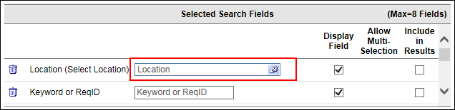
Include in Results
This option controls whether the associated search field value for requisitions is displayed to users in the results display. If this option is selected for a field, the associated search field is included in the results string in the order included in the Selected Search Fields section.
When the Include in Results box is checked for the Keyword or ReqID option, the requisition ID displays to the right of the job title in the list of search results on the career site. This allows applicants to know the requisition ID for a particular job. For example, if an administrator would like the requisition ID to display for all jobs that appear in the search results, then the administrator would add the Keyword or ReqID field to the Selected Search Fields section. Then, the administrator would check the Include in Results box.
Note: This option is hidden for the Location (GeoLocation) field.
Allow Advanced Search
This option controls whether users have the option to perform an advanced search. If this option is selected, the Advanced Search link is available for users. The Advanced Search displays all standard search fields. Note: This option can only be selected if the Display Field option is selected for at least one search field.
Results To Display
This option controls how many search results are displayed in the widget. If the number search results exceed the number of results that can be displayed, the results are truncated and a Click to see more link is displayed, which allows users to see the next set of results. The default value for this field is 10 and the maximum value is 25.
Allow Job Alerts
This option is unchecked by default. Selecting the option enables the Job Alert functionality for the career site. When the Job Alert functionality is enabled, external applicants can create a job alert, which sends the applicant an email when newly opened requisitions are posted that match the job search criteria they defined within the job search on the career site.
Note: Newly opened requisitions are defined as jobs that are posted for the first time and jobs that are reopened.
Note: A job alert created on one career site applies to all of an organization's career sites. The job alert includes open requisitions that are available on any of the organization's career sites.
Use Case
An external job seeker browses an organization's available jobs on their career site. There are no available positions that match his interests, but he is very interested in staying informed about upcoming jobs that may be the right fit. Instead of returning to the career site multiple times to search for matching positions, he sets up a job alert that includes the job criteria in which he is interested. He receives the job alerts on a weekly basis by email, which allows him to review all newly opened job opportunities that match his interests.
In order for the job seeker to set up a job alert, the administrator enabled the Allow Job Alerts option when creating the career site.
Allow Results Sharing
The Allow Results Sharing option enables the Share Search link to display on the career site. If the option is unchecked, the link is hidden on the career site. The option is unchecked by default.
Note: Disabling the Share Search link after users have generated and shared a link to job search results does not disable the shared link. The shared search results can still be viewed if the Share Search link is disabled.
Links to job search results are shared from the career site.
Results View
This option determines how the job search results display for applicants on the career site. The following options are available:
- List - This option is selected by default and displays the job search results as a list. This is the existing format in which the job search results display.
- Table - This option displays the job search results in a sortable table. When selected, a Table Columns section displays at the bottom of the pop-up to allow administrators configure the columns that will appear in the table on the career site.
- Map & Table - This option only displays if the Location (GeoLocation) search field is selected as a search field. This option displays the job search results on both a map and in a table for applicants on the career site. When selected, a Table Columns section displays at the bottom of the pop-up to allow administrators to configure the columns that will appear in the table on the career site.
Table Columns Section
This section only displays if the Table or Map & Table option is selected in the Results View field. This section allows administrators to select up to four columns to display in the table view of the job search results on the career site.
The Job Title column displays in the table by default. This column cannot be removed. Administrators can add up to four columns from the Column Name drop-down:
- Date Posted
- Distance - This option is only available if the Location (GeoLocation) search field is selected as a search field.
- Location City - This option is only available if the Location (GeoLocation) search field is selected as a search field.
- Search Field Values - The search fields added from the Available Search Fields section are available to select from the drop-down.
Once a field is selected, click the Add button. This adds the field to the table. To delete a field from the table, click the Delete icon.
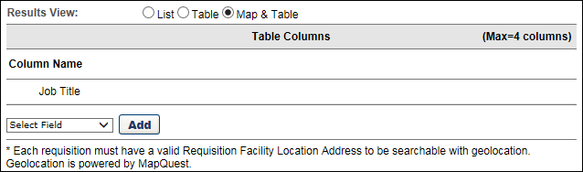
Save/Cancel
After making the appropriate selections, click the Save button to save the widget settings. Or, click Cancel to cancel the changes and close the Widget Settings pop-up.
Configuration Examples
Example 1 - Basic Widget Layout
This is a basic search widget layout. The selected fields are Keyword or Job ID, Location, and Experience Level. All fields are selected to display so that users can set the desired criteria. Also, the Advanced Search option is enabled. The magnifying glass always appears to the right of the last search field.
Example 2 - Narrowed Width
This example is the same configuration as example 1. However, the widget width is narrowed so that all search fields appear in rows. The widget should not be resized smaller than the width of a single search field and the Search icon.
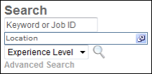
Example 3 - Users Cannot Modify Search Criteria
This configuration is used to display a list of job openings without allowing users to set or modify the search criteria. This is done by deselecting the Display Field option for all selected fields in the Widget Settings pop-up. When the Display Field option is deselected for all selected fields, the widget displays the results of the selected search criteria. Administrators must still add search fields to the widget and set the search criteria in the Widget Settings.
In this widget, the Include in Results option is selected, so the selected search field values are displayed to the right of each job opening. In this example, that is Location, Experience Level, and Employment Type.
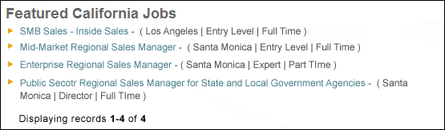
Social Feed Widget
When the Social Feed widget is added to the Welcome page or a custom page, the following settings are available for the widget:
- Title - The default widget title is Social Feed. To change the title, enter a different name in the field, up to 100 characters. If multiple languages are enabled for your portal, select the Translate icon to translate the field into other available languages.
- Number of items to display - Select the maximum number of items that should appear in the widget, between 1 and 10. The default number is 10.
- Connect User Updates - Select this option to include Connect user updates as feed items in the widget.
- Connect Activity Updates - Select this option to include Connect activity updates as feed items in the widget.
Click Save to save the settings. Or, click Cancel to close the pop-up without saving the settings.
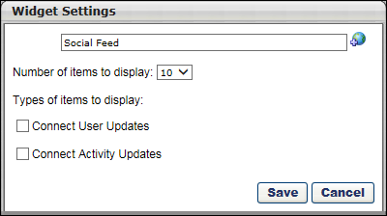

Your Action Items Widget
When the Your Action Items widget is added to the Welcome page or a custom page, the following settings are available for the widget:
- Widget Title - Enter the title that should appear at the top of the widget, up to 100 characters.
- Items to show - Select the maximum number of items that should appear in the widget, between 1 and 10. The default number is 3.
- Action Types - Check the appropriate action types to have them appear in the widget. If an action type is not selected, then those actions do not appear in the widget. For example, if the Performance Reviews option is not selected and a user is assigned a performance review task, then this action does not appear in the widget. However, the action is still visible on the Actions page. The following action types may be included in the widget:
  - Certification - This option is only available if Learning action items are enabled in Universal Profile.
  - Compensation Tasks - This option is only available if Performance action items are enabled in Universal Profile.
  - Competency Assessments - This option is only available if Performance action items are enabled in Universal Profile.
  - Development Plans - This option is only available if Performance action items are enabled in Universal Profile.
  - Development Plans (Redesign) - This option is only available if Performance action items are enabled in Universal Profile. Development plans that are in a Completed or Cancelled status do not appear in the widget.
  - Employee Onboarding - This option is only available if Forms action items are enabled in Universal Profile.
  - Events and Sessions - This option is only available if Learning action items are enabled in Universal Profile.
  - Form Management - This option is only available if Forms action items are enabled in Universal Profile.
  - Goals - This option is only available if Performance action items are enabled in Universal Profile.
  - Performance Reviews - This option is only available if Performance action items are enabled in Universal Profile.
  - Succession Tasks - This option is only available if Performance action items are enabled in Universal Profile.
  - Training - This option is only available if Learning action items are enabled in Universal Profile.
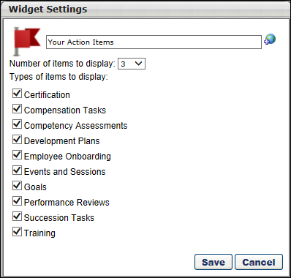
Your Transcript Widget
When the Your Transcript widget is added to the Welcome page or a custom page, the following settings are available for the widget:
- Widget Title
- Items to show - The administrator can select any number between 1 and 10. The default number is 3.
- Transcript Fields - Check the appropriate options to include them in the widget. The following transcript fields can be included in the widget:
  - Title - This option is required and cannot be unchecked.
  - Type
  - Due Date
  - Status
  - Training Purpose - This option is only available if Training Purpose is enabled for the portal and if it is enabled in Transcript Preferences.
  - Action
The Your Transcript widget uses the Transcript Preferences to determine the order in which items are sorted within the widget. However, when sorting by Due Date A > Z (ascending), the Your Transcript widget considers items with no due date as the "A" (or lowest) so it places them at the top of the list alphabetically, then includes due dates ascending. So, when Z to A is selected, it places items with no due date at the bottom of the list reversed alphabetically.
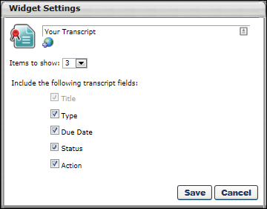

YouTube Widget
The YouTube widget enables administrators to display an embedded YouTube video on the page.
In the Link field, enter the link for the YouTube video. The link can either be the URL address of the YouTube video or the "Share" URL link provided by YouTube for the video. The system parses the video ID from the link and generates an embedded code for the video. HTTPS is used when generating the embedded code.
In the Format section, select the appropriate format for the YouTube video. The selected Format option determines the Size selections that are available in the Size drop-down. 16:9 is a widescreen display, and 4:3 is a Letterbox display. 16:9 is selected by default.
From the Size drop-down, select the size in which the video should appear. The Size dimensions are measured in pixels.
- When 16:9 is selected as the format, the following sizes are available: 320x180, 480x270, 640x360, 853x480, 960x540, and 1024x576.
- When 4:3 is selected as the format, the following sizes are available: 320x240, 480x360, 512x384, 640x480, 800x600, and 1024x768.
From the Alignment drop-down, determine the YouTube video alignment within the cell. The available options are Left, Center, and Right. Center is selected by default.
In the Autoplay section, select the Autoplay setting. If this setting is set to On, the YouTube video begins playing when the page loads. If this setting is set to Off, the user must click the Play button to start the video.
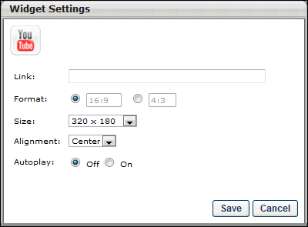

Email Preferences
Email Preferences define end user's ability to change their email address and the associated email notifications when emails are changed. A great deal of Cornerstone workflow is triggered by email functionality. By defining who has the ability to change users emails and where the notification of such changes are to be sent, administrators ensure the appropriate levels of email security and flexibility for their organization. If these requirements vary at different organizational levels, Cornerstone gives you the ability to define email preferences specific to any organizational unit.
To manage Email Preferences, go to Admin > Tools > Core Functions > Core Preferences > Email.
Permissions
PERMISSION NAME | PERMISSION DESCRIPTION | CATEGORY

Email Preferences - Manage | Grants ability to manage Email Preferences, which includes defining end users' ability to change their email address and the associated email notifications when emails are changed. This is an administrator permission. | Core Administration
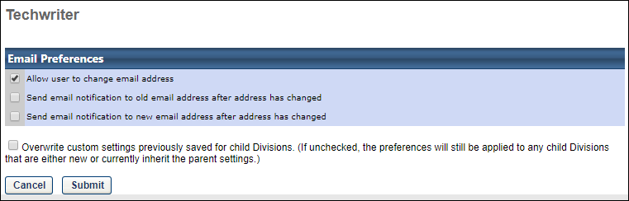
Allow User to Change Email Address
When this option is selected, users have the option to change their email address via My Account. See My Account.
Send Email Notification to Old Email Address After Address Has Changed
When this option is selected, if a user changes their email address via My Account, the system generates an automatic email to the user's old email address, notifying the user that their email address has been changed. See My Account.
Send Email Notification to New Email Address After Address Has Changed
When this option is selected, if a user changes their email address via My Account, the system generates an automatic email to the user's new email address, notifying the user that their email address has been changed. See My Account.
Overwrite Settings
Select this option to overwrite custom settings for child division OUs. If you overwrite custom settings for child division OUs, the selected settings are applied to both new and existing child OUs. Any previously customized child OUs are updated with the selected settings.
- If there are no customizations to the child OU, then the parent OU customizations are applied to all child OUs.
- Overwrite custom settings checkbox setting
  - If this option is selected, all child OU customizations are deleted from the database, which means the parent OU customizations will be applied to new and existing child OUs.
  - If this option is unselected, all existing child OU customizations will remain unchanged, and any new child OUs will inherit the parent OU customizations by default.
- If a child OU has been customized to display any widgets, then regardless of the parent OU customizations, the child OU customizations are applied.
- If a child OU has been customized to hide all widgets, then parent OU customizations will take precedence and will be applied.

Group Preferences
The Group Preferences page enables administrators to activate the Group Preview and Save Draft features. Once Group Preview is activated, administrators can require a preview before saving edits.
Group Preferences are global and cannot be configured by organizational unit (OU).
To access Group Preferences, go to Admin > Tools > Core Functions > Core Preferences > Group Preferences.
Permissions
PERMISSION NAME | PERMISSION DESCRIPTION | CATEGORY

Bypass Required Group Preview | When the Group Preview functionality is enabled and the Require Preview Before Saving Edits toggle is enabled in Group Preferences, administrators with this permission can save edits to a Group or publish a draft without generating a preview. Administrators with this permission still have the option to generate a preview.  This permission cannot be constrained. This is an administrator permission. | Core Administration

Group Preferences - Manage | Grants the ability to access and modify the Group Preferences page. This permission cannot be constrained. This is an administrator permission. | Core Administration
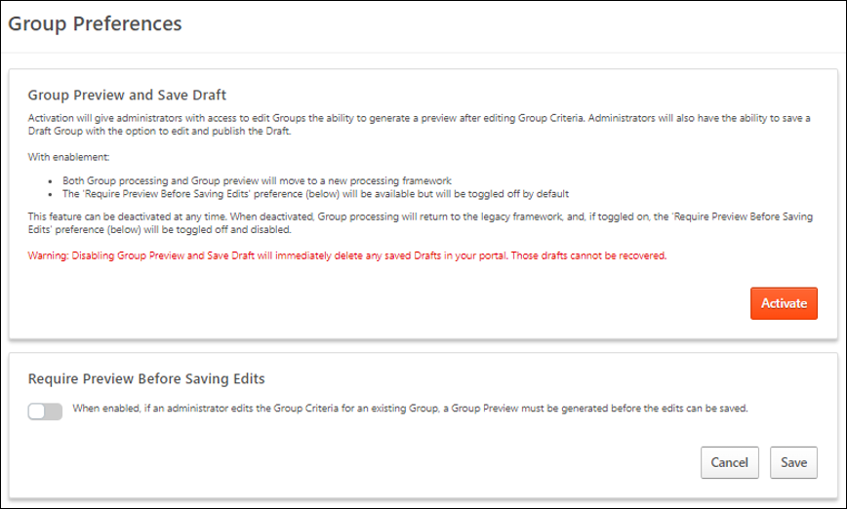
Group Preview and Save Draft
Select the Activate button to activate the Group Preview and Save Draft functionality. This also enables the option to change the Require Preview Before Saving Edits preference.
This functionality can be deactivated at any time. When this functionality is inactive, the Require Preview Before Saving Edits preference is disabled and cannot be enabled. Deactivating this functionality immediately deletes any saved Group drafts in the portal that cannot be recovered.
Require Preview Before Saving Edits
Select the toggle to require all administrators to generate a preview of the Group before saving any criteria changes. By previewing the membership of the Group before saving the changes, the administrator can review the updated Group and potentially identify any unexpected issues. The preview is optional for administrators with the Bypass Required Group Preview permission.
If this preferences is off, administrators are not required to generate a preview of the Group before saving edits. However, they still have the option to do so if Group Preview and Save Draft are activated.

Login Message Preferences
Login Message preferences enable administrators to create messages that appear to users on the Welcome page when they log in to the system. A login message could be a notification that the portal is undergoing maintenance or that certain company-wide training is due that day. Messages could also be used to communicate important company information.
Administrators can configure messages to appear each time a user logs in or only once at login. Further, you can add a series of actions to a message that direct users to another website, send them an email, or even log them out of the system.
The Login Message works with the most commonly used landing pages:
- Welcome Page
- Custom Pages
- Learner Home
- Other pages that contain “/ui/” in the URL
- Other pages that contain “/phnx/driver.aspx?” in the URL
To access Login Message preferences, go to Admin > Tools > Core Functions > Core Preferences > Login Message.
Permissions
PERMISSION NAME | PERMISSION DESCRIPTION | CATEGORY

Log In Message - Manage | Grants access to create a message that appears upon portal login to all users or a selected group/subset of users. This is an administrator permission. This permission can be constrained by OU and User's OU. | Core Administration
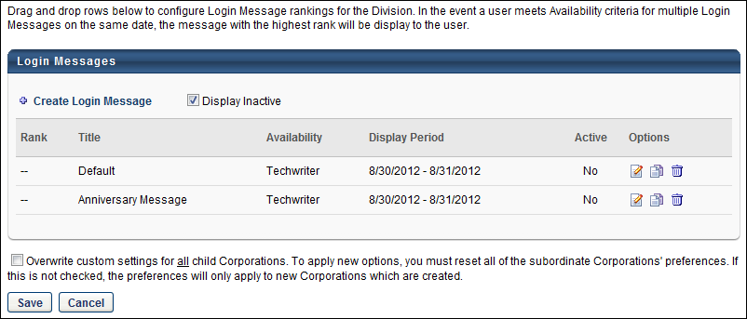
Create Login Message
Select the Create Login Message link to create a new login message. This takes you to the General step of creating a login message. See Create Login Message - General on page 78 for additional information.
Display Inactive
All active login messages are displayed in the table by default. To include inactive login messages in the table, select the Display Inactive option.
Login Messages Table
The following information displays for login messages:
- Rank - This column displays the message's rank. This column also determines the order in which messages appear for users who meet the availability criteria for more than one message during overlapping display periods.
You can change a message's rank by dragging and dropping the message to the desired position. Note: New messages always appear at the bottom of the list and must be manually reordered to change the rank.
- Title - This column displays the message title.
- Availability - This column displays the OU for which the message is configured to display. If multiple OUs are configured for the message, then each OU appears on its own line.
- Display Period - This column displays the dates during which the message is configured to display.
- Mobile Only - When this option is selected for a login message, the message only displays in the Cornerstone Learn app. It does not display when logging in via web browser. Similarly, if this option is not selected for a login message, the message only displays when logging in via web browser. It is not displayed when logging in to Cornerstone Learn. A mobile-only login message only displays to a user if the user is using the latest version of the Cornerstone Learn app.
  - For any login messages that existed prior to the October 2019 release, this checkbox is disabled and cannot be selected. In order to create a mobile-only login message, administrators must copy an existing message or create a new one.
- Active - This column displays the active status of the message. The column displays "Yes" for active messages and "No" for inactive messages. Note: The active status is managed on the General step of the Define Login Message page.
Options
The following options are available in the Options column:
- Edit - Click the Edit icon to edit the message, including the active status of the message.
- Copy - Click the Copy icon to copy the message. All areas of the message are copied. Copied messages are active by default.
- Delete - Click the Trash Can icon to delete the message.
Overwrite Settings
Select this option to overwrite custom settings for child division OUs. If you overwrite custom settings for child division OUs, the selected settings are applied to both new and existing child OUs. Any previously customized child OUs are updated with the selected settings.
- If there are no customizations to the child OU, then the parent OU customizations are applied to all child OUs.
- Overwrite custom settings checkbox setting
  - If this option is selected, all child OU customizations are deleted from the database, which means the parent OU customizations will be applied to new and existing child OUs.
  - If this option is unselected, all existing child OU customizations will remain unchanged, and any new child OUs will inherit the parent OU customizations by default.
- If a child OU has been customized to display any widgets, then regardless of the parent OU customizations, the child OU customizations are applied.
- If a child OU has been customized to hide all widgets, then parent OU customizations will take precedence and will be applied.
Save/Cancel
Once all preference settings are completed on the Login Messages Administration page, click Save. Changes made to this page are not committed until you click Save. Click Cancel to cancel the changes made to the Login Messages Administration page. Clicking either button takes you to the select OU page of Login Message preferences.
Create Login Message
The Login Message works with the most commonly used landing pages:
- Welcome Page
- Custom Pages
- Learner Home
- Other pages that contain “/ui/” in the URL
- Other pages that contain “/phnx/driver.aspx?” in the URL
To create a login message, go to Admin > Tools > Core Functions > Core Preferences > Login Message. On the Login Message Administration page, select the Create Login Message link.
Permissions
PERMISSION NAME | PERMISSION DESCRIPTION | CATEGORY

Log In Message - Manage | Grants access to create a message that appears upon portal login to all users or a selected group/subset of users. This is an administrator permission. This permission can be constrained by OU and User's OU. | Core Administration
The process for creating login messages consists of following steps:
- General
- Message
- Actions
- Summary
Each new login message appears on the Login Message Administration page at the bottom of the ranking. Messages only appear for administrators who have the appropriate permissions and are in the Division in which the message is created.
Important Note: As a best practice, use the Back and Next buttons within the login message steps when creating, copying, or editing a message. Text entered on the Message step may be deleted if you use the left navigation panel to navigate through the steps.
Create Login Message - General
The General step is used to set the display options and is divided into the following sections:
- General
- Display
- Availability
The Login Message works with the most commonly used landing pages:
- Welcome Page
- Custom Pages
- Learner Home
- Other pages that contain “/ui/” in the URL
- Other pages that contain “/phnx/driver.aspx?” in the URL
To create a login message, go to Admin > Tools > Core Functions > Core Preferences > Login Message. On the Login Message Administration page, click the Create Login Message link.
Permissions
PERMISSION NAME | PERMISSION DESCRIPTION | CATEGORY

Log In Message - Manage | Grants access to create a message that appears upon portal login to all users or a selected group/subset of users. This is an administrator permission. This permission can be constrained by OU and User's OU. | Core Administration
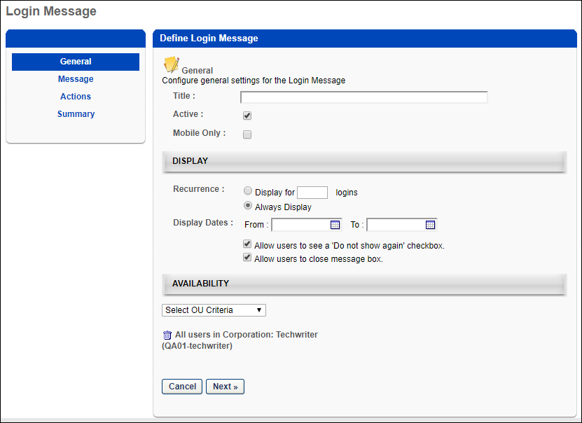
General
Complete the following information in the General section:
- Title - Enter a title for the message, up to 100 characters. This is a required field. The title appears in the Title column on the Login Message Administration page. The title does not display to end users and is not part of the login message that appears when users log in to the portal. As the title is entered in the field, the text of the title displays in the header row above the Define Login Message panel.
- Active - Select or deselect the Active checkbox to activate or inactivate the message. New login messages are active by default.
- Mobile Only - When this option is selected for a login message, the message only displays in the Cornerstone Learn app. It does not display when logging in via web browser. Similarly, if this option is not selected for a login message, the message only displays when logging in via web browser. It is not displayed when logging in to Cornerstone Learn. A mobile-only login message only displays to a user if the user is using the latest version of the Cornerstone Learn app.
  - For any login messages that existed prior to the October 2019 release, this checkbox is disabled and cannot be selected. In order to create a mobile-only login message, administrators must copy an existing message or create a new one.
  - A mobile-only login message only displays to a user if the user is using the latest version of the Cornerstone Learn app.
Display
Complete the following information in the Display panel:
- Recurrence - This option determines the number of instances the message displays.
  - Display for [numeric text box] logins - Select this option to set the message to appear for a certain number of logins. Enter a numeric value between one and 999 in the numeric text box. Entering a value is required if this option is selected.
  - Always Display - This option displays the message each time a user logs in. Note: If this option is selected and the Do not show again box is available to users when viewing the message, the message no longer appears if the user checks the box.
- Display Dates - Select a time frame during which to display the message by choosing a date in the From and To field. You can also use the calendar feature to select the dates. The From date can be set to today's date, but a best practice is to set the From date to be greater than today's date. The To date must be greater than the From date. This means that a message cannot display for only today's date. You must enter a date in both fields. Note: The selected dates are implemented in Coordinated Universal Time (UTC). For example, if the message is set to display until October 11, then the message displays until 23:59:59 UTC on October 11.
- Allow users to see a 'Do not show again' checkbox - Select this option to allow employees to disable the message from reappearing at login. This option is selected by default. Note: If this option is selected and the user checks the Do not show again box when viewing the login message, then the login message does not display again, regardless of the recurrence setting.
- Allow users to close the message box - This option allows users to close the message by clicking "Close" in the upper-right corner of the login message box. This option is selected by default. If this option is deselected, you are required to create a button on the Action step that provides users with the ability to close the message box.
Availability
The Availability panel determines to whom in the organization the message is visible. If you select any one of the organizational units listed in the drop-down list, the message appears to employees in the selected OU. By default, "All Users" is selected. You can delete the default setting by clicking the Trash Can icon to the right of the setting. However, at least one availability criteria is required.
From the drop-down, select an OU. Then, click the Search icon to the right of the drop-down. This opens the Select OU pop-up. Select an OU from the list, which closes the pop-up and adds the OU.
Next
Click Next to go to the Message step. See Create Login Message - Message on page 81 for additional information.
Create Login Message - Message
On the Message step, define the message content that displays to users. You can configure a separate message for each available language in the portal.
The Login Message works with the most commonly used landing pages:
- Welcome Page
- Custom Pages
- Learner Home
- Other pages that contain “/ui/” in the URL
- Other pages that contain “/phnx/driver.aspx?” in the URL
To create a login message, go to Admin > Tools > Core Functions > Core Preferences > Login Message. On the Login Message Administration page, click the Create Login Message link.
Permissions
PERMISSION NAME | PERMISSION DESCRIPTION | CATEGORY

Log In Message - Manage | Grants access to create a message that appears upon portal login to all users or a selected group/subset of users. This is an administrator permission. This permission can be constrained by OU and User's OU. | Core Administration
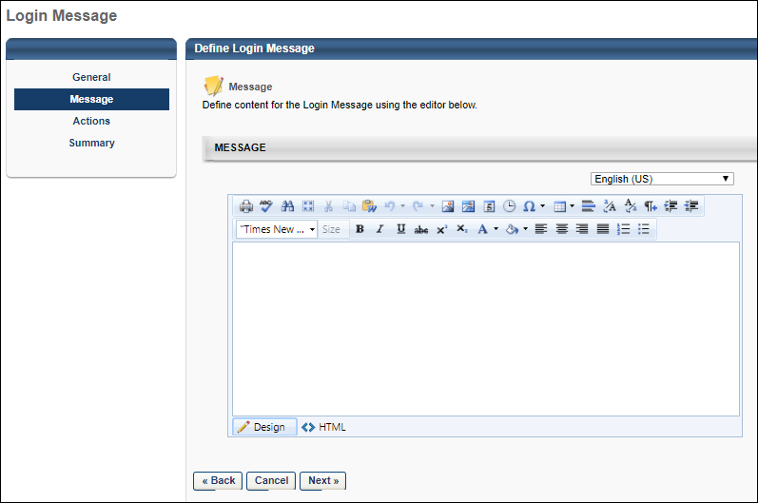
Message Language
If multiple languages are enabled, you may have the option to specify the login message in multiple languages.
To specify the login message in another language, select the language from the Language drop-down.
While creating the message in one language, you can select a different language to begin creating a message in another language. The message text is preserved in the corresponding language when switching back and forth between different languages. However, if you navigate away from the Message step by using the left navigation panel, the message text may be lost upon returning to the Message step.
Message
                - In the Message box, enter the message. The Telerik Editor options are available, enabling you to configure fonts, colors, tables, images, and more. Design and HTML views are also available. Design view is selected by default.
Note: The ability to add script and iframe tags is based on backend settings. If the settings are turned off, a message appears below the language drop-down indicating that script tags are disabled and to contact your system administrator to enable these features. To enable these settings for your portal, contact Global Customer Support.
Next/Back
Click Next to go to the Actions step. See Create Login Message - Actions on page 83 for additional information.
Click Back to go to the General step. See Create Login Message - General on page 78 for additional information.
Create Login Message - Actions
The Actions step is used to define the action buttons that are available to users in the login message box.
The Login Message works with the most commonly used landing pages:
- Welcome Page
- Custom Pages
- Learner Home
- Other pages that contain “/ui/” in the URL
- Other pages that contain “/phnx/driver.aspx?” in the URL
To create a login message, go to Admin > Tools > Core Functions > Core Preferences > Login Message. On the Login Message Administration page, click the Create Login Message link.
Permissions
PERMISSION NAME | PERMISSION DESCRIPTION | CATEGORY

Log In Message - Manage | Grants access to create a message that appears upon portal login to all users or a selected group/subset of users. This is an administrator permission. This permission can be constrained by OU and User's OU. | Core Administration
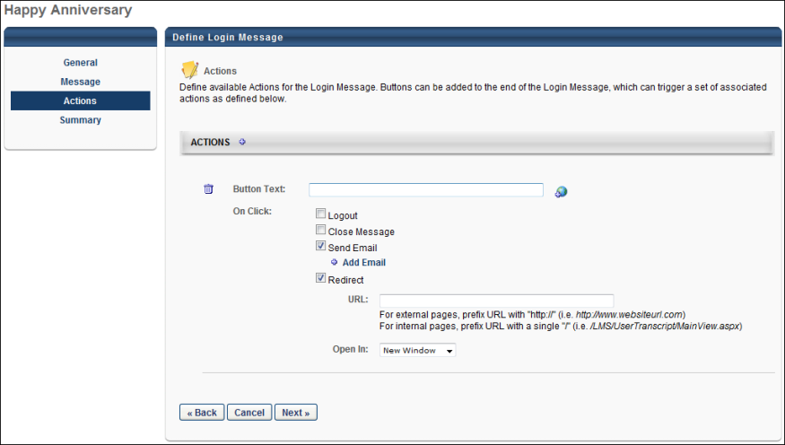
Actions
To add action buttons, click the plus icon in the Actions panel header. This opens the options for defining buttons and on-click actions. Up to six buttons can be added. Note: By default, each time an action is added, the Button Text field is blank and all on-click options are deselected.
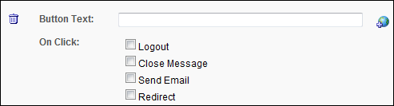
- Button Text - Enter the text that will appear on the button. This is a required field for each action button. For portals with multiple languages, click the Translate icon to enter localized text.
- On Click - This option defines the on-click actions that are available to users. At least one on-click action must be defined for each action button. The following on-click actions are available:
  - Logout - Select this option to log the user out of the portal when they click the action button.When this option is selected, the Close Message option is checked and disabled by default because the message automatically closes as a result of the logout action. This action does not count as a valid login towards the Recurrence configuration.
    - The User Last Access field in custom reports displays the last login for the user. This field is updated at the time the user logs in, regardless of what is selected on the login message.
  - Close Message - Select this option to close the message when the action button is clicked. Note: Selecting this option is required if the Allow users to close the message box option is not selected on the General step.
    - If the Close Message icon is included in the login message and the user selects it, the message box closes and the login will count towards the recurrence count.
  - Send Email - This option sends an email to the user when the action button is clicked. Selecting Send Email enables the Add Email link to appear below the option. Clicking the link opens a pop-up from which to select the email.
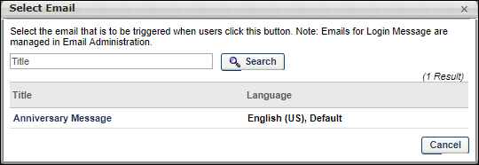
You can filter emails by title using the Title search option, and then clicking Search. To select an email, click the title in the Title column. This closes the pop-up and adds the email below the Send Email field. You can delete emails that you selected by clicking the Trash Can icon to the left of the email title.
Note: Emails for login messages are configured in Email Administration. See Email Triggers for information on the Login Message Email trigger. See Email Tags for information on the tags that are available for the Login Message email.
  - Redirect - Select this option to redirect users to a specified URL. Selecting Redirect enables the URL and Open In fields to appear below the option.
    - URL - Enter the URL to which you would like users to be redirected. This is a required field if Redirect is selected.
    - Open In - This option defines whether or not users are redirected in a new window or in the same window. The "New Window" option in the drop-down is selected by default.
You can delete an action by clicking the Trash Can icon to the left of the Button Text field.
The action buttons appear in the login message box in the order in which they are added. The order cannot be redefined.
Next/Back
Click Next to go to the Summary step. See Create Login Message - Summary on page 86 for additional information.
Click Back to go to the Message step. See Create Login Message - Message on page 81 for additional information.
Create Login Message - Summary
On the Summary step, review your selections. A preview of the message appears in the Message field. The Actions field displays the action buttons and on-click actions that are defined for the message.
The Login Message works with the most commonly used landing pages:
- Welcome Page
- Custom Pages
- Learner Home
- Other pages that contain “/ui/” in the URL
- Other pages that contain “/phnx/driver.aspx?” in the URL
To create a login message, go to Admin > Tools > Core Functions > Core Preferences > Login Message. On the Login Message Administration page, click the Create Login Message link.
Permissions
PERMISSION NAME | PERMISSION DESCRIPTION | CATEGORY

Log In Message - Manage | Grants access to create a message that appears upon portal login to all users or a selected group/subset of users. This is an administrator permission. This permission can be constrained by OU and User's OU. | Core Administration
Click Save to save the message and return to the Login Message Administration page. See Login Message Preferences on page 74 for additional information.
Click Back to go to the Actions step. See Create Login Message - Actions on page 83 for additional information.
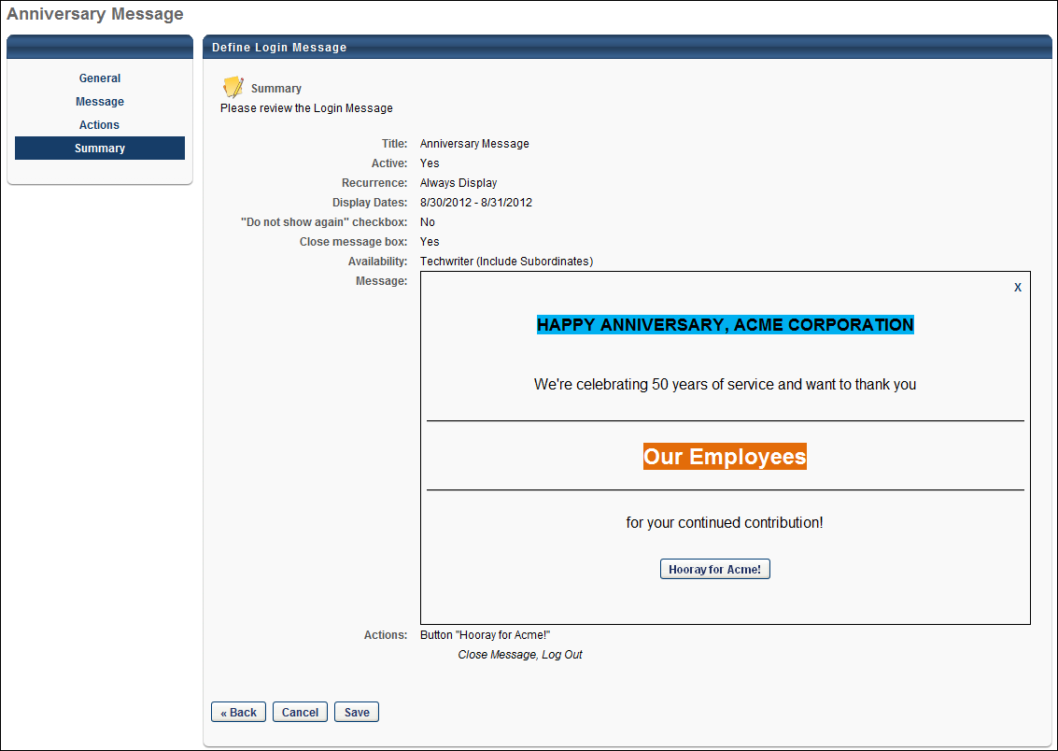

My Account Preferences
The My Account Preferences page allows you to select which custom fields display in My Account by OU. You can define how they are used and if they are required. You can also customize the names of the tabs that appear in My Account, though you cannot omit any of them.
To modify My Account Preferences, go to Admin > Core Functions > Preferences > My Account Preferences.
Permissions
PERMISSION NAME | PERMISSION DESCRIPTION | CATEGORY

My Account Preferences - Manage | Grants access to the My Account Preferences page, which allows selection of which custom fields display in My Account by OU. Define whether custom fields appear as read only or are editable, and whether entry is required. Also provides ability to customize the names of the tabs that appear in My Account. This is an administrator permission. | Core Administration
The My Account Preferences page is separated into two tabs:
- Tabs - The Tabs page enables administrators to define the display names of the My Account tabs, as well as enable the Facebook and LinkedIn settings for the Social tab. See My Account Preferences - Tabs on page 89 for additional information.
- Settings Fields - The Settings Fields page enables administrators to define the User Record contact and custom fields that will display on the Preferences > Settings tab in My Account. See My Account Preferences - Settings Fields on page 91 for additional information.
Overwrite Settings
Select this option to overwrite custom settings for child division OUs. If you overwrite custom settings for child division OUs, the selected settings are applied to both new and existing child OUs. Any previously customized child OUs are updated with the selected settings.
- If there are no customizations to the child OU, then the parent OU customizations are applied to all child OUs.
- Overwrite custom settings checkbox setting
  - If this option is selected, all child OU customizations are deleted from the database, which means the parent OU customizations will be applied to new and existing child OUs.
  - If this option is unselected, all existing child OU customizations will remain unchanged, and any new child OUs will inherit the parent OU customizations by default.
- If a child OU has been customized to display any widgets, then regardless of the parent OU customizations, the child OU customizations are applied.
- If a child OU has been customized to hide all widgets, then parent OU customizations will take precedence and will be applied.
Save
Once all preferences are set, click Save.
My Account Preferences - Tabs
The Tabs page enables administrators to define the display names of the My Account tabs, as well as enable the Facebook and LinkedIn settings for the Social tab.
To modify My Account Preferences, go to Admin > Core Functions > Preferences > My Account Preferences.
Permissions
PERMISSION NAME | PERMISSION DESCRIPTION | CATEGORY

My Account Preferences - Manage | Grants access to the My Account Preferences page, which allows selection of which custom fields display in My Account by OU. Define whether custom fields appear as read only or are editable, and whether entry is required. Also provides ability to customize the names of the tabs that appear in My Account. This is an administrator permission. | Core Administration
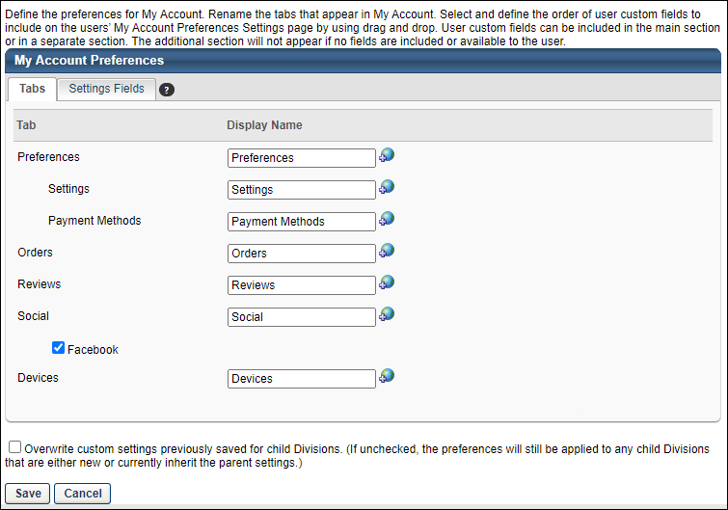
This page enables administrators to customize the names of the tabs that appear in My Account. The Display Name column cannot be blank for any of the tabs. Localize the tab names for different languages if multiple languages are enabled.
The following tabs may be available:
- Preferences
  - Settings - When users view their My Account > Preferences page, the Settings tab includes user information and the User Record custom fields that are defined on the Settings Fields tab in My Account Preferences.
  - Payment Methods - When users view their My Account > Preferences page, the Payment Methods tab includes training unit information, keycode balance, and billing information.
- Orders
- Reviews
- Social - For portals with Referral Suite enabled, a Social tab is available. Note: The availability of the Social tab on the My Account Preferences page is controlled by a backend setting. Similar to the other tabs, the Social tab cannot be inactivated or disabled from the My Account Preferences page. Changes to the preference settings only affect future visibility of the fields on the Social tab. Any existing Facebook or LinkedIn profile data remains connected to the user's user record.
  - The Social tab also includes a Facebook option that enable users to log in to their profile from the My Account page in order to connect their network to their user record. This option is unchecked by default. Checking the box displays a Facebook option on the Social tab that lets users connect to their account.
- Devices
Overwrite Settings
Select this option to overwrite custom settings for child division OUs. If you overwrite custom settings for child division OUs, the selected settings are applied to both new and existing child OUs. Any previously customized child OUs are updated with the selected settings.
- If there are no customizations to the child OU, then the parent OU customizations are applied to all child OUs.
- Overwrite custom settings checkbox setting
  - If this option is selected, all child OU customizations are deleted from the database, which means the parent OU customizations will be applied to new and existing child OUs.
  - If this option is unselected, all existing child OU customizations will remain unchanged, and any new child OUs will inherit the parent OU customizations by default.
- If a child OU has been customized to display any widgets, then regardless of the parent OU customizations, the child OU customizations are applied.
- If a child OU has been customized to hide all widgets, then parent OU customizations will take precedence and will be applied.
Save
Once all preferences are set, click Save.
My Account Preferences - Settings Fields
The Settings Fields page enables administrators to define the User Record contact and custom fields that will display on the Preferences > Settings tab in My Account.
To modify My Account Preferences, go to Admin > Core Functions > Preferences > My Account Preferences.
Permissions
PERMISSION NAME | PERMISSION DESCRIPTION | CATEGORY

My Account Preferences - Manage | Grants access to the My Account Preferences page, which allows selection of which custom fields display in My Account by OU. Define whether custom fields appear as read only or are editable, and whether entry is required. Also provides ability to customize the names of the tabs that appear in My Account. This is an administrator permission. | Core Administration
Fields
In the fields table, administrators can add custom User Record fields and contact information fields. Administrators can configure whether the fields are editable or read-only. Administrators can make the fields required. Also, administrators can configure the order in which the fields appear.
Administrators can add contact information fields to this section to allow users to modify their own contact information from My Account. When a user modifies their own contact information, this also updates their User Record.
To add a field, click the Add Field link. This opens the Fields pop-up from which administrators can select the fields.
Additional Information
This section allows administrators to drag fields from the custom fields table and drop them into the Additional Fields section. When users view their My Account > Preferences > Settings page, the fields display in an Additional Information section at the bottom of the page.
The same columns and options that appear in the custom fields table are available for the fields in this section.
Overwrite Settings
Select this option to overwrite custom settings for child division OUs. If you overwrite custom settings for child division OUs, the selected settings are applied to both new and existing child OUs. Any previously customized child OUs are updated with the selected settings.
- If there are no customizations to the child OU, then the parent OU customizations are applied to all child OUs.
- Overwrite custom settings checkbox setting
  - If this option is selected, all child OU customizations are deleted from the database, which means the parent OU customizations will be applied to new and existing child OUs.
  - If this option is unselected, all existing child OU customizations will remain unchanged, and any new child OUs will inherit the parent OU customizations by default.
- If a child OU has been customized to display any widgets, then regardless of the parent OU customizations, the child OU customizations are applied.
- If a child OU has been customized to hide all widgets, then parent OU customizations will take precedence and will be applied.
Save
Once all preferences are set, click Save.
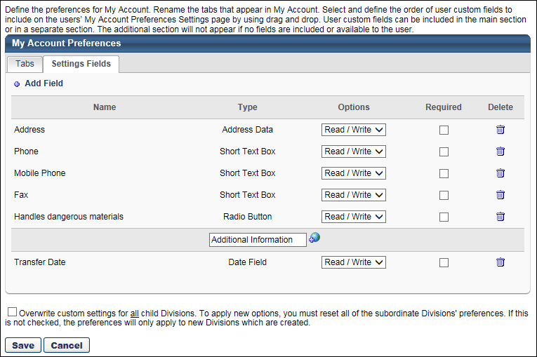

Org Chart Preferences
Use Org Chart Preferences to configure the fields that display in the user details on the Org Chart page.
To access Org Chart Preferences, go to admin > tools > core functions > core preferences.
Permissions
PERMISSION NAME | PERMISSION DESCRIPTION | CATEGORY

Org Chart - Preferences | Grants access to the Org Chart Preferences page. This permission cannot be constrained. | Core
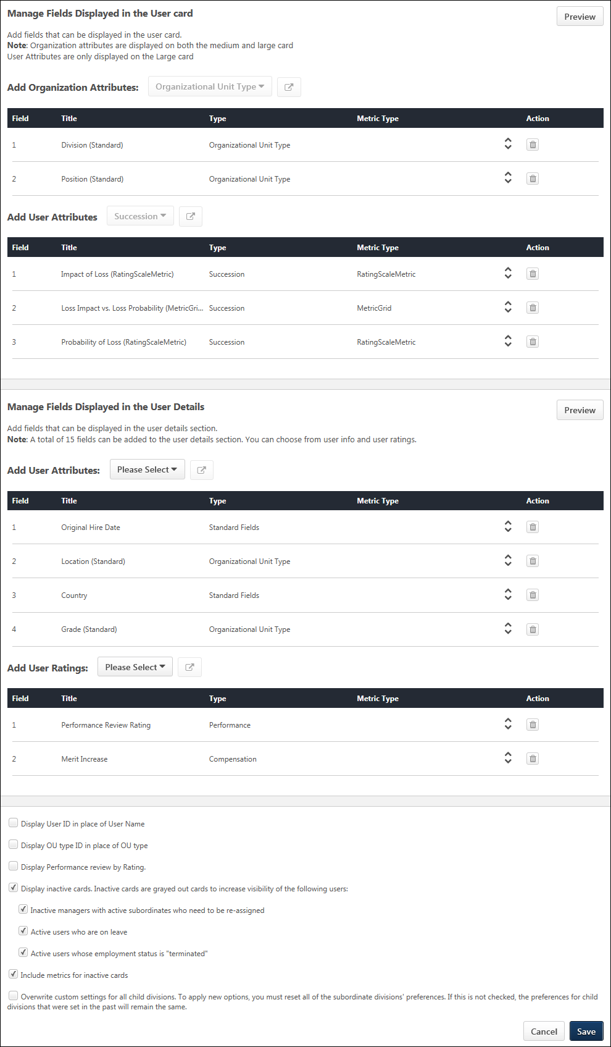
Manage Fields Displayed in the User Card
This section includes options to add up to five organization and user attributes. The organization attributes display in the top portion of the user card flyout, directly below the user's photo. The user attributes appear at the bottom of the flyout.
Add Organization Attributes
This section allows you to select organizational unit (OU) fields that will display in the user cards and user flyout on the Org Chart page. The ability to add OU fields is disabled when the maximum number of fields has been added.
By default, the Division and Position fields are added. You can modify the default selection by removing the field(s) and adding different OU fields.
To add fields:
- Click the select icon . This opens the a pop-up that allows you to select the OU fields.
- Click the Select options drop-down. This displays the list of standard and custom OUs that you can add.
- Check the OU(s) to add. Up to two OU fields can be added. If there is already one OU field in the table, then only one additional OU field can be added. The fields that display in the drop-down are based on your availability to view the fields.
- Click Add. This adds the OU(s) to the fields table.
Add User Attributes
In this section, you can select the user attributes that will appear at the bottom of the user card flyout on the Org Chart page.
Available Field Types
The following are the possible field types that can be added:
- Compensation - This option is only available for portals with Compensation enabled. The following fields can be added:
  - Compa-Ratio
  - Salary/Rate (current)
  - Merit Increase
- Organizational Unit Type
- Organizational Unit Custom Field - This option only displays if at least one Organizational Unit custom field has been configured in Custom Field Administration, and you meet the availability criteria defined for the field. The field will display as "[Field Title (Metric Type, OU Type)]." The following field types can be added:
  - Checkbox
  - Date
  - Dropdown
  - Numeric
  - Radio Button
  - Short Text Box
- Performance - This option is only available for portals with Performance enabled. The latest performance review rating can be added.
- Succession (custom fields) - This section allows you to add Succession custom fields. This option is only available for portals with Succession enabled, and if at least one Succession custom field has been configured in Custom Field Administration, and you meet the availability criteria defined for the field. The fields that are available will display as "[Field Title (Metric Type)]." The following custom field types can be added:
  - Checkbox
  - Date
  - Dropdown
  - Formula Metric
  - Metric Grid
  - Numeric
  - Radio Button
  - Rating Scale Metric
  - Short Text Box
- User Record Custom Field - This section allows you to add User Record custom fields. This option only displays if at least one User Record custom field has been configured in Custom Field Administration, and you meet the availability criteria defined for the field. The fields that are available will display as "[Field Title (Metric Type, Category)]." The following custom field types can be added:
  - Checkbox
  - Date
  - Dropdown
  - Numeric
  - Radio Button
  - Short Text Box
Select OU/User Attributes
To select fields:
- Click the Organizational Unit Type or Performance drop-down and select one of the field types.
- Click the select icon . This opens the select fields pop-up.
- In the pop-up, check the box next to the desired fields in the Select options drop-down.
- Click Add. This adds the fields to the section.
Reorder Fields
Click the arrows to drag and drop the fields to reorder them. Note that you can also click and drag anywhere in the row to reorder the field.
Remove Fields
Click the Remove icon to remove the field from the list. The removed data will no longer appear in the user details on the Org Chart page, unless the field is re-added on the preferences page.
Maximum Number of Fields
Up to 5 fields can be added to the main user card. The select fields pop-up will indicate how many more fields you can add based on the number of fields that have already been added.
If you have met the 5-field maximum and would like to add different fields, then you can delete previously added fields by clicking the Remove icon in the Action column and adding new fields.
Preview
This option allows you to preview how your field selections will look on the user card on the Org Chart page. Click Preview to view the user card with your field selections displayed.
Inactive/Deleted Fields and Permission Changes
If a field becomes inactive or is deleted from the system, then the field is no longer available to select.
If the field had already been selected, then the field is automatically removed from the section and will no longer be visible on the Org Chart Preferences page and the Org Chart page.
If you no longer have permission to view a field as a result of changes to your permissions and constraints, then the field is no longer available to select and will no longer be visible on the Org Chart Preferences page.
Fields Table
The fields table shows you which attributes will be visible in the user details on the Org Chart page.
The following information displays in the table:
- Title - This displays the title of the OU field.
- Type - This displays the OU field type.
- Metric Type -
- Action - The following options are available in this column:
  - Drag to Rearrange - Click the arrows to drag and drop the fields to reorder them. Note that you can also click and drag anywhere in the field row to reorder the field.
  - Remove - Click the Remove icon to remove the field from the list. The removed data will no longer appear in the user details on the Org Chart page unless the field is re-added on the preferences page.
Manage Fields Displayed in the User Details
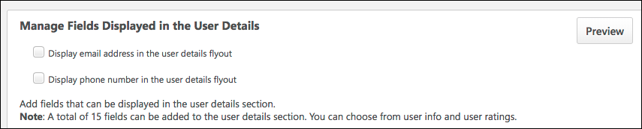
In this section, you can select up to 15 fields that will appear in the user details section of the user card flyout on the Org Chart page. The types of fields that are available to select are dependent upon the functionality that is enabled for the portal, your availability to view the fields, and your permissions and permission constraints.
You can also determine whether or not a user's email and phone number should appear on the flyout by configuring the following fields:
- Display email address in the user details flyout - When checked, the user's email address displays in the user details flyout. When unchecked, this information is hidden.
- Display phone number in the user details flyout - When checked, the user's phone number displays in the user details flyout. When unchecked, this information is hidden.
Add User Attributes
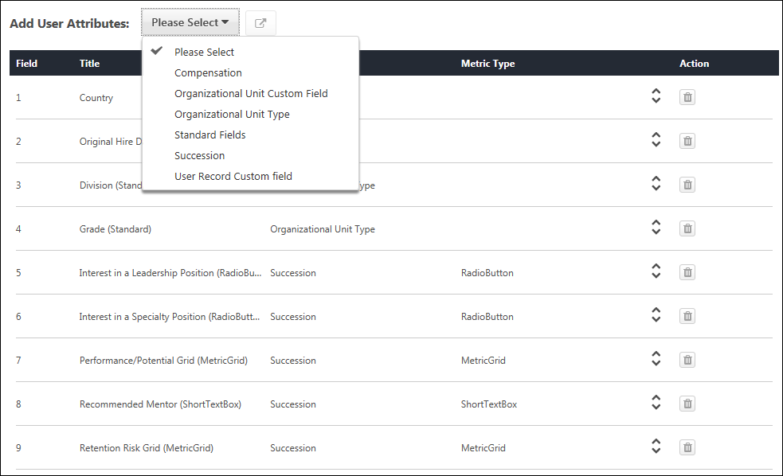
User attributes provide a deeper understanding of the user in the org chart. Administrators can add attributes from across the application to provide more information beyond what is available on the user card on the main org chart page.
The attributes also act as a quickly accessible snapshot of important user data, rather than needing to access this information from various pages in the Universal Profile. The Universal Profile can still be accessed by clicking the user's photo, but by adding attributes, you can deliver more of a 1-stop experience on the org chart.
Available Field Types
The following are the possible field types that can be added:
- Compensation - This option is only available for portals with Compensation enabled. The following fields can be added:
  - Compa-Ratio
  - Salary/Rate (current)
  - Merit Increase
- Organizational Unit Type
- Organizational Unit Custom Field - This option only displays if at least one Organizational Unit custom field has been configured in Custom Field Administration, and you meet the availability criteria defined for the field. The field will display as "[Field Title (Metric Type, OU Type)]." The following field types can be added:
  - Checkbox
  - Date
  - Dropdown
  - Numeric
  - Radio Button
  - Short Text Box
- Standard - The following standard fields can be added:
  - City
  - Country
  - Direct Phone
  - Email
  - Fax
  - Last Hire Date
  - Mobile Phone
  - Original Hire Date
  - State
  - Time Zone
  - UserId
  - User Status
  - User Subtype
  - User Type
- Succession (custom fields) - This section allows you to add Succession custom fields. This option is only available for portals with Succession enabled, and if at least one Succession custom field has been configured in Custom Field Administration, and you meet the availability criteria defined for the field. The fields that are available will display as "[Field Title (Metric Type)]." The following custom field types can be added:
  - Checkbox
  - Date
  - Dropdown
  - Metric Grid
  - Numeric
  - Radio Button
  - Short Text Box
- User Record Custom Field - This section allows you to add User Record custom fields. This option only displays if at least one User Record custom field has been configured in Custom Field Administration, and you meet the availability criteria defined for the field. The fields that are available will display as "[Field Title (Metric Type, Category)]." The following custom field types can be added:
  - Checkbox
  - Date
  - Dropdown
  - Numeric
  - Radio Button
  - Short Text Box
Add User Ratings
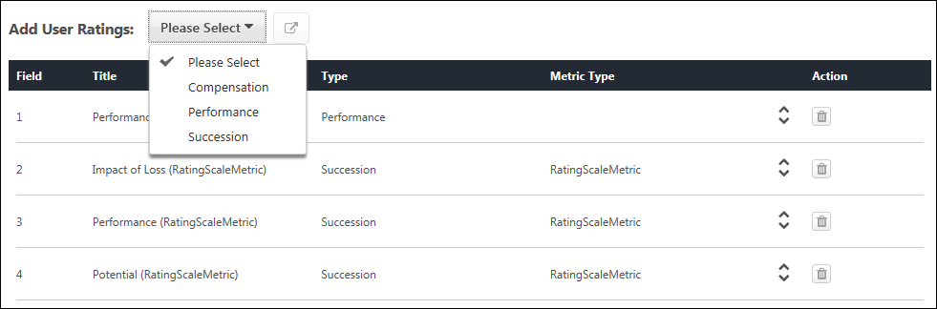
This section allows you to add succession, compensation, and performance data. The types of fields that are available to select are dependent upon the functionality that is enabled for the portal, your availability to view the fields, and your permissions and permission constraints.
The following are the possible field types that can be added:
- Compensation - This option is only available for portals with Compensation enabled. The following fields can be added:
  - Compa-Ratio - Note: The maximum value is 2.0. If the value is greater than 2.0, then the progress bar for the field on the Org Chart page will display as full.
  - Merit Increase
- Performance - This option is only available for portals with Performance enabled. The latest performance review rating can be added.
- Succession (custom fields) - This section allows you to add Succession custom fields. This option is only available for portals with Succession enabled, and if at least one Succession custom field has been configured in Custom Field Administration, and you meet the availability criteria defined for the field. The fields that are available will display as "[Field Title (Metric Type)]." The following custom field types can be added:
  - Formula Metric
  - Rating Scale Metric
Select Fields
To select fields:
- Click the Please Select drop-down and select one of the field types.
- Click the select icon . This opens the select fields pop-up.
- In the pop-up, check the box next to the desired fields in the Select options drop-down.
- Click Add. This adds the fields to the section.
Reorder Fields
Click the arrows to drag and drop the fields to reorder them. Note that you can also click and drag anywhere in the row to reorder the field.
Remove Fields
Click the Remove icon to remove the field from the list. The removed data will no longer appear in the user details on the Org Chart page, unless the field is re-added on the preferences page.
Maximum Number of Fields
Up to 15 fields can be added to the user card flyout. The select fields pop-up will indicate how many more fields you can add based on the number of fields that have already been added.
If you have met the 15-field maximum and would like to add different fields, then you can delete previously added fields by clicking the Remove icon in the Action column and adding new fields.
Preview
This is a new option. This option allows you to preview how your field selections will look on the user card flyout on the Org Chart page. Click Preview to view the flyout with your field selections displayed.
Inactive/Deleted Fields and Permission Changes
If a field becomes inactive or is deleted from the system, then the field is no longer available to select.
If the field had already been selected, then the field is automatically removed from the section and will no longer be visible on the Org Chart Preferences page and the Org Chart page.
If you no longer have permission to view a field as a result of changes to your permissions and constraints, then the field is no longer available to select and will no longer be visible on the Org Chart Preferences page.
Display User ID in Place of User Name
Select this option to display the user's user ID instead of their name.
Display OU Type ID in Place of OU Type
Select this option to display the OU type ID instead of the OU type.
Display Performance Review by Rating
This is a new field with this enhancement. This field enables you to determine how the performance rating displays, either as a text value or numeric equivalent.
By checking the Display Performance Review by Rating box, the performance review result will display as a numeric value rather than a text value.
Display Inactive Cards
This option enables the administrator to display inactive user cards for users who are inactive, on leave, or no longer with the organization. Administrators can enable one or more of these settings to manage how the image for these users appears on the Org Chart page. All settings are enabled by default.
The following options are available for inactivating user cards:
- Inactive managers with active subordinates - This option inactivates the user card for users who are set to "Inactive" on the user record but have direct reports who need to be reassigned.
- Active users who are on leave - This option inactivates the user card for users who are set to "On Leave" on the user record.
- Active users whose employment status is "terminated" - This option inactivates the user card for users who are set to "Terminated" on the user record.
At least one option must be selected when the Display inactive cards option is checked. When the Display inactive cards option is unchecked, the additional options are grayed out and not selectable.
Include Metrics for Inactive Cards
When checked, the large user card and flyout still display metrics (i.e., data for Performance, Succession, etc.) for users whose card is inactive on the org chart. When unchecked, the large user card and flyout do not display metrics for users whose card is inactive.
Overwrite Settings
Select this option to overwrite custom settings for child division OUs. If you overwrite custom settings for child division OUs, the selected settings are applied to both new and existing child OUs. Any previously customized child OUs are updated with the selected settings.
- If there are no customizations to the child OU, then the parent OU customizations are applied to all child OUs.
- Overwrite custom settings checkbox setting
  - If this option is selected, all child OU customizations are deleted from the database, which means the parent OU customizations will be applied to new and existing child OUs.
  - If this option is unselected, all existing child OU customizations will remain unchanged, and any new child OUs will inherit the parent OU customizations by default.
- If a child OU has been customized to display any widgets, then regardless of the parent OU customizations, the child OU customizations are applied.
- If a child OU has been customized to hide all widgets, then parent OU customizations will take precedence and will be applied.
Save/Cancel
Click Save to save the preferences. Click Cancel to cancel the changes to preferences.

Search Preferences
Search Preferences enable administrators to configure search preferences by division.
To manage Global Search preferences, go to Admin > Tools > Core Functions > Core Preferences > Search. Alternately, you can also go to Admin > Tools > Preferences. Then, click the Search Preferences (by Division) link in the System Preferences section. In the Search Preferences page, select a division. This opens the General page of Search Preferences.
Permissions
PERMISSION NAME | PERMISSION DESCRIPTION | CATEGORY

Admin Search Preferences - Manage | Grants ability to configure preferences for Global Search and Course Catalog within Search Preferences. The constraints of this permission are inherited from the Global Search Preferences - Manage permission. This is an administrator permission. | Learning - Administration

Global Search Preferences - Manage | Grants ability to configure Global Search Preferences. This is an administrator permission. The availability of this permission is controlled by a backend setting. This permission can be constrained by OU and User's OU. By default, this permission is constrained to the organization. | Core Administration
The availability of this page is controlled by a backend setting.
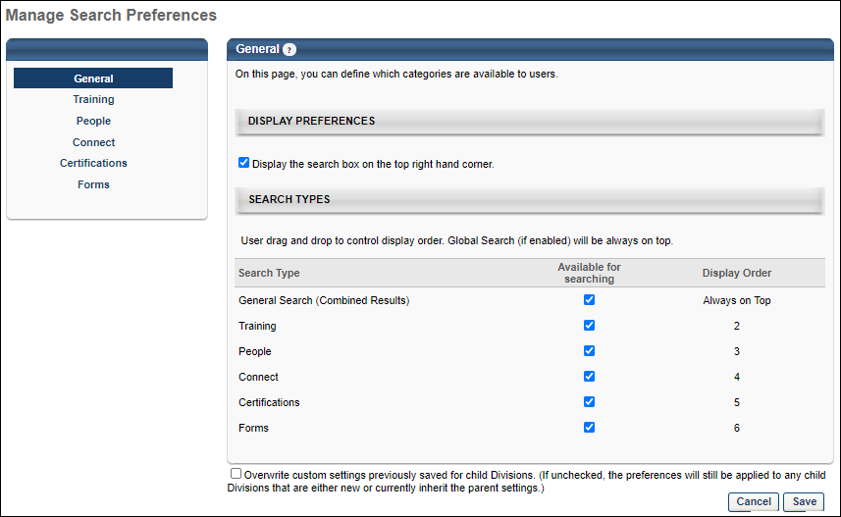
Search Preferences are separated into the following pages:
- General
- Training
- People
- Connect
- Certifications
- Forms
Search Preferences - General
Defining Search Preferences is a multiple step process. The first step is setting the General preferences. The Search Preferences - General page enables administrators to configure the following:
- Whether or not the Global Search option is available in the upper-right corner of system pages
- Which search types are available to users
- The order in which the search type filters appear to users on the Global Search page
To access the Search Preferences - General page, go to Admin > Tools > Core Functions > Core Preferences > Search.
Permissions
PERMISSION NAME | PERMISSION DESCRIPTION | CATEGORY

Admin Search Preferences - Manage | Grants ability to configure preferences for Global Search and Course Catalog within Search Preferences. The constraints of this permission are inherited from the Global Search Preferences - Manage permission. This is an administrator permission. | Learning - Administration

Global Search Preferences - Manage | Grants ability to configure Global Search Preferences. This is an administrator permission. The availability of this permission is controlled by a backend setting. This permission can be constrained by OU and User's OU. By default, this permission is constrained to the organization. | Core Administration
The availability of this page is controlled by a backend setting.
Display Preferences
Select the Display the search box on the top right hand corner option to enable the Global Search box in the upper-right corner of each system page.
Search Types
This section enables administrators to determine which search types are available to users. In addition, the administrator can determine the order in which the search filters appear to users in the Search Types drop-down list.
The Search Type column displays each of the available search types. The following search types may be available:
- General Search - This search type is available for all portals and it searches all search types in a combined search.
- Training - This search type is available for portals using the Learning solution.
- People - This search type is available for all portals.
- Connect - This search type is available for portals using the new Knowledge Bank and Communities functionality.
- Certifications - This search type is only available for portals using Certifications.
- Forms - This search type is only available for portals using Form Management (this does not apply to the old Forms Management functionality).
Enable Search Type
To enable users to use a particular search type within Global Search, select the Available for Searching option. By default, this option is selected for General Search, and this option is deselected for all other search types. Note: At least one search type must be selected. Also, if this option is selected for General Search, at least two other search types must be selected.
When the Available for Searching option is selected for a search type, the following occurs:
- Users can search for items within the search type via Global Search.
- Administrators can configure the search settings for the search type by selecting the search type name in the left navigation bar.
- The Display Order column displays the order in which the search type appears to users in the list of filters, and the search type can be reordered.
Configure Search Type Display Order
The Display Order column displays the order in which the search types appear to users in the list of filters. This also determines the order in which search results are displayed to users. Drag and drop the search types in to the desired order. The General Search type cannot be reordered and it is always displayed first when it is enabled.
Overwrite Settings
Select this option to overwrite custom settings for child division OUs. If you overwrite custom settings for child division OUs, the selected settings are applied to both new and existing child OUs. Any previously customized child OUs are updated with the selected settings.
- If there are no customizations to the child OU, then the parent OU customizations are applied to all child OUs.
- Overwrite custom settings checkbox setting
  - If this option is selected, all child OU customizations are deleted from the database, which means the parent OU customizations will be applied to new and existing child OUs.
  - If this option is unselected, all existing child OU customizations will remain unchanged, and any new child OUs will inherit the parent OU customizations by default.
- If a child OU has been customized to display any widgets, then regardless of the parent OU customizations, the child OU customizations are applied.
- If a child OU has been customized to hide all widgets, then parent OU customizations will take precedence and will be applied.
Note: This option applies to all tabs within Search Preferences (e.g., General, People, Training), not just the current tab.
Save Options
To continue modifying Search Preferences, click the appropriate tab in the left navigation bar.
To save changes for all pages within Search Preferences, click Save.
To discard all unsaved changes made on all pages within Search Preferences, click Cancel.
Search Preferences - Training
Defining Search Preferences is a multiple step process. The Search Preferences - Training page enables administrators to do the following with respect to the Training search type:
- Define available search filters
- Define training types that are available
- Define sorting capability
- Define Search Engine
Deprecation Note: With the March 2024 release, the (legacy) Skills tab has been hidden from the Refine Search page except for those who "opted out" of the (legacy) Skills Tab deprecation. For more information, See Hiding Legacy Skills on Bulk Edit and Refine Search.
Deprecation Note: The Global Search Traditional Search Preference will be removed from user interface by July 2024 release. Administrators can no longer configure Traditional Search in their portal. No changes are made to customer settings. By November 2024, the Traditional Search for Global Search (Training) will be permanently deprecated. After the deprecation, administrators can no longer transition the Global Search (Training) page back to Traditional Search (SQL) using Search Preferences. To know more, See Global Search (Training) - Deprecation of Traditional Search with the November 2024 Release.
To access the Search Preferences - Training page, go to Admin > Tools > Core Functions > Core Preferences > Search. Alternately, you can also go to Admin > Tools > Preferences. Then, click the Search Preferences (by Division) link in the System Preferences section. In the Search Preferences page, select a division and it opens the Manage Search Preferences page. Then, select the Training tab on the left navigation bar. Note: This tab is not selectable unless it is enabled as a search type on the General tab.
Permissions
PERMISSION NAME | PERMISSION DESCRIPTION | CATEGORY

Admin Search Preferences - Manage | Grants ability to configure preferences for Global Search and Course Catalog within Search Preferences. The constraints of this permission are inherited from the Global Search Preferences - Manage permission. This is an administrator permission. | Learning - Administration

Global Search Preferences - Manage | Grants ability to configure Global Search Preferences. This is an administrator permission. The availability of this permission is controlled by a backend setting. This permission can be constrained by OU and User's OU. By default, this permission is constrained to the organization. | Core Administration
The availability of this page is controlled by a backend setting.
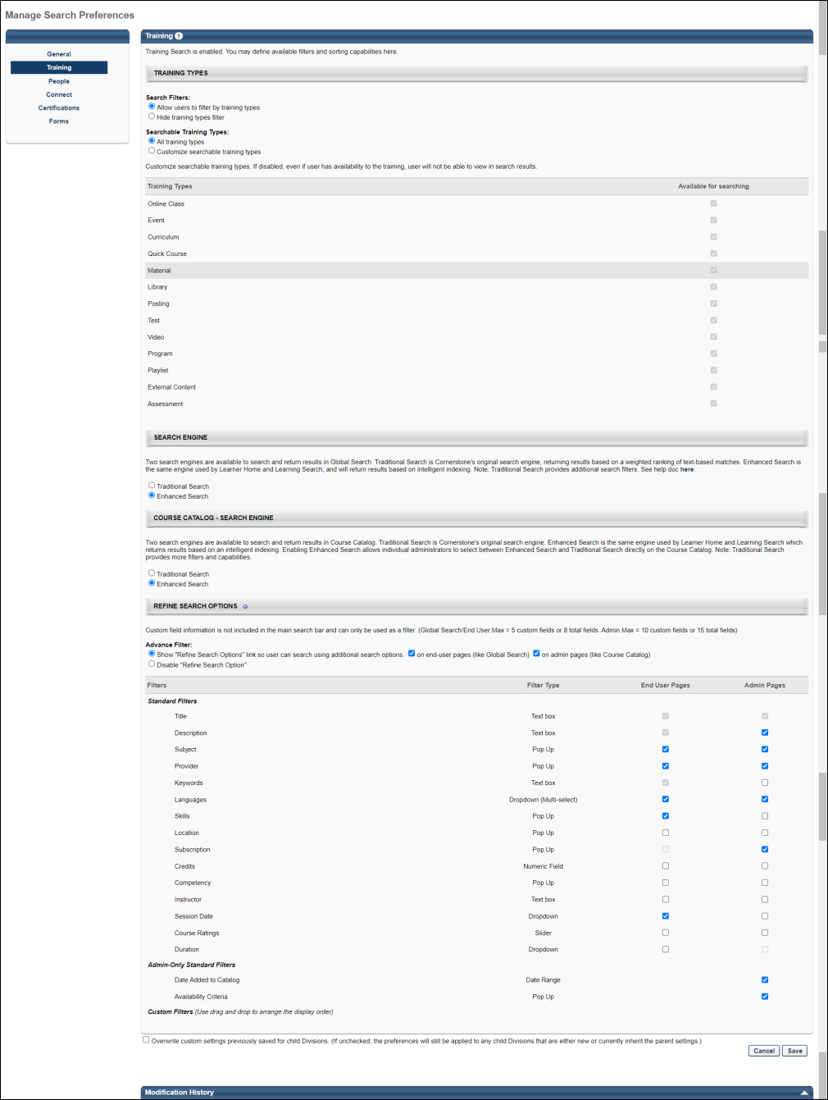
Training Types
The Training Types section of the Search Preferences - Training page enables administrators to determine which search filters are available and which training types are searchable.
When the redesigned Course Catalog is enabled, this section applies to Global Search and Course Catalog Search. Otherwise, this section only applies to Global Search.
Note: Users and administrators can only search for training items that are available to them. If a learning object (LO) is not available to a user, then that LO does not appear in search results.
Note: Connect postings do not operate as stand alone LOs such as online classes, curricula, videos, etc. and therefore do not exist in the Course Catalog. Postings are, however, searchable via Global Search.
See Search Preferences - Training - Training Types on page 113 for additional information.
Search Engine
Two search engines are available to search and return results in Global Search. Traditional Search is Cornerstone's original search engine, returning results based on a weighted ranking of text-based matches. Enhanced Search is the same engine used by Learner Home and Learning Search, and will return results based on intelligent indexing.
The Enhanced Search is a more effective, scalable, and result-driven way to power a search framework. It provides a consistent, unified experience for end users and allows for better and faster searches, especially in cases where large data sets are involved. Therefore, the Enhanced Search is the default framework for Global Search (for Training) across all portals. However, the administrators can still switch back to Traditional Search whenever necessary.
Note: Traditional Search provides additional search filters.
Note: If you are using the results from Global Search (Training) to populate results from other pages of the application, the results may be updated to use Enhanced Search. If you are not sure what solution your portal uses, we recommend testing the updated results in stage portals or other lower environments.
Considerations
- With Enhanced Search enabled by default, the Title and Description filters are combined into one text field to enter search queries. To use the Title and Description filters independently, enable Traditional Search.
- Use Keywords filter independently for both Traditional Search and Enhanced Search on the course catalog search page. It uses “partial match” and “starts with” when returning search results. However, the Keywords filter is currently not supported in Global Search. The rest of the filters in Global Search (Training) remain unchanged and require no further action from the administrator to be able to use them.
- A newly created or updated Learning Object (LO) is updated within 15 minutes or less in the Enhanced Search results, but with few exceptions, which are as follows:
  - In case the LO is a part of a large data ingestion, or if a bulk update is completed, then the time for the update to be reflected in Enhanced Search results may depend on the amount or the size of the update.
  - In case the LO is created or updated at the same time a data set is updated, then the LO may take more than 15 minutes to be available in the Enhanced Search results.
- All filters operate using an 'AND' operation when Enhanced Search is enabled. This includes Custom Fields, which uses an 'OR' operation when Traditional Search is enabled.
Note: It may take up to 4 hours for Traditional Search to take effect in Global Search.
Refine Search Options
The Refine Search Options section of the Search Preferences - Training page enables administrators to determine which search refinement options are available to users when the Training tab is selected on the Global Search page or when searching for Learning Objects (LOs) in Course Catalog search.
See Search Preferences - Training - Refine Search Options on page 117 for additional information.
Overwrite Settings
Select this option to overwrite custom settings for child division OUs. If you overwrite custom settings for child division OUs, the selected settings are applied to both new and existing child OUs. Any previously customized child OUs are updated with the selected settings.
- If there are no customizations to the child OU, then the parent OU customizations are applied to all child OUs.
- Overwrite custom settings checkbox setting
  - If this option is selected, all child OU customizations are deleted from the database, which means the parent OU customizations will be applied to new and existing child OUs.
  - If this option is unselected, all existing child OU customizations will remain unchanged, and any new child OUs will inherit the parent OU customizations by default.
- If a child OU has been customized to display any widgets, then regardless of the parent OU customizations, the child OU customizations are applied.
- If a child OU has been customized to hide all widgets, then parent OU customizations will take precedence and will be applied.
Note: This option applies to all tabs within Search Preferences (e.g., General, People, Training), not just the current tab.
Save Options
To continue modifying Search Preferences, click the appropriate tab in the left navigation bar.
To save changes for all pages within Search Preferences, click Save.
To discard all unsaved changes made on all pages within Search Preferences, click Cancel.
Modification History
This section displays modification history.
Search Preferences - Training - Training Types
The Training Types section of the Search Preferences - Training page enables administrators to determine which search filters are available and which training types are searchable.
When the redesigned Course Catalog is enabled, this section applies to Global Search and Course Catalog Search. Otherwise, this section only applies to Global Search.
Note: Users and administrators can only search for training items that are available to them. If a learning object (LO) is not available to a user, then that LO does not appear in search results.
Note: Connect postings do not operate as stand alone LOs such as online classes, curricula, videos, etc. and therefore do not exist in the Course Catalog. Postings are, however, searchable via Global Search.
To access Search Preferences, go to Admin > Tools > Core Functions > Core Preferences > Search.
Permissions
PERMISSION NAME | PERMISSION DESCRIPTION | CATEGORY

Admin Search Preferences - Manage | Grants ability to configure preferences for Global Search and Course Catalog within Search Preferences. The constraints of this permission are inherited from the Global Search Preferences - Manage permission. This is an administrator permission. | Learning - Administration

Global Search Preferences - Manage | Grants ability to configure Global Search Preferences. This is an administrator permission. The availability of this permission is controlled by a backend setting. This permission can be constrained by OU and User's OU. By default, this permission is constrained to the organization. | Core Administration
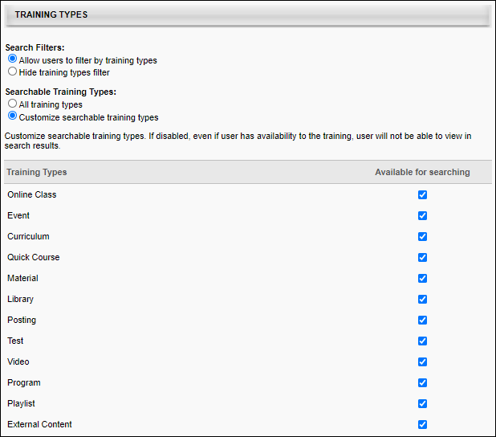
Search Filters
When the redesigned Course Catalog is enabled, this section applies to Global Search and Course Catalog Search. Otherwise, this section only applies to Global Search.
Select whether or not users and administrators have access to training type filters.
- Allow users to filter by training types - When this option is selected, the Training filters are available to users, allowing them to filter the search results by training type. The Searchable Training Types setting and the Training Types table determine which training type filters are available to users. This option is selected by default.
- Hide training types filter - If this option is selected, the training types filter is not visible to users. However, when a user searches for training items, the selections in the Training Types section are automatically applied.
Searchable Training Types
When the redesigned Course Catalog is enabled, this section applies to Global Search and Course Catalog Search. Otherwise, this section only applies to Global Search.
Select whether all training types are searchable or only specific training types.
- All training types - Select this option to make all training types searchable. The system searches all training items that are available to the user.
- Customize searchable training types - Select this option to customize which training types are searchable. The administrator must then use the Training Types table to determine which training types are searchable.
  - Use Case: Within an organization, events can be assigned to users by managers, but users cannot request events. By disabling the Event training type within Global Search, users never see events in the Global Search results.
Training Types
When the redesigned Course Catalog is enabled, this section applies to Global Search and Course Catalog Search. Otherwise, this section only applies to Global Search.
This table enables administrators to determine which training types are available to users.
The Training Types column displays each of the available training types. The following training types may be available:
- Online Course
- Event
- Curriculum
- Quick Course
- Material
- Library
- Posting
- Test
- Video
- Playlist
- Online Content
- External Content
- Program - Note: The Program training type is only available for organizations using redesigned Connect.
Enable Search Type
To enable users to use a particular search type within Search, select the Available for Searching option. By default, this option is selected for all available training types. If this option is not selected for a training type, then training items within the corresponding training type are never displayed in search results. Note: At least one training type must be selected.
When the Available for Searching option is selected for a search type, users can search for items within the training type.
Example of Filters on Global Search Page
This image represents an example of how the training type filters appear on the Global Search page.
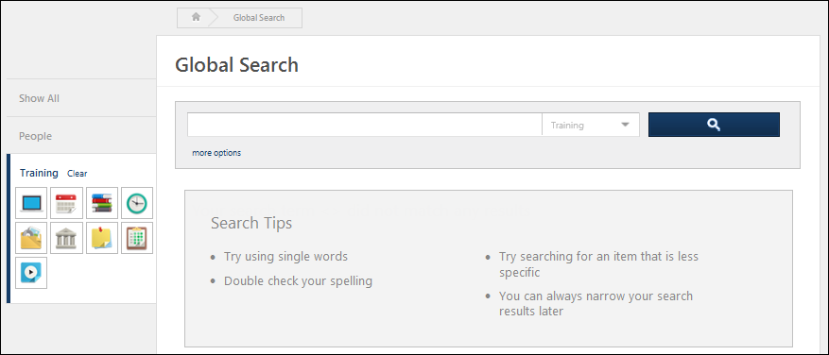
Search Preferences - Training - Refine Search Options
The Refine Search Options section of the Search Preferences - Training page enables administrators to determine which search refinement options are available to users when the Training tab is selected on the Global Search page or when searching for Learning Objects (LOs) in Course Catalog search.
When searching for training, the results you receive will differ depending on whether you are using Learning Search or Global Search. For more information about the differences between these two tools: See Learning Search vs. Global Search.
Permissions
PERMISSION NAME | PERMISSION DESCRIPTION | CATEGORY

Admin Search Preferences - Manage | Grants ability to configure preferences for Global Search and Course Catalog within Search Preferences. The constraints of this permission are inherited from the Global Search Preferences - Manage permission. This is an administrator permission. | Learning - Administration

Global Search Preferences - Manage | Grants ability to configure Global Search Preferences. This is an administrator permission. The availability of this permission is controlled by a backend setting. This permission can be constrained by OU and User's OU. By default, this permission is constrained to the organization. | Core Administration
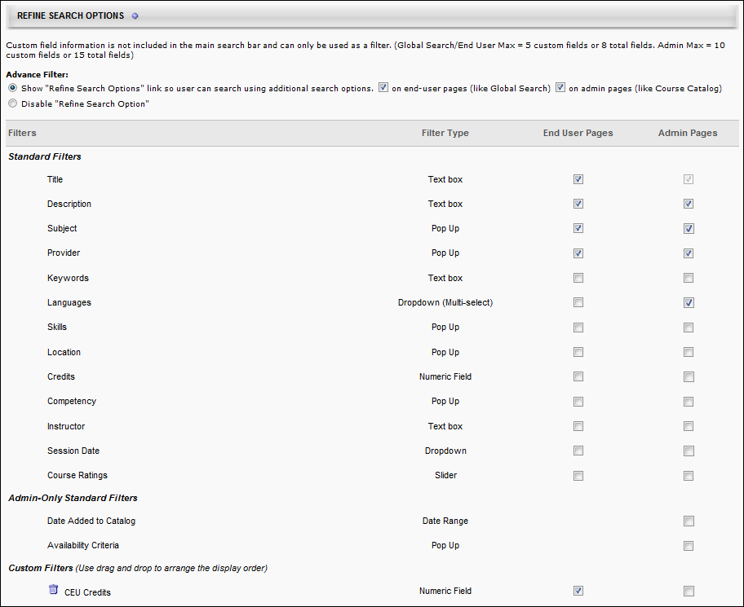
Advanced Filter
Select whether the Additional Search Options section is available to users on the Search page.
- Show "Refine Search Options" link so users can search using additional search options. - Select this option to allow users and administrators to access Refine Search Options on the Global Search or Course Catalog page. These options enable users to further refine their search results. When this option is selected, the search filters can be configured in the Filters section. At least one filter must be selected.
  - On end-user pages (like Global Search) - Select this option to enable the Refine search link on the Global Search page.
  - On admin pages (like Course Catalog) - Select this option to enable the Refine search link on the Course Catalog Search page.
- Disable "Refine Search Options" - Select this option to disable Refine Search Options. When this option is selected, the settings in the Filters table are not implemented.
Filters
Under the Filters section, you can enable the filters to include them in the Refine Search Options section for the corresponding pages.
Note: Deactivating a search filter removes it from the Refine Search Options section, disabling a user or administrator's ability to use the corresponding search filter. However, the system will continue to search the corresponding field. For example, if the Title filter is deactivated, users and administrators cannot filter the search results by title, but a training item is included in the search results if the title matches the search criteria. The order in which the filters appear in the table is the order in which the filters are displayed to users and administrators.
- End User Pages - This option controls whether the filter is active on the Global Search page. Up to 5 custom fields or 8 total fields can be selected for end user pages. Note: Only drop-down, multiple checkbox, numeric, short text, and date type custom fields can be added as filters.
- Admin Pages - This option controls whether the filter is active on the Course Catalog Search page. Up to 10 custom fields or 15 total fields can be selected for admin pages. This column is only available to administrators who have permission to manage administrator search preferences.
Note: Only drop-down, numeric, short text, and date type custom fields can be added as filters.
Note: Currently, the Keyword filter is not supported in Global Search but only supported in Course Catalog search page when Enhanced Search is enabled.
Standard Filters
The Standard Filters section of the Filters table displays all of the standard filters that are available. Select whether the filter is active or inactive for end user pages and admin pages. Up to 5 custom fields or 8 total fields can be selected for end user pages. Up to 10 custom fields or 15 total fields can be selected for admin pages.
The following standard filters are available:
Filter | Type | Description
Title | Text Box | User enters a title up to 100 characters.
Description | Text Box | User enters a description up to 100 characters. Not available when Enhanced Search is enabled.
Subject | Pop-up | User selects a subject from the Find Subject pop-up.
Provider | Pop-up | User selects a provider from the Search Providers pop-up.
Keywords | Text Box | User enters a keyword up to 100 characters.
Languages | Drop-down | User selects languages from the drop-down list.
Skills | Pop-up | User selects a skill from the Search Skills pop-up.
Location | Pop-up | User selects a location from the Select Facility pop-up.
Subscription | Pop-up | User selects the name of a content subscription from the Select Subscription pop-up.
Credit | Greater Than/Less Than | Using the greater than, less than, or equal to symbols, user specifies the number of credits. Credit value must be greater than zero and less than 999.99.
Competency | Pop-up | User selects a competency from the Add Competency pop-up.
Instructor | Text Box | User enters an instructor name up to 100 characters.
Session Date | Drop-down | User selects one of the date ranges to limit the LOs by session start date. This filter is only available if Event is selected as one of the search options.
Course Ratings | Slider | User uses the rating slider to specify a rating range.
Admin-Only Standard Filters
The Admin-Only Standard Filters section contains filters that are only available for administrator search pages. This section is only available to administrators who have permission to manage administrator search preferences. Up to 10 custom fields or 15 total fields can be selected for admin pages.
Custom Filters
Custom field information is not included in the main search bar and can only be used as a filter. Up to 5 custom fields or 8 total fields can be selected for end user pages. Up to 10 custom fields or 15 total fields can be selected for admin pages.
To add a custom filter, click the plus icon to the right of the Refine Search Options heading and select the appropriate custom fields. Note: Only drop-down, numeric, short text, and date type custom fields can be added as filters. The custom filters can be reordered by dragging and dropping them into the appropriate order.
Example of Refine Search Options on Global Search Page
This image represents an example of how the Refine Search Options section appears.
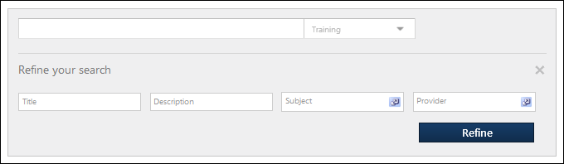
Search Preferences - People
Defining Search Preferences is a multiple step process. The Search Preferences - People page enables administrators to do the following with respect to the People search type:
- Define available search filters
To access the Search Preferences - People page, go to Admin > Tools > Core Functions > Core Preferences > Search. Then, select the People tab on the left navigation bar. Note: This tab is not selectable unless it is enabled as a search type on the General tab.
Permissions
PERMISSION NAME | PERMISSION DESCRIPTION | CATEGORY

Admin Search Preferences - Manage | Grants ability to configure preferences for Global Search and Course Catalog within Search Preferences. The constraints of this permission are inherited from the Global Search Preferences - Manage permission. This is an administrator permission. | Learning - Administration

Global Search Preferences - Manage | Grants ability to configure Global Search Preferences. This is an administrator permission. The availability of this permission is controlled by a backend setting. This permission can be constrained by OU and User's OU. By default, this permission is constrained to the organization. | Core Administration
The availability of this page is controlled by a backend setting.
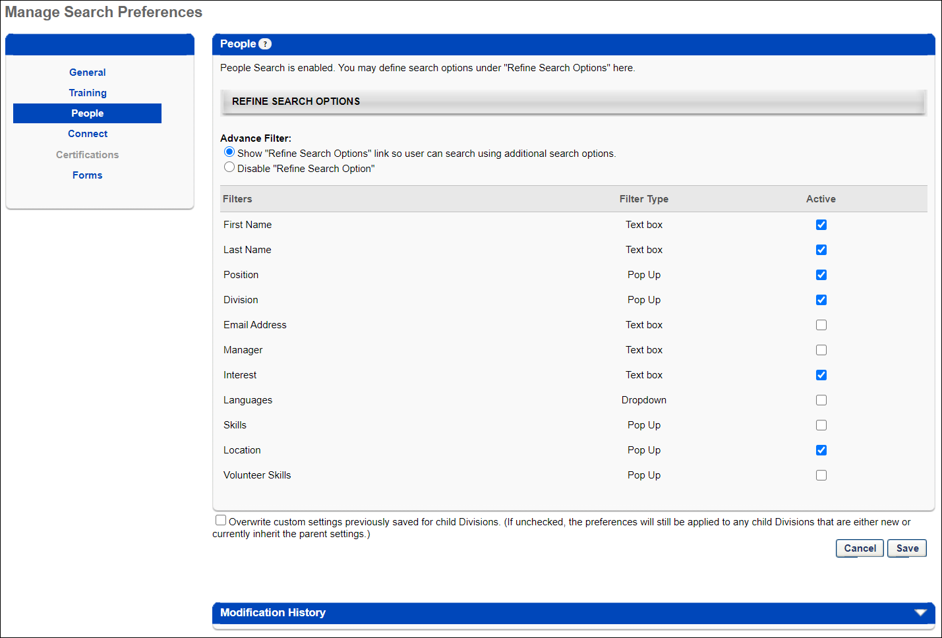
Refine Search Options
This section enables administrators to determine which search refinement options are available to users when the corresponding tab is selected on the Global Search page.
Advance Filter
Select whether the Additional Search Options section is available to users.
- Show "Refine Search Options" link so users can search using additional search options. - Select this option to allow users to access the Refine Search Options on the Global Search page. These options enable users to further refine their search results. When this option is selected, the administrator can set the search filters in the Filters section. At least one filter must be selected.
- Disable "Refine Search Options" - Select this option to disable Refine Search Options. When this option is selected, the settings in the Filters table are not implemented.
Filters
The Filters table displays all of the standard filters that are available. Select the Active checkbox to include the filter in the Refine Search Options section. Note: Deactivating a search filter removes it from the Refine Search Options section, disabling a user's ability to use the corresponding search filter. However, Global Search will continue to search the corresponding field. For example, if the Title filter is deactivated, users cannot filter the search results by title, but a training item is included in the search results if the title matches the search criteria. The order in which the filters appear in the table is the order in which the filters are displayed to users on the Global Search page.
Up to eight filters can be selected as Active.
The following standard filters are available:
Filter | Type | Description
First Name | Text Box | User enters a person's first name up to 100 characters.
Last Name | Text Box | User enters a person's last name up to 100 characters.
Position | Pop-up | User selects a person's Position from the Search Positions pop-up. This filter is only available if the Position OU is enabled for the portal.
Division | Pop-up | User selects a person's Division from the Search Divisions pop-up. This filter is only available if the Division OU is enabled for the portal.
Email Address | Text Box | User enters a person's email address up to 100 characters.
Manager | Text Box | User enters a person's manager's name up to 100 characters. This field matches first and last names.
Interest | Text Box | User enters a person's interest up to 100 characters. This matches a person's interests that are listed on their Resume and in Connect.
Languages | Drop-down | User selects a person's languages from the drop-down list.
Skills | Pop-up | User selects a user's Resume skills from the Search Skills pop-up.
Location | Pop-up | User selects a person's Location from the Search Locations pop-up. This filter is only available if the Location OU is enabled for the portal.
Volunteer Skills | Pop-up | User selects a person's Volunteer Skills from the Select Volunteer Skills pop-up.
Overwrite Settings
Select this option to overwrite custom settings for child division OUs. If you overwrite custom settings for child division OUs, the selected settings are applied to both new and existing child OUs. Any previously customized child OUs are updated with the selected settings.
- If there are no customizations to the child OU, then the parent OU customizations are applied to all child OUs.
- Overwrite custom settings checkbox setting
  - If this option is selected, all child OU customizations are deleted from the database, which means the parent OU customizations will be applied to new and existing child OUs.
  - If this option is unselected, all existing child OU customizations will remain unchanged, and any new child OUs will inherit the parent OU customizations by default.
- If a child OU has been customized to display any widgets, then regardless of the parent OU customizations, the child OU customizations are applied.
- If a child OU has been customized to hide all widgets, then parent OU customizations will take precedence and will be applied.
Note: This option applies to all tabs within Search Preferences (e.g., General, People, Training), not just the current tab.
Save Options
To continue modifying Search Preferences, click the appropriate tab in the left navigation bar.
To save changes for all pages within Search Preferences, click Save.
To discard all unsaved changes made on all pages within Search Preferences, click Cancel.
Search Preferences - Connect
Defining Search Preferences is a multiple step process. The Search Preferences - Connect page enables administrators to do the following with respect to the Connect search type:
- Define available search filters for Knowledge Bank and community postings
To access the Search Preferences - Connect page, go to Admin > Tools > Core Functions > Core Preferences > Search. Then, select the Connect tab on the left navigation bar. Note: This tab is not selectable unless it is enabled as a search type on the General tab.
Permissions
PERMISSION NAME | PERMISSION DESCRIPTION | CATEGORY

Admin Search Preferences - Manage | Grants ability to configure preferences for Global Search and Course Catalog within Search Preferences. The constraints of this permission are inherited from the Global Search Preferences - Manage permission. This is an administrator permission. | Learning - Administration

Global Search Preferences - Manage | Grants ability to configure Global Search Preferences. This is an administrator permission. The availability of this permission is controlled by a backend setting. This permission can be constrained by OU and User's OU. By default, this permission is constrained to the organization. | Core Administration
The availability of this page is controlled by a backend setting.
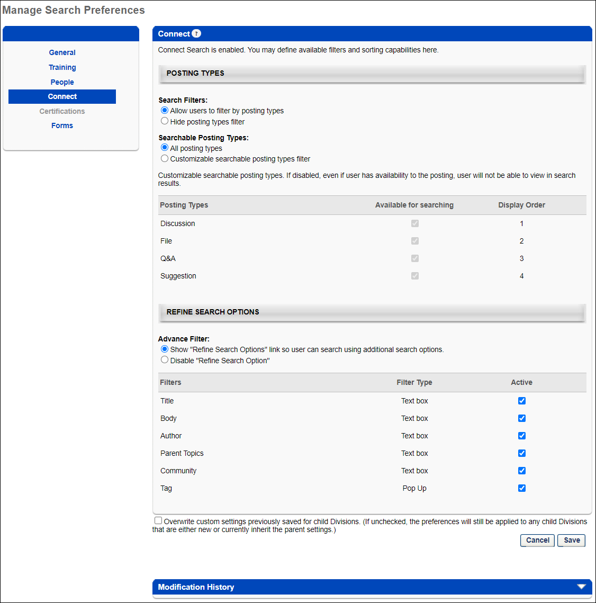
Posting Types
This section enables administrators to determine which search filters are available and which posting types are searchable.
Note: Users and administrators can only search for postings that are available to them. If a posting is from a topic that is not available to a user, then that posting does not appear in search results.
Search Filters
Select whether or not users have access to posting type filters
- Allow users to filter by posting types - When this option is selected, the Posting filters are available on the Global Search page, allowing users to filter the search results by posting type. Which posting type filters are available to users is determined in the Searchable Posting Types setting and the Posting Types table. This option is selected by default.
- Hide posting types filter - If this option is selected, the posting types filter is not visible to users. However, when a user searches for a posting, the selections in the Posting Types section are automatically applied.
Searchable Posting Types
Select whether all posting types are searchable in Global Search or only specific posting types.
- All posting types - Select this option to make all posting types searchable within Global Search. Global Search searches all postings to which the user has availability.
- Customize searchable posting types - Select this option to customize which posting types are searchable within Global Search. The administrator must then use the Posting Types table to determine which posting types are searchable.
Posting Types
This table enables administrators to determine which posting types are available to users within Global Search. In addition, the administrator can determine the order in which the selected posting types appear in the Global Search results.
This Posting Types column displays each of the available posting types. The following posting types may be available:
- Discussion
- File
- Q&A
- Suggestion
Enable Search Type
To enable users to use a particular search type within Global Search, select the Available for Searching option. By default, all available posting types are selected. If this option is not selected for a posting type, then postings within the corresponding posting type are never displayed in search results. Note: At least one posting type must be selected.
When the Available for Searching option is selected for a search type, the following occurs:
- Users can search for items within the posting type.
- The Display Order column displays the order in which the posting types are displayed in the search results and the posting type can be reordered.
This image represents an example of how the posting type filters appear on the Global Search page.
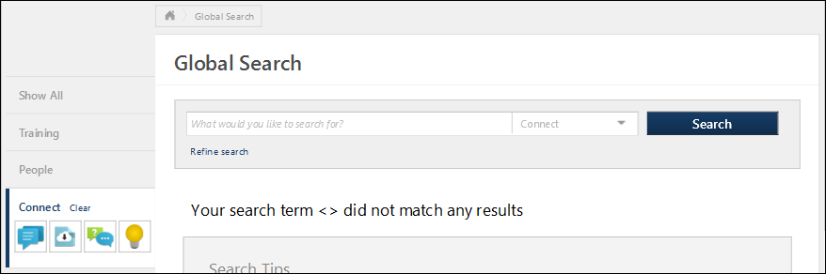
Configure Search Filter Display Order
The Display Order column displays the order in which posting type filters are displayed to users. Drag and drop the posting types in to the desired order.
Refine Search Options
This section enables administrators to determine which search refinement options are available to users when the corresponding tab is selected on the Global Search page.
Advance Filter
Select whether the Additional Search Options section is available to users.
- Show "Refine Search Options" link so users can search using additional search options. - Select this option to allow users to access the Refine Search Options on the Global Search page. These options enable users to further refine their search results. When this option is selected, the administrator can set the search filters in the Filters section. At least one filter must be selected.
- Disable "Refine Search Options" - Select this option to disable Refine Search Options. When this option is selected, the settings in the Filters table are not implemented.
Filters
The Filters table displays all of the standard filters that are available. Select the Active checkbox to include the filter in the Refine Search Options section. Note: Deactivating a search filter removes it from the Refine Search Options section, disabling a user's ability to use the corresponding search filter. However, Global Search will continue to search the corresponding field. For example, if the Title filter is deactivated, users cannot filter the search results by title, but a training item is included in the search results if the title matches the search criteria. The order in which the filters appear in the table is the order in which the filters are displayed to users on the Global Search page.
The following standard filters are available:
Filter | Description
Title | User enters a title up to 100 characters.
Body | User enters posting body text up to 100 characters.
Author | User enters a posting author up to 100 characters.
Parent Topics | User enters a parent topic up to 100 characters.
Community | User enters a community up to 100 characters.
Tag | When this option is selected, users are able to search for Connect postings by tag name.  When this option is not selected, users cannot search by tag name. As a result, users cannot select a posting tag from other areas of the system to initiate a search for that tag. This includes the Posting view, the Topic Details page, and the Community Main tab.
Overwrite Settings
Select this option to overwrite custom settings for child division OUs. If you overwrite custom settings for child division OUs, the selected settings are applied to both new and existing child OUs. Any previously customized child OUs are updated with the selected settings.
- If there are no customizations to the child OU, then the parent OU customizations are applied to all child OUs.
- Overwrite custom settings checkbox setting
  - If this option is selected, all child OU customizations are deleted from the database, which means the parent OU customizations will be applied to new and existing child OUs.
  - If this option is unselected, all existing child OU customizations will remain unchanged, and any new child OUs will inherit the parent OU customizations by default.
- If a child OU has been customized to display any widgets, then regardless of the parent OU customizations, the child OU customizations are applied.
- If a child OU has been customized to hide all widgets, then parent OU customizations will take precedence and will be applied.
Note: This option applies to all tabs within Global Search Preferences (e.g., General, People, Training), not just the current tab.
Save Options
To continue modifying Search Preferences, click the appropriate tab in the left navigation bar.
To save changes for all pages within Search Preferences, click Save.
To discard all unsaved changes made on all pages within Search Preferences, click Cancel.
Search Preferences - Certifications
Defining Search Preferences is a multiple step process. The Search Preferences - Certifications page enables administrators to do the following with respect to the Certifications search type:
- Define available search filters
The availability of this page is controlled by a backend setting.
To access the Search Preferences - Certifications page, go to Admin > Tools > Core Functions > Core Preferences > Search. Then, select the Certifications tab on the left navigation bar. Note: This tab is not selectable unless it is enabled as a search type on the General tab.
Permissions
PERMISSION NAME | PERMISSION DESCRIPTION | CATEGORY

Admin Search Preferences - Manage | Grants ability to configure preferences for Global Search and Course Catalog within Search Preferences. The constraints of this permission are inherited from the Global Search Preferences - Manage permission. This is an administrator permission. | Learning - Administration

Global Search Preferences - Manage | Grants ability to configure Global Search Preferences. This is an administrator permission. The availability of this permission is controlled by a backend setting. This permission can be constrained by OU and User's OU. By default, this permission is constrained to the organization. | Core Administration
The availability of this page is controlled by a backend setting.
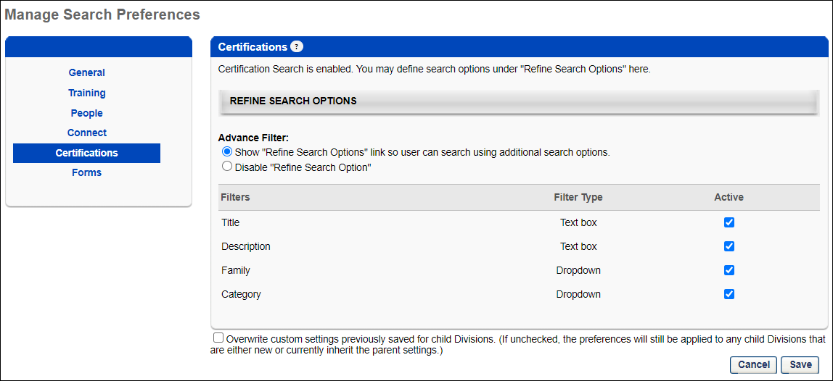
Refine Search Options
This section enables administrators to determine which search refinement options are available to users when the corresponding tab is selected on the Global Search page.
Advance Filter
Select whether the Additional Search Options section is available to users.
- Show "Refine Search Options" link so users can search using additional search options. - Select this option to allow users to access the Refine Search Options on the Global Search page. These options enable users to further refine their search results. When this option is selected, the administrator can set the search filters in the Filters section. At least one filter must be selected.
- Disable "Refine Search Options" - Select this option to disable Refine Search Options. When this option is selected, the settings in the Filters table are not implemented.
Filters
The Filters table displays all of the standard filters that are available. Select the Active checkbox to include the filter in the Refine Search Options section. Note: Deactivating a search filter removes it from the Refine Search Options section, disabling a user's ability to use the corresponding search filter. However, Global Search will continue to search the corresponding field. For example, if the Title filter is deactivated, users cannot filter the search results by title, but a training item is included in the search results if the title matches the search criteria. The order in which the filters appear in the table is the order in which the filters are displayed to users on the Global Search page.
The following standard filters are available:
Filter | Type | Description
Title | Text Box | User enters a title up to 100 characters.
Description | Text Box | User enters a description up to 100 characters.
Family | Drop-down | User selects a family from the drop-down list.
Category | Drop-down | User selects a category from the drop-down list.
Overwrite Settings
Select this option to overwrite custom settings for child division OUs. If you overwrite custom settings for child division OUs, the selected settings are applied to both new and existing child OUs. Any previously customized child OUs are updated with the selected settings.
- If there are no customizations to the child OU, then the parent OU customizations are applied to all child OUs.
- Overwrite custom settings checkbox setting
  - If this option is selected, all child OU customizations are deleted from the database, which means the parent OU customizations will be applied to new and existing child OUs.
  - If this option is unselected, all existing child OU customizations will remain unchanged, and any new child OUs will inherit the parent OU customizations by default.
- If a child OU has been customized to display any widgets, then regardless of the parent OU customizations, the child OU customizations are applied.
- If a child OU has been customized to hide all widgets, then parent OU customizations will take precedence and will be applied.
Note: This option applies to all tabs within Search Preferences (e.g., General, People, Training), not just the current tab.
Save Options
To continue modifying Search Preferences, click the appropriate tab in the left navigation bar.
To save changes for all pages within Search Preferences, click Save.
To discard all unsaved changes made on all pages within Search Preferences, click Cancel.
Search Preferences - Forms
Defining Search Preferences is a multiple step process. The Search Preferences - Forms page enables administrators to do the following with respect to the Forms search type:
- Define available search filters
To manage Search Preferences for forms, go to Admin > Tools > Core Functions > Core Preferences > Search. Then, select the Forms tab on the left navigation bar. Note: This tab is not selectable unless it is enabled as a search type on the General tab.
Permissions
PERMISSION NAME | PERMISSION DESCRIPTION | CATEGORY

Admin Search Preferences - Manage | Grants ability to configure preferences for Global Search and Course Catalog within Search Preferences. The constraints of this permission are inherited from the Global Search Preferences - Manage permission. This is an administrator permission. | Learning - Administration

Global Search Preferences - Manage | Grants ability to configure Global Search Preferences. This is an administrator permission. The availability of this permission is controlled by a backend setting. This permission can be constrained by OU and User's OU. By default, this permission is constrained to the organization. | Core Administration
The availability of this page is controlled by a backend setting.
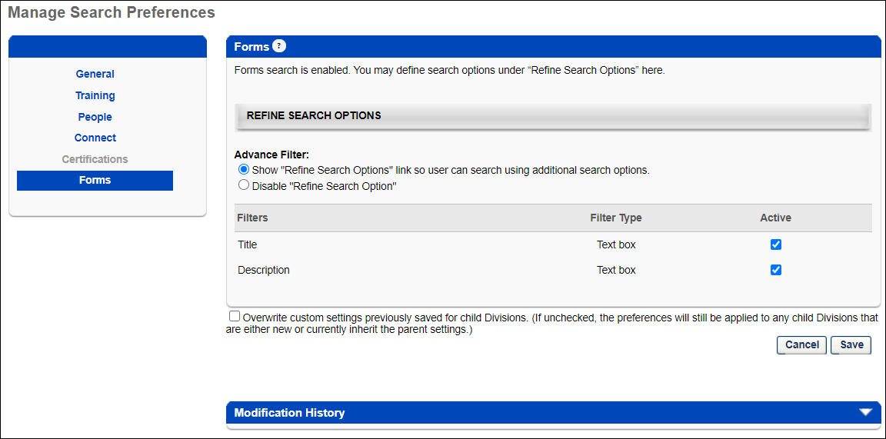
Refine Search Options
This section enables administrators to determine which search refinement options are available to users when the corresponding tab is selected on the Global Search page.
Advance Filter
Select whether the Additional Search Options section is available to users.
- Show "Refine Search Options" link so users can search using additional search options. - Select this option to allow users to access the Refine Search Options on the Global Search page. These options enable users to further refine their search results. When this option is selected, the administrator can set the search filters in the Filters section. At least one filter must be selected.
- Disable "Refine Search Options" - Select this option to disable Refine Search Options. When this option is selected, the settings in the Filters table are not implemented.
Filters
The Filters table displays all of the standard filters that are available. Select the Active checkbox to include the filter in the Refine Search Options section. Note: Deactivating a search filter removes it from the Refine Search Options section, disabling a user's ability to use the corresponding search filter. However, Global Search will continue to search the corresponding field. For example, if the Title filter is deactivated, users cannot filter the search results by title, but a training item is included in the search results if the title matches the search criteria. The order in which the filters appear in the table is the order in which the filters are displayed to users on the Global Search page.
The following filters are available:
Filter | Type | Description
Title | Text Box | User enters a title up to 100 characters.
Description | Text Box | User enters a description up to 100 characters.
Overwrite Settings
Select this option to overwrite custom settings for child division OUs. If you overwrite custom settings for child division OUs, the selected settings are applied to both new and existing child OUs. Any previously customized child OUs are updated with the selected settings.
- If there are no customizations to the child OU, then the parent OU customizations are applied to all child OUs.
- Overwrite custom settings checkbox setting
  - If this option is selected, all child OU customizations are deleted from the database, which means the parent OU customizations will be applied to new and existing child OUs.
  - If this option is unselected, all existing child OU customizations will remain unchanged, and any new child OUs will inherit the parent OU customizations by default.
- If a child OU has been customized to display any widgets, then regardless of the parent OU customizations, the child OU customizations are applied.
- If a child OU has been customized to hide all widgets, then parent OU customizations will take precedence and will be applied.
Note: This option applies to all tabs within Search Preferences (e.g., General, People, Training), not just the current tab.
Save Options
To continue modifying Search Preferences, click the appropriate tab in the left navigation bar.
To save changes for all pages within Search Preferences, click Save.
To discard all unsaved changes made on all pages within Search Preferences, click Cancel.

View Data Preferences
Use the View Data Preferences to configure the following preferences for View Data:
- Define organizational unit (OU) filters
- Define succession metrics filters
- Define employee tooltips
To access View Data Preferences, go to Admin > Preferences > View data preferences.
Permissions
PERMISSION NAME | PERMISSION DESCRIPTION | CATEGORY

View Data: Preferences | Grants access View Data Preferences. This permission can be constrained by OU, User's OU, User, User Self and Subordinates, User's Subordinates, User's Direct Subordinates, and User's Corporation. | View
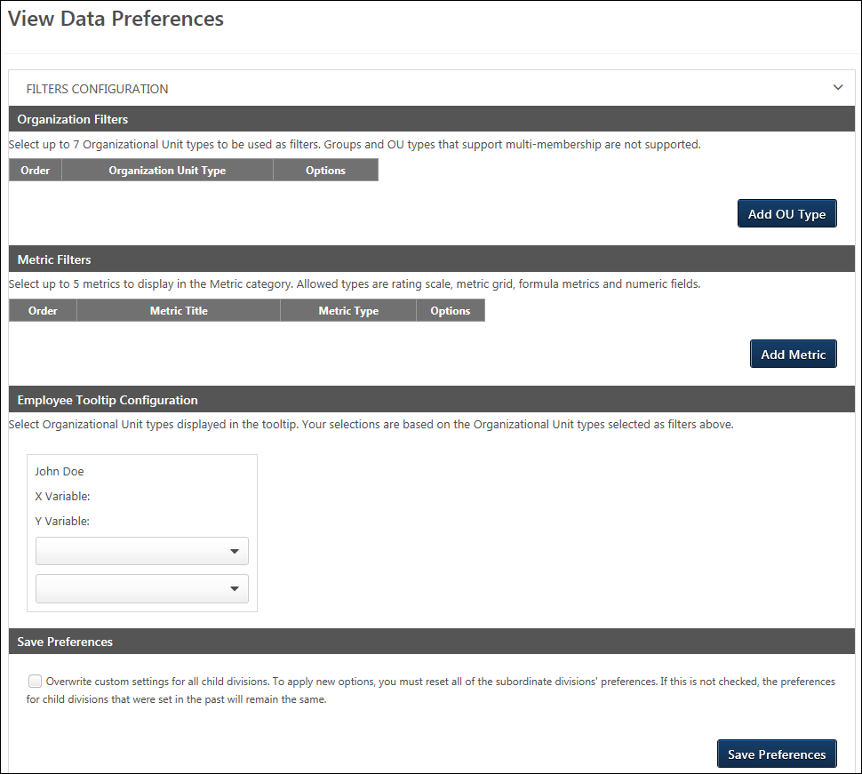
Organization Filters
Select the OU options that will display in the Organization filter. By default, up to five system OUs display in the Organization filter on the View Data page: Division, Position, Grade, Cost Center, and Location. You can use the Organization Filters section in View Data Preferences to determine if you would like different or additional OUs to display, such as custom OUs.
To define the OU filter options:
- Click Add OU Type. This opens the Select OU Type to Add pop-up.
- Select an OU from the drop-down. The OUs that display are the active system and custom OUs for the portal. Group OUs and multi-type OUs are not available to select.
- Click Add. This adds the OU to the list of filters.
You can add more OUs by repeating the steps. You can add up to seven OUs.
Delete OUs
Delete an OU by clicking Delete from the drop-down in the Options column.
Reorder OUs
Change the order in which the OUs appear in the filter by clicking Move Up or Move Down from the drop-down in the Options column.
Metric Filters
Note: Tenure and Merit Increase (%) are added automatically if available and are not user configurable.
Configure Succession metrics to see how they align with Compa-ratio and Performance.
By default, there are no metrics selected to display in the Metrics filter on the View Data page. The metrics must be added in this section in order to appear as filters. The allowable metric types are rating scale, metric grid, formula metrics, and numeric fields.
Add Metrics
To add succession metrics:
- Click the Add Metric button. This opens the Select Succession Metric to Add pop-up.
- Select a metric from the Metric drop-down.
- Click Add. This adds the metric to the list of filters.
You can add more metrics by repeating the steps. Up to five metrics can be added.
Metrics Table
Succession metricsdisplay in a table as follows:
- Order - Order in which the metrics display in the Metrics filter.
- Metric Title - Name of the metric.
- Metric Type - Type of metric field.
- Options - The following options display in the options drop-down:
  - Delete - Delete the metric from the filter.
  - Move Up - Move the metric up one position.
  - Move Down - Move the metric down one position.
Employee Tooltip Configuration
Select the OUs that areincluded in the tooltip that displays in the scatter graph when a plot point on the graph is hovered over or tapped on a mobile device. By default, the tooltip displays the user's name, as well as the variable on the X and Y axes of the graph. You can add up to two OUs to appear in the tooltip.
If OUs are not added, then the default display in View Data will be Division OU and Position OU.
To configure the tooltip OUs, add one or more OUs in the Organization Filters section of the preferences page.
- The most recently added OU in the OUs list will appear in the first drop-down in the Employee Tooltip Configuration section.
- The second most recently added OU in the OUs list will appear in the second drop-down. Note: The order in which the OUs appear in the OUs table in the Organization Filters section does not determine which OU appears in the drop-downs in the tooltip section.
- If three or more OUs are added to the OUs section, then the drop-downs in the tooltip section allow you to select a different OU for the tooltip.
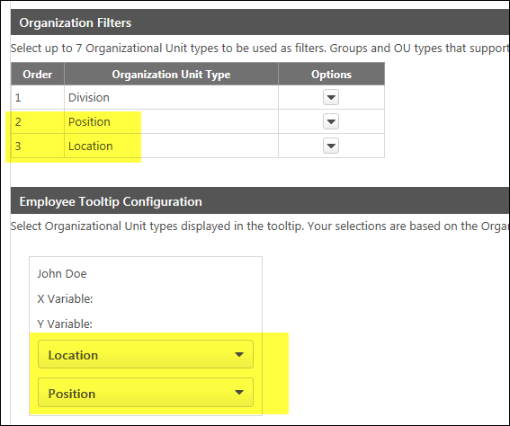
Save Preferences
Click Save preferences to save the preference settings.
Overwrite Settings
Select this option to overwrite custom settings for child division OUs. If you overwrite custom settings for child division OUs, the selected settings are applied to both new and existing child OUs. Any previously customized child OUs are updated with the selected settings.
- If there are no customizations to the child OU, then the parent OU customizations are applied to all child OUs.
- Overwrite custom settings checkbox setting
  - If this option is selected, all child OU customizations are deleted from the database, which means the parent OU customizations will be applied to new and existing child OUs.
  - If this option is unselected, all existing child OU customizations will remain unchanged, and any new child OUs will inherit the parent OU customizations by default.
- If a child OU has been customized to display any widgets, then regardless of the parent OU customizations, the child OU customizations are applied.
- If a child OU has been customized to hide all widgets, then parent OU customizations will take precedence and will be applied.

View People Preferences
The View People Preferences page allows you to configure the following preferences for View People:
- Organizational unit (OU) filters
- OU custom field filters
- Succession metrics filters
- Employee attributes filters
- User Record custom field filters
- Define the OUs that will display for each user in their employee card
- Determine whether or not permission constraints should apply for users when viewing a shared list
To access View People Preferences, go to Admin > Preferences > View People.
Permissions
PERMISSION NAME | PERMISSION DESCRIPTION | CATEGORY

View People Preferences Page | Grants access to the View People Preferences page, which allows administrators to configure the View People page according to their needs per organizational unit (OU). This permission can be constrained by OU, User's OU, User, User Self and Subordinates, and User's Subordinates. | View
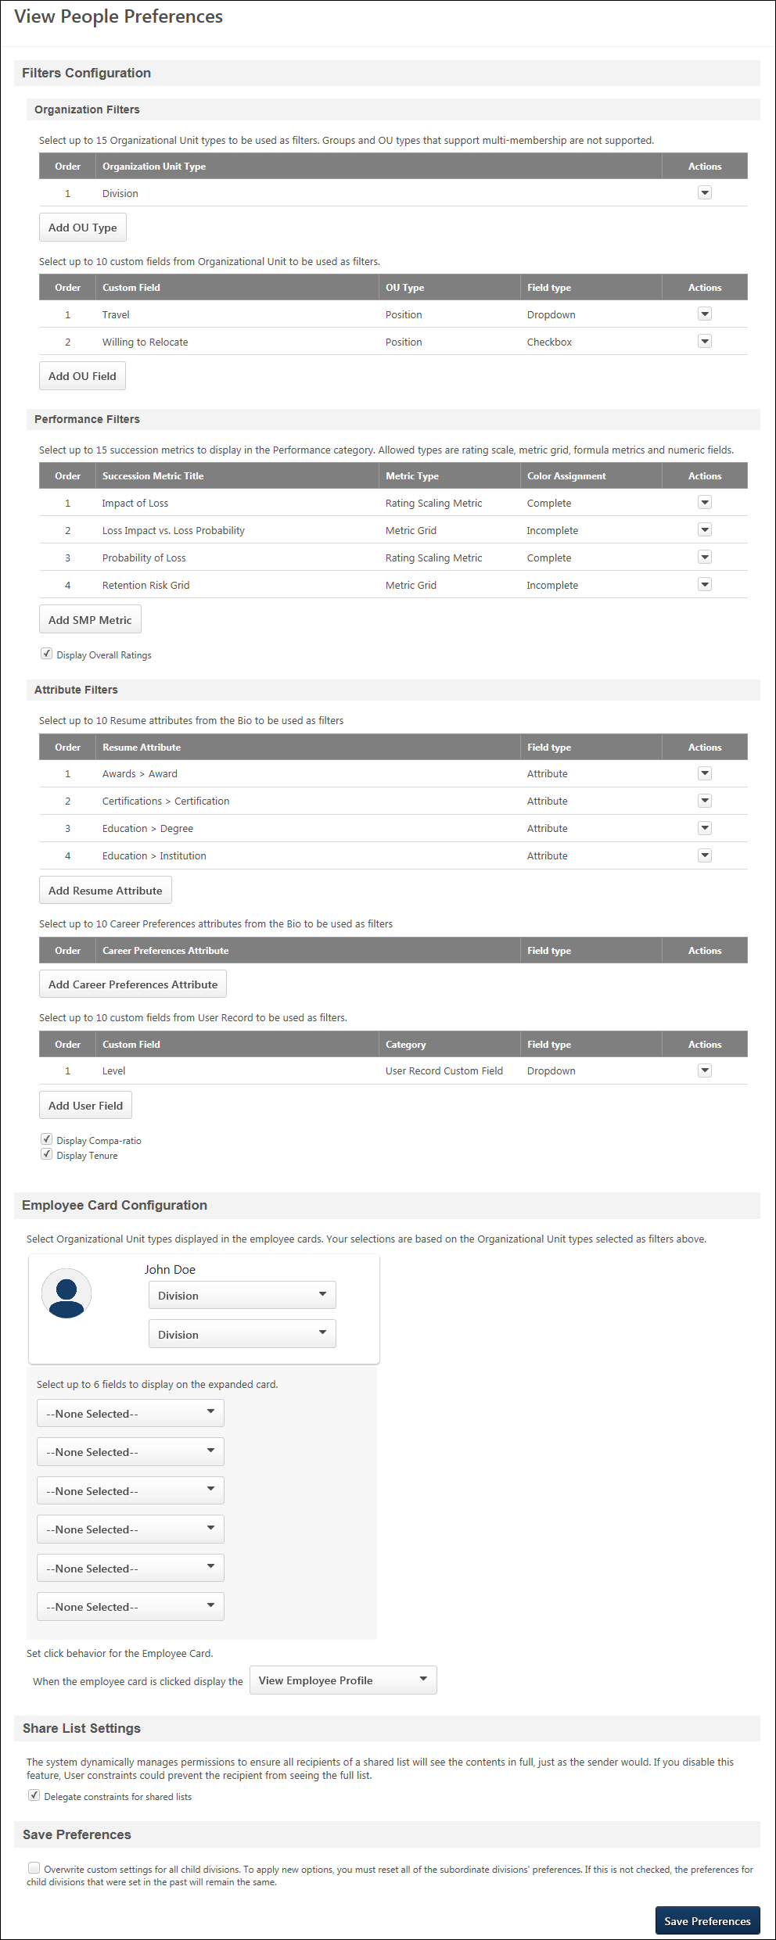
Organization Filters
This section allows you to select the OU types and OU custom fields that will display in the Organization filter.
Use Case
- Claire is the head of Human Resources for a multi-national company with 10,000 employees.
- Her company tracks critical roles as a custom Position organizational unit (OU) field, and also tracks Division OUs that are working on key initiatives for the current fiscal year.
- Claire uses View People to identify employees that are in key roles and review their compensation vs. performance status.
- She can review their succession metrics and take initiative to assign training or move them into talent pools.
- She can also review the performance of Division OUs that are tied to key initiatives and review their existing skill set and progress toward year end goals.
Organizational Unit Type Filter
By default, up to 15 system OUs display in the Organization filter on the View People page: Division, Position, Grade, Cost Center, and Location. You can use the Organization Filters section in View People Preferences to determine if you would like different or additional OUs to display, such as custom OUs.
To define the OU filter options:
- Click Add OU Type. This opens the Select OU Type to Add pop-up.
- Select an OU from the drop-down. The OUs that display are the active system and custom OUs for the portal. Group OUs and multi-type OUs are not available to select.
- Click Add. This adds the OU to the list of filters.
You can add more OUs by repeating the steps. Up to seven OUs can be added.
Reorder OU Position
You can change the order in which the OUs appear in the filter by clicking Move Up or Move Down from the drop-down in the Options column.
Organizational Unit Custom Field Filter
You can add up to 10 OU custom fields to this section. The fields that you add will appear in the OU Fields filter in the Organization section of the Filters panel on the View People page.
The following custom field types can be added:
- Checkbox
- Dropdown
- Formula Metric
- Metric Grid
- Multiple Checkbox
- Numeric
- Radio Button
- Rating Scaling Metric
To add OU custom fields:
- Click the Add OU Field button. This opens the Select OU Custom Field to Add pop-up.
- Click the Please Select drop-down.
- Select an OU custom field.
- Click Add. This adds the field to the OU custom fields table on the View People Preferences page.
OU Custom Fields Table
The following information displays for each OU custom field in the table:
- Order - This column displays the order in which the custom field displays in the filter.
- Custom Field - This column displays the name of the custom field.
- OU Type - This column displays the type of OU that is defined for the custom field.
- Field Type - This column displays the type of custom field.
- Option - The following options are available in the options drop-down:
  - Delete - Click this option to delete the custom field as a filter.
  - Move Down - Click this option to move the custom field down one position.
  - Move Up - Click this option to move the custom field up one position.
Performance Filters
Note: This section only displays for portals with Performance or Succession.
This section allows you to configure Performance and Succession metrics. Up to 15 metrics can be added.
Succession Metrics
By default, the Performance filter on the View People page displays the first five allowable succession metrics. You can modify the metrics that display by adding metrics in this section. The allowable metric types are checkbox, radio button, rating scale, metric grid, formula metrics, numeric, and dropdown fields. There are no metrics selected by default to display in the Performance filter on the View People page. The metrics must be added in this section in order to appear as filters.
To add succession metrics:
- Click the Add SMP Metric button. This opens the Select Succession Metric to Add pop-up.
- Select an SMP metric from the SMP Metric drop-down. The metrics that display are the active system and custom OUs for the portal. Group OUs and multi-type OUs are not available to select.
- Click Add. This adds the OU to the list of filters.
You can add more metrics by repeating the steps. Up to 15 metrics can be added.
Once succession metrics are added, they display in a table below the metrics. The following information displays in the table:
- Order - This column displays the order in which the metrics display in the Performance filter.
- Succession Metric Title - This column displays the name of the metric.
- Metric Type - This column displays the type of metric field.
- Color Assignment - This column indicates whether or not colors have been assigned to the ratings to aid in comparison. The following values display:
  - Complete
  - Incomplete
  - Not Assigned
- Options - The following options display in the options drop-down:
  - Delete - Click this option to delete the metric from the filter.
  - Move Up - Click this option to move the metric up one position.
  - Move Down - Click this option to move the metric down one position.
Performance Options
The Display Overall Ratings option allows you to hide the Overall Performance filter on the View People page. Check the box to hide the filter. Uncheck the box to show the filter.
Attribute Filters
Note: This section only displays for portals with Compensation or Succession.
This section allows you to add Resume, Career Preferences, and User Record custom field filters. You can also define compensation filter options.
Resume
If the resume section of Universal Profile is enabled, then the Resume Filters section allows you to select up to five employee attributes that will display as filters.
To add attributes:
- Click the Add Resume attribute button. This opens the Select Resume Attribute to Add pop-up.
- Select an attribute from the Resume Attributes drop-down. The field types that can be added are Attribute List, Numeric, Checkbox, Short Text Box, or Dropdown.
- Click Add. This adds the attribute to the list of filters.
You can add more attributes by repeating the steps. Up to 10 attributes can be added.
Resume Attributes Metrics Table
Once attributes are added, they display in the table. The following information displays in the table:
- Order - This column displays the order in which the metrics display in the filter.
- Resume Attribute - This column displays the name of the attribute.
- Field Type - This column displays the type of attribute field.
- Options - The following options display in the options drop-down:
  - Delete - Click this option to delete the metric from the filter.
  - Move Up - Click this option to move the metric up one position.
  - Move Down - Click this option to move the metric down one position.
Career Preferences
This section enables you to add questions that are active in the Career Preferences section of Bio Resume and Career Preferences. The questions that are added are available as Attributes filters on the View People page.
To add career preferences attributes:
- Click the Add Career Preferences Attribute button. This opens the Select Career Preferences Attribute to Add pop-up.
- Click the Please Select drop-down.
- Select a career preferences question from the drop-down.
- Click Add. This adds the question to the Career Preferences Attribute section.
To add more questions, repeat the steps above. Up to 10 questions can be added.
Career Preferences Attributes Metrics Table
Once career preferences attributes are added, they display in the table. The following information displays in the table:
- Order - This column displays the order in which the metrics display in the filter.
- Career Preferences Attribute - This column displays the career preferences question.
- Field Type - This column displays the type of attribute field.
- Options - The following options display in the options drop-down:
  - Delete - Click this option to delete the metric from the filter.
  - Move Up - Click this option to move the metric up one position.
  - Move Down - Click this option to move the metric down one position.
User Custom Fields
You can add up to 10 User Record custom fields to this section. The fields that you add will appear in the User Fields filter in the Attributes section of the Filters panel on the View People page.
To add User Record custom fields:
- Click the Add User Field button. This opens the Select User Custom Field to Add pop-up.
- Click the Please Select drop-down.
- Select an User Record custom field.
- Click Add. This adds the field to the User Record custom fields table on the View People Preferences page.
Note: User Record custom date fields cannot be added.
User Record Custom Fields Table
The following information displays for each User Record custom field in the table:
- Order - This column displays the order in which the custom field displays in the filter.
- Custom Field - This column displays the name of the custom field.
- Category - This column displays the type of category that is defined for the custom field.
- Field Type - This column displays the type of custom field.
- Option - The following options are available in the options drop-down:
  - Delete - Click this option to delete the custom field as a filter.
  - Move Down - Click this option to move the custom field down one position.
  - Move Up - Click this option to move the custom field up one position.
Compensation Options
Note: This section only displays for portals with Compensation.
You can configure the following compensation filter options:
- Display Compensation - This option is only available for portals with a single currency. When this option is selected, it displays a sliding Compensation filter in the Attributes section of the Performance filter, which allows users to filter by a compensation range.
- Display Compa-Ratio - Including this option displays a sliding Compa-Ratio filter in the Attributes section of the Performance filter, which allows users to filter by a compa-ratio range.
- Display Tenure - Including this option displays a sliding Tenure filter in the Attributes section of the Performance filter, which allows users to filter by a tenure range.
Employee Card Configuration
This section allows you to define the OUs that will appear in a user's employee card on the View People page. By default, the Position OU and Location OU display for each user on the View People page. If the Position OU and/or Location OU are inactive, then an active system OU displays for users on the View People page.
You can select up to two OUs that will appear in the small card and six that will appear in the large expanded card.
Small Card
The OU options that are available to select are dependent on the OUs that you added in the Organization Filters section. If there are no OUs added to the Organization Filters section, then no OU options will be available to select in the drop-downs in the Employee Card Configuration section.
To select the OUs:
- Click the drop-down below the user name "John Doe."
- Select the OU from the drop-down. The options that are available to select are dependent on the OUs that you added in the Organization Filters section.
Large Card
For the large card, you can configure up to six additional organizational units (OU), OU custom fields, User Record custom fields, and Performance and Succession metrics, including any career preferences that are selected in the Career Preferences Attributes section. The fields and metrics will appear on the expanded user cards on the View People page.
Use Case
A Human Resources executive is in the process of completing the company’s annual planning. Weeks have been spent on annual reviews and succession and compensation plans, but the process is not over until they close the loop and take action on the findings.
To close the loop, they will need to use the results from the succession planning and employee skills and experience to identify the best candidates to lead the upcoming initiatives. Because there will be multiple matches, they are going to need a way to do side by side comparisons. In past years, this process resulted in hundreds of print outs and stacks of paper.
Using View People, they use the built-in filters to find the best matches based on the latest succession/performance ratings. When multiple matches are found, the expanded user cards allow a side by side comparison based on up to six key metrics. The best matches are added to the annual "best bets" list.
The final list is shared across the organization via View people, and decisions are finalized. In the upcoming week, the company’s best bets will be invited to meet with department heads.
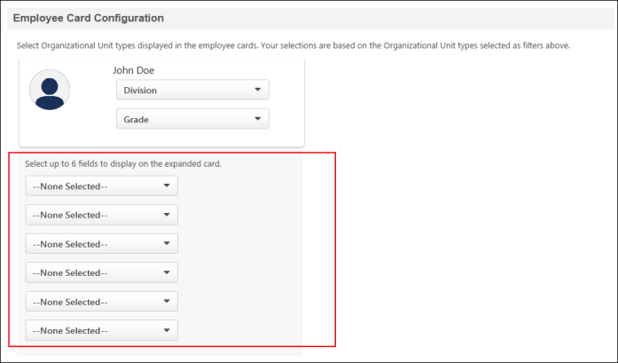
To add fields and metrics:
- Click the drop-down for the field. This opens a list of OU types and metrics.
- Click the desired OU type or metric.
Set Click Behavior for Employee Card
This option lets you set the click behavior of the employee (user) card on the View People page.
To set the click behavior of the user card, select one of the following options from the drop-down:
- View Employee Profile - This opens the employee's profile page within View People. This is the default click behavior of the user card.
- Universal Profile > Bio - This will open the Universal Profile > Bio page in a new tab. This option does not display if the Bio page is not available in your portal.
- Universal Profile > Snapshot - This will open the Universal Profile > Snapshot page in a new tab. This option does not display if the Snapshot page is not available in your portal.
- Universal Profile > User Record - This will open the Universal Profile > User Record page in a new tab.
Share List Settings
The following options are available in the Share List Settings section:
Send shared notifications from the system default email address
When this option is selected, shared lists are sent from the system "Default From Address," rather than the email address for the user who shared the list. The address that will display in the From field for email notifications for shared lists will be the default from address that is configured for the system, provided that a default address has already been set up.
If a "Default From Address" is not yet configured for your portal, you can submit a case to Global Customer Support to have the backend setting configured. Setting up a default address is an optional feature.
Information Icon - Hover over the information icon to view your portal's "Default From Address." If your portal does not have a default address created, then no information displays when hovering over the icon.
Note: If the "Default From Address" is removed from the system, then the value in the From: field on the email will be the email address of the user who shared the list.
Delegate constraints for shared lists
When this option is selected, the system dynamically manages permissions to ensure all recipients of a shared list will see the contents in full, just as the sender would. If you disable this feature, user constraints could prevent the recipient from seeing the full list.
Overwrite Settings
Select this option to overwrite custom settings for child division OUs. If you overwrite custom settings for child division OUs, the selected settings are applied to both new and existing child OUs. Any previously customized child OUs are updated with the selected settings.
- If there are no customizations to the child OU, then the parent OU customizations are applied to all child OUs.
- Overwrite custom settings checkbox setting
  - If this option is selected, all child OU customizations are deleted from the database, which means the parent OU customizations will be applied to new and existing child OUs.
  - If this option is unselected, all existing child OU customizations will remain unchanged, and any new child OUs will inherit the parent OU customizations by default.
- If a child OU has been customized to display any widgets, then regardless of the parent OU customizations, the child OU customizations are applied.
- If a child OU has been customized to hide all widgets, then parent OU customizations will take precedence and will be applied.
Save Preferences
Click Save to save the preferences settings.

Welcome Page Preferences
Welcome Page Preferences define the appearance of the Home page, including the actual components and display arrangement for all elements. The Welcome Page can contain a variety of widgets, which can be customized to suit your organization's needs, including My Action Items, My Inbox, images, etc. By customizing your Welcome Page preferences, you determine which components to display and how they appear. Welcome Page Preferences are important because they define the end user's first view of the system. By placing recognizable images, engaging greetings, and only relevant information on the Welcome page, you enhance end-users familiarity and comfort with the system.
The Welcome page can be configured to display certain widgets, images, messages, and other information. Essentially, the administrator can fully customize the Welcome page.
The Welcome Page Preferences can be set in two different manners, which is determined by a backend setting:
- Custom Page Builder - This method enables administrators to use the Custom Page Builder to set the Welcome Page Preferences. The Custom Page Builder enables administrators to fully customize the Welcome Page, including a fully customizable layout and additional widgets. See Welcome Page Preferences - Custom Page Builder on page 155 for additional information.
- Traditional - This method is the traditional method that enables administrators to manually edit each message box, image, and widget. See Welcome Page Preferences - Traditional on page 152 for additional information.
Permissions
PERMISSION NAME | PERMISSION DESCRIPTION | CATEGORY

Import Assets | Grants ability to Import Assets, which enables uploading updating of image, video and audio files for use in online courses. Can view and update assets imported by others if those assets are designated as editable by anyone. Also requires assignment of LCMS license. This is an administrator permission. | Learning - Administration

Welcome Page Preferences - Manage | Grants ability to configure the look and feel of the Welcome Page that users see upon logging in to the portal. This permission can be constrained by OU and User's OU. This is an administrator permission. | Core Administration
Note: Animation files (.swf) can be used on the Welcome page by adding the animation using the Asset Importer if you have access to the LCMS module. Once the asset is imported, click View icon to see the file path to include in your html.
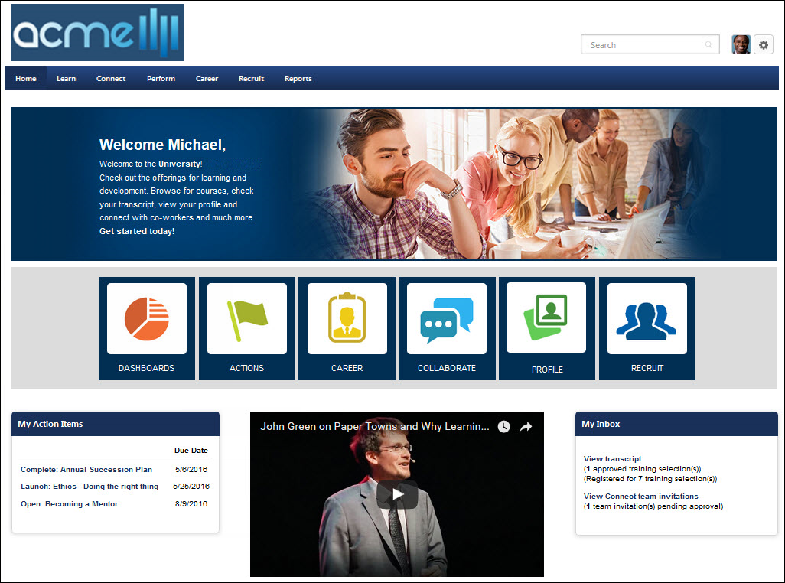

Welcome Page Preferences - Traditional
The Welcome Page Preferences can be set in two different manners, which is controlled by a backend setting. To set the Welcome Page Preferences using the Custom Page Builder, See Welcome Page Preferences - Custom Page Builder on page 155 for additional information.
To set Welcome Page Preferences using the traditional method, go to Admin > Tools > Core Functions > Core Preferences > Welcome Page.
Permissions
PERMISSION NAME | PERMISSION DESCRIPTION | CATEGORY

Task - View | Grants ability to view assigned tasks via Scheduled Tasks screen and Welcome Page My Tasks widget. This is an end user permission. | Core

View My Interests and Waitlists | Grants access for users to view ILT interest lists and waitlists to which they've been added, and to take action when a matching ILT session is offered. This is an end user permission. | Learning

Welcome Page Preferences - Manage | Grants ability to configure the look and feel of the Welcome Page that users see upon logging in to the portal. This permission can be constrained by OU and User's OU. This is an administrator permission. | Core Administration
- Welcome pages can be customized at a divisional level. In addition, welcome pages can be customized by position, location, cost center, etc. To set welcome pages at divisional level, proceed to the next step. To set welcome pages for an OU other than division, See Welcome Page Availability Not By Division on page 158 for additional information.
- Find and click the applicable division from the hierarchy.
- Set the preferences in the following sections. Each section is described below:
  - Welcome Greeting
  - Welcome Page Footer
  - Welcome Page Preferences
    - Formatted Message Box
    - Message Box 1-9
    - Welcome Image
    - Welcome Page Sections
- At the bottom of the page, arrange the Welcome Page sections selected across the three Welcome Page columns by using the arrows .
- Check the Overwrite custom settings for all child divisions option if applicable. This option is described below.
- Click Submit.
Welcome Greeting
- Click the Edit icon to change welcome page greeting located at top of welcome page. The default Welcome Greeting is "Welcome, {FIRSTNAME}, to your personalized corporate training center." Tags can be used within welcome greeting. Click the Save icon to save welcome greeting message. To apply changes to the portal click Submit button or continue to make additional changes to welcome page before applying.
- Click the Include checkbox next to Welcome Greeting to make it appear on your Welcome Page
- Click the Translate icon to enter translated Welcome Greeting text (if using multiple languages)
Formatted Message Box
This Formatted Message Box has an appearance consistent with the standard Welcome Page sections.
- Click the Edit icon to change title and message in Formatted Message Box. This allows you to create a custom message box with a custom heading. This box can contain HTML tags and has a 3000 character limit. Enter title in title field and message in body field. Click the Save icon to save. To apply changes click to the portal Submit button or continue to make additional changes in Welcome Page before applying.
- Click the Include checkbox next to Formatted Message Box to make it appear on your Welcome Page
- Click the Translate icon to enter translated Formatted Message Box text (if using multiple languages)
Message Boxes 1-9
- Click the Edit icon to enter or change a custom message. This box can contain HTML tags and has a 3000 character limit. Click the Save icon to save. To apply changes to the portal click Submit button or continue to make additional changes in Welcome Page before applying.
- Click the Include checkbox next to Message Box to make it appear on your Welcome Page
- Click the Translate icon to enter translated Message Box text (if using multiple languages)
Welcome Image
- Click the Edit icon to upload a new image or select from the drop down a previous uploaded image for the welcome page. Click the Save icon to save. To apply changes to the portal click Submit button or continue to make additional changes in Welcome Page before applying.
- Click the Include checkbox next to Welcome Image to make it appear on your Welcome Page
Welcome Page Sections
- Click the Edit icon next to the section title to change the title of any of the Welcome Page Sections listed below. Click the Save icon to save the changes. To apply changes to the portal click Submit button or continue to make additional changes in Welcome Page before applying.
- Click the Include checkbox next to Welcome Page Section to make it appear on your Welcome Page.
- If multiple languages are available for the portal, click the Translate icon to localize the Welcome Page Section text.
- Click the drop-down list under the Results Returned column to select the maximum number of items that are displayed in the widget. The maximum is 10.
A list of available widgets is available in Online Help. See Custom Page Builder - Available Widgets on page 42 for additional information.
Overwrite Settings
Select this option to overwrite custom settings for child division OUs. If you overwrite custom settings for child division OUs, the selected settings are applied to both new and existing child OUs. Any previously customized child OUs are updated with the selected settings.
- If there are no customizations to the child OU, then the parent OU customizations are applied to all child OUs.
- Overwrite custom settings checkbox setting
  - If this option is selected, all child OU customizations are deleted from the database, which means the parent OU customizations will be applied to new and existing child OUs.
  - If this option is unselected, all existing child OU customizations will remain unchanged, and any new child OUs will inherit the parent OU customizations by default.
- If a child OU has been customized to display any widgets, then regardless of the parent OU customizations, the child OU customizations are applied.
- If a child OU has been customized to hide all widgets, then parent OU customizations will take precedence and will be applied.

Welcome Page Preferences - Custom Page Builder
The Welcome Page Preferences can be set in two different manners, which is controlled by a backend setting. To set the Welcome Page Preferences using the Traditional method, see Welcome Page Preferences - Traditional. See Welcome Page Preferences - Traditional on page 152 for additional information.
To set Welcome Page Preferences, go to Admin > Tools > Core Functions > Core Preferences > Welcome Page.
Permissions
PERMISSION NAME | PERMISSION DESCRIPTION | CATEGORY

Welcome Page Preferences - Manage | Grants ability to configure the look and feel of the Welcome Page that users see upon logging in to the portal. This permission can be constrained by OU and User's OU. This is an administrator permission. | Core Administration
The Link Name for Welcome pages is set in the Navigation Tabs and Links.
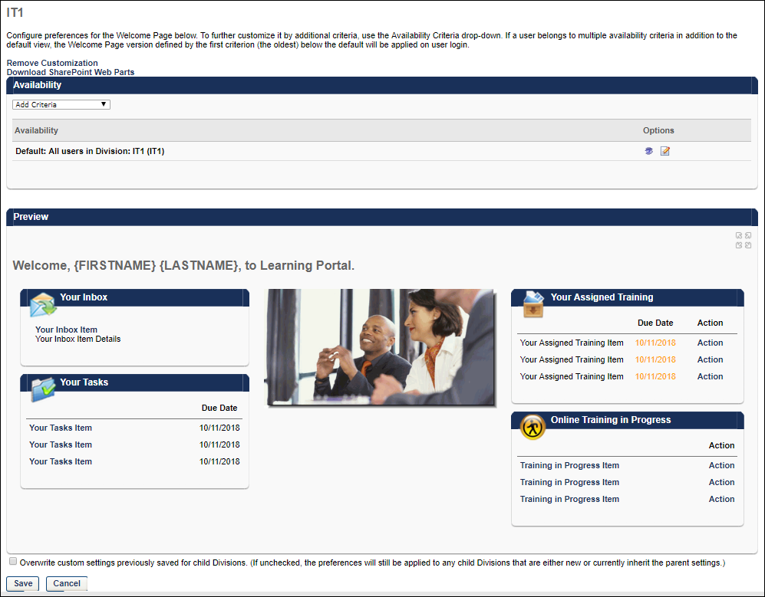
Configure Welcome Pages
The Welcome Page Preferences are configured by division. However, within each division, you can set the default preferences for that division, and you can also set additional custom preferences for specific OUs or groups within that division, such as position or location. The Availability section lists each of the OUs or groups that have custom Welcome Page preferences, including the default preferences for the division.
Configure Default Welcome Page
To set the default Welcome Page preferences for the selected division, click the Edit icon in the Options column. See Custom Page Builder on page 30 for additional information.
Create Welcome Page for Particular OU
To create a custom Welcome Page for a particular OU or group, from the Availability drop-down list, select the appropriate OU type and click the pop-up icon to select the appropriate OUs or groups. The selected OUs or groups appear in the Availability list. By default, the Welcome Page preferences for the custom Welcome Page are the same as the preferences for the default division. Click the Edit icon in the Options column to customize the Welcome Page preferences for the selected OU or group. See Custom Page Builder on page 30 for additional information.
Remove Customization
When the Remove Customization link is available, it appears below the page description and above the Availability section.
The Remove Customization link is only available when editing the Welcome Page Preferences for an OU that has customized settings, which means that the OU is not inheriting the settings from it's parent OU. Administrators can identify whether the OU has custom settings when selecting the OU for which you are editing the Welcome page. If there are custom settings for the OU, then "(Custom)" is displayed next to the OU. If there are not custom settings for the OU, then the parent OU name is displayed.
Select the Remove Customization link to remove the customized preferences for the OU and any child OUs that currently inherit the settings. Any child OUs that have different customizations are not affected by this action. When this link is selected, a confirmation pop-up is displayed. Select OK to remove the customizations, or select Cancel to continue utilizing the customized preferences. Caution: Removing customization from an OU cannot be reversed.
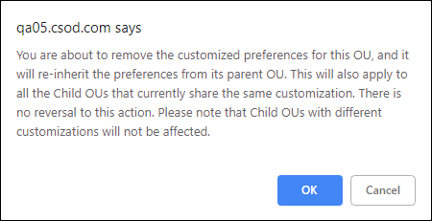
Delete Welcome Page for Particular OU
Any custom Welcome Page preferences other than the default division can be deleted by clicking the Delete icon in the Options column.
Preview Welcome Page for Particular OU
Click the View Details icon in the Options column to preview the Welcome Page for the selected OU or group. The preview is displayed in the Preview section. In the upper-right corner of the Preview section, you can click the Full Screen Preview link to view a full-screen version of the Welcome Page in a new window.
Save Welcome Page Preferences
After creating or editing a Welcome Page, click Save and Exit to return to the Welcome Page Preferences. Click Save at the bottom of the Welcome Page Preferences page to save any changes made to your Welcome pages.

Welcome Page Availability Not By Division
Welcome pages can be customized by Position, Grade, Cost Center, Location, Group, Self Registration Group or User. Welcome pages can be customized for any of these OUs within the top node parent division or within any of the subordinate child divisions. For example, to create a custom Welcome Page for all users assigned to a particular Position, set availability, set availability for that position at the top node parent division. To create a custom page for one position at a subordinate of the parent only (for example, only Admin Assistant in Finance) set availability for that position at the subordinate division.
Important: If a user is in multiple OUs that have customized Welcome pages, the Welcome page that the user sees is determined by the order in which the user's OUs were created. The user sees the Welcome page that is associated with the OU that was created first. For example, if there is a page that is available to the Marketing Cost Center OU and the Content Management Position OU, which page the user sees is dependent on whether the Marketing Cost Center OU or the Content Management Position OU was created first. Because of this, if an organization is using multiple custom Welcome pages, it is a best practice that the availability of these pages is determined using groups that are mutually exclusive. This enables the organization to control which page each user sees.
Permissions
PERMISSION NAME | PERMISSION DESCRIPTION | CATEGORY

Welcome Page Preferences - Manage | Grants ability to configure the look and feel of the Welcome Page that users see upon logging in to the portal. This permission can be constrained by OU and User's OU. This is an administrator permission. | Core Administration
- Select division from hierarchy.
- Select OU type for which to create custom page by selecting type from availability drop-down menu for Position, Grade, Cost Center, Location, Group, Self Registration Group or User.
- Click search icon to select the specific OU. Search OUs by Name, Owner, or ID. Enter full or partial information and click Search.
- Select the appropriate OUs and click Done when all are selected.
- The Selected OUs appear individually in the Availability section. You can then customize the Welcome Page preferences for each OU in the Availability section by clicking the View Details icon . This refreshes the Preferences page to display the preferences for the highlighted OU. Any changes that are made are applied only to the selected OU. Verify you are changing welcome page preferences for the selected OU in the header.
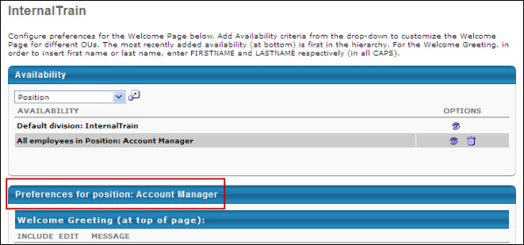
- Modify the Welcome Page preferences as desired. See Welcome Page Preferences on page 150 for additional information.

Display Preferences Overview

Corporate Preferences
Corporate Preferences contains the corporate logo, support information, and additional corporate settings.
To manage Corporate Preferences, go to Admin > Tools > Core Functions > Core Preferences > Corporate Preferences.
Permissions
PERMISSION NAME | PERMISSION DESCRIPTION | CATEGORY

Corporate Preferences - Manage | Grants the ability to manage Corporate Preferences, which includes several portal-wide settings. This is an administrator permission. | Core Administration

Corporate Preferences: Lockout Preferences - Manage | Grants ability to configure the Lockout Preferences on the Corporate Preferences page. This permission cannot be constrained. This is an administrator permission. | Core Administration

Support Information - Manage | Grants ability to manage Support Information, which includes specifying an email address and phone number for end users to contact for portal support. This permission works in conjunction with the Corporate Preferences permission. This is an administrator permission. | Core Administration
Header Logo
This section enables you to configure a header logo for your portal.
From the Select Logo drop-down list, select a previously uploaded corporate logo. When a logo is selected, the selected image is displayed in the Logo field.
To remove the selected logo, click the Remove button below the logo image.
To upload a new logo, in the Upload New Header Logo section, click the Browse button. After browsing to and selecting the new image, click the Upload button. After uploading the image, you can select the image from the Select Logo drop-down list. The maximum file size for logo images is 1 MB, and must be of type .png, .gif, .jpg, or .bmp.
After modifying the header logo, click Save to save the modifications.
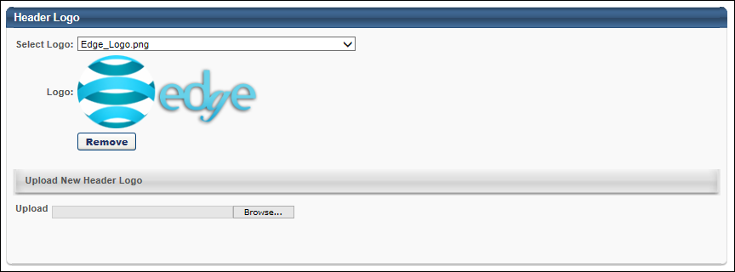
Support Information
The Support Information is accessible from the Feedback link at the bottom of each screen. This information allows users to send feedback via email and displays a central contact number for support.
To modify the support contact information, in the Support Email and Support Phone fields, enter the appropriate support email address and phone number.
Preferences
In the Preferences section, you can view the current compensation currency for the system. You can also customize the Absent Status display. The Absent Status display can also be localized into different languages if multiple languages are available for the portal.
In the Compensation Currency field, the currency that is used to manage compensation is displayed.
In the Absent Status field, enter a new display name for the Absent Status. This display name appears on the My Account page for a user that is absent and unable to access the system. When a user is set as Absent, any approval requests they receive is deferred to the absent user's manager. By default, this is set to On Vacation. This field accepts Unicode characters and the character limit for this field is 100.
- If multiple languages are enabled for your portal, select the Translate icon to translate the field into other available languages.
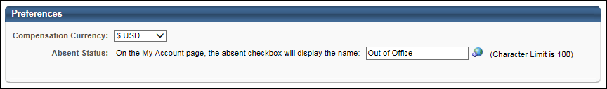
Default Email Address Settings
The following settings are available in the Default Email Address Settings section:
- Create From Address - Select this link to enter a default From Address for the portal. Default From Addresses are automatically populated in the From Address field when creating a new email in Email Management or Marketing Communications. The From Address is the email address that appears as the sender's email address when the email is sent. Note: It may take a few minutes for this value to update.
- Create Reply-To Address - Select this link to enter a default Reply-To Address for the portal. Default Reply-To Addresses are populated in the Reply-To Address field when creating a new email in Email Management or Marketing Communications. The Reply-To Address is the email address that any reply messages are sent to if someone replies to the email.
An Active setting is available for each email address.
- When a default email address is active, the email address can be selected when creating or updating an email in Email Administration and in Marketing Communications. The email addresses can be modified.
- When a default email address is inactive, the email address is not available when creating or updating an email address in Email Administration and in Marketing Communications. The email address cannot be modified or deleted. However, the email address remains associated with any existing emails and templates for which they have been selected. This ensures the email address is not used for new emails and templates but does not impact any existing emails.
Up to 10 default From and Reply-To addresses can be added.
Only active email addresses can be deleted.
Updating or removing email addresses from these setting only impact newly created emails and templates. Existing emails and templates are unaffected. In order to update an existing email or template, they must be updated manually within the email or template.
A Modification History is available for auditing purposes or to aid in troubleshooting.
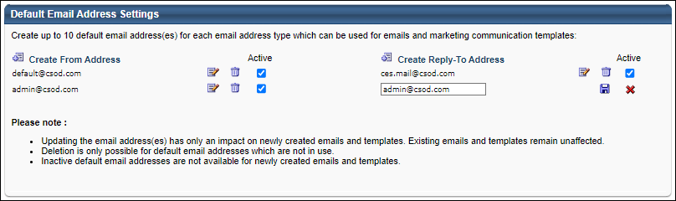
Portal Name Configuration
The portal name is displayed in the browser header or browser tab. For example, "Realize Your Potential: [Portal Name]" appears in the browser header or browser tab when accessing the system.
The Portal Name field determines what portal name is displayed in the browser header or browser tab.
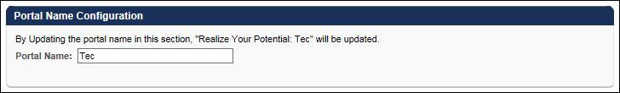
Goals General Settings
This section is only available for organizations that are using the Performance or Careers solution.
This section enables you to configure general settings related to the Goals functionality. The following options are available:
- Goals preferences and configuration respect the goal owner's OU. - When this option is selected, the goal owner or goal assignee's Goal Preferences and Goal Configurations are applied in Universal Profile Snapshot, Goals, and Goal Rating steps within performance reviews. Shared goals respect the goal owner's preferences and configurations. When this option is selected or deselected, the new setting is applied to all goals. This option is enabled by default.
Lockout Preferences
An account becomes locked if a user unsuccessfully attempts to log in to their account a certain number of times within a certain amount of time. When an account is locked, the user cannot access their account for a certain duration of time.
Organizations should be cautious when making lockout preferences less restrictive. If portal lockout preferences are configured to be less restrictive, this increases the threat of malicious users accessing the portal. Cornerstone is not responsible for the risk to client portals when lockout preferences are less restrictive.
This section enables administrators to configure lockout characteristics for user accounts. The following options are available:
- Login Attempt Restrictions - Set the login attempt restrictions for the portal. A user's account will become locked if they exceed the selected restrictions.
  - Number of Attempts Allowed - From the first drop-down, select the number of unsuccessful login attempts a user is able to submit within the selected time frame. The default value is 5.
  - Time Frame - From the second drop-down, select the time frame during which a user is able to attempt to selected number of login attempts. The default value is 5.
- Lockout Duration - From the drop-down, select the amount of time for which a user is locked out of their account if they exceed the selected restrictions.
- Lockout Message - Enter the message that is displayed on a user's login page when their account is locked. The character limit is 200. This is required. If multiple languages are enabled for your portal, select the Translate icon to translate the field into other available languages.
Use Case:
The Number of Attempts Allowed is 5, the Time Frame is 5 minutes, and the Lockout Duration is 60 minutes. A user unsuccessfully attempts to log in to their account 4 times within 2 minutes.
- If the user waits for 5 minutes, then the time frame and the number of attempts are reset. The user is able to attempt 4 more incorrect logins without a lockout.
- If the user waits for 2 minutes and incorrectly enters their login information, then they are locked out of their account.
- If the user successfully logs in on their fifth attempt, then the time frame and the number of attempts are reset.
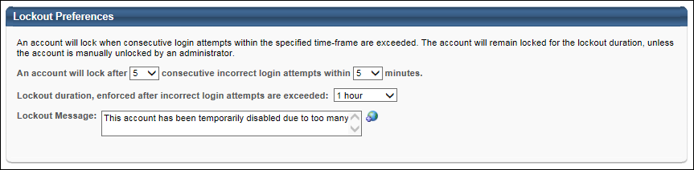

Navigational Tabs and Links
The Navigational Tabs & Links page enables administrators to customize which tabs and links are available to users in the system by Division. Administrators can rename or change the order of tabs and links.
Troubleshooting Note: System pages that are not added to the parent organizational unit's (OU) Navigation Tabs and Links are not available to add in child OU's Navigation Tabs and Links. Thus, when adding pages to a child OU's Navigation Tabs and Links, pages do not appear in the Select Page pop-up until they have been added to the parent OU's Navigation Tabs and Links. This does not apply to custom pages.
Note: When configuring the navigation tabs and links, if a user does not have access to any of the linked pages within a tab, the tab does not appear to that user in the Navigation bar.
To manage Navigation Tabs and Links preferences, go to Admin > Tools > Core Functions > Core Preferences > Navigation Tabs and Links.
Permissions
PERMISSION NAME | PERMISSION DESCRIPTION | CATEGORY

Navigation Tabs and Links - Manage | Grants ability to manage Navigation Tabs and Links for the portal. This permission can be constrained by OU, User's OU, and User's Corporation. This is an administrator permission. | Core Administration
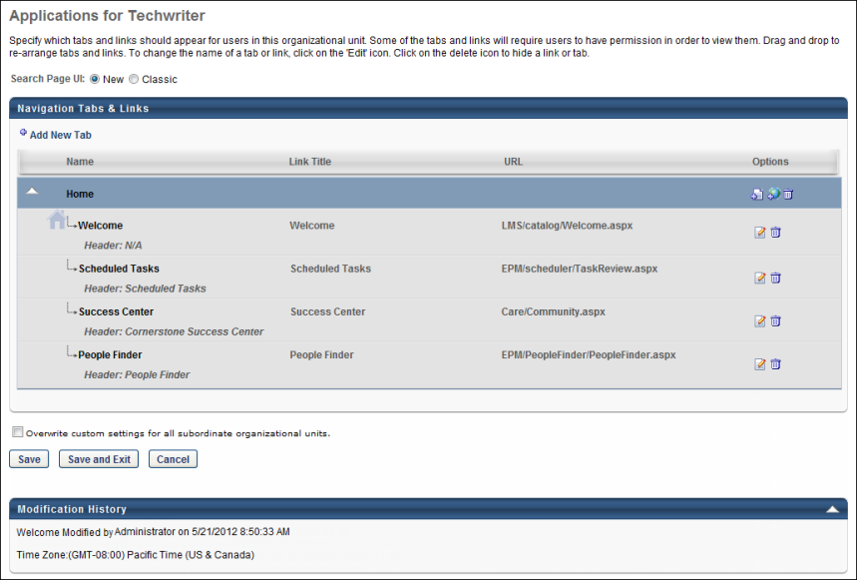
Add New Tab
Select the Add New Tab link to add a new tab to the main navigation. This opens the Add Tab pop-up. Enter the new tab name in the Name field and select the Save button. The character limit for this field is 100. By default, the new tab is added to the bottom of the page as the last tab in the navigation.
Navigation Tabs and Links Table
The following information is displayed for each navigation tab and link:
- Name - This displays the navigation tab or page name.
  - Navigation Tabs - Navigation tabs are denoted by a blue row color. Tabs are displayed in the order in which they appear in the navigation. Tab rows can be collapsed within the table by clicking the arrow to the left of the tab name. When a tab row is collapsed, the links within the tab are hidden, but the tab functionality is not affected within the system.
  - Links - Links are denoted by a gray row color. Links are displayed in the order in which they appear within the tab.
    - The link that is set as the landing page for the division is denoted by a blue home icon . A landing page must be designated. Below each link name, the page header is displayed. If the designated landing page is not available for a user as a result of permissions, the first available page in the first available tab is the user's landing page.
    - The header does not display for Welcome pages because that may vary between Welcome pages.
- Link Title - This displays the title of the link that displays to users. This field is not applicable for navigation tabs.
- URL - This displays the URL for the custom page. This field is not applicable for navigation tabs.
Navigation Tab Options
The following options are available in the Options column for navigation tabs:
- Add Page - Select this icon to add a page to the tab. This opens the Select Page pop-up. See Navigation Tabs and Links - Add Page on page 170 for additional information. The selected page is added to the bottom of the selected navigation tab. The page can then be reordered, if necessary, by dragging and dropping the page into the appropriate position.
- Edit Tab - Select this icon to edit the tab name. The character limit is 100. If multiple languages are available, translate the tab name into other available languages.
- Delete Tab - Select this icon to delete the tab. If no pages exist within the tab, the tab is removed upon click. If there is at least one page within the tab, a confirmation message appears prior to deleting the tab.
Link Options
The following options are available in the Options column for links:
- Edit Link - Select this icon to edit the link properties. This includes the link URL, title, UI, etc. The functionality varies depending on whether the page is a Welcome page, System page, or Custom page. See Navigation Tabs and Links - Edit Link on page 172 for additional information.
- Delete Link - Select this icon to remove a link from the tab. When a link is deleted, the associated page is not deleted, it is simply removed from the navigation tab. The page link can be re-added by selecting the Add Page icon in the navigation tab Options column. When a page link is deleted and then re-added, all previous settings are maintained. See Navigation Tabs and Links - Add Page on page 170 for additional information.
Browse for Training vs Browse for Training Landing Page
If the Browse for Training landing page is enabled, the Browse for Training navigation link automatically directs users to the Browse for Training landing page. The regular Browse for Training page can be added as an additional navigation link, if needed.
Within Navigation Tabs and Links, the Browse for Training landing page is named "Browse for Training Home." The regular Browse for Training page is named "Browse for Training."
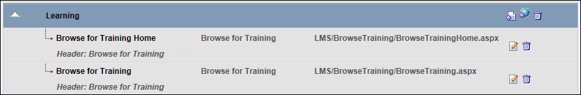
Overwrite Settings
Select this option to overwrite custom settings for child division OUs. If you overwrite custom settings for child division OUs, the selected settings are applied to both new and existing child OUs. Any previously customized child OUs are updated with the selected settings.
- If there are no customizations to the child OU, then the parent OU customizations are applied to all child OUs.
- Overwrite custom settings checkbox setting
  - If this option is selected, all child OU customizations are deleted from the database, which means the parent OU customizations will be applied to new and existing child OUs.
  - If this option is unselected, all existing child OU customizations will remain unchanged, and any new child OUs will inherit the parent OU customizations by default.
- If a child OU has been customized to display any widgets, then regardless of the parent OU customizations, the child OU customizations are applied.
- If a child OU has been customized to hide all widgets, then parent OU customizations will take precedence and will be applied.
Save Options
The following options are available at the bottom of the page:
- Save - Save all changes that were made. When this button is clicked, the administrator remains on this page.
- Save and Exit - Save all changes that were made and return to the previous page.
- Cancel - Cancel all changes made prior to the most recent Save operation. This also returns you to the previous page.
Modification History
All edits and updates made to this instance of the Navigation Tabs and Links are tracked in the Modification History section.
Related Topics
Navigation Tabs and Links - Add Page
Pages can be added to the system's navigation via the Navigation Tabs and Links preferences page.
To manage Navigation Tabs and Links preferences, go to Admin > Tools > Core Functions > Core Preferences > Navigation Tabs and Links.
To add a page to a navigation tab in Navigation Tabs and Links, click the Add Page icon in the Options column of the navigation tab row. This opens the Select Page pop-up.
Permissions
PERMISSION NAME | PERMISSION DESCRIPTION | CATEGORY

Navigation Tabs and Links - Manage | Grants ability to manage Navigation Tabs and Links for the portal. This permission can be constrained by OU, User's OU, and User's Corporation. This is an administrator permission. | Core Administration
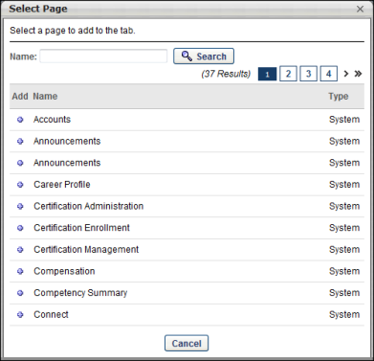
Administrators can search for pages by page name using the Search field.
The pages are listed in alphabetical order by page name and the page type (i.e., System, Custom) is listed in the Type column.
To add a page, click the plus icon to the left of the page name in the Add column. This adds the selected page to the bottom of the navigation tab to which the page was added. The page can then be reordered, if necessary, by dragging and dropping the page into the appropriate position.
Troubleshooting Note: System pages that are not added to the parent organizational unit's (OU) Navigation Tabs and Links are not available to add in child OU's Navigation Tabs and Links. Thus, when adding pages to a child OU's Navigation Tabs and Links, pages do not appear in the Select Page pop-up until they have been added to the parent OU's Navigation Tabs and Links. This does not apply to custom pages.
Navigation Tabs and Links - Edit Link
When editing a page link, the available options vary depending on whether you are editing a Welcome page, System page, or Custom page.
To manage Navigation Tabs and Links preferences, go to Admin > Tools > Core Functions > Core Preferences > Navigation Tabs and Links.
To edit a navigation link's properties, select the Edit Link icon in the Options column of the navigation link row. This opens the Edit Link pop-up.
Permissions
PERMISSION NAME | PERMISSION DESCRIPTION | CATEGORY

Custom Pages - Manage | Grants access to create and edit custom pages for the portal. This permission cannot be constrained. This is an administrator permission. | Core Administration

Navigation Tabs and Links - Manage | Grants ability to manage Navigation Tabs and Links for the portal. This permission can be constrained by OU, User's OU, and User's Corporation. This is an administrator permission. | Core Administration

Welcome Page Preferences - Manage | Grants ability to configure the look and feel of the Welcome Page that users see upon logging in to the portal. This permission can be constrained by OU and User's OU. This is an administrator permission. | Core Administration
Welcome Page
To edit the Welcome page, click the Edit Page link in the upper-left corner. This opens the Welcome Page Administration page. This option is only available for users with the Manage Welcome Pages permission.See Custom Page Builder on page 30 for additional information.
From the language drop-down, select the language for which you are editing the Link Title field.
The page URL value is displayed, but cannot be modified.
Set the following options:
- Link Title - Set the link title. This is the text users see for the link in the navigation menu. The character limit is 100. Header and description values are modified at the page level, so they do not appear in this pop-up.
- UI - Select whether the page user interface is the New UI or Classic UI. Note: This option is only available for portals that are using the old Welcome Page Designer tool.
- Set as homepage - Select this option to set this page as the portal homepage. Any page can be set as a homepage.
Click Save to save the page link settings. Click Cancel to discard the changes.
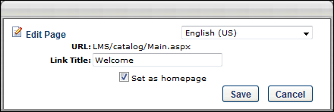
System Page
From the language drop-down, select the language for which you are editing the Link Name, Page Header, and Page Description fields.
The page URL value is displayed, but cannot be modified.
Set the following options:
- Link Title - Set the link title. This is the text users see for the link in the navigation menu. The character limit is 100.
- Page Header - Enter the page header. The character limit is 100. Note: The page header cannot be changed for the Hiring Dashboard page, Add External Training page, Learner Home, Learning Search, or pages that are built with the new Cornerstone design and user interface (UI).
- Page Description - Enter the page description. The character limit is 1000. Note: When editing a page that is built with the new Cornerstone design and user interface (UI), such as the Recruiting module and New Connect, the description that is entered in the Page Description field does not appear on the page. Administrators can tell whether a page is using the new UI by reviewing the page URL. If the URL contains "phnx" at the beginning of the URL, then this indicates that it uses the new UI.
- UI - Select whether the page user interface is the New UI or Classic UI. Note: This option is only available for system pages if the Classic UI is still available for the page.
- Set as homepage - Select this option to set this page as the portal homepage. Any page can be set as a homepage.
Click Save to save the page link settings. Click Cancel to discard the changes.
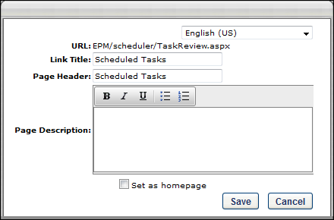
Custom Page
To edit the Custom page, click the Edit Page link in the upper-left corner. This opens the Page Designer Tool for this custom page. This option is only available for users with the ability to manage custom pages. See Custom Page Builder on page 30 for additional information.
From the language drop-down, select the language for which you are editing the Link Name field.
The page URL value is displayed, but cannot be modified.
Set the following options:
- Link Title - Set the link title. The character limit is 100.
- Page Header - The page header is displayed, but cannot be edited because it is managed at the page level.
- Page Description - The page description is displayed, but cannot be edited because it is managed at the page level.
- Set as homepage - Select this option to set this page as the portal homepage. Any page can be set as a homepage.
Click Save to save the page link settings. Click Cancel to discard the changes.
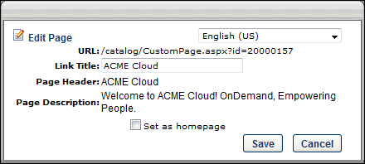

Display Preferences
Display Preferences define the corporate logo and particular color scheme (e.g., tabs, links navigation bar) to be displayed on the portal, and allow the administrator to customize the look and feel of the portal so that the system accurately reflects the corporate identity. The Display Preferences can be defined at the Organizational Unit level, so Administrators have the flexibility to define these settings according to the varying brand images or preferences of specific levels or groups within the organization. By using familiar and engaging Display Preferences, users can more readily recognize and accept the system as part of their standard corporate experience.
Note: When changing the display settings for your portal, it may take a few minutes before the new settings are fully implemented. If the new settings do not take effect after a few minutes, you may need to clear the temporary Internet files for your Internet browser.
To access Display Preferences, go to Admin > Tools > Core Functions > Core Preferences > Theme and Logo.
Permissions
PERMISSION NAME | PERMISSION DESCRIPTION | CATEGORY

Corporate Logo List - View | Grants access to select header logo from the corporate list of images. User must also have Display Preference permission. This is an administrator permission. | Core Administration

Display Preferences - Manage | Grants ability to configure Display Preferences, including Navigation Tab theme and settings and header logo displayed to end users. This is an administrator permission. | Core Administration

Display Preferences - Upload Logo | Grants access to upload an image on the Display Preference Page. User must also have Display Preference permission. This is an administrator permission. | Core Administration
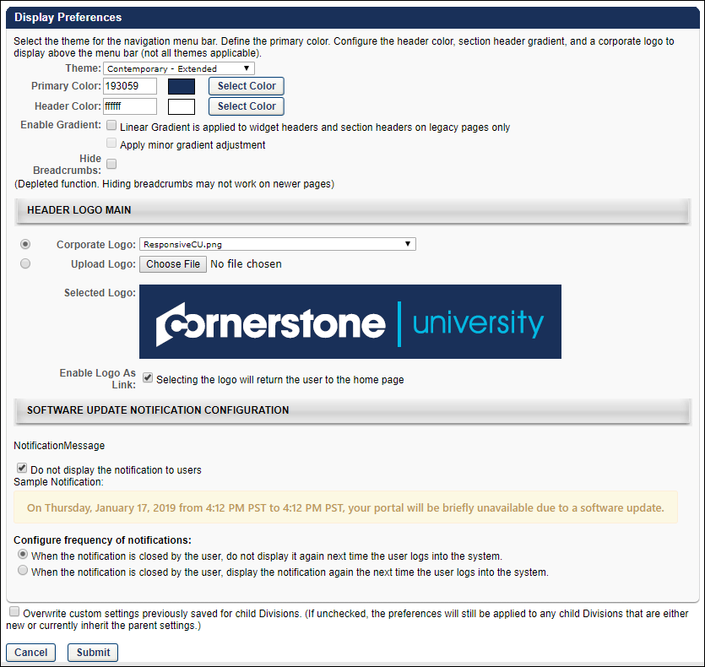
Display Preferences
The following options are available:
- Theme - From the drop-down list, select a theme. Themes include Contemporary - Extended, Eggshell - Extended, None - Hide Navigation, and Responsive Navigation. After saving the Display Preferences, you may have to log out and then log back in to the system to view the new settings. See Theme Header on page 180 for additional information.
  - When the "None - Hide navigation" theme is selected and the preferences are saved, users in the affected OUs can no longer see or access the navigation bar. All of the configurations and settings defined in the Navigation Tabs and Links preferences are ignored and users can only access pages which have links that are available on their Home page.
  - Important: When selecting the "None - Hide navigation" theme, it is not recommended to use this option across the entire portal, as it prevents system administrators from accessing many of the administrative features needed for portal configuration. If this occurs, contact Global Customer Support to correct the setting.
- Primary Color - Select the primary color for your portal. The primary color dictates the color of the navigation bar and table headers. You may enter a hex value for the color or select a color by clicking the Select Color button. All styles allow a second color to display above the navigation bar. The default font is Arial.
- Header Color - Select the header color for your portal. You may enter a hex value for the color or select a color by clicking the Select Color button. All styles except the Responsive Navigation theme allow a second color to display above the navigation bar. The default font is Arial. To remove a color from the header space, select the white color.
  - Important: When using the Responsive Navigation theme, the Header Color field is not applicable and is hidden.
- Enable Gradient - Linear Gradient is applied to widget headers and section headers on legacy pages only - Select this option to enable a linear gradient to widget headers and section headers. When the color gradient is enabled, colors in the interface transition smoothly. If this option is deselected, the widget headers and section headers are a solid color. This only impacts legacy pages.
- Enable Gradient - Apply minor gradient adjustment - Occasionally, when a linear color gradient is applied (via the above option), the colors may appear a bit distorted. If this occurs, organizations may select this option to adjust the colors so that they appear more aesthetically pleasing.
- Hide Breadcrumbs - Select this option to hide the breadcrumb links from view on older pages. This option does not work on newer pages. The breadcrumbs are the links that appear below the navigation bar and display the breadcrumbs for the current page. You can click the various links within the breadcrumbs to navigate to that page.
Header Logo Main
Select a main header logo for the portal:
- Corporate Logo - From the drop-down list, select a logo that has previously been uploaded.
  - When using the Responsive Navigation theme, the recommended image size is 88 x 750 pixels, the minimum image height is 88 pixels, and the maximum image width is 750 pixels.
- Upload Logo - Click Browse to upload a logo image from your computer. After selecting the logo image, click Upload to upload the image to the portal. The maximum file size for logo images is 1 MB, and must be of type .png, .gif, .jpg, or .bmp.
Enable Logo as Link - When this option is selected, the portal logo in the upper-left corner of the page becomes a link to the portal Home page. This logo is always visible to users, so selecting this option provides a convenient way for users to return to the Home page.
- If the "None - Hide navigation" theme is selected for an OU, it is strongly recommended that the header logo be configured as a clickable link, as this enables the user to return to the Welcome page at any time.
Header Logo Icon
When the Theme is set to Responsive Navigation and the Display Preferences are saved, a Header Logo Icon section is available the next time the Display Preferences page is opened. This section enables the administrator to configure the header logo icon that is displayed when the system is viewed on a smaller device, such as a mobile phone. This section contains the same options as the Header Logo Main section. The Header Logo Icon image is displayed when a user is viewing the portal in a browser window that is smaller than 768 pixels wide.
The header icon image must be a square, meaning that the image height must be equal to the image width. The recommended image size is 88 x 88 pixels, and this is also the minimum image height and width.
If no main header logo image is selected and no header icon image is selected in Display Preferences, then the portal name is displayed in place of the logo.
Software Update Notification Configuration
Cornerstone OnDemand can set messages to appear within the portal to directly notify users of upcoming system patches and releases. The message content and duration is controlled by Cornerstone and cannot be customized. Administrators have the ability to configure whether the messages are displayed to users and the frequency of notifications.
- Notifications for release deployments are displayed approximately five days prior to the deployment date.
- Notifications for patch deployments are displayed approximately three days prior to the deployment date.
- Notifications are not displayed for unplanned down time and system maintenance.
The following options are available to configure software update notifications:
- Do not display the notifications to users - This option determines whether or not system update notifications are displayed to users. When this option is selected, software update notifications do not display to users at any time. This option is unchecked by default.
- Configure frequency of notifications - When software update notifications are displayed to users, the notification appears below the navigation tabs and links upon accessing the system, and Cornerstone determines the time at which the notification no longer appears. During the display window, the message continues to appear across pages when the user navigates from one page to another. However, the notification can be closed by the user. This option enables the administrator to configure whether or not the notification appears to the user the next time the user logs in to the system during the display window.
  - When the notification is closed by the user, do not display it again next time the user logs into the system - When this option is selected, once the user closes the notification, it no longer appears to the user the next time the user logs in to the system during the display window. However, if any text changes are made to the message after the user closes the notification, then the notification will appear again in the portal.
  - When the notification is closed by the user, display the notification again the next time the user logs into the system - When this option is selected, if the user closes the notification, the notification will reappear the next time the user logs in to the system during the display window.
Submit, Cancel, or Restore Defaults
Click Submit to finalize the display preferences, Note: After saving the Display Preferences, you may have to log out and then log back in to the system to view the new settings.
Click Cancel to discard any unsaved changes.
Click Restore Defaults to restore the default system settings. This does not restore your portal's original display preferences. This button is only available if the Classic navigation theme is selected, which is no longer supported.
Overwrite Settings
Select this option to overwrite custom settings for child division OUs. If you overwrite custom settings for child division OUs, the selected settings are applied to both new and existing child OUs. Any previously customized child OUs are updated with the selected settings.
- If there are no customizations to the child OU, then the parent OU customizations are applied to all child OUs.
- Overwrite custom settings checkbox setting
  - If this option is selected, all child OU customizations are deleted from the database, which means the parent OU customizations will be applied to new and existing child OUs.
  - If this option is unselected, all existing child OU customizations will remain unchanged, and any new child OUs will inherit the parent OU customizations by default.
- If a child OU has been customized to display any widgets, then regardless of the parent OU customizations, the child OU customizations are applied.
- If a child OU has been customized to hide all widgets, then parent OU customizations will take precedence and will be applied.
Theme Header
The theme header is designed to be aligned with the user interface (UI) that is being introduced throughout the system.
To select a theme, go to Admin > Tools > Core Functions > Core Preferences > Display Preferences. Then, from the Theme drop-down, select the appropriate theme.
Permissions
PERMISSION NAME | PERMISSION DESCRIPTION | CATEGORY

Display Preferences - Manage | Grants ability to configure Display Preferences, including Navigation Tab theme and settings and header logo displayed to end users. This is an administrator permission. | Core Administration
Header
The header consists of the following items:
Corporate Logo
The corporate logo functionality is unchanged from other themes. The corporate logo can be configured within Display Preferences. See Display Preferences on page 175 for additional information.
Search Bar
The Search bar utilizes Global Search. As the user enters a search query into the Search field, predictive search results appear in a menu below the field. Predictive search results appear for each search category where there are relevant results.
- People - People results display the corresponding user photos, if available. The user's position is displayed below their name, if available.
- Training - Training results have corresponding LO icons.
- Certifications - Certification results have a Certification icon.
- If there are no relevant results for a category, then the corresponding category heading does not display.
A maximum of five relevant results appear for each category. Search results are displayed in order of relevancy.
Users can click a predictive search result to go directly to the Global Search results page. Users can also click the magnifying glass icon or press the [Enter] key to open the Global Search page and view the search results. See Global Search Page for additional information.
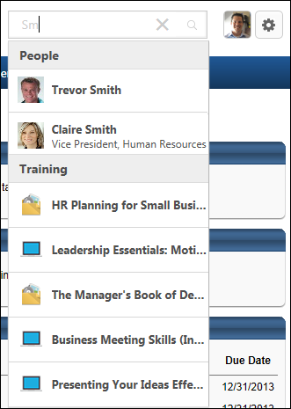
User Photo
The user photo for the logged in user displays to the right of the Search bar. Click the photo to open the Universal Profile - Bio page. The photograph is only available to users who have permission to view the Universal Profile - Bio page. See Bio - About Overview for additional information.
Shopping Cart Icon
If the shopping cart is enabled, then the Shopping Cart icon provides quick access to the shopping cart and also allows users to view the items in the shopping cart.
A red indicator appears in the upper-right corner of the icon if there are items in the user's shopping cart. The maximum value that is displayed is 99. If more than 99 items are in the shopping cart, then 99+ is displayed.
Users can click the Shopping Cart icon to open the shopping cart. See Shopping Cart for additional information.
Users can hover the computer cursor over the Shopping Cart icon to view the items in the shopping cart. Training items have corresponding LO icons. A maximum of three items are displayed. A View Cart button is also displayed. Users can click this button to open the shopping cart.
Settings Icon
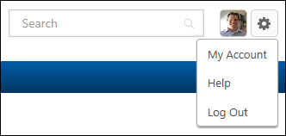
The Settings icon provides quick access to the following options:
- My Account - Click this option to open the My Account - Preferences page. This option is only available if My Account is enabled for the portal and the user has permission to edit their My Account preferences. See My Account - Preferences for additional information.
- Help - Click this option to open the Online Help topic that corresponds with the system page that is currently being viewed. This option is only available if Online Help is enabled for the security role.
- Log Out/Log In - Click this option to log in or out of the system. The Log in option is only available for organizations using the extended enterprise functionality.
- Register - Click this option to register as a user. This option is only available for guest users.
Extended Theme User Experience
The Extended themes deliver full WCAG/508 compliance and a more mobile-friendly experience. With the Extended themes, Cornerstone can be extended to serve more users and more devices, which extends the usage of the application. With these themes, users will have an enhanced experience and improved mobile capabilities.
Themes are configured for a division in Display Preferences. See Display Preferences on page 175 for additional information.
On Desktop
When the width of the browser window is narrowed, the navigation bar responds to the change in width by wrapping the navigation bars. This allows all tabs to remain accessible. There is no limit to the number of rows that can appear when reducing the width of the browser window.
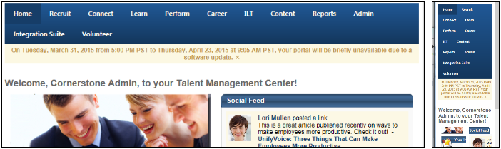
On Tablet/Mobile
When viewing the portal on a mobile device, the navigation bar wraps to allow all tabs to remain accessible.
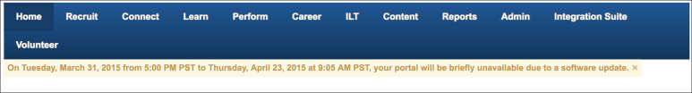
Hover Event
A hover event occurs when hovering the mouse or mousepad over a navigation tab. The hover functionality for the Extended themes is the same as the existing functionality for the non-Extended versions. When hovering over the navigation bar with a mouse, the navigation tabs expand to display the sublinks. This experience is unchanged from the non-Extended versions. This experience is applied for a desktop, laptop, and a tablet with a mouse or mousepad.
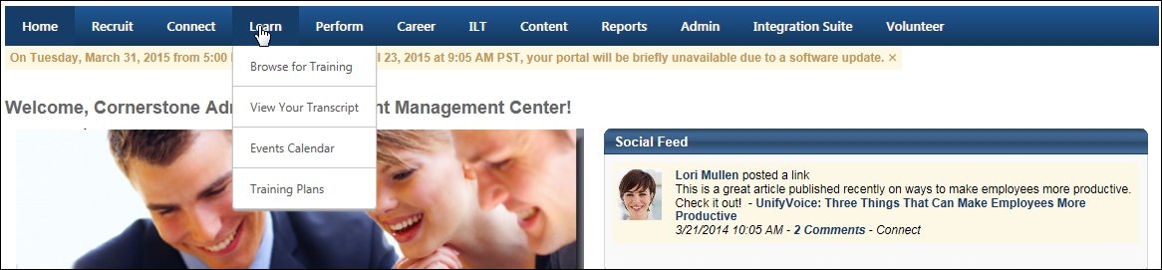
Touch Event
A touch event occurs when touching the screen interface, such as when using a smartphone or tablet. When the Extended them is enabled, tapping provides the same experience as clicking. Users can tap the navigation tabs to open the sublinks drop-down, and then tap a sublink to open the associated page. Tapping the tab again collapses the sublinks drop-down.
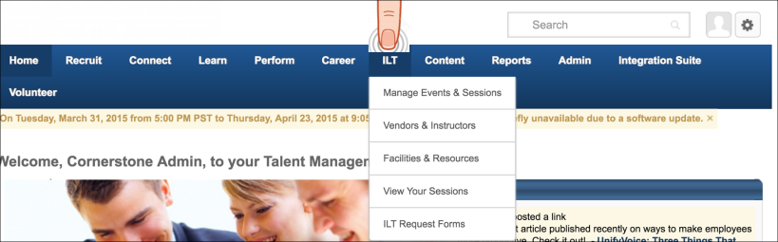
Focus Event
A focus event occurs when using the Tab key on the keyboard. The Extended themes provide enhanced functionality for use with screen readers. When using the Tab key, a border appears around the selected tab. Upon selecting the Down arrow and Enter keys on the keyboard, the tab expands to show the sublinks. This functionality is designed to provide easy navigation for users who use screen readers to navigate websites. This supports the WCAG and 508 compliance requirements.
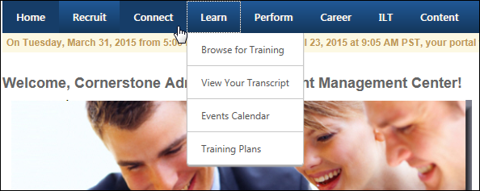
Responsive Navigation Theme User Experience
The Responsive Navigation Theme is a display theme that provides a simpler and more intuitive interaction with the system. When a user navigates throughout the application on a mobile, tablet, or desktop browser, the navigation responds to the appropriate browser size and provides the user with an optimal experience on a responsive page.
Themes are configured for a division in Display Preferences. See Display Preferences on page 175 for additional information.
When the Responsive Navigation Theme is enabled, the navigation tabs and links are hidden and can be viewed by selecting the menu icon in the upper-right corner of the page. When the menu icon is selected, the navigation tabs and links display as a fly-out on the right side of the screen that expands vertically.
Users can initiate a global search by selecting the search icon in the upper-right corner of the page.
The My Account, Help, and Log Out options are available at the bottom of the navigation menu.
Default View
Large Screen:
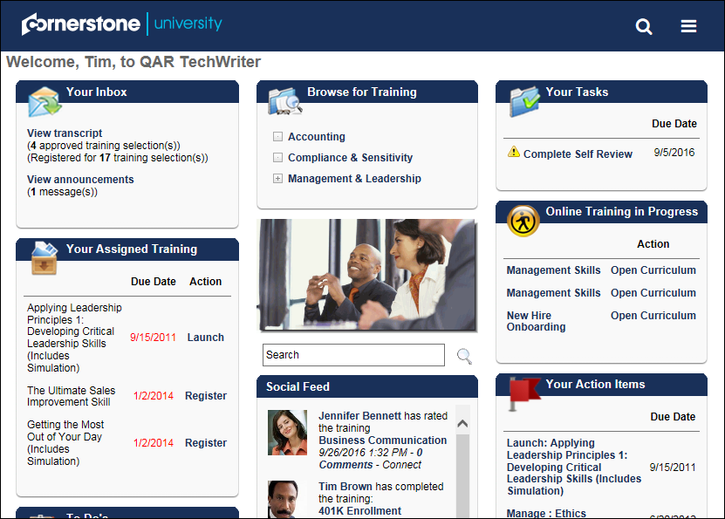
Small Screen:
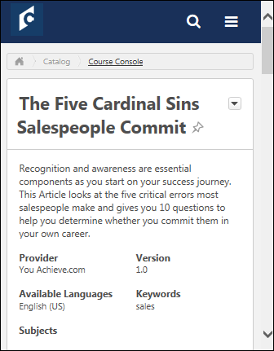
Expanded Menu View
Large Screen:
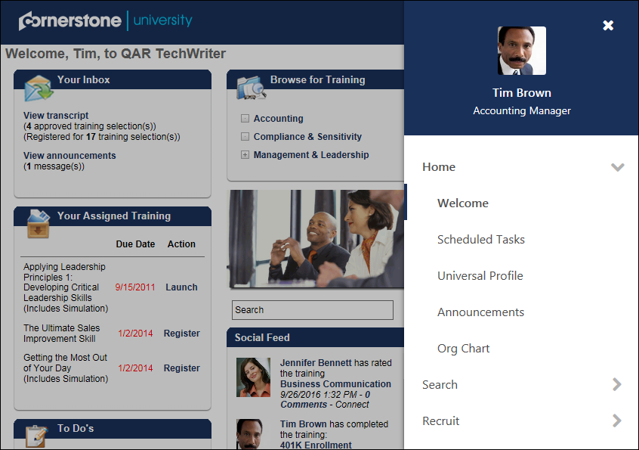
Small Screen:
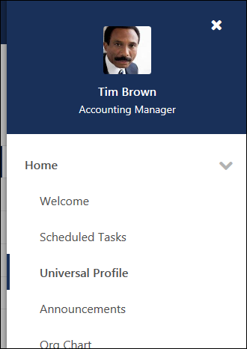
Global Search
Large Screen:
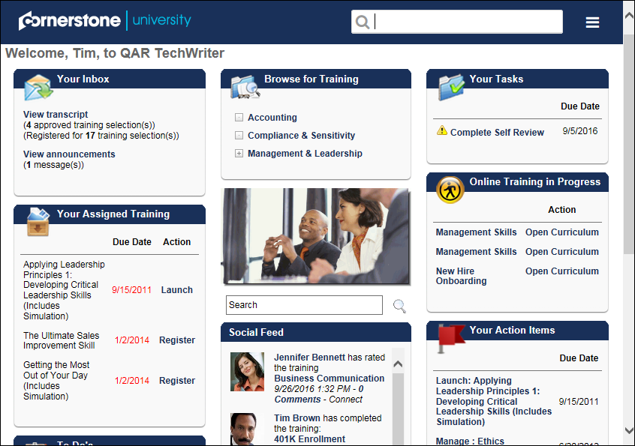
Small Screen:

Security Preferences Overview

IP Whitelist
To access the IP Whitelist, go to Admin > Tools > Core Functions > Core Preferences > IP Whitelist.
Permissions
PERMISSION NAME | PERMISSION DESCRIPTION | CATEGORY

IP White List - Sensitive Information - Manage | Grants ability to manage authorized Sensitive Information IP addresses for use with Sensitive Personally Identifiable Information (SPII) user record data from the IP Whitelist screen. This permission cannot be constrained. This is an administrator permission. | Limited Use/Obsolete

IP White List - Sensitive Information - View | Grants ability to view authorized Sensitive Information IP addresses for use with Sensitive Personally Identifiable Information (SPII) user record data from the IP Whitelist screen. This permission cannot be constrained. This is an administrator permission. | Limited Use/Obsolete

IP White List - View | Grants ability to view authorized IP addresses from the admin/preferences/IP Whitelist screen. | Limited Use/Obsolete
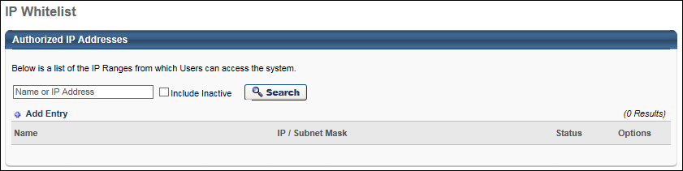
Authorized Sensitive Information IP Addresses
This functionality is only available to organizations using Cornerstone HR. Also, the availability of this functionality is controlled by a backend setting, which is disabled by default. To enable this functionality, contact Global Customer Support.
This safe list controls which IP addresses are authorized to view or edit Sensitive Personally Identifiable Information (SPII) values on a user's User Record. Administrators must have the appropriate permission to view or manage the Sensitive Information IP Whitelist.
The Authorized Sensitive Information IP Addresses section must be set up before SPII values can be viewed or edited anywhere in the system because only users whose IP addresses are listed in the Authorized Sensitive Information IP Addresses section are able to view or edit SPII values.
Cornerstone strongly suggests that organizations review the active IP addresses in their Sensitive Information IP Whitelist periodically for accuracy.

Password Preferences
Password Preferences provide clients the ability to select various combinations of settings to determine the desired password login experience. These requirements can vary by organizational unit.
The password preferences allow the administrator to specify the settings for users to change their own password, or for the system to generate an anonymous password, set the specific password requirements and allowing users to reset password by answering security questions.
To manage Password Preferences, go to Admin > Tools > Core Functions > Core Preferences > Passwords.
Permissions
PERMISSION NAME | PERMISSION DESCRIPTION | CATEGORY

Password Preferences - Manage | Grants ability to manage Password Preferences, which includes specifying the settings for users to change their own password, or for the system to generate an anonymous password, set the specific password requirements and allowing users to reset password by answering security questions. This permission can be constrained by OU and User's OU. This is an administrator permission. | Core Administration
There are tabs within the Password Preferences screen, the General tab and the Password Reset Options tab. Select the appropriate preference settings and select Submit.
Process flow for Forgot Password for User
- Click Forget Password? link on the login page.
- Enter User ID or username and click Submit.
- The user may be required to answer security questions, depending upon the Password Preferences for the user's organizational unit (OU). If a user enters the wrong password five times, the user is locked out of the system for 1 hour. If a user attempts to log in to the system while they are locked out, a lockout message is displayed even if a correct password is entered.
- User receives the User Password Change email, if enabled in Email Management.
EMAIL NAME | EMAIL DESCRIPTION | ACTION TYPE

User Password Change | This email is triggered any time a user changes their password. This email can be sent to User or User's Manager. | System Administration
Password Preferences - General
On the Password Preferences page, under the General tab, select the appropriate password options.
With regards to passwords, the following is always true:
- Passwords can never be recovered, and may only be reset or changed.
- Users always have the option to change their passwords via the My Accounts page, removing the dependence on administrators to initiate password resets.
- External users are always required to adhere to internal password preferences, if available. If a Division is not selected for the external user, then the external user must follow the password preferences of the top level Division.
- When a temporary password is assigned to a user, the temporary password must be changed upon login. Temporary passwords may be issued when a new user is created. Also, a default password may be assigned to a user via a data feed.
- Self-registered users must set their password when they register. Users created via a data feed are assigned a default password via the data feed.
See Passwords and Users Added Via Data Feed on page 210 for additional information.
See Passwords and Users Added Via Data Load Wizard on page 211 for additional information.
See Passwords and Users Added Via Users Page on page 212 for additional information.
See Passwords and Users with Single Sign-On (SSO) on page 214 for additional information.
To manage Password Preferences, go to Admin > Tools > Core Functions > Core Preferences > Passwords.
Permissions
PERMISSION NAME | PERMISSION DESCRIPTION | CATEGORY

Password Preferences - Manage | Grants ability to manage Password Preferences, which includes specifying the settings for users to change their own password, or for the system to generate an anonymous password, set the specific password requirements and allowing users to reset password by answering security questions. This permission can be constrained by OU and User's OU. This is an administrator permission. | Core Administration
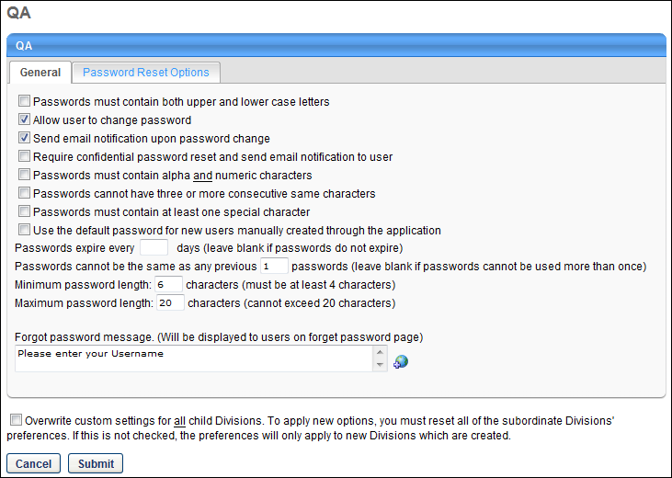
- Passwords must contain both upper and lower case letters - Select this option to require passwords contain at least one lower case letter and one upper case letter (e.g., Smile, sailinG5). Selecting this option strengthens password security.
- Allow user to change password - Select this option to allow users to change their password from My Account. See My Account - My Preferences for additional information. If this option is deselected, users do not have the ability to change their own password. As a best practice, this option should always be selected unless the affected organizational unit (OU) has SSO enabled, in which case the users do not use passwords to access the system.
- Send email notification upon password change - Select this option to generate an email to the user when the administrator changes the user's password.
  - If this option is selected and the Allow user to change password option is selected, the User Password Change email is sent to the user.
  - If the Require confidential password reset option is selected, this option does not need to be selected, because the Require confidential password option includes this functionality.
- Require confidential password reset and send email notification to user -
  - When this option is selected and an administrator resets a user's password, the administrator can only do so by sending the user a password reset email with a confidential temporary password. For this option, users must have a defined email address in their user record.
  - When this option is not selected and an administrator resets a user's password, the administrator has the option to either send a password reset email with a system-generated and confidential temporary password or to manually set a temporary password for the user. When a password is manually reset, the temporary password is not sent to the affected user. The administrator must communicate this password outside of the system. This is the best option for users who do not have an email address associated with their user record.
- Passwords must contain alpha and numeric characters - Select this option to require all passwords to be composed of both letters and numbers (e.g., Europe64, buddy4). Selecting this option strengthens password security.
- Passwords cannot have three or more consecutive same characters - Select this option to require that password not have 3 or more consecutive characters (e.g., smile333, funnn1). Selecting this option strengthens password security.
- Passwords must contain at least one special character - Select this option to require all passwords contain at least one special character (e.g., !, @, #, $). A special character is a character that is not a space, an alpha character (e.g., a, b, c), or a numeric character (e.g., 1, 2, 3). Selecting this option strengthens password security.
  - Note: Users may not use a less than symbol (<) or greater than symbol (>) in their password, as this will cause an error.
- Use the default password for new users manually created through the application - If this option is selected, then new users created from the Admin > Users page with the associated Division OU will be assigned the default password. As a result, the Reset Password pop-up is bypassed when this occurs. This setting does not affect users who are added through the Upload User Tool or User File FTP tool. The availability of this option is controlled by a backend setting. To enable this functionality, contact Global Customer Support.
- Passwords expire every XX days - Enter the number of days after which a user's password expires. For example, if this is set to 30, each user's password expires 30 days after it is set. Leave this field blank if passwords are not to expire. Setting this value strengthens password security.
- Passwords cannot be the same as any previous XX passwords - Enter the number of previous passwords that a user cannot use as the new password. For example, if this is set to 10, when setting a new password, users cannot reuse their previous 10 passwords. Setting this value strengthens password security.
- Minimum password length - Enter a minimum password length. This must be at least 4 characters.
- Maximum password length - Enter a maximum password length. This cannot exceed 20 characters.
- Forgot password message - This field allows the administrator to define the message that is displayed to users on the Forgot Password page. This field is only available when configuring the Password Preferences for the top level organizational unit. If multiple languages are enabled for your portal, select the Translate icon to translate the field into other available languages. The message is displayed to users based on their browser language settings. This field has no character limit.
Overwrite Settings
Select this option to overwrite custom settings for child division OUs. If you overwrite custom settings for child division OUs, the selected settings are applied to both new and existing child OUs. Any previously customized child OUs are updated with the selected settings.
- If there are no customizations to the child OU, then the parent OU customizations are applied to all child OUs.
- Overwrite custom settings checkbox setting
  - If this option is selected, all child OU customizations are deleted from the database, which means the parent OU customizations will be applied to new and existing child OUs.
  - If this option is unselected, all existing child OU customizations will remain unchanged, and any new child OUs will inherit the parent OU customizations by default.
- If a child OU has been customized to display any widgets, then regardless of the parent OU customizations, the child OU customizations are applied.
- If a child OU has been customized to hide all widgets, then parent OU customizations will take precedence and will be applied.
Password Preferences - Password Reset Options
On the Password Preferences page, under the Password Reset Options tab, select the appropriate password options.
To manage Password Preferences, go to Admin > Tools > Core Functions > Core Preferences > Passwords.
Permissions
PERMISSION NAME | PERMISSION DESCRIPTION | CATEGORY

Password Preferences - Manage | Grants ability to manage Password Preferences, which includes specifying the settings for users to change their own password, or for the system to generate an anonymous password, set the specific password requirements and allowing users to reset password by answering security questions. This permission can be constrained by OU and User's OU. This is an administrator permission. | Core Administration
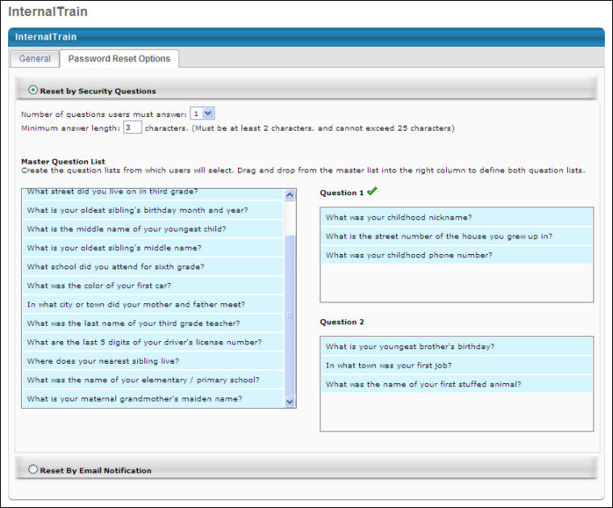
Password Reset Options: Reset by Security Questions
From the Password Reset Options tab, select the Reset by Security Questions option to have users answer security questions in order to reset their password. All security questions and responses are encrypted.
Important: The answers defined for security questions are case sensitive.
The master list of questions cannot be modified. However, organizations can choose which questions may be used as reset options.
Use the following configuration options:
- Number of questions users must answer - Select the number of security questions a user must answer in order to reset their password. The options are either 1 or 2. The number of possible login attempts and question answer attempts is hard coded to six.
  - If the administrator requires two questions and then changes the setting to require only one question, users are not prompted to reset their security questions. If a user forgets their password, they verify only one question, instead of two. If the administrator requires two questions, then changes the setting to require only one question, and then changes the setting back to two required questions, the system does not remember any answers for the user's original second question, so the user is prompted to define a second security question upon login.
- Maximum answer length - Enter the maximum number of characters a security question answer can have. This must be between 2 and 25 characters.
  - If the administrator changes the character limit, all affected users are prompted to edit their security questions and answers upon login.
- Question 1/Question 2 - Drag and drop questions from the Master Question List on the left to the right column for questions lists. You can add a maximum of 5 questions to each question list on the right side. The user will see these questions via a drop-down in the same order that you have added them to the list.
  - To remove a question from the list, drag it back to the master list. If you remove a question from the question list that a user has selected and defined as their security question, when the user logs in, they are prompted to redefine their security questions. If a question is deleted and a user forgets their password before resetting their security questions, the system uses the deleted question to verify their identity and then the user is prompted to redefine their security questions.
Password Reset for External Applicants
The security questions password reset option is bypassed for external applicants when attempting to reset their password from the Forgot Password pop-up in the career site. When the Reset by Security Questions option is enabled, the security questions are not used when external applicants attempt to reset their password. When external applicants click the Forgot password link on the Sign In page for the career site, applicants submit their login credentials, which triggers the Forget Password email, provided that the email is configured by the administrator. The administrator must include the PASSWORD.RESET.URL tag in the email, which takes applicants to the reset password page and allows them to define a new password and then access the career site.
Password Reset Options: Reset by Email Notification
Click the Reset by Email Notification option to allow users to reset their password by email notification. An email notification is sent the user. This contains a link for the user to reset their password.
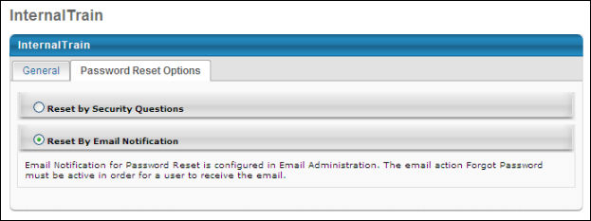
Overwrite Settings
Select this option to overwrite custom settings for child division OUs. If you overwrite custom settings for child division OUs, the selected settings are applied to both new and existing child OUs. Any previously customized child OUs are updated with the selected settings.
- If there are no customizations to the child OU, then the parent OU customizations are applied to all child OUs.
- Overwrite custom settings checkbox setting
  - If this option is selected, all child OU customizations are deleted from the database, which means the parent OU customizations will be applied to new and existing child OUs.
  - If this option is unselected, all existing child OU customizations will remain unchanged, and any new child OUs will inherit the parent OU customizations by default.
- If a child OU has been customized to display any widgets, then regardless of the parent OU customizations, the child OU customizations are applied.
- If a child OU has been customized to hide all widgets, then parent OU customizations will take precedence and will be applied.
Password Preferences - Default Password
The Default Password tab within Password Preferences enables administrators to set a portal-wide default password, change the default password, and manage default password rules such as lifespan and expiration date. Furthermore, default passwords must comply with the password complexity rules defined on the General tab in Password Preferences.
Note: This functionality is only available to organizations that have enabled default password functionality. In addition, this functionality is being rolled out in production environments in phases. See the Rollout Schedule by Swimlane section for additional details.
To manage Password Preferences, go to Admin > Tools > Core Functions > Core Preferences > Passwords.
Permissions
PERMISSION NAME | PERMISSION DESCRIPTION | CATEGORY

Password Preferences - Manage | Grants ability to manage Password Preferences, which includes specifying the settings for users to change their own password, or for the system to generate an anonymous password, set the specific password requirements and allowing users to reset password by answering security questions. This permission can be constrained by OU and User's OU. This is an administrator permission. | Core Administration
Default Password Management Tab
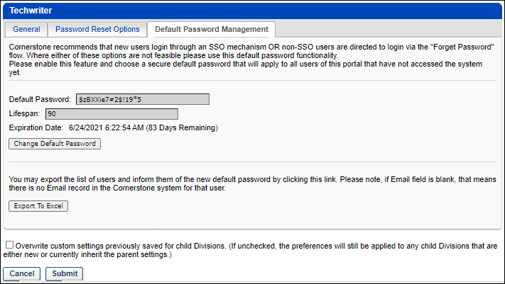
The Default Password Management tab enables organizations to view and set the default password and the lifespan of that password.
The Default Password Management tab displays the following information about the current default password:
- Default Password - This displays the current default password.
- Lifespan - This displays how long the default password is valid before a new default password must be set.
- Expiration Date - This displays the date on which the default password will expire based on the specified lifespan. If enabled, the Default Password Email Reminder Template can be used as a reminder when the default password is approaching its expiration date.
Change Default Password
Select the Change Default Password button to change the default password and set the lifespan for that password.
Enter the following information:
- Password - Enter the new default password.
- Confirm Password - Enter the new default password a second time to confirm it is entered correctly.
- Lifespan - Enter how long the default password is valid before a new default password must be set.
- Reason for Change - Specify why you are changing the default password.
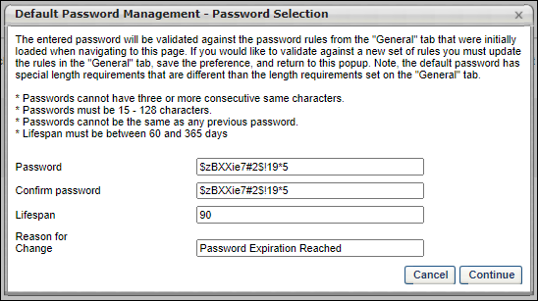
Export to Excel
Select the Export to Excel button to export the list of users who are impacted by the default password change. This includes the user's first name, last name, user ID, and email address. This information can then be used to notify the respective users of the password change.
Rollout Schedule by Swimlane
Swimlane | Date | Default Lifespan Setting
All stage swimlanes | April 20 (Start of UAT) | 90 Days
All pilot swimlanes | May 13 (May '22 Release) | 90 Days
CDG SL1  CDG SL4  FRA SL1  FRA SL4  LAX SL1  LHR SL1 | May 13 (May '22 Release) | 90 Days
AU swimlanes  JP swimlanes  LAX SL2  LAX SL5  LHR SL2 | May 27 Patch | 180 Days
All swimlanes. This includes:  - All remaining swimlanes (LAX SL3, LAX SL4, LHR SL3  - All swimlanes previously migrated (portal that have already been migrated will be skipped) | June 10 Patch | 180 Days
Rollout Implications
For the initial rollout, a default lifespan is set for the default password. Please review the Rollout Schedule by Swimlane section to view the default lifespan for your swimlane.
The default password and lifespan settings are relevant to qualified default password users and may impact the login experience. Users may receive error messages during their login process for the following related scenarios:
- The default password has expired before the user attempts to log in using the password. This scenario may occur if the user is matched with a default password that is older than the number of days defined in the lifespan of the default password preference.
- The user account setup with the default password has been disabled due to 90 days of inactivity. This scenario may occur if the user has not logged in for more than 90 days after setting the default password.
The above scenarios are only relevant to default passwords; there are no changes to existing functionality for custom passwords and lifespans applied to custom passwords are not impacted.
Based on the customer feedback, the default lifespan setting applied to portals as part of the May 27th and June 10th patch rollouts is changed to 180 days. The intention is to limit the number of potentially impacted users and related administration workload. Due to security reasons, it is highly recommended to adjust the default password lifespan setting as soon as possible and apply the lowest possible number of days.
Email Options for Password Changes
The following tables outlines the possible scenarios that may occur when a password is changed, along with the corresponding email options:
Permissions
EMAIL NAME | EMAIL DESCRIPTION | ACTION TYPE

Admin Password Change | This email is triggered when an administrator manually resets a user's password. The user's new password cannot be included in the email. Because of this, the administrator must communicate this password outside of the system. This email can be sent to User or User's Manager. | System Administration

Forget Password | If the Password Reset Option in Password Preferences is set to Reset By Email Notification, then the Forget Password email is triggered when a user clicks Forgot Password? on the Login page. This email can be sent to External User or Internal User. If the user clicks Forgot Password? multiple times and a password reset URL is included in the email, then a new URL is generated for each email and the previous URL is no longer valid.  This email must be configured for administrators to select the "Send Password Reset Email to user's email address" option when resetting a user's password on the Admin - Users page.  The PASSWORD.RESET.URL email tag is a link that opens a page on which the user can create a password. If this email is sent multiple times to the same recipient, then this URL is regenerated each time and the previous URL is no longer valid. Also, the password reset URL is only valid for 48 hours. If the user does not reset their password within the 48-hour validity period, then the user must click Forgot Password? again to get a new password reset URL.  Defining Availability  The availability settings do not apply to external users when External User is added as a recipient in the Send To field.  When Internal User is added to the Send To field, the availability settings defined in the Availability field apply to internal users based on the organizational unit (OU) to which they belong. The following rules apply by OU:  Organizational Unit Rule  Cost Center Cost Center if user is part of the Cost Center  Custom Group Custom group if user is part of the Custom Group  Division Division user belongs to  Grade Grade user belongs to  Location Location user belongs to  Position Position user belongs to  Self-Registration Group Self-Registration group if user is part of the group  User User if user is added individually | System Administration

New User Record Created (via Add User Page) | This email can be configured as a notification and is triggered when a new user record is created via the Admin - Users page. This email is not sent to users who are created via a data feed. This email can be sent to the User Created, User Creator, or the User's Manager.  The PASSWORD.RESET.URL email tag is a link that opens a page on which the user can create a password. If this email is sent multiple times to the same recipient, then this URL is regenerated each time and the previous URL is no longer valid. Also, the password reset URL is only valid for 48 hours. If the user does not reset their password within the 48-hour validity period, then the user must click Forgot Password? again to get a new password reset URL. | System Administration

User Password Change | This email is triggered any time a user changes their password. This email can be sent to User or User's Manager. | System Administration
Add a user
Is confidential password required? | Is an email notification sent? | Which email is triggered when configured? | Explanation
Yes | Yes | New User Record Created | There is no action of changing a password.
Yes | No | New User Record Created | There is no action of changing a password.
No | Yes | New User Record Created and Admin Password Change | The administrator manually defines a password. Configuring the New User Created email is not recommended for organizations with this configuration.
No | No | New User Record Created | The administrator manually defines a password. Configuring the New User Created email is not recommended for organizations with this configuration.
Admin changes the user's password
Is confidential password required? | Is an email notification sent? | Which email is triggered when configured? | Explanation
Yes | Yes | Forget Password | There is no action of changing a password.
Yes | No | Forget Password | There is no action of changing a password.
No, and the Send Forgot Password email option is selected. | Yes | Forget Password | There is no action of changing a password.
No, and the Define a temporary password option is selected. | Yes | Admin Password Change
No, and the Send Forgot Password email option is selected. | No | Forget Password | There is no action of changing a password.
No, and the Define a temporary password option is selected. | No | None
User changes their own password
Is confidential password required? | Is an email notification sent? | Which email is triggered when configured?
Yes | Yes | User Password Change
Yes | No | None
No | Yes | User Password Change
No | No | None
Passwords and Users Added Via Data Feed
This topic outlines what happens with regards to passwords when a user is added to the system via a data feed. See Data Feeds for additional information.
Two possible scenarios occur, depending on whether users are assigned a password within the data feed.
Scenario 1: User is not assigned a password
If a user is added to the system via a data feed and is not assigned a password, then an initial password is set to the default password.
Administrators are responsible for informing users of their initial passwords outside of the system. This communication may be done in person, over the phone, or through an external email system. Users should be aware that they will always be prompted to change their initial password upon logging in to the system for the first time.
Users that are added to the system via a data feed do not receive the "New User Record Created (Via Add User Page)" email.
Scenario 2: User is assigned a password
Some organizations have a custom feed process that assigns new users a specific password (e.g., the first three initials of the user's last name combined with their date of birth). Any organization that provides a customized password for each new user has established a custom feed. In these instances, there are two options for how passwords are configured:
- Password is set to expire - The new user will use the password from the data feed. Upon initial login, the user is prompted to change this password.
- Password is set to not expire - The new user will use the password from the data feed and is not required to change it.
Administrators are responsible for informing users of their initial passwords outside of the system. This communication may be done in person, over the phone, or through an external email system. Users should be aware that they will always be prompted to change their initial password upon logging in to the system for the first time.
Users that are added to the system via a data feed do not receive the "New User Record Created (Via Add User Page)" email.
See Password Preferences on page 194 for additional information.
Passwords and Users Added Via Data Load Wizard
This topic outlines what happens with regards to passwords when a user is added to the system via the Data Load Wizard. See Load Data Wizard Overview for additional information.
When an administrator loads users to the system via the Data Load Wizard, new users have their password set per the default password and Password Preferences. Please note that this also impacts users who were added to the system before the rollout of the Default Password in Password Preferences.
Administrators are responsible for informing users of their initial passwords outside of the system. This communication may be done in person, over the phone, or through an external email system. Users should be aware that they will always be prompted to change their initial password upon logging in to the system for the first time.
Users that are added to the system via a data feed do not receive the "New User Record Created (Via Add User Page)" email.
See Password Preferences on page 194 for additional information.
Passwords and Users Added Via Users Page
This topic outlines what happens with regards to passwords when a user is added to the system via the Users page. See User Record - Add.
Different scenarios occur, depending on whether the Require confidential password reset and send email notification to user option is selected in Password Preferences. See Password Preferences on page 194 for additional information.
Emails
EMAIL NAME | EMAIL DESCRIPTION | ACTION TYPE

New User Record Created (via Add User Page) | This email can be configured as a notification and is triggered when a new user record is created via the Admin - Users page. This email is not sent to users who are created via a data feed. This email can be sent to the User Created, User Creator, or the User's Manager.  The PASSWORD.RESET.URL email tag is a link that opens a page on which the user can create a password. If this email is sent multiple times to the same recipient, then this URL is regenerated each time and the previous URL is no longer valid. Also, the password reset URL is only valid for 48 hours. If the user does not reset their password within the 48-hour validity period, then the user must click Forgot Password? again to get a new password reset URL. | System Administration
Scenario 1: User is assigned default password
If the Use the default password for new users manually created through the application option is selected in Password preferences, then when a user is added to the system via the Users page with the associated Division OU, the user is assigned the default password. As a result, the Reset Password pop-up is bypassed when this occurs. The availability of this option is controlled by a backend setting. To enable this functionality, contact Global Customer Support.
Users that are added to the system via the Users page receive the "New User Record Created (Via Add User Page)" email, if configured in Email Administration.
Scenario 2: Confidential password reset is not required
If the Require confidential password reset and send email notification to user option is not selected in Password Preferences, then when a user is added to the system via the Users page, the administrator is immediately prompted to manually create a temporary password for the new user.
Administrators are responsible for informing users of their initial passwords outside of the system. This communication may be done in person, over the phone, or through an external email system. Another option is to set the temporary password the same as the value in the default password. This default password could then be communicated throughout the organization or OU.
Users should be aware that they will always be prompted to change their initial password upon logging in to the system for the first time.
Users that are added to the system via the Users page receive the "New User Record Created (Via Add User Page)" email, if configured in Email Administration.
Scenario 3: Confidential password reset is required
If the Require confidential password reset and send email notification to user option is selected in Password Preferences, then when a user is added to the system via the Users page, the new user receives the "New User Record Created (Via Add User Page)" email, if configured in Email Administration. This email contains the PASSWORD.RESET.URL email tag. Users must click the password reset link to set a new password. For this option, users must have a defined email address in their user record.
By using the link within the "New User Record Created (Via Add User Page)" email, the user can establish a unique password. No outside communication is required.
Passwords and Users with Single Sign-On (SSO)
SSO relies on a security key, rather than a password. For new users with SSO, the initial login process does not require a password.
Changes to a user's password do not impact their ability to SSO into the system. There is no security issue around users with SSO resetting their passwords.
SSO users do see the Change Password link within My Account. Although this may cause initial confusion, any password changes made by SSO users do not impact their ability to SSO into the system. Additionally, users must know their current password in order to successfully change it.
See Password Preferences on page 194 for additional information.

System Preferences Overview

Authentication Preferences
Authentication Preferences enable administrators to specify whether users authenticate/re-authenticate using their system credentials or network credentials that are validated against a client-configured Service Assertion Markup Language (SAML) server. Organizations must have SP-initiated SAML SSO implemented in their portal to utilize this functionality.
Authentication Preferences apply across all applications in which authentication is required (e.g., Training Completion, Mobile SSO).
To access Authentication Preferences, go to Admin > Tools > Core Functions > Core Preferences > Authentication Preferences.
Permissions
PERMISSION NAME | PERMISSION DESCRIPTION | CATEGORY

Authentication Preferences - Manage | Grants ability to configure which credentials are used for authentication/re-authentication purposes throughout the system. This permission works in conjunction with the preferences that are set within each workflow that uses authentication/re-authentication. This permission can be constrained by OU and User's OU. This is an administrator permission. | Core Administration
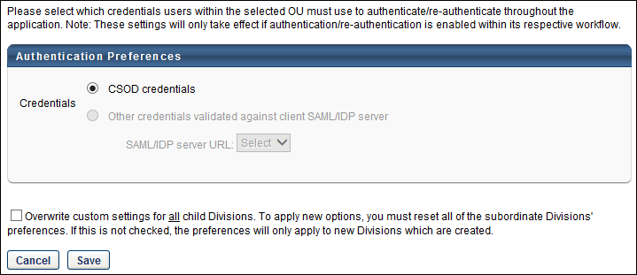
Credentials
The Credentials option enables administrators to specify whether users authenticate/re-authenticate themselves using their system credentials or network credentials that are validated against a client-configured SAML server. The settings are only applied when authentication is enabled within a workflow.
Select one of the following options:
- CSOD credentials - This option is selected by default. When this option is selected, users must authenticate themselves using their system (Cornerstone OnDemand) credentials.
- Other credentials validated against client SAML/IDP server - This option is only available when at least one SAML/IDP server has been configured in the portal. When this option is selected, users must authenticate themselves using their network credentials.
  - SAML/IDP server URL - From the drop-down menu, select the appropriate SAML/IDP server that should be used for user authentication.
Overwrite Settings
Select this option to overwrite custom settings for child division OUs. If you overwrite custom settings for child division OUs, the selected settings are applied to both new and existing child OUs. Any previously customized child OUs are updated with the selected settings.
- If there are no customizations to the child OU, then the parent OU customizations are applied to all child OUs.
- Overwrite custom settings checkbox setting
  - If this option is selected, all child OU customizations are deleted from the database, which means the parent OU customizations will be applied to new and existing child OUs.
  - If this option is unselected, all existing child OU customizations will remain unchanged, and any new child OUs will inherit the parent OU customizations by default.
- If a child OU has been customized to display any widgets, then regardless of the parent OU customizations, the child OU customizations are applied.
- If a child OU has been customized to hide all widgets, then parent OU customizations will take precedence and will be applied.
Save or Cancel
Click Save to save any unsaved changes. Or, click Cancel to discard any unsaved changes.

Duplicate User Management Preferences
When an organization using Cornerstone HR creates new users, the system can be configured to evaluate whether the new users are similar to existing user records. This is done in order to prevent the same user from being added to the system more than once.
The Duplicate User Management Preferences page enables administrators to configure which standard and custom fields are used to identify potential duplicate users. The system uses the selected fields to compare the user being added to all existing users.
This functionality is only available to organizations using Cornerstone HR.
To manage Duplicate User Management Preferences, go to Admin > Tools > Core Functions > Core Preferences > Duplicate User Management.
Permissions
PERMISSION NAME | PERMISSION DESCRIPTION | CATEGORY

Duplicate User Management Preferences - Manage | Grants ability to access and configure management of duplicate records, including parameters used to prevent duplicates. This permission cannot be constrained. This is an administrator permission. | Core Administration
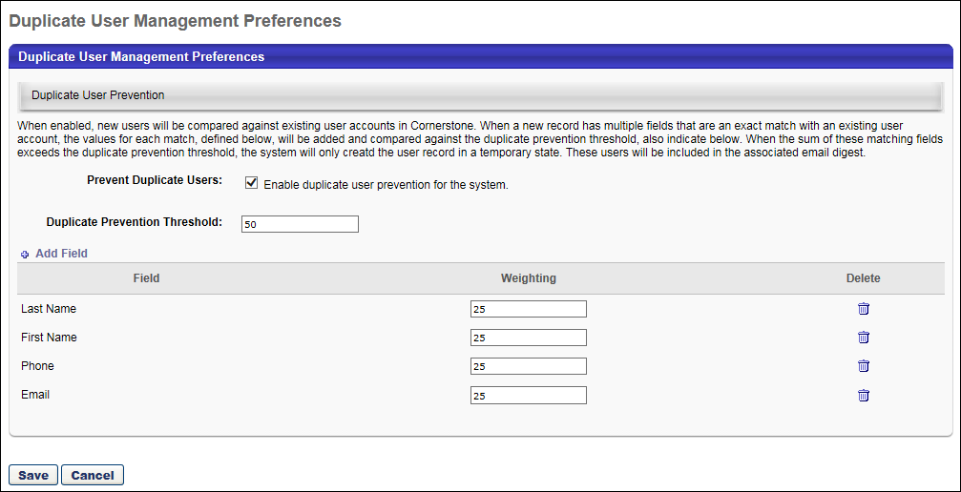
Prevent Duplicate Users
Select this option to enable the system to compare new users with existing users to determine if they are potentially the same as a user who already exists within the system.
Duplicate Prevention Threshold
When a new user record is added that has multiple fields that are an exact match with an existing user record, the weights of those fields, which are specified in the table below, are added together.
Enter the number of points above which new users are flagged as potential duplicates. This field is required when the Prevent Duplicate Users option is selected. The maximum value for this field is 999. Also, this value must be less than the sum of the Weighting values for all added fields.
Fields
This section determines which fields are used to determine whether a new user record is potentially the same as an existing user record.
Add Field
To add a field, click the Add Field link. Standard and custom user fields are available. The following field types cannot be selected: Organizational unit, employee relations, encrypted custom fields, multi-select checkbox, branched drop-down, and hierarchy.
A maximum of eight fields can be added. Also, at least one field must be added when the Prevent Duplicate Users option is selected.
Weighting
Enter the number of points that are associated with this field. When a field matches that of an existing user, then the points associated with the field are counted towards the duplicate prevention threshold. This field is required. The maximum value for this field is 999.
Remove Field
To remove a field from the duplicate user criteria, click the Trash Can icon to the right of the user. This opens a pop-up that displays available standard and custom user fields.
Save/Cancel
Select the Save button to commit any unsaved changes, including fields that are added or removed and any changes to the duplicate prevention threshold or field weighting.
Select the Cancel button to discard any unsaved changes.

Employee Recognition Preferences
The Employee Recognition Awards page allows users to manage their employee recognition awards.
To manage employee recognition awards select Admin > Tools > Core Functions > Core Preferences > Employee Recognition.
Permissions
PERMISSION NAME | PERMISSION DESCRIPTION | CATEGORY

Employee Recognition Preferences - Manage | Grants ability to create and edit employee recognition awards for use by end users. This is an administrator permission. | Core Administration
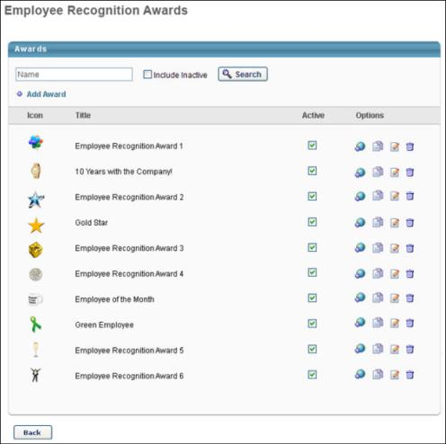
To search for an award by name, enter the award name in the search field and click the Search button. Select the Include Inactive option to also search for inactive awards.
To add an award, click the Add Award link. A pop-up appears where you specify the award name. The character limit for this field is 50. After entering a name, click the Browse button to navigate to an image for the award. Acceptable image file types are jpg, png, bmp, and gif, and the maximum file size is 1 MB. Click Save to save the award, which now appears in the list of awards. A maximum of 250 awards can be created per OU.
To make an award active or inactive, select or deselect the Active option next to the award. Awards are active when this option is selected. When an award is inactive, it is not available for selection within the system.
For each existing activity type, in the Options column you can perform the following actions:
- Localize - If multi-language is enabled, click the Globe icon to localize the activity type name. This allows you to translate the type name to all available languages. The associated award images cannot be localized.
- Copy - Click the Copy icon to duplicate the award, which can then be edited to change the title or image.
- Edit - Click this icon to edit the award name or image. This opens a pop-up where you can modify the name or select another image. Click Save to update your changes.
- Delete - Click this icon to delete the award. Users who have been given the award can still see the award in their Connect profile, My Team page, and Universal Profile - Feedback page.

Feature Activation Preferences for Core Functionality
The Core Feature Activation Preferences page enables administrators to activate and deactivate certain functionality within their portal.
The Feature Activation Preferences in Core Preferences is only available if activation preferences are available. After all features are enabled, this page may only be available once another feature is available for activation in the future.
To access Feature Activation Preferences, go to Admin > Tools > Core Functions > Core Preferences > Feature Activation Preferences.
Permissions
PERMISSION NAME | PERMISSION DESCRIPTION | CATEGORY

Core Features Activation | Grants ability to manage Core Feature Activation Preferences in which administrators can enable and disable certain features. This permission cannot be constrained. This is an administrator permission. | Core Administration
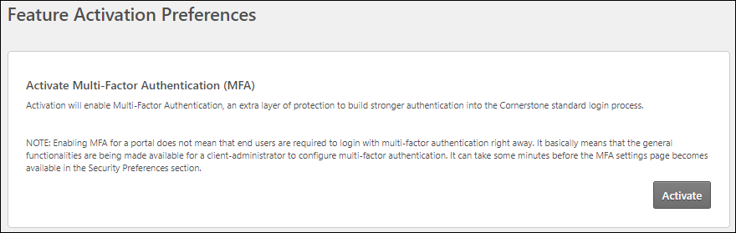
Activate Multi-Factor Authentication (MFA)
Multi-factor authentication (MFA) is a method in which users must verify their identity in multiple ways to log in to the system, such as user name, password, and authentication code.

Language Preferences
The Language Preferences is used to select a default language for users. Additionally, administrators can choose whether users are able to change the language in which their portal is displayed.
To manage Language Preferences, go to Admin > Tools > Core Functions > Core Preferences > Languages.
Permissions
PERMISSION NAME | PERMISSION DESCRIPTION | CATEGORY

Language Preferences - Manage | Grants ability to set default language for portal/OU and set whether end users may adjust their own portal display language. This is an administrator permission. | Core Administration
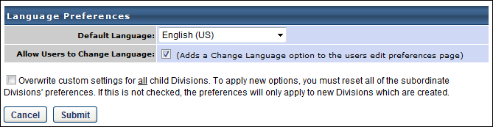
Default Language
From the drop-down menu, select the default language for the portal or organizational unit (OU).
Allow Users to Change Language
Select this option to allow users to change their portal language. When enabled, users can change their display language from the Preferences tab within My Account. See My Account - Preferences - Settings.
Available Languages
A list of all available languages is available within Online Help. See Globalization Overview.
Overwrite Settings
Select this option to overwrite custom settings for child division OUs. If you overwrite custom settings for child division OUs, the selected settings are applied to both new and existing child OUs. Any previously customized child OUs are updated with the selected settings.
- If there are no customizations to the child OU, then the parent OU customizations are applied to all child OUs.
- Overwrite custom settings checkbox setting
  - If this option is selected, all child OU customizations are deleted from the database, which means the parent OU customizations will be applied to new and existing child OUs.
  - If this option is unselected, all existing child OU customizations will remain unchanged, and any new child OUs will inherit the parent OU customizations by default.
- If a child OU has been customized to display any widgets, then regardless of the parent OU customizations, the child OU customizations are applied.
- If a child OU has been customized to hide all widgets, then parent OU customizations will take precedence and will be applied.
Submit
Select the Submit button to save any changes to the Language Preferences.

Mobile Preferences
The Mobile Preferences page enables administrators to manage the features that are available to users on the Cornerstone CSX application.
Mobile Preferences can be set by Division, so different mobile preferences such as Theme can be configured for each Division.
Note: Users can download and use the Cornerstone CSX app from both the Apple App store and the Google Play store.
To access Mobile Preferences, go to Admin > Tools > Core Functions > Core Preferences > Mobile.
Permissions
PERMISSION NAME | PERMISSION DESCRIPTION | CATEGORY

Mobile Preferences | Grants ability to manage Mobile Preferences. This permission cannot be constrained. | Mobile
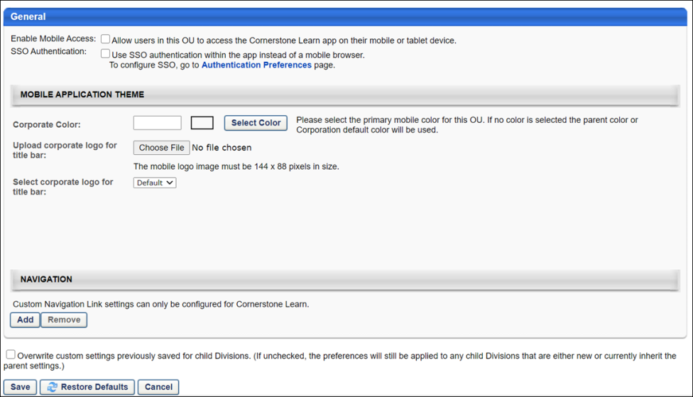
Enable Mobile Access
Select or deselect the Enable Mobile Access option to enable or disable the Cornerstone CSX application.
SSO Authentication
When this option is selected, when a user attempts to log in to the mobile application via SSO, the authentication occurs within the mobile application rather than a mobile browser. When this option is not selected, the authentication occurs in a mobile browser. By default, this option is not selected.
Mobile Application Theme
The Mobile Application Theme section allows administrators to define a custom theme for the Cornerstone CSX app. Configure the following options to customize the app theme and logo:
- Corporate Color - This option enables administrators to define the primary color which will be used on the Log In screen for both iOS and Android, and in the apps navigation on Android. Enter the hex value in the alphanumeric text box. Or, select a color by clicking the Select Color button.
- Upload corporate logo for title bar - This option enables administrators to upload a logo. Click Browse to upload a logo image from your computer. The image dimensions must be 144 x 88 pixels. Please see the section below for other guidelines on how to create your logo for the app. After selecting the logo image, click Upload to upload the image to the portal.
- Select corporate logo for title bar - This option enables administrators to select a previously uploaded logo. From the drop-down list, select a logo that has previously been uploaded.
Logo Guidelines
See the infographic below for more logo image guidelines:
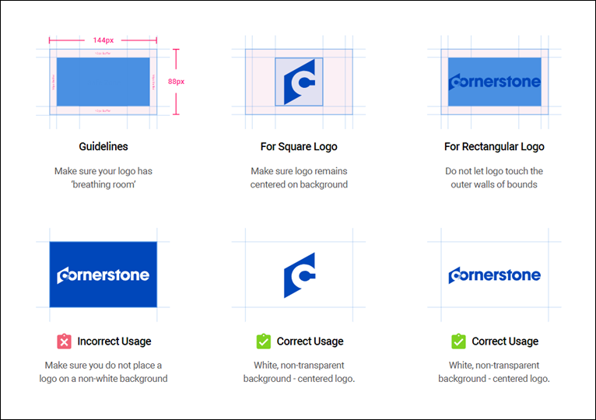
Mobile Application Theme Impact
The branding and customization options you configure via Mobile Preferences have the following impact on the Cornerstone CSX app:
Android
Your Mobile Application Theme configurations in Mobile Preferences impact the Android version of the Cornerstone CSX app pages and features in the following ways:
- The top navigation bar of the app changes to the chosen corporate color.
- The Log In button for the app changes to the chosen corporate color.
- The logo you uploaded displays in the navigation drawer and on the Log In page. Note: If no logo has been provided via Mobile Preferences, the Cornerstone log displays by default.
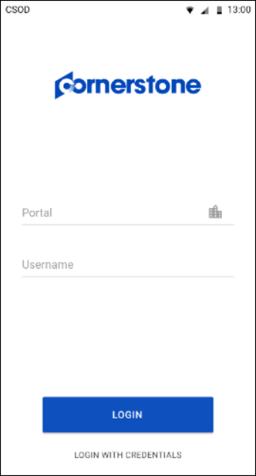

iOS
Your Mobile Application Theme configurations in Mobile Preferences impact the iOS version of the Cornerstone CSX app pages and features in the following ways:
- The Log In button for the app changes to the chosen corporate color.
- The logo you uploaded displays in the navigation drawer and on the Log In page. Note: If no logo has been provided via Mobile Preferences, the Cornerstone logo displays by default.
  - The navigation drawer is new for iOS. Now, instead of tapping the search bar at the top of the screen, the user must tap the search icon to conduct a search.
  - The navigation drawer includes a Give Feedback link to a short survey about the Cornerstone CSX app, to allow the Cornerstone team to continue improving the app.
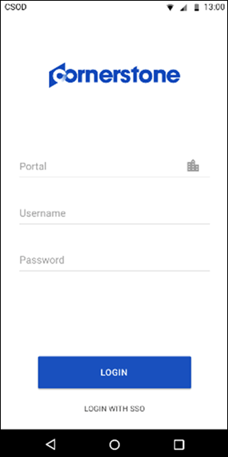
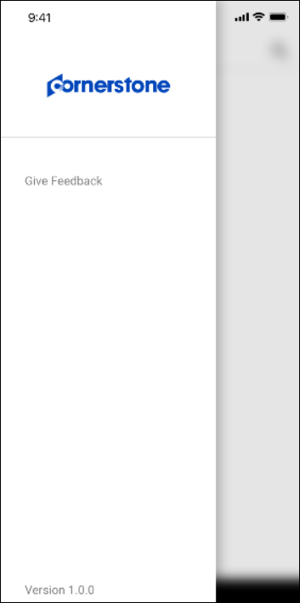
Splash Page
A Cornerstone splash page will display while the Cornerstone CSX app is loading the Log In screen. This splash screen displays for both iOS and Android.
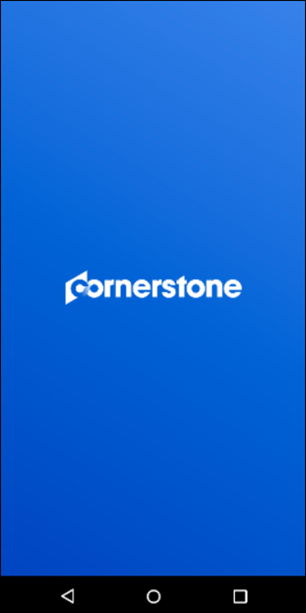
Navigation
To configure a custom link within the Cornerstone CSX app, populate the following fields:
- Link Text - Add text that will be included with the custom navigation link. The character limit for this field is 40 characters.
- URL - Enter the URL for the page you want to add as the custom link.
- Icon - Select the icon that should be displayed with your link from the drop-down menu.
Up to 10 custom navigation links can be added, and they may point to any area of the system. These links are not exclusive to Learning-related pages.
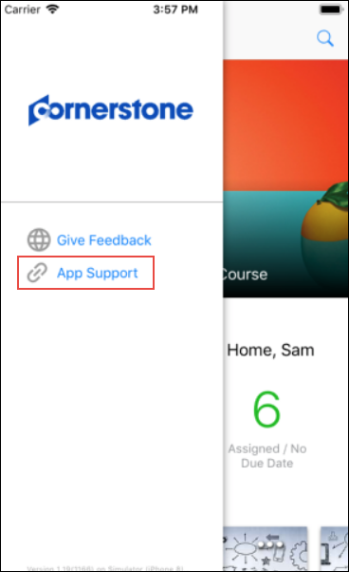
Overwrite Settings
Select this option to overwrite custom settings for child division OUs. If you overwrite custom settings for child division OUs, the selected settings are applied to both new and existing child OUs. Any previously customized child OUs are updated with the selected settings.
- If there are no customizations to the child OU, then the parent OU customizations are applied to all child OUs.
- Overwrite custom settings checkbox setting
  - If this option is selected, all child OU customizations are deleted from the database, which means the parent OU customizations will be applied to new and existing child OUs.
  - If this option is unselected, all existing child OU customizations will remain unchanged, and any new child OUs will inherit the parent OU customizations by default.
- If a child OU has been customized to display any widgets, then regardless of the parent OU customizations, the child OU customizations are applied.
- If a child OU has been customized to hide all widgets, then parent OU customizations will take precedence and will be applied.
Save, Restore Defaults, or Cancel
Click the Save button to save the preferences settings.
Click the Restore Defaults button to restore the preferences to the default settings.
Click the Cancel button to cancel the changes to the preferences settings.

Modify Available Languages
The Modify Available Languages or Modify Language Preferences page is used to determine which languages are available for searching and training association in most areas of your system. Though you may be able to associate objects to a language, the system language pack must be purchased for the full static text conversion to that language. See Globalization Overview.
Note: Learning Search displays languages based on learning object (LO) availability. A given language will display as a filter if it is associated as an Available Language for an LO available to the user.
This page does not determine which languages are available for translation or for display throughout the system. Administrators can determine the default display language for users by division via Language Preferences. See Language Preferences on page 223 for additional information.
Note: Cornerstone does not currently have a Chinese (Taiwan) language pack. Organizations that are using Chinese (Traditional) as a substitute should not request adjustments to this language pack.
To modify the available languages for the portal, go to Admin > Tools > Core Functions > Core Preferences > Modify Available Languages.
Permissions
PERMISSION NAME | PERMISSION DESCRIPTION | CATEGORY

Available Languages - Modify | Grants access to choose what languages to which learning objects may be associated when users search for training. This is an administrator permission. | Core Administration
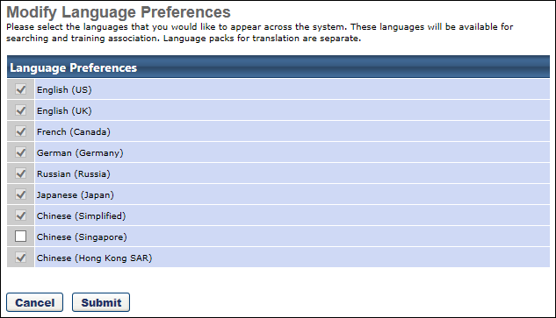
To enable a language for searching and training association:
- Select the checkbox to the left of the language name.
- Select Submit.

Notifications Preferences
Administrators can use the Notifications page in Core Preferences to enable or disable desktop notifications.
To access the Notifications preferences page, go to: Admin > Tools > Core Functions > core Preferences and click the Notifications link.
Permissions
PERMISSION NAME | PERMISSION DESCRIPTION | CATEGORY

Notification Preferences - Manage | This permission grants access to the Notification Preferences page in Core Preferences, allowing administrators to set preferences for system notifications. This is an administrator permission. No constraints can be applied to this permission. | Core Administration
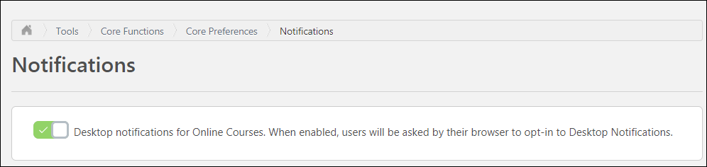
Notifications
On the Notifications page, you can determine whether or not users can allow desktop notifications from the Cornerstone system. Desktop notifications are disabled by default. To enable desktop notifications:
- Toggle the Desktop Notifications switch to the On (green) position.
- Click the Save button at the bottom of the page to save and apply your changes to the system.
When desktop notifications are enabled in the system, the user receives a pop-up request from the system, allowing them to either allow or block desktop notifications.
- See New Online Course Version Available - Notifications.

Reporting 2.0 View and Manage All Reports
The transfer ownership tool enables an administrator to view all current reports and to transfer the ownership of a report created in Reporting 2.0 to another user. This can be useful in the following circumstances:
- The report owner leaves the organization
- The report owner changes responsibilities
The Transfer ownership page can be accessed via Admin > Tools > Core Functions > Core preferences > Reporting 2.0 View and Manage All Reports.
Permissions
PERMISSION NAME | PERMISSION DESCRIPTION | CATEGORY

Reporting - Admin - All Reports | Grants ability to access the Reporting 2.0 View and Manage All Reports tool. This tool enables administrators to view all reports that have been created in Reporting 2.0. Administrators can also transfer ownership of these reports. This permission can be constrained by OU and User. The constraints on this permission refer to the Report Owner. | Reporting
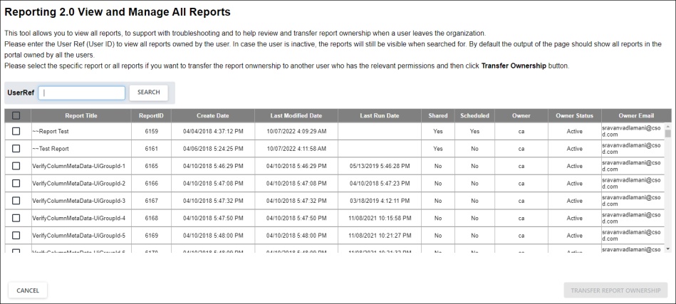
View All Reports
The page is defaulted to show all reports in alphabetical order. The column view includes the following data about each report:
- Report Title
- Report ID
- Create Date
- Last Modified Date
- Last Run Date
- Shared
- Scheduled
- Owner
- Owner Status
- Owner Email
The columns are not sortable or filterable.
Search by User
The search bar enables you to search by User Ref (Owner) to filter the list. The field is not case sensitive, however a full user id is required.
Transfer Report Ownership
To transfer ownership of a report, select the checkbox for the report, and then select the Transfer Report Ownership button. See Transfer Report Ownership on page 238 for additional information.
Transfer Report Ownership
Reporting 2.0 allows for the transfer of ownership of reports from the existing owner to a new owner. This can be useful in the following circumstances:
- The report owner leaves the organization
- The report owner changes responsibilities
Permissions
PERMISSION NAME | PERMISSION DESCRIPTION | CATEGORY

Reporting - Admin - All Reports | Grants ability to access the Reporting 2.0 View and Manage All Reports tool. This tool enables administrators to view all reports that have been created in Reporting 2.0. Administrators can also transfer ownership of these reports. This permission can be constrained by OU and User. The constraints on this permission refer to the Report Owner. | Reporting
To transfer ownership of a report, follow these instructions:
- Navigate to Admin > Tools > Core Functions > Core preferences > Reporting 2.0 View and Manage All Reports.
- The table of reports is defaulted to show all reports. Enter the User Id of the current owner into the User Ref field, click SEARCH. The field is not case sensitive, however a full user id is required.
- The list of reports is now filtered by the owner you searched by. Select the reports to transfer to a new owner by clicking the checkbox next to the report title. If you wish to select all the reports in the list you can use the check box in the title bar of the list. When reports are selected the Transfer Report Ownership button will light up.
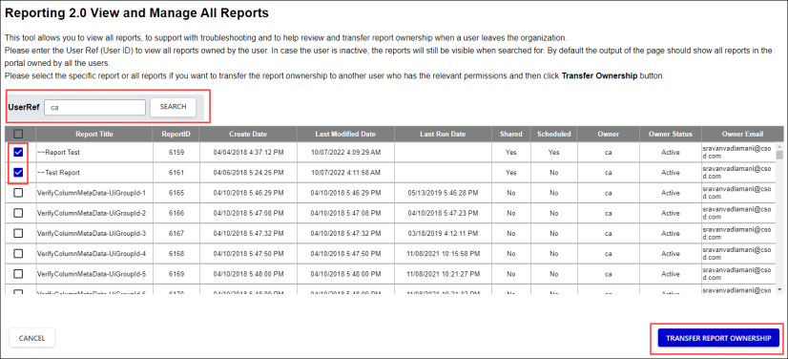
- Click the TRANSFER REPORT OWNERSHIP button. An overlay page will be displayed with a summary of the reports selected for transfer.
If you are not happy with the selection CANCEL out of the process to return to the previous page. If you wish to start your selection again, clear your search criteria.
- When you are happy with selection shown in the summary overlay page enter the User Ref of the new owner into the Transfer Report(s) Ownership to field. The field is not case sensitive, however a full user id is required.
- Click the SUBMIT button. A confirmation message is displayed. From the confirmation message you can either cancel out or of the process or proceed.
Canceling will return you to the summary page. The proceed option will carry out the transfer ownership action. You will receive a success message on the screen if the action was completed. If it was not possible to transfer ownership you will be shown the summary screen with an error message and you will be able to enter a new user id to attempt the process again.
Note: Delivery schedule will remain as-is even after the ownership is transferred
Note: Date and Time fields will be displayed in the time zone of the user accessing the feature

Report Delivery Preferences
The Report Delivery Preferences page enables administrators to set the preferences related to Reporting 2.0 report delivery. This includes the ability to email a copy of Reporting 2.0 reports and send a copy of Reporting 2.0 reports to an FTP site or user's email address. If FTP site delivery is enabled, the administrator must also specify the FTP site location. The Report Delivery Preferences can be set by division or other master OU. Once these are set, any user within that master OU who has the appropriate permissions can access the report delivery options when creating Reporting 2.0 reports.
There are three components to this functionality:
- Set report delivery preferences.
- Create Reporting 2.0 report. See Reporting 2.0 - Create Report.
- Set up report delivery to FTP or user's email address. See Reporting 2.0 - Delivery and Scheduling.
This functionality is available only for Reporting 2.0 reports.
To set the Report Delivery Preferences, go to Admin > Tools > Core Functions > Core Preferences > Report Deliveries.
Permissions
PERMISSION NAME | PERMISSION DESCRIPTION | CATEGORY

Report Delivery Preferences | Provides access to report delivery preferences, which enables administrators to set the preferences related to custom report delivery. This permission can be constrained by OU and User's OU. This is an administrator permission. | Core Administration

Reporting - Email Delivery | Grants ability to deliver reports via email in Reporting 2.0. This permission can be constrained by OU, User's OU, User, User Self and Subordinates, User's Self, User's Manager, User's Superiors, User’s Subordinates, User’s Direct Subordinates, and Employee Relationship.  This permission is used in conjunction with the view permission for Reporting 2.0 and can also be used in conjunction with the various product, section, and field level permissions.  Note about Constraints: The constraints for this permission determine to whom you can deliver the report. The constraints do not pertain to the data you can see in the report. | Reporting

Reporting - FTP Delivery | Grants ability to schedule delivery of Reporting 2.0 reports to an FTP directory. This permission cannot be constrained.  This permission is used in conjunction with the view permission for Reporting 2.0 and can also be used in conjunction with the various product, section, and field level permissions. Users must have permission to view Reporting 2.0 in order to have access to a report that is delivered to them. If they do not have view access, then the Reporting 2.0 navigation sublink will not display for them.  Users who have permission to manage Reporting 2.0 can edit a report that is delivered to them. They can also copy the delivered report. | Reporting

Reporting - Share - Apply Report Owner Constraints | Grants ability to turn on the Apply Owner Constraints setting for reports in the Report Properties panel. This setting affects shared users, delivery, and reports published to dashboards.  When the setting is enabled, the report owner's constraints are applied to the report, and users that run the report will see the report with the report owner's constraints instead of their own.  Due to the possibility of unintended user data becoming visible to a user viewing a report with the report owner's constraints, it is recommended that filters be added to the report to restrict data visibility. It is also recommended that the report owner test the report prior to sharing to ensure the data visibility is appropriate and intended. | Reporting
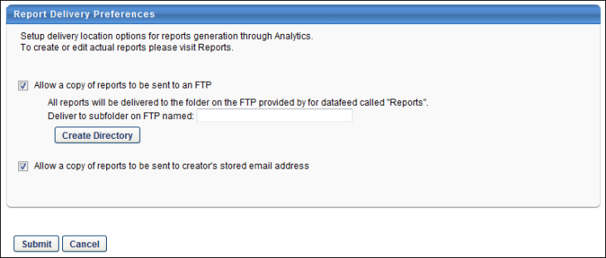
The following report delivery preferences are available:
- Allow a copy of reports to be sent to an FTP - Select this option to enable Reporting 2.0 reports to be sent to a sub folder within the FTP site each time an instance of the report is run. To access this option, you must have permission to schedule delivery of a report to an FTP directory. The maximum file size for this report is 25 MB.
  - Deliver to subfolder on FTP named - Enter the directory name on the data feed FTP site in which the reports should be saved. The character limit for this field is 50.
  - To create a new directory on the FTP site, click the Create Directory button. If a new directory is created all new and old reports are saved to this location.
  - All directories are created within the pre-existing "Reports" directory and if FTP value is left blank, the reports are delivered to the Reports directory.
  - If the directory is changed for divisions, all Reporting 2.0 reports set up for delivery by users in that master OU are delivered to the new directory.
  - If a user's division is changed and the new division has different report delivery preferences, all of the user's reports are delivered to the new division's directory.
- Allow a copy of reports to be sent to creator's stored email address - Select this option to enable Reporting 2.0 reports to be sent to a report creator's system email address. The option to send a copy of the report must still be selected when creating a Reporting 2.0 report. To access this option, you must have permission to schedule delivery of a report to an email address. The maximum report size that can be emailed is 3 MB.
Create Reporting 2.0 Report
After establishing the Report Delivery Preferences, you must create the Reporting 2.0 report and set up report delivery to FTP or user's email address.
- See Reporting 2.0 - Create Report.
- See Reporting 2.0 - Delivery and Scheduling.
The following Report Delivery options are available when creating the Reporting 2.0 report. Note: The Report Delivery options are only available if the report is set to run on a recurring basis.
- Deliver a copy of the report to drop off location set up in Report Delivery Preferences - Select this option to deliver a copy of the custom report to the FTP site specified in the Report Delivery Preferences. If this option is selected, you have the option to send the report in Comma Separated or Tab Delimited format. This option is only available if you have permission to schedule delivery of a report to an FTP site and if the Allow report to be sent to FTP preference is set in Report Delivery Preferences. The maximum file size for this report is 25 MB.
- Send a copy of the report to my stored e-mail address every time it runs - Select this option to deliver a copy of the custom report to the user's system email address. If this option is selected, you have the option to send the report in Comma Separated or Tab Delimited format. This option is only available if you have permission to schedule delivery of a report to an email address. The maximum file size for this report is 3 MB.

Timezone Preference
The Timezone Preference page is used to set time zones by divisions for users. This is helpful when scheduling vILT and ILT events.
To configure Timezone Preferences, go to Admin > Tools > Core Functions > Core Preferences > Timezone.
Permissions
PERMISSION NAME | PERMISSION DESCRIPTION | CATEGORY

Time Zone Preferences - Manage | Grants ability to set default time zone for portal/OU and set whether end users may adjust their own portal time zone. This is an administrator permission. | Core Administration
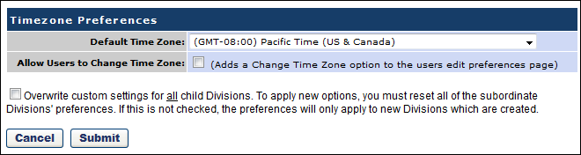
Time Zone Application Rules
Which time zone is applied to a user is dependent on a set of rules. See Time Zone Application Rules on page 245 for additional information.
Preferences
- Default Time Zone - Select the appropriate time zone for the division OU.
- Allow Users to Change Time Zone - Select this option to enable users to change their time zone on their My Account - My Preferences page. When a user sets their time zone via My Account, this time zone is set on their User Record. See My Account - My Preferences for additional information.
Overwrite Settings
Select this option to overwrite custom settings for child division OUs. If you overwrite custom settings for child division OUs, the selected settings are applied to both new and existing child OUs. Any previously customized child OUs are updated with the selected settings.
- If there are no customizations to the child OU, then the parent OU customizations are applied to all child OUs.
- Overwrite custom settings checkbox setting
  - If this option is selected, all child OU customizations are deleted from the database, which means the parent OU customizations will be applied to new and existing child OUs.
  - If this option is unselected, all existing child OU customizations will remain unchanged, and any new child OUs will inherit the parent OU customizations by default.
- If a child OU has been customized to display any widgets, then regardless of the parent OU customizations, the child OU customizations are applied.
- If a child OU has been customized to hide all widgets, then parent OU customizations will take precedence and will be applied.
Time Zone Application Rules
Users are associated with a particular time zone in the system in the following priority order:
- User Record - If a time zone is set for the user on the User Record, then this time zone is applied to the user. By default, no time zone is set on the User Record. See User Record - Settings.
- Location Organizational Unit (OU) - If the user is associated with a Location OU, then the Location OU has an associated time zone. See Organizational Unit - Create/Edit.
- Timezone Preferences (by Division) - If no time zone is set for the user on the User Record and the user is not associated with a Location OU, then the time zone associated with the user's Division OU in Timezone Preferences is applied. See Timezone Preference on page 243 for additional information.
- Implementation - If no time zone is set for a user, then the user's time zone defaults to the system default that was set when your portal was initially configured during implementation. Please contact Global Customer Support to modify the system default time zone.

User Preferences
The User Preferences page enables administrators to manage preferences for the User Record. Administrators can configure which Reasons for Change, User Types, User Subtypes, User Statuses, On Leave Types, and Termination Reasons are available when modifying the User Record.
The Reason for Change functionality is only available if Effective Dating is enabled for the portal.
To access the User Preferences page, go to Admin > Tools > Core Functions > Core Preferences > User Preferences.
Permissions
PERMISSION NAME | PERMISSION DESCRIPTION | CATEGORY

User Preferences - Core Information: View | Grants ability to view the User Preferences administrator page. This permission does not allow administrators to modify the preferences. This permission cannot be constrained. This is an administrator permission. | Core Administration

User Preferences - Leave Types: Manage | Grants ability to manage Leave Types on the User Preferences administrator page. Administrators must also have the User Preferences - Core Information: View permission to access the User Preferences page. This permission cannot be constrained. This is an administrator permission. | Core Administration

User Preferences - Reasons for Change: Manage | Grants ability to define and configure Reasons for Change on the User Preferences administrator page, which may be used when modifying the user record. The administrator must also have the User Preferences - Core Information: View permission to access the User Preferences page.  This permission is also required to view and set the Reason for Change field when editing a user record.  This permission cannot be constrained. This is an administrator permission. | Core Administration

User Preferences - Termination Reasons: Manage | Grants ability to manage Termination Reasons on the User Preferences administrator page. Administrators must also have the User Preferences - Core Information: View permission to access the User Preferences page. This permission cannot be constrained. This is an administrator permission. | Core Administration

User Preferences - User Statuses: Manage | Grants ability to manage User Statuses on the User Preferences administrator page. Administrators must also have the User Preferences - Core Information: View permission to access the User Preferences page. This permission cannot be constrained. This is an administrator permission. | Core Administration

User Preferences - User Types and Subtypes: Manage | Grants ability to manage User Types and Subtypes on the User Preferences administrator page. Administrators must also have the User Preferences - Core Information: View permission to access the User Preferences page. This permission cannot be constrained. This is an administrator permission. | Core Administration
Reasons for Change
Reasons for change enable organizations to track the reasons that can be selected when modifications are made to employee data. These are intended to provide an explanation as to why a change was made. Reasons for change are pre-defined with default names and types so that specific functionality can be associated with reasons within the system. Although the system uses pre-defined reasons for change, administrators can configure the reasons for change names to match their organization's terminology. See User Preferences - Reasons for Change on page 249 for additional information.
User Types
User types enable organizations to designate different types of workers within their organization. All user types are pre-defined with default names and categories so that specific functionality can be associated with user types within the system. Additional user types cannot be created. Although the system uses pre-defined user types, administrators can configure the user type names to match their organization's terminology. See User Preferences - User Types on page 254 for additional information.
User Subtypes
User types enable organizations to designate different types of workers within their organization. All user types are pre-defined with default names and categories so that specific functionality can be associated with user types within the system. Additional user types cannot be created. Although the system uses pre-defined user types, administrators can configure the user type names to match their organization's terminology. See User Preferences - User Subtypes on page 258 for additional information.
User Statuses
User statuses enable organizations to track an employee through different employment life-cycle statuses. All user statuses are pre-defined with default names and categories so that specific functionality can be associated with user statuses within the system. Additional user statuses cannot be created. Although the system uses pre-defined user statuses, administrators can configure the user status names to match their organization's terminology. See User Preferences - User Statuses on page 262 for additional information.
Termination Reasons
Termination reasons enable organizations to track the reasons why employees are terminated, including whether the employee left the organization voluntarily or involuntarily. Termination reasons are pre-defined with default names and categories so that specific functionality can be associated with termination reasons within the system. Although the system uses pre-defined termination reasons, administrators can configure the termination reason names to match their organization's terminology. See User Preferences - Termination Reasons on page 266 for additional information.
On Leave Types
On leave types enable organizations to track when employees are excused from work or duty and the reason for their leave. All leave types are pre-defined with default names and categories so that specific functionality can be associated with on leave types within the system. Although the system uses pre-defined on leave types, administrators can configure the on leave type names to match their organization's terminology. See User Preferences - On Leave Types on page 271 for additional information.
Done
Click Done to save any changes to the User Preferences and return to the Core Preferences page.
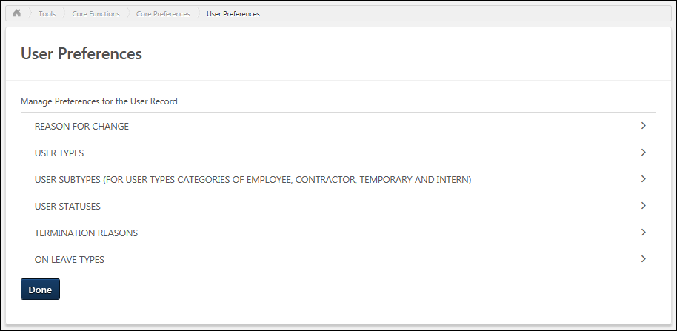
User Preferences - Reasons for Change
Reasons for change enable organizations to track the reasons that can be selected when modifications are made to employee data. These are intended to provide an explanation as to why a change was made. Reasons for change are pre-defined with default names and types so that specific functionality can be associated with reasons within the system. Although the system uses pre-defined reasons for change, administrators can configure the reasons for change names to match their organization's terminology.
The Reason for Change functionality is only available if User Preferences and Effective Dating are enabled for the portal.
To access the User Preferences page, go to Admin > Tools > Core Functions > Core Preferences > User Preferences. Select the arrow to the right of a section name to expand the section.
Permissions
PERMISSION NAME | PERMISSION DESCRIPTION | CATEGORY

User Preferences - Core Information: View | Grants ability to view the User Preferences administrator page. This permission does not allow administrators to modify the preferences. This permission cannot be constrained. This is an administrator permission. | Core Administration

User Preferences - Reasons for Change: Manage | Grants ability to define and configure Reasons for Change on the User Preferences administrator page, which may be used when modifying the user record. The administrator must also have the User Preferences - Core Information: View permission to access the User Preferences page.  This permission is also required to view and set the Reason for Change field when editing a user record.  This permission cannot be constrained. This is an administrator permission. | Core Administration
Reason for Change - Add
To create a new reason for change, click the add button. This opens the Add Reason for Change pop-up. See Reason for Change - Create/Edit on page 252 for additional information.
Reasons for Change Table
The following information is displayed for each existing reason for change:
- Reason - Reasons are sorted alphabetically.
- Reason Type
- ID
- Active - When a reason for change is active, it can be selected as a reason for change when modifying user data on the User Record page. When a reason for change is inactive, the reason cannot be selected. However, the reason remains associated with any existing modifications.
The following options may be available from the Options drop-down menu:
- Edit - Select this option to edit the reason. System defined reasons cannot be edited. See Reason for Change - Create/Edit on page 252 for additional information.
- Translate - If multiple languages are enabled for your portal, select this option to translate the Reason field into other available languages.
- Delete - Select this option to delete the reason. This option is not available if the reason is a system-defined reason or if it has been used in the system. A confirmation pop-up opens to confirm the deletion.
- Info - Select this option to view a description of the system-defined reason. This option is only available for system-defined reasons.
Reasons for Change - Default Reasons
System-defined reasons for change cannot be edited or deleted, and they cannot be selected when making modifications to user record data. Default reasons for change can be edited or deleted.
The following system-defined reasons for change are available:
- Record Creation - This reason for change is automatically selected when a user record is created.
- Rehired - The Rehired reason for change indicates that the user was previously with the company and has been rehired.
- Self-service - This reason for change is automatically selected when a user modifies their user record data in a self-service area, such as My Account.
- Termination - The Termination reason for change indicates that a user is no longer with the company because their employment has been terminated.
The following default reasons for change are available:
- Cancelled - This reason for change is automatically selected when a future effective date is cancelled.
- Data Correction
- Demotion
- Initial Record Updated - This reason for change is automatically selected when a client schedules a backdated effective dated change before the initial effective dated record.
- Personal Data Change
- Promotion
- Reorganization
- Scheduled Change -This reason for change is automatically selected to capture change in employee record when a future dated effective dated record becomes current.
- Transfer
- User Deactivation -This reason for change is automatically selected when user reconciliation process deactivates an user.
- User Status/Type Change
Important Note: The "User Status/Type Change" reason for change must be active for Onboarding so that hire dates can properly process on their hire date.
Require reason for change when modifying the user record
When this option is selected, administrators must select a reason for change when making modifications on the User Record page. This option can only be selected when there is at least one active reason for change.
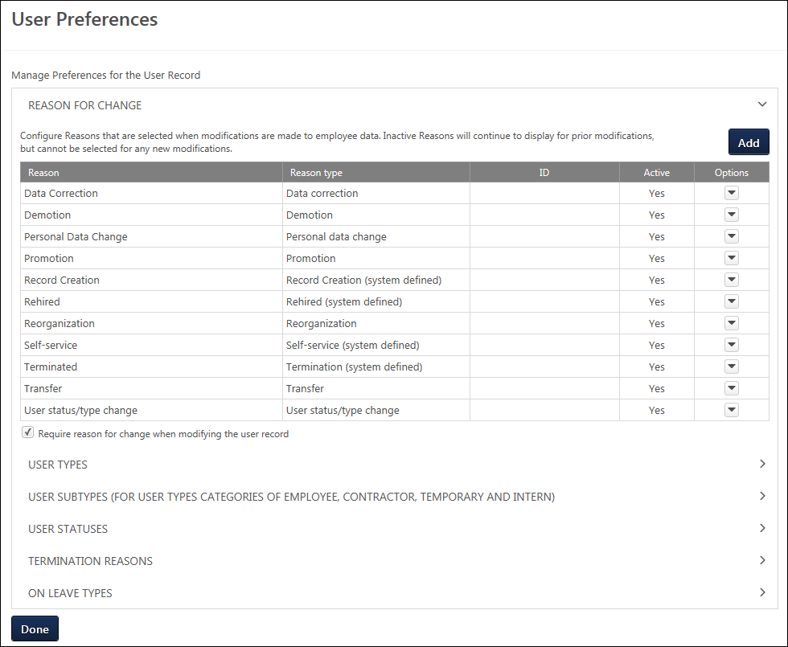
Reason for Change - Create/Edit
If Effective Dating is enabled, when editing the User Record, administrators may provide a Reason for Change which is intended to explain why the employee data is being modified. Reasons for change must be predefined via User Preferences.
Reasons for change can be created and edited from the Reason for Change section of the User Preferences page. See User Preferences on page 246 for additional information.
To access the User Preferences page, go to Admin > Tools > Core Functions > Core Preferences > User Preferences.
- To create a new reason for change, click the add button in the Reasons for Change section. This opens the Add Reason for Change pop-up.
- To edit a reason for change, select Edit from the Options drop-down menu. System defined reasons cannot be edited.
Enter the following information for the reason for change:
- Reason - Enter the reason name, up to 40 characters. This should clearly describe a reason why an administrator may change a field on the User Record. This is required.
- ID - Enter a unique ID for the reason, up to 10 characters. This is optional, but it must be unique if it is provided. The ID cannot contain any spaces. When editing a reason for change, this value cannot be edited if it has been used in the system.
- Reason Type - Select one of the system-defined reason types from the drop-down menu. This enables organizations to categorize their reasons for change. This is required. When editing a reason for change, this value cannot be edited if it has been used in the system.
- Active - When this option is selected, the reason for change is active and can be selected when modifying the User Record. If a reason is deactivated, the reason continues to display for existing modifications. However, inactive reasons cannot be selected for new modifications.
Note: If multiple languages are enabled for a portal, the Reason field can be translated. However, this is done by selecting the Translate option from the Options drop-down on the User Preferences page.
Save or Cancel
Click Save to save the reason for change and return to the User Preferences page. Or, click Cancel to discard any unsaved changes.
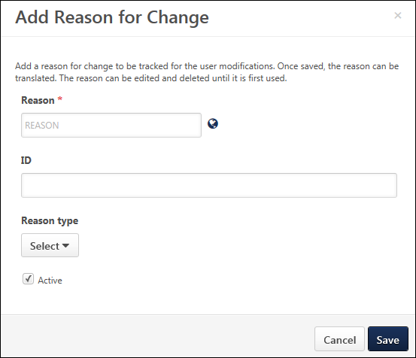
User Preferences - User Types
User types enable organizations to designate different types of workers within their organization. All user types are pre-defined with default names and categories so that specific functionality can be associated with user types within the system. Additional user types cannot be created. Although the system uses pre-defined user types, administrators can configure the user type names to match their organization's terminology.
The availability of this section is controlled by a backend setting. In addition, the User Types section is only available to administrators who have permission to manage user types and subtypes within User Preferences.
To access the User Preferences page, go to Admin > Tools > Core Functions > Core Preferences > User Preferences. Select the arrow to the right of a section name to expand the section.
Permissions
PERMISSION NAME | PERMISSION DESCRIPTION | CATEGORY

User Preferences - Core Information: View | Grants ability to view the User Preferences administrator page. This permission does not allow administrators to modify the preferences. This permission cannot be constrained. This is an administrator permission. | Core Administration

User Preferences - User Types and Subtypes: Manage | Grants ability to manage User Types and Subtypes on the User Preferences administrator page. Administrators must also have the User Preferences - Core Information: View permission to access the User Preferences page. This permission cannot be constrained. This is an administrator permission. | Core Administration
Default User Types
The following default user types are available:
- Employee
- Temporary
- Intern
- Contractor
- Consumer
- External User
- Unspecified
User Type Table
The following information is displayed for each user type:
- User Type - User types are sorted alphabetically. If the type name has been modified, then the modified type name is displayed in this column. This is the type name that is displayed on the User Record.
- User Type Category - This displays the system-defined category that cannot be modified.
- Active - When a user type is active, it can be selected when creating or editing a user. If a user type is deactivated, the user type continues to be associated with the user. However, inactive user types cannot be selected when creating or editing a user.
The following option may be available from the Options drop-down menu:
- Edit - Select this option to edit the user type. See User Preferences - User Type - Edit on page 256 for additional information.
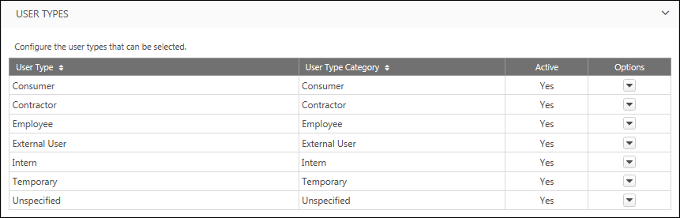
User Preferences - User Type - Edit
User types enable organizations to designate different types of workers within their organization. All user types are pre-defined with default names and categories so that specific functionality can be associated with user types within the system. Additional user types cannot be created. Although the system uses pre-defined user types, administrators can configure the user type names to match their organization's terminology.
To access the User Preferences page, go to Admin > Tools > Core Functions > Core Preferences > User Preferences.
- To edit a user type, select Edit from the Options drop-down menu.
Permissions
PERMISSION NAME | PERMISSION DESCRIPTION | CATEGORY

User Preferences - Core Information: View | Grants ability to view the User Preferences administrator page. This permission does not allow administrators to modify the preferences. This permission cannot be constrained. This is an administrator permission. | Core Administration

User Preferences - User Types and Subtypes: Manage | Grants ability to manage User Types and Subtypes on the User Preferences administrator page. Administrators must also have the User Preferences - Core Information: View permission to access the User Preferences page. This permission cannot be constrained. This is an administrator permission. | Core Administration
Enter the following information for the user type:
- User Type - Enter the user type name, up to 100 characters. This should clearly describe the type of users who are associated with the user type. This is required. If multiple languages are enabled for your portal, select the Translate icon to translate the field into other available languages.
- User Type Category - This displays the system-defined category for the user type. This value cannot be modified.
- Active - When a user type is active, it can be selected when creating or editing a user. If a user type is deactivated, the user type continues to be associated with the user. However, inactive user types cannot be selected when creating or editing a user.
  - Note: The Unspecified user type cannot be set as inactive.
Save or Cancel
Click Save to save the user type and return to the User Preferences page. Or, click Cancel to discard any unsaved changes.
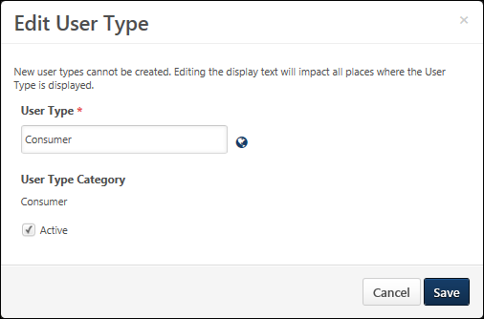
User Preferences - User Subtypes
User types enable organizations to designate different types of workers within their organization. All user types are pre-defined with default names and categories so that specific functionality can be associated with user types within the system. Additional user types cannot be created. Although the system uses pre-defined user types, administrators can configure the user type names to match their organization's terminology.
For Employee, Contractor, Temporary, and Intern user types, administrators can create subtypes. This enables organizations to further designate different types of workers within their organization.
The availability of this section is controlled by a backend setting. In addition, the User Subtypes section is only available to administrators who have permission to manage user types and subtypes within User Preferences.
To access the User Preferences page, go to Admin > Tools > Core Functions > Core Preferences > User Preferences. Select the arrow to the right of a section name to expand the section.
Permissions
PERMISSION NAME | PERMISSION DESCRIPTION | CATEGORY

User Preferences - Core Information: View | Grants ability to view the User Preferences administrator page. This permission does not allow administrators to modify the preferences. This permission cannot be constrained. This is an administrator permission. | Core Administration

User Preferences - User Types and Subtypes: Manage | Grants ability to manage User Types and Subtypes on the User Preferences administrator page. Administrators must also have the User Preferences - Core Information: View permission to access the User Preferences page. This permission cannot be constrained. This is an administrator permission. | Core Administration
User Subtype - Add
To add a new user subtype, click the Add button. This opens the Add User Subtype pop-up. See User Preferences - User Subtypes - Add/Edit on page 260 for additional information.
User Subtype Table
The following information is displayed for each user subtype:
- User Subtype - User subtypes are sorted alphabetically. If the subtype name has been modified, then the modified subtype name is displayed in this column. This is the subtype name that is displayed on the User Record.
- User Subtype Category - This displays the system-defined category that cannot be modified.
- Active - When a user type is active, it can be selected when creating or editing a user. If a user type is deactivated, the user type continues to be associated with the user. However, inactive user types cannot be selected when creating or editing a user.
The following options may be available from the Options drop-down menu:
- Edit - Select this option to edit the user subtype. See User Preferences - User Subtypes - Add/Edit on page 260 for additional information.
- Delete - Select this option to delete the subtype. This option is not available if the subtype has been associated with a user. A confirmation pop-up opens to confirm the deletion.
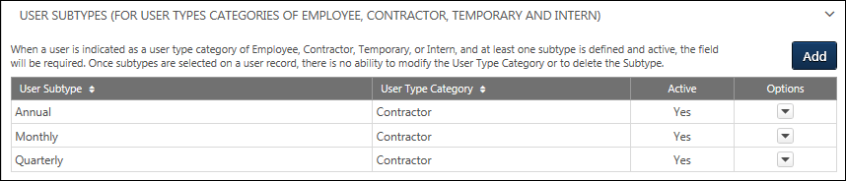
User Preferences - User Subtypes - Add/Edit
User types enable organizations to designate different types of workers within their organization. All user types are pre-defined with default names and categories so that specific functionality can be associated with user types within the system. Additional user types cannot be created. Although the system uses pre-defined user types, administrators can configure the user type names to match their organization's terminology.
For Employee, Contractor, Temporary, and Intern user types, administrators can create subtypes. This enables organizations to further designate different types of workers within their organization.
To access the User Preferences page, go to Admin > Tools > Core Functions > Core Preferences > User Preferences.
- To create a new user subtype, click the Add button in the User Subtypes section. This opens the Add User Subtype pop-up.
- To edit a user subtype, select Edit from the Options drop-down menu.
Permissions
PERMISSION NAME | PERMISSION DESCRIPTION | CATEGORY

User Preferences - Core Information: View | Grants ability to view the User Preferences administrator page. This permission does not allow administrators to modify the preferences. This permission cannot be constrained. This is an administrator permission. | Core Administration

User Preferences - User Types and Subtypes: Manage | Grants ability to manage User Types and Subtypes on the User Preferences administrator page. Administrators must also have the User Preferences - Core Information: View permission to access the User Preferences page. This permission cannot be constrained. This is an administrator permission. | Core Administration
Enter the following information for the user subtype:
- User Subtype - Enter the user subtype name, up to 100 characters. This should clearly describe the type of users who are associated with the user subtype. This is required. If multiple languages are enabled for your portal, select the Translate icon to translate the field into other available languages.
- User Type Category - From the drop-down, select the type associated with the subtype. For example, select Contractor when creating a contractor subtype. If the subtype has been associated with a user, then this field can no longer be modified. The ability to create a user subtype is only available for the following user types: Employee, Contractor, Temporary, and Intern.
- Active - When a user type is active, it can be selected when creating or editing a user. If a user type is deactivated, the user type continues to be associated with the user. However, inactive user types cannot be selected when creating or editing a user.
Save or Cancel
Click Save to save the user subtype and return to the User Preferences page. Or, click Cancel to discard any unsaved changes.
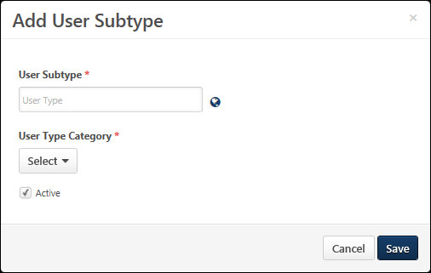
User Preferences - User Statuses
User statuses enable organizations to track an employee through different employment life-cycle statuses. All user statuses are pre-defined with default names and categories so that specific functionality can be associated with user statuses within the system. Additional user statuses cannot be created. Although the system uses pre-defined user statuses, administrators can configure the user status names to match their organization's terminology.
User statuses can only be selected for a user when their user type is set to Employee, Temporary, Intern, or Contractor.
The availability of this section is controlled by a backend setting. In addition, the User Statuses section is only available to administrators who have permission to manage user statuses within User Preferences.
To access the User Preferences page, go to Admin > Tools > Core Functions > Core Preferences > User Preferences. Select the arrow to the right of a section name to expand the section.
Permissions
PERMISSION NAME | PERMISSION DESCRIPTION | CATEGORY

User Preferences - Core Information: View | Grants ability to view the User Preferences administrator page. This permission does not allow administrators to modify the preferences. This permission cannot be constrained. This is an administrator permission. | Core Administration

User Preferences - User Statuses: Manage | Grants ability to manage User Statuses on the User Preferences administrator page. Administrators must also have the User Preferences - Core Information: View permission to access the User Preferences page. This permission cannot be constrained. This is an administrator permission. | Core Administration
Default User Statuses
The following default user statuses are available:
- Onboarding
- Working
- On Leave
- Terminated
User Status Table
The following information is displayed for each user status:
- User Status - User statuses are sorted alphabetically. If the status name has been modified, then the modified status name is displayed in this column. This is the status name that is displayed on the User Record.
- User Status Category - This displays the system-defined category that cannot be modified.
- Active - When a user status is active, it can be selected when creating or editing a user. If a user status is deactivated, the user status continues to be associated with the user. However, inactive user statuses cannot be selected when creating or editing a user.
The following option may be available from the Options drop-down menu:
- Edit - Select this option to edit the user status. See User Preferences - User Status - Edit on page 264 for additional information.
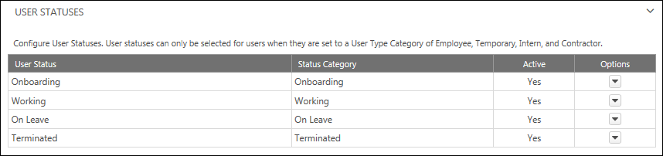
User Preferences - User Status - Edit
User statuses enable organizations to track an employee through different employment life-cycle statuses. All user statuses are pre-defined with default names and categories so that specific functionality can be associated with user statuses within the system. Additional user statuses cannot be created. Although the system uses pre-defined user statuses, administrators can configure the user status names to match their organization's terminology.
To access the User Preferences page, go to Admin > Tools > Core Functions > Core Preferences > User Preferences.
- To edit a user status, select Edit from the Options drop-down menu.
Permissions
PERMISSION NAME | PERMISSION DESCRIPTION | CATEGORY

User Preferences - Core Information: View | Grants ability to view the User Preferences administrator page. This permission does not allow administrators to modify the preferences. This permission cannot be constrained. This is an administrator permission. | Core Administration

User Preferences - User Statuses: Manage | Grants ability to manage User Statuses on the User Preferences administrator page. Administrators must also have the User Preferences - Core Information: View permission to access the User Preferences page. This permission cannot be constrained. This is an administrator permission. | Core Administration
Enter the following information for the user status:
- User Status - Enter the user status name, up to 100 characters. This should clearly describe the employment life-cycle status associated with the user status. This is required. If multiple languages are enabled for your portal, select the Translate icon to translate the field into other available languages.
- Status Category - This displays the system-defined category for the user status. This value cannot be modified.
- Active - When a user status is active, it can be selected when creating or editing a user. If a user status is deactivated, the user status continues to be associated with the user. However, inactive user statuses cannot be selected when creating or editing a user.
Save or Cancel
Click Save to save the user status and return to the User Preferences page. Or, click Cancel to discard any unsaved changes.
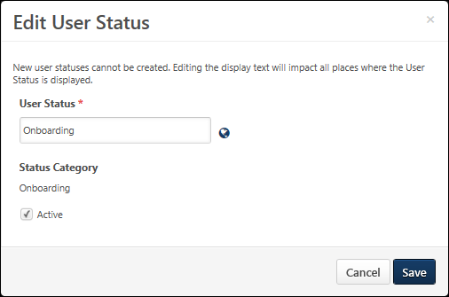
User Preferences - Termination Reasons
Termination reasons enable organizations to track the reasons why employees are terminated, including whether the employee left the organization voluntarily or involuntarily. Termination reasons are pre-defined with default names and categories so that specific functionality can be associated with termination reasons within the system. Although the system uses pre-defined termination reasons, administrators can configure the termination reason names to match their organization's terminology.
Termination reasons can only be selected for a user when their user status is set to Terminated.
The availability of this section is controlled by a backend setting. In addition, the Termination Reasons section is only available to administrators who have permission to manage termination reasons within User Preferences.
To access the User Preferences page, go to Admin > Tools > Core Functions > Core Preferences > User Preferences. Select the arrow to the right of a section name to expand the section.
Permissions
PERMISSION NAME | PERMISSION DESCRIPTION | CATEGORY

User Preferences - Core Information: View | Grants ability to view the User Preferences administrator page. This permission does not allow administrators to modify the preferences. This permission cannot be constrained. This is an administrator permission. | Core Administration

User Preferences - Termination Reasons: Manage | Grants ability to manage Termination Reasons on the User Preferences administrator page. Administrators must also have the User Preferences - Core Information: View permission to access the User Preferences page. This permission cannot be constrained. This is an administrator permission. | Core Administration
Termination Reason - Add
To add a new termination reason, click the Add button. This opens the Add Termination Reason pop-up. See User Preferences - Termination Reason - Add/Edit on page 269 for additional information.
Default Involuntary Termination Reasons
The following involuntary termination reasons are available:
- Conviction of a Crime
- Deceased
- Dishonesty/Falsification/Theft
- End of casual employment
- End of Contract
- Forced retirement
- Negligence
- Offshoring
- Policy violation
- Poor attendance
- Reduction in force/Layoff
- Redundancy
- Transfer
- Unsatisfactory performance
Default Voluntary Termination Reasons
The following voluntary termination reasons are available:
- Better Opportunity
- Career Change
- Company leadership
- Declined offer
- Education
- Employee-job fit
- Fail to return from leave
- Inadequate Benefits
- Inadequate Compensation
- Job abandonment
- Lack of Career Growth
- Lack of Training/Development
- Legally ineligible
- Manager dissatisfaction
- Medical
- Move/relocation
- Retired
- Transfer
- Work Location
- Work Schedule
Termination Reason Table
The following information is displayed for each termination reason:
- Termination Reason - Termination reasons are sorted alphabetically. If the reason name has been modified, then the modified reason name is displayed in this column. This is the termination reason name that is displayed on the User Record.
- Termination Reason Category - This displays the system-defined category that cannot be modified.
- Active - When a termination reason is active, it can be selected when creating or editing a user. If a termination reason is deactivated, the termination reason continues to be associated with the user. However, inactive termination reasons cannot be selected when creating or editing a user.
The following options may be available from the Options drop-down menu:
- Edit - Select this option to edit the termination reason. See User Preferences - Termination Reason - Add/Edit on page 269 for additional information.
- Delete - Select this option to delete the termination reason. This option is not available if the termination reason has been associated with a user. A confirmation pop-up opens to confirm the deletion.
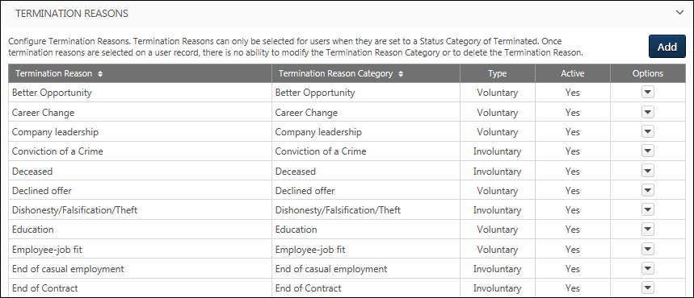
User Preferences - Termination Reason - Add/Edit
Termination reasons enable organizations to track the reasons why employees are terminated, including whether the employee left the organization voluntarily or involuntarily. Termination reasons are pre-defined with default names and categories so that specific functionality can be associated with termination reasons within the system. Although the system uses pre-defined termination reasons, administrators can configure the termination reason names to match their organization's terminology.
To access the User Preferences page, go to Admin > Tools > Core Functions > Core Preferences > User Preferences.
- To create a new termination reason, click the Add button in the Termination Reasons section. This opens the Add Termination Reason pop-up.
- To edit a termination reason, select Edit from the Options drop-down menu.
Permissions
PERMISSION NAME | PERMISSION DESCRIPTION | CATEGORY

User Preferences - Core Information: View | Grants ability to view the User Preferences administrator page. This permission does not allow administrators to modify the preferences. This permission cannot be constrained. This is an administrator permission. | Core Administration

User Preferences - Termination Reasons: Manage | Grants ability to manage Termination Reasons on the User Preferences administrator page. Administrators must also have the User Preferences - Core Information: View permission to access the User Preferences page. This permission cannot be constrained. This is an administrator permission. | Core Administration
Enter the following information for the termination reason:
- Termination Reason - Enter the termination reason name, up to 100 characters. This should clearly describe the general reason associated with termination. This is required. If multiple languages are enabled for your portal, select the Translate icon to translate the field into other available languages.
- Termination Type - Select whether the termination reason is voluntary or involuntary. If the termination reason has been associated with a user, then this field can no longer be modified. This selection determines which options are available in the Termination Reason Category field.
  - Voluntary indicates that the employee chose to leave their position.
  - Involuntary indicates that the organization forced the employee to leave their position.
- Termination Reason Category - From the drop-down, select the general reason associated with the new termination reason. The Termination Type selection determines which options are available. For example, if Voluntary is selected, then only Voluntary termination reason categories are available. Only a default termination reason can be selected. For example, organizations may create multiple types of negligence termination reasons, and these termination reasons should be associated with the Negligence termination reason category. If the termination reason has been associated with a user, then this field can no longer be modified.
- Active - When a termination reason is active, it can be selected when creating or editing a user. If a termination reason is deactivated, the termination reason continues to be associated with the user. However, inactive termination reasons cannot be selected when creating or editing a user.
Save or Cancel
Click Save to save the termination reason and return to the User Preferences page. Or, click Cancel to discard any unsaved changes.
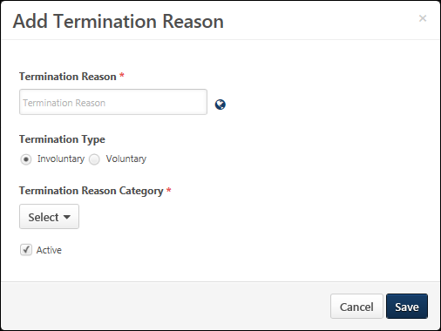
User Preferences - On Leave Types
On leave types enable organizations to track when employees are excused from work or duty and the reason for their leave. All leave types are pre-defined with default names and categories so that specific functionality can be associated with on leave types within the system. Although the system uses pre-defined on leave types, administrators can configure the on leave type names to match their organization's terminology.
Leave types can only be selected for a user when their user status is set to On Leave.
The availability of this section is controlled by a backend setting. In addition, the On Leave Types section is only available to administrators who have permission to manage leave types within User Preferences.
To access the User Preferences page, go to Admin > Tools > Core Functions > Core Preferences > User Preferences. Select the arrow to the right of a section name to expand the section.
Permissions
PERMISSION NAME | PERMISSION DESCRIPTION | CATEGORY

User Preferences - Core Information: View | Grants ability to view the User Preferences administrator page. This permission does not allow administrators to modify the preferences. This permission cannot be constrained. This is an administrator permission. | Core Administration

User Preferences - Leave Types: Manage | Grants ability to manage Leave Types on the User Preferences administrator page. Administrators must also have the User Preferences - Core Information: View permission to access the User Preferences page. This permission cannot be constrained. This is an administrator permission. | Core Administration
On Leave Type - Add
To add a new on leave type, click the Add button. This opens the Add On Leave Type pop-up. See User Preferences - On Leave Type - Add/Edit on page 273 for additional information.
Default On Leave Types
The following default on leave types are available:
- Sabbatical
- Parental
- Medical
- Compassionate
- Force Majeure
- Military
- Jury Service
- Education
- Administrative
- Suspension
- Disability
- Temporary commission
On Leave Type Table
The following information is displayed for each on leave type:
- On Leave Type - On leave types are sorted alphabetically. If the type name has been modified, then the modified type name is displayed in this column. This is the on leave type name that is displayed on the User Record.
- Leave Type Category - This displays the system-defined category that cannot be modified.
- Active - When an on leave type is active, it can be selected when creating or editing a user. If an on leave type is deactivated, the on leave type continues to be associated with the user. However, inactive on leave types cannot be selected when creating or editing a user.
The following options may be available from the Options drop-down menu:
- Edit - Select this option to edit the on leave type. See User Preferences - On Leave Type - Add/Edit on page 273 for additional information.
- Delete - Select this option to delete the on leave type. This option is not available if the on leave type has been associated with a user. A confirmation pop-up opens to confirm the deletion.
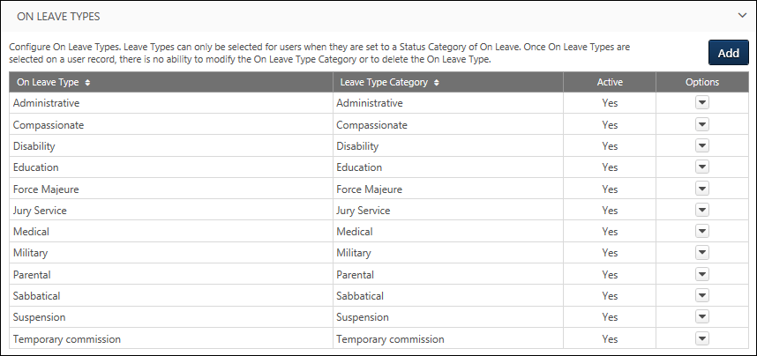
User Preferences - On Leave Type - Add/Edit
On leave types enable organizations to track when employees are excused from work or duty and the reason for their leave. All leave types are pre-defined with default names and categories so that specific functionality can be associated with on leave types within the system. Although the system uses pre-defined on leave types, administrators can configure the on leave type names to match their organization's terminology.
To access the User Preferences page, go to Admin > Tools > Core Functions > Core Preferences > User Preferences.
- To create a new on leave type, click the Add button in the On Leave Type section. This opens the Add On Leave Type pop-up.
- To edit an on leave type, select Edit from the Options drop-down menu.
Permissions
PERMISSION NAME | PERMISSION DESCRIPTION | CATEGORY

User Preferences - Core Information: View | Grants ability to view the User Preferences administrator page. This permission does not allow administrators to modify the preferences. This permission cannot be constrained. This is an administrator permission. | Core Administration

User Preferences - Leave Types: Manage | Grants ability to manage Leave Types on the User Preferences administrator page. Administrators must also have the User Preferences - Core Information: View permission to access the User Preferences page. This permission cannot be constrained. This is an administrator permission. | Core Administration
Enter the following information for the on leave type:
- On Leave Type - Enter the on leave type name, up to 40 characters. This should clearly describe the general reason associated with the type of leave. This is required. If multiple languages are enabled for your portal, select the Translate icon to translate the field into other available languages.
- Leave Type Category - From the drop-down, select the type associated with the new on leave type. Only a default leave type can be selected. For example, organizations may create a Maternal leave type and a Paternal leave type, and both of these leave types should be associated with the Parental leave type. If the on leave type has been associated with a user, then this field can no longer be modified.
- Active - When an on leave type is active, it can be selected when creating or editing a user. If an on leave type is deactivated, the on leave type continues to be associated with the user. However, inactive on leave types cannot be selected when creating or editing a user.
Save or Cancel
Click Save to save the on leave type and return to the User Preferences page. Or, click Cancel to discard any unsaved changes.
