Content March 2024

Table of Contents
Content Overview 1
Content Uploader 2
Content Uploader - Create an Online Course - Overview 3
Online Course Versioning vs. Modifying - Overview 17
Course Publisher (Legacy) - Overview 46
Course Publisher (Legacy) Overview 47
Course Publisher (Legacy) - Create New Course/Publication 50
Course Publisher (Legacy) - Update a Course 55
Course Publisher (Legacy) - Modify Individual SCORM Files 72
LinkedIn Learning Integration 73
LinkedIn Learning - Subjects Synchronization 78
Edge - LinkedIn Learning 82
Survey Administration Overview 86
Surveys Administration 87
Survey Question - Create 89
Survey Category - Create 91
Survey Template - Create 92
Survey Task - Create 94
Test Engine Overview 96
Test Engine Administration 97
Question Bank (Content) 128
xAPI Package Support - Overview 146
xAPI Package Support 149
xAPI - Launch in Iframe 154
xAPI - View Time in Transcript Details 156
xAPI - Scaled Score 158
xAPI (JWT) Token Expression Time 159
xAPI Appendix 160
xAPI Learning Reporter 163

Content Overview

Content Uploader

Content Uploader - Create an Online Course - Overview
Using the Content Uploader, you can upload new online courses to the system and then use the Course Catalog and Course Console to configure the metadata for the course.
Content Uploader can be self-activated in Feature Activation Preferences. To activate, ADMIN > TOOLS > LEARNING > LEARNING PREFERENCES > FEATURE ACTIVATION PREFERENCES. In the Activate Content Publishing Features for Online Courses section, click Activate.
Help Documentation
Click the following links for related help articles:
- Create an online course - See Content Uploader - Upload Files on page 6 for additional information.
- View an audit of a course's uploads - See Content Uploader - Online Course Upload History on page 15 for additional information.
- Different ways to update an online course - See Online Course Versioning vs. Modifying - Overview on page 17 for additional information.
Use Case 1: Upload Online Courses
William is a content developer at ABC Corporation. He completed the development of ten different IT Security Policy courses and wants to upload them to the system. William opens the Content Uploader, then drags and drops the files he wants to upload into the upload box. He can track the upload progress and see if the courses were uploaded successfully. Once the files have been uploaded successfully, drafts are automatically created for each course in the Course Catalog.
Use Case 2: Edit and Publish Draft Courses
William sees that one of his courses was uploaded successfully to the system, and now he wants to edit and publish the course. He accesses the Course Catalog and opens the draft course. He previews the course and finds that it works as expected, so he edits the course metadata and publishes it. If needed, he can continue to edit other fields directly from the Course Catalog.
Permissions
The following permissions apply to this functionality:
PERMISSION NAME | PERMISSION DESCRIPTION | CATEGORY

Assignment Tool - Standard and Dynamic - Recurrence | Grants ability to create Standard (one-time) and Dynamic (continuous) Learning Assignments to directly assign training to users. Also grants ability to enable/disable Recurrence when creating a Dynamic Learning Assignment. This permission can be constrained by OU, Provider, Training Item, Training Type, User, User Self and Subordinates, and User's OU. If this permission is constrained by Location, Provider, Training Type, or Training Item, then they can only assign training within the constraints. If this permission is constrained by OU, User, User Self and Subordinates, or User's OU, then they can only assign to and view assignments created by users within the constraints. This is an administrator permission. | Learning - Administration

Assignment Tool - Standard and Dynamic - Recurrence | Grants ability to create Standard (one-time) and Dynamic (continuous) Learning Assignments to directly assign training to users. Also grants ability to enable/disable Recurrence when creating a Dynamic Learning Assignment. This permission can be constrained by OU, Provider, Training Item, Training Type, User, User Self and Subordinates, and User's OU. If this permission is constrained by Location, Provider, Training Type, or Training Item, then they can only assign training within the constraints. If this permission is constrained by OU, User, User Self and Subordinates, or User's OU, then they can only assign to and view assignments created by users within the constraints. This is an administrator permission. | Learning - Administration

Course Catalog - Update | Grants ability to manage and edit training items listed in the Course Catalog and also grants access to the Course Console, where training can also be managed and edited. This permission also grants access to the Popular Requests and Highest Rated widgets on the Learning Admin Console (in conjunction with the Learning Admin Console - View permission). This permission also allows administrators to reversion online courses via the Course Console page. This permission also allows administrators to access an Edit Training option for training items included as objectives in Development plans.  This permission can be constrained by OU, User's OU, Training Type, Training Item, Provider, ILT Provider, User's ILT Provider, User, User Self and Subordinates, and User's LO Availability. This is an administrator permission.  Note: Adding an OU constraint and a provider constraint to this permission results in an "AND" statement. | Learning - Administration

Course Catalog - View | Grants access to view the learning objects in the course catalog and enables administrators to view the Course Console and the Popular Requests and Highest Rated widgets on the Learning Admin Console (in conjunction with the Learning Admin Console - View permission). This permission can be constrained by OU, User's OU, Training Type, Training Item, Provider, ILT Provider, User's ILT Provider, and User's LO Availability. This is an administrator permission.  Adding an OU constraint and a provider constraint to this permission results in an "AND" statement. | Learning - Administration

Online Class - Modify | Grants ability to modify an online class without creating a new version of the online class. | Learning - Administration

Online Class - Publish | Grants access to two pieces of functionality:  - Publish button on the Course Console, allowing administrator to publish a draft online class  - Upload section of the online class versioning workflow | Learning - Administration

Online Class - Upload | Grants access to the Content Uploader where an administrator can upload zip packages to create draft online classes. In addition, this permission grants the ability to upload a new zip package as part of the online class versioning process. This permission does NOT grant the ability to publish online classes. Without the permission to publish online classes, administrators with the permission to upload online classes can only upload and save online classes, which then must be published by administrators with the relevant permission.  As of November 10, 2017, this is the only permission which provides access to the Content Uploader page. | Learning - Administration

Online Class Version - Publish | Grants ability to upload and publish new online class versions. This permission works in conjunction with the permission for uploading online classes. This permission can be constrained by OU, User's OU, Users, and Providers. This is an administrator permission. | Learning - Administration

Content Uploader - Manage Uploads with Undefined Providers. | Allows administrators to view and manage uploads with undefined providers on the Uploads History page. | Learning - Administration

Upload History - View | Grants ability to view the Upload History page. | Learning - Administration
Content Uploader - Upload Files
The Content Uploader page allows administrators to easily upload and track online course files. The Content Uploader page allows administrators to upload multiple course files at one time, view upload statuses, access the Upload History page, and bulk publish courses. The following Content Uploader sections indicate the current status of the uploaded course files and allow the administrator to take action on the files:
- Upload Files
- Processing
- Needs Provider
- Draft Ready
Note: If no files meet the criteria for the Processing, Needs Provider, or Draft Ready sections, the associated section does not display on the page.
To access the Content Uploader, go to Admin > Tools > Learning and click the Content Uploader link.
Note: Content Publisher functionality is only available after it has been activated in your portal. To access Content Activation Preferences, go to Admin > Tools > Learning > Learning Preferences and click the Feature Activation Preferences link.
Permissions
PERMISSION NAME | PERMISSION DESCRIPTION | CATEGORY

Course Catalog - Update | Grants ability to manage and edit training items listed in the Course Catalog and also grants access to the Course Console, where training can also be managed and edited. This permission also grants access to the Popular Requests and Highest Rated widgets on the Learning Admin Console (in conjunction with the Learning Admin Console - View permission). This permission also allows administrators to reversion online courses via the Course Console page. This permission also allows administrators to access an Edit Training option for training items included as objectives in Development plans.  This permission can be constrained by OU, User's OU, Training Type, Training Item, Provider, ILT Provider, User's ILT Provider, User, User Self and Subordinates, and User's LO Availability. This is an administrator permission.  Note: Adding an OU constraint and a provider constraint to this permission results in an "AND" statement. | Learning - Administration

Course Catalog - View | Grants access to view the learning objects in the course catalog and enables administrators to view the Course Console and the Popular Requests and Highest Rated widgets on the Learning Admin Console (in conjunction with the Learning Admin Console - View permission). This permission can be constrained by OU, User's OU, Training Type, Training Item, Provider, ILT Provider, User's ILT Provider, and User's LO Availability. This is an administrator permission.  Adding an OU constraint and a provider constraint to this permission results in an "AND" statement. | Learning - Administration

Content Uploader - Manage Uploads with Undefined Providers. | Allows administrators to view and manage uploads with undefined providers on the Uploads History page. | Learning - Administration

Online Class - Publish | Grants access to two pieces of functionality:  - Publish button on the Course Console, allowing administrator to publish a draft online class  - Upload section of the online class versioning workflow | Learning - Administration

Online Class - Upload | Grants access to the Content Uploader where an administrator can upload zip packages to create draft online classes. In addition, this permission grants the ability to upload a new zip package as part of the online class versioning process. This permission does NOT grant the ability to publish online classes. Without the permission to publish online classes, administrators with the permission to upload online classes can only upload and save online classes, which then must be published by administrators with the relevant permission.  As of November 10, 2017, this is the only permission which provides access to the Content Uploader page. | Learning - Administration

Upload History - View | Grants ability to view the Upload History page. | Learning - Administration
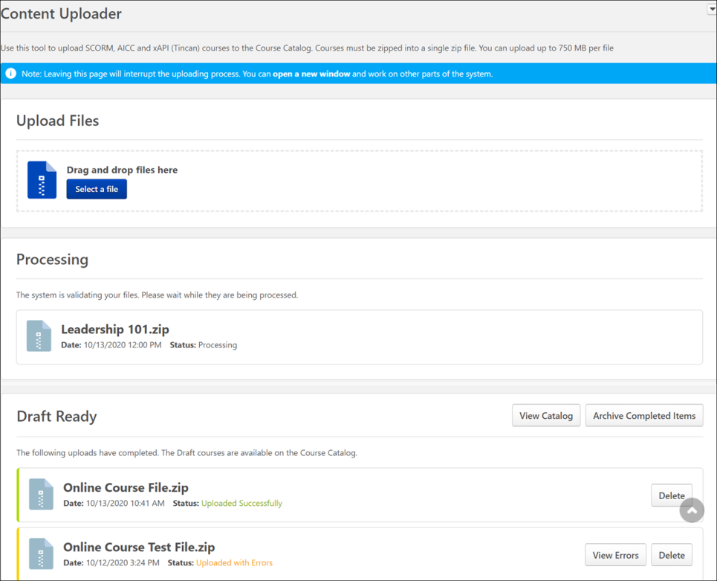
Options
The Options drop-down menu in the upper-right corner of the Content Uploader page allows you to both refresh the page and view the Content Uploader's upload history:
- Upload History - Click this link to navigate to the Upload History page. For more information about Upload History, See Content Uploader - Online Course Upload History on page 15 for additional information.
- Refresh- Click this link to refresh the page and view updated upload statuses.
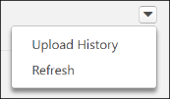
Upload Files
To upload a new set of course files:
- Drag and drop your zipped SCORM or AICC course files into the Upload Files box, or click the Add Files button and select the zipped course files from your computer. Note: Courses must be zipped into a single zip file. Any zip file must contain only one standard (AICC or SCORM or xAPI). You can upload up to 750 MB per file.
- After the course files have been added, they will begin uploading. A progress bar below the files displays the ongoing upload progress for the files. Each set of files displays the following information:
  - File Name
  - File Type
  - Status (i.e., Uploading, Critical Error)
- If there are problems with the upload, the status changes to Critical Error, and you can click the View Error Report button to view the reasons for the upload errors and address any issues. Once the files successfully finish uploading, they are transferred to the Processing section. Continue managing the upload from the Processing section.
If needed, you can delete a set of course files from the Upload Files section by clicking the Delete upload button.
Processing
Uploaded files move to the Processing section while the system checks the files for errors. You can select the Refresh option from the drop-down in the upper-right corner of the page to refresh the page.
If needed, you can delete a set of course files from the Processing section by clicking the Delete upload button.
Needs Provider
If the course provider still needs to be selected for the course files after they finish processing, the files appear in the Needs Provider section. To select a provider for a course:
- Click the Select Provider button. A flyout opens.
- The system's providers appear in the paginated flyout, with up to twenty providers per page. To search for a specific provider, the administrator can either enter the provider's name into the Provider Name search bar and clicking the Search button, or they can page through the list of providers to find the correct provider. Select a provider and then click the Done button to close the flyout and add the provider to the course.
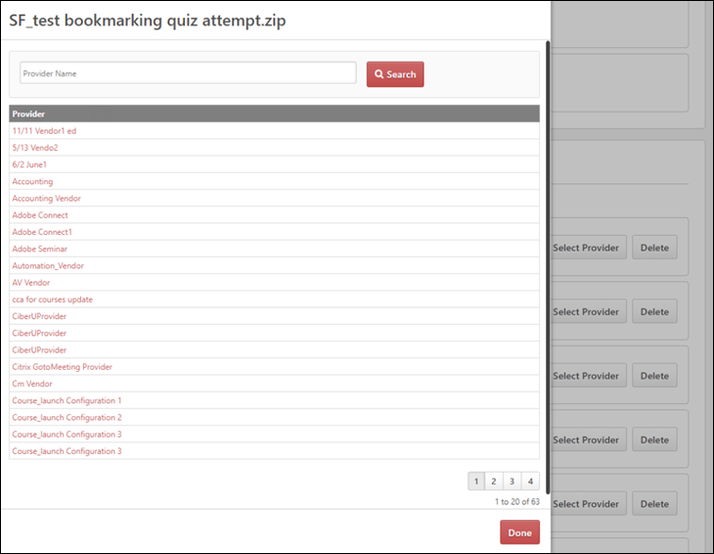
Once a provider is selected, the course files automatically move to the Draft Ready section, and a draft is created automatically in the Course Catalog.
Draft Ready - Publish via the Course Catalog
Once a set of course files moves to the Draft Ready section, its status changes to Uploaded Successfully, and it is available in the Course Catalog as a draft.
Using the Course Catalog, you can configure the metadata for the new online course and also preview the Training Details page for the course. Click the View Catalog button to be redirected to the Course Catalog search page, where you can configure the metadata for the course, such as the title, keywords, approval workflows, pricing, and more. When you access the Course Catalog from the Content Uploader page, the Course Catalog is pre-filtered to display only online courses in a Draft status. See Course Catalog Search - New.
You can click the course title or select Edit from the Actions drop-down menu to edit the course metadata and publish the course. See Course Console - Details.
If needed, you can archive items in the Draft Ready section by clicking the Archive Completed Items button. Archived courses are then only accessible either via the Upload History page or as draft courses in Course Catalog. You can also delete uploaded files from the Content Uploader by clicking the Delete upload button.
Draft Ready - Bulk Publish
Administrators can also bulk publish all or selected publication courses in one click after uploading them in Content Uploader. Apart from the Date, Status of upload, and Delete, the Content Uploader page also includes the Number of Courses, Provider, and the View Course(s) button.
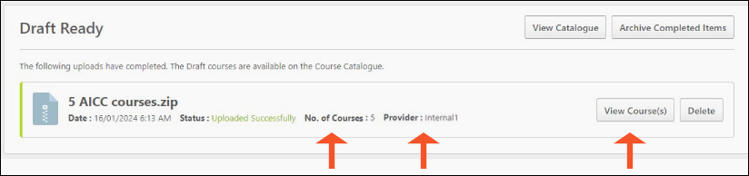
Click View Course(s) to go inside the course file. The View Course(s) page displays the following features:
- A field for Search & Filtering​
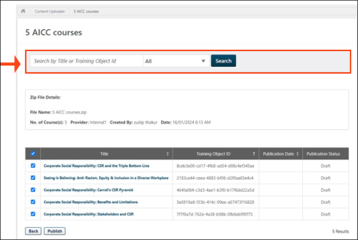
- Zip File Details
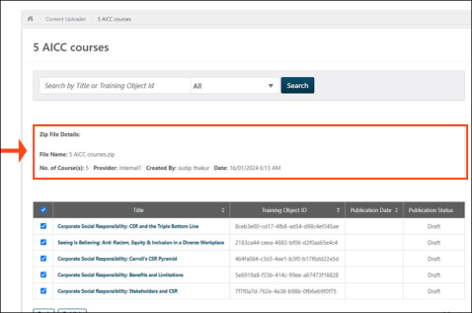
- List of Courses​
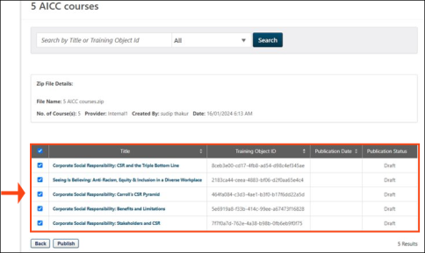
- Publish button
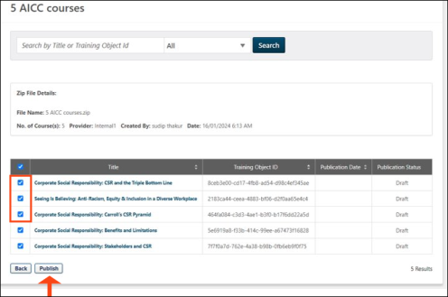
Once published, the publication status is shown as per the below image:
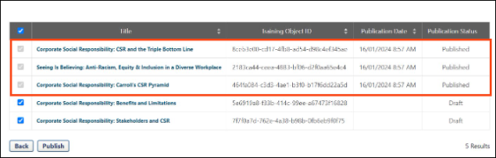
You can also access View Course(s) via Upload History.
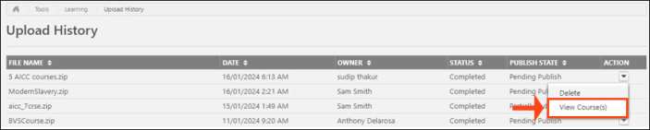
The Users with existing “Online Class - Publish” permission can see the “View Course(s)” option in Content Uploader and Upload History. The same constraints will apply as the user’s “Online Class - Publish” constraints.
Note: Only courses uploaded as part of the same Publication can be published in bulk via the View Courses page.
Online Course - View Errors
If a set of course files uploads with errors, you can click the View Errors button to open a flyout which displays error details. The View Errors flyout displays for files in upload statuses of both Failed and Completed with Comments.
The View Errors flyout displays the following information:
- Title - The title of the course files.
- Critical Errors section - Displays the severe errors, each on a separate row. Each error displays the following information:
  - Error description
  - File name in which the error occurred
- Warning section - Displays the non-severe errors, each on a separate row. Each error displays the following information:
  - Error description
  - File name in which the error occurred
  - Path
When finished viewing the error report, click the Done button to close the flyout.
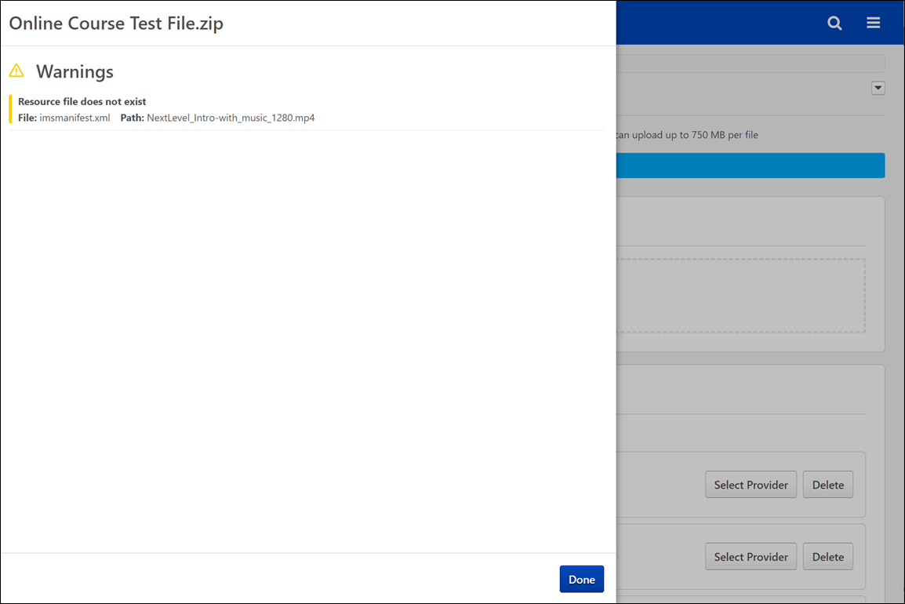
Content Uploader - Online Course Upload History
The Upload History page provides information about sets of course files which were uploaded to the Content Uploader by the administrators in your system, such as the owner of the files and what status the files are in.
To access the Upload History page, go to Admin > Tools > Learning and click the Upload History link. Alternatively, you can access the Upload History page via the Upload History link in the Options drop-down menu on the Content Uploader page.
Permissions
PERMISSION NAME | PERMISSION DESCRIPTION | CATEGORY

Content Uploader - Manage Uploads with Undefined Providers. | Allows administrators to view and manage uploads with undefined providers on the Uploads History page. | Learning - Administration

Upload History - View | Grants ability to view the Upload History page. | Learning - Administration
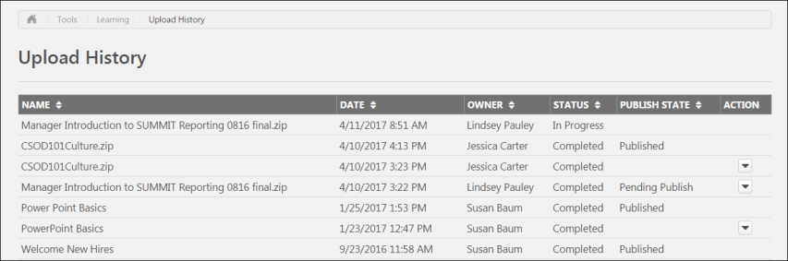
Upload History
The Upload History page displays the following information for each previously uploaded set of course files:
- Name - The title of the uploaded course files
- Date - The date the course files were uploaded to the Course Uploader
- Owner - The name of the administrator who uploaded the course files
- Status - The status of the upload. Available statuses include:
  - In Progress
  - Completed
  - Partially Completed
  - Completed with Comments
  - Failed
- Publish State - This field displays what stage of the publishing process the course files are currently in. Available publish states include:
  - Pending Publish
  - Published
  - Partially Published
- Actions - The Actions drop-down menu next to course files that are Published or Pending Publish allows administrators to take the following actions, if available:
  - Delete
  - View Errors
Note: You can sort uploads by Name, Date, Owner, Status, and Publish State by clicking the column header for the desired sort criteria.

Online Course Versioning vs. Modifying - Overview
There are two ways to make updates to an online course. When an online course requires updates, the administrator can either reversion the course or modify the course:
- Reversion - Reversioning a course creates a new version of the online course, with a new version number.
- Modify - Modifying a course allows administrators to make minor modifications to an online course WITHOUT creating a new version.
Note: Content Uploader functionality is only available after it has been activated in your portal. To access Content Activation Preferences, go to Admin > Tools > Learning > Learning Preferences and click the Content Activation Preferences link.
When should you reversion a class vs. modify a course?
Online Class Update method | type of update
Reversion | The versioning process is the appropriate choice for major changes to an online class, and administrators can control who receives the new version of the online class.
Modify | The online class modification process allows administrators to make updates to an online class without creating a new version. Within the legacy Course Publisher functionality, the process similar to modifying a class is referred to as "Replace Files."
Online Course Update Scenarios
Examples of Needed Changes | Appropriate update method | Use Cases
The following changes are examples of major online course changes which require you to reversion the course:  - Replacing a segment of the course  - Making substantive updates to the course content  - Adding or removing a quiz  - Removing or adding resources such as audio, video, animations, pdfs, etc.  This list of examples is not an exhaustive list of changes which necessitate a new online course version. | Reversion the online course | Holly, an instructional designer and learning administrator at Ventonix, is responsible for creating online courses and uploading them to her organization's portal. Following a quarterly release, Holly needs to update a collection of online courses about Ventonix's product in order to keep the courses up-to-date. She needs to replace the quizzes in two classes, add a few lines of audio to one course, and add sections to two more courses.  Once Holly makes all these changes to her online courses, each class' files structure is changed from its original structure, which means changes are needed to each manifest file, and she is required to reversion each of the five courses.  She uses the Create Version option on the Course Console pages for the courses, uploads her new course files, configures versioning options, and decides who will receive the new course versions on their transcripts, ensuring that people continue to receive accurate information from the online course collection.
The following changes are examples of online course changes which can be accomplished using the option to modify the course:  - Fixing typos in the online course closed captioning  - Removing background noise from an audio clip  - Making edits to a slide's graphics or text  Administrators may make select updates to the course manifest without triggering a new course version. The fields that may be modified in the course manifest without triggering a new version include:  - Mastery score  - Href/launch location  - Files under "Resources"  - Title  - Description  - Keywords  - Duration  There is no exhaustive list of "minor changes" that are allowed. The only validation that prevents you from using the Modify Content option is that there cannot be any changes to the manifest file. Beyond that, you can change other files in the course package at your own risk. Administrators should do sufficient testing to ensure they've maintained backward compatibility with their changes; users who are in progress on the pre-modified course, with saved "suspend data," need to be able to resume the modified course without issue.  Note: Any changes made to the metadata of the online course via the Course Catalog or Course Console, such as description, keywords, and subjects, DO NOT trigger a new version of the class. | Modify the online course | Andy, an instructional designer and learning administrator at ACME Corp, is responsible for creating online courses and uploading them to the portal. He has just noticed a typo in the closed captioning text for one of the slides in his Employee Benefits online course. He wants to quickly fix this minor typo without having to create a whole new version of the online course.  Andy incorporates the fix into his course files and then navigates to the Course Console for the course and clicks the Modify Content option in the Content section.  He is able to upload his zipped files and seamlessly fix the course typo without generating a new version.
Online Course Versioning
The course reversioning process is comprised of two steps:
- Training Content - See Online Course - Create Version - Training Content (Step 1) on page 20 for additional information.
- Versioning Options - See Online Course - Create Version - Versioning Options (Step 2) on page 24 for additional information.
When reversioning a course, you can either replace the original version or append the original version:
- Replace Behavior - See Online Course - Replace Versioning Behavior on page 33 for additional information.
- Append Behavior - See Online Course - Append Versioning Behavior on page 31 for additional information.
Reversioning an online course impacts any curricula the course is contained within:
- See Online Course - Curricula Auto Reversioning on page 34 for additional information.
Online Course Modification
For information about modifying an online course to make a simple change, See Modify an Online Course on page 38 for additional information.
Online Course - Create Version - Training Content (Step 1)
During the first step of creating a new version of an online course, upload the new course files.
To create a new version of an online course, go to Admin > Tools > Learning > Catalog Management and click the Course Catalog link. Find the online coursein the Course Catalog and then click the course title. From the Course Console page, click the Options drop-down menu and click the Create Version option.
Permissions
PERMISSION NAME | PERMISSION DESCRIPTION | CATEGORY

Course Catalog - Update | Grants ability to manage and edit training items listed in the Course Catalog and also grants access to the Course Console, where training can also be managed and edited. This permission also grants access to the Popular Requests and Highest Rated widgets on the Learning Admin Console (in conjunction with the Learning Admin Console - View permission). This permission also allows administrators to reversion online courses via the Course Console page. This permission also allows administrators to access an Edit Training option for training items included as objectives in Development plans.  This permission can be constrained by OU, User's OU, Training Type, Training Item, Provider, ILT Provider, User's ILT Provider, User, User Self and Subordinates, and User's LO Availability. This is an administrator permission.  Note: Adding an OU constraint and a provider constraint to this permission results in an "AND" statement. | Learning - Administration

Online Class - Upload | Grants access to the Content Uploader where an administrator can upload zip packages to create draft online classes. In addition, this permission grants the ability to upload a new zip package as part of the online class versioning process. This permission does NOT grant the ability to publish online classes. Without the permission to publish online classes, administrators with the permission to upload online classes can only upload and save online classes, which then must be published by administrators with the relevant permission.  As of November 10, 2017, this is the only permission which provides access to the Content Uploader page. | Learning - Administration

Online Class Version - Publish | Grants ability to upload and publish new online class versions. This permission works in conjunction with the permission for uploading online classes. This permission can be constrained by OU, User's OU, Users, and Providers. This is an administrator permission. | Learning - Administration
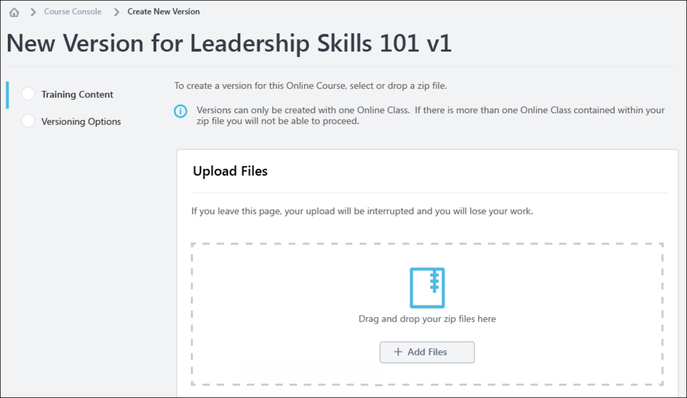
Training Content
Upload Files
To upload a new set of course files:
- Drag and drop your zipped SCORM or AICC course files into the Upload Files box, or click the Add Files button and select the zipped course files from your computer. Note: Courses must be zipped into a single zip file. You can upload up to 750 MB per file.
- After the course files have been added, they will begin uploading. Click the Refresh Status button to view the most current status of the upload. A progress bar below the files displays the ongoing upload progress for the files. Each set of files displays the following information:
  - File name
  - File Type
  - Status (i.e. Uploading, Critical Error)
- If there are problems with the upload, the status changes to Critical Error, and you can click the View Error Report button to view the reasons for the upload errors and address any issues. See Online Course - View Errors on page 14 for additional information.. Note: You cannot use content that is uploaded with a critical error, but you can use content that is uploaded with errors. Once the files successfully finish uploading, they are transferred to the Processing section. Continue managing the upload from the Processing section.
Note: It is recommended that you always preview your uploaded files to ensure the new version will play as expected once published.
Training Information
Once the files have finished uploading, you can preview the course by clicking the Preview button next to the files. If needed, you can delete the files and upload a new set of course files by clicking the Delete icon. If the course previews as expected, populate the following fields for the new version of the course:
- Training Title - Enter the title for the new online course version. By default, the title for the previous course version is populated. This field is required.
- Training Description - Enter the description for the new online class version. Formatting options are available for the training description. By default, the description for the previous course version is populated. This field is limited to 5000 characters.
- Training Hours - Enter the number of training hours received for completion of the online course. The training hours from the manifest of the new version populate in this field automatically.
- Provider - This field displays the provider of the online course. This field is read-only and is automatically populated from the original course version.
- Enable for Mobile App - Choose the Yes option to enable this online class version for the mobile app. Choose the No option if the online course should not be available through the mobile app.
Save and Cancel
Once ready to proceed to the next step in the online course versioning process, click the Save button and continue to the Versioning Options page. See Online Course - Create Version - Versioning Options (Step 2) on page 24 for additional information.
To leave this page without saving any uploads or selections you have made, click the Cancel button.
Considerations
- If an upload is currently in progress for the online course when an administrator navigates to the Course Console page, a notification displays at the top of the Content section, alerting them to the in progress upload. If the administrator wishes to view the in progress upload, they can click the Resume button which displays in the notification. This directs the administrator to the versioning workflow. To resume the upload, click the Resume Upload button. Note: Clicking the Resume option will erase any edits made to the Training Information section. Always preview the upload BEFORE editing the Training Information
- Multi-standard course packages are not allowed for versioning.
Online Course Reversioning - Course Catalog Settings
When an online course is reversioned, the following Course Catalog settings are copied to the new version from the previous version:
- Approval Workflow
- Attempts allowed
- Badges
- Competencies
- Custom OU pricing
- Enable Default Completion Message
- Exclude from Recommendations
- Is Mobile? checkbox
- Points
- Recommended courses
- Recurrence
- Signature Message
- Skills
- Training Purpose
- Thumbnail Image
- Training Units
Online Course - Create Version - Versioning Options (Step 2)
On the second step of reversioning an online course, select versioning options. Default options for this page are configured via Online Course Versioning Preferences, and may be configured as read-only by the administrator. See Online Course Versioning Preferences.
To create a new version of an online course, go to Admin > Tools > Learning > Catalog Management and click the Course Catalog link. Find the online course in the Course Catalog and then click the course title. From the Course Console page, click the Options drop-down menu and click the Create Version option.
Permissions
PERMISSION NAME | PERMISSION DESCRIPTION | CATEGORY

Assignment Tool - Standard and Dynamic | Grants ability to create Standard (one-time) and Dynamic (continuous) Learning Assignments to directly assign training to users. This permission can be constrained by OU, Provider, Training Item, Training Type, User, User Self and Subordinates, and User's OU. If this permission is constrained by Location, Provider, Training Type, or Training Item, then they can only assign training within the constraints. If this permission is constrained by OU, User, User Self and Subordinates, or User's OU, then they can only assign to and view assignments created by users within the constraints. This is an administrator permission. | Learning - Administration

Assignment Tool - Standard and Dynamic - Recurrence | Grants ability to create Standard (one-time) and Dynamic (continuous) Learning Assignments to directly assign training to users. Also grants ability to enable/disable Recurrence when creating a Dynamic Learning Assignment. This permission can be constrained by OU, Provider, Training Item, Training Type, User, User Self and Subordinates, and User's OU. If this permission is constrained by Location, Provider, Training Type, or Training Item, then they can only assign training within the constraints. If this permission is constrained by OU, User, User Self and Subordinates, or User's OU, then they can only assign to and view assignments created by users within the constraints. This is an administrator permission. | Learning - Administration

Course Catalog - Update | Grants ability to manage and edit training items listed in the Course Catalog and also grants access to the Course Console, where training can also be managed and edited. This permission also grants access to the Popular Requests and Highest Rated widgets on the Learning Admin Console (in conjunction with the Learning Admin Console - View permission). This permission also allows administrators to reversion online courses via the Course Console page. This permission also allows administrators to access an Edit Training option for training items included as objectives in Development plans.  This permission can be constrained by OU, User's OU, Training Type, Training Item, Provider, ILT Provider, User's ILT Provider, User, User Self and Subordinates, and User's LO Availability. This is an administrator permission.  Note: Adding an OU constraint and a provider constraint to this permission results in an "AND" statement. | Learning - Administration

Online Class - Publish | Grants access to two pieces of functionality:  - Publish button on the Course Console, allowing administrator to publish a draft online class  - Upload section of the online class versioning workflow | Learning - Administration

Online Class - Upload | Grants access to the Content Uploader where an administrator can upload zip packages to create draft online classes. In addition, this permission grants the ability to upload a new zip package as part of the online class versioning process. This permission does NOT grant the ability to publish online classes. Without the permission to publish online classes, administrators with the permission to upload online classes can only upload and save online classes, which then must be published by administrators with the relevant permission.  As of November 10, 2017, this is the only permission which provides access to the Content Uploader page. | Learning - Administration

Online Class Version - Publish | Grants ability to upload and publish new online class versions. This permission works in conjunction with the permission for uploading online classes. This permission can be constrained by OU, User's OU, Users, and Providers. This is an administrator permission. | Learning - Administration
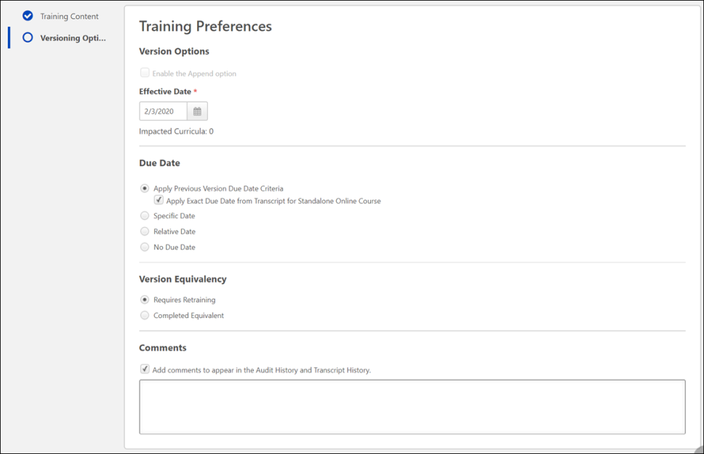
Versioning Options
Select Training Preferences and User Filter Preferences options for the online course version, if editable.
Training Preferences
In the Training Preferences section, configure the following versioning options:
Version Option - In this section, define the criteria for upgrading users and decide who should be upgraded:
  - Append Enablement - Checking this option allows two versions of the online course to exist in the portal at the same time. Both versions can be assigned to users. If this option is enabled, the version uses the Append option, meaning it will require a start date and allow two versions of the same online course to be available at the same time on users' transcripts. If not selected, the new course version replaces the previous version on the effective date. The previous version becomes the old version or expires. Note: This option is only available when the first version of a course is being created. Once a version is created of a certain version type (Append/Replace), following versions must be of that type. For more information about append versioning behavior, See Online Course - Append Versioning Behavior on page 31 for additional information.
- Effective Date - Select the date that the new online course version will be effective in the system.
- Start Date - Select the date that the new online course version can be started by users. This option is only available if Append Enablement has been selected.
- Impacted Curricula - This field displays the number of curricula that are impacted by the online course reversioning.
- Due Date - In this section, select a due date option for reversioned courses. Available options include:
  - Apply Previous Version Due Date Criteria - The following behaviors result from this selection:
    - The due date criteria from the previous version is applied to the new version. So, if the criteria was set to "10 days from Date Assigned" for the previous version, the new due date would be the versioning date plus 10 days.
    - This logic also applies to online courses within a curriculum.
    - The Apply Exact Due Date sub-option becomes available:
      - Apply Exact Due Date - To apply an exact due date from the previous version to the new standalone online course version, also select the Apply Exact Due Date from Transcript for Standalone Online Course sub-option.
  - Specific Date - The following behaviors result from this selection:
    - If the online course is standalone, the new version receives a fixed due date.
    - If the online course is within a curriculum, the new class version displays a fixed date in its structure.
  - Relative Date - The following behaviors result from this selection:
    - If the online course is standalone, the new version receives a relative due date.
    - If the online course is within a curriculum, the new class version displays a relative due date in its structure.
  - No Due Date - The following behaviors result from this selection:
    - If the online course is standalone, the new version will show no due date.
    - If the online course is within a curriculum, the new course version does not display a due date in its structure.
- Version Equivalency - In this section, choose an equivalence option for reversioned training. Available options include:
  - Requires retraining (New training version will be Registered)
  - Completed Equivalent (New training version will be Completed Equivalent based on previous version completion)
- Comments - In the Comments text box, enter any text that should appear in the Audit History and Transcript History for the reversioned course.
All of the options listed above will have default selections, as configured by an administrator via the Online Course Versioning Preferences page. Some options may be read-only if the administrator chose not to allow modification of any or all versioning options.
User Filter Preferences
In the User Filter Preferences section, configure the following user filter options, to determine which users receive the new version:
- Training Version - This drop-down filters the users according to the version of the course in which they are currently enrolled. The list of versions displays the current versions available on the users' transcripts. This enables administrators to easily assign the new online course version to users who are currently enrolled in a specific version of the course. Administrators can select one of the existing versions of the course or all versions. For example, if All Versions is selected, then users who have any version of the course on their transcript are displayed in the User List section.
- Training Status - In this section, select which training statuses will be replaced or appended by the new version of an online course. See Online Course Versioning - Training Status Equivalents on page 45 for additional information.. Available statuses include:
  - Not Started
  - In Progress
  - Completed
- Assignment Type - In this section, select which users receive new versions of an online course. Available options include:
  - Select Users with a previous version - Selecting this option includes all users, regardless of the assignment method (Requested, assigned, or via learning assignment)
  - Select Users assigned by Dynamic Assignment - Selecting this option only includes users who were dynamically assigned the course. Permissions for dynamic and dynamic recurring learning assignments and their associated constraints apply to this option.
  - Select Users by OUs - This option allows the administrator assign the new version to specific organizational units (OUs), such as divisions, locations, groups, etc. If no OUs are selected, then no users receive the new version.
User List
The User List section displays users who have a version of the online course on their transcript. The users that display in the user list are controlled by the constraints applied to the permission for publishing online course versions.
If you make any changes to the User Filter Preference selections in the section above, click the Refresh User List button to view an updated user list. To remove any user from the user list and prevent them from receiving the new version of the online course, uncheck the box next to the user's name. Note: This option is not available if the Effective Date is in the future. The system automatically recalculates the users impacted from the filter selection when the version becomes effective.
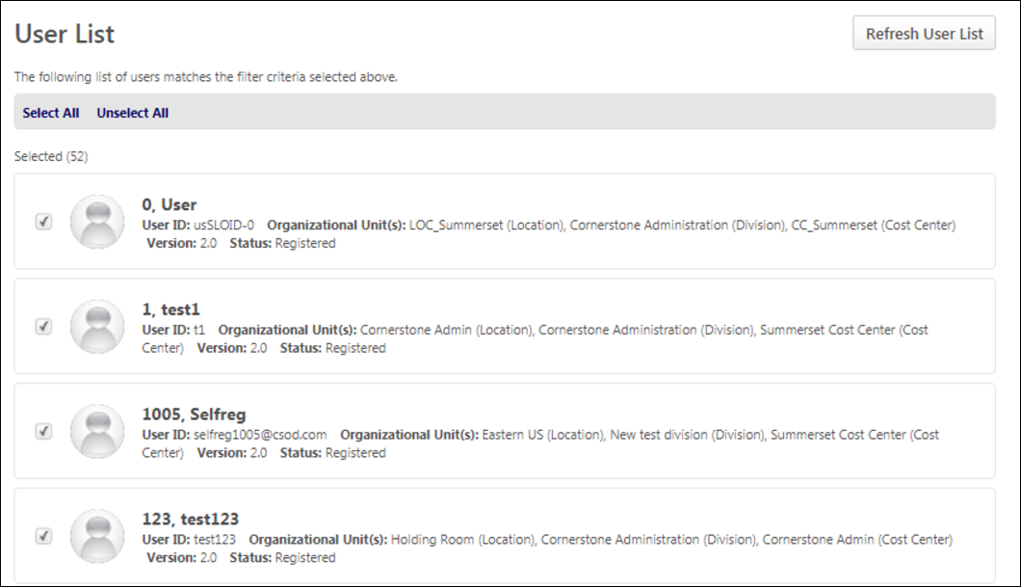
Publish
After configuring all versioning options and verifying that the user list applies to the number of users expected, click the Publish button to publish the new online course version, which will be applied to users as specified in the User Filter Preferences section. After clicking the Publish button, you are redirected to the Course Console page for the online course, and a notification displays at the top of the page, stating, "New version has been created. Please wait while the version is being published."
When the new version is successfully published, the version number and the Last Modified Date are updated on the Course Console page, and the new online course version is active in the portal. Further modifications to the online course can be made on the Course Console page and via Course Catalog. Note: When the online course is reversioned, all metadata from the original course is copied to the new version EXCEPT for the following:
  - Pricing - Prices must be configured for the new version.
  - Approval Workflows - Any applicable approval workflows must be configured for the new version.
  - Training Equivalencies - Any applicable training equivalencies must be configured for the new version.
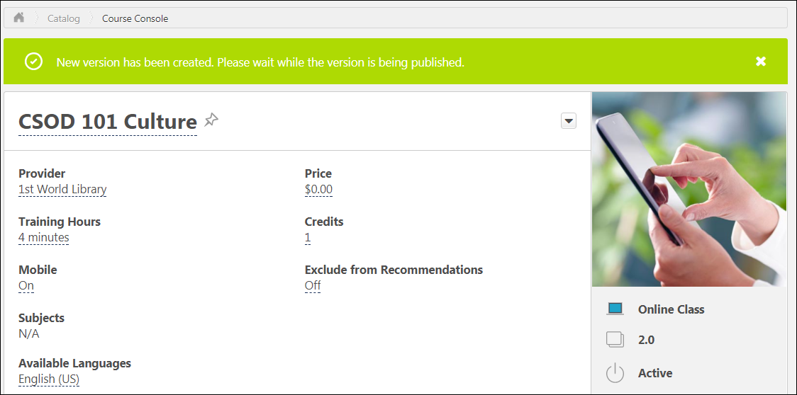
To return to the previous page in the online course versioning process, you can click the Previous button. To exit the process without saving the uploaded files or any options, click the Cancel button.
Online Course - Append Versioning Behavior
Using the Append option when reversioning an online course, two versions of an online course can be active at a time. This selection is only available when the first version of a course is being created. Once a version is created of a certain version type (Append/Replace), following versions must be of that type. Note: No more than two versions can be in a Published status at once.
When an online course is reversioned with the Append option enabled, the new version exhibits the following behaviors:
- Users can have two active versions of the online course on their transcripts, depending on the options selected by the administrator during the reversioning process.
- Two versions of the online course may be included in curricula containing the online course. See Online Course - Curricula Auto Reversioning on page 34 for additional information.
- The Effective Date is either immediate or in the future, depending on the options selected by the administrator who reversioned the course. Users only receive the new version when the effective date is reached.
- The Start Date for the online course can be left blank when reversioning an online course, but needs to be populated in order to deactivate the previous version.
- The new version of the online course is active in the portal either until its end date.
- When one version is inactivated, the other active version also becomes inactivated. For example: Both version 1.0 and version 2.0 would become inactive if one or the other is inactivated.
Use Case - Two Versions on User's Transcript
Sylvia is an administrator, and she is responsible for all compliance training at ACME Inc. On August 15, 2017, Sylvia receives an email from the Chief Compliance Officer informing her that a new factory procedure for 2018 is available. All employees working in the factory should be able to start being trained on September 1, 2017, as the new procedure will be effective on January 1, 2018. The same factory procedure for 2017 should also be available until December 31, 2017.
Sylvia creates a new version of the Factory Procedure for 2017 using the online class Create Version functionality. She uses the Append option because she wants two versions of the class to be available on users' transcripts at the same time. Sylvia alsoadds an Effective Date of January 1, 2018 for the new procedure. She then assigns the new version to all employees at ACME Inc. who have the previous version of the course on their transcript. The Factory Procedure for 2017 will be automatically deactivated when the Factory Procedure for 2018 starts.
John is working in the factory at ACME Inc. He sees the 2017 and the 2018 version of the Factory Procedure on his transcript. John can access both versions of the procedure from September 1, 2017 until January 1, 2018. On January 1, 2018, only the 2018 version is available.
Append Versioning Behavior with the Learning Assignment Tool
When an online course assigned via the Learning Assignment Tool has been reversioned and appended, the following learning assignment behaviors apply:
- If there are two active versions of an online course in a learning assignment, both are assigned to users.
- If a user has two active versions of an online course assigned via a learning assignment, and the user leaves the criteria for the assignment, both course versions are removed when Dynamic Removal is enabled for the assignment. If the user later meets the assignment criteria again, both versions are reassigned to the user.
Scenario | Assignment behavior
Version 1 is active, and the administrator is assigning Version 1 via the Learning Assignment Tool (LAT). | Version 1 is assigned to users.
Version 1 and Version 2 of the online course are active, and the administrator is assigning Version 1 via the LAT. | Version 1 and Version 2 are assigned.
Version 1 and Version 2 of the online course are active, and the administrator is assigning Version 2 via the LAT. | Version 1 and Version 2 are assigned.
Version 2 and Version 3 of the online course are active, and the administrator is assigning Version 1. | Version 2 and Version 3 are assigned.
The administrator creates an assignment with two active versions (Version 2 and Version 3), and assigns both versions with the Assign New Occurrence option. | Both Version 2 and Version 3 are assigned as new occurrences on users' transcripts.
Version 1 and Version 2 are active, and Version 1 is already on users' transcripts. The administrator assigns Version 1 with the Assign New Occurrence option. | Version 1 is assigned as a new occurrence, and users are also assigned Version 2.
Version 1 and Version 2 are active, and Version 1 is already on users' transcripts. The administrator assigns Version 1, but does NOT user the Assign New Occurrence option. | Users only receive Version 2.
Version 1 and Version 2 are active, and Version 1 has been removed from users' transcripts. The administrator assigns Version 1 using a learning assignment. | Version 2 is assigned to users, and Version 1 is also restored to users' transcripts.
Version 1 and Version 2 are active, and both versions are on users' transcripts. The administrator removes the online course from users' transcripts. | Version 1 and Version 2 are both removed from users' transcripts.
Considerations
The Learning Assignment Tool only assigns more than one version if an appended version of the online course exists.
Online Course - Replace Versioning Behavior
When the Append option is NOT enabled for a versioned online course, only one version of the online course can be in a Published status in the portal, and the new version replaces the previous version on selected users' transcripts when the effective date is reached.
When an online course is versioned WITHOUT the Append option enabled, the new version exhibits the following behaviors:
- Only one version of the online course can be on a user's transcript.
- The Effective Date is either immediate or in the future.
- The Start Date and End Date only apply when the online course is appended. They do not apply when the course is replaced.
Note: After choosing to either append or replace a version of an online course, any subsequent versionings default to the same versioning option originally chosen (Append or Replace).
Use Case - One Version on User's Transcript
David is an administrator responsible for all management training at ACME Inc. On August 15, 2017, David receives a call from the Legal Manager informing him that a new anti-harassment policy is available for the State of California, and it is immediately applicable. All managers working in California should be assigned the new online course version of the policy, and the previous version is obsolete.
David creates a new version of the Anti-Harassment Policy using the online course versioning functionality. He does not enable the Append option because he wants only the new version of the course to be available on users' transcripts. David adds an Effective Date of August 15, 2017 for the new policy. He assigns the new version to all managers in California at ACME Inc. When the new version is created, the previous version of the Anti-Harassment Policy class is still Active but its Training Status changes to Epired.
Sam is working in California as a manager at ACME Inc. Before August 15, 2017, Sam can access the previous version of the Anti-Harassment Policy. On August 15, 2017, Sam can only access the new version of the Anti-Harassment Policy. The previous version is automatically made inactive on his transcript.
Online Course - Curricula Auto Reversioning
When an online course is reversioned via Content Uploader functionality available via the Course Console, curricula which contain the online course are automatically reversioned as well. In addition, when a previous version of an online course expires, the previous version is automatically removed from any curricula it is contained within. If an online course contained within a curriculum is reversioned, the new version of the online course is automatically updated within the newest version of the curriculum that contains the course. When this occurs, the curriculum is reversioned. The effective date of the new curriculum version is set to the effective date of the new online course version. The comments for the new curriculum version are the same as the new online course version. This occurs even if there are no users enrolled in the curriculum. Note: Administrators can view the dynamic or dynamic recurring learning assignments for curricula containing any version of the online course.
Important: To maintain compliance, administrators must have the permission for online course versioning AND the permission for curriculum versioning . If an administrator creates a new version of a child material or child online course but does NOT have permission to version curricula, the curriculum will not be updated and version updates cannot be maintained.
- If the new online course version replaces the previous version, the new version maintains the same settings within the curriculum as the previous version (i.e., item sequence, number of required items, pay upfront, pre-approved, auto-register).
- If the new online course version appends the previous version, then the behavior depends on whether there are already two versions of the course within the curriculum.
  - If there is currently only one version of the online course in the curriculum, then the new version is added with the same sequence number as the previous version. If all items in the section are required, then the new version is also required. If not all items in the section are required, then the number of required items for the section is unchanged. The new version has the same pay upfront, pre-approved, and auto-register settings.
  - If there are currently two versions of the online course in the curriculum, then the new version replaces the expired version in the curriculum. The new version is added with the same sequence number as the expired version. The number of required items for the section is unchanged. The new version has the same pay upfront, pre-approved, and auto-register settings.
- Because two versions of an online course may exist in a curriculum, one of the versions within the curriculum may expire, leaving only one active version. When this occurs, the sequence is unaffected, because both versions had the same sequence number. The number of required items in the section returns to its value prior to adding the appended version.
See the table below for curriculum behaviors resulting from various online course reversioning selections:
Replace or Append? | Reversion Behavior | Setup | Sequence | required | Pre-Approved/Pay Upfront/Register
Replace |  | Yes | Same sequence as Version 1 of online course | The same number of items are required for curriculum section completion after the online course and curriculum are reversioned. | The pre-approved/pay upfront/register selections are copied from the previous version to the new version.
Replace |  | No | Same sequence as Version 1 of online course | The same number of items are required for curriculum section completion after the online course and curriculum are reversioned. | The pre-approved/pay upfront/register selections are copied from the previous version to the new version.
Append | When two versions are appended | Yes | Same sequence as Version 1 of online course | -When zero items in the section are required, zero items are required after the reversion. For example, if 0/3 items were required prior to reversioning, 0/4 items are required after the reversioning.  -When all items in the section are required, all items are required after the reversion. For example, if 3/3 items were required prior to the reversioning, 4/4 items are required after the reversioning.  -When not all items in the section are required, the reversioned course becomes optional within the section. For example, if 2/4 items in the section were required prior to the reversioning, 2/5 items in the section will be required after reversioning. | The pre-approved/pay upfront/register selections are copied from the previous version to the new version.
Append | When two versions are appended | No | Same sequence as Version 1 of online course | The same number of training items are required for curriculum completion after the online course and curriculum are reversioned. | The pre-approved/pay upfront/register selections are copied from the previous version to the new version.
Append | When the new version replaces the old version | Yes | Same sequence as Version 1 of online course | -When zero items in the section are required, zero items are required after the reversion. For example, if 0/3 items were required prior to the course reversioning, 0/4 items will be required after reversioning.  -When all items in the section are required, all items are required after the reversion. For example, if 3/3 items were required prior to the course reversioning, 4/4 items are required after reversioning.  -When not all items in the section are required, the reversioned course becomes optional in the section. For example, if 2/4 items in the section were required prior to the course reversioning, 2/5 items in the section are required after reversioning. | The pre-approved/pay upfront/register selections are copied from the previous version to the new version.
Append | When the new version replaces the old version | No | Same sequence as Version 1 of online course | The same number of items are required for curriculum section completion after the online course and curriculum are reversioned. | The pre-approved/pay upfront/register selections are copied from the previous version to the new version.
Modify an Online Course
When an online course only requires minor updates, you can replace the files without creating a new version of the online course, using the Modify Content option available on the Course Console page for the class. Administrators can make select minor updates to the course manifest without triggering a new course version. The fields that may be modified in the course manifest without triggering a new version include:
- Mastery score
- Href/launch location
- Files under "Resources"
- Title
- Description
- Keywords
- Duration
To create or modify the course files for an online course, go to Admin > Tools > Learning > Catalog Management and click the Course Catalog link. Find the online class in the Course Catalog and then click the course title. From the Course Console page, click the Options drop-down menu in the Content section and click the Modify Content option.
Permissions
PERMISSION NAME | PERMISSION DESCRIPTION | CATEGORY

Course Catalog - Update | Grants ability to manage and edit training items listed in the Course Catalog and also grants access to the Course Console, where training can also be managed and edited. This permission also grants access to the Popular Requests and Highest Rated widgets on the Learning Admin Console (in conjunction with the Learning Admin Console - View permission). This permission also allows administrators to reversion online courses via the Course Console page. This permission also allows administrators to access an Edit Training option for training items included as objectives in Development plans.  This permission can be constrained by OU, User's OU, Training Type, Training Item, Provider, ILT Provider, User's ILT Provider, User, User Self and Subordinates, and User's LO Availability. This is an administrator permission.  Note: Adding an OU constraint and a provider constraint to this permission results in an "AND" statement. | Learning - Administration

Online Class - Modify | Grants ability to modify an online class without creating a new version of the online class. | Learning - Administration

Upload History - View | Grants ability to view the Upload History page. | Learning - Administration
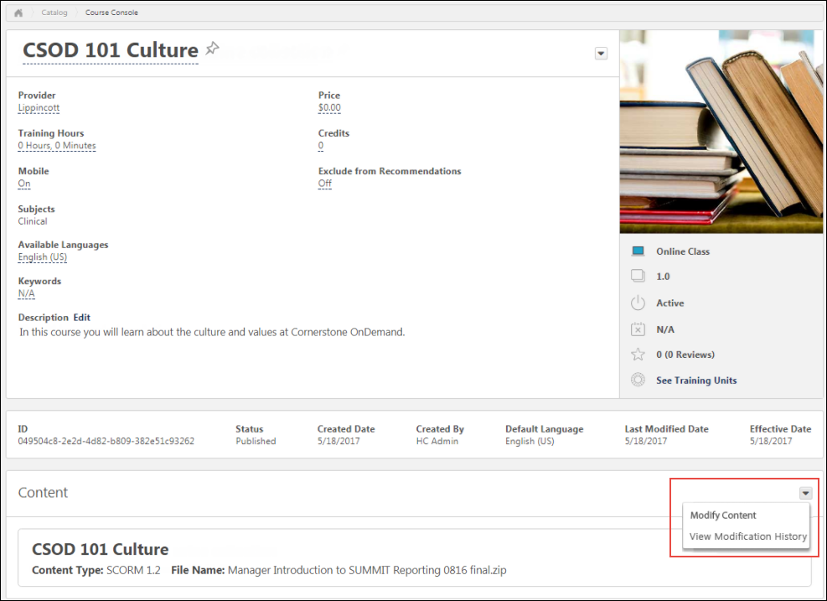
Modify Content
To modify the course files of an existing course, click the Modify Content option in the Content section. This directs you to the Modify Content page, where you can upload the modified course files.
To upload a modified set of course files or publications:
- Drag and drop your zipped SCORM or AICC course files into the Upload Files box, or click the Add Files button and select the zipped course files from your computer. If the replacement files are substantially different from the original files, you will need to reversion the course instead. Note: Courses must be zipped into a single zip file. You can upload up to 750 MB per file.
- After the course files have been added, they will begin uploading. A progress bar below the files displays the ongoing upload progress for the files. Each set of files displays the following information:
  - File name
  - File Type
  - Status (i.e., Uploading, Critical Error)
- If there are problems with the upload, the status changes to Critical Error or Completed with Comments, and you can click the VIEW ERROR REPORT button to view the reasons for the upload errors and address any issues. If the new files are too different from the original files, the upload results in an error. Once the files successfully finish uploading, they are transferred to the Processing section. Continue managing the upload from the Processing section. Available errors:
  - SCORM Courses
    - Severe Error: Manifest change - Only Resources element changes are permitted on the manifest
    - Severe Error: Manifest Location Change - Relative path
    - Warning: HTML/ JS / SWF files have been modified - Check different file size and content
  - AICC Courses
    - Severe Error: AU, CRS, CST, DES files changed - Check different file size and content
    - Severe Error: AU, CRS, CST, DES files Location changed - Relative path
    - Warning: HTML/ JS / SWF files have been modified - Check different file size and content
If needed, you can delete a set of course files from the Upload Files section by clicking the Delete upload button.
Processing
Uploaded files move to the Processing section while the system checks the files for errors.
When a set of course files is transferred to the Processing section, click the Provider drop-down menu and select the provider for the course. After a provider has been selected, the set of course files moves to the Draft Ready section once processing is completed.
If needed, you can delete a set of course files from the Processing section by clicking the Delete upload button.
Needs Provider
If the course provider still needs to be selected for the course files after they finish processing, the files appear in the Needs Provider section. Select a course provider from the Select Provider drop-down menu. Once a provider is selected, the course files automatically move to the Draft Ready section.
Draft Ready
Once a set of course files moves to the Draft Ready section, its status changes to Uploaded Successfully, and it is available in the Course Catalog as a draft. Select a provider for the online course using the drop-down menu next to the uploaded course files.
Using the Course Catalog, you can configure the metadata for the new online course. Click the Modify content button to replace the original online course files with the new files. After clicking the Modify Content button, a pop-up window appears, saying, "Modifying the content will overwrite the current files. You will not be able to undo this action. Are you sure you want to proceed?" If you wish to proceed, click the Modify Content button in the pop-up window. You will be redirected to the Course Console page.
To view information about the online course's modification history, click the Review Content Modification button. This opens a flyout which displays the following information for the course files in the Draft Ready section:
- Title
- File Name
- Current Size
- New Size
If you do not want to modify the content, click the Cancel button to close the pop-up without publishing the new files.
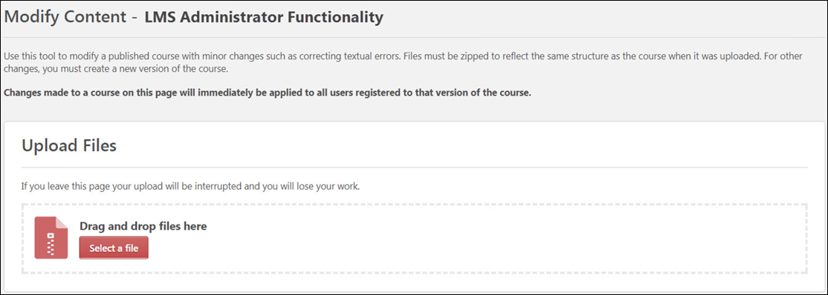
View Modification History
Clicking the View Modification History option from the Content section of the Course Console opens a flyout window with information about the online course's modification history.
Considerations
- If an upload is currently in progress for the online course when an administrator navigates to the Course Console page, a notification displays at the top of the Content section, alerting them to the in progress upload. If the administrator wishes to view the in progress upload, they can click the Resume button which displays in the notification. This directs the administrator to the Modify Content page. To resume the upload, click the Resume Upload button.
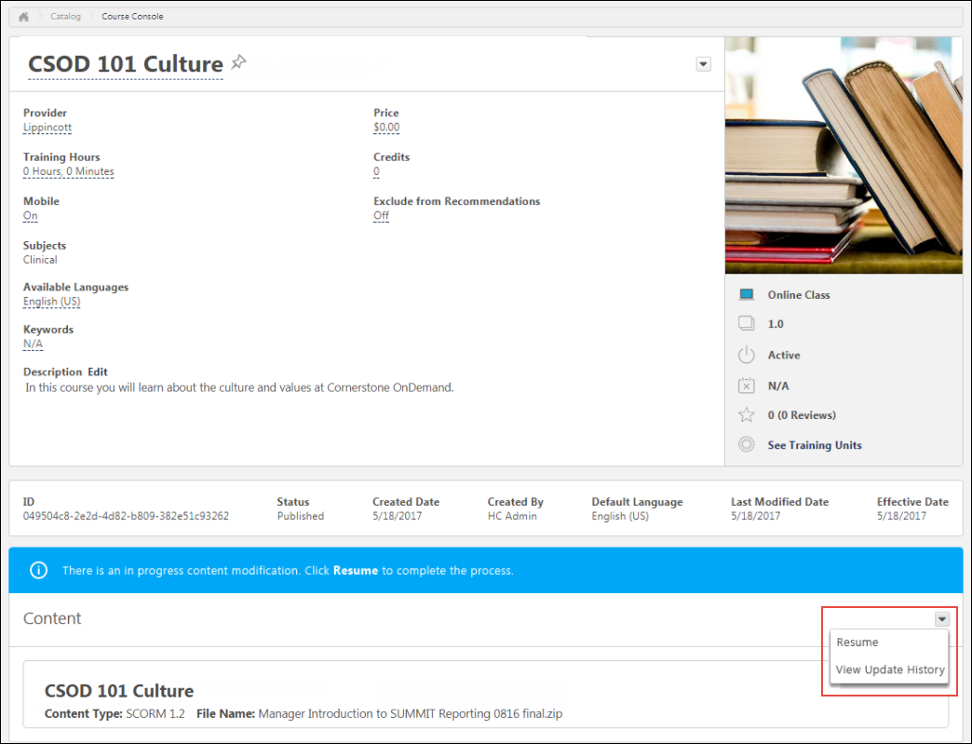
- When an administrator accesses the Modify Content page for a course that is part of a multi-package publication, a notification appears, warning the user that modifying the content for the course will impact other courses within the publication.
Validation Messages
The following validation messages may appear when modifying an online course:
For SCORM Courses
- 1. Severe Errors:
  - a. Manifest change - Only Resources element changes are permitted on the manifest.
  - b. Manifest Location Change - Relative path.
- 2. Warnings
  - a. HTML/ JS / SWF files have been modified - Checking different file size and content.
For AICC Courses
- 1. Severe Error:
  - a. AU, CRS, CST, DES files changed - Checking different file size and content.
  - b. AU, CRS, CST, DES files Location changed - Relative path.
- 2. Warning
  - a. HTML/ JS / SWF files have been modified - Checking different file size and content.
Online Course - Modification History
In the Content section of the Course Console page for an online course, the Options drop-down provides access to the Modification History page. When the View Modification History link is clicked, the Modification History flyout appears. The Modification History flyout displays separate tile for each instance of course modification. Each tile displays the following information:
- Title
- Date of Modification
- Username of the user who modified the online course
- Options drop-down menu - Clicking the Options drop-down opens the File List flyout. The File List flyout displays the following information:
  - Title - The title of the course
  - Back - Clicking this link returns the user to the Modification History flyout
  - Date of Modification
  - Username of the user who modified the online course
  - File Name - The name of the uploaded course files
  - Action - Whether the course files were updated or deleted
  - File Size
Online Course Versioning - Training Status Equivalents
Depending on the administrator's training status selections when reversioning an online class, users with the previous version of the class in statuses of Not Started, In Progress, and Completed, and statuses equivalent to these statuses, can automatically receive the new version.
The following statuses are treated as equivalent to Not Started when an online course is reversioned:
- Not Activated
- Pending Prior Training
- Registered
- Registered/Past Due
- Registered/Not Available
- Registered/Not Available/Past Due
- Approved
- Approved/Past Due
- Pending Prerequisite
- Pending Prerequisite/Past Due
The following statuses are treated as equivalent to In Progress when an online course is reversioned:
- Failed
- In Progress
- In Progress/Past Due
- Pending Observer Completion
- Pending Observer Completion/Past Due
- Pending Completion Approval
- Pending Completion Approval/Past Due
- Pending Evaluation
- Pending Evaluation/Past Due
- Pending Acknowledgment
- Pending Acknowledgment/Past Due
- Pending Pre-work
- Pending Pre-work/Past Due
- Pending Post-work
- Pending Post-work/Past Due
- Pending Completion Signature
- Pending Completion Signature/Past due
The following statuses are treated as equivalent to Completed when an online course is reversioned:
- Completed
- Completed Equivalent
- Exempt

Course Publisher (Legacy) - Overview

Course Publisher (Legacy) Overview
The Course Publisher functionality allows administrators to effectively manage content by uploading, validating, and integrating it into the Cornerstone Learning Management System (LMS). The Course Publisher allows administrators to upload a new course, upload a new version of a course, and replace files in existing courses.
Deprecation Note: With the November 2023 release, Cornerstone has announced the deprecation of Course Publisher and upgrading all clients to use the Content Uploader. With the July '24 Release, Course Publisher will be disabled in all customer portals and Content Uploader will be enabled in all customer portals.
This topic relates to the legacy Course Publisher functionality. Your organization may be using the Content Uploader. See Content Uploader - Create an Online Course - Overview on page 2 for additional information.
Important: The page description and instructions that are displayed at the top of this page can be edited and customized via Navigation Tabs and Links.
To access Course Publisher, go to Content > Course Publisher or Admin > Tools > Learning > Catalog Management > Course Publisher.
Administrators can only access the Course Publisher if they have been granted a content license and they have the proper permissions. A content license can be granted on the Manage Licenses page. See Manage Licenses.
Permissions
PERMISSION NAME | PERMISSION DESCRIPTION | CATEGORY

Course Publisher | Grants access to LCMS Course Publisher, which enables upload and publishing of SCORM and AICC compliant online courses, created either in the LCMS Course Builder, or from a third party course building tool. Administrators must also be granted a content license from the Manage Licenses page. This is an administrator permission.  After Content Publisher is activated in the system, users with this permission are automatically granted the permissions to upload and publish online classes via the Content Publisher, and also the permission to view the Upload History page. | Learning - Administration

Course Publisher Update | Grants ability to update existing online training courses previously published via the course publisher. Administrators must also be granted a content license from the Manage Licenses page. This is an administrator permission.  With the Oct '17 release, after the Content Publisher is activated in the system, users with this permission are automatically granted the permission to modify online classes. | Learning - Administration

Edit Online Course Providers | Grants ability to edit the Provider field for an online course via the Course Catalog and Course Console. User must also have permission to view the Course Catalog. This permission cannot be constrained. This is an administrator permission. | Learning - Administration
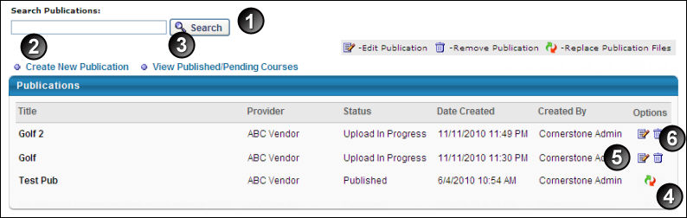
- Search Publication - Search for existing publication. A publication can be a SCORM 1.2 course, SCORM 2004 course, AICC course, or a group of SCORM or AICC courses.
- Create New Publication - Create a new publication. Up to 100 AICC courses or 250MB of SCORM courses can be zipped together and uploaded. See Course Publisher (Legacy) - Create New Course/Publication on page 50 for additional information.
- View Published/Pending Courses - View published or pending courses
- Replace Publication Files - Replace a publication. See Course Publisher (Legacy) - Minor Course Changes - Replace Files on page 61 for additional information.
- Edit - Edit existing publication. See Course Publisher (Legacy) - Edit Course Before Publishing on page 57 for additional information.
- Remove Publication - Remove a publication that has not been published
Update a Course
When updating a course, it is important to understand what types of changes you are making to the course. To help determine which process is best for your course changes, See Course Publisher (Legacy) - Update a Course on page 55 for additional information.
Helpful Hints - Document Types and Size
If a user has permission to update a publication via Course Publisher, then that administrator will be able to view the directory list of files included in a publication to replace or append to those files. If files for an existing publication are modified, then all users registered in that course will see those changes immediately.
Helpful Hints - Replace/Reversion
- Replace Publication Files - The course's publication files are replaced if the course has the exact same file structure as the original publication, for example correcting a spelling error or changing text. This process simply overwrites the previous version with the new files you upload and updates the course in a user's transcript. You can check to see if the course files were uploaded by clicking on the View Updates History link that is available after you click the Replace Publication Files icon .
  - When replacing a course, the old course files are overwritten and the new course files and are immediately applied to all users in any status, including users in a Completed status.
  - Publication files can only be replaced if the uploaded course has an identical manifest to the existing course. If the manifests are not exactly the same, then you cannot replace the publication files. Instead, you must reversion the course.
- Reversion - The course is reversioned if you are changing the structure from the previous version, for example adding a page or a new section.
  - When a new version is created, the version number is increased.
  - The course will then be added to the Course Catalog. You can search for it, just make sure you check the radio button for All Versions.
  - Because this is considered a different course and uploaded as a new publication, if a user has this in their transcript they will not automatically get the new course.
  - The new version will not overwrite the course for any users who currently have the course in their transcript, however new users will get the reversioned course.

Course Publisher (Legacy) - Create New Course/Publication
An online course or publication is an electronic learning course that can be completed asynchronously within the system or offline using the Offline Player. An online course is comprised of SCORM or AICC compliant files that are bundled into a zip file.
This topic relates to the legacy Course Publisher functionality. Your organization may be using the Content Uploader. See Content Uploader - Create an Online Course - Overview on page 2 for additional information.
All uploaded files must be SCORM 1.2, SCORM 2004, or AICC compliant and in a zip file. Note: Currently, SCORM 2004 3rd edition is implemented. Backward compatibility is generally expected, and thus courses published in 2nd edition is likely to work properly, but it is advised that courses are created using SCORM 2004 3rd edition.
Up to 100 AICC courses or 250MB of SCORM courses can be zipped together and uploaded. Individual SCORM courses which exceed 250 MB in size may require upload by Cornerstone. Consult Global Customer Support about creating a work order request.
To create a new online course:
- Go to Content > Course Publisher or Admin > Tools > Learning > Catalog Management > Course Publisher. Then, click the Create New Publication link.
- Go to Admin > Tools > Learning > Learning Admin Console. Then, click the Create button and click the Online Class link.
Administrators can only access the Course Publisher if they have been granted a content license and they have the proper permissions. A content license can be granted on the Manage Licenses page. See Manage Licenses.
Permissions
PERMISSION NAME | PERMISSION DESCRIPTION | CATEGORY

Course Publisher | Grants access to LCMS Course Publisher, which enables upload and publishing of SCORM and AICC compliant online courses, created either in the LCMS Course Builder, or from a third party course building tool. Administrators must also be granted a content license from the Manage Licenses page. This is an administrator permission.  After Content Publisher is activated in the system, users with this permission are automatically granted the permissions to upload and publish online classes via the Content Publisher, and also the permission to view the Upload History page. | Learning - Administration

Course Publisher Update | Grants ability to update existing online training courses previously published via the course publisher. Administrators must also be granted a content license from the Manage Licenses page. This is an administrator permission.  With the Oct '17 release, after the Content Publisher is activated in the system, users with this permission are automatically granted the permission to modify online classes. | Learning - Administration
Process to Create a New Course
The process of creating a new course is a multi-step process. Prior to using Course Publisher to configure and publish your course, a course provider must first author the course and package it into one of the accepted protocols (AICC, SCORM) as a zip file.
Once you have a zip file that contains the course files, follow these steps to configure and publish your course:
- On the Publication Information page, enter the basic information for the course. See the Publication Information section below for additional information.
- Browse for and upload the zip file that contains the course files. See the Upload Publication File section below for additional information.
- Click the Edit Publication icon from the Course Publisher page. See Course Publisher (Legacy) - Edit Course Before Publishing on page 57 for additional information.
- Click Publish to publish the course.
- Configure the course in Course Catalog. When a new course is published, it is added to the Course Catalog, but no availability, evaluations, subjects, skills, or competencies are associated with that course by default. This information is configured by editing the course in Course Catalog. See Course Catalog Overview for additional information.
Troubleshooting Information
See Course Troubleshooting Guide.
See QUICK START GUIDE - Uploading Courses via Course Publisher.
Publication Information
Enter the following information about your Online Course:
- Title - Enter title for publication (required). The title entered here is not the course title the user will see. This title labels the publication files for the administrator. The course title is created from the metadata from the zipped file. If multiple languages are enabled for the portal, click the Translate icon to localize the title into other available languages. The character limit is 500.
- Description - Enter description for publication. This is not the description for the course. The course description can be entered in Course Catalog after the published. If multiple languages are enabled for the portal, click the Translate icon to localize the description into other available languages.
- Default Language - This displays the default language for the course. This is the language that displays for users if a translation is not available for the publication title. The default language is set as the language of the administrator at the time they create the publication. This cannot be edited.
- Provider - To select a provider, click the search icon . This is required. Providers can be viewed within the Providers administration page. See Training Providers Overview.
- Click Next.
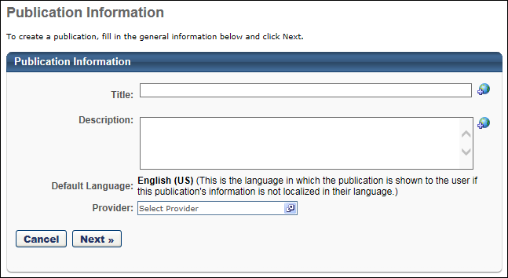
Upload Publication File
- Browse - Click this button to locate and select the zipped course file. Multiple courses can be uploaded in a publication, but must be uploaded in a single zipped file. Up to 100 AICC courses or 250MB of SCORM courses can be zipped together and uploaded.
Important: The Course Publisher cannot unzip multiple zipped files packaged within a single zipped file.
- Upload File - Click to upload file. Upload time is dependent on the size of your course files and your internet connectivity transfer rate for uploading. It is not uncommon for large course files to take up to an hour to load. If you navigate away from the page when uploading a course, the upload terminates.
  - A pop-up window will open with progress indicator and will close when file has uploaded.
  - You will be directed to a confirmation page after upload. Note: If course code functionality has been activated in your portal, a course code is automatically generated for the LO immediately after the administrator saves the new LO.
  - Status will be Upload In Progress. When the status changes to Pending Publish, course can be viewed or published.
  - Click OK and it will redirect you back to the Course Publisher page.
- Click the Edit Publication icon from the Course Publisher page. See Course Publisher (Legacy) - Edit Course Before Publishing on page 57 for additional information.
- Click Publish to publish the course. When a new course is published, it is added to the Course Catalog, but no availability, evaluations, subjects, skills, or competencies are associated with that course by default. This information is configured by editing the course in Course Catalog. See Course Catalog Overview for additional information.
Note: When creating a SCORM 2004 course, the Use SSL preference in Content Launching Preferences must be selected in order for the content to load and function properly.
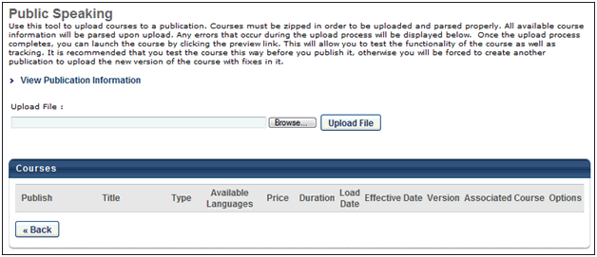
Helpful Hints - Score Calculation
- When creating a new course or publication in which a score is calculated, in order for the system to calculate and display a score on the Training Details page, the maximum score must be defined (i.e., greater than zero) in the SCORM wrapper (max_score) and the user score must be defined (i.e., not equal to null).
  - If the Score field does not appear on the Training Details page, then the maximum score is not defined in the SCORM wrapper.
  - If the Score label does appear, but there is no value, then the user's score is not defined.
Helpful Hints - Weighted Scoring
- Weighted scoring can be applied for multi-sco SCORM courses.
- Weighted sections can be configured for a multi-sco SCORM course regardless of when the course was published.
- If weighted scoring is configured for existing courses, the changes apply for all users that are currently registered for the course and have not yet completed it.
- If various SCOs have different weights, the different weights are included when calculating the user's score to determine if a user has earned a passing score
- When a user completes part of an online course, the score that is displayed is weighted. For example, an online course has three sections. Section 1 is worth 50% of the total score. Section 2 is worth 25% of the total score. Section 3 is worth 25% of the total score. A user completes Section 1 and answers all of the questions correctly. They will have a score of 50%, even though they only completed one sections of the course.
- Once a user completes a multi-sco SCORM course with weighted scoring, their score is recorded and does not change if the user re-takes the course. In order for the user to receive a new score, they must complete a new instance of the course.
Note: The ability to apply weighted scoring for multi-sco SCORM courses is controlled by a backend setting that is turned off by default. To enable the setting for your portal, contact Global Customer Support.
Helpful Hints - SCORM 2004 Table of Contents
When the table of contents (TOC) is being used for SCORM courses, each SCO displays the learner’s progress. One green check mark indicates that the user passed the SCO, and a second green check mark indicates the SCO has been completed. These check marks allow learners to easily view which SCOs have already been completed so they don't need to re-open any chapters they have already completed.
In addition, a refresh mechanism ensures the SCOs are shown in their correct and updated state (enabled or disabled).
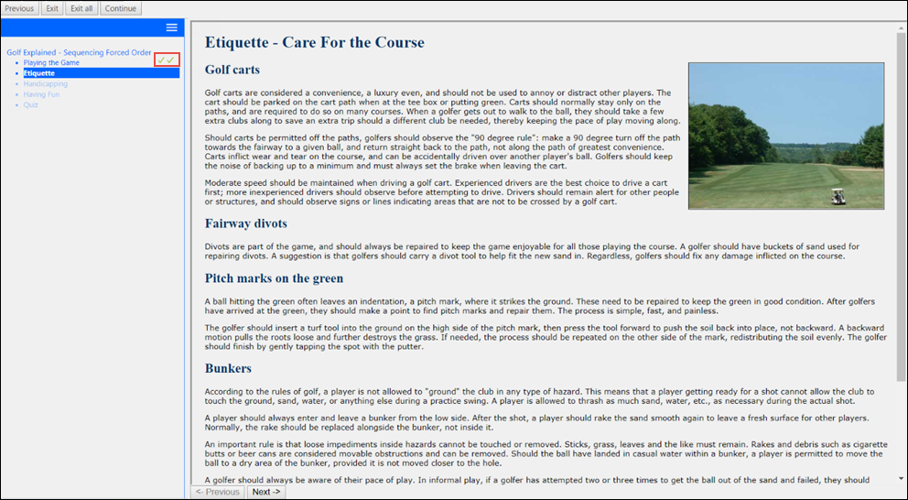

Course Publisher (Legacy) - Update a Course
When updating a course, it is important to understand what types of changes you are making to the course. Review the infographic below to determine which process is best for your changes.
- Edit Course Before Publishing - If you have not yet published your course, you can edit the course to publish the course, replace the publication files, or change the details of the course. See Course Publisher (Legacy) - Edit Course Before Publishing on page 57 for additional information.
- Minor Course Changes - Replace Files - If you have published the course and need to make minor changes to the course, such as text changes, you can replace the publication files. See Course Publisher (Legacy) - Minor Course Changes - Replace Files on page 61 for additional information.
- Major Course Changes - Reversion Course - If you have published the course and need to make major modifications to the course, such as replacing a segment of the course or adding or removing a SCO (Shareable Content Object), you can create a new version of the course. See Course Publisher (Legacy) - Major Course Changes - Reversion Course on page 66 for additional information.
This topic relates to the legacy Course Publisher functionality. Your organization may be using the Content Uploader.
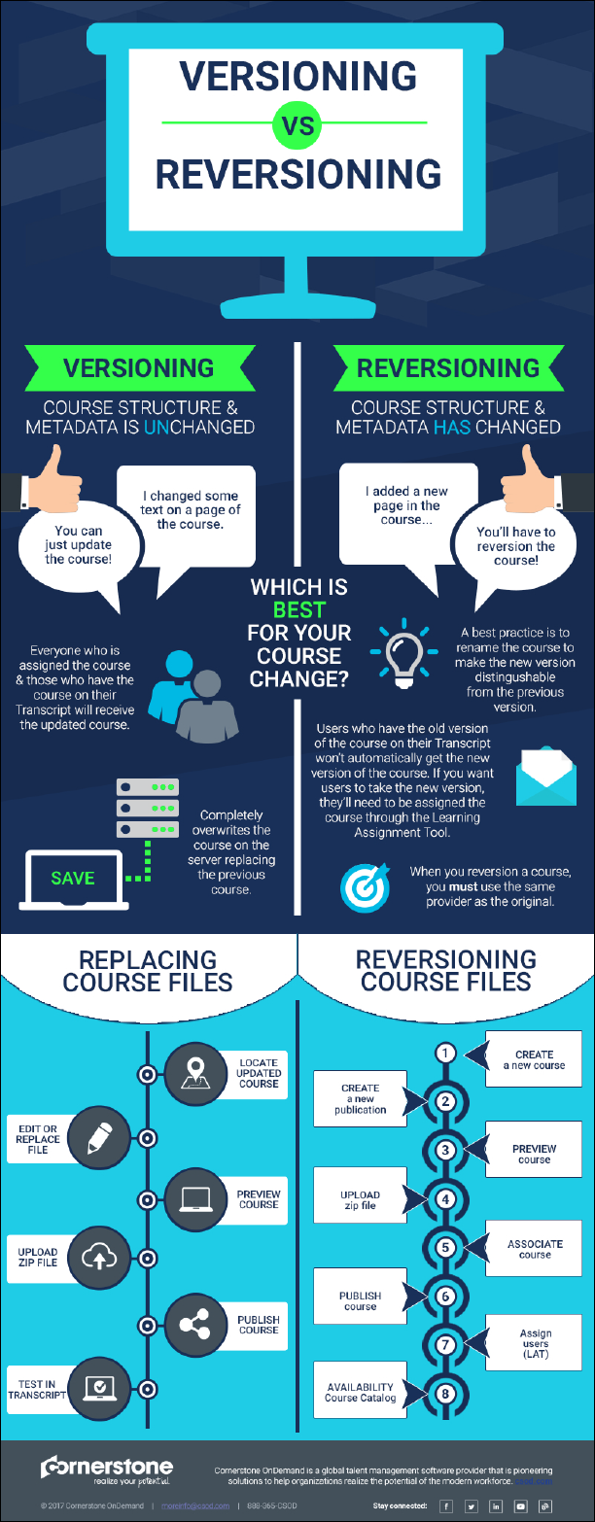

Course Publisher (Legacy) - Edit Course Before Publishing
When modifying a course that has not yet been published, administrators are able to publish the course, replace publication files, or change the course information.
This topic relates to the legacy Course Publisher functionality. Your organization may be using the Content Uploader. See Modify an Online Course on page 38 for additional information.
Administrators can only access the Course Publisher if they have been granted a content license and they have the proper permissions. A content license can be granted on the Manage Licenses page. See Manage Licenses.
To edit a course, go to Content > Course Publisher or Admin > Tools > Learning > Catalog Management > Course Publisher. Then, select one of the following options in the Options column:
- Replace Publication Files - This option is available if the course has been published. See Course Publisher (Legacy) - Minor Course Changes - Replace Files on page 61 for additional information.
- Edit Course - This option is available if the course has not yet been published.
Permissions
PERMISSION NAME | PERMISSION DESCRIPTION | CATEGORY

Course Publisher | Grants access to LCMS Course Publisher, which enables upload and publishing of SCORM and AICC compliant online courses, created either in the LCMS Course Builder, or from a third party course building tool. Administrators must also be granted a content license from the Manage Licenses page. This is an administrator permission.  After Content Publisher is activated in the system, users with this permission are automatically granted the permissions to upload and publish online classes via the Content Publisher, and also the permission to view the Upload History page. | Learning - Administration

Course Publisher Update | Grants ability to update existing online training courses previously published via the course publisher. Administrators must also be granted a content license from the Manage Licenses page. This is an administrator permission.  With the Oct '17 release, after the Content Publisher is activated in the system, users with this permission are automatically granted the permission to modify online classes. | Learning - Administration
View Publication Information
To view and edit the publication information (i.e., Title, Description, Provider), click the View Publication Information link. This information was set when the publication was created.
View Upload History
To see the history of the publication including File, Uploaded By and Uploaded Date, click View Upload History link.
Upload File
This feature allows you to upload a file, which replaces previously uploaded course files.
To replace the publication files for a published course, follow these steps:
- Click Browse to find replacement course files.
- Click Upload to upload the file.
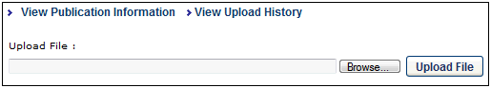
Select Publishing Format
In the Publish column, when a course file is uploaded that contains multiple formats, you can select which course formats to publish. Courses that are not selected are not published.
Preview Course
Click the Preview Course icon in the Options column to preview and test the course.
Edit Course Details
Click the Edit icon to edit the course details. You can edit the following fields:
- Title - Modify the course title. The character limit is 500. If multiple languages are enabled for your portal, select the Translate icon to translate the field into other available languages.
- Description - Modify the course description. This field has no character limit. If multiple languages are enabled for your portal, select the Translate icon to translate the field into other available languages.
- Type - This displays the type of course (e.g., SCORM 1.2, SCORM 2004).
- Available Languages - Determine the languages in which the course is available.
- Price - Set the price for users to take the course.
- Duration - Specify the duration of the course.
- Allow Download - If this option is selected, the corresponding course can be downloaded via the Course Catalog. Note: This option is only available if the Network Player is enabled.
- Load Date - This field is not editable. This field displays the date and time at which the course was uploaded.
- Effective Date - This field displays the date on which the course is effective. This field is only editable when creating another version of an existing course. Using the calendar tool, select the date on which the course is effective.
- Version - This defaults to the version number in the metadata from the uploaded course. It can be updated to another version number that is not in use for the associated course.
- Associated Course - If the course has associated courses, the course names are listed.
- Compatibility Mode - The Internet browser compatibility mode for an online course determines which compatibility mode, if any, is applied when the online course is launched. From the drop-down menu, select the compatibility mode for the online course. The default value for this setting is set in Content Launching Preferences. Note: This option only affects users using Internet Explorer; users using other browsers (e.g., Chrome, Firefox) are unaffected.
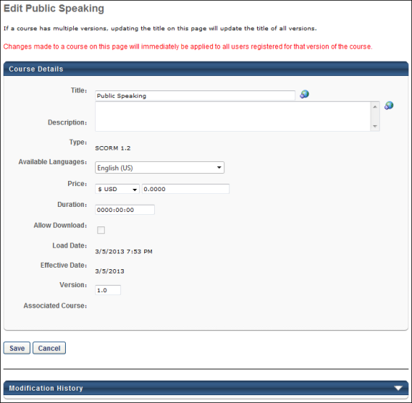
Save/Publish
Click Save to save your modifications.
Click Publish to publish the course. When a new course is published, it is added to the Course Catalog, but no availability, evaluations, subjects, skills, or competencies are associated with that course by default. This information is configured by editing the course in Course Catalog. See Course Catalog Overview for additional information.

Course Publisher (Legacy) - Minor Course Changes - Replace Files
Administrators are able to modify a published course in order to make changes within the course. This option should be used only if minor changes are being made to the course, such as correcting textual errors.
This topic relates to the legacy Course Publisher functionality. Your organization may be using the Content Uploader. See Modify an Online Course on page 38 for additional information.
To edit a course, go to Content > Course Publisher or Admin > Tools > Learning > Catalog Management > Course Publisher. Then, select one of the following options in the Options column:
- Replace Publication Files - This option is available if the course has been published.
- Edit Course - This option is available if the course has not yet been published. See Course Publisher (Legacy) - Edit Course Before Publishing on page 57 for additional information.
Administrators can only access the Course Publisher if they have been granted a content license and they have the proper permissions. A content license can be granted on the Manage Licenses page. See Manage Licenses.
Permissions
PERMISSION NAME | PERMISSION DESCRIPTION | CATEGORY

Course Publisher | Grants access to LCMS Course Publisher, which enables upload and publishing of SCORM and AICC compliant online courses, created either in the LCMS Course Builder, or from a third party course building tool. Administrators must also be granted a content license from the Manage Licenses page. This is an administrator permission.  After Content Publisher is activated in the system, users with this permission are automatically granted the permissions to upload and publish online classes via the Content Publisher, and also the permission to view the Upload History page. | Learning - Administration

Course Publisher Update | Grants ability to update existing online training courses previously published via the course publisher. Administrators must also be granted a content license from the Manage Licenses page. This is an administrator permission.  With the Oct '17 release, after the Content Publisher is activated in the system, users with this permission are automatically granted the permission to modify online classes. | Learning - Administration
Replace Course Files vs. Create New Version
When updating a course, you may have the option to replace the publication files of the existing course or create a new version of the existing course.
- Replace Publication Files - This option can only be used if the new course has an identical file structure and manifest to the old course. If the file structure is different (For example, if you first loaded a course with one SCO and now you are replacing with acourse with two SCOs) you will not be able to replace the course files. SCOs are Sharable Content Objects. These are what you are creating with your authoring tool when building SCORM courses. It is important that you know how many SCOs your course files contain before you try to replace course files. You also cannot replace functionality, such as mastery scores, maximum score, launch URL's, etc. The option to Replace Publication Files is initiated from the Course Publisher Overview page.
- Create New Version - This option is used if the new course does not have an identical file structure or manifest to the old course. This option should be used if non-minor changes are being made to the course. This option is initiated by uploading the new course files as a new course and then associating the new course with the old course prior to publishing. NOTE: The file type must be the same when creating a new version. For example, if you originally loaded the course as SCORM 1.2, you cannot create a new version of the course as SCORM 2004. If you do so, your users will receive an error when they try to launch the course. Instead, publish a new course file for the new SCORM 2004 course.
See Course Publisher (Legacy) - Major Course Changes - Reversion Course on page 66 for additional information.
Do users get the new course files automatically?
When a course file is replaced, the following users automatically receive the updated course:
- Users who are registered for that version of the course, including users in the following statuses: Registered, In Progress, Completed
- Users who request the course after the course is updated
Updating Courses Quick Start Guide
See QUICK START GUIDE - Updating Courses via Course Publisher.
View Upload History
To see the history of the publication including File, Uploaded By and Uploaded Date, click View Upload History link.
View Updates History
To see the history of updates to the publication including Action, Done By, Action Date, Acted On and the Item Value, click View Updates History link.
This can be used to verify whether new course files were uploaded for the course.
Replace Course/Publication Files
When replacing a course file, the structure of the course that is being replaced must be exactly the same as the course that is being loaded. This includes the file structure and the manifest. For example, if the original course has one SCO (Shareable Content Object), then the new course must have only one SCO.
If the manifests are not exactly the same, then you cannot replace the publication files. Instead, you must reversion the course. See Course Publisher (Legacy) - Major Course Changes - Reversion Course on page 66 for additional information.
Note: AICC courses cannot be replaced through the traditional method in the course publisher and must be replaced in the back end.
To replace the publication files for a published course, follow these steps:
- On the Course Publisher page, click the Replace Publication Files icon.
- Click Browse to find replacement course files. Up to 100 AICC courses or 250MB of SCORM courses can be zipped together and uploaded.
- Click Upload to upload the file.
- While the file is being uploaded, the Uploading Course Files page appears. This page indicates that the files are being processed and that the publication status will be Upload In Progress until the file is fully uploaded. Click OK.
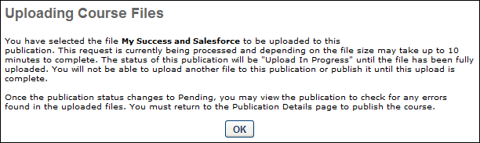
- On the Course Publisher page, the publication appears in the Upload in Progress status until the file is fully uploaded. The following options appear in the Options column:
  - Edit - Click this icon to edit the publication information. See the Edit Published Course Information section below for additional information.
  - Cancel Publication Update - Click this icon to discard the newly uploaded publication files. The previously existing files remain.
- Once the publication files are fully uploaded, the publication status is changed to Pending Update. Click the Edit icon for the publication, and then click the Update button to update the files. Replacing course files immediately overwrites previous files and is applied to all users registered for that version of the course.
  - Best Practice: Although the files are immediately replaced, it may take up to four hours for the new course files to be pushed to users who already have the course on their transcript. As a best practice, confirm that the changes have been implemented using a user who does not currently have the training on their transcript. If the course changes did not occur, the course modifications may be too significant to be implemented using this method, and the course may need to be reversioned in order to implement the changes. See Course Publisher (Legacy) - Major Course Changes - Reversion Course on page 66 for additional information.
Edit Published Course Information
Click the Edit icon to edit the course. Edits to title, price, or duration are immediately applied to all users regardless of status for that version of the course.
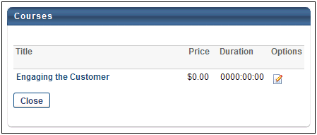
The following fields can be edited:
- Title - Modify the course title. The character limit is 500. If multiple languages are enabled for your portal, select the Translate icon to translate the field into other available languages.
- Description - Modify the course description. This field has no character limit. If multiple languages are enabled for your portal, select the Translate icon to translate the field into other available languages.
- Price - Set the price for users to take the course.
- Duration - Specify the duration of the course.
- Allow Download - If this option is selected, the corresponding course can be downloaded via the Course Catalog. Note: This option is only available if the Network Player is enabled.
- Compatibility Mode - The Internet browser compatibility mode for an online course determines which compatibility mode, if any, is applied when the online course is launched. From the drop-down menu, select the compatibility mode for the online course. The default value for this setting is set in Content Launching Preferences.Note: This option only affects users using Internet Explorer; users using other browsers (e.g., Chrome, Firefox) are unaffected.
After editing the appropriate information, click Save.
Note: The provider selected when the course was created cannot be edited. In order to change the provider for a course, a new course would need to be created with a different provider selected. See Course Publisher (Legacy) - Create New Course/Publication on page 50 for additional information.
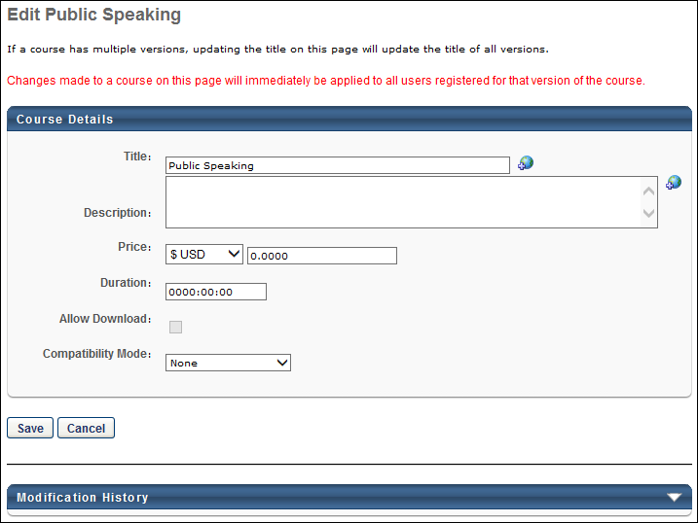
Modification History
The Modification History panel tracks changes that are made to the title and description for published courses, as well as the initial creation of the title and description. Changes made to unpublished courses are not tracked in this panel.
The initial creation and changes to the title and description display in the panel as follows:
- Title at Initial Creation - <Learning Object Type> created with <Language of Title> Title "<Title>" by <User Full Name> (<User ID>) on <Date/Time of Creation>.
- Description at Initial Creation - <Learning Object Type> created with <Language of Description> Description of "<Description>" by <User Full Name> (<User ID>) on <Date/Time of Creation>.
- Change to Title - Title in <Language of Title> was changed to "<New Title>" by <User Full Name> (<User ID>) on <Date/Time of Creation>.
- Change to Description - Description in <Language of Description> was changed to "<New Description>" by <User Full Name> (<User ID>) on <Date/Time of Creation>.
- Title/Description Translation Change - Title/Description in <Language> "<New Title/Description>" was added by <User Full Name> (<User ID>) on <Date/Time of Creation>.

Course Publisher (Legacy) - Major Course Changes - Reversion Course
Administrators are able to create a new version of a course in order to make major modifications to a published course, such as modifications to the file structure. Administrators may choose to create a new version of a course in the following scenarios:
- Making non-minor changes to the course, such as replacing a segment of the course or making significant updates to the course content.
- Modifying the course structure, such as adding or removing a SCO (Shareable Content Object).
This topic relates to the legacy Course Publisher functionality. Your organization may be using the Content Uploader. See Online Course Versioning vs. Modifying - Overview on page 17 for additional information.
As a best practice, a course should not be reversioned when making minor changes such as correcting text errors. Instead, the course publication files should be replaced. See Course Publisher (Legacy) - Minor Course Changes - Replace Files on page 61 for additional information.
When creating a new version of a course, you must first upload the new version as though you are creating a new course. Prior to publishing the new course, you have the option to create a new version of an existing course.
To create a new online course, go to Content > Course Publisher or Admin > Tools > Learning > Catalog Management > Course Publisher. Then, click the Create New Publication link.
Administrators can only access the Course Publisher if they have been granted a content license and they have the proper permissions. A content license can be granted on the Manage Licenses page. See Manage Licenses.
Permissions
PERMISSION NAME | PERMISSION DESCRIPTION | CATEGORY

Course Publisher | Grants access to LCMS Course Publisher, which enables upload and publishing of SCORM and AICC compliant online courses, created either in the LCMS Course Builder, or from a third party course building tool. Administrators must also be granted a content license from the Manage Licenses page. This is an administrator permission.  After Content Publisher is activated in the system, users with this permission are automatically granted the permissions to upload and publish online classes via the Content Publisher, and also the permission to view the Upload History page. | Learning - Administration

Course Publisher Update | Grants ability to update existing online training courses previously published via the course publisher. Administrators must also be granted a content license from the Manage Licenses page. This is an administrator permission.  With the Oct '17 release, after the Content Publisher is activated in the system, users with this permission are automatically granted the permission to modify online classes. | Learning - Administration
Replace Course Files vs. Create New Version
When updating a course, you may have the option to replace the publication files of the existing course or create a new version of the existing course.
- Replace Publication Files - This option can only be used if the new course has an identical file structure and manifest to the old course. If the file structure is different (For example, if you first loaded a course with one SCO and now you are replacing with acourse with two SCOs) you will not be able to replace the course files. SCOs are Sharable Content Objects. These are what you are creating with your authoring tool when building SCORM courses. It is important that you know how many SCOs your course files contain before you try to replace course files. You also cannot replace functionality, such as mastery scores, maximum score, launch URL's, etc. The option to Replace Publication Files is initiated from the Course Publisher Overview page.
- Create New Version - This option is used if the new course does not have an identical file structure or manifest to the old course. This option should be used if non-minor changes are being made to the course. This option is initiated by uploading the new course files as a new course and then associating the new course with the old course prior to publishing. NOTE: The file type must be the same when creating a new version. For example, if you originally loaded the course as SCORM 1.2, you cannot create a new version of the course as SCORM 2004. If you do so, your users will receive an error when they try to launch the course. Instead, publish a new course file for the new SCORM 2004 course.
See Course Publisher (Legacy) - Minor Course Changes - Replace Files on page 61 for additional information.
Do users get the new version automatically?
When a course is reversioned, the following users automatically receive the updated course:
- Users who request the course after the course is reversioned
Creating a new version of a course does not overwrite the course for any users who currently have the course in their transcript. If you want the new version to replace the previous version on users' transcripts, you must assign the new version to the users. See Create Learning Assignment - Overview.
Updating Courses Quick Start Guide
See QUICK START GUIDE - Updating Courses via Course Publisher.
View Publication Information
To view and edit the publication information (i.e., Title, Description, Provider), click the View Publication Information link. This information was set when the publication was created.
View Upload History
To see the history of the publication including File, Uploaded By and Uploaded Date, click View Upload History link.
Create New Version of Course
To create a new version of an existing course, follow these steps:
- Upload the new version as though you are creating a new course. Up to 100 AICC courses or 250MB of SCORM courses can be zipped together and uploaded. See Course Publisher (Legacy) - Create New Course/Publication on page 50 for additional information.
- Once an unpublished course is uploaded, from the Course Publisher screen, click the Edit icon .
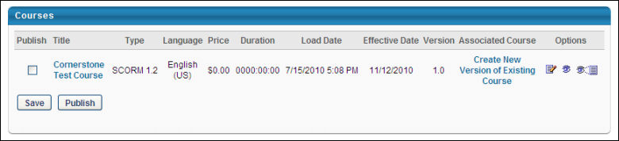
- In the Associated Course column, click the Create New Version of Existing Courses link to select the existing course for which you would like to create a new version. This opens the Select Course to Upgrade pop-up window, displaying all of the courses from the same provider that were uploaded with the Course Publisher.
- Search for the appropriate course, and select it by clicking the Add icon. The selected course is listed in the Associated Course field. When the course is published, it is saved as a new version of the course to which it is associated.
- Click Publish. This automatically creates a new version of the course, and the course version number is created.
- Configure the availability and other settings for the new course version via the Course Catalog. When a new course is published, it is added to the Course Catalog, but no availability, evaluations, subjects, skills, or competencies are associated with that course. The course's availability, evaluations, subjects, skills, competencies, and other information are modified in the Course Catalog. See Course Catalog Overview.
Creating a new version of a course does not overwrite the course for any users who currently have the course in their transcript. If you want the new version to replace the previous version on users' transcripts, you must assign the new version to the users. See Create Learning Assignment - Overview.
Reversioning a Course that Is Part of a Curriculum
When a course that is inside a curriculum is reversioned, users who have the curriculum on their transcript or who have previously requested the curriculum do not receive the new version of the course. Users who have never requested or completed the curriculum will receive the new version of the course if they request or are assigned the curriculum.
- If you change the name of the course, such as adding a version number to the name, the curriculum does not show the new name in Curricula Administration or immediately in the user's transcript. The user will not see the new name until they launch the course, and then the curriculum in their transcript will update with the new course name.
- If it is necessary for all impacted users to receive the new version of the course, you can run a Transcript Status report in Standard Reports that provides all users that currently have the course in an In Progress or Completed status. There are two options for ensuring these affected users receive the new course version:
  - If you run a forced learning assignment of the reversioned LO to push the latest version to a user, it is expected that you will see a stand-alone instance of the LO on the user's transcript. The stand-alone instance and the instance nested under the curriculum will share transcript status. When one instance is completed, the other instance will be completed. Once an LO has been made into a stand-alone LO, this cannot be undone.
  - To prevent duplicated listings of the course on the user's transcript, create a new online course using the content you were going to use to reversion the online course. Name this new course in a manner that indicates it is a new version of an old course. Remove the old online course from the curriculum and add the new online course to the curriculum. The curriculum will reversion. Select the option to push the reversion to applicable users. This action removes the old version from the curriculum and makes it a stand-alone online course on the transcript. This online course can then be removed. You may wish to utilize the Training Removal Tool functionality if multiple users are affected.
Expired Appended Training
When a material or online course is versioned with Append logic, you have the option to choose the start date of the new version. Once the start date is reached, the old version expires and becomes inactive. Expired child training items are hidden by default. The expiration of the previous training version is captured on the Structure History page for curricula, which is accessible from the Course Console.
An option to expose and hide expired training in a curriculum is available on both the Training Details page and on the Curriculum Player page for the curriculum.
Reversioning a Course that Is Part of a Dynamic Learning Assignment
When a course that is part of a dynamic learning assignment is reversioned, the new version of the course is automatically updated for users.
- During the versioning of a material, the user criteria logic of the Users Assigned by Dynamic Proxy option will consider users who meet the following criteria:
  - Are currently in the assignment criteria at the time of versioning
  - Currently have the training on their transcript as a result of the LAT assignment
- For users, if the previous version of the course is in an In Progress status on their transcript, they will not get the new version of the course. Even if they complete the previous version, the new version will not appear in the curriculum on their transcript unless the learning assignment is a recurring assignment, in which case they will receive the new version with the next recurrence of the learning assignment.
Validation Messages
Walidation messages may appear if the Start Date and Effective Date of a versioned online course are too close to each other.
Validation Message #1: Creation of Online Course when Effective Date and Start Date are within [H] hours (H value defined by a backend setting)
For most portals, the time difference between the Start Date and Effective Date which triggers validation messages is set to two hours, meaning that H hours = 2 hours. If an administrator versions an online course and the Start Date and Effective Date are within two hours of one another, the following warning message will trigger:
“The Effective Date and Start Date are too close for the new version to process. By clicking Accept, you are acknowledging that the previous version will expire immediately."
If the administrator clicks Accept, the old version of the training is immediately deactivated.
Note: Select portals have been configured with an H value other than two, so these portals will trigger the above validation message when the value between the Start Date and Effective Date is at or below the H value defined by the portal's backend setting.
Materials/DMS Materials/Online Courses Concurrency
When an administrator reversions an online course, material, or DMS material using Versioning with Append, and the Start Date and Effective Date very close to each other, a confirmation pop-up window appears to the administrator. The time difference value which triggers this pop-up is determined by a backend setting. If an administrator clicks the Accept button in the pop-up window, the old version of the material or online course expires immediately.
In addition, administrators are not able to edit the Start Date of the appended version if the difference between the time the administrator is updating the training and the Effective Date is within the number of hours configured in the backend setting.
Validation Messages
A validation message appears if the Start Date and Effective Date of a versioned material or online course are too close to each other.
Validation Message #1: Creation of Material or Online Course when Effective Date and Start Date are within [H] hours (H value defined by a backend setting)
For most portals, the time difference between the Start Date and Effective Date which triggers validation messages is set to two hours, meaning that H hours = 2 hours. If an administrator versions a material or online course and the Start Date and Effective Date are within two hours of one another, the following warning message will trigger:
“The Effective Date and Start Date are too close for the new version to process. By clicking Accept, you are acknowledging that the previous version will expire immediately."
If the administrator clicks Accept, the old version of the training is immediately deactivated.
Note: Select portals have been configured with an H value other than two, so these portals will trigger the above validation message when the value between the Start Date and Effective Date is at or below the H value defined by the portal's backend setting.

Course Publisher (Legacy) - Modify Individual SCORM Files
This topic relates to the legacy Course Publisher functionality. Your organization may be using the Content Uploader. See Modify an Online Course on page 38 for additional information.
Permissions
PERMISSION NAME | PERMISSION DESCRIPTION | CATEGORY

Course Publisher | Grants access to LCMS Course Publisher, which enables upload and publishing of SCORM and AICC compliant online courses, created either in the LCMS Course Builder, or from a third party course building tool. Administrators must also be granted a content license from the Manage Licenses page. This is an administrator permission.  After Content Publisher is activated in the system, users with this permission are automatically granted the permissions to upload and publish online classes via the Content Publisher, and also the permission to view the Upload History page. | Learning - Administration

Course Publisher Update | Grants ability to update existing online training courses previously published via the course publisher. Administrators must also be granted a content license from the Manage Licenses page. This is an administrator permission.  With the Oct '17 release, after the Content Publisher is activated in the system, users with this permission are automatically granted the permission to modify online classes. | Learning - Administration
Administrators only have access to Course Publisher if they have a content license, which can be granted on the Manage Licenses page. See Manage Licenses.
- Go to Content > Course Publisher
- Click Replace Publication Files
- Click Get Directory List link
- Delete Files:
  - Check files
  - Click Delete
- Upload individual files to replace deleted files. See Course Publisher (Legacy) - Minor Course Changes - Replace Files on page 61 for additional information.
The course's availability, evaluations, subjects, skills, competencies, and other information are modified in the Course Catalog. See Course Catalog Overview for additional information.

LinkedIn Learning Integration
The LinkedIn Learning integration allows LinkedIn Learning content to be synchronized with the Learning Management System (LMS). Learners can launch LinkedIn Learning content from the LMS or their LinkedIn portal and have their progress tracked in their LMS transcripts.
To access the Edge Marketplace, go to: Admin > Tools > Edge and click the Marketplace link.
Permissions
PERMISSION NAME | PERMISSION DESCRIPTION | CATEGORY

Edge Integrations - Manage | Grants access to the Integrations service for Edge Integrate, where the administrator can configure, enable, and disable their third-party integrations used within the Cornerstone system. This permission cannot be constrained. This is an administrator permission. | Edge

Edge Marketplace - Manage | Grants access to the Marketplace service for Edge Integrate, where the administrator can browse integrations that can be used to extend the Cornerstone system. This permission cannot be constrained. This is an administrator permission. | Edge
Use Cases
Use Case #1: Manage LinkedIn Content via Course Catalog
Brenda is a learning administrator at ACME Corp, which uses the LinkedIn Learning integration. She uses the Course Catalog to manage the courses offered by LinkedIn Learning. This content appears in the form of online courses within the Course Catalog.
Use Case #2: Launch and Complete LinkedIn Content in LMS
Lisa is an employee of ACME Corp. She browses for courses on Learner Home and decides to take a LinkedIn Learning course she finds. After launching the course, a new window opens with the course, and she does not need to provide additional login credentials. After she completes the course, it is added to her transcript in a Completed status.
Use Case #3: Sync LinkedIn Content with LMS Transcript
Lisa logged into the LinkedIn Learning site and completed a course for which she was not registered in the LMS. Because her learning administrator enabled the Bypass Registration option for the LinkedIn Learning integration, this completed course is synced to Lisa's transcript in the LMS.
Considerations
The following considerations apply to this functionality:
- When the LinkedIn Learning integration is enabled, LinkedIn Learning content is synced with the LMS on a nightly basis. Note: All synced content is flagged as Mobile Ready if the corresponding option on the Edge Configuration page for the integration is selected.
- Administrators can configure a Bypass Registration option for the integration. If enabled, when a learner completes a course on LinkedIn Learning, even if they are not registered for the course in the LMS, the course appears in a Completed status on their transcript and can be reported on. If this option is disabled, in the same scenario, the course appears in a Completed status in the form of a learning record, which is NOT reportable.
- The learning content progress report available through LinkedIn Learning is limited to training completions at this time. Other than completions, no other progress data is recorded in the LMS, meaning no percentage of progress or time spent in course is recorded.
- LinkedIn Learning courses cannot have their progress reset by assigning a new registration. If a new registration will be made, the information will be reset in the interface, but upon launch, progress made in the course will remain.
- While progress sent from LinkedIn Learning courses typically occurs in near real-time, in some cases it might take up to 24 hours for the progress to be sent back to Cornerstone CSX. This means that the course status and detail history might take up to 24 hours to be updated in the CSX system.
Implementation
This integration is available for no additional cost via the Edge Marketplace . Additional information about the LinkedIn Learning integration and its configuration options is also available through the Edge Marketplace.
Organizations currently using Lynda.com or LinkedIn Learning AICC courses will need a migration to be able to use this new integration. However, this migration is not yet available. Further information will be shared with organizations using Lynda.com or LinkedIn Learning AICC courses once the migration becomes available.
For more information about the LinkedIn Learning platform, see: LinkedIn Learning
LinkedIn Learning - Edge Marketplace
In the Edge Marketplace, you can find the LinkedIn Learning integration by searching or browsing. To learn more about the LinkedIn Learning integration or begin the enablement and configuration process, click the LinkedIn Learning integration tile.
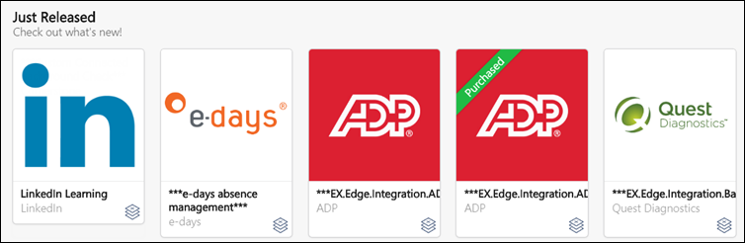
The page for the LinkedIn Learning integration provides access to the following tabs for learning more about and managing the integration:
- Vendor - This tab provides information about the vendor that provides the integration. Here, you can view more information about the LinkedIn Learning platform.
- Integration - This tab provides information about the integration itself and how it can be used with the learning management system (LMS).
- Pricing - This tab provides information about the costs associated with the integration. Note: There is no cost associated with the LinkedIn Learning integration. This integration is free to enable.
- Setup - This tab provides information about how to configure the integration once enabled. The integration can be configured via Edge Integrations.
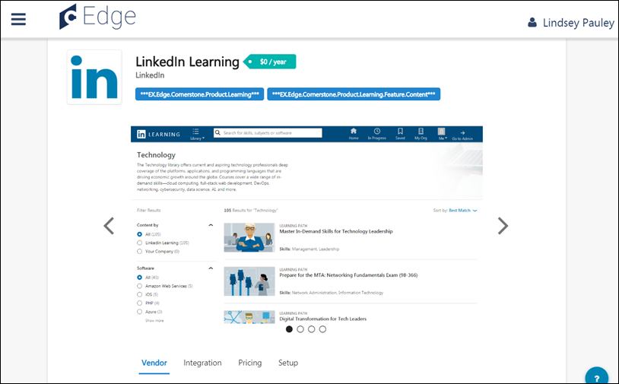
LinkedIn Learning - Edge Integrations
Once the LinkedIn Learning integration has been added through the Edge Marketplace, the integration can be managed and configured from Edge Integrations. The Integrations page for the integration provides access to setup options which the administrator can use to customize the behavior of the LinkedIn Learning integration. See the Setup tab for the LinkedIn Learning integration in the Edge Marketplace for more information about the configuration options available.
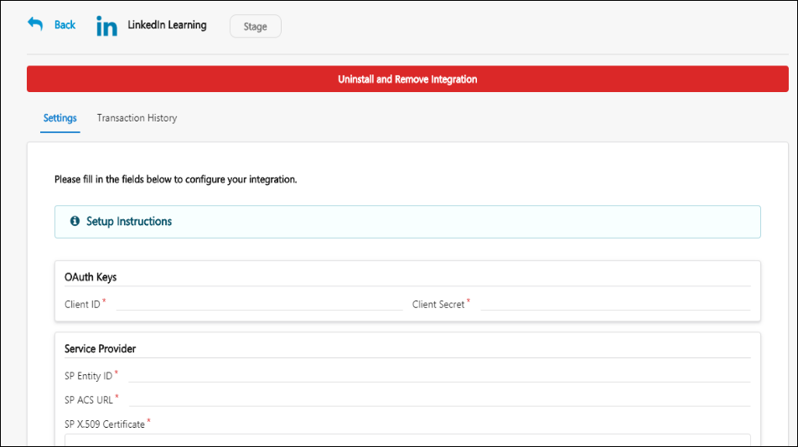
LinkedIn Learning - Course Catalog
LinkedIn Learning content that has been synced to the LMS appears in the Course Catalog as online courses, with a Provider name of LinkedIn Learning, and these courses can be managed through the Course Catalog by administrators. LinkedIn Learning content displays with its original language and course duration time in the system.
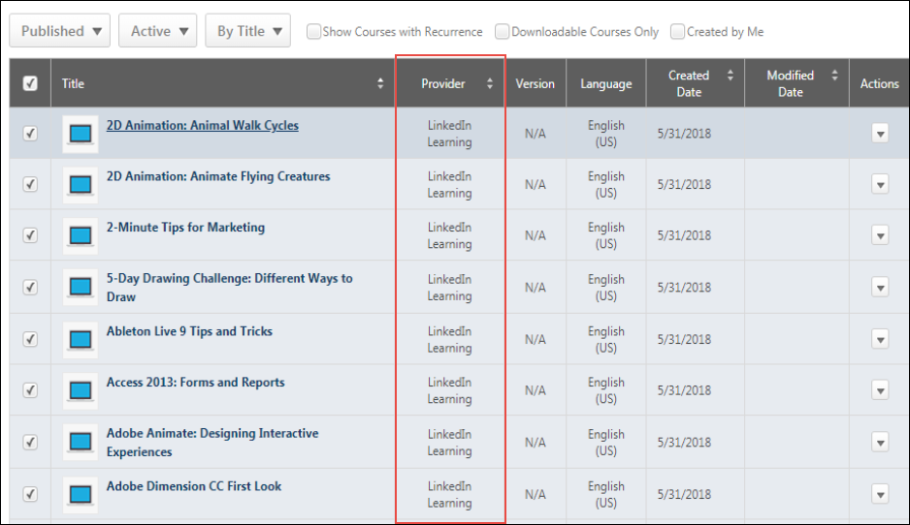

LinkedIn Learning - Subjects Synchronization
Administrators can synchronize LinkedIn Learning subjects to LinkedIn Learning courses using Edge. Once an administrator enables subject synchronization, relevant subjects are automatically populated to the Subject Management page in the Learning Management System (LMS) and are added to existing and future LinkedIn Learning courses. The subjects populated in the LMS via Edge are added to the Learning Search page, the Course Catalog, and to Learner Home. These subjects are automatically defined based on the course metadata sent from LinkedIn Learning.
Customers can choose only to receive LinkedIn Learning integration courses in available and active languages in their portal. The courses set to inactive or unavailable language in the portal are not ingested. It results in fewer courses, removing courses irrelevant to users. To access this functionality, contact Global Customer Support.
Subjects Synchronization for LinkedIn Learning courses can be enabled and disabled from the Settings page of the LinkedIn Learning integration via the Edge Integration Center.
To edit the configurations for the LinkedIn Learning integration, go to: Admin > Tools > Edge and click the Integrations link. This navigates you to the Edge Integration Center. Next to the LinkedIn Learning integration, click the Configure button. Note: The integration must be installed before you can configure the integration. See Edge - LinkedIn Learning on page 82 for additional information.
Permissions
PERMISSION NAME | PERMISSION DESCRIPTION | CATEGORY

Edge Integrations - Manage | Grants access to the Integrations service for Edge Integrate, where the administrator can configure, enable, and disable their third-party integrations used within the Cornerstone system. This permission cannot be constrained. This is an administrator permission. | Edge
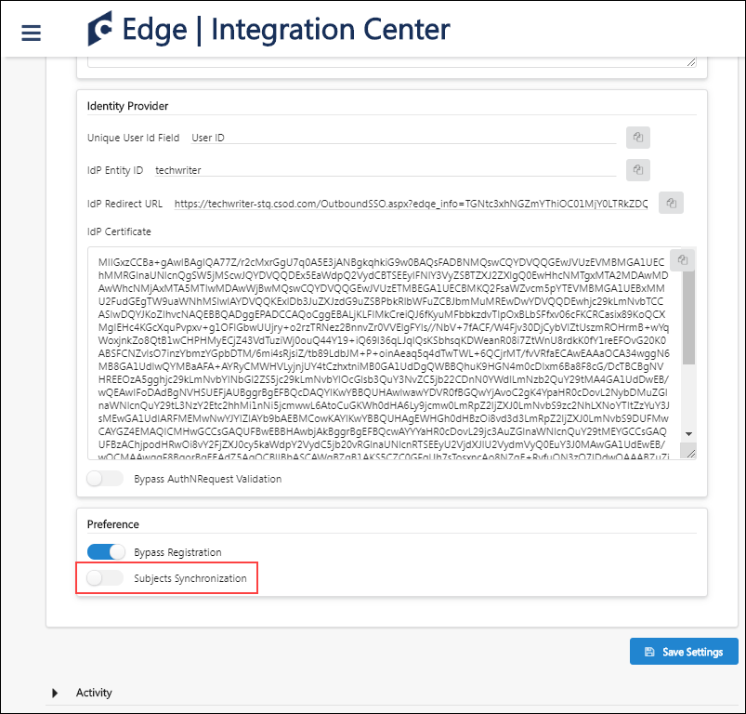
Subjects Synchronization
To enable subject synchronization for the LinkedIn Learning integration:
- On the Settings tab for the integration, toggle the Subjects Synchronization switch to the On position.
- Click the Save Settings button at the bottom of the page.
- Once an administrator enables subject synchronization for the integration, the subjects will be automatically defined based on the course metadata sent from LinkedIn Learning as part of the integration. The new subjects are automatically populated to the Subjects Management page in the Learning Management System (LMS) and are added to existing and future LinkedIn Learning courses.
The subjects populated using this integration operate in the same manner as subjects created manually within the LMS. They will be visible in the Subject filter on the Learning Search page, in Course Catalog, and in the Your Subjects widget on the Learner Home page. Subjects created using the LinkedIn Learning integration will be added to the system as parent subjects. If an identical subject already exists in the portal, the existing subject will be used, and no duplicated subject will be created.
Note: Enabling subject synchronization initiates a full synchronization of LinkedIn courses. Metadata changes made to LinkedIn’s courses may be overridden by the full synchronization. Subjects added by the administrator are not retained when a courses synchronization takes place.
Considerations
The following considerations apply to this functionality:
- Subjects created using the LinkedIn Integration are automatically parent-level subjects
- If an identical parent subject already exists in the portal, the existing subject will be used, and no duplicate subject will be created
- When the Subject preference is turned off, LinkedIn Learning courses are re-synchronized without the subjects, and LinkedIn Learning subjects' statuses are changed to Inactive
- LinkedIn Learning subjects will be enabled or disabled in the portal within twenty-four hours of the updates made to Preferences.
- Once LinkedIn Learning subjects are added to the portal, they can be used by other training types. These subjects function in the same manner as subjects created within the LMS.
- LinkedIn courses synchronized to the Course Catalog can override metadata changes. Subjects added by an administrator will not be retained when a course synchronization occurs.
- By enabling Subjects Synchronization functionality, metadata changes may be overridden with LinkedIn's course metadata. Subjects added by an administrator will not be kept when a course synchronization takes place. The Subjects Synchronization feature is OFF by default. When the Subjects Synchronization functionality remain OFF, there is no change to subjects added by the administrator.
FAQs
What level of LinkedIn's subject hierarchy is synchronized to my catalog?
Only LinkedIn's subjects are captured via the integration. Topics and categories are not mapped.
How are LinkedIn subjects created in the Cornerstone portal?
When a subject is communicated to Cornerstone via the integration, the system checks if the subject already exists in the Cornerstone portal. If the subject does not exist, then a new subject is created. The new subjects are always created at the top level of the subject hierarchy in the Cornerstone portal.
What if the subject communicated by LinkedIn Learning already exists as a child subject in the Cornerstone portal?
If the subject exists as a child subject in the Cornerstone portal, a new subject is created as a parent subject, and the course is associated with the new subject.
Does a course get tagged with more than one subject in the Cornerstone portal?
If more than one subject is synchronized over the integration, then the course is associated with all communicated subjects.
We’ve already associated LinkedIn's courses with subjects in our Cornerstone portal. What will happen if we enable the Subjects Synchronization feature?
Enabling the Subjects Synchronization feature triggers a full synchronization for LinkedIn courses. This course synchronization overrides any metadata changes or previous subject associations made to the courses in the Cornerstone portal with the subject associations from LinkedIn.
We enabled the Subjects Synchronization feature and now want to disable it, what would happen to the courses?
A full course synchronization will be triggered, overriding existing course metadata in the Cornerstone portal. After this point, when a new course is synchronized from LinkedIn Learning to the Cornerstone portal, the subject metadata is not synchronized in the Cornerstone portal. Any changes made to subject metadata in the Cornerstone portal will not be overwritten by LinkedIn Learning.

Edge - LinkedIn Learning
The LinkedIn Learning integration can be enabled via the Edge Marketplace and configured using Edge Integrations.
To access the Edge Marketplace, go to: Admin > Tools > Edge and click the Marketplace link.
Permissions
PERMISSION NAME | PERMISSION DESCRIPTION | CATEGORY

Edge Integrations - Manage | Grants access to the Integrations service for Edge Integrate, where the administrator can configure, enable, and disable their third-party integrations used within the Cornerstone system. This permission cannot be constrained. This is an administrator permission. | Edge

Edge Marketplace - Manage | Grants access to the Marketplace service for Edge Integrate, where the administrator can browse integrations that can be used to extend the Cornerstone system. This permission cannot be constrained. This is an administrator permission. | Edge
LinkedIn Learning - Edge Marketplace
In the Edge Marketplace, you can find the LinkedIn Learning integration by searching or browsing. To learn more about the LinkedIn Learning integration or begin the enablement and configuration process, click the LinkedIn Learning integration tile.
The page for the LinkedIn Learning integration provides access to the following tabs for learning more about and managing the integration:
- Vendor - This tab provides information about the vendor that provides the integration. Here, you can view more information about the LinkedIn Learning platform.
- Integration - This tab provides information about the integration itself and how it can be used with the learning management system (LMS).
- Pricing - This tab provides information about the costs associated with the integration. Note: There is no cost associated with the LinkedIn Learning integration. This integration is free to enable.
- Setup - This tab provides information about how to configure the integration once enabled. The integration can be configured via Edge Integrations.
LinkedIn Learning - Edge Integrations
Once the LinkedIn Learning integration has been added through the Edge Marketplace, the integration can be managed and configured from Edge Integrations. The Integrations page for the integration provides access to setup options which the administrator can use to customize the behavior of the LinkedIn Learning integration. See the Setup tab for the LinkedIn Learning integration in the Edge Marketplace for more information about the configuration options available.
LinkedIn Learning - Course Catalog
LinkedIn Learning content that has been synced to the LMS appears in the Course Catalog as online courses, with a Provider name of LinkedIn Learning, and these courses can be managed through the Course Catalog by administrators. LinkedIn Learning content displays with its original language and course duration time in the system.

Survey Administration Overview

Surveys Administration
Surveys provide you with the power of the Evaluation tool free from the restriction of tying your survey to a course. The variety of question types and response formats allows information to be captured in a variety of ways. Reports on survey responses can then be generated for each task or for recurring surveys over time. Use Surveys to help you collect hard to capture information such as interest in employee developmental opportunities or a skills survey for new job positions.
To access the Surveys Administration page, go to Content > Surveys. To create and manage surveys, administrators must have the appropriate permission and a content license. See Manage Licenses.
To run a survey report, See Survey Report.
Permissions
PERMISSION NAME | PERMISSION DESCRIPTION | CATEGORY

Survey Administrator | Grants ability to create and edit survey templates and launch survey tasks. This is an administrator permission. A content license is needed in addition to this permission in order to allow administrators to create and manage surveys. | Learning - Administration
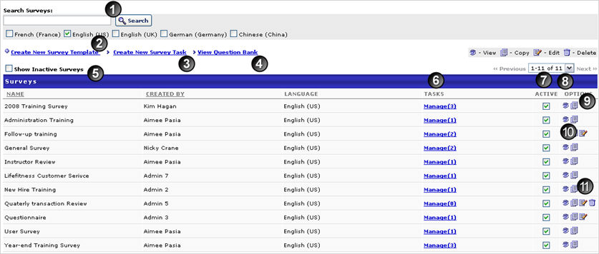
- Search for existing surveys using the search field
- Create New Survey Template - to create a new survey template
- Create New Survey Task - to create a new survey task
- View Question Bank - to view the question bank and create new questions
- Show Inactive Surveys - to view inactive surveys
- Manage - to manage survey tasks. From this link you will see each task for the survey, creator of that task, validity period, and the status. In addition, you can deactivate a survey task, copy a survey task or view the details of each task.
- Active - checkbox to change the status of the survey
- Preview icon - to preview survey
- Copy Icon - to copy an survey
- Edit Icon - to edit an existing survey
- Delete Icon - to delete an existing survey

Survey Question - Create
The survey template must contain at least one question. Question types include Likert scale, Multiple Choice - Multiple Answer, Multiple Choice - Single Answer, True/False, Yes/No, and Text Only. Comments boxes can be included and required for a question. When a new question is created, it must be assigned to a category.
To create a survey question, go to Content > Surveys. Click the View Question Bank link. Then, click the Create New Question link. To create and manage surveys, administrators must have the appropriate permission and a content license. See Manage Licenses.
Permissions
PERMISSION NAME | PERMISSION DESCRIPTION | CATEGORY

Survey Administrator | Grants ability to create and edit survey templates and launch survey tasks. This is an administrator permission. A content license is needed in addition to this permission in order to allow administrators to create and manage surveys. | Learning - Administration
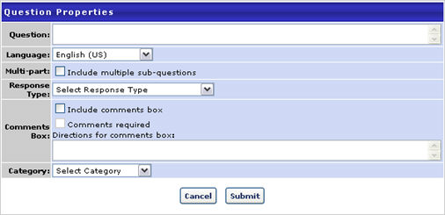
Enter the following information:
- Question - enter question to be used on the survey
- Language - select language from drop-down if applicable
- Create a multi-part question by checking the Include multi-part sub-questions checkbox
  - Click the Add sub-question link
  - Enter the Order of each sub-question
  - Enter the sub-question text
  - Remove a sub-question by clicking on the Remove icon
    - Each sub-question will have the same response choice and will be listed under the main question on the actual survey. The main question will not have a separate response.
- ResponseType - click drop-down to select answer response type
  - Yes/ No - answers are Yes or No
  - True / False - answers are True or False
  - Likert Scale - select to create a question with a Likert scale
    - Optionally edit the rating descriptions
      - The descriptions defined on the Corporate Preferences > Evaluation Preferences page are used by default
  - Multiple Choice - Single Answers - to provide users with a multiple choice question that allows one answer
    - Click Add Response Choice and enter answer choices.
    - Check Include 'None of the above' box to display 'None of the above' as an answer choice
    - Check Include ' All of the above' box to display 'All of the above' as an answer choice
  - Multiple Choice - Multiple Answers - to provide users with a multiple choice question that allows multiple answers
    - Click Add Response Choice and enter answer choices.
    - Check Include 'None of the above' box to display 'None of the above' as an answer choice
    - Check Include 'All of the above' box to display 'All of the above' as an answer choice
  - Text Only - to provide users with question which allows a text-based response
- Comments Box:
  - Include Comments Box - check to include comments box for question
  - Comments Required - check to make comments required. If checked user can not submit survey until comments are entered.
- Category - click drop-down to select category (required field)
- Click Submit.

Survey Category - Create
To create a survey category, go to Content > Surveys. Click the View Question Bank link. Click the Categories tab. Then, click the Create New Category link. To create and manage surveys, administrators must have the appropriate permission and a content license. See Manage Licenses.
Permissions
PERMISSION NAME | PERMISSION DESCRIPTION | CATEGORY

Survey Administrator | Grants ability to create and edit survey templates and launch survey tasks. This is an administrator permission. A content license is needed in addition to this permission in order to allow administrators to create and manage surveys. | Learning - Administration
- Enter Name of category in blank row that appears
- Click Save icon
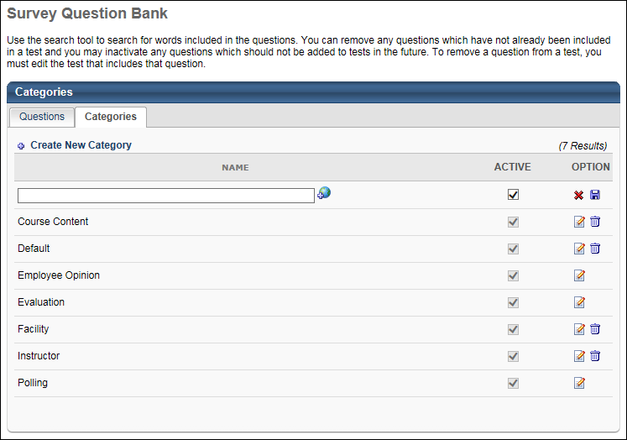

Survey Template - Create
To create a survey template, go to Content > Surveys. Click the Create New Survey Template link. To create and manage surveys, administrators must have the appropriate permission and a content license. See Manage Licenses.
Permissions
PERMISSION NAME | PERMISSION DESCRIPTION | CATEGORY

Survey Administrator | Grants ability to create and edit survey templates and launch survey tasks. This is an administrator permission. A content license is needed in addition to this permission in order to allow administrators to create and manage surveys. | Learning - Administration
Enter the following information:
- Survey Name - enter name of survey
- Language - select language from drop-down if applicable
- Click Add Section icon to add a survey section. Each section is considered a page break on the survey and at least one section is required.
  - Section Title - enter title for section
  - Section Directions - enter directions for section
  - Click Done
- Click Add Question to add survey questions to each section. Any new questions added using the add question icon will append to that specific section of the survey.
  - Search for question by name or category
  - Add - click to add individual Question or click Add All Questions link to add all questions from search results
  - View - to preview question
  - Click Done
  - Edit - click to edit a question. Note: Editing a question changes that question in all surveys the question has been used. Best Practice is to make changes to the grammar or correct errors but not change the meaning or the structure of the question.
  - Delete - click to remove a question from a section
- Order - enter number to order how questions are visible to user
- Response Required - check box to require a response for any question. If checked user can not submit survey until question is answered.
- Preview icon - to preview an question
- Edit Section Icon - to edit the section.
- Edit Question - to edit a question. Note: Editing a question changes that question in all surveys the question has been used. Best Practice is to make changes to the grammar or correct errors but not change the meaning or the structure of the question.
- Delete Icon - to delete an existing question
- Click Submit
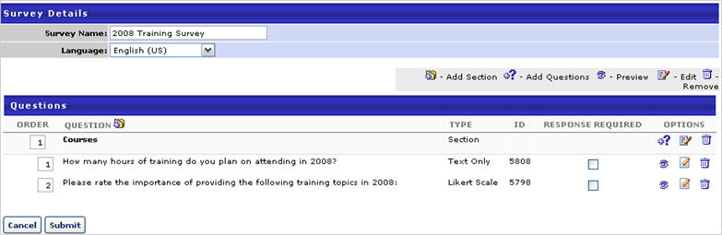

Survey Task - Create
A survey task is assigned to users which can be viewed on the Welcome Page under Your Tasks. When the user clicks on the task, they are taken to the Scheduled Tasks page. Users can launch the survey from this page.
Once a survey task is complete, administrators can run a Survey Report to view the results of the task. See Survey Report.
To create a survey task, go to Content > Surveys. Click the Create New Survey Task link. To create and manage surveys, administrators must have the appropriate permission and a content license. See Manage Licenses.
Permissions
PERMISSION NAME | PERMISSION DESCRIPTION | CATEGORY

Survey Administrator | Grants ability to create and edit survey templates and launch survey tasks. This is an administrator permission. A content license is needed in addition to this permission in order to allow administrators to create and manage surveys. | Learning - Administration
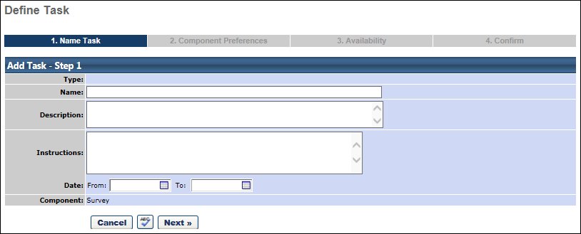
Name Task
- Task Name - Enter a survey task name that will be visible to users who are assigned the task.
- Description - Enter a description for the survey task. Any HTML that is entered in this field will not be rendered to end users.
- Instructions - Enter instructions for users who are completing the survey task. This field accepts basic HTML.
- Date - Select a task start and end date. After the end date, the task will expire and user will not be able to launch the task.
- Spell Check - Select this icon to spell check the text.
- Click Next.
Component Preferences
- Select Survey Template - From the drop-down menu, select the appropriate survey for the task. Survey questions from the selected survey will display.
- Click Next.
Availability
- Choose availability criteria from drop-down list.
- Click Next.
Confirm
- Confirm fields setting.
- Confirm - Review survey details.
- Click Save or Back to return to a previous screen or Cancel to cancel survey entry.

Test Engine Overview

Test Engine Administration
The test engine is used to create, categorize, and deliver tests to meet your corporate training goals. By creating tests, administrators are able to evaluate employee's progress, knowledge, and understanding. The tests can be delivered as stand alone learning objects, or can be associated with any variety of learning objects contained in Cornerstone. Administrators can use this tool to create follow-up exams for compliance training, to measure employee competence in strategic knowledge areas, to perform placement exams for new hires, to evaluate the effectiveness of certain training programs, and more.
Design Note: This page has an updated interface (UI) that is automatically enabled. However, administrators can still revert to legacy UI via Feature Activation Preferences. The page's functionality is unchanged with the new design. With the July 26, 2024 Release, the new UI will be permanently enabled in all production, stage, and pilot portals, and the legacy UI pages will no longer be available. The new UIs disabled in March will be auto-enabled in July.
To access the Test Engine page, go to Admin > Tools > Learning > Catalog Management > Tests.
Permissions
PERMISSION NAME | PERMISSION DESCRIPTION | CATEGORY

Test Engine - Manage | Grants ability to create and edit/manage tests via the Test Engine. This permission can be constrained by OU, User’s OU, User, User’s Self, and User’s Subordinates. This is an administrator permission. | Learning - Administration

Test Engine - Review | Grants ability to view details of user results for tests, via the test engine. This permission can be constrained by OU, User’s OU, User, User’s Self, and User’s Subordinates. This is an administrator permission. | Learning - Administration

Test Engine - View | Grants ability to view existing tests in the test engine. Administrators with this permission can view each section of a test and print tests. Administrators with this permission can enter changes when viewing a test, but these changes cannot be saved. This permission can be constrained by OU, User’s OU, User, User’s Self, and User’s Subordinates. This is an administrator permission. | Learning - Administration

Test Question Bank – Manage | Grants ability to create and edit/update test questions in the test engine question bank. This permission can be constrained by OU, User’s OU, User, User’s Self, and User’s Subordinates. This is an administrator permission. | Learning - Administration

Test Question Bank – View | Grants ability to view the test engine question bank. This permission can be constrained by OU, User’s OU, User, User’s Self, and User’s Subordinates. This is an administrator permission. | Learning - Administration
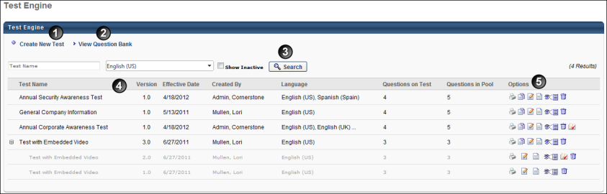
Feature | Description
1 | Create New Test - Click this link to create a new test. This takes you to the General step of creating a test.
2 | View Question Bank - Click this link to view the Question Bank. This takes you to the Question Bank page. Note: The View Question Bank link does not display for users that do not have permission to view or edit the question bank.
3 | Search Options - You can search for tests by name or language. The filters work together so that only the tests that match all criteria are displayed when Search is clicked. To include inactive tests in the display, select the Show Inactive option.
4 | The following information displays for tests:  - Test Name - This column displays the name of the test. The name appears in the language of the administrator that created the test. Or, if available, the name appears in the user's display language. If the administrator's language is not available, the test displays in the test's default language.  For tests with multiple versions, clicking the plus icon to the left of the test name displays the versions. Versions are grayed out and not selectable. However, options are available in the Options column for each version.  If Pending appears next to the Test Name, it indicates a future effective date.Test versions cannot have the same effective date. Once a pending version with a future effective date is queued, all subsequent versions must have an effective date after the pending version. This ensures that version numbers stay in ascending order. Click the edit icon to edit a pending test version. Click the delete icon to delete a pending version. Deleting a pending version removes it from the Test Engine list and marks it "deleted" on the backend.  - Version - This column displays the most current version number of the test.  - Effective Date - When a test is first created, the effective date is the date on which the test was created. When changes are made to a test that result in reversioning, the effective date is the date determined by the administrator as to when the changes are effective.  - Created By - This column displays the name of the user that created the test.  - Language - This column displays the languages in which the test is available. If the test is available in multiple languages, hover over the ellipses in the Language column to view the other available languages.  - Questions on Test - This column displays the number of questions on the test.  - Questions in Pool - This column displays the number of questions in the question pool.  Note: For portals with multiple languages, upon opening the Test Engine page, only tests configured to display in a user's default language and made available to the user appear in the table. The user must use the Search filters to display tests in other languages, provided the tests are available to them.
5 | The following options are available in the Options column:  - Print - Click the Print icon to open a printable version of the test.  - Copy - Click the Copy icon to copy the test. All areas of the test are copied.  - Edit - Click the Edit icon to edit the test.  - Edit Evaluation - Click the Edit Evaluation icon to edit the test evaluation.  - View - Click the View icon to view each section of the test. Note: Changes to a test cannot be saved when accessing a test from the View Details icon. Changes can only be made when accessing the test from the Edit icon.  - Remove - Click the Trash Can icon to delete the test. Note: If a user has registered for the test or the test is the first version of a multi-version test, it cannot be removed but can be inactivated.  - Review - Click the Review icon to open the Review Test page on which you can review user's tests. This icon only appears when there are tests available for you to review. Note: Because reviewers must have permission to manage or view Test Engine, reviewers can view all sections of all tests that are within their permission constraints.
See also:
- Create New Question
- Create New Category
- Create a Test
- Test Question Item Analysis Report
To run a Test Analysis Report, See Test Analysis Report for additional information.

Test - Create
Permissions
PERMISSION NAME | PERMISSION DESCRIPTION | CATEGORY

Test Engine - Manage | Grants ability to create and edit/manage tests via the Test Engine. This permission can be constrained by OU, User’s OU, User, User’s Self, and User’s Subordinates. This is an administrator permission. | Learning - Administration
- To create a test:
  - Go to Content > Test Engine and click the Create New Test link.
  - OR, go to Admin > Tools > Learning > Catalog Management > Tests. Then, click the Create New Test link.
- Enter the appropriate information for the following sections:
  - General
  - Structure
  - Availability
  - Pricing
  - Training Units - The Training Units tab is only available if training units are enabled.
  - Confirm
Helpful Hints
Test graders will all have access to grade essay questions if included in the test via the Test Grading link located on the Content page.
To randomize all questions in each section check the Randomize Questions box in the Order Randomization section. To randomize subset of questions in a section click the Display link for that section and enter number of questions to be displayed.
Editing a question changes that question in all tests the question has been used. Best Practice is to make changes to the grammar or correct errors but not change the meaning or the structure of the question.

Test - Create - General
To create a test, go to Admin > Tools > Learning > Catalog Management > Tests. Then, click the Create New Test link.
Permissions
PERMISSION NAME | PERMISSION DESCRIPTION | CATEGORY

Test Engine - Manage | Grants ability to create and edit/manage tests via the Test Engine. This permission can be constrained by OU, User’s OU, User, User’s Self, and User’s Subordinates. This is an administrator permission. | Learning - Administration
Enter the following information on the General section:
- Test Name - Enter name of test that displays to user. Character limit 500. For portals with multiple languages enabled, localize the field by using the Translate icon to enter localized text.
- Provider - Select from drop-down list.
- Test Description - Enter description of test. The user views the description and details by clicking on Details once the test is in the users transcript. Character limit 5000. For portals with multiple languages enabled, localize the field by using the Translate icon to enter localized text.
- Training Hours - Enter training hours.
- Available Languages - From the drop-down list, select the languages in which the LO is available. The available languages are mainly used for searching purposes and they are independent of the LO's default language. At least one language must be selected. At the top of the drop-down list, all selected languages are displayed. The drop-down list only displays the languages that are available to the user. Select the All Languages option to select all available languages.
  - When a language is selected, the LO is associated with that language and users can search for the course by associated languages.
- Default Language - This displays the default language of the LO. If a user views an LO in a language that does not have a translation, the information is displayed in the default language for the LO. When an administrator creates an LO, the default language for the LO is the administrator's default language at the time they create the LO.
- Credits - Enter the number of credits a user receives upon completing the test.
- Subjects - Select a subject.
- Test Grader - Select one or more test graders to grade essay questions on test.
- Attempts Allowed - Enter the number of times a user can take the test to attempt a passing score before they are locked out of the test and are unable to take it again. If this field is empty, then the user is able to retake the test an unlimited number of times. When a user passes the test, they are unable to retake the test.
Note: An attempt is counted when a learner launches the test and submits for scoring or has reached the time limit of the test or the times an attempt can be entered as set up in the structure configuration page. For more options on the behavior of an attempt, time and number of times a user can launch the same test attempt before they are locked out of the test attempt, please review the test details section.
- View Test Score - Select the Manager option to allow the manager and anyone who can view the user's transcript to view the user's test score after the test is submitted. Select the User option to allow the user to view their test score after the test is submitted. These options are selected by default.
  - If the Manager or User option is deselected, the user's test score is not visible to the respective role (Manager or User) in the Training Details page.
    - Test scores are still visible within reports, so administrators should not share permission to view Test reports if the user should not view test scores.
    - If the View Test Score option is deselected for a role, then the Allow Test Review option for the corresponding role (Manager or User) is automatically deselected.
- Allow Test Review - Select the Manager option to allow the manager to view the user's test details after the test is submitted. The Allow Review After Every Attempt option determines whether the test can be reviewed from the user's Transcript after every attempt or only after the user passes the test. Select the User option to allow the user to view their test details after the test is submitted. These options are selected by default.
  - If the User option is selected, a Review link will be visible on the Test Results page after each submission, pass or fail. Once the user clicks Done on the Test Results page, a Review link will be visible on the user's Transcript only upon completion.
  - If the Manager or User option is deselected, the user's test details are not visible to the respective role (Manager or User). On the Test Results page and the Training Details page, the link to review the test is not available.
    - If the User option is deselected, the Allow Review After Every Attempt option is deselected and disabled.
    - If the User option is deselected, the Review Level options are disabled.
- Allow Review After Every Attempt - Check to allow users to review their test after every submission. Provides users with a Review link after test attempt and will only see answers to questions they attempted. If this option is not selected, then the test can only be reviewed from the Review link on the user's Transcript once the user passes the test.
- Review Level:
  - Allow users to review questions and correct answers - Click radio button to allow users will see which questions they got correct and incorrect as well as the associated answers and answer explanations.
  - Allow users to review questions only - Click radio button to allow users to see which questions they got correct and incorrect. No answers or answer explanation will be displayed.
  - Allow users to review question category and answer explanation only - Click radio button to allow users to see answer explanations separated by category. No questions or answers will be displayed.
- Price - Enter the price of the test.
- Lockout - Select from drop-down period to define the time period that users are locked out between re-takes. Leave blank for no lockout period.
- Instructions - Enter any additional comments or instructions for users to be viewed by the user when taking the test. This field is HTML-friendly. Character limit 2000. For portals with multiple languages enabled, localize the field by using the Translate icon to enter localized text.
- Active - Check or uncheck this box to activate or deactivate the test. This box is checked by default.
- Click Next to proceed to the Structure section. See Test - Create - Structure on page 106 for additional information.
Modification History
For portals with multiple languages enabled, if the translation of a title or description is modified, the Modification History panel displays the change. However, only changes to languages that were added when the learning object was initially created are tracked.
The initial creation and changes to the title and description display in the panel as follows:
- Title at Initial Creation - <Learning Object Type> created with <Language of Title> Title "<Title>" by <User Full Name> (<User ID>) on <Date/Time of Creation>.
- Description at Initial Creation - <Learning Object Type> created with <Language of Description> Description of "<Description>" by <User Full Name> (<User ID>) on <Date/Time of Creation>.
- Change to Title - Title in <Language of Title> was changed to "<New Title>" by <User Full Name> (<User ID>) on <Date/Time of Creation>.
- Change to Description - Description in <Language of Description> was changed to "<New Description>" by <User Full Name> (<User ID>) on <Date/Time of Creation>.
- Title/Description Translation Change - Title/Description in <Language> "<New Title/Description>" was added by <User Full Name> (<User ID>) on <Date/Time of Creation>.
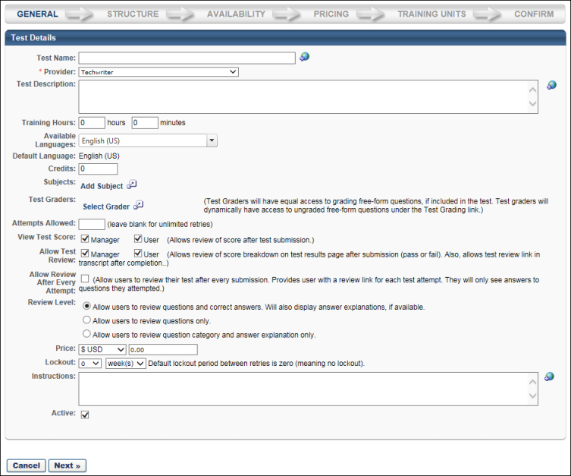

Test - Create - Structure
To create a test, go to Admin > Tools > Learning > Catalog Management > Tests. Then, click the Create New Test link.
Permissions
PERMISSION NAME | PERMISSION DESCRIPTION | CATEGORY

Test Engine - Manage | Grants ability to create and edit/manage tests via the Test Engine. This permission can be constrained by OU, User’s OU, User, User’s Self, and User’s Subordinates. This is an administrator permission. | Learning - Administration
Enter the following information on the Structure section:
Test Details
- Time Limit Minutes - Enter a number to define the time limit for users to take the test. Maximum is 300 minutes. Leave blank for no time limit.
  - Keep time running if user exits test early - Check to allow timer to run even after the user has exited their test attempt.
- Passing Score - Enter passing score percentage. If left blank, defaults to 80%.
- Early Exit - To allow or disallow users to exit the test in the middle and continue, or to require completion of the test in one sitting.
  - Allow the person being tested to save any progress and return to the test at a later point - Click radio button to allow.
  - The person taking the test must proceed all the way through, or accept the score assessed at the point of early exit - Click radio button to allow.
- Maximum Number of Test Entries - Enter the number of times a user can launch the same test attempt before they are locked out of the test attempt and their test is automatically scored based on their existing answers. Users can only attempt the test if the test has time remaining. If this field is empty or if "0" is entered, then the user is able to launch the same test attempt an unlimited number of times.
- Order Randomization Options:
  - Randomize Sections - Check to have sections appear in random order. If it is unchecked the items will appear in the original order listed.
  - Randomize Questions - Check to have questions appear in random order. If it is unchecked the items will appear in the original order listed. Note: The Always Include option for a question is only available if this option is selected.
- Score Test Using Custom Weighting - Check to allow administrator to enter a point/weight distribution for the test. Leaving it blank will score all questions equally.
Questions
In the Questions section, sections and questions can be added to the test.
Add Section
Each section is considered a page break on the test and at least one section is required.
To add a section to the test, click the Add Section icon . This opens the Add Section pop-up.
- Section Title - Enter title for section (required field). For portals with multiple languages enabled, localize the field by using the Translate icon to enter localized text.
- Section Directions - Enter directions for section. For portals with multiple languages enabled, localize the field by using the Translate icon to enter localized text.
- Click Done.
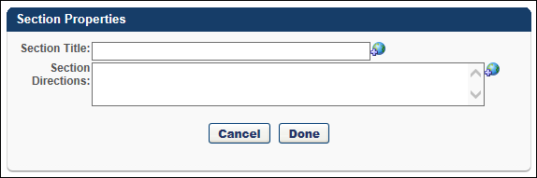
Add Questions
To add a question to a section, click the Add Question icon to the right of the section title. Any new questions added using the add question icon will append to that specific section of the test. Note: When creating, copying, or editing a test, the questions available to select on the Structure step are dependent upon the constraints of the administrator's permission to manage tests within Test Engine. If there are no questions available based on the permission constraints, then no questions appear in the Search Questions pop-up.
Within the Add Questions pop-up, the following functionality is available:
- Search for question by name or category. Select the Include Subordinates option to include subordinate categories in the search. See Question Bank - Questions Tab on page 130 for additional information.
- Add - Click to add individual Question or click Add All Questions link to add all questions from search results.
- Click Done to add the selected questions
In the Questions section, the following options may be available for each question:
- Always Include - Select this option for any question to always display that question for user in the randomized question options. The Always Include option is only available when the Randomize Questions option is selected in the Test Details section.
- View - To preview question.
- Edit - Click to edit a question. Note: Editing a question changes that question in all tests the question has been used. Best Practice is to make changes to the grammar or correct errors but not change the meaning or the structure of the question.
- Delete - Click to remove a question from a section.
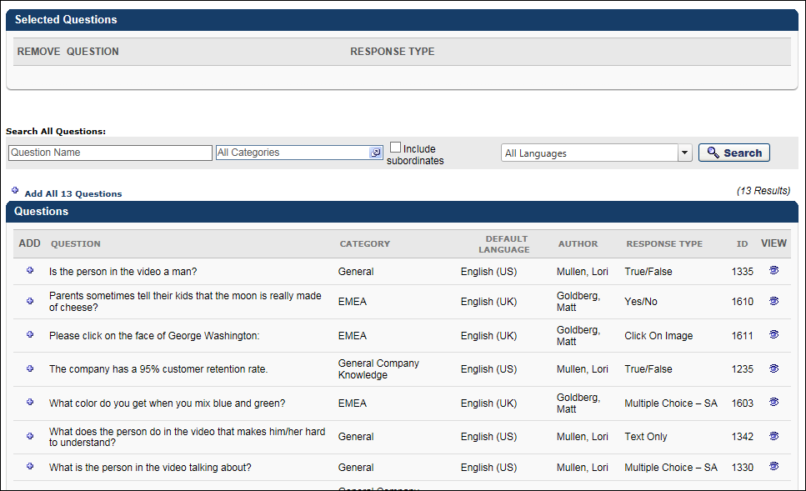
Click Next to continue to the Availability section. See Test - Create - Availability on page 110 for additional information.
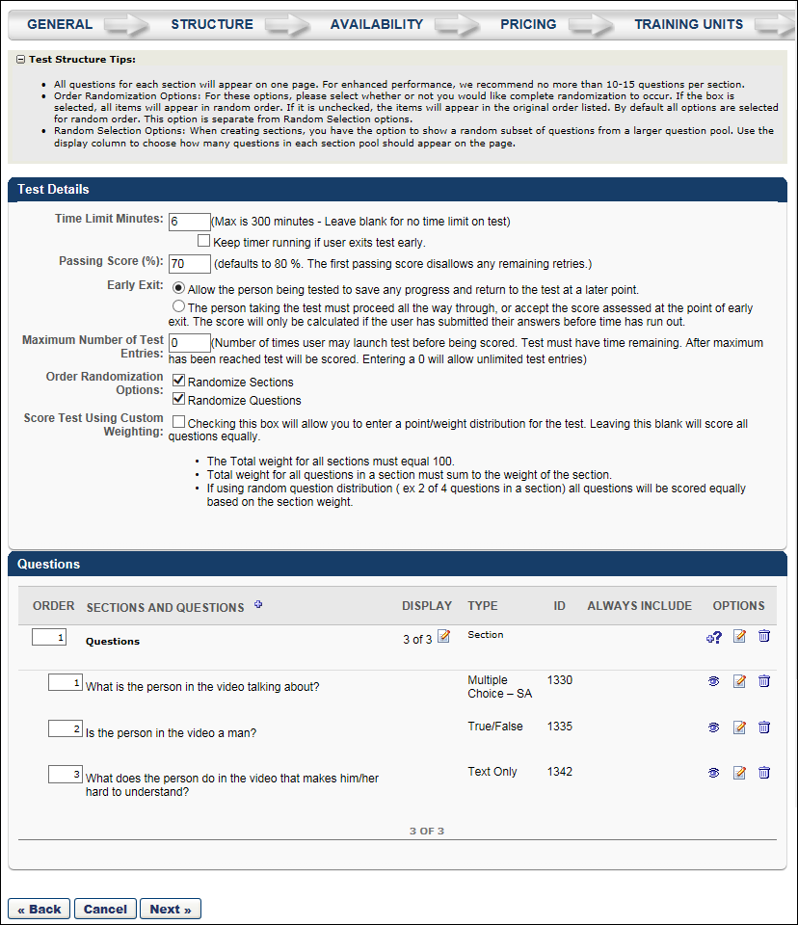

Test - Create - Availability
To create a test, go to Admin > Tools > Learning > Catalog Management > Tests. Then, click the Create New Test link.
Permissions
PERMISSION NAME | PERMISSION DESCRIPTION | CATEGORY

Test Engine - Manage | Grants ability to create and edit/manage tests via the Test Engine. This permission can be constrained by OU, User’s OU, User, User’s Self, and User’s Subordinates. This is an administrator permission. | Learning - Administration
Select the availability for the test in the Availability section:
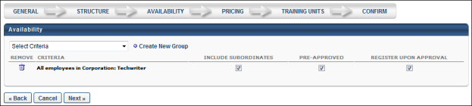
- Select the availability criteria for the test using the Select Criteria drop-down.
- Define the following settings for the selected OUs.
  - Check Include Subordinate to make the learning object (LO) available to the selected OU, as well as is its subordinate OU's.
  - Check Pre-Approved to exempt these OU's from requiring approval for the LO.
  - Check Register Upon Approval to automatically register the selected users in the training, thereby allowing them to bypass the register link on the transcript.
- Click Next to proceed to the Pricing section. See Test - Create - Pricing on page 111 for additional information.

Test - Create - Pricing
To create a test, go to Admin > Tools > Learning > Catalog Management > Tests. Then, click the Create New Test link.
Permissions
PERMISSION NAME | PERMISSION DESCRIPTION | CATEGORY

Test Engine - Manage | Grants ability to create and edit/manage tests via the Test Engine. This permission can be constrained by OU, User’s OU, User, User’s Self, and User’s Subordinates. This is an administrator permission. | Learning - Administration
Enter the following information on the Pricing section:
Default Price
Enter a default price for the training. The default price is what the user (or user's cost center) is charged when registering for training of no other price is set for the user below. This price is converted into all currencies supported using the Current Conversion Rate table. If the rate is fixed, it is displayed using the Client's Fixed Rate. If not fixed, it displays the Cornerstone Rate. If the seller's currency is incompatible with the buyer's currency, the buyer is shown the price converted from the seller's currency to the buyer's default currency using the Currency Conversion Rate Table (Fixed rate or Cornerstone rate).
Apply Custom Invoice - Check this option to apply a custom invoice to the LO. If no custom invoice is available for the LO, this option is not available.
- Apply Sales Tax - Select this option to apply sales tax to the learning object. To implement sales tax functionality, contact Global Customer Support. A sub-account with Cybersource is required as well as a tax nexus.
- Product Code - Enter the product code for the LO up to 200 characters. Product codes are required if a product is non-taxable or if the product has a non-standard tax rate. When a product code is entered, this value is passed to CyberSource at the time of tax calculation to specify any tax exemptions. This field is only available to organizations using sales tax when the Apply sales tax option is selected.
- Billing Entity - Click the pop-up icon to select a billing entity for the LO. This can be used to define the division within the organization from which the product should be taxed. Once a billing entity is selected, it can be removed by clicking the Remove icon to the right of the value. When a billing entity is selected, this value is passed to CyberSource at the time of tax calculation. This field is only available to organizations using sales tax when the Apply sales tax option is selected. Also, this field is only available to users with permission to manage billing entities.
Cornerstone Price
This is the price Cornerstone charges the client (the company, not the user) when the billing is reconciled.
Active Pricing
Select this option to set the active price by OU. See the Create Pricing LOs by OU Rules section below for additional information.
Future Pricing
Select this option to set the future price by OU. See the Create Pricing LOs by OU Rules section below for additional information.
Historical Pricing
Select this option to search for historical prices by date.
Create Pricing LOs by OU Rules
Using the OU drop-down, you can set different prices for different organizational units (OUs). If no price is defined for a user, the default price is used. All pricing rules created on the learning object (LO) level expire immediately if any change is made at the group level. If no end date is set for the pricing, the pricing rules are permanent.
Because it is possible that a LO has multiple pricing rules set, the system observes the following rules:
- If a user falls under multiple OUs with multiple pricing rules that have different rankings, the cost associated with the highest (1) ranking is applied.
- If a user falls under multiple OUs with multiple pricing rules that have the same ranking, the cost associated with the lowest price is applied.
Note: Pricing LOs by OU rules is limited to 120 rules.
Next
Click Next to proceed to the Training Units section or the Confirm section. The Training Units tab is only available if training units are enabled.
See Test - Create - Training Units on page 113 for additional information.
See Test - Create - Confirm on page 114 for additional information.
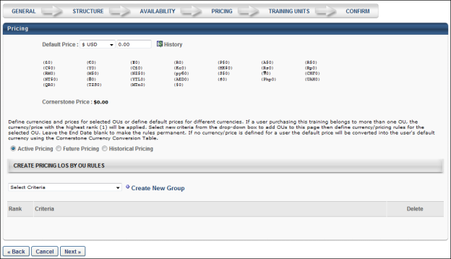

Test - Create - Training Units
To create a test, go to Admin > Tools > Learning > Catalog Management > Tests. Then, click the Create New Test link.
Permissions
PERMISSION NAME | PERMISSION DESCRIPTION | CATEGORY

Test Engine - Manage | Grants ability to create and edit/manage tests via the Test Engine. This permission can be constrained by OU, User’s OU, User, User’s Self, and User’s Subordinates. This is an administrator permission. | Learning - Administration
When creating or editing a test, the Training Units tab offers the following options regarding training units:
- Allow users to check out with training units using the conversion rate that is determined by the monetary value - Select this option to allow users to purchase the test using training units, and the number of training units used is determined by converting the monetary value using the training unit conversion rate.
- Disassociate pricing from monetary value - Select this option to set a training unit price for the item that is unrelated to any monetary value that may be set. You can specify a default training unit price and training unit prices based on OU.
- Do not allow payment by training unit for this item - This prevents users from purchasing the test with training units.
Copying and versioning a test copies all active and future training unit pricing.
The Training Units tab is only available if training units are enabled.
Click Next to proceed to the Confirm section. See Test - Create - Confirm on page 114 for additional information.
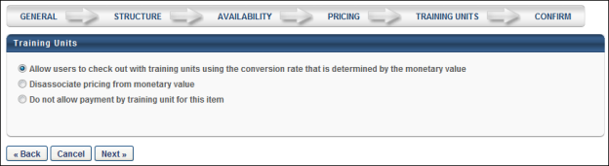

Test - Create - Confirm
To create a test, go to Admin > Tools > Learning > Catalog Management > Tests. Then, click the Create New Test link.
Permissions
PERMISSION NAME | PERMISSION DESCRIPTION | CATEGORY

Test Engine - Manage | Grants ability to create and edit/manage tests via the Test Engine. This permission can be constrained by OU, User’s OU, User, User’s Self, and User’s Subordinates. This is an administrator permission. | Learning - Administration
On the Confirm page, verify the details of the test and click Finish to finalize the test. Note: If course code functionality has been activated in your portal, a course code is automatically generated for the LO immediately after the administrator saves the new LO.
You can also click Back to return to a previous screen, or click Cancel to cancel the test entry.
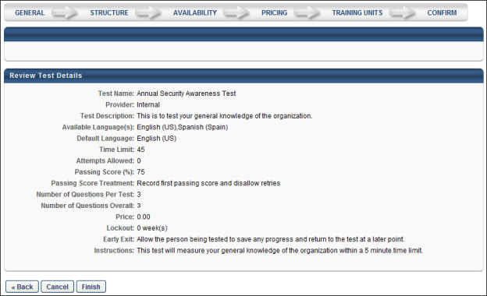

Test - Edit or Reversion
The process for editing or reversioning a test is similar to the process for creating a test with a few exceptions. See Test - Create on page 101 for additional information.
To edit a test, go to Admin > Tools > Learning > Catalog Management > Tests. Then, click the Edit icon for the appropriate test.
Permissions
PERMISSION NAME | PERMISSION DESCRIPTION | CATEGORY

Test Engine - Manage | Grants ability to create and edit/manage tests via the Test Engine. This permission can be constrained by OU, User’s OU, User, User’s Self, and User’s Subordinates. This is an administrator permission. | Learning - Administration
General:
- Changes made to the General section do not create a new version of the test.
- Changes made to the Attempts Allowed are not retroactively applied to users who have already used all attempts allowed.
- Each version of a test retains its original title and owner information, even when new versions of the test are created.
Structure:
- Changes made to the Structure section do create a new version of the test.
Availability:
- Changes made to the Availability section do not create a new version of the test.
Confirm:
The confirmation page states the following:
- If no users have started that version of the test, then the message says "The structure of this test has changed but there are currently no users who have started this version of the test. You may update the existing version or create a new version."
- If users have started the version that was edited, the message says "Clicking on the 'Finish' button will create a new version of this test because the structure of the test has changed and there are users that have already started this test."
The Create New Test Version table appears if any fields on the Test Questions page are modified. Administrators can edit the following:
- Options - This option allows you to create new version or update the existing version. Update Existing Version is selected by default. This field only appears if no users have started this version of the test.
- Effective date - By default, the Effective Date option is set to the current date. If needed, the administrator can select a different date for the new version to be effective.
- Version Equivalency - In this section, the administrator can select from the following version equivalency options:
  - Requires Retraining - Select this option to require users with this test on their Completed transcript to retake the test in order to retain their Completed status for the test.
  - Completed Equivalent - Select this option to set the new test version as a Completed Equivalent of the previous version, allowing users to retain their Completed status for the test without needing to complete the new version. Note: This setting only applies to tests within a curriculum. Standalone tests are not included.
- Changes made to this test - In this field, describe any changes that have been made to the test, for future reference.
Use Case #1: Test Version Equivalency
Richard, a learning administrator at ACME Corp, creates version 2.0 of the Company Compliance Test from the previous 1.0 version. This new test version must be reflected on all users' transcripts, but the users who have already completed the previous 1.0 version should not need to retake the test in order to retain their Completed status.
When reversioning the test, Richard selects the Equivalent Version option so that users who have already completed version 1.0 of the test do not need to complete version 2.0 in order to retain their Completed status for the test.
Use Case #2: Test Version Equivalency Removal
Richard, a learning administrator at ACME Corp, creates version 2.0 of the Company Compliance Test from the previous 1.0 version. This new test version must be reflected on all users' transcripts, but the users who have already completed the previous 1.0 version should not need to retake the test in order to retain their Completed status. However, after a few weeks, ACME adopts a new regulation which states this test must be retaken by all employees. Richard removes the new test version's version equivalency using the Course Console so that the users who complete the test in the future will need to retake the training.
New Test Version - Course Catalog Settings
When a new version of a test is created, the following Course Catalog settings from the previous version are copied to the new version:
- Approval Workflow
- Badges
- Competencies
- Enable Default Completion Message
- Exclude from Course Recommendations
- Points
- Recommended courses
- Signature Message
- Skills
- Thumbnail Image
Test Question Lockdown
If Test Preferences have been set to lock administered test questions, when administrators access the Question Bank for tests, the Edit option for in-use test questions is not available.
If a test question is already in use within a test that has been administered, and the preference for locking in-use test questions is currently enabled, the Edit icon next to the question is grayed out and not clickable. This prevents administrators from making changes to test questions that are currently being used in a test.
If the user hovers over the Edit icon for a question, but editing is not available, a text box appears, stating, "This option is only available for questions that have not been used in a test."
Note: Test questions which have been "administered" refers to test questions included in a test which has been requested, assigned, registered, etc.
See Test Preferences for information about locking test questions for editing.
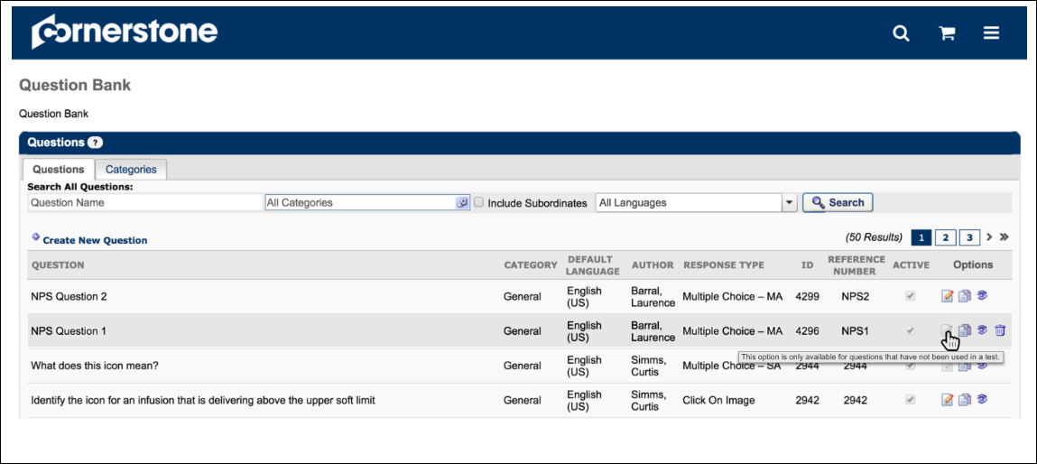
Helpful Hints
Test graders will all have access to grade essay questions if included in the test via the Test Grading link located on the Content page.
To randomize all questions in each section check the Randomize Questions box in the Order Randomization section. To randomize subset of questions in a section click the Display link for that section and enter number of questions to be displayed.
Editing a question changes that question in all tests the question has been used. Best Practice is to make changes to the grammar or correct errors but not change the meaning or the structure of the question.
Test Grading Overview
Test Questions Pending Grading
The Test Questions Pending Grading page displays free-form essay questions that have been answered by users on a test but have not yet been graded. From this page, you can also access and grade users' responses.
Note: Test graders receive an email notification that a test is waiting to be graded, if the Test Grading Notification email is active.
Note: The Test Grading functionality is controlled by a backend setting. To enable the setting for your portal, contact Global Customer Support. When turned off, the Test Grading functionality is disabled, and the Test Grading navigational link does not appear in the Content tab.
To access the Test Questions Pending Grading page, go to Content > Test Grading.
Permissions
PERMISSION NAME | PERMISSION DESCRIPTION | CATEGORY

Test Engine Grader Constraints | Grants ability to apply org unit constraints to designated test graders. If no constraints are applied to this permission, then the grader can see all users for all tests for which they are a grader. If this permission is added to the security profile of a user that has not been dynamically assigned the Test Engine - Grader permission, then the user can access the Test Questions Pending Grading page but there will be no results visible. | Learning

Test Engine - Grader | This permission is not visible within the system because it is a dynamically assigned permission that is assigned to a user when they are added to a test as the grader. Users with this permission can access the Test Questions Pending Grading page. Constraints can be applied to this permission by applying constraints to the Test Engine Grader Constraints permission. | Learning
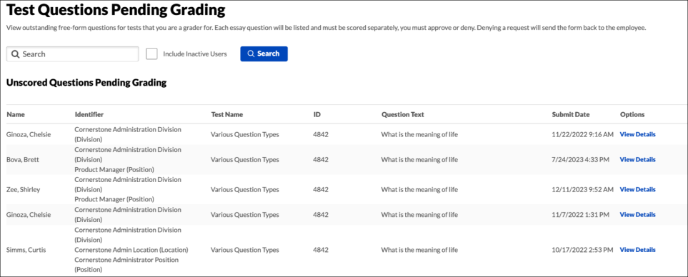
Feature | Description
1 | Search - You can filter the results by using the Search feature. Enter a user's last name in the User Name field, and then click Search. All users matching that last name appear in the Questions Pending Grading table.
2 | Include Inactive Users - administrators can choose to view inactive users pending grading by selecting the Include Inactive Users checkbox.
3 | Questions Pending Grading Table - The following information appears for each pending question:  - Name - This column displays the name of the user that completed the answer to the question.  - Identifier - This column displays the OU and position OU associated with the user.  - Test Name - This column displays the name of the test on which the question was answered.  - ID - This column displays the question's ID number.  - Question Text - This column displays the question that the user answered.  - Submit Date - This column displays the date and time that the user submitted the test.  - View Details - Click the View Details icon to open the Answer Details page on which you can view and grade the response. See Answer Details Page on page 121 for additional information.
Answer Details Page
The Answer Details page enables test graders to view and grade responses to free-form essay questions. Note: Test graders receive an email notification that a test is waiting to be graded, if the Test Grading Notification email is active.
To access the Answer Details page, go to Content > Test Grading. On the Test Questions Pending Grading page, click the View Details icon in the View Details column.
Permissions
PERMISSION NAME | PERMISSION DESCRIPTION | CATEGORY

Test Engine - Grader | This permission is not visible within the system because it is a dynamically assigned permission that is assigned to a user when they are added to a test as the grader. Users with this permission can access the Test Questions Pending Grading page. Constraints can be applied to this permission by applying constraints to the Test Engine Grader Constraints permission. | Learning
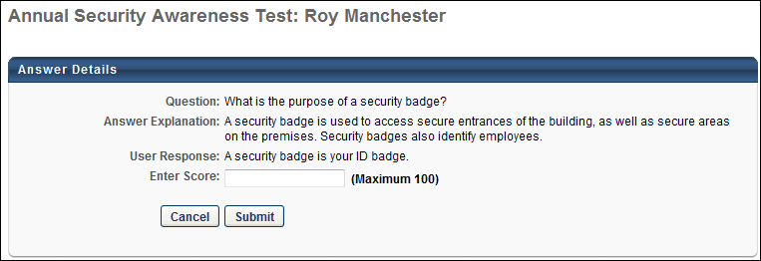
The following information displays for each question:
- Question - This field displays the question that the user answered.
- Answer Explanation - This field displays the correct answer, as determined by the question creator.
- User Response - This field displays the user's answer to the question.
- Enter Score - Enter a score in the Enter Score field. The score is a percentage of the point value for the test. For example, on a 100 question test where every question is worth 1 point, any essay question can be scored up to 1 point. If you enter a score of 50 for the essay question, the user receives .5 points for that questions based on the test that has 100 questions worth 1 point each.
Once you have scored the response, click Submit. This returns you to the Test Questions Pending Grading page. Note: Once a grade is submitted for a question, the question no longer appears on the Test Questions Pending Grading page.
Review Test Page
The Review Test page enables administrators to review a user's responses test and print the results. Administrators can also reset a test from the Review Test page. If a user retakes a test, each attempt appears in a separate row for each user.
Note: Users only appear on the Review Tests page for a test if they have launched the test for their current registration of the test. Having completed past registrations does not include them in this list of users.
To access the Review Test page, go to Content > Test Engine. Then, click the Review icon in the Options column.
Permissions
PERMISSION NAME | PERMISSION DESCRIPTION | CATEGORY

Test Engine - Manage | Grants ability to create and edit/manage tests via the Test Engine. This permission can be constrained by OU, User’s OU, User, User’s Self, and User’s Subordinates. This is an administrator permission. | Learning - Administration

Test Engine - Review | Grants ability to view details of user results for tests, via the test engine. This permission can be constrained by OU, User’s OU, User, User’s Self, and User’s Subordinates. This is an administrator permission. | Learning - Administration

Test Engine - View | Grants ability to view existing tests in the test engine. Administrators with this permission can view each section of a test and print tests. Administrators with this permission can enter changes when viewing a test, but these changes cannot be saved. This permission can be constrained by OU, User’s OU, User, User’s Self, and User’s Subordinates. This is an administrator permission. | Learning - Administration
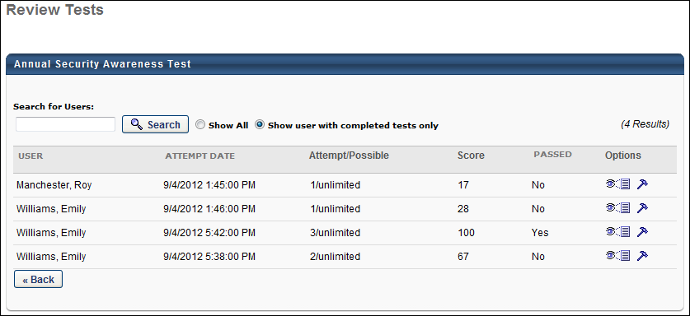
Search
You can filter the results by using the Search feature. Enter a user's last name in the User Name field, and then click Search. All users matching that last name appear in the Questions Pending Grading table.
Questions Pending Grading Table
The following information appears for each pending question:
- User - This column displays the name of the user that completed the test.
- Attempt Date - This column displays the date and time that the user started that attempt of the test.
- Attempt/Possible - This column displays the number of times the user has attempted the test and the number of attempts possible.
- Score - This column displays the user's score on the test.
- Passed - This column indicates whether or not the user passed the test.
Options
The following options are available for each attempt:
- View Details - Click the View Details icon to open the Review Test Questions page on which you can view which questions a user answered correctly and incorrectly. You can also view the response options and an answer explanation, if available. See Review Test Questions on page 125 for additional information.
- Reset - Click the Reset icon to reset the user's test. This allows users to retake a test for which they have reached the maximum number of attempts possible. See Adjust User Test Attempts on page 124 for additional information.
Adjust User Test Attempts
Administrators with permission to review a test are able to adjust the test attempts for a user.
To adjust a user's test attempts, go to Admin > Tools > Catalog Management > Tests. Then, click the Review icon in the Options column next to a test. Note: This icon only appears next to a test when at least one user has taken the test. Then, click the Reset Test icon in the Options column.
From the Adjust User Test Attempts pop-up, the following options are available:
- Reset the attempt status to allow the user to go back and continue the test from the point of previous disruption
- Delete an entire user attempt - This option allows you to remove a test attempt from the user's test history.
- Add new attempt for user - This option lets you allow a user who has reached their test attempt limit to take the test again.
- Set lockout period before users may re-attempt - From the dropdown menus, select the number of days or months a user must wait before they can re-attempt the test. If no time is selected, the user will not be locked out and will be able to re-attempt the test immediately after taking the test the first time.
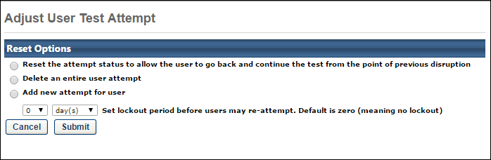
Review Test Questions
The Review Test Questions page enables administrators to view which questions a user answered correctly and incorrectly. You can also view the response options and an answer explanation, if available, as well as print the test results.
To access the Review Test Questions page, go to Content > Test Engine. Then, click the Review icon in the Options column. On the Review Test page, click the View Details icon in the Options column. See Review Test Page on page 122 for additional information.
Permissions
PERMISSION NAME | PERMISSION DESCRIPTION | CATEGORY

Test Engine - Manage | Grants ability to create and edit/manage tests via the Test Engine. This permission can be constrained by OU, User’s OU, User, User’s Self, and User’s Subordinates. This is an administrator permission. | Learning - Administration

Test Engine - Review | Grants ability to view details of user results for tests, via the test engine. This permission can be constrained by OU, User’s OU, User, User’s Self, and User’s Subordinates. This is an administrator permission. | Learning - Administration

Test Engine - View | Grants ability to view existing tests in the test engine. Administrators with this permission can view each section of a test and print tests. Administrators with this permission can enter changes when viewing a test, but these changes cannot be saved. This permission can be constrained by OU, User’s OU, User, User’s Self, and User’s Subordinates. This is an administrator permission. | Learning - Administration
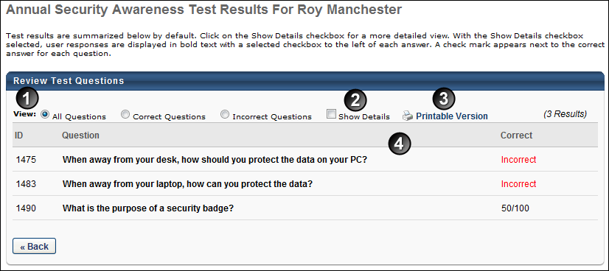
Feature | Description
1 | View - You can filter the results by the following view options:  - All Questions - Select the All Questions option to view questions that the user answered correctly and incorrectly.  - Correct Questions - Select the Correct Questions option to view only the questions that the user answered correctly.  - Incorrect Questions - Select the Incorrect Questions option to view only the questions that the user answered incorrectly.
2 | Show Details - Check the Show Details box to view the question, response options, and answer explanation. Note: The questions that appear are dependent upon the View selection.  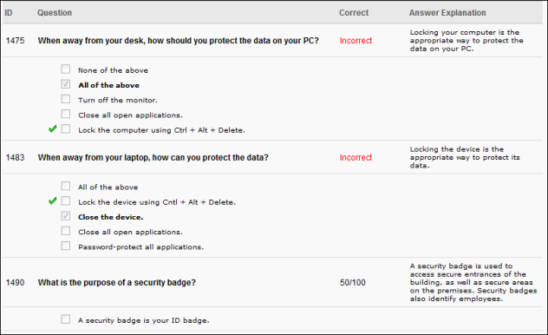
3 | Printable Version - Select the Printable Version link to view a printable version of the test results.  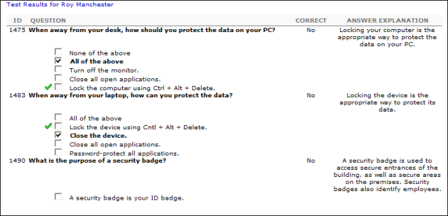
4 | Review Test Questions Table - The following information appears for each question:  - ID - This column displays the question's ID number.  - Question - This column displays the question that the user answered.  - Correct - This column displays whether or not the user answered the question correctly or incorrectly.
Review - Partially Scored Test Questions
When a user provides some but not all of the correct answers for a Multiple Choice/Multiple Answer test question, the question is marked incorrect on the Review Test Questions page when the user reviews their test attempt. Partial credit is automatically calculated and applied, and the user only sees the final calculated score for the question.
>The Review Test Questions page does not display how many points were awarded for each correct answer.
>The Review Test Questions page does not display how many points were subtracted for each incorrect answer.
>Any partial credit received for a Multiple Choice/Multiple Answer question is automatically factored into the overall test score. No specific scoring details are visible to the end user.

Question Bank (Content)
The Question Bank is used to create questions, create question categories, and perform a question item analysis. By default, when accessing the Question Bank, the Questions tab displays.
Note: The Question Bank that is accessed from the Content tab is not the same as the Question Bank that is accessed from Form Management. The Question Bank in the Content tab is used for the Test Engine functionality. The Question Bank from Form Management is used in forms. See Question Bank Overview (Forms).
To access the Question Bank, go to Content > Question Bank. Or, go to Content > Test Engine. On the Test Engine page, click the View Question Bank link.
Permissions
PERMISSION NAME | PERMISSION DESCRIPTION | CATEGORY

Test Question Bank - Category | Grants ability to create and edit/update categories for classifying test engine questions. This permission can be constrained by OU, User's OU, User, User's Self, and User's Subordinates. This is an administrator permission. | Learning - Administration

Test Question Bank – Manage | Grants ability to create and edit/update test questions in the test engine question bank. This permission can be constrained by OU, User’s OU, User, User’s Self, and User’s Subordinates. This is an administrator permission. | Learning - Administration

Test Question Bank – View | Grants ability to view the test engine question bank. This permission can be constrained by OU, User’s OU, User, User’s Self, and User’s Subordinates. This is an administrator permission. | Learning - Administration
Note: To access and manage the Question Bank from the Test Engine page, you must have permission to view or manage the test question bank and manage or view Test Engine.
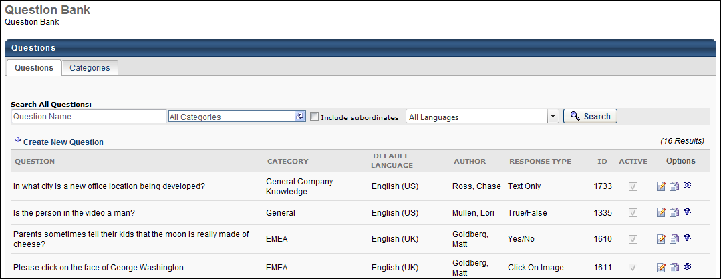
See also:
- Questions
- Categories
- Test Question Item Analysis Report
Question Bank - Questions Tab
The Questions tab displays all questions in the Question Bank. From this tab, you can search for questions, as well as create, edit, or copy a question.
Permissions
PERMISSION NAME | PERMISSION DESCRIPTION | CATEGORY

Test Partial Scoring - Manage | Grants ability to view and edit Partial Scoring for test engine Multiple Choice/Multiple Answer response type. | Learning - Administration

Test Question Bank – Manage | Grants ability to create and edit/update test questions in the test engine question bank. This permission can be constrained by OU, User’s OU, User, User’s Self, and User’s Subordinates. This is an administrator permission. | Learning - Administration

Test Question Bank – View | Grants ability to view the test engine question bank. This permission can be constrained by OU, User’s OU, User, User’s Self, and User’s Subordinates. This is an administrator permission. | Learning - Administration
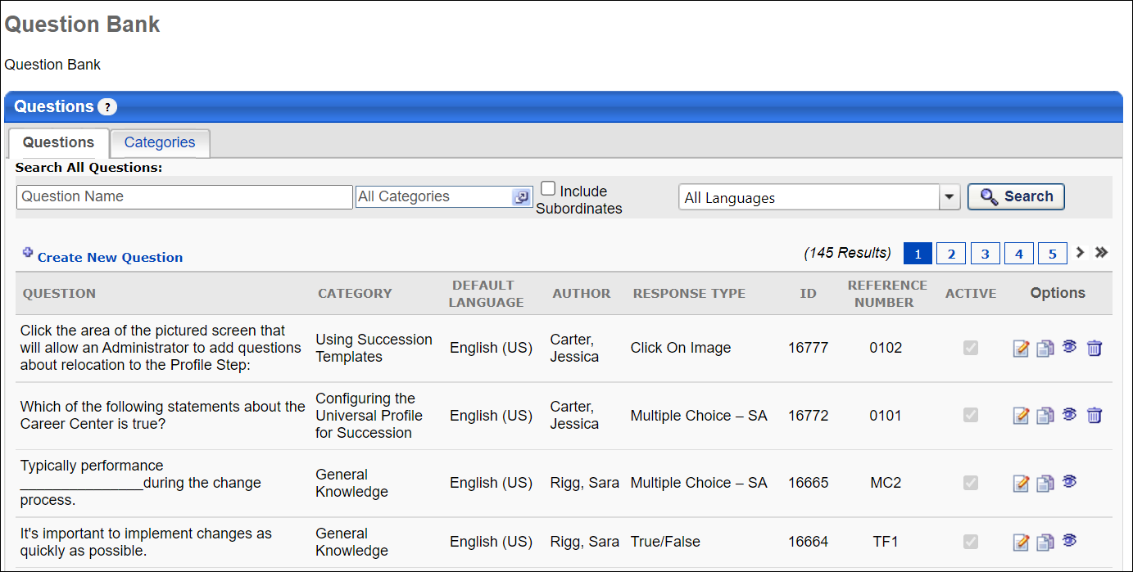
Question and Language Search Filters
You can search for questions by name, category, or language. When using the language search filter, the language searched is the question's default language. These filters work together so that only the questions that match the criteria are displayed when Search is clicked.
Category Search Filter
The category filter enables you to search by question category. Click the Select icon in the right-corner of the filter. This opens the Search Category pop-up.
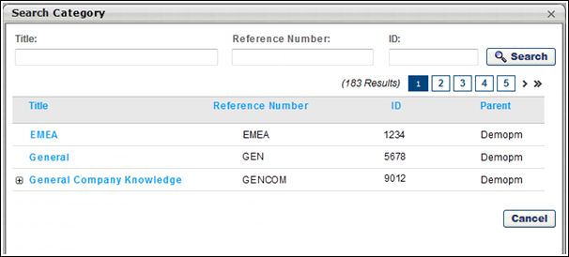
Filters
The following filter options are available in the Search Category pop-up:
- Title - To filter the category results by title, enter a full or partial title in the field. The field accepts up to 100 characters. Unicode characters are accepted. If one or more parent categories have child categories, then the results display both parent and child categories as a list rather than displaying the hierarchy.
- Reference Number - To filter the category results by reference number, enter a full or partial number in the field. The field accepts up to 50 characters. Unicode characters are accepted. The results display all categories that match the search criteria. Note: This filter is only available for portals with the reference number feature enabled. This reference number feature is controlled by a backend setting that is disabled by default. To enable this setting, contact Global Customer Support.
- ID - To filter the category results by identification number, enter a full or partial number in the ID field. The field accepts up to 50 characters. Unicode characters are accepted. The results display all categories that match the search criteria.
- Search - Click the Search button to filter the results based on the search criteria entered in the filters.
- View Hierarchy - If a hierarchical relationship is defined for a category, then a plus icon displays to the left of the category title. Clicking the icon displays the child categories of the parent on a new page within the pop-up. Up to five levels may be available for each category.
Category Results Table
By default, categories display in the results table in ascending order by title. All columns in the table are sortable.
The following information displays in the table:
Column Name | Description
Title | This column displays the title of the category.
Reference Number | This column displays the category's reference number, as defined by the administrator. Note: A reference number only displays if the reference number feature is enabled via a backend setting. To enable this setting, contact Global Customer Support.
ID | This column displays the system-generated identification number for the category.
Parent | This column displays the name of the parent for the category. For categories that are not child categories, the name in the Parent column is the same as the name in the Title column.
Include Subordinates
Select this option to include subordinate categories from the selections made in the categories filter.
Create New Question
Click the Create New Question link to create a new question. Note: Administrators with only view access to the Question Bank cannot create questions.
Questions Table
The following information displays for questions:
- Question - Displays in the language of the administrator who created the test. Or, if available, the test name appears in the user's display language. If the administrator's language is not available, the test displays in the test's default language.
- Category
- Default Language
- Author
- Response Type
- Reference Number - This column displays the reference number, as defined by the administrator when creating/editing the question. This column only displays if the reference number feature is enabled. To enable this feature, contact Global Customer Support.
- ID
- Active - The Active column checkbox is read-only. Note: The Active status of a question is managed when creating, editing, or copying the question.
Options
The following options are available in the Options column:
- Edit - Click to edit the question.
- Copy - Click to copy the question.
- View - Click to view the question.
- Delete - Click to delete the question. This option is only available for questions that have not been used in a test.
Note: Administrators with only view access to the Question Bank cannot edit or copy questions. See Question Bank Overview for Question Bank permissions.
Question Categories
The Categories tab displays all categories in the Question Bank. From this tab, administrators can create and edit categories. Categories can also be organized into parent and child relationships to improve the organization of categories.
To access the Categories tab, go to Content > Question Bank. Or, go to Content > Test Engine. On the Test Engine page, click the View Question Bank link. This opens the Question Bank page. Then, click the Categories tab.
Permissions
PERMISSION NAME | PERMISSION DESCRIPTION | CATEGORY

Test Question Bank - Category | Grants ability to create and edit/update categories for classifying test engine questions. This permission can be constrained by OU, User's OU, User, User's Self, and User's Subordinates. This is an administrator permission. | Learning - Administration
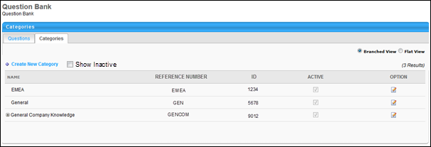
Feature | Description
Create New Category | Click the Create New Category link to create a new category for questions. See Create New Category for information on creating categories.
Show Inactive | Select this option to display inactive categories. This option is unchecked by default.
Branched View | Select this option to view a hierarchical view of the categories in the Categories table. This option is selected by default.
Flat View | Select this option to view a list of all categories in the Categories table. This display does not show the hierarchical category relationships.
Categories Table | The following information displays for categories:  - Name - This column displays the name of the category. When an administrator views a category, if the category is not available in their display language, it appears in the language of the administrator that created the category.  - Reference Number - This column displays the category's reference number, as defined by the administrator when creating/editing the question. This column only displays if the reference number feature is enabled. To enable this feature, contact Global Customer Support.  - ID - This column displays the system-generated identification number for the category. This number cannot be defined by the administrator and cannot be edited.  - Active - The Active column checkbox is read-only. Note: The Active status of a category is managed by clicking the Edit icon.
Options | The following options are available in the Options column:  - Edit - Click the Edit icon to edit the category. See Create/Edit Categories on page 137 for additional information.  - Delete - Click the Delete icon to delete the category. When deleting a parent category, all child categories of the parent are also deleted. A warning message displays indicating that the child categories of the parent will be deleted.
Create/Edit Categories
When creating and editing categories, administrators can create stand alone categories or define parent/child relationships for categories. Up to five levels can be defined for each category within a parent/child relationship.
To access the Categories tab, go to Content > Question Bank. Or, go to Content > Test Engine. On the Test Engine page, click the View Question Bank link. This opens the Question Bank page. Then, click the Categories tab.
the create/edit fields display in a panel above the Categories table.
Permissions
PERMISSION NAME | PERMISSION DESCRIPTION | CATEGORY

Test Question Bank - Category | Grants ability to create and edit/update categories for classifying test engine questions. This permission can be constrained by OU, User's OU, User, User's Self, and User's Subordinates. This is an administrator permission. | Learning - Administration
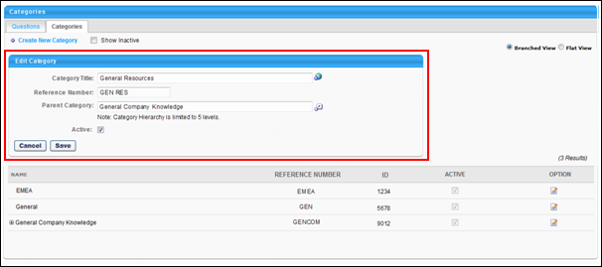
Complete the following fields to create or edit a category:
- Category Title - Enter a title for the category, up to 100 characters. Unicode characters are accepted. If multiple languages are enabled for your portal, select the Translate icon to translate the field into other available languages.
- Reference Number - Enter a reference number, up to 50 characters. The reference number must be unique. Unicode characters are accepted. Reference numbers are used when bulk loading/editing categories into the system. The reference number specifies the category that is being loaded or edited. The option to provide a reference number is only available if enabled by a backend setting. To enable this feature, contact Global Customer Support. When enabled, this is a required field. Upon implementation, a reference number can be added to existing categories.
Note: The bulk loading/editing of categories is done via a technical project. Contact your Account Manager for more information about this process.
- Parent Category - Select a parent category to make the category a child category. Each parent category can have up to five hierarchical levels.
- Active - Select or unselect the check box. When selected, the category is active. When unselected, the category is inactive. Note: Inactivating a parent category inactivates all child categories of the parent.
Click Save to save the category. Or, click Cancel to cancel creating or editing the category.
Create Test Question
All test questions for a test should be created before creating the test itself. It is not possible to create questions from within the test creation process. All test questions must be created from the Question Bank page.
To create a test engine question, Go to Content > Test Engine. Click the View Question Bank link, and then click the Create New Question link. This opens the Create Question page.
Permissions
PERMISSION NAME | PERMISSION DESCRIPTION | CATEGORY

Test Question Bank – Manage | Grants ability to create and edit/update test questions in the test engine question bank. This permission can be constrained by OU, User’s OU, User, User’s Self, and User’s Subordinates. This is an administrator permission. | Learning - Administration

Test Partial Scoring - Manage | Grants ability to view and edit Partial Scoring for test engine Multiple Choice/Multiple Answer response type. | Learning - Administration
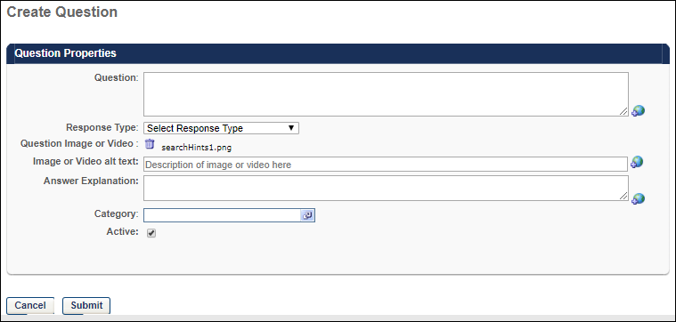
Note: Questions are created one at a time. Questions cannot be uploaded as a group.
Enter the following information about the question in the Question Properties section:
- Question - Enter the text for the question. The question should be descriptive and include all of the details necessary for the test taker to understand what is expected. If an image or video is included, you should explain what the test taker should be looking for or analyzing in the image or video. The character limit for this field is 2000. If multiple languages are enabled for your portal, select the Translate icon to translate the field into other available languages. Note: If a user's language is not available for the value in the field, the value displays in the default language of the question. The default language is the display language of the administrator that created the question.
- Reference Number - This option is only available if enabled by a backend setting. To enable this feature, contact Global Customer Support. Note: Bulk loading/editing questions is done via a technical project. Contact your Account Manager for more information about this process.
A reference number is used when bulk loading/editing questions. To add a reference number, enter the number in the Reference Number field. Up to 50 characters are accepted. Unicode characters are accepted. The reference number must be unique.
- Response Type - Select the type of response that is required from the test taker. This also affects the question options that follow. For example, if the response type is Multiple Question/Single Answer, you must then provide the response options that are presented to the test taker. Note: If a video is uploaded, the Click on Image response type is not available.
- Question Image or Video - To upload an image or video for the question, click the Browse button and locate the appropriate file. Only one file can be uploaded per question. After selecting the file, click the Upload button. The supported file types are .gif, .jpg, .bmp, .wmv, .mp4 and the maximum file size is 50 MB. If an image or video is added to a question and at least one user completes the question, the image or video cannot be edited. Note: When using a video within a test question, The Click on Image response type is not available.
  - See the Video Considerations section below for important considerations regarding video questions.
  - Note: With some media types, you may need to download a plug-in. This warning will appear at the top of the window when a user attempts to launch the video. The user must click the message to download the plug-in and then proceed to play the video.
- Image or Video alt text - This field is only available when an image or video is added to a test question. Enter a short, distinct description of the image or video. The alternative (alt) text is what an accessibility or screen reader references and voices to an impaired user when encountering the image or video. This helps to ensure impaired users can understand the context of the question and answer appropriately. Without alt text, a screen reader may simply say “image” or ignore the image. This field is optional.
- Answer Explanation - In this field, enter an explanation for the question. For example, if the correct answer is True, explain to the test taker why this is the correct response. Answer explanations can only be viewed by the test taker after the test is complete. The character limit for this field is 1000.
  - If multiple languages are enabled for your portal, select the Translate icon to translate the field into other available languages. Note: If a user's language is not available for the value in the field, the value displays in the default language of the question. The default language is the display language of the administrator that created the question.
- Category - Click the Select icon in the Category field to select the appropriate category for the question. This opens the Search Category pop-up. Defining a category for the question is used to organize and filter the questions by subject area. See Question Bank - Questions Tab on page 130 for additional information.
- Active - The Active box is checked by default. Leave the box checked to make the question active. Uncheck the box to inactivate the question.
Submit
After entering the appropriate information, click Submit. Once the question is saved, you may preview the question from the Questions tab on the Question Bank page to ensure it appears properly. If a video or image is included, it is a good idea to verify the item appears properly.
Video Considerations
- Videos that are uploaded to the system can be streamed to the user with minimal buffering and interruptions.
- When uploading a video to the system, there are Internet browser considerations that determine the default format of the video. In addition, when using mp4 videos, organizations must perform additional configurations in order to ensure that mp4 videos play properly. See Video Streaming.
Response Options Based on Response Type
Yes/No
This response type allows users to answer Yes or No. The question should be phrased in a way that the answer is either Yes or No (e.g., Is the sky blue?). You must select which option is the correct response for the question.
True/False
This response type allows users to answer True or False. The question should be phrased in a way that the answer is either True or False (e.g., True or False: The sky is blue.). You must select which option is the correct response for the question.
Multiple Choice/Single Answer
This response type provides users with a multiple choice question that has only one correct answer (e.g., What color is the sky?). Users only select one option. You must provide the response options for the question. If multiple languages are enabled for your portal, select the Translate icon to translate the field into other available languages. Note: If a user's language is not available for the value in the field, the value displays in the default language of the question. The default language is the display language of the administrator that created the question.
- Add Response Choice - Click this link to add a response option for the question. This adds a blank response to the question. For each choice, specify the following information:
  - Order - Enter a number to order the responses. A response with the order of 1 is displayed at the top, followed by 2, then 3, and so on.
  - Response Choice - These are the multiple choice options that are displayed to the user. Enter the response text for each option you'd like to include (e.g., for the question "What color is the sky?" possible response choice text may be Red, Blue, Green, Purple, Orange, Yellow, White, Black). The character limit for this field is 500. If multiple languages are enabled for your portal, select the Translate icon to translate the field into other available languages.
  - Correct - Select this option if the response choice is the correct response. Only one option can be selected as the correct response, and at least one correct response must be selected. If "None of the above" is included as an option, you may select that as the correct response.
  - Always Display - Select this option in order to always display this option as a response choice. This option is only applicable if you select the "Random answer selection" option below, in which not all response choices are displayed.
- Include 'None of the above' - Select this option to include a 'None of the above' response option for the question. This includes it as an option for the user, but this does not have to be the correct response.
- Include 'All of the above' - Select this option to include a 'All of the above' response option for the question. This includes it as an option for the user, but this does not have to be the correct response.
- Random answer selection - Select this option to have the system randomly select a subset of the provided responses to display to the user (e.g., for the question "What color is the sky?" you may provide eight answers: Red, Blue, Green, Purple, Orange, Yellow, White, Black). If this option is selected, you can choose to only display four of the answers to the user and the system randomly selects four of these responses to display. If this option is selected, you must specify the number of response options that display each time.
Multiple Choice/Multiple Answer
This response type provides users with a multiple choice question that has one or more correct answers (e.g., What colors are in a rainbow?). Users may select multiple responses, and all correct responses must be selected in order to receive full credit for the question. This question type can be configured to allow users to receive partial credit for selecting some but not all of the correct answers. You must provide the response options for the question. If multiple languages are enabled for your portal, select the Translate icon to translate the field into other available languages. Note: If a user's language is not available for the value in the field, the value displays in the default language of the question. The default language is the display language of the administrator that created the question.
- Add Response Choice - Click this link to add a response option for the question. This adds a blank response to the question. For each choice, specify the following information:
  - Order - Enter a number to order the responses. A response with the order of 1 is displayed at the top, followed by 2, then 3, and so on.
  - Response Choice - These are the multiple choice options that are displayed to the user. Enter the response text for each option you'd like to include (e.g., for the question "What colors are in a rainbow?" possible response choice text may be Red, Blue, Green, Purple, Orange, Yellow, White, Black). The character limit for this field is 500. If multiple languages are enabled for your portal, select the Translate icon to translate the field into other available languages.
  - Correct - Select this option if the response choice is the correct response. Multiple correct answers may be provided, but at least one correct response must be selected. If "None of the above" is included as an option, you may select that as the correct response.
  - Always Display - Select this option in order to always display this option as a response choice. This option is only applicable if you select the "Random answer selection" option below, in which not all response choices are displayed.
- Include 'None of the above' - Select this option to include a 'None of the above' response option for the question. This includes it as an option for the user, but this does not have to be the correct response.
- Include 'All of the above' - Select this option to include a 'All of the above' response option for the question. This includes it as an option for the user, but this does not have to be the correct response.
- Random answer selection - Select this option to have the system randomly select a subset of the provided responses to display to the user (e.g., for the question "What color is the sky?" you may provide eight answers: Red, Blue, Green, Purple, Orange, Yellow, White, Black). If this option is selected, you can choose to only display four of the answers to the user and the system randomly selects four of these responses to display. If this option is selected, you must specify the number of response options that display each time.
- Apply Partial Scoring - When this option is checked, users can receive partial credit based on the number of correct answers and the number of incorrect answers they select from the available response choices. You must have the permission to allow partial scoring in order to view this option. This option can be selected for all new questions and previously created questions that have not yet been answered by a user. After a Multiple Choice/Multiple Answer question has been answered, the Apply Partial Scoring option is not editable. Partial scores are factored into standard report data when reporting on tests.
Partial credit for Multiple Choice/Multiple Answer test questions using the Apply Partial Scoring option is calculated based on a formula which assumes all possible question answers carry the same weight. To calculate partial credit, the system uses the formula:
Total Points Available x (Correct Answers – Wrong Answers)
Total Correct Answers Set for Question
Text Only
This response type requires users to enter a short text response to the question (e.g., What color is the sky?). You can then enter acceptable text answers. The system then compares their response with the acceptable correct responses. If the response matches the provided correct answers then it is marked Correct.
- Add Correct Answer - Click this link to add a correct text response to the question. After entering the answer, click the Save icon. Multiple correct answer fields may be added if the answer can be spelled or written in a variety of ways. Note: Capitalization is ignored in responses, so there is no need to enter multiple capitalization variations of a word (e.g., Blue = blue = BLUE). The character limit for this field is 2000.
  - If multiple languages are enabled for your portal, select the Translate icon to translate the field into other available languages. Note: When scoring text only responses, the user's response is matched against any of the available translations entered in the Add Correct Answer field. If the answer matches at least one of the translations exactly, the answer is deemed correct. If the answer does not match exactly, it is marked incorrect.
Free Form (Essay)
This response type requires users to enter a free form or essay response to the question (e.g., What makes the sky blue?). The character limit for responses is 4000. Note: When reporting on free form responses, only the first 1500 characters of each response are included in the report output.
This question type must be scored by a test grader on a point scale. The maximum point value for the question is determined by the weight of the question in the test. Tests are not scored until all free form question are scored. All test graders have equal access to score test questions upon user submission. A free form questions can only be scored by one grader and you may add any number of graders to a test. Each question appears individually to allow different graders to score different questions. Upon submission of a test with a free form question, the user has a status of Pending Grade. Once all free form questions are graded, the user is moved to a status of Complete or Failed based upon their score.
Click On Image
This response type requires users to click on a specific area of an image in response to a text question. With this response type, a valid image must be uploaded before the correct response can be defined.
- Define Valid Area - Click this link to define the area of the image that should be clicked for a correct response. This opens a Define Valid Area pop-up. Using your mouse, click the image to select the coordinates that outline the area of the image that constitutes a valid response. Each time the image is clicked, a green dot appears. Note: The Define Valid Area link is not available until a valid image is uploaded.
  - After outlining the area, click the Draw icon to define the area correct area. More than one "correct" area can be selected.
  - Click the Clear icon to clear all previous input and begin again.
  - As coordinates are selected, they appear in the text area, separated by semicolons. You can correct the area in the text field as well.
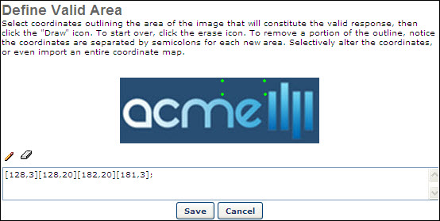
Edit Question
Permissions
PERMISSION NAME | PERMISSION DESCRIPTION | CATEGORY

Test Partial Scoring - Manage | Grants ability to view and edit Partial Scoring for test engine Multiple Choice/Multiple Answer response type. | Learning - Administration

Test Question Bank – Manage | Grants ability to create and edit/update test questions in the test engine question bank. This permission can be constrained by OU, User’s OU, User, User’s Self, and User’s Subordinates. This is an administrator permission. | Learning - Administration
To edit a test question:
- Go to Content > Test Engine.
- Click the View Question Bank link. This opens the Questions tab on the Question Bank page.
- Next to the appropriate test question, click the Edit icon. This opens the Edit Question page. The process of editing a question is similar to creating a question. See Create Test Question on page 139 for additional information. If the question has been answered in a test, the format of the question cannot be edited. You may modify the text to add clarity or correct errors, but you should not alter the meaning of the question, as this will affect the results. Note: Some other question fields cannot be modified if a user has already answered the question, such as the Apply Partial Scoring option available for Multiple Choice/Multiple Answer questions.
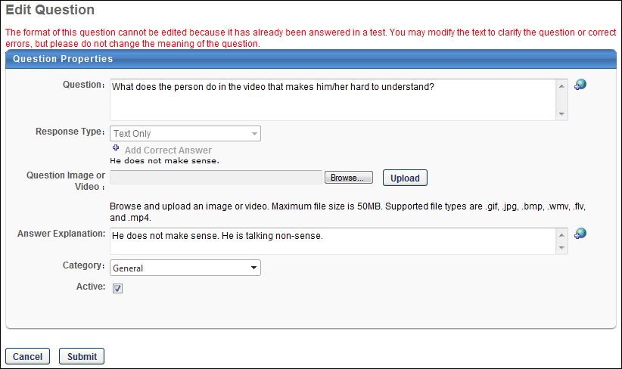

xAPI Package Support - Overview
Learning administrators can upload xAPI courses to their learning management systems (LMS) using the Content Uploader and Course Publisher tools. These courses can then be managed via the Course Catalog and Course Console, using the same Learning Management System (LMS) features provided to manage AICC and SCORM courses. Users can access xAPI courses from system search areas, launch xAPI courses on their transcripts, and view progress. This functionality is supported by the Cornerstone Learn mobile app.
Use Cases
Use Case 1: Instructional Designer Uploads xAPI Courses
Roberto is the instructional designer at ACME Corp. He has completed the development of a new compliance course using his company's authoring tool and has exported it as an xAPI package. Because Roberto is responsible for uploading content to ACME's LMS, he uses the Content Uploader to upload the new xAPI course to the system. After the upload, the system validates the course and provides information about whether the course has uploaded successfully or if there is invalid data that must be fixed.
Use Case 2: Learner launches xAPI Content
Emma is a marketing manager at ACME Corp. According to company policy, she is required to complete monthly compliance courses. Emma navigates to her learning transcript in the company portal and launches a required xAPI course that was uploaded to the system and assigned to her by a learning administrator.
Permissions
The following existing permissions apply to this functionality:
PERMISSION NAME | PERMISSION DESCRIPTION | CATEGORY

Course Catalog - Update | Grants ability to manage and edit training items listed in the Course Catalog and also grants access to the Course Console, where training can also be managed and edited. This permission also grants access to the Popular Requests and Highest Rated widgets on the Learning Admin Console (in conjunction with the Learning Admin Console - View permission). This permission also allows administrators to reversion online courses via the Course Console page. This permission also allows administrators to access an Edit Training option for training items included as objectives in Development plans.  This permission can be constrained by OU, User's OU, Training Type, Training Item, Provider, ILT Provider, User's ILT Provider, User, User Self and Subordinates, and User's LO Availability. This is an administrator permission.  Note: Adding an OU constraint and a provider constraint to this permission results in an "AND" statement. | Learning - Administration

Course Catalog - View | Grants access to view the learning objects in the course catalog and enables administrators to view the Course Console and the Popular Requests and Highest Rated widgets on the Learning Admin Console (in conjunction with the Learning Admin Console - View permission). This permission can be constrained by OU, User's OU, Training Type, Training Item, Provider, ILT Provider, User's ILT Provider, and User's LO Availability. This is an administrator permission.  Adding an OU constraint and a provider constraint to this permission results in an "AND" statement. | Learning - Administration

Course Publisher | Grants access to LCMS Course Publisher, which enables upload and publishing of SCORM and AICC compliant online courses, created either in the LCMS Course Builder, or from a third party course building tool. Administrators must also be granted a content license from the Manage Licenses page. This is an administrator permission.  After Content Publisher is activated in the system, users with this permission are automatically granted the permissions to upload and publish online classes via the Content Publisher, and also the permission to view the Upload History page. | Learning - Administration

Online Class - Upload | Grants access to the Content Uploader where an administrator can upload zip packages to create draft online classes. In addition, this permission grants the ability to upload a new zip package as part of the online class versioning process. This permission does NOT grant the ability to publish online classes. Without the permission to publish online classes, administrators with the permission to upload online classes can only upload and save online classes, which then must be published by administrators with the relevant permission.  As of November 10, 2017, this is the only permission which provides access to the Content Uploader page. | Learning - Administration

View Transcript Item | Grants ability to view details of learning objects that appear on the transcript (training record), by clicking on the name of the learning object. Users must also have the Bio About - View permission in order to access the transcript within Universal Profile. This permission can be constrained by OU, User's OU, User Self and Subordinates, User, or User's Self. This is an end user permission. | Learning - Administration

xAPI Package Support
xAPI courses are supported by the Content Uploader, the Course Publisher, Course Catalog, Course Console, Learner Home, the versioning process, the modification process, the transcript, Custom Reports, and Reporting 2.0.
Incorporating an xAPI (TinCan) LRS into a Learning Management System (LMS)
RusticiSoftware has provided content packaging, launching, and xAPI specifications. For more information about these specifications, click here: Incorporating xAPI (TinCan) into an LMS
The two main package formats are as follows:
- Inclusive - Package is a zip file containing the Tincan XML file and optional additional content
- Shell - This is external content, and the package is only the Tincan XML file
Prerequisites
A valid xAPI course must meet the following validations:
- The package must be zipped into a single zip file
- An xAPI package must contain exactly one “tincan.xml” file (xAPI/TinCan metadata file)
- Conform to the TinCan schema definition (http://projecttincan.com/tincan.xsd)
- The location of the “tincan.xml” file is considered the “root” of the package. All files within the package should be under the root.
- It is acceptable to create a package that contains only activity definitions, but content and activity provider definitions must be packaged with an associated activity definition
- Only one activity definition within a package may contain launch or resource elements
- The Activity ID should be unique for each course per portal
- Launch and resource elements must be verified:
  - Relative path must exist within the package (valid for zip only)
  - Absolute path must be a valid URL
Content Uploader
xAPI course files are supported by the Content Uploader and can be uploaded using the existing Course Uploader process. After the upload is complete, the Content Uploader either displays details of the successful upload or describes any upload errors which occurred.
For more information about using the Content Uploader: See Content Uploader - Create an Online Course - Overview on page 2 for additional information.
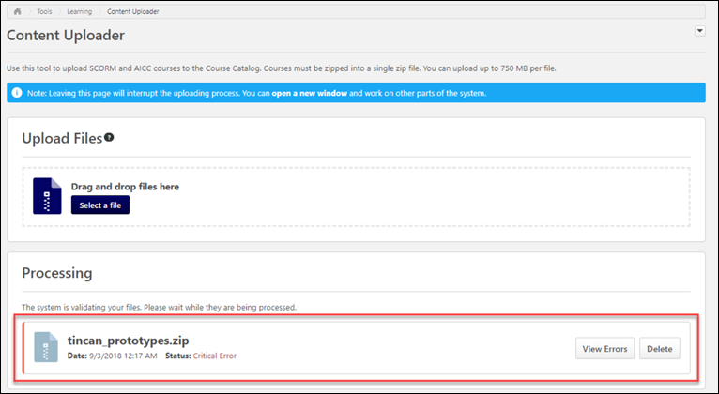
Course Publisher
xAPI course files are also supported by the Course Publisher and can be uploaded using the existing Course Publishing process. After the upload is complete, the Course Publisher either displays details of the successful upload or describes any upload errors which occurred.
For more information about using the Course Publisher: See Course Publisher (Legacy) Overview on page 47 for additional information.
Course Catalog
After xAPI course files have been uploaded to the system via the Content Uploader or Course Publisher, the xAPI courses can be searched for and managed via Course Catalog. Using the Course Catalog, the administrator can configure additional metadata for the course, such as keywords, subjects, availability, and more. xAPI courses are mobile-enabled by default via the Course Catalog.
For more information about using the Course Catalog: See Course Catalog - General.
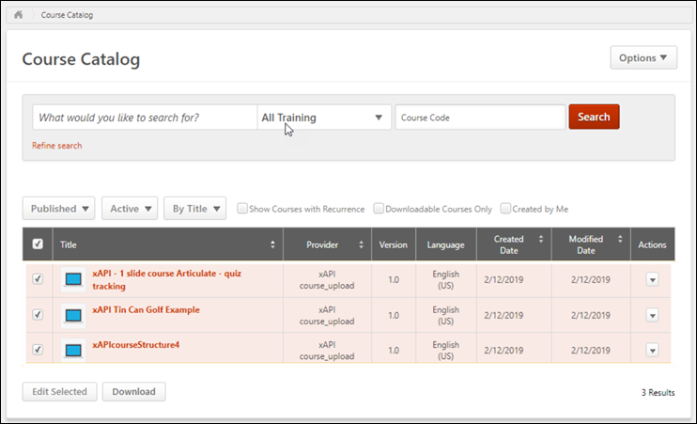
Course Console
After xAPI course files have been uploaded to the system via the Content Uploader or Course Publisher, the xAPI courses can also be searched for and managed via Course Console. Using Course Console, the administrator can configure additional metadata for the course, such as keywords, subjects, availability, and more.
For more information about using Course Console: See Course Console - Overview.
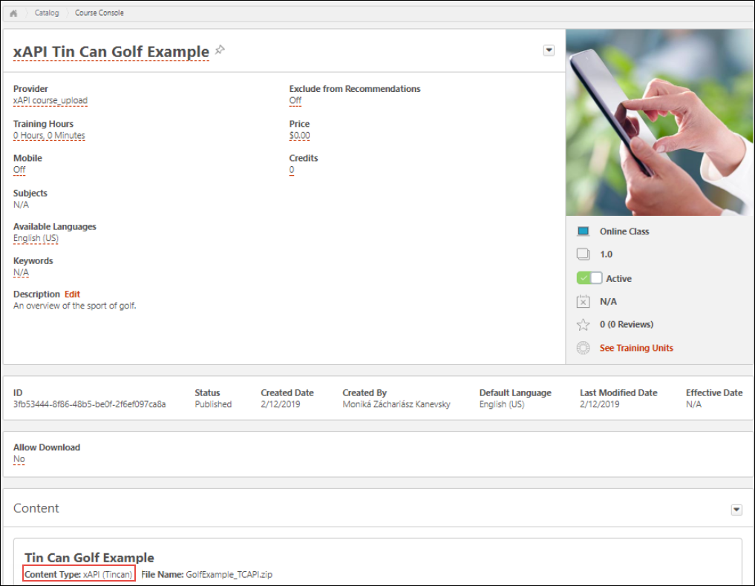
xAPI Course Progres
- When a user launches an xAPI course, the course status changes to In Progress.
- When the courseware sends a statement with Passed, Failed, Completed, or Attempted, and the Completion field in the Results section is "true," the course status will be Completed.
- If the xAPI completion statement includes a row score, the row score displays on the user`s transcript and in reporting as the Course Score.
- If the xAPI completion statements include only scaled score, the scaled score is doubled by 100 and displays on users' transcripts and in reporting as the Course Score. For example, if the scaled score in the xAPI course completion statement is 0.5, the score on the user's transcript and in reporting is 50.
NOTE: xAPI courses display only the last score the user received for the course in the user's transcript and in reporting.
Transcript
xAPI courses which have been uploaded to the system and made available to users can be searched for in the system, assigned and requested, and launched from the user's transcript. The xAPI course will follow normal system workflows as the user launches and completes the course. Any other steps in the workflow, such as approvals, signatures, and prerequisites, will be respected.
Reporting
When an administrator generates reports via Custom Reporting or Reporting 2.0 which include data related to online courses, all fields that are applicable to online courses return values for any xAPI courses which meet the report criteria.
In addition, administrator can view all the xAPI statements reported to Cornerstone's Learning Record Store (LRS) via the xAPI Statement Viewer tool. For more information about the xAPI Statement Viewer page: See xAPI Statement Viewer on page 171 for additional information.
Exclusions
The following functionality is not supported by xAPI packages:
- Content Players
- Local Network Player
- Standard reports
- Course Duration

xAPI - Launch in Iframe
With this enhancement, the administrator can specify whether or not xAPI courses launch in an Iframe when they are launched by a user, which makes it possible to record the user's view time for the course. The option to allow xAPI courses to launch in an Iframe is only available for xAPI courses, and the option is enabled by default.
To access the Course Catalog, go to Admin > Tools > Learning > Catalog Management > Course Catalog. Find the xAPI course you want to modify, click the Options drop-down, and select the Edit option.
Permissions
PERMISSION NAME | PERMISSION DESCRIPTION | CATEGORY

Course Catalog - Update | Grants ability to manage and edit training items listed in the Course Catalog and also grants access to the Course Console, where training can also be managed and edited. This permission also grants access to the Popular Requests and Highest Rated widgets on the Learning Admin Console (in conjunction with the Learning Admin Console - View permission). This permission also allows administrators to reversion online courses via the Course Console page. This permission also allows administrators to access an Edit Training option for training items included as objectives in Development plans.  This permission can be constrained by OU, User's OU, Training Type, Training Item, Provider, ILT Provider, User's ILT Provider, User, User Self and Subordinates, and User's LO Availability. This is an administrator permission.  Note: Adding an OU constraint and a provider constraint to this permission results in an "AND" statement. | Learning - Administration
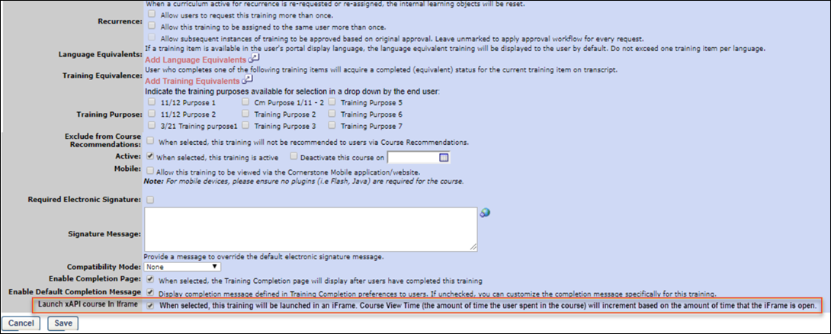
Launch xAPI Course in Iframe
To allow xAPI courses to launch in an Iframe, which enables the system to record how long a user spent viewing the course, ensure the Launch xAPI Course in Iframe option is checked, which is located on the General page of the Course Catalog for the xAPI course. This option is enabled by default. To disable the option, you can uncheck the Launch xAPI Course in Iframe option if needed. Click the Save button to save your changes. Note: The availability of this option is dependent on a new backend setting, which is enabled by default.
When users launch this xAPI course, the system records how long the course window is open. The user's view time for the course can be viewed on the Training Details page for the course and can also be reported on via Reporting 2.0.

xAPI - View Time in Transcript Details
With this enhancement, the amount of time that a user spent viewing an xAPI course displays on the Training Details page when viewed by the user or another user with permission to view the user's transcript. Note: This functionality is only available for xAPI courses if an administrator has enabled the Course Catalog option to allow xAPI courses to launch in an Iframe.
To view the Training Details page, follow these steps:
- Click the View Transcript link, which can be accessed from the Learning tab.
- Click the training title of the xAPI course to view the Training Details page for the course.
Permissions
PERMISSION NAME | PERMISSION DESCRIPTION | CATEGORY

View Transcript Item | Grants ability to view details of learning objects that appear on the transcript (training record), by clicking on the name of the learning object. Users must also have the Bio About - View permission in order to access the transcript within Universal Profile. This permission can be constrained by OU, User's OU, User Self and Subordinates, User, or User's Self. This is an end user permission. | Learning - Administration
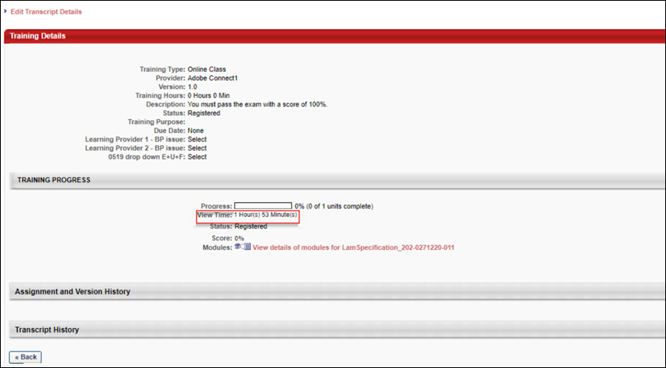
Training Progress
The View Time field displays in the Training Progress section of the Training Details page for the xAPI course. The amount of time the user's course window was open displays in hours and minutes.
This field was already available for AICC and SCORM courses, and an existing Course Time Spent field was available in the Course Interaction report field section in Custom Reporting and Reporting 2.0. With this enhancement, the Course Time Spent field can also be used to report on users' view times for xAPI courses.

xAPI - Scaled Score
With this enhancement, if there is no row score sent to the Learning Record Store (LRS) as part of the xAPI course completion statement, the scaled score is doubled by 100 and displays on users' transcripts and in reporting. For example, if the scaled score from the xAPI course completion statement is 0.5, the score on the user's transcript and in reporting is 50. This updated behavior is relevant to Articulate xAPI courses.
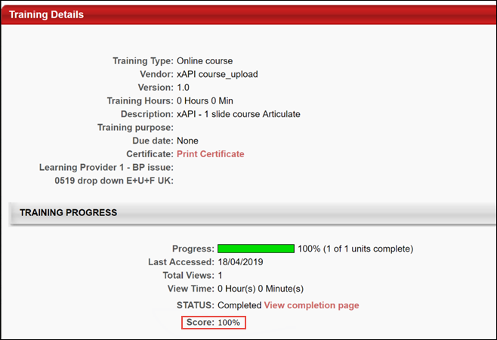

xAPI (JWT) Token Expression Time
Courses using JWTtoken (xAPI courses), allow admins to adjust how many minutes the course can be open before the course session times out (Corp setting name: JWTtokenTimeoutLength).
The default value and the max value is 1440 minutes. If the administrator enters a larger number or leaves the value blank, the default value of 1440 minutes will be applied.

xAPI Appendix
Supported Verbs
The Cornerstone LRS allows the sending of predefined verbs as described in the table below. If a statement is sent with a verb that is not supported, the statement will be rejected.
Label | Description | ID/IRI
abandoned | The verb "Abandoned" indicates that the AU session was abnormally terminated by a learner's action (or due to a system failure). | http://w3id.org/xapi/adl/verbs/abandoned
answered | Indicates the actor replied to a question, where the object is generally an activity representing the question. The text of the answer will often be included in the response inside result. | http://adlnet.gov/expapi/verbs/answered
asked | Indicates an inquiry by an actor with the expectation of a response or answer to a question. | http://adlnet.gov/expapi/verbs/asked
attempted | Indicates the actor tried to access the object. An attempt statement without additional activities could be considered incomplete in some cases. | http://adlnet.gov/expapi/verbs/attempted
attended | Indicates the actor was present at a virtual or physical event or activity. | http://adlnet.gov/expapi/verbs/attended
commented | Indicates the actor provided digital or written annotations on or about an object. | http://adlnet.gov/expapi/verbs/commented
completed | Indicates the actor finished or concluded the activity normally. | http://adlnet.gov/expapi/verbs/completed
enabled | Indicates that the actor turned on a particular part or feature of the system. It works with the verb disabled. | http://id.tincanapi.com/verb/enabled
exited | Indicates the actor intentionally departed from the activity or object. | http://adlnet.gov/expapi/verbs/exited
experienced | Indicates the actor only encountered the object and is applicable in situations where a specific achievement or completion is not required. | http://adlnet.gov/expapi/verbs/experienced
failed | Indicates the actor did not successfully pass an activity to a level of predetermined satisfaction. | http://adlnet.gov/expapi/verbs/failed
imported | Indicates the actor introduced an object into a physical or virtual location. | http://adlnet.gov/expapi/verbs/imported
initialized | Indicates the activity provider has determined that the actor successfully started an activity. | http://adlnet.gov/expapi/verbs/initialized
interacted | Indicates the actor engaged with a physical or virtual object. | http://adlnet.gov/expapi/verbs/interacted
launched | Indicates the actor attempted to start an activity. | http://adlnet.gov/expapi/verbs/launched
liked | Indicates that the actor marked the object as an item of special interest. The "like" verb is an alias of "favorite". The two verbs are semantically identical. | http://activitystrea.ms/schema/1.0/like
mastered | Indicates the highest level of comprehension or competence the actor performed in an activity. | http://adlnet.gov/expapi/verbs/mastered
opened | Indicates that the actor has opened the object. For instance, the object could represent a ticket being tracked in an issue management system. | http://activitystrea.ms/schema/1.0/open
passed | Indicates the actor successfully passed an activity to a level of predetermined satisfaction. | http://adlnet.gov/expapi/verbs/passed
paused | To indicate an actor has ceased or suspended an activity temporarily. | http://id.tincanapi.com/verb/paused
performed offline | Indicates that the actor has performed the object offline for a period of time (episode). For instance, a learner performed task X, which is an offline task like reading a book, for 30 minutes. This is used to record the time spent on offline activities. | http://id.tincanapi.com/verb/performed-offline
played | Indicates that the actor spent some time enjoying the object. For example, if the object is a video this indicates that the subject watched all or part of the video. The "play" verb is a more specific form of the "consume" verb. | http://activitystrea.ms/schema/1.0/play
preferred | Indicates the selected choices, favored options or settings of an actor in relation to an object or activity. | http://adlnet.gov/expapi/verbs/preferred
progressed | Indicates a value of how much of an actor has advanced or moved through an activity. | http://adlnet.gov/expapi/verbs/progressed
read | Indicates that the actor read the object. This is typically only applicable for objects representing printed or written content, such as a book, a message or a comment. The "read" verb is a more specific form of the "consume", "experience" and "play" verbs. | http://activitystrea.ms/schema/1.0/read
registered | Indicates the actor is officially enrolled or inducted in an activity. | http://adlnet.gov/expapi/verbs/registered
reported | Indicates the actor announced the result of an experience or activity. | http://adlnet.gov/expapi/verbs/reported
responded | Indicates an actor reacted or replied to an object. | http://adlnet.gov/expapi/verbs/responded
resumed | Indicates the application has determined that the actor continued or reopened a suspended attempt on an activity. | http://adlnet.gov/expapi/verbs/resumed
scored | Indicates a numerical value related to an actor's performance on an activity. | http://adlnet.gov/expapi/verbs/scored
searched | Indicates that the actor is or has searched for the object. If a target is specified, it indicates the context within which the search is or has been conducted. | http://activitystrea.ms/schema/1.0/search
selected | Indicates that the actor selects an object from a collection or set to use it in an activity. The collection would be the context parent element. | http://id.tincanapi.com/verb/selected
shared | Indicates the actor's intent to openly provide access to an object of common interest to other actors or groups. | http://adlnet.gov/expapi/verbs/shared
started | Indicates that the actor has started the object. For instance, when a person starts a project. | http://activitystrea.ms/schema/1.0/start
suspended | Indicates the status of a temporarily halted activity when an actor's intent is returning to the object or activity at a later time. | http://adlnet.gov/expapi/verbs/suspended
terminated | Indicates that the actor successfully ended an activity. | http://adlnet.gov/expapi/verbs/terminated
viewed | Indicates that the actor has viewed the object | http://id.tincanapi.com/verb/viewed
voided | A special reserved verb used by a LRS or application to mark a statement as invalid. See the xAPI specification for details on Voided statements. | http://adlnet.gov/expapi/verbs/voided
watched | Indicates that the actor has watched the object. This verb is typically applicable only when the object represents dynamic, visible content such as a movie, a television show or a public performance. This verb is a more specific form of "experience", "play" and "consume". | http://activitystrea.ms/schema/1.0/watch

xAPI Learning Reporter
xAPI Learning Reporter
The xAPI (also known as Tin Can API or Experience API) is the next generation e-learning protocol that enables the recording of a wide range of learning experience, including native mobile applications, team-based e-learning, and more.
An xAPI Learning Reporter widget allows users to record learning experiences that occurred outside of the learning management system (LMS) and send them to their transcript.
The Learning Reporter can operate on the following browsers:
- IE 11 and Edge
- Chrome
- Firefox
Permissions
PERMISSION NAME | PERMISSION DESCRIPTION | CATEGORY

xAPI - View Learning Reporter Option on Transcript | Allows users to view the Learning Reporter option on Transcript. | Learning - Administration
Access xAPI Learning Reporter
To add the Learning Reporter to their browser and use it to record learning experiences, the user must do the following:
- Click the Add Learning Reporter option from the Options drop-down menu on the transcript. This directs the user to the Add Learning Reporter page, where a Learning Reporter button displays.
- Click and drag the Learning Reporter button to the bookmarks bar in the browser.
- A Learning Reporter widget will be added to the user’s bookmarks bar, featuring the Cornerstone logo. To begin recording a learning experience, such as watching a video, the user can navigate to the video in the browser and then click the Learning Reporter widget saved to their bookmarks bar.
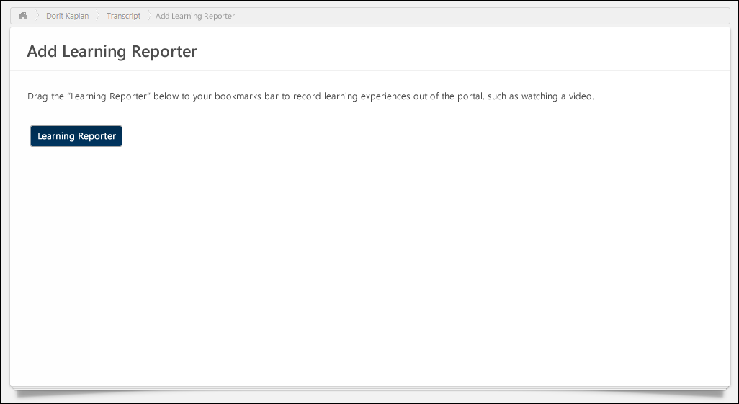
User Authentication
When a user attempts to send data to a portal for the first time, the Learning Reporter widget performs an authentication process .
If the user is not successfully authenticated, an error message appears at the bottom of the Learning Reporter, which reads, “Access Denied.” If the authentication is successful, the user may continue to send learning records to their transcript without further verification.
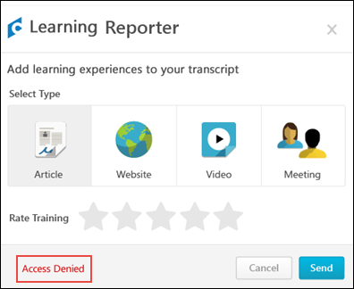
When the user clicks SEND, a new window is display requesting the user to log in the portal. If an SSO integration is configured, the user doesn’t need to log into the system and this page is not displayed.
- Note: If needed, you can view the Learning Reporter version number by clicking the area immediately to the right of the text that reads, "Learning Reporter" at the top of the Learning Reporter widget and drag your cursor over the white space to reveal the version number in white font.
When the user authenticated successfully, a Consent screen is displayed, enabling the user to authorize the Learning Report widget to send data to the portal. This process occurs only once so the user does not need to be authenticated each time they submit a learning record, (unless the authentication code expires before the user is successfully authenticated). The Consent screen contains the portal’s logo and colors.
The user can ALLOW or DENY the Learning Reporter widget.
- Clicking ALLOW will authorize the Learning Record widget to send the data to the portal.
- Clicking DENY will cancel the request and no data will be recorded.
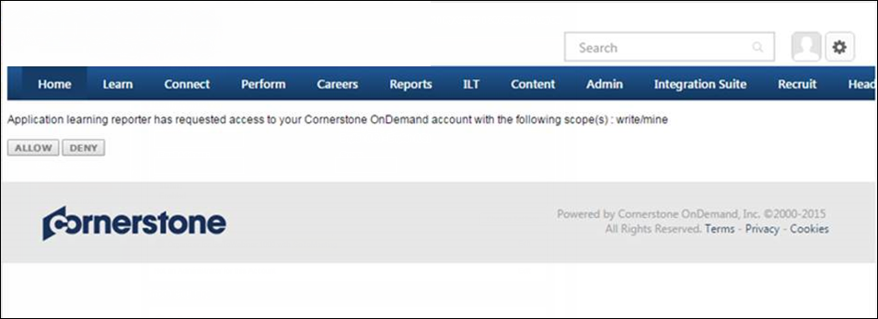
Learning Reporter Options
After a user clicks the Learning Reporter widget saved to their bookmarks bar, the Learning Reporter pop-up window appears. The Learning Recorder provides the user with information and options for recording their learning experience.
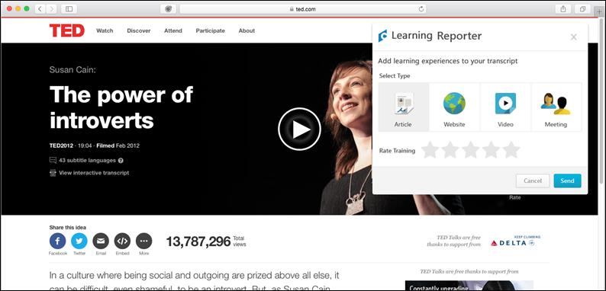
- Header - The header displays the Cornerstone logo, Learning Reporter heading, and an Exit icon. The user can click the Exit icon to close the Learning Reporter.
- Title - In the title area, text saying, “Add learning experiences to your transcript” displays.
- Select Type - In this section, the user clicks the icon for the type of learning experience they want to report. Options include: Article, Website, Video, and Meeting. No type is selected by default.
- Rate Training - In this section, the user can select a star rating for the training they are reporting as a learning experience. Training can be rated up to five stars. No star rating is selected by default for the user. The Rating option is not mandatory and the user can send the record of the learning experience without rating it. Note: For this version, the Rating data is only available on the back-end and is not visible on the transcript.
- Cancel - Clicking this button resets the Learning Reporter widget. This button is disabled by default unless the user selects a training type.
- Send - To record a learning experience and send it to the learning record store (LRS), click this button. This button is disabled by default unless the user selects a training type.
Learning Reporter Error
If pop-ups are blocked on the user’s device, an error message displays when the Learning Reporter is launched. The error displays the following information:
- Title - The top of the error message says, “Learning Reporter Cannot Open.”
- Message - The body of the error message says, “Your pop-up blocker is preventing you from proceeding to the Learning Reporter. To continue, please disable your pop-up blocker for this widget.”
- Close - Click the Close button to exit out of the error.
Send Learning Record Data
When a user is ready to record a learning experience, they select the appropriate options in the Learning Reporter and click the Send button. If the information is successfully sent to the portal, a green message that reads, “Information Sent” appears in the bottom of the widget.
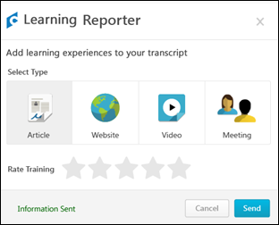
If an error occurs while attempting to send data, a red message that reads, “Error Occurred. Try Again” appears in the bottom of the widget.
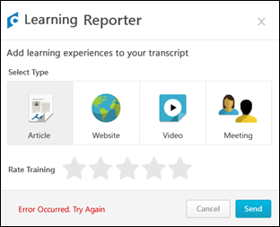
Right to Left Language Orientation
When the Learning Reporter widget is viewed in a language that is read from right to left, the widget features are aligned to the right of the widget:
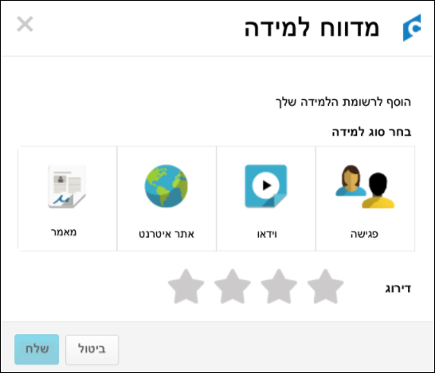
Left to Right Language Orientation
When the Learning Reporter widget is viewed in a language that is read from left to right, the widget features are aligned to the left of the widget:
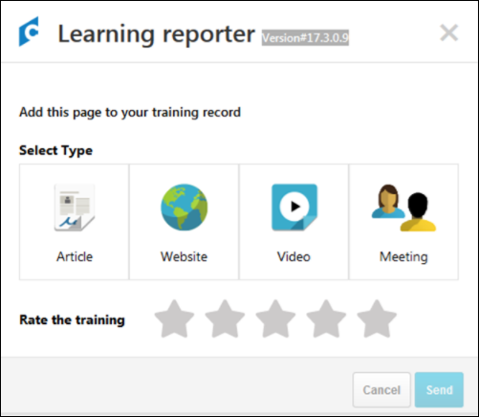
Launch Learning Record
When the user accesses the completed section of the learning transcript, previously recorded xAPI learning records display with a Launch button. Clicking the Launch button opens the xAPI learning record in a pop-up window, allowing the user to view the resource again. The user can also launch the learning record by clicking the Launch option in the Options drop-down menu for the learning record.
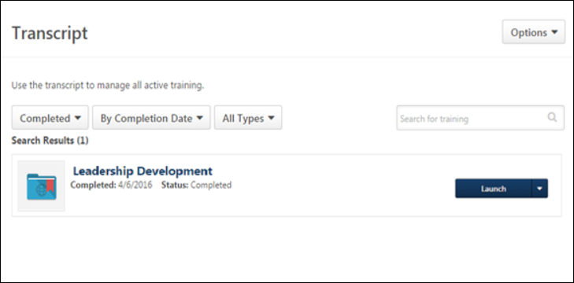
xAPI Statement Viewer
Administrators can use the xAPI Statement viewer to access data about how users are interacting with content in the Learning Record System (LRS).
To access the xAPI Statement Viewer, go to: Admin > Tools > Learning and click the xAPI Statement Viewer link.
Permissions
PERMISSION NAME | PERMISSION DESCRIPTION | CATEGORY

View xAPI Statements Viewer | Grants access to the xAPI Statement Viewer page, which allows users to view interactions with the Learning Record Store (LRS). | Learning
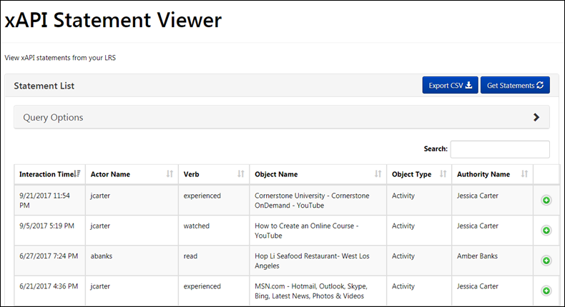
xAPI Statement Viewer
The xAPI Statement Viewer page allows administrators to view and search for xAPI statements from the LRS. The Statement List displays the following information columns for each statement:
- Interaction Time - The time at which the action occurred
- Actor Name - The learner who performed the action
- Verb - A description of the action performed by the learner
- Object Name - The xAPI activity name
- Object Type - Indicates the activity type, such as a course or a game
- Authority Name - Refers to the agent that sent the statement
- Expand icon - Click this icon to expand the full xAPI statement
Statements are paginated, and you can navigate to additional pages of statements using the Previous, Next, and page number buttons at the bottom of the table. You can select how many statements appear per page from the Show Entries drop-down menu above the table. You can select from 10, 25, 50, and 100 statements per page.
Export CSV
To export the statements that have been reported to the LRS, click the Export CSV button on the xAPI Statement Viewer page. The CSV file can be opened when the download is complete.
Note: The Safari browser will open the xAPI statements in a new browser tab.
The maximum number of statements that can be exported in a single CSV file is 20,000.
Get Statements
Click the Get Statements button to refresh the page and receive any new xAPI statements. Any new statements retrieved will display at the top of the table, as statements are sorted in order of most recent interaction time, by default.
Query Options
Query options are available to help you filter and sort the xAPI statement list. To open all the available query options, click the arrow icon on to the right of the Query Options header. The section will expand to display the following query options:
- Predefined Verb - Displays all Cornerstone-supported verbs
- Verb Sort - Filter statements in descending order or ascending order
- Verb ID - Filter statements according to verb URI
- Agent - The learner who performs the action
- Related Agents - True or False
- Activity ID - Filter statements according to a specific Activity ID
- Related Activities - True or False
- Registration ID - Filter statements according to a specific Registration ID
- Statement ID - Filter statements according to a specific Statement ID
- Voided Statement ID - Filter statements according to a specific Voided Statement ID
- Since Date - Filter results from a specific date
- Until Date - Filter results until a specific date
- Limit - Limit the number of statements per one page
- xAPI Query - End point (This is not editable)
To clear any selected query options, you can click the Clear Form button at the bottom of the Query Options section.

