Connectors March 2024

Table of Contents
Connectors - Tools for Developers 1
Edge - Developer Portal Overview 2
Connectors for Content - Overview 3
Edge Import - Online Content (OLCO) Integration Solution 4
Online Content 1:1 Connector 6
Connectors for Learning - Overview 7
Catalog Connector API - AICC Course Integration with LCMS Vendors - Overview 8
Virtual Instructor-Led Training (vILT) Connector 18
Connectors for Recruiting - Overview 35
Assessment Connector 36
Background Check Connector - Settings 37
Job Distribution Connector Overview 44
Video Interview Connector 50

Connectors - Tools for Developers
Cornerstone's Connectors enable external developers to build workflow-based integrations. Edge Connectors support web-hooks, exposing specific Cornerstone workflows with which they can integrate. Using these tools, developers can test their integrations without needing access to a Cornerstone portal. These testing tools are publicly available in the API Explorer and do not require developers to have any permissions or login credentials.
Learning:
- vILT
Recruiting:
- Background Check
- Job Distribution
- Pre-Hire Assessments
- Video Interview
Considerations
Documentation for using the integration testing functionality is available in the API Explorer, along with the testing functionality itself. Separate testing pages are available for assessments and background checks.
To access the API Explorer, go to Admin > Tools > Edge > Develop > Developer Portal. API Explorer can also be accessed directly at the following URL: http://apiexplorer.csod.com
Access
This functionality is automatically available to any user of the Edge platform, whether or not they have login credentials. Cornerstone portal access is not needed to access the developer test tools.
To test an assessment integration, go to the API Explorer.
To access the API Explorer, go to Admin > Tools > Edge > Develop > Developer Portal. API Explorer can also be accessed directly at the following URL: http://apiexplorer.csod.com
Frequently Asked Questions (FAQs)
How do I use a connector to build an integration with Cornerstone?
How do I activate and enable an Online Content 1:1 Connector?

Edge - Developer Portal Overview
The Developer Portal is one-stop shop for API and connector documentations and examples.
The Developer Portal can be accessed via https://csod.dev and from within Cornerstone portals by navigating to Admin > Tools > Edge > Develop > Developer Portal. Once inside, click Learn more to get started.
- Users attempting to navigate to the API Explorer (https://apiexplorer.csod.com/) will automatically be redirected to the Developer Portal.
- API Explorer is accessible via a footer link on the Developer Portal.
- Full deprecation of the API Explorer is scheduled for an upcoming release.
Considerations
The Connector Tools page in API Explorer is not supported in the Developer Portal. This is true for all Connector types. Instead, integrations can be tested directly within the Cornerstone portal.
Not all Reporting endpoints available are displayed in the Developer Portal. Cornerstone is working to get them added. In the meantime, you can reference the API Explorer for the complete list of endpoints.

Connectors for Content - Overview
Content Connectors are only available to Cornerstone’s content partners. However, Cornerstone and selected content vendors have worked to build 1:1 Online Content integrations.

Edge Import - Online Content (OLCO) Integration Solution
A 1:1 Content Integration solution is available for content vendors who prefer file-based content integrations over an API-based content integration. This integration solution allows syncing content from a content provider and Online Content (OLCO) transcripts. Both manual and automated scheduled feeds are supported.
The Edge Import OLCO Integration Solution includes the following:
- Online Content (OLCO) Feed
  - Create new online content by providing new unique Online Content ID values
  - Update existing online content by providing an existing Online Content ID or Learning Object ID
  - Only import content if the vendor URL matches the approved content vendor list, which is configured during activation
  - Perform manual one-time loads or set up a feed to automate the import of Online Content files
- Online Content (OLCO) Transcript Feed
  - Import learner's registration and completion transcripts
  - Perform manual one-time loads or set up a feed to automate the import of Online Content Transcript files
Benefits for Customer:
- File-based integration solution for content vendors that prefer this method
- Self-serviceable solution
- Edge Import product experienced customers would find it easy to learn and implement this new OLCO integration solution
Benefit for Content Vendor:
- Repeat Value - Following the initial implementation of this integration, content vendors can reuse the knowledge gained to integrate their content with other mutual customers already using Cornerstone Learning CSX
- Market Ready for content integration with other CSX customers
Permissions
PERMISSION NAME | PERMISSION DESCRIPTION | CATEGORY

Access LMS - Online Content (OLCO) Feed | Grants access to the Online Content (OLCO) data feed via Edge Import. This permission cannot be constrained. This is an administrator permission. | Edge Import

Access LMS - Online Content (OLCO) Load | Grants access to the Online Content (OLCO) data load via Edge Import. This permission cannot be constrained. This is an administrator permission. | Edge Import
Frequently Asked Questions (FAQs)
Does Edge Import need to be purchased to use this solution?
Yes, if the customer has not yet purchased Edge Import, they will need to purchase Edge Import.
What is the difference between the Online Content (OLCO) Metadata load and the new Online Content (OLCO) load?
The Online Content (OLCO) Metadata load is used to make edits to the CSX catalog-related fields.
- Target User: Customer or Partner Administrator
- Access to this load is granted by purchasing Edge Import.
The Online Content (OLCO) load is used to create and update Online Content metadata delivered from a third-party content provider through a subscription but hosted on the Content Provider’s servers. This type of training is displayed on the CSX Course Catalog page.
- Target User: Customer Administrator
- Access to this load is granted by purchasing the Edge Import OLCO Integration.
Implementation
This functionality is enabled in two steps:
- The customer and vendor agree on content licensing.
- The customer contacts their Account Manager to initiate onboarding and purchase this integration solution.

Online Content 1:1 Connector
Online Content is an all-purpose learning object for launching any kind of content hosted outside of the Cornerstone LMS. The content does not need to conform to existing learning standards such as SCORM, AICC, or xAPI. When used in tandem with the Progress API, Online Content can be tracked in detail, with information such as completion status, time spent, score, and progress passed back to Cornerstone LMS.
Supported Content Provider Connectors
- CrossKnowledge
- GetAbstract 1-1 Integration
- GLOBIS
- Schoo
- Teach on Mars
- Udemy for Business
Activation
The Online Content 1:1 integration in Edge is only available in the Production portal environment for the supported Content Providers listed. To enable, please reach out to your Account Manager and complete a signed Order Form for either of the Content Provider connectors listed above. Once fully executed, please open a case to Global Customer Support and submit a Work Order to scope and complete this request. Please note that Online Content 1:1 integration connectors listed here are not available for Pilot or Stage environments unless an important business reason is provided. Upon validation of the business requirement, the request to enable the Online Content 1:1 integration connector in Pilot or Stage will require a signed Statement of Work (SoW).
Prerequisites
The following prerequisites are associated with this integration:
- An active Content Subscription / Account with one of the supported Content Providers listed (purchased separately by the customer)
- Cornerstone portal should NOT have any existing content by the Content Provider. Content disablement is required if your Cornerstone portal has existing Content Provider content to avoid duplicate content being created.
  - Contact the Cornerstone Global Customer Support team, requesting to disable the existing courses.
- This integration is NOT the same as a data-feed based integration. If you have an existing integration with the Content Provider and would like to activate the new integration, reach out to the following:
  - Cornerstone Global Customer Support team, requesting to disable the existing integration.
  - Content Provider team to disable the existing integration and resend the historical User Transcripts to Cornerstone following the enablement of the Online Content 1:1 integration connector.
- In order to complete the configuration of the Online Content 1:1 integration connector in Cornerstone, a CIID (Account ID) is required. This should be obtained either from the administrator who is configuring the integration in Content Provider's Online Learning Platform or the Content Provider consultant that is supporting the customer with the implementation.

Connectors for Learning - Overview

Catalog Connector API - AICC Course Integration with LCMS Vendors - Overview
The Catalog Connector API allows you to transfer content automatically between content vendors and the Cornerstone platform. With this API, 3rd party AICC courses are automatically synchronized to the course catalog, and the administrators do not need to manually upload them to the system. Note: This functionality is currently only available for organizations using TTS as their LCMS.
Use Case
Jennifer is a learning administrator at ACME Co, where she is responsible for uploading and managing content to their LMS. Her company uses a 3rd party vendor to create and store online courses prior to publishing them in the LMS.
Because the vendor ACME uses supports the Cornerstone Catalog Connector API and also initiated the integration for it, Jennifer does not need to export the vendor's content and upload it to the system herself. On a daily basis, courses that are ready to be published are automatically synchronized and published to the LMS. Once synchronized, Jennifer can access and manage the courses from the Course Catalog.
Considerations
- The Catalog Connector integration requires the 3rd party vendor to support the Catalog Connector API. Provided API specifications will allow 3rd party LCMS and AICC vendors to be compliant with Cornerstone API for seamless integration.
- Only online courses in AICC format can be synchronized using the Catalog Connector API.
Implementation
This functionality can be requested from Global Customer Support. The Catalog Connector API can be used with 3rd party content vendors which support the Catalog Connector API.
To set up an integration with a vendor, contact Global Customer Support and provide the following information:
- Integration Name - The name of the integration
- Provider Name - An existing system Provider
- Provider URL - The Provider URL, as provided by the 3rd party vendor
- Authentication URL - The vendor's authentication URL, as provided by the 3rd party vendor
- Client ID - The client ID, as provided by the 3rd party vendor.
- Client Secret Key - The client key code, as provided by the 3rd party vendor
- Sync Time - The time at which online courses should be automatically published and synched from the vendor each day
Once Global Customer Support registers the vendor, the integration is ready for use.
Catalog Connector - Register AICC Vendors
When the Catalog Connector API is active, a page for registering AICC vendors is available in the portal. Using this page, administrators can add 3rd party vendor integrations to the Catalog Connector API and allow these vendors to automatically publish and synch online courses to the learning management system (LMS). Only vendors which support the Catalog Connector API can be integrated with the API via this registration process.
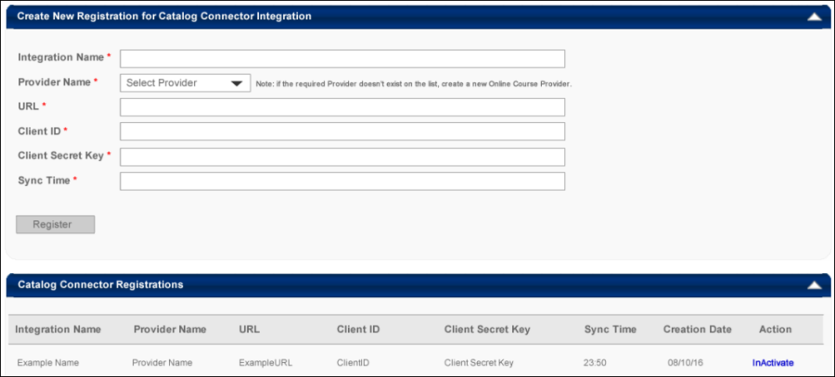
Create New Registration for Catalog Connector Integration
To add a vendor to the Catalog Connector Integration, populate the following fields:
- Integration Name - Enter the name of the integration into this text box.
- Vendor Name - Click this drop-down menu to select a system vendor to add as an AICC vendor for the integration. Note: A provider must first be added to the system in order to be available from this drop-down menu.
- Vendor URL - Enter the vendor's web URL into this text box.
- Authentication URL - Enter the vendor's authentication URL into this text box.
- Client ID - Enter a client ID into this text box.
- Client Secret Key - Enter the client key code into this text box.
- Sync Time - Enter the time at which online courses should be automatically published and synched from the vendor each day.
After populating all required fields, click the Register button to register the AICC vendor with the integration.
Catalog Connector Registrations
The Catalog Connector Registrations sections displays vendors which have been added to the integration, along with the following information:
- Integration Name - The name of the integration, as defined during registration.
- Integration ID - The ID of the integration, as defined in the database.
- Creation Date - The date the vendor was registered.
- Vendor Name - The name of the vendor selected during registration.
- Vendor URL - The vendor URL, as defined during registration.
- Authentication URL - The URL for the oAuth 2.0 server.
- Client ID - The client ID, as defined during registration
- Client Secret Key - The secret key code, as defined during registration.
- Sync Time - The time at which online courses are published and synched from the vendor, as defined during registration.
- Last sync Date - The last date at which the synchronization processed successfully.
- Actions - The following actions are available for existing Catalog Connector registrations:
  - Inactivate - Click this link to deactivate an active integration.
  - Activate - If the integration is not currently active, click this link to activate it.
AICC Connector - Sync Catalog
Using the Sync Catalog page, administrators can easily view active content integrations, sync content, and view information about past synchronizations for active integrations.
To access the Sync Catalog page, go to: Admin > Tools > Learning > Catalog > Course Catalog and click the Options drop-down menu. Then, click the Sync Catalog option.
Permissions
PERMISSION NAME | PERMISSION DESCRIPTION | CATEGORY

Catalog Integration - Sync catalog's content with third party integrations | This permission grants access to the Sync Catalog page and allows administrators to sync content from existing integrations to the catalog and view information about past synchronizations. This permission can be constrained by provider. | Learning - Administration

Course Catalog - View | Grants access to view the learning objects in the course catalog and enables administrators to view the Course Console and the Popular Requests and Highest Rated widgets on the Learning Admin Console (in conjunction with the Learning Admin Console - View permission). This permission can be constrained by OU, User's OU, Training Type, Training Item, Provider, ILT Provider, User's ILT Provider, and User's LO Availability. This is an administrator permission.  Adding an OU constraint and a provider constraint to this permission results in an "AND" statement. | Learning - Administration
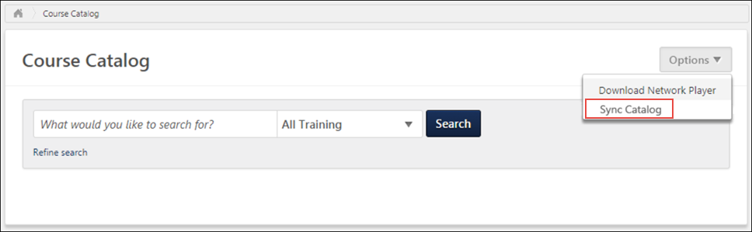
Content Integrations
Using the Sync Catalog page, administrators can initiate catalog synchronizations and download content from outside providers. Learning content integrations display on this page with the following information in the Content Integrations table:
- Integration Name - The name of the content integration
- Integration ID - The unique ID code associated with the integration
- Provider Name - The name of the content provider
- Date Created - The date the content integration was created
- Last Successful Sync - The date and time of the last time content was successfully synced from the integration to the Course Catalog
- Action - The following action is available in the Action column:
  - Sync - Click the Sync button to begin syncing content from the content provider to the Course Catalog
Note: Only active integrations display on this page.
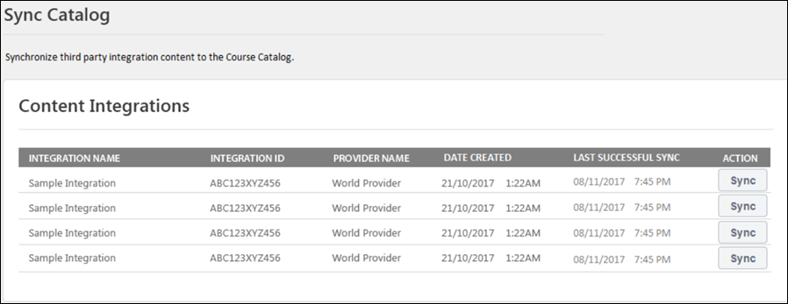
Sync Catalog
To sync content from a content provider to the Course Catalog:
- Click the Sync button next to the integration.
- A syncing icon displays to alert the administrator that the sync has begun.
- After the sync has completed, a notification displays across the top of the page, indicating whether the sync was successful or unsuccessful.
Note: The scheduler which runs automatically to sync content on a regular basis will continue to run normally following this enhancement. The Sync Catalog page allows administrators to sync the catalog manually on demand in addition to the regularly scheduled syncs.
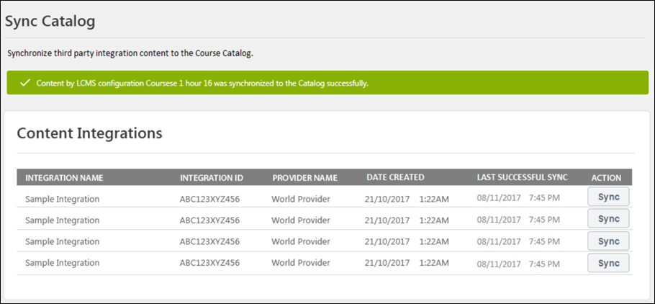
Catalog Connector - Updated Courses
Via the Catalog Connector API, online courses from integrated 3rd party vendors are automatically published and synced in the learning management system (LMS) on a daily basis, at a scheduled time. Administrators can verify that the courses were successfully published by navigating to the Upload History page (beta only), the Course Catalog, or the Course Console.
Permissions
PERMISSION NAME | PERMISSION DESCRIPTION | CATEGORY

Course Catalog - Update | Grants ability to manage and edit training items listed in the Course Catalog and also grants access to the Course Console, where training can also be managed and edited. This permission also grants access to the Popular Requests and Highest Rated widgets on the Learning Admin Console (in conjunction with the Learning Admin Console - View permission). This permission also allows administrators to reversion online courses via the Course Console page. This permission also allows administrators to access an Edit Training option for training items included as objectives in Development plans.  This permission can be constrained by OU, User's OU, Training Type, Training Item, Provider, ILT Provider, User's ILT Provider, User, User Self and Subordinates, and User's LO Availability. This is an administrator permission.  Note: Adding an OU constraint and a provider constraint to this permission results in an "AND" statement. | Learning - Administration

Course Catalog - View | Grants access to view the learning objects in the course catalog and enables administrators to view the Course Console and the Popular Requests and Highest Rated widgets on the Learning Admin Console (in conjunction with the Learning Admin Console - View permission). This permission can be constrained by OU, User's OU, Training Type, Training Item, Provider, ILT Provider, User's ILT Provider, and User's LO Availability. This is an administrator permission.  Adding an OU constraint and a provider constraint to this permission results in an "AND" statement. | Learning - Administration

Course Publisher Update | Grants ability to update existing online training courses previously published via the course publisher. Administrators must also be granted a content license from the Manage Licenses page. This is an administrator permission.  With the Oct '17 release, after the Content Publisher is activated in the system, users with this permission are automatically granted the permission to modify online classes. | Learning - Administration

Course Publisher | Grants access to LCMS Course Publisher, which enables upload and publishing of SCORM and AICC compliant online courses, created either in the LCMS Course Builder, or from a third party course building tool. Administrators must also be granted a content license from the Manage Licenses page. This is an administrator permission.  After Content Publisher is activated in the system, users with this permission are automatically granted the permissions to upload and publish online classes via the Content Publisher, and also the permission to view the Upload History page. | Learning - Administration

Upload History
To access the Upload History page, go to ADMIN > TOOLS > LEARNING and click the Upload History link. Note: This page is only available in Stage portals as beta functionality.
To verify that courses from a 3rd party vendor have been successfully published and synced in the LMS, search the Upload History page for the uploads from the 3rd party vendor. The name of the auto-sync item follows the following naming convention: AutoSync <Integration Name>.
Uploads display with their current status. If the upload shows a status of Completed Successfully, the 3rd party vendor's courses have been successfully uploaded and synced in the system, and can be managed via Course Catalog or Course Console. If the upload is in a status of Upload Failed, Partially Uploaded, or Completed with Comments, click the View Errors link in the Action column to view additional information about the upload and determine what steps are necessary to facilitate a successful upload.
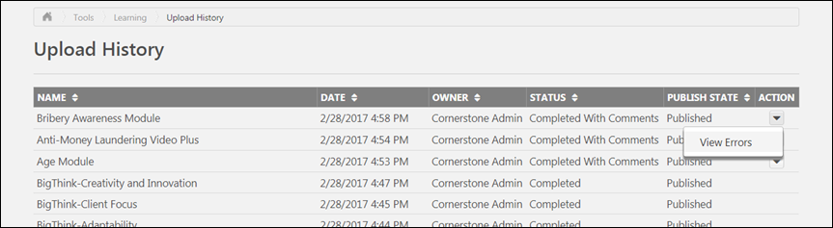
Course Catalog
To access the Course Catalog, go to Admin > Tools > Learning > Catalog and click the Course Catalog link. After 3rd party online courses have been synched via the Catalog Connector API, administrators can search for and manage the online courses through the Course Catalog. If a course has been successfully published via the Catalog Connector, its metadata, such as title, keywords, availability, etc. can be edited via the Course Catalog or the Course Console. Click the Edit option in the Options menu on the Course Catalog search page to edit the course using Course Catalog. To edit the course via the Course Console, see below.
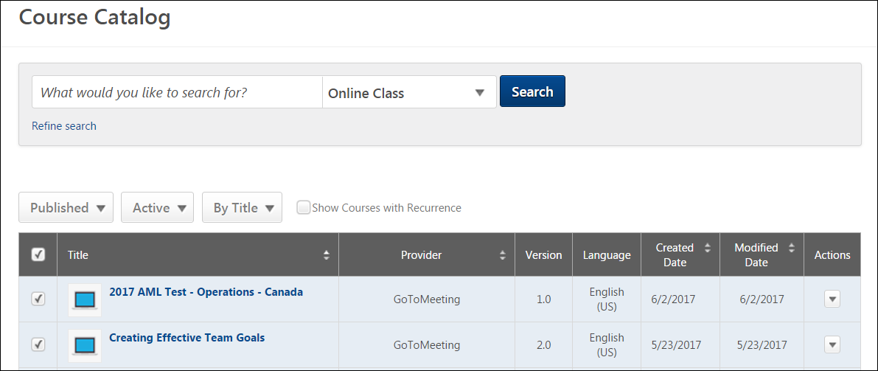
Course Console
To access the Course Console, go to Admin > Tools > Learning > Catalog and click the Course Catalog link. Then, search for the 3rd party vendor course you wish to manage and click the training title on the Course Catalog search page. This opens the Course Console page for the training, where you can modify metadata for the course using the Course Console inline editing feature.
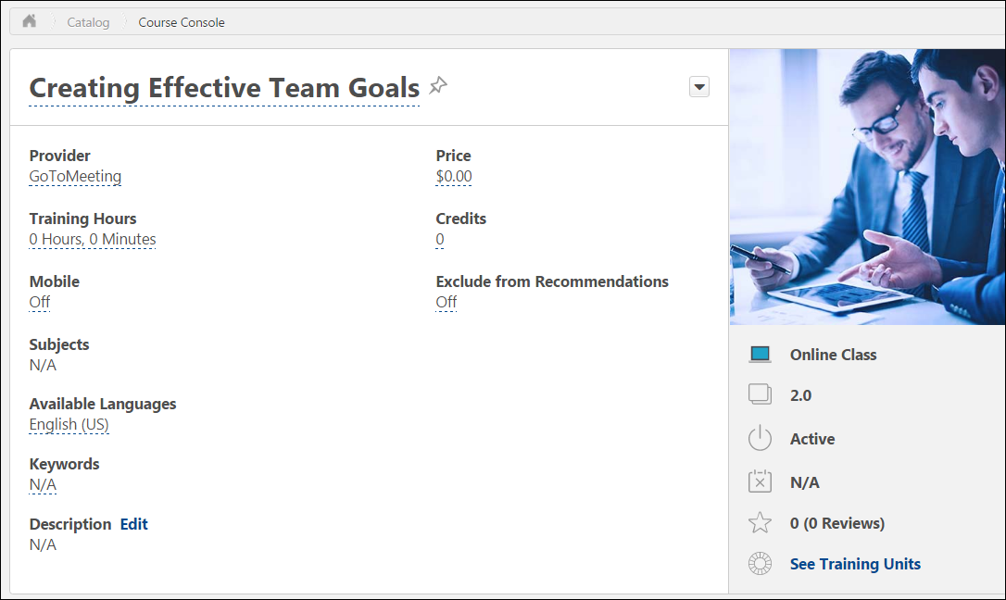

Virtual Instructor-Led Training (vILT) Connector
A Virtual Instructor-Led Training (vILT) connector is available, allowing organizations and partners using Cornerstone to build integrations with the virtual meeting provider of their choosing. This connector allows seamless integration with Cornerstone Learning portals, connects end users to virtual meeting sessions, allows attendance tracking, and provides scheduling tools for instructors.
Please note that in order to use this connector, you must work with a partner to utilize a virtual meeting provider's public APIs or work with your vendor to build a Cornerstone integration. This connector can not be utilized until this prerequisite is met.
Public APIs
https://apiexplorer.csod.com/apiconnectorweb/apiexplorer#/customconnectorguides/vilt
Use Case
Jeremy is a learning administrator at ACME Corp. ACME wants to use a specific new virtual meeting provider that meets their organizational needs, but there is no existing integration that would allow them to use this provider with their Learning Management System (LMS). Jeremy works with a development team to build a new integration, using the Virtual Instructor-Led Training connector.
Considerations and Exclusions
What vendors and providers can I use with this connector?
This connector was designed to require only fundamental data, which allows it to work with many popular vendors. We recommend reviewing the connector requirements and the requirements of your chosen vendor or provider to evaluate compatibility.
Can I continue use my existing vILT integration?
Existing integrations are still supported. However, new integrations can be created by with more and newer features using the connector.
Can I use this new connector and my existing vILT integration at the same time?
Yes. Existing integrations are not impacted.
Can I use this connector with multiple virtual meeting providers?
Yes, this is supported.
Implementation
This functionality is available for organizations using the Learning module and Edge. To enable an integration created using the vILT connector, navigate to the Edge Marketplace.
Once the vILT connector is activated, a new vendor or provider is created and can be found on the ILT Vendors and Instructors page in the LMS. This vendor can only be deactivated by deactivating the vILT connector via Edge Integrate.
Permissions
The following existing permissions apply to this functionality:
PERMISSION NAME | PERMISSION DESCRIPTION | CATEGORY

Edge Integrations - Manage | Grants access to the Integrations service for Edge Integrate, where the administrator can configure, enable, and disable their third-party integrations used within the Cornerstone system. This permission cannot be constrained. This is an administrator permission. | Edge

ILT Vendors - Create | Grants ability to create new training Vendors (Providers). This permission works in conjunction with the Vendors - View permission. This is an administrator permission. | Learning - Administration

ILT Vendors - Update | Grants ability to edit/update existing training Vendors (Providers). This permission works in conjunction with the Vendors - View permission. This is an administrator permission. | Learning - Administration

ILT Vendors - View | Grants view only access to instructor led training vendors (providers), via the ILT Vendors and Instructors screen. This is an administrator permission. | Learning - Administration
Enable vILT Integration
The vILT connector can be enabled via the Edge Marketplace and used to build new vILT integrations.
To enable a vILT integration that was configured using the vILT connector, go to: Admin > Tools > Edge > Integrations and search for and select the integration. Then, click the Settings tab.
Permissions
PERMISSION NAME | PERMISSION DESCRIPTION | CATEGORY

Edge Integrations - Manage | Grants access to the Integrations service for Edge Integrate, where the administrator can configure, enable, and disable their third-party integrations used within the Cornerstone system. This permission cannot be constrained. This is an administrator permission. | Edge
Enablement Steps
- Provide the following information from your vILT provider for the integration:
  - Username - username to authenticate the request coming from CSOD
  - Password - password to authenticate the request coming from CSOD
  - Base Service URL - URL where the service is hosted
- Click the Save button to save your changes. A vILT custom provider will be created and associated with your virtual meeting provider.
When adding a new vILT integration, the integration ID will be automatically generated and no action will be required from the administrator to populate this information.
Administrators can enter multiple sets of credentials, meaning administrators can add multiple vendors for which sessions can be created using the vILT connector. There is no limit to the number of vendors or providers that can be associated with the Edge Marketplace.
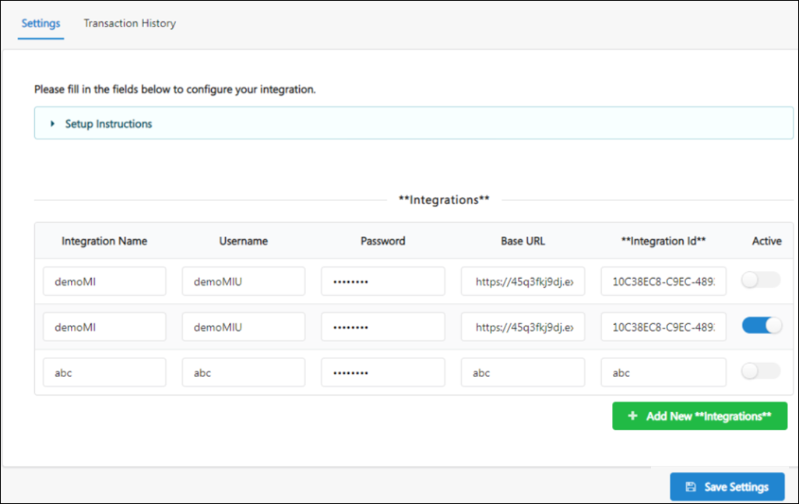
vILT Connector - Vendors and Instructors
Instructor-led training (ILT) administrators can add new instructors and update existing instructors for a vILT custom provider using the Vendors and Instructors page.
To manage vendors and instructors, go to ILT > Vendors & Instructors.
Permissions
PERMISSION NAME | PERMISSION DESCRIPTION | CATEGORY

ILT Vendors - Create | Grants ability to create new training Vendors (Providers). This permission works in conjunction with the Vendors - View permission. This is an administrator permission. | Learning - Administration

ILT Vendors - Update | Grants ability to edit/update existing training Vendors (Providers). This permission works in conjunction with the Vendors - View permission. This is an administrator permission. | Learning - Administration

ILT Vendors - View | Grants view only access to instructor led training vendors (providers), via the ILT Vendors and Instructors screen. This is an administrator permission. | Learning - Administration
Vendors and Instructors
Once the vILT connector is activated, a new vendor or provider is created and can be found on the ILT Vendors and Instructors page. Administrators can add existing or new users as instructors for this vendor. Existing instructors can also be edited. The following criteria is required for each instructor:
- User First Name
- User Last Name
- Email Address
After you submit the new or edited instructors, the instructor information is sent to the vILT provider. Depending on your virtual provider, instructors may need to be registered instructors with the provider. Instructors are validated with third party providers using the instructor email.
Note: A vendor from a vILT integration can only be deactivated by deactivating the vILT connector via Edge Integrate.
vILT Connector - Support for Third Party Extended Options
Each third party meeting vendor (e.g. Webex, Zoom) has many options that can be configured for virtual meetings. For example, a host or administrator can choose whether to start a meeting with everyone muted by default, and whether meetings are set to auto-record. These options are often needed for instructor-led training (ILT) sessions run through Cornerstone.
Integrations using the vILT connector can now surface some extended options through the Cornerstone UI so that an administrator may configure them when creating a session.
To access the Extended Options page, go to: ILT > Manage Events and Sessions. Either search for an existing session to edit or create a new session, and progress through the editing or creation workflow to the Details page. In the Configure Extended Options for vILT section, click the Click Here link to open the Extended Options page.
Permissions
PERMISSION NAME | PERMISSION DESCRIPTION | CATEGORY

Events - Create | Grants ability to create new instructor led training events. This permission works in conjunction with Events - View permission. This permission can be constrained by OU, User's OU, ILT Provider, and User's ILT Provider. This is an administrator permission. | Learning - Administration
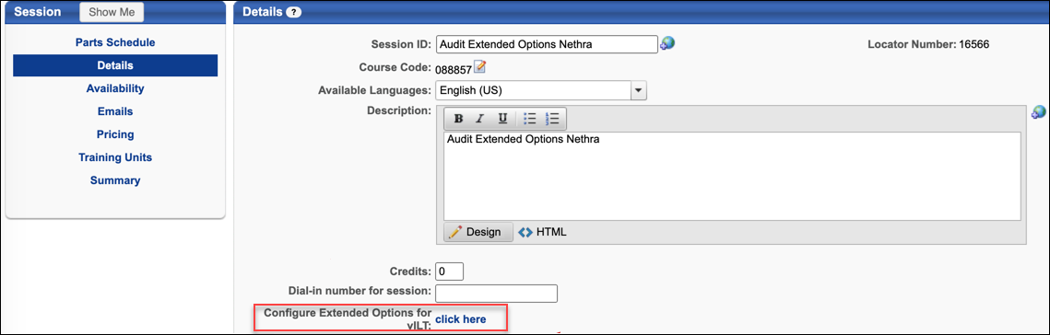
Considerations
The following considerations apply to this enhancement:
- Only 100 controls are supported on the Extended Options page.
- Only three nested levels are supported for any one extended option. For example: Audio > Mute > Mute only people who come in after five minutes.
- The Extended Options page is only available for organizations which have an integration with vILT connector providers.
- Three types of extended options are supported:
  - Radio button extended option
  - Checkbox extended option
  - Text box extended option
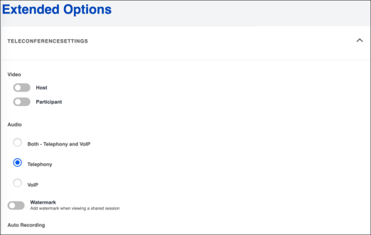
Click here to view a sample JSON response that should be followed for sending a response
Sample JSON Response

{
"extendedOptions": [
{
"type": "label",
"id": "1",
"parentId": null,
"name": "TeleConferenceSettings",
"description": "",
"isNameVisible": true,
"placeholder": null,
"value": null,
"isMultiline": null,
"isChecked": null,
"childExtendedOptions": [
{
"type": "label",
"id": "4",
"parentId": "1",
"name": "Video",
"description": "",
"isNameVisible": true,
"placeholder": null,
"value": null,
"isMultiline": null,
"isChecked": null,
"childExtendedOptions": [
{
"type": "checkbox",
"id": "8",
"parentId": "4",
"name": "Host",
"description": "",
"isNameVisible": true,
"placeholder": null,
"value": null,
"isMultiline": null,
"isChecked": false,
"childExtendedOptions": []
},
{
"type": "checkbox",
"id": "9",
"parentId": "4",
"name": "Participant",
"description": "",
"isNameVisible": true,
"placeholder": null,
"value": null,
"isMultiline": null,
"isChecked": false,
"childExtendedOptions": []
}
]
},
{
"type": "label",
"id": "5",
"parentId": "1",
"name": "Audio",
"description": "",
"isNameVisible": true,
"placeholder": null,
"value": null,
"isMultiline": null,
"isChecked": null,
"childExtendedOptions": [
{
"type": "RadioButton",
"id": "10",
"parentId": "5",
"name": "Both - Telephony and VoIP",
"description": "",
"isNameVisible": true,
"placeholder": null,
"value": null,
"isMultiline": null,
"isChecked": true,
"childExtendedOptions": []
},
{
"type": "RadioButton",
"id": "11",
"parentId": "5",
"name": "Telephony",
"description": "",
"isNameVisible": true,
"placeholder": null,
"value": null,
"isMultiline": null,
"isChecked": false,
"childExtendedOptions": []
},
{
"type": "RadioButton",
"id": "12",
"parentId": "5",
"name": "VoIP",
"description": "",
"isNameVisible": true,
"placeholder": null,
"value": null,
"isMultiline": null,
"isChecked": false,
"childExtendedOptions": []
}
]
},
{
"type": "checkbox",
"id": "6",
"parentId": "1",
"name": "Watermark",
"description": "Add watermark when viewing a shared session",
"isNameVisible": true,
"placeholder": null,
"value": null,
"isMultiline": null,
"isChecked": false,
"childExtendedOptions": []
},
{
"type": "label",
"id": "7",
"parentId": "1",
"name": "Auto Recording",
"description": "",
"isNameVisible": true,
"placeholder": null,
"value": null,
"isMultiline": null,
"isChecked": null,
"childExtendedOptions": [
{
"type": "RadioButton",
"id": "13",
"parentId": "7",
"name": "Local",
"description": "",
"isNameVisible": true,
"placeholder": null,
"value": null,
"isMultiline": null,
"isChecked": false,
"childExtendedOptions": []
},
{
"type": "RadioButton",
"id": "14",
"parentId": "7",
"name": "Cloud",
"description": "",
"isNameVisible": true,
"placeholder": null,
"value": null,
"isMultiline": null,
"isChecked": false,
"childExtendedOptions": []
},
{
"type": "RadioButton",
"id": "15",
"parentId": "7",
"name": "None",
"description": "",
"isNameVisible": true,
"placeholder": null,
"value": null,
"isMultiline": null,
"isChecked": true,
"childExtendedOptions": []
}
]
}
]
},
{
"type": "label",
"id": "2",
"parentId": null,
"name": "SessionSettings",
"description": "",
"isNameVisible": true,
"placeholder": null,
"value": null,
"isMultiline": null,
"isChecked": null,
"childExtendedOptions": [
{
"type": "label",
"id": "16",
"parentId": "2",
"name": "SessionSettings",
"description": "",
"isNameVisible": false,
"placeholder": null,
"value": null,
"isMultiline": null,
"isChecked": null,
"childExtendedOptions": [
{
"type": "checkbox",
"id": "17",
"parentId": "16",
"name": "Meeting Host Location",
"description": "",
"isNameVisible": true,
"placeholder": null,
"value": null,
"isMultiline": null,
"isChecked": false,
"childExtendedOptions": [
{
"type": "checkbox",
"id": "23",
"parentId": "17",
"name": "China",
"description": "",
"isNameVisible": true,
"placeholder": null,
"value": null,
"isMultiline": null,
"isChecked": false,
"childExtendedOptions": []
},
{
"type": "checkbox",
"id": "24",
"parentId": "17",
"name": "India",
"description": "",
"isNameVisible": false,
"placeholder": null,
"value": null,
"isMultiline": null,
"isChecked": false,
"childExtendedOptions": []
}
]
},
{
"type": "checkbox",
"id": "18",
"parentId": "16",
"name": "Mute Upon Entry",
"description": "",
"isNameVisible": true,
"placeholder": null,
"value": null,
"isMultiline": null,
"isChecked": false,
"childExtendedOptions": []
},
{
"type": "checkbox",
"id": "19",
"parentId": "16",
"name": "Use PMI",
"description": "Use a Personal meeting ID. Only used for scheduled meeting and recurring meetings with no fixed time.",
"isNameVisible": true,
"placeholder": null,
"value": null,
"isMultiline": null,
"isChecked": false,
"childExtendedOptions": []
},
{
"type": "checkbox",
"id": "20",
"parentId": "16",
"name": "Approval Type",
"description": "",
"isNameVisible": true,
"placeholder": null,
"value": null,
"isMultiline": null,
"isChecked": false,
"childExtendedOptions": [
{
"type": "RadioButton",
"id": "25",
"parentId": "20",
"name": "Automatically Approve",
"description": "",
"isNameVisible": true,
"placeholder": null,
"value": null,
"isMultiline": null,
"isChecked": false,
"childExtendedOptions": []
},
{
"type": "RadioButton",
"id": "26",
"parentId": "20",
"name": "Manually Approve",
"description": "",
"isNameVisible": true,
"placeholder": null,
"value": null,
"isMultiline": null,
"isChecked": false,
"childExtendedOptions": []
},
{
"type": "RadioButton",
"id": "27",
"parentId": "20",
"name": "No Registration required",
"description": "",
"isNameVisible": true,
"placeholder": null,
"value": null,
"isMultiline": null,
"isChecked": true,
"childExtendedOptions": []
}
]
},
{
"type": "checkbox",
"id": "21",
"parentId": "16",
"name": "Registration Type",
"description": "",
"isNameVisible": true,
"placeholder": null,
"value": null,
"isMultiline": null,
"isChecked": false,
"childExtendedOptions": [
{
"type": "RadioButton",
"id": "28",
"parentId": "21",
"name": "Attendees register once and can attend any of the occurances.",
"description": "",
"isNameVisible": true,
"placeholder": null,
"value": null,
"isMultiline": null,
"isChecked": true,
"childExtendedOptions": []
},
{
"type": "RadioButton",
"id": "29",
"parentId": "21",
"name": "Attendees need to register for each occurence to attend.",
"description": "",
"isNameVisible": true,
"placeholder": null,
"value": null,
"isMultiline": null,
"isChecked": false,
"childExtendedOptions": []
},
{
"type": "RadioButton",
"id": "30",
"parentId": "21",
"name": "Attendees register once and can choose one or more occurances to attend",
"description": "",
"isNameVisible": true,
"placeholder": null,
"value": null,
"isMultiline": null,
"isChecked": false,
"childExtendedOptions": []
}
]
},
{
"type": "checkbox",
"id": "22",
"parentId": "16",
"name": "Alternative Hosts",
"description": null,
"isNameVisible": true,
"placeholder": null,
"value": null,
"isMultiline": null,
"isChecked": false,
"childExtendedOptions": [
{
"type": "textBox",
"id": "31",
"parentId": "22",
"name": "Host Ids",
"description": "",
"isNameVisible": true,
"placeholder": "",
"value": "",
"isMultiline": null,
"isChecked": null,
"childExtendedOptions": []
}
]
}
]
}
]
},
{
"type": "label",
"id": "3",
"parentId": null,
"name": "attendeePrivileges",
"description": "",
"isNameVisible": true,
"placeholder": null,
"value": null,
"isMultiline": null,
"isChecked": null,
"childExtendedOptions": [
{
"type": "label",
"id": "32",
"parentId": "3",
"name": "attendeePrivileges",
"description": "",
"isNameVisible": true,
"placeholder": null,
"value": null,
"isMultiline": null,
"isChecked": null,
"childExtendedOptions": [
{
"type": "checkbox",
"id": "33",
"parentId": "32",
"name": "Join Before Host",
"description": "",
"isNameVisible": false,
"placeholder": null,
"value": null,
"isMultiline": null,
"isChecked": true,
"childExtendedOptions": []
}
]
}
]
}
]
}

vILT Connector - Launch Session Link Tag for Email
If an administrator has configured the ILT Session Register email via Email Administration, when learners register for training, they receive an email with details about the time and date of the training, along with a link to withdraw from the session if necessary. A LAUNCH.SESSION.LINK tag is available when configuring the ILT Session Register email. This tag, when incorporated into the body of the ILT Session Register email, provides email recipients with a customized link which allows them to immediately launch the virtual session by clicking the link.
To access Email Administration, go to ADMIN > TOOLS > CORE FUNCTIONS > EMAIL MANAGEMENT. To configure a template for the ILT Session Register email, search for the ILT Session Register email type and click the Add Email option next to it.
Permissions
PERMISSION NAME | PERMISSION DESCRIPTION | CATEGORY

Global Email Administration - Manage | Grants ability to manage email trigger templates across all active modules in the portal. Enables creating, editing and deleting email message templates for various system actions and workflows. This permission can be constrained by OU, User's OU, User Self and Subordinates, and User. This is an administrator permission. | Core Administration
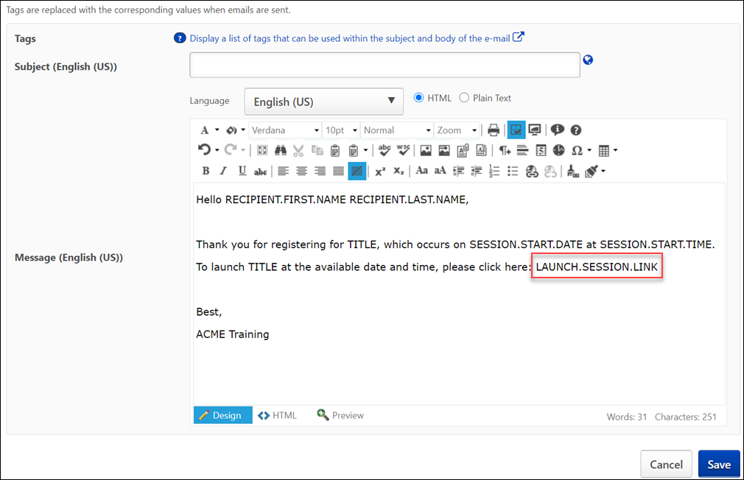
Launch Session Link Tag
To include a link that users can click to launch their virtual session in the ILT Session Register email, the administrator can add the LAUNCH.SESSION.LINK tag to the body of the email. A functional link will replace the tag when users view the email. This email tag functions for both single and multi-part sessions.
vILT Connector - Session Considerations
See the below sections for more information about creating and editing sessions, launching sessions, and updating the roster using an integration created using the vILT connector.
Create and Edit Sessions
Sessions created for vILT sessions using the Learning Management System (LMS) must be associated with the vILT custom provider. Session information is sent to the virtual meeting provider when the SAVE button is clicked on the Summary page of the ILT session creation workflow. Both single and multi-part sessions can be created through the vILT connector. When creating multi-part sessions in the LMS, a separate meeting is created for each part of the session in the vILT connector.
Note: The maximum number of parts for a session is 20.
For more information about creating a session in the LMS: See ILT Session - Create/Edit.
Note: The ability to update a virtual instructor-led training (vILT) session is restricted once the first part is completed (past-dated), even if the session has future-dated session parts.
Cancel Sessions
Sessions canceled via the Learning Management System (LMS) are automatically canceled in the vILT connector as well. Both single and multi-part sessions can be cancelled through the vILT connector. Note: This functionality must be enabled by partners before it can be used.
Update Roster
Manual Roster Update
An administrator can initiate a manual GetAttendance call from the Session Roster page for the session in the LMS. On the roster page, click the UPDATE ROSTER button at least twenty-four hours after the session ends. This obtains the attendance information from the provider directly and updates the roster within the LMS. The instructor must wait at least twenty-four hours after the session ends to ensure the provider has had time to record attendance. After the roster has been updated, click the SUBMIT ROSTER button. Note: Updating the roster manually will overwrite the existing roster for the session.
For more information about the Session Roster page: See Session Roster Overview.

Connectors for Recruiting - Overview

Assessment Connector
Cornerstone’s Assessment Connector provides organizations the ability for their preferred pre-hire assessment provider to integrate with Cornerstone. Cornerstone provides the end-to-end workflow information and the toolkit for external developers to build services required to set up the integration.

Background Check Connector - Settings
On the Settings tab of Edge integrations created using the Background Check connector, a Field Configuration section is available. The Field Configuration section allows administrators to determine which fields are and are not communicated to background check vendors via the integration.
To access the Field Configuration section for an integration created using the Background Check connector, go to Admin > Tools > Edge > Integrations and search for and select the integration. Then, click the Settings tab.
Permissions
PERMISSION NAME | PERMISSION DESCRIPTION | CATEGORY

Edge Integrations - Manage | Grants access to the Integrations service for Edge Integrate, where the administrator can configure, enable, and disable their third-party integrations used within the Cornerstone system. This permission cannot be constrained. This is an administrator permission. | Edge
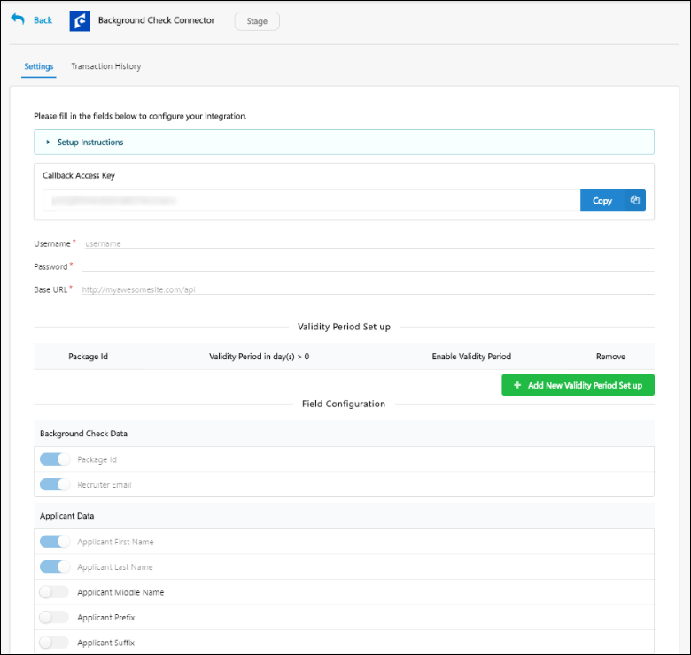
Field Configuration
The fields in the Field Configuration section are categorized into two field types: Background Check Data and Applicant Data. For organizations already using a background check integration created using the Background Check connector, all the available fields are enabled by default. For organizations planning to use a background check integration created using the Background Check connector in the future, only the following four fields in the Field Configuration section are turned on by default:
- Package ID
- Recruiter Email
- Applicant First Name
- Applicant Last Name
Background check vendors require the above four fields at minimum in order to conduct background checks. Therefore, these fields are enabled by default and cannot be disabled.
For organizations planning to use a background check integration in the future, the remaining fields in the Field Configuration section are NOT enabled by default, and the administrator can enable any other desired fields by toggling the switch next to each field to the On position.
To disable any enabled field, simply toggle the corresponding switch to the Off position.
Note: Your background check provider must be notified BEFORE making any changes to the selected fields to ensure that the integration remains functional. This will allow them to make the necessary changes in their system, if needed.
Validity Periods
Validity periods can be configured for background check connector integrations on a per package ID basis. Setting a validity period means that you only need one background check for the same candidate during the validity period. If the candidate applies to multiple requisitions during the validity period and completes a background check, then the same background check will be used for all of the requisitions.
Default Validity Settings Note: By default, the validity period for background checks is 0 days. Any package that is not added in the Validity Period Set up section on the Background Check Connector page in Edge will be treated as if the package does not have a validity period. For example, if your background check vendor has three packages, and you only add two of those packages to the Validity Period Set up section, then the third package will default to a validity period of zero days.
Use Case
Acme Company receives 40,000 unique applicants per month. Each of their jobs require a Motor Vehicle Screening and a Drug Screening because of their large workforce of drivers. Each of these screenings, however, is valid for 30 days. Approximately 60% of their applicants apply to multiple roles, which significantly increases screening costs.
Because of their high volume, recruiters do not have time to review each applicant individually, so they need their Applicant Tracking System to block any new requests to their background check vendor, and they want to be able to see the results of valid background check screenings across all requisitions for each candidate.
By being able to see the results across requisitions, as well as putting systematic blockers in place, Acme is able to reduce costs, as well as enhance their candidate experience.
Benefits of Setting Validity Periods
- No Duplicate Background Checks
- Background Checks Appear Across All of a Candidate's Applications
- Reduces Cost
- Saves Time
Employment background checks take significant time for candidates and cost organizations money. Candidates applying to multiple jobs have to complete the same background check multiple times if a validity period is not set for the background check, which results in a time consuming and expensive process.
When you set a validity period for background checks developed using the Edge Background Check Connector, candidates applying to multiple positions only need to complete background checks initially and upon expiration.
A candidate's background check is visible across all requisitions, which saves recruiters time in having to look through the candidate's other jobs to see if they completed a screening.
This feature is ideal for organizations that use the same background check screenings across many requisitions and have candidates who apply to multiple requisitions.
Set Validity Period
- Enter the package ID in the Package Id field. You will need to obtain the package IDs 3. Enter the package ID in the Background Check Package ID field. You will have to obtain the package IDs from your background check vendor. This is the same ID that a vendor passes back to Cornerstone when Cornerstone requests the list of Packages from the vendor as part of the connector flow.
- Enter a validity period in the Validity Period (Number of Days) field. A validity period can be entered for each package ID. Note: The validity period end date for each background check order will not be calculated until the result is returned from the background check vendor. Cornerstone does not calculate a validity period for a background check that is in an In Progress status. However, background checks will be prevented from triggering when the background check is in an In Progress status if a validity period is configured.
- Use the Enable Validity Period toggle for individual records to enable the validity period for specific packages.
- Use the Enable Validity Periods for all Background Check Packages option to enable the validity periods for all the packages.
- Click Save Settings.
Background check results are displayed on the Manage Applicants page and the Applicant Profile during the validity period across all non-closed requisitions that are applicable for the candidate.
Additional background check requests for the same package will be prohibited during the validity period.
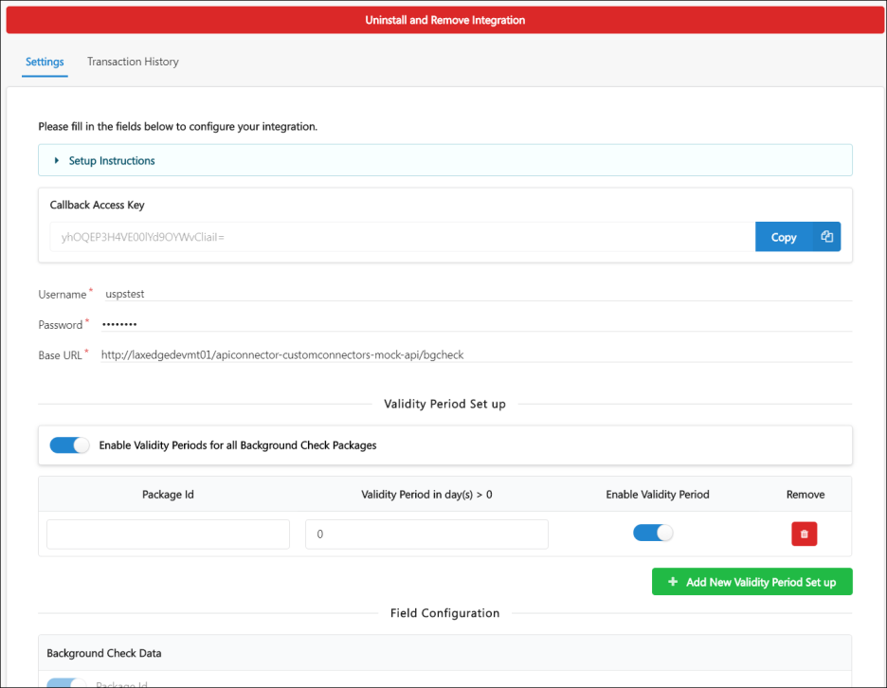
Deactivate Validity Period
You can deactivate a validity period by clicking the Remove icon in the Remove column.
If you deactivate a validity period for a package, then all results after deactivation will no longer have a validity period. All background checks for the package ID that were assigned prior to deactivation will still display the validity period expiration, but there will no longer be a prevention of triggering a background check. Once a new background check has been triggered for that candidate, following the deactivation, the results of the background check will no longer apply across requisitions.
Frequently Asked Questions - Background Check Validity Periods
FAQs
Will this feature work with auto-assigned/auto-progression/auto-disposition?
Yes. This feature will work with the automated candidate progression functionality, but you do not need to have both auto-progression and auto-disposition configured for the requisition. The results of a background check will apply to all requisitions if you have a validity period set up for background checks via the Background Check Connector in Edge, and thus will also apply to auto-progression or auto-dispositioning of a candidate across requisitions, if applicable. See Frequently Asked Questions - Automated Candidate Progression.
Will clients be able to configure a validity period for existing Edge background check integrations (Accurate, FADV, Quest Diagnostics, Sterling, Universal)?
No, not at this time. The validity period feature will only be available for background check integrations that were developed using the background check connector.
Will this work on Manage Candidates?
This will not be available on Manage Candidates at the time of the May '19 release. This feature may be available on Manage Candidates in a future release.
Will I be able to have different processes for internal vs. external candidates?
No, not at this time. If external candidates have been auto-assigned a background check screening for a requisition, then internal candidates for the same requisition will also get a background check.
What happens if the vendor link on the Manage Applicants page expires before the validity period of my background checks?
In such cases, it will be necessary for you to work with your background check vendor to ensure that the results link does not expire prior to the expiration of the validity period.
What happens if I change the validity period?
If you change the validity period, the new validity period will only apply to background checks that are conducted after the validity period is changed. All prior results will not be affected. If you turn off the validity period feature, the expiration dates for previously received results will not be affected and will continue to have the same expiration date.
Will I be able to see the results for background checks across requisitions on the Applicant Profile page?
No, background check results with validity periods will not be visible on the Applicant Profile page. Results across requisitions will be shown only on the Manage Applicants page. Visibility on the Applicant Profile page may be visible in a future enhancement.
Will I be able to see the results of the background check if the background check was requested during an applicant status that is a classified as a sensitive status?
Yes, you will be able to see background check results that were submitted when the candidate was in a sensitive status, provided that you have permission to view sensitive statuses. Your permission to view sensitive statuses allows you to view results across requisitions when the results were submitted in a sensitive status.
Can I use this functionality for assessments?
This functionality cannot be used for assessments at this time. This may be available in a future enhancement.
What happens if the background check results come back in parts?
By default, the initial validity period is set to the first date that background check results are received. If/when an additional part of the results are received, then the validity period is automatically changed to the date of receipt of the next part of the results.
If I add or move a candidate to another requisition during the background check's validity period, does the background check apply to the new requisition?
Yes, the candidate's background check results will follow the candidate, provided that the validity period has not expired.
Can I manually assign a background check to the same candidate when the candidate already has a background check in progress for a different requisition?
No, you will not be able to assign background checks manually to the same candidate once they have a background check in an In Progress status for a different requisition. This is provided that the validity period functionality is enabled for the Background Check Connector in Edge.

Job Distribution Connector Overview
The Job Distribution Connector provides organizations the ability to integrate their preferred job distribution provider with Cornerstone. Cornerstone provides the end-to-end workflow information and the toolkit in the API Explorer for external developers to build services required to set up the integration. Clients configure endpoints and credentials for the job distribution provider in Edge, including which fields to send to the job distribution vendor from a list of available standard fields. Job posting data exchanged using this connector is displayed on the Job Posting page in Recruiting.
How Does this Enhancement Benefit My Organization?
The Job Distribution Connector offering lets you potentially integrate with any job distribution provider without needing any additional work from Cornerstone.
Supported Workflows
- Create job posting
- Refresh job posting
- Update job posting
- Re-post a job
- Delete job posting
- Delete all job postings
Create and Refresh are required workflows. The remaining four workflows are optional and can be turned off on the Settings page for the integration in Edge.
All Recruiting clients that need to integrate with job boards can potentially use this connector. Job distribution vendors should be able to build an integration using the connector, provided they adhere to Cornerstone's workflow and specifications. Alternatively, if a client wishes to build an integration themselves using the connector, they should ideally be a mid to large company with development and QA capabilities.
Use Cases
Use Case 1 - Recruiting Director
A Recruiting Director would like to post the jobs they create in Cornerstone to multiple job boards. However, Cornerstone does not have a pre-built integration with their job distribution vendor.
Instead of requesting a custom technical project from Cornerstone that does not provide a real-time integration, the Recruiting Director decides to use the Job Distribution Connector and goes through the following workflow:
- The Recruiting Director reaches out to the job distribution vendor to build the integration using the Job Distribution Connector.
- The vendor assesses the connector documentation in Cornerstone’s API Explorer and determines that they can build the integration.
- The vendor develops the integration using the API contracts defined by Cornerstone under the Job Distribution Connector.
- The Recruiter Director engages an administrator in their organization to configure the Job Distribution Connector in Edge.
- The vendor works with the administrator to test the integration in the client’s portal. Once testing is complete, the Recruiting Director lets his recruiters know that the integration is ready for their use.
Use Case 2 - Recruiter
As a recruiter, I can use the Job Distribution Connector integration to perform the following operations:
- Post jobs to multiple job boards through a job distribution provider
- Update job posting
- Refresh job posting to retrieve job posting status, expiration date, number of clicks and cost
- Repost a job that has expired
- Delete job posting that I posted in error
- Delete all job postings for a job that has been filled
Considerations
- You can only install one instance of the Job Distribution Connector per portal.
- The connector’s API contracts cannot be customized per client. However, administrators can configure the fields to be sent to the job distribution vendor from a list of available standard fields.
- The client, vendor, or partner developing an integration using the connector must adhere to the connector’s API contracts documented in the API Explorer. Any variance can cause errors when a recruiter is attempting to post, update, re-post, or delete a job.
- The connector only supports basic auth for authenticating the administrator account with the vendor. There is no support for OAuth or other authentication protocols.
- Existing Edge integrations with Broadbean and eQuest are not impacted by this new feature.
Implementation
This feature requires self-activation via Edge Marketplace and Edge Integrations. Clients must have an existing contract with a job distribution vendor and will enter vendor information in Edge during set-up. Client and their job distribution vendor work together to develop and configure this integration.
Additional instructions for enabling and configuring the integration are available on the Setup tab of the integration in Edge.
Security
The following existing permissions apply to this functionality:
PERMISSION NAME | PERMISSION DESCRIPTION | CATEGORY

Edge Develop - API Explorer | Grants access to the API Explorer, which provides access to help documentation for various API applications. | Edge

Edge Integrations - Manage | Grants access to the Integrations service for Edge Integrate, where the administrator can configure, enable, and disable their third-party integrations used within the Cornerstone system. This permission cannot be constrained. This is an administrator permission. | Edge

Edge Marketplace - Manage | Grants access to the Marketplace service for Edge Integrate, where the administrator can browse integrations that can be used to extend the Cornerstone system. This permission cannot be constrained. This is an administrator permission. | Edge
Job Distribution Connector - Job Postings Page
Within Cornerstone, recruiters interact with the Job Distribution Connector integration via the Manage Requisitions > Edit Postings page. From here, recruiters can access their job distribution connector vendor so that they can post the job to job boards through the vendor's system.
Permisisons
PERMISSION NAME | PERMISSION DESCRIPTION | CATEGORY

Requisition: Edit Postings | Grants ability to edit the Job Postings page for a job requisition. In addition, this permission enables users to store user-level credentialing information for job board aggregation partners on Edge. This permission cannot be constrained. | Recruiting

Requisition: Manage | Grants ability to access and manage all requisitions regardless of ownership (constraints permitting). This permission also grants read-only access to the Applicant Review tab when creating or editing a job requisition. This permission can be constrained by OU, User's OU, and Grade. | Recruiting

Requisition: Owner | Enables owner to access requisitions and applicants for requisitions for which they are an owner. This permission also grants read-only access to video interviews that are completed by applicants via HireVue. For portals with Referral Suite enabled, this permission also enables requisition owners to edit the referral source on the Applicant Profile page. This permission cannot be constrained.  Note: This is a dynamically assigned permission that is not available in Security Role Administration. If the user is removed as an owner, the permission is revoked for the associated requisition. This permission cannot be manually assigned. Also, if a user has both the permission necessary to manage requisitions and be a requisition owner, the constraints of the Requisition: Manage permission overrule those of the Requisition: Owner permission. For requisition owners that do not also have permission to manage requisitions, only certain fields are editable when editing a requisition. | Recruiting

Requisition: Reviewer | Enables reviewer to access requisitions and applicants for requisitions for which they are a reviewer. This permission cannot be constrained.  Note: This is a dynamically assigned permission that is not available in Security Role Administration. Once a requisition is in a Closed or Cancelled status or if the user is removed as a reviewer, the permission is revoked for the associated requisition. This permission cannot be manually assigned.  Note: If an applicant reviewer is removed as a reviewer via the Applicant Profile page, the Requisition: Reviewer permission is revoked for the associated requisition. However, if the reviewer was also added as a reviewer via the General tab when creating, editing, or copying the requisition, the reviewer still appears on the In Review panel as a duplicate reviewer and retains access to the requisition and applicants from the Requisition: Reviewer permission. See Applicant Profile Page Overview for more information about duplicate reviewer instances. | Recruiting

Requisition: Select Recruiting Agency | Grants access to manage the Agency Postings workspace on the Requisition - External Postings page. This permission cannot be constrained. | Recruiting
Note: Jobs must be posted to a career site before they can be posted to a job board.
Access Vendor
To access your vendor so that you can post jobs to job boards:
- Scroll down to the Job Boards section on the Job Postings page.
- Click the Job Distribution tab.
- Click Post. This opens a pop-up that navigates you to your vendor's site. Certain requisition information will be pre-populated on the page.
- Once in your vendor's site, enter any additional information required by the vendor.
- Select the job boards to which you would like to post the job.
- Follow any remaining steps required by your vendor.
- Close the pop-up and navigate back to the Job Postings page in Cornerstone.
Postings do not automatically appear in Cornerstone. Click Refresh to fetch the latest status, clicks, and count for each job board posted through the job distribution vendor.
Edit Job on Vendor's Site
Once you post a job through the vendor, you can edit the posting by clicking Edit in the Job Boards section of the Edit Postings page. This opens a pop-up in which you can access your vendor's site to edit the jobs that you have posted to job boards.
Note: The ability to edit a posting is only available if the Vendor supports 'Edit' action toggle is turned on for the integration on the Settings page in Edge.
Note: The option to edit a posting on the vendor's site is only available if at least one posting is in a Pending or Active status.
Repost Job
You can repost an expired posting by clicking Repost. This opens a pop-up in which you can access your vendor's site and the jobs that you have posted to job boards. Once you return to the Edit Postings page, click Refresh to fetch latest details from the job distribution vendor's system.
Note: The ability to repost a job is only available if the Vendor supports 'Repost' action toggle is turned on for the integration on the Settings page in Edge.
Note: The option to repost is only available if all postings for the job distribution vendor are in a Deleted, Error, or Expired status or are no longer active on any job boards.
Delete One Job
You can delete a posting by clicking the Delete icon . Cornerstone sends the delete request to the vendor. This action does not open a pop-up window. Click Refresh to fetch latest details from the job distribution vendor's system.
Note: The ability to delete a job is only available if the Vendor supports 'Delete' action toggle is turned on for the integration on the Settings page in Edge.
Delete All Jobs
You can delete all postings by clicking Delete All. Cornerstone sends the delete request to the vendor. This action does not open a pop-up window. Click Refresh to fetch latest details from the job distribution vendor's system.
Note: The ability to delete all jobs is only available if the Vendor supports 'Delete All' action toggle is turned on for the integration on the Settings page in Edge.

Video Interview Connector
The Video Interview Connector bridges the gap between Cornerstone and third-party offerings so that any video interview connector can build out an integration for conducting video interviews. The connector lets you:
- Partner with any video interview provider to build the integration
- Conduct both on-demand interviews (self-recorded interview by candidate) and live video interviews (candidate meets interviewers live on video)
- Benefit from simplified video interview scheduling features in Manage Candidates
Implementation
The Video Interview Connector is available via Edge Marketplace for all organizations using the Recruiting suite and that also have an account with a video interview integration vendor. Additional instructions for enabling and configuring the connector are available on the Setup tab of the connector in Edge. There is no additional cost associated with enabling this integration in Edge.
Permissions
The following existing permissions apply to this functionality:
PERMISSION NAME | PERMISSION DESCRIPTION | CATEGORY

Edge Integrations - Manage | Grants access to the Integrations service for Edge Integrate, where the administrator can configure, enable, and disable their third-party integrations used within the Cornerstone system. This permission cannot be constrained. This is an administrator permission. | Edge

Edge Marketplace - Manage | Grants access to the Marketplace service for Edge Integrate, where the administrator can browse integrations that can be used to extend the Cornerstone system. This permission cannot be constrained. This is an administrator permission. | Edge

