Compensation for Users March 2024

Table of Contents
Compensation Overview 1
Compensation Statement 2

Compensation Overview

Compensation Statement
The Compensation Statement page contains the current compensation statement and previous statements.
Permissions
PERMISSION NAME | PERMISSION DESCRIPTION | CATEGORY

User Compensation Statement | Grants ability to view and print a user's own current and previous compensation statements. This is an end user permission. | Compensation
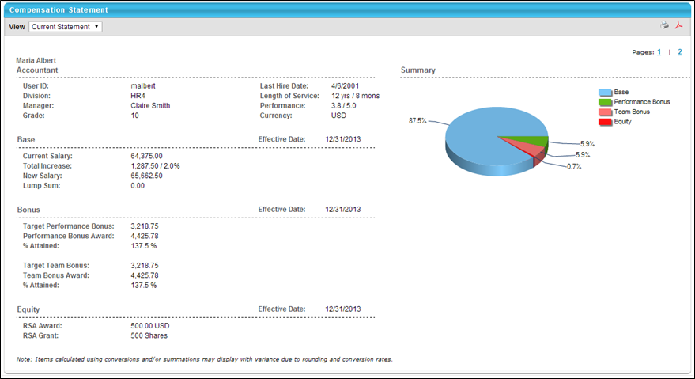
To view a compensation statement, click the Compensation tab and then click the Compensation Statement link. The following sections are available:
- Organization Information - Includes User ID, Division, Manager, Hire Date etc.
- Base, Bonus, Equity - Separate section for each adjustment made in corresponding task including base, bonus, and equity. If any deferrals are made, the payout schedule is included.
- Summary - Contains a pie chart that displays the dollar break down of base, bonus, and/or equity compensation. The Summary graph only reflects the components that are included in the compensation task. When calculating percentages, the system calculates the total cost based on the allocations that appear on the plan.
- Additional Information - Display custom fields if applicable.
If a custom compensation statement is implemented, the standard statement may also be included as the first or second page of the statement. If this is the case, in the upper-right corner, page numbers are available so that users can switch between pages. Note: Custom Compensation Fields are not supported in Custom Statements.
In the upper-right corner, you can click the Printable Version icon to view a printable version of the statement, or you can click the PDF icon to create a PDF version of the statement.

