Compensation for Managers March 2024

Table of Contents
Compensation Overview 1
Compensation Tasks Overview 2
Complete a Compensation Task 3
Compensation Statement 120

Compensation Overview

Compensation Tasks Overview

Complete a Compensation Task
To access a compensation task, go to Home > Scheduled Tasks. Then click the compensation task title.
Note: When referring to the compensation manager and their subordinates, this assumes that the compensation manager and their subordinates have been assigned the same compensation task.
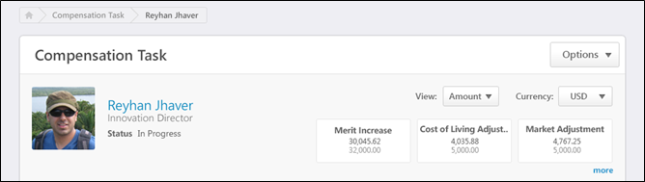
Breadcrumbs
At the top of the page, the breadcrumbs for the page are displayed. Users can click the links within the breadcrumbs to navigate to those pages. Note: The page to which the Home icon is linked is configured by the administrator in Navigation Tabs and Links.
The breadcrumbs include the compensation task name and the name of the compensation manager who is completing the compensation task. If the co-planner is completing the compensation task, then the name of the compensation manager for whom the co-planner is planning is displayed.
When the compensation manager navigates to view the User Profile Dashboard of a subordinate, then the subordinate's name is also displayed in the breadcrumbs.
User Profile Dashboard
At the top of the compensation task, the User Profile Dashboard is displayed. This section displays the compensation task title, the Options drop-down menu, view controls, and a summary of the compensation manager and the compensation task components.
See Compensation Task - User Profile Dashboard on page 5 for additional information.
See Compensation Task - Options Drop-down on page 22 for additional information.
Compensation Task Tabs
Below the User Profile Dashboard, the following tabs may be available:
- Compensation Plans - See Compensation Task - Compensation Plans Tab on page 7 for additional information.
- Roll-up Summary - See Compensation Task - Roll-up Summary Tab on page 11 for additional information.
- Plan Summary - See Compensation Task - Plan Summary Tab on page 15 for additional information.
- Pending Approvals - See Compensation Task - Pending Approvals Tab on page 19 for additional information.
Compensation Task - User Profile Dashboard
At the top of the compensation task, the User Profile Dashboard is displayed. This section displays the compensation task title, the Options drop-down menu, view controls, and a summary of the compensation manager and the compensation task components.
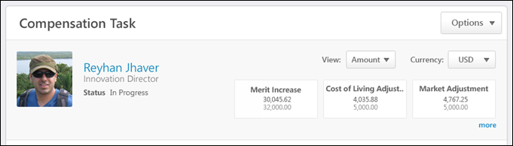
Compensation Task Title
Below the breadcrumbs, the compensation task title is displayed.
Options
Depending on the configuration of the compensation task, options may be available from the Options drop-down menu. See Compensation Task - Options Drop-down on page 22 for additional information.
Compensation Manager Overview
On the left side of the User Profile Dashboard, the following information is displayed for the compensation manager:
- Photograph, Name, and Title - The compensation manager's photograph, name, and position title are displayed. Click the user's name or photograph to open their Universal Profile - Snapshot in a separate window. See Snapshot Overview for additional information. If Universal Profile - Snapshot is not enabled, then this opens their Universal Profile - Bio in a separate window. See Universal Profile - Bio Overview for additional information.
- Compensation Task Status - Below the compensation manager's position, the status of the compensation manager's compensation task is displayed.
View Controls
On the right side of the User Profile Dashboard, the following view controls may be available:
- View - From the drop-down, select whether components are displayed as an amount or as a percentage:
  - Amount - Select this option to display components as fixed currency amounts. This option is selected by default.
  - Percentage - Select this option to display components as percentages of the budget (i.e., <ALLOCATION> divided by <BUDGET>). If no budget applies or has been set, "--%" is displayed.
- Currency - From the drop-down, select the currency in which currency amounts are displayed throughout the compensation task. If only one currency is available, then the currency is displayed as text and cannot be modified. Currency conversions are based upon the conversion rate at the time the compensation task was launched. The following currencies may be available:
  - Corporate Currency - This option is selected by default unless the compensation task is configured to display in the compensation manager's currency.
  - Compensation Manager's Currency
Compensation Task Components
Below the view controls, a summary of each of the component allocations is displayed. The values that are displayed correspond with the compensation plan of the user whose User Profile Dashboard is being viewed. For example, if a compensation manager is viewing a subordinate's User Profile Dashboard, then the values correspond with the subordinate's compensation plan.
- If the plan has been submitted, then values from the submitted plan are displayed.
- If the plan has not been submitted, then values from the last active draft are displayed.
- If the plan has not been started, the component values appear blank.
The following information is displayed for each component that is configured to be displayed in the compensation plan:
- Component name
- Amount allocated for the component
- Budget for the component
Individual component allocations and budgets appear in either Amount or Percent view, depending on the View setting.
Up to three components are displayed by default. If additional components are available, click the more link to display all components. Click the show less link to hide the additional components.
Compensation Task - Compensation Plans Tab
The Compensation Plans tab of a compensation task enables the compensation manager to create a compensation plan. Also, this tab displays all of the compensation manager's compensation plan drafts for the compensation task. If Executive Roll-up is enabled for the compensation task, then the compensation manager can view a subordinate's compensation plan drafts when viewing the subordinate's User Profile Dashboard.
The Compensation Plans tab only displays if one of the following is true:
- The user that is displayed in the User Profile Dashboard is the compensation manager.
- The user that is displayed in the User Profile Dashboard is the compensation manager's co-planner.
- Executive Roll-up is enabled for the task.
To access the Compensation Plans tab of a compensation task, go to Home > Scheduled Tasks. Click the compensation task title. Then, click the Compensation Plans tab.
The Compensation Plans tab is the default tab for the compensation task if the compensation manager or their co-planner does not have subordinate compensation managers (i.e., the Roll-up Summary tab does not appear).
Permissions
PERMISSION NAME | PERMISSION DESCRIPTION | CATEGORY

Compensation Plan - Manage | Grants Compensation Managers the ability to access to the landing page of their assigned compensation tasks. This permission also grants the ability to create and manage compensation plans within the task. This permission cannot be constrained. This is an end user permission. | Compensation
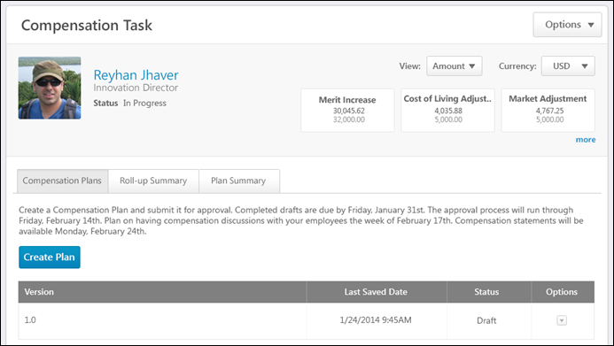
Breadcrumbs
At the top of the page, the breadcrumbs for the page are displayed. Users can click the links within the breadcrumbs to navigate to those pages. Note: The page to which the Home icon is linked is configured by the administrator in Navigation Tabs and Links.
The breadcrumbs include the compensation task name and the name of the compensation manager who is completing the compensation task. If the co-planner is completing the compensation task, then the name of the compensation manager for whom the co-planner is planning is displayed.
When the compensation manager navigates to view the User Profile Dashboard of a subordinate, then the subordinate's name is also displayed in the breadcrumbs.
User Profile Dashboard
At the top of the compensation task, the User Profile Dashboard is displayed. This section displays the compensation task title, the Options drop-down menu, view controls, and a summary of the compensation manager and the compensation task components.
See Compensation Task - User Profile Dashboard on page 5 for additional information.
See Compensation Task - Options Drop-down on page 22 for additional information.
Instructions
The instructions for the Compensation Plans tab are displayed below the User Profile Dashboard. The instructions are configured by the administrator when the compensation task is created.
Create Plan
Click the Create Plan button to create a compensation plan for the compensation task. Note: Users must have permission to manage compensation plans to create a compensation plan. See Compensation Plan - Create/View/Edit on page 38 for additional information.
This button is available when the compensation manager or a co-planner is viewing the compensation manager's User Profile Dashboard and the task is not expired or completed. The button is also available when the compensation manager or a co-planner is viewing the User Profile Dashboard for one of the compensation manager's subordinates and Executive Roll-up is enabled with Edit access for the compensation task.
Compensation Plan Drafts Table
The Compensation Plan Drafts table displays the following information for each of the selected user's compensation plan drafts:
- Version - This displays the version number for the draft. Version updates are increased by 1.0 for each draft version.
- Last Saved Date - This displays the date on which the draft was last saved. For a submitted compensation plan, this includes any time the plan is saved during the approval workflow. Note: During the approval workflow, an approver with edit rights can save a compensation plan by editing the compensation plan and then either saving, approving, or denying the plan.
- Status - This displays the status of the draft. The following statuses are available:
  - Draft
  - Draft (Copy of Submitted <Version #>)
  - Submitted
  - Approved
  - Denied
Draft Options
When a compensation manager or their co-planners are viewing the compensation manager's User Profile Dashboard, the following options may be available by clicking the drop-down arrow in the Options column:
- Edit - This option is available for the following draft statuses:
  - Draft
  - Draft (Copy of Submitted <Version #>)
    - If edits are made to a copy and the copy is saved, the status of the copy changes to Draft.
    - If edits are made to the copy and the copy is submitted, the status of the copy changes to Submitted.
  - Denied
- View - This option is available for the following draft statuses:
  - Submitted - If edits are made to a submitted compensation plan during the approval workflow, then these changes are reflected when the compensation plan is viewed.
  - Approved
- Copy - This option is available for all draft statuses.
- Delete - This option is available for the following draft statuses:
  - Draft
  - Draft (Copy of Submitted <Version #>)
  - Denied
When viewing a subordinate's User Profile Dashboard and Executive Roll-up is enabled for the compensation task, the following options may be available by clicking the drop-down arrow in the Options column:
- Edit - This option is only available when Executive Roll-up is enabled with Edit access for the compensation task. Also, this option is available for the following draft statuses:
  - Draft
  - Draft (Copy of Submitted <Version #>)
  - Denied
- View - This option is available when Executive Roll-up is enabled with Read access for the compensation task for all draft statuses. This option is available when Executive Roll-up is enabled with Edit access for the compensation task if the task is in Submitted or Approved status.
- Copy - This option is available for all draft statuses.
- Delete - This option is only available when Executive Roll-up is enabled with Edit access for the compensation task. Also, this option is available for the following draft statuses:
  - Draft
  - Draft (Copy of Submitted <Version #>)
  - Denied
Compensation Task - Roll-up Summary Tab
The Roll-up Summary tab of a compensation task displays the roll-up of allocations and budgets of all subordinate compensation manager plans. Allocation and budget values are taken from the last submitted or last active draft of each compensation plan. The Roll-up hierarchy is dependent upon the settings at the task level, which can be set to use the compensation manager hierarchy or the manager-subordinate hierarchy.
The Roll-up Summary tab displays budgets at the overall component level. For component budgets that have OU specific component budgets, the component budget represents the sum of all OU specific component budgets for the compensation manager. The OU specific component budgets are only included if there are eligible employees that apply to the budget. This is calculated at the time the compensation plan is created, so budgets may be updated once the plan is In Progress. Initially, budget calculations assume that there is at least one eligible employee for fixed amount budget types, which may be updated once a draft plan is created.
This tab reflects only components that are included in the compensation plan templates. If a component is hidden from a compensation plan template, then the component does not appear in this tab.
- A bonus component is not considered hidden unless all three bonus component columns have been hidden (% Attained, Target, and Bonus).
- An equity component with a target is not considered hidden unless the component and the target are both hidden.
The Roll-up Summary tab only displays if the following is true:
- The task is a standard compensation tasks.
- The compensation manager has subordinate compensation managers based on the hierarchy view set for the task.
- The hierarchy view set for the task does not contain a circular reference.
To access the Roll-up Summary tab of a compensation task, go to Home > Scheduled Tasks. Click the compensation task title.
The Roll-up Summary tab is the default tab for the compensation task if it is available.
Permissions
PERMISSION NAME | PERMISSION DESCRIPTION | CATEGORY

Compensation Plan - Manage | Grants Compensation Managers the ability to access to the landing page of their assigned compensation tasks. This permission also grants the ability to create and manage compensation plans within the task. This permission cannot be constrained. This is an end user permission. | Compensation
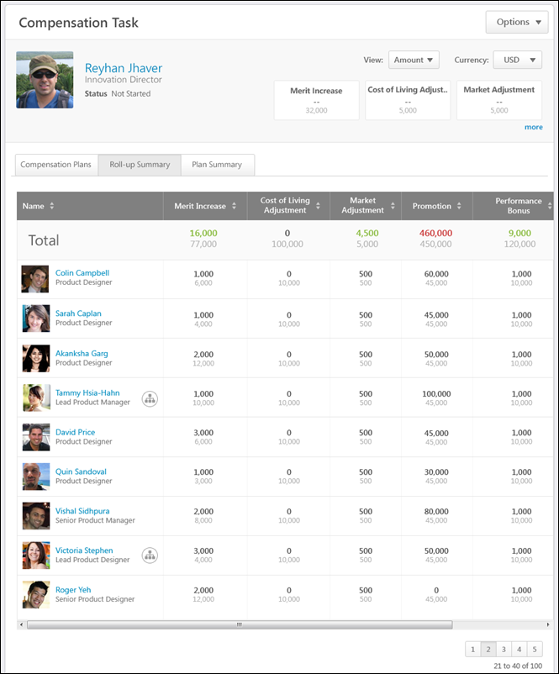
Breadcrumbs
At the top of the page, the breadcrumbs for the page are displayed. Users can click the links within the breadcrumbs to navigate to those pages. Note: The page to which the Home icon is linked is configured by the administrator in Navigation Tabs and Links.
The breadcrumbs include the compensation task name and the name of the compensation manager who is completing the compensation task. If the co-planner is completing the compensation task, then the name of the compensation manager for whom the co-planner is planning is displayed.
When the compensation manager navigates to view the User Profile Dashboard of a subordinate, then the subordinate's name is also displayed in the breadcrumbs.
User Profile Dashboard
At the top of the compensation task, the User Profile Dashboard is displayed. This section displays the compensation task title, the Options drop-down menu, view controls, and a summary of the compensation manager and the compensation task components.
See Compensation Task - User Profile Dashboard on page 5 for additional information.
See Compensation Task - Options Drop-down on page 22 for additional information.
Roll-up Summary Table
The Roll-up Summary information can be viewed for any compensation manager within the Roll-up hierarchy for the compensation manager. The compensation manager can click a user's photograph to view the corresponding user's Roll-up Summary information. When a new user is selected, the User Profile Dashboard is also updated to display the selected user's information.
The table displays the following information:
- Name - This column displays the following information for each direct subordinate compensation manager of the user who is displayed in the User Profile Dashboard:
  - Name and Photograph - By default, compensation managers are displayed in alphabetical order by last name. If the user has subordinate compensation managers, clicking the name or photograph opens the Roll-up Summary information for the corresponding compensation manager. Otherwise, clicking the photograph opens the Compensation Plans tab for the corresponding compensation manager.
  - Position
  - Hierarchy Icon - This icon is displayed if the user has subordinate compensation managers. Click the icon to view the Roll-up Summary information for the corresponding compensation manager.
- Components - Each of the components that are configured to be displayed in the compensation task are displayed. The component allocation appears above the component budget. The manner in which the allocations are displayed (e.g., amount, percentage, currency) can be modified using the view controls in the User Profile Dashboard. Components can be sorted by allocation in Amount view by clicking the column header. Allocation and budget values are taken from the last submitted or last active draft of each compensation plan. The components are displayed in the following order:
  - Base components included in Base salary
  - Base components not included in Base salary
  - Bonus components
  - Equity components
The Total row is displayed at the top of the Roll-up Summary table, and this row displays the total rolled-up allocations and budgets for the compensation manager. Note: For subordinate compensation managers that have a plan status of Not Started, their contributed allocations are zero, but their applicable component budgets are still applied. The color of the allocation reflects whether the allocation is more than or less than the budget. Note: When values are displayed as percentages, due to rounding, a percentage may appear as 100%, but may actually be over the budget. The color is based on the actual allocation and budget values.
- Green - Less than or equal to the budget
- Gray - Zero
- Red - More than the budget
If a subordinate compensation manager becomes inactive during the task, "(Inactive)" appears next to their name. Inactive managers appear in the Roll-up Summary view, but their allocations and budgets are not applied to the roll-up totals unless a co-planner has been added to the task.
Compensation Task - Plan Summary Tab
The Plan Summary tab of a compensation task displays the allocations and budgets for each subordinate compensation managers' compensation plan. Allocation and budget values are taken from the last submitted or last active draft of each compensation plan.
This tab reflects only components that are included in the compensation plan templates. If a component is hidden from a compensation plan template, then the component does not appear in this tab.
- A bonus component is not considered hidden unless all three bonus component columns have been hidden (% Attained, Target, and Bonus).
- An equity component with a target is not considered hidden unless the component and the target are both hidden.
The Plan Summary tab only displays if the following is true:
- The task is a standard compensation tasks.
- The compensation manager has subordinate compensation managers based on the hierarchy view set for the task.
- The hierarchy view set for the task does not contain a circular reference.
To access the Plan Summary tab of a compensation task, go to Home > Scheduled Tasks. Click the compensation task title. Then, click the Plan Summary tab.
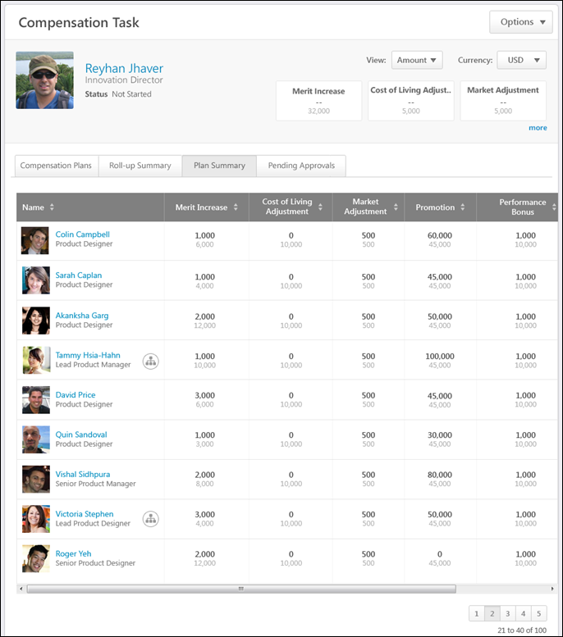
Breadcrumbs
At the top of the page, the breadcrumbs for the page are displayed. Users can click the links within the breadcrumbs to navigate to those pages. Note: The page to which the Home icon is linked is configured by the administrator in Navigation Tabs and Links.
The breadcrumbs include the compensation task name and the name of the compensation manager who is completing the compensation task. If the co-planner is completing the compensation task, then the name of the compensation manager for whom the co-planner is planning is displayed.
When the compensation manager navigates to view the User Profile Dashboard of a subordinate, then the subordinate's name is also displayed in the breadcrumbs.
User Profile Dashboard
At the top of the compensation task, the User Profile Dashboard is displayed. This section displays the compensation task title, the Options drop-down menu, view controls, and a summary of the compensation manager and the compensation task components.
See Compensation Task - User Profile Dashboard on page 5 for additional information.
See Compensation Task - Options Drop-down on page 22 for additional information.
Plan Summary Table
The Plan Summary information can be viewed for any subordinate compensation manager. The compensation manager can click a user's photograph to view the corresponding user's Plan Summary information. When a new user is selected, the User Profile Dashboard is also updated to display the selected user's information.
The table displays the following information:
- Name - This column displays the following information for each direct subordinate compensation manager of the user who is displayed in the User Profile Dashboard:
  - Name and Photograph - By default, compensation managers are displayed in alphabetical order by last name. If the user has subordinate compensation managers, clicking the name or photograph opens the Plan Summary information for the corresponding compensation manager. Otherwise, clicking the photograph opens the Compensation Plans tab for the corresponding compensation manager.
  - Position
  - Hierarchy Icon - This icon is displayed if the user has subordinate compensation managers. Click the icon to view the Plan Summary information for the corresponding compensation manager.
- Components - Each of the components that are configured to be displayed in the compensation task are displayed. The component allocation appears above the component budget. The manner in which the allocations are displayed (e.g., amount, percentage, currency) can be modified using the view controls in the User Profile Dashboard. Components can be sorted by allocation in Amount view by clicking the column header. Allocation and budget values are taken from the last submitted or last active draft of each compensation plan. The components are displayed in the following order:
  - Base components included in Base salary
  - Base components not included in Base salary
  - Bonus components
  - Equity components
- Status - This column displays the status for the compensation manager's compensation plan. The status is linked to the appropriate page of the user's compensation plan:
  - Not Started - This opens the Compensation Plan History pop-up. See Compensation Task - View Plan History on page 36 for additional information.
  - In Progress - This opens the Compensation Plan History pop-up.See Compensation Task - View Plan History on page 36 for additional information.
  - Pending Approval - This opens the Compensation Plan History pop-up. See Compensation Task - View Plan History on page 36 for additional information.
  - Approve Plan - This opens the compensation plan for approval. This status only appears if the user that is viewing the Plan Summary tab is the next approver in the approval workflow (or the co-planner for the approver).See Compensation Plan - Summary/Read-only/Approval Tab on page 65 for additional information.
  - Approved - This opens the Compensation Plan History pop-up. See Compensation Task - View Plan History on page 36 for additional information.
  - Denied - This opens the Compensation Plan History pop-up. See Compensation Task - View Plan History on page 36 for additional information.
If a subordinate compensation manager becomes inactive during the task, "(Inactive)" appears next to their name. If the compensation task is inactive due to the compensation manager becoming inactive, the plan cannot be acted upon unless a co-planner is assigned the task.
Compensation Task - Pending Approvals Tab
The Pending Approvals tab of a compensation task displays all compensation plans within the compensation task that are pending approval from the compensation manager who is viewing the task. Allocation and budget values are taken from the last submitted or last active draft of each compensation plan.
This tab reflects only components that are included in the compensation plan templates. If a component is hidden from a compensation plan template, then the component does not appear in this tab.
- A bonus component is not considered hidden unless all three bonus component columns have been hidden (% Attained, Target, and Bonus).
- An equity component with a target is not considered hidden unless the component and the target are both hidden.
The Pending Approvals tab only displays if the following is true:
- The user that is displayed in the User Profile Dashboard is the compensation manager or the compensation manager's co-planner.
- The compensation manager has compensation plans that are pending approval within the compensation task.
To access the Pending Approvals tab of a compensation task, go to Home > Scheduled Tasks. Click the compensation task title. Then, click the Pending Approvals tab.
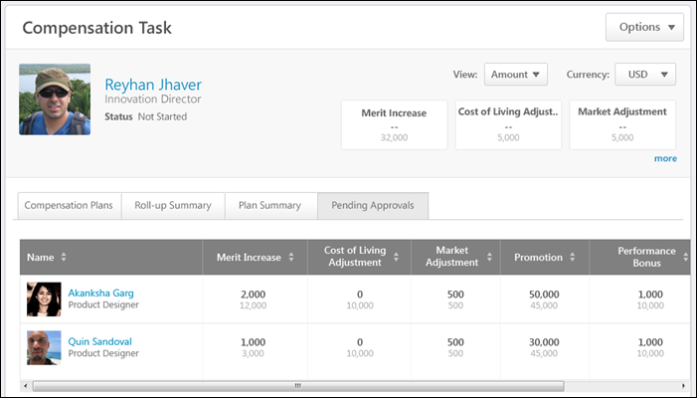
Breadcrumbs
At the top of the page, the breadcrumbs for the page are displayed. Users can click the links within the breadcrumbs to navigate to those pages. Note: The page to which the Home icon is linked is configured by the administrator in Navigation Tabs and Links.
The breadcrumbs include the compensation task name and the name of the compensation manager who is completing the compensation task. If the co-planner is completing the compensation task, then the name of the compensation manager for whom the co-planner is planning is displayed.
When the compensation manager navigates to view the User Profile Dashboard of a subordinate, then the subordinate's name is also displayed in the breadcrumbs.
User Profile Dashboard
At the top of the compensation task, the User Profile Dashboard is displayed. This section displays the compensation task title, the Options drop-down menu, view controls, and a summary of the compensation manager and the compensation task components.
See Compensation Task - User Profile Dashboard on page 5 for additional information.
See Compensation Task - Options Drop-down on page 22 for additional information.
Pending Approvals Table
The Pending Approvals information can be viewed for any user for which the compensation manager is the next level approver.
The table displays the following information:
- Name - This column displays the following information for each direct subordinate compensation manager who has a compensation plan that is pending approval from the user who is displayed in the User Profile Dashboard:
  - Name and Photograph - By default, compensation managers are displayed in alphabetical order by last name.
  - Position
  - Hierarchy Icon - This icon is displayed if the user has subordinate compensation managers. Click the icon to view the Pending Approvals information for the corresponding compensation manager.
- Components - Each of the components that are configured to be displayed in the compensation task are displayed. The component allocation appears above the component budget. The manner in which the allocations are displayed (e.g., amount, percentage, currency) can be modified using the view controls in the User Profile Dashboard. Components can be sorted by allocation in Amount view by clicking the column header. Allocation and budget values are taken from the last submitted or last active draft of each compensation plan. The components are displayed in the following order:
  - Base components included in Base salary
  - Base components not included in Base salary
  - Bonus components
  - Equity components
- Status - This column indicates that the compensation plan is in Approve Plan status. Click the Approve Plan link to open the compensation plan for approval. See Compensation Plan - Summary/Read-only/Approval Tab on page 65 for additional information.
If a subordinate compensation manager becomes inactive during the task, "(Inactive)" appears next to their name. If the compensation task is inactive due to the compensation manager becoming inactive, the plan cannot be acted upon unless a co-planner is assigned the task.
Compensation Task - Options Drop-down
When completing a compensation task, the following options may be available from the Options drop-down menu:
- Adjust Budgets - All Reports - Select this option to adjust the budget for all of the selected compensation manager's subordinates (the entire compensation manager hierarchy). This option is only available if the compensation manager is within the Budget Adjustment Availability criteria that is defined for the compensation task and if the user displayed in the User Profile Dashboard has subordinate compensation managers. For example, if a subordinate who does not have subordinate compensation managers is displayed in the User Profile Dashboard, then this option is not available. See Compensation Task - Adjust Budget - All Reports on page 24 for additional information.
- Adjust Budgets - Individual - Select this option to make adjustments to the compensation budget for an individual subordinate. This option is only available if the compensation manager is within the Budget Adjustment Availability criteria that is defined for the compensation task and when viewing the User Profile Dashboard of a subordinate compensation manager. See Compensation Task - Adjust Budget - Individual on page 27 for additional information.
- Approve Plan - Select this option to open the selected compensation manager's compensation plan for approval or denial. This option is only available if the compensation manager who is viewing the compensation task is next in the approval workflow for the corresponding subordinate's compensation plan. This opens the subordinate's compensation plan for approval or denial. See Compensation Plan - Summary/Read-only/Approval Tab on page 65 for additional information.
- Cascade Budget - Select this option to cascade the budget to subordinate compensation managers. This option is only available when the compensation manager is viewing their own User Profile Dashboard, the compensation task contains Cascaded Budget type components, and the compensation manager must cascade component budgets to their team. See Compensation Task - Cascade Budget on page 29 for additional information.
- Co-Planner - Select this option to view, add, and edit co-planners for the compensation manager's compensation task. This ability to view existing co-planners is always available. The ability to add and edit co-planners is only available when enabled for the compensation task. See Compensation Task - Co-Planner - Add/View on page 32 for additional information.
- Contact Administrator - Select this option to send a message to the administrator for the compensation task. This option is only available if an administrator contact is defined for the compensation task. See Compensation Task - Contact Administrator on page 31 for additional information.
- Download Individual Adjustments - Select this option to open the Compensation Adjustment Report for the users within the compensation task. The most recently saved current draft of the compensation plan is reflected in the report. A deleted draft cannot be exported. This option is only available if Executive Roll-up is enabled for the compensation task.
- Download Statement - Select this option to download the compensation statement of the selected subordinate. This opens a PDF of the subordinate's compensation statement for the compensation task. This option is only available when viewing the User Profile Dashboard of a subordinate and if the compensation task is configured to allow compensation managers to download subordinates' compensation statements.
- Download Team Statements - Select this option to generate and download compensation statements for the direct subordinates of the selected compensation manager. This option is only available when viewing the User Profile Dashboard of a subordinate and if the compensation task is configured to allow compensation managers to download subordinates' compensation statements. See Compensation Task - Download Team Statements on page 34 for additional information.
- View History - Select this option to view the submission, approval/denial, and edit history of the compensation plan during the approval workflow. This option is only available if there is any history to display for the user's compensation plan. See Compensation Task - View Plan History on page 36 for additional information.
Compensation Task - Adjust Budget - All Reports
The Adjust Budget - All Reports pop-up enables compensation managers to adjust the budget for all of the selected compensation manager's subordinates (the entire compensation manager hierarchy). The compensation manager can adjust the budget for all components in the compensation task that have a Fixed Amount or % of Base budget type.
Budget adjustments are only applied to compensation tasks that have a status of Not Started or In Progress.
Note: Co-planners can also adjust budgets. Budget adjustments apply to the compensation manager hierarchy that is set for the task.
To adjust budgets for all of a compensation manager's subordinates (the entire compensation manager hierarchy), select Adjust Budget - All Reports from the Options drop-down in the User Profile Dashboard.
This option is only available if the compensation manager is within the Budget Adjustment Availability criteria that is defined for the compensation task and if the user displayed in the User Profile Dashboard has subordinate compensation managers. For example, if a subordinate who does not have subordinate compensation managers is displayed in the User Profile Dashboard, then this option is not available.
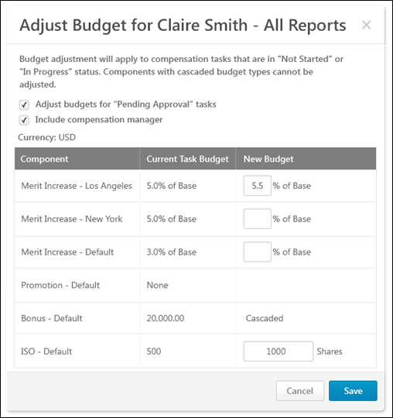
Pop-up Title
The pop-up title indicates the name of the compensation manager whose subordinates' budgets are being adjusted. For example, if budgets are being adjusted for John Doe's subordinates (the entire compensation manager hierarchy), then John Doe's name appears in the pop-up title.
Adjust budgets for "Pending Approval" tasks
This option is unchecked by default.
Select this option to apply the budget adjustments to tasks that are in a Not Started, In Progress, or Pending Approval status. When unchecked, budget adjustments only apply to the tasks that are in a Not Started or In Progress status.
Include compensation manager
This option is only available if the compensation manager is adjusting budgets for their subordinates' teams.
This option is unchecked by default.
Select this option to apply the budget adjustments to the compensation manager's budget and all of the compensation manager's subordinates' budgets. If this option is unchecked, only the budgets for the selected compensation manager's subordinates are affected.
Currency
This displays the system's default currency.
Component Budget Table
The Component Budget Table displays the following information:
- Component - This column displays each component included in the compensation task, regardless of budget type.
- Current Task Budget - This column displays the component's current budget for the compensation task. This reflects the budget that was set at the compensation template or task level. This value does not change unless the administrator changes the budgets for the entire compensation task.
- New Budget - This column enables the compensation manager to set a new budget for the component.
  - A new budget can only be set for components that have a Fixed Amount or % of Base budget type.
  - This column is blank for components that have a Sum of Targets or None budget type.
  - This column displays Cascaded for components that have a Cascaded budget type.
Adjust Budgets
To adjust a component budget, enter a new value in the appropriate field and save the changes. New budgets must be within the threshold set for task budget adjustments.
All adjustments that are saved apply to the selected compensation manager's subordinates (the entire compensation manager hierarchy).
Save or Cancel
After entering the appropriate budget adjustments, click Save to save all adjustments, or click Cancel to discard all adjustments. Any changes that are saved are reflected in the Adjust Budget - Individual pop-up. See Compensation Task - Adjust Budget - Individual on page 27 for additional information.
Compensation Task - Adjust Budget - Individual
The Adjust Budget - Individual pop-up enables compensation managers to make adjustments to the compensation budget for an individual subordinate. The compensation manager can adjust the budget for all components in the compensation task that have a Fixed Amount or % of Base budget type.
Budget adjustments are only applied to compensation tasks that have a status of Not Started or In Progress.
Note: Co-planners can also adjust budgets.
To adjust budgets for an individual subordinate, select Adjust Budget - Individual from the Options drop-down in the User Profile Dashboard.
This option is only available if the compensation manager is within the Budget Adjustment Availability criteria that is defined for the compensation task and when viewing the User Profile Dashboard of a subordinate compensation manager.
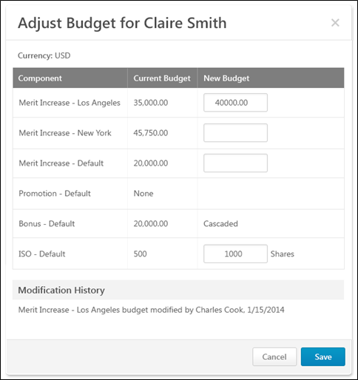
Pop-up Title
The pop-up title indicates the name of the compensation manager whose budgets are being adjusted. For example, if budgets are being adjusted for John Doe, then John Doe's name appears in the pop-up title.
Currency
This displays the system's default currency.
Component Budget Table
The Component Budget Table displays the following information:
- Component - This column displays each component included in the compensation task, regardless of budget type.
- Current Budget - This column displays the component's current calculated budget value for the compensation manager. For example, if the template specified a budget of 3.0% of base, then the Current Budget column displays the actual calculated amount instead of the percentage.
- New Budget - This column enables the compensation manager to set a new budget for the component.
  - A new budget can only be set for components that have a Fixed Amount or % of Base budget type.
  - This column is blank for components that have a Sum of Targets or None budget type.
  - This column displays Cascaded for components that have a Cascaded budget type.
Adjust Budgets
To adjust a component budget, enter a new value in the appropriate field and save the changes. New budgets must be defined as a fixed amount, regardless of how the budget was initially calculated.
- New budgets cannot be lower than current budgets.
- New budgets must be within the threshold set for task budget adjustments.
Modification History
This section displays all modifications that have been made to the compensation manager's budget. The most recent modification appears at the top. The modification includes the component, the name of the person who made the modification, and the modification date.
Save or Cancel
After entering the appropriate budget adjustments, click Save to save all adjustments, or click Cancel to discard all adjustments.
Compensation Task - Cascade Budget
The Cascade Budget pop-up enables compensation managers to set their own compensation budget and cascade or distribute the remaining budget to direct report compensation managers. The compensation manager hierarchy that is set for the compensation task determines which compensation managers are available in the pop-up.
To cascade the budget to subordinate compensation managers, select Cascade Budget from the Options drop-down in the User Profile Dashboard.
This option is only available when the compensation manager is viewing their own User Profile Dashboard, the compensation task contains Cascaded Budget type components, and the compensation manager must cascade component budgets to their team.
Note:Lower level managers in the task must submit their plan before the higher level managers in the task, soupper hierarchy managers cannot submit the plan until the subordinate managers submits their plan.
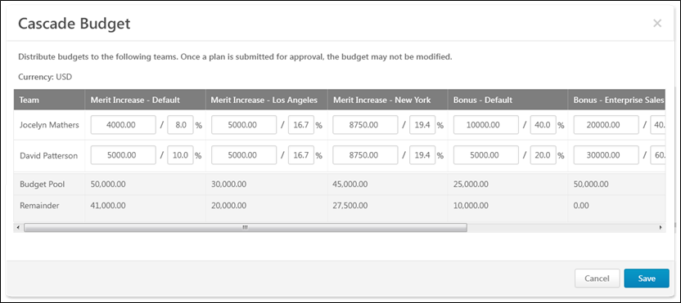
Currency
This displays the system's default currency.
Cascade Budget Table
The Cascade Budget Table displays the following information:
- Team - This column displays the name of the compensation manager and any of the compensation manager's direct subordinates who also have subordinates. Note: If a direct report does not also have subordinates, then they do not appear in this table because the cascaded budgets are intended to be distributed by the corresponding compensation managers.
- Components - Each of the components that are included in the compensation task and also have a Cascaded budget type are displayed. Compensation managers can allocate budgets by a fixed amount or a percentage of the budget pool. The components are displayed in the following order:
  - Base components with a Cascaded budget type
  - Bonus components with a Cascaded budget type
  - Equity components with a Cascaded budget type
Set Budgets
To set a budget for a compensation manager, enter a value in the appropriate field and save the changes.
For each component, the compensation manager can allocate budgets by a fixed amount or a percentage of the budget pool. Enter a value on the left to set the budget at a specific amount, or enter a value on the right to set the budget as a percentage of the Budget Pool.
- Once a compensation plan is submitted for approval, the budget for that compensation plan may not be modified.
- The total amount that is distributed for a component cannot be more than the total Budget Pool for the component.
- If no funds are allocated to a compensation manager for a component, then the amount field for that component cannot be edited.
If a compensation manager does not distribute all of their budgeted funds, then those undistributed funds are available to the indirect manager.
Total Table
Below the Cascade Budget Table, the Total table displays the following information:
- Budget Pool - This row displays the total budget pool for each Cascaded budget type component.
- Remainder - This row displays the currency amount that is left to be distributed for each associated Cascaded budget type component. These values are dynamically updated as budget values are distributed.
Save or Cancel
After entering the appropriate budget distribution, click Save to save all cascaded values, or click Cancel to discard all cascaded values.
Compensation Task - Contact Administrator
The Contact Administrator pop-up enables compensation managers to send a message to the administrator for the compensation task.
To send a message to the administrator for the compensation task, select Contact Administrator from the Options drop-down in the User Profile Dashboard.
This option is only available if an administrator contact is defined for the compensation task.
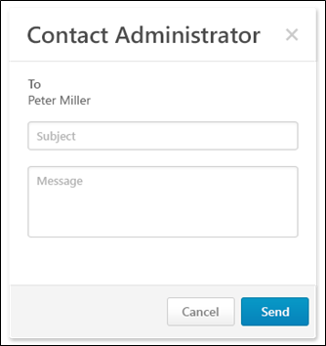
Message Content
- To - This displays the name of the administrator for the compensation task who will receive the message.
- Subject - Enter a descriptive subject for the message.
- Message - Enter the message text. Be sure to provide all of the details regarding your question, concern, or statement.
Note: When the option to contact the administrator is selected, the email is sent from the corporate account email address, and the Reply-To is set to the actual administrator.
Send or Cancel
After entering the subject and message, click Send to send the message to the administrator, or click Cancel to discard the message.
Compensation Task - Co-Planner - Add/View
The Co-Planner pop-up enables users to view, add, and edit co-planners for the compensation manager's compensation task. This functionality applies to the compensation manager who is displayed in the User Profile Dashboard. For example, when viewing another compensation manager's User Profile Dashboard, the pop-up enables you to view, add, and edit co-planners for that compensation manager.
To add or edit co-planners for the compensation manager's compensation task, select Add Co-Planner from the Options drop-down in the User Profile Dashboard.
To view co-planners for the compensation manager's compensation task, select View Co-Planner from the Options drop-down in the User Profile Dashboard. Note: This option is only available when the compensation manager cannot add or edit co-planners.
This ability to view existing co-planners is always available. The ability to add and edit co-planners is only available when enabled for the compensation task.
Add Co-Planner
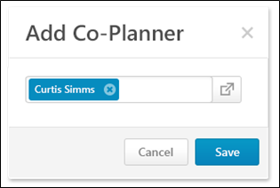
The Add-Co-Planner pop-up enables compensation managers to add or edit co-planners to the compensation manager's compensation task. This functionality applies to the compensation manager who is displayed in the User Profile Dashboard. For example, when viewing another compensation manager's User Profile Dashboard, the pop-up enables you to view, add, and edit co-planners for that compensation manager.
Only one co-planner can be added to a compensation task.
To add a co-planner, click the Select icon . This opens the Select User pop-up. Note: A compensation manager cannot be selected as a co-planner for their own compensation task. See Select User Pop-up for additional information.
To edit a co-planner, you must first remove the existing co-planner by clicking the Remove icon to the right of the co-planner. Then, add a new co-planner.
After adding or editing the compensation task co-planner, click Save to save the co-planner changes, or click Cancel to discard any co-planner changes.
View Co-Planner
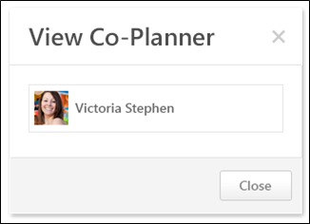
The View Co-Planner pop-up enables compensation managers to view the compensation task's co-planner. If a co-planner exists for the compensation task, the co-planner's photograph and name are displayed. In this pop-up, the co-planner cannot be edited.
To close the pop-up, click Close.
Compensation Task - Download Team Statements
The Download Team Statements pop-up enables compensation managers to generate and download compensation statements for the direct subordinates of the selected compensation manager.
To download team statements, select Download Team Statements from the Options drop-down in the User Profile Dashboard.
This option is only available when viewing the User Profile Dashboard of a subordinate and if the compensation task is configured to allow compensation managers to download subordinates' compensation statements.
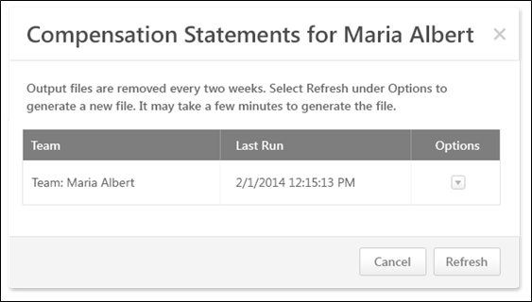
Refresh Compensation Statement File
To generate a new compensation statement file based on the latest compensation data, select the Refresh option from the Options drop-down menu. After refreshing the data, it may take a few minutes for the new compensation statements file to be generated.
When the compensation statement data is refreshed, the Last Run date and time are updated to reflect the most recent refresh.
Download Compensation Statement File
The Last Run date and time indicate when the compensation statement file was last refreshed. If more current data is necessary, you must refresh the compensation data prior to downloading.
To download the compensation statement file, select the Download option from the Options drop-down menu. This option is only available if a compensation statement file is available. If a file is not available, you must first refresh the compensation statement file.
Note: Compensation statements appear in the display language of the user who created the statement.
Refresh or Cancel
Click Refresh to refresh the pop-up. If the compensation manager is generating new statements, this button refreshes the pop-up to indicate whether the updated statements have been generated.
Click Cancel to close the pop-up.
Considerations
- Team hierarchies are based on the view hierarchy set for the compensation task. That is, teams are based upon the hierarchy view set for the Roll-up and Plan Summary tabs for the task. When team statements are downloaded, this functionality utilizes this team hierarchy.
- The compensation statement file is associated with the selected team and the compensation manager. That is, compensation managers will only see the compensation statements that they refresh and download, regardless of whether or not other compensation managers with access to the employee's User Profile Dashboard have downloaded the team statement.
- Co-planners can download team compensation statements.
Compensation Task - View Plan History
The Plan History pop-up displays the following history information for the compensation plan:
- Submission
- Approval/Denial
- Edit During Approval Workflow
The Plan History pop-up can be accessed in the following ways:
- From the Options drop-down in the User Profile Dashboard, Select View History. This option is only available if there is any history to display for the user's compensation plan.
- From the Plan Summary tab of the compensation task, click the Status link.
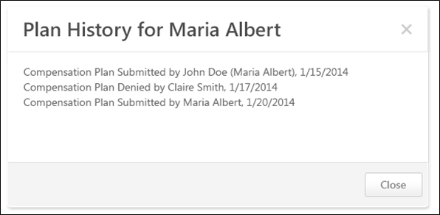
Compensation Plan History
Entries are displayed in chronological order with the earliest event displayed first. If an approver edits and then approves or denies the plan, then the edit entry is always logged before the approval or denial.
The following information is displayed for each entry:
- Action
- Compensation manager who performed the action - If an indirect compensation manager or a co-planner performed the action on behalf of a compensation manager, then the original compensation manager is displayed in parentheses.
- Date on which the action occurred
Close or Deny
Click Close to close the pop-up.
Click Deny to override approval for the compensation plan. This option is only available if the following is true:
- The compensation task is configured to allow indirect managers to override approval.
- An indirect manager is viewing the Plan History pop-up for an approved compensation plan.
Compensation Plan - Create/View/Edit
To create a compensation plan for a compensation task, go to Home > Scheduled Tasks. Click the compensation task title. Click the Compensation Plans tab. Then, click the Create Plan button.
An off-cycle compensation task can be launched via Universal Profile and My Team. See Compensation - Award Off-cycle on page 118 for additional information.
Permissions
PERMISSION NAME | PERMISSION DESCRIPTION | CATEGORY

Compensation Plan - Manage | Grants Compensation Managers the ability to access to the landing page of their assigned compensation tasks. This permission also grants the ability to create and manage compensation plans within the task. This permission cannot be constrained. This is an end user permission. | Compensation
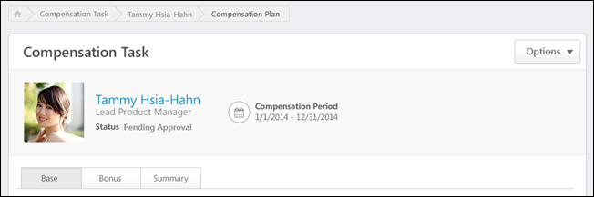
Breadcrumbs
At the top of the page, the breadcrumbs for the page are displayed. Users can click the links within the breadcrumbs to navigate to those pages. Note: The page to which the Home icon is linked is configured by the administrator in Navigation Tabs and Links.
The breadcrumbs include the compensation task name and the name of the compensation managers who is creating the compensation plan. If the compensation manager is editing a subordinate compensation manager's plan, then the breadcrumbs also display the compensation plan owner's name.
User Dashboard
At the top of the compensation plan, the User Dashboard is displayed. This section displays the compensation task title, the Options drop-down menu, and a summary of the compensation plan owner.
See Compensation Plan - User Dashboard on page 41 for additional information.
See Compensation Plan - Options Drop-down Overview on page 71 for additional information.
Additional Recommendations
When viewing a Base, Bonus, or Equity tab within a compensation plan, additional recommendation information may appear above the compensation plan tabs. This information pertains to the selected tab. If a different tab is selected, the information may disappear or change. Additional recommendation information is displayed when the compensation template that corresponds with the selected tab is configured to display additional recommendation information on the compensation plan. For example, when viewing the Base tab, additional recommendation information is displayed on the compensation plan if the corresponding base compensation template is configured to display additional recommendation information.
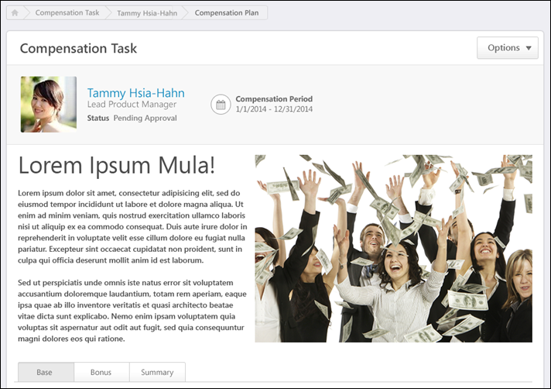
Compensation Task Tabs
Below the User Dashboard, the following tabs may be available:
- Base - See Compensation Plan - Base Tab on page 43 for additional information.
- Bonus - See Compensation Plan - Bonus Tab on page 50 for additional information.
- Equity - See Compensation Plan - Equity Tab on page 58 for additional information.
- Summary - See Compensation Plan - Summary/Read-only/Approval Tab on page 65 for additional information.
- Approve Compensation Plan (no editing rights) - See Compensation Plan - Summary/Read-only/Approval Tab on page 65 for additional information.
- Compensation Plan Details (read-only) - See Compensation Plan - Summary/Read-only/Approval Tab on page 65 for additional information.
The Base, Bonus, and Equity tabs are only available if they are included in the compensation task. Note: The tab names can be configured by the compensation administrator, so the tab names that appear in the compensation plan may vary.
When the compensation plan is in Read-only mode, only the Compensation Plan Details tab is available.
When the compensation plan is in Approval mode and the compensation manager is not able to edit the compensation plan during the approval workflow, only the Approve Compensation Plan tab is available.
Compensation Plan - User Dashboard
At the top of the compensation plan, the User Dashboard is displayed. This section displays the compensation task title, the Options drop-down menu, and a summary of the compensation plan owner.
Permissions
PERMISSION NAME | PERMISSION DESCRIPTION | CATEGORY

Compensation Plan - Manage | Grants Compensation Managers the ability to access to the landing page of their assigned compensation tasks. This permission also grants the ability to create and manage compensation plans within the task. This permission cannot be constrained. This is an end user permission. | Compensation
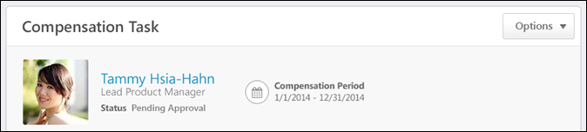
Compensation Task Title
Below the breadcrumbs, the compensation task title is displayed.
Options
Depending on the configuration of the compensation task, options may be available from the Options drop-down menu. See Compensation Plan - Options Drop-down Overview on page 71 for additional information.
Compensation Plan Owner Overview
On the left side of the User Dashboard, the following information is displayed for the compensation plan owner:
- Photograph, Name, and Title - The compensation plan owner's photograph, name, and position title are displayed. Click the user's name or photograph to open their Universal Profile - Snapshot in a separate window. See Snapshot Overview for additional information. If Universal Profile - Snapshot is not enabled, then this opens their Universal Profile - Bio in a separate window. See Universal Profile - Bio Overview for additional information.
- Compensation Task Status - Below the compensation plan owner's position, the status of the compensation plan owner's compensation plan is displayed. The status is only displayed if the compensation plan is in one of the following statuses:
  - Denied
  - Pending Approval
  - Approved
- Compensation Period - To the right of the user information, the compensation period that is defined for the compensation task is displayed.
Compensation Plan - Base Tab
The Base tab enables compensation managers to allocate base compensation to their employees and even promote employees. Only employees that match the criteria set in the compensation task appear.
To access the Base tab when creating a compensation plan, click the Base tab.
The Base, Bonus, and Equity tabs are only available if they are included in the compensation task. Note: The tab names can be configured by the compensation administrator, so the tab names that appear in the compensation plan may vary.
When the compensation plan is in Read-only mode, only the Compensation Plan Details tab is available.
When the compensation plan is in Approval mode and the compensation manager is not able to edit the compensation plan during the approval workflow, only the Approve Compensation Plan tab is available.
Permissions
PERMISSION NAME | PERMISSION DESCRIPTION | CATEGORY

Compensation Plan - Manage | Grants Compensation Managers the ability to access to the landing page of their assigned compensation tasks. This permission also grants the ability to create and manage compensation plans within the task. This permission cannot be constrained. This is an end user permission. | Compensation
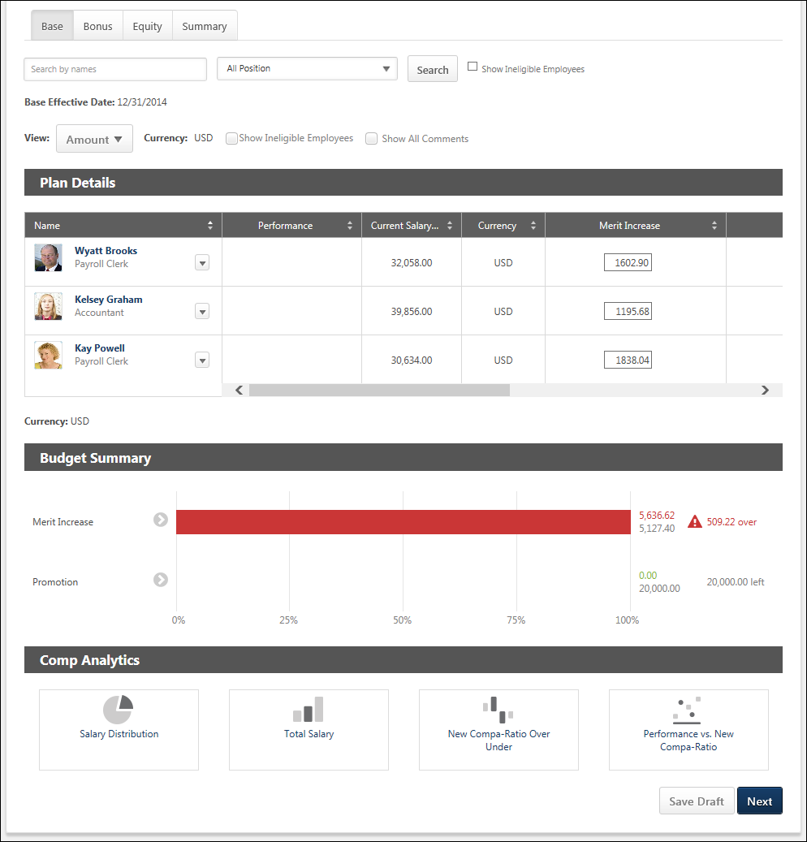
Additional Recommendations
When viewing a Base, Bonus, or Equity tab within a compensation plan, additional recommendation information may appear above the compensation plan tabs. This information pertains to the selected tab. If a different tab is selected, the information may disappear or change. Additional recommendation information is displayed when the compensation template that corresponds with the selected tab is configured to display additional recommendation information on the compensation plan. For example, when viewing the Base tab, additional recommendation information is displayed on the compensation plan if the corresponding base compensation template is configured to display additional recommendation information.
Search and Filter Users
Compensation managers and approvers can search for users within a compensation plan by name, position, and eligibility status.
- Search by Name - This field enables managers to search for specific users within the compensation plan by name. When a search is conducted, the search query is retained as the compensation manager navigates between tabs.
  - The Budget Summary and Compensation Analytics are not impacted or limited when a search is conducted.
  - Compensation managers can search by <First Name>, by <Last Name>, or by <First Name> <Last Name>. Compensation managers cannot search by <Last Name> <First Name>.
  - Compensation managers can search for multiple names by separating them by a semicolon.
- Position - This field enables managers to filter the compensation plan by position. When one or more position organizational unit (OU) is selected, the compensation plan only displays users who are within the selected positions. This enables compensation managers to easily compare employees within the same position or similar positions. The filter only contains the positions that are associated with users within the compensation plan. If there are no users within the compensation plan, then this filter is not available.
- Show Ineligible Employees - Select this option to include ineligible employees in the search. No component data is displayed and no options are available for ineligible employees.
Effective Date
This displays the date on which the compensation adjustments on the selected tab will be implemented. For example, if the effective date for the Base tab is March 15, 2015, then any compensation adjustments that are made on the Base tab will be reflected in the user's compensation on March 15, 2015.
View Options
The following options enable the compensation manager to customize how information is displayed in the Plan Details table:
- View - From the drop-down, select whether components are displayed as an amount or as a percentage. Administrators can configure the default selection for this option when configuring the compensation template.
  - Amount - Select this option to display components as fixed currency amounts. This option is selected by default.
  - Percentage - Select this option to display components as percentages of the budget (i.e., <ALLOCATION> divided by <BUDGET>). If no budget applies or has been set, "--%" is displayed.
- Currency - From the drop-down, select the currency in which currency amounts are displayed throughout the compensation plan tab. If only one currency is available, then the currency is displayed as text and cannot be modified. Currency conversions are based upon the conversion rate at the time the compensation task was launched. The following currencies may be available:
  - Compensation Task Currency
  - Compensation Manager's Currency
  - Employee's Currency
- Show Ineligible Employees - Select this option to include ineligible employees in the Plan Details table for the current tab. No component data is displayed and no options are available for ineligible employees. Administrators can configure the default selection for this option when configuring the compensation template.
- Show All Comments - Select whether all comments for each user are displayed directly in the Plan Details table. When this option is selected, all comments for the current compensation plan tab are displayed in the Plan Details table. The user photo and name of the compensation manager who wrote the comment and the date and time at which the comment was made are displayed for each comment. The newest comments are displayed first. This option is unchecked by default.
- Show - From the drop-down, select the maximum number of users who can be displayed in the Plan Details table. If more than the selected number is available, then the additional users appear on a separate page, and the compensation manager must navigate to each page to view all users. This option is only available if at least 16 users are available to be displayed in the Plan Details table. This includes ineligible employees.
Plan Details Table
The plan details table can be sorted by any of the data or component columns in the plan. Only one column can be sorted at a time. Monetary values are sorted based on string values, so all hourly rates appear above salary rates when sorted from low to high. In addition, $500 appears before 1000 Yen when sorted from low to high regardless of the currency conversion.
- The sorting applies to the entire compensation plan tab, regardless of the number of pages. If the compensation manager is not on the first page when they sort the plan, they are taken to the first page of the plan.
- To sort the compensation plan based on a certain column, click the column heading. To reverse the sort order, click the column heading again. When navigating to a different tab, the sort order is not saved.
The following information is displayed for each user in the Plan Details table:
- User Photograph
- Name - Click the user's name to open their Universal Profile - Snapshot in a separate window. See Snapshot Overview for additional information. If Universal Profile - Snapshot is not enabled, then this opens their Universal Profile - Bio in a separate window. See Universal Profile - Bio Overview for additional information.
- Position
- Promoted - A Promoted link will appear below the user's Position OU title if the user is promoted during a compensation task. Click the link to open the Promotion pop-up. Note: If the user is given a promotion, and then the promotion is removed, the Promoted link is removed.
- Options - To view which options are available for a user, click the Options drop-down to the right of the user's name. See the User Options section below for additional information. Note: The Options drop-down is not available for ineligible employees.
- Components - For each component included in the compensation component template, a column appears to the right of the Name column. The layout of the columns and the column names are configured by the compensation administrator when the compensation template is created. See the Components section below for additional information.
At the bottom of the Plan Details table, the horizontal scroll bar is always visible when viewing any part of the Plan Details table when not all data in the table can be displayed on the screen. The horizontal scroll bar enables the user to scroll left and right on the Plan Details table. As the user scrolls vertically on the page while the Plan Details table is displayed, the horizontal scroll bar for the Plan Details table floats at the bottom of the screen.
User Options
The following options may be available by selecting the Options drop-down to the right of the eligible user's name:
- More Info - Select this option to open the expanded view of the employee. This option is only available if the expanded view is enabled for the component tab (i.e., Base, Bonus, Equity). This option is also available on the Base tab if the user has been promoted. See Compensation Plan - Employee Expanded View on page 87 for additional information.
- Comment - Select this option to view a history of all of the comments made regarding the user for the component tab (i.e., Base, Bonus, Equity). This option also enables the compensation manager to add a new comment. See Compensation Plan - Comments on page 83 for additional information.
- Promote - Select this option to promote the user. This option is only available on the Base component tab if a promotion component is available in the compensation plan. See Compensation Plan - Promotion on page 102 for additional information.
- Show Warning - Select this option to view the components within the compensation plan that are outside the component guidelines. This option is only available when there is at least one component that is outside its guidelines. See Compensation Plan - Outside Guidelines on page 97 for additional information.
Note: The Options drop-down is not available for ineligible employees.
Components
For each component included in the compensation component template, a column appears to the right of the Name column. The layout of the columns and the column names are configured by the compensation administrator when the compensation template is created. Note: No data is displayed for ineligible employees.
In the corresponding field for each component, the compensation manager can enter the appropriate compensation adjustment for each component for each employee. When a component allocation field is selected, a fixed amount field and a percentage of base field are displayed. Enter the allocation amount or percentage in the appropriate field.
If any adjustment guidelines are defined for the employee, the adjustment fields are automatically populated with the recommended adjustments. The recommended adjustment values can be modified, but must remain within the adjustment guidelines. If a component allocation is outside the component guidelines, an error icon appears to the right of the allocation. Compensation managers can click the icon to open the Over Guideline pop-up, which enables the compensation manager to adjust the allocation. See Compensation Plan - Over Guideline on page 99 for additional information.
- If a component allocation is outside the component guidelines but within the threshold, a yellow Error icon appears to the right of the component allocation.
- If a component allocation is outside the component guidelines and also exceeds the threshold, a red Error icon appears to the right of the component allocation.
Adjustment Guideline Recommendations
If a discretionary adjustment guideline applies to a component, then the Adjustment Guidelines icon appears to the right of the component field. Hover the computer cursor over the icon to view the original recommended allocations for the component. The pop-up displays the currency and the original recommended allocation for the component. The currency that is displayed is the currency that is set for the compensation plan.
The Adjustment Guidelines icon is not available if there is no associated adjustment guideline or if the guideline is non-discretionary.
When automatic lump sum allocation for salary range overages is enabled for the template, the salary range overage appears in the pop-up.
Component Proration
If a component has been prorated for the user, then the Prorated Recommendations icon appears to the right of the component field. Hover the computer cursor over the icon to view the prorated recommendations for the component. The pop-up displays the currency and the prorated recommendations for the component. The currency that is displayed is the currency that is set for the compensation plan.
- If the component has not yet been prorated into multiple periods, then the component allocation field is editable.
- If the component has multiple prorated periods, then the component allocation field is read-only and an Edit icon appears to the right of the Prorated Recommendations icon. Click the Edit icon to open the Proration pop-up and allocate prorated amounts for each of the prorated periods of the component for the user.
See Compensation Plan - Proration - Base on page 106 for additional information.
Lump Sum Allocation
If lump sum adjustments are enabled for the Base tab, a Lump Sum component appears on the Base tab in the compensation plan. The location and the name of the Lump Sum column is configured by the administrator when the base template is created. A lump sum is a one-time payment that does not affect the employee's salary/rate. However, it does count towards the budget for base adjustments.
See Compensation Plan - Lump Sum Allocation on page 89 for additional information.
Employee Expanded View
Each employee row is collapsed by default. To view detailed information for the employee, select the More Info option from the Options drop-down menu that appears to the right of the user photo in the Plan Details table. Note: The Options drop-down is not available for ineligible employees.
See Compensation Plan - Employee Expanded View on page 87 for additional information.
Budget Summary Graph
The Budget Summary graph appears below the Plan Details table on Compensation Plan template and summary pages. This graph displays allocations, budgets, and remaining available allocations for each component that is configured to display. The graph is updated dynamically as the compensation plan is edited. See Compensation Plan - Budget Summary Graph Overview on page 76 for additional information.
Comp Analytics
The Comp Analytics section appears below the Budget Summary graph on Compensation Plan template pages. Each report displays a snapshot of the corresponding information. These reports are updated in real-time. If a component is not included in the compensation plan, then the component does not appear in any compensation analytics graphs. See Compensation Plan - Comp Analytics on page 86 for additional information.
Action Buttons
At the bottom of the page, the following buttons may be available:
- Save Draft - Click this button to save the compensation plan without submitting it.
- Previous - Click this button to return to the previous page. This button is not available on the first tab of the compensation plan.
- Next - Click this button to proceed to the next tab within the compensation plan.
- Deny - This option is only available when a compensation manager views a compensation plan that requires their approval. Click this button to validate the compensation allocations for the tab and deny the compensation plan. If all allocation validations are passed, then the Summary tab is opened, and the Approve/Deny Confirmation pop-up is opened.
- Approve - This option is only available when a compensation manager views a compensation plan that requires their approval. Click this button to validate the compensation allocations for the tab and approve the compensation plan. If all allocation validations are passed, then the Summary tab is opened, and the Approve/Deny Confirmation pop-up is opened.
Compensation Plan - Bonus Tab
The Bonus tab enables compensation managers to allocate bonus compensation to their employees. Only employees that match the criteria set in the compensation task appear.
To access the Bonus tab when creating a compensation plan, click the Bonus tab.
The Base, Bonus, and Equity tabs are only available if they are included in the compensation task. Note: The tab names can be configured by the compensation administrator, so the tab names that appear in the compensation plan may vary.
When the compensation plan is in Read-only mode, only the Compensation Plan Details tab is available.
When the compensation plan is in Approval mode and the compensation manager is not able to edit the compensation plan during the approval workflow, only the Approve Compensation Plan tab is available.
Permissions
PERMISSION NAME | PERMISSION DESCRIPTION | CATEGORY

Compensation Plan - Manage | Grants Compensation Managers the ability to access to the landing page of their assigned compensation tasks. This permission also grants the ability to create and manage compensation plans within the task. This permission cannot be constrained. This is an end user permission. | Compensation
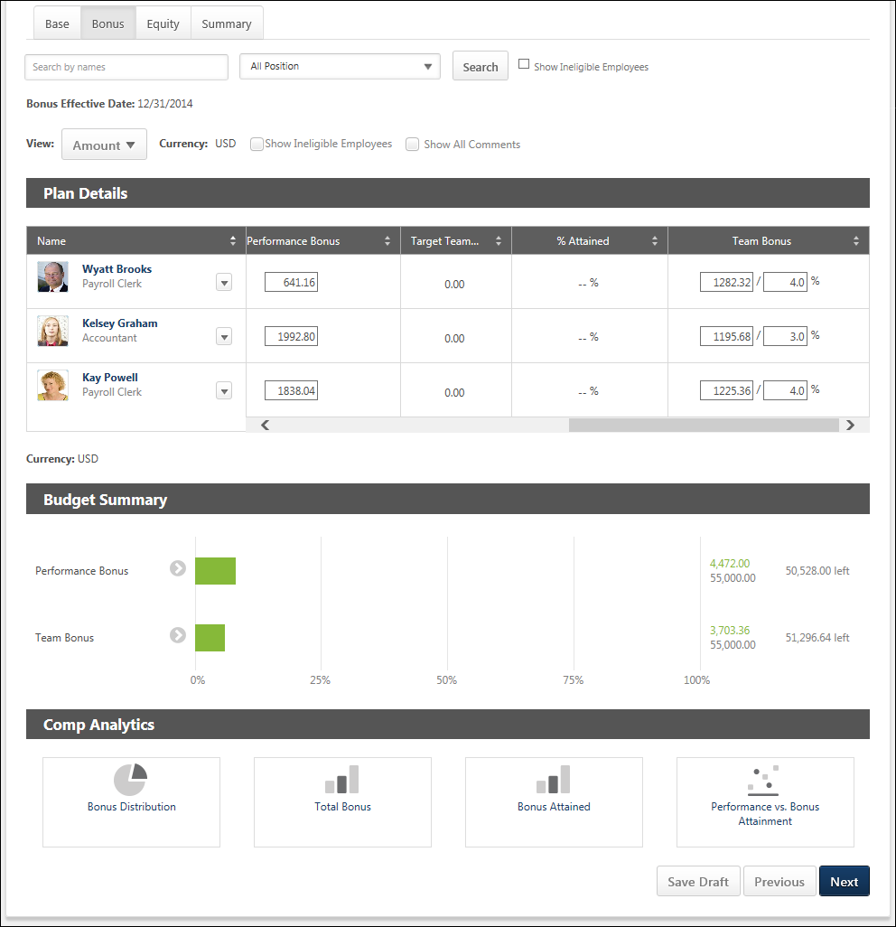
Additional Recommendations
When viewing a Base, Bonus, or Equity tab within a compensation plan, additional recommendation information may appear above the compensation plan tabs. This information pertains to the selected tab. If a different tab is selected, the information may disappear or change. Additional recommendation information is displayed when the compensation template that corresponds with the selected tab is configured to display additional recommendation information on the compensation plan. For example, when viewing the Base tab, additional recommendation information is displayed on the compensation plan if the corresponding base compensation template is configured to display additional recommendation information.
Search and Filter Users
Compensation managers and approvers can search for users within a compensation plan by name, position, and eligibility status.
- Search by Name - This field enables managers to search for specific users within the compensation plan by name. When a search is conducted, the search query is retained as the compensation manager navigates between tabs.
  - The Budget Summary and Compensation Analytics are not impacted or limited when a search is conducted.
  - Compensation managers can search by <First Name>, by <Last Name>, or by <First Name> <Last Name>. Compensation managers cannot search by <Last Name> <First Name>.
  - Compensation managers can search for multiple names by separating them by a semicolon.
- Position - This field enables managers to filter the compensation plan by position. When one or more position organizational unit (OU) is selected, the compensation plan only displays users who are within the selected positions. This enables compensation managers to easily compare employees within the same position or similar positions. The filter only contains the positions that are associated with users within the compensation plan. If there are no users within the compensation plan, then this filter is not available.
- Show Ineligible Employees - Select this option to include ineligible employees in the search. No component data is displayed and no options are available for ineligible employees.
Effective Date
This displays the date on which the compensation adjustments on the selected tab will be implemented. For example, if the effective date for the Base tab is March 15, 2015, then any compensation adjustments that are made on the Base tab will be reflected in the user's compensation on March 15, 2015.
View Options
The following options enable the compensation manager to customize how information is displayed in the Plan Details table:
- View - From the drop-down, select whether components are displayed as an amount or as a percentage. Administrators can configure the default selection for this option when configuring the compensation template.
  - Amount - Select this option to display components as fixed currency amounts. This option is selected by default.
  - Percentage - Select this option to display components as percentages of the budget (i.e., <ALLOCATION> divided by <BUDGET>). If no budget applies or has been set, "--%" is displayed.
- Currency - From the drop-down, select the currency in which currency amounts are displayed throughout the compensation plan tab. If only one currency is available, then the currency is displayed as text and cannot be modified. Currency conversions are based upon the conversion rate at the time the compensation task was launched. The following currencies may be available:
  - Compensation Task Currency
  - Compensation Manager's Currency
  - Employee's Currency
- Show Ineligible Employees - Select this option to include ineligible employees in the Plan Details table for the current tab. No component data is displayed and no options are available for ineligible employees. Administrators can configure the default selection for this option when configuring the compensation template.
- Show All Comments - Select whether all comments for each user are displayed directly in the Plan Details table. When this option is selected, all comments for the current compensation plan tab are displayed in the Plan Details table. The user photo and name of the compensation manager who wrote the comment and the date and time at which the comment was made are displayed for each comment. The newest comments are displayed first. This option is unchecked by default.
- Show - From the drop-down, select the maximum number of users who can be displayed in the Plan Details table. If more than the selected number is available, then the additional users appear on a separate page, and the compensation manager must navigate to each page to view all users. This option is only available if at least 16 users are available to be displayed in the Plan Details table. This includes ineligible employees.
Plan Details Table
The plan details table can be sorted by any of the data or component columns in the plan. Only one column can be sorted at a time. Monetary values are sorted based on string values, so all hourly rates appear above salary rates when sorted from low to high. In addition, $500 appears before 1000 Yen when sorted from low to high regardless of the currency conversion.
- The sorting applies to the entire compensation plan tab, regardless of the number of pages. If the compensation manager is not on the first page when they sort the plan, they are taken to the first page of the plan.
- To sort the compensation plan based on a certain column, click the column heading. To reverse the sort order, click the column heading again. When navigating to a different tab, the sort order is not saved.
The following information is displayed for each user in the Plan Details table:
- User Photograph
- Name - Click the user's name to open their Universal Profile - Snapshot in a separate window. See Snapshot Overview for additional information. If Universal Profile - Snapshot is not enabled, then this opens their Universal Profile - Bio in a separate window. See Universal Profile - Bio Overview for additional information.
- Position
- Promoted - A Promoted link will appear below the user's Position OU title if the user is promoted during a compensation task. Click the link to open the Promotion pop-up. Note: If the user is given a promotion, and then the promotion is removed, the Promoted link is removed.
- Options - To view which options are available for a user, click the Options drop-down to the right of the user's name. See the User Options section below for additional information. Note: The Options drop-down is not available for ineligible employees.
- Components - For each component included in the compensation component template, a column appears to the right of the Name column. The layout of the columns and the column names are configured by the compensation administrator when the compensation template is created. See the Components section below for additional information.
At the bottom of the Plan Details table, the horizontal scroll bar is always visible when viewing any part of the Plan Details table when not all data in the table can be displayed on the screen. The horizontal scroll bar enables the user to scroll left and right on the Plan Details table. As the user scrolls vertically on the page while the Plan Details table is displayed, the horizontal scroll bar for the Plan Details table floats at the bottom of the screen.
User Options
The following options may be available by selecting the Options drop-down to the right of the eligible user's name:
- More Info - Select this option to open the expanded view of the employee. This option is only available if the expanded view is enabled for the component tab (i.e., Base, Bonus, Equity). See Compensation Plan - Employee Expanded View on page 87 for additional information.
- Comment - Select this option to view a history of all of the comments made regarding the user for the component tab (i.e., Base, Bonus, Equity). This option also enables the compensation manager to add a new comment. See Compensation Plan - Comments on page 83 for additional information.
- Show Warning - Select this option to view the components within the compensation plan that are outside the component guidelines. This option is only available when there is at least one component that is outside its guidelines. See Compensation Plan - Outside Guidelines on page 97 for additional information.
Note: The Options drop-down is not available for ineligible employees.
Components
For each component included in the compensation component template, a column appears to the right of the Name column. The layout of the columns and the column names are configured by the compensation administrator when the compensation template is created. Note: No data is displayed for ineligible employees.
In the corresponding field for each component, the compensation manager can enter the appropriate compensation adjustment for each component for each employee. Depending upon how the Bonus component is configured, the compensation manager may be able to define the bonus in different ways:
- If the Bonus component is configured to be set as a fixed amount or as a percentage of the Base Salary, then the compensation manager can set an employee's bonus in the Bonus component column. Enter the allocation amount or percentage in the appropriate field. The % Attained column is read-only, and the value in this column is dynamically updated based on the Bonus component allocation.
- If the Bonus component is configured to be set as a percentage of the Bonus Target, then the compensation manager can set an employee's bonus in the % Attained column. The Bonus component column is read-only, and the value in this column is dynamically updated based on the % Attained allocation. The % Attained value must be greater than or equal to 0% and must be less than 1000%.
See the Use Cases section below for additional information.
Target bonuses can be set for an employee. If a target bonus is set, the target amount is displayed.
If any adjustment guidelines are defined for the employee, the adjustment fields are automatically populated with the recommended adjustments. The recommended adjustment values can be modified, but must remain within the adjustment guidelines. If a component allocation is outside the component guidelines, an error icon appears to the right of the allocation. Compensation managers can click the icon to open the Over Guideline pop-up, which enables the compensation manager to adjust the allocation. See Compensation Plan - Over Guideline on page 99 for additional information.
- If a component allocation is outside the component guidelines but within the threshold, a yellow Error icon appears to the right of the component allocation.
- If a component allocation is outside the component guidelines and also exceeds the threshold, a red Error icon appears to the right of the component allocation.
Adjustment Guideline Recommendations
If a discretionary adjustment guideline applies to a component, then the Adjustment Guidelines icon appears to the right of the component field. Hover the computer cursor over the icon to view the original recommended allocations for the component. The pop-up displays the currency and the original recommended allocation for the component. The currency that is displayed is the currency that is set for the compensation plan.
The Adjustment Guidelines icon is not available if there is no associated adjustment guideline or if the guideline is non-discretionary.
When the allocation rule for the bonus template is set to a percentage of Bonus Targets, then the pop-up does not display a currency setting, as it does not apply.
Component Proration
If a component has been prorated for the user, then the Prorated Recommendations icon appears to the right of the component field. Hover the computer cursor over the icon to view the prorated recommendations for the component. The pop-up displays the currency and the prorated recommendations for the component. The currency that is displayed is the currency that is set for the compensation plan.
- If the component has not yet been prorated into multiple periods, then the component allocation field is editable.
- If the component has multiple prorated periods, then the component allocation field is read-only and an Edit icon appears to the right of the Prorated Recommendations icon. Click the Edit icon to open the Proration pop-up and allocate prorated amounts for each of the prorated periods of the component for the user.
See Compensation Plan - Proration - Bonus on page 108 for additional information.
Employee Expanded View
Each employee row is collapsed by default. To view detailed information for the employee, select the More Info option from the Options drop-down menu that appears to the right of the user photo in the Plan Details table. Note: The Options drop-down is not available for ineligible employees.
See Compensation Plan - Employee Expanded View on page 87 for additional information.
Budget Summary Graph
The Budget Summary graph appears below the Plan Details table on Compensation Plan template and summary pages. This graph displays allocations, budgets, and remaining available allocations for each component that is configured to display. The graph is updated dynamically as the compensation plan is edited. See Compensation Plan - Budget Summary Graph Overview on page 76 for additional information.
Comp Analytics
The Comp Analytics section appears below the Budget Summary graph on Compensation Plan template pages. Each report displays a snapshot of the corresponding information. These reports are updated in real-time. If a component is not included in the compensation plan, then the component does not appear in any compensation analytics graphs. See Compensation Plan - Comp Analytics on page 86 for additional information.
Action Buttons
At the bottom of the page, the following buttons may be available:
- Save Draft - Click this button to save the compensation plan without submitting it.
- Previous - Click this button to return to the previous page. This button is not available on the first tab of the compensation plan.
- Next - Click this button to proceed to the next tab within the compensation plan.
- Deny - This option is only available when a compensation manager views a compensation plan that requires their approval. Click this button to validate the compensation allocations for the tab and deny the compensation plan. If all allocation validations are passed, then the Summary tab is opened, and the Approve/Deny Confirmation pop-up is opened.
- Approve - This option is only available when a compensation manager views a compensation plan that requires their approval. Click this button to validate the compensation allocations for the tab and approve the compensation plan. If all allocation validations are passed, then the Summary tab is opened, and the Approve/Deny Confirmation pop-up is opened.
Use Cases
The following use cases use the following data:
Bonus Template 2012 has the following settings and is included in the 2012 Compensation Task.
- The template includes a Bonus component.
- In the Allocation Rules section, Percentage of Bonus Targets is selected.
Employee | Current Salary | Target Bonus
Allison Briggs | $55,000 | $10,000
Use Case 1: Allocate as Percentage of Bonus Target - Simple
Action
On the Bonus tab of the 2012 Compensation Task, the compensation manager allocates 50.7% in the % Attained field for the Bonus component for Allison.
Results
The compensation task shows the following for Allison Briggs:
- % Attained: 50.7%
- Bonus (read-only):
  - Amount View: 5070.00
  - Percent View: 9.2%
Use Case 2: Allocate as Percentage of Bonus Target - Fixed Amount Adjustment Guideline
Default Adjustment Guideline for Bonus component is set to $4500.25 USD.
Action
The compensation manager views the Bonus tab of the 2012 Compensation Task for Allison.
Results
The compensation task shows the following for Allison Briggs:
- % Attained: 45.0%
- Bonus (read-only):
  - Amount View: 4500.25
  - Percent View: 8.2%
Compensation Plan - Equity Tab
The Equity tab enables compensation managers to allocate equity compensation to their employees. Only employees that match the criteria set in the compensation task appear.
To access the Equity tab when creating a compensation plan, click the Equity tab.
The Base, Bonus, and Equity tabs are only available if they are included in the compensation task. Note: The tab names can be configured by the compensation administrator, so the tab names that appear in the compensation plan may vary.
When the compensation plan is in Read-only mode, only the Compensation Plan Details tab is available.
When the compensation plan is in Approval mode and the compensation manager is not able to edit the compensation plan during the approval workflow, only the Approve Compensation Plan tab is available.
Permissions
PERMISSION NAME | PERMISSION DESCRIPTION | CATEGORY

Compensation Plan - Manage | Grants Compensation Managers the ability to access to the landing page of their assigned compensation tasks. This permission also grants the ability to create and manage compensation plans within the task. This permission cannot be constrained. This is an end user permission. | Compensation
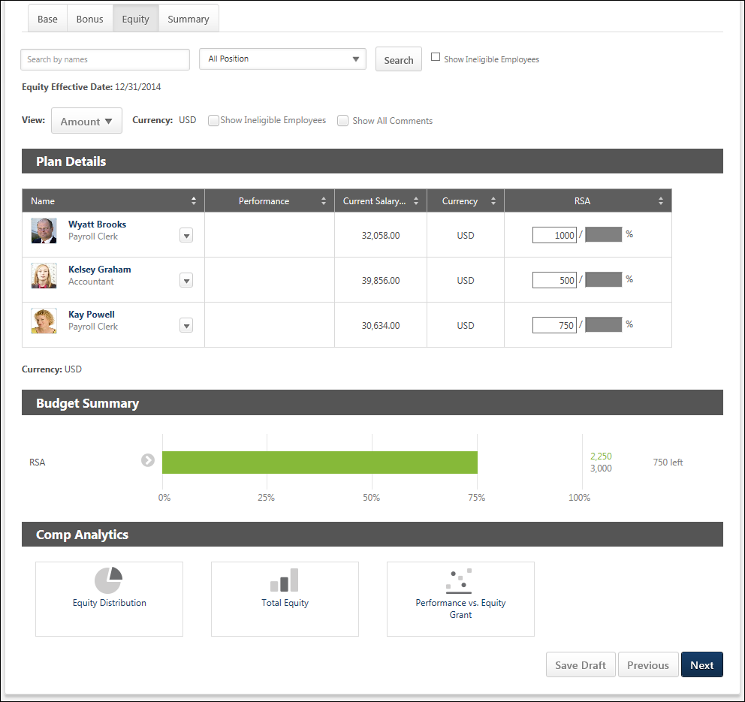
Additional Recommendations
When viewing a Base, Bonus, or Equity tab within a compensation plan, additional recommendation information may appear above the compensation plan tabs. This information pertains to the selected tab. If a different tab is selected, the information may disappear or change. Additional recommendation information is displayed when the compensation template that corresponds with the selected tab is configured to display additional recommendation information on the compensation plan. For example, when viewing the Base tab, additional recommendation information is displayed on the compensation plan if the corresponding base compensation template is configured to display additional recommendation information.
Search and Filter Users
Compensation managers and approvers can search for users within a compensation plan by name, position, and eligibility status.
- Search by Name - This field enables managers to search for specific users within the compensation plan by name. When a search is conducted, the search query is retained as the compensation manager navigates between tabs.
  - The Budget Summary and Compensation Analytics are not impacted or limited when a search is conducted.
  - Compensation managers can search by <First Name>, by <Last Name>, or by <First Name> <Last Name>. Compensation managers cannot search by <Last Name> <First Name>.
  - Compensation managers can search for multiple names by separating them by a semicolon.
- Position - This field enables managers to filter the compensation plan by position. When one or more position organizational unit (OU) is selected, the compensation plan only displays users who are within the selected positions. This enables compensation managers to easily compare employees within the same position or similar positions. The filter only contains the positions that are associated with users within the compensation plan. If there are no users within the compensation plan, then this filter is not available.
- Show Ineligible Employees - Select this option to include ineligible employees in the search. No component data is displayed and no options are available for ineligible employees.
Effective Date
This displays the date on which the compensation adjustments on the selected tab will be implemented. For example, if the effective date for the Base tab is March 15, 2015, then any compensation adjustments that are made on the Base tab will be reflected in the user's compensation on March 15, 2015.
View Options
The following options enable the compensation manager to customize how information is displayed in the Plan Details table:
- View - From the drop-down, select whether components are displayed as an amount or as a percentage. Administrators can configure the default selection for this option when configuring the compensation template.
  - Amount - Select this option to display components as fixed currency amounts. This option is selected by default.
  - Percentage - Select this option to display components as percentages of the budget (i.e., <ALLOCATION> divided by <BUDGET>). If no budget applies or has been set, "--%" is displayed.
- Currency - From the drop-down, select the currency in which currency amounts are displayed throughout the compensation plan tab. If only one currency is available, then the currency is displayed as text and cannot be modified. Currency conversions are based upon the conversion rate at the time the compensation task was launched. The following currencies may be available:
  - Compensation Task Currency
  - Compensation Manager's Currency
  - Employee's Currency
- Show Ineligible Employees - Select this option to include ineligible employees in the Plan Details table for the current tab. No component data is displayed and no options are available for ineligible employees. Administrators can configure the default selection for this option when configuring the compensation template.
- Show All Comments - Select whether all comments for each user are displayed directly in the Plan Details table. When this option is selected, all comments for the current compensation plan tab are displayed in the Plan Details table. The user photo and name of the compensation manager who wrote the comment and the date and time at which the comment was made are displayed for each comment. The newest comments are displayed first. This option is unchecked by default.
- Show - From the drop-down, select the maximum number of users who can be displayed in the Plan Details table. If more than the selected number is available, then the additional users appear on a separate page, and the compensation manager must navigate to each page to view all users. This option is only available if at least 16 users are available to be displayed in the Plan Details table. This includes ineligible employees.
Plan Details Table
The plan details table can be sorted by any of the data or component columns in the plan. Only one column can be sorted at a time. Monetary values are sorted based on string values, so all hourly rates appear above salary rates when sorted from low to high. In addition, $500 appears before 1000 Yen when sorted from low to high regardless of the currency conversion.
- The sorting applies to the entire compensation plan tab, regardless of the number of pages. If the compensation manager is not on the first page when they sort the plan, they are taken to the first page of the plan.
- To sort the compensation plan based on a certain column, click the column heading. To reverse the sort order, click the column heading again. When navigating to a different tab, the sort order is not saved.
The following information is displayed for each user in the Plan Details table:
- User Photograph
- Name - Click the user's name to open their Universal Profile - Snapshot in a separate window. See Snapshot Overview for additional information. If Universal Profile - Snapshot is not enabled, then this opens their Universal Profile - Bio in a separate window. See Universal Profile - Bio Overview for additional information.
- Position
- Promoted - A Promoted link will appear below the user's Position OU title if the user is promoted during a compensation task. Click the link to open the Promotion pop-up. Note: If the user is given a promotion, and then the promotion is removed, the Promoted link is removed.
- Options - To view which options are available for a user, click the Options drop-down to the right of the user's name. See the User Options section below for additional information. Note: The Options drop-down is not available for ineligible employees.
- Components - For each component included in the compensation component template, a column appears to the right of the Name column. The layout of the columns and the column names are configured by the compensation administrator when the compensation template is created. See the Components section below for additional information.
At the bottom of the Plan Details table, the horizontal scroll bar is always visible when viewing any part of the Plan Details table when not all data in the table can be displayed on the screen. The horizontal scroll bar enables the user to scroll left and right on the Plan Details table. As the user scrolls vertically on the page while the Plan Details table is displayed, the horizontal scroll bar for the Plan Details table floats at the bottom of the screen.
User Options
The following options may be available by selecting the Options drop-down to the right of the eligible user's name:
- More Info - Select this option to open the expanded view of the employee. This option is only available if the expanded view is enabled for the component tab (i.e., Base, Bonus, Equity). See Compensation Plan - Employee Expanded View on page 87 for additional information.
- Comment - Select this option to view a history of all of the comments made regarding the user for the component tab (i.e., Base, Bonus, Equity). This option also enables the compensation manager to add a new comment. See Compensation Plan - Comments on page 83 for additional information.
- Show Warning - Select this option to view the components within the compensation plan that are outside the component guidelines. This option is only available when there is at least one component that is outside its guidelines. See Compensation Plan - Outside Guidelines on page 97 for additional information.
Note: The Options drop-down is not available for ineligible employees.
Components
For each component included in the compensation component template, a column appears to the right of the Name column. The layout of the columns and the column names are configured by the compensation administrator when the compensation template is created. Note: No data is displayed for ineligible employees.
In the corresponding field for each component, the compensation manager can enter the appropriate compensation adjustment for each component for each employee. When a component allocation field is selected, a fixed amount field and a percentage of base field are displayed. Enter the allocation amount or percentage in the appropriate field. Note: If an equity component is allocated in shares, the percentage of base field is not available.
Target equity grants can be set for an employee. If a target equity grant is set, the target amount is displayed.
If any adjustment guidelines are defined for the employee, the adjustment fields are automatically populated with the recommended adjustments. The recommended adjustment values can be modified, but must remain within the adjustment guidelines. If a component allocation is outside the component guidelines, an error icon appears to the right of the allocation. Compensation managers can click the icon to open the Over Guideline pop-up, which enables the compensation manager to adjust the allocation. See Compensation Plan - Over Guideline on page 99 for additional information.
- If a component allocation is outside the component guidelines but within the threshold, a yellow Error icon appears to the right of the component allocation.
- If a component allocation is outside the component guidelines and also exceeds the threshold, a red Error icon appears to the right of the component allocation.
Adjustment Guideline Recommendations
If a discretionary adjustment guideline applies to a component, then the Adjustment Guidelines icon appears to the right of the component field. Hover the computer cursor over the icon to view the original recommended allocations for the component. The pop-up displays the currency and the original recommended allocation for the component. The currency that is displayed is the currency that is set for the compensation plan.
The Adjustment Guidelines icon is not available if there is no associated adjustment guideline or if the guideline is non-discretionary.
For equity components being allocated as a cash award, the currency that is displayed is the currency that is set for the compensation plan. For equity components being allocated as shares, the currency is displayed as "Shares."
Component Proration
If a component has been prorated for the user, then the Prorated Recommendations icon appears to the right of the component field. Hover the computer cursor over the icon to view the prorated recommendations for the component. The pop-up displays the currency and the prorated recommendations for the component. The currency that is displayed is the currency that is set for the compensation plan.
- If the component has not yet been prorated into multiple periods, then the component allocation field is editable.
- If the component has multiple prorated periods, then the component allocation field is read-only and an Edit icon appears to the right of the Prorated Recommendations icon. Click the Edit icon to open the Proration pop-up and allocate prorated amounts for each of the prorated periods of the component for the user.
See Compensation Plan - Proration - Equity on page 113 for additional information.
Employee Expanded View
Each employee row is collapsed by default. To view detailed information for the employee, select the More Info option from the Options drop-down menu that appears to the right of the user photo in the Plan Details table. Note: The Options drop-down is not available for ineligible employees.
See Compensation Plan - Employee Expanded View on page 87 for additional information.
Budget Summary Graph
The Budget Summary graph appears below the Plan Details table on Compensation Plan template and summary pages. This graph displays allocations, budgets, and remaining available allocations for each component that is configured to display. The graph is updated dynamically as the compensation plan is edited. See Compensation Plan - Budget Summary Graph Overview on page 76 for additional information.
Comp Analytics
The Comp Analytics section appears below the Budget Summary graph on Compensation Plan template pages. Each report displays a snapshot of the corresponding information. These reports are updated in real-time. If a component is not included in the compensation plan, then the component does not appear in any compensation analytics graphs. See Compensation Plan - Comp Analytics on page 86 for additional information.
Action Buttons
At the bottom of the page, the following buttons may be available:
- Save Draft - Click this button to save the compensation plan without submitting it.
- Previous - Click this button to return to the previous page. This button is not available on the first tab of the compensation plan.
- Next - Click this button to proceed to the next tab within the compensation plan.
- Deny - This option is only available when a compensation manager views a compensation plan that requires their approval. Click this button to validate the compensation allocations for the tab and deny the compensation plan. If all allocation validations are passed, then the Summary tab is opened, and the Approve/Deny Confirmation pop-up is opened.
- Approve - This option is only available when a compensation manager views a compensation plan that requires their approval. Click this button to validate the compensation allocations for the tab and approve the compensation plan. If all allocation validations are passed, then the Summary tab is opened, and the Approve/Deny Confirmation pop-up is opened.
Compensation Plan - Summary/Read-only/Approval Tab
The Summary/Read-only/Approval view enables compensation managers to view all components and their allocations from the compensation plan for each employee. Allocations cannot be edited in this view.
To access the Summary tab when creating a compensation plan, click the Summary tab. This is always the last tab in the compensation plan.
To access the Read-only view of a compensation plan when viewing the compensation task, from the Compensation Plans tab, select the View option for a specific draft.
To access the Approval view of a compensation plan, view a compensation plan for which you are an approver. The Approval view is only available when the compensation manager is an approver for the compensation plan but does not have editing rights.
Permissions
PERMISSION NAME | PERMISSION DESCRIPTION | CATEGORY

Compensation Plan - Manage | Grants Compensation Managers the ability to access to the landing page of their assigned compensation tasks. This permission also grants the ability to create and manage compensation plans within the task. This permission cannot be constrained. This is an end user permission. | Compensation
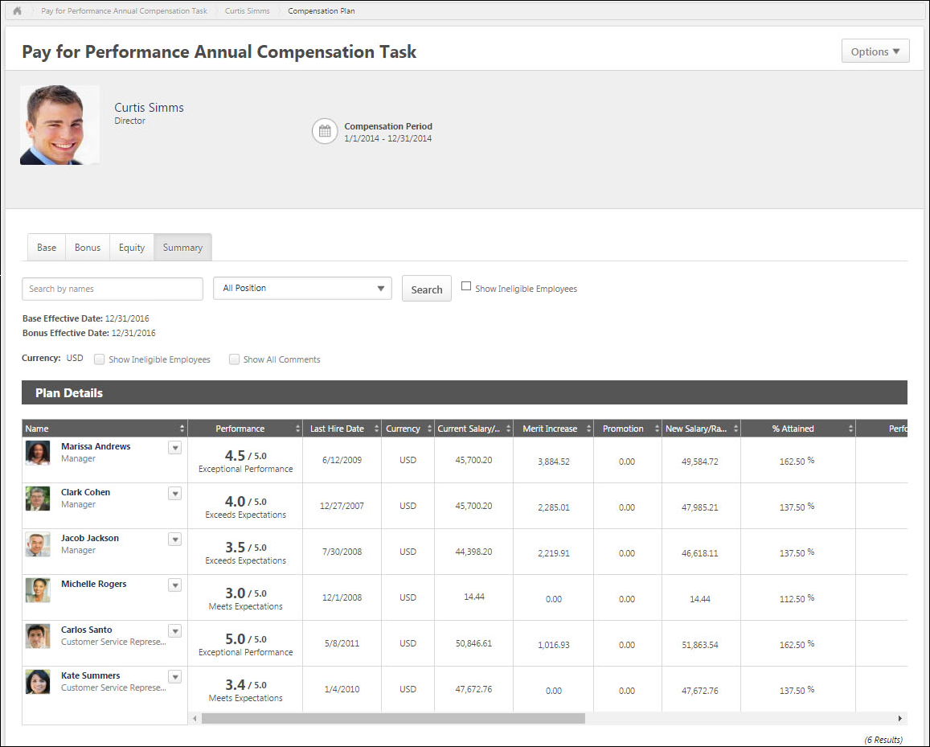
Search and Filter Users
Compensation managers and approvers can search for users within a compensation plan by name, position, and eligibility status.
- Search by Name - This field enables managers to search for specific users within the compensation plan by name. When a search is conducted, the search query is retained as the compensation manager navigates between tabs.
  - The Budget Summary and Compensation Analytics are not impacted or limited when a search is conducted.
  - Compensation managers can search by <First Name>, by <Last Name>, or by <First Name> <Last Name>. Compensation managers cannot search by <Last Name> <First Name>.
  - Compensation managers can search for multiple names by separating them by a semicolon.
- Position - This field enables managers to filter the compensation plan by position. When one or more position organizational unit (OU) is selected, the compensation plan only displays users who are within the selected positions. This enables compensation managers to easily compare employees within the same position or similar positions. The filter only contains the positions that are associated with users within the compensation plan. If there are no users within the compensation plan, then this filter is not available.
- Show Ineligible Employees - Select this option to include ineligible employees in the search. No component data is displayed and no options are available for ineligible employees.
Effective Dates
The Effective Date is displayed for each component in the compensation plan. This indicates when the changes for each component will be effective if the compensation plan is approved.
The Effective Date for each component is set when the component template is added to the compensation task.
For standard off-cycle compensation tasks, this functionality is only available if the Effective Date setting for the task is configured so that the assigner can define the effective date at the launch of the task.
For modeling compensation tasks, this functionality is not available.
View Options
The following options enable the compensation manager to customize how information is displayed in the Plan Details table:
- View - From the drop-down, select whether components are displayed as an amount or as a percentage. Administrators can configure the default selection for this option when configuring the compensation template.
  - Amount - Select this option to display components as fixed currency amounts. This option is selected by default.
  - Percentage - Select this option to display components as percentages of the budget (i.e., <ALLOCATION> divided by <BUDGET>). If no budget applies or has been set, "--%" is displayed.
- Currency - From the drop-down, select the currency in which currency amounts are displayed throughout the compensation plan tab. If only one currency is available, then the currency is displayed as text and cannot be modified. Currency conversions are based upon the conversion rate at the time the compensation task was launched. The following currencies may be available:
  - Compensation Task Currency
  - Compensation Manager's Currency
  - Employee's Currency
- Show Ineligible Employees - Select this option to include ineligible employees in the Plan Details table for the current tab. No component data is displayed and no options are available for ineligible employees. This option is unchecked by default.
- Show All Comments - Select whether all comments for each user are displayed directly in the Plan Details table. When this option is selected, all comments for the current compensation plan tab are displayed in the Plan Details table. The user photo and name of the compensation manager who wrote the comment and the date and time at which the comment was made are displayed for each comment. The newest comments are displayed first. This option is unchecked by default.
- Show - From the drop-down, select the maximum number of users who can be displayed in the Plan Details table. If more than the selected number is available, then the additional users appear on a separate page, and the compensation manager must navigate to each page to view all users. This option is only available if at least 16 users are available to be displayed in the Plan Details table.
Plan Details Table
The plan details table can be sorted by any of the data or component columns in the plan. Only one column can be sorted at a time. Monetary values are sorted based on string values, so all hourly rates appear above salary rates when sorted from low to high. In addition, $500 appears before 1000 Yen when sorted from low to high regardless of the currency conversion.
- The sorting applies to the entire compensation plan tab, regardless of the number of pages. If the compensation manager is not on the first page when they sort the plan, they are taken to the first page of the plan.
- To sort the compensation plan based on a certain column, click the column heading. To reverse the sort order, click the column heading again. When navigating to a different tab, the sort order is not saved.
The following information is displayed for each user in the Plan Details table:
- User Photograph
- Name - Click the user's name to open their Universal Profile - Snapshot in a separate window. See Snapshot Overview for additional information. If Universal Profile - Snapshot is not enabled, then this opens their Universal Profile - Bio in a separate window. See Universal Profile - Bio Overview for additional information.
- Position
- Options - To view which options are available for a user, click the Options drop-down to the right of the user's name. See the User Options section below for additional information.
- Components - For each component included in the compensation plan, a column appears to the right of the Name column. The layout of the columns and the column names are configured by the compensation administrator when the compensation task is created. See the Components section below for additional information.
At the bottom of the Plan Details table, the horizontal scroll bar is always visible when viewing any part of the Plan Details table when not all data in the table can be displayed on the screen. The horizontal scroll bar enables the user to scroll left and right on the Plan Details table. As the user scrolls vertically on the page while the Plan Details table is displayed, the horizontal scroll bar for the Plan Details table floats at the bottom of the screen.
User Options
The following options may be available by selecting the Options drop-down to the right of the user's name:
- More Info - Select this option to open the expanded view of the employee. This option is only available if the expanded view is enabled for at least one component tab (i.e., Base, Bonus, Equity). This option is also available if the user has been promoted. See Compensation Plan - Employee Expanded View on page 87 for additional information.
- Comment - Select this option to view a history of all of the comments made regarding the user for all component tabs (i.e., Base, Bonus, Equity). This option also enables the compensation manager to add a new comment. See Compensation Plan - Comments on page 83 for additional information.
Components
For each component included in the compensation plan, a column appears to the right of the Current Salary column. The layout of the columns and the column names are configured by the compensation administrator when the compensation task is created. Components can be hidden from this page when creating the compensation task. Hiding a component from the Summary page hides the component from the Budget Summary graph, but it does not hide the component as a column in the table.
If a component allocation is outside the component guidelines, a yellow Error icon appears to the right of the component allocation. See Compensation Plan - Outside Guidelines on page 97 for additional information.
Line Item Approval
If a compensation plan has been denied with line item approval and the original compensation manager is viewing the compensation plan, the approval or denial details appear to the left of each employee.
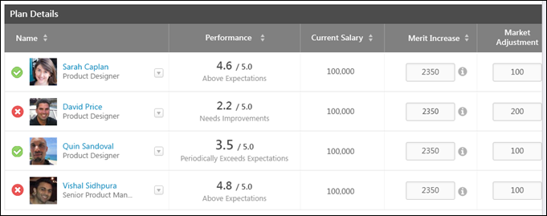
Employee Expanded View
Each employee row is collapsed by default. To view detailed information for the employee, select the More Info option from the Options drop-down menu that appears to the right of the user photo in the Plan Details table. Note: The Options drop-down is not available for ineligible employees.
See Compensation Plan - Employee Expanded View on page 87 for additional information.
Budget Summary Graph
The Budget Summary graph appears below the Plan Details table on Compensation Plan template and summary pages. This graph displays allocations, budgets, and remaining available allocations for each component that is configured to display. The graph is updated dynamically as the compensation plan is edited. See Compensation Plan - Budget Summary Graph Overview on page 76 for additional information.
Additional Comments
On the Summary tab, compensation managers can add additional comments regarding the compensation plan before it is finalized. The additional comments are then viewable within the Plan History pop-up.
When in read-only view, this section displays any existing additional comments, but this field cannot be edited.
Action Buttons
At the bottom of the page, the following buttons may be available:
- Save Draft - Select this button to save the compensation plan without submitting it.
- Previous - Select this button to return to the previous page.
- Submit - Select this button to submit the compensation plan. This button is only available on the Summary tab. This button is only available if the following is true:
  - All allocations are within the corresponding guidelines and thresholds.
  - If there are Cascaded Budget Type components, all budgets have been distributed.
  - If there are Cascaded Budget Type components, all subordinate compensation plans have been submitted.
- Deny - Select this button to deny the compensation plan. This button is only available if the compensation plan is pending the compensation manager's approval. This opens the Approve/Deny Confirmation pop-up. See Compensation Plan - Approve/Deny Confirmation on page 74 for additional information.
- Approve - Select this button to approve the compensation plan. This button is only available if the compensation plan is pending the compensation manager's approval. This opens the Approve/Deny Confirmation pop-up. See Compensation Plan - Approve/Deny Confirmation on page 74 for additional information.
Compensation Plan - Options Drop-down Overview
When creating a compensation plan, the following options may be available from the Options drop-down menu:
- Additional Recommendations - Select this option to view the additional recommendations that are associated with the compensation plan tab. This option is only available if the Base, Bonus, or Equity tab is selected, and if the corresponding compensation template is configured to include additional recommendations in a pop-up. See Compensation Plan - Additional Recommendations on page 72 for additional information.
- Contact Administrator - Select this option to send a message to the administrator for the compensation task. This option is only available if an administrator contact is defined for the compensation task. See Compensation Task - Contact Administrator on page 31 for additional information.
- View History - Select this option to view the submission and approval history of the compensation plan. This option is only available if there is any history to display for the user's compensation plan. See Compensation Task - View Plan History on page 36 for additional information.
Compensation Plan - Additional Recommendations
The Additional Recommendations pop-up provides compensation managers with additional recommendations when completing a Base, Bonus, or Equity tab within a compensation plan. The additional recommendation information is specific to the selected tab. If a different tab is selected, the information may not be available or may change.
To view the additional recommendations that are associated with the compensation plan tab, select Additional Recommendations from the Options drop-down in the User Dashboard.
This option is only available if the Base, Bonus, or Equity tab is selected, and if the corresponding compensation template is configured to include additional recommendations in a pop-up.
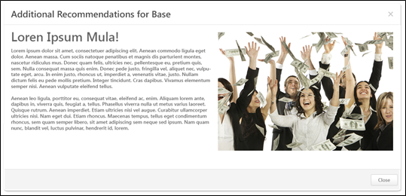
Compensation Plan - Components/Pop-ups Overview
Compensation Plan - Approve/Deny Confirmation
The Approve and Deny Confirmation pop-ups enable the approver to confirm the approval or denial of the compensation plan.
The Approve Confirmation pop-up opens when an approver clicks the Approve button on a compensation plan that is pending the approver's approval.
The Deny Confirmation pop-up opens when an approver clicks the Deny button on a compensation plan that is pending the approver's approval.
Approve Confirmation Pop-up
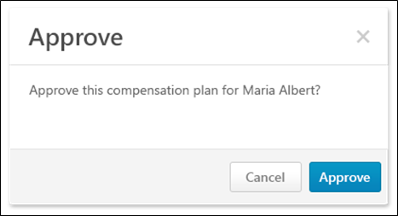
The following options are available in the Approve pop-up:
- Approve - Click this button to approve the compensation plan. The compensation plan is approved and moves to the next step in the approval workflow for the compensation task.
- Cancel - Click this button to cancel the approval and return to the compensation plan.
Deny Confirmation Pop-up
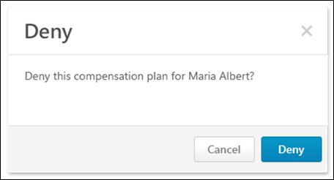
The following options are available in the Deny pop-up:
- Deny - Click this button to deny the compensation plan. The compensation plan is denied and is returned to the original compensation manager.
- Cancel - Click this button to cancel the denial and return to the compensation plan.
Compensation Plan - Budget Summary Graph Overview
The Budget Summary graph appears below the Plan Details table on Compensation Plan template and summary pages. This graph displays allocations, budgets, and remaining available allocations for each component that is configured to display. The graph is updated dynamically as the compensation plan is edited. If all components are hidden from the Budget Summary graph, then the entire Budget Summary graph is hidden.
The Budget Summary graph only appears for compensation planning tasks.
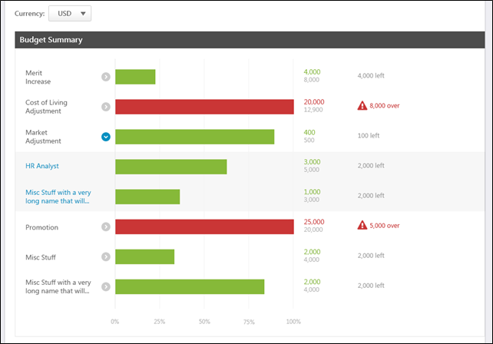
Currency
From the drop-down, select the currency in which currency amounts should be displayed in the Budget Summary and Comp Analytics graphs. If only one currency is available, then the currency is displayed as text and cannot be modified. Currency conversions are based upon the conversion rate at the time the compensation task was launched. The following currencies may be available:
- Corporate Currency
- Compensation Manager's Currency - This option is selected by default.
- Currency of any eligible employee in the compensation plan
Note: The Currency drop-down is hidden on the Equity tab if all equity components are granted in Shares instead of Awards.
Graph Data
Each component that is visible in the compensation template appears in the graph in the following order:
- Base Tab:
  - Merit Increase
  - Custom base components that are included in the Base salary in alphabetical order
  - Custom base components that are not included in the Base salary in alphabetical order
- Bonus Tab:
  - Bonus
  - Custom bonus components in alphabetical order
  - Custom bonus target components in alphabetical order
- Equity Tab:
  - Equity components in alphabetical order
  - Equity target components in alphabetical order
- Summary Tab:
  - Base components that are included in the Base Salary in alphabetical order
  - Base components that are not included in the Base Salary in alphabetical order
  - Bonus components in alphabetical order
  - Equity components in alphabetical order
The Budget Summary graph displays the following information for each component:
- Component Name
- Average Increase (Base Components Only) - See Compensation Plan - Budget Summary Graph - Average Merit Increase Display on page 80 for additional information.
- Expand/Collapse - If a component has multiple budgets, an Expand icon or a Collapse icon appears to the right of the component name. Compensation managers can expand a component to view the allocations and budgets for each OU specific component budget. By default, all components are collapsed, displaying only the overall component allocation and budget. See the Component with Multiple Budgets section below for additional information.
- Graph - The bar graph represents the component allocations with relation to the component budget. The allocation percentages are also displayed at the bottom of the graph.
  - If the allocations are less than the budget, then the row is green.
  - If the allocations exceed the budget, then the row is red.
- Allocation/Budget - To the right of the graph, the exact component allocation and budget values are displayed.
  - If the allocations are less than the budget, then the allocation value appears green.
  - If the allocations exceed the budget, then the allocation value appears red.
- Amount Over/Under Budget - To the right of the allocations and budget values, the amount by which the allocations are over or under the budget is displayed.
  - If the allocations are less than the budget, then the amount remaining for allocation appears gray.
  - If the allocations exceed the budget, then the amount by which the budget is exceeded appears red and an Error icon is displayed.
  - If a component contains an OU specific component that is over budget, then the overall component and the OU specific component appear as over budget. However, the overage amount only appears for the OU specific component.
Component with Multiple Budgets
If a component has multiple budgets, an Expand icon or a Collapse icon appears to the right of the component name. Compensation managers can expand a component to view the allocations and budgets for each OU specific component budget. By default, all components are collapsed, displaying only the overall component allocation and budget.
Component with Multiple Budgets - Collapsed
When a component with multiple budgets is collapsed, the overall budget summary for the component is displayed. This represents the sum of the allocations and budgets from the OU specific component budgets. If an OU specific component does not have a budget, then the allocation amount for the OU specific component is used as the budget.
Component with Multiple Budgets - Expanded
When a component with multiple budgets is expanded, the budget summary is displayed for each OU specific component budget.
- An OU specific component only appears in the graph if there are eligible employees in the compensation plan who apply to the OU specific component budget.
- If an OU specific component does not have a budget, then the budget for the OU specific component is represented by dash marks (i.e., "---").
Component with Multiple Budgets - Filter
When a component with multiple budgets is expanded, compensation managers can click the name of an OU specific component budget to filter the current tab of the compensation plan by the selected component budget. When a tab is filtered by an OU specific component budget, the following occurs:
- The selected OU specific component budget filter is displayed at the top of the compensation plan tab. To remove the filter, click the X icon to the right of the filter details.
- The Budget Summary graph and the Plan Details table are filtered by the selected OU specific component budget. Only users who apply to the selected budget OU appear in the Plan Details table.
- The Budget Summary graph only displays information for the selected OU specific component and the associated overall component (e.g., Merit Increase - Australia budget and Merit Increase - Overall budget).
- Note: The OU specific component budget filter only applies to the current tab. Other tabs within the compensation plan are unaffected. Also, the compensation manager cannot filter the compensation plan when an employee in the compensation plan has been allocated over the threshold that was set in Adjustment Guidelines. The employee line item appears in red when this occurs.
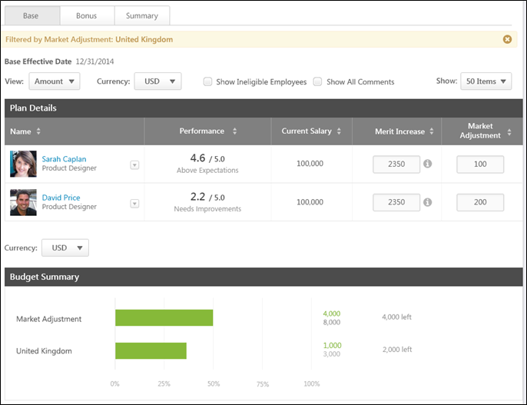
Compensation Plan - Budget Summary Graph - Average Merit Increase Display
Organizations may choose to display the average merit increase in a compensation task. This is only available for base components. This functionality is disabled by default.
The average merit increase percentage can be viewed per component and per organizational unit (OU). Organizations can choose to display either the Average Allocation percentage or the Average Increase percentage:
- Average Allocation - This displays the average of all allocation percentages for the component or OU. See Compensation Plan - Budget Summary Graph - Use Case - Average Allocation on page 81 for additional information.
- Average Increase - This displays the average of all budget increase percentages for the component or OU. This is calculated using the overall ratio of allocations to current salary. See Compensation Plan - Budget Summary Graph - Use Case - Average Increase on page 82 for additional information.
The values are displayed using the compensation decimals of precision for percentages.
If automatic lump sum adjustments are enabled for merit increase, then these allocations are included in the Average Allocation and Average Increase calculations.
Only one value can be displayed. If both values are enabled, then only the Average Increase is displayed.
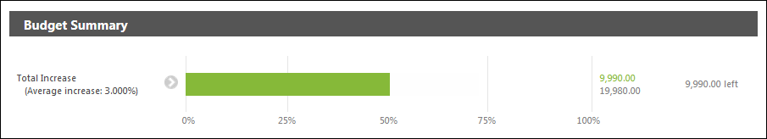
Compensation Plan - Budget Summary Graph - Use Case - Average Allocation
The following budgets are set for the compensation task:
Organizational Unit (OU) | Merit Increase Budget by OU | Cost of Living Budget by OU
Division A | 3% | 5%
Division B | 4% | 4%
Division C | 3.5% | 3.5
The following users are in the compensation plan:
User | OU | Current Salary/Hourly Rate
User 1 | Division A | 10,000 USD
User 2 | Division B | 20,000 GBP (30,000 USD)
User 3 | Division C | 30,000 USD
User 4 | Division A | 40 USD/hour; 2080 hours/year (83,200 USD Annualized)
The decimals of precision that are used for percentages in compensation is 2.
The following allocations are given in the compensation plan:
User | Merit Increase | Cost of Living
User 1 | 3% (300 USD) | 4% (400 USD)
User 2 | 4% (800 GBP; 1200 USD) | 5% (1000 USD; 1500 USD)
User 3 | 3.5% (1050 USD) | 3% (900 USD
User 4 | 2.5% (2080 USD) | 2% (1664 USD)
Total | 4630 USD | 4464 USD
The average allocation is calculated by finding the average of all allocation percentages. The following average allocations result from the compensation plan:
Division | Merit Increase | Cost of Living
Division A (Users 1 & 4) | (3% + 2.5%) / 2 = 2.75% | (4% + 2%) / 2 = 3.00%
Division B (User 2) | 4% / 1 = 4.00% | 5% / 1 = 5.00%
Division C (User 3) | 3.5% / 1 = 3.50% | 3% / 1 = 3.00%
Overall | (3% + 4% + 3.5% + 2.5%) / 4 = 3.25% | (4% + 5% + 3% + 2%) / 4 = 3.50%
Compensation Plan - Budget Summary Graph - Use Case - Average Increase
The following budgets are set for the compensation task:
Organizational Unit (OU) | Merit Increase Budget by OU | Cost of Living Budget by OU
Division A | 3% | 5%
Division B | 4% | 4%
Division C | 3.5% | 3.5
The following users are in the compensation plan:
User | OU | Current Salary/Hourly Rate
User 1 | Division A | 10,000 USD
User 2 | Division B | 20,000 GBP (30,000 USD)
User 3 | Division C | 30,000 USD
User 4 | Division A | 40 USD/hour; 2080 hours/year (83,200 USD Annualized)
The decimals of precision that are used for percentages in compensation is 2.
The following allocations are given in the compensation plan:
User | Merit Increase | Cost of Living
User 1 | 3% (300 USD) | 4% (400 USD)
User 2 | 4% (800 GBP; 1200 USD) | 5% (1000 USD; 1500 USD)
User 3 | 3.5% (1050 USD) | 3% (900 USD
User 4 | 2.5% (2080 USD) | 2% (1664 USD)
Total | 4630 USD | 4464 USD
The average budget increase is calculated by dividing the total allocations by the total original salaries. The following average budget increases result from the compensation plan:
Division | Merit Increase | Cost of Living
Division A (Users 1 & 4) | (300 + 2,080) / (10,000 + 83,200) = 2.55% | (400 + 1,664) / (10,000 + 83,200) = 2.21%
Division B (User 2) | 1,200 / 30,000 = 4.00% | 1,500 / 30,000 = 5.00%
Division C (User 3) | 1,050 / 30,000 = 3.50% | 900 / 30,000 = 3.00%
Overall | (300 + 1,200 + 1,050 + 2,080) / (10,000 + 30,000 + 30,000 + 83,200) = 3.02% | (400 + 1,500 + 900 + 1,664) / (10,000 + 30,000 + 30,000 + 83,200) = 2.91%
Compensation Plan - Comments
The Comments pop-up shows a history of all of the comments made for a user for a specific component in the compensation plan. The pop-up also enables the compensation manager to add a new comment.
The Component Tab Comments pop-up can only be accessed from one of the compensation plan component tabs (i.e., Base, Bonus, Equity). To access the pop-up, select the Comments option from the Options drop-down menu that appears to the right of the user photo in the Plan Details table.
The Summary Comments pop-up can only be accessed from the Summary tab or the Read-only/Approval view of the compensation plan. To access the pop-up, select the Comments option from the Options drop-down menu that appears to the right of the user photo in the Plan Details table. Note: The Options drop-down is not available for ineligible employees.
Component Tab Comments Pop-up
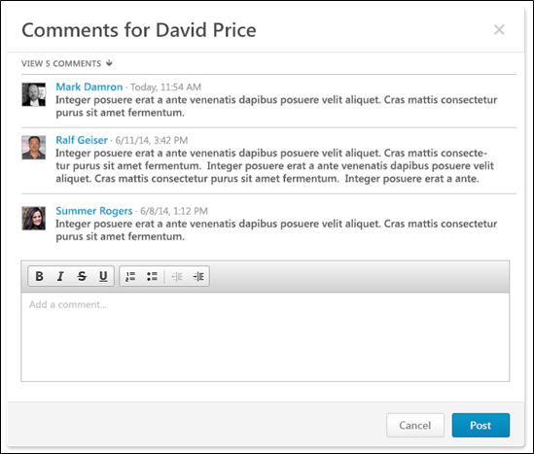
The Component Tab Comments pop-up only displays comments that have been added for the corresponding user on the corresponding component tab. The pop-up title indicates the user whose comments are being viewed.
By default, the last three comments that were added for the user on the component tab are displayed with the most recent comment displayed first. If more than three comments are available, the compensation manager can view all comments by clicking the View # Comments link. The compensation manager can then hide the additional comments by clicking the Show Less link.
The following information is displayed for each comment:
- User Photograph
- Name
- Timestamp - This displays the date and time at which the comment was added.
- Comment Text
To add a comment, enter the comment text in the Add a comment field, up to 2000 characters. This field includes rich text editing options.
- After entering a comment, click Post to post the comment. The pop-up remains open and the new comment appears at the top of the comments list.
- To close the pop-up, click Cancel.
Summary Comments Pop-up
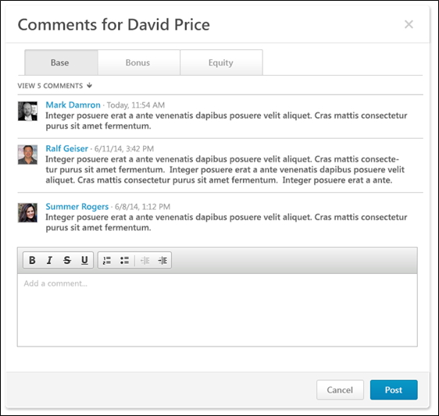
The Summary Comments pop-up enables the compensation manager to view comments from each tab within the compensation plan. Each component tab within the compensation plan appears on a separate tab within the pop-up. Each tab displays comments that have been added for the corresponding user on the corresponding component tab. The pop-up title indicates the user whose comments are being viewed.
By default, the last three comments that were added for the user on the component tab are displayed with the most recent comment displayed first. If more than three comments are available, the compensation manager can view all comments by clicking the View # Comments link. The compensation manager can then hide the additional comments by clicking the Show Less link.
The following information is displayed for each comment:
- User Photograph
- Name
- Timestamp - This displays the date and time at which the comment was added.
- Comment Text
To add a comment for the selected component tab, enter the comment text in the Add a comment field, up to 2000 characters. This field includes rich text editing options. Note: Compensation managers cannot add a comment when viewing the compensation plan in read-only mode.
- After entering a comment, click Post to post the comment. The pop-up remains open and the new comment appears at the top of the comments list.
- To close the pop-up, click Cancel.
Compensation Plan - Comp Analytics
The Comp Analytics section appears below the Budget Summary graph on Compensation Plan template pages. Each report displays a snapshot of the corresponding information. These reports are updated in real-time. If a component is not included in the compensation plan, then the component does not appear in any compensation analytics graphs.
The Comp Analytics section only appears on a tab if it is enabled for the corresponding compensation template. The Comp Analytics section may appear on some tabs, but not others.
The following Comp Analytics may be available on each tab:
- Base:
  - Salary Distribution - This report displays a pie chart of the distribution of employee salary.
  - Total Salary - This report displays a bar graph of each employee's total salary.
  - New Compa-Ratio Over Under - This report displays a graph of New Comp-Ratio Over Under for the employees.
  - Performance vs. New Compa-Ratio - This report displays a graph of each employee's Performance versus New Compa-Ratio.
- Bonus:
  - Bonus Distribution - This report displays a pie chart of the distribution of employee bonuses.
  - Total Bonus - This report displays a bar graph of each employee's total bonus.
  - Bonus Attained - This report displays a graph of the percentage of each employee's attained bonus.
  - Performance vs. Bonus Attainment - This report displays a graph of each employee's Performance versus Bonus Attainment.
- Equity:
  - Equity Distribution - This report displays a pie chart of the distribution of employee equity.
  - Total Equity - This report displays a bar graph of each employee's total equity.
  - Performance vs. Equity Grant - This report displays a graph of each employee's Performance versus Equity Grant.
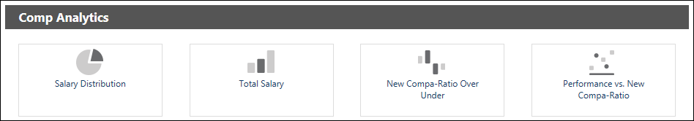
Compensation Plan - Employee Expanded View
Each employee row is collapsed by default. To view detailed information for the employee, select the More Info option from the Options drop-down menu that appears to the right of the user photo in the Plan Details table. Note: The Options drop-down is not available for ineligible employees.
The expanded view displays additional information about the employee. The administrator can configure which information is displayed when the compensation template is configured.
The following informational graphs are available within the employee expanded view on each tab:
- Base:
  - Salary History/Rate History - Click this icon to view the employee's salary/rate for the past three years in graph form.
  - Performance History - Click this icon to view the employee's performance review history.
- Bonus:
  - Bonus History - Click this icon to view the employee's bonuses for the past three years in graph form.
  - Performance History - Click this icon to view the employee's performance review history.
- Equity:
  - Grant History - Click this icon to view the employee's equity awards for the past three years in graph form.
  - Performance History - Click this icon to view the employee's performance review history.
- Summary, Read-only, Approval - No information graphs are available within the employee expanded view for this tab.
Note: If a component is not included in the compensation plan, then the component does not appear in any compensation plan history graphs.
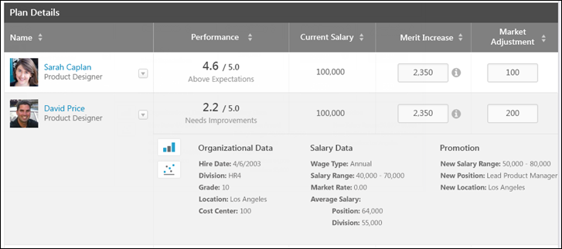
Compensation Plan - Lump Sum Allocation
If lump sum adjustments are enabled for the Base tab, a Lump Sum component appears on the Base tab in the compensation plan. The location and the name of the Lump Sum column is configured by the administrator when the base template is created. A lump sum is a one-time payment that does not affect the employee's salary/rate. However, it does count towards the budget for base adjustments.
Tooltips for Merit Increase and Lump Sum Components
Tooltips for the Merit Increase and Lump Sum components indicate the automatic allocation shift from Merit Increase to Lump Sum. The tooltips are only visible if the compensation template is configured to allow for automatic lump sum allocation for salary range overages.
Merit Increase Tooltip
The Merit Increase tooltip indicates that salary range overage amounts are allocated to the Lump Sum component. Note: The tooltip only displays help text if Recommendations are not available.
When users click into the Merit Increase component field, compensation plans display the original allocated merit increase amount prior to automatic lump sum adjustment and the Lump Sum component reflects "0." When users click out of the Merit Increase component field, automatic lump sum adjustment for salary range overages are calculated and reflected in the Merit Increase and Lump Sum components.
Considerations
The following considerations assume that the automatic lump sum adjustment for salary range overages functionality is enabled:
- Once automatic lump sum adjustment has occurred and the Merit Increase component is not being edited, the Merit Increase and Lump Sum components reflect the amounts calculated by the automatic lump sum adjustment, as currently implemented.
- When editing the allocation amount in the Merit Increase component, the merit increase reflects the original allocated merit increase amount prior to the automatic lump sum adjustment (i.e., <Merit Increase> + <Lump Sum>). Further, the lump sum amount reflects "0."
Use Cases
The following use cases assume that the base template in the task includes Merit Increase and Lump Sum components and that the Automatic Lump Sum allocation for Salary Range overages option is enabled.
Position | Wage Type | Minimum Salary/Rate | Maximum Salary/Rate
Sr. Software Engineer | Annual | $90,000 | $115,000

Employee | Wage Type | Labor Hours | Position | Current Salary/Rate
Jonathan Stanley | Annual | N/A | Sr. Software Engineer | $115,000
Use Case 1: Merit Increase Component - Read-Only Mode
Default Merit Increase adjustment guideline at 5% of base.
Action
Compensation manager creates a new compensation plan.
Results
- Jonathan Stanley reflects:
- Merit Increase: $0.00/0.0%
- New Salary: $115,000.00
- Lump Sum: $5,750.00
  - Salary Range overage: $5,750.00/5.0%
Use Case 2: Merit Increase Component - Edit Mode
Default Merit Increase adjustment guideline at 5% of base.
Action
- Compensation manager creates a new compensation plan.
- Compensation manager opens Jonathan Stanley's Merit Increase component to edit the allocation amount.
Results
- Jonathan Stanley reflects:
- Merit Increase: $5,750.00/5.0%
- New Salary: $115,000.00
- Lump Sum: $0.00
Use Case 3: Merit Increase Component - Edit and Move
Default Merit Increase adjustment guideline at 5% of base.
Action
- Compensation manager creates a new compensation plan.
- Compensation manager opens Jonathan Stanley's Merit Increase component to edit the allocation amount.
- Compensation manager edits Jonathan Stanley's merit increase from $5,750.00 to $3,450.00.
- Compensation manager clicks outside Jonathan Stanley's Merit Increase component on the compensation plan.
Results
- Jonathan Stanley reflects:
- Merit Increase: $0.00/0.0%
- New Salary: $115,000.00
- Lump Sum: $3,450.00
  - Salary Range overage: $3,450.00/3.0%
Lump Sum Tooltip
The Lump Sum tooltip indicates the salary range overage amount that has been shifted from the Merit Increase component. In addition to the currency, the following is included in the tooltip depending on if the wage type is annual or hourly:
- Annual Wage Type - The Salary Range overage field displays the amount shifted from the Merit Increase component that caused the employee to exceed the salary range. The Salary Range overage field also shows the percentage of the overage amount against the employee's current salary. The values included in the field display as <Overage Amount> <Currency> / <Overage as Percentage of Base>. Note: The Salary Range overage field displays "0.00 <CURRENCY> / 0.0%" if the employee is still within their salary range or if the employee exceeds the salary range but no Merit Increase amount has been allocated.
- Hourly Wage Type - The Rate Range overage displays the money per-hour rate amount for which the employee is the salary range. The values included in the field display as <Overage Amount> <Currency> / <Overage as Percentage of Base>. Note: If the hourly salary range is only specified by an annualized amount, the rate range overage is calculated using the following formula: <Max Annual Salary>/<Labor Hours>.
New Salary Exceeds Salary Range
If an employee's new salary is over their salary range, the overage amount is deducted from the merit increase allocation and appears in the Lump Sum component allocation. For annual wage type employees, the overage amount is moved from Merit Increase to display in the Lump Sum component. For hourly wage type employees, the overage amount is calculated by taking the overage expressed in money per hour multiplied by the employee's labor hours. This annualized overage amount displays in the Lump Sum component.
Prorated Merit Increase
If Merit Increase is a prorated component, then when editing the merit increase allocation, the Merit Increase Recommendations pop-up displays help text indicating the automatic allocation. See Compensation Plan - Proration - Base on page 106 for additional information.
Considerations
The following considerations assume that the automatic lump sum adjustment for salary range overages functionality is enabled:
- The calculated merit increase proration breakdown is only visible within the compensation statement when using the proration breakdown tag.
- When the user opens the Merit Increase Recommendations pop-up, the total increase amount reflects the total allocated merit increase amount prior to the automatic lump sum adjustment. Each of the prorated line items show the previous allocated line item amount prior to the automatic lump sum adjustment. That is, the system remembers what was allocated to each prorated line item prior to the automatic lump sum adjustment.
- When the user is not viewing the Merit Increase Recommendations pop-up, the compensation plan reflects the actual Merit Increase and Lump Sum components after the automatic lump sum adjustment.
Use Cases
The following use cases assume that the Automatic Lump Sum allocation for Salary Range overages option is enabled.
Position | Wage Type | Minimum Salary/Rate | Maximum Salary/Rate
Software Engineer | Annual | $75,000 | $90,000
Sr. Software Engineer | Annual | $90,000 | $115,000

Employee | Wage Type | Labor Hours | Position | Current Salary/Rate
Melissa Powers | Annual | N/A | Sr. Software Engineer | $100,000
Use Case 1: Proration - Simple
Assumptions
- Melissa Powers' positions from 1/1/2011 - 12/31/2011:
- Software Engineer: 1/1/2011 - 5/20/2011 (140 days, 38.4%)
- Sr. Software Engineer: 5/21/2011 - 12/31/2011 (225 days, 61.6%)
- Compensation period is set to 1/1/2011 - 12/31/2011.
- Merit increase is prorated by the length of time in the position.
- Default Merit Increase adjustment guideline at 20% of base.
Action
- Compensation manager creates a new compensation plan.
- Melissa Powers shows $15,000 in the Merit Increase component and $5,000 in the Lump Sum component.
- Compensation manager edits the Merit Increase component for Melissa Powers.
Results
- Merit Increase proration pop-up displays the following:
- First prorated period
  - Position: Software Engineer
  - Proration: 38.4%
  - Minimum: $7,671.23
  - Maximum $7,671.23
  - Increase: $7,671.23/7.7%
- Second prorated period
  - Position: Sr. Software Engineer
  - Proration: 61.6%
  - Minimum: $12,328.77
  - Maximum: $12,328.77
  - Increase: $12,328.77/12.3%
- Total Increase: $20,000.00
- The following are compensation tags for Melissa Powers:
- Merit Increase Proration Breakdown:
Date | Number of Days | Amount
1/1/2011 | 140 | $7,671.23
5/21/2011 | 225 | $7,328.77
 | Total | $15,000.00
- Merit Increase: $15,000.00
- Lump Sum: $5,000.00
Use Case 2: Decreasing Component After Salary Range Overage - Proration
Assumptions
- Melissa Powers' positions from 1/1/2011 - 12/31/2011:
- Software Engineer: 1/1/2011 - 5/20/2011 (140 days, 38.4%)
- Sr. Software Engineer: 5/21/2011 - 12/31/2011 (225 days, 61.6%)
- Compensation period is set to 1/1/2011 - 12/31/2011.
- Merit Increase is prorated by the length of time in the position.
- Cost of Living Adjustment is a base component included in the base salary.
- Default merit increase adjustment guideline at 20% of base.
- Default Cost of Living Adjustment adjustment guideline is $1,000.00.
Action
- Compensation manager creates a new compensation plan.
- Melissa Powers shows $14,000 in the Merit Increase component and $6,000 in the Lump Sum component.
- Merit Increase proration pop-up displays the following:
  - First prorated period
    - Position: Software Engineer
    - Proration: 38.4%
    - Minimum: $7,671.23
    - Maximum: $7,671.23
    - Increase: $7,671.23 / 7.7%
- Second prorated period
  - Position: Sr. Software Engineer
  - Proration: 61.6%
  - Minimum: $12,328.77
  - Maximum: $12,328.77
  - Increase: $12,328.77 / 12.3%
- Total Increase: $20,000.00
- Compensation manager allocates $500.00 to Melissa Powers for Cost of Living Adjustment adjustment guideline.
Results
- Melissa Powers is $500.00 less over her salary range than previously ($1,000.00 - $500.00).
- Melissa Powers shows $14,500 in the Merit Increase component and $5,500 in the Lump Sum component.
- Merit Increase proration pop-up displays the following:
  - First prorated period
    - Position: Software Engineer
    - Proration: 38.4%
    - Minimum: $7,671.23
    - Maximum: $7,671.23
    - Increase: $7,671.23/7.7%
  - Second prorated period
    - Position: Sr. Software Engineer
    - Pro-ration: 61.6%
    - Minimum: $12,328.77
    - Maximum: $12,328.77
    - Increase: $12,328.77/12.3%
  - Total Increase: $20,000.00
- The following are compensation tags for Melissa Powers:
- Merit Increase Proration Breakdown:
Date | Number of Days | Amount
1/1/2011 | 140 | $7,671.23
5/21/2011 | 225 | $6,828.77
 | Total | $14,500.00
- Merit Increase: $14,500.00
- Lump Sum: $5,500.00
Automatic Calculation of Salary Range Overages
As adjustments are made to the Merit Increase component on a compensation plan, the system calculates whether or not the amount that is entered causes the new salary to exceed the employee's salary range. If the salary range is exceeded, the overage amount is automatically allocated to the Lump Sum component while Merit Increase retains the amount (if any) that brings the employee to the maximum amount of the salary range.
The following sections provide explanations of possible scenarios that may occur when the compensation template is configured to allow for automatic lump sum allocation for salary range overages.
Recommended Base Allocations Exceed Salary Range
- If an employee's recommended base allocations put them over the salary range, the overage amount is taken from the merit increase allocation and added to the lump sum allocation. This occurs when the plan opens to allow compensation managers to see the lump sum overage amount by default. Note: Only the Merit Increase component is used to reduce the new salary into a range. This means that even if the entire merit increase allocated amount has been shifted to the Lump Sum component, it is possible for the employee to be over the salary range.
- If an employee's current salary is already over the salary range, their entire merit increase allocation is shifted to the Lump Sum component.
Merit Increase Component Exceeds Salary Range
When a compensation manager allocates an employee's Merit Increase component and clicks outside of the component text input box or presses Enter on their keyboard, the system automatically calculates whether or not the amount that is entered causes the employee to exceed the salary range.
- If the employee exceeds the salary range, the overage amount is applied to the Lump Sum component. The Merit Increase component shows any remaining amount that brings the employee to the maximum amount in the salary range.
- If the employee is within the salary range, the Merit Increase component keeps the amount entered by the compensation manager.
Base Component Amount Exceeds Salary Range
When a compensation manager allocates an employee's base component that is selected to be included in the base salary, and then clicks outside of the component text input box or presses Enter on their keyboard, the system automatically calculates whether or not the amount that is entered causes the employee to exceed the salary range.
- If the employee exceeds the salary range and the lump sum has not been calculated (i.e., Lump Sum Amount = 0), the overage amount is removed from the employee's merit increase allocation and shifted to the Lump Sum component.
  - If the overage amount is greater than the merit increase allocation, the entire merit increase allocation is shifted to the Lump Sum component. The remaining overage still applies to the employee's new salary. This also applies if there is a zero amount allocated to the Merit Increase.
- If the employee exceeds the salary range and the automatic lump sum allocation has previously occurred (i.e., the lump sum amount is greater than 0), the Lump Sum and Merit Increase components are recalculated from the start. That is, Merit Increase is treated as a new amount, and automatic lump sum allocation is calculated from the amount entered. Note: This may cause the merit increase allocation amount to increase and the lump sum amount to decrease.
- If the employee is within the salary range, then no amount is shifted.
Promotion
If a promotion is included for an employee, the salary range used to calculate automatic lump sum allocation is the new salary range based upon the promotion. Adding or removing a promotion recalculates and adjusts the merit increase and lump sum allocations appropriately upon closing the Promotion pop-up. See the Promote Employee section below for more information about promoting employees.
Prorated Merit Increase Component
If the Merit Increase component has been prorated and the compensation manager must provide allocations for multiple prorated periods in the Prorated Merit Increase Recommendations pop-up, then the total increase applied must also adhere to the automatic lump sum allocation if the increase causes the employee to exceed the salary range.
- The partial overage amount that is deducted from each prorated period is dependent upon the timeline of the prorated periods. The overage amount is first deducted from the last applicable prorated period. That is, the amount is deducted from the last period to the first (latest to earliest).
- For decreases in other base components included in the base salary that cause the overage amount to decrease, the merit increase amount added back to the prorated periods only adds the merit increase amount to the last applicable prorated period.
MERIT.INCREASE Tag
Any conditions or formulas that use the MERIT.INCREASE tag will pull the value of the Merit Increase component once the automatic lump sum allocation has taken place. That is, the MERIT.INCREASE tag reflects the actual merit increase amount after the overage amount is applied to the Lump Sum component.
Adjustment Guideline Considerations
- If an adjustment guideline references Merit Increase, the guideline is set to dynamically update its value in the task, and automatic lump sum allocation is enabled, then the adjustment guideline component resolves upon creating the compensation plan for the first time. However, the adjustment guideline component does not dynamically update in the task.
- Merit increase allocations, regardless of whether or not they are part of the Merit Increase component or shifted to the Lump Sum component, must follow the rules of the adjustment guideline. That is, the original, total merit increase allocation must adhere to that employees' adjustment guideline.
General Considerations
- The compensation manager cannot edit the Lump Sum component if the compensation template is configured to allow for automatic lump sum allocation for salary range overages.
- The Merit Increase component always utilizes the automatic Lump Sum allocation if the feature is enabled, regardless of whether or not the field is discretionary or non-discretionary.
- When adjusting the Merit Increase component, the Lump Sum component is recalculated at that point. That is, the Lump Sum component does not track its previous value; the value is recalculated based on the Merit Increase amount.
- Only the Merit Increase component is used to shift salary range overages to the Lump Sum component, regardless of whether or not there are other components included in the base salary.
Compensation Plan - Outside Guidelines
The Outside Guidelines pop-up shows the components within the compensation plan that are outside the component guidelines. The pop-up displays the guideline details and the current allocation amount.
The Outside Guidelines pop-up can be accessed in the following ways:
- On any component tab (i.e., Base, Bonus, Equity) on which there is an error for a component, select the Show Warning option from the Options drop-down menu that appears to the right of the user photo in the Plan Details table. Note: The Options drop-down is not available for ineligible employees.
- On the Summary/Read-only/Approval screens, click the Warning icon next to any adjustment that is outside its guidelines.
This pop-up can only be accessed when there is at least one component that is outside its guidelines.
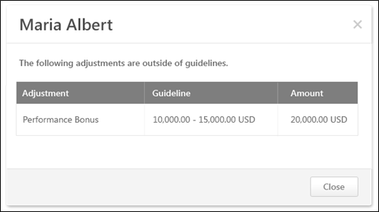
The pop-up displays the following information for each of the adjustments that are outside the component guidelines for the corresponding user:
- Adjustment - This displays the name of the component that has an allocation that is outside the guideline for the corresponding user.
- Guideline - This displays the component guideline for the corresponding user.
- Amount - This displays the allocation amount for the component for the corresponding user.
Compensation Plan - Over Budget
The Over Budget pop-up shows the components that are over the budget and threshold that is set for the compensation component. The pop-up also displays the maximum budget amount that is allowed for the offending components, including the threshold.
The Over Budget pop-up can be accessed in the following ways:
- When viewing a component tab (i.e., Base, Bonus, Equity) within a compensation plan in which one or more components are over the budget and threshold for the component, clicking the Next or Back button opens the pop-up.
- When viewing any tab within a compensation plan in which one or more components are over the budget and threshold for the component, clicking the Submit button opens the pop-up.
This pop-up can only be accessed when there is at least one component that is over the budget and threshold for the component.
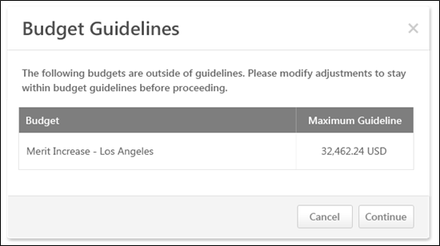
The pop-up displays the following information for each budget that is outside the budget guidelines:
- Budget - This displays the name of the component that is outside the budget and threshold.
- Maximum Guideline - This displays the maximum guideline for the corresponding component, including the threshold.
Continue or Cancel
To navigate to the next tab in the compensation plan, click Continue. This button is not available when submitting the compensation plan. This button is only available when navigating to the next compensation plan tab.
To close the pop-up, click Cancel.
Compensation Plan - Over Guideline
The Over Guideline pop-up shows the minimum or maximum recommendation for the component for the associated user. The pop-up also enables the compensation manager to adjust the allocation amount to adhere to the guideline rules.
The Over Guideline within Threshold pop-up is accessed by clicking the yellow Error icon next to the allocation amount for the user that is over its associated adjustment guideline. Note: This icon only appears when using the Merit Matrix or Editable Merit Matrix.
The Over Guideline Exceeds Threshold pop-up is accessed by clicking the red Error icon next to the allocation amount for the user that is over its associated adjustment guideline and threshold.
This pop-up can only be accessed when there is at least one component that is over its guideline.
Over Guideline within Threshold Pop-up
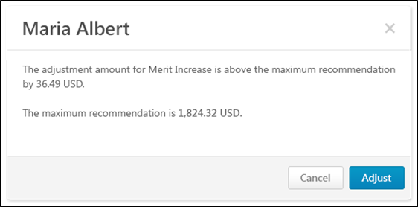
Over Guideline Exceeds Threshold Pop-up
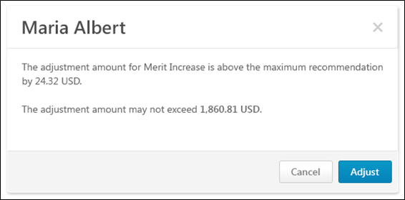
The Over Guideline pop-up displays the current allocation for the corresponding component and user.
- If the current allocation is within the component threshold, then the pop-up displays the minimum or maximum recommendation for the corresponding component and user.
- If the current allocation exceeds the component threshold, then the pop-up displays the maximum allowable allocation for the corresponding component and user.
Adjust or Cancel
To adjust the allocation amount, click Adjust.
- If the allocation was previously within the component threshold, then the allocation is automatically adjusted to the minimum or maximum recommendation (depending on whether the allocation was under or over the recommendation) for the corresponding component and user.
- If the allocation previously exceeded the component threshold, then the allocation is automatically adjusted to be within the threshold for the corresponding component and user. If the allocation is still over the maximum recommendation for the corresponding component and user, then a yellow Error icon appears next to the allocation amount in the Plan Details table.
To close the pop-up, click Cancel.
Compensation Plan - Promotion Over/Under Range
The Promotion Over/Under Range pop-up displays the user's new salary or rate based on all allocations to base components included in the salary or rate. The pop-up also displays the new salary or rate range for the user based on the applied promotion.
The Promotion Over/Under Range pop-up opens when the compensation manager clicks the yellow Error icon next to the promotion component that has a new salary that is either over or under the salary range indicated by the promotion. The Promotion component appears when a promotion has been given. The new salary is based on all allocations to base components included in the salary.
This pop-up can only be accessed when there is a promotion component that has a new salary that is either over or under the salary range indicated by the promotion.
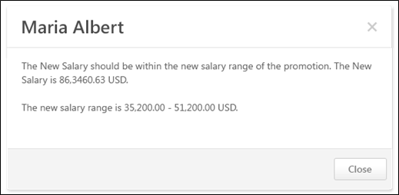
Compensation Plan - Promotion
The Promotion pop-up enables the compensation manager to promote a user and specify the details of the promotion. The pop-up displays the current salary structure and organizational unit (OU) associations for the user.
To promote a user, on the Base tab of the compensation plan, select the Promote option from the Options drop-down menu that appears to the right of the user photo in the Plan Details table. Note: The Options drop-down is not available for ineligible employees.
The ability to promote a user is only available if a promotion component is available in the compensation plan.
Pre-Configuration Note: A salary range for the Position OU that is selected in the New Position field must already be configured in Salary Structures by the administrator in order to save the promotion. If the new position does not have a salary range configured, then an error message displays when attempting to save the promotion.
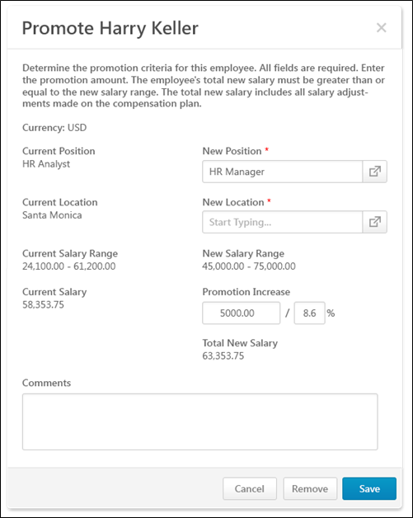
The following information and fields are available within the pop-up:
Currency
This displays the compensation task currency in which monetary values are displayed in the pop-up.
Primary Salary OU
The user's current primary salary OU appears on the left. This is the primary OU from the salary structure, which is configured by the administrator.
In the New (Primary Salary OU) field on the right, click the Select icon to select the user's new primary salary OU. This is the user's primary salary OU after the promotion. This is required.
Secondary Salary OU
The user's current secondary salary OU appears on the left. This is the secondary OU from the salary structure, which is configured by the administrator.
In the New (Secondary Salary OU) field on the right, click the Select icon to select the user's new secondary salary OU. This is the user's secondary salary OU after the promotion. This is required.
Tertiary Salary OU
If the compensation Base component is configured with a tertiary OU, then the user's current tertiary salary OU appears on the left. This is the tertiary OU from the salary structure, which is configured by the administrator.
In the New (Tertiary Salary OU) field on the right, click the Select icon to select the user's new tertiary salary OU. This is the user's tertiary salary OU after the promotion. This is required.
Salary/Rate Range
The user's current salary or rate range appears on the left. This is the salary or rate range that corresponds with the user's current position.
Once the new position and location are selected, the user's new salary or rate range is displayed on the right. This is the salary or rate range that corresponds with the user's position after the promotion.
Salary/Rate
The user's current salary or rate appears on the left. This is the salary or rate that corresponds with the user's current position.
In the Promotion Increase field on the right, enter the fixed amount or percentage of base salary/rate by which the user's base salary or rate is being increased with the promotion. This automatically updates the Total New Salary/Rate value for the user. The promotion increase must not cause the user's total new salary or rate to be above or below the user's new salary or rate range.
Total New Salary/Rate
This displays the user's new salary or rate after the promotion. This value includes all base component allocations included in the user's base salary and the promotion increase. This must be within the user's new salary or rate range.
For hourly employees, if the compensation base component is configured by the administrator to display annual equivalents, then the user's total annualized salary is also displayed.
Comments
In the Comments field, enter any comments that are relevant to the promotion, including the reason for the promotion.
Save, Remove, or Cancel
Click Save to save the promotion details for the user. The user's total new salary or rate must be within the salary or rate range for the user's new position. Once saved, a Promoted link will appear on the Base tab below the user's Position OU title. Click the link to open the Promotion pop-up. Note: If the user is given a promotion, and then the promotion is removed, the Promoted link is removed.
Click Remove to remove the promotion and the promotion details from the user.
Click Cancel to discard any unsaved changes to the promotion details.
Compensation Plan - Proration - Base
Proration enables an organization to adjust a user's compensation based on a prorated time period instead of the compensation period. This may be necessary if the employee has not been with the organization, in the position, or in their current salary for the entire compensation period. This may also be necessary if an employee did not receive a compensation adjustment from the prior compensation period. Proration can be based on the employee's Last Hire Date, Last Salary Change Date, or their time in an OU such as Position of Division. Proration can also be based on an employee's time in a specific group. Compensation components can be set to be prorated by the compensation administrator when configuring the compensation component.
The Proration pop-up enables the compensation manager to view recommendations and allocate prorated amounts for each of the prorated periods of a component for a user.
The Proration pop-up is accessed by clicking the Edit icon for a prorated component for a user in which there are multiple prorated periods.
This pop-up can only be accessed when there is a component with multiple prorated periods.
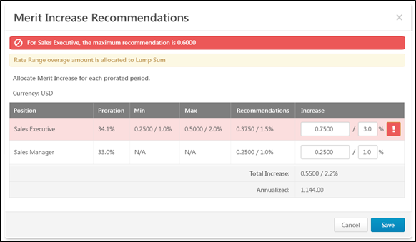
The pop-up title reflects the component that is being prorated.
Lump Sum Alert
If the Merit Increase component is being prorated and Automatic Lump Sum is enabled for the Base component by the administrator, then a Lump Sum alert is displayed to indicate that any rate or salary range overage will be allocated as a Lump Sum. That is, if the prorated increase causes the user's salary to exceed the salary range, then the amount by which the salary range is exceeded is awarded to the employee as a Lump Sum allocation.
Currency
This displays the compensation task currency in which monetary values are displayed in the pop-up.
Proration Table
Within the proration table, the following information is displayed:
- Proration Criteria - This displays the criterion by which the component is prorated. For example, if the proration is based on the time a user spent in a position, then this column displays the user's positions during the compensation period.
- Proration - This displays the proration percentage that is associated with the proration criterion. This percentage is applied to the increase amount to determine the total increase.
- Min - This displays the prorated minimum adjustment guideline amount.
- Max - This displays the prorated maximum adjustment guideline amount.
- Recommendations - This displays the prorated adjustment guideline amount.
- Increase - In this column, enter the base increase for the proration period as a fixed amount or as a percentage of base. The fixed amount defaults to the amount in the Recommendations column. However, these values can be edited.
  - If the Increase value is outside the guidelines but within the threshold, the row is highlighted in yellow, and a yellow Warning icon appears to the right of the allocation. When the proration pop-up is saved, the row in the compensation plan is also highlighted in yellow, and a yellow Warning icon appears to the right of the allocation.
  - If the Increase value is outside the guidelines and the threshold, the row is highlighted in red, and a red Warning icon appears to the right of the allocation. The proration pop-up cannot be saved until the allocations are adjusted to be within the threshold.
Total Increase
This row displays the summation of all of the Increase values.
Annualized
This row is only available for hourly employees if the prorated component is a Base type component that is included in the Base Salary.
This row displays the annualized total increase.
Save or Cancel
Click Save to save the proration allocations. Or, click Cancel to discard the proration allocations.
Compensation Plan - Proration - Bonus
Proration enables an organization to adjust a user's compensation based on a prorated time period instead of the compensation period. This may be necessary if the employee has not been with the organization, in the position, or in their current salary for the entire compensation period. This may also be necessary if an employee did not receive a compensation adjustment from the prior compensation period. Proration can be based on the employee's Last Hire Date, Last Salary Change Date, or their time in an OU such as Position of Division. Proration can also be based on an employee's time in a specific group. Compensation components can be set to be prorated by the compensation administrator when configuring the compensation component.
The Proration pop-up enables the compensation manager to view recommendations and allocate prorated amounts for each of the prorated periods of a component for a user.
The Proration pop-up is accessed by clicking the Edit icon for a prorated component for a user in which there are multiple prorated periods.
This pop-up can only be accessed when there is a component with multiple prorated periods.
Bonus Proration by % Attained
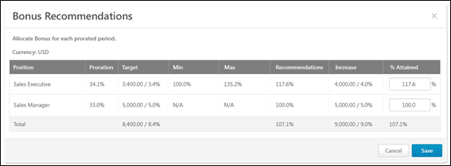
If the Bonus compensation template is configured to be set as a percentage of the Bonus Target, then the compensation manager can set an employee's bonus as a percentage of the component target.
The pop-up title reflects the component that is being prorated.
Currency
This displays the compensation task currency in which monetary values are displayed in the pop-up.
Proration Table
Within the proration table, the following information is displayed:
- Proration Criteria - This displays the criterion by which the component is prorated. For example, if the proration is based on the time a user spent in a position, then this column displays the user's positions during the compensation period.
- Proration - This displays the proration percentage that is associated with the proration criterion.
- Target - This displays the prorated component target for the prorated period.
- Min - This displays the prorated minimum adjustment guideline amount as a percentage of the target.
- Max - This displays the prorated maximum adjustment guideline amount as a percentage of the target.
- Recommendations - This displays the original recommendation as a percentage of the prorated target.
- Increase - This column display the allocation amount as a fixed amount and a percentage of base. These values are dynamically updated based on the % Attained allocation.
- % Attained - In this column, enter the allocation amount as a percentage of the target. This value must be greater than or equal to 0% and must be less than 1000%.
  - If the % Attained value results in an increase amount that is outside the guidelines but within the threshold, the row is highlighted in yellow. When the proration pop-up is saved, the row in the compensation plan is also highlighted in yellow, and a yellow Warning icon appears to the right of the allocation.
  - If the % Attained value results in an increase amount that is outside the guidelines and the threshold, the row is highlighted in red, and a red Warning icon appears to the right of the allocation. The proration pop-up cannot be saved until the allocations are adjusted to be within the threshold.
Total
This column displays the summation of all of the following values:
- Target - This is the sum of the targets of each prorated period.
- Recommendations - This is the total recommendation amount as a percentage of the prorated Target Bonus summation.
- Increase - This is the sum of the increase amounts.
- % Attained - This is the sum of the bonus allocations of each prorated period divided by the sum of the targets of each prorated period.
Save or Cancel
Click Save to save the proration allocations. Or, click Cancel to discard the proration allocations.
Bonus Proration by Fixed %
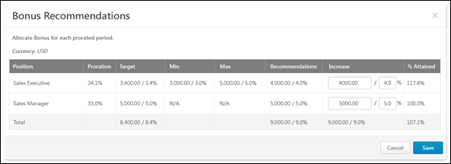
If the Bonus compensation template is configured to be set as a fixed amount or as a percentage of the Base Salary, then the compensation manager can set an employee's bonus as a fixed amount or as a percentage of the Base Salary.
The pop-up title reflects the component that is being prorated.
Currency
This displays the compensation task currency in which monetary values are displayed in the pop-up.
Proration Table
Within the proration table, the following information is displayed:
- Proration Criteria - This displays the criterion by which the component is prorated. For example, if the proration is based on the time a user spent in a position, then this column displays the user's positions during the compensation period.
- Proration - This displays the proration percentage that is associated with the proration criterion.
- Target - This displays the prorated component target for the prorated period.
- Min - This displays the prorated minimum adjustment guideline amount.
- Max - This displays the prorated maximum adjustment guideline amount.
- Recommendations - This displays the original recommendation amount as an amount and as a percentage of the Base Salary.
- Increase - In this column, enter the allocation amount as a fixed amount or as a percentage of base.
  - If the Increase amount is outside the guidelines but within the threshold, the row is highlighted in yellow. When the proration pop-up is saved, the row in the compensation plan is also highlighted in yellow, and a yellow Warning icon appears to the right of the allocation.
  - If the Increase amount is outside the guidelines and the threshold, the row is highlighted in red, and a red Warning icon appears to the right of the allocation. The proration pop-up cannot be saved until the allocations are adjusted to be within the threshold.
- % Attained - This column display the allocation amount as a percentage of the target. This value is dynamically updated based on the Increase allocations.
Total
This column displays the summation of all of the following values:
- Target - This is the sum of the targets of each prorated period.
- Recommendations - This is the sum of the recommendations of each prorated period as a percentage of the Base Salary.
- Increase - This is the sum of the increase amounts.
- % Attained - This is the sum of the bonus allocations of each prorated period divided by the sum of the targets of each prorated period.
Save or Cancel
Click Save to save the proration allocations. Or, click Cancel to discard the proration allocations.
Use Cases
The following use cases use the following data:
Bonus Template 2012 has the following settings and is included in the 2012 Compensation Task.
- The template includes a Bonus component that is set to prorate by the amount of time in the position.
- In the Allocation Rules section, Percentage of Bonus Targets is selected.
Employee | Current Salary | Position | Proration | Target Bonus
Allison Briggs | $65,000 | Product Specialist | 20.0% | $2,000
 |  | Jr. Product Manager | 70.0% | $7,000
 |  | Product Manager | 10.0% | $1,000
Use Case 1: Allocate as Percentage of Bonus Target - Simple
No adjustment guideline is set for the Bonus component.
Action
On the Bonus tab of the 2012 Compensation Task, the compensation manager clicks the Edit icon in the % Attained field for the Bonus component for Allison.
The compensation manager allocates 50.7% in the % Attained field for the Product Specialist prorated period.
Results
The Bonus Proration pop-up shows the following for Allison Briggs:
- Product Specialist:
  - Increase (read-only) - 1,014.00 / 1.6% (Calculation: Increase = <% ATTAINED> * <PRORATED TARGET> = 0.507 * 2000)
  - % Attained: 50.7%
- Jr. Product Manager
  - Increase (read-only) - 0.00 / 0.0%
  - % Attained: 0.0%
- Product Manager
  - Increase (read-only) - 0.00 / 0.0%
  - % Attained: 0.0%
- Total
  - Target - 10,000.00 / 15.4%
  - Increase (read-only) - 1,014.00 / 1.6%
  - % Attained: 10.1%
Use Case 2: Allocate as Percentage of Bonus Target - Fixed Amount Adjustment Guideline
The following Adjustment Guidelines are set for the Bonus component:
- Availability: Position: Product Specialist - $4500.25 USD.
- Availability: Position: Jr. Product Manager - $9000.00 USD.
- Availability: Position: Product Manager - $8750.32 USD.
Action
On the Bonus tab of the 2012 Compensation Task, the compensation manager clicks the Edit icon in the % Attained field for the Bonus component for Allison.
Results
The Bonus Proration pop-up shows the following for Allison Briggs:
- Product Specialist:
  - Increase (read-only) - 900.10 / 1.4% (Calculation: Increase = <RECOMMENDATION> * <PRORATION> = 4500.5 * 0.20)
  - % Attained: 45.0% (Calculation: % Attained = <PRORATED INCREASE> / <PRORATED TARGET BONUS> = 900.10 / 2000.00)
- Jr. Product Manager
  - Increase (read-only) - 6,300.00 / 9.7% (Calculation: 9000.00 * 0.70)
  - % Attained: 90.0% (Calculation: 6300.00 / 7000.00)
- Product Manager
  - Increase (read-only) - 875.03 / 1.3% (Calculation: 8750.32 * 0.10)
  - % Attained: 87.5% (Calculation: 875.03 / 1000.00)
- Total
  - Target - 10,000.00 / 15.4%
  - Increase (read-only) - 8,075.13 / 1.2%
  - % Attained: 80.8%
Compensation Plan - Proration - Equity
Proration enables an organization to adjust a user's compensation based on a prorated time period instead of the compensation period. This may be necessary if the employee has not been with the organization, in the position, or in their current salary for the entire compensation period. This may also be necessary if an employee did not receive a compensation adjustment from the prior compensation period. Proration can be based on the employee's Last Hire Date, Last Salary Change Date, or their time in an OU such as Position of Division. Proration can also be based on an employee's time in a specific group. Compensation components can be set to be prorated by the compensation administrator when configuring the compensation component.
The Proration pop-up enables the compensation manager to view recommendations and allocate prorated amounts for each of the prorated periods of a component for a user.
The Proration pop-up is accessed by clicking the Edit icon for a prorated component for a user in which there are multiple prorated periods.
This pop-up can only be accessed when there is a component with multiple prorated periods.
Equity Proration with Shares
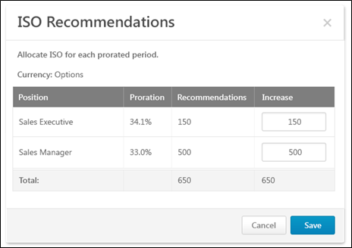
The pop-up title reflects the component that is being prorated.
Currency
For ISO or NQO equity components, the currency is Options. For RSA equity components, the currency is Shares.
Proration Table
Within the proration table, the following information is displayed:
- Proration Criteria - This displays the criterion by which the component is prorated. For example, if the proration is based on the time a user spent in a position, then this column displays the user's positions during the compensation period.
- Proration - This displays the proration percentage that is associated with the proration criterion.
- Recommendations - This displays the original recommendation amount.
- Increase - In this column, enter the allocation amount as a fixed amount of stock options.
  - If the Increase amount is outside the guidelines and the threshold, the row is highlighted in red, and a red Warning icon appears to the right of the allocation. The proration pop-up cannot be saved until the allocations are adjusted to be within the threshold.
Total
This column displays the summation of all of the following values:
- Recommendations - This is the sum of the recommendations of each prorated period.
- Increase - This is the sum of the increase amounts.
Save or Cancel
Click Save to save the proration allocations. Or, click Cancel to discard the proration allocations.
Equity Proration with Cash Award
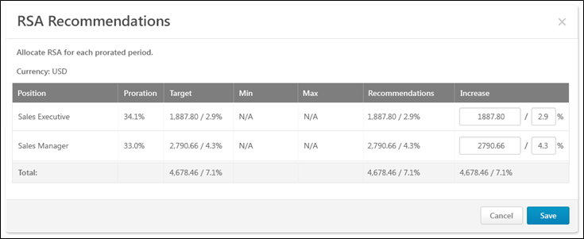
The pop-up title reflects the component that is being prorated.
Currency
This displays the compensation task currency in which monetary values are displayed in the pop-up.
Proration Table
Within the proration table, the following information is displayed:
- Proration Criteria - This displays the criterion by which the component is prorated. For example, if the proration is based on the time a user spent in a position, then this column displays the user's positions during the compensation period.
- Proration - This displays the proration percentage that is associated with the proration criterion.
- Target - This displays the prorated component target for the prorated period.
- Min - This displays the prorated minimum adjustment guideline amount.
- Max - This displays the prorated maximum adjustment guideline amount.
- Recommendations - This displays the original recommendation amount as an amount and as a percentage of the Base Salary.
- Increase - In this column, enter the allocation amount as a fixed amount or as a percentage of base.
  - If the Increase amount is outside the guidelines but within the threshold, the row is highlighted in yellow. When the proration pop-up is saved, the row in the compensation plan is also highlighted in yellow, and a yellow Warning icon appears to the right of the allocation.
  - If the Increase amount is outside the guidelines and the threshold, the row is highlighted in red, and a red Warning icon appears to the right of the allocation. The proration pop-up cannot be saved until the allocations are adjusted to be within the threshold.
Total
This column displays the summation of all of the following values:
- Target - This is the sum of the targets of each prorated period.
- Recommendations - This is the sum of the recommendations of each prorated period.
- Increase - This is the sum of the increase amounts.
Save or Cancel
Click Save to save the proration allocations. Or, click Cancel to discard the proration allocations.
Compensation Plan - Submit Confirmation
The Submit Confirmation pop-up appears when a compensation manager clicks the Submit button on a compensation plan, and it alerts the compensation manager that a compensation plan may be edited during the approval process. The Submit Confirmation pop-up also enables the compensation manager to create a copy of their original submitted compensation plan. The purpose of creating a copy of the submitted plan is to allow the compensation manager to have access to the original submitted version during the approval workflow.
The Submit Confirmation pop-up opens when a compensation manager clicks the Submit button on a compensation plan.
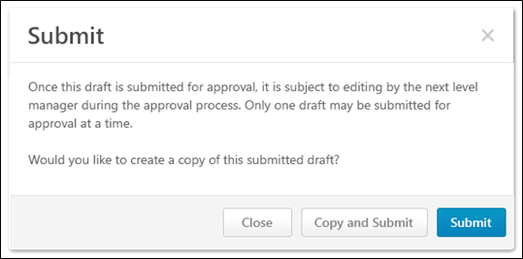
When a compensation manager submits a compensation plan, they have the option to create a copy of the submitted plan. Once a copy is created, the compensation manager can edit, delete, or copy the copy of the submitted draft.
Close
Select this option to cancel the action and return to the plan.
Copy and Submit
Select this option to submit the plan for approval and create a copy of the submitted plan.
Copying and submitting the plan creates an additional entry on the Compensation Plans tab. The original version has a status of Submitted, and the copied version has a status of Draft. Next to the status of the copied draft, "(Copy of Submitted <Version #>)" is displayed. The version number of the copy is calculated as the next available subsequent version number. For example, if a plan has versions 1.0, 2.0, and 3.0, and version 3.0 is copied, then the subsequent version would be 4.0 and the status would be "Draft (Copy of Submitted 3.0)." Note: When a compensation plan is initially copied and submitted, the submitted version is always 1.0 and the copied version is always 2.0.
- Submitted Version - The compensation manager can view a read-only version of the submitted version from the Compensation Plans tab.
- Copied Version - The compensation manager can edit and delete the copied version from the Compensation Plans tab.
See Compensation Task - Compensation Plans Tab on page 7 for additional information.
Submit
Select this option to submit the plan for approval without creating a copy.
Compensation Plan - Edit as Approver
Compensation - Award Off-cycle
An off-cycle compensation task can be launched via Universal Profile and My Team.
- To launch an off-cycle compensation task for a subordinate via Universal Profile, click the Award Compensation link from the Options drop-down list. This option is only available to managers if at least one active off-cycle compensation task is available to the manager. See Bio - About Overview for additional information.
- To launch an off-cycle compensation task for a subordinate via My Team, go to My Team, and then select the ID card of the appropriate direct report. Then, go to Activities > Current. From the Actions drop-down menu, select Award Compensation. Then, select the appropriate off-cycle compensation task. The manager is taken to the Award Compensation page if the task is configured with any templates that require the assigner to define the effective date. See Tasks Overview for additional information.

Compensation Statement
The Compensation Statement page contains the current compensation statement and previous statements.
Permissions
PERMISSION NAME | PERMISSION DESCRIPTION | CATEGORY

User Compensation Statement | Grants ability to view and print a user's own current and previous compensation statements. This is an end user permission. | Compensation
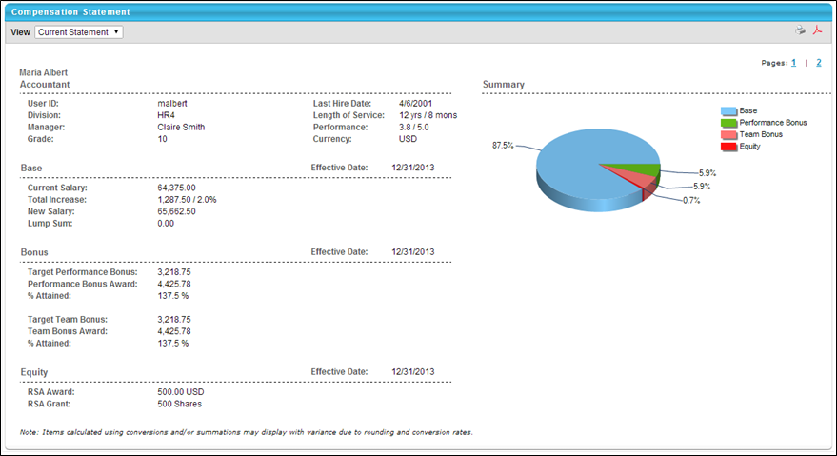
To view a compensation statement, click the Compensation tab and then click the Compensation Statement link. The following sections are available:
- Organization Information - Includes User ID, Division, Manager, Hire Date etc.
- Base, Bonus, Equity - Separate section for each adjustment made in corresponding task including base, bonus, and equity. If any deferrals are made, the payout schedule is included.
- Summary - Contains a pie chart that displays the dollar break down of base, bonus, and/or equity compensation. The Summary graph only reflects the components that are included in the compensation task. When calculating percentages, the system calculates the total cost based on the allocations that appear on the plan.
- Additional Information - Display custom fields if applicable.
If a custom compensation statement is implemented, the standard statement may also be included as the first or second page of the statement. If this is the case, in the upper-right corner, page numbers are available so that users can switch between pages. Note: Custom Compensation Fields are not supported in Custom Statements.
In the upper-right corner, you can click the Printable Version icon to view a printable version of the statement, or you can click the PDF icon to create a PDF version of the statement.

