Capabilities and Skills Profile March 2024

Table of Contents
Skills Profile & Capabilities Library - Overview 1
Capabilities Administration 2
Skills Quick Start Wizard 3
Skills Library Builder 6
Capabilities Library - Manage Capabilities 9
Capabilities Preferences 19
Manage Capability Categories 33
Capability Models Library 39
Capability Rating Scales - Manage 48
Capability Feedback Templates - Manage 54
Reporting on Capabilities 70
Training Capabilities - Content Skills Tagging 71
Universal Profile - Skills Overview 75
Skills Profile 76
People Matrix Homepage 124

Skills Profile & Capabilities Library - Overview
With the Capabilities Library and Skills Profile:
- Cornerstone's AI-powered Skills Graph automatically imports skills into the Capabilities Library. (Administrators have the ability to screen skills before they are published for employees to see.)
- Cornerstone's AI-powered Skills Graph automatically associates relevant skills to each employee job title using data collected from over 250 million profiles worldwide, across all industries and organization sizes.
- Employees can declare which skills they currently have, which skills they want to further develop, and which ones they would like to ignore. (Employees are given a jump start with automatically suggested skills they can declare and the ability to view full skill descriptions.)
- Employees can self-rate their proficiency, interest, and enjoyment for specific skills, and receive skill proficiency ratings from their peers.
- Organizations can continue to use their internally defined skills and competencies in addition to the skills from Cornerstone's Skills Graph.
- Organizations should experience a faster implementation time to get their capabilities library up and running.

Capabilities Administration
Capabilities describe what a person can do or what they know. This may include skills, competencies, knowledge, and other types of data. On the Skills Profile, a user may declare which skills they currently have, which skills they want to further develop, and which ones they would like to ignore.

Skills Quick Start Wizard
The Skills Quick Start Wizard administrator experience guides administrators through the key steps of implementing or optimizing their Skills framework. The experience provides detailed text that explains concepts and best practices, and it provides links to useful resources and Capability administrative tools. Each step is automatically marked complete as administrators progress through the wizard, tracking progress towards completion.
Even if an organization has already enabled Capabilities, the Skills Quick Start Wizard can still be launched to refine the existing configuration or learn about new concepts and features that may not be in use with the current deployment.
The Skills Quick Start Wizard contains the following steps:
- Introduction
- Get Your Skills - Skills Library Builder
- Configure Your Experience
- Validate Your Skills
- Content Skills Tagging
- Enable Permissions
- Spread the Word
- What's Next?
To access the Skills Quick Start Wizard, go to Admin > Tools > Core Functions > Capabilities > Skills Quick Start Wizard.
Permissions
PERMISSION NAME | PERMISSION DESCRIPTION | CATEGORY

Capabilities - Skills Quick Start Wizard - Manage | Grants access to the Skills Quick Start Wizard administrator experience, which helps administrators configure and deploy skills within their organization. This permission cannot be constrained. This is an administrator permission. | Core Administration
Introduction
The introduction helps administrators understand how to be successful when implementing Skills and Capabilities, including the following:
- Guidance on how to earn organizational commitment
- Definitions of key terms related to Skills and Capabilities
- Prerequisite steps that should be taken prior to enabling and leveraging Skills and Capabilities
Select the Mark Complete button to proceed to the next step.
Get Your Skills - Skills Library Builder
This step enables administrators to easily fill their Capabilities Library with meaningful skills for their organization, leveraging the existing user profile data and CV/resume data. See Skills Library Builder on page 6 for additional information.
Administrators can also leverage the Edge Import tool to import skills from an existing library. See Edge Import Homepage.
Select the Mark Complete button to proceed to the next step.
Configure Your Experience
This step provides quick links to some recommended settings that should be reviewed and validated. These include the following preference pages:
- Skills Profile Preferences - Skills Profile preferences page provides basic controls that enable or disable certain features within the Skills Profile. See Capabilities Preferences - Skills Profile on page 30 for additional information.
- Skills Graph Preferences - Administrators can control automatic synchronization and import of skills from the Cornerstone Skills Graph. See Capabilities Preferences - Skill Details Sync on page 28 for additional information.
This step also provides quick links to some optional settings that may be reviewed for organizations that want to further customize the Skills and Capabilities experience. These include the following configuration pages:
- Feedback Templates - The Feedback Templates configuration page enables administrators to customize the rating and feedback experiences for the end user. See Capability Feedback Templates - Manage on page 54 for additional information.
- Proficiency Levels - The Proficiency Levels configuration page enables administrators to customize the language that describes the levels of capability proficiency across the organization. The unified, standard language enables organizations to easily compare across skills and people. See Capabilities Preferences - Proficiency Levels on page 24 for additional information.
- Rating Scales - The Rating Scales configuration page enables administrators to customize the values that employees can select when completing a rating of themselves or others. See Capability Rating Scales - Manage on page 48 for additional information.​
Select the Mark Complete button to proceed to the next step.
Validate Your Skills
This step provides a quick orientation of the Capabilities Library where administrators can view, create, and edit capabilities in their organization's library. See Capabilities Library - Manage Capabilities on page 9 for additional information.
Select the Mark Complete button to proceed to the next step.
Content Skills Tagging
This step automatically tags learning content as part of the initial skills library set up in the Skills Quick Start Wizard, making it easier to find the content needed to build the required skills. To know more about Content Skills Tagging, See Training Capabilities - Content Skills Tagging on page 71 for additional information.
Select the Mark Complete button to proceed to the next step.
Enable Permissions
This step provides guidance regarding which permissions are needed for granting users access to the Skills Profile and user ratings. Permissions and security roles are managed in Security Role Administration. See Security Roles Administration.
Select the Mark Complete button to proceed to the next step.
Spread the Word
This step provides access to sample communication templates to help socialize skills within your organization and help employees build their skills profile. This includes the following resources:
- Email templates
- Email digest templates
- Reporting templates
Select the Mark Complete button to proceed to the next step.
What's Next?
This step provides resources to help administrators stay connected to the Cornerstone product team and other customers. It also enables administrators to submit ideas, feedback, success stories regarding Skills and Capabilities. Lastly, administrators can provide direct feedback on the Skills Quick Start Wizard experience.
Select the Submit button to submit your feedback directly to the product team regarding the expedience.

Skills Library Builder
The Skills Library Builder enables administrators to quickly build the organization's skills library using data that already exists in user profiles.
To access the Skills Library Builder, go to Admin > Tools > Core Functions > Capabilities > Skills Library Builder.
Permissions
PERMISSION NAME | PERMISSION DESCRIPTION | CATEGORY

Capabilities - Skills Library Builder | Grants ability to import relevant Cornerstone Skills Graph skills based on user profile data and generate skill suggestions via the Skills Library Builder page. This permission cannot be constrained. This is an administrator permission. | Core Administration
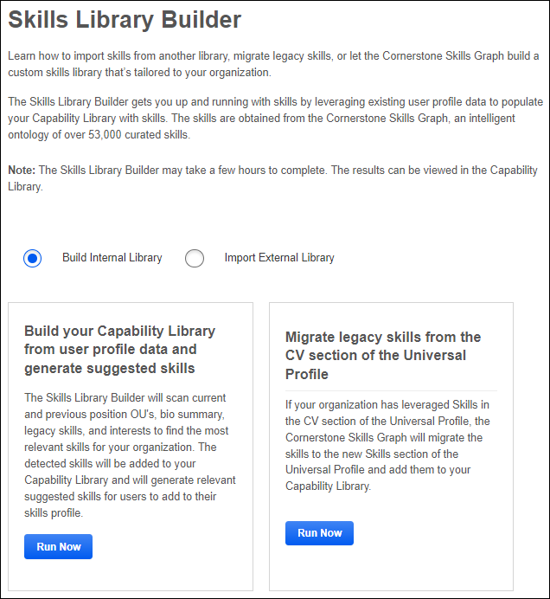
Build Internal Library - Build your Capability Library from user profile data and generate suggested skills
Select the Build Internal Library option. Then, select the Run Now button in this section to run a full portal scan, which uses the Skills Graph to generate suggested skills for each active user in the portal. The top suggested skills are automatically imported into your library, generating a pre-populated Capabilities Library tailored to your organization.
This process may be run periodically, if necessary.
Build Internal Library - Migrate legacy skills from the CV section of the Universal Profile
Select the Build Internal Library option. Then, select the Run Now button in this section to copy all of the skills from the Resume or CV section of the Universal Profile to the Capabilities Library. Selecting this option does not remove the skills from the user's Resume in Universal Profile.
This process may be run periodically, if necessary.
Import External Library - Integrate an existing skills library or competencies
Select the Import External Library option. You can then use Edge Import to import your existing skills library or competencies. See Edge Import - Capabilities Library Load.
When importing a 3rd party skills taxonomy, it is suggested to disable the automatic import of skills from the Skills Graph to prevent mismatches between taxonomies with multiple sources. In the pop-up, select the Disable button to disable the automatic import of detected skills from the Skills Graph. This option can be changed any time under Capabilities Preferences > Skill Details Sync. See Capabilities Preferences - Skill Details Sync on page 28 for additional information.

Capabilities Library - Manage Capabilities
Capabilities describe what a person can do or what they know. The Capabilities Library enables administrators to view, create, and edit capabilities. Once capabilities are available, users can add them to their profile as skills they have or skills they would like to develop.
To access the Capabilities Library, go to Admin > Tools > Core Functions > Capabilities > Library.
Permissions
PERMISSION NAME | PERMISSION DESCRIPTION | CATEGORY

Capability Library - Edit | Grants the ability to create, edit, and copy capabilities via the Capability Library. Administrators with this permission cannot delete capabilities or change the status of a capability. This permission cannot be constrained. This is an administrator permission. | Core Administration

Capability Library - Manage | Grants the ability to create, edit, copy, delete, import, and approve capabilities via the Capability Library. This permission cannot be constrained. This is an administrator permission. | Core Administration
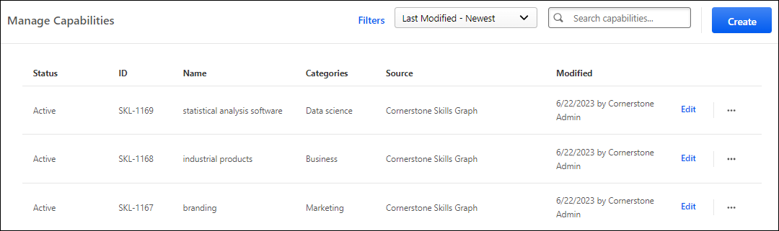
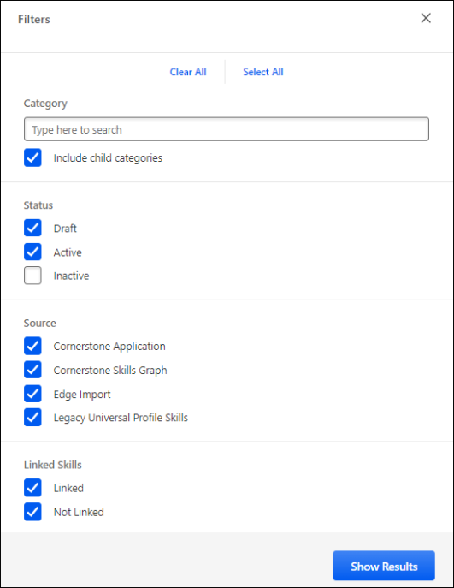
Create Capability
To create a capability, select the Create button. See Capabilities Library - Create/Edit Capability on page 12 for additional information.
Edit Capability
To edit an existing capability, select the Edit link for the appropriate capability in the Capabilities list. See Capabilities Library - Create/Edit Capability on page 12 for additional information.
Search and Filter Capabilities
By default, all capabilities are listed by last modified date, with the most recently modified capabilities listed first.
- To change the sort order, select the appropriate sort option from the drop-down menu in the upper-right corner of the page.
- To search for a capability, enter the appropriate search terms or capability ID in the Search capabilities field and select the Magnifying Glass icon . Searching by ID only returns exact matches. For example, if an administrator searches for "27765," the results will not return SKL-27765; the results will only include a capability with an ID of 27765.
To filter which capabilities are displayed, select the Filters link. A Filters flyout opens. In the Filters flyout, the following options are available:
- Clear All / Select All - Select these links to either select all available Status and Source options or to remove all selections.
- Category - Type a category to view capabilities associated with the selected categories. Select the Include child categories option to view capabilities associated with the selected category and any of the category's subcategories.
- Status - In this section, select one or more statuses to view only capabilities in the selected statuses. By default, Draft and Active are selected.
- Source - In this section, select one or more sources to view only capabilities from the selected sources. By default, all sources are selected.
Capabilities List
The following information is listed for each existing capability:
- Status - This indicates the status of the capability (e.g., draft, active, inactive). Only active capabilities can be added to user profiles or used in new ratings. Statuses can be modified in the action menu on the right side of the page.
- ID
- Name - This displays the name that was given for the capability when it was created or modified. If a custom skill is not linked to a skill in the Cornerstone Skills Graph, then a "Not Linked" tag is displayed next to the skill name on the Manage Capabilities page. Administrators can click the tag to edit the capability. This enables administrators to easily identify any unlinked skills and link them appropriately.
- Source - This displays how the capability was added to the system.
  - Cornerstone Application - This indicates that the capability was added manually by an administrator from within the system.
  - Cornerstone Skills Graph - This indicates that the capability was automatically added as part of Cornerstone's Skills Graph.
- Created - This displays the date on which the capability was created and the administrator who created it.
- Modified - This displays the date on which the capability was last modified and the administrator who modified it.
Capabilities Library - Create/Edit Capability
Capabilities describe what a person can do or what they know. Once capabilities are available, users can add them to their profile as skills they have or skills they would like to develop.
To create a capability from the Capabilities Library, go to Admin > Tools > Core Functions > Capabilities > Library. Then, select the Create button.
To edit a capability from the Capabilities Library, go to Admin > Tools > Core Functions > Capabilities > Library. Then, select the Edit link to the right of the appropriate capability.
Permissions
PERMISSION NAME | PERMISSION DESCRIPTION | CATEGORY

Capability Library - Edit | Grants the ability to create, edit, and copy capabilities via the Capability Library. Administrators with this permission cannot delete capabilities or change the status of a capability. This permission cannot be constrained. This is an administrator permission. | Core Administration

Capability Library - Manage | Grants the ability to create, edit, copy, delete, import, and approve capabilities via the Capability Library. This permission cannot be constrained. This is an administrator permission. | Core Administration
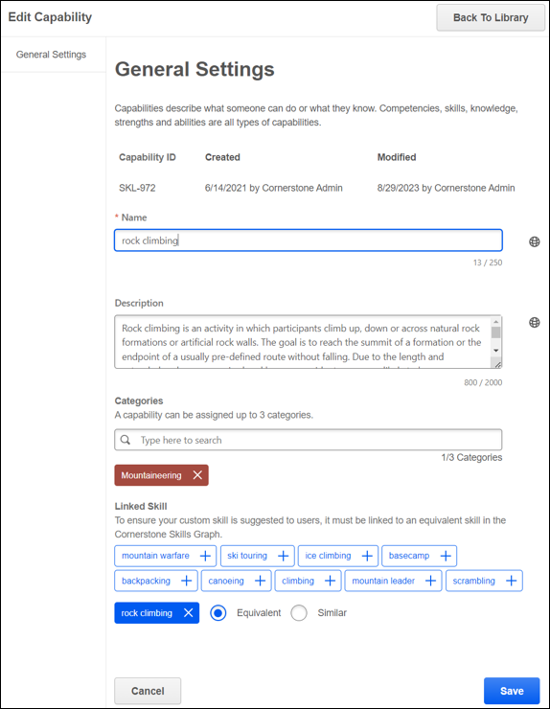
Create Capability
When you select the Create button on the Capability Library page, a flyout opens. Enter the following information for the capability:
- Name - Enter a descriptive name for the capability. This should clearly indicate the skill or knowledge associated with the capability so that end users and administrators understand the capability. This field is required. The character limit for this field is 250.
  - If enabled in Capabilities Preferences, administrators can search for skills within the Skills Graph and import it into the organization's Capabilities Library. When creating a skill, an auto-complete drop-down suggests skills from the Skills Graph and helps identify any duplicates that are already in the portal's library. Once a skill is imported, the description and category is displayed as a preview and can be modified at any time for clarity or to align with an organization’s communication style and categories. Administrators are free to ignore suggestions and can create custom skills as needed.
- Description - Enter a detailed description for the capability. This should provide additional information about the capability so that all users and administrators understand the capability. This field is optional. The character limit for this field is 2000.
- Categories - Enter the name of a capability category to associate the capability with the category. Each capability can be associated with up to three categories. When a category is selected, it is displayed below the Categories field.
- Linked Skill - If the administrator populates the Name field and does not select a suggested skill from the Cornerstone Skills Graph, a Linked Skill section is displayed. A list of suggested, similar skills is displayed in this section. Select a suggested skill to link the custom skill to the suggested skill in the Cornerstone Skills Graph. See the Linked Skill section below for additional information.
If the administrator has the Capability Library - Manage permission, two options will appear during creation, Save Draft or Publish. Capabilities in a draft status are not visible to users.
If the administrator only has the Capability Library - Edit permission, a capability can only be created in a draft status.
If the Capability is ready to be used by users after entering the appropriate details, select the Publish button in the flyout. The new capability is added, and you are presented with two options:
- Done - Select this option to return to the Capability Library. See Capabilities Library - Manage Capabilities on page 9 for additional information.
- Edit - Select this option to navigate to the Edit Capability page where you may edit the capability details. See the Edit Capability section below for additional information.
Edit Capability
When you select the Edit link on the Capability Library page, the Edit Capability page opens.
Enter the following information on the General Settings tab for the capability:
- ID - This is the unique identifier for the capability. When a capability is created from the Capability Library, this ID is automatically generated by the system.
- Name - Enter a descriptive name for the capability. This should clearly indicate the skill or knowledge associated with the capability so that end users and administrators understand the capability. This field is required. The character limit for this field is 250. If multiple languages are enabled for your portal, select the Translate icon to translate the field into other available languages.
- Description - Enter a detailed description for the capability. This should provide additional information about the capability so that all users and administrators understand the capability. This field is optional. The character limit for this field is 2000. If multiple languages are enabled for your portal, select the Translate icon to translate the field into other available languages.
- Categories - Enter the name of a capability category to associate the capability with the category. Each capability can be associated with up to three categories. When a category is selected, it is displayed below the Categories field.
- Linked Skill - If the administrator populates the Name field and does not select a suggested skill from the Cornerstone Skills Graph, a Linked Skill section is displayed. A list of suggested, similar skills is displayed in this section. Select a suggested skill to link the custom skill to the suggested skill in the Cornerstone Skills Graph. See the Linked Skill section below for additional information.
For capabilities in a draft or inactive status:
- If the administrator has the Capability Library - Manage permission, two options will appear during editing, Save or Publish. If publish is selected, changes are first saved before the capability status is changed to active.
- If the administrator only has the Capability Library - Edit permission, the user may save changes, but cannot publish the capability.
For capabilities in an active status:
- Changes to a capability can be saved, but no status transitions are allowed from the Edit Capability page.
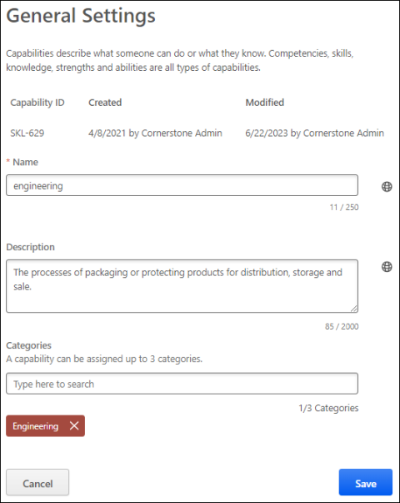
Linked Skill
The Linked Skill section enables administrators to link a custom skill to an equivalent skill in the Cornerstone Skills Graph, which helps ensure the custom skill is suggested to users. If a custom skill is not linked to a skill in the Cornerstone Skills Graph, the custom skill will not produce learning content recommendations and users will be required to search for the skill manually to be added to their profile.
When a Skills Graph skill is imported into an organization's Capabilities Library, it maintains an equivalent link to the Skills Graph. Therefore, a custom skill cannot be set as equivalent to a Skills Graph skill that is imported into the Capabilities Library. This is to prevent confusion from having duplicate skills in an organization's Capabilities Library. In this scenario, organizations should consider using the existing Skills Graph skill rather than a custom skill.
If the administrator populates the Name field and does not select a suggested skill from the Cornerstone Skills Graph, a Linked Skill section is displayed. A list of suggested, similar skills is displayed in this section. Note: When editing a custom skill, the administrator will not see skill suggestions if the skill name does not have a translation in the administrator's culture.
To link the custom skill to a skill from the Cornerstone Skills Graph, select one of the suggested skills in this section. The selected skill is displayed below the suggested skills. If the Cornerstone Skills Graph contains a skill with the exact same name, this skill is automatically selected, but it can be removed if necessary.
The administrator can select whether the linked skill is equivalent or similar to the custom skill.
- Equivalent - Selecting this option indicates that both skills are inherently the same. When a custom skill is linked as an equivalent to a skill in the Cornerstone Skills Graph, the custom skill is shown in place of the equivalent Cornerstone skill anywhere skills are displayed to users, such as Skills You Want to Develop, Skills You Don't Want to Develop, Your Skills, Skills You Might Have, and Manage Skills. In addition, any ratings and feedback that a user has received for the custom skill are aggregated with any ratings and feedback received for the Cornerstone skill.
- Similar - Selecting this option indicates that the custom skill is neighboring or adjacent to the skill from the Cornerstone Skills Graph. When displaying skills to users, both the custom skill and the similar skill may be suggested to the user.
Only one skill from the Cornerstone Skills Graph can be linked to the custom skill. A Skills Graph skill can only be equivalent to a single custom skill but can be similar to many custom skills.
When linking a capability to a Skills Graph skill, administrators may see the following message: "Note: [Skill A] is already selected as an equivalent skill to [Skill B]." This message indicates that an existing skill in your organization's capability library is already selected as an equivalent to the selected skill. Administrators may continue to set the selected skill as a similar skill or remove or replace the selected skill. If [Skill A] is already equivalent to [Skill B], then the "Equivalent" radio button is automatically disabled, and the "Similar" radio button is automatically selected.
What is the difference between Equivalent and Similar?
- "Equivalent" skills are inherently the same. "Similar" skills are neighboring or adjacent skills.
- A Skills Graph skill can only be "Equivalent" to one custom skill. However, a Skills Graph skill can be "Similar" to many custom skills.
- With "Equivalent" skills, only the custom skill is displayed to users. With "Similar" skills, both the custom skill and the "Similar" Skills Graph skill may be suggested to users.
- Existing custom skills can be automatically matched and linked to "Equivalent" Skills Graph skills. Edge Import Capabilities Library loads attempt to match and link "Equivalent" skills to custom skills upon import. Auto-matching does not occur for "Similar" skills. Any skill that is not automatically matched is flagged in the Capabilities Library so that administrators can manually link the skill if necessary.
- When creating or editing a capability, administrators can manually link a custom skill to a Cornerstone Skills Graph skill by choosing from a set of suggested Skills Graph skills. This manual process is the same for both "Equivalent" and "Similar" skills.
Back to Library
When editing a capability, you may select the Back To Library button to return to the Capabilities Library. See Capabilities Library - Manage Capabilities on page 9 for additional information.

Capabilities Preferences
The Capabilities Preferences page consists of the following tabs:
- Content Skills Tagging - See Capabilities Preferences - Content Skills Tagging on page 20 for additional information.
- People Matrix Settings - See Capabilities Preferences - People Matrix Settings on page 23 for additional information.
- Proficiency Levels - See Capabilities Preferences - Proficiency Levels on page 24 for additional information.
- Proficiency Score Recalculation - See Capabilities Preferences - Proficiency Score Recalculation on page 27 for additional information.
- Skill Details Sync - See Capabilities Preferences - Skill Details Sync on page 28 for additional information.
- Skills Profile - See Capabilities Preferences - Skills Profile on page 30 for additional information.
To access Capabilities Preferences, go to Admin > Tools > Core Functions > Capabilities > Preferences.
Permissions
PERMISSION NAME | PERMISSION DESCRIPTION | CATEGORY

Capability Preferences - Manage | Grants the ability to create and edit expertise levels and rating scales for capabilities via Capabilities Preferences. This permission cannot be constrained. This is an administrator permission. | Core Administration
Capabilities Preferences - Content Skills Tagging
Content Skills Tagging can be enabled in your portal via self service. Once Content Skills Tagging is enabled in the portal, the Training Capabilities report and the Learning Object (LO) Capabilities load are also activated.
To activate Content Skills tagging, go to: Admin > Tools > Core Functions > Capabilities > Preferences and click the Content Skills Tagging tab on the left side of the page.
Permissions
PERMISSION NAME | PERMISSION DESCRIPTION | CATEGORY

Capability Preferences - Manage | Grants the ability to create and edit expertise levels and rating scales for capabilities via Capabilities Preferences. This permission cannot be constrained. This is an administrator permission. | Core Administration
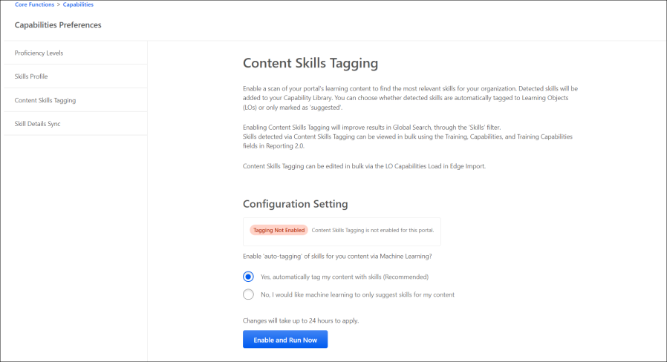
Configuration Setting
The configuration setting enables administrators to choose whether skills detected from machine learning are automatically tagged to the LO or only marked as ‘Suggested’. It affects the status shown on the Training Capabilities report in Reporting 2.0, what skills are shown on the Course Console, and which LOs are shown as results in the Related Learning widget and Search's Skills filter.
If the configuration setting is set to Yes, automatically tag my content with skills (Recommended), the detected skills are automatically added to an LO. If the configuration setting is set to No, I would like machine learning to only suggest skills for my content, the detected skills are saved as ‘Suggested’ for an LO. Select an option and click ENABLE AND RUN Now. It enables Content Skills Tagging which cannot be undone once enabled.
You can change the configuration setting later to trigger a re-tagging of your portal’s content and update the status of your skills from Auto-tagged to Suggested, or vice versa. The change takes up to 24 hours.
However, you can also refresh skills tagged to content by clicking Run Now without changing the configuration setting. It refreshes the skills tagged to content when troubleshooting is required or when new skill equivalencies are added.
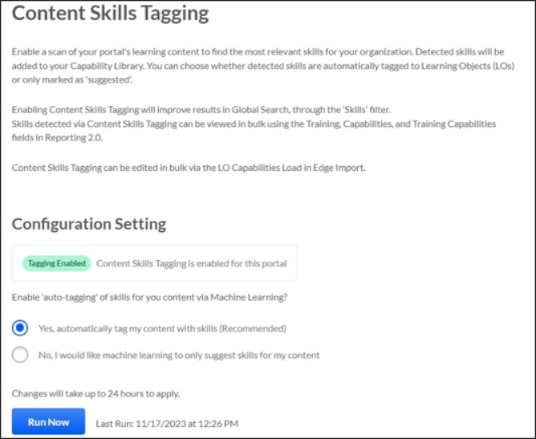
When tagging is initiated, the Content Skills Tagging Configuration page is disabled for 24 hours, while the catalog is tagged with skills.
Considerations
- If the configuration is set to No, I would like machine learning to only suggest skills for my content, the LOs shown in the Related Learning widget and the Skills Filter for Search are only impacted by administrator-tagged skills.
- As Suggested Skills do not influence the Related Learning widget or the Skills filter, the onus falls on the administrator to tag content with skills manually if they select the configuration No, I would like machine learning to only suggest skills for my content.
- A customer’s custom skills are only considered in Content Skills Tagging if they are marked as equivalent to a Skills Graph skill,See Capabilities Library - Create/Edit Capability on page 12 for additional information.
Note: Regardless of the configuration, administrators may continue to manually add skills to LOs via Edge Import.
Capabilities Preferences - People Matrix Settings
The People Matrix Settings page allowing administrators to enable and disable the use of training and capability models.
To manage People Matrix Settings, go to Admin > Tools > Core Functions > Capabilities > People Matrix Settings.
Permissions
PERMISSION NAME | PERMISSION DESCRIPTION | CATEGORY

People Matrix - Manage Preferences | This grants the ability to manage the People Matrix Settings. This permission cannot be constrained. This is an administrator permission. | Core Administration
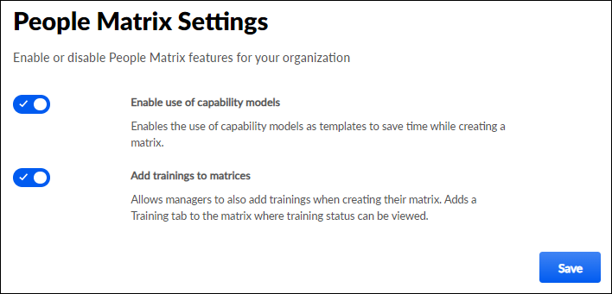
The following settings are available:
- Enable use of capability models - When this toggle is enabled, users can create a people matrix using a capability model as a template. This enables users to save time while creating the matrix because this populates the matrix with the settings from the capability model, including the appropriate set of users, the relevant skills, and the corresponding ratings.
- Add trainings to matrices - This option is only available for organizations using Learning. When this toggle is enabled, managers can add training to the people matrix. This enables users to track critical training completions in the matrix.
Capabilities Preferences - Proficiency Levels
Proficiency levels help describe a user's proficiency in a skill using unified, standard language across the organization to easily compare across skills and people. When a user is rated using proficiency levels, this helps provide more targeted assessment questions and training recommendations. There is a limit of 10 proficiency levels per portal.
It is recommended that organizations set up their proficiency levels to mirror their default rating scale for proficiency without the N/A and No Proficiency ratings.
To edit Proficiency Levels in Capabilities Preferences, go to Admin > Tools > Core Functions > Capabilities > Preferences. The Proficiency Levels tab is selected by default.
The default levels can be modified. To modify the proficiency level labels, add or remove levels, or edit level descriptions, select the Edit Proficiency Levels button.
Permissions
PERMISSION NAME | PERMISSION DESCRIPTION | CATEGORY

Capability Preferences - Manage | Grants the ability to create and edit expertise levels and rating scales for capabilities via Capabilities Preferences. This permission cannot be constrained. This is an administrator permission. | Core Administration
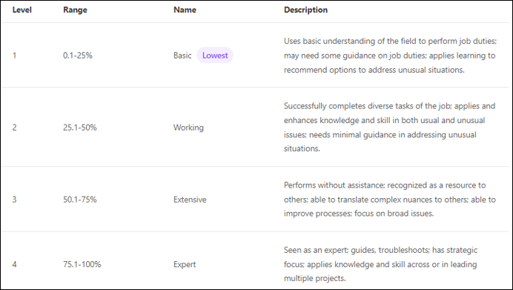
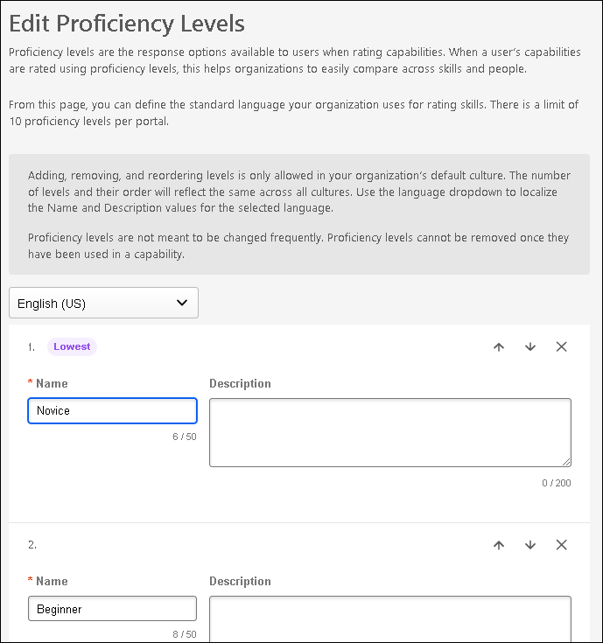
Localization
If multiple languages are enabled for the portal, a Language drop-down is available above the proficiency level names and descriptions on the Proficiency Levels page and when editing the proficiency levels. Select a language from this drop-down to provide localized Name and Description values for the selected language.
- The number of levels and level order should be the same across all cultures and should only be set in the default culture.
- The level name field is required for the default culture.
- Because level names are not required in every culture, any blank values will automatically show the level name in the default culture to end users.
Edit Name and Description
The following text fields are available for each proficiency level:
- Name - Enter a descriptive name for the proficiency level. This should clearly indicate the level of competence that is associated with the level so that end users and administrators may confidently understand the difference between the proficiency levels. This field is required. The character limit for this field is 50.
- Description - Enter a detailed description for the proficiency level. This should provide additional information about the proficiency level so that all users and administrators understand the how to utilize the proficiency level. This field is optional. The character limit for this field is 200.
Add Proficiency Level
By default, three proficiency levels are available, but organizations may choose to build a more granular proficiency level by adding levels.
To add a new proficiency level, select the Add Level button. A new level is added at the bottom of the list.
Change Proficiency Level Order
The proficiency level at the top of the list always represents the level with the least proficiency, and the proficiency level at the bottom of the list always represents the level with the most proficiency.
You may change the order of the proficiency levels by selecting the up arrow or down arrow next to the appropriate proficiency level.
Remove Proficiency Level
To remove a proficiency level from the list, select the Remove icon next to the appropriate proficiency level.
Save/Cancel
All changes on this page are not saved until the page is saved. This includes changes to level names, adding new levels, and reordering levels.
To save your changes to the proficiency levels, select the Save button.
To exit the Capabilities Preferences page without saving your changes, select the Cancel button.
Capabilities Preferences - Proficiency Score Recalculation
Administrators can recalculate predicted proficiency scores using the proficiency score recalculation setting in Capabilities Preferences.
Administrators should recalculate proficiency scores when there is a change in logic for any backend attributes such as proficiency levels or rating scales. Customers may also recalculate predicted proficiency scores if they observe any unexpected data regarding predicted proficiency scores.
To access Proficiency Score Recalculation Preferences, go to Admin > Tools > Core Functions > Capabilities > Preferences. Then, select the Proficiency Score Recalculation tab.
Permissions
PERMISSION NAME | PERMISSION DESCRIPTION | CATEGORY

Capability Preferences - Manage | Grants the ability to create and edit expertise levels and rating scales for capabilities via Capabilities Preferences. This permission cannot be constrained. This is an administrator permission. | Core Administration
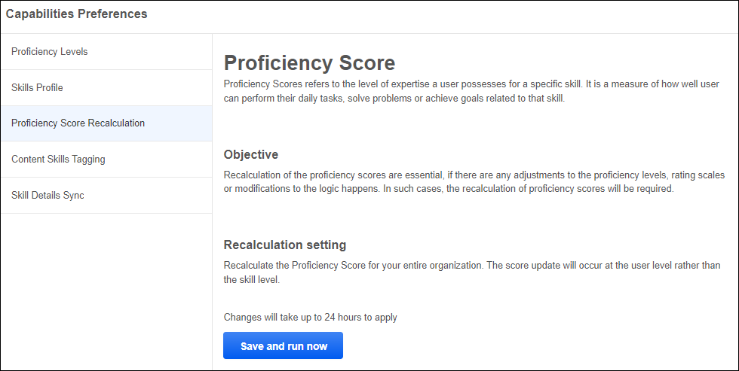
Capabilities Preferences - Skill Details Sync
Within Capabilities Preferences, the Skill Details Sync section provides administrators more control over automatic synchronization and import of skills from the Cornerstone Skills Graph.
To access Skills Details Sync Preferences, go to Admin > Tools > Core Functions > Capabilities > Preferences. Then, select the Skill Details Sync tab.
Permissions
PERMISSION NAME | PERMISSION DESCRIPTION | CATEGORY

Capability Preferences - Manage | Grants the ability to create and edit expertise levels and rating scales for capabilities via Capabilities Preferences. This permission cannot be constrained. This is an administrator permission. | Core Administration
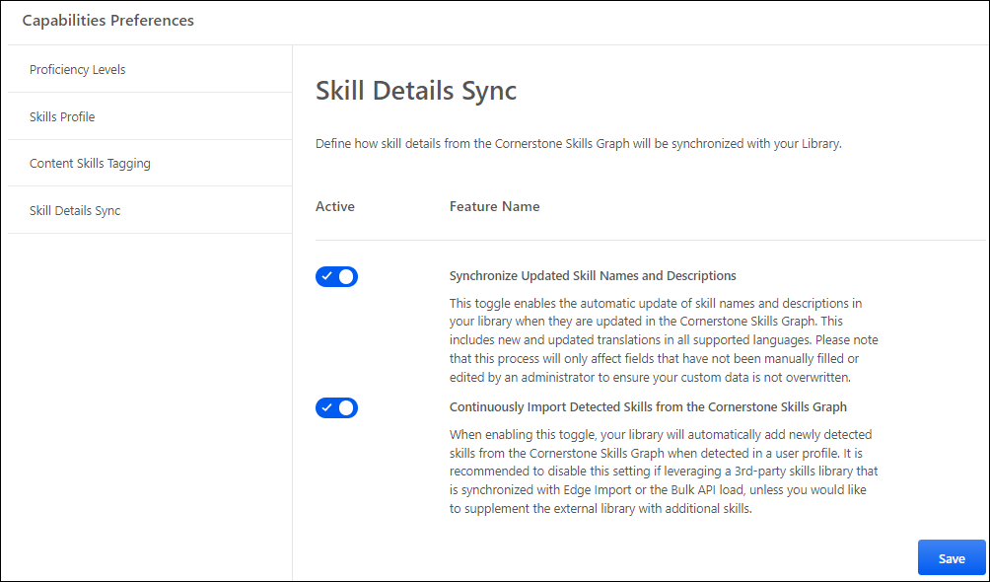
The Skill Details Sync section contains the following preferences:
- Continuously Import Detected Skills from the Cornerstone Skills Graph - When this toggle is enabled, the portal's skills library will automatically add newly detected skills from the Cornerstone Skills Graph when new skills are detected in a user profile. For example, when this toggle is enabled and a user has "playing guitar" listed as an interest in their Universal Profile, skill detection will detect this interest and import a skill called "Guitar" into the organization's Capability Library so it can be suggested to that user in their Skills Profile. When this toggle is disabled, the system will not automatically detect and import any skills into the organization's Capability Library.
  - It is recommended to disable this setting if leveraging a 3rd-party skills library that is synchronized with Edge Import or the Bulk API load unless you would like to supplement the external library with additional skills.
- Synchronize Updated Skill Names and Descriptions - When this setting is enabled, skill names and descriptions in all supported languages are refreshed in the customer’s portal when they are updated in the Cornerstone Skills Graph. Any skill details that are manually updated after being imported will not be overwritten by the Cornerstone Skills Graph. Imported skills are only updated if all of the following are true:
  - The new preference is enabled
  - Skill names and descriptions have not been customized by an administrator
  - Translations have not been manually entered
Capabilities Preferences - Skills Profile
The Capabilities Preferences - Skills Profile page provides basic controls that enable or disable certain features within the Skills Profile.
The Skills Profile Preferences apply to all users within your portal who have the Capabilities - Skills Profile - View permission. There are no Organizational Unit (OU) specific controls at this time.
To access Skills Profile Preferences, go to Admin > Tools > Core Functions > Capabilities > Preferences. Then, select the Skills Profile tab.
Permissions
PERMISSION NAME | PERMISSION DESCRIPTION | CATEGORY

Capability Preferences - Manage | Grants the ability to create and edit expertise levels and rating scales for capabilities via Capabilities Preferences. This permission cannot be constrained. This is an administrator permission. | Core Administration
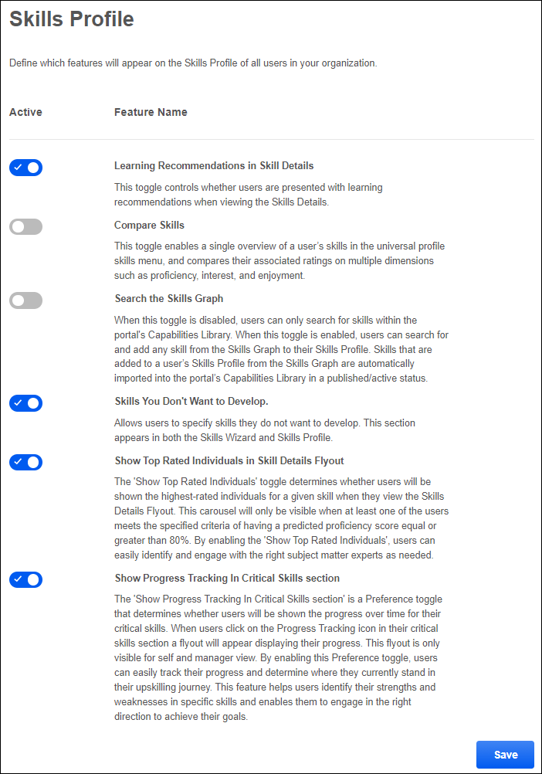
Skills Profile Features
The following product experiences can be enabled or disabled for Skills Profile.
- Learning Recommendations in Skill Details - This toggle controls whether users are presented with learning recommendations when viewing the Skills Details flyout for a skill. This is enabled by default. This feature is only available for organizations using Learning. See Skills Profile - View Skill Details on page 117 for additional information.
- Compare Skills - This toggle controls whether the Compare Skills page is enabled. This page enables managers to quickly view all of a user's skills and their skill ratings for all available dimensions, such as Interest, Enjoyment, and Proficiency. This is disabled by default. See Skills Profile - Compare Skills on page 84 for additional information.
- Search the Skills Graph - When this toggle is disabled, users can only search for skills within the portal's Capabilities Library. When this toggle is enabled, users can search for and add any skill from the Skills Graph to their Skills Profile. Skills that are added to a user’s Skills Profile from the Skills Graph are automatically imported into the portal’s Capabilities Library in a published/active status.
- Skills You Don't Want to Develop - When this toggle is enabled, the Not Developing section is included on the Skills Profile and when selecting skills in the Skills Wizard. This section enables users to specify skills they do not want to develop, which prevents these skills from being suggested for development and being used to suggest learning and development paths.
- Show Top Rated Individuals in Skill Details Flyout - When this toggle is enabled, the Top Rated Individuals section is included on the Skills Details Flyout. This section displays the top rated individuals within the organization for the skill. Up to six top-rated individuals are displayed for a skill based on their skill proficiency. A link to the top-rated individual's Skill Profile is included to enable users to easily connect with the top rated individual. See Skills Profile - View Skill Details on page 117 for additional information.
- Show progress tracking in critical skills section - When this toggle is enabled, managers and users can access the Critical Skills Progress Tracking flyout from the Skills Profile. This flyout displays the user's progress over time for their critical skills. See Skills Profile - View Critical Skills Progress on page 122 for additional information.

Manage Capability Categories
Capability categories allow administrators to categorize their capabilities into a hierarchical list of categories. This can facilitate skill management by filtering skills by business unit, functional area, vertical, or any other relevant categorization in the Capability Library.
The Manage Categories page enables administrators to create and manage capability categories.
To access the Manage Categories page, go to Admin > Tools > Core Functions > Capabilities > Capability Categories.
Permissions
PERMISSION NAME | PERMISSION DESCRIPTION | CATEGORY

Capability Categories | Grants access to the Capability Categories functionality, where administrators can create and manage capability categories. This permission cannot be constrained. This is an administrator permission. | Core Administration
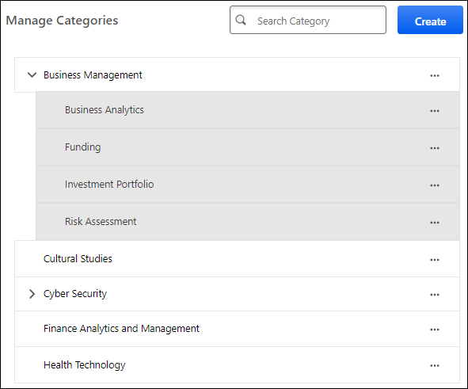
Search Categories
To search for a category, enter the keywords in the search field and press the Enter key or select the magnifying glass icon. The page displays all categories that match the search terms.
Create a Category
To create a capability category, select the Create button. See Create a Capability Category on page 35 for additional information.
Edit a Category
To edit a capability category, select the three-dot menu for the category and select Edit. See Create a Capability Category on page 35 for additional information.
Deactivate or Activate a Category
To deactivate an active capability category, select the three-dot menu for the category and select Deactivate. Deactivated categories can still be used by administrators, but they be hidden from end users when they are made visible on the Skills Profile in a future release.
To activate a deactivated capability category, select the three-dot menu for the category and select Activate.
If a parent category is activated or deactivated, all subcategories are also activated or deactivated. If a parent category is inactive, the Activate option is not available for subcategories.
Delete a Category
To delete a capability category, select the three-dot menu for the category and select Delete. This option is only available if the category does not have any subcategories. See Delete a Capability Category on page 37 for additional information.
Expand a Hierarchy
If a category contains subcategories, an arrow appears next to the category name. Select the arrow to expand the hierarchy and view the subcategories. Subcategories appear indented.
Create a Capability Category
Capability categories allow administrators to categorize their capabilities into a hierarchical list of categories. This can facilitate skill management by filtering skills by business unit, functional area, vertical, or any other relevant categorization in the Capability Library.
To create a capability category, go to Admin > Tools > Core Functions > Capabilities > Capability Categories. Then, select the Create button.
To edit a capability category from the Manage Categories page, select the three-dot menu for the category and select Edit.
Permissions
PERMISSION NAME | PERMISSION DESCRIPTION | CATEGORY

Capability Categories | Grants access to the Capability Categories functionality, where administrators can create and manage capability categories. This permission cannot be constrained. This is an administrator permission. | Core Administration
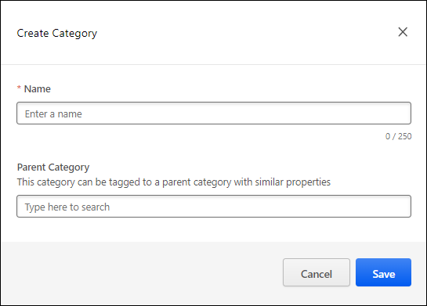
Name
Enter a name for the category. The category name will be visible to administrators when creating capabilities. This field is mandatory.
Parent Category
When creating categories in a hierarchy, you can select the parent category for the category you are creating. This is optional. If no parent category is selected, then the category is created at the top level of the category hierarchy.
Up to five category levels can exist within the category hierarchy.
Save or Cancel
Select Save to create the category. Select Cancel to discard the changes.
Delete a Capability Category
Administrators can delete a capability category if the category does not have any subcategories. When a category is deleted, it cannot be restored.
To delete a capability category, go to Admin > Tools > Core Functions > Capabilities > Capability Categories. Then, select the three-dot menu for the category and select Delete.
Permissions
PERMISSION NAME | PERMISSION DESCRIPTION | CATEGORY

Capability Categories | Grants access to the Capability Categories functionality, where administrators can create and manage capability categories. This permission cannot be constrained. This is an administrator permission. | Core Administration
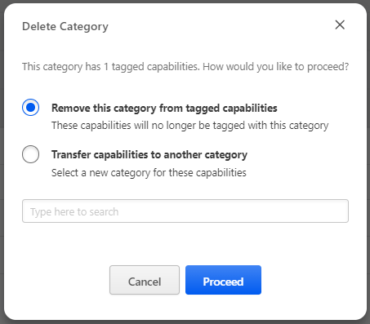
If the category that is being deleted is associated with one or more capabilities, administrators must determine how to update the associated capabilities. The following options are available:
- Remove this category from tagged capabilities - Select this option to disassociate the category from the skills without selecting a replacement category.
- Transfer capabilities to another category - Select this option to replace the deleted category with another category. When this option is selected, you must then specify the replacement category.
Select Proceed to delete the category and update the associated capabilities according to the selected option.

Capability Models Library
A Capability Model is a defined group of critical capabilities that a particular audience or group should either have or be developing. Capability Models can influence a user's suggested skills if the selected organizational unit audience aligns with the user's profile.
The Capability Models Library enables administrators to create, edit, and deactivate Capability Models.
To access the Capability Models Library, go to Admin > Tools > Core Functions > Capabilities > Capability Models Library.
Permissions
PERMISSION NAME | PERMISSION DESCRIPTION | CATEGORY

Capabilities - Capability Models Library - Edit | Grants ability to access the Capability Models Library and create and edit Capability Models. This permission cannot be constrained. This is an administrator permission. | Core Administration

Capabilities - Capability Models Library - Manage | Grants ability to access the Capability Models Library and create, edit, and deactivate Capability Models. This permission cannot be constrained. This is an administrator permission. | Core Administration
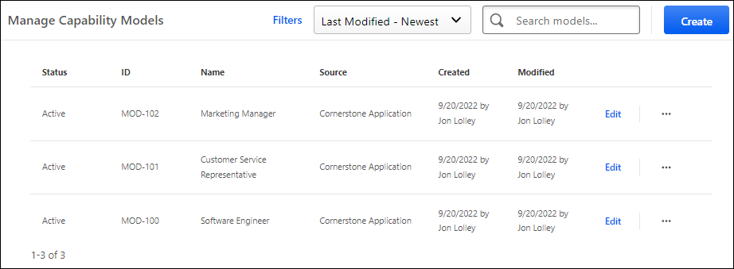
Search, Filter, and Sort Capability Models
To search for a Capability Model by name, enter the keyword in the Search models field. Then, select the Magnifying Glass icon or press the Enter key on your keyboard.
To filter the Capability Models, select the Filters link. The models can be filtered by status (e.g., Draft, Active, Inactive) and source (e.g., Cornerstone Application, Cornerstone Skills Graph, Edge Import).
To change the sort order of the Capability Models, select the appropriate sort order from the drop-down menu. By default, models are sorted by modification date with the most recently modified model displayed first.
Create a Capability Model
To create a Capability Model, select the Create button. See Capability Model - Create/Edit on page 41 for additional information.
Edit a Capability Model
To edit a Capability Model, select the Edit link for the appropriate Capability Model. See Capability Model - Create/Edit on page 41 for additional information.
Deactivate a Capability Model
To deactivate a Capability Model, select menu icon for the appropriate Capability Model. Then, select Deactivate. When a model is inactive, the model will no longer impact the Skills Profile for users within the model's defined audience. Any skills that were suggested to users because of the model will be removed from the Skills You Might Have section of their Skills Profile.
Publish a Capability Model
To publish an inactive Capability Model, select menu icon for the appropriate Capability Model. Then, select Publish. When a Capability Model is published, any user who is within the model's defined audience is provided the model's critical skills as suggested skills in the Skills You Might Have section of their Skills Profile. Users are not suggested any critical skills that they have already declared.
Capability Model List
The following information is displayed for each existing Capability Model:
- Status - This displays the status of the model, such as Draft, Active, and Inactive.
- ID - This displays the unique identifier for the model. This is automatically assigned when the model is created within the Cornerstone CSX application.
- Name - This displays the name of the model.
- Source - This displays how the model was added to the library.
- Created - This displays the date on which the model was created and the name of the user who created the model.
- Modified - This displays the date on which the model was most recently modified and the name of the user who modified the model.
Capability Model - Create/Edit
A Capability Model is a defined group of critical capabilities that a particular audience or group should either have or be developing. Capability Models can influence a user's suggested skills if the selected organizational unit audience aligns with the user's profile.
When creating a capability model, there are two sections:
- Model Details - See Capability Model - Create - Model Details on page 43 for additional information.
- Capability Targets - See Capability Model - Create - Capability Targets on page 45 for additional information.
To create a Capability Model, go to Admin > Tools > Core Functions > Capabilities > Capability Models Library. Then, select the Create button.
To edit a Capability Model, go to Admin > Tools > Core Functions > Capabilities > Capability Models Library. Then, select the Edit link for the appropriate Capability Model.
Permissions
PERMISSION NAME | PERMISSION DESCRIPTION | CATEGORY

Capabilities - Capability Models Library - Edit | Grants ability to access the Capability Models Library and create and edit Capability Models. This permission cannot be constrained. This is an administrator permission. | Core Administration

Capabilities - Capability Models Library - Manage | Grants ability to access the Capability Models Library and create, edit, and deactivate Capability Models. This permission cannot be constrained. This is an administrator permission. | Core Administration
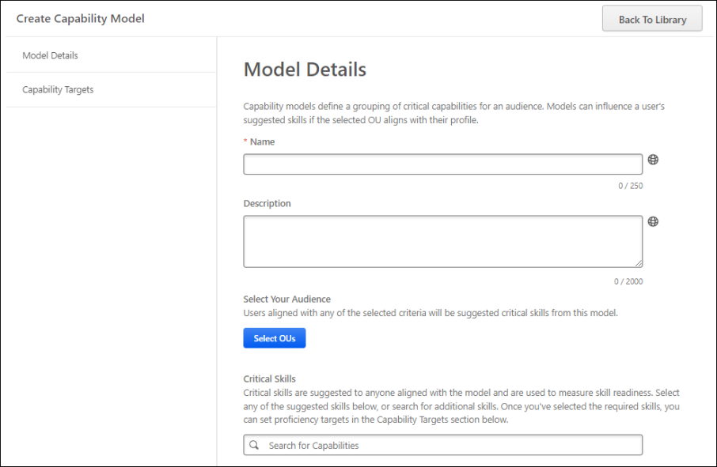
Capability Model - Create - Model Details
A Capability Model is a defined group of critical capabilities that a particular audience or group should either have or be developing. Capability Models can influence a user's suggested skills if the selected organizational unit audience aligns with the user's profile.
To create a Capability Model, go to Admin > Tools > Core Functions > Capabilities > Capability Models Library. Then, select the Create button.
To edit a Capability Model, go to Admin > Tools > Core Functions > Capabilities > Capability Models Library. Then, select the Edit link for the appropriate Capability Model.
Permissions
PERMISSION NAME | PERMISSION DESCRIPTION | CATEGORY

Capabilities - Capability Models Library - Edit | Grants ability to access the Capability Models Library and create and edit Capability Models. This permission cannot be constrained. This is an administrator permission. | Core Administration

Capabilities - Capability Models Library - Manage | Grants ability to access the Capability Models Library and create, edit, and deactivate Capability Models. This permission cannot be constrained. This is an administrator permission. | Core Administration
Enter Capability Model Details
Enter the following information for the Capability Model:
- Capability Model ID - When editing a capability, the model ID is displayed, but this value cannot be edited.
- Name - Enter a descriptive name for the Capability Model. The character limit is 250. If multiple languages are enabled for your portal, select the Translate icon to translate the field into other available languages.
- Description - Enter a clear description for the Capability Model. The character limit is 2000. If multiple languages are enabled for your portal, select the Translate icon to translate the field into other available languages.
- Select Your Audience - Select the Select OUs button to select one or more organizational units to define the audience for the Capability Model. Administrators can select any type of organizational unit, including custom organizational units. Once an organizational unit is selected, administrators may select the Include Subordinates option to also include subordinate organizational units in the audience.
- Critical Skills - Select which skills are critical for the Capability Model by selecting the Plus icon next to the skill name. In this section, a list of suggested capabilities is displayed based on the Capability Model name and description. Suggestions are only displayed after entering a name, description, or audience. Administrators may also search for a skill by name. At least one skill must be selected.
View Skill Details
To view the details of a suggested or selected skill, select the skill name.
Remove a Selected Skill
To remove a selected skill, select the Remove icon to the right of the skill name.
Save Draft
Select the Save Draft button to save the current model as a draft. The model does not impact any users' suggested skills until it is published.
Publish
Select the Publish button to save and publish the Capability Model. When a Capability Model is published, any user who is within the model's defined audience is provided the model's critical skills as suggested skills in the Skills You Might Have section of their Skills Profile. Users are not suggested any critical skills that they have already declared.
Capability Model - Create - Capability Targets
When creating or editing a capability model, administrators can enable and define target proficiency levels for capabilities in a model. The target proficiency level represents the proficiency level that is required for the capability model. Administrators may define target proficiency levels for all users in the organization or for specific organizational units (OUs).
The proficiency levels that are available when setting proficiency targets are configured in Capability Preferences > Proficiency Levels. See Capabilities Preferences - Proficiency Levels on page 24 for additional information.
To create a Capability Model, go to Admin > Tools > Core Functions > Capabilities > Capability Models Library. Then, select the Create button.
To edit a Capability Model, go to Admin > Tools > Core Functions > Capabilities > Capability Models Library. Then, select the Edit link for the appropriate Capability Model.
Permissions
PERMISSION NAME | PERMISSION DESCRIPTION | CATEGORY

Capabilities - Capability Models Library - Edit | Grants ability to access the Capability Models Library and create and edit Capability Models. This permission cannot be constrained. This is an administrator permission. | Core Administration

Capabilities - Capability Models Library - Manage | Grants ability to access the Capability Models Library and create, edit, and deactivate Capability Models. This permission cannot be constrained. This is an administrator permission. | Core Administration
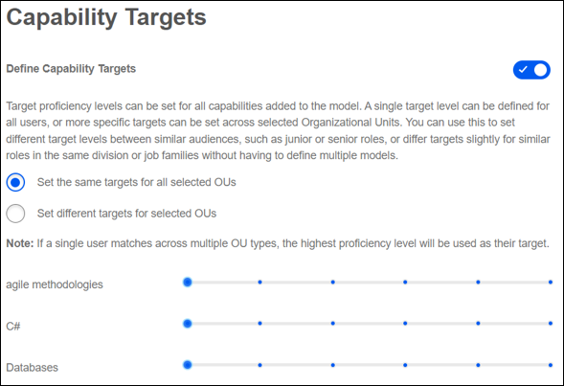
Enable Capability Targets
When creating a capability model, capability targets are disabled by default. To enable capability targets for the competency model, enable the Define Capability Targets toggle.
Set the same targets for all selected OUs
To set the same capability targets for all users who are included in the capability model, select Set the same targets for all selected OUs.
When this option is selected, a single set of sliders are available with one slider for each capability. Select the target proficiency level for each capability. The selected targets are applied to all users in the capability model.
Set different targets for selected OUs
To set different capability targets for each organizational unit associated with the capability model, select Set different targets for selected OUs.
When this option is selected, each organizational unit associated with the capability model will have a distinct set of sliders to set specific targets for each organizational unit. This method could be used to set a model for an entire department or team with different proficiency levels for different roles within that department or team. Similarly, this method could be used to set a model for a job type but require different proficiency levels for Junior or Senior titles.
Suggested Target
When the lowest proficiency level is set as the target or when a target is not set for a proficiency, this indicates the skill is suggested for the role, but there is no target proficiency for the skill within the capability model.
The "Suggested" rating label is not customizable.
Highest Target
The highest rating displays the customized level label for the highest proficiency level configured in Capability Preferences > Proficiency Levels. See Capabilities Preferences - Proficiency Levels on page 24 for additional information.
Save Draft
Select the Save Draft button to save the current model as a draft. The model does not impact any users' suggested skills until it is published.
Publish
Select the Publish button to save and publish the Capability Model. When a Capability Model is published, any user who is within the model's defined audience is provided the model's critical skills as suggested skills in the Skills You Might Have section of their Skills Profile. Users are not suggested any critical skills that they have already declared.

Capability Rating Scales - Manage
Rating Scales are used to set the values that employees can select when completing a rating of themselves or others. They represent an exact point value that can be converted into a percentage based on the scale range.
Rating scales are commonly used to measure proficiency, but they may also be used to measure something other than skill proficiency. For example, you might want to ask employees how much they want to develop a skill. Your scale might look like this:
- Very Interested
- Somewhat Interested
- Not Interested
A skill-specific rating scale could even use statements to describe different scores using domain-specific phrasing like this (Skill-specific scales will be available in a future release):
- Plays piano like a virtuoso
- Can play a nice tune with sheet music available
- Knows the basic keys and scales
- Has never played piano
Administrators may view and edit the rating scales that are used to measure a user's enjoyment, interest, and proficiency in a capability.
To manage capabilities rating scales, go to Admin > Tools > Core Functions > Capabilities > Rating Scales.
Permissions
PERMISSION NAME | PERMISSION DESCRIPTION | CATEGORY

User Rating Scales - Manage | Grants ability to manage rating scales for capabilities. This permission cannot be constrained. This is an administrator permission.  This permission only works when used in conjunction with the User Rating permission. | Core Administration

User Ratings | For end users, this permission grants the ability to perform ratings and view ratings. For administrators, this permission is required, along with the specific user rating administration permissions to edit rating scales or templates. This permission cannot be constrained. | Core Administration
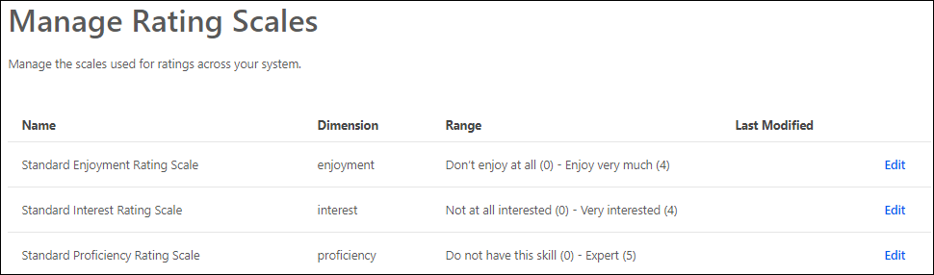
Edit Rating Scale
To edit a capability rating scale, select the Edit link for the appropriate rating scale in the list. See Capability Rating Scales - Edit on page 50 for additional information.
Rating Scales List
The following information is listed for each existing capability rating scale:
- Name - This displays the name that was given for the rating scale when it was created or modified.
- Dimension - This displays whether the rating scale is used to rate a user's proficiency, interest, or enjoyment in a capability.
- Range - This displays the scale's lowest rating and highest rating.
- Last Modified - This displays the date on which the rating scale was last modified and the administrator who modified it.
Default Rating Scales
The following capability rating templates are available by default:
- Standard Enjoyment Rating Scale
- Standard Interest Rating Scale
- Standard Proficiency Rating Scale
Capability Rating Scales - Edit
Rating Scales are used to set the values that employees can select when completing a rating of themselves or others. They represent an exact point value that can be converted into a percentage based on the scale range. Administrators may customize rating scales to suit their organizational needs.
When creating a capability assessment, administrators may specify the appropriate rating scale.
To edit a Capability Rating Scale, go to Admin > Tools > Core Functions > Capabilities > Rating Scales. Then, select the Edit link to the right of the appropriate rating scale.
Permissions
PERMISSION NAME | PERMISSION DESCRIPTION | CATEGORY

User Rating Scales - Manage | Grants ability to manage rating scales for capabilities. This permission cannot be constrained. This is an administrator permission.  This permission only works when used in conjunction with the User Rating permission. | Core Administration

User Ratings | For end users, this permission grants the ability to perform ratings and view ratings. For administrators, this permission is required, along with the specific user rating administration permissions to edit rating scales or templates. This permission cannot be constrained. | Core Administration
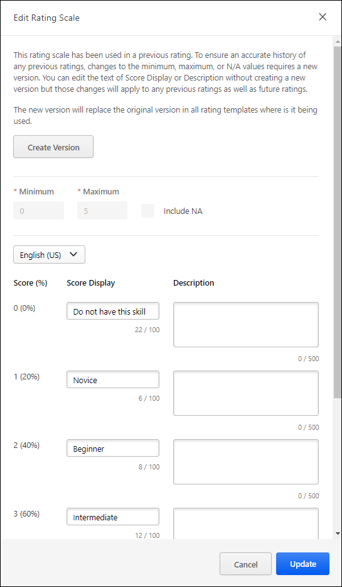
Create New Version
If the rating scale has been used in a previous capability rating, then the Minimum, Maximum, and Include NA options can only be modified if a new version of the rating scale is created. This precaution ensures an accurate history of any previous ratings. However, changes can be made to the Score Display and Description text fields without creating a new version.
To create a new version of the rating scale, select the Create Version button at the top of the flyout. The new version only applies to future ratings. Note: This button is only available if the rating scale has been used in a previous capability rating.
When a new version is created, the new version automatically replaces the original version in all rating templates where the rating scale is being used.
Set Minimum and Maximum Values
The Minimum and Maximum values for the rating scale define the lowest rating value and the highest rating value. The rating scale is divided into even segments based on the minimum and maximum values.
- Minimum - This represents 0% capability level. By default, this value is set to zero.
- Maximum - This represents 100% capability level. By default, this value is set to five.
After updating the Minimum and Maximum values, select the Update button to refresh the rating scale with the new range values. Note: Selecting Update does not save your changes to the rating scale. To save your changes, you must select the Save button.
If the rating scale has been used in a previous capability rating, these values cannot be modified. If you must modify these values, then create a new version of the rating scale. See the Create New Version section.
Include NA Value in Rating Scale
The Not Applicable (N/A) value may be included in the rating scale to allow assessors to indicate that the capability does not apply to the assessee. When this rating is selected, a N/A rating is available at the top of the rating scale.
After selecting or deselecting the Include N/A setting, select the Update button to refresh the rating scale with the new setting. Note: Selecting Update does not save your changes to the rating scale. To save your changes, you must select the Save button.
If the rating scale has been used in a previous capability rating, this value cannot be modified. If you must modify this value, then create a new version of the rating scale. See the Create New Version section.
Edit Score Display and Description
Based on the rating scale configuration, the capability assessment scores are listed in the Score (%) column. The raw score value and the corresponding score percentage is displayed.
The following text fields are available for each rating scale score:
- Score Display - Enter the text that will display for the rating scale score. This may be a numeric value or a text value. By default, this field is set to the numeric score. This field is required. The character limit for this field is 100.
- Description - Enter a detailed description for the rating scale score. This should provide additional information about the score so that all users and administrators understand the how to utilize the score. This field is optional. The character limit for this field is 500.
Save/Cancel/Create Version
All changes on this page are not saved until the page is saved. This includes changes to minimum and maximum values, the Include NA setting, and score display and description values.
To save your changes to the default rating scale, select the Save button.
To exit the Edit Rating Scale page without saving your changes, select the Cancel button.
If you are creating a new version of a rating scale, a Create Version button is available. Select this button to create the new version. The new version only applies to future ratings.

Capability Feedback Templates - Manage
Feedback Templates are the package of configuration choices made by the administrator that form the rating and feedback experiences for the end user. Each template defines the method in which it is initiated, by whom it is initiated, and whom it will rate. These templates exist behind-the-scenes for the end user, while guiding them and minimizing friction.
Prior to editing a feedback template, a best practice is to configure your rating scales.
To manage capabilities feedback templates, go to Admin > Tools > Core Functions > Capabilities > Feedback Templates.
Permissions
PERMISSION NAME | PERMISSION DESCRIPTION | CATEGORY

User Rating Templates - Manage | Grants ability to manage feedback templates for capabilities. This permission cannot be constrained. This is an administrator permission.  This permission only works when used in conjunction with the User Rating permission. | Core Administration

User Ratings - Request Others to Provide Feedback on Themselves | Grants ability to request that someone rate themself. This permission is intended for administrators, managers, or other leadership roles. This permission cannot be constrained. | Core Administration

User Ratings | For end users, this permission grants the ability to perform ratings and view ratings. For administrators, this permission is required, along with the specific user rating administration permissions to edit rating scales or templates. This permission cannot be constrained. | Core Administration
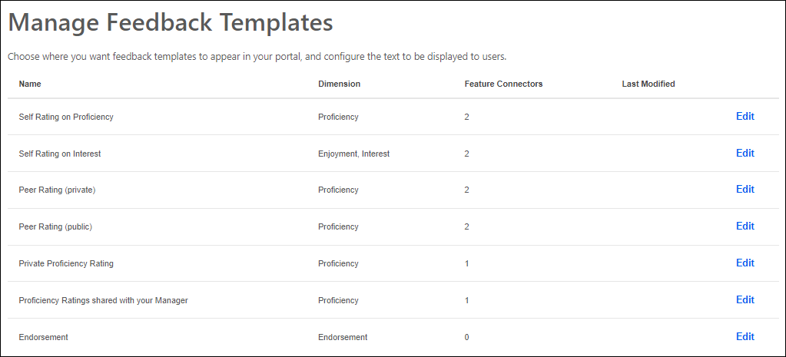
Edit Feedback Template
To edit a capability feedback template, select the Edit link for the appropriate template in the list. See Capability Feedback Templates - Edit on page 57 for additional information.
Feedback Templates List
The following information is listed for each existing capability feedback template:
- Name - This displays the display name of the feedback template that appears to users on the cover page before starting to provide feedback.
- Dimension - This displays whether the template is used to rate a user's proficiency, enjoyment, interest, or endorsement. A template may have multiple dimensions.
- Feature Connectors - This displays the number of areas or features in which the template can be accessed by users.
- Last Modified - This displays the date on which the feedback template was last modified and the administrator who modified it.
Default Feedback Templates
The following capability feedback templates are available by default:
- Self Rating on Proficiency - This template is used for users to rate their own proficiency in a capability. By default, the feedback that raters provide using this template are visible to the rater and the rater's direct manager.
- Self Rating on Interest - This template is used for users to rate their own interest in a capability. By default, the feedback that raters provide using this template are visible to the rater.
- Peer Rating (private) - This template is used for a user's peers to privately rate the user's proficiency in a capability. By default, the feedback that raters provide using this template are visible to only the rater and the user being rated.
- Peer Rating (public) - This template is used for a user's peers to publicly rate the user's proficiency in a capability. By default, the feedback that raters provide using this template are visible to everyone.
- Private Proficiency Rating - This template is used for anyone to privately rate a user's proficiency in a capability. By default, the feedback that raters provide using this template are visible to the rater and the user being rated.
- Proficiency Ratings shared with your Manager - This template is used for anyone to privately rate a user's proficiency in a capability. By default, the feedback that raters provide using this template are visible to the rater, the user being rated, and the user's direct manager.
- Request Private Feedback - This template enables employees to request others to provide private feedback. The person who creates the request is able to select which skill are included in the request. Users have access to this template when requesting feedback in My Feedback Requests.
- Request 360 feedback about a specific person - This template enables administrators, managers, or other leadership roles to ask others to provide feedback about a specific user on a list of skills that they have chosen. The person who creates the request is able to select which skills are included in the request. Users who have permission to request others to provide feedback on a specific user will have access to this template when requesting feedback in My Feedback Requests.
- Request Someone to Rate Themself - This template enables administrators, managers, or other leadership roles to ask others to rate themselves from a list of skills that they have chosen. The person who creates the request is able to select which skill are included in the request. Users who have permission to request others to provide feedback on themselves will have access to this template when requesting feedback in My Feedback Requests.
- Endorsement - This template has a limited set of settings, and it is used to give an endorsement for a user on a specific skill. An endorsement does not confer a specific judgment about proficiency, but it generally means you are willing to vouch for someone's proficiency in a certain skill. It is subjective, but it is always positive. By default, the endorsement is visible to everyone.
Related Topics
Capability Feedback Templates - Edit
Feedback Templates are the package of configuration choices made by the administrator that form the rating and feedback experiences for the end user. Each template defines the method in which it is initiated, by whom it is initiated, and whom it will rate. These templates exist behind-the-scenes for the end user, while guiding them and minimizing friction.
When editing a capability feedback template, the settings are separated into two tabs:
- General Settings - The General Settings tab enables administrators to configure settings such as the Display Name, Instructions, Menu Action Name, and whether the introduction page is displayed when launching a feedback task.See Capability Feedback Templates - Edit - General Settings on page 59 for additional information.
  - When configuring an Endorsement feedback template, the General Settings are limited due to the nature of the feedback. See Capability Feedback Templates - Edit - General Settings - Endorsement Template on page 64 for additional information.
- Feature Connectors - The Feature Connectors tab displays all the areas in which a capability feedback template may be used and enables administrators to configure where the template is available for users, such as the Skills - Declared and Skills - To Develop sections of the Skills Profile.See Capability Feedback Templates - Edit - Feature Connectors on page 67 for additional information.
To edit a Capability Feedback Template, go to Admin > Tools > Core Functions > Capabilities > Feedback Templates. Then, select the Edit link to the right of the appropriate feedback template.
Permissions
PERMISSION NAME | PERMISSION DESCRIPTION | CATEGORY

User Rating Templates - Manage | Grants ability to manage feedback templates for capabilities. This permission cannot be constrained. This is an administrator permission.  This permission only works when used in conjunction with the User Rating permission. | Core Administration

User Ratings | For end users, this permission grants the ability to perform ratings and view ratings. For administrators, this permission is required, along with the specific user rating administration permissions to edit rating scales or templates. This permission cannot be constrained. | Core Administration
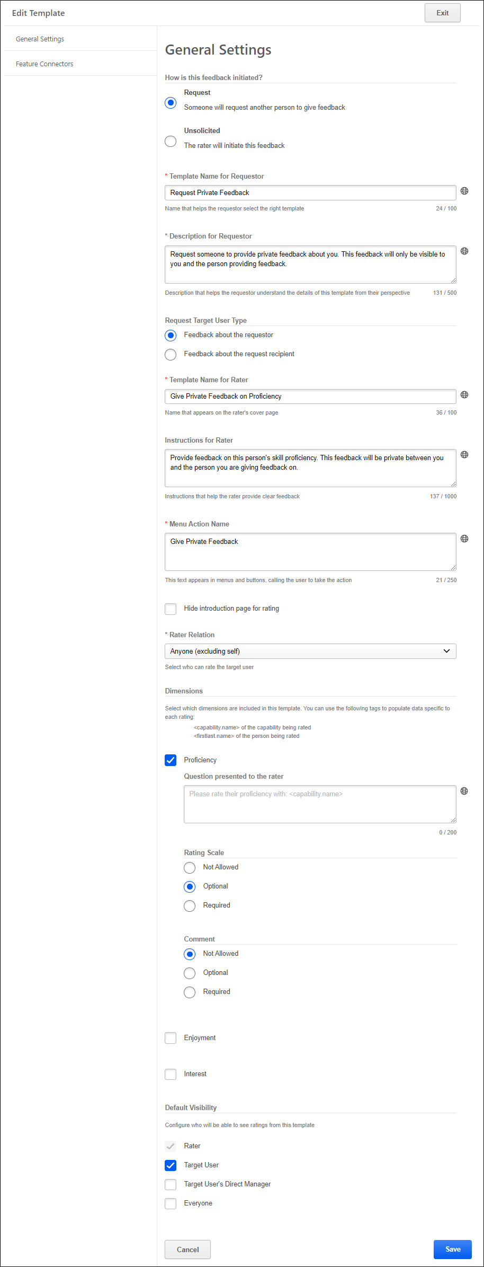
Capability Feedback Templates - Edit - General Settings
Feedback Templates are the package of configuration choices made by the administrator that form the rating and feedback experiences for the end user. Each template defines the method in which it is initiated, by whom it is initiated, and whom it will rate. These templates exist behind-the-scenes for the end user, while guiding them and minimizing friction.
When editing a template, the settings are divided into two tabs, General Settings and Feature Connectors.
The General Settings tab enables administrators to configure settings such as the Display Name, Instructions, Menu Action Name, and whether the introduction page is displayed when launching a feedback task.
To edit a Capability Feedback Template, go to Admin > Tools > Core Functions > Capabilities > Feedback Templates. Then, select the Edit link to the right of the appropriate feedback template.
Permissions
PERMISSION NAME | PERMISSION DESCRIPTION | CATEGORY

User Rating Templates - Manage | Grants ability to manage feedback templates for capabilities. This permission cannot be constrained. This is an administrator permission.  This permission only works when used in conjunction with the User Rating permission. | Core Administration

User Ratings | For end users, this permission grants the ability to perform ratings and view ratings. For administrators, this permission is required, along with the specific user rating administration permissions to edit rating scales or templates. This permission cannot be constrained. | Core Administration
How is feedback initiated?
This field enables administrators to specify whether the corresponding feedback template is used to request feedback from another person or if it is used by users to initiate and provide unsolicited feedback. Depending on which option is selected, additional configurations may be available for the template. The following options are available:
- Request - Select this option if the feedback template allows users to request feedback from another user. When this option is selected, additional settings are available to allow the administrator to provide a name and instructions that are specific for the user requesting the feedback.
- Unsolicited - Select this option if the feedback template allows users to initiate and provide unsolicited feedback for another user.
Template Name for Requestor
This field is only available when the How is feedback initiated? option is set to Request. This field is not available for Unsolicited feedback templates because there is no requester for this feedback interaction.
In this field, specify the title text that will appear when users are choosing a template to request feedback. This title should help the requester select the appropriate template.
Description for Requestor
This field is only available when the How is feedback initiated? option is set to Request. This field is not available for Unsolicited feedback templates because there is no requester for this feedback interaction.
In this field, provide a description of the template that will appear when users are choosing a template to request feedback. The description should help the requester select the appropriate template.
Request Target User Type
This field is only available when the How is feedback initiated? option is set to Request. This field is not available for Unsolicited feedback templates because there is no requester for this feedback interaction.
In this field, select whether the feedback template is used to request feedback about the requester or about the request recipient. The following options are available:
- Feedback about the requester - Select this option if the template is used to request feedback about the user who is requesting the feedback. When this option is selected, the Rater Relation drop-down is set to Anyone (excluding self).
- Feedback about the request recipient - Select this option if the template is used to request feedback about the request recipient. When this option is selected, the Rater Relation drop-down is set to Self.
- Feedback about a specific person - Select this option if the template is used to request feedback about a specific person. When this option is selected, the Rater Relation drop-down is set to Anyone (excluding self).
Template Name for Rater
Specify the title text that appears to the rater on the introduction page before providing feedback. This field is required. The character limit for this field is 100.
This change is to more clearly indicate that this field is what the rater will see on the introduction page before providing feedback.
Instructions for Rater
Specify the instructional text that appears to the rater on the introduction page before providing feedback. This field is optional. The character limit for this field is 1000.
Menu Action Name
Specify the text that appears in menus when launching the template. For example, if the template is used for users to rate their own proficiency in the skill, the menu action name may be "Rate Myself." Similarly, if the template is used for users to request a proficiency rating from others, the menu action name may be "Request a Proficiency Rating."
This field is required. The character limit for this field is 250.
Hide Introduction Page for Rating
Select this option to hide the introduction page for feedback requests using this template. For example, if the menu action is very self-explanatory (e.g., Provide a Public Rating), you may not need an introduction page. However, if the visibility of feedback is sensitive or the purpose is specific, an introduction page is recommended.
Rater Relation
From the drop-down menu, select who can rate the target user using this template based on their relationship to the target user. This enables administrators to tailor the template to reflect the language for a self rating, a peer rating, a manager rating, etc. The following options are available:
- Anyone - This option is available when the Request Target User Type is set to Feedback about the requestor or Feedback about a specific person.
- Anyone (excluding self) - Anyone except the target user can rate the target user.
- Indirect Manager - The target user's indirect manager can rate the target user.
- Manager - The target user's manager can rate the target user.
- Self - The target user can rate the target user.
- Subordinates - The target user's subordinates can rate the target user.
Dimensions
A user can be rated on a capability in terms of three different aspects or dimensions. The three dimensions are the user's proficiency, interest, or enjoyment with regards to the capability.
Select which dimensions are associated with this template. For example, if the template is used to rate a user's interest and enjoyment in a skill, then select the Interest and Enjoyment dimensions.
For each selected dimension, provide the prompt text that is presented to the capability rater. Administrators may use tags to populate data such as the capability name or the name of the user who is being rated.
Set the following settings for each selected dimension:
- Rating Scale - Select the rating scale configuration:
  - Not Allowed - When this option is selected, the rating scale is not available for raters.
  - Optional - This option is selected by default. When this option is selected, the rating scale is available, and it is optional for raters to select a rating.
  - Required - When this option is selected, the rating scale field is available, and it is required for raters to select a rating.
- Comment - Select the comment field configuration:
  - Not Allowed - This option is selected by default. When this option is selected, the Comment field is not available for raters.
  - Optional - When this option is selected, the Comment field is available, and it is optional for raters to add comments.
  - Required - When this option is selected, the Comment field is available, and it is required for raters to add comments.
Administrators may not select "Not Allowed" for both the Rating Scale and Comment configuration.
Given other settings available for feedback, here are two templates organizations may leverage:
- Manager Notes: Private notes kept by a manager about skills that their subordinate is trying to develop.
  - Response Type = Comments only (no rating)
  - Rater Relation = Manager
  - Visibility = Rater & Target User's Direct Manager (not Target User)
- Private Peer Comments:
  - Response Type = Comments only (no rating)
  - Rater Relation = Anyone
  - Visibility = Target User
Default Visibility
Select who can view the feedback that is provided using this template.
Save/Cancel/Exit
Select the Save button at the bottom of the page to save the template settings and return to the Manage Feedback Templates page.
Select the Cancel button at the bottom of the page to discard any unsaved changes to the template settings and return to the Manage Feedback Templates page.
Select the Exit button at the top of the page to discard any unsaved changes to the template settings and return to the Manage Feedback Templates page.
See Capability Feedback Templates - Manage on page 54 for additional information.
Capability Feedback Templates - Edit - General Settings - Endorsement Template
The Endorsement template includes a limited set of configuration choices, including the ability to configure menu action name, localization, and feature connectors where endorsements can be initiated.
To manage capabilities feedback templates, go to Admin > Tools > Core Functions > Capabilities > Feedback Templates.
Permissions
PERMISSION NAME | PERMISSION DESCRIPTION | CATEGORY

User Rating Templates - Manage | Grants ability to manage feedback templates for capabilities. This permission cannot be constrained. This is an administrator permission.  This permission only works when used in conjunction with the User Rating permission. | Core Administration

User Ratings | For end users, this permission grants the ability to perform ratings and view ratings. For administrators, this permission is required, along with the specific user rating administration permissions to edit rating scales or templates. This permission cannot be constrained. | Core Administration
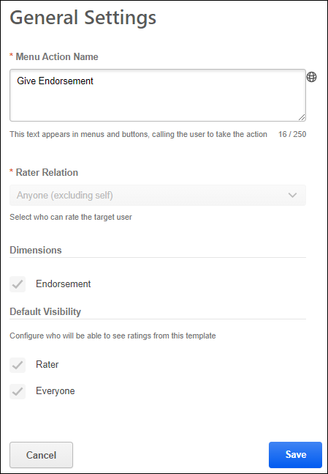

For Endorsement templates, the following settings are available on the General Settings page:
- Menu Action Name - This field controls the menu text that appears to users. For example, when viewing another user's Skills Profile, this field determines the name of the "Give Endorsement" option in the user's Current Skills section menu. This field is only available when editing the Endorsement feedback template. The character limit for this field is 250. If multiple languages are enabled for your portal, select the Translate icon to translate the field into other available languages.
- Rater Relation - For the Endorsement template, this is set to Anyone (excluding self), and it cannot be edited. This means that anyone except the target user can provide endorsements. Users cannot endorse themselves.
- Dimensions - For the Endorsement template, this is set to Endorsement, and it cannot be edited. This ensures that the Endorsement template is only used for endorsements.
- Default Visibility - For the Endorsement template, this is set to Rater and Everyone, and it cannot be edited. This means that all endorsements will be visible to all users.
Capability Feedback Templates - Edit - Feature Connectors
Feedback Templates are the package of configuration choices made by the administrator that form the rating and feedback experiences for the end user. Each template defines the method in which it is initiated, by whom it is initiated, and whom it will rate. These templates exist behind-the-scenes for the end user, while guiding them and minimizing friction.
When editing a template, the settings are divided into two tabs, General Settings and Feature Connectors.
The Feature Connectors tab displays all the areas in which a capability feedback template may be used and enables administrators to configure where the template is available for users, such as the Skills - Declared and Skills - To Develop sections of the Skills Profile.
To edit a Capability Feedback Template, go to Admin > Tools > Core Functions > Capabilities > Feedback Templates. Then, select the Edit link to the right of the appropriate feedback template.
Permissions
PERMISSION NAME | PERMISSION DESCRIPTION | CATEGORY

User Rating Templates - Manage | Grants ability to manage feedback templates for capabilities. This permission cannot be constrained. This is an administrator permission.  This permission only works when used in conjunction with the User Rating permission. | Core Administration

User Ratings | For end users, this permission grants the ability to perform ratings and view ratings. For administrators, this permission is required, along with the specific user rating administration permissions to edit rating scales or templates. This permission cannot be constrained. | Core Administration
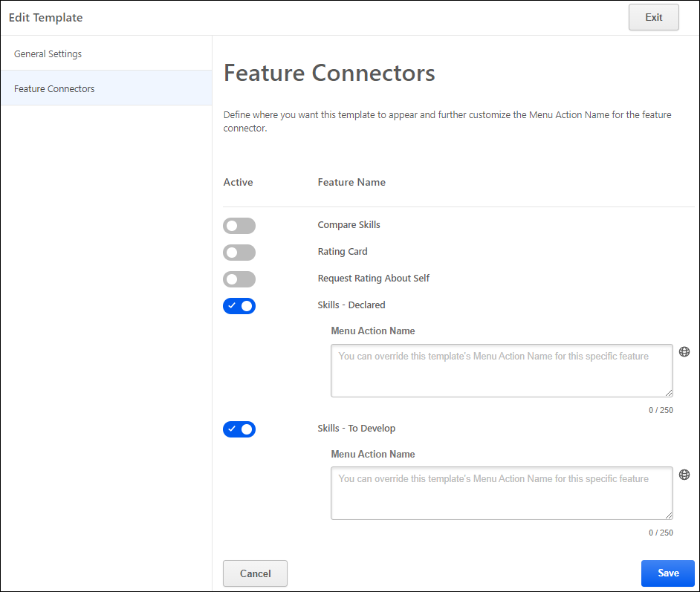
Select Template Availability - Enable the Active Toggle
The Feature Connectors tab displays all of the areas in which a capability feedback template may be used.
To enable the template to be available in an area, select the Active toggle for the appropriate feature area.
Menu Action Name
When the template is active for a feature, administrators have the option to customize the language that is presented to the user when using the template in the specified area. The default language from the General Settings tab is used by default.
Available Features
The following areas or feature are available:
- Compare Skills - When this feature connector is enabled for a template, users can use the corresponding feedback template to initiate feedback for a skill directly from the Compare Skills page. See Skills Profile - Compare Skills on page 84 for additional information.
- People Matrix - When this feature connector is enabled for a template, users can use the corresponding feedback template to update ratings via the People Matrix. See People Matrix - Overview on page 140 for additional information.
- Rating Card - When this feature connector is enabled for a template, users can use the corresponding feedback template to initiate feedback for a skill in the Skills Details flyout, which opens after selecting a skill in the Skills Profile. See Skills Profile - View Skill Details on page 117 for additional information.
- Request Builder - This feature connector enables users to initiate a feedback request using the corresponding template via the request builder in My Feedback Requests. The request target user type for the template is set in the General Settings. When initiating a feedback request, the requester can select which users are included in their request and which skills are being evaluated in the request.
- Request Rating About Self - Users may request feedback from their Skills Profile. See Skills Profile - Request Feedback for Skill Proficiency on page 112 for additional information.
- Skills - Declared - Users may request feedback from the Your Skills section in their Skills Profile. See Skills Profile on page 76 for additional information.
- Skills - To Develop - Users may request feedback from the Skills You Want to Develop section in their Skills Profile. See Skills Profile on page 76 for additional information.
Save/Cancel/Exit
Select the Save button at the bottom of the page to save the template settings and return to the Manage Feedback Templates page.
Select the Cancel button at the bottom of the page to discard any unsaved changes to the template settings and return to the Manage Feedback Templates page.
Select the Exit button at the top of the page to discard any unsaved changes to the template settings and return to the Manage Feedback Templates page.
See Capability Feedback Templates - Manage on page 54 for additional information.

Reporting on Capabilities
When reporting on Capabilities using Reporting 2.0, the report creator must have the following permissions, at a minimum:
- Reporting - Core - User Capabilities - Manage
- Reporting - Core - User Capabilities - View
Reporting on capabilities is easy using Reporting 2.0.
Click here to download the list of Reporting 2.0 report types and field descriptions, updated March 20, 2024. This Excel spreadsheet provides descriptions for the report types and fields in Reporting 2.0. This list is updated when there are changes to existing fields or new fields are added. Currently, the list is in English only. Note that it may be necessary to scroll through the sheets on the Excel spreadsheet in order to access the first sheet.

Training Capabilities - Content Skills Tagging
Content Skills Tagging allows administrators to leverage Cornerstone's AI to have their learning catalog auto-tagged with skills from the Cornerstone Skills Graph, leverage Reporting 2.0 to review tagged skills, update the tagging in bulk via Edge Import, or directly from the Course Console. This is accomplished via a new Content Skills Tagging tab on the Capabilities Preferences page.
Content Skills Tagging can be enabled via self-activation in Capabilities Preferences. See Capabilities Preferences - Content Skills Tagging on page 20 for additional information.
Enabling Content Skills Tagging will cause the following features to also appear for system administrators to support Content Skills Tagging:
- LO Capabilities load in Edge Import which can be used by administrators to easily add or reject skills that were tagged to each training.
- Training Capabilities fields in Reporting 2.0 which can be used to review skills that were tagged to training in the Course Catalog.
- Administrators can add and edit skills directly from Course Console.
Permissions
PERMISSION NAME | PERMISSION DESCRIPTION | CATEGORY

Capability Library - Edit | Grants the ability to create, edit, and copy capabilities via the Capability Library. Administrators with this permission cannot delete capabilities or change the status of a capability. This permission cannot be constrained. This is an administrator permission. | Core Administration

Capability Library - Manage | Grants the ability to create, edit, copy, delete, import, and approve capabilities via the Capability Library. This permission cannot be constrained. This is an administrator permission. | Core Administration

Course Catalog - Update | Grants ability to manage and edit training items listed in the Course Catalog and also grants access to the Course Console, where training can also be managed and edited. This permission also grants access to the Popular Requests and Highest Rated widgets on the Learning Admin Console (in conjunction with the Learning Admin Console - View permission). This permission also allows administrators to reversion online courses via the Course Console page. This permission also allows administrators to access an Edit Training option for training items included as objectives in Development plans.  This permission can be constrained by OU, User's OU, Training Type, Training Item, Provider, ILT Provider, User's ILT Provider, User, User Self and Subordinates, and User's LO Availability. This is an administrator permission.  Note: Adding an OU constraint and a provider constraint to this permission results in an "AND" statement. | Learning - Administration

Reporting - Learning - Training Capabilities - Manage | Grants ability to create and manage Training Capabilities reports via Reporting 2.0. | Reporting

Reporting - Learning - Training Capabilities - View | Grants ability to view Training Capabilities reports via Reporting 2.0. | Reporting
Once enabled, Content Skills Tagging auto-tags the following training types by using their title, description, keywords, and subjects to detect relevant skills:
- Online courses
- Online content
- External content
- Materials
- Videos
- Curricula
- Events
- Tests
Full-portal content skills tagging is triggered when:
- An administrator enables Content Skills Tagging on the enablement page
- Cornerstone makes an update to its skills-detection model
The auto-tagging process always preserves skills that were tagged or rejected by an administrator. After full-portal content skills tagging occurs, Content Skills Tagging will continuously tag additional individual trainings which get added to the portal, and when updates are made to individual training that affect the fields that impact skills detection.
Accessing Skills from Course Console
The Capabilities (Skills) field appears on the Course Console when Content Skills Tagging is enabled in the portal. Review auto-tagged skills and correct skills that were missed or mis-tagged by editing skills on a Learning Object (LO) directly from the Course Console. Click Edit to open the Edit Capabilities (Skills) flyout where you can edit skills for the LO and check suggested skills.
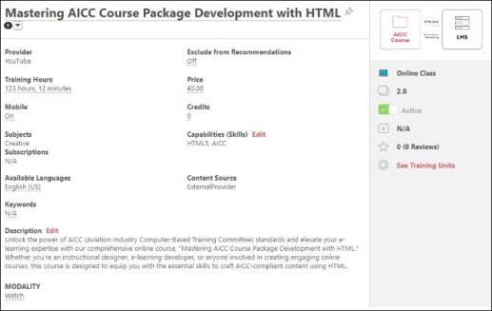
The Edit Capabilities (Skills) flyout displays the following:
- Add Skills - Search for an existing skill or create a custom skill.
- Added Skills - This section shows the skills associated with the LO.
- Suggested Skills - This section displays the skills suggested by AI-powered skills detection algorithm.
- Rejected Skills - This section displays the rejected skills from an LO. The rejected skills can be added again.
Tagging skills to trainings improves the discoverability of learning content. Feedback from interactions with skills within the flyout (such as adding or rejecting skills) improves the AI-powered skills detection algorithm.
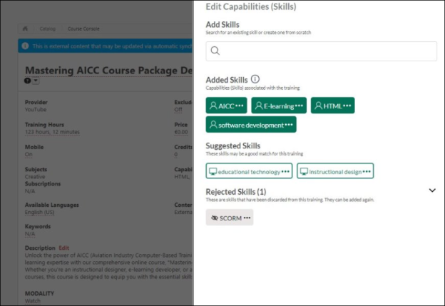

Universal Profile - Skills Overview
Capabilities describe what a person can do or what they know. This may include skills, competencies, knowledge, and other types of data. On the Skills Profile, a user may declare which skills they currently have, which skills they want to further develop, and which ones they would like to ignore.

Skills Profile
Skills Profile is a page within the Universal Profile that enables users to view, select, and configure the skills they have and the skills they'd like to develop.
The Capabilities and Skills Profile functionality is currently in an Early Adopter phase. See Skills Profile & Capabilities Library - Overview on page 1 for additional information.
To access the Skills Profile page, go to Home > Universal Profile. Then, click the Skills tab.
To access another user's Universal Profile - Bio page, select the user's photograph from any Universal Profile or Global Search page. From there, you can access the user's Skills Profile page by clicking the Skills tab.
Permissions
PERMISSION NAME | PERMISSION DESCRIPTION | CATEGORY

Capabilities - Skills Profile - View | Grants the ability to view an employee Skills Profile. Users with this permission may view the Skills Profile for anyone in the organization. However, individual ratings have privacy settings that control visibility within the Skills Profile. This permission cannot be constrained. This is an end user permission. | Core Administration

Skills Profile - Critical Skills - View | Grants the ability to view the Critical Skills table for any user. This permission cannot be constrained. This is an administrator permission.  Administrators must also have permission to access the user's Skills Profile. | Core Administration

User Ratings | For end users, this permission grants the ability to perform ratings and view ratings. For administrators, this permission is required, along with the specific user rating administration permissions to edit rating scales or templates. This permission cannot be constrained. | Core Administration
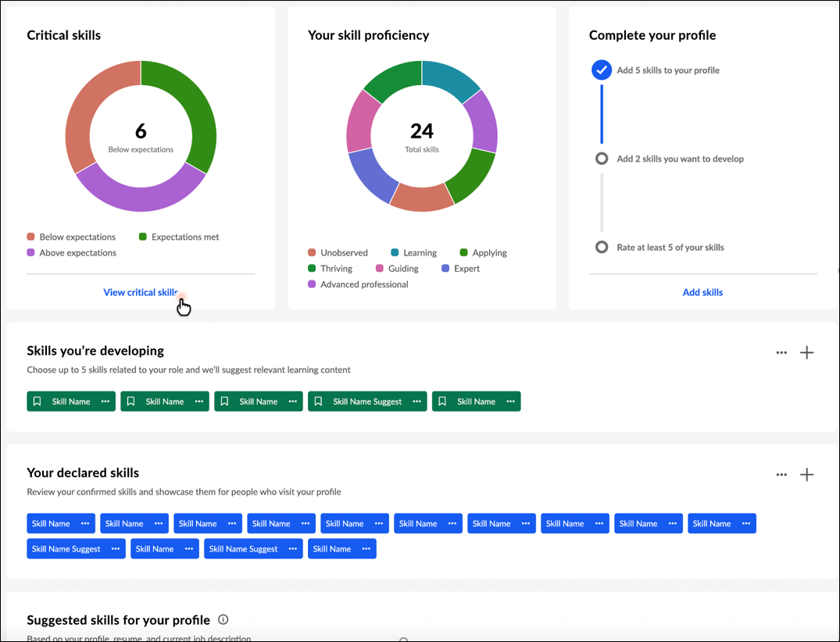
Back to Profile
Select the Back to Profile button to navigate to the Universal Profile Bio page for the user whose Skills Profile you are viewing.
Get Started
Select the Get Started button to begin the Get Started wizard. This wizard guides you through the process of selecting which skills you currently have, which skills you want to develop, and which skills you do not want to develop. See Skills Profile - Get Started Wizard on page 91 for additional information.
Critical skills widget
If you belong to an organizational unit (OU) with an associated capability model, a Critical skills widget is available on your Skills Profile. This widget displays a graphical representation of your critical skills and status. Within the graph, the widget displays the total number of critical skills in which your proficiency is below expectations. If you have no skills in which your proficiency is below expectations, the widget displays the number of skills in which your proficiency meets expectations. If you have no skills in which your proficiency meets expectations, the widget displays the number of skills in which your proficiency is above expectations.
If a critical skill does not have a target, then your status is determined in the following way:
- If you have not declared the skill, your status is Below expectations.
- If you have declared the skill, your status is Expectations met.
Select the View critical skills link to access the Critical skills page. This option is only available if enabled in Skills Profile Preferences. See Skills Profile - View Critical Skills on page 120 for additional information.
Your skill proficiency widget
This widget displays a graphical representation of your declared skills and proficiency level. Within the graph, the widget displays the total number of declared skills.
Complete your profile widget
This widget visually displays the completeness of your skills profile and encourages you based on incomplete areas. The following steps are tracked in the Complete your profile widget:
- Add at least five skills to your profile
- Add two skills you want to develop
- Rate at least five of your skills - When you select the Rate my skills link, you will see actions based on your organization's configuration. For example, you may see Rate My Interest or Rate My Proficiency.
Select the Add skills link to open the Manage Skills pop-up where you can add skills to your profile.
This widget is hidden once all three tasks are complete.
Skills you're developing
When viewing another user's Skills Profile, this section is titled Skills they're developing.
This section displays any skills you have indicated that you want to develop. These skills may be used to suggest learning and development paths.
Add skills you're developing
You may add skills you want to develop by selecting the Add Skill icon in the upper-right corner of the section or the Develop skills button. Note: The Develop skills button is only available if no skills have been selected in this section. See Skills Profile - Add Skill on page 82 for additional information.
Options for skills you're developing
In this section, you can perform the following actions for any skills listed in this section:
- View Skill Details - To view the full description of a skill and your skill rating, select the left side of a skill in your profile. The Skill Details appear in a flyout on the right. See Skills Profile - View Skill Details on page 117 for additional information.
- Remove Skill - To remove a skill from this section, select the menu icon on the right side of the skill button. Then, select Remove.
- Rate My Interest - To rate your interest in a skill from this section, select the menu icon on the right side of the skill button. Then, select Rate My Interest. See Skills Profile - Rate My Interest on page 106 for additional information.
- Request Feedback - To request feedback from others regarding your proficiency in a skill from this section, select the menu icon on the right side of the skill button. Then, select Request Feedback. See Skills Profile - Request Feedback for Skill Proficiency on page 112 for additional information.
Your declared skills
When viewing another user's Skills Profile, this section is titled Their declared skills.
This section displays any skills you have indicated that you already have. These can be skills in any proficiency level (e.g., novice, intermediate, expert). These skills will be used to track progress and identify relevant opportunities for development.
Add skills you have
You may add skills that you have by selecting the Add Skill icon in the upper-right corner of the section or the Add skills button. Note: The Add skills button is only available if no skills have been selected in this section. See Skills Profile - Add Skill on page 82 for additional information.
Options for your declared skills
In this section, you can perform the following actions for any skills listed in this section:
- View Skill Details - To view the full description of a skill and your skill rating, select the left side of a skill in your profile. The Skill Details appear in a flyout on the right. See Skills Profile - View Skill Details on page 117 for additional information.
- Want to Develop - If you want to develop a skill in this section, select the menu icon on the right side of the skill button. Then, select Want to develop. The skill remains in the Your declared skills section, but it is also added to the Suggested skills for your profile section. These skills may be used to suggest learning and development paths.
- Add to My Profile - Select this option to add the skill to your profile as a skill you have. This option is only available when viewing another user's profile.
- Remove Skill - To remove a skill from this section, select the menu icon on the right side of the skill button. Then, select Remove.
- Rate My Proficiency - To rate your proficiency in a skill from this section, select the menu icon on the right side of the skill button. Then, select Rate My Proficiency. See Skills Profile - Rate Skill Level on page 109 for additional information.
- Rate My Interest - To rate your interest in a skill from this section, select the menu icon on the right side of the skill button. Then, select Rate My Interest. See Skills Profile - Rate My Interest on page 106 for additional information.
- Request Feedback - To request feedback from others regarding your proficiency in a skill from this section, select the menu icon on the right side of the skill button. Then, select Request Feedback. See Skills Profile - Request Feedback for Skill Proficiency on page 112 for additional information.
- Endorse - To endorse a user for a specific skill, select the menu icon on the right side of the skill button. Then, select Give Endorsement. Endorsements are also visible to others in the system to encourage the positive recognition that they carry. An endorsement does not confer a specific judgment about proficiency, but it generally means you are willing to vouch for the person's proficiency in a certain skill.
- Feedback Templates - If feedback templates are available and the Compare Skills feature connector is enabled, then users can provide feedback based on the available ratings, such as "Rate Your Proficiency" or "Rate Your Interest & Enjoyment."
Suggested skills for your profile
When viewing another user's Skills Profile, this section is titled Suggested skills for their profile.
This section displays a list of suggested skills you might have based on profile information processed by the AI-based Skills Graph. This currently includes your position (and its associated title, description, responsibilities, competencies, and capability models), any training you've completed, previous positions on your resume/CV, your bio summary, and any subjects or interests you have selected. The number of suggested skills is highly variable per user and is dependent on the confidence level returned by the Skills Graph.
Options for suggested skills
In this section, you can perform the following actions for any skills listed in this section:
- View Skill Details - To view the full description of a skill and your skill rating, select the left side of a skill in your profile. The Skill Details appear in a flyout on the right. See Skills Profile - View Skill Details on page 117 for additional information.
- Want to Develop - If you want to develop a skill in this section, select the menu icon on the right side of the skill button. Then, select Want to develop. The skill is removed from this section and added to the Skills you're developing section. These skills may be used to suggest learning and development paths.
- Hide Recommendations - To hide learning and development recommendations for a skill in this section, select the menu icon on the right side of the skill button. Then, select Hide recommendations. The skill is removed from this section, and it is no longer suggested as a skill to develop. You may still search for this skill by name when adding skills to develop. This skill is added to the Skills you're excluding section if this section has not been hidden by an administrator.
- Add to Profile - If you have one of the skills in this section in any proficiency level (e.g., novice, intermediate, expert), select the menu on the right side of the skill button. Then, select Add to profile. The skill is removed from this section and added to the Your declared skills section. These skills will be used to track progress and identify relevant opportunities for development.
- Remove Skill - To remove a skill from this section, select the menu icon on the right side of the skill button. Then, select Remove.
Skills you're excluding
This section displays any skills you have indicated that you do not want to develop. The system will not suggest these skills any longer, and they will not be used to suggest learning and development paths.
Note: Administrators may disable this section via Capabilities Preferences. See Capabilities Preferences - Skills Profile on page 30 for additional information.
Add skills to exclude
You may add skills that to this section by selecting the Add Skill icon in the upper-right corner of the section or the Select skills button. Note: The Select skills button is only available if no skills have been selected in this section. See Skills Profile - Add Skill on page 82 for additional information.
Options for skills you're excluding
In this section, you can perform the following actions for any skills listed in this section:
- View Skill Details - To view the full description of a skill and your skill rating, select the left side of a skill in your profile. The Skill Details appear in a flyout on the right. See Skills Profile - View Skill Details on page 117 for additional information.
- Want to Develop - If you want to develop a skill in this section, select the menu icon on the right side of the skill button. Then, select Want to develop. The skill is removed from this section, and it is added to the Skills you're developing section. These skills may be used to suggest learning and development paths.
- Remove Skill - To remove a skill from this section, select the menu icon on the right side of the skill button. Then, select Remove.
Skills Profile - Add Skill
The Skills Profile page enables users to view and manage skills they have, skills they want to develop, and skills they do not want to develop.
Users can add skills to any of the sections by selecting the Add Skill icon in the upper-right corner of the appropriate section. This opens the Manage Skills flyout.
To select a skill, you may select one of the listed skills or search for a skill that is not listed. When you select a skill, it is displayed below the search field. You may remove a skill by selecting the X next to the skill.
After selecting one or more skills, select the Add button. The selected skills are added to your Skills Profile.
When you add a skill to your Skills Profile, then any skills that are linked as similar are suggested in the Skills You Might Have section of the Skills Profile. For example, if Business Strategy is linked to Business Development as a similar skill, and you indicate that you have the Business Strategy skill, then Business Development will be suggested to you as a skill that you might have.
Permissions
PERMISSION NAME | PERMISSION DESCRIPTION | CATEGORY

Capabilities - Skills Profile - View | Grants the ability to view an employee Skills Profile. Users with this permission may view the Skills Profile for anyone in the organization. However, individual ratings have privacy settings that control visibility within the Skills Profile. This permission cannot be constrained. This is an end user permission. | Core Administration
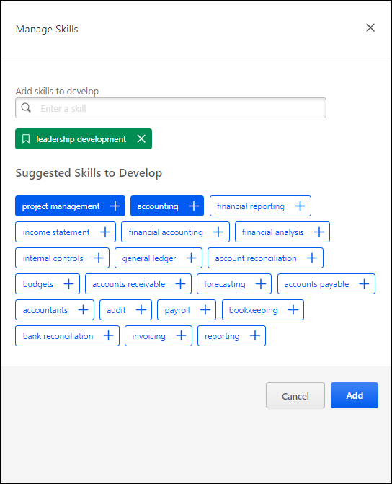
Skills Profile - Compare Skills
The Compare Skills page enables managers and users a central view of all the user's skill ratings. Managers can use this information as a conversation starter and guide around skills when having development conversations with their employees, and users can use this information for self-reflection and calibration.
Compare Skills displays the latest ratings from multiple dimensions/sources while respecting visibility settings for ratings.
The Compare Skills page is only available to users if enabled by the system administrator in Skills Profile Preferences. See Capabilities Preferences - Skills Profile on page 30 for additional information.
To access the Skills Profile page, go to Home > Universal Profile. Then, select the Skills tab. Within the Skill menu, select the Compare Skills option. This option is also available within the three-dot menu in the Your Skills section. This option is only available when viewing the Skills Profile for yourself or for a direct report.
To access another user's Universal Profile - Bio page, select the user's photograph from any Universal Profile or Global Search page. From there, you can access the user's Skills Profile page by clicking the Skills tab.
Permissions
PERMISSION NAME | PERMISSION DESCRIPTION | CATEGORY

Capabilities - Skills Profile - View | Grants the ability to view an employee Skills Profile. Users with this permission may view the Skills Profile for anyone in the organization. However, individual ratings have privacy settings that control visibility within the Skills Profile. This permission cannot be constrained. This is an end user permission. | Core Administration

User Ratings | For end users, this permission grants the ability to perform ratings and view ratings. For administrators, this permission is required, along with the specific user rating administration permissions to edit rating scales or templates. This permission cannot be constrained. | Core Administration
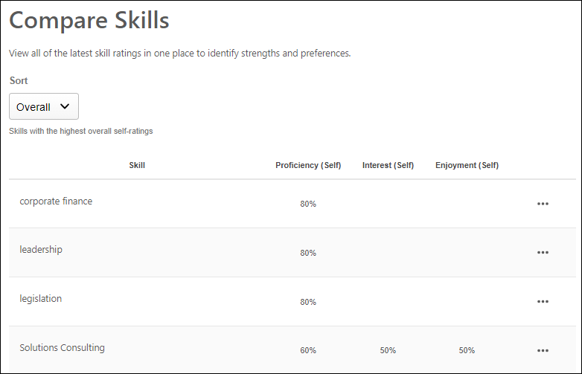
Sort Ratings
The following sort options are available for the Skills display:
- Overall - This displays skills with the highest overall self-ratings at the top of the list.
- Strengths - This displays skills with the highest proficiency and enjoyment at the top of the list.
- Emerging Skills - This displays skills with high interest in developing but lower proficiency at the top of the list.
- Misaligned Proficiency - This displays skills with the greatest to least difference between self-ratings and ratings from others, especially managers.
- Highest Proficiency - This displays skills with the highest to lowest proficiency rating. This is based on the self ratings.
- Highest Interest - This displays skills with the highest to lowest interest rating.
- Highest Enjoyment - This displays skills with the highest to lowest enjoyment rating.
Note: If a portal does not use certain dimensions, such as Interest or Enjoyment, the Sorts that use those dimensions are not shown.
Ratings Display
The following information is displayed for each skill in the user's Skills Profile:
- Most recent self-ratings on Enjoyment, Interest, and Proficiency
- Average of the most recent proficiency ratings from each manager
- Average of the most recent proficiency ratings from each other user (not self or managers)
The ratings displayed on this page respect the visibility settings for the associated ratings.
Ratings Options
For each skill in the table, employees can select the three-dot menu icon for a skill to view the following options:
- Feedback History - Users may select this option to view their feedback history for the selected skill. See Skills Profile - Feedback History on page 87 for additional information.
- Feedback Templates - If feedback templates are available and the Compare Skills feature connector is enabled, then users can provide feedback based on the available ratings, such as "Rate Your Proficiency" or "Rate Your Interest & Enjoyment."
- Request Feedback - Users may select this option to request feedback on the selected skill. See Skills Profile - Request Feedback for Skill Proficiency on page 112 for additional information.
Skills Profile - Feedback History
The Feedback History pop-up displays all of the ratings and feedback available for the user and the selected skill. Feedback is only displayed if the user is within the visibility settings for the feedback.
The Feedback History pop-up can be accessed in the following ways:
- Compare Skills - From the Compare Skills table, select the Feedback History option for a skill in the table.
- Skill Details - When viewing your own Skills Profile, from the Skill Details flyout, select the endorsed by link.
To access the Skills Profile page, go to Home > Universal Profile. Then, select the Skills tab. Within the Skill menu, select the Compare Skills option. This option is also available within the three-dot menu in the Your Skills section. This option is only available when viewing the Skills Profile for yourself or for a direct report.
To access another user's Universal Profile - Bio page, select the user's photograph from any Universal Profile or Global Search page. From there, you can access the user's Skills Profile page by clicking the Skills tab.
Permissions
PERMISSION NAME | PERMISSION DESCRIPTION | CATEGORY

Capabilities - Skills Profile - View | Grants the ability to view an employee Skills Profile. Users with this permission may view the Skills Profile for anyone in the organization. However, individual ratings have privacy settings that control visibility within the Skills Profile. This permission cannot be constrained. This is an end user permission. | Core Administration

User Ratings | For end users, this permission grants the ability to perform ratings and view ratings. For administrators, this permission is required, along with the specific user rating administration permissions to edit rating scales or templates. This permission cannot be constrained. | Core Administration
Users can select one of the available views by selecting the appropriate view icon. The following views are available in the Feedback History pop-up:
- Ladder View
- Comment View
- Reporting View
Ladder View
The Ladder View displays the proficiency ratings for the selected skill on the rating graph. Below the graph, each rating is displayed in a table with the corresponding rater's name, the rater's relationship to the user, and the date on which the rating was provided.
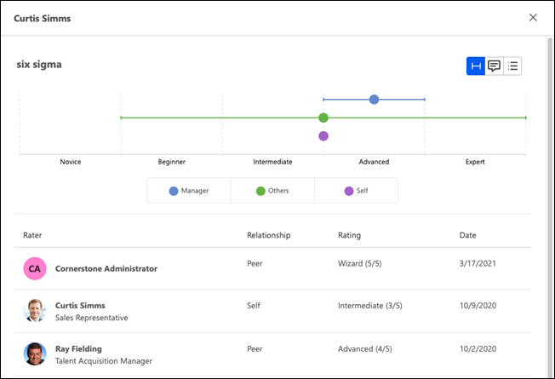
Comment View
The Comment View displays all comments that have been provided for the selected skill with the corresponding rater's name, the commentator’s relationship to the user, and the date on which the comment was provided.
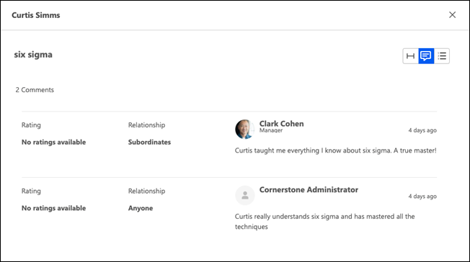
Reporting View
The Reporting View displays all ratings and endorsements across all dimensions (Proficiency, Interest, Enjoyment, Endorsement, etc.) including any comments provided.
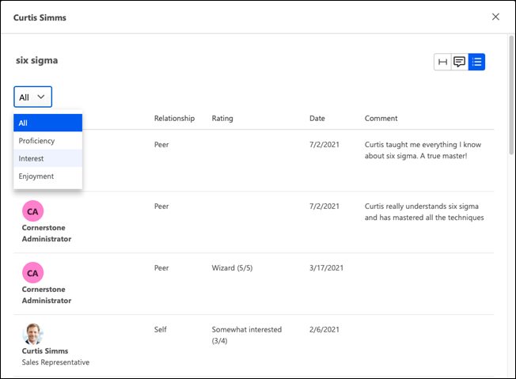
Skills Profile - Get Started Wizard
The Skills Profile enables users to select which skills they currently have and skills they want to develop.
To access the Skills Profile, go to Home > Universal Profile. Then, select the Skills tab.
When users first access their Skills Profile, they are prompted with the "Get Started" menu that guides them through the process of selecting their current skills and skills they want to develop.
Permissions
PERMISSION NAME | PERMISSION DESCRIPTION | CATEGORY

Capabilities - Skills Profile - View | Grants the ability to view an employee Skills Profile. Users with this permission may view the Skills Profile for anyone in the organization. However, individual ratings have privacy settings that control visibility within the Skills Profile. This permission cannot be constrained. This is an end user permission. | Core Administration

User Ratings | For end users, this permission grants the ability to perform ratings and view ratings. For administrators, this permission is required, along with the specific user rating administration permissions to edit rating scales or templates. This permission cannot be constrained. | Core Administration
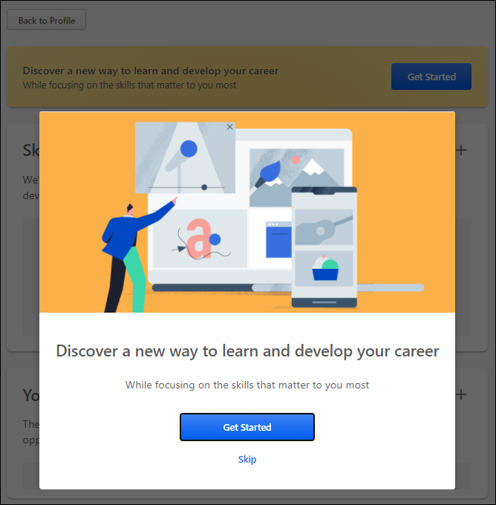
Step 1 - Get Started or Skip
Note: This step is skipped if you select the Get Started button on the Skills Profile page.
When the Get Started menu opens, you are prompted to either get started or skip the wizard.
- Get Started - Select this button to begin the Get Started wizard. This wizard guides you through the process of selecting which skills you currently have, which skills you want to develop, and which skills you do not want to develop.
- Skip - Select this button to skip the Get Started wizard. Users who skip the wizard may initiate the wizard from the Skills Profile page. See Skills Profile on page 76 for additional information.
Step 2 - Select Skills You Have
In this step, select three or more skills that you already have. These can be skills in any proficiency level (e.g., novice, intermediate, expert). By default, the wizard displays a list of skills that are associated with your current position and any previous positions included in your Universal Profile Resume.
To select a skill, you may select one of the listed skills or search for a skill that is not listed. When you select a skill, it is displayed below the search field. You may remove a skill by selecting the X next to the skill.
After selecting three or more skills, select the Continue button.
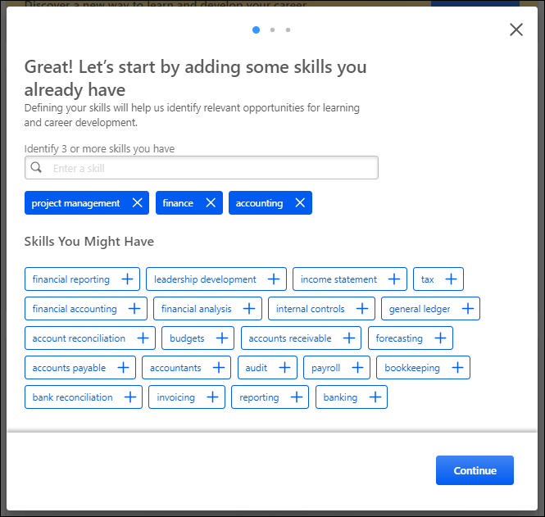
Step 3 - Select Skills to Develop
In this step, select one or more skills that you want to develop. These skills may be used to suggest learning and development paths. By default, the wizard displays a list of skills that are associated with your current position.
To select a skill, you may select one of the listed skills or search for a skill that is not listed. This may be a skill that you already have or one you do not currently have. When you select a skill, it is displayed below the search field. You may remove a skill by selecting the X next to the skill.
After selecting one or more skills, select the Continue button.
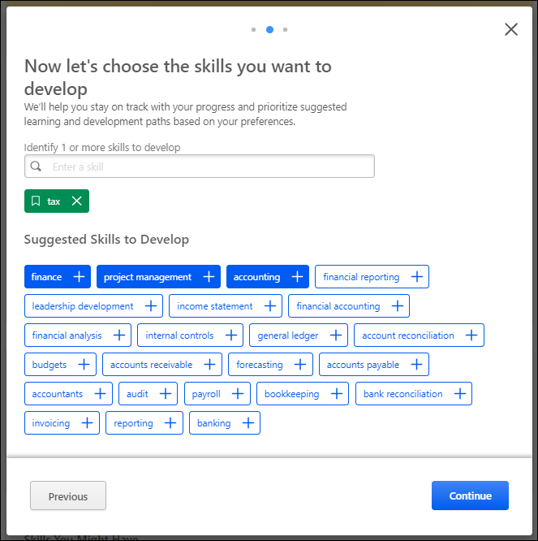
Step 4 - Select Skills to Reduce Recommendations
Note: Administrators may disable this section via Capabilities Preferences. See Capabilities Preferences - Skills Profile on page 30 for additional information.
In this step, select any skills that you do not want to develop. This step is optional. If you select skills in this step, the system will reduce recommendations for training and development for the selected skills. This helps you to focus on the skills that you do want to develop. By default, the wizard displays a list of skills that are associated with your current position.
To select a skill, you may search for the skill. When you select a skill, it is displayed below the search field. You may remove a skill by selecting the X next to the skill.
This step is optional. Select the Finish button to submit your selections. You may adjust your selections at any time via the Skills Profile page. See Skills Profile on page 76 for additional information.
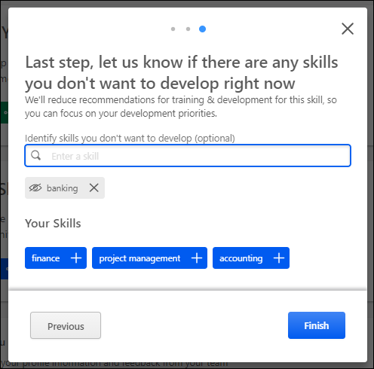
Skills Profile - My Feedback Requests
Once a user has requested feedback for a skill, the user can view and track their requests from the My Feedback Requests page.
Administrators with the appropriate permission are able to view the My Feedback Requests page for other users. When viewing the My Feedback Requests page of another user, the administrator can only view the page. They cannot create or edit any feedback requests. The option to create a request is not available, and the menu icon for each request is not available.
To view the My Feedback Requests page, go to Home > Universal Profile. Then, from the Skills menu, select My Feedback Requests.
From the Skills Profile page, users may be able to view their request in the following areas:
- Skills Profile: Skills You Want to Develop - In the Skills You Want to Develop section of the Skills Profile, select the menu icon in the upper-right corner of the section. Then, select My Requests.
- Skills Profile: Your Skills - In the Your Skills section of the Skills Profile, select the menu icon in the upper-right corner of the section. Then, select My Requests.
Permissions
PERMISSION NAME | PERMISSION DESCRIPTION | CATEGORY

Capabilities - Skills Profile - View | Grants the ability to view an employee Skills Profile. Users with this permission may view the Skills Profile for anyone in the organization. However, individual ratings have privacy settings that control visibility within the Skills Profile. This permission cannot be constrained. This is an end user permission. | Core Administration

User Ratings | For end users, this permission grants the ability to perform ratings and view ratings. For administrators, this permission is required, along with the specific user rating administration permissions to edit rating scales or templates. This permission cannot be constrained. | Core Administration

User Ratings - View Ratings and Feedback about Other User | Grants ability to view ratings history and rating details about other people regardless of the visibility settings on the ratings. Grants ability to view the My Feedback Requests page. Administrators with this permission can view all ratings and feedback about all other users, regardless of the visibility settings of the ratings. This permission cannot be constrained.  This permission does not bypass visibility ratings about yourself, which means users cannot use this permission to view ratings provided about themselves that are otherwise not visible to them.  This permission is intended for an administrator or talent partner who needs broad access to all ratings occurring within the portal. | Core Administration
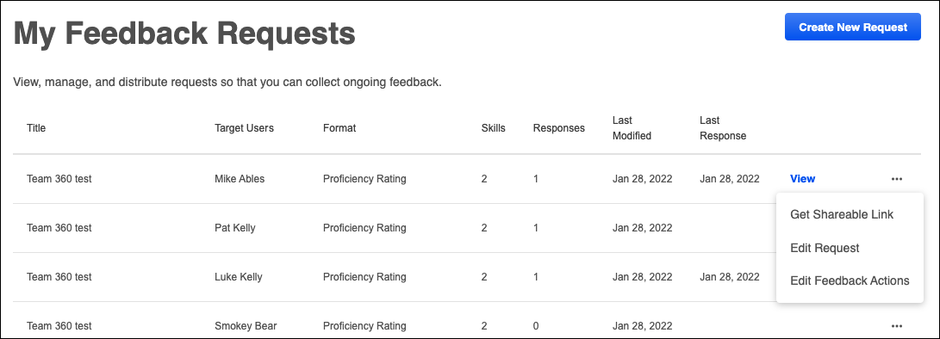
Create New Request
Select the Create New Request button to initiate a new feedback request. See Skills Profile - Request Feedback for Skill Proficiency on page 112 for additional information.
Requests List
The following information is listed for each existing feedback request:
- Title - This displays the name of the request that was provided when the request was created.
- Target Users - This displays who is the target of the feedback request. When the feedback is about a specific person, that person's name is displayed.
- Format - This displays the format that was selected when the request was created.
- Skills - This displays the number of skills that were included in the request.
- Responses - This displays the number of responses that have been submitted thus far.
- Last Modified - This displays the date on which the request was last modified.
- Last Response - This displays the date on which the last feedback response was provided for the request.
View Results
To view the results of a feedback request, select the View link. This link is only available if at least one response has been provided. This opens a pop-up with each of the responses listed with their feedback.
A rater's comments appear in the feedback results, if available. Only comments that are visible to the viewer are displayed.
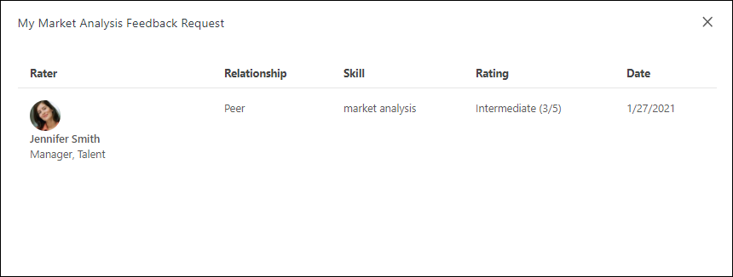
Get Sharable Link
To get a sharable link to invite or re-invite a user to provide feedback, select the menu icon on the right side of a request. Then, select Get Sharable Link. A pop-up opens and displays a URL to access the request. Select the Copy link to clipboard button to copy the link. You can then share this link with desired recipients.
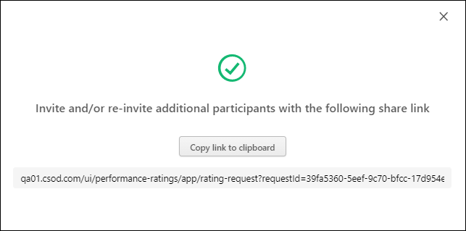
Edit Request
To edit a feedback request, select the menu icon on the right side of the request. Then, select Edit Request. This opens the Edit Feedback Request flyout.
The following values in the request can be edited:
- Who the feedback is about
- Who should provide feedback
- Skills
- Request Name
After updating the request, select the Update button.
Any completed requests are not impacted by the modifications. If a user is removed as an assigned rater or target user, any existing feedback actions for this person are cancelled and can still be viewed on the Feedback Actions page.
Edit Feedback Actions
To view the status of your feedback request and edit any actions, select the menu icon on the right side of the request. Then, select Edit Feedback Actions. This opens the Edit Feedback Actions page. See Skills Profile - My Feedback Requests - Edit Feedback Actions on page 100 for additional information.
Skills Profile - My Feedback Requests - Edit Feedback Actions
The Edit Feedback Actions page enables the feedback requestor to view the status and results of their request, edit the request settings, and cancel any in progress or not started actions if necessary.
To edit feedback actions for your feedback request, go to Home > Universal Profile. Then, from the Skills menu, select My Feedback Requests. Select the menu icon on the right side of the request. Then, select Edit Feedback Actions.
Permissions
PERMISSION NAME | PERMISSION DESCRIPTION | CATEGORY

Capabilities - Skills Profile - View | Grants the ability to view an employee Skills Profile. Users with this permission may view the Skills Profile for anyone in the organization. However, individual ratings have privacy settings that control visibility within the Skills Profile. This permission cannot be constrained. This is an end user permission. | Core Administration

User Ratings | For end users, this permission grants the ability to perform ratings and view ratings. For administrators, this permission is required, along with the specific user rating administration permissions to edit rating scales or templates. This permission cannot be constrained. | Core Administration
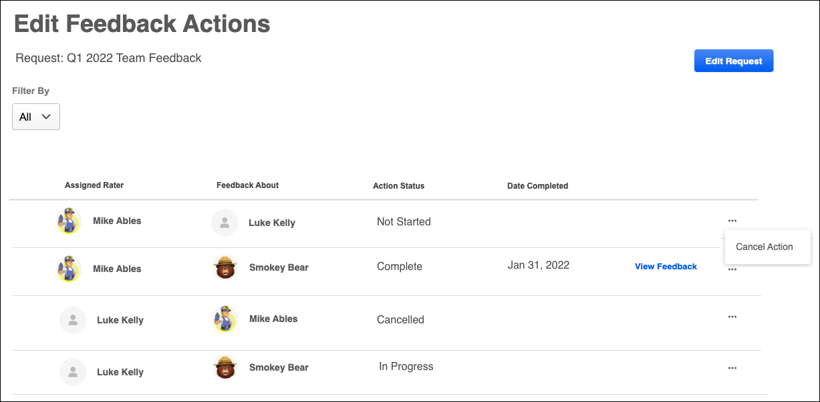
Edit Request
To edit a feedback request, select the Edit Request button. This opens the Edit Feedback Request flyout.
The following values in the request can be edited:
- Who the feedback is about
- Who should provide feedback
- Skills
- Request Name
After updating the request, select the Update button.
Any completed requests are not impacted by the modifications. If a user is removed as an assigned rater or target user, any existing feedback actions for this person are cancelled and can still be viewed on the Feedback Actions page.
View Feedback
To view the results of any completed feedback action, select the View Feedback link. This link is only available for feedback actions in a Completed status.
The Feedback Details pop-up displays the details of the feedback action, including each of the responses and the feedback.

Cancel Action
The feedback requestor has the option to cancel any request that is Not Started or In Progress. When a request is cancelled, the cancelled request remains visible on the Feedback Actions page in a Cancelled status. The request is removed from the requestee's Actions list and any email digests.
Skills Profile - Provide Skill Feedback
When a user creates a feedback request for a skill, a feedback request link is generated. This link can then be shared with others who can then enter the link in an Internet browser to access the feedback process.
When the link is opened, general instructions are displayed, and the page clearly indicates who will be able to view the feedback that is provided.
When providing feedback in response to a feedback request, the person who requested the feedback is clearly displayed on the feedback form.
Permissions
PERMISSION NAME | PERMISSION DESCRIPTION | CATEGORY

Capabilities - Skills Profile - View | Grants the ability to view an employee Skills Profile. Users with this permission may view the Skills Profile for anyone in the organization. However, individual ratings have privacy settings that control visibility within the Skills Profile. This permission cannot be constrained. This is an end user permission. | Core Administration

User Ratings | For end users, this permission grants the ability to perform ratings and view ratings. For administrators, this permission is required, along with the specific user rating administration permissions to edit rating scales or templates. This permission cannot be constrained. | Core Administration
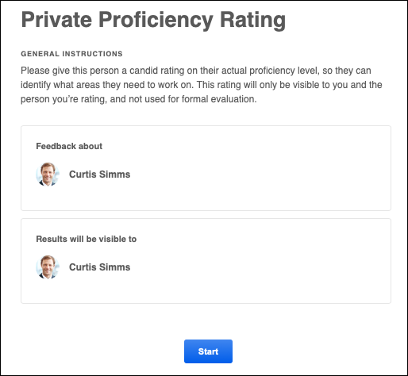
When Select the Start button to begin providing feedback for the user.
If you are giving feedback about multiple people in a single feedback request, then a list of the feedback assessees are displayed once the request is started. Assessors must select the Give Feedback link for each user to provide feedback for each individual in the request. After the assessor has provided feedback for someone in the request, the Date Completed column is populated, and the assessor can select the View Feedback link to review the feedback.
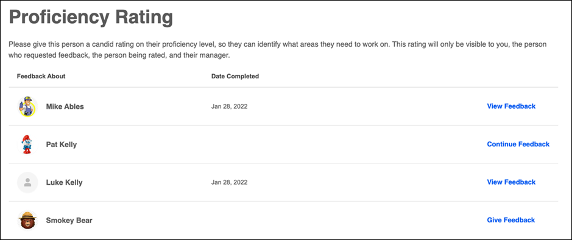
When providing feedback in response to a feedback request, the name and avatar for the person who is being rated is displayed in the upper-left corner of the page. This helps to clearly indicate the user for whom the reviewer is providing feedback.
When providing feedback, you may have a Comments field available to you, and it may be required or optional for you to provide comments, depending on the administrator settings for the associated rating template. The character limit is 5,000.
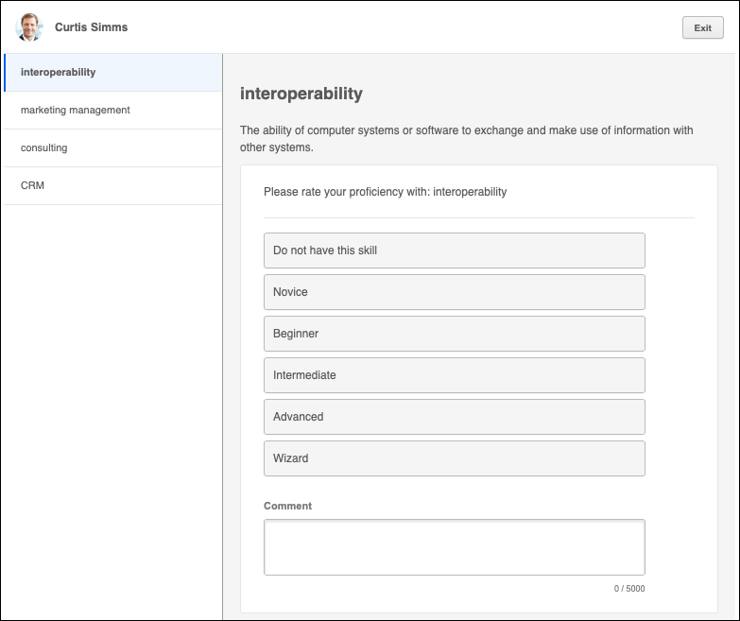
Submit
Once all feedback has been provided, select the Submit button. A confirmation pop-up is displayed.
Skills Profile - Rate My Interest
From the Skills Profile page, users can rate their interest with skills they possess and skills they want to develop. This process helps track your skill improvement over time and helps the system provide more personalized development recommendations and career advice.
To rate your interest in a skill, within the Your Skills or Skills You Want to Develop section of the Skills Profile page, select the menu icon on the right side of the skill button. Then, select Rate My Interest. See Skills Profile on page 76 for additional information.
The General Instructions page explains the process. Select the Start button to begin.
On the second page, select responses for the questions. Then, select the Submit button to save the selected responses.
Permissions
PERMISSION NAME | PERMISSION DESCRIPTION | CATEGORY

Capabilities - Skills Profile - View | Grants the ability to view an employee Skills Profile. Users with this permission may view the Skills Profile for anyone in the organization. However, individual ratings have privacy settings that control visibility within the Skills Profile. This permission cannot be constrained. This is an end user permission. | Core Administration

User Ratings | For end users, this permission grants the ability to perform ratings and view ratings. For administrators, this permission is required, along with the specific user rating administration permissions to edit rating scales or templates. This permission cannot be constrained. | Core Administration
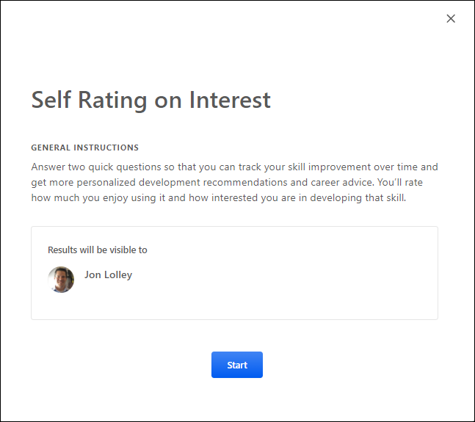
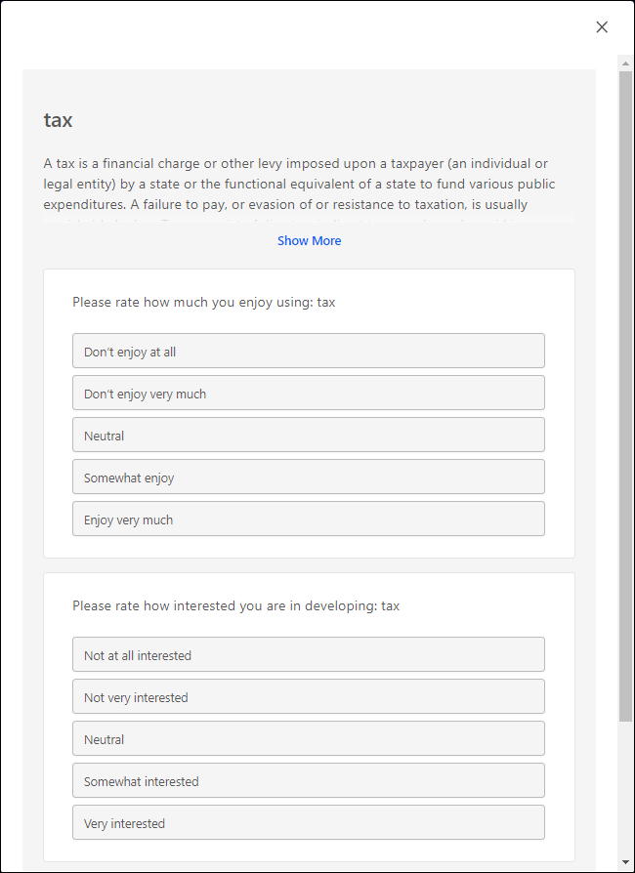
Skills Profile - Rate Skill Level
From the Skills Profile page, users can rate their proficiency with skills they possess and skills they want to develop.
Users may rate their skill level in the following ways:
- Within the Your Skills section of the Skills Profile page, select the menu icon on the right side of the skill button. Then, select Rate My Proficiency. Note: This option is only available for skills that the user has identified as a skill that they have. See Skills Profile on page 76 for additional information.
- Within the Skill Details flyout, select the Rate Myself button. Note: This button is only available if the user has not yet rated their skill level. See Skills Profile - View Skill Details on page 117 for additional information.
Within the Rate Skill Level pop-up, select the appropriate skill proficiency. Then, select the Submit button to save the selected skill proficiency.
Permissions
PERMISSION NAME | PERMISSION DESCRIPTION | CATEGORY

Capabilities - Skills Profile - View | Grants the ability to view an employee Skills Profile. Users with this permission may view the Skills Profile for anyone in the organization. However, individual ratings have privacy settings that control visibility within the Skills Profile. This permission cannot be constrained. This is an end user permission. | Core Administration

User Ratings | For end users, this permission grants the ability to perform ratings and view ratings. For administrators, this permission is required, along with the specific user rating administration permissions to edit rating scales or templates. This permission cannot be constrained. | Core Administration
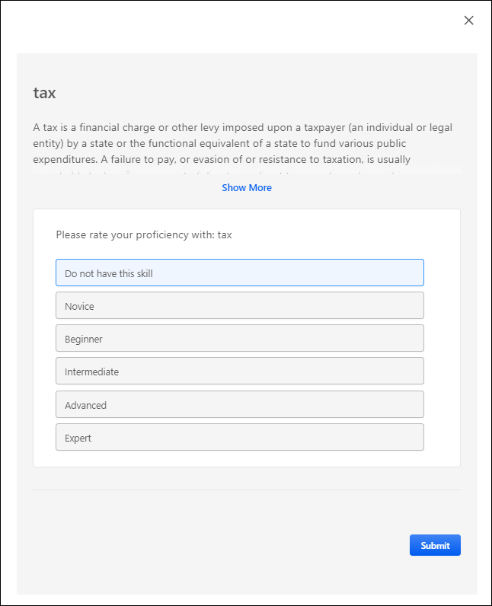
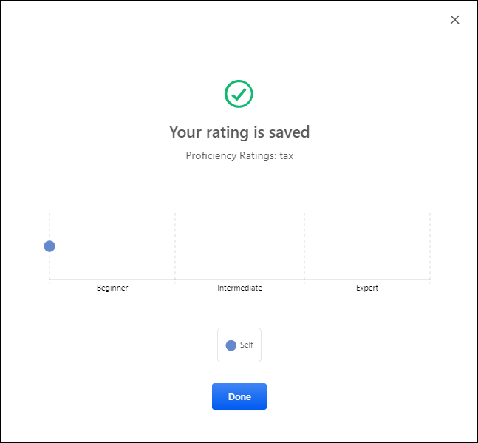
Skills Profile - Request Feedback for Skill Proficiency
From the Skills Profile page, users can request that others provide feedback regarding their proficiency in a skill. Users may also have permission to request others to provide feedback on a specific user.
To access the Skills Profile page, go to Home > Universal Profile. Then, click the Skills tab.
To access another user's Universal Profile - Bio page, select the user's photograph from any Universal Profile or Global Search page. From there, you can access the user's Skills Profile page by clicking the Skills tab.
Users may be able to request feedback in the following areas:
- My Feedback Requests - From the My Feedback Requests page, select the Create New Request button. See Skills Profile - My Feedback Requests on page 96 for additional information.
- Skills Profile: Skills You Want to Develop - In the Skills You Want to Develop section of the Skills Profile, select the menu icon on the right side of the skill button. Then, select Request Feedback.
- Skills Profile: Your Skills - In the Your Skills section of the Skills Profile, select the menu icon on the right side of the skill button. Then, select Request Feedback.
Permissions
PERMISSION NAME | PERMISSION DESCRIPTION | CATEGORY

Capabilities - Skills Profile - View | Grants the ability to view an employee Skills Profile. Users with this permission may view the Skills Profile for anyone in the organization. However, individual ratings have privacy settings that control visibility within the Skills Profile. This permission cannot be constrained. This is an end user permission. | Core Administration

User Ratings - Feedback on specific person | Grants ability to request 360 feedback about a specific user. This permission is intended for administrators, managers, or other leadership roles. This permission can be constrained to User, OU, User's OU, User Self and Subordinates, and User's Direct Subordinates.  It is recommended to constrain this permission. Managers should be constrained to "User's Direct Reports." Administrators can constrain themselves or others to a diverse pool of potential raters. | Core Administration

User Ratings - Feedback Assignment | Grants ability to assign a feedback request to a specific user. This permission can be constrained to User, OU, User's OU, User Self and Subordinates, User's Self, and User's Direct Subordinates. The constraints on this permission determine which users can be selected in the feedback assignment. | Core Administration

User Ratings - Request Others to Provide Feedback on Themselves | Grants ability to request that someone rate themself. This permission is intended for administrators, managers, or other leadership roles. This permission cannot be constrained. | Core Administration
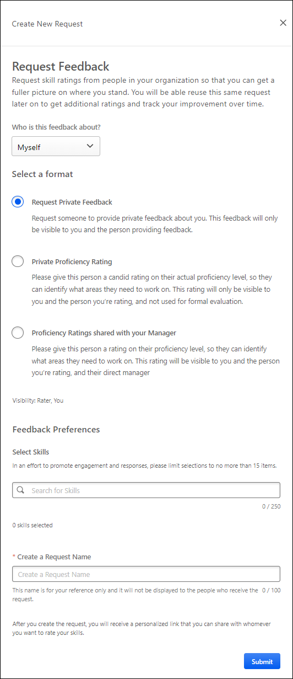
Select who should provide feedback
This option is available for users who have permission to assign feedback requests. This section enables the feedback requestor to assign the feedback request to specific people, if desired.
In the Search for specific person(s) field, select one or more users to be assigned the feedback request. This is optional. You can only select users who are within your permission constraints.
Note: If the request is not assigned to any specific users, the request can be shared with anyone using the sharable link.
Who is This Feedback About?
From the drop-down, select the subject of the feedback request. The following options may be available:
- Myself - Select this option if you are requesting feedback about yourself.
- Recipient - Select this option if you are requesting that the recipient provide feedback about themself. This option is only available to users who have the appropriate permission.
- Specific Person - Select this option if you are requesting that the recipient provide feedback about a specific person. This option is only available for users who have permission to request others to provide feedback on a specific person. Users can only request feedback about users who are within their permission constraints.
The options in this drop-down are dependent upon the requestor's permissions and the available feedback templates.
Select a Format
Select one of the available format options. The selected format determines who can view the proficiency ratings that are provided.
The options in this section are dependent upon the available feedback templates. Administrators can configure these rating templates in Capabilities Administration. See Capability Feedback Templates - Manage on page 54 for additional information.
Select Who This Feedback is About
This option is only available if "Specific Person" is selected in the Who is this feedback about? drop-down menu.
In this field, select one or more users as the subject of the feedback request. You can only select users who are within your permission constraints.
Select Skills
Select which skills you want included in the feedback request. At least one skill must be selected. The request recipients will be asked to provide ratings for each of the selected skills.
Create a Request Name
Provide a name for the feedback request. This name is only for the reference of the requester, and it is never displayed to the request recipients. The character limit for this field is 100.
Submit and Copy Invite Link
Select the Submit button to create the request. A pop-up opens and displays a URL to access the request. Select the Copy link to clipboard button to copy the link. You can then share this link with desired recipients.
Skills Profile - View Skill Details
The Skills Details flyout shows the skill ID, name, category, description, total endorsements, and proficiency rating. If the user's proficiency level has not been rated for the skill, then the user has the option to rate their proficiency level for the skill.
The avatar of the user whose skill details are being viewed is displayed below the skill description. This makes it clear whose skills profile and skill details are being viewed.
To view the Skill Details for a skill, navigate to the Skills Profile page. Then, select the skill name of a skill in your profile. See Skills Profile on page 76 for additional information.
Permissions
PERMISSION NAME | PERMISSION DESCRIPTION | CATEGORY

Capabilities - Skills Profile - View | Grants the ability to view an employee Skills Profile. Users with this permission may view the Skills Profile for anyone in the organization. However, individual ratings have privacy settings that control visibility within the Skills Profile. This permission cannot be constrained. This is an end user permission. | Core Administration

User Ratings | For end users, this permission grants the ability to perform ratings and view ratings. For administrators, this permission is required, along with the specific user rating administration permissions to edit rating scales or templates. This permission cannot be constrained. | Core Administration
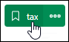
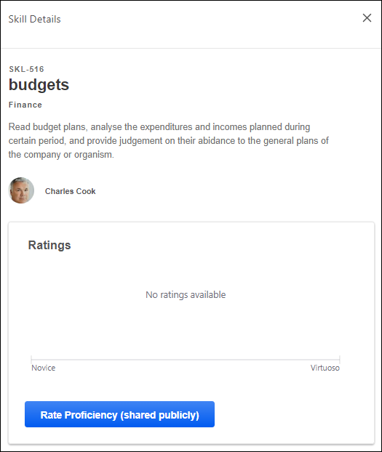
View Endorsements
When a user views the Skill Details flyout from their own Skills Profile, the user can view the number of endorsements they have received for the skill. Users can select the endorsed by link to view the Feedback History for the skill which includes all of the users who have endorsed the user for the skill. The endorsement count and list of endorsers are only displayed if the user has received at least one endorsement for the skill.
Endorsement a Skill
When a user views the Skill Details flyout from another person's Skills Profile, the user can view the number of endorsements the user has received for the skill. If the viewer has not yet endorsed the user for the skill, then they can select the + button to quickly add their endorsement.
Note: Currently, users are not able to undo or revoke endorsements or ratings they have given.
Rate My Proficiency
If a rating template is active with the feature connector "Rating Card" selected, a Rate My Proficiency button is available, allowing the user to launch a self-rating on proficiency. See Capability Feedback Templates - Edit - Feature Connectors on page 67 for additional information.
Select this button to rate your proficiency level for the skill. See Skills Profile - Rate Skill Level on page 109 for additional information.
Ratings
If you have a rating for the skill, then a Ratings chart is available in the flyout. This chart displays any ratings that you have provided and any other ratings that are visible to you. The proficiency levels are configurable by the system administrator.
Each rater's ratings and comments appear below the Rating History chart, if available. Only comments that are visible to the viewer are displayed.
Comments
In situations where your organization is not using scale-based ratings or the target user has not received any ratings, then the Skill Details flyout displays a preview of any feedback comments provided for this skill.
Top Rated Individuals
This section displays the top rated individuals and their ratings within the organization for the skill. Up to six top-rated individuals are displayed for a skill based on their skill proficiency. A link to the top-rated individual's Skill Profile is included to enable users to easily connect with the top rated individual.
A user will only appear as a top rated individual for a skill if they have a predicted proficiency above 80% for the skill. A user's predicted proficiency rating is an amalgamation of all declared ratings for the user (Self, Manager, and Peers) and the user's skill level that can be inferred from their job history and job title. At least one rating is required for a user to appear in this section.
If no users meet the 80% skill proficiency, then the Top Rated Individuals section is not displayed.
This section is only available if enabled by the administrator in Capabilities Preferences. See Capabilities Preferences - Skills Profile on page 30 for additional information.
Learning Recommendations
For organizations using Learning, skills-based learning recommendations are available at the bottom of the Skills Details panel, which displays a carousel of relevant training. The training is presented two-at-a-time with an image in a carousel, which can be browsed using arrows with a limit of 15. Note: Arrows do not appear in this section when viewing the Skill Details on a touchscreen device.
Users can select the training tile to view the Learning Details page for that training. Users can select the Show all link above the carousel to navigate to the Learning Search page with the skill name pre-loaded as the search parameter.
Skills Profile - View Critical Skills
If you belong to an organizational unit (OU) with an associated capability model, a Critical skills page can be accessed from your Skills Profile.
The Critical skills page outlines your critical skills, predicted proficiency ratings, targets, and status for the proficiency target. The highest proficiency target and the corresponding status are displayed if you are aligned to multiple competency models with different proficiency targets for the same skills.
The color associated with the skill tag indicates the skill association. Green indicates developing, blue indicates declared, white indicates suggested, and gray indicates hidden.
Your predicted proficiency rating is an amalgamation of all declared ratings for you (Self, Manager, and Peers) and your skill level that can be inferred from your job history and job title.
You can perform actions on a single skill by selecting the options menu (three dots) to the right of the skill name. You can perform bulk actions on all critical skills by selecting the options menu (three dots) in the upper-right corner of the table.
Select the heartbeat icon to open the Critical Skills Progress Tracking flyout. This option is only available if enabled in Skills Profile Preferences. See Skills Profile - View Critical Skills Progress on page 122 for additional information.
To access the Critical skills page, go to Home > Universal Profile. Then, click the Skills tab. In the Critical skills widget, select the View critical skills link.
Permissions
PERMISSION NAME | PERMISSION DESCRIPTION | CATEGORY

Capabilities - Skills Profile - View | Grants the ability to view an employee Skills Profile. Users with this permission may view the Skills Profile for anyone in the organization. However, individual ratings have privacy settings that control visibility within the Skills Profile. This permission cannot be constrained. This is an end user permission. | Core Administration

Skills Profile - Critical Skills - View | Grants the ability to view the Critical Skills table for any user. This permission cannot be constrained. This is an administrator permission.  Administrators must also have permission to access the user's Skills Profile. | Core Administration

User Ratings | For end users, this permission grants the ability to perform ratings and view ratings. For administrators, this permission is required, along with the specific user rating administration permissions to edit rating scales or templates. This permission cannot be constrained. | Core Administration
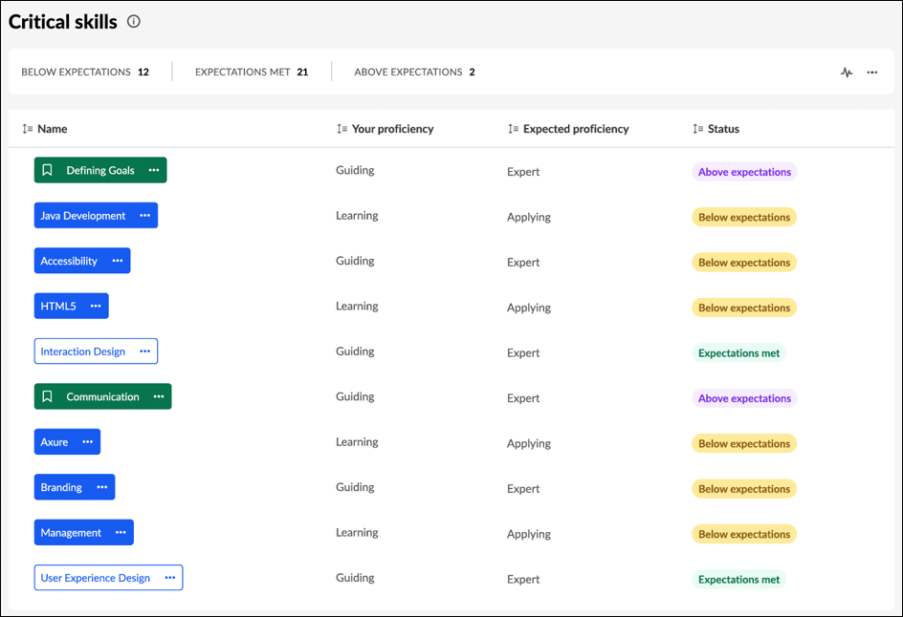
Skills Profile - View Critical Skills Progress
The Critical Skills Progress Tracking flyout displays a user's proficiency in their critical skills over time. Users and managers can view this information in chart or table format.
To view the Critical Skills Progress Tracking flyout, go to Home > Universal Profile. Then, click the Skills tab and view your skills profile. In the Critical skills widget, select the View critical skills link. Then, select the Heartbeat icon to view proficiency progress.
To access another user's Universal Profile - Bio page, select the user's photograph from any Universal Profile or Global Search page. From there, you can access the user's Skills Profile page by clicking the Skills tab.
Permissions
PERMISSION NAME | PERMISSION DESCRIPTION | CATEGORY

Capabilities - Skills Profile - View | Grants the ability to view an employee Skills Profile. Users with this permission may view the Skills Profile for anyone in the organization. However, individual ratings have privacy settings that control visibility within the Skills Profile. This permission cannot be constrained. This is an end user permission. | Core Administration

User Ratings | For end users, this permission grants the ability to perform ratings and view ratings. For administrators, this permission is required, along with the specific user rating administration permissions to edit rating scales or templates. This permission cannot be constrained. | Core Administration
Toggle Between Formats
To toggle between the chart and table format, select the appropriate icon in the upper-right corner of the page.
Time Span
From the Time setting, configure the graph to display either 6 months or 12 months of data.
Select or Deselect Skills
By default, the user's top five critical skills are displayed.
To change which skills are included in the graph, select or deselect the appropriate skills in the Skills section on the left.
Chart Format
The key below the chart indicates which color corresponds to each skill.
Users can hover their cursor over a point on the graph to view the overall rating percentage
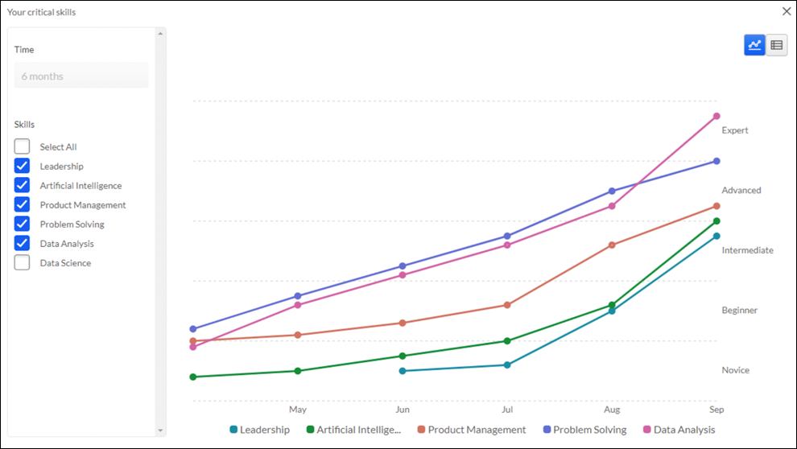
Table Format
The Skills Assessment column indicates whether the skill is strengthened, weakened, or if there is no progress over the selected time frame.
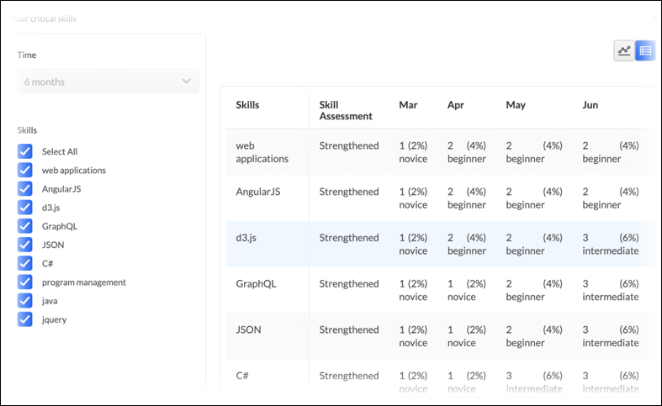

People Matrix Homepage
People Matrix is a tool to help managers to visualize and better understand the qualifications of people on your team or in your organization. Managers can create multiple matrices to track various skill and employee groups.
The People Matrix Homepage displays a summary of each available people matrix.
To access the People Matrix homepage, go to Skills > People Matrix.
Permissions
PERMISSION NAME | PERMISSION DESCRIPTION | CATEGORY

People Matrix | Grants access to the People Matrix functionality. This permission can be constrained to User, OU, User's OU, User Self and Subordinates, and User's Direct Subordinates. The constraints on this permission determine which users are available in the People Matrix. This is a manager permission. | Core Administration

User Ratings - View All Shared Ratings | Grants the ability to view all ratings shared with others in addition to the rater. This permission applies anywhere the ratings are displayed, such as the People Matrix and Skills Profile. This permission is intended for indirect managers or non-managers to view rating data for users over whom they have no oversight. This permission grants access to all OU types, both standard and custom. This permission can be constrained to User, OU, User's OU, User Self and Subordinates, and User's Direct Subordinates. The constraints on this permission determine whose shared ratings the person can view. This is a manager permission. | Core Administration
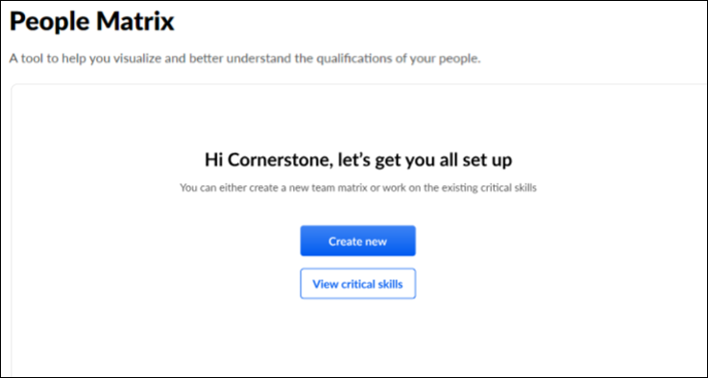
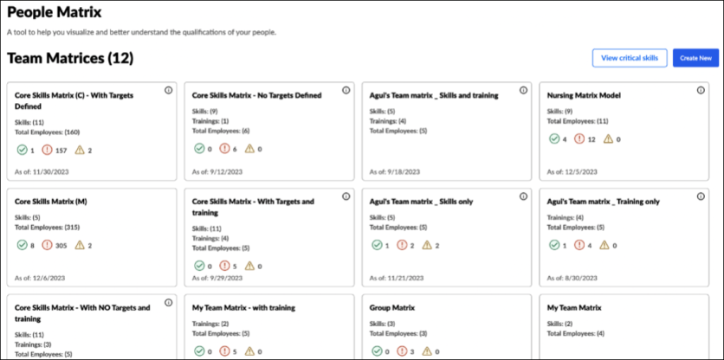
Create a People Matrix
If no matrices exist, select the Get Started button to create a matrix.
If one or more matrices exist, select the Create New button to create a matrix.
See People Matrix - Create on page 127 for additional information.
View Critical Skills
Select the View Critical Skills button to generate a people matrix of your subordinates and their critical skills.
Critical skills for each team member are pooled together from various models. If a skill exists in multiple models, the skill with the highest target will be shown.
The system-generated Critical Skills people matrix cannot be edited, deleted, or copied. This matrix will remain in sync with any changes made to the relevant models.
The View Critical Skills button is available to all users. If you generate this matrix as a non-manager, the matrix will be empty because you do not have subordinates.
People Matrix Summaries
The People Matrix homepage displays a summary for each of the people matrices that are available to you. The following information is displayed in the summary for each matrix:
- Matrix Name
- Skills - This displays the number of skills included in the matrix.
- Total Employees - This displays the number of users included in the matrix.
- Proficiency Targets - The proficiency target icons only appear if the matrix includes skills with proficiency targets.
  - Green - The green circle with the checkmark indicates the number of users in the matrix who achieved an Overall Target Achievement score of 100%.
  - Red - The red circle with the exclamation point indicates the number of users in the matrix who achieved an Overall Target Achievement score below 80%.
  - Yellow - The yellow triangle with the exclamation point indicates the number of users in the matrix who achieved an Overall Target Achievement score greater than 80% but less than 100%.
- As of - This displays the date on which the data was last updated.
People Matrix - Create
A people matrix displays a group of users and their proficiency for a set of capabilities and retraining . Managers can configure which users and capabilities are included in the matrix.
To create a People Matrix, go to Skills > People Matrix.
- If no matrices have been created yet, then select the Get Started button.
- If at least one matrix has been created, then select the Create New button.
A People Matrix can be created in two ways:
- Create new - Build a matrix from scratch, selecting users, capabilities, and training. See People Matrix - Build from Scratch on page 129 for additional information.
- Use a template - Build a matrix using an existing capability model. See People Matrix - Create on page for additional information.
To edit a People Matrix, go to Skills > People Matrix. Select the appropriate matrix. From the People Matrix, select the Options menu and select Edit Matrix.
Permissions
PERMISSION NAME | PERMISSION DESCRIPTION | CATEGORY

People Matrix | Grants access to the People Matrix functionality. This permission can be constrained to User, OU, User's OU, User Self and Subordinates, and User's Direct Subordinates. The constraints on this permission determine which users are available in the People Matrix. This is a manager permission. | Core Administration

User Ratings - View All Shared Ratings | Grants the ability to view all ratings shared with others in addition to the rater. This permission applies anywhere the ratings are displayed, such as the People Matrix and Skills Profile. This permission is intended for indirect managers or non-managers to view rating data for users over whom they have no oversight. This permission grants access to all OU types, both standard and custom. This permission can be constrained to User, OU, User's OU, User Self and Subordinates, and User's Direct Subordinates. The constraints on this permission determine whose shared ratings the person can view. This is a manager permission. | Core Administration
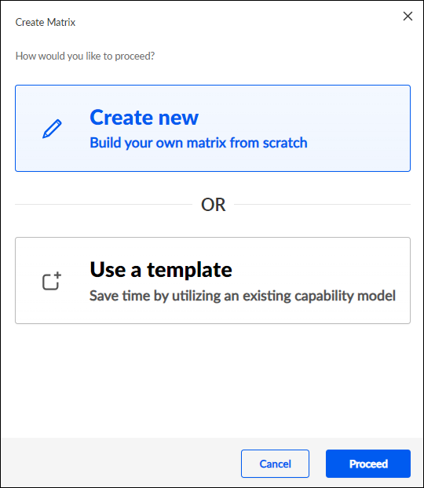
People Matrix - Build from Scratch
A people matrix displays a group of users and their proficiency for a set of capabilities and relevant training. Managers can configure which users, capabilities, and training are included in the matrix.
To create a people matrix from scratch, go to Skills > People Matrix. Select the Get Started or Create New button. Select Create new.
Permissions
PERMISSION NAME | PERMISSION DESCRIPTION | CATEGORY

People Matrix | Grants access to the People Matrix functionality. This permission can be constrained to User, OU, User's OU, User Self and Subordinates, and User's Direct Subordinates. The constraints on this permission determine which users are available in the People Matrix. This is a manager permission. | Core Administration

User Ratings - View All Shared Ratings | Grants the ability to view all ratings shared with others in addition to the rater. This permission applies anywhere the ratings are displayed, such as the People Matrix and Skills Profile. This permission is intended for indirect managers or non-managers to view rating data for users over whom they have no oversight. This permission grants access to all OU types, both standard and custom. This permission can be constrained to User, OU, User's OU, User Self and Subordinates, and User's Direct Subordinates. The constraints on this permission determine whose shared ratings the person can view. This is a manager permission. | Core Administration
Step 1 - Select Team
On the Select Team step, you can configure the matrix name and select which users are included in the matrix.
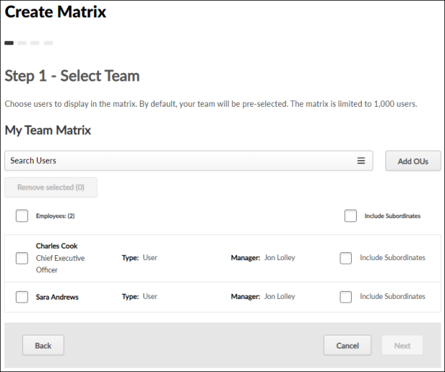
The following options are available to help you configure the matrix name and the group of users displayed in the matrix:
- Add OUs - By default, the matrix includes all of the creator's direct reports. Select this button to add users or organizational units to the matrix. The constraints on the People Matrix permission determine which users are available to add.
- Remove Selected - To remove users from the matrix, select the checkbox next to the appropriate users, and select the Remove Selected button.
- Include Subordinates - Select this option to include the user's subordinates in the matrix. When this option is selected, the subordinates are only included if they are within the matrix creator's permission constraints. In addition, you must have the necessary permission to view the shared ratings of users in the matrix.
After selecting the appropriate users, select Next to proceed to the Select Skills step.
Step 2 - Select Skills
On the Select Skills step, you can configure which skills are included in the matrix, the target proficiency level for each skill, and the number of employees required to have each skill and the required proficiency.
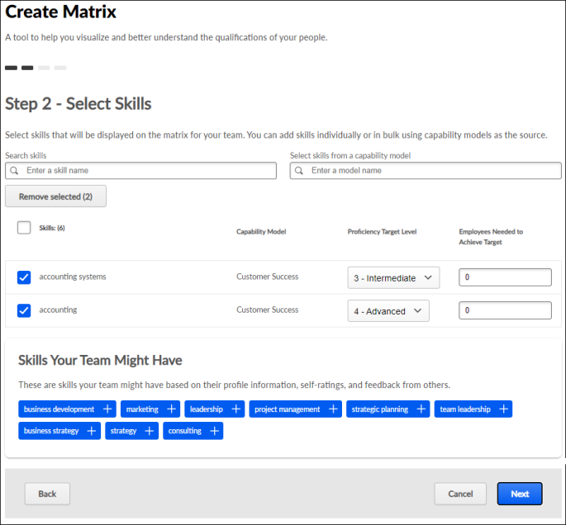
The following options are available to help you configure the matrix skills:
- Search and Add Skills - To add a skill, search for the skill and select Add Skill.
- Select skills from a capability model - Search for and select a capability model from this drop-down to retrieve the skills and targets from the model and add them to the matrix. Multiple capability models can be selected. If a skill has multiple targets, the highest target is used. When a model is selected, the audience is not carried into the matrix.
- Remove Selected - To remove skills from the matrix, select the checkbox next to the appropriate skills, and select the Remove Selected button.
- Capability Model - This column indicates whether the skill was added from a capability model or ad hoc. If the skill was added from a capability model, the name of the capability model is displayed. If a skill is present in multiple models, the Capability Model column displays the most recently added model. The matrix is not automatically updated when a capability model is updated. When editing a matrix, an alert is displayed if the selected skills and targets do not match the capability model, and users can re-add the model to use the latest version.
- Proficiency Target Level - From the drop-down, select the target proficiency level for each skill in the matrix. The people matrix will compare each user's skill level with this target level.
- Employees Needed to Achieve Target - Specify the number of employees required to have each skill and the required proficiency. This field is optional, and the default value for the field is zero. The maximum value is 999. You can only set this field when a Proficiency Target Level field is set for the skill.
  - This field is only available for matrices created from scratch, not those created from a capability model template.
  - This field be set to a value larger than the number of users in the people matrix.
- Team Skills - This section displays the top 10 declared skills that are shared for the people selected in the matrix. Select the plus icon for a skill to add it to the matrix.
- Skills Your Team Might Have - This section displays the top 10 skills your team may have but the skills have not been declared on your team members' profiles. These skills are identified based on the users' positions and skills identified by other employees with the same position title. Select the plus icon for a skill to add it to the matrix.
After selecting the appropriate skills, select Next to proceed to the Default Rating Source step.
Step 3 - Select Trainings
A Select Trainings step is only available for organizations using Learning when Qualification Mode is enabled for People Matrices. This step is optional.
Select the Track latest version of the training option so that any time a learning object in the matrix is updated, reversioned, and assigned to users, the people matrix displays the completion status of the latest training version assigned to the user. This option applies to all training in the matrix.
- The matrix is only updated if the training is reversioned and assigned to users. If the training is versioned but not assigned to the user, then the matrix is not updated. As a result, if training is reversioned and only assigned to some users, the matrix could include a user who is on target for completing version 1 of the training and another user who is off target for not completing version 2 of the same training.
- In the matrix, users can hover over the training status to view the version of the training that is currently used. If this checkbox is not selected, only the current training version will be used in the matrix, even when the training is reversioned.
On the Select Trainings step, select any training that should be tracked in the people matrix. The selected training will be displayed in the people matrix along with each person's training status. This enables managers to easily track each team member's status regarding the critical training.
Managers can only search for and select training if the manager is within the availability of the training.
The following training types can be added: Online Classes, Curriculum, Videos, Tests, Materials
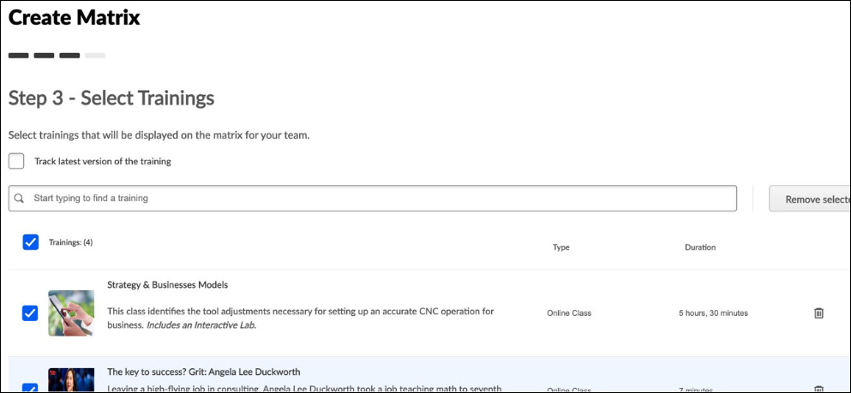
Step 4 - Add Rating Source and Title
On the Add Rating Source and Title step, you must select the default source of the ratings that should be used for the matrix and provide a title for the matrix. The rating source can be changed at any time when viewing the People Matrix.
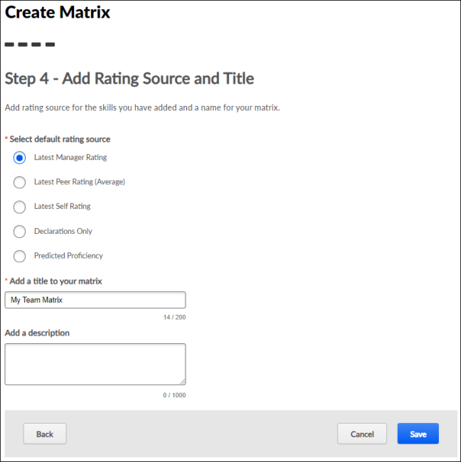
The following options are available to help you configure the rating source:
- Select Rating Source - Select which rating source should be used to display ratings in the matrix. The following options are available:
  - Latest Manager Rating
  - Declarations Only
  - Predicted Proficiency Rating - This option displays each user's predicted proficiency for the skills on the matrix. A user's predicted proficiency rating is an amalgamation of all declared ratings for the user (Self, Manager, and Peers) and the user's skill level that can be inferred from their years of experience in the role. If no value is displayed, it may mean that there is no rating history for the skill or the skill is not normally associated with the role. If a rating is added, a score will be computed and displayed.
- Add a Title to Your Matrix - Enter a name for your matrix, up to 200 characters. The matrix name should reflect the purpose of the matrix. The name will be displayed on the People Matrix Homepage and the People Matrix page.
- Add a Description - Enter a description to explain the purpose of the matrix, up to 1,000 characters.
After selecting the rating source and providing a title, select Save. The new matrix is added to your People Matrix Homepage, and you are directed to the newly created People Matrix. Only the matrix creator can view the matrix.
- See People Matrix Homepage on page 124 for additional information.
- See People Matrix - Overview on page 140 for additional information.
People Matrix - Create from Template
Capability Models define the skills employees should have to succeed in their roles, and the ideal proficiency level they should attain.
Administrators and managers can create a People Matrix using a Capability Model as a template. This pre-populates the people matrix with the settings from the capability model, including the appropriate set of users, the relevant skills, and the corresponding ratings.
To create a people matrix from a capability model, go to Skills > People Matrix. Select the Get Started or Create New button. Select Use a template.
Permissions
PERMISSION NAME | PERMISSION DESCRIPTION | CATEGORY

People Matrix | Grants access to the People Matrix functionality. This permission can be constrained to User, OU, User's OU, User Self and Subordinates, and User's Direct Subordinates. The constraints on this permission determine which users are available in the People Matrix. This is a manager permission. | Core Administration

User Ratings - View All Shared Ratings | Grants the ability to view all ratings shared with others in addition to the rater. This permission applies anywhere the ratings are displayed, such as the People Matrix and Skills Profile. This permission is intended for indirect managers or non-managers to view rating data for users over whom they have no oversight. This permission grants access to all OU types, both standard and custom. This permission can be constrained to User, OU, User's OU, User Self and Subordinates, and User's Direct Subordinates. The constraints on this permission determine whose shared ratings the person can view. This is a manager permission. | Core Administration
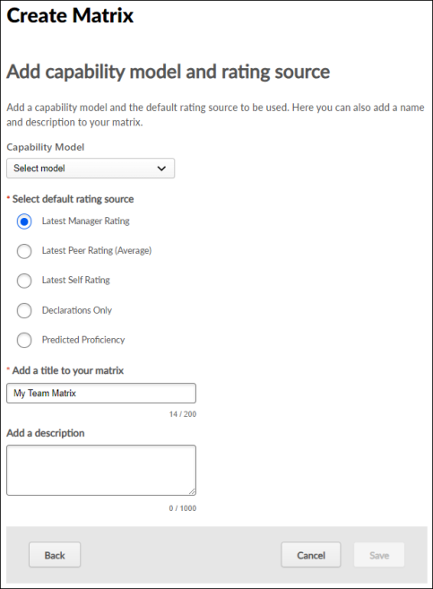
Capability Model
From the drop-down, select the capability model to use as the template for the people matrix. This drop-down includes all active models sorted alphabetically.
Select default rating source
Select which rating source should be used to display ratings in the matrix. The following options are available:
- Latest Manager Rating
- Latest Peer Rating
- Latest Self Rating
- Declarations Only
- Predicted Proficiency Rating - This option displays each user's predicted proficiency for the skills on the matrix. A user's predicted proficiency rating is an amalgamation of all declared ratings for the user (Self, Manager, and Peers) and their skill level that can be inferred from their years of experience in the role. If no value is displayed, it may mean there is no rating history for the skill, or the skill is not generally associated with the role. If a rating is added, a score will be computed and displayed.
Add a title to your matrix
Enter a name for your matrix, up to 200 characters. The matrix name should reflect the purpose of the matrix. The name will be displayed on the People Matrix Homepage and the People Matrix page.
Add a description
Enter a description to explain the purpose of the matrix, up to 1,000 characters.
Save/Update
After configuring the matrix, select the Save button. The matrix is populated using the settings defined in the selected competency model. You are unable to modify the users or skills displayed in the matrix. See People Matrix - Overview on page 140 for additional information.
The first 1,000 users in the competency model availability are included in the matrix.
- If the model has no defined availability, the first 1,000 users in the viewer's constraints are included.
- If the model has no defined availability and the user has no constraints, the first 1,000 users in the organization are included.
Frequently Asked Questions
What is a template, and which ones can I use?
The templates are another name for the Capability Models. Any capability model in the capability model library may be used, but your constraints will limit which users are included in the matrix.
Can the matrices I create be shared as models?
No. Currently, only capability models in the capability model library may be shared as templates. Please note that this is usually an administrator-only function.
I cannot edit the matrix I created using a template. Why is this?
Matrices created using a template are read-only; you may not add or remove skills or employees. If the criteria of a model need to be changed, please contact your system administrator.
I created a matrix using a template. How do I add training to it?
Currently, capability models do not support training; this functionality will be added in a future release. For now, you may only track training in matrices created ad-hoc.
I created a matrix using a template, but I do not see any people in it. Why is this?
Which employees you can view in a matrix depends on your constraints and the audience defined in the capability model. If your constraints do not align with the audience defined in the model, you may not be able to view any people.
Can I create a matrix using multiple templates?
No. Only one capability model may be added to a matrix for now.
I created a matrix from a template with multiple positions. Only some of the OUs have summary metrics when I access the matrix. Why?
To view metrics that enable comparison between OUs, two criteria must be met:
- The OU must not exceed 1,000 employees. If the OU exceeds 1,000 employees, drilling into the OU will display metrics for the top 1,000 employees. An alert is displayed when this occurs.
- The OU must have target proficiency ratings defined. If the OU does not have targets defined, the ratings will be color-coded from blue to gray. Targets must be defined for the OU to have a summary.
If a matrix exceeds 1,000 users, no summary metrics are provided. When viewing a matrix for an OU that exceeds 1,000 users, the first 1,000 users are displayed, and summary metrics are provided for that set of employees.
People Matrix - Overview
The People Matrix displays all of the selected users and their ratings for the selected skills. Only the matrix creator can view the matrix.
To view a People Matrix, go to Skills > People Matrix. Then, select the appropriate matrix.
Permissions
PERMISSION NAME | PERMISSION DESCRIPTION | CATEGORY

People Matrix | Grants access to the People Matrix functionality. This permission can be constrained to User, OU, User's OU, User Self and Subordinates, and User's Direct Subordinates. The constraints on this permission determine which users are available in the People Matrix. This is a manager permission. | Core Administration

User Ratings - View All Shared Ratings | Grants the ability to view all ratings shared with others in addition to the rater. This permission applies anywhere the ratings are displayed, such as the People Matrix and Skills Profile. This permission is intended for indirect managers or non-managers to view rating data for users over whom they have no oversight. This permission grants access to all OU types, both standard and custom. This permission can be constrained to User, OU, User's OU, User Self and Subordinates, and User's Direct Subordinates. The constraints on this permission determine whose shared ratings the person can view. This is a manager permission. | Core Administration
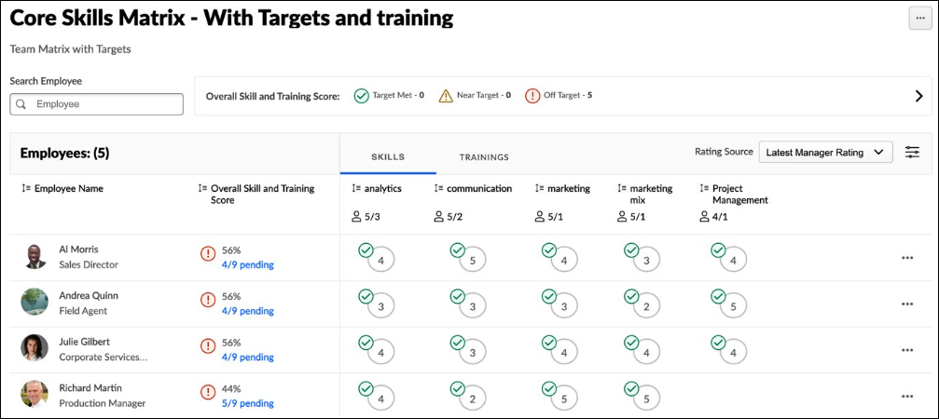
Edit Matrix
To edit the matrix, select the Options menu in the upper-right corner of the page, and select Edit Matrix. See People Matrix - Create on page 127 for additional information.
Delete Matrix
To delete the matrix, select the Options menu in the upper-right corner of the page, and select Delete Matrix. This permanently deletes the matrix.
Export Matrix as CSV
To export the matrix and data to a CSV file, select the Options menu in the upper-right corner of the page, and select Export as CSV. Each row in the CSV file represents a skill for a user.
Copy Matrix
To copy the matrix, select the Options menu in the upper-right corner of the page, and select Copy Matrix. See People Matrix - Create on page 127 for additional information.
Summary View
When a People Matrix is created from a competency model that contains multiple organizational units (OUs), a Summary View is available to compare OUs with unique proficiency targets. Multiple OU types may be used in a matrix. The summary view enables viewers to compare target attainment across OUs. See People Matrix - Summary View on page 144 for additional information.
Proficiency Levels and Targets
In the upper-right corner of the page, each of the proficiency levels are displayed with their corresponding name. Viewers can hover over a proficiency level to view a description.
If proficiency targets are configured for the selected skills' capability model, then the following assessments are displayed in the matrix:
- Target Met - This indicates the user's rating is at or above the skill's proficiency target.
- Near Target - This indicates the user's rating is within 80% of the skill's proficiency target.
- Off Target - This indicates the user's rating is less than 80% of the skill's proficiency target.
Search Users
Search for a specific user in the matrix. When a search is conducted, the matrix only displays users who match the search criteria.
Rating Source
By default, the matrix uses the default rating source configured for the matrix. To view ratings from a different source, select the appropriate source from the Rating Source drop-down menu.
Note: Rating Source is determined by the rater's relation at the time of the rating, regardless of the person's current relation.
Filter Skills and Proficiency Levels
To filter the skills and proficiency levels displayed in the People Matrix, select the Filters toggle. This opens the Filters flyout. The Filters flyout displays filters based on which content is being viewed in the People Matrix.
Which filter criteria are available in the flyout is determined by which data is being viewed in the People Matrix.
- When the rating source is Declarations Only, Skill Name and Declaration Status filters are available.
- When the rating source is not Declarations Only, Skill Name and Proficiency Level filters are available.
The following filters are available:
- Skill Drop-down - Select a specific skill to display. When a skill is selected, only the selected skill is displayed.
- Declaration Status - Select one or more declaration statuses to display. When a declaration status is selected, only ratings with the selected declaration status are displayed.
- Proficiency Level - Select one or more proficiency levels to display. When a proficiency level is selected, only ratings with the selected proficiency level are displayed.
People Matrix Data
The following information is displayed in the People Matrix:
- Employee Count - The number of users included in the matrix is displayed at the top of the employee list.
- Employee Name - The first column displays each user who was configured to be included in the People Matrix. The matrix only displays users who are within the viewer's permission constraints.
- Overall Skill and Training Score - This displays the user's cumulative score, including their skill assessments and training completion. You can select this link to view the user's Summary of Skills Gaps flyout. See People Matrix - View Summary of Skill Gaps on page 147 for additional information.
Skills Tab
When the Skills tab is selected, the following information is displayed:
- Employees Needed to Achieve Target - When creating a matrix, you can specify how many employees need to have the skill and the required proficiency. If a value is set for a skill in the matrix, then the people matrix indicates how many employees are on target for the skill and how many employees are required to be on target for the skill. This information helps managers and administrators quickly identify whether the team or group has the necessary number of adequately skilled employees for each skill.
  - This is displayed as [Number of employees on target]/[Number of employees needed].
  - This value does not display if the Employees Needed to Achieve Target value is set to zero or is not set when creating the matrix.
  - The Employees Needed to Achieve Target value may be set to a value larger than the number of users in the people matrix.
- Skills and Proficiencies - The matrix displays the user's proficiency level for each of the skills.
  - The proficiencies are based on the selected Rating Source.
  - If a proficiency target is configured for the skill's capability model, then the matrix displays whether the user has met the target, is near the target, or is off the target.
    - On Target - This indicates the user meets or exceeds the target.
    - Near Target - This indicates the user is below the target by one level.
    - Off Target - This indicates the user is below the target by two or more levels.
  - If no proficiency target is configured for the skill's capability model, then the rating circles are shaded to reflect the proficiency level. Higher levels are displayed with a darker color, while lower levels are displayed with a lighter color.
  - When Declarations Only is selected as the rating source, a checkmark is displayed if the user has declared the skill. A proficiency assessment is not displayed.
  - When Latest Peer Rating is selected as the rating source, if there are multiple ratings from peers for the skill, then the latest average rating is displayed.
- Skill Actions - An Actions menu (three dots) is available by hovering over the skill rating in the matrix. Actions are available based on the rating source and whether the People Matrix feature connector is enabled for the source. The option names may vary as they can be configured in the feedback template. The following actions may be available if configured in the feedback template:
  - Request a Proficiency Rating
  - View Details - Select this option to view the skill details in a flyout. See Skills Profile - View Skill Details on page 117 for additional information.
  - Update Ratings - Select this to provide a new rating for the user. When a new rating is provided, the matrix displays the new rating. Updating a rating adds a new rating for the user; it does not overwrite the previous rating. See Skills Profile - Provide Skill Feedback on page 102 for additional information.
  - Other options may be available.
Trainings Tab
When training is added to a People Matrix, a Training tab is available in the People Matrix.
When the Training tab is selected, the following information is displayed:
- Selected training
- User's training completion status (Completed, Not Started, Not Assigned, N/A)
  - If the user has not been assigned the training, an Assign link is displayed in the corresponding column for the user. Managers can select this link to assign the training to the user.
  - Managers can hover over the training status for a particular user to open the Learning Details page for the user's training.
Managers can select the menu icon for a user to access the user's Skills Profile or Transcript.
People Matrix - Summary View
When a People Matrix is created from a competency model that contains multiple organizational units (OUs), a Summary View is available to compare OUs with unique proficiency targets. Multiple OU types may be used in a matrix. The summary view enables viewers to compare target attainment across OUs.​
To create a people matrix from a capability model, go to Skills > People Matrix. Select the Get Started or Create New button. Select Use a template.
Permissions
PERMISSION NAME | PERMISSION DESCRIPTION | CATEGORY

People Matrix | Grants access to the People Matrix functionality. This permission can be constrained to User, OU, User's OU, User Self and Subordinates, and User's Direct Subordinates. The constraints on this permission determine which users are available in the People Matrix. This is a manager permission. | Core Administration

User Ratings - View All Shared Ratings | Grants the ability to view all ratings shared with others in addition to the rater. This permission applies anywhere the ratings are displayed, such as the People Matrix and Skills Profile. This permission is intended for indirect managers or non-managers to view rating data for users over whom they have no oversight. This permission grants access to all OU types, both standard and custom. This permission can be constrained to User, OU, User's OU, User Self and Subordinates, and User's Direct Subordinates. The constraints on this permission determine whose shared ratings the person can view. This is a manager permission. | Core Administration
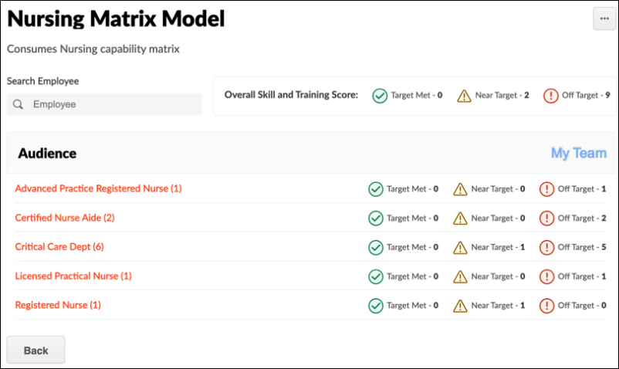
The Summary View displays each OU in the competency model along with target achievement metrics for the first 1,000 users in the OU. If the matrix includes over 1,000 users, the achievement metrics are not displayed when the matrix is first accessed. When this occurs, a message indicates that the matrix row limit is exceeded. Note: If the matrix includes over 1,000 users, the Export option is unavailable on the Summary View.
Managers can select the My Team link to view only their direct subordinates. This option is only available if the viewer has subordinates. The My Team view includes overall metrics for subordinates based on the highest skill target. When calculating if users are on target, the system considers the highest target within the capability model that applies to the user.
Matrix viewers can select an OU to view the details of individuals within it, quickly identifying which employees are most qualified for their roles. If the selected OU includes over 1,000 users, only the first 1,000 users are displayed in the matrix. When this occurs, a message indicates that the matrix row limit is exceeded. This message displays each time the matrix is accessed.
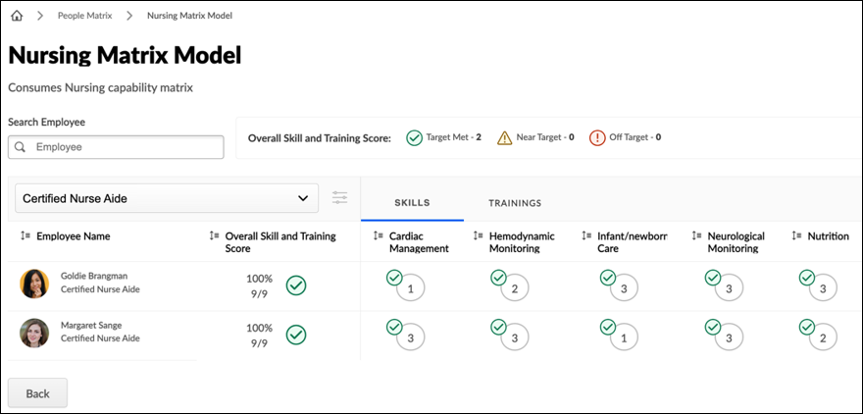
The OU drop-down enables viewers to navigate between OUs quickly. The following options are also available in the drop-down menu:
- Summary - Viewers can select this option to return to the Summary view.
- My Team - This option is only available if the viewer has subordinates. Managers can select this option to view only their direct subordinates.
If the selected OU has multiple levels in the hierarchy, viewers can select the Filter icon to the right of the OU drop-down to select specific OUs within the OU structure. The Filter option is unavailable if the capability model is not configured to include subordinate OUs.
When a matrix from a capability model is exported, the exported file includes an Audience OU field to indicate the OU associated with each user and their data. A user may be included in multiple OUs.
People Matrix - View Summary of Skill Gaps
When viewing the People Matrix, matrix viewers can see how many of the skills and training in the matrix each user has. For example, if a user had four of the eight skills in the matrix, "4/8" would display. Matrix viewers can select this value to view the Summary of Skill Gaps flyout, which displays a summary of the skills and training gaps for the user.
The Summary of Skill Gaps flyout displays the user's overall target status for all skills and training and the number of skills and training not on target. The flyout also lists all skills and training that are not on target so the matrix viewer can quickly see which skills and training need action.
The matrix viewer can select the left and right arrows to view different users in the skills matrix.
To view a People Matrix, go to Skills > People Matrix. Then, select the appropriate matrix. Select the skills summary for the user, such as "4/8," to view the Summary of Skills Gaps flyout.
Permissions
PERMISSION NAME | PERMISSION DESCRIPTION | CATEGORY

People Matrix | Grants access to the People Matrix functionality. This permission can be constrained to User, OU, User's OU, User Self and Subordinates, and User's Direct Subordinates. The constraints on this permission determine which users are available in the People Matrix. This is a manager permission. | Core Administration

User Ratings - View All Shared Ratings | Grants the ability to view all ratings shared with others in addition to the rater. This permission applies anywhere the ratings are displayed, such as the People Matrix and Skills Profile. This permission is intended for indirect managers or non-managers to view rating data for users over whom they have no oversight. This permission grants access to all OU types, both standard and custom. This permission can be constrained to User, OU, User's OU, User Self and Subordinates, and User's Direct Subordinates. The constraints on this permission determine whose shared ratings the person can view. This is a manager permission. | Core Administration
