Webhooks March 2024

Table of Contents
Webhooks (Early Adopter) - Overview 1
Endpoint Management 4
Create a Webhook Endpoint 6
Webhook Management 8
Create a Webhook 10

Webhooks (Early Adopter) - Overview
Webhooks is an HTTP-enabled feature that enables customers to create a deeper integration into the Cornerstone ecosystem by enabling near real-time access to critical business event data. With Webhooks, you can direct your Cornerstone CSX portal to automatically communicate the occurrence of specific events (such as, a training completion) to the other systems on which your organization relies.
Why use Webhooks?
Webhooks provides the following:
- Event-driven notifications to drive more timely business process execution
- Full event data payloads that do not require multiple API calls
- Asynchronous processing of data
- Decreased implementation complexity
Customers implementing Webhooks will see the following:
- Easier integrations that yield lower TTFHW (Time to First Hello World), which is an important metric for data integrations
- Fewer polling API calls to receive critical data faster
- Improved data quality yielding fewer data-fix and no-fix defects
Compared to current API functionality, customers should see a reduced need to call throttled APIs such as the Reporting API, Employee API, and Training API as they adopt the corresponding Webhooks. Webhooks can be used to supplement existing API calls for Employee, Transcript, and Training information to shorten the time to receive notifications on changes to any of this information. Note: Employee and Transcript event Webhooks will be available in a later release. Only Training Assignment/Completion and Status monitoring events are available in the Early Adopter release.
Data Throughput of Webhooks
Data throughput of webhooks is dependent upon endpoint call response time and the infrastructure tiering of the webhook:
- Tier 1: 300 records per minute
Note: In the Early Adopter release, all webhooks are built with Tier 1 infrastructure. Further information will be provided about infrastructure tiering prior to the GA (General Availability) release.
Early Adopter Webhooks Key Features
Customers can create, stop, and start webhooks for easy consumption of Cornerstone business event data. Customers can subscribe to Status webhooks to automate organizational alerts. An action audit log is being captured for Cornerstone's support team to ensure compliance and change tracking. However, the audit log will not be exposed via the user interface until a future release.
Future Enhancements
Future enhancements may include the following:
- Ability to establish notifications based on a Status webhook
- Support of infrastructure tiering to support business process requirements
- Addition of filtering to control the output of webhooks payloads
- Projection of webhook payloads to reduce amount of data in a payload
Implementation
Webhooks can be enabled for all customers except for customers on swimlanes SL4.
To enable Webhooks in Stage environments, contact Global Customer Support.
To enable Webhooks in Production environments, contact your account executive to purchase Webhooks. Once purchased, contact Global Customer Support to enable Webhooks.
When Webhooks are enabled, the new Edge Endpoints - Create Secret, Edge Endpoints - Manage, Edge Endpoints - View Secret, Edge Endpoints - View, Edge Webhooks - Manage, Edge Webhooks - Start/Stop, and Edge Webhooks - View permissions are automatically granted to the default System Administrator role. Administrators must grant this permission with the appropriate constraints to other roles, if necessary.
Set up a Webhook
To set up a webhook, you must first create an endpoint to link your hosted URL and the webhook. See Create a Webhook Endpoint on page 6 for additional information.
Then, create a webhook to begin publishing events to your endpoint. See Create a Webhook on page 10 for additional information.
Permissions
The following permissions apply to this functionality:
PERMISSION NAME | PERMISSION DESCRIPTION | CATEGORY

Edge Endpoints - Create Secret | Grants access to create the secret key for Edge Endpoints used with Webhooks. This permission can be constrained by OU and User. This is an administrator permission. | Edge

Edge Endpoints - Manage | Grants access to view, create, edit, and verify Edge Endpoints used with Webhooks. This permission can be constrained by OU and User. This is an administrator permission. | Edge

Edge Endpoints - View Secret | Grants access to view the secret key for Edge Endpoints used with Webhooks. This permission can be constrained by OU and User. This is an administrator permission. | Edge

Edge Endpoints - View | Grants access to view Edge Endpoints used with Webhooks. This permission can be constrained by OU and User. This is an administrator permission. | Edge

Edge Webhooks - Manage | Grants access to view, create, and edit Edge Webhooks. This permission can be constrained by OU and User. This is an administrator permission. | Edge

Edge Webhooks - Start/Stop | Grants access to start and stop Edge Webhooks. This permission can be constrained by OU and User. This is an administrator permission. | Edge

Edge Webhooks - View | Grants access to view Edge Webhooks. This permission can be constrained by OU and User. This is an administrator permission. | Edge

Endpoint Management
From the Endpoint Management page, administrators can create and edit webhook endpoints. An endpoint is a specific URL on your web server or service to which Cornerstone CSX will send webhook communication.
Endpoints must be configured before webhooks can be created.
To manage webhooks and webhook endpoints, go to Admin > Tools > Edge > Webhooks. Then, select the Endpoints button.
Permissions
PERMISSION NAME | PERMISSION DESCRIPTION | CATEGORY

Edge Endpoints - Manage | Grants access to view, create, edit, and verify Edge Endpoints used with Webhooks. This permission can be constrained by OU and User. This is an administrator permission. | Edge

Edge Webhooks - Manage | Grants access to view, create, and edit Edge Webhooks. This permission can be constrained by OU and User. This is an administrator permission. | Edge
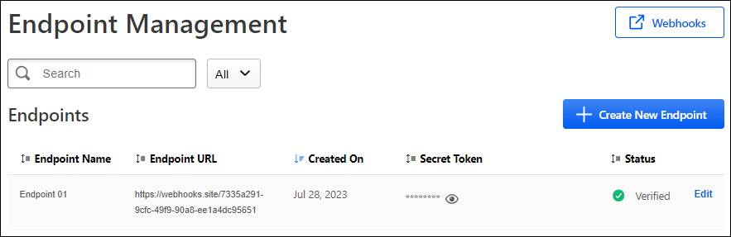
Manage Webhooks
Select the Webhooks button to manage webhooks. See Webhook Management on page 8 for additional information.
Create New Endpoint
Select the Create New Endpoint button to create a webhook endpoint. See Create a Webhook Endpoint on page 6 for additional information.
Verify Endpoint
If an endpoint is not verified, a Verify link is available. Select this link to verify the webhook.
Verification sends a brief communication to your provided Endpoint URL to ensure a secure connection. Your endpoint will need to be verified before it can be used for a webhook. If your endpoint fails verification, ensure the Endpoint URL is correct and that you have provided the proper security tokens to the receiving service.
Edit Endpoint
Select the Edit link to edit the webhook endpoint. See Create a Webhook Endpoint on page 6 for additional information.
If any changes are made to the endpoint, the endpoint will need to be verified again. If a webhook is assigned to this endpoint, it will be stopped until the endpoint is reverified.

Create a Webhook Endpoint
Endpoints are the specific URLs on your web server or service to which Cornerstone CSX will send webhook communication.
The first step in creating a webhook is to create a webhook endpoint to link your hosted URL and the webhook.
To create a webhook endpoint, go to Admin > Tools > Edge > Endpoints and select Create Endpoint.
Permissions
PERMISSION NAME | PERMISSION DESCRIPTION | CATEGORY

Edge Endpoints - Manage | Grants access to view, create, edit, and verify Edge Endpoints used with Webhooks. This permission can be constrained by OU and User. This is an administrator permission. | Edge
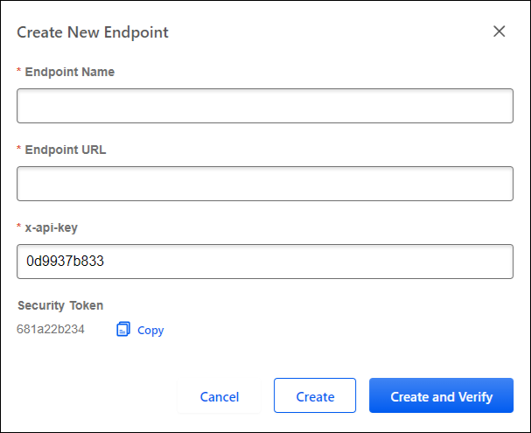
Enter the following information for the webhook endpoint:
- Endpoint Name - Enter a descriptive name for the endpoint to avoid confusion when selecting an endpoint for a webhook.
- Endpoint URL - Enter the URL of your server or service to which Cornerstone CSX will send the webhook.
- x-api-key
- Content Encoding - Select the gzip format from the dropdown. Gzip is a file format designed to compress HTTP content before it is delivered to a client. It utilizes the gzip algorithm to reduce file size and optimize transmission.
- Security Token - You may copy or regenerate the security token if a new token is needed.
You will be provided with an automatically generated x-api-key and a Security Token for you to provide to the receiving service. Both are unique alphanumeric codes that will be included in API requests for identification and authorization. While they serve similar purposes as authentication mechanisms, their usage might differ based on the specific requirements of your receiving service and organization.
x-api-keys and secret tokens are unique for the endpoint you are creating in your Cornerstone CSX portal. No two endpoints will have the same codes. Every time the Create New Endpoint button is selected, new strings will be generated for both.
Select the Create and Verify button to run the verification process. Verification sends a brief communication to your provided Endpoint URL to ensure a secure connection. Your endpoint will need to be verified before it can be used for a webhook.
Select the Create button to create the endpoint without verification. The endpoint will appear on the Endpoint Management page in a status of Unverified. Once ready, select the Verify link. See Endpoint Management on page 4 for additional information.

Webhook Management
From the Webhook Management page, administrators can create webhooks that is connected to an existing endpoint. Administrators can start and stop webhooks.
Endpoints must be configured before webhooks can be created.
To manage webhooks and webhook endpoints, go to Admin > Tools > Edge > Webhooks.
Permissions
PERMISSION NAME | PERMISSION DESCRIPTION | CATEGORY

Edge Endpoints - Manage | Grants access to view, create, edit, and verify Edge Endpoints used with Webhooks. This permission can be constrained by OU and User. This is an administrator permission. | Edge

Edge Webhooks - Manage | Grants access to view, create, and edit Edge Webhooks. This permission can be constrained by OU and User. This is an administrator permission. | Edge
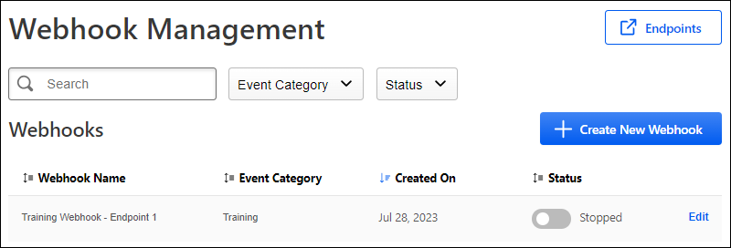
Manage Webhook Endpoints
Select the Endpoints button to manage webhook endpoints. See Endpoint Management on page 4 for additional information.
Create New Webhook
Select the Create New Webhook button to create a webhook. See Create a Webhook on page 10 for additional information.
Start or Stop a Webhook
To start or stop a webhook, enable or disable the Status toggle for the webhook. The status is displayed next to the toggle.
Edit a Webhook
Select the Edit link to edit the webhook. See Create a Webhook on page 10 for additional information.
A webhook can only be edited if the Status toggle is set to Stopped.

Create a Webhook
After creating a webhook endpoint, you can create a webhook that is connected to the existing endpoint.
To create a webhook, go to Admin > Tools > Edge > Webhooks and select Create Webhook.
Permissions
PERMISSION NAME | PERMISSION DESCRIPTION | CATEGORY

Edge Webhooks - Manage | Grants access to view, create, and edit Edge Webhooks. This permission can be constrained by OU and User. This is an administrator permission. | Edge
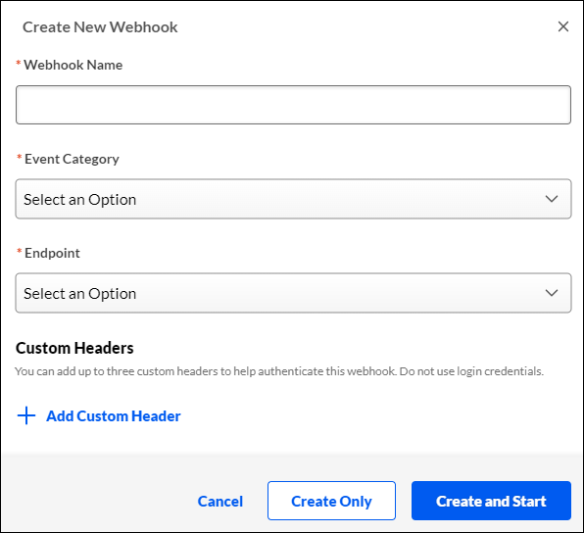
Enter the following information for the webhook endpoint:
- Webhook Name - Provide a descriptive name to avoid confusion in the future when audits or changes occur.
- Event Category - Select the type of webhook:
  - Training - These are webhooks that send communication based on Cornerstone CSX Learning-related system events.
  - Status - These are webhooks that send notifications based on the status of your webhooks.
- Events - Once an Event Category is selected, the Events drop-down appears with selections specific to the selected category. One or more events in the category may be selected. The following events are available:
  - Events:
    - Training Completion
    - Training Assigned
  - Status:
    - Started
    - Running
    - Stopped
    - Failing
    - Failed
- Endpoint - Select the verified endpoint to which you will publish events.
Note: If the desired endpoint is not appearing, return to the endpoint and select the Verify Now button and ensure there are no errors.
- Select a Custom Header, if applicable. You may include up to four custom headers to help authenticate the webhook. Custom headers can be used to pass authentication keys and values to access protected API endpoints.
Note: Do not include login credentials in the custom header fields.
Select Create and Start to immediately create and start the webhook and begin the flow of event data. Otherwise, select Create Only to create the webhook with the flow of event data stopped.

