User Records March 2024

Table of Contents
User Record Overview 1
User Records Administration 2
Universal Profile - User Record - View 9
User Record - Add 21
User Record - Edit 28
User Record - General Information 35
User Record - Sensitive Information 41
User Record - Contact 44
User Record - Settings 47
User Record - Organization Structure 49
User Record - E-Commerce 53
User Record - User Type and Employment Status 55
User Record - User Record Custom Fields 58
User Record - Modification History 60
User Record - Effective Dating 65
User Record Permissions 69
Use Case 1 - View User Record Photo 78
Use Case 2 - Edit Core Standard Fields/Photo 79
Use Case 3 - Edit All User Record Fields 80
Use Case 4 - View All Fields with Editing Limits 87
Edit User Password 91
Manage Device Tokens 94
User Hierarchy 96
User Record Audit History Stamps 98
View Permissions Constraints Details 99
How to Use Permissions Constraints Details 102

User Record Overview
User Records represent the complete profile of each user in the system, including each user's unique identifiers. Often, all user information is loaded and updated via a data feed from your organization's Human Resource Information System (HRIS). In this case, administrators rarely update user information manually through the system. However, the user record serves as a critical source of baseline information for each user.

User Records Administration
The user record represents the complete profile of each user in the system, including each user's unique identifiers. Often, all user information is loaded and updated via a data feed from your organization's Human Resource Information System (HRIS). In this case, administrators rarely update user information manually through the system. However, the user record serves as a critical source of baseline information for each user.
Accurate user information ensures that the system effectively manages each user who is to have access to the portal. The user record determines which Organizational Unit the user is associated with (e.g., Position, Division, Cost Center). The Organizational Units (e.g., Division, Cost Center) selected in each user record will determine availability, approval workflows, and preference settings for that user.
To access the User Records Administration page, go to Admin > Tools > Core Functions > Users.
Permissions
PERMISSION NAME | PERMISSION DESCRIPTION | CATEGORY

Change User Passwords - Administrator | Grants ability to change the portal password of another user. This permission works in conjunction with the Users - View permission. This permission can be constrained by User's Corporation, OU, User's OU, User's Self and Subordinates, and User. This is an administrator permission. | Core Administration

Employee Salary Management | Grants access to the Employee Salary Management page to edit, add, and view users' salaries or rates. This permission can be constrained by OU, User's OU, and User. This is an administrator permission. | Compensation - Administration

Employee Transcripts - Manager/Approver Access | Grants access to transcript (training record) screen of those for whom user is designated manager, approver or cost center approver. System administrators can access all user transcripts from this page. Link to this screen appears under Standard Reports/Track Employees. This is a manager/approver permission. This permission can be constrained by Employee Relationship and User's Direct Subordinates.  Note: The Employee Relationship constraint allows administrators to constrain the permission to a user’s custom employee relationship. For example, an administrator can select to restrict the Matrix Manager relationship to viewing user data for users who have that Matrix Manager indicated on their user record.  Note: The User's Direct Subordinates constraint allows administrators to constrain the data that a user can view to only the data for their direct reports. The user will not be able to view their own data with this constraint.  Note: By design, for any Track Employees report permission that is included in the Manager default security role, all of the manager's direct and indirect reports are included in the constraints, even if they are not selected in the permission constraints for the role. | Reports - Track Employee

Prevent Duplicate Users - Reconcile | Grants ability to view user accounts that have been identified as potential duplicates. Administrators can only view pending user records that were created by administrators who are within the constraints on this permission. This permission can be constrained by OU and User's OU. This is an administrator permission. | Core Administration

Proxy as User | Grants ability to log in as another user via proxy, for purposes of troubleshooting user issues. This is an administrator permission. The users to which the administrator has access to log in as is controlled by the users to which the administrator has access on the Users page and by the constraints upon this permission. This permission can be constrained by OU, User's OU, User Self and Subordinates, and User. By default, this functionality is not available for any users, including administrators. To request this permission, contact Global Customer Support. | Core Administration

Training Unit Revocation - Manage | Grants ability to revoke a user's training units granted, via the user administration page. This is an administrator permission. | eCommerce - Administration

Universal Profile - User Record - Create Users | Grants ability to access the User Record Administration page and to create new users in the system. When creating a new user, this permission grants the ability to add general information, which includes first name, last name, username, assigned OUs, and custom relationships. The administrator must have additional permissions to add any additional fields. This permission can be constrained by OU, User's OU, User's Self, User Self and Subordinates, and User. This is an administrator permission. | Core Administration

Universal Profile - User Record - Edit Users | Grants ability to edit user records in the system. The administrator must have additional permissions to edit specific fields on the user record. This permission can be constrained by OU, User's OU, User's Self, User Self and Subordinates, and User. This is an administrator permission. Note: This permission DOES NOT grant the ability to view user records in the system. Administrators must have the Universal Profile - User Record - View Users permission in order to view user records. | Core Administration

Universal Profile - User Record - View Users | Grants ability to view user records in the system. Administrators can view the Modification History page for user records within their constraints. The administrator must have additional permissions to view specific fields on the user record. This permission can be constrained by OU, User's OU, User's Self, User Self and Subordinates, and User. This is an administrator permission. | Core Administration

Users - Manage User Resume | Grants access to view and edit user resumes from Admin/User Search page. This permission only works when used in conjunction with the Users - View permission. | Talent/Succession - Administration

Users - Unlock Accounts | Grants ability to unlock user accounts that are currently locked. This permission can be constrained by OU, User's OU, User's Subordinates, and User. This is an administrator permission. | Core Administration

Users - View | Grants the ability to search for and view summary information about users in the portal via the Admin/Users screen. This permission can be constrained by OU, User's OU, User Self and Subordinates, and Users. If multiple constraints are added, these constraints are considered OR statements. This is an administrator permission. | Core Administration

Users - View Approver Search | Enables those who can search for and view users via the Admin/User screen to search by users' assigned approver. This permission only works when assigned in conjunction with the Users - View permission. | Core Administration

Users - View Criteria Search | Enables those who can search for and view users via the Admin/User screen to search by OU and Group criteria. This permission only works when assigned in conjunction with the Users - View permission. | Core Administration

Users - View Manager Search | Enables those who can search for and view users via the Admin/User screen to search by users' assigned manager. This permission only works when assigned in conjunction with the Users - View permission. | Core Administration

User Permission and Constraint Details - View | Grants ability to access the Permissions Constraints Details page for a user. This permission also grants ability to see the Permissions Constraints Details link on the Permissions page. This permission can be constrained by OU, User's OU, User, and User Self and Subordinates. This is an administrator permission. | Core Administration

View Transcript Item | Grants ability to view details of learning objects that appear on the transcript (training record), by clicking on the name of the learning object. Users must also have the Bio About - View permission in order to access the transcript within Universal Profile. This permission can be constrained by OU, User's OU, User Self and Subordinates, User, or User's Self. This is an end user permission. | Learning - Administration
You must have at least one of the MyTeam - Manage permissions to access My Team from the Users page. See My Team Permissions.
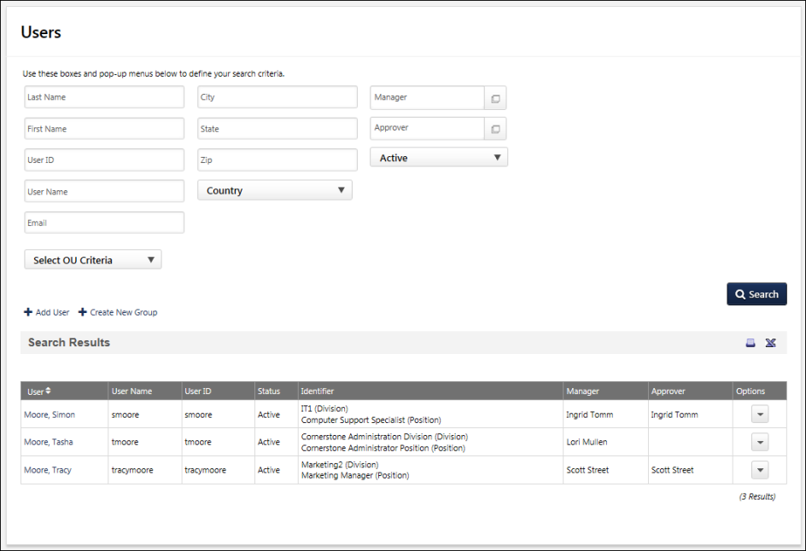
Permissions Considerations
- Administrators must have the Universal Profile - User Record - Create Users permission in order to access the User Record Administration page and to create new users in the system.
- Administrators must have the Universal Profile - User Record - Edit Users permission in order to edit user records. Administrators must have additional permissions to edit each portion of the user record.
- Administrators can view user records with the Universal Profile - User Record - View Users permission. This enables administrators to view user records without editing them. Administrators must have additional permissions to view each portion of the user record.
- If multiple constraints are added to the Users - View permission, these constraints are considered OR statements.
Search for Users
Search for existing users using any of the criteria: Last Name, First Name, User ID, User Name, Email, City, State, Zip, Country, Manager, Approver, Status, or Organizational Units.
Add User
Click this link to add a user. This link is only available to administrators who have permission to create users. See User Record - Add on page 21 for additional information.
Print User List
Click the Printable Version icon to view a printable version of the search results, or click the Export to Excel icon to export the search results to Excel. The maximum number of records that can be exported is 5,000.
Users List
The following information is displayed for each user in the search results:
- User - Click the user's name to view or edit the user record. See User Record - Edit on page 28 for additional information.
- User Name
- User ID
- Status
- Identifier
- Manager
- Approver
User Options
The following options may be available in the drop-down in the Options column, depending on your portal configurations:
- Unlock Account - This option only appears for a user if their account has been locked due to unsuccessful login attempts. Select this option to unlock the locked account. A confirmation pop-up opens to confirm the action.
- View Hierarchy - Select this option to view the user's manager/subordinate hierarchy. See User Hierarchy on page 96 for additional information.
- Permissions - Select this option to view the user's permissions. See View Permissions - User Record.
- Change Password - Select this option to reset the user's password. This option is only available if you have the appropriate permission. See Edit User Password on page 91 for additional information.
- View Transcript - Select this option to view the user's transcript. As an administrator, you can remove transcript items, add external training, edit due dates, edit transcript details, and other functionality. This option is only available if you have permission to view transcript items.
  - Transcript Overview - See Universal Profile - Transcript Overview.
  - Add External Training - See External Training - Add from Transcript.
  - Edit Training Due Date - See Training Details - Edit Due Date.
  - Edit Transcript Details - See Training Details - Edit Transcript Details.
  - Exempt Prerequisites, Pre-work, and Post-work - See Exempt Prerequisites/Pre-Work/Post-Work.
  - Remove Training - See Training - Remove from Transcript.
  - Restore Training - See Training - Restore to Transcript.
  - Transcript Report - See Transcript - Transcript Report.
Note: The Employee Transcripts - Manager/Approver Access permission does not grant access to the View Transcript link in User Options.
- View Certifications - Select this option to view the user's certifications transcript.
- Revoke Training Unit - Select this option to revoke training units from the user. See Revoke Training Units.
- Resume - Select this option to view or edit the user's resume.
- View My Team Profile - Select this option to view the user's My Team profile. See My Team - Profile.
- Employee Salary - This option is available to administrators who have permission to view users and manage employee salaries. Selecting this option opens the Employee Salary Management page for the user. There, the administrator can add, remove, and update the user's salaries. See Employee Salary Management Administration.
- Proxy as User - Select this option to open the Proxy as Another User page. This page enables the administrator to proxy in to the system as another user. This page also displays a history of all administrators that have used the Proxy feature for the user. Important Note: Although the system tracks when administrators proxy as another user, the system does not track the actions that are performed by the administrators on behalf of the user. As such, this functionality should be available to only the top level system administrators. See Proxy as Another User.
- Manage Device Tokens - Select this option to manage the user's devices that are registered with the Cornerstone mobile application. See Manage Device Tokens on page 94 for additional information.
- Permissions Constraints Details - This option is only available to administrators with the appropriate permissions, and it is only available for users within the administrator's permission constraints. Selecting this option opens the Permissions Constraints Details page where the administrator can view each of the user's security roles, permissions, constraints, and permission modification history. See View Permissions Constraints Details on page 99 for additional information.
Potential Duplicate User
When an organization using Cornerstone HR creates new users, the system can be configured to evaluate whether the new users are similar to existing user records. This is done in order to prevent the same user from being added to the system more than once. If similar records do not exist, the new users will be created normally. However, if similar records do exist, the record creation is prevented. A message is displayed to alert administrators that a potential duplicate user has been identified.
Administrators who have the Prevent Duplicate Records - Reconcile permission can click the link within the message to view and manage pending user records. See Pending User Records.
See Users - Potential Duplicate User.

Universal Profile - User Record - View
The User Record page enables administrators or managers with the proper permissions to view the core information about a user. When in view mode, the User Record cannot be modified.
A user's record can be viewed in the following manners:
- Go to Admin > Tools > Core Functions > Users. Then, select the name of the user in the search results.
- Select the user's photograph from any page within Universal Profile or from Global Search. Then, select the User Record tab.
Permissions
PERMISSION NAME | PERMISSION DESCRIPTION | CATEGORY

Grades - View | Grants ability to view the Grade Organizational Unit throughout the system, such as in availability drop down selectors, when editing users, etc. Those without this permission do not see the Grade OU on any screen. This is primarily an administrator permission, although organizational policy should determine whether the Grade OU should be visible to end users on reporting screens, etc. | Core Administration

Universal Profile - User Record - Edit Users | Grants ability to edit user records in the system. The administrator must have additional permissions to edit specific fields on the user record. This permission can be constrained by OU, User's OU, User's Self, User Self and Subordinates, and User. This is an administrator permission. Note: This permission DOES NOT grant the ability to view user records in the system. Administrators must have the Universal Profile - User Record - View Users permission in order to view user records. | Core Administration

Universal Profile - User Record - View Users | Grants ability to view user records in the system. Administrators can view the Modification History page for user records within their constraints. The administrator must have additional permissions to view specific fields on the user record. This permission can be constrained by OU, User's OU, User's Self, User Self and Subordinates, and User. This is an administrator permission. | Core Administration

Users – Edit Custom Field Information | Grants ability to view and edit the custom fields on a user record. Administrators are only able to edit a custom field on a user's user record if the user is within their permission constraints and the administrator is within the availability of the custom field. This permission works in conjunction with the Users - View permission. This permission can be constrained by OU, User's OU, User's Self, User Self and Subordinates, and User. This is an administrator permission. | Core Administration

Users – Edit General Information | Grants ability to edit the general fields on a user record, including first name, last name, username, assigned OUs, and custom relationships. This permission works in conjunction with the Users - View permission. This permission can be constrained by OU, User's OU, User's Self, User Self and Subordinates, and User. This is an administrator permission. | Core Administration

Users - Edit Middle Name | Grants ability to modify the middle name for a user via the admin/users screen. This permission only works when used in conjunction with the Users - View permission. This is an administrator permission. | Core Administration

Users - Edit Mobile Phone | Grants ability to modify the Mobile Phone number for a user via the Admin/Users screen. The availability of this permission is controlled by a backend setting. This permission only works when used in conjunction with the Users - View permission. | Core Administration

Users - Edit Prefix | Grants ability to modify the prefix for a user's name via the admin/users screen. This permission only works when used in conjunction with the Users - View permission. This is an administrator permission. | Core Administration

Users - Edit Sensitive Information: Unmasked | Grants ability to view and edit unmasked Sensitive Personally Identifiable Information (SPII) fields on the user record. Administrators with this permission have the option to view and edit the actual data on the user record. This permission can be constrained by OU, User's OU, User's Self, User's Subordinates, User's Direct Subordinates, User, and Employee Relationship. This is an administrator permission. | Core Administration

Users - Edit Signature | Grants ability to modify the signature font for a user via the admin/users screen. This permission only works when used in conjunction with the Users - View permission. This is an administrator permission. | Core Administration

Users - Edit Suffix | Grants ability to modify the suffix for a user's name via the admin/users screen. This permission only works when used in conjunction with the Users - View permission. This is an administrator permission. | Core Administration

Users - Edit User ID | Enables administrator to modify the User ID for a user via the admin/users screen. This permission only works when used in conjunction with the Users - View permission. | Core Administration

Users - Edit Users Absent Status | Enables administrator to modify the Absent status for a user via the admin/users screen. This permission only works when used in conjunction with the Users - View permission. | Core Administration

Users - Edit Users Active Status | Enables administrator to modify the Active status for a user via the admin/users screen. This permission only works when used in conjunction with the Users - View permission. | Core Administration

Users - Edit Users Address | Enables administrator to modify the address for a user via the admin/users screen. This permission only works when used in conjunction with the Users - View permission. | Core Administration

Users - Edit Users Approver | Enables administrator to modify the specified Approver for a user via the admin/users screen. This permission only works when used in conjunction with the Users - View permission. | Core Administration

Users - Edit Users Email | Enables administrator to modify the Email Address for a user via the admin/users screen. This permission only works when used in conjunction with the Users - View permission. | Core Administration

Users - Edit Users Fax | Enables administrator to modify the Fax number for a user via the admin/users screen. This permission only works when used in conjunction with the Users - View permission. | Core Administration

Users - Edit Users Language | Enables administrator to modify the portal display language for a user via the admin/users screen. This permission only works when used in conjunction with the Users - View permission. | Core Administration

Users - Edit Users Last Hire Date | Enables administrator to modify the Last Hire Date for a user via the admin/users screen. This permission only works when used in conjunction with the Users - View permission. | Core Administration

Users - Edit Users Manager | Enables administrator to modify the assigned Manager for a user via the admin/users screen. This permission only works when used in conjunction with the Users - View permission. | Core Administration

Users - Edit Users Original Hire Date | Enables administrator to modify the Original Hire Date for a user via the admin/users screen. This permission only works when used in conjunction with the Users - View permission. | Core Administration

Users - Edit Users Phone | Enables administrator to modify the Phone number for a user via the admin/users screen. This permission only works when used in conjunction with the Users - View permission. | Core Administration

Users - Edit Users Photo | Enables administrator to upload a photo for a user via the admin/users screen. This permission only works when used in conjunction with the Users - View permission. | Core Administration

Users - Edit Users Reconciliation | Enables administrator to modify the Reconciliation status for a user via the admin/users screen. This permission only works when used in conjunction with the Users - View permission. | Core Administration

Users - Edit Users Required Approvals | Enables administrator to modify the number of required training approvals for a user via the admin/users screen. This permission only works when used in conjunction with the Users - View permission. | Core Administration

Users - Edit Users Time Zone | Enables administrator to modify the portal time zone for a user via the admin/users screen. This permission only works when used in conjunction with the Users - View permission. | Core Administration

Users – Effective Dating: Manage | Enables administrator to make effective dated changes to the user record. This permission only works when used in conjunction with the Users - Edit General Information permission. This permission cannot be constrained. This is an administrator permission. | Core Administration

Users - View | Grants the ability to search for and view summary information about users in the portal via the Admin/Users screen. This permission can be constrained by OU, User's OU, User Self and Subordinates, and Users. If multiple constraints are added, these constraints are considered OR statements. This is an administrator permission. | Core Administration

Users – View Custom Field Information | Grants ability to view the custom fields on a user record. Administrators are only able to view a custom field on a user's user record if the user is within their permission constraints and the administrator is within the availability of the custom field. This permission works in conjunction with the Users - View permission. This permission can be constrained by OU, User's OU, User's Self, User Self and Subordinates, and User. This is an administrator permission. | Core Administration

Users – View General Information | Grants ability to view the general fields on a user record, including first name, last name, username, assigned OUs, and custom relationships. This permission works in conjunction with the Universal Profile - User Record - View Users permission. This permission can be constrained by OU, User's OU, User's Self, User Self and Subordinates, and User. This is an administrator permission. | Core Administration

Users - View Middle Name | Grants ability to view the middle name for a user via the Admin/Users screen. This permission only works when used in conjunction with the Universal Profile - User Record - View Users and Users - View General Information permissions. This is an administrator permission. | Core Administration

Users - View Mobile Phone | Grants ability to view the Mobile Phone number for a user via the Admin/Users screen. The availability of this permission is controlled by a backend setting. This permission only works when used in conjunction with the Users - View permission. | Core Administration

Users - View Modification Details | Grants ability to view the Modification Details on the User Record and view User Audits fields when creating a Reporting 2.0 report. This permission only works when used in conjunction with the Users - View permission. This is an administrator permission. | Core Administration

Users - View Prefix | Grants ability to view the prefix for a user's name via the Admin/User screen. This permission only works when used in conjunction with the Universal Profile - User Record - View Users and Users - View General Information permissions. This is an administrator permission. | Core Administration

Users - View Sensitive Information: Masked | Grants ability to view masked Sensitive Personally Identifiable Information (SPII) fields on the user record. Administrators with this permission cannot view the actual data. This permission can be constrained by OU, User's OU, User's Self, User's Subordinates, User's Direct Subordinates, User, and Employee Relationship. This is an administrator permission. | Core Administration

Users - View Sensitive Information: Unmasked | Grants ability to view unmasked Sensitive Personally Identifiable Information (SPII) fields on the user record. Administrators with this permission have the option to view the actual data on the user record. This permission can be constrained by OU, User's OU, User's Self, User's Subordinates, User's Direct Subordinates, User, and Employee Relationship. This is an administrator permission. | Core Administration

Users - View Signature | Grants ability to view the signature font for a user via the Admin/Users screen. This permission only works when used in conjunction with the Universal Profile - User Record - View Users permission. This is an administrator permission. | Core Administration

Users - View Suffix | Grants ability to view the suffix for a user's name via the Admin/Users screen. This permission only works when used in conjunction with the Universal Profile - User Record - View Users permission. | Core Administration

Users - View User ID | Enables administrator to view the User ID for a user via the Admin/Users screen. This permission only works when used in conjunction with the Universal Profile - User Record - View Users permission. | Core Administration

Users - View Users Absent Status | Enables administrator to view the Absent status for a user via the Admin/Users screen. This permission only works when used in conjunction with the Universal Profile - User Record - View Users permission. | Core Administration

Users - View Users Active Status | Enables administrator to view the Active status for a user via the Admin/Users screen. This permission only works when used in conjunction with the Universal Profile - User Record - View Users permission. | Core Administration

Users - View Users Address | Enables administrator to view the address for a user via the Admin/Users screen. This permission only works when used in conjunction with the Universal Profile - User Record - View Users permission. | Core Administration

Users - View Users Approver | Enables administrator to view the specified Approver for a user via the Admin/Users screen. This permission only works when used in conjunction with the Universal Profile - User Record - View Users permission. | Core Administration

Users - View Users Email | Enables administrator to view the Email Address for a user via the Admin/Users screen. This permission only works when used in conjunction with the Universal Profile - User Record - View Users permission. | Core Administration

Users - View Users Fax | Enables administrator to view the Fax number for a user via the Admin/Users screen. This permission only works when used in conjunction with the Universal Profile - User Record - View Users permission. | Core Administration

Users - View Users Language | Enables administrator to view the portal display language for a user via the Admin/Users screen. This permission only works when used in conjunction with the Universal Profile - User Record - View Users permission. | Core Administration

Users - View Users Last Hire Date | Enables administrator to view the Last Hire Date for a user via the Admin/Users screen. This permission only works when used in conjunction with the Universal Profile - User Record - View Users permission. | Core Administration

Users - View Users Manager | Enables administrator to view the assigned Manager for a user via the Admin/Users screen. This permission only works when used in conjunction with the Universal Profile - User Record - View Users permission. | Core Administration

Users - View Users Original Hire Date | Enables administrator to view the Original Hire Date for a user via the Admin/Users screen. This permission only works when used in conjunction with the Universal Profile - User Record - View Users permission. | Core Administration

Users - View Users Phone | Enables administrator to view the Phone number for a user via the Admin/Users screen. This permission only works when used in conjunction with the Universal Profile - User Record - View Users permission. | Core Administration

Users - View Users Photo | Enables administrator to view a photo for a user via the Admin/Users screen. This permission only works when used in conjunction with the Universal Profile - User Record - View Users permission. | Core Administration

Users - View Users Reconciliation | Enables administrator to view the Reconciliation status for a user via the Admin/Users screen. This permission only works when used in conjunction with the Universal Profile - User Record - View Users permission. | Core Administration

Users - View Users Required Approvals | Enables administrator to view the number of required training approvals for a user via the Admin/Users screen. This permission only works when used in conjunction with the Universal Profile - User Record - View Users permission. | Core Administration

Users - View Users Time Zone | Enables administrator to view the portal time zone for a user via the Admin/Users screen. This permission only works when used in conjunction with the Universal Profile - User Record - View Users permission. | Core Administration
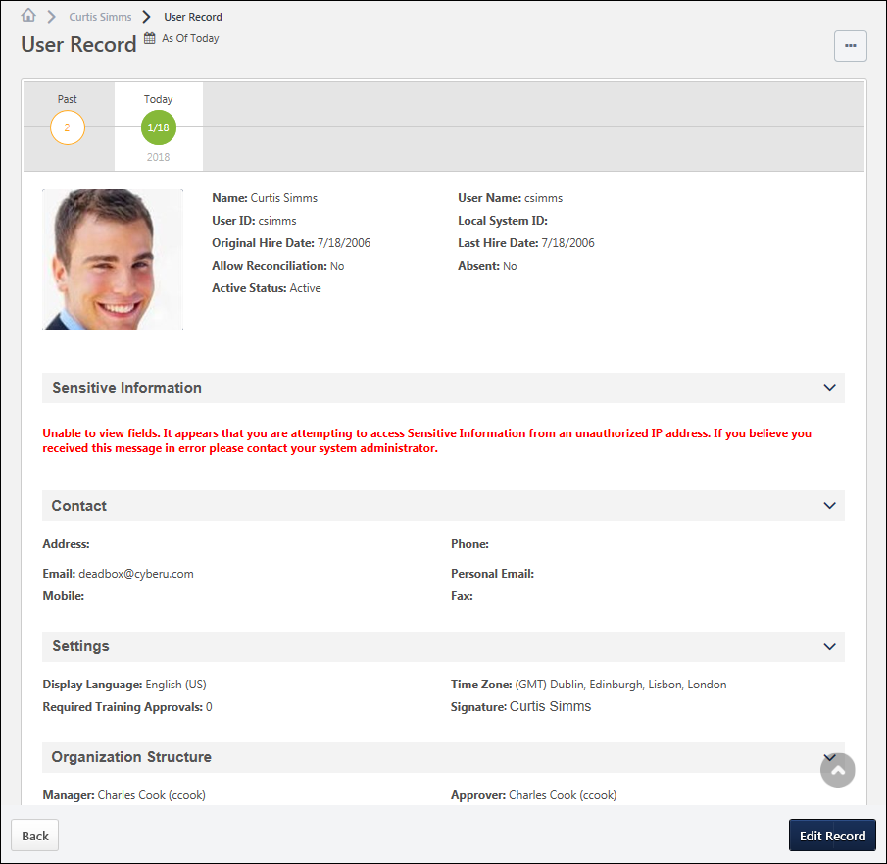
Permission Considerations
Administrators with the Universal Profile - User Record - View Users permission can view user records for users within their permission constraints. Administrators must also have one or more of the Users - View or Users - Edit permissions in order to view the corresponding fields on the user record for users within their permission constraints.
As a best practice, administrators or managers who need access to view user records should at least be granted the Universal Profile - User Record - View Users and the Users - View General Information permissions. If an administrator only has the Universal Profile - User Record - View Users permission, then they can only view a blank user record with no fields.
Note: The Universal Profile - User Record - Edit Users permission DOES NOT grant the ability to view user records in the system. Administrators must have the Universal Profile - User Record - View Users permission in order to view user records.
User Record - Options
The following options may be available from the Options drop-down menu:
- Modification History - Select this option to view the Modification History page for the user. This option is only available to administrators who have permission to view users. See User Record - Modification History on page 60 for additional information.
- Change Password - Select this option to reset the user's password. This option is only available to administrators who have permission to change the user's password. See Edit User Password on page 91 for additional information.
- Proxy as this user - Select this option to open the Proxy as Another User page. This page enables the administrator to proxy into the system as another user. This page also displays a history of all administrators who have used the Proxy feature for the user. This option is only available to administrators who have permission to proxy as the user. Important Note: Although the system tracks when administrators proxy as another user, the system does not track the actions that are performed by the administrators on behalf of the user. As such, this functionality should be available to only the top level system administrators. See Proxy as Another User.
- Permissions - Select this option to view all of the user's permissions in all of the user's roles. Each permission's constraints are also displayed. This option is only available to administrators who have permission to manage the user's security administration. See View Permissions - User Record.
- Unlock Account - Select this option to unlock the locked account. A confirmation pop-up opens to confirm the action. This option only appears for a user if their account has been locked due to unsuccessful login attempts. Also, this option is only available to administrators who have permission to unlock the user's account.
- Employee Salary - Select this option to view the Employee Salary Management page for the user. There, administrators can add, remove, and update the user's salaries. This option is available to administrators who have permission to manage the user's salaries. See Employee Salary Management.
- Expand all sections - This option is available by default, regardless of whether there are any collapsed sections on the User Record. Select this option to expand all sections on the User Record. Once this option is selected, the Collapse all sections option becomes available.
- Collapse all sections - This option is available after the Expand all sections option is selected, regardless of whether there are any expanded sections on the User Record. Once this option is selected, the Expand all sections option becomes available.
User Record - Edit Record
Administrators with the Universal Profile - User Record - Edit Users permission can select the Edit Record button in the light grey floating action bar at the bottom of the screen in order to edit the user record. Administrators must also have one or more of the Users - Edit permissions in order to edit the corresponding fields on the user record for users within their permission constraints. See User Record - Edit on page 28 for additional information.
User Record - Effective Dated Records
For organizations that have Effective Dating enabled, the effective date of the user record is displayed at the top of the page in the timezone of the user whose user record is being viewed. See User Record - Effective Dating on page 65 for additional information.
General Information
The General Information fields are available at the top of the user record, which include basic information about the user, such as name, photograph, and user name. See User Record - General Information on page 35 for additional information.
Sensitive Information
The Sensitive Information section is only available on the User Record when Encrypted Sensitive Information is enabled in the portal, and this functionality is only available to organizations using Cornerstone HR. This section enables organizations to view and edit Sensitive Personally Identifiable Information (SPII) fields. See User Record - Sensitive Information on page 41 for additional information.
Contact Information
The Contact section contains all of the user's contact information, such as address, phone, and email address. This section should be used to store the user's professional contact information. See User Record - Contact on page 44 for additional information.
Settings
The Settings section contains all of the user's system settings, such as display language, time zone, signature font, and required training approvals. See User Record - Settings on page 47 for additional information.
Organizational Structure
The Organization Structure section contains all of the user's organizational information, such as manager, approver, division, position, and location. See User Record - Organization Structure on page 49 for additional information.
E-Commerce
The E-Commerce Information section contains a user's override amount and value added tax (VAT) number. See User Record - E-Commerce on page 53 for additional information.
User Type and Employment Status
The User Type and Employment Status section contains the user's type (e.g., Employee, Intern, Contractor), user status (e.g., Working, On Leave, Terminated), and additional information regarding the user's status. See User Record - User Type and Employment Status on page 55 for additional information.
User Record Custom Fields
Each User Record custom field category that is defined in Custom Field Administration appears as a section on the User Record. All user record custom fields that are associated with that category appear within the section, which can be expanded and collapsed as with other sections. See User Record - User Record Custom Fields on page 58 for additional information.

User Record - Add
The Add New User page enables administrators to create a new user in the system and set the details of the user's record. Administrators are only able to view and set fields based on their permissions. If an administrator does not have permission to view or edit a field on the user record, then the field is not visible to the administrator.
To add a new user record, go to Admin > Tools > Core Functions > Users. Then, select the Add User link.
Note: Users can also be added in bulk using the Data Load Wizard. See Load User Data - Step 1 - Get Started for additional information.
Permissions
PERMISSION NAME | PERMISSION DESCRIPTION | CATEGORY

Grades - View | Grants ability to view the Grade Organizational Unit throughout the system, such as in availability drop down selectors, when editing users, etc. Those without this permission do not see the Grade OU on any screen. This is primarily an administrator permission, although organizational policy should determine whether the Grade OU should be visible to end users on reporting screens, etc. | Core Administration

Universal Profile - User Record - Edit Users | Grants ability to edit user records in the system. The administrator must have additional permissions to edit specific fields on the user record. This permission can be constrained by OU, User's OU, User's Self, User Self and Subordinates, and User. This is an administrator permission. Note: This permission DOES NOT grant the ability to view user records in the system. Administrators must have the Universal Profile - User Record - View Users permission in order to view user records. | Core Administration

Universal Profile - User Record - View Users | Grants ability to view user records in the system. Administrators can view the Modification History page for user records within their constraints. The administrator must have additional permissions to view specific fields on the user record. This permission can be constrained by OU, User's OU, User's Self, User Self and Subordinates, and User. This is an administrator permission. | Core Administration

Users – Edit Custom Field Information | Grants ability to view and edit the custom fields on a user record. Administrators are only able to edit a custom field on a user's user record if the user is within their permission constraints and the administrator is within the availability of the custom field. This permission works in conjunction with the Users - View permission. This permission can be constrained by OU, User's OU, User's Self, User Self and Subordinates, and User. This is an administrator permission. | Core Administration

Users – Edit General Information | Grants ability to edit the general fields on a user record, including first name, last name, username, assigned OUs, and custom relationships. This permission works in conjunction with the Users - View permission. This permission can be constrained by OU, User's OU, User's Self, User Self and Subordinates, and User. This is an administrator permission. | Core Administration

Users - Edit Middle Name | Grants ability to modify the middle name for a user via the admin/users screen. This permission only works when used in conjunction with the Users - View permission. This is an administrator permission. | Core Administration

Users - Edit Mobile Phone | Grants ability to modify the Mobile Phone number for a user via the Admin/Users screen. The availability of this permission is controlled by a backend setting. This permission only works when used in conjunction with the Users - View permission. | Core Administration

Users - Edit Prefix | Grants ability to modify the prefix for a user's name via the admin/users screen. This permission only works when used in conjunction with the Users - View permission. This is an administrator permission. | Core Administration

Users - Edit Sensitive Information: Unmasked | Grants ability to view and edit unmasked Sensitive Personally Identifiable Information (SPII) fields on the user record. Administrators with this permission have the option to view and edit the actual data on the user record. This permission can be constrained by OU, User's OU, User's Self, User's Subordinates, User's Direct Subordinates, User, and Employee Relationship. This is an administrator permission. | Core Administration

Users - Edit Signature | Grants ability to modify the signature font for a user via the admin/users screen. This permission only works when used in conjunction with the Users - View permission. This is an administrator permission. | Core Administration

Users - Edit Suffix | Grants ability to modify the suffix for a user's name via the admin/users screen. This permission only works when used in conjunction with the Users - View permission. This is an administrator permission. | Core Administration

Users - Edit User ID | Enables administrator to modify the User ID for a user via the admin/users screen. This permission only works when used in conjunction with the Users - View permission. | Core Administration

Users - Edit Users Absent Status | Enables administrator to modify the Absent status for a user via the admin/users screen. This permission only works when used in conjunction with the Users - View permission. | Core Administration

Users - Edit Users Active Status | Enables administrator to modify the Active status for a user via the admin/users screen. This permission only works when used in conjunction with the Users - View permission. | Core Administration

Users - Edit Users Address | Enables administrator to modify the address for a user via the admin/users screen. This permission only works when used in conjunction with the Users - View permission. | Core Administration

Users - Edit Users Approver | Enables administrator to modify the specified Approver for a user via the admin/users screen. This permission only works when used in conjunction with the Users - View permission. | Core Administration

Users - Edit Users Email | Enables administrator to modify the Email Address for a user via the admin/users screen. This permission only works when used in conjunction with the Users - View permission. | Core Administration

Users - Edit Users Fax | Enables administrator to modify the Fax number for a user via the admin/users screen. This permission only works when used in conjunction with the Users - View permission. | Core Administration

Users - Edit Users Language | Enables administrator to modify the portal display language for a user via the admin/users screen. This permission only works when used in conjunction with the Users - View permission. | Core Administration

Users - Edit Users Last Hire Date | Enables administrator to modify the Last Hire Date for a user via the admin/users screen. This permission only works when used in conjunction with the Users - View permission. | Core Administration

Users - Edit Users Manager | Enables administrator to modify the assigned Manager for a user via the admin/users screen. This permission only works when used in conjunction with the Users - View permission. | Core Administration

Users - Edit Users Original Hire Date | Enables administrator to modify the Original Hire Date for a user via the admin/users screen. This permission only works when used in conjunction with the Users - View permission. | Core Administration

Users - Edit Users Phone | Enables administrator to modify the Phone number for a user via the admin/users screen. This permission only works when used in conjunction with the Users - View permission. | Core Administration

Users - Edit Users Photo | Enables administrator to upload a photo for a user via the admin/users screen. This permission only works when used in conjunction with the Users - View permission. | Core Administration

Users - Edit Users Reconciliation | Enables administrator to modify the Reconciliation status for a user via the admin/users screen. This permission only works when used in conjunction with the Users - View permission. | Core Administration

Users - Edit Users Required Approvals | Enables administrator to modify the number of required training approvals for a user via the admin/users screen. This permission only works when used in conjunction with the Users - View permission. | Core Administration

Users - Edit Users Time Zone | Enables administrator to modify the portal time zone for a user via the admin/users screen. This permission only works when used in conjunction with the Users - View permission. | Core Administration

Users – Effective Dating: Manage | Enables administrator to make effective dated changes to the user record. This permission only works when used in conjunction with the Users - Edit General Information permission. This permission cannot be constrained. This is an administrator permission. | Core Administration
Emails
EMAIL NAME | EMAIL DESCRIPTION | ACTION TYPE

New User Record Created (via Add User Page) | This email can be configured as a notification and is triggered when a new user record is created via the Admin - Users page. This email is not sent to users who are created via a data feed. This email can be sent to the User Created, User Creator, or the User's Manager.  The PASSWORD.RESET.URL email tag is a link that opens a page on which the user can create a password. If this email is sent multiple times to the same recipient, then this URL is regenerated each time and the previous URL is no longer valid. Also, the password reset URL is only valid for 48 hours. If the user does not reset their password within the 48-hour validity period, then the user must click Forgot Password? again to get a new password reset URL. | System Administration
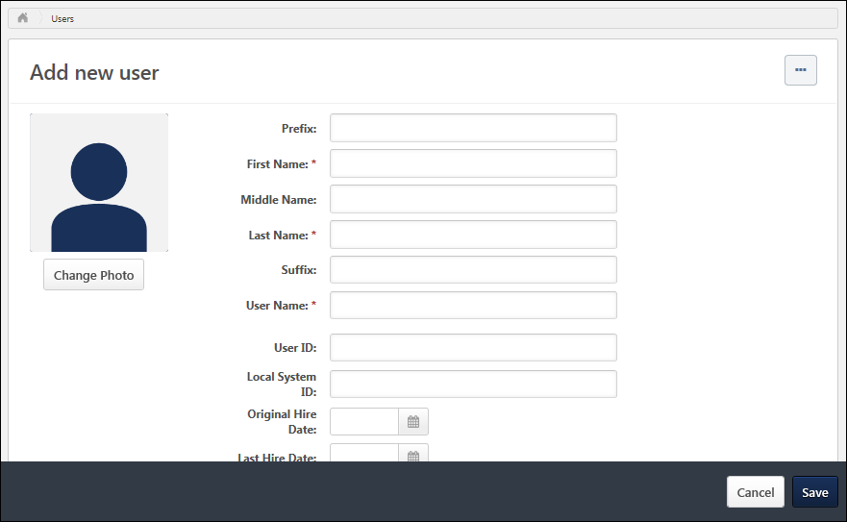
Options
The following options may be available from the Options drop-down menu:
- Expand all sections - This option is available by default, regardless of whether there are any collapsed sections on the User Record. Select this option to expand all sections on the User Record. Once this option is selected, the Collapse all sections option becomes available.
- Collapse all sections - This option is available after the Expand all sections option is selected, regardless of whether there are any expanded sections on the User Record. Once this option is selected, the Expand all sections option becomes available.
General Information
The General Information fields are available at the top of the user record, which include basic information about the user, such as name, photograph, and user name. See User Record - General Information on page 35 for additional information.
Sensitive Information
The Sensitive Information section is only available on the User Record when Encrypted Sensitive Information is enabled in the portal, and this functionality is only available to organizations using Cornerstone HR. This section enables organizations to view and edit Sensitive Personally Identifiable Information (SPII) fields. See User Record - Sensitive Information on page 41 for additional information.
Contact Information
The Contact section contains all of the user's contact information, such as address, phone, and email address. This section should be used to store the user's professional contact information. See User Record - Contact on page 44 for additional information.
Settings
The Settings section contains all of the user's system settings, such as display language, time zone, signature font, and required training approvals. See User Record - Settings on page 47 for additional information.
Organizational Structure
The Organization Structure section contains all of the user's organizational information, such as manager, approver, division, position, and location. See User Record - Organization Structure on page 49 for additional information.
E-Commerce
The E-Commerce Information section contains a user's override amount and value added tax (VAT) number. See User Record - E-Commerce on page 53 for additional information.
User Type and Employment Status
The User Type and Employment Status section contains the user's type (e.g., Employee, Intern, Contractor), user status (e.g., Working, On Leave, Terminated), and additional information regarding the user's status. See User Record - User Type and Employment Status on page 55 for additional information.
User Record Custom Fields
Each User Record custom field category that is defined in Custom Field Administration appears as a section on the User Record. All user record custom fields that are associated with that category appear within the section, which can be expanded and collapsed as with other sections. See User Record - User Record Custom Fields on page 58 for additional information.
Save User Record
To save a new user record, select the Save button in the dark grey floating action bar at the bottom of the screen. The administrator is navigated back to the User Records Administration page. See User Records Administration on page 2 for additional information.
Depending upon the Password Preferences, you may be required to set a temporary password for the new user. After setting the temporary password, click Save. This triggers the New User Created (via Add User Page) email, if configured in Email Administration.

User Record - Edit
The Edit User Record page enables administrators to modify the details of a user's record. Administrators are only able to view and edit fields based on their permissions. If an administrator does not have permission to view or edit a field on the user record, then the field is not visible to the administrator.
Edit a user's user record in one of the following ways:
- Go to Admin > Tools > Core Functions > Users and select the name of the appropriate user.
- Navigate to the user's Universal Profile. Select the User Record tab from the Universal Profile navigation. Then, select the Edit Record button.
For organizations that have Effective Dating enabled, the administrator must set an effective date for the modifications prior to editing the user record. See User Record - Effective Dating on page 65 for additional information.
Permissions
PERMISSION NAME | PERMISSION DESCRIPTION | CATEGORY

Grades - View | Grants ability to view the Grade Organizational Unit throughout the system, such as in availability drop down selectors, when editing users, etc. Those without this permission do not see the Grade OU on any screen. This is primarily an administrator permission, although organizational policy should determine whether the Grade OU should be visible to end users on reporting screens, etc. | Core Administration

Universal Profile - User Record - Edit Users | Grants ability to edit user records in the system. The administrator must have additional permissions to edit specific fields on the user record. This permission can be constrained by OU, User's OU, User's Self, User Self and Subordinates, and User. This is an administrator permission. Note: This permission DOES NOT grant the ability to view user records in the system. Administrators must have the Universal Profile - User Record - View Users permission in order to view user records. | Core Administration

Universal Profile - User Record - View Users | Grants ability to view user records in the system. Administrators can view the Modification History page for user records within their constraints. The administrator must have additional permissions to view specific fields on the user record. This permission can be constrained by OU, User's OU, User's Self, User Self and Subordinates, and User. This is an administrator permission. | Core Administration

Users – Edit Custom Field Information | Grants ability to view and edit the custom fields on a user record. Administrators are only able to edit a custom field on a user's user record if the user is within their permission constraints and the administrator is within the availability of the custom field. This permission works in conjunction with the Users - View permission. This permission can be constrained by OU, User's OU, User's Self, User Self and Subordinates, and User. This is an administrator permission. | Core Administration

Users – Edit General Information | Grants ability to edit the general fields on a user record, including first name, last name, username, assigned OUs, and custom relationships. This permission works in conjunction with the Users - View permission. This permission can be constrained by OU, User's OU, User's Self, User Self and Subordinates, and User. This is an administrator permission. | Core Administration

Users - Edit Middle Name | Grants ability to modify the middle name for a user via the admin/users screen. This permission only works when used in conjunction with the Users - View permission. This is an administrator permission. | Core Administration

Users - Edit Mobile Phone | Grants ability to modify the Mobile Phone number for a user via the Admin/Users screen. The availability of this permission is controlled by a backend setting. This permission only works when used in conjunction with the Users - View permission. | Core Administration

Users - Edit Prefix | Grants ability to modify the prefix for a user's name via the admin/users screen. This permission only works when used in conjunction with the Users - View permission. This is an administrator permission. | Core Administration

Users - Edit Sensitive Information: Unmasked | Grants ability to view and edit unmasked Sensitive Personally Identifiable Information (SPII) fields on the user record. Administrators with this permission have the option to view and edit the actual data on the user record. This permission can be constrained by OU, User's OU, User's Self, User's Subordinates, User's Direct Subordinates, User, and Employee Relationship. This is an administrator permission. | Core Administration

Users - Edit Signature | Grants ability to modify the signature font for a user via the admin/users screen. This permission only works when used in conjunction with the Users - View permission. This is an administrator permission. | Core Administration

Users - Edit Suffix | Grants ability to modify the suffix for a user's name via the admin/users screen. This permission only works when used in conjunction with the Users - View permission. This is an administrator permission. | Core Administration

Users - Edit User ID | Enables administrator to modify the User ID for a user via the admin/users screen. This permission only works when used in conjunction with the Users - View permission. | Core Administration

Users - Edit Users Absent Status | Enables administrator to modify the Absent status for a user via the admin/users screen. This permission only works when used in conjunction with the Users - View permission. | Core Administration

Users - Edit Users Active Status | Enables administrator to modify the Active status for a user via the admin/users screen. This permission only works when used in conjunction with the Users - View permission. | Core Administration

Users - Edit Users Address | Enables administrator to modify the address for a user via the admin/users screen. This permission only works when used in conjunction with the Users - View permission. | Core Administration

Users - Edit Users Approver | Enables administrator to modify the specified Approver for a user via the admin/users screen. This permission only works when used in conjunction with the Users - View permission. | Core Administration

Users - Edit Users Email | Enables administrator to modify the Email Address for a user via the admin/users screen. This permission only works when used in conjunction with the Users - View permission. | Core Administration

Users - Edit Users Fax | Enables administrator to modify the Fax number for a user via the admin/users screen. This permission only works when used in conjunction with the Users - View permission. | Core Administration

Users - Edit Users Language | Enables administrator to modify the portal display language for a user via the admin/users screen. This permission only works when used in conjunction with the Users - View permission. | Core Administration

Users - Edit Users Last Hire Date | Enables administrator to modify the Last Hire Date for a user via the admin/users screen. This permission only works when used in conjunction with the Users - View permission. | Core Administration

Users - Edit Users Manager | Enables administrator to modify the assigned Manager for a user via the admin/users screen. This permission only works when used in conjunction with the Users - View permission. | Core Administration

Users - Edit Users Original Hire Date | Enables administrator to modify the Original Hire Date for a user via the admin/users screen. This permission only works when used in conjunction with the Users - View permission. | Core Administration

Users - Edit Users Phone | Enables administrator to modify the Phone number for a user via the admin/users screen. This permission only works when used in conjunction with the Users - View permission. | Core Administration

Users - Edit Users Photo | Enables administrator to upload a photo for a user via the admin/users screen. This permission only works when used in conjunction with the Users - View permission. | Core Administration

Users - Edit Users Reconciliation | Enables administrator to modify the Reconciliation status for a user via the admin/users screen. This permission only works when used in conjunction with the Users - View permission. | Core Administration

Users - Edit Users Required Approvals | Enables administrator to modify the number of required training approvals for a user via the admin/users screen. This permission only works when used in conjunction with the Users - View permission. | Core Administration

Users - Edit Users Time Zone | Enables administrator to modify the portal time zone for a user via the admin/users screen. This permission only works when used in conjunction with the Users - View permission. | Core Administration

Users – Effective Dating: Manage | Enables administrator to make effective dated changes to the user record. This permission only works when used in conjunction with the Users - Edit General Information permission. This permission cannot be constrained. This is an administrator permission. | Core Administration

User Preferences - Reasons for Change: Manage | Grants ability to define and configure Reasons for Change on the User Preferences administrator page, which may be used when modifying the user record. The administrator must also have the User Preferences - Core Information: View permission to access the User Preferences page.  This permission is also required to view and set the Reason for Change field when editing a user record.  This permission cannot be constrained. This is an administrator permission. | Core Administration
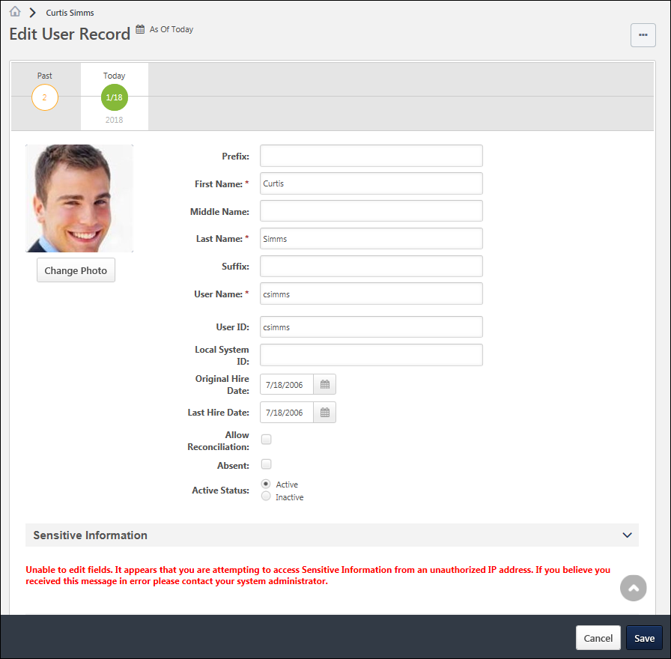
Options
The following options may be available from the Options drop-down menu:
- Expand all sections - This option is available by default, regardless of whether there are any collapsed sections on the User Record. Select this option to expand all sections on the User Record. Once this option is selected, the Collapse all sections option becomes available.
- Collapse all sections - This option is available after the Expand all sections option is selected, regardless of whether there are any expanded sections on the User Record. Once this option is selected, the Expand all sections option becomes available.
General Information
The General Information fields are available at the top of the user record, which include basic information about the user, such as name, photograph, and user name. See User Record - General Information on page 35 for additional information.
Sensitive Information
The Sensitive Information section is only available on the User Record when Encrypted Sensitive Information is enabled in the portal, and this functionality is only available to organizations using Cornerstone HR. This section enables organizations to view and edit Sensitive Personally Identifiable Information (SPII) fields. See User Record - Sensitive Information on page 41 for additional information.
Contact Information
The Contact section contains all of the user's contact information, such as address, phone, and email address. This section should be used to store the user's professional contact information. See User Record - Contact on page 44 for additional information.
Settings
The Settings section contains all of the user's system settings, such as display language, time zone, signature font, and required training approvals. See User Record - Settings on page 47 for additional information.
Organizational Structure
The Organization Structure section contains all of the user's organizational information, such as manager, approver, division, position, and location. See User Record - Organization Structure on page 49 for additional information.
E-Commerce
The E-Commerce Information section contains a user's override amount and value added tax (VAT) number. See User Record - E-Commerce on page 53 for additional information.
User Type and Employment Status
The User Type and Employment Status section contains the user's type (e.g., Employee, Intern, Contractor), user status (e.g., Working, On Leave, Terminated), and additional information regarding the user's status. See User Record - User Type and Employment Status on page 55 for additional information.
User Record Custom Fields
Each User Record custom field category that is defined in Custom Field Administration appears as a section on the User Record. All user record custom fields that are associated with that category appear within the section, which can be expanded and collapsed as with other sections. See User Record - User Record Custom Fields on page 58 for additional information.
Save User Record
To save changes to a user record, select the Save button in the dark grey floating action bar at the bottom of the screen. When the user record is saved, each field value is validated.
When saving a user record, the administrator is returned to their original page. For example, if the administrator edits a user record after navigating from the Users search page, then the administrator is returned to the User's search page when the user record is saved.
If Effective Dating is enabled, following the field validations, the system behavior depends on the effective date:
- Today - If the effective date is set to Today, then each modification is added to the user's Modification History and a new record is added to the Effective Dated Records timeline. Each individual modification is also applied to all future effective dated records that do not specify a modification to the same field.
- Past Date - If the effective date is set to a date in the past, then each modification is added to the user's Modification History and a new record is added to the Effective Dated Records timeline. Each individual modification is also applied to the current user record and all future effective dated records that do not specify a modification to the same field.
- Future Date - If the effective date is set to a date in the past, then a new record is added to the Effective Dated Records timeline. Each modification is not added to the user's Modification History until the effective date of the record is reached and the modifications are processed successfully. Each individual modification is applied to all effective dated records that have an effective date that is beyond the selected effective date so long as the effective dated records do not specify a modification to the same field.

User Record - General Information
The User Record page is organized into sections. The General Information fields are available at the top of the user record, which include basic information about the user, such as name, photograph, and user name.
Note: An asterisk next to a field indicates that the field is required and a value must be entered in order to save the user record.
To add a new user record, go to Admin > Tools > Core Functions > Users. Then, select the Add User link.
Edit a user's user record in one of the following ways:
- Go to Admin > Tools > Core Functions > Users and select the name of the appropriate user.
- Navigate to the user's Universal Profile. Select the User Record tab from the Universal Profile navigation. Then, select the Edit Record button.
Permissions
PERMISSION NAME | PERMISSION DESCRIPTION | CATEGORY

Universal Profile - User Record - Create Users | Grants ability to access the User Record Administration page and to create new users in the system. When creating a new user, this permission grants the ability to add general information, which includes first name, last name, username, assigned OUs, and custom relationships. The administrator must have additional permissions to add any additional fields. This permission can be constrained by OU, User's OU, User's Self, User Self and Subordinates, and User. This is an administrator permission. | Core Administration

Universal Profile - User Record - Edit Users | Grants ability to edit user records in the system. The administrator must have additional permissions to edit specific fields on the user record. This permission can be constrained by OU, User's OU, User's Self, User Self and Subordinates, and User. This is an administrator permission. Note: This permission DOES NOT grant the ability to view user records in the system. Administrators must have the Universal Profile - User Record - View Users permission in order to view user records. | Core Administration

Users – Edit Custom Field Information | Grants ability to view and edit the custom fields on a user record. Administrators are only able to edit a custom field on a user's user record if the user is within their permission constraints and the administrator is within the availability of the custom field. This permission works in conjunction with the Users - View permission. This permission can be constrained by OU, User's OU, User's Self, User Self and Subordinates, and User. This is an administrator permission. | Core Administration

Users - Edit Local System ID | Enables administrator to modify the Local System ID for a user via the admin/users screen. This permission only works when used in conjunction with the Users - View and Users - Edit permissions. This permission cannot be constrained. This is an administrator permission. | Core Administration

Users - View | Grants the ability to search for and view summary information about users in the portal via the Admin/Users screen. This permission can be constrained by OU, User's OU, User Self and Subordinates, and Users. If multiple constraints are added, these constraints are considered OR statements. This is an administrator permission. | Core Administration

Users – View General Information | Grants ability to view the general fields on a user record, including first name, last name, username, assigned OUs, and custom relationships. This permission works in conjunction with the Universal Profile - User Record - View Users permission. This permission can be constrained by OU, User's OU, User's Self, User Self and Subordinates, and User. This is an administrator permission. | Core Administration

Users - View Local System ID | Enables administrator to view the Local System ID for a user via the admin/users screen. This permission only works when used in conjunction with the Users - View and Users - Edit permissions. This permission cannot be constrained. This is an administrator permission. | Core Administration
Additional permissions are required to view and edit the various fields on the user record. See User Record Permissions on page 69 for additional information.
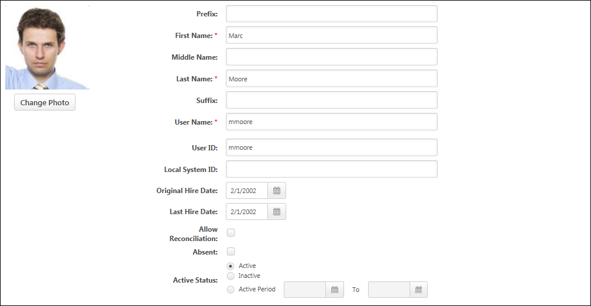
Photograph
Administrators can view or edit the user photo, provided they have the appropriate permission.
- Change Photo - To upload a new photo or edit and crop an existing photo, click the Change Photo button below the photograph. The recommended size for photos is 200 x 200 pixels. The available file types for photos are jpg, png, and gif.
- Remove Photo - To remove an existing photo, click the Change Photo button below the photograph. Select the Edit tab at the top of the Change Photo window. Then, select the Delete Photo button. When a photo is removed, the default image is displayed for the user throughout the system.
Name
Enter the following name components:
- Prefix - The character limit for this field is 10. Administrators must have permission to view or edit the prefix.
- First Name - This is required. The character limit for this field is 200. This field is considered general information. Administrators must have permission to view or edit general information.
- Middle Name - The character limit for this field is 200. Administrators must have permission to view or edit the middle name.
- Last Name - This is required. The character limit for this field is 200. This field is considered general information. Administrators must have permission to view or edit general information.
- Suffix - The character limit for this field is 10. Administrators must have permission to view or edit the suffix.
User Name
This field is considered general information. Administrators must have permission to view or edit general information.
The value entered here is the user name that the user enters to access the system if the organization does not utilize Single Sign On functionality. This is required and must be unique.If the system is configured so that the User Name field is copied from the User ID field, the User Name field is not editable when creating a new user record or updating an existing user record. When the user record is saved, the User Name is copied from the User ID field. To enable this functionality, contact Global Customer Support. Note: The option to have the User Name field copied from the User ID field is only available if the User ID field is editable by administrators. In addition, the User Name field is only copied from the User ID field if the functionality is enabled, which is indicated by a read-only User Name field.
- The User ID field must be populated prior to saving the user record.
- Any formatting restriction that exists for the User Name field is applied to the User ID field when this functionality is enabled (e.g., may only contain letters, numbers, underscores, spaces, hyphens, special characters, etc.).
User ID
The ID is the unique identifier of the user. If this value is populated by the data feed, it is not recommended to edit this area.
User ID - Auto-Generate
When creating a new user, if the Auto-Generate link is enabled and if the administrator has permission to edit the User ID field, administrators can click this link to automatically generate a User ID. The User ID is set to the First Name field combined with the Last Name field. For example, the generated User ID for John Doe is JohnDoe.
- The First Name and Last Name fields must be populated prior to clicking the Auto-Generate link.
- If a user with this User ID already exists in the system, the User ID is appended with a unique identifier.
- If necessary, the User ID field can be edited by the administrator after it is generated.
Note: All accented or special characters that may exist in the user's first and last name are removed when generating the User ID. The accented or special characters are removed from the User ID, however, they remain in the user's first and last name.
Note: This functionality is only available when creating a new user. The functionality is not available when editing a user. The Auto-Generate link only appears if the administrator has permission to edit the User ID field and if the functionality is enabled.
User ID - System Generated User ID
When Cornerstone HR and the System Generated User ID functionality are enabled, a User ID is automatically generated when a user is added to the system. The system-generated User ID value is entered in the User ID field for the new user. Once a User ID value is generated, that value is permanently reserved and cannot be reused.
- If the administrator does not have permission to view or edit the User ID field, the User ID is generated and stored, but the User ID field and value are not displayed on the page.
- If the administrator has permission to view the User ID field, the User ID is displayed on the page, but the administrator cannot modify the value.
- If the administrator who is creating the user has permission to edit the User ID field for the user, then the administrator can edit the system-generated User ID. As a best practice, the User ID value should not be edited after it is generated. In order to control this, administrators should only be granted permission to view the User ID field for users. This enables them to view the value, but they cannot edit the value.
The User ID value is generated according to the User ID Generation Rules. See User ID Generation Rules for additional information.
Local System ID
This field enables organizations to capture an identifier from a local system. This field is optional. Administrators must have permission to view or manage the Local System ID.
This field would typically be used when Cornerstone is generating User IDs for users and the organization wants to store the identifier from their local Human Resources (HR) or Payroll system in the Cornerstone system.
This field is supported by the Data Load Wizard.
Original Hire Date
Select the date on which the user was originally hired. Administrators must have permission to view or edit the original hire date. The date can be a date in the past.
For external new hires, the value in the Original Hire Date field will be the value in the Hire Date field on the Start Onboarding page. If the Hire Date field is changed on the Edit Onboarding page, then the value on the user record is also changed. If onboarding is canceled, then the value in the Original Hire Date field is removed.
Last Hire Date
Select the date on which the user was most recently hired. For example, if a user was hired to the organization multiple times, this field displays the date of the most recent hiring. Administrators must have permission to view or edit the last hire date.
Allow Reconciliation
Select this option to allow the system to deactivate a user that is not in the data feed. Note: This option does not impact passwords. Administrators must have permission to view or edit the reconciliation setting.
The User ID field is the unique identifier that the system uses to match and update a user's record.
- If this option is selected and a User ID is NOT sent in the data feed, the user becomes inactive.
- If a User ID is matched, the system ALWAYS updates the user record regardless of the Allow Reconcile setting.
Allow Reconcile functionality is used for the purpose of deactivating user records, NOT for controlling updating of user records.
Use Cases:
- If you manually create a user and do not select the Allow Reconcile option, the system does not deactivate the user's record if it is missing from the data feed. This might be used for creating a contractor ID or Admin ID that won't be in the data feed. If the User ID field is blank, the system does not change that user's records because the incoming data feed does not recognize this record since there is no User ID to match.
- If you manually create a user and enter a User ID, a record in the data feed with the same user ID updates the user fields with new information whether or not you have the Allow Reconcile box selected.
- Users that come in through the feed always have a User ID on their record. The system and the data feed work together to ensure proper maintenance and active status between your source system and Cornerstone.
Absent
Select this option to mark the user Absent. An Absent user is still active, but has been marked absent because they are either on a leave of absence or on vacation. Administrators must have permission to view or edit the absent status.
- If the Absent functionality is selected and the user is a manager/approver with training requests to approve, the approval request is routed to the next person in the approval chain if the approval process is required. This functionality only pertains to training requests, not other functions requiring approval.
- A user can mark themselves absent by checking the On Vacation checkbox from the My Account > Preferences > Settings page. See My Account - Preferences - Settings for additional information.
- When a user that is marked absent logs in to the system, the following options appear:
  - Yes, change my status to Available.
  - No, leave my status as Absent.
Active Status
Select the appropriate Status option. An Active user can log in and access the system. An Inactive user cannot log in and access to the system, however administrators can access and report on inactive users and can re-activate users at any time.
- Active - Select this option to set the user as active.
- Inactive - Select this option to set the user as inactive.
- Active Period - Select this option to set a date range, during which the user record is active. After selecting this option, use the calendar tool to select the active period.
  - Active Start Date - The first date field represents the date on which the user record becomes active. This field is required if the Active Period option is selected. Entering the current date makes the user record active immediately upon saving the user record. If a past date is entered, this has the same effect as entering the current date.
  - Active End Date - The second date field represents the date on which the user record becomes inactive. If no end date is selected, the user record remains active until this setting is modified. The Active End Date must be after the Active Start Date.

User Record - Sensitive Information
The User Record page is organized into sections. The Sensitive Information section is only available on the User Record when Encrypted Sensitive Information is enabled in the portal, and this functionality is only available to organizations using Cornerstone HR. This section enables organizations to view and edit Sensitive Personally Identifiable Information (SPII) fields.
To add a new user record, go to Admin > Tools > Core Functions > Users. Then, select the Add User link.
Edit a user's user record in one of the following ways:
- Go to Admin > Tools > Core Functions > Users and select the name of the appropriate user.
- Navigate to the user's Universal Profile. Select the User Record tab from the Universal Profile navigation. Then, select the Edit Record button.
Permissions
PERMISSION NAME | PERMISSION DESCRIPTION | CATEGORY

Universal Profile - User Record - Create Users | Grants ability to access the User Record Administration page and to create new users in the system. When creating a new user, this permission grants the ability to add general information, which includes first name, last name, username, assigned OUs, and custom relationships. The administrator must have additional permissions to add any additional fields. This permission can be constrained by OU, User's OU, User's Self, User Self and Subordinates, and User. This is an administrator permission. | Core Administration

Universal Profile - User Record - Edit Users | Grants ability to edit user records in the system. The administrator must have additional permissions to edit specific fields on the user record. This permission can be constrained by OU, User's OU, User's Self, User Self and Subordinates, and User. This is an administrator permission. Note: This permission DOES NOT grant the ability to view user records in the system. Administrators must have the Universal Profile - User Record - View Users permission in order to view user records. | Core Administration

Users – Edit Custom Field Information | Grants ability to view and edit the custom fields on a user record. Administrators are only able to edit a custom field on a user's user record if the user is within their permission constraints and the administrator is within the availability of the custom field. This permission works in conjunction with the Users - View permission. This permission can be constrained by OU, User's OU, User's Self, User Self and Subordinates, and User. This is an administrator permission. | Core Administration

Users - View | Grants the ability to search for and view summary information about users in the portal via the Admin/Users screen. This permission can be constrained by OU, User's OU, User Self and Subordinates, and Users. If multiple constraints are added, these constraints are considered OR statements. This is an administrator permission. | Core Administration

Users – View General Information | Grants ability to view the general fields on a user record, including first name, last name, username, assigned OUs, and custom relationships. This permission works in conjunction with the Universal Profile - User Record - View Users permission. This permission can be constrained by OU, User's OU, User's Self, User Self and Subordinates, and User. This is an administrator permission. | Core Administration
Additional permissions are required to view and edit the various fields on the user record. See User Record Permissions on page 69 for additional information.
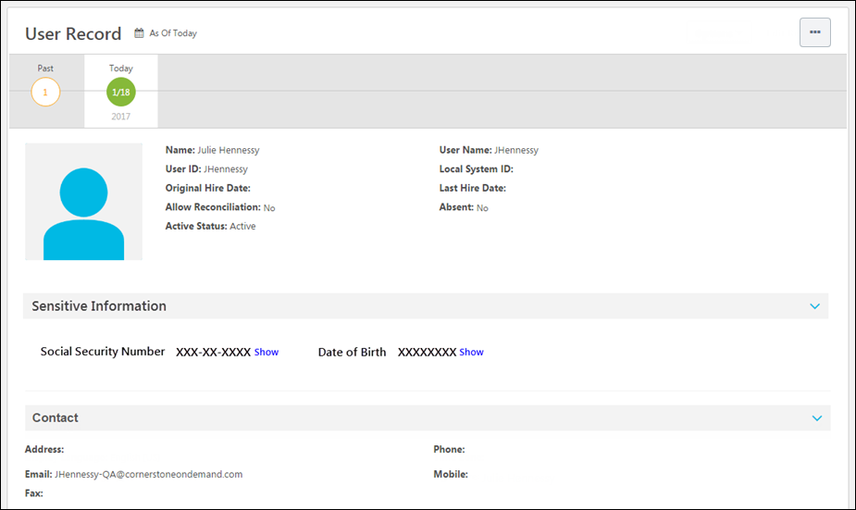
Security Considerations
When viewing the User Record page, administrators must have permission to view these fields. In addition, an administrator may have permission to view these fields masked or unmasked.
When adding a new user or editing the User Record page, administrators must have permission to edit these fields.
Only administrators whose IP addresses are listed in the Authorized Sensitive Information IP Addresses section on the IP Whitelist page are able to decrypt and view SPII fields. If an administrator has permission to view or edit SPII fields, but the Sensitive Information IP Whitelist has not been configured or the administrator's IP is not on the safe list, then an error message is displayed in this section. See IP Whitelist.
Date of Birth
This field is used to store the user's date of birth (DOB). By default, the entire DOB is masked.
- When an administrator views or edits the user record, a Show link is displayed next to the field if the administrator has permission to view or edit the unmasked value. Select this link to view or edit the unmasked field value. The DOB value cannot be copied. Whenever an administrator selects the Show link for a SPII field, the system captures this information on the backend for auditing purposes.
- When an administrator enters a value for this field or shows the unmasked value for this field, a Hide link is displayed next to the field. Select this link to hide or mask the DOB.
Social Security Number
This field is used to store the user's Social Security Number (SSN). By default, only the last four digits of the SSN are displayed, and the first five digits are masked.
- When an administrator views or edits the user record, a Show link is displayed next to the field if the administrator has permission to view or edit the unmasked value. Select this link to view or edit the unmasked field value. The SSN value cannot be copied. Whenever an administrator selects the Show link for a SPII field, the system captures this information on the backend for auditing purposes.
- When an administrator enters a value for this field and exits the field, the field value is automatically masked. The last four digits of the SSN remain visible.
- When an administrator shows the unmasked value for this field, a Hide link is displayed next to the field. Select this link to hide or mask the first five digits of the SSN. The last four digits of the SSN remain visible.
Proxy as Another User - Sensitive Personally Identifiable Information
When an administrator logs in to the system as another user using the Proxy as Another User functionality, that administrator can never unmask, edit, or set Sensitive Personally Identifiable Information (SPII) fields. This ensures the information is completely secured and can only be accessed by administrators who have the appropriate permissions.
If an administrator attempts to unmask or edit SPII fields, a pop-up opens to indicate that the administrator cannot access SPII fields when a use account is impersonated. If an administrator attempts to create a user and set SPII fields, an error message is displayed when the administrator attempts to save the user record.
In order to be able to unmask, edit, or set SPII fields, an administrator with the appropriate permissions must log in to the system or use Single Sign On (SSO) to log in as themselves.

User Record - Contact
The User Record page is organized into sections. The Contact section contains all of the user's contact information, such as address, phone, and email address. This section should be used to store the user's professional contact information. In particular, the user's email address is used when emails are triggered from within the system.
Note: For internal candidates who upload a resume or CV for a job application, these fields are automatically populated by their resume or CV. So if the internal candidate provides their personal address, it will be stored here.
To add a new user record, go to Admin > Tools > Core Functions > Users. Then, select the Add User link.
Edit a user's user record in one of the following ways:
- Go to Admin > Tools > Core Functions > Users and select the name of the appropriate user.
- Navigate to the user's Universal Profile. Select the User Record tab from the Universal Profile navigation. Then, select the Edit Record button.
Permissions
PERMISSION NAME | PERMISSION DESCRIPTION | CATEGORY

Universal Profile - User Record - Create Users | Grants ability to access the User Record Administration page and to create new users in the system. When creating a new user, this permission grants the ability to add general information, which includes first name, last name, username, assigned OUs, and custom relationships. The administrator must have additional permissions to add any additional fields. This permission can be constrained by OU, User's OU, User's Self, User Self and Subordinates, and User. This is an administrator permission. | Core Administration

Universal Profile - User Record - Edit Users | Grants ability to edit user records in the system. The administrator must have additional permissions to edit specific fields on the user record. This permission can be constrained by OU, User's OU, User's Self, User Self and Subordinates, and User. This is an administrator permission. Note: This permission DOES NOT grant the ability to view user records in the system. Administrators must have the Universal Profile - User Record - View Users permission in order to view user records. | Core Administration

Users - View | Grants the ability to search for and view summary information about users in the portal via the Admin/Users screen. This permission can be constrained by OU, User's OU, User Self and Subordinates, and Users. If multiple constraints are added, these constraints are considered OR statements. This is an administrator permission. | Core Administration
Additional permissions are required to view and edit the various fields on the user record. See User Record Permissions on page 69 for additional information.
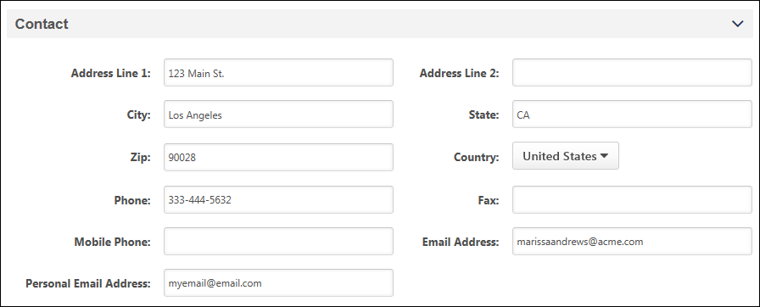
Address Line 1
The character limit for this field is 110. Administrators must have permission to view or edit address information.
Address Line 2
The character limit for this field is 55. Administrators must have permission to view or edit address information.
City
The character limit for this field is 35. Administrators must have permission to view or edit address information.
State
The character limit for this field is 30. Administrators must have permission to view or edit address information.
Zip
The character limit for this field is 35. Administrators must have permission to view or edit address information.
Country
Select a country. Administrators must have permission to view or edit address information.
Phone
The character limit for this field is 30. Administrators must have permission to view or edit address information.
Fax
The character limit for this field is 100. Administrators must have permission to view or edit address information.
Mobile Phone
The character limit for this field is 30. Administrators must have permission to view or edit address information.
The availability of this field is controlled by a backend setting.
Email Address
The character limit for this field is 128. The system verifies that the email address is in a valid format when the administrator navigates away from the field. Administrators must have permission to view or edit address information.
Personal Email Address
The Personal Email Address field is added to the Contact section. The field accepts up to 128 characters, and the value must be a unique email address in the system.
This field allows organizations to capture a secondary email address for employees, aside from their company email address. The field is also used to identify past employees reapplying to an organization as part of the standardized rehire workflow.

User Record - Settings
The User Record page is organized into sections. The Settings section contains all of the user's system settings, such as display language, time zone, signature font, and required training approvals.
To add a new user record, go to Admin > Tools > Core Functions > Users. Then, select the Add User link.
Edit a user's user record in one of the following ways:
- Go to Admin > Tools > Core Functions > Users and select the name of the appropriate user.
- Navigate to the user's Universal Profile. Select the User Record tab from the Universal Profile navigation. Then, select the Edit Record button.
Permissions
PERMISSION NAME | PERMISSION DESCRIPTION | CATEGORY

Universal Profile - User Record - Create Users | Grants ability to access the User Record Administration page and to create new users in the system. When creating a new user, this permission grants the ability to add general information, which includes first name, last name, username, assigned OUs, and custom relationships. The administrator must have additional permissions to add any additional fields. This permission can be constrained by OU, User's OU, User's Self, User Self and Subordinates, and User. This is an administrator permission. | Core Administration

Universal Profile - User Record - Edit Users | Grants ability to edit user records in the system. The administrator must have additional permissions to edit specific fields on the user record. This permission can be constrained by OU, User's OU, User's Self, User Self and Subordinates, and User. This is an administrator permission. Note: This permission DOES NOT grant the ability to view user records in the system. Administrators must have the Universal Profile - User Record - View Users permission in order to view user records. | Core Administration

Users - View | Grants the ability to search for and view summary information about users in the portal via the Admin/Users screen. This permission can be constrained by OU, User's OU, User Self and Subordinates, and Users. If multiple constraints are added, these constraints are considered OR statements. This is an administrator permission. | Core Administration
Additional permissions are required to view and edit the various fields on the user record. See User Record Permissions on page 69 for additional information.
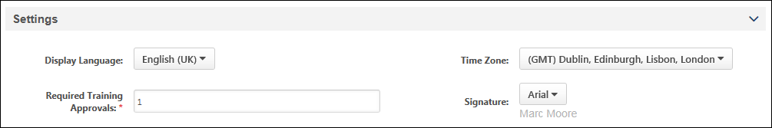
Display Language
Select the language in which the system appears to the user. For example, if French is selected, the system appears to the user in French. Administrators can select any of the languages that are available within their portal. Administrators must have permission to view or edit the language.
Time Zone
Select the time zone in which the user resides. This affects how time are displayed in the system. For example, if a training session occurs at 8 AM PST, this session time is adjusted to each user's time zone when they view it. This allows users to view the time without needing to adjust for time zones. By default, no time zone is selected. See Time Zone Application Rules for additional information.
Administrators must have permission to view or edit the time zone.
Required Training Approvals
This defines the number of people (e.g., managers, approvers) from which the user must get approval from before being able to register for training. The required number of approvals set in the user record is bypassed if the administrator sets the learning object to be pre-approved. Important:If the Required Training Approvals field on the user record is set to zero, then no training approvals are ever required for the user, regardless of any training approvals that are set anywhere in the system.
Administrators must have permission to view or edit the user's required training approvals.
Signature
Select the font in which the user's electronic signature is displayed. This defaults to Arial. Administrators must have permission to view or edit the signature.

User Record - Organization Structure
The User Record page is organized into sections. The Organization Structure section contains all of the user's organizational information, such as manager, approver, division, position, and location.
To add a new user record, go to Admin > Tools > Core Functions > Users. Then, select the Add User link.
Edit a user's user record in one of the following ways:
- Go to Admin > Tools > Core Functions > Users and select the name of the appropriate user.
- Navigate to the user's Universal Profile. Select the User Record tab from the Universal Profile navigation. Then, select the Edit Record button.
Permissions
PERMISSION NAME | PERMISSION DESCRIPTION | CATEGORY

Universal Profile - User Record - Create Users | Grants ability to access the User Record Administration page and to create new users in the system. When creating a new user, this permission grants the ability to add general information, which includes first name, last name, username, assigned OUs, and custom relationships. The administrator must have additional permissions to add any additional fields. This permission can be constrained by OU, User's OU, User's Self, User Self and Subordinates, and User. This is an administrator permission. | Core Administration

Universal Profile - User Record - Edit Users | Grants ability to edit user records in the system. The administrator must have additional permissions to edit specific fields on the user record. This permission can be constrained by OU, User's OU, User's Self, User Self and Subordinates, and User. This is an administrator permission. Note: This permission DOES NOT grant the ability to view user records in the system. Administrators must have the Universal Profile - User Record - View Users permission in order to view user records. | Core Administration

Users - View | Grants the ability to search for and view summary information about users in the portal via the Admin/Users screen. This permission can be constrained by OU, User's OU, User Self and Subordinates, and Users. If multiple constraints are added, these constraints are considered OR statements. This is an administrator permission. | Core Administration
Additional permissions are required to view and edit the various fields on the user record. See User Record Permissions on page 69 for additional information.
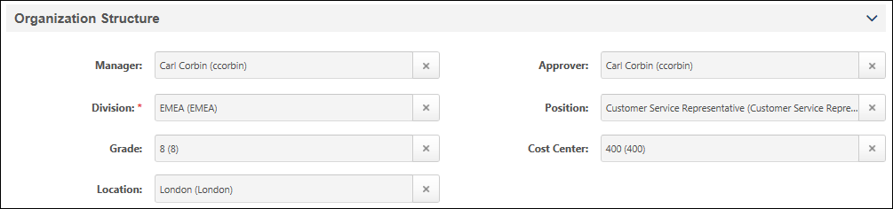
Manager
Click the Search icon to select the Manager. The user selected for this field will be able to see the user's transcript, and assign training to the user, and may approve training for the user depending on the training workflow.
- When adding a new user, depending on the backend settings, the administrator who is creating the user may be automatically populated as the user's manager.
- When a manager is selected, the manager's division is displayed below the field.
- If the selected manager becomes inactive, the selected manager is still displayed in the field until a different user is selected.
This field is never required.
Administrators must have permission to view or edit the user's manager.
Approver
Click the Search icon to select the Approver. The user selected for this field will be able to see users transcript, assign training to the user, and may approve training for the user depending on the training workflow.
- When an approver is selected, the approver's division is displayed below the field.
- The default approval workflow is as follows Approver > Cost Center Approver > Manager > Manager's Approver > Manager's Cost Center Approver > Manager's Manager, etc. However, this is often customized for each organization during implementation. If your current system does not have an approver, then the approver is skipped and it goes to the next person in the chain.
- If the selected approver becomes inactive, the selected approver is still displayed in the field until a different user is selected.
Administrators must have permission to view or edit the user's approver.
Employee Custom Relationships
Click the Search icon to select a user for the custom relationship.
- If the selected user becomes inactive, the selected user is still displayed in the field until a different user is selected.
Administrators must have permission to view or edit the user's core information and custom fields.
Division
Click the Search icon to select the Division. This is required if it is configured to be required on the Manage Organizational Unit Types page.
- If the selected OU becomes inactive, the selected OU is still displayed in the field until a different OU is selected.
This field is only available if it is configured to display on the user record on the Manage Organizational Unit Types page.
Administrators must have permission to view or edit the user's core information and custom fields.
Position
Click the Search icon to select the position. This is required if it is configured to be required on the Manage Organizational Unit Types page.
- If the selected OU becomes inactive, the selected OU is still displayed in the field until a different OU is selected.
This field is only available if it is configured to display on the user record on the Manage Organizational Unit Types page.
Administrators must have permission to view or edit the user's core information and custom fields.
Grade
Click the Search icon to select the Grade. This is required if it is configured to be required on the Manage Organizational Unit Types page.
- If the selected OU becomes inactive, the selected OU is still displayed in the field until a different OU is selected.
This field is only available if it is configured to display on the user record on the Manage Organizational Unit Types page.
Administrators must have permission to view or edit the user's core information and custom fields.
Cost Center
Click the Search icon to select the Cost Center. This is required if it is configured to be required on the Manage Organizational Unit Types page.
- If the selected OU becomes inactive, the selected OU is still displayed in the field until a different OU is selected.
This field is only available if it is configured to display on the user record on the Manage Organizational Unit Types page.
Administrators must have permission to view or edit the user's core information and custom fields.
Location
Click the Search icon to select the Location. This is required if it is configured to be required on the Manage Organizational Unit Types page.
- If the selected OU becomes inactive, the selected OU is still displayed in the field until a different OU is selected.
This field is only available if it is configured to display on the user record on the Manage Organizational Unit Types page.
Administrators must have permission to view or edit the user's core information and custom fields.
Group
Click the plus icon to add the user to one or more groups. The selected groups are displayed below the field. This is required if it is configured to be required on the Manage Organizational Unit Types page.
This field is only available if it is configured to display on the user record on the Manage Organizational Unit Types page.
Administrators must have permission to view or edit the user's core information.
Add User to Group as of Now
CHR administrators can add users to groups "as of now," meaning the date and time the user was added to the group is recorded as the date and time the user added them to the group. It is NOT possible to add users to a group as of a specific date in the past or future.
Self Registration Group
Click the plus icon to add the user to one or more self registration groups. The selected groups are displayed below the field. This is required if it is configured to be required on the Manage Organizational Unit Types page.
This field is only available if it is configured to display on the user record on the Manage Organizational Unit Types page.
Administrators must have permission to view or edit the user's core information.
Custom OUs
Click the Search icon to select the OU. This is required if it is configured to be required on the Manage Organizational Unit Types page.
- If the selected OU becomes inactive, the selected OU is still displayed in the field until a different OU is selected.
This field is only available if it is configured to display on the user record on the Manage Organizational Unit Types page.
Administrators must have permission to view or edit the user's core information and custom fields.

User Record - E-Commerce
The User Record page is organized into sections. The E-Commerce Information section contains a user's override amount and value added tax (VAT) number. The availability of this section is controlled by backend settings. Also, the administrator must also have permission to manage either tax override amounts or VAT numbers.
To add a new user record, go to Admin > Tools > Core Functions > Users. Then, select the Add User link.
Edit a user's user record in one of the following ways:
- Go to Admin > Tools > Core Functions > Users and select the name of the appropriate user.
- Navigate to the user's Universal Profile. Select the User Record tab from the Universal Profile navigation. Then, select the Edit Record button.
Permissions
PERMISSION NAME | PERMISSION DESCRIPTION | CATEGORY

Tax Override - Manage | Grants ability to add and edit the Override value for users in the E-Commerce Information section of the User Record page. This permission cannot be constrained. This is an administrator permission. This permission only works when used in conjunction with the Users - View permission. | eCommerce

Universal Profile - User Record - Create Users | Grants ability to access the User Record Administration page and to create new users in the system. When creating a new user, this permission grants the ability to add general information, which includes first name, last name, username, assigned OUs, and custom relationships. The administrator must have additional permissions to add any additional fields. This permission can be constrained by OU, User's OU, User's Self, User Self and Subordinates, and User. This is an administrator permission. | Core Administration

Universal Profile - User Record - Edit Users | Grants ability to edit user records in the system. The administrator must have additional permissions to edit specific fields on the user record. This permission can be constrained by OU, User's OU, User's Self, User Self and Subordinates, and User. This is an administrator permission. Note: This permission DOES NOT grant the ability to view user records in the system. Administrators must have the Universal Profile - User Record - View Users permission in order to view user records. | Core Administration

Users - View | Grants the ability to search for and view summary information about users in the portal via the Admin/Users screen. This permission can be constrained by OU, User's OU, User Self and Subordinates, and Users. If multiple constraints are added, these constraints are considered OR statements. This is an administrator permission. | Core Administration

VAT Number - Manage | Grants ability to add and edit the VAT number for users in the E-Commerce Information section of the User Record page. This permission cannot be constrained. This is an administrator permission. This permission only works when used in conjunction with the Users - View permission. | eCommerce - Administration
VAT Number
Enter the user's VAT number, up to 25 characters. This is optional and supports letters, numbers, spaces, and hyphens. Administrators must have permission to manage VAT numbers.
Override Amount
From the drop-down list, select whether the override is a tax percentage or a specific monetary amount. Then, enter the rate or amount in the field, up to 15 characters. The override amount is a user specific tax amount or tax rate. This is optional. The override tax amount or rate is applied to each taxable item in the transaction. Administrators must have permission to manage tax override amounts.

User Record - User Type and Employment Status
The User Record page is organized into sections. The User Type and Employment Status section contains the user's type (e.g., Employee, Intern, Contractor), user status (e.g., Working, On Leave, Terminated), and additional information regarding the user's status.
The User Status Information is only available to administrators who have permission to view or edit User Type and Status.
To add a new user record, go to Admin > Tools > Core Functions > Users. Then, select the Add User link.
Edit a user's user record in one of the following ways:
- Go to Admin > Tools > Core Functions > Users and select the name of the appropriate user.
- Navigate to the user's Universal Profile. Select the User Record tab from the Universal Profile navigation. Then, select the Edit Record button.
Permissions
PERMISSION NAME | PERMISSION DESCRIPTION | CATEGORY

Universal Profile - User Record - Create Users | Grants ability to access the User Record Administration page and to create new users in the system. When creating a new user, this permission grants the ability to add general information, which includes first name, last name, username, assigned OUs, and custom relationships. The administrator must have additional permissions to add any additional fields. This permission can be constrained by OU, User's OU, User's Self, User Self and Subordinates, and User. This is an administrator permission. | Core Administration

Universal Profile - User Record - Edit Users | Grants ability to edit user records in the system. The administrator must have additional permissions to edit specific fields on the user record. This permission can be constrained by OU, User's OU, User's Self, User Self and Subordinates, and User. This is an administrator permission. Note: This permission DOES NOT grant the ability to view user records in the system. Administrators must have the Universal Profile - User Record - View Users permission in order to view user records. | Core Administration

Users - View | Grants the ability to search for and view summary information about users in the portal via the Admin/Users screen. This permission can be constrained by OU, User's OU, User Self and Subordinates, and Users. If multiple constraints are added, these constraints are considered OR statements. This is an administrator permission. | Core Administration
Additional permissions are required to view and edit the various fields on the user record. See User Record Permissions on page 69 for additional information.
The following options may appear in the User Type and Employment Status section:
- User Type - Select the user's type, such as Employee, Intern, or Contractor.
- User Subtype - Select the subtype that applies to the user. This option is only available if the User Type is set to Employee, Contractor, Intern, or Temporary and if at least one subtype is defined for the selected type. If this field is available, then it is required.
- User Status - Select the user's employment life-cycle status, such as Working, On Leave, or Terminated. This option is only available if a value is set for the User Type field. This field is required when a user's User Type Category is Employee, Intern, Contractor, or Temporary.
- Leave Type - Select the type of leave the user is currently on, such as Medical, Sabbatical, or Parental. This option is only available if the User Type is set to On Leave. This field is required when a user's User Status Category is On Leave.
- Termination Date - Select the date on which the user's employment was terminated. This option is only available if the User Type is set to Terminated.
- Termination Type - Select whether the employee chose to leave their position (i.e., voluntary termination) or the organization forced the employee to leave their position (i.e., involuntary termination). This option is only available if the User Type is set to Terminated. The default value for this field is Voluntary, and this field is required when the user's User Status Category is Terminated.
- Eligible for Rehire - Select whether the employee is eligible to be employed with the organization in the future. This option is only available if the User Type is set to Terminated.
- Termination Reason - Select the reason why the employee is no longer working for the organization, such as Retired, End of Contract, or Transfer. If the Termination Type is set to Voluntary, then only voluntary termination reasons are available. If the Termination Type is set to Involuntary, then only involuntary termination reasons are available. This option is only available if the User Type is set to Terminated. This field is required when a user's User Status Category is Terminated.
- Rehired Employee - This field is an employment status that indicates whether or not the user was previously with the company and has been rehired. The field only displays when one of the following user types is selected:
  - Contractor
  - Employee
  - Intern
  - Temporary
The field is also available for all user subtypes and statuses. The value in the drop-down is "No" by default. To change the value (i.e., when changing the employment status from Terminated to Working for a former employee who has been rehired), select "Yes" from the drop-down.
When a terminated employee is rehired, their previous organizational units (OU) and employee relationships are removed. This is done so that their new OUs and relationships can be associated with their user record. The new OUs and relationships are updated during the onboarding process.
Note: When first creating a user record, the Rehired Employee field cannot be configured.
Use Case
Seasonal jobs and organizations with high turnover often see an influx of employees that were previously with the company and seek reemployment. In order to identify these users individually and via reporting, employees can be identified as a rehired employee on the user record.
The options for each field are defined in User Preferences. See User Preferences.

User Record - User Record Custom Fields
The User Record page is organized into sections. Each User Record custom field category that is defined in Custom Field Administration appears as a section on the User Record. All user record custom fields that are associated with that category appear within the section, which can be expanded and collapsed as with other sections.
By default, the User Record Custom Field panels are displayed in collapsed mode. To expand the User Custom Fields panel, click the expand arrow. The panel expands to display all user custom fields.
Note: For Cornerstone HR customers, the Custom Fields panels are displayed in expanded mode for sections that include at least one required custom field. If there are no required custom fields configured for a Custom Field panel, the section is displayed in collapsed mode.
If a field is configured to display as read-only, it cannot be edited on the User Record page. On the User Record, the custom fields are displayed in the order and category that is defined in Custom Field Administration. See User Record Custom Field - Add/Edit.
When administrators configure a default value for a user record custom field, the User Record page will not display the default value unless the value is explicitly selected for the user.
To add a new user record, go to Admin > Tools > Core Functions > Users. Then, select the Add User link.
Edit a user's user record in one of the following ways:
- Go to Admin > Tools > Core Functions > Users and select the name of the appropriate user.
- Navigate to the user's Universal Profile. Select the User Record tab from the Universal Profile navigation. Then, select the Edit Record button.
Permissions
PERMISSION NAME | PERMISSION DESCRIPTION | CATEGORY

Universal Profile - User Record - Create Users | Grants ability to access the User Record Administration page and to create new users in the system. When creating a new user, this permission grants the ability to add general information, which includes first name, last name, username, assigned OUs, and custom relationships. The administrator must have additional permissions to add any additional fields. This permission can be constrained by OU, User's OU, User's Self, User Self and Subordinates, and User. This is an administrator permission. | Core Administration

Universal Profile - User Record - Edit Users | Grants ability to edit user records in the system. The administrator must have additional permissions to edit specific fields on the user record. This permission can be constrained by OU, User's OU, User's Self, User Self and Subordinates, and User. This is an administrator permission. Note: This permission DOES NOT grant the ability to view user records in the system. Administrators must have the Universal Profile - User Record - View Users permission in order to view user records. | Core Administration

Users – Edit Custom Field Information | Grants ability to view and edit the custom fields on a user record. Administrators are only able to edit a custom field on a user's user record if the user is within their permission constraints and the administrator is within the availability of the custom field. This permission works in conjunction with the Users - View permission. This permission can be constrained by OU, User's OU, User's Self, User Self and Subordinates, and User. This is an administrator permission. | Core Administration

Users - View | Grants the ability to search for and view summary information about users in the portal via the Admin/Users screen. This permission can be constrained by OU, User's OU, User Self and Subordinates, and Users. If multiple constraints are added, these constraints are considered OR statements. This is an administrator permission. | Core Administration

Users – View Custom Field Information | Grants ability to view the custom fields on a user record. Administrators are only able to view a custom field on a user's user record if the user is within their permission constraints and the administrator is within the availability of the custom field. This permission works in conjunction with the Users - View permission. This permission can be constrained by OU, User's OU, User's Self, User Self and Subordinates, and User. This is an administrator permission. | Core Administration
Additional permissions are required to view and edit the various fields on the user record. See User Record Permissions on page 69 for additional information.

User Record - Modification History
The Modification History page displays each time the User Record page is edited for a user. The Modification History section is only displayed if the administrator has permission to view modification details for a user.
When User Record Auditing is not enabled, the Modification History page includes the name and username of the user who modified the page and the date and time at which it was edited. However, the Modification History section does not display details for each field that was modified.
When User Record Auditing is enabled, the Modification History section displays a detailed record of each successfully completed and scheduled modification to the User Record page for a user. User Record Auditing is only available to organizations that are using Cornerstone HR. Important: User Record Auditing should only be enabled by submitting a case to Global Customer Support.
A user's record can be viewed in the following manners:
- Go to Admin > Tools > Core Functions > Users. Then, select the name of the user in the search results.
- Select the user's photograph from any page within Universal Profile or from Global Search. Then, select the User Record tab.
To view the Modification History page, select the Modification History option from the Options drop-down menu.
Permissions
PERMISSION NAME | PERMISSION DESCRIPTION | CATEGORY

Universal Profile - User Record - Create Users | Grants ability to access the User Record Administration page and to create new users in the system. When creating a new user, this permission grants the ability to add general information, which includes first name, last name, username, assigned OUs, and custom relationships. The administrator must have additional permissions to add any additional fields. This permission can be constrained by OU, User's OU, User's Self, User Self and Subordinates, and User. This is an administrator permission. | Core Administration

Universal Profile - User Record - Edit Users | Grants ability to edit user records in the system. The administrator must have additional permissions to edit specific fields on the user record. This permission can be constrained by OU, User's OU, User's Self, User Self and Subordinates, and User. This is an administrator permission. Note: This permission DOES NOT grant the ability to view user records in the system. Administrators must have the Universal Profile - User Record - View Users permission in order to view user records. | Core Administration

Users – Edit Custom Field Information | Grants ability to view and edit the custom fields on a user record. Administrators are only able to edit a custom field on a user's user record if the user is within their permission constraints and the administrator is within the availability of the custom field. This permission works in conjunction with the Users - View permission. This permission can be constrained by OU, User's OU, User's Self, User Self and Subordinates, and User. This is an administrator permission. | Core Administration

Users – Effective Dating: Manage | Enables administrator to make effective dated changes to the user record. This permission only works when used in conjunction with the Users - Edit General Information permission. This permission cannot be constrained. This is an administrator permission. | Core Administration

Users - View | Grants the ability to search for and view summary information about users in the portal via the Admin/Users screen. This permission can be constrained by OU, User's OU, User Self and Subordinates, and Users. If multiple constraints are added, these constraints are considered OR statements. This is an administrator permission. | Core Administration

Users – View Custom Field Information | Grants ability to view the custom fields on a user record. Administrators are only able to view a custom field on a user's user record if the user is within their permission constraints and the administrator is within the availability of the custom field. This permission works in conjunction with the Users - View permission. This permission can be constrained by OU, User's OU, User's Self, User Self and Subordinates, and User. This is an administrator permission. | Core Administration

Users - View Modification Details | Grants ability to view the Modification Details on the User Record and view User Audits fields when creating a Reporting 2.0 report. This permission only works when used in conjunction with the Users - View permission. This is an administrator permission. | Core Administration
Additional permissions are required to view and edit the various fields on the user record. See User Record Permissions on page 69 for additional information.
Permissions
Administrators must have the appropriate permissions to view the modification history for a field. For example, administrators must have either the Users - View General Information or Users - Edit General Information permission to view the modification history for the First Name, Last Name, Username, Standard OU, Custom OU, and Custom Relationship fields. Administrators can only view the modification history of user custom fields that are available to them.
Modification History - User Record Auditing
When User Record Auditing is enabled, the system enables administrators to audit all modifications to employee data via the Modification History page. User Record Auditing is only available to organizations that are using Cornerstone HR. Important: User Record Auditing should only be enabled by submitting a case to Global Customer Support.
Not all fields on the User Record are audited. See User Record - Audited Fields for additional information.
Generate Audit PDF
The Generate Audit PDF link lets you export data from the Modification History into .pdf format. This link is only visible under the following conditions:
- User Record Audit Feature is enabled
- User has the appropriate permissions (Users - View Modification Details)
- User is not the user who's User Record is being viewed
The .pdf displays the results of the search the user has set. It also takes into account all Search, Filter and Sort modifications which are done in the Modification History table.
The .pdf has the following columns:
- Change Date
- Field Changed
- Field Type
- Changed From
- Changed To
- Changed By
Search Modifications
To search for modifications to a specific field, enter the field name in the Search by field changed field, and select the Search button. The page is updated to display any available modifications to the specified User Record field. If the search matches multiple fields, then modifications to all matching fields are displayed.
This functionality is only available when User Record Auditing is enabled.
Filter Modifications
The following filter options are available and can be used in conjunction with the Search functionality:
- Field Type - Use this filter to view changes to specific types of fields. The following options are available:
  - User Standard Field
  - Organizational Unit
  - Employee Relationship
  - User Custom Field
- Reason for Change - Use this filter to view changes with a specific reason for change. All available reasons for change are available in the drop-down menu. This functionality is only available when Reason for Change is enabled and there is at least one reason for change enabled in User Preferences. See User Preferences - Reasons for Change.
- Include Scheduled Changes - Select this option to include modifications that have an effective date that is in the future. This option is only available when Effective Dating is enabled.
This functionality is only available when User Record Auditing is enabled.
Sort Modifications
The following columns within the Modification History table can be sorted by selecting the column heading:
- Effective Date
- Change Date
This functionality is only available when User Record Auditing is enabled.
Modifications Table
The following information is displayed for each modification:
- Effective Date - This column displays the date and time at which the change is effective. The date and time are displayed in the timezone of the administrator who is viewing the page. Modifications are only displayed if they have successfully completed and have an effective date that is in the past. Note: This column is only available if Effective Dating is enabled.
- Change Date - This column displays the date and time at which the modification was saved.
- Field Changed - This column displays the field that was modified.
- Field Type - This column displays the type of field that was modified (e.g., User standard field, Organizational Unit).
- Changed From - This column displays the value from which the field was modified. This is the old value of the field. If the modified field is an encrypted field, then the field value is displayed as asterisks. If there was no value for the field (i.e., the field was empty), then the column is blank for the field.
- Changed To - This column displays the value to which the field was modified. This is the new value of the field. If the modified field is an encrypted field, then the field value is displayed as asterisks. If there is no value for the field (i.e., the value is removed), then the column is blank for the field.
- Changed By - This column displays the name and username of the administrator who modified the field.
- Reason for Change - This column displays the reason for change that was selected when the modification was made. This column is only available if Effective Dating is enabled.
  - If the modification was made through a self-service location such as My Account, then the self-service location is displayed in this column.
  - If no reason was selected for the modification, then "None" is displayed.
  - If the reason for change for an effective dated record is modified, then any new modifications are associated with the newly selected reason for change, and any unaffected modifications remain associated with the previous reason for change.
  - For user record changes made via a form, the Reason column displays the reason that is selected in the Reason for Change field on the form. See Build Tab - Define Fields for more information about the Reason for Change field on forms.
By default, modifications are sorted chronologically by effective date and can also be sorted by Change Date. Click the Effective Date or Change Date column heading to sort the table using the column data. Clicking the column heading a second time changes the sort order of the table.
If User Record Auditing and Effective Dating are both enabled, then when the User Record page is saved, all current, past, and future modifications are captured in the Modification History section.
The following special cases may occur:
- New User Record - When a user record is created, the detailed field changes are not tracked in the Modification History section. See the Inserted by section below for additional information.
- New Custom Fields - When a new custom field is created and appears on a user record, this addition is not tracked in the Modification History section. This applies even if a default value is defined for the custom field.
- Password Changes - Password changes are tracked in the Modification History section. However, the original and new values are not tracked. As a result "Not tracked" is displayed in the Changed To and Changed From column for the entry.
- Single-select Checkbox Fields - For single-select checkbox fields, the values are "Selected" or "Unselected."
- Multiple-select Checkbox Fields - For multiple-select checkbox fields, each option that is selected or unselected is tracked as an individual modification and they appear as separate entries in the table.
Inserted by
When a user record is created, the detailed field changes are not tracked in the Modification History section. Instead, "Inserted by" is displayed at the bottom of the table with the name of the administrator who created the user record and the date and time at which the user record was created (e.g., "Inserted by Lori Mullen (lmullen) on 9/2/2011 11:00:05 AM").
Sensitive Personally Identifiable Information (SPII) Fields
When SPII values are modified, the details of the modification, that is the Changed From values and the Changed To values, are not currently displayed in the Modification History.
SPII fields are only available on the User Record when Encrypted Sensitive Information is enabled in the portal, and this functionality is only available to organizations using Cornerstone HR

User Record - Effective Dating
Effective Dating enables administrators to associate an effective date with changes that are made to the user record. In addition, administrators can view and make modifications to a user's User Record page as of a particular date in the past, present, or future. It is important to note that all effective dates are displayed and applied in the time zone of the user whose user record is being modified.
Effective Dating is only available to organizations that are using Cornerstone HR and that have Effective Dating enabled.
A user's record can be viewed in the following manners:
- Go to Admin > Tools > Core Functions > Users. Then, select the name of the user in the search results.
- Select the user's photograph from any page within Universal Profile or from Global Search. Then, select the User Record tab.
Permissions
PERMISSION NAME | PERMISSION DESCRIPTION | CATEGORY

Users – Effective Dating: Manage | Enables administrator to make effective dated changes to the user record. This permission only works when used in conjunction with the Users - Edit General Information permission. This permission cannot be constrained. This is an administrator permission. | Core Administration

User Preferences - Reasons for Change: Manage | Grants ability to define and configure Reasons for Change on the User Preferences administrator page, which may be used when modifying the user record. The administrator must also have the User Preferences - Core Information: View permission to access the User Preferences page.  This permission is also required to view and set the Reason for Change field when editing a user record.  This permission cannot be constrained. This is an administrator permission. | Core Administration
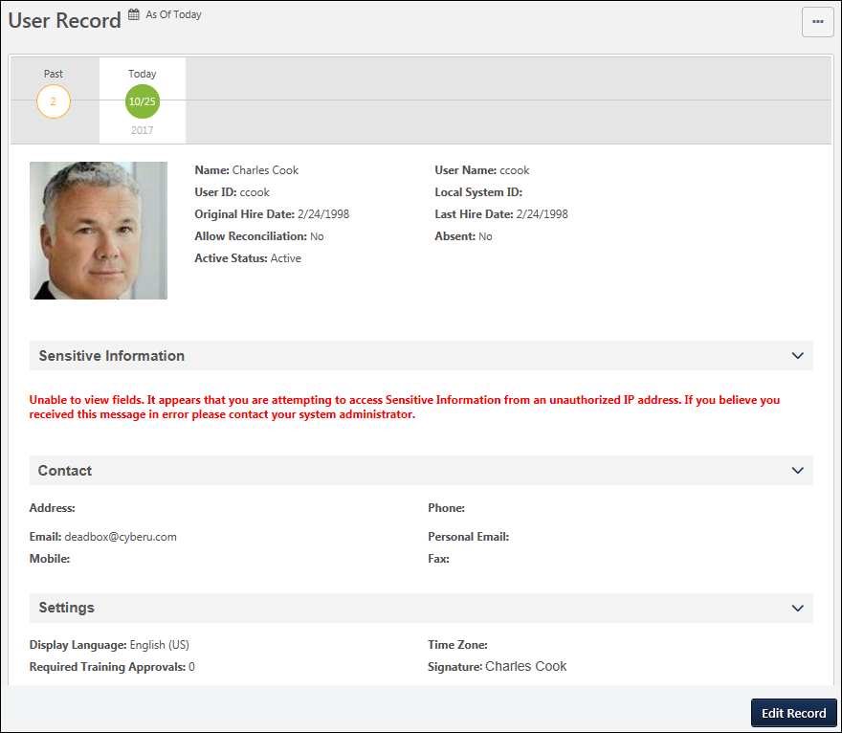
As Of Date
The As Of date for a user record indicates the effective date and time of the record that is currently displayed. If the administrator edits the user record, then the modifications are effective as of the selected effective date. This value is displayed in the time zone of the user whose user record is being viewed.
When editing a user record, the As Of date and time is displayed to the right of the page heading. This enables administrators to quickly view the effective date of the information they are viewing.
This value is only displayed if Cornerstone HR and Effective Dating are enabled. Also, this value is only displayed if the administrator has permission to manage effective dating. This value does not display when creating a user record.
Effective Dated Records - View
Administrators can view and modify the user record as of a specific date in the past or future.
Each of the available effective dated records are displayed in a timeline below the page heading. The timeline is only displayed if the administrator has permission to manage effective dating for users.
By default, the user record is displayed with an effective date of Today, and today's date is displayed. The month and day are displayed within the icon, and the year is displayed below the icon. The effective dates are displayed and applied in the time zone of the user whose user record is being viewed.
- If the user record has an effective dated record in the past, then the effective dated record is displayed to the left of the Today icon. If the user has more than one effective dated record in the past, then a Past icon is displayed to the left of the Today icon.
- If the user record has any effective dated record in the future, then the effective dated record is displayed to the right of the Today icon. If the user has more than one effective dated record in the future, then a Future icon is displayed to the right of the Today icon.
- For the Past or Future icons, the number of effective dated records in each category is displayed within the corresponding icon. For example, if the user has 16 effective dated records in the past, then "16" is displayed within the Past icon.
To view an effective dated record, select one of the effective dates from the timeline. The page refreshes to display the user's effective dated record for the selected date, and the As Of date displays the effective date of the selected effective dated record. If a Past or Future icon is displayed in the timeline, select the icon to display all available effective dated records in the corresponding category (i.e., Past or Future). The corresponding category icon displays an X. For example, if the Future icon is selected, then all available future effective dated records are displayed, and the Future icon displays an X. If there are many effective dated records, the administrator can select the Left or Right arrows to paginate through all effective dated records. Administrators can select the X to hide all effective dated records in that category.
The Effective Dated Record timeline is only displayed if Cornerstone HR and Effective Dating are enabled. Also, this value is only displayed if the administrator has permission to manage effective dating.
Effective Dated Records - Edit
To edit a user record, select the Edit Record button in the floating action bar at the bottom of the screen. A pop-up opens, which enables the administrator to edit the user record as of a specific effective date. It is important to note that all effective dates are displayed and applied the time zone of the user whose user record is being modified. The following options are available within the pop-up:
- Choose Effective Date - This option is only available if the administrator has permission to manage effective dating for users; administrators without this permission can only edit the user record as of the current date. Using the radio buttons, select an effective date for edits.
  - Edit the user record for today - This option is only available when Today is selected from the Effective Date timeline. Selecting this option creates an effective dated record, and the effective date is set to the date at which the administrator saves the changes to the user record.
  - Edit the current view - This option is only available when a specific effective dated record is selected from the Effective Date timeline. The date of the current effective dated record is displayed. Selecting this option edits the existing effective dated record.
  - Edit the user record for a specific date - Selecting this option enables the administrator to create a new effective dated record with a specific effective date. The As Of date is updated to display the specified date.
    - Note: The Effective Date can be any date in the past that is on or after January 1, 1901. However, the Effective Date cannot be set to a date in the past for a user within an In Progress compensation task, either as an employee or a compensation manager.
- Reason for Change - From the drop-down menu, select the reason for modifying the employee data. This option is only available if Effective Dating and Reason for Change are enabled for the portal. Administrators can configure the available options and whether this field is required in User Preferences. See User Preferences for additional information.
  - When a user record is modified, the Reason for Change value is stored in the Modification History.
Note: When a new effective dated record is created, a new entry is added to the Effective Date timeline.
Select the Next button to open the Edit User Record page. Or, select the Cancel button to close the pop-up and return to the View User Record page.
When editing a user record with an effective date that is not set to Today, administrators can only edit fields that can be audited and which they have permission to edit. If a field cannot be audited, it appears inactive and cannot be edited. See User Record - Audited Fields.
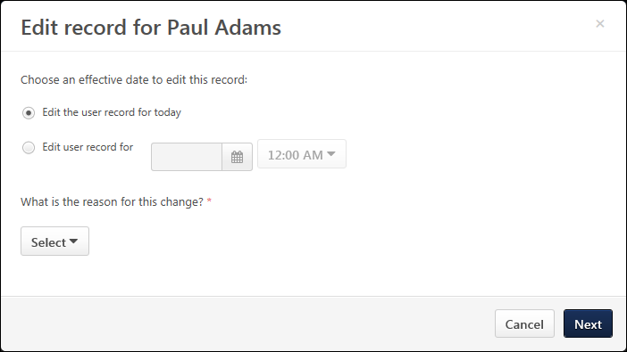
Add User to Group as of Now
CHR administrators can add users to groups "as of now," meaning the date the user was added to the group is recorded as the date the user added them to the group. It is NOT possible to add users to a group as of a specific date in the past or future.

User Record Permissions
Use Cases
See Use Case 1 - View User Record Photo on page 78 for additional information.
See Use Case 2 - Edit Core Standard Fields/Photo on page 79 for additional information.
See Use Case 3 - Edit All User Record Fields on page 80 for additional information.
See Use Case 4 - View All Fields with Editing Limits on page 87 for additional information.
User Record Permissions
The following permissions relate to the editing and viewing user records:
PERMISSION NAME | PERMISSION DESCRIPTION | CATEGORY

Tax Exemption - Manage | Grants ability to manage Tax Exemption and Exemption Certificate on a user record. | eCommerce

Tax Override - Manage | Grants ability to add and edit the Override value for users in the E-Commerce Information section of the User Record page. This permission cannot be constrained. This is an administrator permission. This permission only works when used in conjunction with the Users - View permission. | eCommerce

Universal Profile - User Record - Create Users | Grants ability to access the User Record Administration page and to create new users in the system. When creating a new user, this permission grants the ability to add general information, which includes first name, last name, username, assigned OUs, and custom relationships. The administrator must have additional permissions to add any additional fields. This permission can be constrained by OU, User's OU, User's Self, User Self and Subordinates, and User. This is an administrator permission. | Core Administration

Universal Profile - User Record - Edit Users | Grants ability to edit user records in the system. The administrator must have additional permissions to edit specific fields on the user record. This permission can be constrained by OU, User's OU, User's Self, User Self and Subordinates, and User. This is an administrator permission. Note: This permission DOES NOT grant the ability to view user records in the system. Administrators must have the Universal Profile - User Record - View Users permission in order to view user records. | Core Administration

Universal Profile - User Record - View Users | Grants ability to view user records in the system. Administrators can view the Modification History page for user records within their constraints. The administrator must have additional permissions to view specific fields on the user record. This permission can be constrained by OU, User's OU, User's Self, User Self and Subordinates, and User. This is an administrator permission. | Core Administration

Users – Edit Custom Field Information | Grants ability to view and edit the custom fields on a user record. Administrators are only able to edit a custom field on a user's user record if the user is within their permission constraints and the administrator is within the availability of the custom field. This permission works in conjunction with the Users - View permission. This permission can be constrained by OU, User's OU, User's Self, User Self and Subordinates, and User. This is an administrator permission. | Core Administration

Users – Edit General Information | Grants ability to edit the general fields on a user record, including first name, last name, username, assigned OUs, and custom relationships. This permission works in conjunction with the Users - View permission. This permission can be constrained by OU, User's OU, User's Self, User Self and Subordinates, and User. This is an administrator permission. | Core Administration

Users - Edit Local System ID | Enables administrator to modify the Local System ID for a user via the admin/users screen. This permission only works when used in conjunction with the Users - View and Users - Edit permissions. This permission cannot be constrained. This is an administrator permission. | Core Administration

Users - Edit Middle Name | Grants ability to modify the middle name for a user via the admin/users screen. This permission only works when used in conjunction with the Users - View permission. This is an administrator permission. | Core Administration

Users - Edit Mobile Phone | Grants ability to modify the Mobile Phone number for a user via the Admin/Users screen. The availability of this permission is controlled by a backend setting. This permission only works when used in conjunction with the Users - View permission. | Core Administration

Users - Edit Prefix | Grants ability to modify the prefix for a user's name via the admin/users screen. This permission only works when used in conjunction with the Users - View permission. This is an administrator permission. | Core Administration

Users - Edit Sensitive Information: Unmasked | Grants ability to view and edit unmasked Sensitive Personally Identifiable Information (SPII) fields on the user record. Administrators with this permission have the option to view and edit the actual data on the user record. This permission can be constrained by OU, User's OU, User's Self, User's Subordinates, User's Direct Subordinates, User, and Employee Relationship. This is an administrator permission. | Core Administration

Users - Edit Signature | Grants ability to modify the signature font for a user via the admin/users screen. This permission only works when used in conjunction with the Users - View permission. This is an administrator permission. | Core Administration

Users - Edit Suffix | Grants ability to modify the suffix for a user's name via the admin/users screen. This permission only works when used in conjunction with the Users - View permission. This is an administrator permission. | Core Administration

Users - Edit User ID | Enables administrator to modify the User ID for a user via the admin/users screen. This permission only works when used in conjunction with the Users - View permission. | Core Administration

Users - Edit Users Absent Status | Enables administrator to modify the Absent status for a user via the admin/users screen. This permission only works when used in conjunction with the Users - View permission. | Core Administration

Users - Edit Users Active Status | Enables administrator to modify the Active status for a user via the admin/users screen. This permission only works when used in conjunction with the Users - View permission. | Core Administration

Users - Edit Users Address | Enables administrator to modify the address for a user via the admin/users screen. This permission only works when used in conjunction with the Users - View permission. | Core Administration

Users - Edit Users Approver | Enables administrator to modify the specified Approver for a user via the admin/users screen. This permission only works when used in conjunction with the Users - View permission. | Core Administration

Users - Edit Users Email | Enables administrator to modify the Email Address for a user via the admin/users screen. This permission only works when used in conjunction with the Users - View permission. | Core Administration

Users - Edit Users Fax | Enables administrator to modify the Fax number for a user via the admin/users screen. This permission only works when used in conjunction with the Users - View permission. | Core Administration

Users - Edit Users Language | Enables administrator to modify the portal display language for a user via the admin/users screen. This permission only works when used in conjunction with the Users - View permission. | Core Administration

Users - Edit Users Last Hire Date | Enables administrator to modify the Last Hire Date for a user via the admin/users screen. This permission only works when used in conjunction with the Users - View permission. | Core Administration

Users - Edit Users Manager | Enables administrator to modify the assigned Manager for a user via the admin/users screen. This permission only works when used in conjunction with the Users - View permission. | Core Administration

Users - Edit Users Original Hire Date | Enables administrator to modify the Original Hire Date for a user via the admin/users screen. This permission only works when used in conjunction with the Users - View permission. | Core Administration

Users - Edit Users Phone | Enables administrator to modify the Phone number for a user via the admin/users screen. This permission only works when used in conjunction with the Users - View permission. | Core Administration

Users - Edit Users Photo | Enables administrator to upload a photo for a user via the admin/users screen. This permission only works when used in conjunction with the Users - View permission. | Core Administration

Users - Edit Users Reconciliation | Enables administrator to modify the Reconciliation status for a user via the admin/users screen. This permission only works when used in conjunction with the Users - View permission. | Core Administration

Users - Edit Users Required Approvals | Enables administrator to modify the number of required training approvals for a user via the admin/users screen. This permission only works when used in conjunction with the Users - View permission. | Core Administration

Users - Edit Users Time Zone | Enables administrator to modify the portal time zone for a user via the admin/users screen. This permission only works when used in conjunction with the Users - View permission. | Core Administration

Users - Edit Users Type and Status | Enables administrator to view and modify the type and status information for a user via the User Record. This permission only works when used in conjunction with the Users - View permission. | Core Administration

Users – Effective Dating: Manage | Enables administrator to make effective dated changes to the user record. This permission only works when used in conjunction with the Users - Edit General Information permission. This permission cannot be constrained. This is an administrator permission. | Core Administration

Users - View | Grants the ability to search for and view summary information about users in the portal via the Admin/Users screen. This permission can be constrained by OU, User's OU, User Self and Subordinates, and Users. If multiple constraints are added, these constraints are considered OR statements. This is an administrator permission. | Core Administration

Users – View Custom Field Information | Grants ability to view the custom fields on a user record. Administrators are only able to view a custom field on a user's user record if the user is within their permission constraints and the administrator is within the availability of the custom field. This permission works in conjunction with the Users - View permission. This permission can be constrained by OU, User's OU, User's Self, User Self and Subordinates, and User. This is an administrator permission. | Core Administration

Users – View General Information | Grants ability to view the general fields on a user record, including first name, last name, username, assigned OUs, and custom relationships. This permission works in conjunction with the Universal Profile - User Record - View Users permission. This permission can be constrained by OU, User's OU, User's Self, User Self and Subordinates, and User. This is an administrator permission. | Core Administration

Users - View Local System ID | Enables administrator to view the Local System ID for a user via the admin/users screen. This permission only works when used in conjunction with the Users - View and Users - Edit permissions. This permission cannot be constrained. This is an administrator permission. | Core Administration

Users - View Middle Name | Grants ability to view the middle name for a user via the Admin/Users screen. This permission only works when used in conjunction with the Universal Profile - User Record - View Users and Users - View General Information permissions. This is an administrator permission. | Core Administration

Users - View Mobile Phone | Grants ability to view the Mobile Phone number for a user via the Admin/Users screen. The availability of this permission is controlled by a backend setting. This permission only works when used in conjunction with the Users - View permission. | Core Administration

Users - View Modification Details | Grants ability to view the Modification Details on the User Record and view User Audits fields when creating a Reporting 2.0 report. This permission only works when used in conjunction with the Users - View permission. This is an administrator permission. | Core Administration

Users - View Prefix | Grants ability to view the prefix for a user's name via the Admin/User screen. This permission only works when used in conjunction with the Universal Profile - User Record - View Users and Users - View General Information permissions. This is an administrator permission. | Core Administration

Users - View Sensitive Information: Masked | Grants ability to view masked Sensitive Personally Identifiable Information (SPII) fields on the user record. Administrators with this permission cannot view the actual data. This permission can be constrained by OU, User's OU, User's Self, User's Subordinates, User's Direct Subordinates, User, and Employee Relationship. This is an administrator permission. | Core Administration

Users - View Sensitive Information: Unmasked | Grants ability to view unmasked Sensitive Personally Identifiable Information (SPII) fields on the user record. Administrators with this permission have the option to view the actual data on the user record. This permission can be constrained by OU, User's OU, User's Self, User's Subordinates, User's Direct Subordinates, User, and Employee Relationship. This is an administrator permission. | Core Administration

Users - View Signature | Grants ability to view the signature font for a user via the Admin/Users screen. This permission only works when used in conjunction with the Universal Profile - User Record - View Users permission. This is an administrator permission. | Core Administration

Users - View Suffix | Grants ability to view the suffix for a user's name via the Admin/Users screen. This permission only works when used in conjunction with the Universal Profile - User Record - View Users permission. | Core Administration

Users - View User ID | Enables administrator to view the User ID for a user via the Admin/Users screen. This permission only works when used in conjunction with the Universal Profile - User Record - View Users permission. | Core Administration

Users - View Users Absent Status | Enables administrator to view the Absent status for a user via the Admin/Users screen. This permission only works when used in conjunction with the Universal Profile - User Record - View Users permission. | Core Administration

Users - View Users Active Status | Enables administrator to view the Active status for a user via the Admin/Users screen. This permission only works when used in conjunction with the Universal Profile - User Record - View Users permission. | Core Administration

Users - View Users Address | Enables administrator to view the address for a user via the Admin/Users screen. This permission only works when used in conjunction with the Universal Profile - User Record - View Users permission. | Core Administration

Users - View Users Approver | Enables administrator to view the specified Approver for a user via the Admin/Users screen. This permission only works when used in conjunction with the Universal Profile - User Record - View Users permission. | Core Administration

Users - View Users Email | Enables administrator to view the Email Address for a user via the Admin/Users screen. This permission only works when used in conjunction with the Universal Profile - User Record - View Users permission. | Core Administration

Users - View Users Fax | Enables administrator to view the Fax number for a user via the Admin/Users screen. This permission only works when used in conjunction with the Universal Profile - User Record - View Users permission. | Core Administration

Users - View Users Language | Enables administrator to view the portal display language for a user via the Admin/Users screen. This permission only works when used in conjunction with the Universal Profile - User Record - View Users permission. | Core Administration

Users - View Users Last Hire Date | Enables administrator to view the Last Hire Date for a user via the Admin/Users screen. This permission only works when used in conjunction with the Universal Profile - User Record - View Users permission. | Core Administration

Users - View Users Manager | Enables administrator to view the assigned Manager for a user via the Admin/Users screen. This permission only works when used in conjunction with the Universal Profile - User Record - View Users permission. | Core Administration

Users - View Users Original Hire Date | Enables administrator to view the Original Hire Date for a user via the Admin/Users screen. This permission only works when used in conjunction with the Universal Profile - User Record - View Users permission. | Core Administration

Users - View Users Phone | Enables administrator to view the Phone number for a user via the Admin/Users screen. This permission only works when used in conjunction with the Universal Profile - User Record - View Users permission. | Core Administration

Users - View Users Photo | Enables administrator to view a photo for a user via the Admin/Users screen. This permission only works when used in conjunction with the Universal Profile - User Record - View Users permission. | Core Administration

Users - View Users Reconciliation | Enables administrator to view the Reconciliation status for a user via the Admin/Users screen. This permission only works when used in conjunction with the Universal Profile - User Record - View Users permission. | Core Administration

Users - View Users Required Approvals | Enables administrator to view the number of required training approvals for a user via the Admin/Users screen. This permission only works when used in conjunction with the Universal Profile - User Record - View Users permission. | Core Administration

Users - View Users Time Zone | Enables administrator to view the portal time zone for a user via the Admin/Users screen. This permission only works when used in conjunction with the Universal Profile - User Record - View Users permission. | Core Administration

VAT Number - Manage | Grants ability to add and edit the VAT number for users in the E-Commerce Information section of the User Record page. This permission cannot be constrained. This is an administrator permission. This permission only works when used in conjunction with the Users - View permission. | eCommerce - Administration

Use Case 1 - View User Record Photo
In this use case, permission is granted to access the user record as read-only and view the user's photo. The core information standard fields display but are not editable.
Permissions
The following are the permissions necessary to create this scenario:
Permissions
PERMISSION NAME | PERMISSION DESCRIPTION | CATEGORY

Universal Profile - User Record - View Users | Grants ability to view user records in the system. Administrators can view the Modification History page for user records within their constraints. The administrator must have additional permissions to view specific fields on the user record. This permission can be constrained by OU, User's OU, User's Self, User Self and Subordinates, and User. This is an administrator permission. | Core Administration

Users - Edit Users Photo | Enables administrator to upload a photo for a user via the admin/users screen. This permission only works when used in conjunction with the Users - View permission. | Core Administration

Users – View General Information | Grants ability to view the general fields on a user record, including first name, last name, username, assigned OUs, and custom relationships. This permission works in conjunction with the Universal Profile - User Record - View Users permission. This permission can be constrained by OU, User's OU, User's Self, User Self and Subordinates, and User. This is an administrator permission. | Core Administration
User Record Page
All visible fields on the user record are grayed out and not editable. The Change Photo button does not display, as the user does not have permission to edit the user's photo. The Modification History is visible to the user.

Use Case 2 - Edit Core Standard Fields/Photo
In this use case, permission is granted to edit the user record general information and the user's photo.
Permissions
The following are the permissions necessary to create this scenario:
Permissions
PERMISSION NAME | PERMISSION DESCRIPTION | CATEGORY

Universal Profile - User Record - Edit Users | Grants ability to edit user records in the system. The administrator must have additional permissions to edit specific fields on the user record. This permission can be constrained by OU, User's OU, User's Self, User Self and Subordinates, and User. This is an administrator permission. Note: This permission DOES NOT grant the ability to view user records in the system. Administrators must have the Universal Profile - User Record - View Users permission in order to view user records. | Core Administration

Universal Profile - User Record - View Users | Grants ability to view user records in the system. Administrators can view the Modification History page for user records within their constraints. The administrator must have additional permissions to view specific fields on the user record. This permission can be constrained by OU, User's OU, User's Self, User Self and Subordinates, and User. This is an administrator permission. | Core Administration

Users – Edit General Information | Grants ability to edit the general fields on a user record, including first name, last name, username, assigned OUs, and custom relationships. This permission works in conjunction with the Users - View permission. This permission can be constrained by OU, User's OU, User's Self, User Self and Subordinates, and User. This is an administrator permission. | Core Administration

Users - Edit Users Photo | Enables administrator to upload a photo for a user via the admin/users screen. This permission only works when used in conjunction with the Users - View permission. | Core Administration
User Record Page
The general information fields are visible and editable, as the user has permission to edit general information fields. The Change Photo button also displays because the user has permission to edit the photo. The user can view the Modification History.

Use Case 3 - Edit All User Record Fields
In this use case, the user is granted all edit and view permissions that are applicable to the user record.
Permissions
The following are the permissions necessary to create this scenario:
Permissions
PERMISSION NAME | PERMISSION DESCRIPTION | CATEGORY

Universal Profile - User Record - Edit Users | Grants ability to edit user records in the system. The administrator must have additional permissions to edit specific fields on the user record. This permission can be constrained by OU, User's OU, User's Self, User Self and Subordinates, and User. This is an administrator permission. Note: This permission DOES NOT grant the ability to view user records in the system. Administrators must have the Universal Profile - User Record - View Users permission in order to view user records. | Core Administration

Universal Profile - User Record - View Users | Grants ability to view user records in the system. Administrators can view the Modification History page for user records within their constraints. The administrator must have additional permissions to view specific fields on the user record. This permission can be constrained by OU, User's OU, User's Self, User Self and Subordinates, and User. This is an administrator permission. | Core Administration

Users – Edit Custom Field Information | Grants ability to view and edit the custom fields on a user record. Administrators are only able to edit a custom field on a user's user record if the user is within their permission constraints and the administrator is within the availability of the custom field. This permission works in conjunction with the Users - View permission. This permission can be constrained by OU, User's OU, User's Self, User Self and Subordinates, and User. This is an administrator permission. | Core Administration

Users – Edit General Information | Grants ability to edit the general fields on a user record, including first name, last name, username, assigned OUs, and custom relationships. This permission works in conjunction with the Users - View permission. This permission can be constrained by OU, User's OU, User's Self, User Self and Subordinates, and User. This is an administrator permission. | Core Administration

Users - Edit Middle Name | Grants ability to modify the middle name for a user via the admin/users screen. This permission only works when used in conjunction with the Users - View permission. This is an administrator permission. | Core Administration

Users - Edit Prefix | Grants ability to modify the prefix for a user's name via the admin/users screen. This permission only works when used in conjunction with the Users - View permission. This is an administrator permission. | Core Administration

Users - Edit Signature | Grants ability to modify the signature font for a user via the admin/users screen. This permission only works when used in conjunction with the Users - View permission. This is an administrator permission. | Core Administration

Users - Edit Suffix | Grants ability to modify the suffix for a user's name via the admin/users screen. This permission only works when used in conjunction with the Users - View permission. This is an administrator permission. | Core Administration

Users - Edit User ID | Enables administrator to modify the User ID for a user via the admin/users screen. This permission only works when used in conjunction with the Users - View permission. | Core Administration

Users - Edit Users Absent Status | Enables administrator to modify the Absent status for a user via the admin/users screen. This permission only works when used in conjunction with the Users - View permission. | Core Administration

Users - Edit Users Active Status | Enables administrator to modify the Active status for a user via the admin/users screen. This permission only works when used in conjunction with the Users - View permission. | Core Administration

Users - Edit Users Address | Enables administrator to modify the address for a user via the admin/users screen. This permission only works when used in conjunction with the Users - View permission. | Core Administration

Users - Edit Users Approver | Enables administrator to modify the specified Approver for a user via the admin/users screen. This permission only works when used in conjunction with the Users - View permission. | Core Administration

Users - Edit Users Email | Enables administrator to modify the Email Address for a user via the admin/users screen. This permission only works when used in conjunction with the Users - View permission. | Core Administration

Users - Edit Users Fax | Enables administrator to modify the Fax number for a user via the admin/users screen. This permission only works when used in conjunction with the Users - View permission. | Core Administration

Users - Edit Users Language | Enables administrator to modify the portal display language for a user via the admin/users screen. This permission only works when used in conjunction with the Users - View permission. | Core Administration

Users - Edit Users Last Hire Date | Enables administrator to modify the Last Hire Date for a user via the admin/users screen. This permission only works when used in conjunction with the Users - View permission. | Core Administration

Users - Edit Users Manager | Enables administrator to modify the assigned Manager for a user via the admin/users screen. This permission only works when used in conjunction with the Users - View permission. | Core Administration

Users - Edit Users Original Hire Date | Enables administrator to modify the Original Hire Date for a user via the admin/users screen. This permission only works when used in conjunction with the Users - View permission. | Core Administration

Users - Edit Users Phone | Enables administrator to modify the Phone number for a user via the admin/users screen. This permission only works when used in conjunction with the Users - View permission. | Core Administration

Users - Edit Users Photo | Enables administrator to upload a photo for a user via the admin/users screen. This permission only works when used in conjunction with the Users - View permission. | Core Administration

Users - Edit Users Reconciliation | Enables administrator to modify the Reconciliation status for a user via the admin/users screen. This permission only works when used in conjunction with the Users - View permission. | Core Administration

Users - Edit Users Required Approvals | Enables administrator to modify the number of required training approvals for a user via the admin/users screen. This permission only works when used in conjunction with the Users - View permission. | Core Administration

Users - Edit Users Time Zone | Enables administrator to modify the portal time zone for a user via the admin/users screen. This permission only works when used in conjunction with the Users - View permission. | Core Administration

Users - View | Grants the ability to search for and view summary information about users in the portal via the Admin/Users screen. This permission can be constrained by OU, User's OU, User Self and Subordinates, and Users. If multiple constraints are added, these constraints are considered OR statements. This is an administrator permission. | Core Administration

Users – View Custom Field Information | Grants ability to view the custom fields on a user record. Administrators are only able to view a custom field on a user's user record if the user is within their permission constraints and the administrator is within the availability of the custom field. This permission works in conjunction with the Users - View permission. This permission can be constrained by OU, User's OU, User's Self, User Self and Subordinates, and User. This is an administrator permission. | Core Administration

Users – View General Information | Grants ability to view the general fields on a user record, including first name, last name, username, assigned OUs, and custom relationships. This permission works in conjunction with the Universal Profile - User Record - View Users permission. This permission can be constrained by OU, User's OU, User's Self, User Self and Subordinates, and User. This is an administrator permission. | Core Administration

Users - View Middle Name | Grants ability to view the middle name for a user via the Admin/Users screen. This permission only works when used in conjunction with the Universal Profile - User Record - View Users and Users - View General Information permissions. This is an administrator permission. | Core Administration

Users - View Prefix | Grants ability to view the prefix for a user's name via the Admin/User screen. This permission only works when used in conjunction with the Universal Profile - User Record - View Users and Users - View General Information permissions. This is an administrator permission. | Core Administration

Users - View Signature | Grants ability to view the signature font for a user via the Admin/Users screen. This permission only works when used in conjunction with the Universal Profile - User Record - View Users permission. This is an administrator permission. | Core Administration

Users - View Suffix | Grants ability to view the suffix for a user's name via the Admin/Users screen. This permission only works when used in conjunction with the Universal Profile - User Record - View Users permission. | Core Administration

Users - View User ID | Enables administrator to view the User ID for a user via the Admin/Users screen. This permission only works when used in conjunction with the Universal Profile - User Record - View Users permission. | Core Administration

Users - View Users Absent Status | Enables administrator to view the Absent status for a user via the Admin/Users screen. This permission only works when used in conjunction with the Universal Profile - User Record - View Users permission. | Core Administration

Users - View Users Active Status | Enables administrator to view the Active status for a user via the Admin/Users screen. This permission only works when used in conjunction with the Universal Profile - User Record - View Users permission. | Core Administration

Users - View Users Address | Enables administrator to view the address for a user via the Admin/Users screen. This permission only works when used in conjunction with the Universal Profile - User Record - View Users permission. | Core Administration

Users - View Users Approver | Enables administrator to view the specified Approver for a user via the Admin/Users screen. This permission only works when used in conjunction with the Universal Profile - User Record - View Users permission. | Core Administration

Users - View Users Email | Enables administrator to view the Email Address for a user via the Admin/Users screen. This permission only works when used in conjunction with the Universal Profile - User Record - View Users permission. | Core Administration

Users - View Users Fax | Enables administrator to view the Fax number for a user via the Admin/Users screen. This permission only works when used in conjunction with the Universal Profile - User Record - View Users permission. | Core Administration

Users - View Users Language | Enables administrator to view the portal display language for a user via the Admin/Users screen. This permission only works when used in conjunction with the Universal Profile - User Record - View Users permission. | Core Administration

Users - View Users Last Hire Date | Enables administrator to view the Last Hire Date for a user via the Admin/Users screen. This permission only works when used in conjunction with the Universal Profile - User Record - View Users permission. | Core Administration

Users - View Users Manager | Enables administrator to view the assigned Manager for a user via the Admin/Users screen. This permission only works when used in conjunction with the Universal Profile - User Record - View Users permission. | Core Administration

Users - View Users Original Hire Date | Enables administrator to view the Original Hire Date for a user via the Admin/Users screen. This permission only works when used in conjunction with the Universal Profile - User Record - View Users permission. | Core Administration

Users - View Users Phone | Enables administrator to view the Phone number for a user via the Admin/Users screen. This permission only works when used in conjunction with the Universal Profile - User Record - View Users permission. | Core Administration

Users - View Users Photo | Enables administrator to view a photo for a user via the Admin/Users screen. This permission only works when used in conjunction with the Universal Profile - User Record - View Users permission. | Core Administration

Users - View Users Reconciliation | Enables administrator to view the Reconciliation status for a user via the Admin/Users screen. This permission only works when used in conjunction with the Universal Profile - User Record - View Users permission. | Core Administration

Users - View Users Required Approvals | Enables administrator to view the number of required training approvals for a user via the Admin/Users screen. This permission only works when used in conjunction with the Universal Profile - User Record - View Users permission. | Core Administration

Users - View Users Time Zone | Enables administrator to view the portal time zone for a user via the Admin/Users screen. This permission only works when used in conjunction with the Universal Profile - User Record - View Users permission. | Core Administration
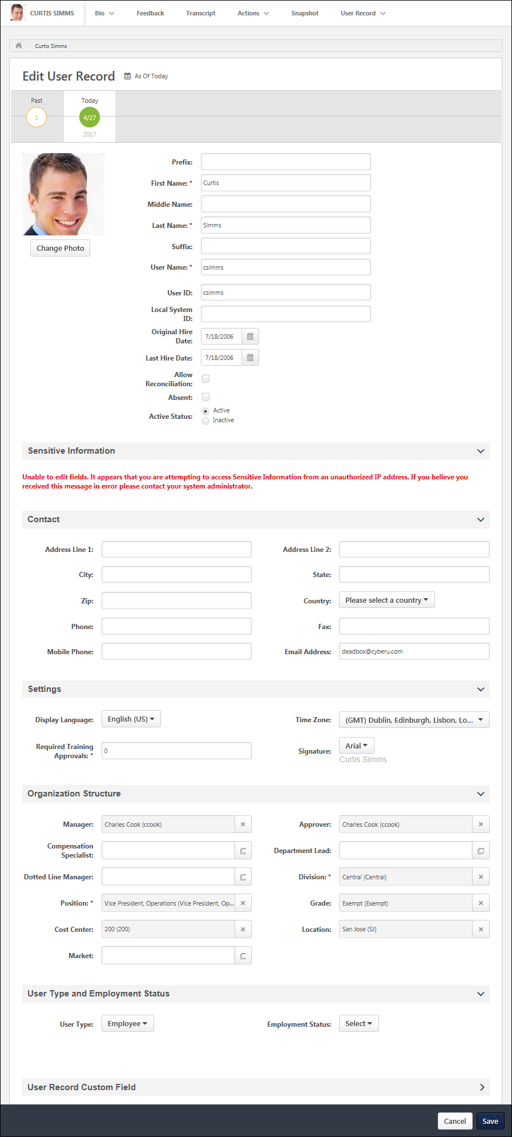

Use Case 4 - View All Fields with Editing Limits
In this use case, the user is granted permission to view all standard fields, as well as edit the user's address. The purpose of this permission configuration is to enable a user to view all user record fields but only edit the address fields.
Permissions
The following are the permissions necessary to create this scenario:
Permissions
PERMISSION NAME | PERMISSION DESCRIPTION | CATEGORY

Universal Profile - User Record - Edit Users | Grants ability to edit user records in the system. The administrator must have additional permissions to edit specific fields on the user record. This permission can be constrained by OU, User's OU, User's Self, User Self and Subordinates, and User. This is an administrator permission. Note: This permission DOES NOT grant the ability to view user records in the system. Administrators must have the Universal Profile - User Record - View Users permission in order to view user records. | Core Administration

Universal Profile - User Record - View Users | Grants ability to view user records in the system. Administrators can view the Modification History page for user records within their constraints. The administrator must have additional permissions to view specific fields on the user record. This permission can be constrained by OU, User's OU, User's Self, User Self and Subordinates, and User. This is an administrator permission. | Core Administration

Users - Edit Users Address | Enables administrator to modify the address for a user via the admin/users screen. This permission only works when used in conjunction with the Users - View permission. | Core Administration

Users – View General Information | Grants ability to view the general fields on a user record, including first name, last name, username, assigned OUs, and custom relationships. This permission works in conjunction with the Universal Profile - User Record - View Users permission. This permission can be constrained by OU, User's OU, User's Self, User Self and Subordinates, and User. This is an administrator permission. | Core Administration

Users - View Middle Name | Grants ability to view the middle name for a user via the Admin/Users screen. This permission only works when used in conjunction with the Universal Profile - User Record - View Users and Users - View General Information permissions. This is an administrator permission. | Core Administration

Users - View Prefix | Grants ability to view the prefix for a user's name via the Admin/User screen. This permission only works when used in conjunction with the Universal Profile - User Record - View Users and Users - View General Information permissions. This is an administrator permission. | Core Administration

Users - View Signature | Grants ability to view the signature font for a user via the Admin/Users screen. This permission only works when used in conjunction with the Universal Profile - User Record - View Users permission. This is an administrator permission. | Core Administration

Users - View Suffix | Grants ability to view the suffix for a user's name via the Admin/Users screen. This permission only works when used in conjunction with the Universal Profile - User Record - View Users permission. | Core Administration

Users - View User ID | Enables administrator to view the User ID for a user via the Admin/Users screen. This permission only works when used in conjunction with the Universal Profile - User Record - View Users permission. | Core Administration

Users - View Users Absent Status | Enables administrator to view the Absent status for a user via the Admin/Users screen. This permission only works when used in conjunction with the Universal Profile - User Record - View Users permission. | Core Administration

Users - View Users Active Status | Enables administrator to view the Active status for a user via the Admin/Users screen. This permission only works when used in conjunction with the Universal Profile - User Record - View Users permission. | Core Administration

Users - View Users Address | Enables administrator to view the address for a user via the Admin/Users screen. This permission only works when used in conjunction with the Universal Profile - User Record - View Users permission. | Core Administration

Users - View Users Approver | Enables administrator to view the specified Approver for a user via the Admin/Users screen. This permission only works when used in conjunction with the Universal Profile - User Record - View Users permission. | Core Administration

Users - View Users Email | Enables administrator to view the Email Address for a user via the Admin/Users screen. This permission only works when used in conjunction with the Universal Profile - User Record - View Users permission. | Core Administration

Users - View Users Fax | Enables administrator to view the Fax number for a user via the Admin/Users screen. This permission only works when used in conjunction with the Universal Profile - User Record - View Users permission. | Core Administration

Users - View Users Language | Enables administrator to view the portal display language for a user via the Admin/Users screen. This permission only works when used in conjunction with the Universal Profile - User Record - View Users permission. | Core Administration

Users - View Users Last Hire Date | Enables administrator to view the Last Hire Date for a user via the Admin/Users screen. This permission only works when used in conjunction with the Universal Profile - User Record - View Users permission. | Core Administration

Users - View Users Manager | Enables administrator to view the assigned Manager for a user via the Admin/Users screen. This permission only works when used in conjunction with the Universal Profile - User Record - View Users permission. | Core Administration

Users - View Users Original Hire Date | Enables administrator to view the Original Hire Date for a user via the Admin/Users screen. This permission only works when used in conjunction with the Universal Profile - User Record - View Users permission. | Core Administration

Users - View Users Phone | Enables administrator to view the Phone number for a user via the Admin/Users screen. This permission only works when used in conjunction with the Universal Profile - User Record - View Users permission. | Core Administration

Users - View Users Photo | Enables administrator to view a photo for a user via the Admin/Users screen. This permission only works when used in conjunction with the Universal Profile - User Record - View Users permission. | Core Administration

Users - View Users Reconciliation | Enables administrator to view the Reconciliation status for a user via the Admin/Users screen. This permission only works when used in conjunction with the Universal Profile - User Record - View Users permission. | Core Administration

Users - View Users Required Approvals | Enables administrator to view the number of required training approvals for a user via the Admin/Users screen. This permission only works when used in conjunction with the Universal Profile - User Record - View Users permission. | Core Administration

Users - View Users Time Zone | Enables administrator to view the portal time zone for a user via the Admin/Users screen. This permission only works when used in conjunction with the Universal Profile - User Record - View Users permission. | Core Administration

Users - View | Grants the ability to search for and view summary information about users in the portal via the Admin/Users screen. This permission can be constrained by OU, User's OU, User Self and Subordinates, and Users. If multiple constraints are added, these constraints are considered OR statements. This is an administrator permission. | Core Administration

Edit User Password
The Password Preferences determine how and what the administrator is allowed to do when they change a user's password. See Password Preferences.
To change a user's password, go to Admin > Tools > Core Functions > Users. Then, select the Change Password option in the Options drop-down menu.
Permissions
PERMISSION NAME | PERMISSION DESCRIPTION | CATEGORY

Change User Passwords - Administrator | Grants ability to change the portal password of another user. This permission works in conjunction with the Users - View permission. This permission can be constrained by User's Corporation, OU, User's OU, User's Self and Subordinates, and User. This is an administrator permission. | Core Administration
Emails
EMAIL NAME | EMAIL DESCRIPTION | ACTION TYPE

Admin Password Change | This email is triggered when an administrator manually resets a user's password. The user's new password cannot be included in the email. Because of this, the administrator must communicate this password outside of the system. This email can be sent to User or User's Manager. | System Administration

Forget Password | If the Password Reset Option in Password Preferences is set to Reset By Email Notification, then the Forget Password email is triggered when a user clicks Forgot Password? on the Login page. This email can be sent to External User or Internal User. If the user clicks Forgot Password? multiple times and a password reset URL is included in the email, then a new URL is generated for each email and the previous URL is no longer valid.  This email must be configured for administrators to select the "Send Password Reset Email to user's email address" option when resetting a user's password on the Admin - Users page.  The PASSWORD.RESET.URL email tag is a link that opens a page on which the user can create a password. If this email is sent multiple times to the same recipient, then this URL is regenerated each time and the previous URL is no longer valid. Also, the password reset URL is only valid for 48 hours. If the user does not reset their password within the 48-hour validity period, then the user must click Forgot Password? again to get a new password reset URL.  Defining Availability  The availability settings do not apply to external users when External User is added as a recipient in the Send To field.  When Internal User is added to the Send To field, the availability settings defined in the Availability field apply to internal users based on the organizational unit (OU) to which they belong. The following rules apply by OU:  Organizational Unit Rule  Cost Center Cost Center if user is part of the Cost Center  Custom Group Custom group if user is part of the Custom Group  Division Division user belongs to  Grade Grade user belongs to  Location Location user belongs to  Position Position user belongs to  Self-Registration Group Self-Registration group if user is part of the group  User User if user is added individually | System Administration
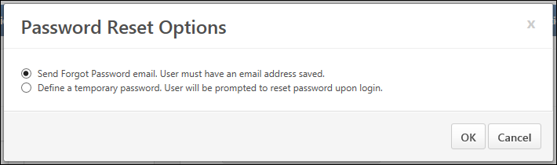
- Select one of the following options:
  - Send Forgot Password email. User must have an email address saved. - When this option is selected, a password reset email is sent to the user, allowing them to set their password. The affected user is still able to log in to the system using their current password until they select the password reset URL in the email. Note: This option triggers the Forget Password email, if configured in Email Administration. This trigger must be configured prior to resetting a user's password with this option.
  - Define a temporary password. User will be prompted to reset password upon login. - When this option is selected, the administrator is prompted to manually set a temporary password for the user. When a password is reset with this option, the temporary password is not sent to the affected user. The administrator must communicate the new password to the user outside of the system. Note: This option is not available if the Require confidential password reset and send email notification to user option is selected in Password Preferences for the user's division.
- Select OK. If the Define a temporary password option is selected, then the Change Password page opens, on which the administrator can manually set a temporary password for the user. This triggers the Admin Password Change email, if configured in Email Administration.
- Select Save.
Emails are configured in Email Administration. See Email Administration.

Manage Device Tokens
Administrators with permission to access the Admin > Users page are able to manage a user's devices that are registered with the Cornerstone mobile application.
To manage a user's mobile devices that are registered with a Cornerstone mobile application, go to Admin > Tools > Core Functions > Users. Then, select the Manage Device Tokens option in the Options drop-down menu for the appropriate user.
Permissions
PERMISSION NAME | PERMISSION DESCRIPTION | CATEGORY

My Account Devices - Manage | Grants ability to access the Devices tab of My Account. The Devices tab enables users to register their mobile devices with the Cornerstone application. This permission cannot be constrained. This is an end user permission. | Mobile

Users - Edit Mobile Phone | Grants ability to modify the Mobile Phone number for a user via the Admin/Users screen. The availability of this permission is controlled by a backend setting. This permission only works when used in conjunction with the Users - View permission. | Core Administration

Users - View | Grants the ability to search for and view summary information about users in the portal via the Admin/Users screen. This permission can be constrained by OU, User's OU, User Self and Subordinates, and Users. If multiple constraints are added, these constraints are considered OR statements. This is an administrator permission. | Core Administration

Users - View Mobile Phone | Grants ability to view the Mobile Phone number for a user via the Admin/Users screen. The availability of this permission is controlled by a backend setting. This permission only works when used in conjunction with the Users - View permission. | Core Administration
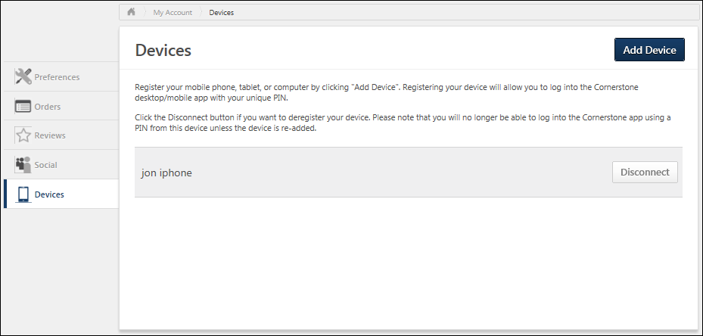
Disconnect a Registered Device
To disconnect a registered device, in the Devices table, select the Disconnect button next to the appropriate device. This opens a confirm pop-up. Select OK to disconnect, or select Cancel to stay connected.
After removing your device, you will not be able to log in using that device again, and a new pairing must be created.
Note: Removing a registered device only disables the device. The user can re-register the device if they have permission to manage devices.
See My Account - Devices.

User Hierarchy
This displays the hierarchy of a user from the search results on the User Search page. Using org chart functionality, the administrator can view the hierarchy of a user and their direct/indirect reports in a graphical, org chart view. The administrator can drill down their hierarchy to view a user's direct and indirect reports and click on the name of a direct/indirect report to edit the profile of that user.
To view the User Hierarchy for a user, go to Admin > Tools > Core Functions > Users. From the Options drop-down next to the user, select View Hierarchy.
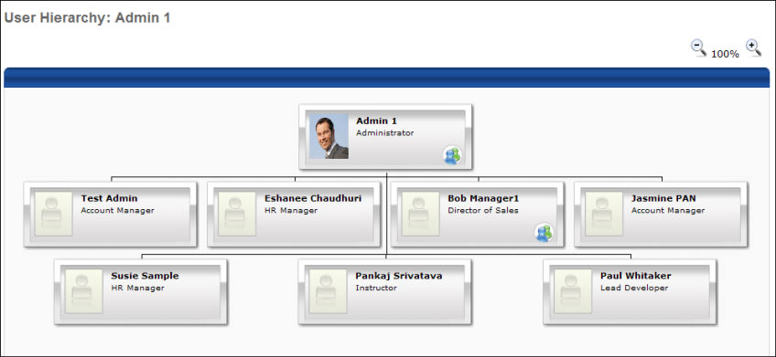
Viewing the Org Chart
The org chart displays the selected user at the top of the hierarchy and the user's direct reports by default. Up to four direct reports will appear per row on the org chart.
- You can zoom in and zoom out of the org chart.
- You can grab and drag the white space of the org chart to move the chart around to the desired position.
ID Cards
An ID card will appear for each user in the org chart. On each ID card, the user's profile picture, full name, and position will display.
- You can click the users name to edit their profile.
- If a user has direct reports, a direct reports icon will appear on the user's ID card that can be clicked to drill into the hierarchy of a user.
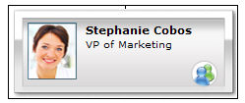

User Record Audit History Stamps
The following items are tracked in the Audit History for the User Record:
- Inserted
- Activated
- Deactivated
- Changed Manager
- Changed Client ID
- Modified
- Changed Approver
- Allow Reconcile
- Disallow Reconcile
- Initial Password
- Password Reset
- Made absent
- Made un-absent
All history stamps display the user's ID following the user's full name (i.e., "<Last Name, First Name><User ID>").
The following field names may appear in a history stamp:
- Prefix
- First Name
- Middle Name
- Last Name
- Suffix
- User Name
- User ID
- Original Hire date
- Last Hire Date
- Display Language
- All Fields related to Address, Phone and Fax
- Email Address
- All Organization Units Standard and Custom
- Required Training Approvals
- Custom Fields

View Permissions Constraints Details
The Permissions Constraints Details page provides administrators with an investigative tool to review and analyze a user’s security profile. For example, if a user reports that they cannot access a page that was previously available to them, this page provide administrators with pertinent information to help streamline the analysis. Having this information on demand allows administrators to take prompt and corrective action more efficiently.
See How to Use Permissions Constraints Details on page 102 for additional information.
To access the Permissions Constraints Details page for a user, go to Admin > Tools > Core Functions > Users. Select the Options drop-down for the user and select the Permissions Constraints Details option.
Permissions
PERMISSION NAME | PERMISSION DESCRIPTION | CATEGORY

Users - View | Grants the ability to search for and view summary information about users in the portal via the Admin/Users screen. This permission can be constrained by OU, User's OU, User Self and Subordinates, and Users. If multiple constraints are added, these constraints are considered OR statements. This is an administrator permission. | Core Administration

User Permission and Constraint Details - View | Grants ability to access the Permissions Constraints Details page for a user. This permission also grants ability to see the Permissions Constraints Details link on the Permissions page. This permission can be constrained by OU, User's OU, User, and User Self and Subordinates. This is an administrator permission. | Core Administration
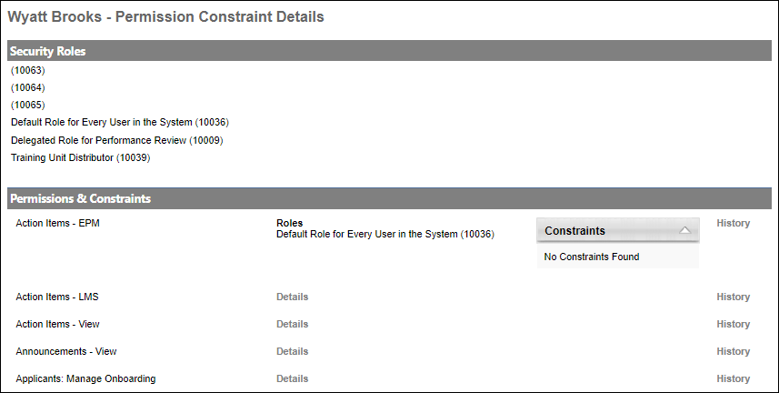
Security Roles
The Security Roles section displays each of the security roles to which the user is assigned. This includes custom security roles assigned to the user and system-defined security roles that are dynamically assigned to the user, such as Manager and Default Role for Every User in the System.
This section displays the security role title and its corresponding role ID.
Permissions & Constraints
The Permissions & Constraints section displays each of the user's permissions and their corresponding roles, constraints, and audit history.
View Permission Details
Select the Details link next to a permission to view each of the user's security roles that contain the permission and any constraints applied to the permission.
View Permission History
Select the History link next to a permission to view history information for the permission.
Note the following:
- All dates and times are displayed in AM/PM format and are localized to the logged in user's time zone.
- No historical data is available to system defined roles, such as Manager, Approver, and Default Role for Every User in the System, unless permissions were manually added to these roles.
The following information is displayed:
- Security Role Details - This section displays details about the user's current and historical security roles that contain the permission. The security roles displayed are based on the user's history with the permission. For example, if the permission is associated with ten security roles in the system but the user is only associated with two of these security roles, then only the two security roles associated with the user are displayed in this section.
- Permissions Constraints Details - This section displays historical details of the constraints that have been defined for the permission at the role level. This section displays the type, value, and dates when the constraint was added or removed.
- User Role Details - This section displays when the user has been added or removed from the security role that contains the permission.
- User Constraint Current Details - This section displays the user's current constraints applied to the permission. The constraints reflect only what the user currently has from roles already assigned as well as system roles, such as Manager, Approver, and Default Role for Every User in the System. Constraints from dynamic roles not yet assigned to the user are not reflected in the list.
- User Constraint History Details - When available, this section displays the user's current and previous constraints applied to the permission.
  - User constraints auditing data are currently not captured in Production and Pilot environments. This will be enabled in Q3. User constraint historical data will only be available from the point auditing is enabled. That is, no user constraint actions (add or remove) that occurred prior to auditing being enabled will be captured in this table.
- Security Role Assignment Details - This section displays details of the historical assignment of the security roles that contain the permission. The details include the following information:
  - Users or OUs to whom the role was assigned or removed, including subordinates
  - Whether the action was immediate or dynamic
  - The merge type for the constraints
  - The administrator who performed the action
  - The date and time of the action
Note: Although administrators cannot perform assignment actions on system-defined roles, these records are still included in the table for visibility purposes.
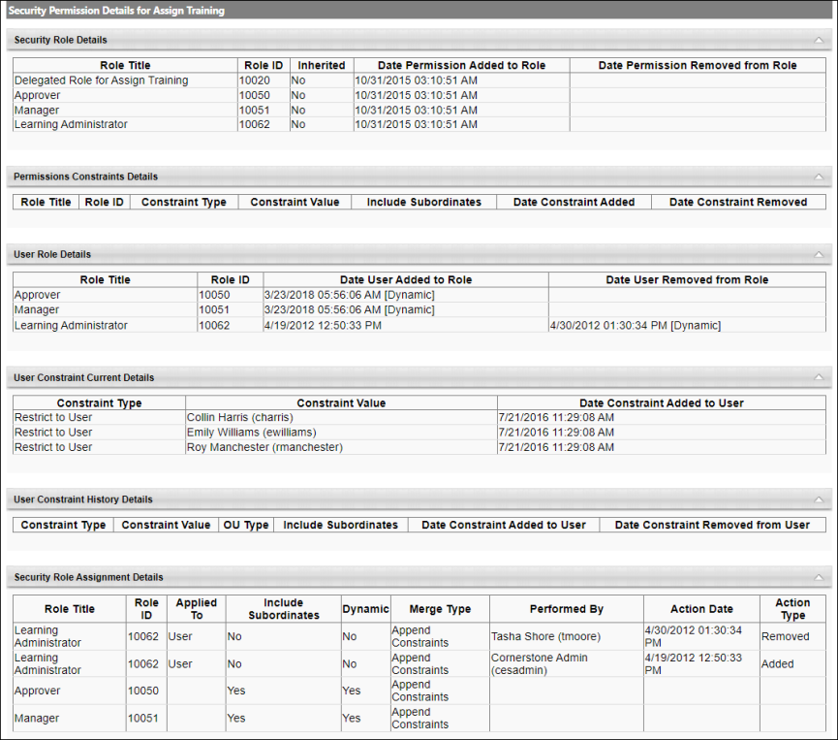

How to Use Permissions Constraints Details
The Permissions Constraints Details page provides administrators with an investigative tool to review and analyze a user’s security profile. For example, if a user reports that they cannot access a page that was previously available to them, this page provides administrators with pertinent information to help streamline the analysis. Having this information on demand allows administrators to take prompt and corrective action more efficiently.
To access the Permissions Constraints Details page for a user, go to Admin > Tools > Core Functions > Users. Select the Options drop-down for the user and select the Permissions Constraints Details option.
Permissions
PERMISSION NAME | PERMISSION DESCRIPTION | CATEGORY

Users - View | Grants the ability to search for and view summary information about users in the portal via the Admin/Users screen. This permission can be constrained by OU, User's OU, User Self and Subordinates, and Users. If multiple constraints are added, these constraints are considered OR statements. This is an administrator permission. | Core Administration

User Permission and Constraint Details - View | Grants ability to access the Permissions Constraints Details page for a user. This permission also grants ability to see the Permissions Constraints Details link on the Permissions page. This permission can be constrained by OU, User's OU, User, and User Self and Subordinates. This is an administrator permission. | Core Administration
Permissions vs. Permissions Constraints Details
The Permissions page accessed from Admin > Tools > Core Functions > Users > Permissions displays the following information:
- Roles, permissions, and constraints the user currently has
- System-defined roles for which the user qualifies
System-defined roles cannot be explicitly assigned to users. They are assigned by the system if the user meets certain properties. System-defined roles are recognizable in the Roles Administration page by the missing User Assignment icon . Examples of system-defined roles:
- Default Role for Every User in the System (most common system-defined role)
- Manager (if the user has one or more direct subordinates)
- Approver (if the user is an approver for one or more other users)
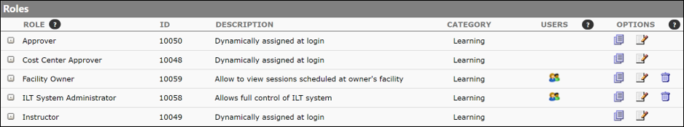
Key notes about system-defined roles:
- System-defined roles and their corresponding permissions and constraints are assigned to users each time they log into the application. This means, that permissions and constraints of a system-defined role are assigned to the user’s security profile last and use the merge type “Append”.
- The permissions and constraints are applied to the users’ security profile only while users are logged in and are removed from their security profile after they log out of the system.
Although system-defined roles are displayed on the Permissions page, their corresponding permissions and constraints are not reflected on this page. This gap in information makes it difficult for administrators to determine the actual security profiles users have when they log in to the system.
The Permissions Constraints Details page provides information about users’ existing roles and system-defined roles which more accurately represent users’ security profile when they are logged into the system. Upon login, the system uses the merge type “Append” to combine any constraints the users have on permissions from other assignable roles, using the same rules defined for appending. See Permission Constraint Calculation Use Cases.
How to Interpret Data on the Details Section
The screenshot of the Permissions page below shows that the user only has six permissions.
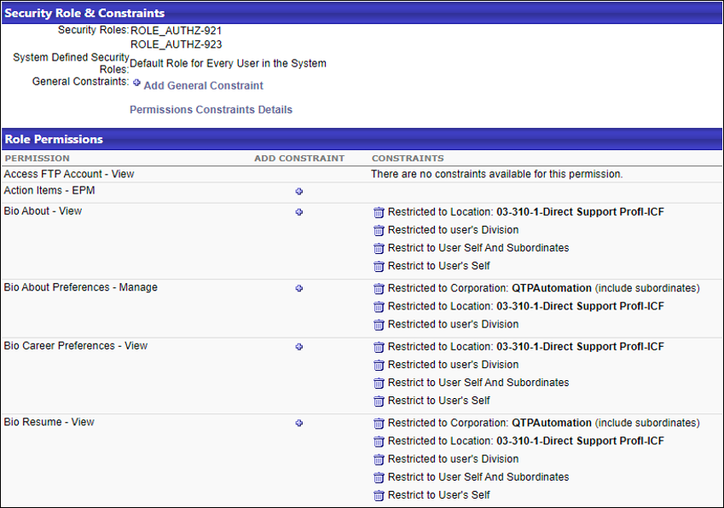
The screenshot of the Permissions Constraints Details page shows the same user to have significantly more permissions. The additional permissions displayed originate from the system-defined role “Default Role for Every User in the System”.
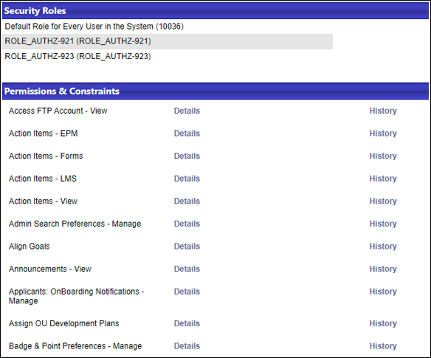
Expanding the Details link for one of the permissions confirms that it originated from the system-defined role “Default Role for Every User in the System”.
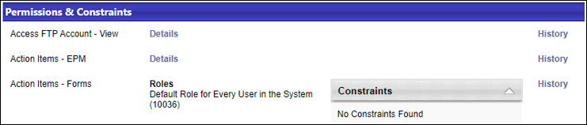
Expanding the Details link for the other permissions displays the following data:
- The roles from which the user received the permission
- The computed constraints for the user and the roles from which they originated
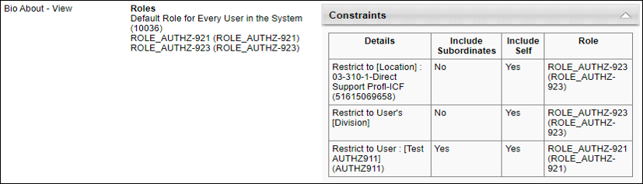
The Permissions Constraints Details page does not display information on dynamically assigned roles unless these roles have already been applied to the user’s security profile. Dynamically assigned roles will not be applied to the user until the next time they log in. Once they are applied, their security properties are persisted on the users’ records. Only then will dynamically assigned roles be visible on the Permissions Constraints Details page.
If administrators have recently defined a dynamic assignment for a role and wish to see it reflected on the Permissions Constraints Details page, they can proxy log in as the user before accessing the page.
How to Interpret Data on the History Page
While the Details section provides information on how the application interprets or computes constraints, the History page displays available raw data about a user's security profile (role, permission, constraints). As such, the data displayed on the Details may not always align with what the History page displays.
The following scenarios clarify why data on the History page are indeed accurate and not contradictory to the Details page.
Scenario 1: Corporation Constraint vs. No Constraint
The Corporation constraint and no constraint have an equal interpretation in the application. When applied to a permission, they give the user the widest access to data in the system. When combined with other constraints, they supersede them. When users have one of these two constraints defined on a permission, any attempt to append new constraints to them will be ignored by the system. The term constraint is used because, by default, most permissions added to a role are unconstrained, thus, giving users the broadest access.
Although the interpretation of Corporation constraint and No Constraint is similar, the system applies them to users differently.
- Corporation constraint has an actual value since it is explicitly selected by administrators or by default by the application for certain permissions.
- No constraint is indicated by the absence of any value.
In this example, on the Permissions page, the user does not have any constraints on the Action Items - EPM permission.
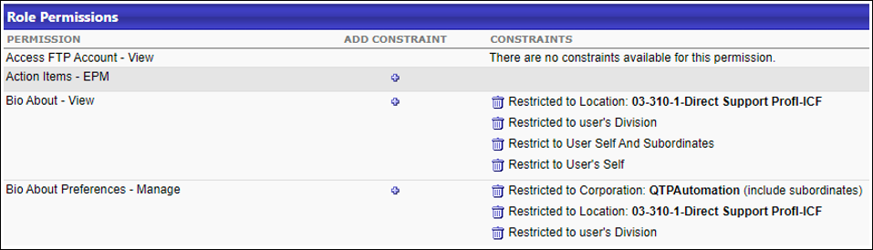
On the Permissions Constraints Details page, the two roles from which the user received the Action Items - EPM permission are listed in the Roles section. In this example, there are no constraints to this permission (No Constraints Found).
For the same permission, the following information is displayed on the History page:
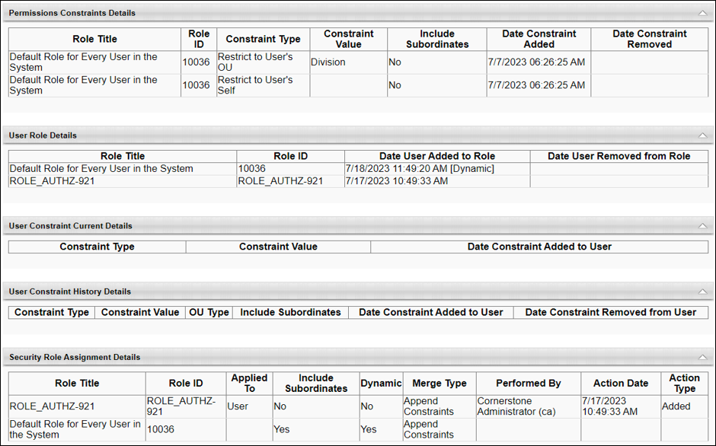
This page tells us that this permission has two constraints associated with the role “Default Role for Every User in the System” (Restrict to User’s OU and User’s Self). Yet, based on the Details and the User Constraint Current Details sections, the user does not have any constraint listed for the Action Items - EPM permission. This is because the user received the same permission from the custom role ROLE_AUTHZ-921, which does not have any constraints. When appending constraints, the application ignores constraints if the user has the permission unconstrained from a different role.
Scenario 2: Order of Role Assignment
In this example, on the Permissions page, the user has three constraints applied on the does not have any constraints on the Bio About Preferences - Manage permission.
On the Permissions Constraints Details page, we see only one constraint applied to this permission. The user received the Corporation constraint from the custom role ROLE_AUTHZ-921 which overrides the other two constraints noted on the Permissions page (Location and user's Division constraints).
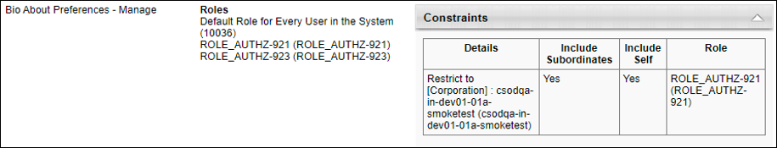
For the same permission, the following information is displayed on the History page:
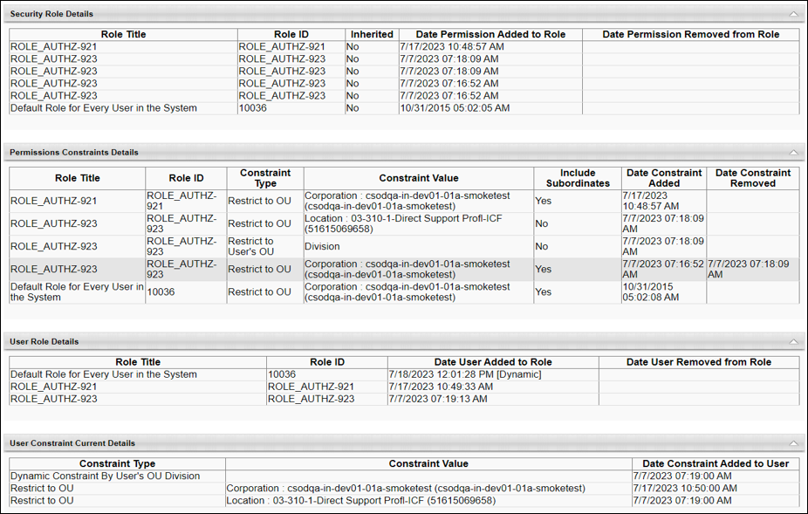
There are three constraints listed under the User Constraint Current Details section. Yet, when the user logs in to the application, the user appears to have unrestricted access on their Bio About Preferences - Manage permission. To understand this outcome, examine the records on the History page by correlating the records from different sections of the page.
- The User Constraint Current Details section shows the user’s current constraints and when each were added. In the screenshot below, we can see that the user received the Location OU and User’s Division constraints before the Corporation constraint. Note: Constraints associated with system-defined roles are not displayed in the User Constraint Current Details section.
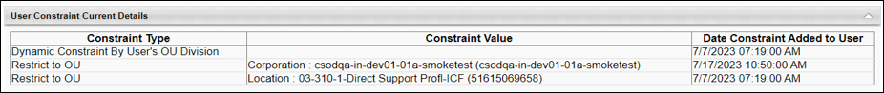
- The user’s constraint information above corresponds with the order in which the user was assigned to the roles.
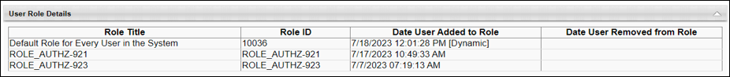
- The details in the Security Role Assignment Details section further verify the data.
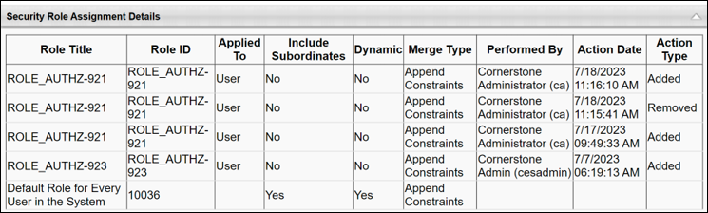
- The information above aligns with the role data displayed in the Permissions Constraints Details section.
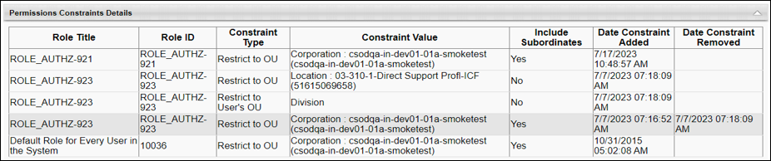
Based on the data displayed on the History page, we see that the role ROLE_AUTHZ-923 has constraints before they were assigned to the user. These constraints were applied to the user when the role was added to the user’s security profile. However, the Corporation constraint from ROLE_AUTHZ-921 supersedes the Location and Division OU constraints, thereby giving this user unrestricted access on their Bio About Preferences - Manage permission. Note that the Corporation constraint from the system-defined role “Default Role for Every User in the System” is skipped since the user already had the same constraint prior to logging in to the system.
This example indicates that order matters in how constraints are saved and applied in the application.
Use Cases on Permission Constraint Calculations
Assumption
- Merge type "Append" is used in all of the following use cases
Conditions
- Role 1: Permission A - Constraint By Location OU
- Role 2: Permission A - No Constraint
- Role 3: Permission A - Corporation Constraint
Use Case 1:
- User receives Role 2 (without constraint)
- User receives Role 1 (with Location OU constraint)
- Result: The user has no constraints for Permission A.
Use Case 2:
- User receives Role 1 (with Location OU constraint)
- User received Role 2 (without constraint)
- Result: User has a Location OU constraint on Permission A. Because Role 2 has no constraint and the user already had a constraint from Role 1, the system does not remove the existing Location constraint.
Use Case 3:
- User receives Role 3 (with Corporation constraint)
- User receives Role 1 (with Location OU constraint)
- Result: The user has no constraints for Permission A.
Use Case 4:
- User receives Role 1 (with Location OU constraint)
- User receives Role 3 (with Corporation constraint)
- Result: The system appends the Corporation constraint to the user's security profile records for Permission A. Although the user has two constraints, Location and Corporation, the presence of the Corporation constraint overrides other constraints. The application determines the user has the Corporation constraint (no constraints) for Permission A.
As demonstrated by these use cases, the order of role assignment and their corresponding permissions and constraints, and the type of constraints specified in each are critical to determine the security profile for users in the application.
Due to the complexity of the processing and application of security on user profiles, the Permissions Constraints Details page and the History page provide powerful tools to enable administrators to investigate perceived security issues.

