Training Tools March 2024

Table of Contents
Training Tools Overview 1
Data Merge Overview 2
Data Merge - Merge User Accounts 4
Data Merge - History 8
Data Merge Rules 10
Training Removal Tool 12
Training Removal Job - Create 14
Create Training Removal Job Using CSV 16
Create Training Removal Job Using Search Criteria 21
Training Removal Details Page 37
Removing Events and Sessions from Users' Transcripts 39
Training Update Tool Overview 41
Training Update - Create 42

Training Tools Overview
Training Tools allow administrators to perform certain training-related actions in bulk, such as removing training, merging user training data, and updating training information.

Data Merge Overview
The Data Merge tool enables administrators to merge user training records when multiple accounts exist in the system for the same person. This is useful when a user has multiple accounts and has completed training in each account. The Data Merge tool will merge the training from both accounts.
Exclusions: The Data Merge tool does not merge training items if they already exist on the recipient account; this includes equivalencies, other versions of the training, and if the training is used in a certification. The Data Merge tool does not merge Certification type trainings.
The Data Merge functionality is available within Configuration Tools and can also be added to Navigation Tabs and Links.
Best Practice: When using the Data Merge tool, it is a best practice to only merge user training records when the donor account has no more than 50 items on their transcript.
To access the Data Merge page, go to Admin > Tools > Learning > Training Tools > Data Merge.
Permissions
PERMISSION NAME | PERMISSION DESCRIPTION | CATEGORY

Training Data Merge - Manage | Grants ability to merge the training records of multiple existing accounts and deactivate one of the accounts, if necessary. The availability of this permission is controlled by a backend setting. This permission can be constrained by OU, User's OU, User Self and Subordinates, and Users. The applied constraints limit the users that are available to be merged and that are displayed in the History section. This is an administrator permission. | Core Administration

Training Data Merge - View | Grants ability to view past training record merges. The availability of this permission is controlled by a backend setting. This permission can be constrained by OU, User's OU, User Self and Subordinates, and Users. Which records are displayed in the History section is dependent on creator constraints. This is an administrator permission. | Core Administration
Terminology
- Donor Account - This is the account from which the training records are being transferred.
- Recipient Account - This is the account to which the training records are being transferred.
Use Case
A user accidentally creates three new accounts for themselves on three different days. The user has completed training in each account, so it is not appropriate to delete any of the accounts. Instead, the administrator decides to merge the accounts in order to consolidate the user's training. The administrator merges the second account into the first and deactivates the second account. The administrator then merges the third account into the first and deactivates the third account.
Implementation
This functionality is controlled by a backend setting.

Data Merge - Merge User Accounts
The Data Merge tool enables administrators to merge user training records when multiple accounts exist in the system for the same person. This is useful when a user has multiple accounts and has completed training in each account. The Data Merge tool will merge the training from both accounts.
Exclusions: The Data Merge tool does not merge training items if they already exist on the recipient account; this includes equivalencies, other versions of the training, and if the training is used in a certification. The Data Merge tool does not merge Certification type trainings.
Only two user accounts can be merged at a time.
Best Practice: When using the Data Merge tool, it is a best practice to only merge user training records when the donor account has no more than 50 items on their transcript.
To access the Data Merge page, go to Admin > Tools > Learning > Training Tools > Data Merge.
Permissions
PERMISSION NAME | PERMISSION DESCRIPTION | CATEGORY

Training Data Merge - Manage | Grants ability to merge the training records of multiple existing accounts and deactivate one of the accounts, if necessary. The availability of this permission is controlled by a backend setting. This permission can be constrained by OU, User's OU, User Self and Subordinates, and Users. The applied constraints limit the users that are available to be merged and that are displayed in the History section. This is an administrator permission. | Core Administration

Training Data Merge - View | Grants ability to view past training record merges. The availability of this permission is controlled by a backend setting. This permission can be constrained by OU, User's OU, User Self and Subordinates, and Users. Which records are displayed in the History section is dependent on creator constraints. This is an administrator permission. | Core Administration
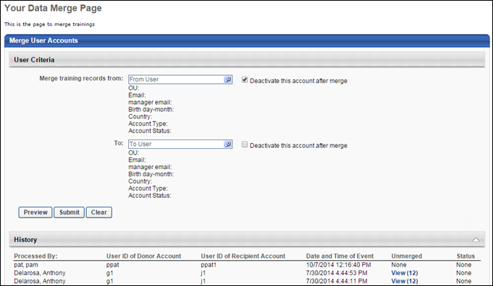
Merge Accounts
There are rules that apply to all training items being moved from one user record to another. See Data Merge Rules on page 10 for additional information.
To merge user accounts, you must select the user account from which the training records are being transferred and the user account to which the training records are being transferred. Note: Only administrators with the appropriate permission can merge user accounts. Which users are available to be merged is dependent upon the administrator's permission constraints.
- From User - The From User is the user from which the training records are being transferred (i.e., the Donor Account). Click this field to select the From User.
- To User - The To User is the user to which the training records are being transferred (i.e., the Recipient Account). Click this field to select the To User.
Once a user is selected, the following information displays for that user:
- OU - This displays the OU with which the user is associated.
- Email - This displays the email address that is associated with the user's account.
- Manager Email - This displays the email address of the manager that is associated with the user's account.
- Birth Day-Month - This displays the user's birth month and day.
- Country - This displays the country with which the user is associated.
- Account Type - This displays the user's account type (e.g., Data Feed, Self Registration).
- Account Status - This displays whether the user's account is active or inactive.
The administrator can remove either the From User or the To User by clicking the Remove icon to the right of the user's name.
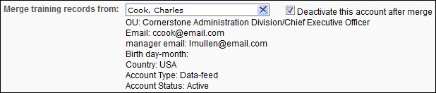
Deactivate Account
To deactivate either the From User account or the To User account, select the Deactivate this account after merge field to the right of the corresponding field. If this option is selected for the From User field, then the From User will be deactivated after the merge is complete. If this option is selected for the To User field, then the To User will be deactivated after the merge is complete. If this option is deselected for a field, then the corresponding user record remains active after the merge is complete.
Preview
After a From User and a To User are selected, the administrator can click the Preview button to view all of the training that will be added to the To User's account after the merge is complete. The preview appears in a pop-up and includes the Active, Completed, and Archived tabs of the transcript.
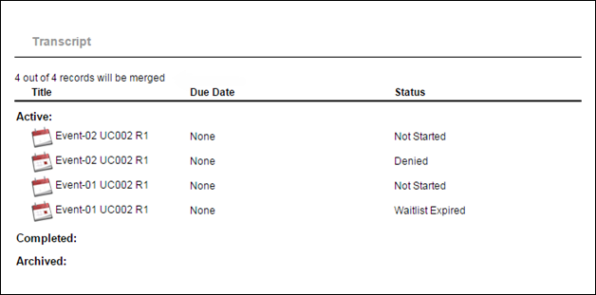
Submit
After selecting a From User and a To User, click Submit to complete the data merge. The data merge process is asynchronous. This means that the system merges the two accounts in the background, while the administrator can move on to other areas of the system. When the data merge is complete, the administrator can return to the Data Merge Tool and view the results of the merge.
When the data merge is completed, this triggers the Transcript Updated email, if configured.
History
At the bottom of the Data Merge page, the History section displays a history of completed data merges. See Data Merge - History on page 8 for additional information.
EMAIL NAME | EMAIL DESCRIPTION | ACTION TYPE

Transcript Updated | This email can be configured as a notification. When configured as a notification, this email is triggered when a transcript is updated via Data Merge. Either training records must be moved or an account should be deactivated for the email trigger to be activated. This email trigger is in the Training Action Type. This trigger can be sent to Destination User's Manager, Source User's Manager, Destination User, and Source User. | Training

Data Merge - History
At the bottom of the Data Merge page, the History section displays a history of completed data merges. After a data merge is complete, it appears in the History section. The most recent data merges appear first.
To access the Data Merge page, go to Admin > Tools > Learning > Training Tools > Data Merge.
Permissions
PERMISSION NAME | PERMISSION DESCRIPTION | CATEGORY

Training Data Merge - Manage | Grants ability to merge the training records of multiple existing accounts and deactivate one of the accounts, if necessary. The availability of this permission is controlled by a backend setting. This permission can be constrained by OU, User's OU, User Self and Subordinates, and Users. The applied constraints limit the users that are available to be merged and that are displayed in the History section. This is an administrator permission. | Core Administration

Training Data Merge - View | Grants ability to view past training record merges. The availability of this permission is controlled by a backend setting. This permission can be constrained by OU, User's OU, User Self and Subordinates, and Users. Which records are displayed in the History section is dependent on creator constraints. This is an administrator permission. | Core Administration
The following information is displayed for each data merge:
- Processed By - This displays the name of the administrator who performed the data merge.
- User ID of Donor Account - This displays the user ID associated with the user account from which the training records were merged (i.e., the From User).
- User ID of Recipient Account - This displays the user ID associated with the user account to which the training records were merged (i.e., the To User).
- Date and Time of Event - This displays the date and time at which the data merge was processed. Note: This is not the time the administrator clicked Submit. This field is empty until the data merge is processed.
- Unmerged - This displays the number of training items that were not merged to the recipient account. Click the View (#) link to open a pop-up that displays all training items that were not merged.
- Status - This column displays the current status of the data merge.
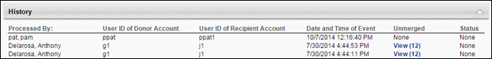
View Unmerged Items Pop-up
This pop-up displays all training items that were not merged to the recipient account for a data merge. These are the training items that already existed on the recipient training record, perhaps in a different status, version, or registration number.
This pop-up is accessed by clicking the View (#) link in the History section.
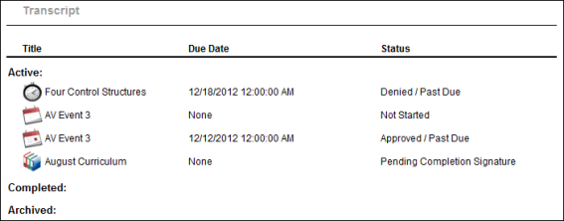

Data Merge Rules
The following rules apply to all training items being moved from one user record to another:
- Best Practice: When using the Data Merge tool, it is a best practice to only merge user training records when the donor account has no more than 50 items on their transcript.
- Training that is transferred from one user record to another will restart the approval process based on the settings associated with the recipient account.
  - Example 1: The donor account is in a status of Pending Approval. The course requires two training approvals in order to register. The donor account receives one approval, and then their training record is merged. After the merge, the recipient account remains in a status of Pending Approval and begins the initial approval process from the beginning, based on the settings associated with the recipient account.
  - Example 2: The donor account is in a status of In Progress and the training record is merged. After the merge, if the course requires completion approval, then this is defined in the settings of the recipient account.
  - Example 3: The donor account is in a status of Pending Completion Approval. The course requires two completion approvals in order to be considered Complete. The donor account receives one approval, and then their training record is merged. After the merge, the recipient account remains in a status of Pending Completion Approval and begins the completion approval process from the beginning, based on the settings associated with the recipient account.
- For sessions, the donor account is withdrawn from the session. Because the recipient account must restart the approval process, the recipient account is not always registered in the session.
- The Data Merge tool does not merge removed training items from the donor account to the recipient account.
- The Data Merge tool does not merge Certification type trainings.
- The Data Merge tool does not merge a training item if it already exist on the recipient account; this includes equivalencies, other versions of the training, and if the training is used in a certification.
  - If the same training item is listed on both training records, the one in the recipient account remains and the one in the donor account is not merged, regardless of the status or version of either course.
  - For sessions, if the recipient account already has the session, then that record remains and no merge occurs. This is regardless of status. If the recipient account is waitlisted in a session and the donor account is registered in the same session, the user retains the status associated with the recipient account.
  - If the recipient account has a completed course that is an equivalent to a course in the donor account, the course is not transferred.
- For curricula, if the recipient account has the curriculum on their transcript (prerequisite, stand-alone item, pre-work, post-work, or as part of another curriculum), the curriculum is not transferred. Also, if a learning object (LO) within a curriculum exists on the recipient account's transcript (prerequisite, stand-alone item, pre-work, post-work, or as part of another curriculum), the LO is not transferred. Note: If an LO in the merge is part of ANY curriculum on the donor account, the merge will fail, even if the curriculum is NOT the one being merged.
- For On the Job Training (OJT) materials, there are considerations for the Data Merge Tool:
  - If the donor account is registered for an OJT material, we will transfer and update the manager data to allow the correct manager to do the observation. In other cases, the learner will have the Notify Observer option.
  - If the OJT material is in a Completed status on the donor account, the recipient account will receive the completed material without the observation history. Any attachments, comments, scoring, or training hours recorded will no longer be available on the recipient account's transcript.

Training Removal Tool
The Training Removal Tool page enables administrators to remove up to 20 training items from multiple users' transcripts at one time. From this page, administrators can also view the list of previously processed training removal jobs and view the details of each training removal job.
Use Cases
- An administrator has mistakenly created and run a proxy enrollment that enrolls the entire Product Management department into Photoshop 2012 Training when she meant to enroll them into Photoshop 2013 Training. The administrator uses the Training Removal Tool to run a batch process that removes the 2012 course from the users' transcripts. She then creates and runs a second proxy enrollment that adds the correct 2013 course to the users' transcripts.
- An administrator assigns training to 10 OUs, and then realizes that one of the OUs should not have been assigned the training. The administrator uses the Training Removal Tool to run a batch process that removes the training only for users in that particular OU.
To access the Training Removal Tool page, go to Admin > Tools > Learning > Training Tools > Training Removal Tool.
Permissions
PERMISSION NAME | PERMISSION DESCRIPTION | CATEGORY

Bulk Training Removal - Manage | Grants ability to bulk remove training from users’ transcripts. This permission can be constrained by OU and User's OU. Creator constraints also apply. This is an administrator permission. | Learning - Administration
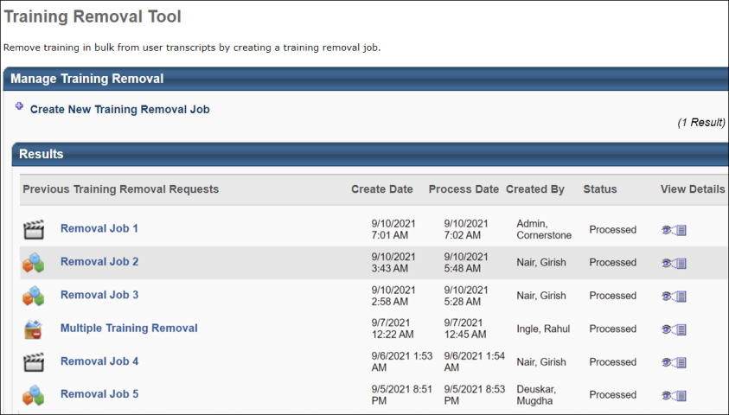
Create New Training Removal Job
Click the Create New Training Removal Job link to create a new training removal job. See Training Removal Job - Create on page 14 for additional information.
For a list of training statuses which are eligible for removal via the Training Removal Tool, please see Training Removal Tool - Create - Step 3 - Status.
Manage Training Removal Table
The Manage Training Removal table displays previously processed training removal jobs. The following columns display in the table:
- Previous Training Removal Requests - This column displays the linked title of the training removal job and an associated learning object (LO) type icon. This column is sortable.
- Create Date - This column displays the date and time at which the training removal job was submitted by an administrator. This field displays in the user's time zone.
- Process Date - This column displays the date and time at which the training removal job was processed. The time displays in the time zone of the user viewing the page. This column also defines the sort order, from most to least recent training removal job. This column is sortable.
- Created By - This column displays the name of the administrator who created the training removal job. This column is sortable.
- Status - This column displays the current status of the training removal job. The following statuses may appear in this column:
  - Queued - The job has not yet begun processing or is currently processing.
  - Processed - The job has finished processing.
- View Details - Click the View Details icon to open the Training Removal Details page. This column is not sortable. See Training Removal Details Page on page 37 for additional information.
Restore Training
See Restore Training for additional information.

Training Removal Job - Create
From the Create a New Training Removal Job page, you can create a new training removal job to remove training from multiple users' transcripts at one time. For a list of training statuses that can be removed using the Training Removal Tool, please see Training Removal Tool - Training Statuses.
Important Note: In the scenario where a user has completed a learning object (LO) in the past and also has a new instance of the LO on their Active transcript, if the LO is removed via the Training Removal Tool, then the tool removes all instances of the LO from user's transcript. This includes the instance of the LOs that is in a Completed status.
To create a new training removal job, go to Admin > Tools > Learning > Training Tools > Training Removal Tool. Then, click the Create New Training Removal Job link.
Permissions
PERMISSION NAME | PERMISSION DESCRIPTION | CATEGORY

Bulk Training Removal - Manage | Grants ability to bulk remove training from users’ transcripts. This permission can be constrained by OU and User's OU. Creator constraints also apply. This is an administrator permission. | Learning - Administration
Training Removal Job Steps
There are to ways to create a training removal job:
- Remove training by search criteria
- Remove training by CSV upload - Up to 200,000 users can be added to a training removal job using this method. The CSV Bulk Training Removal - Manage permission is needed to access this option.
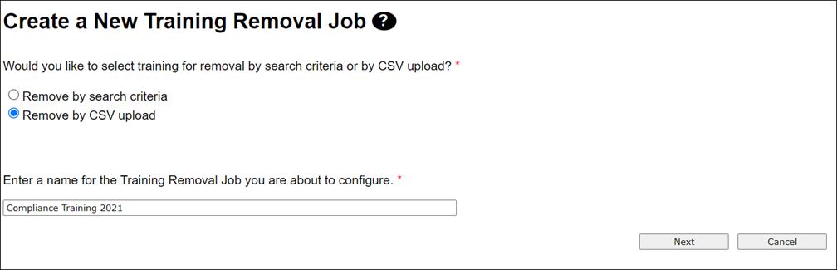
The steps differ depending on which removal method you select on the first page of the process.
Remove by Search Criteria
There are five steps to creating a training removal job using search criteria:
- Training - Choose training for the training removal job. Up to 20 training items can be included in a training removal job, and only the most recent version of the training will be removed from users' transcripts. See Training Removal Job - Create - Step 1 - Training on page 22 for additional information.
- Users - Choose the users/OUs for whom the training will be removed. See Training Removal Job - Create - Step 2 - Users on page 27 for additional information.
- Status - Select which statuses the training can be in on a user's transcript in order for the training to be removed. See Training Removal Job - Create - Step 3 - Status on page 29 for additional information.
- Reason - Define the reason for removing the training. See Training Removal Job - Create - Step 4 - Reason on page 32 for additional information.
- Confirm - Review the training removal job configurations and save the training removal job for processing. See Training Removal Job - Create - Step 5 - Confirm on page 34 for additional information.
Remove by CSV Upload
There are three steps to creating a training removal job using a CSV upload:
- Upload CSV - Upload a CSV file of users and the training items that should be removed from those users' transcripts. See Create Training Removal Job Using CSV - Step 1 - CSV Upload on page 17 for additional information.
- Reason - Define the reason for removing training. See Create Training Removal Job Using CSV - Step 2 - Reason on page 19 for additional information.
- Confirm - Review the training removal job configurations and save the training removal job for processing. See Create Training Removal Job Using CSV - Step 3 - Confirm on page 20 for additional information.
Cancel
Clicking the Cancel button from any step of the training removal process without saving the training removal job redirects you to the Training Removal page without saving the training removal job.

Create Training Removal Job Using CSV
Create Training Removal Job Using CSV - Step 1 - CSV Upload
On the first step of creating a training removal job using a CSV, you will upload a CSV file of users and the training items that should be removed from those users' transcripts. Up to 200,000 users can be added to a training removal job using this method.
To create a new training removal job, go to ADMIN > TOOLS > LEARNING > TRAINING TOOLS > TRAINING REMOVAL TOOL. Then, click the Create New Training Removal Job link.
Permissions
PERMISSION NAME | PERMISSION DESCRIPTION | CATEGORY

CSV Bulk Training Removal - Manage | Grants administrators access to the Remove by CSV Upload option and workflow in the Training Removal Tool, which allows the administrator to add users to a training removal job via a CSV file. This permission cannot be constrained. | Learning - Administration

Bulk Training Removal - Manage | Grants ability to bulk remove training from users’ transcripts. This permission can be constrained by OU and User's OU. Creator constraints also apply. This is an administrator permission. | Learning - Administration
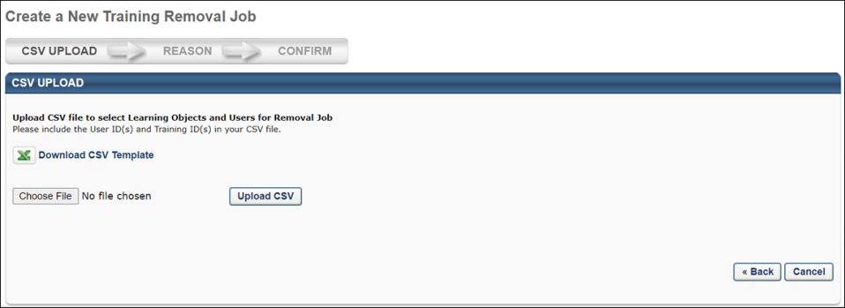
Upload CSV
To download a CSV template file that will allow you to create a file of users and training items that should be removed from users' transcripts, click the Download CSV Template link. The file will download to your device, and you can input the following information into the spreadsheet:
- User ID
- Training Object ID - You can find the Training Object ID for training items via the Course Catalog or Course Console.
- After configuring your file of users and training, click the Choose File button and select the file from your computer.
- Click the Upload CSV button.
- If the file uploads successfully, a Next button appears. Click the Next button to continue configuring the training removal job.
If the system detects a problem with your file, an error message will display. You will need to fix the problem with the CSV before you can continue configuring the training removal job.
Create Training Removal Job Using CSV - Step 2 - Reason
On the second step of creating a training removal job using a CSV, select a reason for removing the training and add comments explaining the removal job.
To create a new training removal job, go to ADMIN > TOOLS > LEARNING > TRAINING TOOLS > TRAINING REMOVAL TOOL. Then, click the Create New Training Removal Job link.
Permissions
PERMISSION NAME | PERMISSION DESCRIPTION | CATEGORY

CSV Bulk Training Removal - Manage | Grants administrators access to the Remove by CSV Upload option and workflow in the Training Removal Tool, which allows the administrator to add users to a training removal job via a CSV file. This permission cannot be constrained. | Learning - Administration

Bulk Training Removal - Manage | Grants ability to bulk remove training from users’ transcripts. This permission can be constrained by OU and User's OU. Creator constraints also apply. This is an administrator permission. | Learning - Administration
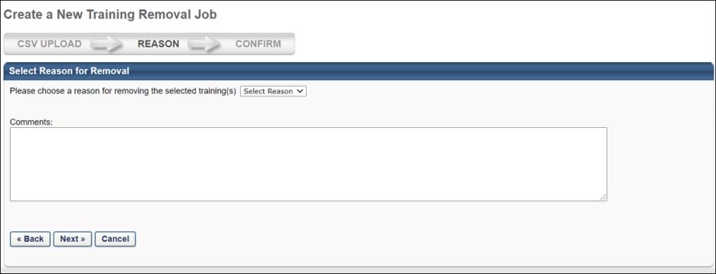
Select Reason
- Select a reason for removing training from the Select Reason drop-down menu.
- Enter comments explaining the reason for the training removal job in the Comments box.
- Click the Next button to proceed to the final step of creating the training removal job.
Create Training Removal Job Using CSV - Step 3 - Confirm
The final step in creating a training removal job using CSV is the Confirm step in which you confirm the selected settings and submit the job.
To create a new training removal job, go to ADMIN > TOOLS > LEARNING > TRAINING TOOLS > TRAINING REMOVAL TOOL. Then, click the Create New Training Removal Job link.
Permissions
PERMISSION NAME | PERMISSION DESCRIPTION | CATEGORY

CSV Bulk Training Removal - Manage | Grants administrators access to the Remove by CSV Upload option and workflow in the Training Removal Tool, which allows the administrator to add users to a training removal job via a CSV file. This permission cannot be constrained. | Learning - Administration

Bulk Training Removal - Manage | Grants ability to bulk remove training from users’ transcripts. This permission can be constrained by OU and User's OU. Creator constraints also apply. This is an administrator permission. | Learning - Administration
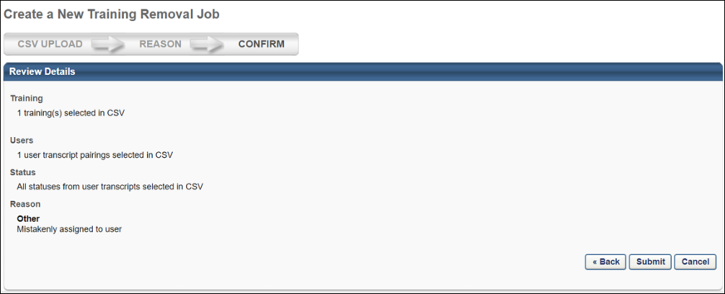

Create Training Removal Job Using Search Criteria
Training Removal Job - Create - Step 1 - Training
When creating a training removal job, the first step is to find the training items you wish to remove. You can find training items by entering the title or keyword in the search field, or search by description, provider, language, locator number, or location. You can include or exclude specific training types of learning in your search.
Note: Up to 20 training items can be added per training removal job, and only the most recent version of the training will be removed from users' transcripts.
To create a new training removal job, go to Admin > Tools > Learning > Training Tools > Training Removal Tool. Then, click the Create New Training Removal Job link.
Permissions
PERMISSION NAME | PERMISSION DESCRIPTION | CATEGORY

Bulk Training Removal - Manage | Grants ability to bulk remove training from users’ transcripts. This permission can be constrained by OU and User's OU. Creator constraints also apply. This is an administrator permission. | Learning - Administration

Training Removal Catalog - View | This permission enables constraining of training removal requests to learning objects that are available to the administrator as a user when searching for training. This permission works in conjunction with the Bulk Training Removal - Manage permission. This permission can be constrained by User and LO Availability. This is an administrator permission. | Learning - Administration
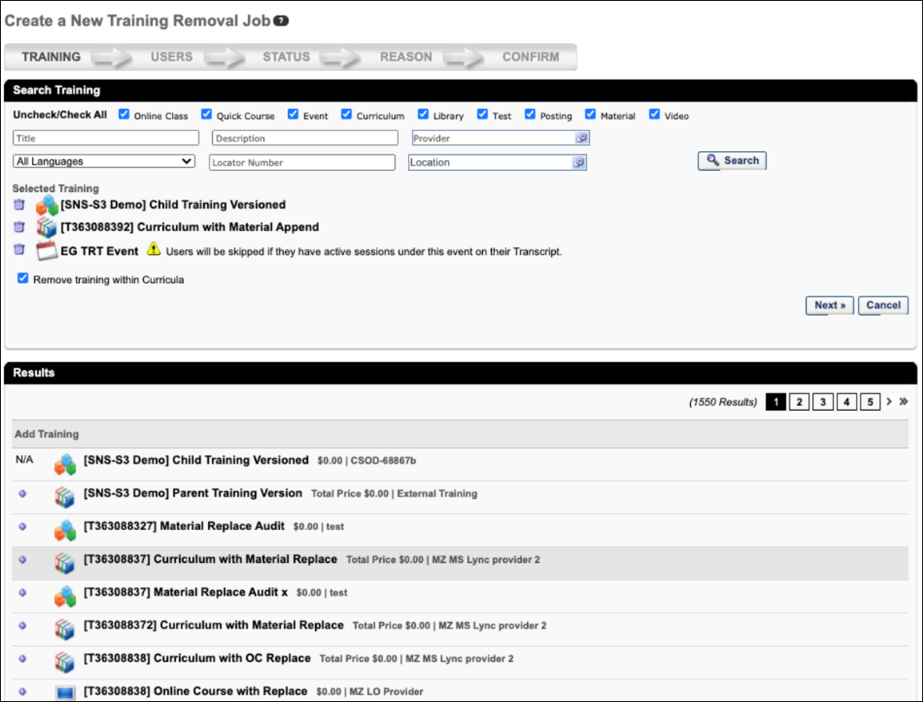
Search for Training
Use the search fields and filters to search for training to add to the training removal job. Only training items that are active and within the administrator's constraints for the permission to view the training catalog are displayed. The following search filters are available:
- LO Type - Select the appropriate learning object type checkboxes to search for a particular LO type. Only LOs that are the selected LO types are returned in the search results. Use the Uncheck/Check All link to select or deselect all LO types.
- Title - Search for LO by title. You can enter all or part of the LO title. All available LOs with a title that matches the criteria are returned.
- Description - Search for LO by description. You can enter all or part of the LO description. All available LOs with a description that matches the criteria are returned.
- Provider - Click this field to open the Search Providers pop-up and select a particular LO provider. Only available LOs from the specified provider are returned.
- Language - From the Language drop-down list, select the language of the LO. Only available LOs with the selected language are returned.
- Locator Number - Search for a session LO by locator number. This field is only available if the Events LO type is selected. All available events with a session that has a matching locator number are returned.
- Location - Click this field to open the Select Location pop-up and select a particular session location. This field is only available if the Events LO type is selected. All available events with a session that has a matching location are returned.
Remove Inactive Training
A Remove Inactive Training checkbox is available in the Search Training section. Selecting this checkbox causes inactive training to be included in the search results. Inactive training is includes an "Inactive" note after the Provider name in search results. These inactive training items can be selected and removed in the same manner as active training.
Select Training
After searching for training, the search results appear in the Results section. Select the checkbox to the left of a training item to add it to the training removal job. Up to twenty training items can be selected. After selecting up to 20 training items, click the Next button to proceed to the next step of the training removal job creation process.
- Note: If more than 20 training items have been selected for the training removal job, an error appears, stating, "You have selected more than the limit of 20 trainings. Please remove trainings from your list before proceeding." The Next button at the bottom of the page will not be clickable until the number of selected training items has been reduced to 20 or fewer.
- Note: When selecting multiple training items for removal, events and their sessions cannot be selected for removal at the same.
- Note: If the LO selected has multiple versions, only the version selected for the training removal job is removed from users' transcripts. Other versions of the training on users' transcripts are not affected.
- Note: If the LO selected is a prerequisite of another training, it cannot be removed.
Removing Sessions of an Event
On the Training step of the training removal job creation process, administrators can opt to remove the child sessions of any events selected for the job. Select the Remove All Sessions of the Selected Events option to ensure that child sessions of any selected events are also removed from users' transcripts when the removal job processes. Note: All child sessions of selected events will be removed from users' transcripts, even if the sessions are in an Active status on the user's transcript.
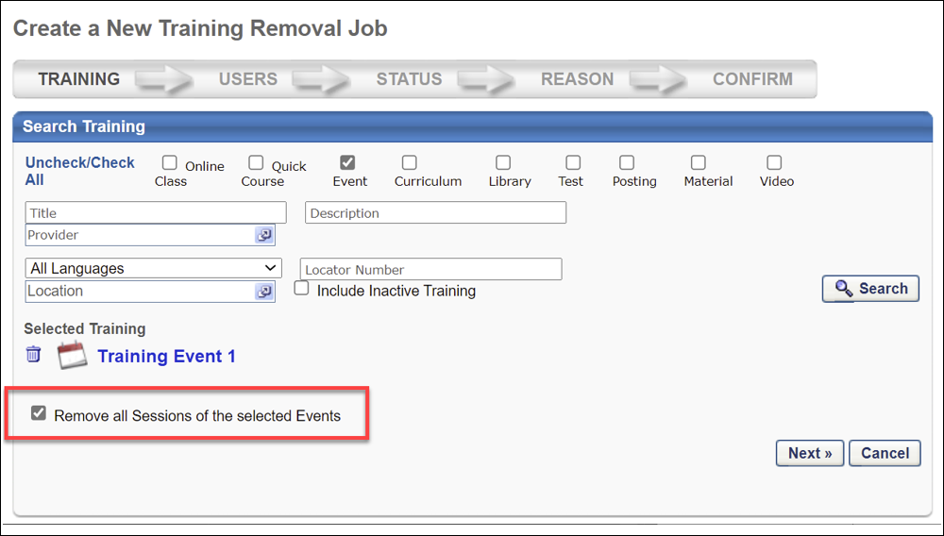
Removing a Curriculum
When a curriculum is selected during this step, the curriculum appears in the Selected Training section with a Remove training within the Curriculum option below the curriculum title. Selecting this option allows you to ALSO remove child learning objects (LOs) contained within the curriculum from users' transcripts. This option is not selected by default. To enable this setting, check the box for Remove training within the Curriculum. Note: The entire curriculum, including its child training, remains intact when removed via the Training Removal Tool, Learning Assignment Tool, or by manual transcript removal. This preserves the structure of the removed curriculum and eliminates the need for transcript cleanup. Upon reassignment, the intact curriculum moves to the Active tab of the user's transcript. Important: This behavior only applies to curriculum child training items which are in a non-completed status. In other words, if a curriculum child training is in a Completed, Completed Equivalent, or Exempt status, it will not remain intact within the curriculum; it will remain as a standalone completed training item on the Completed tab of the user's transcript. Similarly, upon reassignment of the curriculum, these completed training items will remain as standalone items on the Completed tab.
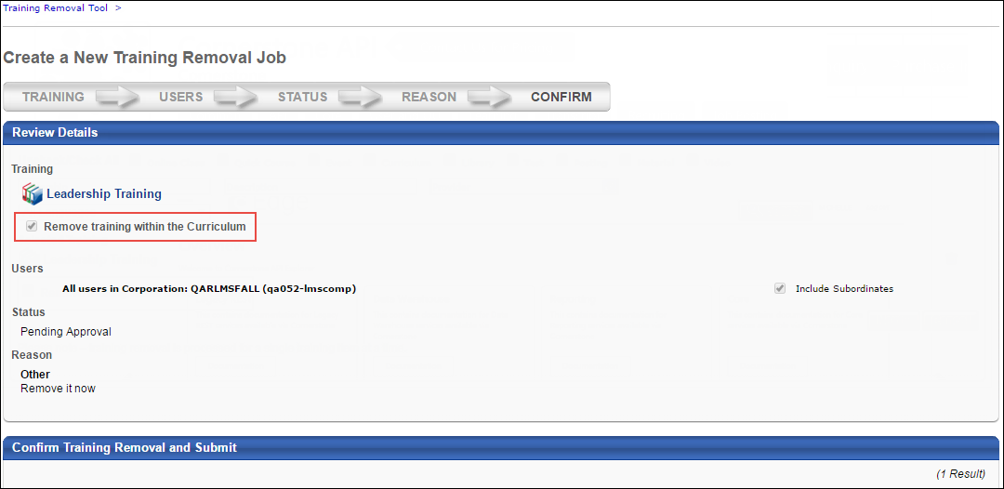
Note: If the child training contained within a curriculum cannot be removed from the user's transcript due to an exception in this scenario, it remains as a standalone LO on the user’s transcript, and the due date for the child LO, if any, is removed. If the LO is within another curriculum on the User’s transcript and left as standalone, it will then inherit the Due Date set for the LO in the curriculum structure.
The due date behaviors for LOs that cannot be removed are:
- If the LO has no parent LO, the due date is set to “No Due Date.”
- If the LO has one or more parent LOs:
  - If the LO has one parent, the due date is set as the parent’s due date. If the parent LO has no due date, the child LO due date is set to “No Due Date.”
  - If the LO has multiple parent LOs, due date is set as the minimum due date from the parent. For example, if the due date of Parent 1 is 3/1/2017 and the due date of Parent 2 is 1/1/2017, then the due date for the child LO is 1/1/2017).
Next
After selecting the LO, click Next to proceed to the Users step. See Training Removal Job - Create - Step 2 - Users on page 27 for additional information.
Click Cancel to return to the Training Removal Tool page without submitting the training removal job. See Training Removal Tool on page 12 for additional information.
Training Removal Job - Create - Step 2 - Users
When creating a training removal job, the second step is to select the users for whom the training is being removed. There is no limit on the number of users which can be included in the training removal job. Up to 20 training items can be removed in a single training removal job.
To create a new training removal job, go to Admin > Tools > Learning > Training Tools > Training Removal Tool. Then, click the Create New Training Removal Job link.
Permissions
PERMISSION NAME | PERMISSION DESCRIPTION | CATEGORY

Bulk Training Removal - Manage | Grants ability to bulk remove training from users’ transcripts. This permission can be constrained by OU and User's OU. Creator constraints also apply. This is an administrator permission. | Learning - Administration

Training Removal - Remove Completed | Grants administrators the ability to bulk remove training in Completed, Completed (Equivalent), and Exempt statuses from users' transcripts. This permission can be constrained by OU and User's OU. This is an administrator permission. | Learning - Administration
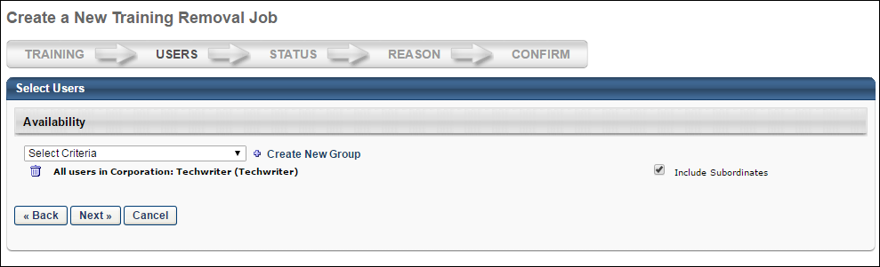
Select Users
- From the Select Criteria drop-down list, select the appropriate OU type, then click the pop-up icon to select the OU or user. At least one user must be selected. There is no limit on the number of users which can be included in the training removal job. Up to 20 training items can be removed in a single training removal job.
- Check the Include Subordinates box to include child OUs for the selected OUs or direct reports of the users if specific users have been selected.
- Click the Create New Group link to create a group. See Create Group for additional information.
- You can remove criteria from the Select Users panel by clicking the Trash Can icon to the left of the OU or user's name.
- All users selected on the Users step will have the learning object selected on the Training step removed from their transcript.
- After selecting the users, click Next to proceed to the Status step. See Training Removal Job - Create - Step 3 - Status on page 29 for additional information.
All training items selected for removal will be applied to all the users selected for the training removal job.
- If a user does not have all of the selected training items on their transcript, they will only be removed from those that do appear on their transcript.
- It is not possible to select separate user groups for different training items within the same removal job. If different sets of users should be removed from different training items, it is necessary to create separate training removal jobs to achieve this.
- If user has the Training Removal - Remove Completed permission, use this permission's constraints for user selection. Otherwise, use the constraints of the Bulk Training Removal - Manage permission for user selection.
Click Back to go to the previous step in the process. See Training Removal Job - Create - Step 1 - Training on page 22 for additional information.
Click Cancel to return to the Training Removal Tool page without submitting the training removal job. See Training Removal Tool on page 12 for additional information.
Training Removal Job - Create - Step 3 - Status
When creating a training removal job, the third step is to select which statuses the learning object (LO) can be in on a user's transcript in order for the LO to be removed.
To create a new training removal job, go to Admin > Tools > Learning > Training Tools > Training Removal Tool. Then, click the Create New Training Removal Job link.
Permissions
PERMISSION NAME | PERMISSION DESCRIPTION | CATEGORY

Bulk Training Removal - Manage | Grants ability to bulk remove training from users’ transcripts. This permission can be constrained by OU and User's OU. Creator constraints also apply. This is an administrator permission. | Learning - Administration
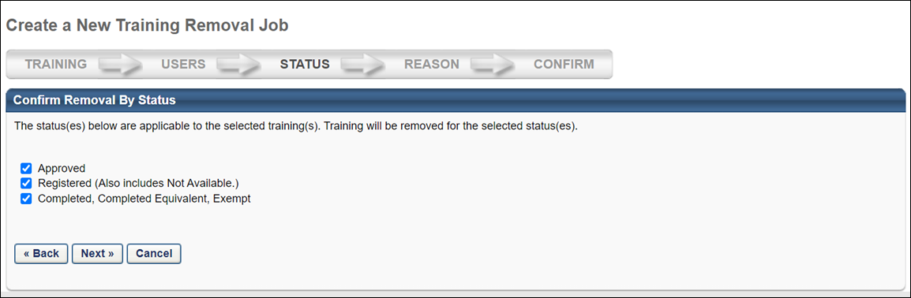
Select Statuses
The Confirm Removal By Status panel displays all statuses that are applicable to the LO. For example, if the LO is in a Pending Payment status on at least one transcript from the user criteria selected on the Users step, then the Pending Payment status displays in the panel.
All statuses are selected by default. Select or unselect one or more statuses to include the status in the training removal job. At least one status must be selected.
If there are no applicable statuses for the user criteria selected on the Users step, then "Training removal is not available for the current criteria. Click 'Back' button to update selected training or user criteria" displays in the Confirm Removal By Status panel. You must return to the Users step to modify the user criteria for the training removal job.
After selecting the statuses, click Next to proceed to the Reason step. See Training Removal Job - Create - Step 4 - Reason on page 32 for additional information.
Click Back to go to the previous step in the process. See Training Removal Job - Create - Step 2 - Users on page 27 for additional information.
Click Cancel to return to the Training Removal Tool page without submitting the training removal job. See Training Removal Tool on page 12 for additional information.
Applicable Statuses for Training Removal Jobs
Only training that is in one of the following statuses can be removed using the bulk removal feature:
- Pending Approval
- Denied
- Approved
- Registration Pending
- Registered (Also includes Not Available)
- In Progress
- Completed, Completed Equivalent, Exempt
- Exception Requested
- Expired
- Cancelled
- Waitlisted
- Withdrawn
- Discontinued
- Incomplete
- Pending Completion Approval
- Failed
- Pending Evaluation
- Pending Prerequisite
- Waitlist Expired
- Not Started
- No Show
- Pending Acknowledgment
- Pending Prior Training
- Pending Grade
- Pending Post-Work
- Pending Pre-Work
- Completion Approval Denied
- Pending Payment
- Payment Denied
- Pending Completion Signature
- Payment Refunded
- Pending SF-182 Form Approval
- SF-182 Form Denied
- Not Available
- Subscription Expired
- Pending Observer Completion
Training that is in any other status cannot be removed with a training removal job. Each of these statuses only appears as an option on the Status step if at least one user currently has the learning object (LO) on their transcript in that status.
The following consideration applies when removing training in a Completed status:
- If the training selected within the Training Removal Tool is a curriculum, any child training items that exist within that curriculum in a Completed, Completed Equivalent, or Exempt status (with the exception of sessions) is not removed. These child training items, with the exception of sessions, continue to persist as standalone trainings on the users’ active transcripts in the Completed tab. Completed child sessions will move the Removed tab on the users' transcript.
  - This behavior occurs regardless of whether the Remove child items option is selected.
  - Once the child items become standalone, they can also be removed as long as the user has the new Training Removal - Remove Completed permission.
Completion Propagation to Removed Curricula
Completed curricula that are removed from users' Completed transcripts via the Training Removal Tool are fully removed. This prevents the need for administrators to perform cleanup due to curricula not being removed as expected. The completion of training will not be propagated to the Removed tab.
The following considerations apply to this functionality:
- Statuses are still synced on the Removed tab
- Completion propagation from the Active to the Removed tab has been prevented for the following training types:
  - Any training in the curriculum on the Active tab
  - Any training completed as a prerequisite of a training item within a curriculum on the Removed tab
  - Any training completed as pre-work or post-work for a training item within a curriculum in the Removed tab
  - Training completed by equivalent
The following exceptions apply to this functionality:
- When the child training status is Pending Prerequisite and the prerequisite is completed, the child training is not moved to a Registered status even if the auto registered setting is selected for the curriculum structure.
- Statuses are not synced for training in a Pending Post-work status. Child training remains in a Pending Post-work” status under a removed curriculum.
Note: It is NOT possible to remove child training within a curriculum using the Training Removal Tool.
Training Removal Job - Create - Step 4 - Reason
When creating a training removal job, the fourth step is to define the reason for removing the training.
To create a new training removal job, go to Admin > Tools > Learning > Training Tools > Training Removal Tool. Then, click the Create New Training Removal Job link.
Permissions
PERMISSION NAME | PERMISSION DESCRIPTION | CATEGORY

Bulk Training Removal - Manage | Grants ability to bulk remove training from users’ transcripts. This permission can be constrained by OU and User's OU. Creator constraints also apply. This is an administrator permission. | Learning - Administration
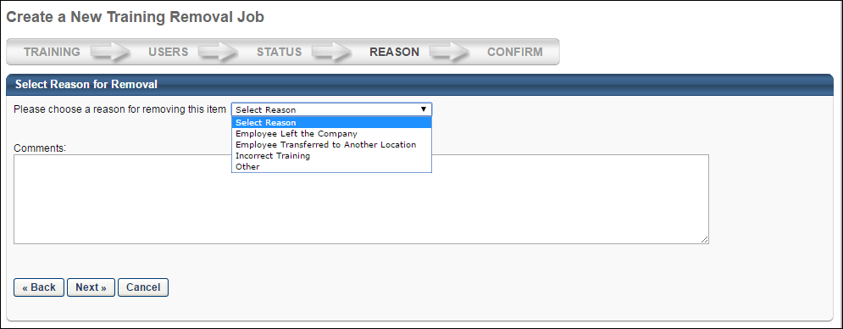
Select Reason for Removal
- Click the Select Reason drop-down to select the reason for removing the training. This is a required field. The reasons in the drop-down are configured by the administrator on the Removals tab in Training Reasons Preferences.
- Enter a comment in the Comments box. Comments may be required, depending on how the administrator configured the reason.
- After selecting the reason, click Next to proceed to the Confirm step. See Training Removal Job - Create - Step 5 - Confirm on page 34 for additional information.
The reason for removal selected on this page will apply to all training items and users selected for the training removal job. If it is necessary for specific training items or users to have different reasons for removal, the administrator must create separate training removal jobs to achieve this, as it is not possible to select different reasons for different users or training items within the same training removal job.
Click Back to go to the previous step in the process. See Training Removal Job - Create - Step 3 - Status on page 29 for additional information.
Click Cancel to return to the Training Removal Tool page without submitting the training removal job. See Training Removal Tool on page 12 for additional information.
Training Removal Job - Create - Step 5 - Confirm
When creating a training removal job, the fifth step is to review the configurations and submit for processing. There is no limit on the number of users which can be included in the training removal job. Up to 20 training items can be removed in a single training removal job.
Important Note: It is important to note that all instances of the learning object (LO) are removed from users' transcripts. This includes LOs that are in a Completed status.
To create a new training removal job, go to Admin > Tools > Learning > Training Tools > Training Removal Tool. Then, click the Create New Training Removal Job link.
Permissions
PERMISSION NAME | PERMISSION DESCRIPTION | CATEGORY

Bulk Training Removal - Manage | Grants ability to bulk remove training from users’ transcripts. This permission can be constrained by OU and User's OU. Creator constraints also apply. This is an administrator permission. | Learning - Administration
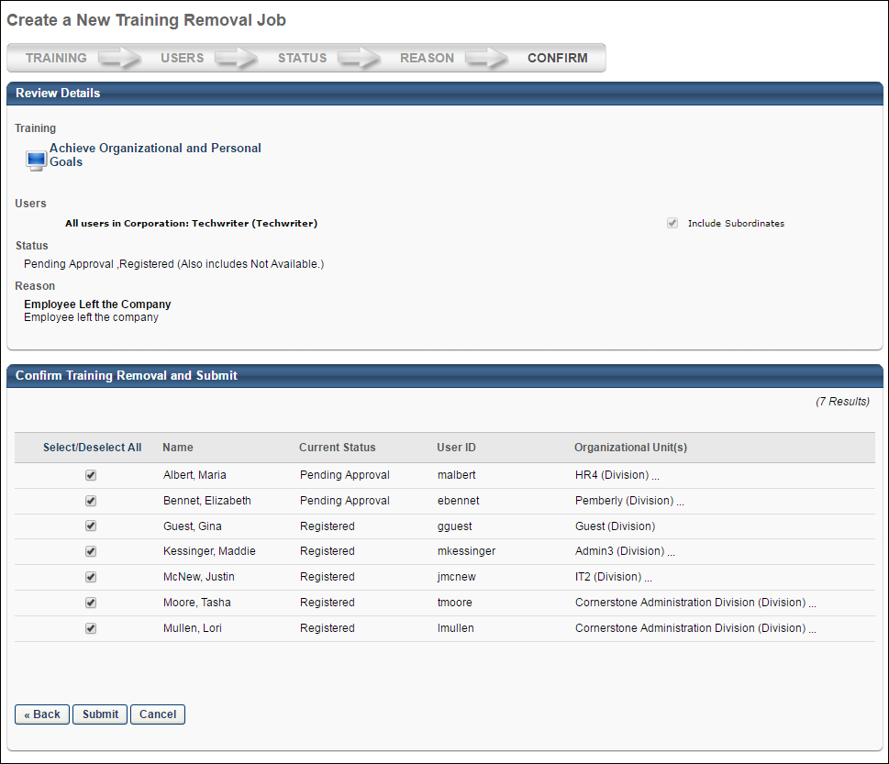
Review Details
The Review Details panel displays the selections from the Training, Users, Status, and Reason steps. The selections cannot be changed from this page. To modify the selections, click the Back button at the bottom of the page to return to the step. All selections can be modified prior to submitting the training removal job. The selections cannot be modified once the training removal job is submitted.
Confirm Training Removal and Submit
The Confirm Training Removal and Submit panel displays all individual users as defined on the Users step. From this table, you must select one or more users for whom the training will be removed. The following information displays in the table:
- Select/Deselect All - Click the link to select or deselect all users in the table to include or exclude from the training removal job.
- Checkbox - Check or uncheck the box to select or deselect an individual user to include or exclude from the training removal job.
- Name - This column displays the name of the user whose transcript will be updated if included in the training removal job.
- Current Status - This column displays the current status of the learning object (LO) on the user's transcript.
- User ID - This column displays the user ID for the user whose transcript will be updated if included in the training removal job.
- Organizational Unit(s) - This column displays the OU of the user whose transcript will be updated if included in the training removal job.
If there are no users with the LO on their transcript in the statuses selected on the Status step, then "No users in the OU’s above have the selected training in their transcripts" displays in the Confirm Training Removal and Submit panel.
Submit Training Removal Job
Click Submit to save the training removal job and submit for processing. This button only appears on the Confirm step. Clicking Submit opens a confirmation pop-up. Click Yes to submit the training removal job for processing. Click No to cancel the submission and return to the Confirm step.
There is no limit on the number of users which can be included in the training removal job. Up to 20 training items can be removed in a single training removal job.
Once the training removal job is processed, the LO is updated on the users' transcript to a status of Removed. The LO moves to the Removed tab on the users' transcript. In addition, any emails associated with the LO in the users' transcript are no longer triggered as a result of the training removal. If the Training Removed from Transcript email is active and configured by the administrator in Email Management, then this email is triggered when the training removal job is processed.
- Click Back to go to the previous step in the process. See Training Removal Job - Create - Step 4 - Reason on page 32 for additional information.
- Click Cancel to return to the Training Removal Tool page without saving the training removal job. See Training Removal Tool on page 12 for additional information.

Training Removal Details Page
The Training Removal Details page displays the details of the training removal job. The information on the Training Removal Details page is read-only and is only for informational purposes.
To access the Training Removal Details page, go to Admin > Tools > Learning > Training Tools > Training Removal Tool. Then, click the View Details icon in the View Details column for the training removal job.
Permissions
PERMISSION NAME | PERMISSION DESCRIPTION | CATEGORY

Bulk Training Removal - Manage | Grants ability to bulk remove training from users’ transcripts. This permission can be constrained by OU and User's OU. Creator constraints also apply. This is an administrator permission. | Learning - Administration
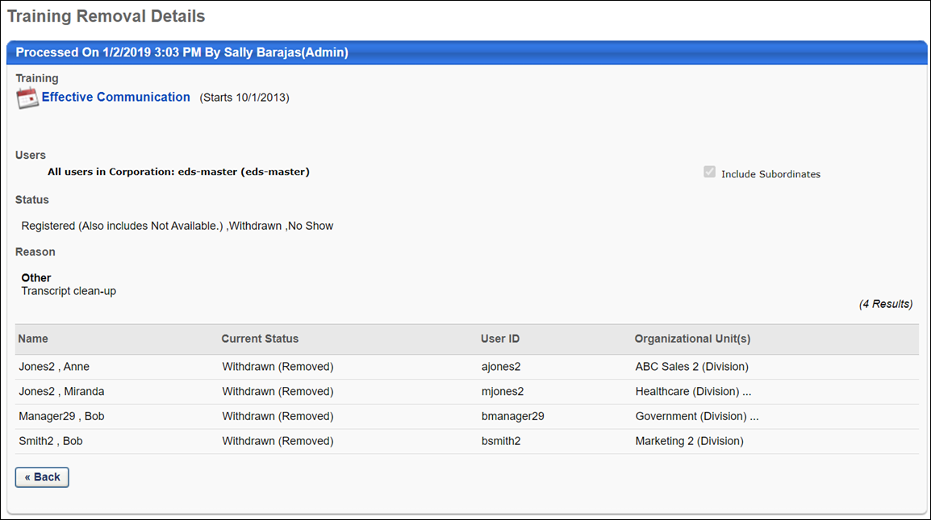
The following information displays on the page:
- Processed Time Stamp - The panel heading displays the date and time at which the training removal job was processed, as well as the user who submitted the training removal job.
- Training - This section displays the selections made on the Training step of the training removal job.
- Users - This section displays the selections made on the Users step of the training removal job.
- Status - This section displays the selections made on the Status step of the training removal job.
- Reason - This section displays the reason selected on the Reason step of the training removal job.
- Impacted Users - This table displays the users for whom the training was removed. The following information displays in the table:
  - Name - This column displays the name of the user for whom the training was removed.
  - Current Status - This column displays the status of the training on the user's transcript prior to removal. The Removed status displays in parentheses, which indicates that the training has been removed from the user's transcript.
  - User ID - This column displays the user ID of the user for whom the training was removed.
  - Organizational Unit(s) - This column displays the OU of the user for whom the training was removed.
Click the Back button to return to the Training Removal Tool page. See Training Removal Tool on page 12 for additional information.

Removing Events and Sessions from Users' Transcripts
The Training Removal Tool, the manual removal process, and dynamic removal behave in the following ways when removing instructor-led training (ILT) events and sessions from users' transcripts:
- When an administrator removes events and sessions from a user's transcript, and these events and sessions are contained within a curriculum on the user's transcript, the system removes the sessions from the user's transcript before also removing the events. Note: Removing a session only does NOT impact the associated event on a user's transcript. When only a session is removed from the transcript, the related event remains on the transcript unless removed separately.
  - Example: Mary is removing a curriculum which contains an event from a user's transcript. When the training removal job processes, any sessions of this event are removed from the user's transcript before the event itself is removed from the transcript. By the time the job finishes processing, both the event and any related sessions are removed from the user's transcript.
FAQ
- See below for some common questions and answers related to this functionality:
Q: Is it possible to remove an event AND its session from a user’s transcript at the same time?
A: On the Training step of the training removal job creation process, administrators can opt to remove the child sessions of any events selected for the job. Select the Remove All Sessions of the Selected Events option to ensure that child sessions of any selected events are also removed from users' transcripts when the removal job processes. Note: All child sessions of selected events will be removed from users' transcripts, even if the sessions are in an Active status on the user's transcript.
Q: If you remove a session, is the associated event also removed?
A: No, UNLESS the session and event are contained in the same curriculum. Otherwise, if you remove a session, its parent event is not removed automatically.

Training Update Tool Overview
The Training Update Tool page enables administrators to create a Training Update and also view past training updates. Training updates are used to update the training score or status of one or more users for a specific training item.
Note: The Training Update Tool cannot be used to remove users from a training item.
To access the Training Update Tool, go to Admin > Tools > Learning > Training Tools > Training Update Tool.
Permissions
PERMISSION NAME | PERMISSION DESCRIPTION | CATEGORY

Training Update Tool | Grants access to the Training Update Tool. This tool enables administrators to mark multiple user transcripts complete for a single online course, quick course, test, or video via the upload of a csv file that includes user IDs, completion status, score and completion date. This is an administrator permission. | Learning - Administration
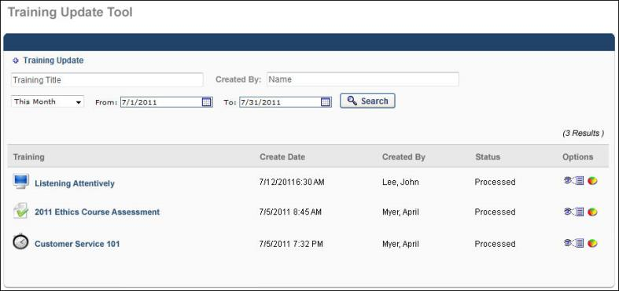
To create a training update, click the Add Training Update link at the top of the page. See Training Update - Create on page 42 for additional information.

Training Update - Create
Up to 2,000 users can be uploaded at once, but it is advised that smaller batches of about 1000 be used.
To create a training update, go to Admin > Tools > Learning > Training Tools > Training Update Tool. Then, click the Training Update link at the top of the page. This opens the Create New Training Update Request page.
Permissions
PERMISSION NAME | PERMISSION DESCRIPTION | CATEGORY

Training Update Tool | Grants access to the Training Update Tool. This tool enables administrators to mark multiple user transcripts complete for a single online course, quick course, test, or video via the upload of a csv file that includes user IDs, completion status, score and completion date. This is an administrator permission. | Learning - Administration
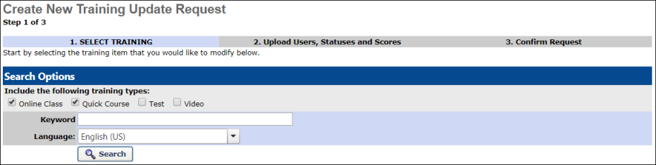
Create Training Update Request
- Using the search filters and criteria, search for the appropriate training and click Search. Note: Only online course, online content, quick course, test, and video training types can be updated. The Training Update Tool cannot be used to remove users from a training item.
  - Only Online Course, Online Content, Quick Course, Test, and Video training types can be updated.
  - The training must be on the users transcript to be updated. Users who do not have the training on their transcript will display as 'Skipped' on the Training Progress Summary page.
  - The Training Update Tool cannot be used to remove users from a training item.
- In the search results, you can also click the training title to view the details of the training if necessary. Click the plus icon in the Add column to add the training from the search results.
- On the Upload Users, Statuses, and Scores page, click the Browse button to locate and select the file.
- After selecting the file, click Add to add the file. If the file contains errors, click the View Errors link to view the error details. The file must be in comma delimited format (.csv) with a maximum file name length of 100 including the file extension. Multiple files can be uploaded. The maximum number of records that can be included in a file is 2000, but files of 1000 or less are recommended. The file should have four columns of information in the following format:
  - Column 1: User IDs, usernames, or email addresses.
  - Column 2: The training score (0-100). If a score is not fed in for the user, the Score field is not affected.
  - Column 3: Completion indication (Y = Complete, N = Status Unchanged).
  - Column 4: Action Date (mm/dd/yyyy). If a date is not provided, the current date is used. The Action Date displays in the history if scores are being updated. If a course status is being updated to Complete, then the Action Date is used as the Completion Date and appears in the history.
    - When updating the Transcript Status to Completed, all other completion requirements (e.g., required evaluation or completion approval) are bypassed and the transcript status immediately changes to Completed.
- Review the information and click Submit to submit the updates. The request is in Queued status until processed. The users' transcripts are updated when the training update request is processed. This may trigger the Transcript Status Edited email if the trigger is active.
Manage Training Updates
To search for an existing training update, use the search fields and filters on the Training Update Tool page to refine your search. Click the Search button to execute the search. Note: Only training updates that are available to be viewed by the administrator as determined by the permission constraints are displayed.
- Training Title - Enter the title of the learning object to search for a training update associated with training titles that match the search criteria.
- Created By - Enter the first or last name of a user to search for a training update that was created by users that match the search criteria.
- Date Range Drop-down - Select a specific time period to display training updates that were created within the specified time period.
- From and To - Using the calendar tool, select a From date and To date to display training updates that were created within the specified date range. The From field should be before the To field.
The Training Updates table displays the following information for each training update. Note: Only training updates that are available to be viewed by the administrator as determined by the permission constraints are displayed.
- Training - The training title associated with the training update. Click the training title to view the details of the LO.
- Create Date - The date on which the training update was created.
- Created By - The name of the user that created the training update.
- Status - The status of the training update.
Options
The following options are available in the Options column:
- View Settings - Displays the settings of the training update.
- Training Progress Summary - Displays the training progress of the training update.To create a training update:
  - Click the Add Training Update link at the top of the page. This opens the Create New Training Update Request page.
  - Using the search filters and criteria, search for the appropriate training and click Search. Note: Only Online Class, Quick Course, Test, and Video LOs can be updated.
  - In the search results, you can also click the training title to view the details of the training if necessary. Click the plus icon in the Add column to add the training from the search results.
  - On the Upload Users, Statuses, and Scores page, click the Browse button to locate and select the file.
  - After selecting the file, click Add to add the file. If the file contains errors, click the View Errors link to view the error details. The file must be in comma delimited format (.csv) with a maximum file name length of 100 including the file extension. Multiple files can be uploaded. The maximum number of records that can be included in a file is 2000, but files of 1000 or less are recommended. The file should have four columns of information in the following format:
    - Column 1: User IDs, usernames, or email addresses
    - Column 2: The training score (0-100). If a score is not fed in for the user, the Score field is not affected.
    - Column 3: Completion indication (Y = Complete, N = Status Unchanged).
    - Column 4: Action Date (mm/dd/yyyy). If a date is not provided, the current date is used. The Action Date displays in the history if scores are being updated. If a course status is being updated to Complete, then the Action Date is used as the Completion Date and appears in the history.
  - Review the information and click Submit to submit the updates. The request is in Queued status until processed. The users' transcripts are updated when the training update request is processed. This may trigger the Transcript Status Edited email if the trigger is active.
- To search for an existing training update, use the search filters to define your search. Click Search to execute the search. Note: Only training updates that are available to be viewed by the administrator as determined by the permission constraints are displayed.
  - Training Title - Enter the title of the learning object to search for a training update associated with training titles that match the search criteria.
  - Created By - Enter the first or last name of a user to search for a training update that was created by users that match the search criteria.
  - Date Range Drop-down - Select a specific time period to display training updates that were created within the specified time period.
  - From and To - Using the calendar tool, select a From date and To date to display training updates that were created within the specified date range. The From field should be before the To field.
- The Training Updates table displays the following information for each training update. Note: Only training updates that are available to be viewed by the administrator as determined by the permission constraints are displayed.
  - Training - The training title associated with the training update. Click the training title to view the details of the LO.
  - Create Date - The date on which the training update was created.
  - Created By - The name of the user that created the training update.
  - Status - The status of the training update.
- The following options are available in the Options column:
  - View Settings - Displays the settings of the training update.
  - Training Progress Summary - Displays the training progress of the training update.

When merging user accounts using the Data Merge tool, this is the account from which the training records are being transferred. This is a Learning term.
When merging user accounts using the Data Merge tool, this is the account to which the training records are being transferred. This is a Learning term.

