Training Plans March 2024

Table of Contents
Training Plans Overview 1
Training Forecast Administration 2
Training Demand Forecasting 5
Training Forecast Administration 6
Training Plan - Budget 9
Training Plan - Copy 14
Training Plan - Create 15
Training Plan - Edit 35
Training Plan Details Overview 38
Training Plans Overview 47
Training Plans - Access 48
Training Plan Contributor Page 51
Training Plan Contributor Page - Co-planners 58
Training Plan Manager Page 61
Training Plan Manager Page - Co-planners 66
Training Plan - Add External Training 69
Training Plan - Add Subject/Topic 72
Training Plan - Add Training 73
Training Plan - Edit Learning Object Forecast 74
Training Plan - Edit Subject Forecast 76
Training Plan - Plan Contributor and User Changes 78

Training Plans Overview

Training Forecast Administration
Training Demand Forecasting allows organizations to determine future training needs by collecting and reviewing training requests from selected parts of the organization. Collections of these needs enables the organization to plan, budget, assess, and implement an effective training program.
The Training Forecast Administration page allows training forecast administrators to create new plans and manage existing plans.
Co-owners can access this page, but can only access training plans for which they are a co-owner. Also, co-owners cannot create or delete any plans.
To navigate to the Training Forecast Administration page, go to Admin > Learning > Training Plans.
Permissions
PERMISSION NAME | PERMISSION DESCRIPTION | CATEGORY

Training Forecast Administration | Grants access to create and edit training plans. This permission can be constrained by OU and User's OU. This is an administrator permission. | Learning - Administration

Training Plans Budgeting - Manage | Grants ability to define and edit budgets for training plans. Users with this permission can view the company training budget. Users must also have the Training Forecast Administration permission. This permission cannot be constrained. | Learning

Training Plans Budgeting - View | Grants ability to view budgets for training plans. This permission cannot be constrained. | Learning

Training Plan Co-Owner | This permission is not visible within the system because it is a dynamically assigned permission that is assigned to a user when they are designated as a co-owner for a training plan. Users with this permission can access the Training Forecast Administration page and can only access training plans for which they are a co-owner. | Learning
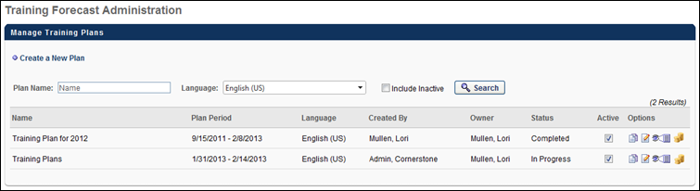
Manage Training Plans
This page displays all the existing training plans that are visible to that user. Co-owners can only view training plans for which they are a co-owner. Up to 20 training plans display on a page, so you may have to move to subsequent pages to view a particular plan. The following information is available for each training plan:
- Training Plan Name
- Plan Period - This displays the start and end date of the plan.
- Language - This displays the language of the plan.
- Training Plan Creator
- Training Plan Owner - Up to three owners display. If more exist, they can be viewed by moving your mouse over the owner names.
- Training Plan Status - Possible statuses include:
  - Not Started - A plan has a status of Not Started prior to the first date of the plan period. After the first date of the plan period, the plan may still have a status of Not Started if none of the plan contributors or plan managers has added a training request. If any participant of the plan has added an objective to their plan, the status of the plan from an administrator's perspective becomes In Progress. For example, Plan A is created on 11/15/2010 and the plan period is 1/1/2011-12/31/2011. This plan is assigned to all users in the Sales division. The status of the training plan is Not Started up until 1/1/2011. At that point, the status will remain as Not Started until a user in the Sales division adds a training request to their training plan.
  - In Progress - A plan has a status of In Progress when at least one plan contributor has added at least one training request.
  - Complete - A plan has a status of Complete when the end date of the plan period passes. It is possible for the administrator to extend the plan period of a completed plan as long as the plan is not yet Expired.
  - Expired - A plan has a status of Expired when the expiration date defined by the administrator passes. The Edit icon on the Training Forecast Administration window changes to the View icon. When the administrator selects this icon, the administrator and owner can then view the steps of the plan, but cannot make any changes to the plan template.
Creating Training Plan Template
If the administrator has permission to create training plans, the Create a New Plan link is available to them. This link is not available to co-owners. Selecting this link begins the process of creating a training plan template. See Training Plan - Create on page 15 for additional information.
Search Training Plans
Using the search filters, administrators and co-owners can search for training plans. Only plans that are visible to the user display in the results table. Administrators can only view training plans that they have created as well as training plans created by other administrators within their constraints. Co-owners can only view training plans that they own.
The Language drop-down list allows you to filter search results by language. The Language drop-down list allows you to select more than one language by checking the box next to a language.
Using the Include Inactive check box, you can also include inactive plans in your search.
Training Plan - Activate or Deactivate
By default, when a plan is created, it is active. An administrator or co-owner can deactivate a plan by deselecting the Active check box next to the plan. When the Active box is unselected, the training plan does not appear on the Training Forecast Administration page unless the Include Inactive check box is selected. Note: Deactivating a plan does not prevent training from being assigned if the plan is configured to include a standard learning assignment and training requests were collected prior to the plan being deactivated. To prevent training from being assigned in this scenario, remove the training requests by removing the Contributor(s) from the Training Plan Details page.
Training Plan - Copy
Administrators can copy any plan they have created or any plan that is within their constraints. All training plan templates can be copied, regardless of their status or state, including inactive and expired templates. Co-owners cannot copy a training plan. To copy a plan, click the Copy icon in the Options column. This begins the process of copying the plan. See Training Plan - Copy on page 14 for additional information.
Training Plan - Edit
Administrators can edit any plan they have created or any plan that is within their constraints. Co-owners can edit any plan of which they are an owner. To edit a plan, click the Edit icon in the Options column. This begins the process of editing the plan. See Training Plan - Edit on page 35 for additional information.
Training Plan - View Details
Administrators can view the details of any plan they have created or any plan that is within their constraints. Co-owners can view any plan of which they are an owner. To view a plan, click the View Details icon in the Options column. This takes you to the View Details page for the training plan. See Training Plan Details - View on page 39 for additional information.
Training Plan - Delete
Administrators can delete a plan that they have created or any plan that is within their constraints. Co-owners cannot delete a training plan. Only plans that have a Status of Not Started can be deleted.
Training Plan - Set Budget
The Training Plan Budget page enables administrators to define a budget for a training plan. Administrators are able to define a training budget that is managed within the system and an external budget that is managed outside of the system. The availability of this functionality is controlled by a backend setting. See Training Plan - Budget on page 9 for additional information.

Training Demand Forecasting
Training Demand Forecasting enables an organization to forecast training demand by collecting and reviewing training needs and requests. Collection of these needs enables the organization to plan, budget, assess, and implement an effective training program. Also, reporting tools enable the organization to view the needs for a segment of the organization and compare those needs across the broader organization.
Organizations must use the Learning module of the application and have training populated in the catalog to use training plans.
To implement training plans, administrators must first create training plan templates, which is the administrative function that sets the parameters and rules for the training plan. The training plan template defines the Plan Contributors, who are users in the organization who participate in gathering training requests. The training plan template also defines the Plan Managers, who are users in the organization responsible for reviewing the training plans created by the Plan Contributors. Lastly, the training plan template also defines for whom the training plans are planning (i.e., who receive the training that is forecasted in the training plan). After all training requests have been gathered, administrators use reporting tools to analyze the data collected from the training plans from various parts of the organization.
Related Resources:
Create a Training Plan - See Training Plan - Create on page 15 for additional information.
Training Forecast Administration - See Training Forecast Administration on page 2 for additional information.
View Training Plan Details - See Training Plan Details - View on page 39 for additional information.

Training Forecast Administration
Training Demand Forecasting allows organizations to determine future training needs by collecting and reviewing training requests from selected parts of the organization. Collections of these needs enables the organization to plan, budget, assess, and implement an effective training program.
The Training Forecast Administration page allows training forecast administrators to create new plans and manage existing plans.
Co-owners can access this page, but can only access training plans for which they are a co-owner. Also, co-owners cannot create or delete any plans.
To navigate to the Training Forecast Administration page, go to Admin > Learning > Training Plans.
Permissions
PERMISSION NAME | PERMISSION DESCRIPTION | CATEGORY

Training Forecast Administration | Grants access to create and edit training plans. This permission can be constrained by OU and User's OU. This is an administrator permission. | Learning - Administration

Training Plans Budgeting - Manage | Grants ability to define and edit budgets for training plans. Users with this permission can view the company training budget. Users must also have the Training Forecast Administration permission. This permission cannot be constrained. | Learning

Training Plans Budgeting - View | Grants ability to view budgets for training plans. This permission cannot be constrained. | Learning

Training Plan Co-Owner | This permission is not visible within the system because it is a dynamically assigned permission that is assigned to a user when they are designated as a co-owner for a training plan. Users with this permission can access the Training Forecast Administration page and can only access training plans for which they are a co-owner. | Learning
Manage Training Plans
This page displays all the existing training plans that are visible to that user. Co-owners can only view training plans for which they are a co-owner. Up to 20 training plans display on a page, so you may have to move to subsequent pages to view a particular plan. The following information is available for each training plan:
- Training Plan Name
- Plan Period - This displays the start and end date of the plan.
- Language - This displays the language of the plan.
- Training Plan Creator
- Training Plan Owner - Up to three owners display. If more exist, they can be viewed by moving your mouse over the owner names.
- Training Plan Status - Possible statuses include:
  - Not Started - A plan has a status of Not Started prior to the first date of the plan period. After the first date of the plan period, the plan may still have a status of Not Started if none of the plan contributors or plan managers has added a training request. If any participant of the plan has added an objective to their plan, the status of the plan from an administrator's perspective becomes In Progress. For example, Plan A is created on 11/15/2010 and the plan period is 1/1/2011-12/31/2011. This plan is assigned to all users in the Sales division. The status of the training plan is Not Started up until 1/1/2011. At that point, the status will remain as Not Started until a user in the Sales division adds a training request to their training plan.
  - In Progress - A plan has a status of In Progress when at least one plan contributor has added at least one training request.
  - Complete - A plan has a status of Complete when the end date of the plan period passes. It is possible for the administrator to extend the plan period of a completed plan as long as the plan is not yet Expired.
  - Expired - A plan has a status of Expired when the expiration date defined by the administrator passes. The Edit icon on the Training Forecast Administration window changes to the View icon. When the administrator selects this icon, the administrator and owner can then view the steps of the plan, but cannot make any changes to the plan template.
Creating Training Plan Template
If the administrator has permission to create training plans, the Create a New Plan link is available to them. This link is not available to co-owners. Selecting this link begins the process of creating a training plan template. See Training Plan - Create on page 15 for additional information.
Search Training Plans
Using the search filters, administrators and co-owners can search for training plans. Only plans that are visible to the user display in the results table. Administrators can only view training plans that they have created as well as training plans created by other administrators within their constraints. Co-owners can only view training plans that they own.
The Language drop-down list allows you to filter search results by language. The Language drop-down list allows you to select more than one language by checking the box next to a language.
Using the Include Inactive check box, you can also include inactive plans in your search.
Training Plan - Activate or Deactivate
By default, when a plan is created, it is active. An administrator or co-owner can deactivate a plan by deselecting the Active check box next to the plan. When the Active box is unselected, the training plan does not appear on the Training Forecast Administration page unless the Include Inactive check box is selected. Note: Deactivating a plan does not prevent training from being assigned if the plan is configured to include a standard learning assignment and training requests were collected prior to the plan being deactivated. To prevent training from being assigned in this scenario, remove the training requests by removing the Contributor(s) from the Training Plan Details page.
Training Plan - Copy
Administrators can copy any plan they have created or any plan that is within their constraints. All training plan templates can be copied, regardless of their status or state, including inactive and expired templates. Co-owners cannot copy a training plan. To copy a plan, click the Copy icon in the Options column. This begins the process of copying the plan. See Training Plan - Copy on page 14 for additional information.
Training Plan - Edit
Administrators can edit any plan they have created or any plan that is within their constraints. Co-owners can edit any plan of which they are an owner. To edit a plan, click the Edit icon in the Options column. This begins the process of editing the plan. See Training Plan - Edit on page 35 for additional information.
Training Plan - View Details
Administrators can view the details of any plan they have created or any plan that is within their constraints. Co-owners can view any plan of which they are an owner. To view a plan, click the View Details icon in the Options column. This takes you to the View Details page for the training plan. See Training Plan Details - View on page 39 for additional information.
Training Plan - Delete
Administrators can delete a plan that they have created or any plan that is within their constraints. Co-owners cannot delete a training plan. Only plans that have a Status of Not Started can be deleted.
Training Plan - Set Budget
The Training Plan Budget page enables administrators to define a budget for a training plan. Administrators are able to define a training budget that is managed within the system and an external budget that is managed outside of the system. The availability of this functionality is controlled by a backend setting. See Training Plan - Budget on page 9 for additional information.

Training Plan - Budget
The Training Plan Budget page enables administrators to define a budget for a training plan. Administrators are able to define a training budget that is managed within the system and an external budget that is managed outside of the system. The availability of this functionality is controlled by a backend setting. Tra
Note: Administrators with permission to manage budgets for training plans are able to see budgets for all organizational units (OUs) within the organization.
To navigate to the Training Plan Budget page, go to Admin > Learning > Training Plans. Then, click the Budget icon for a training plan.
Permissions
PERMISSION NAME | PERMISSION DESCRIPTION | CATEGORY

Grades - View | Grants ability to view the Grade Organizational Unit throughout the system, such as in availability drop down selectors, when editing users, etc. Those without this permission do not see the Grade OU on any screen. This is primarily an administrator permission, although organizational policy should determine whether the Grade OU should be visible to end users on reporting screens, etc. | Core Administration

OU Group - Manage | Grants the ability to create, copy, and edit custom groups of users without allowing the ability to manage organizational units (OUs). This permission can be constrained by OU, User's OU, and Provider. This is an administrator permission. | Core Administration

OU Group - View | Grants access to view existing custom groups. This permission can be constrained by OU. This is an administrator permission. | Core Administration

OU Hierarchy - Manage | Grants ability to create and update/edit organizational units. This permission grants access to all OU types, both standard and custom. This permission can be constrained by OU and User's OU. This is an administrator permission. | Core Administration

Self Registration Groups - Manage | Grants ability to create and update/edit self-registration groups, which are configured to make a self-registration page available to people who are not added to the portal via user feed. This permission can be constrained by OU, User's OU, and User's Corporation. This is an administrator permission. | Core Administration

Self Registration Groups - View | Grants ability to view Self Registration Groups when selecting Availability (for Training, Tasks, learning assignments, etc.) or User Criteria (for Learning Assignments). This permission can be constrained by OU and User's OU. This is an administrator permission. | Core Administration

Training Forecast Administration | Grants access to create and edit training plans. This permission can be constrained by OU and User's OU. This is an administrator permission. | Learning - Administration

Training Plans Budgeting - Manage | Grants ability to define and edit budgets for training plans. Users with this permission can view the company training budget. Users must also have the Training Forecast Administration permission. This permission cannot be constrained. | Learning

Training Plans Budgeting - View | Grants ability to view budgets for training plans. This permission cannot be constrained. | Learning
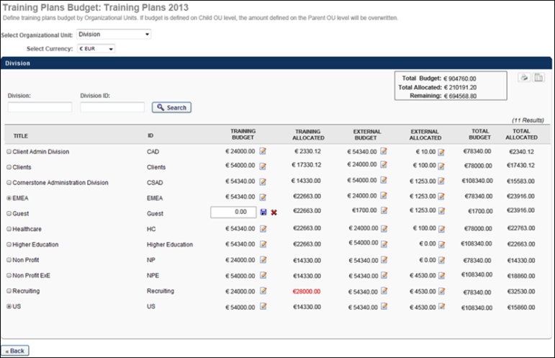
Budgets are defined by OUs, including custom OUs and self-registration groups.
Define Budget Criteria
Before setting budgets for a training plan, the administrator must select the OU type and currency that is used to set budgets. Select the following budget criteria:
- Select Organizational Unit - From the drop-down list, select the OU type by which training plan budgets are set. When an OU type is selected, all of the available parent-level OUs of the selected type are displayed in the Budgets table. For example, if Division is selected, then budgets for the corresponding training plan are set by division OUs and all of the parent-level division OUs are displayed in the Budgets table. Users are only able to select the OU types for which they have permission to view. Note: If an OU type is selected, budgets are defined, and then the OU type is changed, all budgets are removed. A warning message is displayed prior to clearing all defined budgets.
- Select Currency - From the drop-down list, select the currency that is used in the budgets. All currency values on the Training Plan Budget page are displayed in the selected currency. Note: If budgets are defined and the currency is changed, then the system converts the amounts based on the exchange rates.
Budget Overview Information
In the upper-right corner of the Budgets table, a Budget Overview panel displays a summary of the training plan budget. The Budget Overview information is always based on the entire training plan budget, regardless of the search filters that are applied or if the administrator is a child level of OUs. The following information is displayed:
- Total Budget - This displays the sum of all defined budgets from the Budgets table.
- Total Allocated - This displays the sum of all budget allocations from the Budgets table. This does not necessarily correspond to a budget that has been defined.
- Remaining - This displays the total remaining budget that has not yet been allocated, based on total defined budgets and total allocations.
Search for a Budget
Administrators can search for an OU within the Budgets table by division name or ID using the Division and Division ID fields.
Print Training Plan Budgets
Administrators can print or export to Excel all budgets within the training plan by clicking the Print or Export to Excel icons in the upper-right corner of the Budgets panel. All parent OU budgets are included in the output, regardless of whether they are defined. All child OU budgets that are defined are included in the output and are grouped by parent OU.
Budget Table
The following information is displayed for each OU in the Budget table:
- Title - This displays the name of the OU. All OUs are displayed in a hierarchical manner. By default, all parent-level OUs are displayed. Administrators can view the child OUs for a parent OU by clicking the Expand icon to the left of the parent OU title.
- ID - This displays the OU ID.
- Training Budget - This displays the training plan budget for the corresponding OU. This budget determines the maximum amount of training needs that can be forecasted for the OU via the training plan. This value can be edited by clicking the Edit icon to the right of the amount. See the Set a Budget or External Allocation for an OU section for additional information.
- Training Allocated - This displays the total amount of training needs that have been allocated for the OU via the training plan. As the training plan is updated, this value is automatically updated by the system. If the amount of training that is allocated exceeds the budget amount, then the allocated amount appears in red.
- External Budget - This displays the external budget for planned training needs that are managed outside the system. This value can be edited by clicking the Edit icon to the right of the amount. See the Set a Budget or External Allocation for an OU section for additional information.
- External Allocated - This displays the total amount of training needs that have been allocated for the OU outside the system. If the amount of training that is allocated exceeds the budget amount, then the allocated amount appears in red. Because these training needs are being allocated outside the system, this value can be edited by clicking the Edit icon to the right of the amount. See the Set a Budget or External Allocation for an OU section for additional information.
- Total Budget - This displays the sum of the training budget and the external budget.
- Total Allocated - This displays the sum of the training allocated and the external allocated.
Set a Budget or External Allocation for an OU
Administrators can only edit a budget or external allocation if they have permission to manage budgets. Additionally, administrators can only edit a training budget value if it is within the Budget Period for the training plan. Administrators can edit external allocations and external budgets outside the Budget Period.
By default, if the budget or external allocation amount has never been modified, then "Undefined" is displayed, which is equal to an amount of 0.00. To edit a budget or external allocation value for an OU, click the Edit icon to the right of the amount. The amount becomes editable. In the editable field, enter an amount up to 99999999.99. Then, click the Save icon to save the amount, or click the Cancel icon to discard the changes.
Override Parent-Level OU Amount
When setting a budget or external allocation for parent and child OUs, the amount set for a parent-level OU must be greater than the sum of all amounts set for the child-level OUs within the parent-level OU. This is because child-level OU amounts do not automatically increase the budget or external allocation for the parent-level OU.
If the sum of all amounts set for child-level OUs exceeds the parent-level OU amount, then a warning message is displayed. Administrators can click the Override Training Budget link within the warning message to view a pop-up that details why the warning message is displayed.
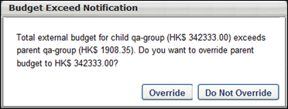
To override a parent-level OU amount, click the Override button. This increases the parent-level OU budget or external allocation amount to match the sum of all child-level OU amounts. Otherwise, click the Do Not Override button to maintain all current amounts. However, the warning message displays until the parent-level OU amount is overridden or until the sum of the child-level OU amounts is decreased and is less than the parent-level OU amount.

Training Plan - Copy
From the Training Forecast Administration screen, the administrator can select the Copy icon to copy a training plan. This navigates them to the Copy Training Plan - General page.
The process for copying a training plan is the same as creating a training plan. Most of the information is copied from the original training plan, but there is some information that must be entered for the new training plan. You may also edit the information that was copied during this process.
You cannot advance to the next step until each of the required fields is satisfied. You can return to previous steps once they are completed or during editing by clicking the appropriate link on the left navigation.
Information NOT Copied
The following information is NOT copied from the original plan and must be entered for the new training plan:
General section
- Training Plan Name
Date Criteria section
- Forecast Period
- Plan Period
- Expiration Date
- Default Access Periods - The check box status is copied, but the date ranges are not copied.
- Learning Assignment Options
Plan Contributors
- Access Period
Plan Managers
- Access Period

Training Plan - Create
Training plans allow organizations to collect and review training requests from selected parts of the organization. Training plans allow organizations to plan, budget, and assess training programs.
To create a training plan, go to Admin > Learning > Training Plans. Then, click the Create New Plan link.
Permissions
PERMISSION NAME | PERMISSION DESCRIPTION | CATEGORY

Training Forecast Administration | Grants access to create and edit training plans. This permission can be constrained by OU and User's OU. This is an administrator permission. | Learning - Administration
Training Plan Creation Process
There are five steps included in the training plan creation process:
- General - See Training Plan - Create - Step 1 - General on page 16 for additional information.
- Emails - See Training Plan - Create - Step 2 - Emails on page 22 for additional information.
- Date Criteria - See Training Plan - Create - Step 3 - Date Criteria on page 24 for additional information.
- Plan Contributors - See Training Plan - Create - Step 4 - Plan Contributors on page 29 for additional information.
- Plan Managers - See Training Plan - Create - Step 5 - Plan Managers on page 32 for additional information.

Training Plan - Create - Step 1 - General
When creating a training plan, there are five possible steps, General, Emails, Date Criteria, Plan Contributors, and Plan Managers. These steps are listed on the left navigation with the current step highlighted. You cannot advance to the next step until each of the required fields has been satisfied. You can return to previous steps once they are completed or during editing by clicking the appropriate link on the left navigation.
On the General step, configure basic information for the training plan, such as the language, name, description, and owners.
To create a training plan, go to Admin > Learning > Training Plans. Then, click the Create New Plan link. You are taken to the Training Plan Create - General page.
Permissions
PERMISSION NAME | PERMISSION DESCRIPTION | CATEGORY

Training Forecast Administration | Grants access to create and edit training plans. This permission can be constrained by OU and User's OU. This is an administrator permission. | Learning - Administration

Training Plans Budgeting - Manage | Grants ability to define and edit budgets for training plans. Users with this permission can view the company training budget. Users must also have the Training Forecast Administration permission. This permission cannot be constrained. | Learning

Training Plans Budgeting - View | Grants ability to view budgets for training plans. This permission cannot be constrained. | Learning
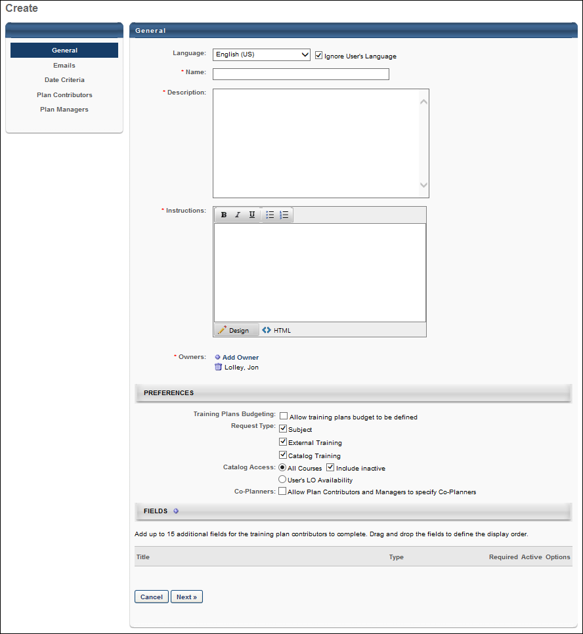
From the Training Plan Create - General page, define the following criteria for the training plan. When complete, click Next to continue to the Emails section. See Training Plan - Create - Step 2 - Emails on page 22 for additional information.
Language
Select the language of the plan, which also displays on the Training Forecast Administration screen. This defaults to the administrator's language setting.
Select the Ignore User's Language option to always use the selected language, regardless of the user's language preference. All plan contributors are assigned the plan, regardless of their language setting. Deselect this option if this training plan is localized into other languages. If the Ignore User's Language option is unselected, training plan availability is based on the language of the owner (plan contributor or plan manager) of the training plan user segment. If co-planners are enabled, then this setting also applies to training plan co-planners within the training plan user segment. For example:
- If the Ignore User's Language option is unselected, the training plan is created in French, the plan contributor's language is English, and the contributor co-planner's language is French, then the plan contributor will not see the segment of users because it is in a different language. Also, the co-planner will not see the entire training plan since the availability is based on the owner of the user segment (i.e., the plan contributor).
- If the Ignore User's Language option is unselected, the training plan is created in French, the plan contributor's language is French, and the contributor co-planner's language is English, then the plan contributor will see the segment of users because it is in the same language. Also, the co-planner will see the training plan since the availability is based on the owner of the user segment (i.e., the plan contributor).
Name
This field is required and is limited to 100 characters.
Description
This field is required and is limited to 3000 characters.
Instructions
This field is required and is limited to 3000 characters. These instructions appear at the top of the Training Plan page for the Plan Contributor, and they should instruct the users on how to implement or complete the training plan. The instructions can include HTML and can be formatted using the formatting tools. This field is required.
Owners
At least one plan owner must be specified, and the plan creator is set as a plan owner by default but can be removed. Additional plan owners can be specified. To add an owner, click the Add Owner link. The list of available users is determined by the OU and constraints for the administrator's permission to create and edit training plans.
- Users selected as training plan owners can act as administrators for the training plan, but cannot delete the plan.
- Designated owners are dynamically assigned the Training Plan Co-Owner permission for that training plan and now have access to the Training Forecast Administration page.
- If an owner is removed, the Training Plan Co-Owner is dynamically removed and they can no longer access the training plan template. Any changes made by the owner are maintained in the template.
Preferences
Training Plans Budgeting
Select this option to enable a budget for the training plan. This option is only available for users with permission to manage training plan budgets. The availability of this functionality is controlled by a backend setting.
Request Types
Select which types of training requests can be created by plan contributors. At least one type must be selected. When selected, during the training plan access period, a plan contributor can request training based on the following options:
- Subject - Request training by Subject via the Add Subject link.
- External Training - Request external training via the Add External Training link.
- Catalog Training - Request catalog training via the Add Training link.
Catalog Access
Select which course catalog items are available to plan contributors when they request catalog training during the training plan access period. This preference is only applied when the plan contributor is able to make catalog training requests.
- All Courses - All active courses are available. This preference overrides catalog availability constraints defined in Catalog Management.
  - Include Inactive - Inactive courses are also available.
- User's LO Availability - Courses availability is determined by the availability set in Catalog Management. Plan managers that add training to a plan contributor's training plan must also adhere to the contributor's course availability.
Co-Planners
Select this option to allow plan contributors and plan managers to select co-planners for their training plan. If training plan co-planners are enabled, then plan contributors and plan managers must also have permission to select co-planners. Each plan contributor and plan manager can designate up to 10 co-planners for each training plan. Co-planners can access the training plans in the same manner as the original plan contributors and plan managers.
- If this option is selected when the training plan is created and then deselected during the training plan access period, co-planners can no longer access the training plan and the option to add co-planners is hidden. If the administrator then re-selects this option, the previously selected co-planners are reinstated, and they can access the training plan.
Fields
Add up to 15 custom fields to the training plan that are completed by the plan contributor when making requests. Drag and drop the fields to determine the order in which they display. These fields behave like custom fields, but are managed only within a training plan template.
- Fields can be required or made inactive.
- While fields appear vertically on this page, they display horizontally to the planner.
- To add a field, click the plus icon next to the Field heading.
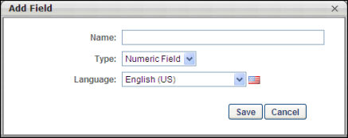
- For each field, define the name and type.
- Fields names can be localized.
- The available field types are Numeric Field, Short Text Box, and Dropdown. If Dropdown is selected, there are no options by default. Drop-down options must be specified. To add an option, click the plus icon next to the Options heading.
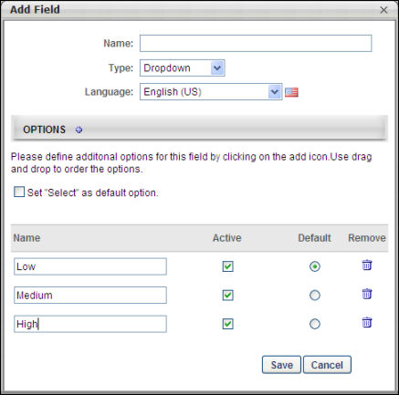
  - Each field option must have a name and can be activated or deactivated. Inactive options do not appear to contributors.
  - Select a default option or select the check box to set "Select" as the default.
- Fields can be edited or deleted. When a field is deleted, its data is also deleted.
The next step of the training plan creation process is the Email step: See Training Plan - Create - Step 2 - Emails on page 22 for additional information.

Training Plan - Create - Step 2 - Emails
On the Emails section of the training plan creation process, define which emails should be triggered for training plans. You can customize email triggers for training plans, use the standard email triggers from the Email Administration page, or disable emails for the training plan.
To create a training plan, go to Admin > Learning > Training Plans. Then, click the Create New Plan link.
Permissions
PERMISSION NAME | PERMISSION DESCRIPTION | CATEGORY

Global Email Administration - Manage | Grants ability to manage email trigger templates across all active modules in the portal. Enables creating, editing and deleting email message templates for various system actions and workflows. This permission can be constrained by OU, User's OU, User Self and Subordinates, and User. This is an administrator permission. | Core Administration
The following options are available for training plan assignment emails:
- System Defaults - This will use the default emails based on settings and availability from the Email Administration page.
- Custom Emails - This allows you to customize the emails for this training plan. The list of customizable emails is listed below in the Email Administration section.
- No Emails - No emails will be sent regarding this training plan.
The available email triggers are:
- Training Plan Assigned - This email is triggered when a training plan is assigned and is triggered on the first day of the access period for a user who is a plan contributor or plan manager. The administrator can set a reminder before or after the training is assigned.
- Training Plan Due - This email is triggered on the last day of an access period for a plan contributor and also on the last day of a plan manager segment for a plan manager. The administrator can set a reminder before the due date arrives.
- Training Plan Submitted - This email is triggered when a plan contributor's training plan is submitted.
- Training Plan Removed - This email is triggered when a plan contributor or manager is manually removed from a training assignment via the View Details page. This email is also triggered when a plan contributor segment or plan manager segment is removed from the plan.
Troubleshooting Information
The following pages contain troubleshooting guides for using emails:
- See Troubleshooting Guide - Emails.
- See Email Troubleshooting Guide.
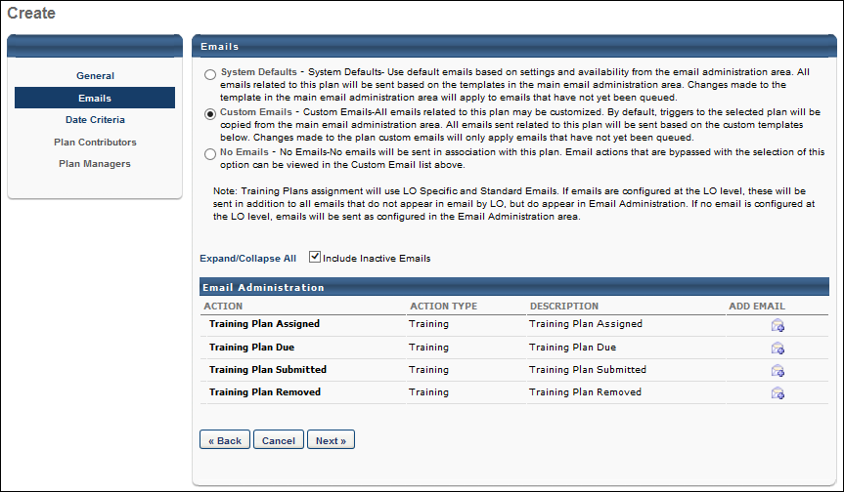
The next step in the training plan creation process is the Date Criteria step: See Training Plan - Create - Step 3 - Date Criteria on page 24 for additional information.

Training Plan - Create - Step 3 - Date Criteria
On the Date Criteria section of the training plan creation process, define the following dates and date ranges for the plan:
- Forecast Period
- Budget Period
- Plan Period
- Expiration Date
- Default Access Periods
To create a training plan, go to Admin > Learning > Training Plans. Then, click the Create New Plan link.
Permissions
PERMISSION NAME | PERMISSION DESCRIPTION | CATEGORY

Training Forecast Administration | Grants access to create and edit training plans. This permission can be constrained by OU and User's OU. This is an administrator permission. | Learning - Administration

Training Plans Budgeting - Manage | Grants ability to define and edit budgets for training plans. Users with this permission can view the company training budget. Users must also have the Training Forecast Administration permission. This permission cannot be constrained. | Learning

Training Plans Budgeting - View | Grants ability to view budgets for training plans. This permission cannot be constrained. | Learning
Forecast Period
The forecast period is the future period of time for which the plan contributors are planning for users to complete training. This date range is displayed to plan contributors so that they are aware of for which time period they are planning.
- The From date must be the current date or a later date.
- The To date must be later than the From date.
Budget Period
This option enables administrators to define the period during which a budget can be set for the training plan.
This option is only available if the Training Plans Budgeting option is selected on the General step. Using the From and To fields, select the start and end date for the period of time during which a budget can be set for the training plan. The Budget Period must be before the Plan Period. The selected budget period displays on the Training Plan Details page. This option is only available for users with permission to manage training plan budgets.
The availability of this functionality is controlled by a backend setting.
Plan Period
The plan period is period of time during which plan contributors can develop and contribute to the training plan. The From date is the first date on which a plan contributor can begin accessing and developing a training plan. The To date is the last day a contributor can add a training request for the training plan.
- The plan period may take place during the forecast period.
- The From date must be the current date or a later date.
- The To date must be later than the From date.
Expiration Date
The expiration date finalizes the training plan. It is the last day an administrator can edit a training plan. This is optional and can be set to a specific date or a specified number of days after the plan period ends.
- If None is selected, the training plan does not have an expiration date.
- If a specific date is selected, the date must be after the plan period end date.
- If the relative is selected, the number entered must be greater than zero and 999 is the maximum value.
Default Access Periods
The default access periods are optional default time periods in which plan contributors and plan managers can access the training plan. When specified, they are used as the default access periods when creating plan contributor segments and plan manager segments. This is useful when plan contributors and plan managers have the same access periods.
- If these options are not selected, they are effectively deactivated. Any dates specified in the Start and Due date fields are disregarded. When adding a plan contributor segment or plan manager segment, the access periods will default to the plan period date range.
- If these options are selected, the Start and Due dates are required.
  - The Start date must be the same or later than the start of the plan period.
  - The Due Date must be the same or later than the end of the plan period.
What type of proxy enrollment would you like to apply (type)?
Using this option, administrators are able to enable a proxy enrollment that enrolls the users that are included in the training plan in the training items that are included in the training plan. Only the users that are included in the training plan are proxy enrolled. Only courses (not subjects and external training) are eligible for proxy enrollment. If a training plan is not submitted, then the proxy enrollment is not created.
- None - When this option is selected, a proxy enrollment is not created from the training plan. In addition, the remaining proxy enrollment options are hidden. This option is selected by default.
- Standard (enroll selected users once) - When this option is selected, a standard proxy enrollment is enabled for the training plan. This is a one-time assignment for the users who meet the defined criteria.
- Force initial enrollment for users who already have the training - By default, a learning assignment only assigns the selected learning objects (LO) to a user if the user does not have the LO on their transcript already. This option allows you to force a user back into the learning object and reset the status of the LO based on the proxy enrollment settings regardless of what status they were in prior to the learning assignment. Using this option allows an administrator to force recurrence of a learning object only in the context of this proxy enrollment. The transcript details will show the initial request or assignment and the reassignment.
When would you like the training to be assigned (assignment date)?
Using this option, administrators are able to determine when the training items that are included in the training plan are assigned via the training learning assignment. When editing a training plan, this setting can only be modified up until the expiration date or the assignment date, whichever occurs first. Note: This option is not visible if None is selected as the learning assignment type.
- Assign on - Select this option to process the learning assignment on a specific date. You must then specify the date using the calendar tool. The assignment date must be after the plan period end date and before the forecast period end date. This option is selected by default.
- XX Days/Months/Years after the Plan Period has ended - Select this option to set the assignment date relative to the date on which the plan period ends. Then, specify when the training is assigned. From the drop-down, select whether the assignment date is days, months, or years after the end of the plan period. Then, in the field, enter the number of days, months, or years. For example, if the assignment date should be three months after the end of the plan period, then select Months from the drop-down and enter "3" in the field. The character limit for the field is 3. The assignment date must be after the plan period end date.
When will training be due (due date)?
Using this option, administrators are able to set the due date for the training items that are assigned via the training plan proxy enrollment. Note: This option is not visible if None is selected as the learning assignment type.
- None - No due date is assigned. This option is selected by default.
- Training is due - Select this option to set the due date for a specific date. You must then specify the date using the calendar tool.
- XX Days/Months/Years from assignment date - Select this option to set the due date relative to the date on which the training is assigned. You must then specify when the training is due. First, from the drop-down, select whether the due date is days, months, or years after the assignment date. Then, in the field, enter the number of days, months, or years. For example, if the due date should be three months after the assignment date, then select Months from the drop-down and enter "3" in the field. The character limit for the field is 3.
If a due date is set, it must be after the assignment date and after the forecasted training plan start date.
Status
The Status options define what the status of the learning objects will be in the user's transcript. Note: This option is not visible if None is selected as the learning assignment type.
Status Options and LO Availability Settings
The system checks the settings in the learning assignment and then looks at the availability settings for the learning objects to determine the transcript status. For example, if you select the Assign Training option in the learning assignment, the system will put the learning objects in the user's transcript, but not automatically approve or register. However, after the system assigns the learning object, it immediately looks at the availability settings for the LO. If the LO is set to Pre-approved and Register upon Approval, then the LO will appear in a Registered status in the user's transcript because of the availability settings.
This workflow means that you can override settings for availability to make the learning object approved or registered. However, you cannot make learning objects require approval if the learning object availability setting does not require approval.
Assign Training
This option places the learning objects onto the user's transcript, but will still require the standard approvals. Once approved, the user must still click the Register link on their Transcript.
Assign & Approve Training
This option assigns, approves, and registers users directly into the training. This bypasses both the approval and registration process as long as the user is not required to pay. The user is only required to launch or complete the training.
Assign, Approve, and Register
This option assigns, approves, and registers users directly into the training. This bypasses both the approval and registration process as long as the user is not required to pay. The user is only required to launch or complete the training.
Bypass User Payment
This option is only available if the Assign, Approve, and Register status option is selected.
If the Assign, Approve, and Register option is selected and the training has a cost, then when the user enrolls in the training from their transcript, that user is taken to the payment page. If the Bypass User Payment option is selected, the enrolled users no longer go to the payment page and are automatically enrolled in training item. On Billing Reports, it appears that the user was charged but there will be no processing fees, which is proof the user was not charged. If the training item has no monetary cost but does have a training unit cost, the user payment can still be bypassed, and the user is not charged any monetary or training unit value. Note: You must have permission to bypass user payment.
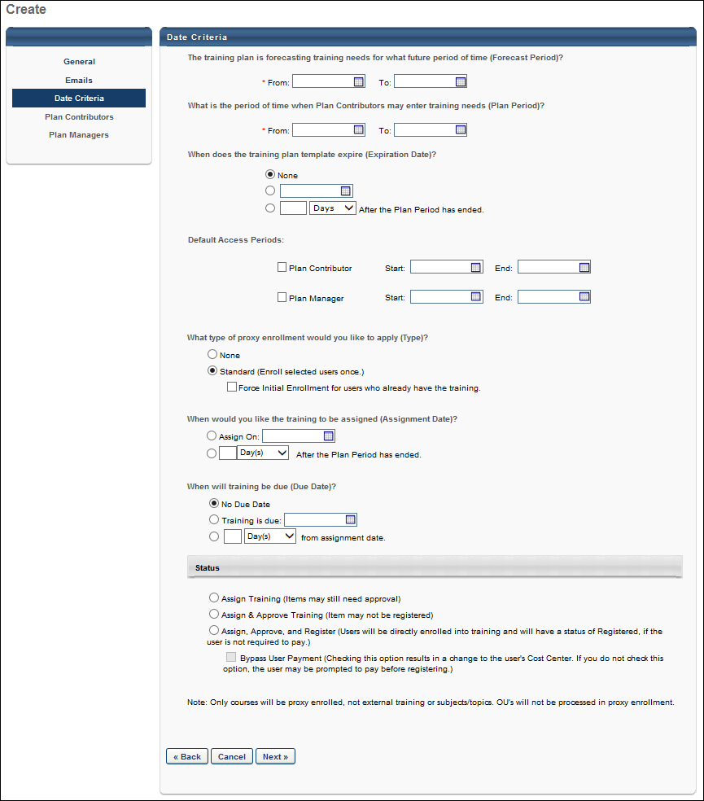
The next step of the process is the Plan Contributors step: See Training Plan - Create - Step 4 - Plan Contributors on page 29 for additional information.

Training Plan - Create - Step 4 - Plan Contributors
On the Plan Contributors step of the training plan creation process, the administrator performs the following actions:
- Add plan contributor segments
- Define plan contributors
- Define for whom the contributors are planning
- Define the contributor's access period
Plan contributors are responsible for adding training requests to the training plan for the group for which they are planning. Plan contributor segments allow you to define groups of contributors in different ways because each segment can have specific restrictions and access periods.
During the contributor access period, these assignments are dynamic, so new users meeting the criteria are added to the task, and the reverse is also true.
To create a training plan, go to Admin > Learning > Training Plans. Then, click the Create New Plan link.
Permissions
PERMISSION NAME | PERMISSION DESCRIPTION | CATEGORY

Training Forecast Administration | Grants access to create and edit training plans. This permission can be constrained by OU and User's OU. This is an administrator permission. | Learning - Administration
Plan Contributors
The forecast period and plan period dates display at the top of the section for reference while defining plan contributors. These dates cannot be edited on this page.
To add a plan contributor segment, click the Add icon next to the Plan Contributors heading. Clicking the Add icon adds a plan contributor segment to the table, allowing you to define the segment. As many segments as necessary can be added.
For the first question, "Who are the plan contributors?" select an OU or group of users to be the plan contributors.
- The available options may be restricted by the constraints for the administrator's permission to create and edit training plans.
- Your selection appears below the question.
- Multiple selections can be made, but at least one selection is required.
- Any user that meets the selected criteria is a contributor.
- It is possible that two contributor segments could have overlapping plan contributor criteria. When this occurs, those plan contributors are responsible for two different views of the training plan and may have two different access periods. For those users, the User-Planner Access Page has a link for each segment.
For the second question, "Who are they planning for?" select the set of users for whom the plan contributor is planning.
- The available options may be restricted by the constraints for the administrator's permission to create and edit training plans.
- Your selection appears below the question.
- Multiple selections can be made, but at least one selection is required.
- Constraints do not work in combination, so when more constraints are added, more users may be included.
- This can be set to the contributor's direct reports only, themselves, or an OU. In each case, when requesting training on their Training Plan page, the contributor will only see those for whom they are planning.
- For each selection, you can also include subordinates.
The Access Period defines when the contributors can access the training plan and make training requests. Refer to the Forecast Period and Plan Period displayed at the top of the section when defining the Access Period. Note: Modifying the Access Period after a Training Plan is in progress may reset any impacted co-planners' access period dates.
- The Start date must be on or after the start of the Plan Period.
- The Due date must be on or before the end of the Plan Period.
A trash can icon appears in the upper-right corner of each contributor segment. Clicking this icon will delete the contributor segment. A segment can be deleted if the training plan template has a status of Not Started, In Progress, or Completed. Training plans with a status of Expired cannot be deleted.
- If a training plan has a status of In Progress or Completed, deleting the contributor segment removes access to the plan for all plan contributors in the segment. Also, all training requests made by the plan contributors in the segment are also deleted.
Clicking Save on this screen validates the Plan Contributors information and submits the training plan. The training plan is now accessible from the Training Forecast Administration page.
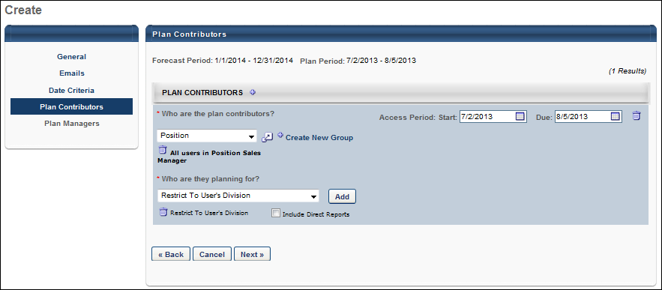
The next step of the process is the Plan Managers step: See Training Plan - Create - Step 5 - Plan Managers on page 32 for additional information.

Training Plan - Create - Step 5 - Plan Managers
On the Plan Managers step of the training plan creation process, the administrator performs the following actions:
- Add plan manager segments
- Define plan managers
- Define whom the managers are reviewing
- Define the manager's access period
Plan managers are responsible for reviewing training plans created by plan contributors. Plan manager segments allow you to define groups of managers in different ways because each segment can have specific restrictions and access periods. A training plan template does not require plan managers, so this step is optional. However, in order to define plan manager segments, plan contributor segments must first be defined.
During the manager access period, these assignments are dynamic, so new users meeting the criteria are added to the task, and the reverse is also true.
To create a training plan, go to Admin > Learning > Training Plans. Then, click the Create New Plan link.
Permissions
PERMISSION NAME | PERMISSION DESCRIPTION | CATEGORY

Training Forecast Administration | Grants access to create and edit training plans. This permission can be constrained by OU and User's OU. This is an administrator permission. | Learning - Administration
Plan Managers
The forecast period and plan period dates are displayed at the top of the section for you to reference while defining plan managers. These dates cannot be edited on this page.
To add a plan manager segment, click the Add icon next to the Plan Managers heading. Clicking the Add icon adds a plan manager segment to the table, where you must define the segment. As many segments as are needed can be added.
Who are the Plan managers?
For the first question, "Who are the plan managers," select an OU or group of users to be the plan managers.
- The available options may be restricted by the constraints for the administrator's permission to create and edit training plans.
- Your selection appears below the question.
- Multiple selections can be made, but at least one selection is required.
- Any user that meets the selected criteria is a manager.
- It is possible that two manager segments could have overlapping plan manager criteria. When this occurs, those plan managers will have a summary of users whose training plans they must review.
Whose Training Plan Will Be Reviewed?
For the second question, "Whose training plan will be reviewed," select the set of users whose training plans the plan manager is reviewing.
- The available options may be restricted by the constraints for the administrator's permission to create and edit training plans.
- Your selection appears below the question.
- Multiple selections can be made, but at least one selection is required.
- For a plan contributor to appear on the plan manager's list page, they must meet the following requirements:
  - The user must meet the selected constraints for the segment.
  - The user must be defined as a plan contributor in the previous section, which also implies they have been assigned a training plan to complete.
- Constraints do not work in combination, so when more constraints are added, more users may be included.
- This can be set to the manager's employees only, themselves, or an OU. In each case, only those that meet the criteria appear for review on the manager's list page.
- For each selection, you can also include their subordinates.
Access Period
The Access Period defines when the managers can review and modify training plans. Refer to the Forecast Period and Plan Period displayed at the top of the section when defining the Access Period. Note: Modifying the Access Period after a Training Plan is in progress may reset any impacted co-planners' access period dates.
- The Start date must be on or after the start of the Plan Period.
- The Due date must be on or before the end of the Plan Period.
- Most business cases would require that the plan manager's access period follow the plan contributor's access period to avoid plan managers modifying training needs before a plan contributor has finalized their plan.
A Delete icon appears in the upper-right corner of each manager segment. Clicking this icon will delete the manager segment. A segment can be deleted if the training plan template has a status of Not Started, In Progress, or Completed. Training plans with a status of Expired cannot be deleted.
- If a training plan has a status of In Progress or Completed, deleting the manager segment removes access to the plan for all plan managers in the segment. Also, any changes made by the plan manager are also deleted.
Clicking Save on this screen will validate the Plan Managers information and submit the training plan. The training plan is now accessible from the Training Forecast Administration page.
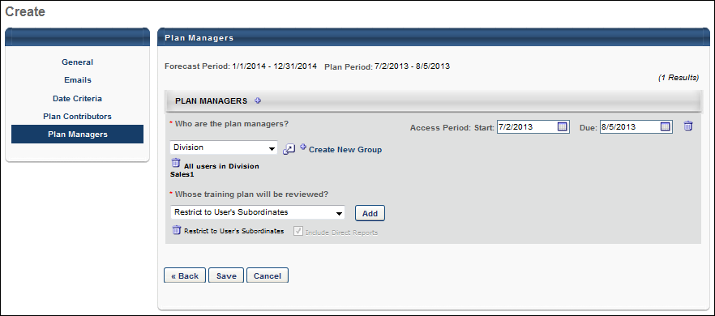

Training Plan - Edit
From the Training Forecast Administration screen, the administrator can select the Edit icon to edit a training plan. This navigates them to the Edit Training Plan - General page.
The process for editing a training plan is the same as creating a training plan. You can move between sections as necessary by clicking the navigation links on the left.
General Section
At the bottom of the General tab, the History section displays the history of the training plan, including creation and modification information.
- The Training Plans Budgeting option can be modified as long as the budget period has not passed.
- If the training plan status is Not Started, the Language drop-down and check box cannot be modified.
- If the training plan status is In Progress, the Language drop-down and check box cannot be modified. When preferences are edited, contributors experience the changes the next time they access their plan. Drop-down fields can be added and fields can be removed, but when fields are removed, any data collected is also removed.
- If the training plan status is Completed, the Language drop-down and check box cannot be modified. Fields can be removed, but any data collected is also removed.
- If the training plan status is Expired, the General step cannot be edited.
Emails Section
Emails cannot be edited after the template is created.
Date Criteria Section
If the training plan status is Not Started and the Plan Period has not yet begun, all Date Criteria options can be edited. The same validation rules are applied. Any changes made to the default access periods only apply to segments that are added after the preferences are changed.
The Budget Period values can be modified as long as the budget period has not passed.
If the training plan status is Not Started and the Plan Period has begun, or if the training plan status is In Progress, the following applies:
- The Forecast Period cannot be edited.
- The Expiration Date can be edited.
- The Date Criteria options can be edited, but any changes made only apply to segments that are added after the preferences are changed.
- The same validation rules are applied.
If the plan Expiration Date has not yet passed, the following applies:
- The end date of the Plan Period can be edited.
If the training plan status is Completed, the following applies:
- The Forecast Period cannot be edited.
- The start date of the Plan Period cannot be edited.
- The end date of the Plan Period can be edited as long as the plan Expiration Date has not yet passed.
- The Expiration Date can be edited. If the Expiration Date is set past the end of the Plan Period, but prior to the current date, the plan status is automatically set to Expired as soon as the plan is saved.
- The Date Criteria options can be edited, but any changes made only apply to segments that are added after the preferences are changed.
- The same validation rules are applied.
If the training plan status is Expired, no changes can be made.
Plan Contributors Section
If the training plan has a status of Not Started and the Plan Period has not yet begun, all options can be edited. The same validation rules are applied.
If the training plan has a status of In Progress, the following applies:
- The start and end date of the Access Period can be edited, regardless of whether or not it has begun. This can be used to temporarily stop and delay access. During that time, plan contributors can view the training plan, but cannot edit it. Changing access periods for plan segments should be done with caution. The same validation rules are applied.
- Contributor segments can be removed.
- Contributor segments can be added.
If the training plan has a status of Completed, the following applies:
- The start and end date of the Access Period can be edited, regardless of whether or not it has begun. This can be used to temporarily stop and delay access. During that time, plan contributors can view the training plan, but cannot edit it. Changing access periods for plan segments should be done with caution. The same validation rules are applied.
- Contributor segments can be removed.
- Contributor segments can be added.
If the training plan has a status of Expired, no changes can be made.
Plan Managers Section
If the training plan has a status of Not Started and the Plan Period has not yet begun, all options can be edited. The same validation rules are applied.
If the training plan has a status of In Progress, the following applies:
- The start and end date of the Access Period can be edited, regardless of whether or not it has begun. This can be used to temporarily stop and delay access. During that time, plan managers can view their list of plan contributors, but cannot access their training plans. Changing access periods for plan segments should be done with caution. The same validation rules are applied.
- Manager segments can be removed. Plan managers that are removed do not see the list of plan contributors on their access page any longer, and the plan manager has no access to the training plans associated with that segment.
- Manager segments can be added.
If the training plan has a status of Completed, the following applies:
- The start and end date of the Access Period can be edited, regardless of whether or not it has begun. This can be used to temporarily stop and delay access. During that time, plan managers can view their list of plan contributors, but cannot access their training plans. Changing access periods for plan segments should be done with caution. The same validation rules are applied.
- Manager segments can be removed. Plan managers that are removed do not see the list of plan contributors on their access page any longer, and the plan manager has no access to the training plans associated with that segment.
- Manager segments can be added.
If the training plan has a status of Expired, no changes can be made.

Training Plan Details Overview

Training Plan Details - View
The Training Plan Details enables an administrator or plan owner to view the progress of all users participating in the training plan. They have the ability to view and modify the plan on which a particular planner is working. They can also remove individual users from the list of users. Both Plan Contributors and Plan Managers are included in this display.
This display can be filtered by Status, Name, User ID, Role, and specific User Criteria.
To access the Training Plan Details page, go to Admin > Tools > Learning > Training Plans. Then, click the View Details icon for the training plan.
Permissions
PERMISSION NAME | PERMISSION DESCRIPTION | CATEGORY

Training Forecast Administration | Grants access to create and edit training plans. This permission can be constrained by OU and User's OU. This is an administrator permission. | Learning - Administration

Training Plan Co-Planner - Add | Grants ability to add a training plan co-planner if co-planners are enabled for the training plan. The permission constraints determine who can be selected as co-planner. This permission can be constrained by OU, User's OU, User Self & Subordinates, Manager, or Superiors. This is an end user permission. | Learning
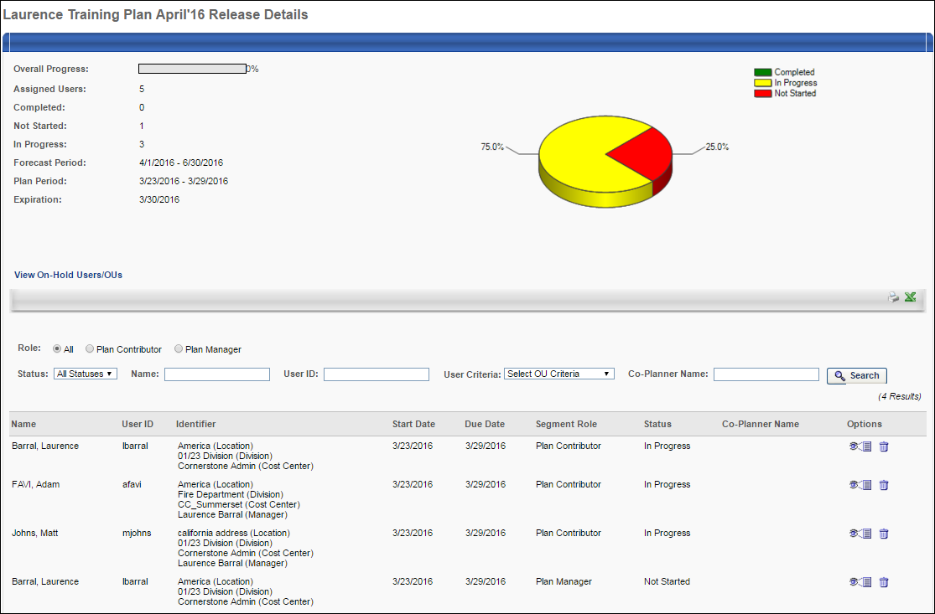
Training Plan Overview
This page displays the following information for the training plan:
- Overall Progress - Displays the percentage of users that have completed their plan.
- Assigned Users - The number of users who are assigned the training plan. This equals the total number of plan users defined during training plan creation.
- Completed - The number of users with a status of Completed for the training plan.
- Not Started - The number of users with a status of Not Started for the training plan.
- In Progress - The number of users with a status of In Progress for the training plan.
- Forecast Period - The forecast period defined during training plan creation.
- Plan Period - The plan period defined during training plan creation.
- Expiration - The expiration date for the plan, if one is defined during training plan creation.
- Pie Chart - The pie chart provides a graphical breakdown of the training plan progress.
View On-Hold Users/OUs
Users and organizational units (OUs) within a training plan who do not currently have a Plan Contributor (Manager) are in an On-hold status. While users and OUs are in an On-hold status, the system maintains any training needs that were identified by their previous Plan Contributor (Manager) so that the training needs can be used by their next Plan Contributor (Manager). Or, the Training Plan Administrator can manage those needs separately.
If the training plan has users or OUs that are in an On-hold status, then a View On-Hold Users/OUs link is available below the Expiration field. Click this link to view a list of all on-hold users and OUs.
Training Plans Table
The results table displays the following information for each contributor:
- Name - The name of the user assigned to participate in the training plan.
- User ID - The user ID of the user assigned to participate in the training plan.
- Identifier - Displays any identifying OUs for the user.
- Start and Due Date - The beginning and ending date of the plan user's access period. The Due Date is the last date the last day the user can access the training plan.
- Segment Role - Displays the user's segment role (e.g., Plan Contributor, Plan Manager).
- Status - The plan user's status for the training plan. The available statuses are:
  - Not Started - Status is Not Started until they submit their first training request for a subject, external training, or subject.
  - In Progress - Status is In Progress as soon as the user adds at least one training request for a subject, external training, or subject.
  - Completed - Status is Complete when the user has submitted their plan, resubmitted their plan, or the due date of their access period has passed.
- Co-Planner Name - This column displays any co-planners who are associated with the plan contributor or plan manager.
Searching for a Training Plan
Using the search filters, administrators and co-owners can search for plan users. All filters work in combination to narrow search results.
- Role - This option allows you to view users in a specific role. The options are All, Plan Contributor, and Plan Manager.
- Status - This option allows you to search for users with a specific status. The Status options are All Statuses, Not Started, In Progress, and Complete. Only users with the specified status display.
- Name- This option allows you to search for a specific user by name. Entering a partial or complete name searches for users with a matching name.
- User ID - This option allows you to search for a specific User ID. Entering a partial or complete ID searches for users with a matching ID.
- User Criteria - This option allows you to select users by OU or specific users. Only users in the specified OU or the specified users display. For example, if you select the Sales division, the results display users that have been assigned the training plan that are in the Sales division or a child division of Sales.
- Co-Planner Name - This search filter enables administrators to search for plan contributors or plan managers by their co-planners.
View a Plan Contributor's Plan
You can view a Plan Contributor's plan by clicking the View Plan icon in the Options column next to a Plan Contributor. This takes you to the contributor's plan, where you can see what requests the user has made and modify the requests. If co-planners are enabled and if the administrator has the necessary permission, the administrator can add co-planners to the training plan. The rules that apply for a contributor do not apply to an administrator when viewing the contributor's plan. For example, an administrator can add any training requests and view inactive items, even if the preferences define different rules for the contributor. See Training Plan Contributor Page on page 51 for additional information.
View a Plan Manager's List Page
You can view a Plan Manager's List page by clicking the View Plan icon in the Options column next to a Plan Manager. This takes you to the Plan Manager's list page. There, the administrator or owner can act as the plan manager. If co-planners are enabled and if the administrator has the necessary permission, the administrator can add co-planners to the training plan. See Training Plan Manager Page on page 61 for additional information.
Remove a User from the Training Plan
You can remove a plan manager or contributor from the training plan assignment by clicking the Remove icon in the Options column. This option is not available once the plan is Expired. When you select this icon, a warning pop-up appears, alerting you that if the contributor is removed, all training requests made by the user are also removed.
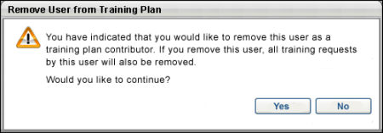
- Selecting Yes removes the contributor's name from the results table. To the user that is removed, the training plan disappears from their Training Plan Access page. All requests the user made are also deleted. No record is stored of the user ever being associated with the training plan.
- Selecting No cancels the action and no changes are made.
Remove a Plan Manager from the Training Plan
You can remove a manager from the training plan assignment by clicking the Remove icon in the Options column. When you select this icon, a warning pop-up appears, alerting you that if the manager is removed, all training request modifications made by the user are also removed.
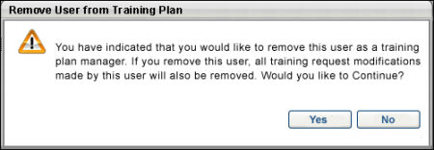
- Selecting Yes removes the user's name from the results table. To the user that is removed, the training plan disappears from their Training Plan Access page. All modifications the user made to a Plan Contributor's training plan are also deleted. Only the task for the Plan Manager is removed.
- Selecting No cancels the action and no changes are made.

Training Plan Details - Export
By clicking the Export icons on the View Plan Details page, the Plan Details view can be exported to a printable version or to Excel.
Export to Printable Version
Selecting the Print icon generates an HTML page output. This output displays all of the information in this view, including the progress pie chart and the training plan overview information that appears above the contributor results table. If the administrator or co-owner uses the search filters to narrow the results and then selects the Print icon, the data that is exported is the filtered results.
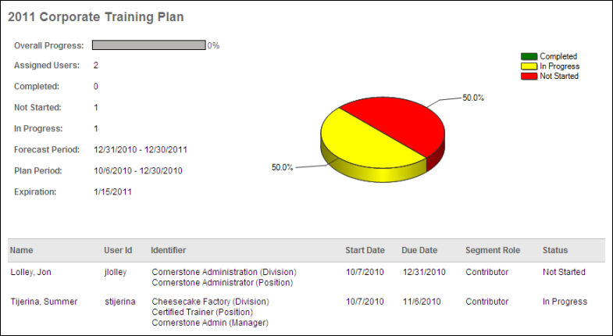
Export to Excel
Selecting the Export to Excel icon exports the title of the training plan and the data detailed in the results to an Excel document. If the administrator or co-owner uses the search filters to narrow the results and then selects the Export to Excel icon, the data that is exported is the filtered results. The progress pie chart and the overview information that appears above the contributor results table are not included.
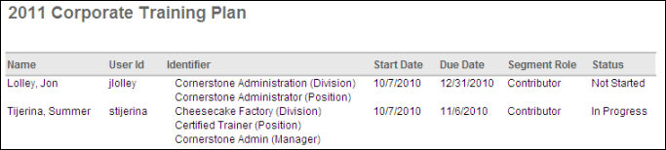
Training Plan Details - On-Hold Training Needs
Users and organizational units (OUs) within a training plan who do not currently have a Plan Contributor (Manager) are in an On-hold status. While users and OUs are in an On-hold status, the system maintains any training needs that were identified by their previous Plan Contributor (Manager) so that the training needs can be used by their next Plan Contributor (Manager). Or, the Training Plan Administrator can manage those needs separately.
The On-Hold Training Needs page displays all On-hold users and OUs within the Training Plan and all of the training needs that have already been identified for those users and OUs. Only active users are displayed.
This page is only available if the training plan has users or OUs in an On-hold status.
If a training plan has on-hold users or OUs, then this page remains accessible even if the training plan period has expired. However, no organizational modification (manager modification) will be handled after the Training Plan period has expired so that the Training Plan remains at the state that it was when it was validated.
To access the On-Hold Training Needs page for a training plan, go to Admin > Tools > Learning > Training Plans. Click the View Details icon for the training plan. Then, click the View On-hold Users link to the right of the Assigned Users field.
Permissions
PERMISSION NAME | PERMISSION DESCRIPTION | CATEGORY

Training Forecast Administration | Grants access to create and edit training plans. This permission can be constrained by OU and User's OU. This is an administrator permission. | Learning - Administration

Training Plan Co-Owner | This permission is not visible within the system because it is a dynamically assigned permission that is assigned to a user when they are designated as a co-owner for a training plan. Users with this permission can access the Training Forecast Administration page and can only access training plans for which they are a co-owner. | Learning
On-Hold Training Needs
The following information is displayed for each on-hold user or OU:
- Previous Plan Contributor - This displays the manager who was previously serving as the Plan Contributor for the user or OU. This user is displayed even if the user is deactivated within the system.
- Users/OUs - This displays the name of the user or OU who currently does not have a Plan Contributor (Manager). When planning for an OU, only the OU name is displayed. The users within the OU are not displayed.
- ID - This displays the ID for the user or OU.
- Estimated Users - This displays the estimated number of users in the corresponding OU. For individual users, this is always 1. However, for OUs, this is the current estimated number of users who require the training. This indicates the number of instances of the training that are required.
- Training - This displays the name of the training that has been identified as a need for the corresponding user or OU.
- Training Type - This displays the training type that corresponds with the training need (e.g., Material, Subject, and External Training) depending on the Training Plan configuration.
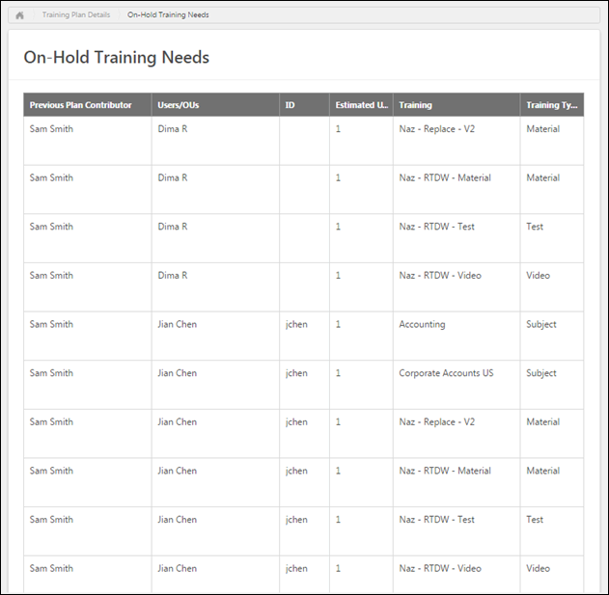

Training Plans Overview

Training Plans - Access
On the Training Plans page, plan contributors can view and access each plan for which they are a contributor, and plan managers can view and access each plan for which they are a manager. On this page, users can perform the following actions:
- Search for a training plan by name.
- Choose to include expired plans in the results table.
- Select a training plan to view or manage. The user's role for each plan is displayed next to the plan details.
To access the Training Plan Access page, go to Learning > Training Plans.
Permissions
PERMISSION NAME | PERMISSION DESCRIPTION | CATEGORY

Training Plans - Manage | Grants access to Training Plans screen, which allows plan managers and plan contributors to access their assigned training plans. This permission cannot be constrained. This is an end user permission. | Learning
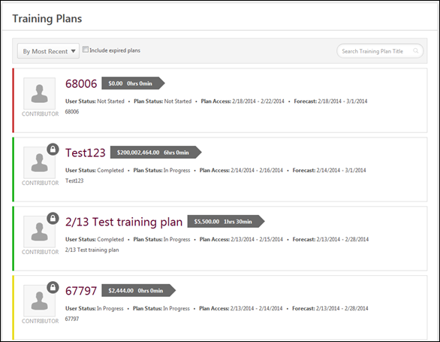
Training Plans - Search
To search for a training plan, in the search field, enter the training plan name. Then, click the magnifying glass icon . The search field accepts up to 100 characters.
Training Plans - View
Up to ten of the plan contributor's or plan manager's active training plans are displayed by default. The user can sort the plans and view expired plans, if necessary. In addition, the user can view additional plans if the user has more than 10 plans.
Sort Training Plans
From the drop-down menu, select the appropriate sort option for the training plans:
- By Most Recent - This option sorts the training plans by plan period start date. The secondary sort is by role. This option is selected by default.
- By Title - This option sorts the training plans alphabetically by plan title. The secondary sort is by plan period start date.
- By Role - This option sorts the training plans by role, either Contributor or Manager. The secondary sort is by plan period start date.
- By User Status - This option sorts the training plans by the user's status for the training plan. Note: This is not the plan status. The secondary sort is by plan period start date.
View Expired Training Plans
Select this option to include expired training plans in the display. This option is unselected by default.
Training Plan Details
The following information is displayed for each training plan:
- Role - To the left of the training plan details, the user's role with regards to the training plan is displayed, either Contributor, Manager, Contributor Co-planner, or Manager Co-planner. A lock icon appears in the upper-right corner of the role image if the access period to modify the training plan is closed.
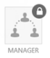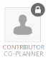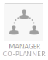
- Title - The training plan title is displayed to the right of the training plan role icon.
- Total Cost and Training Hours - To the right of the title, the total cost and training hours for the training plan are displayed.
- User Status - This displays the user's status with regards to the plan. The user's status is also indicated by a strip of color to the left of the role icon. Red indicates that the user's status is Not Started. Yellow indicates that the user's status is In Progress. Green indicates that the user's status is Completed.
- Plan Status - This displays the plan's status.
- Plan Access - For a plan contributor, this displays the period of time during which the contributor can access the training plan and make requests as defined in the Plan Contributor segment. For a plan manager, this displays the segment access period.
- Forecast - This displays the period of time during which training requests are made. This date range is displayed to plan contributors so that they are aware of the time period for which they are planning.
- Description - The plan description is displayed below the status information.
Show More
If more than 10 training plans are available to the user, then a Show more button is available at the bottom of the list. Click this button to view all of the available plans.
Training Plans - View/Edit
To view or edit a training plan as a plan contributor or plan manager, click the plan title. This opens the corresponding Plan Manager or Plan Contributor page.
- See Training Plan Contributor Page on page 51 for additional information.
- See Training Plan Manager Page on page 61 for additional information.
Possible Statuses
Possible statuses for contributors are:
- Not Started - The plan contributor has not yet saved or submitted the training plan.
- In Progress - The plan contributor has saved the training plan.
- Completed - The plan contributor has submitted their plan, resubmitted their plan, or the contributor's access period due date has passed.
Possible statuses for plan managers are:
- Not Started - The plan manager has not yet saved or submitted the training plan.
- In Progress - The plan manager has saved the training plan.
- Completed - The plan manager has submitted the training plan.

Training Plan Contributor Page
The Training Plan Contributor page allows plan contributors to identify training needs for their training plan by adding training requests.
Within the plan contributor's access period, the plan contributor can request training and modify existing requests. Outside of the plan contributor's access period, the plan contributor can only view their requests; no requests or modifications can be made.
To access the Training Plan Contributor page, click the training plan title on the Training Plans page. See Training Plans - Access on page 48 for additional information.
Permissions
PERMISSION NAME | PERMISSION DESCRIPTION | CATEGORY

Training Demand Forecast Summary Report | Grants access to the Training Demand Forecast Summary report, which enables the administrator to report on training plans and training need requests. This permission can be constrained by OU, User's OU, User's Self and Subordinates, and User. | Reports - Training

Training Plan Co-Planner - Add | Grants ability to add a training plan co-planner if co-planners are enabled for the training plan. The permission constraints determine who can be selected as co-planner. This permission can be constrained by OU, User's OU, User Self & Subordinates, Manager, or Superiors. This is an end user permission. | Learning
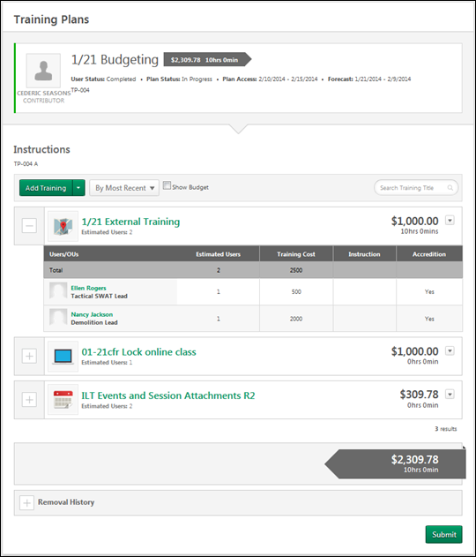
Training Plan Details
At the top of the page, the training plan details are displayed.
- Role - To the left of the training plan details, the user's role with regards to the training plan is displayed, either Contributor, Manager, Contributor Co-planner, or Manager Co-planner. A lock icon appears in the upper-right corner of the role image if the access period to modify the training plan is closed.
- Title - The training plan title is displayed to the right of the training plan role icon.
- Total Cost and Training Hours - To the right of the title, the total cost and training hours for the training plan are displayed.
- User Status - This displays the user's status with regards to the plan. The user's status is also indicated by a strip of color to the left of the role icon. Red indicates that the user's status is Not Started. Yellow indicates that the user's status is In Progress. Green indicates that the user's status is Completed.
- Plan Status - This displays the plan's status.
- Plan Access - For a plan contributor, this displays the period of time during which the contributor can access the training plan and make requests as defined in the Plan Contributor segment. For a plan manager, this displays the segment access period.
- Forecast - This displays the period of time during which training requests are made. This date range is displayed to plan contributors so that they are aware of the time period for which they are planning.
- Description - The plan description is displayed below the status information.
Instructions
Below the training plan details, the instructions for the training plan display.
Co-Planners
If co-planners are enabled for the training plan and if the user has permission to add co-planners, then the Co-Planners section is available. See Training Plan Contributor Page - Co-planners on page 58 for additional information.
Add Training
Plan contributors can add training, subjects, or external training to a training plan using the Add Training drop-down menu. The following options are available:
- Add Training - Select this option to add training to the training plan. This opens the Search for Training pop-up. See Training Plan - Add Training on page 73 for additional information.
- Add Subject/Topic - Select this option to add a subject or topic to the training plan. This opens the Select Subject/Topic pop-up. See Training Plan - Add Subject/Topic on page 72 for additional information.
- Add External Training - Select this option to add external training to the training plan. This opens the External Training pop-up. See Training Plan - Add External Training on page 69 for additional information.
Training Plan - Sort
The training plan can be sorted using the following options in the Sort By drop-down menu:
- Most Recent - When this option is selected, the most recently added training is displayed first. This option is selected by default.
- Training Title - When this option is selected, the training is listed alphabetically by training title.
Training Plan - Show Budget
If budgets are enabled for the training plan, the training plan contributor can choose whether budget information should appear in the training plan. When the Show Budget option is selected, the budget information is displayed next to the user or organizational unit (OU) for whom the contributor is planning.
If the contributor is within the set budget, then the allocated amount is displayed in green. If the contributor is over the set budget, then the allocated amount is displayed in red.
Training Plan - Search
Plan contributors can search the training plan by training or subject title using the Search field in the upper-right corner of the training plan.
Training Demand Report
If the user has permission to view the Training Demand Forecast Summary report, then the Training Demand Report link is available above the training plan. Click this link to run the Training Demand Forecast Summary report. See Training Demand Forecast Summary Report for additional information.
Training Item - Actions
An Actions drop-down icon is available to the right of the training item summary for each training item. This drop-down contains the following actions:
- Edit - Select this option to edit the forecast information for the training item or external training in a pop-up. Plan managers can also approve and deny items within the training plan.
  - LOs - See Training Plan - Edit Learning Object Forecast on page 74 for additional information.
  - Subjects - See Training Plan - Edit Subject Forecast on page 76 for additional information.
- Delete - Select this option to remove the training item from the training plan. A confirmation pop-up appears. Click Yes to confirm the deletion, or click No to cancel the deletion.
- View History - Select this option to view a pop-up that contains the update history for the training item.
  - When a plan manager updates a training item in the training plan, the system tracks the changes in the Training Item History. Each entry in the training item history includes the action, user name, role, date, and time.
  - When a user or OU is denied or re-approved in the training plan, this is tracked in the Training Item History. Each entry in the Training Item History includes the action, user name, role, date, time, and comments. Note: An approval only appears in the Training Item History if the user or OU is changed from Denied to Approved or when the user or OU is added to the plan by the plan manager.
Training Item - Summary
By default, only a summary of each training item within the training plan is displayed. By default, training items and subjects are displayed in the order in which they were added to the training plan, with the most recently added item displayed first.
The following information displays for each training item in the training plan:
- Expand/Collapse Icon - The icon to the left of the training item summary enables the contributor to expand or collapse the training item details.
- Training Item Title - This displays the training item title. In addition, the icon to the left of the title indicates the training type (e.g., event, curriculum, library). For subjects, the default learning icon is displayed. Contributors can click the training title to view the Learning Object (LO) Details page for the LO.
- Estimated Users - This displays the current estimated number of users who require the training. This indicates the number of instances of the training that are required.
- Total Cost - This displays the current estimated total cost for the training request. This amount is based on the number of users and the default price of the LO.
- Total Hours - This displays the current estimated total training hours that are required for the request. This amount is based on the number of users and the duration of the LO.
- Actions - The actions drop-down contains all of the actions that are available to the contributor with regards to the training item. See the Training Item - Actions section for additional information.
Training Item - Expanded Details
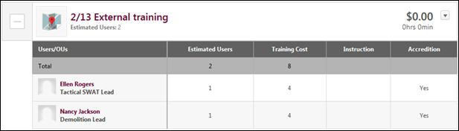
Each training item can be expanded to view the forecast details for the training item. To view the forecast details for a training item, click the Expand icon to the left of the training item summary. The following information is displayed in the expanded details:
- Total - The first row in the table displays the cumulative values for each numeric column. This is only available for columns with integer values.
- User/OU - This column displays the name of the user or OU for whom the contributor is planning. These users and OUs are determined when the training plan is created by the administrator.
  - For users, the user's photograph is displayed to the left of their name, and the user's position is displayed below their name. The contributor can click the user's name to view the Universal Profile - Bio page for the user.
  - For OUs, the OU icon is displayed to the left of the OU name, and the number of users currently in the OU is displayed in parentheses to the right of the OU name.
- Estimated Users - This column displays the current number of estimated users for the user or OU. For users, this is always 1. However, for OUs, this value represents the number of users within the OU who are forecasted to require the corresponding training.
- Additional Fields - Any fields that are included in the training plan appear to the right of the Estimated Users column.
Training Plan Totals
At the bottom of the training plan, the total estimated cost and training hours for the entire plan is displayed.
History
The History section can be expanded and collapsed using the Expand/Collapse icon in the upper-left corner of the section. The History section contains the following subsections:
- Training History - This section contains a record of each time a training item, subject, or external training is added or removed. Each record displays the LO title, action performed, user name, training plan role, date, and time. The most recent activity is displayed first.
- Co-Planner History - This section contains a record of each time a co-planner is added, removed, or edited. Each record displays the co-planner name, action performed, user name, training plan role, date, and time. The most recent activity is displayed first. Note: The Co-Planner History subsection displays even if co-planners are disabled for the training plan.
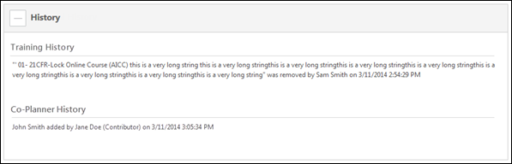
Submit
Click Submit to submit the training plan. This indicates the plan contributor has finished making requests and the training plan is complete. The contributor can resubmit the training plan as many times as needed within the access period. If no requests are included, this indicates that no training is required for the forecast period. For plan contributors, the Submit button is only visible during the contributor access period.

Training Plan Contributor Page - Co-planners
If co-planners are enabled for the training plan and if the user has permission to add co-planners, then the Co-Planners section is available.
Co-planners have the same access to the training plan as the original plan contributor/plan manager with the exception that co-planners cannot add additional co-planners. If Course Catalog access within the training plan is based on the user's learning object (LO) availability, then the co-planner may have access to a different set of LOs than the plan contributor/plan manager. However, once LOs are added to the training plan, then all users with access to the training plan can edit the LOs regardless of Course Catalog access.
The Co-Planners section displays all of the co-planners for the training plan. Co-planners are displayed alphabetically by last name.
When co-planners have been added, this section can be expanded and collapsed using the Expand/Collapse icon in the upper-left corner of the section. The following information is displayed for each co-planner:
- Name - The co-planner's name and photograph are displayed. Click the photograph to open the user's Universal Profile - Bio page in a new window.
- Position - The co-planner's position is displayed below their name.
- Access Period - The co-planner's access period is displayed. This is the period during which the co-planner can access the training plan. When a co-planner is added, their access period is set to the plan contributor/plan manager access period by default. However, this access period can be edited. See the Edit Co-planner Access Period section for additional information.
- Options - The following options are available by clicking the drop-down arrow :
  - Edit Access Period - Select this option to edit a co-planner's access period. See the Edit Co-planner Access Period section for additional information.
  - Remove - Select this option to remove the co-planner from the training plan. See the Remove Co-planner section for additional information.
Add Co-planner
To add a co-planner to the training plan, click the Add Co-Planner button in the Co-Planners section. This opens the Select a User pop-up. See Select a User Pop-up for additional information. This button is only available to plan contributors/plan managers who have permission to add co-planners; co-planners are not able to select additional co-planners.
- The plan contributor/plan manager can only select active users who are within their permission constraints.
- Plan contributors/plan managers can select up to 10 co-planners.
- If a selected co-planner changes OUs so that they are no longer within the user's permission constraints, the co-planner remains as co-planner. However, if the co-planner is removed from the plan, then they cannot be reselected as co-planner if they are still outside the user's permission constraints.
- Co-planners can only be added during the corresponding plan contributor/plan manager's training plan access period.
When a co-planner is selected, the user is automatically granted access to the corresponding training plan with the same access as the corresponding plan contributor/plan manager. When a co-planner is added, their access period is set to the plan contributor/plan manager access period by default. However, this access period can be edited. See the Edit Co-planner Access Period section for additional information.
Note: Plan managers can add and edit co-planners for a plan contributor if it is within the plan manager's access period, it is within the plan contributor's access period, and the plan manager has permission to add co-planners. Which co-planners the plan manager can manage is dependent upon the plan manager's permission constraints.
Edit Co-planner Access Period
The access period is the period during which the co-planner can access the training plan. When a co-planner is added, their access period is set to the plan contributor/plan manager access period by default. However, this access period can be edited. To edit a co-planner's access period, click the drop-down arrow to the right of the co-planner's access period and select Edit Access Period. This opens the Edit Access Period pop-up.
- Co-planners' access period can only be edited during the training plan access period.
Click the Calendar icons to select the appropriate access period for the co-planner. Only dates within the plan contributor/plan manager access period can be selected.
Click Save to save the new access period, or click Cancel to discard any unsaved changes.
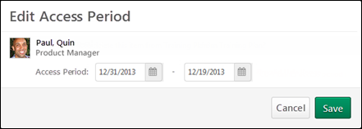
If an administrator modifies the plan contributor/plan manager default access period within Training Forecast Administration and any portion of the co-planner's access period falls outside the newly defined access period, the co-planner's access period is reset to the default access period. However, if the co-planner's access period falls within the newly defined access period, then their access period is not changed.
If a plan contributor/plan manager no longer has permission to add co-planners or if their permission constraints are changed, they can still edit the access period for co-planners who were added prior to them losing the permission.
Note: Plan managers can add and edit co-planners for a plan contributor if it is within the plan manager's access period, it is within the plan contributor's access period, and the plan manager has permission to add co-planners. Which co-planners the plan manager can manage is dependent upon the plan manager's permission constraints.
Remove Co-planner
To remove a co-planner, click the drop-down arrow to the right of the co-planner's access period and select Remove. This opens a confirmation pop-up. Click Yes to confirm the removal, or click No to cancel the removal.
- Co-planners can only be removed during the training plan access period.
Upon removing a co-planner, the user is removed from the Co-Planners section and is no longer able to access the training plan. If the co-planner had made updates to the training plan prior to being removed, the updates remain in the training plan.
If a plan contributor or plan manager no longer has permission to add co-planners or if their permission constraints are changed, they can still remove any co-planners who were added prior to them losing the permission.
Note: Plan managers can add and edit co-planners for a plan contributor if it is within the plan manager's access period, it is within the plan contributor's access period, and the plan manager has permission to add co-planners. Which co-planners the plan manager can manage is dependent upon the plan manager's permission constraints.

Training Plan Manager Page
The Training Plan List page allows plan managers to view the plan contributors for the training plan they are responsible for reviewing along with information about those training plans. From this page, the manager can review the training plans and submit them for final consideration.
Within the plan manager's access period, the plan manager can review the training plans of the plan contributors for which they are the plan manager. Outside of the plan manager's access period, the manager can only view the list of plans; they cannot view the plan details.
To access the Training Plan Manager page, click the training plan title on the Training Plans page. See Training Plans - Access on page 48 for additional information.
Permissions
PERMISSION NAME | PERMISSION DESCRIPTION | CATEGORY

Training Demand Forecast Summary Report | Grants access to the Training Demand Forecast Summary report, which enables the administrator to report on training plans and training need requests. This permission can be constrained by OU, User's OU, User's Self and Subordinates, and User. | Reports - Training
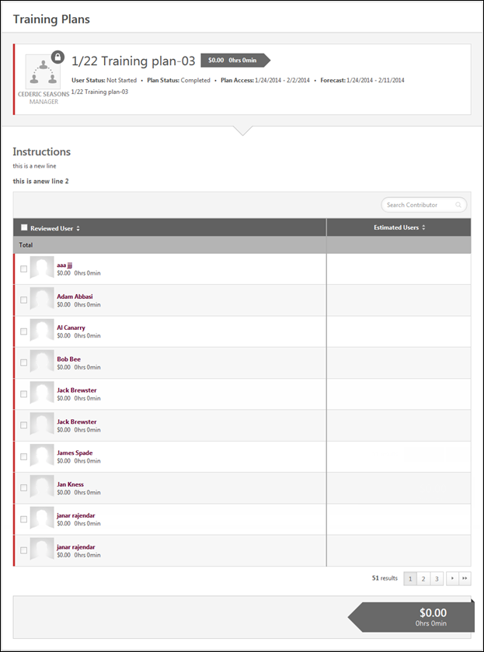
Training Plan Details
At the top of the page, the training plan details are displayed.
- Role - To the left of the training plan details, the user's role with regards to the training plan is displayed, either Contributor, Manager, Contributor Co-planner, or Manager Co-planner. A lock icon appears in the upper-right corner of the role image if the access period to modify the training plan is closed.
- Title - The training plan title is displayed to the right of the training plan role icon.
- Total Cost and Training Hours - To the right of the title, the total cost and training hours for the training plan are displayed.
- User Status - This displays the user's status with regards to the plan. The user's status is also indicated by a strip of color to the left of the role icon. Red indicates that the user's status is Not Started. Yellow indicates that the user's status is In Progress. Green indicates that the user's status is Completed.
- Plan Status - This displays the plan's status.
- Plan Access - For a plan contributor, this displays the period of time during which the contributor can access the training plan and make requests as defined in the Plan Contributor segment. For a plan manager, this displays the segment access period.
- Forecast - This displays the period of time during which training requests are made. This date range is displayed to plan contributors so that they are aware of the time period for which they are planning.
- Description - The plan description is displayed below the status information.
Instructions
Below the training plan details, the instructions for the training plan are displayed.
Co-Planners
If co-planners are enabled for the training plan and if the user has permission to add co-planners, then the Co-Planners section is available. See Training Plan Manager Page - Co-planners on page 66 for additional information.
Training Demand Report
If the user has permission to view the Training Demand Forecast Summary report, then the Training Demand Report link is available above the training plan. Click this link to run the Training Demand Forecast Summary report. See Training Demand Forecast Summary Report for additional information.
Training Plan - Search
Plan managers can search the training plan by contributor using the Search field in the upper-right corner of the training plan.
Contributors Table
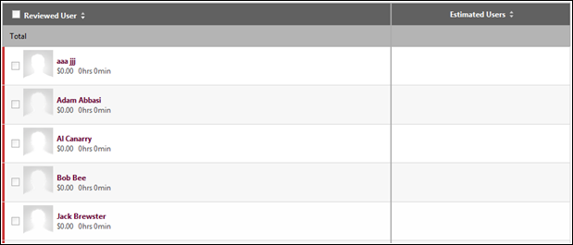
Each contributor who is assigned to the training plan is displayed in the Contributors table. The table can be sorted by clicking any of the column headers. The following information is displayed in the expanded details:
- Total - The first row in the table displays the cumulative values for each numeric column. This is only available for columns with integer values.
- Checkbox - The checkbox to the left of the contributor's photograph is used to indicate that the contributor's training plan has been reviewed. See the Mark Plan as Reviewed section for additional information.
- Reviewed User - This column displays each contributor who is assigned to the training plan. The contributor's name and photograph are displayed as well as the current total plan cost and training hours. The contributor's status is indicated by a strip of color on the left. Red indicates that the user's status is Not Started. Yellow indicates that the user's status is In Progress. Green indicates that the user's status is Completed. Click the reviewer's name to review their plan.
- Estimated Users - This column displays the current number of estimated users for the plan.
- Additional Fields - Any fields that are included in the training plan appear to the right of the Estimated Users column. The values represent the sum of the fields within the contributor's training plan. Non-integer fields are blank.
Review Plan
To review a contributor's plan, click the contributor's name in the Contributors table. This opens the Training Plan Contributor page. The manager can make adjustments as needed to the plan. See Training Plan Contributor Page on page 51 for additional information.
Mark Plan as Reviewed
Once the training plan has reviewed the contributor's plan and made any necessary adjustments, the manager can select the checkbox to the left of the contributor in the Contributors table to indicate the plan has been reviewed. If this checkbox is selected, the manager can continue to make changes to the contributor's plan, as needed, until the plan is submitted.
Training Plan Totals
At the bottom of the training plan, the total estimated cost and training hours for the entire plan is displayed.
History
The History section can be expanded and collapsed using the Expand/Collapse icon in the upper-left corner of the section. The History section contains the following subsection:
- Co-Planner History - This section contains a record of each time a co-planner is added, removed, or edited. Each record displays the co-planner name, action performed, user name, training plan role, date, and time. The most recent activity is displayed first. Note: The Co-Planner History subsection displays even if co-planners are disabled for the training plan.
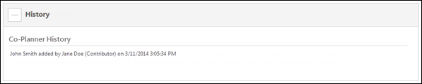
Save or Submit
Click Save to store the status of the training plan.
Click Submit to finalize the training plan. This indicates the plan manager has reviewed all plans.

Training Plan Manager Page - Co-planners
If co-planners are enabled for the training plan and if the user has permission to add co-planners, then the Co-Planners section is available.
Co-planners have the same access to the training plan as the original plan contributor/plan manager with the exception that co-planners cannot add additional co-planners. If Course Catalog access within the training plan is based on the user's learning object (LO) availability, then the co-planner may have access to a different set of LOs than the plan contributor/plan manager. However, once LOs are added to the training plan, then all users with access to the training plan can edit the LOs regardless of Course Catalog access.
The Co-Planners section displays all of the co-planners for the training plan. Co-planners are displayed alphabetically by last name.
When co-planners have been added, this section can be expanded and collapsed using the Expand/Collapse icon in the upper-left corner of the section. The following information is displayed for each co-planner:
- Name - The co-planner's name and photograph are displayed. Click the photograph to open the user's Universal Profile - Bio page in a new window.
- Position - The co-planner's position is displayed below their name.
- Access Period - The co-planner's access period is displayed. This is the period during which the co-planner can access the training plan. When a co-planner is added, their access period is set to the plan contributor/plan manager access period by default. However, this access period can be edited. See the Edit Co-planner Access Period section for additional information.
- Options - The following options are available by clicking the drop-down arrow :
  - Edit Access Period - Select this option to edit a co-planner's access period. See the Edit Co-planner Access Period section for additional information.
  - Remove - Select this option to remove the co-planner from the training plan. See the Remove Co-planner section for additional information.
Add Co-planner
To add a co-planner to the training plan, click the Add Co-Planner button in the Co-Planners section. This opens the Select a User pop-up. See Select a User Pop-up for additional information. This button is only available to plan contributors/plan managers who have permission to add co-planners; co-planners are not able to select additional co-planners.
- The plan contributor/plan manager can only select active users who are within their permission constraints.
- Plan contributors/plan managers can select up to 10 co-planners.
- If a selected co-planner changes OUs so that they are no longer within the user's permission constraints, the co-planner remains as co-planner. However, if the co-planner is removed from the plan, then they cannot be reselected as co-planner if they are still outside the user's permission constraints.
- Co-planners can only be added during the corresponding plan contributor/plan manager's training plan access period.
When a co-planner is selected, the user is automatically granted access to the corresponding training plan with the same access as the corresponding plan contributor/plan manager. When a co-planner is added, their access period is set to the plan contributor/plan manager access period by default. However, this access period can be edited. See the Edit Co-planner Access Period section for additional information.
Edit Co-planner Access Period
The access period is the period during which the co-planner can access the training plan. When a co-planner is added, their access period is set to the plan contributor/plan manager access period by default. However, this access period can be edited. To edit a co-planner's access period, click the drop-down arrow to the right of the co-planner's access period and select Edit Access Period. This opens the Edit Access Period pop-up.
- Co-planners' access period can only be edited during the training plan access period.
Click the Calendar icons to select the appropriate access period for the co-planner. Only dates within the plan contributor/plan manager access period can be selected.
Click Save to save the new access period, or click Cancel to discard any unsaved changes.
If an administrator modifies the plan contributor/plan manager default access period within Training Forecast Administration and any portion of the co-planner's access period falls outside the newly defined access period, the co-planner's access period is reset to the default access period. However, if the co-planner's access period falls within the newly defined access period, then their access period is not changed.
If a plan contributor/plan manager no longer has permission to add co-planners or if their permission constraints are changed, they can still edit the access period for co-planners who were added prior to them losing the permission.
Remove Co-planner
To remove a co-planner, click the drop-down arrow to the right of the co-planner's access period and select Remove. This opens a confirmation pop-up. Click Yes to confirm the removal, or click No to cancel the removal.
- Co-planners can only be removed during the training plan access period.
Upon removing a co-planner, the user is removed from the Co-Planners section and is no longer able to access the training plan. If the co-planner had made updates to the training plan prior to being removed, the updates remain in the training plan.
If a plan contributor or plan manager no longer has permission to add co-planners or if their permission constraints are changed, they can still remove any co-planners who were added prior to them losing the permission.

Training Plan - Add External Training
The External Training pop-up enables training plan contributors and training plan managers to add external training to a training plan.
To add external training to a training plan, click the Add External Training option from the Add Training drop-down menu on the Training Plan Contributor page. This opens the External Training pop-up.
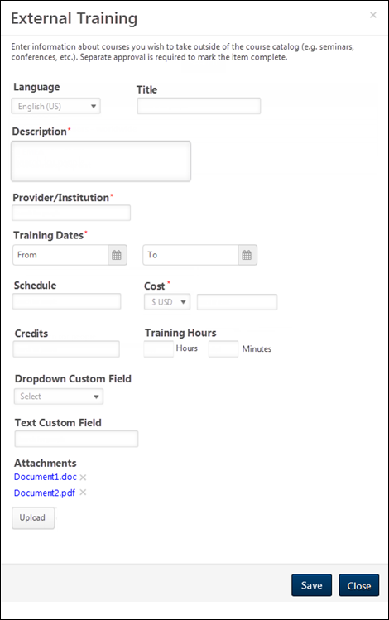
Enter the following information for the external training:
- Language
- Title
- Description
- Provider/Institution
- Training Dates
- Schedule
- Cost
- Credits
- Training Hours
- Custom Fields - Custom fields appear below the Training Hours field if they are enabled by the administrator.
- Attachments - Up to 15 attachments can be added to an external training item.
Note: Required fields have a red asterisk. Administrators can determine which fields are required in Configure External Training Preferences.
After entering the appropriate information, click the Save button to save the external training.

Training Plan - Add Subject/Topic
The Select Subject/Topic pop-up enables training plan contributors and training plan managers to search for and select a subject or topic to add to a training plan. The contributor can search for a subject or topic by title.
To add a subject to a training plan, click the Add Subject/Topic option from the Add Training drop-down menu on the Training Plan Contributor page. This opens the Select Subject/Topic pop-up.
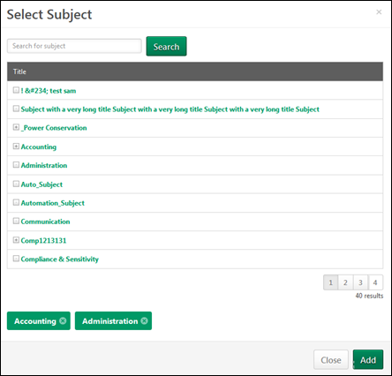
Subject/Topic - Search
To search for a subject or topic, use the following search field to select the appropriate criteria. Then, click the Search button.
- Title - Enter text to search for a subject or topic by title. Any subjects or topics with a title that partially or exactly matches the entered text are displayed.
Alternatively, contributors can browse for a subject or topic using the hierarchy. If a subject or topic has at least one child, an expand icon appears to the left of the title. Click the expand icon to view the child subjects or topics.
Subject/Topic - Add
To add a subject or topic to a training plan, click the title.

Training Plan - Add Training
The Search Training pop-up enables training plan contributors and training plan managers to search for and select training to add to a training plan. The contributor can search for training by learning object (LO) type, title, and keyword.
To add training to a training plan, click the Add Training option from the Add Training drop-down menu on the Training Plan Contributor page. This opens the Search Training pop-up. See Search Training Pop-up for additional information.
Note: If a price changes for a training item that is already part of a training plan, the price will not automatically be updated in the training plan. If a price is changed for a training item that is part of a plan and the new price should be reflected in the plan, you must remove the training item from the plan and add the training item back to the plan after the price change has been saved for the training item.

Training Plan - Edit Learning Object Forecast
Training plan contributors can edit the forecast information for a learning object (LO). Plan managers can also approve and deny items within the training plan.
To edit the forecast information for a LO, click the Actions drop-down icon to the right of the training item summary, and select Edit.
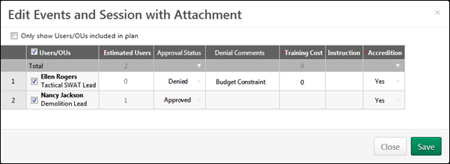
Only show Users/OUs included in plan
When this option is not selected, the pop-up displays all users and OUs for which the contributor is planning, whether or not they are included in the training plan.
When this option is selected, the pop-up displays only the users and OUs that are included in the plan for the corresponding LO or subject.
- If a user or OU is removed from the plan by deselecting the checkbox to the left of their name, the user or OU remains in the pop-up until the changes are saved.
- If the Select All checkbox to the left of the Users/OUs column heading is selected, only the users and OUs that are displayed are selected.
Training Forecast Information Table
The following fields are available in the training forecast information table:
- Total - The first row in the table displays the cumulative values for each numeric column. This is only available for columns with integer values.
- Person - This column displays the name of the user or organizational unit (OU) for whom the contributor is planning. These users and OUs are determined when the training plan is created by the administrator.
  - For users, a checkbox appears to the left of each user's name. Also, a Select All checkbox appears to the left of the Person column heading. Select this checkbox to select all of the individual users.
    - When this checkbox is selected, the user is included in the training plan estimate for the training item.
    - When this checkbox is unselected, the user is not included in the training plan estimate for the training item, and the Estimated Users value for the user is 0. The user does not appear in the Expanded Details view for the training item.
  - For OUs, the Estimated Users field is editable.
- Estimated Users - This column displays the current number of estimated users for the user or OU.
  - For users, this is 1 if the user is selected, and this is 0 if the user is not selected.
  - For OUs, this value represents the number of users within the OU who are forecasted to require the corresponding training. Enter the number of users from within the OU who should be included in the training plan estimate for the training item.
- Approval Status - This column enables the plan manager or administrator to approve or deny each item within the training plan. This column can only be modified during the plan manager's plan access period. This value cannot be modified for users and OUs who are not included in the plan. From the drop-down, select one of the following values:
  - Approved - This option is selected by default. Select this option to approve the user or OU for the training item. When this option is selected, the Estimated Users field is editable.
  - Denied - Select this option to deny the user or OU for the training item. This excludes the user or OU from the plan calculations (e.g., total cost, training hours). When this option is selected, the Estimated Users field is set to zero and is not editable. Also, the user or OU is moved to the bottom of the Users/OUs table and appears gray. "(Denied)" appears to the right of the user or OU name.
- Denial Comments - This column enables the plan manager or administrator to provide comments. Enter comments as to why the user or OU was denied for the training item. The character limit is 250. This field can only be edited when the Approval Status is set to Denied.
- Additional Fields - Any fields that are included in the training plan appear to the right of the Estimated Users column.
Editing Cell Values
Within the table, multiple field types may be present, including numeric, short text box, and drop-down fields.
- To edit a numeric or text value, select the cell and enter the appropriate value.
- To select a drop-down value, click the drop-down menu icon and select the appropriate value.
Multiple cells can be selected, and cell values in the table can be copied and pasted into other cells. In addition, entire rows or columns can be selected by clicking the row or column label.
Save or Cancel
After changes are made to the training item forecast, the Save button becomes active. If no changes are made, the Save button is inactive.
Click the Save button to save any changes, or click Cancel to discard any unsaved changes.
To exit the pop-up, click the X icon in the upper-right corner of the pop-up.

Training Plan - Edit Subject Forecast
Training plan contributors can edit the forecast information for a subject.
To edit the forecast information for a subject, click the Actions drop-down icon to the right of the subject summary, and select Edit.
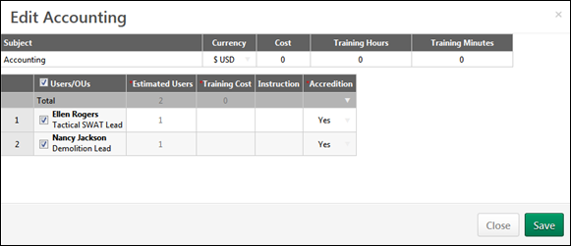
Currency
From the Currency drop-down menu, select the currency that is used when determining the cost for the subject.
Training Forecast Information Table
The first row of the table enables the contributor to specify the cost and training time associated with the subject.
- Subject Name - This displays the name of the subject.
- Cost - This value represents the cost per user that is associated with the subject.
- Training Hours/Training Minutes - These values represent the estimated hours and minutes that are associated with the subject.
The following fields are available in the training forecast information table:
- Total - The first row in the table displays the cumulative values for each numeric column. This is only available for columns with integer values.
- Person - This column displays the name of the user or organizational unit (OU) for whom the contributor is planning. These users and OUs are determined when the training plan is created by the administrator.
  - For users, a checkbox appears to the left of each user's name. Also, a Select All checkbox appears to the left of the Person column heading. Select this checkbox to select all of the individual users.
    - When this checkbox is selected, the user is included in the training plan estimate for the subject.
    - When this checkbox is unselected, the user is not included in the training plan estimate for the subject, and the Estimated Users value for the user is 0. The user does not appear in the Expanded Details view for the subject.
  - For OUs, the Estimated Users field is editable.
- Estimated Users - This column displays the current number of estimated users for the user or OU.
  - For users, this is 1 if the user is selected, and this is 0 if the user is not selected.
  - For OUs, this value represents the number of users within the OU who are forecasted to require the corresponding subject. Enter the number of users from within the OU who should be included in the training plan estimate for the subject.
- Additional Fields - Any fields that are included in the training plan appear to the right of the Estimated Users column.
Editing Cell Values
Within the table, multiple field types may be present, including numeric, short text box, and drop-down fields.
- To edit a numeric or text value, select the cell and enter the appropriate value.
- To select a drop-down value, click the drop-down menu icon and select the appropriate value.
Multiple cells can be selected, and cell values in the table can be copied and pasted into other cells. In addition, entire rows or columns can be selected by clicking the row or column label.
Save or Cancel
After changes are made to the subject forecast, the Save button becomes active. If no changes are made, the Save button is inactive.
Click the Save button to save any changes, or click Cancel to discard any unsaved changes. To exit the pop-up, click the X icon in the upper-right corner of the pop-up.

Training Plan - Plan Contributor and User Changes
When a Plan Contributor (Manager) is removed from the Plan Contributor (Manager) role, any training plan needs that they have identified are stored and are visible on the On-Hold Training Needs page.
- If the Training Plan is expired before the contributor is removed, then the training needs are not stored and they are not visible on the On-Hold Training Needs page.
When a user moves into a Plan Contributor (Manager) role in which a previous Plan Contributor (Manager) had identified training needs, the new plan contributor inherits the previous Plan Contributor's training need information. This enables the new Plan Contributor (Manager) to continue completing the training plan without needing to redo the previous Plan Contributor's efforts.
Inherited Information
All training plan information is inherited by the new Plan Contributor, including the following information:
- User or Organizational Unit (OU) Name
- Estimated Users
- Approval Status
- Denial Comments
- Custom Field Data
If the new Plan Contributor (Manager) already has existing training needs, then the newly inherited users and their training needs are automatically added to the existing training plan. The total costs and hours are automatically updated to include the inherited training needs.
User Moves to New Training Plan
If a user within a training plan moves into a new OU that is not included in the Training Plan Availability, then any training needs that have been identified for the user are deleted and cannot be restored. For example, if a user moves to a new position for which training needs are not planned or are planned in a separate training plan, then the user's existing training needs are deleted and they are not transferred to another training plan.
When a new user is created in the system and is automatically added to an existing training plan, the user is not added to any existing training needs. However, the plan contributor can choose to add the new user to existing or new training needs.
On-hold Training Needs Considerations
- If a user is deactivated, all of their training plan needs are deleted. If a user is deleted and added again, the needs are deleted and cannot be restored.
- The custom fields always save the value from the previous Plan Contributor (Manager).
- After the Plan Expiration date, the on-hold training needs are no longer restored. The page is accessible and non-modifiable.
Restoring Considerations
- The new Plan Contributor (Manager) should initially exist in the Training Plan/Plan Contributor Segment to be able to receive the on-hold needs.
- OUs needs are not restored. This requires manual action from the Training Plan Administrator.
- After the Plan Expiration date, no automatic movements occur anymore.
- The Training Hours and Costs are always updated with the new Plan Contributor (Manager) LO details availability (including currency).
- The OU's default number of users is not recalculated after new users have been added to new Plan Contributors (Managers). This is only applicable if planning for OUs.

