Training Forms March 2024

Table of Contents
Training Forms Overview 1
Form Management for Onboarding and Cornerstone HR 2
Training Order Forms Overview 3
Training Order Form Administration 4
Training Order Form - Create 6
Training Form Administration Overview 9
Training Forms Administration 10
Training Form Category - Create 12
Training Form Request - Approve or Deny 13
Training Form Question - Create 14
Training Form Task - Create 17
Training Form Template - Create 19
Training Form Tasks - Manage 21
Training Request Forms Overview 22
Training Request Forms Administration 23
Training Request Form - Attach to Training 25
Training Request Forms - Add Custom Fields 26
Training Request Forms - Create 27
Training Request Forms - View 29
Training Request Form Email Administration 31
Training Request Form Statuses - Manage 32

Training Forms Overview

Form Management for Onboarding and Cornerstone HR
The Form Management functionality that is part of Onboarding and Cornerstone HR can be found in the Onboarding folder in Online Help. See the following sections in the Onboarding folder in Online Help for the Form Management functionality for Onboarding and Cornerstone HR:
- Form Task Administration
- Manage Forms
- Question Bank

Training Order Forms Overview
Training Order Forms enable administrators to set up promotional bundles of learning objects (LOs) to encourage purchases. Training order forms also bypass the Catalog Search by displaying the training order form on the Welcome page. For example, a company can use an order form to advertise a promotion where users receive a discount when they spend a certain amount on a specified group of training. LOs must have a price greater than zero, and the shopping cart functionality must be enabled in order for order form functionality to be available.
To enable training order forms for your portal, contact Global Customer Support.
To access Training Order Form Administration, go to Admin > Tools > Learning > Training Form Management > Manage Training Order Forms.
Permissions
PERMISSION NAME | PERMISSION DESCRIPTION | CATEGORY

Training Order Forms - Manage | Grants access to the Manage Order Forms page, which allows administrators to create and manage order forms. The order forms act as promotional purchase pages which are displayed to end users. This is an administrator permission. | Training Forms Administration

Training Order Form Administration
The Manage Training Order Forms page allows administrators to create and manage training order forms. The order forms act as promotional purchase pages, which allow users to bypass the Catalog search by appearing on the Welcome page. The Welcome page can be configured to display all visible order forms with the most recently created order forms displayed first.
To access Training Order Form Administration, go to Admin > Tools > Learning > Training Form Management > Manage Training Order Forms.
Permissions
PERMISSION NAME | PERMISSION DESCRIPTION | CATEGORY

Training Order Forms - Manage | Grants access to the Manage Order Forms page, which allows administrators to create and manage order forms. The order forms act as promotional purchase pages which are displayed to end users. This is an administrator permission. | Training Forms Administration
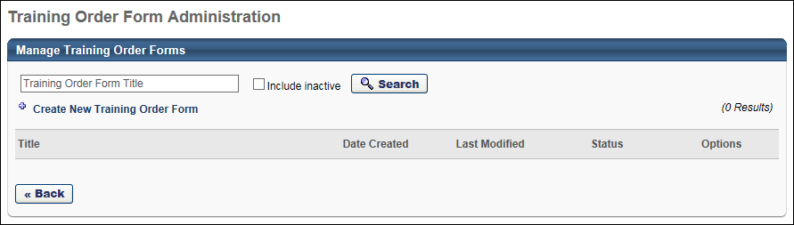
To create an order form, click the Create New Training Order Form link. See Training Order Form - Create on page 6 for additional information.
You can search for an existing order form by name using the Search functionality. Select the Include Inactive option to also include inactive order forms in the search results.
The Order Forms table displays the following information for each order form:
- Title - The title of the order form
- Date Created - The date the order form was first created
- Last Modified - The date on which the order form was last modified
- Status - This displays whether the order form is active or inactive
The following options are available in the Options column:
- View Details - This option allows you to preview the order form.
- Copy - This option takes you to the Copy Training Order Form page with all of the details copied from the original order form except for the title. This page behaves similarly to the Create Training Order Form page. See Training Order Form - Create on page 6 for additional information.
- Edit - This option takes you to the Edit Training Order Form page where you can edit the details of the order form. This page behaves similarly to the Create Training Order Form page. See Training Order Form - Create on page 6 for additional information.
- Delete - This option deletes the order form. All order forms can be deleted.

Training Order Form - Create
The Training Order Form Administration page allows the administrators to set the details of the training order form, including which LOs are included in the offer. Administrators can combine custom page functionality with training order forms in order to place a training order form on a custom page for users.
Once a training order form is created, the training order form link appears on the users' Welcome Page in the Order Forms widget if the widget is enabled. Note: The number of links that appear in the Order Forms widget is determined by the administrator in the Welcome Page preferences. The widget can display up to 10 order form links.
To enable training order forms for your portal, contact Global Customer Support.
To create a training order form, go to Admin > Tools > Learning > Training Form Management > Manage Training Order Forms. Then, click the Create New Training Order Form link.
Permissions
PERMISSION NAME | PERMISSION DESCRIPTION | CATEGORY

Inventory - Manage | Grants ability to purchase multiple learning object licenses with the intent to assign that training to other users at a later time. This permission can be constrained by OU and User's OU. | eCommerce

Training Order Forms - Manage | Grants access to the Manage Order Forms page, which allows administrators to create and manage order forms. The order forms act as promotional purchase pages which are displayed to end users. This is an administrator permission. | Training Forms Administration
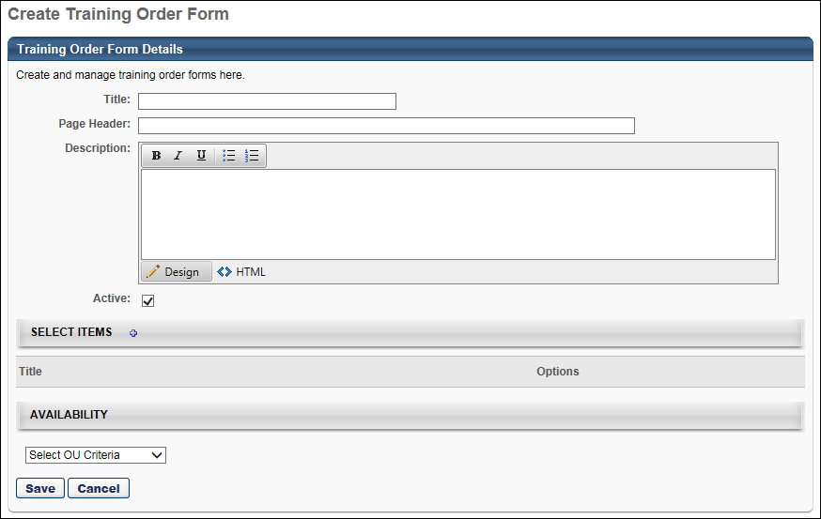
For each order form, enter the following information:
- Order Form Widget Title - This is the title that appears in the Order Forms widget on the Welcome page. The character limit for this field is 20.
- Page Header - The title that appears on the order form page. The character limit for this field is 50.
- Description - The description that appears on the order form page below the page header. This field accepts HTML code and the character limit is 2000.
- Active - Select this option to make the order form active. If this option is not selected, the order form page is not accessible and the link to the page no longer appears on the user's Welcome page widget.
- Select Items - Click the plus icon to the right of the Select Items heading to add learning objects to the order form. The learning objects selected here are available to users on the order form. The training items available for selection is constrained by the order form creator's LO availability. Click the Remove icon to delete the LO from the order form.
- Availability - Use the Select Criteria drop-down menu to select availability for the order form. Only users selected in this section are able to view and use the order form. Best Practice: When setting availability for an order form, ensure that the included users also have availability to all the learning objects on the form. As a user, it can be frustrating to see a learning object in an available form but not be able to purchase it.
Example Order Form
If you do not have permission to manage inventory, the For Others column is not available and you cannot assign the training to other users.
- If you do have permission to manage inventory but the item does not allow inventory purchase, "Not Available" displays in the For Others column.
If an LO is not available to the user, "Not Available" displays in the For You column.
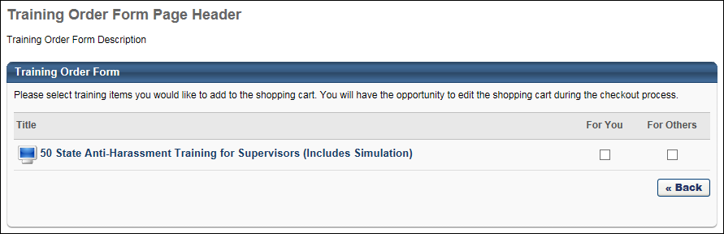

Training Form Administration Overview

Training Forms Administration
The Training Form Administration function allows administrators to create training form templates, training form tasks, and questions in a question bank specifically designed for training forms.
To initially enable training forms for your portal, contact Global Customer Support.
To access the Training Form Administration page, go to Admin > Tools > Learning > Training Form Management > Manage Training Forms.
Permissions
PERMISSION NAME | PERMISSION DESCRIPTION | CATEGORY

Training Forms - Manage | Allows user to create and manage custom training form templates and create and assign training form tasks. This is an administrator permission. | Training Forms Administration
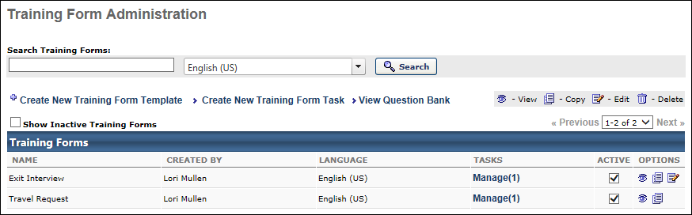
Search Training Forms
Use this field to search for an existing training form. If multiple languages are enabled for your portal, you can use the language filter to search for training forms by language.
Create New Training Form Template
Click the Create New Training Form Template link to create a training form template. See Training Form Template - Create on page 19 for additional information.
Create New Training Form Task
Click the Create New Training Form Task link to create a training form task. See Training Form Task - Create on page 17 for additional information.
View Question Bank
Click the View Question Bank link to view and create training questions and categories. See Training Form Question - Create on page 14 for additional information.
Show Inactive Training Forms
By default, only active forms are included in the table. Select the Show Inactive Training Forms option to include inactive forms in the table.
Training Forms Table
The following information displays for each training form in the table:
- Name - The name of the training form.
- Created By - The user who created the form.
- Language - The default language for this form.
- Tasks - The number of tasks that are actively using the form. Click the Manage link to open the Task Administration page and manage all tasks that use this form. See Training Form Tasks - Manage on page 21 for additional information.
- Active - Select or unselect this option to make a form active or inactive.
Training Form Options
The following options are available in the Options column:
- View - Click this icon to view a read-only version of an existing form.
- Copy - Click this icon to copy existing form.
- Edit - Click this icon to edit the form.
- Delete - Click this icon to remove the form. Forms cannot be removed if the form has been requested by at least one user, however it can be deactivated.
Training forms can be assigned using a task or by being included in a curriculum structure. If the training form is in use in a task or is assigned to a user via a curriculum, then the delete and edit options are not available.

Training Form Category - Create
To create a training form question category, go to Admin > Tools > Learning > Training Form Management > Manage Training Forms. Click the View Question Bank link.
Click the Create New Category link. The Question Categories pop-up opens.
Click the Add Category link. A blank entry appears at the top of the Categories table.
Permissions
PERMISSION NAME | PERMISSION DESCRIPTION | CATEGORY

Training Forms - Manage | Allows user to create and manage custom training form templates and create and assign training form tasks. This is an administrator permission. | Training Forms Administration
- In the Name column, enter a name for the question category. If multiple languages are enabled for your portal, click the Globe icon to translate the field into other available languages.
- Click the Save icon to save the question category.
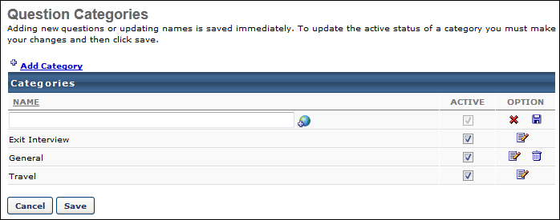

Training Form Request - Approve or Deny
The approve or deny a training form request, follow these steps:
- Go to Content > Form Approval.
- Click View Completed Form - to view details of the form.
- Click Approve or Deny .
Permissions
PERMISSION NAME | PERMISSION DESCRIPTION | CATEGORY

Form Approvals - Manage | Grants access to manage Form Approvals functionality. | Forms - Administration

Training Forms - Manage | Allows user to create and manage custom training form templates and create and assign training form tasks. This is an administrator permission. | Training Forms Administration
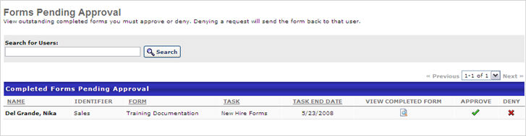

Training Form Question - Create
To create a training form question, go to Admin > Tools > Learning > Training Form Management > Manage Training Forms. Click the View Question Bank link. Then, click the Create New Question link. The Create Question pop-up opens.
Permissions
PERMISSION NAME | PERMISSION DESCRIPTION | CATEGORY

Question Bank - Manage | Grants access to the Question Bank functionality. This permission can be constrained by OU and User's OU. This is an administrator permission. | Forms Management Administration

Training Forms - Manage | Allows user to create and manage custom training form templates and create and assign training form tasks. This is an administrator permission. | Training Forms Administration
Enter the following information:
Question
In this field, enter a question to be used on the form. Form questions have all user fields available as tags and may be used in the body of the Question. When the user views the form, the tag will be replaced with the appropriate user field. To see a list of tags available, click the Display a list of tags that can be used within the body of the Question link.
Language
If multiple languages are enabled for the portal, select the appropriate language from drop-down.
Question Image or Video
If an image or video is used in the question, click the Browse button to browse for the appropriate image or video. Then click Upload to upload the file. The selected image or video will display next to the question for the user when filling out the Form.
Multi-part
Select this option to include multiple sub-questions. This option is only available for Yes/No, True/False, or Likert Scale response type questions.
When this option is selected, the Add sub-question link appears. Click the link to add sub-questions. Enter the following information for the sub-question:
- Order - Enter the order in which the sub-questions should appear. A sub-question with an Order value of 1 will appear first.
- Sub-question - Enter the sub-question text.
Response Type
From the drop-down, select the appropriate response type. The following response types may be available:
- Yes/ No - user will receive a Yes/No option to choose
- True / False - user will receive a True/False option to choose
- Likert Scale - user will receive a Rating Response Choice radio button option to choose. The open text boxes have default response choices, but can be typed over for custom response choices.
- Multiple Choice - Single Answers - user will receive a Multiple Choice - Single Answer option to choose from on the Form. Only one answer can be selected by the user.
  - Click Add Response Choice and enter response choices.
  - For each response choice, enter Order response is to appear
  - Check the Include 'None of the above' box to display 'None of the above' as an response choice. Activating/Selecting this will supersede all other response choices.
  - Check the Include 'All of the above' box to display 'All of the above' as an response choice. Activating/Selecting this will supersede all other response choices.
- Multiple Choice - Multiple Answers - user will receive a Multiple Choice - Multiple Answers option to choose from on the Form. Multiple answers can be selected by the user.
  - Click Add Response Choice and enter answer choices.
  - For each answer choice, enter Order response is to appear
  - Check the Include 'None of the above' box to display 'None of the above' as an response choice. Activating/Selecting this will supersede all other response choices.
  - Check the Include 'All of the above' box to display 'All of the above' as an response choice. Activating/Selecting this will supersede all other response choices.
- Text Only - allows users to respond by entering text. Responses to these questions can be given in paragraph form.
- Date Value - allows users to respond by entering a date or selecting date from calendar icon
- Short Text - to provide users with questions for which the responses are text-based responses. These text responses are limited to 250 characters.
- Instructions - to allow for additional read only, non-numbered text. Instructions are meant to be read-only pieces of text that can be inserted anywhere in a form. The question number will be suppressed for Instructions type questions and will continue sequence with the next question. Instructions boxes are html friendly.
- User Field - allows an administrator to create a field in a form that allows the user to verify the information and then change it if needed. This change will populate to the actual user record thus allowing the user to change their own user records for all OU fields. For Generic fields it gives the user an open text box and for custom it shows as populated. For example, if you choose the division user field (an OU field) the user will see the question and then their division and the select icon. They can change the division to any other division and it changes their user record.
  - Click Select.
- To allow for user to choose from a User Field option. Clicking on the link brings up Select User Field pop-up. All default and custom User fields are available in the pop-up for selection. Allows an Admin to put a field in a form that allows the user to verify the information and then change it if needed. This change will populate to the actual user record thus allowing the user to change their own user records for all OU fields. For Generic fields it gives the user an open text box and for custom it shows as populated
  - Click the Select User Field link.
  - Select User field. Only one user field per question.
  - Click Submit.
Note: In some instances, if a custom field is used and the user does not have a saved value for that field, the "None" value may appear as a placeholder value by default even if the field options do not include "None".
Comments Box
The following options are available in the Comments Box section:
- Include comments box - Select this option to include a comments box after the question. This allows the user to add comments with their response.
- Comments required - Select this option to make the comments field required for users. If this option is selected, a user must include a comment with their question response. This option is only available if the Include comments box option is also selected.
- Directions for comments box - In this field, provide directions that will be displayed above the comments box.
Category
Select the category in which the question should be grouped. Administrators can also filter questions by category.
Submit
Click Submit to save the question.

Training Form Task - Create
To create a training form task, go to Admin > Tools > Learning > Training Form Management > Manage Training Forms. Then, click the Create New Training Form Task link.
Permissions
PERMISSION NAME | PERMISSION DESCRIPTION | CATEGORY

Training Forms - Manage | Allows user to create and manage custom training form templates and create and assign training form tasks. This is an administrator permission. | Training Forms Administration
Name Task
- Type
  - Single Task - choose to enter start and end date for task.
  - Recurring Task - choose to make task recur
- Tags - Click the link to place tags within the Form Task to into the Name, Description, or Instructions fields. This is only available for recurring tasks.
  - TAG.NAME can be added by copying and pasting, or by typing in manually. When the user fills out the form, the TAG NAME will be converted to system information. For example, if the CURRENT.MONTH.NAME is placed in the body of the Section, it will display the current month instead of the TAG NAME.
- Name - enter name for task
- Description - enter description for task
- Instructions - enter instructions for the user. If left blank the user will launch directly to the main body of the form and bypass the instructions page.
- Date:
  - For Recurring tasks, the following options are available:
    - Click the Schedule Recurrence link.
    - Click the link and then enter the Recurrence Frequency for the number of Days/Weeks/Months that the Form Task will recur
    - Set the Duration of Schedule. This controls the length of the recurring form task schedule. Selecting/Activating the No end date check-box overrides the End Date
    - Task Due - Controls Due Date of each scheduled task. *Note - For a Recurring Task , Availability will be copied to new tasks. The new task will pick up and drop off new/old users from Availability dynamically.
  - For single tasks, set the start and end date for the task.
- Allow task launch after expiration date - If this option is not selected/activated, a user will not be able to submit (complete) the form after the task end date has passed. If this option is selected/activated, the user will still be able to launch and submit the form from the Welcome Page after the task end date.
- Spell Check - use to check the spelling
- Click Next
Component Preferences
- Select Form Template - choose a Form Template from the drop-down menu
- Click Next
Availability
- Select Availability Selection Criteria
  - Include Subordinates - check to include subordinates
  - Randomly Assign To - select either an amount of users (place number count in text box) or a percentage amount of users that the Form Task will be randomly assigned. The number and percentage is based off of the Criteria.
  - Require Final Approval From - once the Form Task has been completed, the User selected in this column must approve the completion before it is marked complete on the User Transcript.
- Click Next.
Confirm
- Click Save - the assigned task will appear on a user's Welcome Page under the Your Tasks widget.

Training Form Template - Create
To create a training form template, go to Admin > Tools > Learning > Training Form Management > Manage Training Forms. Then, click the Create New Training Form Template link.
Permissions
PERMISSION NAME | PERMISSION DESCRIPTION | CATEGORY

Training Forms - Manage | Allows user to create and manage custom training form templates and create and assign training form tasks. This is an administrator permission. | Training Forms Administration
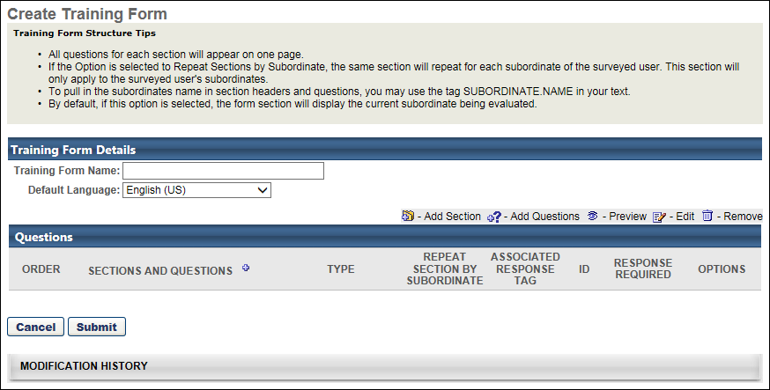
Training Form Details
- Enter Training Form Name (required field).
- Default Language - select language from drop-down if applicable. The form will only be assigned to user's with the corresponding language. If English (US) is selected in Form Details, only user's set with the English (US) language will see the Form once assigned.
Add Section
To add a section:
- Click the Plus icon next to the Sections and Questions heading.
- Section Title - enter title for section.
- Section Directions - enter directions for section.
- Tags can be used in the Section Directions field.
- Click Done.
Add Question
Click Add Question to add questions to each section. Any new questions added using the add question icon will append to that specific section of the form.
- Search for question by name or category.
- Add- click to add individual Question or click Add All Questions link to add all questions from search results.
- View- to preview question.
- Click Done.
- Edit- click to edit a question. Note: Editing a question changes that question in all forms the question has been used. est Practice is to make changes to the grammar or correct errors but not change the meaning or the structure of the question.
- Delete- click to remove a question from a section. If a question has been used in a form, a question cannot be removed/deleted and the icon will not appear.
All questions for each section will appear on one page.
Training Form Tags
When creating a training form template, tags may be used in the Training Form Name, Section Title, Section Directions, or Question fields.
When the views the form, the tag name will be converted with the value in the user record. For example, if the MANAGER.PHONE is placed in the section directions, it will display as an actual phone number instead of the tag name.
To view the list of available training form tags, add or edit a section, and then click the Display a list of tags link at the top of the Add Section pop-up.
To use a tag, copy the tag and place it in the Section Directions field or manually type the tag name in this field.
Options
- Order - enter number to order section or questions within a section.
- Repeat Section By Subordinate - check if you want the same section to repeat for each subordinate. This will apply to the user's subordinates.
- Associate Response Tag - allows you to put in a short text tag so in reports you can use this tag as a column instead of the entire question (in case the question is a graphic or really long).
- Response Required - check to make the response required for the question.
Submit
Click Submit to create the training form template.

Training Form Tasks - Manage
To manage training form tasks, go to Admin > Tools > Learning > Training Form Management > Manage Training Forms. In the table, click the Manage link in the Tasks column for the appropriate form.
Permissions
PERMISSION NAME | PERMISSION DESCRIPTION | CATEGORY

Training Forms - Manage | Allows user to create and manage custom training form templates and create and assign training form tasks. This is an administrator permission. | Training Forms Administration
The following options are available for the task:
- Copy - Existing form tasks can be copied.
- Edit - Existing form tasks can be edited. Note: This icon will only appear for tasks that are in Not Started status.
- View Form Details - Click on this icon to view pie chart details.
- View Details - Click this icon to view details of form tasks In Progress. *This icon will only appear for tasks In Progress.
- Remove - Click this icon to delete Form Tasks. Note: This icon will only appear for tasks that are in Not Started status, and do not fall under Recurring status.
Training forms can be assigned using a task or by being included in a curriculum structure. If the training form is in use in a task or is assigned to a user via a curriculum, then the delete and edit options are not available.
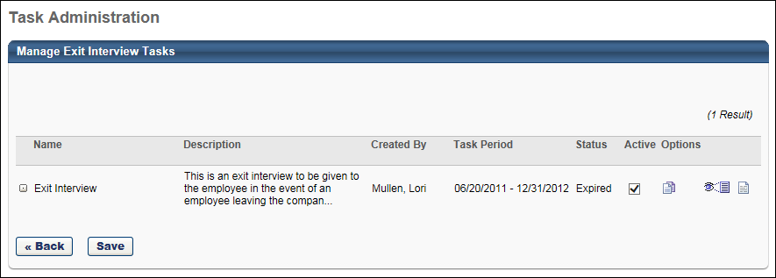

Training Request Forms Overview
Training request forms are designed to obtain additional information from a user at the time of request. For example, a custom travel form might be attached to sessions to obtain information for your employees regarding travel booking information. The Training Request Form Administration page is where administrators can manage the training request forms available in the system.

Training Request Forms Administration
Training request forms are designed to obtain additional information from a user at the time of request. For example, a custom travel form might be attached to sessions to obtain information for your employees regarding travel booking information. The Training Request Form Administration page is where administrators can manage the training request forms available in the system. This main page has a summary view of existing forms and options to manage.
To access the Training Request Form Administration page, go to Admin > Tools > Learning > Training Form Management > Manage Training Request Forms.
Permissions
PERMISSION NAME | PERMISSION DESCRIPTION | CATEGORY

Training Request Form - Manage | Grant access to create and edit training request forms, manage request form statuses, and manage form statuses for users. This is an administrator permission. | Training Forms Administration
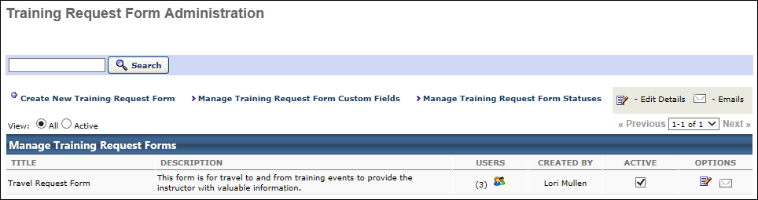
Search Training Request Forms
Use this field to search for an existing training request forms.
Training Request Form - Create
Click the Create New Training Request Form link to create a training request form. See Training Request Forms - Create on page 27 for additional information.
Training Request Form Custom Fields - Manage
Click the Manage Training Request Form Custom Fields link to manage training request form custom fields. See Training Request Forms - Add Custom Fields on page 26 for additional information.
Training Request Form Statuses - Manage
Click the Manage Training Request Form Statuses link to manage training request form statuses. See Training Request Form Statuses - Manage on page 32 for additional information.
View All or Only Active
Select whether all training request forms are displayed or only active training request forms.
Options
- Users - lists the number of users associated to this form. Clicking on the users icon will take you to the Users detail page for that form
- Active - to make forms active or inactive
- Edit - to edit existing form
- Emails - email triggers specific to each form
See also:
- Training Request Form - Attach to Training
- View Training Request Forms
- Training Request Form Email Administration

Training Request Form - Attach to Training
A Training Request Form may be attached to any type of learning object (LO) in the system.
- When attaching a training request form to a LO, only users who have not yet requested this LO will see the form.
- The training request form will display for users when they request the LO. If a learning assignment is used to assign the LO, the user can access the training request form from the Training Details page for the LO in their transcript.
- The user can modify the training request form after the initial submission by accessing it from the Training Details page in their transcript.
Note: If a training request form is not completed before the associated training item is completed, it does not appear on the user's transcript.
Permissions
PERMISSION NAME | PERMISSION DESCRIPTION | CATEGORY

Training Request Form - Manage | Grant access to create and edit training request forms, manage request form statuses, and manage form statuses for users. This is an administrator permission. | Training Forms Administration
Add Training Request Form to Training via Course Catalog
To add a training request form to a training item:
- Go to Admin > Tools > Learning > Catalog Management > Course Catalog.
- Search for Learning Objects in the Course Catalog.
- Click the Edit icon next to the learning object.
- Training Request form can be added via the General tab or the Availability tab.
- From the Training Request Form drop-down menu, select a form to attach to the training. The form must have already been created. See Training Request Forms - Create on page 27 for additional information.
- Click Save.
Add Training Request Form to ILT Events and Sessions
To add a training request form to an instructor-led training (ILT) event or session:
- Go to ILT > Manage Events & Sessions.
- Click the Edit icon for an event.
- Click Session Defaults link.
- From the Request Form drop-down menu, select a form to attach to the training. The form must have already been created. See Training Request Forms - Create on page 27 for additional information.
- Click Save.

Training Request Forms - Add Custom Fields
For more information about adding custom fields to training request forms, refer to: Define Custom Fields for Training

Training Request Forms - Create
To create a training request form, go to Admin > Tools > Learning > Training Form Management > Manage Training Request Forms. Then, click the Create New Training Request Form link.
Permissions
PERMISSION NAME | PERMISSION DESCRIPTION | CATEGORY

Training Request Form - Manage | Grant access to create and edit training request forms, manage request form statuses, and manage form statuses for users. This is an administrator permission. | Training Forms Administration
Create Request Form
Enter the following information:
- Title - Enter a title for the form, up to 100 characters. This will be visible when selecting a form to attach to a learning object. If multiple languages are enabled, click the Translate icon to the right of the field to localize the values to the other available languages.
- Description - Enter text that will be visible only to the administrators, up to 1000 characters. This will display on the Training Request page. If multiple languages are enabled, click the Translate icon to the right of the field to localize the values to the other available languages.
- Instructions - Enter text that will appear at the top of the form as instructions, up to 1000 characters. If multiple languages are enabled, click the Translate icon to the right of the field to localize the values to the other available languages.
- Form Owners - Click to add owners. Owner's will have access to the form and can modify all user forms.
- Default Submission Status - Select the default status the form will change upon first submission by the user.
- Add Custom Field - Select the Add Custom Field link to add existing custom fields to the form. Custom fields must be created in Custom Field Administration before they can be added to a form. See Custom Field Administration.
  - Select fields to add to form, then click Submit.
  - Order - Enter number to rearrange order of fields.
  - Display Name - Enter text to specify how the field name will appear for users when completing the form. The same custom field may be used across forms, but have different display names for the user. If multiple languages are enabled for your portal, select the Translate icon to translate the field into other available languages.
  - Response Required - Check this option to make the field required. If selected, the form cannot be submitted until the user enters a value in the field.
Note: If Reason for Change is enabled for the portal, and the "Require reason for change when modifying the user record" preference is enabled in User Preferences, and a User Record custom field is included in the form, then "Self-Service" is saved as the reason for change when the User Record custom field value is updated using the form.
Click Save.
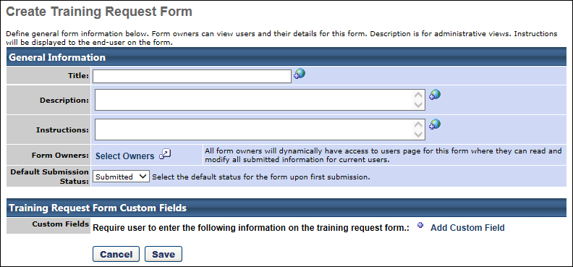

Training Request Forms - View
After a training request form has been created and attached to training, administrators can view user information for the request forms.
Permissions
PERMISSION NAME | PERMISSION DESCRIPTION | CATEGORY

Training Request Form - Manage | Grant access to create and edit training request forms, manage request form statuses, and manage form statuses for users. This is an administrator permission. | Training Forms Administration
Training Request Forms Administration
To view details for a training request form from the Training Request Forms Administration page:
- Go to Admin > Tools > Learning > Training Form Management > Manage Training Request Forms.
- Click the Users icon for any Form to view all users who have a learning object with that form attached.
- Click Details icon to see additional details. The following information may display for the training request form associated with the training:
  - Not Started - Click the number in the Not Started field to view users who have not started the form.
  - Submitted - Click the number in the Submitted field to view users who have submitted the form.
  - Modified - Click the number in the Modified field to view users who have modified the form.
  - Completed - Click the number in the Completed field to view users who have completed the form.
Note: If a Training Request form is not completed t before the associated training item is completed, it does not appear on the user's transcript.
View Training Request Forms for ILT Events and Sessions
To view details for a training request for from for an instructor-led training (ILT) event or session:
- Go to ILT > ILT Request Forms page.
- Click the title of the training to view details. The following information may display for the training request form associated with the training:
  - Not Started - Click the number in the Not Started field to view users who have not started the form.
  - Submitted - Click the number in the Submitted field to view users who have submitted the form.
  - Modified - Click the number in the Modified field to view users who have modified the form.
  - Completed - Click the number in the Completed field to view users who have completed the form.
  - Cancelled - If a session is cancelled, all users' request forms are changed to Cancelled status.
  - View Users - Click this link to view the session with all statuses displayed.
Note: If a Training Request form is not completed t before the associated training item is completed, it does not appear on the user's transcript.

Training Request Form Email Administration
Each Training Request Form will have customizable email templates based on four unique status change triggers. This allows flexibility to decide what text should be included and who emails should be sent to for each unique form.
- Submit Request Form - This email is triggered upon the initial submission of the request form.
- Request Form Completed - This email is triggered upon administrator marking completion of the request form.
- Request Form Modified - This email is triggered if the end user makes changes and resubmits the request form.
- Request Form Cancelled - This email is triggered in one of three instances:
  - An administrator marks a request form as Cancelled
  - The session the user is scheduled to attend is cancelled
  - The user withdraws from a session

Training Request Form Statuses - Manage
The five standard Training Request Form statuses may be configured. The names entered will appear for all administrator and end user views involving request forms.
To manage training request form status names, go to Admin > Tools > Learning > Training Form Management > Manage Training Request Forms. Then, click the Manage Training Request Form Statuses link.
Permissions
PERMISSION NAME | PERMISSION DESCRIPTION | CATEGORY

Training Request Form - Manage | Grant access to create and edit training request forms, manage request form statuses, and manage form statuses for users. This is an administrator permission. | Training Forms Administration
- The following statuses are related to Training Request Forms
  - Not Started - This is a default status for when users are proxy enrolled into training with a request form attached. Once information on the form is submitted, they will move out of this status.
  - Submitted - Upon the first submission of the form, the status will move to Submitted.
  - Modified - If the user changes information in their form and re-submits the status will move to Modified.
  - Completed - An administrator/owner will have the option to mark the form complete. Once the administrator marks the form complete the status will move to completed.
  - Cancelled - If the form is tied to a session, the status will automatically move to cancelled if the user withdraws from the session or if the session is cancelled.
- Enter name changes for the status names as desired. If multiple languages are enabled, click the Translate icon to the right of the field to localize the values to the other available languages.
- Click Save.
