Standard Reports March 2024

Table of Contents
Standard Reports Overview 1
Billing Reports 2
Content Sales Transaction Report 3
Cost Centers Report 6
Credit Card Billing Report 8
Delivery Report for Billing 11
Enterprise Custom Report 14
Enterprises Report 16
Inventory Purchase Report 18
Prepaid Content License Tracking Report 20
Prepaid Delivery Tracking Report 22
Processing Fees Report 24
Sales Tax Report 27
User Report 30
Compensation Reports 32
Adjustment Guidelines Report 33
Budget Status Report 36
Bulk Compensation Statements Report 40
Compensation Audit History Report 43
Compensation Adjustment Report 45
Compensation EEO Report 51
Compensation Modeling Report 55
Compensation Promotion Report 59
Compensation Statement Report 61
Deferral Payments Report 64
Employee Salary Range Report 67
Individual Targets Report 70
Pay For Performance Report 72
Connect Reports 75
Connect Community Report 76
Connect Profile Comments Report 78
Connect Topic Expert Report 80
Connect Topic Moderator Report 82
ILT Reports 84
Enrollment Summary Report 85
ILT Reservation Summary Report 87
Instructor Calendar Report 92
Interest Tracking Report 95
No-Show Report 97
Requests Status Summary Report 99
Session Cancellation Report 101
Session Cost Report 103
Session Withdrawal Report 105
Performance Reports 108
Assessment Freeform Question 109
Assessment Score Comparison Report 110
Bulk Performance Reviews Report 112
Competency Assessment Gap Analysis Report 116
Development Plan Reports Overview (Legacy) 117
Employee Competency Current Ratings Report 127
Employee Peers Report 130
Enterprise Competencies Report 132
Goal Reports Overview 135
Individual Competency Rating Analysis Report 161
Observation Checklist Notes Report 169
Observation Checklist Report 171
Performance Review Details Report 175
Performance Review Distribution Report 184
Performance Review Report 188
Performance Review Rating Report 189
Performance Review Section Rating Comparison Report 191
Performance Review Step Status Report 194
Skills Matrix Report 196
Task User Status Report 199
Recruitment Reports 201
Applicant Compliance Report 202
Applications by Source and Status Report 206
Cost per Hire Report 212
Custom Form Data Report 217
Hires by Source Report 219
Recruiting Agency Statistics Report 222
Referral Statistics Report 229
Requisition Details Report 234
Saved Applicant Searches Report 238
Scheduled Interviews Report 240
Succession Reports 243
Job Pool Task Report 244
Resume and Career Preferences Report 250
Resume Section Details Report 253
SMP External Candidate Report 255
SMP Metric Grid Report 256
SMP PowerPoint Template Report Overview 262
SMP Resume/Feedback Report 265
SMP Succession Report 267
SMP Survey Step Report 270
Succession Management Plan Report 272
Succession Metric Ratings Report 283
Successor Details by Incumbent Report 286
Successor Details by Successor Report 290
Talent Pool Details Report 294
System Reports 296
Dashboard Details Report 297
Groups Criteria Report 300
Headcount Trend Report Homepage 304
Login Report 312
OU Audit Report 315
OU Hierarchy Report 319
Proxy as User Report 322
Reporting 2.0 Delivery Log Report 324
Reporting 2.0 Report Details 326
Security Role - Audit Report 329
Security Role - User Permission Report 333
Security Role Report 336
User Audit Report - Detailed 339
User Record as of a Date Report 345
User Record Audit Report 351
User Transcript Audit Report 354
User's OUs and Groups Report 357
Track Employee Reports Overview 361
Career Profile Report 362
Form Management Status Report 363
No Show Details Report 365
Past Due Report 367
Past Requests Report 369
Pending Requests Report 371
Records Report 374
Session Withdrawal Report 376
Training Progress Pie Chart Report 379
Training Status Summary Report 384
Transcripts 389
Training Reports 391
21 CFR 11 - Transcript Details Report 392
Acknowledgement Report 395
Certification Details Report 398
Certification Summary Report 400
Content Provider Summary Report 403
Course Assessment Question Item Analysis Report 405
Course Assessment Results Report 409
Curriculum Details Report 414
Curriculum Report 420
Divisional Training Report 422
Enterprise Past Due Training Report 424
Enterprise Training Report 427
Evaluation Report 431
Exception Training Report 433
Incomplete Divisional Training Report 435
Incomplete Training Report 437
Learning Evaluation Comparison Report 439
Level 1 Evaluation Report 442
Level 2 Evaluation Report 445
LO Equivalency Report 447
Online Course Attempts Report 449
Online Training Status Report 452
Required Classes Completion Report 455
Required/Suggested Training Report 457
SCORM 2004 Course Progress Chart Report 459
Survey Report 468
Test Question Item Analysis Report 470
Test Analysis Report 475
Top Training Items Report 477
Training Demand Forecast Accuracy Report 480
Training Demand Forecast Summary Report 487
Training Hours Report 490
Training Progress Summary Pie Chart Report 494
Training Registration Details Report 500
Training Unit (Key Code) Report 504
Training Unit Purchase Report 506
Training Unit Redemption Report 509
Training Unit User Report 513
Transcript Status Report 515

Standard Reports Overview
Recommended Reports
A complete list of recommended reports for managers, learning, performance, and succession is available in the OnDemand Support folder:
- See Recommended Standard Reports for Managers for additional information.
- See Recommended Standard Reports - Learning for additional information.
- See Recommended Standard Reports - Performance for additional information.
- See Recommended Standard Reports - Succession for additional information.

Billing Reports

Content Sales Transaction Report
This report allows clients to track revenue and profit for content sales. This report is available from the Billing Reports page.
Permissions
PERMISSION NAME | PERMISSION DESCRIPTION | CATEGORY

Content Sales Transaction Report | Grants access to the Content Sales Transaction Report, which allows administrators to track revenue and profit for content sales. | Reports - Billing
Criteria
Filter Name | Description
Date Criteria | Filter your results by date. The report will search this time frame for transactions. If a transaction falls within that time frame, the transaction displays. Note: Date Criteria is always implemented using UTC (Coordinated Universal Time).
Provider | Select which providers appear in the results.
Transaction Type | Select which types of transactions appear in the results.
Group By | Group the results by Cost Center, Provider, User, or Manager.
Filter By | Select a currency to filter the results.
Convert To | Select a currency to which the currency values are converted. You can also choose to use the client's exchange rate or the system exchange rate.
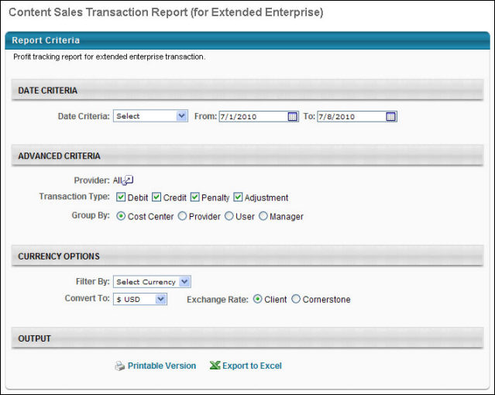
Output
The report output displays the following information:
- Transaction Code
- User
- User ID
- Title
- Date
- CSOD Price - This is the price paid to Cornerstone for the content. If purchased from a provider other than Cornerstone, this field is zero.
- Marked Price - This is the price charged to the user.
- Discount
- Registration
- Delivery Fees
- Final Price
- Profit
The catalog information in the output is based on information in the Course Catalog.
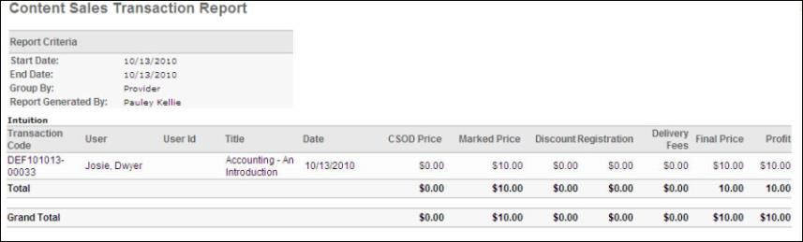

Cost Centers Report
Display all transactions by cost center and detailed reporting on individual transactions.
Permissions
PERMISSION NAME | PERMISSION DESCRIPTION | CATEGORY

Cost Center Billing Report | Grants access to Cost Center Billing Report, which displays all learning transactions grouped by cost center. | Reports - Billing
Filters
- Date Criteria -filter your results based on Registration date range. Note: Date Criteria is always implemented using UTC (Coordinated Universal Time).
- Filter by - select currency option to filter by if applicable
- Convert to - select convert rate if applicable and choose Client or Cornerstone exchange rate
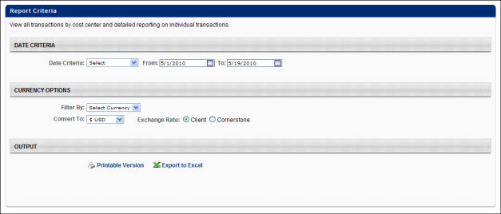
Output
- Printable Version link to view the results in a web page, or Export to Excel link to save/open as an Excel file
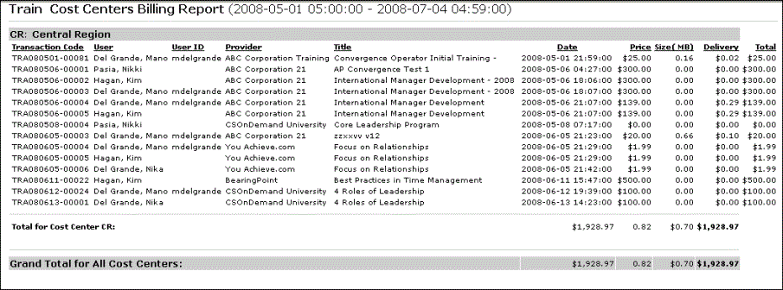

Credit Card Billing Report
This report allows clients to reconcile sales records based on credit card transactions. The output is separated by course title, rather than transaction. This report is available from the Billing Reports page. This report is asynchronous, so it queues briefly before the report becomes available.
Permissions
PERMISSION NAME | PERMISSION DESCRIPTION | CATEGORY

Credit Card Billing Report | Grants access to Credit Card Billing Report, allowing administrators to reconcile sales records based on credit card transactions. The output is separated by course title, rather than transaction. | Reports - Billing
Criteria
Filter Name | Description
Date Criteria | Filter your results by date. Note: Date Criteria is always implemented using UTC (Coordinated Universal Time).
Report Title | Enter a custom title for the report. If no title is entered, the title defaults to the creation date.
Process Report
This is an asynchronous report, which allows the administrator to define the standard report and generate the report asynchronously. As a result, when administrators process the report, the system generates the report in the background, while the administrator can move on to other areas of the system. When the report is finished processing, the administrator can then view the full report in its entirety.
- Up to three separate reports can generate asynchronously, allowing greater flexibility for creating and storing different versions of the report.
- If you process a report or refresh a stored report, the report appears in the table as Queued.
- The most recently created report displays at the top of the table.
- Since the user can generate up to three reports, the administrator can define a report title for each of the generated reports.
- Clicking the View Details icon changes the report settings on the page to match those of the selected previously run report.
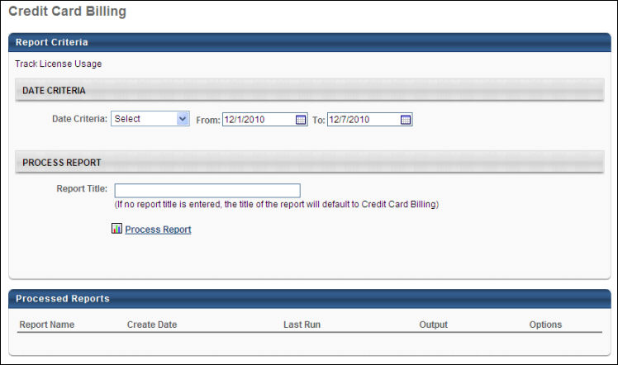
Output
The report output displays the following information:
- Provider
- Passthrough / PayGo - Passthrough indicates it is client content. PayGo indicates it is system content.
- Transaction Date
- Transaction Code
- First Name - The first name of the user who purchased the course.
- Last Name - The last name of the user who purchased the course.
- Card Type
- Title - If this is for inventory, the number of courses purchased is displayed after the title in brackets.
- Content Price - If the content is Passthrough, this is the client marked price. If the content is PayGo, this is the system marked price.
- Delivery Fee - Fee which is set in the Pricing tab for this specific training.
- Processing Fee - Fee which is set in the Pricing tab for this specific training.
- Total - Total of Delivery and Processing fees
- Charge - The amount charged to the user's credit card. The charge is comprised of: Content Price + Delivery Fee + Processing Fees - Discount + Tax.
- Due to Client - This is the amount owed back to your organization for the content purchase. If the content is Passthrough, this is the total minus the processing fee and delivery fee (Due = Total - Processing Fee - Delivery Fee). If the content is PayGo, this is the total minus the processing fee, delivery fee, and content price (Due = Total - Processing Fee - Delivery Fee - Content Price).
- Ref - Reference code.
Note: Discount and Tax fields are not displayed in this report.
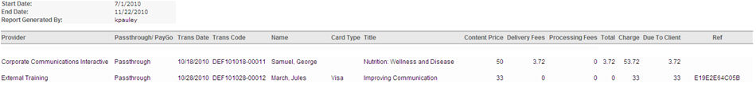

Delivery Report for Billing
This report allows clients who use Pay as you Go delivery to view their delivery usage summary. This report is available from the Billing Reports page. This report is asynchronous, so it queues briefly before the report becomes available.
Permissions
PERMISSION NAME | PERMISSION DESCRIPTION | CATEGORY

Delivery Report for Billing | Grants access to Delivery Report for Billing, which allows administrators to view Pay as you Go delivery usage summary. | Reports - Billing
Criteria
Filter Name | Description
Date Criteria | Filter your results by date. Note: Date Criteria is always implemented using UTC (Coordinated Universal Time).
Charge for Delivery | Use this filter to show only PayGo content.
Payment Type | Use this to filter results by payment type (Credit Card or Invoice).
Group By | Select a grouping option to group results by provider or cost center.
Provider | Select this option to filter results by a certain provider.
Type | Select a detailed output or a summary output.
Report Title | Enter a custom title for the report. If no title is entered, the title defaults to the creation date.
Process Report
This is an asynchronous report, which allows the administrator to define the standard report and generate the report asynchronously. As a result, when administrators process the report, the system generates the report in the background, while the administrator can move on to other areas of the system. When the report is finished processing, the administrator can then view the full report in its entirety.
- Up to three separate reports can generate asynchronously, allowing greater flexibility for creating and storing different versions of the report.
- If you process a report or refresh a stored report, the report appears in the table as Queued.
- The most recently created report displays at the top of the table.
- Since the user can generate up to three reports, the administrator can define a report title for each of the generated reports.
- Clicking the View Details icon changes the report settings on the page to match those of the selected previously run report.
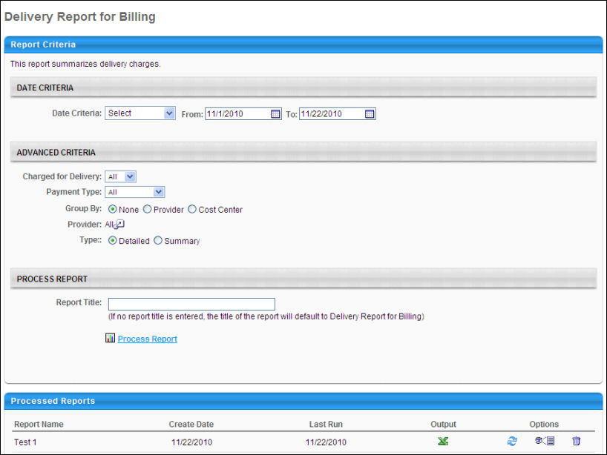
Output
The report output displays the following information:
- Transaction Date
- Transaction Code
- Provider Name
- Title
- Charge for Delivery - Displays whether or not the transaction is PayGo. Content is either prepaid or PayGo.
- Delivery Size - This is based on per title usage. If the content is PayGo, this is zero.
- Delivery Charge - If the content is PayGo, this is zero.
- Payment Type
Delivery Size and Delivery Charge only occur when the content is not PayGo billable.
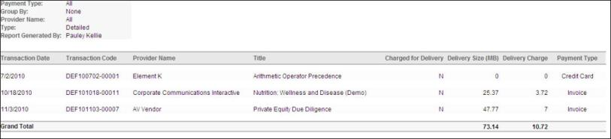

Enterprise Custom Report
Display all transactions in the system. If a purchase is made using a custom payment type, then the custom payment type appears within the report as a cost center.
To access the Enterprises, go to Reports > Standard Reports. From the Billing tab, select the Enterprise Custom link.
Permissions
PERMISSION NAME | PERMISSION DESCRIPTION | CATEGORY

Enterprise Custom Billing Report | Grants access to Enterprise Custom Billing Report, which displays all learning transactions for a specified date period. A variety of filter and grouping options are available when running the report. | Reports - Billing
Filters
- Date Criteria -filter your results based on Registration date range. Note: Date Criteria is always implemented using UTC (Coordinated Universal Time).
- Provider - filter the results for training from a specific training provider/vendor or select All for all training Providers/Vendors
- Transaction Type - filter by Debit, Credit, Penalty or Adjustment
- Group By - select to group report by Cost Center, Provider, User or Manager
- Filter By - select currency to filter (If using Currency Conversion)
- Convert To - select currency to which all monetary fields will be converted
- Exchange Rate - select Client or Cornerstone
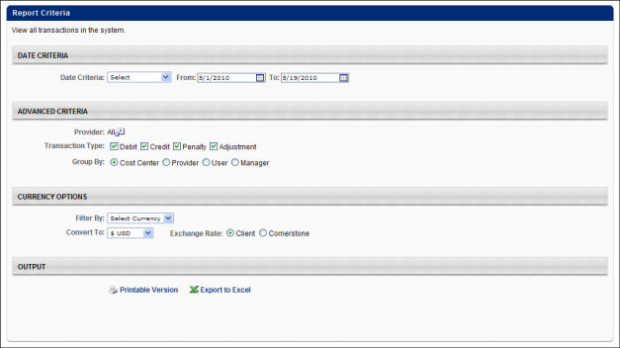
Output
- Printable Version link to view the results in a web page, or Export to Excel link to save/open as an Excel file
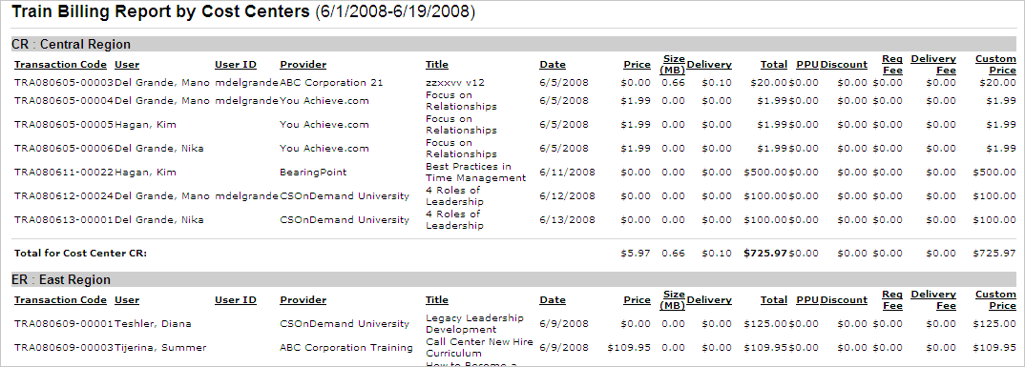

Enterprises Report
This report summarizes all transactions by cost center, provider or employee. Also provides detailed reporting on individual transactions. If a purchase is made using a custom payment type, then the custom payment type appears within the report as a cost center.
To access the Enterprises, go to Reports > Standard Reports. From the Billing tab, select the Enterprises link.
Permissions
PERMISSION NAME | PERMISSION DESCRIPTION | CATEGORY

Enterprise Billing Report | Grants access to Enterprise Billing Report, which summarizes all learning transactions by cost center, provider or employee. Also provides detailed reporting on individual transactions. | Reports - Billing
Filters
- Date Criteria - filter your results based on Registration date range. Note: Date Criteria is always implemented using UTC (Coordinated Universal Time).
- Provider - filter the results for training from a specific training provide/vendor or select All for all training Providers/Vendors
- Group By - select to group report by Cost Center, Provider, User or Manager
- Filter by - select currency option to filter by if applicable
- Convert to - select convert rate if applicable and choose Client or Cornerstone exchange rate
- Transaction Code - filter by specific Transaction Code
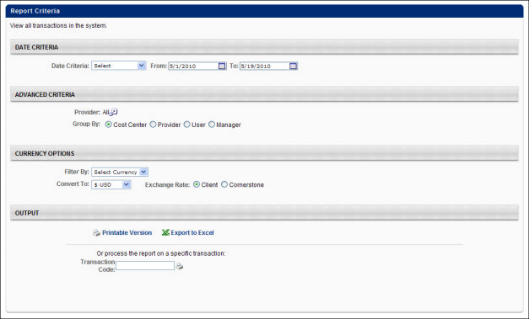
Output
- Printable Version link to view the results in a web page, or Export to Excel link to save/open as an Excel file
Note: For portals that bill the cost center for credit card transaction fees rather than charging the user, the report output one line for the credit card portion of the transaction and one line for the portion that will be charged to the cost center. This occurs because cost centers are not loaded for users, and the system is pushing the charge to the corporate level for the cost center.
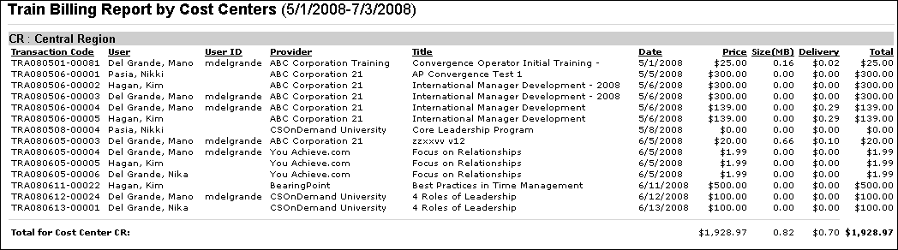

Inventory Purchase Report
Displays pre-purchased items. If a purchase is made using a custom payment type, then the custom payment type appears within the report as a cost center.
Permissions
PERMISSION NAME | PERMISSION DESCRIPTION | CATEGORY

Inventory Purchase Report | Grants access to Inventory Purchase report, which displays transaction details on learning objects purchased for future assignment via the Inventory purchase feature. | Reports - Billing
Filters
- Date Criteria -filter your results based on date range. Note: Date Criteria is always implemented using UTC (Coordinated Universal Time).
- User Criteria - limit report output to the users matching the specified user criteria
- Filter By - select to filter report by specific Currency
- Convert To - select currency to which all monetary fields will be converted
- Exchange Rate - select Client or Cornerstone
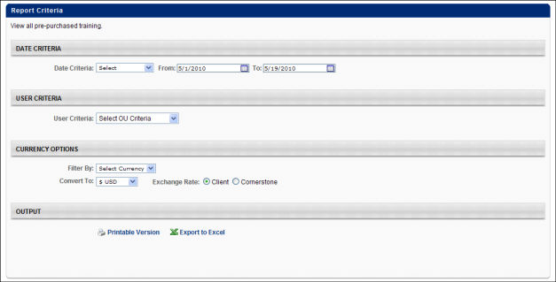
Output
- Printable Version link to view the results in a web page, or Export to Excel link to save/open as an Excel file
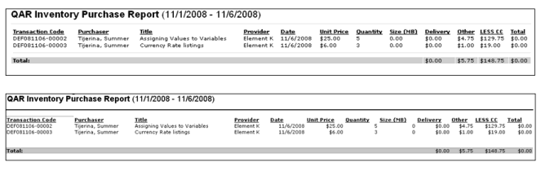

Prepaid Content License Tracking Report
This report allows clients to access their prepaid content license information in order to track licenses usage. When content is prepaid, that means the client has a contract with either the system or a third party to prepay for a given number of content licenses. This report is available from the Billing Reports page. This report is asynchronous, so it queues briefly before the report becomes available.
Permissions
PERMISSION NAME | PERMISSION DESCRIPTION | CATEGORY

Prepaid Content License Tracking Report | Grants access to Prepaid Content License Tracking report, allowing administrators to access their prepaid content license information in order to track licenses usage. When content is prepaid, that means the client has a contract with either the system or a third party to prepay for a given number of content licenses. | Reports - Billing
Criteria
Filter Name | Description
Date Criteria | Filter your results by date. Note: Date Criteria is always implemented using UTC (Coordinated Universal Time).
Report Title | Enter a custom title for the report. If no title is entered, the title defaults to the creation date.
Process Report
This is an asynchronous report, which allows the administrator to define the standard report and generate the report asynchronously. As a result, when administrators process the report, the system generates the report in the background, while the administrator can move on to other areas of the system. When the report is finished processing, the administrator can then view the full report in its entirety.
- Up to three separate reports can generate asynchronously, allowing greater flexibility for creating and storing different versions of the report.
- If you process a report or refresh a stored report, the report appears in the table as Queued.
- The most recently created report displays at the top of the table.
- Since the user can generate up to three reports, the administrator can define a report title for each of the generated reports.
- Clicking the View Details icon changes the report settings on the page to match those of the selected previously run report.
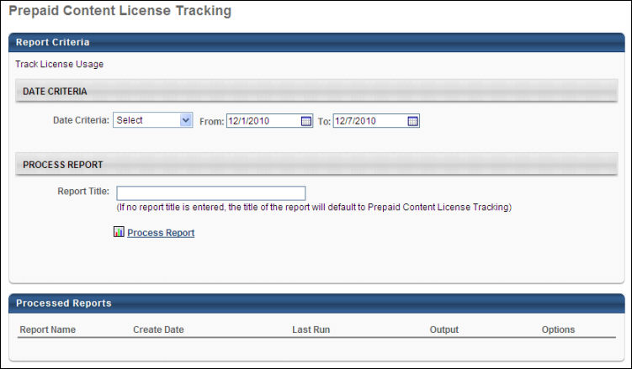
Output
The report output displays the following information:
- Provider Name
- Course Name
- Course Type
- Prepaid Licenses - The number of licenses purchased.
- Licenses Used
- Prepaid License Balance
- Prepaid Content Period
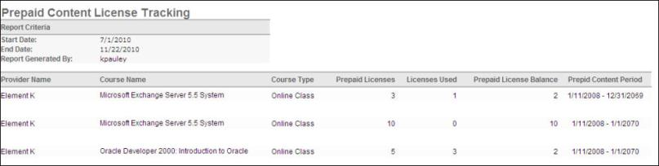

Prepaid Delivery Tracking Report
This report allows clients who prepay for content to view their delivery usage summary. When content is prepaid, that means the client has a contract with either the system or a third party to prepay for a given number of content licenses. This report is available from the Billing Reports page. This report is asynchronous, so it queues briefly before the report becomes available.
Permissions
PERMISSION NAME | PERMISSION DESCRIPTION | CATEGORY

Prepaid Delivery Tracking Report | Grants access to Prepaid Delivery Tracking Report, which allows administrators to view their prepaid content delivery usage summary. When content is prepaid, that means the client has a contract with either the system or a third party to prepay for a given number of content licenses. | Reports - Billing
Criteria
Filter Name | Description
Date Criteria | Filter your results by date. Note: Date Criteria is always implemented using UTC (Coordinated Universal Time).
Report Title | Enter a custom title for the report. If no title is entered, the title defaults to the creation date.
Process Report
This is an asynchronous report, which allows the administrator to define the standard report and generate the report asynchronously. As a result, when administrators process the report, the system generates the report in the background, while the administrator can move on to other areas of the system. When the report is finished processing, the administrator can then view the full report in its entirety.
- Up to three separate reports can generate asynchronously, allowing greater flexibility for creating and storing different versions of the report.
- If you process a report or refresh a stored report, the report appears in the table as Queued.
- The most recently created report displays at the top of the table.
- Since the user can generate up to three reports, the administrator can define a report title for each of the generated reports.
- Clicking the View Details icon changes the report settings on the page to match those of the selected previously run report.
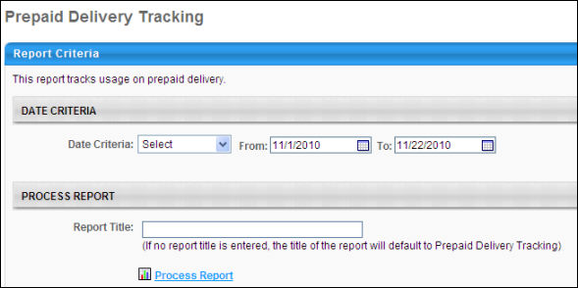
Output
The report output displays the following information:
- Prepaid Delivery Period
- Prepaid Delivery Size - The amount of content that is purchased.
- Delivery Size Used - The amount of content that is used. This value is red if higher than the prepaid delivery size.
- Overage Delivery Charge - If the amount used is higher than the prepaid amount, an overage delivery charge is applied.
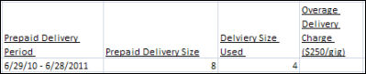

Processing Fees Report
The Processing Fees Report breaks down the processing fees for each transaction that is made using the LMS and EXE functionality within a selected date range.
This functionality is available with the Advanced eCommerce functionality. To utilize the Processing Fees Report, you must use the CSOD merchant account for credit card transactions. To enable the Processing Fees Report for your portal, contact Global Customer Support.
Permissions
PERMISSION NAME | PERMISSION DESCRIPTION | CATEGORY

Processing Fees Report | Grants access to Processing Fees Report, which breaks down the processing fees for each transaction that is made using the LMS and EXE functionality within a selected date range. | Reports - Billing
Criteria
Filter Name | Description
Date Criteria | Filter your results by date. If any part of a transaction falls within that time frame, the transaction displays. Note: Date Criteria is always implemented using UTC (Coordinated Universal Time).
Convert To | Select to which of the available currencies to convert all transactions. You may also choose to use the exchange rate that is set by Client or Cornerstone.
Group By | Select Group by Cost Center to group the transactions by cost center, displaying a summary of totals for each cost center.  Select Group by None to not group the transactions and to display a grand total for all transactions.
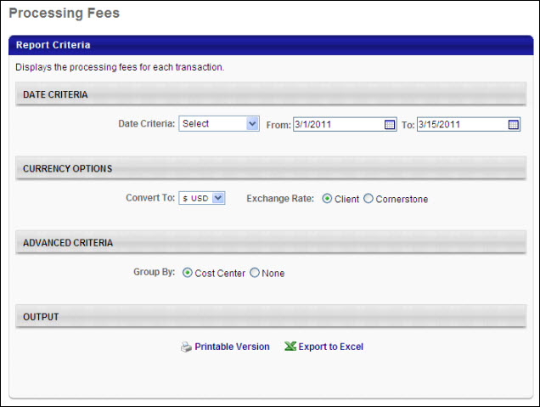
Output Grouped by Cost Center
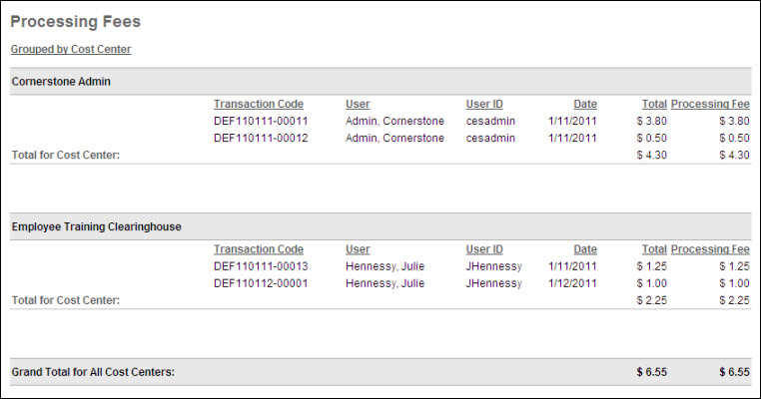
Output Not Grouped
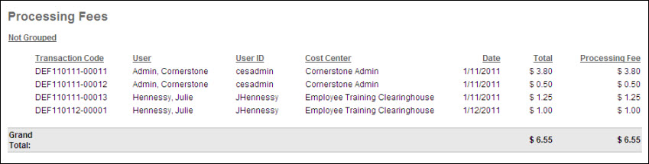

Sales Tax Report
The Sales Tax Report displays the tax breakdown of each item or transaction that has been taxed upon purchase using the LMS and EXE functionality.
This functionality is available with the Advanced eCommerce functionality. To utilize the Sales Tax Report, you must use your own merchant account. To enable the Sales Tax Report for your portal, contact Global Customer Support.
The Sales Tax Report displays the appropriate taxes that are applied for each item within a transaction. If multiple tax values are applied for different items within a transaction, then each tax value is displayed.
Permissions
PERMISSION NAME | PERMISSION DESCRIPTION | CATEGORY

Sales Tax Report | Grants access to Sales Tax Report, which displays the tax breakdown of each item or transaction that has been taxed upon purchase using the LMS and EXE functionality. This permission can be constrained by OU, User's OU, User Self and Subordinates, and User. (Requires CyberSource integration) | Reports - Billing
Criteria
Filter Name | Description
Date Criteria | Filter your results by date. If any part of a transaction falls within that time frame, the transaction displays. Note: Date Criteria is always implemented using UTC (Coordinated Universal Time).
Convert To | Select to which of the available currencies to convert all transactions. You may also choose to use the exchange rate that is set by Client or Cornerstone.
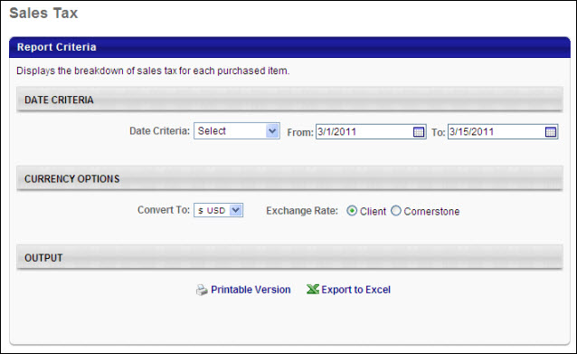
Output
Only items that were taxed at the time of the transaction are included in this report.
- If the item was not taxed in past transactions, but is now set to be taxed, it does not appear in this report.
- Items that are no longer taxed, but were previously taxed in the past do appear in this report.
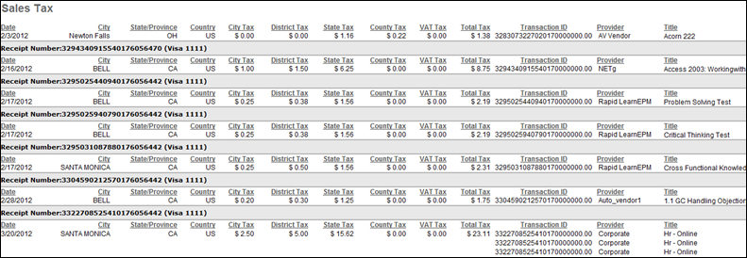
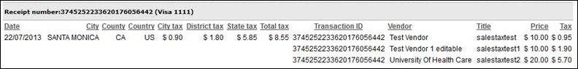
The City Tax, District Tax, State Tax, and Country/VAT Tax columns only appear if the report contains an item in which the tax is applied.

User Report
Display all transactions grouped by users. If a purchase is made using a custom payment type, then the custom payment type appears within the report as a cost center.
Permissions
PERMISSION NAME | PERMISSION DESCRIPTION | CATEGORY

User Billing Report | Grants access to User Billing Report, which displays all learning transactions for a specified date period, grouped by user. | Reports - Billing
Filters
- Date Criteria - filter your results based on Registration date range. Note: Date Criteria is always implemented using UTC (Coordinated Universal Time).
- Provider - filter the results for training from a specific training provider/vendor or select All for all training Providers/Vendors
- Transaction Type - filter by Price, Refund, Penalty, or Adjustment
- Status - filter on specific Status or All
- Filter by - select currency option to filter by if applicable
- Convert to - select convert rate if applicable and choose Client or Cornerstone exchange rate
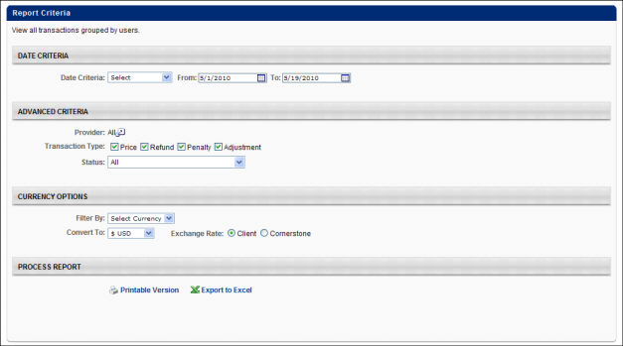
Output
- Printable Version link to view the results in a web page, or Export to Excel link to save/open as an Excel file
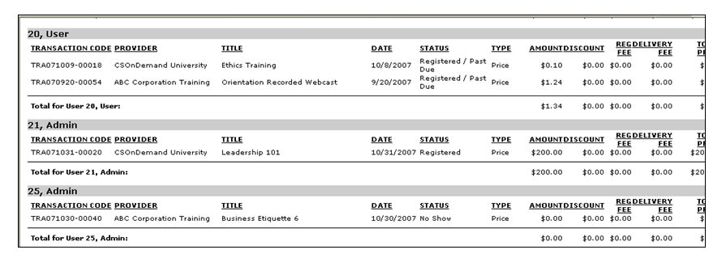

Compensation Reports

Adjustment Guidelines Report
This report displays adjustment guidelines that apply to a group of employees during a specific period for a particular compensation component. This report is effective in displaying whether or not multiple recommendation guidelines apply for an employee for a specific period for a component. Custom bonus components and LTI Award can be selected for inclusion in this report.
Permissions
PERMISSION NAME | PERMISSION DESCRIPTION | CATEGORY

Compensation Adjustment Guidelines Report | Grants access to Compensation Adjustment Guidelines report, which displays adjustment guidelines that apply to an employee during a specific period for a particular compensation component. | Reports - Compensation
Criteria
Filter Name | Description
Date Criteria | Filter your results based on a date range.
User Criteria | Limit report output to the users matching the specified user criteria.  - The report only runs within the defined constraints for the user running the report.  - This is the standard OU availability selection criteria drop-down. Choose from available OU types.  - Defaults: If no User Criteria are selected then the report will run for the entire available population.
Component | Select one or more components to include in the report.
Wage Type | Determine which guidelines are included in the report:  - All Wage Types - Include adjustment guidelines with any Wage Type.  - Wage Type (e.g., Annual, Hourly, Weekly) - All available wage types are displayed, including custom wage types. Select a specific wage type to include only employees from tasks that utilize the selected wage type in the report.
Adjustment Guideline | Select specific guidelines to include in the report.
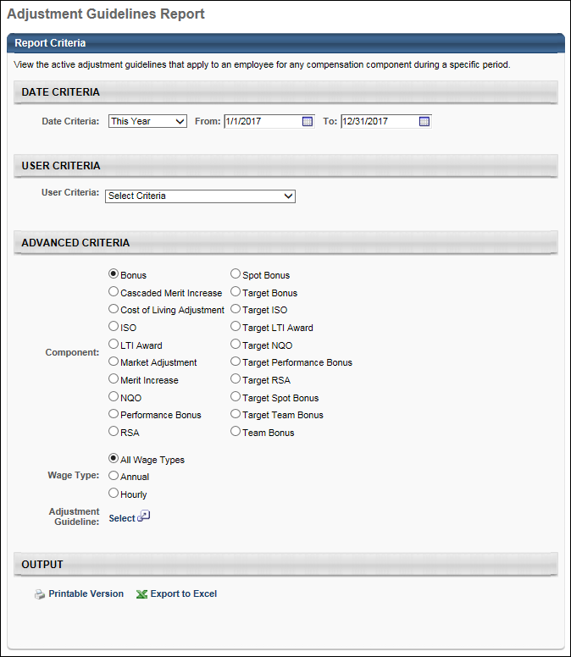
Output
- Printable Version - Click the Printable Version link to view the results in a Web page.
- Export to Excel - Click the Export to Excel link to save/open the report as an Excel file.
Users who have more than one recommendation guideline apply will be highlighted in red.
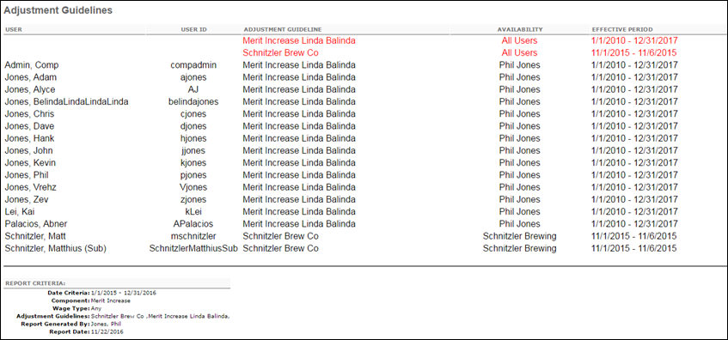

Budget Status Report
This report displays the current budget status of all users in the report criteria for a given compensation task. The administrator can run this report for multiple budgets at a time as long as those budgets are included in the selected task. This report can be run across multiple compensation tasks. LTI Award can be selected as a component on the report and will appear as a budget on the report. RSA, ISO, and NQO budgets will appear as monetary amounts or as shares depending on task setting. Custom bonus components can be selected for inclusion in this report.
Permissions
PERMISSION NAME | PERMISSION DESCRIPTION | CATEGORY

Budget Status Report | Grants access to Budget Status Report, which displays the current budget status of all users in the report criteria for a given compensation task. This permission can be constrained by OU, User's OU, User Self and Subordinates, and User. | Reports - Compensation
Criteria
Filter Name | Description
User Criteria | Select the users for whom you would like to view compensation statements by selecting the appropriate OU or individual user from the drop-down. The users available to select are defined by the administrator's permission constraints. If no User Criteria are selected, then the report runs for the entire available population.
User Status | Check the Include Inactive Users box to include inactive users in the report. Note: Only inactive users that were part of the compensation task and that meet the criteria defined in the User Criteria section are included.
Compensation Task | Select the compensation task from which to pull the selected users. Off Cycle tasks cannot be selected.
Component | Select one or more components to include in the report.
Budget Pooling | Select this option to include the budget OU breakdown for the components included in the report. The overall budget summary is also included, as previously implemented. If this option is unselected, the report output only includes the overall component budget for the components included in the report.  Only component budgets that apply to the compensation manager and the selected compensation task are included in the report output.
Group By | Select the option to group the report by user or component.
Currency | Select a currency.
Report Title | Enter a title for the report. The character limit is 50. If a title is not entered, the report title defaults to Bulk Compensation Statements.
Output
- Printable Version - Click the Printable Version link to view the results in a Web page.
- Export to Excel - Click the Export to Excel link to save/open the report as an Excel file.
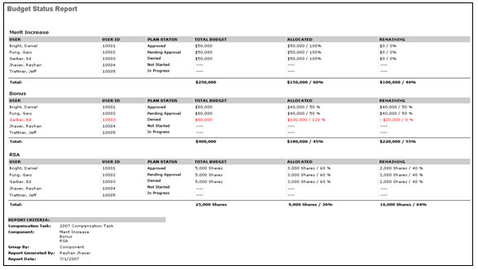
The report displays the plan status, total budget, allocated budget, and remaining budget for each budget for each user on the report. If the user has a budget that is over budget, that will be highlighted in red. The report will display allocated and remaining amounts for plans that are in pending approval or approved status only.
On the output of the task, the budgets from all selected compensation tasks appear.
- All task assignees from all selected tasks appear in the output based on the user criteria of the report.
- The total budget for each component is calculated across all tasks that included the component.
- If a specific task does not have a component that is in included in other tasks, then N/A appears for those users from the task.
The report output displays the LTI Award budget data in the same manner as all other components in the report. Based on the allocation type selected, the RSA, ISO, and NQO budgets appear as either a monetary value or as shares.
Output If OU Breakdown Included
If the Include OU Breakdown option is selected, component OU budget breakdowns appear in the Component, Total Budget, Allocated, and Remaining columns of the Budget Status Report.
Output Grouped By User
If the Include OU Breakdown option is selected and the report output is grouped by user, the Component column displays the OU budget breakdown for each component.
If there is more than one OU breakdown for a component that applies to the compensation manager for the associated compensation task, the first line of that component displays the component total. Below the total, each OU breakdown is displayed in alphabetical order, with the default OU breakdown displayed after all available breakdowns for the component.
The Overall Budget Summary section is unchanged and displays the overall component summations.
If the Include OU Breakdown option is unselected and the report output is grouped by user, the Component column displays only the overall component budget, as currently implemented. Components listed do not have a designated breakdown.
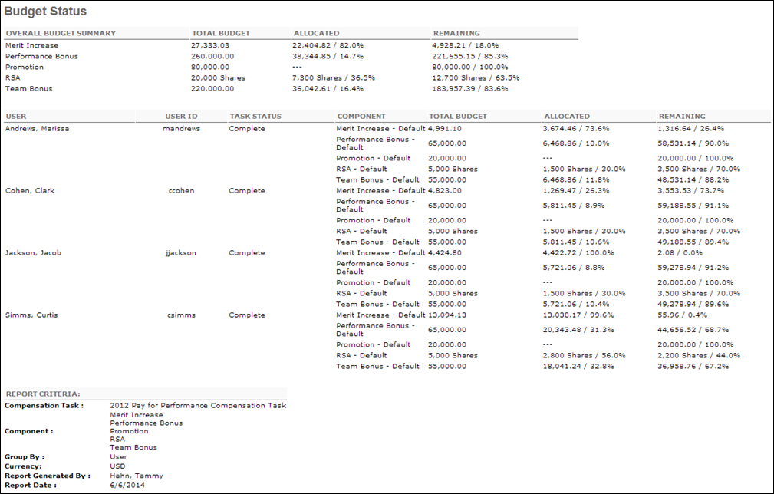
Output Grouped By Component
If the Include OU Breakdown option is selected and the report output is grouped by component, the report sections display the OU breakdown for each component.
For all component OU breakdowns within the selected compensation task, the OU section contains the compensation managers that have employees included in the associated OU component budget. A section only appears if there is at least one compensation manager that applies to the associated component OU budget.
Each OU breakdown is displayed in alphabetical order, with the default OU breakdown displayed after all available breakdowns for the component.
If the Include OU Breakdown option is unselected and the report output is grouped by component, the report is divided by overall components. The components that are listed do not have a designated breakdown.
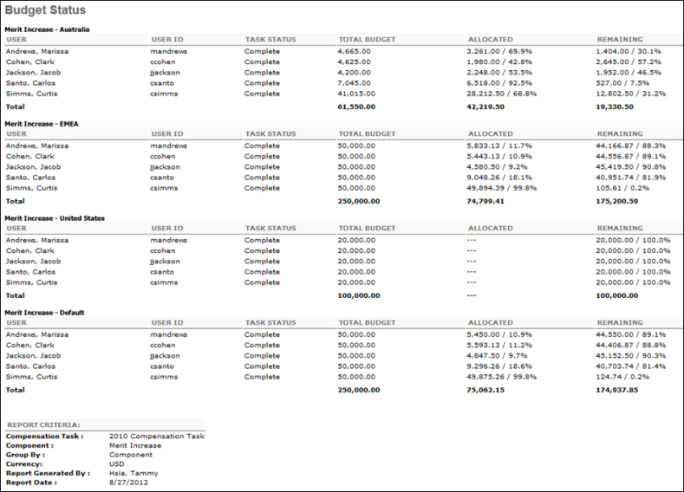

Bulk Compensation Statements Report
The Bulk Compensation Statements report allows administrators to generate compensation statements for multiple employees in a single report.
To access the Bulk Compensation Statements report, go to Reports > Standard Reports. Under the Compensation tab, click the Bulk Compensation Statements Report link.
Permissions
PERMISSION NAME | PERMISSION DESCRIPTION | CATEGORY

Bulk Compensation Statements | Grants access to Bulk Compensation Statements Report, which generates compensation statements for multiple employees in a single report. | Reports - Compensation
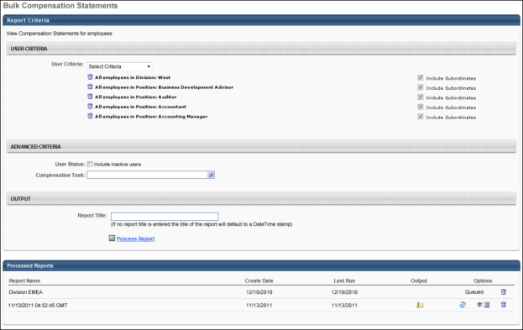
Criteria
Filter Name | Description
User Criteria | Select the users for whom you would like to view compensation statements by selecting the appropriate OU or individual user from the drop-down. The users available to select are defined by the administrator's permission constraints. Search results also include inactive users.
User Status | Check the Include Inactive Users box to include inactive users in the report. Note: Only inactive users that were part of the compensation task and that meet the criteria defined in the User Criteria section are included.
Compensation Task | Select the compensation task from which to pull the selected users.
Report Title | Enter a title for the report. The character limit is 50. If a title is not entered, the report title defaults to Bulk Compensation Statements.
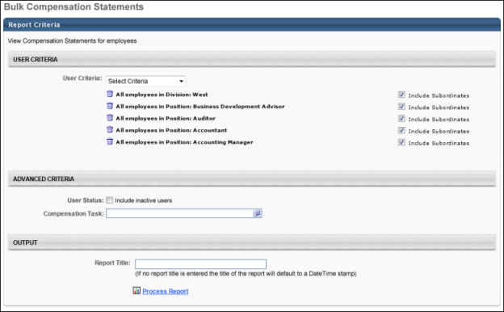
Asynchronous reports allow the administrator to define the standard report and generate the report asynchronously. As a result, when administrators process the report, the system generates the report in the background, while the administrator can move on to other areas of the system. When the report is finished processing, the administrator can then view the full report in its entirety.
- Up to three separate reports can generate asynchronously, allowing greater flexibility creating and storing different versions of the report.
- If you process a report or refresh a stored report, the report appears in the table as Queued.
- Since the user can generate up to three reports, the administrator can define a report title for each of the generated reports.
Processed Reports Table
The Processed Reports table displays the following for the report:
- Report Name
- Create Date
- Last Run
- Output - Click the zip file icon to open the file. Each compensation statement appears in the zip folder as a separate .pdf file. Note: When the report is queuing, which is indicated by "Queued" in the Options column, the Output column is blank.
- Options - The following options are available in the Options column:
  - Refresh - Click to refresh the file data.
  - View Details - Click to view the report configuration details.
  - Remove - Click to delete the report.
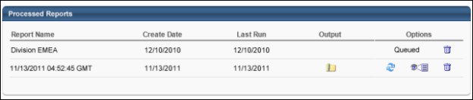

Compensation Audit History Report
This report displays the comment audit history for compensation tasks, including when a compensation plan was submitted and approved.
Permissions
PERMISSION NAME | PERMISSION DESCRIPTION | CATEGORY

Compensation Audit History Report | Grants access to Compensation Audit History report, which displays the comment audit history for compensation tasks. | Reports - Compensation
Criteria
Filter Name | Description
User Criteria | Limit results to the users matching the specified user criteria.
User Status | Select this option to include inactive users in the report. Note: Only inactive users that were part of the compensation task and meet the criteria defined in the User Criteria section are included.
Compensation Task | Select a compensation task on which to report. Multiple tasks can be added. Only submitted tasks are available for the report. Users who are ineligible for the selected task are not included in the report.
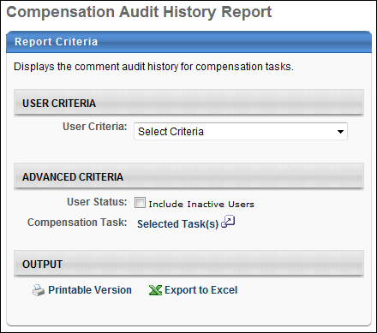
Output
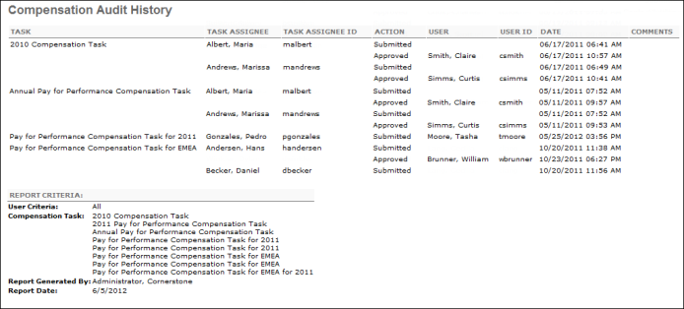

Compensation Adjustment Report
This report displays adjustments for base, bonus, and/or equity for employees within a compensation task. For all employees in the report criteria, the report will display the current compensation, the adjustment amount, and the new compensation for salary, bonus, RSA, ISO, and NQO compensation from a specific task. This report will only report on compensation plans that have been submitted for approval. This report can be run across multiple compensation tasks. This report can report on off cycle tasks. LTI Awards will be included in this report. For RSA, ISO, and NQO, the administrator will have the option of pulling in the grant amount, award amount, or both. Custom bonus components can be selected for inclusion in this report.
To access the Compensation Adjustment report, go to Reports > Standard Reports. Under the Compensation tab, select the Compensation Adjustment Report link.
Permissions
PERMISSION NAME | PERMISSION DESCRIPTION | CATEGORY

Compensation Adjustment Report | Provides access to the Compensation Adjustment Report, which displays adjustments for base, bonus, and/or equity for employees within a compensation task. This permission can be constrained by OU, User's OU, User, and User's Subordinates. | Reports - Compensation
Criteria
User Criteria
Filter | Description
User Criteria | Limit report output to the users matching the specified user criteria.  - The report will only run within the defined constraints for the user running the report.  - This is the standard OU availability selection criteria drop-down. Choose from available OU types.  - Defaults: If no User Criteria are selected then the report will run for the entire available population.
Advanced Criteria
Filter | Description
User Status | Select this option to include inactive users in the report. Note: Only inactive users that were part of the compensation task and meet the criteria defined in the User Criteria section are included.
Compensation Task | Select compensation task.
Components | The available components do not appear until a compensation task is selected. Select the compensation components to include in the report. These include all base types, even if they are set to be included in base salary as long as they are part of the selected compensation task.
Non-Monetary Components | This section lets you report on non-monetary components that are included in a compensation task.  When one or more tasks are added to the report, the Non-Monetary Components section displays the non-monetary components that are included in the task. You can select or deselect any non-monetary component to include in the report.  The report output will display the non-monetary components in a separate column. The value in the report will be the most recently selected value in the task.
Wage Type | Determine which wage type tasks are included in the report. Note: This criterion is not based on the employee's current Wage Type value. It is based on the Wage Type value of the task. The available options are:  - Any - Include employees from both annual and hourly tasks in the report. If this option is selected, a Wage Type column is added to the report to display each user's wage type.  - Annual - Include only employees from annual tasks in the report.  - Hourly - Include only employees from hourly tasks in the report.
Lump Sum | Select this option to include a Lump Sum column in the report output. This column displays the lump sum allocation for the employee. This field is only available if any of the selected compensation tasks included the Lump Sum component. The lump sum is displayed in the currency selected in the Currency field.
Hourly Rates | Select this option to annualize the hourly rates for hourly employees. If this option is selected, any component allocated to an hourly employee at an hourly rate is annualized based on their Labor Hours value for the task (not their current Labor Hours value). Note: This option is only available if the Wage Type is set to Any or Hourly.
Comments | Select this option to include a Comments column in the report output. This column displays any comments that were made at the tab level of each of the selected compensation tasks. When this option is selected, a Comments column appears for each tab that is included in the compensation plan, regardless of whether any comments were added.
Performance Rating | Check to include the performance review rating.
Currency | Select currency from drop-down list. All amounts displayed will be based on the selected currency for the report. All amounts will be converted based on the conversion rates that are pulled in to the task when the task is started.
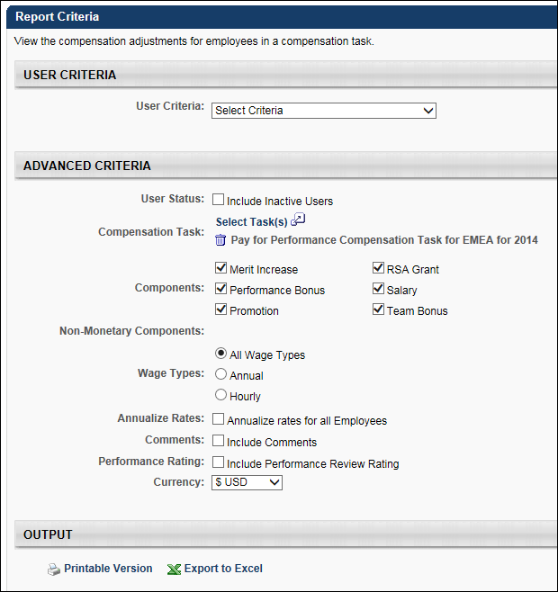
Output
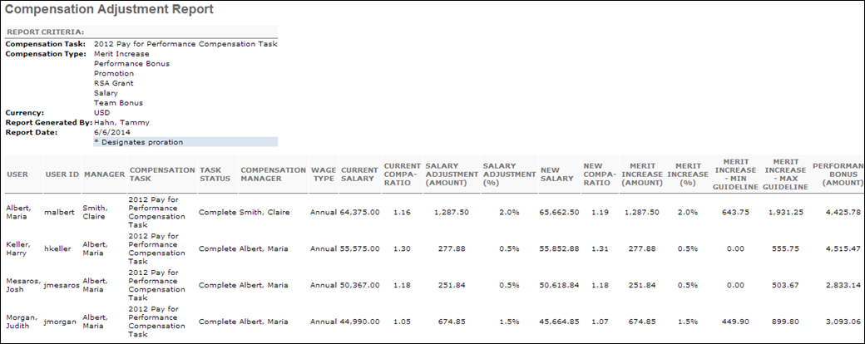
Each of the selected components and non-monetary components are displayed as separate columns.
Users are displayed as a separate row. By default, the report is sorted by user last name, and then first name.
The report output contains the following information:
Non-Allocation Based Data
- User - This displays the user's name (Last Name, First Name).
- User ID - This displays the user's ID.
- Manager - This displays the user's manager's name (Last Name, First Name).
- Compensation Task - This displays the corresponding compensation task name.
- Task Status - This displays the status of the corresponding compensation task.
- Compensation Manager - This displays the name of the compensation manager (Last Name, First Name) for the corresponding compensation task.
- Wage Type - This displays the user's wage type (Annual or Hourly).
- Performance Rating - This displays the employee's most recent performance review score at the time of the compensation task. This column is only included if the Performance Rating option is selected in the Advanced Criteria section.
- Performance Rating (%) - This displays the employee's most recent performance review rating at the time of the compensation task as a percentage. This column is only included if the Performance Rating option is selected in the Advanced Criteria section.
Salary Component Related Data
The following columns are included in the report output only if the Salary component is selected in the Components field in the Advanced Criteria section. For components that are prorated, the corresponding cell appears with a light blue coloring.
Note: Monetary values are displayed in the currency that is selected from the Currency drop-down in the Advanced Criteria section. The currency's default precision is applied if the employee's wage type is Annual or if the employee's wage type is Hourly and is annualized. The currency's hourly precision is applied if the employee's wage type is Hourly and is not annualized.
- Current Salary - This displays the employee's current salary at the time of the compensation task.
- Current Compa-Ratio - This displays the employee's current compa-ratio at the time of the compensation task prior to any allocations granted during the task. This value uses two decimal places of precision.
- Salary Adjustment (Amount) - This displays the employee's total base salary increase for the compensation task.
- Salary Adjustment (%) - This displays the employee's total base salary increase as a percentage of their current salary for the compensation task.
- New Salary - This displays the employee's new salary after allocations from the compensation task.
- New Compa-Ratio - This displays the employee's new compa-ratio after allocations from the compensation task.
Additional Component Related Data
The following columns are included in the report output for the components that are selected in the Components field in the Advanced Criteria section. The components are displayed in alphabetical order. For components that are prorated, the corresponding cell appears with a light blue coloring.
Note: Monetary values are displayed in the currency that is selected from the Currency drop-down in the Advanced Criteria section. The currency's default precision is applied for non-base type components and base type components that are not included in the base salary. For base-type components that are included in the base salary, the currency's default precision is applied if the employee's wage type is Annual or if the employee's wage type is Hourly and is annualized; the currency's hourly precision is applied if the employee's wage type is Hourly and is not annualized.
- <Component> (Amount)/(Shares) - This displays the employee's allocated amount for the component in the compensation task. "Shares" is displayed for equity components awarded in shares, and "Amount" is displayed for all others. This column appears for all components.
- <Component> (%) - This displays the employee's component allocation as a percentage of their current salary for the compensation task. This column appears for all components, except for equity components that are allocated in shares.
- <Component> - Target - This displays the employee's component target amount for the compensation task. This uses the organization's default precision. This column appears for non-target bonus and equity components, except for equity components that are allocated in shares.
- <Component> - % Attained - This displays the employee's component allocation as a percentage of its target for the compensation task. This column appears for non-target bonus and equity components, except for equity components that are allocated in shares. This value cannot be calculated if the component target is set to zero.
- <Component> - Min Guideline - This displays the employee's minimum guideline for the component for the compensation task. This column appears for all components, except for Lump Sum and Promotion.
- <Component> - Max Guideline - This displays the employee's maximum guideline for the component for the compensation task. This column appears for all components, except for Lump Sum and Promotion.
Non-Monetary Components Data
Non-monetary components are displayed in alphabetical order after new compa ratio. The most recent selected value in the task displays in the report cell.
The section will not display if no tasks in the report have non-monetary components.
Comments Data
The following columns are included in the report only if the Comments field is selected in the Advanced Criteria section.
Each column displays the comments that are submitted for the employee on the corresponding tab on the compensation task. Newest comments are displayed first. Each comment appears on a separate line in the same row of the output. This includes the first and last name of the user who submitted the comment, as well as the comment date and text.
A Comments column appears for each tab that is included in the compensation plan, regardless of whether any comments were added.
- Base Comments
- Bonus Comments
- Equity Comments

Compensation EEO Report
This report displays EEO data and compensation information for a specific task. In order to run this report, EEO data such as gender and diversity needs to be loaded into the system. The administrator can run this report for any adjustment for a given task. This report can be run across multiple compensation tasks. This report can report on off cycle tasks. Custom bonus components can be selected for inclusion in this report. LTI Award will appear as a selectable option for the report output.
To access the Compensation EEO report, go to Reports > Standard Reports. Under the Compensation tab, select the Compensation EEO Report link.
Permissions
PERMISSION NAME | PERMISSION DESCRIPTION | CATEGORY

Compensation EEO Report | Grants access to Compensation Equal Employment Opportunity Report, which displays EEO data and compensation information for a specific task. In order to run this report, EEO data such as gender and diversity needs to be loaded into the system. This is an administrator permission. | Reports - Compensation
Filter
- User Criteria - Limit report output to the users matching the specified user criteria.
  - The report will only run within the defined constraints for the user running the report.
  - This is the standard OU availability selection criteria drop-down. Choose from available OU types.
  - Defaults: If no User Criteria are selected then the report will run for the entire available population.
- User Status - Select this option to include inactive users in the report. Note: Only inactive users that were part of the compensation task and meet the criteria defined in the User Criteria section are included.
- Compensation Task - Select compensation task.
- Component - The available components do not appear until a compensation task is selected. Select the compensation components to include in the report. These include all base types, even if they are set to be included in base salary as long as they are part of the selected compensation task. Note: For base types other than Salary, the Compa-Ratio is not included in the output.
- EEO - Select the equal employment opportunity item from the drop-down list.
- Wage Type - Determine which wage type tasks are included in the report. Note: This criterion is not based on the employee's current Wage Type value. It is based on the Wage Type value of the task. The available options are:
  - All Wage Types - Include employees from all wage type tasks in the report. If this option is selected, a Wage Type column is added to the report to display each user's wage type.
  - Wage Type (e.g., Annual, Hourly, Weekly) - All available wage types are displayed, including custom wage types. Select a specific wage type to include only employees from tasks that utilize the selected wage type in the report.
- Hourly Rates - Select this option to annualize the hourly rates for hourly employees. If this option is selected, any component allocated to an hourly employee at an hourly rate is annualized based on their Labor Hours value for the task (not their current Labor Hours value). Note: This option is only available if the Wage Type is set to Any or Hourly.
- Currency - Select currency from drop-down list. All amounts displayed will be based on the selected currency for the report. All amounts will be converted based on the conversion rates that are pulled in to the task when the task is started.
- Display OU - Select an OU type to display in the report for each user.
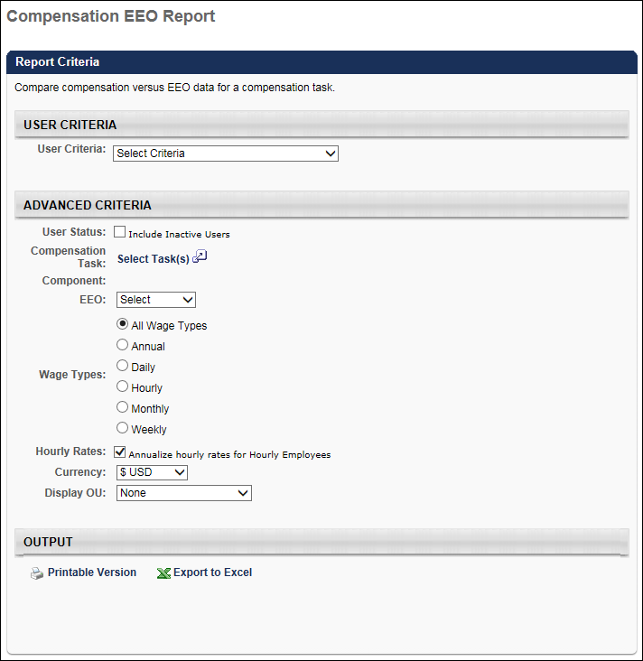
Output - Salary Component Selected
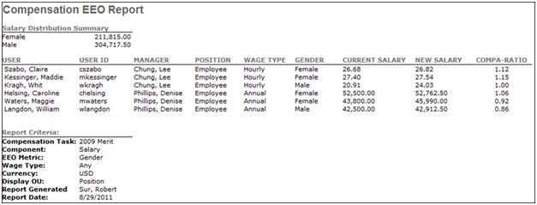
Output - Merit Increase Component Selected
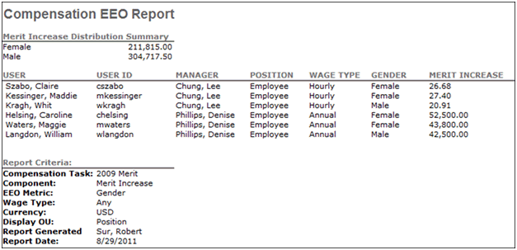
On the output of the task, the components from all selected compensation tasks will appear.
- All task assignees from all selected tasks will appear in the output based on the user criteria of the report.
- For each user, the components will appear from the appropriate task.
- If the user is in more than one task, then the user will appear for each task that the user is in.
If a custom bonus type is selected, the columns that will appear on the report will be displayed as follows:
- Target Bonus - The target bonus for the task.
- Total Bonus - The actual bonus amount for the direct report.
- % Attained - The percentage of total bonus/target bonus.
For LTI Awards, the following columns will appear:
- Target Award - The target award for the task.
- LTI Award - The actual amount for the direct report.
- Award % - The percentage of LTI Award against the current salary.
RSA, ISO, and NQO will not be modified in this report.
Pro-rated adjustments amounts will appear in this report. If pro-ration is split, then the final pro-rated amount will appear in the report, NOT the individual splits.
If an OU type is included, it will appear as a column on the report.

Compensation Modeling Report
The Compensation Modeling Report displays budget projections based on compensation modeling tasks.
To access the Compensation Modeling report, go to Reports > Standard Reports. Under the Compensation tab, select the Compensation Modeling link.
Permissions
PERMISSION NAME | PERMISSION DESCRIPTION | CATEGORY

Compensation Modeling Report | Grants access to Compensation Modeling Report, which displays budget projections based on compensation modeling tasks. This permission can be constrained by OU, User's OU, User Self and Subordinates, and User. | Reports - Compensation
Criteria
Filter Name | Description
User Criteria | Limit results to the users matching the specified user criteria.
User Status | Select this option to include inactive users in the report. Note: Only inactive users that were part of the compensation task and meet the criteria defined in the User Criteria section are included.
Compensation Task | Select a compensation modeling task to include in the report. Multiple modeling tasks can be added. Only submitted modeling tasks are available for the report. Users who are ineligible for the selected modeling task are not included in the report.
Component | The available components do not appear until a compensation task is selected. Select the compensation components to include in the report.
Base Salary | Select this option to include Base Salary in the model. The Base Salary always appears in the report. However, if this option is not selected, the Base Salary Grand Total value is not calculated and displayed in the report. Also, Base Salary is not included in the Total calculation.
Wage Type | Determine which wage type tasks are included in the report. Note: This criterion is not based on the employee's current Wage Type value. It is based on the Wage Type value of the task. The available options are:  - All Wage Types - Include employees from all wage type tasks in the report. If this option is selected, a Wage Type column is added to the report to display each user's wage type.  - Wage Type (e.g., Annual, Hourly, Weekly) - All available wage types are displayed, including custom wage types. Select a specific wage type to include only employees from tasks that utilize the selected wage type in the report.
Lump Sum | Select this option to include Lump Sum allocations.
Annualize Rates | Select this option to annualize the rates for all employees. If this option is selected, any component allocated to an employee at a non-annual rate is annualized based on their Labor Hours value for the task (not their current Labor Hours value). Note: This option is disabled if the Wage Type is set to Annual.
Performance Rating | Select this option to display the user's most recent performance review rating within the compensation task period.
Group By | Group the report either by User or Task.
Currency | Select the currency in which monetary values are displayed in the report. The organization's currency conversion rates are used.
Display OU | Select an Organizational Unit to display that information on the report. For example, if you select the Position OU, each user's position will display in the report. This is optional.
Additional Display OU | Select an additional Organizational Unit to display that information on the report. For example, if you select the Position OU, each user's position will display in the report. This is optional.
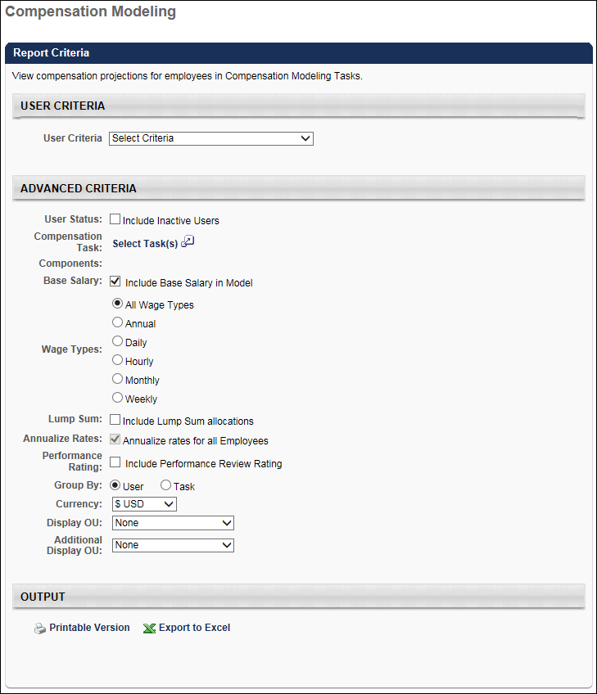
Output
The report displays users in alphabetical order by last name.
Individuals who meet the user criteria but do not have the selected components for the selected date range are still included in the report.
Component percentage columns are calculated as a percentage of the Base Salary column. If Base Salary is zero, the percentage is displayed as "- -".
Output Grouped by Task - Hourly Rates Annualized
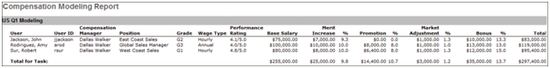
Output Grouped by User - Hourly Rates Annualized
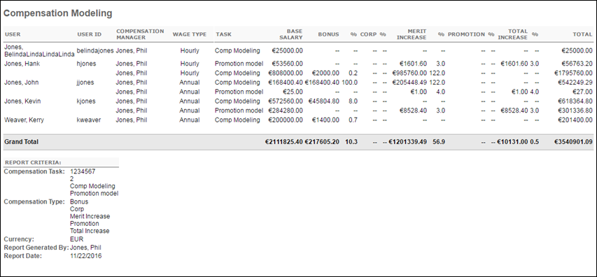

Compensation Promotion Report
This report will report on the promotion details within compensation tasks. This report can run across multiple compensation tasks. This report will display the new OUs and salaries for each employee that is promoted. This report can report on off cycle tasks.
Permissions
PERMISSION NAME | PERMISSION DESCRIPTION | CATEGORY

Compensation Promotion Report | Grants access to Compensation Promotion Report, which reports on the promotion details within compensation tasks. | Reports - Compensation
Filter
- User Criteria- Limit report output to the users matching the specified user criteria.
  - The report will only run within the defined constraints for the user running the report.
  - This is the standard OU availability selection criteria drop-down. Choose from available OU types.
  - Defaults: If no User Criteria are selected then the report will run for the entire available population.
- User Status - Select this option to include inactive users in the report. Note: Only inactive users that were part of the compensation task and meet the criteria defined in the User Criteria section are included.
- Compensation Task - Select compensation task.
- Wage Types - Determine which wage type tasks are included in the report. Note: This criterion is not based on the employee's current Wage Type value. It is based on the Wage Type value of the task. The available options are:
  - All Wage Types - Include employees from all wage types in the report. If this option is selected, a Wage Type column is added to the report to display each user's wage type.
  - Each available wage type is available. Selecting a wage type only includes employees from selected wage type in the report.
- Annualize Rates - Select this option to annualize the non-annual rates for non-annual employees. If this option is selected, any component allocated to a non-annual employee at a non-annual rate is annualized based on their Labor Hours value for the task (not their current Labor Hours value). Note: This option is only available if the Wage Type is set to All Wage Types or a non-annual wage type.
- Currency - Select currency from drop-down list. All amounts displayed will be based on the selected currency for the report. All amounts will be converted based on the conversion rates that are pulled in to the task when the task is started.
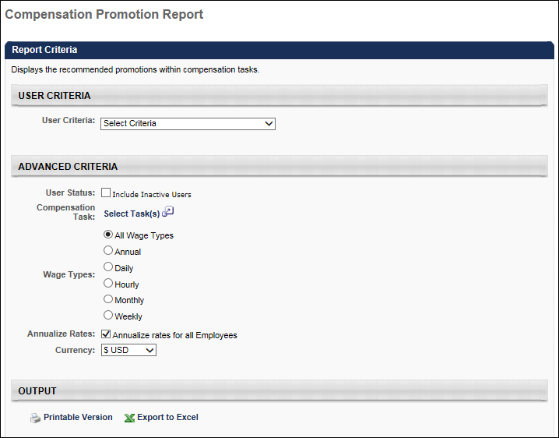
Output
- Printable Version link to view the results in a web page, or Export to Excel link to save/open as an Excel file.
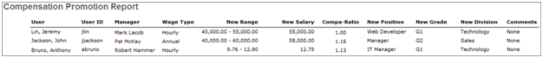
The user can run this report for any group of users through the user criteria. The user can select the compensation tasks to run this report against. This report will include employees who were compensated by a compensation manager in a selected task based on the user criteria. This report can include off cycle tasks.
The Currency setting will default to the user's compensation currency. The user can choose to display amounts in other currencies by selecting a currency in the drop-down. The conversion rates will pull in based on the selected compensation tasks.
The report can be output to HTML or Excel. The output of the report will contain all details entered by the compensation manager at the time the employee was promoted on the compensation plan.

Compensation Statement Report
This report will print out the compensation statement for a given employee. LTI Awards and Custom Bonus types can appear on the compensation statement. This report will not support multi-task reporting functionality.
A user cannot view their own compensation statement using this report. However, a user can view their own compensation statement using the Bulk Compensation Statement Report.
To access the Compensation Statement report, go to Reports > Standard Reports. Under the Compensation tab, click the Compensation Statement Report link.
Permissions
PERMISSION NAME | PERMISSION DESCRIPTION | CATEGORY

Compensation Statement Report | Grants access to Compensation Statement Report which enables printing the compensation statement for one user at a time. This permission can be constrained by Employee Relationship, OU, User's OU, User Self and Subordinates, and User's Subordinates. | Reports - Compensation
Filter
- User Criteria - Click this field to select users for the report. Both inactive and active users are listed in the Select Users pop-up. There is no option to exclude inactive users from the Select Users pop-up. A user cannot view their own compensation statement using this report. However, a user can view their own compensation statement using the Bulk Compensation Statement Report.
- Compensation Task - select compensation task
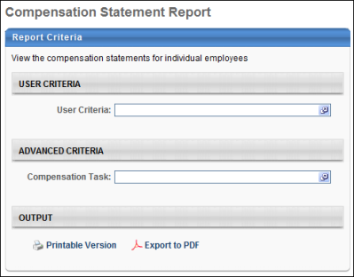
Output
- Printable Version link to view the results in a web page, or Export to Excel link to save/open as an Excel file
Pro-rated adjustment amounts will appear in the statement. If pro-ration is split, then the final pro-rated amount will appear in the report, NOT the individual splits.
If custom bonuses are used in the compensation task, then custom bonus data for the employee will appear in the Bonus section of the compensation statement.
If more than one bonus type is in the task, then each will appear in the Bonus section.
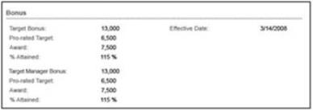
The pie chart will display a percentage of total comp for each custom bonus component included in the task. The pie chart will display a separate percentage for each bonus component included in the task.
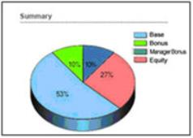
The equity data for the employee will appear in the Equity section of the compensation statement. For RSA, ISO, and NQO, the same fields will appear:
- Grant - the amount of shares given
- Award - the total dollar amount for shares given
The share price for the equity component will be used to convert the grant amount to the monetary amount and vice versa. The share price that will be used is based on the effective date of the equity from the task.
If the allocation of the equity component is set to shares, then the grant amount will populate when the statement is displayed. The monetary amount will not populate unless the current date is greater than or equal to the equity effective date of the task. If the statement is viewed before the equity effective date, then the equity award will not appear on the statement.
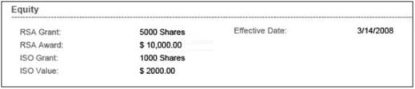
If the allocation of the equity component is set to cash award, then the monetary award amount will populate when the statement is displayed. The grant amount will not populate unless the current date is greater than or equal to the equity effective date of the task. If the statement is viewed before the equity effective date, then the grant amount will not appear on the statement. If a share price does not exist by the effective date, then the Grant field will not appear.
If LTI is used in the task, then the LTI Award field will appear on the statement. If LTI Splits are used, then the Grant amounts for equity components within the split will appear. The grant amounts will only appear once the effective date is reached. If LTI Split is not used, then the Grant amounts will not appear.
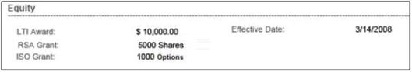

Deferral Payments Report
The Deferral Payments Report enables administrators to track payment schedules of deferred compensation for a population of users.
To run the Deferral Payments Report, go to Reports > Standard Reports. Then, select the Compensation tab and click the Deferral Payments Report link.
Permissions
PERMISSION NAME | PERMISSION DESCRIPTION | CATEGORY

Deferral Payments Report | Grants access to Deferral Payments Report, which tracks payment schedules of deferred compensation for a population of users. This permission can be constrained by OU, User's OU, User, and User's Subordinates. | Reports - Compensation
Criteria
Filter Name | Description
Date Criteria | Filter your results by date. If a deferral payment falls within the date criteria, it is included in the report. Note: Date Criteria is always implemented using UTC (Coordinated Universal Time).
User Criteria | Select the users that are included in the report. Users who meet the criteria but do not have a deferred payment for the date criteria are not included in the report. When filtering by OU, the criterion applies to the user's current OUs at the time the report is run, not the OUs at the time of the deferral. This is a required field. After selecting an OU, you can select the Include Subordinates option to also include subordinate OUs in the report.
User Status | Select this option to include inactive users in the report. Note: Only inactive users that were part of the compensation task and meet the criteria defined in the User Criteria section are included.
Components | Click the Select Components link to select which components are included in the report. Multiple components can be selected. Only active bonus and equity types are available.  - Equity components are separated into Awards and Grants sub-components. Awards are equity components allocated in cash during compensation tasks. Grants are equity components allocated in shares or options during compensation tasks.
Sort By | Select whether the report is sorted by deferral date or by user. If sorted by date, the deferrals are displayed in the order in which they occurred. If sorted by user, all deferrals are sorted by user last name, regardless of when they occurred.
Currency | Select the currency in which the monetary deferrals are displayed. Only the currencies that are available to the user running the report are displayed.
Display OU | Select an OU type to display in the report for each user.
Additional Display OU | Select a second OU type to display in the report for each user.
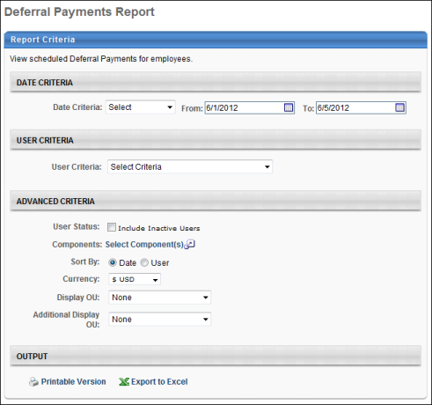
Output Sorted by User
The data is first grouped under two sections, Cash Award and Shares/Options. Fields appearing are user, user ID, primary and secondary OU, payment date, compensation type, payment method, allocation percentage and amount.
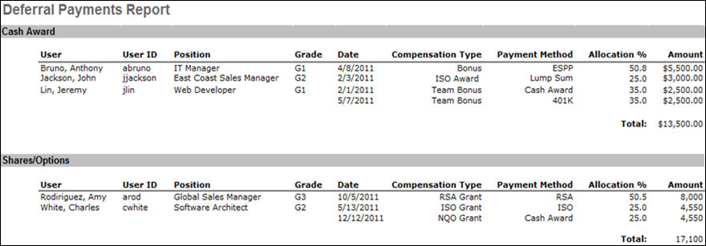
Output Sorted by Date
The report is sorted by date and appears grouped in the two sections, Cash Award and Shares/Options.
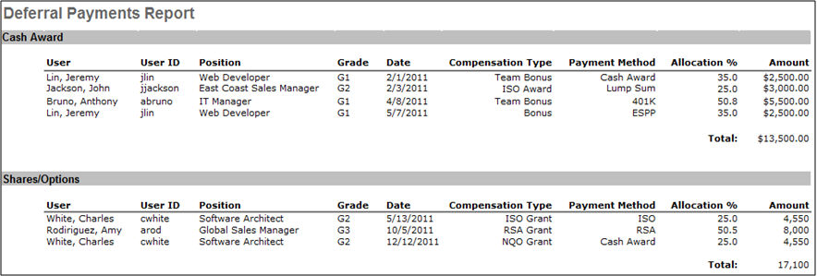

Employee Salary Range Report
This report displays the salary range of each employee in the report criteria.
To access the Employee Salary Range report, go to Reports > Standard Reports. Under the Compensation tab, select the Employee Salary Range Report link.
Permissions
PERMISSION NAME | PERMISSION DESCRIPTION | CATEGORY

Employee Salary Range Report | Grants access to Employee Salary Range Report, which displays the salary range of each employee in the report criteria. | Reports - Compensation
Filter
- User Criteria- Limit report output to the users matching the specified user criteria.
  - The report will only run within the defined constraints for the user running the report.
  - This is the standard organizational unit (OU) availability selection criteria drop-down. Choose from available OU types.
  - Defaults: If no User Criteria are selected, then the report will run for the entire available population within the report user's permission constraints.
- User Status - Select this option to include inactive users in the report. Note: Only inactive users that were part of the compensation task and meet the criteria defined in the User Criteria section are included.
- Wage Types - Determine which wage type tasks are included in the report. Note: This criterion is not based on the employee's current Wage Type value. It is based on the Wage Type value of the task. The available options are:
  - All Wage Types - Include employees from all wage types in the report. If this option is selected, a Wage Type column is added to the report to display each user's wage type.
  - Each available wage type is available. Selecting a wage type only includes employees from selected wage type in the report.
- Annualize Rates - Select this option to annualize the non-annual rates for non-annual employees. If this option is selected, any component allocated to a non-annual employee at a non-annual rate is annualized based on their Labor Hours value for the task (not their current Labor Hours value). Note: This option is only available if the Wage Type is set to All Wage Types or a non-annual wage type.
- Market Salary - Check to display market salary/rate.
- Report Title - Enter report title or leave blank to default to Employee Salary Range title.
Report Settings
This is an asynchronous report, which allows the administrator to define the standard report and generate the report asynchronously. As a result, when administrators process the report, the system generates the report in the background, while the administrator can move on to other areas of the system. When the report is finished processing, the administrator can then view the full report in its entirety.
- Up to three separate reports can generate asynchronously, allowing greater flexibility for creating and storing different versions of the report.
- If you process a report or refresh a stored report, the report appears in the table as Queued.
- The most recently created report displays at the top of the table.
- Since the user can generate up to three reports, the administrator can define a report title for each of the generated reports.
- Clicking the View Details icon changes the report settings on the page to match those of the selected previously run report.
Output
- Printable Version link to view the results in a web page, or Export to Excel link to save/open as an Excel file.
- After the report is processed, you can:
  - Update the data on the report, click the Refresh icon .
  - View the details on the report, click on the Details icon .
  - Delete the report, click on the Delete icon .
The report will display each employee's current salary/rate, compa-ratio, range minimum, midpoint, and maximum as well as the OU's used to determine the employee's salary/rate range.
Tertiary Organizational Unit
For portals that have configured their salary ranges with a tertiary OU, then a Tertiary OU column is included in the report output and displays the tertiary OU for users who are part of a primary, secondary, and tertiary OU. The column name is the name of the tertiary OU that is configured on the Salary Structures page.
Output Examples
The following are examples of the report output based on criteria defined for the portal's salary structure.
Example 1
Criteria | Result
User: John Jones  Primary OU: Grade 1  Secondary OU: Position 1  Tertiary OU: Location 1  Salary Range for Grade 1; Position 1; (No Tertiary OU for this range) - Min: $10,000.00; Range Midpoint: $14,000.00; Max: $20,000.00 | John Jones will show on the report with Grade 1, Position 1, and Location 1 with Min: $10,000.00; Midpoint: $14,000.00; Max: $20,000.00
Example 2
Criteria | Result
User: John Jones  Primary OU: Grade 1  Secondary OU: Position 1  Tertiary OU: Location 1  Salary Range for Grade 1; Position 1; Location 1 - Min: $10,000.00; Edited Midpoint: $14,000.00; Max: $20,000.00 | John Jones will show on the report with Grade 1, Position 1, and Location 1 in the report with Min: $10,000.00; Midpoint: $14,000.00; Max: $20,000.00
Considerations
- If a user has a tertiary OU on their user record, and the tertiary OU is not listed on the Salary Structure page, then the Tertiary OU column displays the user’s tertiary OU from the user record.
- The report will show the salary range minimum, range midpoint, and salary range maximum for the tertiary OU for users who are part of a primary, secondary, and tertiary OU when the Salary Structures page has a defined tertiary OU salary range minimum, range midpoint, and salary range maximum.
- If the Salary Structures page has a primary, secondary, and tertiary OU defined:
  - and the user only has a primary OU, then the system shows the primary salary range minimum, range midpoint, and salary range maximum in the report output.
  - and the user only has a primary and secondary OU, then the system shows the primary and secondary salary range minimum, range midpoint, and salary range maximum in the report output.
  - and a tertiary OU is not present for the user on the user record, tertiary OU will remain blank in the Tertiary OU column.
- If "None" is selected in the Select Tertiary OU field on the Salary Structures page, then the Tertiary OU column does not display on the Employee Salary Range Report.
- The Employee Salary Range Report will display the edited midpoint when the Edit Midpoint option is selected on the Salary Structures page, regardless of the level of the OUs defined for the position.

Individual Targets Report
The Individual Targets Report reports on users' target values for defined Bonus and Equity components for a specific date period.
Permissions
PERMISSION NAME | PERMISSION DESCRIPTION | CATEGORY

Individual Targets Report | Grants access to Individual Targets Report, which reports on users' target values for defined Bonus and Equity components for a specific date period. This permission can be constrained by OU, User's OU, User Self and Subordinates, User, and User's Subordinates. | Reports - Compensation
Criteria
Filter Name | Description
Date Criteria | Filter your results by date. If any part of a target falls within that time frame, the values from that target are included in the report. Note: Date Criteria is always implemented using UTC (Coordinated Universal Time).
User Criteria | Limit results to the users matching the specified user criteria.
User Status | Select this option to include inactive users in the report. Note: Only inactive users that were part of the compensation task and meet the criteria defined in the User Criteria section are included.
Component | Select one of the active bonus or equity components from the drop-down list. This is required.
Additional Fields | Select the additional fields to include them in the report. The available options are:  - Last Updated - The date on which the target was last modified.  - Last Updated By - The name of the user or task to last modify the target.
Additional Options | Select this option to include only the most recent target for the selected component for the selected date range.
Currency | Select the currency in which monetary values are displayed in the report. The organization's currency conversion rates are used.
Display OU | Select an Organizational Unit to display that information on the report. For example, if you select the Position OU, each user's position will display in the report. This is optional.
Additional Display OU | Select an additional Organizational Unit to display that information on the report. For example, if you select the Position OU, each user's position will display in the report. This is optional.
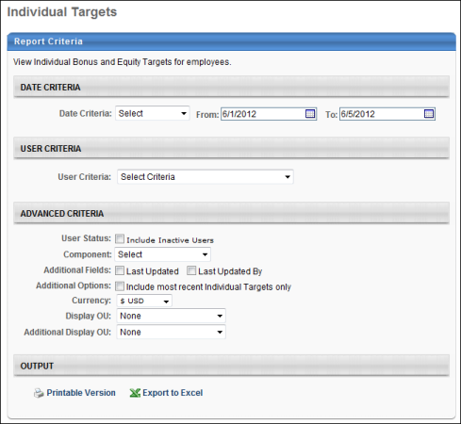
Output
The report displays users in alphabetical order by last name. If a user has more than one target, the targets are ordered by ascending target date.
- Individuals who are not assigned to any component for an individual target and fall under the selected date range are also included in the report.
- Individuals who are part of other components are not included in the report.
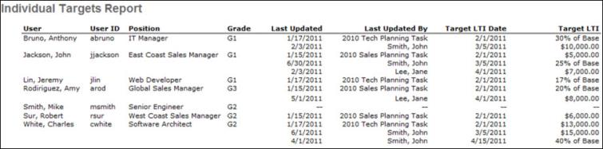

Pay For Performance Report
This report displays the comparison of adjusted compensation for an employee against specific performance metrics for a given task. This report can be run across multiple compensation tasks. Custom bonus components can be selected for inclusion in this report. LTI Awards appear as a selectable option for display on this report. RSA, ISO, and NQO Awards will appear as selectable options for display on this report. This report can report on off cycle tasks.
To access the Pay For Performance report, go to Reports > Standard Reports. Under the Compensation tab, select the Pay For Performance Report link.
Permissions
PERMISSION NAME | PERMISSION DESCRIPTION | CATEGORY

Pay For Performance Report | Grants access to Pay For Performance Report, which displays the comparison of adjusted compensation for an employee against specific performance metrics for a given task. | Reports - Compensation
Criteria
- User Criteria - Limit report output to the users matching the specified user criteria.
  - The report will only run within the defined constraints for the user running the report.
  - This is the standard OU availability selection criteria drop-down. Choose from available OU types.
  - Defaults: If no User Criteria are selected then the report will run for the entire available population.
- User Status - Select this option to include inactive users in the report. Note: Only inactive users that were part of the compensation task and meet the criteria defined in the User Criteria section are included.
- Compensation Task - Select compensation task.
- Components - The available components do not appear until a compensation task is selected. Select the compensation components to include in the report. These include all base types, even if they are set to be included in base salary as long as they are part of the selected compensation task.
- Performance Metrics - Select Performance Review Rating, Competency Assessment Rating, Individual Goal Achievement %, or Divisional Goal Achievement %.
- Wage Types - Determine which wage type tasks are included in the report. Note: This criterion is not based on the employee's current Wage Type value. It is based on the Wage Type value of the task. The available options are:
  - All Wage Types - Include employees from all wage types in the report. If this option is selected, a Wage Type column is added to the report to display each user's wage type.
  - Each available wage type is available. Selecting a wage type only includes employees from selected wage type in the report.
- Annualize Rates - Select this option to annualize the non-annual rates for non-annual employees. If this option is selected, any component allocated to a non-annual employee at a non-annual rate is annualized based on their Labor Hours value for the task (not their current Labor Hours value). Note: This option is only available if the Wage Type is set to All Wage Types or a non-annual wage type.
- Currency - Select currency from drop-down list. All amounts displayed will be based on the selected currency for the report. All amounts will be converted based on the conversion rates that are pulled in to the task when the task is started.
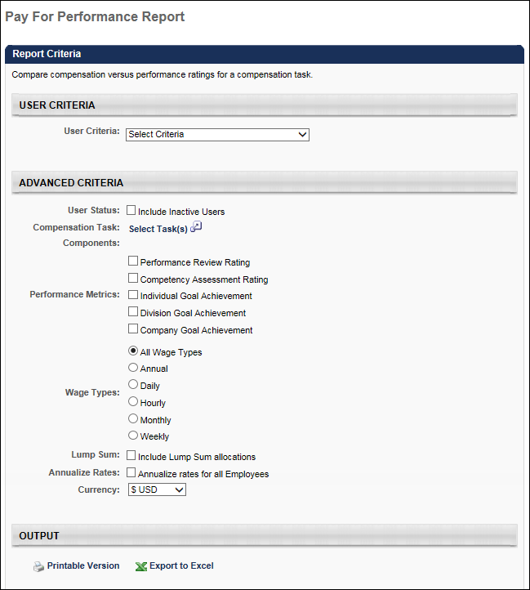
Output
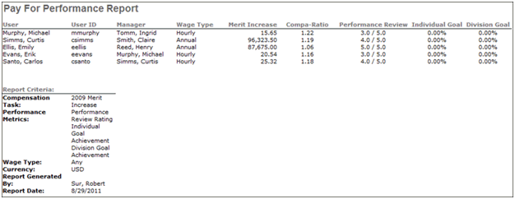
This report will include employees who were compensated by a compensation manager in a selected task based on the user criteria.
In the Adjustment field, the adjustments from all selected compensation tasks will appear. Custom bonus types and LTI will appear for selection.
On the output of the task, the adjustment types from all selected compensation tasks will appear.
- All task assignees from all selected tasks will appear in the output based on the user criteria of the report.
- For each user, the adjustments will appear from the appropriate task.
- If the user is in more than one task, then the user will appear for each task that the user is in.
The performance ratings that pull in for each user will depend on the compensation period of the associated compensation task.
Custom bonus types will appear as columns on the output if selected to be included in the report.
For Equity, LTI Award, RSA Award, ISO Award, and NQO Award will all appear as new adjustment types on the report. When selected, they will appear as columns on the report output.
For RSA, ISO, and NQO, until the effective date on the task, either the Award or the Grant type will populate the report. Once the effective date is reach and the conversion process is executed, both adjustments can appear on the report.
Pro-rated adjustments amounts will appear where the final pro-rated amount will appear in the report, NOT the individual splits.

Connect Reports

Connect Community Report
This report displays community-specific information including designated community leaders, member count and community type. User criteria filter will apply to community leaders' OU criteria.
Permissions
PERMISSION NAME | PERMISSION DESCRIPTION | CATEGORY

Connect Community Report | Grants access to Connect Community Report, which displays community-specific information including designated community leaders, member count and community type. | Reports - Connect
Filters
- User Criteria - select user criteria to filter what community leaders are included in the report
- User Status- select to include inactive community leaders
- Display OU - select to include OU information and choose the OU field from the drop-down which will display as column in output
- Group By - choose to group report by Leader or Community
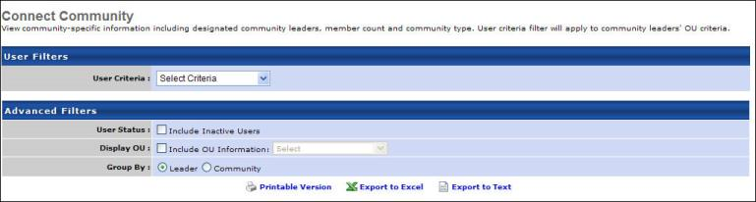
Output
- link to view the results in a web page, link to save/open as an Excel file, or to export data to a tab delimited text file.
Grouped By Leader
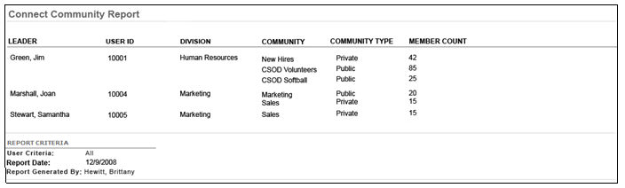
Grouped by Community
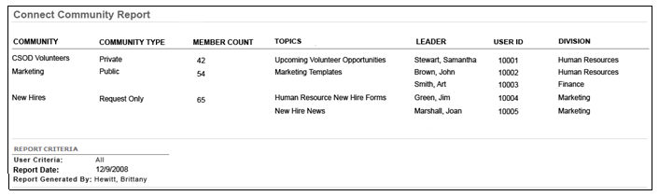

Connect Profile Comments Report
View comments that have been left on users' Connect Profiles. Filter by date that the comments were made or OU criteria to determine which user profiles are included in the report. If user updates and comment left on user updates are to be included, the checkbox must be selected.
Permissions
PERMISSION NAME | PERMISSION DESCRIPTION | CATEGORY

Connect Profile Comments Report | Grants access to Connect Profile Comments Report, which displays comments that have been left on users' Connect Profiles. | Reports - Connect
Filters
- Date Criteria - filter your results based on a date range. Note: Date Criteria is always implemented using UTC (Coordinated Universal Time).
- User Criteria - select user criteria to filter what user's connect profile comments are included in the report
- User Status- select to include inactive user's comments
- Display OU - select to include OU information and choose the OU field from the drop-down which will display as column in output
- Comment Type - select to include user updates and the comments that have been left on those updates
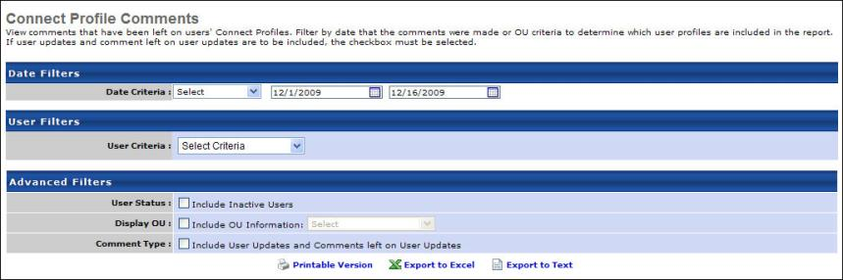
Output
- link to view the results in a web page, link to save/open as an Excel file, or to export data to a tab delimited text file.
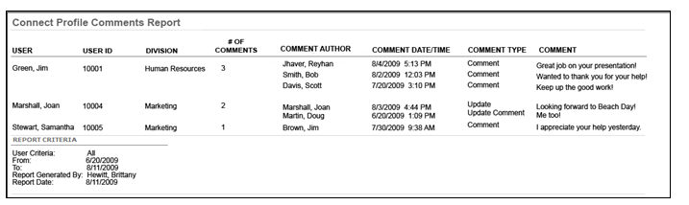
- # of Comments - total number of comments.
  - Include User Updates and Comments left on User Updates - checked, this total will account for both updates left by user themselves, child comments on updates and comments left by other users (visitors).
  - If Include User Updates and Comments left on User Updates - not checked, this total will only account for comments left by visitors only.
- Comment Type:
  - Comment - if visitor made it
  - Update - if user themselves made it
  - Update Comment - if comment was a child comment off of user update

Connect Topic Expert Report
View topics that users have been designated Topic Experts for and the number of questions they have answered.
Permissions
PERMISSION NAME | PERMISSION DESCRIPTION | CATEGORY

Connect Topic Expert Report | Grants access to Connect Topic Expert Report, which displays topics that users have been designated Topic Experts for and the number of questions they have answered. | Reports - Connect
Filters
- User Criteria - select user criteria to filter which topic experts are included in the report
- User Status- select to include inactive topic experts
- Display OU - select to include OU information and choose the OU field from the drop-down which will display as column in output
- Group By - choose to group report by Expert or Topic
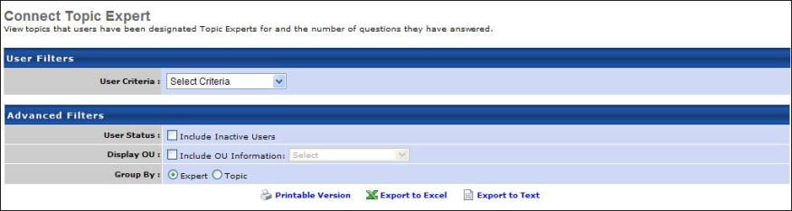
Output
- link to view the results in a web page, link to save/open as an Excel file, or to export data to a tab delimited text file.
Group By Expert
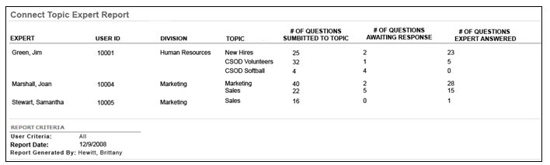
Group By Topic
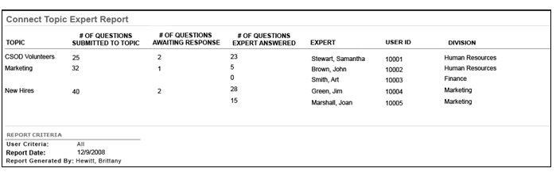

Connect Topic Moderator Report
View topics that users have been designated Topic Moderators for and the number of postings associated with those topics.
Permissions
PERMISSION NAME | PERMISSION DESCRIPTION | CATEGORY

Connect Topic Moderator Report | Grants access to Connect Topic Moderator Report, which displays topics that users have been designated Topic Moderators for and the number of postings associated with those topics. | Reports - Connect
Filters
- User Criteria - select user criteria to filter which topic moderators are included in the report
- User Status- select to include inactive topic moderators
- Display OU - select to include OU information and choose the OU field from the drop-down which will display as column in output
- Group By - choose to group report by Moderator or Topic
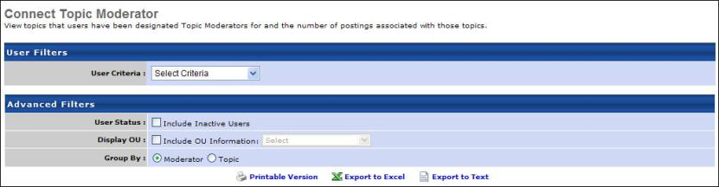
Output
- link to view the results in a web page, link to save/open as an Excel file, or to export data to a tab delimited text file.
Group By Moderator
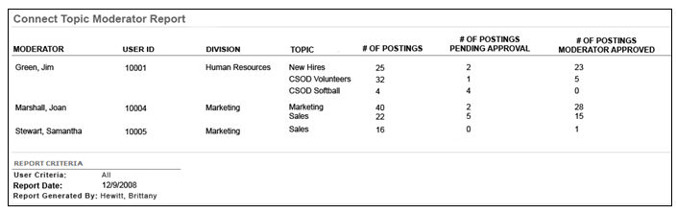
- # of Postings Moderator Approved - total # of Postings specific moderator has approved themselves
Group By Topic
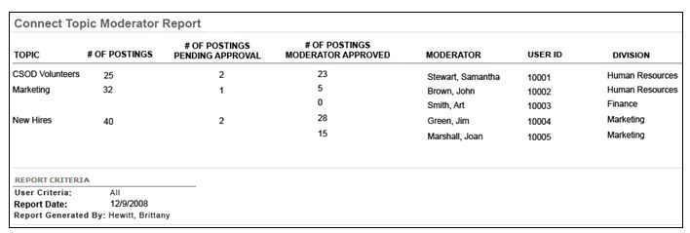

ILT Reports

Enrollment Summary Report
View enrollment summary information for Instructor Led Training (ILT) sessions.
To access the Enrollment Summary report, go to Reports > Standard Reports > ILT Reports. Then, click the Enrollment Summary link.
Permissions
PERMISSION NAME | PERMISSION DESCRIPTION | CATEGORY

ILT Enrollment Summary Report | Grants access to ILT Enrollment Summary report, which displays enrollment summary information for Instructor Led training sessions. | Reports - ILT
Filters
- Date Criteria - filter your results based on a session date range. Note: Date Criteria is always implemented using UTC (Coordinated Universal Time).
- Facility - filter on session location
- Vendor - filter the results for training from a specific training vendor or select All for all training Vendors
- Instructor - filter by a specific instructor name. Vendor must be selected to select an Instructor.
- Event - filter by event
- Location Number - filter by session locator number
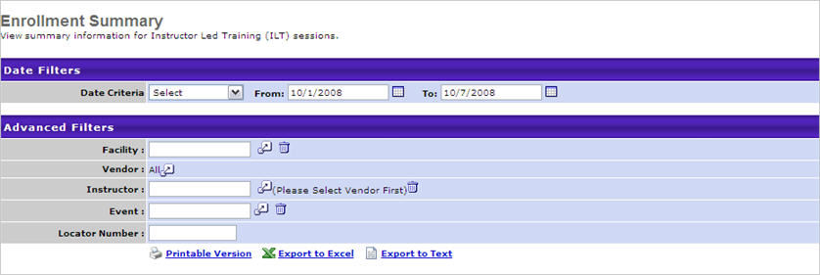
Output
- link to view the results in a web page, link to save/open as an Excel file, or to export data to a tab delimited text file.
  - Waitlisted field displays the number of user's with the status Waitlisted or Waitlisted Expired
  - Currently Registered field displays the number of users that are Registered for the session regardless of what their status is now (not just users with the status Registered)
    - The field displays the number of users that have one of the following status/s: Registered, No Show, Completed, Incomplete, In Progress, Pending Evaluation, Pending Acknowledgement, Pending Prerequisite (or any of the previous status/s with Past Due appended). Users with the status Withdrawn are not included in this count.
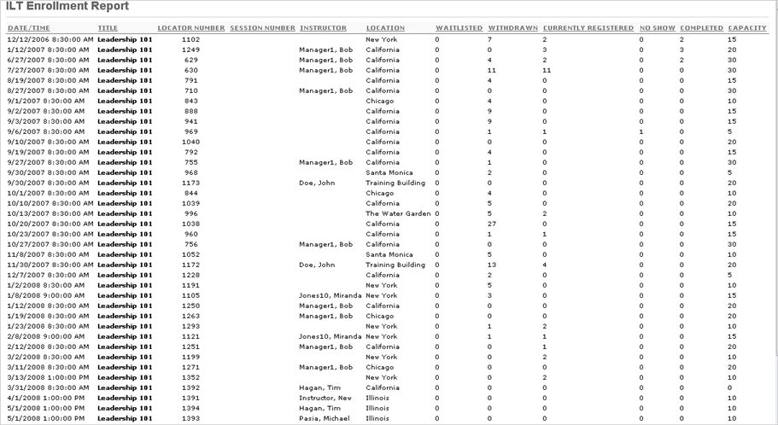

ILT Reservation Summary Report
The ILT Reservation Summary report enables administrators to view the seat information for one or more sessions for which the administrator has permission to view. This report enables administrators to filter sessions by date criteria, organizational units, event, facility, and provider.
Use Case
An organization sells events to different partner organizations and to the public. The organization reserves a certain number of seats for employees of their partners so that some seats are guaranteed to the partner's employees.
Before a session starts the administrator runs the ILT Reservation Summary report. The administrator's permission to access the ILT Reservation Summary report is not constrained, so the administrator can see all reservation information in the report output.
The organization gives their partners access to the ILT Reservation Summary report. The partner's permission to access the ILT Reservation Summary report is constrained to their own organizational unit (OU), so the partner can only see sessions of the event where the partner has one or more reserved seats. The partner cannot see how many seats are reserved for another OU or for the public.
To access the ILT Reservation Summary Report, go to Reports > Standard Reports. Then, within the ILT tab, click the ILT Reservation Summary link.
Permissions
PERMISSION NAME | PERMISSION DESCRIPTION | CATEGORY

ILT Reservation Summary Report | Grants access to ILT Reservation Summary report, which displays seat reservation information for sessions. This permission can be constrained by OU and User's OU. The permission constraints limit the OUs that can be selected in the User Criteria for the report. Administrators can only see sessions where the constrained OUs are indicated as a reservation OU. If this permission is not constrained, the administrator can see all sessions and registration information. This is an administrator permission. | Reports - ILT
Criteria
Feature | Description
Date Criteria | Select the date range for the report from the drop-down list or enter specific dates in the From and To fields. Only sessions with start dates that are equal to or between the date criteria are included in the report.
User Criteria | Select the appropriate OUs for the report. If no OU is selected, the report checks the administrator's permission constraints and returns all sessions within the administrator's constraints. If the administrator's permission is not constrained, then the report is run for all event sessions. Multiple OUs can be selected. When multiple OUs are selected, the report returns sessions with reservations from either selected OU. Note: If seats are not reserved by OU for a session, then the session is considered Public and is not associated with an OU.
Event | Click the Select icon  to select a specific event for the report. If an event is selected, the report only displays information for sessions from the selected event. If no event is selected, then the report displays all sessions. The other report criteria must also be met for a session to display.
Facility | Click the Select icon  to select a specific facility for the report. If a facility is selected, the report only displays information for sessions where the first part location is equal to the selected location. The other report criteria must also be met for a session to display.
Providers | Click the Select icon  to select a specific provider for the report. If a provider is selected, the report only displays information for sessions where the provider is equal to the selected provider. The other report criteria must also be met for a session to display.
Sort by | This option enables administrators to determine how the report data is sorted. The following options are available:  - Start Date/Time  - Event Title  - Session ID  - Organizational Unit  - Seats Available
Filter Session Status | - Filter Session Status - This option enables administrators to filter the report data by ILT session status. Select the filter option to include sessions in the corresponding status. If no status filters are selected, then the filter is not applied. The following status filters are available:  - Approved  - Completed  - Tentative  - Cancelled
Include Restrictions | - Include Restrictions - Select this option to include seat restriction information in the report. When this option is selected, a Seats Restricted column is included in the report. Also, for sessions that have restrictions applied, additional rows are added to provide details for each restriction that was applied. This option is only available if the user running the report is able to set restriction information sessions. This requires that both of the following are true:  - The user either has permission to create or edit ILT sessions.  - At least one of the restriction options is enabled within ILT Preferences (Allow enrollment restrictions to be placed on a specific organizational unit, Allow enrollment restrictions to be placed on organizational unit types, or Manage Reservations and Restrictions).
Include Waitlisted | When this option is checked, the report output includes a "# of Waitlisted Users" column. The column shows the number of users who are waitlisted for the session. The option is unchecked by default.
Remove Instructors | When this option is checked, the Instructor column does not appear in the report output. This option is beneficial when users would prefer not to have instructor names appear in the report output. The option is unchecked by default.
Report Title | Enter a title for the report. If no title is entered, the report title defaults to the report name. The title appears on both the report output and in the Processed Reports list.
Process Report
This is an asynchronous report, which allows the administrator to define the standard report and generate the report asynchronously. As a result, when administrators process the report, the system generates the report in the background, while the administrator can move on to other areas of the system. When the report is finished processing, the administrator can then view the full report in its entirety.
- Up to three separate reports can generate asynchronously, allowing greater flexibility for creating and storing different versions of the report.
- If you process a report or refresh a stored report, the report appears in the table as Queued.
- Since the user can generate up to three reports, the administrator can define a report title for each of the generated reports.
- Clicking the View Details icon changes the report settings on the page to match those of the selected previously run report.
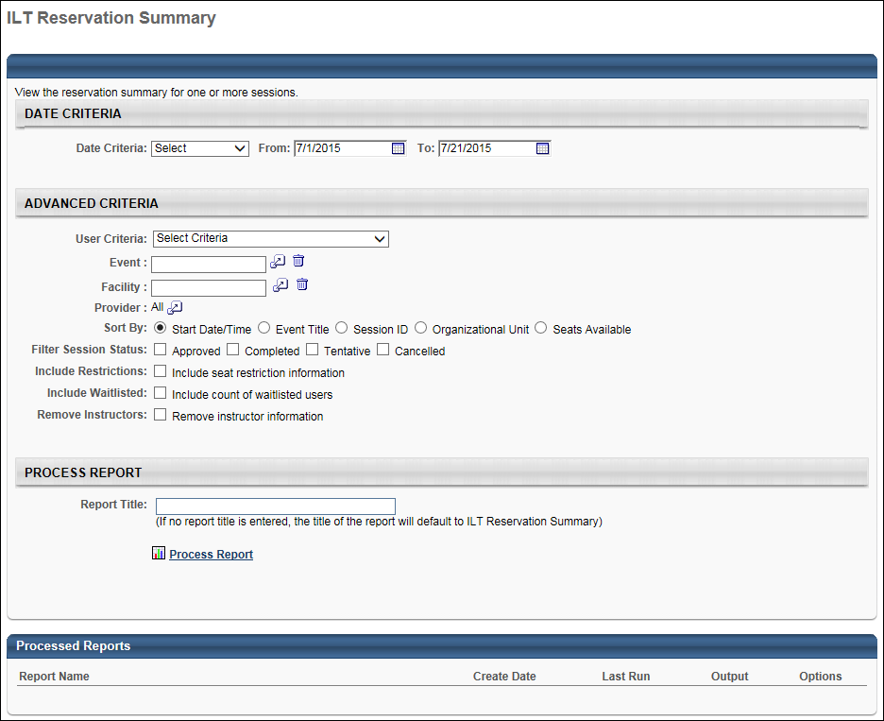
Output
The following information is displayed for each session included in the report output:
- Start Date/Time - The start date and time of the session. By default, sessions are displayed in chronological order, with the nearest approaching session displayed first.
- Title - The event title. For sessions with the same start date and time, sessions are then displayed in alphabetical order.
- Provider - ILT session provider.
- Locator Number - Session locator number.
- Session ID - If no session ID exists, this cell is empty.
- Instructor - The session's primary instructors. If multiple primary instructors exist for the session, the instructor names appear in the order in which they are listed in the session.
- Location - The location value for the first session part.
- Organizational Unit - The OU associated with the session in the Enrollment section of the Details page. If reservations are not used for the session, then "Public" is displayed.
- Seats Reserved - The current number of seats reserved for the corresponding OU.
- Seats Used - The current number of users who have registered for the corresponding OU.
- Seats Available - The number of seats that are currently available for the corresponding OU. This value does not account for registration deadlines. Even if the registration deadline has passed, if not all seats were used, then this value displays available seats.
- Capacity - The current maximum registration value that is defined on the Details page for the session.
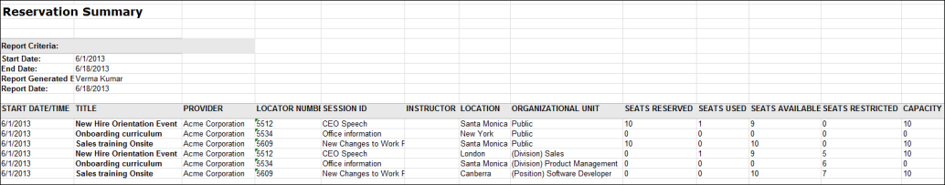

Instructor Calendar Report
This report displays ILT Events for instructors by week. This is a comprehensive view of the instructor calendar, giving the administrator a better view of the instructor availability for events.
The data for this report is updated in real-time. However, if you are not seeing updated data for sessions, you may need to check the Include tentative sessions option to view data for sessions that have not yet been approved.
Permissions
PERMISSION NAME | PERMISSION DESCRIPTION | CATEGORY

Instructor Calendar Report | Grants access to Instructor Calendar Report, which displays scheduled ILT sessions for instructors for a one week period. | Reports - ILT
Filters
- Vendor Name (required field) - filter report by one or more instructor vendors. At least one vendor must be selected.
- ILT Event - filter by a specific ILT event
- Instructor Name - filter by a specific instructor name
- Calendar Date ( required field) - filter to run for specific dates or a relative date range
- Session Status - select to include completed sessions or tentative sessions
- Include in Output - select to include Session Time, Session Number or Session Location
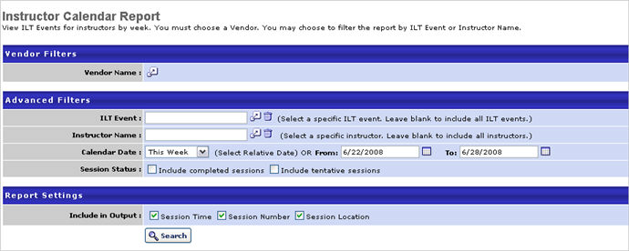
Output
- The report will generate on the page as an inline report. Each instructor in the criteria will display on the left and a column will appear for each date in the date range. The report can output to HTML or excel.
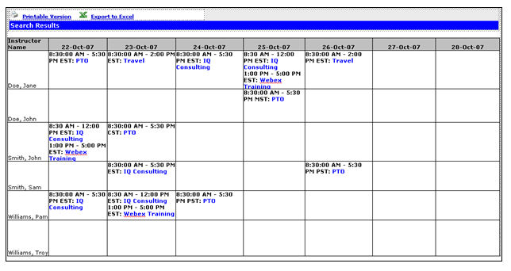
For each instructor, the report will show the session time, title, number (if selected), and location (if selected) per Calendar Date. The Session Title is a hyperlink and allows the user to view the Session Details.
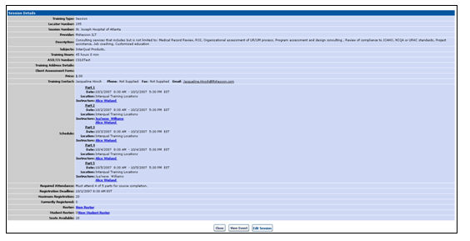
If the user has ILT Admin rights to create/edit Events and Sessions, an Edit button will appear at the bottom of the page. If they click on the 'Edit Button' they will be taken to the appropriate session in 'Edit' mode. Otherwise, the user will see the standard session details page.
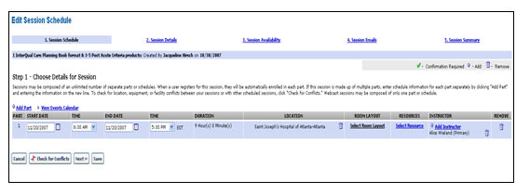

Interest Tracking Report
Display events which users have expressed interest in.
Permissions
PERMISSION NAME | PERMISSION DESCRIPTION | CATEGORY

ILT Interest Tracking Report | Grants access to the Interest Tracking report which displays ILT events for which users have expressed interest in attending future sessions. | Reports - ILT
Filters
- User Criteria - limit report output to the users matching the specified user criteria
  - The report will only run within the defined constraints for the user running the report
  - This is the standard OU availability selection criteria drop-down. Choose from available OU types
  - Defaults: If no User Criteria are selected then the report will run for the entire available population
- Vendor - filter the results for training from a specific training vendor/provider or select All for all training vendors/provider
- Training Title - type word/s of title of event to search for events which have Interested users
- Facility - filter by session location
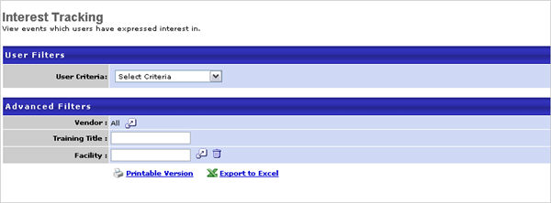
Output
- Printable Version link to view the results in a web page, or Export to Excel link to save/open as an Excel file
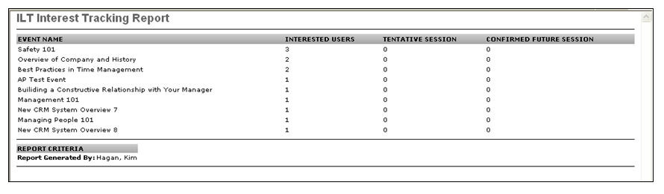
More Information
For more information on interest tracking, see the following:
- Interest Tracking - This topic covers the Manage Events and Sessions > Interest Tracking page. The Interest Tracking page lists all events for which users have expressed interest. From here, you can also view the users who have expressed interest, as well as export the information to Excel. Exporting allows you to have a complete list of the users who have expressed interest.
- LO Details Page - Interest Tracking - This topic is a user topic and explains to users how they express interest in an event.
Frequently Asked Questions
How do I find out which users expressed interest? The ILT Interest Tracking Report doesn't show the user's names.
You can get this information directly from the Interest Tracking page in Manage Events and Sessions. A list of the users who expressed interest can be exported to Excel.

No-Show Report
Display attendance rates and lists of no-shows per session.
Permissions
PERMISSION NAME | PERMISSION DESCRIPTION | CATEGORY

ILT No-Show Report | Grants access to No-Show Report, which displays attendance rates and lists of no-shows (registered students who did not attend any parts of the session) for each instructor led training session. | Reports - ILT
Filters
- Date Criteria -filter your results based on a session date range. Note: Date Criteria is always implemented using UTC (Coordinated Universal Time).
- Event - filter by a specific ILT event
- Facility - filter by session location
- Providers - filter the results for training from a specific training vendor/provider or select All for all training providers/vendors
- Details - check to no show user details and/or include subordinates
- Filter by - select currency option to filter by if applicable
- Convert to - select convert rate if applicable and choose Client or Cornerstone exchange rate
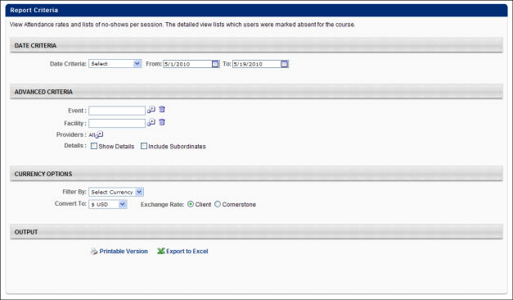
Output
- Printable Version link to view the results in a web page, or Export to Excel link to save/open as an Excel file
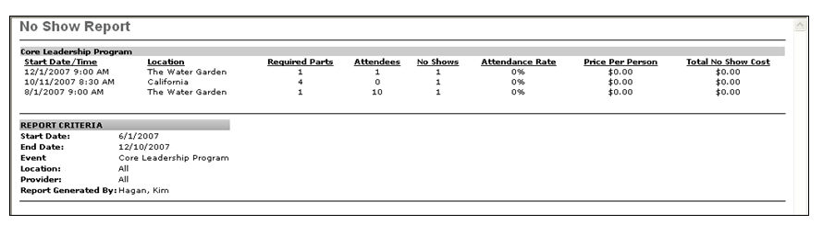
Considerations
This report should not be delegated, as it is designed to only show the user's own subordinates in the results. If the report is delegated, the user to whom it is delegated will not see the delegating user's subordinates in the output.

Requests Status Summary Report
This report displays a summary of ILT requests for each ILT session made by users within the criteria. For example, if you select all users and a certain two week period, it will display a summary of the ILT requests made by all users for each ILT session that occurs within the two week window.
The summary includes the session name, session ID, session start date, total number of requests for the session, and the number of requests that are pending, denied, and approved.
Permissions
PERMISSION NAME | PERMISSION DESCRIPTION | CATEGORY

ILT Requests Summary Report | Grants access to ILT Requests Summary Report, which displays a summary of requests for each instructor led training session made by a specified population of users. | Reports - ILT
Filters
- Date Criteria -filter your results based on a session date. Note: Date Criteria is always implemented using UTC (Coordinated Universal Time).
- User Criteria - limit report output to the users matching the specified user criteria
  - The report will only run within the defined constraints for the user running the report
  - This is the standard OU availability selection criteria drop-down. Choose from available OU types
  - Defaults: If no User Criteria are selected then the report will run for the entire available population
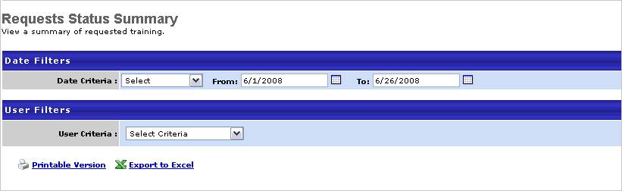
Output
- Printable Version link to view the results in a web page, or Export to Excel link to save/open as an Excel file
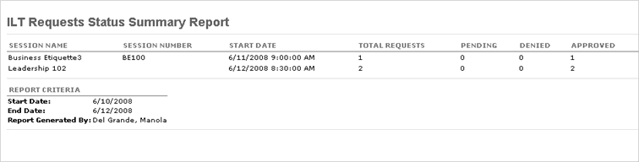

Session Cancellation Report
Display a list of cancelled sessions including reason for cancellation.
Permissions
PERMISSION NAME | PERMISSION DESCRIPTION | CATEGORY

ILT Session Cancellation Report | Grants access to ILT Session Cancellation Report, which displays a list of cancelled instructor led training sessions, including reason for cancellation. | Reports - ILT
Filters
- Date Criteria -filter your results based on a session date. Note: Date Criteria is always implemented using UTC (Coordinated Universal Time).
- User Criteria - limit report output to the users matching the specified user criteria
  - The report will only run within the defined constraints for the user running the report
  - This is the standard OU availability selection criteria drop-down. Choose from available OU types
  - Defaults: If no User Criteria are selected then the report will run for the entire available population
- Provider - filter the results for training from a specific training provider or select All for all training Providers
- Subject - filter by subject the event is associated
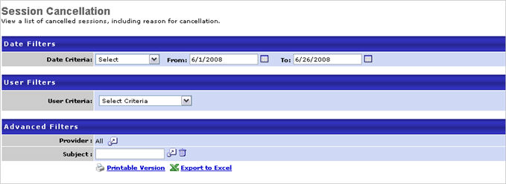
Output
- Printable Version link to view the results in a web page, or Export to Excel link to save/open as an Excel file
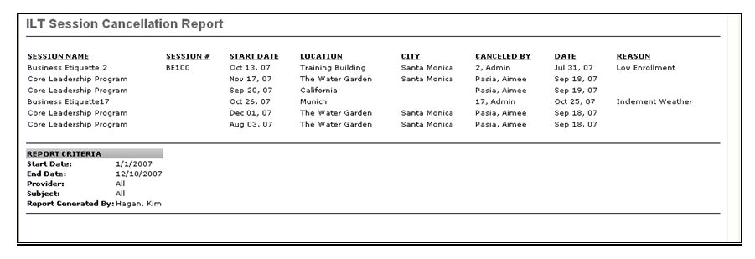

Session Cost Report
Display the cost associated with each session. The costs categories are client specific and cost dollars are set at the session level by ILT administrators creating sessions.
Permissions
PERMISSION NAME | PERMISSION DESCRIPTION | CATEGORY

ILT Session Cost Report | Grants access to ILT Session Cost Report, which displays the costs associated with each instructor led training session. The costs categories are portal specific and cost dollars are set at the session level by ILT administrators when creating sessions. | Reports - ILT
Filters
- Date Criteria -filter your results based on a session date range. Note: Date Criteria is always implemented using UTC (Coordinated Universal Time).
- Event - filter by a specific ILT event
- Facility - filter by session location
- Providers - filter the results for training from a specific training provider/vendor or select All for all training providers/vendors
- Filter by - select currency option to filter by if applicable
- Convert to - select convert rate if applicable and choose Client or Cornerstone exchange rate
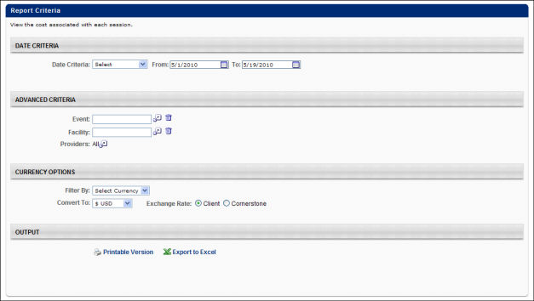
Output
- Printable Version link to view the results in a web page, or Export to Excel link to save/open as an Excel file
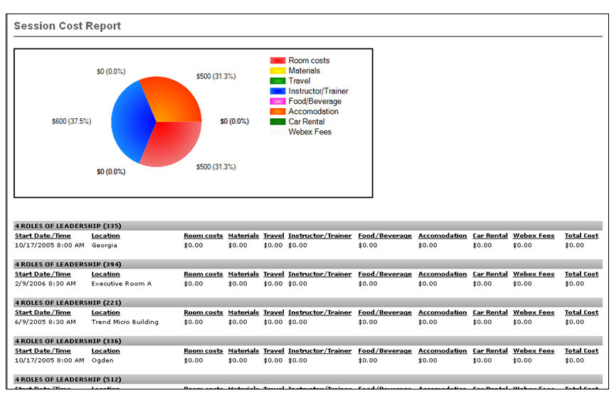

Session Withdrawal Report
Display a list of employees who registered for sessions and later withdrew their registration, including reasons for withdrawal.
Permissions
PERMISSION NAME | PERMISSION DESCRIPTION | CATEGORY

ILT Session Withdrawal Report | Grants access to ILT Session Withdrawal Report, which displays a list of users who registered for instructor led training sessions and later withdrew their registration, including reasons for withdrawal. | Reports - ILT
Filters
- Date Criteria -filter your results based on a session date range. Note: Date Criteria is always implemented using UTC (Coordinated Universal Time).
- User Criteria - limit report output to the users matching the specified user criteria
  - The report will only run within the defined constraints for the user running the report
  - This is the standard OU availability selection criteria drop-down. Choose from available OU types
  - Defaults: If no User Criteria are selected then the report will run for the entire available population
- Providers - filter the results for training from a specific training provider/vendors or select All for all training providers/vendors
- Primary Sort By - sort by Employee or Event
- Secondary Sort- sort by Employee or Event
- Filter by - select currency option to filter by if applicable
- Convert to - select convert rate if applicable and choose Client or Cornerstone exchange rate
Report Settings
This is an asynchronous report, which allows the administrator to define the standard report and generate the report asynchronously. As a result, when administrators process the report, the system generates the report in the background, while the administrator can move on to other areas of the system. When the report is finished processing, the administrator can then view the full report in its entirety.
- Up to three separate reports can generate asynchronously, allowing greater flexibility for creating and storing different versions of the report.
- If you process a report or refresh a stored report, the report appears in the table as Queued.
- The most recently created report displays at the top of the table.
- Since the user can generate up to three reports, the administrator can define a report title for each of the generated reports.
- Clicking the View Details icon changes the report settings on the page to match those of the selected previously run report.
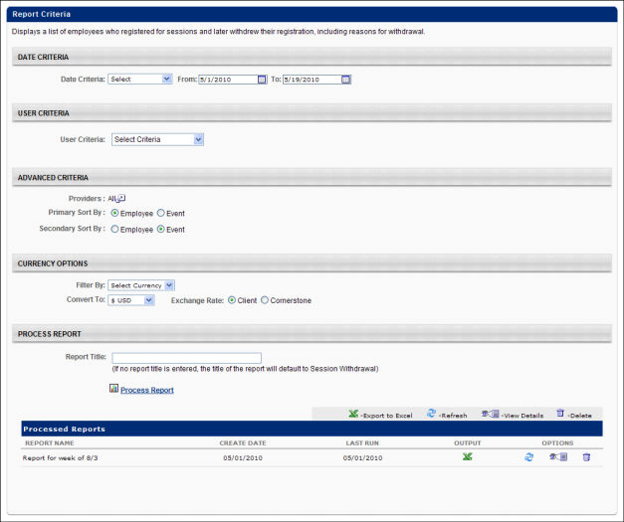
Output
- Printable Version link to view the results in a web page, or Export to Excel link to save/open as an Excel file
- After the report is processed you can:
  - Update the data on the report, click the Refresh icon
  - View the details on the report, click on the Details icon
  - Delete the report, click on the Delete icon
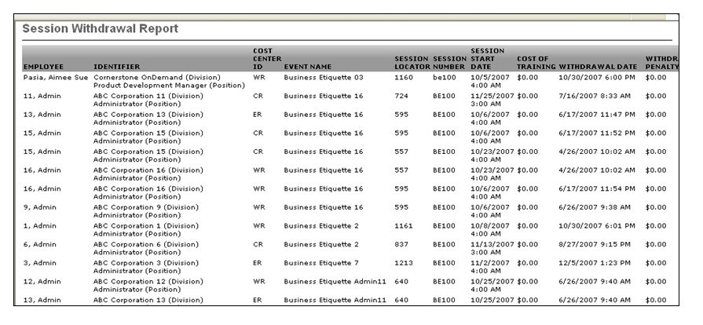
Considerations
This report should not be delegated, as it is designed to only show the user's own subordinates in the results. If the report is delegated, the user to whom it is delegated will not see the delegating user's subordinates in the output.

Performance Reports
Performance reports help you and your organization analyze data related to goals, competency assessments, performance reviews, and development plans.
Recommended Reports
A complete list of recommended reports for managers, learning, performance, and succession is available in the OnDemand Support folder:
- See Recommended Standard Reports for Managers for additional information.
- See Recommended Standard Reports - Learning for additional information.
- See Recommended Standard Reports - Performance for additional information.
- See Recommended Standard Reports - Succession for additional information.

Assessment Freeform Question
Report on responses to freeform questions from within a competency assessment tasks.
Permissions
PERMISSION NAME | PERMISSION DESCRIPTION | CATEGORY

Competency Assessment Freeform Question Report | Grants access to Assessment Freeform Question report, which reports on responses to freeform questions from within a competency assessment tasks. | Reports - Performance
Filters
- User Criteria (required field)- limit report output to the users matching the specified user criteria
  - The report will only run within the defined constraints for the user running the report
  - This is the standard OU availability selection criteria drop-down. Choose from available OU types
  - Defaults: If no User Criteria are selected then the report will run for the entire available population
- Task (required field) - filter by specific task
- Display OU - choose OU from the drop-down lists
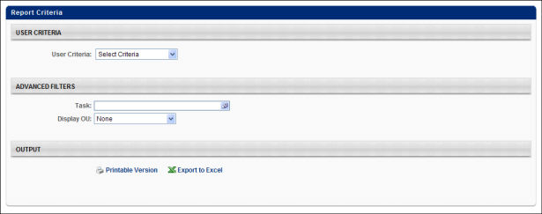
Output
- Printable Version link to view the results in a web page, or Export to Excel link to save/open as an Excel file

Assessment Score Comparison Report
Display the percentage breakdown of competency assessment responses by item/behavior. This report will average the competency ratings across all Assessees and display the gap analysis for each competency.
This report includes results from all assessment types.
Permissions
PERMISSION NAME | PERMISSION DESCRIPTION | CATEGORY

Competency Assessment Score Comparison Report | Grants access to Assessment Score Comparison Report, which displays the percentage breakdown of competency assessment responses by item/behavior. This permission can be constrained by User Self and Subordinates. | Reports - Performance
Filters
- User Criteria - limit report output to the users matching the specified user criteria
  - The report will only run within the defined constraints for the user running the report
  - This is the standard OU availability selection criteria drop-down. Choose from available OU types
  - Defaults: If no User Criteria are selected then the report will run for the entire available population
- Competency Model - filter by specific competency model
- Task (required field) - filter by specific task
- Display - choose one of the following options
  - All users in selected criteria
  - Users from the selected criteria with top scores for each competency
  - Users from the selected criteria with top scores overall for their selected model
- Display - check to Display percentile for each user score (only when group by user is selected) - check to display the percentile for each user. This option is only available when the report is grouped by user.
- Group By - select User or Competency
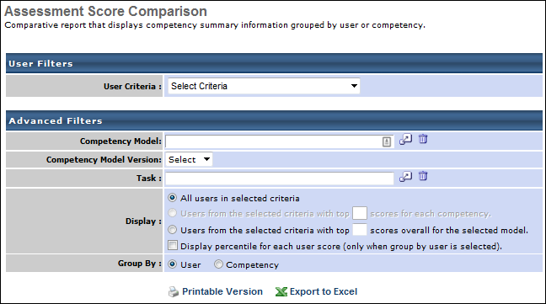
Output
- Printable Version link to view the results in a web page, or Export to Excel link to save/open as an Excel file
  - The report will generate to show the competency ratings for each user, the average score for the assessment, and what percentile the user falls in. The report criteria will display at the bottom of the report displaying the competency model, the competency task, and the name of the administrator who generated the report.
The same information will appear in excel if the administrator chooses to output the report to excel.
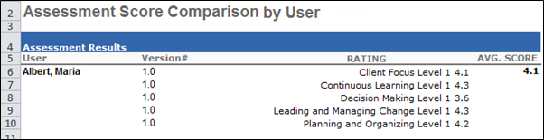

Bulk Performance Reviews Report
The Bulk Performance Reviews Report enables users to download all performance reviews within a specified criteria of users, date range, or performance review task. A maximum of 500 performance review PDFs can be generated at one time.
This report includes both active and inactive users.
To access the Bulk Performance Reviews Report, go to Reports > Standard Reports. From the Performance tab, click the Bulk Performance Reviews link.
Permissions
PERMISSION NAME | PERMISSION DESCRIPTION | CATEGORY

Bulk Performance Reviews Report | Grants access to the Bulk Performance Reviews Report, which downloads all performance reviews within a specified criteria of users, date range, or performance review task. Each review is contained within a separate PDF. This permission can be constrained by OU, User's OU, User Self and Subordinates, User's Self, User's Subordinates, and Direct Reports. | Reports - Performance
Criteria
Review Filters
Select whether the review is filtered by date or by review task:
Filter | Description
Date Criteria | Select this option to filter the performance review results by date. You must then select the date range by selecting a preset date range from the drop-down list or a custom date range using the From and To fields. The Which performance reviews would you like to print setting in the Advanced section determines how the date criteria is applied. Note: Date Criteria is always implemented using UTC (Coordinated Universal Time).
Task | Select this option to filter the performance review results by performance review task. You must then click the Select icon  to select a performance review task to include in the report. All active standard and off-cycle performance review tasks that are available to the user can be selected. The Which performance reviews would you like to print setting in the Advanced section determines which performance review statuses are included in the report. Note: If an off-cycle task is selected and a user within the selected User Criteria has multiple tasks, then all associated off-cycle task printouts are included in the report.
User Criteria
Filter | Description
User Criteria | Select a user or a group of users. This criterion applies to the reviewee of the performance review. This is a required field. You may choose one or more individual users as well as entire OUs or Groups. If the permission for this report is constrained, those constraints apply to user criteria selection when running the report.  This report includes both active and inactive users.
Advanced
Filter | Description
Which performance reviews would you like to print? | The following options are available if the Date Criteria option is selected in the Review Filters section:  - Performance reviews for which the completion date is equal to or contained within the date filters. - If this option is selected, the date criteria filter is based on the user's task completion date. For example, if the user's performance review task was completed on March 2, 2012, the user is selected in the user criteria, and the date criterion is set to January 1, 2012 to June 1, 2012, then the user's performance review is included in the report.  - Performance reviews for which the report date criteria overlaps the performance review period. - If this option is selected, the date criteria filter is based on the task performance review period. For example, if the "2012 Performance Review" has a performance review task period from January 1, 2012 to December 31, 2012, and the date criterion is set to January 1, 2012 to June 1, 2012, then the "2012 Performance Review" task is included in the report.  The following options are available if the Task option is selected in the Review Filters section:  - Only completed performance reviews. - If this option is selected, only performance reviews that are in a Completed status are included in the report.  - All completed or in progress performance reviews. - If this option is selected, then only performance reviews in a Completed or In Progress status are included in the report.
Print Preferences | The following options are available:  - Employee view - This option prints only the sections that are visible to the reviewee.  - Manager view - This option prints all sections of the performance review, including all submitted responses.
Process Report
Criteria | Description
Report Title | Enter a title for the report, up to 50 characters. This defaults to "Bulk Performance Reviews" if no title is entered. The title is displayed on the report and is also displayed in the list of Processed Reports on this page.
This is an asynchronous report, which allows the administrator to define the standard report and generate the report asynchronously. As a result, when administrators process the report, the system generates the report in the background, while the administrator can move on to other areas of the system. When the report is finished processing, the administrator can then view the full report in its entirety.
- Up to three separate reports can generate asynchronously, allowing greater flexibility for creating and storing different versions of the report.
- If you process a report or refresh a stored report, the report appears in the table as Queued.
- The most recently created report displays at the top of the table.
- Since the user can generate up to three reports, the administrator can define a report title for each of the generated reports.
- Clicking the View Details icon changes the report settings on the page to match those of the selected previously run report.
When the Process Report link is clicked, the report is run based on the selected criteria. The report output is stored in the Processed Reports table.
The administrator can choose the following actions and options for each report in the Processed Report table:
- Click the Zip File icon to download a .zip file that contains all of the performance review PDFs. Up to 500 PDFs can be included in a .zip file. If the report criteria return more than 500 results, then only 500 are included. The .zip file is named "<REPORT TITLE>_<LAST RUN DATE>.zip" (e.g., 2011 Performance Reviews_20120302.zip). The Last Run Date is displayed in YYYYMMDD format.
- Click the Refresh icon to refresh the report results.
- Click the View Details icon to view the filter criteria for the report.
- Click the Delete icon to delete the report.
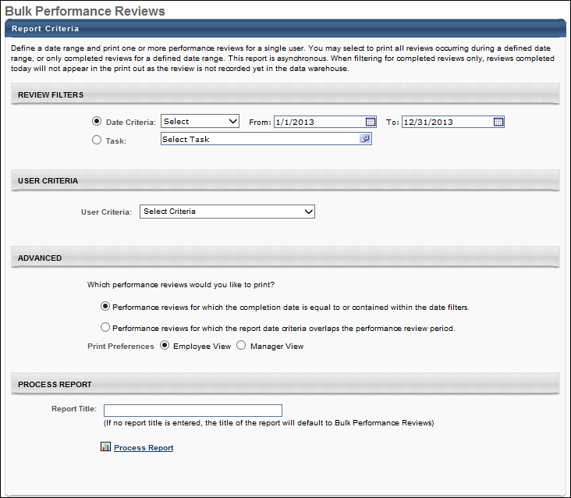
Output
The format of the performance review PDFs is determined by the Performance Review Printable Version Preferences. See Set Printable View.

Competency Assessment Gap Analysis Report
This report displays an aggregate gap analysis of each competency in an assessment for a group of users. This report will average the competency ratings across all Assessees and display the gap analysis for each competency.
This report includes results from all assessment types.
Permissions
PERMISSION NAME | PERMISSION DESCRIPTION | CATEGORY

Competency Assessment Gap Analysis Report | Grants access to Competency Assessment Gap Analysis Report, which displays an aggregate gap analysis of each competency in an assessment for a group of users. This permission can be constrained by OU and User's OU. | Reports - Performance
Filters
- User Criteria - limit report output to the users matching the specified user criteria
  - The report will only run within the defined constraints for the user running the report
  - This is the standard OU availability selection criteria drop-down. Choose from available OU types
  - Defaults: If no User Criteria are selected then the report will run for the entire available population
- Competency Task (required field) - select a specific competency task
- Filter By - check to Only display competencies that are below target
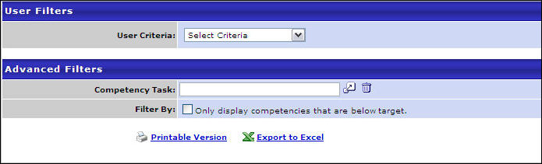
Output
- Printable Version link to view the results in a web page, or Export to Excel link to save/open as an Excel file
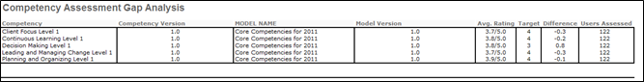

Development Plan Reports Overview (Legacy)
Development Plan Exception (Legacy)
The Development Plan Exception Report displays all users who do not have an active approved development plan within a specific time period. Users with development plans that are pending approval, denied, or cancelled may be included in the report, depending on the options selected when running the report. This report can be useful to see which users have not yet set a development plan for themselves for an upcoming year.
Note: Development plans that are in draft status are not considered active dev plans.
Note: Development Plans Standard Reports are not supported if your organization is using the redesigned development plan functionality.
Permissions
PERMISSION NAME | PERMISSION DESCRIPTION | CATEGORY

Development Plan Exception Report | Grants access to the Development Plan Exception report, which displays all users who do not have an active approved development plan within a specific time period. | Reports - Performance
Criteria
Filter | Description
Date Criteria | Filter your results by date. The report searches this time frame for development plans. If any part of a plan falls within that time frame for a user, that user does not display. The default date criteria are specified by OU on the Development Plan Preferences page. Note: Date Criteria is always implemented using UTC (Coordinated Universal Time).
User Criteria | Limit results to the users matching the specified user criteria. You may choose one or more individual users as well as entire OUs or Groups. If permission for this report is constrained, those constraints apply to user criteria selection when running the report.
Display OU | Select an Organizational Unit to display that information on the report. For example, if you select the Position OU, each user's position will display in the report. Choosing a Display OU is optional.
Pending Approval or Denied Plans | Select this option to also display users with development plans pending approval or denied (but no other active development plans). These users are not included if this option is not selected.
Cancelled Plans | Select this option to also display users with cancelled development plans (but no other active development plans). These users are not included if this option is not selected.
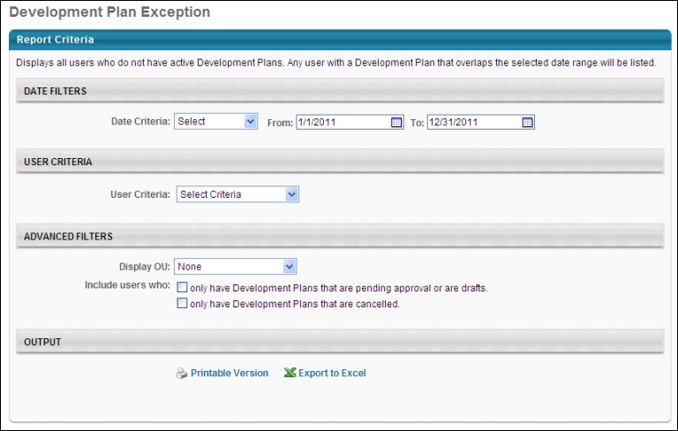
Output
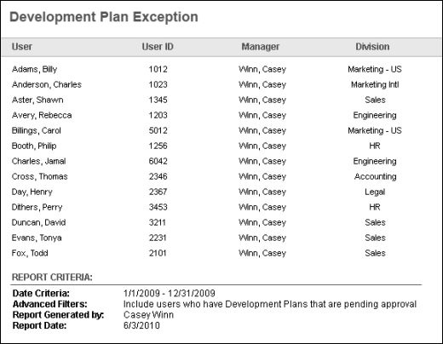
Development Plan Group Details Report (Legacy)
The Development Plan Group Details Report displays the details of each development plan for a selected group of users that fall within a specific time period. This report includes development plans that are in Draft status. If any part of a development plan is in the time period, it is displayed. This report can be used to get a detailed look at a group of users' development plans.
Note: Development Plans Standard Reports are not supported if your organization is using the redesigned development plan functionality.
Permissions
PERMISSION NAME | PERMISSION DESCRIPTION | CATEGORY

Development Plan Group Details Report | Grants access to Development Plan Group Details report, which displays the details of each development plan for a selected group of users that fall within a specific time period. | Reports - Performance
Criteria
Filter | Description
Date Criteria | Filter your results by date. If any part of a development plan falls within that time frame, the plan displays. The default date criteria are specified by OU on the Development Plan Preferences page. Note: Date Criteria is always implemented using UTC (Coordinated Universal Time).
User Criteria | Select a user or a group of users. This is a required field. You may choose one or more individual users as well as entire OUs or Groups. If permission for this report is constrained, those constraints apply to user criteria selection when running the report.
Cancelled Development Plans | Select this option to include cancelled development plans in the report.
Development Plan Comments | Select this option to include development plan comments in the report.
Report Title | Enter a title for the report. This defaults to the report name if no title is entered. The title is displayed on the report and is also displayed in the list of Processed Reports on this page.
Process Report
This is an asynchronous report, which allows the administrator to define the standard report and generate the report asynchronously. As a result, when administrators process the report, the system generates the report in the background, while the administrator can move on to other areas of the system. When the report is finished processing, the administrator can then view the full report in its entirety.
- Up to three separate reports can generate asynchronously, allowing greater flexibility for creating and storing different versions of the report.
- If you process a report or refresh a stored report, the report appears in the table as Queued.
- The most recently created report displays at the top of the table.
- Since the user can generate up to three reports, the administrator can define a report title for each of the generated reports.
- Clicking the View Details icon changes the report settings on the page to match those of the selected previously run report.
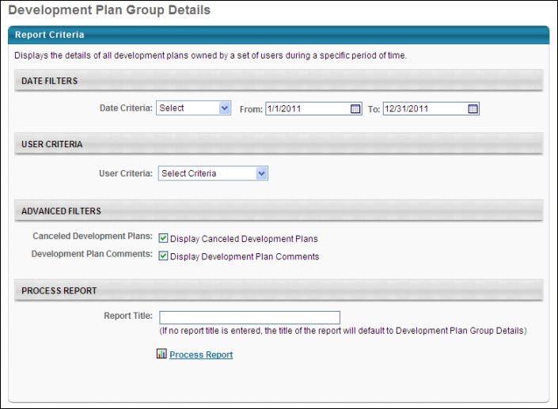
Output
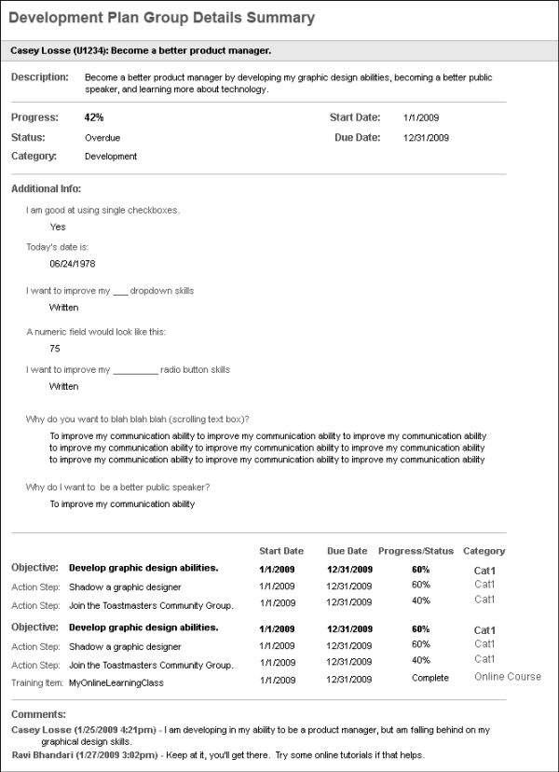
Development Plan Status Report (Legacy)
The Development Plan Status Report summarizes the status of all development plans for specific users during a specific time period.
Note: Development Plans Standard Reports are not supported if your organization is using the redesigned development plan functionality.
Permissions
PERMISSION NAME | PERMISSION DESCRIPTION | CATEGORY

Development Plan Status Report | Grants access to the Development Plan Status report, which summarizes the status of all development plans for specific users during a specific time period. | Reports - Performance
Criteria
Filter | Description
Date Criteria | Filter your results by date. If any part of a development plan falls within that time frame, the plan displays. The default date criteria are specified by OU on the Development Plans Preferences page. Note: Date Criteria is always implemented using UTC (Coordinated Universal Time).
User Criteria | Limit results to the users matching the specified user criteria. You may choose one or more individual users as well as entire OUs or Groups. If permission for this report is constrained, those constraints apply to user criteria selection when running the report.
Display OU | Select an Organizational Unit to display that information on the report. For example, if you select the Position OU, each user's position will display in the report. Choosing a Display OU is optional.
Group By | - None - Display the status for each development plan for each user.  - User - Group the report results by user, displaying the user's cumulative progress for all dev plans along with the number of dev plans the user has.
User Status | Select this option to include inactive users in the report output.
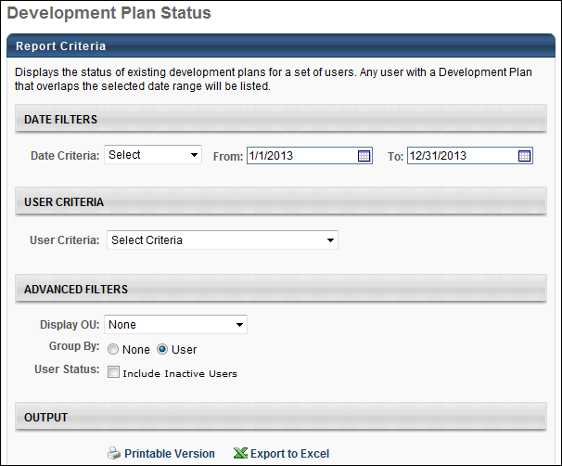
Output Grouped by User
When the output is grouped by user, the report displays each selected user along with their cumulative progress for all development plans along with the number of plans the user has.
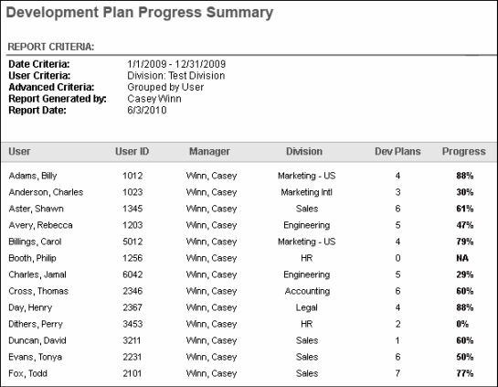
Output Ungrouped
When the output is ungrouped, the report displays each selected user along with the status for each of their development plans.
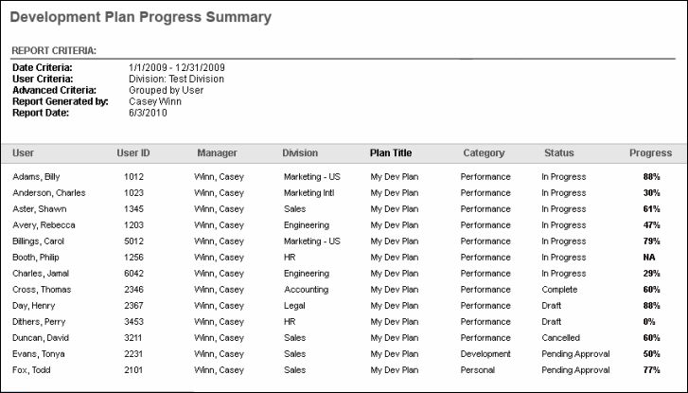

Employee Competency Current Ratings Report
This report displays current competency ratings from both the user's career profile and all competency assessments. This report will display the most recent rating for each Competency, either from an assessment or the Career Profile for each user.
This report includes results from all assessment types. Note: Only completed tasks are included in report results.
Permissions
PERMISSION NAME | PERMISSION DESCRIPTION | CATEGORY

Employee Competency Current Ratings Report | Grants access to Employee Competency Current Ratings Report, which displays current competency ratings from the user's resume or competency assessment, whichever is more recent. | Reports - Performance
Filters
- User Criteria - limit report output to the users matching the specified user criteria
  - The report will only run within the defined constraints for the user running the report
  - This is the standard OU availability selection criteria drop-down. Choose from available OU types
  - Defaults: If no User Criteria are selected then the report will run for the entire available population
- Competencies - filter by specific Competencies
- Group By - select to group report by User, Competency or None (group by selection will determine available sort by options). If Group By option is None, the export to text file option will be available.
- Sort By - select to sort by Competency, Rating or User
- Rating Type - check to Include Rating Type (Assessment/Career Profile Rating)
- Display OU - check to Include OU information and select Organizational unit to include from drop-down list
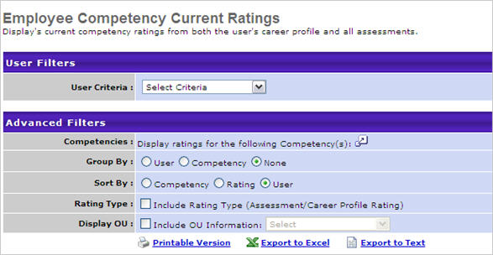
Output
- Click this link to view the results in a web page, or link to save/open as an Excel file
- Click this link to export data to a tab delimited text file if None is selected in the Group By option.
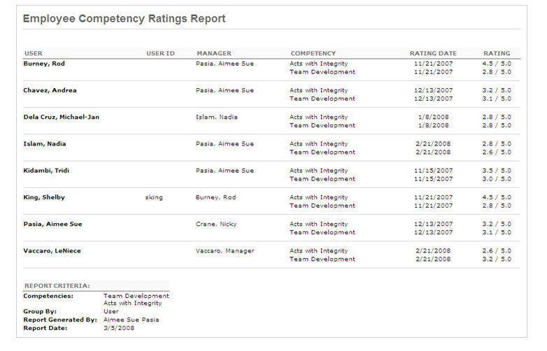

Employee Peers Report
View approved peers for any group of employees in the organization.
Permissions
PERMISSION NAME | PERMISSION DESCRIPTION | CATEGORY

Employee Peers Report | Grants access to Employee Peers Report, which displays approved peers for any group of users in the organization. | Reports - Performance
Filters
- User Criteria - limit report output to the users matching the specified user criteria
  - The report will only run within the defined constraints for the user running the report
  - This is the standard OU availability selection criteria drop-down. Choose from available OU types
  - Defaults: If no User Criteria are selected then the report will run for the entire available population
- Peers Selected - check Only display employees with no peers selected box to generate report of employees that have no peers at all
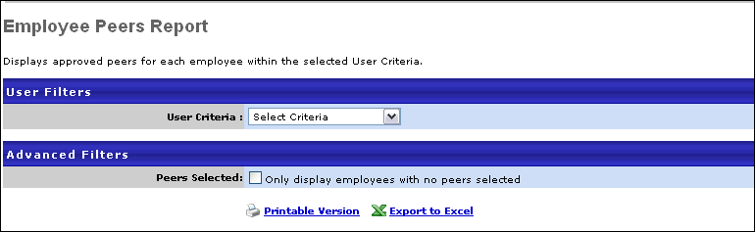
Output
- link to view the results in a web page, or link to save/open as an Excel file
  - The administrator can see the peers, the relationship group, who approved each peer and the date the peer was approved for each employee. The report criteria will display at the bottom of the report displaying the name of the administrator who generated the report and the date the report was generated.
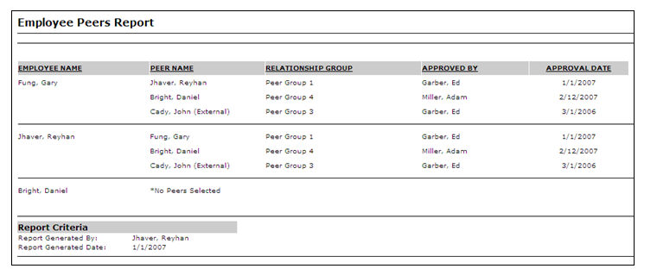

Enterprise Competencies Report
This report allows you to compare average competency scores of two different user groups. This report allows you to compare competency ratings from a competency model against two sets of users.
This report includes results from all assessment types. Note: Only completed tasks are included in report results.
Permissions
PERMISSION NAME | PERMISSION DESCRIPTION | CATEGORY

Enterprise Competencies Report | Grants access to Enterprise Competencies Report, which allows comparison of average competency scores of two groups of users. This permission can be constrained by User Self and Subordinates. | Reports - Performance
Filters
- Group A User Criteria - limit report output to the users matching the specified user criteria
  - The report will only run within the defined constraints for the user running the report
  - This is the standard OU availability selection criteria drop-down. Choose from available OU types
  - Defaults: If no User Criteria are selected then the report will run for the entire available population
- Group Title - enter a title for Group A
- Group B User Criteria - limit report output to the users matching the specified user criteria
  - The report will only run within the defined constraints for the user running the report
  - This is the standard OU availability selection criteria drop-down. Choose from available OU types
  - Defaults: If no User Criteria are selected then the report will run for the entire available population
- Group Title - enter a title for Group B
- Competency Model (required field) - select specific competency model
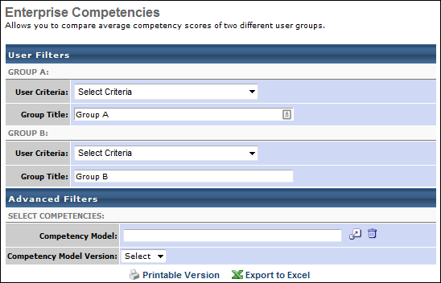
Output
- link to view the results in a web page, or link to save/open as an Excel file
- All ratings will normalize to the rating scale of the selected model. If a rating is not available for a group, then N/A will appear for the average rating for that group and no bar graph will appear. If both groups have N/A, then the difference will display N/A for the competency.
Excel output - a column will appear for each group and the average rating from each group will appear.
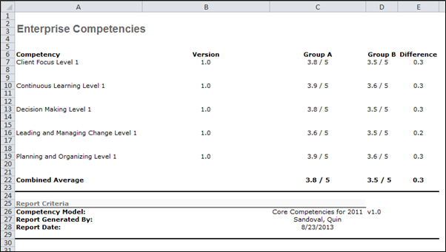

Goal Reports Overview
Goal Details Report
The Goal Details Report displays the details of each goal a user owns that fall within a specific time period. If any part of a goal is in the time period, it is displayed. This report can be used to get a detailed look at a user's goals.
Permissions
PERMISSION NAME | PERMISSION DESCRIPTION | CATEGORY

Goal Details Report | Grants access to Goal Details Report, which displays the details of each goal a user owns that fall within a specific time period. This permission can be constrained by OU, User's OU, and User Self and Subordinates. | Reports - Performance
Criteria
Filter Name | Description
Date Criteria | Filter your results by date. If any part of a goal falls within that time frame, the goal will display. The default date criteria are specified by OU on the Goals Preferences page. Note: Date Criteria is always implemented using UTC (Coordinated Universal Time).
User Criteria | Select a specific user. This is a required field.
Cancelled Goals | Include cancelled goals in the report.
Goal Comments | Include goal comments in the report.
Printable Version | Display each goal on a separate page in the PDF version.
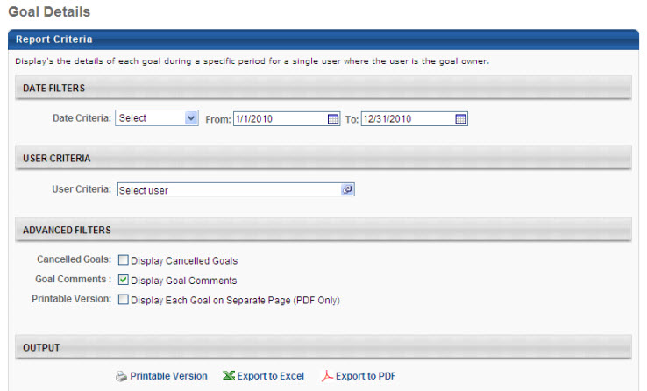
Output
The report is sorted by perspective, and then alphabetically by goal title.
Note: Field names may be customizable by the system administrator, so your field names may vary.
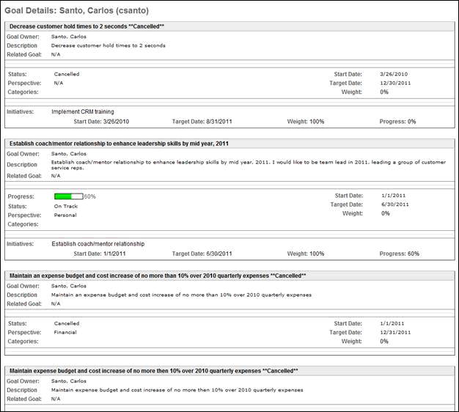
Configuration Options
The following labels can be configured on the Goal Configuration page, and this report will match what is configured there:
- Description, Progress, Status, Perspective, Categories, Start Date, Due Date, Success Descriptors, Task, Target
Any fields that do not exist within the goal will not display. For example, if a goal does not have any tasks, the Tasks field will not display.
Perspectives
If the goal owner has some goals that contain perspectives but others that do not, the goals that do not have perspectives are treated as one group and placed at the end of the list. If the goal owner only has goals that do not have a perspective, the goals are sorted alphabetically by goal title. In this case, the Perspective field does not display in the report output.
If a goal does not have a perspective, the value in the Perspective field on the report output is N/A.
Shared Goals & Goal Weight
For shared goals, the shared goal is not included in the report output for users with whom the goal is shared. The shared goal can only be included for the user who is the goal owner. As a result, the goal weight in the report output does not include the shared goal for users who are not the goal owner. A shared goal is only factored into the goal weight for the user who is the goal owner.
Goal Exception Report
The Goal Exception Report displays all users who do not have an active approved goal within a specific time period. This report can be useful to see which users have not yet set goals for themselves for a review period.
Note: Goals that are in draft status are not considered active goals.
Permissions
PERMISSION NAME | PERMISSION DESCRIPTION | CATEGORY

Goal Exception Report | Grants access to Goal Exception Report, which displays all users who do not have an active approved goal within a specific time period. This permission can be constrained by OU, User's OU, and User Self and Subordinates. | Reports - Performance
Criteria
Filter Name | Description
Date Criteria | Filter your results by date. The report will search this time frame for goals. If any part of a goal falls within that time frame for a user, that user will not display. The default date criteria are specified by OU on the Goals Preferences page. Note: Date Criteria is always implemented using UTC (Coordinated Universal Time).
User Criteria | Limit results to the users matching the specified user criteria. This is required. If your permission to run the report is constrained to a specific subset of the population, that constraint is displayed above the User Criteria selection list and you are not required to make a User Criteria selection. An additional selection can be made to expand the results; the report will include users who match any of the selected criteria. If no User Criteria selection is made, the report is run for all available users.
Display OU | Select an Organizational Unit to display that information on the report. For example, if you select the Position OU, each user's position will display in the report. This is optional.
Pending Goals | Users with goals pending approval (but no other active goals) will not display if this option is selected.
Shared Goals | Users with shared goals (but no independent goals) will not display if this option is selected.
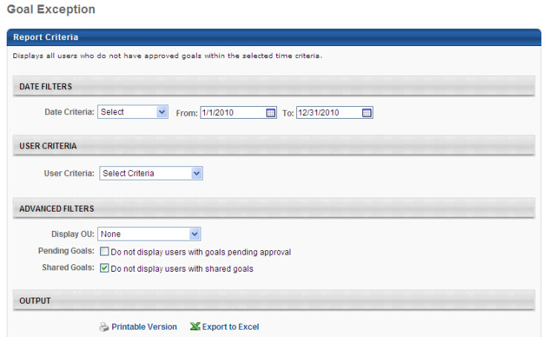
Output
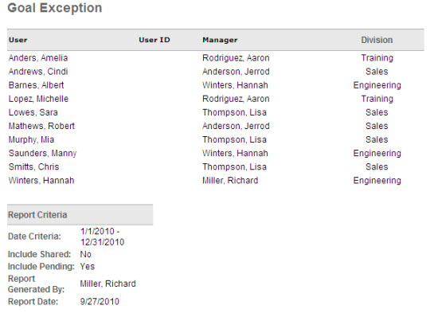
Goal Hierarchy Report
The Goal Hierarchy Report displays a visual representation of the full hierarchy for a specified user's goals. This report can be run for all of a user's goals or specific goals.
Permissions
PERMISSION NAME | PERMISSION DESCRIPTION | CATEGORY

Goal Hierarchy Report | Grants access to Goal Hierarchy Report, which displays a visual representation of the full hierarchy for a specified user's goals. | Reports - Performance
Criteria
Filter Name | Description
Date Criteria | Filter your results by date. If any part of a goal falls within that time frame, the goal will display. The default date criteria are specified by OU on the Goals Preferences page. Note: Date Criteria is always implemented using UTC (Coordinated Universal Time).
User Criteria | Select a specific user. This is a required field.
Goals Criteria | Once a date range and user have been selected, you may optionally select one or more specific goals to include in the report. If no goals are selected, the report will be run for all of the user's goals.
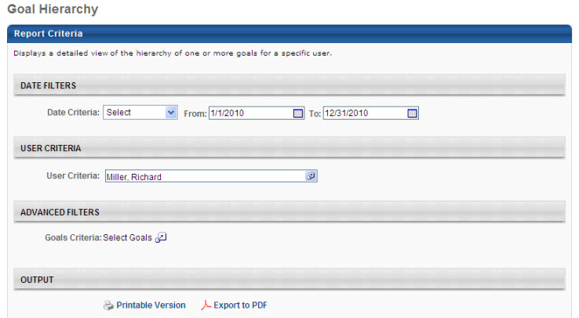
Output
Note: Field names may be customizable by the system administrator, so your field names may vary.
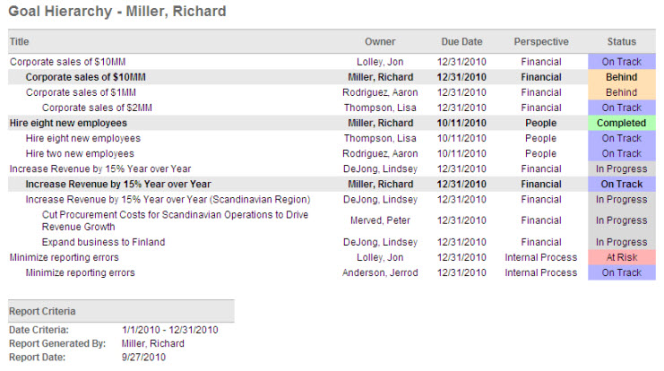
The entire hierarchy for each goal displays along with detailed information about each goal. Goals that are part of the same hierarchy display together. Goals that are not part of the same hierarchy are separated by a line.
Configuration Options
The following labels can be configured on the Goal Configuration page, and this report will match what is configured there:
- Status, Perspective, Due Date
Progress and Status can be turned off on the Goal Configuration page. If Status is turned off, a Progress percentage will display in its place. If both Progress and Status are turned off, nothing will display in this column.
The names and colors associated with the statuses are based on the OU of the goal owner and can be configured on the Goal Configuration page.
Goal visibility is set on the Goal Preferences screen. For goals that you do not have the proper permissions to view, you will not see a detailed status. For example, for your supervisor's goals, you will not see a detailed status (On Track, Critical). Instead you will see a general status (In Progress, Not Started).
Goal Progress Report
The Goal Progress Report summarizes the progress of all goals for specific users during a specific time period. If goals are weighted, the summarized progress is a weighted average of the goal progress.
To access the Goal Progress report, go to Reports > Standard Reports. From the Performance tab, click the Goal Progress Report link.
Permissions
PERMISSION NAME | PERMISSION DESCRIPTION | CATEGORY

Goal Progress Report | Grants access to Goal Progress Report, which summarizes the progress of all goals for specific users during a specific time period. This permission can be constrained by OU, User's OU, User Self and Subordinates, and User. | Reports - Performance
Criteria
Filter Name | Description
Date Criteria | Filter your results by date. If any part of a goal falls within that time frame, the goal will display. The default date criteria are specified by OU on the Goals Preferences page. Note: Date Criteria is always implemented using UTC (Coordinated Universal Time).
User Criteria | Limit results to the users matching the specified user criteria. If your permission to run the report is constrained to a specific subset of the population, that constraint is displayed above the User Criteria selection list and you are not required to make a User Criteria selection. An additional selection can be made to narrow the results further, but if no User Criteria selection is made, the report is run for all available users.
Perspective | Limit results to a specific Perspective.
Detailed View | Select Summarize Goals to display an average goal completion percentage for each user. Select Show All Goals to display the progress of each goal separately.
Display OU | Select an Organizational Unit to display that information on the report. For example, if you select the Position OU, each user's position will display in the report. This is optional.
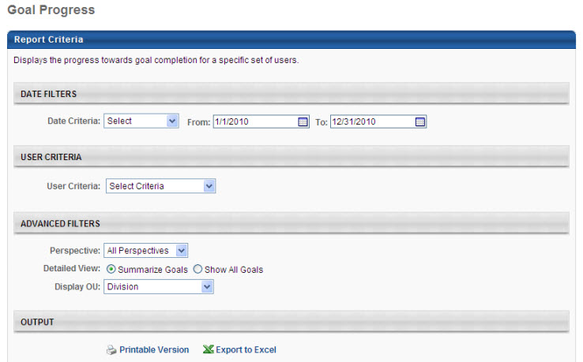
Output with Summarize Goals Selected
Note: Field names may be customizable by the system administrator, so your field names may vary.
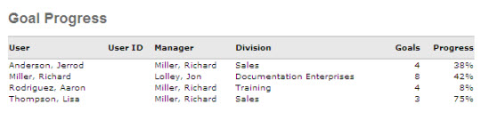
The progress displayed is a weighted average of all goals each user owns that has a start date or target date within the specified criteria.
If a user has no goals, the user does not appear in the report output.
Output with Show All Goals Selected
Note: Field names may be customizable by the system administrator, so your field names may vary.
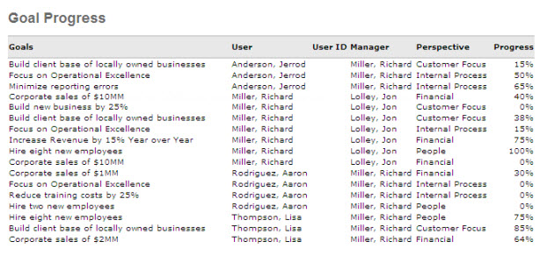
Configuration Options
The following labels can be configured on the Goal Configuration page, and this report will match what is configured there:
- Goal, Perspective, Progress
Progress can be turned off on the Goal Configuration page. If Progress is turned off for your OU or that of a goal being displayed, progress will display as N/A for those goals.
Shared Goals & Goal Weight
For shared goals, the shared goal is not included in the report output for users with whom the goal is shared. The shared goal can only be included for the user who is the goal owner. As a result, the goal weight in the report output does not include the shared goal for users who are not the goal owner. A shared goal is only factored into the goal weight for the user who is the goal owner.
Overall Goal Progress
When viewing the overall goal progress percentage in the report, the value is rounded down. For example, an overall goal completion of 99.6% rounds to 99%. This aligns with how overall goal progress is calculated and displayed in the system.
Goal Status Report
The Goal Status Report summarizes the status of all goals for specific users during a specific time period. This report graphically displays the percentage of all goals that are in each progress status (e.g., Completed, On Track, Behind).
Note: When reporting on another user's goals, only submitted goals are displayed. However, when reporting on your own goals, then goals in Draft status are displayed.
This report is interactive and the output can be edited and altered after it is displayed.
Note: Goal statuses are configured on the Goal Configuration preferences page. Administrators can configure the status name, color, and condition, so the statuses may vary by portal. See Goals Configuration - Status Administration.
To access the Goal Progress report, go to Reports > Standard Reports. From the Performance tab, click the Goal Status Report link.
Permissions
PERMISSION NAME | PERMISSION DESCRIPTION | CATEGORY

Goal Status Report | Grants access to the Goal Status Report, which summarizes the status of all goals for specific users during a specified date range. | Reports - Performance
Criteria
Filter Name | Description
Date Criteria | Filter your results by date. If any part of a goal falls within that time frame, the goal will display. The default date criteria are specified by OU on the Goals Preferences page. Note: Date Criteria is always implemented using UTC (Coordinated Universal Time).
User Criteria | Limit results to the users matching the specified user criteria. This is required. If your permission to run the report is constrained to a specific subset of the population, that constraint is displayed above the User Criteria selection list and you are not required to make a User Criteria selection. An additional selection can be made to narrow the results further, but if no User Criteria selection is made, the report is run for all available users.
Perspective | Limit results to a specific Perspective.
Display OU | Select an Organizational Unit to display that information on the report. For example, if you select the Position OU, each user's position will display in the report. This is optional.
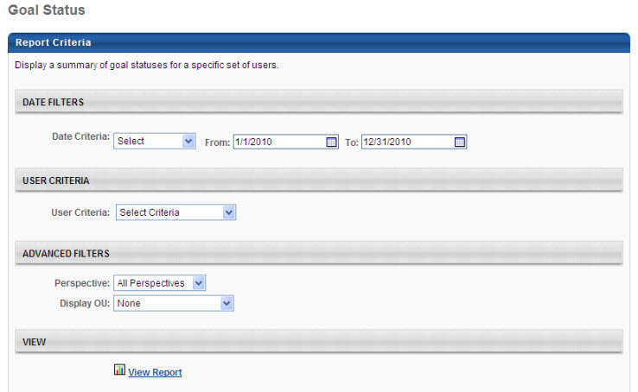
Output
Each view displays a pie chart representing the number of goals in each status. Status can be determined by goal, task, and target progress and can also factor in the amount of time remaining for completion. Clicking any of the pieces of the pie will filter the list of results to only the status that was clicked. For example, if you click the On Track section, only goals in On Track status will display.
Note: When reporting on another user's goals, only submitted goals are displayed. However, when reporting on your own goals, then goals in Draft status are displayed.
There are export options for each view, including Printable Version and Export to Excel. Each option exports the current view of goals, but does not include the pie chart.
You can select different view options from the Grouped By drop-down list.
If there are more than 25 results, you can navigate between the pages using the navigation options on the right.
Status can be turned off on the Goal Configuration page. If Status is turned off for any OU being returned as a result, Status will display as NA for those goals.
Each column in this report can be sorted upon.
Output - Ungrouped View
Note: Field names may be customizable by the system administrator, so your field names may vary.
The Ungrouped view is the default view and displays information about each goal by user.
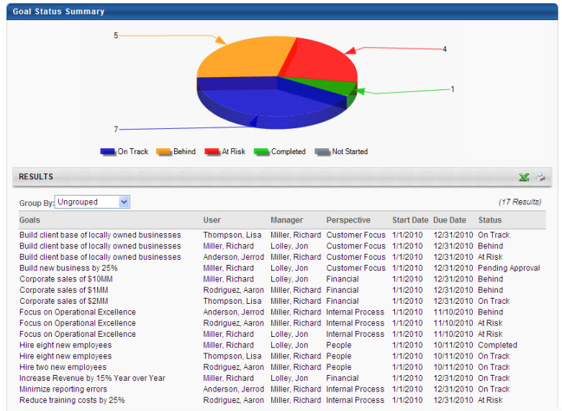
Output - User - Summary View
Note: Field names may be customizable by the system administrator, so your field names may vary.
The User - Summary view displays a summary of each user's goals by status.
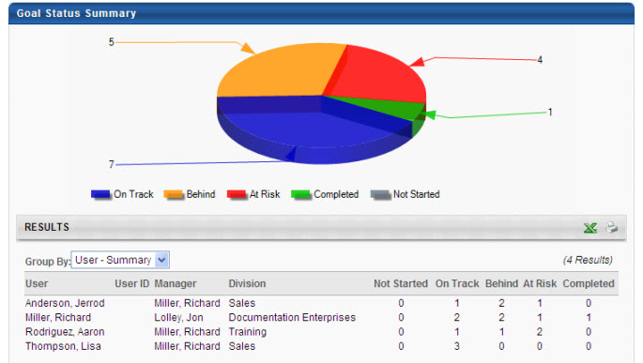
Output - User - Detailed View
Note: Field names may be customizable by the system administrator, so your field names may vary.
The User - Detailed view displays a detailed view of each goal, grouping the goals by user. These groups are alphabetized by user's last name.
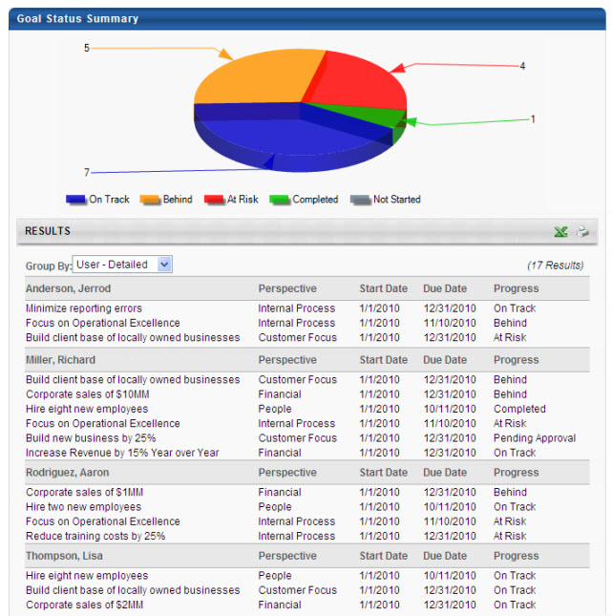
Output - Perspective View
Note: Field names may be customizable by the system administrator, so your field names may vary.
The Perspective view displays information about each goal, grouping the goals by perspective. These groups are alphabetized by perspective.
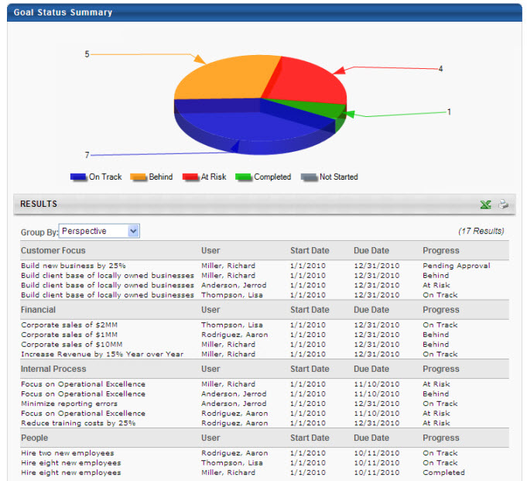
Output - Status View
Note: Field names may be customizable by the system administrator, so your field names may vary.
The Status view displays information about each goal, grouping the goals by status. The order of these groups is: Completed, On Track, Behind, Critical, Not Started.
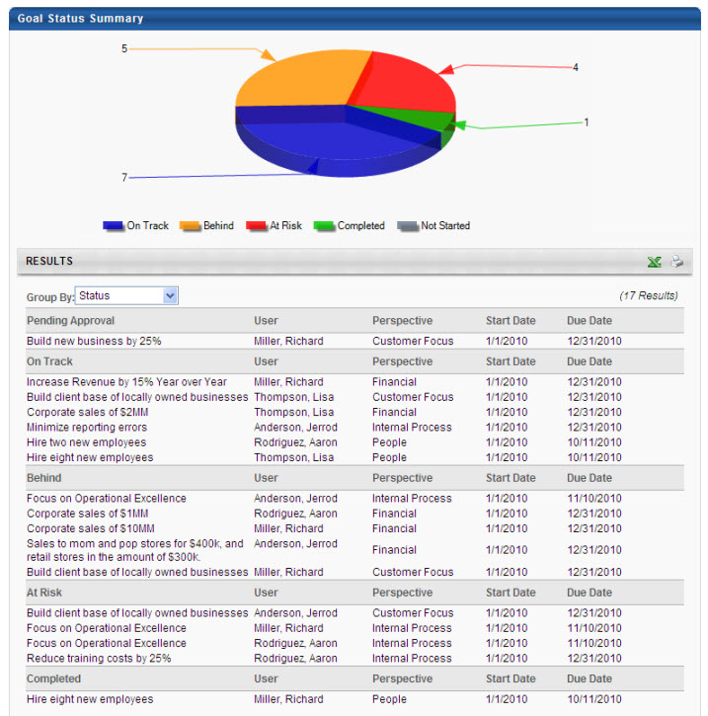
Clicking the Pie Chart to Filter by Status
Note: Field names may be customizable by the system administrator, so your field names may vary.
Clicking any of the pieces of the pie will filter the list of results to only the status that was clicked. The grouping of the results is unchanged, so if you were viewing the results by Perspective, they will still be grouped by Perspective.
Click the Show All Statuses link to view all statuses again.
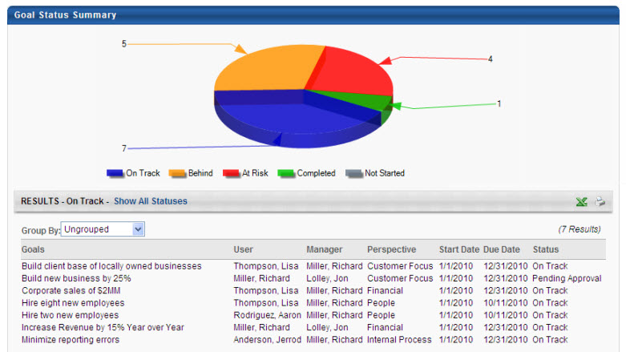
Configuration Options
The following labels can be configured on the Goal Configuration page, and this report will match what is configured there:
- Goal, Perspective, Start Date, Due Date, Status
Progress can be turned off on the Goal Configuration page. If Progress is turned off for your OU or that of a goal being displayed, progress will display as NA for those goals.
The name and color associated with the goal status is based on the OU of the user running the report. However, the rules to determine the status are based on goal, task, and target progress and can also factor in the amount of time remaining for completion. Statuses settings can be configured by OU on the Goal Configuration page.
Goal visibility is set on the Goal Preferences screen. For goals that you do not have the proper permissions to view, you will not see a detailed status. For example, for your supervisor's goals, you will not see a detailed status (On Track, Critical). Instead you will see a general status (In Progress, Not Started).
Shared Goals & Goal Weight
For shared goals, the shared goal is not included in the report output for users with whom the goal is shared. The shared goal can only be included for the user who is the goal owner. As a result, the goal weight in the report output does not include the shared goal for users who are not the goal owner. A shared goal is only factored into the goal weight for the user who is the goal owner.
Goal Target Report
The Goal Target Report summarizes all goal targets for specific users during a specific time period, regardless of the goal to which they belong. This report can be run on multiple users, but is always sorted by user name.
Permissions
PERMISSION NAME | PERMISSION DESCRIPTION | CATEGORY

Goal Target Report | Grants access to the Goal Target report, which summarizes all goal targets for specific users during a specific time period, regardless of the goal to which they belong. This report can be run on multiple users, but is always grouped by user. This permission can be constrained by OU, User's OU, User Self and Subordinates, and User. | Reports - Performance
Criteria
Filter Name | Description
Date Criteria | Filter your results by date. If any part of a target falls within that time frame, the goal will display. This date range is related to the target and is independent of the dates associated with the goal itself. The default date criteria are specified by OU on the Goals Preferences page. Note: Date Criteria is always implemented using UTC (Coordinated Universal Time).
User Criteria | Limit results to the users matching the specified user criteria. If your permission to run the report is constrained to a specific subset of the population, that constraint is displayed above the User Criteria selection list and you are not required to make a User Criteria selection. An additional selection can be made to narrow the results further, but if no User Criteria selection is made, the report is run for all available users.
Perspective | Limit results to a specific Perspective.
Inherited Targets | Include details about inherited targets.
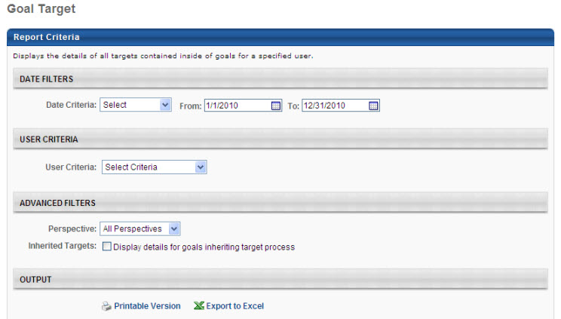
Output without Details for Inherited Goals
Note: Field names may be customizable by the system administrator, so your field names may vary.
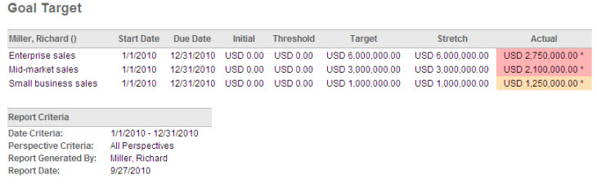
Output with Details for Inherited Goals
Note: Field names may be customizable by the system administrator, so your field names may vary.
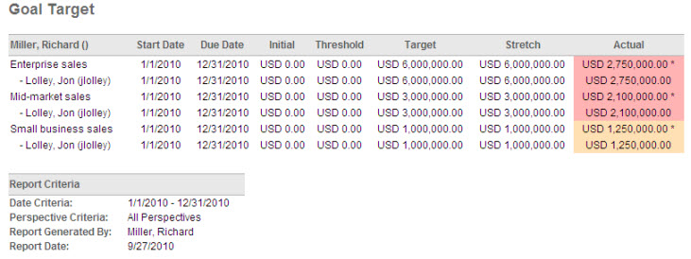
For targets that inherit progress from aligned goals, an asterisk displays next to the value in the Actual column.
If the report was run to display the details of inherited targets, those targets will be expanded. Users that are aligned display below the target with their individual target values.
Configuration Options
The color associated with the target status is based on the OU of the user running the report. Goals below the threshold display as Critical status color. Goals above the threshold but below the target display as Behind status color. Goals above the target display as On Track status color. If there is no threshold value, Critical status color will not be displayed. These settings can be configured on the Goal Configuration page.
Goal Task Summary Report
The Goal Tasks Summary Report summarizes all goal tasks for specific users during a specific time period, regardless of the goal to which they belong. This report can be run on multiple users, but is always sorted by user name.
Permissions
PERMISSION NAME | PERMISSION DESCRIPTION | CATEGORY

Goal Tasks Summary Report | Grants access to Goal Tasks Summary Report, which summarizes all goal tasks for specific users during a specific time period, regardless of the goal to which each task belongs. This permission can be constrained by OU, User's OU, User Self and Subordinates, and User. | Reports - Performance
Criteria
Filter Name | Description
Date Criteria | Filter your results by date. If any part of a task falls within that time frame, the goal will display. This date range is related to the target and is independent of the dates associated with the goal itself. The default date criteria are specified by OU on the Goals Preferences page. Note: Date Criteria is always implemented using UTC (Coordinated Universal Time).
User Criteria | Limit results to the users matching the specified user criteria. If your permission to run the report is constrained to a specific subset of the population, that constraint is displayed above the User Criteria selection list and you are not required to make a User Criteria selection. An additional selection can be made to narrow the results further, but if no User Criteria selection is made, the report is run for all available users.
Perspective | Limit results to a specific Perspective.
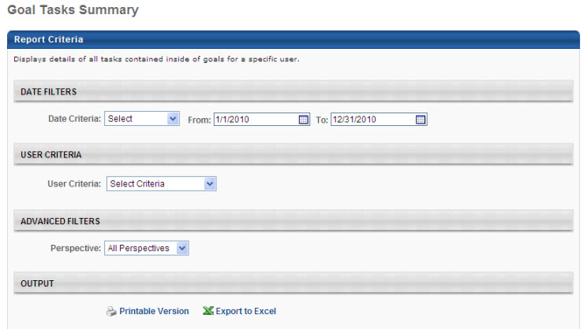
Output
Note: Field names may be customizable by the system administrator, so your field names may vary.
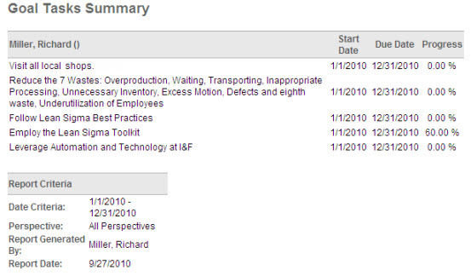
Shared Goals & Goal Weight
For shared goals, the shared goal is not included in the report output for users with whom the goal is shared. The shared goal can only be included for the user who is the goal owner. As a result, the goal weight in the report output does not include the shared goal for users who are not the goal owner. A shared goal is only factored into the goal weight for the user who is the goal owner.

Individual Competency Rating Analysis Report
This report is an administrator report but can also be included as part of the results of a competency assessment for each Assessee. This report has the following features:
- The report is printed in batch format, so each Assessee receives the same report with each of the selected summaries, including the report cover.
- The page numbering on the report starts over for each Assessee.
- The descriptions defined for each summary page are included in the output.
- All description fields accept HTML.
- The administrator can display this report in both landscape and portrait formats.
- The ability to include this report as part of the assessment task is a configuration option defined by the administrator on the Assessment Results section of the task setup. If included, a link will appear on the assessment summary for the user.
This report includes results from all assessment types.
Note: Only completed tasks are included in report results. N/A Ratings are included in the report output.
Permissions
PERMISSION NAME | PERMISSION DESCRIPTION | CATEGORY

Individual Competency Ratings Analysis Report | Grants access to Individual Competency Ratings Analysis Report, which displays assessment results in detail for one or more users. This permission can be constrained by User Self and Subordinates, OU, and User's OU. | Reports - Performance
Filters
- User Criteria - Limit report output to the users matching the specified user criteria. The reporting content selected in the next section will appear on a separate page for every user included in the user criteria. For example, if 8 components are included, pages 1-8 of the report will show the data for the one user and pages 8-16 of the report will show the data for another user.
  - The report will only run within the defined constraints for the user running the report.
  - This is the standard OU availability selection criteria drop-down. Choose from available OU types.
  - Defaults: If no User Criteria are selected then the report will run for the entire available population.
- Task (required field) - When the task is selected, all of the settings and descriptions defined for the report by the administrator within the task will automatically populate the fields on this page. The administrator can still modify the contents of the report however.
- Admin/Assessee - This report can be generated as an Assessee or as an Administrator.
  - Admin - The comments and ratings from the different assessor groups will not be constrained based on the task anonymity preferences.
  - Assessee - The comments and ratings from the different assessor groups will be constrained based on the task anonymity preferences.
- Report Contents - Define which of the following reporting components you would like included for each user in this report. Each component will appear on a separate page for every user included in the user criteria.
  - Check Include to include that section on the report.
  - Enter number in Order field to define the order in which these components will appear on the report.
  - Enter Description in description field for each section, HTML friendly up to 3500 characters.
Report Settings
This is an asynchronous report, which allows the administrator to define the standard report and generate the report asynchronously. As a result, when administrators process the report, the system generates the report in the background, while the administrator can move on to other areas of the system. When the report is finished processing, the administrator can then view the full report in its entirety.
- Up to three separate reports can generate asynchronously, allowing greater flexibility for creating and storing different versions of the report.
- If you process a report or refresh a stored report, the report appears in the table as Queued.
- The most recently created report displays at the top of the table.
- Since the user can generate up to three reports, the administrator can define a report title for each of the generated reports.
- Clicking the View Details icon changes the report settings on the page to match those of the selected previously run report.
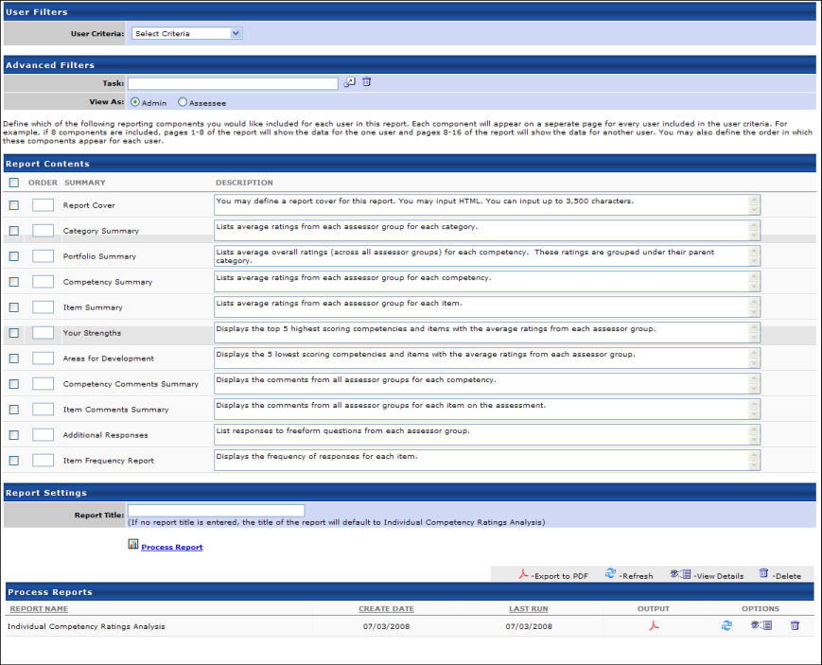
Output
  - Printable Version Click this link to view the results in a web page.
  - Click this link to save/open as a pdf file.
  - After the report is processed you can:
    - Update the data on the report, click the Refresh icon .
    - View the details on the report, click on the Details icon .
    - Delete the report, click on the Delete icon .
  - Report Cover - The report cover will display as a cover page for the report. The administrator can define the report cover. The report cover takes HTML and up to 3,500 characters. The title of the report will display at the top of the page. Each page contains a header and footer. The header consists of the Assessee's name, the name of the task, and the end date of the task. The footer consists of the company name and the page number.
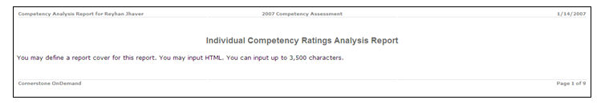
  - Category Summary - The category summary displays the summary of ratings for each category included in the assessment. This page applies to assessments that have models grouped by a category type. The user will see the breakdown of ratings from each assessor group for the category. The configuration settings for the task that are related to which results the Assessee can view as well as the minimum response requirement for relationship groups applies to the report as well in order to maintain confidentiality and anonymity for the assessment. This applies to all pages within the report.
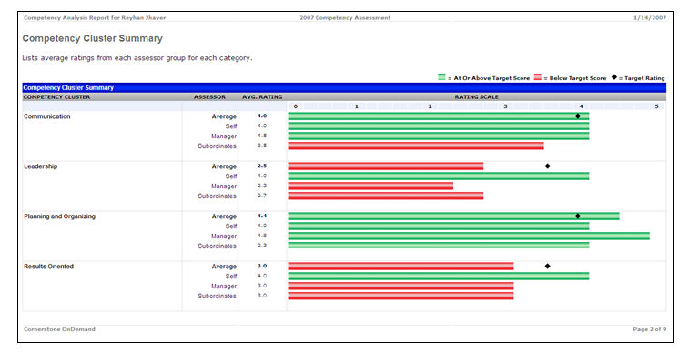
  - Portfolio Summary - The portfolio summary displays the summary of ratings for each competency included in the assessment, with each competency grouped by their respective categories. This page applies to assessments that have models grouped by a category type. The user will see the average rating for each competency.
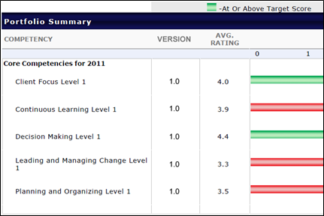
  - Competency Summary - The competency summary displays the summary of ratings for each competency included in the assessment. Competencies displayed on this page will not be grouped by any category type. The user can view the breakdown of ratings from each assessor group on this page.
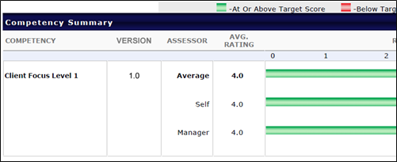
  - Item Summary - The item summary displays the breakdown of ratings from each assessor group for each item in the assessment. This page applies to assessments that have competencies that contain items.
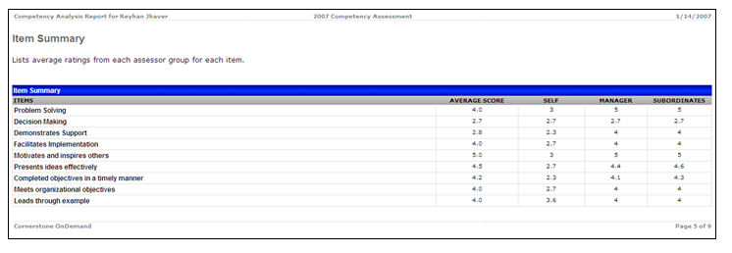
  - Your Strengths - This page displays the top 5 highest rated competencies and the top 5 highest rating items from the assessment for the Assessee. The user will see the average rating for each competency and the average ratings from the available assessor groups. If the model is grouped by a category type, the user will see the related category for the competency. The competencies will display in the order of highest to lowest.
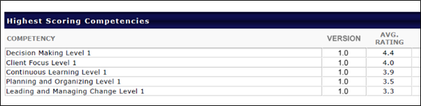
  - Areas for Development - This page displays the lowest 5 rated competencies and the lowest 5 rated items from the assessment for the Assessee. The user will see the average rating for each competency and the average ratings from the available assessor groups. If the model is grouped by a category type, the user will see the related category for the competency. The competencies will display in the order of lowest to highest.
    - The lowest scoring items will display the average rating for each item, the average ratings from the available assessor groups, and the related competency. If the model is grouped by a category type, the user will see the related category for the item. The items will display in the order of lowest to highest. If the assessment has competencies that contain behaviors, the lowest scoring items table will automatically be removed on this page.
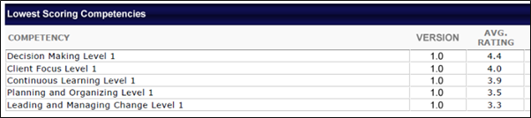
- Competency Comments Summary - This page will display the comments from all assessors groups for each competency. The description for the section can be modified. If the assessor group has more than one user with comments, then the comments will be displayed as a bulleted list, one for each comment entry. For assessor groups, the minimum number of respondents setting for the assessment task will apply. If the total respondents are less than the minimum for the group, then the group, group's rating, and comments will not appear. If the administrator chooses to display comments anonymously, then all comments from all assessor groups will display anonymously. The text "Other" will appear for the assessor group's name, a "-"will appear for the average rating, and all comments will display as a bulleted list. The report output will display the item comments summary on a new page based on the ordering defined for the assessment and if the page is included in the report output. This page WILL NOT appear if the competency model contains behaviors. If the assessor group has more than one user with comments, then the comments will be displayed as a bulleted list, one for each comment entry.
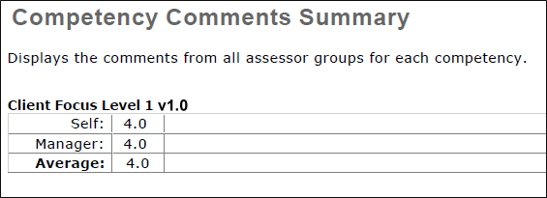
- Item Comments Summary - This page will display the comments from all assessor groups for each item on the assessment. The description for the section can be modified. For assessor groups, the minimum number of respondents setting for the assessment task will apply. If the total respondents are less than the minimum for the group, then the group, group's rating, and comments will not appear. If the administrator chooses to display comments anonymously, then all comments from all assessor groups will display anonymously. The text "Other" will appear for the assessor group's name, a "-"will appear for the average rating, and all comments will display as a bulleted list.
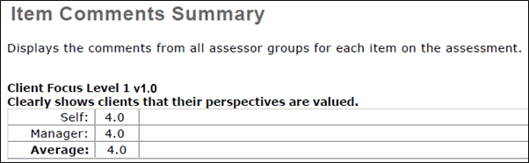
- Additional Responses - This page will display all of the responses to freeform questions on the assessment. The Assessee can view the responses to each of the freeform questions from all the assessor groups. The responses from relationship groups will be displayed anonymously or omitted based on the minimum number of respondents requirement set for the task.
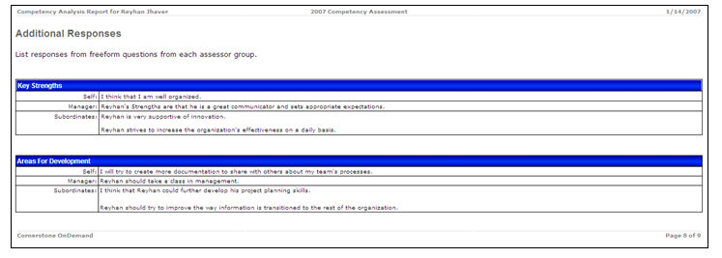
- Item Frequency Summary - This page displays the distribution of ratings for each item on the assessment. For each item, the average rating will display for each assessor group. The Assessee will see the distribution of ratings for each assessor group with each item.
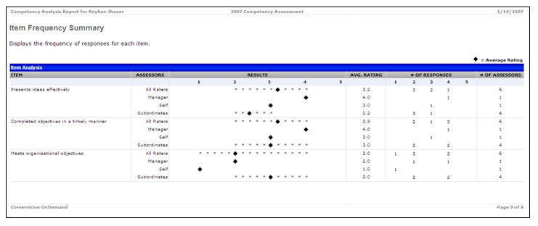

Observation Checklist Notes Report
The Observation Checklist Notes Report displays notes made on observation checklists. This report can be filtered by date, user, and checklist. The notes included in this report are notes that were added to a competency from the Competency Details page.
To access the Observation Checklist Report, go to Reports > Standard Reports. From the Performance tab, click the Observation Checklist Notes link.
Permissions
PERMISSION NAME | PERMISSION DESCRIPTION | CATEGORY

Observation Checklist Comments Report | Grants access to Observation Checklist Notes report, which displays notes made on observation checklists. This permission can be constrained by User Self and Subordinates, OU, User’s OU, and User. | Reports - Performance

Observation Checklist Report | Grants access to the Observation Checklist report, which enables administrators to report on Observation Checklist data. This permission can be constrained by User Self and Subordinates, OU, User’s OU, and User. | Reports - Performance
Criteria
Filter Name | Description
Date Criteria | Filter your results by date. Notes made within the specified time frame will display. Note: Date Criteria is always implemented using UTC (Coordinated Universal Time).
User Criteria | Limit results to the users matching the specified user criteria. If no criteria are selected, the report will run for all available users.
Checklist | Limit results to specific checklists. This filter is only available to users who have the Observation Checklist Report permission.
User Status | Select this option to include notes made by users that are now inactive.
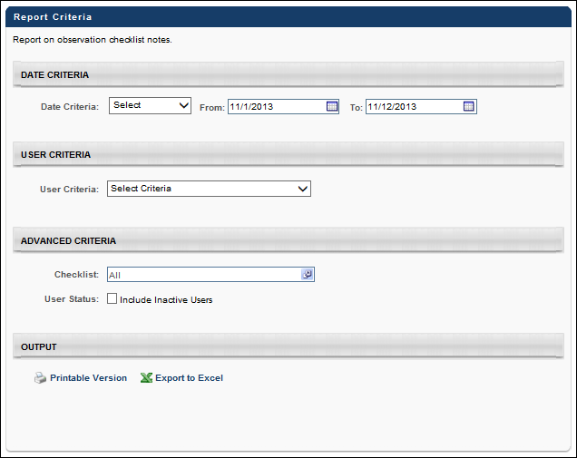
Output
Notes are sorted by user, so the notes for each user are grouped together. The notes are then sorted by checklist and competency.
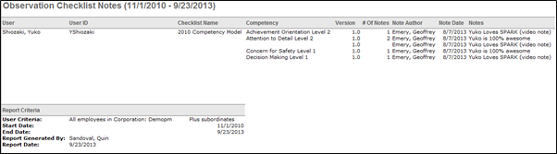

Observation Checklist Report
This report enables administrators to report on Observation Checklist data.
Note: Only completed tasks are included in report results. The maximum number of entries in the report is 30,000.
To access the Observation Checklist Report, go to Reports > Standard Reports. From the Performance tab, click the Observation Checklist link.
Permissions
PERMISSION NAME | PERMISSION DESCRIPTION | CATEGORY

Observation Checklist Report | Grants access to the Observation Checklist report, which enables administrators to report on Observation Checklist data. This permission can be constrained by User Self and Subordinates, OU, User’s OU, and User. | Reports - Performance
Criteria
Tab Name | Description
Date Criteria | Filter your results based on start date or target date within the specified range. By default, the date criteria will be the default date criteria for the goals page (available on the Goals Preferences page) for the OU of the user running the report. Note: Date Criteria is always implemented using UTC (Coordinated Universal Time).
User Criteria | Limit report output to the users matching the specified user criteria. The report will only run within the defined constraints for the user running the report. This is the standard OU availability selection criteria drop-down. Choose from available OU types. If no User Criteria are selected then the report will run for the entire available population.
Validated By | Using the OU Criteria filter, filter by verifiers. A verifier is the person who is detailed on the checklist as the user who checked off a user's competency item. If you select External a text input box appears so you can report on external verifiers (verifiers who do not have user records in the system).
Checklist | Select one or all checklists to include in the report.
Competency | Select a specific competency to include in the report.
Include Skills | Check this filter to display the competency's skills under the competency title in the report.
Competencies | Filter the report to display all competencies, only completed competencies, or competencies with at least one skill that is not yet verified.
User Status | Select this option to include users who are indicated as Inactive in the system as defined on the User Record page.
User Checklist Status | Filter results by Checklist Status for a user.
Checklist | Select the options to display the Due Date, Completion Date and Assignment Date for a checklist.
Recurrence | Select this option to include results for a previous instance of a checklist and competency for a user.
Description | Select this option to include the competency description in the report. When including the competency description in the observation checklist report, any HTML code used in the description is removed from the report output because HTML code is not recognized in Excel.  The report is also updated to included ratings, if available for the checklist. The new option appears as an additional checkbox option under Advanced Criteria in the report setup screen. Ratings appear in the report output automatically if applicable.
Group By | Select the appropriate option to group results by User or Competency.
Process Report
This is an asynchronous report, which allows the administrator to define the standard report and generate the report asynchronously. As a result, when administrators process the report, the system generates the report in the background, while the administrator can move on to other areas of the system. When the report is finished processing, the administrator can then view the full report in its entirety.
- Up to three separate reports can generate asynchronously, allowing greater flexibility for creating and storing different versions of the report.
- If you process a report or refresh a stored report, the report appears in the table as Queued.
- The most recently created report displays at the top of the table.
- Since the user can generate up to three reports, the administrator can define a report title for each of the generated reports.
- Clicking the View Details icon changes the report settings on the page to match those of the selected previously run report.
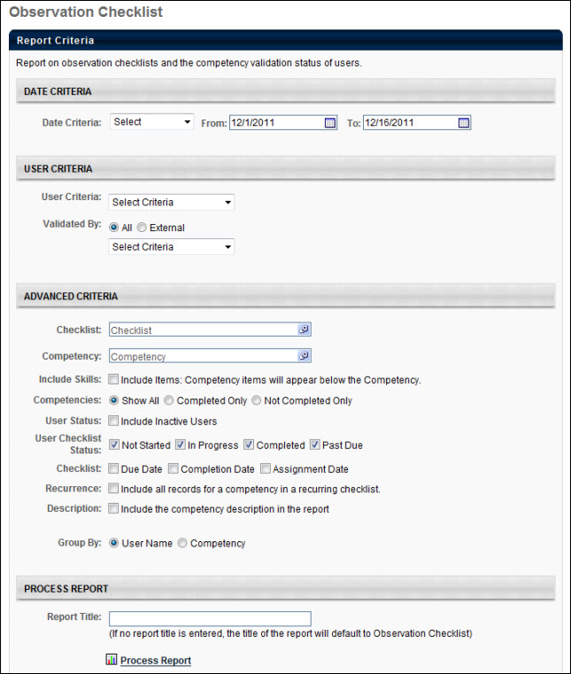
Output Grouped by User
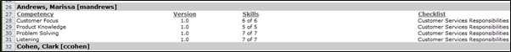
Output Grouped by Competency
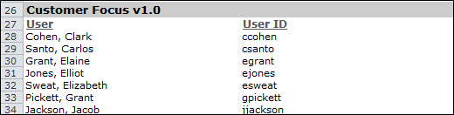

Performance Review Details Report
The Performance Review Details Report allows users to report on multiple performance reviews within a given time range, all in a single PDF. This report displays reviews from a reviewee's perspective, which means that the report observes the performance review task's visibility criteria when printing. If the task's visibility criteria has information blocked at the time the report is processed, the report's output will omit this information. If the report is run at a later time where the visibility criteria has allowed the reviewee access to the information, the report's output will include this information.
The following options are available:
- Indicate a single user for whom to print one or more reviews.
- Filter the number of reviews to be printed by date.
- Filter for only reviews completed for a defined date range, or reviews that overlap for a defined date range.
- Name the report.
- Process and save up to three reports (per report user).
To access the Performance Review Details report, go to Reports > Standard Reports. From the Performance tab, click the Performance Review Details Report link.
Permissions
PERMISSION NAME | PERMISSION DESCRIPTION | CATEGORY

Performance Review Details Report | Grants access to Performance Review Group Details report, which can display multiple performance reviews for the same user within a given time range, all in a single PDF output. This permission can be constrained by OU, User's OU, User Self and Subordinates, User, and User's Subordinates. | Reports - Performance
Criteria
Filter Name | Description
Date Criteria | Filter your results by date. Select a pre-configured date range from the drop-down or use the calendar fields to configure a date range. The default From date is January 1 of the current year, and the default To date is December 31 of the current year.  Note: Date Criteria is always implemented using UTC (Coordinated Universal Time).
User Criteria | The following options are available in this section:  - Include review data for inactive users - When this option is selected, inactive users are included in the report output.  - Include review data for applicants, if available - When this option is selected, any historical review data for applicants is included in the report output.  - User Criteria - Select the user for whom to print one or more reviews by clicking the Select icon and choosing a user from the Select User pop-up. The users available to select are defined by the administrator's permission constraints. This is a required field. Note: To change the user selected, click the Select icon, and then choose a different user.
Advanced Criteria | Select from the following options to determine which performance review you would like to print:  - Complete date is equal to or within the date filters - This option is selected by default. When selected, the report output displays all standard and off-cycle reviews that were completed during the defined date range.  - Report date criteria overlaps the performance review period - When this option is selected, the report output displays all standard and off-cycle reviews where the review period overlaps the defined date criteria.  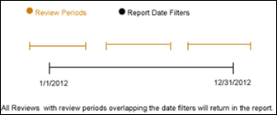
Report Title | Enter a title for the report. The character limit is 50. If a title is not entered, the report title defaults to Performance Review Details Report.
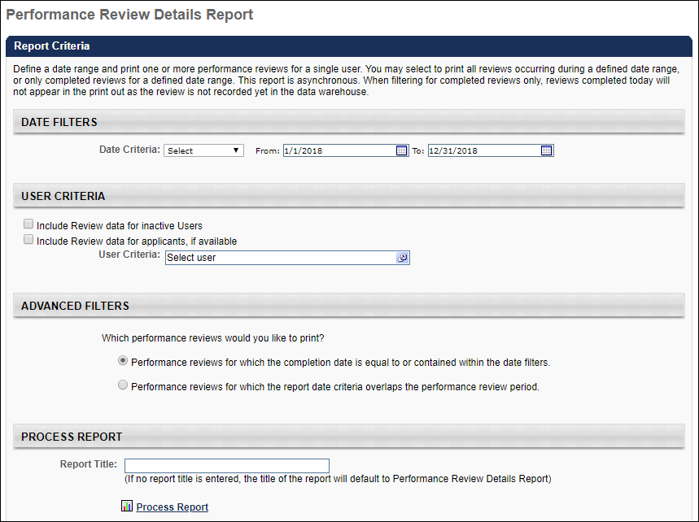
This is an asynchronous report, which means that report data is only available as of the previous day. If the administrator would like to print reviews for a date range that concludes on today's date, any reviews completed on that date are not returned in the report output, as the review completion record is not yet available via the data feed.
For example, date criteria is configured to include reports completed 1/1/2011 to 12/31/2011. If the review was completed on 12/31/2011 and that is the day on which the report is run, the review does not appear in the output. The review will be available the following day after the data feed is refreshed.
Asynchronous reports allow the administrator to define the standard report and generate the report asynchronously. As a result, when administrators process the report, the system generates the report in the background, while the administrator can move on to other areas of the system. When the report is finished processing, the administrator can then view the full report in its entirety.
- Up to three separate reports can generate asynchronously, allowing greater flexibility creating and storing different versions of the report.
- If you process a report or refresh a stored report, the report appears in the table as Queued.
- Since the user can generate up to three reports, the administrator can define a report title for each of the generated reports.
Processed Reports Table
The Processed Reports table displays the following for the report:
- Report Name
- Create Date
- Last Run
- Output - Click the PDF icon to open the report.
- Options - The following options are available in the Options column:
  - Refresh - Click to refresh the report data.
  - View Details - Click to view the report configuration details.
  - Remove - Click to delete the report.
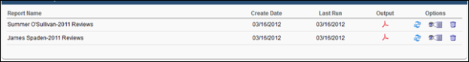
Output
Depending on the option selected in the Advanced Criteria section, the report output is sorted by review completion date, with the most recently completed review appearing last, or it is sorted by the first date of the earliest review period.
If multiple reviews are included in the report, each review begins on a new page.
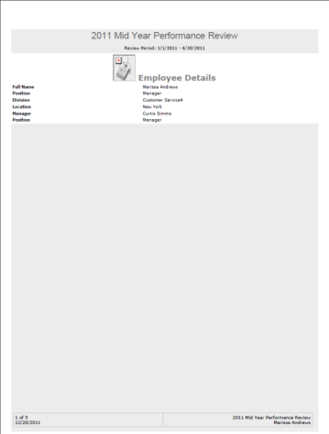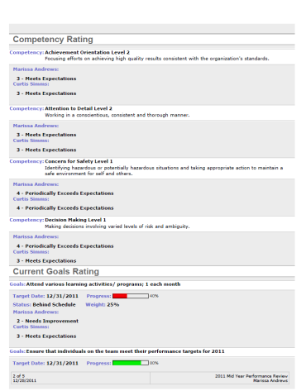
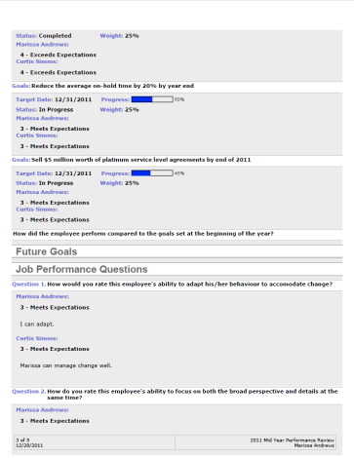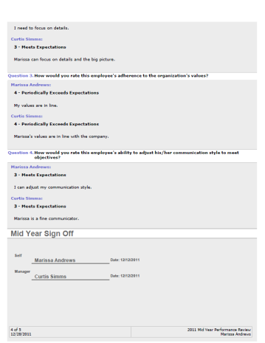
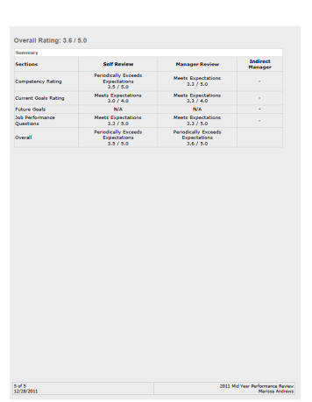

Performance Review Distribution Report
The Performance Review Distribution Report provides a graphical representation of the distribution of ratings for a given performance review task. The goal is that once administrators create a target distribution of ratings during task setup, managers can then use that target as a guideline for reviewing their employees which helps create consistency in review ratings across the division. Review ratings can also be calibrated in this report.
After running the report, ratings may be manually altered with the goal of having the ratings more closely match the target distribution. The calibrated rating will then replace the final rating system-wide (Performance, Compensation, Succession, Reports, Analytics). Review tasks can still be calibrated with an Expired status.
Note: The Save All button does not appear until changes are made to the ratings.
To access the Performance Review Distribution report, go to Reports > Standard Reports. From the Performance tab, click the Performance Review Distribution Report link.
Permissions
PERMISSION NAME | PERMISSION DESCRIPTION | CATEGORY

Performance Review Distribution Report | Grants access to Performance Review Distribution Report, which provides a graphical representation of the distribution of ratings for a given performance review task. This permission can be constrained by OU, User's OU, User's Self and Subordinates, and User's Subordinates. | Reports - Performance

Performance Review Distribution Report - Calibration | Grants ability to adjust final overall rating for performance reviews when viewing the Performance Review Distribution report. This permission works in conjunction with the Performance Review Distribution Report permission. This permission cannot be constrained. This is an administrator permission. | Performance - Administration
User Criteria
Filter Name | Description
User Criteria | Limit report output to the users matching the specified user OU criteria. The report only runs within the defined constraints for the user running the report. If no criteria are selected, the report is run for all available users.
Advanced Criteria
Filter Name | Description
Performance Review Task | Select a specific Performance Review Task. Once a Performance Review Task is selected, the title of each Review Section within Question List, Competency, and Goal Rating sections appear. Select the sections to include in the report. By default, no sections are selected and only the overall Performance Review rating appears in the report. Goal Planning and Sign Off sections are not included.
Performance Review Data Set | From the drop-down menu, select the cohort type that will be used to calculate the z-score values. The report will compare each users' ratings with the average rating of other users in the same cohort.  The following options are available:  - Manager - This option is selected by default.  - Division  - Location  - Position
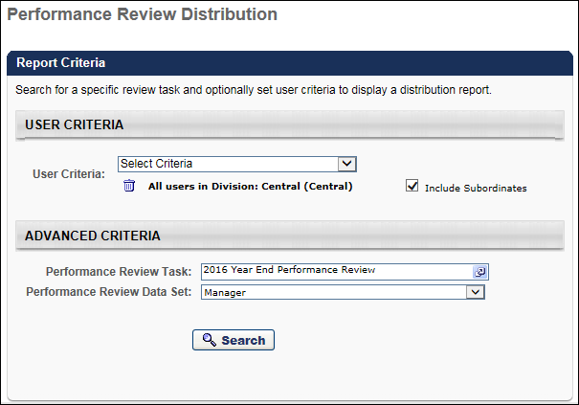
Report Output
The report output contains two parts:
- A chart representing the number of user rating in each rating bucket (the number of users with a rating of 1, 2, 3, etc.)
- A list of user ratings, sorted by user name
When the Target Distribution option box is selected, the target distribution displays on the chart as a curve on top of the actual distribution ratings. Note: Online Help contains additional information about how the target distribution is set. See Define Performance Review Task Rating Scale.
The Employee Reviews table displays all employees that match the search criteria, along with their user ID, manager, status, the date the review was completed, and their review rating.
By selecting a column in the chart, the Employee Reviews table is filtered to display only the users represented in that column.
Report Output - Z-Score
The Z-Score column provides each user's Z-Score, which represents how the user's rating compares to the average rating within the selected cohort. This value is based on the performance review data set that is selected. For example, if "Manager" is selected, then the Z-Score value is in relation to all of the user's manager's subordinates within the availability (i.e., the user's peers). If "Position" is selected, then the Z-Score value is in relation to all of the user's within the availability in the user's position.
The Z-Score value is only displayed if the cohort size is large enough to make a valid analysis.
Because z-score values are calculated using Cornerstone's Machine Learning Platform, z-score values are updated based on the following:
- In Stage portals, z-scores are only updated during User Acceptance Testing (UAT).
- In Production portals, z-scores are regularly updated.
- In Pilot portals, z-scores are not available. In Pilot portals, this field is always displayed "N/A."
Z-Score Calculation Note: Z-scores are calculated at the time the performance review is submitted with the data set contained within the review. The system does not recalculate z-scores when this report is run. If a manager's subordinates change or if the users within a position change, the report continues to reflect z-scores according to their original determination and unique data sets. Therefore, if you have users in your report who were originally reviewed in separate, unique review groups, the z-scores represented may not be relative to one another.
Calibration
After running the report, ratings may be manually altered by entering a new value in the Calibrated column next to the review rating. The calibrated rating replaces the final rating system-wide. The goal of calibrating ratings is to have ratings more closely match the target distribution. As a best practice, ratings should not be dramatically adjusted.
Note: The Save All button does not appear until changes are made to the ratings.
If the review task is set to use text-only ratings, the raw rating displays as text and the Calibration contains drop-down lists. The drop-down lists contain all of the text ratings available for the review task.
Calibration is available for any tasks that are In Progress or Completed. Expired tasks can also be calibrated.
Calibration changes are saved temporarily, but are not permanently saved until the Save All button is clicked. When Save All is clicked, the report is re-run and the page is refreshed with the calibrated ratings. At the completion of the review process, the calibrated rating is the official overall review rating (for Compensation, Succession, all standard reports which display overall review rating, Analytics, and the official rating displayed to employees).
Exporting to Excel or Printable Version exports the raw ratings as well as the calibrated ratings.
The Options column displays a History icon next to ratings that have been calibrated. Clicking the History icon opens a pop-up that details each time the rating for that employee was calibrated, including date, who it was calibrated by, and each calibrated rating. The original Raw Rating is always displayed at the bottom. If the task uses text-only ratings, the Rating column displays the text rating for the employee. While calibrated ratings act as the official rating, raw ratings are still available via Reporting and Analytics.
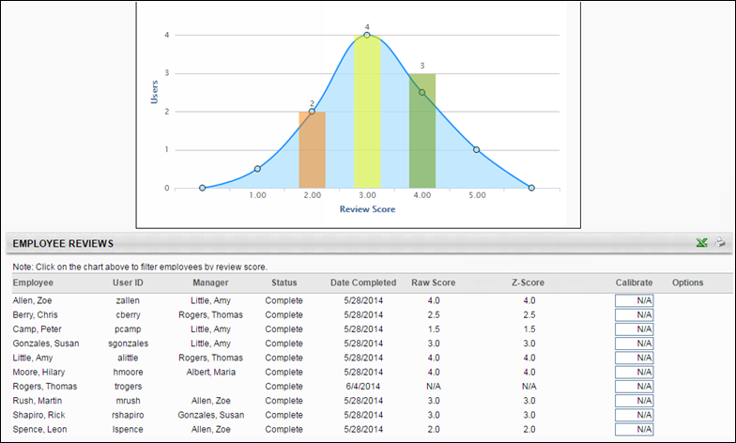

Performance Review Report
The Performance Review Report displays a performance review for a single user. This report can be run for both active and inactive users. Note: Task visibility settings from the Performance Review Task Administration page do not apply to this report.
Permissions
PERMISSION NAME | PERMISSION DESCRIPTION | CATEGORY

Performance Review Report | Grants access to Performance Review report, which allows display and printing of a specific performance review for one user at a time. The constraints on this permission also determine for which users the administrator can print the review task PDF and review attachments when viewing the performance review task details. This permission can be constrained by OU, User's OU, User Self and Subordinates, and User. | Reports - Performance
Criteria
Filter Name | Description
Employee Reviewed | Select the employee whose review you are viewing.
Task | Select the review task to display for the selected employee.
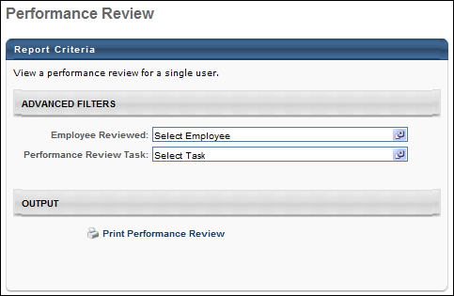
Output
Click the Print Performance Review link to open or save a printable version of the performance review.

Performance Review Rating Report
The Performance Review Rating Report displays performance review ratings for a specific assigned review task.
To access the Performance Review Rating Report, go to Reports > Standard Reports. Select the Performance tab. Then, select the Performance Review Rating link.
Permissions
PERMISSION NAME | PERMISSION DESCRIPTION | CATEGORY

Performance Review Rating Report | Grants access to Performance Review Rating Report, which displays performance review task overall and section ratings for multiple users. This permission can be constrained by OU, User's OU, User's Self and Subordinates, User, and User's Subordinates. | Reports - Performance
Criteria
Filter Name | Description
User Criteria | Limit report output to the users matching the specified user OU criteria. The report only runs within the defined constraints for the user running the report. If no criteria are selected, the report is run for all available users.
Review Task | Select a specific Performance Review Task. Once a Performance Review Task is selected, the title of each Review Section within Question List, Competency, and Goal Rating sections appear. Select the sections to include in the report. By default, no sections are selected and only the overall Performance Review rating appears in the report. Goal Planning and Sign Off sections are not included.
Review Section | Once a review task is selected, the sections in that review task are displayed. Select the sections to include in the report
Rating Display | Display either the numeric or text version of the ratings.
User Status | Select this option to include inactive users in the report.
In-Progress Task | Select this option to include reviews that are in progress in the report.
Display OU | Select an Organizational Unit to display that information on the report. For example, if you select the Position OU, each user's position will display in the report. This is optional.
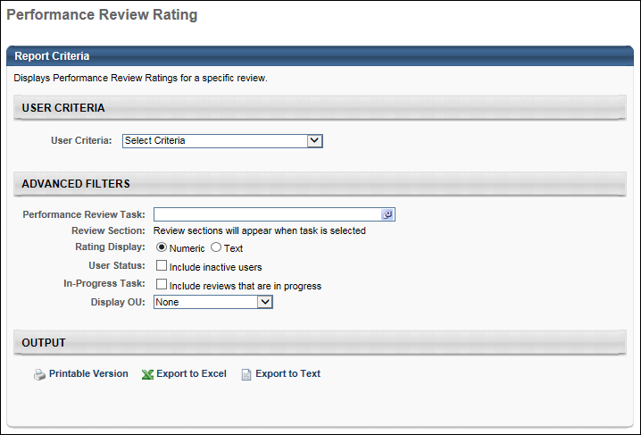
Output
The sections selected appear as columns within the report. Section ratings do not have section weights applied to them, only step weights. Therefore, when section ratings are manually averaged together they may not equal the overall rating.

Performance Review Section Rating Comparison Report
The Performance Review Section Rating Comparison Report displays ratings for a section on a performance review task for a set of users. This report allows administrators to compare ratings for questions in a review across multiple users.
Score Calculation Note: This report calculates a review section score by calculating the average of the question scores within the section. This report does not reflect the question weights included in the review section. As a result, the section rating shown in the report may not match the actual section rating from the task.
To access the Performance Review Section Rating Comparison Report, go to Reports > Standard Reports. Select the Performance tab. Then, select the Performance Review Section Rating Comparison link.
Permissions
PERMISSION NAME | PERMISSION DESCRIPTION | CATEGORY

Performance Review Section Rating Comparison Report | Grants access to Performance Review Section Rating Comparison Report, which displays individual question ratings for a review section of a performance review task for a group of users. This permission can be constrained by OU, User's OU, and User's Subordinates. | Reports - Performance
Criteria
Filter Name | Description
User Criteria | Limit report output to the users matching the specified user OU criteria. The report only runs within the defined constraints for the user running the report. If no criteria are selected, the report is run for all available users.
Review Task | Select a specific Performance Review Task. Once a Performance Review Task is selected, the Review Section field is enabled.
Review Section | This field is only available once a review task is selected. Select the sections to include in the report. Only Question List and Competency sections are available. By default, no sections are selected and only the overall Performance Review score appears in the report.
Group By | Group the report display by either question or user.
Rating Display | Display either the numeric or text version of the scores.
Response Display | Choose to display the average rating for the task or display the responses of a particular reviewer.
Question Display | Display either the full question or abbreviate the question to 25 characters. The option to display the abbreviated question is only available when grouping by user.
Sort By | Sort the results either by User Name, Question Rating, or Section Rating. Question Rating is only available if grouping by question, and Section Rating is only available if grouping by user.
Report Title | Enter a title for the report you are generating. If no title is entered, the report title defaults to Performance Review Section Score Comparison.
Process Report
This is an asynchronous report, which allows the administrator to define the standard report and generate the report asynchronously. As a result, when administrators process the report, the system generates the report in the background, while the administrator can move on to other areas of the system. When the report is finished processing, the administrator can then view the full report in its entirety.
- Up to three separate reports can generate asynchronously, allowing greater flexibility for creating and storing different versions of the report.
- If you process a report or refresh a stored report, the report appears in the table as Queued.
- The most recently created report displays at the top of the table.
- Since the user can generate up to three reports, the administrator can define a report title for each of the generated reports.
- Clicking the View Details icon changes the report settings on the page to match those of the selected previously run report.
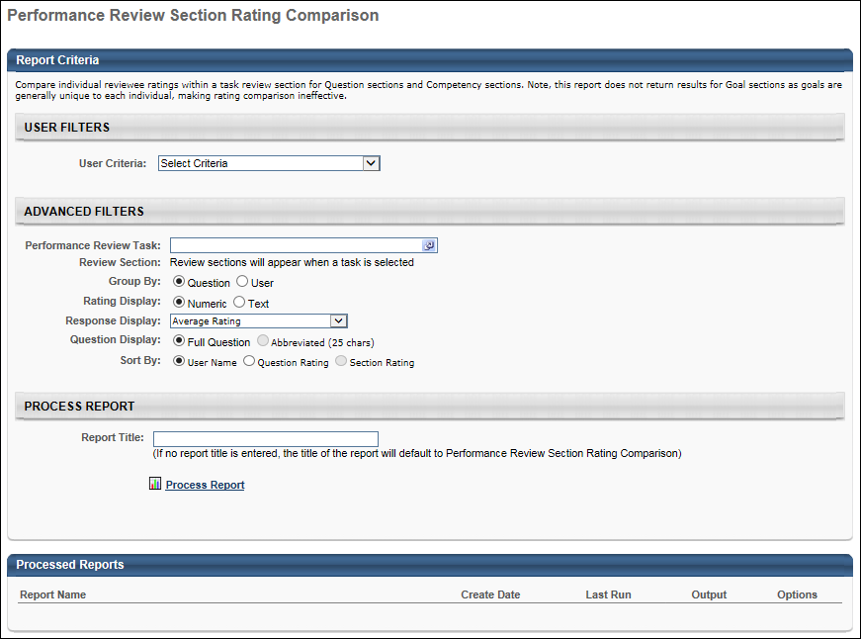
Output
After the report is processed, you can:
- View the report data by clicking the Excel icon.
- Update the report data by clicking the Refresh icon.
- View the report details by clicking the Details icon.
- Delete the report by clicking the Delete icon.

Performance Review Step Status Report
The Performance Review Step Status Report displays the status of review steps within a performance review task.
To access the Performance Review Step Status Report, go to Reports > Standard Reports. Select the Performance tab. Then, select the Performance Review Step Status Report link.
Permissions
PERMISSION NAME | PERMISSION DESCRIPTION | CATEGORY

Performance Review Step Status Report | Grants access to Performance Review Step Status Report, which displays the status of review steps within a performance review task. This permission can be constrained by OU, User's OU, User's Direct Reports, and User Self and Subordinates. The permission constraints determine which users are available within the report. Note: If the user's permission is also constrained by User Self and Subordinates, then this overrides the User's Direct Reports constraint. | Reports - Performance
Criteria
Filter Name | Description
User Criteria | Limit report output to the users matching the specified user OU criteria. The report only runs within the defined constraints for the user running the report. If no criteria are selected, the report is run for all available users.
Review Task | Select a specific performance review task.
Review Step | Once a Review Task is selected, the steps within the review task are displayed. The report displays the status of each selected step for the selected users. The steps do not display as options until a task is selected. Select the sections to include in the report.
Display OU | Select an Organizational Unit to display that information on the report. For example, if you select the Position OU, each user's position will display in the report. This is optional.
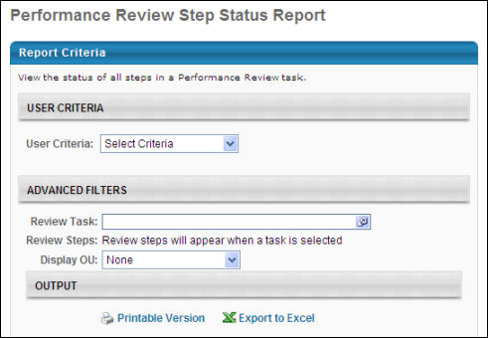
Output
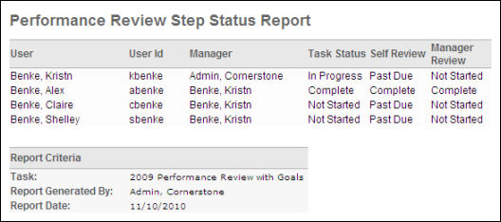

Skills Matrix Report
The Skills Matrix report displays role qualification statuses for one or more users.
Note: Only completed tasks are included in report results. If a user has completed any version of a learning object (LO) or training equivalency, the LO will show as Completed and count toward role completion.
To access the Skills Matrix Report, go to Reports > Standard Reports. From the Performance tab, select the Skills Matrix Report link.
Permissions
PERMISSION NAME | PERMISSION DESCRIPTION | CATEGORY

Skills Matrix Report | Grants access to Skills Matrix Report, which displays an aggregate gap analysis of each competency in an assessment for a group of users. This permission can be constrained by OU, User's OU, and User Self and Subordinates. | Reports - Performance
Criteria
User Criteria
Filter Name | Description
User Criteria | Select a user or a group of users that may be included in the report. This criterion applies to the users who will appear in the report output. This is a required field. You may choose one or more individual users as well as entire organizational units (OUs) or Groups. If permission for this report is constrained, those constraints apply to user criteria selection when running the report.
Additional User OU | This section contains an expandable OU selector. One or more OUs can be selected to display additional OU information about each user in the report output.
Roles
Filter Name | Description
Select Roles | Click the pop-up icon  to select one or more roles to include in the report. The user can only select roles for which the user is within the availability that is defined for the role. This is a required field.
Include Role Requirement Details | When this option is selected, the following details are included for each competency requirement:  - Competency Requirement - This displays the competency title.  - Competency Version - This displays the competency version.  - Requirement Complete Status - This displays whether the competency requirement is completed for the user.  When this option is selected, the following details are included for each training requirement:  - Training Requirement - This displays the training title.  - Training Status - This displays the user's status for the training.  - Training Requirement Complete - This displays whether the training requirement is complete.  - Training Completion Date - If the training requirement is complete, then this displays the date on which the training was completed.
Process Report
Filter Name | Description
Report Title | Enter a title for the report. The character limit is 50. If a title is not entered, the report title defaults to Skills Matrix Report.
This is an asynchronous report, which means that report data is only available as of the previous day.
Asynchronous reports allow the administrator to define the standard report and generate the report asynchronously. As a result, when administrators process the report, the system generates the report in the background, while the administrator can move on to other areas of the system. When the report is finished processing, the administrator can then view the full report in its entirety.
- Up to three separate reports can generate asynchronously, allowing greater flexibility creating and storing different versions of the report.
- If you process a report or refresh a stored report, the report appears in the table as Queued.
- Since the user can generate up to three reports, the administrator can define a report title for each of the generated reports.
Processed Reports Table
The Processed Reports table displays the following for the report:
- Report Name
- Create Date
- Last Run
- Output - Click the PDF icon to open the report.
- Options - The following options are available in the Options column:
  - Refresh - Click to refresh the report data.
  - View Details - Click to view the report configuration details.
  - Remove - Click to delete the report.
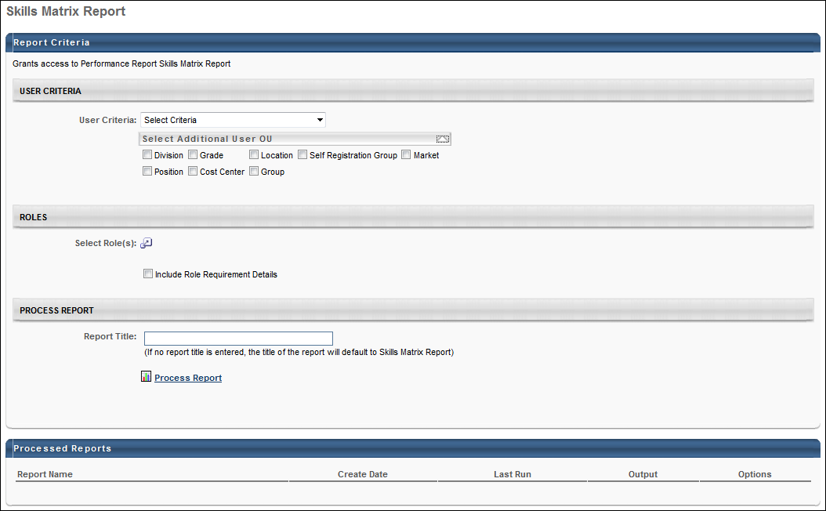
Output
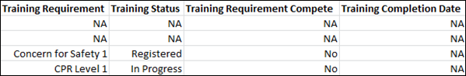

Task User Status Report
This report displays the status of one or more tasks for any organizational unit. The report will generate an overall percentage for each status, Not Started, In Progress, or Complete, across multiple tasks.
Permissions
PERMISSION NAME | PERMISSION DESCRIPTION | CATEGORY

Performance - Task User Status | Grants access to Task User Status Report. This permission can be constrained by OU, User's OU, User's Self and Subordinates, and User. | Reports - Performance
Filters
- User Criteria - limit report output to the users matching the specified user criteria
  - The report will only run within the defined constraints for the user running the report
  - This is the standard OU availability selection criteria drop-down. Choose from available OU types
  - Defaults: If no User Criteria are selected then the report will run for the entire available population
- Task (required field) - filter on specific task/s
- Task Completion Date - check to Include Task Completion Date
- Sort By - choose to sort by User or Task
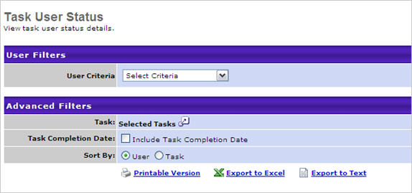
Output
- Click this link to view the results in a web page. Click this link to save/open as an Excel file. Click this link to export data to a tab delimited text file.
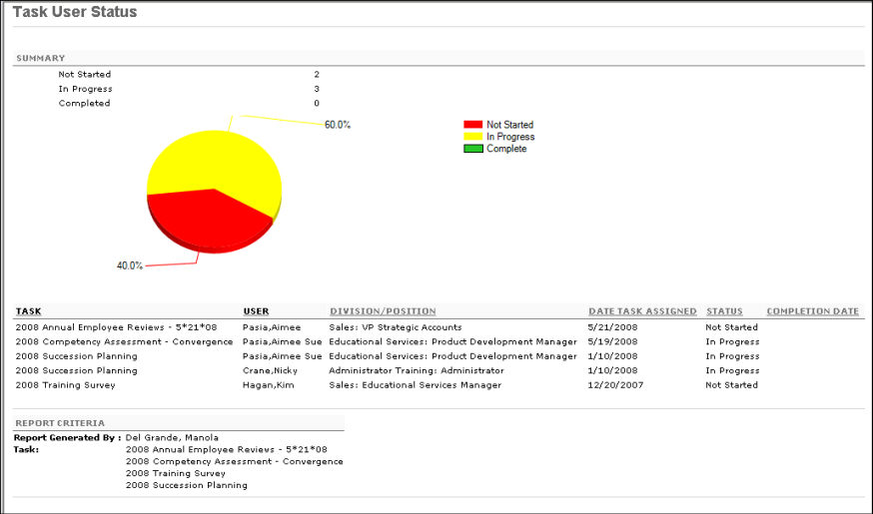

Recruitment Reports

Applicant Compliance Report
The Applicant Compliance Report tracks applicants' self-reported responses to gender, race, ethnicity, and EEO questions.
Note: The results that are available for the Applicant Compliance report are dependent upon the Compliance Enablement Preferences settings for the associated Location OU.
Note: The results may include information from candidates who have not completed their application. As a result, some candidates may appear in the Applicant Compliance Report but are not visible elsewhere in the system.
To access the Applicant Compliance report, go to Standard Reports > Recruitment.
Permissions
PERMISSION NAME | PERMISSION DESCRIPTION | CATEGORY

Applicant Compliance Report | Grants access to the Applicant Compliance Report, which tracks applicants' self-reported responses to disability, gender, race, ethnicity, and EEO questions. | Reports - Recruiting
Criteria
Feature | Description
Date Criteria | Select the date range for the report from the drop-down list or enter specific dates in the From and To fields.
Advanced Criteria | Limit report output to the following:  - Requisition Owner - Select requisition owners from standard OUs.  - Division - Use the default value of "All" or select one or more Division OUs.  - Location - Use the default value of "All" or select one or more Location OUs.  - Job Title - Use the default value of "All" or select one or more Position OUs. Note: The job title criterion does not use the display job title defined on the requisition.  - Requisition ID - Enter the requisition ID, which can be found on the Manage Job Requisitions page. Only one ID can be used, and the ID must match exactly. Note: Entering a Requisition ID supersedes all other criteria.  Multiple values can be selected for each criterion except Requisition ID. The report only runs within the defined constraints for the user running the report. If the user's permission to run the report is not constrained, at least one criterion must be selected. If the user's permission to run the report has at least one constraint and no criterion is selected, the report is run for all available advanced criteria.
Display Options | The Display Options section enables you to select a template for the report output from the Report output template field and also configure specific fields to appear on the report from the Compliance Questions and Other Fields sections. At least one Display Options field must be selected.  The following are the display option templates:  - Custom Output - With this template, you can select the fields that will appear in the output. There are no fields checked by default.  - EEO-C - With this template, all fields in the Compliance Questions section are checked by default. In the Other Fields section, the Job Category field is checked by default.  - Applicant Flow Log - With this template, all fields are checked by default in the Other Fields section except Requisition ID, Interview Date, Source, and Job Division.  Compliance Questions  The Compliance Questions section enables you to determine which compliance questions appear on the report. Both default and custom questions can be selected, depending on the questions that are available for the user's organizational unit (OU).  The questions that are available to select are dependent upon the Compliance Enablement Preferences settings for the requisition. For this reason, the report may include requisitions for which a specific question was not included as part of the application. If a question is not asked as part of the application but is included in the report, the value for the field is "Not asked."  Other Fields  The following fields are available to select in the Other Fields section and will appear on the report if selected:  - Applicant Name  - Requisition ID  - Job Title  - Job Category - This field displays the EEO job category that is associated with the requisition for each application record. If the report includes a requisition for which this field was not completed, the value for the field is "Not defined."  - Job Division - This field displays the division associated with the requisition for each application.  - Hiring Manager  - Requisition Owner  - Date of Application - This field displays the application submission date associated with each application.  - Source  - Qualified Applicant - This field replaces the Applicant Pool field. This field indicates whether the application record is defined as qualified. The value is "Yes" if the application has a candidate date. The value is "No" if the application does not have a candidate date.  - Interview - This field indicates whether the applicant has completed the Interview status, either "Yes" or "No." This field displays in the report output even if at least one applicant who meets the report criteria has not reached an Interview status type for the requisition.  - Interview Date - This field indicates the date on which the applicant completed the Interview status. The date displays in MM/DD/YYYY format. This field displays in the report output even if at least one applicant who meets the report criteria has not reached an Interview status type for the requisition.  - Action Taken - This field indicates whether the applicant was hired. The value is "Hired" if the applicant achieved a Hired status. The value is "Not Hired" if the applicant did not achieve a Hired status.  - Action Date - This field displays the date on which the applicant achieved a status of Hired or Closed. The field is blank if the applicant has a status of anything other than Hired or Closed.  - Disposition - This field displays the disposition associated with each application that has a status of Closed. If the applicant has an active status or if the status is Hired, then the field is blank.
Report Title | Enter a title for the report. If no title is entered, the report title defaults to the report name. The title appears on both the report output and in the Processed Reports list.
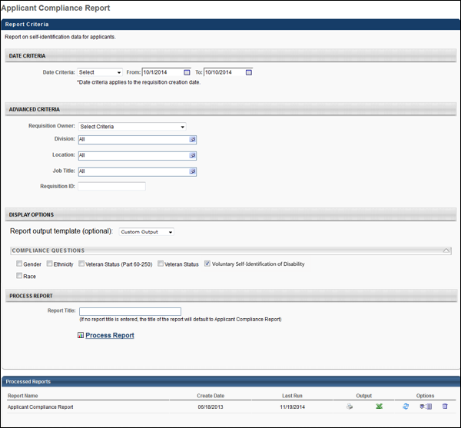
Output
If Compliance Enablement Preferences are configured to only include applicants who meet the minimum qualifications for the requisition, then the report output only includes applicants who have a candidate date. If this setting is not configured in Compliance Enablement Preferences, then all application records for the requisition are included in the report output, regardless of the candidate date.
For compliance questions included in the report, the value that was selected for the field by the applicant displays in the report.
Note: Because Compliance Enablement Preferences are configured by Location OU, the report output could contain requisitions from different locations with different settings. If this occurs, application records display in results for each requisition in accordance with the settings for each requisition.

Applications by Source and Status Report
The Applications by Source and Status report is used to report on the source data for all applications. The report breaks sources into the following categories in a pie chart on the report page:
- Career Center
- Career Sites
- Employee Referrals
- External Referrals
- Job Boards
- Other
Additionally, there are detail reports for each individual source, displaying the number of applications that reached specific statuses.
Note: The Agency Portal functionality must be enabled in order for recruiting agency source data to be available for the report.
To access the Applications by Source and Status report, go to Standard Reports > Recruitment.
Permissions
PERMISSION NAME | PERMISSION DESCRIPTION | CATEGORY

Applications by Source and Status Report | Grants access to the Applications by Source and Status report, which displays source data for all applications. | Reports - Recruiting
Criteria
Feature | Description
Date Criteria | Select the date range for the report from the drop-down list or enter specific dates in the From and To fields.
Advanced Criteria | You can limit report output to the following:  - Requisition Owner - Select requisition owners from standard OUs.  - Division - Use the default value of "All" or select one or more Division OUs.  - Location - Use the default value of "All" or select one or more Location OUs.  - Job Title - Use the default value of "All" or select one or more Position OUs. Note: The job title criterion uses the position title defined in the Position OUs, rather than the display job title defined on the requisition.  - Requisition ID - Enter the requisition ID, which can be found on the Manage Job Requisitions page. Only one ID can be used, and the ID must match exactly. Note: Entering a Requisition ID supersedes all other criteria.  Multiple values can be selected for each criterion except Requisition ID. The report only runs within the defined constraints for the user running the report. If the user's permission to run the report is not constrained, at least one criterion must be selected. If the user's permission to run the report has at least one constraint and no criterion is selected, the report is run for all available advanced criteria.
Display Options | The report must be filtered by at least one of the following statuses:  - Unqualified Submissions - This field includes all submissions that are not qualified in the report. Unqualified submissions are submissions that do not have a candidate date. When selected, the Failed Pre-Screening field is checked and disabled.  - Failed Pre-Screening - This status filter includes all applicants that submitted an application, failed the pre-screening questions, and have an applicant status of Closed. Note: Such applicants are only visible on the requisition's Requisition Snapshot page. These applicants were never considered a new submission because their first and only applicant status was Closed and their disposition reason was Failed Pre-Screening.  - Qualified Applicants - Select this option to include all submissions that have a candidate date.  - All applicants that have submitted an application and are in any applicant status except Closed and Hired. Note: All custom statuses are included in this category.  - All applicants that have an applicant status of Closed and whose immediate preceding status was any applicant status.  - Hired - All applicants that have an applicant status of Hired.
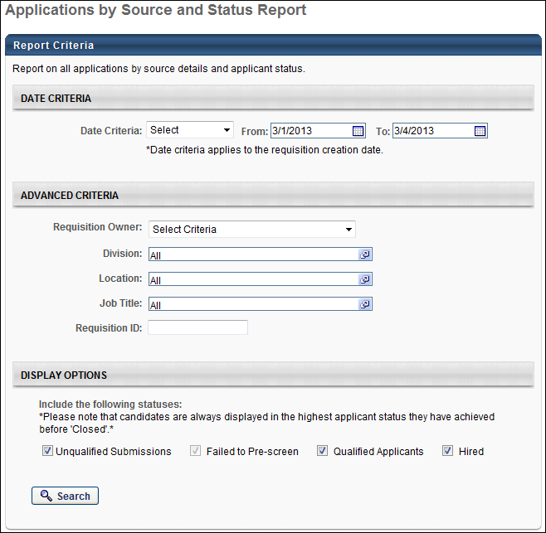
Output
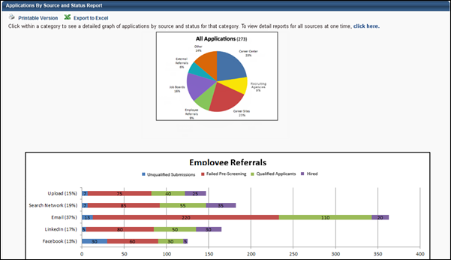
The summary view of the report is a pie chart that shows the percentage of applications by source. Click on any pie segment to open a details graph of the segment. The number in parentheses in the pie chart header represents the total number of applications included in the report data.
The details graph displays below the pie chart. In the y-axis, a colored bar displays, showing the name and percentage of applications from that source within the overarching source. Each bar is split into the number of applicants that are using each source.
Note: A "Recruiting Agencies" bar graph displays if the "Recruiting Agencies" segment is selected in the pie chart or if all source sections are expanded. The graph displays all recruiting agency submissions.
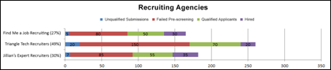
The printable version displays the details graph for each piece of the pie chart. The Excel version does not display either the pie chart or the details graph.
Printable Version Output
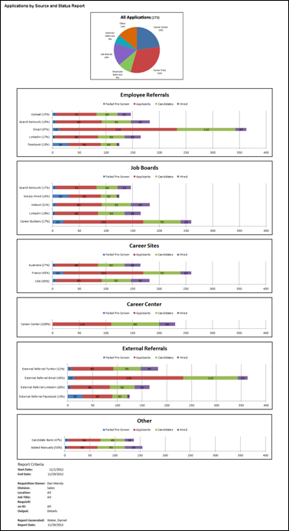
Excel Output
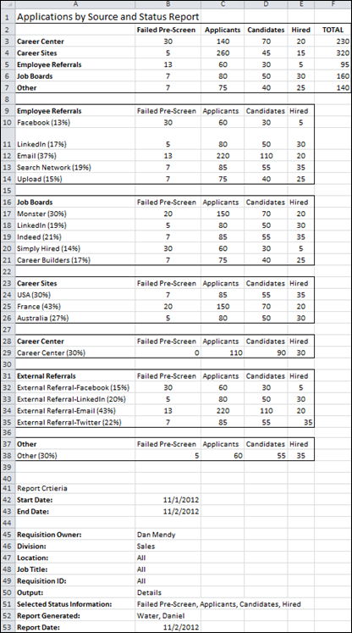

Cost per Hire Report
The Cost per Hire report enables you to report on the various costs associated with hiring for a requisition. The results of the report can be used to gauge the effectiveness of the recruiting management process. The report provides details about costs that are tracked manually by recruiters and automatically by the system.
Use Case
A human resources manager is tasked with determining why the IT department's overall referral costs are lower than any other department, despite the fact that their referral bonuses are the highest in the company. He runs a Cost per Hire report and sees that all of the IT department's referral fees are internal costs because all hires within the past six months have been internal referrals. The department's internal referral costs are 70% lower than the process of hiring externally, which the report indicates is the general practice of all other departments. He proposes a cross-functional project designed to increase internal referrals and reduce overall hiring costs.
To access the Cost per Hire report, go to Standard Reports > Recruitment.
Permissions
PERMISSION NAME | PERMISSION DESCRIPTION | CATEGORY

Cost per Hire Report | Grants access to the Cost per Hire report, which displays the costs tracked for recruiting. This permission cannot be constrained. | Reports - Recruiting
Criteria
Feature | Description
Date Criteria | Select the date range for the report from the drop-down list or enter specific dates in the From and To fields.
Date Based On | You must select one of the following options to define how the date range criteria is determined:  - Date Incurred - Select this option to base the date on the value in the Date Incurred field for the cost.  - Date Modified - Select this option to base the date on the date on which the cost was most recently modified.
Advanced Criteria | Limit report output to the following:  - Requisition Owner - Select requisition owners from standard OUs.  - Division - Use the default value of "All" or select one or more Division OUs.  - Location - Use the default value of "All" or select one or more Location OUs.  - Job Title - Use the default value of "All" or select one or more Position OUs. Note: The job title criterion does not use the display job title defined on the requisition.  - Requisition ID - Enter the requisition ID, which can be found on the Manage Job Requisitions page. Only one ID can be used, and the ID must match exactly. Note: Entering a Requisition ID supersedes all other criteria.  Multiple values can be selected for each criterion except Requisition ID. The report only runs within the defined constraints for the user running the report. If the user's permission to run the report is not constrained, at least one criterion must be selected. If the user's permission to run the report has at least one constraint and no criterion is selected, the report is run for all available advanced criteria.
Display Options | Select one of the following display options:  - Cost per Hire - Select this option to display the requisition and applicant level costs.  - Applicant Cost Details - Select this option to display the applicant cost details.
Display Options - Include the following cost fields | The cost fields that display are the default cost fields, as well as the custom cost fields created by the administrator in Cost Field Management. See Cost Field Management for additional information.  All boxes are checked by default, and the section is expanded by default. On the report output, each criterion appears in a separate column.
Display Options - Include the following classifications | Select one or both of the following cost field classifications:  - External - Select this option to include cost fields that are classified as "External" in Cost Field Management.  - Internal - Select this option to include cost fields that are classified as "Internal" in Cost Field Management.  Both boxes are checked by default, and the section is expanded by default.
Report Title | Enter a title for the report. If no title is entered, the report title defaults to the report name. The title appears on both the report output and in the Processed Reports list.
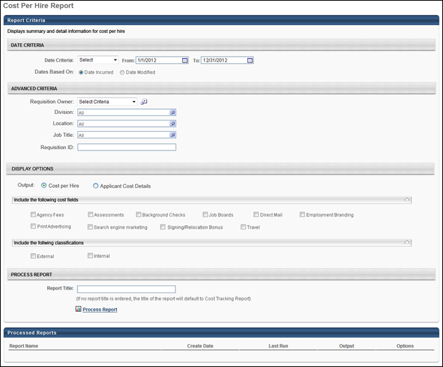
When the Process Report link is clicked, the report is run based on the selected criteria. The report output is stored in the Processed Reports table.
The administrator can choose the following actions and options for each report in the Processed Report table:
- Click the Excel icon to generate an Excel output of the report.
- Click the Refresh icon to refresh the report results.
- Click the View Details to view the filter criteria for the report.
- Click the Delete icon to delete the report.
Output - Cost per Hire
In the Cost per Hire display output, all costs are grouped by currency and display in alphabetical order by job title. For requisitions that have costs in more than one currency due to currency inconsistencies, the requisition appears in all applicable currencies.
At the top of the report, all currencies that appear in the output display in a list below the Currency field. To the right of the Currency field, the Cost Per Hire field displays the sum of all of the costs for each currency. The sum is calculated by adding the requisition level costs and the applicant level costs.
The report criteria display below the report details. All criteria defined for the report display, as well as the user who generated the report and the date on which the report was generated.
The following information appears in the output:
- Job Title - This column displays the title of the requisition.
- Requisition ID - This column displays the ID of the requisition.
- Owner - This column displays the owner of the requisition.
- Division - This column displays the division of the requisition.
- Location - This column displays the location of the requisition.
- # Openings - This column displays the total number of openings defined for the requisition.
- # Hires - This column displays the total number of hired candidates for the requisition.
- # Total Submissions - This column displays the total number of submissions for the requisition.
- # Applicants - This column displays the total number of applicants for the requisition.
- Default Currency -This column displays the currency defined for the requisition.
- [Custom Cost Fields] - If custom cost fields are included in the report output, each cost field displays as a separate column.
- Total - This column displays the total of all the cost fields included in the report output.
- Number of Hires in Period - This field displays the number of candidates moved to a Hired status within the dates defined for the report.
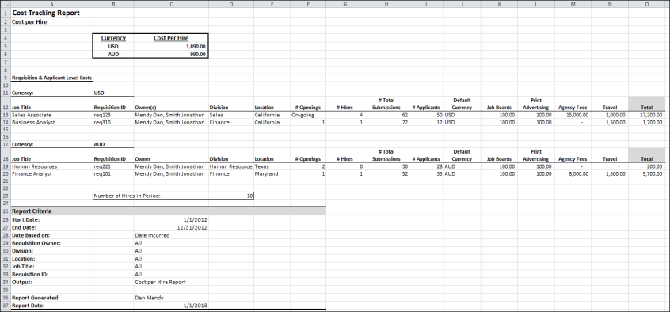
Output - Applicant Cost Details
With this display output, all costs are grouped by currency and display in alphabetical order by applicant last name. For applicants who have incurred costs in multiple currencies, the applicants appear in each applicable currency group.
The report criteria display below the report details. All criteria defined for the report display, as well as the user who generated the report and the date on which it was generated.
The following information appears in the output:
- Applicant Last Name - This column displays the applicant's last name.
- Applicant First Name - This column displays the applicant's first name.
- Requisition - This column displays the title of the requisition to which the applicant applied.
- Requisition ID - This column displays the ID of the requisition.
- Candidate Status - This column displays the status of the candidate for the requisition.
- [Custom Cost Fields] - If custom cost fields are included in the report output, each cost field displays as a separate column. Note: If requisition level costs are included in the report, then the value of the requisition level costs is zero for all applicants.
- Total - This column displays the total cost for all of the monetary cost fields in a given row.
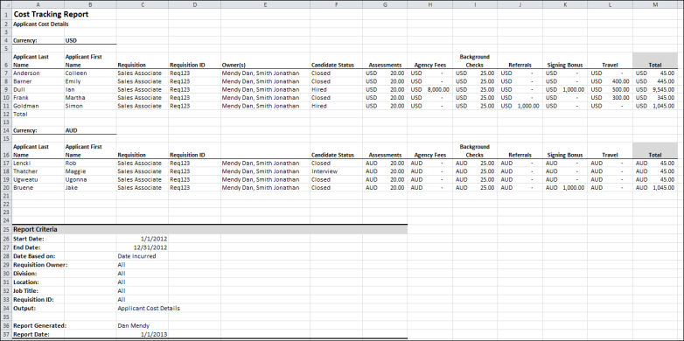

Custom Form Data Report
The Custom Form Data Report tracks data for the Form Management functionality. This report is only available for portals with the Form Management functionality enabled.
To access the Custom Form Data Report, go to Reports > Standard Reports > Track Employees. Then, click the Custom Form Data link.
Permissions
PERMISSION NAME | PERMISSION DESCRIPTION | CATEGORY

Custom Form Data Report | Grants access to the Custom Form Data Report, which displays data collected through forms. This permission can be constrained by OU and User's OU. | Reports - Recruiting
Criteria
Filter Name | Description
User Criteria | Select the users for whom you would like to view form data by selecting the appropriate OU or individual user from the drop-down. If user criteria are not defined, then the report runs for the entire available population.
Date Filters | Select the date range for the report from the drop-down list or enter specific dates in the From and To fields.
Advanced Filters | Limit report output to the following:  - Select Form - This is a required field. Click the Select icon in the Select Form field. This opens the Select Form pop-up. Select the form from the list of available forms. This closes the pop-up and populates the Select Form field with the form title.  - Submission Type - This field allows the recruiter to filter the report output based on how the form was submitted. The options that are available are dependent upon how users submitted the report selected in the Select Form field.  - Select Task - This field allows the recruiter to filter the report output based on tasks. Click the Select icon in the Select Task field. This opens the Select Task pop-up. Select one or more tasks from the list, and then click Done. This closes the pop-up and populates the Select Task field with the tasks.
Report Title
Enter a title for the report in the Report Title field. If no title is entered, the report title defaults to the report name. The title appears on both the report output and in the Processed Reports table.
Process Report
Click the Process Report link to run the report based on the selected criteria. The report output is stored in the Processed Reports table.
Processed Reports Table
The Processed Reports table displays the three most recently run reports. The following options are available for each report in the table:
- Click the Print icon to view a printable version of the report. The report can also be printed from the printable version.
- Click the Excel icon to generate an Excel output of the report.
- Click the Refresh icon to refresh the report results.
- Click the View Details icon to view and modify the filter criteria for the report.
- Click the Delete icon to delete the report.
Output
The report output includes the report criteria, as well as the following report data:
- First Name - This column displays the first name of the user who submitted the form.
- Last Name - This column displays the last name of the user who submitted the form.
- [User Criteria Columns] - These columns display the organizational units and/or users defined in the User Criteria section of the report.
- Submission Source - This column displays the source of the submitted form.
- Task Title - This column displays the title of the task associated with the form, if available.
- Task Description - This column displays the description of the task associated with the form, if available.
- Task Assigned - This column displays the date on which the task associated with the form was assigned, if available.
- Task Due - This column displays the date on which the task associated with the form is due.
- Date Submitted - This column displays the date on which the form was submitted.
- [Form Fields] - The column title is based on the fields included on the form. These columns display the value entered for the field.

Hires by Source Report
The Hires by Source Report enables you to track the sources through which new hires applied for a requisition. The report includes a bar graph that categorizes sources by the following:
- Job Board
- Career Site
- Career Center
- Referral
- Other
To access the Hires by Source report, go to Standard Reports > Recruitment.
Permissions
PERMISSION NAME | PERMISSION DESCRIPTION | CATEGORY

Hires By Source Report | Grants access to the Hires by Source report, which tracks the sources through which new hires applied for a requisition. | Reports - Recruiting
Criteria
Feature | Description
Date Criteria | Select the date range for the report from the drop-down list or enter specific dates in the From and To fields.
Advanced Criteria | Limit report output to the following:  - Requisition Owner - Select requisition owners from standard OUs.  - Division - Use the default value of "All" or select one or more Division OUs.  - Location - Use the default value of "All" or select one or more Location OUs.  - Job Title - Use the default value of "All" or select one or more Position OUs. Note: The job title criterion does not use the display job title defined on the requisition.  - Requisition ID - Enter the requisition ID, which can be found on the Manage Job Requisitions page. Only one ID can be used, and the ID must match exactly. Note: Entering a Requisition ID supersedes all other criteria.  Multiple values can be selected for each criterion except Requisition ID. The report only runs within the defined constraints for the user running the report. If the user's permission to run the report is not constrained, at least one criterion must be selected. If the user's permission to run the report has at least one constraint and no criterion is selected, the report is run for all available advanced criteria.
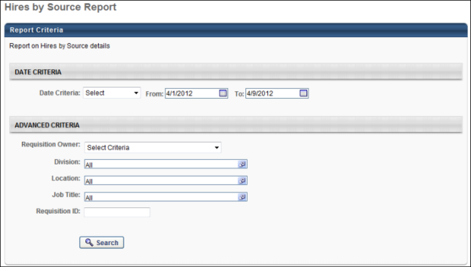
Output Summary
The source categories display on the Y-axis. If a source category has no results, then the source category does not appear on the summary. The X-axis displays the total number of applications that fall within each source category. The column increments increase as necessary to accommodate the number of applicants that fall into each source category.
The percent of total is calculated by dividing the total number of new hires that applied through the source by the total number of new hires returned in the report results.
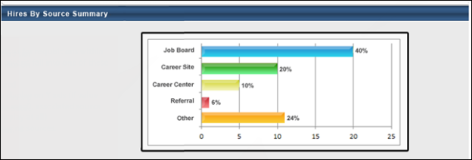
Note: A "Recruiting Agencies" bar displays in the graph the Agency Portal functionality is enabled and at least one recruiting agency is a source.
Output Details
The Hires by Source Details table is sorted by the % of Hires column, with the highest percentage displaying first. The following source data is included in the report output:
Field | Description
Source | The source through which a new hire applied for a requisition. If a source category has no results, then the source category does not appear in the Details table.  Note: If the Agency Portal functionality is enabled and a recruiting agency is a source, then "Recruiting Agency" displays as a source in the Source column. The name of the recruiting agency displays in the Details column.
Details | For Job Board and Career Site, the name of the job board or career site displays. For Career Center and Other, the cell is blank. For Referral, the email address of the referrer displays.
# of Hires | The total number of applicants hired from the source.
% of Hires | The percentage of new hires that derived from the source. The percentage is calculated by dividing the total number of new hires that applied through the source by the total number of new hires returned in the report results.
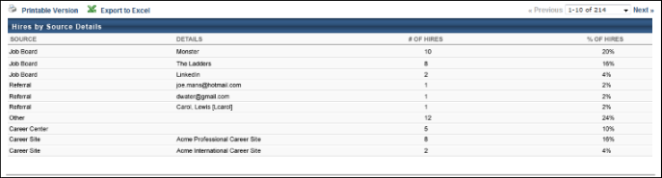

Recruiting Agency Statistics Report
The Recruiting Agency Statistics report is a new report that enables you to report on agency statistics and cost. This report enables you to track where agency costs are being spent and determine which agencies are the best performers. The information in this report can also help organizations understand and track the cost of recruiting new employees.
To access the Recruiting Agency Statistics report, go to Reports > Standard Reports > Recruitment.
Permissions
PERMISSION NAME | PERMISSION DESCRIPTION | CATEGORY

Recruiting Agency Statistics Report | Grants access to the Recruiting Agency Statistics report, which displays recruiting agency submission details. This permission cannot be constrained. | Reports - Recruiting
Criteria
Feature | Description
Date Criteria | - Date Criteria - Select the date range for the report from the drop-down list or enter specific dates in the From and To fields.  - Dates Based On - Select one of the following options on which to base the date range defined in the Date Criteria fields:  - Requisition Creation - This option returns results based on the date that the requisition was created.  - Agency Submission - This option returns results based on the date that the recruiting agency submitted the applicant.
Advanced Criteria | You can limit report output to the following:  - Requisition Owner - Select requisition owners from standard OUs.  - Division - Use the default value of "All" or select one or more Division OUs.  - Location - Use the default value of "All" or select one or more Location OUs.  - Job Title - Use the default value of "All" or select one or more Position OUs. Note: The job title criterion uses the position title defined in the Position OUs, rather than the display job title defined on the requisition.  - Requisition ID - Enter the requisition ID, which can be found on the Agency Portal - My Jobs page. Only one ID can be used, and the ID must match exactly. Note: Entering a Requisition ID supersedes all other criteria.  - Recruiting Agency - Click the plus icon to add one or more agencies. Both active and inactive agencies can be selected. If no agency is selected, then all agencies are included in the report.  - Agency User - Select the user criteria from the drop-down. Then, click the Select icon to select the users from the Select pop-up. The users available to select are users that have been defined as agency users for at least one recruiting agency. If no agency user is selected, then all agency users are included in the report.  - Applicant Status - Select one of the following options:  - Only 'Hired' status included in report - Select this option to only include submissions that have a Hired applicant status.  - All statuses included in report - Select this option to include all submissions regardless of their current status.  - Minimum days since hire - This option enables you to filter the results of submissions that have a Hired status by the number of days since they achieved a Hired status. Select a number from the drop-down, between 0 and 365. This is a required field.  Multiple values can be selected for each criterion except Requisition ID. The report only runs within the defined constraints for the user running the report. If the user's permission to run the report is not constrained, at least one criterion must be selected. If the user's permission to run the report has at least one constraint and no criterion is selected, the report is run for all available advanced criteria.
Display Options | Select one of the following options to determine how the report displays:  - Summary - Select this option to display the report in the summary output view.  - Details - Select this option to display the report in the detail output view. If selected, the following additional options are available:  - Submission Full Name - This column displays the full name of the applicant.  - Application Date - This column displays the date that the applicant completed the application. Note: This is not the date that the applicant was submitted by the recruiting agency.  - Applicant Status - This column displays the current status of the applicant at the time the report is processed.  - Hire Date - This column displays the date that the applicant's status changed to Hired.  - Days Since Hire - This column displays the number of days that have passed since the applicant's status last changed to Hired.  - Accepted as Applicant Date - This column displays the date on which the new submission received an active applicant status.  - Interviewed Date - This column displays the date of the earliest scheduled interview for the applicant. If the applicant does not have any interview sessions scheduled, then the column is blank. If the applicant does not have a scheduled interview with a date, then the column is blank in the report output. Interview credit is defined as the first time that the applicant is moved into the Scheduled Interview applicant status that is defined as the status type Interview.  - Agency Cost - This column displays the cost associated with each submission.  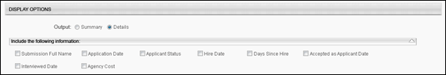
Report Title | Enter a title for the report. If a title is not entered, the report title defaults to the report name. The title appears on both the report output and in the Processed Reports list.
When the Process Report link is clicked, the report is run based on the selected criteria. The report output is stored in the Processed Reports table.
The administrator can choose the following actions and options for each report in the Processed Report table:
- Click the Excel icon to generate an Excel output of the report.
- Click the Refresh icon to refresh the report results.
- Click the View Details to view the filter criteria for the report.
- Click the Delete icon to delete the report.
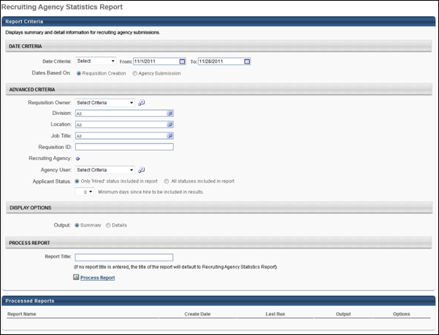
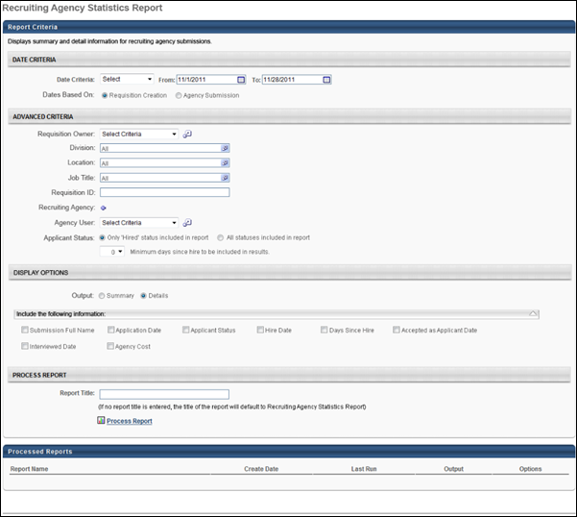
Output - Summary
The summary view of the report is an Excel table with a bar graph included.
Graph
- X Axis - This axis displays the name of the recruiting agency.
- Y Axis - This axis displays percentages, from 0 to 100 in 10 percent increments.
- Bar 1 - This bar displays the percent of accepted applicants. The percentage is calculated by dividing the total number of accepted applicants for the agency by the total number of submissions to the agency. Note: An "accepted" applicant is an applicant that has a candidate date.
- Bar 2 - This bar displays the percent of applicants interviewed. The percentage is calculated by dividing the total number of applicants interviewed for the agency by the total number of submissions to the agency. The value for total number of applicants interviewed is dependent upon completion of the Interview status. Applicants achieve completion the first time that the applicant is moved into the Scheduled Interview applicant status that is defined as the status type Interview.
- Bar 3 - This bar displays the percent of applicants hired. The percentage is calculated by dividing the total number of applicants hired for the agency by the total number of submissions to the agency.
Table
Each recruiting agency displays in a separate table. Agencies appear in the report in alphabetical order. All submissions within an agency are grouped by agency user. The following columns display:
- Agency User Full Name - This column displays the name of the agency user.
- # of Submissions - This column displays the total number of submissions per agency user.
- # of Accepted Applicants - This column displays the total number of accepted applicants per agency user.
- # of Interviewed Applicants - This column displays the total number of applicants interviewed per agency user. The value for total number of applicants interviewed is dependent upon completion of the Interview status. Applicants achieve completion the first time that the applicant is moved into the Scheduled Interview applicant status that is defined as the status type Interview.
- # Hired - This column displays the total number of applicants hired per agency user.
- Submission to Hired Rate - This column displays the hired ratio. The ratio is calculated per agency user by dividing the total number of applicants hired by the total number of applicants submitted.
- Agency Cost - This column displays the total agency cost per agency user.
- Total - This row displays the totals for each column.
- Grand Total - This row displays the totals for all of the agencies included in the report.
Note: The information that displays in the report is the information that meets the report criteria.
Report Criteria
The Report Criteria section displays the criteria values configured for the report.
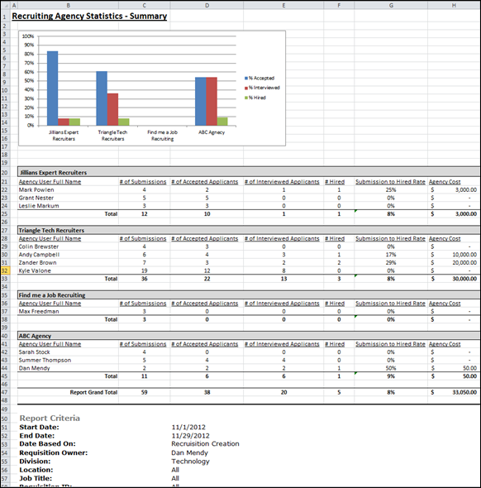
Output - Details
The details view of the report is an Excel table that displays the columns selected in the Display Options section when configuring the report. If Agency Cost is selected in the Display Options section, then the following associated columns appear:
- Agency Cost Total - This column displays the total agency cost for the submission.
- Agency Cost for Submission - This column displays the agency cost of each submission.
- Agency Cost for Interview - This column displays the agency cost per interview.
- Agency Cost for Salary Flat Rate - This column displays the agency cost per salary hire flat rate.
- Agency Cost for Salary Percentage - This column displays the agency cost per salary percentage.
- Agency Cost for Hourly Flat Rate - This column displays the agency cost per hourly flat rate.
- Agency Cost for Hourly Percentage - This column displays the agency cost per hourly percentage.
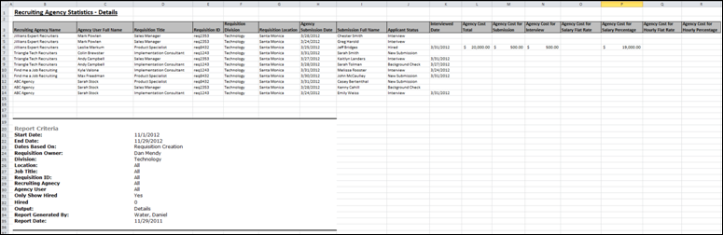

Referral Statistics Report
The Referral Statistics Report enables you to view and compare referrers and their referral statistics. Essentially, the report allows you to ascertain the success of referrals by employee. You can view the number of referrals that an employee has made and if they qualify for a referral bonus.
Permissions
PERMISSION NAME | PERMISSION DESCRIPTION | CATEGORY

Referral Statistics Report | Grants access to Referral Statistics report, which displays summary or detailed information on referrals by users and whether a bonus is owed on referrals. | Reports - Recruiting
Criteria
Feature | Description
Date Criteria | Select the date range for the report from the drop-down list or enter specific dates in the From and To fields.
Advanced Criteria | You can limit report output to the following:  - Requisition Owner - Select requisition owners from standard OUs.  - Division - Use the default value of "All" or select one or more Division OUs.  - Location - Use the default value of "All" or select one or more Location OUs.  - Job Title - Use the default value of "All" or select one or more Position OUs. Note: The job title criterion uses the position title defined in the Position OUs, rather than the display job title defined on the requisition.  - Requisition ID - Enter the requisition ID, which can be found on the Manage Job Requisitions page. Only one ID can be used, and the ID must match exactly. Note: Entering a Requisition ID supersedes all other criteria.  - Requisition Referrer - Select one or more OU criteria for the referrer.  Multiple values can be selected for each criterion except Requisition ID. The report only runs within the defined constraints for the user running the report. If the user's permission to run the report is not constrained, at least one criterion must be selected. If the user's permission to run the report has at least one constraint and no criterion is selected, the report is run for all available advanced criteria.
Display Options | The report must be filtered by at least one of the following values:  - Referrer Name - The full name of the employee who made the referral.  - Requisition Referred - The requisition that the employee referred.  - Requisition ID - The requisition ID of the position that the employee referred.  - Requisition Division - The division of the position that the employee referred.  - Requisition Location - The location of the position that the employee referred.  - Referral Name - The name of the applicant who submitted a referral.  - Referral Method - The method the employee used to refer the job. The following are the only possible referral method values:  - Referral-Facebook  - Referral-LinkedIn  - Referral-Email  - Referral-Search Network  - Referral-Suggested  - Referral-Other  - Date Applied - The date the referral applicant submitted an application for the position.  - Applicant Status - The current status of the applicant on the day the report is processed.  - Hire Date - The day (MM/DD/YYYY) that the applicant's status changed to Hired.  - Days Since Hire - If the applicant status is Hired, this value shows the number of days that have passed since the status was last changed to Hired.  - Bonus Amount - If applicable, this value shows the bonus amount and currency associated with the requisition.  Each value selected displays in its own column on the report.
Report Title | Enter a title for the report. If no title is entered, the report title defaults to the report name. The title appears on both the report output and in the Processed Reports list.
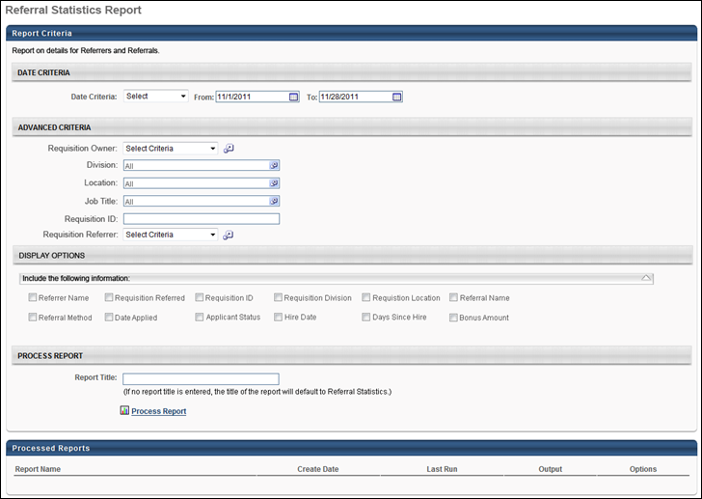
Output
The summary view of the report is an Excel table that shows referral statistics by employee. Details about the specific requisitions or applicants that were referred does not display in the summary view.
The following columns appear as the last three columns on the report:
- Number of Existing Referrals - The total number of referral applications that are credited to the employee. Applicants that have a Hired status are included.
- Number of Hired Referrals - The total number of referral applications that are credited to the employee and that currently have an applicant status of Hired.
- Referral Success Rate - The percentage of referrals that resulted in a hire. The referral success rate is calculated by dividing the total number of hired referrals by the total number of existing referrals.
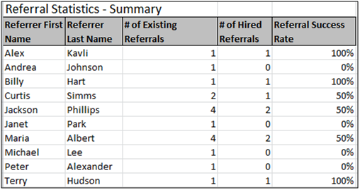
The details view is also an Excel table and shows referral statistics for each requisition that is referred.
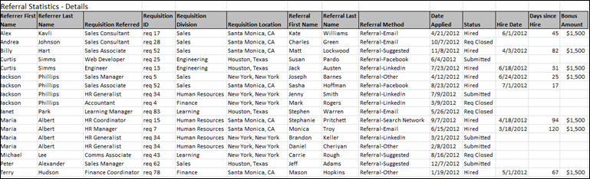
Printable Version Output
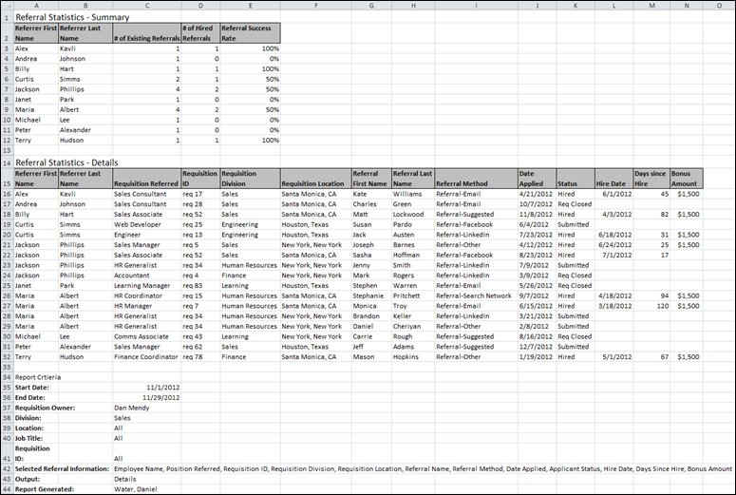

Requisition Details Report
The Requisition Details Report enables you to report on the requisitions in your portal. Applicant details can be included, such as name, contact information, and status. Position OU custom fields can also be included, if configured in Requisition and Applicant Preferences.
To access the Requisition Details Report, go to Standard Reports > Recruitment.
Permissions
PERMISSION NAME | PERMISSION DESCRIPTION | CATEGORY

Requisition Details Report | Grants access to the Requisition Details report, which displays details of requisitions in the portal. This permission cannot be constrained. | Reports - Recruiting
Criteria
Feature | Description
Date Criteria | Select the date range for the report from the drop-down list or enter specific dates in the From and To fields.
Advanced Criteria | Limit report output to the following:  - Requisition Owner - Select requisition owners from standard OUs.  - Division - Use the default value of "All" or select one or more Division OUs.  - Location - Use the default value of "All" or select one or more Location OUs.  - Job Title - Use the default value of "All" or select one or more Position OUs. Note: The job title criterion does not use the display job title defined on the requisition.  - Requisition ID - Enter the requisition ID, which can be found on the Manage Job Requisitions page. Only one ID can be used, and the ID must match exactly. Note: Entering a Requisition ID supersedes all other criteria.  Multiple values can be selected for each criterion except Requisition ID.
Display Options - Include Custom Fields | All custom Position OU fields for which you have availability display. Check the box for each custom OU to include in the report. All boxes are unchecked by default, and the section is expanded by default. On the report output, custom fields appear as the last columns, with each custom field in a separate column. Note: Custom fields only display if configured in Requisition Preferences; they appear on the Requisition Details Report page in the order in which they are configured in Requisition Preferences.
Display Options - Include Submission Information | The following applicant information can be included:  - Full Name - The applicant's first and last name.  - Email Address - The applicant's email address.  - Phone Number - The applicant's phone number.  - Source - The source through which the applicant applied.  - Applicant Status - The most recent status of the applicant.  - Application Date - The date on which the application was submitted.  - Time to Fill - Time to Fill is calculated based on a requisition to be filled. The formula for the calculation is as follows:  Time to Fill = [Fill Date] – [Date Requisition Status Changes to Open] – [Days Requisition Is on Hold]  Once all the openings are filled for the requisition, then the system updates time to fill value.  - Time to Offer - This field displays the number of days from the date on which a requisition is posted to the date on which the first offer is extended to a candidate for the requisition. The following calculation is used to determine the value for the field:  Time to Offer = [Date First Offer Extended to Candidate] - [Date Requisition Status Changes to Open] - [Days Requisition Is on Hold]  - Qualified Applicant - Select this option to include applicants that have a candidate date. This field appears as a separate column on the report.  All boxes are unchecked by default, and the section is expanded by default. On the report output, each criterion appears in a separate column.  In the Group By field, the No Grouping radio button is selected by default and displays all requisitions on the report in alphabetical order by job title. Select the Requisition Division radio button to group the report output by the division configured for the requisition. Divisions are listed on the report in alphabetical order, and then each requisition appears below in alphabetical order.
Report Title | Enter a title for the report. If no title is entered, the report title defaults to the report name. The title appears on both the report output and in the Processed Reports list.
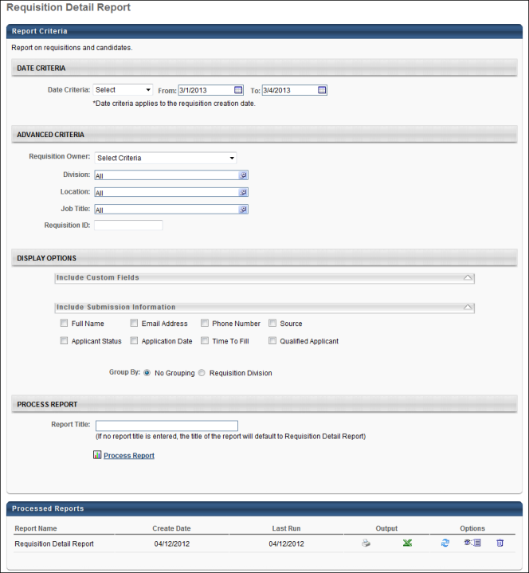
Output Grouped by None
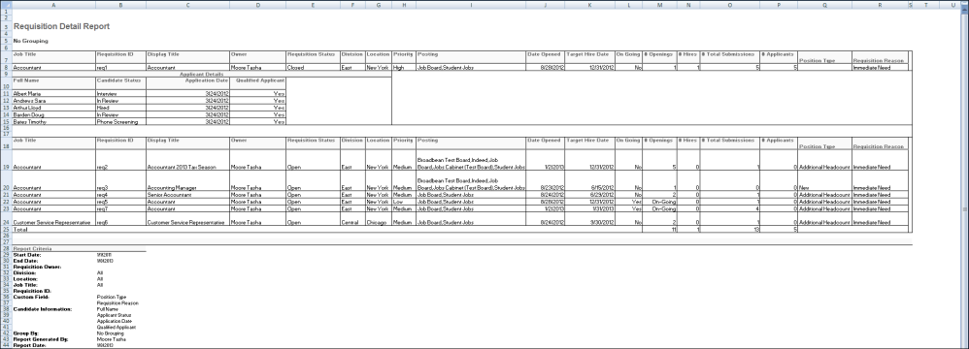
Output Grouped by Division
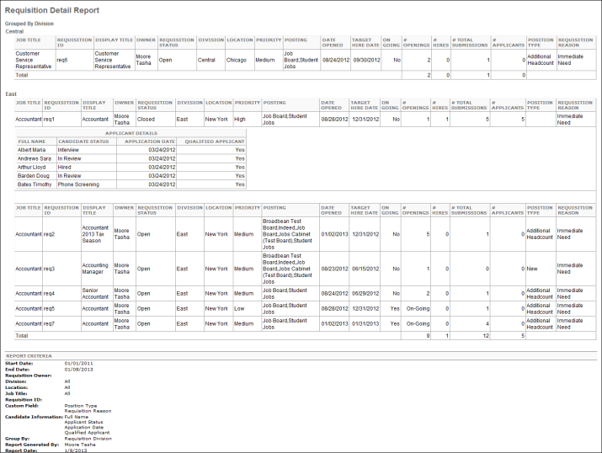

Saved Applicant Searches Report
The Saved Applicant Searches report enables you to report on saved applicant searches.
To access the Saved Applicant Searches report, go to Standard Reports > Recruitment.
Permissions
PERMISSION NAME | PERMISSION DESCRIPTION | CATEGORY

Saved Applicant Searches Report | Grants access to the Saved Applicant Searches report, which displays saved applicant search details. | Reports - Recruiting
Criteria
Feature | Description
Date Criteria | Select the date range for the report from the drop-down list or enter specific dates in the From and To fields.
Advanced Criteria | Limit report output to the following:  - Search User - This field reports the user that conducted the search. Click the Select icon to open the Select User pop-up and select a user.  - Search Reason - This field enables you to select a search reason.  - Specific Requisition - Select this option to choose the specific requisition that was used in the search. When selected, the Specific Requisition field appears below.  - Specific Requisition - Select a requisition by clicking the Select icon and then choosing a requisition from the pop-up.  - Other - Select Other to include the value entered by the searcher in the Other field on the Reason for Search pop-up. When selected, the Other field appears below. Enter a value in the Other field. Both full and partial values are accepted.
Once all criteria are configured, click Search. The report results display in the Saved Searches Summary panel. The report can be viewed as a printable version and can be exported to Excel.
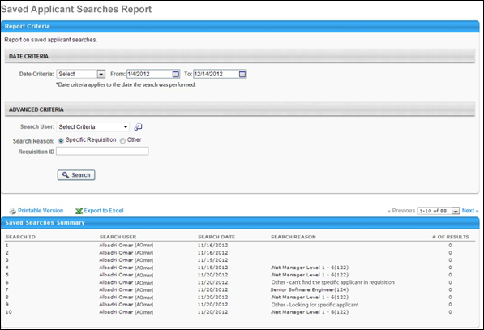
Saved Searches Summary
The following information displays in the Saved Searches Summary table.
Column Name | Description
Search ID | This column displays the unique ID associated with each search. Note: The Search ID is generated when the search is conducted in Search Candidates.
Search User | This column displays the user who conducted the search.
Search Date | This column displays the date on which the search was conducted. This column determines the sort order. The results are sorted by most to least recent.
Search Reason | This column displays the reason specified for executing the search. If the Specific Requisition option was selected when configuring the report, then the column displays the requisition display name and ID. If the Other option was selected, then the column displays "Other - [reason for search]."  Note: If a reason was not required to be selected for the search, then the column displays "Not Available."
Number of Results | This column displays the number of results that were included in the search results.

Scheduled Interviews Report
The Scheduled Interviews report enables you to report on all interviews by date, interviewer, location, and applicant. The report can serve as a complete interview schedule by displaying important scheduling information for recruiters and other users.
Use Case
An organization's front desk personnel would like to view the day's interview schedule. They create a Scheduled Interviews report so that they can plan the interview rooms and ensure that they know when to contact interviewers to inform them that the applicant has arrived.
Note: Live Video, On Demand Video, and Phone interview types are always included in the output. These interview types cannot be filtered out of the report.
To access the Scheduled Interviews report, go to Standard Reports > Recruitment.
Permissions
PERMISSION NAME | PERMISSION DESCRIPTION | CATEGORY

Scheduled Interviews Report | Grants access to the Scheduled Interviews report, which displays scheduled interviews by date, interviewer, location or applicant. This permission cannot be constrained. | Reports - Recruiting
Criteria
Feature | Description
Date Criteria | The Interview Date field allows you to define the interview date on which you would like to report. The report can only be run for one interview date at a time. The default value is the current date. Enter a date in the field or select a date using the calendar feature. This field is required.
Advanced Criteria | Limit report output to the following:  - Interviewer(s) - Click the Select icon to select one or more interviewers to include in the output. This opens the Select User pop-up. Select the interviewers, and then click Done. This adds the interviewers to the filter. Note: The interviewer must be defined as an interviewer for at least one requisition in order to appear in the output.  - Interview Location(s) - Click the Select icon to select one or more locations. This opens the Select Location pop-up. Select the locations, and then click Done. This adds the locations to the filter. If a location has child locations, then all child locations are included.  - Applicant(s) - Click the Select icon to select one or more internal or external applicants to include in the output. This opens the Select User pop-up. Select the applicants, and then click Done. This adds the applicants to the filter.  Multiple values can be selected for each criterion. The Advanced Criteria fields are not required.
Report Title | Enter a title for the report. If no title is entered, the report title defaults to the report name. The title appears on both the report output and in the Processed Reports list.
When the Process Report link is clicked, the report is run based on the selected criteria. The report output is stored in the Processed Reports table.
The administrator can choose the following actions and options for each report in the Processed Report table:
- Click the Print icon to generate a printable version of the report. Note: Excel output is not available for this report.
- Click the Refresh icon to refresh the report results.
- Click the View Details icon to view the filter criteria for the report.
- Click the Delete icon to delete the report.
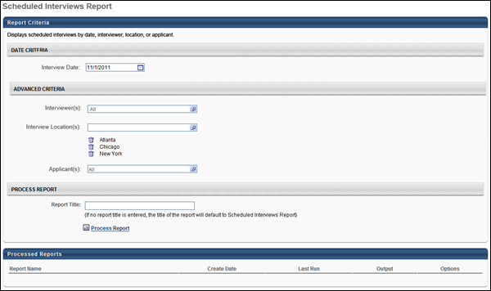
Output
The following information displays in the output:
- Interview Scheduled Date - This displays the date selected in the Interview Date field.
- Time - This column displays the interview start and end time. The time zone for the interview displays in parentheses to the right of the time. The time displays in the time zone of the report creator. This column defines the sort order, from earliest to latest start time.
- Applicant - This column displays the full name of the applicant, requisition title, requisition ID, and applicant phone number.
- Interviewer(s) - This column displays the full name, position title, and phone number for each interviewer. If there are multiple interviewers for the same interview session, then the interviewers are listed in the order in which they are defined on the Interview Scheduler page.
- Location - This column displays the location of the interview. The information that displays is dependent upon the interview type:
  - In Person - Physical location of interview
  - Phone - Phone number for interview
  - Live Video - "Live Video Interview" (Note: This displays for both Live Video interviews and On Demand Video interviews.)
  - Virtual - "Virtual Interview".
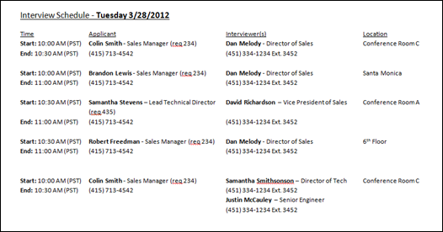

Succession Reports
Recommended Reports
A complete list of recommended reports for managers, learning, performance, and succession is available in the OnDemand Support folder:
- See Recommended Standard Reports for Managers for additional information.
- See Recommended Standard Reports - Learning for additional information.
- See Recommended Standard Reports - Performance for additional information.
- See Recommended Standard Reports - Succession for additional information.

Job Pool Task Report
The SMP Job Pool report enables administrators to view detailed incumbent, position, and successor information from a SMP Job Pool task. This report only returns data from job pool tasks that are in an In Progress, Completed, or Expired status.
To run the Job Pool Task Report, go to Reports > Standard Reports. Then click the Succession tab and click the Job Pool Task Report link.
Permissions
PERMISSION NAME | PERMISSION DESCRIPTION | CATEGORY

Job Pool Task Report | Grants access to Job Pool Task report, which enables administrators to view detailed incumbent and successor information from a SMP Job Pool task. This permission can be constrained by OU, User's OU, User Self and Subordinates, and User. The permission constraints determine which users are available within the report. | Reports - Talent/Succession
Criteria
General
Filter | Description
Task | This field enables administrators to select a specific job pool task or use the most recent task. This is a required field.  - Most Recent Task - This option is selected by default. This option provides the most recent position, incumbent, or successor data that is available.  - Select a Task - To select a specific task, click the Select icon . The task must be in the In Progress, Completed, or Expired status.
User Criteria | Select a user or a group of users that may be included in the report. This criterion applies to both incumbents and successors for the job pool task. You may choose one or more individual users, OUs, and groups. Note: The Position OU type is not available for this criterion. If permission for this report is constrained, those constraints apply to user criteria selection when running the report. This field is required unless a specific task is selected in the Task field.
Position Criteria
Filter | Description
Positions | This field enables administrators to select which positions are included in the report. To select one or more positions, click the Select icon  . This field is required unless a specific task is selected in the Task field. This field is disabled if a specific task is selected in the Task field because the positions are defined in the selected task.
Select Position Custom Fields | This field enables administrators to include position custom fields in the report. Click the Expand arrow to view the available custom fields. A maximum of 30 custom fields and metrics can be selected.  - If a specific task has not been selected in the Task field, then all position custom fields that are available to the user are available in this panel.  - If a specific task has been selected in the Task field, then all position custom fields that are included in the selected task and available to the user are available in this panel.
Select Position SMP Metrics - Current Ratings | This field enables administrators to include position SMP ratings in the report. These position ratings will always come from the most recent SMP task. Click the Expand arrow  to view the available ratings. A maximum of 30 custom fields and metrics can be selected. All SMP metric fields that are available to the user are displayed.
Select Position SMP Metrics - SMP Task | This field enables administrators to include SMP metrics that are associated with the Position Details section from the selected task and available to the user. Click the Expand arrow  to view the available ratings. A maximum of 30 custom fields and metrics can be selected. This field is only available if a specific task is selected in the Task field.
Incumbent Criteria
Filter | Description
Additional Incumbent OU | From the drop-down, select an additional OU to display in the report. The incumbent's current position is automatically displayed in the report.
Include Incumbent User Name(s) | Select this option to include the incumbent user names for each position. As a best practice, this option should be selected for organizations that have multiple successors per position and want to filter reporting results by potential successor.
Select Incumbent User Custom Fields | This field enables administrators to include incumbent user custom fields in the report. Click the Expand arrow  to view the available custom fields. A maximum of 30 custom fields and metrics can be selected.  - If a specific task has not been selected in the Task field, then all incumbent user custom fields that are available to the user are available in this panel.  - If a specific task has been selected in the Task field, then all incumbent user custom fields that are included in the selected task and available to the user are available in this panel.
Select Incumbent SMP Metrics - Current Ratings | This field enables administrators to include incumbent SMP ratings in the report. These are the most recent SMP ratings for the incumbent. Click the Expand arrow  to view the available ratings. A maximum of 30 custom fields and metrics can be selected. All SMP metric fields that are available to the user are displayed.
Select Incumbent SMP Metrics - SMP Task | This field enables administrators to include SMP metrics that are associated with the Incumbent Details section from the selected task and available to the user. Click the Expand arrow  to view the available custom fields. A maximum of 30 custom fields and metrics can be selected. This field is only available if a specific task is selected in the Task field.
Successor Criteria
Filter | Description
Additional Successor OU | From the drop-down, select an additional OU to display for each successor in the report. The successor's current position is automatically displayed in the report.
Select Successor User Custom Fields | This field enables administrators to include successor user custom fields in the report. Click the Expand arrow  to view the available custom fields. A maximum of 30 custom fields and metrics can be selected.  - If a specific task has not been selected in the Task field, then all successor user custom fields that are available to the user are available in this panel.  - If a specific task has been selected in the Task field, then all successor user custom fields that are included in the selected task and available to the user are available in this panel.
Select Successor SMP Metrics - Current Ratings | This field enables administrators to include successor SMP ratings in the report. These are the most recent SMP ratings for the successor. Click the Expand arrow  to view the available ratings. A maximum of 30 custom fields and metrics can be selected. All SMP metric fields that are available to the user are displayed.
Select Successor SMP Metrics - SMP Task | This field enables administrators to include SMP metrics that are associated with the Successor Details section from the selected task and available to the user. This field returns a value only if the successor was rated on the selected metric in the Succession Chart step of the selected job pool task. Any ratings from the Profile or Batch Rating step do not apply because they do not relate to the user as a named successor. Click the Expand arrow  to view the available ratings. A maximum of 30 custom fields and metrics can be selected. This field is only available if a specific task is selected in the Task field.
Process Report
Criteria | Description
Report Title | Enter a title for the report, up to 50 characters. This defaults to "Job Pool Task Report" if no title is entered. The title is displayed on the report and is also displayed in the list of Processed Reports on this page.
This is an asynchronous report, which allows the administrator to define the standard report and generate the report asynchronously. As a result, when administrators process the report, the system generates the report in the background, while the administrator can move on to other areas of the system. When the report is finished processing, the administrator can then view the full report in its entirety.
- Up to three separate reports can generate asynchronously, allowing greater flexibility for creating and storing different versions of the report.
- If you process a report or refresh a stored report, the report appears in the table as Queued.
- The most recently created report displays at the top of the table.
- Since the user can generate up to three reports, the administrator can define a report title for each of the generated reports.
- Clicking the View Details icon changes the report settings on the page to match those of the selected previously run report.
When the Process Report link is clicked, the report is run based on the selected criteria. The report output is stored in the Processed Reports table.
The administrator can choose the following actions and options for each report in the Processed Report table:
- Click the Excel icon to download the report in an Excel file.
- Click the Refresh icon to refresh the report results.
- Click the View Details icon to view the filter criteria for the report.
- Click the Delete icon to delete the report.
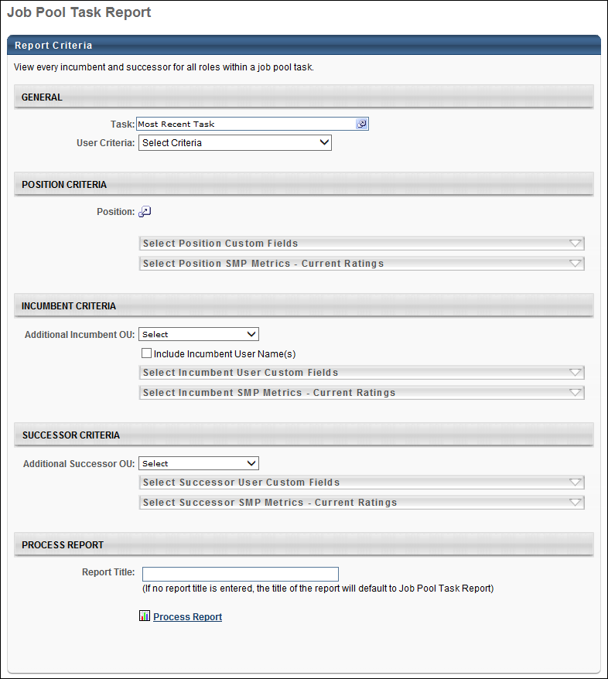
Output
In the output, the position data appears on the left. This includes any custom fields applied to the position.
Incumbent data appears to the right of the position data. If included, the Incumbent Full Name(s) column contains a comma separated list of the incumbent user full names for each successor.
Successor data appears to the right of the incumbent data. Successor data does not repeat within the same position.

Resume and Career Preferences Report
Allows reporting on a single or multiple users' resume and Career Preferences information and is an asynchronous report.
To access the Resume and Career Preferences Report, go to Reports > Standard Reports > Succession. Then, click the Resume and Career Preferences link.
Permissions
PERMISSION NAME | PERMISSION DESCRIPTION | CATEGORY

Resume and Career Preferences Report | Grants access to Resume and Career Preferences PDF Report, for 1-100 users at a time. | Reports - Talent/Succession
Filters
- User Criteria - Limit report output to the users matching the specified user criteria.
  - The report will only run within the defined constraints for the user running the report.
  - This is the standard OU availability selection criteria drop-down. Choose from available OU types.
  - Defaults: If no User Criteria are selected, then the report will run for the entire available population.
- User Status - Check to include inactive users.
- Preferences Division - Choose a preference to base preference settings off of for Resume sections and Career Preference questions.
- Report Title - Enter a report title.
Report Settings
This is an asynchronous report, which allows the administrator to define the standard report and generate the report asynchronously. As a result, when administrators process the report, the system generates the report in the background, while the administrator can move on to other areas of the system. When the report is finished processing, the administrator can then view the full report in its entirety.
- Up to three separate reports can generate asynchronously, allowing greater flexibility for creating and storing different versions of the report.
- If you process a report or refresh a stored report, the report appears in the table as Queued.
- The most recently created report displays at the top of the table.
- Since the user can generate up to three reports, the administrator can define a report title for each of the generated reports.
- Clicking the View Details icon changes the report settings on the page to match those of the selected previously run report.
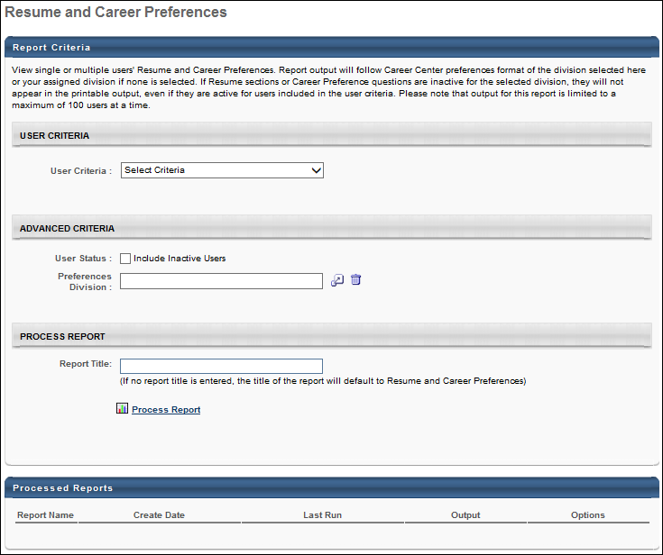
Output
- Click the link to view the results as a pdf.
- The Report output follows Career Center preferences format of the division selected in the Preferences Division filter or runs off of the user who is running the report's assigned division if none is selected. If Resume sections or Career Preference questions are inactive for the selected division, they will not appear in the PDF output, even if they are active for users included in the user criteria.
- After the report is processed you can:
  - Update the data on the report, click the Refresh icon .
  - View the details on the report, click on the Details icon .
  - Delete the report, click on the Delete icon .
For portals with Universal Profile enabled, the Resume and Career Preferences Report output reflects the layout and appearance of the Resume and Career Preferences tabs in Universal Profile. The following applies to the report output:
- The report is only available as a .pdf file type.
- All users included in the report display in a single report output. The output does not display each user's resume as a separate report.
- The report is sorted by user. The Resume page displays first, and then the Career Preferences information displays after the resume.
- The report displays all information that is visible on the read-only view of the Resume tab in Universal Profile.
- If a resume section has not been completed by the user, then the section displays "[Section.Name] not specified."
- If a career preferences question has not been completed by the user, then the question section displays "No information provided."
- A Footer displays on each page, displaying the user's name and "Last Modified By: [User's Name, Date]."

Resume Section Details Report
This report allows reporting on a designated Resume section and its corresponding fields, of the Resume.
Permissions
PERMISSION NAME | PERMISSION DESCRIPTION | CATEGORY

Resume Section Details Report | Grants access to Resume Section Details Report, which allows reporting on a designated Resume section and its corresponding fields, of the Resume. | Reports - Talent/Succession
Filters
- User Criteria - limit report output to the users matching the specified user criteria
  - The report will only run within the defined constraints for the user running the report
  - This is the standard OU availability selection criteria drop-down. Choose from available OU types
  - Defaults: If no User Criteria are selected then the report will run for the entire available population
- Resume Section (required field) - all Resume sections, static and custom, available and defined by administrator in Admin Resume page, will display in drop-down menu except attachment section. All available field names for selected section will appear, both static and custom.
- User Status - check to include inactive users
- Display OU - check to Include OU Information and select Organizational Unit from drop-down list
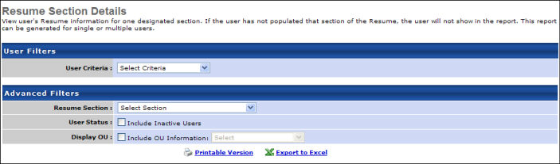
Output
- Printable Version link to view the results in a web page, or Export to Excel link to save/open as an Excel file
- As the report description notes, if a user has not populated the selected section or that section is inactivated for the user, they will not show in the report. If a user has not populated a field within the section, N/A will appear.
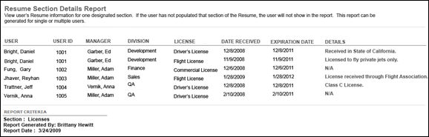

SMP External Candidate Report
This report displays the external candidates added as successors for a specific SMP task. SMP task data is available for this report as soon as the corresponding SMP task is saved.
Permissions
PERMISSION NAME | PERMISSION DESCRIPTION | CATEGORY

SMP External Candidate Report | Grants access to SMP External Candidate Report, which displays the external candidates added as successors for a specific SMP task. This permission cannot be constrained. | Reports - Talent/Succession
Filters
- Task - select specific SMP task (required field)
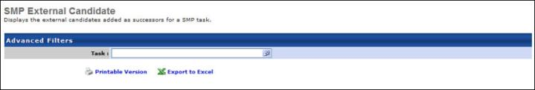
Output
- link to view the results in a web page, or link to save/open as an Excel file
The output will display the information about each external candidate that is entered when an external candidate is added as a successor in the SMP task.
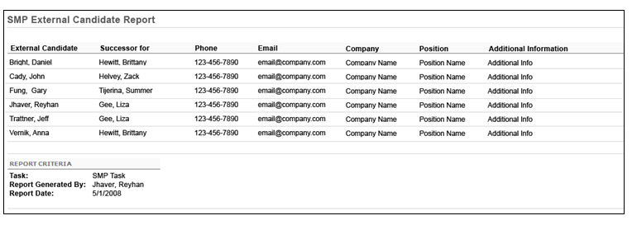

SMP Metric Grid Report
This report displays the grid rating of users on a metric grid. Grid ratings can be pulled in from a specific SMP task for a metric grid. SMP task data is available for this report as soon as the corresponding SMP task is saved. Calibration allows you to move employees on the metric grid from cell to cell using drag and drop.
Permissions
PERMISSION NAME | PERMISSION DESCRIPTION | CATEGORY

SMP Metric Grid - Calibration | Allows for calibration on the SMP Metric Grid report (ability to move users from one grid position to another and save the changes to the related SMP task). This permission works in conjunction with the SMP Metric Grid Report permission; user must have both permissions in order to enable calibration access to the metric grid report. This is an administrator permission. | Reports - Talent/Succession

SMP Metric Grid Report | Grants access to SMP Metric Grid report, which displays the grid rating of users on an SMP metric grid. Report can be run for most recent grid rating across multiple SMP tasks, or from a specific SMP task. This permission can be constrained by OU, User's OU, User's Direct Reports, User Self and Subordinates, and User. The permission constraints determine which users are available within the report. Note: If the user's permission is also constrained by User Self and Subordinates, then this overrides the User's Direct Reports constraint. | Reports - Talent/Succession
Filters
- User Criteria (required field) - Limit report output to the users matching the specified user criteria.
  - The report will only run within the defined constraints for the user running the report.
  - This is the standard OU availability selection criteria drop-down. Choose from available OU types.
  - Defaults: If no User Criteria are selected then the report will run for the entire available population.
- Select SMP Task (required field) - Select the appropriate SMP task or select "Most Recent Grid Rating."
  - Most Recent Grid Rating - This option is selected by default. When this option is selected, the report includes the most recent grid rating for each user included in the report. Calibration functionality is not available if the report is pulling in most recent grid ratings.
    - If the employee's metric ratings or grid placements were most recently updated via My Team or Helicopter View, the employee appears on the grid based upon their My Team metric ratings and Helicopter View grid placements.
    - If the employee's metric ratings or grid placements were most recently updated via a completed SMP task, the employee appears on the grid based upon their metric ratings and grid placements from the corresponding SMP task. If an SMP task is not complete, then the grid rating does not pull in from that task.
  - SMP Task - Click the Select SMP Task field to select a specific SMP Task. This includes only data from the selected task in the report. Only one SMP Task can be chosen. If you have the calibration permission, then calibration functionality is available on the report. The selected task does not have to be completed.
- Select Metric (required field) - Select SMP metric. Only one SMP Metric can be chosen.
- Gender - Filter by Male, Female or All (if Gender is a field in the user record, otherwise defaults to All).
- Ethnicity - Filter by Ethnicity or All (if Ethnicity is a field in the user record, otherwise defaults to All).
- User Status - Select this option to include inactive users in the report. This option is useful when viewing the most recent grid rating data, which can span multiple years of tasks, resulting in high numbers of employees who may have been assessed but are no longer active employees.
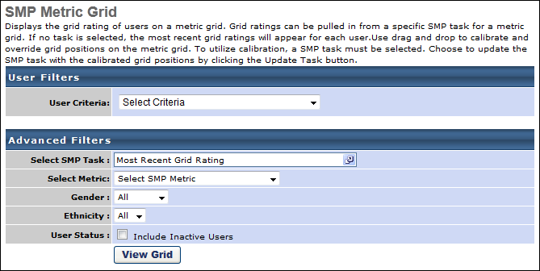
Output
- View Grid - click on the view grid button to view the grid on the screen. The grid displays all users within the selected user criteria for the report. The grid displays anywhere from a 4 box to a 25 box grid based on the metric grid field definition. If the option to display axis labels is unchecked for the metric grid, then the axis labels will not appear. Cell labels, color codes, row and column labels will appear based on the metric grid custom field.
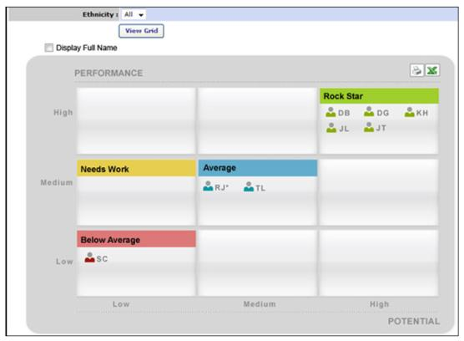
If a SMP task is selected, each user will appear on the grid based their grid position defined within the selected SMP task. If the user's grid position was overridden, then the user will appear in the overridden grid position with an asterisk from the selected task.
If a SMP task is not selected, then each user in the report criteria will be placed on the grid based on their grid position from the most recent completed SMP task for the selected metric grid. If on the most recent completed SMP task the user's grid position was overridden, then an asterisk will display. Only the employee's initials will display by default. An option will be available to display each employee in the grid by their full name.
If checked, then the employee's full name will appear instead of their initials. Each employee will appear on a separate line within the box.
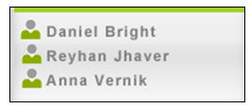
If there are more employees listed than the size of the box allows, use the vertical scroll bar to navigate. You can mouseover each initial to see a popup information box about the employee.
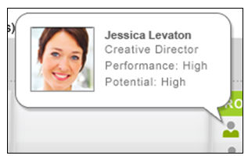
If you have the Calibration permission, then you can use drag and drop to move employees around on the metric grid. A SMP task must be selected in order to use calibration. If you do not have the calibration permission and the report does not have a selected SMP task, then drag and drop will be disabled. If employees are moved, then an asterisk will appear indicating the grid position has changed. If the employee was already moved on the grid within the task, the employee can still be moved on the report. To apply grid changes, click the Update Task button.
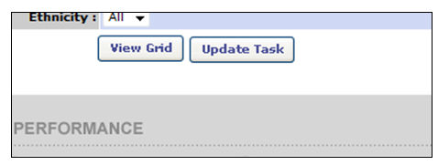
When the update task button is clicked, a popup will appear confirming to the user that they want to update the task with the new grid positions. If the user clicks continue, the task will be updated with the new grid positions.
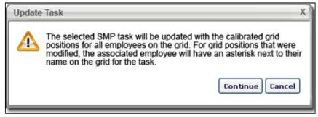
This update will only update employees that were moved on the report. An asterisk will appear next to their name on the grid in the task. If the task contains an individual metric grid and the general metric grid, the employee's new grid position will appear in both locations within the task with an asterisk. This new grid position will be the employee's reportable grid position on the SMP Metric Ratings report and analytics. The grid can be exported to HTML or excel by clicking on the output buttons on the grid. If calibration is used and employees are moved to different cells on the grid, these new grid positions will appear on the printable versions of the metric grid. The employee's full name will appear in the print out.
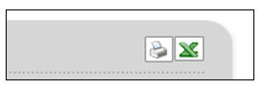
For calibration, an audit trail will be available when grid positions are calibrated on the report and the task is updated. This audit trail will be available within task details for the SMP task. This audit trail will only appear if the user has the calibration permission. If the user does not have the calibration permission, then this link will not appear the task details page for the SMP task.
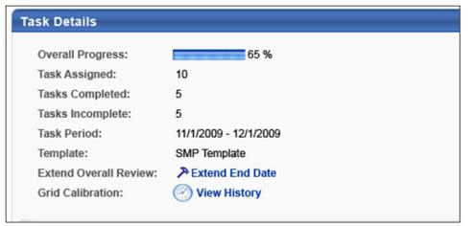
View History link - click to view the history of calibrations for the task. You will see all grid modifications from the report. This audit trail will only record calibrations that are done within the SMP Metric Grid Report and not calibrations that are done by the task assignee within the task.
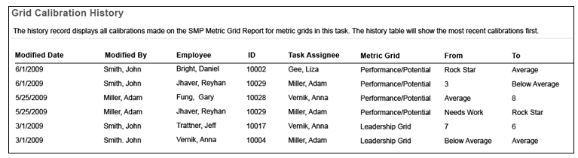
The From and To data will be captures when the Task Update button is clicked on the report. An entry will be made in this audit table for each employee that has their grid position modified on the report and the task is updated. If an employee has their grid position modified more than once, then an entry will appear for each time the employee's grid position is modified.

SMP PowerPoint Template Report Overview
The SMP PowerPoint Template enables administrators to create custom PowerPoint templates with which to report on incumbents for an SMP task. SMP task data is available for this report as soon as the corresponding SMP task is saved. Currently, the SMP PowerPoint Template Report can be used with Manager and Assessor SMP tasks, but cannot be used with the Job Pool task type. Up to 150 employees can be included in a report. External or unknown successors are not displayed in this report.
You can view the available SMP PowerPoint Tag by clicking the View Tags link in the upper-left corner. See Create PowerPoint Template - Inserting Tags for additional information.
Note: You must create the PowerPoint templates prior to running the report.
Note: This report is not compatible with the Job Pool task type.
To run the SMP PowerPoint Template Report, go to Reports > Standard Reports. Then click the Succession tab and click the SMP PowerPoint Template link. To manage tags for specific fields for use in the SMP PowerPoint Profile Report, you must have the appropriate permissions.
Permissions
PERMISSION NAME | PERMISSION DESCRIPTION | CATEGORY

SMP PowerPoint Report Preferences | Enables administrators to manage templates and tags for specific fields for use in the SMP PowerPoint Template report. This is an administrator permission. | Talent/Succession - Administration

SMP PowerPoint Template Report | Grants ability to create custom PowerPoint templates with which to report on incumbents for an SMP task. This permission can be constrained by OU, User's OU, User Self and Subordinates, and User. This is an administrator permission. | Reports - Talent/Succession
Criteria
Filter Name | Description
User Criteria | Select the users for whom the report is run. Up to 150 profiles can be created.
Succession Task | Select the SMP tasks to include in the report. This report does not return results for job pool template tasks. Note: If the selected succession task does not contain a Profile step, then a Profile template will contain no data.
Competency Task | Select the competency tasks to include in the report. This report includes data from standalone competency tasks or competency assessments inside Succession tasks. Specific competencies from within the task include the scores, not just the over all score of a competency assessment. Notes: You can only enable one competency task per Succession PowerPoint Template. The competency name and the score the user received are returned from a single tag, so users are unable to separate these values in the new templates.
User Status | Select this option to include inactive users in the report output. This option is unselected by default, so inactive users are excluded from the report output by default.
Type | Select the type of template you are uploading. This can be Profile, Grid, or Succession. Your selection determines the type of output that is produced from the report. If Profile is selected, the report produces profiles in PowerPoint. If Grid is selected, the report produces the employees on a metric grid in PowerPoint. If Succession is selected, the report produces the employees on a succession plan in PowerPoint.
Template | Click the Upload Template link to upload your PowerPoint template. This option is not available until the task is selected. This template must be created prior to running the report and the type of template that is uploaded must match the template type selected above.  After the template is selected, the system immediately validates the template to ensure there are no critical errors. If there are no errors, you may process the report. If errors are found, they must be corrected before processing the report. Click the Invalid Template link to view the errors. After resolving issues, click the Upload Template link again to re-upload the template.
Report Title | Enter a title for the report. This defaults to the report name if no title is entered. The title is displayed on the report and is also displayed in the list of Processed Reports on this page.
Report Settings
This is an asynchronous report, which allows the administrator to define the standard report and generate the report asynchronously. As a result, when administrators process the report, the system generates the report in the background, while the administrator can move on to other areas of the system. When the report is finished processing, the administrator can then view the full report in its entirety.
- Up to 10 separate reports can generate asynchronously, allowing greater flexibility for creating and storing different versions of the report.
- If you process a report or refresh a stored report, the report appears in the table as Queued.
- The most recently created report displays at the top of the table.
- Since the user can generate up to 10 reports, the administrator can define a report title for each of the generated reports.
- Clicking the View Details icon changes the report settings on the page to match those of the selected previously run report.
Output
The output of the report will be a PowerPoint file in the PowerPoint 2007 format (*.pptx). Click on the PowerPoint output icon to open and view the file in PowerPoint.
Through the report processing, the data from the selected SMP task will populate the template based on the tags and attributes included in the template. The system will process this report for SMP tasks that are Not Started, In Progress, Completed, and Expired.
If tags are included in the template that are associated with fields that the user does not have access to through field level security, the data for those tags will populate as "#####".
When Resume OU tags are included, the following considerations apply to the report output:
- If more than one OU applies to a user, then each OU displays on a separate line in the order in which it appears on the user's Resume page.
- Resume Position OU sections that include tags with START.DATE and END.DATE tag data display the appropriate tag values in the report.
For an employee to populate on the PowerPoint template from the report:
- The employee must have been assessed within the SMP task selected for the report.
- The employee must be in the defined user criteria for the report.
- The employee must fall within the permission constraints for the user running the report.
The output of this report is entirely dependent on the template that you create and upload for this report. See Create PowerPoint Template.
Share Report Template
When the report is processed, the system saves the report in the Processed Reports section so that the same report can be ran again without having to configure the report.
In order to share the report, the PowerPoint file that is used for the template must be emailed or shared with the other users. Once they have the file, they can upload it and use it to run their own SMP PowerPoint reports.

SMP Resume/Feedback Report
Display information from the Resume/Feedback sub-step of the Profile within a SMP task. A specific SMP Task must be selected. SMP task data is available for this report as soon as the corresponding SMP task is saved.
To access the SMP Resume/Feedback Report, go to Reports > Standard Reports > Succession. Then, click the SMP Resume/Feedback link.
Permissions
PERMISSION NAME | PERMISSION DESCRIPTION | CATEGORY

SMP Resume/Feedback Report | Grants access to SMP Resume/Feedback Report, which displays responses to SMP task Resume/Feedback sub-step for a group of users. This permission can be constrained by OU and User's OU. | Reports - Talent/Succession
Filters
- User Criteria- limit report output to the users matching the specified user criteria
  - The report will only run within the defined constraints for the user running the report
  - This is the standard OU availability selection criteria drop-down. Choose from available OU types
  - Defaults: If no User Criteria are selected then the report will run for the entire available population
- Task (required field) - select specific task
  - Once the task is selected, all feedback or career profile sub-steps will appear in the "Select Sub-Steps" row.
- Select Sub-Step- only rating scale metrics that were included on the succession chart step for the selected SMP task will be displayed
  - If there is no feedback or career profile sub-step, then the message will appear: "This task does not contain a Feedback or Career Profile Sub-Step. Please select another task." and the report will not run
- Display OU - check to Include OU Information and select Organizational Unit from drop-down list
- Sort by - select to sort the report by User or by Assessing Manager
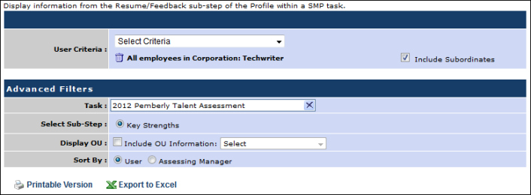
Output
The output displays the user, assessing manager, and the assessor comments.
- Printable Version link to view the results in a web page, or Export to Excel link to save/open as an Excel file.
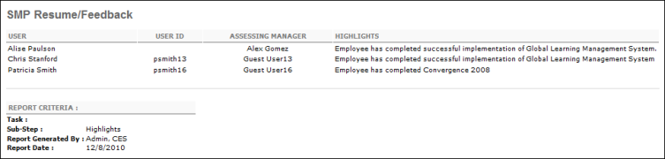

SMP Succession Report
This report enables administrators to search for internal succession candidates for any position. All vacant positions added by a manager or assessor during the succession plan will appear on the report. This report will pull the most recent successors for a user. SMP task data is available for this report as soon as the corresponding SMP task is saved.
Only SMP Manager and Assessor tasks can be selected for this report.
Permissions
PERMISSION NAME | PERMISSION DESCRIPTION | CATEGORY

SMP Succession Report | Grants access to SMP Succession Report which displays most recently named successors for a group of users, or successors named in a specific SMP task. This permission can be constrained by OU, User's OU, User Self and Subordinates, and User. | Reports - Talent/Succession
Filters
- User Criteria - limit report output to the users matching the specified user criteria
  - The report will only run within the defined constraints for the user running the report
  - This is the standard OU availability selection criteria drop-down. Choose from available OU types
  - Defaults: If no User Criteria are selected then the report will run for the entire available population
- Task - Select a specific SMP Manager or Assessor Task, or select the option to display the most recent successors. Only active SMP tasks can be selected.
  - If Most Recent Successors is selected, the report will display the most recent successors for each user in the report criteria. For each user, the report will display the most recent successors from the most recent completed SMP task. If the individual task where the user may have successors added is not complete, then the successors will not pull in from that task and display the next most recent completed task. If the most recent task does not have the succession step included, then that task will be skipped and the next most recent completed task will be looked at.
  - If a task is selected, then the report will pull in successors for all users in the report criteria. The task does not have to be completed if a specific task is selected.
- Primary Metric - if no task is selected, then all active rating scale metrics will appear in the Primary and Secondary metric fields. Only one metric can be selected for Primary Metric. The Primary metric will display as a graph on the report output.
- Secondary Metric - if no task is selected, then all active rating scale metrics will appear in the Secondary Metric field. Only one metric can be selected for Secondary Metric. The Secondary metric will display as a column in the report output.
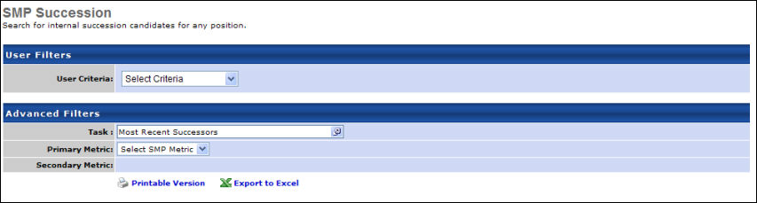
Output
- Printable Version link to view the results in a web page, or Export to Excel link to save/open as an Excel file
The output of the report displays a graphical bar chart for the selected Primary metric along with the number of users in the report criteria that have each rating on the metric. The bar chart will display the Primary metric as follows:
- The ratings on the metric will display from highest rating to the lowest rating, with the highest rating appearing at the top of the bar chart.
- Each bar will be color coded based on the defined color for the corresponding rating in the metric.
- A Not Rated bar will appear for successors who do not have a rating available.
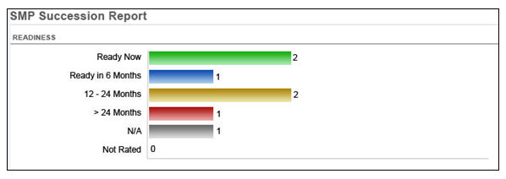
If a Primary metric is not selected, then the graph section of the output will not appear.
The table in the output will display at least 7 columns:
- Incumbent - the user on the succession chart
- User ID - the user ID of the incumbent
- Task - the name of the task
- Successors - the name of each successor added to the incumbent
- Successor ID - the user ID of the internal successor
- Current Position - the current position of the successor
- Current Manager - the current manager of the successor
- Primary Metric - the selected Primary metric
- Secondary Metric - the selected Secondary metric
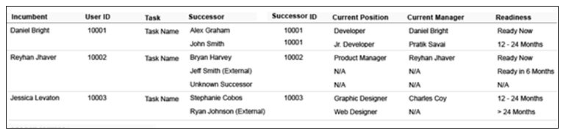
The report will be sorted by the incumbent's last name. A separate row will appear for each incumbent. Within each row for each incumbent, the successor information will be grouped and sorted by last name of the successors. If the successor is an external candidate, the text External will appear next to the name of the successor. If data is not available for one of the successors, then the text N/A will appear. The successor ID will only populate for internal successors. If the report is run on most recent successors, then the task column will appear on the output with the corresponding task name for each incumbent. If a specific task is selected, then this column will not appear.

SMP Survey Step Report
This report will display the answers to questions from a survey step within a SMP task. SMP task data is available for this report as soon as the corresponding SMP task is saved.
Permissions
PERMISSION NAME | PERMISSION DESCRIPTION | CATEGORY

SMP Survey Step Report | Grants access to SMP Survey Step Report, which displays the answers to questions from a survey step within a SMP task. This permission can be constrained by OU, User's OU, User Self and Subordinates, and User. | Reports - Talent/Succession
Filters
- User Criteria - limit report output to the users matching the specified user criteria
  - The report will only run within the defined constraints for the user running the report
  - This is the standard OU availability selection criteria drop-down. Choose from available OU types
  - Defaults: If no User Criteria are selected then the report will run for the entire available population
- Task - select specific SMP task (required field)
- Survey Step -select step from drop-down
- Question Display - select to display question in full or abbreviated on the report output. If Full Question is selected, the full question title will appear in the column header for each question in the survey step. If Abbreviated is selected, then the each question in the column header will be abbreviated to 25 characters with the text "..." displaying at the end.
- Display OU - check to include OU information on report and select specific OU from drop-down
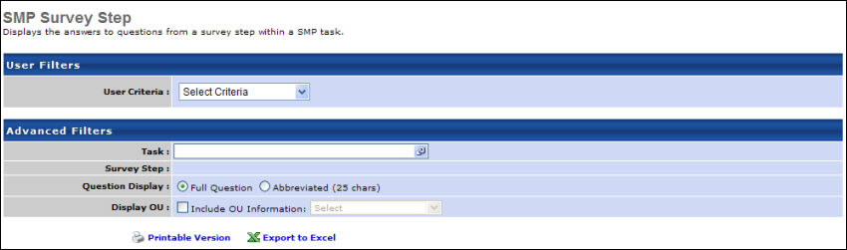
Output
- link to view the results in a web page, or link to save/open as an Excel file
The report output will consist of a minimum of 3 columns:
- Assigned User - the user assigned the SMP task
- User ID - the ID of the user assigned the SMP task
- Question [1 - N] - a column will appear for each question included in the selected survey step.
  - The questions will appear in the order they are defined in the survey step.
  - The question title will be full or abbreviated based on the question display setting.
  - In each question column, the assigned user's answer will appear
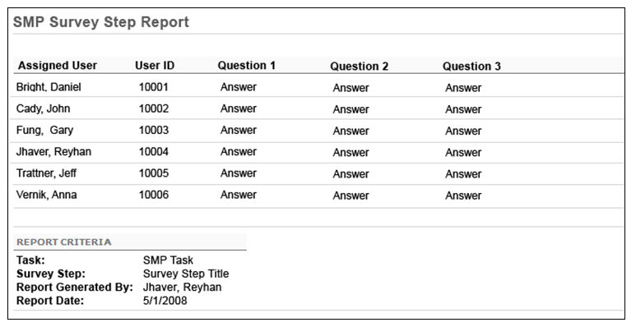

Succession Management Plan Report
This report displays the selected sections of a Succession Management Plan Task. Each section will be displayed on a separate page. You may select one individual at a time to view his or her plan. Succession task data is available for this report as soon as the corresponding succession task is saved.
Permissions
PERMISSION NAME | PERMISSION DESCRIPTION | CATEGORY

Succession Management Plan Report | Grants access to Succession Management Plan report, which displays the selected sections of a Succession Management Plan Task of a specific assessor. This permission can be constrained by OU, User's OU, User's Direct Reports, User Self and Subordinates, and User. The permission constraints determine which users are available within the report. Note: If the user's permission is also constrained by User Self and Subordinates, then this overrides the User's Direct Reports constraint. | Reports - Talent/Succession
Filters
- Select User (required field) - Select specific user. This criteria refers to the user who was assigned a task (the assessor).
- Tasks (required field)- select SMP task
- Steps - check sections to include
- Metric Grid - check to display grids based on employee name of percentage distribution
- Profile Step Display - check to display all profile sub-steps on separate pages or leave unchecked to display on a single page
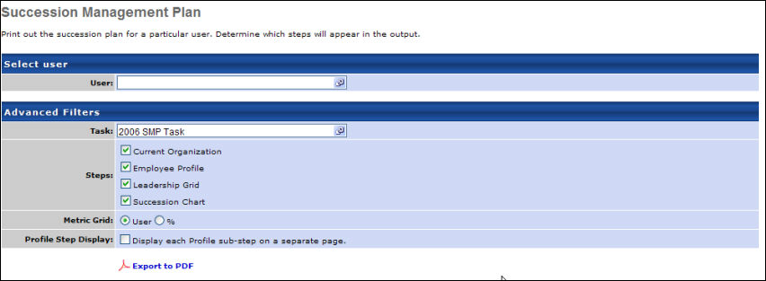
Output
- link to print out one report at a time
On the output, each step will appear on a separate page and each step will appear in the order defined within the SMP template on the output. The header will display the task name on the left side and the task assignee's name on the right side.
Freeform step will display the text defined for the freeform step
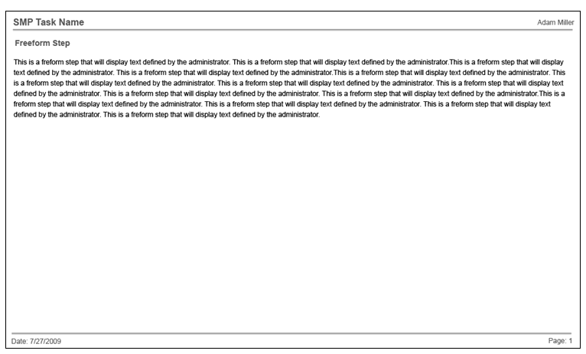
Current Organization step will display the employees in the task. The org chart view will display the org chart of the manager and all employees included in the task. Employees not included in the task will not display in the org chart. The additional info from the info popup will not display on the org chart. Up to 4 ID cards will display per row.
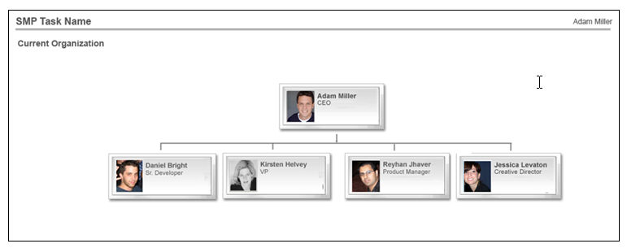
If the Current Organization step is displayed as a list, the list view will display a list of all employees included in the SMP task. Employees not included in the task will not display in the list. The additional information will display for each employee.
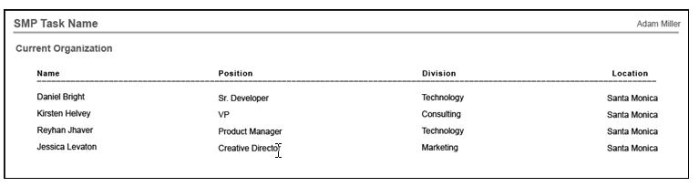
Survey Step will display all questions and their associated answers from the survey step in the task. Each question will display on the page in the order defined for the step. The answer of each question will display. If the answers are formatted using formatting tools, these formatting options will appear on the page.
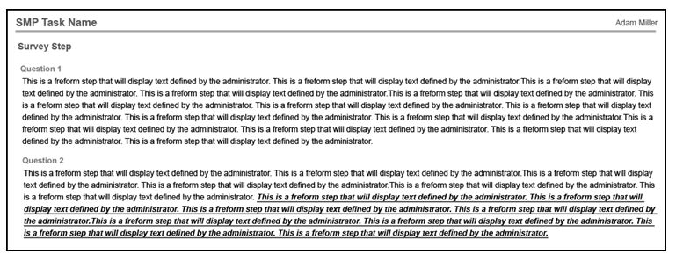
Profile will display sub-steps within the profile in a single, combined output view. The data that is displayed in all the sub-steps in the Profile will be based on Custom Field Security. If the user accessing the output does not have access to fields or data based on Custom Field availability, then these items will not appear in the printout. A separate profile step will appear for each employee included in the task. The employee profile steps will appear in the same order they appear within the SMP task. The profile step for an employee will always start on a new page. If all the sub-steps do not fit on a single page, then the profile step of each user will run multiple pages.
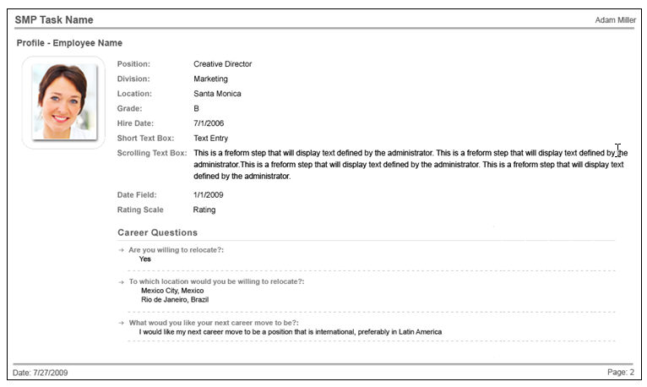
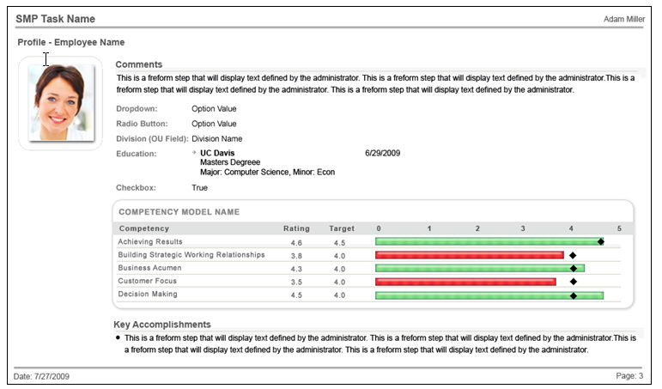
If the option to display each sub-step on a separate page is checked, then each sub-step will display on a separate page. The title of each sub-step will appear on the page.
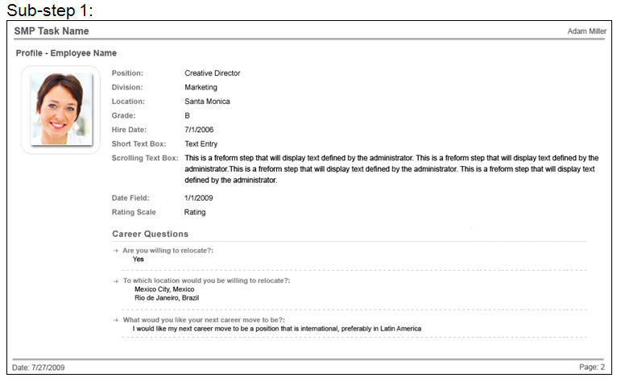
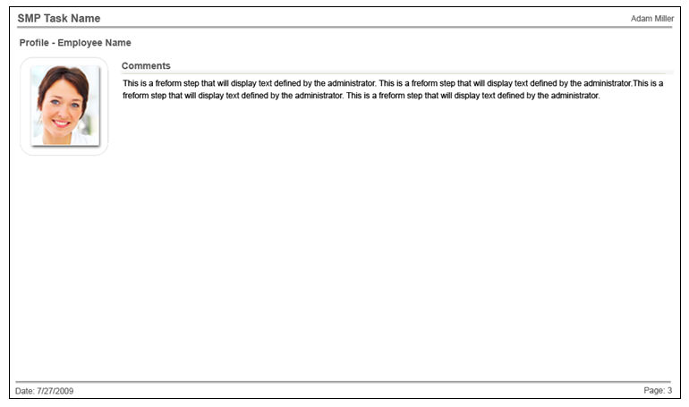
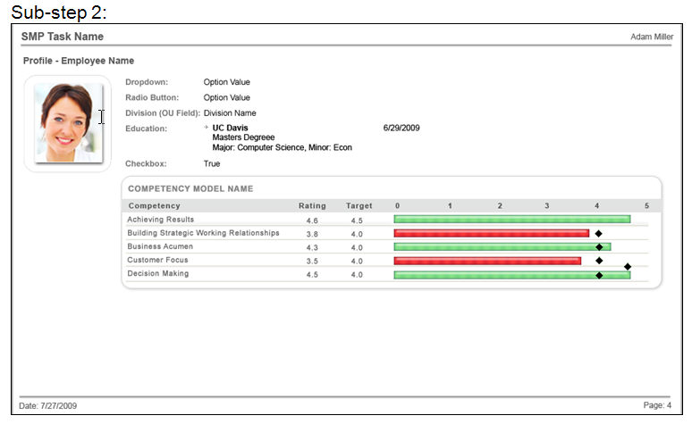
If the employee photo is enabled for display on any Profile sub-step within the task, then the photo of the employee will appear in the top left below the step title. The photo will appear on every page of the profile print out.
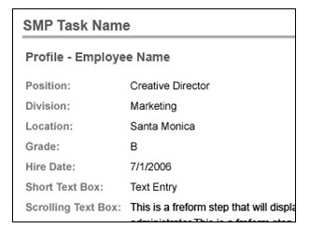
All data will display based on the order of the sub-steps. The data will appear in the same order as it appears in the task.
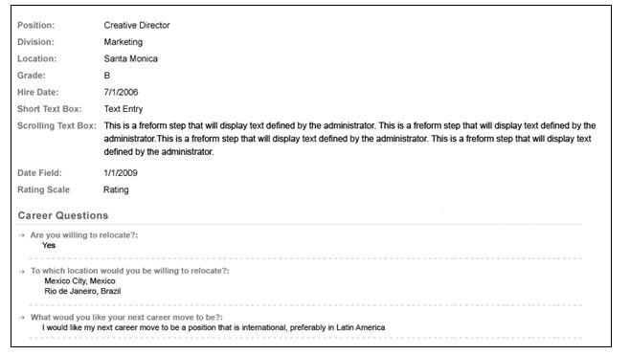
The Fields Displayed will appear in the order defined for the step. Rating Scale and Formula metric fields that are included in the Metric sub-step as the metric rated on the sub-step will also appear in the Fields Displayed list at the bottom of the list.
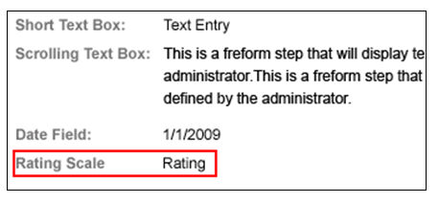
Career Questions section of the sub-step will list out all included career preference questions for the sub-step. This section will only appear if career questions are included in the sub-step.
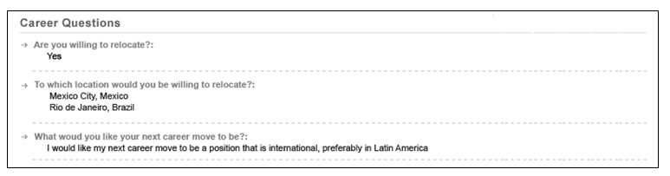
If the metric grid in included in the Metric sub-step as a metric rated on this sub-step, then the grid will appear as it does in the task. The grid will appear on a separate page. For the Competency sub-step, a competency ratings table will appear on the print out.
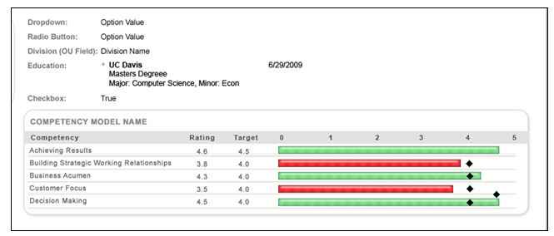
Resume/Feedback sub-step will display the feedback comments as a bulleted list. All formatting tools applied to the entries will appear on the print out.
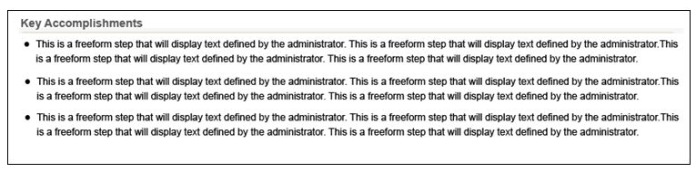
Metric Grid Step will display the metric grid on the print out as defined in the metric grid step of the task. The grid will display the same number of rows and columns as defined in the metric grid field. All employees included in the task will appear on the grid based on their x and y axis values. If the metric grid setting on the report is set to User then the employee's names will appear on the grid. Each employee will appear with their full name on a separate line within the box. If the user does not have access to fields used on the grid through Custom Field security, then the grid will not appear on the print out.
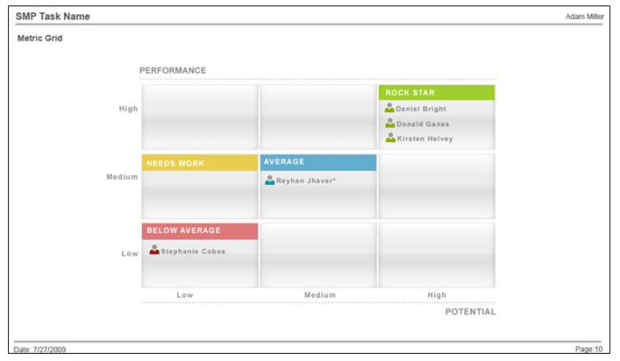
Indirect reports will not be displayed on the grid. If the reporting is set to display the grid as %, then the percentage of the employees in each box will appear instead of the employee names.
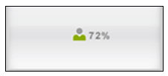
Batch Rating Step will display the batch rating table as defined in the task. The batch rating table will display with all employees included in the task. The employees will be listed in alphabetical order. The columns will appear as defined for the step. Indirect reports will not display on the print out. Custom Field administration rules will apply to succession fields included on this step.
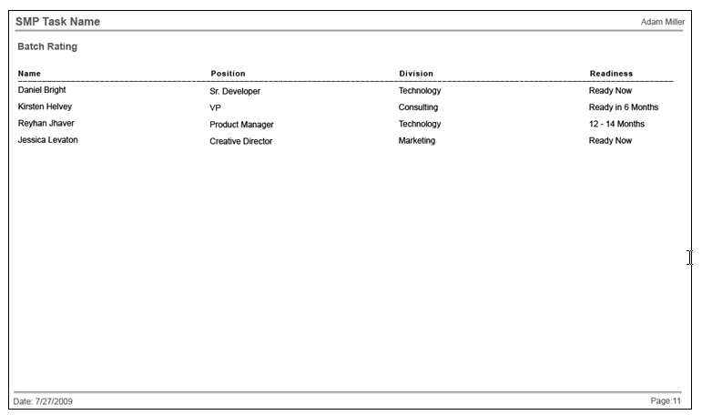
Succession step will display the succession step in the task. The ID cards will be color coded based on settings for the step. The successors will be color coded based on the settings for the step. If color coding is used, then a legend will appear at the bottom right of the chart. If the succession step is an org chart, then the org chart will display on the page along with successors added for employees on the chart. Up to 4 ID cards will display per row.
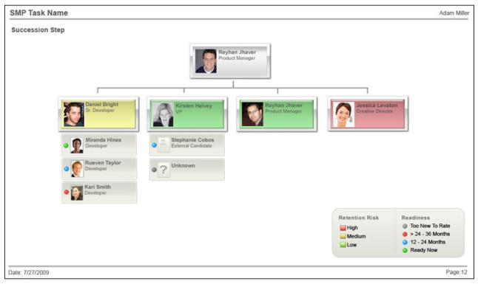
If the succession step is a list, then the employees will be listed on the page along with successors added for employees on the print out.
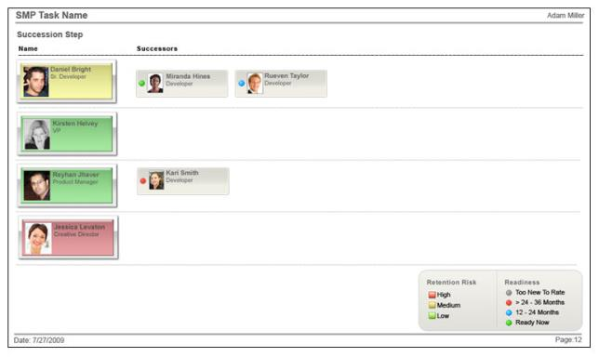

Succession Metric Ratings Report
This report displays all the ratings for a rating scale metric on completed SMP tasks for a set of users. Administrators can select a rating scale metric and view the ratings for the selected rating scale metric for each user in the SMP task. SMP task data is available for this report as soon as the corresponding SMP task is submitted.
The Succession Metric Ratings report only reports on tasks that are currently in a Completed status. Expired tasks are not included in this report, but can be reported on in Custom Reporting.
To run the Succession Metric Ratings Report, go to Reports > Standard Reports. Then click the Succession tab and click the Succession Metric Ratings link.
Permissions
PERMISSION NAME | PERMISSION DESCRIPTION | CATEGORY

Succession Metric Ratings Report | Grants access to Succession Metric Ratings Report, which displays all the ratings for a rating scale metric on a SMP task for a set of users. This permission can be constrained by OU and User's OU. | Reports - Talent/Succession
Criteria
Filter Name | Description
User Criteria | Limit results to the users matching the specified user criteria. This is optional. If no selection is made, the report includes the entire available population.  - The report will only run within the defined constraints for the user running the report.
Task | Select the appropriate SMP task or select "Most Recent Data."  - Most Recent Data - This option is selected by default. When this option is selected, the report includes the most recent data for each user included in the report.  - When the report is grouped by User, the following occurs:  - If the employee's metric ratings were most recently updated via My Team or Helicopter View, the report displays the metric rating value that was updated via My Team. The Task column for these employees displays "Current."  - If the employee's metric ratings were most recently updated via a completed SMP task, the report displays the metric rating value from the completed SMP task. The Task column for these employees displays the corresponding SMP task title.  - Within the printable version, the rating value counters reflect the number of employees with each rating value, regardless of the rating source (My Team or completed SMP tasks). The pie chart displays accurate percentages of users with each value, regardless of the rating source (My Team or completed SMP tasks).  - When the report is grouped by Metric Rating, the following occurs:  - If the employee's metric ratings were most recently updated via My Team or Helicopter View, the employee appears in the report based on the metric rating value that was updated via My Team.  - If the employee's metric ratings were most recently updated via a completed SMP task, the employee appears in the report based on the metric rating value from the completed SMP task.  - Within the printable version, the rating value counters reflect the number of employees with each rating value, regardless of the rating source (My Team or completed SMP tasks). The pie chart displays accurate percentages of users with each value, regardless of the rating source (My Team or completed SMP tasks).  - SMP Task - Click the Select SMP Task field to select a specific SMP Task. This includes only data from the selected task in the report. Only one SMP Task can be chosen.
Succession Metric | Select the appropriate rating scale metric.
Group By | Choose whether the report output is grouped by User or Metric Rating. If User is selected, the Export to Text option will available in report output.
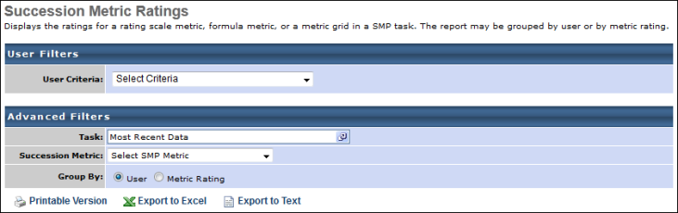
Output
- link to view the results in a web page, or link to save/open as an Excel file
- to export data to a tab delimited text file. This option is only available if the report is grouped by User.
Output Grouped by User
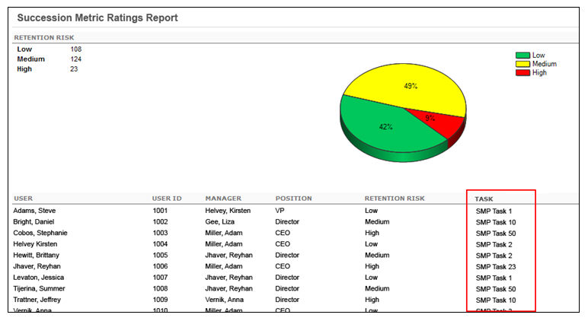
Frequently Asked Questions (FAQs)
Is this report automatically constrained so that users can only see the data of their subordinates and not their own data or that of users higher up in the hierarchy?
No, the report is not automatically constrained. A constraint would need to be placed on the permission in order for it to have any constraints.

Successor Details by Incumbent Report
The Succession Details by Incumbent Report displays all of the nominated successors for an incumbent from the selected task or most recent succession task. Because this is an incumbent-based report, it does not yield results for a job pool task, as that task type has no incumbents. For manager and assessor tasks, you may run this report based on the incumbent employees included in the task. For example, if this report is on the Chicago location, the report includes results for incumbents assigned to the Chicago location, regardless of the location of their named successors.
SMP task data is available for this report as soon as the corresponding SMP task is saved.
This report can be run for one or more tasks at the same time or for the most recent task in which someone was named a successor.
The report automatically includes both incumbent and successor current position, and you may include up to one additional OU field to display for both incumbent and successor.
You may include up to 10 SMP metrics related to the named successors. Keep in mind that the metric field only returns a value in this report if the successor was rated on the metric in the succession chart step of an SMP task that is included in the report. If the user was rated on a profile or batch step of an SMP task, that field does not appear because it does not relate to that user as a named successor.
You may also include up to 10 custom user fields to display on the report. These fields relate to the named successors rather than the incumbents.
To run the Succession Details by Successor Report, go to Reports > Standard Reports. Then click the Succession tab and click the Succession Details by Successor link.
Permissions
PERMISSION NAME | PERMISSION DESCRIPTION | CATEGORY

Successor Details by Incumbent Report | Grants access to Successor Details by Incumbent, which displays the most recently nominated successors, or nominated successors from a specific SMP task, for a group of incumbent employees. The report can include multiple successor metrics and/or custom user fields. This permission can be constrained by OU, User's OU, User Self and Subordinates, and User. | Reports - Talent/Succession
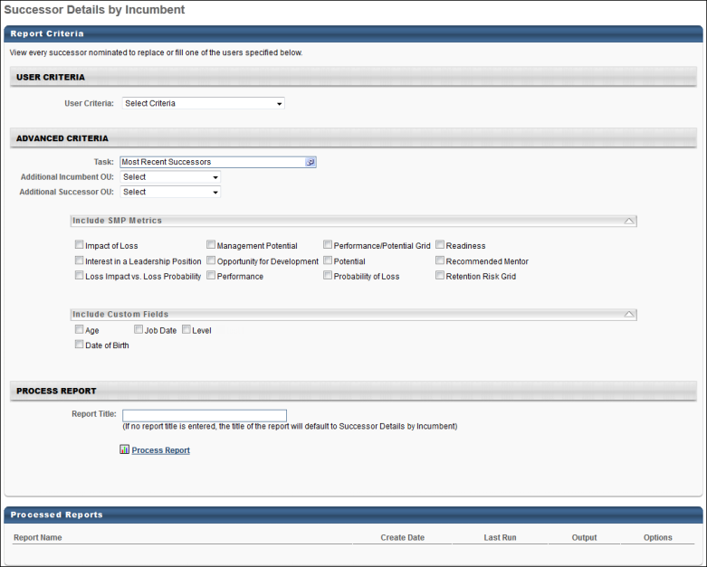
Criteria
Filter Name | Description
User Criteria | Limit results to the users matching the specified user criteria. This is optional. If no selection is made, the report includes all incumbents included in the task.
Task | Select the SMP tasks to include in the report. This report does not return results for job pool tasks, as that task type has no incumbents. This option defaults to Most Recent Successors, which is the most recent SMP task to which the administrator has access. Note: This report only reflects successors from succession tasks, and it does not reflect any successor changes made outside of a task.
Additional Incumbent OU | Select the appropriate SMP task or select "Most Recent Successors."  - Most Recent Successors - This option is selected by default. When this option is selected, the report includes the successors from the most recent SMP task to which the administrator has access.  - SMP Task - Click the Select SMP Task field to select a specific SMP Task. This includes only data from the selected task in the report.
Additional Successor OU | The successor's current position is automatically included in the report. From the drop-down list, you may select an additional OU to display for each successor.
Include SMP Metrics | Up to 10 SMP metrics related to the named successors can be included in the report. The metric field only returns a value in this report if the successor was rated on the metric in the succession chart step of an SMP task that is included in the report. If the user was rated on a profile or batch step of an SMP task, that field does not appear because it does not relate to that user as a named successor.
Include Custom Fields | Up to 10 custom user fields related to the successors can be included in the report.
Report Title | Enter a title for the report. This defaults to the report name if no title is entered. The title is displayed on the report and is also displayed in the list of Processed Reports on this page.
Process Report
This is an asynchronous report, which allows the administrator to define the standard report and generate the report asynchronously. As a result, when administrators process the report, the system generates the report in the background, while the administrator can move on to other areas of the system. When the report is finished processing, the administrator can then view the full report in its entirety.
- Up to three separate reports can generate asynchronously, allowing greater flexibility for creating and storing different versions of the report.
- If you process a report or refresh a stored report, the report appears in the table as Queued.
- The most recently created report displays at the top of the table.
- Since the user can generate up to three reports, the administrator can define a report title for each of the generated reports.
- Clicking the View Details icon changes the report settings on the page to match those of the selected previously run report.
Output
In the left-most columns of the report, the basic incumbent data appears. To the right of those columns, the successor information is displayed followed by columns for the selected succession metrics and custom user fields for the successors.
Other output includes data from Manager and Assessor succession task template types.
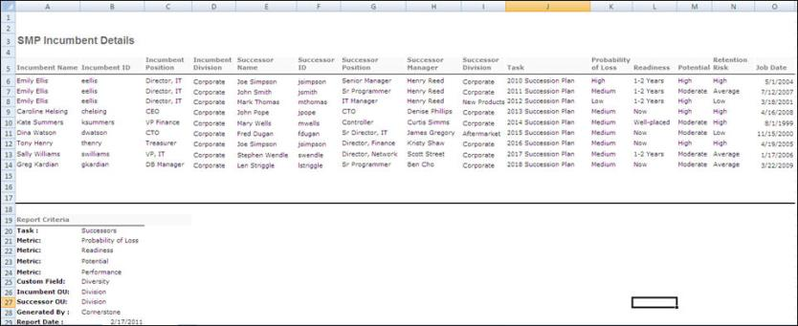

Successor Details by Successor Report
The Succession Details by Successor Report displays all of the positions or incumbents for which a user is nominated as a successor to fill or replace. This report is run for a population of successors. For example, if this report is run for all users in Division A, this report displays all users that are named as successors for the specified SMP tasks.
SMP task data is available for this report as soon as the corresponding SMP task is saved.
This report can be run for the most recent successors or one or more tasks in which someone was named a successor.
The report automatically includes both incumbent and successor current position, and you may include up to one additional OU field to display for both incumbent and successor.
You may include up to 10 SMP metrics related to the named successors. Keep in mind that the metric field only returns a value in this report if the successor was rated on the metric in the succession chart step of an SMP task that is included in the report. If the user was rated on a profile or batch step of an SMP task, that field does not appear because it does not relate to that user as a named successor.
Note: The succession metric fields included in this Standard Report are equivalent to the "Successor Succession metrics" section in other reports. These metric fields are for Successors.
You may also include up to 10 custom user fields to display on the report. These fields relate to the named successors rather than the incumbents.
To run the Succession Details by Successor Report, go to Reports > Standard Reports. Then click the Succession tab and click the Succession Details by Successor link.
Permissions
PERMISSION NAME | PERMISSION DESCRIPTION | CATEGORY

Successor Details by Successor Report | Grants access to Successor Details by Successor, which displays the most recent positions or incumbents for which a user is nominated as a successor to fill or replace, or from a specific SMP task. The report can include multiple successor metrics and/or custom user fields. This permission can be constrained by OU, User's OU, User Self and Subordinates, and User. | Reports - Talent/Succession
Criteria
Filter Name | Description
User Criteria | Limit results to the users matching the specified user criteria. This is optional. If no selection is made, the report includes all successors included in the task.
Task | Select the appropriate SMP task or select "Most Recent Successors."  - Most Recent Successors - This option is selected by default. When this option is selected, the report includes the most recent successors for each user included in the report.  - If the successor was added through My Team, the Task column displays "Current." Also, the succession metrics are populated from My Team ratings updates.  - If the successor was added via a completed SMP task, the Task column displays the corresponding SMP task title. Also, the succession metrics are populated from the corresponding SMP task.  - SMP Task - Click the Select SMP Task field to select a specific SMP Task. This includes only data from the selected task in the report.
Additional Incumbent OU | The incumbent's current position is automatically included in the report. From the drop-down list, you may select an additional OU to display for each incumbent.
Additional Successor OU | The successor's current position is automatically included in the report. From the drop-down list, you may select an additional OU to display for each successor.
Include SMP Metrics | Up to 10 SMP metrics related to the named successors can be included in the report. The metric field only returns a value in this report if the successor was rated on the metric in the succession chart step of an SMP task that is included in the report. If the user was rated on a profile or batch step of an SMP task, that field does not appear because it does not relate to that user as a named successor.
Include Custom Fields | Up to 10 custom user fields related to the successors can be included in the report.
Report Title | Enter a title for the report. This defaults to the report name if no title is entered. The title is displayed on the report and is also displayed in the list of Processed Reports on this page.
Process Report
This is an asynchronous report, which allows the administrator to define the standard report and generate the report asynchronously. As a result, when administrators process the report, the system generates the report in the background, while the administrator can move on to other areas of the system. When the report is finished processing, the administrator can then view the full report in its entirety.
- Up to three separate reports can generate asynchronously, allowing greater flexibility for creating and storing different versions of the report.
- If you process a report or refresh a stored report, the report appears in the table as Queued.
- The most recently created report displays at the top of the table.
- Since the user can generate up to three reports, the administrator can define a report title for each of the generated reports.
- Clicking the View Details icon changes the report settings on the page to match those of the selected previously run report.
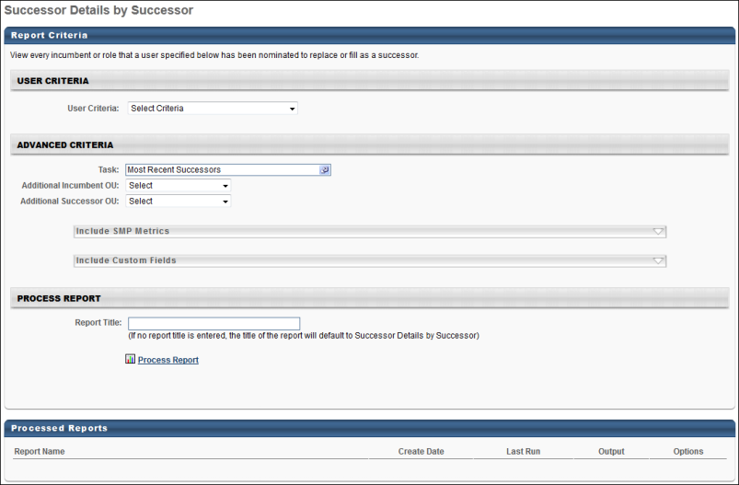
Output
In the left-most columns of the report, the basic successor data appears. To the right of those columns, the incumbent information is displayed followed by columns for the selected succession metrics and custom user fields for the successors.
Other output includes data from all three succession task template types: Manager, Assessor, and Job Pool.
The Role column displays data from Job Pool tasks. The role displayed is the position or job for which the successor was named. In a Job Pool task, you designate successors for the job or position rather than an incumbent employee, so any line where the Role field is populated, the Incumbent columns are not.
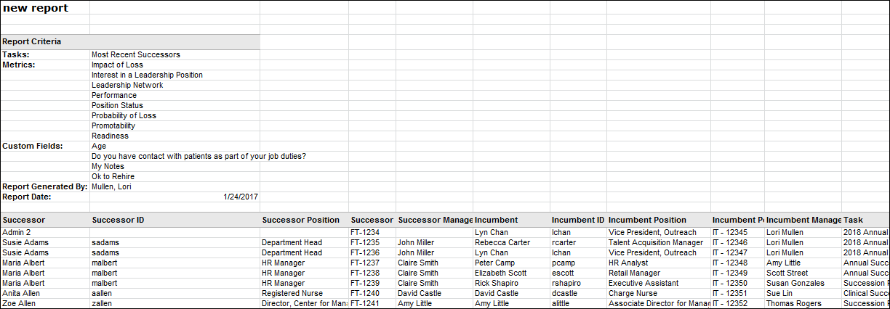

Talent Pool Details Report
View the details of a talent pool created by a specific user.
Permissions
PERMISSION NAME | PERMISSION DESCRIPTION | CATEGORY

Talent Pool Details Report | Grants access to Talent Pool Details Report, which displays users for a given talent pool, including their date added and talent pool status. This permission can be constrained by OU, User's OU, User Self and Subordinates, and User. | Reports - Talent/Succession
Filters
- User - select the user for the report. The user is who created the talent pool. (required field)
- Talent Pools - select any talent pool that the selected user has created. The talent pool list will also include nomination lists that the user has created.
- Removed Candidates - check to display removed candidates from the list
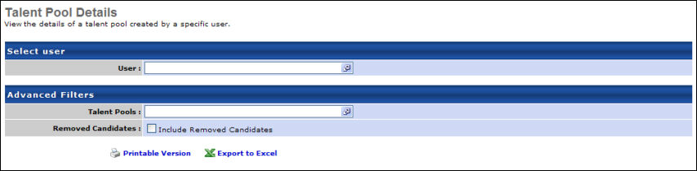
Output
- link to view the results in a web page, or link to save/open as an Excel file
The HTML output will contain a pie chart for the different statuses. A count will appear for each status based on the candidates in the report.
- New Candidate - Orange
- In Development - Yellow
- Nominated - Blue
- Placed - Green
- Removed - Red
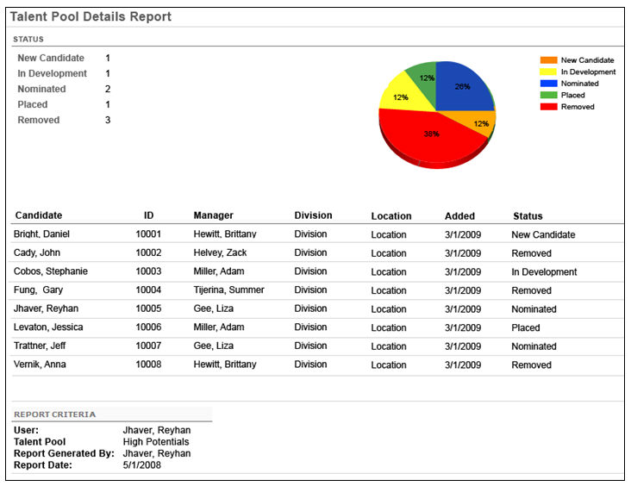

System Reports

Dashboard Details Report
The Dashboards Details standard report enables administrators to report on metadata related to the dashboards in the portal.
- The report output is .xlsx format.
- The report output includes a maximum of 100,000 rows.
- All report criteria options are optional. If no criteria options are selected, the report output includes all dashboards created by any user at any time.
- Date and time fields are displayed in the time zone of the user running the report.
To access the Dashboards Details Report, go to Reports > Standard Reports. From the System tab, select the Dashboards Details Report link.
Permissions
PERMISSION NAME | PERMISSION DESCRIPTION | CATEGORY

Dashboards Details Report | Grants access to view the Dashboards Details Report, which displays details related to the dashboards in their portal, such as the dashboard creator and with whom the dashboard is shared. This permission cannot be constrained. This is an administrator permission. | Reports - System
Report Criteria
The following criteria options are available:
- User Criteria - Select which users are included in the report. The report will only include dashboards created by the selected users.
- Creation Date - Select which dates are included in the report. The report will only include dashboards created within the selected date range.
- Dashboard Title - Specify the dashboard title. The report will only include dashboards with a title that contains the text in this field.
- Sharing Details: Include Dashboard Sharing Details - Select this option to include dashboard sharing details in the report.
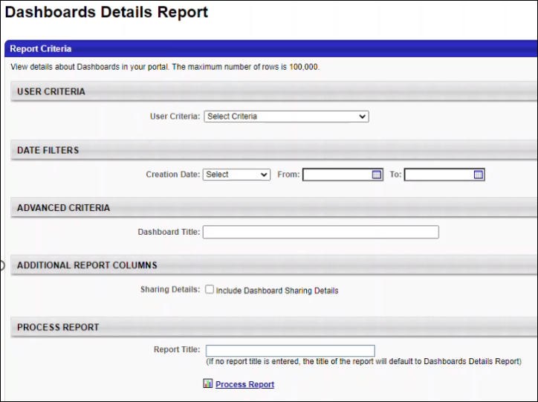
Report Output
The following dashboard details are included in this report when the Sharing Details option is unchecked:
- Dashboard Title
- Dashboard ID
- Dashboard Creator User ID
- Dashboard Creator Full Name
- Dashboard Creator User Status
- Create Date
- Modified Date
- Creator Division ID
- Creator Division
In addition to the above details, the following sharing details are included in the report when the Sharing Details option is checked:
- Shared OU ID
- Shared With OU Title
- Shared With OU - Include Subordinates
- Shared with User ID
- Shared With User Full Name
- Shared with User Status
- Shared With User - Include Subordinates

Groups Criteria Report
The Groups Criteria Report enables organizations to report on the criteria defined for one or more groups in their portal. Note: Groups that do not have any criteria are not included in this report.
This report supports 100,000 rows of data. When the report exceeds 100,000 rows, the following occurs:
- The report is created and has 100,000 user records.
- In the Report Criteria section of the report output, Record Count = 100,000
- In the Report Criteria section of the report output, Row Limit = Report exceeded 100,000 row limit and was truncated. Please change filters to limit results.
To access the Groups Criteria Report, go to Reports > Standard Reports. From the System tab, select the Groups Criteria Report link.
Permissions
PERMISSION NAME | PERMISSION DESCRIPTION | CATEGORY

Groups Criteria Report | Grants access to the Group Criteria Report, which enables organizations to retrieve the criteria defined for one or more groups in their portal. This permission cannot be constrained. | Reports - System
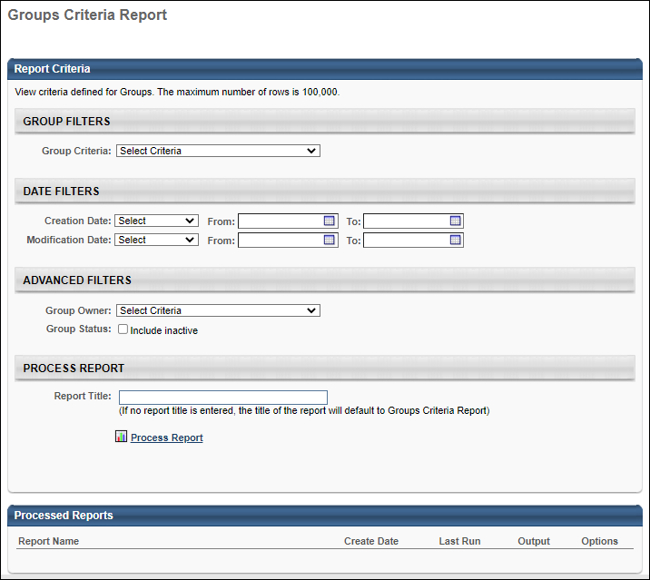
Report Criteria
The following report filters are available:
Filter Name | Description
Organizational Unit | Select one or more groups to include in the report. Note: Groups that do not have any criteria are not included in this report.
Creation Date | Select a date range for the report. The report will only include groups that were created within the selected date range. Date values are set in the time zone of the user running the report. When set, this filter works in conjunction with the Modification Date filter.
Modification Date | Select a date range for the report. The report will only include groups that were modified within the selected date range. Date values are set in the time zone of the user running the report. When set, this filter works in conjunction with the Creation Date filter.
Group Status | Select this option to include inactive groups in the report output.
Group Owner User ID | Provide a user ID to only include groups that are owned by the corresponding user.
Report Output
The following details are included in the report output:
Column Name | Description
Group ID | This displays the ID of the group.
Group Name | This displays the name of the group.
Group Status | This displays the active status of the group.
Group Parent ID | This displays the ID of the parent group.
Group Parent Name | This displays the name of the parent group
Group Parent Status | This displays the active status of the parent group.
Group Description | This displays the description set for the group.
Group Criteria Type | This displays the type of criteria that was set for the group (e.g., User, Standard Field, Custom Field, etc.).
Group Creator ID | This displays the ID of the user who created the group.
Group Creator Username | This displays the Username of the user who created the group.
Group Creator User Full Name | This displays the full name of the user who created the group.
Group Creation Date | This displays the date on which the group was created. Date fields are displayed in the time zone of the user running the report.
Group Owner User ID | This displays the ID of the user who is set as the group owner.
Group Owner Username | This displays the Username of the user who is set as the group owner.
Group Owner User Full Name | This displays the full name of the user who is set as the group owner.
Group Last Modification Date | This displays the date on which the group was last modified. Date fields are displayed in the time zone of the user running the report.
Group Last Modified by User ID | This displays the ID of the user who last modified the group.
Group Last Modified by Username | This displays the Username of the user who last modified the group.
Group Last Modified by User Full Name | This displays the full name of the user who last modified the group.
Freeze Group Processing | This displays whether the "Freeze Group Processing" option is enabled for the group. When this option is enabled for a group, the system does not add or remove any users based on the group criteria.
Operator | This displays the operator associated with the group criteria, such as "Is or Below" or "Includes any of."
OU Title | If the Group Criteria Type is set to an organizational unit, then this displays the title of the organizational unit used in the criterion. Otherwise, this field is blank.
OU ID | If the Group Criteria Type is set to an organizational unit, then this displays the ID of the organizational unit used in the criterion. Otherwise, this field is blank.
OU Status | If the Group Criteria Type is set to an organizational unit, then this displays the status of the organizational unit used in the criterion. Otherwise, this field is blank.
OU Type | If the Group Criteria Type is set to an organizational unit, then this displays the type of the organizational unit used in the criterion. Otherwise, this field is blank.
User ID | If the Group Criteria Type is set to a user, then this displays the ID of the user used in the criterion. Otherwise, this field is blank.
Username | If the Group Criteria Type is set to a user, then this displays the Username of the user used in the criterion. Otherwise, this field is blank.
User Full Name | If the Group Criteria Type is set to a user, then this displays the full name of the user used in the criterion. Otherwise, this field is blank.
User Status | If the Group Criteria Type is set to a user, then this displays the status of the user used in the criterion. Otherwise, this field is blank.
Other Group Criteria | If the Group Criteria Type is set to something other than an organizational unit or a user, then this displays the details of the criterion. Otherwise, this field is blank. Entries in this field will be pipe delimited.

Headcount Trend Report Homepage
The Headcount Trend Report is an interactive month-end headcount report for portals with Cornerstone HR enabled. The report allows organizations to explore the historical headcount, viewable by different organizational units (OU). Senior managers, executives, and human resources professionals are empowered by this report to explore their organization's historical headcount to spot trends.
The Headcount Trend Report homepage lists all existing Headcount Trend Reports. From this page, you can view existing reports and create new reports.
To access the Headcount Trend Report homepage, go to Reports > Standard Reports > System Reports.
Note: The Headcount Trend Report is only available in portals with Cornerstone HR enabled.
Permissions
PERMISSION NAME | PERMISSION DESCRIPTION | CATEGORY

Headcount Trend Report Admin | Allows users to query historical headcount aggregates and view by different organizational units (OU). This permission cannot be constrained. | Reports - System
Use Case
Beth is the COO of a growing company with almost 2,000 employees. She knows the company has been accelerating its expansion, especially in certain Division and Location Organizational Units (OU). To study these trends, Beth used to have an analyst compute the aggregate headcount in different OUs using Excel.
Now, with the Headcount Trend Report and after a one-time data load of historical data, Beth can explore these trends over her entire company's history without an analyst's help. She can view the headcount in each standard OU, apply filters on what constitutes a “headcount” in her organization, and drill in and out of specific parts of the organization. This report facilitates resource planning and basic organizational management with Finance, Human Resources, and the rest of the executive team.
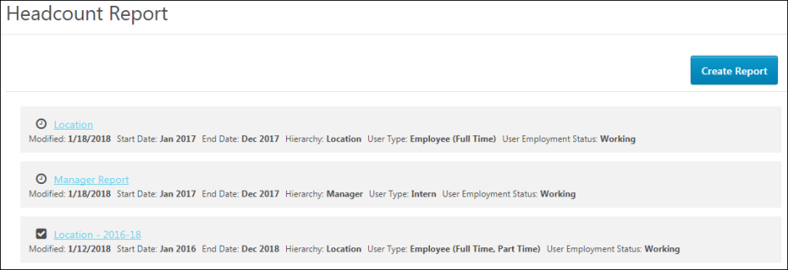
Create Report
Click Create Report to create a new Headcount Trend Report. See Create Headcount Trend Report on page 306 for additional information.
Report List
The Headcount Trend Report homepage lists all existing Headcount Trend Reports. The following information displays for each report:
- Report Name - The report name displays as a link. Click the link to view the report output.
- Date Created - The field displays the date on which the report was created.
- Start and End Dates - The field displays the date range selected for the report.
- Hierarchy - This field displays the organizational unit (OU) that was selected to group the headcount for viewing. If the OU has a hierarchical structure, then there may be multiple levels of groupings.
- User Type - The field displays the user types and subtypes selected for the report.
- Employment Status - This field displays the employment statuses and sub-statuses for report, as defined in the User Employment Status field when configuring the report.
Create Headcount Trend Report
The Headcount Trend Report is an interactive month-end headcount report for portals with Cornerstone HR enabled. The report allows organizations to explore the historical headcount, viewable by different organizational units (OU).
To create a Headcount Trend Report, go to Reports > Standard Reports > System Reports. Then, click Headcount Trend Report.
Permissions
PERMISSION NAME | PERMISSION DESCRIPTION | CATEGORY

Headcount Trend Report Admin | Allows users to query historical headcount aggregates and view by different organizational units (OU). This permission cannot be constrained. | Reports - System
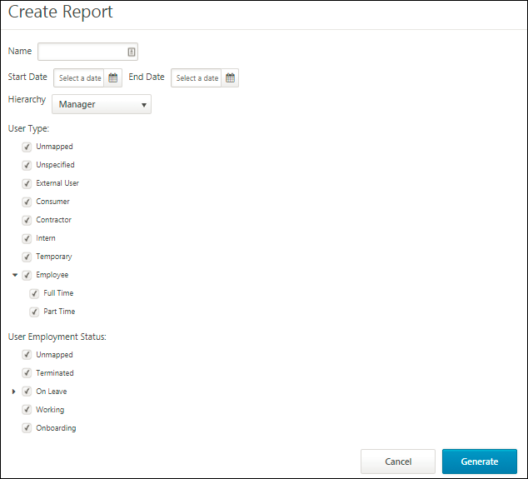
Name
Enter the name of the report, up to 100 characters.
Start/End Date
Select the start and date for the headcount period. Any date period can be selected, and the report will show those years in the output.
If there is no data for a date period or parts of the date period, then the report will be blank for the areas with no data.
Hierarchy
Select the organizational unit (OU) hierarchy. Only one hierarchy can be selected. The options available are the OUs that are configured for your portal, as well as manager/reporting hierarchy. Custom OUs are also available.
The OU that is selected determines how the headcount is grouped or aggregated and will be how you navigate through or interact with the report. While the User Type and User Employment Status fields define what constitutes a “headcount” for the report, the Hierarchy field defines how you see those headcount in the report.
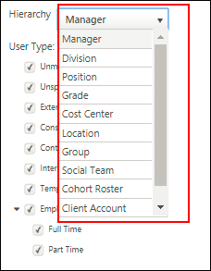
User Type
This section allows you to select one or more user types and subtypes that qualify as a headcount. The options that are available are the default options that are defined by the administrator in User Preferences.
Selecting a user types will filter all users in your portal into a narrower category of headcount. For example, if you select full-time employees and interns but do not select consultants, then the headcount is narrowed down to those groups and will not include consultants.
Note: The user type "Unmapped" means blank. The user type "Unspecified" means that the user type value is not specified.
User Employment Status
This section allows you to select one or more user statuses. The options that are available are the default options that are defined by the administrator in User Preferences.
Selecting a user type will filter all users in your portal into a narrower category of headcount. For example, if your headcount includes users with a status of "Working" and "On Leave" but not "Terminated," then the headcount is narrowed down to the users who are in those user statuses and would not include users in a "Terminated" status.
Generate
Once you have selected the report criteria, click Generate. This creates the report and directs you to the report output page. See Headcount Trend Report - Output on page 309 for additional information.
Note: The report processing time will vary based on the amount of data being generated.
Headcount Trend Report - Output
The output page of the Headcount Trend Report displays the number of hires across the organization and organizational units (OU). From here, you can view headcount data, rename the report, and edit the criteria.
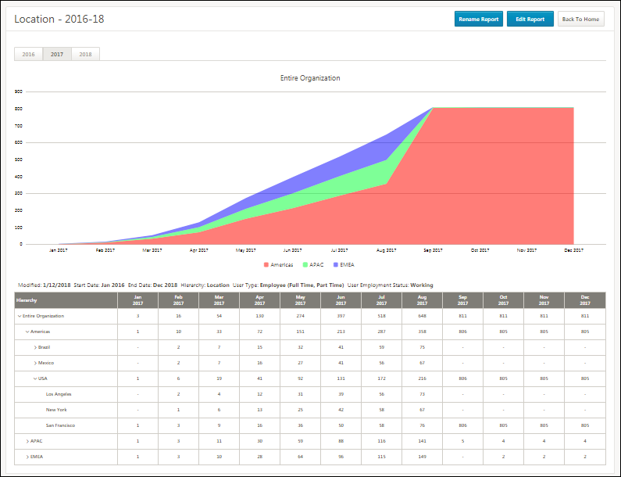
Rename Report
Select o change the name of the report. The name can be changed at any time.
Edit Report
Click Edit Report to change the criteria selected for the report. The report can be edited at any time.
Editing the report opens the Edit Report flyout. This shows your existing criteria and allows you to change your selections. From here, you can also change the report name and date range.
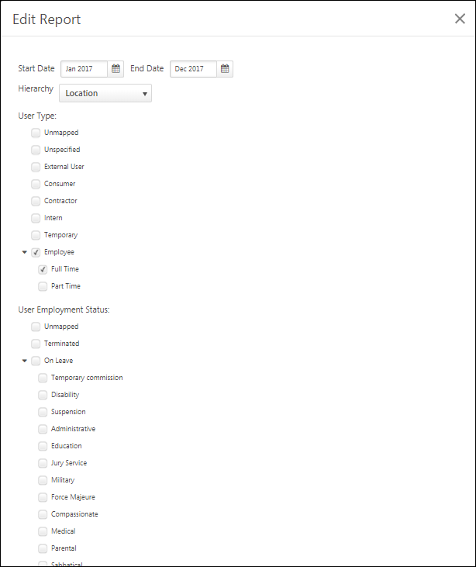
Report Years
The year tabs above the chart are the time dimensions. Click a year to view the headcount trends for that year.
Chart
A stacked area chart appears above the output table to show the results as a graphic. It is fixed on the top node of your hierarchy, or the highest parent OU in the table below, and it reflects the year displayed in the table. Each color in the chart represents the child OUs of the highest parent OU.
OU Hierarchy Drop-Down
The OU Hierarchy drop-down allows you to chart a specific OU. Click the drop-down and select an OU to view the chart data for that specific OU.
Filters
The list of filters, which were selected when creating the report, display below the chart.
Report Output Section
The report data displays in the columns below the filters.
- Hierarchy - This column displays the hierarchy values, as defined in the field when configuring the report. The values will vary based on your hierarchy selection. You can click within the hierarchy to view headcount at different levels. Note: If the OU selected does not have a valid parent OU, then the selected OU will appear under the "Unmapped" section in the table.
- Month/Year - These columns display the number of headcount per month within the time period defined when configuring the report.

Login Report
Customers often need to review who has logged in to their portal. They need to understand which users have logged in to the portal and when. Organizations often need to provide this information to auditors.
The Login Report enables organizations to report on which users have logged in to the portal and when. With this report, it is possible to report on who has logged in during a specific date range, their IP address, and details on how they logged in (e.g., SAML SSO).
This report supports 100,000 rows of data.
To access the Login Report, go to Reports > Standard Reports. From the System tab, select the Login Report link.
Permissions
PERMISSION NAME | PERMISSION DESCRIPTION | CATEGORY

Login Report | Grants access to the Login Report, which enables organizations to report which users have logged in to the portal and when. This permission cannot be constrained. | Reports - System
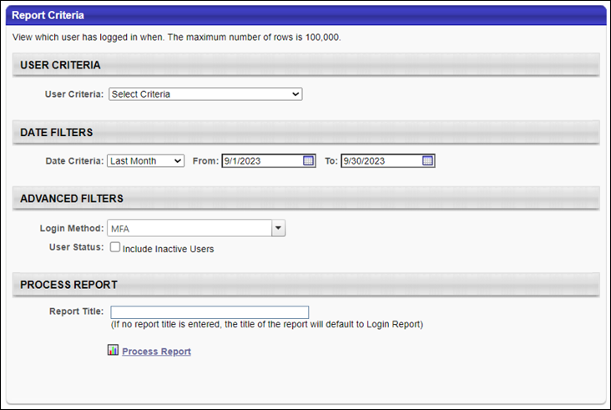
Report Criteria
The following report filters are available:
Filter Name | Description
User Criteria | Select a user or a group of users that may be included in the report. This criterion filters the set of users who have logged in to the system and may appear in the report output. You may choose one or more individual users as well as entire organizational units (OUs) or Groups. If permission for this report is constrained, those constraints apply to user criteria selection when running the report.
Date Criteria | Select a date range for the report. The report will return login information for the selected date range. The default value is Last Month. This is a required field.
Login Method | From the drop-down, select a specific login method to only include information for a single login method. If no method is selected, then all methods are included.  The following login methods may be available:  - AES SSO  - Custom SSO  - Desktop Player  - Desktop Player Device Registration  - Device Registration - User used the Device Registration option in the mobile application to log in using a smart phone.  - Form  - Login Page - User logged in from their standard login page from a web browser.  - MFA - User logged in with Multi-factor authentication.  - Mobile - User used the Log in With Credentials option in the mobile application to log in using a smart phone.  - Mobile SSO - User used their internal SSO to log in using a smart phone.  - OAuth2 Login  - Saml Gateway SSO  - Saml SSO - User used their internal SSO to log in using a computer.  - SSO
User Status | Select this option to include inactive users in the report output.
Report Output
The following details are included in the report output:
Column Name | Description
User ID | This displays the ID of the user who logged in to the system.
User Name | This displays the user name of the user who logged in to the system.
User First Name | This displays the first name of the user who logged in to the system.
User Last Name | This displays the last name of the user who logged in to the system.
Division | This displays the division organizational unit of the user who logged in to the system.
Division ID | This displays the division organizational unit ID of the user who logged in to the system.
Cost Center | This displays the cost center organizational unit of the user who logged in to the system.
Cost Center ID | This displays the cost center organizational unit ID of the user who logged in to the system.
Location | This displays the location organizational unit of the user who logged in to the system.
Location ID | This displays the location organizational unit ID of the user who logged in to the system.
Login Date | This displays the date and time at which the user logged in to the system. Date fields are displayed in the time zone of the user running the report.
Impersonate User | This indicates if somebody else logged in as the user.
IP Address | This displays the IP address of the device that the user used to log in to the system (e.g., SSO, Mobile, Desktop Player).
User Login Method | This displays how the user logged in to the system (e.g., SSO, Mobile, Desktop Player).

OU Audit Report
The Organizational Unit (OU) Audit standard report enables organizations to report on changes made to common standard and custom OU fields for one or more standard OUs. The report output displays each time one of the selected fields was modified for the selected OUs within the selected date range.
Cornerstone does not store any audit data for group OUs, including changes to custom fields.
This functionality is only available for organizations using Cornerstone HR or Life Science Auditing.
To run the OU Audit report, go to Reports > Standard Reports. Then, select the System tab and select the OU Audit link.
Permissions
PERMISSION NAME | PERMISSION DESCRIPTION | CATEGORY

OU Audit Report | Grants access to OU Audit report, which displays audit information for changes made to organizational units. This permission can be constrained by OU, User's OU, and User's Corporation. | Reports - System
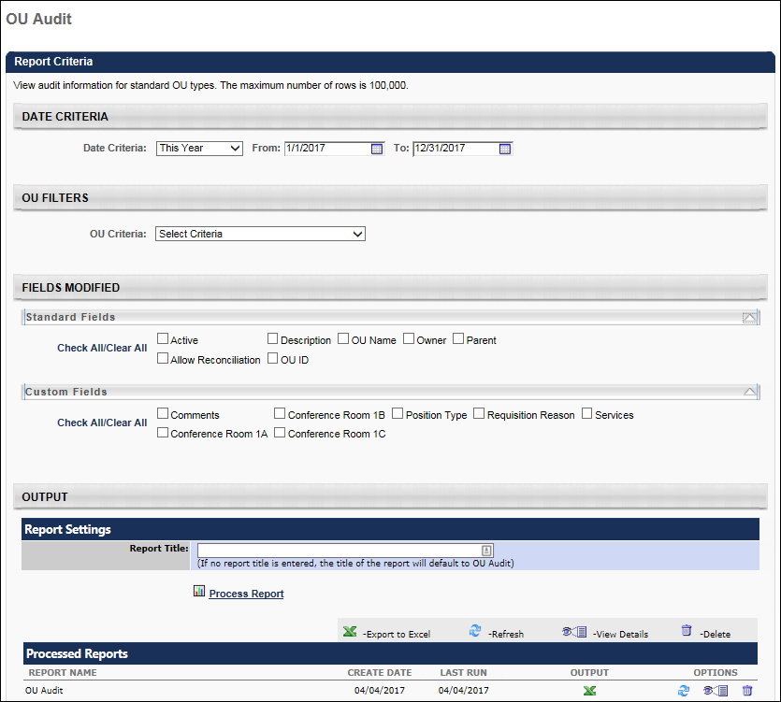
Report Criteria
Date Criteria
Filter Name | Description
Date Criteria | Select the range of dates to include in the report. The report will include any changes made to the selected OUs within the selected date range. This can be done by selecting a preset date range or by manually selecting a date range using the date pickers.
OU Filters
Filter Name | Description
OU Criteria | Select which standard OUs are included in the report. One or more OUs can be selected, and only standard OUs can be selected. The user's permission constraints determine which OUs are available for selection.
Advanced Criteria
In this section, select which fields are audited in the report. When a field is included in the report, the output displays each time the field was modified. Up to 50 fields can be selected.
Filter Name | Description
Standard Fields | Select which standard OU fields are audited in this report. Only the most common standard OU fields are available.
Custom Fields | Select which custom OU fields are audited in the report. All custom OU fields are available. If the user is not within the availability for a custom field, then the field is not available to be selected.
Process Report
This is an asynchronous report, which allows the administrator to define the standard report and generate the report asynchronously. As a result, when administrators process the report, the system generates the report in the background, while the administrator can move on to other areas of the system. When the report is finished processing, the administrator can then view the full report in its entirety.
- Up to three separate reports can generate asynchronously, allowing greater flexibility for creating and storing different versions of the report.
- If you process a report or refresh a stored report, the report appears in the table as Queued.
- The most recently created report displays at the top of the table.
- Since the user can generate up to three reports, the administrator can define a report title for each of the generated reports.
- Clicking the View Details icon changes the report settings on the page to match those of the selected previously run report.
In the Report Title field, enter a title for the report. If no title is entered, the report title defaults to the report name. The title appears on both the report output and in the Processed Reports section.
Click the Process Report link to run the report based on the selected criteria. The report output is stored in the Processed Reports table.
Processed Reports Table
The Processed Reports table displays the three most recently run reports. The report name, create date, and last run date display for each report. The following options are available for each report in the table:
- Click the Print icon to view a printable version of the report. The report can also be printed from the printable version.
- Click the Excel icon to generate an Excel output of the report. Note: Once the Excel icon has been pressed, the report starts processing without a visual indicator that the report is processing. Pressing the Excel icon multiple times will restart the export process each time.
- Click the Refresh icon to refresh the report results.
- Click the View Details icon to view and modify the filter criteria for the report.
- Click the Delete icon to delete the report.
Report Output
In addition to the selected fields, the following information is displayed in the report output:
- Change Date
- Changed From
- Changed To
- Field Changed
- Reason for Change
- Changed Culture
- Changed By
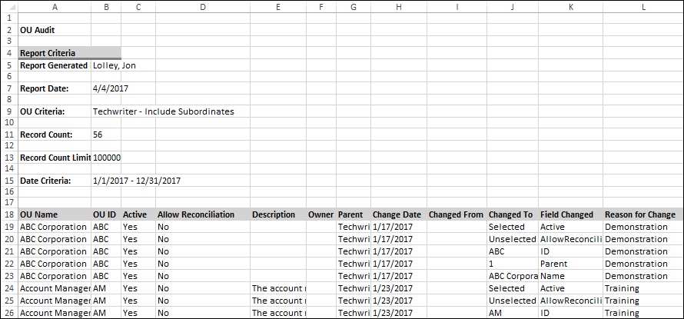

OU Hierarchy Report
This report display details of each OU in a selected hierarchy. The report output has different sets of columns for each reportable OU (OU Type, Group, and Self Registration Group). Also, OU custom fields are included in the report.
Note: Both active and inactive OU custom fields are included in the report.
- When running the standard OU Hierarchy without specifying any criteria, all custom fields (Active and Inactive) are returned even if the fields contain no data.
- When running the standard OU Hierarchy and specifying any criteria, all custom fields (Active and Inactive) are only returned if the custom field has been populated for an OU within the report criteria.
To run the OU Hierarchy Report, go to Reports > Standard Reports. Then, select the System tab and click the OU Hierarchy link.
Permissions
PERMISSION NAME | PERMISSION DESCRIPTION | CATEGORY

OU Hierarchy Report | Grants access to OU Hierarchy Report, which displays details of each organizational unit for a selected OU type. | Reports - System
Criteria
Filter Name | Description
OU Criteria | Select a specific organizational unit.
OU Status | Select this option to display inactive OUs.
Group By | Select whether to group by parent OU or to not group results.
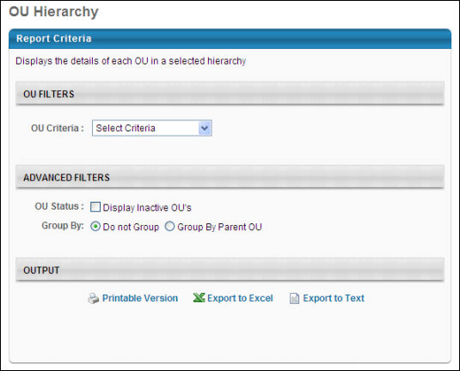
The report first displays the information for the selected OU. After, the report displays the OU information for the selected OU's child OUs. The report displays the child OUs by first listing the OUs in the first level below the selected OU, then the OUs in the second level below the selected OU, etc.
The Active column only appears when the Display Inactive OU's option is selected.
Output Not Grouped
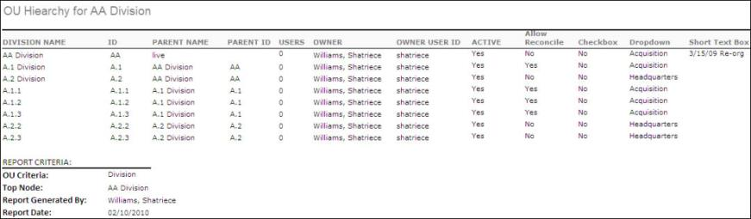
Output Grouped by Parent OU
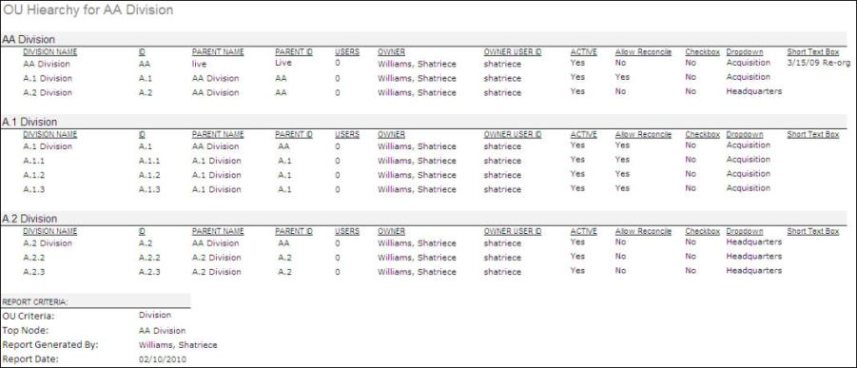

Proxy as User Report
Customers often need to audit how proxy functionality is being used. They need to understand which users have proxied in, as what user, and when. This information is often requested during formal audits.
The Proxy as User Report enables organizations to report on which users have proxied in, as what user, and when.
This report supports 100,000 rows of data.
To access the Proxy as User Report, go to Reports > Standard Reports. From the System tab, select the Proxy as User Report link.
Permissions
PERMISSION NAME | PERMISSION DESCRIPTION | CATEGORY

Proxy as User Report | Grants access to the Proxy as User Report, which enables organizations to report on which users have logged in to the portal and when. This permission cannot be constrained. | Reports - System
Report Criteria
The following report filters are available:
Filter Name | Description
User Criteria | Select a user or a group of users that may be included in the report. This criterion filters the set of users whose account was accessed via proxy login and may appear in the report output. You may choose one or more individual users. If permission for this report is constrained, those constraints apply to user criteria selection when running the report.
Date Criteria | Select a date range for the report. The report will return proxy information for the selected date range. The default value is Last Month. This is a required field.
Action Performed by User ID | Select the user or users who may be included in the report as the user who proxied in as another user. If no users are selected, then all users are included.
User Status | Select this option to include inactive users in the report output.
Report Output
The following details are included in the report output:
Column Name | Description
User ID | This displays the ID of the user whose account was accessed via a proxy login.
User Name | This displays the user name of the user whose account was accessed via a proxy login.
User First Name | This displays the first name of the user whose account was accessed via a proxy login.
User Last Name | This displays the last name of the user whose account was accessed via a proxy login.
User Status | This displays the active status of the user whose account was accessed via a proxy login.
Action Performed by User ID | This displays the ID of the user who proxied in as another user.
Action Performed by User Name | This displays the user name of the user who proxied in as another user.
Action Performed by User Full Name | This displays the full name of the user who proxied in as another user.
Action Performed by User Status | This displays the active status of the user who proxied in as another user.
Proxy Start Date and Time | This displays the date and time at which the proxy login began. Date fields are displayed in the time zone of the user running the report.
Proxy End Date and Time | This displays the date and time at which the proxy login ended. Date fields are displayed in the time zone of the user running the report.
Reason for User Emulation | This displays the reason that was provided when the proxy login was initiated.

Reporting 2.0 Delivery Log Report
Administrators and others sometimes have a need to check the status of a report delivery or to see to whom a certain report has been delivered.
With the Reporting 2.0 Delivery Log standard report, customers can see the status and a log of their report deliveries via this report. Scheduled reports that are sent to an FTP or sent through email will be included. The report will show entries for reports that have either been delivered successfully or for which delivery has failed. When generation and delivery is still in progress for a certain report, this report will not be included in the delivery log output. The report is available within the System section of Standard Reports.
This report supports 100,000 rows of data and will include several filter options.
To access the Reporting 2.0 Delivery Log Report, go to Reports > Standard Reports. From the System tab, select the Reporting 2.0 Delivery Log link.
Permissions
PERMISSION NAME | PERMISSION DESCRIPTION | CATEGORY

Reporting 2.0 Delivery Log | Grants access to view the Reporting 2.0 Delivery Log, which displays user-level information about deliveries for your Reporting 2.0 Reports. | Reports - System
Report Output
The following details are included in the report output:
Column Name | Description
Report ID | This displays the ID of the report that is delivered by FTP / Email.
Report Title | This displays the title of the report that is delivered by FTP / Email.
Report Owner User ID | This displays the ID of the user who created the report.
Report Owner Username | This displays the username of the user who created the report.
Report Owner User Full Name | This displays the full name of the user who created the report.
Delivery Method | This displays the report delivery method (FTP / Email).
Scheduled Delivery Date and Time | This displays the date and time at which the report is scheduled to deliver.
Delivery Path | This displays the delivery path for reports delivered by FTP.
Recipient User ID | This displays the ID of the user who received the report.
Recipient Username | This displays the username of the user who received the report.
Recipient User Full Name | This displays the full name of the user who received the report.
Recipient User Email | This displays the email address of the user who received the report.
Delivery Status | This displays the status of report delivery, if it is success or failed.
Error Message | This displays the error message in case the report was not delivered.
Delivery Statuses
These are possible delivery statuses:
- Failed
- Success
- Email delivery is partially successful (fails for few users) and FTP delivery is successful
- FTP delivery failed and Email delivery is partially successful (fails for few users)​
- Email delivery is partially successful (fails for few users)​
- FTP delivery failed, Email delivery succeeded
- Email delivery failed, FTP delivery succeeded
Error Message Values
These are possible error message values:
- Schedule must have at least one active user
- Invalid FTP folder path
- Schedule must have at least one valid email address
- Report scheduled for delivery is not found
- Report owner is inactive.
- Email cannot be sent to user, email string is empty
- Email cannot be sent to user, user is inactive
- Email cannot be sent to user, email string is Invalid
- Email cannot be sent to user, user does not have permission for Email Delivery
- General error occurred during operation. Please contact your service Administrator (Global Customer Support)
Considerations
- The Date Filter is mandatory, but other filters are optional.
- The Date and Date/Time fields display in the time zone of the user running the report.
- The default sort order is by latest delivery date and time in descending order.
- Only reports that are delivered to an FTP or via email are included in the Reporting 2.0 Delivery Log.
- Only data as of the May '22 Release will be displayed.

Reporting 2.0 Report Details
The Reporting 2.0 Report Details report allows System Admins to extract a list showing all reports that have been created within the portal. This report supports 100,000 rows of data and will include several filter options. Because this is an Admin report, the report will not be constrainable.
To access the Reporting 2.0 Report Details Report, go to Reports > Standard Reports. From the System tab, select the Reporting 2.0 Delivery Log link.​
Permissions
PERMISSION NAME | PERMISSION DESCRIPTION | CATEGORY

Reporting 2.0 Report Details | Grants access to view the Reporting 2.0 Report Details, which displays information about the Reporting 2.0 reports created and ran.  The Reporting 2.0 Report Details permission can be constrained by OU and User constraints. The constraints apply to the recipient user.  The Reporting 2.0 Report Details permission will be assigned to the Cornerstone Administrator and System Administrator roles by default. | Reports - System
Report Output
The following details are included in the report output:
Column Name | Description
Report ID | This displays the ID of the report.
Report Title | This displays the title of the report.
Report Type | This displays the type of the e.g. Transcript report, Performance review report etc.
Report Owner User ID | This displays the ID of the user who created the report.
Report Owner Username | This displays the username of the user who created the report.
Report Owner Full Name | This displays the full name of the user who created the report.
Report Owner's Status | This displays the status of the user who created the report, if the user is still active / Inactive.
Report Owner's Email | This displays the email address of the user who created the report.
Report Modifier User ID | This displays the ID of the user who modified the report.
Report Modifier Username | This displays the username of the user who modified the report.
Report Modifier Full Name | This displays the full name of the user who modified the report.
Report Creation Date | This displays the date on which the report is created.
Report Active | This displays if the report is active or not.
Report Last Modified Date | This displays the date on which the report was modified for the last time
Report Last Run Date | This displays the date on which the report was last run.
Report Total Runs | This displays the total runs altogether for the reports, irrespective of the date filter 'Report Last Run date.'
Report Columns | This displays all the columns (active and inactive) that are mapped to the report separated by pipe separator (|).
Filter Columns | This displays all the columns (active and inactive) on which filter is applied for the report separated by pipe separator (|).

The following advanced fields are available in the report output:
- Sorted Columns
- Summarized Columns
- Show Distinct Rows
- Run When Opened
- Report OU Filter
- Report User Filter
- Automation Details
  - Automation Enabled?
  - Automation Type
  - Delivery Format
  - Schedule Recurrence
  - Schedule Start Date
  - Schedule End Date
  - Schedule Time Zone
- Creator Report Folder Name
- Migrated from Custom Reports?
- Include Inactive Reports
- Report Sharing Details
  - Is Report Shared
  - Report Shared with OU Title
  - Report Shared with OU ID
  - Report Shared with OU - Include subordinates
  - Report Shared with OU - Include Automation
  - Report Shared with OU - Edit Report?
  - Report Shared with User ID
  - Report Shared with User Full Name
  - Report Shared with User - Edit Report?
  - Report Shared with User - Include Automation?
  - Report Shared with User - Include Subordinates?
Reporting 2.0 Report Details Considerations
- The Report Total Runs column in the report output will show total runs altogether for the reports, irrespective of the date filter Report Last Run date.
- Date fields are displayed in the time zone of the user running the report.
- The ‘Report columns’ field in the report output will include both active and inactive columns mapped to a specific report.

Security Role - Audit Report
The Security Role - Audit Report enables organizations to monitor changes made to security roles. Organizations can retrieve information related to which users have been assigned to which security roles and the security role modification history. This report includes changes to the security role name, the parent security role, the security role type, active status, the permissions included in the security role, and users assigned to or removed from the security role.
This report supports 100,000 rows of data.
To access the Security Role - Audit Report, go to Reports > Standard Reports. From the System tab, select the Security Role - Audit Report link.
Permissions
PERMISSION NAME | PERMISSION DESCRIPTION | CATEGORY

Security Role - Audit Report | Grants access to the Security Role - Audit Report, which enables organizations to report on which users have been assigned to which security roles and the security role modification history. This permission cannot be constrained. | Reports - System
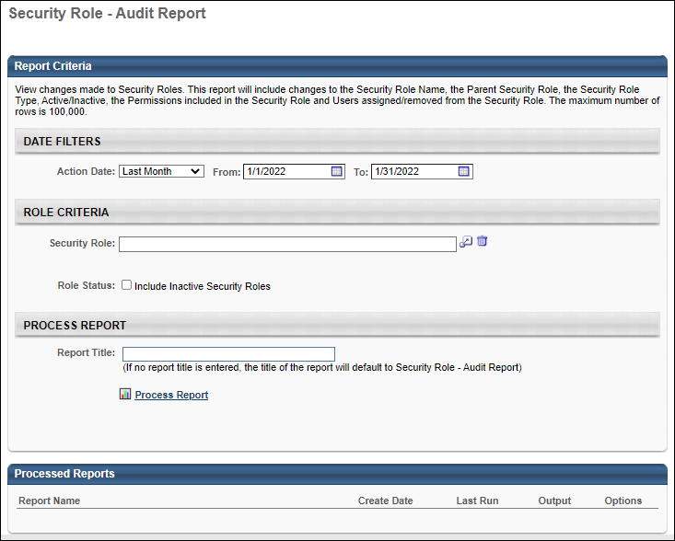
Report Criteria
The following report filters are available:
Filter Name | Description
Action Date | Select a date range for the report. The report will return any modification history for the selected date range. The default value is Last Month. This is a required field. Date values are set in the time zone of the user running the report.
Security Role | Select one security roles to include in the report. The report will return any modification history related to the selected security role.  The Security Role filter is visible to all users. However, a Restricted Access error message is displayed if an administrator attempts to use the filter or process the report if they do not have the Security Administration - Manage permission. Further, administrators can only view security roles that are within their Security Administration - Manage and Security Administration - General Constraints permissions.
Role Status | Select this option to include inactive security roles in the report output.
Report Output
The following details are included in the report output:
Column Name | Description
Security Role Name | This displays the name of the security role that was modified.
Security Role ID | This displays the ID of the security role that was modified.
Security Role Type | This displays the type associated with the security role.
Security Role Active | This displays whether the security role is active or inactive.
Changed On | This displays the date on which the action occurred. Date fields are displayed in the time zone of the user running the report.
Changed By User ID | This displays the User ID of the user who modified the security role.  Important: If a user creates a dynamic rule to assign a security role, then that rule creator will appear as the actor for any subsequent dynamic assignments of the role even if the rule creator is made inactive in the system.
Changed By Username | This displays the Username of the user who modified the security role.
Changed By User Full Name | This displays the full name of the user who modified the security role.
Field Changed | This displays which field was modified within the security role, if applicable.
Action Performed | This displays the specific action that was taken upon the security role.
Old value | This displays the old value of the field that was modified, if applicable.
New Value | This displays the new value of the field that was modified, if applicable.
Considerations
- The Security Role pop-up will show only the roles that a user is part of AND the child roles of those roles.
- If a user creates a dynamic rule to assign a security role, then that rule creator will appear as the actor for any subsequent dynamic assignments of the role even if the rule creator is made inactive in the system.

Security Role - User Permission Report
The Security Role - User Permission Report enables organizations to extract details on the roles assigned to a user and the permissions and constraints associated with those roles. This report also includes constraints at the individual user level. Filtering options are available.
This report supports 100,000 rows of data.
To access the Security Role - User Permission Report, go to Reports > Standard Reports. From the System tab, select the Security Role - User Permission Report link.
Permissions
PERMISSION NAME | PERMISSION DESCRIPTION | CATEGORY

Security Role - User Permission Report | Grants access to the Security Role - User Permission Report, which enables organizations to report on the roles assigned to a user and the permissions and constraints associated with those roles. This permission cannot be constrained. | Reports - System
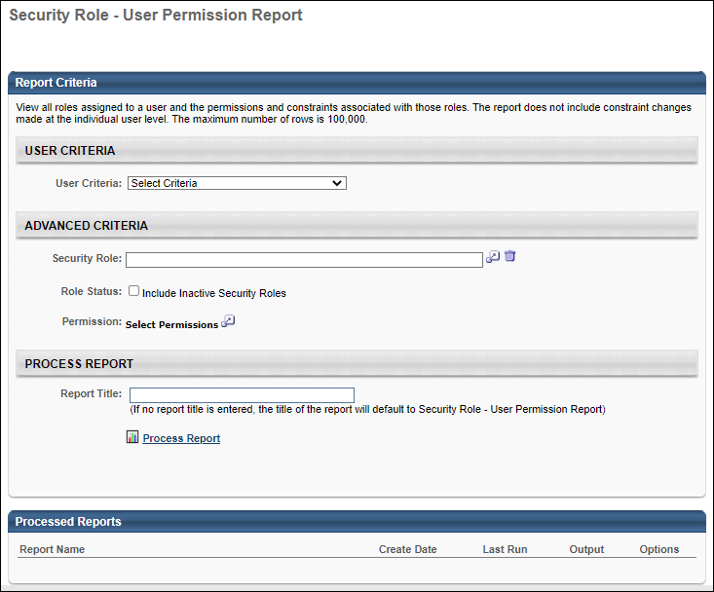
Report Criteria
The following report filters are available:
Filter Name | Description
User Criteria | Select a user or a group of users to include in the report. You may choose one or more individual users as well as entire organizational units (OUs) or Groups.
Security Role | Select a security roles to include in the report. If a role is selected, the report only includes information related to the selected role.  The Security Role filter is visible to all users. However, a Restricted Access error message is displayed if an administrator attempts to use the filter or process the report if they do not have the Security Administration - Manage permission. Further, administrators can only view security roles that are within their Security Administration - Manage and Security Administration - General Constraints permissions.
Role Status | Select whether the report should include inactive roles.
Permission | Select one or more permissions to include in the report. If a permission is selected, the report only includes information related to the selected permission.
Report Output
The following details are included in the report output:
Column Name | Description
User ID | This displays the ID of the user in the security role.
Username | This displays the username of the user in the security role.
User Full Name | This displays the full name of the user in the security role.
Constraint | This displays the constraint applied to the security role.
Security Role Name | This displays the name of the security role.
Security Role ID | This displays the ID of the security role.
Security Role Type | This displays the type associated with the security role.
Security Role Active | This displays whether the security role is active or inactive.
Parent Security Role Name | This displays the parent security role associated with the security role.
Parent Security Role ID | This displays the ID of the parent security role.
Permission | This displays the permission included in the security role.
Permission Category | This displays the category of the permission included in the security role.
Inherited Permission | This displays whether or not the permission is inherited from a child role.
Considerations
The Security Role pop-up will show only the roles that a user is part of AND the child roles of those roles.

Security Role Report
The Security Role Report enables users to view security role information, as well as the permissions and constraints defined for the role. Users can only run the report for security roles to which they have access in the system.
To create Security Role reports, go to Reports > Standard Reports > System. Then, click the Security Role Report link.
Permissions
PERMISSION NAME | PERMISSION DESCRIPTION | CATEGORY

Security Role Report | Grants access to view the User Roles, Permission and Constraints Report, which displays user level information about roles, permissions and constraints. This permission cannot be constrained. | Reports - System
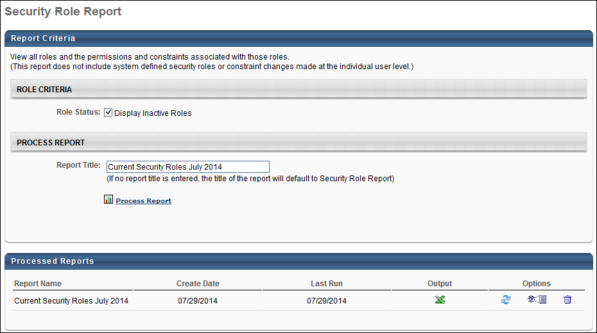
Role Criteria
The Role Status field is unchecked by default. This field allows users to include inactive roles in the report output. When unchecked, inactive roles are not included in the report.
Process Report
In the Report Title field, enter a title for the report. If no title is entered, the report title defaults to the report name. The title appears on both the report output and in the Processed Reports section.
Click the Process Report link to run the report based on the selected criteria. The report output is stored in the Processed Reports table.
Processed Reports Table
The Processed Reports table displays the three most recently run reports. The report name, create date, and last run date display for each report. The following options are available for each report in the table:
- Click the Print icon to view a printable version of the report. The report can also be printed from the printable version.
- Click the Excel icon to generate an Excel output of the report. Note: Once the Excel icon has been pressed, the report starts processing without a visual indicator that the report is processing. Pressing the Excel icon multiple times will restart the export process each time.
- Click the Refresh icon to refresh the report results.
- Click the View Details icon to view and modify the filter criteria for the report.
- Click the Delete icon to delete the report.
Output
The report data is sorted alphabetically by security role name. The only security roles that display are the roles that are available to the user.
Note: User level constraints, which are defined for individual users on the Users page, are not included in the report.
The report output includes the report criteria, as well as the following report data:
- Role Name - This column displays the name of the role the user is in.
- Role ID - This column displays the ID of the role the user is in. If the user has more than one role, each role appears on a separate row.
- Parent Role - This column displays the parent role.
- Parent Role ID - This column displays the role ID of the parent role.
- Role Description - This column displays the description text for the role.
- Role Type - This column displays the type of role, either static or dynamic.
- Active - This column displays the active status of the role. The column displays "Yes" for active and "No" for inactive.
- Permission Name - This column displays the permission name. If a role has more than one permission, each permission appears on a separate row.
- Permission Category - This column displays the permission category associated with the permission for the user.
- Constraints - This column displays the constraints added to a permission for each role. Constraints appearing in the role are role-specific only and do not reflect constraints set at the individual user level.
If more than one constraint exists for a permission, all constraints appear in the same cell, separated by a line break. If a constraint includes subordinates, the subordinates display in parenthesis to the right of the constraint name. For example, "Restricted to Corporation: Acme (include subordinates)."
- Inherited Permissions - This column indicates whether or not a permission has been inherited from a child role. The column displays "Yes" if the permission has been inherited by the parent role from a child role, and "No" if the permission has not been inherited from a child role.
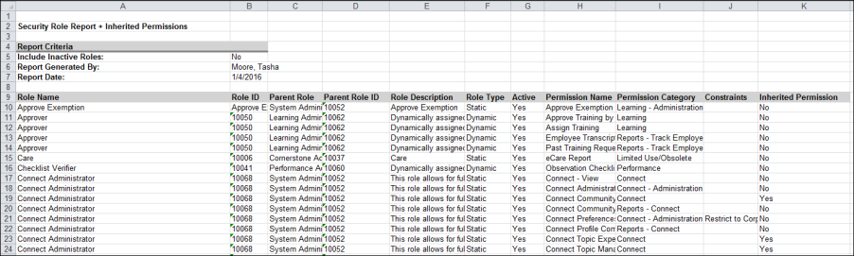

User Audit Report - Detailed
The User Audit Report - Detailed report provides complete audit details of user record data, including fields that have changed, their prior value, and their new value for all users in the portal. The maximum number of entries in the report is 100,000. Up to 50 user record fields can be selected for the report.
The User Audit Report - Detailed report is only available for organizations that are using Cornerstone HR or Enhanced-Audit. For more information regarding the Cornerstone HR and Enhanced-Audit products, please contact your Account Manager.
The User Audit Report - Detailed report goes beyond the generally available, standard user record auditing report, called the User Record Audit Report, which shows basic audit information of user records, including what users records have been modified and when they were modified.
To run the User Audit report, go to Reports > Standard Reports. Then, select the System tab and click the User Audit Report - Detailed link.
Permissions
PERMISSION NAME | PERMISSION DESCRIPTION | CATEGORY

User Audit Report - Detailed | Grants access to the User Audit standard report, which displays detailed changes to user data. Users with this permission must also have permission to view user fields in other areas of the system. The users and fields available in this report are controlled by additional permissions. This permission can be constrained by OU, User's OU, User's Subordinates, User's Direct Subordinates, User's Self, User Self and Subordinates, User, and Employee Relationship. The constraints on this permission limit the users and OUs that are available when running the report. This is an administrator permission. | Reports - System

Users - View | Grants the ability to search for and view summary information about users in the portal via the Admin/Users screen. This permission can be constrained by OU, User's OU, User Self and Subordinates, and Users. If multiple constraints are added, these constraints are considered OR statements. This is an administrator permission. | Core Administration

Users - View Sensitive Information: Masked | Grants ability to view masked Sensitive Personally Identifiable Information (SPII) fields on the user record. Administrators with this permission cannot view the actual data. This permission can be constrained by OU, User's OU, User's Self, User's Subordinates, User's Direct Subordinates, User, and Employee Relationship. This is an administrator permission. | Core Administration
Administrators must have permission to view or edit a field on the User Record in order to include it in the report output. See User Record Permissions.
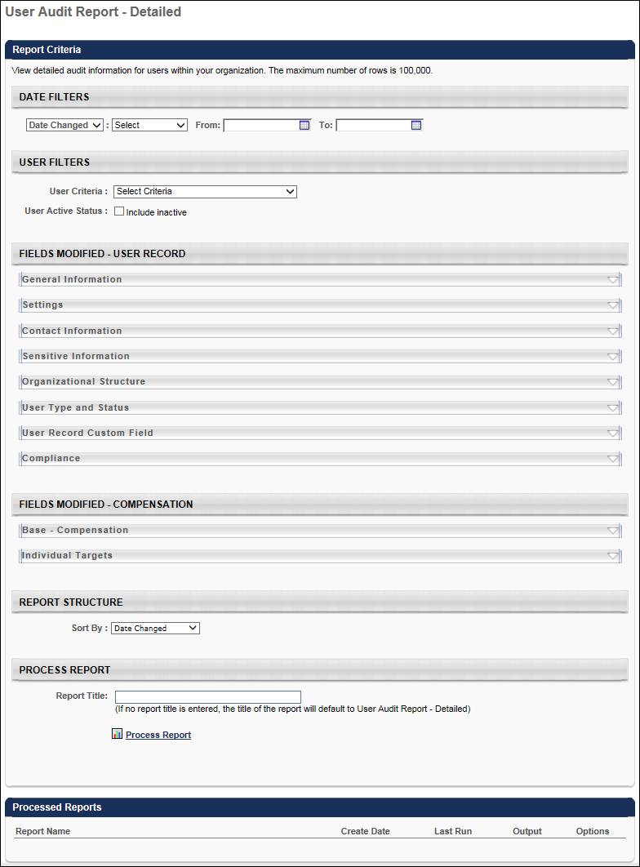
Report Criteria
Date Filters
Filter | Description
Date Type | Select whether the report is filtered by Date Changed or Date Effective.  - Date Changed - When this option is selected, then the report only displays user record modifications that were submitted within the selected date parameters.  - Date Effective - When this option is selected, then the report only displays user record modifications that have an effective date that is within the selected date parameters. This option is only available if User Record Effective Dating is enabled.
Date Parameters | Using the filters, select the date range for the report. Depending on the Date Type selection, the report will only include modifications to the user record that are within the selected date parameters. For example, if the Date Type is set to Date Changed, then only modifications that were initiated within the selected date range are included in the report output.
User Filters
Filter | Description
User Criteria | Select a user or a group of users. This criterion applies to the users whose records are being modified. This is a required field. You may choose one or more individual users as well as entire OUs or Groups. If permission for this report is constrained, those constraints apply to user criteria selection when running the report.  Note: If no User Criteria is selected, or if "All Users" is selected, then no data will be returned in the report output.
Include Inactive | Select this option to include inactive users in the report.
Fields Modified - User Record
This section enables you to select which user record fields are included in the report output. This section is only available if user record auditing is enabled.
The User Record section is comprised of multiple subsections that contain fields that may appear on the User Record. All subsections are displayed in the order in which they appear on the user record, and they are collapsed by default. To expand the subsection to view the section's fields, click the down arrow icon to the right of the subsection heading. Up to 50 user record fields can be selected for the report.
Security Note: In order for audits of user record fields to be included in the output of the report, the target user must be within the constraints of the Users - View permission and the User Audit Report - Detailed permission. In addition, you must have permission to view or edit the corresponding field on the User Record. See User Record Permissions.
The following subsections appears in the Fields Modified - User Record section:
- Contact information
- Sensitive Information - This subsection enables organizations to report on when Sensitive Personally Identifiable Information (SPII) fields are modified on a user record. This section is only available when Encrypted Sensitive Information is enabled. This section is only available to administrators who have the Users - View Sensitive Information: Masked permission, and administrators can only access data for users who are within their constraints on this permission.
  - When sensitive information fields are included in the report output, the report output displays when each SPII field is modified and by whom. However, the Changed From and Changed To values are always hidden and cannot be revealed to the administrator within this report.
  - Because the actual values of the SPII fields are not displayed in the report output, the system does not audit the access of this report.
- General Information
- Organizational Structure
- Settings
- User Status Information
- User Record Custom Field Categories - These categories can be configured in User Record Custom Fields. Only active categories are displayed, and they are displayed in the order in which they are ordered within Custom Field Administration.
Fields Modified - Compensation
This section enables you to select which compensation fields are included in the report output. This section is only available if compensation auditing is enabled.
The Fields Modified - Compensation section is comprised of multiple subsections that contain different types of compensation fields. All subsections are displayed in alphabetical order, and they are collapsed by default. To expand the subsection to view the section's fields, click the down arrow icon to the right of the subsection heading. Up to 50 total fields can be selected for the report. This includes fields in the User Record and Compensation sections.
Security Note: In order for audits of compensation fields to be included in the output of the report, the target user must be within the constraints of the applicable permissions. For Base Compensation fields, these are the Employee Salary Management - View and User Audit Report - Detailed permissions. For Individual Targets fields, these are the Compensation Individual Targets - View and User Audit Report - Detailed permissions.
The following subsections appears in the Fields Modified - Compensation section:
- Base Compensation
- Individual Targets - This section includes standard and custom individual targets.
Report Structure
Filter | Description
Sort report by | Select the order in which the report data should be sorted. The following options are available:  - Date Changed - This option is selected by default.  - Date Effective - This option is only available if User Record Effective Dating is enabled.  - User Last Name  - User ID  - Reason for Change - This option is only available if the Reason for Change functionality is enabled.
Process Report
Criteria | Description
Report Title | Enter a title for the report, up to 50 characters. The title is displayed on the report and is also displayed in the list of Processed Reports on this page.
This is an asynchronous report, which allows the administrator to define the standard report and generate the report asynchronously. As a result, when administrators process the report, the system generates the report in the background, while the administrator can move on to other areas of the system. When the report is finished processing, the administrator can then view the full report in its entirety.
- Up to 10 separate reports can generate asynchronously, allowing greater flexibility for creating and storing different versions of the report.
- If you process a report or refresh a stored report, the report appears in the table as Queued.
- The most recently created report displays at the top of the table.
- Since the user can generate up to ten reports, the administrator can define a report title for each of the generated reports.
- Clicking the View Details icon changes the report settings on the page to match those of the selected previously run report.
When the Process Report link is clicked, the report is run based on the selected criteria. The report output is stored in the Processed Reports table.
The administrator can choose the following actions and options for each report in the Processed Report table:
- Click the Excel icon to export the report to Excel.
- Click the Refresh icon to refresh the report results.
- Click the View Details icon to view the filter criteria for the report.
- Click the Delete icon to delete the report.
Report Output
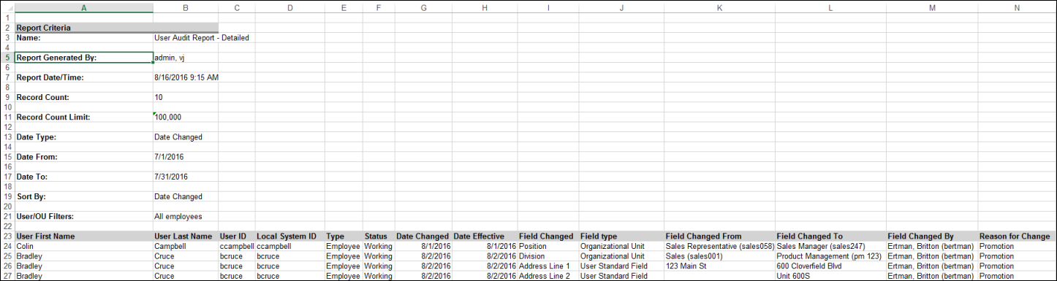

User Record as of a Date Report
The "User Record as of a Date" Standard Report will be deprecated in the first quarter of 2023.
- As an alternative, customers with Cornerstone HR enabled in their portal and using the effective dating feature or the aggregate audit feature can use the "Point-in-time Headcount Details" report. This report provides a list of user records for a specific date at any point in time. See Point-in-Time Headcount Details Report.
- Customers who do not have Cornerstone HR enabled can use Reporting 2.0.
- Note: For customers who do not use Cornerstone HR, this report did not respect any past/future point in time relations/data values. Generated results were based on an "as of now" dataset which is why Reporting 2.0 is a viable alternative.
When Effective Dating is enabled with Cornerstone HR (CHR), the User Record as of a Date report is available as a standard report.
The User Record as of a Date report displays user data as of a specified effective date. This enables administrators to view user information as of a date in the past or in the future. The report can also be configured to display user standard and custom field data. For example, this report can be configured to display all users in the Sales division as of June 1, 2012. Important: The Grade field is only available to users who have permission to view grades. However, all other fields are not limited by the user record permissions.
Note: If grouping was applied, the report will return users who are in the group on 'the run day' and were part of the group on the "as of date". It will miss people who are still active but changed groups.
The availability of this report is controlled by a backend setting, which is only available when Cornerstone HR is purchased and Effective Dating is enabled. Users must also have permission to run this report.
To run the User Record as of a Date report, go to Reports > Standard Reports. Then, select the System tab and select the User Record as of a Date link.
Permissions
PERMISSION NAME | PERMISSION DESCRIPTION | CATEGORY

Employee Salary Management - View | Grants access to the Employee Salary Management page to view users' salaries or rates. This permission can be constrained by OU, User's OU, and User. This is an administrator permission. | Compensation - Administration

Employee Salary Management | Grants access to the Employee Salary Management page to edit, add, and view users' salaries or rates. This permission can be constrained by OU, User's OU, and User. This is an administrator permission. | Compensation - Administration

Grades - View | Grants ability to view the Grade Organizational Unit throughout the system, such as in availability drop down selectors, when editing users, etc. Those without this permission do not see the Grade OU on any screen. This is primarily an administrator permission, although organizational policy should determine whether the Grade OU should be visible to end users on reporting screens, etc. | Core Administration

User Record as of a Date | Grants access to run the User Record as of a Date report, which displays user data as of a specified effective date. This permission can be constrained by OU, User's OU, User Self and Subordinates, and User. The constraints on this permission limit the users and OUs that are available when running the report. Also, the constraints are based on the data as of the effective date of the report. This is an administrator permission. | Reports - System
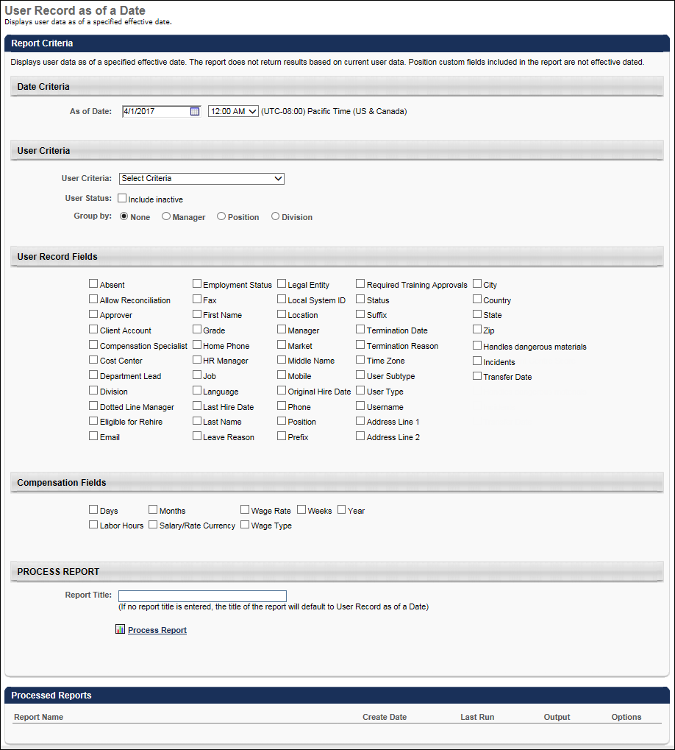
Date Criteria
Filter Name | Description
As of Date | Select the effective date and time for the report. For example, if this is set to a date in the past, then the report output will display data as it existed on the selected date in the past. If this is set to a date in the future, then the report output will display data as it is currently expected to exist on the selected date in the future. The time that is selected is in the timezone of the user who is configuring the report.
User Criteria
Filter Name | Description
User Criteria | Limit results to the users matching the specified user criteria as of the date selected in the Date Criteria section. For example, if this is set to the Sales division, and the Date Criteria is set to 2014/06/01, then the report output includes users who were in the Sales division as of June 1, 2014. When multiple OUs are selected, OR logic is applied to the selections. Groups and users cannot be selected. The constraints on the User Record as of a Date permission limit the OUs and users available, and the constraints are based on the data as of the report's effective date. Note: If the Include Subordinates option is selected for an OU, the current OU hierarchy is used.
User Status | Select this option to include inactive users in the report. This option is based on the user status as of the report's effective date, not the current user status.
Group by | Select one of the options to group users based on the selected criterion as of the report's effective date.
User Record Fields
Filter Name | Description
User Record Fields | Select the user record fields that will be displayed on the report. At least one user record field must be selected, and up to 50 fields can be selected. All standard and custom fields that are included on the User Record and are available to the user who is running the report are available to be selected except multi-select checkboxes. Standard fields are displayed first, followed by custom fields. When selected, the fields are included as columns in the report, and the data in the fields are reported as of the report's effective date. Important: The Grade field is only available to users who have permission to view grades. However, all other fields are not limited by the user record permissions.
Compensation Fields
Compensation fields are available to be included in the report if the manager or administrator has permission to view or manage employee compensation data. Constraints on the Employee Salary Management permission are not currently enforced within the User as of a Date report.
Filter Name | Description
Compensation Fields | Select the compensation fields that will be displayed on the report. Up to 50 total fields can be selected. When selected, the fields are included as columns in the report. The following fields are available:  - Wage Type Equivalencies (e.g., Days, Months, Years)  - Salary/Rate Currenty  - Wage Rate  - Wage Type
Process Report
This is an asynchronous report, which allows the administrator to define the standard report and generate the report asynchronously. As a result, when administrators process the report, the system generates the report in the background, while the administrator can move on to other areas of the system. When the report is finished processing, the administrator can then view the full report in its entirety.
- Up to three separate reports can generate asynchronously, allowing greater flexibility for creating and storing different versions of the report.
- If you process a report or refresh a stored report, the report appears in the table as Queued.
- The most recently created report displays at the top of the table.
- Since the user can generate up to three reports, the administrator can define a report title for each of the generated reports.
- Clicking the View Details icon changes the report settings on the page to match those of the selected previously run report.
In the Report Title field, enter a title for the report. If no title is entered, the report title defaults to the report name. The title appears on both the report output and in the Processed Reports section.
Click the Process Report link to run the report based on the selected criteria. The report output is stored in the Processed Reports table.
Processed Reports Table
The Processed Reports table displays the three most recently run reports. The report name, create date, and last run date display for each report. The following options are available for each report in the table:
- Click the Print icon to view a printable version of the report. The report can also be printed from the printable version.
- Click the Excel icon to generate an Excel output of the report. Note: Once the Excel icon has been pressed, the report starts processing without a visual indicator that the report is processing. Pressing the Excel icon multiple times will restart the export process each time.
- Click the Refresh icon to refresh the report results.
- Click the View Details icon to view and modify the filter criteria for the report.
- Click the Delete icon to delete the report.
Report Output
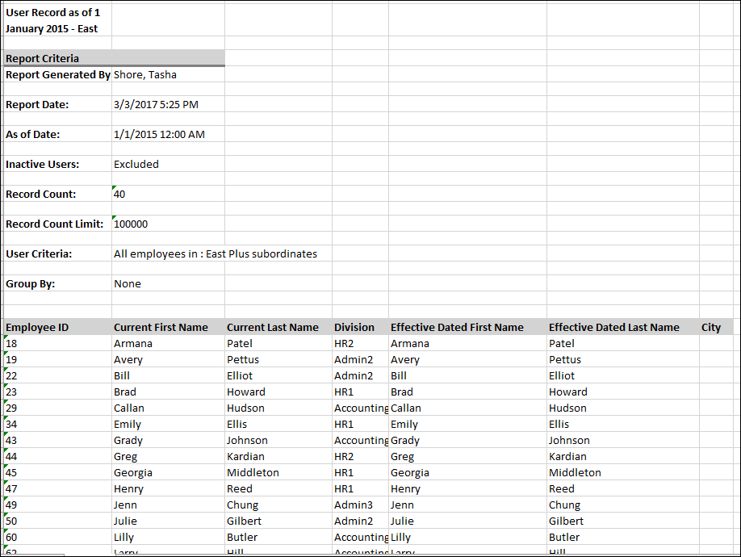

User Record Audit Report
The User Record Audit Report enables managers to view user audit information for users within the organization.
To run the User Record Audit Report, go to Reports > Standard Reports. Then select the System tab and click the User Record Audit Report link.
Permissions
PERMISSION NAME | PERMISSION DESCRIPTION | CATEGORY

User Record Audit Report | Grants access to User Record Audit report, which displays user record modification history. The selected constraints function independently and are then combined to determine the availability for this report. | Reports - System
Criteria
Filter Name | Description
User Criteria | Limit results to the users matching the specified user criteria. This is required.
Date Criteria | Filter your results by date. This filter refers to the date on which an audit action occurred. This filter is required. Note: Date Criteria is always implemented using UTC (Coordinated Universal Time).
Update Action Type | From the multi-select drop-down, select the action types that should be included in the report.
User Status | Select this option to include inactive users in the report.
Process Report
This is an asynchronous report, which allows the administrator to define the standard report and generate the report asynchronously. As a result, when administrators process the report, the system generates the report in the background, while the administrator can move on to other areas of the system. When the report is finished processing, the administrator can then view the full report in its entirety.
- Up to three separate reports can generate asynchronously, allowing greater flexibility for creating and storing different versions of the report.
- If you process a report or refresh a stored report, the report appears in the table as Queued.
- The most recently created report displays at the top of the table.
- Since the user can generate up to three reports, the administrator can define a report title for each of the generated reports.
- Clicking the View Details icon changes the report settings on the page to match those of the selected previously run report.
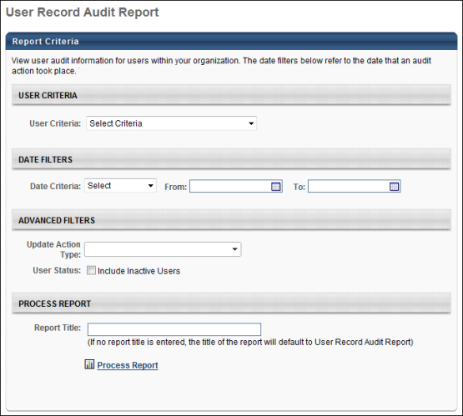
Output
The following information is included in the report:
- User Last Name
- User First Name
- User ID - This displays the user's current User ID.
- User OU at the time of action - This displays the user's identifying OU at the time the action was performed. The OUs that are used as identifying OUs are set by administrators. The audit data for this field may not be available for dates prior to the Summer 2012 Release (September 7, 2012). If the data is not available, then N/A is displayed.
- Manager - This displays the user's manager.
- Update Action - This displays the action that was performed upon the user's user record. Only action types that were selected in the report criteria are included in the report.
- Updated On - This displays the date on which the action was performed.
- Performed By (ID) - This displays the User ID of the user that performed the action.
- Performed By (Name) - This displays the name of the user that performed the action.
The report results are sorted by User Last Name, User First Name, User ID, and then Action Date.
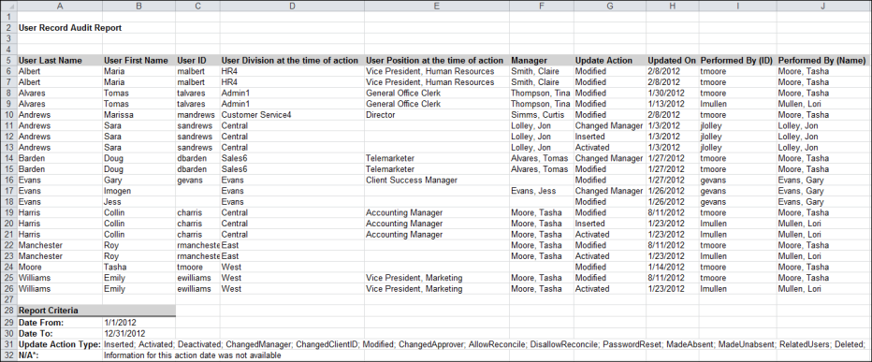

User Transcript Audit Report
The User Transcript Audit Report enables managers to view transcript audit information for users within the organization.
To run the User Transcript Audit Report, go to Reports > Standard Reports. Then select the System tab and click the User Transcript Audit Report link.
Permissions
PERMISSION NAME | PERMISSION DESCRIPTION | CATEGORY

User Transcript Audit Report | Grants access to User Transcript Audit report, which displays user transcript approval history from the Training Details page for any training in the transcript. The report results are limited by the permission constraints. The selected constraints function independently and are then combined to determine the availability for this report. | Reports - Training
Criteria
Filter Name | Description
User Criteria | Limit results to the users matching the specified user criteria. This is required.
Date Criteria | Filter your results by date. This filter refers to the date on which an audit action occurred. This filter is required. Note: Date Criteria is always implemented using UTC (Coordinated Universal Time).
Training Title | Click the Select icon to select a specific training item for this report. If no training item is selected, the report includes all available training items.
Training Type | From the drop-down list, select a specific training type to include in the report. If a Training Title and a Training Type are selected, then the report includes the selected training title and all available training items within the selected training type. If multiple languages are available for the portal, you can select a specific language from the Language drop-down list.
Recurring Training | Select this option to include all registrations in the report, including recurrences. If this option is unchecked, then the report only includes the latest registration.
User Status | Select this option to include inactive users in the report.
Include Removed Training | Select this option to include training that was removed from the user transcript in the report.
Process Report
This is an asynchronous report, which allows the administrator to define the standard report and generate the report asynchronously. As a result, when administrators process the report, the system generates the report in the background, while the administrator can move on to other areas of the system. When the report is finished processing, the administrator can then view the full report in its entirety.
- Up to three separate reports can generate asynchronously, allowing greater flexibility for creating and storing different versions of the report.
- If you process a report or refresh a stored report, the report appears in the table as Queued.
- The most recently created report displays at the top of the table.
- Since the user can generate up to three reports, the administrator can define a report title for each of the generated reports.
- Clicking the View Details icon changes the report settings on the page to match those of the selected previously run report.
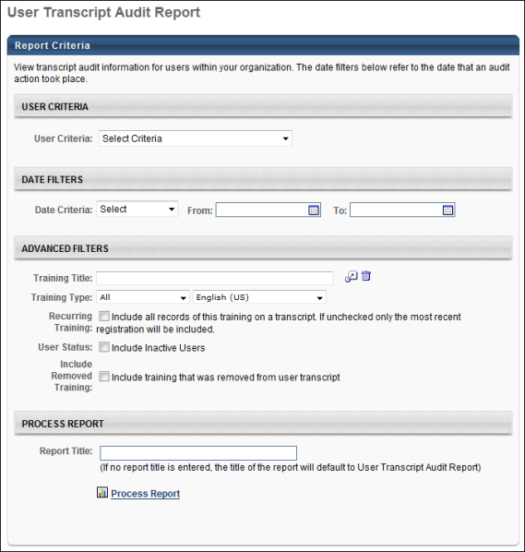
Output
The following information is included in the report:
- User Last Name
- User First Name
- User ID
- Training Type - This displays the type of training that was modified. Only training types that were selected in the report criteria are included in the report.
- Training Title - This displays the title of the training that was modified. Only training items that match the report criteria are included in the report.
- Training Version - This displays the version of the training at the time of the action.
- Training Description - This displays the current description of the training that was modified.
- Training Action - This displays the action that was performed upon the user's transcript record.
- Registration Number
- Action Date - This displays the date and time at which the action was performed. The column displays the date and time as MM/DD/YYYY HH:MM:SS <AM/PM>. Note: The availability of the action time stamp is controlled by a backend setting. To enable this functionality, contact Global Customer Support.
- Action Performed By (ID) - This displays the User ID of the user that performed the action.
- Action Performed By (Name) - This displays the name of the user that performed the action.
- Action Reason - This displays the reason for the action that was provided by the action performer, if applicable.
- Action Comments - This displays any comments provided by the action performer, if applicable.
- User OU at the time of action - This displays the user's identifying OU at the time the action was performed. The OUs that are used as identifying OUs are set by administrators. The audit data for this field may not be available for dates prior to the Summer 2012 Release (September 7, 2012). If the data is not available, then N/A is displayed.
- User Last Modification Date - This displays the date on which the user's user record was last modified.
- User Last Modification Action - This displays the action that was last performed upon the user's user record.
The report results are sorted by User Last Name, User First Name, User ID, Training Title, and then Action Date.

User's OUs and Groups Report
The User's OUs and Groups Report lists all of the OUs and Groups to which a user belongs, and can include OUs and Groups to which a user has belonged in the past. This report is located under the System tab of Standard Reports.
Permissions
PERMISSION NAME | PERMISSION DESCRIPTION | CATEGORY

User's OUs and Groups Report | Grants access to User's OUs & Groups Report, which lists all of the OUs and Groups to which a user belongs, and can include OUs and Groups to which a user has belonged in the past. | Reports - System
Criteria
Filter Name | Description
Date Criteria | The report displays the OUs and Groups to which the user belonged during this time period, including both OUs and Groups to which the user belonged and currently belongs. This defaults to the current year up to today's date. To include only the user's current OUs and Groups, the dates selected should both be set to the current date. Note: Date Criteria is always implemented using UTC (Coordinated Universal Time).
User Criteria | Limit results to the users matching the specified user criteria.
OU Type Criteria | Run the report on all OU types or a specific OU type.  When selecting a group in the OU filter, users who are not currently in the group are excluded from the output. If a user is not currently in the group selected in the OU filter, that user will not be displayed in the output even if they may have been in the group on a past date.
Group By | Choose to group the results by User, OU Type, or choose not to group the results.
OU Custom Fields | Check the box to include OU custom fields in the report. This option only displays if the report output is set to Group by None or Group by User. If the report output is set to OU Type in the Group By field, the checkbox becomes grayed out and not selectable. Only current values of the OU custom fields are included; historical values are not included.  OU custom fields display on the report in the following formats:  - Branched Dropdown - Includes the name of the lowest selected branch.  - Checkbox - True or False  - Date - 1/2/2011  - Dropdown - Includes the name of the lowest selected branch.  - Hierarchy - The name of the lowest level selection.  - Multiple Checkbox - A comma delimited list of checked responses.  - Numeric - The entered number.  - Radio button - The selected choice.  - Short Text - The entered text.  - Scrolling Text - The entered text.  If no information exists for the custom OU field, the cell on the report is blank. In addition, inactive custom fields do not appear in the report output.
Inactive Users | Select this option to include inactive users in the report.
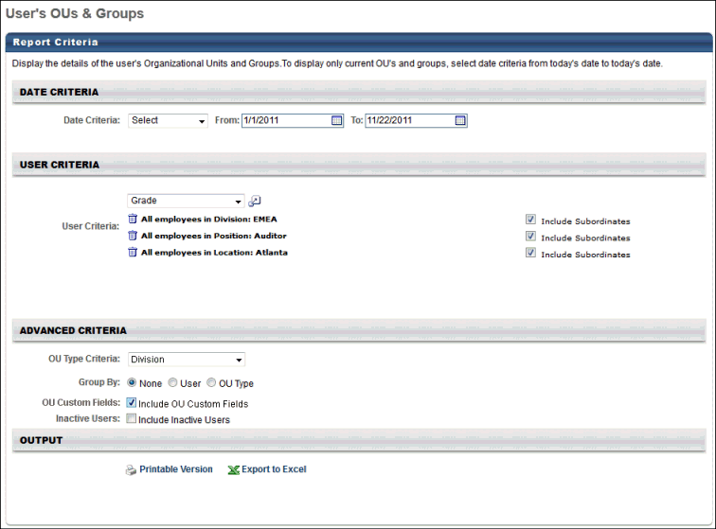
Output
The output includes the following information:
- User ID
- User Name
- OU Type - Customized OU Types also display
- OU Name
- Start Date - Start Dates prior to the Spring/Summer 2010 release are unavailable and are not displayed. Prior to the Spring/Summer 2010 release, the system did not track historical dates assigned to an OU.
- End Date - End Dates prior to the Spring/Summer 2010 release are unavailable and is not displayed. Also, if the user is currently in the OU or Group, this is blank.
- Time in OU - This is calculated based on a 365 day year and assumes each month is 30 days. This calculation does not consider short or long months.
The maximum number of rows in the Excel output is 30,000.
Results Not Grouped
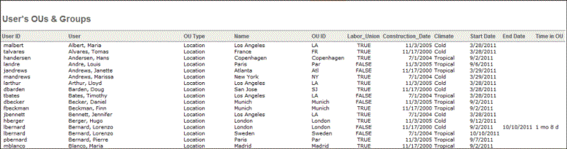
Results Grouped by User
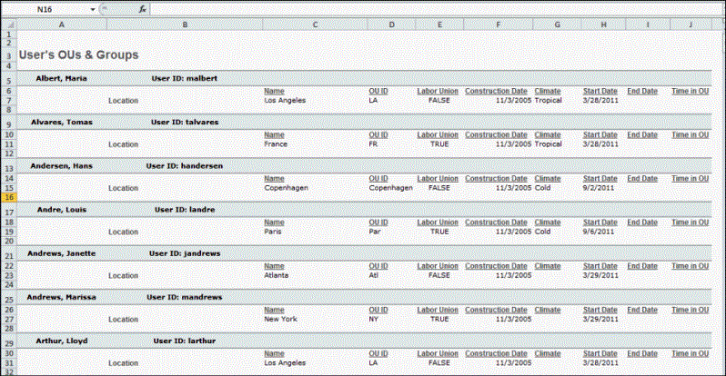
Results Grouped by OU Type
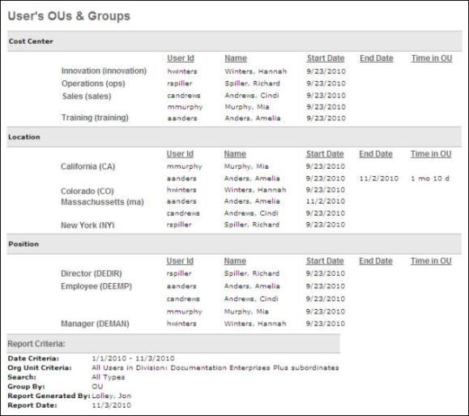

Track Employee Reports Overview
Recommended Reports
A complete list of recommended reports for managers, learning, performance, and succession is available in the OnDemand Support folder:
- See Recommended Standard Reports for Managers for additional information.
- See Recommended Standard Reports - Learning for additional information.
- See Recommended Standard Reports - Performance for additional information.
- See Recommended Standard Reports - Succession for additional information.

Career Profile Report
Display career profiles for individual employees.
Filters
- Select User
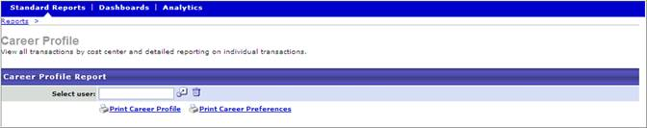
Output
- Printable Career Profile link or Printable Career Preference link
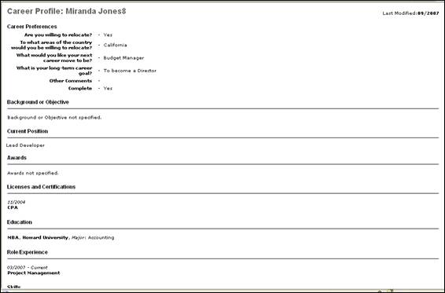

Form Management Status Report
This report tracks data for the Form Management functionality and is only available for portals with this functionality. This report displays status summary for compliance forms.
Permissions
PERMISSION NAME | PERMISSION DESCRIPTION | CATEGORY

Form Management Status Report | Grants access to Form Management Status report, which displays form task status summary by user. Note: By design, for any Track Employees report permission that is included in the Manager default security role, all of the manager's direct and indirect reports are included in the constraints, even if they are not selected in the permission constraints for the role. | Reports - Track Employee
Filters
- User Criteria - click user criteria from drop-down menu
- Form - select from pop-up window
- Task - select task from pop-up window
- Form Task Status - select form task status from drop-down list
- User Task Status - select user task status from drop-down list
- User Status - check to include Inactive Users
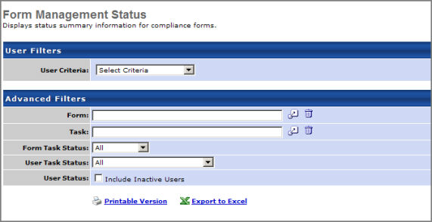
Output
- Printable Version link to view the results in a web page, or Export to Excel link to save/open as an Excel file
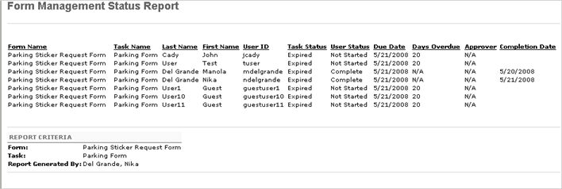

No Show Details Report
Display attendance rates and lists of no-shows per session. The detailed view lists users absent for the course.
Permissions
PERMISSION NAME | PERMISSION DESCRIPTION | CATEGORY

ILT No Show Report - Manager Version | Grants access to manager version of the ILT No Show Report, which displays attendance summaries and lists of subordinates who were registered for but did not attend any parts of instructor led training sessions. Note: By design, for any Track Employees report permission that is included in the Manager default security role, all of the manager's direct and indirect reports are included in the constraints, even if they are not selected in the permission constraints for the role. | Reports - Track Employee
Filters
- Date Criteria - Click on Calendar icon or enter a Date range (From/To) in the field. Note: Date Criteria is always implemented using UTC (Coordinated Universal Time).
- Event - Select an event.
- Facility - Select a facility.
- Provider - Click on search icon to select a specific Provider or skip to search on all providers.
- Details - Check to show details or/and include subordinates.
- Filter By - Select currency option to filter by if applicable.
- Convert To - Select convert rate if applicable and choose Client or Cornerstone exchange rate.
Output
- Printable Version link to view the results in a web page, or Export to Excel link to save/open as an Excel file.
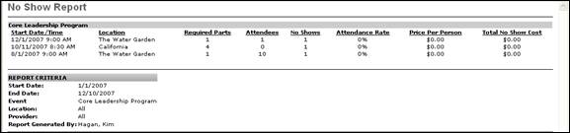

Past Due Report
This report displays employees past due training.
Permissions
PERMISSION NAME | PERMISSION DESCRIPTION | CATEGORY

Track Employees - Past Due Report | Grants access to Employee Past Due report, which displays past due training for subordinate employees (system administrators see all employees). This is a manager report. Note: By design, for any Track Employees report permission that is included in the Manager default security role, all of the manager's direct and indirect reports are included in the constraints, even if they are not selected in the permission constraints for the role. | Reports - Track Employee
Filters
- Date Criteria - click on calendar icon or enter a Date range (From/To) in the field. Note: Date Criteria is always implemented using UTC (Coordinated Universal Time).
- Training Type - click on drop-down menu to choose Training Type or skip to select all training types
- Provider - click on search icon to select a specific Provider or skip to search on all providers
- Removed Training - check Removed Training box if you want to include training that was removed from the users transcript in the report results
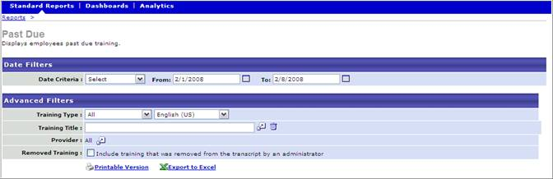
Output
- Printable Version link to view the results in a web page, or Export to Excel link to save/open as an Excel file
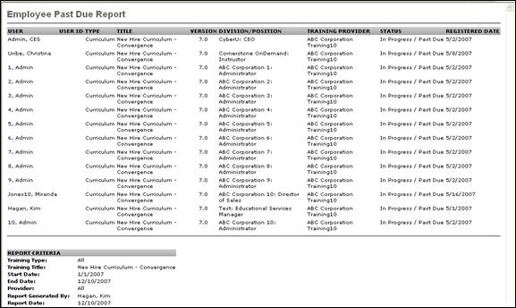

Past Requests Report
Displays past training requests from users for whom you are the Approver. This report enables you to see what approval decisions were made on those requests. Requests from the past three months are displayed. Approvers may change their decision for training for which the employee has not yet registered.
Permissions
PERMISSION NAME | PERMISSION DESCRIPTION | CATEGORY

Past Training Requests Report | Grants access to Past Requests, an interactive report that displays training requests the user has already approved, deferred, or denied. The user may change the approval decision for training that an employee has not yet registered for. This is an approver permission.  Note: By design, for any Track Employees report permission that is included in the Manager default security role, all of the manager's direct and indirect reports are included in the constraints, even if they are not selected in the permission constraints for the role. | Reports - Track Employee
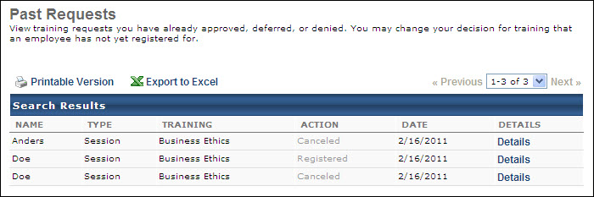
Output
- Printable Version link to view the results in a web page, or Export to Excel link to save/open as an Excel file
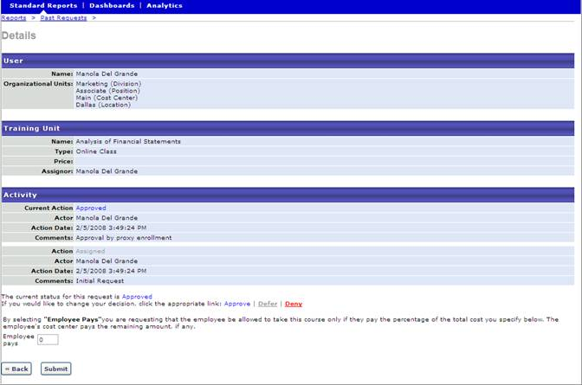

Pending Requests Report
This report displays outstanding training requests to be approved. Deferring a request will send the request to the next person in the approval chain for that employee.
This report is only available for users who are an approver in an approval workflow.
Design Note: An updated interface is available for this page, which can be enabled by administrators in Feature Activation Preferences. With the new design, the functionality of the page is unchanged.
To access this report, go to Reports > Standard Reports > Track Employees > Pending Requests.
Permissions
PERMISSION NAME | PERMISSION DESCRIPTION | CATEGORY

Approve Training by Approver | Grants ability to approve training requests of those for whom the user is the designated approver. | Learning

Approve Training by Cost Center Approver | Grants ability to approve training requests of those for whom the user is the designated cost center approver. | Learning

Approve Training by Manager | Grants ability to approve training requests of those for whom the user is the designated manager.  Note: Delegating this permission only applies when "Manager" is designated in the Approval Workflow. If the Approval Workflow contains a custom employee relationship - even if the Manager happens to fill that role - the approval will not flow to the delegate. | Learning

Employee Transcripts - Manager/Approver Access | Grants access to transcript (training record) screen of those for whom user is designated manager, approver or cost center approver. System administrators can access all user transcripts from this page. Link to this screen appears under Standard Reports/Track Employees. This is a manager/approver permission. This permission can be constrained by Employee Relationship and User's Direct Subordinates.  Note: The Employee Relationship constraint allows administrators to constrain the permission to a user’s custom employee relationship. For example, an administrator can select to restrict the Matrix Manager relationship to viewing user data for users who have that Matrix Manager indicated on their user record.  Note: The User's Direct Subordinates constraint allows administrators to constrain the data that a user can view to only the data for their direct reports. The user will not be able to view their own data with this constraint.  Note: By design, for any Track Employees report permission that is included in the Manager default security role, all of the manager's direct and indirect reports are included in the constraints, even if they are not selected in the permission constraints for the role. | Reports - Track Employee
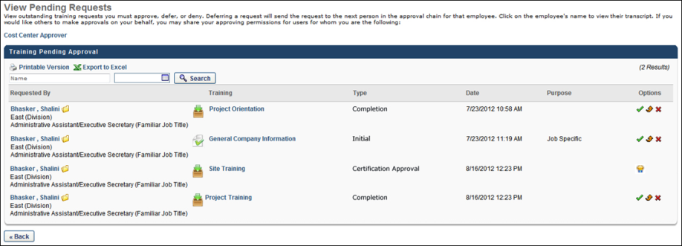
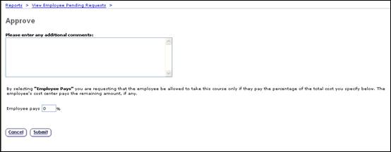
Approve/Defer/Deny Requests
- Approve - Click this icon to approve the request.
  - If the Delegate the approval process of external training to user's manager option is selected for a certification to which a user submits an external training item, when a manager approves completion of the external training from the Pending Requests page, the manager is automatically taken to the Evidence Needed Approval page.
- Defer - Click this icon to defer approval to the next person in the approval chain for the employee.
- Deny - Click this icon to deny the request.
- Certification Requests - This option is available for certifications that require approval. Click the icon to open the Pending Requests for Certifications page. See Certification Approval Requests for additional information.
Session Approve/Defer Attempt After Registration Deadline
When acting on a session approval request, approvers are prevented from approving or deferring a session request when the session registration deadline has passed. This applies to both traditional classroom and virtual classroom sessions but is not applicable to vILT sessions.
Note: Deferring requests is only available in portals for which it is enabled by a backend setting.
The request will need to be denied on the View Pending Requests page.
If you are attempting to approve the request on the Approve Request page, a message displays to indicate that the registration deadline has passed for the session and that it is too late to approve the request and it also cannot be deferred. The request will need to be denied on the View Pending Requests page. The user can then request or be assigned to another session.
For sessions that require more than one approval level, all approval levels must approve a request prior to the registration deadline, or the request cannot be approved (i.e., Manager Approver approves the request before the registration deadline, but Indirect Manager Approver does not. The request cannot be approved).
External Training Within a Certification
- If an external training is in a status of Completed (Evidence Needed) and is associated with a certification that has external training approval delegated to a user's manager, the external training appears in the Pending Requests report with the Type set as Certification Approval. Note: External Training requests for certifications only appear in the Pending Requests report if the Delegate the approval process of external training to user's manager option is selected for the certification.
- If an external training request for certification appears in the Pending Requests report, the Type for the request is set as Certification Approval. These external training items appear in the Pending Requests report after they receive completion approval or if they do not require completion approval.
- If the Delegate the approval process of external training to user's manager option is selected for a certification, the manager can still approve the external training and approve the application of the training to the certification. Once an external training is approved for a certification, any changes to the external training that are made by the administrator or the user are not applied to the external training within the certification.
- If the Delegate the approval process of external training to user's manager option is selected for a certification, the certification owner or the user's manager can approve the application of the external training to the certification. If either the certification owner or the user's manager approves or denies the external training request, then that request no longer appears to the other approver.

Records Report
Display user data and transcripts for direct and indirect reports.
Permissions
PERMISSION NAME | PERMISSION DESCRIPTION | CATEGORY

Track Employees - Employee Records | Grants access to Employee Records, enabling manager to view basic user and transcript data for a single direct or indirect report. This is a manager permission. This permission can be constrained by User's Direct Subordinates.  Note: The User's Direct Subordinates constraint allows administrators to constrain the data that a user can view to only the data for their direct reports. The user will not be able to view their own data with this constraint.  Note: By design, for any Track Employees report permission that is included in the Manager default security role, all of the manager's direct and indirect reports are included in the constraints, even if they are not selected in the permission constraints for the role. | Reports - Track Employee
Filters
- Choose User - Click the Select option to select the direct or indirect subordinate for the report. To remove the user, click the Delete option , and then select a different user.
- Display - Check the User Data option to display user record data. Check the Transcript option to display transcript data.
- Removed Training - This option is unchecked by default. When checked, the report output includes training that was removed from a user's transcript. The report output also includes a new "Removed" column that identifies removed training. If the this option is not selected, then training that has been removed and the "Removed" column do not display in the report output.
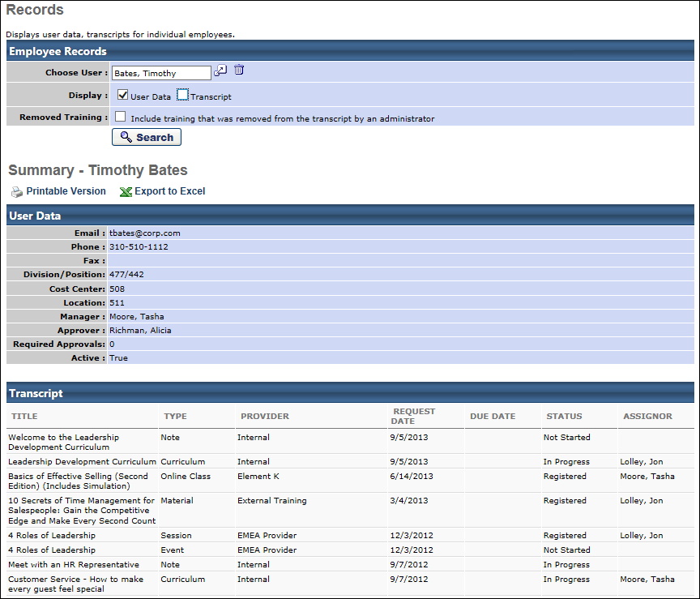
Output
- Printable Version link to view the results in a web page, or Export to Excel link to save/open as an Excel file

Session Withdrawal Report
Display a list of employees who registered and later withdrew their registration, including reasons for withdrawal.
Permissions
PERMISSION NAME | PERMISSION DESCRIPTION | CATEGORY

ILT Session Withdrawal Report - Manager Version | Grants access to Session Withdrawal report for subordinates of the user. The report displays subordinates who registered and later withdrew their registration, including reasons for withdrawal. This is a manager report. This permission can be constrained by Employee Relationship and User's Direct Subordinates.  Note: The Employee Relationship constraint allows administrators to constrain the permission to a user’s custom employee relationship. For example, an administrator can select to restrict the Matrix Manager relationship to viewing user data for users who have that Matrix Manager indicated on their user record.  Note: The User's Direct Subordinates constraint allows administrators to constrain the data that a user can view to only the data for their direct reports. The user will not be able to view their own data with this constraint.  Note: By design, for any Track Employees report permission that is included in the Manager default security role, all of the manager's direct and indirect reports are included in the constraints, even if they are not selected in the permission constraints for the role. | Reports - Track Employee
Filters
- Date Criteria - click on calendar icon or enter a Date range (From/To) in the field. Note: Date Criteria is always implemented using UTC (Coordinated Universal Time).
- User Criteria
- Provider - click on search icon to select a specific Provider or skip to search on all providers
Report Settings
This is an asynchronous report, which allows the administrator to define the standard report and generate the report asynchronously. As a result, when administrators process the report, the system generates the report in the background, while the administrator can move on to other areas of the system. When the report is finished processing, the administrator can then view the full report in its entirety.
- Up to three separate reports can generate asynchronously, allowing greater flexibility for creating and storing different versions of the report.
- If you process a report or refresh a stored report, the report appears in the table as Queued.
- The most recently created report displays at the top of the table.
- Since the user can generate up to three reports, the administrator can define a report title for each of the generated reports.
- Clicking the View Details icon changes the report settings on the page to match those of the selected previously run report.
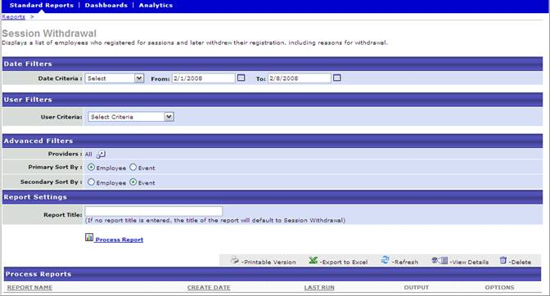
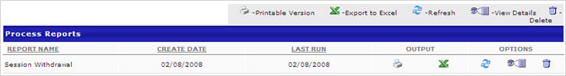
Output
- Printable Version link to view the results in a web page, or Export to Excel link to save/open as an Excel file
- After the report is processed you can:
  - Update the data on the report, click the Refresh icon
  - View the details on the report, click on the Details icon
  - Delete the report, click on the Delete icon
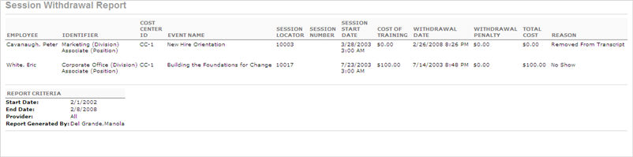

Training Progress Pie Chart Report
This report displays the percentage of users with certain statuses for a particular training item. This report can be run for any LO type. This report allows you to click on a slice of the pie to see a detailed breakdown of users with that status.
When date filters are not applied to this report, the report includes training in all statuses. However, when date filters are applied, the report only includes training in which the user is registered, and the date filters refer to the date the training was Registered.
Permissions
PERMISSION NAME | PERMISSION DESCRIPTION | CATEGORY

Track Employees - Training Progress Pie Chart | Grants access to Employee Training Progress Summary Report, a pie chart report that displays transcript status on a single learning object for a manager's direct reports. This is a manager permission. This permission can be constrained by Employee Relationship and User's Direct Subordinates.  Note: The Employee Relationship constraint allows administrators to constrain the permission to a user’s custom employee relationship. For example, an administrator can select to restrict the Matrix Manager relationship to viewing user data for users who have that Matrix Manager indicated on their user record.  Note: The User's Direct Subordinates constraint allows administrators to constrain the data that a user can view to only the data for their direct reports. The user will not be able to view their own data with this constraint.  Note: By design, for any Track Employees report permission that is included in the Manager default security role, all of the manager's direct and indirect reports are included in the constraints, even if they are not selected in the permission constraints for the role. | Reports - Track Employee
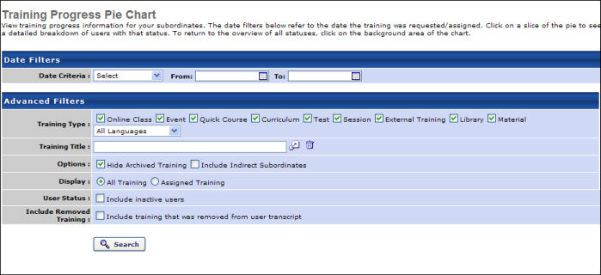
Filters
- Date Criteria - Use this filter to select a specific date range for the report. To select a date range, either select a standard range from the drop-down or select the calendar icons in the From and To fields to select a specific date range. Note: Date Criteria is always implemented using UTC (Coordinated Universal Time).
  - When date filters are not applied to this report, the report includes training in all statuses. However, when date filters are applied, the report only includes training in which the user is registered, and the date filters refer to the date the training was Registered.
- Training Type - check training type to include in report
- Training Title - choose training title
- Options:
  - Hide Archived Training - check to hide archived training
  - Include Indirect Subordinates - check to include indirect subordinates. Note: For users who have been given permission to run this report via the Shared Permissions functionality, this box must be checked in order for report data to display on the delegated/shared users.
- Display:
  - All Training - Select this option to include all Registered training.
  - Assigned Training - Select this option to only display Registered training that was assigned to the user.
- User Status - check to include inactive users
- Include Removed Training - check to include training that was removed from users transcript
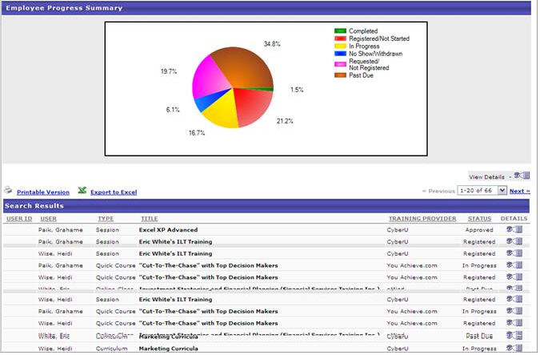
Registered/Not Started is shown in red:  - Registered  - Pending Prerequisite  In Progress is shown in yellow:  - Users with the status In Progress  Completed is shown in green:  - Completed  - Pending Evaluation  - Pending Acknowledgement  No Show/Withdrawn is shown in blue:  - No Show  - Withdrawn  - Incomplete  - Failed  - Or any of the above statuses with Past Due appended | Requested/ Not Registered is shown in purple:  - Pending Approval  - Approved  - Denied  - Cancelled  - Exception Requested  - Registration Pending  - Waitlisted  - Waitlist Expired  Or any of the above statuses with Past Due appended  Past Due is shown in brown:  - Past Due  - Failed/Past Due
This report allows you to click on a slice of the pie to see a detailed breakdown of users with that status. Clicking on a section of the pie chart will refresh the page showing a new pie chart with the breakdown of subordinate's training statuses. The Search Results table will also be refreshed to show only the users with the statuses that fall under that status category.
For example, clicking on the Completed section will refresh the page showing a pie chart with the breakdown of the statuses: Pending Evaluation, Pending Acknowledgment, and Completed. Please see Example 1.
In the detailed view, a View All Statuses link appears next to the pie chart. Clicking on this link refreshes the page to show the summary of all status categories, which is the default view.
Example 1: Completed Training
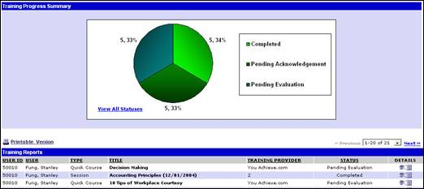
Example 2: Incomplete Training
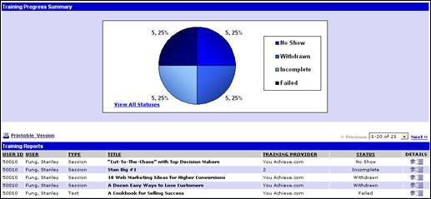
Clicking on the Details icon for a training item, navigates to that user's transcript training details page.
Output
- Printable Version link to view the results in a web page, or Export to Excel link to save/open as an Excel file
Considerations
This report should not be delegated, as it is designed to only show the user's own subordinates in the results. If the report is delegated, the user to whom it is delegated will not see the delegating user's subordinates in the output.

Training Status Summary Report
Display training progress information for your direct reports. The data filters refer to the date the training was requested/assigned (except for Events/Sessions, in which case the filter refers to the session start date for the event that to which the user is assigned).
Permissions
PERMISSION NAME | PERMISSION DESCRIPTION | CATEGORY

Track Employees - Training Status Summary Report | Grants access to Employee Training Status Summary Report, which displays transcript status of all training for a manager's direct reports, and allows the manager to view the transcript details for any learning object listed on the report. This is a manager permission. This permission can be constrained by Employee Relationship and User's Direct Subordinates.  Note: The Employee Relationship constraint allows administrators to constrain the permission to a user’s custom employee relationship. For example, an administrator can select to restrict the Matrix Manager relationship to viewing user data for users who have that Matrix Manager indicated on their user record.  Note: The User's Direct Subordinates constraint allows administrators to constrain the data that a user can view to only the data for their direct reports. The user will not be able to view their own data with this constraint.  Note: By design, for any Track Employees report permission that is included in the Manager default security role, all of the manager's direct and indirect reports are included in the constraints, even if they are not selected in the permission constraints for the role. | Reports - Track Employee
Filters
- Date Criteria - click on calendar icon or enter a Date range (From/To) in the field. Note: Date Criteria is always implemented using UTC (Coordinated Universal Time).
- Training Type - Check each training type to include it in the report.
  - From the drop-down list, select the appropriate languages to only include training items that are available in the selected languages. At least one language must be selected. When multiple languages are selected, the report includes LOs that match one of the selected languages as well as the other criteria. At the top of the drop-down list, all selected languages are displayed. The drop-down list only displays the languages that are available to the user. Select the All Languages option to select all available languages.
- Options:
  - Hide Archived Training - check to hide archived training
  - Include Indirect Subordinates - check to include indirect subordinates. Note: For users who have been given permission to run this report via the Shared Permissions functionality, this box must be checked in order for report data to display on the delegated/shared users.
- Display:
  - All Training - check to include all training
  - Assigned Training - check to include assigned training
- Include Removed Training - check to include training that was removed from users transcript
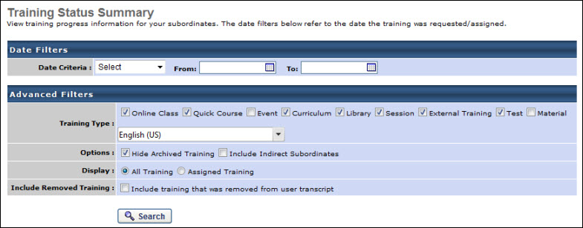
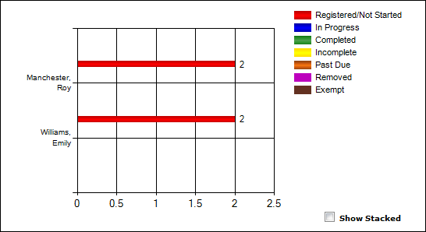
Registered/Not Started - red bar displaying the number of training items with the following statuses:
- Pending Approval
- Approved
- Denied
- Cancelled
- Exception Requested
- Waitlisted
- Waitlist Expired
- Registered
- Registration Pending
- Pending Prerequisite
- Or any of the above status with Past Due appended
In Progress- blue bar displaying the number of training items with the status:
- In Progress
Completed - green bar displaying the number of training items with the following statuses:
- Completed
- Pending Evaluation
- Pending Acknowledgement
Incomplete - yellow bar displaying the number of training items with the following statuses:
- No Show
- Withdrawn
- Incomplete
- Failed
- Or any of the above statuses with Past Due appended
Past Due - brown bar displaying number of training items with the following statuses:
- Past Due
- Or any of the above statuses with Past Due appended
Removed - purple bar displaying the number of training items that have been removed from the user's transcript.
Exempt - brown bar displaying the number of training items with the status:
- Exempt
Clicking on a status bar for a particular user will filter the search results to only display records for that user that fall in that status category in the Search Results table. The bar graph, however, will not change. Clicking on the View All Status link next to the bar chart will show all the search results that meet the search criteria (without limiting it to one user and one status).
- For example, clicking on the Completed section of a particular user will refresh the page showing the same bar graph but a with different search results table.
- In the detailed view, a View All Statuses link appears next to the bar graph. Clicking on this link refreshes the page to show the summary of all status categories, which is the default view. Please see Example 1.
- Click on the Show Stacked checkbox, the page will refresh to show a stacked count version of the bar graph. Please see Example 2.
Example 1: View All Statuses link
Click on the View All Statuses link to return to the default view.
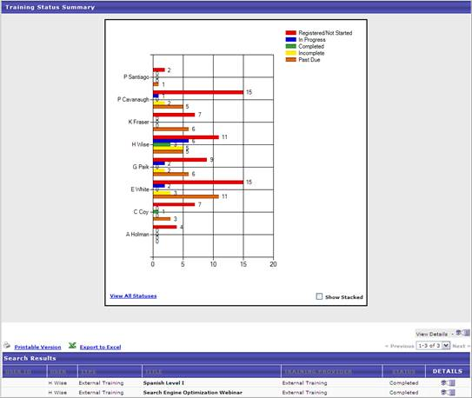
Example 2: Show Stacked Version
Click on the Show Stacked checkbox to view the bar graph in the Stacked Version
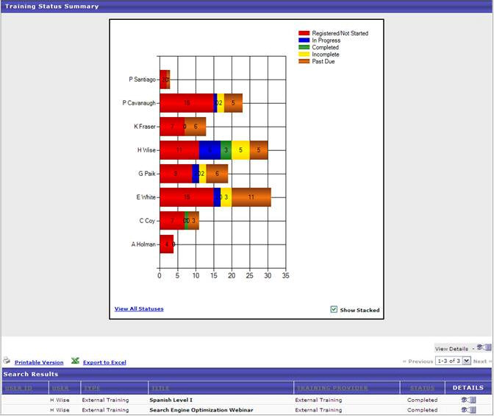
Output
Printable Version link to view the results in a web page, or Export to Excel link to save/open as an Excel file.
Considerations
This report should not be delegated, as it is designed to only show the user's own subordinates in the results. If the report is delegated, the user to whom it is delegated will not see the delegating user's subordinates in the output.

Transcripts
The Transcripts report displays transcripts of users for whom you are the approver, manager, or cost center approver.
To access the Transcripts report, go to Reports > Standard Reports > Track Employees. Then, click the Transcripts report link.
Permissions
PERMISSION NAME | PERMISSION DESCRIPTION | CATEGORY

Bio About - View | Enables user to view the Bio page for users within their permission constraints. This permission must be enabled to view the Transcript page within Universal Profile. If a user does not have this permission and they click a person's name or user photo within the Universal Profile, then the Bio page will not open.  On the Learner Home page, this permission also allows end users to view the Completions & Hours field, the training sidebar, and the Continue Learning carousel.  This permission can be constrained by Employee Relationship, OU, User's OU, User's Direct Reports, User Self and Subordinates, and User. Note: For security purposes, this permission is constrained to User Self and Subordinates by default. However, the permission constraints can be modified to allow users to view the Bio About page for other users. | Universal Profile

Employee Transcripts - Manager/Approver Access | Grants access to transcript (training record) screen of those for whom user is designated manager, approver or cost center approver. System administrators can access all user transcripts from this page. Link to this screen appears under Standard Reports/Track Employees. This is a manager/approver permission. This permission can be constrained by Employee Relationship and User's Direct Subordinates.  Note: The Employee Relationship constraint allows administrators to constrain the permission to a user’s custom employee relationship. For example, an administrator can select to restrict the Matrix Manager relationship to viewing user data for users who have that Matrix Manager indicated on their user record.  Note: The User's Direct Subordinates constraint allows administrators to constrain the data that a user can view to only the data for their direct reports. The user will not be able to view their own data with this constraint.  Note: By design, for any Track Employees report permission that is included in the Manager default security role, all of the manager's direct and indirect reports are included in the constraints, even if they are not selected in the permission constraints for the role. | Reports - Track Employee

View Transcript Item | Grants ability to view details of learning objects that appear on the transcript (training record), by clicking on the name of the learning object. Users must also have the Bio About - View permission in order to access the transcript within Universal Profile. This permission can be constrained by OU, User's OU, User Self and Subordinates, User, or User's Self. This is an end user permission. | Learning - Administration
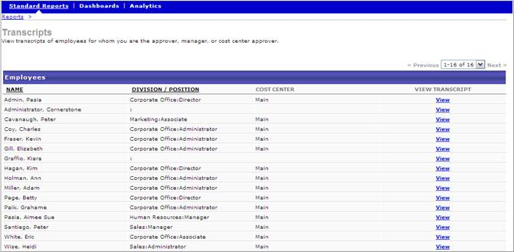
Once on the user's Transcript page, you can manage transcript items, such as selecting a session for an event, removing a training item, or editing transcript details on the Training Details page of a learning object. The actions you can take are dependent upon your permissions.
The View link is only available for users who have permission to view transcript items.

Training Reports
Recommended Reports
A complete list of recommended reports for managers, learning, performance, and succession is available in the OnDemand Support folder:
- See Recommended Standard Reports for Managers for additional information.
- See Recommended Standard Reports - Learning for additional information.
- See Recommended Standard Reports - Performance for additional information.
- See Recommended Standard Reports - Succession for additional information.

21 CFR 11 - Transcript Details Report
The 21 CFR 11 - Transcript Details Report is a standard report available in the Training section. This report displays details for completed courses based on training title, user, and date range selections. The information that displays in the report output is based on the data available at the time the selected user's transcripts were locked down upon training completion.
See Transcript Lockdown - Administrator Overview in Online Help for additional information about the transcript lockdown feature.
To access the 21 CFR 11 - Transcript Details Report, go to Reports > Standard Reports > Training. Then, click the 21 CFR 11 - Transcript Details link.
Permissions
PERMISSION NAME | PERMISSION DESCRIPTION | CATEGORY

21 CFR Part 11 - Transcript Details Report | Grants ability to view training details for completed courses. This permission can be constrained by OU, User's OU, and User's Self and Subordinates. | Reports - Training
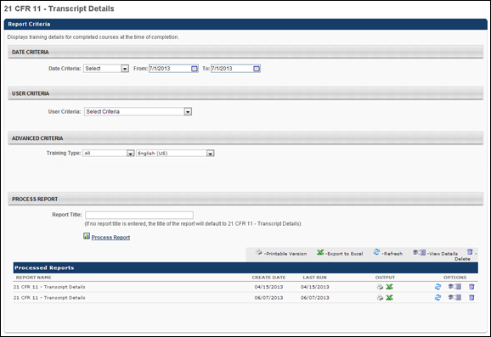
Criteria
Filter | Description
Date Criteria | Select the date range for the report from the drop-down list or enter specific dates in the From and To fields. Only learning objects (LOs) with completion dates that are equal to or between the "From" and "To" dates will appear in the output.
User Criteria | Select a user or a group of users that may be included in the report. This criterion applies to the users who will appear in the report output. This is a required field. You may choose one or more individual users as well as entire organizational units (OUs) or Groups. Depending on the constraints of the report permission, the user running the report may only be able to view users for the organizational units to which they are constrained.  If this field is left blank, then the report checks the user's permission constraints and returns results for all users who are within the report permission constraints. If the user has no permission constraints, then the report returns results for all users.
Advanced Criteria | Select one or more training types from the Training Type drop-down to filter the results by the selected training type. By default, all training types are selected. The following training types are available:  - Curriculum  - Event  - External Training  - Library  - Material  - Online Class  - Posting  - Quick Course  - Test  - Video  Select a language from the drop-down to filter the report results by the language in which the LO is configured. By default, the user's default language is selected.
If constraints are added to the permission needed to run the report, then the constraints limit the training information that is visible to the user running the report, as well as the users that can be selected in the User Criteria filter.
Process Report
Filter | Description
Report Title | Enter a title for the report. The character limit is 50. If a title is not entered, the report title defaults to 21 CFR 11 - Transcript Details Report.
To process the report, click the Process Report link. This is an asynchronous report, which means that report data is only available as of the previous day.
Asynchronous reports allow the administrator to define the standard report and generate the report asynchronously. As a result, when administrators process the report, the system generates the report in the background, while the administrator can move on to other areas of the system. When the report is finished processing, the administrator can then view the full report in its entirety.
- Up to three separate reports can generate asynchronously, allowing greater flexibility creating and storing different versions of the report.
- If you process a report or refresh a stored report, the report appears in the table as Queued.
- Since the user can generate up to three reports, the administrator can define a report title for each of the generated reports.
Processed Reports Table
The Processed Reports table displays the following for the report:
- Report Name
- Create Date
- Last Run
- Output - Click the PDF icon to open the report. Or, click the Excel icon to open the report as an Excel spreadsheet.
- Options - The following options are available in the Options column:
  - Refresh - Click to refresh the report data.
  - View Details - Click to view the report configuration details.
  - Remove - Click to delete the report.
Output
The following information displays in the report output:
- User ID
- User - This column defines the sort order for the report by user last name in ascending order.
- Training Title - The training title that displays is the title of the training at the time of lockdown.
- Training Type
- Registration Date
- Completion Date
- Status - This column displays the status of the training in the user's transcript.
- User Status - This column displays the status of the user in the portal, either Active or Inactive.
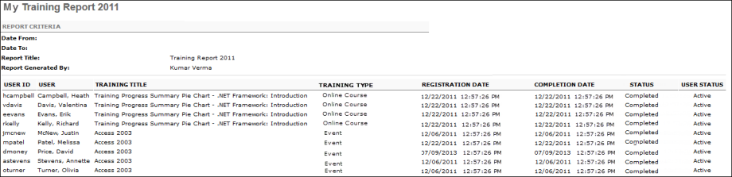

Acknowledgement Report
Display summary information for acknowledgement, including acknowledgement responses and comments. Acknowledgements tied to learning objects are set in the Course Catalog.
To access the Acknowledgement report, go to Reports > Standard Reports > Training. Then, click the Acknowledgement link.
Permissions
PERMISSION NAME | PERMISSION DESCRIPTION | CATEGORY

Training Acknowledgement Report | Grants access to Training Acknowledgement Report, which displays summary information for completed training acknowledgements, including comments. | Reports - Training
Filters
- Date Criteria - filter your results based on a specific time period. Note: Date Criteria is always implemented using UTC (Coordinated Universal Time).
- User Criteria - limit report output to the users matching the specified user criteria
  - The report will only run within the defined constraints for the user running the report
  - This is the standard OU availability selection criteria drop-down. Choose from available OU types
  - Defaults: If no User Criteria are selected then the report will run for the entire available population
- Training Title - filter by training title
- Session ID -filter by session id
- Locator Number - filter by session locator number
- Location of Training - filter by location of training
- Instructor - filter by a specific instructor name
- Provider - filter the results for training from a specific training provider/vendor or select All for all training providers/vendors
- Recurring Training - check to include all records of this training on a transcript. If unchecked only the most recent registration will be included.
- List by - select to sort by Employee or Training title
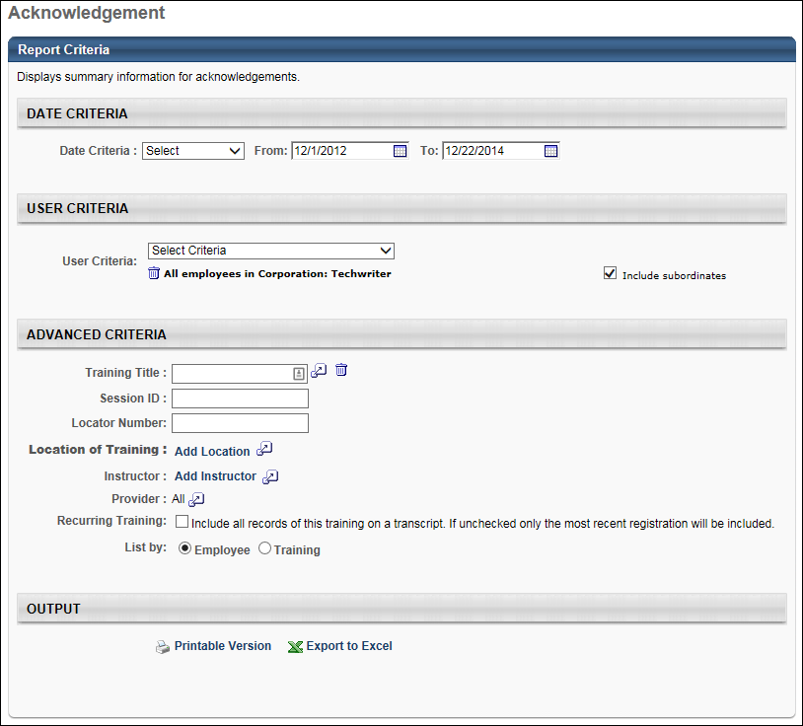
Output
Click the Printable Version link or icon to view the results in a web page. Or, click the Export to Excel link or icon to save/open the report output as an Excel file.
The report output includes a Response column that displays "True" for users who have submitted the acknowledgment form and displays "False" for users who have not yet completed the form.
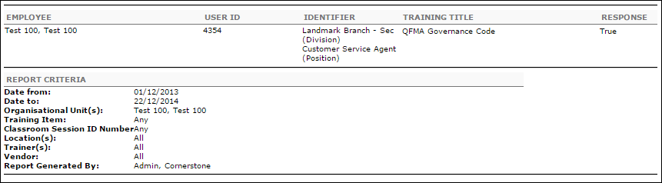
Frequently Asked Questions
Can I create a report that only shows users who have not yet submitted the acknowledgment form?
The report will display both "True" and "False" values. The report cannot be configured to only display "False" responses. Therefore, users who have submitted the acknowledgment form and users who have not yet submitted the form will appear on the report.

Certification Details Report
The Certification Details Report displays users' progress for each learning object within a certification.
Permissions
PERMISSION NAME | PERMISSION DESCRIPTION | CATEGORY

Certifications Details Report | Grants access to Certifications Details Report, which displays users' progress for each learning object within a certification. | Reports - Training
Criteria
Filter Name | Description
User Criteria | Limit results to the users matching the specified user criteria. This is required.
Certification | Select the certification to include in the report. Only one certification can be selected. Note: For portals with multiple languages enabled, the title of the certifications in the Search for training pop-up appear in the reporting administrator's language. If the reporting administrator's language is not available, the field displays in the field's default language.
Certification Period | Select this option to include training from all past certification periods. If this option is not selected, only training from the current certification period is displayed.
User Status | Select this option to include users whose certification is in archived status.
View By | Select whether to view a Summary View or a Detailed View of the data.
Include Custom Fields | Up to 10 custom user fields related to the successors can be included in the report.
Report Title | Enter a title for the report. This defaults to the report name if no title is entered. The title is displayed on the report and is also displayed in the list of Processed Reports on this page.
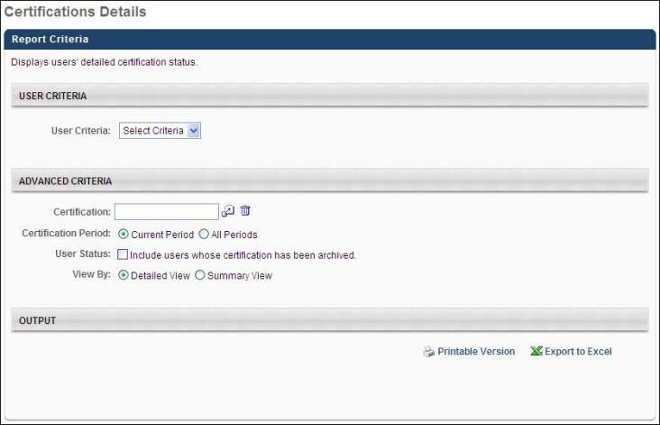
Output
In the upper-right corner of the report, the report title is displayed along with the title of the selected certification.
To the right of that, a pie chart summarizes the certification status for all users assigned to the certification and the table provides the specific numbers that compromise the pie chart. Note: The pie chart appears in the printable version, but does not appear in the Excel output.
Below the overview, the details for each user within the certification are displayed, including name, completed training, incomplete training, the current certification status, and historical certified dates for any past certifications.
Note: On the report output, for portals with multiple languages enabled, the certification title and section title displays in the reporting administrator's language. If the reporting administrator's language is not available, the certification title and section title displays in the fields' default language.

Certification Summary Report
The Certification Summary report enables administrators to report on users' certification statuses within the new Certification module. Multiple certifications can be included in this report.
The maximum number of rows that can be included in the report output is 50,000.
To create Certification Summary reports, go to Reports > Standard Reports > Training. Then, click the Certification Summary Report link.
Permissions
PERMISSION NAME | PERMISSION DESCRIPTION | CATEGORY

Certification Summary Report | Grants access to Certification Summary report, which displays summary information on users' certification statuses on one or more certifications. | Reports - Training
Criteria
Filter Name | Description
Date Criteria | Filter your results by date. The report will search this time frame for certifications. If any part of a certification falls within that time frame for a user, that user will display. Note: Date Criteria is always implemented using UTC (Coordinated Universal Time).
User Criteria | Limit report output to the users matching the specified user OU criteria.
Certification | Click the Select Certifications link to select the certifications on which you are reporting. Multiple certifications can be selected. The report will summarize the selected users' progress on the selected certifications. Note: For portals with multiple languages enabled, the title of the certifications in the Search for training pop-up appear in the reporting administrator's language. If the reporting administrator's language is not available, the field displays in the field's default language.
Certification Status | Select specific certification statuses to only include certifications that are in the corresponding statuses.
Include Archived Users | Select this option to include users with archived certifications in the report.
View By | Select whether the report is grouped by Employee, Certification, or no grouping.
Process Report
This is an asynchronous report, which allows the administrator to define the standard report and generate the report asynchronously. As a result, when administrators process the report, the system generates the report in the background, while the administrator can move on to other areas of the system. When the report is finished processing, the administrator can then view the full report in its entirety.
- Up to three separate reports can generate asynchronously, allowing greater flexibility for creating and storing different versions of the report.
- If you process a report or refresh a stored report, the report appears in the table as Queued.
- The most recently created report displays at the top of the table.
- Since the user can generate up to three reports, the administrator can define a report title for each of the generated reports.
- Clicking the View Details icon changes the report settings on the page to match those of the selected previously run report.
The maximum number of rows that can be included in the report output is 50,000.
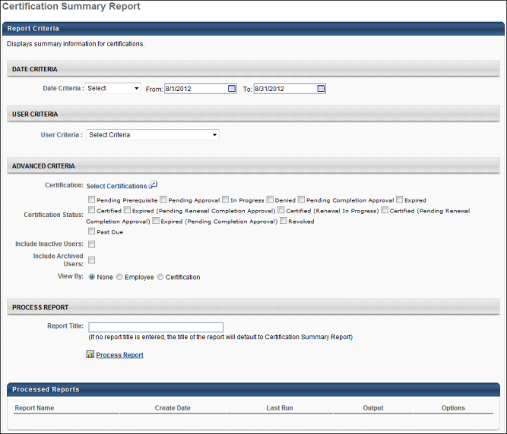
Note: On the report output, for portals with multiple languages enabled, the certification title and certification period title displays in the reporting administrator's language. If the reporting administrator's language is not available, the certification title and certification period title displays in the fields' default language.
Output Not Grouped
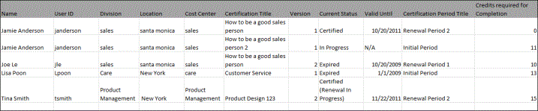
Output Grouped by Employee
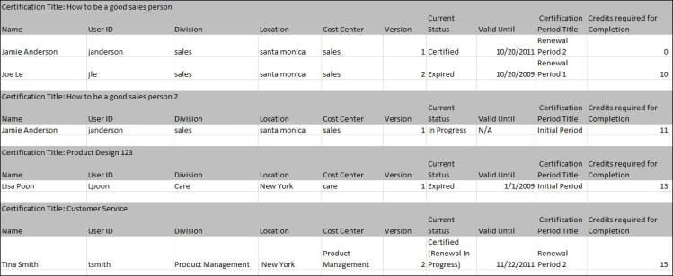
Output Grouped by Certification
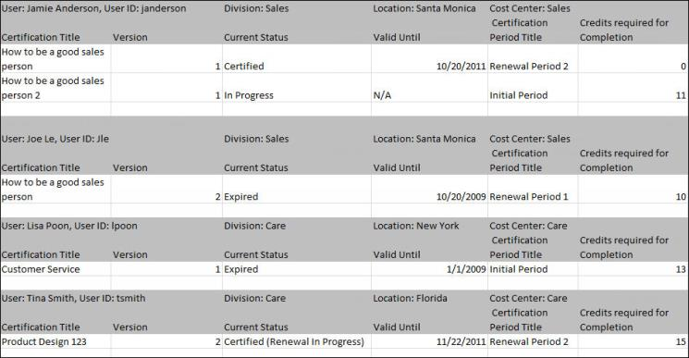

Content Provider Summary Report
Display training Registration, Completion, and In Progress totals per provider.
Permissions
PERMISSION NAME | PERMISSION DESCRIPTION | CATEGORY

Content Provider Summary Report | Grants access to Content Provider Summary Report, which displays training Registration, Completion, and In Progress transcript status totals per provider. | Reports - Training
Filters
- Registration Date Criteria - filter by registration date
- Training Type - filter by training type
- Providers - filter the results for training from a specific training provider/vendor or select All for all training providers/vendors
- Status - select Registered, In Progress or Completed
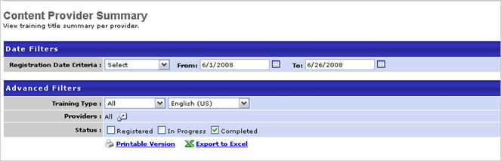
Output
- Printable Version link to view the results in a web page, or Export to Excel link to save/open as an Excel file
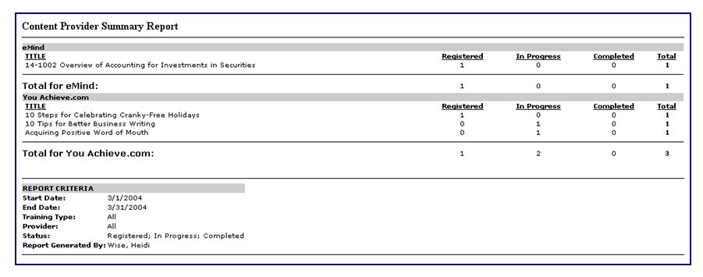

Course Assessment Question Item Analysis Report
The Course Assessment Question Item Analysis Report displays SCORM 2004 online course assessment data organized by question components.
Permissions
PERMISSION NAME | PERMISSION DESCRIPTION | CATEGORY

Course Assessment Question Item Analysis Report | Provides access to Course Assessment Question Item Analysis report, which displays SCORM 2004 online course assessment data organized by question components. | Reports - Training
Criteria
Filter Name | Description
Online Course | Click the pop-up icon to select an online course on which to run the report. Only SCORM 2004 courses are available for selection. Only one course can be selected.
Details | Select this option to include question details and the answer breakdown in the report. When this option is selected, the response details are displayed in the report, including the correct response, incorrect responses provided by users, and the percentages for each response.
Primary Sort Order | This option defines the primary sort order of the report output. Select the data item on which you would like to primarily sort the data. The data is first sorted by the selected data item. See Sort Order for additional information.
Secondary Sort Order | This option defines the secondary sort order of the report output. Select the data item on which you would like to secondarily sort the data. The data is first sorted by the Primary Sort Order selection and then sorted on the selected data item. See Sort Order for additional information.
Date Criteria | Filter your results by date. If the question has responses that occurred within that time frame, the information displays. You may select a standard time frame from the drop-down list, or you may specify a specific date range using the date selection tool. Note: Date Criteria is always implemented using UTC (Coordinated Universal Time).
Report Title | Enter a title for the report. This defaults to the report name if no title is entered. The title is displayed on the report and is also displayed in the list of Processed Reports on this page.
Sort Order
The Primary and Secondary Sort Order do not change the order in which the columns appear. They only impact the order in which the data is displayed.
- Primary:
  - Question Identifier - The report output lists the question identifier value in numerical order by first digit, low to high, and then alphabetically, A to Z.
  - Question Type - The question types are listed in alphabetical order, A to Z.
  - Question - The questions are listed in alphabetical order, A to Z.
  - Responses - The questions with the largest number of responses for the indicated date criteria are listed first.
  - Correct % - The questions with the highest rate of correct responses for the indicated date criteria are listed first. If there are questions in which there are no correct responses (i.e., a neutral question), the Correct % displays as N/A.
  - Incorrect % - The questions with the highest rate of incorrect responses for the indicated date criteria are listed first. If there are questions in which there are no incorrect responses (i.e., a neutral question), the Incorrect % displays as N/A.
- Secondary:
  - Question Identifier - After the primary sort, the report output lists the question identifier value in numerical order by first digit, low to high, and then alphabetically, A to Z.
  - Question Type - After the primary sort, the question types are listed in alphabetical order, A to Z.
  - Question - After the primary sort, the questions are listed in alphabetical order, A to Z.
  - Responses - After the primary sort, the questions with the largest number of responses for the indicated date criteria are listed first.
  - Correct % - After the primary sort, the questions with the highest rate of correct responses for the indicated date criteria are listed first. If there are questions in which there are no correct responses (i.e., a neutral question), the Correct % displays as N/A.
  - Incorrect % - After the primary sort, the questions with the highest rate of incorrect responses for the indicated date criteria are listed first. If there are questions in which there are no incorrect responses (i.e., a neutral question), the Incorrect % displays as N/A.
Process Report
This is an asynchronous report, which allows the administrator to define the standard report and generate the report asynchronously. As a result, when administrators process the report, the system generates the report in the background, while the administrator can move on to other areas of the system. When the report is finished processing, the administrator can then view the full report in its entirety.
- Up to three separate reports can generate asynchronously, allowing greater flexibility for creating and storing different versions of the report.
- If you process a report or refresh a stored report, the report appears in the table as Queued.
- The most recently created report displays at the top of the table.
- Since the user can generate up to three reports, the administrator can define a report title for each of the generated reports.
- Clicking the View Details icon changes the report settings on the page to match those of the selected previously run report.
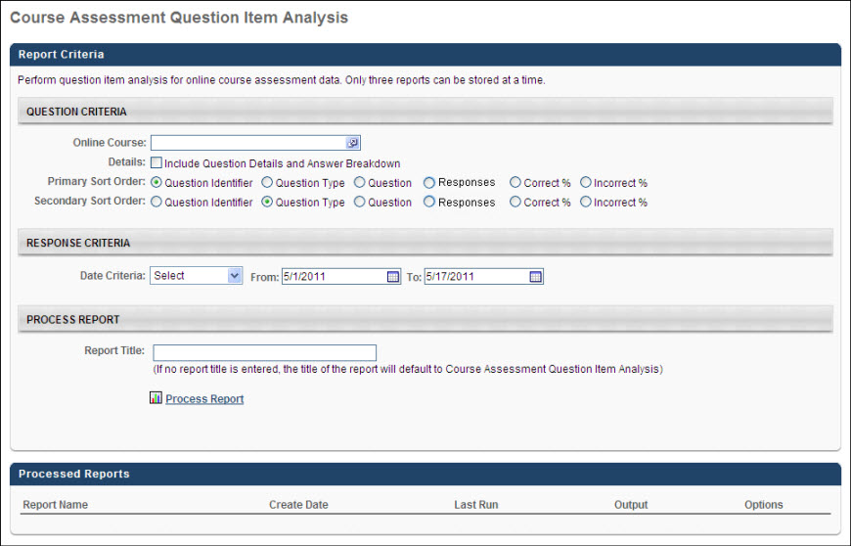
Output
The following information is displayed within the report:
- ID - The question ID for which the data is displayed.
- Question Type - The corresponding type of question for which the data is displayed.
- Question - The question text for which the data is displayed.
- Responses - The total number of responses entered for a given time period.
- % Correct - The percentage of correct responses. If there are questions in which there are no correct responses (i.e., a neutral question), the Correct % displays as N/A.
- % Incorrect - The percentage of incorrect responses. If there are questions in which there are no correct responses (i.e., a neutral question), the Correct % displays as N/A.
- SCO Title/ID - This displays the list of SCOs defined for an online course.
- Correct/Neutral Response - This displays the correct response for the question. The Response % displays the percentage of users that selected this response.
- Learner's Response(s) - This displays the incorrect responses received by users for the question. The Response % displays the percentage of users that selected that response.
Without Details, using Default Sort Filters:
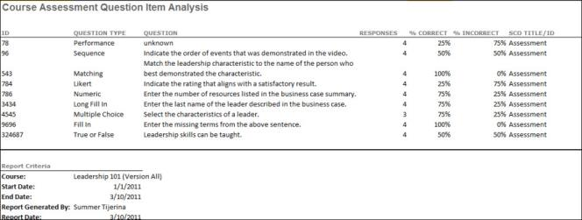
With Details, using Default Sort Filters:
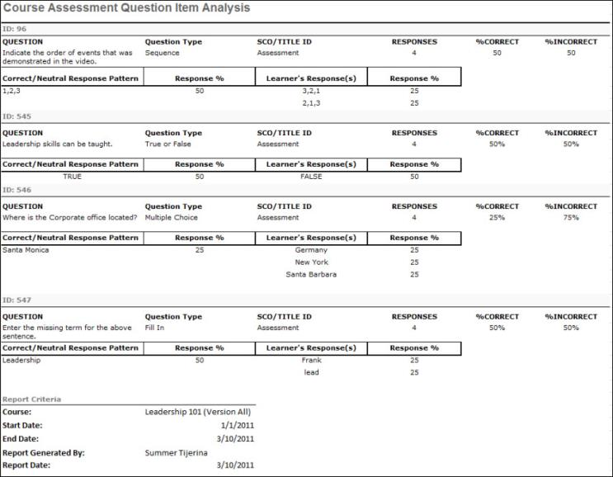

Course Assessment Results Report
The Course Assessment Results Report displays a summary of information for online course assessment data. This report is used to report on course test data.
Permissions
PERMISSION NAME | PERMISSION DESCRIPTION | CATEGORY

Course Assessment Results Report | Grants access to the Course Assessment Results Report, which displays a summary of information for SCORM 2004 online course assessment data. This report is used to report on course test data. The constraints that are placed upon this permission limit the users that are available when running the report. | Reports - Training

Training Reports Attempts and Scores | Grants ability to view attempts and scores data from the Course Assessment Results, Enterprise Training, Online Training Status, SCORM 2004 Course Progress, and Transcript Status report outputs. This permission cannot be constrained.  This permission works in conjunction with the permissions for the associated reports.  Note: Users may need to be granted permission view the Test Engine so that they can see the Test Engine results within Admin > Tools > Content. | Reports - Training
Criteria
Filter Name | Description
Date Criteria | Filter your results by the date on which the assessment was created. If the course assessment creation date falls within that time frame, the information displays. You may select a standard time frame from the drop-down list, or you may specify a specific date range using the date selection tool. Note: Date Criteria is always implemented using UTC (Coordinated Universal Time).
User Criteria | Limit results to the users matching the specified user criteria. This is required unless the administrator or manager has constraints placed on the permission that allows them to run this report.
Online Course | Click the pop-up icon to select an online course on which to run the report. Only SCORM 2004 courses are available for selection. Only one course can be selected. If multiple versions of the course are available, the administrator can select the version on which to run the report or to run the report on all versions.
Inactive Courses | Select this option to exclude inactive courses from the report.
Recurring Training | Select this option to also include results from previous instances of the assessment. When this option is not selected, only the most recent instances of the assessment are included in the report.
Inactive Users | Select this option to include the assessments from inactive users in the results. When this option is not selected, only active users are included in the results.
Report Title | Enter a title for the report. This defaults to the report name if no title is entered. The title is displayed on the report and is also displayed in the list of Processed Reports on this page.
Process Report
This is an asynchronous report, which allows the administrator to define the standard report and generate the report asynchronously. As a result, when administrators process the report, the system generates the report in the background, while the administrator can move on to other areas of the system. When the report is finished processing, the administrator can then view the full report in its entirety.
- Up to three separate reports can generate asynchronously, allowing greater flexibility for creating and storing different versions of the report.
- If you process a report or refresh a stored report, the report appears in the table as Queued.
- The most recently created report displays at the top of the table.
- Since the user can generate up to three reports, the administrator can define a report title for each of the generated reports.
- Clicking the View Details icon changes the report settings on the page to match those of the selected previously run report.
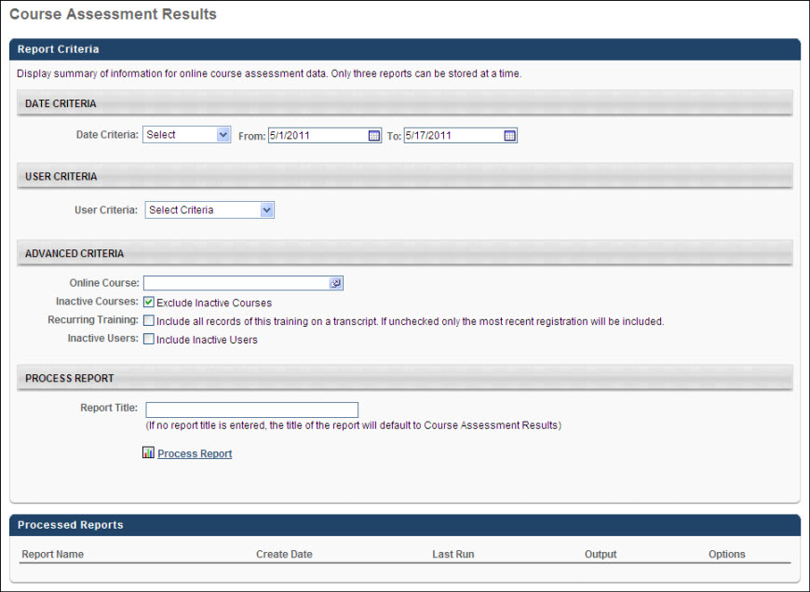
Output
The following information is displayed within the report:
- Course title and version
- User Name
- User ID - The user's current ID as defined on the user's record.
- Occurrence - If the Recurring Training preference is selected, the Occurrence column appears and displays the instance of the training for which the data is displayed. "1" indicates the first instance of the training.
- Course Status - The course status pulled from the LMS.
- Course Completion Date - If the training status is Complete, this displays the course completion date. This is blank if the course is not yet complete.
- Overall Score - If an overall score exists for the course, the overall score is displayed. Note: It is possible for the administrator to mark a course complete without entering an overall score value.
- SCO Title/ID - This displays the list of SCOs defined for an online course. Depending on the course design, a SCO may not have a score value.
- Status - The status of the SCO as defined by the course. This is blank if the course does not provide a value for this field.
- Completion Date - The completion date defined by the course for the SCO. This is blank if the course does not provide a value for this field.
- Score - This is the score defined by the course. This is blank if the course does not provide a value for this field.
Without Recurrence:
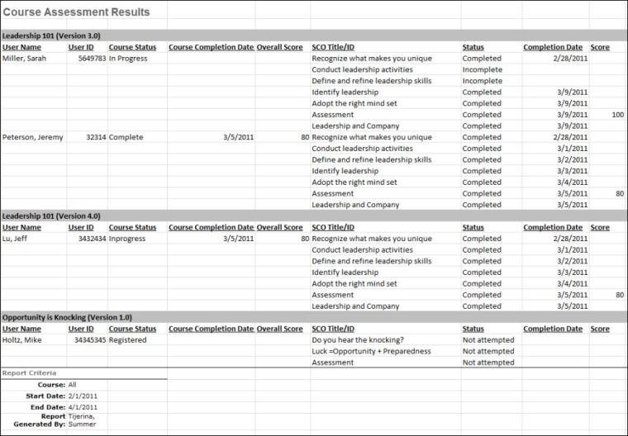
With Recurrence:
If recurring training is included in the report, an Occurrence column is included in the report to display which occurrence of the course is being displayed.
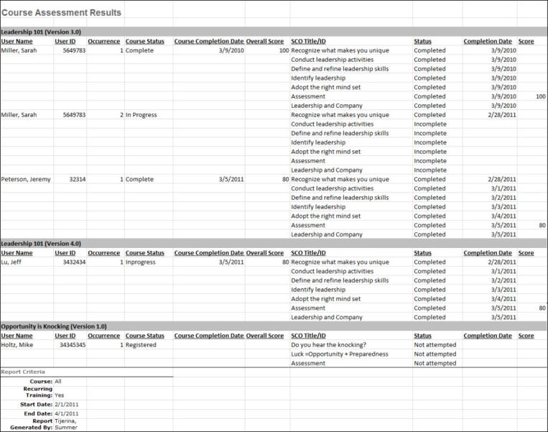

Curriculum Details Report
The Curriculum Details report displays statuses for all types of training within a curriculum. You can add additional columns of data as required. Reporting can be performed on more than one curriculum at a time.
To access the Curriculum Details report, go to Reports > Standard Reports > Training. Then, click the Curriculum Details link.
Permissions
PERMISSION NAME | PERMISSION DESCRIPTION | CATEGORY

Training - Curriculum Details Report | Grants access to Curriculum Details report, which displays statuses for all learning objects within one or more curricula. This permission can be constrained by OU, User's OU, and User Self And Subordinates. | Reports - Training
Criteria
Feature | Description
User Criteria | Limit results to the users matching the specified user criteria.
Advanced Criteria | You can limit report output to the following:  - Curriculum - Click the Select icon to select one or more curricula. This is a required field.  - Hire Date - Enter a hire date range in the From and To fields. Or, leave both fields blank for open-ended queries. Or, enter the same date in both fields if to have the range encompass a single day. The option to enter a hire date gives you the opportunity to create a wide or narrow date window for your report. This can provide a broad spectrum of users or a very specific list of users. For example, you want to see completion dates for your "New Employee Orientation" curriculum. But, you only want to see the data for employees hired on a certain date. To do this, you can enter the specific hire date in the Hire Date field, check the Completion Information box, and return data for only those employees.  - Transcript Status - Select one or more transcript statuses to include in the results. By default, all statuses are selected.  - Training Type - Select one or more training types by which to filter the report. By default, all training types are selected.  - List Training by - Select this option to display a curriculum's training items in the order in which they are configured in the curriculum or alphabetically by training title. Selecting Curriculum Order lists training items in the order in which they are configured in the curriculum. Selecting Training Title lists training items alphabetically by training title. Note: On the report output, each training item appears in a separate column either in curriculum order or alphabetical order.  - Language - Select a language from drop-down list.  - Recurring Training - Select this option to include recurring training functionality. If checked, all instances for the training are displayed separately. If unchecked, only the most recent instance of the training will be displayed.  - Include Removed - Select this option to include curricula that are in the Removed tab of a user's transcript. If this option is unchecked, then neither the items within the removed curriculum nor the removed curriculum are included in the report. This option is unchecked by default.  - Include Archived - Select this option to include curricula that are in the Archived tab of a user's transcript. If this option is unchecked, then neither the items within the archived curriculum nor the archived curriculum are included in the report. This option is unchecked by default.  - User Status - Select this option to include inactive users.
Additional Report Columns | The report can include the following additional columns:  - Curriculum Information - Select this option to include the curriculum's status or curriculum completion totals.  - Training Due Dates - Select this option to include the due date of the training.  - Completion Information - Select this option to include the completion date.
Report Title | Enter a title for the report. If no title is entered, the report title defaults to the report name. The title appears on both the report output and in the Processed Reports list.
Process Report
This is an asynchronous report, which allows the administrator to define the standard report and generate the report asynchronously. As a result, when administrators process the report, the system generates the report in the background, while the administrator can move on to other areas of the system. When the report is finished processing, the administrator can then view the full report in its entirety.
- Up to three separate reports can generate asynchronously, allowing greater flexibility for creating and storing different versions of the report.
- If you process a report or refresh a stored report, the report appears in the table as Queued.
- The most recently created report displays at the top of the table.
- Since the user can generate up to three reports, the administrator can define a report title for each of the generated reports.
- Clicking the View Details icon changes the report settings on the page to match those of the selected previously run report.
The following actions and options are available in the Processed Report table for each report:
- View the report name, as well as the date on which the report was created and the most recent run date.
- Click the Excel icon to generate an Excel output of the report.
- Click the Refresh icon to refresh the report results.
- Click the View Details icon to view the filter criteria for the report. From this page, you can modify the criteria and process the report again.
- Click the Trash Can icon to delete the report.
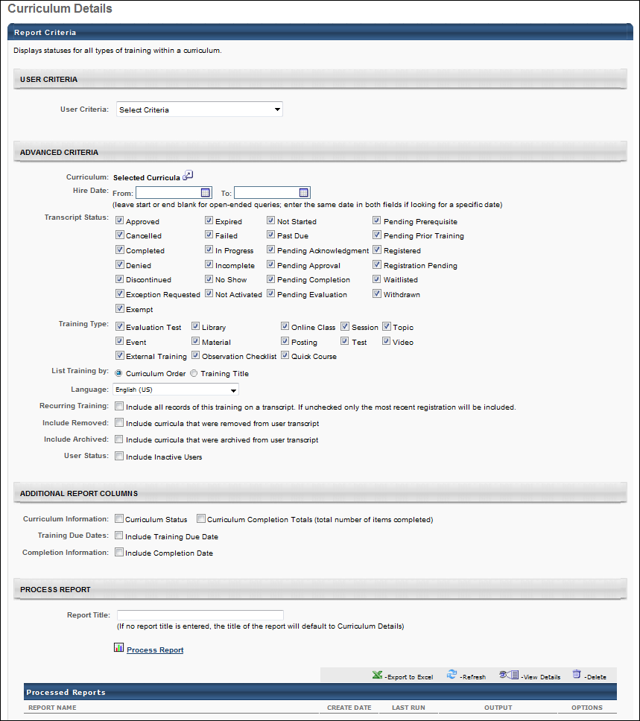
Output - List Training by Curriculum Order
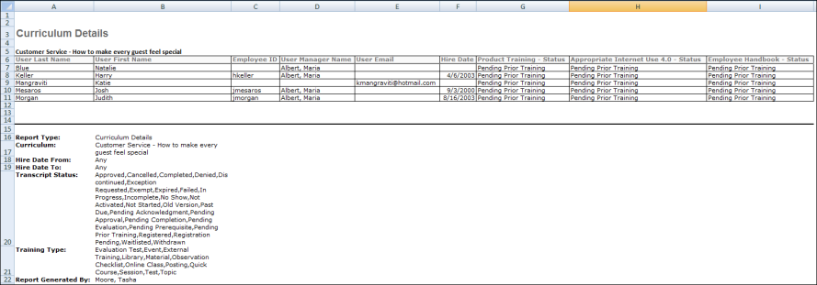
Output - List Training by Training Title
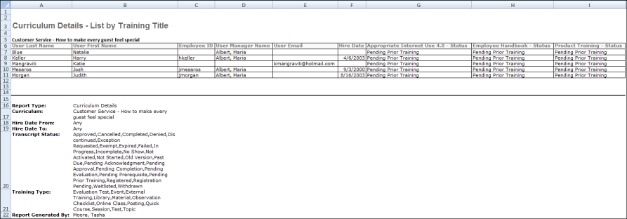
Frequently Asked Questions (FAQs)
I want to get a list of all the users who took a particular training. How do I do that?
A Custom Transcript Report will provide this information. Be sure to include the following fields in the report:
- Training Title
- User Full Name
- Transcript Status
Filter the report by Training Title so that you can enter the exact name of the training. You can also filter by Transcript Status to get a list of users who are in a particular status for the training, such as Completed or Registered.
Can I output this report to an FTP server?
No. Standard reports cannot be outputted to an FTP server.
However, you can create a custom report that includes the data from your standard report and output the custom report to an FTP server.
Why does the report output not match my curriculum structure when a test that is part of the curriculum structure has been versioned?
When a test is versioned, the curriculum is not versioned and the curriculum structure does not version to reflect the most updated version of the test. Any learners that launch a test from a curriculum in their transcript will get the latest version of the test, but to include the most recent version of the test in the curriculum structure, an administrator needs to manually remove the test from the curriculum structure and re-add the latest test version.

Curriculum Report
This report displays detailed transcript status for a set of users taking a curriculum.
Permissions
PERMISSION NAME | PERMISSION DESCRIPTION | CATEGORY

Curriculum Report | Grants access to Curriculum Report which displays user progress for a curriculum at a summary or detailed level. | Reports - Training
Filters
- User Criteria - limit report output to the users matching the specified user criteria
  - The report will only run within the defined constraints for the user running the report
  - This is the standard OU availability selection criteria drop-down. Choose from available OU types
  - Defaults: If no User Criteria are selected then the report will run for the entire available population
- Curriculum (required field) - select specific curriculum
- User Manager - select specific manager
- Hire Date From - select hire date range (leave start or end blank for open-ended queries, enter the same date in both fields if looking for a specific date)
- User Status - check to Search all inactive users
- View By - select Detailed or Summary view. If the view by option Summary is selected, an export to text option will be available for the report output
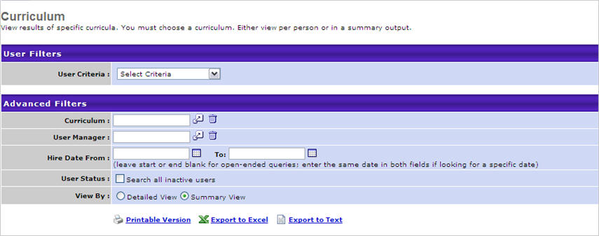
Output
- link to view the results in a web page, or link to save/open as an Excel file
- to export data to a tab delimited text file if the Summary view by option is selected
Note: In the report output, the % Met value is calculated by the dividing the number of completed learning objects (LOs) by the total number of LOs in the curriculum. Unlike the curriculum progress that is displayed in the Curriculum Player or on a user's Transcript, LOs contained within a curriculum which are NOT marked as required factor into the report's percentage met. As such, you may see a discrepancy if you look at the curriculum progress percentage on a users' Transcript versus this report.
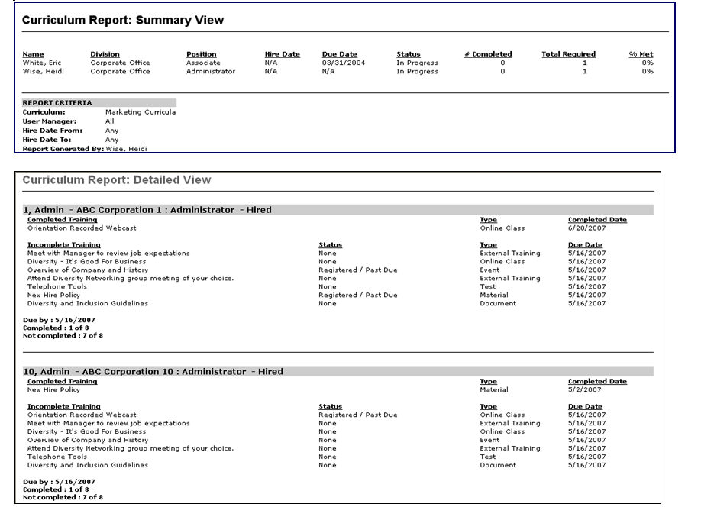

Divisional Training Report
Displays training requested by employees in your division. Note: The Title column only displays the latest version of the training.
Permissions
PERMISSION NAME | PERMISSION DESCRIPTION | CATEGORY

Divisional Training Report | Grants access to Divisional Training Report, which displays training statuses for all LOs assigned or requested by those assigned to user's own division within a specified period of time. | Reports - Training
Filters
- Date Criteria -filter your results based on training registration date range. For sessions, the report results are filtered based on the session start date. Note: Date Criteria is always implemented using UTC (Coordinated Universal Time).
- User Criteria - limit report output to the users matching the specified user criteria
  - The report will only run within the defined constraints for the user running the report
  - This is the standard OU availability selection criteria drop-down. Choose from available OU types
  - Defaults: If no User Criteria are selected then the report will run for the entire available population
- Training Type - filter the report on a certain training type or select All for all training types
- Status- select status/s to include in results
- Training Title - To report on a specific training, select the training from this field. Only one can be selected. Note: If a Training Title is specified, then this report output only includes the latest version of the training that is in a Completed status. Previous versions of the training will not be included in the report output. *
- Division - auto populates with division of user (divisional training report will only allow results to be returned for users in your division)
  - Check Include Subordinate divisions to include subordinates of the division
- Provider - filter the results for training from a specific training provider or select All for all training Providers
- Recurring Training - check to include all records of this training on a transcript. If unchecked only the most recent registration will be included.
- Removed Training - check to Include training that was removed from the transcript by an administrator
- User Status - check to Search all inactive users
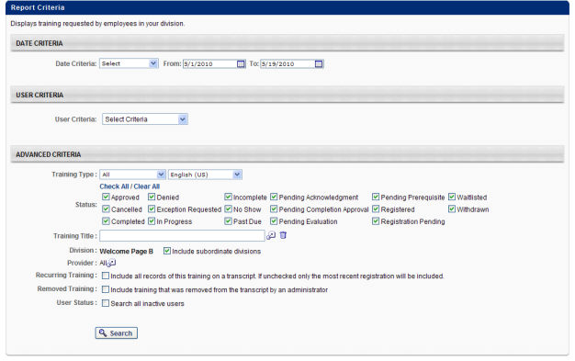
Output
- Printable Version link to view the results in a web page, or Export to Excel link to save/open as an Excel file
Note: The Title column only displays the latest version of the training.
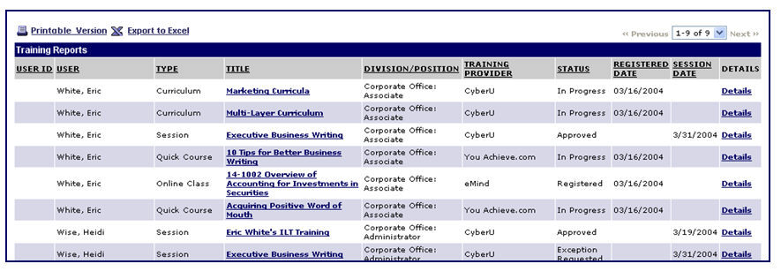

Enterprise Past Due Training Report
This report displays past due training. Past due events are not included in the report. However, past due sessions are included.
Permissions
PERMISSION NAME | PERMISSION DESCRIPTION | CATEGORY

Enterprise Past Due Training Report | Grants access to Enterprise Past Due Training Report, which displays list of employees with incomplete training for which the assigned due date has passed. | Reports - Training
Date Criteria
Filter your results on Registered date range. Note: Date Criteria is always implemented using UTC (Coordinated Universal Time).
User Criteria
Limit report output to the users matching the specified user criteria.
- The report will only run within the defined constraints for the user running the report
- This is the standard OU availability selection criteria drop-down. Choose from available OU types
- Defaults: If no User Criteria are selected then the report will run for the entire available population
Advanced Criteria
- Training Types - filter the report on a certain training type or select All for all training types
- Training Title - filter by Training title
- Provider - filter the results for training from a specific training provider/vendor or select All for all training Providers/Vendors
- Recurring Training - check to include all records of this training on a transcript. If unchecked only the most recent registration will be included.
- Removed Training - check to Include training that was removed from the transcript by an administrator
- User Status - check to Search all Inactive users
Process Report
Criteria | Description
Report Title | Enter a title for the report, up to 50 characters. This defaults to "Enterprise Past Due Training" if no title is entered. The title is displayed on the report and is also displayed in the list of Processed Reports on this page.
This is an asynchronous report, which allows the administrator to define the standard report and generate the report asynchronously. As a result, when administrators process the report, the system generates the report in the background, while the administrator can move on to other areas of the system. When the report is finished processing, the administrator can then view the full report in its entirety.
- Up to three separate reports can generate asynchronously, allowing greater flexibility for creating and storing different versions of the report.
- If you process a report or refresh a stored report, the report appears in the table as Queued.
- The most recently created report displays at the top of the table.
- Since the user can generate up to three reports, the administrator can define a report title for each of the generated reports.
- Clicking the View Details icon changes the report settings on the page to match those of the selected previously run report.
When the Process Report link is clicked, the report is run based on the selected criteria. The report output is stored in the Processed Reports table.
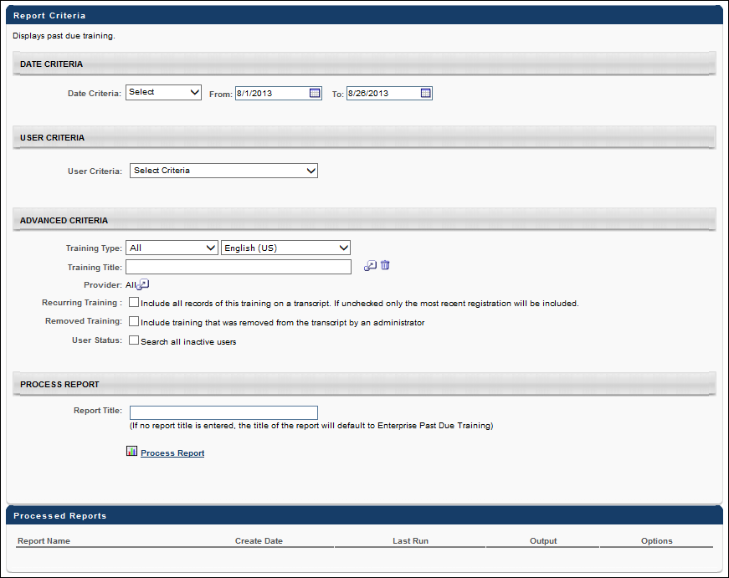
Output
- Printable Version link to view the results in a web page, or Export to Excel link to save/open as an Excel file
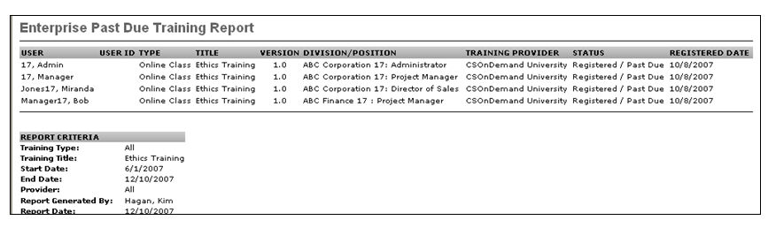

Enterprise Training Report
This report displays transcript status information about all the learning objects assigned to or requested by the selected users. It can be organized by organizational unit or by user. The Enterprise Training report allows for reporting for multiple versions of a training item.
Permissions
PERMISSION NAME | PERMISSION DESCRIPTION | CATEGORY

Enterprise Training Report | Grants access to the Enterprise Training Report, which displays training statuses for all LOs assigned or requested by users within a specified period of time. | Reports - Training

Assignment Tool - Training Start Date | Grants ability to configure a Training Start Date when creating a Standard Learning Assignment. The Training Start Date is the date that users will be able to start the training. This permission is dependent on the Assignment Tool - Standard, Assignment Tool - Standard and Dynamic, and Assignment Tool - Standard and Dynamic - Recurrence permissions. This permission cannot be constrained. This is an administrator permission. | Learning - Administration

Training Reports Attempts and Scores | Grants ability to view attempts and scores data from the Course Assessment Results, Enterprise Training, Online Training Status, SCORM 2004 Course Progress, and Transcript Status report outputs. This permission cannot be constrained.  This permission works in conjunction with the permissions for the associated reports.  Note: Users may need to be granted permission view the Test Engine so that they can see the Test Engine results within Admin > Tools > Content. | Reports - Training
Filters
- Date Criteria - filter your results on Registration date range. For sessions, the report results are filtered based on the session start date. Note: Date Criteria is always implemented using UTC (Coordinated Universal Time).
- User Criteria - limit report output to the users matching the specified user criteria
  - The report will only run within the defined constraints for the user running the report
  - This is the standard OU availability selection criteria drop-down. Choose from available OU types
  - Defaults: If no User Criteria are selected then the report will run for the entire available population
- Training Type - filter the report on a certain training type or select All for all training types
- Status - select status/s to include in results. Note: The Not Available field is only visible to users who have permission to manage the available date setting for proxy enrollments.
- Training Title - filter by training title
  - When the administrator selects a training title, if the training has more than one version, a version drop down will appear next to the training title text field.
  - The drop down will list all the version numbers for the selected training title in descending order.
  - The drop down will default to "All Versions", allowing the administrator to run the report for all versions of the selected training.
  - Note: If a training title is not selected for the report, the report will only run for the latest version of any training item. If a training title is not selected for the report, the report will only run for the latest version of any training item.
- Provider - filter the results for training from a specific training provider/vendor or select All for all training Providers/Vendors
- Completion Date - check to include a column for completion date
- Equivalent Training - check to show Equivalent Training Title. This functionality will only be available if the report is ran on a training title
- Recurring Training - check to include all records of this training on a transcript. If not checked, only the most recent registration will be display in report output.
- Removed Training - check to Include training that was removed from transcript by an administrator
- User Status - check to Search all inactive users
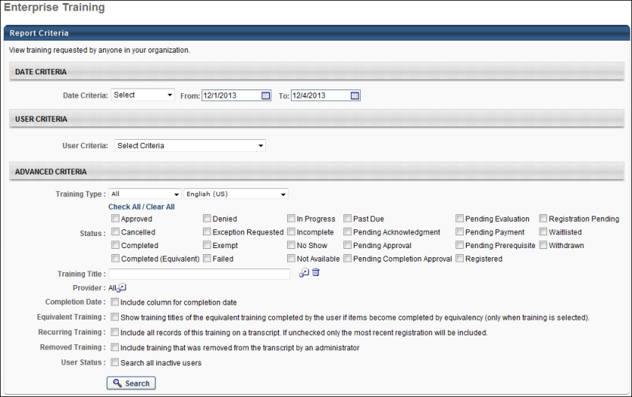
Output
- The report will generate on the page as an inline report. To see additional details by user, click on the Details icon.
- link to view the results in a web page, link to save/open as an Excel file, or to export data to a tab delimited text file.
  - In the search results, a Version column is added next to the Title column. This column will display the version number for each training in the search results.
  - For training items that do not have multiple versions, the number 1.0 will appear for the training item.
  - The Session Date column will only display on the search results if a session appears within the results. If a session is not included in the search results, the Session Date column will not appear.
  - The User Last Name and User First Name columns will be combined into one column, User. This column will display the user's name in Last Name, First Name format.
  - When the Not Available status is included in the report output, "Not Available" displays in the Status column for users for whom the training is in a Not Available status.
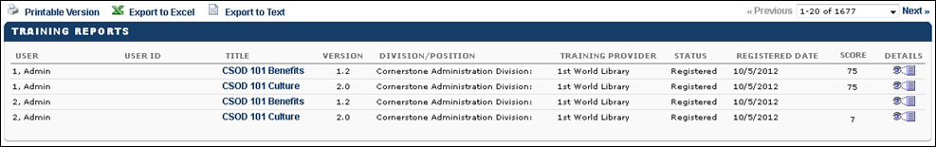
Maximum Number of Rows in Excel Output
The maximum number of rows in the Excel output is determined by a backend setting. Contact Global Customer Support to configure this setting.
By default, the maximum number of rows in the Excel output is 100,000. Note: If more rows are needed in this report, then it is necessary to submit a work order. You will need to provide the amount of data needed and the business reason for the request.
Output with Recurring Training Option Selected
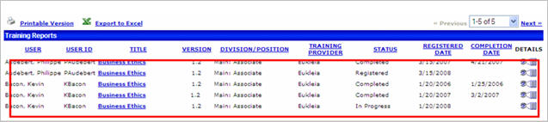
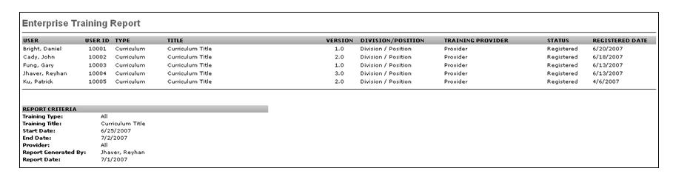
Output with Equivalent Title Selected
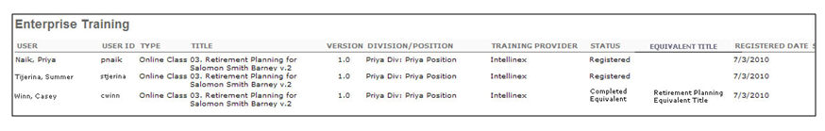

Evaluation Report
Display summary information of Evaluation Levels 1-3. If using a Level 2 (scored) evaluation, the data can only be pulled using the Level 2 Evaluation report, not the Evaluation report. See Level 2 Evaluation Report on page 445 for additional information.
Note: In the case that an instructor has not been set for a session, the user can access this session's evaluation information via the Training Evaluation Report at the event level.
Permissions
PERMISSION NAME | PERMISSION DESCRIPTION | CATEGORY

Training Evaluation Report | Grants access to the Training Evaluation report, which displays summary information from completed learning evaluations, levels 1,2 (non-scored) and 3. | Reports - Training
Filters
- Date Criteria -filter your results based on date range of evaluation completion. Note: Date Criteria is always implemented using UTC (Coordinated Universal Time).
- Training Title - filter by training title. When a training title is selected, the language that is selected is ignored, and the filter logic only looks for the training title.
- Session Location - filter on session location
- Vendor - filter the results for training from a specific training vendor/provider or select All for all training Vendors/Providers
- Instructor - filter by a specific instructor name. Vendor must be selected to select an Instructor.
- Locator number - filter by specific Locator number
- Session Number - filter by specific Session number
- Question ID - filter by specific Question ID
- Category - filter on Category
- Training Type -filter by Training Type or choose All. Select a language from the drop-down to filter training by available languages.
- Evaluations Included - check to include any combination of Level 1, Level 2 or Level 3
- Group by - select Enterprise, Training Unit or Vendor to group evaluation reporting results
- Details -check Display text-only responses box to view responses to text questions. Check Display supplementary text responses box to view comments to other question types.
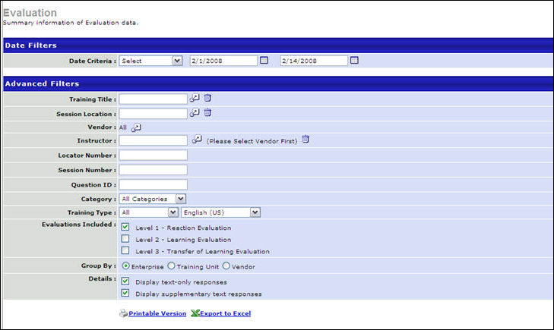
Output
- Printable Version link to view the results in a web page, or Export to Excel link to save/open as an Excel file
Note: On the report output, for portals with multiple languages enabled, the data in the evaluation question, text-only responses, and supplementary text responses displays in the reporting administrator's language. If the reporting administrator's language is not available, the data displays in the field's default language.
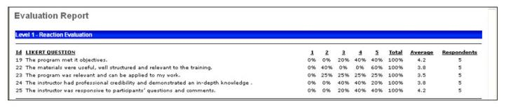

Exception Training Report
Display employees that have not taken a specific training.
Permissions
PERMISSION NAME | PERMISSION DESCRIPTION | CATEGORY

Exception Training Report | Grants access to Exception Training Report, which displays a list of users who do not have a specific learning object on their learning transcript within a specified date range. | Reports - Training
Filters
- Date Criteria -filter your results based on when the training was added to the user's transcript. Note: Date Criteria is always implemented using UTC (Coordinated Universal Time).
- User Criteria - limit report output to the users matching the specified user criteria
  - The report will only run within the defined constraints for the user running the report
  - This is the standard OU availability selection criteria drop-down. Choose from available OU types
  - Defaults: If no User Criteria are selected then the report will run for the entire available population
- Training Title - filter by training title (required field)
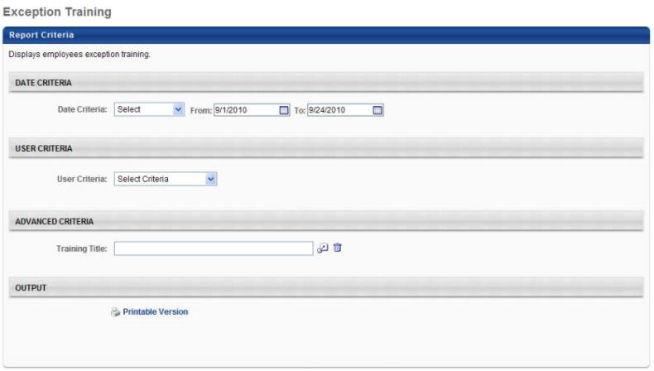
Output
- Printable Version link to view the results in a web page
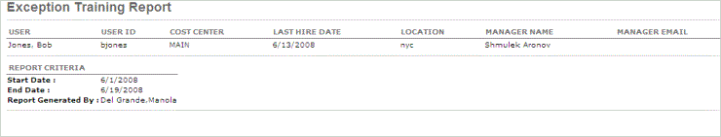

Incomplete Divisional Training Report
Display training not completed within 30, 60, 90 or 120 days of registration in your division.
Filters
- Date Criteria -filter your results based on Registration date range. Note: Date Criteria is always implemented using UTC (Coordinated Universal Time).
- User Criteria - limit report output to the users matching the specified user criteria
  - The report will only run within the defined constraints for the user running the report
  - This is the standard OU availability selection criteria drop-down. Choose from available OU types
  - Defaults: If no User Criteria are selected then the report will run for the entire available population
- Training Type - filter the report on a certain training type or select All for all training types
- Division - auto populates with division of user (divisional training report will only allow results to be returned for users in your division)
  - Check Include Subordinate divisions to include subordinates of the division
- Provider - filter the results for training from a specific training provider/vendor or select All for all training Providers/Vendors
- Subject - filter by specific subject
- AGE - select to show training not completed within 30, 60, 90 or 120 days of registration
- Primary Sort By - select to sort by Employee, Training Type, Title, Provider or Status
- Secondary Sort By - select to create secondary sort by Employee, Training Type, Title, Provider or Status
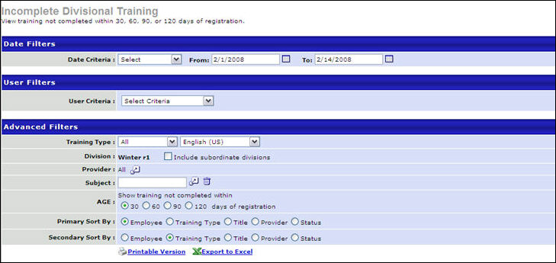
Output
- Printable Version link to view the results in a web page, or Export to Excel link to save/open as an Excel file
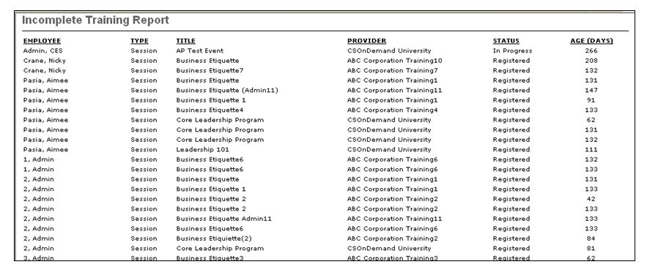

Incomplete Training Report
Display training not completed within 30, 60, 90 or 120 days of registration.
Permissions
PERMISSION NAME | PERMISSION DESCRIPTION | CATEGORY

Enterprise Incomplete Training Report | Grants access to Incomplete Training Report, which displays training not completed within 30, 60, 90 or 120 days of registration. | Reports - Training
Filters
- Date Criteria - filter your results based on a specific time period. Note: Date Criteria is always implemented using UTC (Coordinated Universal Time).
- User Criteria - limit report output to the users matching the specified user criteria
  - The report will only run within the defined constraints for the user running the report
  - This is the standard OU availability selection criteria drop-down. Choose from available OU types
  - Defaults: If no User Criteria are selected then the report will run for the entire available population
  - Include Subordinates - When this option is selected, the report output includes user data for the users selected in the User Criteria section, as well as the user's subordinates.
- Training Type - filter the report on a certain training type or select All for all training types
- Provider - filter the results for training from a specific training provider/vendor or select All for all training Providers/Vendors
- Subject - select specific subject
- Age - select to show training not completed within 30, 60, 90 or 120 days of registration
- Primary Sort By - select to sort by Employee, Training Type, Title, Provider or Status
- Secondary Sort By - select to create secondary sort by Employee, Training Type, Title, Provider or Status
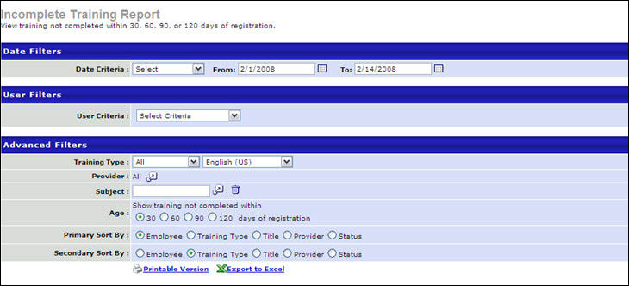
Output
- Printable Version link to view the results in a web page, or Export to Excel link to save/open as an Excel file
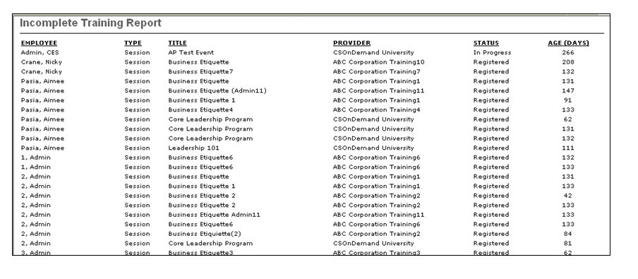

Learning Evaluation Comparison Report
Compare the average pre and post training test scores for a group of training items.
Permissions
PERMISSION NAME | PERMISSION DESCRIPTION | CATEGORY

Learning Evaluation Comparison Report | Grants access to the Learning Evaluation Comparison report, which compares the average pre and post training test scores for a group of training items. | Reports - Training
Filters
- Date Criteria - filter your results based on a specific time period. Note: Date Criteria is always implemented using UTC (Coordinated Universal Time).
- User Criteria - limit report output to the users matching the specified user criteria
  - The report will only run within the defined constraints for the user running the report
  - This is the standard OU availability selection criteria drop-down. Choose from available OU types
  - Defaults: If no User Criteria are selected then the report will run for the entire available population
- Training Title - type word/s of title of event to search
- Training Type - filter the report on a certain training type or select All for all training types
- Instructor - filter by a specific instructor name
- Provider - filter the results for training from a specific training provider/vendor or select All for all training Providers/Vendors
- Subject - filter by specific subject
- ILT Evaluations - select to Display Session Separately or Groups Sessions by Events
- Sort By - select to sort by Title, Avg. Pre-Training Score or Avg. Improvement
  - If the report is sorted by title, the bar graph will be alphabetically sorted by training title, type, or provider, depending on how it is grouped. The data columns will be sorted by the Training Title column.
  - If the report is sorted by avg. pre-training score, the bar graph will sort increasingly to show the lowest pre-training score item first. The data columns will be sorted by the Avg. Pre-Training Score column.
  - If the report is sorted by avg. improvement, the bar graph will sort increasingly to show the lowest improvement item first. The data columns will be sorted by the Avg. Improvement column.
  - The resulting report contains a stacked bar graph with the pre-training test scores in blue. The average improvement for each training item, type, or provider, is then stacked on top of the pre-training scores and appears in green. However, if the average improvement is negative, it appears in red.
- Group By - select to compare a group of Training Titles, Training Types or Providers. This option controls how the bar graph will appear in the report. It does not affect the columns that appear on the report; the report will always list the training titles of each training item that meets the filter criteria.
- If the report is grouped by training title, the bar graph will have a separate bar for each training item. The titles of the courses will be listed on the Y axis. See Example 1.
- If the report is grouped by training type, the bar graph will have a separate bar for each training type, which is listed on the Y-axis. See Example 2.
- If the report is grouped by provider, the bar graph will have a separate bar for each provider that meets the criteria. The provider names will be listed on the Y-axis.
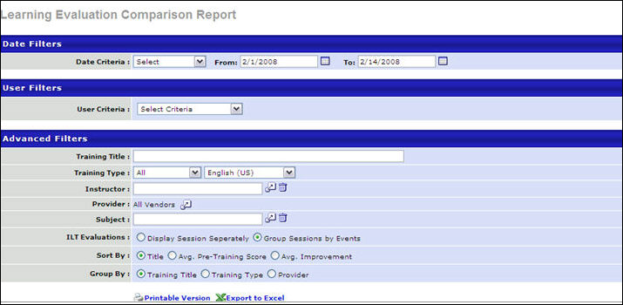
Output
- Printable Version link to view the results in a web page, or Export to Excel link to save/open as an Excel file
Example 1: Group by Training Title
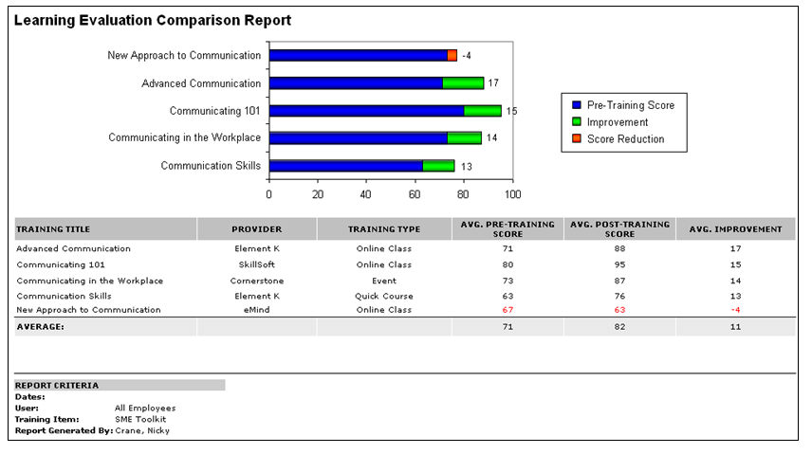
Example 2: Group by Training Type
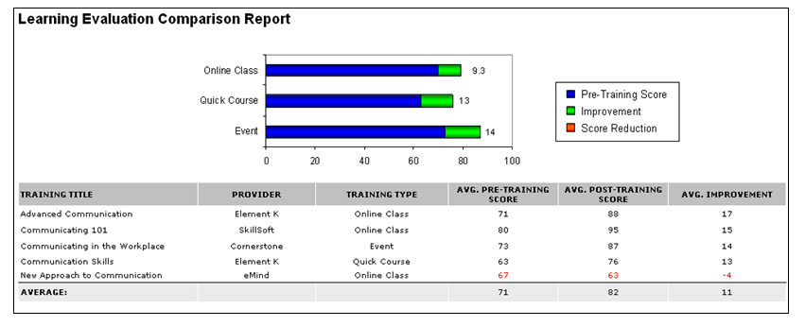

Level 1 Evaluation Report
Display results for a Level 1 Evaluation based on selected criteria. The report will return results for one evaluation based on selected criteria.
This report does not provide the names of users who provided evaluations. However, this information can be obtained using custom evaluation reports.
Permissions
PERMISSION NAME | PERMISSION DESCRIPTION | CATEGORY

Course Catalog - Update | Grants ability to manage and edit training items listed in the Course Catalog and also grants access to the Course Console, where training can also be managed and edited. This permission also grants access to the Popular Requests and Highest Rated widgets on the Learning Admin Console (in conjunction with the Learning Admin Console - View permission). This permission also allows administrators to reversion online courses via the Course Console page. This permission also allows administrators to access an Edit Training option for training items included as objectives in Development plans.  This permission can be constrained by OU, User's OU, Training Type, Training Item, Provider, ILT Provider, User's ILT Provider, User, User Self and Subordinates, and User's LO Availability. This is an administrator permission.  Note: Adding an OU constraint and a provider constraint to this permission results in an "AND" statement. | Learning - Administration

ILT Evaluations - Update | Grants ability to configure training evaluation settings at instructor led training event or session level, including choosing which evaluation template to use, and indicating whether an evaluation is active and required for the event or session. This is an administrator permission. | Learning - Administration

Level 1 Evaluation Report | Grants access to Level 1 Evaluation report, which will return results for a single level 1 evaluation based on selected criteria. | Reports - Training

Test Engine - Manage | Grants ability to create and edit/manage tests via the Test Engine. This permission can be constrained by OU, User’s OU, User, User’s Self, and User’s Subordinates. This is an administrator permission. | Learning - Administration
Filters
- Date Criteria - Filter your results based on an evaluation completion date range. Note: Date Criteria is always implemented using UTC (Coordinated Universal Time). This means that if the user running the report does not belong to UTC, the dates entered in the filter will be converted to UTC and the report will provide results according to the UTC dates.
- Evaluation Title - Filter the report on a specific evaluation title
- Training Title - Filter by training title.
  - Report will pull results for currently associated evaluation.
Note: If users took the original evaluation and later it was updated to a different evaluation, the report will pull only the first evaluation. If you would like to report on a specific evaluation, add the Evaluation Title to the filter criteria.
Also, you can filter by training version which will show results based on the associated training and evaluation.
Note: When an event is added as the Training Title, the report will look at all Level 1 Evaluations associated with all sessions under the event and select one to use in the report. If you would like to report on a specific evaluation, add the Evaluation Title to the filter criteria.
- Locator Number - Filter report by a specific locator number
- Details -
  - Display text-only responses - Select this option to view responses to text questions.
  - Display supplementary text responses Select this option to view comments to other question types.
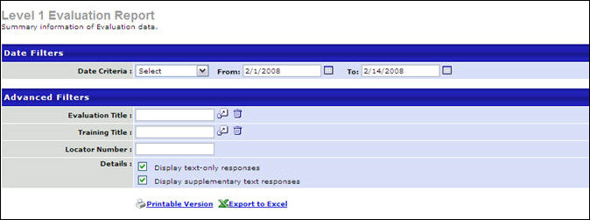
Output
- Printable Version link to view the results in a web page, or Export to Excel link to save/open as an Excel file.
Note: On the report output, for portals with multiple languages enabled, the evaluation title and questions display in the reporting administrator's language. If the reporting administrator's language is not available, the fields display in the fields' default language.
Note: On the report output, the sections display by the associated Instructor (primary sort), then by the actual section order (secondary sort). Sections without an associated Instructor will display first.
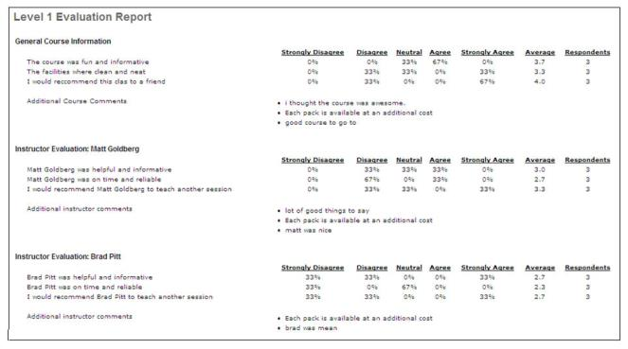
Note: For Likert scale question results, this report will display the default Likert scale values (1-5) set in evaluation preferences. These may or may not be the actual Likert scale values used for the specific question. A best practice is to use this report only if the Likert scale default values are the only values used. If Likert scale values other than the defaults are used, the Evaluation Report will display the numeric values only. The look of the Likert report may differ from the end user's evaluation experience, as the evaluation may be modified for accessibility for the user. See Evaluation Report on page 431 for additional information.

Level 2 Evaluation Report
Compares pre and post training test scores for a particular training item.
This report is only used for Level 2 Scored Evaluations, and cannot be used for Level 2 Knowledge Evaluations.
Permissions
PERMISSION NAME | PERMISSION DESCRIPTION | CATEGORY

Level 2 Evaluation Report | Grants access to the Level 2 Evaluation report, which compares pre and post training test scores for a particular training item. | Reports - Training
Filters
- Date Criteria filter your results based on an evaluation completion date range. Note: Date Criteria is always implemented using UTC (Coordinated Universal Time).
- User Criteria- limit report output to the users matching the specified user criteria
  - The report will only run within the defined constraints for the user running the report
  - This is the standard OU availability selection criteria drop-down. Choose from available OU types
  - Defaults: If no User Criteria are selected then the report will run for the entire available population
- Training Title - filter by training title
- Session Locator - filter by specific Locator number
- User Status - check to Search all inactive users
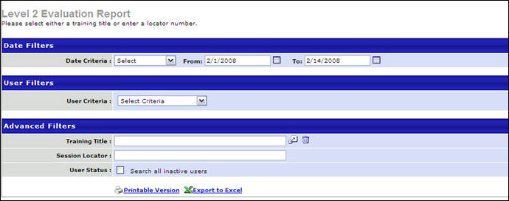
The report also displays the number of days between taking the post-training test and completing the course so that administrators can determine if this time period affected the user's scores.
- The administrator may filter by the date that the training item was marked complete in the user's transcript. Only users who have completed the training item will be included in this report.
Output
- Printable Version link to view the results in a web page, or Export to Excel link to save/open as an Excel file
Note: On the report output, for portals with multiple languages enabled, the evaluation title displays in the reporting administrator's language. If the reporting administrator's language is not available, the field displays in the field's default language.
Note: On the report output, the sections display by the associated Instructor (primary sort), then by the actual section order (secondary sort). Sections without an associated Instructor will display first.
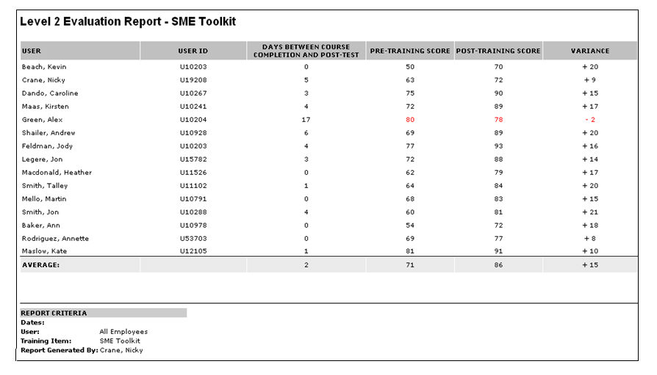

LO Equivalency Report
View all items that are set to equivalent in the course catalog.
Permissions
PERMISSION NAME | PERMISSION DESCRIPTION | CATEGORY

LO Equivalency Report | Grants access to LO Equivalency Report which allows administrators to view all items that are set to equivalent in the course catalog. | Reports - Training
Filters
- Training Type - check one or more training types
- Training Title - filter by training title
- Provider - choose all or specific provider
- Subject - choose a subject
- Inactive Training - check to include inactive training
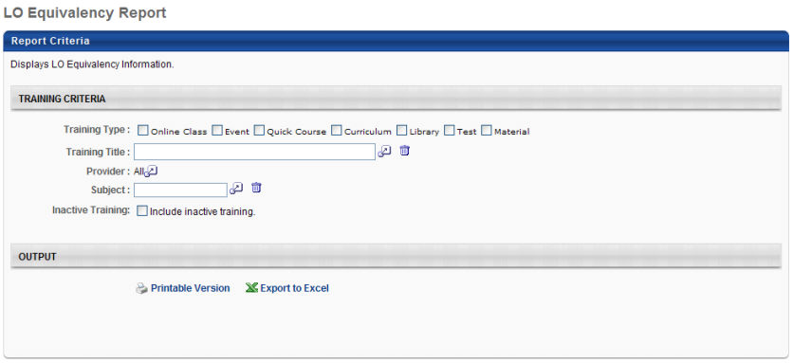
- On this report, each equivalent training item will be listed as a separate line item.
- The report output will indicate whether the item is a training equivalent item or language equivalent item. See Course Catalog - General.
Output
- Printable Version link to view the results in a web page, or Export to Excel link to save/open as an Excel file
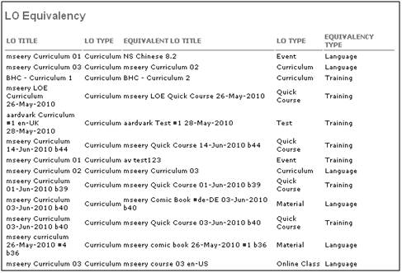

Online Course Attempts Report
The Online Course Attempts Report provides report data for online courses that users have attempted but not yet completed or have completed. The report provides the user's score, if available, as well as the status of the attempt, the date on which the user attempted/completed the course, and the number of attempts. This report does not include information on users who have not attempted the course.
To access the Online Course Attempts Report, go to Reports > Standard Reports > Training.
Permissions
PERMISSION NAME | PERMISSION DESCRIPTION | CATEGORY

Online Course Attempts Report | Grants access to Online Course Attempts Report, which displays registration number, transcript status and score for recurring and non-recurring training. | Reports - Training
Criteria
Feature | Description
Date Criteria | Select the date range for the report from the drop-down list or enter specific dates in the From and To fields.
User Criteria | Select a user or a group of users that may be included in the report. This criterion applies to the users who will appear in the report output. You may choose one or more individual users as well as entire organizational units (OUs) or Groups. Depending on the constraints of the report permission, the user running the report may only be able to view users for the organizational units to which they are constrained.  If this field is left blank, then the report checks the user's permission constraints and returns results for all users who are within the report permission constraints. If the user has no permission constraints, then the report returns results for all users.
Advanced Criteria | Training Title |  | Filter the report by a specific training title. The report output returns online course attempt results for the selected training.
 | Provider |  | Filter the report by a specific training provider. The report output returns online course attempt results for the selected provider.
 | Recurring Training |  | Check the box to include all records of this training on a transcript. If unchecked only the most recent registration will be included.
 | Removed Training |  | Check the box to include training that was removed from the transcript by an administrator.
 | User Status |  | Check the box to include inactive users in the report output.
Output
Feature | Description
Printable Version | Click the Printable Version link to view a printable version of the report. A pop-up opens displaying the report data, which can be printed using your browser settings.
Export to Excel | Click the Export to Excel link to view the report in Excel.
Printable Output
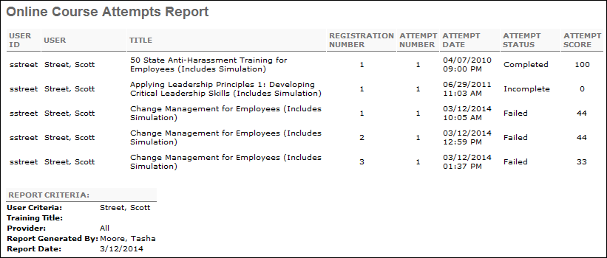
Excel Output
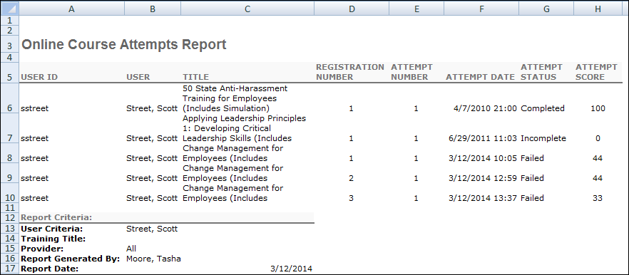
The following information displays in the printable and Excel report output:
- User ID - This column displays the user ID of the user who attempted the course.
- User - This column displays the name of the user who attempted the course, displaying as last name, first name.
- Title - This column displays the title of the course that was attempted.
- Registration Number - This column displays the registration instance for the course.
- Attempt Number - This column displays the attempt number for the course. Each course attempt displays in a separate row on the report.
- Attempt Date - This column displays the date on which the user attempted the course.
- Attempt Status - This column displays the status of the attempt. The following are the possible statuses:
  - Completed
  - Failed
  - Incomplete
  - Passed
- Attempt Score - This column displays the user's score for the course attempt, if a score is available for the course. Note: If the user's score is manually updated by a manager or administrator, the updated score does not display on the report.
Note: If the report fails to process, consider reducing the possible output volume by narrowing the report criteria. For example, instead of including all Division organizational units (OU) in the User Criteria section, only include one or two Division OUs. Or, if all Division OUs are included, narrow the date range in the Date Criteria fields.

Online Training Status Report
Display status and progress information for online training.
Permissions
PERMISSION NAME | PERMISSION DESCRIPTION | CATEGORY

Online Training Status Report | Grants access to Online Training Status Report, which displays transcript status and progress information for online training courses. | Reports - Training

Training Reports Attempts and Scores | Grants ability to view attempts and scores data from the Course Assessment Results, Enterprise Training, Online Training Status, SCORM 2004 Course Progress, and Transcript Status report outputs. This permission cannot be constrained.  This permission works in conjunction with the permissions for the associated reports.  Note: Users may need to be granted permission view the Test Engine so that they can see the Test Engine results within Admin > Tools > Content. | Reports - Training

Pre/ Post Work Training Status | Grants access to Pre/Post Work Training Status Report. This permission can be constrained by OU, Facility, Facilities Owned by User, Training Item, Training Type, User, User's Direct Reports, User's ILT Provider, User's LO Availability, User's OU, User's Self, User Self and Subordinates, and User's Subordinates. | Reports - Training
Criteria
- Date Criteria - This filter applies to the date on which the training was added to the user's transcript. The report output only includes training that was added to the selected users' transcripts within the selected date criteria. If no date criterion is selected, then no date filters are applied to the report output.
- User Criteria - Limit report output to the users matching the specified user criteria
  - The report will only run within the defined constraints for the user running the report
  - This is the standard OU availability selection criteria drop-down. Choose from available OU types
  - Defaults: If no User Criteria are selected then the report will run for the entire available population
- Provider - Filter the results for training from a specific training provider/vendor or select All for all training Providers/Vendors
- Recurring Training - Check to include all online course records from a user's transcript, including all recurring online training. If unchecked only the most recent registration will be included.
- User Status - Check to Include inactive users
- Group By - Select to Summarize by employee or Do not Summarize
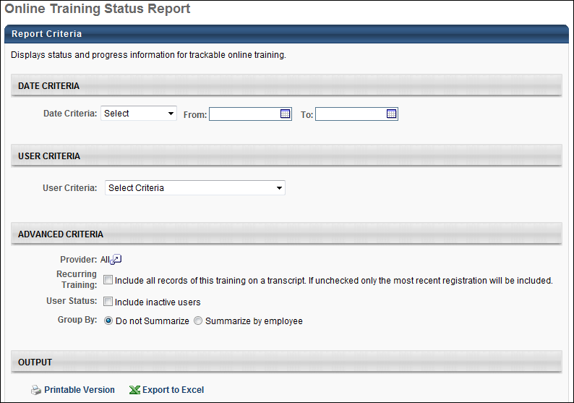
Output
- Printable Version link to view the results in a web page, or Export to Excel link to save/open as an Excel file
- The value of N/A* in the Score column indicates that for completed courses, the status was manually overridden by an Administrator and marked complete
- If recurring training is included in the report, then an online course may appear in the report multiple times for each instance of the online course.
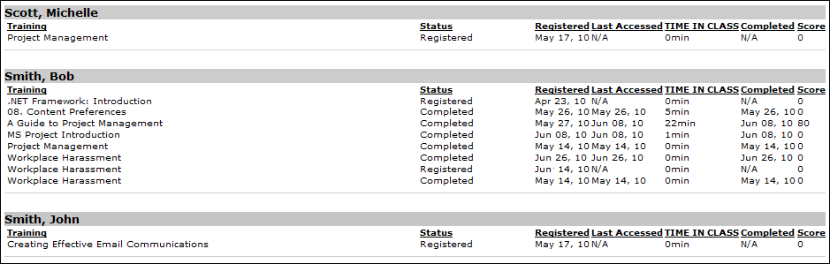

Required Classes Completion Report
Display registration and completion information for required classes.
Permissions
PERMISSION NAME | PERMISSION DESCRIPTION | CATEGORY

Required Class Completion Report | Grants access to Required Class Completion Report, which displays users' transcript statuses for learning objects that are designated as required when setting user availability. | Reports - Training
Filters
- Course Criteria (required field)- limit report output to the users matching the specified OU criteria
  - The report will only run within the defined constraints for the user running the report
  - This is the standard OU availability selection criteria drop-down. Choose from available OU types
  - Defaults: If no User Criteria are selected then the report will run for the entire available population
- Group By - check to group by Employee or Training
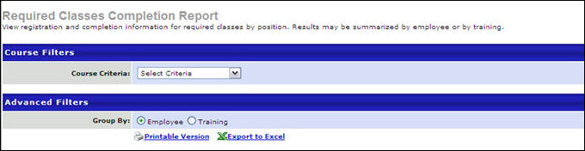
Output
- Printable Version link to view the results in a web page, or Export to Excel link to save/open as an Excel file
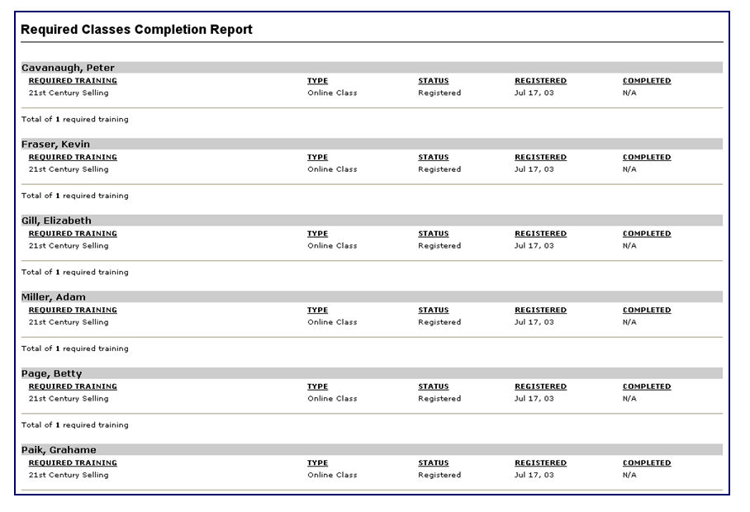

Required/Suggested Training Report
This report displays required and suggested training that has been assigned to users. The report uses the most current version of a learning object (LO) to display the required and suggested LOs have been added to users' transcript. The administrator also has the option to run this report to view required and suggested LOs that have not been added to users' transcripts.
Permissions
PERMISSION NAME | PERMISSION DESCRIPTION | CATEGORY

Required/Suggested Training Report | Grants access to Required/Suggested Training Report, which displays courses designated as required or suggested for a population of users. | Reports - Training
Filters
- User Criteria - limit report output to the users matching the specified user criteria
  - The report will only run within the defined constraints for the user running the report
  - This is the standard OU availability selection criteria drop-down. Choose from available OU types
  - Defaults: If no User Criteria are selected then the report will run for the entire available population
- Training Types - filter the report on a certain training type or select All for all training types
- Training Title -filter by training title
- Display Required/Suggested Training - select to display Required/Suggested Training Added to Transcript or Not Added to Transcript
- Filter By - select to filter Required or Suggested training or select None to display both
- Training Due Date - check to Include Training Due Date
- Completion Date - check to Include Completion Date
Report Settings
This is an asynchronous report, which allows the administrator to define the standard report and generate the report asynchronously. As a result, when administrators process the report, the system generates the report in the background, while the administrator can move on to other areas of the system. When the report is finished processing, the administrator can then view the full report in its entirety.
- Up to three separate reports can generate asynchronously, allowing greater flexibility for creating and storing different versions of the report.
- If you process a report or refresh a stored report, the report appears in the table as Queued.
- The most recently created report displays at the top of the table.
- Since the user can generate up to three reports, the administrator can define a report title for each of the generated reports.
- Clicking the View Details icon changes the report settings on the page to match those of the selected previously run report.
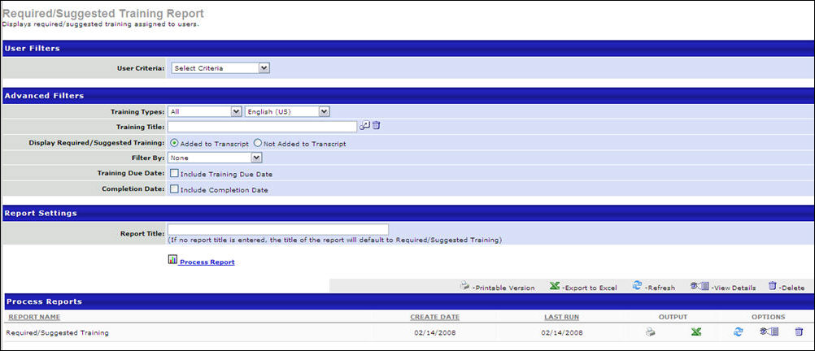
Output
- Printable Version link to view the results in a web page, or Export to Excel link to save/open as an Excel file
- After the report is processed you can:
  - Update the data on the report, click the Refresh icon
  - View the details on the report, click on the Details icon
  - Delete the report, click on the Delete icon
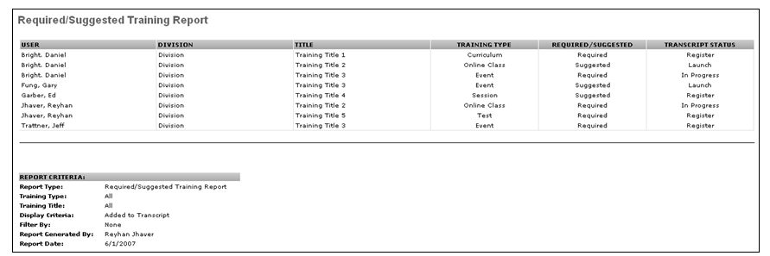

SCORM 2004 Course Progress Chart Report
The SCORM 2004 Course Progress Chart report enables you to view data for online courses, including course progress, module progress, and assessments. The report is available for the following course types:
- Online Courses
- Quick Courses
- SCORM 2004
To create SCORM 2004 Course Progress Chart reports, go to Reports > Standard Reports > Training. Then, click the SCORM 2004 Course Progress Chart link.
Permissions
PERMISSION NAME | PERMISSION DESCRIPTION | CATEGORY

SCORM 2004 Course Progress Chart Report | Grants access to the SCORM 2004 Course Progress Chart Report, a report that displays various types of summary and detail information for results on a SCORM 2004 course for a manager's subordinates. This permission cannot be constrained. This is a manager permission. | Reports - Training

Training Reports Attempts and Scores | Grants ability to view attempts and scores data from the Course Assessment Results, Enterprise Training, Online Training Status, SCORM 2004 Course Progress, and Transcript Status report outputs. This permission cannot be constrained.  This permission works in conjunction with the permissions for the associated reports.  Note: Users may need to be granted permission view the Test Engine so that they can see the Test Engine results within Admin > Tools > Content. | Reports - Training
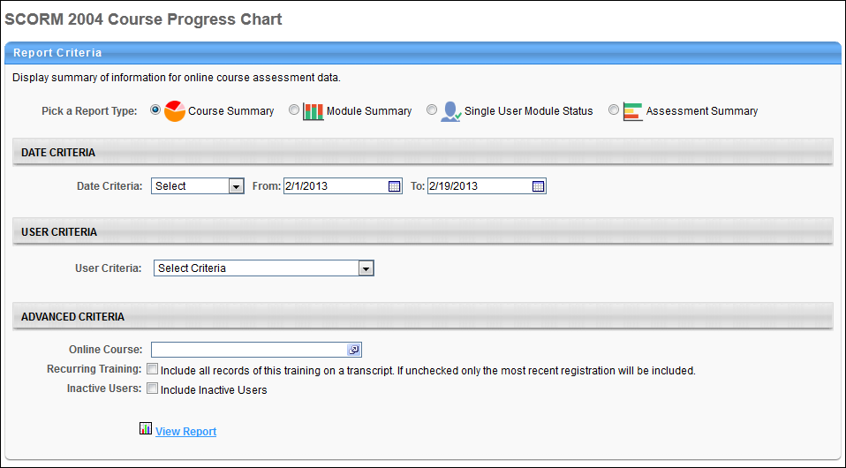
Criteria
Feature | Description
Report Type | The report type determines the information that displays in the report output. The following report types are available:  - Course Summary - This report type displays course progress and additional data for each course. Multiple users can be selected for this report.  - Module Summary - This report type displays progress for the modules in the course for all selected users. Multiple users can be selected for this report.  - Single User Module Status - This report type displays progress for the modules in the course for one user. Only one user can be selected for this report.  - Assessment Summary - This report type displays progress for assessments within the course. Multiple users can be selected for this report. Note: The assessment type is selected once the online course is selected in the Advanced Criteria section.
Date Criteria | Select the date range for the report from the drop-down list or enter specific dates in the From and To fields. The date criteria is the date on which the training is added to the transcript.
User Criteria | Limit results to the users matching the specified user criteria by selecting the criteria from the drop-down. Note: For the Single User Module Status report type, only one user can be selected.
Advanced Criteria | The following advanced report options are available:  - Online Course - Click the Select icon to open the Select Training pop-up and select a course. This is a required field. Only one course can be selected per report. The only courses that are available to select are SCORM 2004-compliant courses.  - Assessment - This option is only available for the Assessment Summary report type. Select an assessment from the drop-down. Any assessment within the course can be selected. If there are no assessments in the course, then the drop-down does not display. Instead, "No assessments were found for this course" displays in the Assessment field.  An assessment only displays if at least one user has completed the assessment. Results only display for completed assessments. If a question has not been answered by any of the users configured for the report, then the question does not appear in the report output.  - Recurring Training - This option is only available for the Course Summary report type. Select this option to include all instances of the course from the users' transcript. If this option is not selected, then only the most recent instance of the course is included in the report.  - Inactive Users - Select this option to include inactive users in the report.
Once all criteria are configured, click View Report. The results display in the Report Results panel and may also display in graphical form.
The report can be viewed as a printable version and can be exported to Excel. In these views, the report title is "SCORM 2004 Course Progress Chart" and cannot be configured from the report page.
Output
Course Progress
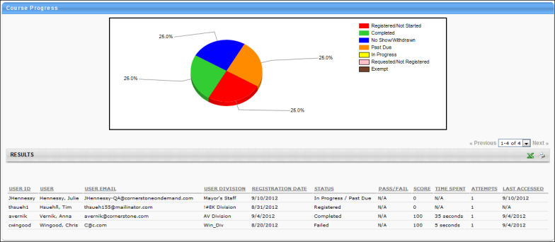
The Course Progress output displays a pie chart that shows the percentage of users that are in a given status. The following statuses display:
- Registered/Not Started
- Requested/Not Registered
- Past Due
- In Progress
- Completed
- No Show/Withdrawn
- Exempt
The Excel version of the chart displays a numeric breakdown of the information in the chart. For example, the following information would be included in the Excel version of the pie chart:
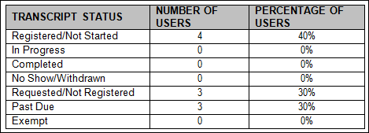
The Report Results table displays the following columns:
- User ID
- User
- Email
- Division
- Reg. Date - This column displays the date on which the user registered for the course.
- Status - This column displays the status of the course in the user's transcript.
- Pass/Fail - This column displays whether the user passed or failed the course.
- Score
- Time Spent - This column displays the amount of time the user spent in the course.
- Attempts - This column displays the number of times the user attempted the course.
- Last Accessed - This column displays the date on which the user most recently accessed the course.
The Excel version of the report includes the following additional information for the course:
- Training Object ID - This is the ID of the learning object.
- Training Title
- Provider
The Excel version also includes the following additional columns:
- User Location
- User's Division Parent - This is the parent division of the user's division.
Historical Data
When needing historical data, it is recommended that you use the Custom Transcript Report instead of the SCORM 2004 Course Progress Chart Report. Be sure to include the SCORM 2004 Quiz Data field in the report.
The reason to use the custom report instead of the standard report is that the standard report only shows data for the latest version of the course. If a user does not have data for the latest version, then the report will not include them.
Module Summary
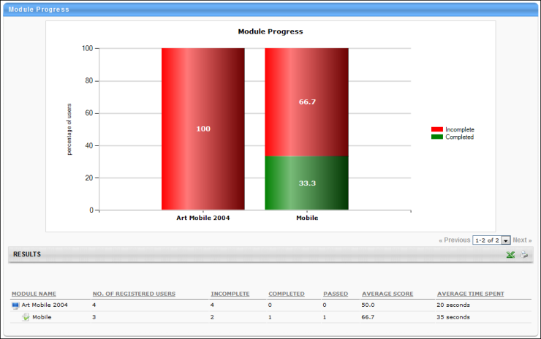
The Module Summary output displays progress for the modules inside the course. The top portion of the results displays a graph that shows incomplete and complete information by module.
The Report Results table displays the following columns:
- Module Name - This column displays the module hierarchy for the course.
- No. of Registered Users - This column displays the total number of users that are registered for the course.
- Incomplete - This column displays the number of users who have not completed the module.
- Completed - This column displays the number of users who have a status of Completed the module.
- Passed - This column displays the number of users with a SCORM success status of Passed for the module.
- Average Score - This column displays the average score of the users who have a score for the module. If there are no users who have a score for the module, then "N/A" displays.
- Average Time Spent - This column displays the average time spent in the module. If there are no users who have spent time in the module, then "N/A" displays.
Note: Quizzes are identified by a Quiz icon .
Single User Module Status
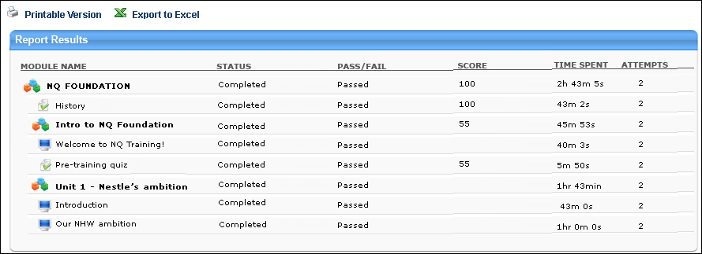
The Single User Module Status output displays a Report Results table with summary information for one user. A graph is not included in this output. The following columns display in the Report Results table:
- Module Name - This column displays the module hierarchy for the course.
- Status - This column displays the completion status of the module.
- Pass/Fail - This column displays whether the user passed or failed the module.
- Score - This column displays the user's score for the module.
- Time Spent - This column displays the amount of time the user spent in the module.
- Attempts - This column displays the number of times the user attempted the module.
The printable version and Excel output include the following additional information about the user:
- User ID
- User Full Name
- Username
- User Email
Assessment Summary
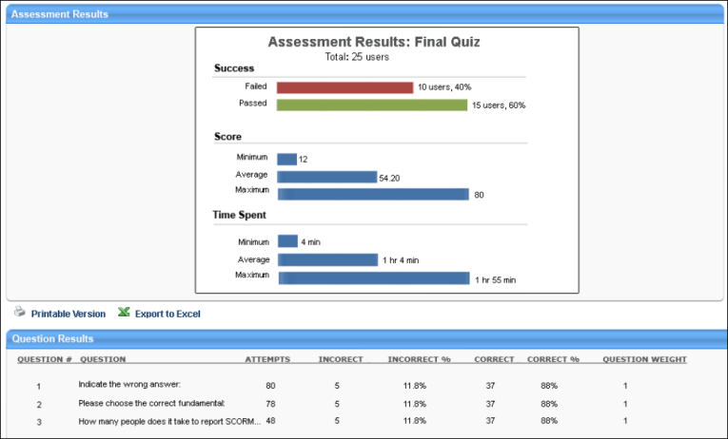
The Assessment Summary output displays progress for assessments within the course. Progress only displays for completed assessments.
The top portion of the results displays a bar chart that shows the following information:
- Success - This section displays the number and percentage of users who have failed or passed the assessment. The calculation is based on the number of users who attempted the assessment.
- Score - This section displays the minimum, average, and maximum score achieved. The calculation is based on the total score for the assessment.
- Time Spent - This section displays the minimum, average, and maximum time spent on the assessment. The calculation is based on the total time spent in the assessment.
The Report Results table displays the following columns:
- Question # - This column displays the number of the question in the assessment.
- Question - This column displays the question. If there are no users that attempted the question, then the question does not display.
- Attempts - This column displays the number of times the question was attempted. The value only increments from "1" if a backend setting is enabled and the user fails the attempt and retakes the training.
- Incorrect - This column displays the number of attempts that resulted in an incorrect answer.
- Incorrect % - This column displays the percentage of total attempts that resulted in an incorrect answer.
- Correct - This column displays the number of attempts that resulted in a correct answer.
- Correct % - This column displays the percentage of total attempts that resulted in a correct answer.
- Question Weight - This column displays the weight of the question on the assessment.

Survey Report
This report enables you to view response details for a particular survey task or to view cumulative responses from all instances of this survey over a certain time period. This report is only available for organizations using the Survey functionality.
Report Output Note: While user's names do not appear in the report output, you can specify a user in the User Criteria section, and the output displays that user's responses. Similarly, organizational unit (OU) criteria does not appear in the report output. However, if you narrow down the criteria to one OU, then the report output will be restricted to the results from that OU. Availability of user and OU data is dependent upon your permission constraints.
Permissions
PERMISSION NAME | PERMISSION DESCRIPTION | CATEGORY

Survey Report | Grants access to the Survey Report, which displays summary of responses for a particular survey task or view cumulative responses from all instances of this survey over a certain time period. This permission can be constrained by OU, User's OU, User, and User Self and Subordinates. | Reports - Training
Filters
- Date Criteria - Filter your results based on survey completion date range. Note: Date Criteria is always implemented using UTC (Coordinated Universal Time).
- User Criteria - Limit report output to the users matching the specified user criteria
  - The report will only run within the defined constraints for the user running the report
  - This is the standard OU availability selection criteria drop-down. Choose from available OU types
  - Defaults: If no User Criteria are selected then the report will run for the entire available population
- Survey - Filter by specific Survey
- Task - Filter by specific Survey Task. Survey tasks are only available to be selected after the expiration date has passed or after all users complete the survey.
- Details - Check Display supplementary text responses to display comments included with any question
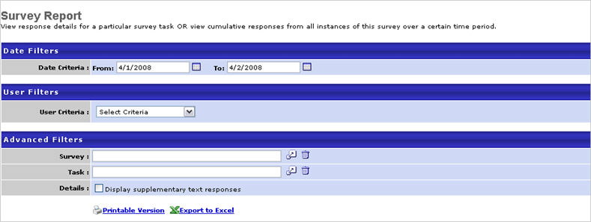
Output
- Printable Version link to view the results in a web page, or Export to Excel link to save/open as an Excel file
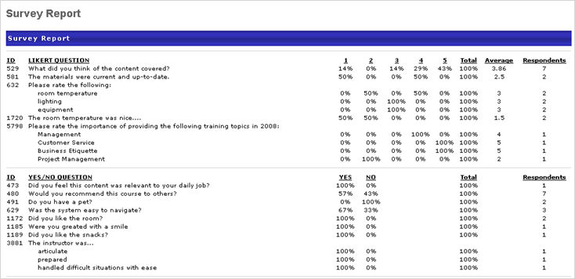

Test Question Item Analysis Report
The Test Question Item Analysis report enables you to analyze the value, clarity, and difficulty level of the following test question types:
- Yes/No
- True/False
- Multiple Choice/Single Answer
- Multiple Choice/Multiple Answer
- Text Only
The report displays each question for these question types on the test, as well as the percentage of correct and incorrect responses.
Data for Click on Image Questions: Data for Click on Image question types is not available from the Test Question Item Analysis Report. Instead, you can create a Custom Test Report to obtain analysis for Click on Image question types. Include the following fields in the custom report: Question ID, Question, Question Category, Question User Response Correct, and User ID. You can add filters to narrow down the data, such as a Title filter to report on data for a specific test. Or, you could include a filter for the Test Question ID field so that you can report on specific test questions.
To access the Test Question Item Analysis report, go to Reports > Standard Reports > Training. Then, click the Test Question Item Analysis link.
Permissions
PERMISSION NAME | PERMISSION DESCRIPTION | CATEGORY

Test Question Item Analysis Report | Grants access to Test Question Item Analysis report, which displays summary data about user responses to test questions. This permission can be constrained by OU, User’s OU, User’s Self and Subordinates, and Provider. | Reports - Training
Question Criteria
Feature | Description
Test | Click the Select icon to select a test. When searching for a test that has multiple versions, select the title of the first version of the test in order to view the report.
Event | Click the Select icon to select an event.
Session | Click the Select icon to select a session.
Curriculum | Click the Select icon to select a curriculum.
Category | Click the Select icon to select a test category. This opens the Search Category pop-up.
Active | Check the box to show only active questions in the report.
Details | Check the box to include the response choices for each question and the percentage of users who selected each response.
Primary Sort Order | Primary Sort Order - Select one of the following to determine the primary sort order of the information in the report:  - ID - This option is selected by default.  - Ref Number - Note: This option is only available if the reference number feature is enabled for the portal. Contact Global Customer Support to enable the reference number feature.  - Questions  - Category  - Respondents  - Correct  - Incorrect
Secondary Sort Order | Select one of the following to determine the secondary sort order of the information in the report:  - ID  - Ref Number - Note: This option is only available if the reference number feature is enabled for the portal. Contact Global Customer Support to enable the reference number feature.  - Questions - This option is selected by default.  - Category  - Respondents  - Correct  - Incorrect
Date Criteria
Feature | Description
Date Criteria | Select the date range for the report from the drop-down list or enter specific dates in the From and To fields.
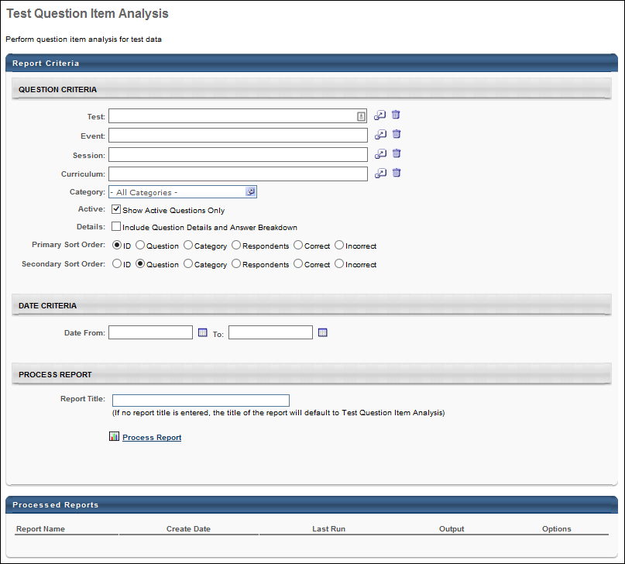
Note: On the report output, for portals with multiple languages enabled, the data in the Question, Category, and Response (if translatable) fields displays in the reporting administrator's language. If the reporting administrator's language is not available, the data displays in the field's default language.
Output - Printable Version
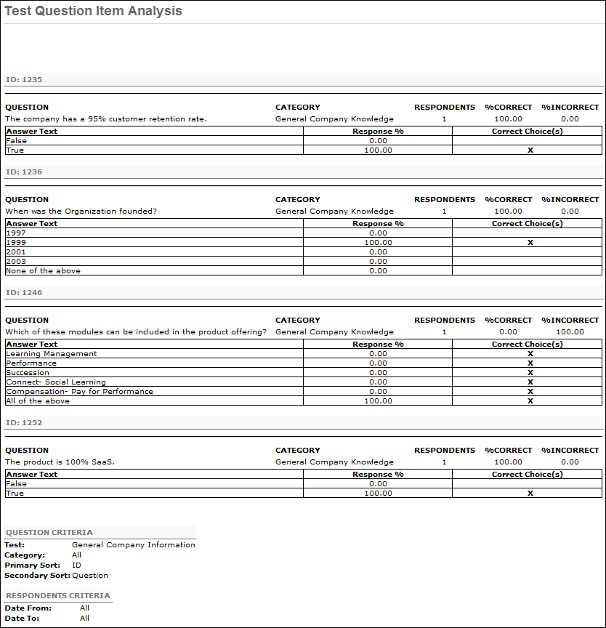
Output - Excel Version
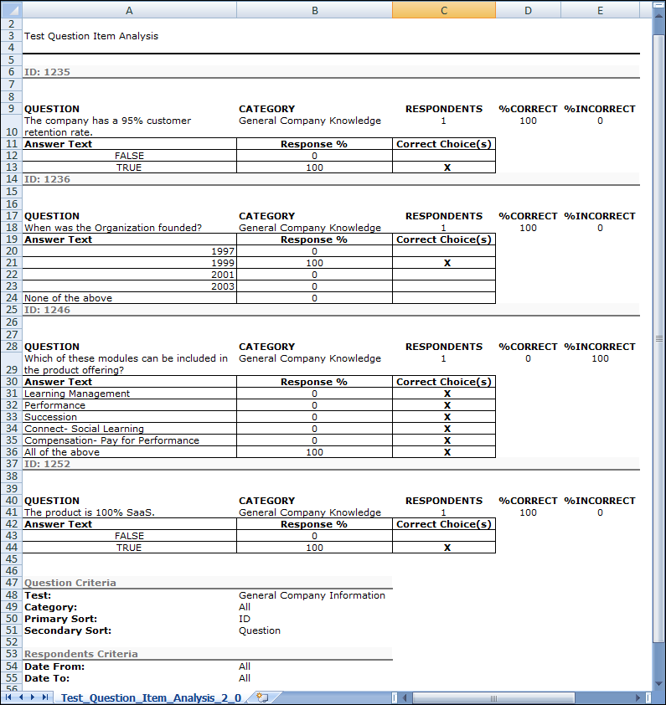

Test Analysis Report
Display summary information of test data.
Permissions
PERMISSION NAME | PERMISSION DESCRIPTION | CATEGORY

Test Analysis Report | Grants access to Test Analysis report, which displays summary information about users' test attempts, grouped by test name. | Reports - Training
Filters
- Date From - filter your results based on test completion or test re-take date range. Note: Date Criteria is always implemented using UTC (Coordinated Universal Time).
- User Criteria - limit report output to the users matching the specified user criteria
  - The report will only run within the defined constraints for the user running the report
  - This is the standard OU availability selection criteria drop-down. Choose from available OU types
  - Defaults: If no User Criteria are selected then the report will run for the entire available population
- Test- filter by specific test
- Details - check to Display scores by section. The report results will show each individual section percentages correct out of 100 percent for each section.
- Recurring Training -check to include all records of this training on a transcript. If unchecked only the most recent registration will be included.
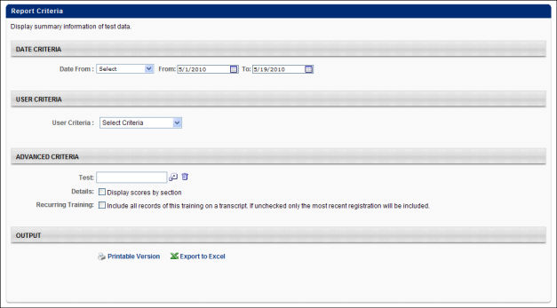
Output
- Printable Version link to view the results in a web page, or Export to Excel link to save/open as an Excel file.
Note: On the report output, for portals with multiple languages enabled, the data in the Name and Section fields displays in the reporting administrator's language. If the reporting administrator's language is not available, the data displays in the field's default language.
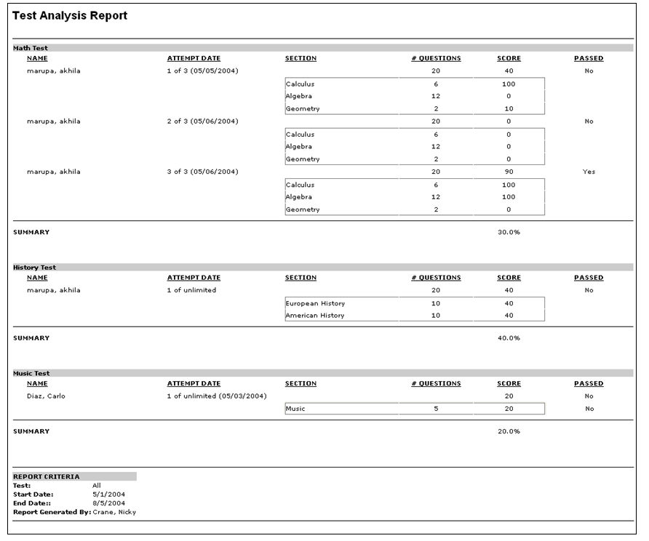

Top Training Items Report
Display top courses by transcript status during the specified time period. This report allows administrators to view what the top requested courses were for a certain time period. It also allows administrators to view courses with the most withdrawals, no shows, completions, registrations or other actions.
Permissions
PERMISSION NAME | PERMISSION DESCRIPTION | CATEGORY

Top Training Registrations Report | Grants access to Top Training Registration Report, which displays learning objects with most frequent registrations within a specified time period. User may choose from a drop down to control the total number of courses to include in the report. | Reports - Training
Filters
- Date Criteria - Filter your results based on a date range for the Action filter selected. For example, if Action selected is Assigned, the date range will filter based on assigned date. If requested, then the date range will filter based on the requested date. If an action is not selected in the Action field but date criteria is defined in the Date Criteria field, the date criteria is ignored. Note: Date Criteria is always implemented using UTC (Coordinated Universal Time).
- User Criteria - Limit report output to the users matching the specified user criteria.
  - The report will only run within the defined constraints for the user running the report.
  - This is the standard OU availability selection criteria drop-down. Choose from available organizational unit (OU) types.
  - Defaults: If no User Criteria are selected then the report will run for the entire available population.
- Action - Filter by specific action. Note: If an action is not selected in the Action field but date criteria is defined in the Date Criteria field, the date criteria is ignored.
- Training Title - Filter by specific training title.
- Training Type - Filter by specific training type or select All for all training types.
- Provider - Filter the results for training from a specific training provider/vendor, or select "All" to include all training providers/vendors.
- Subject - Filter by a specific subject.
- Group By - Check to group by Enterprise, Training Type, or Provider.
- Record Unit - Choose number of top training titles to display.
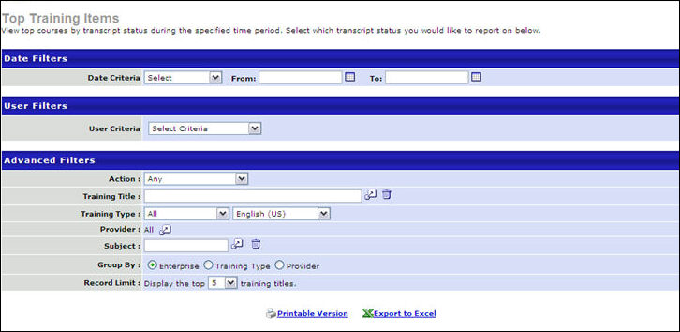
Output
- Printable Version link to view the results in a web page, or Export to Excel link to save/open as an Excel file
Example 1: Action = Registered, Group by Enterprise (10 record limit)
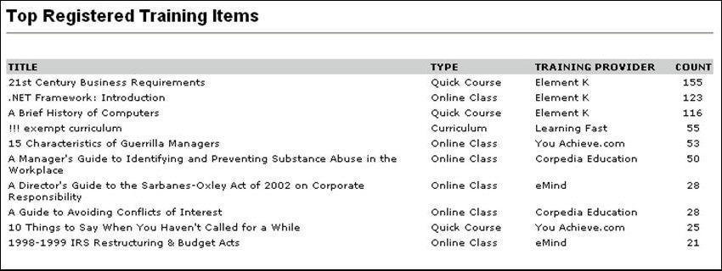
Example 2: Action = Completed, Group by Provider (5 record limit)
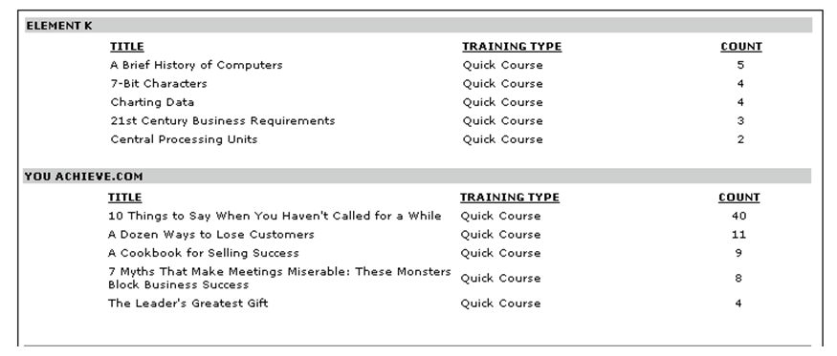

Training Demand Forecast Accuracy Report
The Training Demand Forecast Accuracy report compares a training plan forecast with transcript data.
To access the Training Demand Forecast Accuracy report, go to Reports > Standard Reports. From the Training tab, click the Training Demand Forecast Accuracy Report link.
Permissions
PERMISSION NAME | PERMISSION DESCRIPTION | CATEGORY

Training Demand Forecast Accuracy Report | Grants access to the Training Demand Forecast Accuracy report, which compares a training plan forecast with transcript data. | Reports - Training
Criteria
Filter Name | Description
Training Plan Template | Click the pop-up icon  to select a training plan. This is a required field.
Training(s) | Click the pop-up icon  to select one or more training items. "All Training" is selected by default.
Subject(s) | Click the pop-up icon  to select one or more subjects. "All Subjects" is selected by default.
Training Purpose | Select a training purpose from the drop-down. Only training purposes that are available for the administrator to view appear in the drop-down.
Training Category | Select a training category from the drop-down. Only training categories that are available for the administrator to view appear in the drop-down. Note: Training categories are associated with training purposes and are configured in Training Purpose Administration.
Chart Display | Select the Users, Costs, or Hours option to filter by the estimated number of users, training cost, or number of hours, as configured on the training plan.
User Criteria | Limit transcript results to the users matching the specified user criteria by selecting the criteria from the drop-down. Note: User Criteria only applies to transcripts; only the transcripts of the selected users are utilized in the report.
Date Criteria | Use the drop-down to select filter criteria that displays training added to a user's transcript during a specific date range. You can also use the calendar fields to configure a date range.  For non-ILT learning objects (LO), the filter is applied to the date on which the training was added to the transcript. For events and sessions, the filter is applied to the session start date. If the user has only the event on their transcript, the report filters by the date the event was added to the transcript.  If date criteria are not provided, then by default, the report filters by the date on which training is added to the transcript between the training forecast period start and end date.  The start and end dates for the year options in the drop-down are as follows:  - This Year - January 1 of the current year through December 31 of the current year.  - Last Year - January 1 one year before the start date of the current date's year through December 31 one year before the end date of the current date's year.  - Next Year - January 1 one year after the start date of the current date's year through December 31 one year after the end date of the current year.  The transcript items that display in the report output are pulled from the Active tab. Transcript items on the Completed or Archived tab are not included.  Note: Date Criteria is always implemented using UTC (Coordinated Universal Time).
Training Type | Select the training type and language. "All Languages" is selected by default in the Languages drop-down.
User Status | Select this option to include inactive users that matched the criteria for the selected training plan.
Include Removed Training | Select this option to include the results for users that matched the criteria for the training plan but had the training removed from their transcript.
User Custom Fields | Select from all available User Record custom fields. This section is collapsed by default.
Training Custom Fields | Select from all available Training custom fields. This section is collapsed by default.
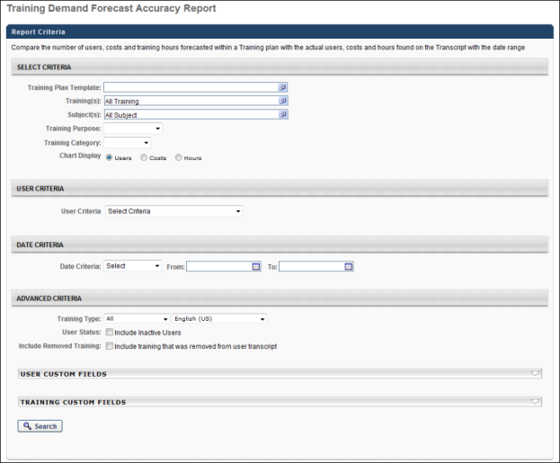
Output
The report output displays in a graphical view and as a table of results. Depending on the selection in the Chart Display field, the graph displays the User, Cost, or Hours chart.
For each category, Total, Planned, or Unplanned, the graph breaks the bar down into slices based on the transcript status. Each bar can be clicked to view the Training Progress Pie chart for that user population. Note: Selecting a slice changes the border color of the slice to light blue.
Users
The following displays on the axes of the Users chart:
- Y-Axis - The number of users.
- X-Axis - The number of transcript items that matched the criteria, as follows:
  - Total Forecasted in Training Plan- Total number of users forecasted in the training plan that match the report criteria.
  - Total on Transcript -The total number of items that were forecasted to be added to the transcript plus the total number of items that were added to the transcript but were not forecasted.
  - Forecasted and on Transcript -The number of transcript items forecasted in the training plan.
  - Not Forecasted and on Transcript -The number of transcript items that were not forecasted but are in the training plan.
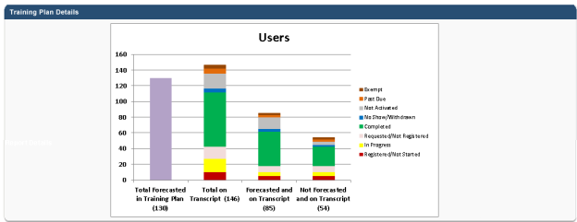
Costs
The following displays on the axes of the Costs chart:
- Y-Axis - The cost amount.
- X-Axis - The total cost of training items added to the transcript that matched the criteria, as follows:
  - Total Forecasted in Training Plan - Total cost for all the trainings forecasted in the training plan that match the report criteria.
  - Total on Transcript - The total number of items that were forecasted to be added to the transcript plus the total number of items that were added to the transcript but were not forecasted.
  - Forecasted and on Transcript - The number of transcript items forecasted in the training plan.
  - Not Forecasted and on Transcript - The number of transcript items that were not forecasted but are in the training plan.
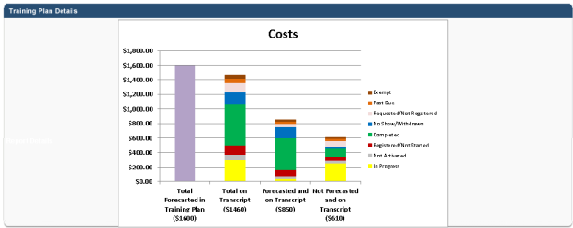
Hours
The following displays on the axes of the Hours chart:
- Y-Axis - The number of hours.
- X-Axis - The total number of hours of transcript items that match the criteria to determine whether they were planned or not planned:
  - Total Forecasted in Training Plan - Total number of hours forecasted in the training plan that match the report criteria.
  - Total on Transcript - The total number of items that were forecasted to be added to the transcript plus the total number of items that were added to the transcript but were not forecasted.
  - Forecasted and on Transcript - The number of transcript items forecasted in the training plan.
  - Not Forecasted and on Transcript - The number of transcript items that were not forecasted but are in the training plan.
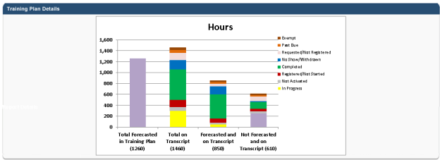
Report Details
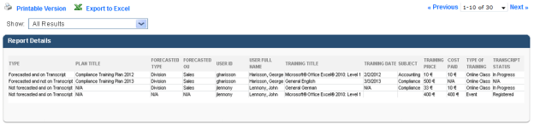
The Report Details table displays the search results selected in the Show Results drop-down. "All Results" is selected by default. The following additional filter options are available:
- Forecasted and not on Transcript - Displays items that were forecasted but not found on the transcript.
- Forecasted and on Transcript - Displays items that were forecasted and were on the transcript.
- Not forecasted and on Transcript - Displays items that were not forecasted but were on the transcript.
- All items on Transcripts - Displays all transcript items in the report.
By default, the results are sorted by Type, then Plan Title, and then Training Title. All columns in the table are sortable.
Field Name | Description
Type | The following are the possible values:  - Forecasted and on Transcript: The training need was identified in the training plan AND the user has the item on their transcript (for the period taken into account).  - Forecasted and not on Transcript: The training need was identified in the training plan BUT the user does not have the item on their transcript (for the period taken into account).  - Not forecasted and on Transcript: The training need was NOT identified in the training plan BUT the user has the item on their transcript (for the period taken into account).
Plan Title | The title of the training plan.
Forecasted Type | The type of OU forecasted in the training plan into which the user falls.
Forecasted OU | The actual OU forecasted in the training plan into which the user falls.
User ID | The user ID.
User Full Name | The user's last name, first name.
Training Title | The title of the LO.
Training Date | For non-ILT LOs, the column displays the date on which the training was added to the transcript.  For events and sessions, the column displays the session start date. If the user only has the event on their transcript, the column displays the date the event was added to the transcript.
Cost Paid | If the training does not have an associated cost, the value is zero. If the training has an associated cost, the value is the cost of the training, either purchased by the user or cost center.
Type of Training | The LO type.

Training Demand Forecast Summary Report
The Training Demand Forecast Summary Report enables the administrator to report on training plans and training need requests. Administrators can view training needs requested by an OU and to view training needs requested for an OU. Administrators can get a consolidated view of training needs requests across an organization and across more than one training plan assignment. This report is available in the Training section of Standard Reports.
Permissions
PERMISSION NAME | PERMISSION DESCRIPTION | CATEGORY

Training Demand Forecast Summary Report | Grants access to the Training Demand Forecast Summary report, which enables the administrator to report on training plans and training need requests. This permission can be constrained by OU, User's OU, User's Self and Subordinates, and User. | Reports - Training
Criteria
Filter Name | Description
Who are the Plan Contributors? | Select which plan contributor's training reports to include in the report. This is selected by OU or specific users. Multiple selections can be made. If no Plan Contributor is selected, the report includes training requests created by all plan contributors. When an OU is selected, you can also include its subordinates. At least one Plan Contributor or OU Criteria must be selected.
Who are they planning for? | Select the users for which training plans were made. This is selected by OU or specific users. Multiple selections can be made. If no OU Criteria is selected, the report includes training requests created for all users.
Training Plan Template | Select a training plan template to report on. Only templates created by administrators within your constraints are displayed. This is required; the administrator must select a training plan template.
Training Request Type | Filter the results by training type. The report will display only training requests of the selected type. Select All to return all Catalog and External training. Select the training request types to include. You can also select which language to include.
Include Request Type Subject | Select this option to include requests made by subject in the report. You cannot report on only Subject type requests.
Training Title | Select specific training titles to report. Multiple titles can be selected.
Subject | Select specific subjects to include in the report. Multiple subjects can be selected. This filter is applied to all training requests.
Status | Restrict the report output to training plans in specific statuses.
Include Additional Fields | Select this option to include additional free-form fields in the report.
Group By | Group the report by Plan Contributor, Training Title, OU, or None.
Report Title | Enter a title for the report. This defaults to "Training Plan Forecast Summary" if no title is entered. The title is displayed on the report and is also displayed in the list of Processed Reports on this page.
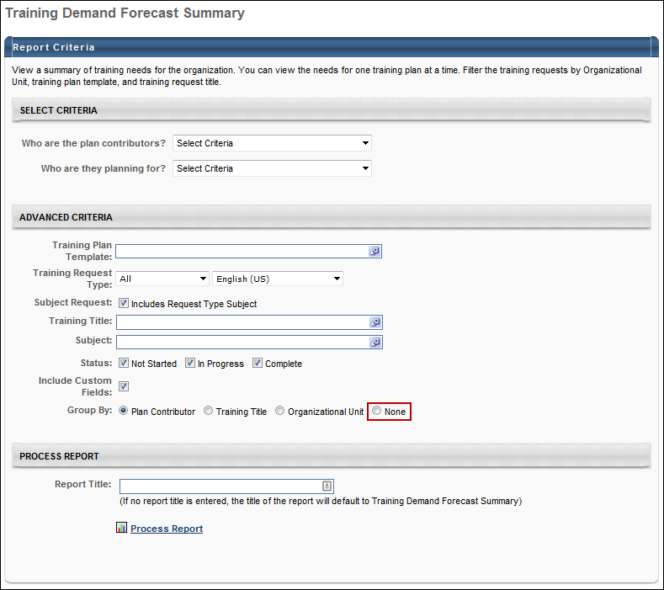
When the Process Report link is clicked, the report is run based on the selected criteria. The report output is stored in the Processed Reports table.
The administrator can choose the following actions and options for each report in the Processed Report table:
- Click the Excel icon to generate an Excel output of the report.
- Click the Refresh icon to refresh the report results.
- Click the View Details to view the filter criteria for the report.
- Click the Delete icon to delete the report.
Output
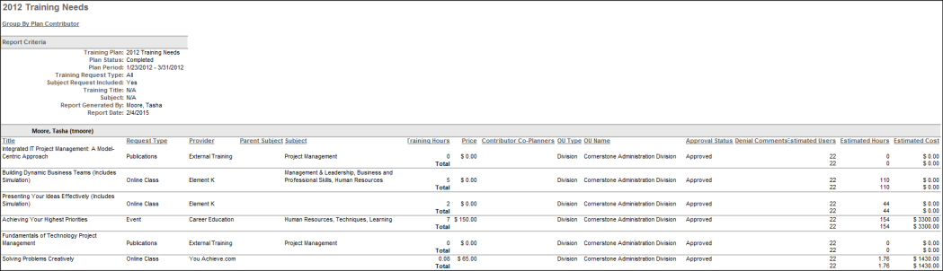

Training Hours Report
This report displays training hours completed by users. The report displays training hours for active and inactive training items. The report can summarize the data by user, provider, or training type. There is also an option to not summarize the report data.
Note: For sessions, training hours are calculated based on the parts completed with breaks excluded.
Note: Training is recorded in hours. For example, 0.23 is 13 minutes, 0.5 is 30 minutes, etc. The actual calculation to get the minutes is done by multiplying the training hours by 60 (e.g., 0.23 training hours multiplied by 60 is 13.8 minutes). This formula may be helpful when the report is exported to Excel.
To access the Training Hours report, go to Reports > Standard Reports. From the Training tab, click the Training Hours link.
Permissions
PERMISSION NAME | PERMISSION DESCRIPTION | CATEGORY

Training Hours Report | Grants access to Training Hours Report, which displays training hours completed by populations of users. This permission can be constrained by User's Corporation, User's OU, and OU. | Reports - Training
Criteria
Filter Name | Description
Date Criteria | Filter your results by date. Note: Date Criteria is always implemented using UTC (Coordinated Universal Time). For an item to be included in the report, the following must occur between the selected Start and End date:  - For sessions, the session start date must be within the date criteria.  - For external training, the registration date must be within the date criteria. If the external training does not have a registration date, then the training must be added to the user's transcript within the date criteria.  - For all other LOs, the registration date must be within the date criteria.
User Criteria | Limit report output to the users matching the specified user criteria.  - The report will only run within the defined constraints for the user running the report  - This is the standard OU availability selection criteria drop-down. Choose from available OU types  - Defaults: If no User Criteria are selected then the report will run for the entire available population
Training Type | Filter the report on a certain training type or select All for all training types.
Provider | Filter the results for training from a specific training provider/vendor or select All for all training Providers/Vendors.
Recurring Training | Check to include all records of this training on a transcript. If unchecked only the most recent registration will be included.
Group By | Provides various options for sorting the report results.  - Do not Summarize - Do not summarize the data.  - Summarize by Training Type - Selecting this radio button will summarize the results of the report by training type.  - Summarize by Provider - Selecting this radio button will summarize the results of the report by provider.  - Summarize by User - Selecting this radio button will summarize the results of the report by user. The report will be broken down into user sections, each listing unique completed training related to the user and Total Training Hours by each section. When this option is selected, the Display Summary Only option appears.  - Display Summary Only - Select this option to only include a summary of the data in the report. The report only displays a summary of the Time in Training and Training Hours fields. Note: This option is only available when the Summarize by User option is selected.
Status | Select the available filter options to only include training in a certain status. All options are selected by default. If a training status is deselected, the report does not include any training items in the deselected status.
User Status | Select this option to include inactive users in the report.
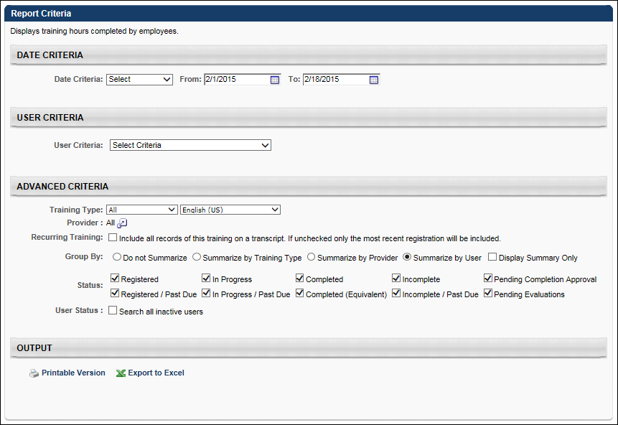
Output
The following information displays in the output columns:
- Employee - This column displays the name of the user.
- User ID - This column displays the user ID of the user.
- Training - This column displays the training title.
- Type - This column displays the training type.
- Provider - This column displays the name of the training provider.
- Status - This column displays the status of the training in the user's transcript.
- Time in Training - The Time in Training value represents the actual amount of time the user spent in the training. The report displays training hours for active and inactive training items.
For example, the Training Hours for an online course may be set to 0.25 hours (15 minutes). However, if a user completes the online course quickly, they may only spend 0.2 hours (12 minutes) in the online course. In this example Training Hours is recorded as 0.25, and the Time in Training is set to 0.2.
- Training Hours - When creating training, you are able to specify the Training Hours for the training. Training hours are definable via Course Catalog, Manage Events and Sessions, Course Publisher, or Video Administration. This indicates the amount of time that the training should take to complete. This is the value that is displayed as Training Hours in the report.
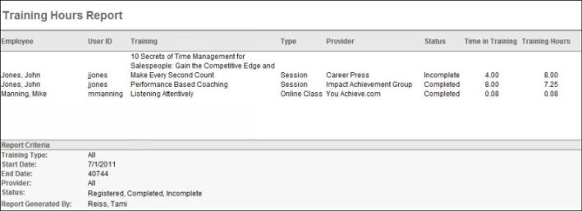
Output Summarized by User and Display Summary Only
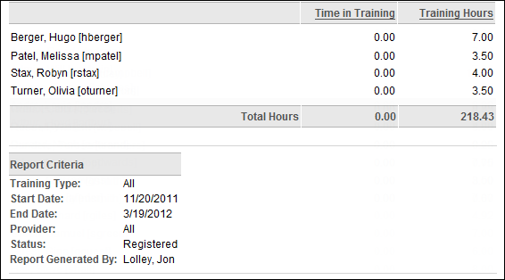

Training Progress Summary Pie Chart Report
Display the percentage of users with certain statuses for a particular training item. The report output only includes records with latest registration number.
Permissions
PERMISSION NAME | PERMISSION DESCRIPTION | CATEGORY

Training Progress Summary Pie Chart Report | Grants access to Training Progress Summary Pie Chart Report, which displays the percentage of users with certain transcript statuses for a particular learning object. This permission can be constrained by User Self and Subordinates, User's LO Availability, User's Corporation, OU, User's OU, and Training Item. | Reports - Training
Criteria
Feature | Description
Date Criteria | Select the date range for the report from the drop-down list or enter specific dates in the From and To fields. Note: Date Criteria is always implemented using UTC (Coordinated Universal Time).  - When selecting an event learning object (LO), you can filter your results based on a date range for the session start date. If a date range is selected, then only sessions that match the selected date criterion may be included in the report output. The event does not appear in the report output. If no date range is selected, then the event and all available sessions for the event may be included in the report output.  - For all LOs except events and sessions, results are filtered based on a Requested or Assigned date range.  - Please do not use date filters if you want to generate equivalent training data.
User Criteria | Select a user or a group of users that may be included in the report. This criterion applies to the users who will appear in the report output. You may choose one or more individual users as well as entire organizational units (OUs) or Groups. Depending on the constraints of the report permission, the user running the report may only be able to view users for the organizational units to which they are constrained.  If this field is left blank, then the report checks the user's permission constraints and returns results for all users who are within the report permission constraints. If the user has no permission constraints, then the report returns results for all users.
Advanced Criteria | Training Title |  |  |  | Filter the report by a specific training title. The report output returns online course attempt results for the selected training. Note: When an event LO is selected, the event and the corresponding sessions may be included in the report output. See the Date Criteria section above for additional information.
 | Transcript Status |  |  |  | Check the box to include users who do not have this training item on their transcript or have not activated the training item.  Note: It is important to note that the data returned in the report is dependent upon the constraints placed on the permission for this report. For example, you may not be able to view all users who have the training in a certain status because you are constrained to viewing only users in a certain Division Organizational Unit (OU), Location OU, etc.
 | User Status |  |  |  | Check the box to include inactive users in the report output.
 | Equivalent Training* |  |  | Include users who have completed equivalent courses | Select this option to display the equivalent training title for users who have acquired a Completed (Equivalent) status through completing an equivalent course. Please do not use date filters if you want to generate equivalent training data.
 |  |  |  | Only include user transcript records for the training selected | When selected this option is selected, the report does not include the user transcript record for the equivalent course. This option is unselected by default.
 | Include Removed Training |  |  |  | Check the box to include training that was removed from the transcript.
 | ILT Training (This field allows users to exclude events and sessions or exclude events only or sessions only.) |  |  | Events and Sessions | This option is selected by default. When selected, both transcript records for both events and sessions are included in the report output.
 |  |  |  | Events Only | When this option is selected, the report output only includes transcript records for events.
 |  |  |  | Sessions Only | When this option is selected, the report output only includes transcript records for sessions.
Search
Click Search to run the report. This refreshes the page and displays the results below the criteria.
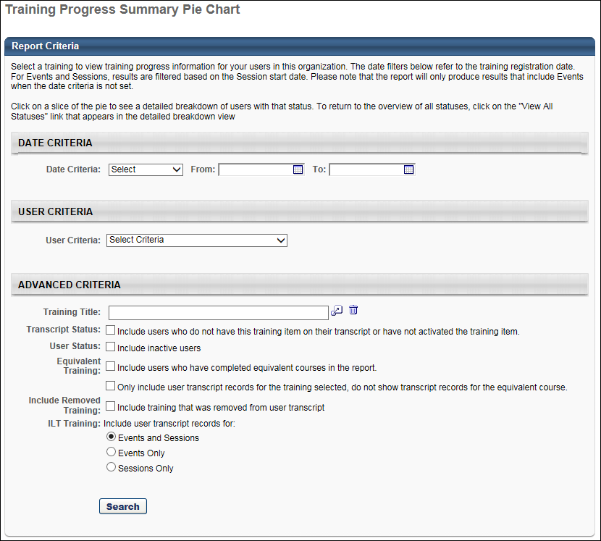
Output
- The report will generate on the page as an inline report. To see additional details by user, click the Details icon.
- The report will include all versions. The report output only includes records with latest registration number.
- Printable Version link to view the results in a web page, or Export to Excel link to save/open as an Excel file
- Clicking on a section of the pie chart will refresh the page showing a new pie chart with the breakdown of user's training statuses. The Search Results table will be refreshed to show only the users with the statuses that fall under that status category.
- In the detailed view, a View All Statuses link appears next to the pie chart. Clicking on this link refreshes the page to show the summary of all status categories, which is the default view.
Note: Users who are in a Not Available status, as a result of being proxy enrolled into an LO that is configured to have an available date, are included in the Registered/Not Started segment of the pie chart.
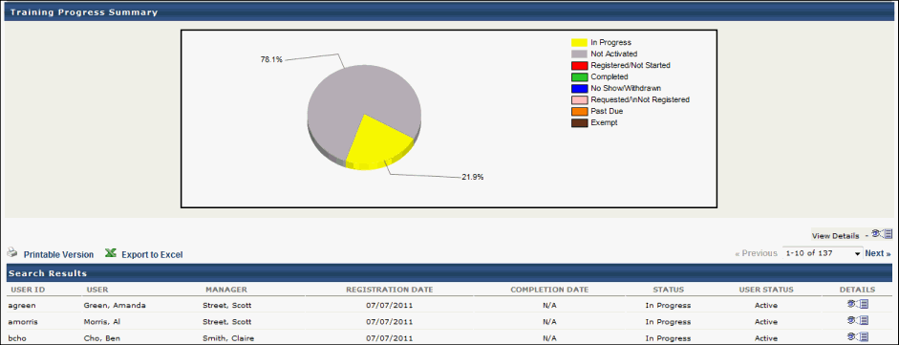
*Equivalent Training Use Cases
Use Case 1: Both Equivalent Training Options Selected
- Training A and Training B are set as equivalents.
- 10 users have Training A on their transcript in a Completed status.
- Training B is assigned to 15 users:
  - 10 of these users have Training A on their transcript; therefore, 10 of the 15 users get a Completed (Equivalent) status for Training B.
- The other 5 users complete the training and get a Completed status for Training B.
- Tom Jones is an Learning administrator and runs the Training Progress Summary Pie Chart report for Training B for all 15 users.
- He selects the existing option to: Include users who have completed equivalent courses in the report.
- He also selects the option to: Only include user transcript records for the training title selected, do not show transcript records for the equivalent course.
- The report output will show 15 transcript records, and will display the user transcript records for Training B for the 5 users who have completed the training (Status = Completed) and the 10 users who have completed the equivalent (Status = Completed Equivalent).
Use Case 2: Only the 'Include users who have completed equivalent courses' Option Is Selected
- Training A and Training B are set as equivalents.
- 10 users have Training A on their transcript in a Completed status.
- Training B is assigned to 15 users:
  - 10 of these users have Training A on their transcript; therefore, 10 of the 15 users get a Completed (Equivalent) status for Training B.
- The other 5 users complete the training and get a Completed status for Training B.
- Tom Jones is an Learning administrator and runs the Training Progress Summary Pie Chart report for Training B for all 15 users.
- He selects the existing option to: Include users who have completed equivalent courses in the report. He does not select the option to: Only include user transcript records for the training title selected, do not show transcript records for the equivalent course.
- The report output will show 25 transcript records:
  - 5 records for the users who completed Training B.
  - 10 records for Training B for the users who completed the equivalent course (Status = Completed Equivalent).
  - 10 records for Training A for the users who completed the equivalent course (Status = Completed). Note: These are the same users as 5b.
Supported Statuses
The Training Progress Summary Pie Chart Report is currently designed to support the following values for the Status field (i.e., supported statutes):
- Pending Approval
- Denied
- Approved
- Registration Pending
- Registered
- In Progress
- Completed
- Exception Requested
- Cancelled
- Waitlisted
- Pending Approval / Waitlisted
- Exception Requested / Waitlisted
- Deselected from user criteria
- Skipped
- Initial processing
- Recently entered availability
- Withdrawn
- Incomplete
- Failed
- Past Due
- Pending Approval / Past Due
- Denied / Past Due
- Approved / Past Due
- Registration Pending / Past Due
- Registered / Past Due
- In Progress / Past Due
- Exception Requested / Past Due
- Expired / Past Due
- Cancelled / Past Due
- Waitlisted / Past Due
- Pending Approval / Waitlisted / Past Due
- Exception Requested / Waitlisted / Past Due
- Withdrawn / Past Due
- Discontinued / Past Due
- Incomplete / Past Due
- Pending Completion / Past Due
- Failed / Past Due
- Pending Evaluation
- Pending Evaluation / Past Due
- Pending Prerequisite
- Pending Prerequisite / Past Due
- Waitlist Expired
- Waitlist Expired / Past Due
- Not Started
- Not Started/ Past Due
- No Show
- No Show / Past Due
- Pending Acknowledgment
- Pending Acknowledgment / Past Due
- Pending Grade / Past Due
- Pending Post-Work/Past Due
- Pending Pre-Work/Past Due
- Completion Approval Denied / Past Due
- Equivalent
- Completed (Equivalent)
- Pending Payment / Past Due
- Payment Denied /Past Due
- Pending Completion Signature
- Pending Completion Signature /Past Due
- Payment Refunded /Past Due
- Exempt-Internal
- Exempt
- Pending SF-182 Form Approval / Past Due
- SF-182 Form Denied / Past Due
- Registered / Not Available
- Registered / Not Available / Past Due
- Subscription Expired / Past Due
- Pending Observer Completion / Past Due
- Pending Observer Completion / Not Available / Past Due

Training Registration Details Report
This report displays user and training details for users registered for training in the system. The report displays user registration information in real-time and includes user standard and custom fields, training fields and session detail information.
To access the Training Registration Details report, go to Reports > Standard Reports. From the Training tab, click the Training Registration Details Reports link.
Permissions
PERMISSION NAME | PERMISSION DESCRIPTION | CATEGORY

Training Registration Details Report | Grants access to Training Registration Details Report, which displays the registration details for users and indicates whether a user still needs to take action on a training to register for it. This permission can be constrained by OU, Facility, Facilities Owned by User, Provider, Training Item, Training Type, User, User's Direct Reports, User's ILT Provider, User's LO Availability, User's OU, User's Self, User Self and Subordinates, and User's Subordinates. | Reports - Training
Criteria
Filter Name | Description
Date Criteria | Filter your results by date. Select the date range for the report from the drop-down list or enter specific dates in the From and To fields. Note: Date Criteria is always implemented using UTC (Coordinated Universal Time).  Registration Date Criteria: This date filter will filter transcript records based on the registration date of the training on the transcript.  Session Date Criteria: When a date range is specified, the report will display user transcript information for all sessions that contain parts within the date range.  Note: When the date filter is used it will ignore the rest of the filters.
User Criteria | Limit report output to the users matching the specified user criteria.  - The report will only run within the defined constrains for the user running the report  - This is the standard OU availability selection criteria drop-down. Choose from available OU types  - Defaults: If no User Criteria are selected, then the report will run for the entire available population
Training Type | Filter the report on a certain training type or select All for all training types.
Training Title | Filter the report by a specific training title. Users will have the ability to filter the report by one or more training titles (up to 5). At least one training title must be provided when the Needs to Register option is selected.
Provider | Filter the results for training from a specific training provider/vendor or select All for all training Providers/Vendors.
Session ID | Filter the report by Session ID. The report will display user transcript information for any sessions that contain the value entered in the Session ID filter.
Locator Number | Filter the report by Locator number. The report will display user transcript information for any sessions that contain the value entered in the Locator Number filter. Please note that an exact value needs to be entered in the filter.
User Status | Select this option to include inactive users in the report.
Session Details | When selected, it will include the following columns in the report:  - Session ID  - Locator Number  - Roster Comments  - Session Part Start Date/Time (First Part)  - Session Part End Date/Time (Last Part)  - Session Part Time Zone  - Facility ID  - Facility Name  - Facility City  - Facility Region  - Facility Country  Please note that Session Details will not be available if User Needs to Register is selected.
User needs to register | Field Type: Boolean - Yes/No  At least one Training Title and User Criteria must be selected if this option is selected  Any dates entered in the Date Criteria and Session Part Date Criteria filters will be ignored when this option is selected  The Training Status filter section will be hidden when this option is selected  When selected, a new column will appear in the report  When selected, all session registrations for a user for a given event will roll-up to one row and will be listed under the event. No session registrations will appear individually on the report.
Training Status | Filter the report by Training Status. By default, all training statuses are selected. This filter will not be available when User Needs to Register is selected. users will have the ability to filter the report by selecting all or individual training status.
Include Organizational Units | This will add OU columns to the report by OU type as per selection. By default, all OU types (Division, Location, and Position) are selected.
Include Custom Fields | This will display custom fields in the order they are configured in the custom field administration page. Users will be able to select up to 12 custom fields at a time.
Output
The following information displays in the output columns:
- Training Type - This column displays the training type
- Training Title - This column displays the training title
- Training Object ID - This column displays the learning object ID
- User ID - This column displays the user ID
- First Name - This column displays the user's first name
- Last Name - This column displays the user's last name
- Email - This column displays the user's email address
- User Status - This column displays the user's status (Active/Inactive)
- Last Hire Date - This column displays the last hire date for the user (MM/DD/YYYY)
- Transcript Status - This column displays the transcript status for the training. It will be blank for Event training type when the User Needs to Register option is selected
- Last Transcript Status Change Date ­- This column displays the last transcript status change date for the training. It will be blank for Event training type when the User Needs to Register option is selected.
- Event Number - This column displays the Event Number for an event
- Session ID - This column displays the Session ID when a session is included in the report. It will appear when Session Details option is checked off. The value will be blank if User Needs to Register is selected in the report criteria
- Session Locator Number - This column displays the Locator Number when a session is included in the report. It will appear when Session Details option is checked off. The value will be blank if the User Needs to Register is selected in the report criteria
- Registration Comments - This column displays the comments entered on the Session Roster when a session is included in the report. It will appear when Session Details option is checked off. The value will be blank if the User Needs to Register is selected in the report criteria
- Session Start Date/Time (First Part) - This column displays the date and time for the first part of a session when a session is included in the report. It will appear when Session Details option is checked off. The value will be blank if the User Needs to Register is selected in the report criteria
- Session End Date/Time (Last Part) - This column displays the date and time for the last part of a session when a session is included in the report. It will appear when the Session Details option is checked. The value will be blank if the User Needs to Register is selected in the report criteria
- Session Time Zone - This column displays the time zone for used for the session parts when a session is included in the report. It will appear when the Session Details option is checked. The value will be blank if the User Needs to Register is selected in the report criteria. It will use the time zone of the first session part.
- Facility Name - This column displays the facility name for a session when a session is included in the report. It will appear when the Session Details option is checked. The value will be blank if the User Needs to Register is selected in the report criteria. It will use the time zone of the first session part.
- Facility City - This column displays the facility city for a session when a session is included in the report. It will appear when the Session Details option is checked. The value will be blank if User Needs to Register is selected in the report criteria. It will use the time zone of the first session part
- Facility Country - This column displays the facility country for a session when a session is included in the report. It will appear when the Session Details option is checked. The value will be blank if the User Needs to Register option is selected in the report criteria. It will use the time zone of the first session part
- [OU Name] - Will display the OU name for the OUs included in the OU type selected in the report criteria
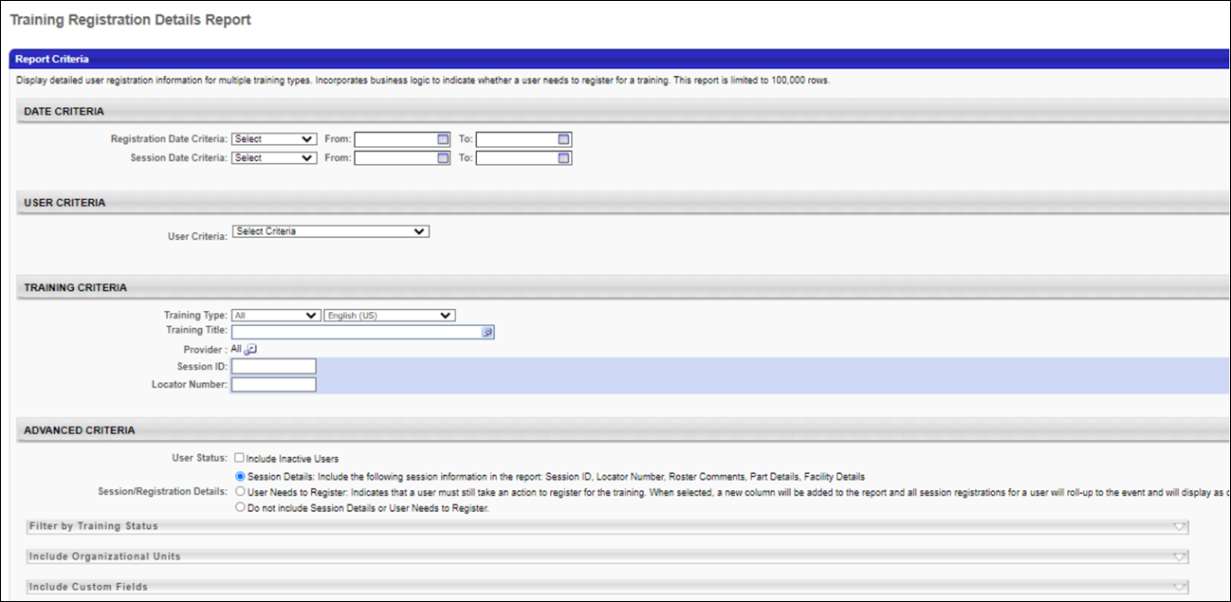

Training Unit (Key Code) Report
The Training Unit (Key Code) Report displays the activity for a specific key code during a specific time period.
Permissions
PERMISSION NAME | PERMISSION DESCRIPTION | CATEGORY

Training Unit (Key Code) Report | Grants access to Training Unit (Key Code) report, which displays the activity for a specific key code during a specific time period. | Reports - Training
Criteria
Filter Name | Description
Date Criteria | Filter your results by date. If any key code transaction falls within that time frame, the activity displays. Note: Date Criteria is always implemented using UTC (Coordinated Universal Time).
Key Code | Enter the key code on which you are reporting.
Transaction Type | Select the types of transactions to include in the report. The options are: Assigned, Redeemed, Revoked, Expired, Refunded.
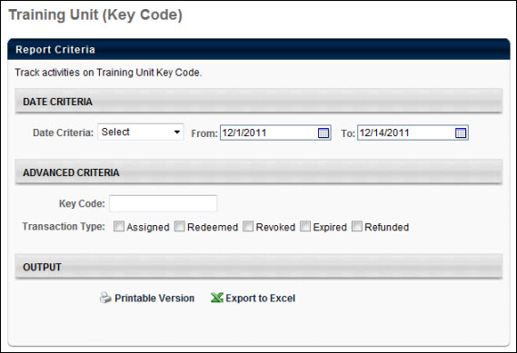
Output
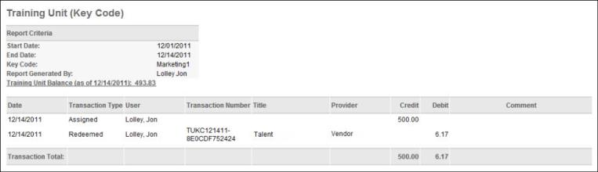

Training Unit Purchase Report
The Training Unit Purchase Report tracks training units purchased by users. This report is located in the Training section of Standard Reports. This report is also only available to customers with eCommerce functionality.
Processing fees are charged if the client is using a system merchant account as a payment processor.
Note: Information about the purchase of training units is only available within this report. Any transaction reports (standard, custom, or Reporting 2.0) only cover the purchase of LOs and not the purchase of training units.
Permissions
PERMISSION NAME | PERMISSION DESCRIPTION | CATEGORY

Training Unit Purchase Report | Grants access to the Training Unit Purchase report, which tracks training units purchased by users. | Reports - Training
Criteria
Filter Name | Description
Date Criteria | Select the date range for the report. Only training units purchased within the date criteria are displayed. Note: Date Criteria is always implemented using UTC (Coordinated Universal Time).
User Criteria | Select the user to include in the report. Only training units purchased by the selected users are displayed.
Currency Options
The currency options are not available by default. Contact Global Customer Support to have them enabled.
Filter Name | Description
Filter By | Filter the results by a particular currency.
Convert To | Select a currency to which the training unit values are converted. Also, select the appropriate conversion rate.
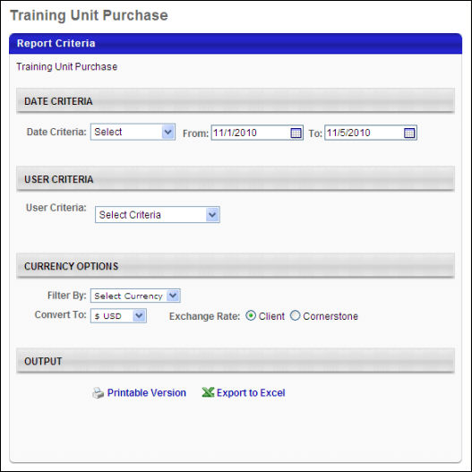
Output
- Transaction ID - This column displays a Cornerstone generated code for each transaction.
- Date - This column displays the transaction date.
- Name - This column displays the purchaser name.
- Training Unit Type - This column indicates the following types of training unit purchases:
  - Keycode - This training unit purchase type is a key code purchase via the Training Unit tab in My Account.
  - Distributable - This training unit purchase type is a training unit purchase via the Distribute Training Units page. This is an existing training unit purchase type.
  - Personal - This training unit purchase type is a training unit purchase via the Training Unit tab in My Account or as a result of purchasing training units when the user's existing training unit amount was insufficient to purchase training items in their shopping cart.
- Unit Price - This column displays the cost per unit.
- Quantity - This column displays the number of training units purchased.
- Sub Total - This column displays the total before discounts and fees.
- Discount - This column displays any discount received for the purchase, including discounts from coupons.
- Processing Fee - This column displays the fee that is charged if using a system merchant account as a payment processor.
- Total - This column displays the total cost for all units.
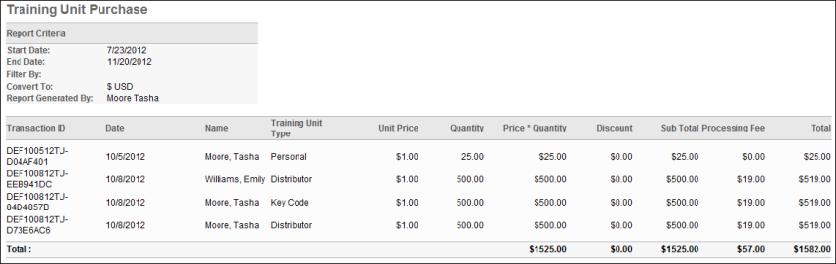

Training Unit Redemption Report
The Training Unit Redemption Report tracks training units redeemed by users. This report is located in the Training section of Standard Reports. If a purchase is made using a custom payment type, then the custom payment type appears within the report as a cost center.
Permissions
PERMISSION NAME | PERMISSION DESCRIPTION | CATEGORY

Training Unit Redemption Report | Grants access to the Training Unit Redemption report, which tracks training units redeemed by users. | Reports - Training
Criteria
Filter Name | Description
Date Criteria | Select the date range for the report. Only training units redeemed within the date criteria are displayed.  Note: Date Criteria is always implemented using UTC (Coordinated Universal Time).
User Criteria | Select the users to include in the report. Only training units redeemed by the selected users are displayed.
Advanced Criteria | The following options are available in the Advanced Criteria section:  - Training Title - Select a specific training title on which to report.  - Provider - Select a specific provider on which to report  - Group By - This option allows you select whether or not to group the report results. "None" is selected by default and displays the results chronologically. Select "Currency" to group the results chronologically by currency. Grouping by currency also displays totals at the bottom of each currency group.
Currency Options | The following options are available in the Currency Options section:  - Display monetary value - Select the Check to display training units monetary value option to display the equivalent monetary value of a training unit, both raw and converted.  - Filter By - Select an active currency with which to filter the training units. Only one currency can be selected per report.  - Convert To - Select an active currency by which to convert the training units. Select one of the following exchange rate options:  - Client - This option converts the training unit monetary value using the client's current exchange rate for the currency.  - Cornerstone - This option converts the training unit monetary value using the system's current exchange rate for the currency.  - Numeric Text Field - This option allows you to enter an exchange rate.
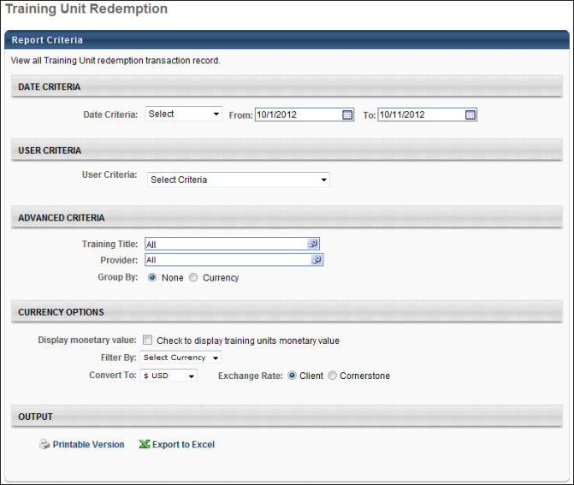
Output
- Transaction ID - This column displays a Cornerstone generated code for each transaction.
- Purchase Date - This column displays the date the training units were redeemed.
- Name - This column displays the redeemer's name.
- Provider Name - This column displays the training provider.
- Training Title - This column displays the training title.
- Training Unit Type - This column indicates the following types of training unit purchases:
  - Keycode - This training unit purchase type is a key code purchase via the Training Unit tab in My Account.
  - Distributable - This training unit purchase type is a training unit purchase via the Distribute Training Units page. This is an existing training unit purchase type.
  - Personal - This training unit purchase type is a training unit purchase via the Training Unit tab in My Account or as a result of purchasing training units when the user's existing training unit amount was insufficient to purchase training items in their shopping cart.
- Keycode - This column displays the key code.
- Training Unit Amount - This column displays the number of training units used to redeem the training.
- Equivalent Monetary Value (Raw) - This column displays the training unit's raw equivalent value and the currency into which the value is converted.
If the user's training units are assigned, then the equivalent monetary value is calculated using the following formula: OU Monetary Value (at time of assignment) * Number of Training Units.
If the user's training units are purchased, then the equivalent monetary value is calculated using the following formula: (OU Monetary Value (at time of purchase) - Coupon Discount - Bundling Discount) * Number of Training Units.
Example
  - On 08/08/2012, a user purchases a key code with 100 training units. The training units have a monetary value of $600 USD and are purchased with a 10% coupon code discount and a 10% bundling discount. On 08/09/2012, 100 training units are added to the key code and have a monetary value of $700 USD.
The user redeems all 200 training units on 08/10/2012. The raw equivalent monetary value is calculated using the following formula: (600*100*.90*.90) + (100*700) = $118,600.00 USD.
- Equivalent Monetary Value (Converted) - This column displays the training unit's converted equivalent value. The value is calculated using the following formula: Training Unit Monetary Value Raw * Conversion Rate (at time of purchase). If the conversion rate is not available that was used at the time the training units were purchased, then the current conversion rate is used.
Example 1
  - At the time of purchase, 1 training unit equals $1 USD or 7.8 HKD (Hong Kong Dollar). However, at the time the report is created, 1 training unit equals $1 USD or 7.9 HKD. The converted equivalent monetary value is calculated using the value at the time of purchase.
Example 2
  - On 08/08/2012, a user purchases a key code with 100 training units. The training units have a monetary value of $600 USD and are purchased with a 10% coupon code discount and a 10% bundling discount. One 08/09/2012, 100 training units are added to the key code and have a monetary value of $700 USD. On 08/11/2012, 100 training units are added to the key coded, but the monetary value is disabled.
The user redeems all 300 training units on 08/11/2012. The converted equivalent monetary value is calculated using the following formula: (600*100*.90*.90) + (100*700) + 0 = $118,600.00 HKD.
Note: The Equivalent Monetary Value (Raw) and Equivalent Monetary Value (Converted) columns only appear in the report output if the Display monetary value option is selected in the Currency Options section.
Note: If a coupon is applied when purchasing training units, the value in the Equivalent Monetary Value columns is calculated using the following formula: Training Unit Monetary Value at Time of Assignment/Purchase - Coupon Code Discount = Equivalent Monetary Value.
Grouped by None
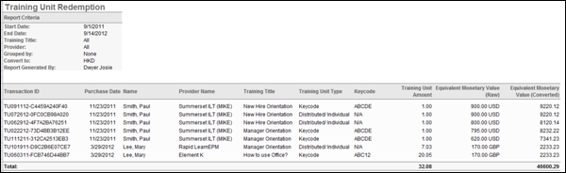
Output - Grouped by Currency
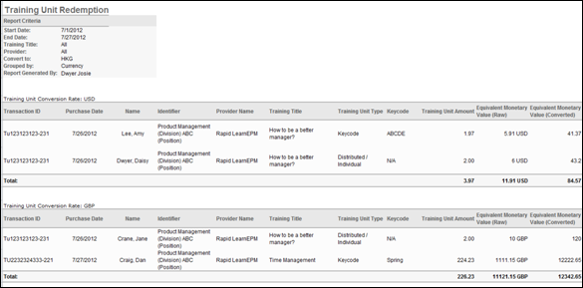

Training Unit User Report
The Training Unit User Report tracks the number of training units in a user's account. This report is located in the Training section of Standard Reports.
Permissions
PERMISSION NAME | PERMISSION DESCRIPTION | CATEGORY

Training Unit User Report | Grants access to the Training Unit User report, which tracks the number of training units in a user's account. | Reports - Training
Criteria
Filter Name | Description
User Criteria | Select the users whose training unit total you'd like to view.
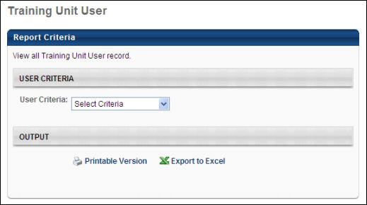
Output
- User Name
- User ID
- Total Assigned - The total number of training units assigned to the user
- Total Purchased - The number of training units the user has purchased
- Total Redeemed - The number of training units the user has redeemed
- Total Revoked - The number of training units that have been revoked
- Total Expired - The number of training units that have expired
- Total Refunded - The number of training units that have been refunded
- Balance - Number of unexpired training units the user has in their account
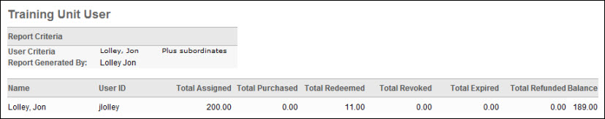

Transcript Status Report
Display status and progress information on a user's transcript. This report can be run for one or multiple users. Filter the report by status, training title, training type, or by when trainings were added to the transcript.
Permissions
PERMISSION NAME | PERMISSION DESCRIPTION | CATEGORY

Assignment Tool - Training Start Date | Grants ability to configure a Training Start Date when creating a Standard Learning Assignment. The Training Start Date is the date that users will be able to start the training. This permission is dependent on the Assignment Tool - Standard, Assignment Tool - Standard and Dynamic, and Assignment Tool - Standard and Dynamic - Recurrence permissions. This permission cannot be constrained. This is an administrator permission. | Learning - Administration

Training Reports Attempts and Scores | Grants ability to view attempts and scores data from the Course Assessment Results, Enterprise Training, Online Training Status, SCORM 2004 Course Progress, and Transcript Status report outputs. This permission cannot be constrained.  This permission works in conjunction with the permissions for the associated reports.  Note: Users may need to be granted permission view the Test Engine so that they can see the Test Engine results within Admin > Tools > Content. | Reports - Training

Transcript Status Report | Grants access to Transcript Status Report, which displays status and progress information on a user's transcript for one or multiple users. | Reports - Training
Filters
- Date Criteria - filter your results based on when learning objects were added to a user's transcript. Note: Date Criteria is always implemented using UTC (Coordinated Universal Time).
- User Criteria - limit report output to the users matching the specified user criteria
  - The report will only run within the defined constraints for the user running the report
  - This is the standard OU availability selection criteria drop-down. Choose from available OU types
  - Defaults: If no User Criteria are selected then the report will run for the entire available population
- Training Type - filter the report on a certain training type or select All for all training types
- Training Title - To report on a specific training, select the training from this field. Only one can be selected. Note: If a Training Title is specified, then this report output only includes the latest version of the training that is in a Completed status. Previous versions of the training will not be included in the report output.
- Training Status - select statuses to include in results. Note: The Not Available field is only visible to users who have permission to manage the available date setting for proxy enrollments.
- User Status - check to Include Inactive Users
- Training Due Date - check to Include Training Due Date
- Completion Date - check to Include Completion Date
Report Settings
This is an asynchronous report, which allows the administrator to define the standard report and generate the report asynchronously. As a result, when administrators process the report, the system generates the report in the background, while the administrator can move on to other areas of the system. When the report is finished processing, the administrator can then view the full report in its entirety.
- Up to three separate reports can generate asynchronously, allowing greater flexibility for creating and storing different versions of the report.
- If you process a report or refresh a stored report, the report appears in the table as Queued.
- The most recently created report displays at the top of the table.
- Since the user can generate up to three reports, the administrator can define a report title for each of the generated reports.
- Clicking the View Details icon changes the report settings on the page to match those of the selected previously run report.
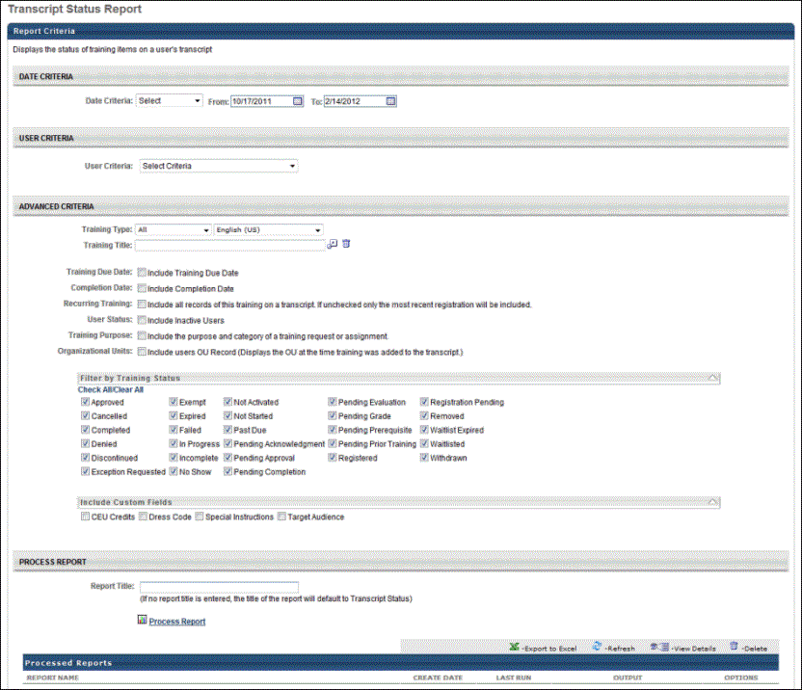
Output
- Printable Version link to view the results in a web page, or Export to Excel link to save/open as an Excel file
- After the report is processed you can:
  - Update the data on the report, click the Refresh icon
  - View the details on the report, click on the Details icon
  - Delete the report, click on the Delete icon
The Transcript Date column displays the date and time the training is added to the user's transcript, regardless of what status that training item is in. The Transcript Date is updated when new versions of the training are added due to the update in LO ID that takes place. This is recorded in Transcript History.
The Training Version column displays the version of the training item that the user completed. If a user took more than one version of a training, each version appears on a separate line, and the Training Version column displays the version number.
Note: When the Not Available status is included in the report output, "Not Available" displays in the Status column for users for whom the training is in a Not Available status.
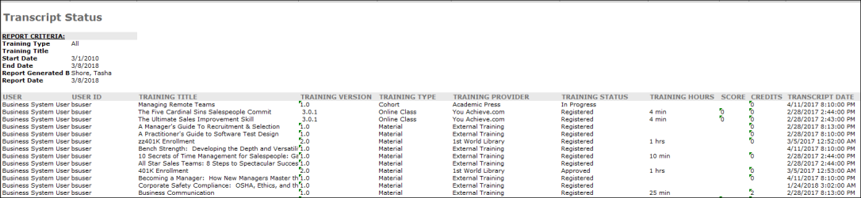
Output Limit Warning
A warning message will appear when opening the Excel output of the report if the number of records exceeds the maximum number of rows that can be exported. The message indicates that there are more records and that the records are not being shown in the report.

