Search March 2024

Table of Contents
Search Overview 1
Search Preferences 2
Search Preferences - General 4
Search Preferences - Training 7
Search Preferences - Training - Training Types 12
Search Preferences - Training - Refine Search Options 16
Search Preferences - People 20
Search Preferences - Connect 24
Search Preferences - Certifications 29
Search Preferences - Forms 32
Global Search Overview 35
Global Search Page 40
Learning Search vs. Traditional Search 45
Global Search Logic 47

Search Overview

Search Preferences
Search Preferences enable administrators to configure search preferences by division.
To manage Global Search preferences, go to Admin > Tools > Core Functions > Core Preferences > Search. Alternately, you can also go to Admin > Tools > Preferences. Then, click the Search Preferences (by Division) link in the System Preferences section. In the Search Preferences page, select a division. This opens the General page of Search Preferences.
Permissions
PERMISSION NAME | PERMISSION DESCRIPTION | CATEGORY

Admin Search Preferences - Manage | Grants ability to configure preferences for Global Search and Course Catalog within Search Preferences. The constraints of this permission are inherited from the Global Search Preferences - Manage permission. This is an administrator permission. | Learning - Administration

Global Search Preferences - Manage | Grants ability to configure Global Search Preferences. This is an administrator permission. The availability of this permission is controlled by a backend setting. This permission can be constrained by OU and User's OU. By default, this permission is constrained to the organization. | Core Administration
The availability of this page is controlled by a backend setting.
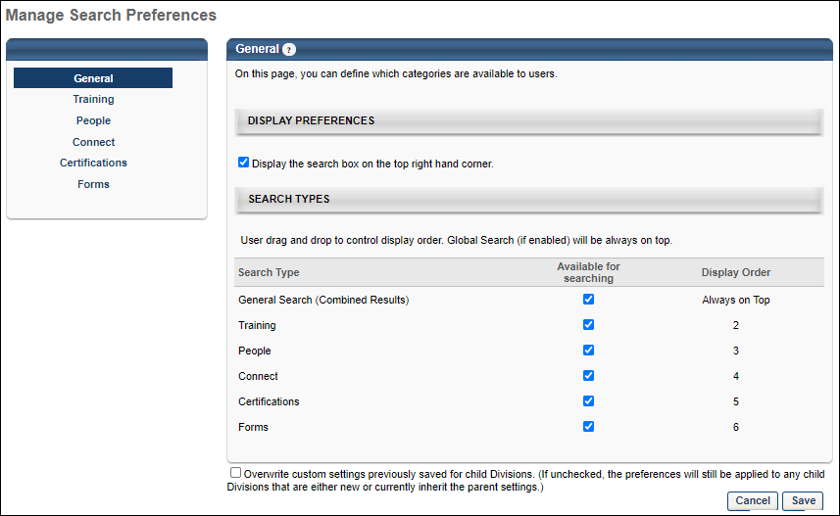
Search Preferences are separated into the following pages:
- General
- Training
- People
- Connect
- Certifications
- Forms

Search Preferences - General
Defining Search Preferences is a multiple step process. The first step is setting the General preferences. The Search Preferences - General page enables administrators to configure the following:
- Whether or not the Global Search option is available in the upper-right corner of system pages
- Which search types are available to users
- The order in which the search type filters appear to users on the Global Search page
To access the Search Preferences - General page, go to Admin > Tools > Core Functions > Core Preferences > Search.
Permissions
PERMISSION NAME | PERMISSION DESCRIPTION | CATEGORY

Admin Search Preferences - Manage | Grants ability to configure preferences for Global Search and Course Catalog within Search Preferences. The constraints of this permission are inherited from the Global Search Preferences - Manage permission. This is an administrator permission. | Learning - Administration

Global Search Preferences - Manage | Grants ability to configure Global Search Preferences. This is an administrator permission. The availability of this permission is controlled by a backend setting. This permission can be constrained by OU and User's OU. By default, this permission is constrained to the organization. | Core Administration
The availability of this page is controlled by a backend setting.
Display Preferences
Select the Display the search box on the top right hand corner option to enable the Global Search box in the upper-right corner of each system page.
Search Types
This section enables administrators to determine which search types are available to users. In addition, the administrator can determine the order in which the search filters appear to users in the Search Types drop-down list.
The Search Type column displays each of the available search types. The following search types may be available:
- General Search - This search type is available for all portals and it searches all search types in a combined search.
- Training - This search type is available for portals using the Learning solution.
- People - This search type is available for all portals.
- Connect - This search type is available for portals using the new Knowledge Bank and Communities functionality.
- Certifications - This search type is only available for portals using Certifications.
- Forms - This search type is only available for portals using Form Management (this does not apply to the old Forms Management functionality).
Enable Search Type
To enable users to use a particular search type within Global Search, select the Available for Searching option. By default, this option is selected for General Search, and this option is deselected for all other search types. Note: At least one search type must be selected. Also, if this option is selected for General Search, at least two other search types must be selected.
When the Available for Searching option is selected for a search type, the following occurs:
- Users can search for items within the search type via Global Search.
- Administrators can configure the search settings for the search type by selecting the search type name in the left navigation bar.
- The Display Order column displays the order in which the search type appears to users in the list of filters, and the search type can be reordered.
Configure Search Type Display Order
The Display Order column displays the order in which the search types appear to users in the list of filters. This also determines the order in which search results are displayed to users. Drag and drop the search types in to the desired order. The General Search type cannot be reordered and it is always displayed first when it is enabled.
Overwrite Settings
Select this option to overwrite custom settings for child division OUs. If you overwrite custom settings for child division OUs, the selected settings are applied to both new and existing child OUs. Any previously customized child OUs are updated with the selected settings.
- If there are no customizations to the child OU, then the parent OU customizations are applied to all child OUs.
- Overwrite custom settings checkbox setting
  - If this option is selected, all child OU customizations are deleted from the database, which means the parent OU customizations will be applied to new and existing child OUs.
  - If this option is unselected, all existing child OU customizations will remain unchanged, and any new child OUs will inherit the parent OU customizations by default.
- If a child OU has been customized to display any widgets, then regardless of the parent OU customizations, the child OU customizations are applied.
- If a child OU has been customized to hide all widgets, then parent OU customizations will take precedence and will be applied.
Note: This option applies to all tabs within Search Preferences (e.g., General, People, Training), not just the current tab.
Save Options
To continue modifying Search Preferences, click the appropriate tab in the left navigation bar.
To save changes for all pages within Search Preferences, click Save.
To discard all unsaved changes made on all pages within Search Preferences, click Cancel.

Search Preferences - Training
Defining Search Preferences is a multiple step process. The Search Preferences - Training page enables administrators to do the following with respect to the Training search type:
- Define available search filters
- Define training types that are available
- Define sorting capability
- Define Search Engine
Deprecation Note: With the March 2024 release, the (legacy) Skills tab has been hidden from the Refine Search page except for those who "opted out" of the (legacy) Skills Tab deprecation. For more information, See Hiding Legacy Skills on Bulk Edit and Refine Search.
Deprecation Note: The Global Search Traditional Search Preference will be removed from user interface by July 2024 release. Administrators can no longer configure Traditional Search in their portal. No changes are made to customer settings. By November 2024, the Traditional Search for Global Search (Training) will be permanently deprecated. After the deprecation, administrators can no longer transition the Global Search (Training) page back to Traditional Search (SQL) using Search Preferences. To know more, See Global Search (Training) - Deprecation of Traditional Search with the November 2024 Release.
To access the Search Preferences - Training page, go to Admin > Tools > Core Functions > Core Preferences > Search. Alternately, you can also go to Admin > Tools > Preferences. Then, click the Search Preferences (by Division) link in the System Preferences section. In the Search Preferences page, select a division and it opens the Manage Search Preferences page. Then, select the Training tab on the left navigation bar. Note: This tab is not selectable unless it is enabled as a search type on the General tab.
Permissions
PERMISSION NAME | PERMISSION DESCRIPTION | CATEGORY

Admin Search Preferences - Manage | Grants ability to configure preferences for Global Search and Course Catalog within Search Preferences. The constraints of this permission are inherited from the Global Search Preferences - Manage permission. This is an administrator permission. | Learning - Administration

Global Search Preferences - Manage | Grants ability to configure Global Search Preferences. This is an administrator permission. The availability of this permission is controlled by a backend setting. This permission can be constrained by OU and User's OU. By default, this permission is constrained to the organization. | Core Administration
The availability of this page is controlled by a backend setting.
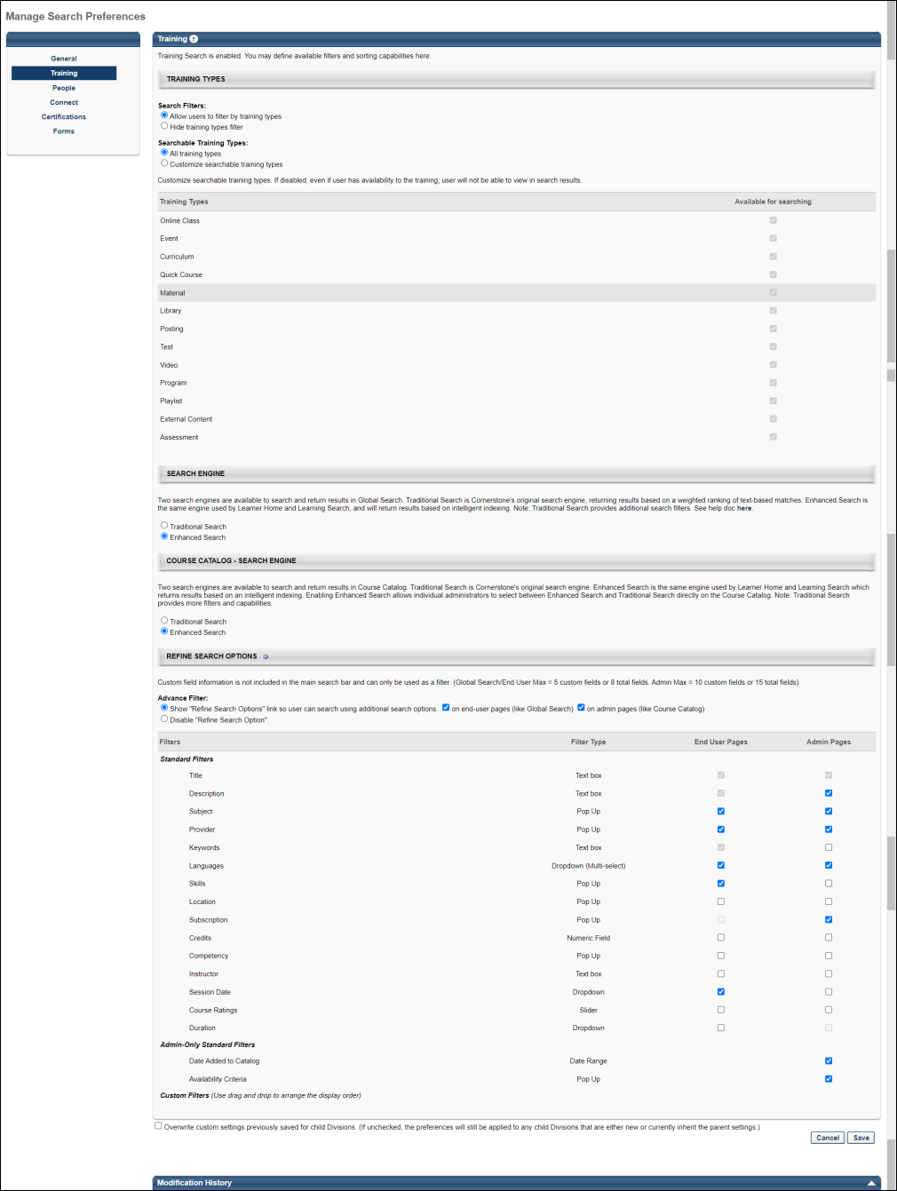
Training Types
The Training Types section of the Search Preferences - Training page enables administrators to determine which search filters are available and which training types are searchable.
When the redesigned Course Catalog is enabled, this section applies to Global Search and Course Catalog Search. Otherwise, this section only applies to Global Search.
Note: Users and administrators can only search for training items that are available to them. If a learning object (LO) is not available to a user, then that LO does not appear in search results.
Note: Connect postings do not operate as stand alone LOs such as online classes, curricula, videos, etc. and therefore do not exist in the Course Catalog. Postings are, however, searchable via Global Search.
See Search Preferences - Training - Training Types on page 12 for additional information.
Search Engine
Two search engines are available to search and return results in Global Search. Traditional Search is Cornerstone's original search engine, returning results based on a weighted ranking of text-based matches. Enhanced Search is the same engine used by Learner Home and Learning Search, and will return results based on intelligent indexing.
The Enhanced Search is a more effective, scalable, and result-driven way to power a search framework. It provides a consistent, unified experience for end users and allows for better and faster searches, especially in cases where large data sets are involved. Therefore, the Enhanced Search is the default framework for Global Search (for Training) across all portals. However, the administrators can still switch back to Traditional Search whenever necessary.
Note: Traditional Search provides additional search filters.
Note: If you are using the results from Global Search (Training) to populate results from other pages of the application, the results may be updated to use Enhanced Search. If you are not sure what solution your portal uses, we recommend testing the updated results in stage portals or other lower environments.
Considerations
- With Enhanced Search enabled by default, the Title and Description filters are combined into one text field to enter search queries. To use the Title and Description filters independently, enable Traditional Search.
- Use Keywords filter independently for both Traditional Search and Enhanced Search on the course catalog search page. It uses “partial match” and “starts with” when returning search results. However, the Keywords filter is currently not supported in Global Search. The rest of the filters in Global Search (Training) remain unchanged and require no further action from the administrator to be able to use them.
- A newly created or updated Learning Object (LO) is updated within 15 minutes or less in the Enhanced Search results, but with few exceptions, which are as follows:
  - In case the LO is a part of a large data ingestion, or if a bulk update is completed, then the time for the update to be reflected in Enhanced Search results may depend on the amount or the size of the update.
  - In case the LO is created or updated at the same time a data set is updated, then the LO may take more than 15 minutes to be available in the Enhanced Search results.
- All filters operate using an 'AND' operation when Enhanced Search is enabled. This includes Custom Fields, which uses an 'OR' operation when Traditional Search is enabled.
Note: It may take up to 4 hours for Traditional Search to take effect in Global Search.
Refine Search Options
The Refine Search Options section of the Search Preferences - Training page enables administrators to determine which search refinement options are available to users when the Training tab is selected on the Global Search page or when searching for Learning Objects (LOs) in Course Catalog search.
See Search Preferences - Training - Refine Search Options on page 16 for additional information.
Overwrite Settings
Select this option to overwrite custom settings for child division OUs. If you overwrite custom settings for child division OUs, the selected settings are applied to both new and existing child OUs. Any previously customized child OUs are updated with the selected settings.
- If there are no customizations to the child OU, then the parent OU customizations are applied to all child OUs.
- Overwrite custom settings checkbox setting
  - If this option is selected, all child OU customizations are deleted from the database, which means the parent OU customizations will be applied to new and existing child OUs.
  - If this option is unselected, all existing child OU customizations will remain unchanged, and any new child OUs will inherit the parent OU customizations by default.
- If a child OU has been customized to display any widgets, then regardless of the parent OU customizations, the child OU customizations are applied.
- If a child OU has been customized to hide all widgets, then parent OU customizations will take precedence and will be applied.
Note: This option applies to all tabs within Search Preferences (e.g., General, People, Training), not just the current tab.
Save Options
To continue modifying Search Preferences, click the appropriate tab in the left navigation bar.
To save changes for all pages within Search Preferences, click Save.
To discard all unsaved changes made on all pages within Search Preferences, click Cancel.
Modification History
This section displays modification history.

Search Preferences - Training - Training Types
The Training Types section of the Search Preferences - Training page enables administrators to determine which search filters are available and which training types are searchable.
When the redesigned Course Catalog is enabled, this section applies to Global Search and Course Catalog Search. Otherwise, this section only applies to Global Search.
Note: Users and administrators can only search for training items that are available to them. If a learning object (LO) is not available to a user, then that LO does not appear in search results.
Note: Connect postings do not operate as stand alone LOs such as online classes, curricula, videos, etc. and therefore do not exist in the Course Catalog. Postings are, however, searchable via Global Search.
To access Search Preferences, go to Admin > Tools > Core Functions > Core Preferences > Search.
Permissions
PERMISSION NAME | PERMISSION DESCRIPTION | CATEGORY

Admin Search Preferences - Manage | Grants ability to configure preferences for Global Search and Course Catalog within Search Preferences. The constraints of this permission are inherited from the Global Search Preferences - Manage permission. This is an administrator permission. | Learning - Administration

Global Search Preferences - Manage | Grants ability to configure Global Search Preferences. This is an administrator permission. The availability of this permission is controlled by a backend setting. This permission can be constrained by OU and User's OU. By default, this permission is constrained to the organization. | Core Administration
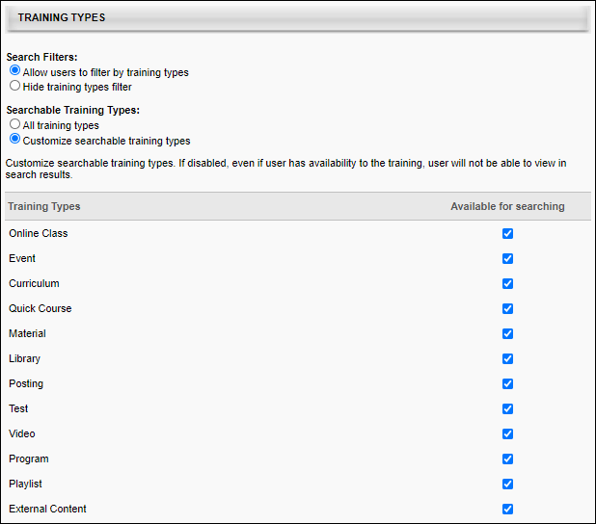
Search Filters
When the redesigned Course Catalog is enabled, this section applies to Global Search and Course Catalog Search. Otherwise, this section only applies to Global Search.
Select whether or not users and administrators have access to training type filters.
- Allow users to filter by training types - When this option is selected, the Training filters are available to users, allowing them to filter the search results by training type. The Searchable Training Types setting and the Training Types table determine which training type filters are available to users. This option is selected by default.
- Hide training types filter - If this option is selected, the training types filter is not visible to users. However, when a user searches for training items, the selections in the Training Types section are automatically applied.
Searchable Training Types
When the redesigned Course Catalog is enabled, this section applies to Global Search and Course Catalog Search. Otherwise, this section only applies to Global Search.
Select whether all training types are searchable or only specific training types.
- All training types - Select this option to make all training types searchable. The system searches all training items that are available to the user.
- Customize searchable training types - Select this option to customize which training types are searchable. The administrator must then use the Training Types table to determine which training types are searchable.
  - Use Case: Within an organization, events can be assigned to users by managers, but users cannot request events. By disabling the Event training type within Global Search, users never see events in the Global Search results.
Training Types
When the redesigned Course Catalog is enabled, this section applies to Global Search and Course Catalog Search. Otherwise, this section only applies to Global Search.
This table enables administrators to determine which training types are available to users.
The Training Types column displays each of the available training types. The following training types may be available:
- Online Course
- Event
- Curriculum
- Quick Course
- Material
- Library
- Posting
- Test
- Video
- Playlist
- Online Content
- External Content
- Program - Note: The Program training type is only available for organizations using redesigned Connect.
Enable Search Type
To enable users to use a particular search type within Search, select the Available for Searching option. By default, this option is selected for all available training types. If this option is not selected for a training type, then training items within the corresponding training type are never displayed in search results. Note: At least one training type must be selected.
When the Available for Searching option is selected for a search type, users can search for items within the training type.
Example of Filters on Global Search Page
This image represents an example of how the training type filters appear on the Global Search page.
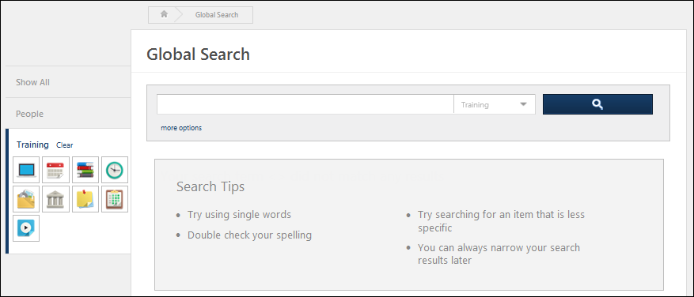

Search Preferences - Training - Refine Search Options
The Refine Search Options section of the Search Preferences - Training page enables administrators to determine which search refinement options are available to users when the Training tab is selected on the Global Search page or when searching for Learning Objects (LOs) in Course Catalog search.
When searching for training, the results you receive will differ depending on whether you are using Learning Search or Global Search. For more information about the differences between these two tools: See Learning Search vs. Traditional Search on page 45 for additional information.
Permissions
PERMISSION NAME | PERMISSION DESCRIPTION | CATEGORY

Admin Search Preferences - Manage | Grants ability to configure preferences for Global Search and Course Catalog within Search Preferences. The constraints of this permission are inherited from the Global Search Preferences - Manage permission. This is an administrator permission. | Learning - Administration

Global Search Preferences - Manage | Grants ability to configure Global Search Preferences. This is an administrator permission. The availability of this permission is controlled by a backend setting. This permission can be constrained by OU and User's OU. By default, this permission is constrained to the organization. | Core Administration
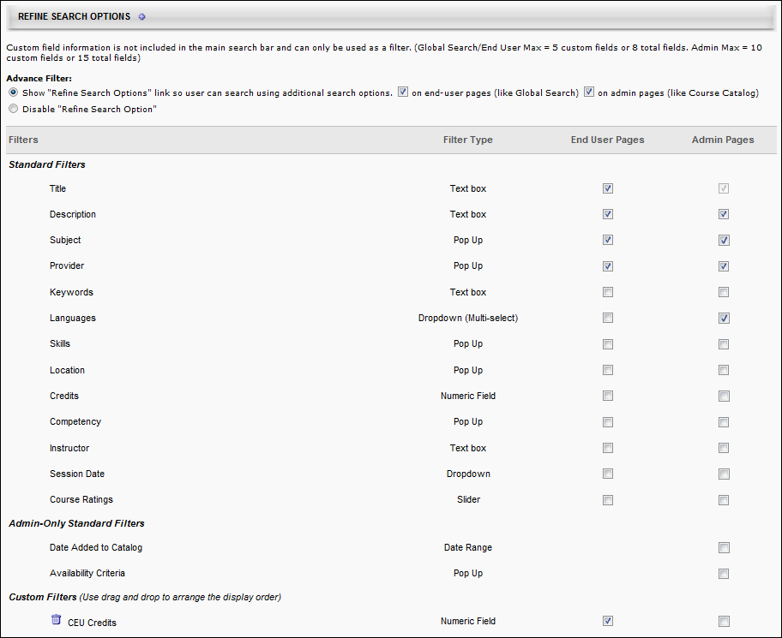
Advanced Filter
Select whether the Additional Search Options section is available to users on the Search page.
- Show "Refine Search Options" link so users can search using additional search options. - Select this option to allow users and administrators to access Refine Search Options on the Global Search or Course Catalog page. These options enable users to further refine their search results. When this option is selected, the search filters can be configured in the Filters section. At least one filter must be selected.
  - On end-user pages (like Global Search) - Select this option to enable the Refine search link on the Global Search page.
  - On admin pages (like Course Catalog) - Select this option to enable the Refine search link on the Course Catalog Search page.
- Disable "Refine Search Options" - Select this option to disable Refine Search Options. When this option is selected, the settings in the Filters table are not implemented.
Filters
Under the Filters section, you can enable the filters to include them in the Refine Search Options section for the corresponding pages.
Note: Deactivating a search filter removes it from the Refine Search Options section, disabling a user or administrator's ability to use the corresponding search filter. However, the system will continue to search the corresponding field. For example, if the Title filter is deactivated, users and administrators cannot filter the search results by title, but a training item is included in the search results if the title matches the search criteria. The order in which the filters appear in the table is the order in which the filters are displayed to users and administrators.
- End User Pages - This option controls whether the filter is active on the Global Search page. Up to 5 custom fields or 8 total fields can be selected for end user pages. Note: Only drop-down, multiple checkbox, numeric, short text, and date type custom fields can be added as filters.
- Admin Pages - This option controls whether the filter is active on the Course Catalog Search page. Up to 10 custom fields or 15 total fields can be selected for admin pages. This column is only available to administrators who have permission to manage administrator search preferences.
Note: Only drop-down, numeric, short text, and date type custom fields can be added as filters.
Note: Currently, the Keyword filter is not supported in Global Search but only supported in Course Catalog search page when Enhanced Search is enabled.
Standard Filters
The Standard Filters section of the Filters table displays all of the standard filters that are available. Select whether the filter is active or inactive for end user pages and admin pages. Up to 5 custom fields or 8 total fields can be selected for end user pages. Up to 10 custom fields or 15 total fields can be selected for admin pages.
The following standard filters are available:
Filter | Type | Description
Title | Text Box | User enters a title up to 100 characters.
Description | Text Box | User enters a description up to 100 characters. Not available when Enhanced Search is enabled.
Subject | Pop-up | User selects a subject from the Find Subject pop-up.
Provider | Pop-up | User selects a provider from the Search Providers pop-up.
Keywords | Text Box | User enters a keyword up to 100 characters.
Languages | Drop-down | User selects languages from the drop-down list.
Skills | Pop-up | User selects a skill from the Search Skills pop-up.
Location | Pop-up | User selects a location from the Select Facility pop-up.
Subscription | Pop-up | User selects the name of a content subscription from the Select Subscription pop-up.
Credit | Greater Than/Less Than | Using the greater than, less than, or equal to symbols, user specifies the number of credits. Credit value must be greater than zero and less than 999.99.
Competency | Pop-up | User selects a competency from the Add Competency pop-up.
Instructor | Text Box | User enters an instructor name up to 100 characters.
Session Date | Drop-down | User selects one of the date ranges to limit the LOs by session start date. This filter is only available if Event is selected as one of the search options.
Course Ratings | Slider | User uses the rating slider to specify a rating range.
Admin-Only Standard Filters
The Admin-Only Standard Filters section contains filters that are only available for administrator search pages. This section is only available to administrators who have permission to manage administrator search preferences. Up to 10 custom fields or 15 total fields can be selected for admin pages.
Custom Filters
Custom field information is not included in the main search bar and can only be used as a filter. Up to 5 custom fields or 8 total fields can be selected for end user pages. Up to 10 custom fields or 15 total fields can be selected for admin pages.
To add a custom filter, click the plus icon to the right of the Refine Search Options heading and select the appropriate custom fields. Note: Only drop-down, numeric, short text, and date type custom fields can be added as filters. The custom filters can be reordered by dragging and dropping them into the appropriate order.
Example of Refine Search Options on Global Search Page
This image represents an example of how the Refine Search Options section appears.
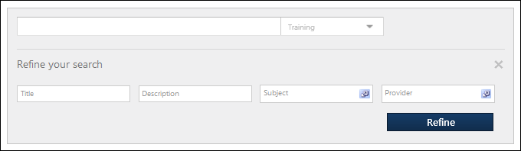

Search Preferences - People
Defining Search Preferences is a multiple step process. The Search Preferences - People page enables administrators to do the following with respect to the People search type:
- Define available search filters
To access the Search Preferences - People page, go to Admin > Tools > Core Functions > Core Preferences > Search. Then, select the People tab on the left navigation bar. Note: This tab is not selectable unless it is enabled as a search type on the General tab.
Permissions
PERMISSION NAME | PERMISSION DESCRIPTION | CATEGORY

Admin Search Preferences - Manage | Grants ability to configure preferences for Global Search and Course Catalog within Search Preferences. The constraints of this permission are inherited from the Global Search Preferences - Manage permission. This is an administrator permission. | Learning - Administration

Global Search Preferences - Manage | Grants ability to configure Global Search Preferences. This is an administrator permission. The availability of this permission is controlled by a backend setting. This permission can be constrained by OU and User's OU. By default, this permission is constrained to the organization. | Core Administration
The availability of this page is controlled by a backend setting.
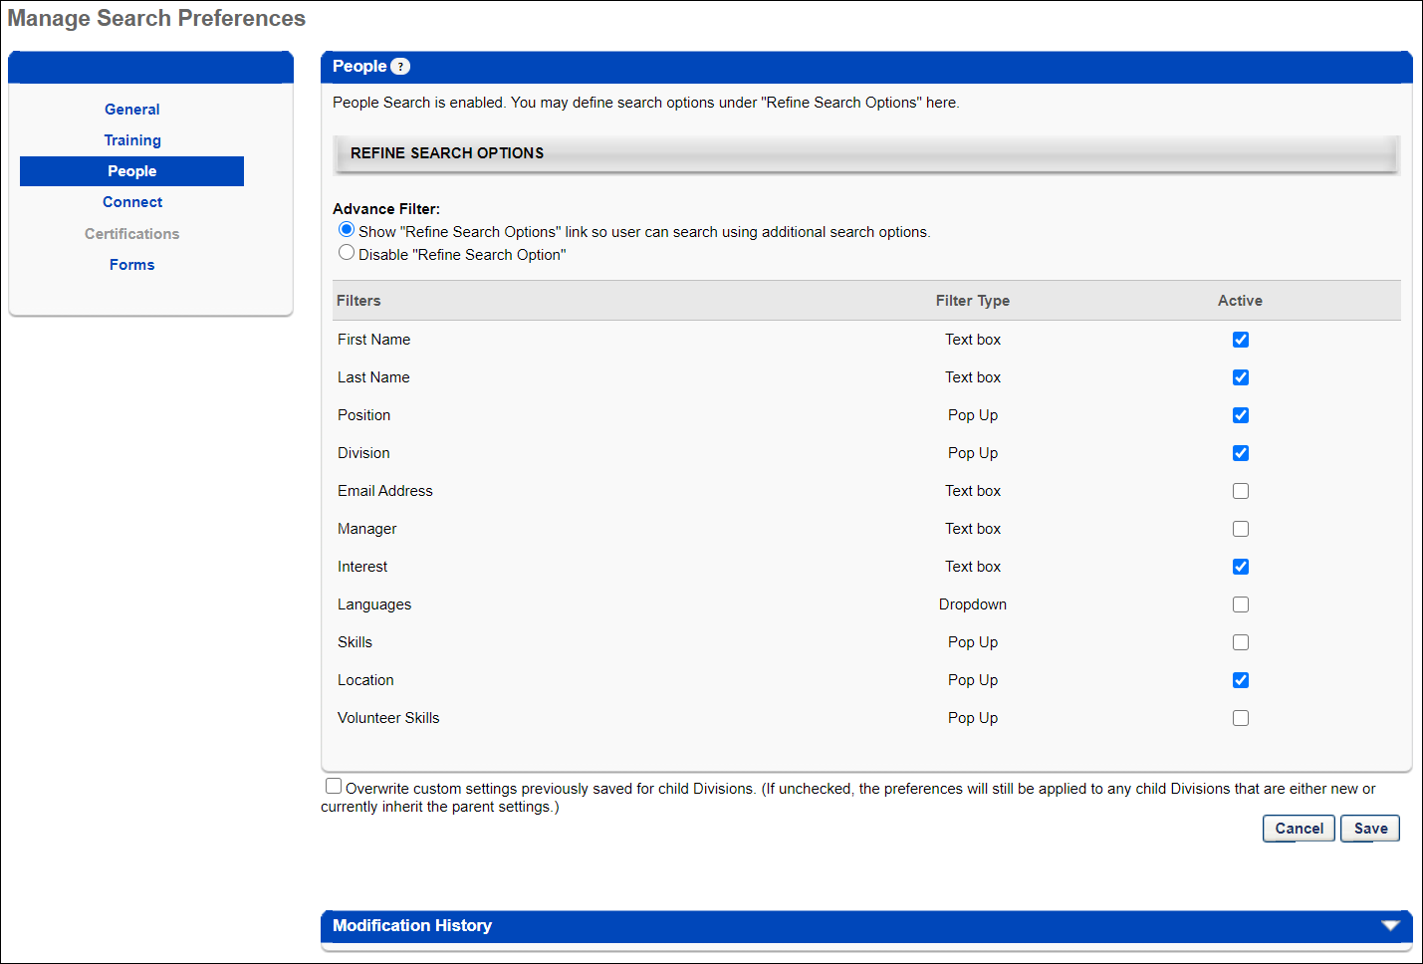
Refine Search Options
This section enables administrators to determine which search refinement options are available to users when the corresponding tab is selected on the Global Search page.
Advance Filter
Select whether the Additional Search Options section is available to users.
- Show "Refine Search Options" link so users can search using additional search options. - Select this option to allow users to access the Refine Search Options on the Global Search page. These options enable users to further refine their search results. When this option is selected, the administrator can set the search filters in the Filters section. At least one filter must be selected.
- Disable "Refine Search Options" - Select this option to disable Refine Search Options. When this option is selected, the settings in the Filters table are not implemented.
Filters
The Filters table displays all of the standard filters that are available. Select the Active checkbox to include the filter in the Refine Search Options section. Note: Deactivating a search filter removes it from the Refine Search Options section, disabling a user's ability to use the corresponding search filter. However, Global Search will continue to search the corresponding field. For example, if the Title filter is deactivated, users cannot filter the search results by title, but a training item is included in the search results if the title matches the search criteria. The order in which the filters appear in the table is the order in which the filters are displayed to users on the Global Search page.
Up to eight filters can be selected as Active.
The following standard filters are available:
Filter | Type | Description
First Name | Text Box | User enters a person's first name up to 100 characters.
Last Name | Text Box | User enters a person's last name up to 100 characters.
Position | Pop-up | User selects a person's Position from the Search Positions pop-up. This filter is only available if the Position OU is enabled for the portal.
Division | Pop-up | User selects a person's Division from the Search Divisions pop-up. This filter is only available if the Division OU is enabled for the portal.
Email Address | Text Box | User enters a person's email address up to 100 characters.
Manager | Text Box | User enters a person's manager's name up to 100 characters. This field matches first and last names.
Interest | Text Box | User enters a person's interest up to 100 characters. This matches a person's interests that are listed on their Resume and in Connect.
Languages | Drop-down | User selects a person's languages from the drop-down list.
Skills | Pop-up | User selects a user's Resume skills from the Search Skills pop-up.
Location | Pop-up | User selects a person's Location from the Search Locations pop-up. This filter is only available if the Location OU is enabled for the portal.
Volunteer Skills | Pop-up | User selects a person's Volunteer Skills from the Select Volunteer Skills pop-up.
Overwrite Settings
Select this option to overwrite custom settings for child division OUs. If you overwrite custom settings for child division OUs, the selected settings are applied to both new and existing child OUs. Any previously customized child OUs are updated with the selected settings.
- If there are no customizations to the child OU, then the parent OU customizations are applied to all child OUs.
- Overwrite custom settings checkbox setting
  - If this option is selected, all child OU customizations are deleted from the database, which means the parent OU customizations will be applied to new and existing child OUs.
  - If this option is unselected, all existing child OU customizations will remain unchanged, and any new child OUs will inherit the parent OU customizations by default.
- If a child OU has been customized to display any widgets, then regardless of the parent OU customizations, the child OU customizations are applied.
- If a child OU has been customized to hide all widgets, then parent OU customizations will take precedence and will be applied.
Note: This option applies to all tabs within Search Preferences (e.g., General, People, Training), not just the current tab.
Save Options
To continue modifying Search Preferences, click the appropriate tab in the left navigation bar.
To save changes for all pages within Search Preferences, click Save.
To discard all unsaved changes made on all pages within Search Preferences, click Cancel.

Search Preferences - Connect
Defining Search Preferences is a multiple step process. The Search Preferences - Connect page enables administrators to do the following with respect to the Connect search type:
- Define available search filters for Knowledge Bank and community postings
To access the Search Preferences - Connect page, go to Admin > Tools > Core Functions > Core Preferences > Search. Then, select the Connect tab on the left navigation bar. Note: This tab is not selectable unless it is enabled as a search type on the General tab.
Permissions
PERMISSION NAME | PERMISSION DESCRIPTION | CATEGORY

Admin Search Preferences - Manage | Grants ability to configure preferences for Global Search and Course Catalog within Search Preferences. The constraints of this permission are inherited from the Global Search Preferences - Manage permission. This is an administrator permission. | Learning - Administration

Global Search Preferences - Manage | Grants ability to configure Global Search Preferences. This is an administrator permission. The availability of this permission is controlled by a backend setting. This permission can be constrained by OU and User's OU. By default, this permission is constrained to the organization. | Core Administration
The availability of this page is controlled by a backend setting.
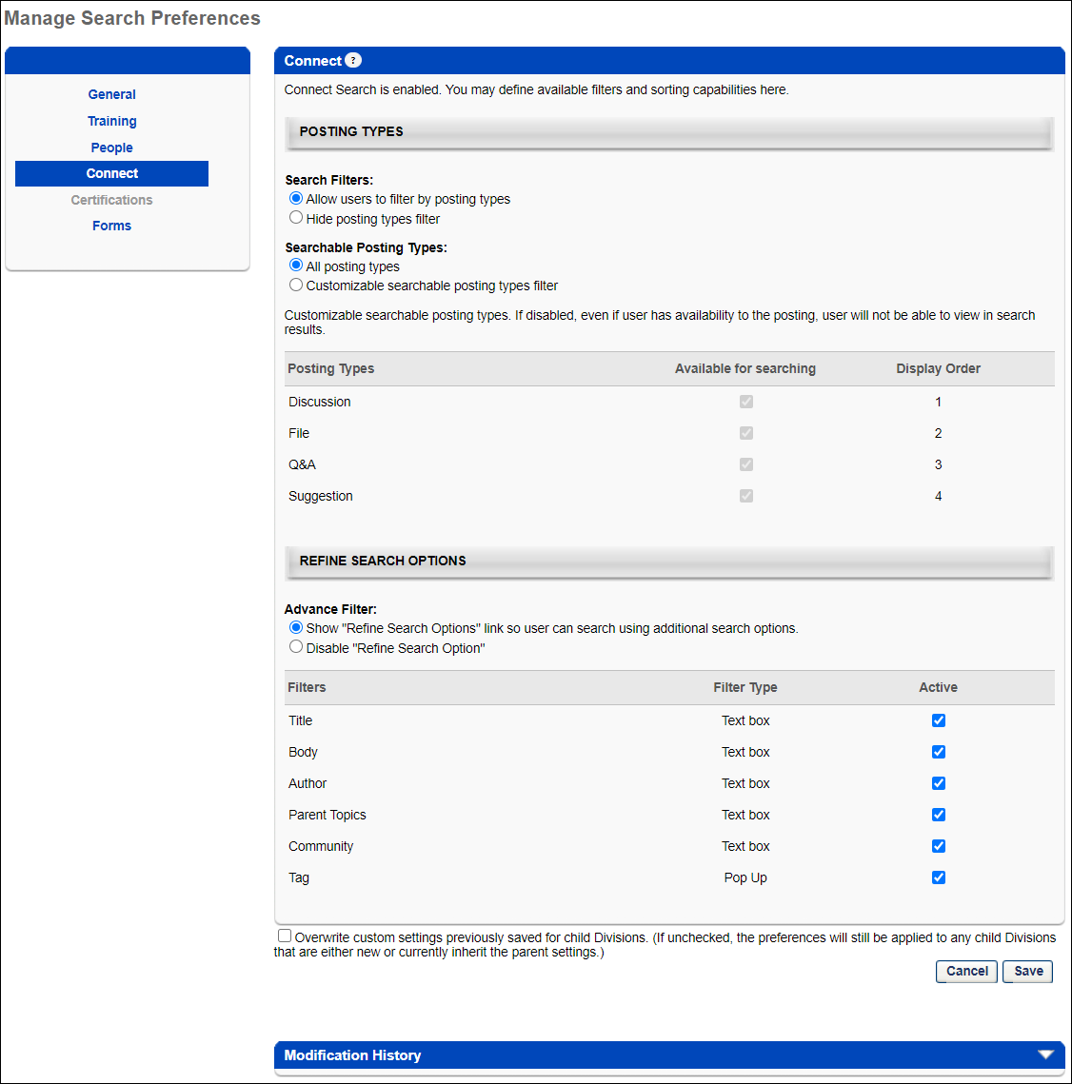
Posting Types
This section enables administrators to determine which search filters are available and which posting types are searchable.
Note: Users and administrators can only search for postings that are available to them. If a posting is from a topic that is not available to a user, then that posting does not appear in search results.
Search Filters
Select whether or not users have access to posting type filters
- Allow users to filter by posting types - When this option is selected, the Posting filters are available on the Global Search page, allowing users to filter the search results by posting type. Which posting type filters are available to users is determined in the Searchable Posting Types setting and the Posting Types table. This option is selected by default.
- Hide posting types filter - If this option is selected, the posting types filter is not visible to users. However, when a user searches for a posting, the selections in the Posting Types section are automatically applied.
Searchable Posting Types
Select whether all posting types are searchable in Global Search or only specific posting types.
- All posting types - Select this option to make all posting types searchable within Global Search. Global Search searches all postings to which the user has availability.
- Customize searchable posting types - Select this option to customize which posting types are searchable within Global Search. The administrator must then use the Posting Types table to determine which posting types are searchable.
Posting Types
This table enables administrators to determine which posting types are available to users within Global Search. In addition, the administrator can determine the order in which the selected posting types appear in the Global Search results.
This Posting Types column displays each of the available posting types. The following posting types may be available:
- Discussion
- File
- Q&A
- Suggestion
Enable Search Type
To enable users to use a particular search type within Global Search, select the Available for Searching option. By default, all available posting types are selected. If this option is not selected for a posting type, then postings within the corresponding posting type are never displayed in search results. Note: At least one posting type must be selected.
When the Available for Searching option is selected for a search type, the following occurs:
- Users can search for items within the posting type.
- The Display Order column displays the order in which the posting types are displayed in the search results and the posting type can be reordered.
This image represents an example of how the posting type filters appear on the Global Search page.
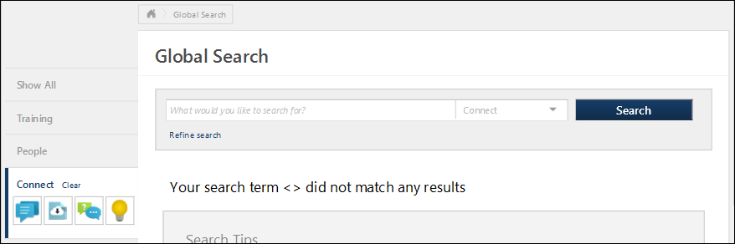
Configure Search Filter Display Order
The Display Order column displays the order in which posting type filters are displayed to users. Drag and drop the posting types in to the desired order.
Refine Search Options
This section enables administrators to determine which search refinement options are available to users when the corresponding tab is selected on the Global Search page.
Advance Filter
Select whether the Additional Search Options section is available to users.
- Show "Refine Search Options" link so users can search using additional search options. - Select this option to allow users to access the Refine Search Options on the Global Search page. These options enable users to further refine their search results. When this option is selected, the administrator can set the search filters in the Filters section. At least one filter must be selected.
- Disable "Refine Search Options" - Select this option to disable Refine Search Options. When this option is selected, the settings in the Filters table are not implemented.
Filters
The Filters table displays all of the standard filters that are available. Select the Active checkbox to include the filter in the Refine Search Options section. Note: Deactivating a search filter removes it from the Refine Search Options section, disabling a user's ability to use the corresponding search filter. However, Global Search will continue to search the corresponding field. For example, if the Title filter is deactivated, users cannot filter the search results by title, but a training item is included in the search results if the title matches the search criteria. The order in which the filters appear in the table is the order in which the filters are displayed to users on the Global Search page.
The following standard filters are available:
Filter | Description
Title | User enters a title up to 100 characters.
Body | User enters posting body text up to 100 characters.
Author | User enters a posting author up to 100 characters.
Parent Topics | User enters a parent topic up to 100 characters.
Community | User enters a community up to 100 characters.
Tag | When this option is selected, users are able to search for Connect postings by tag name.  When this option is not selected, users cannot search by tag name. As a result, users cannot select a posting tag from other areas of the system to initiate a search for that tag. This includes the Posting view, the Topic Details page, and the Community Main tab.
Overwrite Settings
Select this option to overwrite custom settings for child division OUs. If you overwrite custom settings for child division OUs, the selected settings are applied to both new and existing child OUs. Any previously customized child OUs are updated with the selected settings.
- If there are no customizations to the child OU, then the parent OU customizations are applied to all child OUs.
- Overwrite custom settings checkbox setting
  - If this option is selected, all child OU customizations are deleted from the database, which means the parent OU customizations will be applied to new and existing child OUs.
  - If this option is unselected, all existing child OU customizations will remain unchanged, and any new child OUs will inherit the parent OU customizations by default.
- If a child OU has been customized to display any widgets, then regardless of the parent OU customizations, the child OU customizations are applied.
- If a child OU has been customized to hide all widgets, then parent OU customizations will take precedence and will be applied.
Note: This option applies to all tabs within Global Search Preferences (e.g., General, People, Training), not just the current tab.
Save Options
To continue modifying Search Preferences, click the appropriate tab in the left navigation bar.
To save changes for all pages within Search Preferences, click Save.
To discard all unsaved changes made on all pages within Search Preferences, click Cancel.

Search Preferences - Certifications
Defining Search Preferences is a multiple step process. The Search Preferences - Certifications page enables administrators to do the following with respect to the Certifications search type:
- Define available search filters
The availability of this page is controlled by a backend setting.
To access the Search Preferences - Certifications page, go to Admin > Tools > Core Functions > Core Preferences > Search. Then, select the Certifications tab on the left navigation bar. Note: This tab is not selectable unless it is enabled as a search type on the General tab.
Permissions
PERMISSION NAME | PERMISSION DESCRIPTION | CATEGORY

Admin Search Preferences - Manage | Grants ability to configure preferences for Global Search and Course Catalog within Search Preferences. The constraints of this permission are inherited from the Global Search Preferences - Manage permission. This is an administrator permission. | Learning - Administration

Global Search Preferences - Manage | Grants ability to configure Global Search Preferences. This is an administrator permission. The availability of this permission is controlled by a backend setting. This permission can be constrained by OU and User's OU. By default, this permission is constrained to the organization. | Core Administration
The availability of this page is controlled by a backend setting.
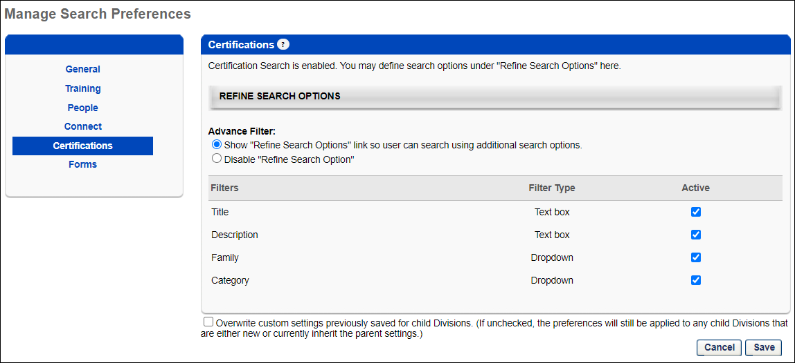
Refine Search Options
This section enables administrators to determine which search refinement options are available to users when the corresponding tab is selected on the Global Search page.
Advance Filter
Select whether the Additional Search Options section is available to users.
- Show "Refine Search Options" link so users can search using additional search options. - Select this option to allow users to access the Refine Search Options on the Global Search page. These options enable users to further refine their search results. When this option is selected, the administrator can set the search filters in the Filters section. At least one filter must be selected.
- Disable "Refine Search Options" - Select this option to disable Refine Search Options. When this option is selected, the settings in the Filters table are not implemented.
Filters
The Filters table displays all of the standard filters that are available. Select the Active checkbox to include the filter in the Refine Search Options section. Note: Deactivating a search filter removes it from the Refine Search Options section, disabling a user's ability to use the corresponding search filter. However, Global Search will continue to search the corresponding field. For example, if the Title filter is deactivated, users cannot filter the search results by title, but a training item is included in the search results if the title matches the search criteria. The order in which the filters appear in the table is the order in which the filters are displayed to users on the Global Search page.
The following standard filters are available:
Filter | Type | Description
Title | Text Box | User enters a title up to 100 characters.
Description | Text Box | User enters a description up to 100 characters.
Family | Drop-down | User selects a family from the drop-down list.
Category | Drop-down | User selects a category from the drop-down list.
Overwrite Settings
Select this option to overwrite custom settings for child division OUs. If you overwrite custom settings for child division OUs, the selected settings are applied to both new and existing child OUs. Any previously customized child OUs are updated with the selected settings.
- If there are no customizations to the child OU, then the parent OU customizations are applied to all child OUs.
- Overwrite custom settings checkbox setting
  - If this option is selected, all child OU customizations are deleted from the database, which means the parent OU customizations will be applied to new and existing child OUs.
  - If this option is unselected, all existing child OU customizations will remain unchanged, and any new child OUs will inherit the parent OU customizations by default.
- If a child OU has been customized to display any widgets, then regardless of the parent OU customizations, the child OU customizations are applied.
- If a child OU has been customized to hide all widgets, then parent OU customizations will take precedence and will be applied.
Note: This option applies to all tabs within Search Preferences (e.g., General, People, Training), not just the current tab.
Save Options
To continue modifying Search Preferences, click the appropriate tab in the left navigation bar.
To save changes for all pages within Search Preferences, click Save.
To discard all unsaved changes made on all pages within Search Preferences, click Cancel.

Search Preferences - Forms
Defining Search Preferences is a multiple step process. The Search Preferences - Forms page enables administrators to do the following with respect to the Forms search type:
- Define available search filters
To manage Search Preferences for forms, go to Admin > Tools > Core Functions > Core Preferences > Search. Then, select the Forms tab on the left navigation bar. Note: This tab is not selectable unless it is enabled as a search type on the General tab.
Permissions
PERMISSION NAME | PERMISSION DESCRIPTION | CATEGORY

Admin Search Preferences - Manage | Grants ability to configure preferences for Global Search and Course Catalog within Search Preferences. The constraints of this permission are inherited from the Global Search Preferences - Manage permission. This is an administrator permission. | Learning - Administration

Global Search Preferences - Manage | Grants ability to configure Global Search Preferences. This is an administrator permission. The availability of this permission is controlled by a backend setting. This permission can be constrained by OU and User's OU. By default, this permission is constrained to the organization. | Core Administration
The availability of this page is controlled by a backend setting.
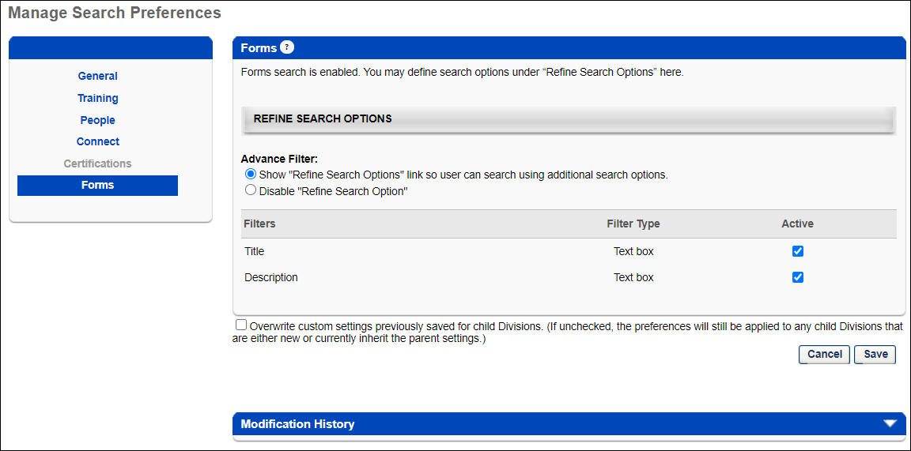
Refine Search Options
This section enables administrators to determine which search refinement options are available to users when the corresponding tab is selected on the Global Search page.
Advance Filter
Select whether the Additional Search Options section is available to users.
- Show "Refine Search Options" link so users can search using additional search options. - Select this option to allow users to access the Refine Search Options on the Global Search page. These options enable users to further refine their search results. When this option is selected, the administrator can set the search filters in the Filters section. At least one filter must be selected.
- Disable "Refine Search Options" - Select this option to disable Refine Search Options. When this option is selected, the settings in the Filters table are not implemented.
Filters
The Filters table displays all of the standard filters that are available. Select the Active checkbox to include the filter in the Refine Search Options section. Note: Deactivating a search filter removes it from the Refine Search Options section, disabling a user's ability to use the corresponding search filter. However, Global Search will continue to search the corresponding field. For example, if the Title filter is deactivated, users cannot filter the search results by title, but a training item is included in the search results if the title matches the search criteria. The order in which the filters appear in the table is the order in which the filters are displayed to users on the Global Search page.
The following filters are available:
Filter | Type | Description
Title | Text Box | User enters a title up to 100 characters.
Description | Text Box | User enters a description up to 100 characters.
Overwrite Settings
Select this option to overwrite custom settings for child division OUs. If you overwrite custom settings for child division OUs, the selected settings are applied to both new and existing child OUs. Any previously customized child OUs are updated with the selected settings.
- If there are no customizations to the child OU, then the parent OU customizations are applied to all child OUs.
- Overwrite custom settings checkbox setting
  - If this option is selected, all child OU customizations are deleted from the database, which means the parent OU customizations will be applied to new and existing child OUs.
  - If this option is unselected, all existing child OU customizations will remain unchanged, and any new child OUs will inherit the parent OU customizations by default.
- If a child OU has been customized to display any widgets, then regardless of the parent OU customizations, the child OU customizations are applied.
- If a child OU has been customized to hide all widgets, then parent OU customizations will take precedence and will be applied.
Note: This option applies to all tabs within Search Preferences (e.g., General, People, Training), not just the current tab.
Save Options
To continue modifying Search Preferences, click the appropriate tab in the left navigation bar.
To save changes for all pages within Search Preferences, click Save.
To discard all unsaved changes made on all pages within Search Preferences, click Cancel.

Global Search Overview
Global Search is a multiple phase project. When complete, Global Search will search the entire system, including Learning, Performance, Succession, and Compensation data. Currently, Global Search is able to search people, training, certifications, Connect postings, and forms within the system.
Performing a search may search multiple databases, such as the course catalog, people, certifications, etc. so results from all areas may be displayed.
To access Global Search, select the Search icon or the Search field in the upper-right corner of any system page.
Permissions
PERMISSION NAME | PERMISSION DESCRIPTION | CATEGORY

Global Search – Certifications | Grants ability to search for certifications via Global Search. This permission cannot be constrained. This is an end user permission. The availability of this permission is controlled by a backend setting. | Learning

Global Search – Connect | Grants ability to search for Knowledge Bank and community postings via Global Search. This permission cannot be constrained. The user's ability to view a posting is determined by the user's ability to view the posting's Knowledge Bank or community topic. This is an end user permission. The availability of this permission is controlled by a backend setting. | New Connect

Global Search – Forms | Grants ability to search for Forms in Global Search. This permission cannot be constrained. This is an end user permission. | Forms Management Administration

Global Search - People | Grants ability to search for people via Global Search. If this permission is constrained to a specific OU, then that constraint is automatically applied within Global Search, including search filters and search results. This is an end user permission. The availability of this permission is controlled by a backend setting.  Note: In Universal Profile > Bio > Career Preferences, this permission is required for users to search for jobs. | Core

Global Search - Training | Grants ability to search for training via Global Search. This permission also grants users the ability to view Subjects in Learner Home. If this permission is constrained to a specific OU, then that constraint is automatically applied within Global Search, including search filters and search results. This is an end user permission. The availability of this permission is controlled by a backend setting. | Learning

Global Search Preferences - Manage | Grants ability to configure Global Search Preferences. This is an administrator permission. The availability of this permission is controlled by a backend setting. This permission can be constrained by OU and User's OU. By default, this permission is constrained to the organization. | Core Administration

Bio About - View | Enables user to view the Bio page for users within their permission constraints. This permission must be enabled to view the Transcript page within Universal Profile. If a user does not have this permission and they click a person's name or user photo within the Universal Profile, then the Bio page will not open.  On the Learner Home page, this permission also allows end users to view the Completions & Hours field, the training sidebar, and the Continue Learning carousel.  This permission can be constrained by Employee Relationship, OU, User's OU, User's Direct Reports, User Self and Subordinates, and User. Note: For security purposes, this permission is constrained to User Self and Subordinates by default. However, the permission constraints can be modified to allow users to view the Bio About page for other users. | Universal Profile
Global Search Criteria
In order for a user to have access to Global Search, the following criteria must be met:
- The user must have at least one of the Global Search permissions.
- The search box must be enabled and at least one of the search types must be enabled in Search Preferences. See Search Preferences - General on page 4 for additional information.
Global Search Widget
As you enter a search query into the Search field, predictive search results appear in a menu below the field. Predictive search results appear for each search category where there are relevant results. A maximum of five relevant results appear for each category. Search results are displayed in order of relevancy.
When you select a predictive search result, you are navigated directly to the selected item.
You can also select the magnifying glass icon or press the [Enter] key to open the Global Search page and view the search results.
Global Search Types
The following types of items may be included in Global Search:
- Training Search - When a training item is selected in the Search results, the system directs you to the Training Details page.
- People Search - When an individual is selected in the Search results, the system directs you to the Universal Profile of the corresponding user.
- Connect - When a Connect posting is selected in the Search results, the system directs you to the posting page.
- Certifications - When a certification is selected in the Search results, the system directs you to the Certification Details page.
- Forms - When a form task is selected in the Search results, the system directs you to the Training Details page. The following criteria must be met in order for forms to be searched in Global Search:
  - Search Preferences must be configured to allow forms to be searched in Global Search. See Search Preferences on page 2 for additional information.
  - The form must be created using the Form Management functionality. See Create Form Overview.
  - The form must be active. See Create Form - Access Tab.
  - The form must be enabled for self service. See Create Form - Access Tab.
  - The user must meet the availability criteria for the self service functionality configured for the form. See Create Form - Access Tab.
Searches are performed in your default language, if available. If an item is not available in your default language, Global Search searches the item in the item's default language. For example, if your default language is Chinese, then Global Search searches each item in Chinese. If an item (e.g., a training item) is not available in Chinese, then the item is searched in the item's default language.
Predictive Search
When entering a search query on the Global Search page or in the Global Search widget, as soon as two characters are entered into the Search field, predictive search results display below the field. The search results are categorized by search category (e.g., People, Training).
If you select one of the predictive search results, then the Global Search page completes a search for the selected predictive search result. Otherwise, if you select the Search button, then the Global Search page completes a search for the text string that was entered.
Searching Logic
In order for an item to be returned in the search results, the item must match all keywords entered in the Search field, while each individual word can match any searchable field for the item (e.g., first name, last name, training title). The search logic begins comparing items at the beginning of the search string. For example, if you search for "geo data," Global Search returns matches for George, Georgia, geography, geology, data, database, dataset, etc. "Geo" or "data" need to exist in at least one field that is being searched, but they do not have to exist in the same field. For example, if "geo" is in the title and "data" is in the description, then this item is returned in the search results.
Global Search is designed to search for words, but not symbols.
The search results are sorted so that the most relevant items are displayed first, and this is based on a combination of how many times the search term is mentioned in the item and in which fields it is mentioned. In training, for example, the most important fields are the title and the description. A training item that has the search term twice in the title will appear higher in the search results than an item that has the search term only once.
What Items are Searched?
The following items are searched in each search type:
Certifications
- Title
- Description
- Family
- Category
Connect
- Title
- Body
- Author
- Parent Topics
- Tag
People
- First Name
- Last Name
- Position
- Division
- Email Address
- Manager
- Interest
- Languages
- Skills
- Location
Training
- LO Title
- LO Type - All LOs from that LO type are displayed.
- Material Type - All customized material types can be searched.
- Competency - All LOs associated with the competency are displayed. Only direct matches are displayed. No child competencies are searched.
- Subject - All LOs associated with the subject are displayed. Only direct matches are displayed. No child subjects are searched.
- Keyword - All LOs with matching keywords are displayed. Search results are returned for up to 38 characters per keyword.
- Locator Number - All ILT sessions with a matching locator number are displayed.
- Skills - All LOs with matching skills are displayed. Only direct matches are displayed. No child skills are searched.
- Provider - All LOs with a matching provider are displayed.
- Description
- Location - If a parent location is entered, sessions are displayed that have a location that matches the location or a child location. For example, if California is entered, all sessions that have a location of California or a child to California (e.g., Los Angeles, Santa Monica).
- Instructor Name for ILT - All sessions with a matching primary or secondary instructor are displayed. The preferred instructor on the event level is not searched.
Forms
- Title
- Description

Global Search Page
The Global Search page allows users to search across multiple item types throughout the system, including training, people, Knowledge Bank and community postings, certifications, and forms within the system. See Global Search Overview on page 35 for additional information.
Depending on the Global Search Preferences set by the system administrator, users may not have all search options.
When searching for training, the results you receive will differ depending on whether you are using Learning Search or Global Search. For more information about the differences between these two tools: See Learning Search vs. Traditional Search on page 45 for additional information.
To access Global Search, select the Search icon or the Search field in the upper-right corner of any system page.
The Global Search page is only available for users who have at least one Global Search permission.
Permissions
PERMISSION NAME | PERMISSION DESCRIPTION | CATEGORY

Global Search – Certifications | Grants ability to search for certifications via Global Search. This permission cannot be constrained. This is an end user permission. The availability of this permission is controlled by a backend setting. | Learning

Global Search – Connect | Grants ability to search for Knowledge Bank and community postings via Global Search. This permission cannot be constrained. The user's ability to view a posting is determined by the user's ability to view the posting's Knowledge Bank or community topic. This is an end user permission. The availability of this permission is controlled by a backend setting. | New Connect

Global Search – Forms | Grants ability to search for Forms in Global Search. This permission cannot be constrained. This is an end user permission. | Forms Management Administration

Global Search - People | Grants ability to search for people via Global Search. If this permission is constrained to a specific OU, then that constraint is automatically applied within Global Search, including search filters and search results. This is an end user permission. The availability of this permission is controlled by a backend setting.  Note: In Universal Profile > Bio > Career Preferences, this permission is required for users to search for jobs. | Core

Global Search - Training | Grants ability to search for training via Global Search. This permission also grants users the ability to view Subjects in Learner Home. If this permission is constrained to a specific OU, then that constraint is automatically applied within Global Search, including search filters and search results. This is an end user permission. The availability of this permission is controlled by a backend setting. | Learning

Bio About - View | Enables user to view the Bio page for users within their permission constraints. This permission must be enabled to view the Transcript page within Universal Profile. If a user does not have this permission and they click a person's name or user photo within the Universal Profile, then the Bio page will not open.  On the Learner Home page, this permission also allows end users to view the Completions & Hours field, the training sidebar, and the Continue Learning carousel.  This permission can be constrained by Employee Relationship, OU, User's OU, User's Direct Reports, User Self and Subordinates, and User. Note: For security purposes, this permission is constrained to User Self and Subordinates by default. However, the permission constraints can be modified to allow users to view the Bio About page for other users. | Universal Profile
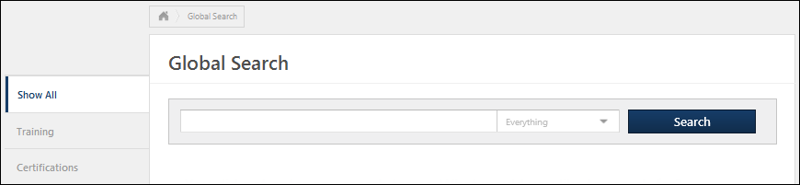
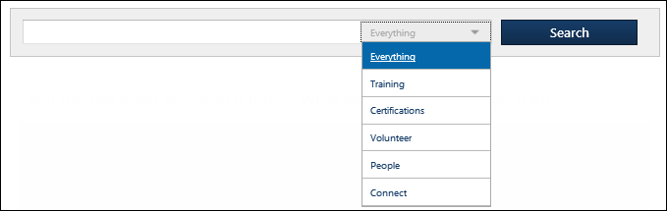
Conduct a Search
In the Search field, enter the appropriate search terms. If appropriate, you may filter your search results by selecting a search type from the drop-down list. Then, select Search. Note: When a search type is selected from the drop-down list, up to 400 search results are displayed. The results are sorted based on a formula that determines the relevance of the search terms to each item. Relevance is determined by how many times a specific keyword is being mentioned with an item. For example, relevance for a learning object (LO) is determined by Title, Description, Keywords, etc.
To narrow your search, select the appropriate filters in the Refine your search section. If Training is selected as the search type, then there are Training Type filters available on the left navigation to filter the results by training type.
- People - When an individual is selected in the Search results, the system directs you to the Universal Profile of the corresponding user. See Universal Profile - Bio Overview.
- Training - When a training item is selected in the Search results, the system directs you to the Training Details page. See Learning Details Page (Early Adopter).
- Connect - When a Connect posting is selected in the Search results, the system directs you to the posting page.
- Certification - When a certification is selected in the Search results, the system directs you to the Certification Details page.
- Form - When a form task is selected in the Search results, the system directs you to the Training Details page.
Note: The Search Type drop-down list is only available if more than one search type is enabled for the user.
Note: When searching for a person by first and last name, always enter the first name prior to the last name. This applies when using the People search or when searching for training by instructor, curriculum owner, etc.
Scenarios
Scenario 1: No search term is entered and the Search button is selected.
- If Everything is selected from the Search Type drop-down list, then no results are returned.
- If a specific search type is selected from the Search Type drop-down list (e.g., People, Training), then all available results are displayed based on the user's constraints. For example, if Training is selected, then all catalog results that are available to the user are returned in the search results.
Scenario 2: A search term is entered and the Search button is selected.
- If Everything is selected from the Search Type drop-down list, then the search returns results from all available search types. The results are separated by search type. Up to five search results are displayed within each search type. The user can select the Search Type filter links on the left panel to view only results for a specific search type (e.g., Training, People).
  - If there are more than five results within a search type, a Show More button is available. Select the button to display more results for the search type.
  - If there are no matches in any search type, then no search results are displayed.
  - If there are no matches within a search type, then that search type category is not displayed.
- If Training is selected from the Search Type drop-down list, then the search returns all available matching results from the Training search type based on the user's constraints.
  - The user can use the Training Type filters on the left navigation to filter the results by training type. When a filter is selected, the search results are automatically updated. If the filters are either all selected or all deselected, then all search results are displayed in both scenarios.
  - The user can use the options within the Refine your search section to narrow the search results. After entering the additional criteria, select the Refine button again to update the search results.
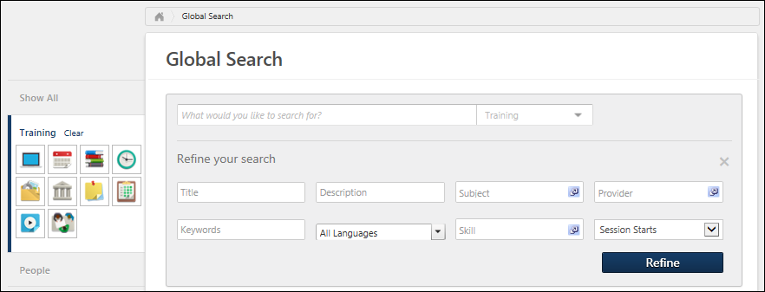
- If Training is using Enhanced Search as default search option, the Title, Keywords, and Description filters are combined into one text field to enter search queries. To use the Title, Keywords, and Description filters independently, enable Traditional Search. The rest of the filters in Global Search (Training) remain unchanged and require no further action from the administrator to be able to use them. See Search Preferences - Training on page 7 for additional information. Note: The Traditional Search for Global Search (Training) will be deprecated in November 2024. To know more, See Global Search (Training) - Deprecation of Traditional Search with the November 2024 Release.
- If People is selected from the Search Type drop-down list, then the search returns all available matching results from the People search type based on the user's constraints.
  - The user can use the options within the Refine your search section to narrow the search results. After entering the additional criteria, select the Refine button again to update the search results.
- If Connect is selected from the Search Type drop-down list, then the search returns all available matching results from the Connect search type based on the user's availability. Note: The availability for a posting is determined by the availability settings of the topic to which the posting is associated.
  - The user can use the Posting Type filters on the left navigation to filter the results by posting type. When a filter is selected, the search results are automatically updated. If the filters are either all selected or all deselected, then all search results are displayed in both scenarios.
  - The user can use the options within the Refine your search section to narrow the search results. After entering the additional criteria, select the Refine button again to update the search results.
  - Connect posting results are ranked by relevancy. Relevancy for postings places the most importance on whether the matching posting is a featured posting. Next, importance is placed on posting title, body, and parent topics.
- If Certifications is selected from the Search Type drop-down list, then the search returns all available matching certifications.
  - Certification results are ranked by relevancy. Relevancy for certifications places the most importance on the title. Next, family and category are given equal importance. Finally, description holds the least importance.
  - The user can use the options within the Refine your search section to narrow the search results. After entering the additional criteria, select the Refine button again to update the search results.
- If Form is selected from the Search Type drop-down list, then the search returns all available matching forms.
  - The user can use the options within the Refine your search section to narrow the search results. After entering the additional criteria, select the Refine button again to update the search results.
  - When searching for forms in Global Search, users can launch the form directly from the Training Details page. Once the form is completed, the user can submit the form by selecting the Submit button.
  - If the user does not meet the availability criteria for the form, then a Restricted Access page displays. Users cannot launch forms for which they do not meet the availability criteria defined by the administrator.
  - The following criteria must be met in order for forms to be available in Global Search:
    - Search Preferences must be configured to allow forms to be searched in Global Search. See Search Preferences - General on page 4 for additional information.
    - The form must be created using the new Form Management functionality.
    - The form must be active. See Create Form - Build Tab - Define General Information.
    - The form must be enabled for self service. See Self Service Form Submissions - Configure Availability.
    - The user must meet the availability criteria for the self service functionality configured for the form. See Self Service Form Submissions - Configure Availability.

Learning Search vs. Traditional Search
When searching for training content, there may be a difference in search result behavior when searching via Learning Search and when searching via Traditional Search. Users may notice a varying number of results returned, as well as a different order of search results for the same search query.
This behavior is due to Learning Search and Global Search being powered by different search engines. These search tools are separate and behave differently.
- Learning Search: Learning Search is powered by Cornerstone’s newest search engine. This engine indexes and intelligently surfaces training based on several variables, powered by the user’s search string. It is designed to surface relevant training in an expeditious manner.
- Traditional Search: Traditional Search is powered by Cornerstone's original search engine. This engine contains a predetermined ranking model which recommends training based on a combination of title, description, and other matches also driven by the user’s search string. Traditional Search returns predictive results as the user types, which is powered by the engine of Learning Search.
Predictive search results are displayed as a user is typing a search in both Learning Search and Traditional Search pages, and results are displayed before the search is executed. Predictive search only uses the title and description fields to show possible results.
Content Ranking
Each search engine carries its own ranking protocol which may cause results to return in a different order.
Search Type | Ranking Behavior
Learning Search | If the search text is present in more than one of the above training fields, the score is aggregated. The ordering of results is determined by the total score.  The following weights are applied for a match within the title, description, or keywords:  - Title: 1,000  - Description: 2  - Keywords: 1  Learning Search presents full-text features such as instant search, fuzzy search, text splitting, text stemming, and more.  Tokenizing of terms is based on whitespacing and special characters. Therefore, a phrase like "Compliance 2.0" would become searchable in terms of "Compliance," "2," and "0" for an end user.  Learning Search applies availability to search results.  Another example involving special characters in a search term could include dashes. An example search term of "LMS-Compliance-2023" would be broken down into "LMS", "Compliance", and "2023". In this case, any training that has either "LMS", "Compliance", or "2023" in the Title, Description, or Keyword would be included in the results (See search weighting above). However, any training with an exact title match would be listed at the top. See Learning Search.
Traditional Search | - Contains the following logic: Starts With, Inflections, Locale-Based. See Global Search Logic on page 47 for additional information.  - Global Search applies availability to search results
Filters Availability
Filters are available for both Learning Search and Global Search. Many of the most used filters are present in both areas, but there are some differences. See the table below for the filters available in each search area.
Filter Type | Learning Search | Traditional Search
Subject | X | X
Provider | X | X
Type | X | X
Languages | X | X
Course Rating | X | X
Duration | X
Mobile-enabled | X
Title |  | X
Description |  | X
Keywords | X | X
Custom Fields |  | X
Subscription | X | X
Suggestions
- Begin with the search bar on the Learner Home page, which is fueled by Learning Search. Although Traditional Search is also an intelligent search engine, users may not find it as valuable when searching for training.
- It may make sense to choose your search tool based on the filters you wish to use if the desired filters are not available in one of the search tools. See the table above to help make your search tool choice if certain filters are necessary.

Global Search Logic
The following search logic behaviors apply to Global Search when traditional search is enabled:
- Contains "starts with" logic, meaning the search text "work" will yield results for "workplace" and "working," but "homework" and "framework" will not be returned in search results.
- Contains inflectional logic, meaning the search text "foot" will be relevant to a training item called "Feet."
- Contains "locale-based" logic, meaning the search string "sugar-free" in English will be evaluated as any of the following combinations: "sugarfree," "sugar," and "free," or "sugar-free." However, in another language, such as Chinese, in which hyphens have no literal significance, the search string "sugar-free" will only be evaluated as "sugar-free" as a fixed string.
- Contains field relevance logic, meaning different fields have different relevancy, which leads to differences in result ranking. For example, the word "work" will have higher ranking when it appears in training title than training type. The order of relevancy is:
  - Training title
  - Training type
  - Material type
  - Competency
  - Subject
  - Keywords (Search results are returned for up to 38 characters per keyword)
  - Locator
  - Skill
  - Provider name
  - Description
  - Location
  - Instructor name
  - Curriculum owner
Note: In addition, the number of occurrences of the keyword will further influence the search ranking. For example, a training titled "Work work work" will have higher ranking than "Work Ethic," when a user searches for "work." The results ranking is a combination of all searching and ranking logic.
Global Search Predictive Results
- Global Search predictive search does not respect the Available for searching by learning object type preference setting. Predictive search is governed by availability.
  - For example, even if the Material training type is disabled as a searchable type in Global Search, predictive results may contain materials, due to availability settings.
- Predictive search results are displayed as a user is typing a search in both Learning Search and Traditional Search pages, and results are displayed before the search is executed. Predictive search only uses the title and description fields to show possible results.
Deprecation Note: The Global Search Traditional Search Preference will be removed from user interface by July 2024 release. Administrators can no longer configure Traditional Search in their portal. No changes are made to customer settings. By November 2024, the Traditional Search for Global Search (Training) will be permanently deprecated. After the deprecation, administrators can no longer transition the Global Search (Training) page back to Traditional Search (SQL) using Search Preferences. To know more, See Global Search (Training) - Deprecation of Traditional Search with the November 2024 Release.

