Screening March 2024

Table of Contents
Screening Overview 1
Add or Move to Requisition Overview 2
Reference Letter Requests Overview 3
Reference Letter Form for References 4
Complete Reference Letter Request Task 6
Reference Letter Request - Pending/Completed Tasks 8
Applicant and Application Flags Overview 9
Manage Applicant Flag Bank Overview 10
Applicant Flags Preferences 13
Applicant Flags Preferences - Add Flag 17
Manage Applicant Flag Bank - Create Flag 19
Applicant Flags Preferences - Define Flag Visibility 21
Applicant Feed Page 24
Manage Applicant Statuses 28
Define Default Status List 31
Add Default Status 34
Create Custom Applicant Status at Top OU Level 35
Add Custom Applicant Status at Child OU Level 40
Candidate Search Query Overview 42
Additional Criteria Options 45
Advanced Search - Search Results Criteria Panel 51
Advanced Search Tab 54
Candidate Search Query Results - Actions 62
Quick Search - Search Results Criteria Panel 69
Quick Search Tab 75
Saved Searches 84
Search Results Details 88
Recruiting Dashboards Overview 93
Hiring Dashboard Page - Overview 94
Recruiting Dashboard Page 129
Recruiting Manager Dashboard Page 140
LinkedIn Recruiter System Connect - Overview 151
LinkedIn Recruiter System Connect - Overview 154
Applicant Profile - LinkedIn Recruiter System Connect 157
Enable LinkedIn Recruiter System Connect 158
Frequently Asked Questions - LinkedIn Recruiter System Connect 159
LinkedIn Experience 160
Manage Candidates Overview 163
Candidates Page 168
Manage Candidates - Candidate Skills Match 186
Manage Candidates - Feedback Requests 194
Manage Candidates - Add/Move to Requisition 205
Manage Candidates - Assign Forms 209
Manage Candidates - Assign Integrations 210
Manage Candidates - Assign On-Demand Video Interview 213
Manage Candidates - Change Status 215
Manage Candidates - Invite to Event 220
Manage Candidates - Manage Email Templates 222
Manage Candidates - Manage Flags 224
Manage Candidates - Request Reference Letters 226
Manage Candidates - Schedule Live Video Interview 229
Manage Candidates - Send Email Overview 232
Manage Candidates - View Profile 240
Search Candidates - Overview 246
Search for Candidates 249
Search Candidates - Actions 258
Search Candidates - Search Results 263

Screening Overview

Add or Move to Requisition Overview

Reference Letter Requests Overview

Reference Letter Form for References
When applicants complete the Reference Letter Request task, their references fill out the reference letter form that was selected by the recruiter when assigning the task.
To access the form, the applicant's references click the form link in the Reference Letter Request email, provided that the email is configured and active in Email Administration.
Note: The email that is sent to references is not sent to the applicant.
Emails
EMAIL NAME | EMAIL DESCRIPTION | ACTION TYPE

Reference Letter Request (to external references) | This email is triggered when the Reference Letter Request task is completed by an applicant in order to send a reference letter request to the external references.  When configuring this email, the email must contain the FORM.LINK tag. If the tag is not included, then referrers will not have a link in the email that opens the reference letter form from which the referrer completes and submits their reference letter. Note: The link to the reference letter form is only valid for the current applicant and cannot be reused or resubmitted for a different applicant.  The email can be sent to External Reference, Hiring Manager, Requisition Owner(s), Requisition Reviewer(s), or a specific user. When configuring this email, the External Reference email recipient must be selected. If this recipient is not selected, then the email will not be sent to the referrer.  This email can be configured as a Notification or Reminder type email. This email is active by default and can be found in the Recruitment action type section of Email Administration.  Use Case: Use this trigger to notify referrers that a reference letter has been requested of them. Reminders can also be set for this email to remind referrers to complete and submit a reference letter for the applicant. | Recruiting
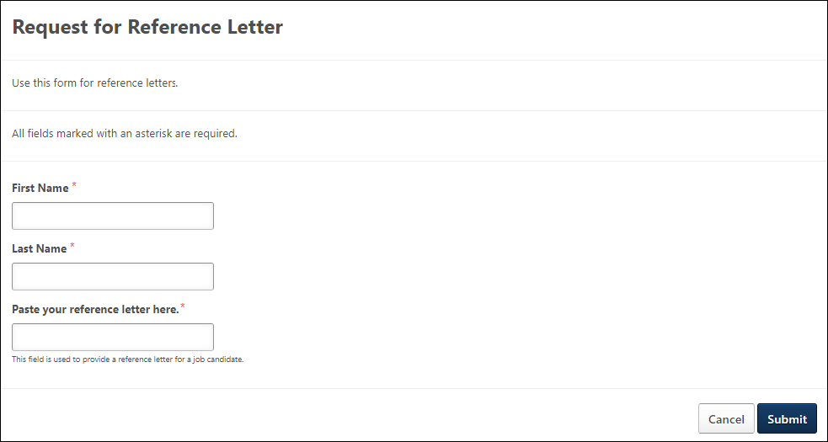
Launch & Submit Reference Letter
The following is the workflow for completing reference letter requests:
- The reference clicks the form link in the email. This opens the form that the recruiter selected when assigning the reference letter task. Note: Forms are created in Form Management. See Create Form Overview.
- The reference fills out the form, including any required field.
- The reference clicks Submit. Or, the reference can click Cancel on the form to cancel creating the reference letter.
- Once submitted, t confirmation message appears, indicating the form was submitted successfully.
- The form is automatically added to the Documents tab on the Applicant Profile page for the applicant.
- The Reference Form Completed email is triggered, if configured and active in Email Administration.
Link Validity and Expiration
The link to the form in the Reference Letter Request email is only valid for the current applicant and cannot be reused or resubmitted for a different applicant.
The link expires within 30 days of the date on which the Reference Letter Request email is sent.

Complete Reference Letter Request Task
The Reference Letter Request page is where applicants complete the Reference Letter Request task. Here, they will enter the contact information for each reference and submit the task.
Applicants access this page by launching the task from the My Profile page. See Reference Letter Request - Pending/Completed Tasks on page 8 for additional information.
Recruiter Note: The fields and instructions on the Reference Letter Request page are hard-coded and cannot be modified by the administrator or recruiter.
Emails
EMAIL NAME | EMAIL DESCRIPTION | ACTION TYPE

Reference Letter Request (to external references) | This email is triggered when the Reference Letter Request task is completed by an applicant in order to send a reference letter request to the external references.  When configuring this email, the email must contain the FORM.LINK tag. If the tag is not included, then referrers will not have a link in the email that opens the reference letter form from which the referrer completes and submits their reference letter. Note: The link to the reference letter form is only valid for the current applicant and cannot be reused or resubmitted for a different applicant.  The email can be sent to External Reference, Hiring Manager, Requisition Owner(s), Requisition Reviewer(s), or a specific user. When configuring this email, the External Reference email recipient must be selected. If this recipient is not selected, then the email will not be sent to the referrer.  This email can be configured as a Notification or Reminder type email. This email is active by default and can be found in the Recruitment action type section of Email Administration.  Use Case: Use this trigger to notify referrers that a reference letter has been requested of them. Reminders can also be set for this email to remind referrers to complete and submit a reference letter for the applicant. | Recruiting
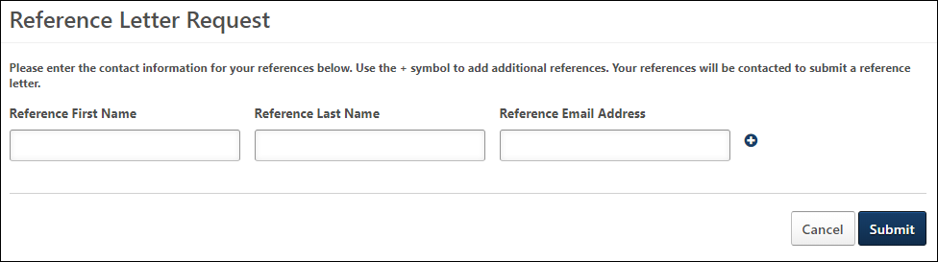
To complete the task:
- Click Launch from the pending task on the My Profile page.
- Enter the name and email address of the reference. Each field accepts up to 100 characters. At least one reference must be provided.
- Add up to four additional references by selecting the Add Reference icon . References can be removed by selecting the Remove Reference icon .
- Click Submit.
Once the references are submitted, the Reference Letter Request email is sent to the references, provided the email is configured and active in Email Administration. The task changes to Completed on the applicant's profile page. The reference cannot be modified once submitted.
Selecting Cancel returns the applicant to their My Profile page, and the task remains in a Pending status.

Reference Letter Request - Pending/Completed Tasks
When applicants are assigned the Reference Letter Request task, the task is added to the applicant's My Tasks panel as a pending task.
For external applicants, the task is launched from the My Profile page on the career site. For internal applicants, the task is launched from the My Profile page on the internal career site or the Applications tab in the legacy Career Center.
Note: If an external applicant has not yet created a profile, they can click the Create a Profile link in the upper-right corner of any page in the career site.
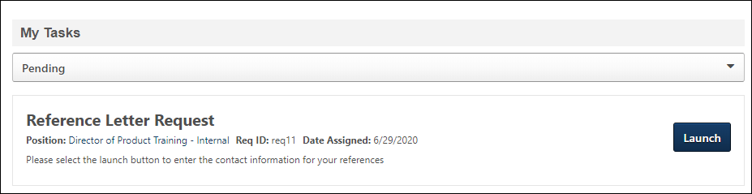
Reference Letter Request - Pending Task
Pending Reference Letter Request tasks display in Pending tasks. Applicants can view a task by clicking Launch, which opens the Reference Letter Request page where applicants can complete the task.
The panel shows the date on which the task was assigned, as well as the name of the job to which the task applies. The requisition ID also displays.
Note: The instructional text that appears below the task name, position, requisition ID, and assigned date are system-defined and cannot be modified by the administrator or recruiter.
Reference Letter Request - Completed Task
Once the Reference Letter Request task is completed or the applicant is placed into a disposition that automatically completes the task, the task appears in Completed tasks.
The panel shows the assigned and completed dates, as well as the name of the job to which the task applied.
Select View Details to view the completed task. This opens the Reference Letter Request page as read-only. Click OK to return to the profile page.

Applicant and Application Flags Overview

Manage Applicant Flag Bank Overview
The Applicant Flag Bank enables administrators to create and manage a master list of applicant flags, which can be applied to applicants and applications. From this page, administrators can create an unlimited number of flags, define the flag color, and permanently remove flags. Flags cannot be created, deleted, or edited from any other page in the Applicant Tracking System (ATS).
To access the Applicant Flag Bank, click the Manage Applicant Flag Bank link from the Applicant Flags Preferences page. The Applicant Flag Bank can only be accessed at the top level organizational unit.
Permissions
PERMISSION NAME | PERMISSION DESCRIPTION | CATEGORY

Applicant Flags Preferences - Manage | Grants ability to access and manage Applicant Flags Preferences. This permission cannot be constrained. | Recruiting Administration
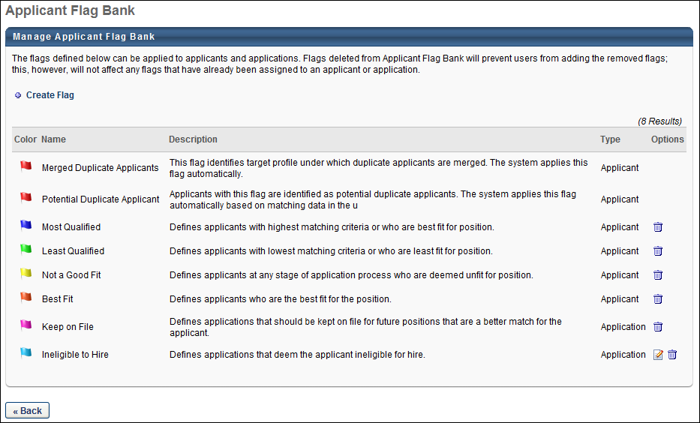
Create Flag
Click this link to create a new applicant or application flag. See Manage Applicant Flag Bank - Create Flag on page 19 for additional information.
Applicant Flag Bank Table
The following information displays for each flag:
- Color - This column displays the flag in the color defined for the flag.
- Name - This column displays the name of the flag. This column is sortable. For portals with multiple languages enabled, the field displays in the viewing administrator's language, if available.
- Description - This column displays the description of the flag. For descriptions that are longer than the space allows, hover over the description to display a tooltip with the full text. For portals with multiple languages enabled, the field displays in the viewing administrator's language, if available.
- Type - This column displays the flag type, either Applicant or Application.
- Options - The following options are available in the Options column:
  - Edit - Click the Edit icon to edit the flag's settings. See Manage Applicant Flag Bank - Create Flag on page 19 for additional information.
  - Delete - Click the Delete icon to remove the flag. This opens a confirmation pop-up. Click Yes to permanently delete the flag, or click No to cancel the removal action. Deleting a flag does not affect applicants or applications with which the flag is currently associated.
Click Back to return the Applicant Flags Preferences page.
Potential Duplicate Applicant Flag
The Potential Duplicate Applicant flag is a system-defined flag. This flag is available at the top level organizational unit in the Applicant Flag Bank. The color, name, description, and flag type are predefined and cannot be modified. The flag displays in the Applicant Flag Bank regardless of the duplicate applicant preference settings in Requisition and Applicant Preferences.
The following attributes are assigned to the Potential Duplicate Applicant flag:
Color | Name | Description | Type | Availability | Options
Bright Red (ff000) | Potential Duplicate Applicant | Applicants with this flag are identified as potential duplicate applicants. The system applies this flag automatically based on matching data in the user record fields. | Applicant | Always available | None; flag cannot be edited or removed
For portals with multiple languages enabled, the flag name, type, and description are localized.
Best Practice: If a red applicant flag has already been created for the portal, then it is a best practice to change the color of the existing flag if enabling the duplicate applicant feature. This allows recruiters to identify duplicate applicants quicker if only one flag in the system is red.
Merge Duplicate Applicants Flag
The Merged Duplicate Applicants flag is system defined and cannot be edited or removed. The flag color, name, description, and type are also system defined and cannot be modified. This flag is always available in the Applicant Flag Bank. This flag does display in the Add Flag pop-up.
The following attributes are assigned to the Merged Duplicate Applicants flag:
Color | Name | Description | Type | Availability | Options
Dark Red (33000) | Merged Duplicate Applicants | This flag identifies target profile under which duplicate applicants are merged. The system applies this flag automatically. | Applicant | Always available | None; flag cannot be edited or removed

Applicant Flags Preferences
Applicant Flags Preferences enables administrators to create and manage applicant and application flags. Administrators create flags in the Applicant Flag Bank, and then add them to the Applicant Flag Preferences page and define the flag's visibility settings.
To access Applicant Flags Preferences, go to go to Admin > Tools > Recruit > Applicant Flags.
Permissions
PERMISSION NAME | PERMISSION DESCRIPTION | CATEGORY

Applicant Flags Preferences - Manage | Grants ability to access and manage Applicant Flags Preferences. This permission cannot be constrained. | Recruiting Administration
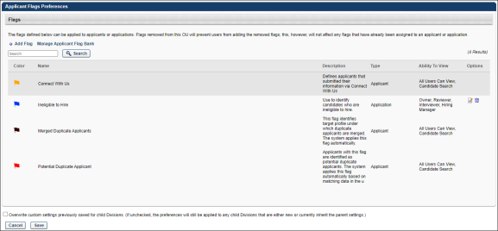
Add Flag
Click this link to add flags to the Applicant Flags Preferences page. Flags must first be created in the Applicant Flag Bank in order to be available to add to the Applicant Flags Preferences page. See Applicant Flags Preferences - Add Flag on page 17 for additional information.
Note: When adding flags from the Applicant Flag Bank, the Potential Duplicate Applicant flag cannot be added manually to the Flags table. The flag is a default flag that appears automatically in Applicant Flags Preferences.
Manage Applicant Flag Bank
Click this link to open the Manage Applicant Flag Bank. See Manage Applicant Flag Bank Overview on page 10 for additional information.
Note: The Applicant Flag Bank is only available to administrators in the top level organizational unit (OU). The link does not display for administrators in child OUs.
Flags Table
The following information displays in the Flags table for each flag:
- Color - This column displays the flag in the color defined for the flag.
- Name - This column displays the name of the flag. By default, the Flags table is sorted alphabetically by flag name. This column is sortable. For portals with multiple languages enabled, the field displays in the viewing administrator's language, if available.
- Description - This column displays the description of the flag. For descriptions that are longer than the space allows, hover over the description to display a tooltip with the full text. For portals with multiple languages enabled, the field displays in the viewing administrator's language, if available.
- Type - This column displays the flag type, either Applicant or Application.
- Ability To View - This column displays who can view the flag. If there are no users currently defined, then "Not defined. Click Edit to define visibility" displays. See Applicant Flags Preferences - Define Flag Visibility on page 21 for additional information. The following are the possible viewers:
  - All Users in the associated OU
  - Hiring Manager
  - Interviewer
  - Requisition Owner
  - Requisition Reviewer
- Options - The following options are available in the Options column:
  - Edit - Click the Edit icon to edit the flag's visibility. See Applicant Flags Preferences - Define Flag Visibility on page 21 for additional information.
  - Remove - Click the Trash Can icon to remove the flag. Removed flags are no longer available for use for the associated OU and are removed from applicants for whom the flag is currently designated.
Flags can also be deleted from the Flags table within the Select Flag pop-up by clicking the Trash Can icon in the Remove column.
Default Flags
The following are the system-defined default flags:
Connect With Us
The Connect With Us flag is system defined and cannot be edited or removed. This flag indicates that an applicant has applied via Connect With Us. The flag color is orange.
Color | Name | Description | Type | Ability to View | Options
Yellow | Connect With Us | Indicates that an applicant has applied via Connect With Us. | Applicant | All users can view, Candidate Search | None; visibility settings cannot be edited; flag cannot be removed
The Connect With Us flag displays in the following areas of the Applicant Tracking System (ATS):
- Applicant Profile > Snapshot
- Candidate Search Query
- Manage Applicants
- Resume/CV Page
Potential Duplicate Applicant Flag
The Potential Duplicate Applicant flag is a system defined flag. This flag is available to the top level organizational unit in Applicant Flags Preferences and automatically displays in the Flags table. This flag is an Applicant flag type and cannot be edited or removed. The visibility settings are predefined and cannot be modified. The flag displays in Applicant Flags Preferences regardless of the duplicate applicant preference settings in Requisition and Applicant Preferences.
The following attributes are assigned to the Potential Duplicate Applicant flag:
Color | Name | Description | Type | Ability to View | Options
Bright Red (ff000) | Potential Duplicate Applicant | Applicants with this flag are identified as potential duplicate applicants. The system applies this flag automatically based on matching data in the user record fields. | Applicant | All users can view, Candidate Search | None; visibility settings cannot be edited; flag cannot be removed
For portals with multiple languages enabled, the flag name, type, description, and visibility settings are localized.
Merge Duplicate Applicants Flag
The Merged Duplicate Applicants flag is system defined and cannot be edited or removed. The flag color, name, description, and type are also system defined and cannot be modified. This flag is always available on the Applicant Flags Preferences page.
The following attributes are assigned to the Merged Duplicate Applicants flag:
Color | Name | Description | Type | Ability to View | Options
Dark Red (33000) | Merged Duplicate Applicants | This flag identifies target profile under which duplicate applicants are merged. The system applies this flag automatically. | Applicant | All users can view, Candidate Search | None; visibility settings cannot be edited; flag cannot be removed
Overwrite Settings
Select this option to overwrite custom settings for child division OUs. If you overwrite custom settings for child division OUs, the selected settings are applied to both new and existing child OUs. Any previously customized child OUs are updated with the selected settings.
- If there are no customizations to the child OU, then the parent OU customizations are applied to all child OUs.
- Overwrite custom settings checkbox setting
  - If this option is selected, all child OU customizations are deleted from the database, which means the parent OU customizations will be applied to new and existing child OUs.
  - If this option is unselected, all existing child OU customizations will remain unchanged, and any new child OUs will inherit the parent OU customizations by default.
- If a child OU has been customized to display any widgets, then regardless of the parent OU customizations, the child OU customizations are applied.
- If a child OU has been customized to hide all widgets, then parent OU customizations will take precedence and will be applied.
Save/Cancel
Click Save to save the preference settings. If Save is not clicked, then any modifications made to the preference settings are not committed.
Click Cancel to cancel changes to the page settings.

Applicant Flags Preferences - Add Flag
The Add Flag feature enables administrators to add applicant and application flags to the Applicant Flags Preferences page. Once flags are added, administrators define the visibility for each flag, which allows the flags to be used by users who are defined in the visibility settings.
Note: When adding flags from the Applicant Flag Bank, the Potential Duplicate Applicant flag cannot be added manually to the Flags table. The flag is a default flag that appears automatically in Applicant Flags Preferences. See Applicant Flags Preferences - Define Flag Visibility on page 21 for additional information.
To access Applicant Flags Preferences, go to go to Admin > Tools > Recruit > Applicant Flags.
Permissions
PERMISSION NAME | PERMISSION DESCRIPTION | CATEGORY

Applicant Flags Preferences - Manage | Grants ability to access and manage Applicant Flags Preferences. This permission cannot be constrained. | Recruiting Administration
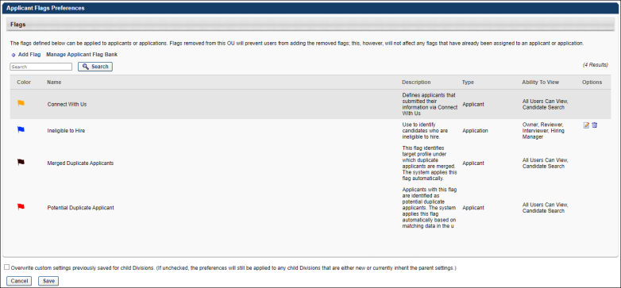
Add Flag
To add a flag:
- Click Add Flag on the Applicant Flags Preferences page. This opens the Select Flag pop-up.
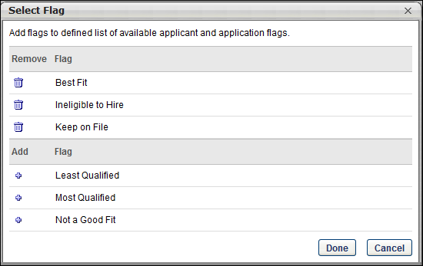
- Click the plus icon to the left of each flag you would like to add. This moves the flags into the selected flags table in the pop-up.
To remove a flag, click the trash can icon in the Remove column. This returns the flag to the bottom table. There is no limit to the number of flags that can be added.
- Click Done. This adds the flags to the Flags table on the Applicant Flags Preferences page.
- Click Save on the Applicant Flags Preferences page to save the settings.

Manage Applicant Flag Bank - Create Flag
Applicant and application flags are created from the Applicant Flag Bank. Flags created in the flag bank can be added to Applicant Flags Preferences and used by recruiters to categorize and organize applicants for various job requisitions.
To access the Applicant Flag Bank, click Manage Applicant Flag Bank from the Applicant Flags Preferences page. The Applicant Flag Bank can only be accessed at the top level organizational unit.
Permissions
PERMISSION NAME | PERMISSION DESCRIPTION | CATEGORY

Applicant Flags Preferences - Manage | Grants ability to access and manage Applicant Flags Preferences. This permission cannot be constrained. | Recruiting Administration
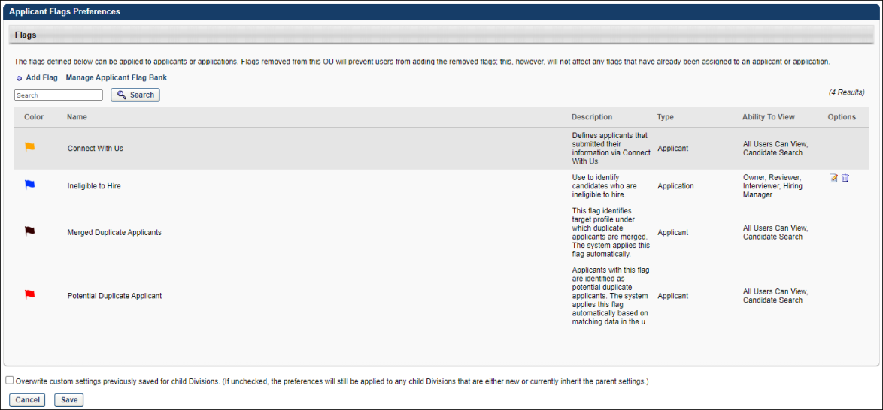
Create Flag
To create an applicant or application flag:
- Click the Create Flag link on the Manage Applicant Flag Bank page. This opens the Flag Preferences pop-up.
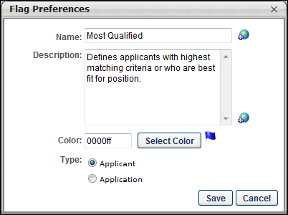
- Complete the following fields in the pop-up:
  - Name - This is a required field. Enter the flag name, up to 50 characters. If multiple languages are enabled for your portal, select the Translate icon to translate the field into other available languages. The flag name must be provided in the same language as the flag description.
  - Description - This is a required field. Enter a description for the flag, up to 500 characters. If multiple languages are enabled for your portal, select the Translate icon to translate the field into other available languages. The flag description must be provided in the same language as the flag name.
  - Color - This is a required field. Enter the hexadecimal (hex) value for the flag color, up to six characters. Or, click Select Color to choose a pre-defined hex color. Once the color is selected, the colored flag displays to the right of the Select Color button.
  - Type - This is a required field. Select one of the following flag types:
    - Applicant - Select this option to enable the flag to be defined for applicants. Applicant flags are added to applicants to highlight an applicant's skills, qualifications, etc.
    - Application - Select this option to enable the flag to be defined for applications. Application flags are added to an application for a particular requisition, such as a flag named "Short List" that highlights the application as a top contender for the position.
- Click Save to save the flag and add it to the Applicant Flag table. Or, click Cancel to close the pop-up without saving the flag.

Applicant Flags Preferences - Define Flag Visibility
The Edit option in the Options column on the Applicant Flags Preferences page allows administrators to define the flag's visibility. When visible, the flag can be used by the users who are defined in the visibility settings. For users who are not included in the visibility, the flag is not available to select when flagging applicants.
To access Applicant Flags Preferences, go to go to Admin > Tools > Recruit > Applicant Flags.
Permissions
PERMISSION NAME | PERMISSION DESCRIPTION | CATEGORY

Applicant Flags Preferences - Manage | Grants ability to access and manage Applicant Flags Preferences. This permission cannot be constrained. | Recruiting Administration

Applicants: Manage Flags | Grants ability to add and remove applicant (user) and application flags. This permission also grants ability to use applicant flags in Search Candidates. This permission cannot be constrained. | Recruiting
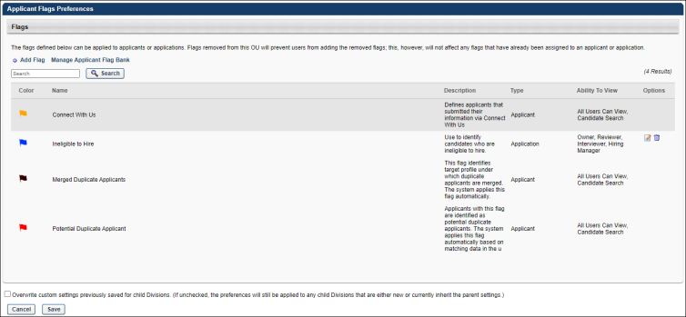
To define the flag's visibility:
- Click the Edit option in the Options column of the Flags table. This opens the Edit Visibility pop-up.
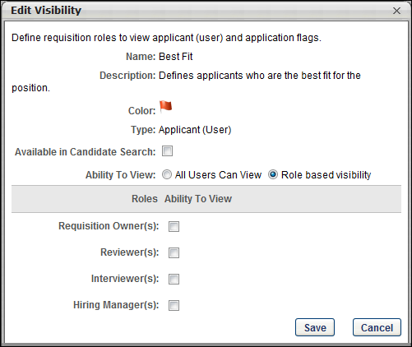
The following information displays in the upper portion of the pop-up and can only be edited from the Applicant Flag Bank:
  - Name - This field displays the name of the flag. For portals with multiple languages enabled, the field displays in the viewing administrator's language, if available.
  - Description - This field displays the description of the flag. For portals with multiple languages enabled, the field displays in the viewing administrator's language, if available.
  - Color - This field displays the flag in the color defined for the flag.
  - Type - This field displays the flag type, either Applicant or Application.
- Complete the following options in the pop-up:
  - Available in Candidate Search - Select this option to allow the users defined in the visibility settings to view the Applicant (User) Flags criteria option in the Search Candidates feature and select the flag as a search criterion. This option does not display for Application flag types.
  - Ability to View: All Users Can View - Select this option to provide access to the flag to all users in the associated organizational unit, rather than only users defined by a specific role. Selecting this option hides the options for the Role based visibility field.
  - Ability to View: Role based visibility - When this option is selected, administrators must enable visibility of the flag for at least one of the following roles by checking the box to the right of the role name:
    - Requisition Owner(s) - Enables visibility of the flag for requisition owners of the associated requisition.
    - Reviewer(s) - Enables visibility of the flag for requisition reviewers of the associated requisition.
    - Interviewer(s) - Enables visibility of the flag for interviewers defined for the associated requisition.
    - Hiring Manager(s) - Enables visibility of the flag for hiring managers defined for the associated requisition.
- Click Save to save the settings. Or, click Cancel to cancel the changes.
Note: The users defined in the visibility settings for a flag must also have permission to manage applicant flags in order to assign the flag to an applicant.
Note: The user viewing the candidate can only see and manage flags if Ability to view is checked for their role.
Note: Applicant Flags do not have role-based visibility because they are flags set on a user and not an application.
Note: The role-based visibility only applies to application flags, not to applicant flags.

Applicant Feed Page
The Applicant Feed page provides a single page view of an applicant's entire history of events and comments from the most recent 20 requisitions related to the applicant. This allows recruiters to only have to access one page in order to view this data.
Note: Recruiters will only have access to requisitions for which they have permission to view or for which they are the owner or hiring manager. The Applicant Feed page is not available for archived applicants.
To access the Applicant Feed, click the Applicant Feed icon from the Manage Applicants, Applicant Profile, or Candidate Search Query page.
Permissions
PERMISSION NAME | PERMISSION DESCRIPTION | CATEGORY

Requisition: Manage | Grants ability to access and manage all requisitions regardless of ownership (constraints permitting). This permission also grants read-only access to the Applicant Review tab when creating or editing a job requisition. This permission can be constrained by OU, User's OU, and Grade. | Recruiting

Requisition: Owner | Enables owner to access requisitions and applicants for requisitions for which they are an owner. This permission also grants read-only access to video interviews that are completed by applicants via HireVue. For portals with Referral Suite enabled, this permission also enables requisition owners to edit the referral source on the Applicant Profile page. This permission cannot be constrained.  Note: This is a dynamically assigned permission that is not available in Security Role Administration. If the user is removed as an owner, the permission is revoked for the associated requisition. This permission cannot be manually assigned. Also, if a user has both the permission necessary to manage requisitions and be a requisition owner, the constraints of the Requisition: Manage permission overrule those of the Requisition: Owner permission. For requisition owners that do not also have permission to manage requisitions, only certain fields are editable when editing a requisition. | Recruiting

Requisition: Reviewer | Enables reviewer to access requisitions and applicants for requisitions for which they are a reviewer. This permission cannot be constrained.  Note: This is a dynamically assigned permission that is not available in Security Role Administration. Once a requisition is in a Closed or Cancelled status or if the user is removed as a reviewer, the permission is revoked for the associated requisition. This permission cannot be manually assigned.  Note: If an applicant reviewer is removed as a reviewer via the Applicant Profile page, the Requisition: Reviewer permission is revoked for the associated requisition. However, if the reviewer was also added as a reviewer via the General tab when creating, editing, or copying the requisition, the reviewer still appears on the In Review panel as a duplicate reviewer and retains access to the requisition and applicants from the Requisition: Reviewer permission. See Applicant Profile Page Overview for more information about duplicate reviewer instances. | Recruiting
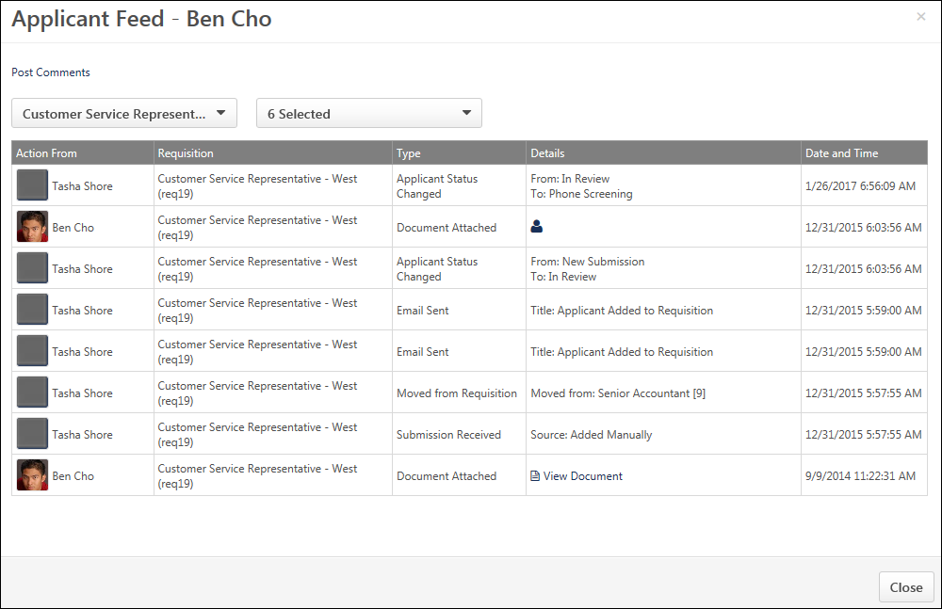
Post Comments
Click Post Comments to post a comment about the applicant. This enables the Add Comment box to appear.
You can enter your comment in the Add Comment box. You can also select a specific requisition to which to post the comment by selecting it from the requisition drop-down. Or, you can select an applicant's name so that the comment appears on all requisitions for that applicant.
Once you have finished your comment, click Post.
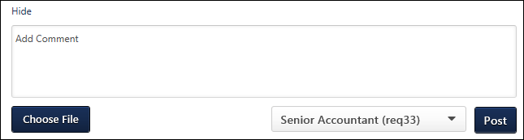
Once posted, the comment appears in the feed and displays the text of the comment in the Details box. The comment is also visible on the Applicant Profile > Comments tab.
You can delete comments you post on the applicant feed by clicking the Delete Comment icon in the Details column.
Requisition Filter
This filter lists the most recent 20 requisitions for the applicant. You can click any of the requisitions in the filter to view the applicant's history and comments for that requisition. Requisitions display in order of most to least recent open requisitions, then they display from most to least recently closed.
You can also click All Requisitions in the filter to view the applicant's history for all of the requisitions that are available.
When accessing the page, the Applicant Feed opens to the requisition that the recruiter was viewing in Manage Applicants.
Event Type Filter
This filter lists the types of events that can be viewed on the Applicant Feed. By default, all event types are checked in the filter.
The following event types are available:
- Attachments - Attachments can be viewed by clicking the associated attachment icon in the Details column. The attachment will open in the application in which it was originally attached.
- Comments - The comment displays in the Details column for users with permission to manage or view comments. Options to edit or delete the comment also display for the user who posted the comment.
  - Delete Comment - You can delete a comment that you posted. Click the Delete Comment icon to delete the comment. This removes the comment from all areas of the ATS.
- Emails & Notifications - For emails, the Type column displays "Email Sent," and the Details column displays the subject line. For notifications, the Type column displays the type of notification, such as "Interview Notification Sent to Applicant." The Details column displays the name of the notification, such as "Applicant Notification."
- Offer Letter - For offer letter events, the Type column displays the type of offer action, such as "Offer Sent to Candidate" or "Offer Accepted by Candidate." The Details column displays the version of the offer.
- Other Events -
- Status Activity - This event type is for status changes. The Type column displays "Applicant Status Changed," and the Details column indicates what the status was changed from and what it was changed to.
Actions Table
The following columns display in the table:
- Action From - This column displays the first and last name of the user who conducted the action.
- Requisition - This column displays the display job title of the requisition and the requisition ID.
- Type - This column displays the type of action.
- Details - This column displays the details for the action.
- Date and Time - This column displays the date and time on which the action occurred.
Comments do not display for archived applicants.

Manage Applicant Statuses
An applicant status is essentially a step in a workflow that an applicant goes through when being considered for a job. The Manage Applicant Statuses page enables administrators to define the master list of applicant statuses that are available for use in application workflows. This page displays all applicant statuses that are available in the portal, including the default statuses and the custom statuses that have been created by the administrator.
From this page, administrators can:
- View the complete list of default and custom statuses for the portal
- View the list of default statuses
- Rename default statuses
- Create custom statuses
To access Manage Applicant Statuses, go to Admin > Tools > Recruit > Applicant Statuses.
Permissions
PERMISSION NAME | PERMISSION DESCRIPTION | CATEGORY

Applicant Status Bank - Manage | Grants ability to access and manage Applicant Status Bank. | Recruiting Administration
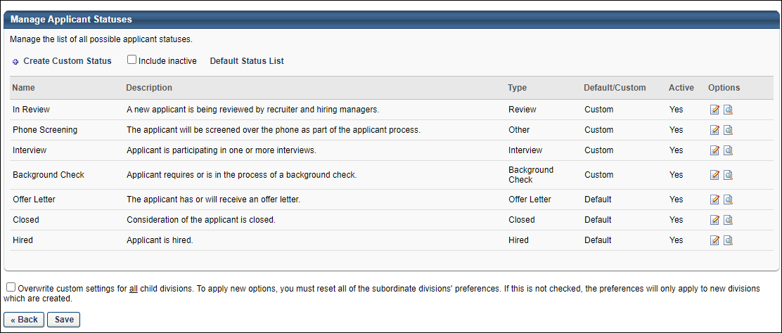
The functionality of an applicant status is determined by the status type defined for the status.
- For the default statuses, which are Closed, Hired, and Offer Letter, the status type is predefined by the system and cannot be modified. See the Default Statuses section below for more information.
- For custom statuses, the status type is defined when the status is created or modified. See the Custom Statuses section below for more information.
Defining a type for each applicant status enables administrators to control the functionality associated with each status and more effectively define the various steps of the application process. Some status types can be used multiple times, which allows administrators greater flexibility in defining the functionality associated with a status.
Note: The status types that are available to select for custom statuses are system-defined. New status types cannot be created.
Applicant Statuses by OU
Applicant statuses can be defined for each organizational unit (OU) or for the portal as a whole. Defining statuses by OU allows each OU to set the statuses that are relevant for their hiring process. This also prevents other OUs from using the statuses that are specific to another OU.
By default, a master applicant status list is created at the top OU level, including default and custom statuses. Administrators who create job requisitions and recruiters who change applicant statuses should only have access to the applicant statuses at their OU level so that the master applicant status list is only modified by top-level administrators.
When managing the applicant statuses at the child OU level, the statuses are initially an exact copy of the parent OU's statuses.
- All custom statuses may be deleted from the child OU status list, regardless of whether they are in use. Note: At the top OU level, custom statuses can only be deleted if they have never been used.
- At the child OU level, new custom applicant statuses cannot be created. Instead, administrators can only create custom statuses from the master list defined at the top level OU.
Create Custom Status
Click the link to add a custom applicant status. See Create Custom Applicant Status at Top OU Level on page 35 for additional information.
Include Inactive
Select this option to include inactive applicant statuses in the display.
Note: Inactivating an applicant status does not remove it from existing requisition templates and requisitions, but rather prevents it from being added moving forward. To prevent the status from appearing on future requisitions, the status needs to be removed from requisition templates where it is in use.
Default Status List
Click Default Status List to view and define the default list of statuses for the OU. See Define Default Status List on page 31 for additional information.
Manage Applicant Statuses Table
The following information displays for each status:
- Name - This column displays the names of default and custom applicant statuses. By default, statuses are listed in the order in which they are added. New statuses appear first.
- Description - This column displays the status descriptions that were defined during creation.
- Type - This column displays the status type defined for the status.
- Default/Custom - This column displays whether the applicant status is one of the default statuses or a custom status.
  - Default statuses are available by default and cannot be deleted but can be modified. Some default statuses have specific preferences and functionality associated with them. When a default status is modified, these additional options can be configured. See Default Statuses below for additional information.
- Active - This column displays whether or not the status is active. All custom status can be activated or inactivated when the status is created or when editing the status. Note: Inactivating an applicant status does not remove it from existing requisition templates and requisitions, but rather prevents it from being added moving forward. To prevent the status from appearing on future requisitions, the status needs to be removed from requisition templates where it is in use.
- Options - The following options are available in the Options column:
  - Edit - Click this icon to edit the details of the applicant status. If a status is currently in use, any modifications are applied to all requisitions, requisition templates, and applicants to which the status applies. For default statuses, the display name can be edited but the status type cannot be changed.
  - History - Click this icon to view the modification history of the status, including the creation and any modifications to the status.
  - Remove - Click this icon to delete the status. This option is only available for custom statuses that are not being used in status workflow templates or job requisition status workflows. Default statuses cannot be deleted.
Back/Save
Click Back to return to the OU selection page for managing applicant status.
Click Save to save the changes to the Overwrite custom settings option.
Overwrite Settings
Select this option to overwrite custom settings for child division OUs. If you overwrite custom settings for child division OUs, the selected settings are applied to both new and existing child OUs. Any previously customized child OUs are updated with the selected settings.
- If there are no customizations to the child OU, then the parent OU customizations are applied to all child OUs.
- Overwrite custom settings checkbox setting
  - If this option is selected, all child OU customizations are deleted from the database, which means the parent OU customizations will be applied to new and existing child OUs.
  - If this option is unselected, all existing child OU customizations will remain unchanged, and any new child OUs will inherit the parent OU customizations by default.
- If a child OU has been customized to display any widgets, then regardless of the parent OU customizations, the child OU customizations are applied.
- If a child OU has been customized to hide all widgets, then parent OU customizations will take precedence and will be applied.

Define Default Status List
The Define Default Status List page enables administrators to configure the default statuses by organizational unit (OU), in turn defining a default applicant status workflow. A default status list can be configured for any OU level. The default list populates the Status section of a job requisition template unless the template has a custom status list. On the Default Status List page, administrators can add and remove statuses from the list, reorder the status list, and make statuses required or optional.
The following are the default statuses and their associated status type:
- Offer Letter - This status is used when an applicant has or is set to receive an offer letter. The status type is Offer Letter by default and cannot be changed. When this status is selected on the applicant profile, additional functionality is available. This status can be inactivated, and an Active option displays on the Edit Status pop-up.
- Closed - This status is used when consideration of the applicant is closed. The status type is Closed by default and cannot be changed. When this status is selected on the applicant profile, additional functionality is available. This status cannot be inactivated, and an Active option does not display on the Edit Status pop-up.
- Hired - This status is used when the applicant is hired. The status type is Hired by default and cannot be changed. When this status is selected on the applicant profile, additional functionality is available. This status cannot be inactivated, and an Active option does not display on the Edit Status pop-up.
When a default status is edited, the default name appears in the Edit Status pop-up and cannot be modified. However, the display name can be modified. See Create Custom Applicant Status at Top OU Level on page 35 for additional information.
To access the default status list, go to Admin > Tools > Recruit > Applicant Statuses. Then click the Default Status List link.
Permissions
PERMISSION NAME | PERMISSION DESCRIPTION | CATEGORY

Applicant Status Bank - Manage | Grants ability to access and manage Applicant Status Bank. | Recruiting Administration
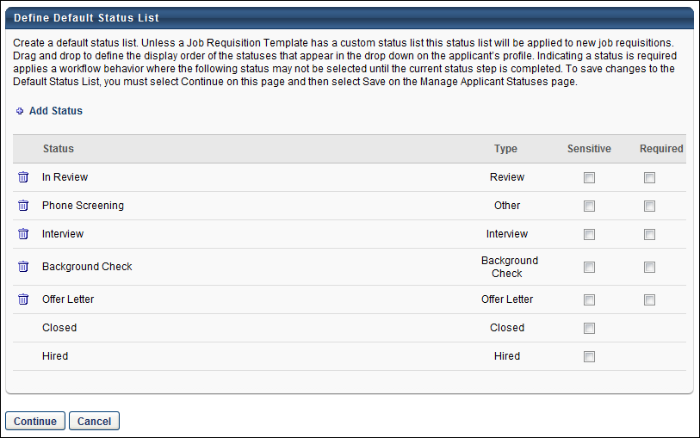
Add Status
To add an applicant status to the default status list, click the Add Status link. See Add Default Status for additional information.
Reorder Statuses
The Status table displays all of the statuses in the default status list. The order in which they appear in the list is the order in which the default statuses appear on the Applicant Profile page. To reorder the statuses, drag and drop the statuses into the desired order and click Save to save the changes.Note: The position of the Closed and Hired statuses cannot be reordered.
Type
The Type column displays the status type. For custom statuses, the status type is defined when creating or modifying the status. For default statuses, the status type is system-defined and cannot be modified.
Remove Status
To remove a status from the list, click the Trash Can icon to the left of the status name. Note: The Closed and Hired statuses cannot be removed.
Designate Status as Sensitive
To designate a status as sensitive, select the Sensitive option for the status. By default, there are no statuses marked as sensitive, including the Offer Letter status.
If a status is marked as sensitive in Manage Applicant Statuses, then the status appears as sensitive when configuring a requisition template. The Sensitive option can be unchecked at the template level but cannot be changed at any other point in the application process.
Checking or unchecking the Sensitive box does not affect existing requisition templates.
During the application process, sensitive statuses can only be accessed by users with permission to view sensitive statuses. The corresponding status panel on the Applicant Profile page is visible to the user but is not expandable. Note: For users that do not have permission to view sensitive statuses, the expand/collapse arrow does not appear for sensitive statuses on the Applicant Profile page.
First Advantage Integrations
For portals with First Advantage enabled for background checks, if the custom FADV custom applicant status is part of the default status list, then the status must be configured as sensitive in order to restrict access to the status.
Designate Status as Required
To make a status required by default, select the Required option for the status. When the Required option is selected for a status on this page, the status is required by default when creating a Job Requisition template. The administrator can change the Required value at the template level if necessary. Note: The Closed and Hired statuses cannot be designated as required.
Continue/Cancel
Click Continue to implement any changes made on the Default Status List page, including any changes to the order of the statuses, required statuses, additional statuses, or removed statuses.
Click Cancel to disregard any changes made on the Default Status List page, including any changes to the order of the statuses, required statuses, added statuses, or removed statuses.

Add Default Status
To add a default status to the default status list, on the Default Status List page, click the Add Status link. The Select Default Statuses pop-up appears.
In the upper portion of the pop-up, all of the statuses that are currently in the default status list are displayed.
- To remove a status from the default status list, in the upper portion of the pop-up, click the Remove icon to the left of the status name. The status that is removed is moved to the lower portion of the pop-up. Note: The Closed and Hired statuses cannot be removed.
In the lower portion of the pop-up, all of the active statuses that are not in the default status list are displayed.
- To add a status to the default status list, in the lower portion of the pop-up, click the Add icon to the left of the status name. The status that is added is moved to the upper portion of the pop-up at the top of the list. The status order can be reordered on the Default Status List page.
From the pop-up, click Done to apply any changes that are made within the pop-up, such as adding or removing statuses. You must then click Save on the Default Status List page in order to save any additions or removals.
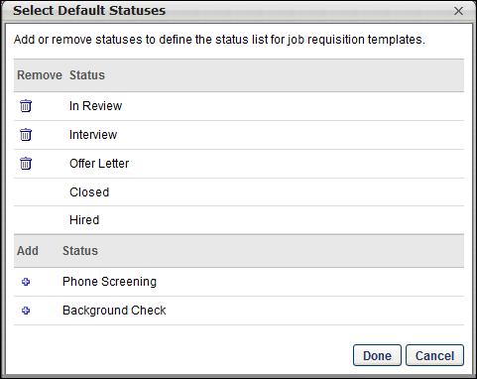

Create Custom Applicant Status at Top OU Level
When defining applicant statuses, a master applicant status list is created at the top organizational unit (OU) level. This list includes the default applicant statuses, which are available by default for Recruiting. The list can also include additional applicant statuses, which are called "custom" statuses. These statuses are created by the administrator and are used to identify the various status points of an applicant during the recruiting process.
Each custom status is associated with a status type, such as Interview or Background Check. The ability to create custom statuses is only available at the top OU level.
All custom statuses can be modified or inactivated.
Note: When managing applicant statuses at the child OU level, new custom statuses cannot be created. Instead, administrators can only add custom statuses that were created at the top level OU.
To create a custom applicant status, go to Admin > Tools > Recruit > Applicant Statuses. Then click the Create Custom Status link.
Permissions
PERMISSION NAME | PERMISSION DESCRIPTION | CATEGORY

Applicant Status Bank - Manage | Grants ability to access and manage Applicant Status Bank. | Recruiting Administration
Create Custom Applicant Status
To create a custom status, click Create Custom Status from the Manage Applicant Statuses page. This opens the Create Custom Status pop-up.
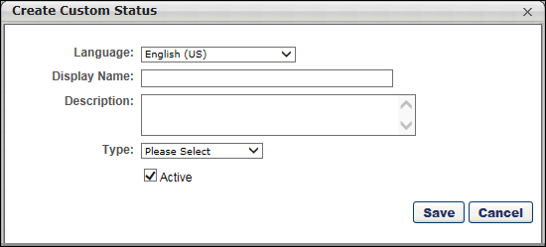
Complete the following fields for the status:
Language
If multiple languages are enabled, from the drop-down list select the language in which you are entering the status name and description. To localize the status name and description into other available languages, select the appropriate language from the drop-down list and enter the localized name and description in the appropriate fields.
Display Name
Enter the status name, which appears throughout the system. The character limit for this field is 50. When the Display Name of an active status is modified after the status is in use or has been used in a job requisition:
- The new display name appears on the Default Status List page.
- The new display name appears in the Status list on the job requisition template.
- Any new job requisitions created after the display name is changed apply the new display name.
- Job requisitions created before the status display name is changed continue to honor the name that existed at the time the requisition was created.
Description
Enter the description of the status. This should describe the purpose of the status and what is implied when an applicant is in that status. The character limit for this field is 500.
Type
A status type must be defined for each custom status. The status type contains specific functionality that is only available for that status type. This enables administrators to create any number of custom statuses and choose the status type for each custom status. The status type selected for a custom status determines the functionality for that step in the applicant status workflow for a requisition.
The name of a custom status in the Display Name field has no bearing on the functionality of a status. The functionality for a status is determined by the status type selected for the status. For example, an administrator wants to create a custom status with the display name of "Phone Screening." They select Interview as the status type so that , an interview process can be configured for the status. If the administrator were to select Background Check as the type, then a background check process could be configured for the status. But, since they are creating a custom applicant status for phone interviews, the administrator want to select Interview as the status type so that the interview functionality that is configured by the system can be used for the Phone Screening status.
Each applicant status can only have one associated status type.
The following status types cannot be associated with custom statuses, as they are only associated with the system-defined default statuses:
- Closed
- Hired
- Offer Letter
Select from one of the following status types:
Background Check
The Background Check status type means that an applicant is in a background check step of the status workflow. The Background Check status type can be selected for any custom status and can be added multiple times to the applicant status workflow. This allows you to have multiple background check steps throughout the applicant status workflow.
For portals with third party vendor background check integration, the functionality associated with the Background Check status type is available for each instance of the Background Check status type in an applicant status workflow. For portals that do not have HireRight integration, there is no functionality that can be configured for the Background Check status type.
Use Case
A recruiter would like candidate background checks to be managed by a third party vendor but keep the process connected to each candidate's Applicant Profile page. By integrating the background check process with a third party vendor, the recruiter can request background checks directly from the Applicant Profile page and monitor the progress from within the associated status panel. Once the vendor completes the background check, he can view the final report from the vendor to understand the applicant's background check result.
See Statuses Tab - Background Check Status Type in the Applicant Profile section of Online Help for information about the configurable options for the Background Check status type.
Interview
The Interview status type means that an applicant is in an interview step of the status workflow. The Interview status type can be selected for any custom status and can be added multiple times to the applicant status workflow. This allows you to have multiple interview steps throughout the applicant status workflow. The functionality associated with the Interview status type is available for each instance of the Interview status type in an applicant status workflow.
The functionality for the Interview status type is configured on the requisition template and can also be configured on the job requisition. Additional interview functionality is configured via the Interview status type panel on the Applicant Profile page and from the Interview Manager page.
For information about the configurable options available for the Interview status type, see the following topics in Online Help:
- See Applicant Review Tab - Interview Status Type Overview in the Requisition Templates section for additional information.
- See Applicant Review Tab - Interview Status Type Overview in the Manage Job Requisitions section for additional information.
- See Statuses Tab - Interview Status Type - Scheduled Interview in the Applicant Profile section for additional information.
- See Statuses Tab - Interview Status Type - On Demand Video Interview in Applicant Profile for additional information.
- See Interview Manager Overview for additional information.
Use Case
An organization's hiring process has multiple stages, which includes in-person and live video interviews with the candidate. With this enhancement, the administrator can create an interview process by configuring the Interview status type in the applicant status workflow. She can then configure the interviewers and schedule the interviews using the Interview Management and Scheduling feature.
Other
This option is selected by default. The Other status type is designed to be used for applicant status workflow steps that do not require any configurable functionality to be associated with the step. For example, a status workflow may have a custom status named Discussion. During the Discussion step of the status workflow, the applicant reviewers, hiring manager, and department head meet in-person to discuss the applicants and determine the top three prospects. This step does not require any configurable functionality, as it is an in-person, internal meeting that is a standard part of the organization's recruiting process. For this reason, the status type defined for the status is Other.
Review
The Review status type means that an applicant is in an applicant review step of the status workflow, which indicates that the applicant is being reviewed by recruiters and hiring managers. The Review status type can be selected for any custom status and can be added multiple times to the applicant status workflow. This allows you to have multiple applicant review steps throughout the applicant status workflow. However, the functionality associated with the Review status type only appears in the first instance of the Review status type in an applicant status workflow. All subsequent instances are placeholders in the status workflow to indicate that the applicant is in an applicant review status.
See Statuses Tab - Review Status Type in the Applicant Profile section of Online Help for additional information.
Hiring Manager/Applicant Reviewer Shortlisting
For portals with the shortlisting functionality (for hiring managers and applicant reviewers) enabled, there must be at least one applicant in a Review status type in order for the reviewer or hiring manager to have access to review the applicant. Applicant reviewers only have to access applicants when the applicants are in the Review status type. Further, once they have reviewed the applicant, the applicant will no longer appear on their Review Applicants page.
This functionality is deprecated. It will not be activated for any new customer.
Learn more about Request Candidate Feedback on the following Online Help topics:
- Manage Candidates - Request Candidate Feedback
- Manage Candidates - Give Candidate Feedback
Custom Integration
The Custom Integration status type mans that the applicant is in an integration step of the status workflow. The Integration status type can be selected for any custom status and can be added multiple times to the applicant status workflow. This allows you to have multiple integration steps throughout the applicant status workflow. For portals with custom integrations enabled, the functionality associated with the Custom Integration status type is available for each instance of the Custom Integration status type in an applicant status workflow. For example, this status type would be selected for portals with First Advantage enabled in order to create a custom status for the background check.
The Integration status type can be used to define a custom applicant status as an integration step in the applicant workflow. When Custom Integration is selected in the Type field, the Integration field appears below. This field requires the administrator to select the appropriate integration for the status. The drop-down displays integrations that are defined as active and available to select for applicant statuses. Note: Integration availability is defined by the administrator in Recruiting Integrations Preferences.See Recruiting Integrations Preferences for additional information.
SHL Assessment
This status type is only available for portals with the assessment vendor functionality enabled. This status type enables administrators to include an SHL assessment status type in the applicant review workflow and configure assessment functionality for the applicable steps in the workflow. Note: SHL is an assessment vendor with whom assessment functionality can be integrated. To enable this functionality, contact Global Customer Support. The SHL Assessment status type remains available when used in a job requisition, even if the backend setting is disabled after the requisition is created.
This status type indicates that the applicant is in an assessment step in the workflow. The SHL Assessment status type can be selected for any custom status and can be added multiple times to the applicant status workflow. This allows you to have multiple SHL assessment steps throughout the applicant status workflow. The functionality associated with the SHL Assessment status type is available for each instance of the SHL Assessment status type in an applicant status workflow.
Active
When the Active box is checked, the status is active and is available to be included in applicant status workflows.
If a status is made inactive:
- The status is no longer available for selection on the Default Status List page.
- The status no longer appears in the Status list on the job requisition template and is not available to be added to a template.
- Any new job requisitions created after the status is inactive do not apply the inactive status.
- Job requisitions created before the status is inactive continue to honor the status as an active status.
Save/Cancel
After entering the appropriate information, click Save.
Or, click Cancel to cancel creating the custom applicant status.

Add Custom Applicant Status at Child OU Level
New custom applicant statuses can only be created at the top organizational unit (OU) level. At the child OU level (any OU that is not the top level OU), administrators can add custom statuses that were created at the top OU level.
To access adding custom statuses, go to Admin > Tools > Recruit > Applicant Statuses. Then click Add Custom Status.
Permissions
PERMISSION NAME | PERMISSION DESCRIPTION | CATEGORY

Applicant Status Bank - Manage | Grants ability to access and manage Applicant Status Bank. | Recruiting Administration
Add Custom Status
To add a custom applicant status:
- Click Add Custom Status from the Manage Applicant Statuses page. This opens the Add Custom Status pop-up.
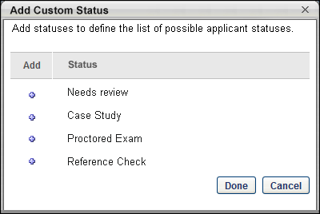
- Click the plus icon to the left of the status to add it to the list of applicant statuses at the child OU level. Once a status is selected, it appears in the upper portion of the pop-up and can be removed from the list if necessary by clicking the Delete icon .
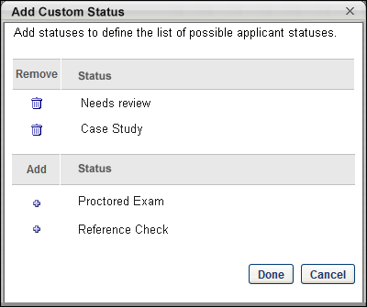
- Click Done to add the status. Or, click Cancel to cancel adding the status.

Candidate Search Query Overview
The Candidate Search Query functionality is designed to improve the user experience when searching for talent or looking up specific candidates across internal and external users. The legacy Search Candidates functionality is still available but includes fewer search options. Candidate Search Query enhances the capabilities of the keyword search feature by allowing Boolean operators to be used in the search. In addition, the information that is used to find matching candidates is expanded by including attached resumes. The user interface (UI) for the Candidate Search and search results pages is designed to match current styles.
The Candidate Search page displays in two tabs: Quick Search and Advanced Search. The Quick Search tab allows recruiters to search for candidates using keywords and Boolean operators that will search the parsed resume/CV fields, typed-in resume/CV, and the most recently attached resume. The Advanced Search tab allows recruiters to search the same data sources as in Quick Search, but instead of using a single keyword text field, users can create complex Boolean search queries in a new step-by-step interface.
To access the Candidate Search Query, go to Recruit > Candidate Search Query.
Note: To access the Search Candidates (Legacy) functionality, go to Recruit > Search Candidates.
Permissions
PERMISSION NAME | PERMISSION DESCRIPTION | CATEGORY

Applicants: Add/Move to Requisition | Grants ability to add or move applicants to requisitions the applicant did not apply for. This permission can be constrained by OU, User's OU, and Grade. | Recruiting

Recruiter: Share Saved Searches | Allows users to view and manage the Availability column on the Saved Searches Page. This permission can be constrained by OU and User's OU. | Recruiting

Recruiting: Search Candidates | Grants ability to access Candidate Search page for recruiting, which enables searching for internal candidates and external candidates who have applied for open positions. This permission also enables the Invite to Apply action item to appear in the Actions drop-down on the Search Candidates - Search Results page. This permission can be constrained by OU and User's OU. | Recruiting Administration

Requisition: Manage | Grants ability to access and manage all requisitions regardless of ownership (constraints permitting). This permission also grants read-only access to the Applicant Review tab when creating or editing a job requisition. This permission can be constrained by OU, User's OU, and Grade. | Recruiting
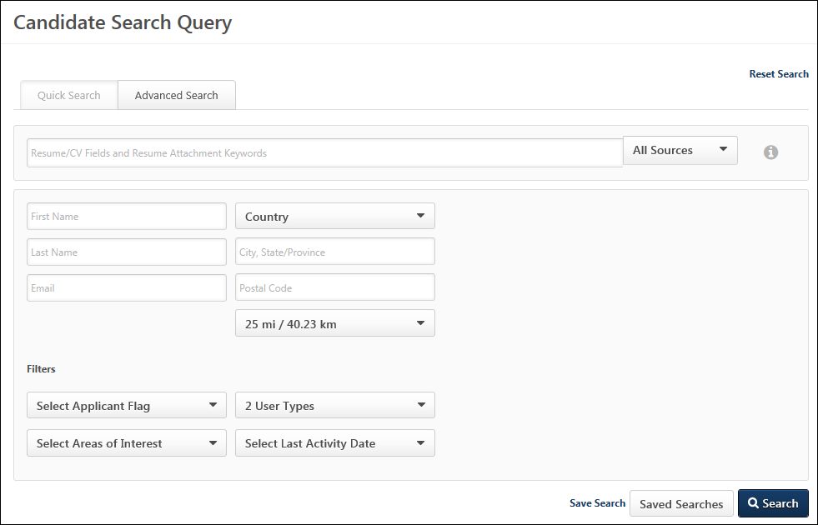
Search Use Cases
Boolean Operators
- Scenario - A recruiter is looking for a candidate to fill a Supply Chain Manager position. The recruiter is interested in candidates with supply chain, operations, and procurement experience who also possess analytical skills and VBA certification. Candidates must be located within 50 miles of Boston, Massachusetts.
- Query - The recruiter enters the following into the keyword search field on the Candidate Search page: +("Supply chain manager" "Procurement Manager" operations analy*) +vba. Query Interpretation: Position required to be included in search results, Supply chain manager or procurement manager or operations or analytical or analysis or analyses or analytics or etc. with VBA required as a term that must appear in the resume.
- Country - United States
- Location - Boston, Massachusetts
- Postal Code - 02112
- Radius - 50 miles
Wildcard Search
- Scenario - A recruiter wants to find a particular applicant in order to invite them to apply to a position. The recruiter can only remember the first four characters of the applicant’s first name, Jon. The recruiter wants to make sure that the search returns all candidates whose name starts with Jon by adding a wildcard operator at the end of the query.
- Query - The recruiter enters the following into the keyword search field on the Candidate Search page: "Jon*"
- Search Results - The search returns all internal employees/candidates and external candidates whose first name starts with Jon (i.e., Jon, Jonathan).

Additional Criteria Options
Once a resume/CV field or attachment is selected on the Advanced Search tab, additional options are available to refine the search criteria. The options that are available are dependent upon the type of field selected for the search criteria.
To access the Advanced Search tab on the Candidate Search page, go to Recruit > Candidate Search Query, then click the Advanced Search tab.
Permissions
PERMISSION NAME | PERMISSION DESCRIPTION | CATEGORY

Recruiting: Search Candidates | Grants ability to access Candidate Search page for recruiting, which enables searching for internal candidates and external candidates who have applied for open positions. This permission also enables the Invite to Apply action item to appear in the Actions drop-down on the Search Candidates - Search Results page. This permission can be constrained by OU and User's OU. | Recruiting Administration
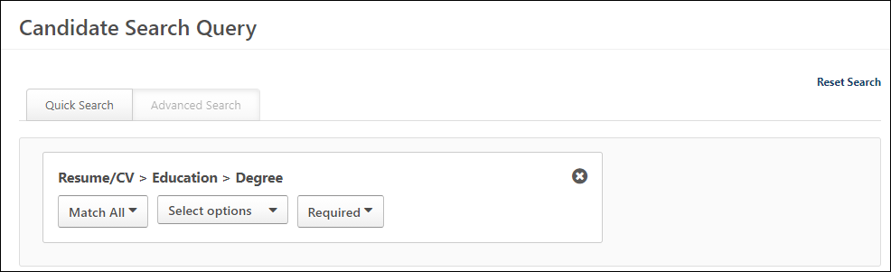
Checkbox Field
The following criteria options are available for checkbox field types:
- Is - This option is the only value for checkbox fields and is selected by default. This option applies to the Checked criteria field selection to indicate that the checkbox is checked or unchecked.
- Checked - Select one of the following options:
  - Checked - This option is selected by default. When selected, candidates only appear in the search results if they check the box.
  - Unchecked - When selected, candidates only appear in the search results if the candidate does not check the box.
- Boolean Operators - Select one of the following operators:
  - Required - This option indicates that a candidate will only appear in the search results if they check the box.
  - Optional - This option indicates that a candidate may or may not appear in the search results if they check the box.
  - Exclude - This option indicates that a candidate will not appear in the search results if they check the box.
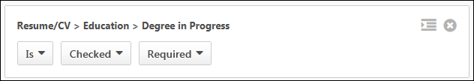
Date Field - On/Before/After
The following criteria options are available for date field types that apply to on, before, or after dates:
- Equality Operators - Select one of the following operators:
  - Is - When selected, the search results include internal and external users that entered the selected date.
  - On OR after - When selected, the search results include internal and external users that entered the date value on or after the Start Date.
  - On OR before - When selected, the search results include internal and external users that entered the date value on or before the End Date.
  - Between - When selected, the search results include internal and external users that entered a date that is on or between the selected dates.
- Date - Define a date from the calendar. This is a required field.
- Boolean Operators - Select one of the following operators:
  - Required - This option indicates that a candidate will only appear in the search results if they match the selections in the equality operator and date fields.
  - Optional - This option indicates that a candidate may or may not appear in the search results if they match the selections in the equality operator and date fields.
  - Exclude - This option indicates that a candidate will not appear in the search results if they match the selections in the equality operator and date fields.
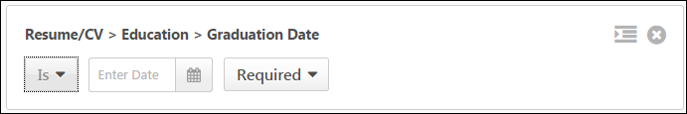
Date Field - Start/End/Between
The following criteria options are available for date field types that apply to start and/or end dates:
- Equality Operators - Select one of the following operators:
  - Starts on OR after - When selected, the search results include internal and external users that entered a date value on or after the Start Date.
  - Ends on OR before - When selected, the search results include internal and external users that entered a date value on or after the End Date.
  - Starts OR ends between - When selected, the search results include internal and external users that entered a date range that intersects with the dates selected in the search query.
Example:
  - Starts AND ends between - When selected, the search results include internal and external users that entered a date range that is completely contained by the dates selected in the search query.
Example:
- Date - Select a date or date range, depending on the selection made in the equality operator field. This is a required field.
- Boolean Operators - Select one of the following operators:
  - Required - This option indicates that a candidate will only appear in the search results if they match the selections in the equality operator and date fields.
  - Optional - This option indicates that a candidate may or may not appear in the search results if they match the selections in the equality operator and date fields.
  - Exclude - This option indicates that a candidate will not appear in the search results if they match the selections in the equality operator and date fields.
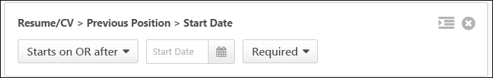
Drop-Down Field
The following criteria options are available for drop-down fields:
- Matching - The following matching options are available:
  - Match All - Select this option to find candidates who match all of the selections in the Select Options field.
  - Match Any - Select this option to find candidates who match any of the selections in the Select Options field.
- Select Options - This drop-down displays the available for the field that are configured when defining attributes for a resume section. The options appear in alphabetical order. Select one or more individual options or check the Select All box.
- Boolean Operators - Select one of the following operators:
  - Required - This option indicates that a candidate will only appear in the search results if they have the selected options in their resume/CV.
  - Optional - This option indicates that a candidate may or may not appear in the search results if they have the selected options in their resume/CV.
  - Exclude - This option indicates that a candidate will not appear in the search results if they have the selected options in their resume/CV.
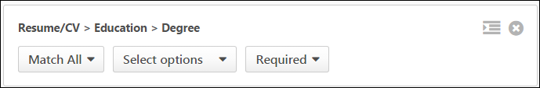
Numeric Field
The following criteria options are available for numeric field types:
- Equality Operators - Select one of the following operators:
  - Is
  - Less Than
  - Greater Than
  - Less Than or Equal
  - Greater Than or Equal
- Numeric Text Field - Enter the value based on the operator selected. This field accepts up to five digits with up to two decimal places (inclusive). This means that if two decimal places are included in the number, then only three digits can be present to the left of the decimal place. This is based on existing functionality throughout the Recruiting module. This is a required field.
- Boolean Operators - Select one of the following operators:
  - Required - This option indicates that a candidate will only appear in the search results if they match the numeric entry in the text field.
  - Optional - This option indicates that a candidate may or may not appear in the search results if they match the numeric entry in the text field.
  - Exclude - This option indicates that a candidate will not appear in the search results if they match the numeric entry in the text field.
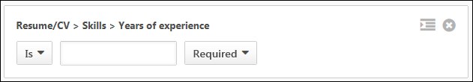
Short Text/Scrollable Text/OU Selector Fields
The following criteria options are available for short text fields and scrollable text fields in which candidates have entered a response into a text box and which allow recruiters to search for key words from the candidate's text responses:
- Equality Operators - Select one of the following equality operators:
  - Exact - When selected, the search results only include candidates that exactly match the search term entered. If multiple search terms are entered, then the search matches the terms as a phrase (equivalent to using quotation marks "" in Quick Search).
  - Starts With - When selected, the search results include candidates that match any partial search term entered by the candidate in the text box.
- Text Field - Enter full or partial search terms in the search field. At least one search term must be entered. Each search term must be at least two characters. If multiple terms are entered with a space between each term, then the terms are searched as a phrase. The search does not require that all words of the candidate's entry in the text field on the application be included in the text field on the Advanced Search tab. For example, if "Product" is entered by the recruiter in the search field, then the system matches terms on the application such as Product Manager and Product Marketing Manager.
- Boolean Operators - Select one of the following operators:
  - Required - This option indicates that a candidate will only appear in the search results if they match the entry in the text field.
  - Optional - This option indicates that a candidate may or may not appear in the search results if they match the entry in the text field.
  - Exclude - This option indicates that a candidate will not appear in the search results if they match the entry in the text field.
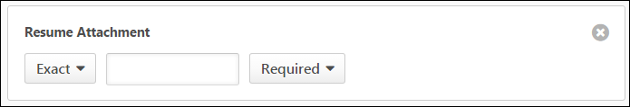
Attributes
The following criteria options are available for attributes (i.e., educational degrees, certifications, languages, etc.):
- Matching - The following matching options are available:
  - Match All - Select this option to find candidates who match all of the attributes selected in the Select Options field.
  - Match Any - Select this option to find candidates who match any of the attributes selected in the Select Options field.
- Select Options - This drop-down displays the active attribute options available for the field that are configured when defining attributes for a resume section. The options appear in alphabetical order. Select one or more individual options or check the Select All box.
- Boolean Operators - Select one of the following operators:
  - Required - This option indicates that a candidate will only appear in the search results if they have the selected attribute options in their resume/CV.
  - Optional - This option indicates that a candidate may or may not appear in the search results if they have the selected attribute options in their resume/CV.
  - Exclude - This option indicates that a candidate will not appear in the search results if they have the selected attribute options in their resume/CV.
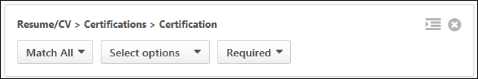
Search Tips
- Unmapped resume section values can still be searchable. The user may find a discrepancy looking at resume section values for an applicant on Applicant Profile > Resume/CV page, which shows only mapped resume fields.
- Date formats that are stored in the system are not always the same as the formats presented to the user in the UI. If a user searches by “12/29/2014” from quick search, they may not return any results, since the field stored in the database is 2014/12/29. Advanced Search should be used when searching for dates because it handles these scenarios and searches against all date formats.
- Using the “Match All” operator in Advanced Search (for a multi-select drop-down control) along with the “Optional” priority operator is treated the same as all selected attributes values being “Required” within a search result.
- Using the “Exact” operator in Advanced Search returns results even if the entered word is part of a phrase with a searched field. For example, a search for EXACT Role = ‘Manager’ would return a result for a resume having Role = ‘QA Manager.’

Advanced Search - Search Results Criteria Panel
The search criteria panel on the left side of the search results page for the Advanced Search tab displays all criteria that were selected when conducting the search. The criteria cannot be modified from the search results page.
The results for a search on Candidate Search are accessed by clicking Search on the Quick Search or Advanced Search tabs. You can also access search results via saved searches.
Permissions
PERMISSION NAME | PERMISSION DESCRIPTION | CATEGORY

Recruiting: Search Candidates | Grants ability to access Candidate Search page for recruiting, which enables searching for internal candidates and external candidates who have applied for open positions. This permission also enables the Invite to Apply action item to appear in the Actions drop-down on the Search Candidates - Search Results page. This permission can be constrained by OU and User's OU. | Recruiting Administration
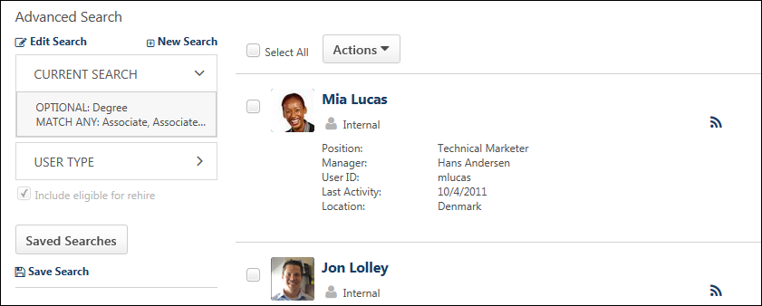
Edit Search
Click Edit Search to return to the Advanced tab of the Candidate Search page and make changes to the search criteria. The criteria cannot be modified from the search results page.
New Search
Click New Search to conduct a new search. This opens the Advanced Search tab on the Candidate Search page, with all fields returned to their default state.
Reason for Search
The Reason for Search section only appears if enabled in Compliance Enablement Preferences. This section displays the following information:
- Reason for Search - This is the reason that was selected for conducting the search. The reason is not editable for the search once the search has been conducted.
- Job Details - Click Job Details to view the job details, which includes the requisition's internal and external job description, minimum qualifications, and ideal qualifications.
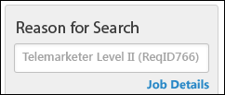
Current Search
This section displays the resume criteria defined for the search. The equality and Boolean operators display, as well as the keywords entered for the search. Hovering over a criteria section will display the full path of the resume/CV field to which the criteria apply.
For grouped criteria, the child criteria are indented below the parent criteria.
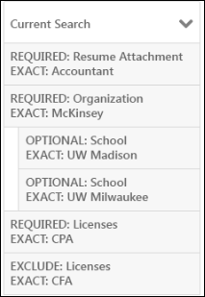
Contact Details
This section displays the criteria defined in the First Name, Last Name, and Email fields on the Advanced Search tab. Only the fields that have values display in this section. This section does not display if none of the fields are defined for the search.
Location
This section displays the criteria defined in the Country, City, State/Province, Postcode, and Radius fields on the Advanced Search tab. Only the fields that have values display in this section. This section does not display if none of the fields are defined for the search or if geolocation is disabled. Note: Geolocation can be added as a location option when configuring the Search Jobs widget for Standard career sites.
User Type
This option displays the candidate type selected for the search, either Internal or External or both.
Applicant Flags
This option displays the applicant flags that were selected for the search.
Include Eligible for Rehire
The field is selected by default and enables past employees to appear in the search results. Having former employees in the search results helps recruiters when they want to reach out to these former employees to apply to open jobs.
Saved Searches
The option to saved searches enables you to search for candidates using searches you saved or searches shared with you. To search using a saved search, click Saved searches. This opens the Saved Searches page.
Save As
The Save As option only displays when editing an existing saved search. Once all changes are made to the saved search, click the Save As link to save the search as a new saved search. Enter a title in the Save Search pop-up, and then click Save to save the search.
Save Search
Save the changes to the criteria by clicking Save Search. This opens the Save Search pop-up. Enter a unique title in the Title field, up to 100 characters. This is a required field. Click Save to save the criteria or Cancel to close the pop-up without saving.
Note: If you save changes to the criteria, and then make additional changes that you would like to save, the title given to the previous saved search populates the Title field in the Save Search pop-up. You can edit or rename the title.

Advanced Search Tab
From the Advanced Search tab, users can search all of the same sources as in Quick Search by entering keywords to match criteria in applicant resumes. With the advanced search, both the parsed resume/CV fields and the attached resume are searched.
To access the Advanced Search tab on the Candidate Search page, go to Recruit > Candidate Search Query, then click the Advanced Search tab.
Permissions
PERMISSION NAME | PERMISSION DESCRIPTION | CATEGORY

Recruiting: Search Candidates | Grants ability to access Candidate Search page for recruiting, which enables searching for internal candidates and external candidates who have applied for open positions. This permission also enables the Invite to Apply action item to appear in the Actions drop-down on the Search Candidates - Search Results page. This permission can be constrained by OU and User's OU. | Recruiting Administration
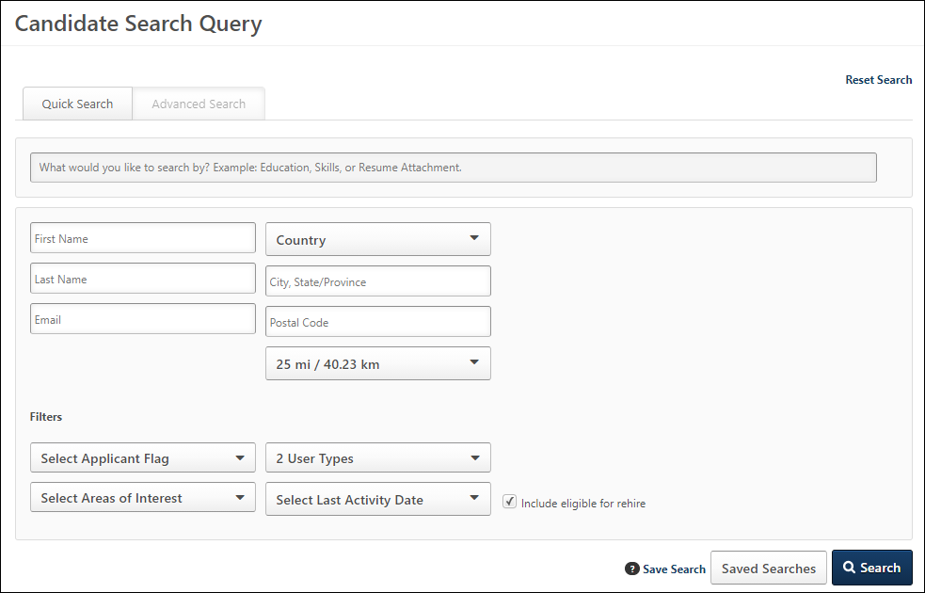
Search Resume/CV Fields & Attachments
The predictive search bar helps recruiters quickly find the resume fields they would like to include in the search. When terms are entered in the search field, a drop-down appears, showing a list of up to 20 potential resume field matches based on the characters entered. Recruiters can select the fields from the list to include in the search.
In addition, when searching for candidates on the Advanced Search tab, resume attachments can also be searched. This broadens the search options and helps recruiters to find candidates who meet the search criteria.
Search by Resume/CV Fields
To search for default and custom resume/CV fields to include in the candidate search, enter the search terms in the predictive search field, a minimum of three characters. For example, to find specific fields in the Education section of the resume/CV, a recruiter can enter "educ." The system automatically searches for matches and displays up to 20 results in a drop-down according to the field's relevance to the search terms. Default resume/CV fields display as "Resume/CV > [Resume/CV Section Title] > [Resume/CV Field Title]."
To add the field as search criteria, click anywhere in the search result row. Then, click the plus icon to the right of the search bar. This adds the field as search criteria. Additional resume/CV fields can be added by searching for and selecting the field, and then clicking the plus icon to the right of the search bar.
For portals with multiple languages enabled, the localized field title displays in the list. If a localized title is not configured for a field, then the field displays in the default language of the field.
Resume/CV Field Availability
The fields that display in the drop-down list are fields that are active resume/CV fields. Fields are defined by the administrator on the Define Section page when configuring resume sections in Succession.
Search by Attachments
To search through resume attachments, enter all or part of the words "Resume Attachment" into the predictive search field. Select the Resume Attachment option, and then click the plus icon to add the field as search criteria. This allows you to define the search criteria for candidate attachments.
Additional Criteria Options
Once the criteria is added, additional options are available to further define the criteria. See Additional Criteria Options on page 45 for additional information.
Group Search Criteria
When more than one search criteria box is added, a Group option displays in the upper-right corner of the search box. This allows the recruiter to conduct a nested search by linking the search criteria together into a group of at least two terms that are perceived by the system as child search terms in parentheses. Grouped search terms are executed prior to other operations.
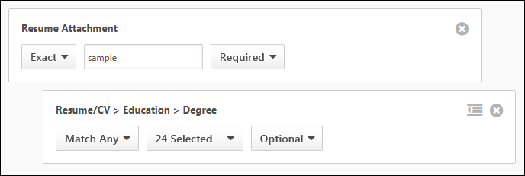
To group the search criteria:
- Add two or more search criteria boxes. This enables the Group icon to appear in all search boxes below the top box.
- Click the Group icon in the upper-right corner of the search box. This groups the search box with the box directly above it.
- Define the equality operator in the drop-down. Note: Selecting a Boolean operator is not necessary, since the system considers the terms in all child search boxes to be required.
- Define the priority operator in the drop-down. Note: Depending on the priority operators (required, optional, exclude) that are defined for the nested search terms, the search results may include all, some, or none of the nested terms.
Search groups must have at least two search boxes. If only one search box is grouped under another box when the Search button is clicked, an error message displays to indicate that at least one more search box must be added to the group.
Ungroup Search Box
To ungroup a search box, click the Ungroup icon .
Delete Search Criteria
To delete a search criteria box, click the Delete icon in the upper-right corner of the box.
If the search box is part of a group that has additional search boxes below it, then the search boxes are moved up to the next position. If the ungrouped search box above a group is deleted, then the first grouped search box below the deleted box is moved up to the ungrouped level.
User Fields
The user fields allow recruiters to search for candidates by first/last name and email, as well as add location criteria to the search query. The values entered in the user fields are preserved when toggling between the Quick Search and Advanced Search tabs.
The following criteria are available:
- First Name - This field allows recruiters to search by full or partial first name. This field accepts the * wildcard Boolean operator.
- Last Name - This field allows recruiters to search by full or partial last name. This field accepts the * wildcard Boolean operator.
- E-mail - This field allows recruiters to search by an exact email address. This field accepts the special characters of @, ., -, _, +, 0-9, A-Z, a-z, !, #, $, %, &, ', *, /, =, ?, ^, {, }, ~.
- Country - This field allows recruiters to search for candidates by country. Select a country from the drop-down to search by country. Completing the Location field is required when a country is selected. Depending on the country selected, a Postal Code field displays to the right of the Location field, which allows recruiters to further define the search criteria.
When using this field, the search results display candidates who are in the selected country, location, and postal code if defined (in addition to other search options if defined, such as first and last name). If a radius is defined, then the results display candidates who are within the selected distance to the location within the selected country. Note: If geolocation has been disabled for your portal, this field does not display.
- City State/Province - This field allows recruiters to search for candidates by city/state/province. Enter a location, up to 20 characters. When using this field, the search results display candidates who are in the location in the selected country and within the postal code if defined. Best Practice: As a best practice, enter the City, State/Province to improve the accuracy of the location search. Note: If geolocation has been disabled for your portal, this field does not display.
- Postcode - This field only displays if one of the following countries is selected in the Country field: (Note: If geolocation has been disabled for your portal, the this field does not display.)
  - Austria
  - Belgium
  - Canada
  - Czech Republic
  - Denmark
  - Finland
  - France
  - Germany
  - Greece
  - Hungary
  - Italy
  - Luxembourg
  - Mexico
  - Netherlands
  - Norway
  - Poland
  - Portugal
  - Spain
  - Sweden
  - Switzerland
  - United Kingdom
  - United States
- Radius - Recruiters can search for candidates within a certain radius of the location. The Within field allows recruiters to select a radius. The following options are available:
  - 10 mi / 16.09 km
  - 25 mi / 40.23 km
  - 50 mi / 80.47 km
  - 100 mi / 160.93 km
Note: Searching by phone number is not available on the Candidate Search page.
Note: Geolocation can be added as a location option when configuring the Search Jobs widget for Standard career sites.
Applicant Flags
This option allows recruiters to search for candidates by applicant flags. All flags are unchecked by default. Click the Applicant Flags drop-down to view the flags and select one or more flags.
The Potential Duplicate Applicant flag is only available if the Flag Potential Duplicates option is enabled in Requisition and Applicant Preferences. Selecting this flag enables recruiters to search for applicants who are flagged by the system as potential duplicates. When the flag is selected, potential duplicates display in the search results.
The Merged Duplicate Applicants flag is available. When this flag is selected, applicants who have been automatically flagged by the system with the Merged Duplicate Applicants flag can be searched using the applicant flag filter.
The additional flags that display are the flags that are visible to the recruiter based on the flag's visibility settings and organizational unit availability. In addition, the candidate search option must be enabled for a flag in order for the flag to be available in the Search Candidates feature.
Note: Visibility and candidate search settings for flags are defined by the administrator in Applicant Flags Preferences. See Applicant Flags Preferences on page 13 for additional information.
Candidate Type
This is a required field. This option allows recruiters to define the candidate type for the search criteria. The following options are available in the User Type drop-down:
- Select All - This option is checked by default. When checked, both internal and external candidates are included in the search.
- Internal - Checking this option includes current employees who have not applied to the requisition and existing applicants.
- External - Checking this option includes external candidates in the search.
Select Areas of Interest Filter
This filter displays on both the Quick Search and Advanced Search tabs. allows you to filter the search results by areas of interest so that you can find candidates with specific interests.
Note: Applicants select areas of interest when applying to the organization via Connect With Us from the career site.
To filter your candidate search by areas of interest:
- Click the Select Areas of Interest drop-down in the Filters section.
- Check the one or more areas of interest. Or, check the Select All box to select all areas of interest.
Once the interests are selected, you can add additional search criteria or click Search to conduct the candidate search.
You can also save the search by clicking Save Search so that you can quickly find additional or future candidates within those areas of interest.
Select Last Activity Date Filter
This filter only displays on the Quick Search tab. This filter allows you to filter candidates based on last activity date so that you can find candidates by using activity date ranges.
Note: Applicants select areas of interest when applying to the organization via Connect With Us from the career site.
The following options are available in the filter:
- Less than 7 days
- Less than 30 days
- Less than 60 days
- Less than 90 days
- Less than 180 days
Include Eligible for Rehire
The field is selected by default and enables past employees to appear in the search results. Having former employees in the search results helps recruiters when they want to reach out to these former employees to apply to open jobs.
Reset Search
Click Reset Search at the top of the page to clear all search criteria fields. The page is refreshed to display the default values for all fields.
Save Search
You can save the search by clicking Save Search. This opens the Save Search pop-up. Enter a unique title in the Title field, up to 100 characters. This is a required field. Click Save to save the search, or click Cancel to close the pop-up without saving.
Note: If you save changes to the criteria, and then make additional changes that you would like to save, the title given to the previous saved search populates the Title field in the Save Search pop-up. When accessing the saved search, you can edit the criteria.
Saved Searches
The Saved Searches option enables you to search for candidates using searches you have saved or searches made public by other users.
To search using a saved search, click Saved searches on the Candidate Search page. This opens the Saved Searches pop-up, which displays the following information:
- Keyword Search - Filter the list of saved searches by entering keywords into the search bar, up to 50 characters. Click Search to update the list.
- Saved Search Title - Click the title of the saved search to view the search results on the search results page. The results display all candidates found using the search criteria for the saved search.
- Date Saved - The date the search was added as a saved search displays below the saved search title.
- Search Criteria - The search criteria that were configured on the Candidate Search page displays in the center column. The following criteria types may have been configured for the search:
  - Resume/CV keywords
  - First Name
  - Last Name
  - Email
  - Country
  - City, State/Province
  - Zip Code
  - Radius
  - Applicant Flags - (Note: If a flag has been removed from a user, then the user does not appear in the search results using this search filter. If the flag's visibility rule has changed and no longer allows the user to view the flag or the flag cannot be used to search in Candidate Search, then candidates will not appear in the results for the flag.)
  - User Type
  - Source
- Options Drop-Down - The drop-down to the right of the search criteria displays the Edit option. Click the link to open the Candidate Search page with the criteria options filled. You can change the settings for the saved search, and then click Save Search to save the updated settings. To reset the search criteria after making changes, click Reset Search.
Click Cancel to cancel the changes to the search.
Save As
The Save As link only displays when editing an existing saved search. Once all changes are made to the saved search, click Save As to save the search as a new saved search. Enter a title in the Save Search pop-up, and then click Save to save the search.
Search
Once the search criteria are defined, click Search to view the search results page. If the option to require a reason for the search is enabled in Compliance Enablement Preferences, then the Reason for Search pop-up displays, and a reason for the search must be selected before the search results display.
Reason for Search
Clicking Search may require you to enter a reason for the search prior to conducting the search. If configured in Compliance Enablement Preferences, then when Search is clicked, a Reason for Search pop-up opens. Select a requisition from the Specific Requisition drop-down to indicate the requisition for which you are conducting the search. For portals with multiple languages enabled, the job title in the Select Requisition drop-down displays in the user's language if available. If a translation is not available in the user's language, then the value displays in the language of the recruiter who created the job requisition.
Or, select Other and enter a reason in the text field. There is no character limit when entering a reason in the Other field.
Click Save in the pop-up to execute the search.
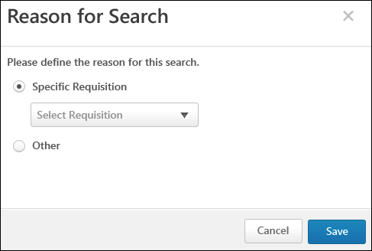
Note: The Specific Requisition drop-down displays all requisitions that are available to the user. For this reason, the user must have permission to manage or review requisitions or must be a requisition owner.
Note: If users are not required to enter a reason for the search, then clicking Search on the Search Candidates page executes the search.

Candidate Search Query Results - Actions
The Actions drop-down on the Search Results page for Candidate Search Query enables you to perform a series of actions on all candidates at once or on individual candidates. The drop-down displays only actions for which you have permission to perform and that are relevant to the functionality in your portal.
The results for a search on Candidate Search are accessed by clicking Search on the Quick Search or Advanced Search tabs. You can also access search results via saved searches.
Permissions
PERMISSION NAME | PERMISSION DESCRIPTION | CATEGORY

Recruiting: Search Candidates | Grants ability to access Candidate Search page for recruiting, which enables searching for internal candidates and external candidates who have applied for open positions. This permission also enables the Invite to Apply action item to appear in the Actions drop-down on the Search Candidates - Search Results page. This permission can be constrained by OU and User's OU. | Recruiting Administration
From the Actions drop-down, you can do the following:
- Invite candidates to apply to a requisition.
- Add candidates to a requisition.
- Add candidates to the Talent Pool.
- Compare the criteria of up to five candidates.
- Export candidate data to Excel.
- Send candidates an email.
Invite to Apply
The Invite to Apply action sends an email invitation to all applicants that are selected from the search results to apply to the requisition. When Invite to Apply is clicked, the Invite to Apply pop-up opens. Select one or more requisitions to which to invite applicants to apply, and then click Done. This triggers the Invitation to Apply email, if configured. The History tab on the applicant's profile page is updated with the event.
If multiple requisitions are selected in the pop-up, a separate email is sent for each requisition.
Note: If the applicant applies via the link in the email, the applicant's source for the requisition is Other - Invited to Apply.
Compare Candidates (up to 5)
Compare Candidates enables you to view the Matching Criteria score and number of matching attributes for up to five candidates at once.
To compare candidates:
- Select up to five candidates by checking the box to the left of the candidate's name.
- Click Compare Candidates in the Actions drop-down. This opens the Compare Candidates pop-up, displaying the following for each candidate:
  - Photo, if available; ghost image displays if no photo is available
  - Full name
  - Current position (for internal applicants only)
  - Matching criteria score
  - Number of matching attributes
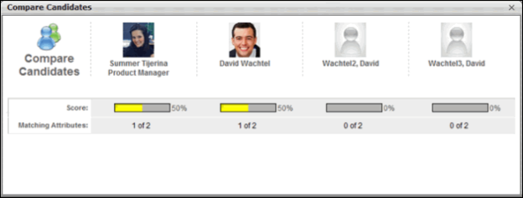
Add to Requisition
You can add candidates to requisitions for which they did not apply by using the Add to Requisition feature. All candidates can be added as a batch or individually. Adding a candidate to another requisition does not affect the existing requisition. The candidate appears on the new requisition as though they applied for the job themselves.
In addition, all applicant documents and attachments on the Applicant Profile page for the source requisition move with the applicant to the new requisition. The documents and attachments display on the Documents tab of the Applicant Profile page for the new requisition. For all attachments in the Attachments table, the status in the Applicant Status column is New Submission.
Note: Only candidates who checked the Consider me for other positions field when completing their application can be added to a requisition.
To add a candidate to a requisition:
- Check the Select All box to add all candidates to a requisition at once. Or, select individual candidates by checking the box to the left of the candidate's name.
- Click the Add to Requisition link in the Actions drop-down. This opens the Add to Requisition pop-up.
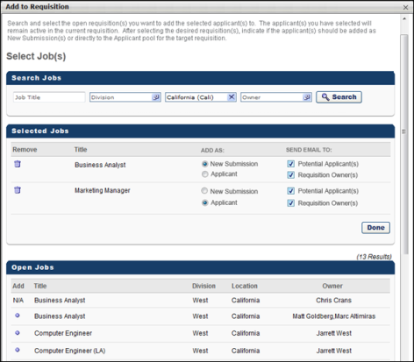
- Enter search terms in the Job Title, Division, Location, and Owner fields.
- Click Search.
- The search results display in the Open Jobs table in alphabetical order. The title, division, location, and requisition owner display. All columns in the Open Jobs table are sortable. Note: The results that display are dependent upon your permission constraints.
- Click the plus icon in the Add column to select a job. This opens the Selected Jobs table and places the job in the table. The plus icon in the Add column in the Open Jobs table changes to "N/A." You can delete jobs added to the Selected Jobs table by clicking the Remove icon to the left of the job title. Jobs display in Selected Jobs table in the order in which they are added.
- The Add As column enables you to add the submission as a new submission or an applicant. Select New Submission to add the applicant as a new submission. Select Applicant to add the applicant into the first status in the status workflow for the requisition, in which case the date for the Current Status is the date on which the applicant was manually added to the requisition.
Note: If Skip New Submission Status is enabled by the administrator in Requisition and Applicant Preferences, then the option to add an applicant as a new submission is disabled for the Add to Requisition action item. The New Submission option in the Add to Requisition pop-up is grayed out and cannot be selected. The Applicant option is then selected by default.
- In the Send Email To column in the Selected Jobs table, check the box to send an email to potential applicants and/or requisition owners, notifying them that the candidate has been added to the requisition. Both boxes are unchecked by default. Note: If the new requisition requires applicants to complete certain steps prior to submitting their application, the email can be configured in Email Management to include a link for the applicant to apply directly to the requisition. Further, the application materials for the new job are pre-populated with the applicant's existing information.
- Click Done to save the changes.
Mobile-Friendly Candidate Experience Considerations
When an applicant is added or moved to a new requisition and some but not all answers have been answered from the first requisition, the applicant will continue with the second application using the mobile-friendly candidate workflow. In addition, the applicant's previously answered questions will populate in the new mobile-friendly workflow.
Use Case
- Scott is a recruiter for IMEC. Scott has self-enabled the new mobile-friendly candidate experience in his Production portal.
- Alex is interested in a position at IMEC and applies for the Senior Project Manager role. Alex completes the application in the mobile-friendly workflow.
- Scott really likes Alex but thinks she is more qualified for the Junior Project Manager role. Scott moves Alex to the Junior Project Manager role. There are a few additional questions in the Junior Project Manager role that were not in the original Senior Project Manager Application workflow. Scott invites Alex to apply to the new requisition.
- Alex receives an email to apply to the Junior Project Manager role. Alex clicks the link to apply and is prompted to sign in. For security reasons, Alex will have to claim her account or log in to continue the new application with her previously answered questions populated.
- When the application workflow loads, it is in the new mobile-friendly application workflow, not the standard workflow. Alex is taken to page 1 of the application. All previously answered questions from the Senior Project Manager role populate the new application.
- On page 2, the pre-screening questions are exactly the same on the Senior and Junior Project Manager requisition, so her previously answered questions are populated. On page 3, only some of the pre-screening questions are the same. Because some and not all of the pre-screening questions are the same on page 3, Alex's previously answered pre-screening questions do not populate.
Considerations
- The questions in the two requisitions (source and new requisition) have to be exactly the same in order for an applicant's answers to pre-populate.
- If some but not all pre-screening questions in a specific section are the same, then none of the previously answered pre-screening questions will populate.
- The applicant will be taken to the first page of the application workflow, regardless of how many questions are complete.
- Applicants will have to log in or claim their account in order to continue on the new application and have their previously answered questions populate populate on the new application.
Add To Talent Pool
For portals using EPM, the Talent Pool functionality enables you to organize your search results into candidate pools. See Manage Talent Pools.
To add users to a talent pool:
- Check the Select All box to add all candidates to a talent pool at once. Or, select individual candidates by checking the box to the left of the candidate's name.
- Click Add To Talent Pool in the Actions drop-down. This opens the Add to Talent Pool pop-up.
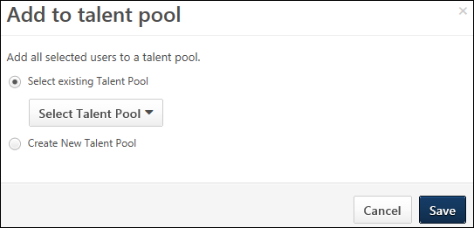
- Both radio buttons are deselected by default. To create a new talent pool, select Create New Talent Pool for users. Enter a name for the talent pool in the Title field. To add candidates to an existing talent pool, select Select an existing Talent Pool for users. Click the drop-down in the Select field to choose a talent pool.
- Click Save to add the candidates to the talent pool.
To view and manage the talent pool, go to Succession > Manage Talent Pool.
Export to Excel
This action allows recruiters to export the data for the selected candidates to Excel. The Excel file includes the search criteria and the candidate data.
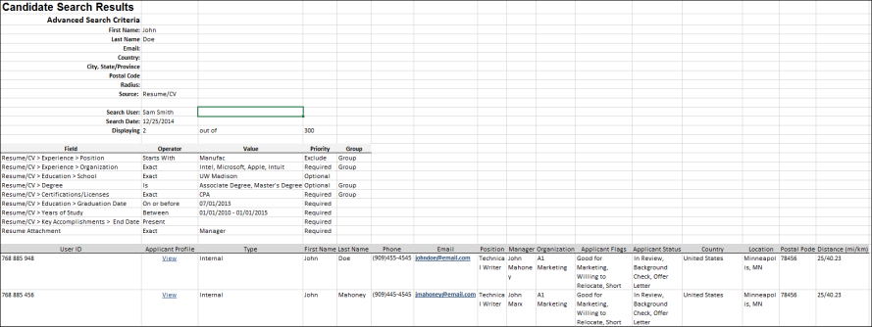
Quick Search Excel Output
The Excel output for searches conducted from the Quick Search tab includes a Search Criteria section and the table that lists the search results.
Search Criteria
The Search Criteria section displays the following information:
- Resume/CV Keywords - This field displays the search terms defined in the quick search field.
- First Name
- Last Name
- Email
- Country
- City, State/Province
- Postal Code
- Radius
- Source
- Search User - This field displays the name of the user who conducted the search.
- Search Date - This field displays the date of the search.
- Displaying - This field displays the number of candidates selected to export out of the number of candidates available to select.
Search Results
The information that displays in the table is the information that displays for candidates on the search results page.
- User ID
- Applicant Profile - Click the View link to open the applicant's profile page.
- User Type - This field displays the option selected in the User Type drop-down, either Internal or External or both.
- Phone
- Email - The candidate's email displays as a link. Click the link to email the applicant from your email provider.
- Position
- Manager
- Organization
- Applicant Flags
- Country
- Location
- Postal Code - This column only displays if an applicable country is selected in the Country field when configuring the search criteria.
- Distance
Advanced Search Excel Output
The Excel output for searches conducted from the Advanced Search tab displays the equality and Boolean operators, as well as the resume keywords defined for the search.
In addition, a table displays above the search results, showing the criteria defined in the Advanced Search Query Builder. The table shows the field name, equality operator, field value, priority (required, optional, exclude), and grouping (if the criteria are grouped).
The search results display below the criteria.
Best Practices for Exporting to Excel
When exporting candidate search data to Excel, it is a best practice to consider candidate data privacy and level of security when sharing Excel files with other users within the organization. For portals that have the archive applicant data functionality enabled in Compliance Enablement Preferences, the following best practices should be considered when using the Export to Excel action:
- Grant candidate search permissions to a limited number of users.
- Destroy exported candidate search results after a certain period of time.
Send Email
The Send Email feature enables you to email all candidates at once or individual candidates, using your default email application. Clicking Send Email opens an email in a pop-up window. Each checked candidate's email address displays in the blind carbon copy (bcc) field. Email addresses are pulled from a candidate's user record.
To send an email:
- Check the Select All box to send an email to all candidates at once. Or, select individual candidates by checking the box to the left of the candidate's name.
- Click Send Email in the Actions drop-down. This opens an email from your default email application. Each checked candidate's email address displays in the bcc field. No other fields are auto-populated.
- Enter a subject, email text, etc., and then send the email. The email is distributed to all included candidates whose email addresses are active.

Quick Search - Search Results Criteria Panel
The search criteria panel on the left side of the search results page for the Quick Search tab displays all criteria that were selected when conducting the search.
Recruiters can edit the search criteria if enabled by the administrator in Compliance Enablement Preferences. If recruiters are not allowed to modify the search criteria, then the criteria in the panel are grayed out and not selectable. Note: The Job Details and View Criteria links are still selectable. However, the criteria in the View Criteria pop-up cannot be modified.
The results for a search on Candidate Search are accessed by clicking Search on the Quick Search or Advanced Search tabs. You can also access search results via saved searches.
Permissions
PERMISSION NAME | PERMISSION DESCRIPTION | CATEGORY

Recruiting: Search Candidates | Grants ability to access Candidate Search page for recruiting, which enables searching for internal candidates and external candidates who have applied for open positions. This permission also enables the Invite to Apply action item to appear in the Actions drop-down on the Search Candidates - Search Results page. This permission can be constrained by OU and User's OU. | Recruiting Administration
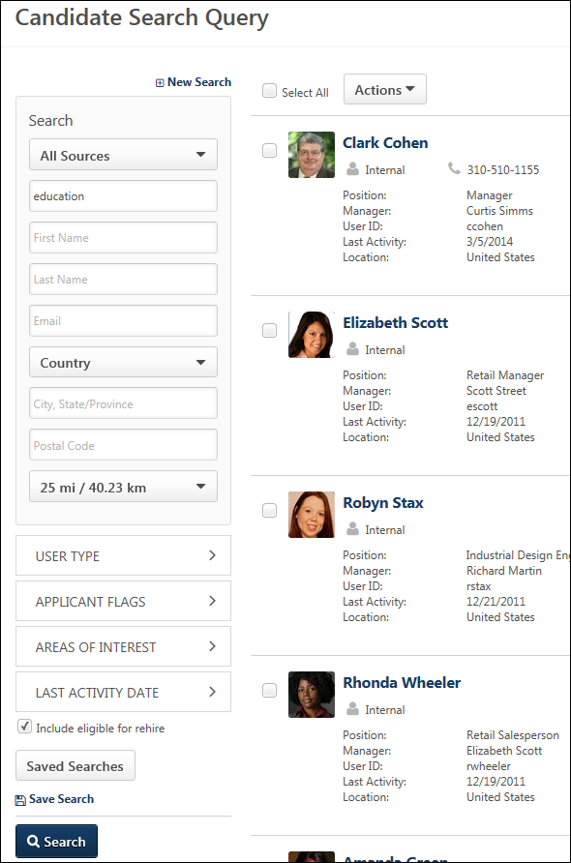
New Search
Click New Search at the top of the page to conduct a new search. This opens the Quick Search tab on the search page, with all fields returned to their default state.
Reason for Search
The Reason for Search section only appears if enabled in Compliance Enablement Preferences. This section displays the following information:
- Reason for Search - This is the reason that was selected for conducting the search. The reason is not editable for the search once the search has been conducted.
- Job Details - Click Job Details to view the job details, which includes the requisition's internal and external job description, minimum qualifications, and ideal qualifications.
Search
This section displays the additional user criteria used to filter the search results. The following fields display:
- Source - This option displays the source information that was selected for the search, either Resume/CV Fields or Resume Attachments or both.
- Keywords - This field displays the keywords used in the Resume/CV keywords field.
- First Name - This field displays the full or partial first name entered for the search.
- Last Name - This field displays the full or partial last name entered for the search.
- Email - This field displays the email address entered for the search.
- Country - This field displays the country selected for the search.
- City/State/Province - This field displays the city and state/province entered for the search.
- Postcode -This field displays the postal code entered for the search. Note: This field only displays if a postal code applies to the country selected in the Country field.
- Radius - This field displays the radius defined for the search location.
User Type
This option displays the candidate type selected for the search, either Internal or External or both.
Note: Administrators can disable the ability to search for and view internal employees in Candidate Search Query. This is controlled by a preference in Requisition and Applicant Preferences. If this preference is enabled, the Internal filter option is not available. See Requisition and Applicant Preferences.
Applicant Flags
This option displays the applicant flags that were selected for the search.
Saved Searches
The Saved Searches option enables you to search for candidates using searches you have saved or searches made public by other users.
To search using a saved search, click Saved searches. This opens the Saved Searches pop-up, which displays the following information:
- Keyword Search - Filter the list of saved searches by entering keywords into the search bar, up to 50 characters. Click Search to update the list.
- Saved Search Title - Click the title of the saved search to view the search results on the search results page. The results display all candidates found using the search criteria for the saved search.
- Date Saved - The date the search was added as a saved search displays below the saved search title.
- Search Criteria - The search criteria that were configured on the Candidate Search page displays in the center column. The following criteria types may have been configured for the search:
  - Resume/CV keywords
  - First Name
  - Last Name
  - Email
  - Country
  - City, State/Province
  - Zip Code
  - Radius
  - Applicant Flags - (Note: If a flag has been removed from a user, then the user does not appear in the search results using this search filter. If the flag's visibility rule has changed and no longer allows the user to view the flag or the flag cannot be used to search in Candidate Search, then candidates will not appear in the results for the flag.)
  - User Type
  - Source
- Options Drop-Down - The drop-down to the right of the search criteria displays the Edit option. Click the link to open the Candidate Search page with the criteria options filled. You can change the settings for the saved search, and then click Save Search to save the updated settings. To reset the search criteria after making changes, click Reset Search.
Click Cancel to cancel the changes to the search.
Save As
The Save As link only displays when editing an existing saved search. Once all changes are made to the saved search, click Save As to save the search as a new saved search. Enter a title in the Save Search pop-up, and then click Save to save the search.
Save Search
Save the changes to the criteria by clicking Save Search. This opens the Save Search pop-up. Enter a unique title in the Title field, up to 100 characters. This is a required field. Click Save to save the criteria or Cancel to close the pop-up without saving. Note: If you save changes to the criteria, and then make additional changes that you would like to save, the title given to the previous saved search populates the Title field in the Save Search pop-up. You can edit or rename the title.
Search
If changes are made to the fields, then the Search button executes a new search based on the updated criteria. If the option to require a reason for the search is enabled in Compliance Enablement Preferences, then the Reason for Search pop-up displays, and a reason for the search must be selected before the search results display.
Note: The Search button only displays on the Search Candidates results page if the Require OFCCP Compliance Enablement functionality option is not checked in Compliance Enablement Preferences. In addition, users must be allowed to filter the search results, which also must be enabled in Compliance Enablement Preferences. See Compliance Enablement Preferences for additional information.
Reason for Search
Clicking Search may require you to enter a reason for the search prior to conducting the search. If configured in Compliance Enablement Preferences, when Search is clicked, a Reason for Search pop-up opens. Select a requisition from the Specific Requisition drop-down to indicate the requisition for which you are conducting the search. Or, select Other and enter a reason in the text field. There is no character limit when entering a reason in the Other field. Click Save in the pop-up to execute the search.
Note: The Specific Requisition drop-down displays all requisitions that are available to the user. For this reason, the user must have permission to manage or review requisitions or must be a requisition owner.
Note: If users are not required to enter a reason for the search, then clicking Search on the Search Candidates page executes the search.

Quick Search Tab
The Quick Search tab on the Candidate Search page allows recruiters to search for candidates using keywords and Boolean operators that will search the parsed resume/CV, typed-in resume/CV, and the most recently attached resume. Recruiters can also enter candidate contact information and filter the search by applicant status and applicant type.
To access the Quick Search tab on the Candidate Search Query page, go to Recruit > Candidate Search Query.
Permissions
PERMISSION NAME | PERMISSION DESCRIPTION | CATEGORY

Recruiting: Search Candidates | Grants ability to access Candidate Search page for recruiting, which enables searching for internal candidates and external candidates who have applied for open positions. This permission also enables the Invite to Apply action item to appear in the Actions drop-down on the Search Candidates - Search Results page. This permission can be constrained by OU and User's OU. | Recruiting Administration
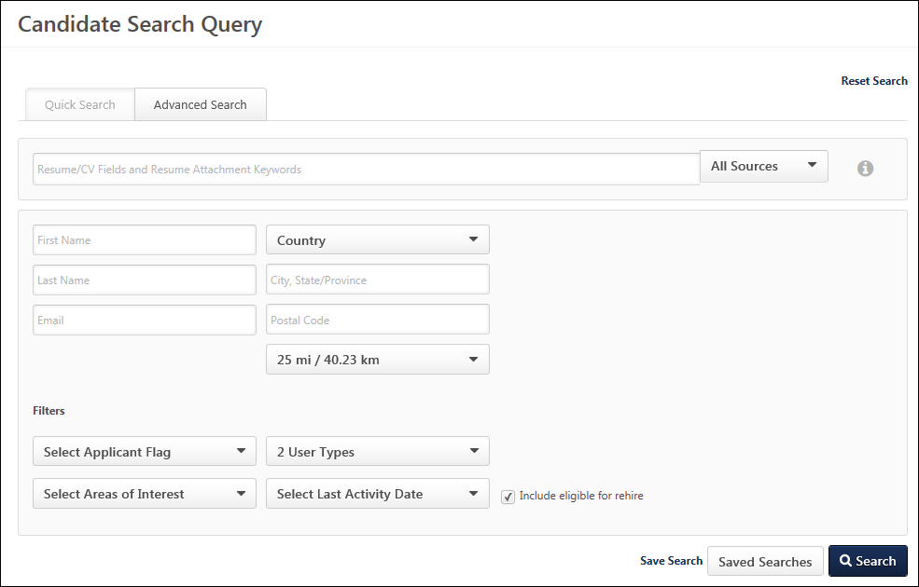
Keyword Search
The keyword search bar allows recruiters to search for candidates using keywords and Boolean operators that will search the parsed resume/CV, typed-in resume/CV, and the most recently attached resume. The searches are not case sensitive. An error message displays upon clicking Search if the search terms are invalid.
Boolean Operators
The following Boolean operators can be included in the search bar as part of the keyword search:
Operator | Description | Query | Search Results
+ | AND, used to require term to be included in search | +Manager +Associate  +"Sales Associate" +"Product Manager" | Results include all candidates whose resume/CV contains the terms Manager and Associate.  Results include all candidates whose resume/CV contains the exact terms Sales Associate and Product Manager.
- | NOT, used to exclude term from search | Manager Associate -VP  Note: Quotation marks must be used when user wants to include + and - as part of a search term or a query (e.g., "c+".)  Note: The - operator must be used in conjunction with another operator. For example, -java is an invalid search term. Since - operators generally do not filter out as many results as other Boolean operators, the - operator(s) in a query will be applied to the documents remaining only after other operators are applied to the entire document population. This is to improve system performance and prevent the system from returning a very large number of results before applying other operators to them. | Results include all candidates whose resume/CV contains the terms Manager or Associate or both but does not contain the term VP.
* | Begins with, used to search for terms that begin with the letters that appear before the *  At least two letters must appear before the * | analy*  analy* procur* | Results include all candidates whose resume/CV contains terms that begin with analy, such as analytical and analysis.  Results include all candidates whose resume/CV contains terms that begin with analy (i.e., analytical, analysis) and/or procur (i.e., procure, procurement).
Parentheses | Used to group or nest search terms | +(Director Manager Associate) +(Sales Operations) | Results include all candidates whose resume/CV contains the terms Director, Manager, or Associate AND candidates whose resume/CV contains the terms Sales or Operations.
Quotation Marks | Used to conduct an exact match search | "Customer Service Representative" | Results include all candidates whose resume/CV contains the exact term Customer followed by the term Service followed by the term Representative.
Special Characters | The following special characters are accepted:  ! (searchable with/without quotes)  ( (searchable with quotes)  ) (searchable with quotes)  [ (searchable with quotes)  ] (searchable with quotes)  ? (searchable with/without quotes)  : (searchable with quotes)  \ (searchable with quotes)  @ (searchable with/without quotes)  . (searchable with/without quotes)  - (searchable with quotes)  _ (searchable with quotes)  + (searchable with quotes)  # (searchable with/without quotes)  $ (searchable with/without quotes)  % (searchable with/without quotes)  & (searchable with/without quotes)  ' (searchable with quotes)  * (searchable with quotes)  / (searchable with quotes)  = (searchable with quotes)  ^ (searchable with/without quotes)  { (searchable with quotes)  } (searchable with quotes)  ~ (searchable with quotes) | A recruiter would like to find candidates who have included a salary of $120,000 on their resume/CV. The recruiter enters "$120,000" in the quick search field. | Results include all candidates whose resume/CV contains the term $120,000.
Whitespace | OR, used to make term optional in search results | Manager Associate  Note: If only one search term is entered and that term does not have a "+" or "-" preceding it, such as "Manager", the system treats the search term as a required term (as if "+" preceded the single term). This also applies where there is only one search term with whitespace accompanied by another search term with a "-", such as "-Manager Associate". In this case, the term with whitespace preceding it is treated as a required term; all documents containing the word "Associate" will then have the negation operator "-" applied to them to arrive at the list of all documents containing "Associate" that do not also contain "Manager". [Quotations do not apply.] | Results include all candidates whose resume/CV contains Manager or Associate or both.
Sources
The source drop-down displays to the right of the keyword search bar. This option allows recruiters to select the source information that is used in the search. The following options are available in the Source drop-down:
- All Sources - This option is selected by default. When this option is selected, both the parsed resume/CV fields and most recently attached resume are searched.
- Resume/CV Fields - When this option is selected, only the information saved in the resume fields of the external applicant's profile and in the internal applicant's Universal Profile > Bio page will be searched. For parsed resume data (if parsing is enabled), only the parsed data that is saved by the applicant into one of the mapped resume fields is searchable.
- Resume Attachment - When this option is selected, only the most recently attached resume is searched. This search does not include parsed resume data.
Quick Search Info Pop-Up
The Quick Search Info pop-up provides descriptions and examples of the Boolean operators that are accepted in the keyword search field. To open the pop-up, click the Quick Search Info icon to the right of the sources drop-down.
User Fields
The user fields allow recruiters to search for candidates by first/last name and email, as well as add location criteria to the search query. The values entered in the user fields are preserved when toggling between the Quick Search and Advanced Search tabs.
The following criteria are available:
- First Name - This field allows recruiters to search by first name. You can enter the candidate's full first name or enter part of the name. This field accepts the * wildcard Boolean operator.
- Last Name - This field allows recruiters to search by last name. You can enter the candidate's full last name or enter part of the name. This field accepts the * wildcard Boolean operator.
- E-mail - This field allows recruiters to search by an exact email address. This field accepts the special characters of @, ., -, _, +, 0-9, A-Z, a-z, !, #, $, %, &, ', *, /, =, ?, ^, {, }, ~.
- Country - This field allows recruiters to search for candidates by country. Select a country from the drop-down to search by country. Completing the Location field is required when a country is selected. Depending on the country selected, a Postal Code field displays to the right of the Location field, which allows recruiters to further define the search criteria.
When using this field, the search results display candidates who are in the selected country, location, and postal code if defined (in addition to other search options if defined, such as first and last name). If a radius is defined, then the results display candidates who are within the selected distance to the location within the selected country. Note: If geolocation has been disabled for your portal, this field does not display.
- City State/Province - This field allows recruiters to search for candidates by city/state/province. Enter a location, up to 20 characters. When using this field, the search results display candidates who are in the location in the selected country and within the postal code if defined. Best Practice: As a best practice, enter the City, State/Province to improve the accuracy of the location search. Note: If geolocation has been disabled for your portal, this field does not display.
- Postal Code - This field allows recruiters to enter a postal code for the location.
- Radius - Recruiters can search for candidates within a certain radius of the location. The Within field allows recruiters to select a radius. The following options are available:
  - 10 mi / 16.09 km
  - 25 mi / 40.23 km
  - 50 mi / 80.47 km
  - 100 mi / 160.93 km
Note: Searching by phone number is not available on the new Candidate Search page.
Applicant Flags Filter
This option allows recruiters to search for candidates by applicant flags. All flags are unchecked by default. Click the Applicant Flags drop-down to view the flags and select one or more flags.
The Potential Duplicate Applicant flag is only available if Flag Potential Duplicates is enabled in Requisition and Applicant Preferences. Selecting this flag enables recruiters to search for applicants who are flagged by the system as potential duplicates. When the flag is selected, potential duplicates display in the search results.
The Merged Duplicate Applicants flag is available. When this flag is selected, applicants who have been automatically flagged by the system with the Merged Duplicate Applicants flag can be searched using the applicant flag filter.
The additional flags that display are the flags that are visible to the recruiter based on the flag's visibility settings and organizational unit availability. In addition, the candidate search option must be enabled for a flag in order for the flag to be available in the Search Candidates feature.
Note: Visibility and candidate search settings for flags are defined by the administrator in Applicant Flags Preferences. See Applicant Flags Preferences on page 13 for additional information.
Candidate Type Filter
This is a required field. This option allows recruiters to define the candidate type for the search criteria. The following options are available in the User Type drop-down:
- Select All - This option is checked by default. When checked, both internal and external candidates are included in the search.
- Internal - Checking this option includes current employees who have not applied to the requisition and existing applicants. Note: Administrators can disable the ability to search for and view internal employees in Candidate Search Query. This is controlled by a preference in Requisition and Applicant Preferences. If this preference is enabled, the Internal filter option is not available. See Requisition and Applicant Preferences.
- External - Checking this option includes external candidates in the search.
Select Areas of Interest Filter
This filter displays on both the Quick Search and Advanced Search tabs. allows you to filter the search results by areas of interest so that you can find candidates with specific interests.
Note: Applicants select areas of interest when applying to the organization via Connect With Us from the career site.
To filter your candidate search by areas of interest:
- Open the Select Areas of Interest drop-down in the Filters section.
- Check the one or more areas of interest. Or, check Select All to select all areas of interest.
Once the interests are selected, you can add additional search criteria or click Search to conduct the candidate search.
You can also save the search by clicking Save Search so that you can quickly find additional or future candidates within those areas of interest.
Select Last Activity Date Filter
This filter allows you to filter candidates based on last activity date so that you can find candidates by using activity date ranges. A candidate's last activity refers to the most recent time they logged in to the career site. The last activity date updates each time the candidate logs in.
The following options are available in the filter:
- Less than 7 days
- Less than 30 days
- Less than 60 days
- Less than 90 days
- Less than 180 days
This filter only displays on the Quick Search tab.
Include Eligible for Rehire
The field is selected by default and enables past employees to appear in the search results. Having former employees in the search results helps recruiters when they want to reach out to these former employees to apply to open jobs.
Reset Search
Click the Reset Search link at the top of the page to clear all search criteria fields. The page is refreshed to display the default values for all fields.
Save Search
You can save the search by clicking Save Search. This opens the Save Search pop-up. Enter a unique title in the Title field, up to 100 characters. This is a required field. Click Save to save the search, or click Cancel to close the pop-up without saving.
Note: If you save changes to the criteria, and then make additional changes that you would like to save, the title given to the previous saved search populates the Title field in the Save Search pop-up. When accessing the saved search, you can edit the criteria.
Saved Searches
The Saved Searches option enables you to search for candidates using searches you saved or searches shared with you. To search using a saved search, click Saved searches. This opens the Saved Searches page.
Save As
The Save As link only displays when editing an existing saved search. Once all changes are made to the saved search, click Save As to save the search as a new saved search. Enter a title in the Save Search pop-up, and then click Save to save the search.
Search
Once at least one search term is entered, click Search to view the search results page. If the option to require a reason for the search is enabled in Compliance Enablement Preferences, then the Reason for Search pop-up displays, and a reason for the search must be selected before the search results display.
Reason for Search
Clicking Search may require you to enter a reason for the search prior to conducting the search. If configured in Compliance Enablement Preferences, when Search is clicked, a Reason for Search pop-up opens. Select a requisition from the Select Requisition drop-down to indicate the requisition for which you are conducting the search. For portals with multiple languages enabled, the job title in the Select Requisition drop-down displays in the user's language if available. If a translation is not available in the user's language, then the value displays in the language of the recruiter who created the job requisition.
Or, select Other and enter a reason in the text field. There is no character limit when entering a reason in the Other field.
Click Save in the pop-up to execute the search.
Note: The Specific Requisition drop-down displays all requisitions that are available to the user. For this reason, the user must have permission to manage or review requisitions and must be a requisition owner.
Note: If users are not required to enter a reason for the search, then clicking Search on the Search Candidates page executes the search.

Saved Searches
The Saved Searches feature enables you to search for candidates using searches you saved or searches shared by other users. Searches that are saved on the Quick Search and Advanced Search tabs are accessed from the same Saved Searches page. The searches display in order or most to least recently saved.
To search using a saved search, click Saved Searches on the Candidate Search page or the search results page. This opens the Saved Searches page.
Permissions
PERMISSION NAME | PERMISSION DESCRIPTION | CATEGORY

Recruiter: Share Saved Searches | Allows users to view and manage the Availability column on the Saved Searches Page. This permission can be constrained by OU and User's OU. | Recruiting

Recruiting: Search Candidates | Grants ability to access Candidate Search page for recruiting, which enables searching for internal candidates and external candidates who have applied for open positions. This permission also enables the Invite to Apply action item to appear in the Actions drop-down on the Search Candidates - Search Results page. This permission can be constrained by OU and User's OU. | Recruiting Administration
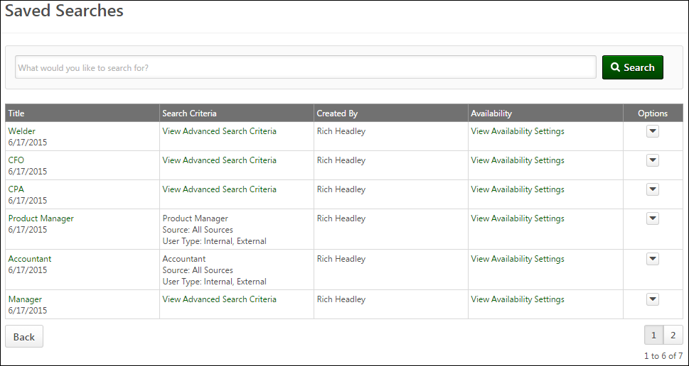
Keyword Search
Filter the list of saved searches by entering full or partial keywords into the search bar, up to 50 characters. Click Search to update the list.
Title/Date
This column displays the title of the search and the date the search was saved. Click the title of the saved search to view the search results of the saved search on the search results page. The results display all candidates found using the search criteria defined on either the Quick Search or Advanced Search tabs.
Search Criteria
The following options and information displays in the Search Criteria column:
Quick Search Saved Searches
For searches saved from the Quick Search tab, this column displays the search criteria that were configured on the Candidate Search Query page. If ares of interest were selected, they display in this column.
Advanced Search Saved Searches
For searches saved from the Advanced Search tab, this column displays a View Advanced Search Criteria link. Click the link to open the Saved Search [Search Title] pop-up. The pop-up displays the full criteria defined on the Advanced Search tab, which also includes any areas of interest criteria. Hovering over a criteria section will display the full path of the resume/CV field to which the criteria apply.
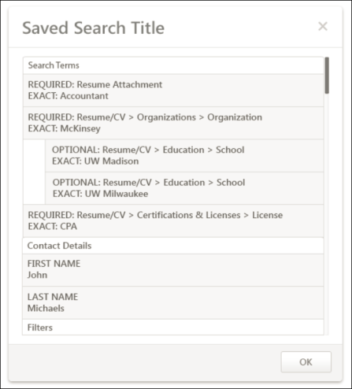
The pop-up is divided into the following sections:
- Search Terms - This section displays the search criteria defined in the predictive search section on the Advanced Search tab. For grouped criteria, the child criteria are indented below the parent criteria.
- Contact Details - This section displays the search criteria defined in the contact/location information section on the Advanced Search tab. This section only displays if at least one contact/location search criteria is defined.
- Location - This section displays the geolocation information defined in the location information section on the Advanced Search tab. This section only displays if at least one geolocation search criteria is defined.
- Filters - This section displays the search criteria defined in the Filters section on the Advanced Search tab.
Once the search is saved, the search can only be executed if all resume/CV fields in the search criteria are active. If any of the fields are inactive, then the search cannot be executed until the inactive fields are activated.
Note: For saved searches that included applicant flags, if a flag has been removed from a user, then the user does not appear in the search results that include the flag criteria. If the flag's visibility rule has changed and no longer allows the user to view the flag or the flag cannot be used to search in Candidate Search, then candidates will not appear in the search results for the flag.
Created By
This column displays the name of the user who saved the search.
Availability
This option allows you to share the search. The users with whom the search is shared must have permission to share saved searches and access the Candidate Search page in order to have access to the Saved Searches page.
To share your saved search:
- Click View Availability Settings in the Availability column. This opens the Saved Search Availability pop-up.
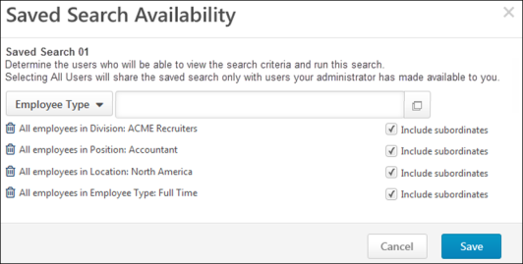
- Select the users or organizational units (OU) from the Select OU Criteria drop-down with whom to share the search.
- Enter OU or user search terms in the predictive search field. The predictive search field can only be used if there are no constraints on the your permission to share searches. If you have constraints on your permission to share searches, then you can search for users by clicking the Select icon to select users from a list of available users or organizational units (OU).
- Check Include subordinates to include subordinate OUs. When unchecked, the saved search is not shared with subordinate OUs.
- Click Save. This adds the saved search to the Saved Searches page for the selected users. The selected users cannot share the search with other users.
Note: Saved searches that include applicant flags or applicant custom fields in the search criteria cannot be shared.
Options
The drop-down to the right of the search criteria displays the Delete option. Click the Delete to delete the saved search. Saved searches that were shared with other users will no longer be available to those users after they are deleted.
If a shared search is deleted by a user with whom the search is shared, then the shared search is also deleted from the user who created and shared the search.
Back
Click Back to return to the page from which you accessed the Saved Searches page.

Search Results Details
The search results for both the Quick Search and Advanced Search tabs display all candidates who match the criteria defined for the search. The results display general details for each candidate and provide direct access to the candidate's Applicant Profile page.
The results for a search on Candidate Search are accessed by clicking Search on the Quick Search or Advanced Search tabs. You can also access search results via saved searches.
Permissions
PERMISSION NAME | PERMISSION DESCRIPTION | CATEGORY

Recruiting: Search Candidates | Grants ability to access Candidate Search page for recruiting, which enables searching for internal candidates and external candidates who have applied for open positions. This permission also enables the Invite to Apply action item to appear in the Actions drop-down on the Search Candidates - Search Results page. This permission can be constrained by OU and User's OU. | Recruiting Administration
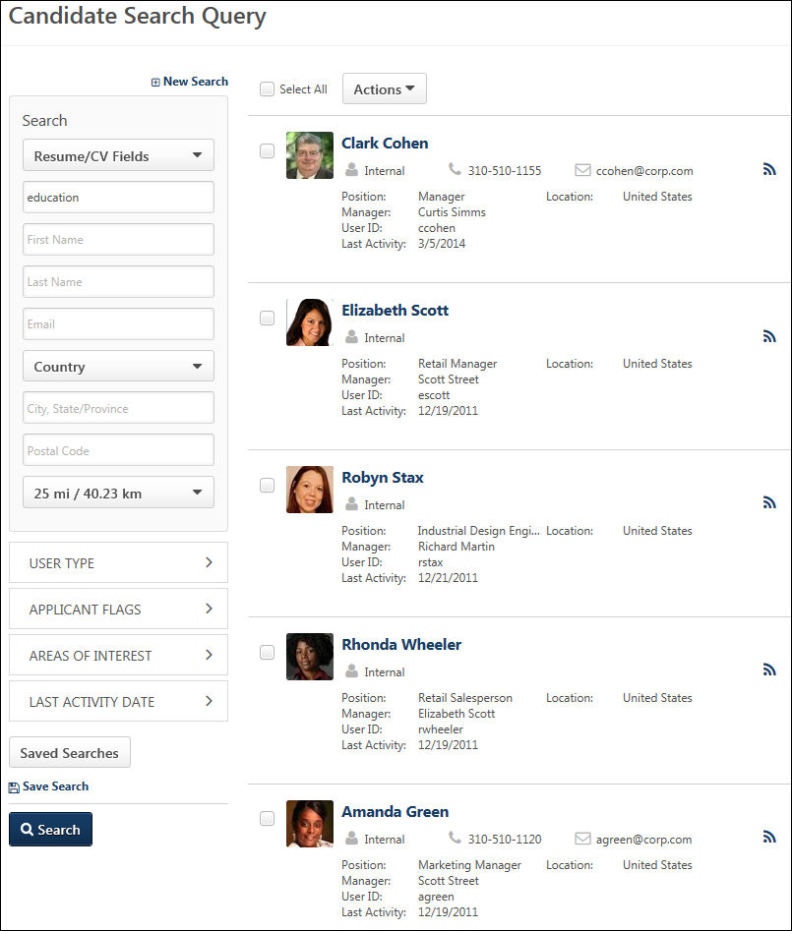
Select All
The Select All box to the left of the Actions drop-down checks all candidates on the current page, enabling you to batch perform the Add to Requisition, Add To Talent Pool, and Send Email actions. Unchecking the box unchecks all users on the current page.
Actions
The Actions drop-down enables you to perform a series of actions on all candidates at once or on individual candidates. The drop-down only displays actions for which you have permission to perform and that are relevant to the functionality in your portal.
For detailed information about the available actions, see the Candidate Search Query Results - Actions topic in Online Help.
Candidate Results
The candidate search results are displayed in the order in which they were retrieved from the search server. Each candidate card shows general information about the candidate and helps the recruiter to determine the candidates on which to take action.
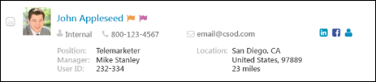
Note: When constraints are applied to the recruiter or administrator's permission to search candidates, the search results are limited to candidates who fit within the permission constraints. For example, if the search criteria are for Sales Manager Position OU and Houston Location OU, then only candidates associated with the indirect OUs of Sales Manager and Houston display in the search results. For external candidates, the following constraints are associated with external candidates: Restrict to Position, Restrict to User's Position, Restrict to Division, Restrict to User's Division, Restrict to Location, and Restrict to User's Location.
The following information displays for candidates in the search results:
- Checkbox - Each row displays a checkbox next to the candidate's name with which you can use to perform single actions. The box is unchecked by default.
- Photo, Name & Contact - The following displays for the candidate:
  - Photo, if available; ghost image displays if no photo is available.
  - Candidate's name displays as a link. Clicking the link opens the Applicant Snapshot page of the applicant's profile for the most recent requisition to which the candidate applied. The snapshot opens for all candidates, including those who have not yet applied to a job requisition.
  - Type - Indicates if a candidate is internal (existing employee) or external (applied for a position through the application process). Note: Administrators can disable the ability to search for and view internal employees in Candidate Search Query. This is controlled by a preference in Requisition and Applicant Preferences. If this preference is enabled, the Internal filter option is not available. See Requisition and Applicant Preferences.
  - Phone Number
  - Email
- Applicant Flags - Applicant flags that are associated with an applicant display to the right of the candidate's name. This information only displays for users with permission to manage flags. The flags that display are the flags that are visible to the recruiter based on the flag's visibility settings and OU availability. Hover over the flag to view the name of the flag. Up to five flags display by default.
  - Click Show More to open the Applicant Profile page, from which the recruiter can view the additional applicant flags.
  - Click the flag to view the flag details. This opens the Application Flag pop-up, which displays the flag name and description. The user who added the flag also displays, as well as the date on which the flag was added. For portals with multiple languages enabled, the name and description display in the viewing user's language, if available.
- Social Profiles - You can access the candidate's Facebook or LinkedIn social profiles by clicking the social profile icons on the right side of the candidate's row. The profiles must be linked via the My Account page or the candidate's My Profile page on the career site.
- Resume - Click the resume icon to view the candidate's most recently uploaded resume. The resume opens in the file type in which the applicant submitted the document.
  - For resumes that are typed or pasted into the Write or Paste a Resume/CV field during the application process, clicking the Resume icon opens a pop-up that displays the resume data.
  - For pasted resumes, the resume data appears in the original format in which the candidate pasted it.
  - For resumes submitted by internal users using their Career Center resume, clicking the Resume icon opens the resume as a PDF.
  - For applicants who applied using their Seek profile, a Seek icon displays. Click the icon to view the applicant's profile.
- Applicant Feed - Clicking the Applicant Feedback icon opens the Applicant Feed page, from which you can view an applicant's entire history of events and comments from the most recent 20 requisitions related to the applicant. This allows recruiters to only have to access one page in order to view this data.
- Position - For internal candidates, displays their current position. For external candidates, displays their current position and the organization associated with their current position, as defined on the candidate's resume. If the position or organization are longer than 100 characters, hover over the name to display the full name.
- Manager - This field displays the candidate's manager, if available. If the manager's name is longer than 100 characters, hover over the name to display the full name.
- User ID - This field displays the user ID for the candidate.
- Area(s) of Interest - If an applicant has applied to the organization via Connect With Us, and they have selected areas of interest, then their interests display in the Area(s) of Interest field in the search results.Note: Applicants select areas of interest when applying to the organization via Connect With Us from the career site.
- Location - For internal candidates, displays the name of the Location OU to which they are assigned. For external candidates, displays the city and state defined in the Contact Information section of the user record.
- Distance - The candidate's distance from the location displays below the location information. This field only appears if the search defined a location.
Recruiting Agency Submission
For candidates submitted by a recruiting agency, the source credit setting is respected when searching for candidates.
Candidate Opt-Out
Candidates who opt out of candidate search are not visible in the search results.
Total Search Results Number
The total number of search results displays below the results at the bottom-right of the page. If there is more than one page of search results, then the total results displays along with the number of results per page. A maximum of 1000 search results can be displayed. If more than 1000 search results are returned, a message is displayed at the top of the page indicating that the search criteria should be refined.
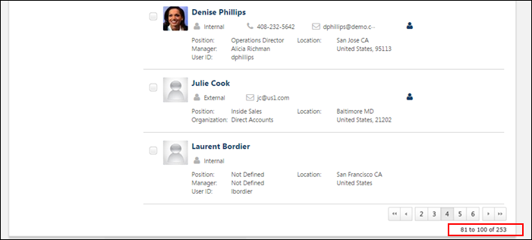
Next/Previous
Click Next to view the next page of search results. Click Previous to view the previous page of search results. Up to 20 search results display per page, with a maximum of 500 results total. If a larger-than-desired number of results appear, the search query may need to be refined with additional or more specific criteria.

Recruiting Dashboards Overview

Hiring Dashboard Page - Overview
The Hiring Dashboard provides hiring team members visibility into their requisitions, applicants, and other tasks all from a single page. The dashboard is organized by widgets that allow hiring managers, recruiters, and requisition approvers to drill into specific details of their own requisitions and applicants. This simplifies their processes for finding requisition and applicant data, reduces clicks, and avoids the need to learn or remember how to navigate through the system to find information or perform actions.
To access the Hiring Dashboard, go to Recruit > Hiring Dashboard.
Permissions
PERMISSION NAME | PERMISSION DESCRIPTION | CATEGORY

Hiring Dashboard: Manage | Grants the ability to access the Hiring Dashboard. Access to the Hiring Dashboard is dynamically assigned when the user is a Requisition Owner or Applicant Reviewer (including Hiring Manager).  This permission is only assigned to the Hiring Manager/Applicant Reviewer when there is a qualified candidate for the requisition. A qualified candidate is any candidate that is past the New Submission stage. Until that point, the Hiring Dashboard will not be visible to recruiters who are dynamically assigned this permission who do not already have access to the Hiring Dashboard through another requisition. | Recruiting

Hiring Dashboard: View Other Dashboards | Grants the ability to view other users' dashboards. While viewing another user's dashboard, no actions can be taken on behalf of the dashboard owner. User also needs access to their own Hiring Dashboard before accessing other dashboards using this permission. This permission can be constrained by OU, User's OU, User, and User's Subordinates. | Recruiting

Requisition Details Report | Grants access to the Requisition Details report, which displays details of requisitions in the portal. This permission cannot be constrained. | Reports - Recruiting

Requisition: Owner | Enables owner to access requisitions and applicants for requisitions for which they are an owner. This permission also grants read-only access to video interviews that are completed by applicants via HireVue. For portals with Referral Suite enabled, this permission also enables requisition owners to edit the referral source on the Applicant Profile page. This permission cannot be constrained.  Note: This is a dynamically assigned permission that is not available in Security Role Administration. If the user is removed as an owner, the permission is revoked for the associated requisition. This permission cannot be manually assigned. Also, if a user has both the permission necessary to manage requisitions and be a requisition owner, the constraints of the Requisition: Manage permission overrule those of the Requisition: Owner permission. For requisition owners that do not also have permission to manage requisitions, only certain fields are editable when editing a requisition. | Recruiting

Requisition: Reviewer | Enables reviewer to access requisitions and applicants for requisitions for which they are a reviewer. This permission cannot be constrained.  Note: This is a dynamically assigned permission that is not available in Security Role Administration. Once a requisition is in a Closed or Cancelled status or if the user is removed as a reviewer, the permission is revoked for the associated requisition. This permission cannot be manually assigned.  Note: If an applicant reviewer is removed as a reviewer via the Applicant Profile page, the Requisition: Reviewer permission is revoked for the associated requisition. However, if the reviewer was also added as a reviewer via the General tab when creating, editing, or copying the requisition, the reviewer still appears on the In Review panel as a duplicate reviewer and retains access to the requisition and applicants from the Requisition: Reviewer permission. See Applicant Profile Page Overview for more information about duplicate reviewer instances. | Recruiting
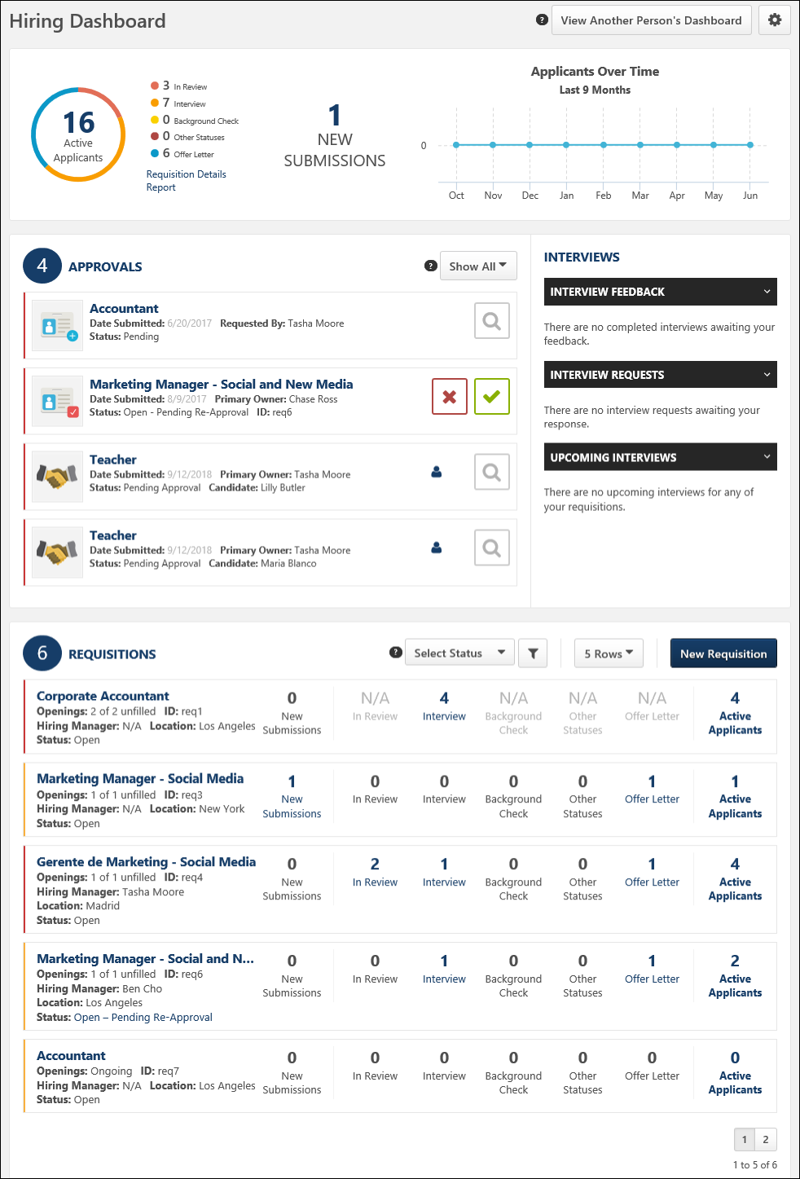
Make the Hiring Dashboard Visible in Your Portal
The Hiring Dashboard must be added to Navigation Tabs and Links in order to be available for users to find in your portal. For more information about how to add a system page to a navigation tab, see the Navigation Tabs and Links - Add Page topic in Online Help.
Features and Options Overview
The following is an overview of the features and options that are available on the Hiring Dashboard. These features and options are available as standard functionality for the Hiring Dashboard and do not require any configuration on your part.
View Another Person's Dashboard
This option allows you to access another person's dashboard so that you can understand the status of that person's requisitions, approvals, and applicants. This option only displays for users with permission to view another user's dashboard. See Hiring Dashboard - View Another Person's Dashboard on page 127 for additional information.
Manage Sections
The Manage Sections option allows you to rearrange the position of each section on the Hiring Dashboard and hide certain sections from view. The option appears as an icon in the upper-right corner of the dashboard. See Hiring Dashboard - Manage Sections on page 119 for additional information.
Approvals
The Approvals widget displays a list of all pending approval items that are awaiting the dashboard owner's action. Actions can be taken directly from the dashboard to process pending items. See Hiring Dashboard - Approvals Widget on page 102 for additional information.
Applicants
The Applicants widget displays applicant submission and status data as an aggregate for all of your active requisitions. You can also create a Requisition Details Report from this widget, provided that you have permission to run the report. See Hiring Dashboard - Applicants on page 98 for additional information.
Requisitions
The Requisitions widget lists all of your requisitions. From this widget, you can view basic information about your requisitions and the distribution of applicants across the status types for the requisition. Users with permission to manage requisitions or requisition owners can access the Edit Requisition page for the requisition to view and change the requisition configurations, unless they are viewing another person’s dashboard, in which case everything is read-only and not clickable. See Hiring Dashboard - Requisitions on page 122 for additional information.
Hiring Dashboard - Applicants
The Applicants section displays applicant submission and status data as an aggregate for all of your active requisitions. You can also create a Requisition Details Report from this widget, provided that you have permission to run the report.
To access the Hiring Dashboard, go to Recruit > Hiring Dashboard.
Permissions
PERMISSION NAME | PERMISSION DESCRIPTION | CATEGORY

Hiring Dashboard: Manage | Grants the ability to access the Hiring Dashboard. Access to the Hiring Dashboard is dynamically assigned when the user is a Requisition Owner or Applicant Reviewer (including Hiring Manager).  This permission is only assigned to the Hiring Manager/Applicant Reviewer when there is a qualified candidate for the requisition. A qualified candidate is any candidate that is past the New Submission stage. Until that point, the Hiring Dashboard will not be visible to recruiters who are dynamically assigned this permission who do not already have access to the Hiring Dashboard through another requisition. | Recruiting

Hiring Dashboard: View Other Dashboards | Grants the ability to view other users' dashboards. While viewing another user's dashboard, no actions can be taken on behalf of the dashboard owner. User also needs access to their own Hiring Dashboard before accessing other dashboards using this permission. This permission can be constrained by OU, User's OU, User, and User's Subordinates. | Recruiting

Requisition Details Report | Grants access to the Requisition Details report, which displays details of requisitions in the portal. This permission cannot be constrained. | Reports - Recruiting

Requisition: Manage | Grants ability to access and manage all requisitions regardless of ownership (constraints permitting). This permission also grants read-only access to the Applicant Review tab when creating or editing a job requisition. This permission can be constrained by OU, User's OU, and Grade. | Recruiting

Requisition: Owner | Enables owner to access requisitions and applicants for requisitions for which they are an owner. This permission also grants read-only access to video interviews that are completed by applicants via HireVue. For portals with Referral Suite enabled, this permission also enables requisition owners to edit the referral source on the Applicant Profile page. This permission cannot be constrained.  Note: This is a dynamically assigned permission that is not available in Security Role Administration. If the user is removed as an owner, the permission is revoked for the associated requisition. This permission cannot be manually assigned. Also, if a user has both the permission necessary to manage requisitions and be a requisition owner, the constraints of the Requisition: Manage permission overrule those of the Requisition: Owner permission. For requisition owners that do not also have permission to manage requisitions, only certain fields are editable when editing a requisition. | Recruiting
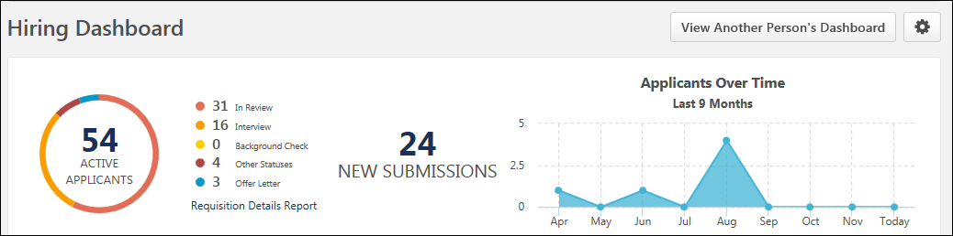
Active Applicants Chart and Statuses
The Active Applicants ring chart displays the total applicant count for the requisitions for which you are part of the hiring team. Each color bar in the chart represents a different applicant status category as represented in the Requisitions widget. The size of the ring segment is dependent upon the number of applicants in the status in relation to the total number of active applicants. Hover over a segment to view the number of applicants in the status.
For users with permission to manage requisitions or for requisition owners, click the linked number of active applicants to open the Manage Requisitions page. All status filters except Closed or Hired are automatically selected.
Applicant Statuses
The status breakdown for the Active Applicants ring chart displays to the right of the chart. The list shows each applicant status that has been defined for the requisition and provides the total number of applicants in each status.
Requisition Details Report
This option only displays for users with permission to create Requisition Details Reports. Click Requisition Details Report to open the report page and create the report.
For information about creating this report, see the Requisition Details Report topic in Online Help.
New Submissions
This section displays the number of new submissions, which is the total number of applicants that are in a New Submission status for the requisitions for which you are part of the hiring team.
For users with permission to manage requisitions or for requisition owners, click the linked number of new submissions to open a filtered view of Manage Candidates.
Use Case
- Peter is a Recruiter and is an avid user of the Hiring Dashboard. He is in charge of screening new submissions.
- Peter needs to quickly view all the new submissions that have come in for all his requisitions from the Hiring Dashboard.
- Peter clicks the New Submissions tile on his Hiring Dashboard and is taken to a filtered view of Manage Candidates that shows all candidates in a New Submissions status.
- Peter is able to quickly review the new submissions across all of the requisitions.
Applicants Over Time Chart
The Applicants Over Time chart shows the following:
- Applicant count over a 9-month period, from the last eight months up to today's date for requisitions for which you are one or more of the following roles:
  - Hiring Manager
  - Requisition Owner
  - Requisition Reviewer
- For applicant reviewers, the chart only shows the applicant count for requisitions for which you are an applicant reviewer.
The X axis shows the months up to the current month. The Y axis shows the number of applicants. The data in the chart updates each time the page is refreshed.
The applicants that are counted in the chart are applicants that have moved from a New Submission into the applicant status in a given month. Applicants from requisitions that are in a Closed or Hired status are counted in the chart.
Note: The constraints on the permission to manage requisitions are considered in the applicant count. If the permission constrains users to only viewing certain applicants for a requisition, then the Applicants Over Time chart will only include those applicants.
Note: When viewing another user's dashboard, the applicant data that displays in the Applicants Over Time chart is based on the user's permissions and constraints and is not based on your permissions and constraints. You are able to see the applicant data that the user can see.
Frequently Asked Questions
What if there are no active applicants?
If there are no active applicants, then the Active Applicants ring chart and list of statuses does not display. Instead, "0 Active Applicants" displays as a link. Clicking the link opens the Manage Requisitions page.
What if there are no new submissions?
If there are no New Submissions, then "0 New Submissions" displays as a link. Clicking the link opens the Manage Requisitions page.
Does the Requisition Details Report option still display if there are no active applicants or new submissions?
Yes. In either case, the Requisition Details Report link still displays and is clickable.
Hiring Dashboard - Approvals Widget
The Approvals widget displays all job requisitions, requisition requests, and offer letters that are pending your approval. This widget mirrors the functionality available in the Universal Profile > Actions > Requests Tab.
Users with permission to approve requisitions (listed as a Requisition Approver in a requisition’s hiring team) can approve/deny job requisitions. Users identified in Admin > Recruit > Requisition Requests as requisition request approvers can approve/deny requisition requests. Actions can be taken directly from the dashboard to process pending items.
To access the Hiring Dashboard, go to Recruit > Hiring Dashboard.
Permissions
PERMISSION NAME | PERMISSION DESCRIPTION | CATEGORY

Hiring Dashboard: Manage | Grants the ability to access the Hiring Dashboard. Access to the Hiring Dashboard is dynamically assigned when the user is a Requisition Owner or Applicant Reviewer (including Hiring Manager).  This permission is only assigned to the Hiring Manager/Applicant Reviewer when there is a qualified candidate for the requisition. A qualified candidate is any candidate that is past the New Submission stage. Until that point, the Hiring Dashboard will not be visible to recruiters who are dynamically assigned this permission who do not already have access to the Hiring Dashboard through another requisition. | Recruiting

Request Items - View | Allows user to access the Requests tab on the Universal Profile > Actions tab. This permission cannot be constrained. | Universal Profile
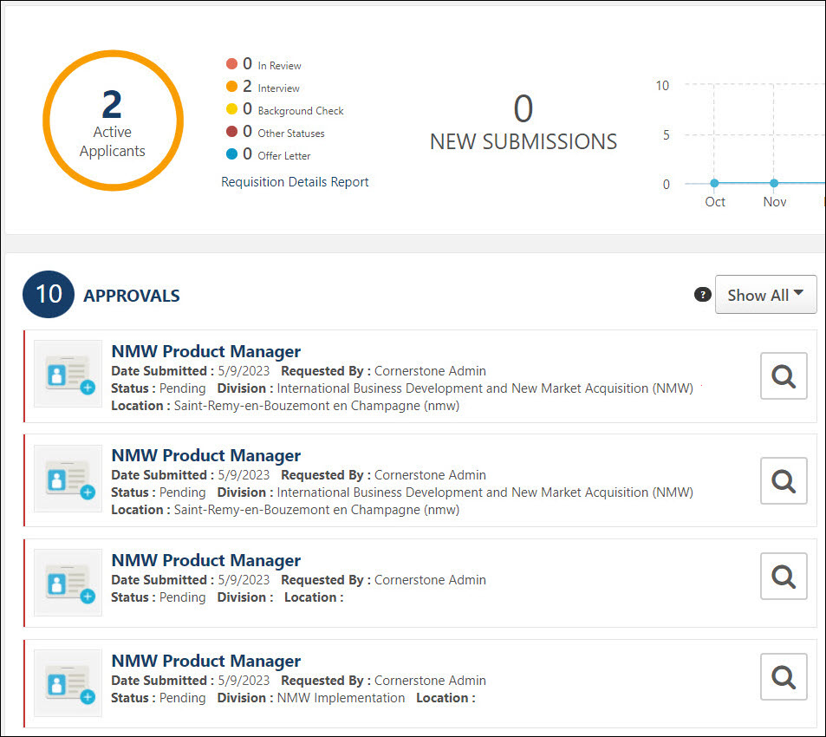
Approvals Heading
The Approvals Heading is only visible to users with permission to view request items.
The Approvals heading displays as a link. Clicking Approvals opens your Universal Profile page. Note: When viewing another user's dashboard, the Approvals heading is not clickable.
The number to the right of the Approvals heading displays the number of pending approval actions.
Filter
The following options can be selected in the filter drop-down to filter the list of pending items:
- Show All - This option is selected by default. When selected, all pending items display.
- Offer Letter - Select this option to filter the page to show only pending offer letter approvals.
- Requisition Approval - Select this option to show only job requisition approvals in the list.
- Requisition Request - Select this option to show only requisition request approvals in the list.
Approve Requisitions, Requisition Requests, and Offer Letters
The following approval types are available from the Approvals widget:
Job Requisition Approvals
The job requisition approval items display in order of oldest to newest submitted date. An item only displays here if it is pending your approval.
Job Requisition Approval Items
The following information displays for pending approval items:
- Icon - A red checkmark icon displays for job requisition approvals.
- Title - The title of the item is clickable. Click the title to open the Edit Requisition page. You can modify the requisition if the requisition is in an editable status. For more information about editable fields based on requisition status, see the Edit Job Requisition topic in Online Help.
Note: The visibility of custom fields on a requisition is based on the availability settings for the field in Custom Field Administration.
- Date Submitted - This displays the date on which the item was submitted.
- Primary Owner - This displays the primary owner of the item.
- Status - This displays the approval status of the item. The statuses that display are dependent upon the approval status options for requisitions.
- ID - This displays the requisition ID.
- Division - The division associated with the requisition request.
- Location - The location associated with the requisition request.
Deny Job Requisition
Click the deny button on the Hiring Dashboard to deny approval. This opens the deny pop-up. You can enter comments about your approval decision in the Comment box, up to 2,000 characters. Click Deny to process the denial.
Once you have submitted your approval decision, the pending action item is removed from your Hiring Dashboard page.
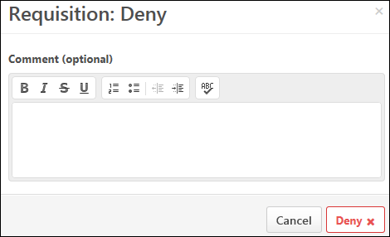
Approve Job Requisition
Click the approve button on the Hiring Dashboard to approve the item. This opens the approve pop-up. You can enter comments about your approval decision in the Comment box, up to 2,000 characters. Click Approve to process the approval. Once you have submitted your approval decision, the pending action item is removed from your Hiring Dashboard page.
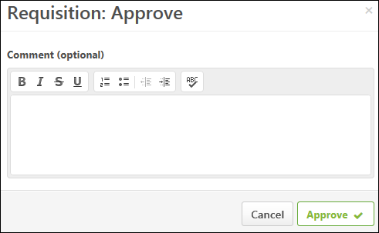
Requisition Request Approvals
The following information displays for pending approval items:
- Icon - A blue plus sign icon displays for Requisition Request Approvals.
- Title - The title of the item is clickable. Click the title to open the Requisition Request page.
- Date Submitted - This displays the date on which the item was submitted.
- Primary Owner - This displays the primary owner of the item.
- Requested By - This field displays the name of the person who requested the requisition.
- Status - This displays the approval status of the item. The statuses that display are dependent upon the approval status options for requisition requests.
Approve/Deny Requisition Request
Click the Review Requisition Request button to open the View Requisition Request page. This allows you to view a read-only version of the requisition request.
You can decline or create the request from the View Requisition Request page. Once you have submitted your approval decision, the pending action item is removed from your Hiring Dashboard page. See Review/Decline/Accept Requisition Request.
Offer Letter Approvals
Pending offer letter approvals display in the Approvals widget and appear in order of most recently submitted. You can review, approve, and deny offer letters from the Approvals widget.
The ability to manage offer letter approvals from the Hiring Dashboard allows recruiters and hiring managers to make critical offer letter decisions on the same page from which they approve such items as requisitions or interview requests.
Use Cases
Rachel is a Hiring Manager at Acme who has open requisitions to fill multiple positions on her team.
The candidates for her open requisitions have completed the application and interview steps of the Acme recruiting process. The candidates are now at the Offer Letter stage. Rachel is an Offer Letter Approver User.
Scenario 1: View Status of Offer Letters from Universal Profile > Actions
- Rachel goes to the Hiring Dashboard in order to check the status of her open offer letters.
- Rachel views the Approvals widget, where she can see all items requiring approval, including offer letters.
- Rachel selects Offer Letters from the approvals type filter to view all offer letters awaiting her approval.
Scenario 2: Approve or Deny Offer Letters from Hiring Dashboard
- From the Approvals widget, Rachel can see offer letter approvals that require her attention.
- Rachel sees an offer letter approval tile with a status of Pending Approval.
- The approval tile contains a Review Offer Letter icon .
- Rachel clicks the Review Offer Letter icon to view the offer letter.
- The offer letter opens and displays the offer letter details, as well as Approve/Deny buttons. In addition, a Download Offer Letter button and Comments section displays.
- Rachel reviews the offer letter, enters comments (optional), and selects the Approve button.
- The offer letter status is moved from Pending to Approved with comments added by Rachel and is removed from the Approvals widget.
Scenario 3: Review and Remove Offer Letters Approved by Alternates
Rachel was not able to approve some of her offer letters, since she was recently out of the office. Because Rachel was out of the office, one of the offer letters was approved by her alternate, Summer, who is the hiring manager.
- From the Approvals widget, Rachel can see offer letter approvals that require her attention.
- Rachel sees an offer letter approval tile with a status of Approved by Alternate. The tile contains the Review Offer Letter icon and a Remove option.
- Rachel selects the Review Offer Letter icon to view the offer letter.
- The offer letter displays the Offer Letter Details, a Download Offer Letter button, read-only comments, and a Close button.
- After reviewing the offer letter, Rachel closes the offer letter.
- Satisfied with the actions that Summer took in her absence, Rachel selects the Remove option to remove the offer letter tile from her dashboard.
Scenario 4: Review and Remove Notification-Only Offer Letters
Rachel is not the approver in this scenario. Instead, she has been selected to receive a notification when an approval action is taken on an offer letter. Because Rachel is the notification recipient in this scenario, she expects to see a notification tile for all offer letters for which she is the notification recipient.
- From the Approvals widget, Rachel can see offer letter approvals that require her attention.
- Rachel sees an offer letter approval tile with a status of Notification Only. The tile contains the Review Offer Letter icon and a Remove option.
- Rachel selects the Review Offer Letter icon to view the offer letter.
- The offer letter displays the offer letter details, a Download Offer Letter button, read-only comments, and a Close button.
- After reviewing the offer letter, Rachel closes the offer letter.
- Satisfied with the actions that Summer took in her absence, Rachel selects the Remove option to remove the offer letter tile from her dashboard.
Scenario 5: View Offer Letter Approval status of Direct Reports
Rachel is not the approver in this scenario. Instead, she would like to view the offer letter approval status of her direct report, Summer.
- To view Summer's approval actions, Rachel selects the View Another Person's Dashboard button and searches for and selects Summer in the user search pop-up.
- Rachel filters the Approvals widget by offer letters and can see offer letter approvals that require Summer's attention.
- While Rachel can view Summer's pending offer letter approvals, she cannot take action on any of them.
The following displays for offer letter approvals:
- Job Title - Click the job title to open the Edit Requisition page. This allows you to view details about the requisition. Requisition owners can edit the Requisition Status field, as per existing functionality for offer letter approvals. Click Back or Save to return to the Hiring Dashboard. Note: When viewing the requisition, custom fields are visible to users who meet the availability criteria for the custom field.
- Submitted - This field displays the date on which the offer letter was submitted for approval.
- Primary Owner - This field displays the primary owner of the job requisition.
- Status - This field displays the status of the offer letter. The following are the possible values:
  - Pending
  - Approved
  - Denied
  - [Approved/Denied] by Alternate
  - Notification Only
- Candidate - This field displays the name of the candidate for whom the offer letter was created.
- View Resume/CV - Click the View Resume/CV icon to open the applicant's resume. This provides you with quick access to applicant information when making approval/denial decisions for offer letters.
- Review Offer Letter - Click the Review Offer Letter icon to open the offer letter. When viewing the offer letter, you can approve or deny it by clicking the associated button at the bottom of the letter. See Approve/Deny Offer Letter below for more information.Note: The Review Offer Letter icon is only available while you are still able to submit an approval decision.
- Remove - Click Remove to remove the action item from your active list. Upon removing the action item, it can be viewed by clicking the Show All option in the action item status filter. Or, you can click the Approved option in the status filter to view approved requests. Or, you can click the Denied option in the status filter to view denied requests. You can also remove the action item from your active list by clicking the X icon in the upper-right corner of the tile.
- Division - The division associated with the requisition request.
- Location - The location associated with the requisition request.
Notification Only Approvers
For approvers who are added to the approval workflow as "Notification Only," the Offer Letter Approval action item displays on the Requests tab with a status of "Notification Only."
You can view the offer letter by clicking the Review Offer Letter icon .
You can remove the action item from your pending requests by clicking Remove. Upon removing the action item, it can be viewed by clicking the Show All option in the action item status filter.
Note: The Notification only option is selected for an approver when configuring the offer letter approval workflow. See the Offer Letter Workflow - Approval topic in Online Help for more information about this setting.
Approved/Denied by Alternate Approver in Your Approval Workflow Step
When you are part of an approval workflow step that includes another user who is required to submit an approval decision, the following scenarios may occur in the approval process:
- The other approver in your step approves the offer letter before you have submitted an approval decision. In this case, the action item displays "Approved by Alternate," and you can no longer submit an approval decision.
- The other approver in your step denies the offer letter before you have submitted an approval decision. In this case, the action item displays "Denied by Alternate," and you can no longer submit an approval decision.
- The other approver in your step denies the offer letter at the same time that you are viewing the offer letter but have not yet submitted a decision. The letter will be denied and you will not be able to submit an approval decision. In this case, the action item displays "Denied by Alternate."
Note: These scenarios occur if the approval step is configured as an OR rule by the administrator or if the step is part of an AND pair combined in a single approval sequence.
Approved/Denied by Alternate Approver in Overall Approval Workflow
As with existing functionality for offer letter approvals, if any approver that is in an approval step before yours approves or denies the offer letter, then the entire offer letter is approved or denied. The action item will display on the Requests tab as "[Approved/Denied] by Alternate," and you can no longer submit an approval decision.
View Offer Letter
You can view the offer letter by clicking the Review Offer Letter button . This opens the offer letter. From here, you can view details of the offer letter, such as proposed compensation and the expected start date of the position. You can also approve or deny the offer letter.
Approve/Deny Offer Letter
You can approve or deny the offer letter directly from the action item. To approve or deny:
- Click the Review Offer Letter icon . This opens the offer letter. Note: The Review Offer Letter icon is only available if you are still able to submit an approval decision.
- Click Deny at the bottom of the offer letter to deny the offer letter.
- Click Approve at the bottom of the offer letter to approve the offer letter.
Once your approval decision is made, the status of the offer letter changes to Approved or Denied, depending on the decision. action item is removed from your list of actions and moves to the next step in the approval cycle.
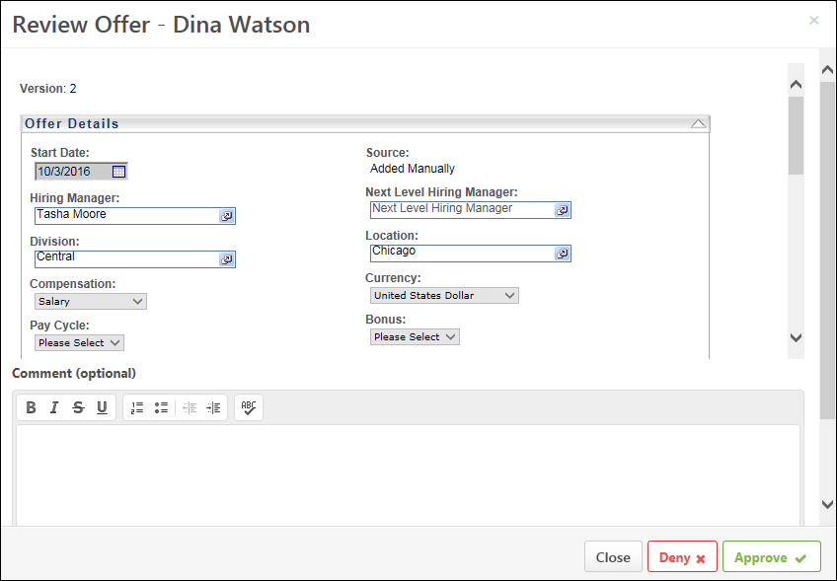
Add Comments
When viewing the offer letter, you can enter comments about the offer in the Comment section. There is no character limit.
Comments can be viewed by others in the approval workflow.
Hiring Dashboard - Interviews Widget
The Interviews Widget on the Hiring Dashboard provides hiring managers and recruiters visibility into interview feedback, interview requests, and upcoming interviews.
Note: If an interview was created for a candidate who is now in a Closed status, the interview will not be visible on the Hiring Dashboard.
To access the Hiring Dashboard, go to Recruit > Hiring Dashboard.
Permissions
PERMISSION NAME | PERMISSION DESCRIPTION | CATEGORY

Hiring Dashboard: Manage | Grants the ability to access the Hiring Dashboard. Access to the Hiring Dashboard is dynamically assigned when the user is a Requisition Owner or Applicant Reviewer (including Hiring Manager).  This permission is only assigned to the Hiring Manager/Applicant Reviewer when there is a qualified candidate for the requisition. A qualified candidate is any candidate that is past the New Submission stage. Until that point, the Hiring Dashboard will not be visible to recruiters who are dynamically assigned this permission who do not already have access to the Hiring Dashboard through another requisition. | Recruiting

Hiring Dashboard: View Other Dashboards | Grants the ability to view other users' dashboards. While viewing another user's dashboard, no actions can be taken on behalf of the dashboard owner. User also needs access to their own Hiring Dashboard before accessing other dashboards using this permission. This permission can be constrained by OU, User's OU, User, and User's Subordinates. | Recruiting

Requisition: Owner | Enables owner to access requisitions and applicants for requisitions for which they are an owner. This permission also grants read-only access to video interviews that are completed by applicants via HireVue. For portals with Referral Suite enabled, this permission also enables requisition owners to edit the referral source on the Applicant Profile page. This permission cannot be constrained.  Note: This is a dynamically assigned permission that is not available in Security Role Administration. If the user is removed as an owner, the permission is revoked for the associated requisition. This permission cannot be manually assigned. Also, if a user has both the permission necessary to manage requisitions and be a requisition owner, the constraints of the Requisition: Manage permission overrule those of the Requisition: Owner permission. For requisition owners that do not also have permission to manage requisitions, only certain fields are editable when editing a requisition. | Recruiting

Requisition: Reviewer | Enables reviewer to access requisitions and applicants for requisitions for which they are a reviewer. This permission cannot be constrained.  Note: This is a dynamically assigned permission that is not available in Security Role Administration. Once a requisition is in a Closed or Cancelled status or if the user is removed as a reviewer, the permission is revoked for the associated requisition. This permission cannot be manually assigned.  Note: If an applicant reviewer is removed as a reviewer via the Applicant Profile page, the Requisition: Reviewer permission is revoked for the associated requisition. However, if the reviewer was also added as a reviewer via the General tab when creating, editing, or copying the requisition, the reviewer still appears on the In Review panel as a duplicate reviewer and retains access to the requisition and applicants from the Requisition: Reviewer permission. See Applicant Profile Page Overview for more information about duplicate reviewer instances. | Recruiting
Click here to view the Hiring Dashboards training video in the Cornerstone Success Center.
Use Cases
Rachel is a Hiring Manager user who has open requisitions to fill multiple positions on her team. She has applicants in different stages of the interview process and would like to check the interview status of her open requisitions.
To get a quick view of the interview status of her open requisitions, Rachel goes to the Hiring Dashboard. From there, she can view counts of the different interview states:
- Interview Feedback - This section displays interviews that have been completed and require completion of the interview guide, if provided. Additionally, this section displays interviews that require an Advance/Do Not Advance recommendation and comments.
- Interview Requests - This section displays interview requests for interviews that have not yet occurred.
- Upcoming Interviews - This section displays interviews that are scheduled to occur on the current day or later.
Scenario 1 - Completed Interview: Leave Feedback and Provide Recommendation
- Rachel has completed an interview with Tony, an applicant for one her open requisitions, and would like to provide a recommendation.
- Rachel opens the Hiring Dashboard to view the status for Tony's interview.
- From the dashboard, she can see a tile for Tony in the Interview Feedback section of the Interviews widget. The following information displays for the completed interview:
  - The date in which Tony was interviewed.
  - The position to be filled by the requisition.
  - The interview method (Phone, In-Person, OnDemand).
  - An Advance button.
  - A Do not Advance button.
- Rachel believes that Tony would be a great fit for the position. She selects the Advance button. This opens an Advance pop up with an option to leave a comment.
- After leaving a comment and selecting Advance, Rachel sees that the card is removed from the Interview Feedback section.
Scenario 2 - Completed Interview: Complete Interview Guide
- Rachel has completed an interview with Emma, an applicant for of one her open requisitions. Rachel would like to complete the associated interview guide.
- Rachel opens the Hiring Dashboard to view the status for Emma's interview.
- From the dashboard, she can see a tile for Emma in the Interview Feedback section of the Interviews widget.
- The following information displays in the tile:
  - The date in which Emma was interviewed.
  - The position to be filled by the requisition.
  - The interview method (Phone, In-Person, OnDemand).
  - An Interview Guide icon .
- Rachel selects the Interview Guide icon and is directed to the interview guide for Emma's interview.
- After completing the interview guide and returning to the Hiring Dashboard, Rachel sees that Emma's card is removed from the Interview Feedback section.
Scenario 3: Accept an Interview Request
An interview has been scheduled with Ash, an applicant for one of Rachel's open requisitions. Rachel is designated as an interviewer and would like to accept the interview request.
- Rachel opens the Hiring Dashboard to view her interview request for Ash's interview.
- From the dashboard, she can see a tile for Ash in the Interview Requests section of the Interviews widget.
- The following information displays for the interview:
  - The date and time of the interview.
  - The name of candidate to be interviewed.
  - The interview location or method.
  - An Accept button.
  - A Decline button.
- Rachel selects the Accept button.
- After selecting the Accept button, Rachel sees that the interview tile is removed from the Interview Requests section.
Scenario 4: Review Upcoming Interviews
An interview has been scheduled with Robbie, an applicant for one of Rachel's open requisitions. Rachel is requisition owner, not an interviewer, but would like to see the Robbie's interview details.
- Rachel opens the Hiring Dashboard to view her interview details for Robbie's interview.
- From the dashboard, she can see a tile for Robbie in the Upcoming Interviews section of the Interviews widget.
- The following information displays for the interview:
  - The date and time of the interview.
  - The name of the candidate to be interviewed.
  - The interview location or method.
  - The name of the interviewer(s).
  - A Resume button.
- Rachel reviews the interview details, interviewers, and Robbie's resume.
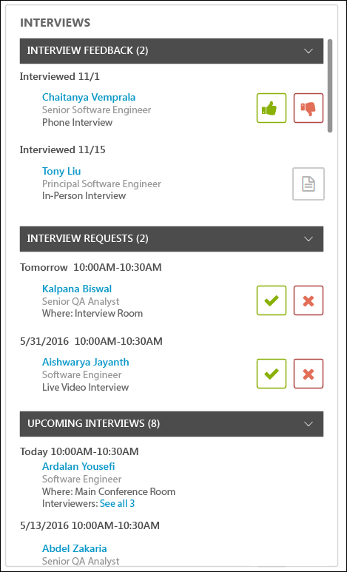
Interview Feedback
The Interview Feedback section allows you to advance or pass on applicants who have completed the interview. This section displays up to 10 completed interviews for which feedback has not yet been submitted by you or by interviewers for job requisitions for which you are the owner or hiring manager.
Completed interviews appear in this section for up to 30 days after the interview date has passed. After 30 days, if an advance/pass decision has not been made by the interviewer, then the interview moves to the Completed Interviews tab on the Interview Manager page and can no longer be accessed from the Hiring Dashboard.
The following information displays for each completed interview:
- Interviewed - This displays the [Day/Month] on which the interview occurred.
- Applicant Name - This is the name of the applicant for whom the interview was conducted. Click the applicant's name to open their Applicant Profile page.
- Job Title - This displays the name of the job for which the interview was conducted.
- Interview Type - This displays the type of interview. The following are the possible values:
  - Phone Interview
  - In-Person Interview
  - Virtual Interview
- Advance - Click the Advance icon to recommend moving the applicant forward. This opens the Recommendation: Advance pop-up. In the pop-up, you can enter comments about your decision. Then, click Advance at the bottom of the pop-up.
- Do Not Advance - Click the Do Not Advance icon to recommend that the applicant not move forward. This opens the Recommendation: Do Not Advance pop-up. In the pop-up, you can enter comments about your decision. Then, click Do Not Advance at the bottom of the pop-up.
- Interview Guide - The Interview Guide icon displays if an interview guide is available for the interview. Click the icon to open the guide and record your advance/pass decision. Note: The Advance/Do Not Advance icons do not display if an interview guide is configured for the interview and if a rating is not required for the interview guide.
- View All - Click View All at the bottom of section to view all items.
Interview Requests
The Interview Requests section displays up to 10 pending interview requests for which you have been added as an interviewer. Interviews only appear in this section if you have not yet accepted or denied the interview request.
The total number of interview requests displays to the right of the section heading.
The following information displays for each interview request:
- Interview Date - The date above the interview details is the date of the interview.
- Interview Time - The start and end time of the interview displays below the interview date.
- Applicant Name - This is the name of the applicant for whom the interview is being conducted. Click the applicant's name to open their Applicant Profile page.
- Job Title - This displays the name of the job for which the interview is being conducted.
- Where - This displays the location of the interview. If "Phone Interview" displays, then this indicates that the interview will be conducted via phone. If "OnDemand Interview" displays, then this indicates that the interview will be conducted via a video interviewing tool. If "Live Video Interview" displays, then this indicates that the interview will be live via video. If a location was not configured, then this field displays "Not Defined."
Note: OnDemand Video interviews are conducted via third party software, such as an integration with HireVue. Applicants access the third party software and record a video of themselves, through the software provider, answering the questions that you prepare for the applicant. Then, the video is submitted to be reviewed by the video interview reviewers, who are selected when the OnDemand Video interview is configured by the recruiter. For more information about OnDemand Video interview types, see the Interview Status Type - On Demand Video Interview topic in Online Help.
- Accept - Click the Accept icon to accept the interview request.
- Deny - Click the Deny icon to deny the interview request.
- View All - Click View All at the bottom of section to view all items.
Upcoming Interviews
For requisition owners and hiring managers, the Upcoming Interviews section displays up to 10 interviews that are scheduled for the requisition for the current date or for a future date. For users who are only interviewers, then the Upcoming Interviews section displays up to 10 interviews for which the user is scheduled. Note: For requisition owners, if you decline an interview that has multiple interviewers, and another interviewer accepts the interview, then the Upcoming Interviews section will still display the interview.
Interviews only appear in this section after at least one interviewer has accepted the interview. The total number of upcoming interviews displays to the right of the section heading.
The following information displays for each upcoming interview:
- Interview Date - The date above the interview details is the date of the interview. Interviews on the current date display "Today." Interviews on the next day display "Tomorrow."
- Interview Time - The start and end time of the interview displays below the interview date.
- Applicant Name - This is the name of the applicant for whom the interview is being conducted. Click the applicant's name to open their Applicant Profile page.
- Job Title - This displays the name of the job for which the interview is being conducted.
- [Location] - For in-person interviews, this will display "Where: [Location]." If "Phone Interview" displays, then this indicates that the interview will be conducted via phone. If "OnDemand Interview" displays, then this indicates that the interview will be conducted via a video interviewing tool. If "Live Video Interview" displays, then this indicates that the interview will be live via video. If a location was not configured, then this field displays "Not Defined."
- Interviewer - This displays the name of the interviewer. Click See all if there is more than one interviewer.
- View All - Click View All at the bottom of section to view all items.
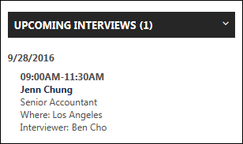
Hiring Dashboard - Manage Sections
The Manage Sections option allows you to rearrange the position of each section on the Hiring Dashboard and hide certain sections from view. The option appears as an icon in the upper-right corner of the dashboard.
To access the Hiring Dashboard, go to Recruit > Hiring Dashboard.
Permissions
PERMISSION NAME | PERMISSION DESCRIPTION | CATEGORY

Hiring Dashboard: Manage | Grants the ability to access the Hiring Dashboard. Access to the Hiring Dashboard is dynamically assigned when the user is a Requisition Owner or Applicant Reviewer (including Hiring Manager).  This permission is only assigned to the Hiring Manager/Applicant Reviewer when there is a qualified candidate for the requisition. A qualified candidate is any candidate that is past the New Submission stage. Until that point, the Hiring Dashboard will not be visible to recruiters who are dynamically assigned this permission who do not already have access to the Hiring Dashboard through another requisition. | Recruiting

Hiring Dashboard: View Other Dashboards | Grants the ability to view other users' dashboards. While viewing another user's dashboard, no actions can be taken on behalf of the dashboard owner. User also needs access to their own Hiring Dashboard before accessing other dashboards using this permission. This permission can be constrained by OU, User's OU, User, and User's Subordinates. | Recruiting

Requisition: Owner | Enables owner to access requisitions and applicants for requisitions for which they are an owner. This permission also grants read-only access to video interviews that are completed by applicants via HireVue. For portals with Referral Suite enabled, this permission also enables requisition owners to edit the referral source on the Applicant Profile page. This permission cannot be constrained.  Note: This is a dynamically assigned permission that is not available in Security Role Administration. If the user is removed as an owner, the permission is revoked for the associated requisition. This permission cannot be manually assigned. Also, if a user has both the permission necessary to manage requisitions and be a requisition owner, the constraints of the Requisition: Manage permission overrule those of the Requisition: Owner permission. For requisition owners that do not also have permission to manage requisitions, only certain fields are editable when editing a requisition. | Recruiting

Requisition: Reviewer | Enables reviewer to access requisitions and applicants for requisitions for which they are a reviewer. This permission cannot be constrained.  Note: This is a dynamically assigned permission that is not available in Security Role Administration. Once a requisition is in a Closed or Cancelled status or if the user is removed as a reviewer, the permission is revoked for the associated requisition. This permission cannot be manually assigned.  Note: If an applicant reviewer is removed as a reviewer via the Applicant Profile page, the Requisition: Reviewer permission is revoked for the associated requisition. However, if the reviewer was also added as a reviewer via the General tab when creating, editing, or copying the requisition, the reviewer still appears on the In Review panel as a duplicate reviewer and retains access to the requisition and applicants from the Requisition: Reviewer permission. See Applicant Profile Page Overview for more information about duplicate reviewer instances. | Recruiting
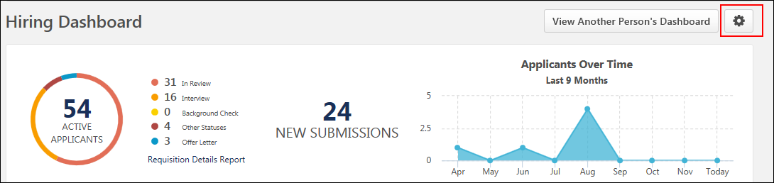
Manage Sections
You can change the position and visibility of the sections by clicking the Manage Sections icon . This opens the Manage Sections options on the left side of your dashboard. The changes you make to the order/visibility only apply to your dashboard.
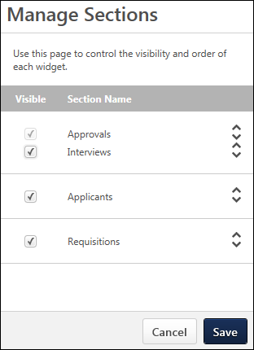
The following information and options are available in Manage Sections:
- Visible Column - This column allows you to manage the visibility of the sections on your dashboard. Check the box to make the section visible. Uncheck the box to hide the section. Note: The Approvals section cannot be hidden.
- Section Name Column - This column displays the name of the section. The Approvals and Interviews sections can only be moved together as a single section. They cannot be moved individually.
- Drag and Drop Sections - Click anywhere in the section to drag and drop the section to a different position on the page. Note: The up/down arrows do not have any functionality.
Once the changes are made, click Save to save the settings. Or, click Cancel to cancel the changes.
View Another Person's Dashboard
When viewing another person's dashboard, all sections display by default. Even if the user has hidden a section, you will still see all sections. You cannot hide or reorder the sections on another user's dashboard.
Hiring Dashboard - Requisitions
The Requisitions section on the Hiring Dashboard lists requisitions for which the user is a requisition owner or applicant reviewer (including hiring manager).
From Requisitions, you can do the following:
- View submission, status, and interview data
- Access the following pages:
  - Manage Candidates
  - Manage Job Requisitions
  - Edit Requisition
The requisitions that display are requisitions that are in a status of Open, Pending Approval, Pending Re-Approval, Approval Denied, and On Hold.
Note: Requisitions that are in a Canceled, Closed, or Draft status do not display in Requisitions.
To access the Hiring Dashboard, go to Recruit > Hiring Dashboard.
Permissions
PERMISSION NAME | PERMISSION DESCRIPTION | CATEGORY

Hiring Dashboard: Manage | Grants the ability to access the Hiring Dashboard. Access to the Hiring Dashboard is dynamically assigned when the user is a Requisition Owner or Applicant Reviewer (including Hiring Manager).  This permission is only assigned to the Hiring Manager/Applicant Reviewer when there is a qualified candidate for the requisition. A qualified candidate is any candidate that is past the New Submission stage. Until that point, the Hiring Dashboard will not be visible to recruiters who are dynamically assigned this permission who do not already have access to the Hiring Dashboard through another requisition. | Recruiting

Requisition: Manage | Grants ability to access and manage all requisitions regardless of ownership (constraints permitting). This permission also grants read-only access to the Applicant Review tab when creating or editing a job requisition. This permission can be constrained by OU, User's OU, and Grade. | Recruiting

Requisition: Owner | Enables owner to access requisitions and applicants for requisitions for which they are an owner. This permission also grants read-only access to video interviews that are completed by applicants via HireVue. For portals with Referral Suite enabled, this permission also enables requisition owners to edit the referral source on the Applicant Profile page. This permission cannot be constrained.  Note: This is a dynamically assigned permission that is not available in Security Role Administration. If the user is removed as an owner, the permission is revoked for the associated requisition. This permission cannot be manually assigned. Also, if a user has both the permission necessary to manage requisitions and be a requisition owner, the constraints of the Requisition: Manage permission overrule those of the Requisition: Owner permission. For requisition owners that do not also have permission to manage requisitions, only certain fields are editable when editing a requisition. | Recruiting

Requisition: Reviewer | Enables reviewer to access requisitions and applicants for requisitions for which they are a reviewer. This permission cannot be constrained.  Note: This is a dynamically assigned permission that is not available in Security Role Administration. Once a requisition is in a Closed or Cancelled status or if the user is removed as a reviewer, the permission is revoked for the associated requisition. This permission cannot be manually assigned.  Note: If an applicant reviewer is removed as a reviewer via the Applicant Profile page, the Requisition: Reviewer permission is revoked for the associated requisition. However, if the reviewer was also added as a reviewer via the General tab when creating, editing, or copying the requisition, the reviewer still appears on the In Review panel as a duplicate reviewer and retains access to the requisition and applicants from the Requisition: Reviewer permission. See Applicant Profile Page Overview for more information about duplicate reviewer instances. | Recruiting
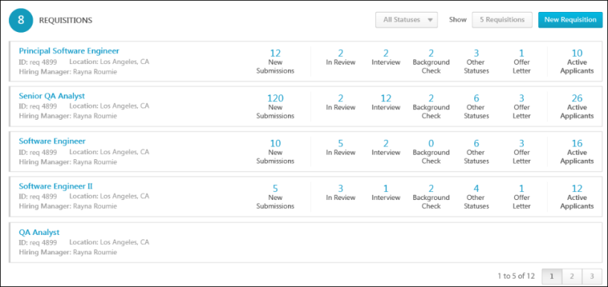
Status Filter
The status filter allows you to filter the requisitions by status so that you only view the requisitions that are in the status in which you are interested in viewing.
To filter by status, select one or more statuses in the status drop-down. Then, click the filter icon to the right of the status drop-down. The Requisitions section updates to display requisitions that match the filter criteria.
The status filter will be available in the Requisitions section when viewing another user's dashboard.
Number of Requisitions to Display
The Show option allows you to determine how many requisition rows to display in the section. Click the drop-down to the right of "Show" to select the number of requisitions to display. You can display requisitions in increments of 5, 10, or 20.
This option is disabled when viewing another user's dashboard.
Create Job Requisitions
Users with permission to manage requisitions can access the ability to create new job requisitions directly from the dashboard via the New Requisition button. Clicking the button opens the Create Requisition page from which you can create a new requisition.
For users who have permission to create requisitions and requisition requests, this section only displays the New Requisition button.
This option is disabled when viewing another user's dashboard.
Create Job Requisition Requests
For users with permission to create requisition requests but who do not have permission to create requisitions, a New Requisition Request button displays instead of the New Requisition button. Click the button to create a new requisition request.
This option is disabled when viewing another user's dashboard.
Requisition Priority
The requisitions display in order of high to low priority, and then by the creation date. The priority appears as a color bar on the left edge of the requisition card.
- Red - This color indicates high priority.
- Yellow - This color indicates medium priority.
- Gray - This color indicates low priority.
Total Number of Requisitions
The number in parentheses to the right of the Requisitions heading displays the total number of requisitions for which you are an owner or reviewer (including hiring manager) and which are not in a Closed or Canceled status.
Requisition Detail Cards
The following information displays for each requisition card:
- Title - This displays the Display Job Title. For requisition owners with permission to manage requisitions, click the title of the requisition to open the Edit Requisition page. You can modify the requisition if the requisition is in an editable status. For more information about editable fields based on requisition status, see the Edit Job Requisition topic in Online Help. Note: As with existing functionality, the visibility of custom fields on a requisition is based on the availability settings for the field in Custom Field Administration.
- Openings - This displays the number of unfilled openings out of the total number of openings. For requisitions that are configured as Do Not Allow to Apply, the Openings field displays "Not available to apply." For requisitions that are configured with ongoing openings, the Openings field displays "Ongoing."
- ID - This displays the requisition ID.
- Hiring Manager - This displays the hiring manager for the requisition.
- Location - This displays the requisition's primary location.
- Created - This displays the date on which the requisition was created.
- Status - This displays the requisition status. The following statuses display:
  - Denied
  - On Hold
  - Open
  - Open - Pending Re-Approval - Click the status to view the Requisition Approval Status pop-up. The pop-up displays the approver and the status of the user's approval decision in the approval workflow. For more information about the Requisition Approval Status pop-up, see the Requisition Approval Status Pop-Up topic in Online Help.
  - Pending Approval - Click the status to view the Requisition Approval Status pop-up. The pop-up displays the approver and the status of the user's approval decision in the approval workflow. For more information about the Requisition Approval Status pop-up, see the Requisition Approval Status Pop-Up topic in Online Help.
- New Submissions - This displays the number of applicants that are in the New Submission status. For users with permission to manage requisitions or requisition owners, click the linked number to open a filtered view of Manage Candidates.
- Status Type Count - The number of applicants within each status category displays to the right of the requisition details. Interview custom status types are added to the Interview status category. If a standard status type is not configured for the requisition, then "N/A" displays for the status count.
Hover over the status type to view the applicant count for each sub-status that is associated with the status category.
The following status categories are linked:
  - In Review - Clicking the In Review status type or count opens the Resume/CV Review page with the In Review applicants listed. For archived applicants, the Resume/CV Review page indicates that the applicant is archived and that their resume cannot be reviewed.
  - Background Check/Interview/Offer Letter/Other Statuses - Clicking the status type or count opens the Manage Candidates page, which is pre-filtered to show the applicants in the status category that was clicked.
  - Interview - Clicking Interview opens the Manage Candidates page to display the candidates in the respective statuses.
Note: For requisitions in a Pending Approval status, the status category counts do not display. The status category counts also do not apply to requisitions that are configured as Do Not Allow to Apply. If a user is not a requisition owner for a requisition in the Requisitions list, New Submissions does not display in the status type count.
Note: If there are no applicants in a status category, then the status type is not clickable.
- Active Applicants - This displays the number of applicants for the requisition. Selecting the linked number opens the Manage Candidates page, which displays all active candidates for the specific requisition. .
Hiring Dashboard - View Another Person's Dashboard
From the Hiring Dashboard page, you can access another user's dashboard. Viewing another user's dashboard helps you understand the status of that person's requisitions, approvals, and applicants.
The View Another Person's Dashboard button only displays for users with permission to view another user's dashboard. Note: Giving users permission to access other users’ dashboards may allow the user to access basic information about requisitions, applicant statuses, and approvals that the user would not otherwise be able to see elsewhere in the Applicant Tracking System (ATS). This permission should be used with caution.
To access the Hiring Dashboard, go to Recruit > Hiring Dashboard.
Permissions
PERMISSION NAME | PERMISSION DESCRIPTION | CATEGORY

Hiring Dashboard: Manage | Grants the ability to access the Hiring Dashboard. Access to the Hiring Dashboard is dynamically assigned when the user is a Requisition Owner or Applicant Reviewer (including Hiring Manager).  This permission is only assigned to the Hiring Manager/Applicant Reviewer when there is a qualified candidate for the requisition. A qualified candidate is any candidate that is past the New Submission stage. Until that point, the Hiring Dashboard will not be visible to recruiters who are dynamically assigned this permission who do not already have access to the Hiring Dashboard through another requisition. | Recruiting

Hiring Dashboard: View Other Dashboards | Grants the ability to view other users' dashboards. While viewing another user's dashboard, no actions can be taken on behalf of the dashboard owner. User also needs access to their own Hiring Dashboard before accessing other dashboards using this permission. This permission can be constrained by OU, User's OU, User, and User's Subordinates. | Recruiting
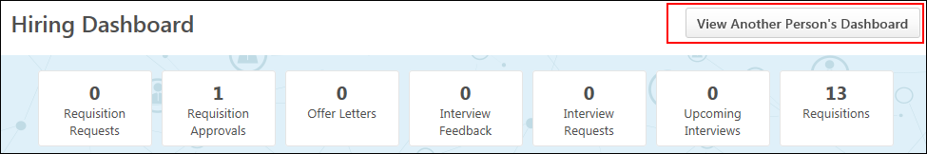
View Dashboard
To view another dashboard:
- Click View Another Person's Dashboard. This opens the Select a user pop-up. Users are available to select based on constraints, if any, applied to the permission to view other dashboards.
- Search for a user from the pop-up.
- Click the user's name. This opens their dashboard as read-only, with all of the same information that would be displayed to the dashboard owner upon loading their dashboard, except that no links are clickable.
Back to My Dashboard
To return to your own dashboard, click Back to My Dashboard at the top of the page.

Recruiting Dashboard Page
The Recruiter Dashboard provides recruiters with a homepage that shows a snapshot of pending actions, as well as requisition and applicant activity. The dashboard displays widgets that provide requisition status, new submissions, and referrals data. From this page, recruiters with the appropriate permissions can add requisitions and access the Manage Candidates, Recruiting Manager Dashboard, Requisition Snapshot, and Search Candidates pages. Recruiters can also access requisitions that are pending approval.
The Recruiter Dashboard page must be enabled by the administrator in Navigation Tabs and Links in order to be available. In addition, the page only displays if the recruiter has permission to access at least one of the widgets that appears on the dashboard.
To access the Recruiter Dashboard, go to Recruit > Recruiter Dashboard.
Permissions
PERMISSION NAME | PERMISSION DESCRIPTION | CATEGORY

Candidate Search | Grants ability to create, save and manage Candidate Searches, a search for users by various criteria such as performance and succession ratings, resume data, etc. The constraints that are applied to this permission determine the users that are available within a candidate search. This is an administrator permission. | Talent/Succession - Administration

Requisition: Approver | Enables approver to access and approve/deny requisitions for which they are an approver. This permission cannot be constrained. Note: This is a dynamically assigned permission. If the user is removed as an approver for an offer that is in a Pending Offer status, the user can no longer access that version of the offer. This permission cannot be manually assigned. | Recruiting

Requisition: Manage | Grants ability to access and manage all requisitions regardless of ownership (constraints permitting). This permission also grants read-only access to the Applicant Review tab when creating or editing a job requisition. This permission can be constrained by OU, User's OU, and Grade. | Recruiting

Requisition: Owner | Enables owner to access requisitions and applicants for requisitions for which they are an owner. This permission also grants read-only access to video interviews that are completed by applicants via HireVue. For portals with Referral Suite enabled, this permission also enables requisition owners to edit the referral source on the Applicant Profile page. This permission cannot be constrained.  Note: This is a dynamically assigned permission that is not available in Security Role Administration. If the user is removed as an owner, the permission is revoked for the associated requisition. This permission cannot be manually assigned. Also, if a user has both the permission necessary to manage requisitions and be a requisition owner, the constraints of the Requisition: Manage permission overrule those of the Requisition: Owner permission. For requisition owners that do not also have permission to manage requisitions, only certain fields are editable when editing a requisition. | Recruiting
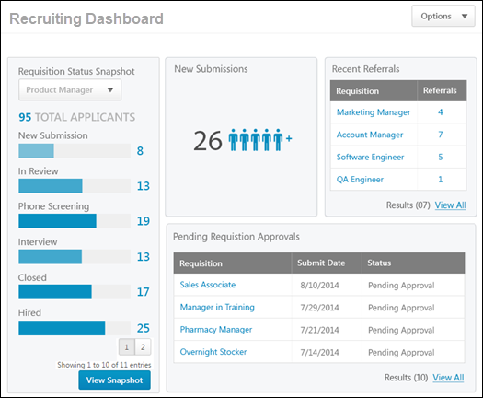
Options
The following options are available in the Options drop-down in the upper-right corner of the page:
- Add Requisition - Select this option to create a new job requisition. Clicking the link opens the General tab of the Create Requisition page. This option is only available for recruiters with permission to manage requisitions.
- Search Candidates - Select this option to open the Search Candidates page. This option is only available for recruiters with permission to search candidates.
- View Recruiting Manager Dashboard - Select this option to open the Recruiting Manager Dashboard. This option is only available for recruiters with permission to access the Recruiting Manager Dashboard.
Note: The Options drop-down only displays if the recruiter has at least one of the permissions needed to access one of the options.
Dashboard Widgets
The Recruiting Dashboard is made up of widgets that contain information about the recruiter's job requisitions, applicant data, and other Applicant Tracking System functionality. The widgets that display are dependent upon the recruiter's permissions.
The dashboard widgets also allow recruiters to access the system page associated with the widget. This provides recruiters with quick access to complete information about the data on the dashboard.
The following widgets may be available on the dashboard:
- New Submissions
- Pending Requisition Approvals
- Recent Referrals
- Requisition Status Snapshot
New Submissions
The New Submissions area only displays for recruiters with permission to manage requisitions and for requisition owners. It displays the number of applicants in a New Submission status for the recruiter's open requisitions.
To access the Recruiter Dashboard, go to Recruit > Recruiter Dashboard.
Permissions
PERMISSION NAME | PERMISSION DESCRIPTION | CATEGORY

Requisition: Manage | Grants ability to access and manage all requisitions regardless of ownership (constraints permitting). This permission also grants read-only access to the Applicant Review tab when creating or editing a job requisition. This permission can be constrained by OU, User's OU, and Grade. | Recruiting

Requisition: Owner | Enables owner to access requisitions and applicants for requisitions for which they are an owner. This permission also grants read-only access to video interviews that are completed by applicants via HireVue. For portals with Referral Suite enabled, this permission also enables requisition owners to edit the referral source on the Applicant Profile page. This permission cannot be constrained.  Note: This is a dynamically assigned permission that is not available in Security Role Administration. If the user is removed as an owner, the permission is revoked for the associated requisition. This permission cannot be manually assigned. Also, if a user has both the permission necessary to manage requisitions and be a requisition owner, the constraints of the Requisition: Manage permission overrule those of the Requisition: Owner permission. For requisition owners that do not also have permission to manage requisitions, only certain fields are editable when editing a requisition. | Recruiting
Selecting the New Submissions number opens the Manage Candidates page, from which recruiters can view candidates in a New Submission status.
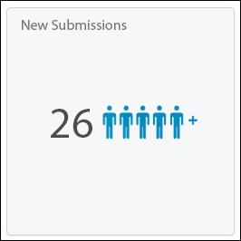
Pending Requisition Approvals Widget
The Pending Requisition Approvals widget only displays for recruiters with permission to manage requisitions or for requisition owners. The widget shows the requisitions that have been submitted by the recruiter and are pending approval by the approvers. Up to five requisitions display in the widget, but the recruiter has the option to view all of their requisitions pending approval if there are more than four requisitions. The requisitions display in order of submitted date, from oldest to newest submitted.
If the recruiter has no requisitions pending approval, the Pending Requisition Approvals widget still displays, but the approvals table is blank.
To access the Recruiter Dashboard, go to Recruit > Recruiter Dashboard.
Permissions
PERMISSION NAME | PERMISSION DESCRIPTION | CATEGORY

Requisition: Manage | Grants ability to access and manage all requisitions regardless of ownership (constraints permitting). This permission also grants read-only access to the Applicant Review tab when creating or editing a job requisition. This permission can be constrained by OU, User's OU, and Grade. | Recruiting

Requisition: Owner | Enables owner to access requisitions and applicants for requisitions for which they are an owner. This permission also grants read-only access to video interviews that are completed by applicants via HireVue. For portals with Referral Suite enabled, this permission also enables requisition owners to edit the referral source on the Applicant Profile page. This permission cannot be constrained.  Note: This is a dynamically assigned permission that is not available in Security Role Administration. If the user is removed as an owner, the permission is revoked for the associated requisition. This permission cannot be manually assigned. Also, if a user has both the permission necessary to manage requisitions and be a requisition owner, the constraints of the Requisition: Manage permission overrule those of the Requisition: Owner permission. For requisition owners that do not also have permission to manage requisitions, only certain fields are editable when editing a requisition. | Recruiting
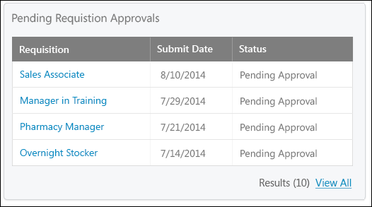
The widget displays the following information for each requisition that is pending approval:
- Requisition - This column displays the linked title of the requisition. Clicking the link opens the Edit Requisition page for the requisition.
- Submit Date - This column displays the date on which the requisition was submitted for approval.
- Status - This column displays the approval status of the requisition. The following statuses apply:
  - Pending Approval - This status indicates that the requisition is pending approval by the requisition approvers.
  - Open - Pending Re-Approval - This status indicates that the requisition is in an Open status but that the recruiter submitted a change to the requisition that requires re-approval by the requisition approvers.
- Results - This field displays the total number of the recruiter's requisitions that are pending approval.
- View All - This option only displays if the recruiter has five or more requisitions that are pending approval. Clicking the link opens the My Jobs tab of the Manage Job Requisitions page, from which the recruiter can view all of their requisitions that are pending approval.
Recent Referrals
Recent Referrals displays for recruiters with permission to manage requisitions and for requisition owners. The widget displays the recruiter's requisitions that have referrals and the number of referrals for each requisition.
Up to four requisitions display in the widget, but the recruiter has the option to view all of their requisitions that have referrals if there are more than four requisitions with referrals. The requisitions display in order of submitted date, from most to least recently submitted.
If the recruiter has no requisitions with referrals, then "No data available for this widget" displays.
To access the Recruiter Dashboard, click the Recruiter Dashboard link from the navigation tab defined by the administrator.
Permissions
PERMISSION NAME | PERMISSION DESCRIPTION | CATEGORY

Requisition: Manage | Grants ability to access and manage all requisitions regardless of ownership (constraints permitting). This permission also grants read-only access to the Applicant Review tab when creating or editing a job requisition. This permission can be constrained by OU, User's OU, and Grade. | Recruiting

Requisition: Owner | Enables owner to access requisitions and applicants for requisitions for which they are an owner. This permission also grants read-only access to video interviews that are completed by applicants via HireVue. For portals with Referral Suite enabled, this permission also enables requisition owners to edit the referral source on the Applicant Profile page. This permission cannot be constrained.  Note: This is a dynamically assigned permission that is not available in Security Role Administration. If the user is removed as an owner, the permission is revoked for the associated requisition. This permission cannot be manually assigned. Also, if a user has both the permission necessary to manage requisitions and be a requisition owner, the constraints of the Requisition: Manage permission overrule those of the Requisition: Owner permission. For requisition owners that do not also have permission to manage requisitions, only certain fields are editable when editing a requisition. | Recruiting
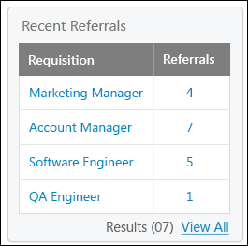
The following information displays in the widget for each requisition with referrals:
- Requisition - This column displays the linked title of the requisition. Clicking the link opens the Edit Requisition page for the requisition.
- Referrals - This column displays the linked number of referrals for each requisition. Clicking the number in the column opens a filtered view of Manage Candidates, showing the users who are in a referral status for that requisition.
- View All - This option only displays if the recruiter has five or more requisitions that have referrals. Clicking the link opens the My Jobs tab of the Manage Job Requisitions page, from which the recruiter can view all of their requisitions that have referrals.
Requisition Status Snapshot Widget
The Requisition Status Snapshot widget displays for requisition owners. The widget displays the requisition owner's open requisitions and a breakdown of the applicant statuses for the applicants who applied to the selected requisition.
If the recruiter has no open requisitions, then "No open requisitions" displays in the widget.
To access the Recruiter Dashboard, go to Recruit > Recruiter Dashboard.
Permissions
PERMISSION NAME | PERMISSION DESCRIPTION | CATEGORY

Requisition: Manage | Grants ability to access and manage all requisitions regardless of ownership (constraints permitting). This permission also grants read-only access to the Applicant Review tab when creating or editing a job requisition. This permission can be constrained by OU, User's OU, and Grade. | Recruiting

Requisition: Owner | Enables owner to access requisitions and applicants for requisitions for which they are an owner. This permission also grants read-only access to video interviews that are completed by applicants via HireVue. For portals with Referral Suite enabled, this permission also enables requisition owners to edit the referral source on the Applicant Profile page. This permission cannot be constrained.  Note: This is a dynamically assigned permission that is not available in Security Role Administration. If the user is removed as an owner, the permission is revoked for the associated requisition. This permission cannot be manually assigned. Also, if a user has both the permission necessary to manage requisitions and be a requisition owner, the constraints of the Requisition: Manage permission overrule those of the Requisition: Owner permission. For requisition owners that do not also have permission to manage requisitions, only certain fields are editable when editing a requisition. | Recruiting
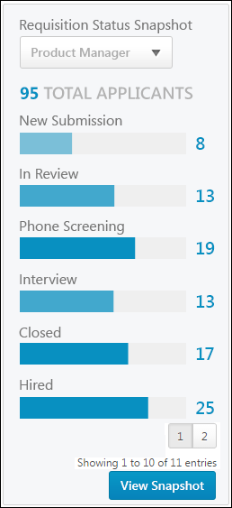
The Requisition Status Snapshot displays the following information:
- Requisition Drop-Down - The requisitions for which the recruiter is an owner display in the drop-down. The requisitions are listed in alphabetical order. If the requisition name is longer than the space allows, hover over the name to view the full name. Selecting a requisition updates the list of applicant statuses that displays below the drop-down. Note: Requisitions in a Closed status do not display.
- Total Applicants - This field displays the number of applicants for the requisition. If there are no applicants for the requisition, then the "0" displays as the total applicant number.
- Status List - The status list displays the number of applicants who are in a given status. The statuses display in order of the applicant status workflow defined for the requisition. If the status name is longer than the space allows, hover over the name to view the full status name. The number of applicants in the status displays as a link. Clicking the link opens the Requisition Snapshot page.
- View Snapshot - Click View Snapshot to open the Requisition Snapshot page for the requisition.

Recruiting Manager Dashboard Page
The Recruiting Manager Dashboard provides recruiting managers with a homepage that displays a snapshot of their recruiting information. The dashboard displays widgets that provide recruiting managers with quick access to the following data:
- Average Time to Hire
- Recent Referrals
- Recruiter Snapshot
- Requisitions Pending Approval
- Requisition Status
From this page, recruiters can also create new requisitions and access the Recruiter Approvals, Requisition Snapshot, Search Candidates, and Recruiter Dashboard pages.
The Recruiting Manager Dashboard page must be enabled by the administrator in Navigation Tabs and Links in order to be available. In addition, the page only displays if the recruiter has permission to access at least one of the widgets that appears on the dashboard.
To access the Recruiter Dashboard, go to Recruit > Recruiting Manager Dashboard.
Permissions
PERMISSION NAME | PERMISSION DESCRIPTION | CATEGORY

Recruiting Manager Dashboard | Grants access to the Recruiting Manager Dashboard page. This permission cannot be constrained. | Recruiting
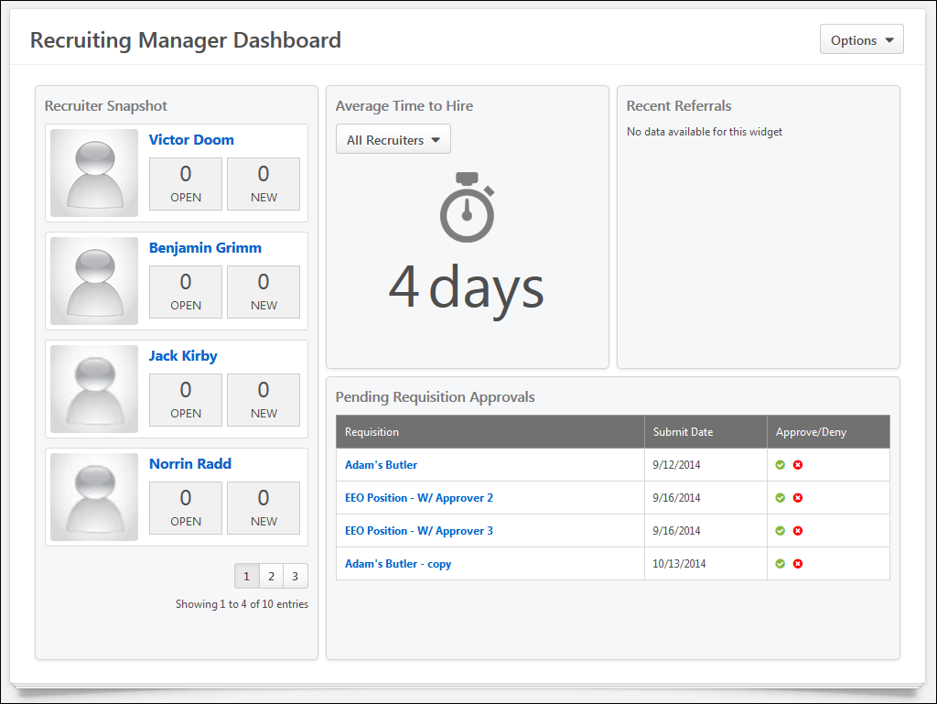
Options
The following options are available in the Options drop-down in the upper-right corner of the page:
- Add Requisition - Select this option to create a new job requisition. Clicking the link opens the General tab of the Create Requisition page. This option is only available for recruiters with permission to manage requisitions.
- Search Candidates - Select this option to open the Search Candidates page. This option is only available for recruiters with permission to search candidates.
- View Recruiter Dashboard - Select this option to open the Recruiter Dashboard. This option is only available for job requisition owners.
Note: The Options drop-down only displays if the recruiter has at least one of the permissions needed to access one of the options.
Dashboard Widgets
The Recruiting Manager Dashboard is made up of widgets that contain information about the recruiter's job requisitions, applicant data, and other Applicant Tracking System functionality. The widgets that display are dependent upon the recruiter's permissions.
The dashboard widgets also allow recruiters to access the system page associated with the widget. This provides recruiters with quick access to complete information about the data on the dashboard.
The following widgets may be available on the dashboard:
- Average Time to Hire
- Pending Requisition Approvals
- Recent Referrals
- Recruiter Snapshot
Average Time to Hire Widget
The Average Time to Hire widget only displays for recruiters with permission to manage requisitions. The widget displays the average number of days to hire an applicant for the requisitions for which the recruiter's direct reports are defined as owners.
To access the Recruiter Dashboard, go to Recruit > Recruiting Manager Dashboard.
Permissions
PERMISSION NAME | PERMISSION DESCRIPTION | CATEGORY

Recruiting Manager Dashboard | Grants access to the Recruiting Manager Dashboard page. This permission cannot be constrained. | Recruiting

Requisition: Manage | Grants ability to access and manage all requisitions regardless of ownership (constraints permitting). This permission also grants read-only access to the Applicant Review tab when creating or editing a job requisition. This permission can be constrained by OU, User's OU, and Grade. | Recruiting
The following information displays in the widget:
- Select Recruiter Drop-Down - The drop-down lists the recruiter's direct reports who are defined as requisition owners. Select an individual recruiter's name from the drop-down or select the All Recruiter option. The widget updates to display the data for the selected recruiter or for all recruiters.
- Average Days to Hire - The average days to hire displays below the drop-down. The number is calculated using the date on which applicants applied to the requisition and the applicant's hire date. The data is refreshed daily.
Pending Requisition Approvals Widget
The Pending Requisition Approvals widget only displays for recruiters with permission to approve requisitions. The widget shows the requisitions that are awaiting an approval decision by the recruiter. From this widget, recruiters can select to approve or deny requisitions and then access the Recruiting Approvals page to submit the approval decision. Recruiters can also access the Edit Requisitions page for each requisition that is pending approval.
Up to five requisitions display in the widget, but the recruiter has the option to view all of their requisitions that are awaiting an approval decision if there are more than four requisitions. The requisitions display in order of submitted date, from oldest to newest submitted.
If the recruiter has no requisitions pending approval, the Pending Requisition Approvals widget still displays, but the approvals table is blank.
To access the Recruiter Dashboard, go to Recruit > Recruiting Manager Dashboard.
Permissions
PERMISSION NAME | PERMISSION DESCRIPTION | CATEGORY

Recruiting Manager Dashboard | Grants access to the Recruiting Manager Dashboard page. This permission cannot be constrained. | Recruiting

Requisition: Approver | Enables approver to access and approve/deny requisitions for which they are an approver. This permission cannot be constrained. Note: This is a dynamically assigned permission. If the user is removed as an approver for an offer that is in a Pending Offer status, the user can no longer access that version of the offer. This permission cannot be manually assigned. | Recruiting

Requisition: Manage | Grants ability to access and manage all requisitions regardless of ownership (constraints permitting). This permission also grants read-only access to the Applicant Review tab when creating or editing a job requisition. This permission can be constrained by OU, User's OU, and Grade. | Recruiting

Requisition: Owner | Enables owner to access requisitions and applicants for requisitions for which they are an owner. This permission also grants read-only access to video interviews that are completed by applicants via HireVue. For portals with Referral Suite enabled, this permission also enables requisition owners to edit the referral source on the Applicant Profile page. This permission cannot be constrained.  Note: This is a dynamically assigned permission that is not available in Security Role Administration. If the user is removed as an owner, the permission is revoked for the associated requisition. This permission cannot be manually assigned. Also, if a user has both the permission necessary to manage requisitions and be a requisition owner, the constraints of the Requisition: Manage permission overrule those of the Requisition: Owner permission. For requisition owners that do not also have permission to manage requisitions, only certain fields are editable when editing a requisition. | Recruiting
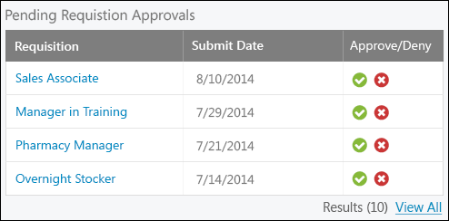
The widget displays the following information for each requisition that is pending approval:
- Requisition - This column displays the linked title of the requisition. Clicking the link opens the Edit Requisition page for the requisition.
- Submit Date - This column displays the date on which the requisition was submitted for approval.
- Approve/Deny - This column displays the options for approving or denying the requisition. Select one of the following options:
  - Approve - Click the Approve icon to mark the requisition as approved. This opens the Recruiting Approvals page. The recruiter's approval decision is remembered upon accessing the Recruiting Approvals page. The recruiter can then choose to submit the approval or deselect the Approve icon. Comments can also be entered.
  - Deny - Click the Deny icon to deny approval of the requisition. This opens the Recruiting Approvals page. The recruiter's deny decision is remembered upon accessing the Recruiting Approvals page. The recruiter can then choose to submit the denial or deselect the Deny icon. Comments can also be entered.
- Results - This field displays the total number of the recruiter's requisitions that are pending an approval decision.
- View All - This option only displays if the recruiter has five or more requisitions that are pending an approval decision. Clicking the link opens the Recruiting Approvals page, from which the recruiter can view all of their requisitions that are pending an approval decision.
Recent Referrals Widget
The Recent Referrals widget only displays for recruiters with permission to manage requisitions. The widget lists the requisitions with referrals for which the recruiter's direct reports are defined as owners. The requisitions that displays are the requisitions that are available to the recruiter based on permission constraints.
Up to five requisitions display in the widget, but the recruiter has the option to view all of their requisitions that have referrals if there are more than four requisitions with referrals. The requisitions display in order of submitted date, from most to least recently submitted.
If the recruiter has no requisitions with referrals, then "No data available for this widget" displays.
To access the Recruiter Dashboard, go to Recruit > Recruiting Manager Dashboard.
Permissions
PERMISSION NAME | PERMISSION DESCRIPTION | CATEGORY

Recruiting Manager Dashboard | Grants access to the Recruiting Manager Dashboard page. This permission cannot be constrained. | Recruiting

Requisition: Manage | Grants ability to access and manage all requisitions regardless of ownership (constraints permitting). This permission also grants read-only access to the Applicant Review tab when creating or editing a job requisition. This permission can be constrained by OU, User's OU, and Grade. | Recruiting
The following information displays in the widget for each requisition with referrals:
- Requisition - This column displays the linked title of the requisition. Clicking the link opens the Edit Requisition page for the requisition.
- Referrals - This column displays the linked number of referrals for each requisition. Clicking the the number in the column opens a filtered view of Manage Candidates, showing the users who are in a referral status for that requisition.
- Results - This field displays the total number of requisitions with recent referrals for the recruiter's direct reports. The results only display if there are five or more requisitions with referrals.
- View All - This option only displays if the recruiter has five or more requisitions that have referrals. Clicking the link opens the My Jobs tab of the Manage Job Requisitions page, from which the recruiter can view all of their requisitions that have referrals.
Recruiter Snapshot Widget
The Recruiter Snapshot widget only displays for recruiters with permission to manage requisitions. In addition, the recruiter must have at least one direct report.
The Recruiter Snapshot widget lists each of the recruiter's direct reports who are defined as requisition owners for at least one requisition. The number of requisitions for each recruiter displays, as well as total number of new submissions for each recruiter's requisitions.
To access the Recruiter Dashboard, go to Recruit > Recruiting Manager Dashboard.
Permissions
PERMISSION NAME | PERMISSION DESCRIPTION | CATEGORY

Recruiting Manager Dashboard | Grants access to the Recruiting Manager Dashboard page. This permission cannot be constrained. | Recruiting

Requisition: Manage | Grants ability to access and manage all requisitions regardless of ownership (constraints permitting). This permission also grants read-only access to the Applicant Review tab when creating or editing a job requisition. This permission can be constrained by OU, User's OU, and Grade. | Recruiting
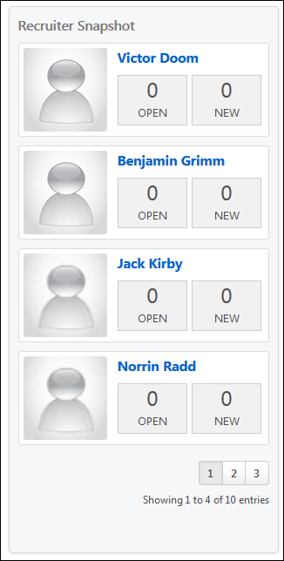
The recruiters display in the widget in alphabetical order by last name. Each recruiter appears in an individual linked recruiter card. Clicking the recruiter's name or image opens the All Jobs tab on the Manage Requisitions page with the selected recruiter as the filter. The name of the selected recruiter is pre-populated in the Owner search filter, and the Manage Requisitions table is pre-filtered to display only the requisitions for which the selected recruiter is an owner.
The following information displays in each recruiter card:
- Photo - The recruiter's photo displays, if available.
- Name - The recruiter's name displays.
- Open - This displays the number of open requisitions for which the recruiter is an owner.
- New - This displays the total number of new submissions for the requisitions for which the recruiter is an owner.

LinkedIn Recruiter System Connect - Overview
LinkedIn Recruiter System Connect bridges the information gap between Cornerstone Recruiting and LinkedIn Recruiter by making candidate communication, notes, and application information available in both places. With this integration, a recruiter will no longer need to look up a candidate in both systems to get a complete picture of the candidate.
How Does this Integration Benefit My Organization?
Full Candidate Picture in LinkedIn and Recruiting
Drives Quicker and Easier Informed Decisions
Enhances Usability
LinkedIn Recruiter System Connect delivers a holistic view of the candidate in both LinkedIn and Cornerstone Recruiting, giving recruiters the information they need to make informed decisions more quickly.
Without this integration, LinkedIn Recruiter data will only display in LinkedIn Recruiter, and Recruiting information will only display in Recruiting. This means recruiters have to look up the candidate in both applications to get a complete view.
With LinkedIn Recruiter System Connect, recruiters can view all LinkedIn Recruiter information in Recruiting and vice versa, including InMail History, Notes, and Profiles. This provides a candidate picture in both applications. This also saves time and supports more informed decision-making by being able to look up candidate information in whichever application the recruiter is in.
What LinkedIn Recruiter Information Is Available in Cornerstone?
InMail History
A candidate's InMail history will display on the Emails tab of the Applicant Profile page. The date, sender, subject, and message body is included. InMail will appear with “via LinkedIn” next to the name of the user who sent the email. Attachments are not included. InMail history will only be visible to users who have a LinkedIn Recruiter seat on the same contract.
Prospect Notes
Notes that are created in LinkedIn Recruiter will be visible on the Comments tab on the Applicant Profile page. LinkedIn Recruiter notes will appear with "via LinkedIn" next to the name of the user who submitted the comment. Notes will only be visible to users who have a LinkedIn Recruiter seat on the same contract.
LinkedIn Profiles
A candidate's LinkedIn profile will be visible on a new "LinkedIn" tab on the Applicant Profile page. This tab will be available for all portals that enable LinkedIn Recruiter System Connect. Users with a LinkedIn Recruiter seat will be able to see the full LinkedIn profile, including links to save the candidate to a project, send an InMail, or choose to be notified when the candidate updates their LinkedIn profile. Users without a LinkedIn Recruiter seat will see the candidate’s public LinkedIn profile.
Considerations/Exclusions
- Application data can be deleted from LinkedIn. Cornerstone will send deletion requests when triggered by the candidate or after the period of inactivity specified by a client.
- Jobs must meet the following criteria to sync to LinkedIn:
  - "External Description" must contain at least 100 characters.
  - The Primary Location field must include a value for the Country field.
  - The Primary Location field must include a value for either the City field or the State/Province field.
- This integration is only available in Production environments.
Implementation
The option to activate LinkedIn Recruiter is available for all portals with Recruiting enabled. However, a LinkedIn Recruiter subscription is required for activation. LinkedIn Recruiter can be purchased through LinkedIn.
Additional instructions for enabling and configuring the integration are available on the Setup tab of the integration in Edge.
Security
The following permissions apply to this functionality:
PERMISSION NAME | PERMISSION DESCRIPTION | CATEGORY

Edge Integrations - Manage | Grants access to the Integrations service for Edge Integrate, where the administrator can configure, enable, and disable their third-party integrations used within the Cornerstone system. This permission cannot be constrained. This is an administrator permission. | Edge

Edge Marketplace - Manage | Grants access to the Marketplace service for Edge Integrate, where the administrator can browse integrations that can be used to extend the Cornerstone system. This permission cannot be constrained. This is an administrator permission. | Edge

Requisition: Manage | Grants ability to access and manage all requisitions regardless of ownership (constraints permitting). This permission also grants read-only access to the Applicant Review tab when creating or editing a job requisition. This permission can be constrained by OU, User's OU, and Grade. | Recruiting

Requisition: Owner | Enables owner to access requisitions and applicants for requisitions for which they are an owner. This permission also grants read-only access to video interviews that are completed by applicants via HireVue. For portals with Referral Suite enabled, this permission also enables requisition owners to edit the referral source on the Applicant Profile page. This permission cannot be constrained.  Note: This is a dynamically assigned permission that is not available in Security Role Administration. If the user is removed as an owner, the permission is revoked for the associated requisition. This permission cannot be manually assigned. Also, if a user has both the permission necessary to manage requisitions and be a requisition owner, the constraints of the Requisition: Manage permission overrule those of the Requisition: Owner permission. For requisition owners that do not also have permission to manage requisitions, only certain fields are editable when editing a requisition. | Recruiting

Requisition: Reviewer | Enables reviewer to access requisitions and applicants for requisitions for which they are a reviewer. This permission cannot be constrained.  Note: This is a dynamically assigned permission that is not available in Security Role Administration. Once a requisition is in a Closed or Cancelled status or if the user is removed as a reviewer, the permission is revoked for the associated requisition. This permission cannot be manually assigned.  Note: If an applicant reviewer is removed as a reviewer via the Applicant Profile page, the Requisition: Reviewer permission is revoked for the associated requisition. However, if the reviewer was also added as a reviewer via the General tab when creating, editing, or copying the requisition, the reviewer still appears on the In Review panel as a duplicate reviewer and retains access to the requisition and applicants from the Requisition: Reviewer permission. See Applicant Profile Page Overview for more information about duplicate reviewer instances. | Recruiting

LinkedIn Recruiter System Connect - Overview
LinkedIn Recruiter System Connect bridges the information gap between Cornerstone Recruiting and LinkedIn Recruiter by making candidate communication, notes, and application information available in both places. With this integration, a recruiter will no longer need to look up a candidate in both systems to get a complete picture of the candidate.
How Does this Integration Benefit My Organization?
Full Candidate Picture in LinkedIn and Recruiting
Drives Quicker and Easier Informed Decisions
Enhances Usability
LinkedIn Recruiter System Connect delivers a holistic view of the candidate in both LinkedIn and Cornerstone Recruiting, giving recruiters the information they need to make informed decisions more quickly.
Without this integration, LinkedIn Recruiter data will only display in LinkedIn Recruiter, and Recruiting information will only display in Recruiting. This means recruiters have to look up the candidate in both applications to get a complete view.
With LinkedIn Recruiter System Connect, recruiters can view all LinkedIn Recruiter information in Recruiting and vice versa, including InMail History, Notes, and Profiles. This provides a candidate picture in both applications. This also saves time and supports more informed decision-making by being able to look up candidate information in whichever application the recruiter is in.
What LinkedIn Recruiter Information Is Available in Cornerstone?
InMail History
A candidate's InMail history will display on the Emails tab of the Applicant Profile page. The date, sender, subject, and message body is included. InMail will appear with “via LinkedIn” next to the name of the user who sent the email. Attachments are not included. InMail history will only be visible to users who have a LinkedIn Recruiter seat on the same contract.
Prospect Notes
Notes that are created in LinkedIn Recruiter will be visible on the Comments tab on the Applicant Profile page. LinkedIn Recruiter notes will appear with "via LinkedIn" next to the name of the user who submitted the comment. Notes will only be visible to users who have a LinkedIn Recruiter seat on the same contract.
LinkedIn Profiles
A candidate's LinkedIn profile will be visible on a new "LinkedIn" tab on the Applicant Profile page. This tab will be available for all portals that enable LinkedIn Recruiter System Connect. Users with a LinkedIn Recruiter seat will be able to see the full LinkedIn profile, including links to save the candidate to a project, send an InMail, or choose to be notified when the candidate updates their LinkedIn profile. Users without a LinkedIn Recruiter seat will see the candidate’s public LinkedIn profile.
Considerations/Exclusions
- Application data can be deleted from LinkedIn. Cornerstone will send deletion requests when triggered by the candidate or after the period of inactivity specified by a client.
- Jobs must meet the following criteria to sync to LinkedIn:
  - "External Description" must contain at least 100 characters.
  - The Primary Location field must include a value for the Country field.
  - The Primary Location field must include a value for either the City field or the State/Province field.
- This integration is only available in Production environments.
Implementation
The option to activate LinkedIn Recruiter is available for all portals with Recruiting enabled. However, a LinkedIn Recruiter subscription is required for activation. LinkedIn Recruiter can be purchased through LinkedIn.
Additional instructions for enabling and configuring the integration are available on the Setup tab of the integration in Edge.
Security
The following permissions apply to this functionality:
PERMISSION NAME | PERMISSION DESCRIPTION | CATEGORY

Edge Integrations - Manage | Grants access to the Integrations service for Edge Integrate, where the administrator can configure, enable, and disable their third-party integrations used within the Cornerstone system. This permission cannot be constrained. This is an administrator permission. | Edge

Edge Marketplace - Manage | Grants access to the Marketplace service for Edge Integrate, where the administrator can browse integrations that can be used to extend the Cornerstone system. This permission cannot be constrained. This is an administrator permission. | Edge

Requisition: Manage | Grants ability to access and manage all requisitions regardless of ownership (constraints permitting). This permission also grants read-only access to the Applicant Review tab when creating or editing a job requisition. This permission can be constrained by OU, User's OU, and Grade. | Recruiting

Requisition: Owner | Enables owner to access requisitions and applicants for requisitions for which they are an owner. This permission also grants read-only access to video interviews that are completed by applicants via HireVue. For portals with Referral Suite enabled, this permission also enables requisition owners to edit the referral source on the Applicant Profile page. This permission cannot be constrained.  Note: This is a dynamically assigned permission that is not available in Security Role Administration. If the user is removed as an owner, the permission is revoked for the associated requisition. This permission cannot be manually assigned. Also, if a user has both the permission necessary to manage requisitions and be a requisition owner, the constraints of the Requisition: Manage permission overrule those of the Requisition: Owner permission. For requisition owners that do not also have permission to manage requisitions, only certain fields are editable when editing a requisition. | Recruiting

Requisition: Reviewer | Enables reviewer to access requisitions and applicants for requisitions for which they are a reviewer. This permission cannot be constrained.  Note: This is a dynamically assigned permission that is not available in Security Role Administration. Once a requisition is in a Closed or Cancelled status or if the user is removed as a reviewer, the permission is revoked for the associated requisition. This permission cannot be manually assigned.  Note: If an applicant reviewer is removed as a reviewer via the Applicant Profile page, the Requisition: Reviewer permission is revoked for the associated requisition. However, if the reviewer was also added as a reviewer via the General tab when creating, editing, or copying the requisition, the reviewer still appears on the In Review panel as a duplicate reviewer and retains access to the requisition and applicants from the Requisition: Reviewer permission. See Applicant Profile Page Overview for more information about duplicate reviewer instances. | Recruiting

Applicant Profile - LinkedIn Recruiter System Connect
When LinkedIn Recruiter System Connect is enabled in the portal, a candidate's LinkedIn Recruiter data appears on the Applicant Profile page. You can view InMail history, notes, and the LinkedIn Recruiter profile.
A candidate's Cornerstone data is also available in LinkedIn Recruiter.
InMail History
A candidate's InMail history displays on the Emails tab. The date, sender, and subject are visible to all users with access to the Applicant Profile page in Cornerstone. InMail history will only be visible to users who have a LinkedIn Recruiter seat on the same contract.
Attachments are not included.
Cornerstone Record Creation via InMail
When a LinkedIn recruiter sends an InMail to a candidate, the candidate will be able to respond to the InMail, and in the process can choose to share their contact information with the recruiter. If a candidate chooses to share their contact information, that detail will be passed to Cornerstone.
If the candidate does not have an account in the portal, a new record will be created for the user. The record will not be connected to any specific requisition and can only be found through Candidate Search Query. Note: If the Applicant Opt Out option in Requisition and Applicant Preferences is checked, then the new profile will not be visible in Candidate Search Query by default. The only way to find candidates generated through this InMail Stub Profile is to ensure Applicant Opt-Out is not checked.
If the candidate does have an account in the portal, then the record will be updated with the contact information shared through LinkedIn.
Notes
Notes added on LinkedIn display on the Comments tab. These notes will be distinguished from Recruiting notes by displaying "via LinkedIn" next to the name of the user who submitted the note. Notes will only be visible to users who have a LinkedIn Recruiter seat on the same contract.
Notes that are created in LinkedIn Recruiter and viewed in your Cornerstone portal cannot be edited or deleted in Cornerstone.
LinkedIn Recruiter Profile
A candidate's LinkedIn profile will now be visible on a new "Linkedin" tab on the Applicant Profile page. This tab is only available in portals that have enabled LinkedIn Recruiter System Connect. Users with a LinkedIn Recruiter seat will be able to see the full LinkedIn profile, including links to send an InMail or view the profile in LinkedIn Recruiter. Users without a LinkedIn Recruiter seat will see the candidate’s public LinkedIn profile.
For candidates who do not have a LinkedIn profile, the tab will display "Candidate Not Matched." If the profile being shown does not match the candidate, a Wrong person's profile? link can be clicked to unlink the current profile and select the correct one.

Enable LinkedIn Recruiter System Connect
To enable the LinkedIn Recruiter System Connect integration, the client administrator must perform the actions listed below. The activation of the integration is a one-time activity.
To view detailed LinkedIn instructions for enabling the LinkedIn Recruiter System Connect integration, click the Getting Started link on the Setup page. A "LinkedIn Recruiter System Connect Enablement Guide" is available to download.
Additional Information
- You must have an existing LinkedIn Recruiter account with LinkedIn.
- No migration is required.
- The integration comes with Recruiting at no additional cost.
- The integration cannot be purchased independently of a product line.

Frequently Asked Questions - LinkedIn Recruiter System Connect
What is the difference between LinkedIn Recruiter and LinkedIn Recruiter System Connect?
LinkedIn Recruiter is the name of the recruiting application within LinkedIn. This application is purchased through LinkedIn and is necessary in order for LinkedIn Recruiter System Connect to be enabled in Cornerstone.
LinkedIn Recruiter System Connect is the name of the integration that can be enabled through Edge in Cornerstone.
Where do I find Cornerstone candidate data in LinkedIn?
Cornerstone candidate data can be viewed in LinkedIn on the candidate's page in LinkedIn Recruiter.
Can I turn off the integration after I enable it?
Yes. You can submit a request to LinkedIn (ltsatsintegrations@linkedin.com) to deactivate the integration.
Will permissions and constraints be respected in LinkedIn?
Yes. Constraints will be synched so that users with LinkedIn Recruiter will only be able to see jobs and application information for requisitions they can access in Cornerstone.
Can application data be deleted from LinkedIn?
Yes. Cornerstone will send deletion requests when triggered by the candidate or after the period of inactivity specified by a client.
How are Notes and InMails from LinkedIn attributed to recruiters in Cornerstone?
When Notes and InMails are synced from LinkedIn, LinkedIn email address of the Note/InMail author is matched with the corresponding email address in Cornerstone . If multiple users in Cornerstone have the same email address, the first matching user (based on ascending user ID) will be labeled as the author of the Note/InMail in Cornerstone.
If the LinkedIn profile displayed on the "LinkedIn" tab of the Applicant Profile page is incorrect, can the proper profile be mapped to the candidate?
Yes. A Not the right candidate? link will appear in the LinkedIn profile. Clicking this link will unlink the current LinkedIn profile. Afterwards, you can search for the correct LinkedIn profile and map the user to the selected profile.
When the profile is unlinked, any InMails and Notes from LinkedIn that are associated with the unlinked profile will be deleted from the candidate's record in Cornerstone. If the recruiter manually links a new LinkedIn profile to the candidate in Cornerstone, then all InMails and Notes from LinkedIn that are associated with the new profile will be synced to the candidate's record in Cornerstone.
Note: The process to sync all historical InMails and Notes for manually linked profiles will run once per day, so please allow up to 24 hours for the new information to appear in Cornerstone.
Note: If multiple candidates are mapped to the same LinkedIn profile, then Notes and InMails from LinkedIn may not sync properly. When new Notes and InMails come in from LinkedIn, they will be assigned to the first matching candidate that is connected to this profile (based on ascending user ID).

LinkedIn Experience
With LinkedIn Recruiter System Connect, Cornerstone Recruiting data and actions can be viewed on the candidate's LinkedIn Recruiter page.
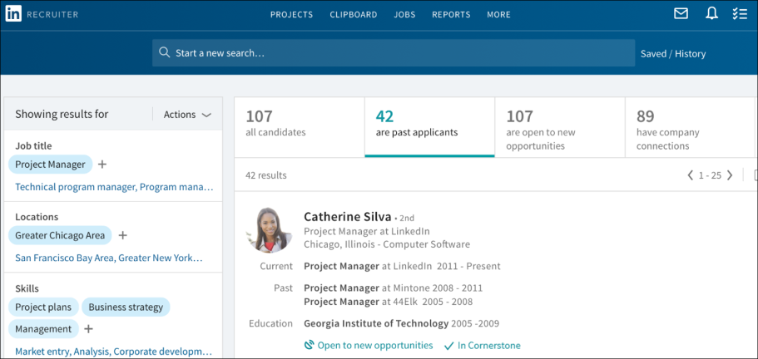
You can view Cornerstone data by clicking In Cornerstone in the candidate's details section on LinkedIn Recruiter. This opens a pop-up that displays their Cornerstone data. Much of the same candidate data that is visible in your Cornerstone portal will also be visible in LinkedIn Recruiter.
For example, you can view status changes and dates so that you know which jobs the candidate applied to, as well as their current and previous status(es) for those jobs. Note: A candidate’s application for a job is not visible until they are moved out of the New Submissions stage.
You can view comments from interviewers and their recommendation. A candidates score does not display.
Comments from recruiters and stakeholders will be visible in LinkedIn Recruiter so that you can use their input to make decisions about what actions to take. If attachments were included in the comment in Cornerstone, the attachment will not be visible in LinkedIn Recruiter.
You can also quickly and easily get to your Cornerstone portal to view the candidate on the Applicant Profile page by clicking the View in Cornerstone link.
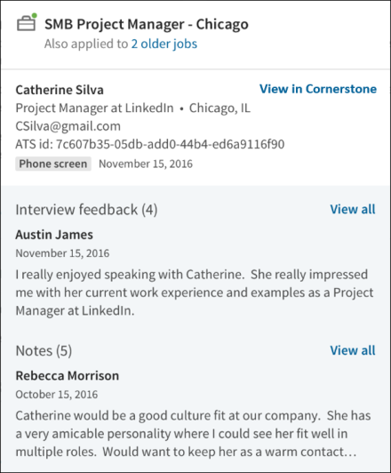
Information for candidates who have been archived, inactivated, or deleted will not display in LinkedIn Recruiter.
InMail Functionality
While viewing a candidate's profile in LinkedIn Recruiter, a recruiter can send an InMail to a candidate.
When responding to the InMail, the candidate will have the option to share their contact information with the recruiter. When the candidate replies, basic information about the candidate is synced from LinkedIn to Cornerstone. If no matching candidate is found in Cornerstone, a basic profile will be created with the candidate's name. No resume/CV information is synced from LinkedIn to Cornerstone. These candidates can now be added to requisitions using the Add Submission functionality on the Requisition Snapshot page, or they can be exported directly to a requisition from LinkedIn (see the "Export Candidate" section below). Approximately an hour after the candidate replies, a link to their Applicant Snapshot page should be visible in LinkedIn Recruiter.
If the candidate chose to share their contact information, the email address and phone number will be visible on the "ATS" tab of the LinkedIn profile approximately an hour after the candidate replied.
Export Candidate
Candidates can be exported from LinkedIn Recruiter to jobs in Cornerstone. To export a candidate:
- Navigate to their profile in LinkedIn Recruiter.
- Click the ellipsis icon and select Export to ATS. This opens the Export to your ATS flyout.
- Click the Job Name field and search for the job by keyword or job ID number. For example, entering "Product" should return options for "Product Manager" or "Associate Product Manager." Similarly, entering "25" will return job requisitions with IDs such as 25, 251, 252, etc. By default, no jobs will appear in the Job Name field. Note: Entering a prefix with the job ID (e.x., Req123) will likely result in no match.
The jobs that display are the jobs to which you have access based on your permission constraints, as well as those that meet the required criteria for syncing to LinkedIn:
  - "External Description" must contain at least 100 characters.
  - The Primary Location field must include a value for the Country field.
  - The Primary Location field must include a value for either the City field or the State/Province field.
Note: A recently created job that meets the criteria listed above may not appear for approximately two hours. The requisition must first be synced to LinkedIn, which occurs roughly every thirty minutes, and a separate list of the users who have access to the requisition must also be synced to LinkedIn, which occurs roughly every two hours.
- Click the job to select it and add it to the Job Name field.
- Click Export. A confirmation appears to indicate the export has been initiated.
To confirm the success of the export, click the ATS tab. An Export Summary section will indicate if the export is in progress, complete, or needs to be retried. This section will also show profile information from Cornerstone, as well as contact information shared by the candidate if they chose to share their contact information in response to an InMail.
When the export occurs, basic information about the candidate is synced from LinkedIn to Cornerstone. If no matching candidate is found in Cornerstone, a basic profile will be created with the candidate's name and a link to their LinkedIn profile. Additionally, an incomplete application for the selected job will be created. No resume/CV information is synced from LinkedIn to Cornerstone. To gain more information about a candidate, a recruiter can visit the LinkedIn tab of the Applicant Profile. Additionally, the recruiter can invite the candidate to apply to the requisition, where they can submit a resume/CV, answer pre-screening questions, and more.

Manage Candidates Overview
Manage Candidates provides a one-stop shop where recruiters can quickly and effectively assess and manage all their candidates through the hiring process on one page. Further, recruiters can change the status of candidates from across all their requisitions using a single Change Status page.
From the Manage Candidates page, you can:
- View Suggested Referrals, New Submissions, and other applicants across requisitions in a single view
- View a candidate's name, phone number, email address, requisition (title and requisition ID), current status, days in status, and submission date
- Search for candidates by name, email address, phone number, and parsed resume keyword
- Sort candidates by application/referral submission date, candidate first name, days in status, and requisition ID
- Filter candidates by requisition, status, or both
- Change status for one or more candidates in one or multiple requisitions
- Change status for suggested referrals, new submissions, and all other statuses in one place
- View the next available status for one or more candidates when changing status
- Assign disposition(s) to one or more candidates
- Click a candidate’s name redirects to Applicant Profile (Suggested Referrals excluded)
- Click candidate's email address to send email
- Click requisition title to edit requisition
- View/download a candidate's resume and application
- View the Manage Candidates experience on a mobile device
Click here for instructions for enabling Manage Candidates.
Should my organization be an Early Adopter of Manage Candidates?
Consider the following when determining whether being an Early Adopter for Manage Candidates is right for your organization:
- My organization wants to view and manage candidates on a mobile device
- My organization wants to change status across all requisitions
- My organization understands that not all planned Manage Candidate features are currently available in the Early Adopter program, but we are eager to start using the features that are available now.
- My organization does not need to configure which columns appear on the table and the column order to begin using the Manage Candidate experience. We understand that this is planned.
- My organization can begin using the Manage Candidate experience using only Requisition and Status filters. We understand that additional filters and the ability to configure which filters are displayed is planned.
Considerations
- Access to the Manage Candidates page is only available to users with Requisition: Manage permission and/or Requisition: Owner permission
- Job seekers who used Connect With Us but have not applied to or been suggested for a job will not be displayed on the Manage Candidates page.
- Searching:
  - When a search is performed it will search across the following fields:
    - Name
    - Email
    - Phone Number
    - Parsed Resume Keyword
Note: You cannot specify which field you are searching for (i.e., “First name = John”).
  - Searches are performed using a "starts with" method. This means that a search for "Art" will yield "Arthur" but not "Martin."
    - Names will be searched by first name and last name individually, meaning if I search for “John”, it will match a candidate “John Newton,” as well as “Sally Johnson”
    - Exception: Japanese or Chinese characters are searched using a "contains" method. This means that a search for "Art" would yield “Arthur” and "Martin" as a match.
- In some cases the data shown in Manage Candidates may temporarily not match what is seen in Manage Applicants and other pages. There may be a delay of up to 20 minutes before changes to candidate information are reflected. Manage Applicants Deprecation: Cornerstone is deprecating Manage Applicants in Q1 2024. See Manage Applicants Overview.
Implementation
Manage Candidates is available for Recruiting clients through the Feature Activation Preferences page.
Frequently Asked Questions
Who will appear in the Manage Candidates table?
Suggested Referrals, New Submissions, and Active Applicants will appear in the table. These candidates are all associated with jobs and will appear with their current status and requisition. Inactive internal candidates who are eligible for rehire will appear; however, inactive internal candidates who are not eligible for rehire, will not appear. Job seekers who used “Connect With Us” but have not applied to or been suggested for a job will not be displayed.
For more information about dispositions, see the Requisition and Applicant Preferences - Dispositions topic in Online Help.
What is the default view for the Manage Candidates page?
The recruiter will only see active candidates (not in a Closed or Hired status) for open jobs for which the recruiter is a requisition owner. The recruiter can change the filter to show other candidates, but this will always be the default view upon returning to this page.
If a candidate is associated with more than one requisition, what will be displayed?
There will be a record for each requisition with which a candidate is associated. For example, if John Smith is a “New Submission” for Req1 and Req2, he would appear twice when filtering only for candidates in “New Submission” status.
Can users configure which filters are available?
All filters display on Manage Candidates, and their visibility is not configurable. Additional filters and the ability to configure which filters display may be available in a future release.
Can users configure which columns appear on the table and the order of the columns?
With the May ’18 release, the candidate table will not be configurable. The ability to configure the table may be available in a future release.
When searching, can users specify which field they want to search (e.g., Only search in “email address” field)?
No. Searching is across the available fields. For example, a search for “New” will show matches for “John Newton” (name) as well as Newton@emailaddress.com (email).
Why are certain candidates not appearing when I enter part of their contact information in the search field?
Searches are performed using a "starts with" method. This means that a search for "Art" will yield "Arthur" but not "Martin." This search enables recruiters to find candidates quickly by entering part of their name, email, or phone number or a term in their resume. When characters are entered into the search field, the search framework identifies a list of the top 50 related terms and attempts to match candidates who have those terms in their record. As an example, a search for "Bal" may yield terms such as "Bal," "Balance," "Bali," "Ball," etc. A candidate with the name Balto, for example, may be returned if the characters "Bal" are entered into the search field. However, if "Balto" is not part of the top 50 related terms, then that candidate will not be returned in the search results.
If you do not see the candidate you are looking for after entering a partial search term, try adding additional characters as that will improve the likelihood that the search term will be included in the top 50 related terms and will help ensure the right candidate is returned.
Is Manage Candidates FedRAMP certified?
Manage Candidates is in the process of becoming FedRAMP certified. While awaiting certification, United States government clients will not be able to self-enable this functionality so that they stay in compliance.
Will changes made on Manage Applicants be applied to Manage Candidates?
Yes, changes made on Manage Applicants will be applied to Manage Candidates. For example, if you change a candidate’s status via Manage Applicants, the change will also show up on Manage Candidates.
Manage Applicants Deprecation: Cornerstone is deprecating Manage Applicants in Q1 2024. See Manage Applicants Overview.
What if the preference is not enabled for changing the date of the status change?
If the Allow applicant status change date option is unchecked in General Preferences, then the option to change the date of a status change does not display in the Change Status flyout. The date of change will be the date you made the change in the system, which is consistent with current functionality.
What if the client does not allow New Submissions to go to a status past the In Review status?
All required statuses will be validated and candidates will not be able to skip a required status. The only caveat is that it will no longer be necessary to click the Complete button on a status. As long as the candidate has been in the required status, they can move forward.
What happens if I have moved someone from Suggested Referral to Invite to Apply?
With this enhancement, you will be able to see referrals on the Manage Candidates page, with detail as to whether they have been “Invited to Apply” or “Declined.” This lets you follow up more easily with candidates that have been “Invited to Apply.”
Can I move candidates from a Closed or Hired status to another status from the Manage Candidates page?
Yes, you will now be able to move candidates from a Closed or Hired status to another status from the Manage Candidates page, in addition to the Applicant Profile.
What if I'm changing a candidate's status at the same time as another recruiter?
A validation message will appear to whoever changes the status second to indicate that another user recently updated the status. The message will prompt the user to refresh the page in order to view and change the status. If you tried to change the status for multiple candidates, when you receive this message, some of the candidates may already be successfully processed. The message at the top of the flyout will indicate any successfully processed candidates.
How do I quickly send a another suggested referral invitation to apply?
Leave the Invite to Apply status as is in the Change Status flyout. Then, click SAVE. This will resend the Invitation to Apply email, provided the email is configured and active in Email Administration.
Security
The following permissions apply to this functionality:
PERMISSION NAME | PERMISSION DESCRIPTION | CATEGORY

Applicants: Add/Move to Requisition | Grants ability to add or move applicants to requisitions the applicant did not apply for. This permission can be constrained by OU, User's OU, and Grade. | Recruiting

Applicants: Comments - Manage | Grants ability to view and manage comments for applicants.  This permission also defines whether comments posted when an interviewer submits an interview recommendation are posted to the Comments section on the Applicant Profile tab. Note: Interview recommendation comments for interviewers who have this permission display on the Applicant Profile tab. For interviewers who do not have this permission, the comments do not display on the Applicant Profile tab. | Recruiting

Applicants: Comments - View | Grants ability to view comments for applicants. | Recruiting

Applicants: Status Change | Grants ability to change applicant status for any applicant to whom the user already has access. This permission cannot be constrained. | Recruiting

Recruiting Feature Activation Preferences - Manage | Grants ability to access and manage Feature Activation Preferences in Recruiting. This permission cannot be constrained. This is an administrator permission. | Recruiting

Requisition: Manage | Grants ability to access and manage all requisitions regardless of ownership (constraints permitting). This permission also grants read-only access to the Applicant Review tab when creating or editing a job requisition. This permission can be constrained by OU, User's OU, and Grade. | Recruiting

Requisition: Owner | Enables owner to access requisitions and applicants for requisitions for which they are an owner. This permission also grants read-only access to video interviews that are completed by applicants via HireVue. For portals with Referral Suite enabled, this permission also enables requisition owners to edit the referral source on the Applicant Profile page. This permission cannot be constrained.  Note: This is a dynamically assigned permission that is not available in Security Role Administration. If the user is removed as an owner, the permission is revoked for the associated requisition. This permission cannot be manually assigned. Also, if a user has both the permission necessary to manage requisitions and be a requisition owner, the constraints of the Requisition: Manage permission overrule those of the Requisition: Owner permission. For requisition owners that do not also have permission to manage requisitions, only certain fields are editable when editing a requisition. | Recruiting

Candidates Page
The Candidates page provides a one-stop shop where recruiters can quickly and effectively assess and manage all their candidates through the hiring process.
Prior to the Manage Candidates page, recruiters had to navigate to various pages to manage their candidates (Manage Requisitions, Manage Applicants, etc.). Further, recruiters could only view candidates for one requisition at a time.
With the Manage Candidates, recruiters will be able to view all of their candidates across their requisitions in a single screen, eliminating the need to navigate to other pages in the system. Recruiters will also be able to search and filter to find specific candidates, as well as view their candidates on a mobile device.
To access Manage Candidates, go to Recruit > Manage Candidates.
Permissions
PERMISSION NAME | PERMISSION DESCRIPTION | CATEGORY

Applicants: Add/Move to Requisition | Grants ability to add or move applicants to requisitions the applicant did not apply for. This permission can be constrained by OU, User's OU, and Grade. | Recruiting

Applicants: Comments - Manage | Grants ability to view and manage comments for applicants.  This permission also defines whether comments posted when an interviewer submits an interview recommendation are posted to the Comments section on the Applicant Profile tab. Note: Interview recommendation comments for interviewers who have this permission display on the Applicant Profile tab. For interviewers who do not have this permission, the comments do not display on the Applicant Profile tab. | Recruiting

Applicants: Comments - View | Grants ability to view comments for applicants. | Recruiting

Applicants: Status Change | Grants ability to change applicant status for any applicant to whom the user already has access. This permission cannot be constrained. | Recruiting

Requisition: Manage | Grants ability to access and manage all requisitions regardless of ownership (constraints permitting). This permission also grants read-only access to the Applicant Review tab when creating or editing a job requisition. This permission can be constrained by OU, User's OU, and Grade. | Recruiting

Requisition: Owner | Enables owner to access requisitions and applicants for requisitions for which they are an owner. This permission also grants read-only access to video interviews that are completed by applicants via HireVue. For portals with Referral Suite enabled, this permission also enables requisition owners to edit the referral source on the Applicant Profile page. This permission cannot be constrained.  Note: This is a dynamically assigned permission that is not available in Security Role Administration. If the user is removed as an owner, the permission is revoked for the associated requisition. This permission cannot be manually assigned. Also, if a user has both the permission necessary to manage requisitions and be a requisition owner, the constraints of the Requisition: Manage permission overrule those of the Requisition: Owner permission. For requisition owners that do not also have permission to manage requisitions, only certain fields are editable when editing a requisition. | Recruiting

Applicants - View Candidate Matching Score | Grants ability to view a candidate's Matching Score on the Manage Candidates page. This permission is not constrained. | Recruiting

Offer: Manage Offers | Grants ability to manage all functionality available in the Offer Letter Management table of an applicant's profile, as well as view offer letters on the Documents tab of the Applicant Profile page. This permission must be used in conjunction with the Requisition: Manage or Requisition: Owner permission. This permission cannot be constrained.  Note: Users must also be assigned the Offer: Edit Letter Content permission in order to edit offer letters that are generated from a template.  Note: Users must also be assigned the Offer: Select Letter Template permission to change the template that is used when generating offer letters.  - If an offer letter template is defined at the Requisition Level, then users without the Offer: Select Letter Template permission can only use the template defined at the requisition level when configuring the offer letter at the Applicant Level.  - If an offer letter template is not defined at the requisition level, then users must have the Offer: Select Letter Template permission in order to use a template at the applicant level.  Note: Users must also be assigned the Applicants: Access Sensitive Statuses permission to access offer letters that are defined as sensitive. | Recruiting
Change Status
The Change Status feature on Manage Candidates lets you change the status of one or more candidates across all your requisitions. All candidates can be changed to the same status at once, or you can select a status for each candidate individually.
See Manage Candidates - Change Status on page 215 for additional information.
View Profile
You can view the resume and application information for one or more candidates at a time on the applicant carousel. You can also change a candidate's status from the applicant carousel.
See Manage Candidates - View Profile on page 240 for additional information.
More Drop-Down
See the following topics in Online Help for detailed information about the actions you can take on Manage Candidates from the More drop-down:
- Add/Move to Requisition - See Manage Candidates - Add/Move to Requisition on page 205 for additional information.
- Request Feedback - See Manage Candidates - Request Candidate Feedback on page 194 for additional information.
- Manage Flags - See Manage Candidates - Manage Flags on page 224 for additional information.
- Assign Integration - See Manage Candidates - Assign Integrations on page 210 for additional information.
- Invite to Event - See Manage Candidates - Invite to Event on page 220 for additional information.
- Assign Form - See Manage Candidates - Assign Forms on page 209 for additional information.
- Request Reference Letter - See Manage Candidates - Request Reference Letters on page 226 for additional information.
- Schedule Live Video Interview - See Manage Candidates - Schedule Live Video Interview on page 229 for additional information.
- Schedule On-Demand Video Interview - See Manage Candidates - Assign On-Demand Video Interview on page 213 for additional information.
- Send e-mail -See Manage Candidates - Send Email on page 234 for additional information.
Configure Columns
The Customize Columns option lets you dictate which columns display on the page and the order in which they display.
Note: Edge integration packages can be displayed as unique columns. As of March 2020, non-Edge integrations such as HireRight cannot be displayed as columns on Manage Candidates.
To configure columns:
- Click the Customize Columns option . This opens the Customize Columns flyout.
- Uncheck the box next to the columns you would like to hide.
  - Suggested Action - This option can only be configured if the box for the Status column is checked. If the Status column is unchecked, the Suggested Action box is disabled on the Customize Columns flyout, and suggested actions will not appear on Manage Candidates.
- Click and drag columns into the order in which you would like them to appear.
  - Suggested Action - This option cannot be ordered separately from the Status column.
- Check the Save As Default box to set this as your default view.
- Click Save.
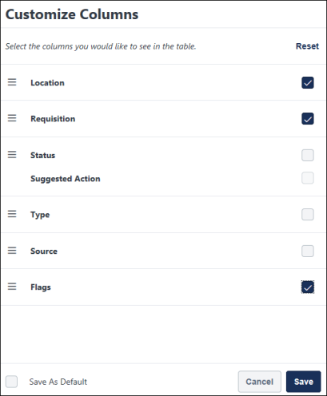
The columns you hide only appear in your view and does not impact the view for other users.
You can go back to viewing all columns on the page by clicking Reset at the top of the Customize Columns flyout.
Candidate Statuses Carousel
The total number of active candidates is displayed at the top of the page, along with the number of active candidates in each status. The statuses reflect all relevant candidates, based on the filters that have been applied.
Each status is clickable. When you click a status, the results update to show candidates who are in the selected the status.
By default, candidates in the Closed and Hired status do not display. You can view these candidates by toggling the Show only active candidates filter.
Each status has its own color bar. The color bar appears in the carousel, as well as in the Status column in the table. This can help to quickly identify a candidate's status in the table.
Search for Candidates
You can search for candidates by name, email address, phone number, and parsed resume keyword. Simply enter the search term(s) in the Search candidates and resume field and the page will update to only show candidates that match the search criteria. The search field allows a maximum of 320 characters. Therefore, you can enter up to 320 characters when searching for candidates.
Note: You cannot specify which field you are searching for (i.e., “First name = John”).
- Searches are performed using a "starts with" method. This means that a search for "Art" will yield "Arthur" but not "Martin."
  - Names will be searched by first name and last name individually, meaning if I search for “John”, it will match a candidate “John Newton,” as well as “Sally Johnson”
  - Exception: Japanese or Chinese characters are searched using a "contains" method. This means that a search for "Art" would yield “Arthur” and "Martin" as a match.
Note: If you entered a partial search term and do not see the desired candidate(s), please enter additional characters. When characters are entered into the search bar, the search framework identifies a list of the top 50 related terms and attempts to match candidates who have those terms in their record. As an example, a search for 'Bal' may yield terms such as 'Bal' 'Balance' 'Bali' 'Ball' etc. A candidate with the name Balto, for example, may be returned if the characters 'Bal' are entered into the search field. However, if 'Balto' is not part of the top 50 related terms, then that candidate will not be returned in the search results. Adding additional characters to the search will improve the likelihood that the appropriate term will be included in the top 50 related terms, and will help ensure the right candidate is returned.
Note: Anonymized New Submissions are not searchable by their anonymized data (name, email address, phone number). However, other data from their resume is searchable.
Search Suggestions
- Name
- Email Address
- Phone Number
- Job Title*
- Education Details*
- Skills*
*The resume fields that are available for keyword search may vary depending on which fields are mapped for the resume, as well as whether or not resume parsing is turned on in the application workflow.
Searchable Resume Field Types
When using the search box to search for data in parsed resume fields, the following types of resume fields are used in the search:
- Short Text Box
- Scrolling Text Box
- Dropdown
- Attribute List
Candidate/Recruiter Language
Resume keywords are not translated. If a recruiter searches for terms in a language that the candidate did not use, their search may not result in a match. For example, if a candidate applies in French (France), and a recruiter whose language is English (UK) enters an English search term (e.g., "accounting"), then the search will not return results for candidates whose resume data is in French (France).
Filters
You can decide which requisitions and statuses you would like to view on the Manage Candidates page by configuring the filters in the Filters panel.
Available Filters
The following filters are available on the Manage Candidates page:
Requisition
- Show only open reqs - By default, only open requisitions are shown on the page. To show requisitions in other statuses, toggle the Show only open reqs option.
- All Jobs - Click All Jobs to show candidates in all jobs you have access to, regardless of whether or not you are a requisition owner. To view all jobs, a user must have permission to manage candidates. The candidates that display are the candidates that are within your permission constraints.
- My Jobs - Click My Jobs to show candidates in jobs for which you are a requisition owner.
- Select Requisition - Check the box next to the requisitions you would like to view. To filter the list, enter keywords into the search field. The list updates automatically to match the search criteria. The most recently created jobs will appear at the top of the list. If no requisitions are selected, candidates from all of the displayed requisitions will appear.
Current Status
- Show only active candidates - By default, candidates in the Closed and Hired statuses are not displayed on the Manage Candidates page. To view these candidates, toggle the Show only active candidates reqs option.
- Select Status - Check the box next to the statuses you would like to view. The candidates table updates automatically to show candidates who are in the selected statuses. Default and custom statuses are available as filters, as well as referral statuses including Suggested, Invited to Apply, and Declined.
Tip: Searching by status can help you quickly find candidates in one or more statuses across your requisitions, or within one or more particular requisitions. This can provide helpful flexibility to enable the recruiter to execute their work as they see fit.
Flags
You can filter candidates by applicant and application flags. The Flags filter displays all flags that have been added to the candidates who are in the applicant pool for the requisitions to which you have access. Application flags that apply to the applicants in your available requisitions also display.
To filter by flags, check the box next to the filter. You can also search for flags using the search box. The number of candidates that have been assigned the flag appears to the right of the flag name.
The candidate results update automatically. When more than one flag is selected, only candidates who have all of the flags display in the results.
Permission Considerations
Recruiters are only able to view, add, and delete applicant flags that are in their organizational unit (OU) and can only edit applicant flags if they have the Applicants: Manage Flags permission.
Flags that are not in a recruiter's OU will not be visible to the recruiter.
Candidate Source
This filter lets you filter by candidate source, which is how the candidate applied. This includes candidates being added manually, referrals, career sites, etc.
To filter by candidate source, select or deselect a source option. The candidate results update automatically.
Prescreening Questions
This filter lets you create pre-screening questions to filter candidates based on the answers to these questions. Pre-screen filtering supports the following question types:
- Multiples choices, single answer
- Multiple choice, multiple answer
- Date
- Numeric
- Yes/No
- True/False
To create pre-screening question filters:
- In the Prescreening Questions section, click Add question. Only questions answered by candidates currently shown on your Manage Candidates page are available.
- Search for, and select pre-screening questions.
- Provide options and answers for each question.
- Select Apply. The pre-screening question filters operate as "and" operator, so only candidates meeting all criteria will be met.
The Manage Candidates page refreshes and displays only candidates that match the selected pre-screening criteria. The selected questions and their options now appear in the Prescreening Questions filter section.
Matching Score
You can select one or more Matching Score filters to identify the best matched applicants.
Reset Filters
You can remove all filters by clicking Reset. Filters can be collapsed.
Create Default Filters Settings
You can save your filter settings as default so that the Manage Candidates page is always filtered by the jobs, candidate statuses, and applicant flags you want to view. This is especially helpful when viewing large volumes of candidates across multiple jobs.
To save your filter settings:
- Select your desired filters in the Requisition, Candidate Status, and Applicant Flags sections.
- Click Save As Default at the bottom of the Filters panel. A pop-up message appears at the top of the page to let you know that your selections were successful.
Your filter settings will remain even when you leave Manage Candidates and return or log out of your portal and log back in. This creates a more efficient experience when viewing and comparing candidates.
You can remove your default settings by clicking Reset at the top of the Filters panel. This returns the filters to their default system settings.
Candidates Table
Manage Candidates displays candidates from all the requisitions you can access and that are within your permission constraints. By default, candidates are sorted by newest to oldest submission date. Up to 20 candidates display per page. Additional candidates can be viewed by clicking on the pagination controls at the bottom of the page.
Up to 10 pages of results can be viewed. To find candidates in groups that exceed the 10-page limit, narrow your search results by selecting specific requisitions or statuses or by doing a keyword search.
Show
Select the number of candidates you want to view in the table. Options are 20 or 50.
Sort By
You can sort the candidates table by the following:
- First Name (A-Z)
- First Name (Z-A)
- Last Name (A-Z)
- Last Name (Z-A)
- Req ID (Ascending)
- Req ID (Descending)
- Days in Status (Shortest)
- Days in Status (Longest)
- Submission Date (Oldest)
- Submission Date (Newest)
- Relevance - This setting sorts by the candidate's relevance to the search criteria you entered in the Search candidates and resume search field.
Select All Checkbox
The Select All checkbox is used to quickly select all candidates that are visible on the page so that you can complete actions for all the selected candidates at once, such as changing their status.
Note: When using the Select All checkbox, only candidates on the page can be selected. If there are multiple pages of candidates, candidates on other pages are not selected.
Information and Options in the Candidates Table
The following columns and information is available in the candidates table:
Applicant Flags
Recruiters can view, add, and edit applicant flags for candidates in bulk or one at a time, as well as filter candidates by flags. When looking at multiple candidates across multiple requisitions, administrators can quickly select candidates and add the same flag to all of them. Administrators can even add multiple flags and delete existing ones from the same flyout for an efficient, simplified experience.
The flags are color-coded and labeled based on Applicant Flags Preferences and the system defaults for flags. Flags display in order or most to least recently added.
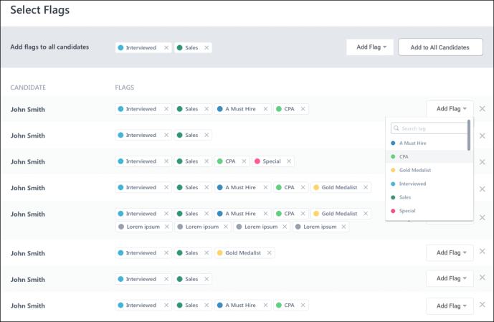
Add/Edit Flags
Flags can be added in bulk and individually to candidates.
To add flags:
- Select one or more candidates.
- Select Manage Flags from the More drop-down. This opens the Select Flags flyout, from which you can add and remove flags for candidates.
- Or, click a flag from the column of a specific candidate. This will also open the flyout.
Note: As with existing functionality for applicant flags, flags cannot be added for referrals. In addition, system flags cannot be added or deleted.
Add Flags to All Candidates
You can add one or more flags to all candidates at once.
To bulk-add flags:
- Select the flag from the Add Flag drop-down at the top of the flyout.
- Click Add to All Candidates.
- Click Save.
All flags added in bulk will appear at the top of the flyout and in each candidate's row on Manage Candidates.
Add Flags to Individual Candidates
You can add flags to each candidate on an individual basis.
To add flags to individual candidates:
- Select the flag from the Add Flag drop-down to the right of the candidate.
- Select the flag from the drop-down.
The flag will appear next to the candidate's name in the flyout and in their row on Manage Candidates.
Remove Flags from Candidates in Flyout
To remove a flag from candidates, click the X to right of the flag name.
Remove Flags from Candidates in the Table
To remove flags from candidates, click the X to right of the flag name.
When a flag is removed, the action is shown in the candidate's history on their applicant profile.
Candidate
The following information displays in the Candidate column:
- Select Candidate Checkbox - Each row displays a checkbox next to the candidate's name. The box is used to select candidates for whom you would like to process actions, such as changing the candidate's status. The box is unchecked by default. Check the box to select a candidate. Check the box again to deselect a candidate. Note: Candidates cannot be selected across multiple pages. For example, if one or more candidates are selected on the first page of candidates and the recruiter uses the pagination controls at the bottom of the screen to view another page of candidates, the selection(s) from the first page are lost.
- Name - The name displays as a link to the Applicant Profile page, from which you can view additional details about the candidate. Click your browser's "Back" option to return to Manage Candidates. All filter settings remain upon return.
Note: Suggested Referrals who have applied for a requisition do not have an Applicant Profile. Clicking the name of such a candidate will result in no action.
- Last/Current Job and Company - This is the candidate's most recent job and employer.
Note: The job/company data may display as "Not Defined." This is a known issue for which a fix is planned in a post-release patch.
Note: For external candidates, this information is based on the work history information provided when completing the application. A position marked as “Current” will be used as the candidate’s current position and company. If no position is marked as current, then the role with the most recent start date will be considered the Current position. For internal candidates, “Internal” will display.
- Phone Number - The candidate's phone number appears as a link. Click the phone number to call the candidate. This feature is available for both mobile and desktop.
- Email Address - Click the email address to email the candidate. This opens an email pop-up from your email provider.
- Resume/CV - To view/download the applicant's resume/CV, select the Resume icon . If the candidate applied with LinkedIn, a link will appear that will open the candidate's LinkedIn profile.
- View Application - To view/download the application, select the View Application icon . This option only displays for internal and external candidates, as well as candidates submitted by a recruiting agency. This option does not display for candidates who are added manually. See View Application as PDF for additional information.
- View Seek Submission - For candidates who applied using their Seek profile, a Seek icon displays. Click the icon to view the candidate's profile.
Note: If the Anonymize personal applicant data for New Submissions option is enabled in Compliance Enablement Preferences, then a New Submission’s name, email address, phone number, and location are hidden. In addition, their PDF application is disabled and their resume is hidden. Contact information for such candidates is not searchable, but these candidates may appear in searches for resume keyword.
Location
This column displays the candidate's location, if available. The following location information displays:
- City
- State/Region/Province
- Country
Requisition
This column displays the requisition display job title and the requisition ID.
For users with permission to manage requisitions or who are a requisition owner, the name appears as a link. Click the name to view and edit the requisition. Click the Back button to return to Manage Candidates. All filter settings remain upon return.
Assessment
This column displays the result and overall score for an assessment. Each assessment displays in its own column.
Including the result and score on Manage Candidates can help recruiters interpret the score. The result is passed to Cornerstone by the assessment provider and is not defined by Cornerstone.
The columns can be hidden via the Customize Columns option.
Status and Suggested Actions
The Status column displays the candidate's current status and includes suggested actions for the status. The number of days since the status was changed also displays.
For candidates who have been dispositioned, the disposition reason displays below the status.
Suggested Actions for Statuses
Suggested actions appear in the Status column and show recruiters exactly what action they should take next for each candidate. The action is clickable and opens right to the area of Recruiting that lets you perform the suggested action.
Types of Suggested Actions
The following are the suggested actions based on a candidate's status:
candidate Status/Sub-Status | suggested action button | suggested action Displays if... | takes me to...
Background Check | VIEW RESULTS | Background check is complete | Applicant Profile > Statuses
Background Check | NO SUGGESTED ACTION | Background check has been assigned but has not been completed | Applicant Profile > Statuses
Background Check | ASSIGN BACKGROUND CHECK | Background check has not been assigned | Applicant Profile > Statuses
In Review | VIEW FEEDBACK | Reviewer feedback has been provided | Applicant Profile > Statuses (if Hiring Manager Shortlisting is disabled) Applicant Profile > Summary (if Hiring Manager Shortlisting is enabled)  Learn more about Request Candidate Feedback on the following Online Help topics:  - Manage Candidates - Request Candidate Feedback  - Manage Candidates - Give Candidate Feedback
Integration (Assessment) | NO SUGGESTED ACTION | Candidate is in Integration (Assessment) status | Applicant Profile > Statuses
Integrations (Background Check) | VIEW RESULTS | Background check is complete | Applicant Profile > Statuses
Integrations (Background Check) | NO SUGGESTED ACTION | Background check has been assigned but has not been launched | Applicant Profile > Statuses
Integrations (Background Check) | ASSIGN BACKGROUND CHECK | Background check has not been assigned | Applicant Profile > Statuses
Interview (On-Demand) | ASSIGN INTERVIEW | Interview has not been assigned | Applicant Profile > Statuses
Interview (On-Demand) | NO SUGGESTED ACTION | Interview has been assigned, but interviewer feedback has not been provided | Applicant Profile > Statuses
Interview (On-Demand) | VIEW FEEDBACK | Interview feedback has been provided | Applicant Profile > Statuses
Interview (Scheduled) | SCHEDULE INTERVIEW | No interview has been scheduled | Interview Scheduler
Interview (Scheduled) | NO SUGGESTED ACTION | Interview has been scheduled but no interviewers have provided feedback | Applicant Profile > Statuses
Interview (Scheduled) | VIEW FEEDBACK | Interviewer feedback has been provided | Applicant Profile > Statuses
New Submission | Review Candidate | Candidate is in a New Submission status | Manage Candidates > Applicant Carousel
Offer Letter | NO SUGGESTED ACTION | Offer letter has been sent, but the candidate has not responded to the offer letter via their My Profile page | Applicant Profile > Statuses
Offer Letter / Pending Approval | NO SUGGESTED ACTION | Offer letter has been created, and submitted for internal approval | Opens Applicant Status tab
Offer Letter / No Offer Created | CREATE OFFER LETTER | No offer letter has been created | Opens offer letter creation page
Offer Letter | VIEW RESPONSE | Candidate has responded to offer letter via their My Profile page, or recruiter has recorded the candidate’s response to the offer letter | Applicant Profile > Statuses
Offer Letter | SEND OFFER LETTER | Offer letter has been approved but not sent | Applicant Profile > Statuses
Offer Letter / Letter in Preparation | View Details | Offer letter is being prepared | Opens Applicant Status tab
Offer Letter / Approval Denied | View Details | One internal approver denies the offer | Opens Applicant Status tab
Offer Letter / Offer Accepted | View Details | Candidate accepted the offer | Opens Applicant Status tab
Offer Letter / Offer Rejected | View Details | Candidate rejected the offer | Opens Applicant Status tab
Offer Letter/ Pending Candidate's Response | Record Response | Letter submitted to candidate, waiting for response | Opens Record Response page
Offer Letter / Letter Created | Submit Letter | Offer letter is created | Opens Applicant Status tab
Offer Letter / Letter Approved | Send to Candidate | Offer Letter is approved by all internal approvers  OR  Offer letter doesn't require internal approval. If the letter does not require approval, it still must be submitted. It then automatically moves to “letter approved” status | Opens Applicant Status tab
SHL Assessment | NO SUGGESTED ACTION | Candidate is in SHL Assessment status | Applicant Profile > Statuses
- All suggested actions are system-defined and cannot be modified, deleted, or hidden.
- Administrators and recruiters cannot create their own suggested actions.
- You cannot disable suggested actions. The suggested action will always appear in the Status column when an action is available based on the candidate's status.
- There will be no suggested action for statuses with custom assessment integrations. Examples of such integrations include WOTC, Shaker, AON, and more.
- On mobile devices, the Suggested Action button is visible, but the pages to which the Suggested Action button links (e.g., Interview Scheduler or Statuses tab of the Applicant Profile) are not responsive.
- If there are multiple interviews in a status, the earliest scheduled interview will drive the suggested action.
- If a candidate has multiple offer letters, the most recently created offer letter will drive the suggested action.
Type
This column indicates whether a submission is Internal or External. The candidate type is not searchable.
Source
This column displays the source with which the candidate's application was submitted, such as a career site, the internal career site, etc.
This column also displays the date on which the candidate submitted their application, was added by a recruiter or agency, or was submitted as a suggested referral. The name of the user who submitted the suggested referral also appears, as well as the user's relationship to the candidate.
For applications submitted via a mobile device, the word "Mobile" appears after the source name.
Candidate Matching Score
This column displays the candidate skills match score by matching a candidate's profile against the requisition's job description. Users must have the Applicants - View Candidate Matching Score permission to view these scores.
To enable this feature, administrators can go to Admin > Recruit > Feature Activation and select Candidate Skills Match.
Once enabled, an administrator must configure location Organizational Units (OUs) where matching is required by going to Admin > Recruit > Compliance Enablement and checking the Enable Candidate Skills Match option under the Applicants section.
Matching begins when a candidate submits an application with a resume attached in .doc, .docx, or .pdf format. Scoring is based on the candidate's resume /work experience matched against the job description. Scores appear in the Candidate Score column as follows:
- 76 to 100 – Excellent
- 51 to 75 – Good
- 26 to 50 – Fair
- 0 to 25 - Low
Note: If the resume is not attached to the application, the score is blank. For better scoring, it is recommended that parsing for previous work experiences is enabled. See Application Workflow - Upload Attachments.
Skills Matching Summary Flyout
Recruiters can click on any score to open the Skills Matching Summary flyout. The flyout displays the following details:
- Skills Relevance – Predicts how well the candidate's skill match the position.​
- Experience Relevance – Predicts whether the candidate's experience matches the position.​
- Upward Opportunity - Predicts how well the current position matches the candidates career path.
- Is the matching score relevant? question - Recruiters can submit feedback about whether the scores calculated were appropriate or needed fine tuning. Feedback goes to Beta Community Thread for Feedback and Questions page. Only one feedback can be submitted per application.
- Matching skills and Missing Skills- Displays items mapped in the customer's Capabilities Library. Note: If the skills identified are not mapped in the Capabilities library, then the Skills Graph keys display. See Capabilities Library - Create/Edit Capability.
- Work Experience - Only visible if work experience parsing is enabled for the application.
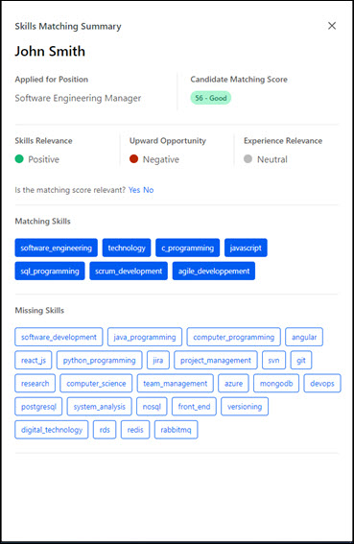
- Matching is provided only for locations where candidate skills match is enabled under Admin > Recruit > Compliance Enablement​.
- Matching is only supported for External Career Site, Internal Career Site, Add/ Move to Requisition, and Snapshot workflows.
- If the Capabilities Library is not configured, information in the Matching Skills and Missing Skills fields will be displayed as keys and might not be translated to the logged-in user’s language.
Note: In the Matching Skills and Missing Skills sections, to display only skills mapped in the Capabilities Library and ignore the Skills Graph skills, contact Global Customer Support (GCS).
​

Manage Candidates - Candidate Skills Match
Candidate Skills Match - Overview
Candidate Skills Matching enables recruiting teams to quickly identify and review the highest matching candidates against any job and reduces the risk of missing out on top talent.
To use Candidate Skills Match, you must enable it. See See Enable Candidate Skills Match on page 190 for additional information.
Note: Candidate Matching Scores are calculated only for applications which are submitted after the functionality is enabled. Previous applications do not have the calculated scores.
Permissions
PERMISSION NAME | PERMISSION DESCRIPTION | CATEGORY

Applicants - View Candidate Matching Score | Grants ability to view a candidate's Matching Score on the Manage Candidates page. This permission is not constrained. | Recruiting

Applicants: Add/Move to Requisition | Grants ability to add or move applicants to requisitions the applicant did not apply for. This permission can be constrained by OU, User's OU, and Grade. | Recruiting

Applicants: Comments - Manage | Grants ability to view and manage comments for applicants.  This permission also defines whether comments posted when an interviewer submits an interview recommendation are posted to the Comments section on the Applicant Profile tab. Note: Interview recommendation comments for interviewers who have this permission display on the Applicant Profile tab. For interviewers who do not have this permission, the comments do not display on the Applicant Profile tab. | Recruiting

Applicants: Comments - View | Grants ability to view comments for applicants. | Recruiting

Applicants: Status Change | Grants ability to change applicant status for any applicant to whom the user already has access. This permission cannot be constrained. | Recruiting

Requisition: Manage | Grants ability to access and manage all requisitions regardless of ownership (constraints permitting). This permission also grants read-only access to the Applicant Review tab when creating or editing a job requisition. This permission can be constrained by OU, User's OU, and Grade. | Recruiting

Requisition: Owner | Enables owner to access requisitions and applicants for requisitions for which they are an owner. This permission also grants read-only access to video interviews that are completed by applicants via HireVue. For portals with Referral Suite enabled, this permission also enables requisition owners to edit the referral source on the Applicant Profile page. This permission cannot be constrained.  Note: This is a dynamically assigned permission that is not available in Security Role Administration. If the user is removed as an owner, the permission is revoked for the associated requisition. This permission cannot be manually assigned. Also, if a user has both the permission necessary to manage requisitions and be a requisition owner, the constraints of the Requisition: Manage permission overrule those of the Requisition: Owner permission. For requisition owners that do not also have permission to manage requisitions, only certain fields are editable when editing a requisition. | Recruiting
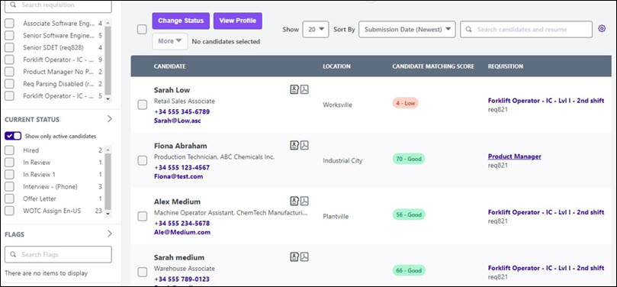
Skills Matching Summary
Candidate Skills Match provides:
- Information about how well the candidate profile matches the job.
- Sub-scores that display Skills Relevance, Experience Relevance, and Upward Opportunity for the applicant.
- Candidate's missing and matching skills.
- Self-enablement.
- Integration with Capabilities to ensure seamless skills experience through out the CSX suite.
- Work Experience details in matching summary.
- Matching score available for applications submitted using Apply with LinkedIN.
- Support in 15 languages
Workflow
The image below describes how Candidate Skills Match works:
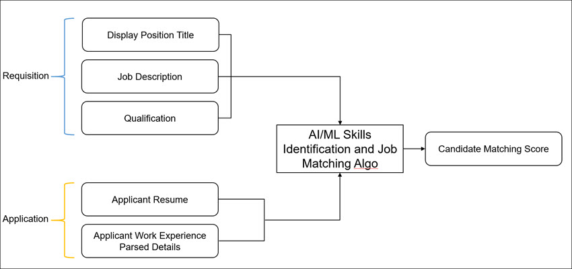
Job Matching Algorithm
The Candidate Skills Match job matching algorithm is a combination of several scores:
- A comparison of the skills detected on both the user profile and on the requisition, for example, Programming or Microsoft Word.
- A comparison of the user positions job titles vs the vacancy/job role title based on their related skills, for example, a user's Sales Associate job compared to the Account Manager job.
- A comparison of the users position job titles vs the vacancy/job role title based on the likeliness of such a job title transition in the market.
- A penalty for job title transitions with non-typical forward or backward seniority gaps, for example, senior role to a junior role.
- Experience distance (Experience Relevance): Are the past experiences (job titles) from the user profile consistent with the job offer?
- Career coherence (Upward Opportunity) : From a seniority standpoint, is the job offer consistent with the career trajectory?
- Skills coherence (Skills Relevance): Are skills inferred on both the user profile and the job consistent?

Enable Candidate Skills Match
To use Candidate Skills Match, an administrator must enable it.
Note: Candidate Matching Score is calculated only for applications submitted after the functionality is enabled. Previous applications do not have their scores calculated.
Permissions
PERMISSION NAME | PERMISSION DESCRIPTION | CATEGORY

Applicants - View Candidate Matching Score | Grants ability to view a candidate's Matching Score on the Manage Candidates page. This permission is not constrained. | Recruiting
To enable Candidate Skills Match:
- Go to Admin > Recruit > Feature Activation Preferences.
- Select Activate.
- Go to Admin > Recruit > Compliance Enablement.
- In the Applicants section, select Enable Candidate Skills Match.
View Candidate Skills Match
Candidate Skills Match information displays on the Manage Candidates page in the Candidate Matching Score column.
This column displays the candidate skills match score by matching a candidate's profile against the requisition's job description.
Matching begins when a candidate submits an application with a resume attached in .doc, .docx, or .pdf format. Scoring is based on the candidate's resume /work experience matched against the job description. Scores appear in the Candidate Score column as follows:
- 76 to 100 – Excellent
- 51 to 75 – Good
- 26 to 50 – Fair
- 0 to 25 - Low
Note: If the resume is not attached to the application, the score is blank. For better scoring, it is recommended that parsing for previous work experiences is enabled. See Application Workflow - Upload Attachments.
You must enable Candidate Skills Match to use it.See Enable Candidate Skills Match on page 190 for additional information.
To access the Manage Candidates page, go to Recruit > Manage Candidates.
Permissions
PERMISSION NAME | PERMISSION DESCRIPTION | CATEGORY

Applicants - View Candidate Matching Score | Grants ability to view a candidate's Matching Score on the Manage Candidates page. This permission is not constrained. | Recruiting
Display the Candidate Matching Score Column
To view the Candidate Score column (if not visible):
- On the Manage Candidates page, select the Customize Columns option .
- Check Candidate Matching Score.
- Click Save.
Recruiters can click on any score to open the Skills Matching Summary flyout.
Skills Matching Summary Flyout
The flyout displays the following details:
- Skills Relevance – Predicts how well the candidate's skill match the position.​
- Experience Relevance – Predicts whether the candidate's experience matches the position.​
- Upward Opportunity - Predicts how well the current position matches the candidates career path.
- Is the matching score relevant? question - Recruiters can submit feedback about whether the scores calculated were appropriate or needed fine tuning. Feedback goes to Beta Community Thread for Feedback and Questions page. Only one feedback can be submitted per application.
- Matching skills and Missing Skills- Displays items mapped in the customer's Capabilities Library. Note: If the skills identified are not mapped in the Capabilities library, then the Skills Graph keys display. See Capabilities Library - Create/Edit Capability.
- Work Experience - Only visible if work experience parsing is enabled for the application.
- Matching is provided only for locations where candidate skills match is enabled.
- Matching is only supported for External Career Site, Internal Career Site, Add/ Move to Requisition, and Snapshot workflows.
- If the Capabilities Library is not configured, information in the Matching Skills and Missing Skills fields will be displayed as keys and might not be translated to the logged-in user’s language.
Note: In the Matching Skills and Missing Skills sections, to display only skills mapped in the Capabilities Library and ignore the Skills Graph skills, contact Global Customer Support (GCS).

Manage Candidates - Feedback Requests
Manage Candidates - Request Candidate Feedback
The Request Feedback feature lets recruiters share candidates with hiring managers or business stakeholders at any point in the recruiting process and across all available requisitions. The request candidate feedback feature is a single workflow, allowing hiring managers to provide feedback quickly, reducing time to screen and hire the right candidates. In addition, this feature allows recruiters and hiring managers to better align on applicants and key competencies.
This feature also lets submitters provide comments about the candidate, provided that the Allow Comments When Requesting Feedback option is checked by the administrator in Requisition and Applicant Preferences. See Requisition and Applicant Preferences.
How does this feature benefit my organization?
- Get feedback anytime during the hiring process. An applicant may be in any status, and feedback may be requested multiple times.
- Share candidates with any user in your organization.
- Configurable feedback options enabled you to share a candidate with or without requesting feedback.
- This feature is beneficial for a committee hiring experience as it allows you to share candidates with a group of individuals.
- Hiring managers will be able to see application comments left on the applicant by a recruiter. This way, they can get the full picture when leaving feedback.
- The new feedback experience is completely mobile friendly, so hiring managers and business stakeholders can leave feedback on the go.
- Single Sign-On support from feedback request link in email.
- Limit who can view feedback by using the privacy feature.
Permissions
PERMISSION NAME | PERMISSION DESCRIPTION | CATEGORY

View Private Comments | Grants ability to read all advance/do not advance feedback when reviewing candidates in Manage Candidates. | Recruiting

Request Candidate Feedback Search | Grants users the ability to utilize the Request Candidate feature to search for users to share candidates. This permission can be constrained and is connected to the user OU service. | Recruiting
Emails
The following emails apply to the Request Feedback feature:
EMAIL NAME | EMAIL DESCRIPTION | ACTION TYPE

Request Candidate Feedback | This email is triggered when a recruiter has selected a list of candidates and shared them with the recipient. This email can be sent to Hiring Manager and Reviewers. This email can be configured as a Notification type email. This email is active by default and can be found in the Recruitment action type section of Email Management.  Configuration Note: When creating this email, be sure to include the COHORT.LINK tag so that recipients have quick access to the candidate review page, which is where recipients provide comments and determine whether to advance or not advance the candidate. | Recruiting

Feedback Submitted from Request Candidate Feedback | This email is triggered when a business stakeholder has been shared a candidate and has submitted feedback. This email can be sent to Request Candidate Feedback Sender. This email can be configured as a Notification type email. This email is active by default and can be found in the Recruitment action type section of Email Management. | Recruiting
Use Cases
Use Case 1 - Request Feedback
- Max is a Hiring Manager at ACME and has a new open Product Manager requisition. Max meets with Jack the recruiter at ACME to review position requirements. After their intake meeting, Jack interviews various candidates for the new position. A few candidates feel like great fits for the organization, so he would like to get Max's feedback.
- To determine if Jack should advance these candidates through the recruiting process, Jack shares these candidates with Max. From Manage Candidates, Jack selects all candidates, and then selects Request Feedback from the More drop-down.
- This opens a fly-out where Jack can write a message about the selected candidates and configure his request. Because comments have been enabled by the system administrator, Jack requests feedback from Max and allows Max to write comments.
- Jack sends the request to Max and sends himself a copy of the email.
- Not only will Max get an email letting him know feedback is being requested, but also Jack has the option to copy and paste a direct link to the application details of the group of shared candidates. Upon sharing the candidates, Jack will see a modal with the option to copy and paste a link. Because Jack and Max frequently use a chat application, Jack also copies the link and pastes it into their chat conversation. This allows Max and Jack to continue working within the tools of their daily schedule. This SSO supported link will take all recipients to the group of shared candidates.
- Max also receives an email requesting feedback on candidates for the Product Manager role. The email includes all candidate's names and the message about the cohort of candidates left by Jack.
- Both the link and email direct Max to a new page with all shared candidates. Here, Max can view the candidate's parsed resume, resume file, LinkedIn URL if the candidate applied with LinkedIn, prescreening questions, and application comments. In addition Max can see the candidate's status in a requisition, as well as their address, phone number, source, and referral details.
- Here, Max can say advance or do not advance and can add open comments about each candidate.
- Max will only see candidates that have been shared by Jack in this workflow. If Jack has shared candidates with Max from a different day, Max will have to access that group of candidates via the other email or link.
- Once Max leaves feedback, Jack receives an email letting him know feedback has been submitted. Max clicks the link and is taken to the new Applicant Carousel on Manage Candidates. Here, he reads all submitted feedback.
Use Case 2 - Configure Comments
- Jill is an administrator at ACME and is very excited about the Request Candidate Feedback feature. However, she does not want Hiring Managers to write open comments about each candidate.
- Jill unchecks the Allow Comments When Requesting Feedback option in Requisition and Applicant Preferences, which disables the comment feature. When comments are turned off, recruiters only have the option to request a response to the question, "Do you wish to Advance or not Advance this candidate?"
Use Case 3 - Provide Hiring Manager with an Update
- Sarah is a Hiring Manager at ACME and has a new open Account Manager requisition. Sarah meets with Jack the recruiter to review position requirements. After their intake meeting, Jack interviews various candidates for the new position. None of the candidates meet Sarah's ideal qualifications, so Jack continues vetting candidates. Two weeks pass, and Sarah requests an update from Jack on the new position.
- Jack would like to share a few candidates he has interviewed with Sarah to keep her in the loop and aware of his process. Jack selects candidates from Manage Candidates, most of whom are in the Closed status. Next, he searches for Sarah and includes a message about the cohort explaining why these candidates were not qualified. Jack does not select Request Feedback or Enable Comments because he is just giving Sarah an update.
- Sarah receives an email letting her know Jack has shared candidates for the Account Manager role. The email also includes a message from Jack about the group of candidates. This message was written when Jack selected and shared the candidates.
- Upon clicking Review Candidates, Sarah is taken to the new cohort page where she can see the candidate's resume, prescreening questions, and all application comments.
- Sarah reads the application comments left by Jack for each candidate. This allows Sarah to stay included in the recruiting process and enables Sarah and Jack to align on next steps.
Submit a Feedback Request
To request feedback:
- Navigate to the Manage Candidates page.
- Select one or more candidates.
- Select Request Feedback from the More drop-down. This opens a feedback request flyout that lets you configure your request.
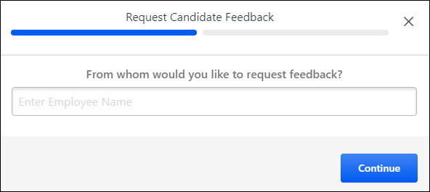
- Search for users to request feedback from. Or, select a user from the Recommended section, which is a list of the hiring manager and requisition reviewers who are already associated with the requisitions that are part of your request.
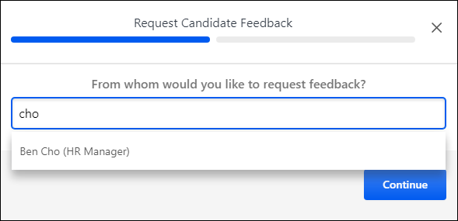
- Click Continue.
- Add a Message to recipients. This is optional. Note: If you exit the request without submitting it, your message text will not be saved. Tip: Use the <Enter> key to insert line breaks so that the full comment is visible in the comment box.
- Configure the following feedback preferences:
  - Request candidate feedback - This option is checked by default. When checked, recipients are required to select an advance or pass option when submitting feedback.
  - Allow comments - This option is checked by default. When checked, recipients will have the option to leave comments about the candidate. Recipients will not be required to leave comments. If you uncheck this option, then the Comment section will not appear for reviewers. Note: This option only displays if the Allow Comments When Requesting Feedback option is checked by the administrator in Requisition and Applicant Preferences. In addition, if the Allow Comments When Requesting Feedback option is not checked in Requisition and Applicant Preferences, then the users from whom you are requesting feedback will not be able to enter comments when submitting their feedback.
  - Anonymize applicants - When this option is checked:
    - The candidate's name is replaced with a number, and all personal information is redacted from their resume on the candidate cohort page. Note: The anonymized resume attachment may take a few minutes to generate after submitting the feedback request. If the user providing feedback sees an error on the resume attachment, they should wait a few minutes, then try again.
    - The candidate cohort page displays the candidate's name as a number.
    - The word "Hidden" displays in place of the candidate's email address, phone number, and location.
    - The candidate's name and contact information are omitted from the resume.
Use Case
A recruiter at ACME is hiring an account manager. The recruiter has just interviewed five candidates and wants to share them with the hiring manager. Each candidate is in a First Phone Interview status. To reduce the chance that the hiring manager's unconscious bias impacts their feedback, the recruiter decides to anonymize all candidates before requesting feedback. When the hiring manager clicks the link to review the shared candidates, each candidate's name is replaced with a number and all personal information is redacted from their resumes.
  - Check Email me a copy to send yourself a copy of the feedback request.
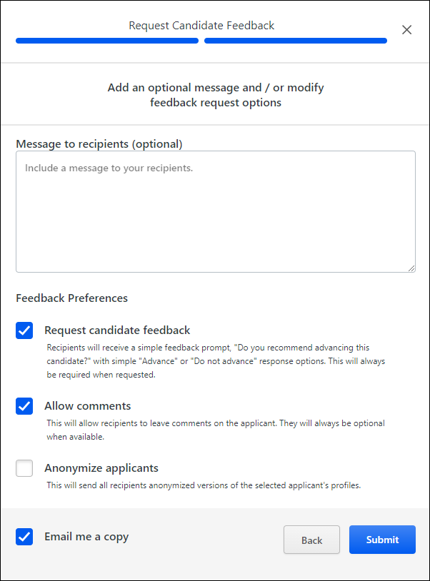
- Click Continue. This submits your requests and opens a pop-up with an SSO link you can copy and include in other applications, such as a chat.
Once your request is submitted, reviewers receive an email with a link to the feedback page. If you entered a message in your request, the email will include your message. See Manage Candidates - Give Candidate Feedback on page 201 for additional information.
Troubleshooting
Error When Clicking Shareable Feedback Link
If users experience an error when trying to open the feedback page using the link in the feedback request email, it is possible that the error is occurring due to an issue with the deep links in your portal, so you will want to confirm that the deep links are configured properly. For example, after a Production copy down to Stage, the deep links for the Stage portal will point to the Production portal, since those were the copied down values.
To fix this, navigate to Admin > Tools > Learning > Catalog Management > Deep Links. Then, click the Edit icon for the deep link and set the base URL as desired.
Manage Candidates - Give Candidate Feedback
A candidate feedback request is an opportunity for hiring managers and business stakeholders to quickly review candidates for a requisition and provide feedback. The request is sent by a recruiter to any user in the organization from whom they would like to get feedback. The request can be sent at any point in the recruiting process and may include multiple candidates across multiple requisitions.
Permissions
PERMISSION NAME | PERMISSION DESCRIPTION | CATEGORY

View Private Comments | Grants ability to read all advance/do not advance feedback when reviewing candidates in Manage Candidates. | Recruiting
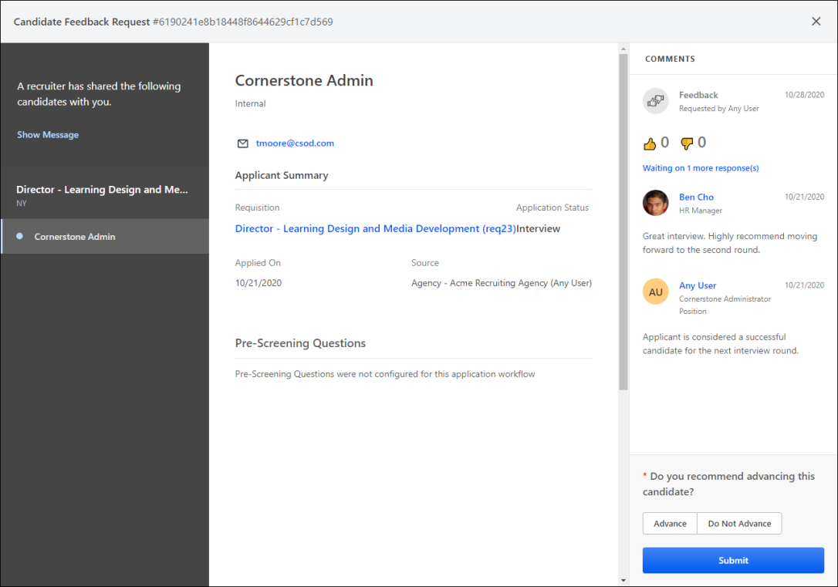
How do I receive a Feedback Request?
When recruiters ask for feedback on candidates, their request is sent to you by email. The request includes a link to the candidate review cohort page. From the cohort page, you can view a candidate's application details, advance or not advance the candidate, and view other users' feedback if visible. You can also comment about a user, if you have permission to comment.
What happens if I get more than one feedback request for the same candidate in the same job?
Each request is considered a separate request. Any required feedback will need to be completed on both requests.
Candidate Review Cohort Page
When you click the feedback link in the feedback request email, you will be directed to a welcome page that includes the following information:
- Get Started button for quick access to the feedback page for the first candidate in the list
- Date the feedback request was sent
- Recruiter's message to recipients
- Name of recruiter who requested the feedback
- List of candidates for feedback, which is grouped by requisition and includes the candidate's name and location
When you are viewing a candidate and would like to return to the welcome page, click Show Message.
Submit Feedback
To view details for the candidate and provide feedback:
- Select a candidate name from the left-side panel. This opens the candidate details. Note: Contact information is only visible if available and not hidden. Considerations are also made for anonymous applicants. See Applicant Profile Page Overview.
Note: Quick-access navigation icons appear to the left of a candidate's name for quick access to additional sections of the application, if additional sections were included in the application.
- Review the Applicant Summary. This section includes the following information:
  - Requisition - This field shows the requisition title and ID.
  - Status - This field shows the candidate's current status in the application workflow.
  - Application Received - This field shows the date the applicant applied.
  - Application Source - This field shows how the applicant applied. For example, if they applied via LinkedIn, then "LinkedIn" appears. If they were manually added, then "Added Manually" appears. If they applied via a career site, then the name of the career site appears.
  - Note: For the Employee Referral source, a tooltip appears next to the source name. Click the tooltip to view the referring employee’s name as a link to their universal profile, as well as the referring employee’s title and their relationship to the candidate.
- Review the Resume section, if available. If the candidate uploaded a resume or filled out the resume fields when completing the application, the resume appears in this section. When a candidate’s resume file has been parsed, you will be able to toggle between the two views. You may also be able to download a PDF of the resume.
- Review the Pre-Screening Questions section, if available. Any pre-screening questions that were included in the application appear in this section. Both the question and the candidate's answer appear.
- Review any other sections that are included in the application.
- Enter comments in the Comments section. The comments section is only available if they have been enabled by the system administrator and the recruiter has configured their request to allow comments. Administrators enable comments by selecting the Allow Comments When Requesting Feedback option in Requisition and Applicant Preferences. See Requisition and Applicant Preferences.
Comments that have been provided for the candidate by other users appear at the top of the Comments section. For hiring managers, you cannot view comments by other hiring managers unless you have permission to manage private comments.
Note: You can edit your comments after submitting feedback. Any changes you make to your comments will send an email to the recruiter notifying them that your comments have been updated.
- Select to advance or not advance the candidate. This section is only visible if enabled by the recruiter when creating the request for your feedback. If this section is visible, then you are required to select an advance/don't advance option before you can submit feedback.
Advancing a candidate means you think they should move forward in the application process. Not advancing a candidate means you think they should not progress beyond the current step in the process.
Your advance/don't advance selection will be visible to other reviewers, and their selection will be visible to you. The status of other reviewers' feedback is also visible, letting you know who has and has not submitted feedback
- Click Submit to submit your feedback.
Once you click Submit, your comments appear along with other users who have provided comments. In addition, an email is sent to the recruiter to let them know you submitted feedback. Providing comments is not required.
Anonymous Applicants
When requesting feedback, the requester can select to anonymize the applicants. When applicants are anonymized:
- The candidate's name is replaced with a number, and all personal information is redacted from their resume on the candidate cohort page. Note: The anonymized resume attachment can take a few minutes to generate after submitting the feedback request. If you receive an error on the resume attachment, wait a few minutes, and then try again.
- The candidate cohort page displays the candidate's name as a number.
- The word "Hidden" displays in place of the candidate's email address, phone number, and location.
- The candidate's name and contact information are omitted from the resume.
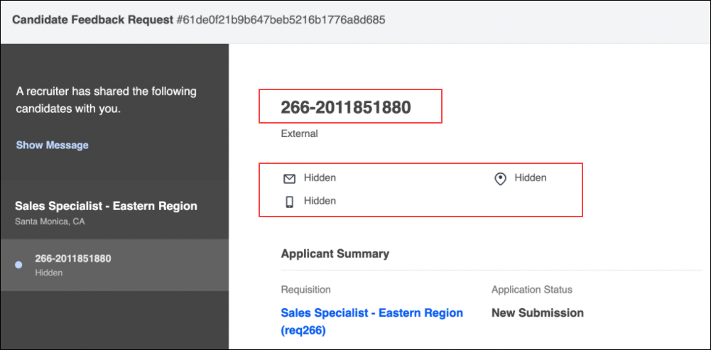
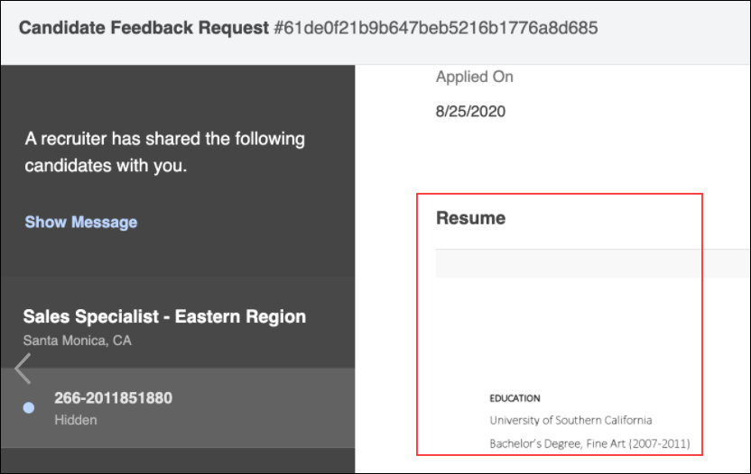

Manage Candidates - Add/Move to Requisition
Candidates can be added or moved to different requisitions from either the Manage Candidates page or the applicant carousel. This lets you quickly and easily associate candidates to the requisitions for which they are a better fit. This also helps you retain candidates who might be a good fit for your organization but not for the job to which they applied. These actions can be performed for a single candidate or in bulk.
Candidate Availability Note: Only candidates who checked the Consider me for other positions option when completing their application can be added to a requisition.
To access Manage Candidates, go to Recruit > Manage Candidates.
Permissions
PERMISSION NAME | PERMISSION DESCRIPTION | CATEGORY

Applicants: Add/Move to Requisition | Grants ability to add or move applicants to requisitions the applicant did not apply for. This permission can be constrained by OU, User's OU, and Grade. | Recruiting

Requisition: Manage | Grants ability to access and manage all requisitions regardless of ownership (constraints permitting). This permission also grants read-only access to the Applicant Review tab when creating or editing a job requisition. This permission can be constrained by OU, User's OU, and Grade. | Recruiting

Requisition: Owner | Enables owner to access requisitions and applicants for requisitions for which they are an owner. This permission also grants read-only access to video interviews that are completed by applicants via HireVue. For portals with Referral Suite enabled, this permission also enables requisition owners to edit the referral source on the Applicant Profile page. This permission cannot be constrained.  Note: This is a dynamically assigned permission that is not available in Security Role Administration. If the user is removed as an owner, the permission is revoked for the associated requisition. This permission cannot be manually assigned. Also, if a user has both the permission necessary to manage requisitions and be a requisition owner, the constraints of the Requisition: Manage permission overrule those of the Requisition: Owner permission. For requisition owners that do not also have permission to manage requisitions, only certain fields are editable when editing a requisition. | Recruiting
General Considerations for Adding/Moving Candidates
- Statuses that are configured as Required cannot be skipped when selecting the candidate's status, except when changing the status to a previous status or to Closed).
- If the Anonymize applicant data after a period of inactivity option is configured by the administrator in Compliance Enablement Preferences, then the period of inactivity for applicants added to a requisition begins when the Submit to Requisition button is clicked.See Compliance Enablement Preferences for additional information about defining the period of inactivity for applicants.
- A candidate will not be added or moved to a new requisition if any of the following are true:
  - The candidate has an open application for the new requisition.
  - The candidate was dispositioned for the new requisition and the allow reapply preference is turned off.
  - The candidate is an inactive user who is not eligible for rehire.
  - The candidate opted out of candidate search.
  - The candidate was screened out of the applicant pool based on their responses to pre-screening questions.
- Candidates cannot be moved into a Closed status directly as part of the add/move to requisition process. If a recruiter wants to add a Closed candidate from requisition A to requisition B, they would first need to add the candidate to requisition B in any of the available statuses, and then they would need to change the candidate's status to Closed.
- If you select the In Review status type, this will trigger the Review Applicant email, provided that the email is configured and active in Email Administration.
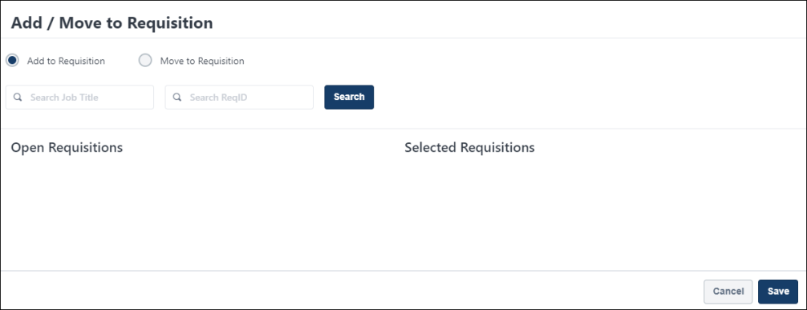
Add/Move a Single Candidate
To add or move a single candidate:
- From the Manage Candidates page, check the box to the left of the candidate's name. Note: You can also add/move candidates from the applicant carousel.
- Click View Profile. This opens the resume flyout.
- Click Add/Move to Requisition. This opens a flyout that lets you choose to add or move the candidate, select the requisitions, and select the status and email options.
- Add to Requisition - Select this option to add a candidate to a another requisition. If the candidate is currently in the applicant pool for other requisitions, they will remain in that pool.
  - Search for and select the requisitions. The requisitions that are available for you to select are requisitions in an Open status to which you have access. Once you select the requisitions, the add/move options appear.
  - When at least one requisition is selected, the Selected Requisitions panel appears to the right. If more than one requisition is selected, a separate panel appears for each requisition.
  - In the Selected Requisitions panel, select a status from the New Status drop-down. This is the status you would like the candidate to be in once they are added to the requisition. The options that display are the statuses that have been configured for the requisition. More information about candidate statuses is available here: See Manage Candidates - Change Status on page 215 for additional information.
  - In the Selected Requisitions panel, check the box next to Potential Applicants and/or Requisition Owners to send the "Add Applicant" email to notify them that the candidate has been added to the requisition. Both boxes are unchecked by default. Note: The "Add Applicant" email must be configured and active in Email Administration. If the new requisition requires candidates to complete certain steps prior to submitting their application, then the email can be configured in Email Management to include a link for the candidate to apply directly to the requisition. Further, the application materials for the new job are pre-populated with the candidate's existing information.
- Move to Requisition - Select this option to move a candidate from the current requisition to a different requisition. This action removes the candidate from the applicant pool of the current requisition and puts them into the applicant pool for the new requisition.
  - Search for and select the requisitions. When at least one requisition is selected, the Selected Requisitions panel appears to the right.
  - Select a disposition from the Please select a disposition drop-down, which appears at the top of the flyout. The disposition provides the reason for why you are moving the candidate to a different requisition.
  - Follow steps 4.C and 4.D above.
- Click Save. For candidates who are moved to a different requisition, their status will be Closed for their current requisition.
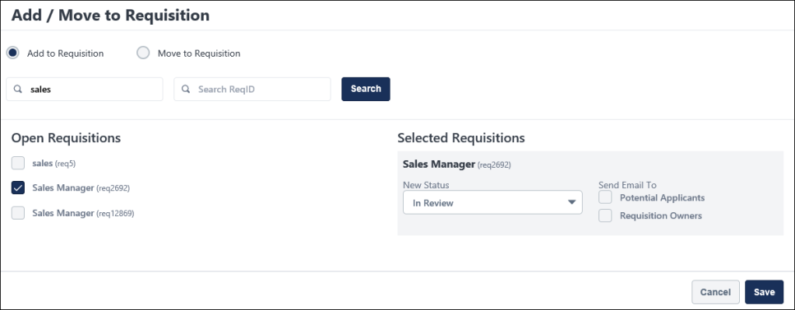
Add/Move Multiple Candidates
To add or move multiple candidates:
- From the Manage Candidates page, check box to the left of the candidates' name. Or, click the select all checkbox to the left of the Change Status button.
- Click Add/Move to Requisition from the More drop-down. This opens a flyout that lets you choose to add or move the candidate, select the requisitions, and select the status and email options.
- Follow steps 4-7 above.
Add/Move Suggested Referrals
Candidates who are in a Suggested Referral status can be added or moved to other requisitions, using the same process that is used for other statuses. However, the candidate's status will be system-defined rather than manually defined (i.e., selecting a status in the New Status drop-down or selecting a disposition when moving a candidate).
- If moving a suggested referral, their status in the old requisition will be set as "Suggestion Declined."
- If adding or moving a suggested referral, their status in the new requisition will be set as "Suggested Referral."
- While the status for a suggested referral will be system defined, a status will still need to be selected in the New Status drop-down. For candidates who are moved, a disposition will need to be selected in the Please select a disposition drop-down. The status and disposition you select will not appear for the candidate, but it is still necessary to make a selection in order to complete the add/move process.
Note: It is possible that the candidate being moved is already a candidate or suggested referral in the new requisition. In such cases, the candidate will still be added as a suggested referral.

Manage Candidates - Assign Forms
The Assign Forms feature is available from the More drop-down on Manage Candidates. A form can be assigned to one candidate at a time or to multiple candidates at once.
Note: Forms can be assigned to candidates again only if the previous assignment is completed.
Permissions
PERMISSION NAME | PERMISSION DESCRIPTION | CATEGORY

Recruiting Forms - Assign | Grants access to assign forms in Recruiting. This permission cannot be constrained. | Recruiting
Emails
EMAIL NAME | EMAIL DESCRIPTION | ACTION TYPE

Assign Applicant Form | This email is triggered when a form is assigned to an applicant. The email can be sent to External Applicant, Hiring Manager, Internal Applicant, Requisition Owner(s), Requisition Reviewer(s), or a specific user. This email can be configured as a Notification type email. This email is active by default and can be found in the Recruitment t action type section of Email Management.  Use Case: Use this trigger to send notifications that a form has been assigned to an applicant. | Recruiting
To assign a form:
- Navigate to Recruit > Manage Candidates.
- Check the box to the left of the candidate name.
- Select Assign Form from the More drop-down. This opens the Assign Forms flyout. Each candidate's name appears in the recipients list at the top of the flyout. Note: You can also assign forms from the applicant carousel by clicking the Assign Form link on the carousel page.
- Select a form from the Available Forms section. The only forms that display are forms that are within your availability.
- Click Submit. A confirmation message will appear indicating whether the invitation was sent successfully.
Submitting the form also triggers the Assign Applicant Form email notification, if enabled and active in Email Administration. This email lets the candidate know they have been assigned the form.
Forms are available to candidates from their My Profile page. From there, they can launch and complete the form.

Manage Candidates - Assign Integrations
The Assign Integration feature is available from the More drop-down on Manage Candidates. Integrations can be assigned to one candidate at a time or to multiple candidates at once.
Depending on your permissions, you will be able to assign third party assessments and/or background checks.
Permissions
PERMISSION NAME | PERMISSION DESCRIPTION | CATEGORY

Applicants: Assign Assessment Integration | Grants access to manage assessment integrations from the Applicant Profile page. This applies to assessments that have been configured in the integration center. This permission cannot be constrained. This permission is only available for portals that have an active assessments integration.  This is the highest level of permission for this functionality. In addition to being able to assign assessments, users with this permission will be able to view the assessment status and assessment details. | Recruiting

Applicants: Initiate Background Check | This permission grants access to manage background checks from the Applicant Profile page. This applies to background checks that have been configured in the Integration Center. This permission cannot be constrained. Users who have this permission will have an Assign to Applicant link in the background check status type panel on the Applicant Profile page. Once the background check is assigned, the page will display "Assigned - [Date Assigned]." | Recruiting

Applicants: View Assessment Integration Status | Allows user to view the assessment integration check status on the Applications tab of the Applicant Profile page. The user cannot view the link to the detailed report of the assessment. This permission cannot be constrained. This permission is only available for portals that have an active assessments integration.  This is the lowest level of permission for this functionality. Users with this permission can only view the assessment status; they cannot assign assessments or view assessment details. | Recruiting

Applicants: View Assessment Integration Status and Details Link | Allows user to view the assessment integration status and view link to access the assessment report from the Applications tab of the Applicant Profile page and from the associated column on the Manage Applicants page. This permission cannot be constrained. This permission is only available for portals that have an active assessments integration.  This is the second highest level of permission for this functionality. Users with this permission will be able to view the assessment status and assessment details but will not be able to assign assessments. | Recruiting

Applicants: View Background Check Status | Allow user to view the background check status. The user cannot view the link to the detailed report. This permission cannot be constrained. | Recruiting

Applicants: View Background Check Status and Details Link | This permission allows users to view the background check status and view a link to access the background check report, which can be found in the background check status type panel on the Applicant Profile page. This permission cannot be constrained. | Recruiting
Emails
EMAIL NAME | EMAIL DESCRIPTION | ACTION TYPE

Assign Integration Assessment | This email is triggered when an Edge integration assessment is assigned to an applicant, such as a WOTC assessment. This email can be configured as a notification or a reminder, and it can be sent to External Applicant, Internal Applicant, OU Approver, Hiring Manager, OU Approver, or a specific user.  This email only triggers when a successful response is received from the vendor.  Note: The APPLICANT.INTEGRATION.ASSESSMENT.LINK tag must be included in the email. This tag provides a link that the applicant can click to access the assessment.  Note about Auto-Assignment of Pre-Employment Verifications: This email also applies to auto-assignment of pre-employment verifications, via the Automated Candidate Progression (Early Adopter) functionality. For more information, see Feature Activation Preferences. | Recruiting
Assign Integration from Manage Candidates Page
To assign an integration:
- Navigate to Recruit > Manage Candidates.
- Check the box to the left of the candidate name.
- Select Assign Integrations from the More drop-down. This opens the Integrations flyout. Each candidate's name appears in the Candidates section.
- Select an integration from the drop-down in the Provider section.
- Select the package, which is available if you have an integration that has more than one type of package. For example, your integration provider may have a background check, drug check, etc.
- Click Submit.
Submitting the integration assignment triggers the Assign Integration Assessment email notification, if enabled and active in Email Administration. This email lets the candidate know they have been assigned the integration.
View Integration Results
Integration results are available from Manage Candidates. You can configure the integration columns to appear by using the Customize Columns feature. See Candidates Page on page 168 for additional information.
The results include the assignment status, as well as a link to view the results.

Manage Candidates - Assign On-Demand Video Interview
On-demand video interviews can be scheduled on Manage Candidates. This feature is available for all portals using Recruiting, but it is also necessary to have an integration configured with a third-party video interview provider. The integration is configured using the Video Interview Connector via Edge Integrations. See Edge Integration - Configure.
Some steps of assigning an on-demand video interview can be performed from Manage Candidates, while others are completed within the video interview provider's platform.
Permissions
PERMISSION NAME | PERMISSION DESCRIPTION | CATEGORY

Applicants: Assign Video Interview Integration | Allows user to assign video interview integrations from Manage Candidates. This permission cannot be constrained. | Recruiting

Applicants: View Video Interview Integration Status and Details Link | Allows user to view the video interview integration status and details link to access the video interview. This permission cannot be constrained. | Recruiting
Assign On-Demand Video Interview
To assign an on-demand video interview:
- Select one or more candidates on the Manage Candidates page. Note: You can also assign on-demand video interviews from the applicant carousel.
- Select Assign On-Demand Video Interview from the More drop-down. This opens the Assign On-Demand Video Interview flyout.
- Select a provider from the Provider drop-down. If your portal only has one provider, then the provider is selected automatically and the field is grayed out.
- Select a package from list in the Choose a Package field. You can also search for packages using the search field. Note: Packages are created by the video interview provider and are automatically pulled in from the provider. It is necessary to have at least one package configured on the vendor side in order to use on-demand video interviews.
- Select reviewers in the Reviewers field. These are the users who will review the interview and decide whether to move candidates forward in the application process. Note: A list of reviewers may already appear if reviewers were added from within the video interview provider's platform. You can delete any reviewers by clicking the X to the right of their name.
- Click Submit.
Once the interview is assigned, the candidate will receive an email from the video interview provider. The email includes the interview details and a link to record the interview. Note: There are no internal Cornerstone emails that are sent to the candidate when the interview is assigned or completed. In addition, the candidate cannot access the interview link from their profile page in the career site.
View Video Interview Status and Video
When the video interview is assigned by the recruiter, a column appears for the interview package on Manage Candidates. The column name is "[Video Interview Provider Name] - [On-Demand Video Interview]."
The column indicates the status of the interview and includes a link to view the interview once it is completed by the candidate. When a video interview is first assigned, the candidate's interview status is Assigned.
Add Reviewers
Reviewers are the users who will review the interview and application details and determine whether or not to recommend the candidate for the position. They can be assigned from within the third-party video interview provider's platform. Or, they can be assigned from the applicant carousel in Manage Candidates.
To assign reviewers, from the applicant carousel in Manage Candidates:
- Click Add Reviewers. This opens the Add Reviewers flyout.
- Search for and select the video interview reviewers. There may already be one or more reviewers listed.
- Click Submit.
Note: There are no internal Cornerstone emails that are sent when reviewers are assigned. All emails are handled by the video interview provider.
Reviewers - View Interview and Submit Review
Once the candidate submits their video, their interview status changes to Pending Recommendation. Reviewers can click View Interview from the Manage Candidates page to view the interview from within the video interview provider's platform, which is also where they will complete and submit their review.
Once the reviewer has submitted their review, their recommendation appears on the applicant carousel in Cornerstone.
Recruiters - View Recommendations by Reviewers
Recruiters can view all recommendations by reviewers by selecting the candidate on Manage Candidates and clicking View Profile. This opens the applicant carousel.
The reviewers' name, date of the review, and recommendation appear on the applicant carousel. The review may also include a score and comments.

Manage Candidates - Change Status
The Change Status feature on Manage Candidates lets you change the status of one or more candidates across all your requisitions. All candidates can be changed to the same status at once, or you can select a status for each candidate individually.
To access Manage Candidates, go to Recruit > Manage Candidates.
Note: Suggested referrals will appear with the status of Suggested Referral. You can only change a suggested referral to Invite to Apply or Decline. Candidates in the Invite to Apply or the Decline status cannot be moved into another status. However, you can change a suggested referral from Invite to Apply to Decline.
Note: Only users with appropriate permissions can use the Change Status option. If you do not have the appropriate permission, an error message appears.
Permissions
PERMISSION NAME | PERMISSION DESCRIPTION | CATEGORY

Applicants: Status Change | Grants ability to change applicant status for any applicant to whom the user already has access. This permission cannot be constrained. | Recruiting

Requisition: Manage | Grants ability to access and manage all requisitions regardless of ownership (constraints permitting). This permission also grants read-only access to the Applicant Review tab when creating or editing a job requisition. This permission can be constrained by OU, User's OU, and Grade. | Recruiting

Requisition: Owner | Enables owner to access requisitions and applicants for requisitions for which they are an owner. This permission also grants read-only access to video interviews that are completed by applicants via HireVue. For portals with Referral Suite enabled, this permission also enables requisition owners to edit the referral source on the Applicant Profile page. This permission cannot be constrained.  Note: This is a dynamically assigned permission that is not available in Security Role Administration. If the user is removed as an owner, the permission is revoked for the associated requisition. This permission cannot be manually assigned. Also, if a user has both the permission necessary to manage requisitions and be a requisition owner, the constraints of the Requisition: Manage permission overrule those of the Requisition: Owner permission. For requisition owners that do not also have permission to manage requisitions, only certain fields are editable when editing a requisition. | Recruiting
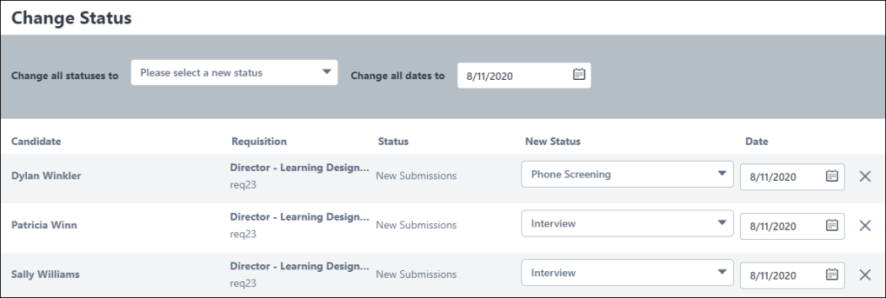
Required Statuses
When changing a candidate's status, the status can be changed to any previous status in the status workflow or to Closed. However, statuses that are configured as Required cannot be skipped (except when changing the status to a previous status or to Closed).
- When batch changing the status, the status can be changed up to the first required status of the first applicant listed in the batch.
- When changing the status of an individual candidate, the status can be changed up to the first required status in the status workflow.
- If a candidate's status is changed back to a required status and you attempt to change the status to one that comes after a required status, then the Mark Complete option must be checked for the current status in order to change the status to a required status further in the status workflow.
Required statuses display in the drop-down with an asterisk to the right of the status name. If the candidate's current status is a required status, the drop-down in the "Change Status to:" column is grayed out. A Mark Complete link displays below the candidate's status in the Current Status column. You must click the Mark Complete link before you can change the status in the Change Status to: column. After clicking Mark Complete, the link changes to "Complete" and is no longer selectable. The drop-down in the Change Status to: column becomes selectable and you are required to select a new status in order to submit the changes to the pop-up.
Change Individual Candidate Status
To change the status for one candidate:
- Check the box to the left of the candidate's name on the main Manage Candidates page.
- Click the Change Status button. This opens the Change Status flyout.
- Select a status from the drop-down in the New Status column. Required statuses cannot be skipped. The statuses that appear in the drop-down are common statuses that are used across requisitions. By default, each candidate's status is auto-populated as the next status in the workflow.
- Select an effective from the Date column. The date cannot be:
  - A future date.
  - Earlier than the start date of the current status.
  - Earlier than the date the requisition was created.
- Click Save. This updates the status in all locations in the system.
Bulk Change Candidate Status
- Check the Select All box on the main Manage Candidates page. This selects all the candidates who appear on the page.
- Click the Change Status button. This opens the Change Status flyout.
- Select a status from the Change all statuses to drop-down to change all candidates to the same status at once. Or, select a status from the drop-down in the New Status column for individual candidates.
Required statuses cannot be skipped. The statuses that appear in the drop-down are common statuses that are used across requisitions.
When changing the status to Closed, you can select a disposition in bulk or for each candidate individually. The Disposition option is only enabled if the Closed status is selected in the Change Status To option. The Disposition option requires recruiters to select a reason for changing the status to Closed. Disposition reasons are listed in alphabetical orderNote: Dispositions are defined in Requisition and Applicant Preferences.
- Select an effective date from the Date column. The date cannot be:
  - A future date.
  - Earlier than the start date of the current status.
  - Earlier than the date the requisition was created.
A validation message will be shown for each candidate that has an error, prior to being able to save the new status.
Note: The ability to select a date is not available if the Allow applicant status change date option is unchecked in General Preferences.
- Remove candidates from the Change Status flyout by clicking the X in the last column. This option is helpful if you change your mind about wanting to change a candidate's status. This does not remove a candidate from the requisition.
- Click Save. This updates the status in all locations in the system. If you change a candidate from New Submission or Suggested Referral, the candidate will no longer appear on those respective pages.
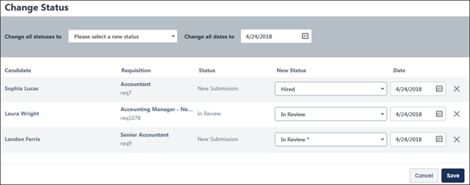
When the change are saved, the status change is processed and the table is refreshed. A message appears at the top of the Manage Candidates page indicating that the table is being updated to reflect the changes. In some cases, the table may refresh moments before the status change is processed. As a result, the previous status may still be visible after the table is refreshed.
If you would like to confirm that the status change was effective, you can refresh the table manually. This can be done many ways, including changing the sorting on the table, applying or removing a filter, entering or removing search terms, or even refreshing the browser page. Alternatively, completing another action, such as adding or removing flags, adding or moving a candidate to a requisition, or completing an additional status change, will also refresh the table.
Manage Remaining Candidates
You can disposition the remaining candidates for a job requisition when you fill all openings for the requisition. This can be done when bulk changing status across one or more requisitions or when changing the status of candidates for an individual requisition.
Once you have clicked Save to change a candidate's status to Hired and all openings for the requisition are filled, the Manage Remaining Candidates flyout appears so that you can make decisions about the remaining candidates. In the pop-up, select one of the following:
- Don't Change - This option is selected by default. When selected, the remaining candidates remain in their current status.
- Close All - Select this option to change the status of all remaining candidates to Closed. In the drop-down, select a disposition reason for closing the candidates.
Click Save to save the changes. The changes will not be reflected immediately and will take time to appear in the system.
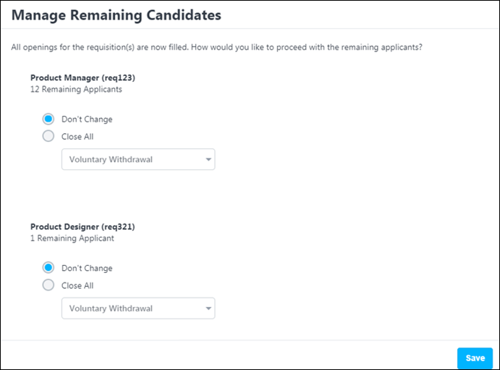
Auto Progression/Disposition of Status (Early Adopter)
If auto-progression is configured for the status (via the requisition template), then candidates are automatically moved to the next status in the workflow upon receiving a Pass value for the pre-employment verification.
If auto-disposition is configured for the status (via the requisition template), then candidates are automatically dispositioned if they receive a Fail value for the pre-employment verification.
Click here for frequently asked questions about the Automated Candidate Progression features, as well as considerations and exclusions.

Manage Candidates - Invite to Event
The Invite to Event feature lets you invite one or more candidates to interview events. This feature is available from the More drop-down on Manage Candidates.
Pre-Step Note: In order to have interview events available to select, there must be at least one interview event already created in Interview Events & Sessions, and the event must be available to the recruiter who is creating the invite.
Permissions
PERMISSION NAME | PERMISSION DESCRIPTION | CATEGORY

Applicants: Manage Interviews | Grants ability to manage and schedule interviews for applicants. This permission cannot be constrained. | Recruiting
Emails
EMAIL NAME | EMAIL DESCRIPTION | ACTION TYPE

Invitation to Interview Event (Applicant Self Schedule) | This email is triggered when a recruiter sends a self schedule invitation to an applicant for an interview event. The email can be sent to Applicant, Hiring Manager, Requisition Owner(s), Requisition Reviewer(s), or a specific user. This email can be configured as a Notification or Reminder type email. This email is active by default and can be found in the Recruitment action type section of Email Management.  Use Case: Use this email to send a message to the applicant regarding self scheduling an interview event. With this link, the applicant can schedule themselves into an interview event. | Recruiting
To invite candidates to interview events:
- Navigate to Recruit > Manage Candidates.
- Check the box to the left of the candidate name or use the select all checkbox to select all visible candidates.
- Select Invite to Event from the More drop-down. This opens the Invite to Event flyout.
- Search for and select an event. The events that display are within your availability, as defined by the administrator when configuring the event. Selecting an event opens the Invite Details flyout.
- Configure the following details of the invite:
  - Interview Format - Select the format of the interview, either In Person, Virtual, or Phone. If Phone is selected, you will have the option to enter a phone number, but this is not required.
  - Interview Duration - Select the duration of the interview from the drop-down. The options that are available are the time intervals configured for the session part that was selected in the Date field. If only one duration has been configured for all session parts for the event, then that duration value displays by default and cannot be modified.
  - Date(s) - This field displays the dates available for the event based on the interview duration that was selected. Select one or more specific dates from which the candidate can choose to schedule themselves for an interview. Or, select the Select All value to include all available interview slots from which the candidate can choose. As dates are selected, a count will update to indicate the number of dates selected and the number of available slots for the selected dates that will be shared with the invitees. Note: Be sure that the number of total slots selected is greater than or equal to the number of candidates selected. If the number of total slots selected is less than the number of candidates selected, you will receive an error message and the invitation will not be sent.
  - Optional Message to Candidates - Use this field if you would like to provide comments to the candidate in regards to the invite.
- Click Send. A confirmation message will appear indicating whether the invitation was sent successfully.
Saving the invite also triggers the Invitation to Interview Event email, if enabled and active in Email Administration. This email lets the candidate know they have been invited to the event and can schedule an interview.
The invite is available to candidates in the Pending Tasks section of their profile. From there, they can launch the invite and schedule an interview. Note: If the invitation was sent to more than one candidate, the dates will be available on a first come first serve basis.

Manage Candidates - Manage Email Templates
Administrators can configure email templates that Recruiters can select on the Manage Candidates page to send email to candidates. Templates include a customized subject and message for a template. When Recruiters select an email template on the Manage Candidates page, the Subject field and Message to candidate area pre-populate based on the selected template.
You can also use Email Tags in these templates. See See Email Tags.
Administrators can create, edit, delete email templates, and save templates in more than one language.
To access the email template, go to Admin > Tools > Recruit > Email Templates.
Permissions
PERMISSION NAME | PERMISSION DESCRIPTION | CATEGORY

Recruiting Configure Email Templates- Manage | Grants ability to configure email communication templates for Recruiting. This permission cannot be constrained. This is an administrator permission. | Recruiting

Recruiting Feature Activation Preferences - Manage | Grants ability to access and manage Feature Activation Preferences in Recruiting. This permission cannot be constrained. This is an administrator permission. | Recruiting
Creating or Editing an Email Template
To create or edit an email template:
- Select one of the following:
  - To create a new email template, select the Create Email Template button. The Create an email template using the fields below page opens.
  - To edit an email template, select Edit for the appropriate item..
- Complete or edit the following fields:
  - Category - Select the appropriate category.
  - Template Active - Check this box if you want this template to be visible and usable.
  - Language - Select the appropriate language. If you want to save this template in more than one language, see Saving Email Templates in Another Language.
  - Title - Enter the title of this template.
  - Description - Enter a description for this template.
  - Reply To Address - The email address to respond to.
  - Reply To Display Name - The name to respond to.
  - Select CC - The name to send a copy to.
  - Subject - Enter the email subject that appears by default when a Recruiter selects this template.
  - Message - Enter the email message that appears by default when a Recruiter selects this template. You can use html source code to send email and the Rich Text Editor (RTE) to preview email and view source code.
  - View tags link to display requisitions and application custom fields in alphabetical order. Only tags for custom fields that are available for the user creating or editing the template show in the list. Note: These tags can be used in “Candidates Email”. They are not available for job alerts. When editing a template containing tags outside of their availability, users can still see them displayed in the email body. If the tag is removed from the text, users will not be able to find them again in the list of tags using the View Tags link.
  - In the Drag and drop files here area, browse for or drag and drop additional candidate documents. You can attach the following document formats:
.avi | .gif | .mid | .png | .vsd
.bmp | .htm | .mp3 | .pps | .wav.
.doc | .html | .mp4 | .ppt | .wma
.docx | .jpg | .mpeg | .ppsx | .wmv
.dot | .jpeg | .mpg | .pptx | .xls
.dotx | .m4a | .mpp | .rm | xlsx
.flv | .m4v | .pdf | .txt | .zip

- Click Save to return to the Configure Email Templates page.
Deleting Email Templates
Use the Configure Email Templates page to access the edit or delete functionality.
- Select the ellipses for the appropriate email template. The options menu appears.
- To delete a template, select Delete. On the confirmation message, click Delete. The selected template is deleted and no longer visible or available for use.
Saving Email Templates in Another Language
You can save templates in more than one language. Create templates in the default language first, then additional languages as necessary.
Note: List of templates display based on logged in user’s language. If a template is not configured in user's language then the Title of the template displays in the default language.​
To save email templates in another language:
When creating or editing an email template, click the Save and add another language button, complete the required fields, and click Save or Save and add another language as appropriate.

Manage Candidates - Manage Flags
The Manage Flags option lets you add and remove applicant and application flags from candidates.
To access Manage Candidates, go to Recruit > Manage Candidates.
Permissions
PERMISSION NAME | PERMISSION DESCRIPTION | CATEGORY

Applicants: Manage Flags | Grants ability to add and remove applicant (user) and application flags. This permission also grants ability to use applicant flags in Search Candidates. This permission cannot be constrained. | Recruiting

Requisition: Manage | Grants ability to access and manage all requisitions regardless of ownership (constraints permitting). This permission also grants read-only access to the Applicant Review tab when creating or editing a job requisition. This permission can be constrained by OU, User's OU, and Grade. | Recruiting

Requisition: Owner | Enables owner to access requisitions and applicants for requisitions for which they are an owner. This permission also grants read-only access to video interviews that are completed by applicants via HireVue. For portals with Referral Suite enabled, this permission also enables requisition owners to edit the referral source on the Applicant Profile page. This permission cannot be constrained.  Note: This is a dynamically assigned permission that is not available in Security Role Administration. If the user is removed as an owner, the permission is revoked for the associated requisition. This permission cannot be manually assigned. Also, if a user has both the permission necessary to manage requisitions and be a requisition owner, the constraints of the Requisition: Manage permission overrule those of the Requisition: Owner permission. For requisition owners that do not also have permission to manage requisitions, only certain fields are editable when editing a requisition. | Recruiting
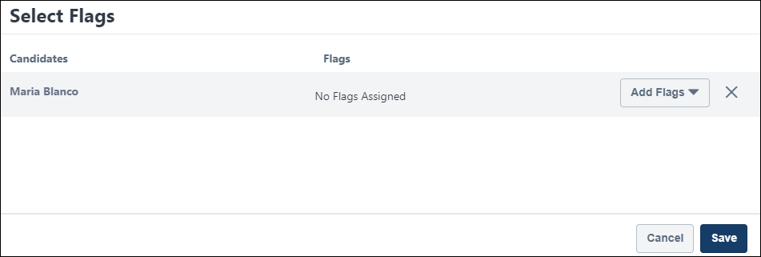
To manage flags:
- Check the Select All box on the main Manage Candidates page to select all candidates on the page. Or, select individual candidates by checking the box to the left of a candidate's name.
- Select Manage Flags from the More drop-down. This opens the Select Flags flyout.
- Search for and select flags from the Add Flags drop-down. When adding flags to multiple candidates at a time, click Add to All Candidates, which adds all the flags you selected to every candidate on the list.
- Click Save.
The flags appear in the Flags column in the candidates table.

Manage Candidates - Request Reference Letters
The Request Reference Letter feature is available from the More drop-down on Manage Candidates and is also available from the applicant carousel.
From the Manage Candidates page, you can request references for one candidate or in bulk. From the applicant carousel, you can request references from one candidate at a time.
Pre-Step Note: A form for completing reference letters must be available in order to use the Request Reference Letter action properly. Forms are created by the administrator in the Manage Forms area of the Form Management functionality.
Permissions
PERMISSION NAME | PERMISSION DESCRIPTION | CATEGORY

Request Reference Letter | Grants access to request references from an applicant and assign a reference letter form in Manage Applicants. This permission cannot be constrained. | Recruiting
Emails
EMAIL NAME | EMAIL DESCRIPTION | ACTION TYPE

Reference Letter Form Complete | This email is triggered when a reference letter form is submitted by the referrer. The email can be sent to External Applicant, Hiring Manager, Internal Applicant, Requisition Owner(s), Requisition Reviewer(s), or a specific user. This email can be configured as a Notification type email. This email is active by default and can be found in the Recruitment action type section of Email Administration.  Use Case: Use this trigger to notify recipients that the referrer has submitted the reference letter. | Recruiting

Reference Letter Request (to external references) | This email is triggered when the Reference Letter Request task is completed by an applicant in order to send a reference letter request to the external references.  When configuring this email, the email must contain the FORM.LINK tag. If the tag is not included, then referrers will not have a link in the email that opens the reference letter form from which the referrer completes and submits their reference letter. Note: The link to the reference letter form is only valid for the current applicant and cannot be reused or resubmitted for a different applicant.  The email can be sent to External Reference, Hiring Manager, Requisition Owner(s), Requisition Reviewer(s), or a specific user. When configuring this email, the External Reference email recipient must be selected. If this recipient is not selected, then the email will not be sent to the referrer.  This email can be configured as a Notification or Reminder type email. This email is active by default and can be found in the Recruitment action type section of Email Administration.  Use Case: Use this trigger to notify referrers that a reference letter has been requested of them. Reminders can also be set for this email to remind referrers to complete and submit a reference letter for the applicant. | Recruiting

Request References | This email is triggered when the Reference Letter Request task is assigned to an applicant. The email can be sent to External Applicant, Hiring Manager, Internal Applicant, Requisition Owner(s), Requisition Reviewer(s), or a specific user. This email can be configured as a Notification type email. This email is active by default and can be found in the Recruitment action type section of Email Administration.  Use Case: Use this trigger to notify applicants that they have been assigned the Reference Letter Request task. | Recruiting
Submit Reference Letter Request from Manage Candidates Page
To submit a reference letter request:
- Navigate to Recruit > Manage Candidates.
- Check the box to the left of the candidate name.
- Select Request Reference Letter from the More drop-down. This opens the Request a Reference Letter flyout. The candidate's name appears in the Candidates list at the top of the flyout.
- Select a reference letter request form from the list of forms. The only forms that display are forms that are within your availability.
Note on E-Signature Forms: Forms that include an e-signature option cannot be used for requesting reference letters via Manage Candidates.
- Click Submit. A confirmation message appears indicating whether the request was assigned successfully.
Submitting the form also triggers the Request References email notification, if enabled and active in Email Administration. This email lets the candidate know they have been assigned the request form.
Candidates can launch the form from their My Profile page in the career site (external or internal) or from their Application page in the Career Center (Legacy). From there, they can launch and complete the form.
Submit Reference Letter Request from Applicant Carousel
You can request references letters from one candidate at a time via the applicant carousel. To submit a reference letter request:
- Navigate to Recruit > Manage Candidates.
- Check the box to the left of the candidate name.
- Click View Profile. This opens the applicant carousel.
- Click Request Reference Letter from the options menu. This opens the Request a Reference Letter flyout. The candidate's name appears in the Candidates list at the top of the flyout.
- Select a reference letter request form from the list of forms. The only forms that display are forms that are within your availability.
Note on E-Signature Forms: Forms that include an e-signature option cannot be used for requesting reference letters via Manage Candidates.
- Click Submit. A confirmation message appears indicating whether the request was assigned successfully.
Submitting the form also triggers the Request References email notification, if enabled and active in Email Administration. This email lets the candidate know they have been assigned the request form.
Candidates can launch the form from their My Profile page in the career site (external or internal) or from their Application page in the Career Center (Legacy). From there, they can launch and complete the form.
Reassign Reference Letter Request
Once a candidate completes a reference letter task, recruiters can reassign the task if needed. The ability to reassign reference letter requests is not available outside Manage Candidates.
Reference letter requests cannot be assigned to candidates who have a reference letter request task in progress.

Manage Candidates - Schedule Live Video Interview
Live video interviews can be scheduled on Manage Candidates. This feature is available for all portals using Recruiting, but it is also necessary to have an integration configured with a third-party video interview provider. The integration is configured using the Video Interview Connector via Edge Integrations. See Edge Integration - Configure.
Pre-Step Note: Prior to scheduling a live video interview, it will be necessary to create a custom Interview status for this interview type.See Create Custom Applicant Status at Top OU Level on page 35 for additional information.
Permissions
PERMISSION NAME | PERMISSION DESCRIPTION | CATEGORY

Applicants: Assign Video Interview Integration | Allows user to assign video interview integrations from Manage Candidates. This permission cannot be constrained. | Recruiting

Applicants: View Video Interview Integration Status and Details Link | Allows user to view the video interview integration status and details link to access the video interview. This permission cannot be constrained. | Recruiting
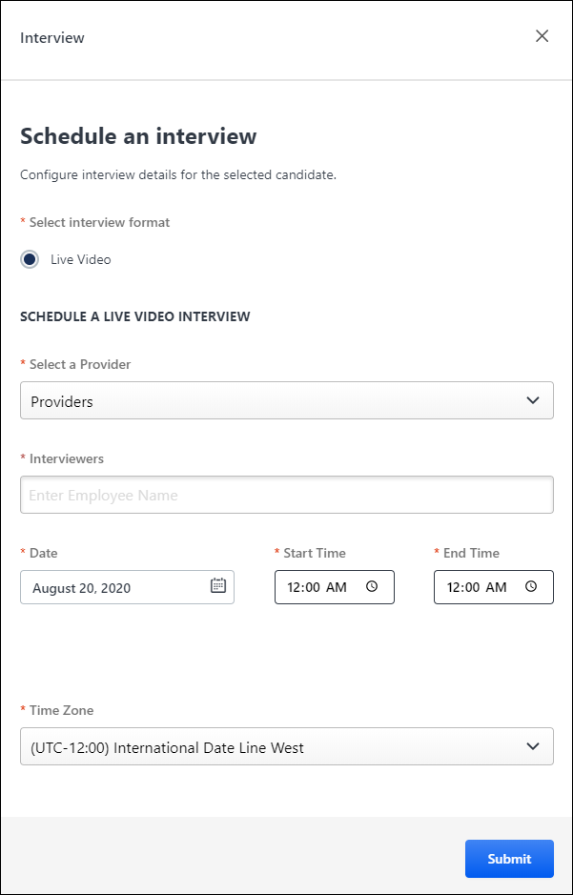
Schedule Live Video Interview
To schedule a Live Video interview:
- Select one or more candidates on the Manage Candidates page.
- Select Schedule Live Video Interview from the More drop-down. This opens the "Schedule an interview" flyout. Note: Clicking Schedule Interview for a candidate lets you schedule an interview, but this option follows the existing schedule interview workflow in the applicant profile. This option also does not allow for live video interviews to be scheduled.
- Select Live Video in the Interview Type field.
- Select the video interview provider in the Provider field.
- Search for and select interviewers in the Interviewers field. Predictive search results appear in a list as you enter a name.
- Enter the interview date in the Date field.
- Select the interview time in the Start Time and End Time fields.
- Select the time zone for the interview start/end time.
- Click Submit.
Once the interview is scheduled, the suggested action for the candidate on Manage Candidates changes from Schedule Interview to Interview Scheduled.
The interviewers and candidate will receive an email from the video interview provider. The email includes the interview details and a link to access the interview session. Note: There are no internal Cornerstone emails that are sent to the candidate when the interview is scheduled or completed. In addition, the candidate cannot access the interview link from their profile page in the career site.
Reviewers - Complete Candidate Review
Once the interview is completed, the suggested action on Manage Candidates changes to Pending Recommendation.
Reviewers can complete and submit their review of the candidate from within the video interview provider's platform, which includes the ability to view the recorded interview. Once the reviewer is done evaluating the candidate, their recommendation appears on the applicant carousel in Cornerstone.
Recruiters - View Reviewer Recommendation
Recruiters can view all recommendations by reviewers by clicking View Feedback in the Status column on Manage Candidates. This opens the applicant carousel.
The reviewers' name, date of the review, and recommendation appear in the Interview section of the applicant carousel. The review may also include a score and comments.
An option will also be available to view the recorded live video interview.

Manage Candidates - Send Email Overview
Activate Email on Manage Candidates
Note: This feature is in the Early Adopter stage.
The Email on Manage Candidates feature must be self-activated in Feature Activation Preferences. When activated, the Send Email option is available on Manage Candidates.
Click Activate to activate the functionality. Once activated, you can deactivate this feature by clicking Deactivate.
To access Feature Activation Preferences, go to Admin > Tools > Recruit > Feature Activation Preferences.
Permissions
PERMISSION NAME | PERMISSION DESCRIPTION | CATEGORY

Recruiting Feature Activation Preferences - Manage | Grants ability to access and manage Feature Activation Preferences in Recruiting. This permission cannot be constrained. This is an administrator permission. | Recruiting
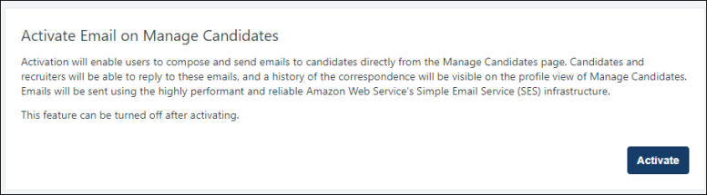
Manage Candidates - Send Email
Use the Manage Candidates send email feature to email individual candidates directly from the Manage Candidates page or the candidate's profile. Replies can be sent and received from your email provider. View a history of the emails on the applicant's profile.
Additionally, you can use tags that contain the text used to populate an email message.
Note: This functionality does not apply to candidates submitted via Suggested Referrals.
To access Manage Candidates, go to Recruit > Manage Candidates.
Permissions
Note: Any user who can access Manage Candidates can send emails, provided the Email on Manage Candidates functionality is activated in Feature Activation Preferences. See Feature Activation Preferences.
PERMISSION NAME | PERMISSION DESCRIPTION | CATEGORY

Requisition: Manage | Grants ability to access and manage all requisitions regardless of ownership (constraints permitting). This permission also grants read-only access to the Applicant Review tab when creating or editing a job requisition. This permission can be constrained by OU, User's OU, and Grade. | Recruiting

Requisition: Owner | Enables owner to access requisitions and applicants for requisitions for which they are an owner. This permission also grants read-only access to video interviews that are completed by applicants via HireVue. For portals with Referral Suite enabled, this permission also enables requisition owners to edit the referral source on the Applicant Profile page. This permission cannot be constrained.  Note: This is a dynamically assigned permission that is not available in Security Role Administration. If the user is removed as an owner, the permission is revoked for the associated requisition. This permission cannot be manually assigned. Also, if a user has both the permission necessary to manage requisitions and be a requisition owner, the constraints of the Requisition: Manage permission overrule those of the Requisition: Owner permission. For requisition owners that do not also have permission to manage requisitions, only certain fields are editable when editing a requisition. | Recruiting
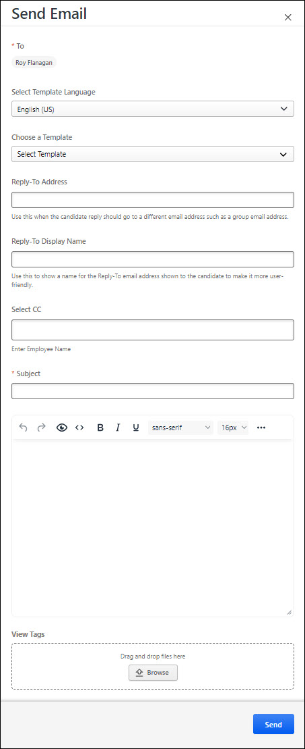
To send email:
- Check the box next to one or more candidates.
- From the More drop-down, click Send Email. The Send Email flyout opens. The selected candidates' names appear in the To: field in the flyout. Note: On the Send Email flyout, all selected candidate names appear in the To: field and are only visible to the recruiter. When the emails are sent, only the name of the receiving candidate appears in the To: field.
  - Complete the following:
    - In the Select Template Language field, select the appropriate language.
    - In the Choose a Template field, select the appropriate template.
    - In the Reply-To Address field, enter the address where you want the candidate to respond. If this field is blank, the candidate's return email is sent to the recruiter's email address
    - In the Reply-To - Display Name field, enter a name for the reply-to address. This should be a user-friendly name. If this field is blank, the candidate will see the recruiter's full name.
    - In the Select CC field, enter a name for a copy of this email.
    - In the Subject field, enter the subject of this email. Maximum number of characters is 250 characters. Note: This field may pre-populate based on the selected template, but is editable.
    - Enter a message in the message field, up to 100,000 characters. Use the editing toolbar to add formatting to the message, if necessary. You can use html source code to send email. You can also use the editing toolbar to preview email and view source code. Note: This field may pre-populate based on the selected template, but is editable.
    - In the Drag and drop files here area, browse for or drag and drop additional candidate documents. You can attach the following document formats:
.avi | .gif | .mid | .png | .vsd
.bmp | .htm | .mp3 | .pps | .wav.
.doc | .html | .mp4 | .ppt | .wma
.docx | .jpg | .mpeg | .ppsx | .wmv
.dot | .jpeg | .mpg | .pptx | .xls
.dotx | .m4a | .mpp | .rm | xlsx
.flv | .m4v | .pdf | .txt | .zip

- Click Send. The message is sent to the email addresses provided. Any responses are managed within your and the candidate's email provider and do not occur within Manage Candidates. However, you can view the message threads on the applicant carousel. See Manage Candidates - View Candidate Messages on page 239 for additional information.
Note: Emails from Manage Candidates will go to the recipient, unless a deadbox is configured. This is important to keep in mind for testing the email functionality in Stage or Pilot portals.
Note:Customers on SL4 environment cannot receive emails sent from Manage Candidates send email feature.
View Tags
Click the View Tags link to select tags that contain the text used to populate an email message. You can edit messages and preview the email message before it is sent. When the email is sent, the tags are resolved and replaced with the relevant text.
To use tags:
- On the Send Email page, click the View Tags link. The List of Supported Tags page opens.
- Copy and paste the tags you want to use into the Message to candidate box.
- Select the Send button. The tags resolve and the message is sent to the recipients listed in the To: field.
- Click the Preview button to view the resolved message before sending. Preview mode displays tags being resolved for the first selection only.
- Click the Edit button to make changes to the message.
Considerations
- Email Delivery to Candidate's Inbox - As part of this feature, steps have been taken to ensure emails come from addresses that do not have reputation issues. This will accelerate delivery and improve the probability that your emails appear in the candidate's inbox. To increase that probability, it is recommended that you use the candidate's name in the email.
  - Emails sent from Stage will appear in the candidate’s inbox with the following convention: “Recruiter Name <recruiter.email.address@cc.npe.lumesse.top>”
  - Emails sent from Production will appear in the candidate’s inbox with the following convention: “Recruiter Name <recruiter.email.address@cc.recruitmail.com>”
- Email Delivery to Recruiter's Inbox - If your organization has special email quarantine or spam filters, this may delay or prevent a candidate's replies from appearing in your inbox. To overcome this issue, the IP addresses for the email functionality in Production portals are being shared below. Your IT organization can add the IP addresses to your "allow" list to help ensure candidate replies are not blocked or delayed.
  - 54.240.54.239
  - 54.240.54.240
  - 54.240.54.241
Frequently Asked Questions
Can I manually enter an email address for the candidate?
No, an email address cannot be entered manually in the Send Email flyout. However, if the candidate does not have an email address in the system, you can add one to their profile, using the Edit Contact Details option in the Options drop-down at the top of the Applicant Profile page. See Applicant Profile Page Overview.
Can I send an email if I do not have an email address in my user record?
No. The sender must have an email address on their user record. An email address can be added to a user record by an administrator with permission to create, view, and edit users. See User Record - Contact.
Manage Candidates - View Candidate Messages
Note: This feature is in the Early Adopter stage.
Emails that originated from Manage Candidates can be viewed in the Candidate Messages section on the candidate's profile. The most recent message appears first.
To view candidate messages, go to Recruit > Manage Candidates. Select a candidate, and then click a conversation from the Candidate Messages section.
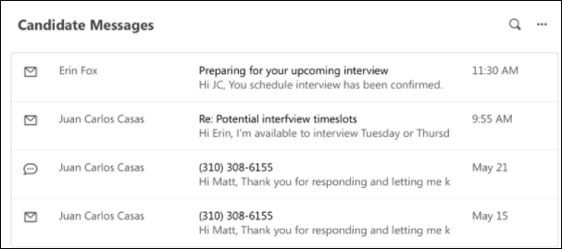
The conversation flyout opens and recruiters can view candidate conversations, including the sender's avatar, full name of the sender and recipient,the date the email was sent, and any attached documents. Additionally, recruiters can reply to the candidates email and attach documents, even if another recruiter initiated the conversation.
Emails sent from Manage Candidates are only visible on Manage Candidates. In addition, the following message types will not appear here:
- System-generated emails
- Custom emails sent from Manage Applicants or the Applicant Profile page
Note: New messages sent while viewing the profile page in Manage Candidates will not appear until the profile is closed and reopened or a different candidate's profile is selected. This will refresh the message history.
Note: To access the applicant carousel, select a candidate from the Manage Candidates page, and then click View Profile. See Manage Candidates - View Profile on page 240 for additional information.
Note: Replies to messages cannot be sent from Manage Candidates. Replies are sent between your and the candidate's email provider.

Manage Candidates - View Profile
You can view the profile and application information for one or more candidates at a time on the applicant carousel. You can also change a candidate's status from the applicant carousel.
To access Manage Candidates, go to Recruit > Manage Candidates.
Permissions
PERMISSION NAME | PERMISSION DESCRIPTION | CATEGORY

Offer: Manage Offers | Grants ability to manage all functionality available in the Offer Letter Management table of an applicant's profile, as well as view offer letters on the Documents tab of the Applicant Profile page. This permission must be used in conjunction with the Requisition: Manage or Requisition: Owner permission. This permission cannot be constrained.  Note: Users must also be assigned the Offer: Edit Letter Content permission in order to edit offer letters that are generated from a template.  Note: Users must also be assigned the Offer: Select Letter Template permission to change the template that is used when generating offer letters.  - If an offer letter template is defined at the Requisition Level, then users without the Offer: Select Letter Template permission can only use the template defined at the requisition level when configuring the offer letter at the Applicant Level.  - If an offer letter template is not defined at the requisition level, then users must have the Offer: Select Letter Template permission in order to use a template at the applicant level.  Note: Users must also be assigned the Applicants: Access Sensitive Statuses permission to access offer letters that are defined as sensitive. | Recruiting

Applicants: Comments - Manage | Grants ability to view and manage comments for applicants.  This permission also defines whether comments posted when an interviewer submits an interview recommendation are posted to the Comments section on the Applicant Profile tab. Note: Interview recommendation comments for interviewers who have this permission display on the Applicant Profile tab. For interviewers who do not have this permission, the comments do not display on the Applicant Profile tab. | Recruiting

Applicants: Comments - View | Grants ability to view comments for applicants. | Recruiting

Applicants: Status Change | Grants ability to change applicant status for any applicant to whom the user already has access. This permission cannot be constrained. | Recruiting

Requisition: Manage | Grants ability to access and manage all requisitions regardless of ownership (constraints permitting). This permission also grants read-only access to the Applicant Review tab when creating or editing a job requisition. This permission can be constrained by OU, User's OU, and Grade. | Recruiting

Requisition: Owner | Enables owner to access requisitions and applicants for requisitions for which they are an owner. This permission also grants read-only access to video interviews that are completed by applicants via HireVue. For portals with Referral Suite enabled, this permission also enables requisition owners to edit the referral source on the Applicant Profile page. This permission cannot be constrained.  Note: This is a dynamically assigned permission that is not available in Security Role Administration. If the user is removed as an owner, the permission is revoked for the associated requisition. This permission cannot be manually assigned. Also, if a user has both the permission necessary to manage requisitions and be a requisition owner, the constraints of the Requisition: Manage permission overrule those of the Requisition: Owner permission. For requisition owners that do not also have permission to manage requisitions, only certain fields are editable when editing a requisition. | Recruiting
View Profile
To view candidate profiles:
- Select one or more candidates by selecting their checkboxes.
- Click View Profile. This opens the applicant carousel. Note: At least one candidate must be selected in order to enable the View Profile button.
Applicant Carousel
The applicant carousel is a centralized location where recruiters can evaluate a candidate's application and assess their qualifications. This page is accessed by clicking View Profile from Manage Candidates or by selecting the Review Candidate status for candidates who are in an New Submissions status.
From the applicant carousel, recruiters can:
- Evaluate the resume and prescreening questions
- Read and write contextual information about the candidate through the Comments feature
- Take actions without navigating to another page
- View and access live video and ondemand video interview information
- Access resume and applicant information for multiple candidates across requisitions
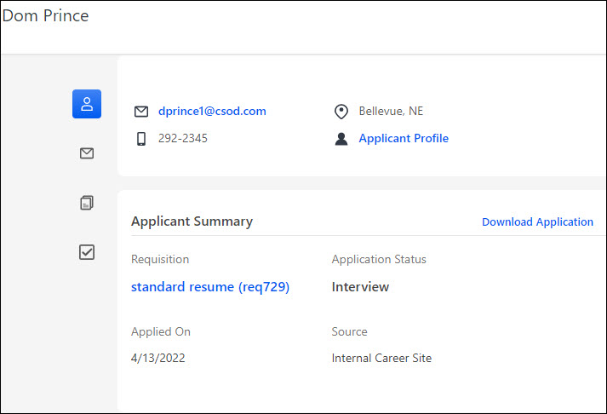
The following information is available from the applicant carousel:
List of Applicants
If two or more candidates were selected on Manage Candidates, then a list of the candidates appears in a panel on the left-side of the applicant carousel. Click a candidate's name to view their resume and application details.
Contact Information
The candidate's email address, phone number, and location appear at the top of the page.
Contact information is only visible if configured by the administrator to be available and not hidden.
Note: The visibility of contact information is also dependent upon anonymous applicant settings. See Applicant Profile Page Overview for more information about anonymous applicants.
Applicant Profile
Opens the Applicant Profile page for the selected applicant. Note: The Applicant Profile link is not available for Suggested Referrals.
Applicant Summary
This section displays the name and requisition ID of the job, the application date, and status, and documents uploaded by the candidate.
- Download Application link downloads a .pdf version of documents a candidate uploaded when they submitted their application. Note: This feature is in the Early Adopter stage.
- A Referral Details field displays for candidates who are referrals, and the referral relationship also displays.
- Application Status field displays the applicant's current status and sub-status, such as Offer Letter / Letter Created which means that an offer letter has been prepared, but not yet sent.
- Source field displays the source the candidate used to apply:
  - For candidates who apply via LinkedIn, a link to their 's LinkedIn page appears in the Source field.
  - For candidates who were added manually, "Added Manually" appears.
  - For candidates who applied via a career site, the name of the career site appears.
  - For the Employee Referral source, a tooltip appears next to the source name. Click the tooltip to view:
    - Referring employee's name, which appears as a link to their universal profile
    - Referring employee's title
    - Referring employee's relationship to the candidate
For more information about sources, see Applicant Profile Page - Summary Tab.
Resume Section
If the candidate uploaded a resume, the resume appears in the Resume section below the Overview section. You can download a PDF of the resume, as well.
For candidates who filled out their resume when completing their application, their resume details appear in this section. When a resume has been parsed, you will be able to view both the resume file and parsed resume details.
When an applicant applies with their LinkedIn resume, this will replace a resume file. An applicant can have both a LinkedIn and parsed resume.
The applicant carousel shows the resume and/or any parsed parsed resume fields that are available for the candidate. The structured resume fields used for Succession > Resume are a subset of the Universal Profile fields.
For internal employees, when they apply to a requisition and choose to use their existing resume on the application, then the structured resume fields from their Universal Profile will populate the application workflow. The internal user could choose to update these values in the resume step on the application and this would also update their Universal Profile. While the full Universal Profile does not appear on the applicant carousel, what is shown are the fields from the employee's Universal Profile that were used to apply to the requisition.
Prescreening Questions Section
Any pre-screening questions that were included in the application appear in the Pre-Screening Questions section. Both the question and the candidate's answer appear.
Interview Section
This section displays if a candidate is in a status for live video or on-demand video interviews.
See Manage Candidates - Schedule Live Video Interview on page 229 for additional information.
See Manage Candidates - Assign On-Demand Video Interview on page 213 for additional information.
Assessments Section
This section displays all assessments assigned to the applicant and that were part of the application. The completion status, overall score, and date completed displays.
Click Show Details to view the score for individual assessments that are part of an assessment package.
Actions You Can Take
The following actions are available by clicking the three dots in the upper-right corner of the flyout:
- Add/Move to Requisition - See Manage Candidates - Add/Move to Requisition on page 205 for additional information.
- Request Feedback - See the following:
  - See Manage Candidates - Give Candidate Feedback on page 201 for additional information.
  - See Manage Candidates - Request Candidate Feedback on page 194 for additional information.
- Manage Flags - See Manage Candidates - Manage Flags on page 224 for additional information.
- Invite to Event - See Manage Candidates - Invite to Event on page 220 for additional information.
- Assign Form - See Manage Candidates - Assign Forms on page 209 for additional information.
- Request Reference Letter - See Manage Candidates - Request Reference Letters on page 226 for additional information.
Change Status
You can change a candidate's status from the applicant carousel to move the candidate into a different status. To change the status:
- Click Change Status in the upper-right corner of the flyout. This opens the Change Status flyout.
- Select the new status from the drop-down in the New Status column. Required statuses cannot be bypassed.
- Select an effective date in the Date column.
- Click Save. This updates the candidate's status. Note: Once the status change is saved in the Change Status flyout, the change is saved in Manage Candidates. There are no other steps needed on the applicant carousel to save the status change.
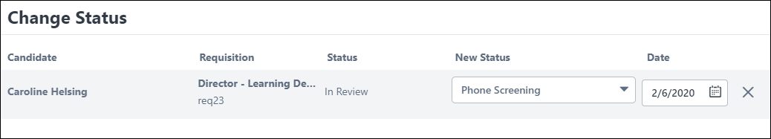
Note: Statuses can be defined as required by the administrator when configuring the job requisition template and by the recruiter when configuring the job requisition. Changing a candidate's status can also be done on the main Manage Candidates page. See Manage Candidates - Change Status on page 215 for additional information.
Comments
You can enter comments about the candidate in the Comments section. Once you click Submit, your comment appears in the Comments section.
Comments from other users are also available in this section.
Tip: Use the <Enter> key to insert line breaks so that the full comment is visible in the comment box.

Search Candidates - Overview
The Search Candidates functionality enables you to search for talent across internal and external users. Through the use of Talent Search functionality, you can specify with great detail the types of candidates from which to search. After completing a search, you can also specify the candidate source to narrow your search results.
Search Candidates searches for competencies and/or attributes in a user's resume using a key word search. You can also conduct a Job Profile or Model Employee search, as well as a custom search. Additional search options are available that allow you to search by contact information and other applicant fields.
Note: When utilizing competency ratings in Career Profile or Talent Search, competency ratings from competency assessment tasks and Competency Assessment performance review sections are available because they both use the rating scale from the competency model. However, competency ratings from Competency Rating performance review sections are not available because they use the performance review section rating scale. See Talent Search for additional information.
Note: External users that are not included in the Candidate Bank (based on their application disposition) do not appear in Candidate Search results.
Note: If a recruiting agency is configured to hide the applicants it owns, then the applicants are not available in Search Candidates for the timeframe specified for the agency that owns the applicants.
From the Search Candidates page, you can:
- Search for candidates by key word, referencing a user's resume, either from Career Center or an external applicant's application
- View more search options to configure advanced search options
- Save search criteria
- Refine search results using filters
- Add candidates to requisitions
- Add candidates to talent pools
- Compare candidates
- Send emails to candidates
- View a candidate's resume and social profile
Permissions
PERMISSION NAME | PERMISSION DESCRIPTION | CATEGORY

Applicants: Add/Move to Requisition | Grants ability to add or move applicants to requisitions the applicant did not apply for. This permission can be constrained by OU, User's OU, and Grade. | Recruiting

Applicants: Add to Talent Pool | Grants ability to add applicants to talent pools. | Recruiting

Applicants: Compare Candidates | Grants ability to compare candidates against each other | Recruiting

Applicants: Send Email | Grants ability to send email to candidates. | Recruiting

Recruiting: Search Candidates | Grants ability to access Candidate Search page for recruiting, which enables searching for internal candidates and external candidates who have applied for open positions. This permission also enables the Invite to Apply action item to appear in the Actions drop-down on the Search Candidates - Search Results page. This permission can be constrained by OU and User's OU. | Recruiting Administration
For users that do not have the permission needed to add/move applicants to a different requisition, the Add to Requisition and Move to Requisition links do not display in the Actions drop-down. The permission to add/move applicants to a different requisition must be used in conjunction with the permission necessary to manage requisitions. Or, if a user is dynamically assigned the permission necessary to be a requisition owner and also has the permission needed to add/move applicants to a different requisition, the links display.
For users that do not have the permission needed to compare candidates, the Compare Candidates link does not display in the Actions drop-down. The permission needed to compare candidates must be used in conjunction with the permission necessary to manage requisitions. Or, if a user is dynamically assigned the permission necessary to be a requisition owner and also has the permission needed to compare candidates, the link displays.
For users that do not have the permission needed to send emails, the Send Email link does not display in the Actions drop-down. The permission needed to send emails must be used in conjunction with the permission necessary to manage requisitions. Or, if a user is dynamically assigned the permission necessary to be a requisition owner and also has the permission needed to send emails, the link displays.
For users that do not have the permission needed to add applicants to a talent pool, the Add to Talent Pool link does not display in the Actions drop-down. The permission needed to add applicants to a talent pool must be used in conjunction with the permission necessary to manage requisitions. Or, if a user is dynamically assigned the permission necessary to be a requisition owner and also has the permission needed to add applicants to a talent pool, the link displays.
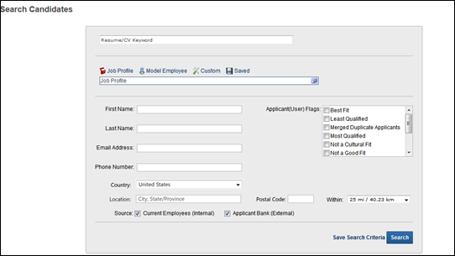

See also:
- Search for Candidates
- Search Candidates - Search Results
- Search Candidates - Actions

Search for Candidates
When searching for candidates, you can search by resume/CV keyword, job profile, and model employee, as well as conduct a custom search. You can also save the search criteria to create a list of saved searches, which allows you to conduct a Saved search from the advanced search options.
Additional search options are available that allow you to search by a candidate's contact information and other applicant fields.
Note: Archived applicants are not available in Search Candidates and do not display in search results.
Note: If the user's permission to search candidates is constrained, then the search results are restricted to internal and external candidates who exist within the constraints of the user conducting the search.
Permissions
PERMISSION NAME | PERMISSION DESCRIPTION | CATEGORY

Applicants: Add/Move to Requisition | Grants ability to add or move applicants to requisitions the applicant did not apply for. This permission can be constrained by OU, User's OU, and Grade. | Recruiting

Applicants: Add to Talent Pool | Grants ability to add applicants to talent pools. | Recruiting

Applicants: Compare Candidates | Grants ability to compare candidates against each other | Recruiting

Applicants: Send Email | Grants ability to send email to candidates. | Recruiting

Recruiting: Search Candidates | Grants ability to access Candidate Search page for recruiting, which enables searching for internal candidates and external candidates who have applied for open positions. This permission also enables the Invite to Apply action item to appear in the Actions drop-down on the Search Candidates - Search Results page. This permission can be constrained by OU and User's OU. | Recruiting Administration
For users that do not have the permission needed to add/move applicants to a different requisition, the Add to Requisition and Move to Requisition links do not display in the Actions drop-down. The permission to add/move applicants to a different requisition must be used in conjunction with the permission necessary to manage requisitions. Or, if a user is dynamically assigned the permission necessary to be a requisition owner and also has the permission needed to add/move applicants to a different requisition, the links display.
For users that do not have the permission needed to compare candidates, the Compare Candidates link does not display in the Actions drop-down. The permission needed to compare candidates must be used in conjunction with the permission necessary to manage requisitions. Or, if a user is dynamically assigned the permission necessary to be a requisition owner and also has the permission needed to compare candidates, the link displays.
For users that do not have the permission needed to send emails, the Send Email link does not display in the Actions drop-down. The permission needed to send emails must be used in conjunction with the permission necessary to manage requisitions. Or, if a user is dynamically assigned the permission necessary to be a requisition owner and also has the permission needed to send emails, the link displays.
For users that do not have the permission needed to add applicants to a talent pool, the Add to Talent Pool link does not display in the Actions drop-down. The permission needed to add applicants to a talent pool must be used in conjunction with the permission necessary to manage requisitions. Or, if a user is dynamically assigned the permission necessary to be a requisition owner and also has the permission needed to add applicants to a talent pool, the link displays.
Resume/CV Keyword Search
From the advanced search page, you can search for candidates by keyword. The Resume/CV Keyword search references the fields on a user's resume, either from Career Center or an external applicant's application. To conduct a keyword search, enter the search term in the Resume/CV Keyword field, and then click Search. The results display on the Search Results page.
The following are helpful tips when searching by keyword:
- The search is not case sensitive.
- The Resume/CV Keyword field accepts up to 4,000 characters.
- Special characters are not searched.
- Numbers are considered keywords when used in a search.
- The search only searches across applicant statuses for which the user has availability.
- When more than one keyword is entered in the search field, the system uses AND logic in the search. This means that the search returns results that meet the criteria of all of the search terms that are entered.
Search by Job Profile/Model Employee
The Job Profile search allows you to select a position and search for candidates against the position's attributes and a user's competencies. Searching by Model Employee allows you to select the user whose resume data most closely matches the criteria of the type of candidate for whom you are searching.
Note: If the recruiter or administrator's permission to search candidates is constrained by Position or User's Position, then only positions that are within the position constraints display in the search results.
Note: For the Model Employee search, the search results only display users that are available to view based on the searcher's permission constraints.
To search by Job Profile or Model Employee:
- Click the Job Profile or Model Employee link. This populates the Select field with the search type.
- Click the Select icon or click in the search bar. This opens the Select Position/Select Employee pop-up.
- Select the position or employee in the pop-up. This places the position/employee in the Job Profile/Model Employee search field. All attributes defined for the position in Manage Organizational Hierarchy display below the search bar. For the model employee, the employee's resume data displays. You can modify the criteria by editing the attributes, deleting attributes, and changing the importance level. This helps to narrow or widen your search. Note: At least one criteria must be entered to conduct a search. When searching for the position or employee, if there are no criteria currently defined, then you must add at least one criteria.
Add Criteria
Click the plus sign icon to add criteria. This opens the Edit Attributes pop-up and allows you to select from available attributes and define the criteria.
Edit Criteria
Click the Edit icon to edit the attribute. This opens the Edit Attributes pop-up and allows you to edit the criteria for the individual attribute.
Delete Criteria
Click the Delete icon to delete criteria.
Edit Criteria Importance
Select a criteria importance level from the drop-down. The options are low, average, and high. The system uses the importance level when searching for matching candidates.
Custom Search
The Custom search feature enables you to define search criteria from all sections on the Resume page in Admin > Succession > Career Center and also career preference questions. For portals using Performance Management, you can also define criteria using performance reviews, competencies, and succession metrics.
Note: When utilizing competency ratings in Career Profile or Talent Search, competency ratings from competency assessment tasks and Competency Assessment performance review sections are available because they both use the rating scale from the competency model. However, competency ratings from Competency Rating performance review sections are not available because they use the performance review section rating scale.
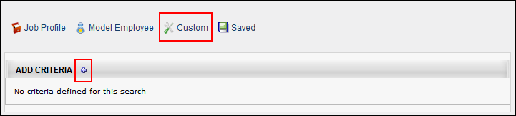
To conduct a Custom search:
- Click the Custom link. This displays the Add Criteria bar.
- Click the plus sign icon next to Add Attributes. This opens the Edit Attributes pop-up from which you can define the criteria.
- Once the criteria are defined, they display in the Add Criteria panel. You can modify the criteria by editing or deleting criteria or changing the importance level. This helps to narrow or widen your search.
Search by Saved Searches
The Saved Searches option enables you to search for candidates using searches you have saved or searches made public by other users.
To search using a saved search, click the Saved link. This opens a panel with the option to use your own saved searches from the My Searches panel or use searches made public by other users in the All Searches panel. My Searches is the default view.
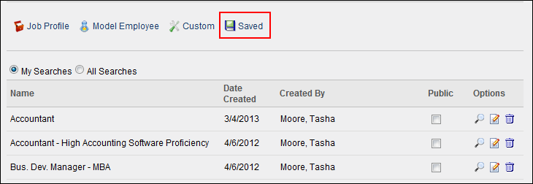
The following columns display in the Saved Searches panel:
Feature | Description
Name | This column displays the title of the saved search.
Date Created | This column displays the date on which the search was created.
Created By | This column displays the user that created the search.
Public | Checking the Public box enables other users with the appropriate permissions to view and use the search.
Options | The following options display in the Options column:  - Run Search - The Run Search icon conducts a search of the criteria in the saved search. Clicking the icon runs the search and opens the Search Results page.  Users may be required to enter a reason for the search prior to conducting the search. See the Search Reason section below for information about search reasons.  Note: Run Search only searches criteria from the saved search; it does not search criteria that have been modified in the Add Criteria panel through the Edit option.  - Edit - The Edit icon opens the Add Criteria panel, enabling you to modify the search criteria within the saved search by editing or deleting criteria or changing the importance level. This helps to narrow or widen your search. See Succession - Career Center - Resume in Online Help for more information on defining attributes. Once criteria changes are made, click the Search button at the bottom of the Search Candidates page. This displays the results of your search based on the modifications made in the Add Criteria panel. All candidates with at least one criteria match display.  You can save the modifications to a new saved search by clicking the Save Search Criteria link. This opens the Save Search pop-up. Enter a name in the Title field. Click Save to save the criteria or click Cancel to close the pop-up without saving. Note: If you save changes to the criteria, and then make additional changes that you would like to save, the title given to the previous saved search populates the Title field in the Save Search pop-up. You can edit the title or rename it completely.  Note: The Search button must be used to search the modified criteria; the Run Search icon in the Saved Searches panel does not search the modified criteria. Importantly, clicking the Run Search icon will erase any modified criteria from the Add Criteria panel and only search criteria in the original saved search.  Note: Editing the criteria in the Add Criteria panel does not change the criteria in the original saved search.  - Delete - Click the Delete icon to delete the saved search.
Matching Criteria Threshold
In order for applicants to appear in the search results, they must match the minimum number of criteria defined in the matching criteria threshold field. For example, if seven criteria are configured in the Criteria panel and the value in the matching criteria threshold field is "3," then applicants must meet at least three of the seven criteria.
The default minimum is defined as a percentage in Compliance Enablement Preferences. The default value can be modified by selecting a different value from the drop-down in the matching criteria threshold field.
Note: The default value in Compliance Enablement Preferences is a percentage, while the matching criteria threshold field on the Search Candidates page is a whole number. To calculate a match, the system converts the percentage value to a whole number and applies standard rounding.
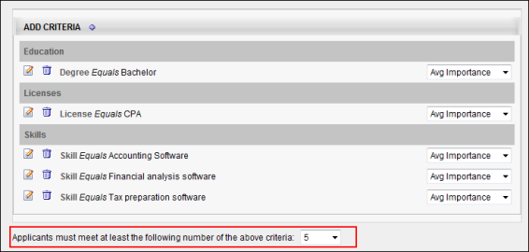
Additional Search Options
Below the criteria panel, you can search for candidates using the additional search options. The following additional search options are available:
- First Name - Enter a candidate first name. Note: Partial matches will appear in the search results.
- Last Name - Enter a candidate last name. Note: Partial matches will appear in the search results.
- Email Address - Enter a candidate email address. Note: Only exact matches display in the search results.
- Phone Number - Enter a candidate phone number. Note: Only exact matches display in the search results.
- Country - This field allows recruiters to search for candidates by country. Select a country from the drop-down to search by country. Completing the Location field is required when a country is selected. Depending on the country selected, a Postal Code field displays to the right of the Location field, which allows recruiters to further define the search criteria.
When using this field, the search results display candidates who are in the selected country, location, and postal code if defined (in addition to other search options if defined, such as first and last name). If a radius is defined, then the results display candidates who are within the selected distance to the location within the selected country.
- Location - This field allows recruiters to search for candidates by city/state/province. Enter a location, up to 20 characters. When using this field, the search results display candidates who are in the location in the selected country and within the postal code if defined. Best Practice: As a best practice, enter the City, State/Province to improve the accuracy of the location search.
- Postal Code - This field only displays if one of the following countries is selected in the Country field:
  - Austria
  - Belgium
  - Canada
  - Czech Republic
  - Denmark
  - Finland
  - France
  - Germany
  - Greece
  - Hungary
  - Italy
  - Luxembourg
  - Mexico
  - Netherlands
  - Norway
  - Poland
  - Portugal
  - Spain
  - Sweden
  - Switzerland
  - United Kingdom
  - United States
This is not a required field. Enter a postal code in the field, up to 20 characters. When using this field, the search results display candidates who are within this postal code in the location in the selected country (in addition to other search options if defined, such as first and last name).
- Radius (Within) - Recruiters can search for candidates within a certain radius of the location. The Within field allows recruiters to select a radius. The following options are available:
  - 10 mi / 16.09 km
  - 25 mi / 40.23 km
  - 50 mi / 80.47 km
  - 100 mi / 160.93 km
By default, the 25 mi / 40.23 km option is selected. Clicking the Search button displays results for candidates who live within the selected radius of the location in the selected country.
If a country and location are not defined, then the Radius field is ignored when searching for candidates.
- Applicant (User) Flags - This option enables recruiters to search for candidates by applicant flags. All flags are unchecked by default. Check or uncheck the flags to define the search criteria.
The Potential Duplicate Applicant flag is only available if the Flag Potential Duplicates option is enabled in Requisition and Applicant Preferences. Selecting this flag enables recruiters to search for applicants who are flagged by the system as potential duplicates. When the flag is selected, potential duplicates display in the search results.
The Merged Duplicate Applicants flag is available. When this flag is selected, applicants who have been automatically flagged by the system with the Merged Duplicate Applicants flag can be searched using the applicant flag filter.
The additional flags that display are the flags that are visible to the recruiter based on the flag's visibility settings and organizational unit availability. In addition, the candidate search option must be enabled for a flag in order for the flag to be available in the Search Candidates feature.
Note: Visibility and candidate search settings for flags are defined by the administrator in Applicant Flags Preferences. See Applicant Flags Preferences on page 13 for additional information.
- Source - At least one of the following source option must be selected:
  - Current Employees (Internal) - This option is checked by default. When checked, the search includes current employees who have not applied to the requisition.
  - Applicant Bank (External) - This option is checked by default. When checked, the search includes external applicants.
Save Search Criteria
Save the changes to the criteria by clicking the Save Search Criteria button. This opens the Save Search pop-up. Enter a name in the Title field. Click Save to save the criteria or Cancel to close the pop-up without saving. Note: If you save changes to the criteria, and then make additional changes that you would like to save, the title given to the previous saved search populates the Title field in the Save Search pop-up. You can edit the title or rename it completely.
Search
Click the Search button. This displays the results of your search. All candidates with at least one criteria match display.
Search Reason
Clicking the Search button may require you to enter a reason for the search prior to conducting the search. If configured in Compliance Enablement Preferences, when Search is clicked, a Reason for Search pop-up opens. Select a requisition from the Specific Requisition drop-down to indicate for which requisition you are conducting the search. Or, select Other and enter a reason in the text field. There is no character limit when entering a reason in the Other field. Click Search in the pop-up to execute the search. This also automatically saves the search and generates a unique ID for the search.
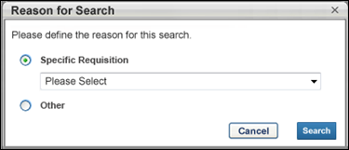
Note: The Specific Requisition drop-down displays all requisitions that are available to the user. For this reason, the user must have permission to manage or review requisitions or must be a requisition owner.
Note: If users are not required to enter a reason for the search, then clicking Search on the Search Candidates page executes the search and also automatically saves the search.

Search Candidates - Actions
The Actions drop-down enables you to perform a series of actions on all candidates at once or on individual candidates. The drop-down displays only actions for which you have permission to perform and that are relevant to the functionality in your portal.
From the Actions drop-down on the Search Results page, you can do the following:
- Invite candidates to apply to a requisition.
- Add candidates to a requisition.
- Add candidates to the Talent Pool.
- Compare the criteria of up to five candidates.
- Send candidates an email.
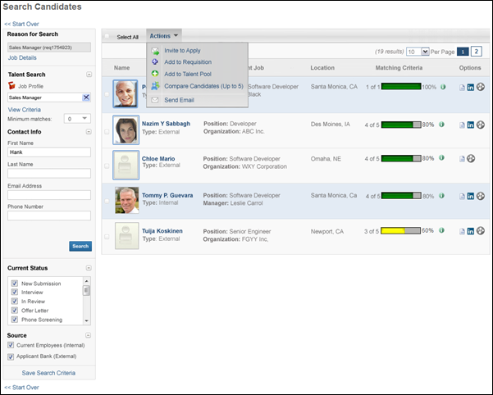
The Select All box to the left of the Actions drop-down checks all users in the search results, enabling you to batch perform the Add to Requisition, Add To Talent Pool, and Send Email actions. If there are multiple pages of results, all users on all pages are checked. Unchecking the box unchecks all users.
When an Add to Requisition or Add To Talent Pool action is successfully completed, a notification bar appears at the top of the page. A notification does not appear for the Send Email action. If an action has already been performed for a candidate and a user attempts to perform the action again, an error message displays, indicating that the action has already been performed.
Invite to Apply
The Invite to Apply action sends an email invitation to all applicants that are selected from the search results to apply to the requisition. When the Invite to Apply link is clicked, the Invite to Apply pop-up opens. Select one or more requisitions to which to invite applicants to apply, and then click Done. This triggers the Invitation to Apply email, if configured. The History tab on the applicant's profile page is updated with the event.
If multiple requisitions are selected in the pop-up, a separate email is sent for each requisition.
Note: If the applicant applies via the link in the email, the applicant's source for the requisition is Other - Invited to Apply.
Compare Candidates (up to 5)
Compare Candidates enables you to view the Matching Criteria score and number of matching attributes for up to five candidates at once.
To compare candidates:
- Select up to five candidates by checking the box to the left of the candidate's name.
- Click the Compare Candidates link in the Actions drop-down. This opens the Compare Candidates pop-up, displaying the following for each candidate:
  - Photo, if available; ghost image displays if no photo is available
  - Full name
  - Current position (for internal applicants only)
  - Matching criteria score
  - Number of matching attributes
Add to Requisition
You can add candidates to requisitions for which they did not apply by using the Add to Requisition feature. All candidates can be added as a batch or individually. Adding a candidate to another requisition does not affect the existing requisition. The candidate appears on the new requisition as though they applied for the job themselves.
In addition, all applicant documents and attachments on the Applicant Profile page for the source requisition move with the applicant to the new requisition. The documents and attachments display on the Documents tab of the Applicant Profile page for the new requisition. For all attachments in the Attachments table, the status in the Applicant Status column is New Submission.
Note: Only candidates who checked the Consider me for other positions field when completing their application can be added to a requisition.
To add a candidate to a requisition:
- Check the Select All box to add all candidates to a requisition at once. Or, select individual candidates by checking the box to the left of the candidate's name.
- Click the Add to Requisition link in the Actions drop-down. This opens the Add to Requisition pop-up.
- Enter search terms in the Job Title, Division, Location, and Owner fields.
- Click the Search button.
- The search results display in the Open Jobs table in alphabetical order. The title, division, location, and requisition owner display. All columns in the Open Jobs table are sortable. Note: The results that display are dependent upon your permission constraints.
- Click the plus icon in the Add column to select a job. This opens the Selected Jobs table and places the job in the table. The plus icon in the Add column in the Open Jobs table changes to "N/A." You can delete jobs added to the Selected Jobs table by clicking the Remove icon to the left of the job title. Jobs display in Selected Jobs table in the order in which they are added.
- The Add As column enables you to add the submission as a new submission or an applicant. Select the New Submission option to add the applicant as a new submission for the requisition. Select the Applicant option to add the applicant into the first status in the status workflow for the requisition, in which case the date for the Current Status is the date on which the applicant was manually added to the requisition.
Note: If the Skip New Submission Status option is enabled by the administrator in Requisition and Applicant Preferences, then the option to add an applicant as a new submission is disabled for the Add to Requisition action item. The New Submission option in the Add to Requisition pop-up is grayed out and cannot be selected. The Applicant option is then selected by default.
- In the Send Email To column in the Selected Jobs table, check the box to send an email to potential applicants and/or requisition owners, notifying them that the candidate has been added to the requisition. Both boxes are unchecked by default. Note: If the new requisition requires applicants to complete certain steps prior to submitting their application, the email can be configured in Email Management to include a link for the applicant to apply directly to the requisition. Further, the application materials for the new job are pre-populated with the applicant's existing information.
- Click Done to save the changes.
Add To Talent Pool
For portals using EPM, the Talent Pool functionality enables you to organize your search results into candidate pools. See Succession - Succession Planning - Manage Talent Pool in Online Help for more information about creating Talent Pools.
To add users to a talent pool:
- Check the Select All box to add all candidates to a talent pool at once. Or, select individual candidates by checking the box to the left of the candidate's name.
- Click the Add To Talent Pool link in the Actions drop-down. This opens the Add to Talent Pool pop-up.
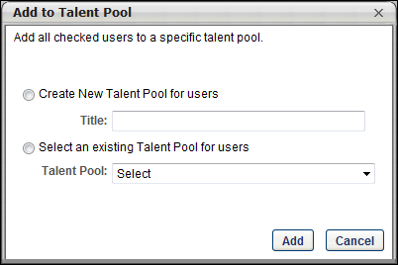
- Both radio buttons are deselected by default. To create a new talent pool, select the Create New Talent Pool for users radio button. Enter a name for the talent pool in the Title field. To add candidates to an existing talent pool, select the Select an existing Talent Pool for users radio button. Click the drop-down in the Select field to choose a talent pool.
- Click Add to add the candidates to the talent pool.
To view and manage the talent pool, go to Succession > Manage Talent Pool.
Send Email
The Send Email feature enables you to email all candidates at once or individual candidates, using your default email application. Clicking the Send Email link opens an email in a pop-up window. Each checked candidate's email address displays in the blind carbon copy (bcc) field. Email addresses are pulled from a candidate's user record.
To send an email:
- Check the Select All box to send an email to all candidates at once. Or, select individual candidates by checking the box to the left of the candidate's name.
- Click the Send Email link in the Actions drop-down. This opens an email from your default email application. Each checked candidate's email address displays in the bcc field. No other fields are auto-populated.
- Enter a subject, email text, etc., and then send the email. The email is distributed to all included candidates whose email addresses are active.

Search Candidates - Search Results
The Search Results page displays all candidates with matching criteria from the search. The search criteria panel displays the criteria used for the search. The candidate results table displays the candidates who have matching criteria.
Note: See Search Candidates - Actions for information about the actions available in the Actions drop-down, as well as the functionality of the Select All option. See Search Candidates - Actions on page 258 for additional information.
Note: When keywords and additional search options are used in the search, then the results are first sorted by highest to lowest match percentage, as with current functionality. See Search Candidates - Advanced Search for more information about keyword searches and the additional search options.
Note about archived applicants: Archived applicants are not available in Search Candidates and do not display in search results. In addition, if the URL for an applicant's profile is entered manually, then the profile is restricted and cannot be accessed.
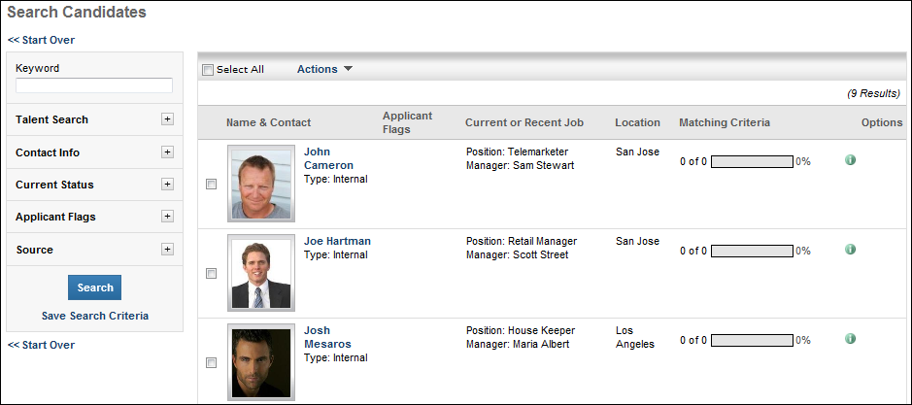
Search Criteria Panel
The panel on the left side of the search results page displays all criteria that were selected when conducting the search. All sections except Reason for Search can be expanded or collapsed.
If Compliance Enablement Preferences are configured not to allow users to edit search criteria, then the criteria in the panel is grayed out and not selectable. Note: The Job Details and View Criteria links are still selectable. However, the criteria in the View Criteria pop-up cannot be modified.
Reason for Search
The Reason for Search section only appears if enabled in Compliance Enablement Preferences. This section displays the following information:
- Reason for Search - This is the reason that was selected for conducting the search. The reason is not editable for the search once the search has been conducted.
- Job Details - Click the link to view the job details, which includes the requisition's internal and external job description, minimum qualifications, and ideal qualifications.
Keyword
The field displays the criteria entered in the Resume/CV Keyword field, if used when conducting the search. Note: The Keyword field can only be modified if Compliance Enablement Preferences are configured to allow criteria to be changed on the Search Results page.See Compliance Enablement Preferences for additional information.
Talent Search
The Talent Search section displays the type of search that was conducted, as well as the matching criteria threshold. Clicking the View Criteria link opens the associated criteria in the Search Results panel. See Search for Candidates on page 249 for additional information.
The following are the search types:
- Job Profile - For job profile searches, the job display title is shown.
- Model Employee - For model employee searches, the username of the model employee that was used for the search displays. This field can be edited by clicking the Select icon and choosing a different model employee from the Select User pop-up.
- Custom Search
- Saved Search - For saved searches, the title of the search displays.
If the search is conducted by clicking the More search options link on the Search Candidates page prior to selecting a search type, then "No criteria defined" displays below the Talent Search heading.
View Criteria
In the View Criteria pop-up, the following new buttons appear in the bottom-left:
- Reset - This button resets all attributes to the criteria defined for the previous search.
- Cancel - This button closes the pop-up and does not save any changes to the criteria.
- Save - This button saves the changes to the criteria and closes the pop-up. The criteria changes are not applied until Search is clicked.
If changes are made to the criteria when viewing the criteria for any of the search types, a Search button appears at the bottom of the panel. Clicking Search conducts a new search based on the updated criteria.
Contact Info
The Contact Info section displays the values from the contact information search fields. These fields can be edited.
Current Status
The Current Status section displays all available applicant statuses, as defined for the OU in Applicant Statuses. See Manage Applicant Statuses on page 28 for additional information. This section can be edited. If changes are made to the status selections, the search results are automatically updated.
Applicant Flags Filter
The Applicant (User) Flags section enables recruiters to filter the search results by applicant flags. Check or uncheck the flags to define the filter.
Source
The Source section displays the Current Employees (Internal) and the Applicant Bank (External) options. This section can be edited. If changes are made to the source selections, the search results are automatically updated.
If both options in the Source section are unchecked, then no results display in the Candidate Results table.
Search
If changes are made to the fields, then the Search button appears at the bottom of the panel. Clicking Search conducts a new search based on the updated criteria.
Note: The Search button only displays on the Search Candidates results page if the Require OFCCP Compliance Enablement functionality option is not checked in Compliance Enablement Preferences. In addition, users must be allowed to filter the search results, which also must be enabled in Compliance Enablement Preferences. See Compliance Enablement Preferences for additional information.
Save Search Criteria
Clicking the Save Search Criteria link saves the search to the Saved Searches page.
Start Search Over
At the top and bottom of the panel, clicking the Start Over link navigates you to the main Search Candidates page. All search criteria is discarded, as well as the reason for the search.
Candidate Results Table
For all candidate search types, the results table displays the below columns and options, with a default sort order of highest to lowest matching criteria. Each column except the Options column is sortable. Internal candidates display with a light blue background. External candidates display with a white background.
Note: When constraints are applied to the recruiter or administrator's permission to search candidates, the search results are limited to candidates who fit within the permission constraints. For example, if the search criteria are for Sales Manager Position OU and Houston Location OU, then only candidates associated with the indirect OUs of Sales Manager and Houston display in the search results. For external candidates, the following constraints are associated with external candidates: Restrict to Position, Restrict to User's Position, Restrict to Division, Restrict to User's Division, Restrict to Location, and Restrict to User's Location.
Feature | Description
Checkbox | Each row displays a checkbox next to the candidate's name with which you can use to perform single actions. The box is unchecked by default.
Name & Contact | The following displays for the candidate:  - Photo, if available; ghost image displays if no photo is available.  - Candidate's name displays as a link. Clicking the link opens the Applicant Snapshot page of the applicant's profile for the most recent requisition to which the candidate applied. The snapshot opens for all candidates, including those who have not yet applied to a job requisition.  - Type - Indicates if a candidate is internal (existing employee) or external (applied for a position through the application process).
Applicant Flags | This column displays the flags that are associated with an applicant. This information only displays for users with permission to manage flags. This column is not sortable. The flags that display are the flags that are visible to the recruiter based on the flag's visibility settings and OU availability.  Hover over the flag to view the name of the flag.  Click the flag to view the flag details. This opens the Application Flag pop-up that displays the flag name and description. The user who added the flag also displays, as well as the date on which the flag was added. For portals with multiple languages enabled, the name and description display in the viewing user's language, if available.
Current or Recent Job | For internal candidates, displays their current position and manager.  For external candidates, displays their current position and the organization associated with their current position, as defined on the candidate's resume.  If the position, manager, or organization is longer than 100 characters, hover over the name to display the full name.
Location | For internal candidates, displays the name of the Location OU to which they are assigned.  For external candidates, displays the city and state defined in the Contact Information section of the user record.
Matching Criteria | Dynamically displays the number of criteria associated with the position for which the candidate matches, as well as the match percentage. The percentage is calculated by dividing the number of matching attributes with the number of attributes for the position. The match percentage displays as both a number and color:  - Red = 0-32%  - Yellow = 33-65%  - Green = 66-100%  Note: You can use the Edit option in the Saved Searches panel to modify the results of the Matching Criteria column.  Clicking the Information icon opens a pop-up of the position criteria. A green checkmark next to an attribute indicates a match. A red warning icon next to an attribute indicates the candidate does not match the attribute.
Options | The following options display, if available:  - Resume - You can view a candidate's resume by clicking the Resume icon. Multiple resumes open at one time for side-by-side comparison. The resume opens in the format in which the candidate submitted it. For resumes that are typed or pasted into the Write or Paste a Resume/CV field during the application process, clicking the Resume icon opens a pop-up that displays the resume data. For pasted resumes, the resume data appears in the original format in which the candidate pasted it. For resumes submitted by internal users using their Career Center resume, clicking the Resume icon opens the resume as a PDF.  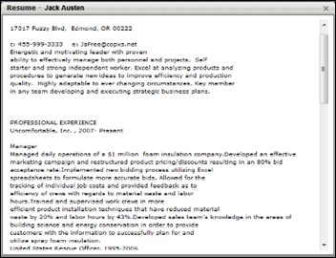  - LinkedIn - If the candidate included a LinkedIn profile, you can view the profile by clicking the LinkedIn icon .  - Seek - For applicants who applied using their Seek profile, a Seek icon displays. Click the icon to view the applicant's profile.

A candidate entered 1 Jan 2015 to 1 June 2015 and the recruiter enters 1 May 2015 to 1 July 2015, the candidate is included in the search results because part of the date range the candidate entered intersects with part of the date range that the recruiter entered.
For example, if a candidate entered 1 May 2015 to 1 June 2015 and the search user enters 1 May 2015 to 1 July 2015, the candidate is included in search results because the entire date range the candidate entered is contained by the date range the search user entered.
Requisition level refers to the job requisition in Manage Job Requisitions. Changes made to a job requisition are referred to as being made at the "requisition level." Applicant reviewers added to a job requisition after the requisition is created are referred to as being added at the "requisition level." An offer letter template added to a job requisition is referred to as being added at the "requisition level." This term applies to the Recruiting functionality. This is a Recruiting term.
Applicant level refers to the applicant's profile. Changes made to an applicant's profile are referred to as being made at the "applicant level." Access granted to an applicant's profile is referred to as being granted at the "applicant level." This term applies to the Recruiting functionality. This is a Recruiting term.
Requisition level refers to the job requisition in Manage Job Requisitions. Changes made to a job requisition are referred to as being made at the "requisition level." Applicant reviewers added to a job requisition after the requisition is created are referred to as being added at the "requisition level." An offer letter template added to a job requisition is referred to as being added at the "requisition level." This term applies to the Recruiting functionality. This is a Recruiting term.
Applicant level refers to the applicant's profile. Changes made to an applicant's profile are referred to as being made at the "applicant level." Access granted to an applicant's profile is referred to as being granted at the "applicant level." This term applies to the Recruiting functionality. This is a Recruiting term.

