Reviews for Managers March 2024

Table of Contents
Performance Reviews Overview 1
Performance Review - End User Overview 2
Performance Review Summary 7
Performance Review Task Complete Overview 10
Performance Review Task - Components Overview 76
Performance Review - Options Drop-down 118
Performance Reviews - Batch Rating 139
Batch Rating - Ratings and Comments Pop-up 145
Performance Reviews - Bulk Sign Off 148
Launch Off-cycle Performance Review 150
External Reviewers 153
View and Print Performance Review 154
Performance Review - Data Workflow 157
Snapshot - Reviews 159

Performance Reviews Overview

Performance Review - End User Overview
Performance reviews may include different sections and options based on the configuration established by the administrator. Generally, an email notification is sent to users when they are assigned a review task.
You can access review tasks as follows:
- Welcome Page > My Tasks section
- Performance Review Summary page
- Universal Profile > Actions page.
To open a performance review task, click the performance review task title. The Overview step opens, displaying a snapshot of the review.
Permissions
PERMISSION NAME | PERMISSION DESCRIPTION | CATEGORY

View Performance Reviews | Grants ability to view the Performance Reviews page, which displays a user's own past performance reviews as well as performance review task steps they've been assigned to complete. This also grants ability to view the Batch Rating page. This permission can be constrained by OU, User's OU, User Self and Subordinates, and User. This is an end user permission. | Performance
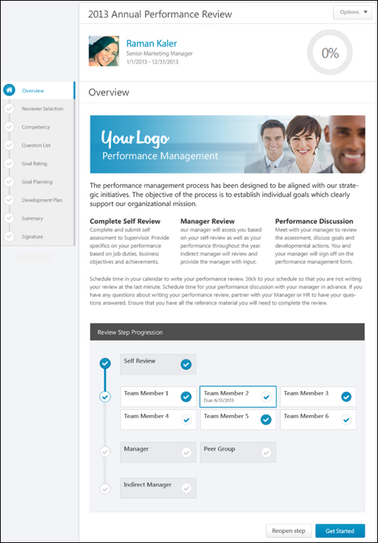
Performance Review Details
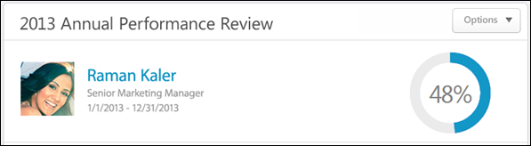
At the top of the performance review, the following performance review details are displayed:
- Performance Review Title - Title of the review. It is configured by the administrator when the review is created.
- Reviewee Photograph, Name, and Title - Reviewee's photograph, name, and position. Click the user's name or photograph to open their Universal Profile in a separate window. See Universal Profile - Bio Overview.
- Review Period - Time period of this review.
- Step Progress - Percentage complete. As review step sections are completed, the step progress is updated to reflect the correct percentage. Sections that require you to enter data complete once all required fields in the section are completed. When a reviewer views a section that does not require any information, the section is considered complete when the reviewer views the section. Note: The Overview page is not included in the completion percentage.
Options
Based on the configuration of the performance review and the reviewer's permissions, options may be available from the Options drop-down menu. See Performance Review - Options Drop-down on page 118 for additional information.
Performance Review Sections
On the left side of the performance review, the navigation menu displays all sections along with their completion status. Reviewers can click a section tab to access the section. See Performance Review - Review Sections on page 113 for additional information.
Performance Review Instructions
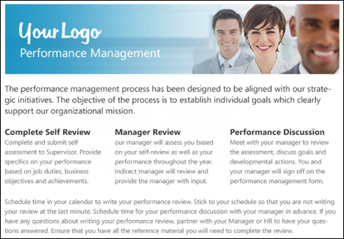
The performance review instructions are displayed below the performance review details. This section contains the instructions for completing the performance review. These instructions are configured by the administrator when the performance review task is created.
Review Step Progression
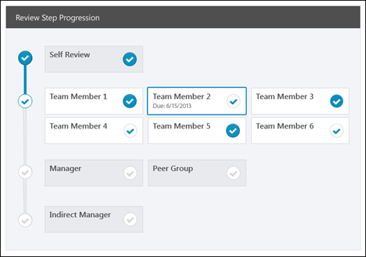
The Review Step Progression section provides the reviewer with a high-level view of the progress of all reviewers involved with the performance review task. All of the steps within the review task are displayed vertically with the first step displayed at the top of the section.
- Active Reviewer Step - The review step for which the user is an active reviewer appears with a colored border. The due date is displayed for this step.
- Completed Step - If a step is completed, it appears with a white check mark within a colored circle .
- Not Started/In Progress Step - If a step is not started or in progress, it appears with a colored check mark within a white circle .
- Future Step - If a step has not yet started and is not yet available, it appears gray with a gray check mark within a white circle .
Note: If the active reviewer step is a step that was reopened, then a message appears at the top of the Review Step Progression section, indicating that the active reviewer step must be completed before advancing to the next step.
Get Started
Click the Get Started button to open the first section of the performance review step.
Submit
If all sections are complete, the Submit button is available instead of the Get Started button. Click this button to submit the completed performance review. The Submit button appears on all pages once all required sections are complete.
Reopen Step
Reviewers (manager, indirect manager, custom relationship, or specific user) may have the ability to reopen previous steps in a performance review. This ability is enabled by the administrator when configuring the performance review task, and when available, the Reopen Step button appears at the bottom of the Review Step Progression section on the Overview page.
Click the Reopen Step button to reopen a previous step of the performance review task. This opens the Reopen Previous Review Step pop-up. See Performance Review - Reopen Previous Step on page 130 for additional information.
Decline Review
For off-cycle reviews, a dynamically selected reviewer (manager, indirect manager, custom relationship, or specific user) can decline to complete a review if they feel they are not the most appropriate person to complete the review. Note: This option is only available for off-cycle reviews. See Performance Review - Decline Review on page 124 for additional information.
Contents

Performance Review Summary
The Performance Review Summary page enables users to view the performance reviews that are assigned to them as well as the performance reviews in which they are the reviewee. The Performance Review section is divided into two tabbed sections: My Assigned Reviews and My Personal Reviews.
To access the Performance Review Summary page, go to Performance > Performance Reviews.
Permissions
PERMISSION NAME | PERMISSION DESCRIPTION | CATEGORY

Launch Off-Cycle Performance Review Task | Enables a user to launch an off-cycle performance review task. Having this permission does not guarantee that the user can launch an off-cycle review, only that they will have access to the Launch Performance Review page. A task must still be configured properly for the user to successfully launch an off-cycle review task. This permission works only if user has been designated to launch at least one currently active off-cycle performance review task. This permission can be constrained by OU, User's Subordinates, and Employee Relationship. This is an end user permission and does not apply to an administrator role.

View Performance Reviews | Grants ability to view the Performance Reviews page, which displays a user's own past performance reviews as well as performance review task steps they've been assigned to complete. This also grants ability to view the Batch Rating page. This permission can be constrained by OU, User's OU, User Self and Subordinates, and User. This is an end user permission. | Performance
Launch Review
The Launch Review button is available on the Performance Review Summary page only if the user has the permission to launch off-cycle performance review tasks. To launch a review, select the Launch Review button. This opens the Launch Performance Review page.
Note: The Launch Review button is only available if you have permission to launch off-cycle performance review tasks. Having this permission does not guarantee that you can launch an off-cycle review, only that you will have access to the Launch Performance Review page. A task must still be configured properly for you to successfully launch an off-cycle review task.
See Launch Off-cycle Performance Review on page 150 for additional information.
My Assigned Reviews
The My Assigned Reviews tab displays all of the reviews that are assigned to the user, including reviews in which the user completes a self review and in which the user serves as a co-planner.
To search for a review, enter the review title in the Title field and click Search. You can also use the following filters to search for specific types of reviews:
- Not Started
- In Progress
- Completed
- Incomplete
- Expired
The Review table displays the following information for each review:
- Title - The review title. For off-cycle reviews, the task name is also displayed in parenthesis after the review title. Click the review title to launch the review.
- Description - The review description.
- Status - The status of the task, but not every step within the task. For example, if there is more than one step in the task and one of the steps is completed then the status remains Inprogress until all steps are completed.
- Start Date - The review start date.
- Due Date - The review end date.
- Last Modified Date - The last date someone made changes to the review. This column is sorted by last modified date in descending order.
To launch a review, click the review title. See Performance Review - End User Overview on page 2 for additional information.
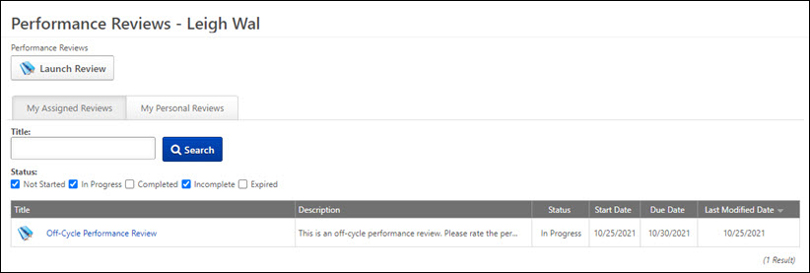
My Personal Reviews
The My Personal Reviews tab displays all of the reviews in which the user is the reviewee. The reviews are displayed in reverse chronological order by review period start date.
The Review table displays the following information for each review:
- Review - The review title. For off-cycle reviews, the task name is also displayed in parenthesis after the review title. Click the review title to launch the review.
- Review Period
- Start Date
- Completion Date - The review completion date. If the review is not yet complete, N/A is displayed.
- Task Status - The status of the review.
- Rating - The rating received from the review. If review rating is not displayed to the user, as determined via review task settings, then "No Rating" is displayed. If the review is not yet complete, N/A is displayed.
- Attachments - If a review is complete or expired and at least one file is attached to the review, then the attachments can be downloaded by clicking the Attachment icon. This opens the Open Attachments pop-up, which displays all of the available attachments. Click the attachment title to download the attachment.
To launch a review, select the review title. See Performance Review - End User Overview on page 2 for additional information.
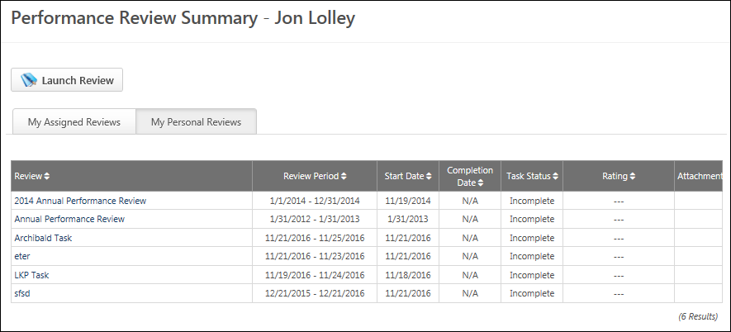

Performance Review Task Complete Overview
Performance Review - Reviewer Selection
When a Reviewer Selection step is assigned to a user, the user must select the reviewers for a performance review. The Reviewer Selection step does not appear on any of the printable versions of the review.
You can access review tasks as follows:
- Welcome Page > My Tasks section
- Performance Review Summary page
- Universal Profile > Actions page.
To open a performance review task, click the performance review task title.
Permissions
PERMISSION NAME | PERMISSION DESCRIPTION | CATEGORY

Select Peers and Reviewers | Grants ability to select peers and reviewers in off-cycle performance reviews. This permission can be constrained by User's Corporation, OU, and User's OU. This is an end user permission. | Performance

View Performance Reviews | Grants ability to view the Performance Reviews page, which displays a user's own past performance reviews as well as performance review task steps they've been assigned to complete. This also grants ability to view the Batch Rating page. This permission can be constrained by OU, User's OU, User Self and Subordinates, and User. This is an end user permission. | Performance
Note: The reviewer selector must have permission to select peers and reviewers. The constraints on this permission determine who the reviewer selector can select for the performance review step. Also, peer group availability is set by the administrator in Employee Relationships. If the user does not have the permission to select peers and reviewers, an error pop-up appears, alerting them that they are not able to select reviewers.
- There is no limitation or constraint on selecting external peers.
- Any changes to the reviewer selector's permissions or constraints after the reviewers are selected have no effect on the selection. Once a reviewer is selected, the selection is considered final.
- If a reviewer declines a review, the reviewer selector must select a new reviewer to fill the role. The users available to the reviewer selector are based on the constraints of the reviewer selector's permission at the time of the re-selection. If the reviewer selector's constraints have changed, the new constraints are applied.
Emails
EMAIL NAME | EMAIL DESCRIPTION | ACTION TYPE

Performance Review Step Assigned | Performance review of a specific user assigned. This email is triggered when the task step is available for that user to review, which may be triggered by the employee hire date, the previous reviewer submitting the review, or the task assignment date. Note: When customizing this email for a self-review step, this email cannot be sent to "Reviewer" because the system considers this user the reviewee.  Reviewee will not receive any step email other than the self step and Similarly, a reviewer cannot receive any email for a Reviewee step.  This email trigger can be sent to external users. If the REVIEW.LINK tag is used in the trigger and is sent to an external reviewer, then the link takes external reviewers to an external review page that requires no login or validation. See External Reviewers on page 153 for additional information. | Performance Management
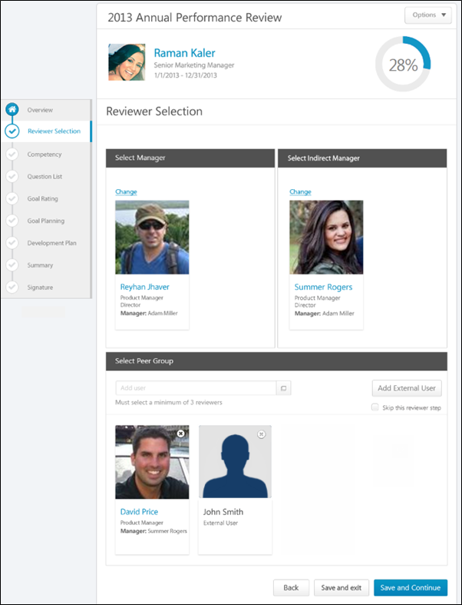
After completing the Reviewer Selection step, the selections cannot be edited unless multiple submissions are allowed for the review task. Returning to the Reviewer Selection step displays the selected users, but the selection cannot be modified.
Note: If the reviewer selection is not submitted by the due date, all available users are automatically selected.
If the review selector is not also a reviewer, then the Review Selection step is the only step in the task. For example, a user is chosen as a review selector, but does not participate in any review steps for the task.
Performance Review Details
At the top of the performance review, the following performance review details are displayed:
- Performance Review Title - Title of the review. It is configured by the administrator when the review is created.
- Reviewee Photograph, Name, and Title - Reviewee's photograph, name, and position. Click the user's name or photograph to open their Universal Profile in a separate window. See Universal Profile - Bio Overview.
- Review Period - Time period of this review.
- Step Progress - Percentage complete. As review step sections are completed, the step progress is updated to reflect the correct percentage. Sections that require you to enter data complete once all required fields in the section are completed. When a reviewer views a section that does not require any information, the section is considered complete when the reviewer views the section. Note: The Overview page is not included in the completion percentage.
Options
Based on the configuration of the performance review and the reviewer's permissions, options may be available from the Options drop-down menu. See Performance Review - Options Drop-down on page 118 for additional information.
Performance Review Sections
On the left side of the performance review, the navigation menu displays all sections along with their completion status. Reviewers can click a section tab to access the section. See Performance Review - Review Sections on page 113 for additional information.
Select Manager
This section is only available if enabled by the administrator when configuring the review task. In the Select Manager section, the user must select the reviewing manager. By default, this section displays the user's manager that is set on the User Record. If no manager is set for the user, then no manager is selected by default.
Only one manager can be selected, and this selection is required. In order to change the reviewing manager, click the Change link. This opens the Select User pop-up. See Select a User Pop-up for additional information.
Users can click the selected manager's name to open their Universal Profile in a new browser window.
Select Indirect Manager
Note: This section may not be available.
This section is only available if enabled by the administrator when configuring the review task. In the Select Indirect Manager section, the user must select the reviewing indirect manager. By default, this section displays the user's indirect manager that is set on the User Record. If no indirect manager is set for the user, then no indirect manager is selected by default.
Only one indirect manager can be selected, and this selection is required. In order to change the reviewing indirect manager, click the Change link. This opens the Select User pop-up. See Select a User Pop-up for additional information.
Users can click the selected indirect manager's name to open their Universal Profile in a new browser window.
Select Peer Group
This section is only available if enabled by the administrator when configuring the review task. In the Select Peer Group section, the user must select the appropriate number of peers who will complete the review. Note: The reviewer selector must have permission to select peers and reviewers. The constraints on this permission determine who the reviewer selector can select for the performance review step. The user's manager and indirect manager cannot be selected as a peer.
If peers are selected for a user and another review is created for the same user, then the previously selected peers are automatically selected by default for the following review. However, these selections can be modified.
Users can click the selected peer's name to open their Universal Profile in a new browser window.
There may be a minimum number of users that must be selected. In this case, you must select at least the minimum number of reviewers in order to complete the step.
Peer Selection Considerations
- The reviewer selector must have the Select Peers and Reviewers permission to select peer reviewers.
- The constraints on the Select Peers and Reviewers permission determine who the reviewer selector can select for the performance review step.
- The reviewee's manager and indirect manager cannot be selected as a peer. However, all other users within the selector's permission constraints can be selected, including second-level indirect managers (the manager of an indirect manager) and above.
Add Peer Reviewer
To add a peer reviewer, enter the peer's name in the Add a peer field. Predictive search displays users who match the entered name. Click the appropriate peer. Only peers that are approved or pending approval can be selected. Peers will not receive the review step until they are approved.
Alternatively, click the Select User button to search for and select peers. This opens the Select a user pop-up, in which you can search for users by name, position, division, location, or manager's name. See Select a User Pop-up for additional information.
When a user is added to the reviewer list and the list is submitted, the added user goes through the standard peer approval workflow.
- When a manager submits the peer list, the new user is immediately added to the peer group and will receive the review step.
- If the reviewee submits the peer list and approval is required for the peer group, the manager or an administrator must approve the new peers. These new peers pending approval do not receive the review task until they are approved.
  - If they are approved before the step expires, they immediately receive the Review Step Assigned email (if the email trigger is active) and the task. If they are approved after the step expires, they do not receive the email or the task.
- If the reviewee is submitting the list and approval is not required for the peer group, the new users are instantly added to the peer group and receive the review step.
If the minimum number required for the review step is less than the number of available users, each available user must be selected.
Add External User as Peer Reviewer
Users can choose to add external users to serve as reviewers. To add an external user as a peer reviewer, click the Add External User button. This opens the Search External Users pop-up. See Search External Users Pop-up for additional information.
Once an external reviewer is added, an email is sent to the external reviewer if the email is enabled. Added external reviewers may be subject to the peer approval process. If this is the case, the task is not assigned until the peer is approved.
The experience for an external reviewer differs from an internal reviewer. See External Reviewers on page 153 for additional information.
Remove Peer Reviewer
To remove a selected peer reviewer, click the Remove icon in the upper-right corner of the reviewer's photograph.
Select Direct Subordinates
This section is only available if enabled by the administrator when configuring the review task. In the Select Direct Subordinates section, the user must select the reviewing direct reports. By default, this section displays all of the reviewee's direct subordinates.
To remove a selected direct subordinate, click the Remove icon in the upper-right corner of the reviewer's photograph.
To re-add a direct subordinate that has been removed, enter the subordinate's name in the Add user field. Predictive search displays users who match the entered name. Click the appropriate user.
Alternatively, click the Select User button to search for and select subordinates. This opens the Select a user pop-up, in which you can search for users by name, position, division, location, or manager's name. See Select a User Pop-up for additional information.
Users can click the selected user's name to open their Universal Profile in a new browser window.
There may be a minimum number of users that must be selected. In this case, you must select at least the minimum number of reviewers in order to complete the step.
Skip Reviewer Step
For certain reviewer selection steps within an off-cycle task, a Skip this reviewer step option appears. This option is only available if the corresponding review step is optional and if the role being selected is a reviewer selector.
If this option is selected, the corresponding review section is skipped and marked complete. All relative dates of future steps are adjusted forward.
Skipped steps cannot be reopened.
Navigation Buttons
The following buttons are available at the bottom of the page:
- Back - Opens the previous step of the performance review. This button is not available on the first page of the performance review.
- Save and Exit - Saves the reviewer's progress and exits the performance review.
- Save and Continue - Saves the reviewer's progress, validates all selections and comments, and proceeds to the next step of the performance review. This button is not available on the final page of the performance review.
- Submit - Submits the performance review. This button is only available when all sections of the performance review are complete. Once the task is submitted, you cannot modify the review task unless multiple submissions are allowed for the review task.
Based on the configuration of the performance review task, the reviewer's selected ratings may be visible to the system administrator as soon as the review task is saved. This includes when the performance review is automatically saved by the system. This enables the administrators to begin utilizing the data for calibration purposes while the review step is in progress.
When a reviewer is editing a reopened step or a submitted review step that allows multiple submissions, the performance review Save button labels are updated to more clearly indicate that the Save options do not finalize any of the ratings.
- The Save and Exit button is renamed to Save as Draft and Exit.
- The Save and Continue button is renamed to Save as Draft and Continue.
When in read-only mode, the available buttons are Back, Exit, and Next.
When the reviewer selections are saved, all fields are validated and finalized. The selected users will receive the Review Step Assigned email (if the email trigger is active) and the review step in their task list.
Declined Reviewers
If a reviewer has declined to complete a review, then the reviewer selector is sent the Performance Review Reviewer Declined email, if enabled, and they receive a Your Tasks notification stating that they must select another reviewer.
When they revisit the Reviewer Selection step, the Declinee's name is displayed above the corresponding role and their reason for declining the task is displayed.
Click the Change link to select a new reviewer. The reviewer that declined the task cannot be selected again.
Workflow Information
If a Reviewer Selection step is not completed by the due date for any reason, the user who is in the system-defined relationship is assigned the task. For example, if a manager is supposed to select the user that fills the role of Indirect Manager for the next step in the review and the manager does not make the selection, then the user who is currently in the system-defined Indirect Manager role for the reviewee is assigned the task.
- If there is no user who holds that relationship for the user, then the task is not assigned to anyone.
- If a user is added to that relationship during the task availability, then the task is assigned to that user.
If a dynamically chosen reviewer is made inactive, then the reviewer selector is alerted via the Performance Review Reviewer Declined email, if enabled. The reviewer selector must then select a new reviewer.
If a statically chosen reviewer is made inactive, the step remains open until the step expires.
If a statically chosen reviewer is replaced by another user (manager, indirect manager, or custom relationship), the task is closed to the original reviewer and is assigned to the new reviewer with the original reviewer's information transferred to the new reviewer.
If a reviewee is made inactive, then the review tasks are removed from all active reviewers.
The status of a performance review cannot be affected by a lack of peer responses if the lack of peer responses is caused by peers being made inactive. For example, if the minimum number of peer reviews is three and one selected peer is made inactive, the peer review step is considered complete once the two remaining active peers complete the task.
Performance Review - Competency Assessment
Competency Assessment sections allow reviewers to rate competency items, apply comments to competencies, and view previous competency ratings and comments. When a competency assessment is included in a performance review, the competency assessment cannot be completed offline.
Permissions
PERMISSION NAME | PERMISSION DESCRIPTION | CATEGORY

View Performance Reviews | Grants ability to view the Performance Reviews page, which displays a user's own past performance reviews as well as performance review task steps they've been assigned to complete. This also grants ability to view the Batch Rating page. This permission can be constrained by OU, User's OU, User Self and Subordinates, and User. This is an end user permission. | Performance
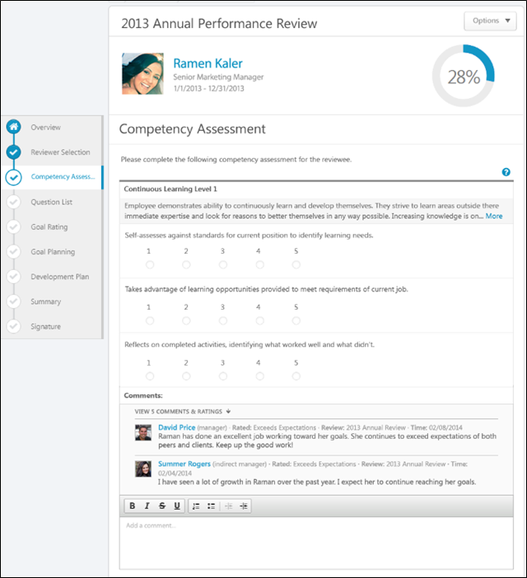
Performance Review Details
At the top of the performance review, the following performance review details are displayed:
- Performance Review Title - Title of the review. It is configured by the administrator when the review is created.
- Reviewee Photograph, Name, and Title - Reviewee's photograph, name, and position. Click the user's name or photograph to open their Universal Profile in a separate window. See Universal Profile - Bio Overview.
- Review Period - Time period of this review.
- Step Progress - Percentage complete. As review step sections are completed, the step progress is updated to reflect the correct percentage. Sections that require you to enter data complete once all required fields in the section are completed. When a reviewer views a section that does not require any information, the section is considered complete when the reviewer views the section. Note: The Overview page is not included in the completion percentage.
Options
Based on the configuration of the performance review and the reviewer's permissions, options may be available from the Options drop-down menu. See Performance Review - Options Drop-down on page 118 for additional information.
Performance Review Sections
On the left side of the performance review, the navigation menu displays all sections along with their completion status. Reviewers can click a section tab to access the section. See Performance Review - Review Sections on page 113 for additional information.
Competency Assessment
Competency assessments may either be item-based or behavior-based.
- Item-based assessments enable assessors to rate a competency item using an administrator-defined rating scale (e.g., 1 to 5, where 1 may be Unacceptable and 5 may be Consistently Excels).
- Behavior-based assessments enable assessors to rate a competency item using behavior descriptors. The assessor selects the behavior description that best describes the individual being assessed (e.g., "Prefers to let others handle problems and challenges" or "Is consistently creative in problem solving and solutions").
Competency Item Rating
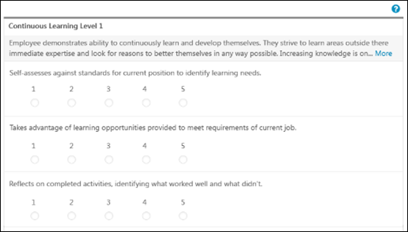
For an item-based competency assessment, the competency title and competency description display at the top of the competency. If the competency description is longer than two lines, a More link appears at the end of the second line. Click the link to view the entire competency description.
Below the competency description, each competency item is displayed with a rating scale below each competency item description. If previous ratings exist for a competency item, a Rating History link is available to the right of the rating scale. Click the link to view the previous ratings for the competency item. See Performance Review - Competency Assessment - Rating History on page 78 for additional information.
The rating scale is inherited from the competency model. If the rating scale contains 10 or fewer rating options, then the rating options appear as radio buttons and the rating score text appears above each option. If the rating scale contains 11 or more rating options, then the rating options appear in a drop-down menu and only the rating names are displayed. Only one rating can be selected per competency item. A rating selection is required for each competency item.
For each competency item, select a rating and enter comments explaining the selected ratings. See the Comments section below for additional information.
Competency Behavior Rating
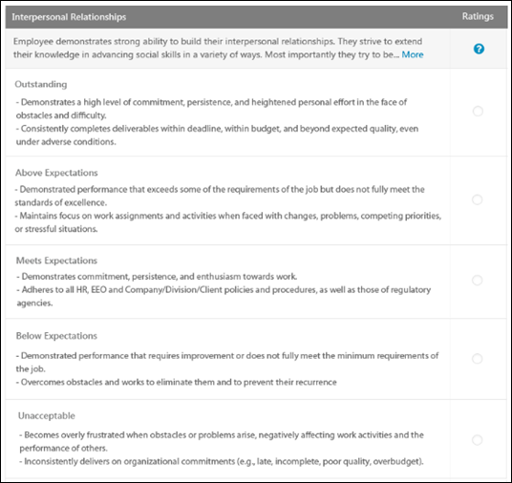
For a behavior-based competency assessment, the competency title and competency description display at the top of the competency. If the competency description is longer than two lines, a More link appears at the end of the second line. Click the link to view the entire competency description.
Below the competency description, each behavior name and behavior attribute is displayed, as configured by the administrator in the Competency Bank.
Only one rating can be selected per competency behavior. A rating selection is required for each competency behavior.
For each competency behavior, select a rating and enter comments explaining the selected rating. See the Comments section below for additional information.
View Evidence
When a Competency Assessment review section is linked with an Evidence Collection review section, then reviewers may have the option to view all pieces of evidence associated with a competency. The reviewer can click the View Competency button below the competency to view all pieces of evidence that are associated with the competency. See Performance Review - Competency Assessment - View Evidence on page 79 for additional information.
Rating Scale Information
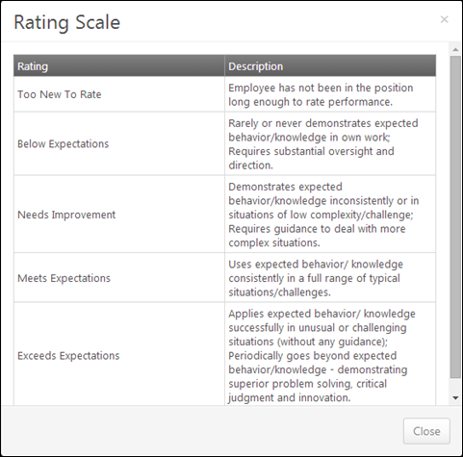
To view the rating definitions, click the Question Mark icon . This opens the Rating Scale pop-up, which displays the ratings and their definitions. Note: The ratings and their definitions are configured by the administrator.
Comments
For each competency item or behavior, select a rating and enter comments explaining the selected rating. For example, if you selected a poor rating, explain why the rating was selected. The character limit for comment fields is 30,000.
- To add a suggested comment from the comment assistant, click the Comment Assistant icon above the Comments field. This opens the Suggested Comments pop-up. See Performance Review - Comment Assistant on page 77 for additional information.
- If the Inappropriate Word Filter is enabled for performance reviews, the filter flags any inappropriate words contained in the Comment field. See Performance Review - Inappropriate Language on page 110 for additional information.
- To check the spelling of the text box contents, click the ABC icon in the text box toolbar. This opens the Spell Checker pop-up.
- If you have a need to copy and paste content into a performance review, please be sure to right-click the field into which you are pasting the content, and select the "Paste" option. You can also perform the same action by pressing [Ctrl]+[Shift]+[V]. This will ensure any formatting HTML does not get inserted into the text.
When adding a comment, an HTML safe list is used for the Comments field. The system only accepts certain customizable HTML elements in the WYSIWYG Editor. Elements that are not acceptable display as text. See Safe Listed Customizable Elements.
Because Competency Assessment sections can be reused year after year, ratings and comments from previous reviews may be included. After a peer or direct report review step, reviewers can view peer and direct report responses within the review. Each step (peer step or direct report step) appears in its own grouping. The names of the peers and direct reports are not visible to the reviewee, and the responses are not visible unless the minimum number of responses is reached.
Multiple Reviewers/Co-Planners
Co-planners have the ability to view and update Competency Assessment sections in a review step. However, the co-planner's ratings and comments are attributed to the assignee of the review step, not the co-planner.
Navigation Buttons
The following buttons are available at the bottom of the page:
- Back - Opens the previous step of the performance review. This button is not available on the first page of the performance review.
- Save and Exit - Saves the reviewer's progress and exits the performance review.
- Save and Continue - Saves the reviewer's progress, validates all selections and comments, and proceeds to the next step of the performance review. This button is not available on the final page of the performance review.
- Submit - Submits the performance review. This button is only available when all sections of the performance review are complete. Once the task is submitted, you cannot modify the review task unless multiple submissions are allowed for the review task.
Based on the configuration of the performance review task, the reviewer's selected ratings may be visible to the system administrator as soon as the review task is saved. This includes when the performance review is automatically saved by the system. This enables the administrators to begin utilizing the data for calibration purposes while the review step is in progress.
When a reviewer is editing a reopened step or a submitted review step that allows multiple submissions, the performance review Save button labels are updated to more clearly indicate that the Save options do not finalize any of the ratings.
- The Save and Exit button is renamed to Save as Draft and Exit.
- The Save and Continue button is renamed to Save as Draft and Continue.
When in read-only mode, the available buttons are Back, Exit, and Next.
Performance Review - Competency Rating
Uses the Competency Rating sections to view competencies on which the reviewee is rated. To view additional information, select the View Details option for the competency. For each competency, there is a rating scale, a comment field, and a weight field.
If a Competency Rating section is included in a performance review, employees cannot be evaluated if they are not associated with any competency models. In this instance, no competencies appear. For example:
- If the competency model assignment is based on position and the employee has no defined position, then no competency assessment is assigned for the employee.
- If the competency model assignment is based on position but the employee's position has no associated competency model, then no competency assessment is assigned for the employee.
If an employee is eligible for multiple competency models, the system uses the competency model for the group or OU to which the user was most recently added.
Permissions
PERMISSION NAME | PERMISSION DESCRIPTION | CATEGORY

View Performance Reviews | Grants ability to view the Performance Reviews page, which displays a user's own past performance reviews as well as performance review task steps they've been assigned to complete. This also grants ability to view the Batch Rating page. This permission can be constrained by OU, User's OU, User Self and Subordinates, and User. This is an end user permission. | Performance
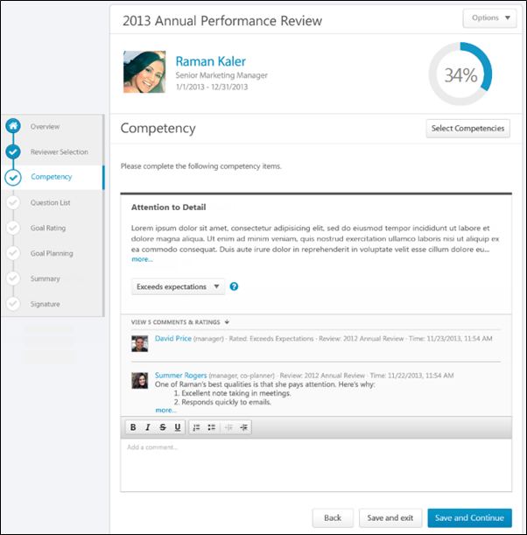
Performance Review Details
At the top of the performance review, the following performance review details are displayed:
- Performance Review Title - Title of the review. It is configured by the administrator when the review is created.
- Reviewee Photograph, Name, and Title - Reviewee's photograph, name, and position. Click the user's name or photograph to open their Universal Profile in a separate window. See Universal Profile - Bio Overview.
- Review Period - Time period of this review.
- Step Progress - Percentage complete. As review step sections are completed, the step progress is updated to reflect the correct percentage. Sections that require you to enter data complete once all required fields in the section are completed. When a reviewer views a section that does not require any information, the section is considered complete when the reviewer views the section. Note: The Overview page is not included in the completion percentage.
Options
Based on the configuration of the performance review and the reviewer's permissions, options may be available from the Options drop-down menu. See Performance Review - Options Drop-down on page 118 for additional information.
Performance Review Sections
On the left side of the performance review, the navigation menu displays all sections along with their completion status. Reviewers can click a section tab to access the section. See Performance Review - Review Sections on page 113 for additional information.
Select Competencies
To select additional competencies, click the Select Competencies button. This opens a pop-up to select the competencies you want to add to the review. The ability to select additional competencies is determined by the system administrator. See Performance Review - Select Competencies Pop-up on page 115 for additional information.
Competency Rating
For each competency, review the competency description before selecting a rating.
After reviewing the competency description, select a rating and enter comments explaining the selected rating. The character limit for comment fields is 30,000. In the Weight field, enter a weight for the competency. Weighting allows you to place a greater value on certain competencies. The weight of all competencies must add up to 100%.
- To add a suggested comment from the comment assistant, click the Comment Assistant icon above the Comments field. This opens the Suggested Comments pop-up. See Performance Review - Comment Assistant on page 77 for additional information.
- If the Inappropriate Word Filter is enabled for performance reviews, the filter flags any inappropriate words contained in the Comment field. See Performance Review - Inappropriate Language on page 110 for additional information.
- To check the spelling of the text box contents, click the ABC icon in the text box toolbar. This opens the Spell Checker pop-up.
- If you have a need to copy and paste content into a performance review, please be sure to right-click the field into which you are pasting the content, and select the "Paste" option. You can also perform the same action by pressing [Ctrl]+[Shift]+[V]. This will ensure any formatting HTML does not get inserted into the text.
When adding a comment, an HTML safe list is used for the Comments field. The system only accepts certain customizable HTML elements in the WYSIWYG Editor. Elements that are not acceptable display as text. See Safe Listed Customizable Elements.
Because Competency Rating sections can be reused year after year, ratings and comments from previous reviews may be included. After a peer or direct report review step, reviewers can view peer and direct report responses within the review. Each step (peer step or direct report step) appears in its own grouping. The names of the peers and direct reports are not visible to the reviewee, and the responses are not visible unless the minimum number of responses is reached.
View Competency Details
To view the competency details, click the drop-down icon to the right of the competency title. Then, select View Details.
The Competency Details pop-up displays the competency title, description, items, and development actions.
Multiple Reviewers/Co-Planners
If a review step has co-planners, each reviewer is able to enter their own comments and modify the review ratings. Comments are attributed to the user who submitted them, so each comment appears distinct and separate. In addition, any comments that have been saved, but not submitted are viewable by the assignee and the co-planners.
- If a co-planner is the first user to access a review section, the co-planner is able to select a rating and enter comments, if the rating option and comment box are enabled for the co-planner.
- If a co-planner accesses a review section that has been saved but not submitted by the assignee or another co-planner, then the system displays the following:
  - Ratings values are pre-selected with the rating that was selected by the assignee or another co-planner. Note: The rating option only appears if the task is configured for the section to accept comments from the corresponding assignee.
  - An empty comment box appears for the co-planner to enter comments. Note: The comment box only appears if the task is configured for the section to accept comments from the corresponding assignee.
  - A response section containing the rating applied by the assignee or another co-planner. This section displays the assignee or co-planner name, rating, and comments. "(Co-Planner)" appears next to all co-planner names. Note: The rating and comment only appear if the task is configured for the section to accept ratings and comments from the corresponding assignee.
Any comments are attributed to the reviewer who entered them. Ratings are attributed to the user who was the last to apply or modify the rating. For example, if Co-planner A applies a rating to a question, and then Co-planner B modifies the rating for the question, then the rating is attributed to Co-planner B. However, if Co-planner B does not modify the rating, then the rating is attributed to Co-planner A.
When viewing reviewer comments, the comments from the review step assignee are displayed first, followed by comments from the step co-planners in alphabetical order based on last name. The most recent comments are displayed first.
Navigation Buttons
The following buttons are available at the bottom of the page:
- Back - Opens the previous step of the performance review. This button is not available on the first page of the performance review.
- Save and Exit - Saves the reviewer's progress and exits the performance review.
- Save and Continue - Saves the reviewer's progress, validates all selections and comments, and proceeds to the next step of the performance review. This button is not available on the final page of the performance review.
- Submit - Submits the performance review. This button is only available when all sections of the performance review are complete. Once the task is submitted, you cannot modify the review task unless multiple submissions are allowed for the review task.
Based on the configuration of the performance review task, the reviewer's selected ratings may be visible to the system administrator as soon as the review task is saved. This includes when the performance review is automatically saved by the system. This enables the administrators to begin utilizing the data for calibration purposes while the review step is in progress.
When a reviewer is editing a reopened step or a submitted review step that allows multiple submissions, the performance review Save button labels are updated to more clearly indicate that the Save options do not finalize any of the ratings.
- The Save and Exit button is renamed to Save as Draft and Exit.
- The Save and Continue button is renamed to Save as Draft and Continue.
When in read-only mode, the available buttons are Back, Exit, and Next.
Performance Review - Development Plan
Use the Development Plan section to add training and action steps to the reviewee's development plan on the performance review. Administrators can configure the Development Plan section to build upon the reviewee's existing primary development plan or create a new performance review development plan. If the Development Plan section is set to build upon the reviewee's primary development plan, the section behavior depends on the status of the reviewee's existing primary development plan. See Performance Review - Development Plan - Primary Plan Status on page 36 for additional information.
Permissions
PERMISSION NAME | PERMISSION DESCRIPTION | CATEGORY

View Performance Reviews | Grants ability to view the Performance Reviews page, which displays a user's own past performance reviews as well as performance review task steps they've been assigned to complete. This also grants ability to view the Batch Rating page. This permission can be constrained by OU, User's OU, User Self and Subordinates, and User. This is an end user permission. | Performance
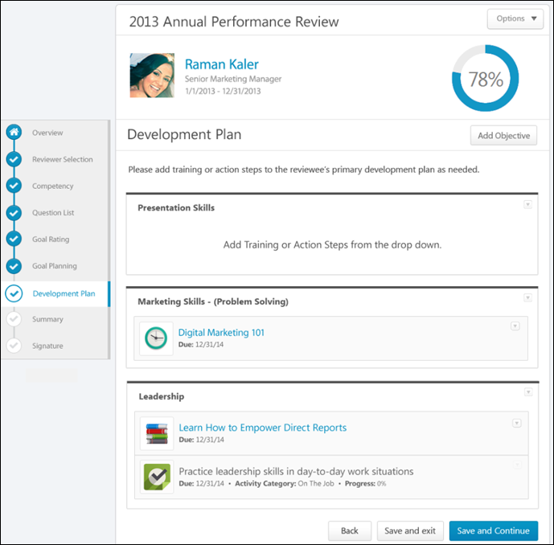
Performance Review Details
At the top of the performance review, the following performance review details are displayed:
- Performance Review Title - Title of the review. It is configured by the administrator when the review is created.
- Reviewee Photograph, Name, and Title - Reviewee's photograph, name, and position. Click the user's name or photograph to open their Universal Profile in a separate window. See Universal Profile - Bio Overview.
- Review Period - Time period of this review.
- Step Progress - Percentage complete. As review step sections are completed, the step progress is updated to reflect the correct percentage. Sections that require you to enter data complete once all required fields in the section are completed. When a reviewer views a section that does not require any information, the section is considered complete when the reviewer views the section. Note: The Overview page is not included in the completion percentage.
Options
Based on the configuration of the performance review and the reviewer's permissions, options may be available from the Options drop-down menu. See Performance Review - Options Drop-down on page 118 for additional information.
Performance Review Sections
On the left side of the performance review, the navigation menu displays all sections along with their completion status. Reviewers can click a section tab to access the section. See Performance Review - Review Sections on page 113 for additional information.
View Primary Development Plan
The Development Plan performance review section can be configured to either add training and action steps to the reviewee's existing primary development plan or to a newly created performance review development plan. If configured to add items to the reviewee's primary development plan, then the reviewee's existing primary development plan is displayed. Note: If the reviewee's primary development plan is modified outside the performance review while the review is in progress, the modified objectives, training, and action steps are updated for the in-progress review.
Add Objective
Development plans are creating by adding development objectives to outline what you are trying to achieve in your development plan. Objectives are the target areas of the plan. For example, if you are creating a development plan to improve your communication skills, you may create an objective to improve your writing skills. This objective should contain all of the training and actions you need to complete in order to achieve the objective, such as completing writing classes or shadowing a writer at your organization. See Performance Review - Development Plan - Add Objective on page 85 for additional information.
Objective Options
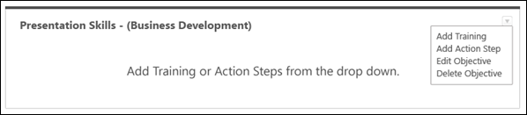
Click the Actions drop-down to view the available options or for development plan objectives. Options are:
- Add Training
- Add Action Step
- Edit Objective
- Delete Objective
See Performance Review - Development Plan - Objective Options on page 86 for additional information.
Training Options
If training options are added to objectives within a development plan, reviewers can click the training title to open the Learning Object (LO) Details page for the training item. See Learning Object (LO) Details Page.
For training items added to the development plan during the performance review task, you can add or delete training by clicking the option in the Actions drop-down .
Note: The Actions drop-down is not available for training items that are added to the development plan prior to the performance review task. These training items cannot be edited or deleted within the performance review section.
See Performance Review - Development Plan - Training Options on page 88 for additional information.
Action Step Options
Within the Development Plan performance review section, the action step details (title, category, progress, and due date) can be provided when the action step is added to the objective or when editing the action step.
For action steps added to the development plan during the performance review task, you can edit or delete an action step by selection an option in the Actions drop-down .
Note: The Actions drop-down is not available for action steps that were added to the development plan prior to the performance review task. These action steps cannot be edited or deleted within the performance review section.
See Performance Review - Development Plan - Action Step Options on page 83 for additional information.
Primary Development Plan - Sync Now
The user's primary development plan is pulled in to the Development Plan section of the performance review. If the user's primary plan changes while the performance review is open, the user is notified within the Development Plans section of the review, and they are given the option to sync the new or updated primary plan into the review and remove the previous plan from the review. When the new plan is synced with the review, any comments or modifications that were added to the plan within the review are not saved.
Development Plan Section Completion
The development plan approval process occurs after the entire performance review is complete and submitted and training items and action steps are added to the development plan.
When the performance review is completed and submitted, a snapshot of the development plan objectives, training, and action steps is captured. Any items added, removed, or modified from the development plan outside of the performance review are not reflected in the performance review.
Training items and action steps are only added to the development plan if the task is completed and submitted. If the performance review task is Incomplete, Past Due, or Not Submitted, the items are not added to the development plan.
Performance Review - Development Plan - Primary Plan Status
Use the Development Plan section to add training and action steps to the reviewee's development plan on the performance review. Administrators can configure the Development Plan section to build upon the reviewee's existing primary development plan or create a new performance review development plan. If the Development Plan section is set to build upon the reviewee's primary development plan, the section behavior depends on the status of the reviewee's existing primary development plan.
Reviewee Has No Existing Primary Development Plan
If the Development Plan review section is configured to build upon the reviewee's existing primary development plan, but the reviewee does not have an existing primary development plan, then a new performance review development plan is created. The newly created development plan has the following title: {Name of Performance Review} Development Plan (e.g., 2013 Annual Review Development Plan). This title can be edited after the development plan is created.
- If the reviewee still does not have a primary development plan when the performance review is submitted (i.e., a new primary plan was not created outside the performance review while the review was in progress), then the new performance review development plan is set as the reviewee's primary development plan.
- If a new development plan is created and selected as the primary development plan while the performance review is in progress, then the performance review development plan is not the primary development plan when the performance review is submitted.
Reviewee Has Existing Primary Development Plan
If the Development Plan review section is configured to build upon the reviewee's existing primary development plan and the reviewee has an existing primary development plan, then the status of the existing primary development plan determines whether new training and action steps can be added to the primary plan or if a new performance review development plan is created.
If the primary development plan is in one of the following statuses, then training and action steps can be added at the completion of the review:
- In Progress
  - If approval is required, the status changes to Pending Approval when the performance review is submitted.
  - If approval is not required, the status remains In Progress.
- Pending Approval - The status remains Pending Approval when the performance review is submitted.
- Denied - The status changes to Pending Approval when the performance review is submitted.
- Expired
  - If approval is required, the status changes to Pending Approval when the performance review is submitted.
  - If approval is not required, the status changes to In Progress.
- Completion Approval Denied - The status changes to Pending Approval when the performance review is submitted.
- Pending Acceptance Approval - The status is changed to Pending Approval when the performance review is submitted.
- Pending Cancellation Approval - If new training or action steps are added to the development plan in the Development Plan performance review section, the status is changed to In Progress.
- Pending Completion Approval - If new training or action steps are added to the development plan in the Development Plan performance review section, then the status changes to In Progress.
If the primary development plan is in one of the following statuses, you cannot add training and action steps to the existing primary development plan.
- Draft
- Canceled
- Complete
- Deleted
A new performance review development plan is created when the performance review is submitted. The newly created development plan has the following title: {Name of Performance Review} Development Plan (e.g., 2013 Annual Review Development Plan). This title can be edited after the development plan is created.
Performance Review - Evidence Collection
Evidence Collection review sections are used in conjunction with Competency Assessment review sections because Evidence Collection sections enable reviewers to input, upload, and edit materials that provide evidence that supports the competency ratings assigned in the Competency Assessment section. Evidence Collection sections also display all existing evidence that has been collected to support the required competencies. Reviewers can filter the section by competency to view only the evidence that supports specific competencies.
Permissions
PERMISSION NAME | PERMISSION DESCRIPTION | CATEGORY

View Performance Reviews | Grants ability to view the Performance Reviews page, which displays a user's own past performance reviews as well as performance review task steps they've been assigned to complete. This also grants ability to view the Batch Rating page. This permission can be constrained by OU, User's OU, User Self and Subordinates, and User. This is an end user permission. | Performance
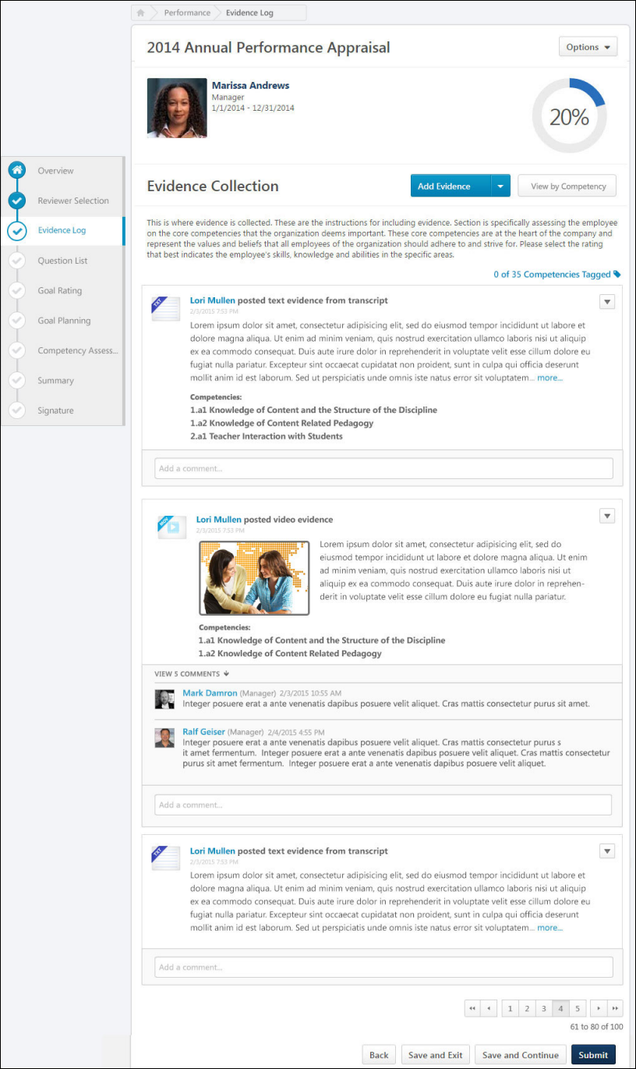
Performance Review Details
At the top of the performance review, the following performance review details are displayed:
- Performance Review Title - Title of the review. It is configured by the administrator when the review is created.
- Reviewee Photograph, Name, and Title - Reviewee's photograph, name, and position. Click the user's name or photograph to open their Universal Profile in a separate window. See Universal Profile - Bio Overview.
- Review Period - Time period of this review.
- Step Progress - Percentage complete. As review step sections are completed, the step progress is updated to reflect the correct percentage. Sections that require you to enter data complete once all required fields in the section are completed. When a reviewer views a section that does not require any information, the section is considered complete when the reviewer views the section. Note: The Overview page is not included in the completion percentage.
Options
Based on the configuration of the performance review and the reviewer's permissions, options may be available from the Options drop-down menu. See Performance Review - Options Drop-down on page 118 for additional information.
Performance Review Sections
On the left side of the performance review, the navigation menu displays all sections along with their completion status. Reviewers can click a section tab to access the section. See Performance Review - Review Sections on page 113 for additional information.
Add Evidence
Evidence is text or a material that can be used to support the competency ratings assigned in the Competency Assessment section.
To add evidence to an Evidence Collection performance review section, click the Add Evidence button or select Add Evidence from the Add Evidence drop-down menu. Note: This option is only available if the performance review step is configured to allow reviewers to create and edit evidence. Self and peer reviewers cannot edit any evidence that was added by another reviewer. Self and peer reviewers can only edit evidence that they uploaded within the Evidence Collection review section.
Create Notebook
An evidence notebook is a document of text notes from an observation. An evidence notebook can be divided into individual pieces of evidence and associated with competencies.
To create an evidence notebook, select Create Notebook from the Add Evidence drop-down menu. Note: This option is only available if the performance review step is configured to allow reviewers to create and edit evidence notebooks.
See Performance Review - Evidence Collection - Add/Edit Evidence Notebook on page 90 for additional information.
Manage Notebooks
To manage existing evidence notebooks, select Manage Notebooks from the Add Evidence drop-down menu. Note: This option is only available if the performance review step is configured to allow reviewers to create and edit evidence notebooks.
See Performance Review - Evidence Collection - Manage Notebooks on page 99 for additional information.
View by Competency
By default, the Evidence Collection review step displays all evidence that has been collected and added to the Evidence Collection section for the reviewee. Reviewers can filter the evidence to only display evidence that is associated with certain competencies.
To filter evidence by one or more specific competencies, click the View by Competencies button. This opens the Search Competencies pop-up. See Search Competencies Pop-up for additional information. Note: This button is not available if there is no competency model available.
When competencies are selected, the evidence feed only displays evidence that is associated with the selected competencies.
Total Competencies Tagged
Within an Evidence Collection performance review section, each piece of evidence can be tagged or associated with a competency. This indicates that the piece of evidence is related to the competency and can be used to support any ratings associated with the competency. At the top of the Evidence Feed, the total number of available and tagged competencies is displayed. For example, if "26 of 35 Competencies Tagged" is displayed, then this indicates that there are 35 total competencies available to be tagged within the associated competency model and 26 competencies have been tagged with evidence.
To view which competencies are tagged with evidence and which competencies have not yet been tagged within the Evidence Collection step, click the Competencies Tagged link at the top of the Evidence Feed. This opens the Total Competencies Tagged pop-up. See Performance Review - Evidence Collection - Total Competencies Tagged on page 101 for additional information.
Note: This link is not available if there is no competency model available. This link is also not available if the performance review step is configured to only grant reviewers view-only access to the section.
Evidence Feed
The Evidence Feed displays all pieces of evidence that have been added for the reviewee. Evidence is displayed in the order in which it was created with the most recently created evidence displayed first.
Evidence Display Rules
If more than one review step (e.g., Self Review, Manager Review, Peer Review) includes the Evidence Collection step, then the following rules apply:
- Each reviewer can view all evidence that has been added and submitted by any reviewers in previous review steps. However, evidence submitted by another reviewer does not appear in any review steps that occur in parallel. For example, if a Self and Peer review step occur at the same time, then the Peer step does not display any evidence added during the Self step. If a Manager review step occurs after the Self and Peer review steps, then the Manager review step displays any evidence added during the Self and Peer review steps.
- If a reviewer revisits their performance review step after it is submitted, then the reviewer can only view the evidence that was available to them at the time they completed the review step. For example, if only two pieces of evidence have been added when a reviewer submits their review, then only those two pieces of evidence are available to the reviewer if they revisit their performance review step.
- If evidence is deleted from an Evidence Collection review section, then that piece of evidence is deleted from all performance review steps.
If a reviewer has multiple steps in a review task (e.g., there are two Self Review steps or two Manager Review steps in the same task) and the Evidence Collection section is only added to the reviewer's first review step, then the reviewer can view the Evidence Collection section in their second review step. However, the reviewer cannot add or edit evidence in their second review step, and the Evidence Collection section only displays evidence that was available to the reviewer when the reviewer submitted their first review step. For example, if a Self Review step is added as the first step and the fourth step in the review task and the Evidence Collection section is only added to the first step, then the reviewee can submit evidence in the first Self Review step. In the fourth step (i.e., the second Self Review step), the reviewee can access the Evidence Collection section and view any evidence they added in the first Self Review step. However, the reviewee cannot add or edit any evidence and they cannot view any evidence that was added in the second or third review steps.
Evidence Details
The following information is displayed with each piece of evidence:
- Evidence File Type - Associated file type. An icon that represents the file type is displayed to the left of the evidence details.
- Evidence Creator - Name of the user who added the evidence is displayed to the right of the evidence file type icon.
- Timestamp - Timestamp is displayed with each piece of evidence to indicate when the evidence was added. The timestamp is always displayed in the time zone of the user who is viewing the evidence.
- Evidence Text - Summary of the evidence is displayed below the timestamp. Up to five lines of the summary text is displayed. If the evidence summary contains more than five lines of text, a more link is displayed at the end of the summary. Click this link to view the full summary of the evidence.
- Competencies - Tagged competencies if the evidence is tagged with competencies. Displays in alphabetical order.
- Comments - Comments added to a piece of evidence. Displays below the tagged competencies.
For information regarding adding comments, see the Evidence - Add Comment section below.
Evidence Options
The following evidence actions may be available from the actions drop-down menu to the right of the evidence:
- Download Attachment - Select this option to download the evidence attachment. Note: This option is only available if the evidence has an attachment.
- Edit Evidence - Select this option to edit the evidence. Note: This option is only available if the performance review step is configured to allow reviewers to create and edit evidence. Self and peer reviewers cannot edit any evidence that was added by another reviewer. Self and peer reviewers can only edit evidence that they uploaded within the Evidence Collection review section. See Performance Review - Evidence Collection - Add/Edit Evidence on page 95 for additional information.
- View Notebook - Select this option to view the corresponding Evidence Notebook for the reviewee. Note: This option is only available if the evidence was created within a notebook and if the performance review step is configured to allow reviewers to create and edit evidence. See Performance Review - Evidence Collection - Add/Edit Evidence Notebook on page 90 for additional information.
- Delete Evidence - Select this option to permanently delete the evidence. Note: This option is only available if the performance review step is configured to allow reviewers to create and edit evidence. Self and peer reviewers cannot delete any evidence that was added by another reviewer. Self and peer reviewers can only delete evidence that they uploaded within the Evidence Collection review section.
- Select Competencies - Select this option to view and edit the competencies that are associated with the evidence. Note: This option is only available if the performance review step is configured to allow reviewers to tag evidence but reviewers cannot create and edit evidence. Self and peer reviewers cannot edit any evidence that was added by another reviewer. Self and peer reviewers can only edit evidence that they uploaded within the Evidence Collection review section. See Search Competencies Pop-up for additional information.
Evidence - Add Comment
To add a comment regarding a piece of evidence, enter the comments in the Add a comment field below the appropriate piece of evidence in the Evidence Feed.Note: This field is only available if the performance review step is configured to allow reviewers to add comments.
If you have a need to copy and paste content into a performance review, please be sure to right-click the field into which you are pasting the content, and select the "Paste" option. You can also perform the same action by pressing [Ctrl]+[Shift]+[V]. This will ensure any formatting HTML does not get inserted into the text.
Pagination
If more than 10 pieces of evidence are available in the feed, then pagination options appear in the lower-right corner of the feed.
- Click a specific page number to go directly to that page.
- To move one page forward or backward, click the right or left arrow icon.
- To move to the first or last page, click the double left or double right arrow icon.
Navigation Buttons
The following buttons are available at the bottom of the page:
- Back - Opens the previous step of the performance review. This button is not available on the first page of the performance review.
- Save and Exit - Saves the reviewer's progress and exits the performance review.
- Save and Continue - Saves the reviewer's progress, validates all selections and comments, and proceeds to the next step of the performance review. This button is not available on the final page of the performance review.
- Submit - Submits the performance review. This button is only available when all sections of the performance review are complete. Once the task is submitted, you cannot modify the review task unless multiple submissions are allowed for the review task.
Based on the configuration of the performance review task, the reviewer's selected ratings may be visible to the system administrator as soon as the review task is saved. This includes when the performance review is automatically saved by the system. This enables the administrators to begin utilizing the data for calibration purposes while the review step is in progress.
When a reviewer is editing a reopened step or a submitted review step that allows multiple submissions, the performance review Save button labels are updated to more clearly indicate that the Save options do not finalize any of the ratings.
- The Save and Exit button is renamed to Save as Draft and Exit.
- The Save and Continue button is renamed to Save as Draft and Continue.
When in read-only mode, the available buttons are Back, Exit, and Next.
Performance Review - Goal Planning
Goal Planning sections allow users and managers to create goals for a future goal period. Goals can be created, edited, and removed from this section. All goals are automatically approved and added to the user's goal page when the review is completed.
Permissions
PERMISSION NAME | PERMISSION DESCRIPTION | CATEGORY

View Performance Reviews | Grants ability to view the Performance Reviews page, which displays a user's own past performance reviews as well as performance review task steps they've been assigned to complete. This also grants ability to view the Batch Rating page. This permission can be constrained by OU, User's OU, User Self and Subordinates, and User. This is an end user permission. | Performance
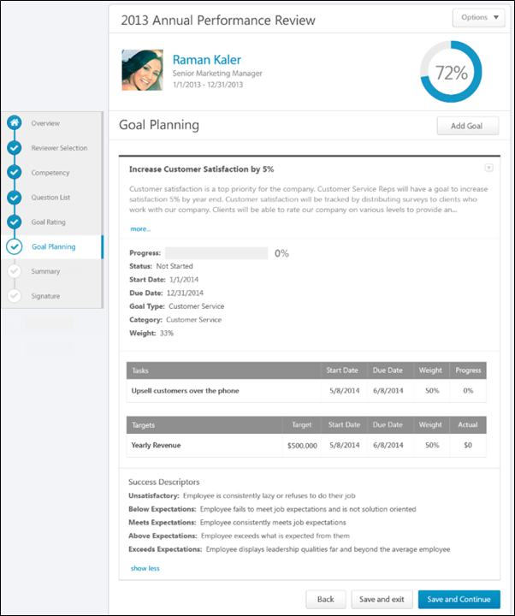
Performance Review Details
At the top of the performance review, the following performance review details are displayed:
- Performance Review Title - Title of the review. It is configured by the administrator when the review is created.
- Reviewee Photograph, Name, and Title - Reviewee's photograph, name, and position. Click the user's name or photograph to open their Universal Profile in a separate window. See Universal Profile - Bio Overview.
- Review Period - Time period of this review.
- Step Progress - Percentage complete. As review step sections are completed, the step progress is updated to reflect the correct percentage. Sections that require you to enter data complete once all required fields in the section are completed. When a reviewer views a section that does not require any information, the section is considered complete when the reviewer views the section. Note: The Overview page is not included in the completion percentage.
Options
Based on the configuration of the performance review and the reviewer's permissions, options may be available from the Options drop-down menu. See Performance Review - Options Drop-down on page 118 for additional information.
Performance Review Sections
On the left side of the performance review, the navigation menu displays all sections along with their completion status. Reviewers can click a section tab to access the section. See Performance Review - Review Sections on page 113 for additional information.
View Current Goals
Goal Planning sections can be configured to display the reviewee's current goals. If the Goal Planning section is configured to display the reviewee's current goals and if Goal Preferences allow goals to be edited after creation, then the reviewer can edit or cancel existing goals.
- A user completing a self-review can edit or cancel their goals. If goal approval is required, then users can request goal modification approval or goal cancellation approval.
- A manager completing a manager review can edit or cancel their subordinate's goals. Managers can also approve or deny goal modification or cancellation, which opens the Approve/Deny pop-up.
To view additional goal details, click the more link below the goal details. To hide the additional details, click the show less link.
Note: When a performance review step is reopened, Goal Planning sections reflect the latest goal planning information. See the Reopened Steps section below for additional information.
Add Goal
To add a goal, click the Add Goal button. This opens the Create Goals pop-up where you can configure the goal. Reviewers can add as many goals as necessary. Goals that are created within a performance review are automatically approved when the performance review is completed. See Goal - Create/Edit.
Edit Goal
To edit an existing goal, click the Options drop-down icon to the right of the goal title. Then, select Edit. This opens the Edit Goal pop-up where you can edit the details of the goal. See Goal - Create/Edit.
Delete Goal
To delete an existing goal, click the Options drop-down icon to the right of the goal title. Then, select Delete. This opens the Delete pop-up. Click Delete to confirm the deletion. Or, click Cancel to cancel the deletion.
View Goal History
To view the history of a goal, click the Options drop-down icon to the right of the goal title. Then, select View History. This opens the History pop-up for the goal. See Goal - View History.
Shared Goals
If the Goal Planning section is configured to include shared goals, then any shared goals that overlap with the performance review period are displayed in the goal planning section. Shared goals are read-only. An asterisk (*) appears to the left of the goal title to indicate that it is a shared goal.
Goal Weight Validation
If the Goal Planning section is configured to include goal weight validation, then the total weight of all goals is displayed and should equal 100%. If shared goals are displayed, then the weight of shared goals is included in the total. Note: The total goal weight includes all non-shared goals, including any goals that are in Draft status or created within the performance review.
If the Goal Planning section is configured to include goal weight validation, and the reviewer attempts to submit a performance review when the total goal weight does not equal 100%, a warning pop-up is displayed. The reviewer can click OK to submit the review or click Cancel to cancel the submission.
Approve/Deny/Cancel Goal
If a reviewee adds or edits a goal that requires manager approval, the manager can approve, deny, or cancel the reviewee's goal addition or edit. The following action buttons appear below the goal that requires approval:
- Cancel Goal - Click this button to cancel the goal. The Cancel Goal pop-up appears to confirm the action. Once a goal is cancelled, this cannot be undone. This option is only available for added goals.
- Deny - Click this button to deny the addition or the modification. An Edit Goal pop-up appears to display the changes that were made to the goal. This option is only available for edited goals.
- Approve - Click this button to approve the addition or the modification. An Edit Goal pop-up appears to display the changes that were made to the goal.
Comments
Depending on the configuration of the Goal Planning section, reviewers may have the ability to add comments to a Goal Planning section. When commenting is enabled, reviewers can add a comment for each goal. This enables a user and manager to have discussions regarding future goals within the Goal Planning section.
The Goal Planning section allows only one comment per goal per user and does not support threading.
The character limit for comment fields is 30,000.
- To check the spelling of the text box contents, click the ABC icon in the text box toolbar. This opens the Spell Checker pop-up.
- If you have a need to copy and paste content into a performance review, please be sure to right-click the field into which you are pasting the content, and select the "Paste" option. You can also perform the same action by pressing [Ctrl]+[Shift]+[V]. This will ensure any formatting HTML does not get inserted into the text.
When adding a comment, an HTML safe list is used for the Comments field. The system only accepts certain customizable HTML elements in the WYSIWYG Editor. Elements that are not acceptable display as text. See Safe Listed Customizable Elements.
If a non-peer reviewer (manager, indirect manager, custom relationship, or self) adds comments and saves the performance review task, then the reviewer's comments are visible to other reviewers. If a reviewee is completing a self review after another non-peer reviewer has added comments and saved their review, then the reviewee can view the other reviewer's comments. This applies if a self review step is reopened.
Navigation Buttons
The following buttons are available at the bottom of the page:
- Back - Opens the previous step of the performance review. This button is not available on the first page of the performance review.
- Save and Exit - Saves the reviewer's progress and exits the performance review.
- Save and Continue - Saves the reviewer's progress, validates all selections and comments, and proceeds to the next step of the performance review. This button is not available on the final page of the performance review.
- Submit - Submits the performance review. This button is only available when all sections of the performance review are complete. Once the task is submitted, you cannot modify the review task unless multiple submissions are allowed for the review task.
Based on the configuration of the performance review task, the reviewer's selected ratings may be visible to the system administrator as soon as the review task is saved. This includes when the performance review is automatically saved by the system. This enables the administrators to begin utilizing the data for calibration purposes while the review step is in progress.
When a reviewer is editing a reopened step or a submitted review step that allows multiple submissions, the performance review Save button labels are updated to more clearly indicate that the Save options do not finalize any of the ratings.
- The Save and Exit button is renamed to Save as Draft and Exit.
- The Save and Continue button is renamed to Save as Draft and Continue.
When in read-only mode, the available buttons are Back, Exit, and Next.
Reopened Steps
When a performance review step is reopened, Goal Planning sections reflect the latest goal planning information, including any goals that have been added or modified in later steps within the performance review task.
Once modifications are made to the Goal Planning section and this section is saved, these updates are reflected in reopened steps even if the reviewer does not complete their step. However, goals added by parallel step owners are never visible to reviewers in parallel steps.
Use Case:
- Frank is a sales representative at Acme Corp., and he recently completed his annual performance review, which contained a Goal Planning section.
- Frank's manager completes the Manager Review step in the performance review task and adds two new goals to Frank's Goal Planning section.
- Frank's manager wants Frank to review the newly added goals before the performance review task is complete, so he reopens Frank's performance review step.
- Frank opens the Goal Planning section of his performance review and sees the two goals that his manager added. Frank is able to make edits to the newly added goals prior to submitting his performance review.
Performance Review - Goal Rating
Goal Rating sections allows reviewers to view and rate the reviewee's goal progress for the task review period. The goal description is displayed below the goal name.
Note: Any shared goals that are assigned to an OU do not appear in a Goal Rating section.
Permissions
PERMISSION NAME | PERMISSION DESCRIPTION | CATEGORY

View Goals | Grants ability to view own goals and (depending on role and settings) goals of others (manager's visible goals, direct subordinate's goals, company goals, division goals). This permission can be constrained by Employee Relationship, OU, User's OU, and User Self and Subordinates. This is an end user permission. | Performance

View Performance Reviews | Grants ability to view the Performance Reviews page, which displays a user's own past performance reviews as well as performance review task steps they've been assigned to complete. This also grants ability to view the Batch Rating page. This permission can be constrained by OU, User's OU, User Self and Subordinates, and User. This is an end user permission. | Performance
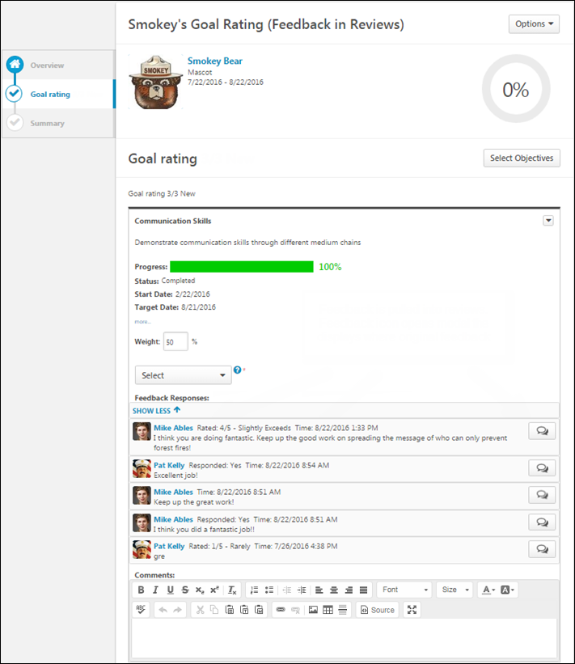
Performance Review Details
At the top of the performance review, the following performance review details are displayed:
- Performance Review Title - Title of the review. It is configured by the administrator when the review is created.
- Reviewee Photograph, Name, and Title - Reviewee's photograph, name, and position. Click the user's name or photograph to open their Universal Profile in a separate window. See Universal Profile - Bio Overview.
- Review Period - Time period of this review.
- Step Progress - Percentage complete. As review step sections are completed, the step progress is updated to reflect the correct percentage. Sections that require you to enter data complete once all required fields in the section are completed. When a reviewer views a section that does not require any information, the section is considered complete when the reviewer views the section. Note: The Overview page is not included in the completion percentage.
Options
Based on the configuration of the performance review and the reviewer's permissions, options may be available from the Options drop-down menu. See Performance Review - Options Drop-down on page 118 for additional information.
Performance Review Sections
On the left side of the performance review, the navigation menu displays all sections along with their completion status. Reviewers can click a section tab to access the section. See Performance Review - Review Sections on page 113 for additional information.
Goal Options
To view the goal options, click the drop-down icon to the right of the goal title. This drop-down is only available if the administrator configured goal details to display.
The following options may be available:
- Goal Page Comments - Opens a Goal Comments pop-up that displays any comments that were added to the goal within the performance review period. See Performance Review - Goal Rating - Goal Comments on page 108 for additional information.
- Goal Page Attachments - Opens a Goal Attachments pop-up that displays any attachments that were added to the goal within the performance review period. See Performance Review - Goal Rating - Goal Attachments on page 107 for additional information.
- Manage Goals - Only available when the Goal Rating section is configured to allow users to update goal progress. This option is only available if the reviewer has permission to view the goal. This option opens the Manage Goals page for the goal. When done updating the goal progress, the user is directed back to the Goal Rating section so they can continue completing the performance review. See Goal - Manage (New Design).
  - This option is never available to peers and subordinates when they are completing a 360 performance review.
  - This option is not available if the performance review is in read-only mode.
Goal Rating
To view additional details of the goal, including tasks, targets, and success descriptors, click the more link below the goal details. To hide the additional details, click the show less link. Note: Tasks and targets only display if they are included in the goal. Success descriptors only display if they are configured to display.
- For each goal, there is a rating scale, a Comment field, and a Weight field. Note: The editable Weight field is only available if configured to display by the system administrator.
- For each goal, select a rating and enter comments explaining the selected rating. For example, if you selected a poor rating, explain why the rating was selected. The character limit for comment fields is 30,000. In the Weight field, enter a weight for the goal. Weighting allows you to place a greater value on certain goals. The weight of all goals must add up to 100%.
- Depending on the backend setting, the weight percentage field may accept up to two decimal places.
  - To add a suggested comment from the comment assistant, click the Comment Assistant icon above the Comments field. This opens the Suggested Comments pop-up. See Performance Review - Comment Assistant on page 77 for additional information.
  - If the Inappropriate Word Filter is enabled for performance reviews, the filter flags any inappropriate words contained in the Comment field. See Performance Review - Inappropriate Language on page 110 for additional information.
  - To check the spelling of the text box contents, click the ABC icon in the text box toolbar. This opens the Spell Checker pop-up.
  - If you have a need to copy and paste content into a performance review, please be sure to right-click the field into which you are pasting the content, and select the "Paste" option. You can also perform the same action by pressing [Ctrl]+[Shift]+[V]. This will ensure any formatting HTML does not get inserted into the text.
When adding a comment, an HTML safe list is used for the Comments field. The system only accepts certain customizable HTML elements in the WYSIWYG Editor. Elements that are not acceptable display as text. See Safe Listed Customizable Elements.
Because Goal Rating sections can be reused year after year, ratings and comments from previous reviews may be included. After a peer or direct report review step, reviewers can view peer and direct report responses within the review. Each step (peer step or direct report step) appears in its own grouping. The names of the peers and direct reports are not visible to the reviewee, and the responses are not visible unless the minimum number of responses is reached.
Considerations for Auto-Calculation of Section Ratings
When completing a Goal Rating section within a performance review, if the section is configured to automatically calculate ratings based on goal achievement progress, then the user’s overall goal achievement progress is calculated when a user with the ability to rate the section opens the section, and this progress is displayed at the top of the section. This progress reflects the progress and weight of each goal. If no goals are available in the section, then N/A is displayed. If the section is not configured to automatically calculate section ratings based on goal progress, then the overall goal progress field is not displayed.
Note: The automated goal rating feature provides an automated rating for the entire goal rating section, not individual goals.
If the user who is completing the review has the ability to rate the section and if the section is configured to display weighted goal achievement progress, then the user’s Total Weighted Progress is calculated when the section is opened and is displayed at the top of the section. In addition, if the section is configured to automatically calculate section ratings based on the user’s total weighted progress, then the Automated Goal Rating is also displayed.
When a user who has the ability to rate the section reopens the section, the user’s total weighted progress is recalculated if a goal has been added or removed from the section, a goal has been cancelled, the progress of a goal is updated, or if the weight of a goal is changed.
Note: If the reviewer does not open the section, then the reviewee’s overall goal achievement progress is not calculated. For example, if the review step is reopened and the reviewer does not reopen the Goal Rating section, the progress is not recalculated and does not reflect any potential changes that were made to goal progress.
If the Goal Rating section is read-only for the reviewer, then the user’s overall goal achievement is not calculated.
Important: Because the user’s overall goal achievement progress is calculated when a user with the ability to rate the Goal Rating section opens the section, there are circumstances in which the goal progress and section rating do not reflect the most current values. This may occur if a user with the ability to rate the section opens the section and saves the section without submitting the review step, the goal progress is updated outside of the review task, the review task goes past due and becomes submitted, and the reviewee does not open the section again.
For more information about auto-calculation of section ratings, see the Create Review Section - Goal Rating topic in Online Help.
Lock Goal Results
The ability to lock a goal is only available when the Goal Rating section is configured to allow reviewers to manage goals in the review. This option is not available when completing a self review.
Based on the configuration of the portal, a Lock icon may appear to the right of a direct report's goal. Managers can click this icon to lock or unlock the goal. The following statuses are available:
- Locked - The goal is locked. Click this icon to unlock the goal. Users cannot update the goal progress or edit the goal. Managers may lock a goal at the end of the goal period or at the beginning of a review period. This prevents any miscommunication between the manager and employee. Note: This does not prevent users from advancing the goal.
- Unlocked - The goal is unlocked. Click this icon to lock the goal. Users can update the goal progress and edit the goal.
Feedback Responses
A Feedback Responses section is available and displays feedback obtained on goals if all of the following are true:
- The Goal Rating performance review section is configured to include feedback obtained on goals.
- The reviewee has received feedback on a goal that appears in the Goal Rating section. If no feedback is available, then the section is not displayed.
The Feedback Responses section displays a live view of all structured feedback that is currently available for the user's goals. The visibility settings of the structured feedback is respected within the Goal Rating section. That is, reviewers can only view feedback if the reviewer is within the visibility settings for the feedback. Also, if the feedback is provided anonymously, then this anonymity is respected within the Goal Rating section.
Feedback responses are displayed in chronological order with the most recent feedback responses displayed first.
The first two feedback responses are displayed. To view an additional responses, click the View XX Responses link.
To view all feedback responses that are available for a specific Goals Feedback request, click the Feedback button to the right of the feedback response.
Select Additional Goals
To select additional goals within the Goal Rating section of a performance review, click the Select Goals button. This opens a pop-up where you can select which of the user's goals you would like to add to the review. The ability to select goals is only available if configured to display by the system administrator. See Performance Review - Select Goals Pop-up on page 117 for additional information.
Multiple Reviewers/Co-Planners
If a review step has co-planners, each reviewer is able to enter their own comments and modify the review ratings. Comments are attributed to the user who submitted them, so each comment appears distinct and separate. In addition, any comments that have been saved, but not submitted are viewable by the assignee and the co-planners.
- If a co-planner is the first user to access a review section, the co-planner is able to select a rating and enter comments, if the rating option and comment box are enabled for the co-planner.
- If a co-planner accesses a review section that has been saved but not submitted by the assignee or another co-planner, then the system displays the following:
  - Ratings values are pre-selected with the rating that was selected by the assignee or another co-planner. Note: The rating option only appears if the task is configured for the section to accept comments from the corresponding assignee.
  - An empty comment box appears for the co-planner to enter comments. Note: The comment box only appears if the task is configured for the section to accept comments from the corresponding assignee.
  - A response section containing the rating applied by the assignee or another co-planner. This section displays the assignee or co-planner name, rating, and comments. "(Co-Planner)" appears next to all co-planner names. Note: The rating and comment only appear if the task is configured for the section to accept ratings and comments from the corresponding assignee.
Any comments are attributed to the reviewer who entered them. Ratings are attributed to the user who was the last to apply or modify the rating. For example, if Co-planner A applies a rating to a question, and then Co-planner B modifies the rating for the question, then the rating is attributed to Co-planner B. However, if Co-planner B does not modify the rating, then the rating is attributed to Co-planner A.
When viewing reviewer comments, the comments from the review step assignee are displayed first, followed by comments from the step co-planners in alphabetical order based on last name. The most recent comments are displayed first.
Weight values are also attributed to the user who was the last to apply or modify the weight value.
Navigation Buttons
The following buttons are available at the bottom of the page:
- Back - Opens the previous step of the performance review. This button is not available on the first page of the performance review.
- Save and Exit - Saves the reviewer's progress and exits the performance review.
- Save and Continue - Saves the reviewer's progress, validates all selections and comments, and proceeds to the next step of the performance review. This button is not available on the final page of the performance review.
- Submit - Submits the performance review. This button is only available when all sections of the performance review are complete. Once the task is submitted, you cannot modify the review task unless multiple submissions are allowed for the review task.
Based on the configuration of the performance review task, the reviewer's selected ratings may be visible to the system administrator as soon as the review task is saved. This includes when the performance review is automatically saved by the system. This enables the administrators to begin utilizing the data for calibration purposes while the review step is in progress.
When a reviewer is editing a reopened step or a submitted review step that allows multiple submissions, the performance review Save button labels are updated to more clearly indicate that the Save options do not finalize any of the ratings.
- The Save and Exit button is renamed to Save as Draft and Exit.
- The Save and Continue button is renamed to Save as Draft and Continue.
When in read-only mode, the available buttons are Back, Exit, and Next.
Performance Review - Question List
Question List sections contain basic questions about the employee's overall performance along with a rating scale and a comment field.
Permissions
PERMISSION NAME | PERMISSION DESCRIPTION | CATEGORY

View Performance Reviews | Grants ability to view the Performance Reviews page, which displays a user's own past performance reviews as well as performance review task steps they've been assigned to complete. This also grants ability to view the Batch Rating page. This permission can be constrained by OU, User's OU, User Self and Subordinates, and User. This is an end user permission. | Performance
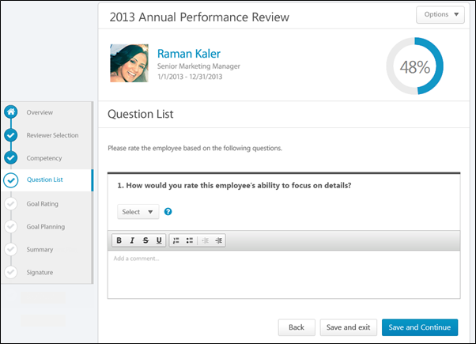
Performance Review Details
At the top of the performance review, the following performance review details are displayed:
- Performance Review Title - Title of the review. It is configured by the administrator when the review is created.
- Reviewee Photograph, Name, and Title - Reviewee's photograph, name, and position. Click the user's name or photograph to open their Universal Profile in a separate window. See Universal Profile - Bio Overview.
- Review Period - Time period of this review.
- Step Progress - Percentage complete. As review step sections are completed, the step progress is updated to reflect the correct percentage. Sections that require you to enter data complete once all required fields in the section are completed. When a reviewer views a section that does not require any information, the section is considered complete when the reviewer views the section. Note: The Overview page is not included in the completion percentage.
Options
Based on the configuration of the performance review and the reviewer's permissions, options may be available from the Options drop-down menu. See Performance Review - Options Drop-down on page 118 for additional information.
Performance Review Sections
On the left side of the performance review, the navigation menu displays all sections along with their completion status. Reviewers can click a section tab to access the section. See Performance Review - Review Sections on page 113 for additional information.
Question Rating
For each question, select a rating and enter comments explaining the selected rating. For example, if you selected a poor rating, explain why the rating was selected. The character limit for Comment fields is 30,000.
- To add a suggested comment from the comment assistant, click the Comment Assistant icon above the Comments field. This opens the Suggested Comments pop-up. See Performance Review - Comment Assistant on page 77 for additional information.
- If the Inappropriate Word Filter is enabled for performance reviews, the filter flags any inappropriate words contained in the Comment field. See Performance Review - Inappropriate Language on page 110 for additional information.
- To check the spelling of the text box contents, click the ABC icon in the text box toolbar. This opens the Spell Checker pop-up.
- If you have a need to copy and paste content into a performance review, please be sure to right-click the field into which you are pasting the content, and select the "Paste" option. You can also perform the same action by pressing [Ctrl]+[Shift]+[V]. This will ensure any formatting HTML does not get inserted into the text.
When adding a comment, an HTML safe list is used for the Comments field. The system only accepts certain customizable HTML elements in the WYSIWYG Editor. Elements that are not acceptable display as text. See Safe Listed Customizable Elements.
Because Question List sections can be reused year after year, ratings and comments from previous reviews may be included. After a peer or direct report review step, reviewers can view peer and direct report responses within the review. Each step (peer step or direct report step) appears in its own grouping. The names of the peers and direct reports are not visible to the reviewee, and the responses are not visible unless the minimum number of responses is reached.
Multiple Reviewers/Co-Planners
If a review step has co-planners, each reviewer is able to enter their own comments and modify the review ratings. Comments are attributed to the user who submitted them, so each comment appears distinct and separate. In addition, any comments that have been saved, but not submitted are viewable by the assignee and the co-planners.
- If a co-planner is the first user to access a review section, the co-planner is able to select a rating and enter comments, if the rating option and comment box are enabled for the co-planner.
- If a co-planner accesses a review section that has been saved but not submitted by the assignee or another co-planner, then the system displays the following:
  - Ratings values are pre-selected with the rating that was selected by the assignee or another co-planner. Note: The rating option only appears if the task is configured for the section to accept comments from the corresponding assignee.
  - An empty comment box appears for the co-planner to enter comments. Note: The comment box only appears if the task is configured for the section to accept comments from the corresponding assignee.
  - A response section containing the rating applied by the assignee or another co-planner. This section displays the assignee or co-planner name, rating, and comments. "(Co-Planner)" appears next to all co-planner names. Note: The rating and comment only appear if the task is configured for the section to accept ratings and comments from the corresponding assignee.
Any comments are attributed to the reviewer who entered them. Ratings are attributed to the user who was the last to apply or modify the rating. For example, if Co-planner A applies a rating to a question, and then Co-planner B modifies the rating for the question, then the rating is attributed to Co-planner B. However, if Co-planner B does not modify the rating, then the rating is attributed to Co-planner A.
When viewing reviewer comments, the comments from the review step assignee are displayed first, followed by comments from the step co-planners in alphabetical order based on last name. The most recent comments are displayed first.
Navigation Buttons
The following buttons are available at the bottom of the page:
- Back - Opens the previous step of the performance review. This button is not available on the first page of the performance review.
- Save and Exit - Saves the reviewer's progress and exits the performance review.
- Save and Continue - Saves the reviewer's progress, validates all selections and comments, and proceeds to the next step of the performance review. This button is not available on the final page of the performance review.
- Submit - Submits the performance review. This button is only available when all sections of the performance review are complete. Once the task is submitted, you cannot modify the review task unless multiple submissions are allowed for the review task.
Based on the configuration of the performance review task, the reviewer's selected ratings may be visible to the system administrator as soon as the review task is saved. This includes when the performance review is automatically saved by the system. This enables the administrators to begin utilizing the data for calibration purposes while the review step is in progress.
When a reviewer is editing a reopened step or a submitted review step that allows multiple submissions, the performance review Save button labels are updated to more clearly indicate that the Save options do not finalize any of the ratings.
- The Save and Exit button is renamed to Save as Draft and Exit.
- The Save and Continue button is renamed to Save as Draft and Continue.
When in read-only mode, the available buttons are Back, Exit, and Next.
Performance Review - Summary
Use the Summary section of a performance review to view a review summary once the reviewee and managers complete their tasks. This contains the section names, the step ratings along with the maximum rating, and the weight for each section if visible. If the overall review score is affected by auto-score functionality, this is noted below the overall rating at the top of the Summary section.
Scores for peers or direct reports are averaged across all users who submit a response. Each user's section score is calculated independently, based on the questions to which they responded. The peer or direct report section score is then averaged evenly across all respondents within the group. The step score is calculated based on the scores and weights of each section.
The Summary task is not visible to peer or direct report reviewers.
Permissions
PERMISSION NAME | PERMISSION DESCRIPTION | CATEGORY

View Performance Reviews | Grants ability to view the Performance Reviews page, which displays a user's own past performance reviews as well as performance review task steps they've been assigned to complete. This also grants ability to view the Batch Rating page. This permission can be constrained by OU, User's OU, User Self and Subordinates, and User. This is an end user permission. | Performance
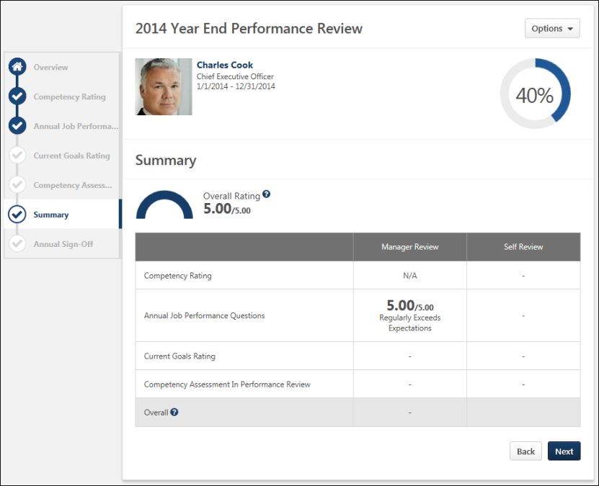
Performance Review Details
At the top of the performance review, the following performance review details are displayed:
- Performance Review Title - Title of the review. It is configured by the administrator when the review is created.
- Reviewee Photograph, Name, and Title - Reviewee's photograph, name, and position. Click the user's name or photograph to open their Universal Profile in a separate window. See Universal Profile - Bio Overview.
- Review Period - Time period of this review.
- Step Progress - Percentage complete. As review step sections are completed, the step progress is updated to reflect the correct percentage. Sections that require you to enter data complete once all required fields in the section are completed. When a reviewer views a section that does not require any information, the section is considered complete when the reviewer views the section. Note: The Overview page is not included in the completion percentage.
Options
Based on the configuration of the performance review and the reviewer's permissions, options may be available from the Options drop-down menu. See Performance Review - Options Drop-down on page 118 for additional information.
Performance Review Sections
On the left side of the performance review, the navigation menu displays all sections along with their completion status. Reviewers can click a section tab to access the section. See Performance Review - Review Sections on page 113 for additional information.
Overall Rating
Overall Rating is the normalized rating for all sections compared to the maximum rating of the task. The Overall Rating appears as either a numeric or a text rating depending on the performance review task configuration. If the overall rating is displayed as a text rating, the half-circle gauge does not appear.
When the overall rating scale is configured to display, the overall rating scale is available by clicking the Question Mark icon to the right of overall rating.
on the Summary page within the performance review task. When enabled, this icon is available to the right of the overall rating and in the Overall row of the ratings table.
Summary Table
Displays each section in the performance review and the section rating from each review step. If there are steps that are not visible in the table, a horizontal scroll bar appears at the bottom of the table and can be used to scroll left and right within the table.
- If the section is optional or if the rating is hidden, then a dash appears for the score.
- If the performance review task is configured to display weights on the Review Summary step, then weights are displayed in the summary table below the rating.
When the overall rating scale is configured to display, the overall rating scale is available by clicking the Question Mark icon in the Overall row of the ratings table.
Summary Section Completion
The Summary section becomes completed once the user has completed all required sections that are included in the summary table.
Navigation Buttons
The following buttons are available at the bottom of the page:
- Back - Takes users to the previous step of the performance review. This button is not available on the first page of the performance review.
- Next - Takes users to the next step of the performance review.
- Save and Exit - Saves the reviewer's progress and exits the performance review.
- Submit - Submits the performance review. This button is only available when all sections of the performance review are complete. Once the task is submitted, you cannot modify the review task unless multiple submissions are allowed for the review task.
When in read-only mode, the available buttons are Back, Exit, and Next.
Performance Review - Sign-off
The Sign-off section allows reviewees, managers, and other users to electronically sign the performance review. A signature line appears for each role that is added to the signature section.
Users with the appropriate permission can sign off on performance reviews in bulk. Note: Reviewers can only utilize the Bulk Sign Off functionality for performance reviews that are configured to use the Electronic sign-off method. See Performance Reviews - Bulk Sign Off on page 148 for additional information.
Permissions
PERMISSION NAME | PERMISSION DESCRIPTION | CATEGORY

View Performance Reviews | Grants ability to view the Performance Reviews page, which displays a user's own past performance reviews as well as performance review task steps they've been assigned to complete. This also grants ability to view the Batch Rating page. This permission can be constrained by OU, User's OU, User Self and Subordinates, and User. This is an end user permission. | Performance
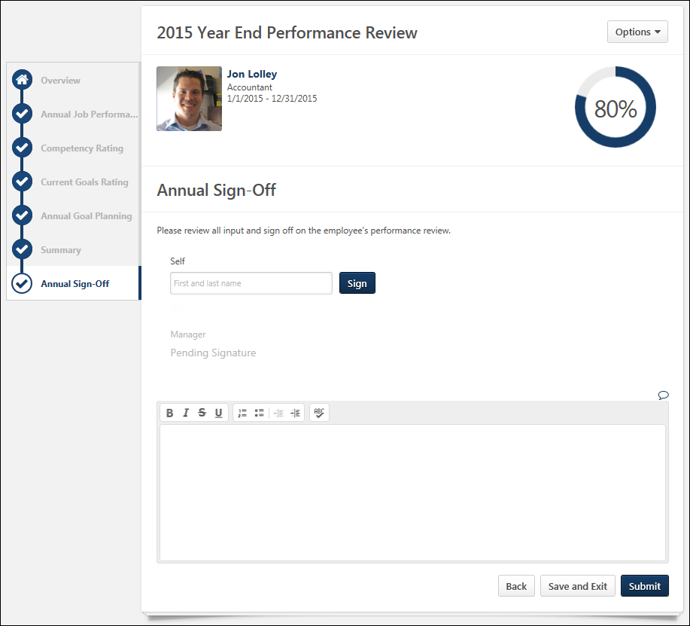
Performance Review Details
At the top of the performance review, the following performance review details are displayed:
- Performance Review Title - Title of the review. It is configured by the administrator when the review is created.
- Reviewee Photograph, Name, and Title - Reviewee's photograph, name, and position. Click the user's name or photograph to open their Universal Profile in a separate window. See Universal Profile - Bio Overview.
- Review Period - Time period of this review.
- Step Progress - Percentage complete. As review step sections are completed, the step progress is updated to reflect the correct percentage. Sections that require you to enter data complete once all required fields in the section are completed. When a reviewer views a section that does not require any information, the section is considered complete when the reviewer views the section. Note: The Overview page is not included in the completion percentage.
Options
Based on the configuration of the performance review and the reviewer's permissions, options may be available from the Options drop-down menu. See Performance Review - Options Drop-down on page 118 for additional information.
Performance Review Sections
On the left side of the performance review, the navigation menu displays all sections along with their completion status. Reviewers can click a section tab to access the section. See Performance Review - Review Sections on page 113 for additional information.
Sign-off
The signature method varies depending on the review section configuration. The following signature methods may be available:
- Electronic - If an empty field appears, enter your name and click Sign. You can re-sign prior to submitting the associated step by clicking the Re-Sign button. The submitted signature displays the name in the font selected by the employee on the My Account > My Preferences page and a date stamp. The section is complete once the review is signed.
- Authenticated - If an acknowledgment option appears, read the acknowledgment, select the acknowledgment checkbox to acknowledge the agreement, and click Sign. Your signature is automatically added with a date stamp. Users cannot edit their name or signature. This prevents typos because your system name is automatically entered. The section is complete once the review is signed.
- Manual - If a manual signature has been selected, the act of viewing the Sign-off section marks the section complete. You must then sign the printable version of the review.
Decline to Sign
If enabled, this option lets the reviewer decline to add their signature to the Sign Off section of the performance review to indicate that they do not agree with the outcome of the performance review. When the reviewer selects this option, the Sign button and the First and last name field are disabled. Also, a notification appears at the top of all performance review steps to indicate that the reviewer declined to sign the performance review.
If the reviewer already signed the performance review, then the Decline to sign option is hidden. If the reviewer chooses to remove their signature prior to submitting the performance review, they can click the Redo button to remove their signature. At this point, the Decline to sign option is available again.
In read-only mode, the Decline to sign is not displayed if it was not selected during the performance review.
In the printable performance review, if the reviewer declines to sign the performance review task, then "Decline to sign" is displayed in the user's signature area and no date is populated in the Date field. This clearly indicates that the user did not sign the performance review.
Comments
Add comments about the review. The character limit for comment fields is 30,000.
- If the Inappropriate Word Filter is enabled for performance reviews, the filter flags any inappropriate words contained in the Comment field. See Performance Review - Inappropriate Language on page 110 for additional information.
- To check the spelling of the text box contents, click the ABC icon in the text box toolbar. This opens the Spell Checker pop-up.
- If you have a need to copy and paste content into a performance review, please be sure to right-click the field into which you are pasting the content, and select the "Paste" option. You can also perform the same action by pressing [Ctrl]+[Shift]+[V]. This will ensure any formatting HTML does not get inserted into the text.
Navigation Buttons
The following buttons are available at the bottom of the page:
- Back - Opens the previous step of the performance review. This button is not available on the first page of the performance review.
- Save and Exit - Saves the reviewer's progress and exits the performance review.
- Save and Continue - Saves the reviewer's progress, validates all selections and comments, and proceeds to the next step of the performance review. This button is not available on the final page of the performance review.
- Submit - Submits the performance review. This button is only available when all sections of the performance review are complete. Once the task is submitted, you cannot modify the review task unless multiple submissions are allowed for the review task.
Based on the configuration of the performance review task, the reviewer's selected ratings may be visible to the system administrator as soon as the review task is saved. This includes when the performance review is automatically saved by the system. This enables the administrators to begin utilizing the data for calibration purposes while the review step is in progress.
When a reviewer is editing a reopened step or a submitted review step that allows multiple submissions, the performance review Save button labels are updated to more clearly indicate that the Save options do not finalize any of the ratings.
- The Save and Exit button is renamed to Save as Draft and Exit.
- The Save and Continue button is renamed to Save as Draft and Continue.
When in read-only mode, the available buttons are Back, Exit, and Next.
Performance Review - Confirmation
If the Confirmation page is enabled by the system administrator, it appears when the user has completes their performance review step.
The message that is displayed is configured by the system administrator when creating or editing the performance review task.
Permissions
PERMISSION NAME | PERMISSION DESCRIPTION | CATEGORY

View Performance Reviews | Grants ability to view the Performance Reviews page, which displays a user's own past performance reviews as well as performance review task steps they've been assigned to complete. This also grants ability to view the Batch Rating page. This permission can be constrained by OU, User's OU, User Self and Subordinates, and User. This is an end user permission. | Performance
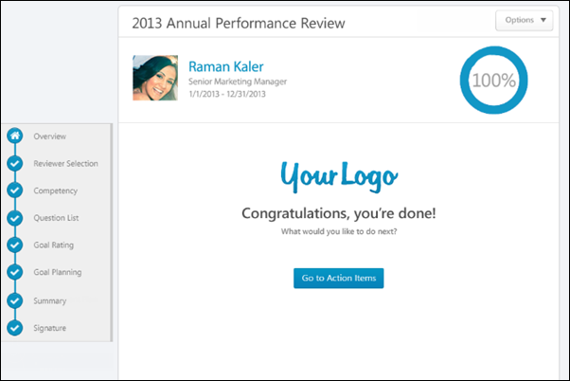
Performance Review Details
At the top of the performance review, the following performance review details are displayed:
- Performance Review Title - Title of the review. It is configured by the administrator when the review is created.
- Reviewee Photograph, Name, and Title - Reviewee's photograph, name, and position. Click the user's name or photograph to open their Universal Profile in a separate window. See Universal Profile - Bio Overview.
- Review Period - Time period of this review.
- Step Progress - Percentage complete. As review step sections are completed, the step progress is updated to reflect the correct percentage. Sections that require you to enter data complete once all required fields in the section are completed. When a reviewer views a section that does not require any information, the section is considered complete when the reviewer views the section. Note: The Overview page is not included in the completion percentage.
Options
Based on the configuration of the performance review and the reviewer's permissions, options may be available from the Options drop-down menu. See Performance Review - Options Drop-down on page 118 for additional information.
Performance Review Sections
On the left side of the performance review, the navigation menu displays all sections along with their completion status. Reviewers can click a section tab to access the section. See Performance Review - Review Sections on page 113 for additional information.
Go to Action Items
Click the Go to Action Items button to go to the Universal Profile > Actions page. See Universal Profile - Actions Overview for additional information. This button is only available if enabled by the system administrator. This button is not available to external reviewers.
Performance Review - Discuss Review
During an off-cycle performance review, users can discuss the review on the Discuss Review page if the functionality is enabled. User comments are either sent to the reviewee privately or to all participants of the review. Note: This option is only available for off-cycle performance review tasks that are configured to allow reviewers to discuss the review.
To access the Discuss Review page:
- Open the performance review and click the Discuss Review section link on the left navigation.
- If you receive an email notifying you that there is a discussion, there may be a link to the Discuss Review page. This option is only available if enabled by an administrator.
Permissions
PERMISSION NAME | PERMISSION DESCRIPTION | CATEGORY

View Performance Reviews | Grants ability to view the Performance Reviews page, which displays a user's own past performance reviews as well as performance review task steps they've been assigned to complete. This also grants ability to view the Batch Rating page. This permission can be constrained by OU, User's OU, User Self and Subordinates, and User. This is an end user permission. | Performance
Emails
EMAIL NAME | EMAIL DESCRIPTION | ACTION TYPE

Performance Review Reviewer Commented | This email is triggered when a reviewer adds a comment as part of a discussion thread within an off-cycle performance review. Discussions cannot be part of a standard performance review task.  The available recipients are Reviewee, Reviewer (the commenting reviewer), and Comment Recipients. Selecting Comment Recipients triggers a separate email to all users who have visibility to the comment. For example, a private comment only triggers emails to the reviewee or the person to which the reviewee is replying. A public comment triggers emails to the reviewee and all reviewers. | Performance Management

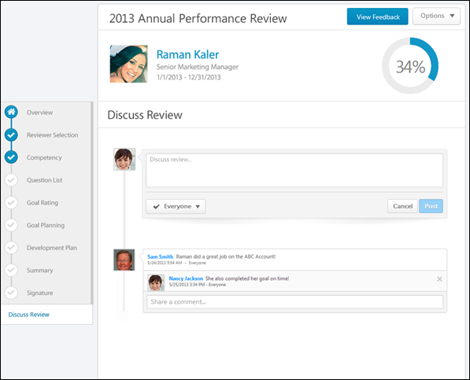
On the Discuss Review page:
- The reviewee can view all comments. Comments are displayed in the order in which the parent comment was posted with the most recent parent comment displayed first.
- Peers and subordinates can only see public comments.
- Managers, indirect managers, and custom relationships can only see public comments and any comment that they made privately.
Performance Review Details
At the top of the performance review, the following performance review details are displayed:
- Performance Review Title - Title of the review. It is configured by the administrator when the review is created.
- Reviewee Photograph, Name, and Title - Reviewee's photograph, name, and position. Click the user's name or photograph to open their Universal Profile in a separate window. See Universal Profile - Bio Overview.
- Review Period - Time period of this review.
- Step Progress - Percentage complete. As review step sections are completed, the step progress is updated to reflect the correct percentage. Sections that require you to enter data complete once all required fields in the section are completed. When a reviewer views a section that does not require any information, the section is considered complete when the reviewer views the section. Note: The Overview page is not included in the completion percentage.
Options
Based on the configuration of the performance review and the reviewer's permissions, options may be available from the Options drop-down menu. See Performance Review - Options Drop-down on page 118 for additional information.
Performance Review Sections
On the left side of the performance review, the navigation menu displays all sections along with their completion status. Reviewers can click a section tab to access the section. See Performance Review - Review Sections on page 113 for additional information.
Add Comment
To add a comment to the review discussion, in the Discuss review field, enter a comment up to 4000 characters.
Reply to Comment
To reply to a discussion post, in the Share a comment field below the original post, enter a reply comment up to 4000 characters. Note: When replying to a discussion post, the Post and Cancel buttons are not visible until you click the Share a comment field.
When replying to a comment, you cannot change the visibility setting. The reply automatically has the same visibility setting as the original post. Peers and subordinates can only make private comments, so they cannot reply to any comment that is visible to everyone.
Determine Comment Visibility
When adding a new comment, users can determine who can see the comment. Note: The visibility setting does not appear until the Discuss review field is clicked. To determine who can see your comment, select the appropriate option from the visibility drop-down list. The visibility applies to the original post as well as any additional comments that are added to your post by others. Note: This option cannot be changed after the comment is saved. The following options are available:
- Everyone - Select this option to make the comment visible to everyone involved with the review.
- Reviewee Only - Select this option to make the comment visible only to the reviewee and the reviewer who posted the comment. This option is not available to the reviewee. Also, peers and subordinates can only make private comments, so this option is automatically selected and cannot be changed.
Post or Cancel
After entering the appropriate text and setting the comment visibility, click Post to post the comment, or click Cancel to discard the comment.
When a comment is posted, it appears on the Discuss Review page with a date and time stamp of when the comment was made. The comment visibility setting is displayed to the right of the date and time stamp.
When a comment is posted, the recipients of the comment are notified via an email notification, if the Performance Review Reviewer Comment email is enabled.
Delete a Comment
Reviewers can delete one of their parent comments only if the comment has no child comments (i.e., the parent comment has no reply comments).
Reviewers can delete one of their child comments only if the child comment is the last child comment (i.e., the last reply comment) for the parent comment.
To delete a comment, click the Remove icon to the right of the comment.
Automatic Comment Deletion
If comments are configured to be deleted, all comments are permanently deleted when the review task meets the deletion criteria. Once deleted, the Discuss Review page is still available, but the comments are removed. If a review step is reopened or a step due date is extended, you can engage in comments, but the comments are deleted once the task meets the deletion criteria.

Performance Review Task - Components Overview
Performance Review - Comment Assistant
Use the Comment Assistant to suggested comments throughout the performance review. Note: The comment assistant only appears if it is enabled in Writing Tools preferences and if the item has at least one associated suggested comment.
Note: Comment Assistant is only available in Question List form sections.
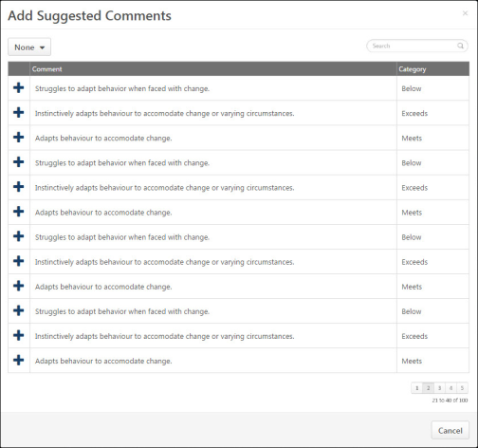
Manage Comments
- To add a suggested comment from the comment assistant, click the Comment Assistant icon above the Comments field. This opens the Suggested Comments pop-up.
- To filter the comments, select the appropriate category from the drop-down menu in the upper-left corner.
- Click the plus icon to the left of the comment to add the comment to the review. If text already exists in the Comments field, the added comment is appended to the existing text.
Performance Review - Competency Assessment - Rating History
When completing a competency assessment within a performance review, previous ratings may be available for a competency item. If previous ratings exist for a competency item, a Rating History link is available to the right of the rating scale. Click the link to view the previous ratings for the competency item.
At the top of the pop-up, the competency item description is displayed. Below the competency item description, all of the available competency item ratings for the reviewee are displayed. The ratings are organized by the performance review in which they were assessed with the most recent performance review displayed first. The reviewee's photograph and name are displayed along with their rating for the reviewee.
Performance Review - Competency Assessment - View Evidence
When a Competency Assessment review section is linked with an Evidence Collection review section, reviewers may have the option to view all pieces of evidence associated with a competency.
Reviewers can click the View Competency button to view all pieces of evidence associated with the competency.
Evidence is displayed in the order in which it was created with the most recently created evidence displayed first.
Evidence Display Rules
Click View Evidence to view all available evidence.
Evidence Details
The following information is displayed with each piece of evidence:
- Evidence File Type - Associated file type. An icon that represents the file type is displayed to the left of the evidence details.
- Evidence Creator - Name of the user who added the evidence is displayed to the right of the evidence file type icon.
- Timestamp - Timestamp is displayed with each piece of evidence to indicate when the evidence was added. The timestamp is always displayed in the time zone of the user who is viewing the evidence.
- Evidence Text - Summary of the evidence is displayed below the timestamp. Up to five lines of the summary text is displayed. If the evidence summary contains more than five lines of text, a more link is displayed at the end of the summary. Click this link to view the full summary of the evidence.
- Competencies - Tagged competencies if the evidence is tagged with competencies. Displays in alphabetical order.
- Comments - Comments added to a piece of evidence. Displays below the tagged competencies.
Evidence Options
The following evidence action may be available from the actions drop-down menu to the right of the evidence:
- Download Attachment - Select this option to download the evidence attachment. Note: This option is only available if the evidence has an attachment.
Pagination
If more than 10 results are available in the table, then pagination options appear in the lower-right corner of the table.
- Click a specific page number to go directly to that page.
- To move one page forward or backward, click the right or left arrow icon.
- To move to the first or last page, click the double left or double right arrow icon.
Close
To close the pop-up, click the X icon in the upper-right corner or click the Close button in the lower-right corner of the pop-up.
Performance Review - Custom Fields
If a performance review section is configured to include custom fields, the custom fields display below the section description and above the section questions, goals, or competencies.
Checkbox
Date Field
Drop-down
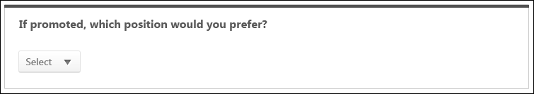
Numeric Field
Radio Button
Scrolling Text Box
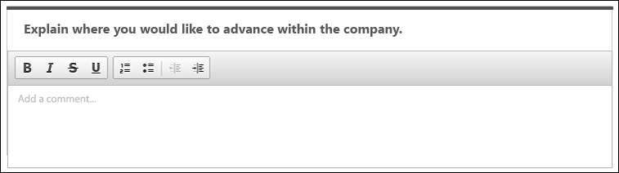
Short Text Box
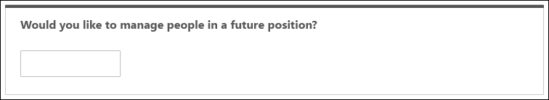
Performance Review - Development Plan - Action Step Options
For action steps added to the development plan during the performance review task, you can edit or delete an action step by selection an option in the Actions drop-down .
Note: The Actions drop-down is not available for action steps that were added to the development plan prior to the performance review task. These action steps cannot be edited or deleted within the performance review section.
You can edit the title, category, progress, and due date.
To edit an action step, click the drop-down arrow in the upper-right corner of the action step and select Edit Action Step.
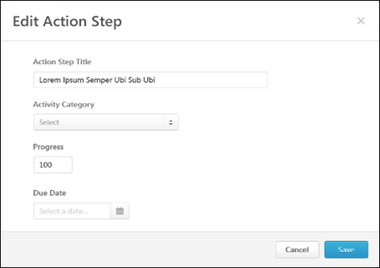
Action Step Title
Enter a title for the action step, up to 3000 characters. This title should provide an understanding of the developmental action step.This is required.
Activity Category
Select a category for the action step. If there are no available activity categories, then the drop-down menu does not appear. This is optional. The available activity categories are defined by the administrator.
Progress
The percentage complete for the item. If there is progress on the action step when it is added to the plan or when edited, you can update the progress. If the step is not started, enter 0; if the step is complete, enter 100.
Due Date
Set a due date for the action step. This is optional.
After entering the appropriate information, click Save. The action step details are updated.
Action Step - Delete
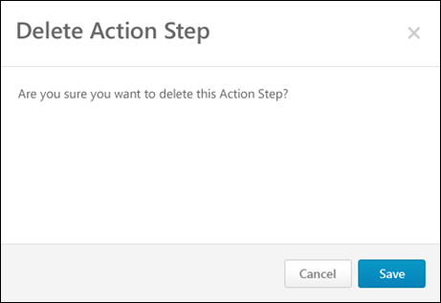
Click the drop-down arrow in the upper-right corner of the action step and select Delete Action Step. A confirmation pop-up appears to confirm the deletion.
Performance Review - Development Plan - Add Objective
Development plans are creating by adding development objectives to outline what you are trying to achieve in your development plan. Objectives are the target areas of the plan. For example, if you are creating a development plan to improve your communication skills, you may create an objective to improve your writing skills. This objective should contain all of the training and actions you need to complete in order to achieve the objective, such as completing writing classes or shadowing a writer at your organization.
To add an objective to the development plan, click the Add Objective button. The Add Objective pop-up opens.
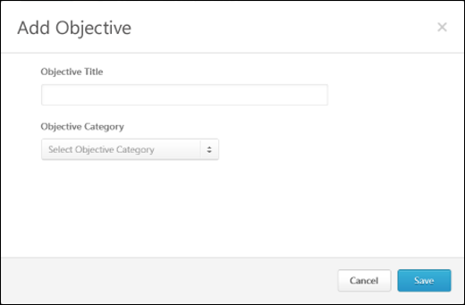
Objective Title
Enter a title for the objective, up to 3000 characters. This is required. This title should provide an understanding of the developmental objective (e.g., Leadership, Presentation Skills).
Objective Category
From the drop-down, select a category for the objective. This is optional. The available objective categories are defined by the administrator. If there are no available objective categories, then the drop-down menu does not appear.
After entering the appropriate information, click Save. The new objective is added at the top of the development plan. If a category is selected for the objective, then the category name appears to the right of the objective title in parenthesis. Training and action steps can then be added to the objective.
Performance Review - Development Plan - Objective Options
You can view the options for development plan objectives.
Add Training
Add training to a development plan to help the user develop the corresponding objective. Training must exist within the system before it can be added to the development plan.
See Search Training Pop-up for additional information.
Add/Edit Action Step
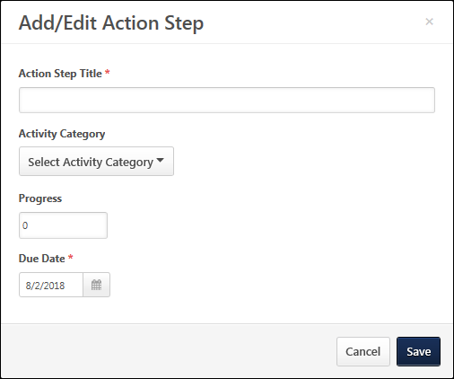
Add or edit action steps for a development plan to help the user develop the corresponding objective.
To add or edit an action step:
- Click the drop-down arrow in the upper-right corner of the objective and select Add Action Step. This opens the Add Action Step Training pop-up.
- Enter the following information for the action step:
  - Action Step Title - Enter a title for the action step, up to 3000 characters. This is required. This title should provide an understanding of the developmental action step.
  - Activity Category - From the drop-down, select a category for the action step. This is optional. The available activity categories are defined by the administrator. If there are no available activity categories, then the drop-down menu does not appear.
  - Progress - In this field, enter the percentage complete for the item. This is optional. If there is progress made on the action step at the time it is added to the plan or when the action step is edited, you may update the progress at that time. If the step has not been started, enter 0, and if the step is complete, enter 100.
  - Due Date - Click the Calendar icon to set a due date for the action step. Or, enter a date in the field. This is optional.
- Click Save. The new action step is added at the top of the objective.
Edit Objective
You can edit the objective title and category. Note: Only objectives that are added during the performance review task can be edited. Objectives that existed within the reviewee's primary development plan prior to the performance review task cannot be edited.
To edit an objective, click the drop-down arrow in the upper-right corner of the objective and select Edit Objective.
Delete Objective
When you delete an objective, all training and action items within the objective are also deleted. Note: You can only delete objectives that are added during the performance review task. You cannot delete objectives that existed within the reviewee's primary development plan prior to the performance review task .
To delete an objective, click the drop-down arrow in the upper-right corner of the objective and select Delete Objective. A confirmation pop-up appears to confirm the deletion.
Performance Review - Development Plan - Training Options
For training items added to the development plan during the performance review task, you can add or delete training by clicking the option in the Actions drop-down .
Note: The Actions drop-down is not available for training items that are added to the development plan prior to the performance review task. These training items cannot be edited or deleted within the performance review section.
Edit Training
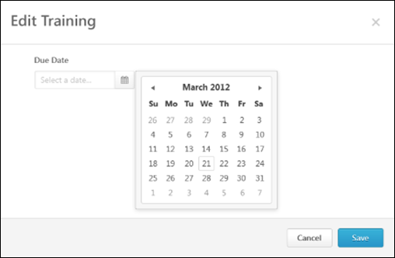
To edit a training item, click the drop-down arrow in the upper-right corner of the training item and select Edit Training.
Training - Delete
To remove a training item from an objective within a development plan, click the drop-down arrow in the upper-right corner of the training item and select Delete Training. A confirmation pop-up appears to confirm the deletion.

Performance Review - Evidence Collection - Add/Edit Evidence Notebook
Evidence Collection review sections are used in conjunction with Competency Assessment review sections because Evidence Collection sections enable reviewers to input, upload, and edit materials that provide evidence that supports the competency ratings assigned in the Competency Assessment section.
The Evidence Notebook page enables a reviewer to create and save an evidence notebook, which is a document of text notes. This page also enables a reviewer to divide a notebook into individual pieces of evidence and associate the evidence with competencies.
You can access the Evidence Notebook as follows:
- From the Evidence Collection performance review section, select Create Notebook from the Add Evidence drop-down menu. Note: This option is only available if the performance review step is configured to allow reviewers to create and edit evidence notebooks.
- From the Evidence Collection performance review section, in the Evidence Feed, select View Notebook from the actions drop-down menu to the right of the evidence.
- From the Manage Notebooks pop-up, click the Create Notebook button or click a notebook name in the Notebook table.
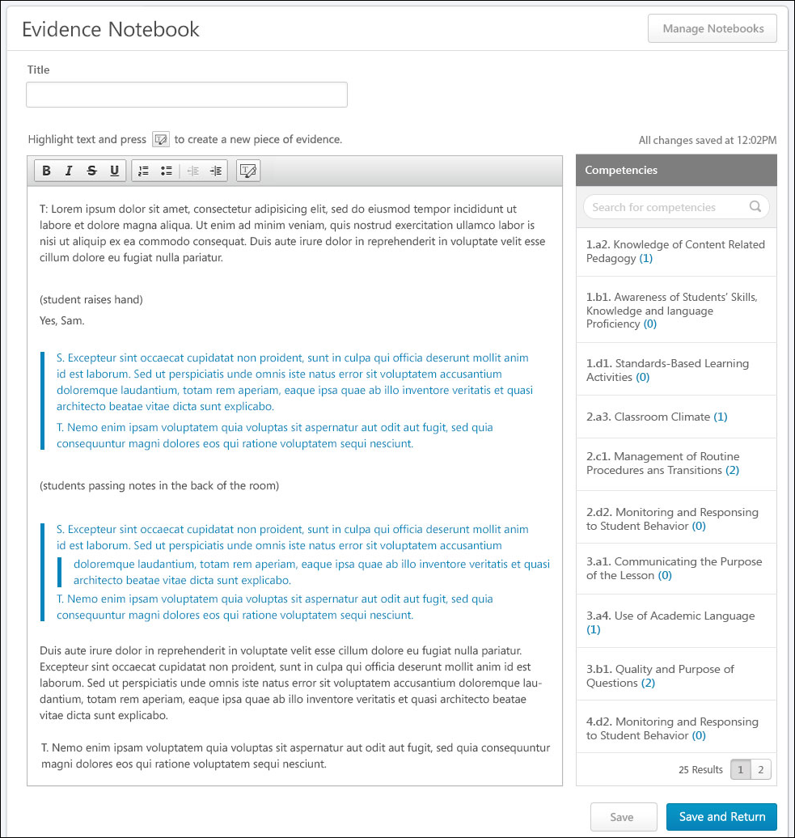
Manage Notebooks
Click the Manage Notebooks button to view and manage existing notebooks. This opens the Manage Notebooks pop-up. See Performance Review - Evidence Collection - Manage Notebooks on page 99 for additional information.
Title
Enter a title that provides a clear purpose of the evidence notebook. You can enter up to 100 characters.
If there is no title when the notebook is saved (either automatically or using one of the Save buttons), the notebook is automatically named "Notebook N," where "N" is one more than the total number of notebooks for the user. For example, if the user has three notebooks, then the new notebook is automatically named "Notebook 4."
Evidence Text
The large text box enables the reviewer to enter text notes from an observation. These text notes should be as detailed as possible so that they can be used as evidence to support competency ratings. HTML can be used. The system only accepts certain customizable HTML elements in the WYSIWYG Editor. Elements that are not acceptable display as text. See Safe Listed Customizable Elements.
If a segment of text within the Evidence Text field is used to create a piece of evidence, then the segment is indented and a vertical bar appears to the left of the segment.
Add and Tag Evidence
The Add New Evidence functionality enables the reviewer to separate the text within the Evidence Text field into individual pieces of evidence.
To separate a section of text into an individual piece of evidence, select the appropriate text within the Evidence Text field and click the Select Text icon in Evidence Text field editing toolbar. Depending on the configuration of the performance review step, the reviewer may be able to tag the evidence with one or more competencies. Note: Text must selected within the Evidence Text field prior to clicking the Select Text icon .
Scenarios
Scenario 1: Reviewer Can Tag Evidence
If the performance review step is configured to allow reviewers to tag evidence, then the following occurs when the Select Text icon is clicked:
- The Search Competencies pop-up opens, which enables the reviewer to search for and select the competencies with which the evidence will be tagged. See Search Competencies Pop-up for additional information.
- After the competencies are selected, the Add Evidence pop-up opens. The Evidence Text field is populated with the text that was selected on the Evidence Notebook page, and the Competencies section is populated with the competencies that were selected in the Search Competencies pop-up. See Performance Review - Evidence Collection - Add/Edit Evidence on page 95 for additional information.
- After the evidence is added, the previously selected text is now a unique piece of evidence and is tagged with the selected competencies. To visually indicate that the text has been tagged, the text is indented and a vertical bar appears to the left of the text in the Evidence Text field. In the Competencies panel on the Evidence Notebook, the counters for the selected competencies are updated.
Scenario 2: Reviewer Cannot Tag Evidence
If the performance review step is configured to not allow reviewers to tag evidence or if there is no competency model available, then the following occurs when the Select Text icon is clicked:
- The Add Evidence pop-up opens. The Evidence Text field is populated with the text that was selected on the Evidence Notebook page, and the Competencies section is not available.
- After the evidence is added, the previously selected text is now a unique piece of evidence. The evidence text is indented and there is a vertical bar to the left of the text.
Competencies Panel
To the right of the Evidence Text field, the Competencies panel displays all of the competencies contained in the competency model associated with the Competency Assessment review section. Competencies display in alphabetical order. If there are more than 15 competencies, pagination options are available at the bottom of the Competencies panel.
Search - Search field lets the reviewer search for competencies by name.
Number of pieces of evidence - Represents the total number of pieces of evidence tagged with the competency. This number is in parenthesis. Click the number to view all pieces of evidence in a pop-up.
Remove evidence - Within the Competency Evidence pop-up, the reviewer can remove a piece of evidence from a competency by clicking the Remove icon to the left of the evidence text.
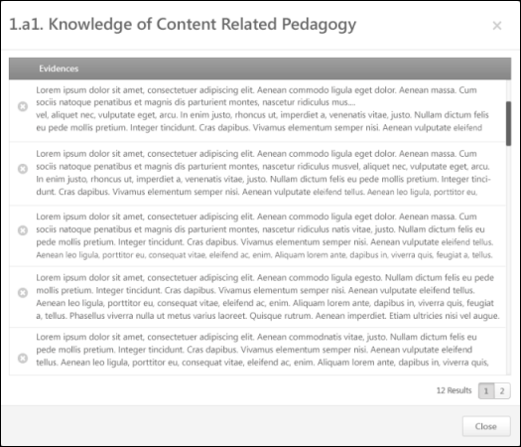
Save/Save and Return
When editing the Evidence Notebook page, the content is automatically saved every three minutes to prevent data loss. However, the reviewer can also manually save the page by clicking one of the Save buttons. When the page is automatically saved or when one of the Save buttons is clicked, the text in the upper-right corner of the page is updated to reflect the last time the page was saved.
- Click Save to save the evidence notebook and continue editing the Evidence Notebook page.
- Click Save and Return to save the Evidence Notebook page and return to the Evidence Collection performance review section.
Performance Review - Evidence Collection - Add/Edit Evidence
Evidence Collection review sections are used in conjunction with Competency Assessment review sections because Evidence Collection sections enable reviewers to input, upload, and edit materials that provide evidence that supports the competency ratings assigned in the Competency Assessment section. When creating or editing evidence, reviewers can provide summary text, associate the evidence with competencies, and attach documents to the evidence.
- To add evidence to an Evidence Collection performance review section, click the Add Evidence button or select Add Evidence from the Add Evidence drop-down menu. Note: This option is only available if the performance review step is configured to allow reviewers to create and edit evidence. Self and peer reviewers cannot edit any evidence that was added by another reviewer. Self and peer reviewers can only edit evidence that they uploaded within the Evidence Collection review section.
- To edit a piece of evidence within an Evidence Collection performance review section, click the actions drop-down menu to the right of the evidence in the Evidence Feed and click the Edit Evidence option. Note: This option is only available if the performance review step is configured to allow reviewers to create and edit evidence. Self and peer reviewers cannot edit any evidence that was added by another reviewer. Self and peer reviewers can only edit evidence that they uploaded within the Evidence Collection review section.
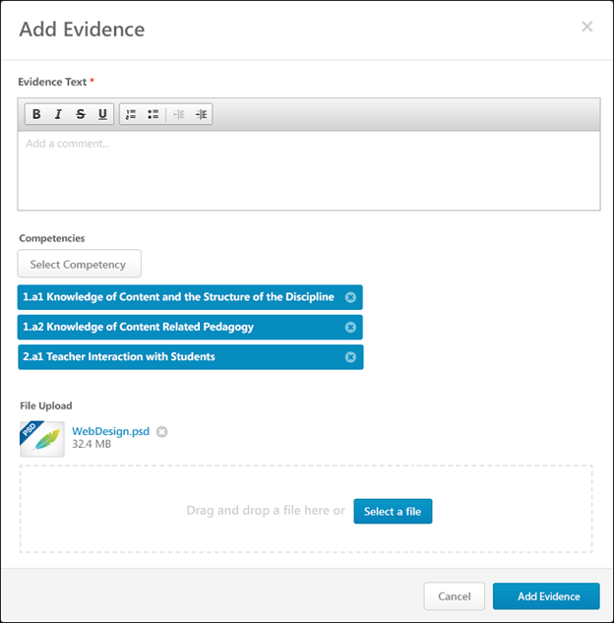
Evidence Text
Enter the details of the evidence. For example, if the evidence is an observation,describe what was observed and how the observation relates to the appropriate competencies. If an attachment is added as evidence, summarize the attachment and describe how the attachment relates to the appropriate competencies.
This field is required.
Competencies
Evidence Collection sections enable reviewers to input or upload materials that provide evidence that supports the competency ratings assigned in the Competency Assessment section.
Note: This section is not available if there is no competency model available.
Select Competency
Click the Select Competency button to associate the evidence with one or more competencies. This opens the Search Competencies pop-up. The reviewer can only select competencies that are contained within the competency model that is associated with the Competency Assessment review section. See Search Competencies Pop-up for additional information.
Selected competencies display below the Select Competency button.
Adding competencies to a piece of evidence is optional.
Remove Competencies
To remove a selected competency from the evidence, click the X icon on the right side of the competency.
File Upload
Reviewers may add or upload a file to provide evidence.
- Click the Select a file button to select a file from your computer.
- Drag-and-drop a file - Select a file and drop it into the file upload box. Note: The drag-and-drop functionality is not supported by Internet Explorer browsers.Attach a file by dragging and dropping a file into the Attachment area or by
After the file is selected, the attachment appears at the top of the File Upload section.
The following attachment restrictions apply:
- One attachment can be added.
- The maximum file size is 5 MB.
- The attachment file name cannot exceed 50 characters.
- Executable files cannot be uploaded.
- Files cannot have a hidden extension or no extension.
File types
You can add or upload the following file types:
File Type | Extension
Compressed | - zip
Data | - xls/xlsx
Image | - bmp  - gif  - jpeg/jpg/jpe  - png
Presentation | - ppt/pptx
Text | - doc/docx  - pdf  - txt
Video | - avi  - mov
File - Remove
To remove an uploaded file, click the X icon to the right of the file name.
Add Evidence/Save Evidenceor Cancel
- When creating a new piece of evidence, click Add Evidence to save and create the new piece of evidence.
- When editing an existing piece of evidence, click Save Evidence to save the changes.
Cancel
Click Cancel to discard any unsaved changes.
Performance Review - Evidence Collection - Manage Notebooks
The Manage Notebooks pop-up enables reviewers to create notebooks and view and delete their existing notebooks. Notebooks are not shared between reviewers, so a reviewer can only view their own notebooks.
To access the Manage Notebooks pop-up, click the Manage Notebooks button on the Evidence Notebook page.
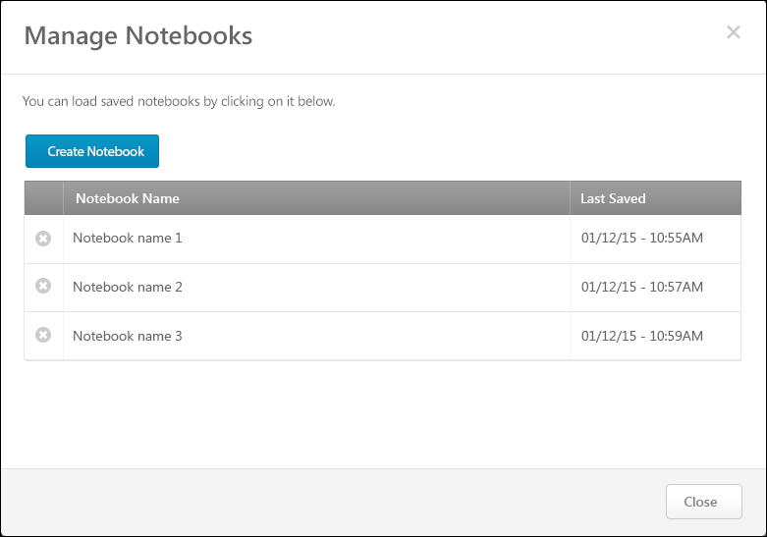
Create Notebook
Click the Create Notebook button to create a new notebook. This opens the Evidence Notebook page. If the reviewer already has a different notebook open, then the previous notebook is automatically saved before the Evidence Notebook page is opened.
See Performance Review - Evidence Collection - Add/Edit Evidence Notebook on page 90 for additional information.
Notebook Table
The following information is displayed in the Notebook table for each of the reviewer's existing evidence notebooks:
- Notebook Name - This displays the title of each of the reviewer's existing evidence notebooks.
- Last Saved - This displays the date and time at which the corresponding notebook was last saved either manually or automatically.
Open Notebook
Click the notebook name in the Notebook table to open the Evidence Notebook page for the notebook. If the reviewer has a different notebook open, the previous notebook is automatically saved before the new notebook is opened.
See Performance Review - Evidence Collection - Add/Edit Evidence Notebook on page 90 for additional information.
Remove Notebook
Click the Remove icon to the left of the appropriate notebook name to delete a notebook. A confirmation pop-up opens to confirm the removal.
Close
To close the pop-up, click the X icon in the upper-right corner of the pop-up or click the Close button in the lower-right corner of the pop-up.
Performance Review - Evidence Collection - Total Competencies Tagged
Within an Evidence Collection performance review section, each piece of evidence can be tagged or associated with a competency. This indicates that the piece of evidence is related to the competency and can be used to support any ratings associated with the competency. Within the performance review, reviewers can view which competencies have been tagged with evidence and which have not.
To view which competencies are tagged with evidence and which competencies have not yet been tagged within the Evidence Collection step, click the Competencies Tagged link at the top of the Evidence Feed.
Total Competencies Tagged
At the top of the Total Competencies Tagged pop-up, the total number of available and tagged competencies is displayed. For example, if "26 of 35 Competencies Tagged" is displayed, this indicates that there are 35 total competencies available to be tagged within the associated competency model and 26 competencies have been tagged with evidence.
Untagged Tab
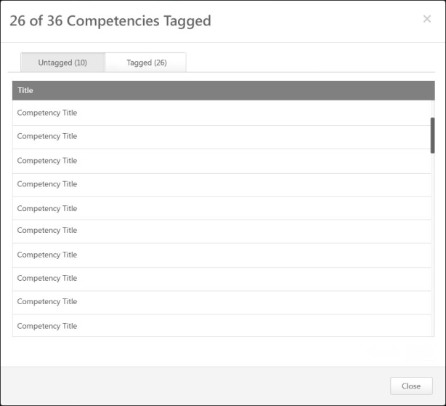
By default, the Untagged tab is selected when the pop-up is opened. This tab displays all of the competencies within the competency model that do not yet have evidence tagged to them. Competencies are sorted alphabetically.
Tagged Tab
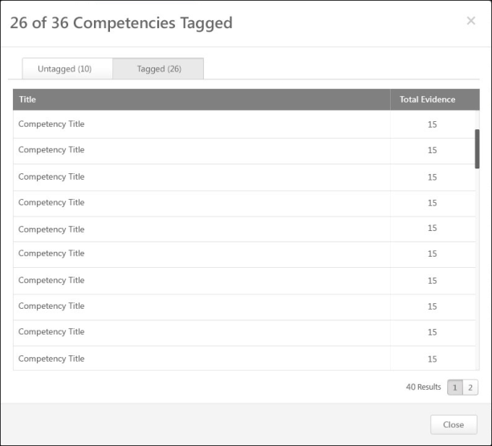
This tab displays all of the competencies within the competency model that have evidence tagged to them. The total number of tagged competencies is displayed next to the tab name.
In the Total Evidence column to the right of the competency name, the total number of pieces of evidence that are associated with the competency is displayed.
Competencies are sorted by Total Evidence with the lowest number of evidence displayed first.
Pagination
If more than 20 results are available in the table, then pagination options appear in the lower-right corner of the table.
- Click a specific page number to go directly to that page.
- To move one page forward or backward, click the right or left arrow icon.
- To move to the first or last page, click the double left or double right arrow icon.
Close Pop-up
To close the pop-up, either click the X icon in the upper-right corner of the pop-up or click the Close button in the lower-right corner of the pop-up.
Performance Review - Goal Rating - Feedback Responses
Administrators can configure a Goal Rating performance review section to include any feedback the user received on the goals that are included in the section.
The Feedback Responses pop-up enables reviewers to view all feedback responses available within a specific Goals Feedback request. This enables the reviewer to easily reference all available information when rating a specific goal.
To view the Feedback Responses pop-up for a goal within a Goal Rating review section, click the Feedback button to the right of the goal feedback. Goal feedback is only displayed in the Goal Rating section if it is enabled by the administrator and if goal feedback is available for the goal. A reviewer can only view goal feedback if the reviewer is within the visibility settings for the feedback.
Permissions
PERMISSION NAME | PERMISSION DESCRIPTION | CATEGORY

View Goals | Grants ability to view own goals and (depending on role and settings) goals of others (manager's visible goals, direct subordinate's goals, company goals, division goals). This permission can be constrained by Employee Relationship, OU, User's OU, and User Self and Subordinates. This is an end user permission. | Performance
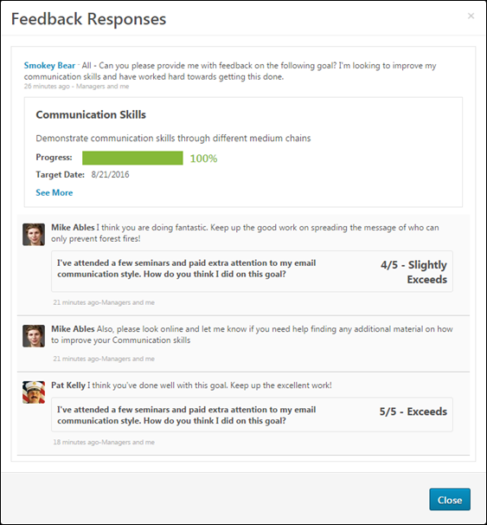
Feedback Request Details
At the top of the pop-up, the details of the feedback request are displayed, including the original feedback request and the details of the goal for which the user requested feedback.
Feedback Responses
Below the feedback request details, feedback responses display in chronological order with the most recent feedback responses displayed first.
The visibility settings of the structured feedback is respected within the pop-up. That is, reviewers can only view feedback if the reviewer is within the visibility settings for the feedback. Also, if the feedback is provided anonymously, then this anonymity is respected within the pop-up.
Performance Review - Goal Rating - Goal Attachments
When completing a Goal Rating section within a performance review, reviewers can view any attachments added to the goal within the performance review period.
To view the goal attachments, click the drop-down icon to the right of a goal title and select the Goal Page Attachments option.
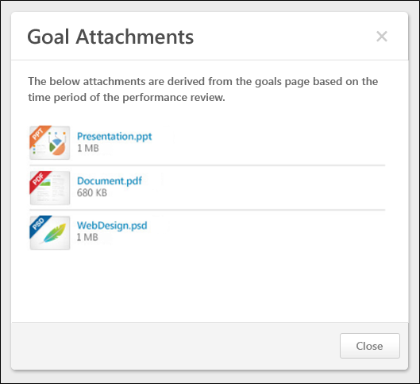
Goal Attachments
Goal attachments are displayed in the order in which they are added.
The following information is displayed in the Goal Comments pop-up:
- File Type Icon - The type of added file.
- File Name - The name of the file. Click the file name to view or download the attachment.
- File Size - The file size.
View or Download Attachment
To view or download the attachment, click the file name.
Performance Review - Goal Rating - Goal Comments
When completing a Goal Rating section within a performance review, reviewers can view any comments that were added to the goal within the performance review period.
To view the goal comments, click the drop-down icon to the right of the goal title and select the Goal Page Comments option.
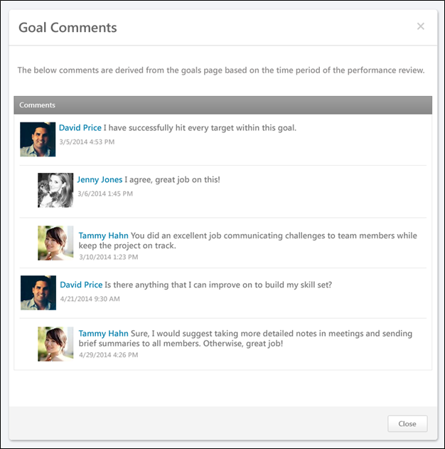
Comments
Comments are displayed in chronological order with the oldest comments displayed first.
The following information is displayed in the Goal Comments pop-up:
- User Photograph - Picture of the reviewee.
- User Name - Reviewee's name. Click the user's name or photograph to open their Universal Profile in a separate window. See Universal Profile - Bio Overview for additional information.
- Comment Text - The written comment.
- Date and Time Stamp - The date and time of the comment.
- Child Comments - User reply to a comment, this is considered a child comment. Child comments appear indented below the parent comment.
Performance Review - Inappropriate Language
If the Inappropriate Word Filter is enabled for performance reviews, the filter flags any inappropriate words contained in the Comment field.
Validation occurs when you click the Save and Continue button on a performance review page. When a word is flagged as inappropriate, the word is highlighted. The inappropriate word must be corrected before you can submit the review.
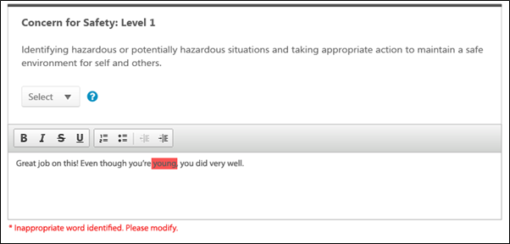
Performance Review - Rating Options
You can select a rating for a performance review from a rating drop-down or a star rating scale, based on the performance review configuration.
Drop-down Menu
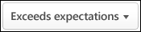
To select a rating from the drop-down menu, click the drop-down menu and select the appropriate rating.
Star Rating
- To select a star rating, click the appropriate number of stars. Reviewers can hover over a star to view the rating description.
- If a reviewee is too new to rate, select the Too new to rate option below the star rating.
- To reset the rating, click the Reset icon to the right of the stars. This removes the selected rating.
Rating Scale Information
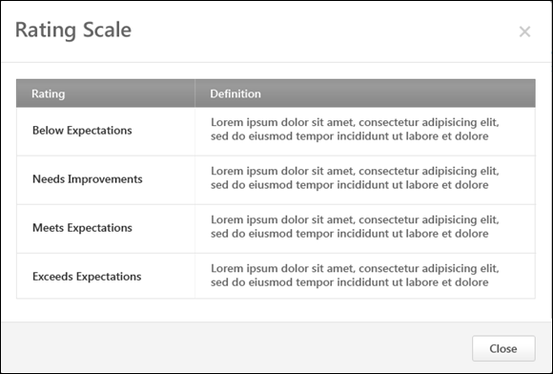
To view the rating definitions, click the Question Mark icon to the right of the rating scale. This opens the Rating Scale pop-up, which displays the ratings and their definitions. Note: The ratings and their definitions are configured by the administrator.
Performance Review - Review Sections
On the left side of the performance review, the navigation menu displays all sections along with their completion status. Reviewers can click a section tab to access the section.
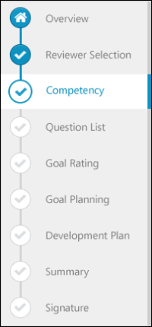
The icon to the left of the section title indicates the section status:
- Selected Section - The section that is currently selected.
- Completed Section - A completed section. A section is considered complete when all required fields are completed. If the section has no required fields, then the user must view the section for it to be considered complete. The Summary section is considered complete once all sections that are included in the Summary have been completed.
- Not Started/In Progress Section - Section is not started or in progress.
- Future Step Section - Section is currently not available because it will be completed in a future step of the performance review. You cannot view these sections until the reviewer is able to access the sections in a later step.
- Overview Section - The overview page.
- Discuss Review - If review discussion is enabled for the performance review, the Discuss Review page is always available below the review sections in the navigation menu. When this section is selected, the speech bubble is colored.
When viewing a read-only version of a previously completed task, the navigation menu displays section statuses as they were at the time of the review submission or expiration.
Performance Review - Select Competencies Pop-up
When completing a Competency Rating step within a performance review, the reviewer can select additional competencies on which to rate the reviewee.
To select additional competencies, click the Select Competencies button. This opens a pop-up to select the competencies you want to add to the review. The ability to select additional competencies is determined by the system administrator.
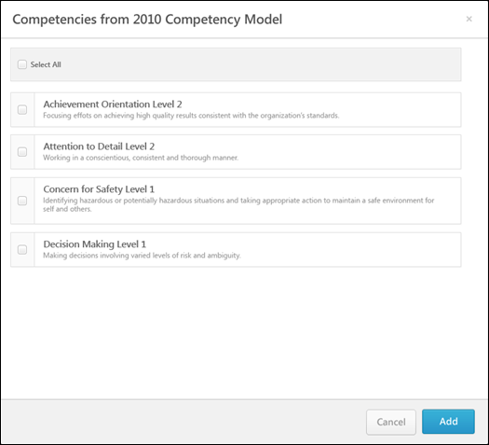
Select Competencies
- To select a single competency, select the checkbox to the left of the competency name. Multiple competencies can be selected.
- To select all of the available competencies, select the Select All checkbox in the upper-left corner of the competency list.
Add
Click the Add button after selecting the appropriate competencies, .
Add Competency
Some competencies may not automatically appear in the pop-up. To add competencies that do not appear in the pop-up automatically, click the Add Competency button in the upper-right corner of the competency list. This opens the Search Competencies pop-up. See Search Competencies Pop-up for additional information. This option is only available to certain reviewers if enabled by the administrator.
Performance Review - Select Goals Pop-up
The Select Goal pop-up displays the user's goals from the performance review period.
To select additional goals within the Goal Rating section of a performance review, click the Select Goals button. This opens a pop-up where you can select which of the user's goals you would like to add to the review. The ability to select goals is only available if configured to display by the system administrator.
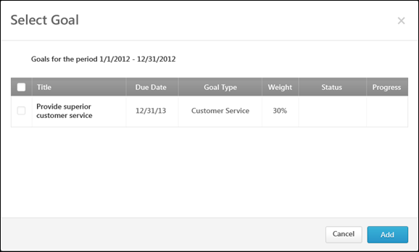
To Select a Goal
- To select a single goal, click the checkbox to the left of the goal title.
- To select all of the goals currently displayed, select the Select All checkbox to the left of the Title column heading in the upper-left corner of the goal list.
Add
Click the Add button to add the selected goals to a performance review.

Performance Review - Options Drop-down
Use the Performance Review Options drop-down to manage tasks associated with a performance review.
Permissions
PERMISSION NAME | PERMISSION DESCRIPTION | CATEGORY

Offline Performance Reviews | Allow users to download and upload offline reviews. This permission works in conjunction with active performance review tasks. If the user has this permission and is assigned one or more steps of an active performance review task, that user may download the review for offline completion. This permission can be constrained by OU and User's OU. This is an end user permission. | Performance

Performance Co-Planner | Enables a manager to name a performance review co-planner if co-planners are enabled for the performance review task. This permission should be assigned to the default user role to avoid constraint issues. This permission can be constrained by OU, User's OU, User Self and Subordinates, User's Manager, and User's Superiors. This is an end user permission. | Performance
When completing a performance review, the following options may be available from the Options drop-down menu:
- Add Co-Planner - Add and remove co-planners for the performance review. This option is only available if the performance review task is configured to allow co-planners and the reviewer has permission to add co-planners. See Performance Review - Add Co-Planner on page 120 for additional information.
- Attachments - Upload attachments to the performance review. This option is only available if the performance review task is configured to allow attachments. See Performance Review - Attachments on page 122 for additional information.
- Employee Details - View details about the reviewee. This option is only available if the administrator has configured additional employee information to be displayed. See Performance Review - Employee Details on page 126 for additional information.
- View Check-Ins - View the Check-Ins Dashboard for the user. See Performance Review - View Check-Ins on page 136 for additional information.
- View Feedback - View the reviewee's social feedback from the performance review period. Only the feedback that is visible to the reviewer on the reviewee's Universal Profile - Feedback page is displayed in the pop-up. This action is only available if enabled by the system administrator when the performance review task is created. In addition, this action is only available if the reviewer has permission to view the reviewee's Feedback page.
- Off-Cycle Summary - View a summary of the reviewee's off-cycle performance reviews. This option is only available if it is enabled by the administrator when configuring the performance review task. See Performance Review - Off Cycle Summary on page 127 for additional information.
- Competency Summary - Download an Excel file that summarizes all of the competencies on which the employee is rated within off-cycle performance review tasks. See Off-cycle Reviews - Competency Summary File on page 129 for additional information.
- View Peer Selectors - View which peer reviewers were selected and who selected them. See Performance Review - View Peer Selectors on page 137 for additional information.
- Complete Offline - Download the performance review to be completed offline. This option is only available for users who have permission to download offline performance reviews.
- Upload Review - Upload the completed review file into the system. This option is only available if the reviewer has the permission to download offline performance reviews and if the review task includes at least one Question List, Competency Rating, or Goal Rating section for the reviewer to complete. See Performance Review - Upload Review on page 133 for additional information.
- Print Review - Print the performance review. This option prints all sections of the performance review, including all submitted responses.
- Print Reviewee Version - Print the performance review. This option prints only the sections that are visible to the reviewee. This option is only available to reviewers who are reviewing a subordinate.
Performance Review - Add Co-Planner
The Add Co-Planner option lets managers with the appropriate permission add co-planners for a performance review, if enabled. This ability is enabled by the administrator, and when available, the Add Co-Planner option is available from the Options drop-down within the performance review. Co-planners can perform reviews as though they were the manager who was assigned the review task. This can be useful for managers to delegate reviews for certain review tasks.
Note: Competency Assessment sections should be completed by the review step assignee and should not be completed by co-planners. If a co-planner completes a Competency Assessment section or provides comments, it will display and be saved as if the manager provided the ratings and comments.
To access the Add Co-Planner option, open the performance review page and click Add Co-Planner option from the Options drop-down.
Permissions
PERMISSION NAME | PERMISSION DESCRIPTION | CATEGORY

Performance Co-Planner | Enables a manager to name a performance review co-planner if co-planners are enabled for the performance review task. This permission should be assigned to the default user role to avoid constraint issues. This permission can be constrained by OU, User's OU, User Self and Subordinates, User's Manager, and User's Superiors. This is an end user permission. | Performance
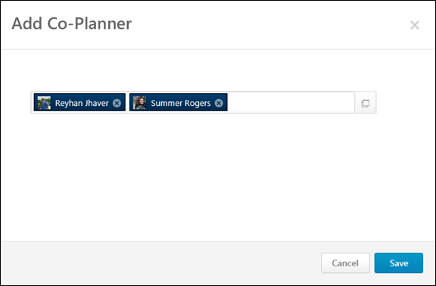
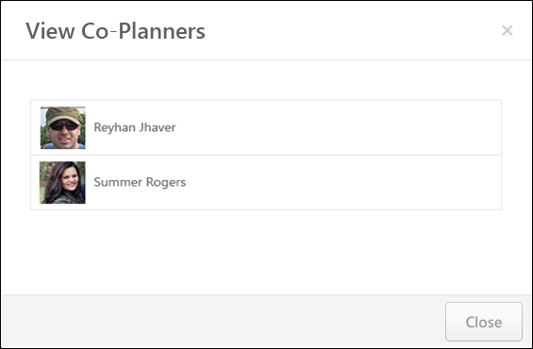

Add Co-Planner
To add a co-planner:
- Click the Add Co-Planner option from the Options drop-down. This opens the Add Co-Planner pop-up.
- Enter a name in the field. Predictive search is used to display users who match the entered text as it is entered. Managers can also click the Select User button to search for and select co-planners. The selected co-planners then appear in the field. There is no limit to the number of co-planners that can be added.
If the performance review task has been submitted and a user opens the task in read-only mode, the previously selected co-planners display in read-only mode.
Remove a Co-Planner
To remove a selected co-planner, click the Remove icon to the right of the co-planner's name.
Performance Review - Attachments
Attachments can be added to a performance review.
To view, add, or remove attachments, open the performance review and click Attachments from the Options drop-down. This option is only available if the performance review task is configured to allow attachments.
The following rules apply to performance review attachments:
- Attachments can be up to 1 MB in size and are limited to ppt, pptx, doc, docx, pdf, jpg, jpeg, jpe, png, txt, gif, zip, xls, xlsx, csv, psd, bmp, rtf, msg, xml, and saz file types.
- Attachments are visible throughout the review, but do not display on the printable version.
- Files can be added by the reviewee, but reviewees can only remove files that they have uploaded. If the manager attaches a file to the review, the reviewee cannot remove it.
- Managers and other reviewers can both add and remove attachments, regardless of who uploaded them.
- Files cannot be uploaded during peer and direct report review steps.
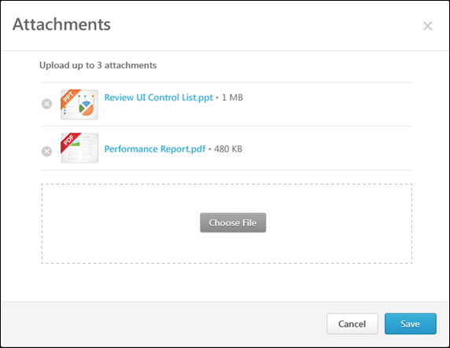
Add an Attachment
To add an attachment:
- Click the Choose File button and select the file. You can add up to three attachments throughout the review process. Attachments can be up to 1 MB in size and are limited to ppt, pptx, doc, docx, pdf, jpg, jpeg, jpe, png, txt, gif, zip, xls, xlsx, csv, psd, bmp, rtf, msg, xml, and saz file types.
- Click the Save button to save the attachments to the review.
Download an Attachment
To download an attachment, click the attachment name.
Remove an Attachment
To remove an attachment, click the Remove icon to the left of the document title.
Performance Review - Decline Review
For off-cycle reviews, a dynamically selected reviewer (manager, indirect manager, custom relationship, or specific user) can decline to complete a review if they feel they are not the most appropriate person to complete the review. Note: This option is only available for off-cycle reviews.
- Only dynamically selected reviewers who are selected by a reviewer selector can decline a review.
- Peers and subordinates cannot decline a review.
- Reviewers who are reviewer selectors cannot decline a review.
The ability to decline a review is only available before the reviewer submits their first step. Once they submit their first step, the Decline Review option is removed.
To decline a performance review, open the appropriate performance review.
Emails
EMAIL NAME | EMAIL DESCRIPTION | ACTION TYPE

Performance Review Reviewer Declined | This email is triggered when a reviewer declines a review.  The available recipients are Reviewee, Reviewer (the declining reviewer), and Review Selector (the user that selects the reviewers. | Performance Management
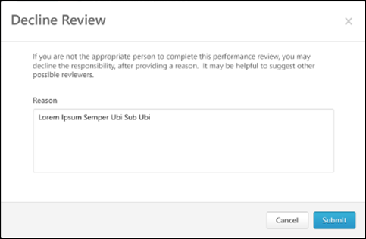
Decline a Review
Note: The Decline Review button is only available for an off-cycle performance review task if the administrator has enabled the feature when creating the review task.
To decline a review:
- In the Reason field, enter the reason why you are declining the review. This field is required, and the character limit is 500.
- Click Submit. The declined reviewer's reason for declining is added to the review task discussion as a public comment.
When the review is declined, the reviewer selector is notified. A Reviewer Selection task is generated in the reviewer selector's My Assigned Reviews page and in the My Tasks widget on the Welcome page. An email notification is also triggered if the Performance Review Reviewer Declined email is enabled. The reviewer selector must then open the review task and select a new reviewer.
Performance Review - Employee Details
The Employee Details option lets you view details about the reviewee.
To view details about the reviewee, open the performance review and click the Employee Details option from the Options drop-down. This opens the Employee Details pop-up. This option is only available if the administrator has configured additional employee information to be displayed. Additionally, the administrator can configure which information is displayed when creating the performance review task.
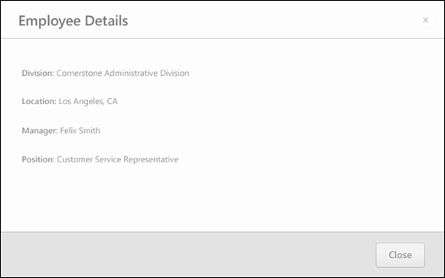
Performance Review - Off Cycle Summary
The Off Cycle Summary option displays a summary of the reviewee's off-cycle tasks in order to inform the reviewer of off-cycle review results throughout the review period. The Off-Cycle Summary option is only available to the reviewee, manager, indirect manager, and custom relationships. The section does not appear to peers or direct reports.
To view the reviewee's off-cycle summary, open the performance review and click the Off Cycle Summary option from the Options drop-down. This opens the Off Cycle Summary pop-up. This option is only available if it is enabled by the administrator when configuring the performance review task.
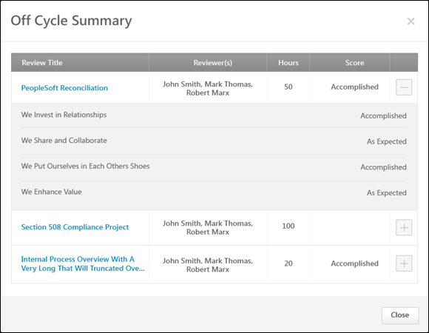
Off-Cycle Summary Table
The Off-Cycle Summary table includes the information about off-cycle tasks that were selected by the administrator. Only completed tasks are included and the tasks appear in chronological order by completion date. The following information for each off-cycle review task is displayed:
- Review Title - Title of the off-cycle review task. Click the title to open a printable version of the completed off-cycle review.
- Reviewers - Names of each reviewer in alphabetical order by last name. If no reviewer names are included by the administrator, then this column does not appear.
- Custom Fields - After the reviewers and before the review score, custom fields may appear. The custom fields are displayed in alphabetical order by field name. If a custom field is not defined for the reviewee, the field is left blank, and if no data exists for all instances of the custom field, the custom field column does not appear.
- Score - If enabled by the administrator, displays the overall review score. The format of the score matches the format of the task configuration. The review score visibility settings are maintained in this table, so if certain reviewers cannot view the score, then it is not displayed.
- Section Title and Score - If enabled by the administrator, each off-cycle review task can be expanded by clicking the expand icon to the right of the Score column. When the review task is expanded, each ratable section within the review is displayed along with the section score. Only Goal Rating, Competency, and Question List sections are displayed. Sign Off and Goal Planning sections are not included. The review score visibility settings are maintained in this table, so if certain reviewers cannot view the score, then it is not displayed.

Off-cycle Reviews - Competency Summary File
The Competency Summary file includes a summary of each competency rating included in the off-cycle tasks.
Within the file, each review task is listed as a separate column, ordered chronologically by review task completion date.
The first rows display the custom fields that are included in the off-cycle review tasks along with their values. The custom fields are listed in the order in which they were added to the Off-Cycle Summary table.
Following the custom fields, each competency is listed in alphabetical order. The scores for each competency are displayed for each review. The scores are taken directly from the review, and they are not averaged. The format of the score matches the configuration of the review section from which they are taken.
To view the Competency Summary file for an off-cycle review, select the Competency Summary option from the Options drop-down.
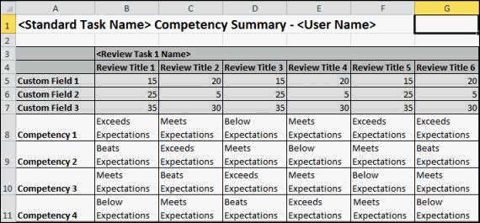
Performance Review - Reopen Previous Step
Reviewers (manager, indirect manager, custom relationship, or specific user) may have the ability to reopen previous steps in a performance review. This ability is enabled by the administrator when configuring the performance review task, and when available, the Reopen Step button appears at the bottom of the Review Step Progression section on the Overview page. This can be useful for reopening steps that should be corrected by a reviewer or for reopening steps that are past due.
The following applies when reopening a previous step:
- You can only reopen one review step at a time. If a previous step has been reopened by another user, then this option is not available.
- Reviewees, peers, and subordinates cannot reopen a step.
Emails
EMAIL NAME | EMAIL DESCRIPTION | ACTION TYPE

Performance Review Step Reopened | This email is triggered when a performance review step is reopened in order to alert or remind the user that a performance step has been reopened. When configured, this email is triggered any time a step is reopened, whether it is done by a manager or administrator. This email can be sent to Reviewee, Reviewee's Direct Manager, Reviewee's Indirect Manager, Reviewer, or a specific user.  The REOPEN.STEP.COMMENT tag displays the Reason commentary that was provided when the review step was reopened.  The REVIEW.REOPENED.STEP.DUE.DATE email tag displays the due date of the performance review step that is reopened. If no due date is defined for the step, then "No Due Date Defined" is displayed.  The system verifies that the review step is still due prior to triggering the email, so if the review step is no longer due, then this email is not triggered.  Reviewee will not receive any step email other than the self step and Similarly, a reviewer cannot receive any email for a Reviewee step. | Performance Management
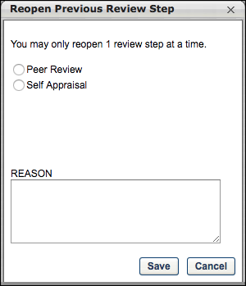
Reopen a Step
- Click the Reopen Step button to open a pop-up which lists all previous steps that are either completed or past due. When reopening a peer or direct report review step, managers can reopen the step only for select specific users. Managers cannot reopen a step assigned to them.
- Select the appropriate step. If the step has multiple reviewers, select the appropriate reviewers. In the Reason field, enter the reason or explanation that will be sent to the person associated with the reopened step via the Performance Review Step Reopened email trigger. This field accepts a maximum of 3,000 characters. Click Save to reopen the step.
When a step is reopened, a new task appears to the step role owner in:
  - Scheduled Tasks page
  - My Tasks widget on the Welcome page
  - My Assigned Reviews page
The reopened step is open for submission until the task expiration date, but may vary slightly from the original step:
- The ability to edit comments, ratings, and weights is unaffected.
- The ability to view and edit custom fields is unaffected.
- If any later reviewers entered or edited comments, ratings, weights, or fields, then the reopened step displays the updated information if they are visible to the reviewer.
- If the owner of the reopened step also owns a later step in the review, both steps can be open and accessed at the same time.
  - The sections from all opened steps appear to the reviewer in the left navigation panel.
  - All information previously entered by the reviewer from the reopened step can be edited.
- Reopening a step sends out the appropriate Step Assigned emails (if the emails are enabled). Also, the reopened task displays again in the appropriate user's Scheduled Tasks page and the My Tasks widget on the Welcome page.
- On the Scheduled Tasks page, reopened steps display regardless of whether or not the Display Completed/Expired options are selected.
- Within the pop-up, all previous steps are displayed with the following exceptions:
  - Reviewers cannot reopen their own step.
  - Reviewers cannot reopen a reviewer selection step if the reviewer selections have been made and submitted.
  - Skipped steps cannot be reopened.
Frequently Asked Questions
When a step is reopened, how does the step appear in the system to the user who reopened the step?
For the user who reopens a previous step, their step in the task still appears with a status of Completed. The Completed status of the user's step does not change when they reopen a previous step. Example:
Performance Review - Upload Review
Reviewers may be able to download a performance review from within the performance review task. After completing the review offline, reviewers can upload the completed review file into the system.
The ability to download and upload performance reviews is only available if the reviewer has permission to download offline performance reviews and if the review task includes at least one Question List, Competency Rating, or Goal Rating section for the reviewer to complete.
Only reviews that are In Progress or Not Started are eligible to be completed offline.
- If the task is configured to allow users to submit reviews after the due date, then reviews that are Past Due can also be downloaded and uploaded.
- If the task is configured to allow multiple submissions, then reviews that are Complete can also be downloaded and uploaded.
To upload the completed performance review file, open the performance review page and click the Upload Review option from the Options drop-down. This opens the Upload Your Performance Review pop-up. This option is only available if the performance review task is configured to allow attachments.
Permissions
PERMISSION NAME | PERMISSION DESCRIPTION | CATEGORY

Offline Performance Reviews | Allow users to download and upload offline reviews. This permission works in conjunction with active performance review tasks. If the user has this permission and is assigned one or more steps of an active performance review task, that user may download the review for offline completion. This permission can be constrained by OU and User's OU. This is an end user permission. | Performance
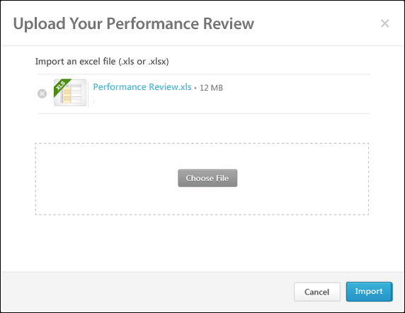
Upload Review
From the pop-up, click the Choose File button to select the completed review file (xls or xlsx). After selecting a file, click the Import button.
- If a valid performance review file is uploaded, the Upload Validation pop-up opens. See the Upload Validation section below for additional information.
- If an invalid performance review file is uploaded, an error message is displayed.
Upload Validation
If a valid performance review file is uploaded, the Upload Validation pop-up opens, which displays the upload status and validation details for the uploaded offline performance review. Each of the performance review sections are displayed in the order in which they appear in the performance review step.
To the left of each performance review section, the validation status of the review section is displayed.
- If a section does not require user input, N/A is displayed as the validation status.
- If a section is completed correctly with valid data, a green check icon is displayed .
- If a section is not completed correctly or if there is invalid data, a red warning icon is displayed . In addition, each error that exists is displayed below the section title. The cell name that caused the issue is also displayed. The potential errors are:
  - Rating out of range - A numeric rating is below 1 or above the maximum value.
  - Invalid numerical rating - A rating is not a multiple of 1, .1, or .5, depending on the rating scale configuration.
  - Invalid text rating - A text or text/numeric rating is not one of the configured options.
  - Required field missing - A rating or required comment is missing.
  - Comments character limit exceeded - A comment exceeds the character limit of 10,000.
- If a section contains errors, you cannot save that section. You must correct the errors using the cell numbers and error descriptions and then re-upload the file by pressing the Re-upload button.
- If the file is tampered with, an error message is displayed and the file cannot be saved.
- Only sections with green check icons can be saved. Click the Save button to save the validated sections. All sections with no errors are imported into the system. All uploaded data overwrites any data previously submitted.
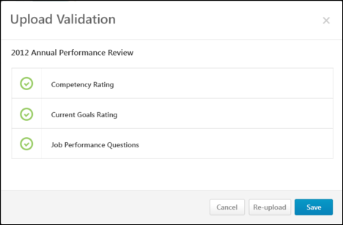
Performance Review - View Check-Ins
The View Check-Ins option takes reviewers to the user's Check-Ins home page. This option is only available if the user has permission to create a check-in or has had at least one check-in with another person. The information that you see is based on the following:
With Check-Ins - Create Permissions
- For a reviewer reviewing an employee (such as a manager reviewing an employee)
  - If check-ins between the two are available, this option opens a list of their check-ins in a new tab.
  - If the reviewer has not had check-ins with the reviewee, this option opens the Check-Ins landing page in a new tab.
- For self-reviewers, this option opens the Check-Ins landing page in a new tab.
To access the Check-Ins home page, open the performance review page and click the View Check-Ins option from the Options drop-down.
For information about Check-Ins, see Check-Ins Home Page.
Permissions
PERMISSION NAME | PERMISSION DESCRIPTION | CATEGORY

Check-Ins - Create | Grants ability for the user to create and update Check-Ins. The permission constraints determine with whom the user can create Check-In discussions. This permission can be constrained by OU, User's OU, User Self and Subordinates, User, User's Subordinates, User's Direct Reports, User's Self, User's Manager, User's Superiors, and Employee Relationship. Users with constraints in the “Check-Ins - Create” permission cannot create a new Check-In with anyone who is not part of the constraints, but can still view and update any Check-In in which they are a participant.  This is an end user permission.  Note: Permission constraint to Employee Relationship grants permission to dotted line or secondary managers to create Check-Ins with users that report to them in the matrix structure. A constraint "Restricted to Employee Relationship: Detail Supervisor" means that the Detail Supervisor can create a Check-In with their indirect subordinate but the indirect subordinate cannot create a Check-In with their Detail Supervisor. | Performance
View Check-Ins
Performance Review - View Peer Selectors
You can view selected peer reviewers were selected and who selected them.
Note: This functionality is only available for organizations using the redesigned performance reviews.
To view which peer reviewers were selected and who selected them, click the View Peer Selectors option from the Options drop-down. This opens the Peer Reviewer Selection pop-up.
Permissions
PERMISSION NAME | PERMISSION DESCRIPTION | CATEGORY

Offline Performance Reviews | Allow users to download and upload offline reviews. This permission works in conjunction with active performance review tasks. If the user has this permission and is assigned one or more steps of an active performance review task, that user may download the review for offline completion. This permission can be constrained by OU and User's OU. This is an end user permission. | Performance

Performance Co-Planner | Enables a manager to name a performance review co-planner if co-planners are enabled for the performance review task. This permission should be assigned to the default user role to avoid constraint issues. This permission can be constrained by OU, User's OU, User Self and Subordinates, User's Manager, and User's Superiors. This is an end user permission. | Performance
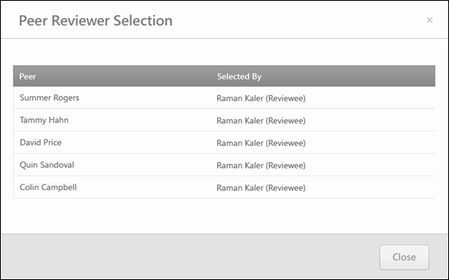
This option:
- Only appears for managers, indirect managers, and custom relationships. This link is not available for peers, a reviewee's subordinates, and reviewees.
- Only appears if the review contains peer group review steps that are configured so that peers are selected by other reviewers.
If a reviewer is selected, the Peer Reviewer Selection pop-up displays the name of any peer reviewer that has been selected for the reviewee.
- Peer - This column displays the selected peers.
- Selected By - This column displays the user that selected the corresponding peer. The reviewer selector's role is displayed in parenthesis to the right of their name.

Performance Reviews - Batch Rating
The Batch Rating page for a performance review enables reviewers to view reviewees within the same performance review task on a single page, provide ratings and comments, more quickly complete performance reviews, and view a high-level overview of all reviewees.
The Batch Rating page is available to all active relationships except self, peers, external reviewers, and subordinates. Also, the Batch Rating page is only available for a performance review task if batch rating is enabled for the performance review task.
Note: The Batch Rating page is used to provide ratings for Competency Rating and Question List performance review sections only.
To access the Batch Rating page, from the Universal Profile - Actions page, click the Launch button to the right of a Batch Rating task.
Permissions
PERMISSION NAME | PERMISSION DESCRIPTION | CATEGORY

Action Items - EPM | Grants ability to view and take action upon Performance (EPM) items on the Action Items page and in the Your Action Items widget. This permission can be constrained by OU, User's OU, User's Self, and User's Self and Subordinates. This is an end user permission. | Universal Profile

View Performance Reviews | Grants ability to view the Performance Reviews page, which displays a user's own past performance reviews as well as performance review task steps they've been assigned to complete. This also grants ability to view the Batch Rating page. This permission can be constrained by OU, User's OU, User Self and Subordinates, and User. This is an end user permission. | Performance
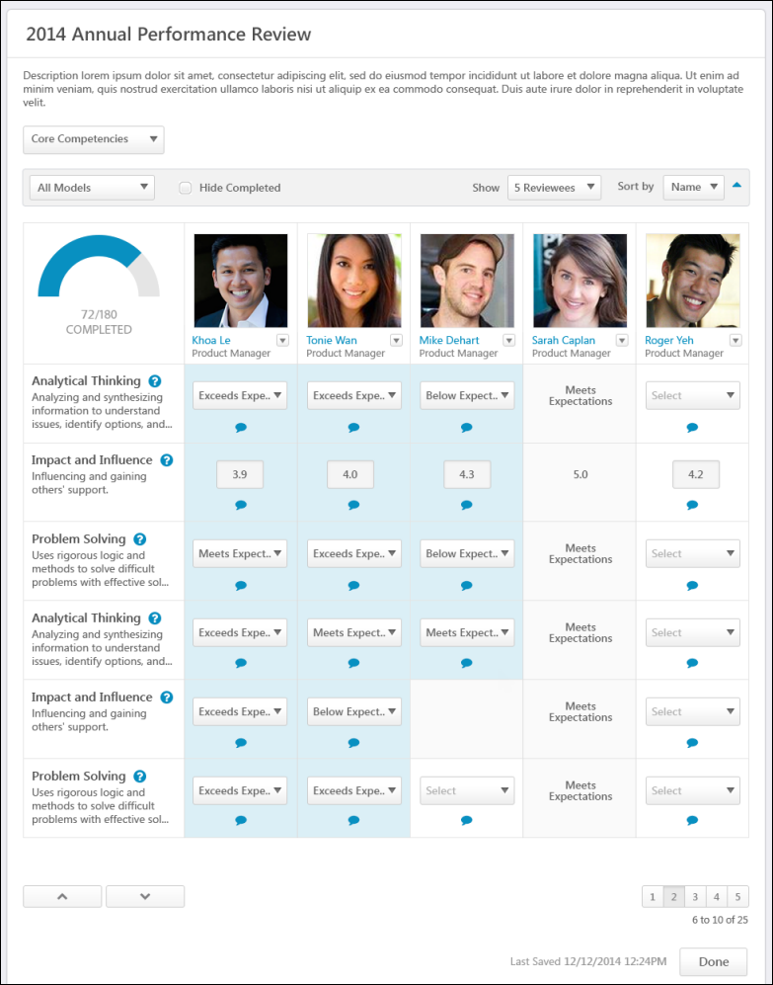
Review Title and Instructions
The performance review task title and the batch rating instructions.
Review Section Tabs
Tab for each performance review section for which batch rating is available. If there are more than four tabs, then all tabs appear in a drop-down menu. The reviewer can select a tab to provide batch ratings for the corresponding review section.
Sort and Filter Options
- Model Filter -Only appears for Competency Rating sections, and this filter is only available when there are multiple competency models within a performance review section. If available, this option enables the reviewer to filter the Batch Rating panel by competency model. When a specific competency model is selected, only the competencies within that model are displayed and only the users who are associated with that model are included in the panel. By default, all models are included and all competency items appear in the panel.
- Hide Completed/Hide Read Only. The following options are available:
  - Hide Completed - When this option is selected, all reviewees whose tasks are completed or read-only are hidden. In addition, any question, competency, or custom field rows that are fully completed are hidden. Note: This option does not consider any items in the Detailed Responses section. That is, a reviewee may be hidden even if items in the Detailed Responses section are not completed.
  - Hide Read Only - When this option is selected, all reviewees whose tasks are read-only are hidden.
This option is unchecked by default.
Important: When this option is selected, entries are not dynamically hidden. That is, the entries are only hidden at the moment that the option is selected. In order to hide new completed items, the reviewer must uncheck and recheck the option.
- Show - The Show option enables the reviewer to set the number of reviewees that are displayed per page. If the reviewer's viewing screen cannot display the number of selected reviewees, then the reviewer can scroll horizontally to view additional reviewees. By default, five reviewees are displayed.
- Sort by - Enables the reviewer to sort the reviewees on the Batch Rating page. The following sort options are available:
  - Name - This sort option is selected by default.
  - Position
  - Remaining Items
  - Hire Date
  - Position Started Date
By default, items are sorted in ascending order. For example, numerical values are sorted lowest to highest (0 to 9), dates are sorted earliest to most recent, and characters are sorted alphabetically (A to Z). The reviewer can reverse the sort order by clicking the Arrows icon to the right of the Sort by option.
When a different sort option is selected, the reviewer is automatically navigated to the first page of reviewees.
Batch Rating Panel
Displays the reviewer's overall completion, the available reviewees, and review items.
Overall Completion Progress
Displays the number of ratings that have been provided for the section and the total number of ratings that are required for the section are displayed. For example, if the reviewer provided a 72 rating and is required to provide 180 ratings, then "72/180 COMPLETED" is displayed. The gauge visually represents the reviewer's completion progress. As the reviewer provides a rating, the rating count and the gauge are updated to reflect the reviewer's real-time progress.
The following items are not counted in the number of required ratings and do not impact the overall completion progress:
- Questions with no ratings
- Checkbox type custom fields
- Scrolling Text type custom fields
Reviewees
Displays reviewees who are included in the performance review step. Depending on the filter and sort options, this may include reviewees who need to be rated and reviewees who have already had this review section completed. Click the reviewee's name to open the reviewee's Universal Profile page.
The reviewee's position is displayed below their name.
Launch Review for Reviewee
Reviewers can launch the performance review for an individual reviewee by clicking the Actions drop-down icon to the right of the reviewee's name and selecting Launch Review.
Reviewee Pagination
The Show option at the top of the Batch Rating panel determines the number of reviewees that are displayed on a page. If more than the selected number of reviewees are available for batch ratings, then pagination options appear in the lower-right corner of the panel.
- Click a specific page number to go directly to that page.
- To move one page forward or backward, click the right or left arrow icon.
- To move to the first or last page, click the double left or double right arrow icon.
Competencies/Questions/Custom Fields
Displays the competencies, questions, or custom fields:
- Competencies - Displays the competency name and the following lines display the competency description. If the full competency name or description cannot be displayed, hover the cursor over the name or description to view the full text. To view the rating scale associated with the Competency Rating section, click the Question Mark icon to the right of the competency name.
- Questions - Displays question text. If the full question text cannot be displayed, hover the cursor over the text to view the full text. To view the rating scale associated with the Question List section, click the Question Mark icon to the right of the question text.
- Custom fields - Displays custom field text. Hover the cursor over the text to view the full text, if necessary.
Rating Item Pagination
Displays rating items. If there are more than 20 available rating items, then Up and Down arrows appear at the bottom of the Rating Item column.
- Click the Down arrow to view the next 20 rating items.
- Click the Up arrow to view the previous 20 rating items.
Ratings
Select or enter a rating for each reviewee for each available competency, question, or custom field. The rating scale and the rating type (numeric, text, or both) are determined by the administrator. Select or enter ratings as follows:
- Text ratings are selected from a drop-down menu.
- Numeric ratings are selected from a drop-down menu unless the rating scale interval is 0.5 or 0.1. In this case, the reviewers must manually enter the rating in a field.
- Star ratings are selected from a drop-down menu.
- Questions without ratings do not have a drop-down or a field in the Batch Rating panel. Reviewers must click the Ratings and Comments icon within the cell to open the Ratings and Comments pop-up, in which the reviewer can enter text to answer the question. See Batch Rating - Ratings and Comments Pop-up on page 145 for additional information.
- Scrolling Text Box custom fields do not have a drop-down or a field in the Batch Rating panel. Reviewers must click the Ratings and Comments icon within the cell to open the Ratings and Comments pop-up, in which the reviewer can enter text to answer the question. See Batch Rating - Ratings and Comments Pop-up on page 145 for additional information.
- Radio Button custom fields appear as a drop-down menu.
If a rating item is not applicable to a reviewee, then an empty, gray cell is displayed for the reviewee.
When a rating is selected, the rating is automatically saved, the reviewee's Section Score is recalculated, and the Overall Completion Progress is updated. Also, the rating cell is shaded to visually indicate that a rating has been selected. This enables the reviewer to clearly see which ratings have not yet been selected.
Access ratings and comments
Click the Ratings and Comments icon to access the ratings and comments for a rating item. This opens the Ratings and Comments pop-up, in which the reviewer can provide a rating and add comments to support or explain the rating. See Batch Rating - Ratings and Comments Pop-up on page 145 for additional information.
- If the review section is configured so that the reviewer cannot add comments, then the reviewer can click the icon to view any existing comments, but they cannot add comments.
- This icon is not available for custom fields that are drop-down, date, numeric, or short text fields.
Detailed Responses
If available, the following items appear in the Detailed Responses section:
- Questions with no ratings
- Checkbox type custom fields
- Scrolling Text type custom fields
These items are not counted in the number of required ratings and do not impact the overall completion progress. In addition, these items are not considered when the Hide Completed option is selected. That is, if these items have not been completed for a user, but all other ratings have been provided for the user, then the user will be hidden when the Hide Completed option is selected.
Last Saved
When a rating is selected, the rating is automatically saved, and this updates the Last Saved date and time, which is displayed to the left of the Done button.
Done
Click Done to return to the Action Items page.

Batch Rating - Ratings and Comments Pop-up
Use the Ratings and Comments pop-up to access and provide ratings and comments from the Batch Rating page.
To access the Ratings and Comments pop-up, click the Ratings and Comments icon on the Batch Rating page.
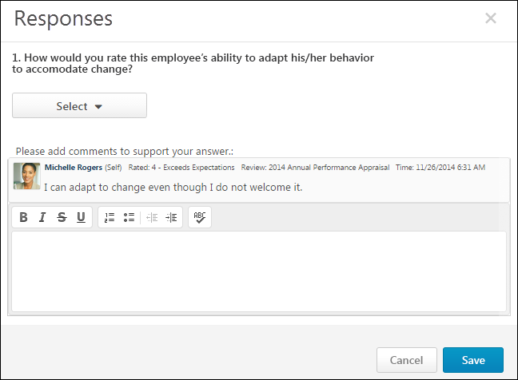
Question or Competency
The question or competency description.
Ratings
Select or enter a rating. The rating scale and the rating type (numeric, text, or both) are determined by the administrator.
- Text ratings are selected from a drop-down menu.
- Numeric ratings are selected from a drop-down menu unless the rating scale interval is 0.5 or 0.1. In this case, the reviewers must manually enter the rating in a field.
- Star ratings are selected by clicking the appropriate rating.
- Radio Button Custom Fields appear as a drop-down menu.
Comments
Enter comments explaining the selected rating. For example, if you selected a poor rating, explain why the rating was selected. The total character limit for comments is 10,000. Please modify accordingly. Note: Comments might be captured in different formatting styles which might not truly reflect total calculated character count.
- To check the spelling of the text box contents, click the ABC icon in the text box toolbar. This opens the Spell Checker pop-up.
- If you have a need to copy and paste content into a performance review, please be sure to right-click the field into which you are pasting the content, and select the "Paste" option. You can also perform the same action by pressing [Ctrl]+[Shift]+[V]. This will ensure any formatting HTML does not get inserted into the text.
When adding a comment, an HTML safe list is used for the Comments field. The system only accepts certain customizable HTML elements in the WYSIWYG Editor. Elements that are not acceptable display as text. See Safe Listed Customizable Elements.
The Comment Assistant is not available within the Ratings and Comments pop-up.
Multiple Reviewers/Co-Planners
If a review step has co-planners, each reviewer is able to enter their own comments and modify the review ratings. Comments are attributed to the user who submitted them, so each comment appears distinct and separate. In addition, any comments that have been saved, but not submitted are viewable by the assignee and the co-planners.
- If a co-planner is the first user to access a review section, the co-planner is able to select a rating and enter comments, if the rating option and comment box are enabled for the co-planner.
- If a co-planner accesses a review section that has been saved but not submitted by the assignee or another co-planner, then the system displays the following:
  - Ratings values are pre-selected with the rating that was selected by the assignee or another co-planner. Note: The rating option only appears if the task is configured for the section to accept comments from the corresponding assignee.
  - An empty comment box appears for the co-planner to enter comments. Note: The comment box only appears if the task is configured for the section to accept comments from the corresponding assignee.
  - A response section containing the rating applied by the assignee or another co-planner. This section displays the assignee or co-planner name, rating, and comments. "(Co-Planner)" appears next to all co-planner names. Note: The rating and comment only appear if the task is configured for the section to accept ratings and comments from the corresponding assignee.
Any comments are attributed to the reviewer who entered them. Ratings are attributed to the user who was the last to apply or modify the rating. For example, if Co-planner A applies a rating to a question, and then Co-planner B modifies the rating for the question, then the rating is attributed to Co-planner B. However, if Co-planner B does not modify the rating, then the rating is attributed to Co-planner A.
When viewing reviewer comments, the comments from the review step assignee are displayed first, followed by comments from the step co-planners in alphabetical order based on last name. The most recent comments are displayed first.
Done
Click Save to save the rating and comments. Or, click Cancel to discard the unsaved rating and comments and return to the Batch Rating page.

Performance Reviews - Bulk Sign Off
Use the Performance Review Signature Sign Off page to electronically sign off on current performance review tasks in bulk. Reviewers still have the option to sign off on reviews individually. This page must be enabled by the administrator via Navigation Tabs and Links. Note: Reviewers cannot sign off on their own reviews via this page.
To electronically sign off on performance review tasks in bulk, go to Performance > Review Sign Off.
Permissions
PERMISSION NAME | PERMISSION DESCRIPTION | CATEGORY

Performance Review Bulk Sign Off | Enables reviewers to electronically sign off on current performance review tasks in bulk. This permission cannot be constrained. This is primarily a manager permission. | Performance

Task - View | Grants ability to view assigned tasks via Scheduled Tasks screen and Welcome Page My Tasks widget. This is an end user permission. | Core
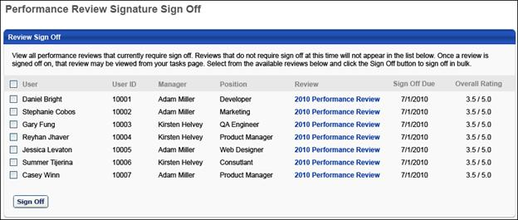
The Performance Review Signature Sign Off page displays all performance reviews that currently require sign-off from the reviewer. Reviews that do not require sign-off do not appear in the list, and once a review is signed off on, the review no longer appears on this page.
Note: Reviewers can only utilize the Bulk Sign Off functionality for performance reviews that are configured to use the Electronic sign-off method. In addition, the Bulk Sign Off functionality can only be used if the Sign Off section is the only section in the step.
The following information is displayed for each reviewee:
- User - Reviewee's name
- User ID - Reviewee's system ID.
- Manager - Reviewee's direct manager.
- Position - Reviewee's position title.
- Review - Performance review title. To view the current printable version of the reviewee's review, click the review title in the Review column.
- Sign Off Due - Due date of the review step that contains the Sign Off section for the user for each review.
- Overall Rating - Reviewee's current overall rating for the review. This value is displayed in either numeric or text form, depending on the review task configuration. Because the review task is still In Progress, the overall rating may not be final and could change.
To electronically sign off on a group of performance reviews in bulk:
- Select the checkbox for the appropriate reviews. To select all reviews, select the checkbox to the left of the User heading.
- Click the Sign Off button. This opens a Performance Review Sign Off pop-up.
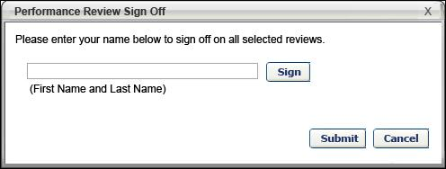
- Enter your full name and click the Sign button to record the e-signature. The signature appears based on the user's signature preferences. To make an edit to the name, click the Re-Sign button.
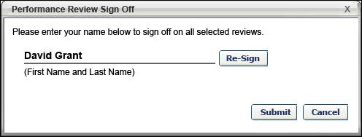
- Click Submit to apply the e-signature to all of the selected reviews. Once the reviews are signed off, they no longer appear in the Performance Review Signature Sign Off page. The task is removed from the Your Tasks widget. You can access the signed off reviews from your Tasks page.

Launch Off-cycle Performance Review
Use the Launch Performance Review page to launch off-cycle performance reviews. When launching the performance review, the user can select the reviewee, the review task they are launching, and they can enter the purpose of the review.
A user can launch as many concurrent off-cycle reviews of the same task as necessary.
You can access the Launch Performance Review page as follows:
- Click the Launch Off-Cycle Task link from the Performance Review Details page.
- Click the Launch Review button from the Performance Review Summary page.
- Click the Launch Review link for a subordinate in My Team > Activities or My Team > Performance > Reviews.
Permissions
PERMISSION NAME | PERMISSION DESCRIPTION | CATEGORY

Launch Off-Cycle Performance Review Task | Enables a user to launch an off-cycle performance review task. Having this permission does not guarantee that the user can launch an off-cycle review, only that they will have access to the Launch Performance Review page. A task must still be configured properly for the user to successfully launch an off-cycle review task. This permission works only if user has been designated to launch at least one currently active off-cycle performance review task. This permission can be constrained by OU, User's Subordinates, and Employee Relationship. This is an end user permission and does not apply to an administrator role.
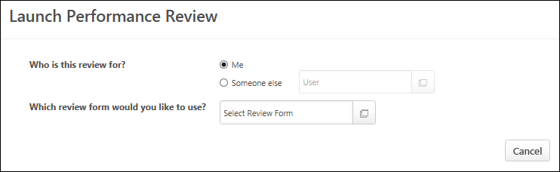
Who is this review for?
Using the radio buttons, select the reviewee for the review you are launching.
- Me - Select this option if you are launching a review for yourself.
- Someone else - Select this option if you are launching a review for someone else. You must then click the User field to select the appropriate user. Only one user can be selected.
- If a user accesses this page by clicking the Launch Review link in My Team, then the "Someone else" option is automatically selected and the reviewee is pre-populated with the appropriate My Team user.
- If an administrator accesses this page by clicking the Launch Off-Cycle Task link on the Performance Review Details page, then the administrator must click the Add Users link to select reviewees for the task. The administrator can select as many users as necessary.
Which review form would you like to use?
Click the Select Review Form field to select the appropriate review form. If necessary, use the search functionality to locate the review form.
- A review form is only available if it is available for the reviewee and can be assigned by you.
- A review form is only available if it either does not have a fixed end date or if the fixed end date has not yet passed.
- A review form is not available if there is a fixed end date and there is not sufficient time to complete all steps in the review.
- If there is only one review form you can assign to the selected reviewee, then that task is automatically selected and this cannot be changed.
- If an administrator accesses this page by clicking the Launch Off-Cycle Task link on the Performance Review Details page, then the review form is pre-populated with the appropriate form, but can be changed if necessary.
What is this feedback for?
This text is customizable by the administrator and may appear differently based on the review task configuration. This question only appears once a review task is selected. In the field, enter the purpose of the review task. The character limit for this field is 100.
To customize this text. Edit a task > Review Summary > User Prompt for Review Title.
What is the review period?
This option only appears if the selected review task is configured to allow the task assigner to define the review period for the task. Using the From and To calendar fields, select the start and end date of the review period. Once a review period is specified, it cannot be modified.
Task Preview
Once the review task is selected, a preview of the task displays, including the description and workflow.
Launch
Select the Launch button to launch the review. All users who have tasks assigned to them can see the review in their Scheduled Tasks page as well as their Performance Review Summary page.
- See Scheduled Tasks.
- See Performance Review Summary on page 7 for additional information.
Frequently Asked Questions
Can I assign an off-cycle performance review task to a group of users or an organizational unit?
No, off-cycle performance review tasks can only be assigned to a single user.
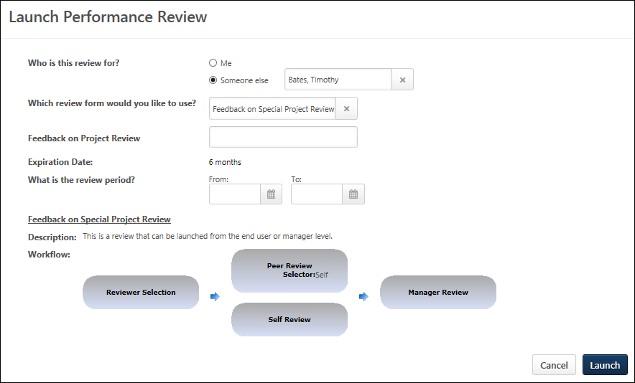

External Reviewers
External reviewers can serve as reviewers if they are added to a peer group. External reviewers have certain limitations.
When an external user is assigned a review task, an email is sent that contains a link to the performance review task. This link is the only way an external user can access the review task. When viewing the review task, all top level navigation and settings functionality is removed.
External reviewers cannot:
- Decline a review
- Reopen steps
- Make a public comment on a review (they are able to make private comments)
- Assign development actions
- Serve as reviewer selectors
- Complete goal planning sections
- Add co-planners
- Edit custom fields

View and Print Performance Review
You can view and print a Performance Review PDF as follows:
- Within a performance review, click the Print Review or Print Reviewee Version option from the Options drop-down. Note: The Print Reviewee Version option is only available to reviewers who are reviewing a subordinate, and this version only includes the sections that are visible to the reviewee.
- From the Universal Profile - Action Items page, select the Print PDF option from the actions drop-down menu to the right of the review.
- From the Universal Profile - Snapshot - Reviews page, select the Print Review option from the actions drop-down menu to the right of the review.
- From the My Team - Performance - Reviews page, click the performance review title.
- From the Scheduled Tasks page, click the title of a Completed or Expired performance review task.
The performance review PDF respects the visibility settings that are configured for the performance review task. Information that is configured to not show is not included in the PDF until the configured visibility conditions have been met.
The printable performance review is locked at the time the performance review is completed. All goal details in the printable performance review reflect the goals as they were at the time of the performance review. Any changes that are made to the goal details after the performance review are not displayed in the printable performance review.
When a reviewee opens the printable version of their performance review, they can view any responses they have submitted. Also, if the reviewee is allowed to view peer or direct report responses and the minimum number of responses have been submitted, the reviewee can view any responses submitted by peers or direct reports. Peer and direct report ratings are displayed anonymously to the reviewee. The reviewee may or may not be able to view manager responses, depending on settings set by the administrator.
When a peer or direct report opens the printable version of a review in which they are a reviewer (i.e., they are opening a review they have completed as a peer or direct report), they can view only their own responses.
Print Performance Review
Click the Print Performance Review link. The Print Review pop-up opens.
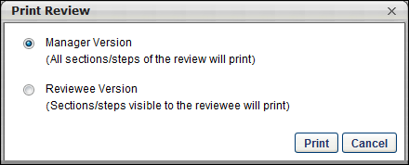
The following options are available in the Print Review pop-up:
- Manager Version - This option prints all sections of the performance review, including all submitted responses.
- Reviewee Version - This option prints only the sections that are visible to the reviewee.
Shared Goals
If the goal planning section is configured to include shared goals, then any shared goals that overlap with the performance review period are also included in the performance review PDF. Shared goals appear exactly as individual goals appear. There is no indication as to which goals are shared.
Printable Version Locked Scenarios
- For performance review tasks that are in progress, the printable performance review task displays goal details as they currently exist.
- For performance review tasks that have been completed or expired, the printable performance review task displays the goal details as they were when the task was completed or expired.
  - For performance review tasks that have been expired, then extended, and are currently in progress, the printable performance review task displays goal details as they currently exist.
  - For performance review tasks that have been completed for an employee and a step is reopened, the following occurs:
    - The performance review step that is reopened displays goal details as they currently exist. Any updates to the goal details after the task is completed are reflected within the reopened step.
    - If the reopened step is resubmitted, the printable performance review displays the goal details at the time the reopened step is submitted.
    - If the reopened step is not resubmitted before the task expires, then the printable performance review displays the goal details at the time the performance review task is first completed (i.e., before the step was reopened).
  - For performance review tasks in which the last workflow step allows multiple submissions, the following occurs:
    - Each time the step owner reopens the performance review, the system displays the goal details at the time of the submission. If the step owner prints the performance review at that time, the printable review reflects the goal details as they appear within the task.
    - Once the last step is closed and no more submissions are allowed, the printable performance review reflects the goal details at the time of the last submission for the last workflow step.
Printable performance reviews reflect the current Goals Configuration settings as of the day the review is printed. If changes are made to the Goals Configuration, then those changes are reflected in all printable performance reviews, even if those tasks had previously been completed.
Printable performance reviews reflect the current Performance Review Printable View settings as of the day the review is printed. If changes are made to the Performance Review Printable View, then those changes are reflected in all printable performance reviews even if those tasks had previously been completed.
Printable Version Content
The following information may be displayed in the printable version of a performance review. The appearance of the PDF and which information is included in the PDF is configured by the administrator.
- Cover Page - The performance review PDF cover page may display the following information:
  - Logo
  - Task title
  - Task review period
  - Reviewer names and roles
  - Reviewee photograph, name, and up to four employee information attributes. If more than 4 employee info fields are displayed, all of them will be displayed in a separate employee info section rather than on the cover page.
- Report Body - The performance review report body is displayed following the cover page. The performance review report body may display the following information:
  - Header logo
  - Review Overview
    - Review task instructions
    - Employee details - The Employee Details section displays the reviewee's position description and any employee information attributes that were not displayed on the cover page. Note: The Position Description is always included in the Employee Details table.
  - Review section details - Each review section may contain the following information:
    - Section header
    - Section directions
    - Rating scale
    - Custom fields
    - Section details
  - Off-Cycle Summary
  - Review Summary - The performance review summary is displayed following all review sections, if enabled for the review task. The performance review summary may display the following information:
    - Overall rating - The overall rating is displayed as either a numeric or text rating, depending on the task configuration.
    - Section names and ratings - The summary table only displays if enabled for the review task.
  - Sign-off - The performance review Sign-off section is displayed following the Summary section. The performance review Sign-off section displays the required signatures for the review. If signatures have already been provided, then they are displayed in this section.
  - Footer information - The footer that appears on each page of the report body contains the following information:
    - Task title
    - Page number and total number of pages
    - Reviewee name

Performance Review - Data Workflow
Within a performance review, any ratings, comments, and weights that are saved prior to submitting the performance review step are not visible to parallel steps or reports.
The following rules determine when ratings, comments, and weights are and are not finalized.
- Any saved responses are automatically finalized when the performance review step is no longer active. This occurs in the following scenarios:
  - The reviewer submits the performance review step.
  - The review task becomes past due.
  - The performance review step is locked and no more submissions are allowed.
  - The performance review step is advanced by an administrator.
  - The performance review step is submitted via Bulk Sign-off when all sections are completed.
- If multiple submissions are allowed, the following rules apply:
  - Edits that are made after the step is submitted remain in draft until the step is submitted again.
  - Any unsubmitted edits that are made after the step is submitted are not automatically finalized when the performance review step is no longer active.
  - When edits are made after the step is submitted, a notification banner appears at the top of every section of the review step until the step is submitted again. This banner indicates that the latest changes have not been submitted and they will not be finalized until the step is submitted.
- If review steps are reopened, the following rules apply:
  - Edits that are made in a reopened step remain in draft until the step is submitted again.
  - Any unsubmitted edits that are made in a reopened step are not automatically finalized when the performance review step is no longer active.
  - When edits are made in a reopened step, a notification banner appears at the top of every section of the review step until the step is submitted. This banner indicates that the latest changes have not been submitted and they will not be finalized until the step is submitted.
  - As with existing behavior, if any later reviewers entered or edited comments, ratings, weights, or fields, then the reopened step displays the updated information if they are visible to the reviewer.
- If the review step is the final step in the review, the following rules apply:
  - If the final step is locked, then all comments and ratings are finalized when the step becomes past due.
  - If the final step is not locked, then all comments and ratings are finalized at the task end date.
Reviewers who are completing parallel review steps cannot view which goals or competencies are selected for goal and competency ratings. This is true regardless of whether the parallel step is submitted.
Sign-offs and signatures are only committed when the review step is submitted.
Performance Review PDF
Any ratings, comments, and weights that are saved within a performance review prior to submitting the performance review step are not visible in the performance review PDF. Ratings, comments, weights are not visible until the performance review step is submitted or is completed due to automatic workflows such as the performance review task being past due.
The following rules apply when viewing a performance review PDF:
- Reviewer views Reviewee Version - When a reviewer who is not the reviewee views the reviewee version, only committed data is included in the PDF.
- Reviewer views Reviewee Version as Reviewee - When a reviewer is also the reviewee and they view the reviewee version, the following occurs:
  - Uncommitted data is included in the PDF prior to submission.
  - Committed data is included in the PDF after submission.
  - If multiple submissions are allowed or if a step is reopened and edits are made after the step is submitted, a notification banner appears at the top of the PDF until the step is submitted again. This banner indicates that the latest changes have not been submitted and they will not be finalized until the step is submitted.
- View Manager Version - When any user views the manager version, only committed data is included in the PDF.
- View Performance Review PDF - When any user views the performance review PDF from outside of the performance review, only committed data is included in the PDF.
- View Performance Review PDF as Co-planner - If a co-planner views the performance review PDF, they can view any uncommitted data from all co-planners of the step. Either co-planner can submit the step, which finalizes all co-planner data. This visibility enables all co-planners for a step to view what is being submitted.
Batch Ratings
Any ratings, comments, and weights that are automatically saved while batch rating a performance review step are uncommitted and are not visible to parallel performance review steps or in reports. Ratings, comments, and weights are not committed until the performance review step is submitted or is completed due to automatic workflows such as the performance review task being past due.
Offline Reviews
Any uploaded data is uncommitted and is not visible to parallel performance review steps or in reports. Ratings, comments, and weights are not committed until the performance review step is submitted or is completed due to automatic workflows such as the performance review task being past due.

Snapshot - Reviews
The Reviews page enables users, managers, and administrators to view a summary of the user's performance reviews. The availability of certain functionality is determined by the user's permissions.
To access the Snapshot: Reviews page, go to Home > Universal Profile. Select the Snapshot tab. Then, select the Reviews widget.
Permissions
The availability of this functionality is controlled by backend settings.
PERMISSION NAME | PERMISSION DESCRIPTION | CATEGORY

Snapshot - Reviews | Enables user to view the Reviews widget and subpage within the Universal Profile - Snapshot page for users within their permission constraints. This permission can be constrained by OU, User's OU, User Self and Subordinates, User, User's Self, User's Manager, User's Superiors, User's Subordinates, User's Direct Reports, and Employee Relationship. Best Practice: For most users, this permission should be constrained by User Self and Subordinates. | Universal Profile

Launch Off-Cycle Performance Review Task | Enables a user to launch an off-cycle performance review task. Having this permission does not guarantee that the user can launch an off-cycle review, only that they will have access to the Launch Performance Review page. A task must still be configured properly for the user to successfully launch an off-cycle review task. This permission works only if user has been designated to launch at least one currently active off-cycle performance review task. This permission can be constrained by OU, User's Subordinates, and Employee Relationship. This is an end user permission and does not apply to an administrator role.
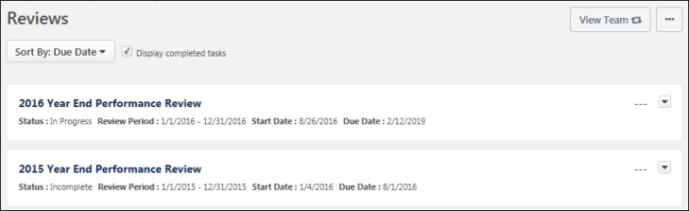
View Team
The View Team flyout allows managers, approvers, and custom relationships to quickly navigate between subordinates' profiles and transcripts. When enabled, the View Team flyout is available to managers and dotted line managers on all pages of their Universal Profile and the Universal Profile of their subordinates. This flyout displays the manager's reports visually.
The View Team button displays if enabled in the portal.
See Universal Profile - View Team Flyout.
Options
The following options are available in the Options drop-down menu:
- Launch Review - Select this option to launch an off-cycle performance review for the user whose Universal Profile page you are viewing. This option is only available if you have permission to launch off-cycle reviews, and an off-cycle review is available for the user. See Universal Profile - Options - Launch Review.
Sort By
The table of reviews can be sorted using the following sorting options within the Sort By drop-down menu at the top of the Reviews section:
- Due Date - Select this option to sort the reviews in chronological order by due date, with the incomplete review with the soonest due date displayed first.
  - All incomplete reviews are displayed before all completed reviews.
  - Completed reviews are listed after incomplete reviews, with the most recently completed review displayed first.
  - Reviews with the same due date are then sorted alphabetically.
- Completion Date - Select this option to sort the reviews in chronological order by completion date, with the most recently completed review displayed first. Reviews with a completion date of "N/A" are displayed first. Reviews with a due date are listed after completed reviews, with the review with the soonest due date displayed first. Reviews with the same completion date are then sorted alphabetically.
- Start Date - Select this option to sort the reviews in chronological order by start date, with the reviews with the most recent start date displayed first. Reviews with the same start date are then sorted alphabetically.
- Status - Select this option to sort the reviews by status. Reviews with the same status are then sorted alphabetically. Reviews are sorted in the following status order:
  - Not Started
  - In Progress
  - Completed
  - Expired
  - Incomplete
Display completed tasks
This option is selected by default. This ensures that users see historical performance review information as soon as they navigate to the page.
When this option is selected, the page includes reviews with a status of Completed. When this option is unselected, reviews with a status of Completed are hidden.
Reviews List
Note: A review task is only displayed on the Reviews page if it is visible to the reviewee. Administrators can configure whether a review task is visible to the reviewee when creating the performance review task. Administrators cannot hide a performance review task from a reviewee if the user is assigned a review step for the performance review.
The following information is displayed for each review in the Performance Reviews list:
- Review Title - Users can select the review title to launch the review. See Performance Review - End User Overview on page 2 for additional information.
- Status - The current status of the review.
- Review Period - The dates for the review period.
- Start Date - The review start date.
- Due Date - The review end date.
- Completion Date - This is visible only if the review has been completed.
- Rating - If the review is complete and a numeric rating has been configured to display for the review, then the value is displayed to the right of the review details. Note: The visibility of the rating is determined by the administrator when creating the performance review task.
Review Actions
The following review actions may be available from the actions drop-down menu to the right of the review:
- Launch Review - Select this option to launch the review. The review opens to the step that is assigned to the user who is performing the action. Note: This option is not available for completed performance reviews. See Performance Review - End User Overview on page 2 for additional information.
- Print Review - Select this option to download a PDF of the reviewee version of the review.
- Print Review - Manager Version - Select this option to download a PDF of all sections of the performance review, including all submitted responses. Note: This option is only available when viewing a subordinate's Snapshot.
- Print Review - Reviewee Version - Select this option to download a PDF of only the sections that are visible to the reviewee. Note: This option is only available when viewing a subordinate's Snapshot.
- Attachments - Select this option to view the attachments for the review. This opens the Attachments pop-up, in which users can select an attachment to view it. This option is only available if attachments are enabled for the performance review task and if the performance review has at least one attachment.
- Work Offline - Select this option to download the review to Excel. This enables the user to complete the review offline. See Complete/Upload Offline Review Task.

An indirect manager reopens a previous step for the manager. For the manager, the task appears in their Scheduled Tasks list with the status the task was in prior to being reopened (e.g., Completed, Past Due). When the manager completes the reopened step, the indirect manager's step still has a status of "Complete" and does not need to be resubmitted. Thus, reopening the step for the manager does not change how the step appears in the indirect manager's task list.

