Reviews March 2024

Table of Contents
Performance Reviews Overview 1
Admin Review Tasks Overview 2
Performance Reviews Overview 3
Performance Review Task Categories - Overview 7
Performance Review Task Administration - Overview 9
Performance Review Task Details 69
Performance Review Task Details - Add Co-planner 73
Performance Review Tasks - Manage Batch Co-Planners 75
Performance Review Task Details - Extend Due Dates 78
Performance Review Task Statuses 80
Performance Comment Assistant 82
Performance Reviews Custom Fields 84
Performance Review - End User Overview 85
Performance Review Summary 90
Performance Review Task Complete Overview 93
Performance Review Task - Components Overview 159
Performance Review - Options Drop-down 201
Performance Reviews - Batch Rating 222
Batch Rating - Ratings and Comments Pop-up 228
Performance Reviews - Bulk Sign Off 231
Launch Off-cycle Performance Review 233
Offline Reviews Overview 236
External Reviewers 251
View and Print Performance Review 252
Performance Review - Data Workflow 256
Performance Review Form Sections Overview 258
Performance Review Sections Administration 259
Create Review Form Section (Early Adopter) 261
Create Review Section - Competency Assessment 263
Create Review Section - Competency 266
Create Review Section - Development Plan 273
Review Section - Create - Evidence Collection 276
Create Review Section - Goal Planning 279
Create Review Section - Goal Review 284
Create Review Section - Question List 291
Create Review Section - Sign Off 297
Define Section Category 300
Define Default Performance Review Section Rating Scale 301
Define Performance Review Section Rating Scale 304
Snapshot - Reviews 308
Review Task Central 311
Activating Review Task Central 315
Review Task Central - Reviewer View 316
Review Task Central - Reviewee View 318
Review Task Central - Bulk Reopen 319
Review Task Central - Bulk Sign Off 321
Review Task Central - Bulk Submit 323
Review Task Central - Print Performance Review 325
Create Review Section - Skill Assessment 326
Set Printable View 331

Performance Reviews Overview

Admin Review Tasks Overview

Performance Reviews Overview
The Performance module displays an integrated relationship with the LMS where tasks completed within Performance can lead back to training activities designed to enhance an employee's training and knowledge within your organization. To accommodate various workflows, performance functionality can be configured to include multiple steps of each major process that can result in an overall performance review. For example, competency assessments can be included in a performance review which can produce a tailored development plan based on the employee's overall performance review results influenced by the recent assessment.
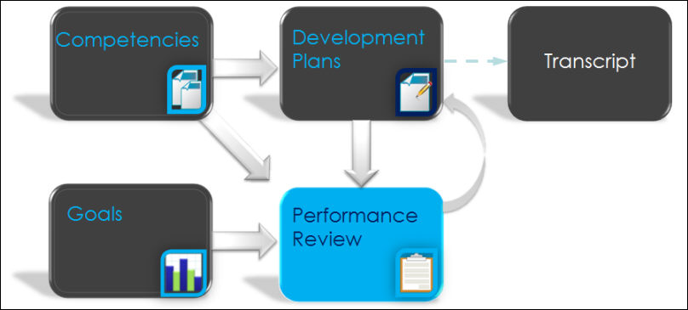
Because the performance review tool can be integrated with many modules, performance review tasks can be configured to include multiple steps of a review process that occur in a defined sequence. For example, a review may first be sent to the user for a self-review, then to the user's peers or direct reports, then to the user's manager, and the feedback may be cumulative as if all the reviewer's responses were written on the same form.
Overall performance review scores and performance review section scores can display and round up to two decimal places. The performance review score precision is controlled by a backend setting and can be set to round to one or two decimal places. The default score precision is one decimal place. To change the performance review score precision from one decimal place to two decimal places, contact Global Customer Support.
- The score precision affects overall performance review scores, performance review section scores, and rating scale points across the entire portal.
- Note: When calculating an overall performance review score, the performance review section scores are rounded before they are used to calculate the overall score.
Performance Review Process
Creating and deploying a performance review involves a series of steps. Before you begin to create your review in the system, it is a best practice to have a plan and documentation for what you would like to include in your review and the process flow for how you want your users to complete the process review. This plan may also include getting feedback and approval from others in your organization. The basic steps in the performance review process are:
- Define and create the sections of the performance review form.
- Create the performance review task including defining the sequence or steps for the review, who will complete the review, and the due dates of each step.
- Deploy the task to the user who completes the review.
- Users access and complete the review.
The performance review tasks appear on the user's Welcome Page in the Tasks widget or from the Scheduled Tasks link beneath the Home tab.
There are many ways to create your review process in the system to enable your organization to deploy reviews based on your organization's needs. However, there are some basic parameters to configuration that will apply to all processes. The review form is created in sections. Each section is created separately, but multiple sections can be included in the review the user sees. Once created, sections can be used in multiple reviews. Once the review is created, the steps of the review process, the sequence or order in which the users in the process complete the review and the actions available to the reviewers is determined by the administrator. A typical sequence example is first the employee completes a self review, then the manager completes the review on the employee, then a second-level manager completes the review. At that point, the process is complete.
360 Performance Reviews
During review task setup, steps can be assigned to internal peer groups, external peers, and direct reports, thus allowing administrators to set up 360-degree employee performance reviews. This step can be assigned to an entire group of users or the admin can give permission to either the manager or the user to select which users should be included. Additionally, if a peer step is created, the manager or user can select from existing peer groups in the system and add new peers to the group. Ultimately, when the step is assigned, it is simultaneously assigned to all selected users and an email is sent to each. 360 reviews allow for a multi-directional representation of an employee's performance.
360-degree reviews are available through the Performance Review module by allowing assignment to direct reports and peer groups. Any tasks assigned to a group (either direct reports or peers) is like any other step with a few differences:
- The direct reports and peers who contribute to a performance review are never able to see any responses other than their own. Also, the admin can determine how many responses must be submitted before the step is visible to the reviewee. If this option is selected, it is possible for the score from a peer/subordinate review to change after the reviewee has viewed it. If the number is not reached, the step is still calculated into the final review score, but the step is not visible to the reviewee. Peer and subordinate review comments are always anonymous to the user but visible to the manager and to administrators via reports.
- The completion of a review step assigned to a 360 group is governed by different rules than other steps. If a review step is assigned to a peer group or subordinates, there are two ways for the step to be completed. If multiple submissions are not allowed, the task is completed when all users have submitted a response. The task is also completed when the due date expires regardless of how many people have responded. If multiple submissions are allowed, the step is only complete when the step expires. If no one has responded, the step is complete but with no values. If the step with no responses entered has a weight associated with it, the step weight is ignored, and all other step weights are normalized to total 100%.
A 360 step is completed one of two ways:
- The step expiration date has passed.
- All users in the assigned group have completed the review and multiple submissions are not allowed.
Off Cycle Performance Reviews
Administrators can define off-cycle review tasks for the purpose of reviewing an employee on an ad hoc basis outside of the annual review process.
Multiple off-cycle reviews can be created for various purposes, such as performance improvement needed reviews that may become necessary outside of the normal annual review cycle, end of project reviews, promotion reviews (closing out performance in previous position when promoting employee to new position), or upon the completion of a specific project in order to review the employee's work on that project.
From the General step of the Performance Review Task Administration page, Off-Cycle task is an option. This option forces all start dates, due dates, and visibility dates of the task to be relative.
Once an off-cycle task is created, the manager or administrator can initiate the off-cycle task for an employee. Administrators can also designate who is able to assign the reviews, allowing any user with a certain relationship (e.g., self, manager, indirect manager, custom relationship) to initiate a review. This is useful for organizations where employees report to different project leads for various amounts of time. In these types of organizations, the traditional manager may not be the most appropriate person to complete the off-cycle review. Accordingly, administrators can allow the user who is creating a review to select the reviewing manager for off-cycle reviews, which can be the defined manager, another user, or an external user.
- This functionality could result in a user selecting an incorrect or inappropriate reviewer, or a reviewer may be given an excessive amount of reviews to complete. To alleviate this potential problem, administrators can allow reviewers to decline completion of a review. Review creators are notified through an automatically generated email and can then select an alternative reviewer.
The administrator can create off-cycle tasks for any review task and can create any number of off-cycle tasks. The manager can initiate an off-cycle task for an employee from MyTeam. The administrator can initiate an off-cycle task from the task details page of the selected task. The setup of the task is similar to creating a standard review task. An off-cycle task can be assigned to a user multiple times concurrently if necessary.
Offline Performance Reviews
Offline performance reviews enable users to download performance reviews as Excel files, complete the review in Excel, then upload the review back into the system. Uploaded reviews are validated by the system, and then the review is then available to the reviewee.
This functionality enables users to complete performance reviews when they do not have access to the Internet. However, Sign Off steps must be completed online. Also, steps that require collaboration (assigning co-planners, reopening steps, threaded discussions, etc.) must be completed online.
The ability to download and upload an offline review is controlled by the permission to download and upload offline performance reviews. By default, System Administrators have this permission and have the option to assign this permission to other roles within the system.
When using offline performance reviews, the following considerations must be made:
- Suggested Responses are not available for users within the Comments fields.
- Users cannot create a development plan from an offline review.
- Goal Planning sections cannot be included in an offline review.
- Users cannot view previous review tasks data in an offline review.
- Spell checking must be done via Excel, rather than the system spell check.
- The inappropriate word filter is not available.
- Co-planners cannot be named using offline reviews.
- Co-planners that are selected during an online review can download and upload offline reviews.
- All custom tags are converted to the appropriate values.
- Most HTML is removed from the offline review.
- Numbered and bulleted lists are displayed as a list with no numbers or bullets.
- Italic, bold, and underlined text features are removed.
- Users must have Excel 2010, 2007, or 2003 with a compatibility pack. Both Windows and Macintosh versions of Excel are supported.

Performance Review Task Categories - Overview
The Performance Review Task Categories page enables administrators to create and manage performance review task categories. After a category is created, performance review tasks can be associated with the category, which enables administrators to efficiently organize and filter review tasks.
Use Case: An organization conducts career interview reviews between employees and HR partners. The administrator creates a performance review task category titled Career Interview. During performance review task administration, the administrator creates an off-cycle review and selects Career Interview from the category drop-down.
To view Performance Review Task Categories, go to Admin > Tools > performance Management > Task Categories.
Permissions
PERMISSION NAME | PERMISSION DESCRIPTION | CATEGORY

Performance Review Task Administration | Grants ability to create/assign performance review tasks and manage activity within those tasks. This permission also gives the ability to enable and view co-planners for a task from the administration pages. This permission can be constrained by OU, User's OU, User Self and Subordinates, and User. | Performance - Administration
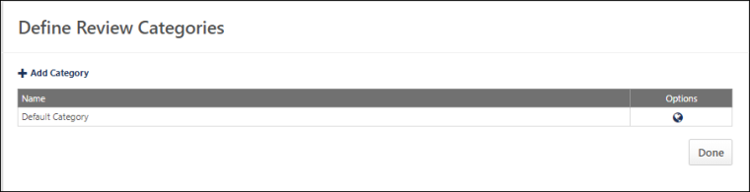
The following options are available:
- Add Category - Click the Add Category link to add a new performance review task category. This opens the Add Category pop-up. In the Name field, enter the category name. The character limit is 100. Click Save. The new category appears in the Categories table in alphabetical order.
- Categories - The following information displays for each category:
  - Name - This column displays the category name. Categories are displayed in alphabetical order by name.
  - Active - This column displays the active status of the category. Categories are active by default. Check or uncheck the box and click Save to activate or deactivate the category. If the category is inactive, it cannot be associated with a performance review task. Any task currently associated with the inactive category remains associated with the category.
- Options - The following options are available in the Options column:
  - Translate - If multiple languages are enabled for your portal, select the Translate icon to translate the field into other available languages.
  - Delete - Click the Delete icon to delete the category. This option is not available if a performance review task has been associated with the category. A deleted category cannot be restored.

Performance Review Task Administration - Overview
Use the Performance Review Task Administration page to create or edit Performance Review Tasks.
The Performance Review Task is the framework of the performance review and may include information such as overall due dates, the review period, rating scales, and who is assigned to participate in the review. Administrators also add sections to the Performance Review Task. Administrators can create, modify or copy a current performance review task.
Administrators must complete the following pages for a Performance Review Task:
- General – Define the name of the performance review, instructions for the reviewer, due dates, who can review and see the review, and define a rating scale if necessary. Some of the information that you define here may be visible to reviewers and reviewees. See Performance Review Task - Create/Edit - General on page 13 for additional information.
- Review Workflow – Define who is performing the review, the pages that they complete, and the review progresses (sequence) for reviewees and managers. See Performance Review Task - Create/Edit Review Workflow and Add Sections on page 22 for additional information.
- Review Summary – Define the way that the reviewee scores appear in the performance review. See Performance Review Task - Create/Edit Review Summary on page 39 for additional information.
- Visibility – Define what reviewees can or cannot see in the performance review. See Review Task - Create/Edit Visibility on page 47 for additional information.
- Confirm – Review and confirm all the options selected on the previous Performance Review Task pages and see a preview of how the performance review will appear to end users.See Review Task - Create/Edit Confirm on page 51 for additional information.
Note: Before you create or edit a Performance Review Task, performance review sections should already exist. See Performance Review Form Sections Overview on page 258 for additional information.
Administrator are only able to view and administer a task if they are within the Admin Visibility of the task and they have permission to manage performance review tasks. This includes adding users, viewing task details, and editing the task.
To access Performance Review Task Administration, go to Admin > Tools > Performance Management > Tasks.
Permissions
PERMISSION NAME | PERMISSION DESCRIPTION | CATEGORY

Performance Review Task - Manage | Grants ability to assign performance review tasks and manage activity within those tasks. This permission works in conjunction with the Admin Visibility settings for the performance review task. Administrators who have this permission and are within the Admin Visibility settings can view the task, edit the task, add users, and view the task details. However, the admin cannot edit the Admin Visibility settings for the task. This permission can be constrained by OU, User's OU, User Self and Subordinates, and User. The constraints on this permission control which users can be added to the task. | Performance - Administration

Performance Review Task Administration | Grants ability to create/assign performance review tasks and manage activity within those tasks. This permission also gives the ability to enable and view co-planners for a task from the administration pages. This permission can be constrained by OU, User's OU, User Self and Subordinates, and User. | Performance - Administration

Task - View | Grants ability to view assigned tasks via Scheduled Tasks screen and Welcome Page My Tasks widget. This is an end user permission. | Core

View Performance Reviews | Grants ability to view the Performance Reviews page, which displays a user's own past performance reviews as well as performance review task steps they've been assigned to complete. This also grants ability to view the Batch Rating page. This permission can be constrained by OU, User's OU, User Self and Subordinates, and User. This is an end user permission. | Performance
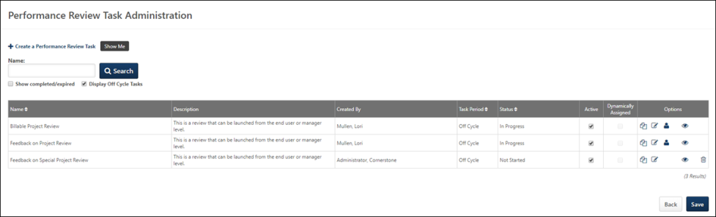
Create a Performance Review Task
Click Create a Performance Review Task to create a new performance review task. This opens the Define Performance Review Task page to the General tab. See Performance Review Task - Create/Edit - General on page 13 for additional information.
Search
Use the search field to search for an existing review task. You can choose to display completed or expired tasks as well as off cycle tasks using the corresponding options. Click the Search button to begin the search.
Performance Review Task Table
The following information is displayed for each existing review task:
- Name - The name of the performance review task.
- Description - The description of the performance review task.
- Created By - The person who created the performance review task.
- Task Period - The review or task period for the performance review task.
- Status - The current status of the performance review task. Options are Queued, Not Started, Completed, Expired, and In Progress.See Performance Review Task Statuses on page 80 for additional information.
- Active - Activate or deactivate a task by selecting the Active option next to the task. Inactive tasks are not implemented. Warning: If a task is made inactive, any queued emails that are associated with the task are cancelled. If the task is then made active again, the cancelled emails remain cancelled. Any modifications to the Active or Dynamically Assigned options are not saved until the Save button is clicked.
- Dynamically Assigned - Whether the task is dynamically assigned to a group or OU. If a task is dynamically assigned, the task is dynamically assigned to users who meet the specified criteria. If a user leaves the OU, they can no longer access the task. If a user joins the OU during the Task Period, they are automatically assigned the task. Any modifications to the Active or Dynamically Assigned options are not saved until the Save button is clicked.
- Options - The following options may be available in the Options column:
  - Copy - Select this option to copy the performance review task. See Performance Review Task - Create.
  - View Settings - Select this option to view the settings of the in progress performance review task. See View Performance Review Task Settings on page 64 for additional information.
  - Edit - Depending on the status of the performance review task, the task may be able to be edited. See Review Task - Edit on page 55 for additional information.
  - Add User - Select this option to add users to the performance review task's availability. Additionally, the Dynamically Assigned checkbox must be selected for the task in order for the user to be added to the task.
    - See Use Case - Adding Users to Performance Review Task after Initial Task Launch Date on page 62 for additional information.
    - The Add User icon is only available for tasks that are still within the assignment period.
    - Adding users is a multi-step process that typically occurs over night and may take up to 24 hours. To verify that the users have been successfully added to the task, click the View Details icon to open the task details page.
    - View Task Details - Select this option to view the details of the performance review task. See Performance Review Task Details on page 69 for additional information.
    - Delete - Select this option to delete the performance review task. This option is only available for tasks that have not yet begun. A deleted review cannot be restored.
Note: If Review Task Central is activated, tasks created before activation remain in the legacy format. Tasks created after activation appear with a green check-mark next to the name.
Back/Save
- Click Back to return to the previous page. If you do not save your changes before returning to the previous page, your changes will be lost.
- Click Save to save changes on this tab. Any modifications to the Active or Dynamically Assigned options are not saved until the Save button is clicked.
Troubleshooting Information
The following page contains a quick reference card to guide you through the process of creating a performance review task:
- See Creating Performance Review Tasks Quick Reference Card on page 68 for additional information.
For best practice information regarding performance reviews: See Best Practices - Performance Review Task Administration.
Contents

Performance Review Task - Create/Edit - General
Use the Performance Review Task General tab to define or edit due dates, assignees, assignment rights, rating scales, delivery, and who is reviewed for this performance review.
To access performance review tasks, go to Admin > Tools > Performance Management > Tasks.
- If you are creating a new review task, you must complete the General tab to move to the next tab.
- To edit a review task, in the Options column, click the edit icon for the appropriate performance review task.
Permissions
PERMISSION NAME | PERMISSION DESCRIPTION | CATEGORY

Performance Review Task - Manage | Grants ability to assign performance review tasks and manage activity within those tasks. This permission works in conjunction with the Admin Visibility settings for the performance review task. Administrators who have this permission and are within the Admin Visibility settings can view the task, edit the task, add users, and view the task details. However, the admin cannot edit the Admin Visibility settings for the task. This permission can be constrained by OU, User's OU, User Self and Subordinates, and User. The constraints on this permission control which users can be added to the task. | Performance - Administration

Performance Review Task Administration | Grants ability to create/assign performance review tasks and manage activity within those tasks. This permission also gives the ability to enable and view co-planners for a task from the administration pages. This permission can be constrained by OU, User's OU, User Self and Subordinates, and User. | Performance - Administration
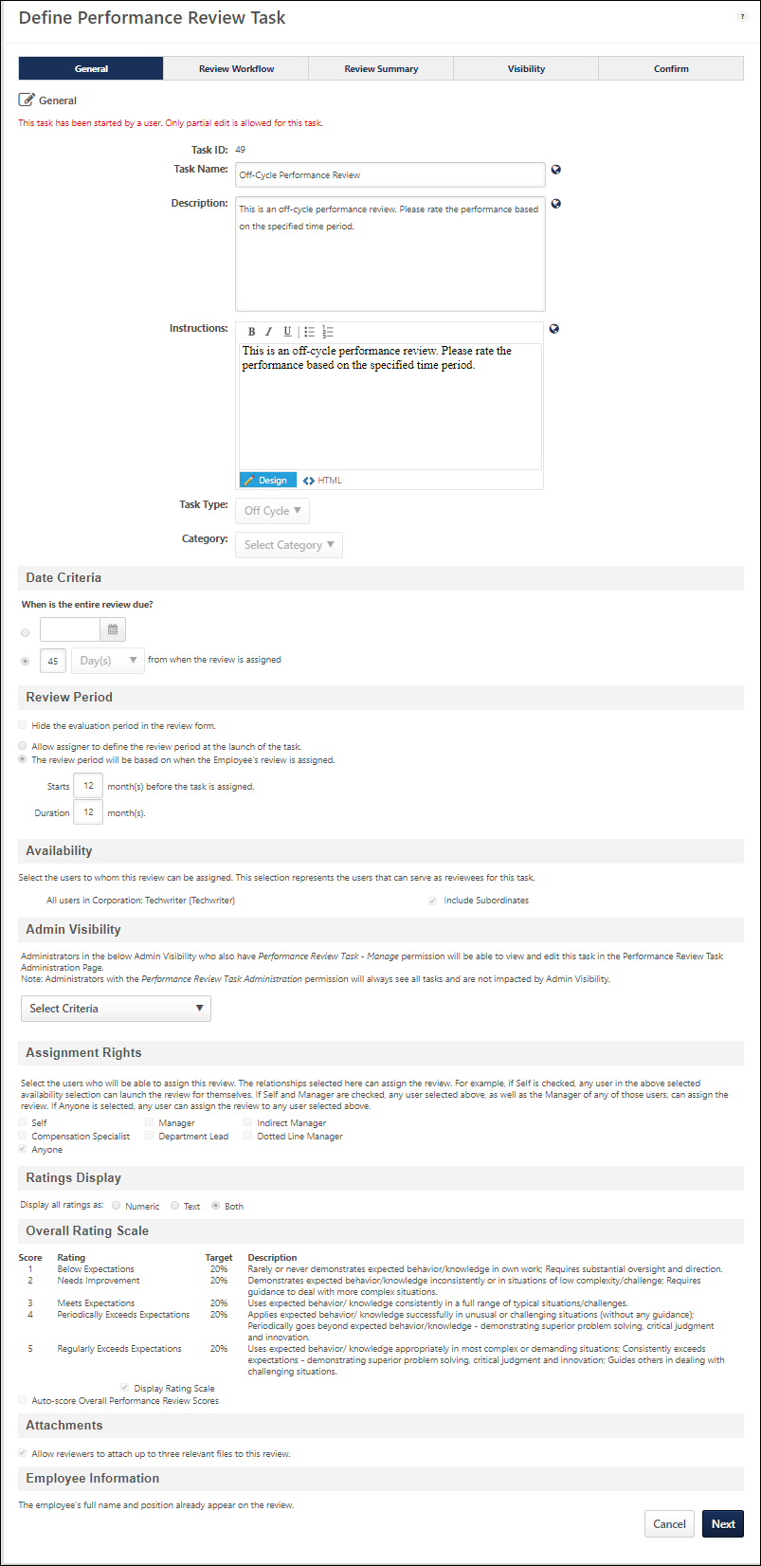
Note: The information that you can edit is based on the current status of the performance review task. See Review Task - Edit on page 55 for additional information.
General
- Task ID - When editing a performance review task or when viewing the task settings, this field displays a unique identifier for the performance review task. This enables administrators to easily access the Task ID in order to reference the performance review task. This value is not visible when creating a performance review task; it is only visible once the performance review task has been created.
- Task Name - Enter a descriptive name for the review task. The character limit for this field is 100. If multiple languages are enabled for your portal, select the Translate icon to translate the field into other available languages.
- Description - Enter a detailed description of the review task. The character limit for this field is 500. If multiple languages are enabled for your portal, select the Translate icon to translate the field into other available languages.
- Instructions - Enter directions that appear to the reviewers at the top of the performance review task. HTML can be used. The character limit for this field is 3000 characters. If multiple languages are enabled for your portal, select the Translate icon to translate the field into other available languages.
- Task Type - Select whether the review task is a standard task or an off cycle task. If Off Cycle is selected, the task will not have a static assignment date. Instead, it is available to the manager on the My Team page, where it can be assigned at any time.
- Category - Select the appropriate review task category to associate the review task with the category. This is optional. If there are no active categories, this option does not display.
Date Criteria
- When can the review task be assigned (Task Period)? - Using the From and To fields, define when the system begins assigning review tasks to eligible individuals and when the system stops assigning review tasks. When creating an off cycle review task, this option is not available.
- When is the entire review due? - Specify when the review is due. This represents the total duration of the review itself, including time allotted for the employee and manager to complete their steps in the review. This date can be a fixed date or a relative date. A relative date allows you to set a due date that is a certain number of days or months from the date the review task is assigned.
Assignment Criteria
The assignment criteria defines how the review task is assigned.
Note: The Assignment Criteria options are not available when creating an off cycle review task.
- All reviews will be assigned at the beginning of the Task Period - Select this option to assign all reviews at the beginning of the task period (The task period is defined in the Date Criteria). For example, if the task period is from December 1st through 4th, all reviews are assigned on December 1st.
- Reviews will be assigned based on each Employee's XXX - Select this option to assign reviews based on a specific user date field. Review tasks can be based on the user's Hire Date, Last Hire Date, or Last Performance Review Completion Date. Select the appropriate option from the drop-down list. Then, set the specific assignment date criteria.
Only the Day and Month are considered when determining the assignment date. The year is not considered, but the number of days within a given year (leap year) is taken into consideration.
Use Cases:
- Mark was hired on January 1, 2004. Each year a review task is configured with a Task Period of January 1 to February 28, and is configured to be assigned 30 days after the employee's Hire Date. Each year, the review task is assigned to Mark on January 30 because this is 30 days after his hire date of January 1 even though Mark was hired in a previous year.
- (Leap Year): Mark was hired on January 1, 2016. 2016 was a leap year (there were 29 days in February 2016). The admin configures a review task each year with a Task Period of January 1 to April 30th, and it is configured to be assigned 60 days after the employee's Hire Date. Each year, the review task is assigned to Mark on March 1st because this is 60 days after his hire date of January 1 even though Mark was hired in a previous year. If Mark had been hired in 2015 (not a leap year), he would be assigned the review on March 2nd.
Review Period
The Review Period section allows you to set the period of time for which the employee is being reviewed. This can be done using a fixed set of dates or using a relative set of dates based on when the employee's review is assigned. When creating an off cycle review task, the review period must be relative to when it is assigned. The options that appear are based on the Task type you selected in the General Section.
- If you selected the Standard task type, the following options appear:
  - From: and To: fields - Select the specific dates for which the employee is reviewed based on a calendar year.
  - The review period will be based on when the Employee's review is assigned - Select this option to set the review period based on the criteria that is set in the Assignment Criteria section. Typically this may be based on an employee's hire date. When this option is selected, you must also specify the following options:
    - Review period will start XX before the Employee's review is assigned - This determines how many days or months prior to the employee's review assignment that the review period begins. If this is annual review, this is set to 12 months.
    - Select one of the following:
      - Review Period Duration - This option sets the length of the review period for which the employee is being reviewed, which can be set in months or days. If this is an annual review, the review period duration is 12 months.
      - Review period will end - This option sets a specific end date for the review period. The selected end date should be selected so that it is never before the review period start date. If the selected end date occurs before the dynamic start date, then no current goals are pulled into Goal Planning or Goal Rating sections in the performance review task. All other sections will function normally.
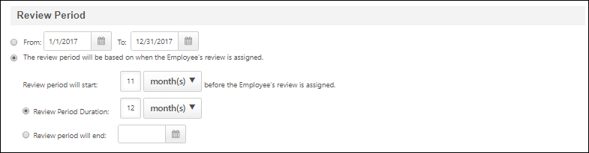
If you selected the Off Cycle task type, the following options appear:
- Hide the evaluation period in the review - If this option is selected, the evaluation period does not appear in the review form. Note: This option is only available for off-cycle tasks.
- Allow assigner to define the review period at the launch of the task - This option allows the review task assigner to specify the start and end dates for the off-cycle review task review period. The assigner specifies the review period when they launch the task.
- The review period will be based on when the Employee's review is assigned - This option allows the administrator to select a dynamic review period that is based on when the review is assigned. When this option is selected, the following options appear:
  - Starts - This determines how many months prior to the employee's review assignment that the review period begins.
  - Duration - This is the length of the review period for which the employee is being reviewed, which is set in months.
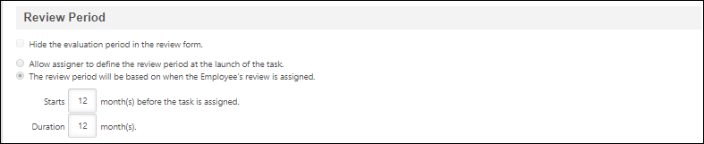
Availability
The Availability section determines who in the organization is assigned the review task. If you select any one of the organizational units listed in the drop-down list, employees in the selected OU are assigned a review as long as they are eligible based on the task period and assignment criteria set above.
From the drop-down, select an OU or select All Employees. Based on the selected option, an Add button or a search option icon appears. If the Add button appears, click it and you are done with this section. If the search option icon appears, click it to select additional criteria related to the Availability option you chose, and then click Done.
Best Practice: Once a performance review task is In Progress status, the process of adding additional users to the performance review task may take up to 24 hours. It is very important to consider all users who should be included in the performance review task prior to setting the availability for the performance review task and submitting the task. See Use Case - Adding Users to Performance Review Task after Initial Task Launch Date on page 62 for additional information.
Admin Visibility
This section enables administrators to define which administrators can view and administer this task. Only administrators who are within the defined Admin Visibility and who also have permission to manage performance review tasks can view and administer this performance review task.
Note: Administrators who have the Performance Review Task Administration permission can always view and administer all performance review tasks, and they are not impacted by this setting.
Note: Administrators can view all tasks if any of the following conditions are true:
- If the task is created by the user which belongs to the OU constraint of permission 'Performance Review Task Administration'.
- If the task contains any user (reviewee) which belongs to the OU constraint of permission 'Performance Review Task Administration'.
To define the administrator visibility for this task, from the drop-down select one or more OUs or select All Employees. Based on the selected option, an Add button or a search option icon appears. If the Add button appears, click it and either add additional OUs move on to the next section. If the search option icon appears, click it to select additional criteria related to the Availability option you chose, and then click Done.
Assignment Rights
This section only appears for off-cycle reviews.
Select the users that are able to assign this review. For example, if Self is selected, any user selected in the Availability section can launch the review task for themselves. If Self and Manager is selected, any user selected in the Availability section, as well as the manager of any user selected in the Availability section can assign the review. If Anyone is selected, any user in the system can assign the review to any user selected in the Availability section.
At least one relationship must be selected for the review. The available options are:
- Self
- Manager
- Indirect Manager
- Compensation Specialist
- Department Lead
- Dotted Line Manager
- Anyone - Anyone in the system can assign the review to any user selected in the Availability section. Selecting this option deselects all of the other options.
Ratings Display
Ratings can be displayed as a numeric value, as text, or both. This selection is applied to all steps and sections within a task. This selection applies across the system:
- Reviews
- Printable Version
- My Team
- Talent Profile
- Succession
- Compensation
- Reports
  - Analytics (Custom Performance Review Reports) includes fields for Numeric Rating and Text Rating separately.
Ratings
Display all ratings as: - Select the way you want ratings to display.
Overall Rating Scale
The overall rating scale is used to determine the employee's final overall performance review score for the review. The default scale displayed is set in the Performance Review Sections area, but can be modified for each performance review task. See Define Default Performance Review Section Rating Scale on page 301 for additional information.
To edit the overall rating scale for this particular task, click the Edit icon. See Define Performance Review Task Rating Scale on page 58 for additional information.
- Auto-score Overall Performance Review Scores - Select this option to enable the auto-score functionality for overall performance review scores. When this option is selected, the following options are enabled:
  - Trigger score (any items rated on or below this score will activate Auto-score) - In this field, enter the trigger score for the review task. If a user is rated at or below the trigger score for any item in the performance review, the user automatically fails the performance review task. For example, if the trigger score is set to 2, then any users that scores a 2 or lower on any item in the review (goal rating, competency rating, question list item), then the user automatically fails the performance review task.
  - Overall resulting score if Auto-score is triggered - From the drop-down, select the overall resulting score that users receive if the auto-score is triggered. This is the score that the user receives if they receive the trigger score for any item in the review. The available values are the visible values included in the rating scale. Note: If the Overall Rating Scale for the performance review task is changed and the Automatic Failure Overall Resulting Score is no longer included or visible in the scale, then the Auto-score checkbox is unchecked and the score settings are cleared. See Automatic Failure Use Cases on page 65 for additional information.
Edit Overall Rating Scale Rating and Description
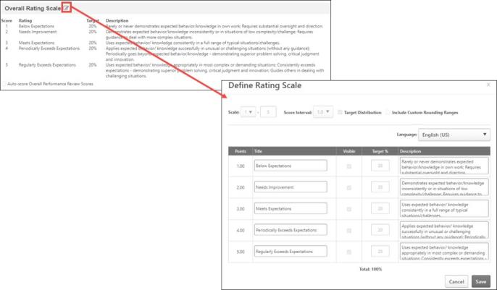
To edit the overall rating scale rating and description, next to the Overall Rating Scale section title, click the Edit icon . A Define Rating Scale page opens.
- To edit the Rating title, make any necessary changes in the Title column.
- To edit the description, make any necessary changes in the Description column .
The changes immediately appear in the Overall Rating Scale section. Users can see the updated rating when they generate a review task .pdf from the Define Rating Scale page.
Attachments
You can choose whether or not users can attach files to a review. Up to three attachments can be added to a review.
- Attachments can be up to 1 MB in size and are limited to ppt, pptx, doc, docx, pdf, jpg, jpeg, jpe, png, txt, gif, zip, xls, xlsx, csv, psd, bmp, rtf, msg, xml, and saz file types.
- Attachments are visible throughout the review, but do not display on the printable version.
- Files can be added by the reviewee, but reviewees can only remove files that they have uploaded. If the manager attaches a file to the review, the reviewee cannot remove it.
- Managers and other reviewers can both add and remove attachments, regardless of who uploaded them.
- Files cannot be uploaded during peer and direct report review steps.
- On the Task Details page, an Attachments icon displays for the review if the review has one or more attachments. See Performance Review Task Details on page 69 for additional information.
Employee Information
The employee's full name and position automatically appear in the review. However, there may be times that more user information needs to be displayed to help provide the reviewers a more comprehensive user snapshot of the employee in the organization. Additional information can include the employee's user record information, which can contain hire and last hire dates, as well as OU information. Reviewers may even want to see the last overall performance review score, the date the employee was last reviewed, and the name of the task in which the employee was reviewed.
Click the Add icon to add employee information, which opens the Select Fields window. Select the appropriate fields and click Save. Fields can then be reordered by dragging and dropping them in the required order. Fields can also be deleted by clicking the Delete icon.
Cancel/Next
- Click Cancel to close this page.
- Click Next to proceed to the next tab. See Performance Review Task - Create/Edit Review Workflow and Add Sections on page 22 for additional information.

Performance Review Task - Create/Edit Review Workflow and Add Sections
Use the Review Workflow tab to define the review workflow. Every reviewer who participates in a review for an employee must have an assigned step in the performance review. Steps contain information about who is performing the review and what the reviewer completes in the review, such as set goals or questions about the employee. The sequence and weight of the step, when the step is due, and how the step is submitted is also determined here.
You can create new steps, edit the step and its contents, copy the step, and delete the step from the workflow. Each step must have a due date and contain at least one section. By default, when setting up a new review task the review workflow contains a self or employee step and a manager step.
Sections
You also use this page to add sections to the performance review. Sections are the pages that populate the performance review. Typically, sections are created and available for you to select, but if sections are not yet available, you need to create them. See Create Review Form Section (Early Adopter) on page 261 for additional information.
Additional Steps
To add additional steps, click the Add Steps icon next to Review Steps. See Performance Review Task - Review Workflow - Add/Edit Review Step on page 31 for additional information.
To access performance review tasks, go to Admin > Tools > Performance Management > Tasks.
- If you are creating a new review task and you completed the previous page, you can enter information on this page.
- To edit a review task, in the Options column, click the Edit icon for the appropriate review task.
Permissions
PERMISSION NAME | PERMISSION DESCRIPTION | CATEGORY

Performance Review Task - Manage | Grants ability to assign performance review tasks and manage activity within those tasks. This permission works in conjunction with the Admin Visibility settings for the performance review task. Administrators who have this permission and are within the Admin Visibility settings can view the task, edit the task, add users, and view the task details. However, the admin cannot edit the Admin Visibility settings for the task. This permission can be constrained by OU, User's OU, User Self and Subordinates, and User. The constraints on this permission control which users can be added to the task. | Performance - Administration

Performance Review Task Administration | Grants ability to create/assign performance review tasks and manage activity within those tasks. This permission also gives the ability to enable and view co-planners for a task from the administration pages. This permission can be constrained by OU, User's OU, User Self and Subordinates, and User. | Performance - Administration
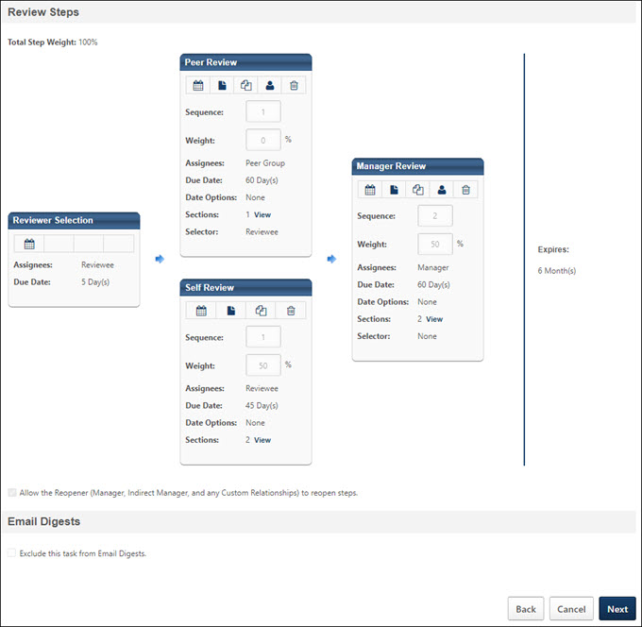
Review Steps
The Review Steps section lets you specify which steps should be included in this performance review task, due dates for each step, the order of the steps, and configure who has the responsibility of selecting the reviewer for future steps. You can also edit steps in this section.
For a new performance review, by default, the Review Steps section contains a Self Review step and a Manager Review step. You can add more steps if necessary
Define Due Date Criteria
Click the Define Date Criteria calendar icon to configure the step due date. The due date determines how much time the reviewer has to complete their step of the review. Clicking the icon opens the Configure Step Due Date pop-up.
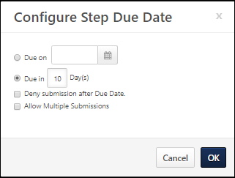
The following options are available:
- Due Date - Select a due date option. When creating off cycle reviews, the due dates of all individual steps must be relative to the assignment of the task and the relative start date of the step. Based on the number of steps in a workflow, the due dates must not exceed the duration or the overall due date of the performance review. For example, if the overall due date is in 60 days, all due dates within the review task must be complete within the 60 days. This is why the expiration date of the performance review is displayed on the Review Workflow page.
  - Due on XX/XX/XXXX - Select this option to specify a specific due date for the step (e.g., January 1) using the calendar feature. This option is selected by default.
  - Due in X Day(s) - Select this option to set a due date for the step that is relative to the date on which the step is assigned (e.g., 14 days from the date the step is assigned).
- Deny submission after Due Date - Select this option to prevent a reviewer from being able to submit their review step after the due date has passed.
  - If the step is configured as Required and the reviewer's step is past due, the reviewer must contact an administrator to have their due date extended to allow them to submit their task.
  - If the step is configured as Optional, then this checkbox is checked by default and cannot be unchecked. If the review is not completed by the user, the step is set to Past Due status and the task's overall status is Completed instead of Incomplete.
- Allow Multiple Submissions - Select this option to allow the reviewer to submit their step multiple times before the step due date.
  - If this option is selected, the following occurs:
    - The task does NOT move to the next step in the workflow until after the due date has passed.
    - If the reviewer has submitted the step at least once before the due date, once the due date passes, the system will accept the most recent submission as the reviewer’s final submission and the task will move to the next step in the workflow.
    - The next step of the review does not begin until the due date of the previous step passes.
  - If this option is not selected, the following occurs:
    - Reviewers can only submit their review once.
    - The next step in the review workflow is initiated as soon as the previous step is complete.
Edit
Edit the review step from the Review Workflow section by clicking the Edit icon at the top of the step. The Edit Review Step screen appears. See Performance Review Task - Review Workflow - Add/Edit Review Step on page 31 for additional information.
Add Sections to the Review
Add sections to add the pages the reviewer completes as part of the review.
- Click the plus icon next to the Review Steps heading.
- On the Add Review Step window, click the plus icon next to the Sections heading.
- From the Search Review Form Sections window, select which sections the reviewer needs to complete during the review. The sections that appear are sections that have been previously created. See Performance Review Task - Create/Edit Review Summary on page 39 for additional information. There are different types of sections available, which include:
- Competency Assessment - Allow reviewers to complete a competency assessment in a performance review task.
- Competency - Allows reviewers to rate competencies.
- Development Plan - Allows reviewers to add training and action steps to a development plan for the reviewee while completing the performance review task.
- Goal Planning - Allows reviewers to create new goals that are added to the employee's Goal Management page after the review process is complete.
- Goal Rating - Allows reviewers to provide feedback about goals completed during the review period.
- Question List - Allows the reviewer to answer questions about the employee's performance.
- Sign Off Section - Provides a page for reviewers and reviewees to sign-off on the review. Signatures can be captured electronically in the system.
When you are done selecting sections, click Done to return to the previous page.
With the selected sections, you can select which rights the reviewer has for each section. Rights allow the reviewer to perform certain functions during their step of the review. This includes the ability to comment on and rate questions, competencies, and goals, edit new goals created in a goal planning section, select which goals or competencies are included in the review, and weight the goals or competencies for the review itself. If the corresponding right is not selected, that function is not available to the reviewer during their step of the review process.
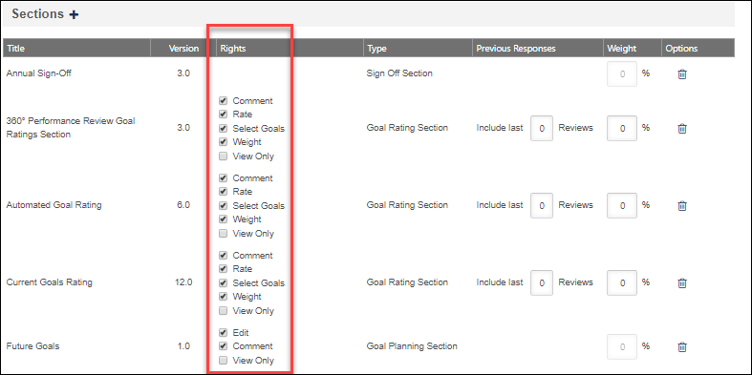
You can also determine the order of the sections by dragging and dropping the sections into the appropriate order.
Because Competency, Question List, and Goal Review section types can be reused year after year, information from a prior review can be included by setting the Previous Responses option. Based on the number set, the system can display feedback from past reviews going as far back as to when the employee was first reviewed in the system.
The Weight of each section determines the value of the responses within the step of the review. This is different from the overall weight of the step. Together, all sections must total 100%. The weights for the Goal Planning and Sign Off sections are automatically set to 0% and cannot be modified. Weight cannot be set for a review step that is marked as optional. Depending on the backend setting, the weight percentage fields may accept up to two decimal places.
Email Administration
In Email Administration, you define which emails should be triggered regarding the step. You can customize email triggers for the step, use the standard email triggers from the Email Administration page, or disable emails for the step.
Click Save to save the step and return to the review workflow.
Copy
Click the Copy icon to copy the settings in that step to another step. When a step is copied, the new step contains all of the sections from the original step, including rights, responses, and weights. For the newly created step, enter a title for the step, select to whom the step is assigned, and select whether or not it is optional. Also, adjust any of the section settings if necessary. This is a good way to quickly create steps with the same settings.
Reviewer Selector
To select a Selector for the step, select the Reviewer Selection icon . Once a selector is chosen, the Selector is displayed at the bottom of the review step.
If Reviewee or Manager are assigned as a selector, but are not assigned steps in the task, then a Reviewer Selection step is added to the workflow. Also, if Review Creator is chosen as the selector, then a Reviewer Selection step is added to the task to provide time for the review creator to select the reviewer. Reviewer Selection sections always occur prior to the first review step.
If a user changes a reviewer selector for a role in the review that occupies multiple steps, the change permeates through all steps for that role.
Reviewer Selector - Peer Group or Subordinate Step
For Peer Group and Subordinate steps, click the Reviewer Selection icon. The Reviewing Peer Group Selection pop-up allows the administrator to determine who serves as the peer group and also specify the minimum number of reviewers. Up to two digits can be entered in this field (1-99). When selecting peer groups for different peer review steps, administrators can create as many peer review steps as necessary. However, administrators can only include up to five different peer groups as reviewers in a performance review.
For Peer Group steps, it is very important that each reviewee in the performance review task has peers established before the performance review task begins. If the reviewee does not have sufficient peers when the Reviewer Selection step is submitted, then the minimum number of reviewers is not enforced. See the Tips & Tricks - Peer Reviewer Selector section below for additional information.
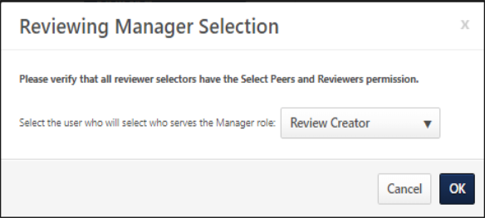
Reviewer Selector - Off-Cycle Review Task
Within an off-cycle review task, for each review step other than the Self Review, the task creator can choose a Selector for the review step. The Selector is responsible for selecting which user completes the review step. For example, if the Selector for the Manager Review step is Reviewee, then the reviewee selects who completes the Manager Review step. Note: This option is only available for off-cycle tasks. Also, the reviewer selector must have the permission to select peers and reviewers. The constraints on this permission determine who the reviewer selector can select for the performance review step. Before the task is assigned, ensure all necessary users have this permission and that the constraints are applied appropriately.
The available options for review selector are Review Creator, Reviewee, Manager, and No Reviewer Selection. In addition, the Indirect Manager or any custom relationships that appear in the review are available as potential reviewer selectors. Note: This icon is not available for the Self Review step.
A selector is not required for each step. If no selector is chosen, then the user in the corresponding role (Manager, Indirect Manager) is responsible for completing the step.
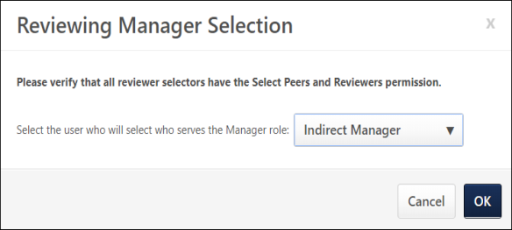
Delete
Click the Delete icon to remove the step from the review.
Sequence
The sequence of the review determines the order in which the reviewers complete the performance review. Enter a sequence number for the steps. If a sequence is entered, then the tasks for each step is not be sent to that reviewer until the reviewer who was immediately before them in the sequence has submitted their review.
- If a sequence is entered, but two steps have the same sequence, then the two steps with the same sequence are triggered at the same time. For example, if self and manager are "1" and second level manager is "2", then the self and manager receive the task at the same time, but the second level manager does not receive the task until both the self and the manager submit their reviews. Is self is "1" and manager and second level manager are "2", then the manager and second level manager both receive the task when the self is done, but the review is not be complete until both the manager and second level manager submit their reviews.
- If no sequence is entered (if it is left blank or all the numbers are the same), then all of the tasks for an employee's reviewers are sent at the same time and the results are aggregated once all reviewers are complete.
Weight
The weight determines how the weight of the ratings in each section fits into the overall calculation of the review ratings. If a step's weight is set to 0%, the step is essentially used for informational purposes, and the scores in that step have no impact on the overall review rating. The total of all step weights must be 100%.
Assignees
The Assignees displays to whom the step is assigned.
Due Date
This is the date by which the review step must be completed. This is specified by clicking the Define Date Criteria icon. When creating off cycle reviews, the due dates of all individual steps must be relative to the assignment of the task and the relative start date of the step.
Date Options
This displays any date options that are set for the step. The date options are specified by clicking the Define Date Criteria icon. See the Define Due Date Criteria section above for additional information.
Sections
This displays the number of sections contained in the step. Click the View link next to this value to open a pop-up that displays the title of the step and for each section within the step, the title, version, and type are displayed. Each step must have at least one section.
Allow the Reopener (Manager, Indirect Manager, and any Custom Relationships) to reopen steps
If there is a step assigned to the manager with other steps before it in the workflow, this option appears. Selecting this option allows the manager to reopen previous steps. If this option is selected, when the manager views the review they have the option to reopen a previous step in the review process. Reopening a previous step does not affect the current step; both steps are available in parallel. See Performance Review - Reopen Previous Step on page 213 for additional information.
For off-cycle reviews, this option is also expanded to Indirect Manager and any custom relationships.
The new due date for the reopened step is the due date for the entire review. All other steps can progress in parallel.
For any review steps assigned to a peer or direct reports group, the manager can reopen the step for specific users.
Click Next to proceed to the Review Summary step. See Performance Review Task - Create/Edit Review Summary on page 39 for additional information.
Email Digests
Select the Exclude from Digest Email checkbox to exclude individual performance review tasks from email notifications. This checkbox is not editable once the task starts.
Tips & Tricks - Peer Reviewer Selector
For Peer Group steps, it is very important that each reviewee in the performance review task has peers established before the performance review task begins. If the reviewee does not have sufficient peers when the Reviewer Selection step is submitted, then the minimum number of reviewers is not enforced. For example, if the required number of peers is set to 2, then the following occurs:
- If the reviewee has two peers when the task begins, then the reviewee's two peers are automatically selected. In the Reviewer Selector step, the reviewee has the option to deselect one or both of the selected peers and create new peers. In this scenario, the minimum number of reviewers is enforced because the reviewee had the minimum number of peers.
- If the reviewee has one peer when the task begins, then the reviewee's one peer is automatically selected, and the minimum number of peers is automatically reduced to one (the number of peers that the reviewee has). In the Reviewer Selector step, the reviewee has the option to deselect the selected peer and create a new peer. In this scenario, the minimum number of reviewers is automatically reduced to the number of peers that the reviewee has.
- If the reviewee has zero peers when the task begins, then the minimum number of peers is automatically reduced to zero (the number of peers that the reviewee has). In the Reviewer Selector step, the reviewee has the option to create a new peer. In this scenario, the minimum number of reviewers is automatically reduced to the number of peers that the reviewee has.
Back/Cancel/Next
- Click Back to return to the previous page.
- Click Cancel to close this page.
- Click Next to proceed to the next tab. See Performance Review Task - Create/Edit Review Summary on page 39 for additional information.

Performance Review Task - Review Workflow - Add/Edit Review Step
From the Review Workflow section, click the Add Steps icon to add a step to the review. The Define Review Step screen appears.
Permissions
PERMISSION NAME | PERMISSION DESCRIPTION | CATEGORY

Performance Review Task - Manage | Grants ability to assign performance review tasks and manage activity within those tasks. This permission works in conjunction with the Admin Visibility settings for the performance review task. Administrators who have this permission and are within the Admin Visibility settings can view the task, edit the task, add users, and view the task details. However, the admin cannot edit the Admin Visibility settings for the task. This permission can be constrained by OU, User's OU, User Self and Subordinates, and User. The constraints on this permission control which users can be added to the task. | Performance - Administration

Performance Review Task Administration | Grants ability to create/assign performance review tasks and manage activity within those tasks. This permission also gives the ability to enable and view co-planners for a task from the administration pages. This permission can be constrained by OU, User's OU, User Self and Subordinates, and User. | Performance - Administration
Emails
EMAIL NAME | EMAIL DESCRIPTION | ACTION TYPE

Performance Review Step Assigned | Performance review of a specific user assigned. This email is triggered when the task step is available for that user to review, which may be triggered by the employee hire date, the previous reviewer submitting the review, or the task assignment date. Note: When customizing this email for a self-review step, this email cannot be sent to "Reviewer" because the system considers this user the reviewee.  Reviewee will not receive any step email other than the self step and Similarly, a reviewer cannot receive any email for a Reviewee step.  This email trigger can be sent to external users. If the REVIEW.LINK tag is used in the trigger and is sent to an external reviewer, then the link takes external reviewers to an external review page that requires no login or validation. See External Reviewers on page 251 for additional information. | Performance Management

Performance Review Step Due Date | This email is triggered when a performance review task is due. If this email is sent to the recipient group "Reviewer" then only the users that have received performance reviews will receive the email. This email is conditional so that it only includes the users who are in progress or have not started. Note: When customizing this email for a self-review step, this email cannot be sent to "Reviewer" because the system considers this user the reviewee.  This email can be set up as a reminder to go out before the due date. The reminder will not be sent to reviewers that have already completed the review.  The due date for performance review tasks is defined for each reviewer group on step 2 of creating a performance review task. This date is not necessarily the same as the task end date for it may occur before the task ends. Reviewers will not be locked out of the task on the task due date unless it is the same date as the task end date.  Reviewee will not receive any step email other than the self step and Similarly, a reviewer cannot receive any email for a Reviewee step.  Note: Email Digest emails do not include past-due notifications for optional or locked performance review steps after the step due date. | Performance Management

Performance Review Step Completed | The Performance Review Step Completed email is only sent to the reviewee regarding other reviewers in the same sequence (if there is any). It is not designed to send email to own reviewer or the person (self) who is completing the review.  This email is not sent to other Reviewers. | Performance Management

Performance Review Step Reopened | This email is triggered when a performance review step is reopened in order to alert or remind the user that a performance step has been reopened. When configured, this email is triggered any time a step is reopened, whether it is done by a manager or administrator. This email can be sent to Reviewee, Reviewee's Direct Manager, Reviewee's Indirect Manager, Reviewer, or a specific user.  The REOPEN.STEP.COMMENT tag displays the Reason commentary that was provided when the review step was reopened.  The REVIEW.REOPENED.STEP.DUE.DATE email tag displays the due date of the performance review step that is reopened. If no due date is defined for the step, then "No Due Date Defined" is displayed.  The system verifies that the review step is still due prior to triggering the email, so if the review step is no longer due, then this email is not triggered.  Reviewee will not receive any step email other than the self step and Similarly, a reviewer cannot receive any email for a Reviewee step. | Performance Management
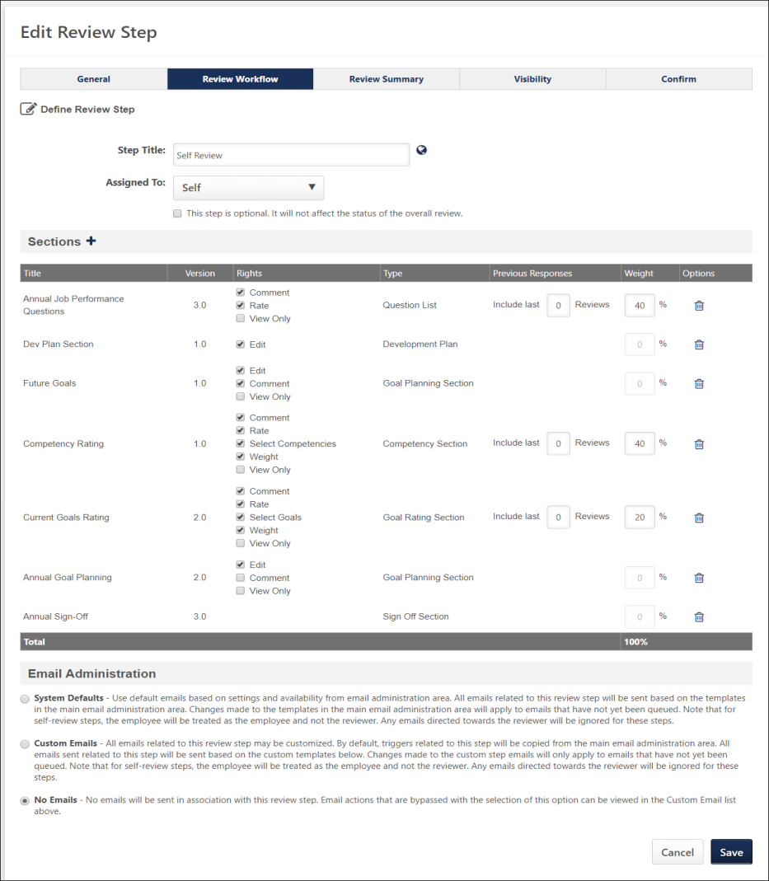
Step Title
Enter the name of the step. If multiple languages are available for the portal, the step title can be localized by clicking the Translate icon to the right of the field.
Assigned To
Select the role to whom the step is assigned. Steps can be assigned to a number of different roles, including Self, Manager, Indirect Manager, Subordinates, and internal peer groups that have been created in the system. If a step is assigned to a internal peer group that can contain subordinates (an option available in the Employee Relationships Management), you cannot also assign a step to subordinates. Note: Performance review steps cannot be assigned to external peers.
See Assigning Step to Peer Group or Direct Reports on page 60 for additional information.
Assigned To - Peer Groups
When selecting peer groups for different peer review steps, administrators can create as many peer review steps as necessary. However, administrators can only include up to five different peer groups as reviewers in a performance review. Peer group availability is set in Employee Relationships.
Assigned To - Indirect Managers and Custom Roles
Steps assigned to indirect managers and custom roles are dynamically assigned. If the reviewee moves under a new indirect manager before the step is completed or expires, the new indirect manager receives a Performance Review Step Assigned email and is assigned the step. The previous indirect manager no longer has the task on their To Do list. Any progress made by the previous indirect manager carries over to the new indirect manager. If the step is complete or expired before the indirect manager changes, the step does not move to the new indirect manager.
Assigned To - Dynamic Relationships (e.g., Manager, Indirect Managers)
If a performance review step is assigned to a dynamic relationship (including manager and indirect manager) and no user currently exists in that relationship, the step is not immediately assigned. However, the step is not skipped. If at any time during the step's duration a user fulfills that relationship, the step is then assigned to that user. A Performance Review Step Assigned email is sent and the task displays in the user's task list. If the step's due date has passed before a user is assigned to the open role, the step is skipped and the next step in the sequence is activated.
This step is optional
Select this option to make this step optional. If this option is selected, the review step is included in the process, but the review process can be completed without the user completing this step. For optional steps, the weight is set to 0% and cannot be edited. If the step is not completed by the step reviewer, the step status will be set to Past Due on the due date . The review step does not affect the overall status of the review task.
Sections
Determine which sections the reviewer completes as part of the review. Click the Add Form Section icon to add sections to the review. From the Add Review Section window, select which sections the reviewer needs to complete during the review. The sections that appear are sections that have been previously created. See Create Review Section for information how to create sections. There are different types of sections available, which include:
- Competency Assessment - This section allows the reviewer to complete a competency assessment for the reviewee. A competency assessment cannot be assigned multiple times in a single step for the same assignee.
- Competency - This section allows reviewers to rate competencies.
- Development Plan - This section allows reviewers to add training and action steps to a development plan for the reviewee while completing the performance review task. Development Plan sections can only be added to Self and Manager review steps. Note: Only one unique Development Plan section can be added per review across the Self and Manager review steps. For example, if a Development Plan section is added to the Self review step, then only the same Development Plan section can be added to the Manager review step.
- Goal Planning - This section allows reviewers to create new goals that are added to the employee's Goal Management page after the review process is complete. Goal Planning sections cannot be added to steps assigned to a peer group or direct reports.
- Goal Review - This section allows reviewers to provide feedback about goals completed during the review period.
- Sign Off - This section allows the signatures that are needed for the review to be captured electronically in the system. Sign Off Planning sections cannot be added to steps assigned to a peer group or direct reports.
- Question List - This section allows the reviewer to answer questions about the employee's performance.
Rights
With the sections selected, you can select which rights the reviewer has for each section. Rights allow the reviewer to perform certain functions during their step of the review.
- Comment - This option enables the reviewer to add comments within the section.
- Create and Edit Evidence Notebooks - This option is only available for Evidence Collection sections. This enables the user to create and edit evidence notebooks within a performance review on the Evidence Collection page.
- Create and Edit Evidence - This option is only available for Evidence Collection sections. This enables the user to add evidence within the Evidence Collection step of a performance review. The user can also add and edit evidence within a performance review on the Evidence Collection page.
  - Within the performance review, Self or Peer users cannot edit any evidence that was added by another user.
  - Within the performance review, Self or Peer users can only edit evidence that they uploaded in their Evidence Collection performance review section.
- Edit - This option is available in Goal Planning and Development Plan sections.
  - Development Plan - When this option is selected, the reviewer can add objectives, training, and action items to the development plan. The reviewer can also edit or delete objectives. When this option is not selected, a read-only view of the development plan is displayed, if available.
  - Goal Planning - When this option is selected, the reviewer can edit the section contents. For example, if the Edit option is selected for a Manager Review step, this enables the manager to edit the section and set goals for the reviewee.
- Edit Custom Fields - If custom fields are included in the section, this option enables the reviewer to edit those fields.
- Rate - This option enables the reviewer to rate the reviewee within the section.
- Select Goals/Select Competencies - The Select Goals option is only available in Goal Rating sections, and the Select Competencies option is only available in Competency sections. This option enables the reviewer to select specific goals or competencies on which the reviewee is rated. For example, if the reviewee has eight goals for the review period, this option enables the reviewer to select which of those eight goals to use when rating the reviewee's performance.
- Tag Evidence - This option is only available for Evidence Collection sections. This enables the user to tag evidence to a competency.
- View Custom Fields - If custom fields are included in the section, this option enables the reviewer to view those fields.
- View Only - Select this option to prevent the reviewer from making comments or rating the reviewee within the section. They can only view the section. For example, some organizations may wish to make all of the review sections View Only for the Indirect Manager Review step. This allows the indirect manager to view the sections with the manager and reviewee's ratings and comments without making any ratings or comments. When the View Only right is selected, the Comment, Rate, Select Goals or Competencies, and Weight options are all unchecked. Similarly, if any of those options are selected, View Only is unchecked. View Only is not available for Sign Off section since action is required.
- Weight - This option is only available in Goal Rating and Competency sections, and it enables the reviewer to edit the weights for each goal or competency within the section.
Section Order
You can determine the order of the sections by dragging and dropping the sections into the appropriate order.
Previous Responses (Include last xx Reviews)
For Competency, Question List, and Goal Review sections, because these types of sections can be reused year after year, information from a prior review can be included by setting the Previous Responses option. Based on the number set, the system can display feedback from past reviews going as far back as to when the employee was first reviewed in the system.
Section Weight
The Weight of each section determines the value of the responses within the step of the review. This is different from the overall weight of the step. Together, all sections must total 100%. The weights for the Evidence Collection, Goal Planning, Sign Off sections are automatically set to 0% and cannot be modified. Depending on the backend setting, the weight percentage fields may accept up to two decimal places.
Section Options
The following options are available in the Options column:
- Delete - Select this option to remove the section from the performance review step.
Email Administration
In Email Administration, define which emails should be triggered regarding the step. You can customize email triggers for the step, use the standard email triggers from the Email Administration page, or disable emails for the step.
If a task is assigned to a group of people, a separate task are assigned to each person. An email is sent to each user in the group and display separately and independently for each user in the group. The email is sent to each user in the group individually. All singular email rules remain intact.
Note: When customizing the Performance Review Step Assigned and Performance Review Step Due Date emails for a self-review step, those email cannot be sent to "Reviewer" because the system considers this user the reviewee.
Note: Once a performance review task has been started by at least one user, the task can no longer be edited, but administrators can view the task settings to view the email log for an email.
Note: In Performance Review Step Emails (both custom and system emails): Reviewee will not receive any step email other than the self step and similarly, a reviewer cannot receive any email for a reviewee step.
Click Save to save the step and return to the review workflow.
Troubleshooting Information
The following pages contain troubleshooting guides for using emails:
- See Troubleshooting Guide - Emails.
- See Email Troubleshooting Guide.

Performance Review Task - Create/Edit Review Summary
Use the Review Summary tab to decide how much of the overall summary is displayed to all the reviewers in the task.
For reviewees, the Review Summary page provides an overall recap of the scores a reviewee received by section from all reviewers in the process as well as the overall score. Administrators can configure this page to display only an overall ratings summary to the user, only a self-review and not a manager's review, and a confirmation page once a user completes their step in the process.
To access performance review tasks, go to Admin > Tools > Performance Management > Tasks.
- If you are creating a new review task and you completed the previous page, you can enter information on this page.
- To edit a review task, in the Options column, click the Edit icon for the appropriate review task.
Permissions
PERMISSION NAME | PERMISSION DESCRIPTION | CATEGORY

Performance Review Task - Manage | Grants ability to assign performance review tasks and manage activity within those tasks. This permission works in conjunction with the Admin Visibility settings for the performance review task. Administrators who have this permission and are within the Admin Visibility settings can view the task, edit the task, add users, and view the task details. However, the admin cannot edit the Admin Visibility settings for the task. This permission can be constrained by OU, User's OU, User Self and Subordinates, and User. The constraints on this permission control which users can be added to the task. | Performance - Administration

Performance Review Task Administration | Grants ability to create/assign performance review tasks and manage activity within those tasks. This permission also gives the ability to enable and view co-planners for a task from the administration pages. This permission can be constrained by OU, User's OU, User Self and Subordinates, and User. | Performance - Administration
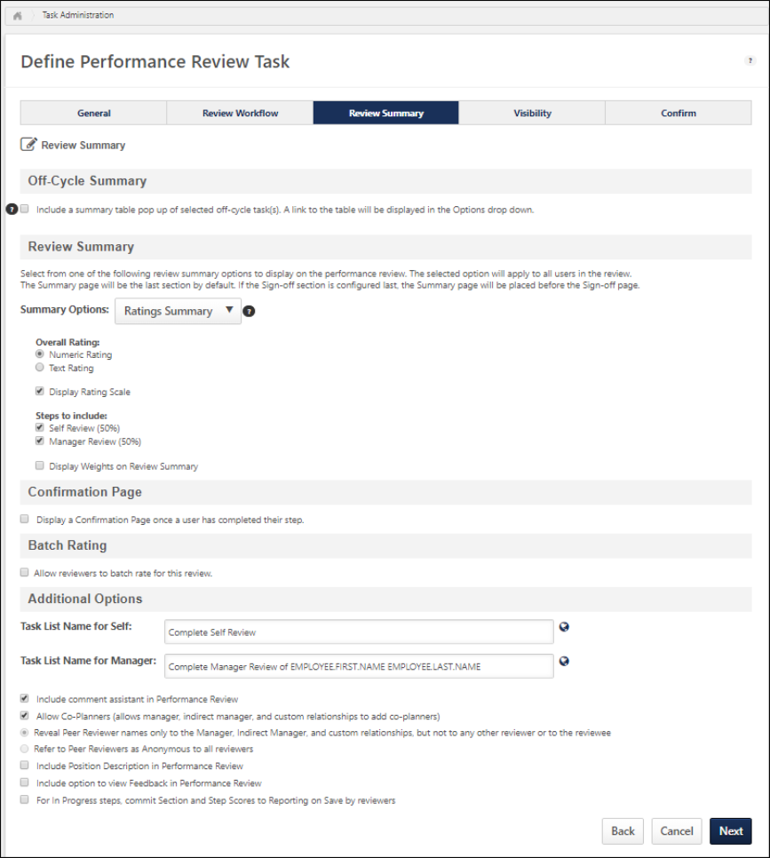
Off-Cycle Summary
In the Off-Cycle Summary section, administrators have the option to include and configure an off-cycle summary table in a standard review task. Note: The Off-Cycle Summary section is only available when creating a standard review task. In addition, if no off-cycle tasks are available, this section does not appear.
- Include a summary table of selected off-cycle task(s) - Select this option to include a summary table of selected off-cycle tasks in the performance review. The Off-cycle Summary displays a summary of an employee's off-cycle reviews that have been completed throughout the year. This enables organizations to remind reviewers of the results of any off-cycle reviews that have occurred during the review period. Note: It is not possible to limit which reviewers see the off-cycle summary.
  - For organizations using the old performance reviews user interface (UI), the Off-Cycle Summary table appears within the Overview section of the review
  - For organizations using the redesigned performance reviews UI, the Off-Cycle Summary is available as an option within the Options drop-down menu on all performance review task pages.
If the option to include an off-cycle summary table in the review task is selected, additional configuration options appear. The following options appear within the Off-Cycle Summary section:
- Which review tasks would you like to summarize? - Click the pop-up icon to the right of the question to select the off-cycle review tasks you would like to summarize. Multiple off-cycle tasks can be selected and there is no limit to the number of tasks that can be selected. Note: Even though many off-cycle review tasks may be selected, the off-cycle summary section within a standard review only displays a summary of the off-cycle tasks that apply to the reviewee.
After an off-cycle task is selected, the remaining options may appear:
- Which reviewers' names would you like to include? - The off-cycle summary table displays the names of the reviewers that participated in the off-cycle review. Select which reviewers appear in the summary table.
  - This list includes the names of each reviewer step included in any of the selected off-cycle tasks, except for Self, Peers, and Subordinates. Managers, Indirect Managers, Custom Relationships, and specifically named reviewers are included.
  - If no reviewers are selected, the Reviewers column is not included in the off-cycle summary.
- Which custom fields would you like to include? - The off-cycle summary table displays custom fields for the off-cycle review. Select which custom fields appear in the summary table. The selected fields appear as their own column in the summary table.
  - This list includes all custom fields that are included in any of the selected off-cycle tasks and that are available to the review task creator, except for scrolling text fields. Note: If no custom field is available to the administrator, or if no custom field is included in the selected off-cycle tasks, then this question does not appear.
  - There is no limit to the number of custom fields that can be selected.
  - If the selected custom field has no data, the field does not appear in the summary table.
- Which performance reviews would you like to include in the summary table? - This option enables administrators to determine which off-cycle review tasks are included in the summary.
  - Only include off-cycle tasks completed between XX/XX/XXXX and XX/XX/XXXX - Select this option to include only the reviews that ended within the selected date range. Select the date range start date from the first calendar box and the date range end date from the second calendar box. The end date must be after the start date.
  - Include all complete off-cycle reviews whose review period overlaps this task's review period - Select this option to include only the reviews that are complete that also partially or completely overlaps with the standard review task that is being created.
- Include the overall and section scores in the table - Select this option to include a column that displays the score for the off-cycle review task. All scores appear as they were configured in the original task configuration (numeric, text, both).
- Include a collapsible list of sections for every displayed review instance - Select this option to include a list of sections that appear in the off-cycle task for each off-cycle task that is included. Each section list can be expanded and collapsed.
- Include an additional summary table of every competency rating from these off-cycle tasks - Select this option to also include a competency summary in the Overview section for each competency rating in the off-cycle task. To enable this option, contact Global Customer Support.
Review Summary
Summary Options - The selected option applies to all reviewers and the employee being reviewed. Select one of the following options from the drop-down menu:
- No Summary - Select this option to hide the entire review summary, including the overall rating. The summary page is not available on the reviewe for any reviewer. The ratings are still available for reports and other modules in the application.
- Overall Ratings Only - Select this option to show only the final overall review score received by the reviewee.
- Ratings Summary - Select this option to show the entire review summary.
Overall Rating - This option is not available if No Summary is selected as the Summary Option. Select whether the overall rating is displayed as a numeric or text rating. The numeric and text ratings are based off the rating scale defined on the General page.
Display Rating Scale - Note: For organizations who have not enabled the new performance review user interface (UI) for new performance review tasks, this option is available on the General page. This option is not available if No Summary is selected as the Summary Option. When this option is selected, the rating scale is displayed to reviewers. The overall rating scale is available by clicking the Question Mark icon to the right of the overall rating and in the Overall row of the ratings table on the Summary page within the performance review task. Deselect this option to hide the rating scale in the review.
Steps to include - This option is only available if Rating Summary is selected as the Summary Option. Select which review steps are included in the review summary. If the weight of a step is set to 0%, by default, that reviewer's scores are not displayed.
Display Weights on Review Summary - This option is only available if Rating Summary is selected as the Summary Option. Select this option to display the step and section weights in the review summary.
For organizations using the redesigned performance reviews UI, the Summary page appears before the Sign-off page by default.
- If the Sign-off section is the last section in the review task, then the Summary page appears before the Sign-off page.
- If the Sign-off section is not the last section in the review task, then the Summary page appears as the last page in the review task.
- If two Sign-off sections exist in the review task and neither are the last section in the review task, then the Summary page appears as the last page in the review task.
- If two Sign-off sections exist in the review task and one of them is the last section in the review task, then the Summary page appears before the last Sign-off page.
- If two Sign-off sections exist in the review task and they are the last two sections in the review task, then the Summary page appears before both of the Sign-off pages.
- If no Sign-off section exists in the review task, then the Summary page appears as the last page in the review task.
Confirmation Page
Note: This section is only available for organizations using the redesigned performance reviews UI.
The following options are available in the Confirmation Page section:
- Display a Confirmation Page once a user has completed their step. - Select this option to display a Confirmation page to the user after they have completed their performance review step. The Confirmation page is used to indicate to the user that they have completed their responsibilities for the step. Once this option is selected, additional options appear.
- Include a 'Go to Action Items' button below text content. - Select this option to include a Go to Action Items button below the text on the Confirmation page. Users can click this button to open their Action Items page. Note: When enabled, the Go to Action Items button does not display for external reviewers.
- Enter the text you want to display to end users. - In this field, enter the text that will display to users on the Confirmation page, up to 3000 characters.
Batch Rating
This section enables the administrator to enable and configure the Batch Rating section for the performance review task. Batch rating enables reviewers to view reviewees within the same performance review task on a single page, provide ratings and comments, more quickly complete performance reviews, and view a high-level overview of all reviewees. The Batch Rating page is available to all active relationships except self, peers, external reviewers, and subordinates.
The Batch Rating page can only be used to provide ratings for Competency Rating and Question List performance review sections.
- Allow reviewers to batch rate for this review - Select this option to enable batch rating for the performance review task. When this option is selected, the Instructions and Batch Task List Name for [Reviewer Role] fields are available. This checkbox is unchecked by default.
- Instructions - This field is only available when batch rating is enabled. This field is optional. In this field enter the instruction text that will appear to reviewers at the top of the Batch Rating page. The character limit for this field is 3000. If multiple languages are enabled for your portal, select the Translate icon to translate the field into other available languages.
- Batch Task List Name for [Reviewer Role] - This field is only available when batch rating is enabled. This field is required if batch rating is enabled. In this field, enter the name of the batch rating task that will appear on the Universal Profile - Actions page for the reviewer. Additional fields are available for each reviewer role that can complete a batch rating (e.g., manager, indirect manager). The default value is "Batch Rating for [Reviewer Role] Review." The character limit for this field is 250. If multiple languages are enabled for your portal, select the Translate icon to translate the field into other available languages.
Additional Options
- User Prompt for Review Title - For off-cycle reviews, users that initiate the review provide a title for the review. In this field, enter the label of the text field in which the review initiator provides a title for the review. This text should guide the user to provide a useful review title, such as "What is the purpose of this review?" The character limit for this field is 100. If multiple languages are enabled, click the globe icon to translate the name into other available languages. Note: This option is only available for off-cycle reviews.
- Task List Name for - Enter a unique name for the step review task that is different from the overall review task name. You can set up each individual steps in the task with unique names, which allows the reviewer to identify the task easier in the Your Tasks widget. Employee name tags can be included in the name in which the tag is replaced with the employee's first and last name (e.g., EMPLOYEE.FIRST.NAME and EMPLOYEE.LAST.NAME). If multiple languages are available for the portal, the task list name can be localized by clicking the Translate icon to the right of the field.
- Include comment assistant - Select this option to add the Comment Assistant in the review, which provides suggested feedback for questions in the review. The comment assistant pulls suggested comments that are defined for a question. If they do not exist, the suggested comments pulls from the general Performance Comment Assistant bank.
- Allow Managers to create development plans - Select this option to allow managers to create development plans for a user from the performance review. Note: For organizations using the redesigned performance reviews UI, this option is not available.
- Allow Co-Planners (allows manager, indirect manager, and custom relationships to add co-planners) - Select this option to allow co-planners to access the task. Co-planners allow a user to access a reviewer's task and enter information on their behalf. This option is visible only to the manager, indirect manager, and users selected to review the employee. Any comments that are provided by a co-planner are attributed directly to the co-planner. Ratings are attributed to the co-planner or assignee who selects the rating that is submitted.
- Anonymous Peer Reviewer Options - Select the appropriate option for the review regarding anonymous peer reviewers. Note: This option is only available when a Peer Group review step is included in the review task.
  - Reveal Peer Reviewer names only to the Manager, Indirect Manager, and custom relationships, but not to any other reviewer or to the reviewee - When this option is selected, reviewees, peers, and subordinates see the term Anonymous in place of the peer reviewer's name in the review. Managers, indirect managers, and custom relationships can see the peer reviewers name in the review.
  - Refer to Peer Reviewers as Anonymous to all reviewers - When this option is selected, all reviewers see the term Anonymous in place of the peer reviewer's name in the review.
- Include Position Description in Performance Review - Select this option to include a position description in the performance review task. This option is deselected by default. If this option is selected, a Position Description tab is added to the Overview step of the performance review task and in the Employee Information section of the printed review, provided that Position is an active OU type in the portal, the reviewee has a position, and the reviewee's position has a description. Note: For organizations using the redesigned performance reviews UI, this option is not available.
- Include option to view Feedback in Performance Review - When this option is selected, a View Feedback link appears in the Actions widget on the performance review. This option is only available if the Universal Profile - Feedback functionality is enabled for the portal, which is controlled by a backend setting.
- For In Progress steps, commit Section and Step Scores to Reporting on Save by reviewers - This option determines when administrators are able to view the ratings that are selected by reviewers.
  - When this option is not selected, administrators can only view a reviewer's selected scores once the reviewer submits the step.
  - When this option is selected, administrators can see the reviewer step score, which is the cumulative rating for the reviewer's entire step.
- Allow users to decline a Performance Review - Select this option to allow users to decline to complete an off-cycle performance review that they are assigned. Selecting this option enables a Decline Review link on the performance review task page. Note: This option is only available for off-cycle reviews. See Performance Review - Decline Review on page 207 for additional information.
- Allow users to participate in a discussion about the Performance Review - Select this option to allow users to participate in a threaded discussion about the performance review. Selecting this option enables a Discuss Review link on the performance review task page. The discussion comments can be sent to the reviewee either privately or to all participants of the review. Note: This option is only available for off-cycle reviews. See Performance Review - Discuss Review on page 155 for additional information.
  - Permanently delete all discussion comments from performance review - This field allows you to configure threaded discussion comments to be deleted from the review task. The field is not selectable and unchecked by default. You must check the Allow users to participate in a discussion about the Performance Review box to activate the checkbox.
    - Checking this option opens a confirmation pop-up.
      - Clicking Yes activates the Completion Date and Review End Date checkboxes, which are checked by default once activated.
      - Clicking No in the confirmation pop-up cancels the action.
    - When this option is selected, you must specify when comments will be deleted, either within a period of days, weeks, or months following the review's completion date or end date.
    - Once at least one reviewer starts the task, the delete comments preferences cannot be changed.
    - Notes:
      - Comments deleted from a performance review task cannot be restored. As soon as the task meets the deletion criteria, all comments in the task are removed and cannot be restored.
      - The due date and status of a performance review task can be changed by administrative or end user controls (i.e., reopening a step, extending a step due date, etc.). If the due date or status changes and the comments are configured to delete but have not yet been deleted, the comment deletion date is reset.
      - Comments within the same performance review task can be deleted multiple times. For example, if a task is configured to have its comments deleted upon completion and the task's status is Complete, the comments are deleted. However, if 1) a step within the task is reopened or the step due date extended and 2) the task is completed three days later, then any comments entered during that period are deleted when the task meets the deletion criteria.
      - If the numeric field is set to "0," the comments are deleted the moment the task achieves a status of Complete. If the numeric field is set to greater than "0," then deletion of comments occurs the set number of days, weeks, or months after the deletion trigger.
      - Changes to the deletion preference setting affect all instances of the task.
Back/Cancel/Next
- Click Back to return to the previous page.
- Click Cancel to close this page.
- Click Next to proceed to the next tab. See Review Task - Create/Edit Visibility on page 47 for additional information.

Review Task - Create/Edit Visibility
Use the Visibility tab to determine what reviewees can or cannot see, and if visible, when the reviewee can view the information. In some situations, your organization may not want to display all of the information gathered in a review, or may choose to delay displaying the final results of a performance review to the reviewee.
Visibility of review information is divided into two sets of options: the reviewers providing feedback and the overall rating itself.
To access performance review tasks, go to Admin > Tools > Performance Management > Tasks.
- If you are creating a new review task and you completed the previous page, you can enter information on this page.
- To edit a review task, in the Options column, click the Edit icon for the appropriate review task.
Permissions
PERMISSION NAME | PERMISSION DESCRIPTION | CATEGORY

Performance Review Task - Manage | Grants ability to assign performance review tasks and manage activity within those tasks. This permission works in conjunction with the Admin Visibility settings for the performance review task. Administrators who have this permission and are within the Admin Visibility settings can view the task, edit the task, add users, and view the task details. However, the admin cannot edit the Admin Visibility settings for the task. This permission can be constrained by OU, User's OU, User Self and Subordinates, and User. The constraints on this permission control which users can be added to the task. | Performance - Administration

Performance Review Task Administration | Grants ability to create/assign performance review tasks and manage activity within those tasks. This permission also gives the ability to enable and view co-planners for a task from the administration pages. This permission can be constrained by OU, User's OU, User Self and Subordinates, and User. | Performance - Administration
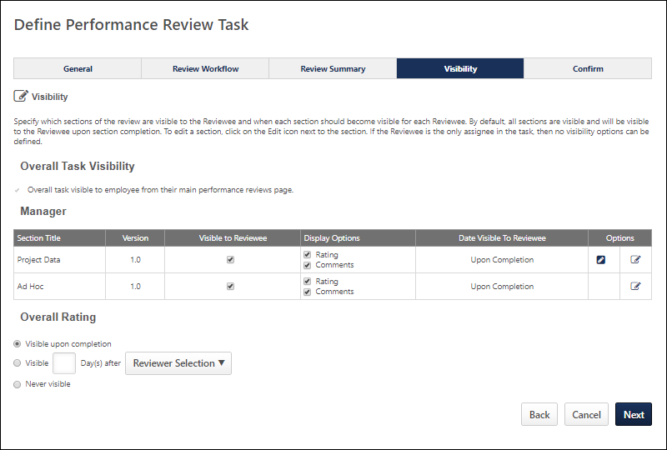
Overall Task Visibility
Select this option to make the review task visible to the employee from the employee's main performance review page. This option is only available if the Self role is not assigned a review step for the performance review. This option overrides all other visibility options on the page.
Reviewer (Manager, HR Manager, Peer)
If the reviewee is allowed to see the feedback provided by the reviewer, you can decide which sections to display, options to display the rating in the section and/or the comments of the section, and on what date is the information visible.
Please note that Goal Planning sections are designed to facilitate open conversations, and there is no rating for this type of section. Therefore, Goal Planning sections are always visible for end users and this visibility cannot be configured. In addition, Sign Off sections do not appear for visibility settings as there is no rating or comments on these sections.
The following options are available for each section in the table:
- Visible to Reviewee - Select this option next to the section to make the information from that section visible to the reviewee.
- Display Options: Rating and Comments - Select which information from the section is visible to the reviewee.
- Date Visible to Reviewee - If section information is visible to the reviewee, this column displays when the section information is visible to the reviewee. Visibility is set by selecting one of the visibility options in the Options column. Visibility can be set individually for each section. When creating off cycle reviews, visibility dates must be relative.
- Options - Click the icon to set the visibility date for an individual section or the icon to set the visibility date for all sections in a step.
You can set the visibility date for an individual section or for all sections in a step.
To set the visibility date for an individual section
- Click the Edit icon in the Options column. This opens the Section Visibility pop-up. The Reviewer field displays the step name. The Section field displays the section name.
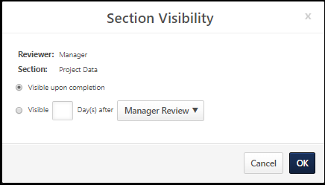
- The following visibility options may be available:
  - Select the Visible upon completion option to make the section visible as soon as the step is complete.
  - Select the Visible option to configure the visibility date relative to the completion of a specific step in the task. Enter the number of days in the Day(s) field. Select a step from the drop-down.
  - Select the Visible on option to set a specific date on which the section is visible. Enter a date in the date field or use the calendar option to select a date. This option is not available for off-cycle reviews.
- Click OK.
To set the visibility date for all sections in a step
- Click the Edit All icon in the Options column. This opens the Reviewer: [Reviewer] pop-up.
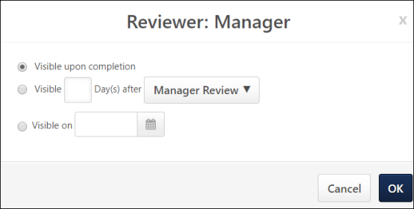
- The following visibility options may be available:
  - Select the Visible upon completion option to make the sections visible as soon as the step is complete.
  - Select the Visible option to configure the visibility date relative to the completion of a specific step in the task. Enter the number of days in the Day(s) field. Select a step from the drop-down.
  - Select the Visible on option to set a specific date on which the section is visible. Enter a date in the date field or use the calendar option to select a date. This option is not available for off-cycle reviews.
- Click OK.
For steps assigned to direct reports or peer groups, when you click the Edit icon, you also have the option to set the number of responses that are required before the responses are displayed. The responses from a peer or direct report review step are immediately visible to the manager and administrators via reporting. However, an average score and anonymous comments are not visible to the reviewee until the minimum number of responses specified here has been reached.
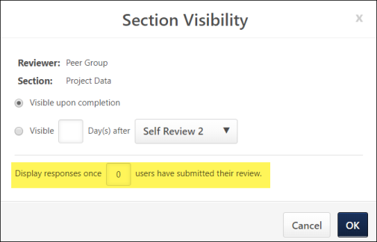
Overall Rating
If you choose to display the overall rating or the ratings summary for the summary page option on the Review Summary Step, then you can determine when to display the overall review rating to the employee. This option only applies to the overall rating and not the ratings summary table on the Review Summary page. This option applies to the summary page on the online review, the employee's performance review main list page, and the printable version.
Back/Cancel/Next
- Click Back to return to the previous page.
- Click Cancel to close this page.
- Click Next to proceed to the next tab. See Review Task - Create/Edit Confirm on page 51 for additional information.

Review Task - Create/Edit Confirm
Use the Confirm tab to view all of the selections, including a visual workflow of the performance review process itself.
To access performance review tasks, go to Admin > Tools > Performance Management > Tasks.
- If you are creating a new review task and you completed the previous page, you can enter information on this page.
- To edit a review task, in the Options column, click the Edit icon for the appropriate review task.
Permissions
PERMISSION NAME | PERMISSION DESCRIPTION | CATEGORY

Performance Review Task - Manage | Grants ability to assign performance review tasks and manage activity within those tasks. This permission works in conjunction with the Admin Visibility settings for the performance review task. Administrators who have this permission and are within the Admin Visibility settings can view the task, edit the task, add users, and view the task details. However, the admin cannot edit the Admin Visibility settings for the task. This permission can be constrained by OU, User's OU, User Self and Subordinates, and User. The constraints on this permission control which users can be added to the task. | Performance - Administration

Performance Review Task Administration | Grants ability to create/assign performance review tasks and manage activity within those tasks. This permission also gives the ability to enable and view co-planners for a task from the administration pages. This permission can be constrained by OU, User's OU, User Self and Subordinates, and User. | Performance - Administration
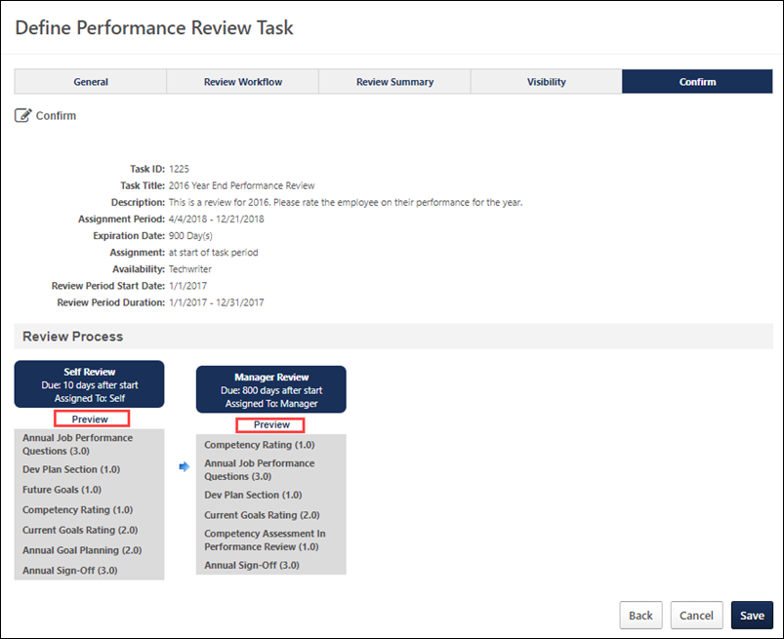
General Information
This section displays the information that you set on the General page for this review. This information is not editable.
Preview
Click the Preview link in the Review Process section to open a preview of the performance review step in a new window. The preview displays the performance review as it will appear to reviewers with the following considerations:
- The version number for each performance review section is displayed to the right of the section title in parentheses.
- Generic employee information is displayed in the review header.
- All options and buttons are included, but cannot be selected.
- The performance review progress is always zero percent.
- Sample data is used for Goal Rating, Goal Planning, Competency, Competency Assessment, and Development Plan sections.
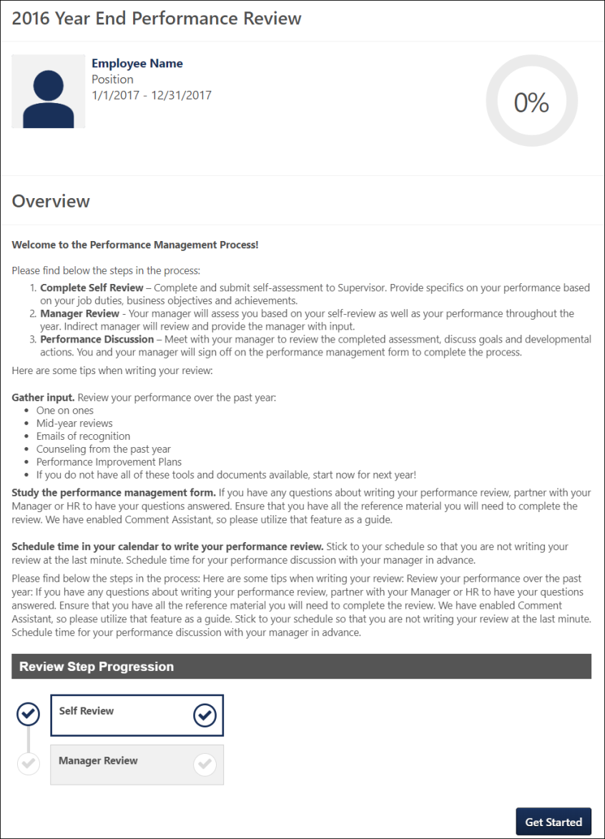
Back/Cancel/Next
- Click Back to return to the previous page.
- Click Cancel to close this page.
- Click SAVE when you are ready for the system to begin assigning the performance review.
Best Practice: Once a performance review task is In Progress status, the process of adding additional users to the performance review task may take up to 24 hours. It is very important to consider all users who should be included in the performance review task prior to setting the availability for the performance review task and submitting the task. See Use Case - Adding Users to Performance Review Task after Initial Task Launch Date on page 62 for additional information.
Review Task - Edit
Depending on the status of the performance review task, the task may be able to be edited.
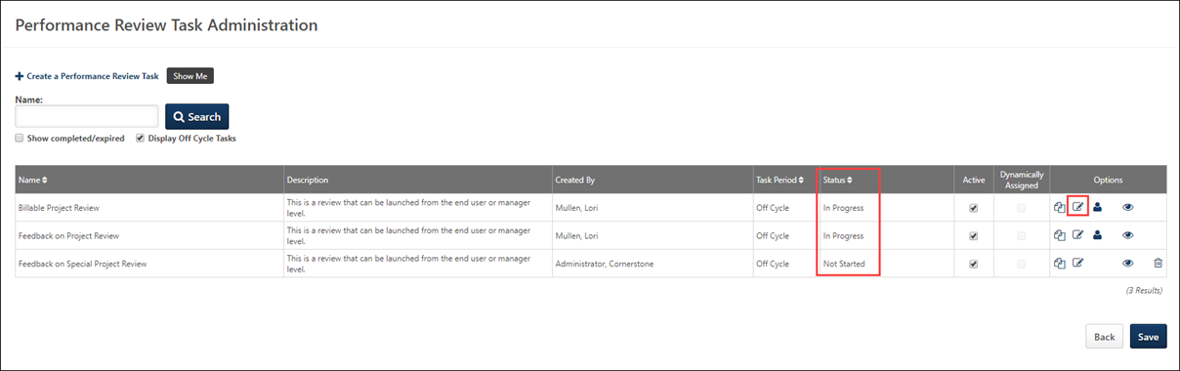
- Queued - Full Edit: Administrators can edit all areas of the performance review task.
- Not Started - Off-cycle performance review tasks can be fully edited. Standard performance review tasks in Not Started status can be fully edited if 200 or less users are being reviewed in the task. If over 200 users are being reviewed in the standard performance review task, then the task can be partially edited.
  - For standard performance review tasks in Not Started status, the first step cannot be deleted because the first step has been assigned to users. Administrators are able to fully edit the first step (e.g., add or remove sections, change assignee, change due dates), but the first step cannot be removed. This is to prevent any issues with the data and processing workflow.
  - Important: If the standard performance review task status is changed from Not Started to In Progress while the administrator is editing the task, the administrator is able to save their edits. However, any users who started the task will lose any data that was saved to their task before the administrator edited and saved the task.
  - Important: If an off-cycle performance review task status is changed from Not Started to In Progress while the administrator is editing the task, the administrator cannot save their edits. The administrator is forced to return to the Performance Review Task Administration page and click the Edit icon again to partially edit the review task or to click the Copy icon to create a new task and make full edits. An error message displays this information when the administrator attempts to save the task.
  - Note: If full edits must be made to a standard task in Not Started status that has more than 200 users, administrators can copy the Not Started task, modify the copy, and delete the initial task.
- In Progress - Partial Edit
- Completed - No Edit: Administrators cannot edit any part of the performance review task.
- Expired - No Edit: Administrators cannot edit any part of the performance review task.
- Deleted - No Edit: Administrators cannot edit any part of the performance review task.
Full Edits
Administrators can fully edit a performance review task when it is in a Queued status. However, any change that are made while the task is in Queued status can only be saved up until the task begins processing. When editing a task that is in Queued status, the following message is displayed on each page: "Current changes to this task can only be saved until [DATE/TIME]."
Administrators can fully edit an off-cycle performance review task when it is in Not Started status. Administrators can fully edit a standard performance review task when it is in Not Started status if 200 or less users are being reviewed in the task. However, administrators can only partially edit the task once the task is In Progress.
- For standard performance review tasks in Not Started status, the first step cannot be deleted because the first step has been assigned to users. Administrators are able to fully edit the first step (e.g., add or remove sections, change assignee, change due dates), but the first step cannot be removed. This is to prevent any issues with the data and processing workflow.
- Important: If the standard performance review task status is changed from Not Started to In Progress while the administrator is editing the task, the administrator is able to save their edits. However, any users who started the task will lose any data that was saved to their task before the administrator edited and saved the task.
- Important: If an off-cycle performance review task status is changed from Not Started to In Progress while the administrator is editing the task, the administrator cannot save their edits. The administrator is forced to return to the Performance Review Task Administration page and click the Edit icon again to partially edit the review task or to click the Copy icon to create a new task and make full edits. An error message displays this information when the administrator attempts to save the task.
Partial Edits
When editing a standard performance review task that is in Not Started status but has more than 200 users assigned to the task, administrators can partially edit the task. A notification is displayed at the top of all pages. This message indicates that the task has more than 200 assigned users and that only partial edits are allowed.
- Note: If full edits must be made to a standard task in Not Started status that has more than 200 users, administrators can copy the Not Started task, modify the copy, and delete the initial task.
When editing an off-cycle performance review task that is in In Progress status, administrators can partially edit the task. A notification is displayed at the top of all pages. This message indicates that only partial edits are allowed.
When editing an In Progress task, administrators can partially edit the task. A notification is displayed at the top of all pages to indicate that the task has been started by a user and that only partial edits are allowed.
When administrators can partially edit a performance review task, the following areas can be edited:
- General Tab - On this page, administrators can edit the following fields, and all other fields are read-only:
  - Task Name
  - Description
  - Instructions
- Review Summary Tab - On this page, administrators can edit the fields within the following sections:
  - Off-cycle Summary
  - Review Summary
  - Batch Rating
  - Additional Options - All fields can be edited except the following options:
    - Allow Co-Planners (allows manager, indirect manager, and custom relationships to add co-planners
    - Allow users to decline a Performance Review
    - Allow users to participate in a discussion about the Performance Review
      - Permanently Delete All Discussion Comments
        - Completion Date
        - Review End Date
- Visibility Tab - When visibility changes are made to a task, the visibility changes are immediately reflected in the performance review. On this page, administrators can edit the fields within the following sections:
  - Overall Task Visibility
  - Rating and Comments
  - Overall Rating
Define Performance Review Task Rating Scale
A performance review rating scale is required for each performance review task.
Permissions
PERMISSION NAME | PERMISSION DESCRIPTION | CATEGORY

Performance Review Task Administration | Grants ability to create/assign performance review tasks and manage activity within those tasks. This permission also gives the ability to enable and view co-planners for a task from the administration pages. This permission can be constrained by OU, User's OU, User Self and Subordinates, and User. | Performance - Administration
To create a performance review task, go to Admin > Tools > Performance Management > Tasks. Then, click the Create a Performance Review Task link.
To define a default rating scale, click the Edit icon in the Overall Rating Scale section. The Define Default Rating Scale window appears.
At the top of the pop-up, set the following configuration options to determine how the rating scale is structured. After setting these options, click the Update button to implement the settings and refresh the rating scale accordingly.
- Scale - This setting represents the rating scale used in the given performance review form section. Entering a number is required and creates a scale based on the number of ratings to be used in the review. Additional rows appear for every point on the defined scale.
- Score Interval - From the drop-down list, determine the score interval for the rating scale. This score interval can use whole points (1), half points (0.5), or a tenth of a point (0.1).
- Target Distribution - Select this option to define a target distribution of scores that managers can use as a guideline when reviewing their employees by viewing the Performance Review Distribution Report. The target distribution helps create consistency by providing all managers the same scoring guidelines for the review process.
- Include Custom Rounding Range - Select this option to define custom rounding for the rating scale. Note: This option is only available if the Score Interval is set to 1.0. If any other score interval is selected, custom rounding is not available and standard rounding rules apply. See the Custom Rounding Range section below for additional information.
If multiple languages are available for the portal, the rating scale titles and descriptions can be localized by selecting the appropriate language from the Language drop-down list. The titles and descriptions for the administrator's default language must be entered prior to translating the rating and descriptions for other languages.
The following information displays for each point in the rating scale:
- Points - This field is fixed for each rating and cannot be changed. This represents the numerical value used to calculate a score for the section using the scale.
- Title - This represents the value of the rating (Exceptional, Above Average, etc.). This can also be a combination of letters and numbers that express the value of the point on the rating scale.
- Visible - When this option is selected, the corresponding rating scale score is available to reviewers when completing a performance review. When this option is deselected, the corresponding rating scale score is not available to reviewers and cannot be selected. In addition, when this option is not selected for a rating score, the range value cannot be set and the Target % is set to zero.
- Range - See the Custom Rounding Range section below for additional information.
- Target % - This column is visible only when the Target Distribution option is selected. If this option is selected and the Target % column is not visible, click Update. This is the target distribution for each rating. The total of all percentages must be 100%.
- Description - This is used to explain the rating in greater detail.
After defining the rating scale, click Save to save the changes and return to the Define Performance Review Task page.
Custom Rounding Range
For every rating that has the Visible option selected, a range of numbers appears in the Range column. Each range of numbers represents a range of performance review scores. If a reviewee's performance review score is within the range of scores, then the reviewee's performance review score is set to the corresponding rating. For example, if the range of 2.5-3.4 corresponds to a rating of 3.0 (Meets Expectations) and the range of 3.5-5.0 corresponds to a rating of 5.0 (Superior Performance), then a reviewee with a score of 3.4 gets a rating of 3.0 (Meets Expectations) and a reviewee with a score of 3.5 gets a rating of 5.0 (Superior Performance). Note: The reviewee's numeric score is unchanged. However, the text ratings can be determined by custom rounding.
The left value in the range is known as the range floor and it represents the lowest value that is included in the range.
- The range floor value is always read-only. If a range ceiling is modified, the range floor for the following range is automatically adjusted to match the previous range ceiling. For example, for the first rating (1.0), the range is set to 0-1.0. The range floor for the following rating (2.0) is automatically set to 1.1 because this is the next possible performance review score. If the range ceiling for the first rating (1.0) is modified from 1.0 to 1.4, the range floor for the following rating (2.0) is automatically updated to 1.5 because this is the next possible performance review score.
- The first range floor is always set to zero.
The right value in the range is known as the range ceiling and it represents the highest value that is included in the range. This value can be modified for all ranges except the final value, which is equal to the highest rating point value.
If a rating is set as not visible, the range for that rating is not available and is set to N/A. The ranges for the remaining ratings are automatically adjusted to account for the missing range.
If a rating that is not visible is set to be visible, the ranges are automatically adjusted to accommodate the new rating.

Assigning Step to Peer Group or Direct Reports
Assigning a task to Direct Reports assigns the task to all active direct reports for the employee being reviewed. If new users are added to the group after the step is assigned, they do not receive the task. If a user is removed from the group after receiving the task but before completing the step, they lose the task.
Assigning a task to an internal peer group assigns the task to all active users inside that peer group. Non-approved peers do not receive the task. If new users enter the group, they do not receive the task. If a user exits the group after receiving the task, they lose the task.
When assigning tasks to subordinates and peers, the rules for multiple submissions and due dates are the same as with any other relationships. If multiple submissions are allowed, each user is allowed to submit multiple times independently of each other and the step is not complete until the expiration date.
When a performance review task step is assigned to a peer group or direct report, a Reviewer Selection step is added to the review workflow. This step is set to be step 1 and this cannot be changed. Other steps can also be step 1 as long as it is not the peer/subordinate step that is dependent on the Reviewer Selection step. If more than one group step allows for reviewer selection (for example, a direct manager is selecting users for a peer review step and a direct report step), the reviewer selection steps are consolidated into one. The only option available for a Reviewer Selection step is the date selection. You cannot, edit, copy, view sections, or delete. In the date selection, there is no option to Deny submission after Due Date. This option is always true for a Reviewer Selection step. If the step is not completed by the due date, all users are selected. As with any step assigned to a manager, the Reviewer Selection step can be delegated to a co-planner.
If a review step is assigned to peers or subordinates, it appears on the Scheduled Tasks page and in the My Tasks widget on the Welcome Page.
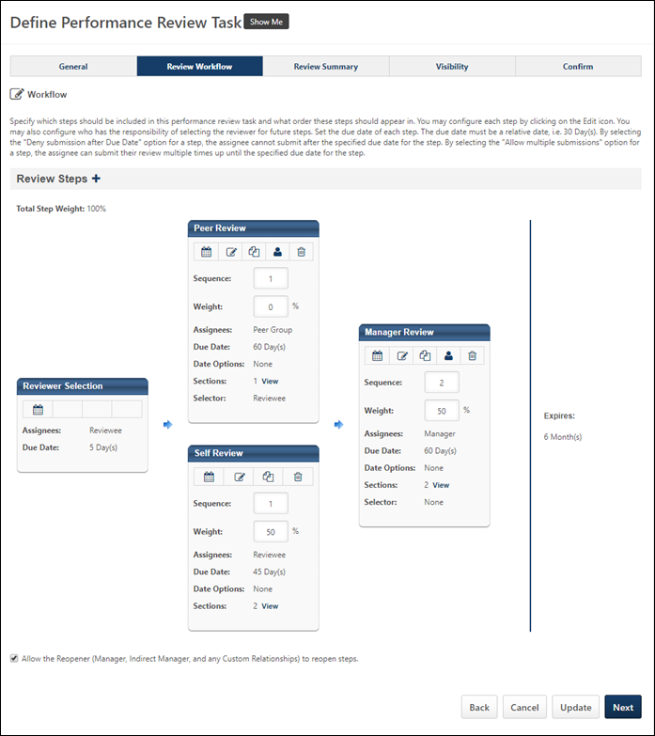
Use Case - Adding Users to Performance Review Task after Initial Task Launch Date
In these examples, an administrator is looking to add users to a Performance Review task that is currently In Progress, or set up an automated process to assign Performance Reviews on an on-going basis.
- Scenario 1: A user was accidentally omitted from the Performance Review Task
- Scenario 2: A Performance Review task is configured to assign to new hires 30 days after their Hire Date
Scenario 1: A user was accidentally omitted from the Performance Review Task
ABC Company launched a Performance Review task on a prior date to a group of users defined in the task Availability Criteria. User Jeff Martin was not included in the original Availability Criteria selection and was later found to be eligible for the Performance Review task.
- The administrator navigates to the Performance Review Task Administration page, and clicks the Add Users icon next to the desired task. This icon is only available for tasks that still have an open Task Period.
- The administrator searches for and selects Jeff Martin’s name, and then clicks Done to finalize her selection. She also checks the Dynamically Assigned checkbox next to the performance review task. Then, she clicks on the Save button from the task administration page.
- The system will process and add Jeff Martin into the Performance Review task within 24 hours. Users are added to Performance Review tasks as part of a nightly (Pacific Standard Time) system process.
- The next day, the administrator clicks the View Details icon next to the task from the Task Administration page to verify that Jeff Martin has been successfully added. The administrator types in Jeff’s User ID to locate him within the task. If Jeff appears under the task details, he has been successfully added.
- Finally, the administrator then unchecks the Dynamically Assigned checkbox from the Task Administration page to stop processing any new users into the Performance Review task.
Scenario 2: A Performance Review task is configured to assign to new hires 30 days after their Hire Date
- Ventonix Co. wants to create a Performance Review task that assigns to all new hires 30 days after each users' original hire date. This configuration helps administrators avoid creating a new 30-day task each time a new employee joins the organization.
- The administrator first creates a dynamic group titled 2016 New Hires, which includes group criteria to identify all users whose hire date is on or after January 1, 2016. The administrator waits for the group to process to ensure all the appropriate users have been added to the Group, and then navigates to the Performance Review task administration page to create a new Performance Review Task.
- When creating the performance review task, the administrator selects a Task Period from January 1, 2016 to December 31, 2016, so the task can be assigned at any point throughout the year. The administrator then selects a relative due date of 10 days from when the review is assigned. Under the Assignment Criteria section, the administrator sets the review to be assigned 30 days after each employee’s contract start date. Under the Review Period section, the administrator selects the option of "The review period will be based on when the Employee's review is assigned." The review period is then set to start one day after the task assignment date and end after thirty days.
- In the Availability section of the performance review task, the administrator selects the previously created group called 2016 New Hires. As new users are added to the system with a hire date on or after January 1, 2016, they will meet the criteria of the group and be dynamically added to the Performance Review task.
- The administrator configures the rest of the performance review task as desired and saves it.
- On the Task Administration page, the administrator checks the Dynamically Assigned checkbox and saves her changes. As long as this box is checked, new users who meet the criteria of the 2016 New Hires group throughout the year will be added to the Performance Task for their 30 day review on an ongoing basis, even after the task has originally launched.

View Performance Review Task Settings
Once a performance review task has been started by at least one user, the task can no longer be edited, but administrators can view the task settings. This provides a read-only view of the settings for each section in the task (e.g., General, Review Workflow).
To view the settings for a performance review task, from the Task Administration screen, click the View Settings icon.
From the Review Workflow step, you can view the details of individual steps within the task, including step sections and an email log for each email. To view a read-only version of the sections and email settings for an individual step within a task, from the Review Workflow section of a task, click the View icon for the step you'd like to view.
To view the email log for an email, in the Email Administration section expand the desired email by clicking the plus icon next to the email. Next to the expanded email, in the Options column, click the Export Log icon. This allows you to view or save the email log as an Excel file.
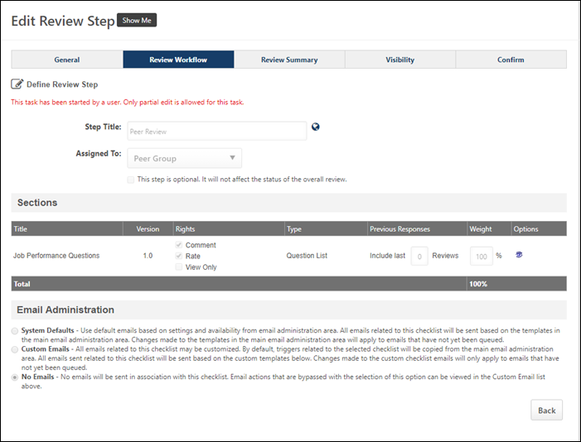
Automatic Failure Use Cases
Administrators can specify a threshold rating for any item within a performance review section that will trigger a status of "failed" for the overall review. Administrators can also specify the rating for the overall performance review if the automatic failure is triggered.
For example, if a performance review rating scale is 1-5, the automatic failure threshold may be set at 2. If a user receives a score of 2 or lower on any goal rating, competency rating, or question list item, then the automatic failure is triggered and the user automatically receives the automatic failure score.
Performance review section scores are calculated normally, regardless of the automatic failure setting.
This functionality is available for both standard and off-cycle performance reviews.
The following use cases apply to the Auto-score functionality set on the General step when creating a performance review task. See Performance Review Task - Create/Edit - General on page 13 for additional information.
Automatic Failure - Simple
Use Case:
- Admin creates Performance Review PR2011:
  - Automatic Failure enabled
  - Trigger score set to 2
  - Overall resulting score set to 1.0
  - Self Review step with Goal Rating Section GRS and Question List Section QLS
Action:
- User1 launches PR2011 and rates Goals in GRS as follows:
Goal | Weight | Rating
A | 25% | 4
B | 25% | 4
C | 25% | 4
D | 25% | 2
- User1 rates questions in QLS as follows:
Question | Weight | Rating
Q1 | 25% | 5
Q2 | 25% | 4
Q3 | 25% | 4
Q4 | 25% | 5
Result:
- Automatic failure is triggered due to the 2 rating on Goal D in GRS.
- User1 receives 3.5 as the section score for GRS.
  - Calculation: ((0.25*4)+(0.25*4)+(0.25*4)+(0.25*2))=3.5
- User1 receives 4.5 as the section score for QLS.
  - Calculation: ((0.25*5)+(0.25*4)+(0.25*4)+(0.25*5))=4.5
- User1 receives a Self Review Workflow step overall score of 1.0 due to Automatic Failure being triggered.
- User1 receives an overall Performance Review score of 1.0 due to Automatic Failure being triggered.
Automatic Failure – Multiple Workflow Steps
Use Case:
- Admin creates Performance Review PR2011:
  - Automatic Failure enabled
  - Trigger score set to 2
  - Overall resulting score set to 1.0
  - Overall Rating Scale set to 1 – 5
  - Self Review step (50% weight):
    - Goal Rating Section GRS (50% weight)
    - Question List Section QLS (50% weight)
  - Manager Review step (50% weight):
    - GRS (50% weight)
    - QLS (50% weight)
- Manager1 is the Manager for User1.
Action:
- User1 launches PR2011 and rates Goals in GRS as follows:
Goal | Weight | Rating
A | 25% | 4
B | 25% | 4
C | 25% | 3
D | 25% | 3
- User1 rates questions in QLS as follows:
Question | Weight | Rating
Q1 | 25% | 5
Q2 | 25% | 4
Q3 | 25% | 4
Q4 | 25% | 5
Result:
- User1 receives 3.5 as the section score for GRS (Self Review).
  - Calculation: ((0.25*4)+(0.25*4)+(0.25*3)+(0.25*3))=3.5
- User1 receives 4.5 as the section score for QLS (Self Review).
  - Calculation: ((0.25*5)+(0.25*4)+(0.25*4)+(0.25*5))=4.5
- User1 receives a Self Review Workflow step overall score of 4.0.
  - Calculation: ((0.5*3.5)+(0.5*4.5))=4.0
Action:
- Manager1 launches Manager Review of User1 for PR2011 and rates Goals in GRS as follows:
Goal | Weight | Rating
A | 25% | 4
B | 25% | 4
C | 25% | 4
D | 25% | 2
- Manager1 rates questions in QLS as follows:
Question | Weight | Rating
Q1 | 25% | 4
Q2 | 25% | 3
Q3 | 25% | 4
Q4 | 25% | 5
Result:
- Automatic Failure is triggered due to the 2 rating on Goal D in GRS (Manager Review).
- User1 receives 3.5 as the section score for GRS (Manager Review).
  - Calculation: ((0.25*4)+(0.25*4)+(0.25*4)+(0.25*2))=3.5
- User1 receives 4.0 as the section score for QLS (Manager Review).
  - Calculation: ((0.25*4)+(0.25*3)+(0.25*4)+(0.25*5))=4.0
- User1 receives a Manager Review Workflow step overall score of 1.0 due to Automatic Failure being triggered.
- User1 receives an overall Performance Review score of 1.0 due to Automatic Failure being triggered.
Creating Performance Review Tasks Quick Reference Card
Select the following link to access the Performance Reviews Feature Focus Playlist within the Success Center. This includes many resources such as training videos and quick reference cards for creating performance review sections, creating performance review tasks, and performance review workflows: Performance Reviews Feature Focus Playlist

Performance Review Task Details
On the Performance Review Task Details page, you can track the progress of the different employees being reviewed. The pie chart displays the status of the review and shows results either in the Overall Review status or by a specific step of the review. The task users are displayed below the pie chart. When viewing the results by employee, you can view details of the review, reset the review for a reviewee that is in the Not Started status, view and print attachments, or delete the task.
To view the Performance Review Task Details, go to Admin > Tools > Performance Management > Tasks. Then, click the View Details icon next to the appropriate performance review.
Permissions
PERMISSION NAME | PERMISSION DESCRIPTION | CATEGORY

Performance Review Task Administration | Grants ability to create/assign performance review tasks and manage activity within those tasks. This permission also gives the ability to enable and view co-planners for a task from the administration pages. This permission can be constrained by OU, User's OU, User Self and Subordinates, and User. | Performance - Administration
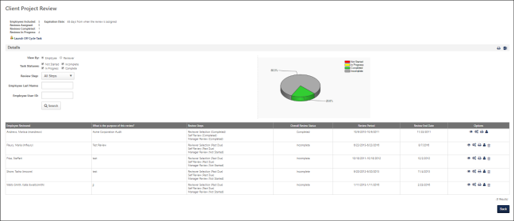
Print
Select the Print icon to print In Progress and Completed reviews. The constraints on the Performance Review Report permission determine for which users the Print option is available.
Export to Excel
Select the Export to Excel icon to export the information on the Performance Review Task Details to Excel.
Progress Details
The progress details sections contains information about the overall progress of the task, employee and reviews complete and incomplete, and assignment and review periods.
Extend Review Dates
Click the Extend Review Dates link to extend the overall review date for the performance review task. See Performance Review Task Details - Extend Due Dates on page 78 for additional information.
Launch Off Cycle Task
If the performance review task is an off-cycle task, the Launch Off Cycle Task option is available. Click the link to launch an off-cycle task for the review. Note: This option is only available for off-cycle reviews, and you must have permission to launch off-cycle performance review tasks. See Launch Off-cycle Performance Review on page 233 for additional information.
Best Practices
For best practice information regarding performance reviews: See Best Practices - Performance Review Task Administration.
Details
Use this section to create a search that populates the Details Table. You can select the following search options:
- View by - The employee type you want to display. Options are Employee or Reviewer.
- Task Statuses - The statuses you want to display. Options are Not Started, Incomplete, In Progress, and Complete.
- Review Step - The specific review steps you want to display. Options are All Steps, Self-Review, Manager Review, and Indirect Manager.
- Employee Last Name - The name of a specific employee, if necessary.
- Employee User ID - The User ID of a specific employee, if necessary.
- Pie Chart - A visual representation of the task status of all of the items in the details table, or an individual employee if selected.
Details Table
For each employee, the following information displays:
- Email - When the display is sorted by Reviewer, there is an option to email each reviewer directly next to the reviewer name. Clicking the email icon opens a pop-up where you can compose an email to reviewers.
- Employee/Reviewer Name - For off-cycle reviews, if a reviewer has declined a review, they appear as the reviewer until a replacement is set.
- What is the purpose of this review? - The corresponding review title. This text is customizable by the administrator and may display differently based on the review task configuration. See Performance Review Task - Create/Edit Review Summary on page 39 for additional information.
- Review Steps - The steps related to that user.
- Overall Review Status - The status of the entire performance review taskSee Performance Review Task Statuses on page 80 for additional information.
- Review Period - This information only displays for off cycle reviews.
- Review End Date - The set end date of the review.
Options
The following options are available for each user:
- View Details - View a read-only version of each review step, the assignees for each step, the due dates, and the current step.
- Advance - If a review is in progress and has future steps, in the View Details pop-up there is a button to advance the review to the next step. Advancing a review task opens whichever step is next in the sequence, regardless of the start dates and expiration dates.
  - This option is not available if the current step is the last step in the review workflow or if the current step allows multiple submissions.
  - When this option is selected, the current step is closed and all saved responses are submitted and finalized. If there are two parallel tasks next in the sequence, both steps are opened. Opening the next step fires all appropriate emails and the steps are then displayed in the task list for the appropriate users.
- Extend Review Dates - Select this option to extend the due date for the review. This is available only for Not Started or In Progress reviews. Individual reviewee due dates can be extended beyond the fixed end date for the task. Extending the task due date for an individual reviewee beyond the fixed end date will not extend the due date for the task. However, the task will remain in an In Progress status until the last open reviewee task is completed or expired, at which time the task will move to a Complete or Expired status. See Performance Review Task Details - Extend Due Dates on page 78 for additional information.
- Reopen Review Step - Administrators have the ability to reopen a previous step. Reopening a previous step does not affect the current step; both steps are available in parallel. The new due date for the reopened step is the due date for the entire review. All other steps can progress in parallel. For any review steps assigned to a peer or direct reports group, the manager can reopen the step for specific users. If a previous step is reopened and that reopened step has the same assignee as the current step, then all sections in the current step will be locked from editing for the assignee, and the assignee must complete the sections from the reopened step first before proceeding. When a step has been reopened the assignee will see the review task overview with a warning icon and a warning message. In general, this is available only for In Progress reviews. Depending on a backend setting, administrators may be able to reopen steps within a completed review task.
  - In the event that a user does not complete a Sign Off step, the step status eventually becomes Past Due.
    - In the event that a user does not complete a Sign Off step, the step status eventually becomes Past Due.
    - If the step is optional, the task eventually becomes Complete. In this situation, administrators cannot reopen the step.
  - For best practice information regarding performance reviews: See Best Practices - Performance Review Task Administration.
- Attachments - Click this icon to view the available attachments for the employee's review. The Attachment icon is not available if there are no attachments available. In the attachments pop-up, click the attachment name to open the attachment. Once the attachment is open, you may choose to print the attachment if necessary. The constraints on the Performance Review Report permission determine for which users the Attachments option is available.
- Add Co-Planner - Click this icon to add a co-planner for corresponding employee's review. Note: The ability to add a co-planner to a review task is controlled by the review task configuration.See Performance Review Task Details - Add Co-planner on page 73 for additional information.
- Delete - Delete the review.
Launching Off Cycle Reviews
When viewing the details of an off-cycle review, at the top of the page, there is an option to launch an off cycle task. This opens the Launch Performance Review page, where you can select the reviewee and the review task. Note: This option is only available for off-cycle reviews. See Launch Off-cycle Performance Review on page 233 for additional information.

Performance Review Task Details - Add Co-planner
Administrators can add a co-planner to an existing performance review task from the Performance Review Details page. Note: The ability to add a co-planner to a review task is controlled by the review task configuration.
To add a batch of co-planners to a task, See Performance Review Tasks - Manage Batch Co-Planners on page 75 for additional information.
To add a co-planner to an existing performance review task, follow these steps:
- Go to Admin > Tools > Performance Management > Tasks.
- In the Options column to the right of the appropriate performance review task, click the View Details icon . This opens the project review details page.
- In the Options column of the list of employees reviewed, click the Add Co-Planner icon for the employee to whom you are assigning a co-planner.This opens the Co-Planner pop-up, displaying all of the roles that are included as reviewers in the performance review task.
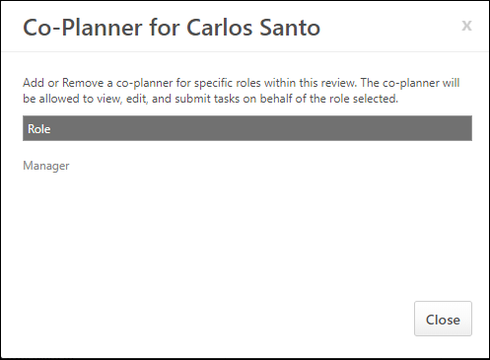
- The user name associated with each role is listed in parenthesis to the right of the role. If a co-planner has already been added to the employee's review, the co-planner's name appears under the role with which the co-planner is associated. To add a co-planner to a role, click the plus icon to the right of the role.
  - If a role does not have an associated user, no name is listed and a co-planner cannot be added for this role.
  - Co-planners can be assigned before the step is assigned to the reviewer.
  - A co-planner cannot be added if the review step is assigned to the following roles: Self-Review, Subordinates, Peer Group, and Specific User. If an administrator selects the Add Co-Planner icon for a review that is assigned to one of these roles, the Co-Planner pop-up indicates that no co-planners can be added to the review.
- From the Select User pop-up, select the appropriate co-planner by clicking the plus icon to the left of the user's name. Users can be searched by First Name, Last Name, User ID, and Manager's Last Name. The selected co-planner appears directly below the assigned role.
  - If the selected role is associated with multiple review steps, then the co-planner is added to each review step associated with the role.
  - There is no limit to the number of co-planners that can be added to a role.
  - The reviewee cannot be added as a co-planner.
  - The user that is currently in a role cannot be selected as a co-planner for that role. For example, if John Smith is in the Manager role, he cannot be selected as a co-planner for the Manager role.
  - If the user in a role becomes inactive, existing co-planners remain for that role. Administrators can remove co-planners if necessary, but the administrator cannot add new co-planners.
  - Click the Trash Can icon to the right of the co-planner's name to remove the co-planner.
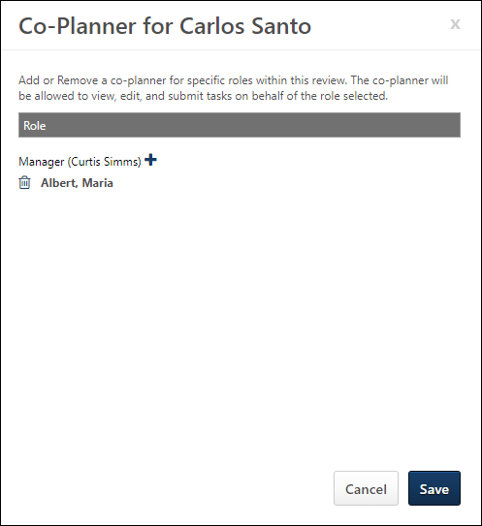
- Click Save to save the co-planner settings or click Cancel to discard changes made to the co-planners.

Performance Review Tasks - Manage Batch Co-Planners
Use the Batch Manage Co-Planners page to assign co-planners to a performance review task in a batch. You can search for, then add or remove co-planners.
To access the Batch Manage Co-Planners page, go to Admin > Tools > Performance Management > Tasks. In the Options column, click the Batch Actions ellipses, and then click Batch Manage Co-Planners.
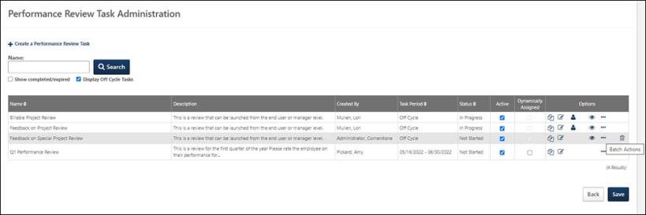

Permissions
PERMISSION NAME | PERMISSION DESCRIPTION | CATEGORY

Performance Review Task - Manage | Grants ability to assign performance review tasks and manage activity within those tasks. This permission works in conjunction with the Admin Visibility settings for the performance review task. Administrators who have this permission and are within the Admin Visibility settings can view the task, edit the task, add users, and view the task details. However, the admin cannot edit the Admin Visibility settings for the task. This permission can be constrained by OU, User's OU, User Self and Subordinates, and User. The constraints on this permission control which users can be added to the task. | Performance - Administration

Performance Review Task Administration | Grants ability to create/assign performance review tasks and manage activity within those tasks. This permission also gives the ability to enable and view co-planners for a task from the administration pages. This permission can be constrained by OU, User's OU, User Self and Subordinates, and User. | Performance - Administration

Task - View | Grants ability to view assigned tasks via Scheduled Tasks screen and Welcome Page My Tasks widget. This is an end user permission. | Core

View Performance Reviews | Grants ability to view the Performance Reviews page, which displays a user's own past performance reviews as well as performance review task steps they've been assigned to complete. This also grants ability to view the Batch Rating page. This permission can be constrained by OU, User's OU, User Self and Subordinates, and User. This is an end user permission. | Performance

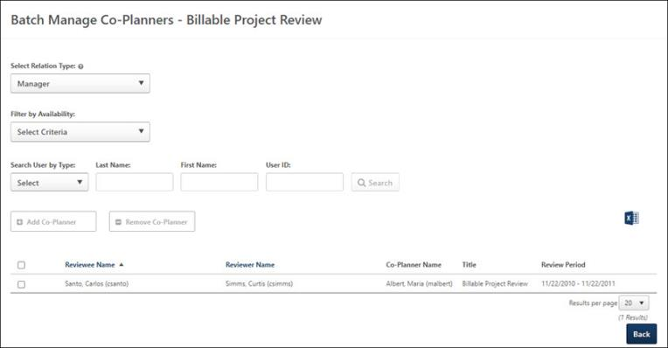
Search for Reviewees
Complete the following fields, as necessary to display search results based on the selected criteria.
- Select Relation Type: Select the reviewer relation type available for this task.
- Filter by Availability: Select the appropriate Organizational Unit (OU) to narrow search results. Options are:
  - All Users
  - Division
  - Position
  - Grade
  - Cost Center
  - Location
  - Group
  - Self Registration Group
  - Users
- Specific users by:
  - Type: Search by type of user. Options are Reviewer, Reviewee, or Co-Planner.
  - Last Name: The last name of the user.
  - First Name: The first name of the user.
  - User ID: The user id assigned to the user.
Click the Search button to display user search results.
Add or Remove a Batch of Co-Planners
To add or remove a batch of co-planners
- Search for the appropriate co-planners.
- In the search results table, select all or several names that you want to add as co-planners for this task.
- Select one of the following:
  - To add co-planners, click the Add Co-Planner button.
  - To remove co-planners, click the Remove Co-Planner button.
The Select User panel opens.
- Search for the co-planners you want to assign to the selected reviewees. Note: You can only add users that are currently associated with a role that can be added as co-planner.
- In the Search Results section, select the Add icon for the appropriate users. The selected users appear in the Selected User table.
- Click the Done button. All of the selected users are added or removed as co-planners for the appropriate Performance Review Task.
Note: You can only add co-planners that are not the same as the reviewee, reviewer, or an already added co-planner, or if there is no reviewer for any reviewee.
Download a List of Co-Planners
Click the Excel icon to download a list of co-planners. The downloaded .xlsx file contains the following information:
- Reviewee Name and ID
- Reviewer Name and ID
- Co-Planner Name and ID
- Task Title
- Review Period

Performance Review Task Details - Extend Due Dates
You can modify the actual date the step is due or the workflow due date for a step that is either In Progress or Not Started. You can also extend the due dates for the overall review task itself.
The updated dates only appear to users in In Progress or Not Started status. For tasks assigned to peer groups or direct reports, the due date can be reset for one or more specific users in the group. The reopened steps in the task list have a Reopened status and display regardless of the expired/completed checkbox.
If you reset a review, the workflow for the review appears in a pop-up.
- To extend the overall due date of the review, in the upper section, click the Extend Review Dates link.
- To extend due dates for an employee, click the Reset Review icon in the Options column.
Once the new dates are defined, all affected reviews that are Not Started or In Progress are updated.
Emails
EMAIL NAME | EMAIL DESCRIPTION | ACTION TYPE

Performance Review Step Due Date | This email is triggered when a performance review task is due. If this email is sent to the recipient group "Reviewer" then only the users that have received performance reviews will receive the email. This email is conditional so that it only includes the users who are in progress or have not started. Note: When customizing this email for a self-review step, this email cannot be sent to "Reviewer" because the system considers this user the reviewee.  This email can be set up as a reminder to go out before the due date. The reminder will not be sent to reviewers that have already completed the review.  The due date for performance review tasks is defined for each reviewer group on step 2 of creating a performance review task. This date is not necessarily the same as the task end date for it may occur before the task ends. Reviewers will not be locked out of the task on the task due date unless it is the same date as the task end date.  Reviewee will not receive any step email other than the self step and Similarly, a reviewer cannot receive any email for a Reviewee step.  Note: Email Digest emails do not include past-due notifications for optional or locked performance review steps after the step due date. | Performance Management
Note: If system default emails are configured and enabled for the performance review step for which a due date is being reset, then the Performance Review Step Due Date email is the only email that would be affected. The date on which the email fires is dependent upon how the email is configured in Email Administration. If custom emails are configured for the performance review step, then it would be necessary to review which emails are configured and how they are set up to determine if there are any other emails that would be affected by resetting the due date.
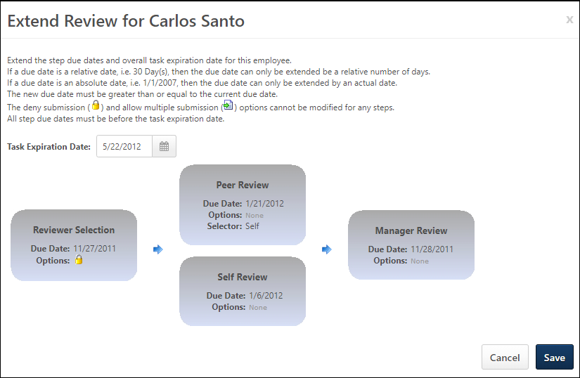
Best Practices
For best practice information regarding performance reviews: See Best Practices - Performance Review Task Administration.

Performance Review Task Statuses
Performance Review task statuses can be determined in the following areas:
- Performance Review Task Administration - To access Performance Review Task Administration, go to Admin > Tools > Performance Management > Tasks.
- Performance Review Task Details - To view the Performance Review Task Details, go to Admin > Tools > Performance Management > Tasks. Then, click the View Details icon next to the appropriate performance review.
Performance Review Task Status - All Reviewees
This refers to the status of the entire performance review task. For example, the performance review status is not Complete unless all performance review tasks within the performance review are completed. This status is displayed on the Performance Review Task Administration page.
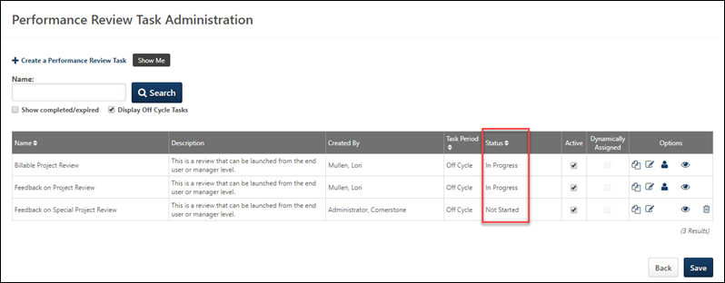
The available statuses are:
- Queued - The performance review task has been created, but the assignments have not yet been processed by the system.
- Not Started - No one has started their performance review task
- Completed - All individual performance review tasks are complete
- Expired - All individual performance tasks are expired (past the expiration date)
- In Progress - At least one assignee has started a performance review
Performance Review Task Status - Individual Reviewee
These are statuses that are available for each individual performance review assignment within the task. Performance review steps that are optional do not affect the overall performance review task status when the optional step's due date has passed for the performance review. This status is displayed on the Performance Review Details page.
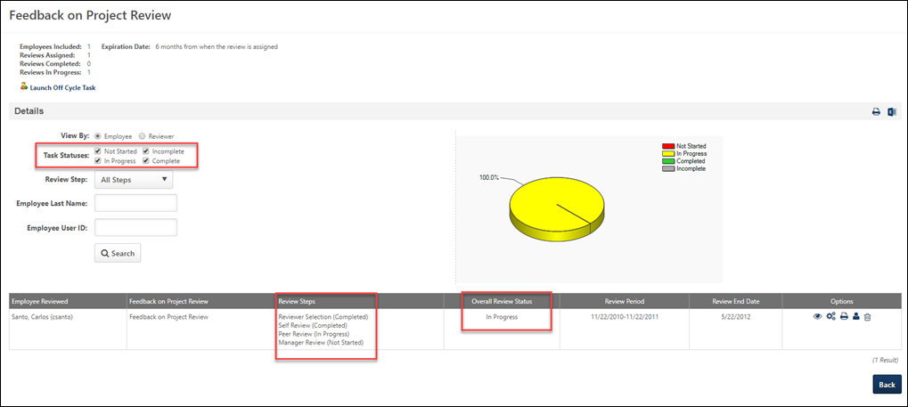
The available statuses are:
- Queued - The performance review task has been created, but the assignments have not yet been processed by the system.
- Not Started - The performance review has not started. If the review is not started and a review step becomes past due, the individual review task status is changed to In Progress.
- In Progress - At least one performance review step has started. Also, this status occurs when a the review is not started and a review step becomes past due.
- Completed - All required performance review steps are complete for the review
- Incomplete - All required performance review steps are not complete after the end date of the individual review
Performance Review Step Status
The status of a performance review step within an individual performance review task. This status is displayed on the Performance Review Details page.
The available statuses are:
- Queued - The performance review task has been created, but the assignments have not yet been processed by the system.
- Not Started - The step assignee has not started the performance review step
- In Progress - The step assignee has started the performance review step
- Completed - All sections are complete and the performance review step is submitted. If multiple submissions are allowed, the step is marked complete after the first submission.
- Past Due - The assignee has not completed all sections and the performance review step is past the due date. If the Deny Submission option is selected and it is past the due date, the status remains past due.

Performance Comment Assistant
The Performance Comment Assistant allows administrators to define words, sentences, or phrases that can be recommended to users who are entering comments on performance reviews. The Comment Assistant tool is only available to reviewers in performance reviews if it is enabled for performance reviews in Writing Tools. See Writing Tools Overview.
Note: The Comment Assistant is not available when batch rating performance reviews.
To view the Performance Comment Assistant, go to Admin > Tools > Performance Management > Comment Assistant.
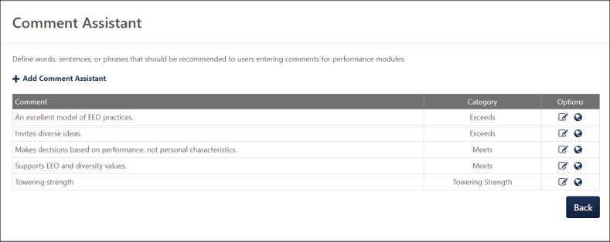
Comment Assistant - Add
To add a new comment assistant, click the Add Comment Assistant link. This adds a new entry to the table.
Each entry consists of a suggested comment and a category. Click the Save icon after entering a comment assistant.
Comment Assistant - Edit
Existing comment assistants can be edited by clicking the corresponding icon in the Options column.
Comment Assistant - Delete
Comment assistants cannot be deleted. However, a comment assistant can be edited and re-purposed with a different comment.
Comment Assistant - Translate
If multiple languages are enabled for your portal, select the Translate icon to translate the field into other available languages.
Comment Assistant - Categories
The categories that are available when creating or editing a comment assistant are managed in Writing Tools. See Writing Tools Overview.

Performance Reviews Custom Fields
The following custom field types are available for Performance Reviews:
- Performance Reviews - See Custom Field Admin - Performance Reviews for additional information.

Performance Review - End User Overview
Performance reviews may include different sections and options based on the configuration established by the administrator. Generally, an email notification is sent to users when they are assigned a review task.
You can access review tasks as follows:
- Welcome Page > My Tasks section
- Performance Review Summary page
- Universal Profile > Actions page.
To open a performance review task, click the performance review task title. The Overview step opens, displaying a snapshot of the review.
Permissions
PERMISSION NAME | PERMISSION DESCRIPTION | CATEGORY

View Performance Reviews | Grants ability to view the Performance Reviews page, which displays a user's own past performance reviews as well as performance review task steps they've been assigned to complete. This also grants ability to view the Batch Rating page. This permission can be constrained by OU, User's OU, User Self and Subordinates, and User. This is an end user permission. | Performance
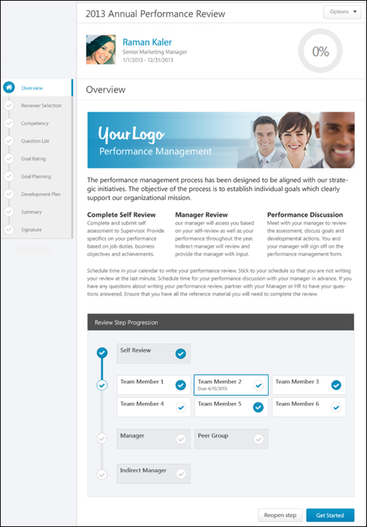
Performance Review Details
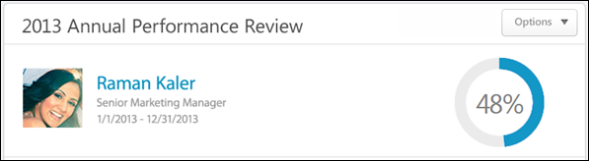
At the top of the performance review, the following performance review details are displayed:
- Performance Review Title - Title of the review. It is configured by the administrator when the review is created.
- Reviewee Photograph, Name, and Title - Reviewee's photograph, name, and position. Click the user's name or photograph to open their Universal Profile in a separate window. See Universal Profile - Bio Overview.
- Review Period - Time period of this review.
- Step Progress - Percentage complete. As review step sections are completed, the step progress is updated to reflect the correct percentage. Sections that require you to enter data complete once all required fields in the section are completed. When a reviewer views a section that does not require any information, the section is considered complete when the reviewer views the section. Note: The Overview page is not included in the completion percentage.
Options
Based on the configuration of the performance review and the reviewer's permissions, options may be available from the Options drop-down menu. See Performance Review - Options Drop-down on page 201 for additional information.
Performance Review Sections
On the left side of the performance review, the navigation menu displays all sections along with their completion status. Reviewers can click a section tab to access the section. See Performance Review - Review Sections on page 196 for additional information.
Performance Review Instructions
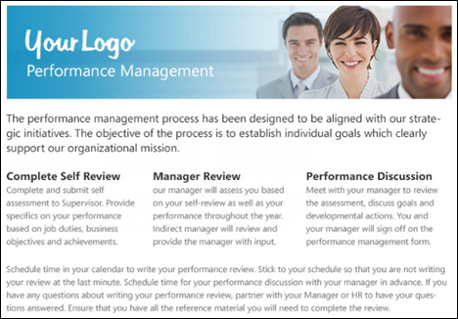
The performance review instructions are displayed below the performance review details. This section contains the instructions for completing the performance review. These instructions are configured by the administrator when the performance review task is created.
Review Step Progression
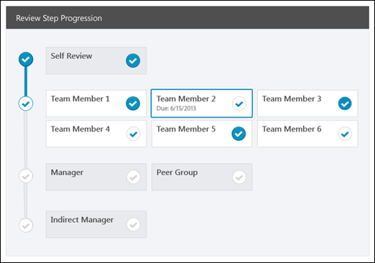
The Review Step Progression section provides the reviewer with a high-level view of the progress of all reviewers involved with the performance review task. All of the steps within the review task are displayed vertically with the first step displayed at the top of the section.
- Active Reviewer Step - The review step for which the user is an active reviewer appears with a colored border. The due date is displayed for this step.
- Completed Step - If a step is completed, it appears with a white check mark within a colored circle .
- Not Started/In Progress Step - If a step is not started or in progress, it appears with a colored check mark within a white circle .
- Future Step - If a step has not yet started and is not yet available, it appears gray with a gray check mark within a white circle .
Note: If the active reviewer step is a step that was reopened, then a message appears at the top of the Review Step Progression section, indicating that the active reviewer step must be completed before advancing to the next step.
Get Started
Click the Get Started button to open the first section of the performance review step.
Submit
If all sections are complete, the Submit button is available instead of the Get Started button. Click this button to submit the completed performance review. The Submit button appears on all pages once all required sections are complete.
Reopen Step
Reviewers (manager, indirect manager, custom relationship, or specific user) may have the ability to reopen previous steps in a performance review. This ability is enabled by the administrator when configuring the performance review task, and when available, the Reopen Step button appears at the bottom of the Review Step Progression section on the Overview page.
Click the Reopen Step button to reopen a previous step of the performance review task. This opens the Reopen Previous Review Step pop-up. See Performance Review - Reopen Previous Step on page 213 for additional information.
Decline Review
For off-cycle reviews, a dynamically selected reviewer (manager, indirect manager, custom relationship, or specific user) can decline to complete a review if they feel they are not the most appropriate person to complete the review. Note: This option is only available for off-cycle reviews. See Performance Review - Decline Review on page 207 for additional information.
Contents

Performance Review Summary
The Performance Review Summary page enables users to view the performance reviews that are assigned to them as well as the performance reviews in which they are the reviewee. The Performance Review section is divided into two tabbed sections: My Assigned Reviews and My Personal Reviews.
To access the Performance Review Summary page, go to Performance > Performance Reviews.
Permissions
PERMISSION NAME | PERMISSION DESCRIPTION | CATEGORY

Launch Off-Cycle Performance Review Task | Enables a user to launch an off-cycle performance review task. Having this permission does not guarantee that the user can launch an off-cycle review, only that they will have access to the Launch Performance Review page. A task must still be configured properly for the user to successfully launch an off-cycle review task. This permission works only if user has been designated to launch at least one currently active off-cycle performance review task. This permission can be constrained by OU, User's Subordinates, and Employee Relationship. This is an end user permission and does not apply to an administrator role.

View Performance Reviews | Grants ability to view the Performance Reviews page, which displays a user's own past performance reviews as well as performance review task steps they've been assigned to complete. This also grants ability to view the Batch Rating page. This permission can be constrained by OU, User's OU, User Self and Subordinates, and User. This is an end user permission. | Performance
Launch Review
The Launch Review button is available on the Performance Review Summary page only if the user has the permission to launch off-cycle performance review tasks. To launch a review, select the Launch Review button. This opens the Launch Performance Review page.
Note: The Launch Review button is only available if you have permission to launch off-cycle performance review tasks. Having this permission does not guarantee that you can launch an off-cycle review, only that you will have access to the Launch Performance Review page. A task must still be configured properly for you to successfully launch an off-cycle review task.
See Launch Off-cycle Performance Review on page 233 for additional information.
My Assigned Reviews
The My Assigned Reviews tab displays all of the reviews that are assigned to the user, including reviews in which the user completes a self review and in which the user serves as a co-planner.
To search for a review, enter the review title in the Title field and click Search. You can also use the following filters to search for specific types of reviews:
- Not Started
- In Progress
- Completed
- Incomplete
- Expired
The Review table displays the following information for each review:
- Title - The review title. For off-cycle reviews, the task name is also displayed in parenthesis after the review title. Click the review title to launch the review.
- Description - The review description.
- Status - The status of the task, but not every step within the task. For example, if there is more than one step in the task and one of the steps is completed then the status remains Inprogress until all steps are completed.
- Start Date - The review start date.
- Due Date - The review end date.
- Last Modified Date - The last date someone made changes to the review. This column is sorted by last modified date in descending order.
To launch a review, click the review title. See Performance Review - End User Overview on page 85 for additional information.
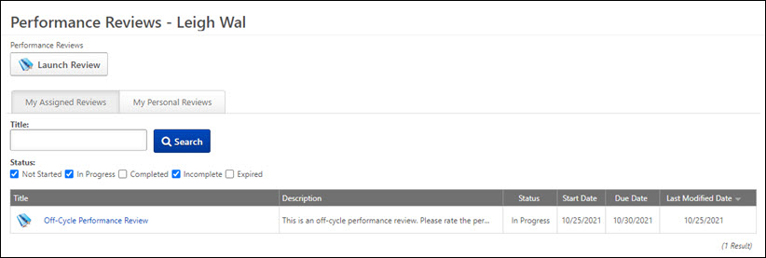
My Personal Reviews
The My Personal Reviews tab displays all of the reviews in which the user is the reviewee. The reviews are displayed in reverse chronological order by review period start date.
The Review table displays the following information for each review:
- Review - The review title. For off-cycle reviews, the task name is also displayed in parenthesis after the review title. Click the review title to launch the review.
- Review Period
- Start Date
- Completion Date - The review completion date. If the review is not yet complete, N/A is displayed.
- Task Status - The status of the review.
- Rating - The rating received from the review. If review rating is not displayed to the user, as determined via review task settings, then "No Rating" is displayed. If the review is not yet complete, N/A is displayed.
- Attachments - If a review is complete or expired and at least one file is attached to the review, then the attachments can be downloaded by clicking the Attachment icon. This opens the Open Attachments pop-up, which displays all of the available attachments. Click the attachment title to download the attachment.
To launch a review, select the review title. See Performance Review - End User Overview on page 85 for additional information.
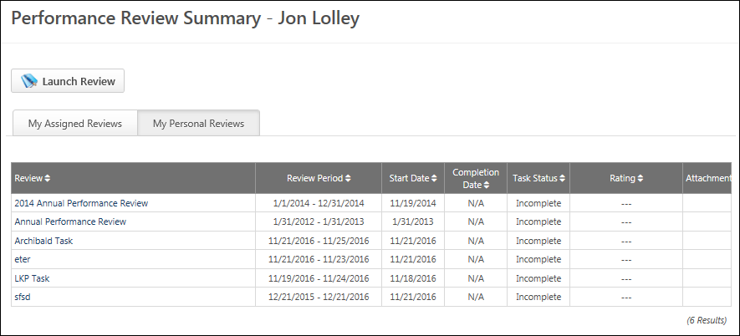

Performance Review Task Complete Overview
Performance Review - Reviewer Selection
When a Reviewer Selection step is assigned to a user, the user must select the reviewers for a performance review. The Reviewer Selection step does not appear on any of the printable versions of the review.
You can access review tasks as follows:
- Welcome Page > My Tasks section
- Performance Review Summary page
- Universal Profile > Actions page.
To open a performance review task, click the performance review task title.
Permissions
PERMISSION NAME | PERMISSION DESCRIPTION | CATEGORY

Select Peers and Reviewers | Grants ability to select peers and reviewers in off-cycle performance reviews. This permission can be constrained by User's Corporation, OU, and User's OU. This is an end user permission. | Performance

View Performance Reviews | Grants ability to view the Performance Reviews page, which displays a user's own past performance reviews as well as performance review task steps they've been assigned to complete. This also grants ability to view the Batch Rating page. This permission can be constrained by OU, User's OU, User Self and Subordinates, and User. This is an end user permission. | Performance
Note: The reviewer selector must have permission to select peers and reviewers. The constraints on this permission determine who the reviewer selector can select for the performance review step. Also, peer group availability is set by the administrator in Employee Relationships. If the user does not have the permission to select peers and reviewers, an error pop-up appears, alerting them that they are not able to select reviewers.
- There is no limitation or constraint on selecting external peers.
- Any changes to the reviewer selector's permissions or constraints after the reviewers are selected have no effect on the selection. Once a reviewer is selected, the selection is considered final.
- If a reviewer declines a review, the reviewer selector must select a new reviewer to fill the role. The users available to the reviewer selector are based on the constraints of the reviewer selector's permission at the time of the re-selection. If the reviewer selector's constraints have changed, the new constraints are applied.
Emails
EMAIL NAME | EMAIL DESCRIPTION | ACTION TYPE

Performance Review Step Assigned | Performance review of a specific user assigned. This email is triggered when the task step is available for that user to review, which may be triggered by the employee hire date, the previous reviewer submitting the review, or the task assignment date. Note: When customizing this email for a self-review step, this email cannot be sent to "Reviewer" because the system considers this user the reviewee.  Reviewee will not receive any step email other than the self step and Similarly, a reviewer cannot receive any email for a Reviewee step.  This email trigger can be sent to external users. If the REVIEW.LINK tag is used in the trigger and is sent to an external reviewer, then the link takes external reviewers to an external review page that requires no login or validation. See External Reviewers on page 251 for additional information. | Performance Management
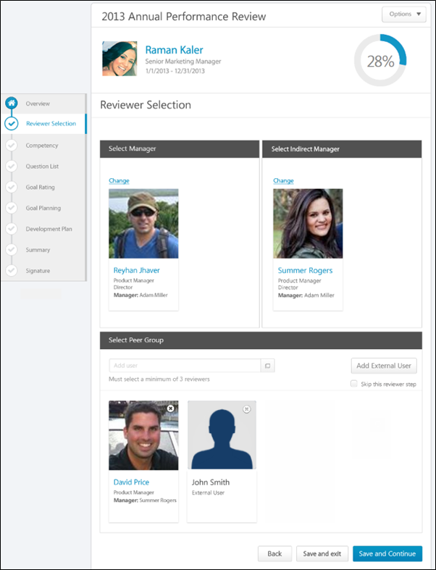
After completing the Reviewer Selection step, the selections cannot be edited unless multiple submissions are allowed for the review task. Returning to the Reviewer Selection step displays the selected users, but the selection cannot be modified.
Note: If the reviewer selection is not submitted by the due date, all available users are automatically selected.
If the review selector is not also a reviewer, then the Review Selection step is the only step in the task. For example, a user is chosen as a review selector, but does not participate in any review steps for the task.
Performance Review Details
At the top of the performance review, the following performance review details are displayed:
- Performance Review Title - Title of the review. It is configured by the administrator when the review is created.
- Reviewee Photograph, Name, and Title - Reviewee's photograph, name, and position. Click the user's name or photograph to open their Universal Profile in a separate window. See Universal Profile - Bio Overview.
- Review Period - Time period of this review.
- Step Progress - Percentage complete. As review step sections are completed, the step progress is updated to reflect the correct percentage. Sections that require you to enter data complete once all required fields in the section are completed. When a reviewer views a section that does not require any information, the section is considered complete when the reviewer views the section. Note: The Overview page is not included in the completion percentage.
Options
Based on the configuration of the performance review and the reviewer's permissions, options may be available from the Options drop-down menu. See Performance Review - Options Drop-down on page 201 for additional information.
Performance Review Sections
On the left side of the performance review, the navigation menu displays all sections along with their completion status. Reviewers can click a section tab to access the section. See Performance Review - Review Sections on page 196 for additional information.
Select Manager
This section is only available if enabled by the administrator when configuring the review task. In the Select Manager section, the user must select the reviewing manager. By default, this section displays the user's manager that is set on the User Record. If no manager is set for the user, then no manager is selected by default.
Only one manager can be selected, and this selection is required. In order to change the reviewing manager, click the Change link. This opens the Select User pop-up. See Select a User Pop-up for additional information.
Users can click the selected manager's name to open their Universal Profile in a new browser window.
Select Indirect Manager
Note: This section may not be available.
This section is only available if enabled by the administrator when configuring the review task. In the Select Indirect Manager section, the user must select the reviewing indirect manager. By default, this section displays the user's indirect manager that is set on the User Record. If no indirect manager is set for the user, then no indirect manager is selected by default.
Only one indirect manager can be selected, and this selection is required. In order to change the reviewing indirect manager, click the Change link. This opens the Select User pop-up. See Select a User Pop-up for additional information.
Users can click the selected indirect manager's name to open their Universal Profile in a new browser window.
Select Peer Group
This section is only available if enabled by the administrator when configuring the review task. In the Select Peer Group section, the user must select the appropriate number of peers who will complete the review. Note: The reviewer selector must have permission to select peers and reviewers. The constraints on this permission determine who the reviewer selector can select for the performance review step. The user's manager and indirect manager cannot be selected as a peer.
If peers are selected for a user and another review is created for the same user, then the previously selected peers are automatically selected by default for the following review. However, these selections can be modified.
Users can click the selected peer's name to open their Universal Profile in a new browser window.
There may be a minimum number of users that must be selected. In this case, you must select at least the minimum number of reviewers in order to complete the step.
Peer Selection Considerations
- The reviewer selector must have the Select Peers and Reviewers permission to select peer reviewers.
- The constraints on the Select Peers and Reviewers permission determine who the reviewer selector can select for the performance review step.
- The reviewee's manager and indirect manager cannot be selected as a peer. However, all other users within the selector's permission constraints can be selected, including second-level indirect managers (the manager of an indirect manager) and above.
Add Peer Reviewer
To add a peer reviewer, enter the peer's name in the Add a peer field. Predictive search displays users who match the entered name. Click the appropriate peer. Only peers that are approved or pending approval can be selected. Peers will not receive the review step until they are approved.
Alternatively, click the Select User button to search for and select peers. This opens the Select a user pop-up, in which you can search for users by name, position, division, location, or manager's name. See Select a User Pop-up for additional information.
When a user is added to the reviewer list and the list is submitted, the added user goes through the standard peer approval workflow.
- When a manager submits the peer list, the new user is immediately added to the peer group and will receive the review step.
- If the reviewee submits the peer list and approval is required for the peer group, the manager or an administrator must approve the new peers. These new peers pending approval do not receive the review task until they are approved.
  - If they are approved before the step expires, they immediately receive the Review Step Assigned email (if the email trigger is active) and the task. If they are approved after the step expires, they do not receive the email or the task.
- If the reviewee is submitting the list and approval is not required for the peer group, the new users are instantly added to the peer group and receive the review step.
If the minimum number required for the review step is less than the number of available users, each available user must be selected.
Add External User as Peer Reviewer
Users can choose to add external users to serve as reviewers. To add an external user as a peer reviewer, click the Add External User button. This opens the Search External Users pop-up. See Search External Users Pop-up for additional information.
Once an external reviewer is added, an email is sent to the external reviewer if the email is enabled. Added external reviewers may be subject to the peer approval process. If this is the case, the task is not assigned until the peer is approved.
The experience for an external reviewer differs from an internal reviewer. See External Reviewers on page 251 for additional information.
Remove Peer Reviewer
To remove a selected peer reviewer, click the Remove icon in the upper-right corner of the reviewer's photograph.
Select Direct Subordinates
This section is only available if enabled by the administrator when configuring the review task. In the Select Direct Subordinates section, the user must select the reviewing direct reports. By default, this section displays all of the reviewee's direct subordinates.
To remove a selected direct subordinate, click the Remove icon in the upper-right corner of the reviewer's photograph.
To re-add a direct subordinate that has been removed, enter the subordinate's name in the Add user field. Predictive search displays users who match the entered name. Click the appropriate user.
Alternatively, click the Select User button to search for and select subordinates. This opens the Select a user pop-up, in which you can search for users by name, position, division, location, or manager's name. See Select a User Pop-up for additional information.
Users can click the selected user's name to open their Universal Profile in a new browser window.
There may be a minimum number of users that must be selected. In this case, you must select at least the minimum number of reviewers in order to complete the step.
Skip Reviewer Step
For certain reviewer selection steps within an off-cycle task, a Skip this reviewer step option appears. This option is only available if the corresponding review step is optional and if the role being selected is a reviewer selector.
If this option is selected, the corresponding review section is skipped and marked complete. All relative dates of future steps are adjusted forward.
Skipped steps cannot be reopened.
Navigation Buttons
The following buttons are available at the bottom of the page:
- Back - Opens the previous step of the performance review. This button is not available on the first page of the performance review.
- Save and Exit - Saves the reviewer's progress and exits the performance review.
- Save and Continue - Saves the reviewer's progress, validates all selections and comments, and proceeds to the next step of the performance review. This button is not available on the final page of the performance review.
- Submit - Submits the performance review. This button is only available when all sections of the performance review are complete. Once the task is submitted, you cannot modify the review task unless multiple submissions are allowed for the review task.
Based on the configuration of the performance review task, the reviewer's selected ratings may be visible to the system administrator as soon as the review task is saved. This includes when the performance review is automatically saved by the system. This enables the administrators to begin utilizing the data for calibration purposes while the review step is in progress.
When a reviewer is editing a reopened step or a submitted review step that allows multiple submissions, the performance review Save button labels are updated to more clearly indicate that the Save options do not finalize any of the ratings.
- The Save and Exit button is renamed to Save as Draft and Exit.
- The Save and Continue button is renamed to Save as Draft and Continue.
When in read-only mode, the available buttons are Back, Exit, and Next.
When the reviewer selections are saved, all fields are validated and finalized. The selected users will receive the Review Step Assigned email (if the email trigger is active) and the review step in their task list.
Declined Reviewers
If a reviewer has declined to complete a review, then the reviewer selector is sent the Performance Review Reviewer Declined email, if enabled, and they receive a Your Tasks notification stating that they must select another reviewer.
When they revisit the Reviewer Selection step, the Declinee's name is displayed above the corresponding role and their reason for declining the task is displayed.
Click the Change link to select a new reviewer. The reviewer that declined the task cannot be selected again.
Workflow Information
If a Reviewer Selection step is not completed by the due date for any reason, the user who is in the system-defined relationship is assigned the task. For example, if a manager is supposed to select the user that fills the role of Indirect Manager for the next step in the review and the manager does not make the selection, then the user who is currently in the system-defined Indirect Manager role for the reviewee is assigned the task.
- If there is no user who holds that relationship for the user, then the task is not assigned to anyone.
- If a user is added to that relationship during the task availability, then the task is assigned to that user.
If a dynamically chosen reviewer is made inactive, then the reviewer selector is alerted via the Performance Review Reviewer Declined email, if enabled. The reviewer selector must then select a new reviewer.
If a statically chosen reviewer is made inactive, the step remains open until the step expires.
If a statically chosen reviewer is replaced by another user (manager, indirect manager, or custom relationship), the task is closed to the original reviewer and is assigned to the new reviewer with the original reviewer's information transferred to the new reviewer.
If a reviewee is made inactive, then the review tasks are removed from all active reviewers.
The status of a performance review cannot be affected by a lack of peer responses if the lack of peer responses is caused by peers being made inactive. For example, if the minimum number of peer reviews is three and one selected peer is made inactive, the peer review step is considered complete once the two remaining active peers complete the task.
Performance Review - Competency Assessment
Competency Assessment sections allow reviewers to rate competency items, apply comments to competencies, and view previous competency ratings and comments. When a competency assessment is included in a performance review, the competency assessment cannot be completed offline.
Permissions
PERMISSION NAME | PERMISSION DESCRIPTION | CATEGORY

View Performance Reviews | Grants ability to view the Performance Reviews page, which displays a user's own past performance reviews as well as performance review task steps they've been assigned to complete. This also grants ability to view the Batch Rating page. This permission can be constrained by OU, User's OU, User Self and Subordinates, and User. This is an end user permission. | Performance
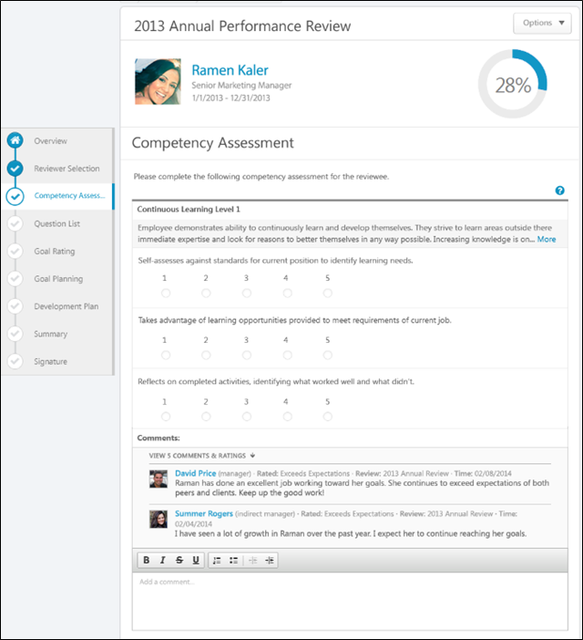
Performance Review Details
At the top of the performance review, the following performance review details are displayed:
- Performance Review Title - Title of the review. It is configured by the administrator when the review is created.
- Reviewee Photograph, Name, and Title - Reviewee's photograph, name, and position. Click the user's name or photograph to open their Universal Profile in a separate window. See Universal Profile - Bio Overview.
- Review Period - Time period of this review.
- Step Progress - Percentage complete. As review step sections are completed, the step progress is updated to reflect the correct percentage. Sections that require you to enter data complete once all required fields in the section are completed. When a reviewer views a section that does not require any information, the section is considered complete when the reviewer views the section. Note: The Overview page is not included in the completion percentage.
Options
Based on the configuration of the performance review and the reviewer's permissions, options may be available from the Options drop-down menu. See Performance Review - Options Drop-down on page 201 for additional information.
Performance Review Sections
On the left side of the performance review, the navigation menu displays all sections along with their completion status. Reviewers can click a section tab to access the section. See Performance Review - Review Sections on page 196 for additional information.
Competency Assessment
Competency assessments may either be item-based or behavior-based.
- Item-based assessments enable assessors to rate a competency item using an administrator-defined rating scale (e.g., 1 to 5, where 1 may be Unacceptable and 5 may be Consistently Excels).
- Behavior-based assessments enable assessors to rate a competency item using behavior descriptors. The assessor selects the behavior description that best describes the individual being assessed (e.g., "Prefers to let others handle problems and challenges" or "Is consistently creative in problem solving and solutions").
Competency Item Rating
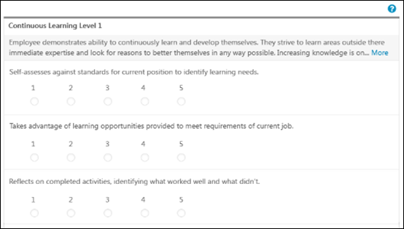
For an item-based competency assessment, the competency title and competency description display at the top of the competency. If the competency description is longer than two lines, a More link appears at the end of the second line. Click the link to view the entire competency description.
Below the competency description, each competency item is displayed with a rating scale below each competency item description. If previous ratings exist for a competency item, a Rating History link is available to the right of the rating scale. Click the link to view the previous ratings for the competency item. See Performance Review - Competency Assessment - Rating History on page 161 for additional information.
The rating scale is inherited from the competency model. If the rating scale contains 10 or fewer rating options, then the rating options appear as radio buttons and the rating score text appears above each option. If the rating scale contains 11 or more rating options, then the rating options appear in a drop-down menu and only the rating names are displayed. Only one rating can be selected per competency item. A rating selection is required for each competency item.
For each competency item, select a rating and enter comments explaining the selected ratings. See the Comments section below for additional information.
Competency Behavior Rating
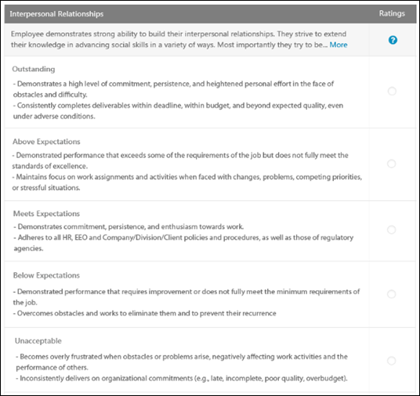
For a behavior-based competency assessment, the competency title and competency description display at the top of the competency. If the competency description is longer than two lines, a More link appears at the end of the second line. Click the link to view the entire competency description.
Below the competency description, each behavior name and behavior attribute is displayed, as configured by the administrator in the Competency Bank.
Only one rating can be selected per competency behavior. A rating selection is required for each competency behavior.
For each competency behavior, select a rating and enter comments explaining the selected rating. See the Comments section below for additional information.
View Evidence
When a Competency Assessment review section is linked with an Evidence Collection review section, then reviewers may have the option to view all pieces of evidence associated with a competency. The reviewer can click the View Competency button below the competency to view all pieces of evidence that are associated with the competency. See Performance Review - Competency Assessment - View Evidence on page 162 for additional information.
Rating Scale Information
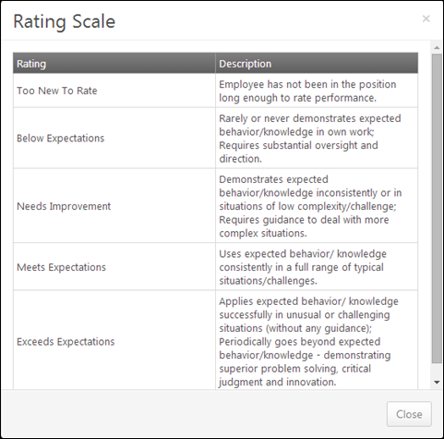
To view the rating definitions, click the Question Mark icon . This opens the Rating Scale pop-up, which displays the ratings and their definitions. Note: The ratings and their definitions are configured by the administrator.
Comments
For each competency item or behavior, select a rating and enter comments explaining the selected rating. For example, if you selected a poor rating, explain why the rating was selected. The character limit for comment fields is 30,000.
- To add a suggested comment from the comment assistant, click the Comment Assistant icon above the Comments field. This opens the Suggested Comments pop-up. See Performance Review - Comment Assistant on page 160 for additional information.
- If the Inappropriate Word Filter is enabled for performance reviews, the filter flags any inappropriate words contained in the Comment field. See Performance Review - Inappropriate Language on page 193 for additional information.
- To check the spelling of the text box contents, click the ABC icon in the text box toolbar. This opens the Spell Checker pop-up.
- If you have a need to copy and paste content into a performance review, please be sure to right-click the field into which you are pasting the content, and select the "Paste" option. You can also perform the same action by pressing [Ctrl]+[Shift]+[V]. This will ensure any formatting HTML does not get inserted into the text.
When adding a comment, an HTML safe list is used for the Comments field. The system only accepts certain customizable HTML elements in the WYSIWYG Editor. Elements that are not acceptable display as text. See Safe Listed Customizable Elements.
Because Competency Assessment sections can be reused year after year, ratings and comments from previous reviews may be included. After a peer or direct report review step, reviewers can view peer and direct report responses within the review. Each step (peer step or direct report step) appears in its own grouping. The names of the peers and direct reports are not visible to the reviewee, and the responses are not visible unless the minimum number of responses is reached.
Multiple Reviewers/Co-Planners
Co-planners have the ability to view and update Competency Assessment sections in a review step. However, the co-planner's ratings and comments are attributed to the assignee of the review step, not the co-planner.
Navigation Buttons
The following buttons are available at the bottom of the page:
- Back - Opens the previous step of the performance review. This button is not available on the first page of the performance review.
- Save and Exit - Saves the reviewer's progress and exits the performance review.
- Save and Continue - Saves the reviewer's progress, validates all selections and comments, and proceeds to the next step of the performance review. This button is not available on the final page of the performance review.
- Submit - Submits the performance review. This button is only available when all sections of the performance review are complete. Once the task is submitted, you cannot modify the review task unless multiple submissions are allowed for the review task.
Based on the configuration of the performance review task, the reviewer's selected ratings may be visible to the system administrator as soon as the review task is saved. This includes when the performance review is automatically saved by the system. This enables the administrators to begin utilizing the data for calibration purposes while the review step is in progress.
When a reviewer is editing a reopened step or a submitted review step that allows multiple submissions, the performance review Save button labels are updated to more clearly indicate that the Save options do not finalize any of the ratings.
- The Save and Exit button is renamed to Save as Draft and Exit.
- The Save and Continue button is renamed to Save as Draft and Continue.
When in read-only mode, the available buttons are Back, Exit, and Next.
Performance Review - Competency Rating
Uses the Competency Rating sections to view competencies on which the reviewee is rated. To view additional information, select the View Details option for the competency. For each competency, there is a rating scale, a comment field, and a weight field.
If a Competency Rating section is included in a performance review, employees cannot be evaluated if they are not associated with any competency models. In this instance, no competencies appear. For example:
- If the competency model assignment is based on position and the employee has no defined position, then no competency assessment is assigned for the employee.
- If the competency model assignment is based on position but the employee's position has no associated competency model, then no competency assessment is assigned for the employee.
If an employee is eligible for multiple competency models, the system uses the competency model for the group or OU to which the user was most recently added.
Permissions
PERMISSION NAME | PERMISSION DESCRIPTION | CATEGORY

View Performance Reviews | Grants ability to view the Performance Reviews page, which displays a user's own past performance reviews as well as performance review task steps they've been assigned to complete. This also grants ability to view the Batch Rating page. This permission can be constrained by OU, User's OU, User Self and Subordinates, and User. This is an end user permission. | Performance
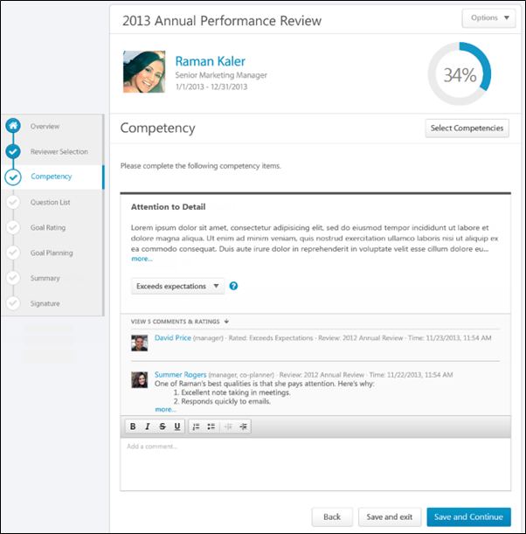
Performance Review Details
At the top of the performance review, the following performance review details are displayed:
- Performance Review Title - Title of the review. It is configured by the administrator when the review is created.
- Reviewee Photograph, Name, and Title - Reviewee's photograph, name, and position. Click the user's name or photograph to open their Universal Profile in a separate window. See Universal Profile - Bio Overview.
- Review Period - Time period of this review.
- Step Progress - Percentage complete. As review step sections are completed, the step progress is updated to reflect the correct percentage. Sections that require you to enter data complete once all required fields in the section are completed. When a reviewer views a section that does not require any information, the section is considered complete when the reviewer views the section. Note: The Overview page is not included in the completion percentage.
Options
Based on the configuration of the performance review and the reviewer's permissions, options may be available from the Options drop-down menu. See Performance Review - Options Drop-down on page 201 for additional information.
Performance Review Sections
On the left side of the performance review, the navigation menu displays all sections along with their completion status. Reviewers can click a section tab to access the section. See Performance Review - Review Sections on page 196 for additional information.
Select Competencies
To select additional competencies, click the Select Competencies button. This opens a pop-up to select the competencies you want to add to the review. The ability to select additional competencies is determined by the system administrator. See Performance Review - Select Competencies Pop-up on page 198 for additional information.
Competency Rating
For each competency, review the competency description before selecting a rating.
After reviewing the competency description, select a rating and enter comments explaining the selected rating. The character limit for comment fields is 30,000. In the Weight field, enter a weight for the competency. Weighting allows you to place a greater value on certain competencies. The weight of all competencies must add up to 100%.
- To add a suggested comment from the comment assistant, click the Comment Assistant icon above the Comments field. This opens the Suggested Comments pop-up. See Performance Review - Comment Assistant on page 160 for additional information.
- If the Inappropriate Word Filter is enabled for performance reviews, the filter flags any inappropriate words contained in the Comment field. See Performance Review - Inappropriate Language on page 193 for additional information.
- To check the spelling of the text box contents, click the ABC icon in the text box toolbar. This opens the Spell Checker pop-up.
- If you have a need to copy and paste content into a performance review, please be sure to right-click the field into which you are pasting the content, and select the "Paste" option. You can also perform the same action by pressing [Ctrl]+[Shift]+[V]. This will ensure any formatting HTML does not get inserted into the text.
When adding a comment, an HTML safe list is used for the Comments field. The system only accepts certain customizable HTML elements in the WYSIWYG Editor. Elements that are not acceptable display as text. See Safe Listed Customizable Elements.
Because Competency Rating sections can be reused year after year, ratings and comments from previous reviews may be included. After a peer or direct report review step, reviewers can view peer and direct report responses within the review. Each step (peer step or direct report step) appears in its own grouping. The names of the peers and direct reports are not visible to the reviewee, and the responses are not visible unless the minimum number of responses is reached.
View Competency Details
To view the competency details, click the drop-down icon to the right of the competency title. Then, select View Details.
The Competency Details pop-up displays the competency title, description, items, and development actions.
Multiple Reviewers/Co-Planners
If a review step has co-planners, each reviewer is able to enter their own comments and modify the review ratings. Comments are attributed to the user who submitted them, so each comment appears distinct and separate. In addition, any comments that have been saved, but not submitted are viewable by the assignee and the co-planners.
- If a co-planner is the first user to access a review section, the co-planner is able to select a rating and enter comments, if the rating option and comment box are enabled for the co-planner.
- If a co-planner accesses a review section that has been saved but not submitted by the assignee or another co-planner, then the system displays the following:
  - Ratings values are pre-selected with the rating that was selected by the assignee or another co-planner. Note: The rating option only appears if the task is configured for the section to accept comments from the corresponding assignee.
  - An empty comment box appears for the co-planner to enter comments. Note: The comment box only appears if the task is configured for the section to accept comments from the corresponding assignee.
  - A response section containing the rating applied by the assignee or another co-planner. This section displays the assignee or co-planner name, rating, and comments. "(Co-Planner)" appears next to all co-planner names. Note: The rating and comment only appear if the task is configured for the section to accept ratings and comments from the corresponding assignee.
Any comments are attributed to the reviewer who entered them. Ratings are attributed to the user who was the last to apply or modify the rating. For example, if Co-planner A applies a rating to a question, and then Co-planner B modifies the rating for the question, then the rating is attributed to Co-planner B. However, if Co-planner B does not modify the rating, then the rating is attributed to Co-planner A.
When viewing reviewer comments, the comments from the review step assignee are displayed first, followed by comments from the step co-planners in alphabetical order based on last name. The most recent comments are displayed first.
Navigation Buttons
The following buttons are available at the bottom of the page:
- Back - Opens the previous step of the performance review. This button is not available on the first page of the performance review.
- Save and Exit - Saves the reviewer's progress and exits the performance review.
- Save and Continue - Saves the reviewer's progress, validates all selections and comments, and proceeds to the next step of the performance review. This button is not available on the final page of the performance review.
- Submit - Submits the performance review. This button is only available when all sections of the performance review are complete. Once the task is submitted, you cannot modify the review task unless multiple submissions are allowed for the review task.
Based on the configuration of the performance review task, the reviewer's selected ratings may be visible to the system administrator as soon as the review task is saved. This includes when the performance review is automatically saved by the system. This enables the administrators to begin utilizing the data for calibration purposes while the review step is in progress.
When a reviewer is editing a reopened step or a submitted review step that allows multiple submissions, the performance review Save button labels are updated to more clearly indicate that the Save options do not finalize any of the ratings.
- The Save and Exit button is renamed to Save as Draft and Exit.
- The Save and Continue button is renamed to Save as Draft and Continue.
When in read-only mode, the available buttons are Back, Exit, and Next.
Performance Review - Development Plan
Use the Development Plan section to add training and action steps to the reviewee's development plan on the performance review. Administrators can configure the Development Plan section to build upon the reviewee's existing primary development plan or create a new performance review development plan. If the Development Plan section is set to build upon the reviewee's primary development plan, the section behavior depends on the status of the reviewee's existing primary development plan. See Performance Review - Development Plan - Primary Plan Status on page 119 for additional information.
Permissions
PERMISSION NAME | PERMISSION DESCRIPTION | CATEGORY

View Performance Reviews | Grants ability to view the Performance Reviews page, which displays a user's own past performance reviews as well as performance review task steps they've been assigned to complete. This also grants ability to view the Batch Rating page. This permission can be constrained by OU, User's OU, User Self and Subordinates, and User. This is an end user permission. | Performance
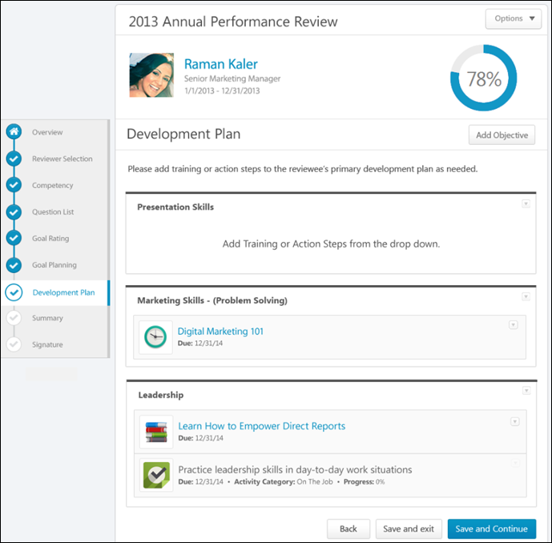
Performance Review Details
At the top of the performance review, the following performance review details are displayed:
- Performance Review Title - Title of the review. It is configured by the administrator when the review is created.
- Reviewee Photograph, Name, and Title - Reviewee's photograph, name, and position. Click the user's name or photograph to open their Universal Profile in a separate window. See Universal Profile - Bio Overview.
- Review Period - Time period of this review.
- Step Progress - Percentage complete. As review step sections are completed, the step progress is updated to reflect the correct percentage. Sections that require you to enter data complete once all required fields in the section are completed. When a reviewer views a section that does not require any information, the section is considered complete when the reviewer views the section. Note: The Overview page is not included in the completion percentage.
Options
Based on the configuration of the performance review and the reviewer's permissions, options may be available from the Options drop-down menu. See Performance Review - Options Drop-down on page 201 for additional information.
Performance Review Sections
On the left side of the performance review, the navigation menu displays all sections along with their completion status. Reviewers can click a section tab to access the section. See Performance Review - Review Sections on page 196 for additional information.
View Primary Development Plan
The Development Plan performance review section can be configured to either add training and action steps to the reviewee's existing primary development plan or to a newly created performance review development plan. If configured to add items to the reviewee's primary development plan, then the reviewee's existing primary development plan is displayed. Note: If the reviewee's primary development plan is modified outside the performance review while the review is in progress, the modified objectives, training, and action steps are updated for the in-progress review.
Add Objective
Development plans are creating by adding development objectives to outline what you are trying to achieve in your development plan. Objectives are the target areas of the plan. For example, if you are creating a development plan to improve your communication skills, you may create an objective to improve your writing skills. This objective should contain all of the training and actions you need to complete in order to achieve the objective, such as completing writing classes or shadowing a writer at your organization. See Performance Review - Development Plan - Add Objective on page 168 for additional information.
Objective Options
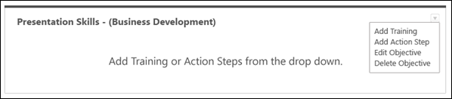
Click the Actions drop-down to view the available options or for development plan objectives. Options are:
- Add Training
- Add Action Step
- Edit Objective
- Delete Objective
See Performance Review - Development Plan - Objective Options on page 169 for additional information.
Training Options
If training options are added to objectives within a development plan, reviewers can click the training title to open the Learning Object (LO) Details page for the training item. See Learning Object (LO) Details Page.
For training items added to the development plan during the performance review task, you can add or delete training by clicking the option in the Actions drop-down .
Note: The Actions drop-down is not available for training items that are added to the development plan prior to the performance review task. These training items cannot be edited or deleted within the performance review section.
See Performance Review - Development Plan - Training Options on page 171 for additional information.
Action Step Options
Within the Development Plan performance review section, the action step details (title, category, progress, and due date) can be provided when the action step is added to the objective or when editing the action step.
For action steps added to the development plan during the performance review task, you can edit or delete an action step by selection an option in the Actions drop-down .
Note: The Actions drop-down is not available for action steps that were added to the development plan prior to the performance review task. These action steps cannot be edited or deleted within the performance review section.
See Performance Review - Development Plan - Action Step Options on page 166 for additional information.
Primary Development Plan - Sync Now
The user's primary development plan is pulled in to the Development Plan section of the performance review. If the user's primary plan changes while the performance review is open, the user is notified within the Development Plans section of the review, and they are given the option to sync the new or updated primary plan into the review and remove the previous plan from the review. When the new plan is synced with the review, any comments or modifications that were added to the plan within the review are not saved.
Development Plan Section Completion
The development plan approval process occurs after the entire performance review is complete and submitted and training items and action steps are added to the development plan.
When the performance review is completed and submitted, a snapshot of the development plan objectives, training, and action steps is captured. Any items added, removed, or modified from the development plan outside of the performance review are not reflected in the performance review.
Training items and action steps are only added to the development plan if the task is completed and submitted. If the performance review task is Incomplete, Past Due, or Not Submitted, the items are not added to the development plan.
Performance Review - Development Plan - Primary Plan Status
Use the Development Plan section to add training and action steps to the reviewee's development plan on the performance review. Administrators can configure the Development Plan section to build upon the reviewee's existing primary development plan or create a new performance review development plan. If the Development Plan section is set to build upon the reviewee's primary development plan, the section behavior depends on the status of the reviewee's existing primary development plan.
Reviewee Has No Existing Primary Development Plan
If the Development Plan review section is configured to build upon the reviewee's existing primary development plan, but the reviewee does not have an existing primary development plan, then a new performance review development plan is created. The newly created development plan has the following title: {Name of Performance Review} Development Plan (e.g., 2013 Annual Review Development Plan). This title can be edited after the development plan is created.
- If the reviewee still does not have a primary development plan when the performance review is submitted (i.e., a new primary plan was not created outside the performance review while the review was in progress), then the new performance review development plan is set as the reviewee's primary development plan.
- If a new development plan is created and selected as the primary development plan while the performance review is in progress, then the performance review development plan is not the primary development plan when the performance review is submitted.
Reviewee Has Existing Primary Development Plan
If the Development Plan review section is configured to build upon the reviewee's existing primary development plan and the reviewee has an existing primary development plan, then the status of the existing primary development plan determines whether new training and action steps can be added to the primary plan or if a new performance review development plan is created.
If the primary development plan is in one of the following statuses, then training and action steps can be added at the completion of the review:
- In Progress
  - If approval is required, the status changes to Pending Approval when the performance review is submitted.
  - If approval is not required, the status remains In Progress.
- Pending Approval - The status remains Pending Approval when the performance review is submitted.
- Denied - The status changes to Pending Approval when the performance review is submitted.
- Expired
  - If approval is required, the status changes to Pending Approval when the performance review is submitted.
  - If approval is not required, the status changes to In Progress.
- Completion Approval Denied - The status changes to Pending Approval when the performance review is submitted.
- Pending Acceptance Approval - The status is changed to Pending Approval when the performance review is submitted.
- Pending Cancellation Approval - If new training or action steps are added to the development plan in the Development Plan performance review section, the status is changed to In Progress.
- Pending Completion Approval - If new training or action steps are added to the development plan in the Development Plan performance review section, then the status changes to In Progress.
If the primary development plan is in one of the following statuses, you cannot add training and action steps to the existing primary development plan.
- Draft
- Canceled
- Complete
- Deleted
A new performance review development plan is created when the performance review is submitted. The newly created development plan has the following title: {Name of Performance Review} Development Plan (e.g., 2013 Annual Review Development Plan). This title can be edited after the development plan is created.
Performance Review - Evidence Collection
Evidence Collection review sections are used in conjunction with Competency Assessment review sections because Evidence Collection sections enable reviewers to input, upload, and edit materials that provide evidence that supports the competency ratings assigned in the Competency Assessment section. Evidence Collection sections also display all existing evidence that has been collected to support the required competencies. Reviewers can filter the section by competency to view only the evidence that supports specific competencies.
Permissions
PERMISSION NAME | PERMISSION DESCRIPTION | CATEGORY

View Performance Reviews | Grants ability to view the Performance Reviews page, which displays a user's own past performance reviews as well as performance review task steps they've been assigned to complete. This also grants ability to view the Batch Rating page. This permission can be constrained by OU, User's OU, User Self and Subordinates, and User. This is an end user permission. | Performance
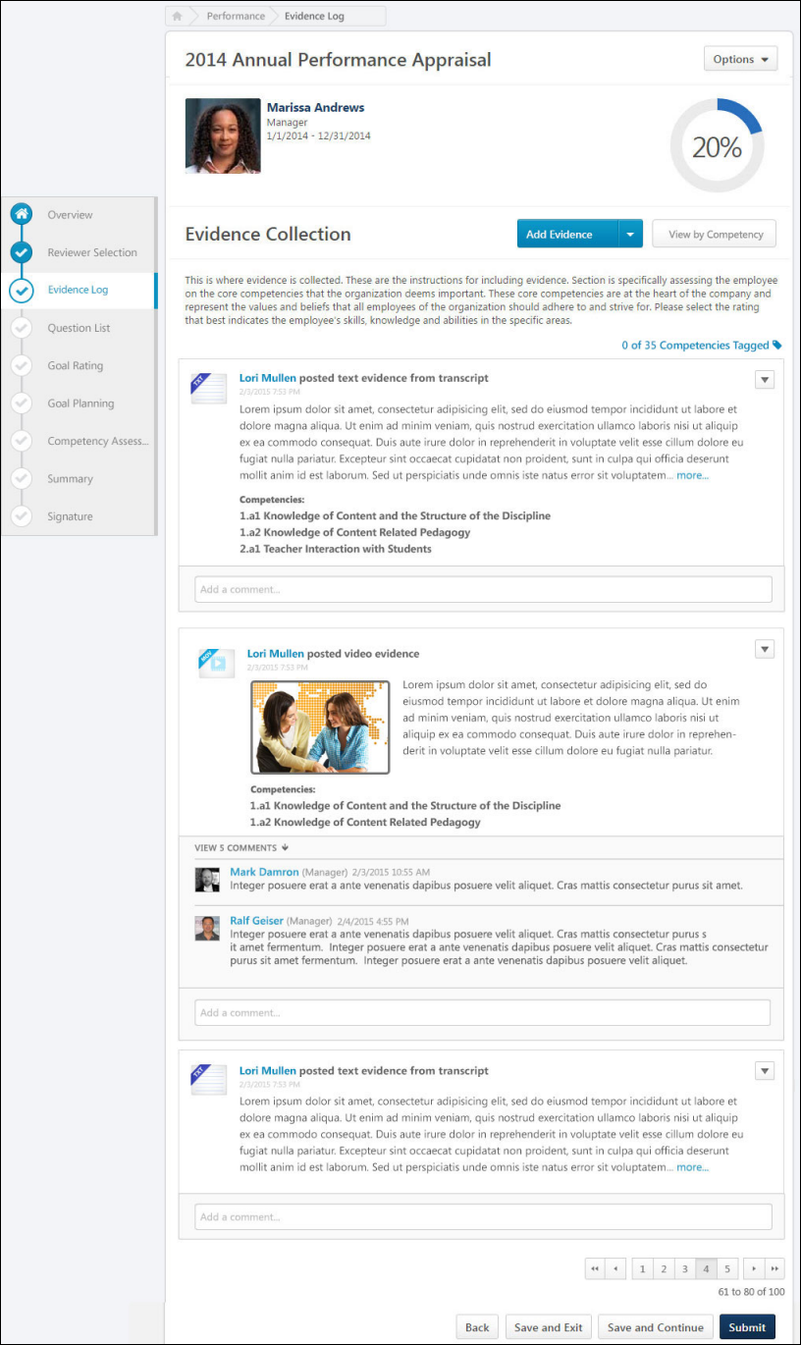
Performance Review Details
At the top of the performance review, the following performance review details are displayed:
- Performance Review Title - Title of the review. It is configured by the administrator when the review is created.
- Reviewee Photograph, Name, and Title - Reviewee's photograph, name, and position. Click the user's name or photograph to open their Universal Profile in a separate window. See Universal Profile - Bio Overview.
- Review Period - Time period of this review.
- Step Progress - Percentage complete. As review step sections are completed, the step progress is updated to reflect the correct percentage. Sections that require you to enter data complete once all required fields in the section are completed. When a reviewer views a section that does not require any information, the section is considered complete when the reviewer views the section. Note: The Overview page is not included in the completion percentage.
Options
Based on the configuration of the performance review and the reviewer's permissions, options may be available from the Options drop-down menu. See Performance Review - Options Drop-down on page 201 for additional information.
Performance Review Sections
On the left side of the performance review, the navigation menu displays all sections along with their completion status. Reviewers can click a section tab to access the section. See Performance Review - Review Sections on page 196 for additional information.
Add Evidence
Evidence is text or a material that can be used to support the competency ratings assigned in the Competency Assessment section.
To add evidence to an Evidence Collection performance review section, click the Add Evidence button or select Add Evidence from the Add Evidence drop-down menu. Note: This option is only available if the performance review step is configured to allow reviewers to create and edit evidence. Self and peer reviewers cannot edit any evidence that was added by another reviewer. Self and peer reviewers can only edit evidence that they uploaded within the Evidence Collection review section.
Create Notebook
An evidence notebook is a document of text notes from an observation. An evidence notebook can be divided into individual pieces of evidence and associated with competencies.
To create an evidence notebook, select Create Notebook from the Add Evidence drop-down menu. Note: This option is only available if the performance review step is configured to allow reviewers to create and edit evidence notebooks.
See Performance Review - Evidence Collection - Add/Edit Evidence Notebook on page 173 for additional information.
Manage Notebooks
To manage existing evidence notebooks, select Manage Notebooks from the Add Evidence drop-down menu. Note: This option is only available if the performance review step is configured to allow reviewers to create and edit evidence notebooks.
See Performance Review - Evidence Collection - Manage Notebooks on page 182 for additional information.
View by Competency
By default, the Evidence Collection review step displays all evidence that has been collected and added to the Evidence Collection section for the reviewee. Reviewers can filter the evidence to only display evidence that is associated with certain competencies.
To filter evidence by one or more specific competencies, click the View by Competencies button. This opens the Search Competencies pop-up. See Search Competencies Pop-up for additional information. Note: This button is not available if there is no competency model available.
When competencies are selected, the evidence feed only displays evidence that is associated with the selected competencies.
Total Competencies Tagged
Within an Evidence Collection performance review section, each piece of evidence can be tagged or associated with a competency. This indicates that the piece of evidence is related to the competency and can be used to support any ratings associated with the competency. At the top of the Evidence Feed, the total number of available and tagged competencies is displayed. For example, if "26 of 35 Competencies Tagged" is displayed, then this indicates that there are 35 total competencies available to be tagged within the associated competency model and 26 competencies have been tagged with evidence.
To view which competencies are tagged with evidence and which competencies have not yet been tagged within the Evidence Collection step, click the Competencies Tagged link at the top of the Evidence Feed. This opens the Total Competencies Tagged pop-up. See Performance Review - Evidence Collection - Total Competencies Tagged on page 184 for additional information.
Note: This link is not available if there is no competency model available. This link is also not available if the performance review step is configured to only grant reviewers view-only access to the section.
Evidence Feed
The Evidence Feed displays all pieces of evidence that have been added for the reviewee. Evidence is displayed in the order in which it was created with the most recently created evidence displayed first.
Evidence Display Rules
If more than one review step (e.g., Self Review, Manager Review, Peer Review) includes the Evidence Collection step, then the following rules apply:
- Each reviewer can view all evidence that has been added and submitted by any reviewers in previous review steps. However, evidence submitted by another reviewer does not appear in any review steps that occur in parallel. For example, if a Self and Peer review step occur at the same time, then the Peer step does not display any evidence added during the Self step. If a Manager review step occurs after the Self and Peer review steps, then the Manager review step displays any evidence added during the Self and Peer review steps.
- If a reviewer revisits their performance review step after it is submitted, then the reviewer can only view the evidence that was available to them at the time they completed the review step. For example, if only two pieces of evidence have been added when a reviewer submits their review, then only those two pieces of evidence are available to the reviewer if they revisit their performance review step.
- If evidence is deleted from an Evidence Collection review section, then that piece of evidence is deleted from all performance review steps.
If a reviewer has multiple steps in a review task (e.g., there are two Self Review steps or two Manager Review steps in the same task) and the Evidence Collection section is only added to the reviewer's first review step, then the reviewer can view the Evidence Collection section in their second review step. However, the reviewer cannot add or edit evidence in their second review step, and the Evidence Collection section only displays evidence that was available to the reviewer when the reviewer submitted their first review step. For example, if a Self Review step is added as the first step and the fourth step in the review task and the Evidence Collection section is only added to the first step, then the reviewee can submit evidence in the first Self Review step. In the fourth step (i.e., the second Self Review step), the reviewee can access the Evidence Collection section and view any evidence they added in the first Self Review step. However, the reviewee cannot add or edit any evidence and they cannot view any evidence that was added in the second or third review steps.
Evidence Details
The following information is displayed with each piece of evidence:
- Evidence File Type - Associated file type. An icon that represents the file type is displayed to the left of the evidence details.
- Evidence Creator - Name of the user who added the evidence is displayed to the right of the evidence file type icon.
- Timestamp - Timestamp is displayed with each piece of evidence to indicate when the evidence was added. The timestamp is always displayed in the time zone of the user who is viewing the evidence.
- Evidence Text - Summary of the evidence is displayed below the timestamp. Up to five lines of the summary text is displayed. If the evidence summary contains more than five lines of text, a more link is displayed at the end of the summary. Click this link to view the full summary of the evidence.
- Competencies - Tagged competencies if the evidence is tagged with competencies. Displays in alphabetical order.
- Comments - Comments added to a piece of evidence. Displays below the tagged competencies.
For information regarding adding comments, see the Evidence - Add Comment section below.
Evidence Options
The following evidence actions may be available from the actions drop-down menu to the right of the evidence:
- Download Attachment - Select this option to download the evidence attachment. Note: This option is only available if the evidence has an attachment.
- Edit Evidence - Select this option to edit the evidence. Note: This option is only available if the performance review step is configured to allow reviewers to create and edit evidence. Self and peer reviewers cannot edit any evidence that was added by another reviewer. Self and peer reviewers can only edit evidence that they uploaded within the Evidence Collection review section. See Performance Review - Evidence Collection - Add/Edit Evidence on page 178 for additional information.
- View Notebook - Select this option to view the corresponding Evidence Notebook for the reviewee. Note: This option is only available if the evidence was created within a notebook and if the performance review step is configured to allow reviewers to create and edit evidence. See Performance Review - Evidence Collection - Add/Edit Evidence Notebook on page 173 for additional information.
- Delete Evidence - Select this option to permanently delete the evidence. Note: This option is only available if the performance review step is configured to allow reviewers to create and edit evidence. Self and peer reviewers cannot delete any evidence that was added by another reviewer. Self and peer reviewers can only delete evidence that they uploaded within the Evidence Collection review section.
- Select Competencies - Select this option to view and edit the competencies that are associated with the evidence. Note: This option is only available if the performance review step is configured to allow reviewers to tag evidence but reviewers cannot create and edit evidence. Self and peer reviewers cannot edit any evidence that was added by another reviewer. Self and peer reviewers can only edit evidence that they uploaded within the Evidence Collection review section. See Search Competencies Pop-up for additional information.
Evidence - Add Comment
To add a comment regarding a piece of evidence, enter the comments in the Add a comment field below the appropriate piece of evidence in the Evidence Feed.Note: This field is only available if the performance review step is configured to allow reviewers to add comments.
If you have a need to copy and paste content into a performance review, please be sure to right-click the field into which you are pasting the content, and select the "Paste" option. You can also perform the same action by pressing [Ctrl]+[Shift]+[V]. This will ensure any formatting HTML does not get inserted into the text.
Pagination
If more than 10 pieces of evidence are available in the feed, then pagination options appear in the lower-right corner of the feed.
- Click a specific page number to go directly to that page.
- To move one page forward or backward, click the right or left arrow icon.
- To move to the first or last page, click the double left or double right arrow icon.
Navigation Buttons
The following buttons are available at the bottom of the page:
- Back - Opens the previous step of the performance review. This button is not available on the first page of the performance review.
- Save and Exit - Saves the reviewer's progress and exits the performance review.
- Save and Continue - Saves the reviewer's progress, validates all selections and comments, and proceeds to the next step of the performance review. This button is not available on the final page of the performance review.
- Submit - Submits the performance review. This button is only available when all sections of the performance review are complete. Once the task is submitted, you cannot modify the review task unless multiple submissions are allowed for the review task.
Based on the configuration of the performance review task, the reviewer's selected ratings may be visible to the system administrator as soon as the review task is saved. This includes when the performance review is automatically saved by the system. This enables the administrators to begin utilizing the data for calibration purposes while the review step is in progress.
When a reviewer is editing a reopened step or a submitted review step that allows multiple submissions, the performance review Save button labels are updated to more clearly indicate that the Save options do not finalize any of the ratings.
- The Save and Exit button is renamed to Save as Draft and Exit.
- The Save and Continue button is renamed to Save as Draft and Continue.
When in read-only mode, the available buttons are Back, Exit, and Next.
Performance Review - Goal Planning
Goal Planning sections allow users and managers to create goals for a future goal period. Goals can be created, edited, and removed from this section. All goals are automatically approved and added to the user's goal page when the review is completed.
Permissions
PERMISSION NAME | PERMISSION DESCRIPTION | CATEGORY

View Performance Reviews | Grants ability to view the Performance Reviews page, which displays a user's own past performance reviews as well as performance review task steps they've been assigned to complete. This also grants ability to view the Batch Rating page. This permission can be constrained by OU, User's OU, User Self and Subordinates, and User. This is an end user permission. | Performance
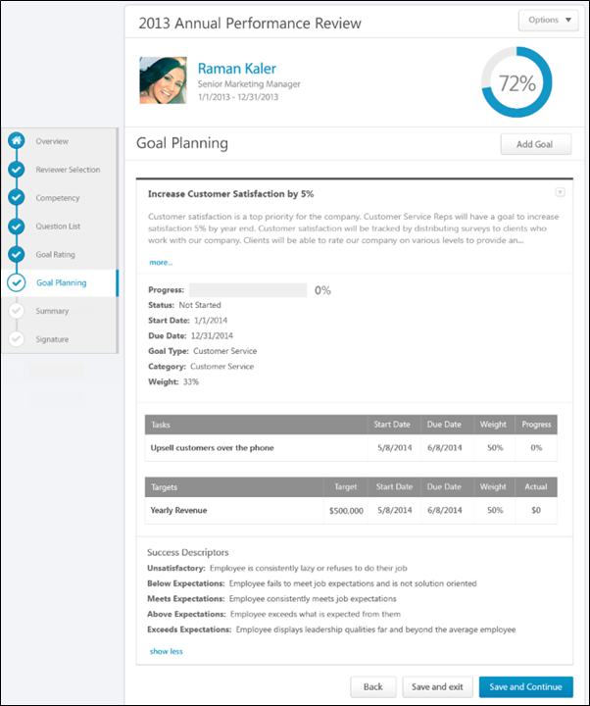
Performance Review Details
At the top of the performance review, the following performance review details are displayed:
- Performance Review Title - Title of the review. It is configured by the administrator when the review is created.
- Reviewee Photograph, Name, and Title - Reviewee's photograph, name, and position. Click the user's name or photograph to open their Universal Profile in a separate window. See Universal Profile - Bio Overview.
- Review Period - Time period of this review.
- Step Progress - Percentage complete. As review step sections are completed, the step progress is updated to reflect the correct percentage. Sections that require you to enter data complete once all required fields in the section are completed. When a reviewer views a section that does not require any information, the section is considered complete when the reviewer views the section. Note: The Overview page is not included in the completion percentage.
Options
Based on the configuration of the performance review and the reviewer's permissions, options may be available from the Options drop-down menu. See Performance Review - Options Drop-down on page 201 for additional information.
Performance Review Sections
On the left side of the performance review, the navigation menu displays all sections along with their completion status. Reviewers can click a section tab to access the section. See Performance Review - Review Sections on page 196 for additional information.
View Current Goals
Goal Planning sections can be configured to display the reviewee's current goals. If the Goal Planning section is configured to display the reviewee's current goals and if Goal Preferences allow goals to be edited after creation, then the reviewer can edit or cancel existing goals.
- A user completing a self-review can edit or cancel their goals. If goal approval is required, then users can request goal modification approval or goal cancellation approval.
- A manager completing a manager review can edit or cancel their subordinate's goals. Managers can also approve or deny goal modification or cancellation, which opens the Approve/Deny pop-up.
To view additional goal details, click the more link below the goal details. To hide the additional details, click the show less link.
Note: When a performance review step is reopened, Goal Planning sections reflect the latest goal planning information. See the Reopened Steps section below for additional information.
Add Goal
To add a goal, click the Add Goal button. This opens the Create Goals pop-up where you can configure the goal. Reviewers can add as many goals as necessary. Goals that are created within a performance review are automatically approved when the performance review is completed. See Goal - Create/Edit.
Edit Goal
To edit an existing goal, click the Options drop-down icon to the right of the goal title. Then, select Edit. This opens the Edit Goal pop-up where you can edit the details of the goal. See Goal - Create/Edit.
Delete Goal
To delete an existing goal, click the Options drop-down icon to the right of the goal title. Then, select Delete. This opens the Delete pop-up. Click Delete to confirm the deletion. Or, click Cancel to cancel the deletion.
View Goal History
To view the history of a goal, click the Options drop-down icon to the right of the goal title. Then, select View History. This opens the History pop-up for the goal. See Goal - View History.
Shared Goals
If the Goal Planning section is configured to include shared goals, then any shared goals that overlap with the performance review period are displayed in the goal planning section. Shared goals are read-only. An asterisk (*) appears to the left of the goal title to indicate that it is a shared goal.
Goal Weight Validation
If the Goal Planning section is configured to include goal weight validation, then the total weight of all goals is displayed and should equal 100%. If shared goals are displayed, then the weight of shared goals is included in the total. Note: The total goal weight includes all non-shared goals, including any goals that are in Draft status or created within the performance review.
If the Goal Planning section is configured to include goal weight validation, and the reviewer attempts to submit a performance review when the total goal weight does not equal 100%, a warning pop-up is displayed. The reviewer can click OK to submit the review or click Cancel to cancel the submission.
Approve/Deny/Cancel Goal
If a reviewee adds or edits a goal that requires manager approval, the manager can approve, deny, or cancel the reviewee's goal addition or edit. The following action buttons appear below the goal that requires approval:
- Cancel Goal - Click this button to cancel the goal. The Cancel Goal pop-up appears to confirm the action. Once a goal is cancelled, this cannot be undone. This option is only available for added goals.
- Deny - Click this button to deny the addition or the modification. An Edit Goal pop-up appears to display the changes that were made to the goal. This option is only available for edited goals.
- Approve - Click this button to approve the addition or the modification. An Edit Goal pop-up appears to display the changes that were made to the goal.
Comments
Depending on the configuration of the Goal Planning section, reviewers may have the ability to add comments to a Goal Planning section. When commenting is enabled, reviewers can add a comment for each goal. This enables a user and manager to have discussions regarding future goals within the Goal Planning section.
The Goal Planning section allows only one comment per goal per user and does not support threading.
The character limit for comment fields is 30,000.
- To check the spelling of the text box contents, click the ABC icon in the text box toolbar. This opens the Spell Checker pop-up.
- If you have a need to copy and paste content into a performance review, please be sure to right-click the field into which you are pasting the content, and select the "Paste" option. You can also perform the same action by pressing [Ctrl]+[Shift]+[V]. This will ensure any formatting HTML does not get inserted into the text.
When adding a comment, an HTML safe list is used for the Comments field. The system only accepts certain customizable HTML elements in the WYSIWYG Editor. Elements that are not acceptable display as text. See Safe Listed Customizable Elements.
If a non-peer reviewer (manager, indirect manager, custom relationship, or self) adds comments and saves the performance review task, then the reviewer's comments are visible to other reviewers. If a reviewee is completing a self review after another non-peer reviewer has added comments and saved their review, then the reviewee can view the other reviewer's comments. This applies if a self review step is reopened.
Navigation Buttons
The following buttons are available at the bottom of the page:
- Back - Opens the previous step of the performance review. This button is not available on the first page of the performance review.
- Save and Exit - Saves the reviewer's progress and exits the performance review.
- Save and Continue - Saves the reviewer's progress, validates all selections and comments, and proceeds to the next step of the performance review. This button is not available on the final page of the performance review.
- Submit - Submits the performance review. This button is only available when all sections of the performance review are complete. Once the task is submitted, you cannot modify the review task unless multiple submissions are allowed for the review task.
Based on the configuration of the performance review task, the reviewer's selected ratings may be visible to the system administrator as soon as the review task is saved. This includes when the performance review is automatically saved by the system. This enables the administrators to begin utilizing the data for calibration purposes while the review step is in progress.
When a reviewer is editing a reopened step or a submitted review step that allows multiple submissions, the performance review Save button labels are updated to more clearly indicate that the Save options do not finalize any of the ratings.
- The Save and Exit button is renamed to Save as Draft and Exit.
- The Save and Continue button is renamed to Save as Draft and Continue.
When in read-only mode, the available buttons are Back, Exit, and Next.
Reopened Steps
When a performance review step is reopened, Goal Planning sections reflect the latest goal planning information, including any goals that have been added or modified in later steps within the performance review task.
Once modifications are made to the Goal Planning section and this section is saved, these updates are reflected in reopened steps even if the reviewer does not complete their step. However, goals added by parallel step owners are never visible to reviewers in parallel steps.
Use Case:
- Frank is a sales representative at Acme Corp., and he recently completed his annual performance review, which contained a Goal Planning section.
- Frank's manager completes the Manager Review step in the performance review task and adds two new goals to Frank's Goal Planning section.
- Frank's manager wants Frank to review the newly added goals before the performance review task is complete, so he reopens Frank's performance review step.
- Frank opens the Goal Planning section of his performance review and sees the two goals that his manager added. Frank is able to make edits to the newly added goals prior to submitting his performance review.
Performance Review - Goal Rating
Goal Rating sections allows reviewers to view and rate the reviewee's goal progress for the task review period. The goal description is displayed below the goal name.
Administrator Note: A preference in Corporate Preferences determines whether the goal owner/assignee's Goal Preferences and Goal Configurations are applied in Universal Profile Snapshot, Goals, and Goal Rating steps within performance reviews. Shared goals respect the goal owner's preferences and configurations.
Note: Any shared goals that are assigned to an OU do not appear in a Goal Rating section.
Permissions
PERMISSION NAME | PERMISSION DESCRIPTION | CATEGORY

View Goals | Grants ability to view own goals and (depending on role and settings) goals of others (manager's visible goals, direct subordinate's goals, company goals, division goals). This permission can be constrained by Employee Relationship, OU, User's OU, and User Self and Subordinates. This is an end user permission. | Performance

View Performance Reviews | Grants ability to view the Performance Reviews page, which displays a user's own past performance reviews as well as performance review task steps they've been assigned to complete. This also grants ability to view the Batch Rating page. This permission can be constrained by OU, User's OU, User Self and Subordinates, and User. This is an end user permission. | Performance
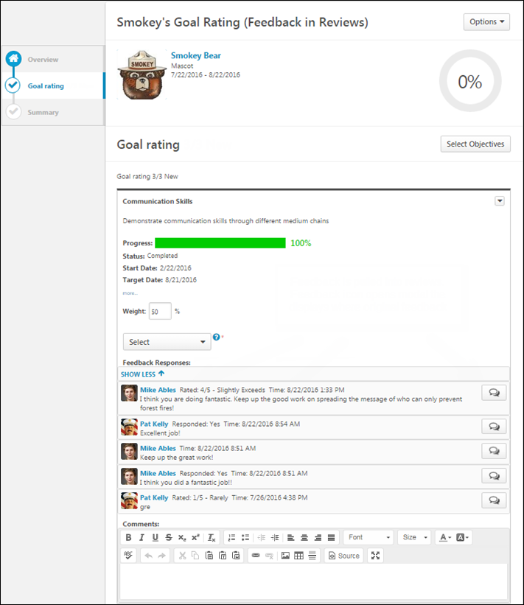
Performance Review Details
At the top of the performance review, the following performance review details are displayed:
- Performance Review Title - Title of the review. It is configured by the administrator when the review is created.
- Reviewee Photograph, Name, and Title - Reviewee's photograph, name, and position. Click the user's name or photograph to open their Universal Profile in a separate window. See Universal Profile - Bio Overview.
- Review Period - Time period of this review.
- Step Progress - Percentage complete. As review step sections are completed, the step progress is updated to reflect the correct percentage. Sections that require you to enter data complete once all required fields in the section are completed. When a reviewer views a section that does not require any information, the section is considered complete when the reviewer views the section. Note: The Overview page is not included in the completion percentage.
Options
Based on the configuration of the performance review and the reviewer's permissions, options may be available from the Options drop-down menu. See Performance Review - Options Drop-down on page 201 for additional information.
Performance Review Sections
On the left side of the performance review, the navigation menu displays all sections along with their completion status. Reviewers can click a section tab to access the section. See Performance Review - Review Sections on page 196 for additional information.
Goal Options
To view the goal options, click the drop-down icon to the right of the goal title. This drop-down is only available if the administrator configured goal details to display.
The following options may be available:
- Goal Page Comments - Opens a Goal Comments pop-up that displays any comments that were added to the goal within the performance review period. See Performance Review - Goal Rating - Goal Comments on page 191 for additional information.
- Goal Page Attachments - Opens a Goal Attachments pop-up that displays any attachments that were added to the goal within the performance review period. See Performance Review - Goal Rating - Goal Attachments on page 190 for additional information.
- Manage Goals - Only available when the Goal Rating section is configured to allow users to update goal progress. This option is only available if the reviewer has permission to view the goal. This option opens the Manage Goals page for the goal. When done updating the goal progress, the user is directed back to the Goal Rating section so they can continue completing the performance review. See Goal - Manage (New Design).
  - This option is never available to peers and subordinates when they are completing a 360 performance review.
  - This option is not available if the performance review is in read-only mode.
Goal Rating
To view additional details of the goal, including tasks, targets, and success descriptors, click the more link below the goal details. To hide the additional details, click the show less link. Note: Tasks and targets only display if they are included in the goal. Success descriptors only display if they are configured to display.
- For each goal, there is a rating scale, a Comment field, and a Weight field. Note: The editable Weight field is only available if configured to display by the system administrator.
- For each goal, select a rating and enter comments explaining the selected rating. For example, if you selected a poor rating, explain why the rating was selected. The character limit for comment fields is 30,000. In the Weight field, enter a weight for the goal. Weighting allows you to place a greater value on certain goals. The weight of all goals must add up to 100%.
- Depending on the backend setting, the weight percentage field may accept up to two decimal places.
  - To add a suggested comment from the comment assistant, click the Comment Assistant icon above the Comments field. This opens the Suggested Comments pop-up. See Performance Review - Comment Assistant on page 160 for additional information.
  - If the Inappropriate Word Filter is enabled for performance reviews, the filter flags any inappropriate words contained in the Comment field. See Performance Review - Inappropriate Language on page 193 for additional information.
  - To check the spelling of the text box contents, click the ABC icon in the text box toolbar. This opens the Spell Checker pop-up.
  - If you have a need to copy and paste content into a performance review, please be sure to right-click the field into which you are pasting the content, and select the "Paste" option. You can also perform the same action by pressing [Ctrl]+[Shift]+[V]. This will ensure any formatting HTML does not get inserted into the text.
When adding a comment, an HTML safe list is used for the Comments field. The system only accepts certain customizable HTML elements in the WYSIWYG Editor. Elements that are not acceptable display as text. See Safe Listed Customizable Elements.
Because Goal Rating sections can be reused year after year, ratings and comments from previous reviews may be included. After a peer or direct report review step, reviewers can view peer and direct report responses within the review. Each step (peer step or direct report step) appears in its own grouping. The names of the peers and direct reports are not visible to the reviewee, and the responses are not visible unless the minimum number of responses is reached.
Considerations for Auto-Calculation of Section Ratings
When completing a Goal Rating section within a performance review, if the section is configured to automatically calculate ratings based on goal achievement progress, then the user’s overall goal achievement progress is calculated when a user with the ability to rate the section opens the section, and this progress is displayed at the top of the section. This progress reflects the progress and weight of each goal. If no goals are available in the section, then N/A is displayed. If the section is not configured to automatically calculate section ratings based on goal progress, then the overall goal progress field is not displayed.
Note: The automated goal rating feature provides an automated rating for the entire goal rating section, not individual goals.
If the user who is completing the review has the ability to rate the section and if the section is configured to display weighted goal achievement progress, then the user’s Total Weighted Progress is calculated when the section is opened and is displayed at the top of the section. In addition, if the section is configured to automatically calculate section ratings based on the user’s total weighted progress, then the Automated Goal Rating is also displayed.
When a user who has the ability to rate the section reopens the section, the user’s total weighted progress is recalculated if a goal has been added or removed from the section, a goal has been cancelled, the progress of a goal is updated, or if the weight of a goal is changed.
Note: If the reviewer does not open the section, then the reviewee’s overall goal achievement progress is not calculated. For example, if the review step is reopened and the reviewer does not reopen the Goal Rating section, the progress is not recalculated and does not reflect any potential changes that were made to goal progress.
If the Goal Rating section is read-only for the reviewer, then the user’s overall goal achievement is not calculated.
Important: Because the user’s overall goal achievement progress is calculated when a user with the ability to rate the Goal Rating section opens the section, there are circumstances in which the goal progress and section rating do not reflect the most current values. This may occur if a user with the ability to rate the section opens the section and saves the section without submitting the review step, the goal progress is updated outside of the review task, the review task goes past due and becomes submitted, and the reviewee does not open the section again.
For more information about auto-calculation of section ratings, see the Create Review Section - Goal Rating topic in Online Help.
Lock Goal Results
The ability to lock a goal is only available when the Goal Rating section is configured to allow reviewers to manage goals in the review. This option is not available when completing a self review.
Based on the configuration of the portal, a Lock icon may appear to the right of a direct report's goal. Managers can click this icon to lock or unlock the goal. The following statuses are available:
- Locked - The goal is locked. Click this icon to unlock the goal. Users cannot update the goal progress or edit the goal. Managers may lock a goal at the end of the goal period or at the beginning of a review period. This prevents any miscommunication between the manager and employee. Note: This does not prevent users from advancing the goal.
- Unlocked - The goal is unlocked. Click this icon to lock the goal. Users can update the goal progress and edit the goal.
Administrative Note: To disable the Lock Goal Results functionality, contact Global Customer Support.
Feedback Responses
A Feedback Responses section is available and displays feedback obtained on goals if all of the following are true:
- The Goal Rating performance review section is configured to include feedback obtained on goals.
- The reviewee has received feedback on a goal that appears in the Goal Rating section. If no feedback is available, then the section is not displayed.
The Feedback Responses section displays a live view of all structured feedback that is currently available for the user's goals. The visibility settings of the structured feedback is respected within the Goal Rating section. That is, reviewers can only view feedback if the reviewer is within the visibility settings for the feedback. Also, if the feedback is provided anonymously, then this anonymity is respected within the Goal Rating section.
Feedback responses are displayed in chronological order with the most recent feedback responses displayed first.
The first two feedback responses are displayed. To view an additional responses, click the View XX Responses link.
To view all feedback responses that are available for a specific Goals Feedback request, click the Feedback button to the right of the feedback response.
Select Additional Goals
To select additional goals within the Goal Rating section of a performance review, click the Select Goals button. This opens a pop-up where you can select which of the user's goals you would like to add to the review. The ability to select goals is only available if configured to display by the system administrator. See Performance Review - Select Goals Pop-up on page 200 for additional information.
Multiple Reviewers/Co-Planners
If a review step has co-planners, each reviewer is able to enter their own comments and modify the review ratings. Comments are attributed to the user who submitted them, so each comment appears distinct and separate. In addition, any comments that have been saved, but not submitted are viewable by the assignee and the co-planners.
- If a co-planner is the first user to access a review section, the co-planner is able to select a rating and enter comments, if the rating option and comment box are enabled for the co-planner.
- If a co-planner accesses a review section that has been saved but not submitted by the assignee or another co-planner, then the system displays the following:
  - Ratings values are pre-selected with the rating that was selected by the assignee or another co-planner. Note: The rating option only appears if the task is configured for the section to accept comments from the corresponding assignee.
  - An empty comment box appears for the co-planner to enter comments. Note: The comment box only appears if the task is configured for the section to accept comments from the corresponding assignee.
  - A response section containing the rating applied by the assignee or another co-planner. This section displays the assignee or co-planner name, rating, and comments. "(Co-Planner)" appears next to all co-planner names. Note: The rating and comment only appear if the task is configured for the section to accept ratings and comments from the corresponding assignee.
Any comments are attributed to the reviewer who entered them. Ratings are attributed to the user who was the last to apply or modify the rating. For example, if Co-planner A applies a rating to a question, and then Co-planner B modifies the rating for the question, then the rating is attributed to Co-planner B. However, if Co-planner B does not modify the rating, then the rating is attributed to Co-planner A.
When viewing reviewer comments, the comments from the review step assignee are displayed first, followed by comments from the step co-planners in alphabetical order based on last name. The most recent comments are displayed first.
Weight values are also attributed to the user who was the last to apply or modify the weight value.
Navigation Buttons
The following buttons are available at the bottom of the page:
- Back - Opens the previous step of the performance review. This button is not available on the first page of the performance review.
- Save and Exit - Saves the reviewer's progress and exits the performance review.
- Save and Continue - Saves the reviewer's progress, validates all selections and comments, and proceeds to the next step of the performance review. This button is not available on the final page of the performance review.
- Submit - Submits the performance review. This button is only available when all sections of the performance review are complete. Once the task is submitted, you cannot modify the review task unless multiple submissions are allowed for the review task.
Based on the configuration of the performance review task, the reviewer's selected ratings may be visible to the system administrator as soon as the review task is saved. This includes when the performance review is automatically saved by the system. This enables the administrators to begin utilizing the data for calibration purposes while the review step is in progress.
When a reviewer is editing a reopened step or a submitted review step that allows multiple submissions, the performance review Save button labels are updated to more clearly indicate that the Save options do not finalize any of the ratings.
- The Save and Exit button is renamed to Save as Draft and Exit.
- The Save and Continue button is renamed to Save as Draft and Continue.
When in read-only mode, the available buttons are Back, Exit, and Next.
Troubleshooting Information
The following page contains a troubleshooting guide for administrators for goals that are not appearing in a performance review:
- See Troubleshooting Guide - Goal not Appearing in Performance Review.
Performance Review - Question List
Question List sections contain basic questions about the employee's overall performance along with a rating scale and a comment field.
Permissions
PERMISSION NAME | PERMISSION DESCRIPTION | CATEGORY

View Performance Reviews | Grants ability to view the Performance Reviews page, which displays a user's own past performance reviews as well as performance review task steps they've been assigned to complete. This also grants ability to view the Batch Rating page. This permission can be constrained by OU, User's OU, User Self and Subordinates, and User. This is an end user permission. | Performance
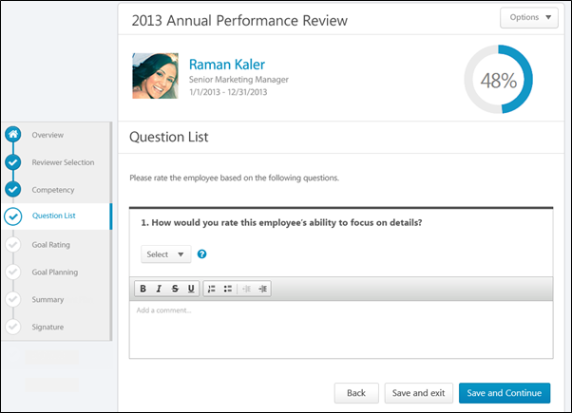
Performance Review Details
At the top of the performance review, the following performance review details are displayed:
- Performance Review Title - Title of the review. It is configured by the administrator when the review is created.
- Reviewee Photograph, Name, and Title - Reviewee's photograph, name, and position. Click the user's name or photograph to open their Universal Profile in a separate window. See Universal Profile - Bio Overview.
- Review Period - Time period of this review.
- Step Progress - Percentage complete. As review step sections are completed, the step progress is updated to reflect the correct percentage. Sections that require you to enter data complete once all required fields in the section are completed. When a reviewer views a section that does not require any information, the section is considered complete when the reviewer views the section. Note: The Overview page is not included in the completion percentage.
Options
Based on the configuration of the performance review and the reviewer's permissions, options may be available from the Options drop-down menu. See Performance Review - Options Drop-down on page 201 for additional information.
Performance Review Sections
On the left side of the performance review, the navigation menu displays all sections along with their completion status. Reviewers can click a section tab to access the section. See Performance Review - Review Sections on page 196 for additional information.
Question Rating
For each question, select a rating and enter comments explaining the selected rating. For example, if you selected a poor rating, explain why the rating was selected. The character limit for Comment fields is 30,000.
- To add a suggested comment from the comment assistant, click the Comment Assistant icon above the Comments field. This opens the Suggested Comments pop-up. See Performance Review - Comment Assistant on page 160 for additional information.
- If the Inappropriate Word Filter is enabled for performance reviews, the filter flags any inappropriate words contained in the Comment field. See Performance Review - Inappropriate Language on page 193 for additional information.
- To check the spelling of the text box contents, click the ABC icon in the text box toolbar. This opens the Spell Checker pop-up.
- If you have a need to copy and paste content into a performance review, please be sure to right-click the field into which you are pasting the content, and select the "Paste" option. You can also perform the same action by pressing [Ctrl]+[Shift]+[V]. This will ensure any formatting HTML does not get inserted into the text.
When adding a comment, an HTML safe list is used for the Comments field. The system only accepts certain customizable HTML elements in the WYSIWYG Editor. Elements that are not acceptable display as text. See Safe Listed Customizable Elements.
Because Question List sections can be reused year after year, ratings and comments from previous reviews may be included. After a peer or direct report review step, reviewers can view peer and direct report responses within the review. Each step (peer step or direct report step) appears in its own grouping. The names of the peers and direct reports are not visible to the reviewee, and the responses are not visible unless the minimum number of responses is reached.
Multiple Reviewers/Co-Planners
If a review step has co-planners, each reviewer is able to enter their own comments and modify the review ratings. Comments are attributed to the user who submitted them, so each comment appears distinct and separate. In addition, any comments that have been saved, but not submitted are viewable by the assignee and the co-planners.
- If a co-planner is the first user to access a review section, the co-planner is able to select a rating and enter comments, if the rating option and comment box are enabled for the co-planner.
- If a co-planner accesses a review section that has been saved but not submitted by the assignee or another co-planner, then the system displays the following:
  - Ratings values are pre-selected with the rating that was selected by the assignee or another co-planner. Note: The rating option only appears if the task is configured for the section to accept comments from the corresponding assignee.
  - An empty comment box appears for the co-planner to enter comments. Note: The comment box only appears if the task is configured for the section to accept comments from the corresponding assignee.
  - A response section containing the rating applied by the assignee or another co-planner. This section displays the assignee or co-planner name, rating, and comments. "(Co-Planner)" appears next to all co-planner names. Note: The rating and comment only appear if the task is configured for the section to accept ratings and comments from the corresponding assignee.
Any comments are attributed to the reviewer who entered them. Ratings are attributed to the user who was the last to apply or modify the rating. For example, if Co-planner A applies a rating to a question, and then Co-planner B modifies the rating for the question, then the rating is attributed to Co-planner B. However, if Co-planner B does not modify the rating, then the rating is attributed to Co-planner A.
When viewing reviewer comments, the comments from the review step assignee are displayed first, followed by comments from the step co-planners in alphabetical order based on last name. The most recent comments are displayed first.
Navigation Buttons
The following buttons are available at the bottom of the page:
- Back - Opens the previous step of the performance review. This button is not available on the first page of the performance review.
- Save and Exit - Saves the reviewer's progress and exits the performance review.
- Save and Continue - Saves the reviewer's progress, validates all selections and comments, and proceeds to the next step of the performance review. This button is not available on the final page of the performance review.
- Submit - Submits the performance review. This button is only available when all sections of the performance review are complete. Once the task is submitted, you cannot modify the review task unless multiple submissions are allowed for the review task.
Based on the configuration of the performance review task, the reviewer's selected ratings may be visible to the system administrator as soon as the review task is saved. This includes when the performance review is automatically saved by the system. This enables the administrators to begin utilizing the data for calibration purposes while the review step is in progress.
When a reviewer is editing a reopened step or a submitted review step that allows multiple submissions, the performance review Save button labels are updated to more clearly indicate that the Save options do not finalize any of the ratings.
- The Save and Exit button is renamed to Save as Draft and Exit.
- The Save and Continue button is renamed to Save as Draft and Continue.
When in read-only mode, the available buttons are Back, Exit, and Next.
Performance Review - Summary
Use the Summary section of a performance review to view a review summary once the reviewee and managers complete their tasks. This contains the section names, the step ratings along with the maximum rating, and the weight for each section if visible. If the overall review score is affected by auto-score functionality, this is noted below the overall rating at the top of the Summary section.
Scores for peers or direct reports are averaged across all users who submit a response. Each user's section score is calculated independently, based on the questions to which they responded. The peer or direct report section score is then averaged evenly across all respondents within the group. The step score is calculated based on the scores and weights of each section.
The Summary task is not visible to peer or direct report reviewers.
Permissions
PERMISSION NAME | PERMISSION DESCRIPTION | CATEGORY

View Performance Reviews | Grants ability to view the Performance Reviews page, which displays a user's own past performance reviews as well as performance review task steps they've been assigned to complete. This also grants ability to view the Batch Rating page. This permission can be constrained by OU, User's OU, User Self and Subordinates, and User. This is an end user permission. | Performance
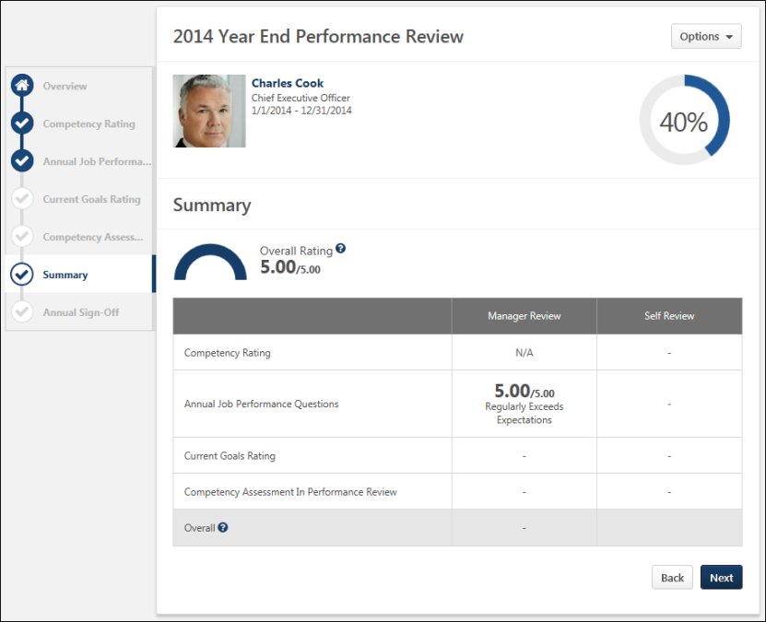
Performance Review Details
At the top of the performance review, the following performance review details are displayed:
- Performance Review Title - Title of the review. It is configured by the administrator when the review is created.
- Reviewee Photograph, Name, and Title - Reviewee's photograph, name, and position. Click the user's name or photograph to open their Universal Profile in a separate window. See Universal Profile - Bio Overview.
- Review Period - Time period of this review.
- Step Progress - Percentage complete. As review step sections are completed, the step progress is updated to reflect the correct percentage. Sections that require you to enter data complete once all required fields in the section are completed. When a reviewer views a section that does not require any information, the section is considered complete when the reviewer views the section. Note: The Overview page is not included in the completion percentage.
Options
Based on the configuration of the performance review and the reviewer's permissions, options may be available from the Options drop-down menu. See Performance Review - Options Drop-down on page 201 for additional information.
Performance Review Sections
On the left side of the performance review, the navigation menu displays all sections along with their completion status. Reviewers can click a section tab to access the section. See Performance Review - Review Sections on page 196 for additional information.
Overall Rating
Overall Rating is the normalized rating for all sections compared to the maximum rating of the task. The Overall Rating appears as either a numeric or a text rating depending on the performance review task configuration. If the overall rating is displayed as a text rating, the half-circle gauge does not appear.
When the overall rating scale is configured to display, the overall rating scale is available by clicking the Question Mark icon to the right of overall rating.
on the Summary page within the performance review task. When enabled, this icon is available to the right of the overall rating and in the Overall row of the ratings table.
Summary Table
Displays each section in the performance review and the section rating from each review step. If there are steps that are not visible in the table, a horizontal scroll bar appears at the bottom of the table and can be used to scroll left and right within the table.
- If the section is optional or if the rating is hidden, then a dash appears for the score.
- If the performance review task is configured to display weights on the Review Summary step, then weights are displayed in the summary table below the rating.
When the overall rating scale is configured to display, the overall rating scale is available by clicking the Question Mark icon in the Overall row of the ratings table.
Summary Section Completion
The Summary section becomes completed once the user has completed all required sections that are included in the summary table.
Navigation Buttons
The following buttons are available at the bottom of the page:
- Back - Takes users to the previous step of the performance review. This button is not available on the first page of the performance review.
- Next - Takes users to the next step of the performance review.
- Save and Exit - Saves the reviewer's progress and exits the performance review.
- Submit - Submits the performance review. This button is only available when all sections of the performance review are complete. Once the task is submitted, you cannot modify the review task unless multiple submissions are allowed for the review task.
When in read-only mode, the available buttons are Back, Exit, and Next.
Performance Review - Sign-off
The Sign-off section allows reviewees, managers, and other users to electronically sign the performance review. A signature line appears for each role that is added to the signature section.
Users with the appropriate permission can sign off on performance reviews in bulk. Note: Reviewers can only utilize the Bulk Sign Off functionality for performance reviews that are configured to use the Electronic sign-off method. See Performance Reviews - Bulk Sign Off on page 231 for additional information.
Permissions
PERMISSION NAME | PERMISSION DESCRIPTION | CATEGORY

View Performance Reviews | Grants ability to view the Performance Reviews page, which displays a user's own past performance reviews as well as performance review task steps they've been assigned to complete. This also grants ability to view the Batch Rating page. This permission can be constrained by OU, User's OU, User Self and Subordinates, and User. This is an end user permission. | Performance
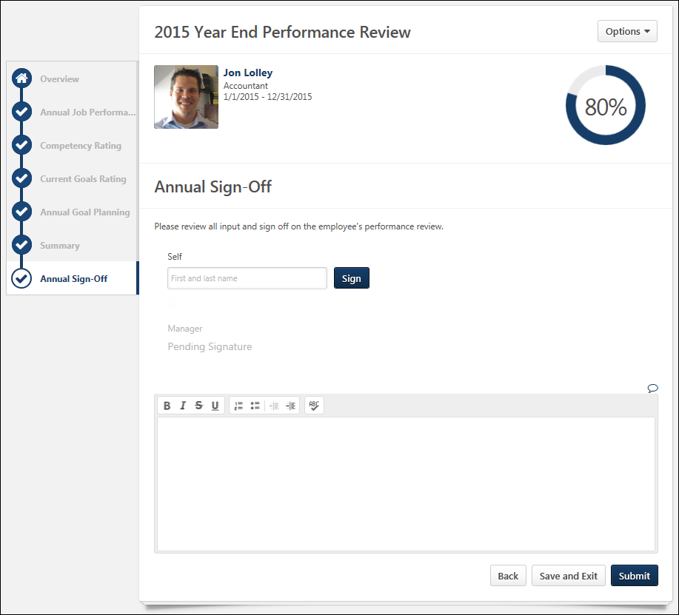
Performance Review Details
At the top of the performance review, the following performance review details are displayed:
- Performance Review Title - Title of the review. It is configured by the administrator when the review is created.
- Reviewee Photograph, Name, and Title - Reviewee's photograph, name, and position. Click the user's name or photograph to open their Universal Profile in a separate window. See Universal Profile - Bio Overview.
- Review Period - Time period of this review.
- Step Progress - Percentage complete. As review step sections are completed, the step progress is updated to reflect the correct percentage. Sections that require you to enter data complete once all required fields in the section are completed. When a reviewer views a section that does not require any information, the section is considered complete when the reviewer views the section. Note: The Overview page is not included in the completion percentage.
Options
Based on the configuration of the performance review and the reviewer's permissions, options may be available from the Options drop-down menu. See Performance Review - Options Drop-down on page 201 for additional information.
Performance Review Sections
On the left side of the performance review, the navigation menu displays all sections along with their completion status. Reviewers can click a section tab to access the section. See Performance Review - Review Sections on page 196 for additional information.
Sign-off
The signature method varies depending on the review section configuration. The following signature methods may be available:
- Electronic - If an empty field appears, enter your name and click Sign. You can re-sign prior to submitting the associated step by clicking the Re-Sign button. The submitted signature displays the name in the font selected by the employee on the My Account > My Preferences page and a date stamp. The section is complete once the review is signed.
- Authenticated - If an acknowledgment option appears, read the acknowledgment, select the acknowledgment checkbox to acknowledge the agreement, and click Sign. Your signature is automatically added with a date stamp. Users cannot edit their name or signature. This prevents typos because your system name is automatically entered. The section is complete once the review is signed.
- Manual - If a manual signature has been selected, the act of viewing the Sign-off section marks the section complete. You must then sign the printable version of the review.
Decline to Sign
If enabled, this option lets the reviewer decline to add their signature to the Sign Off section of the performance review to indicate that they do not agree with the outcome of the performance review. When the reviewer selects this option, the Sign button and the First and last name field are disabled. Also, a notification appears at the top of all performance review steps to indicate that the reviewer declined to sign the performance review.
If the reviewer already signed the performance review, then the Decline to sign option is hidden. If the reviewer chooses to remove their signature prior to submitting the performance review, they can click the Redo button to remove their signature. At this point, the Decline to sign option is available again.
In read-only mode, the Decline to sign is not displayed if it was not selected during the performance review.
In the printable performance review, if the reviewer declines to sign the performance review task, then "Decline to sign" is displayed in the user's signature area and no date is populated in the Date field. This clearly indicates that the user did not sign the performance review.
Comments
Add comments about the review. The character limit for comment fields is 30,000.
- If the Inappropriate Word Filter is enabled for performance reviews, the filter flags any inappropriate words contained in the Comment field. See Performance Review - Inappropriate Language on page 193 for additional information.
- To check the spelling of the text box contents, click the ABC icon in the text box toolbar. This opens the Spell Checker pop-up.
- If you have a need to copy and paste content into a performance review, please be sure to right-click the field into which you are pasting the content, and select the "Paste" option. You can also perform the same action by pressing [Ctrl]+[Shift]+[V]. This will ensure any formatting HTML does not get inserted into the text.
Navigation Buttons
The following buttons are available at the bottom of the page:
- Back - Opens the previous step of the performance review. This button is not available on the first page of the performance review.
- Save and Exit - Saves the reviewer's progress and exits the performance review.
- Save and Continue - Saves the reviewer's progress, validates all selections and comments, and proceeds to the next step of the performance review. This button is not available on the final page of the performance review.
- Submit - Submits the performance review. This button is only available when all sections of the performance review are complete. Once the task is submitted, you cannot modify the review task unless multiple submissions are allowed for the review task.
Based on the configuration of the performance review task, the reviewer's selected ratings may be visible to the system administrator as soon as the review task is saved. This includes when the performance review is automatically saved by the system. This enables the administrators to begin utilizing the data for calibration purposes while the review step is in progress.
When a reviewer is editing a reopened step or a submitted review step that allows multiple submissions, the performance review Save button labels are updated to more clearly indicate that the Save options do not finalize any of the ratings.
- The Save and Exit button is renamed to Save as Draft and Exit.
- The Save and Continue button is renamed to Save as Draft and Continue.
When in read-only mode, the available buttons are Back, Exit, and Next.
Performance Review - Confirmation
If the Confirmation page is enabled by the system administrator, it appears when the user has completes their performance review step.
The message that is displayed is configured by the system administrator when creating or editing the performance review task.
Permissions
PERMISSION NAME | PERMISSION DESCRIPTION | CATEGORY

View Performance Reviews | Grants ability to view the Performance Reviews page, which displays a user's own past performance reviews as well as performance review task steps they've been assigned to complete. This also grants ability to view the Batch Rating page. This permission can be constrained by OU, User's OU, User Self and Subordinates, and User. This is an end user permission. | Performance
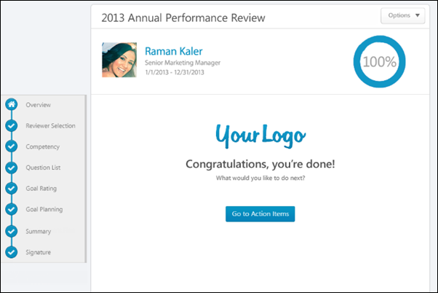
Performance Review Details
At the top of the performance review, the following performance review details are displayed:
- Performance Review Title - Title of the review. It is configured by the administrator when the review is created.
- Reviewee Photograph, Name, and Title - Reviewee's photograph, name, and position. Click the user's name or photograph to open their Universal Profile in a separate window. See Universal Profile - Bio Overview.
- Review Period - Time period of this review.
- Step Progress - Percentage complete. As review step sections are completed, the step progress is updated to reflect the correct percentage. Sections that require you to enter data complete once all required fields in the section are completed. When a reviewer views a section that does not require any information, the section is considered complete when the reviewer views the section. Note: The Overview page is not included in the completion percentage.
Options
Based on the configuration of the performance review and the reviewer's permissions, options may be available from the Options drop-down menu. See Performance Review - Options Drop-down on page 201 for additional information.
Performance Review Sections
On the left side of the performance review, the navigation menu displays all sections along with their completion status. Reviewers can click a section tab to access the section. See Performance Review - Review Sections on page 196 for additional information.
Go to Action Items
Click the Go to Action Items button to go to the Universal Profile > Actions page. See Universal Profile - Actions Overview for additional information. This button is only available if enabled by the system administrator. This button is not available to external reviewers.
Performance Review - Discuss Review
During an off-cycle performance review, users can discuss the review on the Discuss Review page if the functionality is enabled. User comments are either sent to the reviewee privately or to all participants of the review. Note: This option is only available for off-cycle performance review tasks that are configured to allow reviewers to discuss the review.
To access the Discuss Review page:
- Open the performance review and click the Discuss Review section link on the left navigation.
- If you receive an email notifying you that there is a discussion, there may be a link to the Discuss Review page. This option is only available if enabled by an administrator.
Permissions
PERMISSION NAME | PERMISSION DESCRIPTION | CATEGORY

View Performance Reviews | Grants ability to view the Performance Reviews page, which displays a user's own past performance reviews as well as performance review task steps they've been assigned to complete. This also grants ability to view the Batch Rating page. This permission can be constrained by OU, User's OU, User Self and Subordinates, and User. This is an end user permission. | Performance
Emails
EMAIL NAME | EMAIL DESCRIPTION | ACTION TYPE

Performance Review Reviewer Commented | This email is triggered when a reviewer adds a comment as part of a discussion thread within an off-cycle performance review. Discussions cannot be part of a standard performance review task.  The available recipients are Reviewee, Reviewer (the commenting reviewer), and Comment Recipients. Selecting Comment Recipients triggers a separate email to all users who have visibility to the comment. For example, a private comment only triggers emails to the reviewee or the person to which the reviewee is replying. A public comment triggers emails to the reviewee and all reviewers. | Performance Management

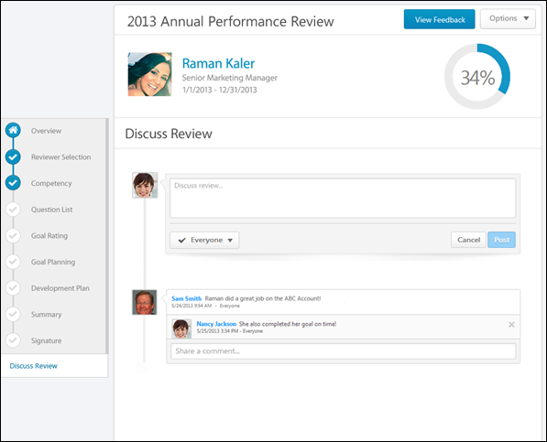
On the Discuss Review page:
- The reviewee can view all comments. Comments are displayed in the order in which the parent comment was posted with the most recent parent comment displayed first.
- Peers and subordinates can only see public comments.
- Managers, indirect managers, and custom relationships can only see public comments and any comment that they made privately.
Performance Review Details
At the top of the performance review, the following performance review details are displayed:
- Performance Review Title - Title of the review. It is configured by the administrator when the review is created.
- Reviewee Photograph, Name, and Title - Reviewee's photograph, name, and position. Click the user's name or photograph to open their Universal Profile in a separate window. See Universal Profile - Bio Overview.
- Review Period - Time period of this review.
- Step Progress - Percentage complete. As review step sections are completed, the step progress is updated to reflect the correct percentage. Sections that require you to enter data complete once all required fields in the section are completed. When a reviewer views a section that does not require any information, the section is considered complete when the reviewer views the section. Note: The Overview page is not included in the completion percentage.
Options
Based on the configuration of the performance review and the reviewer's permissions, options may be available from the Options drop-down menu. See Performance Review - Options Drop-down on page 201 for additional information.
Performance Review Sections
On the left side of the performance review, the navigation menu displays all sections along with their completion status. Reviewers can click a section tab to access the section. See Performance Review - Review Sections on page 196 for additional information.
Add Comment
To add a comment to the review discussion, in the Discuss review field, enter a comment up to 4000 characters.
Reply to Comment
To reply to a discussion post, in the Share a comment field below the original post, enter a reply comment up to 4000 characters. Note: When replying to a discussion post, the Post and Cancel buttons are not visible until you click the Share a comment field.
When replying to a comment, you cannot change the visibility setting. The reply automatically has the same visibility setting as the original post. Peers and subordinates can only make private comments, so they cannot reply to any comment that is visible to everyone.
Determine Comment Visibility
When adding a new comment, users can determine who can see the comment. Note: The visibility setting does not appear until the Discuss review field is clicked. To determine who can see your comment, select the appropriate option from the visibility drop-down list. The visibility applies to the original post as well as any additional comments that are added to your post by others. Note: This option cannot be changed after the comment is saved. The following options are available:
- Everyone - Select this option to make the comment visible to everyone involved with the review.
- Reviewee Only - Select this option to make the comment visible only to the reviewee and the reviewer who posted the comment. This option is not available to the reviewee. Also, peers and subordinates can only make private comments, so this option is automatically selected and cannot be changed.
Post or Cancel
After entering the appropriate text and setting the comment visibility, click Post to post the comment, or click Cancel to discard the comment.
When a comment is posted, it appears on the Discuss Review page with a date and time stamp of when the comment was made. The comment visibility setting is displayed to the right of the date and time stamp.
When a comment is posted, the recipients of the comment are notified via an email notification, if the Performance Review Reviewer Comment email is enabled.
Delete a Comment
Reviewers can delete one of their parent comments only if the comment has no child comments (i.e., the parent comment has no reply comments).
Reviewers can delete one of their child comments only if the child comment is the last child comment (i.e., the last reply comment) for the parent comment.
To delete a comment, click the Remove icon to the right of the comment.
Automatic Comment Deletion
If comments are configured to be deleted, all comments are permanently deleted when the review task meets the deletion criteria. Once deleted, the Discuss Review page is still available, but the comments are removed. If a review step is reopened or a step due date is extended, you can engage in comments, but the comments are deleted once the task meets the deletion criteria.

Performance Review Task - Components Overview
Performance Review - Comment Assistant
Use the Comment Assistant to suggested comments throughout the performance review. Note: The comment assistant only appears if it is enabled in Writing Tools preferences and if the item has at least one associated suggested comment.
Note: Comment Assistant is only available in Question List form sections.
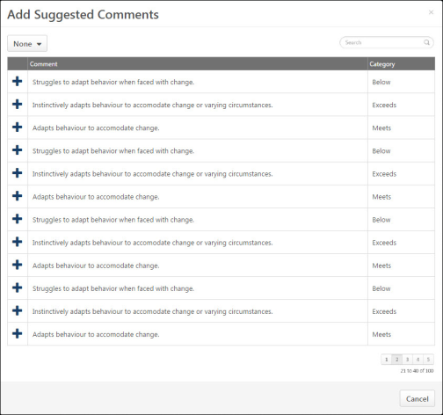
Manage Comments
- To add a suggested comment from the comment assistant, click the Comment Assistant icon above the Comments field. This opens the Suggested Comments pop-up.
- To filter the comments, select the appropriate category from the drop-down menu in the upper-left corner.
- Click the plus icon to the left of the comment to add the comment to the review. If text already exists in the Comments field, the added comment is appended to the existing text.
Performance Review - Competency Assessment - Rating History
When completing a competency assessment within a performance review, previous ratings may be available for a competency item. If previous ratings exist for a competency item, a Rating History link is available to the right of the rating scale. Click the link to view the previous ratings for the competency item.
At the top of the pop-up, the competency item description is displayed. Below the competency item description, all of the available competency item ratings for the reviewee are displayed. The ratings are organized by the performance review in which they were assessed with the most recent performance review displayed first. The reviewee's photograph and name are displayed along with their rating for the reviewee.
Performance Review - Competency Assessment - View Evidence
When a Competency Assessment review section is linked with an Evidence Collection review section, reviewers may have the option to view all pieces of evidence associated with a competency.
Reviewers can click the View Competency button to view all pieces of evidence associated with the competency.
Evidence is displayed in the order in which it was created with the most recently created evidence displayed first.
Evidence Display Rules
Click View Evidence to view all available evidence.
Evidence Details
The following information is displayed with each piece of evidence:
- Evidence File Type - Associated file type. An icon that represents the file type is displayed to the left of the evidence details.
- Evidence Creator - Name of the user who added the evidence is displayed to the right of the evidence file type icon.
- Timestamp - Timestamp is displayed with each piece of evidence to indicate when the evidence was added. The timestamp is always displayed in the time zone of the user who is viewing the evidence.
- Evidence Text - Summary of the evidence is displayed below the timestamp. Up to five lines of the summary text is displayed. If the evidence summary contains more than five lines of text, a more link is displayed at the end of the summary. Click this link to view the full summary of the evidence.
- Competencies - Tagged competencies if the evidence is tagged with competencies. Displays in alphabetical order.
- Comments - Comments added to a piece of evidence. Displays below the tagged competencies.
Evidence Options
The following evidence action may be available from the actions drop-down menu to the right of the evidence:
- Download Attachment - Select this option to download the evidence attachment. Note: This option is only available if the evidence has an attachment.
Pagination
If more than 10 results are available in the table, then pagination options appear in the lower-right corner of the table.
- Click a specific page number to go directly to that page.
- To move one page forward or backward, click the right or left arrow icon.
- To move to the first or last page, click the double left or double right arrow icon.
Close
To close the pop-up, click the X icon in the upper-right corner or click the Close button in the lower-right corner of the pop-up.
Performance Review - Custom Fields
If a performance review section is configured to include custom fields, the custom fields display below the section description and above the section questions, goals, or competencies.
Checkbox
Date Field
Drop-down
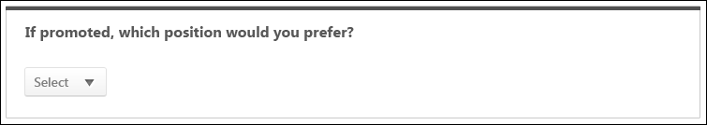
Numeric Field
Radio Button
Scrolling Text Box
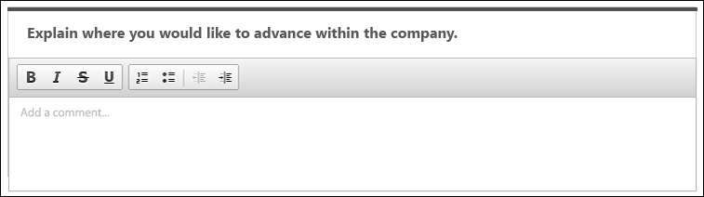
Short Text Box
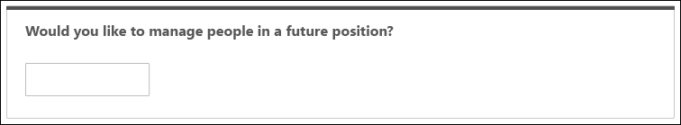
Performance Review - Development Plan - Action Step Options
For action steps added to the development plan during the performance review task, you can edit or delete an action step by selection an option in the Actions drop-down .
Note: The Actions drop-down is not available for action steps that were added to the development plan prior to the performance review task. These action steps cannot be edited or deleted within the performance review section.
You can edit the title, category, progress, and due date.
To edit an action step, click the drop-down arrow in the upper-right corner of the action step and select Edit Action Step.
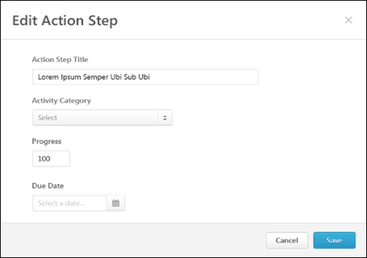
Action Step Title
Enter a title for the action step, up to 3000 characters. This title should provide an understanding of the developmental action step.This is required.
Activity Category
Select a category for the action step. If there are no available activity categories, then the drop-down menu does not appear. This is optional. The available activity categories are defined by the administrator.
Progress
The percentage complete for the item. If there is progress on the action step when it is added to the plan or when edited, you can update the progress. If the step is not started, enter 0; if the step is complete, enter 100.
Due Date
Set a due date for the action step. This is optional.
After entering the appropriate information, click Save. The action step details are updated.
Action Step - Delete
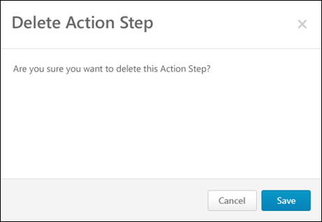
Click the drop-down arrow in the upper-right corner of the action step and select Delete Action Step. A confirmation pop-up appears to confirm the deletion.
Performance Review - Development Plan - Add Objective
Development plans are creating by adding development objectives to outline what you are trying to achieve in your development plan. Objectives are the target areas of the plan. For example, if you are creating a development plan to improve your communication skills, you may create an objective to improve your writing skills. This objective should contain all of the training and actions you need to complete in order to achieve the objective, such as completing writing classes or shadowing a writer at your organization.
To add an objective to the development plan, click the Add Objective button. The Add Objective pop-up opens.
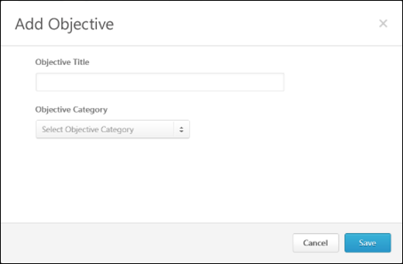
Objective Title
Enter a title for the objective, up to 3000 characters. This is required. This title should provide an understanding of the developmental objective (e.g., Leadership, Presentation Skills).
Objective Category
From the drop-down, select a category for the objective. This is optional. The available objective categories are defined by the administrator. If there are no available objective categories, then the drop-down menu does not appear.
After entering the appropriate information, click Save. The new objective is added at the top of the development plan. If a category is selected for the objective, then the category name appears to the right of the objective title in parenthesis. Training and action steps can then be added to the objective.
Performance Review - Development Plan - Objective Options
You can view the options for development plan objectives.
Add Training
Add training to a development plan to help the user develop the corresponding objective. Training must exist within the system before it can be added to the development plan.
See Search Training Pop-up for additional information.
Add/Edit Action Step
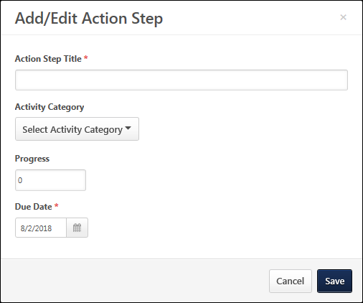
Add or edit action steps for a development plan to help the user develop the corresponding objective.
To add or edit an action step:
- Click the drop-down arrow in the upper-right corner of the objective and select Add Action Step. This opens the Add Action Step Training pop-up.
- Enter the following information for the action step:
  - Action Step Title - Enter a title for the action step, up to 3000 characters. This is required. This title should provide an understanding of the developmental action step.
  - Activity Category - From the drop-down, select a category for the action step. This is optional. The available activity categories are defined by the administrator. If there are no available activity categories, then the drop-down menu does not appear.
  - Progress - In this field, enter the percentage complete for the item. This is optional. If there is progress made on the action step at the time it is added to the plan or when the action step is edited, you may update the progress at that time. If the step has not been started, enter 0, and if the step is complete, enter 100.
  - Due Date - Click the Calendar icon to set a due date for the action step. Or, enter a date in the field. This is optional.
- Click Save. The new action step is added at the top of the objective.
Edit Objective
You can edit the objective title and category. Note: Only objectives that are added during the performance review task can be edited. Objectives that existed within the reviewee's primary development plan prior to the performance review task cannot be edited.
To edit an objective, click the drop-down arrow in the upper-right corner of the objective and select Edit Objective.
Delete Objective
When you delete an objective, all training and action items within the objective are also deleted. Note: You can only delete objectives that are added during the performance review task. You cannot delete objectives that existed within the reviewee's primary development plan prior to the performance review task .
To delete an objective, click the drop-down arrow in the upper-right corner of the objective and select Delete Objective. A confirmation pop-up appears to confirm the deletion.
Performance Review - Development Plan - Training Options
For training items added to the development plan during the performance review task, you can add or delete training by clicking the option in the Actions drop-down .
Note: The Actions drop-down is not available for training items that are added to the development plan prior to the performance review task. These training items cannot be edited or deleted within the performance review section.
Edit Training
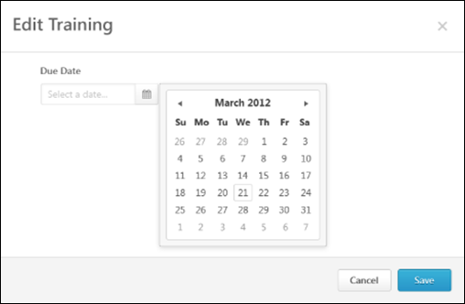
To edit a training item, click the drop-down arrow in the upper-right corner of the training item and select Edit Training.
Training - Delete
To remove a training item from an objective within a development plan, click the drop-down arrow in the upper-right corner of the training item and select Delete Training. A confirmation pop-up appears to confirm the deletion.

Performance Review - Evidence Collection - Add/Edit Evidence Notebook
Evidence Collection review sections are used in conjunction with Competency Assessment review sections because Evidence Collection sections enable reviewers to input, upload, and edit materials that provide evidence that supports the competency ratings assigned in the Competency Assessment section.
The Evidence Notebook page enables a reviewer to create and save an evidence notebook, which is a document of text notes. This page also enables a reviewer to divide a notebook into individual pieces of evidence and associate the evidence with competencies.
You can access the Evidence Notebook as follows:
- From the Evidence Collection performance review section, select Create Notebook from the Add Evidence drop-down menu. Note: This option is only available if the performance review step is configured to allow reviewers to create and edit evidence notebooks.
- From the Evidence Collection performance review section, in the Evidence Feed, select View Notebook from the actions drop-down menu to the right of the evidence.
- From the Manage Notebooks pop-up, click the Create Notebook button or click a notebook name in the Notebook table.
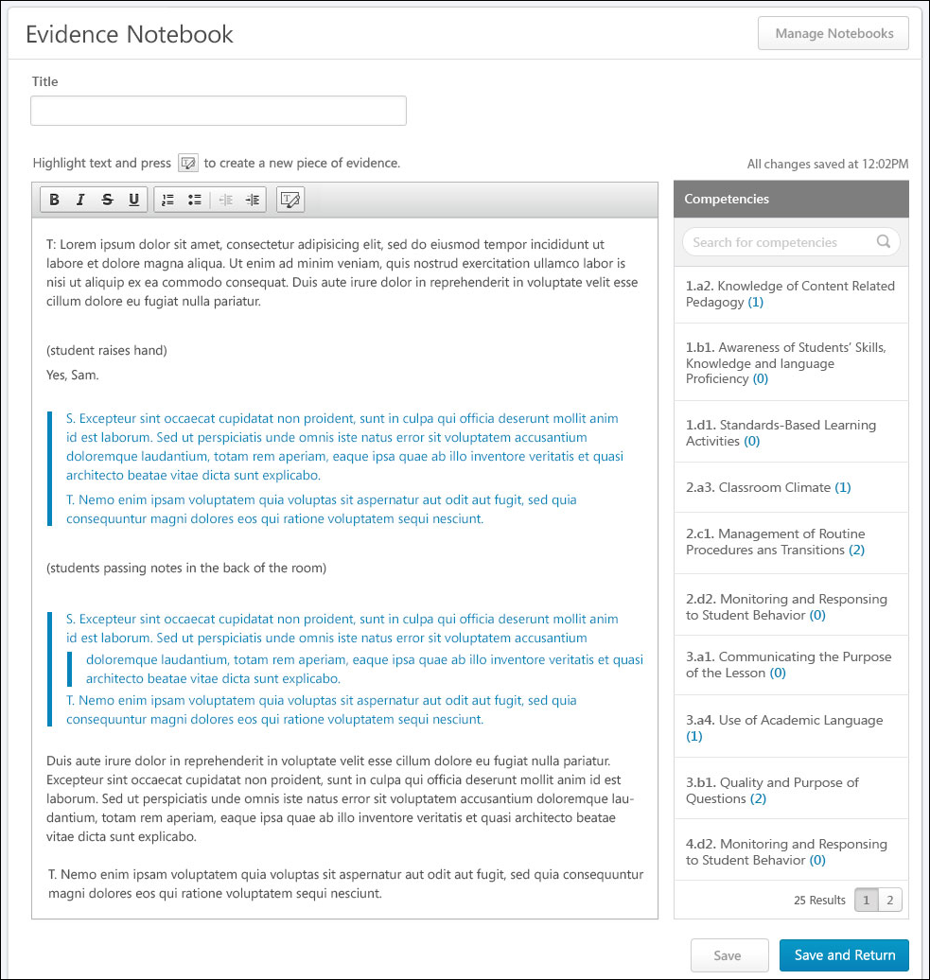
Manage Notebooks
Click the Manage Notebooks button to view and manage existing notebooks. This opens the Manage Notebooks pop-up. See Performance Review - Evidence Collection - Manage Notebooks on page 182 for additional information.
Title
Enter a title that provides a clear purpose of the evidence notebook. You can enter up to 100 characters.
If there is no title when the notebook is saved (either automatically or using one of the Save buttons), the notebook is automatically named "Notebook N," where "N" is one more than the total number of notebooks for the user. For example, if the user has three notebooks, then the new notebook is automatically named "Notebook 4."
Evidence Text
The large text box enables the reviewer to enter text notes from an observation. These text notes should be as detailed as possible so that they can be used as evidence to support competency ratings. HTML can be used. The system only accepts certain customizable HTML elements in the WYSIWYG Editor. Elements that are not acceptable display as text. See Safe Listed Customizable Elements.
If a segment of text within the Evidence Text field is used to create a piece of evidence, then the segment is indented and a vertical bar appears to the left of the segment.
Add and Tag Evidence
The Add New Evidence functionality enables the reviewer to separate the text within the Evidence Text field into individual pieces of evidence.
To separate a section of text into an individual piece of evidence, select the appropriate text within the Evidence Text field and click the Select Text icon in Evidence Text field editing toolbar. Depending on the configuration of the performance review step, the reviewer may be able to tag the evidence with one or more competencies. Note: Text must selected within the Evidence Text field prior to clicking the Select Text icon .
Scenarios
Scenario 1: Reviewer Can Tag Evidence
If the performance review step is configured to allow reviewers to tag evidence, then the following occurs when the Select Text icon is clicked:
- The Search Competencies pop-up opens, which enables the reviewer to search for and select the competencies with which the evidence will be tagged. See Search Competencies Pop-up for additional information.
- After the competencies are selected, the Add Evidence pop-up opens. The Evidence Text field is populated with the text that was selected on the Evidence Notebook page, and the Competencies section is populated with the competencies that were selected in the Search Competencies pop-up. See Performance Review - Evidence Collection - Add/Edit Evidence on page 178 for additional information.
- After the evidence is added, the previously selected text is now a unique piece of evidence and is tagged with the selected competencies. To visually indicate that the text has been tagged, the text is indented and a vertical bar appears to the left of the text in the Evidence Text field. In the Competencies panel on the Evidence Notebook, the counters for the selected competencies are updated.
Scenario 2: Reviewer Cannot Tag Evidence
If the performance review step is configured to not allow reviewers to tag evidence or if there is no competency model available, then the following occurs when the Select Text icon is clicked:
- The Add Evidence pop-up opens. The Evidence Text field is populated with the text that was selected on the Evidence Notebook page, and the Competencies section is not available.
- After the evidence is added, the previously selected text is now a unique piece of evidence. The evidence text is indented and there is a vertical bar to the left of the text.
Competencies Panel
To the right of the Evidence Text field, the Competencies panel displays all of the competencies contained in the competency model associated with the Competency Assessment review section. Competencies display in alphabetical order. If there are more than 15 competencies, pagination options are available at the bottom of the Competencies panel.
Search - Search field lets the reviewer search for competencies by name.
Number of pieces of evidence - Represents the total number of pieces of evidence tagged with the competency. This number is in parenthesis. Click the number to view all pieces of evidence in a pop-up.
Remove evidence - Within the Competency Evidence pop-up, the reviewer can remove a piece of evidence from a competency by clicking the Remove icon to the left of the evidence text.
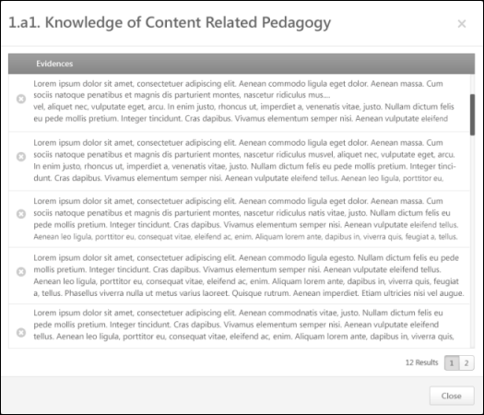
Save/Save and Return
When editing the Evidence Notebook page, the content is automatically saved every three minutes to prevent data loss. However, the reviewer can also manually save the page by clicking one of the Save buttons. When the page is automatically saved or when one of the Save buttons is clicked, the text in the upper-right corner of the page is updated to reflect the last time the page was saved.
- Click Save to save the evidence notebook and continue editing the Evidence Notebook page.
- Click Save and Return to save the Evidence Notebook page and return to the Evidence Collection performance review section.
Performance Review - Evidence Collection - Add/Edit Evidence
Evidence Collection review sections are used in conjunction with Competency Assessment review sections because Evidence Collection sections enable reviewers to input, upload, and edit materials that provide evidence that supports the competency ratings assigned in the Competency Assessment section. When creating or editing evidence, reviewers can provide summary text, associate the evidence with competencies, and attach documents to the evidence.
- To add evidence to an Evidence Collection performance review section, click the Add Evidence button or select Add Evidence from the Add Evidence drop-down menu. Note: This option is only available if the performance review step is configured to allow reviewers to create and edit evidence. Self and peer reviewers cannot edit any evidence that was added by another reviewer. Self and peer reviewers can only edit evidence that they uploaded within the Evidence Collection review section.
- To edit a piece of evidence within an Evidence Collection performance review section, click the actions drop-down menu to the right of the evidence in the Evidence Feed and click the Edit Evidence option. Note: This option is only available if the performance review step is configured to allow reviewers to create and edit evidence. Self and peer reviewers cannot edit any evidence that was added by another reviewer. Self and peer reviewers can only edit evidence that they uploaded within the Evidence Collection review section.
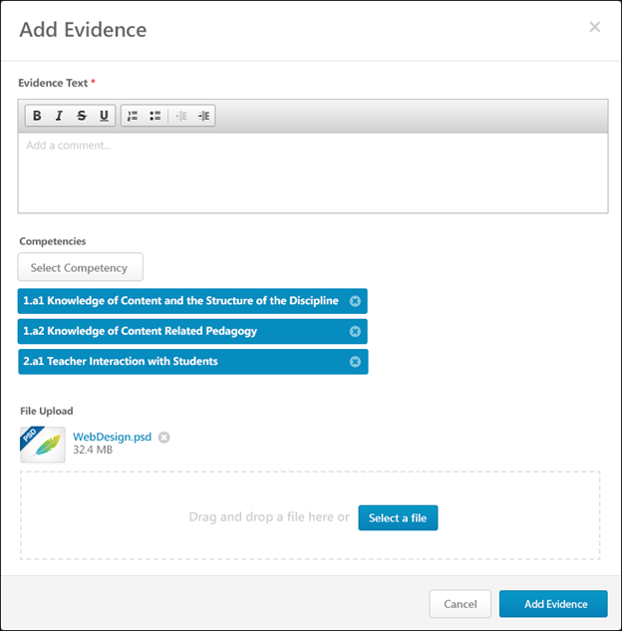
Evidence Text
Enter the details of the evidence. For example, if the evidence is an observation,describe what was observed and how the observation relates to the appropriate competencies. If an attachment is added as evidence, summarize the attachment and describe how the attachment relates to the appropriate competencies.
This field is required.
Competencies
Evidence Collection sections enable reviewers to input or upload materials that provide evidence that supports the competency ratings assigned in the Competency Assessment section.
Note: This section is not available if there is no competency model available.
Select Competency
Click the Select Competency button to associate the evidence with one or more competencies. This opens the Search Competencies pop-up. The reviewer can only select competencies that are contained within the competency model that is associated with the Competency Assessment review section. See Search Competencies Pop-up for additional information.
Selected competencies display below the Select Competency button.
Adding competencies to a piece of evidence is optional.
Remove Competencies
To remove a selected competency from the evidence, click the X icon on the right side of the competency.
File Upload
Reviewers may add or upload a file to provide evidence.
- Click the Select a file button to select a file from your computer.
- Drag-and-drop a file - Select a file and drop it into the file upload box. Note: The drag-and-drop functionality is not supported by Internet Explorer browsers.Attach a file by dragging and dropping a file into the Attachment area or by
After the file is selected, the attachment appears at the top of the File Upload section.
The following attachment restrictions apply:
- One attachment can be added.
- The maximum file size is 5 MB.
- The attachment file name cannot exceed 50 characters.
- Executable files cannot be uploaded.
- Files cannot have a hidden extension or no extension.
File types
You can add or upload the following file types:
File Type | Extension
Compressed | - zip
Data | - xls/xlsx
Image | - bmp  - gif  - jpeg/jpg/jpe  - png
Presentation | - ppt/pptx
Text | - doc/docx  - pdf  - txt
Video | - avi  - mov
File - Remove
To remove an uploaded file, click the X icon to the right of the file name.
Add Evidence/Save Evidenceor Cancel
- When creating a new piece of evidence, click Add Evidence to save and create the new piece of evidence.
- When editing an existing piece of evidence, click Save Evidence to save the changes.
Cancel
Click Cancel to discard any unsaved changes.
Performance Review - Evidence Collection - Manage Notebooks
The Manage Notebooks pop-up enables reviewers to create notebooks and view and delete their existing notebooks. Notebooks are not shared between reviewers, so a reviewer can only view their own notebooks.
To access the Manage Notebooks pop-up, click the Manage Notebooks button on the Evidence Notebook page.
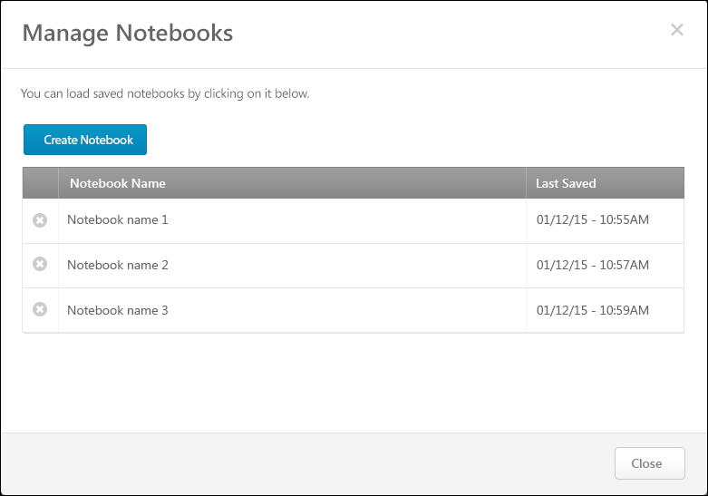
Create Notebook
Click the Create Notebook button to create a new notebook. This opens the Evidence Notebook page. If the reviewer already has a different notebook open, then the previous notebook is automatically saved before the Evidence Notebook page is opened.
See Performance Review - Evidence Collection - Add/Edit Evidence Notebook on page 173 for additional information.
Notebook Table
The following information is displayed in the Notebook table for each of the reviewer's existing evidence notebooks:
- Notebook Name - This displays the title of each of the reviewer's existing evidence notebooks.
- Last Saved - This displays the date and time at which the corresponding notebook was last saved either manually or automatically.
Open Notebook
Click the notebook name in the Notebook table to open the Evidence Notebook page for the notebook. If the reviewer has a different notebook open, the previous notebook is automatically saved before the new notebook is opened.
See Performance Review - Evidence Collection - Add/Edit Evidence Notebook on page 173 for additional information.
Remove Notebook
Click the Remove icon to the left of the appropriate notebook name to delete a notebook. A confirmation pop-up opens to confirm the removal.
Close
To close the pop-up, click the X icon in the upper-right corner of the pop-up or click the Close button in the lower-right corner of the pop-up.
Performance Review - Evidence Collection - Total Competencies Tagged
Within an Evidence Collection performance review section, each piece of evidence can be tagged or associated with a competency. This indicates that the piece of evidence is related to the competency and can be used to support any ratings associated with the competency. Within the performance review, reviewers can view which competencies have been tagged with evidence and which have not.
To view which competencies are tagged with evidence and which competencies have not yet been tagged within the Evidence Collection step, click the Competencies Tagged link at the top of the Evidence Feed.
Total Competencies Tagged
At the top of the Total Competencies Tagged pop-up, the total number of available and tagged competencies is displayed. For example, if "26 of 35 Competencies Tagged" is displayed, this indicates that there are 35 total competencies available to be tagged within the associated competency model and 26 competencies have been tagged with evidence.
Untagged Tab
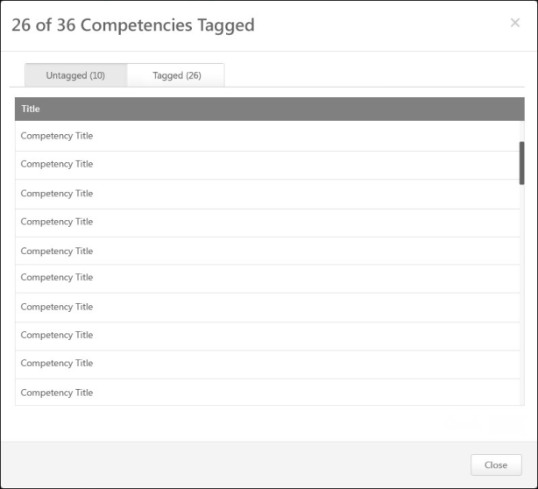
By default, the Untagged tab is selected when the pop-up is opened. This tab displays all of the competencies within the competency model that do not yet have evidence tagged to them. Competencies are sorted alphabetically.
Tagged Tab
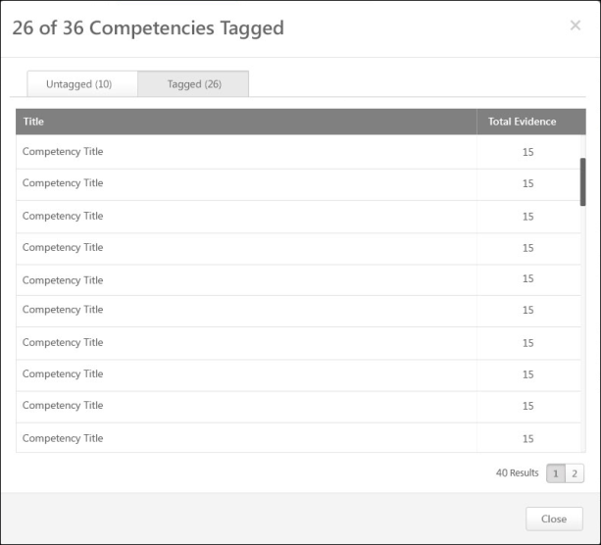
This tab displays all of the competencies within the competency model that have evidence tagged to them. The total number of tagged competencies is displayed next to the tab name.
In the Total Evidence column to the right of the competency name, the total number of pieces of evidence that are associated with the competency is displayed.
Competencies are sorted by Total Evidence with the lowest number of evidence displayed first.
Pagination
If more than 20 results are available in the table, then pagination options appear in the lower-right corner of the table.
- Click a specific page number to go directly to that page.
- To move one page forward or backward, click the right or left arrow icon.
- To move to the first or last page, click the double left or double right arrow icon.
Close Pop-up
To close the pop-up, either click the X icon in the upper-right corner of the pop-up or click the Close button in the lower-right corner of the pop-up.
Performance Review - Goal Rating - Feedback Responses
Administrators can configure a Goal Rating performance review section to include any feedback the user received on the goals that are included in the section.
The Feedback Responses pop-up enables reviewers to view all feedback responses available within a specific Goals Feedback request. This enables the reviewer to easily reference all available information when rating a specific goal.
To view the Feedback Responses pop-up for a goal within a Goal Rating review section, click the Feedback button to the right of the goal feedback. Goal feedback is only displayed in the Goal Rating section if it is enabled by the administrator and if goal feedback is available for the goal. A reviewer can only view goal feedback if the reviewer is within the visibility settings for the feedback.
Permissions
PERMISSION NAME | PERMISSION DESCRIPTION | CATEGORY

View Goals | Grants ability to view own goals and (depending on role and settings) goals of others (manager's visible goals, direct subordinate's goals, company goals, division goals). This permission can be constrained by Employee Relationship, OU, User's OU, and User Self and Subordinates. This is an end user permission. | Performance
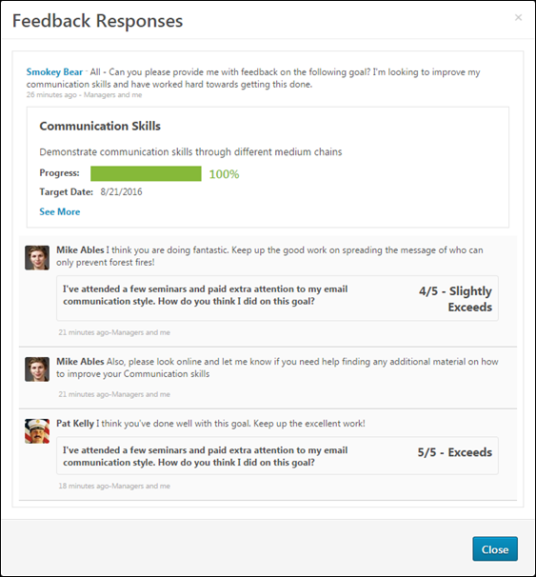
Feedback Request Details
At the top of the pop-up, the details of the feedback request are displayed, including the original feedback request and the details of the goal for which the user requested feedback.
Feedback Responses
Below the feedback request details, feedback responses display in chronological order with the most recent feedback responses displayed first.
The visibility settings of the structured feedback is respected within the pop-up. That is, reviewers can only view feedback if the reviewer is within the visibility settings for the feedback. Also, if the feedback is provided anonymously, then this anonymity is respected within the pop-up.
Performance Review - Goal Rating - Goal Attachments
When completing a Goal Rating section within a performance review, reviewers can view any attachments added to the goal within the performance review period.
To view the goal attachments, click the drop-down icon to the right of a goal title and select the Goal Page Attachments option.
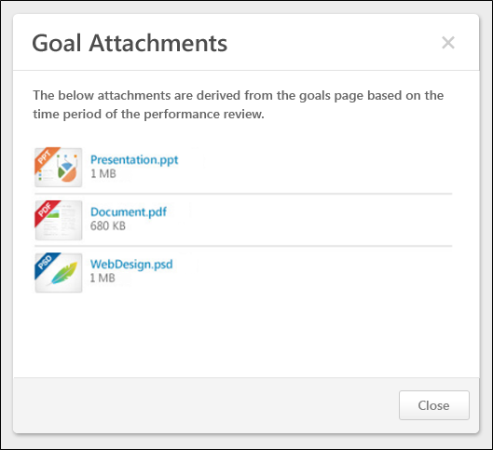
Goal Attachments
Goal attachments are displayed in the order in which they are added.
The following information is displayed in the Goal Comments pop-up:
- File Type Icon - The type of added file.
- File Name - The name of the file. Click the file name to view or download the attachment.
- File Size - The file size.
View or Download Attachment
To view or download the attachment, click the file name.
Performance Review - Goal Rating - Goal Comments
When completing a Goal Rating section within a performance review, reviewers can view any comments that were added to the goal within the performance review period.
To view the goal comments, click the drop-down icon to the right of the goal title and select the Goal Page Comments option.
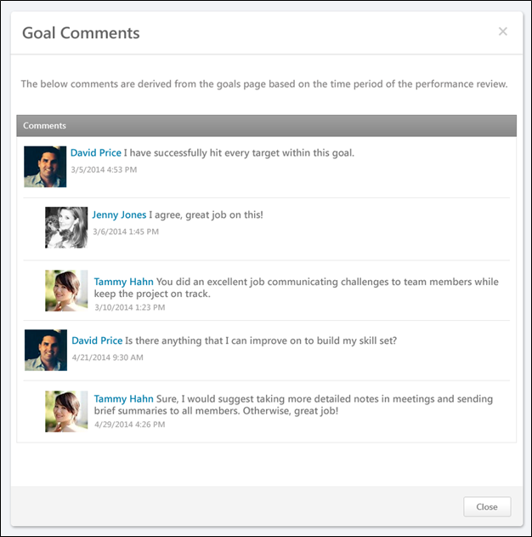
Comments
Comments are displayed in chronological order with the oldest comments displayed first.
The following information is displayed in the Goal Comments pop-up:
- User Photograph - Picture of the reviewee.
- User Name - Reviewee's name. Click the user's name or photograph to open their Universal Profile in a separate window. See Universal Profile - Bio Overview for additional information.
- Comment Text - The written comment.
- Date and Time Stamp - The date and time of the comment.
- Child Comments - User reply to a comment, this is considered a child comment. Child comments appear indented below the parent comment.
Performance Review - Inappropriate Language
If the Inappropriate Word Filter is enabled for performance reviews, the filter flags any inappropriate words contained in the Comment field.
Validation occurs when you click the Save and Continue button on a performance review page. When a word is flagged as inappropriate, the word is highlighted. The inappropriate word must be corrected before you can submit the review.
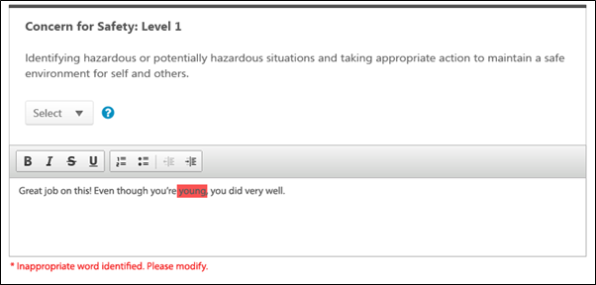
Administrators configure this filter in Writing Tools Administration. See Writing Tools Overview for additional information.
Performance Review - Rating Options
You can select a rating for a performance review from a rating drop-down or a star rating scale, based on the performance review configuration.
Drop-down Menu
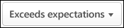
To select a rating from the drop-down menu, click the drop-down menu and select the appropriate rating.
Star Rating
- To select a star rating, click the appropriate number of stars. Reviewers can hover over a star to view the rating description.
- If a reviewee is too new to rate, select the Too new to rate option below the star rating.
- To reset the rating, click the Reset icon to the right of the stars. This removes the selected rating.
Rating Scale Information
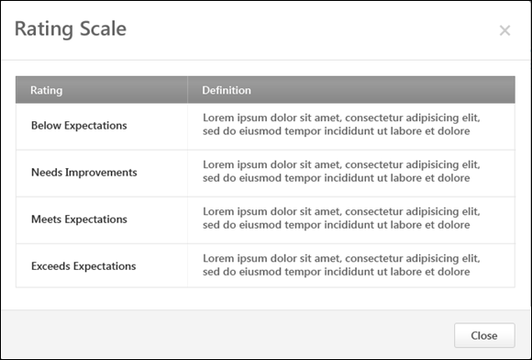
To view the rating definitions, click the Question Mark icon to the right of the rating scale. This opens the Rating Scale pop-up, which displays the ratings and their definitions. Note: The ratings and their definitions are configured by the administrator.
Performance Review - Review Sections
On the left side of the performance review, the navigation menu displays all sections along with their completion status. Reviewers can click a section tab to access the section.
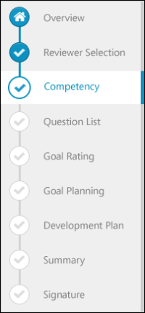
The icon to the left of the section title indicates the section status:
- Selected Section - The section that is currently selected.
- Completed Section - A completed section. A section is considered complete when all required fields are completed. If the section has no required fields, then the user must view the section for it to be considered complete. The Summary section is considered complete once all sections that are included in the Summary have been completed.
- Not Started/In Progress Section - Section is not started or in progress.
- Future Step Section - Section is currently not available because it will be completed in a future step of the performance review. You cannot view these sections until the reviewer is able to access the sections in a later step.
- Overview Section - The overview page.
- Discuss Review - If review discussion is enabled for the performance review, the Discuss Review page is always available below the review sections in the navigation menu. When this section is selected, the speech bubble is colored.
When viewing a read-only version of a previously completed task, the navigation menu displays section statuses as they were at the time of the review submission or expiration.
Performance Review - Select Competencies Pop-up
When completing a Competency Rating step within a performance review, the reviewer can select additional competencies on which to rate the reviewee.
To select additional competencies, click the Select Competencies button. This opens a pop-up to select the competencies you want to add to the review. The ability to select additional competencies is determined by the system administrator.
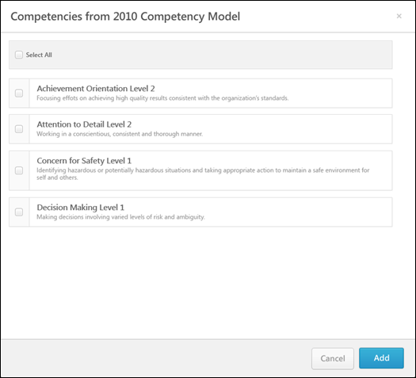
Select Competencies
- To select a single competency, select the checkbox to the left of the competency name. Multiple competencies can be selected.
- To select all of the available competencies, select the Select All checkbox in the upper-left corner of the competency list.
Add
Click the Add button after selecting the appropriate competencies, .
Add Competency
Some competencies may not automatically appear in the pop-up. To add competencies that do not appear in the pop-up automatically, click the Add Competency button in the upper-right corner of the competency list. This opens the Search Competencies pop-up. See Search Competencies Pop-up for additional information. This option is only available to certain reviewers if enabled by the administrator.
Performance Review - Select Goals Pop-up
The Select Goal pop-up displays the user's goals from the performance review period.
To select additional goals within the Goal Rating section of a performance review, click the Select Goals button. This opens a pop-up where you can select which of the user's goals you would like to add to the review. The ability to select goals is only available if configured to display by the system administrator.
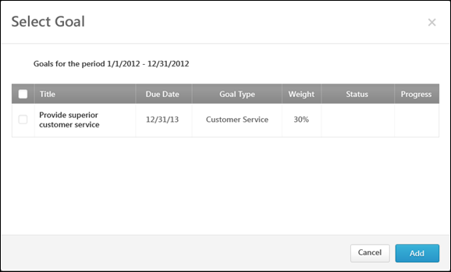
To Select a Goal
- To select a single goal, click the checkbox to the left of the goal title.
- To select all of the goals currently displayed, select the Select All checkbox to the left of the Title column heading in the upper-left corner of the goal list.
Add
Click the Add button to add the selected goals to a performance review.

Performance Review - Options Drop-down
Use the Performance Review Options drop-down to manage tasks associated with a performance review.
Permissions
PERMISSION NAME | PERMISSION DESCRIPTION | CATEGORY

Offline Performance Reviews | Allow users to download and upload offline reviews. This permission works in conjunction with active performance review tasks. If the user has this permission and is assigned one or more steps of an active performance review task, that user may download the review for offline completion. This permission can be constrained by OU and User's OU. This is an end user permission. | Performance

Performance Co-Planner | Enables a manager to name a performance review co-planner if co-planners are enabled for the performance review task. This permission should be assigned to the default user role to avoid constraint issues. This permission can be constrained by OU, User's OU, User Self and Subordinates, User's Manager, and User's Superiors. This is an end user permission. | Performance
When completing a performance review, the following options may be available from the Options drop-down menu:
- Add Co-Planner - Add and remove co-planners for the performance review. This option is only available if the performance review task is configured to allow co-planners and the reviewer has permission to add co-planners. See Performance Review - Add Co-Planner on page 203 for additional information.
- Attachments - Upload attachments to the performance review. This option is only available if the performance review task is configured to allow attachments. See Performance Review - Attachments on page 205 for additional information.
- Employee Details - View details about the reviewee. This option is only available if the administrator has configured additional employee information to be displayed. See Performance Review - Employee Details on page 209 for additional information.
- View Check-Ins - View the Check-Ins Dashboard for the user. See Performance Review - View Check-Ins on page 219 for additional information.
- View Feedback - View the reviewee's social feedback from the performance review period. Only the feedback that is visible to the reviewer on the reviewee's Universal Profile - Feedback page is displayed in the pop-up. This action is only available if enabled by the system administrator when the performance review task is created. In addition, this action is only available if the reviewer has permission to view the reviewee's Feedback page.
- Off-Cycle Summary - View a summary of the reviewee's off-cycle performance reviews. This option is only available if it is enabled by the administrator when configuring the performance review task. See Performance Review - Off Cycle Summary on page 210 for additional information.
- Competency Summary - Download an Excel file that summarizes all of the competencies on which the employee is rated within off-cycle performance review tasks. See Off-cycle Reviews - Competency Summary File on page 212 for additional information.
- View Peer Selectors - View which peer reviewers were selected and who selected them. See Performance Review - View Peer Selectors on page 220 for additional information.
- Complete Offline - Download the performance review to be completed offline. This option is only available for users who have permission to download offline performance reviews.
- Upload Review - Upload the completed review file into the system. This option is only available if the reviewer has the permission to download offline performance reviews and if the review task includes at least one Question List, Competency Rating, or Goal Rating section for the reviewer to complete. See Performance Review - Upload Review on page 216 for additional information.
- Print Review - Print the performance review. This option prints all sections of the performance review, including all submitted responses.
- Print Reviewee Version - Print the performance review. This option prints only the sections that are visible to the reviewee. This option is only available to reviewers who are reviewing a subordinate.
Performance Review - Add Co-Planner
The Add Co-Planner option lets managers with the appropriate permission add co-planners for a performance review, if enabled. This ability is enabled by the administrator, and when available, the Add Co-Planner option is available from the Options drop-down within the performance review. Co-planners can perform reviews as though they were the manager who was assigned the review task. This can be useful for managers to delegate reviews for certain review tasks.
Note: Competency Assessment sections should be completed by the review step assignee and should not be completed by co-planners. If a co-planner completes a Competency Assessment section or provides comments, it will display and be saved as if the manager provided the ratings and comments.
To access the Add Co-Planner option, open the performance review page and click Add Co-Planner option from the Options drop-down.
Permissions
PERMISSION NAME | PERMISSION DESCRIPTION | CATEGORY

Performance Co-Planner | Enables a manager to name a performance review co-planner if co-planners are enabled for the performance review task. This permission should be assigned to the default user role to avoid constraint issues. This permission can be constrained by OU, User's OU, User Self and Subordinates, User's Manager, and User's Superiors. This is an end user permission. | Performance
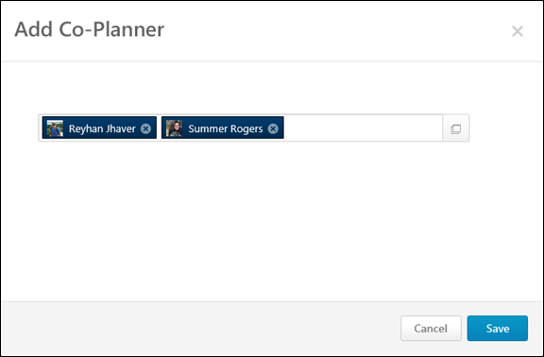
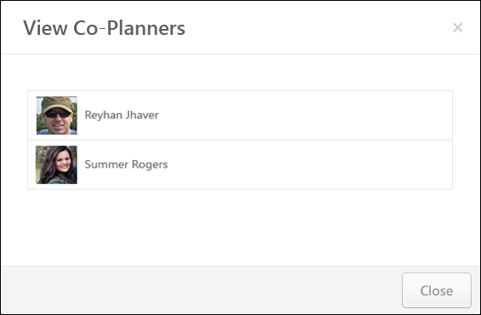

Add Co-Planner
To add a co-planner:
- Click the Add Co-Planner option from the Options drop-down. This opens the Add Co-Planner pop-up.
- Enter a name in the field. Predictive search is used to display users who match the entered text as it is entered. Managers can also click the Select User button to search for and select co-planners. The selected co-planners then appear in the field. There is no limit to the number of co-planners that can be added.
If the performance review task has been submitted and a user opens the task in read-only mode, the previously selected co-planners display in read-only mode.
Remove a Co-Planner
To remove a selected co-planner, click the Remove icon to the right of the co-planner's name.
Performance Review - Attachments
Attachments can be added to a performance review.
To view, add, or remove attachments, open the performance review and click Attachments from the Options drop-down. This option is only available if the performance review task is configured to allow attachments.
The following rules apply to performance review attachments:
- Attachments can be up to 1 MB in size and are limited to ppt, pptx, doc, docx, pdf, jpg, jpeg, jpe, png, txt, gif, zip, xls, xlsx, csv, psd, bmp, rtf, msg, xml, and saz file types.
- Attachments are visible throughout the review, but do not display on the printable version.
- Files can be added by the reviewee, but reviewees can only remove files that they have uploaded. If the manager attaches a file to the review, the reviewee cannot remove it.
- Managers and other reviewers can both add and remove attachments, regardless of who uploaded them.
- Files cannot be uploaded during peer and direct report review steps.
- On the Task Details page, an Attachments icon displays for the review if the review has one or more attachments. See Performance Review Task Details on page 69 for additional information.
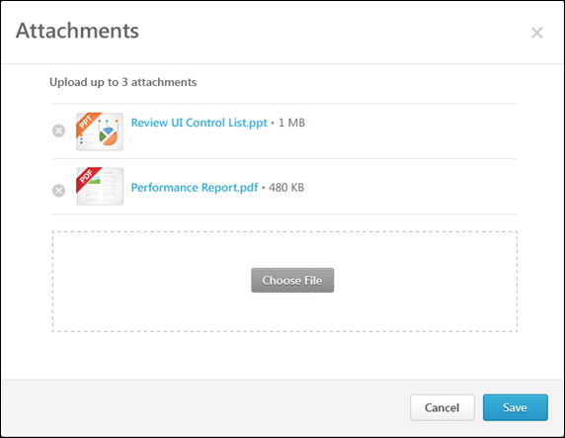
Add an Attachment
To add an attachment:
- Click the Choose File button and select the file. You can add up to three attachments throughout the review process. Attachments can be up to 1 MB in size and are limited to ppt, pptx, doc, docx, pdf, jpg, jpeg, jpe, png, txt, gif, zip, xls, xlsx, csv, psd, bmp, rtf, msg, xml, and saz file types.
- Click the Save button to save the attachments to the review.
Download an Attachment
To download an attachment, click the attachment name.
Remove an Attachment
To remove an attachment, click the Remove icon to the left of the document title.
Performance Review - Decline Review
For off-cycle reviews, a dynamically selected reviewer (manager, indirect manager, custom relationship, or specific user) can decline to complete a review if they feel they are not the most appropriate person to complete the review. Note: This option is only available for off-cycle reviews.
- Only dynamically selected reviewers who are selected by a reviewer selector can decline a review.
- Peers and subordinates cannot decline a review.
- Reviewers who are reviewer selectors cannot decline a review.
The ability to decline a review is only available before the reviewer submits their first step. Once they submit their first step, the Decline Review option is removed.
To decline a performance review, open the appropriate performance review.
Emails
EMAIL NAME | EMAIL DESCRIPTION | ACTION TYPE

Performance Review Reviewer Declined | This email is triggered when a reviewer declines a review.  The available recipients are Reviewee, Reviewer (the declining reviewer), and Review Selector (the user that selects the reviewers. | Performance Management
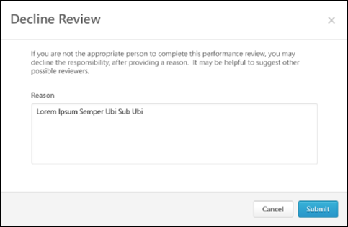
Decline a Review
Note: The Decline Review button is only available for an off-cycle performance review task if the administrator has enabled the feature when creating the review task.
To decline a review:
- In the Reason field, enter the reason why you are declining the review. This field is required, and the character limit is 500.
- Click Submit. The declined reviewer's reason for declining is added to the review task discussion as a public comment.
When the review is declined, the reviewer selector is notified. A Reviewer Selection task is generated in the reviewer selector's My Assigned Reviews page and in the My Tasks widget on the Welcome page. An email notification is also triggered if the Performance Review Reviewer Declined email is enabled. The reviewer selector must then open the review task and select a new reviewer.
Performance Review - Employee Details
The Employee Details option lets you view details about the reviewee.
To view details about the reviewee, open the performance review and click the Employee Details option from the Options drop-down. This opens the Employee Details pop-up. This option is only available if the administrator has configured additional employee information to be displayed. Additionally, the administrator can configure which information is displayed when creating the performance review task.
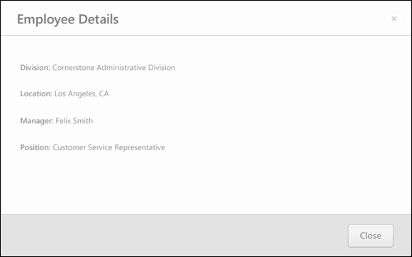
Performance Review - Off Cycle Summary
The Off Cycle Summary option displays a summary of the reviewee's off-cycle tasks in order to inform the reviewer of off-cycle review results throughout the review period. The Off-Cycle Summary option is only available to the reviewee, manager, indirect manager, and custom relationships. The section does not appear to peers or direct reports.
To view the reviewee's off-cycle summary, open the performance review and click the Off Cycle Summary option from the Options drop-down. This opens the Off Cycle Summary pop-up. This option is only available if it is enabled by the administrator when configuring the performance review task.
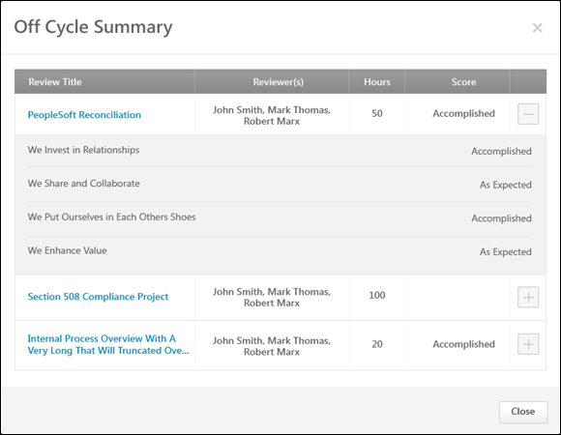
Off-Cycle Summary Table
The Off-Cycle Summary table includes the information about off-cycle tasks that were selected by the administrator. Only completed tasks are included and the tasks appear in chronological order by completion date. The following information for each off-cycle review task is displayed:
- Review Title - Title of the off-cycle review task. Click the title to open a printable version of the completed off-cycle review.
- Reviewers - Names of each reviewer in alphabetical order by last name. If no reviewer names are included by the administrator, then this column does not appear.
- Custom Fields - After the reviewers and before the review score, custom fields may appear. The custom fields are displayed in alphabetical order by field name. If a custom field is not defined for the reviewee, the field is left blank, and if no data exists for all instances of the custom field, the custom field column does not appear.
- Score - If enabled by the administrator, displays the overall review score. The format of the score matches the format of the task configuration. The review score visibility settings are maintained in this table, so if certain reviewers cannot view the score, then it is not displayed.
- Section Title and Score - If enabled by the administrator, each off-cycle review task can be expanded by clicking the expand icon to the right of the Score column. When the review task is expanded, each ratable section within the review is displayed along with the section score. Only Goal Rating, Competency, and Question List sections are displayed. Sign Off and Goal Planning sections are not included. The review score visibility settings are maintained in this table, so if certain reviewers cannot view the score, then it is not displayed.

Off-cycle Reviews - Competency Summary File
The Competency Summary file includes a summary of each competency rating included in the off-cycle tasks.
Within the file, each review task is listed as a separate column, ordered chronologically by review task completion date.
The first rows display the custom fields that are included in the off-cycle review tasks along with their values. The custom fields are listed in the order in which they were added to the Off-Cycle Summary table.
Following the custom fields, each competency is listed in alphabetical order. The scores for each competency are displayed for each review. The scores are taken directly from the review, and they are not averaged. The format of the score matches the configuration of the review section from which they are taken.
To view the Competency Summary file for an off-cycle review, select the Competency Summary option from the Options drop-down.
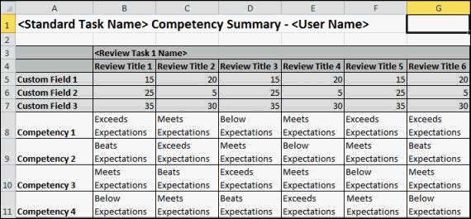
Performance Review - Reopen Previous Step
Reviewers (manager, indirect manager, custom relationship, or specific user) may have the ability to reopen previous steps in a performance review. This ability is enabled by the administrator when configuring the performance review task, and when available, the Reopen Step button appears at the bottom of the Review Step Progression section on the Overview page. This can be useful for reopening steps that should be corrected by a reviewer or for reopening steps that are past due.
The following applies when reopening a previous step:
- You can only reopen one review step at a time. If a previous step has been reopened by another user, then this option is not available.
- Reviewees, peers, and subordinates cannot reopen a step.
Emails
EMAIL NAME | EMAIL DESCRIPTION | ACTION TYPE

Performance Review Step Reopened | This email is triggered when a performance review step is reopened in order to alert or remind the user that a performance step has been reopened. When configured, this email is triggered any time a step is reopened, whether it is done by a manager or administrator. This email can be sent to Reviewee, Reviewee's Direct Manager, Reviewee's Indirect Manager, Reviewer, or a specific user.  The REOPEN.STEP.COMMENT tag displays the Reason commentary that was provided when the review step was reopened.  The REVIEW.REOPENED.STEP.DUE.DATE email tag displays the due date of the performance review step that is reopened. If no due date is defined for the step, then "No Due Date Defined" is displayed.  The system verifies that the review step is still due prior to triggering the email, so if the review step is no longer due, then this email is not triggered.  Reviewee will not receive any step email other than the self step and Similarly, a reviewer cannot receive any email for a Reviewee step. | Performance Management
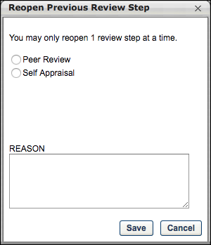
Reopen a Step
- Click the Reopen Step button to open a pop-up which lists all previous steps that are either completed or past due. When reopening a peer or direct report review step, managers can reopen the step only for select specific users. Managers cannot reopen a step assigned to them.
- Select the appropriate step. If the step has multiple reviewers, select the appropriate reviewers. In the Reason field, enter the reason or explanation that will be sent to the person associated with the reopened step via the Performance Review Step Reopened email trigger. This field accepts a maximum of 3,000 characters. The "Reason" commentary is only included in the Performance Review Step Reopened email trigger if you use the REOPEN.STEP.COMMENT tag. Click Save to reopen the step.
When a step is reopened, a new task appears to the step role owner in:
  - Scheduled Tasks page
  - My Tasks widget on the Welcome page
  - My Assigned Reviews page
The reopened step is open for submission until the task expiration date, but may vary slightly from the original step:
- The ability to edit comments, ratings, and weights is unaffected.
- The ability to view and edit custom fields is unaffected.
- If any later reviewers entered or edited comments, ratings, weights, or fields, then the reopened step displays the updated information if they are visible to the reviewer.
- If the owner of the reopened step also owns a later step in the review, both steps can be open and accessed at the same time.
  - The sections from all opened steps appear to the reviewer in the left navigation panel.
  - All information previously entered by the reviewer from the reopened step can be edited.
- Reopening a step sends out the appropriate Step Assigned emails (if the emails are enabled). Also, the reopened task displays again in the appropriate user's Scheduled Tasks page and the My Tasks widget on the Welcome page.
- On the Scheduled Tasks page, reopened steps display regardless of whether or not the Display Completed/Expired options are selected.
- Within the pop-up, all previous steps are displayed with the following exceptions:
  - Reviewers cannot reopen their own step.
  - Reviewers cannot reopen a reviewer selection step if the reviewer selections have been made and submitted.
  - Skipped steps cannot be reopened.
Frequently Asked Questions
When a step is reopened, how does the step appear in the system to the user who reopened the step?
For the user who reopens a previous step, their step in the task still appears with a status of Completed. The Completed status of the user's step does not change when they reopen a previous step. Example:
Performance Review - Upload Review
Reviewers may be able to download a performance review from within the performance review task. After completing the review offline, reviewers can upload the completed review file into the system.
The ability to download and upload performance reviews is only available if the reviewer has permission to download offline performance reviews and if the review task includes at least one Question List, Competency Rating, or Goal Rating section for the reviewer to complete.
Only reviews that are In Progress or Not Started are eligible to be completed offline.
- If the task is configured to allow users to submit reviews after the due date, then reviews that are Past Due can also be downloaded and uploaded.
- If the task is configured to allow multiple submissions, then reviews that are Complete can also be downloaded and uploaded.
To upload the completed performance review file, open the performance review page and click the Upload Review option from the Options drop-down. This opens the Upload Your Performance Review pop-up. This option is only available if the performance review task is configured to allow attachments.
Permissions
PERMISSION NAME | PERMISSION DESCRIPTION | CATEGORY

Offline Performance Reviews | Allow users to download and upload offline reviews. This permission works in conjunction with active performance review tasks. If the user has this permission and is assigned one or more steps of an active performance review task, that user may download the review for offline completion. This permission can be constrained by OU and User's OU. This is an end user permission. | Performance
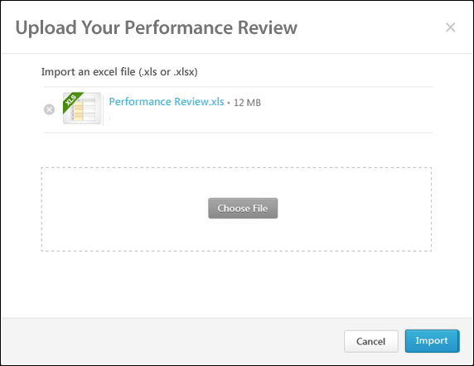
Upload Review
From the pop-up, click the Choose File button to select the completed review file (xls or xlsx). After selecting a file, click the Import button.
- If a valid performance review file is uploaded, the Upload Validation pop-up opens. See the Upload Validation section below for additional information.
- If an invalid performance review file is uploaded, an error message is displayed.
Upload Validation
If a valid performance review file is uploaded, the Upload Validation pop-up opens, which displays the upload status and validation details for the uploaded offline performance review. Each of the performance review sections are displayed in the order in which they appear in the performance review step.
To the left of each performance review section, the validation status of the review section is displayed.
- If a section does not require user input, N/A is displayed as the validation status.
- If a section is completed correctly with valid data, a green check icon is displayed .
- If a section is not completed correctly or if there is invalid data, a red warning icon is displayed . In addition, each error that exists is displayed below the section title. The cell name that caused the issue is also displayed. The potential errors are:
  - Rating out of range - A numeric rating is below 1 or above the maximum value.
  - Invalid numerical rating - A rating is not a multiple of 1, .1, or .5, depending on the rating scale configuration.
  - Invalid text rating - A text or text/numeric rating is not one of the configured options.
  - Required field missing - A rating or required comment is missing.
  - Comments character limit exceeded - A comment exceeds the character limit of 10,000.
- If a section contains errors, you cannot save that section. You must correct the errors using the cell numbers and error descriptions and then re-upload the file by pressing the Re-upload button.
- If the file is tampered with, an error message is displayed and the file cannot be saved.
- Only sections with green check icons can be saved. Click the Save button to save the validated sections. All sections with no errors are imported into the system. All uploaded data overwrites any data previously submitted.
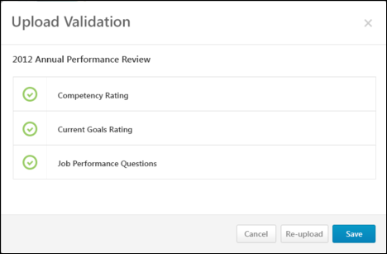
Performance Review - View Check-Ins
The View Check-Ins option takes reviewers to the user's Check-Ins home page. This option is only available if the user has permission to create a check-in or has had at least one check-in with another person. The information that you see is based on the following:
With Check-Ins - Create Permissions
- For a reviewer reviewing an employee (such as a manager reviewing an employee)
  - If check-ins between the two are available, this option opens a list of their check-ins in a new tab.
  - If the reviewer has not had check-ins with the reviewee, this option opens the Check-Ins landing page in a new tab.
- For self-reviewers, this option opens the Check-Ins landing page in a new tab.
To access the Check-Ins home page, open the performance review page and click the View Check-Ins option from the Options drop-down.
For information about Check-Ins, see Check-Ins Home Page.
Permissions
PERMISSION NAME | PERMISSION DESCRIPTION | CATEGORY

Check-Ins - Create | Grants ability for the user to create and update Check-Ins. The permission constraints determine with whom the user can create Check-In discussions. This permission can be constrained by OU, User's OU, User Self and Subordinates, User, User's Subordinates, User's Direct Reports, User's Self, User's Manager, User's Superiors, and Employee Relationship. Users with constraints in the “Check-Ins - Create” permission cannot create a new Check-In with anyone who is not part of the constraints, but can still view and update any Check-In in which they are a participant.  This is an end user permission.  Note: Permission constraint to Employee Relationship grants permission to dotted line or secondary managers to create Check-Ins with users that report to them in the matrix structure. A constraint "Restricted to Employee Relationship: Detail Supervisor" means that the Detail Supervisor can create a Check-In with their indirect subordinate but the indirect subordinate cannot create a Check-In with their Detail Supervisor. | Performance
View Check-Ins
Performance Review - View Peer Selectors
You can view selected peer reviewers were selected and who selected them.
Note: This functionality is only available for organizations using the redesigned performance reviews.
To view which peer reviewers were selected and who selected them, click the View Peer Selectors option from the Options drop-down. This opens the Peer Reviewer Selection pop-up.
Permissions
PERMISSION NAME | PERMISSION DESCRIPTION | CATEGORY

Offline Performance Reviews | Allow users to download and upload offline reviews. This permission works in conjunction with active performance review tasks. If the user has this permission and is assigned one or more steps of an active performance review task, that user may download the review for offline completion. This permission can be constrained by OU and User's OU. This is an end user permission. | Performance

Performance Co-Planner | Enables a manager to name a performance review co-planner if co-planners are enabled for the performance review task. This permission should be assigned to the default user role to avoid constraint issues. This permission can be constrained by OU, User's OU, User Self and Subordinates, User's Manager, and User's Superiors. This is an end user permission. | Performance
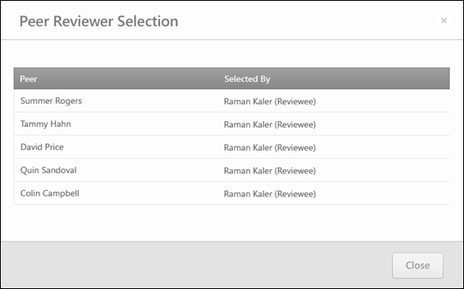
This option:
- Only appears for managers, indirect managers, and custom relationships. This link is not available for peers, a reviewee's subordinates, and reviewees.
- Only appears if the review contains peer group review steps that are configured so that peers are selected by other reviewers.
If a reviewer is selected, the Peer Reviewer Selection pop-up displays the name of any peer reviewer that has been selected for the reviewee.
- Peer - This column displays the selected peers.
- Selected By - This column displays the user that selected the corresponding peer. The reviewer selector's role is displayed in parenthesis to the right of their name.

Performance Reviews - Batch Rating
The Batch Rating page for a performance review enables reviewers to view reviewees within the same performance review task on a single page, provide ratings and comments, more quickly complete performance reviews, and view a high-level overview of all reviewees.
The Batch Rating page is available to all active relationships except self, peers, external reviewers, and subordinates. Also, the Batch Rating page is only available for a performance review task if batch rating is enabled for the performance review task.
Note: The Batch Rating page is used to provide ratings for Competency Rating and Question List performance review sections only.
To access the Batch Rating page, from the Universal Profile - Actions page, click the Launch button to the right of a Batch Rating task.
Permissions
PERMISSION NAME | PERMISSION DESCRIPTION | CATEGORY

Action Items - EPM | Grants ability to view and take action upon Performance (EPM) items on the Action Items page and in the Your Action Items widget. This permission can be constrained by OU, User's OU, User's Self, and User's Self and Subordinates. This is an end user permission. | Universal Profile

View Performance Reviews | Grants ability to view the Performance Reviews page, which displays a user's own past performance reviews as well as performance review task steps they've been assigned to complete. This also grants ability to view the Batch Rating page. This permission can be constrained by OU, User's OU, User Self and Subordinates, and User. This is an end user permission. | Performance
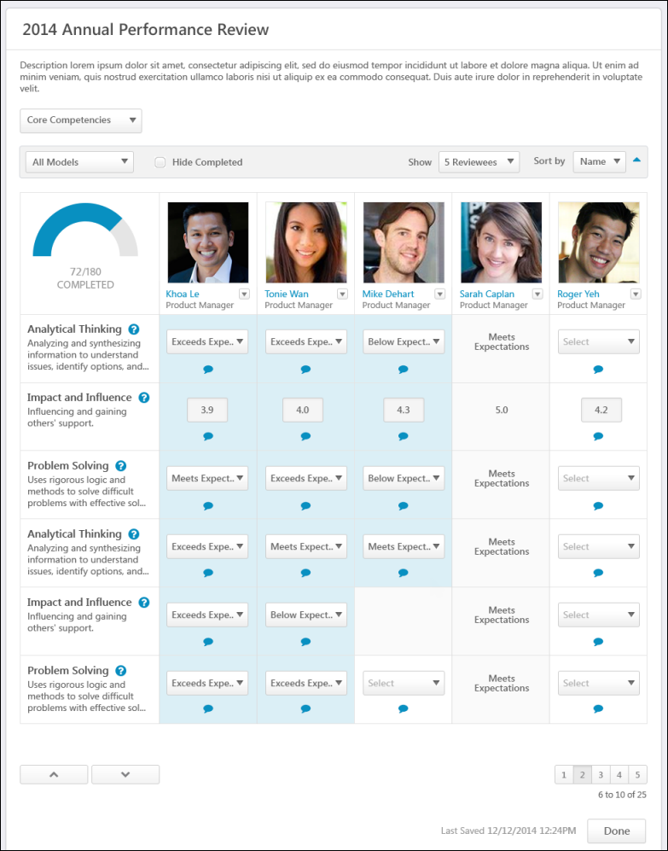
Review Title and Instructions
The performance review task title and the batch rating instructions. The batch rating instructions are configured by the administrator when the performance review task is created.
Review Section Tabs
Tab for each performance review section for which batch rating is available. If there are more than four tabs, then all tabs appear in a drop-down menu. The reviewer can select a tab to provide batch ratings for the corresponding review section.
Sort and Filter Options
- Model Filter -Only appears for Competency Rating sections, and this filter is only available when there are multiple competency models within a performance review section. If available, this option enables the reviewer to filter the Batch Rating panel by competency model. When a specific competency model is selected, only the competencies within that model are displayed and only the users who are associated with that model are included in the panel. By default, all models are included and all competency items appear in the panel.
- Hide Completed/Hide Read Only. The following options are available:
  - Hide Completed - When this option is selected, all reviewees whose tasks are completed or read-only are hidden. In addition, any question, competency, or custom field rows that are fully completed are hidden. Note: This option does not consider any items in the Detailed Responses section. That is, a reviewee may be hidden even if items in the Detailed Responses section are not completed.
  - Hide Read Only - When this option is selected, all reviewees whose tasks are read-only are hidden.
This option is unchecked by default.
Important: When this option is selected, entries are not dynamically hidden. That is, the entries are only hidden at the moment that the option is selected. In order to hide new completed items, the reviewer must uncheck and recheck the option.
- Show - The Show option enables the reviewer to set the number of reviewees that are displayed per page. If the reviewer's viewing screen cannot display the number of selected reviewees, then the reviewer can scroll horizontally to view additional reviewees. By default, five reviewees are displayed.
- Sort by - Enables the reviewer to sort the reviewees on the Batch Rating page. The following sort options are available:
  - Name - This sort option is selected by default.
  - Position
  - Remaining Items
  - Hire Date
  - Position Started Date
By default, items are sorted in ascending order. For example, numerical values are sorted lowest to highest (0 to 9), dates are sorted earliest to most recent, and characters are sorted alphabetically (A to Z). The reviewer can reverse the sort order by clicking the Arrows icon to the right of the Sort by option.
When a different sort option is selected, the reviewer is automatically navigated to the first page of reviewees.
Batch Rating Panel
Displays the reviewer's overall completion, the available reviewees, and review items.
Overall Completion Progress
Displays the number of ratings that have been provided for the section and the total number of ratings that are required for the section are displayed. For example, if the reviewer provided a 72 rating and is required to provide 180 ratings, then "72/180 COMPLETED" is displayed. The gauge visually represents the reviewer's completion progress. As the reviewer provides a rating, the rating count and the gauge are updated to reflect the reviewer's real-time progress.
The following items are not counted in the number of required ratings and do not impact the overall completion progress:
- Questions with no ratings
- Checkbox type custom fields
- Scrolling Text type custom fields
Reviewees
Displays reviewees who are included in the performance review step. Depending on the filter and sort options, this may include reviewees who need to be rated and reviewees who have already had this review section completed. Click the reviewee's name to open the reviewee's Universal Profile page.
The reviewee's position is displayed below their name.
Launch Review for Reviewee
Reviewers can launch the performance review for an individual reviewee by clicking the Actions drop-down icon to the right of the reviewee's name and selecting Launch Review.
Reviewee Pagination
The Show option at the top of the Batch Rating panel determines the number of reviewees that are displayed on a page. If more than the selected number of reviewees are available for batch ratings, then pagination options appear in the lower-right corner of the panel.
- Click a specific page number to go directly to that page.
- To move one page forward or backward, click the right or left arrow icon.
- To move to the first or last page, click the double left or double right arrow icon.
Competencies/Questions/Custom Fields
Displays the competencies, questions, or custom fields:
- Competencies - Displays the competency name and the following lines display the competency description. If the full competency name or description cannot be displayed, hover the cursor over the name or description to view the full text. To view the rating scale associated with the Competency Rating section, click the Question Mark icon to the right of the competency name.
- Questions - Displays question text. If the full question text cannot be displayed, hover the cursor over the text to view the full text. To view the rating scale associated with the Question List section, click the Question Mark icon to the right of the question text.
- Custom fields - Displays custom field text. Hover the cursor over the text to view the full text, if necessary.
Rating Item Pagination
Displays rating items. If there are more than 20 available rating items, then Up and Down arrows appear at the bottom of the Rating Item column.
- Click the Down arrow to view the next 20 rating items.
- Click the Up arrow to view the previous 20 rating items.
Ratings
Select or enter a rating for each reviewee for each available competency, question, or custom field. The rating scale and the rating type (numeric, text, or both) are determined by the administrator when the performance review sections are created. Select or enter ratings as follows:
- Text ratings are selected from a drop-down menu.
- Numeric ratings are selected from a drop-down menu unless the rating scale interval is 0.5 or 0.1. In this case, the reviewers must manually enter the rating in a field.
- Star ratings are selected from a drop-down menu.
- Questions without ratings do not have a drop-down or a field in the Batch Rating panel. Reviewers must click the Ratings and Comments icon within the cell to open the Ratings and Comments pop-up, in which the reviewer can enter text to answer the question. See Batch Rating - Ratings and Comments Pop-up on page 228 for additional information.
- Scrolling Text Box custom fields do not have a drop-down or a field in the Batch Rating panel. Reviewers must click the Ratings and Comments icon within the cell to open the Ratings and Comments pop-up, in which the reviewer can enter text to answer the question. See Batch Rating - Ratings and Comments Pop-up on page 228 for additional information.
- Radio Button custom fields appear as a drop-down menu.
If a rating item is not applicable to a reviewee, then an empty, gray cell is displayed for the reviewee.
When a rating is selected, the rating is automatically saved, the reviewee's Section Score is recalculated, and the Overall Completion Progress is updated. Also, the rating cell is shaded to visually indicate that a rating has been selected. This enables the reviewer to clearly see which ratings have not yet been selected.
Access ratings and comments
Click the Ratings and Comments icon to access the ratings and comments for a rating item. This opens the Ratings and Comments pop-up, in which the reviewer can provide a rating and add comments to support or explain the rating. See Batch Rating - Ratings and Comments Pop-up on page 228 for additional information.
- If the review section is configured so that the reviewer cannot add comments, then the reviewer can click the icon to view any existing comments, but they cannot add comments.
- This icon is not available for custom fields that are drop-down, date, numeric, or short text fields.
Detailed Responses
If available, the following items appear in the Detailed Responses section:
- Questions with no ratings
- Checkbox type custom fields
- Scrolling Text type custom fields
These items are not counted in the number of required ratings and do not impact the overall completion progress. In addition, these items are not considered when the Hide Completed option is selected. That is, if these items have not been completed for a user, but all other ratings have been provided for the user, then the user will be hidden when the Hide Completed option is selected.
Last Saved
When a rating is selected, the rating is automatically saved, and this updates the Last Saved date and time, which is displayed to the left of the Done button.
Done
Click Done to return to the Action Items page.

Batch Rating - Ratings and Comments Pop-up
Use the Ratings and Comments pop-up to access and provide ratings and comments from the Batch Rating page.
To access the Ratings and Comments pop-up, click the Ratings and Comments icon on the Batch Rating page.
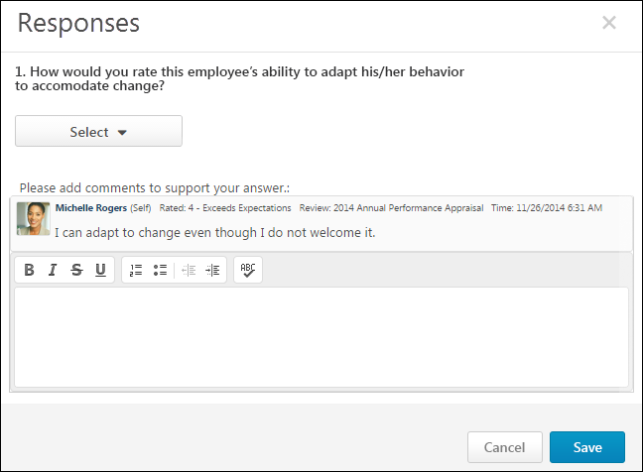
Question or Competency
The question or competency description.
Ratings
Select or enter a rating. The rating scale and the rating type (numeric, text, or both) are determined by the administrator when the performance review sections are created.
- Text ratings are selected from a drop-down menu.
- Numeric ratings are selected from a drop-down menu unless the rating scale interval is 0.5 or 0.1. In this case, the reviewers must manually enter the rating in a field.
- Star ratings are selected by clicking the appropriate rating.
- Radio Button Custom Fields appear as a drop-down menu.
Comments
Enter comments explaining the selected rating. For example, if you selected a poor rating, explain why the rating was selected. The total character limit for comments is 10,000. Please modify accordingly. Note: Comments might be captured in different formatting styles which might not truly reflect total calculated character count.
- To check the spelling of the text box contents, click the ABC icon in the text box toolbar. This opens the Spell Checker pop-up.
- If you have a need to copy and paste content into a performance review, please be sure to right-click the field into which you are pasting the content, and select the "Paste" option. You can also perform the same action by pressing [Ctrl]+[Shift]+[V]. This will ensure any formatting HTML does not get inserted into the text.
When adding a comment, an HTML safe list is used for the Comments field. The system only accepts certain customizable HTML elements in the WYSIWYG Editor. Elements that are not acceptable display as text. See Safe Listed Customizable Elements.
The Comment Assistant is not available within the Ratings and Comments pop-up.
Multiple Reviewers/Co-Planners
If a review step has co-planners, each reviewer is able to enter their own comments and modify the review ratings. Comments are attributed to the user who submitted them, so each comment appears distinct and separate. In addition, any comments that have been saved, but not submitted are viewable by the assignee and the co-planners.
- If a co-planner is the first user to access a review section, the co-planner is able to select a rating and enter comments, if the rating option and comment box are enabled for the co-planner.
- If a co-planner accesses a review section that has been saved but not submitted by the assignee or another co-planner, then the system displays the following:
  - Ratings values are pre-selected with the rating that was selected by the assignee or another co-planner. Note: The rating option only appears if the task is configured for the section to accept comments from the corresponding assignee.
  - An empty comment box appears for the co-planner to enter comments. Note: The comment box only appears if the task is configured for the section to accept comments from the corresponding assignee.
  - A response section containing the rating applied by the assignee or another co-planner. This section displays the assignee or co-planner name, rating, and comments. "(Co-Planner)" appears next to all co-planner names. Note: The rating and comment only appear if the task is configured for the section to accept ratings and comments from the corresponding assignee.
Any comments are attributed to the reviewer who entered them. Ratings are attributed to the user who was the last to apply or modify the rating. For example, if Co-planner A applies a rating to a question, and then Co-planner B modifies the rating for the question, then the rating is attributed to Co-planner B. However, if Co-planner B does not modify the rating, then the rating is attributed to Co-planner A.
When viewing reviewer comments, the comments from the review step assignee are displayed first, followed by comments from the step co-planners in alphabetical order based on last name. The most recent comments are displayed first.
Done
Click Save to save the rating and comments. Or, click Cancel to discard the unsaved rating and comments and return to the Batch Rating page.

Performance Reviews - Bulk Sign Off
Use the Performance Review Signature Sign Off page to electronically sign off on current performance review tasks in bulk. Reviewers still have the option to sign off on reviews individually. This page must be enabled by the administrator via Navigation Tabs and Links. Note: Reviewers cannot sign off on their own reviews via this page.
To electronically sign off on performance review tasks in bulk, go to Performance > Review Sign Off.
Permissions
PERMISSION NAME | PERMISSION DESCRIPTION | CATEGORY

Performance Review Bulk Sign Off | Enables reviewers to electronically sign off on current performance review tasks in bulk. This permission cannot be constrained. This is primarily a manager permission. | Performance

Task - View | Grants ability to view assigned tasks via Scheduled Tasks screen and Welcome Page My Tasks widget. This is an end user permission. | Core
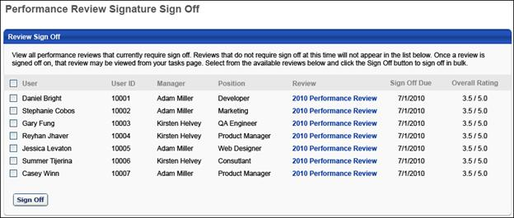
The Performance Review Signature Sign Off page displays all performance reviews that currently require sign-off from the reviewer. Reviews that do not require sign-off do not appear in the list, and once a review is signed off on, the review no longer appears on this page.
Note: Reviewers can only utilize the Bulk Sign Off functionality for performance reviews that are configured to use the Electronic sign-off method. In addition, the Bulk Sign Off functionality can only be used if the Sign Off section is the only section in the step.
The following information is displayed for each reviewee:
- User - Reviewee's name
- User ID - Reviewee's system ID.
- Manager - Reviewee's direct manager.
- Position - Reviewee's position title.
- Review - Performance review title. To view the current printable version of the reviewee's review, click the review title in the Review column.
- Sign Off Due - Due date of the review step that contains the Sign Off section for the user for each review.
- Overall Rating - Reviewee's current overall rating for the review. This value is displayed in either numeric or text form, depending on the review task configuration. Because the review task is still In Progress, the overall rating may not be final and could change.
To electronically sign off on a group of performance reviews in bulk:
- Select the checkbox for the appropriate reviews. To select all reviews, select the checkbox to the left of the User heading.
- Click the Sign Off button. This opens a Performance Review Sign Off pop-up.
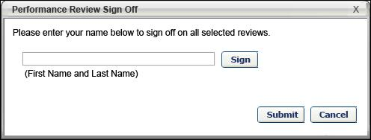
- Enter your full name and click the Sign button to record the e-signature. The signature appears based on the user's signature preferences. To make an edit to the name, click the Re-Sign button.
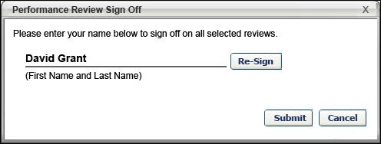
- Click Submit to apply the e-signature to all of the selected reviews. Once the reviews are signed off, they no longer appear in the Performance Review Signature Sign Off page. The task is removed from the Your Tasks widget. You can access the signed off reviews from your Tasks page.

Launch Off-cycle Performance Review
Use the Launch Performance Review page to launch off-cycle performance reviews. When launching the performance review, the user can select the reviewee, the review task they are launching, and they can enter the purpose of the review.
A user can launch as many concurrent off-cycle reviews of the same task as necessary.
You can access the Launch Performance Review page as follows:
- Click the Launch Off-Cycle Task link from the Performance Review Details page.
- Click the Launch Review button from the Performance Review Summary page.
- Click the Launch Review link for a subordinate in My Team > Activities or My Team > Performance > Reviews.
Permissions
PERMISSION NAME | PERMISSION DESCRIPTION | CATEGORY

Launch Off-Cycle Performance Review Task | Enables a user to launch an off-cycle performance review task. Having this permission does not guarantee that the user can launch an off-cycle review, only that they will have access to the Launch Performance Review page. A task must still be configured properly for the user to successfully launch an off-cycle review task. This permission works only if user has been designated to launch at least one currently active off-cycle performance review task. This permission can be constrained by OU, User's Subordinates, and Employee Relationship. This is an end user permission and does not apply to an administrator role.
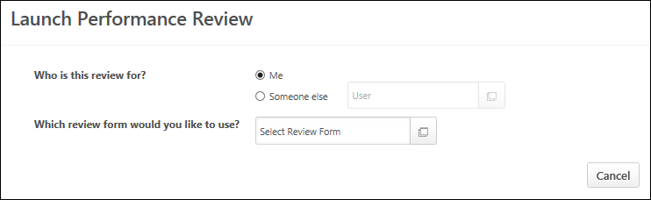
Who is this review for?
Using the radio buttons, select the reviewee for the review you are launching.
- Me - Select this option if you are launching a review for yourself.
- Someone else - Select this option if you are launching a review for someone else. You must then click the User field to select the appropriate user. Only one user can be selected.
- If a user accesses this page by clicking the Launch Review link in My Team, then the "Someone else" option is automatically selected and the reviewee is pre-populated with the appropriate My Team user.
- If an administrator accesses this page by clicking the Launch Off-Cycle Task link on the Performance Review Details page, then the administrator must click the Add Users link to select reviewees for the task. The administrator can select as many users as necessary.
Which review form would you like to use?
Click the Select Review Form field to select the appropriate review form. If necessary, use the search functionality to locate the review form.
- A review form is only available if it is available for the reviewee and can be assigned by you.
- A review form is only available if it either does not have a fixed end date or if the fixed end date has not yet passed.
- A review form is not available if there is a fixed end date and there is not sufficient time to complete all steps in the review.
- If there is only one review form you can assign to the selected reviewee, then that task is automatically selected and this cannot be changed.
- If an administrator accesses this page by clicking the Launch Off-Cycle Task link on the Performance Review Details page, then the review form is pre-populated with the appropriate form, but can be changed if necessary.
What is this feedback for?
This text is customizable by the administrator and may appear differently based on the review task configuration. This question only appears once a review task is selected. In the field, enter the purpose of the review task. The character limit for this field is 100.
To customize this text. Edit a task > Review Summary > User Prompt for Review Title.
What is the review period?
This option only appears if the selected review task is configured to allow the task assigner to define the review period for the task. Using the From and To calendar fields, select the start and end date of the review period. Once a review period is specified, it cannot be modified.
Task Preview
Once the review task is selected, a preview of the task displays, including the description and workflow.
Launch
Select the Launch button to launch the review. All users who have tasks assigned to them can see the review in their Scheduled Tasks page as well as their Performance Review Summary page.
- See Scheduled Tasks.
- See Performance Review Summary on page 90 for additional information.
Frequently Asked Questions
Can I assign an off-cycle performance review task to a group of users or an organizational unit?
No, off-cycle performance review tasks can only be assigned to a single user.
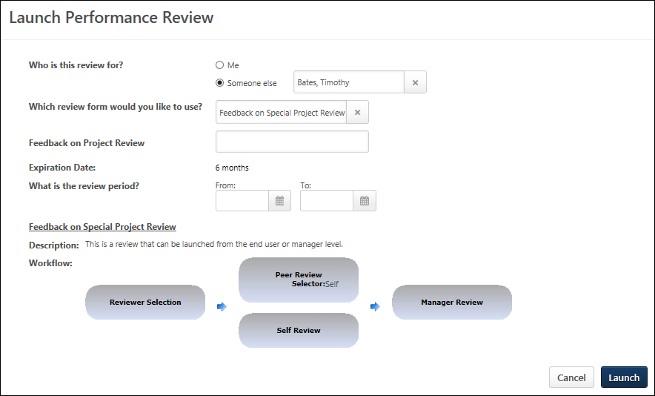

Offline Reviews Overview

Complete Offline Performance Review
To download and upload offline performance reviews, See Complete/Upload Offline Review Task on page 249 for additional information.
You can download the following review tasks and complete them offline:
- The Overview step - Presents a high level view of the performance review. See Offline Review Task - Overview Step on page 238 for additional information.
- The Question List step - Read the questions and provide ratings and comments for each question. See Offline Review Task - Question List Step on page 240 for additional information.
- The Competency Rating Step - Assess the reviewee for each competency. See Offline Review Task - Competency Rating Step on page 242 for additional information.
- The Goal Rating Step - Assess the reviewee for each goal. See Offline Review Task - Goal Rating Step on page 245 for additional information.

Offline Review Task - Overview Step
The Overview step presents a high level view of the performance review. All cells are locked and cannot be modified. There are no interactive elements to the Overview step. When completing a performance review offline, the Overview step is displayed in Excel similarly to the way it appears online.
To navigate to the next step of the review, click the next tab of the Excel spreadsheet, which is located in the lower-left corner of the page.
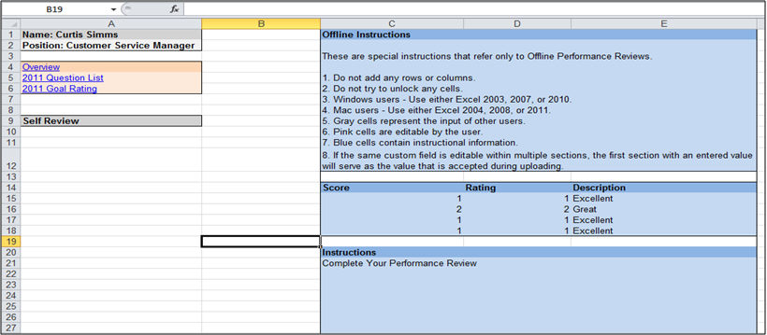
The following information is displayed on the Overview step:
- Reviewee Information, including Name, Position, and any additional user fields.
- Performance Review Sections, (e.g., Overview, Question List). The current section is highlighted.
- Performance Review Steps are displayed (e.g., Self Review, Manager Review). The current step is highlighted.
- Offline Instructions. The Offline Instructions are:
  - Do not add or delete any rows or columns.
  - Do not try to unlock any cells.
  - Use either Excel 2003 or 2007.
  - Gray cells represent the input of other users.
  - Your ratings, comments, and weights should be entered into the pink cells.
  - Blue cells contain instructional information.
- Rating Scale and Descriptions.
- Review Instructions.
Custom Fields
If custom fields are included in the Question List, Competency Rating, or Goal Rating section, they are also available in the offline review. If the custom fields are editable then they appear in pink, while read-only fields appear in gray.
- If another user completed the custom field, then their entry is displayed, but can be edited.
- If the same custom field is editable within multiple sections, the first section with a valid value serves as the value that is uploaded.
The following character limits are enforced for custom fields:
- Date fields - 10.
- Short text fields - 100.
- Scrolling text fields - 2000.
- Numerical text fields - 10.
Custom fields are subject to the following data validations:
- Invalid Date Format - This error is received if a date is entered in an improper date format. Acceptable date formats are:
  - 12/31/2011 (Standard separator)
  - 12-31-2011 (Dash separator)
  - 12.31.2011 (Dot separator)
  - 2011/12/31 (Reordered date) - The order of the date elements should be defined by the culture of the user.
- Numeric Value Expected - This error is received if a non-numeric character (a character that is not 0-9) is entered in a numeric custom field.
  - Numeric separators are accepted based on the preferred culture of the user. For example, French users can use commas as decimal places in numbers, rather than periods.

Offline Review Task - Question List Step
On the Question List step, you read the questions and provide ratings and comments for each question. All cells that do not require user input are locked.
When completing a performance review offline, the Question List step is displayed in Excel similarly to the way it appears online.
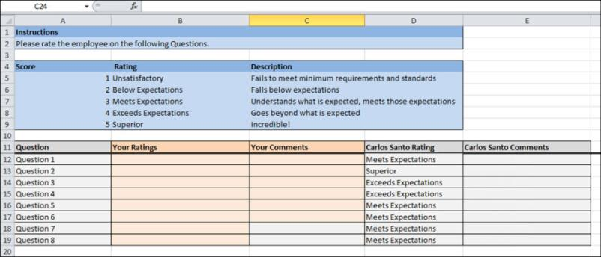
The following information is displayed on the Question List step:
- At the top of the page, the Instructions for the step are displayed.
- Below the Instructions, the Rating Scale and Descriptions are displayed if they are configured to be displayed in the review task. All HTML code is removed from the rating scale descriptions.
- Below the Rating Scale, each of the questions is displayed.
For each question, read the question and in the Your Ratings column, provide a rating for the question. Then, in the Your Comments column, provide comments explaining your rating, however, comments may not be available for some questions. The character limit for comment fields is 10,000.
To the right of your ratings and comments, each previous reviewer's ratings and comments are displayed only if a previous rating is available and if the task is configured to display previous ratings.
- Users can only view their manager's review data if configured to do so. In some instances, manager data is displayed after a certain date.
- Managers and indirect managers can view all users' review data.
- Peers cannot view any other user's review data.
If custom fields are included in the section, they are also available in the offline review. If the custom fields are editable then they appear in orange, while read-only fields appear in gray. If another user has already completed the custom field, then their entry is displayed, but can be edited.
Note: If the same review section is assigned to the same user in multiple steps, they can view their previous input and this information is editable.
To navigate to the next step of the review, click the next tab of the Excel spreadsheet, which is located in the lower-left corner of the page.
Multiple Reviewers/Co-Planners
If a review step has co-planners, each reviewer is able to enter their own comments and modify the review ratings. Comments are attributed to the user who submitted them, so each comment appears distinct and separate. In addition, any comments that have been saved, but not submitted are viewable by the assignee and the co-planners.
- If a co-planner is the first user to access a review section, the co-planner is able to select a rating and enter comments, if the rating option and comment box are enabled for the co-planner.
- If a co-planner accesses a review section that has been saved but not submitted by the assignee or another co-planner, then the system displays the following:
  - Ratings values are pre-selected with the rating that was selected by the assignee or another co-planner. Note: The rating option only appears if the task is configured for the section to accept comments from the corresponding assignee.
  - An empty comment box appears for the co-planner to enter comments. Note: The comment box only appears if the task is configured for the section to accept comments from the corresponding assignee.
  - A response section containing the rating applied by the assignee or another co-planner. This section displays the assignee or co-planner name, rating, and comments. "(Co-Planner)" appears next to all co-planner names. Note: The rating and comment only appear if the task is configured for the section to accept ratings and comments from the corresponding assignee.
Any comments are attributed to the reviewer who entered them. Ratings are attributed to the user who was the last to apply or modify the rating. For example, if Co-planner A applies a rating to a question, and then Co-planner B modifies the rating for the question, then the rating is attributed to Co-planner B. However, if Co-planner B does not modify the rating, then the rating is attributed to Co-planner A.
When viewing reviewer comments, the comments from the review step assignee are displayed first, followed by comments from the step co-planners in alphabetical order based on last name. The most recent comments are displayed first.

Offline Review Task - Competency Rating Step
On the Competency Rating step, you assess the reviewee for each competency. A name and description is provided for each competency. For each competency, provide a rating and a comment. All cells that do not require user input are locked.When completing a performance review offline, the Competency Rating step is displayed in Excel similarly to the way it appears online.
Note: To see this section in the offline review template, the reviewer must click the section within the online review before downloading the offline review task. If the reviewer does not click the section within the online review prior to downloading the offline review, the section details do not appear in the offline review template.
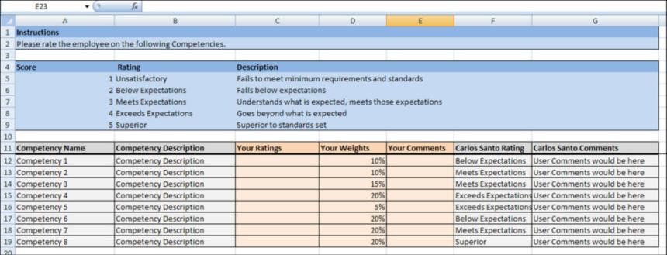

Competency Rating Table
The following information is displayed:
- Instructions for the step.
- Rating Scale and Descriptions if they are configured to display. All HTML code is removed from the rating scale descriptions.
- Each of the competency is displayed. If the reviewee selected which competencies to include in the review, only those competencies are displayed.
To the right of your ratings and comments, each previous reviewer's ratings and comments are displayed only if a previous rating is available and if the task is configured to display previous ratings.
- Users can only view their manager's review data if configured to do so. In some instances, manager data is displayed after a certain date.
- Managers and indirect managers can view all users' review data.
- Peers cannot view any other user's review data.
If questions are included in the section, they are also available in the offline review. Rating questions factor into the final result of the review according the questions/ratings configuration. Text questions do not factor into the final result of the review.
If custom fields are included in the section, they are also available in the offline review. If the custom fields are editable then they appear in orange, while read-only fields appear in gray. If another user has already completed the custom field, then their entry is displayed, but can be edited.
Note: If the same review section is assigned to the same user in multiple steps, they can view their previous input and this information is editable.
To navigate to the next step of the review, click the next tab of the Excel spreadsheet, which is located in the lower-left corner of the page.
Provide a Rating
To provide a rating:
- For each competency, read the competency name and description.
- In the Your Ratings column, provide a rating for the competency.
- In the Your Comments column, provide comments explaining your rating. The character limit for comment fields is 30,000.
  - The Your Weights column displays the weight for each competency if weights are enabled and displayed. If weights can be edited, then reviewers can modify the weights if necessary.
Multiple Reviewers/Co-Planners
If a review step has co-planners, each reviewer is able to enter their own comments and modify the review ratings. Comments are attributed to the user who submitted them, so each comment appears distinct and separate. In addition, any comments that have been saved, but not submitted are viewable by the assignee and the co-planners.
- If a co-planner is the first user to access a review section, the co-planner is able to select a rating and enter comments, if the rating option and comment box are enabled for the co-planner.
- If a co-planner accesses a review section that has been saved but not submitted by the assignee or another co-planner, then the system displays the following:
  - Ratings values are pre-selected with the rating that was selected by the assignee or another co-planner. Note: The rating option only appears if the task is configured for the section to accept comments from the corresponding assignee.
  - An empty comment box appears for the co-planner to enter comments. Note: The comment box only appears if the task is configured for the section to accept comments from the corresponding assignee.
  - A response section containing the rating applied by the assignee or another co-planner. This section displays the assignee or co-planner name, rating, and comments. "(Co-Planner)" appears next to all co-planner names. Note: The rating and comment only appear if the task is configured for the section to accept ratings and comments from the corresponding assignee.
Any comments are attributed to the reviewer who entered them. Ratings are attributed to the user who was the last to apply or modify the rating. For example, if Co-planner A applies a rating to a question, and then Co-planner B modifies the rating for the question, then the rating is attributed to Co-planner B. However, if Co-planner B does not modify the rating, then the rating is attributed to Co-planner A.
When viewing reviewer comments, the comments from the review step assignee are displayed first, followed by comments from the step co-planners in alphabetical order based on last name. The most recent comments are displayed first.

Offline Review Task - Goal Rating Step
On the Goal Rating step, you assess the reviewee for each goal.
When completing a performance review offline, the Goal Rating step is displayed in Excel similarly to the way it appears online.
Note: To see this section in the offline review template, the reviewer must click the section within the online review before downloading the offline review task. If the reviewer does not click the section within the online review prior to downloading the offline review, the section details do not appear in the offline review template.
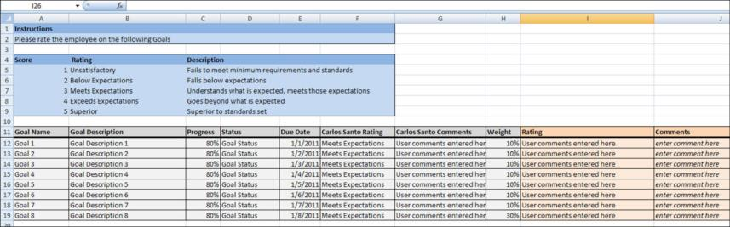
A name and description is provided for each goal, along with the goal progress, status, due date, and weight. For each goal, provide a rating and a comment. All cells that do not require user input are locked.
Goal Rating Table
The following information is displayed on the Competency Rating step table:
- Instructions for the step are displayed.
- Rating Scale and Descriptions if they are configured to display in the review task. All HTML code is removed from the rating scale descriptions.
- Each goal is displayed. If the reviewee selected which goals to include in the review, then only those goals display.
To the right of your ratings and comments, each previous reviewer's ratings and comments are displayed only if a previous rating is available and if the task is configured to display previous ratings.
- Users can only view their manager's review data if configured to do so. In some instances, manager data is displayed after a certain date.
- Managers and indirect managers can view all users' review data.
- Peers cannot view any other user's review data.
If questions are included in the section, they are also available in the offline review. Rating questions factor into the final result of the review according the questions/ratings configuration. Text questions do not factor into the final result of the review.
If custom fields are included in the section, they are also available in the offline review. If the custom fields are editable then they appear in orange, while read-only fields appear in gray. If another user has already completed the custom field, then their entry is displayed, but can be edited.
Note: If the same review section is assigned to the same user in multiple steps, they can view their previous input and this information is editable.
To navigate to the next step of the review, click the next tab of the Excel spreadsheet, which is located in the lower-left corner of the page.
Provide a Goal Rating
For each goal, read the goal name and information, and in the Your Ratings column, provide a rating for the goal. Then, in the Your Comments column, provide comments explaining your rating. The character limit for comment fields is 30,000.
- The Your Weights column displays the weight for each goal if weights are enabled and displayed. If weights can be edited, then reviewers can modify the weights if necessary. Depending on the backend setting, the weight percentage fields may accept up to two decimal places.
Multiple Reviewers/Co-Planners
If a review step has co-planners, each reviewer is able to enter their own comments and modify the review ratings. Comments are attributed to the user who submitted them, so each comment appears distinct and separate. In addition, any comments that have been saved, but not submitted are viewable by the assignee and the co-planners.
- If a co-planner is the first user to access a review section, the co-planner is able to select a rating and enter comments, if the rating option and comment box are enabled for the co-planner.
- If a co-planner accesses a review section that has been saved but not submitted by the assignee or another co-planner, then the system displays the following:
  - Ratings values are pre-selected with the rating that was selected by the assignee or another co-planner. Note: The rating option only appears if the task is configured for the section to accept comments from the corresponding assignee.
  - An empty comment box appears for the co-planner to enter comments. Note: The comment box only appears if the task is configured for the section to accept comments from the corresponding assignee.
  - A response section containing the rating applied by the assignee or another co-planner. This section displays the assignee or co-planner name, rating, and comments. "(Co-Planner)" appears next to all co-planner names. Note: The rating and comment only appear if the task is configured for the section to accept ratings and comments from the corresponding assignee.
Any comments are attributed to the reviewer who entered them. Ratings are attributed to the user who was the last to apply or modify the rating. For example, if Co-planner A applies a rating to a question, and then Co-planner B modifies the rating for the question, then the rating is attributed to Co-planner B. However, if Co-planner B does not modify the rating, then the rating is attributed to Co-planner A.
When viewing reviewer comments, the comments from the review step assignee are displayed first, followed by comments from the step co-planners in alphabetical order based on last name. The most recent comments are displayed first.
Weight values are also attributed to the user who was the last to apply or modify the weight value.

Offline Review Upload Validation
When a user uploads an offline performance review, they are taken to the Upload Validation page, which displays the upload status and validation details for the uploaded offline performance review.
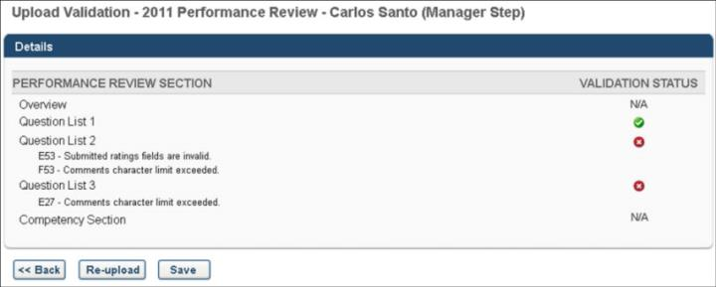
In the Details section, each of the performance review sections are displayed in the order in which they appear in the performance review step.
In the Validation Status column, the validation status of the review section is displayed.
- If a section does not require user input, N/A is displayed as the validation status.
- If a section is completed correctly with valid data, a green check icon is displayed .
- If a section is not completed correctly or if there is invalid data, a red X icon is displayed . In addition, each error that exists is displayed below the section title. The cell name that caused the issue is also displayed. The potential errors are:
  - Rating out of range - A numeric rating is below 1 or above the maximum value.
  - Invalid numerical rating - A rating is not a multiple of 1, .1, or .5, depending on the rating scale configuration.
  - Invalid text rating - A text or text/numeric rating is not one of the configured options.
  - Required field missing - A rating or required comment is missing.
  - Comments character limit exceeded - A comment exceeds the character limit of 10,000.
If a section contains errors, you cannot save that section. You must correct the errors using the cell numbers and error descriptions and then re-upload the file by pressing the Re-upload button.
If the file is tampered with, an error message is displayed and the file cannot be saved.
Only sections with green check icons can be saved. Click the Save button to save the validated sections. All sections with no errors are imported into the system. All uploaded data overwrites any data previously submitted.

Complete/Upload Offline Review Task
You can download and upload performance reviews with appropriate permission and only if the review task includes at least one Question List, Competency Rating, or Goal Rating section for the reviewer to complete.
Only reviews that are In Progress or Not Started are eligible to be completed offline.
- If the task is configured to allow users to submit reviews after the due date, then reviews that are Past Due can also be downloaded and uploaded.
- If the task is configured to allow multiple submissions, then reviews that are Complete can also be downloaded and uploaded.
Permissions
PERMISSION NAME | PERMISSION DESCRIPTION | CATEGORY

Offline Performance Reviews | Allow users to download and upload offline reviews. This permission works in conjunction with active performance review tasks. If the user has this permission and is assigned one or more steps of an active performance review task, that user may download the review for offline completion. This permission can be constrained by OU and User's OU. This is an end user permission. | Performance
Download and Complete Offline
Select the Complete Offline option from the Option's drop-down menu to download the performance review and complete it offline. A pop-up appears with the option to either Open the file or Save the file.
The file is named with the following convention and all spaces are replaced by underscores:
[Performance Review Task Name]_[Name of Reviewee]_[Review Step Name].xls
See Complete Offline Performance Review on page 237 for additional information.
Upload Review
After completing an offline review, you can upload the completed review file into the system.
To upload the completed performance review file:
- Open the appropriate review task and select the Upload Review option from the Option's drop-down menu. An Upload File pop-up opens
- Click the Browse button to locate and select the performance review file.
- Click Upload to upload the file.
  - If a valid performance review file is uploaded, the Upload Validation page opens. See Offline Review Upload Validation on page 248 for additional information.
  - If an invalid performance review file is uploaded, an error message is displayed.

External Reviewers
External reviewers can serve as reviewers if they are added to a peer group. External reviewers have certain limitations.
When an external user is assigned a review task, an email is sent that contains a link to the performance review task. This link is the only way an external user can access the review task. When viewing the review task, all top level navigation and settings functionality is removed.
External reviewers cannot:
- Decline a review
- Reopen steps
- Make a public comment on a review (they are able to make private comments)
- Assign development actions
- Serve as reviewer selectors
- Complete goal planning sections
- Add co-planners
- Edit custom fields

View and Print Performance Review
You can view and print a Performance Review PDF as follows:
- Within a performance review, click the Print Review or Print Reviewee Version option from the Options drop-down. Note: The Print Reviewee Version option is only available to reviewers who are reviewing a subordinate, and this version only includes the sections that are visible to the reviewee.
- From the Universal Profile - Action Items page, select the Print PDF option from the actions drop-down menu to the right of the review.
- From the Universal Profile - Snapshot - Reviews page, select the Print Review option from the actions drop-down menu to the right of the review.
- From the My Team - Performance - Reviews page, click the performance review title.
- From the Scheduled Tasks page, click the title of a Completed or Expired performance review task.
- From the Performance Review Task Details page, click the Print icon for a user's performance review task.
The performance review PDF respects the visibility settings that are configured for the performance review task. Information that is configured to not show is not included in the PDF until the configured visibility conditions have been met.
The printable performance review is locked at the time the performance review is completed. All goal details in the printable performance review reflect the goals as they were at the time of the performance review. Any changes that are made to the goal details after the performance review are not displayed in the printable performance review.
When a reviewee opens the printable version of their performance review, they can view any responses they have submitted. Also, if the reviewee is allowed to view peer or direct report responses and the minimum number of responses have been submitted, the reviewee can view any responses submitted by peers or direct reports. Peer and direct report ratings are displayed anonymously to the reviewee. The reviewee may or may not be able to view manager responses, depending on settings set by the administrator.
When a peer or direct report opens the printable version of a review in which they are a reviewer (i.e., they are opening a review they have completed as a peer or direct report), they can view only their own responses.
Print Performance Review
Click the Print Performance Review link. The Print Review pop-up opens.
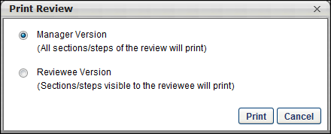
The following options are available in the Print Review pop-up:
- Manager Version - This option prints all sections of the performance review, including all submitted responses.
- Reviewee Version - This option prints only the sections that are visible to the reviewee.
Shared Goals
If the goal planning section is configured to include shared goals, then any shared goals that overlap with the performance review period are also included in the performance review PDF. Shared goals appear exactly as individual goals appear. There is no indication as to which goals are shared.
Printable Version Locked Scenarios
- For performance review tasks that are in progress, the printable performance review task displays goal details as they currently exist.
- For performance review tasks that have been completed or expired, the printable performance review task displays the goal details as they were when the task was completed or expired.
  - For performance review tasks that have been expired, then extended, and are currently in progress, the printable performance review task displays goal details as they currently exist.
  - For performance review tasks that have been completed for an employee and a step is reopened, the following occurs:
    - The performance review step that is reopened displays goal details as they currently exist. Any updates to the goal details after the task is completed are reflected within the reopened step.
    - If the reopened step is resubmitted, the printable performance review displays the goal details at the time the reopened step is submitted.
    - If the reopened step is not resubmitted before the task expires, then the printable performance review displays the goal details at the time the performance review task is first completed (i.e., before the step was reopened).
  - For performance review tasks in which the last workflow step allows multiple submissions, the following occurs:
    - Each time the step owner reopens the performance review, the system displays the goal details at the time of the submission. If the step owner prints the performance review at that time, the printable review reflects the goal details as they appear within the task.
    - Once the last step is closed and no more submissions are allowed, the printable performance review reflects the goal details at the time of the last submission for the last workflow step.
Printable performance reviews reflect the current Goals Configuration settings as of the day the review is printed. If changes are made to the Goals Configuration, then those changes are reflected in all printable performance reviews, even if those tasks had previously been completed.
Printable performance reviews reflect the current Performance Review Printable View settings as of the day the review is printed. If changes are made to the Performance Review Printable View, then those changes are reflected in all printable performance reviews even if those tasks had previously been completed.
Printable Version Content
The following information may be displayed in the printable version of a performance review. The appearance of the PDF and which information is included in the PDF is configured by the administrator.
- Cover Page - The performance review PDF cover page may display the following information:
  - Logo
  - Task title
  - Task review period
  - Reviewer names and roles
  - Reviewee photograph, name, and up to four employee information attributes. If more than 4 employee info fields are displayed, all of them will be displayed in a separate employee info section rather than on the cover page.
- Report Body - The performance review report body is displayed following the cover page. The performance review report body may display the following information:
  - Header logo
  - Review Overview
    - Review task instructions
    - Employee details - The Employee Details section displays the reviewee's position description and any employee information attributes that were not displayed on the cover page. Note: The Position Description is always included in the Employee Details table.
  - Review section details - Each review section may contain the following information:
    - Section header
    - Section directions
    - Rating scale
    - Custom fields
    - Section details
  - Off-Cycle Summary
  - Review Summary - The performance review summary is displayed following all review sections, if enabled for the review task. The performance review summary may display the following information:
    - Overall rating - The overall rating is displayed as either a numeric or text rating, depending on the task configuration.
    - Section names and ratings - The summary table only displays if enabled for the review task.
  - Sign-off - The performance review Sign-off section is displayed following the Summary section. The performance review Sign-off section displays the required signatures for the review. If signatures have already been provided, then they are displayed in this section.
  - Footer information - The footer that appears on each page of the report body contains the following information:
    - Task title
    - Page number and total number of pages
    - Reviewee name

Performance Review - Data Workflow
Within a performance review, any ratings, comments, and weights that are saved prior to submitting the performance review step are not visible to parallel steps or reports.
The following rules determine when ratings, comments, and weights are and are not finalized.
- Any saved responses are automatically finalized when the performance review step is no longer active. This occurs in the following scenarios:
  - The reviewer submits the performance review step.
  - The review task becomes past due.
  - The performance review step is locked and no more submissions are allowed.
  - The performance review step is advanced by an administrator.
  - The performance review step is submitted via Bulk Sign-off when all sections are completed.
- If multiple submissions are allowed, the following rules apply:
  - Edits that are made after the step is submitted remain in draft until the step is submitted again.
  - Any unsubmitted edits that are made after the step is submitted are not automatically finalized when the performance review step is no longer active.
  - When edits are made after the step is submitted, a notification banner appears at the top of every section of the review step until the step is submitted again. This banner indicates that the latest changes have not been submitted and they will not be finalized until the step is submitted.
- If review steps are reopened, the following rules apply:
  - Edits that are made in a reopened step remain in draft until the step is submitted again.
  - Any unsubmitted edits that are made in a reopened step are not automatically finalized when the performance review step is no longer active.
  - When edits are made in a reopened step, a notification banner appears at the top of every section of the review step until the step is submitted. This banner indicates that the latest changes have not been submitted and they will not be finalized until the step is submitted.
  - As with existing behavior, if any later reviewers entered or edited comments, ratings, weights, or fields, then the reopened step displays the updated information if they are visible to the reviewer.
- If the review step is the final step in the review, the following rules apply:
  - If the final step is locked, then all comments and ratings are finalized when the step becomes past due.
  - If the final step is not locked, then all comments and ratings are finalized at the task end date.
Reviewers who are completing parallel review steps cannot view which goals or competencies are selected for goal and competency ratings. This is true regardless of whether the parallel step is submitted.
Sign-offs and signatures are only committed when the review step is submitted.
Performance Review PDF
Any ratings, comments, and weights that are saved within a performance review prior to submitting the performance review step are not visible in the performance review PDF. Ratings, comments, weights are not visible until the performance review step is submitted or is completed due to automatic workflows such as the performance review task being past due.
The following rules apply when viewing a performance review PDF:
- Reviewer views Reviewee Version - When a reviewer who is not the reviewee views the reviewee version, only committed data is included in the PDF.
- Reviewer views Reviewee Version as Reviewee - When a reviewer is also the reviewee and they view the reviewee version, the following occurs:
  - Uncommitted data is included in the PDF prior to submission.
  - Committed data is included in the PDF after submission.
  - If multiple submissions are allowed or if a step is reopened and edits are made after the step is submitted, a notification banner appears at the top of the PDF until the step is submitted again. This banner indicates that the latest changes have not been submitted and they will not be finalized until the step is submitted.
- View Manager Version - When any user views the manager version, only committed data is included in the PDF.
- View Performance Review PDF - When any user views the performance review PDF from outside of the performance review, only committed data is included in the PDF.
- View Performance Review PDF as Co-planner - If a co-planner views the performance review PDF, they can view any uncommitted data from all co-planners of the step. Either co-planner can submit the step, which finalizes all co-planner data. This visibility enables all co-planners for a step to view what is being submitted.
Batch Ratings
Any ratings, comments, and weights that are automatically saved while batch rating a performance review step are uncommitted and are not visible to parallel performance review steps or in reports. Ratings, comments, and weights are not committed until the performance review step is submitted or is completed due to automatic workflows such as the performance review task being past due.
Offline Reviews
Any uploaded data is uncommitted and is not visible to parallel performance review steps or in reports. Ratings, comments, and weights are not committed until the performance review step is submitted or is completed due to automatic workflows such as the performance review task being past due.

Performance Review Form Sections Overview

Performance Review Sections Administration
A performance review is built in sections. Before creating a performance review, you must create performance review sections.
There are five types of sections that can be created for a performance review. Each section makes up a different part of the review for the user completing the review. The sections can:
- Incorporate information from other parts of the performance management functionality if you are using the applicable functionality (goals and competencies)
- Ask questions about a user's performance
- Electronically sign the performance review within the system
The Performance Review Sections page displays a list of previously created sections, the section version, type, and category. If there are many sections already created, you can search for a specific section in the search area. From this page, you can also:
- Create review sections
- Define section categories
- Define a default rating scale
- Activate/deactivate sections
- View, edit, copy, and delete sections
To view and manage performance review sections, go to Admin > Tools > Performance Management > Form Sections.
Permissions
PERMISSION NAME | PERMISSION DESCRIPTION | CATEGORY

Performance Review Form Sections - Manage | Grants ability to create and manage performance review questions and sections which are used in performance review tasks. This permission can be constrained by OU and User's OU. This is an administrator permission. | Performance - Administration
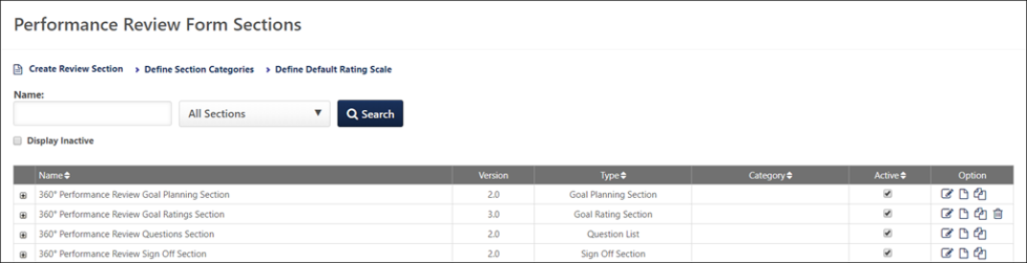
Create Review Section
To create a performance review section, click the Create Review Section link. See Create Review Form Section (Early Adopter) on page 261 for additional information.
Define Section Categories
To define performance review section categories, click the Define Categories link. See Define Section Category on page 300 for additional information.
Define Default Rating Scale
To define a default rating scale, click the Define Default Rating Scale link. See Define Performance Review Section Rating Scale on page 304 for additional information.
Search and Filters
Use the search features to search for existing performance review sections.
Use the Section filter to search by section type.
Select the Display Inactive option to include inactive form sections in the search results.
Performance Review Sections Table
The table displays the name, version, type, and category for the review section. The active status also displays, as well as options for editing, deleting, etc.
- Name - This column displays the name of the review section. If there are multiple versions, click the plus icon to view previous versions. Once a section is used in a performance review task, the section will create a new version if any of the title, description, questions, rating scale, or options have been changed. Changes made to a section do not impact current or previous review tasks that include the section.
- Version - This column displays the version number of the section.
- Type - This column displays the section type.
- Category - This column displays the section category.
- Active - This column lets you manage the active status of a section. Check the box to make the section active. Uncheck the box to make the section inactive. As soon as the box is unchecked, the section will be hidden on the page. To view the section and make it active again, click the Display Inactive option, and then check the Active box.
- Options - The following options are available in the Options column:
  - Edit - This option lets you edit the section.
  - Rename - You can use this option to rename a section and edit the instructions. Updates to the form section title and instructions do not trigger a new version, and the title and instruction changes are pushed to In Progress reviews. When this option is selected, a truncated version of the Edit Section page opens, displaying the following fields:
    - Name - This displays the name of the form section.
    - Section Type (read-only)
    - Directions
  - Copy - This option lets you create a copy of the section. You can edit the copy, as well as rename it.
  - Delete - This option lets you delete the section. This option is not available once a review section has been included in a review task. In addition, if an Evidence Collection review section is associated with a Competency Assessment review section, the Competency Assessment section to which the Evidence Collection section is linked cannot be deleted until the associated Evidence Collection review section is deleted.

Create Review Form Section (Early Adopter)
Use the Review Section page to determine if a section contains goals, competencies, or Rating Scale, and response questions. Custom Fields may be added to any section, except Sign-Off sections. Rating Scale and/or Text Response questions may be added to sections containing goals and competencies. Suggested comments may be added to each Rating Scale question. Weights can be applied to each free form question. When entering the directions for a section, you may insert tags that are replaced with information about the employee reviewed or with links to that employee's performance data.
To view the Review Section, go to Admin > Tools > Performance Management > Form Sections. Then, click the Create Review Section link. The Review Section window opens.
Permissions
PERMISSION NAME | PERMISSION DESCRIPTION | CATEGORY

Performance Review Form Sections - Manage | Grants ability to create and manage performance review questions and sections which are used in performance review tasks. This permission can be constrained by OU and User's OU. This is an administrator permission. | Performance - Administration
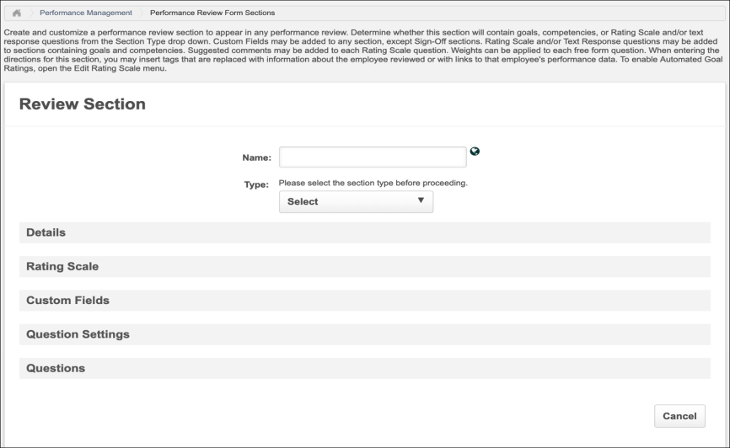
The options that are visible on this page are determined by the section that is selected from the Type drop-down list. Some sections are only available if you are also using the associated functionality in the system.
- The Competency section is only used if also using the Competency functionality and have previously created competency models in the system.
- The Competency Assessment section is only used if also using the Competency functionality and have previously created review-based competency assessment tasks in the system.
- The Goals section is only applicable if also using the Goals functionality.
The following options are available:
- Name - Enter a name that helps identify the section. The character limit for this field is 50. If multiple languages are available for the portal, the section name can be localized by clicking the Translate icon to the right of the field.
- Type - Select the section type. Based on your selection, the various sections are populated accordingly. Once the section is created, the section type cannot be edited. The available Section Types are:
  - Competency Assessment - Include a competency assessment in a performance review task and can be used in standard and off-cycle performance review tasks. See Create Review Section - Competency Assessment on page 263 for additional information.
  - Competency - Include competencies in a review, allowing reviewers and reviewees to rate and comment on how the user has performed on the selected competencies during the review period. See Create Review Section - Competency on page 266 for additional information.
  - Development Plan - Add training and action steps to a development plan for the reviewee while completing the performance review task. See Create Review Section - Development Plan on page 273 for additional information.
  - Evidence Collection - Enable reviewers to input or upload materials that provide evidence to support competencies. See Review Section - Create - Evidence Collection on page 276 for additional information.
  - Goal Planning - Set goals for the next period within the performance review. See Create Review Section - Goal Planning on page 279 for additional information.
  - Goal Rating - Rate the employee's performance against approved goals that fall within the performance review period. See Create Review Section - Goal Review on page 284 for additional information.
  - Question List - Contains basic questions about the employee's overall performance with a rating scale. See Create Review Section - Question List on page 291 for additional information.
  - Sign Off - Include signature lines in a printed copy of the review or allow reviewers to type their name into the review itself and "electronically sign" and date the review in the system. See Create Review Section - Sign Off on page 297 for additional information.
  - Skill Assessment - Integrates a user's skills profile into performance reviews and updates the skills profile as part of a performance review task.

Create Review Section - Competency Assessment
Competency Assessment review sections allow administrators to include a competency assessment in a performance review task and can be used in standard and off-cycle performance review tasks. When a competency assessment is included in a performance review, the competency assessment cannot be completed offline.
Note: When utilizing competency ratings in Career Profile or Talent Search, competency ratings from competency assessment tasks and Competency Assessment performance review sections are available because they both use the rating scale from the competency model. However, competency ratings from Competency Rating performance review sections are not available because they use the performance review section rating scale.
In order to include a performance review-based competency assessment task in a performance review, you must create a competency assessment review section. This review section can then be added to a performance review task.
To create a performance review section, go to Admin > Tools > Performance Management > Form Sections. Then, click the Create Review Section link.
Permissions
PERMISSION NAME | PERMISSION DESCRIPTION | CATEGORY

Performance Review Form Sections - Manage | Grants ability to create and manage performance review questions and sections which are used in performance review tasks. This permission can be constrained by OU and User's OU. This is an administrator permission. | Performance - Administration
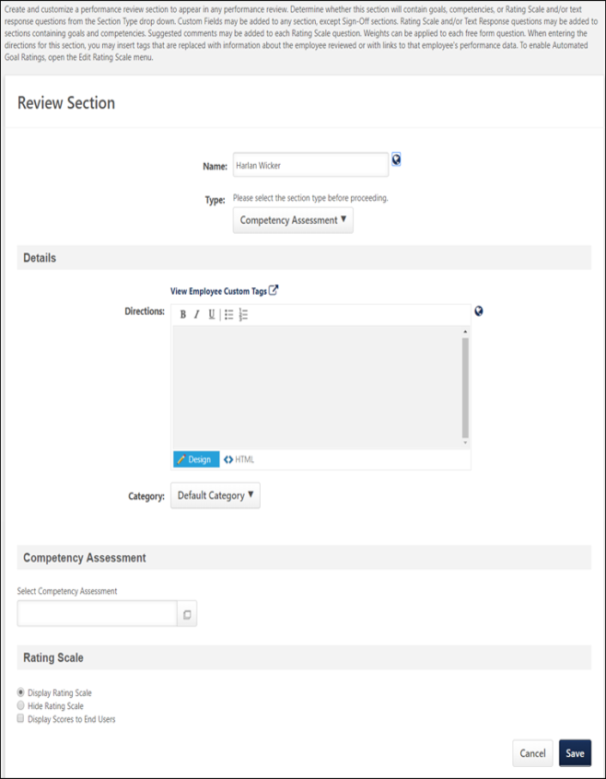
In the Name field, enter a name that helps identify the section. The character limit for this field is 50. If multiple languages are available for the portal, the section name can be localized by clicking the Translate icon to the right of the field.
In the Type field, select Competency Assessment from the drop-down list.
Details
- Directions - Enter directions that appear to the reviewers at the top of the performance review section. The character limit for this field is 3000 characters. To see a list of available tags that can be used in the directions, click the View Employee Custom Tags link. When utilized in the directions, the tags are automatically replaced with a hyperlink on the review form, similar to the way email tags work. HTML can be used. The system only accepts certain customizable HTML elements in the WYSIWYG Editor. Elements that are not acceptable display as text. See Safe Listed Customizable Elements. If multiple languages are enabled for your portal, select the Translate icon to translate the field into other available languages.
- Category - Select the appropriate category from the drop-down.
Competency Assessment
Click the pop-up icon to select a performance review-based competency assessment from the list of active performance review-based competency assessments.
To remove a selected competency assessment, click the Trash Can icon to the right of the competency assessment name.
Rating Scale
- Display/Hide Rating Scale - Select whether the competency assessment review section should display or hide the rating scale. When the rating scale is displayed, a Question Mark icon appears to the right of the rating scale, which reviewers can click to view the ratings and their definitions.
- Display Scores to End Users - Select this option to display the user's competency assessment rating score in the Ratings tab of the performance review.
In the context of the Competency Assessment review section, Rating Scale denotes the question mark icon .
- If you select Hide Rating Scale, the rating scale in the competency assessment review section is hidden, thereby disabling reviewers from viewing the ratings and their definitions.
- Alternatively, if you select Display Rating Scale and the Display Scores to End User option, the rating scale with a question mark icon will appear in the competency assessment review section, enabling reviewers and reviewees to access the ratings and learn their definitions by clicking on the icon.
Save
Click the Save button to save the performance review section.

Create Review Section - Competency
If you are using the Competency Management functionality, the competency section allows you to include competencies in a review, allowing reviewers and reviewees to rate and comment on how the user has performed on the selected competencies during the review period.
Note: When utilizing competency ratings in Career Profile or Talent Search, competency ratings from competency assessment tasks and Competency Assessment performance review sections are available because they both use the rating scale from the competency model. However, competency ratings from Competency Rating performance review sections are not available because they use the performance review section rating scale.
To create a performance review section, go to Admin > Tools > Performance Management > Form Sections. Then, click the Create Review Section link.
Permissions
PERMISSION NAME | PERMISSION DESCRIPTION | CATEGORY

Competency Assessment Model Admin - Edit | Grants ability to edit competency models. This permission cannot be constrained. This is an administrator permission. | Performance - Administration

Competency Assessment Model Admin - Manage | Grants ability to create, edit, delete, and view competency models. This permission cannot be constrained. This is an administrator permission. | Performance - Administration

Competency Assessment Model Admin - View | Grants ability to view competency models. This permission cannot be constrained. This is an administrator permission. | Performance - Administration

Performance Review Form Sections - Manage | Grants ability to create and manage performance review questions and sections which are used in performance review tasks. This permission can be constrained by OU and User's OU. This is an administrator permission. | Performance - Administration
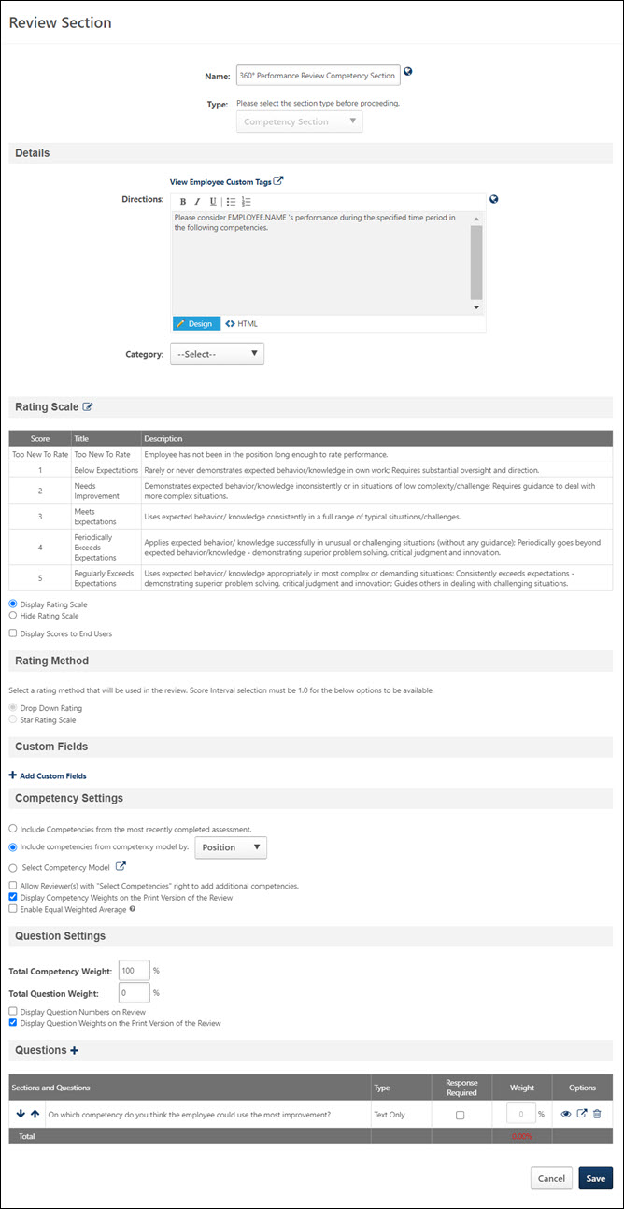
Details
- Directions - Enter directions that appear to the reviewers at the top of the performance review section. The character limit for this field is 3000 characters. To see a list of available tags that can be used in the directions, click the View Employee Custom Tags link. When utilized in the directions, the tags are automatically replaced with a hyperlink on the review form, similar to the way email tags work. HTML can be used. The system only accepts certain customizable HTML elements in the WYSIWYG Editor. Elements that are not acceptable display as text. See Safe Listed Customizable Elements. If multiple languages are enabled for your portal, select the Translate icon to translate the field into other available languages.
- Category - Select the appropriate category from the drop-down.
Rating Scale
This section displays the default rating scale for the section along with options related to the rating scale. Default section rating scales are automatically pulled into each new performance review, but can be modified for each performance review.
Click the Edit icon to modify the default rating scale. See Define Performance Review Section Rating Scale on page 304 for additional information.
- Display Rating Scale - Select this option to display the rating scale to users.
- Hide Rating Scale - Select this option to hide the rating scale from users.
- Display Scores to End Users - Select this option to display the scores along with the rating.
Each rating scale question on the review contains a drop-down that displays the rating. The score is also displayed if the Display Scores to End Users option is selected.
If a score interval of 0.5 or 0.1 is selected, then a text box appears in the section, rather than a rating scale drop-down list.
Rating Method
This section is only available when the new performance reviews user interface (UI) is enabled.
The Rating Method section is only active when the score interval for the rating scale is 1.0. If a score interval other than 1.0 is selected for the section rating scale, the Rating Method options are disabled and a text input rating option is implemented for the section.
Select the appropriate rating method for the performance review section:
- Drop-Down Rating - When this option is selected, reviewers select a rating from a drop-down for the section.
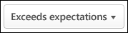
- Star Rating Scale - When this option is selected, reviewers select a star rating for the section.
Note: Once a performance review section is saved, any change to the Rating Method causes the section template to create a new version.
Custom Fields
This section displays the custom fields that are included in the section. To add a custom field, in the Custom Fields section, click the Add Custom Fields link. The Select Fields pop-up opens. Note: The Custom Fields section is only available if the administrator has availability to at least one custom field.
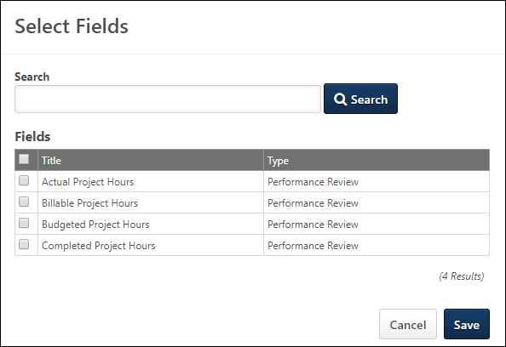
Click the option box to the left of the field title to select the field. You can also search for a custom field by title using the Search field. Note: Only custom fields that are available to the user appear in the list. After selecting the appropriate custom fields, click Save. Up to 100 custom fields can be selected.
- After custom fields are added to the review form section, you can reorder them by dragging and dropping them into the appropriate order.
- Select the Required option to require users to complete the custom field.
- Click the Remove icon to remove any custom fields from the section.
When editing a review section that already contains custom fields, all custom fields that have been added to the section appear to the administrator, regardless of the availability of the custom fields. Administrators can also reorder or delete any fields that have been added to the section, regardless of the availability of the custom fields.
Custom fields that are added to the review section only appear to the reviewer or reviewee in the review if they are within the availability of the custom field.
Competency Settings
- Include Competencies from the most recently completed assessment - Select this option to include competencies from the user's most recently completed competency assessment task.
- Include competencies from competency model by - Select this option to include competencies by organizational unit type. Select the appropriate OU type from the drop-down list.
- Select Competency Model - Select this option to utilize an existing competency model. Click the Search icon to select the model. When selecting a competency model, administrators can only view and select a competency model if they are within the Admin Visibility settings for the competency model and if they have permission to view, edit, or manage competency models.
- Allow Reviewer(s) with "Selected Competencies" right to add additional competencies - Select this option to allow certain reviewers to add additional competencies to the review.
- Display Competency Weights on the Print Version of the Review - Select this option to display the weights associated with each competency on the printable version of the review. For example, if one competency carries more weight than another, then after users have completed their review and they view the printable version, they can see the corresponding weights for each competency.
- Enable Equal Weighted Average - Select this option to calculate goals and competencies added in a review task based on equal weighted average.
How the system calculate ratings if Enable Equal Weighted Average is enabled:
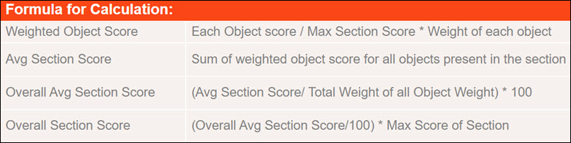
Question Settings
This section only applies if this section also contains questions.
- Total Competency Weight - Enter the weight for the competencies with respect to the questions in this section. Depending on the backend setting, the weight percentage field may accept up to two decimal places.
- Total Question Weight - Enter the weight for the questions with respect to the competencies in this section. Depending on the backend setting, the weight percentage field may accept up to two decimal places.
The Total Competency Weight and Total Question Weight must total 100%.
- Display Question Numbers on Review - Select this option to display question numbers next to each question on the review.
- Display Question Weights on the Print Version of the Review - Select this option to display the weights associated with each question on the printable version of the review. For example, if one question carries more weight than another, then after users have completed their review and they view the printable version, they can see the corresponding weights for each question.
Questions
To add a question to the section, click the Add Question icon, which opens the Add Questions window. From the Add Questions window, select an existing question from the question bank or create a new question. The character limit for questions is 2000. On the Add Questions window, click Done when you have selected the appropriate questions.
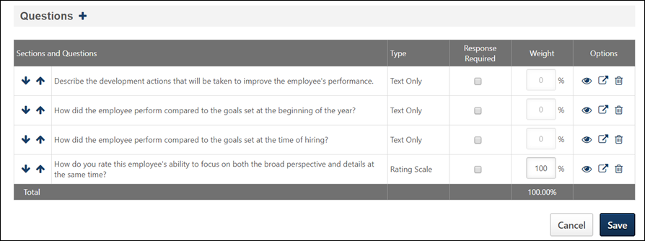
Once questions are added, reorder them using the up and down arrows.
Determine which questions are optional and which are required by selecting the Response Required option.
Enter a weight for each question in the Weight column. All question weights must total 100%. If all questions are text only, the Weights column is disabled. Depending on the backend setting, the weight percentage fields may accept up to two decimal places.
Preview, Edit, or Delete a question using the appropriate icon.
Batch Ratings Considerations
For Competency performance review form sections, batch ratings can be provided for drop-down fields, numeric fields, and star ratings. Also, the following custom field types are supported:
- Checkbox
- Date
- Drop-down
- Numeric
- Radio Button
- Scrolling Text Box
- Short Text Box
In the Competency Settings section, the following applies to the Batch Rating page:
- If the Include Competencies from the most recent complete assessment option is selected, this is enforced on the Batch Rating page.
- If the Include competencies from the competency model by option is selected, this is enforced on the Batch Rating page.
- If the Select Competency Model option is selected, this is enforced on the Batch Rating page.
- If the Allow Reviewer(s) with "Select Competencies" right to add additional competencies option is selected, the following occurs:
  - Users cannot select competencies from the Batch Rating page.
  - Users can select competencies from individual review tasks.
  - Competencies that are selected from the individual review tasks will appear on the Batch Rating page.
In the Question section, any questions that are added will be supported and displayed in the corresponding Competency section tab on the Batch Rating page.
Save
Click the Save button to save the performance review section.

Create Review Section - Development Plan
Development Plan sections enable reviewers to add training and action steps to a development plan for the reviewee while completing the performance review task. Administrators can configure whether the training and action steps are added to the reviewee's primary development plan or a new performance review development plan.
To create a performance review section, go to Admin > Tools > Performance Management > Form Sections. Then, click the Create Review Section link.
Permissions
PERMISSION NAME | PERMISSION DESCRIPTION | CATEGORY

Performance Review Form Sections - Manage | Grants ability to create and manage performance review questions and sections which are used in performance review tasks. This permission can be constrained by OU and User's OU. This is an administrator permission. | Performance - Administration
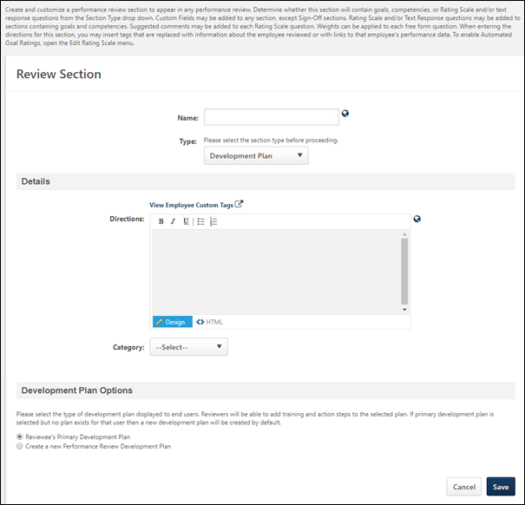
Details
- Directions - Enter directions that appear to the reviewers at the top of the performance review section. The character limit for this field is 3000 characters. To see a list of available tags that can be used in the directions, click the View Employee Custom Tags link. When utilized in the directions, the tags are automatically replaced with a hyperlink on the review form, similar to the way email tags work. HTML can be used. The system only accepts certain customizable HTML elements in the WYSIWYG Editor. Elements that are not acceptable display as text. See Safe Listed Customizable Elements. If multiple languages are enabled for your portal, select the Translate icon to translate the field into other available languages.
- Category - Select the appropriate category from the drop-down.
Development Plan Options
Select whether the Development Plan section creates a new performance review development plan or builds upon the reviewee's existing primary development plan. Reviewers can add training and action steps to the selected development plan.
- Reviewee's Primary Development Plan - This option is selected by default. When this option is selected, if the reviewee has an existing primary development plan, then a read-only view of the reviewee's primary development plan is displayed in the review section. Also, additional training or action steps can be added to the reviewee's primary development plan within the performance review section. Note: If this option is selected and the reviewee does not currently have a primary development plan, then the Development Plan performance review section automatically creates a new performance review development plan, which becomes the reviewee's primary development plan.
- Create a new Performance Review Development Plan - When this option is selected, a new performance review development plan is created, and training or action steps can be added to the development plan within the performance review section. The newly created development plan is created upon the final submission of the performance review. The newly created development plan has the following title: {Name of Performance Review} Development Plan (e.g., 2013 Annual Review Development Plan). This title can be edited after the development plan is created.
Save
Click the Save button to save the performance review section.

Review Section - Create - Evidence Collection
Evidence Collection review sections are used in conjunction with Competency Assessment review sections, and at least one Competency Assessment section must be created prior to creating an Evidence Collection review section.
Evidence Collection review sections enable reviewers to input or upload materials that provide evidence to support competencies. These sections also display all existing evidence that has been collected to support the required competencies. Reviewers can filter the section by competency to view only the evidence that supports specific competencies.
To create a performance review section, go to Admin > Tools > Performance Management > Form Sections. Then, click the Create Review Section link.
Permissions
PERMISSION NAME | PERMISSION DESCRIPTION | CATEGORY

Performance Review Form Sections - Manage | Grants ability to create and manage performance review questions and sections which are used in performance review tasks. This permission can be constrained by OU and User's OU. This is an administrator permission. | Performance - Administration
In the Name field, enter a name that helps identify the section. The character limit for this field is 50. If multiple languages are enabled for your portal, select the Translate icon to translate the field into other available languages.
Select Evidence Collection from the Type drop-down list. This option is only available when using the redesigned Performance Reviews functionality.
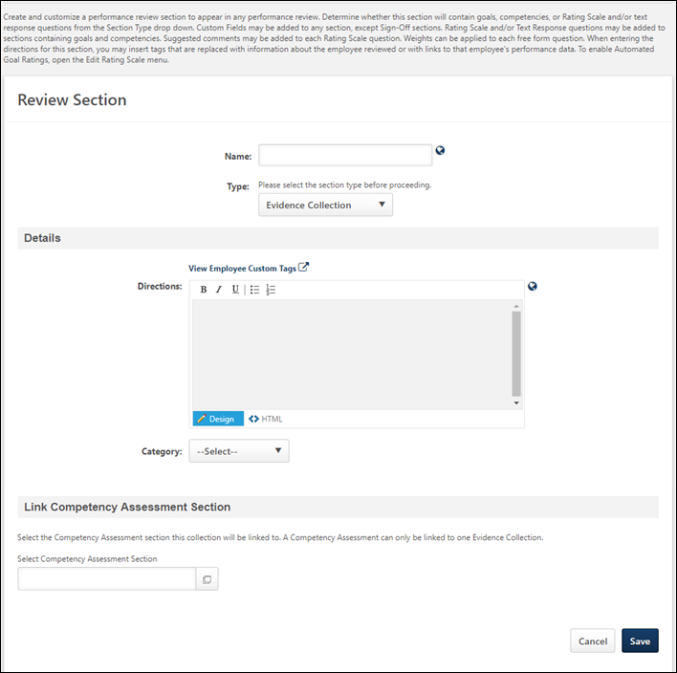
Details
- Directions - Enter directions that appear to the reviewers at the top of the performance review section. The character limit for this field is 3000 characters. To see a list of available tags that can be used in the directions, click the View Employee Custom Tags link. When utilized in the directions, the tags are automatically replaced with a hyperlink on the review form, similar to the way email tags work. HTML can be used. The system only accepts certain customizable HTML elements in the WYSIWYG Editor. Elements that are not acceptable display as text. See Safe Listed Customizable Elements. If multiple languages are enabled for your portal, select the Translate icon to translate the field into other available languages.
- Category - Select the appropriate category from the drop-down.
Link Competency Assessment Section
Each Evidence Collection review section is associated with a Competency Assessment review section. The evidence that is collected with the Evidence Collection review section is associated with the Competency Assessment review section's competency assessment, and the associated competencies can be viewed and selected within the Evidence Collection review section.
To select a Competency Assessment review section to link to the Evidence Collection section, click the Select icon . The pop-up displays the latest versions of all available Competency Assessment review sections. Click the section name to select the section.
Only one Evidence Collection review section can be linked to a Competency Assessment review section. In addition, the Evidence Collection section is linked to the specific version of the Competency Assessment section.
Save
Click the Save button to save the performance review section. Once the section is saved, administrators cannot change the Competency Assessment section to which the Evidence Collection section is linked. In addition, the Competency Assessment section to which the Evidence Collection section is linked cannot be deleted until the associated Evidence Collection review section is deleted.

Create Review Section - Goal Planning
Using this section type, users can set goals for the next period within the performance review. The Goal Planning section is a good option to allow organizations to take advantage of the Goals functionality within the review and set up goals for the next review cycle.
Goals that are created within a Goal Planning section are automatically approved when the performance review is completed.
Best Practice: When using this section in the performance review and goal creation requires approval, it is a best practice to assign the goal planning section to the employee first to fill out their goals for the future period. Then, include the same goal planning section in a following manager review step to allow the manager to edit or remove goals that were added by the employee or add additional goals. Thus once the review is completed, both the employee and manager have reviewed the future goals and these goals are automatically approved when the performance review is completed.
Once the review is complete, the goals appear in the Goals module for the user and are automatically approved. The review must be completed before these goals appear on the module. For every step that includes this section, the step assignee can add, edit, or remove goals that were added by a previous reviewer or the user if that step assignee has the Edit section privilege for their assigned review step.
To create a performance review section, go to Admin > Tools > Performance Management > Form Sections. Then, click the Create Review Section link.
Permissions
PERMISSION NAME | PERMISSION DESCRIPTION | CATEGORY

Performance Review Form Sections - Manage | Grants ability to create and manage performance review questions and sections which are used in performance review tasks. This permission can be constrained by OU and User's OU. This is an administrator permission. | Performance - Administration
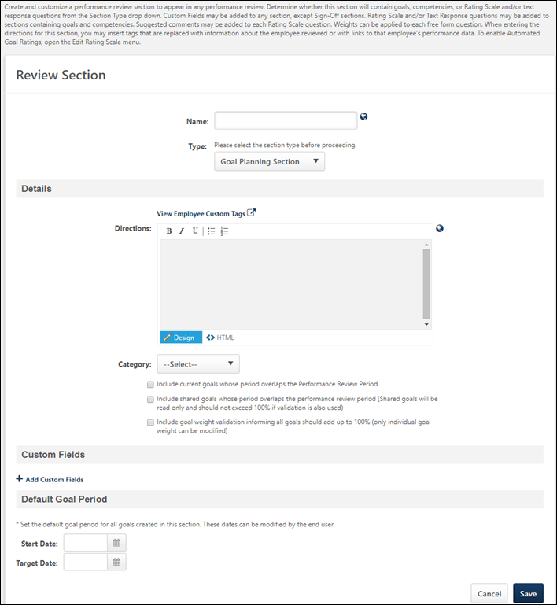
Details
- Directions - Enter directions that appear to the reviewers at the top of the performance review section. The character limit for this field is 3000 characters. To see a list of available tags that can be used in the directions, click the View Employee Custom Tags link. When utilized in the directions, the tags are automatically replaced with a hyperlink on the review form, similar to the way email tags work. HTML can be used. The system only accepts certain customizable HTML elements in the WYSIWYG Editor. Elements that are not acceptable display as text. See Safe Listed Customizable Elements. If multiple languages are enabled for your portal, select the Translate icon to translate the field into other available languages.
- Category - Select the appropriate category from the drop-down.
- Include current goals whose period overlaps the Performance Review Period - Select this option to include a user's current existing goals in a Goal Planning section. When this option is selected, the user's current existing goals are displayed in the Goal Planning section. This includes current existing goals whose period overlaps the Performance Review period. If a goal approval workflow is in place, only goals that are approved appear in the Goal Planning section.
  - If current goals are displayed in the Goal Planning section, the reviewer can view the reviewee's goals. Depending on the goal configuration and if the reviewer has the appropriate permissions, the reviewer may be able to modify or cancel existing goals from within the Goal Planning section.
- Include shared goals whose period overlaps the performance review period - When this option is selected, the goal planning section displays the reviewee's shared goals that overlap with the performance review period. Shared goals are read-only. If shared goals and goal weight validation are displayed on the goal planning section, then the shared goals are included in the goal weight percentage, and the total goal weight should not exceed 100%.
- Include goal weight validation informing all goals should add up to 100% - When this option is selected, the goal planning section displays a total goal weight percentage of both individual and shared goals. If shared goals are not displayed on the goal planning section, then they do not factor in to the total goal weight percentage.
Custom Fields
This section displays the custom fields that are included in the section. To add a custom field, in the Custom Fields section, click the Add Custom Fields link. The Select Fields pop-up opens. Note: The Custom Fields section is only available if the administrator has availability to at least one custom field.
Click the option box to the left of the field title to select the field. You can also search for a custom field by title using the Search field. Note: Only custom fields that are available to the user appear in the list. After selecting the appropriate custom fields, click Save. Up to 100 custom fields can be selected.
- After custom fields are added to the review form section, you can reorder them by dragging and dropping them into the appropriate order.
- Select the Required option to require users to complete the custom field.
- Click the Remove icon to remove any custom fields from the section.
When editing a review section that already contains custom fields, all custom fields that have been added to the section appear to the administrator, regardless of the availability of the custom fields. Administrators can also reorder or delete any fields that have been added to the section, regardless of the availability of the custom fields.
Custom fields that are added to the review section only appear to the reviewer or reviewee in the review if they are within the availability of the custom field.
Default Goal Period
This section enables administrators to define the default goal period for any goals that are added within this section of the performance review.
- Start Date - Set the default start date for the goal. User can edit this during the review.
- Target Date - Set the default target date for the goal. User can edit this during the review.
Save
Click the Save button to save the performance review section.

Create Review Section - Goal Review
If you are using the Goals Management functionality, a Goal Review section can be included in order to rate the employee's performance against approved goals that fall within the performance review period.
To create a performance review section, go to Admin > Tools > Performance Management > Form Sections. Then, click the Create Review Section link.
Permissions
PERMISSION NAME | PERMISSION DESCRIPTION | CATEGORY

Performance Review Form Sections - Manage | Grants ability to create and manage performance review questions and sections which are used in performance review tasks. This permission can be constrained by OU and User's OU. This is an administrator permission. | Performance - Administration
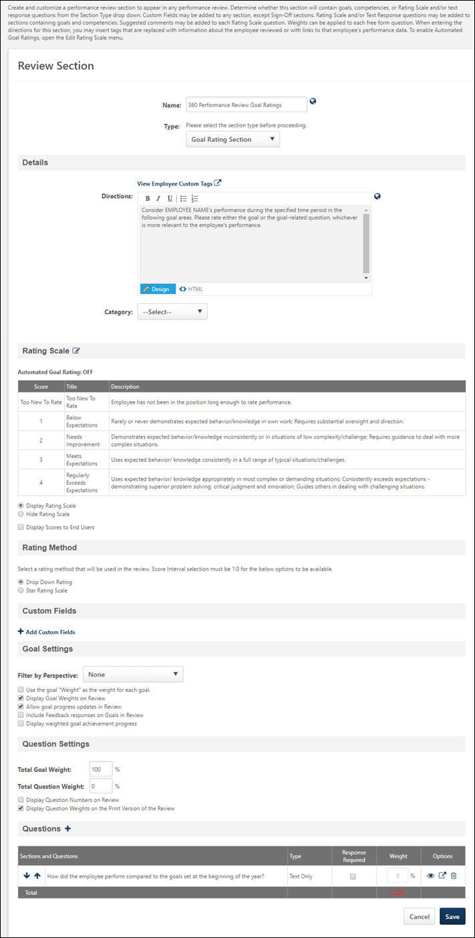
Troubleshooting Information
The following page contains a troubleshooting guide for administrators for goals that are not appearing in a performance review:
- See Troubleshooting Guide - Goal not Appearing in Performance Review.
Details
- Directions - Enter directions that appear to the reviewers at the top of the performance review section. The character limit for this field is 3000 characters. To see a list of available tags that can be used in the directions, click the View Employee Custom Tags link. When utilized in the directions, the tags are automatically replaced with a hyperlink on the review form, similar to the way email tags work. HTML can be used. The system only accepts certain customizable HTML elements in the WYSIWYG Editor. Elements that are not acceptable display as text. See Safe Listed Customizable Elements. If multiple languages are enabled for your portal, select the Translate icon to translate the field into other available languages.
- Category - Select the appropriate category from the drop-down.
Rating Scale
This section displays the default rating scale for the section along with options related to the rating scale. Default section rating scales are automatically pulled into each new performance review, but can be modified for each performance review.
Click the Edit icon to modify the default rating scale. See Define Performance Review Section Rating Scale on page 304 for additional information.
- Display Rating Scale - Select this option to display the rating scale to users.
- Hide Rating Scale - Select this option to hide the rating scale from users.
- Display Scores to End Users - Select this option to display the scores along with the rating.
Each rating scale question on the review contains a drop-down that displays the rating. The score is also displayed if the Display Scores to End Users option is selected.
If a score interval of 0.5 or 0.1 is selected, then a text box appears in the section, rather than a rating scale drop-down list.
An Automated Goal Rating Status Indicator displays at the top of this section to indicate whether automated goal ratings are enabled or disabled for the section.
Rating Method
This section is only available when the new performance reviews user interface (UI) is enabled.
The Rating Method section is only active when the score interval for the rating scale is 1.0. If a score interval other than 1.0 is selected for the section rating scale, the Rating Method options are disabled and a text input rating option is implemented for the section.
Select the appropriate rating method for the performance review section:
- Drop-Down Rating - When this option is selected, reviewers select a rating from a drop-down for the section.
- Star Rating Scale - When this option is selected, reviewers select a star rating for the section.
Note: Once a performance review section is saved, any change to the Rating Method causes the section template to create a new version.
Custom Fields
This section displays the custom fields that are included in the section. To add a custom field, in the Custom Fields section, click the Add Custom Fields link. The Select Fields pop-up opens. Note: The Custom Fields section is only available if the administrator has availability to at least one custom field.
Click the option box to the left of the field title to select the field. You can also search for a custom field by title using the Search field. Note: Only custom fields that are available to the user appear in the list. After selecting the appropriate custom fields, click Save. Up to 100 custom fields can be selected.
- After custom fields are added to the review form section, you can reorder them by dragging and dropping them into the appropriate order.
- Select the Required option to require users to complete the custom field.
- Click the Remove icon to remove any custom fields from the section.
When editing a review section that already contains custom fields, all custom fields that have been added to the section appear to the administrator, regardless of the availability of the custom fields. Administrators can also reorder or delete any fields that have been added to the section, regardless of the availability of the custom fields.
Custom fields that are added to the review section only appear to the reviewer or reviewee in the review if they are within the availability of the custom field.
Goal Settings
- Filter by Perspective - Filter the goals by perspective by selecting it from the drop-down list.
- Use the goal "Weight" as the weight for each goal - Select this option to use the weight associated with each goal as the goal weight within this section.
- Display Goal Weights on Review - Select this option to display the weights associated with each goal on the printable version of the review. For example, if one goal carries more weight than another, then after users have completed their review and they view the printable version, they can see the corresponding weights for each goal.
  - Note: If the reviewer has the Weight goals section right enabled for their review step, then the goals weight appears to that reviewer on the online review despite this option.
- Allow goal progress updates in Review - This option is selected by default. When this option is selected, reviewers can manage goals directly from the Goal Rating section. This enables the reviewer to quickly update the goal progress without exiting the performance review.
- Include Feedback responses on Goals in Review - When this option is selected, feedback that has been obtained on goals is imported into the review section. This option is unselected by default.
- Display weighted goal achievement progress - When this option is selected, the user’s overall weighted goal achievement progress is displayed within the Goal Rating section of the review. When the Automatically calculate section rating option is selected in the rating scale, this option is automatically selected and cannot be unselected.
Question Settings
This section only applies if this section also contains questions.
- Total Goal Weight - Enter the weight for the goals with respect to the questions in this section. Depending on the backend setting, the weight percentage field may accept up to two decimal places.
- Total Question Weight - Enter the weight for the questions with respect to the goals in this section. Depending on the backend setting, the weight percentage field may accept up to two decimal places.
The Total Goal Weight and Total Question Weight must total 100%.
- Display Question Numbers on Review - Select this option to display question numbers next to each question on the review.
- Display Question Weights on the Print Version of the Review - Select this option to display the question weights associated with each question on the printable version of the review. For example, if one question carries more weight than another, then after users have completed their review and they view the printable version, they can see the corresponding weights for each question.
Considerations for Auto-Calculation of Section Ratings
If the section is configured to automatically calculate section ratings based on goal achievement progress, then in the Question Settings section the Total Goal Weight field is set to 0%, and the Total Question Weight field is set to 100%. The Display Question Numbers on Review option is unselected, and the Display Question Weights on the Print Version of the Review option is selected. These values cannot be modified.
Questions
To add a question to the section, click the Add Question icon, which opens the Add Questions window. From the Add Questions window, select an existing question from the question bank or create a new question. The character limit for questions is 2000. On the Add Questions window, click Done when you have selected the appropriate questions.
Once questions are added, reorder them using the up and down arrows.
Determine which questions are optional and which are required by selecting the Response Required option.
Enter a weight for each question in the Weight column. All question weights must total 100%. If all questions are text only, the Weights column is disabled. Depending on the backend setting, the weight percentage fields may accept up to two decimal places.
Preview, Edit, or Delete a question using the appropriate icon.
Considerations for Auto-Calculation of Section Ratings
If the section is configured to automatically calculate section ratings based on goal achievement progress, then a question is automatically added to the Questions section. This question is titled “Automated Goal Rating,” it is set to be required, the weight is set to 100%, and the question settings cannot be edited. The weight of all other questions is set to 0%, and this question cannot be edited, previewed, or deleted.
If the option to automatically calculate section ratings based on goal achievement progress is selected and then unselected, then the Automated Goal Rating question is removed, and all fields that were previously read-only become editable.
Save
Click the Save button to save the performance review section.

Create Review Section - Question List
Question List sections contain basic questions about the employee's overall performance with a rating scale. The questions are created by the administrator and do not rely on any other part of the performance functionality.
To create a performance review section, go to Admin > Tools > Performance Management > Form Sections. Then, click the Create Review Section link.
Permissions
PERMISSION NAME | PERMISSION DESCRIPTION | CATEGORY

Performance Review Form Sections - Manage | Grants ability to create and manage performance review questions and sections which are used in performance review tasks. This permission can be constrained by OU and User's OU. This is an administrator permission. | Performance - Administration
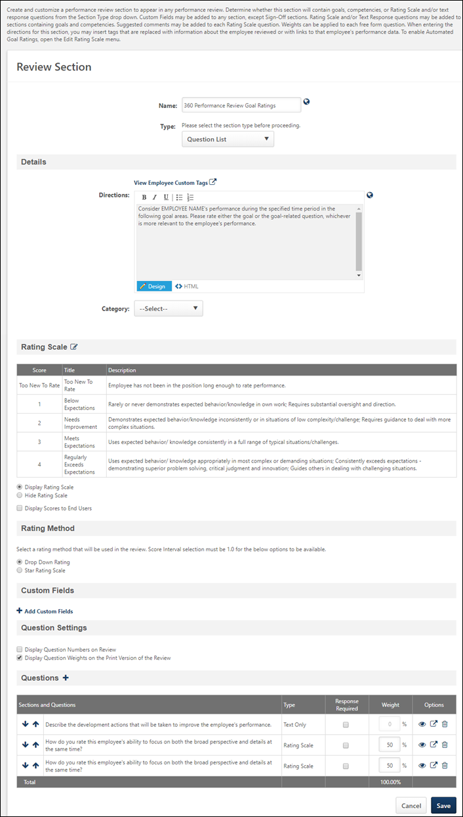
Details
- Directions - Enter directions that appear to the reviewers at the top of the performance review section. The character limit for this field is 3000 characters. To see a list of available tags that can be used in the directions, click the View Employee Custom Tags link. When utilized in the directions, the tags are automatically replaced with a hyperlink on the review form, similar to the way email tags work. HTML can be used. The system only accepts certain customizable HTML elements in the WYSIWYG Editor. Elements that are not acceptable display as text. See Safe Listed Customizable Elements. If multiple languages are enabled for your portal, select the Translate icon to translate the field into other available languages.
- Category - Select the appropriate category from the drop-down.
Rating Scale
This section displays the default rating scale for the section along with options related to the rating scale. Default section rating scales are automatically pulled into each new performance review, but can be modified for each performance review.
Click the Edit icon to modify the default rating scale. See Define Performance Review Section Rating Scale on page 304 for additional information.
- Display Rating Scale - Select this option to display the rating scale to users.
- Hide Rating Scale - Select this option to hide the rating scale from users.
- Display Scores to End Users - Select this option to display the scores along with the rating.
Each rating scale question on the review contains a drop-down that displays the rating. The score is also displayed if the Display Scores to End Users option is selected.
If a score interval of 0.5 or 0.1 is selected, then a text box appears in the section, rather than a rating scale drop-down list.
Rating Method
This section is only available when the new performance reviews user interface (UI) is enabled.
The Rating Method section is only active when the score interval for the rating scale is 1.0. If a score interval other than 1.0 is selected for the section rating scale, the Rating Method options are disabled and a text input rating option is implemented for the section.
Select the appropriate rating method for the performance review section:
- Drop-Down Rating - When this option is selected, reviewers select a rating from a drop-down for the section.
- Star Rating Scale - When this option is selected, reviewers select a star rating for the section.
Note: Once a performance review section is saved, any change to the Rating Method causes the section template to create a new version.
Custom Fields
This section displays the custom fields that are included in the section. To add a custom field, in the Custom Fields section, click the Add Custom Fields link. The Select Fields pop-up opens. Note: The Custom Fields section is only available if the administrator has availability to at least one custom field.
Click the option box to the left of the field title to select the field. You can also search for a custom field by title using the Search field. Note: Only custom fields that are available to the user appear in the list. After selecting the appropriate custom fields, click Save. Up to 100 custom fields can be selected.
- After custom fields are added to the review form section, you can reorder them by dragging and dropping them into the appropriate order.
- Select the Required option to require users to complete the custom field.
- Click the Remove icon to remove any custom fields from the section.
When editing a review section that already contains custom fields, all custom fields that have been added to the section appear to the administrator, regardless of the availability of the custom fields. Administrators can also reorder or delete any fields that have been added to the section, regardless of the availability of the custom fields.
Custom fields that are added to the review section only appear to the reviewer or reviewee in the review if they are within the availability of the custom field.
Question Settings
- Display Question Numbers on Review - Select this option to display question numbers next to each question on the review.
- Display Question Weights on the Print Version of the Review - Select this option to display the weights associated with each question on the printable version of the review. For example, if one question carries more weight than another, then after users have completed their review and they view the printable version, they can see the corresponding weights for each question.
Questions
To add a question to the section, click the Add Question icon, which opens the Add Questions window. From the Add Questions window, select an existing question from the question bank or create a new question. The character limit for questions is 2000. On the Add Questions window, click Done when you have selected the appropriate questions.
Once questions are added, reorder them using the up and down arrows.
Determine which questions are optional and which are required by selecting the Response Required option.
Enter a weight for each question in the Weight column. All question weights must total 100%. If all questions are text only, the Weights column is disabled. Depending on the backend setting, the weight percentage fields may accept up to two decimal places.
Preview, Edit, or Delete a question using the appropriate icon.
Question Title HTML Safe List
For organizations using the redesigned performance reviews, when creating questions within a Question List performance review section, an HTML safe list is used for the Question field. Only HTML tags that are on the safe list will be rendered.
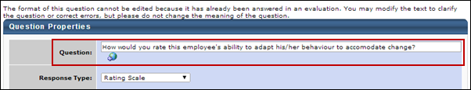
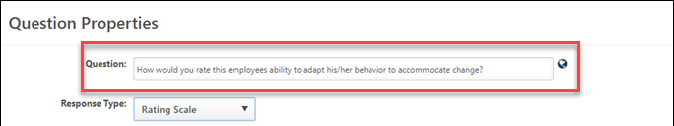
Only certain HTML tags will be rendered. All other tags will not be rendered and the tags will display as text. See HTML Safe List.
Batch Ratings Considerations
For Question List performance review form sections, batch ratings can be provided for drop-down fields and numeric fields. Also, the following custom field types are supported:
- Checkbox
- Date
- Drop-down
- Numeric
- Radio Button
- Scrolling Text Box
- Short Text Box
In the Question Settings section, the Display Question Numbers on Review setting is enforced on the Batch Rating page.
In the Question section, any questions with ratings that are added will be supported and displayed in the corresponding Question List section tab on the Batch Rating page.
Save
Click the Save button to save the performance review section.

Create Review Section - Sign Off
For some organizations, it is important to document the signature at the end of the performance review. Using the Sign Off section, you can include signature lines in a printed copy of the review or allow reviewers to type their name into the review itself and "electronically sign" and date the review in the system.
To create a performance review section, go to Admin > Tools > Performance Management > Form Sections. Then, click the Create Review Section link.
Permissions
PERMISSION NAME | PERMISSION DESCRIPTION | CATEGORY

Performance Review Form Sections - Manage | Grants ability to create and manage performance review questions and sections which are used in performance review tasks. This permission can be constrained by OU and User's OU. This is an administrator permission. | Performance - Administration
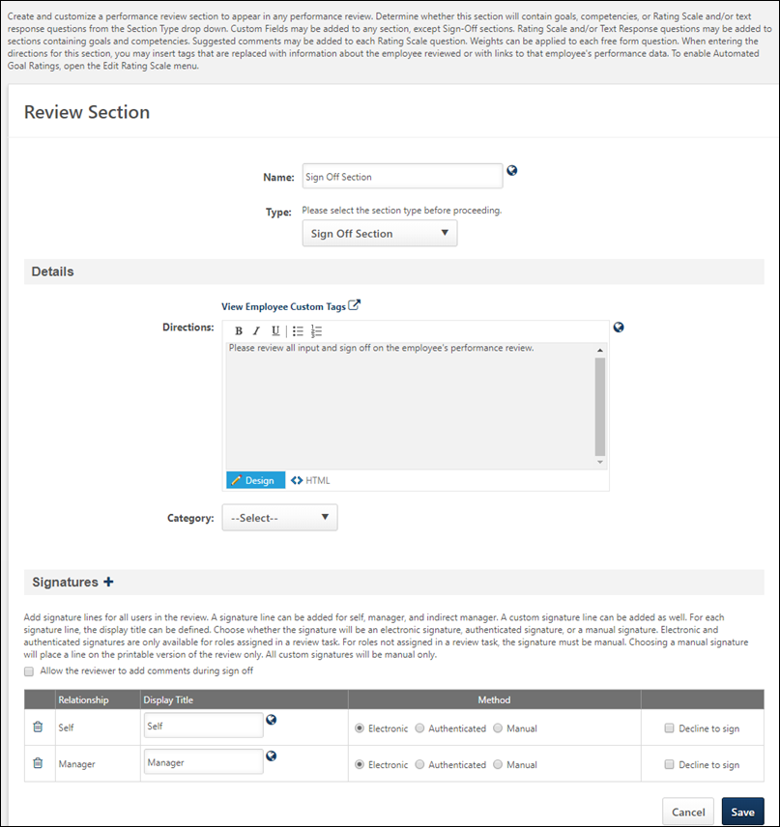
Details
- Directions - Enter directions that appear to the reviewers at the top of the performance review section. The character limit for this field is 3000 characters. To see a list of available tags that can be used in the directions, click the View Employee Custom Tags link. When utilized in the directions, the tags are automatically replaced with a hyperlink on the review form, similar to the way email tags work. HTML can be used. The system only accepts certain customizable HTML elements in the WYSIWYG Editor. Elements that are not acceptable display as text. See Safe Listed Customizable Elements. If multiple languages are enabled for your portal, select the Translate icon to translate the field into other available languages.
- Category - Select the appropriate category from the drop-down.
Signatures
To add a signature to the section, click the Add Signature icon, which opens the Add Signatures window. From the Add Signatures window, select the signatures to add to the section. Signatures will be required from each of the selected roles. The options include Self, Manager, Indirect Manager, Custom Relationship, etc. Click Add to add the signatures to the section.
- Allow the reviewer to add comments during sign off - Select this option to all the reviewer to add comments within the sign off section at the end of the review. These allows reviewers to make some closing comments or clarifications regarding the review.
- Display Title - Set the title that displays for each role on the online and printed version of the review. If multiple languages are available for the portal, the display title can be localized by clicking the Translate icon to the right of the field.
- Signature Method:
  - Electronic - When selected, users enter their name electronically and click a Sign button. If this option is selected, the corresponding role must be assigned a review step within a task for the signature to appear. If the corresponding role is not assigned a review step, the signature line appears on the printable version only. Note: This option must be selected in order for the reviewer to use the Bulk Sign Off functionality for the performance review.
  - Authenticated - When selected, users sign off on the review by selecting an acknowledgment checkbox and clicking a Sign button. With this method, users do not type their name and cannot edit their name or signature. This prevents typos because the user's system name is automatically entered. All signatures that are designated as Authenticated revert to Manual if the selected relationship is not included as a reviewer.
  - Manual - When selected, users sign their names manually. For this option, a signature line appears on the printable version. This option is the only option available for Custom roles.
- Decline to sign - This option is unselected by default. When this option is selected, the corresponding role (e.g., Self, Manager) has the option to decline to add their signature to the Sign Off section of the performance review. This allows the reviewer to indicate that they do not agree with the outcome of the performance review. This option is only available when Electronic or Authenticated is selected as the signature method. If Manual is selected, this option is disabled and cannot be selected.
  - Best Practice: As a best practice, this option should only be selected for the Self reviewer role, and it should only be selected for organizations in which a performance review can be completed without a reviewer's sign off.
Save
Click the Save button to save the performance review section.

Define Section Category
Because performance reviews can be used for different purposes, it is helpful to create categories to differentiate what sections are to be used for what purpose. Every section should be associated to a category. Some common examples include categories to reflect the different times of year a specific section is used or sections for specific parts of the organization.
To manage section categories, go to Admin > Tools > Performance Management > Form Sections. Then, click the Define Section Categories link.
- Click the Add Category link. An entry appears at the bottom of the list.
- In the Name field, enter a name for the category. If multiple languages are enabled for your portal, select the Translate icon to translate the field into other available languages.
- Click the Save icon next to the entry.

Define Default Performance Review Section Rating Scale
A performance review rating scale is required for each section created. The same scale can be used for the overall performance review task as well.
Permissions
PERMISSION NAME | PERMISSION DESCRIPTION | CATEGORY

Performance Review Form Sections - Manage | Grants ability to create and manage performance review questions and sections which are used in performance review tasks. This permission can be constrained by OU and User's OU. This is an administrator permission. | Performance - Administration
To define a default rating scale, go to Admin > Tools > Performance Management > Performance Reviews > Form Sections. Then, click the Define Default Rating Scale link. The Define Default Rating Scale window appears.
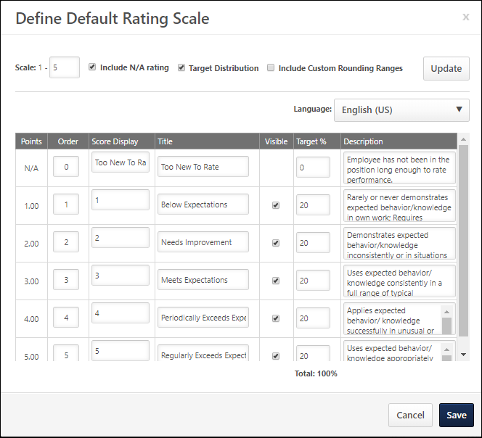
At the top of the pop-up, set the following configuration options to determine how the rating scale is structured. After setting these options, click the Update button to implement the settings and refresh the rating scale accordingly.
- Scale - This setting represents the rating scale used in the given performance review form section. Entering a number is required and creates a scale based on the number of ratings to be used in the review. Additional rows appear for every point on the defined scale.
- Include N/A rating - Select this option to include a scoreless value titled N/A at the top of the scale. This option allows reviewers to not select a rating if the particular evaluation does not apply or if the reviewer cannot properly judge the evaluation.
- Target Distribution - Select this option to define a target distribution of scores that managers can use as a guideline when reviewing their employees by viewing the Performance Review Distribution Report. The target distribution helps create consistency by providing all managers the same scoring guidelines for the review process.
- Include Custom Rounding Range - Select this option to define custom rounding for the default rating scale. See the Custom Rounding Range section below for additional information.
If multiple languages are available for the portal, the rating scale can be localized by selecting the appropriate language from the Language drop-down list. The ratings and descriptions for the administrator's default language must be entered prior to translating the rating and descriptions for other languages.
The following information displays for each point in the rating scale:
- Points - This field is fixed for each rating and cannot be changed. This represents the numerical value used to calculate a score for the section using the scale.
- Order - This determines the display order of the scale. In some cases, organizations want the highest possible score to display at the top of the list, while other organizations want the highest possible score to display at the bottom of the list. The point with the lowest Order value displays at the top of the rating scale. Click Update to refresh the display based on the updated Order values.
- Score Display - This is the value that reviewers see during the review process. This represents the point value of the rating on the rating scale. This can be a number or letter or combination of both and is used to help express what the score is on the rating scale. Typically, this number matches the point value of the rating scale, but other examples include the first letter of the scale (E for Exceptional, A for Above Average, etc.).
- Title - This represents the value of the rating (Exceptional, Above Average, etc.). This can also be a combination of letters and numbers that express the value of the point on the rating scale.
- Visible - When this option is selected, the corresponding rating scale score is available to reviewers when completing a performance review. When this option is deselected, the corresponding rating scale score is not available to reviewers and cannot be selected. In addition, when this option is not selected for a rating score, the range value cannot be set and the Target % is set to zero.
- Range - See the Custom Rounding Range section below for additional information.
- Target % - This column is visible only when the Target Distribution option is selected. If this option is selected and the Target % column is not visible, click Update. This is the target distribution for each rating. The total of all percentages must be 100%.
- Description - This is used to explain the rating in greater detail.
After defining the default rating scale, click Save to save the changes and return to the Performance Review Sections page.
Custom Rounding Range
For every rating that has the Visible option selected, a range of numbers appears in the Range column. Each range of numbers represents a range of performance review scores. If a reviewee's performance review score is within the range of scores, then the reviewee's performance review score is set to the corresponding rating. For example, if the range of 2.5-3.4 corresponds to a rating of 3.0 (Meets Expectations) and the range of 3.5-5.0 corresponds to a rating of 5.0 (Superior Performance), then a reviewee with a score of 3.4 gets a rating of 3.0 (Meets Expectations) and a reviewee with a score of 3.5 gets a rating of 5.0 (Superior Performance). Note: The reviewee's numeric score is unchanged. However, the text ratings can be determined by custom rounding.
The left value in the range is known as the range floor and it represents the lowest value that is included in the range.
- The range floor value is always read-only. If a range ceiling is modified, the range floor for the following range is automatically adjusted to match the previous range ceiling. For example, for the first rating (1.0), the range is set to 0-1.0. The range floor for the following rating (2.0) is automatically set to 1.1 because this is the next possible performance review score. If the range ceiling for the first rating (1.0) is modified from 1.0 to 1.4, the range floor for the following rating (2.0) is automatically updated to 1.5 because this is the next possible performance review score.
- The first range floor is always set to zero.
The right value in the range is known as the range ceiling and it represents the highest value that is included in the range. This value can be modified for all ranges except the final value, which is equal to the highest rating point value.
If a rating is set as not visible, the range for that rating is not available and is set to N/A. The ranges for the remaining ratings are automatically adjusted to account for the missing range.
If a rating that is not visible is set to be visible, the ranges are automatically adjusted to accommodate the new rating.

Define Performance Review Section Rating Scale
A performance review rating scale is required for each section you create. You can also use this scale for the overall performance review task. The rating scale for a performance review section is defined when creating the performance review section.
To create a performance review section, go to Admin > Tools > Performance Management > Form Sections. Then, click the Create Review Section link.
Permissions
PERMISSION NAME | PERMISSION DESCRIPTION | CATEGORY

Performance Review Form Sections - Manage | Grants ability to create and manage performance review questions and sections which are used in performance review tasks. This permission can be constrained by OU and User's OU. This is an administrator permission. | Performance - Administration
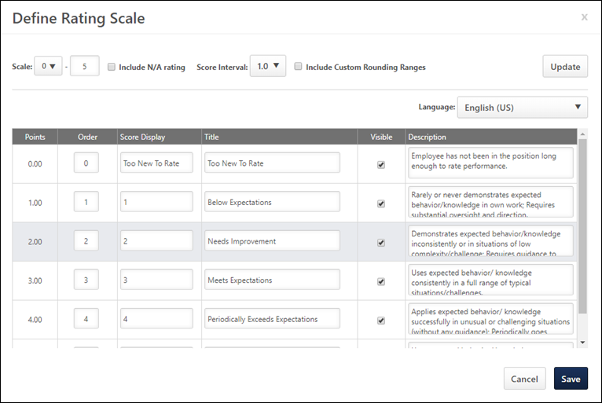
To define the Rating Scale:
- In the Type field, click Question List, Goal Rating Section, or Competency Section. Then, click the Edit icon in the Rating Scale section.
Automatically Calculate Section Rating
Note: The automated goal rating feature provides an automated rating for the entire goal rating section, not individual goals.
When this option is selected, a Progress Range column is added to the pop-up. The fields in this column are used to define the progress range for each rating. For example, if the 1.00 point rating has a progress range of 15-35, then any user who has a goal completion percentage of 15-35% will automatically get a rating of 1.00 point for the Goal Rating section. The first row of the rating scale always begins at 0%, even if the N/A rating is included in the rating scale. As you set the upper range values for each rating, the lower range values are automatically set to ensure all progress values are mapped to a rating. Progress range values respect the Performance Precision setting that is configured in a backend setting.
When this option is selected, the Include Custom Rounding Ranges option is unselected, and this cannot be modified.
After selecting or unselecting this option, you must select the Update button to apply your changes and refresh the pop-up display. The Update button applies any updates to the Automatically calculate section rating option, the Scale field, the Include N/A rating option, and the Scale Interval setting.
Note: If the Visible setting is unselected for a rating value, then the Progress Range value is disabled.
Note: Modifying the rating scale creates a new version of the section.
Note: Goal rating sections must have Rate Rights in order for the section to be rated automatically.
Scale, N/A Rating, Score Interval, Custom Rounding
At the top of the pop-up, set the following configuration options to determine how the rating scale is structured. After setting these options, click the Update button to implement the settings and refresh the rating scale accordingly.
- Scale - This setting represents the rating scale used in the given performance review form section. Entering a number is required and creates a scale based on the number of ratings to be used in the review. Additional rows appear for every point on the defined scale.
- Include N/A rating - Select this option to include a scoreless value titled N/A at the top of the scale. This option allows reviewers to not select a rating if the particular evaluation does not apply or if the reviewer cannot properly judge the evaluation.
- Score Interval - From the drop-down list, determine the score interval for the rating scale. This score interval can use whole points (1), half points (0.5), or a tenth of a point (0.1).
- Include Custom Rounding Range - Select this option to define custom rounding for the rating scale. Note: This option is only available if the Score Interval is set to 1.0. If any other score interval is selected, custom rounding is not available and standard rounding rules apply. See the Custom Rounding Range section below for additional information.
Language
If multiple languages are available for the portal, the rating scale can be localized by selecting the appropriate language from the Language drop-down list. The ratings and descriptions for the administrator's default language must be entered prior to translating the rating and descriptions for other languages.
Rating Scale Table
The following information displays for each point in the rating scale:
- Points - This field is fixed for each rating and cannot be changed. This represents the numerical value used to calculate a score for the section using the scale.
- Order - This determines the display order of the scale. In some cases, organizations want the highest possible score to display at the top of the list, while other organizations want the highest possible score to display at the bottom of the list. The point with the lowest Order value displays at the top of the rating scale. Click Update to refresh the display based on the updated Order values.
- Score Display - This is the value that reviewers see during the review process. This represents the point value of the rating on the rating scale. This can be a number or letter or combination of both and is used to help express what the score is on the rating scale. Typically, this number matches the point value of the rating scale, but other examples include the first letter of the scale (E for Exceptional, A for Above Average, etc.).
- Title - This represents the value of the rating (Exceptional, Above Average, etc.). This can also be a combination of letters and numbers that express the value of the point on the rating scale.
- Visible - When this option is selected, the corresponding rating scale score is available to reviewers when completing a performance review. When this option is deselected, the corresponding rating scale score is not available to reviewers and cannot be selected. In addition, when this option is not selected for a rating score, the range value cannot be set and the Target % is set to zero.
- Range - See the Custom Rounding Range section below for additional information.
- Description - This is used to explain the rating in greater detail.
After defining the rating scale, click Save to save the changes and return to the Create Review Form Section page.
Custom Rounding Range
For every rating that has the Visible option selected, a range of numbers appears in the Range column. Each range of numbers represents a range of performance review scores. If a reviewee's performance review score is within the range of scores, then the reviewee's performance review score is set to the corresponding rating. For example, if the range of 2.5-3.4 corresponds to a rating of 3.0 (Meets Expectations) and the range of 3.5-5.0 corresponds to a rating of 5.0 (Superior Performance), then a reviewee with a score of 3.4 gets a rating of 3.0 (Meets Expectations) and a reviewee with a score of 3.5 gets a rating of 5.0 (Superior Performance). Note: The reviewee's numeric score is unchanged. However, the text ratings can be determined by custom rounding.
The left value in the range is known as the range floor and it represents the lowest value that is included in the range.
- The range floor value is always read-only. If a range ceiling is modified, the range floor for the following range is automatically adjusted to match the previous range ceiling. For example, for the first rating (1.0), the range is set to 0-1.0. The range floor for the following rating (2.0) is automatically set to 1.1 because this is the next possible performance review score. If the range ceiling for the first rating (1.0) is modified from 1.0 to 1.4, the range floor for the following rating (2.0) is automatically updated to 1.5 because this is the next possible performance review score.
- The first range floor is always set to zero.
The right value in the range is known as the range ceiling and it represents the highest value that is included in the range. This value can be modified for all ranges except the final value, which is equal to the highest rating point value.
If a rating is set as not visible, the range for that rating is not available and is set to N/A. The ranges for the remaining ratings are automatically adjusted to account for the missing range.
If a rating that is not visible is set to be visible, the ranges are automatically adjusted to accommodate the new rating.

Snapshot - Reviews
The Reviews page enables users, managers, and administrators to view a summary of the user's performance reviews. The availability of certain functionality is determined by the user's permissions.
To access the Snapshot: Reviews page, go to Home > Universal Profile. Select the Snapshot tab. Then, select the Reviews widget.
Permissions
The availability of this functionality is controlled by backend settings.
PERMISSION NAME | PERMISSION DESCRIPTION | CATEGORY

Snapshot - Reviews | Enables user to view the Reviews widget and subpage within the Universal Profile - Snapshot page for users within their permission constraints. This permission can be constrained by OU, User's OU, User Self and Subordinates, User, User's Self, User's Manager, User's Superiors, User's Subordinates, User's Direct Reports, and Employee Relationship. Best Practice: For most users, this permission should be constrained by User Self and Subordinates. | Universal Profile

Launch Off-Cycle Performance Review Task | Enables a user to launch an off-cycle performance review task. Having this permission does not guarantee that the user can launch an off-cycle review, only that they will have access to the Launch Performance Review page. A task must still be configured properly for the user to successfully launch an off-cycle review task. This permission works only if user has been designated to launch at least one currently active off-cycle performance review task. This permission can be constrained by OU, User's Subordinates, and Employee Relationship. This is an end user permission and does not apply to an administrator role.
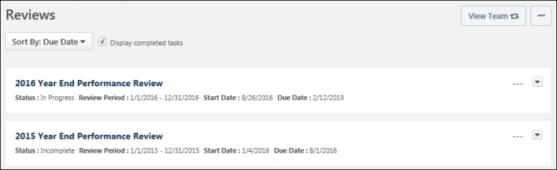
View Team
The View Team flyout allows managers, approvers, and custom relationships to quickly navigate between subordinates' profiles and transcripts. When enabled, the View Team flyout is available to managers and dotted line managers on all pages of their Universal Profile and the Universal Profile of their subordinates. This flyout displays the manager's reports visually.
The View Team button displays if enabled in the portal. Administrators may enable or disable this flyout via the My Team Dropdown section within Universal Profile General Preferences. See Universal Profile General Preferences.
See Universal Profile - View Team Flyout.
Options
The following options are available in the Options drop-down menu:
- Launch Review - Select this option to launch an off-cycle performance review for the user whose Universal Profile page you are viewing. This option is only available if you have permission to launch off-cycle reviews, and an off-cycle review is available for the user. See Universal Profile - Options - Launch Review.
Sort By
The table of reviews can be sorted using the following sorting options within the Sort By drop-down menu at the top of the Reviews section:
- Due Date - Select this option to sort the reviews in chronological order by due date, with the incomplete review with the soonest due date displayed first.
  - All incomplete reviews are displayed before all completed reviews.
  - Completed reviews are listed after incomplete reviews, with the most recently completed review displayed first.
  - Reviews with the same due date are then sorted alphabetically.
- Completion Date - Select this option to sort the reviews in chronological order by completion date, with the most recently completed review displayed first. Reviews with a completion date of "N/A" are displayed first. Reviews with a due date are listed after completed reviews, with the review with the soonest due date displayed first. Reviews with the same completion date are then sorted alphabetically.
- Start Date - Select this option to sort the reviews in chronological order by start date, with the reviews with the most recent start date displayed first. Reviews with the same start date are then sorted alphabetically.
- Status - Select this option to sort the reviews by status. Reviews with the same status are then sorted alphabetically. Reviews are sorted in the following status order:
  - Not Started
  - In Progress
  - Completed
  - Expired
  - Incomplete
Display completed tasks
This option is selected by default. This ensures that users see historical performance review information as soon as they navigate to the page.
When this option is selected, the page includes reviews with a status of Completed. When this option is unselected, reviews with a status of Completed are hidden.
Reviews List
Note: A review task is only displayed on the Reviews page if it is visible to the reviewee. Administrators can configure whether a review task is visible to the reviewee when creating the performance review task. Administrators cannot hide a performance review task from a reviewee if the user is assigned a review step for the performance review.
The following information is displayed for each review in the Performance Reviews list:
- Review Title - Users can select the review title to launch the review. See Performance Review - End User Overview on page 85 for additional information.
- Status - The current status of the review.
- Review Period - The dates for the review period.
- Start Date - The review start date.
- Due Date - The review end date.
- Completion Date - This is visible only if the review has been completed.
- Rating - If the review is complete and a numeric rating has been configured to display for the review, then the value is displayed to the right of the review details. Note: The visibility of the rating is determined by the administrator when creating the performance review task.
Review Actions
The following review actions may be available from the actions drop-down menu to the right of the review:
- Launch Review - Select this option to launch the review. The review opens to the step that is assigned to the user who is performing the action. Note: This option is not available for completed performance reviews. See Performance Review - End User Overview on page 85 for additional information.
- Print Review - Select this option to download a PDF of the reviewee version of the review.
- Print Review - Manager Version - Select this option to download a PDF of all sections of the performance review, including all submitted responses. Note: This option is only available when viewing a subordinate's Snapshot.
- Print Review - Reviewee Version - Select this option to download a PDF of only the sections that are visible to the reviewee. Note: This option is only available when viewing a subordinate's Snapshot.
- Attachments - Select this option to view the attachments for the review. This opens the Attachments pop-up, in which users can select an attachment to view it. This option is only available if attachments are enabled for the performance review task and if the performance review has at least one attachment.
- Work Offline - Select this option to download the review to Excel. This enables the user to complete the review offline. See Complete/Upload Offline Review Task on page 249 for additional information.

Review Task Central
Review Task Central provides reviewers an easy way to view and work on all their assigned performance review steps in one location. Additionally, it is easy to see which performance tasks are due and where to find them.
Once an administrator enables Review Task Central, users can:
- Filter by review status
- Search for reviewees by name
- View all previous off-cycle tasks
Before Review Task Central functionality is visible, an administrator must enable it. See Activating Review Task Central on page 315 for additional information.
Important: Once activated, Review task Central cannot be reverted.
Once activated, Review Task Central provides access to:
- A reviewee view to view all personal review and any other steps in one location. See Review Task Central - Reviewee View on page 318 for additional information.
- A reviewer view to view current review step and any other steps assigned in one location. See Review Task Central - Reviewer View on page 316 for additional information.
- A bulk submit feature to submit multiple assigned review steps at one time, if enabled. See Review Task Central - Bulk Submit on page 323 for additional information.
- A bulk reopen feature to reopen a review step for one or more reviewees at one time, if enabled. See Review Task Central - Bulk Reopen on page 319 for additional information.
- A Skills Assessment section that allows reviewers and reviewees to view and manage skills during a performance review, if enabled. See Create Review Section - Skill Assessment on page 326 for additional information.
Additionally, Review Task Central provides a new Skill Assessment type that integrates a user's skills profile into performance reviews and updates the skills profile as part of a performance review task. It is not possible to add step weight to the Skill Assessment Form Section.
Review Actions Menu
Selecting Review Actions Menu opens the Review Actions menu. This menu:
- Allows users to navigate between assigned review steps.
- Highlights the step the reviewer is currently working on.
- Displays step titles that are displayed in the Performance Review Workflow.
- Displays the Bulk Actions option, if enabled.
- Consolidates links to performance reviews. If a manager has 20 direct reports, they will see only one link that opens to all 20 reviews.
Status Changes
All performance tasks that use Task Central now show new statuses as follows:
- Open: There are actionable steps to complete.
- Closed: There is no current action that can be taken on that review.
This change applies to the Universal Profile Actions, Scheduled Tasks, Action Items, and Performance Review Summary pages.
Note: The filters on the Performance Review Summary Page will be mapped to the new open and closed statuses.
Due Date Changes
The following due date changes now apply:
- The due date associated with the task central link will represent a consolidated due date. This applies to the due date field on the Universal Profile - Actions, Performance Review Summary, Scheduled Tasks, and Actions items pages.
- If there is an action to complete on the task, and the status is open, the due date shows the earliest due date in the step.
The due date for the review step is also visible in the section header.
Reviewee View
A new Review Actions Menu allows users to:
- Navigate between the review step they are currently on and any other steps they are assigned.
- Access bulk actions, if enabled.​
Reviewee Menu
Reviewers can:
- Move between reviewees or review sections.
- View when a review is completed, in progress, or past due.
- View the due date for each review.
- View all the reviews assigned for that step in the left-hand navigation bar.
Statuses and Tags
The reviewee menu now displays three status icons:
- Completed: Green check mark icon
- Past due: Red warning sign icon
- In progress: Blue dot icon
Tags appear above reviewee names to identify when a step is re-opened or if the reviewer is serving as a co-planner for that reviewee.
Off-cycle Tasks
The review view applies to Off-cycle tasks as follows:
- The Off-cycle task shows each occurrence of that task in the reviewer menu.
- The Off-cycle task title is visible in the reviewee header.
- Reviewees can filter by step status or off-cycle task name.
- The Off-cycle task name displays below the reviewee name.
- A reviewer will see all reviews assigned for that step in the left navigation bar.
Form Sections
Form sections are the building blocks of the review process in Task Central, allowing the customization of reviews to meet the specific needs of the organization and its employees. Review Task Central provides the following form sections:
- Competency Assessment: Allows inclusion of a competency assessment in performance review tasks for both standard and off-cycle reviews.
- Competency: Enables reviewers and reviewees to rate and comment on performance regarding selected competencies during the review period.
- Development Plan: Allows reviewers to add training and action steps to a development plan for the reviewee during the performance review task.
- Evidence Collection: Used in conjunction with Competency Assessment review sections to gather evidence related to competencies.
- Goal Planning: Facilitates setting goals for the next period within the performance review.
- Goal Rating: Allows reviewers to rate the employee’s performance against approved goals within the performance review period.
- Question List: Contains basic questions about the employee’s overall performance with a rating scale for responses.
- Sign Off: Includes signature lines for a printed copy of the review or allows for an electronic signature directly in the system.
- Skills Profile - Enables users to view and manage skills they have, skills they want to develop, and skills they do not want to develop.
Users can add each form section multiple time within a single task. Note: This does not apply to the Skills Profile section, which can only be added once per task.
Buttons and Navigation
Task Central button names and navigation on the review task changed to the following:​
- Save for later button: Save and exit the review.
- Next button: Save and move to the next section.
- Previous button: Save and move to the previous section.
- X in top right corner of screen: Save and exit.
When a user navigates away from a task in Task Central, that task is automatically saved.
REVIEW.LINK email tag and Single Sign On (SSO)
If Review Task Central is enabled, the REVIEW.LINK email tag in Step Assigned and Step Due emails allows the use of an SSO deep link, if SSO is enabled in the portal.
Note: The REVIEW.LINK email tag only works with Task Central for step due and step assigned emails.
Considerations
- Task Administration: Review Summary
  - The Confirmation page is not available after Review Task Central is enabled.
  - Task Central uses aggregated links to access review tasks, so the tags used in Task List Names will not render. Instead, use a generic name, such as “2022 Manager Review”.​​
- During the early adopter period, Review Task Central does not support the following:
  - Discuss or decline review functionality for off-cycle tasks.
  - Review previews. ​
- During the early adopter period, only the following links are available under the options menu in the review: ​
  - Add co-planner​
  - Attachments​
  - Employee details ​
  - Print review
- Tags in Task Administration cannot be used for Task Central.

Activating Review Task Central
To access Review Task Central features, an administrator with appropriate permission must activate it.
Permissions
PERMISSION NAME | PERMISSION DESCRIPTION | CATEGORY

Performance Features Self Activation | Grants access to the Feature Activation Preferences page, where an administrator can activate new features associated with Performance. This is an administrator permission. | Performance - Administration
Important: Once activated, Review Task Central cannot be turned off.
To activate Review Task Central:
- Go to Admin > Tools > Performance Management > Performance Features Self Activation. The Feature Activation Preferences page opens.
- In the Activate Task Central area, select the Activate button. All newly created tasks now appear in the new interface.
Tasks created before activation remain in the legacy format. Tasks created after activation appear with a green check-mark next to their name in the Task Administration screen.

Review Task Central - Reviewer View
The reviewer view allows users to navigate between their current review step and any other steps assigned.
To access reviewer view, go to PERFORMANCE > PERFORMANCE REVIEWS and select the My Assigned Reviews tab. Select the appropriate link in the Title column.
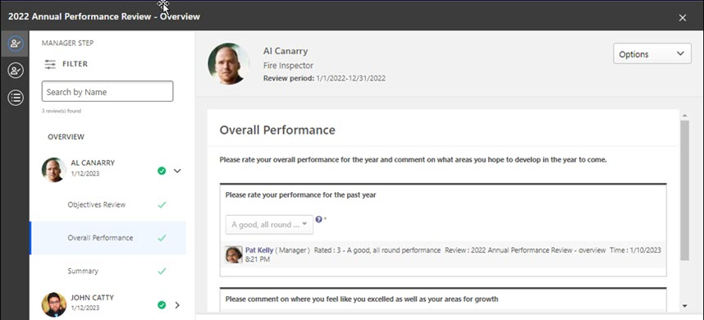
Standard Task
The following information applies to standard tasks.
Review Actions Menu
The Review Actions Menu lets users navigate between any review step assigned to them. The step the reviewer is currently working on is highlighted. The step titles displayed are the same step titles that display in the Performance Review Workflow.
Note: If enabled, a Bulk Actions item may appear on this list.
See Review Task Central - Bulk Reopen on page 319 for additional information.
See Review Task Central - Bulk Submit on page 323 for additional information.
Navigation Panel
All reviews assigned for a step appear in the left navigation panel. Reviewees can use the left navigation panel to move between reviewees and review sections.
To access review step sections, select a reviewee name. Their available sections appear in the right panel to complete.
The navigation panel also displays the name of the option selected on the Review Actions Menu.
For each reviewee, the navigation panel provides the following information:
- Green check - This indicates the task is Completed.
- Red warning icon - This indicates the task is Past due.
- Blue dot - This indicates the task is In Progress.
- Co-planner - This indicates the reviewer is a co-planner.
- Reopened - This indicates the step is reopened
- Due date - This indicates the he due date for each reviewee's review.
Filter
Use the following filters to filter the reviewee list by step status:
- All
- In Progress
- Past Due
- Not Started
- Completed
Search
Use the Search by Name field to locate reviewees by name.
Off-Cycle Task
The reviewee view for an off-cycle task displays each occurrence of the off-cycle task in the left navigation menu and the header.
Reviewees can filter by step status or off-cycle task name.

Review Task Central - Reviewee View
The reviewee view allows users to navigate between their personal review and any other steps assigned via the Review Actions menu.
To manage your review, select a link in the left navigation panel and complete the details in the right panel.
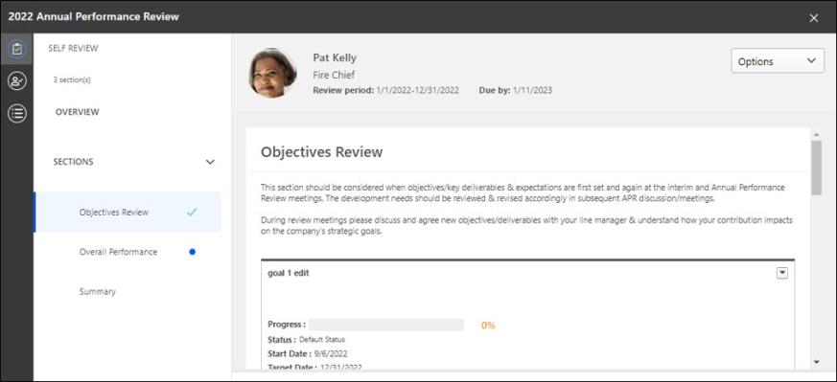
Standard Task
The following information applies to standard tasks.
Navigation Panel
The reviewee's review and any other assigned steps appear in the navigation panel. Selecting an item in the navigation panel displays its details in the right panel.
When a section of the review is completed, a green check appears next to the section title.
For convenience, the due date for the review step appears in the Due by field.
Off-Cycle Task
The left navigation panel for an off-cycle task shows each occurrence of the off-cycle task and the task title.
Reviewees can filter by step status or off-cycle task name.
Buttons
- Save for later - Option to save and exit the review
- Next - Saves the review and moves to the next section
- Previous - Saves the review and moves to the previous section

Review Task Central - Bulk Reopen
Use the Task Central Bulk Reopen page to reopen and resubmit a review step for one or more reviewees at the same time and provide a reason for reopening the step.
Bulk reopen supports up to 1,000 users per bulk reopen action.
Note: Only one step can be opened at a time. Comments about why a step is reopened are visible in Review Task Central.
To use this functionality, Review Task Central must be enabled. See Activating Review Task Central on page 315 for additional information.
Permissions
PERMISSION NAME | PERMISSION DESCRIPTION | CATEGORY

Performance Review Task Administration | Grants ability to create/assign performance review tasks and manage activity within those tasks. This permission also gives the ability to enable and view co-planners for a task from the administration pages. This permission can be constrained by OU, User's OU, User Self and Subordinates, and User. | Performance - Administration

Performance Review Task - Manage | Grants ability to assign performance review tasks and manage activity within those tasks. This permission works in conjunction with the Admin Visibility settings for the performance review task. Administrators who have this permission and are within the Admin Visibility settings can view the task, edit the task, add users, and view the task details. However, the admin cannot edit the Admin Visibility settings for the task. This permission can be constrained by OU, User's OU, User Self and Subordinates, and User. The constraints on this permission control which users can be added to the task. | Performance - Administration
Enabling Bulk Reopen
To enable bulk reopen:
- Go to Admin > Tools > PERFORMANCE MANAGEMENT > TASKS.
- Select the edit icon for the appropriate review and then select the Review Workflow tab .
- In the Review Step section, check Allow the Reopener (Manager, Indirect Manager, and any Custom Relationships to reopen steps.
Submitting Bulk Reopen
To bulk reopen steps:
- Go to ADMIN > TOOLS > PERFORMANCE MANAGEMENT > TASKS.
- Select a task and in the Options column, select the ellipsis, and then select Bulk Reopen. The Bulk Reopen page opens.
- Select a step or search for a step and select it.
- Click the check-boxes for one or more users.
- Click the Reopen Step button. A Reopen Step window opens.
- In the Comments box, enter the reason for reopening this step.
- Click the Reopen step button. The reopen information is displayed in the Bulk Reopen table, including the comment and reopened due date.
Once processing is done, a success message, a partial success message, or a failed message appears.
- If successful, the step is reopened and the comment is displayed for the appropriate assignees in Task Central.
- If the bulk reopen was partially successful or not successful, you are returned to the bulk submit page to correct any errors and submit again.
Note: During bulk action processing, the reviewer cannot navigate away from the Bulk Actions page.
Note: Bulk reopen is enabled per step and cannot be enabled or disabled once a task is started.

Review Task Central - Bulk Sign Off
Use the Task Central Bulk Actions Sign Off tab to save time by allowing signers to sign off on multiple steps in a single review task.
To use the bulk sign-off feature, the review step must include a sign off section and the electronic signature must be enabled for the signer. See Create Review Section - Sign Off on page 297 for additional information.
To use this functionality, Review Task Central must be activated. See Activating Review Task Central.
Bulk sign-off is not available for self-review, peer, or subordinate review steps.
A maximum of 1000 records will be displayed in the table at one time. As records are signed-off and automatically removed from the table, new records may appear, if necessary.
Permissions
PERMISSION NAME | PERMISSION DESCRIPTION | CATEGORY

Performance Review Task Administration | Grants ability to create/assign performance review tasks and manage activity within those tasks. This permission also gives the ability to enable and view co-planners for a task from the administration pages. This permission can be constrained by OU, User's OU, User Self and Subordinates, and User. | Performance - Administration

Performance Review Task - Manage | Grants ability to assign performance review tasks and manage activity within those tasks. This permission works in conjunction with the Admin Visibility settings for the performance review task. Administrators who have this permission and are within the Admin Visibility settings can view the task, edit the task, add users, and view the task details. However, the admin cannot edit the Admin Visibility settings for the task. This permission can be constrained by OU, User's OU, User Self and Subordinates, and User. The constraints on this permission control which users can be added to the task. | Performance - Administration
Enable Bulk Sign Off
To enable bulk sign off:
- Go to Admin > Tools > PERFORMANCE MANAGEMENT > TASK ADMINISTRATION.
- Select the Review Workflow tab for the appropriate review.
- In the Define Review Step section, check Enable Bulk Signoff for this Review Step. Note: This checkbox is only visible if a sign-off section is added and the sign-off section has e-sign enabled.
Bulk Sign Off Review of Review Tasks
To submit bulk sign off review tasks:
- Go to Performance > Performance Reviews.
- In the reviewer view, in the Review Actions menu, select the bulk action icon. The Bulk Actions page opens to display all bulk actions available to the reviewer.
- Click the Sign Off tab.
- In the Assigned step drop-down, select an option to enable the selection check-boxes.
- Click one or more reviews to sign off on or search for specific assignees.
- Click Sign Off Reviews.
- In the confirmation window, in the Your first and last name box, enter your name. If you need to edit the signature, click Re-Sign and re-enter the information.
- Click Sign Off. Note: If an error message appears, go back and make the appropriate changes and attempt to sign-off again.
- Click Close on the confirmation message.
Note: Bulk Sign-off only signs off on the reviews. To submit the reviews, click the Submit tab.

Review Task Central - Bulk Submit
Use the Task Central Bulk Submit page to save time by submitting multiple assigned review steps at one time. To use the bulk submit functionality, an administrator must enable bulk submit for the specific review step.
Bulk submit supports up to 1,000 users per bulk submit action.
Note: To use this functionality, Review Task Central must be enabled. See Activating Review Task Central on page 315 for additional information.
Permissions
PERMISSION NAME | PERMISSION DESCRIPTION | CATEGORY

Performance Review Task Administration | Grants ability to create/assign performance review tasks and manage activity within those tasks. This permission also gives the ability to enable and view co-planners for a task from the administration pages. This permission can be constrained by OU, User's OU, User Self and Subordinates, and User. | Performance - Administration

Performance Review Task - Manage | Grants ability to assign performance review tasks and manage activity within those tasks. This permission works in conjunction with the Admin Visibility settings for the performance review task. Administrators who have this permission and are within the Admin Visibility settings can view the task, edit the task, add users, and view the task details. However, the admin cannot edit the Admin Visibility settings for the task. This permission can be constrained by OU, User's OU, User Self and Subordinates, and User. The constraints on this permission control which users can be added to the task. | Performance - Administration
Enabling Bulk Submit
To enable bulk submit:
- Go to Admin > Tools > PERFORMANCE MANAGEMENT > TASKS.
- Select the edit icon for the appropriate review and then select the Review Workflow tab .
- In the Define Review Step section, check Enable Bulk Submit for this Review Step to allow bulk actions to appear in Review Task Central.
Submitting Bulk Review Steps
To submit bulk review steps:
- In the reviewer view, in the Review Actions menu, select the bulk action icon. The Bulk Actions page opens to display all bulk actions available to the reviewer.
- Click the Submit tab to view all available reviews.
- Select a review step. This enables the selection check-boxes.
- Click one or more reviews to submit.
- Click SUBMIT REVIEWS. A processing message appears
Once processing is done, a success message, a partial success message, or a failed message appears. If the bulk submit was not successful, you are returned to the bulk submit page to correct any errors and try again.
Note: During bulk action processing, the reviewer cannot navigate away from the Bulk Actions page.
Note: Bulk submit is enabled per step and cannot be enabled or disabled once a task is started.
Note: Overall Step Rating only shows in the bulk submit table if an administrator enables the For In Progress steps, commit Section and Step Scores to Reporting on Save by reviewers option in task administration.

Review Task Central - Print Performance Review
Once Review Task Central is activated, you can print an updated .pdf version of a performance review.
Note: Review Task Central must be activated. See Activating Review Task Central on page 315 for additional information. Customers who do not activate Review Task Central will still see the old .pdf format.
To print a performance review in Review Task Central, go to Performance > Performance Reviews. Launch a review or open a review task. Click Options > Print Review.
Permissions
PERMISSION NAME | PERMISSION DESCRIPTION | CATEGORY

Performance Review Task - Manage | Grants ability to assign performance review tasks and manage activity within those tasks. This permission works in conjunction with the Admin Visibility settings for the performance review task. Administrators who have this permission and are within the Admin Visibility settings can view the task, edit the task, add users, and view the task details. However, the admin cannot edit the Admin Visibility settings for the task. This permission can be constrained by OU, User's OU, User Self and Subordinates, and User. The constraints on this permission control which users can be added to the task. | Performance - Administration

Performance Review Task Administration | Grants ability to create/assign performance review tasks and manage activity within those tasks. This permission also gives the ability to enable and view co-planners for a task from the administration pages. This permission can be constrained by OU, User's OU, User Self and Subordinates, and User. | Performance - Administration

Task - View | Grants ability to view assigned tasks via Scheduled Tasks screen and Welcome Page My Tasks widget. This is an end user permission. | Core

View Performance Reviews | Grants ability to view the Performance Reviews page, which displays a user's own past performance reviews as well as performance review task steps they've been assigned to complete. This also grants ability to view the Batch Rating page. This permission can be constrained by OU, User's OU, User Self and Subordinates, and User. This is an end user permission. | Performance

Create Review Section - Skill Assessment
Use the Skill Assessment type to integrate a user's skills profile into performance reviews and update the skills profile as part of a performance review task.
This allows a user's skill proficiency to be rated from within a review and allows the manager or user to add custom questions to the Skills Review section.
Once enabled, the Skills Assessment section can be assigned to Self, Manager, a Custom Relationship, or Peer.
- Reviewees can provide context for skills development over the review period, update their declared skills and proficiencies, identify areas of interest for further growth, and explore related learning.
- Reviewers can view a reviewee’s skills profile, rate their proficiency, provide context or comments around skill development, and explore related learning.
Note: Task Central must be activated to view the Skills Assessment type. See Activating Review Task Central on page 315 for additional information.
Note: It is not possible to add step weight to the Skill Assessment Form Section.
To create a skill assessment review section, go to Admin > Tools > Performance Management > Form Sections. Then, Click the Create Review Section link.
Permissions
PERMISSION NAME | PERMISSION DESCRIPTION | CATEGORY

Performance Review Form Sections - Manage | Grants ability to create and manage performance review questions and sections which are used in performance review tasks. This permission can be constrained by OU and User's OU. This is an administrator permission. | Performance - Administration
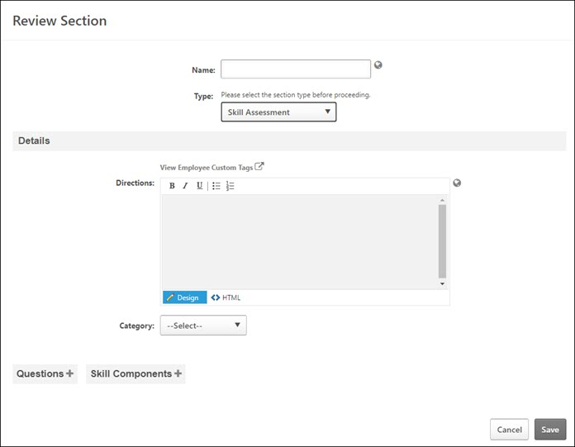
To create a Skill Assessment section:
- In the Name field, enter a name that helps identify the section. The character limit for this field is 50. If multiple languages are available for the portal, the section name can be localized by clicking the Translate icon to the right of the field.
- In the Type field, select Skill Assessment from the drop-down list.
Details
- Directions - Enter directions that appear to the reviewers at the top of the performance review section. The character limit for this field is 3000 characters. To see a list of available tags that can be used in the directions, click the View Employee Custom Tags link. When utilized in the directions, the tags are automatically replaced with a hyperlink on the review form, similar to the way email tags work. HTML can be used. The system only accepts certain customizable HTML elements in the WYSIWYG Editor. Elements that are not acceptable display as text. See Safe Listed Customizable Elements. If multiple languages are enabled for your portal, select the Translate icon to translate the field into other available languages.
- Category - Select the appropriate category from the drop-down.
Questions
To add custom questions to the section, click the Questions button to open the Add Questions window. From the Add Questions window, select an existing question from the question bank or create a new question. The character limit for questions is 2000. Click Done when you are done selecting questions.
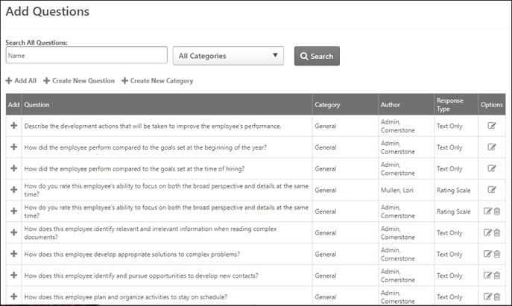
Skills Components
To add skill components from the Universal Profile to this section, click the Skills Components button to open the Add Skill Components window. Select the appropriate skills. Click Done when you are done adding skill components.
Questions and Skills Components Table
All selected questions and skills appear in the Questions and Skill Components table. Reorder the items using the up and down arrows.
Custom Fields
This section displays the custom fields that are included in the section. To add a custom field, in the Custom Fields section, click the Add Custom Fields link. The Select Fields pop-up opens. Note: The Custom Fields section is only available if the administrator has availability to at least one custom field.
Click the option box to the left of the field title to select the field. You can also search for a custom field by title using the Search field. Note: Only custom fields that are available to the user appear in the list. After selecting the appropriate custom fields, click Save. Up to 100 custom fields can be selected.
- After custom fields are added to the review form section, you can reorder them by dragging and dropping them into the appropriate order.
- Select the Required option to require users to complete the custom field.
- Click the Remove icon to remove any custom fields from the section.
When editing a review section that already contains custom fields, all custom fields that have been added to the section appear to the administrator, regardless of the availability of the custom fields. Administrators can also reorder or delete any fields that have been added to the section, regardless of the availability of the custom fields.
Custom fields that are added to the review section only appear to the reviewer or reviewee in the review if they are within the availability of the custom field.
Save
Click Save to save the selected questions and skill components. Selected options appear in the appropriate section in the end user's Performance Review.
The Skills Review section appears as a skills section in the user's Performance Review.
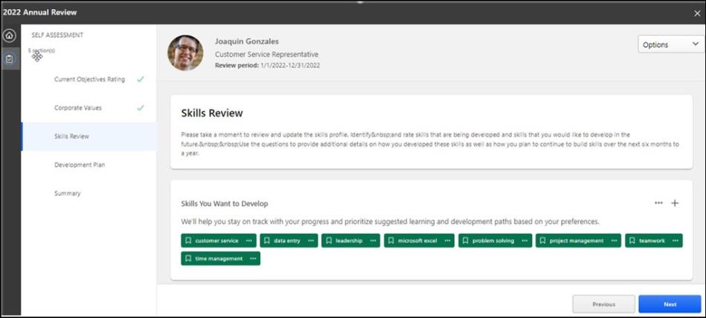

Set Printable View
Use the Printable View Settings page to configure the layout and appearance of the printable view of a performance review. The left side of the page displays all of the settings and options for the printable view, while the right side of the page displays a sample image based on those settings.
To access the Performance Review Printable View page, go to Admin > Tools > Performance Management. Then, select Set Printable View in the Performance Reviews section.
Permissions
PERMISSION NAME | PERMISSION DESCRIPTION | CATEGORY

Performance Review Print Preferences New UI – Manage | Grants ability to configure formatting preferences for the PDF version of redesigned performance reviews. This is an administrator permission. This permission can be constrained by OU and User's OU. | Performance - Administration
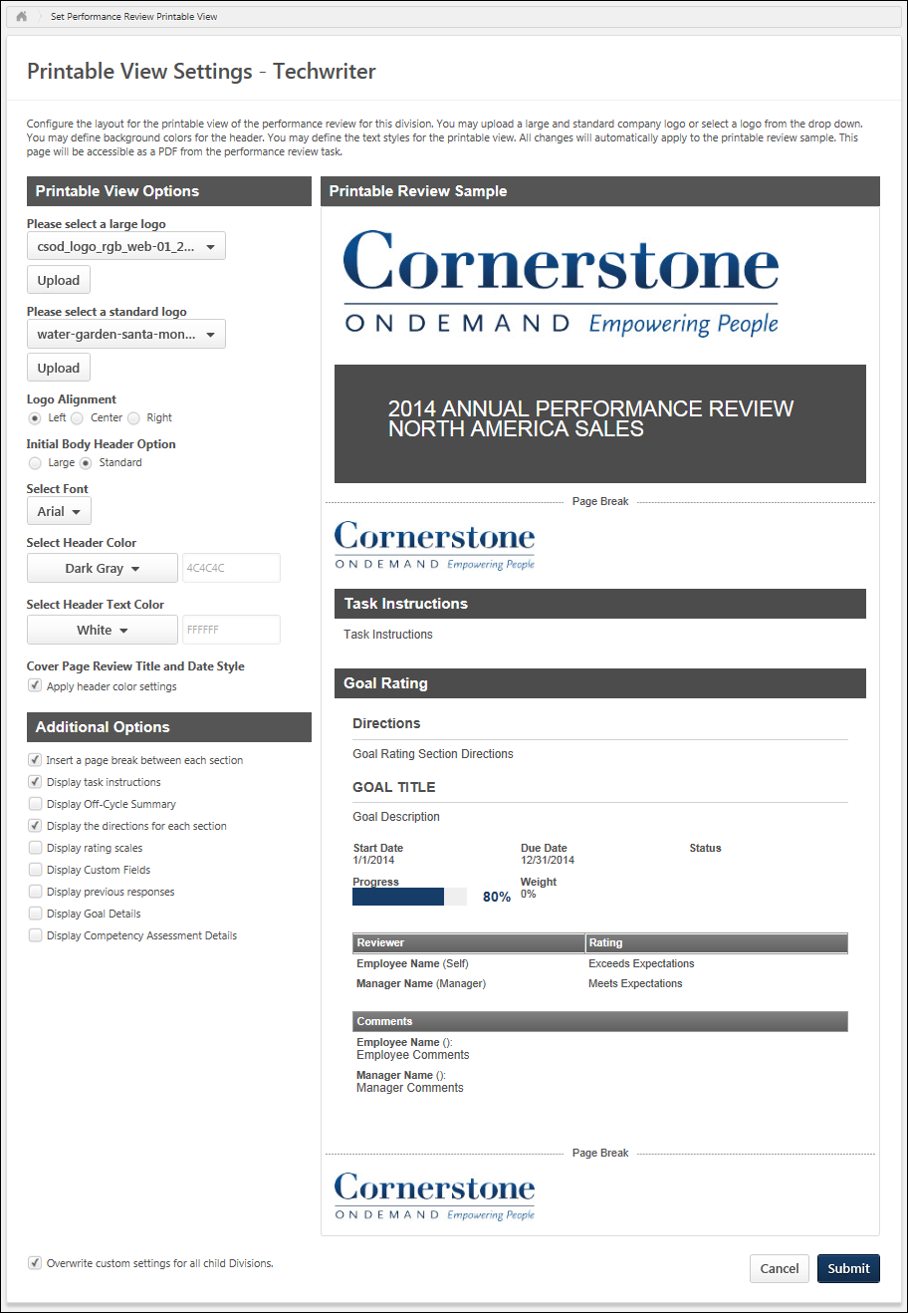
Printable Review Sample
The Printable Review Sample section displays a preview of a sample printable performance review based on the settings and options that are currently selected on the left. The sample is dynamically updated as settings and options are modified on the left. The sample review contains generic data.
Printable View Options
The following options are available in the Printable View Options section:
Large Logo
The large logo is used for the performance review cover page. The large logo also appears as the header for the first page of the report body if selected in the Initial Body Header Option field.
To select an existing logo, select the appropriate image from the Please select a large logo drop-down menu.
To upload a new logo, click the Upload button. This opens the Upload Logo pop-up, where you can browse for and select the appropriate image. The selected logo is displayed in the drop-down menu. The recommended image height is 120 pixels, and the recommended image width is 650 pixels. The supported file types are .jpg, .gif, and .png.
Standard Logo
The standard logo always appears as the header image for all pages of the performance review except for the first page of the report body. The standard logo appears as the header for first page of the report body if selected in the Initial Body Header Option field.
To select an existing logo, select the appropriate image from the Please select a standard logo drop-down menu.
To upload a new logo, click the Upload button. This opens the Upload Logo pop-up, where you can browse for and select the appropriate image. The selected logo is displayed in the drop-down menu. The recommended image height is 55 pixels, and the recommended image width is 650 pixels. The supported file types are .jpg, .gif, and .png.
Logo Alignment
Select whether logos are left, center, or right aligned. This applies to all logos in the performance review printable view.
Initial Body Header Option
This option determines whether the large logo or standard logo is used as the header image for the first page of the report body.
- Large - If this option is selected, then the large logo is used as the header image for the first page of the report body. All subsequent pages use the standard logo as the header image.
- Standard - If this option is selected, then the standard logo is used as the header image for all pages of the report body.
Font
This option determines the font that is used for all text in the performance review printable view.
Header Color
This option determines the background color for all headers throughout the report. This includes the performance review title header and all section headers. From the drop-down menu, select the appropriate header background color. The default selection is dark gray.
- Standard Color - To select a standard color, select the color from the drop-down menu. When a color is selected, the corresponding hex value is displayed in the field to the right of the drop-down menu. The hex value is read-only and cannot be modified.
- Custom Color - To specify a custom color, select Other from the drop-down menu and enter the custom color's hex value in the field to the right of the drop-down menu.
Header Text Color
This option determines the text color for all headers text throughout the report. This includes the performance review title header and all section headers. From the drop-down menu, select the appropriate header text color. The default selection is white.
- Standard Color - To select a standard color, select the color from the drop-down menu. When a color is selected, the corresponding hex value is displayed in the field to the right of the drop-down menu. The hex value is read-only and cannot be modified.
- Custom Color - To specify a custom color, select Other from the drop-down menu and enter the custom color's hex value in the field to the right of the drop-down menu.
Cover Page Review Title and Date Style
Select the Apply header color settings option to apply the Header Color and Header Text Color settings to the performance review task title and review date on the cover page. When this option is not selected, the performance review task title and review date text is black and the background color is white.
Additional Options
The following additional options are also available for the printable version, which allow you to further customize the printable version:
- Insert a page break between each section
  - When this option is selected, each section begins on a new page within the printable view.
  - When this option is not selected, each section begins immediately after the previous section.
- Display task instructions
  - When this option is selected, the performance review task instructions are displayed on the first page of the report body.
  - When this option is not selected, the task instructions are not displayed.
- Display Off-Cycle Summary
  - When this option is selected, the user's Off-cycle Summary is displayed in the printable view. The Off-cycle Summary is a summary of the employee's off-cycle performance reviews that have been completed throughout the year. This enables organizations to remind reviewers of the results of any off-cycle reviews that had occurred during the review period.
  - When this option is not selected, the Off-cycle Summary is not displayed.
- Display the directions for each section
  - When this option is selected, the directions for each section are displayed at the top of the corresponding section.
  - When this option is not selected, the section directions are not displayed.
- Display rating scales
  - When this option is selected, the rating scale for the section is displayed within the corresponding section. The rating scale is only displayed if the corresponding section has an associated rating scale.
  - When this option is not selected, the section rating scale is not displayed.
- Display Custom Fields
  - When this option is selected, custom fields are displayed for each section within the report that has associated custom fields. Custom fields only display if the corresponding section has associated custom fields.
  - When this option is not selected, section custom fields are not displayed.
- Display previous responses
  - When this option is selected, previous responses for each section are displayed within the corresponding section. Previous responses must also be enabled in the performance review task.
  - When this option is not selected, previous responses do not display.
- Display Goal Details
  - When this option is selected, the goal details (e.g., Perspective, Category, Tasks, Targets) are displayed for each goal within the Goal Rating and Goal Planning sections. Only goal fields that are enabled in Goal Configuration are displayed.
  - When this option is not selected, goal details are not displayed.
- Display Competency Assessment Details
  - When this option is selected, item based competencies display item level scores within the printable view. Competency assessment details are only included in the printable view if a competency assessment was included in the performance review.
  - When this option is not selected, only the overall competency rating is displayed.
Overwrite Settings
Select this option to overwrite custom settings for child division OUs. If you overwrite custom settings for child division OUs, the selected settings are applied to both new and existing child OUs. Any previously customized child OUs are updated with the selected settings.
- If there are no customizations to the child OU, then the parent OU customizations are applied to all child OUs.
- Overwrite custom settings checkbox setting
  - If this option is selected, all child OU customizations are deleted from the database, which means the parent OU customizations will be applied to new and existing child OUs.
  - If this option is unselected, all existing child OU customizations will remain unchanged, and any new child OUs will inherit the parent OU customizations by default.
- If a child OU has been customized to display any widgets, then regardless of the parent OU customizations, the child OU customizations are applied.
- If a child OU has been customized to hide all widgets, then parent OU customizations will take precedence and will be applied.
Submit/Cancel
- Click Submit to save any unsaved changes.
- Click Cancel to discard any unsaved changes.

An indirect manager reopens a previous step for the manager. For the manager, the task appears in their Scheduled Tasks list with the status the task was in prior to being reopened (e.g., Completed, Past Due). When the manager completes the reopened step, the indirect manager's step still has a status of "Complete" and does not need to be resubmitted. Thus, reopening the step for the manager does not change how the step appears in the indirect manager's task list.

