Organizational Unit Administration March 2024

Table of Contents
Organizational Units Overview 1
Organizational Units Administration 2
Organizational Unit - Create/Edit 5
Location OU - Create 10
Position OU - Create Overview 15
Position OU - Create - Step 1 - General 16
Position OU - Create - Step 2 - Related Jobs 20
Position OU - Create - Step 3 - Roles 22
Position OU - Create - Step 4 - Responsibilities 24
Position OU - Create - Step 5 - Attributes 26
Position OU - Create - Step 6 - Competencies 28
Position OU - Create - Step 7 - Training 31
Active Users in OU 33

Organizational Units Overview
Organizational Units (OUs) form the administrative foundation of your system. You can think of OUs as distinct information containers that capture, store and categorize all client data within the system. Often, OU information is loaded to and maintained in the Cornerstone system via an automatic Data Feed that sends information directly from your organization's Human Resource Information System (HRIS) or other application. The standard OU types are Division, Position, Cost Center, Location, and Grade.

Organizational Units Administration
Organizational Units (OUs) form the administrative foundation of Cornerstone. You can think of OUs as distinct information containers that capture, store and categorize all client data within the system. Often, OU information is loaded to and maintained in the Cornerstone system via an automatic Data Feed that sends information directly from your organization's Human Resource Information System (HRIS) or other application. The standard OU types are Division, Position, Cost Center, Location, and Grade.
OU types can be configured and mapped to your organization's Data Feed during your organization's implementation. If your organization's OU types need to be modified or if OU types need to be added after implementation, please reach out to your Implementation Consultant, who can advise you if additional OUs are needed and provide the necessary requirements to configure an additional OU type.
Administrators set availability for specific OUs to include and constrain functionality such as who can access certain learning objects or who is assigned a specific task (e.g., only users included in the Executive Group are assigned an annual competency assessment). OUs are also used to define reporting criteria.
To access Organizational Unit Administration, go to Admin > Tools > Core Functions > Organizational Units. Select the Manage Organizational Unit Hierarchy link. Then, select the appropriate OU type from the Select Organizational Unit drop-down list.
Permissions
PERMISSION NAME | PERMISSION DESCRIPTION | CATEGORY

Grades - View | Grants ability to view the Grade Organizational Unit throughout the system, such as in availability drop down selectors, when editing users, etc. Those without this permission do not see the Grade OU on any screen. This is primarily an administrator permission, although organizational policy should determine whether the Grade OU should be visible to end users on reporting screens, etc. | Core Administration

OU Group - Manage | Grants the ability to create, copy, and edit custom groups of users without allowing the ability to manage organizational units (OUs). This permission can be constrained by OU, User's OU, and Provider. This is an administrator permission. | Core Administration

OU Group - Update | Grants access to edit existing custom groups of users. This permission can be constrained by OU, User's OU, and Provider. This is an administrator permission. | Core Administration

OU Group - View | Grants access to view existing custom groups. This permission can be constrained by OU. This is an administrator permission. | Core Administration

OU Hierarchy - Manage | Grants ability to create and update/edit organizational units. This permission grants access to all OU types, both standard and custom. This permission can be constrained by OU and User's OU. This is an administrator permission. | Core Administration

Requisition Template - Manage | Grants ability to access and view Requisition Templates. This permission cannot be constrained. This is an administrator permission. | Recruiting Administration

Requisition Template - View | Grants ability to access and view Requisition Templates. This is an administrator permission. | Recruiting Administration
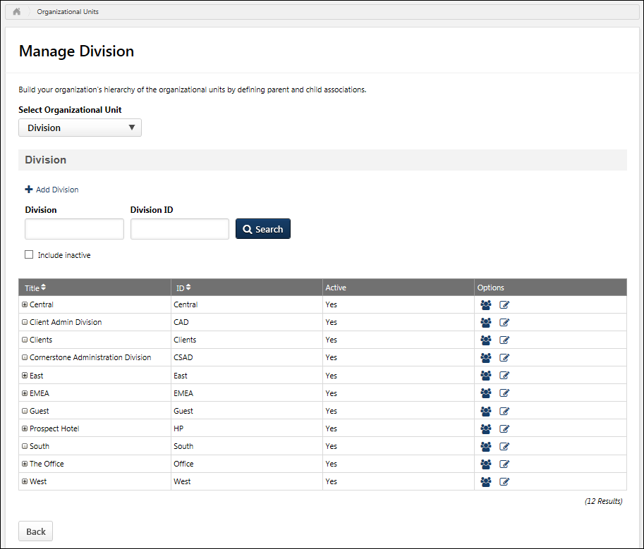
Select Organizational Unit Type
When you arrive at the Manage OU page, you must first select which type of OU you are managing. From the Select Organizational Unit drop-down menu, select the appropriate OU type. All existing OUs in the selected OU type are displayed.
After you select an OU type, you may choose to manage a different OU type by selecting the appropriate OU type from the Select Organizational Unit drop-down menu.
Add Organizational Unit
To add a new OU to the hierarchy, select the Add [OU Type] link above the search fields. See Organizational Unit - Create/Edit on page 5 for additional information.
Search Organizational Units
Administrators can search for a specific OU by title or ID. Administrators can also choose to include inactive OUs in the display using the Include Inactive checkbox.
After entering the appropriate search criteria, select the Search button to search OUs.
View Organizational Units Hierarchy
All of the existing OUs are displayed in the table in a hierarchical manner. The following information is displayed for each OU:
- Expand Hierarchy - If the OU has subordinate OUs, then an Expand icon appears to the left of the OU title. Select this icon to view the OU's subordinate OUs. This icon is only available if the OU has one or more subordinate OUs.
- Title
- ID
- Active - This column displays whether or not the OU is active. The active status can be changed by editing the OU. See Organizational Unit - Create/Edit on page 5 for additional information.
Options
The following options may be available in the Options column:
- Users - Select the Users icon to view names and IDs of users included in this OU.
- Edit - Select the Edit icon to make changes to the OU. See Organizational Unit - Create/Edit on page 5 for additional information.
- Copy - The Copy icon is only available when managing groups. Select this option to create a copy of the group. See Create Group for additional information.
- Manage Requisition Template - Select the Manage Requisition Template icon to manage the job requisition template for the position OU. Note: This option is only available for Position OUs and is only available to users with permission to manage OUs and either create or view requisition templates.
Related Topics

Organizational Unit - Create/Edit
Organizational Units (OUs) form the administrative foundation of Cornerstone. You can think of OUs as distinct information containers that capture, store and categorize all client data within the system.
To create an OU, go to Admin > Tools > Core Functions > Organizational Units. Then, select the Manage Organizational Unit Hierarchy link.
Select the appropriate OU type from the Select Organizational Unit drop-down list. Then, select the Add [OU] link (e.g., Add Division, Add Position, Add Location).
Permissions
PERMISSION NAME | PERMISSION DESCRIPTION | CATEGORY

Grades - View | Grants ability to view the Grade Organizational Unit throughout the system, such as in availability drop down selectors, when editing users, etc. Those without this permission do not see the Grade OU on any screen. This is primarily an administrator permission, although organizational policy should determine whether the Grade OU should be visible to end users on reporting screens, etc. | Core Administration

OU Hierarchy - Manage | Grants ability to create and update/edit organizational units. This permission grants access to all OU types, both standard and custom. This permission can be constrained by OU and User's OU. This is an administrator permission. | Core Administration
Emails
EMAIL NAME | EMAIL DESCRIPTION | ACTION TYPE

Request Facility | Within the Session Schedule set-up, it is required to Request a Facility/Location for a Session. This email is fired upon request. | ILT Administration
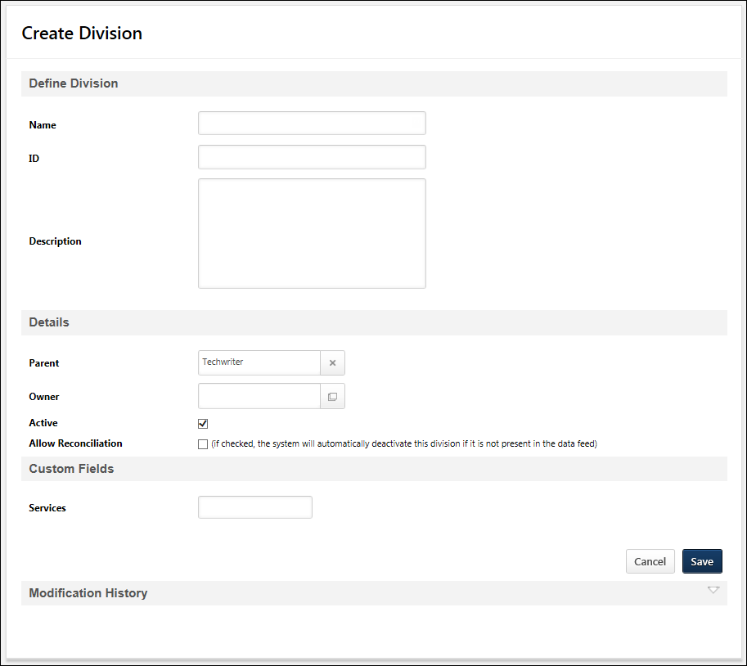
Add/Edit Group
Groups are used to create an organizational unit based on multiple criteria. See Group - Create/Edit.
Add/Edit Position OU
The process of adding a new position is a multi-step process. See Position OU - Create - Step 1 - General on page 16 for additional information.
Add/Edit Location OU
The process of creating a Location OU varies slightly from the process of creating a Division, Cost Center, or Grade OU. See Location OU - Create on page 10 for additional information.
Add/Edit Division, Cost Center, or Grade OU
In the General section, enter the following information:
- Name - Enter the name of OU. This is required. If OU Localization is enabled for your portal, click the Translate icon to translate the field into other available languages. A translation for the OU's default language is required for this field.
- ID - Enter an ID for the OU. This is required if the Allow Reconciliation option is selected. See the Helpful Hints - Data Feeds and Reconciliation section for additional information.
- Description - Enter the OU description. If OU Localization is enabled for your portal, click the Translate icon to translate the field into other available languages.
In the Details section, enter the following information:
- Parent - Select the OU parent. This enables administrators to create an OU hierarchy. This is required and it defaults to the corporate OU/root parent for the entire hierarchy.
- Owner - Select the user who serves as the owner of the OU.
- Active - Select this option to make the OU active.
- Allow Reconciliation - Select this option to allow the system to deactivate an OU that is not included in the data feed. See the Helpful Hints - Data Feeds and Reconciliation section for additional information.
- Default Language - If OU Localization is enabled for your portal, this displays the default language for the OU. This enables administrators to know which translation will be displayed to a user if a translation is not defined for the user's preferred language. This value cannot be modified.
  - For OUs that are created after OU Localization is enabled, the OU's default language is set to the preferred language of the administrator who creates the OU. This is set at the time the OU is created.
  - For OUs that are created before OU Localization is enabled, the OU's default language is set to the default language of the portal's top-level OU. This is typically the Corporate Language, and it is set when OU Localization is enabled.
If any Organizational Unit custom fields are available, they appear in the Custom Fields section. Modification History includes any modifications to the custom fields.
Reason for Change
This option is only available for organizations using Cornerstone HR or Enhanced Auditing.
When modifying a standard field for an OU, the Reason for Change field enables administrators to specify why the OU is being modified. This option is only available when editing an OU, and this field is required when modifying a standard field. The character limit for this field is 250.
When an OU is modified, the Reason for Change value is stored in the Modification History section.
Save/Cancel
Click Save to save the OU.
Click Cancel to discard any unsaved changes.
Modification History
Modifications to the following standard fields are tracked in the Modification History:
- Name
- ID
- Description
- Parent - This displays the Parent OU name and ID
- Owner - This displays the OU Owner's name and ID
- Allow Reconciliation
For organizations that are not using Cornerstone HR or Enhanced Auditing, the Modification History section displays the following details for each modification:
- Modifier
- Date Changed
For organizations that are using Cornerstone HR or Enhanced Auditing, the Modification History section also tracks changes to custom OU fields and displays the following details for each modification. The Modification History table respects the Availability settings for custom fields, so administrators can only view modifications to custom OU fields if they are within the field's availability.
- Date Changed
- Field Changed
- Field Type
- Changed From
- Changed To
- Changed By
- Reason For Change - If an OU is created or modified via the Data Load Wizard, then the Reason for Change is set to Data Load Feed for all related entries.
Helpful Hints - Data Feeds and Reconciliation
- If the Allow Reconciliation option is selected for an OU, then the OU will be automatically deactivated in the system if this OU is not present in the data feed.
- OU IDs are required for OUs which have the Allow Reconciliation option selected and are being updated by the data feed.
Helpful Hints - Inactive OUs
- If an OU is deactivated, its subordinate OUs will remain active. Since the parent OU is inactive, the system will not readily display its child OUs. In order to see active child OUs to an inactive parent, search for the OU by name or ID.
- If an OU is inactive, the users within that OU will remain active. If an OU is inactive and contains active users, search for the users by name OR use another OU type that is currently active.
- Inactive OUs cannot be used as reporting filters or to set availability.
Helpful Hints - Cost Center Approvers
- Cost Center Approvers may perform training request approvals for users in this cost center. The cost center approver is the second person in the approval chain for training requests, after the user's Approver and before the user's Manager.
- The default approval workflow is as follows Approver > Cost Center Approver > Manager > Manager's Approver > Manager's Cost Center Approver > Manager's Manager, etc. However, this is often customized for each organization during implementation. If your current system does not have an approver, then the approver is skipped and it goes to the next person in the chain. See Approval Workflow Overview.
Related Topics
Frequently Asked Questions
What does the Freeze Group Processing option do?
This option is only available when creating or editing a group. This option is explained within the following topic: See Group - Create/Edit.

Location OU - Create
Organizational Units (OUs) form the administrative foundation of Cornerstone. You can think of OUs as distinct information containers that capture, store and categorize all client data within the system.
To create an OU, go to Admin > Tools > Core Functions > Organizational Units. Then, click the Manage Organizational Unit Hierarchy link.
Select the Location OU type from the Select Organizational Unit drop-down list. Then, click the Add Location link.
Permissions
PERMISSION NAME | PERMISSION DESCRIPTION | CATEGORY

OU Hierarchy - Manage | Grants ability to create and update/edit organizational units. This permission grants access to all OU types, both standard and custom. This permission can be constrained by OU and User's OU. This is an administrator permission. | Core Administration
Emails
EMAIL NAME | EMAIL DESCRIPTION | ACTION TYPE

Request Facility | Within the Session Schedule set-up, it is required to Request a Facility/Location for a Session. This email is fired upon request. | ILT Administration
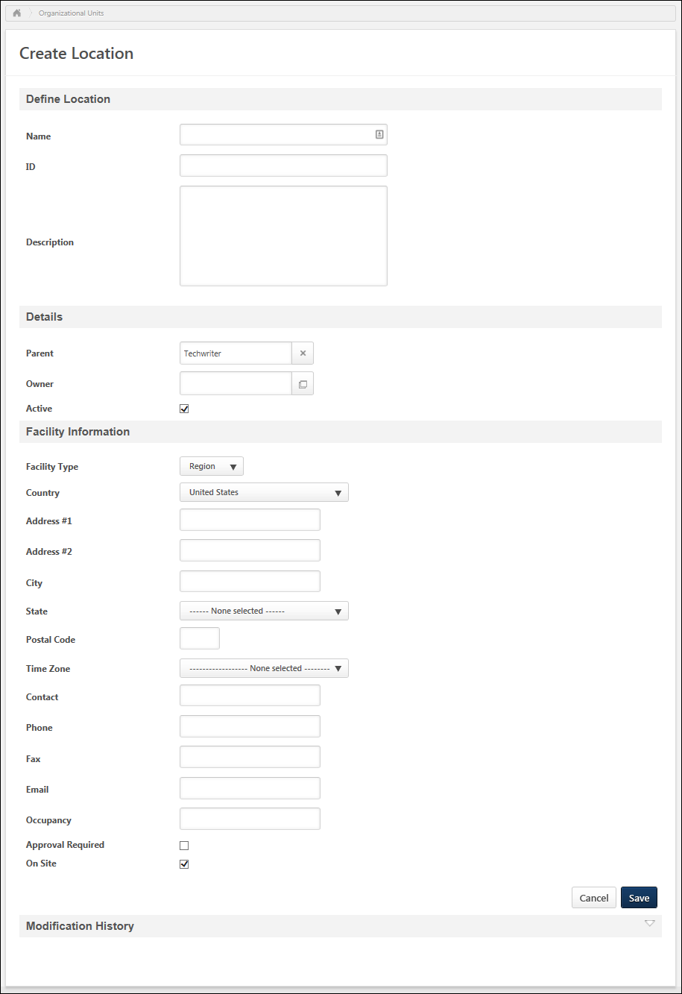
General
In the General section, enter the following information:
- Name - Enter the name of OU. This is required. If OU Localization is enabled for your portal, click the Translate icon to translate the field into other available languages. A translation for the OU's default language is required for this field.
- ID - Enter an ID for the OU. This is required if the Allow Reconciliation option is selected. See the Helpful Hints - Data Feeds and Reconciliation section for additional information.
- Description - Enter the OU description. If OU Localization is enabled for your portal, click the Translate icon to translate the field into other available languages.
Details
In the Details section, enter the following information:
- Parent - Select the OU parent. This enables administrators to create an OU hierarchy. This is required and it defaults to the corporate OU/root parent for the entire hierarchy.
- Owner - Select the user who serves as the owner of the Location OU. Location Owners are responsible for granting ILT facility requests for this location. When a facility is requested, the Facility Request email is sent to the Location Owner, if the email is enabled.
- Active - Select this option to make the OU active.
Facility Information
Generally, facility information is used to set up locations which are rooms or buildings to be used for instructor led training (ILT). In the Facility Information section, enter the following information:
- Facility Type - Select the type from the drop-down list.
- Country - From the drop-down, select the appropriate country for the location. The default value for this field is United States.
- Address #1 - Enter the first line of the facility's address. The address for a location is used to show a map for that location via Google when a user clicks the View Map link for that location on the ILT Training Details page.
- Address #2 - Enter the second line of the facility's address.
- City - Enter the city in which the facility is located.
- State - From the drop-down menu, select the state in which the facility is located.
- Postal Code - Enter the postal code that corresponds with the facility's location.
- Time Zone - From the drop-down menu, select the time zone that corresponds with the facility's location. This is required. The time zone entered for a location will automatically populate the time zone for all ILT session start dates that are scheduled at that location. The time zone that is applied to a user is dependent on a set of rules. See Time Zone Application Rules.
- Contact - Enter the name of the user who serves as the contact for the facility. If an email is provided in the Email field, the facility contact can be notified when the facility is selected for a session. If the contact is an active user in the system and if the location is configured to require approvals during the session creation process, then an email can be sent to the contact user for approvals.
- Phone - Enter the contact person's phone number.
- Fax - Enter the contact person's fax number.
- Email - Enter the contact person's email address.
- Occupancy - Enter the enter maximum number of users who can safely occupy the room during a training session.
- Approval Required - Select this option if approval is required from the location owner for sessions scheduled at this location.
- On Site - Select this option if this location is on-site. This is a label to help distinguish which facilities are on or off-site based on the company's definition of an on or off-site course.
Reason for Change
This option is only available for organizations using Cornerstone HR or Enhanced Auditing.
When modifying a standard field for an OU, the Reason for Change field enables administrators to specify why the OU is being modified. This option is only available when editing an OU, and this field is required when modifying a standard field. The character limit for this field is 250.
When an OU is modified, the Reason for Change value is stored in the Modification History section.
Save/Cancel
Click Save to save the OU.
Click Cancel to discard any unsaved changes.
Modification History
Modifications to the following standard fields are tracked in the Modification History:
- Name
- ID
- Description
- Parent - This displays the Parent OU name and ID
- Owner - This displays the OU Owner's name and ID
- Allow Reconciliation
For organizations that are not using Cornerstone HR or Enhanced Auditing, the Modification History section displays the following details for each modification:
- Modifier
- Date Changed
For organizations that are using Cornerstone HR or Enhanced Auditing, the Modification History section also tracks changes to custom OU fields and displays the following details for each modification. The Modification History table respects the Availability settings for custom fields, so administrators can only view modifications to custom OU fields if they are within the field's availability.
- Date Changed
- Field Changed
- Field Type
- Changed From
- Changed To
- Changed By
- Reason For Change - If an OU is created or modified via the Data Load Wizard, then the Reason for Change is set to Data Load Feed for all related entries.
Helpful Hints - Data Feeds and Reconciliation
- If the Allow Reconciliation option is selected for an OU, then the OU will be automatically deactivated in the system if this OU is not present in the data feed.
- OU IDs are required for OUs which have the Allow Reconciliation option selected and are being updated by the data feed.
Helpful Hints - Inactive OUs
- If an OU is deactivated, its subordinate OUs will remain active. Since the parent OU is inactive, the system will not readily display its child OUs. In order to see active child OUs to an inactive parent, search for the OU by name or ID.
- If an OU is inactive, the users within that OU will remain active. If an OU is inactive and contains active users, search for the users by name OR use another OU type that is currently active.
- Inactive OUs cannot be used as reporting filters or to set availability.
Related Topics

Position OU - Create Overview

Position OU - Create - Step 1 - General
The position OU can be used be used to configure system preference by, set availability for learning content, to assign learning, or to filter for reporting. In addition, the position OU is used to improve learning recommendations on Learner Home. Administrators can create as many position OUs as their organization needs.
To create a position OU, go to Admin > Tools > Core Functions > Organizational Units. Then, click the Manage Organizational Unit Hierarchy link. Select Position from the Organization Unit category drop-down list. Then, click the Add Position link.
Permissions
PERMISSION NAME | PERMISSION DESCRIPTION | CATEGORY

OU Hierarchy - Manage | Grants ability to create and update/edit organizational units. This permission grants access to all OU types, both standard and custom. This permission can be constrained by OU and User's OU. This is an administrator permission. | Core Administration
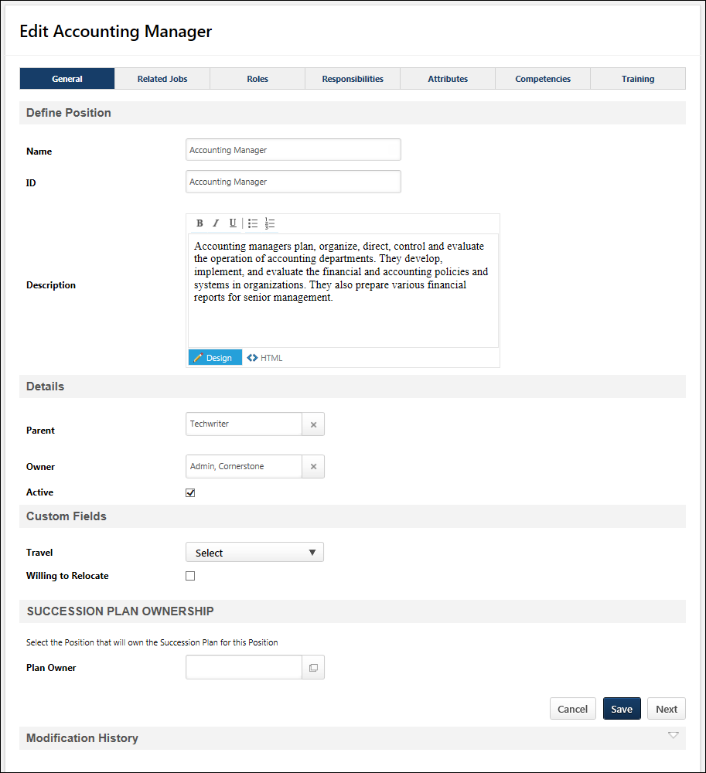
General
- Name - Enter name of position. This field is required. This name will be considered the Job Title for the Job Profile. If OU Localization is enabled for your portal, click the Translate icon to translate the field into other available languages. A translation for the OU's default language is required for this field.
- ID - Enter an ID for the position. This is required if the Allow Reconciliation option is selected. See the Helpful Hints - Data Feeds and Reconciliation section for additional information.
- Description - Enter a description of the position. This field utilizes the Telerik RadEditor. If OU Localization is enabled for your portal, click the Translate icon to translate the field into other available languages. This description will be considered the Job Description. Position descriptions may be displayed in ATS Requisition Templates, Succession Career Center, and the Position Description tab of a performance review.
Details
- Parent - Select the OU parent. This enables administrators to create an OU hierarchy. This is required and it defaults to the corporate OU/root parent for the entire hierarchy.
- Owner - Select the user who serves as the owner of the OU.
- Active - Select this option to make the OU active.
- Allow Reconciliation - Select this option to allow the system to deactivate an OU that is not included in the data feed. See the Helpful Hints - Data Feeds and Reconciliation section for additional information.
- Default Language - If OU Localization is enabled for your portal, this displays the default language for the OU. This enables administrators to know which translation will be displayed to a user if a translation is not defined for the user's preferred language. This value cannot be modified.
  - For OUs that are created after OU Localization is enabled, the OU's default language is set to the preferred language of the administrator who creates the OU. This is set at the time the OU is created.
  - For OUs that are created before OU Localization is enabled, the OU's default language is set to the default language of the portal's top-level OU. This is typically the Corporate Language, and it is set when OU Localization is enabled.
Custom Fields
If there are any position custom fields, these fields appear below the Details section.
Succession Plan Ownership
This section enables administrators to define a Plan Owner for the position OU. A Plan Owner is also a position OU, and users within the Plan Owner OU are owners of the succession plan for users within the position OU. For example, if a job pool task is assigned to a position, the Plan Owners for that position are assigned the job pool task.
- Plan Owner - Click this field to select a Plan Owner OU for the position OU. This opens the Search pop-up, in which a position OU can be selected. Only one Plan Owner OU can be selected. However, a position OU can be selected as the Plan Owner for multiple position OUs.
  - If a Plan Owner OU is already selected, then it appears in the Plan Owner field. Also, all users within the Plan Owner OU are displayed in the User(s) in Plan Owner OU field.
- User(s) in Plan Owner OU - This field displays a list of the users within the selected Plan Owner OU.
  - If there are no users in the selected OU, then "Vacant" is displayed in this field.
  - If no Plan Owner OU is selected, then this field does not appear.
Plans Owned by this Position
This section displays in alphabetical order all position OUs for which this position is a Plan Owner. For example, if you are editing the Accounting Manager position, then this section displays all positions for which the Accounting Manager position OU is selected as the Plan Owner. This section is only available if the position OU is selected as the Plan Owner for at least one position OU. This section is collapsed by default and can be expanded by clicking the arrow icon to the right of the section heading.
A Modify Plan Ownership link appears to the right of a position OU in the Plans Owned by this Position section. Administrators can click this link for a position OU to open the General tab of the corresponding position OU, where the administrator can modify the plan ownership of the OU, if necessary.
When the Modify Plan Ownership link is clicked, a pop-up appears, which enables the administrator to save their changes or continue without saving. This pop-up appears regardless of whether there are any unsaved changes.
- Continue without Saving - Click this button to continue to the new Position page without saving any unsaved changes on the current Position page.
- Save and Continue - Click this button to save any unsaved changes on the current Position page prior to continuing to the new Position page.
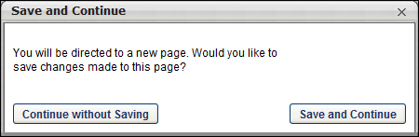
Next
Click Next to proceed to the Related Jobs page. See Position OU - Create - Step 2 - Related Jobs on page 20 for additional information.
Helpful Hints - Data Feeds and Reconciliation
- If the Allow Reconciliation option is selected for an OU, then the OU will be automatically deactivated in the system if this OU is not present in the data feed.
- OU IDs are required for OUs which have the Allow Reconciliation option selected and are being updated by the data feed.

Position OU - Create - Step 2 - Related Jobs
The Related Jobs tab allows administrators to define related Jobs that are associated with the current Job OU. This will allow for the ability to have career pathing functionality in the Career Center. For each OU, the administrator can determine the previous and next jobs to define the career path. Completing this section of the setup is NOT mandatory.
To create a Position OU, go to Admin > Tools > Core Functions > Organizational Units. Then, click the Manage Organizational Unit Hierarchy link. Select Position from the Organization Unit category drop-down list. Then, click the Add Position link.
Permissions
PERMISSION NAME | PERMISSION DESCRIPTION | CATEGORY

OU Hierarchy - Manage | Grants ability to create and update/edit organizational units. This permission grants access to all OU types, both standard and custom. This permission can be constrained by OU and User's OU. This is an administrator permission. | Core Administration

Role Management | Grants ability to view, edit, and copy roles. When editing or copying a role, administrators can delete or modify an assignment. However, this permission does not grant the ability to select assignment criteria for a role. This permission can be constrained by OU, User's OU, User Self and Subordinates, User, User's Self, User's Manager, User's Subordinates, and User's Direct Reports. These permission constraints limit the users to whom administrators can assign a role. | Performance
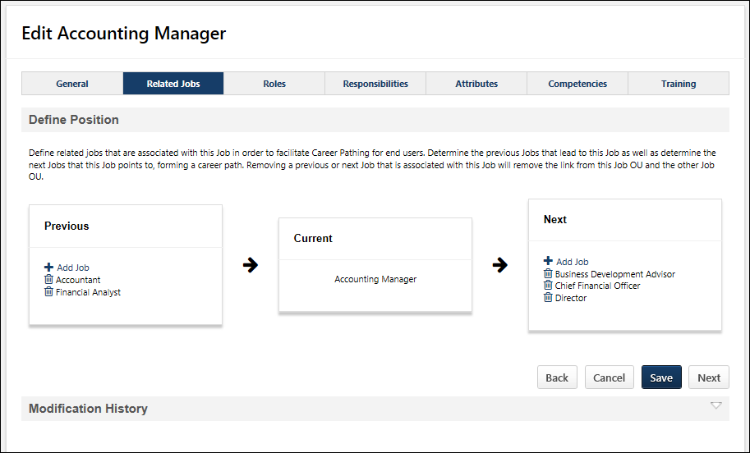
Add a Related Job
To add a job that is related to the position OU, select the Add Job link in the Previous or Next sections.
- There is no limit to the number of related jobs that can be added to the Previous or Next position sections.
- The same position cannot be added to both the Previous or Next position sections.
- The current position cannot be added to either section.
- If a position OU is added as a related job, then a relationship will be created between the current position and the related position.
  - If a related job is added as a Next job to the current job, then the current job will be added as a Previous job to the related job OU.
  - If a related job is added as a Previous job to the current job, then the current job will be added as a Next job to the related job OU.
- If a Job is removed as a related Job on this page, then the relationship between the current Job and the related Job is removed from both the current Job OU and the related Job OU.
- If a related Job is made inactive, then the relationship will be removed from both the current job and the inactive Job.
- If a related Job is deleted as an OU from the system, then the relationship between the deleted Job and the current Job will be removed and the deleted Job will no longer appear on this page as a related job.
Next or Save
Click Next to proceed to the Roles step. See Position OU - Create - Step 3 - Roles on page 22 for additional information.

Position OU - Create - Step 3 - Roles
This step displays a read-only list of the roles with which the Position OU has been associated. The employees in the Position organizational unit (OU) are measured against the qualifications requirements for the associated roles. Positions can be associated with a role when the role is created or edited. See Role - Create - Step 2 - Related Positions for additional information.
For example, a Master Welder position may be associated with different roles within Role Management, such as Welder and Master Welder. These roles have competencies associated with them, such as Layout, Tacking, Welding, and Grinding. Because the Master Welder position is associated with the Welder and Master Welder roles, then any user in the Master Welder position may be measured against the competencies that are associated with the Welder and Master Welder roles.
Note: Role visibility is not enforced on this page. The administrator can view all roles that are associated with the position, regardless of the visibility that is set for each role.
To create a Position OU, go to Admin > Tools > Core Functions > Organizational Units. Then, click the Manage Organizational Unit Hierarchy link. Select Position from the Organization Unit category drop-down list. Then, click the Add Position link.
Permissions
PERMISSION NAME | PERMISSION DESCRIPTION | CATEGORY

Role Management | Grants ability to view, edit, and copy roles. When editing or copying a role, administrators can delete or modify an assignment. However, this permission does not grant the ability to select assignment criteria for a role. This permission can be constrained by OU, User's OU, User Self and Subordinates, User, User's Self, User's Manager, User's Subordinates, and User's Direct Reports. These permission constraints limit the users to whom administrators can assign a role. | Performance
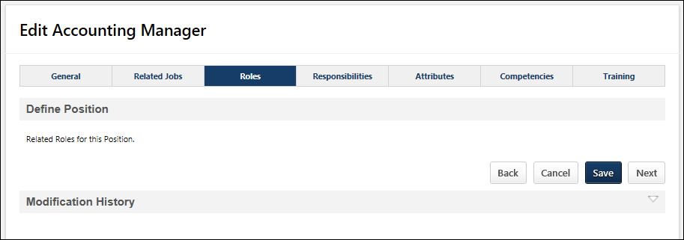
Roles Table
The following information is displayed for each role that is associated with the position:
- Title - This displays the role title.
- ID - This displays the role ID.
Back/Save/Cancel/Next
- Back - Click to return to the Related Jobs step. See Position OU - Create - Step 2 - Related Jobs on page 20 for additional information.
- Save - Click to save the position and return to the Manage Positions page. See Organizational Units Administration on page 2 for additional information.
- Cancel - Click to discard any unsaved changes and return to the Manage Positions page. See Organizational Units Administration on page 2 for additional information.
- Next - Click to continue to the Responsibilities step. See Position OU - Create - Step 4 - Responsibilities on page 24 for additional information.
Modification History
Modifications to the position are logged in the Modification History section.
Related Topics

Position OU - Create - Step 4 - Responsibilities
This page allows the administrator to define job responsibilities/duties for the job. This information will allow users to view the job duties/responsibilities when looking at jobs. Each responsibility will be a separate item in a bulleted list when the user is viewing a job profile. Completing this section of the Job OU setup is NOT mandatory.
To create a Position OU, go to Admin > Tools > Core Functions > Organizational Units. Then, click the Manage Organizational Unit Hierarchy link. Select Position from the Organization Unit category drop-down list. Then, click the Add Position link.
Permissions
PERMISSION NAME | PERMISSION DESCRIPTION | CATEGORY

OU Hierarchy - Manage | Grants ability to create and update/edit organizational units. This permission grants access to all OU types, both standard and custom. This permission can be constrained by OU and User's OU. This is an administrator permission. | Core Administration
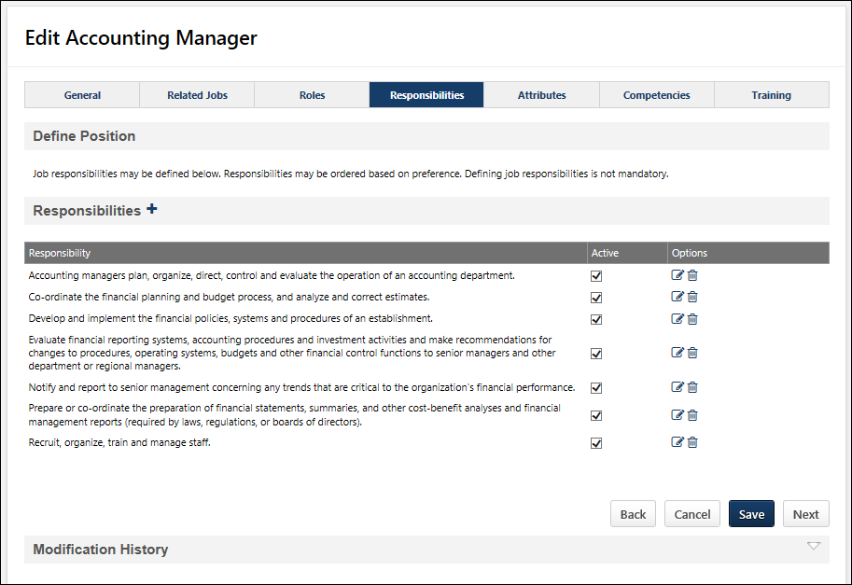
Add Job Responsibilities
To add a job responsibility to the position OU:
- Click the Add icon . The Add Job Responsibility pop-up opens.
- Add text to define the job responsibility up to 1000 characters. The field is not HTML-friendly.
- Click Save within the pop-up to save the job responsibility.
There is no limit to the number of responsibilities that can be added.
Responsibilities Table
The Responsibilities table displays all responsibilities that have been added to the position OU.
The following settings and options are available for each responsibility.
- Active - Select this checkbox for a responsibility to make the responsibility active, or unselect a checkbox to make the responsibility inactive.
- Edit - Click to edit the responsibility.
- Delete - Click to remove the responsibility.
Next
Click Next to continue to the Attributes step. See Position OU - Create - Step 5 - Attributes on page 26 for additional information.

Position OU - Create - Step 5 - Attributes
The Attributes tab allows the administrator to define job attributes. Job attributes can be defined by utilizing criteria from the Resume. Attributes such as education, experience, skills, etc. can be used to define the attributes and requirements ideal to a particular Job OU. This allows for candidate profile matching, job profile matching, career pathing, enhanced succession and workforce planning. In order to utilize the Job attributes, Succession Management must be enabled. If Succession Management is not enabled, then the ability to add Job attributes will not be available. This functionality allows you to add criteria from Resume sections to define Job attributes. Completing this section of the Job OU setup is NOT mandatory.
To create a Position OU, go to Admin > Tools > Core Functions > Organizational Units. Then, click the Manage Organizational Unit Hierarchy link. Select Position from the Organization Unit category drop-down list. Then, click the Add Position link.
Permissions
PERMISSION NAME | PERMISSION DESCRIPTION | CATEGORY

OU Hierarchy - Manage | Grants ability to create and update/edit organizational units. This permission grants access to all OU types, both standard and custom. This permission can be constrained by OU and User's OU. This is an administrator permission. | Core Administration
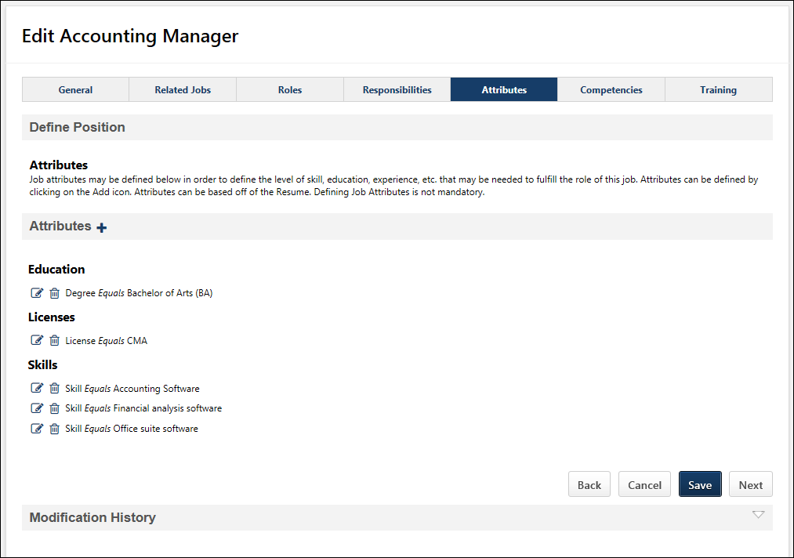
Add Position Attributes
To add an attribute to the position:
- Select the Add icon to the rights of the Attribute heading. The Add Attributes pop-up opens.
- Select from any resume section defined within the Career Center from the Attribute drop down. Performance or Competency will not appear as a selectable attribute.
- Define the attribute criteria. The criteria fields will vary based on the resume section selected as the attribute. Only active fields within the Resume section will appear when defining the job attribute.
- Click Save.
Attributes Table
The Attributes table displays all attributes that have been added to the position OU.
The following settings and options are available for each attribute.
- Edit - Click to edit the attribute.
- Delete - Click to remove the attribute. If all criteria within a resume section are removed, then the Resume section will no longer appear on the Job Profile.
Next
Click Next to continue to the Competencies step. See Position OU - Create - Step 6 - Competencies on page 28 for additional information.

Position OU - Create - Step 6 - Competencies
This page allows the administrator to associate the position OU with a competency model. When a competency model is selected, the competencies within the model are displayed on the page.
This functionality directly relates to the Career Center - Career Path page. When viewing a position on the Career Center - Career Path page, the selected competency model is used to compare the user's current competencies against the competencies and targets that are defined for the position OU. This allows for greater job matching for career pathing, succession planning, and internal recruiting.
This functionality is only available if Competency Assessments are enabled. Associating a competency model with a position OU is optional.
To create a Position OU, go to Admin > Tools > Core Functions > Organizational Units. Then, click the Manage Organizational Unit Hierarchy link. Select Position from the Organization Unit category drop-down list. Then, click the Add Position link.
Permissions
PERMISSION NAME | PERMISSION DESCRIPTION | CATEGORY

OU Hierarchy - Manage | Grants ability to create and update/edit organizational units. This permission grants access to all OU types, both standard and custom. This permission can be constrained by OU and User's OU. This is an administrator permission. | Core Administration
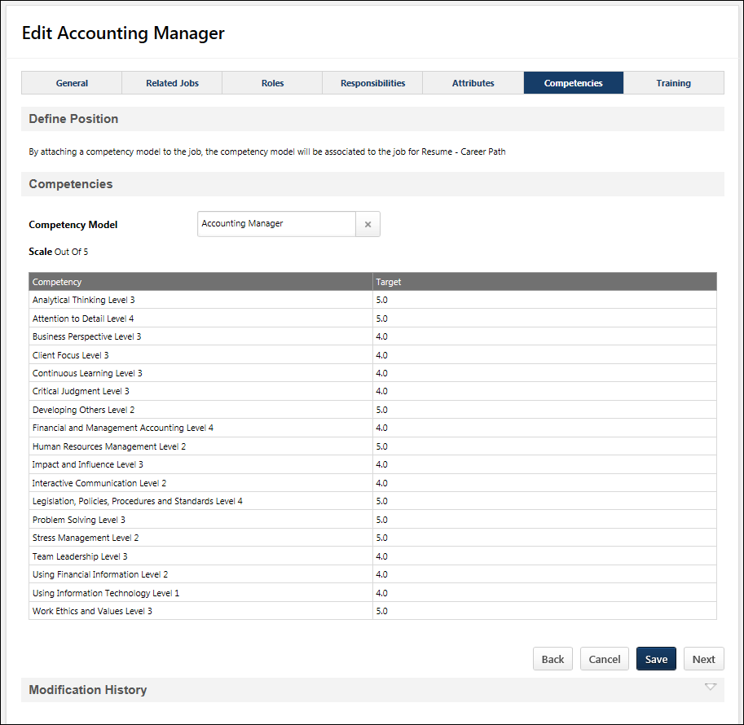
Select Competency Model
To associate a competency model with the position OU, click the Select icon next to the Competency Model field. When a competency model is selected, the competency model's scale and competencies are displayed.
Only one model can be selected for the position OU.
Remove Competency Model
To remove a competency model from a position OU, click the X icon to the right of the competency model. You can then select a new competency model, if necessary.
Next
Click Next to continue to the Training step. See Position OU - Create - Step 7 - Training on page 31 for additional information.

Position OU - Create - Step 7 - Training
The Training tab allows the administrator to pull in trainings. These trainings are related to the user when they are looking at Job Profiles within the application. The administrator can define the related trainings for a user to qualify them for the Job. Users in the Job are not automatically assigned to the trainings. To fully utilize the following functionality, the client must have the LMS module. Note: Completing this section of the Job OU setup is not mandatory.
To create a Position OU, go to Admin > Tools > Core Functions > Organizational Units. Then, click the Manage Organizational Unit Hierarchy link. Select Position from the Organization Unit category drop-down list. Then, click the Add Position link.
Permissions
PERMISSION NAME | PERMISSION DESCRIPTION | CATEGORY

OU Hierarchy - Manage | Grants ability to create and update/edit organizational units. This permission grants access to all OU types, both standard and custom. This permission can be constrained by OU and User's OU. This is an administrator permission. | Core Administration
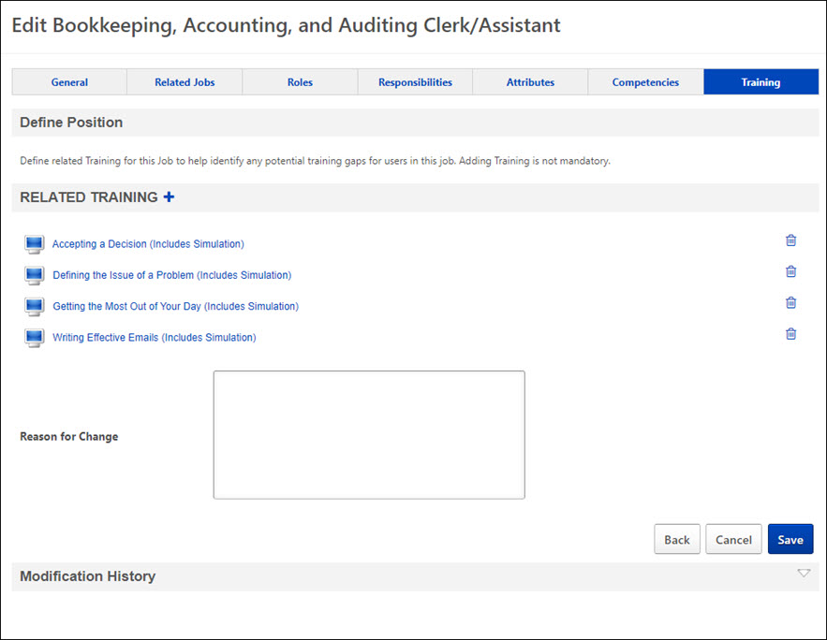
Add Related Training
To add training that is related to the position:
- Select the Add icon to the rights of the Related Training heading. The Select Training pop-up opens.
- Search and select training by clicking the Add icon. There is no limit to the amount of LOs that can be added to the position OU.
- Click Done.
Related Training
Training that is associated with the position OU appears in this section in alphabetical order. To view details on the training, click the training title.
To remove a related training item, click the Remove icon to the right of the training item.
Reason for Change
This option is only visible for organizations using Cornerstone HR or Enhanced Auditing.
When modifying a standard field for an OU, the Reason for Change field enables administrators to specify why the OU is being modified. This option is only available when editing an OU, and is required when modifying a standard field. The character limit for this field is 250.
When an OU is modified, the Reason for Change value is stored in the Modification History section.
Save
Click Save to save the position OU.

Active Users in OU
The Active Users in OU page enables administrators to view all users who are active within a specific organizational unit (OU). Administrators can search for specific users within the selected OU.
To view the active users within an OU, go to Admin > Tools > Core Functions > Organizational Units. Select the Manage Organizational Unit Hierarchy link. Select the appropriate OU type from the Select Organizational Unit drop-down list. Then, select the Users icon in the Options column for the appropriate OU.
Permissions
PERMISSION NAME | PERMISSION DESCRIPTION | CATEGORY

Grades - View | Grants ability to view the Grade Organizational Unit throughout the system, such as in availability drop down selectors, when editing users, etc. Those without this permission do not see the Grade OU on any screen. This is primarily an administrator permission, although organizational policy should determine whether the Grade OU should be visible to end users on reporting screens, etc. | Core Administration

OU Group - Manage | Grants the ability to create, copy, and edit custom groups of users without allowing the ability to manage organizational units (OUs). This permission can be constrained by OU, User's OU, and Provider. This is an administrator permission. | Core Administration

OU Group - Update | Grants access to edit existing custom groups of users. This permission can be constrained by OU, User's OU, and Provider. This is an administrator permission. | Core Administration

OU Group - View | Grants access to view existing custom groups. This permission can be constrained by OU. This is an administrator permission. | Core Administration

OU Hierarchy - Manage | Grants ability to create and update/edit organizational units. This permission grants access to all OU types, both standard and custom. This permission can be constrained by OU and User's OU. This is an administrator permission. | Core Administration
