Onboarding March 2024

Table of Contents
Onboarding Overview 1
Onboarding Dashboard 2
Bio - Onboarding 7
Employee Onboarding Overview 13
Onboarding Workflows 16
Navigation Tabs and Links Extensions 25
Preboarding Overview 29
Start Onboarding Page 38

Onboarding Overview

Onboarding Dashboard
The Onboarding Dashboard allows recruiters to view and track all available users who are undergoing the onboarding process. By default, the dashboard displays in-progress onboarding. Users who have completed onboarding can also be viewed.
The dashboard also includes options to view details of the user’s onboarding progress, which takes the viewer to the user's Onboarding tab in Universal profile. For users with permission to manage employee onboarding, there are options to change the start date or cancel the onboarding.
Note: The Onboarding Dashboard is only visible if configured by the administrator in Navigation Tabs and Links.
To access the Onboarding Dashboard, go to Recruit > Onboarding Dashboard.
Permissions
PERMISSION NAME | PERMISSION DESCRIPTION | CATEGORY

Employee Onboarding: Manage | Grants ability to manage user onboarding in the Onboarding Dashboard and the Onboarding tab on the Universal Profile. This permission can be constrained by OU, User's OU, and User Self and Subordinates. | Employee Onboarding

Employee Onboarding: Manage Onboarding Tasks | Grants the ability to cancel an onboarding task or mark the task as complete. This permission also grants the ability to cancel onboarding workflows after the hire date.

Employee Onboarding: View | Grants ability to view the Onboarding Dashboard and the Onboarding tab on the Universal Profile. This permission can be constrained by OU, User's OU, and User Self and Subordinates. | Employee Onboarding
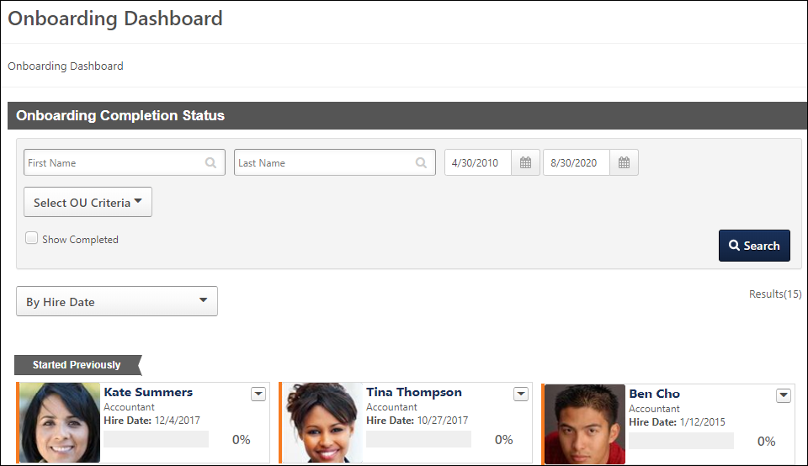
Onboarding Completion Status Section
The Onboarding Completion Status section displays the user cards for employees who are undergoing the onboarding process. Recruiters can view the user's onboarding progress and status, as well as access the user's Onboarding tab on their Universal Profile page.
Search Filters
Use the search filters to filter the dashboard based on the criteria defined. The users that display in the dashboard are dependent upon the constraints of the permissions needed to manage and view the dashboard.
- First Name/Last Name - Use the filters to search by First Name/Last Name. This field has no character limit.
- Organizational Unit - Use this option to filter by organizational unit (OU). To filter by OU, use the predictive search feature by entering an OU name into the Organizational Unit field, or select one of the following OUs from the drop-down:
  - Cost Center
  - Division
  - Grade
  - Location
  - Position
  - Self Registration Group
  - Custom OU
Then, use the Select option to open the Select OU pop-up and select an OU from the list.
Note: The Onboarding Dashboard search functionality is based on the onboarding user's future OUs, not current OUs.
- Start Date - Use this option to filter by the date on which the user started the onboarding process. By default, the dashboard displays users who started the onboarding process two months before the current date.
- End Date - Use this option to filter by the date on which the user ended the onboarding process. By default, the dashboard displays users who started the onboarding process two months after the current date.
- Show Completed - Check this box to update the dashboard to show users who have completed the onboarding process. When unchecked, users who have completed the onboarding process do not display.
- Search - Click Search to filter the dashboard by the criteria defined in the search filters.
Sorting Options
The following options are available for sorting the users in the dashboard:
- By Completion (Low-High) - Select this option to group the users by completion or non-completion of onboarding. The users display in order of lowest to highest completion percentage. The following groups display:
  - Completed - This group only displays if the Show Completed filter option is selected. This group includes users whose onboarding is completed.
  - Not Completed - This group includes users whose onboarding is not completed.
Each group displays up to 15 users by default. To view more users, click the Show More button.
- By Completion (High-Low) - Select this option to group the users by completion or non-completion of onboarding. The users display in order of highest to lowest completion percentage. The following groups display:
  - Completed - This group only displays if the Show Completed filter option is selected. This group includes users whose onboarding is completed.
  - Not Completed - This group includes users whose onboarding is not completed.
Each group displays up to 15 users by default. To view more users, click the Show More button.
- By First Name (A-Z) - Select this option to sort the users by first name. The users are listed in alphabetical order. Up to 45 users display by default. If more than 45 users are in the group, then the Show More button displays. Click the button to view additional users.
- By First Name (Z-A) - Select this option to sort the users by first name in Z-A order. The users are listed in reverse alphabetical order. Up to 45 users display by default. If more than 45 users are in the group, then the Show More button displays. Click the button to view additional users.
- By Start Date - The dashboard is sorted by this option by default. Select this option to group the users by the date range of when the onboarding begins. The following groups display:
  - Started Previously - Includes users who started onboarding two weeks prior to the current date.
  - Last Week - Includes users who started onboarding the Sunday before last to the Sunday after last. For example, if the current date is Monday, August 18, then this group includes users who started onboarding between Sunday, August 10 and Sunday, August 17.
  - This Week - Includes users who started onboarding the Sunday before to the Sunday after. For example, if the current date is Monday, August 18, then this group includes users who started onboarding between Sunday, August 17 and Sunday, August 24.
  - Next Week - Includes users who begin onboarding the Sunday after until the Sunday after next. For example, if the current date is Monday, August 18, then this group includes users who started onboarding between Sunday, August 24 and Sunday, August 31.
  - In Two Weeks - Includes users who begin onboarding the Sunday after next until the Sunday after the next Sunday. For example, if the current date is Monday, August 18, then this group includes users who started onboarding between Sunday, August 31 and Sunday, September 7.
  - Starting Later - Includes users who begin onboarding the Sunday after the next Sunday and beyond. For example, if the current date is Monday, August 18, then this group includes users who started onboarding between Sunday, August 31 and all dates after August 31.
Each group displays up to 15 users by default. If more than 15 users are in the group, then the Show More button displays. Click the button to view additional users.
If a group does not have any users who meet the group criteria, then the group is hidden on the dashboard.
User Cards
Users display in the dashboard in user cards. User cards repeat for each onboarding that the user undergoes. The cards are sorted left to right. Each card displays the following information about the user:
- Photo - This displays the user's photo, if available.
- Name - The user's name displays as a link. Click the link to open the Onboarding tab of the Universal Profile page.
- Position - This displays the user's future position. For internal employees, this is a helpful feature as it provides viewers with the position into which the employee is onboarding.
- Start Date - This displays the date on which the user is scheduled to start their new position.
- Progress Bar - This displays the user's onboarding progress based on a percentage of completion of all requirements. The color of the progress bar is the corporate color.
- Completion Percentage - This displays the user's percentage of completion of the onboarding process.
Options Drop-Down
The options drop-down displays in the upper-right corner of the user card. The following options are available in the drop-down:
- View Details - Select this option to open the Onboarding tab of the Universal Profile page. This option is available with permission to view or manage employee onboarding. The Onboarding tab displays the onboarding user's workflows, as well as the results of integration tasks, such as completing I-9 forms.
- Cancel Onboarding - Select this option to cancel the user's onboarding process. Onboarding can be cancelled before or after the onboarding start date. This option helps you to better manage new hires who did not or were not able to start the job and helps to ensure the accuracy of new hire and onboarding data.
Clicking Cancel Onboarding opens a warning pop-up that indicates the cancellation cannot be undone and cancels all of the user's incomplete tasks. Click Yes to cancel the onboarding, or click No to close the pop-up without canceling the onboarding.
Canceling the onboarding workflow cancels all incomplete tasks for the user in the workflow. The user is converted back to an external candidate. The user's employee relationships are converted back to the relationships they were in at the time onboarding was started.
Once the onboarding workflow is cancelled:
  - The new hire is moved back to being an external candidate.
  - The percentage of onboarding tasks is updated according to the tasks that have been completed.
  - Onboarding tasks that are in an In Progress or Complete status will still be tied to the hire date.
  - Tasks are removed automatically from the new hire's Universal Profile.
Note: The Cancel Onboarding option is only available with permission to manage onboarding tasks.
- Edit Start Date - Select this option to edit the start date. This opens the Edit Start Date pop-up. Enter a new date in the date field or select the date from the calendar option. Click SAVE to save the new start date. Note: This option is only available with permission to manage employee onboarding. In addition, this option is no longer available once the start date has arrived.
Timestamps for start dates are in UTC, not necessarily the logged-in user's time zone.
I-9 E-Verify Section
The I-9 E-Verify section displays a link to the I-9 E-Verify dashboard. The dashboard opens in a new window in the third party vendor's tool. The dashboard displays various data for I-9 tasks and statuses.
While the page is loading, recruiters can click the Back button to return to the Onboarding Dashboard page without opening the third party vendor's I-9 E-Verify dashboard page.

Bio - Onboarding
Visibility Note: The Onboarding tab only displays if a user is currently or has previously been through onboarding.
The Onboarding tab displays an applicant's onboarding workflows. Workflows are launched by the recruiter from the Applicant Profile page, and the applicant and recruiter can then view the workflows from Universal Profile. The tab displays all workflows that have been launched for the applicant.
This page is available to recruiters who have access to the applicant's profile and also permission to view onboarding for an applicant. This page is also available to recruiters who have permission to manage employee onboarding. The Employee Onboarding functionality must also be enabled for the portal.
To access the Onboarding tab, go to Universal Profile > Bio and select the Onboarding tab. Or, go to Recruit > Onboarding Dashboard and click the user's name on the dashboard.
For detailed information about the Universal Profile, see Universal Profile Overview.
Use Case
A Human Resources Manager is looking through the Universal Profile > Bio pages of various employees within the company. She can see the Onboarding tab for users who are currently onboarding or who have previously gone through onboarding. She cannot see an Onboarding tab for users who have not been through onboarding before.
Permissions
PERMISSION NAME | PERMISSION DESCRIPTION | CATEGORY

Employee Onboarding: Manage | Grants ability to manage user onboarding in the Onboarding Dashboard and the Onboarding tab on the Universal Profile. This permission can be constrained by OU, User's OU, and User Self and Subordinates. | Employee Onboarding

Employee Onboarding: Manage Onboarding Tasks | Grants the ability to cancel an onboarding task or mark the task as complete. This permission also grants the ability to cancel onboarding workflows after the hire date.

Employee Onboarding: View | Grants ability to view the Onboarding Dashboard and the Onboarding tab on the Universal Profile. This permission can be constrained by OU, User's OU, and User Self and Subordinates. | Employee Onboarding

View Goals | Grants ability to view own goals and (depending on role and settings) goals of others (manager's visible goals, direct subordinate's goals, company goals, division goals). This permission can be constrained by Employee Relationship, OU, User's OU, and User Self and Subordinates. This is an end user permission. | Performance
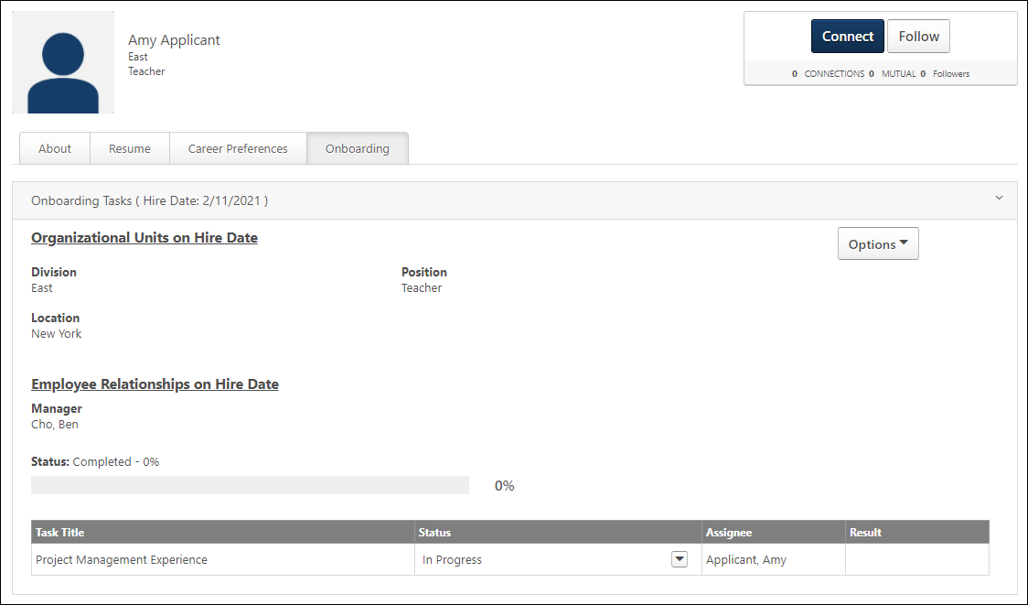
Onboarding Workflows
The Onboarding tab displays all workflows that have been assigned to the applicant. Each workflow displays in a separate panel that can be expanded or collapsed. The most recent workflow is expanded by default.
The following information displays in the upper portion of the workflow details:
Organizational Units on Hire Date
This section displays the new hire's future OUs that they will move into on their hire date. Both standard and custom OUs display.
Employee Relationships on Hire Date
This section displays the new hire's future relationships that they will get on their hire date.
Status
This field displays the applicant's progress in the workflow. The applicant's workflow progress status displays to the right of the field name. The following are the potential statuses:
- In progress - This indicates that the applicant has not yet been onboarded to an employee.
- Completed
- Cancelled
- Onboarding
- Working - For portals that have Onboarding enabled and User Types and Statuses, the external applicant's status changes from Onboarding to Working when the applicant reaches their onboarding hire date.
The completion percentage displays next to the status. The applicant's progress also displays as a colored progress bar.
Canceled Onboarding for External Applicants
If onboarding is canceled for external applicants, then the user type that was defined in the User Type section on the Start Onboarding page is removed. This allows external applicants to have the appropriate user type of external applicant when onboarding is canceled.
In addition, the user's status is canceled so that the external applicant returns to being an external applicant instead of being a user in the system.
Task Table Section
The following columns and information display in the table:
Task Title
This column displays the title of the task, including integration tasks.
For form tasks, the title displays as a link. Click the link to view the form.
Status
This column displays the status of the task, including integration tasks. The following are the possible statuses:
- Cancelled - This status displays if onboarding is cancelled for the user.
- Completed - For form tasks, this status displays if the user has submitted the form. For I-9 E-Verify tasks, this status displays if all steps of the task are completed.
- In Progress - For form tasks, this status displays if the user has started completing the form but has not yet submitted the form. For I-9 E-Verify tasks, this status displays if the task has been assigned and at least one or more steps of the task are not yet completed by the assignee.
- Not Started - This status displays if the user has not yet started the task. This status also displays if a Not Started status is submitted by the integration provider.
Status Options
Users with permission to manage onboarding tasks can mark a task completed or cancelled. This helps to better manage onboarding tasks that are no longer needed or have been completed outside the workflow.
Note: Tasks can be cancelled or completed whether they are assigned before the hire date or after the hire date.
Use Cases
- A new hire changes their manager in the first month of employment but has an onboarding form assigned to their former manager that has not been completed. The onboarding coordinator wants to be able to mark the task as complete so that they can manage outstanding tasks. With the existing functionality, the onboarding form stays with the former manager without a way to mark it as complete because the manager change occurred outside the onboarding workflow. With this enhancement, the onboarding coordinator can mark the task complete on the new hire’s Universal Profile > Onboarding tab.
- A new hire completes a direct deposit form on paper outside the onboarding workflow. The form remains on the new hire’s onboarding dashboard as a task that has not been completed, despite the form having been completed offline. This is impactful because the onboarding coordinator clients utilizes percent task completion to trigger their data feeds to the HRIS. Having a task sit open impacts the ability for the user to be sent over to the HRIS. If a user is not sent over to the HRIS, then the onboarding coordinator is unable to get new hire into the payroll and benefits system.
- A new hire has an onboarding task that is no longer relevant in their onboarding process. However, with the existing functionality, the onboarding coordinator does not have a way to cancel the task. With this enhancement, the onboarding coordinator can cancel the individual task from the new hire’s Universal Profile > Onboarding tab.
- A new hire has an optional task on their onboarding workflow. The new hire chooses not to complete the task. The onboarding coordinator wants to be able to cancel the task since it is no longer relevant to their onboarding process, which is different than the task being completed offline. With this enhancement, the onboarding coordinator can cancel the task so that the task is removed from the workflow and the percentage of task is not impacted because it is reset to match the updated number of tasks.
The following options are available in the drop-down in the Status column:
Mark Onboarding Task Complete
To mark a task as complete:
- Click the options drop-down in the Status column.
- Select Mark Complete. The Onboarding tab updates to show the task as completed. This action also triggers the Onboarding Form Completed email, if enabled and active in Email Administration.
Once the task is marked complete:
- The onboarding completion percentage, which displays on the onboarding dashboard and in the Status field on the new hire's Universal Profile > Onboarding tab, is updated automatically based on the tasks that have been completed.
- It is removed from the user's Universal Profile > Actions page.
- Tasks that are In Progress or Complete will still be associated with the hire date.
- The task can still be viewed in the Onboarding tab as completed.
- For form tasks, child tasks can be triggered to the appropriate assignees upon parent tasks being marked as completed so that the child task can be completed. Child tasks cannot be marked complete until the parent task is completed.
- For integration tasks, because child tasks are dependent upon a response from a vendor, marking an integration task as completed does not trigger any reviewer or child tasks.
Mark Onboarding Task Cancelled
To mark a task as cancelled:
- Click the options drop-down in the Status column.
- Select Mark Cancelled.
Once the task is marked cancelled:
- It is removed from the user's Universal Profile > Actions page.
- The onboarding completion percentage, which displays on the onboarding dashboard and in the Status field on the new hire's Universal Profile > Onboarding tab, is updated automatically to reflect the change as a result of the cancelled task.
- Tasks that are In Progress or Complete will still be associated with the hire date.
- The task can still be viewed in the Onboarding tab as Cancelled.
- Any child tasks are also cancelled if the parent task is cancelled. The parent and child tasks are removed from the user's Universal Profile > Actions page.
Note: Both form tasks and integration tasks can be cancelled.
Assignee
This column displays the name of the user assigned to the task.
Result
This column displays for all tasks but only provides results for integration tasks. The column is blank for form tasks.
I-9 E-Verify Tasks
For I-9 E-Verify tasks, the result displays the status of the I-9 form after it has been submitted to the third party application. The column displays one of the following results of the e-verification, depending on the case state of the verification process:
- Action Required - This result displays if an action is required by the employer to complete the e-verify process for the new hire.
- Approved - This status indicates that the submitted form has been approved. The form is now considered completed.
- Authorized - This result indicates that the user's identity has been verified and the user is authorized to work in the United States. This result displays if the e-verification has been completed and the case is closed.
- Authorized - Closed Case - This result indicates that the new hire is authorized to work in the United States, and the employer must access the third party application to close the e-verify case to make the work authorization official.
- Denied - This status indicates that the submitted form has been denied. The approver may have included comments to explain why the form was denied. When a form is denied, the user cannot make changes to the form and resubmit it for approval. A form that requires approval is not considered completed until the form is approved or denied.
- Denied and Returned - This status indicates that the submitted form has been denied and returned to the user. The user can access the returned form from the Universal Profile > Actions tab, where they can make changes to the form and resubmit it for approval.
- N/A - If a result has not yet been received, then N/A displays.
- Pending - This result displays if a decision to verify whether or not the new hire is authorized to work in the United States is pending on the verification.
- Pending Approval - This status indicates that the submitted form is pending action from the approver to approve, deny, or deny and return the form.
- Unauthorized - This result indicates that the user's identity has been verified and the user is not authorized to work in the United States. This result displays if the e-verification has been completed and the case is closed.
- Unauthorized - Close Case - This result indicates that the new hire is determined to be not authorized to work in the United States, and the employer must access the third party application to close the e-verify case to make the work authorization official.
W-4 Form Tasks
The result displays status updates for W-4 form tasks. The updates are sent by CIC Plus. The following results may display:
- [Number of] Pending Form(s) - This indicates the number of forms that the user has not yet completed in CIC Plus. This status displays when a task is in an In Progress status and there is at least one pending form status received from CIC Plus.
Once all forms are completed, the Result column is blank and the Status column displays a Completed status.

Employee Onboarding Overview
The Onboarding functionality is part of the onboarding process for new employees, as well as employees moving to a different position within the organization. With Employee Onboarding, internal employees can be onboarded to new roles in the organization, while new hires can be acclimated to the company's processes and corporate culture.
Onboarding encompasses a series of features that help organizations get new and transitioning hires up to speed in their new roles. During the onboarding process, new hires may need to fill out forms, such as tax forms, benefits, and contact information. They may also benefit from a dedicated navigation tab that includes links to the system pages that will be important onboarding resources, such as Universal Profile and Browse for Training. The Onboarding functionality allows you to build onboarding workflows that include the necessary forms and navigation tabs and links that will help new hires transition smoothly into their new role.
Onboarding Topics
- Navigation Tabs and Links Extensions
- Onboarding Workflows
- Onboarding Integrations
Onboarding Process Workflow
The following image applies to the Onboarding process workflow:
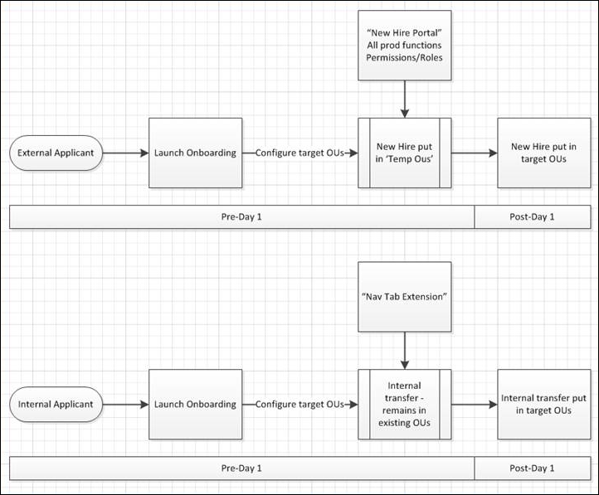
Frequently Asked Questions (FAQs)
What are Navigation Tabs and Links Extensions and what can I do with them?
Navigation tabs and links extensions are tabs and sublinks that provide a dedicated navigation tab/links resource in your portal for onboarding employees.
Example
- You create an extension and name it Onboarding for New Employees. While creating the extension, you add "Universal Profile" and "Browse for Training" sublinks to the extension so that new employees have quick access to these important system pages. You save the extension so that it is available to select when creating onboarding workflows.
- You create an onboarding workflow and name it Workflow for New Sales Team. In the Acculturation section, you add the Onboarding for New Employees extension. You save the workflow so that it is available for recruiters to select on the Applicant Profile page when they start onboarding for new Sales Team employees.
- A recruiter is ready to start onboarding for a new Sales Team employee. She navigates to the new employee's Applicant Profile page. She clicks Start Onboarding from the Options drop-down. This opens the Start Onboarding page, from which she configures the onboarding settings for the employee. In the Onboarding Workflow section on the page, she makes sure to select the Workflow for New Sales Team onboarding workflow that you created. She clicks Start onboarding to start onboarding for the employee.
- The new Sales Team employee accesses the portal. She sees the Onboarding for New Employees navigation tab. She clicks the Universal Profile link so that she can complete her bio. Then, she clicks the Browse for Training link so that she can find training that is relevant to her new role.
How do new and transitioning employees see my navigation tabs and links extensions?
Employees can see the tabs and links if onboarding is started for them (from the Applicant Profile > Start Onboarding page), and the extension is included in the onboarding workflow that is selected for the onboarding employee.
Why aren't new hires seeing their dedicated onboarding navigation tab that was created in Onboarding > Navigation Tabs and Links and included in their onboarding workflow?
Check to make sure they have not reached their hire date. Once they reach their hire date, the navigation tab is no longer visible. You can check an employee's hire date from your Onboarding Dashboard.

Onboarding Workflows
From the Onboarding Workflows page, you can view, create, and manage employee onboarding workflows.
To access the Onboarding Workflows page, go to Admin > Configuration Tools > Onboarding > Onboarding Workflows.
Permissions
PERMISSION NAME | PERMISSION DESCRIPTION | CATEGORY

Onboarding Workflows - Manage | Grants ability to access and manage Onboarding Workflows. This permission cannot be constrained. This is an administrator permission. | Employee Onboarding - Administration
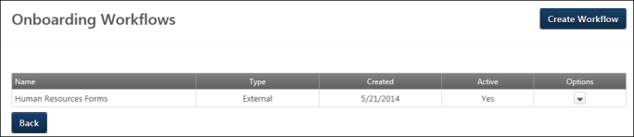
Create Workflow
Click Create Workflow to create an employee onboarding workflow.
Onboarding Workflows Table
The following information displays in the table:
- Name - This column displays the name of the workflow.
- Type - This column displays the workflow type. The column displays Internal for workflows that are for internal employees moving to another internal position. The column displays External for workflows for new hires who enter the organization as external candidates and become internal employees.
- Created - This column displays the date on which the onboarding was created.
- Active - This column displays the active status of the workflow. The column displays Yes for active and No for inactive. Note: For workflows that have not yet been used, the active status can be changed on the Edit Workflow page. For workflows that have been used, the active status can be changed by clicking the Edit link from the Options drop-down and changing the active status from the Edit Status pop-up.
Options
The following options display in the Options drop-down:
- Edit - Click Edit to edit the workflow. The content of a workflow can only be edited if it has not yet been used. If the workflow has been used, then when viewing the workflow, only the active status can be modified.
- Copy - Click Copy to copy the workflow. Note: If a task in the workflow has been inactivated, then the inactive task is not copied. For child tasks, if the parent task has been inactivated, then the child task also is not copied.
- Delete - Click Delete to delete the workflow. This opens a confirmation pop-up. Click Yes to delete the workflow, or click Cancel to cancel the delete action. Workflows can only be deleted if they have not been used.
Back
Click Back to return to the Employee Onboarding page.
Create Onboarding Workflow
The Create Onboarding Workflow page allows administrators to create onboarding workflows. The workflows can be created for new hires who are just entering the organization, or they can be created for internal employees who are starting a different role. The workflows help employees acclimate to the company and their position. They can also include forms created from the Form Management functionality. Such forms may be needed for Human Resources, IT Security, or other departments that are part of the employee onboarding process.
To access the Create Onboarding Workflow page, click the Create Onboarding button on the Onboarding Workflows page.
Permissions
PERMISSION NAME | PERMISSION DESCRIPTION | CATEGORY

Onboarding Workflows - Manage | Grants ability to access and manage Onboarding Workflows. This permission cannot be constrained. This is an administrator permission. | Employee Onboarding - Administration
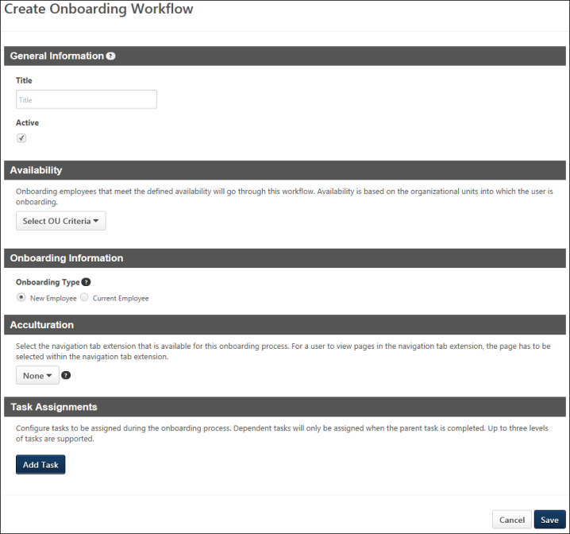
General Information
Complete the following fields in this section:
- Title - Enter a title for the workflow, up to 100 characters. This is a required field.
- Active - Define the active status for the workflow. Workflows are active by default. Uncheck the box to inactivate the workflow.
Availability
In the Availability section, administrators are required to define the organizational units (OUs) and/or users who will complete the workflow. If the workflow is defined in the Onboarding Information section as an internal-to-internal workflow, then employees who are moving from one role in the organization to another role will go through the workflow when onboarding. If the workflow is defined in the Onboarding Information section as an external-to-internal workflow, then external candidates who have been hired will go through the workflow.
To define the availability, select one or more OUs and/or users from the Select OU Criteria drop-down. The Include Subordinates box is checked by default. Unchecking the option does not include subordinate OUs or users.
Onboarding Information
In the Onboarding Information section, define the type of workflow. The following options are available:
- New Employee - Prior to migration, this option was named "External-to-internal" and allowed administrators to select temporary OUs for external candidates who were hired from outside the organization and are being onboarded to an internal position. After migration, selecting this option will create an onboarding workflow for external-to-internal onboarding.
- Current Employee - Prior to migration, this option was named "Internal-to-internal" and allowed administrators to select temporary OUs for users who were onboarding from one internal position to another. After migration, selecting this option will create an onboarding workflow for internal-to-internal onboarding.
Note: Preboarding OUs are configured on the Create Preboarding Organizational Unit Configuration page.
Acculturation
In the Acculturation section, select the navigation tab that will be available for the onboarding workflow. In order to add a navigation tab, at least one navigation tab has to be created already in Navigation Tabs and Links Extensions. This section is not required.
To select the tab, click the drop-down and select from one of the available tabs.
Note: The purpose of creating navigation tabs and links extensions for Onboarding is to provide onboarding employees with a dedicated space in your portal where the new employees can have quick access to important onboarding information and actions. For example, you can include a custom Welcome page, as well as links to key system pages, such as Universal Profile and Browse for Training. You can also include a link directly to the new employee's transcript, depending on the products that have been enabled in your portal.
Task Assignments
In the Task Assignments section, administrators can add tasks that will b e assigned to the employees on the date the onboarding workflow starts. Both form and integration tasks can be added.
Add Form Task
Add Task
To add a task:
- Click Add Task. This opens the task carousel.
- Select Form Task from the carousel. This opens the Select Form Task pop-up.
- Select the form task from the pop-up. The tasks that display are onboarding task types for which the administrator meets the availability criteria. The filter options can be used to search for tasks. Task Availability Note: The form tasks that are available to select in the pop-up are the tasks that are within the administrator's permission constraints for the permission needed to access the Form Task Administration page. Form tasks that are not within the administrator's permission constraints are not available to select in the pop-up.
- Selecting the task adds the task to the Task Assignments section.
Once the task is added, the following additional options are available prior to saving the task to the workflow:
Edit Task Selection
Click the Edit option in the options drop-down in the upper-right corner of the Task section. This opens the Select Form Task pop-up, allowing the administrator to select a different task before saving the task to the workflow.
Assignment Criteria
The Select Assignment option in the Assignment Criteria section is a required field. This option allows the administrator to select the role to which the task will be assigned. The following roles are available to select:
- Onboarding Employee
- Manager
- Cost Center Approver
- [Custom Relationship(s)] - Note: This functionality is only available for portals that have enabled the Performance module.
Date Criteria
Assignment Date
In this section, administrators determine when the onboarding task begins for the employee. The following options are available:
- Onboarding Launch Date - Select this option to assign the task on the date the employee launches the onboarding workflow. This option is selected by default.
- Start Date - Select this option to assign the task on the employee's start date of employment.
- Relative Date - Select this option to assign the task on a certain number of days before or after the employee's start date of employment. When selected, options display that require the administrator to define the number of days before or after the employee's start date that the task will be assigned. Enter the number of days in the Day(s) numeric text box, from 1 to 200. Then select the Before or the After option from the drop-down to define the task assignment date relative to the start date.
The Onboarding Form Assigned email is triggered on the task assignment date. The start date selected populates the TASK.START.DATE tag in the email, provided that the tag is used in the email.
The Assignment Date section does not display when configuring dependent tasks.
Due Date
In this section, administrators determine when the onboarding task is due. The due date for parent tasks must be after the assignment date. The due date for dependent tasks must be after the parent task due date.
The following options are available:
- Start Date - Select this option for the task to be due on the employee's start date of employment. This option is selected by default.
- Relative Date - Select this option for the task to be due on a certain number of days before or after the employee's start date of employment. When selected, options display that require the administrator to define the number of days before or after the employee's start date that the task will be due. Enter the number of days in the Day(s) numeric text box, from 1 to 200. Then select the Before or the After option from the drop-down to define the task due date relative to the start date.
The Onboarding Form Assigned email is triggered on the task due date. The due date selected populates the TASK.DUE.DATE tag in the email, provided that the tag is used in the email.
Save Task/Add Additional Task
The task must be saved to the workflow. Click Save to save the task to the workflow.
Additional tasks can be added by clicking the Add Task button and configuring the tasks.
Task Options
Once the task is saved, an options drop-down is available for the task to enable the administrator to further manage the task. The following options are available:
- Add Dependent Task - Dependent tasks can be added to the first and second level tasks for a workflow. To add a dependent task, click Add Dependent Task from the options drop-down. This opens the Select Form Task pop-up. The available Onboarding task types display in the pop-up. Selecting a task from the pop-up adds the dependent task to the parent task. When the task is added, configure the assignment criteria, and then click Save. Note: A dependent task can be the same task as the parent task.
- Edit - Click Edit to change the task or select a different assignee.
- Copy - Click Copy to copy the task. Both the task and assignee are copied.
- Delete - Click Delete to delete the task. This opens a confirmation pop-up. Click Yes to delete the task, or click No to cancel the delete action. The task and dependent relationships are removed. The delete action cannot be undone.
Dependent Task Options
The same options drop-down that is available for parent tasks is available for dependent tasks. However, the Add Dependent Task option is only available for the first and second level tasks.
Add Integration Task
The Integration task option displays in the Task Assignments section. This option allows administrators to include integration tasks in the onboarding workflow. The option only appears if there is at least one integration available for onboarding workflows. Note: The availability of integrations for onboarding workflows is defined by the administration on the Recruiting and Onboarding Integrations page.
To add an integration task:
- Click the Add Task button. This enables the task options to display below the button. Note: Click Cancel to close the task options.
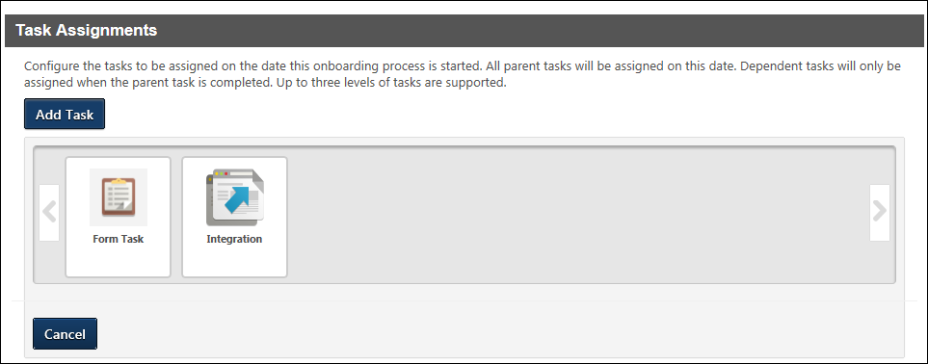
- Select the Integration option. This opens the Select Integration pop-up.
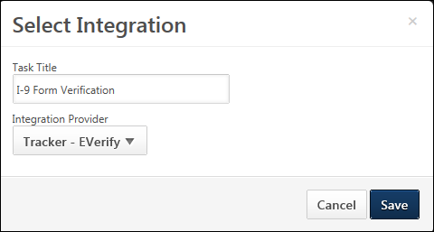
- Complete the following fields in the Select Integration pop-up:
  - Task Title - Enter a title for the task, up to 50 characters. The title appears to task recipients. This is a required field.
  - Integration Provider - Select the integration provider from the drop-down. The drop-down lists all available integration providers for onboarding workflows, as defined by the administrator in Recruiting and Onboarding Integrations. This is a required field.
- Click Save to add the task to the workflow. Or, click Cancel to cancel adding the task.
When the task is added to the workflow, the Task Assignments section is updated to display the task and include an option to edit the task details and configure the assignment criteria.
Electronic W-4 Form Tasks
Electronic W-4 Form tasks can be added to onboarding workflows for portals with an active integration with CIC Plus. The W-4 Form task can be added to the workflow by selecting the task from the Task Assignments section.
When saving the Task Assignments section, the W-4 Form task can only be saved if the CIC Plus integration is active. If the integration is not active, then an error message display indicating that the task is not available to be added to the workflow.
Edit Task
Once the integration task is added to the workflow, the task title and integration provider can be modified by clicking the Edit link in the options drop-down, which displays in the upper-right corner of the Integration section.
Assignment Criteria
Complete the following fields in this section:
- Select Assignee - Select the user to whom the task is being assigned. The options that are available to select are the custom relationships defined on the user record. By default, Onboarding Employee is selected as the assignee.
- Select Employer - Define the user who will act as the employer representative for completing Section 2 of the I-9 form. Enter a full or partial name in the field. Predictive search displays a list of matching names. Or, click the Select icon to open the Select a user pop-up and search for a user from the pop-up. Note: The Select Employer option is hidden for CIC Plus integrations.
Save/Cancel Task
Once the task is added and configured, click Save to save the task to the workflow. Or, click Cancel to cancel adding the task to the workflow.
Edit/Delete Saved Task
Once the task is saved to the workflow, the task details can be modified. The task can also be deleted.
Select the Edit option in the options drop-down to edit the task details. The task title, integration provider, assignee, and employer can be modified.
Select the Delete option in the options drop-down to delete the task. This opens a confirmation pop-up. Select Yes to delete the task, or select Cancel to cancel the delete action.
Save/Cancel Workflow
Click Save to save the workflow. Note: If a task has not been saved to the workflow, the workflow cannot be saved.
Click Cancel to cancel creating, editing, or copying the workflow.

Navigation Tabs and Links Extensions
The Navigation Tabs and Links Extensions functionality allows you to create navigation tabs specifically for the onboarding process. Various sublinks are available to select for the tabs in order to provide onboarding employees with access to system and custom pages that are beneficial during the onboarding process, such as Universal Profile and Browse for Training. Navigation tabs are then added to employee onboarding workflows, which are used in the onboarding process.
From the Navigation Tabs and Links Extensions administration page, you can create navigation tabs and links extensions. You can also view the existing tabs and links that have been created for onboarding.
To access the Navigation Tabs and Links Extensions page, go to Admin > Configuration Tools > Employee Onboarding. Then, click the Navigation Tabs and Links Extensions link.
Permissions
PERMISSION NAME | PERMISSION DESCRIPTION | CATEGORY

Onboarding Navigation Tab - Manage | Grants ability to access and manage Navigation Tabs and Links Extensions in Onboarding. This permission cannot be constrained. This is an administrator permission. | Employee Onboarding - Administration
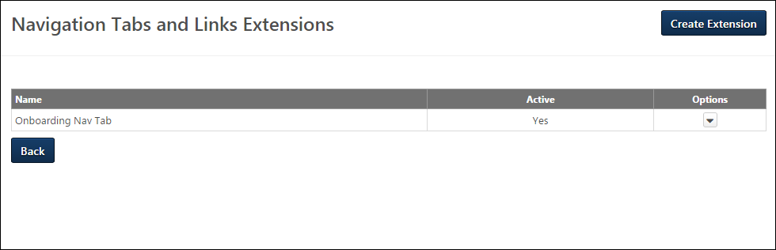
Create Extension
Click Create Extension to create a navigation tab and link extension. See Create/Edit/Copy Extension on page 27 for additional information.
Extensions Table
The following information displays in the Extensions table:
- Name - This column displays the name of the extension.
- Active - This column displays the active status of the extension. The column displays Yes for active extensions and No for inactive extensions.
Options
The following options display in the Options drop-down:
- Edit - Click Edit to edit the extension. If the extension is currently included in a workflow, a confirmation pop-up opens. Click Yes to continue the edit action, or click No to cancel the edit action. Changes to a navigation tab extension when the transition is in an In Progress status affect all of the associated transitions.
- Copy - Click Copy to copy the extension.
- Delete - Click Delete to delete the extension. This option is only available if the extension has not been used in a transition workflow.
Back
Click Back to return to the Admin > Configuration Tools > Onboarding page.
Frequently Asked Questions (FAQs)
What are Navigation Tabs and Links Extensions and what can I do with them?
Navigation tabs and links extensions are tabs and sublinks that provide a dedicated navigation tab/links resource in your portal for onboarding employees.
Example
- You create an extension and name it Onboarding for New Employees. While creating the extension, you add "Universal Profile" and "Browse for Training" sublinks to the extension so that new employees have quick access to these important system pages. You save the extension so that it is available to select when creating onboarding workflows.
- You create an onboarding workflow and name it Workflow for New Sales Team. In the Acculturation section, you add the Onboarding for New Employees extension. You save the workflow so that it is available for recruiters to select on the Applicant Profile page when they start onboarding for new Sales Team employees.
- A recruiter is ready to start onboarding for a new Sales Team employee. She navigates to the new employee's Applicant Profile page. She clicks Start Onboarding from the Options drop-down. This opens the Start Onboarding page, from which she configures the onboarding settings for the employee. In the Onboarding Workflow section on the page, she makes sure to select the Workflow for New Sales Team onboarding workflow that you created. She clicks Start onboarding to start onboarding for the employee.
- The new Sales Team employee accesses the portal. She sees the Onboarding for New Employees navigation tab. She clicks the Universal Profile link so that she can complete her bio. Then, she clicks the Browse for Training link so that she can find training that is relevant to her new role.
How do new and transitioning employees see my navigation tabs and links extensions?
Employees can see the tabs and links if onboarding is started for them (from the Applicant Profile > Start Onboarding page), and the extension is included in the onboarding workflow that is selected for the onboarding employee.
Why aren't new hires seeing their dedicated onboarding navigation tab that was created in Onboarding > Navigation Tabs and Links and included in their onboarding workflow?
Check to make sure they have not reached their hire date. Once they reach their hire date, the navigation tab is no longer visible. You can check an employee's hire date from your Onboarding Dashboard.
Create/Edit/Copy Extension
Administrators can create and manage navigation tabs and links extensions from this page. The extensions are included in employee onboarding workflows, which are used in the onboarding process.
To access the Navigation Tabs and Links Extensions page, go to Admin > Configuration Tools > Employee Onboarding. Then, click Navigation Tabs and Links Extensions. Click Create Extension on the Navigation Tabs and Links Extensions page to access the Create Extension page.
For an overview of navigation tabs and links extensions, See Navigation Tabs and Links Extensions on page 25 for additional information.
For more information about onboarding, See Employee Onboarding Overview on page 13 for additional information.
Permissions
PERMISSION NAME | PERMISSION DESCRIPTION | CATEGORY

Onboarding Navigation Tab - Manage | Grants ability to access and manage Navigation Tabs and Links Extensions in Onboarding. This permission cannot be constrained. This is an administrator permission. | Employee Onboarding - Administration
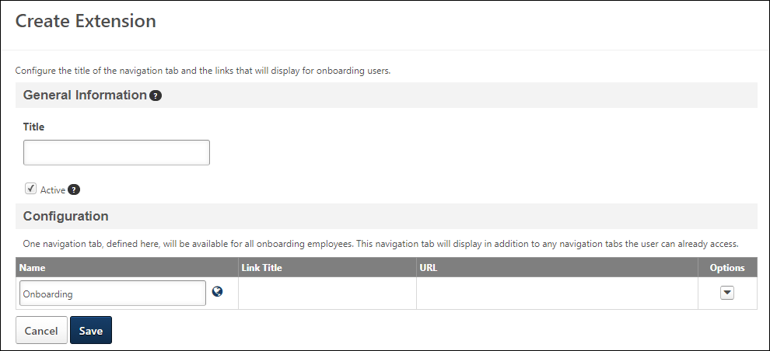
Title
Enter a title for the extension, up to 50 characters. This is a required field.
Active
Define the active status for the extension. Extensions are active by default. Uncheck the box to inactivate the extension. Note: Inactive navigation tab extensions cannot be added to new onboarding workflows. However, the navigation tab will still be visible to applicable users.
Configuration
The configuration section allows administrators to view, add, and manage navigation sublinks for the navigation tab.
Add Page
The Add Page option is available from the Options drop-down in the Onboarding row. At least one page must be added.
To add a page:
- Select Add Page. This opens the Select Page pop-up.
- Select a sublink from the list. This automatically closes the pop-up and adds the link to the sublinks table.
Translate
For portals with multiple languages, click Translate in the Options drop-down in the Onboarding row to translate the "Onboarding" text.
Sublinks Table
The sublinks table displays the links that will be available from the navigation tab. The following information displays in the table:
- Name - For navigation tabs, this column displays the title of the tab. For pages within the system, this column displays the page title.
- Link Title - For navigation tabs, this column is blank. For pages within the system, this column displays the link title.
- URL - For navigation tabs, this column is blank. For pages within the system, this column displays the page URL.
- Options - The following options are available in the Options drop-down:
  - Move Up - Click this option to move the link up one level in the order.
  - Move Down - Click this option to move the link down one level in the order.
  - Delete - Click this option to delete the link from the tab.
Save/Cancel
Click Save to save the navigation tab extension.
Click Cancel to cancel creating, editing, or copying the navigation tab extension.

Preboarding Overview
Create Preboarding Organizational Unit Configuration
From the Create Preboarding Organizational Unit Configuration page, you can create preboarding organizational unit (OU) configurations that new hires will be placed into if they meet the availability criteria that are defined for the OU. These configurations will be available for recruiters to select on the Start Onboarding page when onboarding external users.
To access the Create Preboarding Organizational Unit Configuration page, click the Create Configuration button on the Preboarding Organizational Unit Configurations page.
Permissions
PERMISSION NAME | PERMISSION DESCRIPTION | CATEGORY

Preboarding Organizational Units - Manage | Grants ability to access and manage Preboarding OU Configurations. This permission cannot be constrained. This is an administrator permission. | Employee Onboarding - Administration
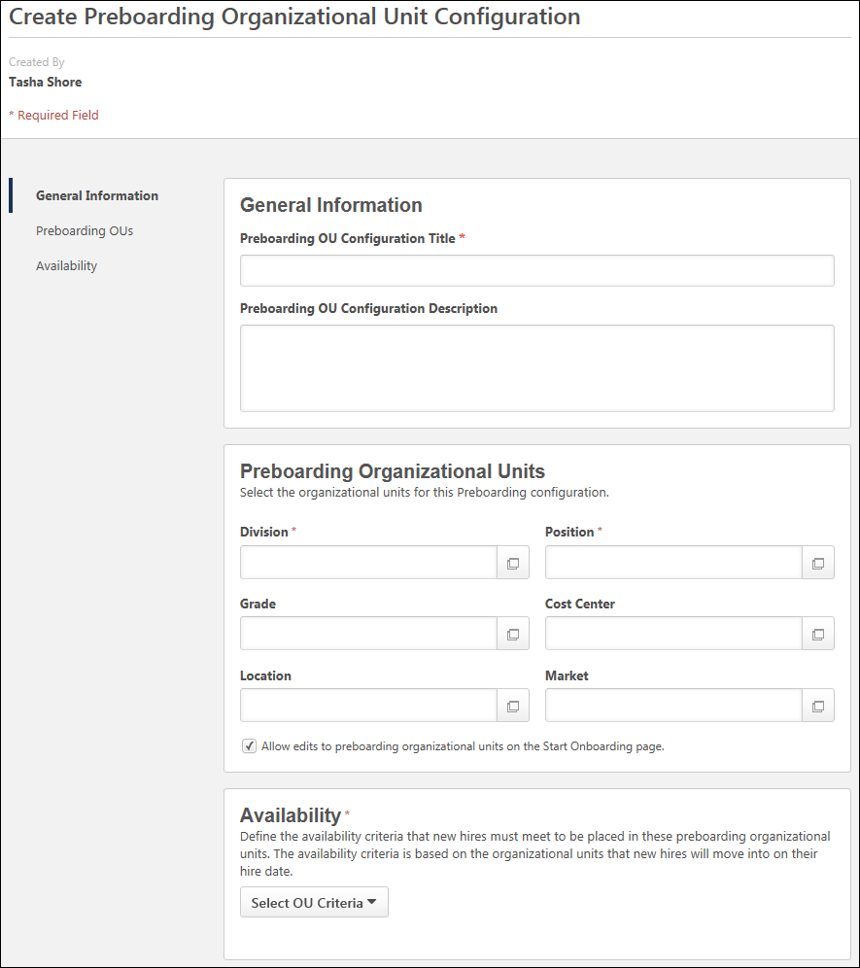
Created By
The user who is creating the preboarding OU configuration displays at the top of the page.
General Information
This section enables you to define the title and description. Required fields are identified with a red asterisk.
- Preboarding OU Configuration Title - Enter a title, up to 100 characters.
- Preboarding OU Configuration Description - Enter a description, up to 250 characters. The description should be worded in a way that helps recruiters know the purpose of this configuration. For example, if you create a configuration for newly hired sales managers, then the description could be something like "Use this preboarding OU configuration for all newly hired sales managers."
Preboarding Organizational Units
This section is where you will select the individual preboarding OUs for this configuration. Standard and custom OUs are available. Required fields are identified with a red asterisk.
To select the OUs:
- Enter the OU name in the predictive search field, and then select the OU from the list of matching OUs.
- Or, click the Select icon to open the OU pop-up. Then, select the OU from the list.
If this preboarding OU configuration is selected by the recruiter on the Start Onboarding page for a new hire, then the new hire will placed into the preboarding OUs until their hire date. Once the new hire reaches their hire date, they are automatically moved into the OUs that are defined in the Organizational Units section on the Start Onboarding page. Note: It is possible that the preboarding OUs and the OUs that the applicant will move into on their hire date are the same OUs, depending on the preboarding OU configuration and the Start Onboarding page settings.
Allow Edits to Preboarding OUs
The Allow edits to preboarding organizational units on the Start Onboarding page option enables you to enable or disable changes to the preboarding OUs. The option is checked by default.
When checked, recruiters are able to change the preboarding OUs on the Start Onboarding page.
Availability
This section enables you to select the availability criteria for the preboarding OU configuration. The availability determines the criteria that must be met in order for this preboarding OU configuration to be available for recruiters to select on the Start Onboarding page.
For example, you create a preboarding OU configuration called Accountant New Hires. The availability criterion in the Position field is the Accountant Position OU. When a recruiter configures the Start Onboarding page for a new hire in the Accountant position, the recruiter will be able to select your Accountant New Hires preboarding OU configuration because the candidate was hired for an Accountant position.
To select the availability:
- Click the Select OU Criteria drop-down. This displays a list of the available OU types.
- Select an OU type. This enables the predictive search field to display.
- Enter the full name or partial name of an OU in the field, and then select an OU from the list of matching OUs.
- Or, click the Select icon to open the OU pop-up. Then, select the OU from the list.
Repeat these steps to add additional criteria.
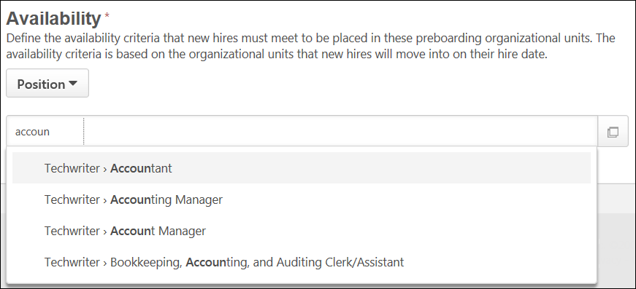
Preboarding Organizational Unit Configurations
The Preboarding Organizational Unit Configurations page enables administrators to manage and configure preboarding organizational units (OU) for new hires. The page lists all of the preboarding OUs that have been created. From here, you can edit, copy, and delete the preboarding OUs.
To access the Preboarding Organizational Unit Configurations page, go to Admin > Tools > Onboarding > Preboarding Organizational Unit Configurations.
Permissions
PERMISSION NAME | PERMISSION DESCRIPTION | CATEGORY

Preboarding Organizational Units - Manage | Grants ability to access and manage Preboarding OU Configurations. This permission cannot be constrained. This is an administrator permission. | Employee Onboarding - Administration
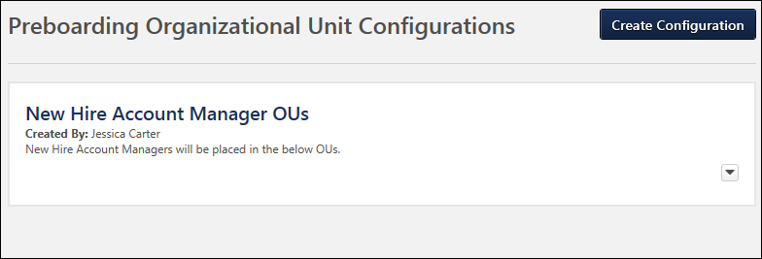
Create Configuration
Click the Create Configuration button at the top of the page to create a preboarding OU. This opens the Create Preboarding Organizational Unit Configuration page. See Create Preboarding Organizational Unit Configuration on page 30 for additional information.
Preboarding OUs
All of the preboarding OUs that have been created display on the page in alphabetical order.
The following information displays for each preboarding OU configuration:
- Title - The title of the configuration appears at the top.
- Created By - This field displays the first and last name of the user who created the configuration.
- Description - The description of the configuration displays below the created by user.
- Options - The following options are available from the options drop-down :
  - Edit - Click Edit to edit the configuration. This opens the Edit Preboarding Organizational Unit page, from which you can make changes to the configuration. The changes are not applied to users who are currently onboarding; they only apply to future users.
  - Copy - Click Copy to copy the configuration. All settings are copied and can be modified. The word "Copy" will appear in the title but can be removed.
  - Delete - Click Delete to delete the configuration. This does not impact users who are currently onboarding.
Self-Migration of Temporary OUs
Top level system administrators can choose to self-migrate their portal over to use preboarding organizational units (OU) rather than temporary OUs. The temporary OUs are found in onboarding workflows that were created prior to implementation of the preboarding OUs functionality.
Self-migration can be done from the Preboarding Organizational Units Enablement section at the bottom of the Onboarding Workflows administration page. Enabling the migration is portal-wide.
Note: The self-migration will not include inactive onboarding workflows.
Enable Self-Migration
To self-migrate the portal:
- Navigate to Admin > Tools > Onboarding > Onboarding Workflows.
- Scroll to the Preboarding Organizational Units Enablement section.
- Click the Accept & Enable option. This opens the Preboarding Organizational Units Enablement acknowledgment pop-up.
- Click Yes to enable the migration.
- Click No to close the pop-up without enabling the migration.
Clicking Yes removes the temporary OUs from onboarding workflows. You will then need to select the preboarding OUs for new hires by creating preboarding OU configurations and/or selecting the preboarding OUs on the Start Onboarding page.
The Preboarding Organizational Units Enablement section on the Onboarding Workflows page will be hidden the next time you or another system administrator accesses the page.
Self-Migration Enabled
Once the self-migration is enabled, all temporary OUs in onboarding workflows are converted to preboarding OU configurations. The preboarding OU configurations can be viewed and managed from the Preboarding OU Configurations page.
- For each onboarding workflow, one new preboarding OU configuration is created. The following values are placed into the configuration:
  - Created By - The name of the user who enabled the self-migration.
  - Title of Preboarding OU Configuration - The name of the onboarding workflow.
  - Preboarding OUs - Populated with the temporary OUs from the onboarding workflow.
  - Availability - Populated with the availability settings from the onboarding workflow.
Onboarding Information Section
The self-migration will make changes to the Onboarding Information section for onboarding workflows. After migration, only the following options will display in this section:
- New Employee - Prior to migration, this option was named "External-to-internal" and allowed administrators to select temporary OUs for external candidates who were hired from outside the organization and are being onboarded to an internal position. After migration, selecting this option will create an onboarding workflow for external-to-internal onboarding.
- Current Employee - Prior to migration, this option was named "Internal-to-internal" and allowed administrators to select temporary OUs for users who were onboarding from one internal position to another. After migration, selecting this option will create an onboarding workflow for internal-to-internal onboarding.
The temporary OUs fields will no longer display, since they will be configured on the Create Preboarding Organizational Unit Configuration page.
Automatic Permission Assignment
In addition, all users who currently have permission to manage onboarding workflows will be automatically assigned the Preboarding Organizational Units - Manage permission.

Start Onboarding Page
The Start Onboarding page allows recruiters to select and start an onboarding workflow for the applicant. When onboarding is started, the applicant is transitioned from applicant to employee. The employee is placed into the job requisition's designated organizational units (OU) and can begin completing their onboarding workflow.
Note: At least one employee onboarding workflow must already be created by the administrator in Onboarding Workflows in order for a workflow to be available for onboarding.
To access the Start Onboarding page, click Start Onboarding from in the Options drop-down on the Applicant Profile page.
Permissions
PERMISSION NAME | PERMISSION DESCRIPTION | CATEGORY

Start Onboarding | Allows user to start the onboarding process from applicant to employee and view onboarding progress from the Applicant Profile. This permission can be constrained by OU and User's OU.  When using the Start Onboarding option on the Applicant Profile page, recruiters must have the Start Onboarding permission and must be able to access the applicant's profile based on their permission constraints for the associated job requisition. | Employee Onboarding
Emails
EMAIL NAME | EMAIL DESCRIPTION | ACTION TYPE

Employee Onboarding Started | This email is triggered when Onboarding is started and when emails are configured for the given employee onboarding process. The email can be sent to Onboarding User, User's Approver, User's Manager, or a specific user. This email can be configured as a Notification type email. This email is active by default and can be found in the Employee Onboarding action type section of Email Management. | Employee Onboarding
Use Case
- Laura has a brand new crop of interns that were hired for an internship program.
- When Laura is ready to initiate the onboarding process for the hired interns, she starts onboarding for each of them.
- As Laura initiates the onboarding for each new hire, she ensures that the OUs they will be moving into are correct.
- After she sets the OUs for a new hire, Laura can select the correct onboarding workflow which the new hire will be going through.
- Once Laura selects the onboarding workflow, she defines the new hire’s Manager and other details.
- Finally, Laura sets the date that the new hire will begin their first day of work.
- After all of this is done, Laura is able to “Start Onboarding” for the new hire.
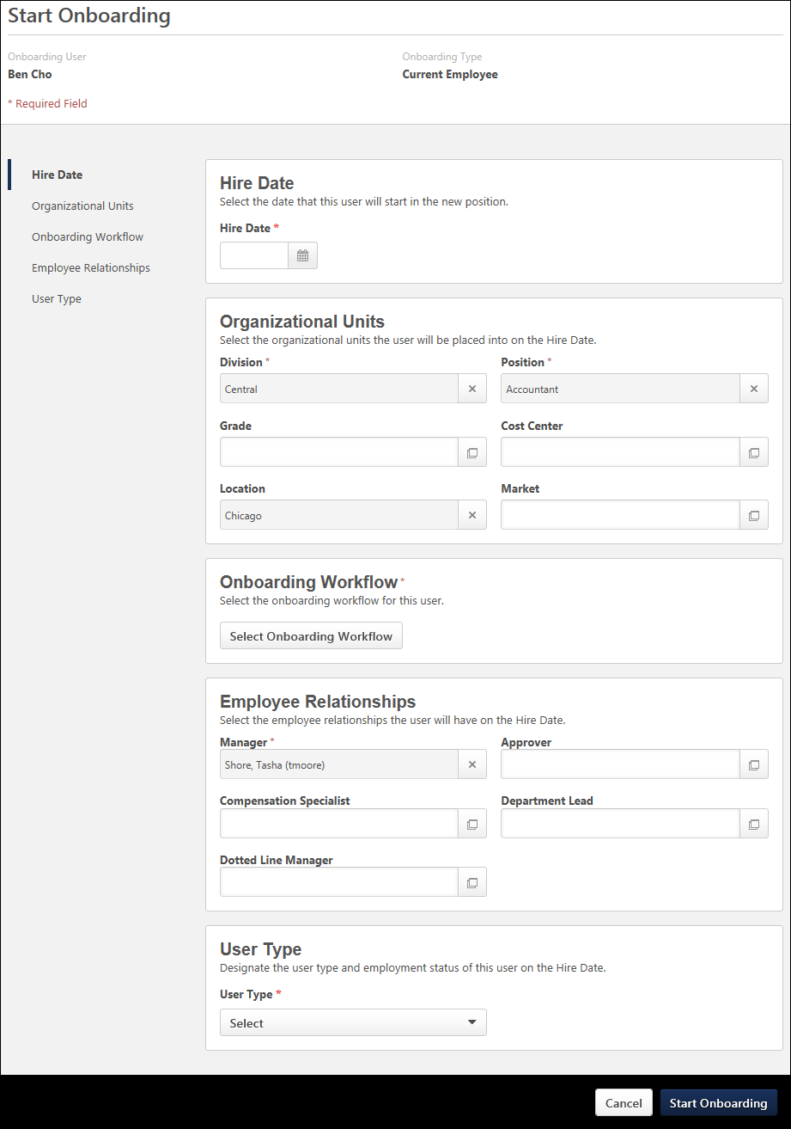
Onboarding User/Type
The name of the onboarding user and the type of onboarding displays at the top of the page.
For the onboarding type, the following are the two possible values:
- Current Employee - This indicates the user is an internal employee and is transitioning into a different role.
- New Employee - This indicates the user is an external employee who is new to the company.
Hire Date
This section requires the recruiter to define the date on which the applicant will start onboarding. Enter a date in the field or use the calendar feature to select a date. The date must be the current date or a date in the future. This is a required field.
Note: For external applicants, when they reach their onboarding start date, their user status changes from Onboarding to Working.
Note: You can change the hire date to a different date on the user record, such as a date in the past, by modifying the Original Hire Date Field. See User Record - General Information.
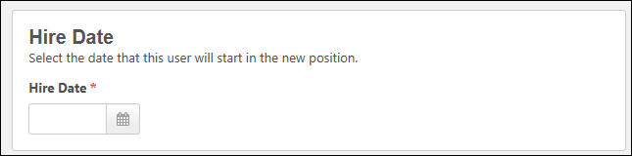
Organizational Units
This section displays the standard and custom OUs that are defined for the job requisition that the recruiter was viewing on the Applicant Profile page or for the most recent requisition to which the applicant has applied. If the Division OU or Location OU was updated to a different value in the offer letter, then the fields are pre-populated with those values but can be modified.
Note: If default values are removed and new OU values are selected, then the OUs that can be selected are constrained by the constraints on the Start Onboarding permission, if applied. The default values are exempt from the OU constraints since they are pre-populated.
You can change the OUs by doing the following:
- Enter the OU name in the predictive search field. Select the OU from the list of matching OUs.
- Or, click the Select icon to open the OU pop-up. Then, select the OU from the list.
The OUs that are defined in this section dictate the onboarding workflows that will be available to select in the Onboarding Workflow section.
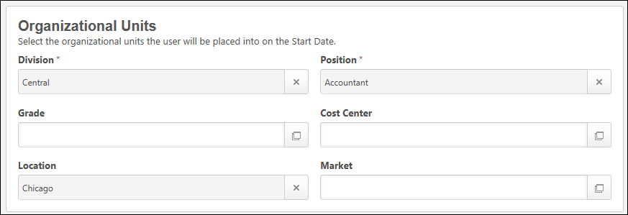
Location Field for Tracker I-9 and WOTC
If there are onboarding tasks that include either Tracker I-9 or Work Opportunity Tax Credit (WOTC), the Location field must be completed on the Start Onboarding page
Onboarding Workflow
This section allows you to select the onboarding workflow for the user.
To select an onboarding workflow:
- Click Select Onboarding Workflow. This opens a slide-out menu on the left side of the page, which displays the onboarding workflows that are available to select.
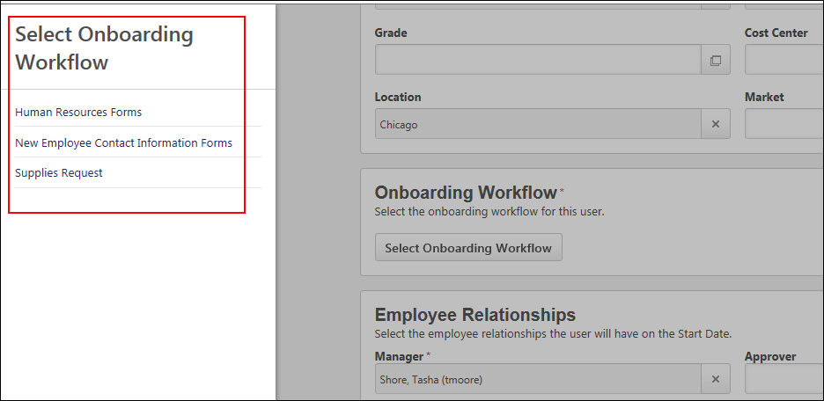
- Click the name of an onboarding workflow to select it. This closes the menu and adds the onboarding workflow to the page.
If the applicant is external, then only workflows that are defined as external-to-internal will be available. If the applicant is internal, then only workflows that are internal-to-internal are available. Selecting a workflow closes the pop-up and assigns the onboarding workflow to the applicant.
If there are no workflows that match the OU criteria, then an error message displays, indicating that there are no workflows available to assign.
Employee Relationships
This section displays standard and custom employee relationships. You can change the employee relationships by doing the following:
- Enter the employee relationship name in the predictive search field.
- Then, select the relationship from the list of matching relationships based on the predictive search.
- Or, click the Select icon to open the Select Employee Relationship pop-up.
- Then, select the relationship from the list.
The relationships available to select are dependent upon the constraints of the permission needed to start onboarding for applicants.
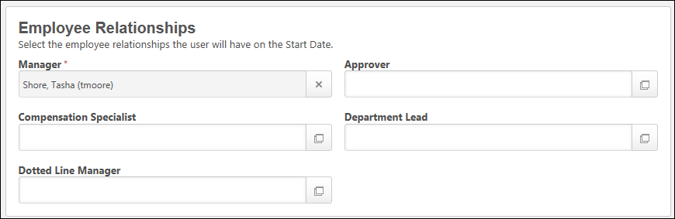
User Type
This section only displays for portals that have Onboarding enabled and User Types and Statuses. This section allows you to define the user type and user subtype, if applicable, for the onboarding user. For clients with onboarding and the user type and employment status feature enabled, any user with access to "Start Onboarding" will be required to set the user type and employment status.
Use Case
Peter has hired two new hires and is about to launch their onboarding. Evan is an external applicant and Irene is an internal applicant. Peter launches onboarding for both Evan and Irene. He defines the user types and subtypes for Evan and Irene in the User Type section of the Start Onboarding page.
Evan - External Applicant
- Evan will be a full-time employee, so his user type is defined as Employee and his user subtype is defined as Full-Time.
- On the date that onboarding is started, Evan moves into the user type Employee and user subtype Full-Time. His user status is also updated to Onboarding, as he is not yet actively working prior to his hire date.
- On Evan's hire date, his user status is updated to Working, as he is a full-time employee that is actively working.
Irene - Internal Applicant
- Irene is making a transition to become a part-time contractor. Her user type is defined as Contractor and her user subtype is defined as Part-Time.
- On the date that onboarding is started , there is no change to Irene's current user type and subtype, and her user status remains as Working, as she is still actively working during her onboarding period prior to her hire date.
- On Irene's hire date, her user type is updated to Contractor and her user subtype is updated to Part-Time. Her user status remains Working, as she continues to actively work.
To define the user type and subtype, select one of the following user type options from the :
- User Type - This field requires you to define the user type for the onboarding employee. The user types that display in the drop-down are the system-defined user types. Select a user type from the drop-down to define the user type. Once the onboarding user reaches their hire date, they are moved into the user type/subtype that is defined in the User Type section.
- User Subtype - This field only displays if subtypes have been configured for the user type. To define a subtype, select an option from the drop-down. This is a required field.
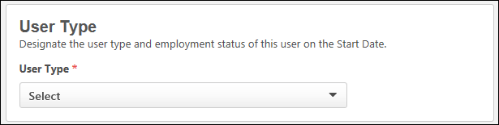
Canceled Onboarding for External Applicants
If onboarding is canceled for external applicants, then the user type that was defined in the User Type section is removed. This allows external applicants to have the appropriate user type of external applicant when onboarding is canceled.
In addition, the user's status is canceled so that the external applicant returns to being an external applicant instead of being a user in the system.
Preboarding Organizational Units
Note: This section only displays for external applicants.
The Preboarding Organizational Units section allows you to select the preboarding OU configuration that contains the OUs in which the user will be placed until their hire date. This section is a required to complete in order to start onboarding for the user.
To select the preboarding OU configuration:
- Click Select preboarding ou configuration. This opens a slide-out menu on the left side of the page, which displays the configurations that are available to select, based on the OUs defined for the new hire on Start Onboarding page. These OUs are populated on the requisition and/or offer letter but can be changed on the Start Onboarding page.
- Click the name of a configuration to select it. This closes the menu and adds the configuration to the page.
Upon clicking Start Onboarding at the bottom of the page, the user is placed into the preboarding OUs.
Modify Preboarding OUs
If enabled by the administrator when creating the preboarding OU configuration, you can change any of the preboarding OU selections by selecting a different OU in the field.
If changes are disabled by the administrator, then the OU selections cannot be modified by the recruiter.
Overwriting on Hire Date
Once the user reaches their hire date, the OUs that are defined in the Organizational Units section on the Start Onboarding page will overwrite the user's preboarding OUs.
Impact When Onboarding Is Canceled
When onboarding is canceled for the user, the user is removed from all preboarding OUs to which they were assigned.
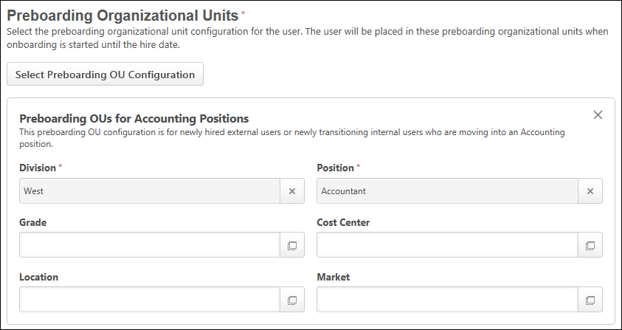
Start Onboarding
Click Start Onboarding to start the onboarding process for the user. This returns you to the Applicant Profile page.
Or, to close the Start Onboarding page without starting the onboarding process, click Cancel. This returns you to the Applicant Profile page and will not keep the settings you configured for the applicant.
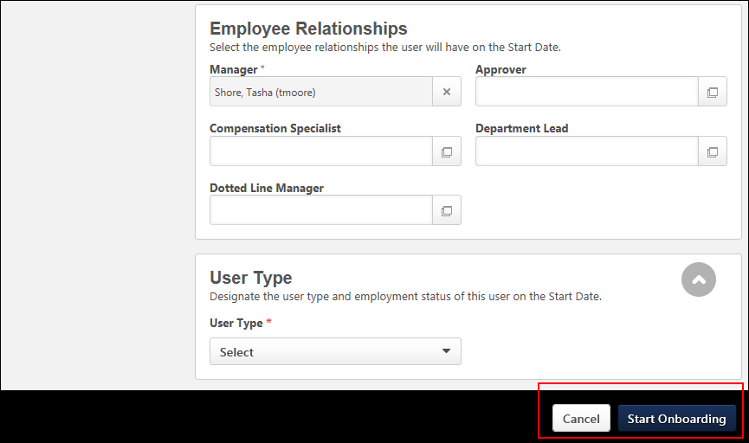
Assigned Workflow
Once the workflow is assigned, the following occurs:
- If the applicant is an internal applicant, the applicant is placed into the OUs defined.
- If the applicant is an external applicant, the applicant is transitioned to an employee and placed into the preboarding OUs defined for the workflow.
- The Employee Onboarding Started email is triggered, if configured by the administrator in Email Management.
- The History tab on the Applicant Profile page logs the transition event.
- Dynamic security roles are granted for internal and external applicants.
- Parent tasks that are configured for the workflow are assigned to the applicant. Dependent tasks are assigned once the parent tasks are completed.
Cancel
Click Cancel to cancel starting the onboarding process.
Start Onboarding Error Messages
If certain user record fields are not configured properly for onboarding, an error message appears when you click Start Onboarding to indicate why the error occurred. Recruiters can provide the message to their system administrator to correct the issue.
The following user record settings apply to these error messages:
- Reason for Change - If this setting is enabled in User Preferences, then you must also have at least one user type and one user status active in User Preferences.
- User Status - The Onboarding status must be active in the User Statuses section in User Preferences. If it is not active, then an error will occur when attempting to start onboarding.
There will also be a notification to the user on the Applicant Profile that onboarding failed, if the onboarding failed to start for any other reason, as well.

