Mobile March 2024

Table of Contents
Mobile - Overview 1
Mobile Preferences 2
Cornerstone CSX App - Overview 11
Cornerstone CSX iOS App - Overview 13
Cornerstone CSX Android App - Overview 72
Cornerstone CSX App - Goals 126
Cornerstone CSX App - More Menu 129
Cornerstone CSX App - Notification Center 131
Cornerstone CSX App - Observation Checklists 135

Mobile - Overview

Mobile Preferences
The Mobile Preferences page enables administrators to manage the features that are available to users on the Cornerstone CSX application.
Mobile Preferences can be set by Division, so different mobile preferences such as Theme can be configured for each Division.
Note: Users can download and use the Cornerstone CSX app from both the Apple App store and the Google Play store.
To access Mobile Preferences, go to Admin > Tools > Core Functions > Core Preferences > Mobile.
Permissions
PERMISSION NAME | PERMISSION DESCRIPTION | CATEGORY

Mobile Preferences | Grants ability to manage Mobile Preferences. This permission cannot be constrained. | Mobile
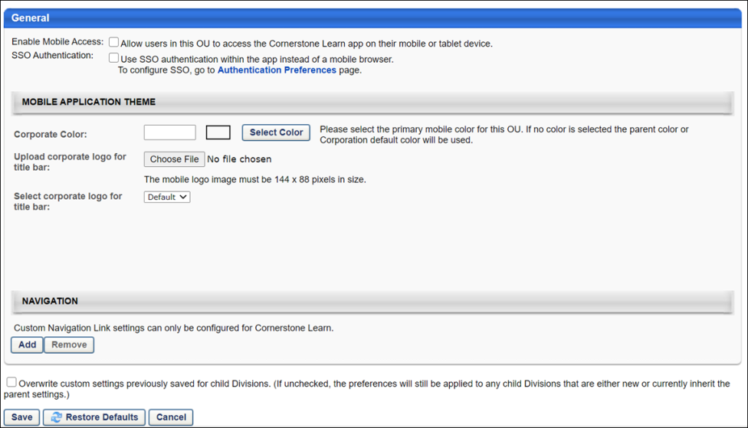
Enable Mobile Access
Select or deselect the Enable Mobile Access option to enable or disable the Cornerstone CSX application.
SSO Authentication
When this option is selected, when a user attempts to log in to the mobile application via SSO, the authentication occurs within the mobile application rather than a mobile browser. When this option is not selected, the authentication occurs in a mobile browser. By default, this option is not selected.
Mobile Application Theme
The Mobile Application Theme section allows administrators to define a custom theme for the Cornerstone CSX app. Configure the following options to customize the app theme and logo:
- Corporate Color - This option enables administrators to define the primary color which will be used on the Log In screen for both iOS and Android, and in the apps navigation on Android. Enter the hex value in the alphanumeric text box. Or, select a color by clicking the Select Color button.
- Upload corporate logo for title bar - This option enables administrators to upload a logo. Click Browse to upload a logo image from your computer. The image dimensions must be 144 x 88 pixels. Please see the section below for other guidelines on how to create your logo for the app. After selecting the logo image, click Upload to upload the image to the portal.
- Select corporate logo for title bar - This option enables administrators to select a previously uploaded logo. From the drop-down list, select a logo that has previously been uploaded.
Logo Guidelines
See the infographic below for more logo image guidelines:
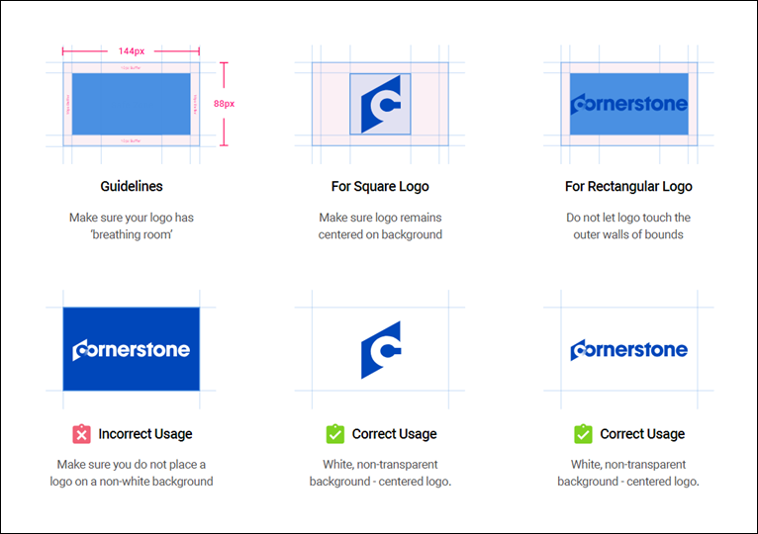
Mobile Application Theme Impact
The branding and customization options you configure via Mobile Preferences have the following impact on the Cornerstone CSX app:
Android
Your Mobile Application Theme configurations in Mobile Preferences impact the Android version of the Cornerstone CSX app pages and features in the following ways:
- The top navigation bar of the app changes to the chosen corporate color.
- The Log In button for the app changes to the chosen corporate color.
- The logo you uploaded displays in the navigation drawer and on the Log In page. Note: If no logo has been provided via Mobile Preferences, the Cornerstone log displays by default.
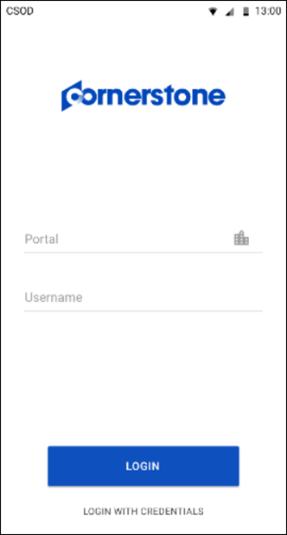

iOS
Your Mobile Application Theme configurations in Mobile Preferences impact the iOS version of the Cornerstone CSX app pages and features in the following ways:
- The Log In button for the app changes to the chosen corporate color.
- The logo you uploaded displays in the navigation drawer and on the Log In page. Note: If no logo has been provided via Mobile Preferences, the Cornerstone logo displays by default.
  - The navigation drawer is new for iOS. Now, instead of tapping the search bar at the top of the screen, the user must tap the search icon to conduct a search.
  - The navigation drawer includes a Give Feedback link to a short survey about the Cornerstone CSX app, to allow the Cornerstone team to continue improving the app.
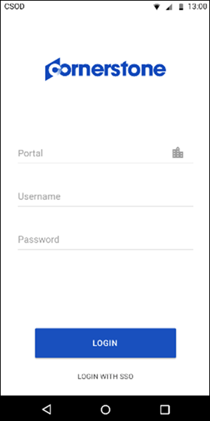
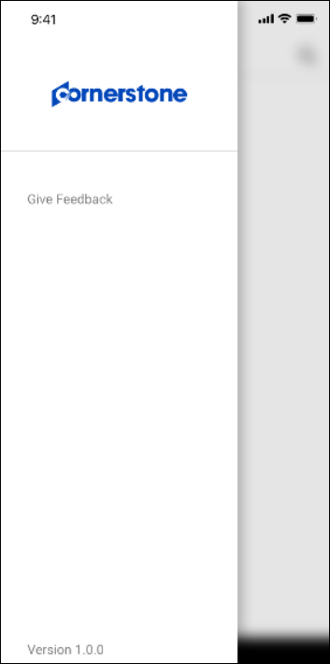
Splash Page
A Cornerstone splash page will display while the Cornerstone CSX app is loading the Log In screen. This splash screen displays for both iOS and Android.
Navigation
To configure a custom link within the Cornerstone CSX app, populate the following fields:
- Link Text - Add text that will be included with the custom navigation link. The character limit for this field is 40 characters.
- URL - Enter the URL for the page you want to add as the custom link.
- Icon - Select the icon that should be displayed with your link from the drop-down menu.
Up to 10 custom navigation links can be added, and they may point to any area of the system. These links are not exclusive to Learning-related pages.
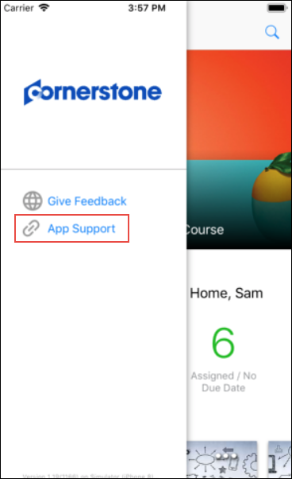
Overwrite Settings
Select this option to overwrite custom settings for child division OUs. If you overwrite custom settings for child division OUs, the selected settings are applied to both new and existing child OUs. Any previously customized child OUs are updated with the selected settings.
- If there are no customizations to the child OU, then the parent OU customizations are applied to all child OUs.
- Overwrite custom settings checkbox setting
  - If this option is selected, all child OU customizations are deleted from the database, which means the parent OU customizations will be applied to new and existing child OUs.
  - If this option is unselected, all existing child OU customizations will remain unchanged, and any new child OUs will inherit the parent OU customizations by default.
- If a child OU has been customized to display any widgets, then regardless of the parent OU customizations, the child OU customizations are applied.
- If a child OU has been customized to hide all widgets, then parent OU customizations will take precedence and will be applied.
Save, Restore Defaults, or Cancel
Click the Save button to save the preferences settings.
Click the Restore Defaults button to restore the preferences to the default settings.
Click the Cancel button to cancel the changes to the preferences settings.

Cornerstone CSX App - Overview
The Cornerstone CSX app provides learners with a fast, modern, and intuitive mobile learning experience.
Using the Cornerstone CSX app, mobile learners can interact with the following learning features:
- Learner Home
- Learning Search
- Learning Transcript
Use Cases
Use Case 1: Log In
Laurence's iPhone displays content in French, but she works at a Santa Monica office, so her company's learning portal language is English. She just installed the Cornerstone CSX app and opens it, and the Log In screen is in French, like her device. She logs into the application with her credentials and receives a prompt to enable Touch ID, which she does.
Once Laurence has logged into the app, she is notified that a new language has been detected, and she needs to close the app and restart it in order to view the app in her company portal's language. She closes the message and notes that her system tabs are in French, but her training tiles are in English, so she closes the app and restarts it.
When Laurence logs into the Cornerstone CSX app again, everything in the application, including training tiles, tabs, and links, are in English.
Use Case 2: Learner Home
John opens the Cornerstone CSX app on his iPhone 8, and the first thing he sees is his company's marketing banner. Below that, he sees a welcome message and his training metrics, which quickly show him the general status of training items on his transcript. When scrolling down the page, he sees carousels with training content recommended for him. The carousel order and availability respect the learning administrator's configurations, but the content itself is powered by machine learning. Because he can only see mobile training on the carousels, he can interact with all the training he sees by requesting, launching, and saving a training for later.
Use Case 3: Learning Search
Mike wants to find a course on leadership that he can take in less than fifteen minutes. He taps on the Search bar in his Cornerstone CSX app and taps Enter on his mobile keyboard. Because he ran a blank search, up to 50 mobile training items available to him display in search results. He taps on the filter icon and decides to filter for courses under fifteen minutes, which causes only 123 courses to display in search results. He selects a subject filter as well, and twenty-three results are returned this time. On the search results page, he can see twenty-three mobile training items related to the Leadership subject that are shorter than fifteen minutes.
Use Case 4: Transcript
Mark visits the Transcript page of the Cornerstone CSX app, and the first thing he sees is the Continue Learning carousel, with the last course he opened in the first slot in the carousel. Scrolling down, he sees all the active mobile-enabled training on his transcript. He can launch an items, mark items complete, and view the Training Details pages for training items. After completing training, he can view completed training items on the Completed transcript page in the application.
Considerations
- The Cornerstone CSX app is available for iOS and Android.
- Access to the app and all pages inside it is controlled by the Enable Mobile Access checkbox on the Mobile Preferences page. Any users included in an organizational unit (OU) configured to allow mobile access can navigate to any page in the app, even if they do not have permission to access the desktop version of these pages. See Mobile Preferences on page 2 for additional information.
- The corporate color and logo of the Cornerstone CSX app can be customized via Mobile Preferences. See Mobile Preferences on page 2 for additional information.
- Only online courses, materials, and videos can be launched inside the app. Items that are not mobile-enabled are hidden by default, but the user can choose to see them by toggling the Mobile switch to the Off position in the app settings.
- Cornerstone CSX is supported by the following devices and operating systems:
  - Cornerstone supports the native mobile application for the three most recent versions of Android and the most recent versions of iOS. In order to use the Cornerstone CSX app, users' devices must use one of the three most recent versions of Android or the most recent version of iOS.
Documentation Overview
Click the links below to access documentation for each section of the Cornerstone iOS CSX app:
- See Cornerstone CSX iOS App - Log In on page 14 for additional information.
- See Cornerstone CSX iOS App - Learner Home on page 29 for additional information.
- See Cornerstone CSX iOS App - Learning Search on page 34 for additional information.
- See Cornerstone CSX iOS App - Transcript on page 42 for additional information.
- See Cornerstone CSX iOS App - Settings on page 27 for additional information.
Click the links below to access documentation for each section of the Cornerstone Android CSX app:
- See Cornerstone CSX Android App - Log In on page 73 for additional information.
- See Cornerstone CSX Android App - Learner Home on page 89 for additional information.
- See Cornerstone CSX Android App - Learning Search on page 95 for additional information.
- See Cornerstone CSX Android App - Transcript on page 102 for additional information.
- See Cornerstone CSX Android App - Settings on page 86 for additional information.

Cornerstone CSX iOS App - Overview
Cornerstone CSX iOS App - Log In
Mobile learners can log into the Cornerstone CSX app using any of the following methods, if available:
- System Credentials
- SSO
- Biometric Information
Before configuring login credentials, the user must first register their device.
Permissions
PERMISSION NAME | PERMISSION DESCRIPTION | CATEGORY

My Account Devices - Manage | Grants ability to access the Devices tab of My Account. The Devices tab enables users to register their mobile devices with the Cornerstone application. This permission cannot be constrained. This is an end user permission. | Mobile
Register Device
The Devices tab of the My Account page allows users to register their mobile phones, tablets or computer. Users must register their mobile phone, tablet, or computer on this page in order to log in to the Cornerstone desktop or Cornerstone CSX mobile app using a unique device key. Users can also disconnect devices from the Offline Player and mobile application.
Within the desktop version of the Cornerstone system, navigate to My Account > DeviceS. The tab name may appear differently in your portal, depending on the display name configured by the administrator via My Account Preferences. If the tab name is longer than the maximum visible characters, then the full name can be viewed by hovering over the tab. Note: The Devices tab only displays if enabled by the administrator.
The Device Registration login Method does not support Biometric configuration. Biometric login is only available if users log in using Credentials/SSO methods.
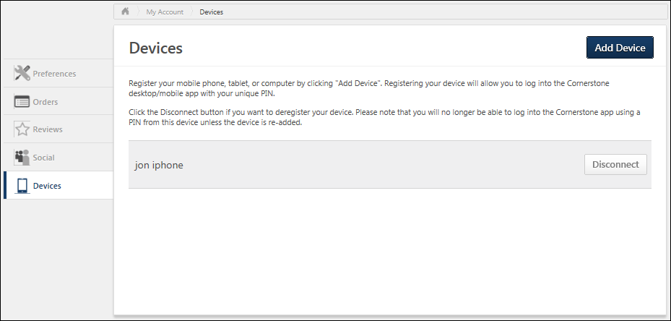
Add Device
- In the first field, enter a name for the device. For example, if it is a mobile phone, you may enter "Mobile Phone" or the brand of mobile phone. Note: The device name entered here will not persist on the Devices tab after the user’s initial login to the Cornerstone CSX App.
- In the second field, enter a temporary five-digit PIN. The PIN must be five numbers, and it will only be used during device registration setup. Click NEXT to proceed to the next step.
- The next step displays instructions that must be completed within the Cornerstone CSX app. Do not close the pop-up until the registration process is complete within the Cornerstone CSX app, as the device key and temporary PIN are required to register the device. After completing the registration process, click the CLOSE button. The registered mobile device appears on the Devices tab.
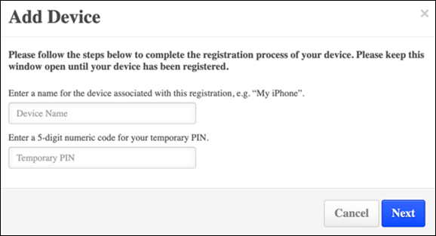
Disconnect a Registered Device
To disconnect a registered device, navigate to the Devices tab of the My Account page and click the DISCONNECT button next to the device. This opens a confirmation pop-up. Click OK to disconnect or click CANCEL to stay connected.
After removing your device, you will not be able to log in using that device again unless a new pairing is created.
Device Entries on the Devices Page
Users are asked to name their device during the device registration process. This device name does not persist on the Devices tan after the user’s initial login to the Cornerstone CSX app. Rather, users can expect to see a maximum of two system-generated device entries per registered device.
Why two device entries?
Because users who register a device ultimately authenticate with a PIN, a backup entry is created and associated with the user. This allows the user to log into the app in the future with their stored PIN, as well as log in offline. One of these entries is always stored and displayed on the Devices tab. Additionally, a backup entry is created with every login. Therefore, a user can expect the following on the Devices tab:
- When logged into the Cornerstone CSX app, a maximum of two device entries per registered device displays.
- When logged out of the Cornerstone CSX app, one device entry displays. This is a backup entry.
- The device entry displays as follows: mobile_backupsession <date time>.
- The timestamp and date correspond to the time and date the user last logged in to the Cornerstone CSX app.
- The backup entry timestamp updates with each login.
How do device entries appear?
After initial login, the device name entered by the user displays with a backup device entry as follows:
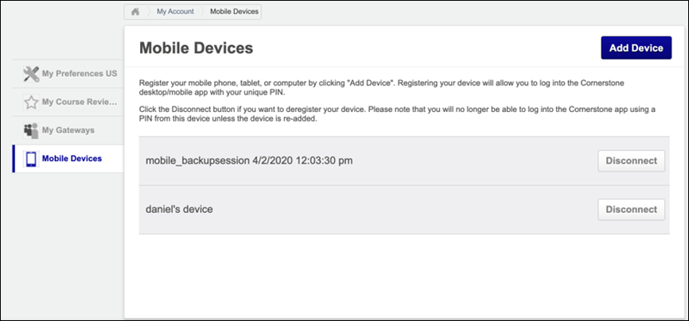
For subsequent logins, the Devices tab displays as follows:
When logged into Cornerstone CSX app:
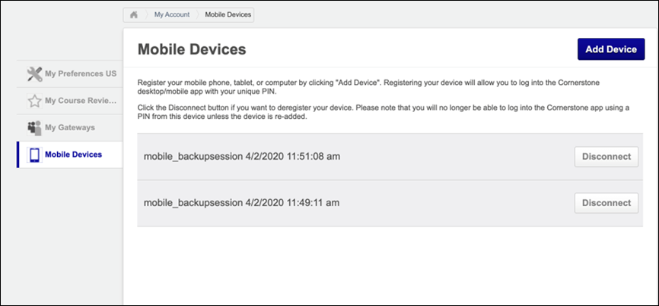
Note: The date and timestamp are localized to the user’s location, based on their user record.
When logged out of Cornerstone CSX app:
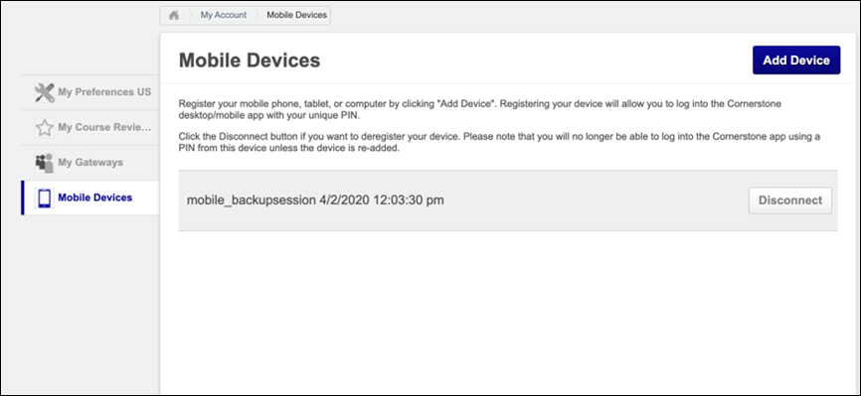
Note: The date and timestamp are localized to the user’s location, based on their user record.
Biometric Authentication
When a user initially accesses the Cornerstone CSX app, they are first prompted to enable biometric authentication for the app. If the user does not enable biometric authentication, the app will then prompt the user to configure a PIN.
- To enable biometric authentication, tap the OK button when prompted, and complete the setup process with your phone. Once biometric authentication is configured, the user will be prompted for biometric authentication each time they log in, unless they change their authentication method via the Settings tab.
- To bypass enablement of biometric authentication, tap the Cancel button. You will then be prompted to configure a PIN instead.
The Device Registration login Method does not support Biometric configuration. Biometric login is only available if users log in using Credentials/SSO methods.
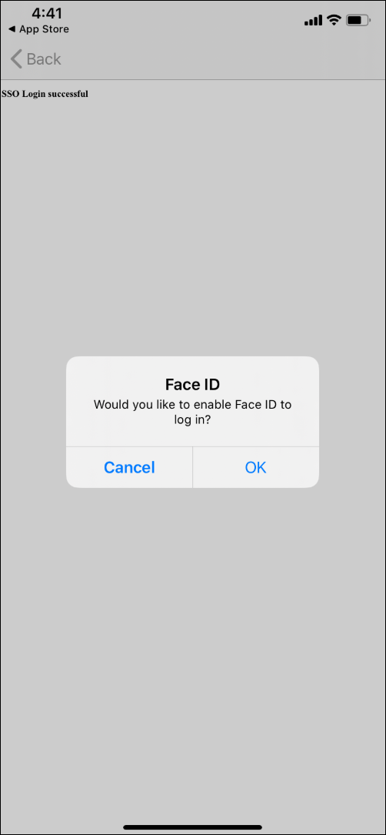
Biometric Reauthentication
If the user's attempt to enable biometric authentication fails, they will be prompted to reauthenticate.
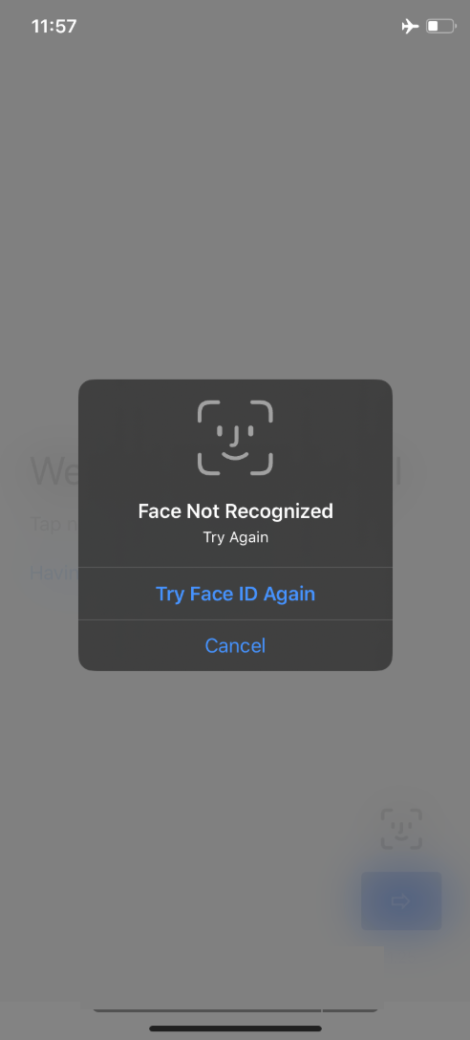
The user can attempt to try again, or they can cancel the biometric authentication setup. The user will be prompted to configure a PIN if they cancel the biometric authentication setup.
Configure PIN
If the user does not configure biometric authentication, the user is then prompted to configure a PIN for future logins.
Users can create a six digit PIN Code which they will be prompted for each time they log into the Cornerstone CSX app. After configuring a PIN, the user will be prompted for that PIN each time they log into the app, unless the user changes their authentication method. Login authentication settings can be changed at any time from the Settings tab of the app.
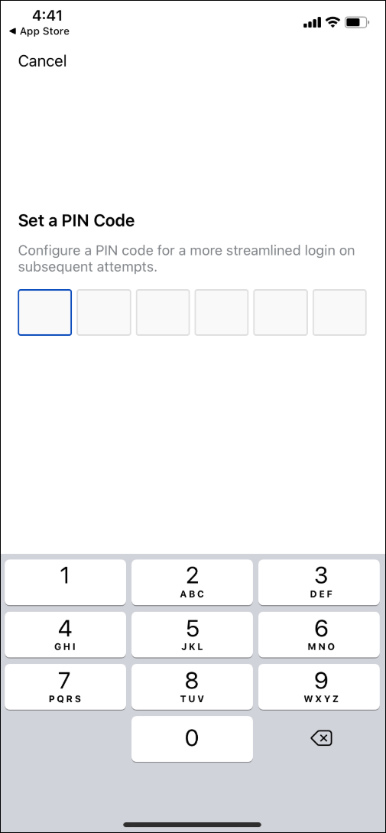
Considerations
Depending on your organization's portal and application configurations, the beginning of your users' login experiences may differ slightly. See below for details:
- For SSO Users: Upon entering a valid portal name, "smart" logic is applied during login. If a user is configured for SSO, upon tapping the Next button, the user is navigated to the SSO page.
- For Credential Users: Upon entering a valid portal name, "smart" logic is applied during login. If a user's portal has no SSO configurations, upon tapping the next button, the user is navigated to the credentials page.
- For organizations using both SSO and credentials: Upon entering a valid portal name, users are directed to the Username page. Upon entering their username, the app checks whether the user is in an organizational unit that has SSO enabled in Mobile Preferences.
  - If YES: User is navigated to the SSO page
  - If NO: User is navigated to the Learn App password screen
- If a portal has no SSO configurations and a user taps the Alternative Device link, the SSO option will not appear.
- If a user is offline, the Alternative Device link is disabled .
- The Alternative Device link is in a disabled state until a valid portal name is entered.
SSO Sign On
If SSO functionality is enabled, users can log into the application via SSO either by using their portal log-in information or biometric information. Note: Users can only use biometric information to log in after they have logged in at least once using SSO and associated their biometric information with their login.
To access the SSO Sign On page on the app, swipe the Credentials login page to the left. Then, populate the following fields:
- Portal - The name of your organization's learning portal
- Username - Your username for your organization's learning portal
After populating the required fields, tap the Log In button. If the SSO authentication is successful, you are granted access to the application. If the credentials are incorrect or an error occurs, an error message displays and you can attempt to re-enter your credentials.
Note: The Log In button is disabled until all required fields are populated.
Note: The SSO page is visible even for organizations that do not support SSO.
After a user logs in to the Cornerstone CSX app with SSO, they are prompted to associate the biometric information that they have on their phone to their login.
- When a user associates the biometric information on their phone with their login, the user can then log in to the Cornerstone CSX app using the SSO login method and fingerprint or facial recognition, depending on their device.
- If a user chooses not to associate the biometric information on their phone with their login, then the user can make this association from the Settings page within the app.
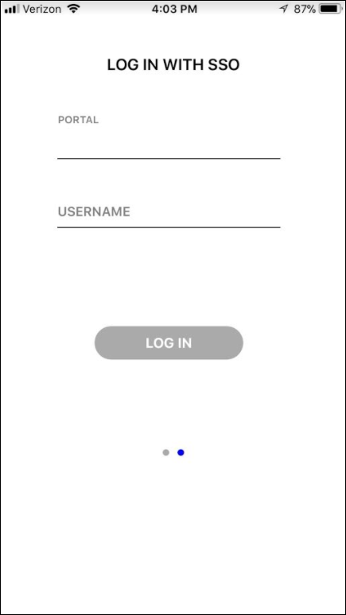
Authentication Settings
To reconfigure the authentication settings for the app at any time, the user can navigate to the Settings tab. To enable a different form of authentication, toggle the switch for that authentication type to the On position. The app will prompt the user to configure the enabled authentication type.
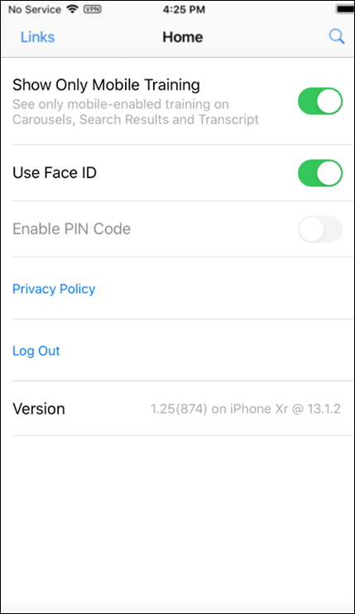
Language Considerations
If the user's portal language is different than their device's language, when the user logs in for the first time, an alert displays in the user's device language, stating that a new language has been detected, and in order for the app to switch to the user's portal language, the app must be restarted. Users only need to restart the app one time in order for the language change to take effect. When the user logs in again, the entire application displays in the user's portal language instead of their device language. If the portal language is the same as the device language, no alert displays.
Cornerstone CSX iOS App - User Profile
The user profile icon displays in the upper-right corner of the Cornerstone CSX app. Tapping the user profile icon opens the Profile page, where various settings and options can be accessed by the user.
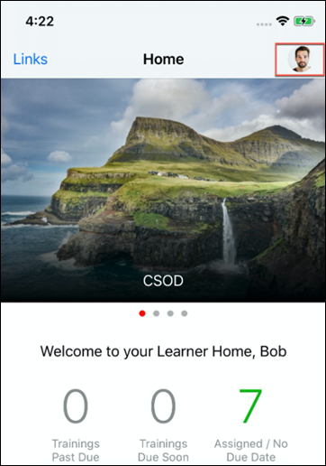
On the Profile page, the user can access the following features:
- Settings - The user can tap this option to adjust their Cornerstone CSX app settings.
- Scan QR Code - The user can tap this option to access their QR code when attending a training session that uses QR codes for attendance tracking. See Cornerstone CSX App - QR Codes for Instructor-Led Training on page 115 for additional information.
- Forget Me - The user can tap this option to reregister their Cornerstone CSX app account from their device. Any downloaded courses and user data associated with the app will be removed.
- Log Out - The user can tap this option to log out of the Cornerstone CSX app on their device.
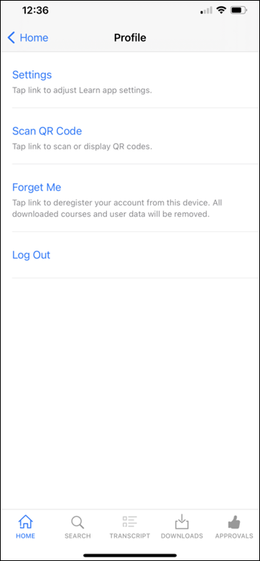
Cornerstone CSX iOS App - Settings
The Settings page of the Cornerstone CSX app allows mobile learners to:
- Choose to see non mobile-enabled training in the app
- Enable and disable Touch ID
- Enable PIN code
- View the Privacy Policy
- Deregister your account from your device
Access the Settings page by tapping the Settings icon at the bottom of the screen.
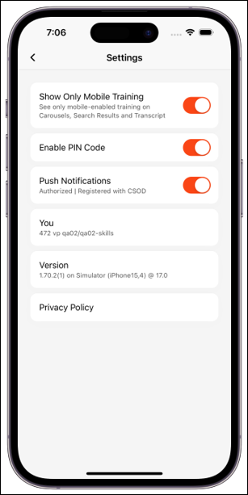
Show Only Mobile Training
To see non-mobile content in the app, toggle the Show Only Mobile Training switch to the Off position. This selection will be saved for future log ins.
Use Touch ID/Use Face ID
To disable or enable Touch ID or Face ID, toggle the Use Touch ID or Use Face ID switch to the Off or On position, respectively. The default selection is based on the user’s choice after first logging into the app and selecting initial options.
Enable PIN Code
To enable or disable a PIN code, toggle the Enable PIN Code switch to the On or Off position, respectively. Users can create a six digit PIN Code which they will be prompted for each time they log into the Cornerstone CSX app. After configuring a PIN, the user will be prompted for that PIN each time they log into the app, unless the user changes their authentication method.
Privacy Policy
Click the Privacy Policy link to view the Cornerstone CSX app privacy policy.
Version
The Version section displays the version of the app you are using.
Cornerstone CSX iOS App - Learner Home
The Learner Home page functions as the landing page for the Cornerstone CSX app, allowing mobile learners to browse for and request relevant training, search and filter for specific training, and prioritize mandatory training. The Learner Home includes several features which enable learners to easily select subjects of interest, discover training based on machine learning, and quickly access and request new training.
To access Learner Home on the app, log into the Cornerstone CSX app. To navigate back to the Learner Home after navigating to other pages, click the Home tab on the bottom left of the screen.
Note: The permission to access Learner Home is NOT required in order to access this page in the app.
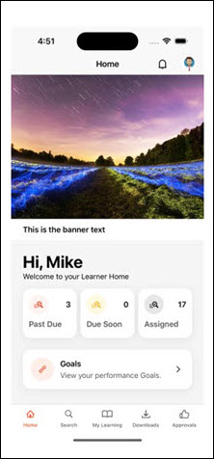
Across the top of the page, a carousel of banners created by the learning administrator display to the mobile learner. The carousel cycles through all available banners. If the user taps the banner, they are navigated to any URL that the administrator associated with the banner. The link associated with the banner opens in a web browser, and the user does NOT need to log in again if the link is to a Cornerstone system page.
The following considerations apply to this functionality:
- No button displays on custom banners in the Cornerstone CSX app.
- The Cornerstone CSX app displays the same banner that is uploaded for the web experience. For information about configuring the banner: See Learner Home Preferences.
Below the banner carousel, the message, "Welcome to your Learner Home, [User]" displays if the user is accessing the page for the first time. The message, "Welcome back, [User]" displays if the user has previously accessed the page. These welcome messages display the user's name as it appears in their user record.
Training Metrics
In the Training Metrics section, the following information about training on the user's transcript displays:
- Past Due - This field displays the number of training items on the user's transcript which have due dates that have passed.
- Due Soon - This field displays the number of training items on the user's transcript that are due within the next ten days.
- Assigned - This field displays the number of training items on the user's transcript that have been assigned without a due date.
Training Carousels
Below the welcome message, several different carousels of training may display to the user if applicable training is available and the learning administrator has enabled the carousel via Learner Home Preferences. Each carousel provides relevant training recommendations to learners, and learners can page through the carousel to see all recommendations.
Note: Only mobile-enabled training displays in the training carousels on the app.
Note: Not all the carousels available on the desktop version of Learner Home are available on the mobile version of Learner Home.
Each training tile displays with its associated thumbnail image, training type, and training title.
Carousel | Details
Continue Learning | This section displays training that is on the user's active transcript. Training in this section is sorted by the last transcript status change date, and a maximum of 20 training items can display in the section. If no training is on the user's active transcript, this section is hidden. Note: The last transcript status change date is a date field that tracks when a training moves from one transcript status to another transcript status.
Saved for Later | This section displays training that has been saved by the user. Training in this section is sorted by most recently saved first, and there is no limit on the number of training items that can display in this section. If the user has not saved any training, this section is hidden. If any of the user's saved training has been made inactive or unavailable, that training is removed from the section automatically. Note: This section displays the most recent version of the saved training. For example, if the user saved Leadership Skills (Version 1), and Leadership Skills (Version 2) has since been published, Version 2 of the training displays for the user in this section.
Top Picks for User | This section displays training that is recommended to the user based on their training history. Training in this section is sorted by relevancy to the user (determined by machine learning), and a maximum of 20 training items can display in this section. If no recommendation results are found for the user, the system considers the training history of users in the user's position, division, and location, and then neighboring positions, divisions, and locations in the hierarchy to find recommendations. This section is hidden if any of the following are true:  - The backend setting for machine learning course recommendations is not enabled.  - No recommendation results are found for the user.  - An error occurs.
Trending for Your Position | This section displays training that is recommended to the user based on their position. Training in this section is sorted by relevancy to the user (determined by machine learning), and a maximum of 20 items can display in this section. If no recommendations are found for the user's position, then the system considers the user's division and location, then neighboring positions, divisions, and locations in the hierarchy to find recommendations. This section is hidden if any of the following are true:  - The backend setting for machine learning course recommendations is not enabled.  - No recommendation results are found for the user.  - An error occurs.
Inspired by Your Subjects | This section displays training that is recommended to the user based on subjects in which the user has indicated interest. See Learner Home - Subjects. Training in this section is sorted by relevancy to the user (determined by machine learning), and a maximum of 20 items can display in the section. If the user has not selected any subjects, then the section displays a prompt for the user to add subjects. If no recommendations are found for the user’s selected subjects, the system considers the user's division and location, then neighboring positions, divisions, and locations in the hierarchy to find recommendations. This section is hidden if any of the following are true:  - The backend setting for machine learning course recommendations is not enabled.  - No recommendation results are found for the user.  - An error occurs.
Most Popular | This section displays training that was requested the most number of times in the last 60 days. Training in this section is sorted by the highest number of requests, and a maximum of 20 items can display in the section. If no training has been requested in the last 60 days, this section is hidden.
Featured | This section displays training items which have been designated as Featured on the Availability page of the Course Catalog by an administrator. If no training available to the user has been designated as Featured, this carousel does not display to the user. Note: If a playlist is designated as featured via the Course Catalog, it does NOT display in the Featured Training widget on the Welcome page. The featured playlist does, however, display in the Featured carousel on the Learner Home page.See Course Catalog - Availability for more information about setting the Availability Type of training items to Featured.
Suggested | This section displays training items which have been designated as Suggested on the Availability page of the Course Catalog by an administrator. If no training available to the user has been designated as Suggested, this carousel does not display to the user. See Course Catalog - Availability for more information about setting the Availability Type of training items to Suggested.
Required | This section displays training items which have been designated as Required on the Availability page of the Course Catalog by an administrator. If no training available to the user has been designated as Required, this carousel does not display to the user.See Course Catalog - Availability for more information about setting the Availability Type of training items to Required.
Training Tile Actions
When a learner taps on a training tile, they are navigated to the Training Details page for that training. When a learner taps the Options icon for a training item, different actions are available depending on whether or not the training is on the user's transcript, what type of training it is, and what status the training is currently in.
The following options may be available for training items that are already on the learner's transcript:
- Primary Transcript Action - The current primary action on the user’s transcript for the specific training item displays as the top option. For example, if the primary training action is Launch, the user can tap Launch to open the training. Note: Only online courses, materials, and videos can be launched from a carousel on the mobile version of Learner Home.
- Secondary Transcript Actions - Any other transcript actions available to the user for the training item appear in the list of options and allow the user to perform the associated action on the training. See Transcript (Universal Profile) - Status and Options for all available actions. Note: Tapping some transcript actions causes the user to be redirected to their learning transcript.
- Save for Later (if available) - Tap this option to save the training item. Saved training items display in the Saved for Later section on the Learner Home. Any training item available to the user or on their transcript can be saved except for certifications, and there is no limit on the number of items which can be saved.
- Remove from Saved (if available) - This option is only available if the training has already been saved by the user. Tap this link to remove the training item from the Saved for Later section.
- Cancel - Tap this option to close the list of options.
The following options may be available for training items that are NOT already on the learner's transcript:
- Launch (if available) - Tap this option to launch the training. This opens the training and adds the training item to the user’s transcript. Note: Only online courses, materials, and videos can be launched from a carousel on the mobile version of Learner Home.
- Request (if available) - Tap this option to request the training. This adds the training item to the user’s transcript. The page will then refresh to the transcript.
- Save for Later (if available) - Tap this option to save the training item. Saved training items display in the Saved for Later carousel on the Learner Home page. Any training item available to the user or on their transcript can be saved except for certifications, and there is no limit on the number of items which can be saved.
- Remove from Saved (if available) - This option is only available if the training has already been saved by the user. Tap this link to remove the training item from the Saved for Later section.
- Cancel - Tap this option to close the list of options.
Cornerstone CSX iOS App - Learning Search
At the bottom of every page in the Cornerstone CSX app, a search icon displays in the navigation bar and allows users to access Learning Search, where they can search for specific learning using powerful search technology that is fully optimized for mobile browsers.
To access Learner Search on the Cornerstone CSX App, log into the Cornerstone CSX App and tap the Search icon in the bottom navigation bar.
Note: The permission to access Learner Home is NOT required in order to access Learning Search in the app.
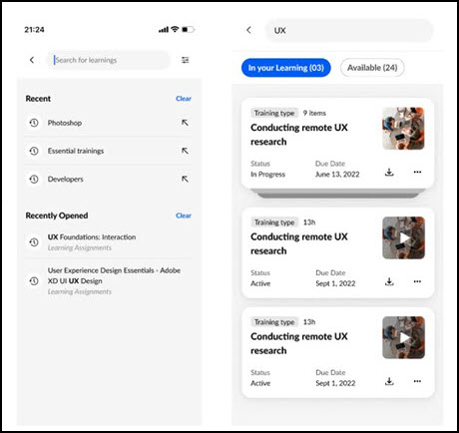
Search Training
Users can enter words relating to the following training attributes into the search box to receive relevant training results that are sorted by relevance:
- Title
- Keywords
- Description
To search for training in the Cornerstone CSX app:
- Enter a search term or phrase into the search box and press the Enter key on your phone keyboard. You will be redirected to the Learning Search page. You can also press the Enter key without entering search terms, which navigates you to the Learning Search page with all available results displayed. A maximum of 50 search results can be returned.
- Peruse the results which display on the Learning Search page and use the available filters to receive more specific training results, if necessary. Search results are sorted by relevance, and text queries are matched with content title, descriptions, and keywords.
Each training result displays with a thumbnail image, the training type, the title of the training, and the duration, if applicable. If the training is on the user's transcript, the status of the training item displays under the training title. Tap a training result to access the Training Details page for the training.
If the training is already on the user's transcript, and the training is an online course, material, or video, a play icon displays over the training's thumbnail image, and tapping the training thumbnail image launches the training. Training that is on the user's transcript can also be launched by tapping the Play icon over the training's thumbnail image or by navigating to the Training Details page for the item. The Training Details page displays information about the training, such as its title, duration, price, a Show Description link, and more.
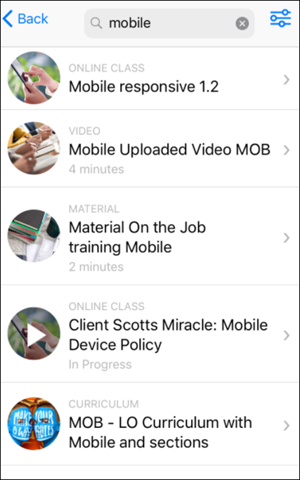
Training Options
To access the options for a training item in the search results:
- Tap on the training item to access the Training Details page for the item, or slide the training item to the left with your finger. This causes the More button to appear.
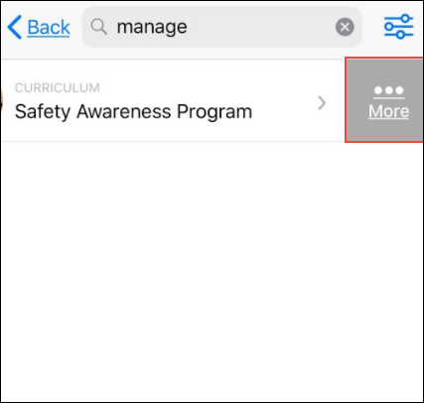
Tap the More button. An Options menu appears at the bottom of the screen with the following options, if available:
- View Details - Tap this option to view the Training Details page for the training.
- Primary Transcript Action - The current primary action on the user’s transcript for the specific training item displays in the menu. For example, if the primary training action is Launch, the user can tap Launch to open the training. Note: Only online courses, materials, and videos can be launched from a carousel on the mobile version of Learner Home.
- Secondary Transcript Actions - Any other transcript actions available to the user for the training item appear in the list of options and allow the user to perform the associated action on the training. See Transcript (Universal Profile) - Status and Options for all available actions. Note: Tapping some transcript actions causes the user to be redirected to their learning transcript.
- Save for Later - Tap this option to add the training to the Saved for Later carousel on Learner Home. This option is only available if the training is NOT currently contained in the Saved for Later carousel.
- Remove from Saved - Tap this option to remove the training item from the Saved for Later carousel on Learner Home. This option is only available if the training is currently contained in the Saved for Later carousel.
- Cancel - Tap this option to close the Options menu.
Filters
Users can filter the training results that appear by clicking the Filter icon in the upper-right corner of the search results page. The following filters are available:
- Training Type
- Duration
- Subject
- Language
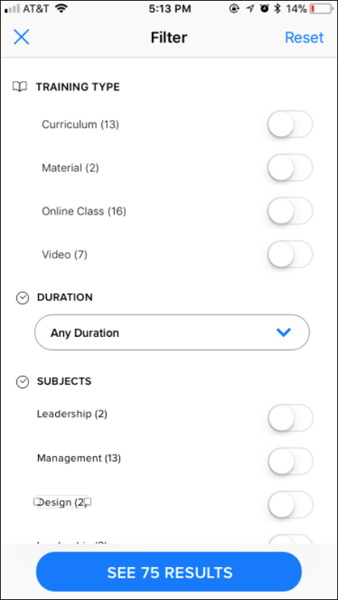
To apply a filter to your training search results, toggle a filter option to the On position or select a filter option from the drop-down, depending on the filter type. The blue button at the bottom of the screen displays text stating, "See [X] Results," X being the number of search results which meet the currently selected search criteria and search filters.
View the table below for more information about the available filters:
Filter | Selection Type | Options | Additional notes
Training Type | Multi-select toggles | - Curriculum  - Event  - Library  - Material  - Online Class  - Program  - Quick Course  - Test  - Video | Type options display based on the entered search terms, meaning that if, for example, no curricula meet the user's search criteria, the Curriculum filter option does not display.
Duration | Drop-down menu | - Any Duration (default)  - < 15 minutes  - < 30 minutes  - < 1 hour  - < 2 hours  - 2 + hours | Duration options display based on the entered search terms, meaning that if no training that meets a user's search criteria has a duration of greater than two hours, then the 2+ hours filter option doesn't display.
Subject | Multi-select toggles | The top ten subjects related to the search result display, all unselected by default | If no training that meets the user's search criteria has an associated subject, the subject filter does not display.
Language | Multi-select toggles | Languages related to the search results display alphabetically, all unselected by default | Language options display based off the text query (e.g. if no training returned in the results has an Available Language of 'Spanish', then 'Spanish' wouldn't display as a language option). The language filter will not display if only 1 language matches the training returned in the results (e.g. all training returned in the results has a language of 'English (US)', then the language filter won't display) When many, many languages are displayed, a scroll-bar will appear within the section.
To remove all filters from the search, tap the Reset link in the upper-right corner of the screen.
To exit the filters panel, click the X icon in the upper-left corner of the screen.
Cornerstone CSX iOS App - View Curricula
When a user navigates to Learning Search or Learner Home within the Cornerstone CSX app, the user can access the Curriculum Details page for the curriculum and both view and take action on child training items contained within the curriculum, even if the curriculum itself is not on their transcript.
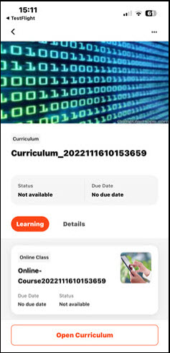
Curriculum Courses
When a user taps a curriculum within the Cornerstone CSX app, they are navigated to the Curriculum Details page for the curriculum, which contains two tabs: Details and Courses. To view the structure of the curriculum and the training contained in the curriculum, tap the Courses tab.
Courses
On the Courses tab, each section of the curriculum displays. The user can view the full curriculum structure, provided all the child training within the curriculum is supported by the Cornerstone CSX app.
The user can tap a section to view the child training items contained in that section. If a section of the curriculum has already been completed by the user, the section shows a status of Completed. If the section has not been completed, no progress information displays. Even if the curriculum is not on the user's transcript, the user can perform available actions on the training contained within the curriculum, such as requesting the training.
The following supported training items can be accessed from within a curriculum:
- Online Courses
- Materials
- Videos
The following information displays for each child training item:
- Training Title
- Training Type (i.e. online course, material, video)
- Image Thumbnail
If a child training item within a curriculum is already on the user's transcript, when the user views the child training from within the curriculum, a message displays with the training stating, "This item is already on your transcript."
Note: The curriculum structure respects the Mobile Enabled filter, meaning that if this filter is enabled, the user will only see mobile-enabled training on the Courses page.
Cornerstone CSX iOS App - Transcript
On the Transcript page of the Cornerstone CSX app, mobile learners can access both their active and completed transcript pages, launch certain types of training, and view information about the training on their transcripts. Note: Only mobile-enabled training items that have been assigned to or requested by the user display on the Cornerstone CSX app transcript by default.
To access the Transcript page of the app, tap the Transcript icon at the bottom of the screen.
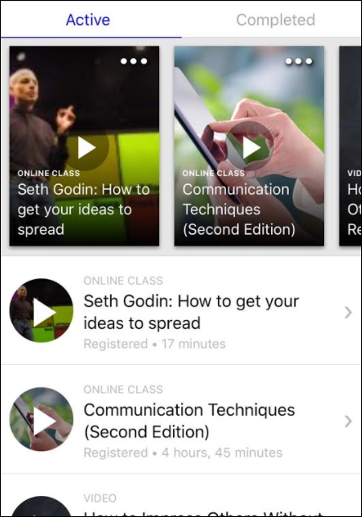
Search
To search for specific training, the mobile learner can tap the Search icon in the bottom navigation bar, then enter search terms into the Search bar and tap the Enter key on their mobile keyboard.
Continue Learning
The Continue Learning carousel on the Active transcript page displays training that is already on the user's transcript. Training in the carousel is sorted by the last transcript status change date, and a maximum of 20 training items can display in the section. If no training is on the user's active transcript, this section is hidden. Note: The last transcript status change date is a date field that tracks when a training moves from one transcript status to another transcript status.
Each training tile displays with its associated thumbnail image, training type, and training title. For more information about interacting with training carousels and training tiles,
Active Transcript
On the Active transcript page, training that has been assigned to the user but not yet completed displays in order of earliest due date to latest, with the following information for each item:
- Thumbnail image
- Training type
- Training Title
- Transcript Status
- Duration (if available)
If the training is an online course, video, or material, a Play icon displays over the thumbnail image for the training. Tap the Play icon to launch the training.
Tap the arrow to the right of the training result to access the Training Details page for the training. If the training is an online course, video, or material, the training can also be launched from the Training Details page by tapping the Play icon.
Note: Online courses, videos, and materials can also be launched from within curricula via the Learning App.
Completed Transcript
To access the Completed transcript page, swipe the Active transcript page to the left. Training the user has completed displays on the Completed transcript page with the following information:
- Thumbnail image
- Training type
- Training Title
- Completed Status
- Duration (if available)
If the training is an online course, video, or material, a Play icon displays over the thumbnail image for the training. Tap the Play icon to launch the training.
Tap the arrow to the right of the training result to access the Training Details page for the training. If the training is an online course, video, or material, the training can also be launched from the Training Details page by tapping the Play icon.
Note: Online courses, videos, and materials can also be launched from within curricula via the Learning App.
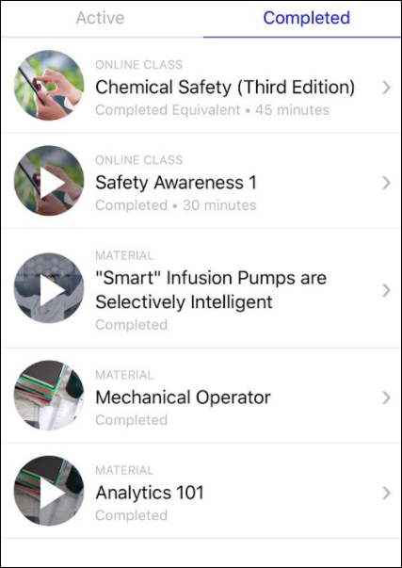
Transcript Actions
To access actions for a training item on the transcript without leaving the Transcript page, swipe the training item to the left. A More button appears. Tap the More button to access a menu of available actions for the training. The following options may be available for training items that are on the learner's transcript:
- Primary Transcript Action - The current primary action on the user’s transcript for the specific training item displays as the top option. For example, if the primary training action is Launch, the user can tap Launch to open the training. Note: Only online courses, materials, and videos can be launched from a carousel on the mobile version of Learner Home.
- Secondary Transcript Actions - Any other transcript actions available to the user for the training item appear in the list of options and allow the user to perform the associated action on the training. For example, if the training is a material, Mark Complete may display as an option for the material, allowing the user to mark the material complete on their transcript. See Transcript (Universal Profile) - Status and Options for all available actions.
- Save for Later (if available) - Tap this option to save the training item. Saved training items display in the Saved for Later section on the Learner Home. Any training item available to the user or on their transcript can be saved except for certifications, and there is no limit on the number of items which can be saved.
- Remove from Saved (if available) - This option is only available if the training has already been saved by the user. Tap this link to remove the training item from the Saved for Later section.
- Delete - If the user has downloaded a training item for offline consumption, they can remove the downloaded course by clicking the Delete option. The user can deleted a downloaded course even when not connected to the internet. After a training item has been deleted, it is available for download again.
- Cancel - Tap this option to close the list of options.
Cornerstone CSX App - Download Learning
If offline content has been enabled in the portal and an online course has been made available offline, users of the Cornerstone CSX app can download the training and then complete it without needing access to an internet connection, as long as they have the Offline Content permission. This functionality is available to both users of the iOS version of the app and users of the Android version of the app.
Most video formats can be downloaded, but only ".mp4" and ".m4v" can be played inline. Other formats must be opened in external apps that support video playback.
Permissions
PERMISSION NAME | PERMISSION DESCRIPTION | CATEGORY

Offline Content | Grants ability to download and complete training items offline via a mobile device or the new Offline Player. This permission cannot be constrained. This is an end user permission. | Mobile
Download
Training that is available for download via the Cornerstone CSX app can be downloaded either from the Home page for the training or from the My Learning page.
To download a training item tap the Download button at the bottom of the screen. Once the course has finished downloading, a confirmation displays under the training status in the Training Details. All downloaded training items also display on the New Downloads page, which can be accessed through the main navigation of the Cornerstone CSX app. The next time an internet connection is available, any training progress the user has made on the course will be synced with the user's transcript in the Cornerstone CSX app. Note: Only courses and materials that have been made available to download by an administrator can be downloaded from the app.
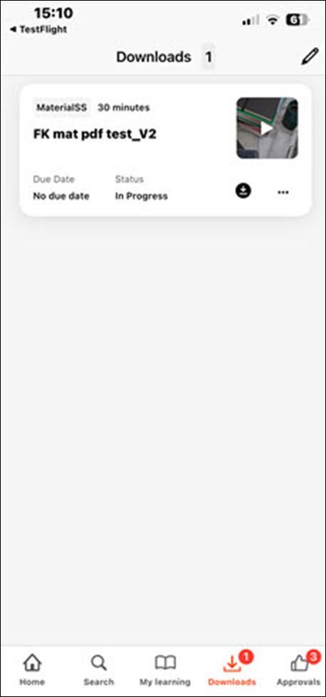
Errors
If a training item does not download successfully, a red error icon displays next to the training. The user can tap the error icon to see an alert describing the error. The user can then either retry the download or cancel their download. If the error persists, there may be an issue with the course and the user should contact their learning administrator.
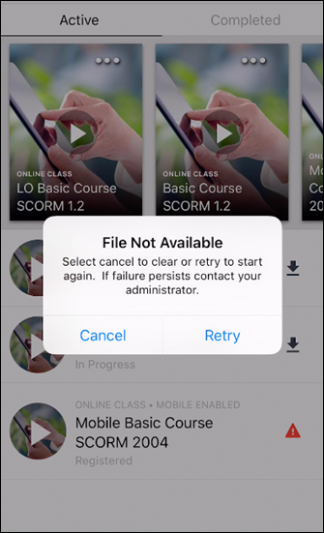
Considerations
The following considerations apply to this functionality:
- Only SCORM Online Courses are available for download.
- In order to log into the Cornerstone CSX app without an internet connection, a user must have performed a successful previous online login using their username and password. Note: Offline login via SSO is not currently supported.
- Materials uploaded with a source that is a YouTube URL are not available for download, as this violates YouTube's Terms of Service.
- Materials uploaded with a source that is a URL that requires the user to authenticate before accessing, such as an Excel document hosted on OneDrive or GoogleDrive, are not available for download.
- Materials uploaded with a source that is a .zip file are not available for download.
- Materials uploaded with no source are not available for download.
- The following material file types can be made available for download and offline consumption:
  - doc
  - docx
  - gif.
  - jpeg
  - jpg
  - pdf
  - pps
  - ppsx
  - ppt
  - pptx
  - xls
  - xlsx
Download Materials FAQ
Q: Can a user mark a material complete while offline?
A: No, a user must first regain connectivity. Once they log into the Cornerstone CSX app with an internet connection, they will have access to the Mark Complete action for the material.
Q: What completion date will be reflected for materials launched offline?
A: The date and time that the user taps the Mark Complete action after logging into the Cornerstone CSX app with an internet connection will be reflected as the material's completion date.
Q: Can I configure materials to be mobile enabled and available for download during the material creation process?
A: No, these settings must be enabled after the material is created via the Course Catalog.
Cornerstone CSX iOS App - Training Push Notifications
The following training push notifications are available for both the Android and iOS versions of the Cornerstone CSX app:
Notification Type | Corresponding System Event | Banner Message | Recipient | Redirect When Tapped
Training is Approved | Approver/Manager approves a training request | Training request for [Training Title] has been approved. | End User | Training Details
Training is Assigned | Manager assigns training directly to her direct/indirect subordinate | [Training Title] has been assigned to you. | End User | Training Details
Training is Denied | Approver/Manager denies a training request | Training request for [Training Title] has been denied. | End User | Training Details
Training Has Due Date | Manager assigns training directly to her direct/indirect subordinate with a due date | [Training Title] was assigned with a due date. | End User | Training Details
Training is Requested | User requests a training that requires approval | [Training Title] requires your approval. | Approver | Approvals List
Considerations
The following considerations apply to push notifications for the Cornerstone CSX app:
- iOS users will be prompted to opt in to receive push notifications from the Cornerstone CSX App upon installing the latest version of the application and logging in.
- While there is no setting to disable push notifications in the Cornerstone CSX App, notifications can be disabled from your device settings at any time via the Notifications section of the Settings page.
- Push notifications are disabled for multi-user devices. If more than one user shares a device, push notifications are not sent.
- If enabled, push notifications appear on the home screen of the user's device, even when they are not logged in to the app.
- All training notifications display regardless of whether the training is mobile-enabled.
- Push notifications expire and are automatically removed after one year from the date of receipt.
- If users have viewed the Training Details page of a training item for which they received a push notification, they will be navigated to the Training Details page for the training when they tap the notification. If the user has NOT viewed the Training Details page of the item, they will be navigated to the Transcript page when they tap the notification. This is due to application cache, and this behavior will be modified in a future patch so that end users will always be navigated to the Training Details page after tapping a training push notification.
- If user is logged in to the app when they tap a push notification, they are navigated to the relevant application area, such as the Transcript, Training Details page, or Approvals list, as specified in the table above.
- If a user is not logged in to the app when they tap a push notification, they will be redirected to the login page and prompted to log in. After logging in, user will be directed to the application area, as specified in the table above.
- Push notifications can be disabled for an entire portal via a backend setting. Please contact Global Customer Support to request this.
Cornerstone CSX iOS App - Playlists
Users of the Cornerstone CSX app can interact with playlists in the following ways:
- Search for and filter by playlists via Learning Search
- Follow playlists
- Access playlists via a new carousel on Learner Home in the app
- Consume training within playlists
- Launch external content from within playlists in the app
- View playlist metrics
- Share playlists with other users
Exclusions
The following playlist functionality is NOT available for playlists within the Cornerstone CSX app:
- Create playlists - Users cannot create playlists within the Cornerstone CSX app
- Add to playlists - Users cannot add items to playlists within the Cornerstone CSX app
- Edit playlists - Users cannot edit playlists within the Cornerstone CSX app
- Copy playlists - Users cannot copy playlists from within the Cornerstone CSX app
- View as administrator - Users are not able to view playlists as an administrator from within the Cornerstone CSX app
- Follower and creator bios - Users cannot navigate to the Universal Profile of a playlist creator or a playlist's followers
Considerations
In order for playlist functionality to be enabled in the Cornerstone CSX app, it must be enabled in your portal. For information about activating playlist functionality in your portal: See Learning Feature Activation Preferences.
Permissions
PERMISSION NAME | PERMISSION DESCRIPTION | CATEGORY

Playlists - View | Playlists will be visible to users with this permission. The user can search for playlists, follow playlists, and consume training contained within playlists that are available to them. The learning playlists that are visible to a user are not impacted by this permission, but instead is based on the availability of the playlist. This permission cannot be constrained. This is an end user permission. | Learning - Administration
Search for Playlists
Users can search for playlists on the Learning Search page.
- If the user taps a playlist from the Learning Search page, they are navigated to the Playlist Details page for the playlist.
- Playlists respect the Mobile Enabled filter, meaning that if this filter is enabled, the user will only see playlists that are mobile-enabled. To also see non mobile-enabled training, the user can navigate to the Settings page of the app and disable the Show Only Mobile Training setting.
- Users can only search for playlists that are public.
- Search is disabled when a user is offline.
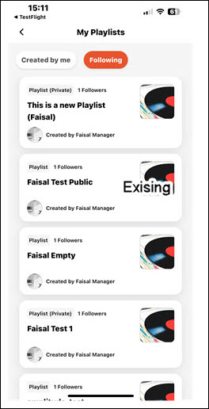
Filter by Playlists
When searching for playlists, users can use the Playlist filter to constrain their search results to playlists. To use this filter, tap the Filters icon and toggle the Playlist filter in the Training Type section to the On position.
View Playlist Metrics
- A Playlist Metrics card displays on the Learner Home page of the app, indicating how many playlists the user has created. Note: The card will display a 0 if the user has not created any playlists, but they can still access their followed playlists by tapping this card and tapping the Followed tab.
- Tap the Playlist Metrics card to navigate to a My Playlists page, which is separated into two tabs: Created and Followed. Any playlists the user has created display on the Created tab. Any playlists the user is following display on the Followed page.
Note: Playlists cannot be created from the Cornerstone CSX app. To create a playlist, access the system via a desktop device.
Playlist Details
The Playlist Details page can be accessed by tapping a playlist. The Playlist Details page displays the following features:
- Playlist Banner Image - The banner image associated with the playlist
- Creator Photo and Name - The profile photo and name of the user who created the playlist
- Follow/Unfollow buttons - See the Follow Playlists and Unfollow Playlists sections below for more details.
- Followers - The number of users who are following the playlist
- Updated - The date on which the playlist was last updated by the creator
- Description - The description of the playlist
- Items - The number of training items contained within the playlist
- Training - Each training item contained within the playlist displays as a tile with the following information:
  - Training Type
  - Mobile Enabled (if applicable)
  - Training Title
  - Transcript Status
  - Synced Status (if applicable)
  - Training thumbnail image
Follow Playlists
- Users can follow any public playlist in their portal via the Cornerstone CSX app.
- To follow a playlist, navigate to the Playlist Details page for the playlist and tap the Follow button. Note: If the user is offline, the Follow button is disabled.
Unfollow Playlists
Users can unfollow playlists they have followed by tapping the Unfollow button on the Playlist Details page for the playlist. This option is only available if the user is already following the playlist.
My Playlists
Users can access the My Playlists page from Learner Home in both iOS and Android. For Android users, My Playlists can also be accessed from the app navigation drawer. On the My Playlists page, there are two tabs. On the My Playlists page, there are two tabs:
- Created - This tab shows any playlists the user has created. It is not possible to create or edit playlists from within the Cornerstone CSX app, but the user can tap their playlist to view its Playlist Details page and access actions for the playlist.
- Followed - This tab displays any playlists the user has followed. The user can tap a followed playlist to view its Playlist Details page and access actions for the playlist.
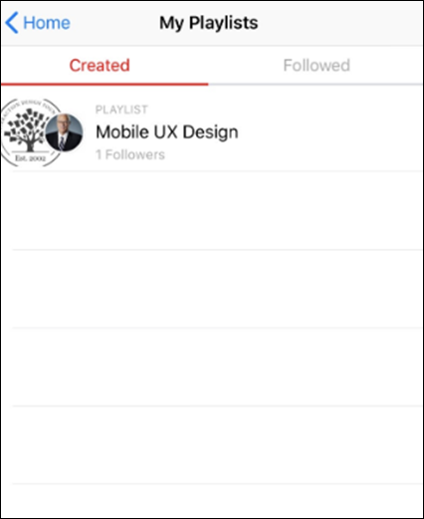
Access Playlist Training
- Users can consume any mobile-enabled content contained in a playlist from within the Cornerstone CSX app. Available actions for the training include Request, Launch, Complete, Save for Later, and View Training Details, and in some cases, Download.
- Playlists respect the Mobile Enabled filter, meaning that if this filter is enabled, the user will only see playlists that are mobile-enabled on the Playlist Details page. To also see non mobile-enabled training, the user can navigate to the Settings page of the app and disable the Show Only Mobile Training setting.
- If a user is offline, they will only be able to consume training that was previously downloaded.
Launch External Content
Users can launch external content contained in a playlist from within the Cornerstone CSX app.
Share Playlists
Cornerstone CSX app users can share playlists with others using the app. To share a playlist, navigate to the Playlist Details and tap the Share option to generate a deeplink and share the deeplink with other users via native iOS and Android sharing features.
The following considerations apply to playlist sharing on iOS:
- If a user is online AND the playlist is private, the Share option is hidden.
- If a user is offline AND the playlist is private, the Share option is hidden.
- If a user is offline AND the playlist is public, the Share option is disabled.
Cornerstone CSX App - QR Codes for Instructor-Led Training
Learning QR code generation and scanning capabilities are available for the Cornerstone CSX app. Administrators can configure instructor-led training (ILT) sessions to support QR code functionality for easy session attendance tracking. Using QR codes for ILT session attendance streamlines attendance tracking for large sessions and reduces the administrative burden associated with manually managing attendance for large quantities of in-person ILT sessions.
A Scan QR Code link is available on the Cornerstone CSX app Profile page. To access your profile, tap the user profile icon in the upper-right of the screen.
Tapping the Scan QR Code link allows up to three tabs to display to the learner, depending on the learner's permissions and the portal configuration. The three potentially available tabs include:
- Scan
- My QR Code
- Instructor
Access the Settings page by tapping the Settings icon at the bottom of the screen.
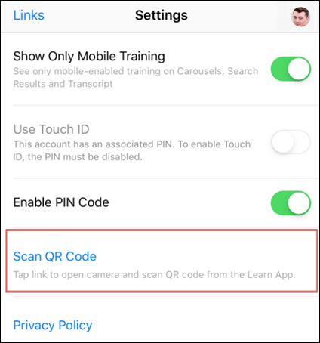
Scan
The Scan tab leverages a device's camera, allowing learners to scan a printed or digital display of an individual session part's QR code. Users will be asked permission for the Cornerstone CSX app to access their device's camera in order to scan QR codes. After a successful scan, learners receive a success confirmation and their attendance is recorded for that part. The instructor must submit the roster for the session in order for attended users to be marked complete.
- Note: A QR code scan is required for each session part the user is attending. For example, if the session includes four parts across two days, the user must be scanned into each of the four session parts they attend.
- Note: A user must be registered for a session in order to be scanned into a session successfully using a QR code. If the user is not registered for the session, an error will appear when they scan the QR code of the session.
- Note: If a user scans the QR code beyond the time limit allowed for the validity of the QR code, the following error message displays: "QR code scan has been attempted too early/late for this session. Contact your administrator."
Scan Tab - Android
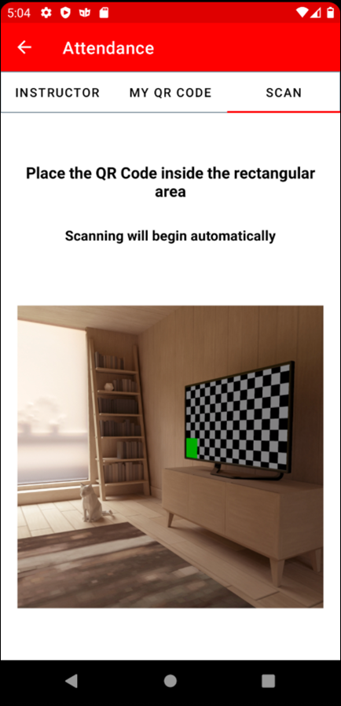
Scan Tab - iOS
My QR Code
The My QR Code tab displays a unique QR code belonging to the learner, the learner's first and last name, and the learner's profile photo. This QR code can be scanned by an instructor or administrator to capture attendance. Users who are scanned into the session via QR code are marked as attended, and the instructor must submit the roster for the session in order for the attended users to be marked complete.
Android users can save their QR code to their device's photos.
- Note: A QR code scan is required for each session part the user is attending. For example, if the session includes four parts across two days, the user must be scanned into each of the four session parts they attend.
- Note: A user must be registered for a session in order to be scanned into a session successfully using a QR code. If the user is not registered for the session, an error will appear when their QR code is scanned by the instructor.
- Note: The user can also access and print their QR code via the web version of the system, from the My Account page. See My Account - Preferences - Print QR Code.
My QR Code Tab - Android
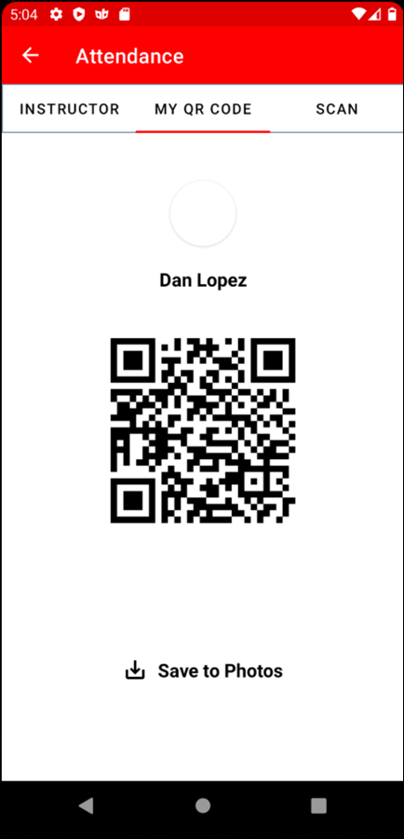
My QR Code Tab - iOS
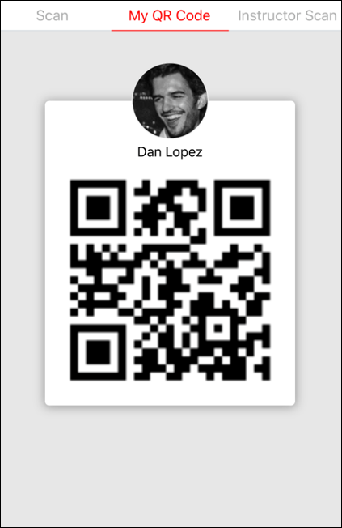
Instructor
The Instructor tab is only available to users with either the permission to view sessions or users in the Instructor security role. When a user taps the Instructor tab, the tab displays a list of session parts the user is conducting on that day, based on the user's device time and time zone. If an instructor has no sessions for the day, no session parts display on the Instructor tab until the instructor searches for a session by locator number. When the instructor or administrator taps a session part, a scanner opens, allowing them to scan the QR codes of the session part's registered attendees and capture their attendance.
The Instructor tab also contains a Search bar to search for session parts by session locator number. Instead of viewing the sessions they are conducting that day, they can search for the session parts specific to a session's locator number. Note: The Search bar respects any constraints applied to the user's permission to view ILT sessions.
Each session part displays with the following information:
- Event name
- Locator number
- Session part name
- Session part start date and time, with associated time zone
- Session part end date and time, with associated time zone
- Location
- Note: Instructors can also access and print the QR code for their session part via the web version of the system, on the Session Roster page. See Session Roster - Roster Tab.
- Note: If a session and its parts are not configured as QR code-enabled, these session parts will display in the Cornerstone CSX app in a disabled state. Instructors and administrators will not be able to tap the part to mark attendance for non QR code-enabled sessions.
- Note: A Location must be provided when creating the session to be able to generate a session QR code.
Instructor Tab - Android
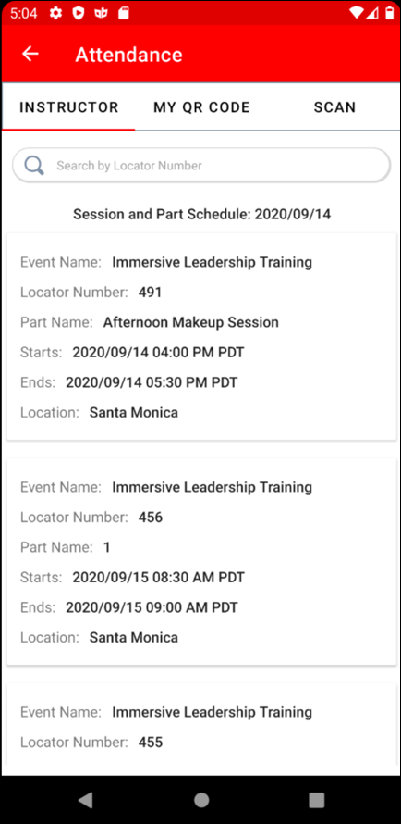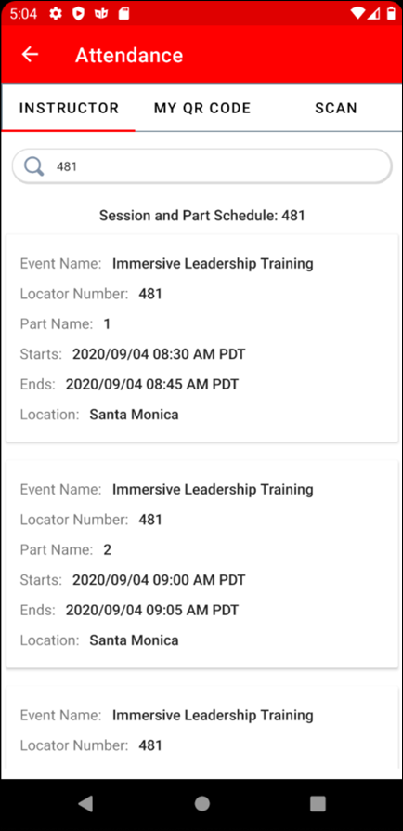
Instructor Tab - iOS
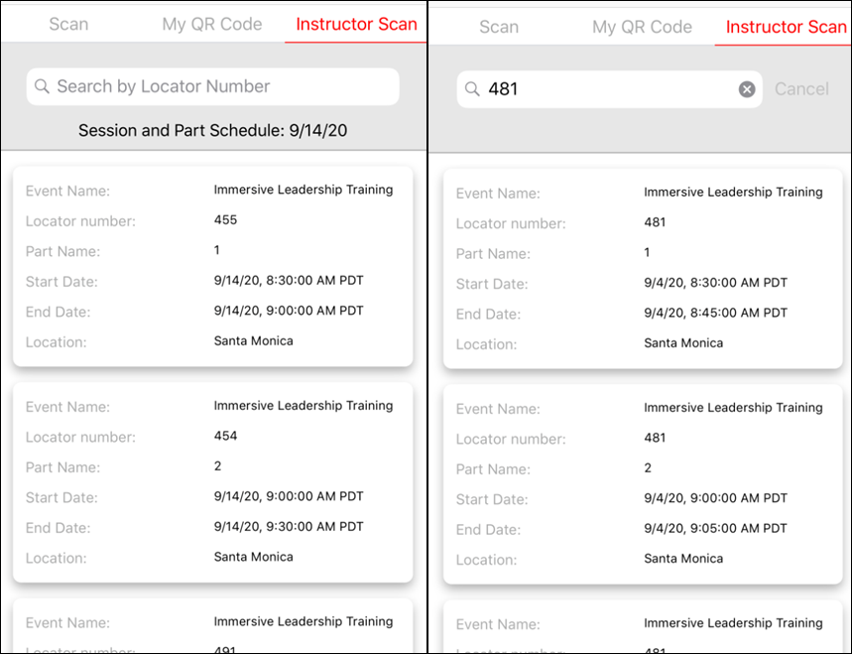
Additional Information
For information about QR code configuration, please see the following additional resources:
- See ILT Preferences - General.
- See Create Session - Details.
- See Session Roster - Roster Tab.
Cornerstone CSX iOS App - Approvals Tab
Users with permission to manage training approval requests have access to an Approvals tab on the Cornerstone CSX app. To access the Approvals tab, tap the Approvals icon at the bottom of the app. In addition, a red notification displays on the Approvals tab with the number of outstanding approval requests that are waiting for review.
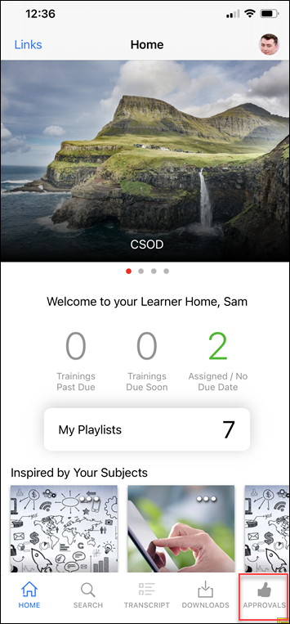
The Approval icon appears in the navigation tray at the bottom of the screen on iOS devices.
- Users only see the Approval icon if they have the relevant approval permissions.
- If a user has pending approval requests, the Approval icon is enumerated in red with the corresponding number. If a user has more than 99 approvals, 99+ displays.
Permissions
PERMISSION NAME | PERMISSION DESCRIPTION | CATEGORY

Approve Training by Approver | Grants ability to approve training requests of those for whom the user is the designated approver. | Learning

Approve Training by Cost Center Approver | Grants ability to approve training requests of those for whom the user is the designated cost center approver. | Learning

Approve Training by Manager | Grants ability to approve training requests of those for whom the user is the designated manager.  Note: Delegating this permission only applies when "Manager" is designated in the Approval Workflow. If the Approval Workflow contains a custom employee relationship - even if the Manager happens to fill that role - the approval will not flow to the delegate. | Learning
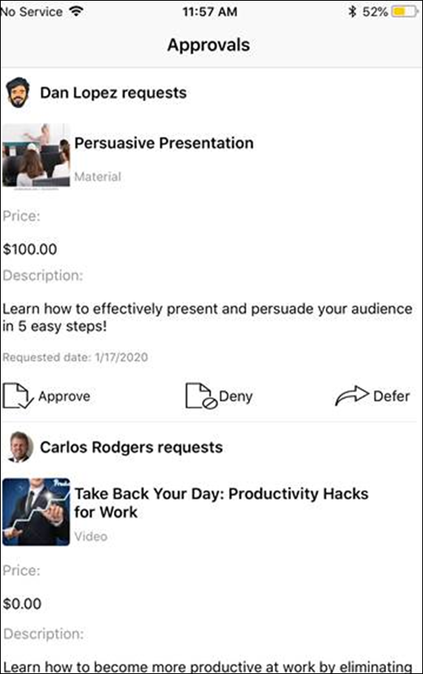
Approvals
On the Approvals tab, a scrollable list of pending approval requests displays. Each approval request displays with the following information and options:
- User profile photo - The profile photo of the user who made the request, or the default profile photo image if the user has not configured a profile photo
- User full name - The user's first and last name
- Training thumbnail image - The thumbnail image associated with the requested training item. Note: If a thumbnail image does not exist in the Course Catalog for a training item, the image set via Default Training Image Preferences for the training type will be used as the thumbnail image for the training.
- Training title - The title of the requested training item
- Training type - The type of training that was requested (i.e. online course, material, curriculum, etc.)
- Price - The price of the training, if applicable
- Training Purpose - The training purpose associated with the requested training, if applicable
- Description - The first four lines of the training description display in plain text. If the description is longer, it will be truncated. Approvers can tap the description and be navigated to the Training Details page of the training, where they can read the full description.
- Requested Date - The date on which the user requested the training item
- Request Management Options - The following options are available for each approval request:
  - Approve - Tap the Approve option to approve the request. The user can then register for and take the training.
  - Deny - Tap the Deny option to deny the request. The user will not be able to register for or take the training.
  - Defer - Tap the Defer option to defer the request. If the approver defers the request, the next approver in the workflow will receive the approval request.
After tapping a request management option, a Comment field appears, allowing the approver to provide an optional comment explaining their decision, if needed. Comments display in the Approval History section on the Training Details page of the user's transcript.
Cornerstone CSX iOS App - Usability Features
The following key Apple usability features are included in the Cornerstone CSX app:
- Built-in system fonts
- Dynamic type sizes
- Multitasking
- Links menu
Built-in System Fonts
The Cornerstone CSX app has implemented Apple's built-in fonts, which the app to apply the same size classes, font types, and colors consistently throughout the application. It also enables the application to support Dynamic Size Types, allowing users who utilize large text or bold text on their iOS device to see these text changes in the Cornerstone CSX App.
Dynamic Type Sizes
The Cornerstone CSX app supports Dynamic Type, which provides additional flexibility by allowing app users to choose their preferred text size via their iOS device settings. The Cornerstone CSX app supports both larger accessibility text sizes and bold text.
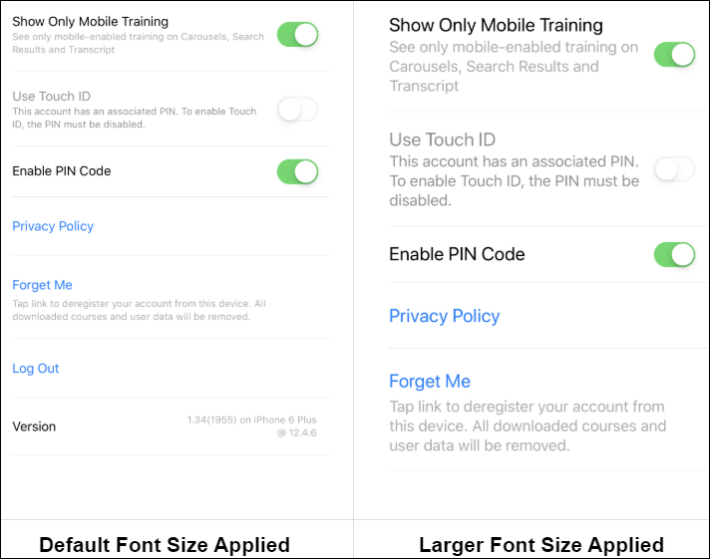
Multitasking
Slide Over and Split View has been enabled for Cornerstone CSX app iPad users, allowing users to use the Cornerstone CSX app simultaneously with other applications that support the same features.
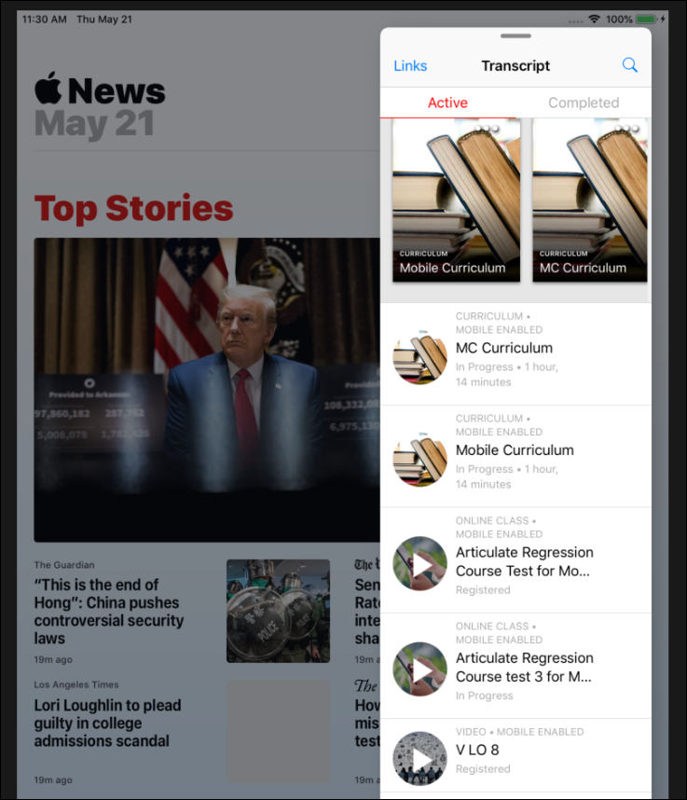
Links Menu
A Links navigation link is located in the upper-left corner of the Cornerstone CSX app, allowing users to intuitively navigate the app.
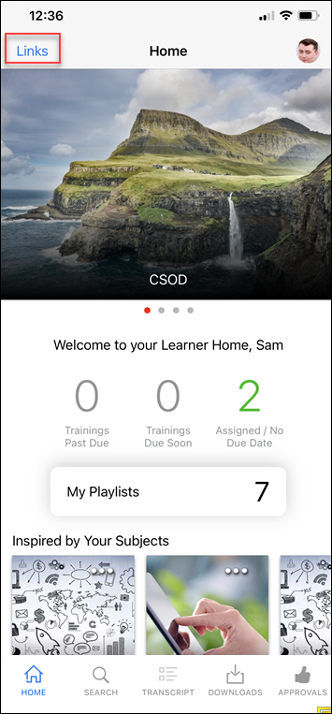
When tapped, the Links link opens a tableview of any configured custom links, in addition to the Give Feedback link.
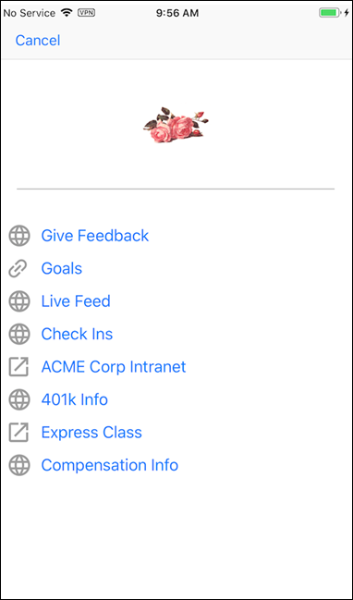
Picture in Picture (PIP) Functionality
Picture in Picture (PIP) functionality was made available for iPads. Users can initiate PIP when viewing a video learning object (LO). All Cornerstone CSX app functionality is disabled while PIP is active. Users can traverse other apps while the video LO continues to play in a small window. After exiting PIP mode, all app functionality is re-enabled.
Considerations
The following considerations apply to PIP functionality:
- The following file types are supported for Picture in Picture: .mpg, .mpeg, .wmv, .flv, .m4v, .mp4.
- PIP is enabled by tapping the PIP icon in the left-hand corner of a Video
Exclusions
The following exclusions apply to PIP functionality:
- Videos with a YouTube URL source are not supported
- Online courses are not supported; this feature is only enabled for video LOs.
Picture in Picture Split Screen
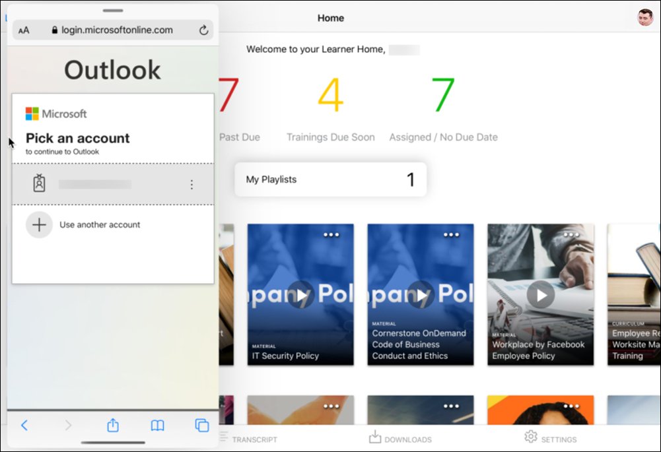
Picture in Picture
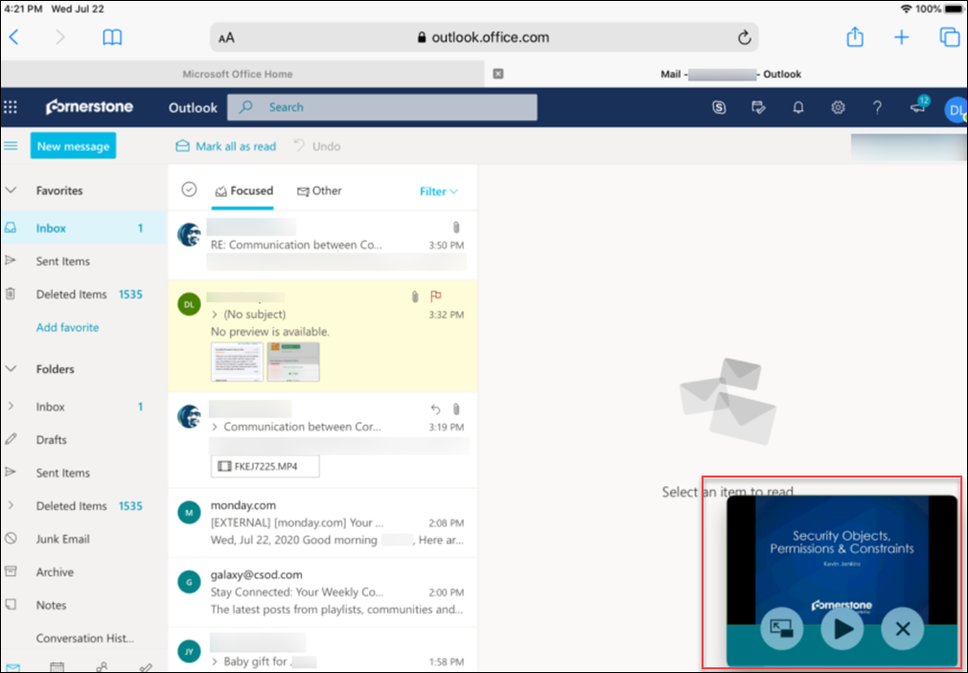

Cornerstone CSX Android App - Overview
Cornerstone CSX Android App - Log In
Mobile learners can log into the Cornerstone CSX app using either of the following methods, if available:
- System Credentials
- SSO
- Biometric Information
Before configuring login credentials, the user must first register their device.
Permissions
PERMISSION NAME | PERMISSION DESCRIPTION | CATEGORY

My Account Devices - Manage | Grants ability to access the Devices tab of My Account. The Devices tab enables users to register their mobile devices with the Cornerstone application. This permission cannot be constrained. This is an end user permission. | Mobile
Register Device
The Devices tab of the My Account page allows users to register their mobile phones, tablets or computer. Users must register their mobile phone, tablet, or computer on this page in order to log in to the Cornerstone desktop or Cornerstone CSX mobile app using a unique device key. Users can also disconnect devices from the Offline Player and mobile application.
Within the desktop version of the Cornerstone system, navigate to My Account > DeviceS. The tab name may appear differently in your portal, depending on the display name configured by the administrator via My Account Preferences. If the tab name is longer than the maximum visible characters, then the full name can be viewed by hovering over the tab. Note: The Devices tab only displays if enabled by the administrator.
The Device Registration login Method does not support Biometric configuration. Biometric login is only available if users log in using Credentials/SSO methods.
Add Device
- In the first field, enter a name for the device. For example, if it is a mobile phone, you may enter "Mobile Phone" or the brand of mobile phone. Note: The device name entered here will not persist on the Devices tab after the user’s initial login to the Cornerstone CSX App.
- In the second field, enter a temporary five-digit PIN. The PIN must be five numbers, and it will only be used during device registration setup. Click NEXT to proceed to the next step.
- The next step displays instructions that must be completed within the Cornerstone CSX app. Do not close the pop-up until the registration process is complete within the Cornerstone CSX app, as the device key and temporary PIN are required to register the device. After completing the registration process, click the CLOSE button. The registered mobile device appears on the Devices tab.
Disconnect a Registered Device
To disconnect a registered device, navigate to the Devices tab of the My Account page and click the DISCONNECT button next to the device. This opens a confirmation pop-up. Click OK to disconnect or click CANCEL to stay connected.
After removing your device, you will not be able to log in using that device again unless a new pairing is created.
Device Entries on the Devices Page
Users are asked to name their device during the device registration process. This device name does not persist on the Devices tan after the user’s initial login to the Cornerstone CSX app. Rather, users can expect to see a maximum of two system-generated device entries per registered device.
Why two device entries?
Because users who register a device ultimately authenticate with a PIN, a backup entry is created and associated with the user. This allows the user to log into the app in the future with their stored PIN, as well as log in offline. One of these entries is always stored and displayed on the Devices tab. Additionally, a backup entry is created with every login. Therefore, a user can expect the following on the Devices tab:
- When logged into the Cornerstone CSX app, a maximum of two device entries per registered device displays.
- When logged out of the Cornerstone CSX app, one device entry displays. This is a backup entry.
- The device entry displays as follows: mobile_backupsession <date time>.
- The timestamp and date correspond to the time and date the user last logged in to the Cornerstone CSX app.
- The backup entry timestamp updates with each login.
How do device entries appear?
After initial login, the device name entered by the user displays with a backup device entry as follows:
For subsequent logins, the Devices tab displays as follows:
When logged into Cornerstone CSX app:
Note: The date and timestamp are localized to the user’s location, based on their user record.
When logged out of Cornerstone CSX app:
Note: The date and timestamp are localized to the user’s location, based on their user record.
Biometric Authentication
When a user initially accesses the Cornerstone CSX app, they are first prompted to enable biometric authentication for the app. If the user does not enable biometric authentication, the app will then prompt the user to configure a PIN.
- To enable biometric authentication, tap the OK button when prompted, and complete the setup process with your phone. Once biometric authentication is configured, the user will be prompted for biometric authentication each time they log in, unless they change their authentication method via the Settings tab.
- To bypass enablement of biometric authentication, tap the Cancel button. You will then be prompted to configure a PIN instead.
The Device Registration login Method does not support Biometric configuration. Biometric login is only available if users log in using Credentials/SSO methods.
Biometric Reauthentication
If the user's attempt to enable biometric authentication fails, they will be prompted to reauthenticate.
The user can attempt to try again, or they can cancel the biometric authentication setup. The user will be prompted to configure a PIN if they cancel the biometric authentication setup.
Considerations
Depending on your organization's portal and application configurations, the beginning of your users' login experiences may differ slightly. See below for details:
- For SSO Users: Upon entering a valid portal name, "smart" logic is applied during login. If a user is configured for SSO, upon tapping the Next button, the user is navigated to the SSO page.
- For Credential Users: Upon entering a valid portal name, "smart" logic is applied during login. If a user's portal has no SSO configurations, upon tapping the next button, the user is navigated to the credentials page.
- For organizations using both SSO and credentials: Upon entering a valid portal name, users are directed to the Username page. Upon entering their username, the app checks whether the user is in an organizational unit that has SSO enabled in Mobile Preferences.
  - If YES: User is navigated to the SSO page
  - If NO: User is navigated to the Learn App password screen
- If a portal has no SSO configurations and a user taps the Alternative Device link, the SSO option will not appear.
- If a user is offline, the Alternative Device link is disabled .
- The Alternative Device link is in a disabled state until a valid portal name is entered.
SSO Sign On
If SSO functionality is enabled, users can log into the application via SSO either by using their portal log-in information or biometric information. Note: Users can only use biometric information to log in after they have logged in at least once using SSO and associated their biometric information with their login.
To access the SSO Sign On page on the app, swipe the Credentials login page to the left. Then, populate the following fields:
- Portal - The name of your organization's learning portal
- Username - Your username for your organization's learning portal
After populating the required fields, tap the Log In button. If the SSO authentication is successful, you are granted access to the application. If the credentials are incorrect or an error occurs, an error message displays and you can attempt to re-enter your credentials.
Note: The Log In button is disabled until all required fields are populated.
Note: The SSO page is visible even for organizations that do not support SSO.
After a user logs in to the Cornerstone CSX app with SSO, they are prompted to associate the biometric information that they have on their phone to their login.
- When a user associates the biometric information on their phone with their login, the user can then log in to the Cornerstone CSX app using the SSO login method and fingerprint or facial recognition, depending on their device.
- If a user chooses not to associate the biometric information on their phone with their login, then the user can make this association from the Settings page within the app.
Authentication Settings
To reconfigure the authentication settings for the app at any time, the user can navigate to the Settings tab. To enable a different form of authentication, toggle the switch for that authentication type to the On position. The app will prompt the user to configure the enabled authentication type.
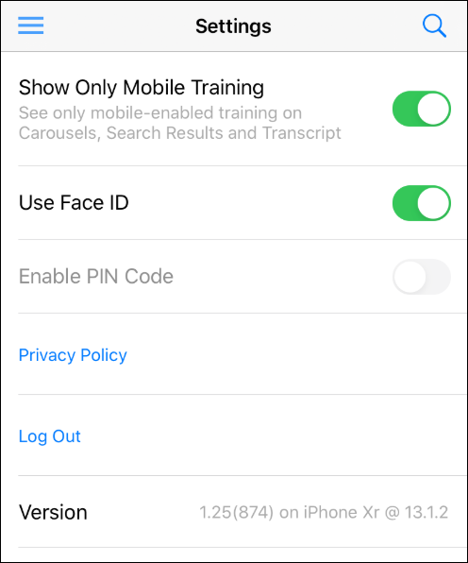
Language Considerations
The Cornerstone CSX Android app displays to users in the display language specified in the user record. The Cornerstone CSX Android app does NOT default to the display language of the device.
Cornerstone CSX Android App - User Profile, Links, and Navigation
The user profile icon displays in the upper-right corner of the top app bar. Tapping the user profile icon opens the Profile page, where various settings and options can be accessed by the user.
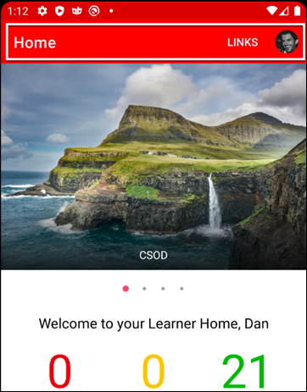
On the Profile page, the user can access the following features:
- Settings - The user can tap this option to adjust their Cornerstone CSX app settings.
- Scan QR Code - The user can tap this option to access their QR code when attending a training session that uses QR codes for attendance tracking. See Cornerstone CSX App - QR Codes for Instructor-Led Training on page 56 for additional information.
- Forget Me - The user can tap this option to reregister their Cornerstone CSX app account from their device. Any downloaded courses and user data associated with the app will be removed.
- Log Out - The user can tap this option to log out of the Cornerstone CSX app on their device.
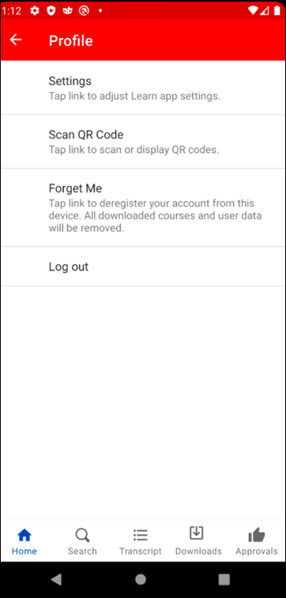
Links
Any custom links configured by the user's organization, as well as the Give Feedback link, can be accessed by tapping the Links link in the upper-right corner of the top app bar.
Bottom Navigation Bar
A fixed navigation bar is available at the bottom of all pages of the Cornerstone CSX app. The navigation bar includes the following icons, if available to the user:
- Home - The user can tap this icon to navigate to the home screen.
- Search - The user can tap this icon to access Learning Search, through which they can search for training.
- Transcript - The user can tap this icon to access their Learning transcript page.
- Downloads - The user can tap this icon to view their downloaded courses.
- Approvals - Users with permission to manage training approval requests have access to an Approvals tab on the Cornerstone CSX app. To access the Approvals tab, tap the Approvals icon.
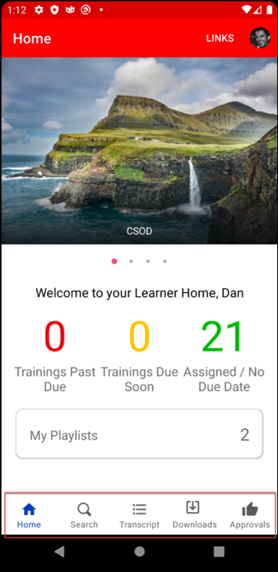
Cornerstone CSX Android App - Settings
The Settings page of the Cornerstone CSX app allows mobile learners to:
- Log out of the Cornerstone CSX app.
- Choose to see non mobile-enabled training in the app
- Enable PIN code
- View the Privacy Policy
- Deregister your account from your device
Access the Settings page by tapping the Settings icon at the bottom of the screen.
Show Only Mobile Training
To see non-mobile content in the app, toggle the Show Only Mobile Training switch to the Off position. This selection will be saved for future log ins.
Enable Biometrics
To disable or enable fingerprint or Face ID, toggle the Enable Biometrics switch to the Off or On position, respectively. The default selection is based on the user’s choice after first logging into the app and selecting initial options.
Enable PIN Code
To enable or disable a PIN code, toggle the Enable PIN Code switch to the On or Off position, respectively. Users can create a six digit PIN Code which they will be prompted for each time they log into the Cornerstone CSX app. After configuring a PIN, the user will be prompted for that PIN each time they log into the app, unless the user changes their authentication method.
The app provides weak PIN detection, with a pop-up that prompts users to use a stronger PIN. Criteria that will flag a PIN as weak:
- Less than three unique characters (e.g. PIN that uses only two numbers, such as 343344)
- Using four numbers that are in subsequent order (e.g 1234XX or X1234X or XX4567)
- Using four numbers in backwards subsequent order (e.g. XX4321 or 4321XX)
Note: There is a 30 minute device lockout after five unsuccessful PIN attempts.
Privacy Policy
Click the Privacy Policy link to view the Cornerstone CSX app privacy policy.
Version
The Version section displays the version of the app you are using.
Picture in Picture Display
Android users can initiate Picture In Picture (PIP) when viewing video training items by tapping the Home button on their Android device. All Android device types support PIP functionality. All Cornerstone CSX app functionality is disabled while PIP is active. After exiting PIP mode, all app functionality is re-enabled.
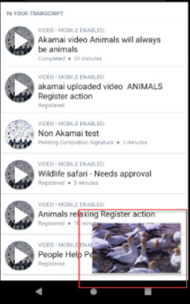
PIP Considerations
The following considerations apply to this feature:
- PIP is supported for Android version 7 and above
- The following file types are supported for Picture in Picture: .mpg, .mpeg, .wmv, .flv, .m4v, .mp4.
PIP Exclusions
The following exclusions apply to this feature:
- Videos with a YouTube URL source are not supported
- Online courses are not supported; this feature is only enabled for video LOs.
Cornerstone CSX Android App - Learner Home
The Learner Home page functions as the landing page for the Cornerstone CSX app, allowing mobile learners to browse for and request relevant training, search and filter for specific training, and prioritize mandatory training. The Learner Home includes several features which enable learners to easily select subjects of interest, discover training based on machine learning, and quickly access and request new training.
To access Learner Home on the app, log into the Cornerstone CSX app. To navigate back to the Learner Home after navigating to other pages, click the Options icon in the upper-left corner of the screen, then click the Home option.
Note: The permission to access Learner Home is NOT required in order to access this page in the app.
Welcome Banner
Across the top of the page, a carousel of banners created by the learning administrator display to the mobile learner. The carousel cycles through all available banners. If the user taps the banner, they are navigated to any URL that the administrator associated with the banner. The link associated with the banner opens in a web browser, and the user does NOT need to log in again if the link is to a Cornerstone system page.
The following considerations apply to this functionality:
- No button displays on custom banners in the Cornerstone CSX app.
- The Cornerstone CSX app displays the same banner that is uploaded for the web experience. For information about configuring the banner: See Learner Home Preferences.
Below the banner carousel, the message, "Welcome to your Learner Home, [User]" displays if the user is accessing the page for the first time. The message, "Welcome back, [User]" displays if the user has previously accessed the page. These welcome messages display the user's name as it appears in their user record.
Training Metrics
In the Training Metrics section, the following information about training on the user's transcript displays:
- Training Past Due - This field displays the number of training items on the user's transcript which have due dates that have passed.
- Training Due Soon - This field displays the number of training items on the user's transcript that are due within the next ten days.
- Assigned Training - This field displays the number of training items on the user's transcript that have been assigned without a due date.
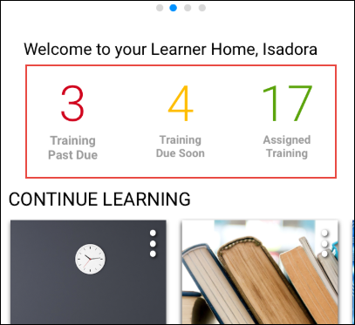
Training Carousels
Below the welcome message, several different carousels of training may display to the user if applicable training is available and the learning administrator has enabled the carousel via Learner Home Preferences. Each carousel provides relevant training recommendations to learners, and learners can page through the carousel to see all recommendations.
Note: Only mobile-enabled training displays in the training carousels on the app, unless the user has not opted to enable the Only Show Mobile Training option on the Settings page of the app.
Note: Not all the carousels available on the desktop version of Learner Home are available on the mobile version of Learner Home.
Each training tile displays with its associated thumbnail image, training type, and training title.
Carousel | Details
Continue Learning | This section displays training that is on the user's active transcript. Training in this section is sorted by the last transcript status change date, and a maximum of 20 training items can display in the section. If no training is on the user's active transcript, this section is hidden. Note: The last transcript status change date is a date field that tracks when a training moves from one transcript status to another transcript status.
Saved for Later | This section displays training that has been saved by the user. Training in this section is sorted by most recently saved first, and there is no limit on the number of training items that can display in this section. If the user has not saved any training, this section is hidden. If any of the user's saved training has been made inactive or unavailable, that training is removed from the section automatically. Note: This section displays the most recent version of the saved training. For example, if the user saved Leadership Skills (Version 1), and Leadership Skills (Version 2) has since been published, Version 2 of the training displays for the user in this section.
Top Picks for User | This section displays training that is recommended to the user based on their training history. Training in this section is sorted by relevancy to the user (determined by machine learning), and a maximum of 20 training items can display in this section. If no recommendation results are found for the user, the system considers the training history of users in the user's position, division, and location, and then neighboring positions, divisions, and locations in the hierarchy to find recommendations. This section is hidden if any of the following are true:  - The backend setting for machine learning course recommendations is not enabled.  - No recommendation results are found for the user.  - An error occurs.
Trending for Your Position | This section displays training that is recommended to the user based on their position. Training in this section is sorted by relevancy to the user (determined by machine learning), and a maximum of 20 items can display in this section. If no recommendations are found for the user's position, then the system considers the user's division and location, then neighboring positions, divisions, and locations in the hierarchy to find recommendations. This section is hidden if any of the following are true:  - The backend setting for machine learning course recommendations is not enabled.  - No recommendation results are found for the user.  - An error occurs.
Inspired by Your Subjects | This section displays training that is recommended to the user based on subjects in which the user has indicated interest. See Learner Home - Subjects. Training in this section is sorted by relevancy to the user (determined by machine learning), and a maximum of 20 items can display in the section. If the user has not selected any subjects, then the section displays a prompt for the user to add subjects. If no recommendations are found for the user’s selected subjects, the system considers the user's division and location, then neighboring positions, divisions, and locations in the hierarchy to find recommendations. This section is hidden if any of the following are true:  - The backend setting for machine learning course recommendations is not enabled.  - No recommendation results are found for the user.  - An error occurs.
Most Popular | This section displays training that was requested the most number of times in the last 60 days. Training in this section is sorted by the highest number of requests, and a maximum of 20 items can display in the section. If no training has been requested in the last 60 days, this section is hidden.
Featured | This section displays training items which have been designated as Featured on the Availability page of the Course Catalog by an administrator. If no training available to the user has been designated as Featured, this carousel does not display to the user. Note: If a playlist is designated as featured via the Course Catalog, it does NOT display in the Featured Training widget on the Welcome page. The featured playlist does, however, display in the Featured carousel on the Learner Home page.See Course Catalog - Availability for more information about setting the Availability Type of training items to Featured.
Suggested | This section displays training items which have been designated as Suggested on the Availability page of the Course Catalog by an administrator. If no training available to the user has been designated as Suggested, this carousel does not display to the user. See Course Catalog - Availability for more information about setting the Availability Type of training items to Suggested.
Required | This section displays training items which have been designated as Required on the Availability page of the Course Catalog by an administrator. If no training available to the user has been designated as Required, this carousel does not display to the user.See Course Catalog - Availability for more information about setting the Availability Type of training items to Required.
Training Tile Actions
When a learner taps on a training tile, they are navigated to the Training Details page for that training. When a learner taps the Options icon for a training item, different actions are available depending on whether or not the training is on the user's transcript, what type of training it is, and what status the training is currently in.
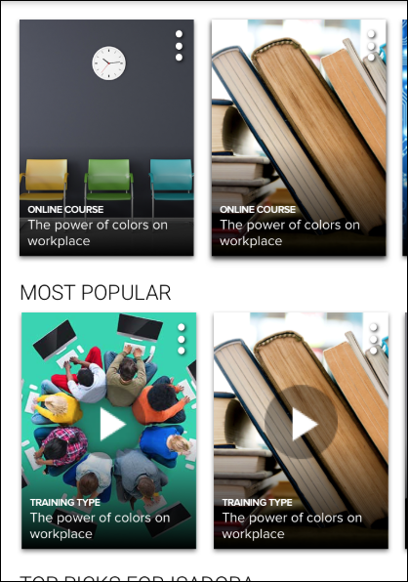
The following options may be available for training items that are already on the learner's transcript:
- Primary Transcript Action - The current primary action on the user’s transcript for the specific training item displays as the top option. For example, if the primary training action is Launch, the user can tap Launch to open the training. Note: Only online courses, materials, and videos can be launched from a carousel on the mobile version of Learner Home.
- Secondary Transcript Actions - Any other transcript actions available to the user for the training item appear in the list of options and allow the user to perform the associated action on the training. See Transcript (Universal Profile) - Status and Options for all available actions. Note: Tapping some transcript actions causes the user to be redirected to their learning transcript.
- See Details - Tap this option to access the Training Details page for the training item.
- Save for Later (if available) - Tap this option to save the training item. Saved training items display in the Saved for Later section on the Learner Home. Any training item available to the user or on their transcript can be saved except for certifications, and there is no limit on the number of items which can be saved.
- Remove from Saved (if available) - This option is only available if the training has already been saved by the user. Tap this link to remove the training item from the Saved for Later section.
The following options may be available for training items that are NOT already on the learner's transcript:
- Launch (if available) - Tap this option to launch the training. This opens the training and adds the training item to the user’s transcript. Note: Only online courses, materials, and videos can be launched from a carousel on the mobile version of Learner Home.
- Request (if available) - Tap this option to request the training. This adds the training item to the user’s transcript. The page will then refresh to the transcript.
- See Details - Tap this option to access the Training Details page for the training item.
- Save for Later (if available) - Tap this option to save the training item. Saved training items display in the Saved for Later carousel on the Learner Home page. Any training item available to the user or on their transcript can be saved except for certifications, and there is no limit on the number of items which can be saved.
- Remove from Saved (if available) - This option is only available if the training has already been saved by the user. Tap this link to remove the training item from the Saved for Later section.
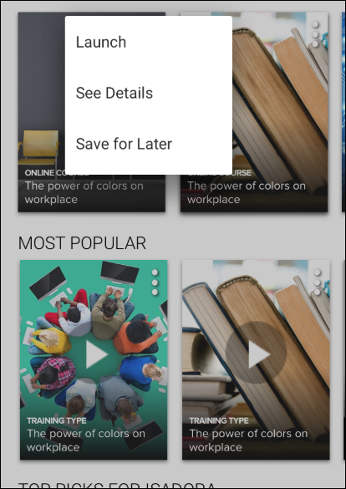
Cornerstone CSX Android App - Learning Search
At the top of every page in the Cornerstone CSX app, a Search icon allows users to open a search box and search for specific learning using powerful search technology. Users can enter words relating to the following training attributes into the search box to receive relevant training results that are sorted by relevance:
- Title
- Keywords
- Description
Note: The permission to access Learner Home is NOT required in order to access Learning Search in the app.
Search Training
To search for training in the Cornerstone CSX app:
- Enter a search term or phrase into the search box and press the Enter key on your phone keyboard. A maximum of 50 search results can be returned.
- Peruse the results which display on the Learning Search page and use the available filters to receive more specific training results, if necessary. Search results are separated into two sections: In Your Transcript, which shows relevant training results which are already on your transcript, and Available, which shows training that is available to you and not already on your transcript. In each section, search results are sorted by relevance, and text queries are matched with content title, descriptions, and keywords.
Each training result displays with a thumbnail image, the training type, the title of the training, and the duration, if applicable. If the training is on the user's transcript, the status of the training item displays under the training title. Tap a training result to access the Training Details page for the training.
If the training is already on the user's transcript, and the training is an online course, material, or video, a play icon displays over the training's thumbnail image, and tapping the training thumbnail image launches the training. Training that is on the user's transcript can also be launched by tapping the Play icon over the training's thumbnail image or by navigating to the Training Details page for the item.
Mobile Enabled Icon
When viewing training items in search results or on the transcript in the Cornerstone CSX app, mobile-enabled training tiles display with a Mobile-Enabled icon, allowing users to quickly determine which training is best to take using their mobile device.
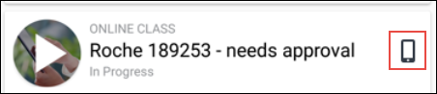
Training Options
Tap on the training item to access the Training Details page for the item. Training Details page provides access to information for the training item, including its title, duration, price, languages, description, and more.
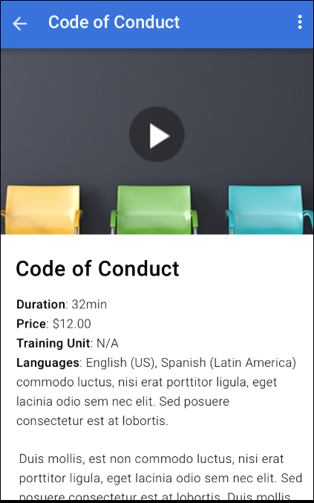
The following options may be available, depending on the training type and the current status of the training:
- Primary Transcript Action - The current primary action on the user’s transcript for the specific training item displays in the menu. For example, if the primary training action is Launch, the user can tap Launch to open the training.
- Secondary Transcript Actions - Any other transcript actions available to the user for the training item appear in the list of options and allow the user to perform the associated action on the training. See Transcript (Universal Profile) - Status and Options for all available actions. Note: Tapping some transcript actions causes the user to be redirected to their learning transcript.
- Save for Later - Tap this option to add the training to the Saved for Later carousel on Learner Home. This option is only available if the training is NOT currently contained in the Saved for Later carousel.
- Remove from Saved - Tap this option to remove the training item from the Saved for Later carousel on Learner Home. This option is only available if the training is currently contained in the Saved for Later carousel.
Filters
Users can filter the training results that appear by clicking the Filter icon in the upper-right corner of the search results page. The following filters are available:
- Training Type
- Duration
- Subject
- Language
To apply a filter to your training search results, toggle a filter option to the On position or select a filter option from the drop-down, depending on the filter type. The blue button at the bottom of the screen displays text stating, "See [X] Results," X being the number of search results which meet the currently selected search criteria and search filters.
View the table below for more information about the available filters:
Filter | Selection Type | Options | Additional notes
Training Type | Multi-select toggles | - Curriculum  - Event  - Library  - Material  - Online Class  - Program  - Quick Course  - Test  - Video | Type options display based on the entered search terms, meaning that if, for example, no curricula meet the user's search criteria, the Curriculum filter option does not display.
Duration | Drop-down menu | - Any Duration (default)  - < 15 minutes  - < 30 minutes  - < 1 hour  - < 2 hours  - 2 + hours | Duration options display based on the entered search terms, meaning that if no training that meets a user's search criteria has a duration of greater than two hours, then the 2+ hours filter option doesn't display.
Subject | Multi-select toggles | The top ten subjects related to the search result display, all unselected by default | If no training that meets the user's search criteria has an associated subject, the subject filter does not display.
Language | Multi-select toggles | Languages related to the search results display alphabetically, all unselected by default | Language options display based off the text query (e.g. if no training returned in the results has an Available Language of 'Spanish', then 'Spanish' wouldn't display as a language option). The language filter will not display if only 1 language matches the training returned in the results (e.g. all training returned in the results has a language of 'English (US)', then the language filter won't display) When many, many languages are displayed, a scroll-bar will appear within the section.
To remove all filters from the search, tap the Reset link in the upper-right corner of the screen.
To exit the filters panel, click the X icon in the upper-left corner of the screen.
Cornerstone CSX Android App - View Curricula
When a user navigates to Learning Search or Learner Home within the Cornerstone CSX app, the user can access the Curriculum Details page for the curriculum and both view and take action on child training items contained within the curriculum, even if the curriculum itself is not on their transcript.
Curriculum Courses
When a user taps a curriculum within the Cornerstone CSX app, they are navigated to the Curriculum Details page for the curriculum, which contains two tabs: Details and Courses. To view the structure of the curriculum and the training contained in the curriculum, tap the Courses tab.
Courses
On the Courses tab, each section of the curriculum displays. The user can view the full curriculum structure, provided all the child training within the curriculum is supported by the Cornerstone CSX app.
The user can tap a section to view the child training items contained in that section. If a section of the curriculum has already been completed by the user, the section shows a status of Completed. If the section has not been completed, no progress information displays. Even if the curriculum is not on the user's transcript, the user can perform available actions on the training contained within the curriculum, such as requesting the training.
The following supported training items can be accessed from within a curriculum:
- Online Courses
- Materials
- Videos
The following information displays for each child training item:
- Training Title
- Training Type (i.e. online course, material, video)
- Image Thumbnail
If a child training item within a curriculum is already on the user's transcript, when the user views the child training from within the curriculum, a message displays with the training stating, "This item is already on your transcript."
Note: The curriculum structure respects the Mobile Enabled filter, meaning that if this filter is enabled, the user will only see mobile-enabled training on the Courses page.
Cornerstone CSX Android App - Transcript
On the Transcript page of the Cornerstone CSX app, mobile learners can access both their active and completed transcript pages, launch certain types of training, and view information about the training on their transcripts. Note: Only mobile-enabled training items that have been assigned to or requested by the user display on the Cornerstone CSX app transcript by default.
To access the Transcript page of the app, tap the Menu icon in the upper-left corner of the screen and then tap the Transcript link.
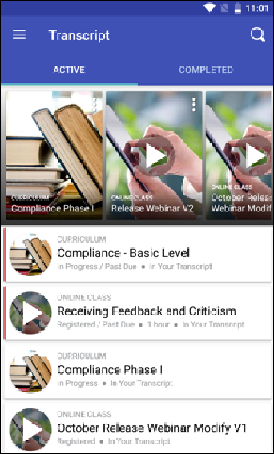
Continue Learning
The Continue Learning carousel on the Active transcript page displays training that is already on the user's transcript. Training in the carousel is sorted by the last transcript status change date, and a maximum of 20 training items can display in the section. If no training is on the user's active transcript, this section is hidden. Note: The last transcript status change date is a date field that tracks when a training moves from one transcript status to another transcript status.
Each training tile displays with its associated thumbnail image, training type, and training title. For more information about interacting with training carousels and training tiles,
Active Transcript
On the Active transcript page, training that has been assigned to the user but not yet completed displays in order of earliest due date to latest, with the following information for each item:
- Thumbnail image
- Training type
- Training Title
- Transcript Status
- Duration (if available)
If the training is an online course, video, or material, a Play icon displays over the thumbnail image for the training. Tap the Play icon to launch the training.
Tap the arrow to the right of the training result to access the Training Details page for the training. If the training is an online course, video, or material, the training can also be launched from the Training Details page by tapping the Play icon.
Note: Online courses, videos, and materials can also be launched from within curricula via the Learning App.
Completed Transcript
To access the Completed transcript page, swipe the Completed tab. Training the user has completed displays on the Completed transcript page with the following information:
- Thumbnail image
- Training type
- Training Title
- Completed Status
- Duration (if available)
If the training is an online course, video, or material, a Play icon displays over the thumbnail image for the training. Tap the Play icon to launch the training.
Tap the arrow to the right of the training result to access the Training Details page for the training. If the training is an online course, video, or material, the training can also be launched from the Training Details page by tapping the Play icon.
Note: Online courses, videos, and materials can also be launched from within curricula via the Learning App.
Transcript Actions
A Play icon displays over the thumbnail image for a training item if it can be launched from the Learning app. Tap the play icon to launch the training. You can also tap the training tile to access the Training Details page for the training, where additional options may be available depending on the training type and status of the training. The following options may be available for training items on the learner's transcript:
- Primary Transcript Action - The current primary action on the user’s transcript for the specific training item displays as the top option. For example, if the primary training action is Launch, the user can tap Launch to open the training. Note: Only online courses, materials, and videos can be launched from a carousel on the mobile version of Learner Home.
- Secondary Transcript Actions - Any other transcript actions available to the user for the training item appear in the list of options and allow the user to perform the associated action on the training. For example, if the training is a material, Mark Complete may display as an option for the material, allowing the user to mark the material complete on their transcript. See Transcript (Universal Profile) - Status and Options for all available actions.
- Save for Later (if available) - Tap this option to save the training item. Saved training items display in the Saved for Later section on the Learner Home. Any training item available to the user or on their transcript can be saved except for certifications, and there is no limit on the number of items which can be saved.
- Remove from Saved (if available) - This option is only available if the training has already been saved by the user. Tap this link to remove the training item from the Saved for Later section.
- Delete - If the user has downloaded a training item for offline consumption, they can remove the downloaded course by clicking the Delete option. The user can deleted a downloaded course even when not connected to the internet. After a training item has been deleted, it is available for download again.
- Cancel - Tap this option to close the list of options.
Cornerstone CSX App - Download Learning
If offline content has been enabled in the portal and an online course has been made available offline, users of the Cornerstone CSX app can download the training and then complete it without needing access to an internet connection, as long as they have the Offline Content permission. This functionality is available to both users of the iOS version of the app and users of the Android version of the app.
Most video formats can be downloaded, but only ".mp4" and ".m4v" can be played inline. Other formats must be opened in external apps that support video playback.
Permissions
PERMISSION NAME | PERMISSION DESCRIPTION | CATEGORY

Offline Content | Grants ability to download and complete training items offline via a mobile device or the new Offline Player. This permission cannot be constrained. This is an end user permission. | Mobile
Download
Training that is available for download via the Cornerstone CSX app can be downloaded either from the Home page for the training or from the My Learning page.
To download a training item tap the Download button at the bottom of the screen. Once the course has finished downloading, a confirmation displays under the training status in the Training Details. All downloaded training items also display on the New Downloads page, which can be accessed through the main navigation of the Cornerstone CSX app. The next time an internet connection is available, any training progress the user has made on the course will be synced with the user's transcript in the Cornerstone CSX app. Note: Only courses and materials that have been made available to download by an administrator can be downloaded from the app.
Errors
If a training item does not download successfully, a red error icon displays next to the training. The user can tap the error icon to see an alert describing the error. The user can then either retry the download or cancel their download. If the error persists, there may be an issue with the course and the user should contact their learning administrator.
Considerations
The following considerations apply to this functionality:
- Only SCORM Online Courses are available for download.
- In order to log into the Cornerstone CSX app without an internet connection, a user must have performed a successful previous online login using their username and password. Note: Offline login via SSO is not currently supported.
- Materials uploaded with a source that is a YouTube URL are not available for download, as this violates YouTube's Terms of Service.
- Materials uploaded with a source that is a URL that requires the user to authenticate before accessing, such as an Excel document hosted on OneDrive or GoogleDrive, are not available for download.
- Materials uploaded with a source that is a .zip file are not available for download.
- Materials uploaded with no source are not available for download.
- The following material file types can be made available for download and offline consumption:
  - doc
  - docx
  - gif.
  - jpeg
  - jpg
  - pdf
  - pps
  - ppsx
  - ppt
  - pptx
  - xls
  - xlsx
Download Materials FAQ
Q: Can a user mark a material complete while offline?
A: No, a user must first regain connectivity. Once they log into the Cornerstone CSX app with an internet connection, they will have access to the Mark Complete action for the material.
Q: What completion date will be reflected for materials launched offline?
A: The date and time that the user taps the Mark Complete action after logging into the Cornerstone CSX app with an internet connection will be reflected as the material's completion date.
Q: Can I configure materials to be mobile enabled and available for download during the material creation process?
A: No, these settings must be enabled after the material is created via the Course Catalog.
Cornerstone CSX Android App - Training Push Notifications
The following training push notifications are available for both the Android and iOS versions of the Cornerstone CSX app:
Notification Type | Corresponding System Event | Banner Message | Recipient | Redirect When Tapped
Training is Approved | Approver/Manager approves a training request | Training request for [Training Title] has been approved. | End User | Training Details
Training is Assigned | Training is assigned by a manager or via the Learning Assignment Tool | [Training Title] has been assigned to you. | End User | Training Details
Training is Denied | Approver/Manager denies a training request | Training request for [Training Title] has been denied. | End User | Training Details
Training Has Due Date | Manager assigns training directly to their direct/indirect subordinate with a due date | [Training Title] was assigned with a due date. | End User | Training Details
Training is Requested | User requests a training that requires approval | [Training Title] requires your approval. | Approver | Approvals List
Emails
EMAIL NAME | EMAIL DESCRIPTION | ACTION TYPE

Assign Training | The Assign Training email is designed to fire when a user is assigned an online class, quick course, event, curriculum, posting, test, video, or material. This email does not fire when a manager or administrator adds external training to a user’s transcript.  However, the Assign Training email trigger is also leveraged during the approval process and will also fire for any learning objects with an approval workflow required and will fire for external training after each approval if approvals are required. The email can be leveraged to notify the next approvers they have an approval waiting for the learning object. If there are multiple approvals required, this email will fire multiple times.  Note: If the user currently has a previous version of the training on his transcript and the previous version is version equivalence of its next version, the user will not get the 'Assign Training' email on the assignment of the next version. | Training
Considerations
The following considerations apply to push notifications for the Cornerstone CSX app:
- While there is no setting to disable push notifications in the Cornerstone CSX app, notifications can be disabled from your device settings at any time via the Notifications section of the Settings page.
- Push notifications are disabled for multi-user devices. If more than one user shares a device, push notifications are not sent.
- If enabled, push notifications appear on the home screen of the user's device, even when they are not logged in to the app.
- All training notifications display regardless of whether the training is mobile-enabled.
- Push notifications expire and are automatically removed after one year from the date of receipt.
- If users have viewed the Training Details page of a training item for which they received a push notification, they will be navigated to the Training Details page for the training when they tap the notification. If the user has NOT viewed the Training Details page of the item, they will be navigated to the Transcript page when they tap the notification. This is due to application cache, and this behavior will be modified in a future patch so that end users will always be navigated to the Training Details page after tapping a training push notification.
- If user is logged in to the app when they tap a push notification, they are navigated to the relevant application area, such as the Transcript, Training Details page, or Approvals list, as specified in the table above.
- If a user is not logged in to the app when they tap a push notification, they will be redirected to the login page and prompted to log in. After logging in, user will be directed to the application area, as specified in the table above.
- Push notifications can be disabled for an entire portal via a backend setting. Please contact Global Customer Support to request this.
Cornerstone CSX Android App - Playlists
Users of the Cornerstone CSX app can interact with playlists in the following ways:
- Search for and filter by playlists via Learning Search
- Follow playlists
- Access playlists via a new carousel on Learner Home in the app
- Consume training within playlists
- Launch external content from within playlists in the app
- View playlist metrics
- Share playlists with other users
Exclusions
The following playlist functionality is NOT available for playlists within the Cornerstone CSX app:
- Create playlists - Users cannot create playlists within the Cornerstone CSX app
- Add to playlists - Users cannot add items to playlists within the Cornerstone CSX app
- Edit playlists - Users cannot edit playlists within the Cornerstone CSX app
- Copy playlists - Users cannot copy playlists from within the Cornerstone CSX app
- View as administrator - Users are not able to view playlists as an administrator from within the Cornerstone CSX app
- Follower and creator bios - Users cannot navigate to the Universal Profile of a playlist creator or a playlist's followers
Considerations
In order for playlist functionality to be enabled in the Cornerstone CSX app, it must be enabled in your portal. For information about activating playlist functionality in your portal: See Learning Feature Activation Preferences.
Permissions
PERMISSION NAME | PERMISSION DESCRIPTION | CATEGORY

Playlists - View | Playlists will be visible to users with this permission. The user can search for playlists, follow playlists, and consume training contained within playlists that are available to them. The learning playlists that are visible to a user are not impacted by this permission, but instead is based on the availability of the playlist. This permission cannot be constrained. This is an end user permission. | Learning - Administration
Search for Playlists
Users can search for playlists on the Learning Search page.
- If the user taps a playlist from the Learning Search page, they are navigated to the Playlist Details page for the playlist.
- Playlists respect the Mobile Enabled filter, meaning that if this filter is enabled, the user will only see playlists that are mobile-enabled. To also see non mobile-enabled training, the user can navigate to the Settings page of the app and disable the Show Only Mobile Training setting.
- Users can only search for playlists that are public.
- Search is disabled when a user is offline.
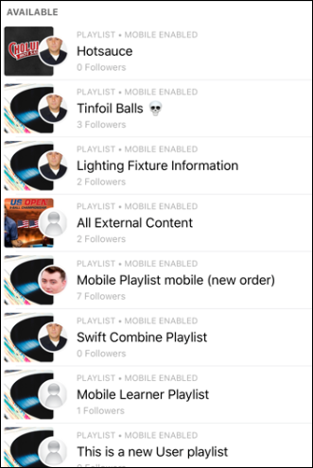
Filter by Playlists
When searching for playlists, users can use the Playlist filter to constrain their search results to playlists. To use this filter, tap the Filters icon and toggle the Playlist filter in the Training Type section to the On position.
View Playlist Metrics
- A Playlist Metrics card displays on the Learner Home page of the app, indicating how many playlists the user has created. Note: The card will display a 0 if the user has not created any playlists, but they can still access their followed playlists by tapping this card and tapping the Followed tab.
- Tap the Playlist Metrics card to navigate to a My Playlists page, which is separated into two tabs: Created and Followed. Any playlists the user has created display on the Created tab. Any playlists the user is following display on the Followed page.
Note: Playlists cannot be created from the Cornerstone CSX app. To create a playlist, access the system via a desktop device.
Playlist Details
The Playlist Details page can be accessed by tapping a playlist. The Playlist Details page displays the following features:
- Playlist Banner Image - The banner image associated with the playlist
- Creator Photo and Name - The profile photo and name of the user who created the playlist
- Follow/Unfollow buttons - See the Follow Playlists and Unfollow Playlists sections below for more details.
- Followers - The number of users who are following the playlist
- Updated - The date on which the playlist was last updated by the creator
- Description - The description of the playlist
- Items - The number of training items contained within the playlist
- Training - Each training item contained within the playlist displays as a tile with the following information:
  - Training Type
  - Mobile Enabled (if applicable)
  - Training Title
  - Transcript Status
  - Synced Status (if applicable)
  - Training thumbnail image
Follow Playlists
- Users can follow any public playlist in their portal via the Cornerstone CSX app.
- To follow a playlist, navigate to the Playlist Details page for the playlist and tap the Follow button. Note: If the user is offline, the Follow button is disabled.
Unfollow Playlists
Users can unfollow playlists they have followed by tapping the Unfollow button on the Playlist Details page for the playlist.
My Playlists
Users can access the My Playlists page from Learner Home in both iOS and Android. For Android users, My Playlists can also be accessed from the app navigation drawer. On the My Playlists page, there are two tabs. On the My Playlists page, there are two tabs:
- Created - This tab shows any playlists the user has created. It is not possible to create or edit playlists from within the Cornerstone CSX app, but the user can tap their playlist to view its Playlist Details page and access actions for the playlist.
- Followed - This tab displays any playlists the user has followed. The user can tap a followed playlist to view its Playlist Details page and access actions for the playlist.
Access Playlist Training
- Users can consume any mobile-enabled content contained in a playlist from within the Cornerstone CSX app. Available actions for the training include Request, Launch, Complete, Save for Later, and View Training Details, and in some cases, Download.
- Playlists respect the Mobile Enabled filter, meaning that if this filter is enabled, the user will only see playlists that are mobile-enabled on the Playlist Details page. To also see non mobile-enabled training, the user can navigate to the Settings page of the app and disable the Show Only Mobile Training setting.
- If a user is offline, they will only be able to consume training that was previously downloaded.
Launch External Content
- Users can launch external content contained in a playlist from within the Cornerstone CSX app.
Share Playlists
Cornerstone CSX app users can share playlists with others using the app. To share a playlist, navigate to the Playlist Details and tap the Share option to generate a deeplink and share the deeplink with other users via native iOS and Android sharing features.
The following considerations apply to playlist sharing on Android:
- If a user is online AND the playlist is private, the Share option is hidden.
- If a user is offline AND the playlist is private, the Share option is hidden.
- If a user is offline AND the playlist is public, the Share option is enabled. The playlist URL can be copied and shared when the user regains connectivity.
Cornerstone CSX App - QR Codes for Instructor-Led Training
Learning QR code generation and scanning capabilities are available for the Cornerstone CSX app. Administrators can configure instructor-led training (ILT) sessions to support QR code functionality for easy session attendance tracking. Using QR codes for ILT session attendance streamlines attendance tracking for large sessions and reduces the administrative burden associated with manually managing attendance for large quantities of in-person ILT sessions.
A Scan QR Code link is available on the Cornerstone CSX app Profile page. To access your profile, tap the user profile icon in the upper-right of the screen.
Tapping the Scan QR Code link allows up to three tabs to display to the learner, depending on the learner's permissions and the portal configuration. The three potentially available tabs include:
- Scan
- My QR Code
- Instructor
Access the Settings page by tapping the Settings icon at the bottom of the screen.
Scan
The Scan tab leverages a device's camera, allowing learners to scan a printed or digital display of an individual session part's QR code. Users will be asked permission for the Cornerstone CSX app to access their device's camera in order to scan QR codes. After a successful scan, learners receive a success confirmation and their attendance is recorded for that part. The instructor must submit the roster for the session in order for attended users to be marked complete.
- Note: A QR code scan is required for each session part the user is attending. For example, if the session includes four parts across two days, the user must be scanned into each of the four session parts they attend.
- Note: A user must be registered for a session in order to be scanned into a session successfully using a QR code. If the user is not registered for the session, an error will appear when they scan the QR code of the session.
- Note: If a user scans the QR code beyond the time limit allowed for the validity of the QR code, the following error message displays: "QR code scan has been attempted too early/late for this session. Contact your administrator."
Scan Tab - Android
Scan Tab - iOS
My QR Code
The My QR Code tab displays a unique QR code belonging to the learner, the learner's first and last name, and the learner's profile photo. This QR code can be scanned by an instructor or administrator to capture attendance. Users who are scanned into the session via QR code are marked as attended, and the instructor must submit the roster for the session in order for the attended users to be marked complete.
Android users can save their QR code to their device's photos.
- Note: A QR code scan is required for each session part the user is attending. For example, if the session includes four parts across two days, the user must be scanned into each of the four session parts they attend.
- Note: A user must be registered for a session in order to be scanned into a session successfully using a QR code. If the user is not registered for the session, an error will appear when their QR code is scanned by the instructor.
- Note: The user can also access and print their QR code via the web version of the system, from the My Account page. See My Account - Preferences - Print QR Code.
My QR Code Tab - Android
My QR Code Tab - iOS
Instructor
The Instructor tab is only available to users with either the permission to view sessions or users in the Instructor security role. When a user taps the Instructor tab, the tab displays a list of session parts the user is conducting on that day, based on the user's device time and time zone. If an instructor has no sessions for the day, no session parts display on the Instructor tab until the instructor searches for a session by locator number. When the instructor or administrator taps a session part, a scanner opens, allowing them to scan the QR codes of the session part's registered attendees and capture their attendance.
The Instructor tab also contains a Search bar to search for session parts by session locator number. Instead of viewing the sessions they are conducting that day, they can search for the session parts specific to a session's locator number. Note: The Search bar respects any constraints applied to the user's permission to view ILT sessions.
Each session part displays with the following information:
- Event name
- Locator number
- Session part name
- Session part start date and time, with associated time zone
- Session part end date and time, with associated time zone
- Location
- Note: Instructors can also access and print the QR code for their session part via the web version of the system, on the Session Roster page. See Session Roster - Roster Tab.
- Note: If a session and its parts are not configured as QR code-enabled, these session parts will display in the Cornerstone CSX app in a disabled state. Instructors and administrators will not be able to tap the part to mark attendance for non QR code-enabled sessions.
- Note: A Location must be provided when creating the session to be able to generate a session QR code.
Instructor Tab - Android
Instructor Tab - iOS
Additional Information
For information about QR code configuration, please see the following additional resources:
- See ILT Preferences - General.
- See Create Session - Details.
- See Session Roster - Roster Tab.
Cornerstone CSX Android App - Approvals Tab
Users with permission to manage training approval requests have access to an Approvals tab on the Cornerstone CSX app. To access the Approvals tab, tap the Approvals icon at the bottom of the app. In addition, a red notification displays on the Approvals tab with the number of outstanding approval requests that are waiting for review.
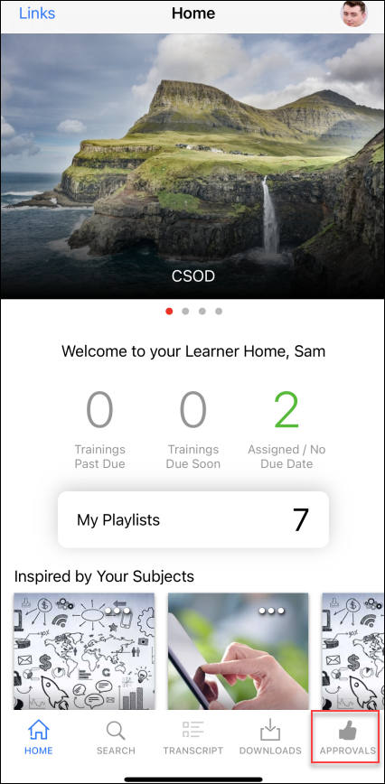
The Approval link appears in the navigation drawer on Android devices.
- Users will only see the Approval link if they have the relevant approval permissions
- If a user has pending approval requests, the Approval link in the navigation drawer displays with the corresponding number in parenthesis. If a user has more than 99 approvals, 99+ displays.
Permissions
PERMISSION NAME | PERMISSION DESCRIPTION | CATEGORY

Approve Training by Approver | Grants ability to approve training requests of those for whom the user is the designated approver. | Learning

Approve Training by Cost Center Approver | Grants ability to approve training requests of those for whom the user is the designated cost center approver. | Learning

Approve Training by Manager | Grants ability to approve training requests of those for whom the user is the designated manager.  Note: Delegating this permission only applies when "Manager" is designated in the Approval Workflow. If the Approval Workflow contains a custom employee relationship - even if the Manager happens to fill that role - the approval will not flow to the delegate. | Learning
Approvals
On the Approvals tab, a scrollable list of pending approval requests displays. Each approval request displays with the following information and options:
- User profile photo - The profile photo of the user who made the request, or the default profile photo image if the user has not configured a profile photo
- User full name - The user's first and last name
- Training thumbnail image - The thumbnail image associated with the requested training item. Note: If a thumbnail image does not exist in the Course Catalog for a training item, the image set via Default Training Image Preferences for the training type will be used as the thumbnail image for the training.
- Training title - The title of the requested training item
- Training type - The type of training that was requested (i.e. online course, material, curriculum, etc.)
- Price - The price of the training, if applicable
- Training Purpose - The training purpose associated with the requested training, if applicable
- Description - The first four lines of the training description display in plain text. If the description is longer, it will be truncated. Approvers can tap the description and be navigated to the Training Details page of the training, where they can read the full description.
- Requested Date - The date on which the user requested the training item
- Request Management Options - The following options are available for each approval request:
  - Approve - Tap the Approve option to approve the request. The user can then register for and take the training.
  - Deny - Tap the Deny option to deny the request. The user will not be able to register for or take the training.
  - Defer - Tap the Defer option to defer the request. If the approver defers the request, the next approver in the workflow will receive the approval request.
After tapping a request management option, a Comment field appears, allowing the approver to provide an optional comment explaining their decision, if needed. Comments display in the Approval History section on the Training Details page of the user's transcript.
Cornerstone CSX Android App - Usability Features
Android users can initiate Picture In Picture (PIP) when viewing video training items by tapping the Home button on their Android device. All Android device types support PIP functionality. All Cornerstone CSX App functionality is disabled while PIP is active. After exiting PIP mode, all app functionality is re-enabled.
Considerations
The following considerations apply to this feature:
- PIP is supported for Android version 7 and above
- The following file types are supported for Picture in Picture: .mpg, .mpeg, .wmv, .flv, .m4v, .mp4.
Exclusions
The following exclusions apply to this feature:
- Videos with a YouTube URL source are not supported
- Online courses are not supported; this feature is only enabled for video LOs.
Picture in Picture
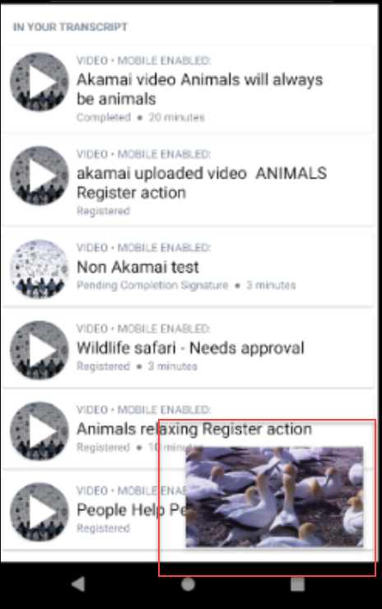

Cornerstone CSX App - Goals
With the My Goals module, users can manage their goals in the Cornerstone CSX mobile app. My Goals allows managers to create, edit, align, and update goals, tasks, and targets.
Users can also add and edit comments in the app with goals attachments.
My Goals App Screens
Images below display the goal screens in the My Goals module.
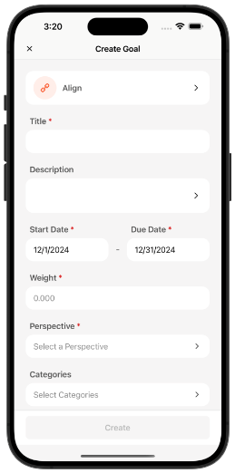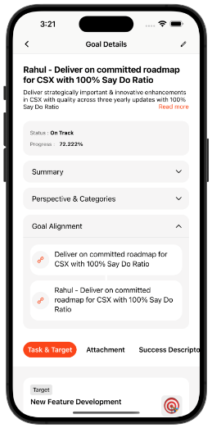
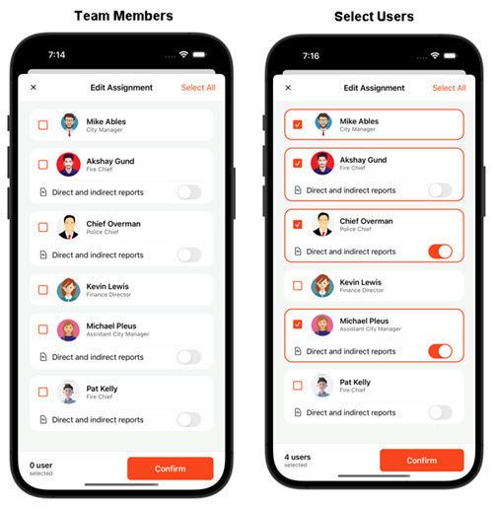
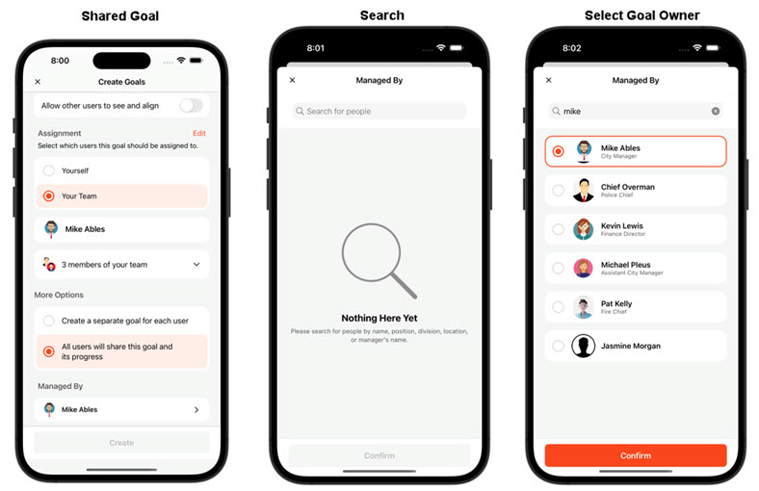

Cornerstone CSX App - More Menu
In the Cornerstone CSX app, a More menu is available in the navigation tray. This menu is a hub for accessing additional features and options within the app.
The More menu may contain the following options:
- User profile image
- Observation checklist - See Cornerstone CSX App - Observation Checklists on page 135 for additional information.
- Scan QR Code
- Settings
- Forget Me
- Log Out
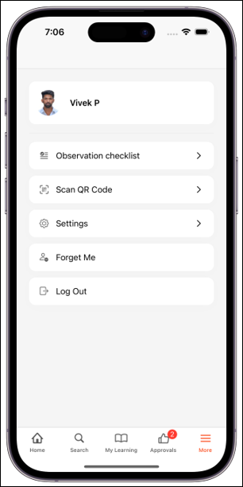

Cornerstone CSX App - Notification Center
Cornerstone introduces the Notification Center for the Cornerstone CSX App. By selecting the bell icon on a device's home screen, the Notification List screen opens to display all received and unattended notifications. Selecting any notification in the list opens its details.
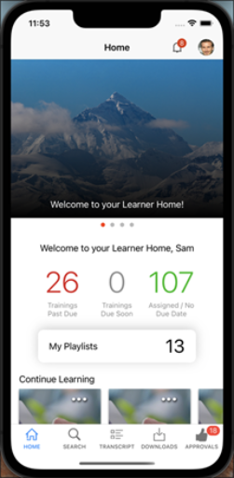
The Notification Center also provides the following:
- An unread notification count in the top bar
- A red dot that indicates unread notifications
- A "Mark all as read" option
- For each notification, an option to mark the specific message read or unread
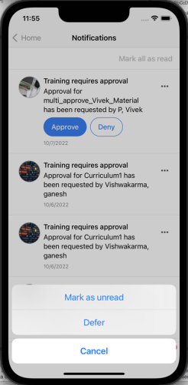

The learner can enable and disable the DND setting for push notifications in the Cornerstone CSX App settings.
Additionally, managers can use the Notification Center to:
- Approve, reject, and defer training
- Add approval comments
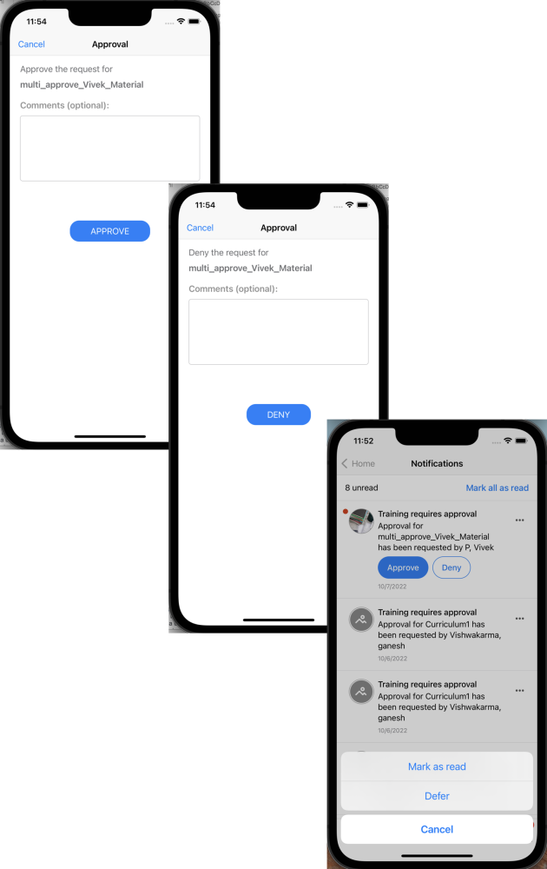
The Notification Center helps manage all push notifications and categories them according to type and event.
Considerations
- Push notification support is limited to the five currently supported notifications:
  - Training is Approved
  - Training is Assigned
  - Training is Denied
  - Training Has Due Date
  - Training is Requested
- If more than one user is logged into the app, notifications are not be received and the count is not updated.

Cornerstone CSX App - Observation Checklists
The Cornerstone CSX App includes an Observation Checklist feature, facilitating seamless assessments and accessing employees' skills and competencies, even in remote locations with limited or no internet connectivity. This functionality empowers organizations to ensure comprehensive evaluation and documentation regardless of the working environment.
Offline Mode Support
- User Checklist Management and Checklist Summary Modules - Users can access Observation Checklists offline, including checklist items, criteria, descriptions, and attachments. This comprehensive offline access ensures that users have all necessary information readily available, even without an internet connection.
- Checklist Updates - Validators can update checklists, add notes, and revise assessments even offline. This ensures that assessments remain dynamic and up-to-date, regardless of the user's connectivity status.
- Offline Mode for Observation Checklists - Observation checklists can be utilized offline, allowing users to conduct assessments regardless of internet availability. The app automatically synchronizes offline checklist data with the central server once the user reestablishes an internet connection, ensuring data consistency and integrity.
- Offline Mode Indicator - Visual indicators in the app inform users when they are operating offline. The app provides clear guidance on syncing data once back online, ensuring a seamless transition between offline and online modes.
Checklists Page
The Checklists page can be accessed by selecting the More menu and selecting Observation Checklists.
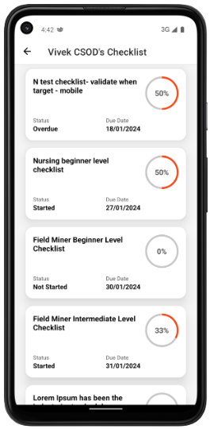
Checklist Details
When viewing the checklist details, observers can add observation notes from the Observation Notes tab or assess competencies from the Competencies tab.
