Login and Welcome Page March 2024

Table of Contents
Login and Welcome Page Overview 1
Login Message Preferences 2
Create Login Message 5
Login Page - CAPTCHA 17
Multi-factor Authentication Overview 19
Multi-factor Authentication Administration - Overview 20
Multi-factor Authentication 27
Login Process - Register a New Device 28
Register an MFA Device with a QR Code 29
Register an MFA Device with a Secret Unique Key 31
Login Process - Log in Using Multi-factor Authentication 33
My Account - Register New Device 34
Replace a Multi-factor Authentication Device 36
Welcome Page Preferences 37
Welcome Page Preferences - Traditional 39
Welcome Page Preferences - Custom Page Builder 42
Welcome Page Availability Not By Division 45
Welcome Page Overview 47
Welcome Page Header Overview 61
Manage To-Do's 64
View To-Do's 65
Create To-Do's 66
Modify To-Do's 67
Scheduled Tasks 68
Using Order Forms 71
Waitlist and Interest Tracking 73

Login and Welcome Page Overview

Login Message Preferences
Login Message preferences enable administrators to create messages that appear to users on the Welcome page when they log in to the system. A login message could be a notification that the portal is undergoing maintenance or that certain company-wide training is due that day. Messages could also be used to communicate important company information.
Administrators can configure messages to appear each time a user logs in or only once at login. Further, you can add a series of actions to a message that direct users to another website, send them an email, or even log them out of the system.
The Login Message works with the most commonly used landing pages:
- Welcome Page
- Custom Pages
- Learner Home
- Other pages that contain “/ui/” in the URL
- Other pages that contain “/phnx/driver.aspx?” in the URL
To access Login Message preferences, go to Admin > Tools > Core Functions > Core Preferences > Login Message.
Permissions
PERMISSION NAME | PERMISSION DESCRIPTION | CATEGORY

Log In Message - Manage | Grants access to create a message that appears upon portal login to all users or a selected group/subset of users. This is an administrator permission. This permission can be constrained by OU and User's OU. | Core Administration
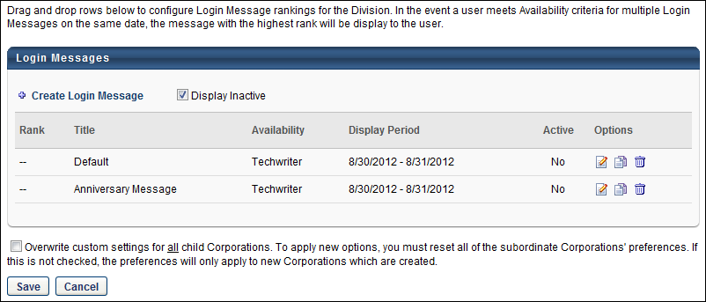
Create Login Message
Select the Create Login Message link to create a new login message. This takes you to the General step of creating a login message. See Create Login Message - General on page 6 for additional information.
Display Inactive
All active login messages are displayed in the table by default. To include inactive login messages in the table, select the Display Inactive option.
Login Messages Table
The following information displays for login messages:
- Rank - This column displays the message's rank. This column also determines the order in which messages appear for users who meet the availability criteria for more than one message during overlapping display periods.
You can change a message's rank by dragging and dropping the message to the desired position. Note: New messages always appear at the bottom of the list and must be manually reordered to change the rank.
- Title - This column displays the message title.
- Availability - This column displays the OU for which the message is configured to display. If multiple OUs are configured for the message, then each OU appears on its own line.
- Display Period - This column displays the dates during which the message is configured to display.
- Mobile Only - When this option is selected for a login message, the message only displays in the Cornerstone Learn app. It does not display when logging in via web browser. Similarly, if this option is not selected for a login message, the message only displays when logging in via web browser. It is not displayed when logging in to Cornerstone Learn. A mobile-only login message only displays to a user if the user is using the latest version of the Cornerstone Learn app.
  - For any login messages that existed prior to the October 2019 release, this checkbox is disabled and cannot be selected. In order to create a mobile-only login message, administrators must copy an existing message or create a new one.
- Active - This column displays the active status of the message. The column displays "Yes" for active messages and "No" for inactive messages. Note: The active status is managed on the General step of the Define Login Message page.
Options
The following options are available in the Options column:
- Edit - Click the Edit icon to edit the message, including the active status of the message.
- Copy - Click the Copy icon to copy the message. All areas of the message are copied. Copied messages are active by default.
- Delete - Click the Trash Can icon to delete the message.
Overwrite Settings
Select this option to overwrite custom settings for child division OUs. If you overwrite custom settings for child division OUs, the selected settings are applied to both new and existing child OUs. Any previously customized child OUs are updated with the selected settings.
- If there are no customizations to the child OU, then the parent OU customizations are applied to all child OUs.
- Overwrite custom settings checkbox setting
  - If this option is selected, all child OU customizations are deleted from the database, which means the parent OU customizations will be applied to new and existing child OUs.
  - If this option is unselected, all existing child OU customizations will remain unchanged, and any new child OUs will inherit the parent OU customizations by default.
- If a child OU has been customized to display any widgets, then regardless of the parent OU customizations, the child OU customizations are applied.
- If a child OU has been customized to hide all widgets, then parent OU customizations will take precedence and will be applied.
Save/Cancel
Once all preference settings are completed on the Login Messages Administration page, click Save. Changes made to this page are not committed until you click Save. Click Cancel to cancel the changes made to the Login Messages Administration page. Clicking either button takes you to the select OU page of Login Message preferences.

Create Login Message
The Login Message works with the most commonly used landing pages:
- Welcome Page
- Custom Pages
- Learner Home
- Other pages that contain “/ui/” in the URL
- Other pages that contain “/phnx/driver.aspx?” in the URL
To create a login message, go to Admin > Tools > Core Functions > Core Preferences > Login Message. On the Login Message Administration page, select the Create Login Message link.
Permissions
PERMISSION NAME | PERMISSION DESCRIPTION | CATEGORY

Log In Message - Manage | Grants access to create a message that appears upon portal login to all users or a selected group/subset of users. This is an administrator permission. This permission can be constrained by OU and User's OU. | Core Administration
The process for creating login messages consists of following steps:
- General
- Message
- Actions
- Summary
Each new login message appears on the Login Message Administration page at the bottom of the ranking. Messages only appear for administrators who have the appropriate permissions and are in the Division in which the message is created.
Important Note: As a best practice, use the Back and Next buttons within the login message steps when creating, copying, or editing a message. Text entered on the Message step may be deleted if you use the left navigation panel to navigate through the steps.
Create Login Message - General
The General step is used to set the display options and is divided into the following sections:
- General
- Display
- Availability
The Login Message works with the most commonly used landing pages:
- Welcome Page
- Custom Pages
- Learner Home
- Other pages that contain “/ui/” in the URL
- Other pages that contain “/phnx/driver.aspx?” in the URL
To create a login message, go to Admin > Tools > Core Functions > Core Preferences > Login Message. On the Login Message Administration page, click the Create Login Message link.
Permissions
PERMISSION NAME | PERMISSION DESCRIPTION | CATEGORY

Log In Message - Manage | Grants access to create a message that appears upon portal login to all users or a selected group/subset of users. This is an administrator permission. This permission can be constrained by OU and User's OU. | Core Administration
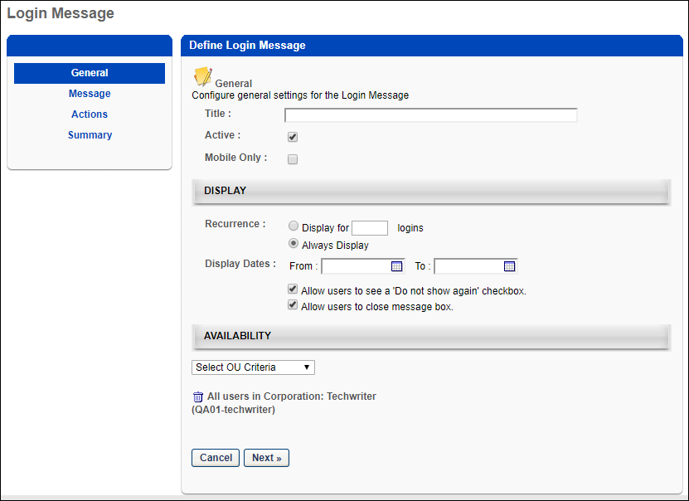
General
Complete the following information in the General section:
- Title - Enter a title for the message, up to 100 characters. This is a required field. The title appears in the Title column on the Login Message Administration page. The title does not display to end users and is not part of the login message that appears when users log in to the portal. As the title is entered in the field, the text of the title displays in the header row above the Define Login Message panel.
- Active - Select or deselect the Active checkbox to activate or inactivate the message. New login messages are active by default.
- Mobile Only - When this option is selected for a login message, the message only displays in the Cornerstone Learn app. It does not display when logging in via web browser. Similarly, if this option is not selected for a login message, the message only displays when logging in via web browser. It is not displayed when logging in to Cornerstone Learn. A mobile-only login message only displays to a user if the user is using the latest version of the Cornerstone Learn app.
  - For any login messages that existed prior to the October 2019 release, this checkbox is disabled and cannot be selected. In order to create a mobile-only login message, administrators must copy an existing message or create a new one.
  - A mobile-only login message only displays to a user if the user is using the latest version of the Cornerstone Learn app.
Display
Complete the following information in the Display panel:
- Recurrence - This option determines the number of instances the message displays.
  - Display for [numeric text box] logins - Select this option to set the message to appear for a certain number of logins. Enter a numeric value between one and 999 in the numeric text box. Entering a value is required if this option is selected.
  - Always Display - This option displays the message each time a user logs in. Note: If this option is selected and the Do not show again box is available to users when viewing the message, the message no longer appears if the user checks the box.
- Display Dates - Select a time frame during which to display the message by choosing a date in the From and To field. You can also use the calendar feature to select the dates. The From date can be set to today's date, but a best practice is to set the From date to be greater than today's date. The To date must be greater than the From date. This means that a message cannot display for only today's date. You must enter a date in both fields. Note: The selected dates are implemented in Coordinated Universal Time (UTC). For example, if the message is set to display until October 11, then the message displays until 23:59:59 UTC on October 11.
- Allow users to see a 'Do not show again' checkbox - Select this option to allow employees to disable the message from reappearing at login. This option is selected by default. Note: If this option is selected and the user checks the Do not show again box when viewing the login message, then the login message does not display again, regardless of the recurrence setting.
- Allow users to close the message box - This option allows users to close the message by clicking "Close" in the upper-right corner of the login message box. This option is selected by default. If this option is deselected, you are required to create a button on the Action step that provides users with the ability to close the message box.
Availability
The Availability panel determines to whom in the organization the message is visible. If you select any one of the organizational units listed in the drop-down list, the message appears to employees in the selected OU. By default, "All Users" is selected. You can delete the default setting by clicking the Trash Can icon to the right of the setting. However, at least one availability criteria is required.
From the drop-down, select an OU. Then, click the Search icon to the right of the drop-down. This opens the Select OU pop-up. Select an OU from the list, which closes the pop-up and adds the OU.
Next
Click Next to go to the Message step. See Create Login Message - Message on page 9 for additional information.
Create Login Message - Message
On the Message step, define the message content that displays to users. You can configure a separate message for each available language in the portal.
The Login Message works with the most commonly used landing pages:
- Welcome Page
- Custom Pages
- Learner Home
- Other pages that contain “/ui/” in the URL
- Other pages that contain “/phnx/driver.aspx?” in the URL
To create a login message, go to Admin > Tools > Core Functions > Core Preferences > Login Message. On the Login Message Administration page, click the Create Login Message link.
Permissions
PERMISSION NAME | PERMISSION DESCRIPTION | CATEGORY

Log In Message - Manage | Grants access to create a message that appears upon portal login to all users or a selected group/subset of users. This is an administrator permission. This permission can be constrained by OU and User's OU. | Core Administration
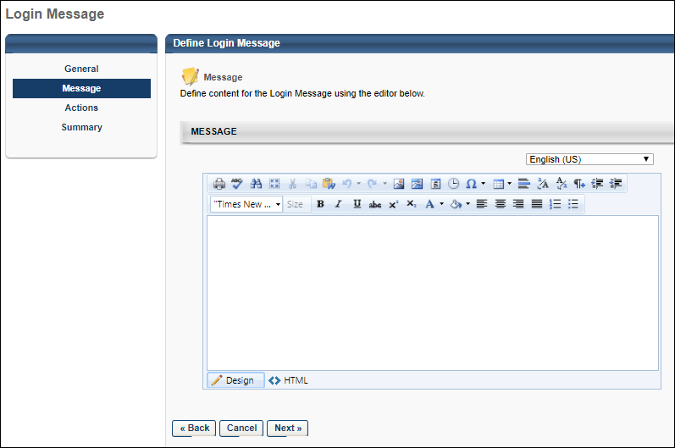
Message Language
If multiple languages are enabled, you may have the option to specify the login message in multiple languages.
To specify the login message in another language, select the language from the Language drop-down.
While creating the message in one language, you can select a different language to begin creating a message in another language. The message text is preserved in the corresponding language when switching back and forth between different languages. However, if you navigate away from the Message step by using the left navigation panel, the message text may be lost upon returning to the Message step.
Message
                - In the Message box, enter the message. The Telerik Editor options are available, enabling you to configure fonts, colors, tables, images, and more. Design and HTML views are also available. Design view is selected by default.
Note: The ability to add script and iframe tags is based on backend settings. If the settings are turned off, a message appears below the language drop-down indicating that script tags are disabled and to contact your system administrator to enable these features. To enable these settings for your portal, contact Global Customer Support.
Next/Back
Click Next to go to the Actions step. See Create Login Message - Actions on page 12 for additional information.
Click Back to go to the General step. See Create Login Message - General on page 6 for additional information.
Create Login Message - Actions
The Actions step is used to define the action buttons that are available to users in the login message box.
The Login Message works with the most commonly used landing pages:
- Welcome Page
- Custom Pages
- Learner Home
- Other pages that contain “/ui/” in the URL
- Other pages that contain “/phnx/driver.aspx?” in the URL
To create a login message, go to Admin > Tools > Core Functions > Core Preferences > Login Message. On the Login Message Administration page, click the Create Login Message link.
Permissions
PERMISSION NAME | PERMISSION DESCRIPTION | CATEGORY

Log In Message - Manage | Grants access to create a message that appears upon portal login to all users or a selected group/subset of users. This is an administrator permission. This permission can be constrained by OU and User's OU. | Core Administration
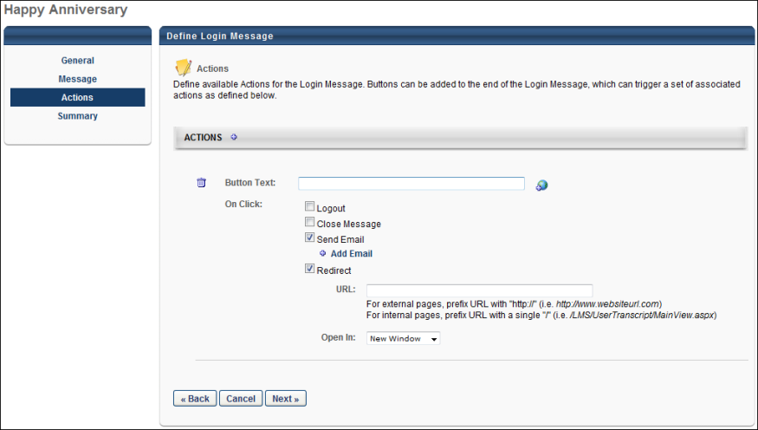
Actions
To add action buttons, click the plus icon in the Actions panel header. This opens the options for defining buttons and on-click actions. Up to six buttons can be added. Note: By default, each time an action is added, the Button Text field is blank and all on-click options are deselected.
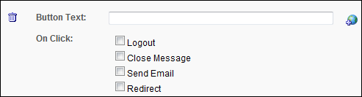
- Button Text - Enter the text that will appear on the button. This is a required field for each action button. For portals with multiple languages, click the Translate icon to enter localized text.
- On Click - This option defines the on-click actions that are available to users. At least one on-click action must be defined for each action button. The following on-click actions are available:
  - Logout - Select this option to log the user out of the portal when they click the action button.When this option is selected, the Close Message option is checked and disabled by default because the message automatically closes as a result of the logout action. This action does not count as a valid login towards the Recurrence configuration.
    - The User Last Access field in custom reports displays the last login for the user. This field is updated at the time the user logs in, regardless of what is selected on the login message.
  - Close Message - Select this option to close the message when the action button is clicked. Note: Selecting this option is required if the Allow users to close the message box option is not selected on the General step.
    - If the Close Message icon is included in the login message and the user selects it, the message box closes and the login will count towards the recurrence count.
  - Send Email - This option sends an email to the user when the action button is clicked. Selecting Send Email enables the Add Email link to appear below the option. Clicking the link opens a pop-up from which to select the email.
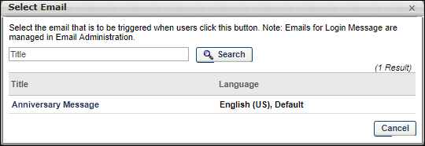
You can filter emails by title using the Title search option, and then clicking Search. To select an email, click the title in the Title column. This closes the pop-up and adds the email below the Send Email field. You can delete emails that you selected by clicking the Trash Can icon to the left of the email title.
Note: Emails for login messages are configured in Email Administration. See Email Triggers for information on the Login Message Email trigger. See Email Tags for information on the tags that are available for the Login Message email.
  - Redirect - Select this option to redirect users to a specified URL. Selecting Redirect enables the URL and Open In fields to appear below the option.
    - URL - Enter the URL to which you would like users to be redirected. This is a required field if Redirect is selected.
    - Open In - This option defines whether or not users are redirected in a new window or in the same window. The "New Window" option in the drop-down is selected by default.
You can delete an action by clicking the Trash Can icon to the left of the Button Text field.
The action buttons appear in the login message box in the order in which they are added. The order cannot be redefined.
Next/Back
Click Next to go to the Summary step. See Create Login Message - Summary on page 15 for additional information.
Click Back to go to the Message step. See Create Login Message - Message on page 9 for additional information.
Create Login Message - Summary
On the Summary step, review your selections. A preview of the message appears in the Message field. The Actions field displays the action buttons and on-click actions that are defined for the message.
The Login Message works with the most commonly used landing pages:
- Welcome Page
- Custom Pages
- Learner Home
- Other pages that contain “/ui/” in the URL
- Other pages that contain “/phnx/driver.aspx?” in the URL
To create a login message, go to Admin > Tools > Core Functions > Core Preferences > Login Message. On the Login Message Administration page, click the Create Login Message link.
Permissions
PERMISSION NAME | PERMISSION DESCRIPTION | CATEGORY

Log In Message - Manage | Grants access to create a message that appears upon portal login to all users or a selected group/subset of users. This is an administrator permission. This permission can be constrained by OU and User's OU. | Core Administration
Click Save to save the message and return to the Login Message Administration page. See Login Message Preferences on page 2 for additional information.
Click Back to go to the Actions step. See Create Login Message - Actions on page 12 for additional information.
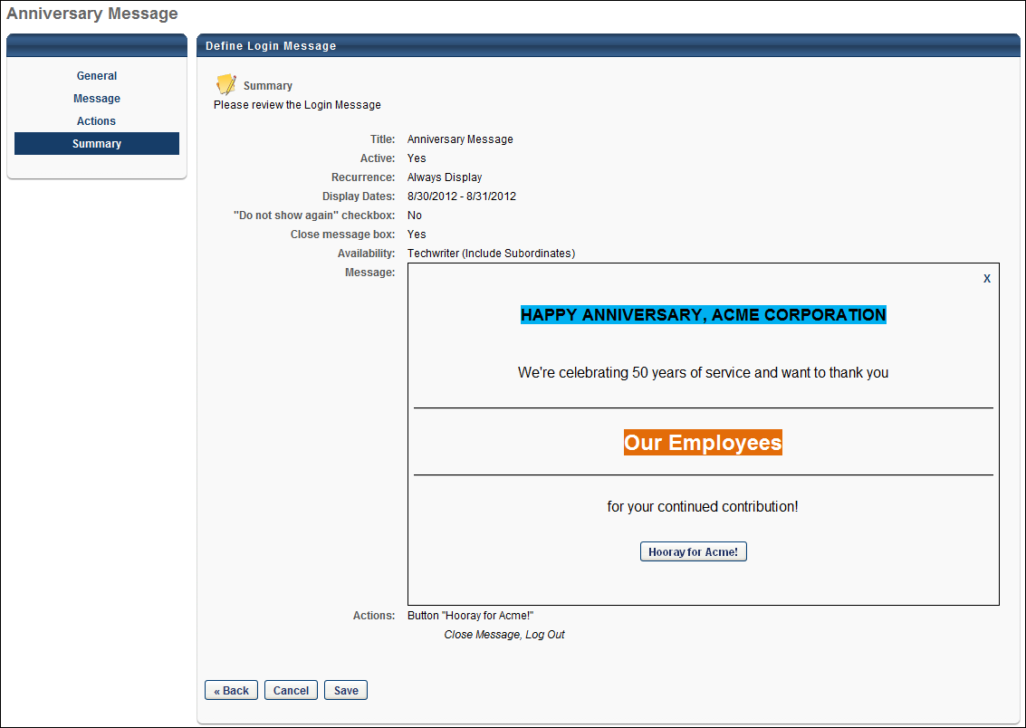

Login Page - CAPTCHA
To prevent a program or user from identifying valid email addresses, CAPTCHA is available. When CAPTCHA is enabled, you must complete the CAPTCHA field when completing the self-registration page or when retrieving a forgotten username or password.
The availability of this functionality is controlled by a security setting which can be managed in the Security Health Check tool.
Forgot Password
If CAPTCHA is enabled for your portal and you click the Forgot Password? link on your login page, the Forgot Password page appears with the CAPTCHA functionality.
In order to retrieve a password for the corresponding User ID, the you must enter a valid User ID. You must also enter in the CAPTCHA field the two words that appear above the field. If either the User ID or CAPTCHA words are not valid, one or more error messages are displayed.
If both the User ID field and the CAPTCHA field are entered properly, a confirmation message is displayed.
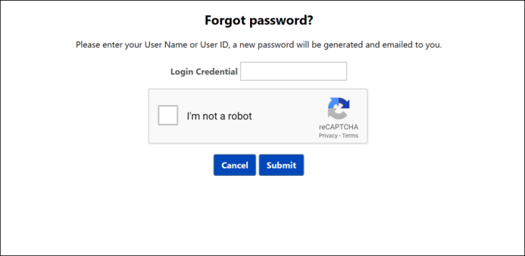
Forgot Username
If CAPTCHA is enabled for your portal and you click the Forgot Username? link on your login page, the Forgot Username pop-up appears with the CAPTCHA functionality.
In order to retrieve a username for the corresponding email address, you must enter a valid email address. You must also enter in the CAPTCHA field the two words that appear above the field. If either the email address or CAPTCHA words are not valid, one or more error messages are displayed.
If both the Email field and the CAPTCHA field are entered properly, a confirmation message is displayed.
Self-Registration
If CAPTCHA is enabled for a portal, a CAPTCHA widget appears at the bottom of the Self-Registration page. The exact location of the widget is dependent upon the other options that are available on the page.
When CAPTCHA is enabled, users must enter in the CAPTCHA field the two words that appear above the field.
When the Next or Submit button is clicked, the system first validates that all required fields have been entered. The system then validates the CAPTCHA values. Finally, the system validates that the user does not already exist in the system and that the password follows the password creation guidelines.
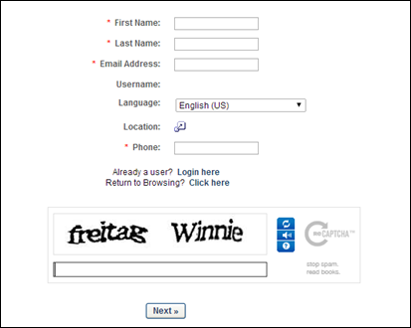

Multi-factor Authentication Overview
Multi-factor authentication (MFA) is a security mechanism to build stronger authentication into the Cornerstone CSX standard login process.
MFA enhances the security of user accounts by requiring the user to provide two different forms of authentication before they can access their account.
Prerequisites
Users who are required to log in with MFA must use a mobile device, such as a smartphone, with a virtual authenticator app that supports the time-based one-time password (TOTP) algorithm.
Some popular authenticator apps include Google Authenticator, Microsoft Authenticator, Okta Verify, and many others available in app stores.
Register New Device
Users who are required to log in with MFA must register a device.

Multi-factor Authentication Administration - Overview
MFA (Multi-factor Authentication) Configuration
Administrators can configure how multi-factor authentication is configured within their organization.
Multi-factor authentication (MFA) is a method in which users must verify their identity in multiple ways to log in to the system, such as user name, password, and authentication code.
To access MFA Configuration, go to Admin > Tools > Core Functions > Multi-factor Authentication.
Permissions
PERMISSION NAME | PERMISSION DESCRIPTION | CATEGORY

MFA Authentication Preferences - Manage | Grants the ability to view and configure Multi-factor Authentication (MFA) preferences. This permission cannot be constrained. This is an administrator permission. | Core Administration

MFA Authentication Preferences - View | Grants the ability to view the Multi-factor Authentication (MFA) preferences. This permission cannot be constrained. This is an administrator permission. | Core Administration
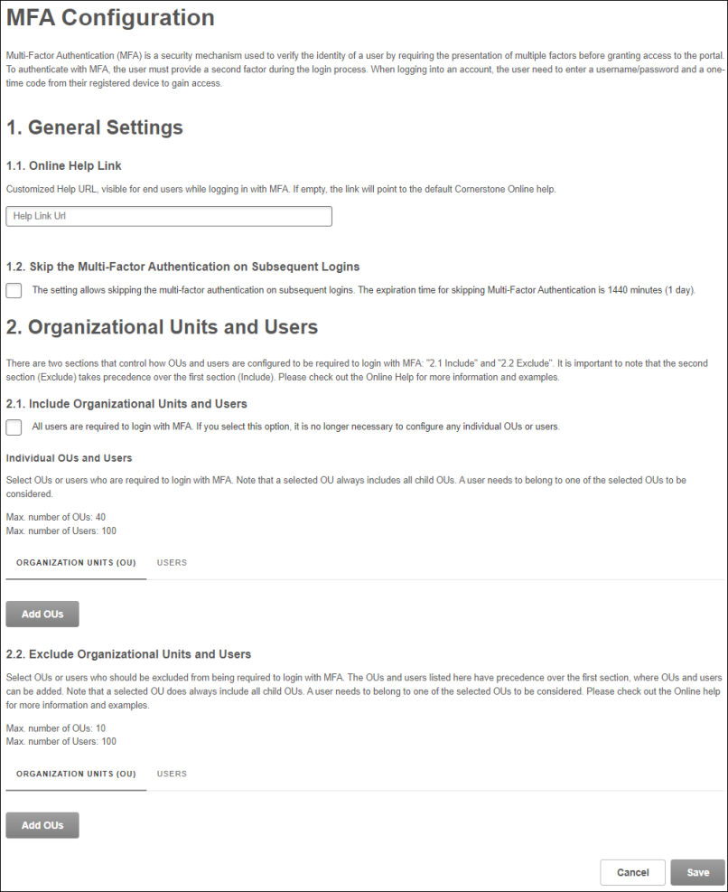
General Settings - Online Help Link
When users log in, and MFA is enabled, a Help link is available on the page. By default, this link opens Cornerstone's Online Help for this functionality. However, organizations may prefer to create a customized support page with specific, company-related help and instructions for users in their organization.
If your organization has created a customized support page to help users log in with multi-factor authentication, enter the URL for that page in this field.
General Settings - Skip the Multi-Factor Authentication on Subsequent Logins
The setting allows users to skip the multi-factor authentication on subsequent logins. The expiration time for this setting is 24 hours by default.
If this setting is enabled, users will see the Multi-Factor Authentication screen only for the first login attempt. After successfully logging in, the Multi-Factor Authentication screen will be bypassed for one day.
Include and Exclude Organizational Units and Users
Two sections control which organizational units (OUs) and users must log in with MFA: the Include Organizational Units and Users and Exclude Organizational Units and Users sections. The Exclude Organizational Units and Users section takes precedence, meaning that if a user is included in both sections, they are not required to log in with MFA.
Administrators may select the All users are required to login with MFA option. When this option is selected, administrators may still add users or OUs to the Exclude section since the Exclude section takes precedence.
Otherwise, administrators can select the Organization Units (OU) and Users tabs in each section to choose which OUs and users must log in with MFA. All child OUs are included by default when an OU is selected.
To avoid latency when logging in to the system, the maximum number of configurable OUs and users is limited:
- Maximum number of Organizational Units (OUs) to Include - 40
- Maximum number of Organizational Units (OUs) to Exclude - 10
- Maximum number of individual users to Include - 100
- Maximum number of individual users to Exclude - 100
Important: When adding new OUs in the MFA Configuration page, all previously selected OUs needs to be re-selected, otherwise they will be removed from the list. This will be improved with the July release.
Disable MFA for a User Account
Administrators with appropriate permissions can disable Multi-factor Authentication (MFA) for a specific User record. This can be helpful to allow a user to log in for a short time without MFA and re-register their device.
To disable MFA for a specific user, an administrator can open the MFA Configuration and add the user to the list of users in the Exclude Organizational Units and Users section.
To access MFA Configuration, go to Admin > Tools > Core Functions > Multi-factor Authentication.
Permissions
PERMISSION NAME | PERMISSION DESCRIPTION | CATEGORY

MFA Authentication Preferences - Manage | Grants the ability to view and configure Multi-factor Authentication (MFA) preferences. This permission cannot be constrained. This is an administrator permission. | Core Administration
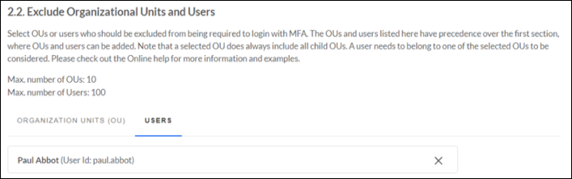
Login Report - MFA Login Method
The Login Report enables organizations to report which users have logged in to the portal using multi-factor authentication (MFA) and when. Organizations may need to provide this information to auditors.
Select MFA as a Login Method filter to process the report.
To access the Login Report, go to Reports > Standard Reports. From the System tab, select the Login Report link.
Permissions
PERMISSION NAME | PERMISSION DESCRIPTION | CATEGORY

Login Report | Grants access to the Login Report, which enables organizations to report which users have logged in to the portal and when. This permission cannot be constrained. | Reports - System
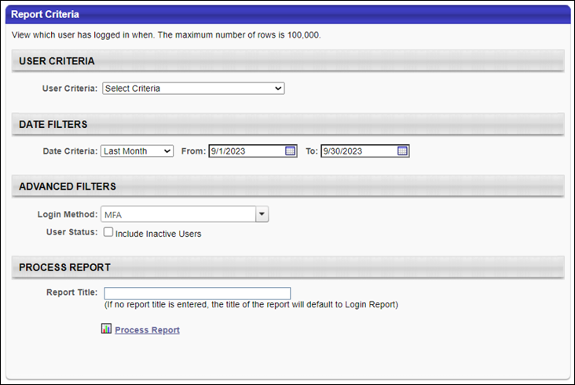
User Record - Remove MFA Device
Administrators with appropriate permissions can remove an existing mobile device from a User record.
This may be necessary if a user cannot log in anymore because the existing registered mobile device is broken or unavailable. After the administrator removes the mobile device, the user can register a new one as part of the initial login process.
To access the User Records Administration page, go to Admin > Tools > Core Functions > Users.
To view or remove a user's registered Multi-factor Authentication device, select the Options drop-down and select the MFA option for the user.
Permissions
PERMISSION NAME | PERMISSION DESCRIPTION | CATEGORY

MFA - Admin - User Device - Manage | Grants the ability to manage the user device information for Multi-factor Authentication. This permission works with the MFA - Admin - User Device - View permission. Administrators can delete devices for user records within their constraints. This permission can be constrained by OU, User's OU, User's Self, User Self and Subordinates, and User. This is an administrator permission. | Core Administration

MFA - Admin - User Device - View | Grants the ability to view the user device information for Multi-factor Authentication. Administrators can view the page for user records within their Users - View permission constraints, and additional constraints can be added to this permission. This permission can be constrained by OU, User's OU, User's Self, User Self and Subordinates, and User. This is an administrator permission. | Core Administration
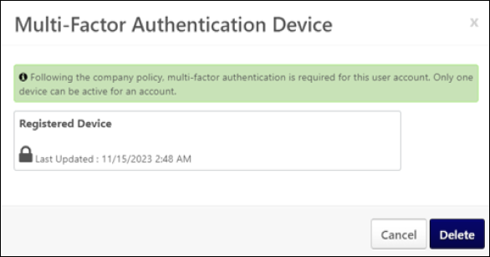

Multi-factor Authentication

To log in using multi-factor authentication, you must first register your device.

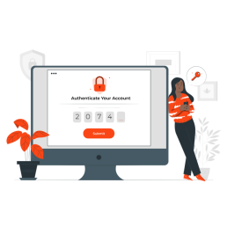 | 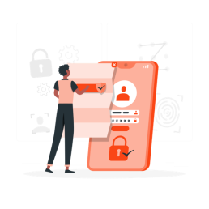 | 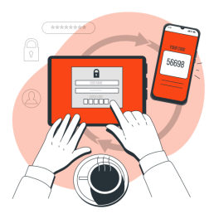
What is Multi-factor Authentication? | How to register a new device? | How to login with MFA?

Login Process - Register a New Device
The option to register a new Multi-factor Authentication (MFA) device as part of the login process is available and mandatory for all users who are required to log in with MFA but who have not yet registered a device.
If the following conditions are met, an MFA device must be registered as part of the first-time login process:
- MFA has been activated for a user by the CSX administrator in the portal's Multi-factor Authentication Configuration. See MFA (Multi-factor Authentication) Configuration on page 21 for additional information.
- The user still needs to register an MFA device.
Users can register a device in two ways:
- QR Code - See Register an MFA Device with a QR Code on page 29 for additional information.
- Secret Unique Key - See Register an MFA Device with a Secret Unique Key on page 31 for additional information.

Register an MFA Device with a QR Code
Using the QR code is the most convenient way to register a device for multi-factor authentication (MFA).
Steps to register a device with a QR Code
- On your smartphone, open the virtual authenticator app.
- In the app, select the option to add an account or scan a QR code.
- Use your smartphone's camera to scan the QR code on your computer screen. The app will automatically recognize the code and add the account.
- After adding the account to your virtual authenticator app, the app will generate a one-time code. Enter this code into the Cornerstone MFA page to verify the setup and confirm that the virtual authenticator app is correctly set up.
- Once verified, your MFA device is active. Now, each time you log in to your account, you must open your virtual authenticator app to generate a temporary code to complete the login process. See Login Process - Log in Using Multi-factor Authentication on page 33 for additional information.
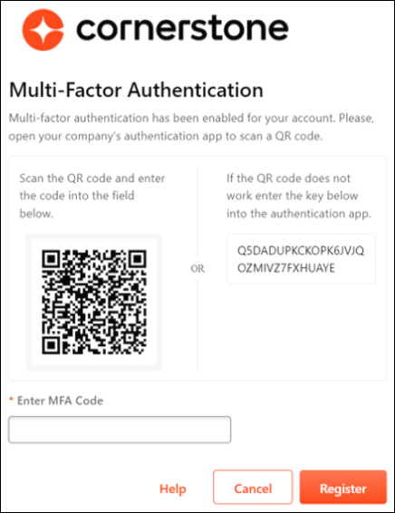

Register an MFA Device with a Secret Unique Key
Users can use a secret unique key to register their device for multi-factor authentication (MFA).
Steps to register a device with a secret unique key
- On your smartphone, open the virtual authenticator app.
- In the app, select the "Add Account" or "Manual Entry" option. This may vary depending on the app.
- Enter a name or label for the account.
- Enter the secret key from the Cornerstone MFA page. This will be a random sequence of characters and numbers, such as Q5DADUPKCKOPK6JVJQOZMIVZ7FXHUAYE.
- The app will recognize the secret code and add the account.
- After adding the account to your virtual authenticator app, the app will generate a one-time code. Enter this code into the Cornerstone MFA page to verify the setup and confirm that the virtual authenticator app is correctly set up.
- Once verified, your MFA device is active. Now, each time you log in to your account, you must open your virtual authenticator app to generate a temporary code to complete the login process. See Login Process - Log in Using Multi-factor Authentication on page 33 for additional information.
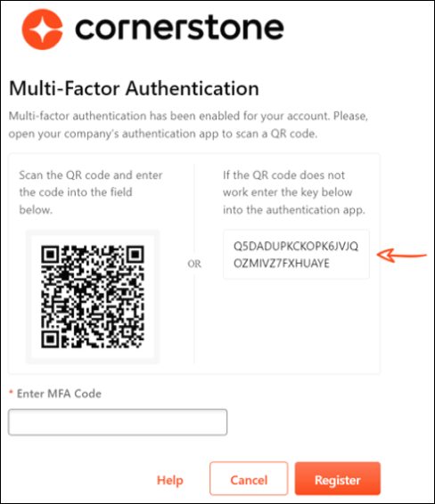

Login Process - Log in Using Multi-factor Authentication
After the user's username and password are successfully verified, they must enter the random and temporary 6-digit number from the virtual authenticator app on their registered device to log in to the Cornerstone portal.
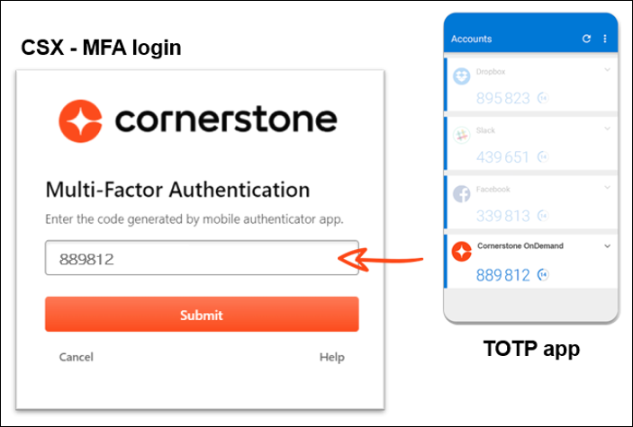

My Account - Register New Device
In My Account, users can register a new device or delete or replace an existing device. In a Multi-factor Authentication (MFA)-enabled portal, any user can register an MFA device, even if the user is not yet required to log in with MFA.
To access My Account:
- Select the Settings icon in the screen's upper-right corner and select the My Account link.
- Select the Navigation icon in the screen's upper-right corner and select the My Account link.
Select the MFA tab on the left. Select the Add Device button to register a device.
Note: The MFA tab only displays when the system administrator enables MFA.
Users can register a device in two ways:
- QR Code - See Register an MFA Device with a QR Code on page 29 for additional information.
- Secret Unique Key - See Register an MFA Device with a Secret Unique Key on page 31 for additional information.
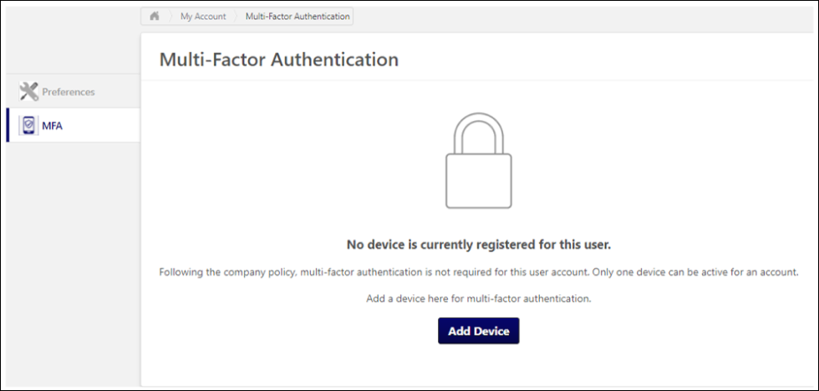
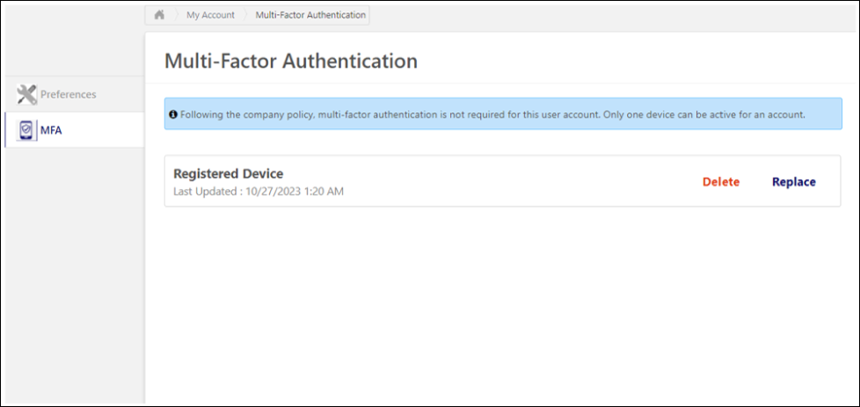

Replace a Multi-factor Authentication Device
A Multi-factor Authentication (MFA) device can be replaced in two ways, depending on whether the previous mobile device is still available and working:
- The mobile device is still available and working - The user logs in with MFA and replaces the device in My Account. See My Account - Register New Device on page 34 for additional information.
- The mobile device is not available or not functional - The user contacts the CSX administrator outside the CSX system, such as via email or an internal ticketing system, to remove the existing mobile device from the user account. After the administrator has removed the device, the user can register a new mobile device as part of the login process.
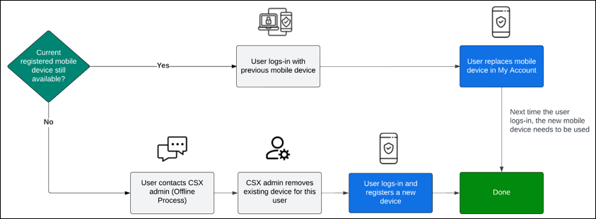

Welcome Page Preferences
Welcome Page Preferences define the appearance of the Home page, including the actual components and display arrangement for all elements. The Welcome Page can contain a variety of widgets, which can be customized to suit your organization's needs, including My Action Items, My Inbox, images, etc. By customizing your Welcome Page preferences, you determine which components to display and how they appear. Welcome Page Preferences are important because they define the end user's first view of the system. By placing recognizable images, engaging greetings, and only relevant information on the Welcome page, you enhance end-users familiarity and comfort with the system.
The Welcome page can be configured to display certain widgets, images, messages, and other information. Essentially, the administrator can fully customize the Welcome page.
The Welcome Page Preferences can be set in two different manners, which is determined by a backend setting:
- Custom Page Builder - This method enables administrators to use the Custom Page Builder to set the Welcome Page Preferences. The Custom Page Builder enables administrators to fully customize the Welcome Page, including a fully customizable layout and additional widgets. See Welcome Page Preferences - Custom Page Builder on page 42 for additional information.
- Traditional - This method is the traditional method that enables administrators to manually edit each message box, image, and widget. See Welcome Page Preferences - Traditional on page 39 for additional information.
Permissions
PERMISSION NAME | PERMISSION DESCRIPTION | CATEGORY

Import Assets | Grants ability to Import Assets, which enables uploading updating of image, video and audio files for use in online courses. Can view and update assets imported by others if those assets are designated as editable by anyone. Also requires assignment of LCMS license. This is an administrator permission. | Learning - Administration

Welcome Page Preferences - Manage | Grants ability to configure the look and feel of the Welcome Page that users see upon logging in to the portal. This permission can be constrained by OU and User's OU. This is an administrator permission. | Core Administration
Note: Animation files (.swf) can be used on the Welcome page by adding the animation using the Asset Importer if you have access to the LCMS module. Once the asset is imported, click View icon to see the file path to include in your html.
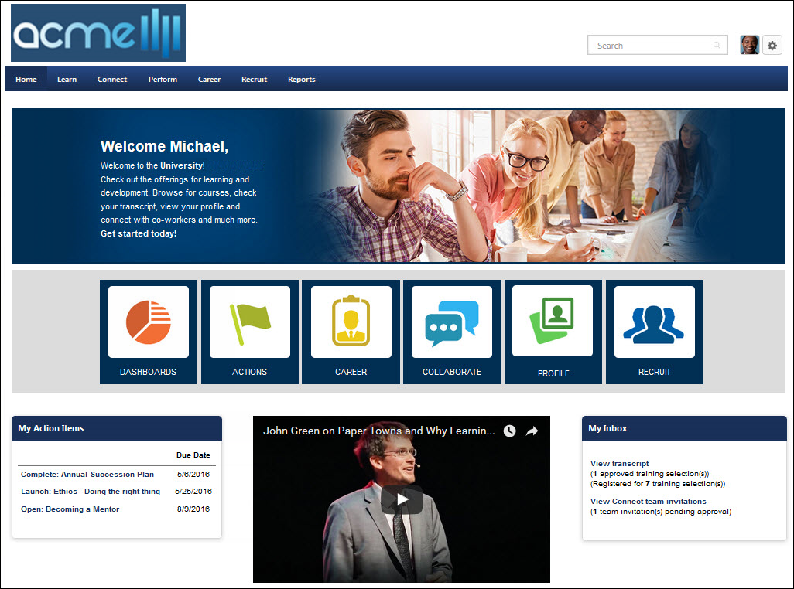

Welcome Page Preferences - Traditional
The Welcome Page Preferences can be set in two different manners, which is controlled by a backend setting. To set the Welcome Page Preferences using the Custom Page Builder, See Welcome Page Preferences - Custom Page Builder on page 42 for additional information.
To set Welcome Page Preferences using the traditional method, go to Admin > Tools > Core Functions > Core Preferences > Welcome Page.
Permissions
PERMISSION NAME | PERMISSION DESCRIPTION | CATEGORY

Task - View | Grants ability to view assigned tasks via Scheduled Tasks screen and Welcome Page My Tasks widget. This is an end user permission. | Core

View My Interests and Waitlists | Grants access for users to view ILT interest lists and waitlists to which they've been added, and to take action when a matching ILT session is offered. This is an end user permission. | Learning

Welcome Page Preferences - Manage | Grants ability to configure the look and feel of the Welcome Page that users see upon logging in to the portal. This permission can be constrained by OU and User's OU. This is an administrator permission. | Core Administration
- Welcome pages can be customized at a divisional level. In addition, welcome pages can be customized by position, location, cost center, etc. To set welcome pages at divisional level, proceed to the next step. To set welcome pages for an OU other than division, See Welcome Page Availability Not By Division on page 45 for additional information.
- Find and click the applicable division from the hierarchy.
- Set the preferences in the following sections. Each section is described below:
  - Welcome Greeting
  - Welcome Page Footer
  - Welcome Page Preferences
    - Formatted Message Box
    - Message Box 1-9
    - Welcome Image
    - Welcome Page Sections
- At the bottom of the page, arrange the Welcome Page sections selected across the three Welcome Page columns by using the arrows .
- Check the Overwrite custom settings for all child divisions option if applicable. This option is described below.
- Click Submit.
Welcome Greeting
- Click the Edit icon to change welcome page greeting located at top of welcome page. The default Welcome Greeting is "Welcome, {FIRSTNAME}, to your personalized corporate training center." Tags can be used within welcome greeting. Click the Save icon to save welcome greeting message. To apply changes to the portal click Submit button or continue to make additional changes to welcome page before applying.
- Click the Include checkbox next to Welcome Greeting to make it appear on your Welcome Page
- Click the Translate icon to enter translated Welcome Greeting text (if using multiple languages)
Formatted Message Box
This Formatted Message Box has an appearance consistent with the standard Welcome Page sections.
- Click the Edit icon to change title and message in Formatted Message Box. This allows you to create a custom message box with a custom heading. This box can contain HTML tags and has a 3000 character limit. Enter title in title field and message in body field. Click the Save icon to save. To apply changes click to the portal Submit button or continue to make additional changes in Welcome Page before applying.
- Click the Include checkbox next to Formatted Message Box to make it appear on your Welcome Page
- Click the Translate icon to enter translated Formatted Message Box text (if using multiple languages)
Message Boxes 1-9
- Click the Edit icon to enter or change a custom message. This box can contain HTML tags and has a 3000 character limit. Click the Save icon to save. To apply changes to the portal click Submit button or continue to make additional changes in Welcome Page before applying.
- Click the Include checkbox next to Message Box to make it appear on your Welcome Page
- Click the Translate icon to enter translated Message Box text (if using multiple languages)
Welcome Image
- Click the Edit icon to upload a new image or select from the drop down a previous uploaded image for the welcome page. Click the Save icon to save. To apply changes to the portal click Submit button or continue to make additional changes in Welcome Page before applying.
- Click the Include checkbox next to Welcome Image to make it appear on your Welcome Page
Welcome Page Sections
- Click the Edit icon next to the section title to change the title of any of the Welcome Page Sections listed below. Click the Save icon to save the changes. To apply changes to the portal click Submit button or continue to make additional changes in Welcome Page before applying.
- Click the Include checkbox next to Welcome Page Section to make it appear on your Welcome Page.
- If multiple languages are available for the portal, click the Translate icon to localize the Welcome Page Section text.
- Click the drop-down list under the Results Returned column to select the maximum number of items that are displayed in the widget. The maximum is 10.
A list of available widgets is available in Online Help. See Custom Page Builder - Available Widgets.
Overwrite Settings
Select this option to overwrite custom settings for child division OUs. If you overwrite custom settings for child division OUs, the selected settings are applied to both new and existing child OUs. Any previously customized child OUs are updated with the selected settings.
- If there are no customizations to the child OU, then the parent OU customizations are applied to all child OUs.
- Overwrite custom settings checkbox setting
  - If this option is selected, all child OU customizations are deleted from the database, which means the parent OU customizations will be applied to new and existing child OUs.
  - If this option is unselected, all existing child OU customizations will remain unchanged, and any new child OUs will inherit the parent OU customizations by default.
- If a child OU has been customized to display any widgets, then regardless of the parent OU customizations, the child OU customizations are applied.
- If a child OU has been customized to hide all widgets, then parent OU customizations will take precedence and will be applied.

Welcome Page Preferences - Custom Page Builder
The Welcome Page Preferences can be set in two different manners, which is controlled by a backend setting. To set the Welcome Page Preferences using the Traditional method, see Welcome Page Preferences - Traditional. See Welcome Page Preferences - Traditional on page 39 for additional information.
To set Welcome Page Preferences, go to Admin > Tools > Core Functions > Core Preferences > Welcome Page.
Permissions
PERMISSION NAME | PERMISSION DESCRIPTION | CATEGORY

Welcome Page Preferences - Manage | Grants ability to configure the look and feel of the Welcome Page that users see upon logging in to the portal. This permission can be constrained by OU and User's OU. This is an administrator permission. | Core Administration
The Link Name for Welcome pages is set in the Navigation Tabs and Links.
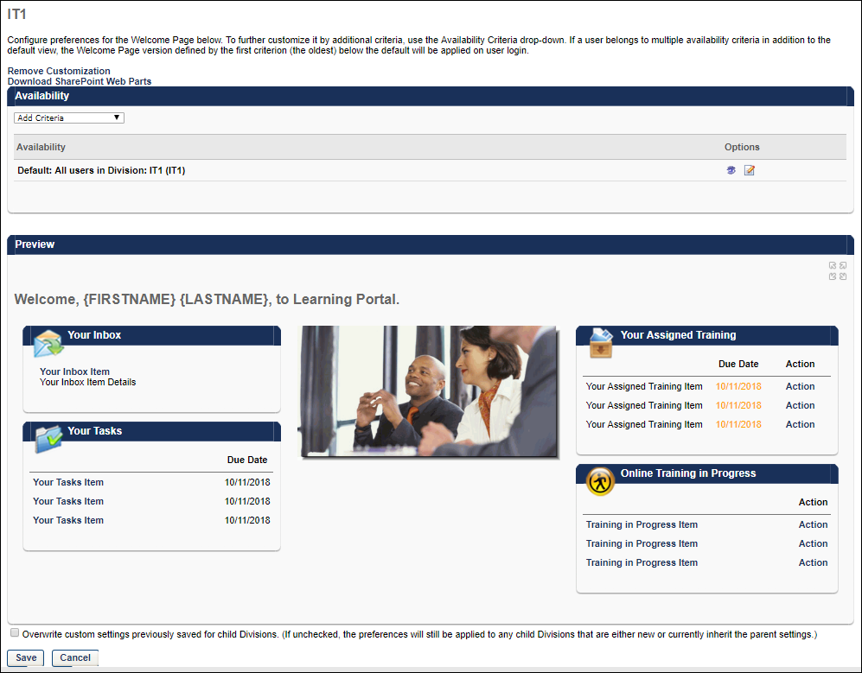
Configure Welcome Pages
The Welcome Page Preferences are configured by division. However, within each division, you can set the default preferences for that division, and you can also set additional custom preferences for specific OUs or groups within that division, such as position or location. The Availability section lists each of the OUs or groups that have custom Welcome Page preferences, including the default preferences for the division.
Configure Default Welcome Page
To set the default Welcome Page preferences for the selected division, click the Edit icon in the Options column. See Custom Page Builder for additional information.
Create Welcome Page for Particular OU
To create a custom Welcome Page for a particular OU or group, from the Availability drop-down list, select the appropriate OU type and click the pop-up icon to select the appropriate OUs or groups. The selected OUs or groups appear in the Availability list. By default, the Welcome Page preferences for the custom Welcome Page are the same as the preferences for the default division. Click the Edit icon in the Options column to customize the Welcome Page preferences for the selected OU or group. See Custom Page Builder for additional information.
Remove Customization
When the Remove Customization link is available, it appears below the page description and above the Availability section.
The Remove Customization link is only available when editing the Welcome Page Preferences for an OU that has customized settings, which means that the OU is not inheriting the settings from it's parent OU. Administrators can identify whether the OU has custom settings when selecting the OU for which you are editing the Welcome page. If there are custom settings for the OU, then "(Custom)" is displayed next to the OU. If there are not custom settings for the OU, then the parent OU name is displayed.
Select the Remove Customization link to remove the customized preferences for the OU and any child OUs that currently inherit the settings. Any child OUs that have different customizations are not affected by this action. When this link is selected, a confirmation pop-up is displayed. Select OK to remove the customizations, or select Cancel to continue utilizing the customized preferences. Caution: Removing customization from an OU cannot be reversed.
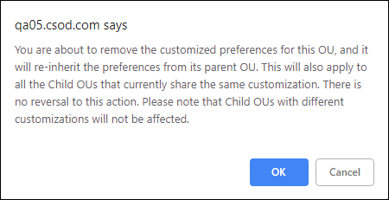
Delete Welcome Page for Particular OU
Any custom Welcome Page preferences other than the default division can be deleted by clicking the Delete icon in the Options column.
Preview Welcome Page for Particular OU
Click the View Details icon in the Options column to preview the Welcome Page for the selected OU or group. The preview is displayed in the Preview section. In the upper-right corner of the Preview section, you can click the Full Screen Preview link to view a full-screen version of the Welcome Page in a new window.
Save Welcome Page Preferences
After creating or editing a Welcome Page, click Save and Exit to return to the Welcome Page Preferences. Click Save at the bottom of the Welcome Page Preferences page to save any changes made to your Welcome pages.

Welcome Page Availability Not By Division
Welcome pages can be customized by Position, Grade, Cost Center, Location, Group, Self Registration Group or User. Welcome pages can be customized for any of these OUs within the top node parent division or within any of the subordinate child divisions. For example, to create a custom Welcome Page for all users assigned to a particular Position, set availability, set availability for that position at the top node parent division. To create a custom page for one position at a subordinate of the parent only (for example, only Admin Assistant in Finance) set availability for that position at the subordinate division.
Important: If a user is in multiple OUs that have customized Welcome pages, the Welcome page that the user sees is determined by the order in which the user's OUs were created. The user sees the Welcome page that is associated with the OU that was created first. For example, if there is a page that is available to the Marketing Cost Center OU and the Content Management Position OU, which page the user sees is dependent on whether the Marketing Cost Center OU or the Content Management Position OU was created first. Because of this, if an organization is using multiple custom Welcome pages, it is a best practice that the availability of these pages is determined using groups that are mutually exclusive. This enables the organization to control which page each user sees.
Permissions
PERMISSION NAME | PERMISSION DESCRIPTION | CATEGORY

Welcome Page Preferences - Manage | Grants ability to configure the look and feel of the Welcome Page that users see upon logging in to the portal. This permission can be constrained by OU and User's OU. This is an administrator permission. | Core Administration
- Select division from hierarchy.
- Select OU type for which to create custom page by selecting type from availability drop-down menu for Position, Grade, Cost Center, Location, Group, Self Registration Group or User.
- Click search icon to select the specific OU. Search OUs by Name, Owner, or ID. Enter full or partial information and click Search.
- Select the appropriate OUs and click Done when all are selected.
- The Selected OUs appear individually in the Availability section. You can then customize the Welcome Page preferences for each OU in the Availability section by clicking the View Details icon . This refreshes the Preferences page to display the preferences for the highlighted OU. Any changes that are made are applied only to the selected OU. Verify you are changing welcome page preferences for the selected OU in the header.
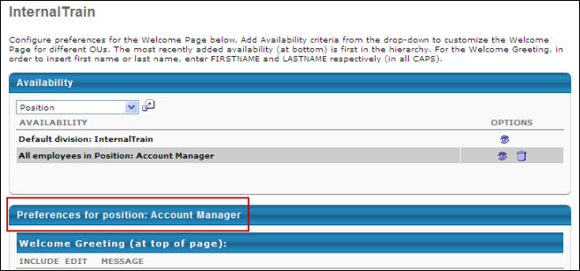
- Modify the Welcome Page preferences as desired. See Welcome Page Preferences on page 37 for additional information.

Welcome Page Overview
The Welcome page or Home page is where you find access to training, tasks, or To-Do's. You can search, request, or launch training and tasks from this page. This page may look different for different organizations, as it is configurable by client.
Permissions
PERMISSION NAME | PERMISSION DESCRIPTION | CATEGORY

Action Items - EPM | Grants ability to view and take action upon Performance (EPM) items on the Action Items page and in the Your Action Items widget. This permission can be constrained by OU, User's OU, User's Self, and User's Self and Subordinates. This is an end user permission. | Universal Profile

Action Items - Forms | Grants ability to view Form actions via the Universal Profile - Actions page or the Welcome/Custom page Actions widget. This permission cannot be constrained. | Universal Profile

Action Items - View | Grants ability to view action items on the Action Items page and in the Your Action Items widget. Users without this permission cannot access the Action Items page. This permission can be constrained by Employee Relationship, OU, User's OU, User's Self and Subordinates, and User's Self. This is an end user permission. | Universal Profile

Announcements - View | Grants ability to view announcements created by others, via the Welcome Page Inbox widget or the Announcements page. This is an end user permission. | Core

Career Center - View | Enables users to view the Career Center, including Career Pathing and Job Search, depending on enabled components and preferences. This permission enables users to view the Internal Job Search widget on the Welcome Page and custom pages. This permission is also required to post a requisition to an internal career site. This is an end user permission. | Talent/Succession

Goals - Approve | Grants ability to approve or deny goals that are pending the user's approval. This is a manager/approver permission.  Note: If this permission is constrained by Employee Relationships, assigned co-planners can create, view, and approve goals. | Performance

Task - View | Grants ability to view assigned tasks via Scheduled Tasks screen and Welcome Page My Tasks widget. This is an end user permission. | Core

Welcome Page - View | Grants access to view Welcome Page. This permission cannot be constrained. This is an end user permission. | Core

Withdraw Users from Sessions | Allows administrators and managers to withdraw users from sessions on their behalf. This is done from the user's Transcript page. Note: There is a setting in the Session Defaults for an event that may prevent users from being able to withdraw from sessions. When this option is selected, users, managers, and administrators are prevented from withdrawing from sessions for themselves or on behalf of other users. This permission can be constrained by OU, User's OU, User's Self and Subordinates, User, User's Subordinates, and User's Direct reports. This is a manager or administrator permission. | Learning
At the top of the page, the header is displayed. This header is available on all pages throughout the system. See Welcome Page Header Overview on page 61 for additional information.
Along the top of the page, the available functionality is grouped by tabs. Place the cursor over a tab to view the available options within the tab.
In the upper-right corner, you can search for training, people, or other items, depending on your portal's configuration. See Global Search Overview for additional information.
Widgets
The following widgets may be available on your Welcome page:
Browse for Training
The Browse for Training widget supports subject hierarchy. By default, all subjects in the widget are collapsed. Subjects with child subjects are identified by an Expand icon , while subjects with no child subjects have a non-expandable icon . Subjects only appear if there are available training items that are associated with the subject.
To expand a parent subject, click the Expand icon to the left of the subject. The child subjects are displayed.
To browse for training for a particular subject, click the subject name. This opens the Browse for Training page with the selected subject added as a filter.
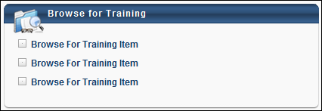
Certification
Displays the user's certifications, enabling the user to track certification due dates, expiration dates, and statuses. The certifications are displayed in order of expiration with the soonest expiration date displayed first. Hover the mouse pointer over the certification title to view the certification family, category, status, and required credits.
Featured Training
The Featured Training widget displays training items that are configured by the administrator as Featured. Clicking the widget title bar takes the user to the Browse for Training page. Administrators can set a training item to be Featured via the Availability settings within Course Catalog. If the user has completed a featured training item or has the featured training in their Transcript, then that item is not displayed in the widget. If the training item is not available to the user, then it is not displayed in the widget. Note: Playlists are an exception to this behavior. If a playlist is designated as featured, it does NOT display in the Featured Training widget. The featured playlist does, however, display in the Featured carousel on the Learner Home page. Via the Welcome Page Preferences, administrators can configure the widget name that appears to users and the number of items that appear in the widget.
Users can click the name of a training item within the widget to open the LO Details page for the training item.
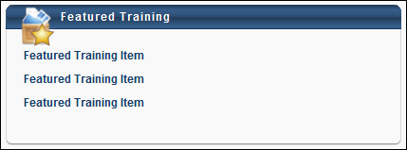
Internal Job Search
The Internal Job Search widget displays up to 10 currently open jobs, as well as allows users to conduct a job search using the widget.
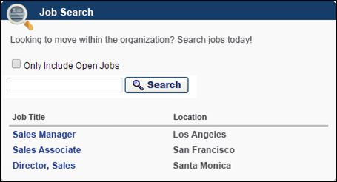
The following information displays in the widget:
- Widget Title - The title of the widget displays at the top of the widget. The title is defined by the administrator when configuring the widget.
- Instructions - The widget instructions displays below the widget title. The instructions are defined by the administrator when configuring the widget.
- Only Include Open Jobs - This option is checked by default. This option allows users to only include open jobs in their job search. When unchecked, the job search returns results for all jobs, regardless of whether or not the job requisition has at least one open job associated with the requisition.
- Search Jobs - This option allows users to filter their job search by entering a full or partial job title, up to 200 characters. Clicking Search opens the Search Jobs page in Career Center. The search results display jobs that match the search terms. If the Only Include Open Jobs option is selected in the widget, then the option is selected by default when the Search Jobs page opens.
- Open Jobs Preview - A list of currently open jobs displays below the search filter. The jobs display in order of most to least recent effective date. In order to display in the list, there must be a requisition associated with the job and the job must be posted to Career Center. Users must also meet the availability for the internal posting, as defined by the recruiter when configuring the Internal Postings tab for the job requisition.
- Job Title - This column displays the title of the job requisition as a link. Clicking the link opens the job details for the job requisition in Career Center.
- Location - This column displays the location of the job.
My Required and Assigned Training Overview
The My Required and Assigned Training Overview widget is available when Required Training Tagging is active in the portal. To know more, See Required Training Tagging Overview. This widget mimics the transcript block of the Learner Home and displays the numbers for the following:
- Required (if not null)
- Past Due
- Due Soon
- Assigned / No Due Date (if no required training is shown)
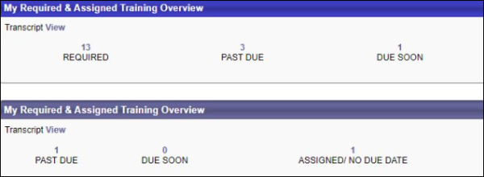
My Training
The My Training widget lists the user's training, including assigned, required, in progress, suggested training, and child training items. The following options are available within the widget:
- Click the widget title to navigate to the user's Transcript page with only the In Progress training displayed.
- Click a training title to open the LO Details page.
- Click the Add link for a training item to add the training item to your transcript and to navigate to the Transcript page.
- Click the Launch link to launch the training item.
- Click the Manage link to navigate to the training details page for the course.
- Click the View Prerequisites, View Post-Work, or View Pre-Work link to navigate to the Transcript Details page for the corresponding LO. The corresponding section (e.g., Prerequisite, Pre-work, Post-work) is displayed.
- Click the Select Session link to open the sessions pop-up.
Note: For training items into which the user was assigned via learning assignment, which are subsequently in a Not Available status on the user's transcript, the Action column displays "None" if the learning assignment is configured by the administrator not to be available until a certain date. Once the training becomes available, the associated option displays in the Action column for the user.
Note: This widget does not display training that has been archived.
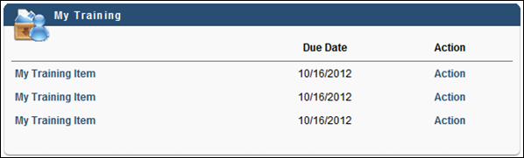
Online Training in Progress
The Online Training in Progress widget lists the user's most recent online training titles that are in progress. The following options are available within the widget:
- Click the widget title to navigate to the user's Transcript page with only the In Progress training displayed.
- Click a training title to open the LO Details page.
- Click the Launch link to launch the training item.
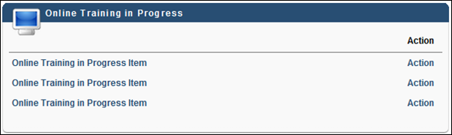
Pending Evaluations
The Pending Evaluations widget lists the user's most recent training titles that need evaluations. The following options are available within the widget:
- Click a training title to open the training details pop-up.
- Click the Evaluate link to navigate to the training evaluation.
Referrals
The Referrals widget lists up to 10 Smart Referrals, which are defined by recruiters when configuring job requisitions. The jobs display in the order in which they were created, with the most recently created job at the top.
Note: If there are no Smart Referrals available to display in the widget, then the widget displays without any requisitions listed.
The following information displays in the widget:
- Widget Title - The title of the widget displays at the top of the widget. The title is defined by the administrator when configuring the widget.
- Instructions - The widget instructions displays below the widget title. The instructions are defined by the administrator when configuring the widget.
- Job Title - This column displays the title of the job requisition as a link. Selecting the link opens the job details in Career Center.
- Location - This column displays the location of the job.
- Bonus - This column displays the referral bonus amount. If a referral bonus is not defined the job requisition, then the column is blank.
- Refer Job - This column displays the Refer Job link. Selecting the link opens the Refer Job page. This page allows users to view the job details and select from the available referral options to refer the job.
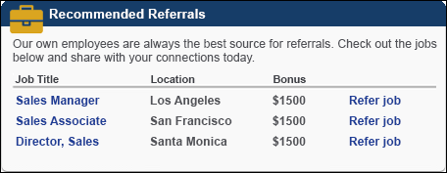
When a job requisition's status is changed to Closed, the job no longer displays in the Referrals widget if configured as a Smart Referral.
Required Training
The Required Training widget lists the user's required training. The following options are available within the widget:
- Click the widget title to navigate to the user's Transcript page with only the In Progress training displayed.
- Click a training title to open the LO Details page.
- Click the Add link for a training item to add the training item to your transcript and to navigate to the Transcript page.
Search
Provides a quick search text box, which can be used to search for training, certifications, and volunteer activities. The character limit for the Search field is 100. Only one instance of this widget is available per page. Note: This widget is not available when creating ATS Job Requisition pages. When a user enters a search term in the Search field and presses [Enter], the user is directed to the Global Search page with the search terms populated. See Global Search Overview for additional information.
Social Feed
This widget is only available to organizations using Redesigned Connect.
The Social Feed widget can be configured to display up to 10 updates and may include Connect user updates and Connect activity updates. The widget only displays updates that are visible to the user. Updates are displayed in chronological order with the most recent updates displayed first.
The following information is displayed for each update:
- User Photograph and Name - The photograph and name of the user who made the update is displayed. Users can click the photograph or name to open the Universal Profile - Bio page for the user in a new window. See Universal Profile - Bio Overview for additional information.
- Update Text - The update text is displayed after the user's name.
- Timestamp - The date and time of the update is displayed.
- Comments - The number of comments associated with the update is displayed. Users can click the Comments link to open the Live Feed.
- Source - The source of the update is displayed. Currently, Connect is the only available source.
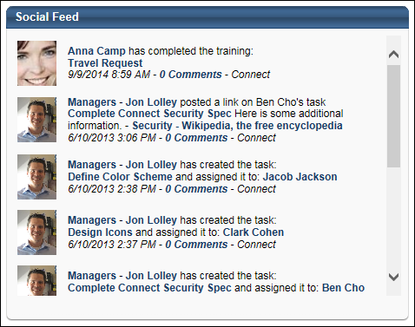
Suggested Training
The Suggested Training widget lists the training that has been suggested for the user. The following options are available within the widget:
- Click a training title to open the LO Details page.
To Do's
The To Do's widget displays the to-do's assigned to by your manager. This widget also allows you to create your own to do's. See Manage To-Do's on page 64 for additional information.
Training in Progress
The Training in Progress widget lists the user's most recent curricula, online classes, and quick courses that are in progress. The following options are available within the widget:
- Click the widget title to navigate to the Transcript page.
- Click a training title to open the LO Details page.
- For curricula, click the Open Curriculum link to navigate to the Training Details page.
- For online courses and quick courses, click the Launch link to launch the training item.
Your Action Items
The Your Action Items widget displays a list of the user's action items. Action items are sorted by due date with past due dates or the soonest due dates displayed first. Administrators can configure the widget to display on Welcome and custom pages. Administrators can also configure which types of actions appear in the widget. With this release, only performance and onboarding actions are supported by the Your Action Items widget.
The following options are available within the widget:
- Click the widget title to navigate to the user's Universal Profile - Actions page.
- Click the action title to perform the primary action for the item.
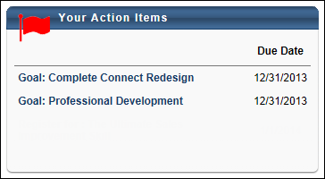
Your Assigned Training
The Your Assigned Training widget lists the user's assigned training in chronological order, beginning with the session that was assigned earliest. The following options are available within the widget:
- Click the widget title to navigate to the user's Transcript page.
- Click the Add link for a training item to add the training item to your transcript and to navigate to the Transcript page.
- Click the View Prerequisites, View Post-Work, or View Pre-Work link to navigate to the Transcript Details page for the corresponding LO. The corresponding section (e.g., Prerequisite, Pre-work, Post-work) is displayed.
Note: For training items into which the user is assigned via learning assignment, which are subsequently in a Not Available status on the user's transcript, the Action column displays "None" if the learning assignment is configured by the administrator not to be available until a certain date. Once the training becomes available, the associated option displays in the Action column for the user.
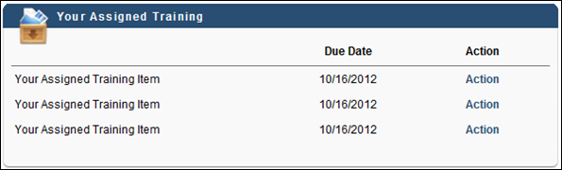
Your Inbox
The Your Inbox widget lists a summary of all action items associated with a user. The following options are available within the widget:
- Approve Checklists - This link navigates the user to the Pending Checklists page (Performance > Observation Checklists > (Select Checklist) > Pending Checklists).
- Approve Compensation Plan - This link navigates the user to the Compensation Plan Approvals page (Compensation > Compensation Plan Approvals).
- Approve Forms - This link navigates the user to the Forms Pending Approval page (Content > Form Management > Forms Pending Approval).
- Approve SF-182 Requests - This link navigates the user to the SF-182 Requests Management page (Learning > SF-182 Management).
- Approve Training - This link navigates the user to the Pending Requests page (Reports > Standard Reports > Track Employee > Pending Requests).
- Approve User Records - This link navigates the user to the View Pending User Records page (Admin > Organizational Units > View Pending User Records).
- Test Questions Pending Scoring - This link navigates the user to the Test Questions Pending Grading page (Content > Test Grading). This section does not show inactive users pending scoring.
- View Announcements - This link navigates the user to the Announcements page (Admin > Catalog Management > Message List).
- View Competency Assessments - This link navigates the user to the Competency Assessment Summary page (Performance > Competency Assessment Summary).
- View Connection Requests - This displays the number of pending connection requests, which are requests from other users for you to connect with them via the New Connect that has not yet been deleted. This entry is only displayed when the user has at least one pending connection request. This link navigates the user to the Pending Connection Requests page.
- View Connect Team Invitations - This displays the number of pending Connect team invitations, which are invitations to join a team within the New Connect to which the user has not yet responded. This entry is only displayed when the user has at least one pending Connect team invitation. This link navigates the user to the All Teams page.
- View Development Plans - This link navigates the user to the Development Plan Approval page (Performance > Manage Employee Performance > Manage Pending Development Plans).
- View Facility Requests - This link navigates the user to the Facility Requests page (ILT > Facilities and Resources > View Facilities Requests).
- View Feedback Requests - This link navigates the user to the Feedback Requests page (Universal Profile > Feedback > Feedback Requests). See Feedback Requests for additional information.
- View Form Approval Requests - This link navigates the user to the Requests tab in Universal Profile (Universal Profile > Actions > Requests). The action displays an approver's pending form approval requests, as well as the number of pending requests.
- View Instructor Requests - This link navigates the user to the Instructor Requests page (ILT > Vendors and Instructors > View Instructor Requests).
- View Resource Requests - This link navigates the user to the Resource Requests page (ILT > Facilities and Resources > View Equipment Requests).
- View To Do List for Goals - This link navigates the user to the To Do List page (Performance > To Do's).
- View Training Exemption Requests - This link navigates the user to the Pending Exemption Requests page (Learning > Exemption Tracking).
- View Transcript - This link navigates the user to their Transcript page (Learning > View Transcript).
Your Interest and Waitlist Tracking
The Your Interest & Waitlist Tracking widget lists the sessions in which the user's status is Waitlisted and events in which the user has noted interest. The following options are available within the widget:
- Click the widget title to navigate to the Interests and Waitlists page.
- Click a training title to open the LO Details page.
See Waitlist and Interest Tracking on page 73 for additional information.
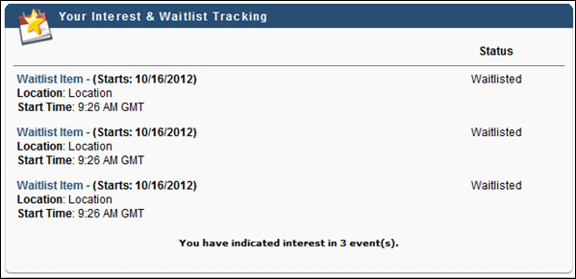
Your Tasks
The Your Tasks widget lists the tasks that are pending the user's completion. This includes performance related tasks, Level 3 evaluations, and survey tasks. The following options are available within the widget:
- Click the widget title to navigate to the Scheduled Tasks page.
- Click a task title to navigate to the selected task.
Overdue tasks are displayed with a warning icon. Expired tasks are not displayed on the widget, such as surveys and behavior evaluations that cannot be completed after the expiration date.
This widget is different from the Your Inbox widget. Task based items appear in the Your Tasks widget while non-task based items appear in the Your Inbox widget.
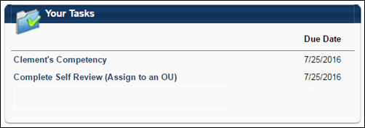
Your Transcript
The Your Transcript widget includes the top sorted items from the Active tab of a user's transcript. The widget is capable of displaying all columns from the Active tab of a user's transcript, including the training purpose for each training item.
Which columns display in the widget is determined by the administrator when the widget is added to the Welcome page. The following columns may be available for the widget:
- Title
- Type
- Due Date
- Status
- Training Purpose
- Action
The following options are available within the widget:
- Click the widget title to navigate to the user's Transcript page.
- Click the View Prerequisites, View Post-Work, or View Pre-Work link to navigate to the Transcript Details page for the corresponding LO. The corresponding section (e.g., Prerequisite, Pre-work, Post-work) is displayed.
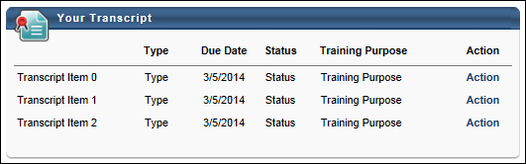
Your Upcoming Sessions
The Your Upcoming Sessions widget lists the user's upcoming ILT sessions in chronological order, beginning with the session that begins soonest. The following options are available within the widget:
- Click the widget title to navigate to the user's Event Calendar page.
- Click a training title to open the LO Details page.
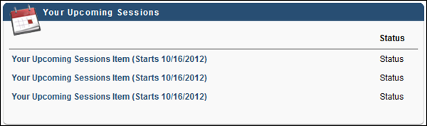

Welcome Page Header Overview
Header
The header consists of the following items:
Corporate Logo
The corporate logo functionality is unchanged from other themes. The corporate logo can be configured within Display Preferences. See Display Preferences (by Division).
Search Bar
The Search bar utilizes Global Search. As the user enters a search query into the Search field, predictive search results appear in a menu below the field. Predictive search results appear for each search category where there are relevant results.
- People - People results display the corresponding user photos, if available. The user's position is displayed below their name, if available.
- Training - Training results have corresponding LO icons.
- Certifications - Certification results have a Certification icon.
- If there are no relevant results for a category, then the corresponding category heading does not display.
A maximum of five relevant results appear for each category. Search results are displayed in order of relevancy.
Users can click a predictive search result to go directly to the Global Search results page. Users can also click the magnifying glass icon or press the [Enter] key to open the Global Search page and view the search results. See Global Search Page for additional information.
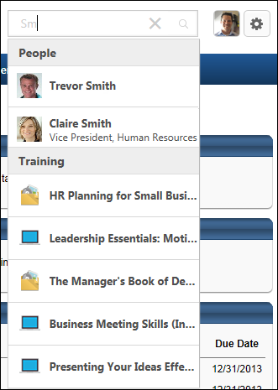
User Photo
The user photo for the logged in user displays to the right of the Search bar. Click the photo to open the Universal Profile - Bio page. The photograph is only available to users who have permission to view the Universal Profile - Bio page. See Bio - About Overview for additional information.
Shopping Cart Icon
If the shopping cart is enabled, then the Shopping Cart icon provides quick access to the shopping cart and also allows users to view the items in the shopping cart.
A red indicator appears in the upper-right corner of the icon if there are items in the user's shopping cart. The maximum value that is displayed is 99. If more than 99 items are in the shopping cart, then 99+ is displayed.
Users can click the Shopping Cart icon to open the shopping cart. See Shopping Cart for additional information.
Users can hover the computer cursor over the Shopping Cart icon to view the items in the shopping cart. Training items have corresponding LO icons. A maximum of three items are displayed. A View Cart button is also displayed. Users can click this button to open the shopping cart.
Settings Icon
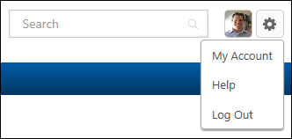
The Settings icon provides quick access to the following options:
- My Account - Click this option to open the My Account - Preferences page. This option is only available if My Account is enabled for the portal and the user has permission to edit their My Account preferences. See My Account - Preferences for additional information.
- Help - Click this option to open the Online Help topic that corresponds with the system page that is currently being viewed. This option is only available if Online Help is enabled for the security role.
- Log Out/Log In - Click this option to log in or out of the system. The Log in option is only available for organizations using the extended enterprise functionality.
- Register - Click this option to register as a user. This option is only available for guest users.

Manage To-Do's
A To Do is a free form item a must be completed by the user. A To Do item can be added by a manager via My Team or the user via the To Do page.
All non-past due, incomplete To Dos will appear under the To-Do's welcome page box. You will see the title, progress percentage and the due date. Once the due date has passed, the To Do is no longer displayed in the widget.
To Dos are displayed by due date with the soonest due date displayed first.
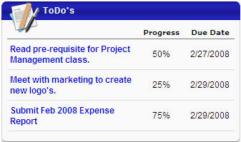

View To-Do's
- To view all current To-Do's click on the ToDo's heading in the widget from the Home page
- On this page, you can view current and archived To-Do's.
- For each To-Do, you will see the title, percentage progress, due date, and the status light.
- You can click on the Archived tab to view archived To-Do's.
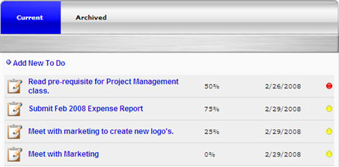

Create To-Do's
- You can add To-Do's on the main page by clicking on the Add New To Do link.
- A pop-up will appear where the To-Do can be defined.
- All To-Do's added here will also appear to your manager on the My Team activities page.
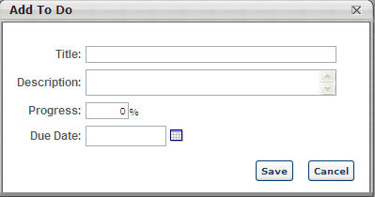

Modify To-Do's
- On both the welcome page box and the To-Do's page, you can click on the title of the To-Do to view details and update the progress.
- A Modify To Do pop-up will appear where you can modify the progress of the To- Do.
- If the To-Do was created by you, then all aspects of can by modified.
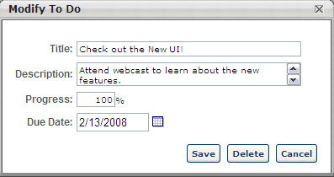

Scheduled Tasks
The Scheduled Tasks page displays all of the tasks the user is required to complete, including performance reviews, evaluations, assessments, forms, surveys, etc.
To view your scheduled tasks, go to Home > Scheduled Tasks.
Permissions
PERMISSION NAME | PERMISSION DESCRIPTION | CATEGORY

Task - View | Grants ability to view assigned tasks via Scheduled Tasks screen and Welcome Page My Tasks widget. This is an end user permission. | Core
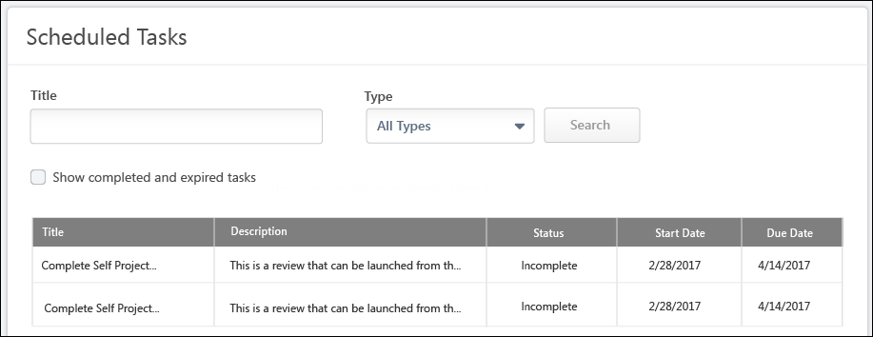
Search Tasks
You can search your scheduled tasks by title or type using the search bar and drop-down menu. You can include completed and expired tasks in the display by selecting the Show completed and expired tasks option.
Note: Performance review tasks may show a title other than the task name if the task is configured to show unique names for different reviewer roles. For example, the self review task may have a different task list name than the manager review task. Administrators can configure and customize task list names in the Additional Options section of the Review Summary step when creating the performance review task. See Review Task - Create - Step 3 - Review Summary.
Complete Task
To view and begin completing a task, select the task title.
View Task Details
The following information is displayed for each tasks:
- Title - The task title. For off-cycle performance review tasks, the review title is displayed in parenthesis after the task title.
- Description - The task description.
- Status - The current task status.
- Start Date - The start date of the step in the task.
- Due Date - The due date of the step in the task.
Print Task
Completed or expired tasks may be printed from the Scheduled Tasks page.
To print the task:
- Click the task title. The Task Print pop-up opens.
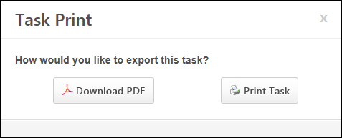
- Click Download PDF to download the task as a PDF.
  - The message in the pop-up changes to indicate that an email will be sent when the PDF is ready. The email address is pulled from your user record.
  - The corresponding email must be active and configured in Email Administration.
  - If you downloaded the PDF within the last 20 days, when you click the task title, the pop-up opens and indicates that your PDF is ready to download.
- Click Print Task to print the task from your browser. This opens the Print window for your browser and allows you to print the task.
Automatic Task Status Changes
The task status updates automatically to In Progress in the following instances:
- Manager gets a new subordinate in employee relationship task. The status updates even when the manager does not reopen the task.
- If employee relationship task status is complete and a new manager is assigned the task, the task status is updated to In Progress.
- Assessor gets a new assessee in assessor task. The status updates even if the assessor does not reopen the task. If the task is configured to allow assessors to be added after the task period starts, the task status is automatically updated to In Progress if a new assessor is added.
- For job pool tasks with assessor based availability, if the task status is complete before the task expires and a new incumbent is added to a position, then the task status is automatically updated to In Progress.
- For job pool tasks with position to be planned availability, if the task status is complete before the task expires and a new incumbent is added to a position, the task status is automatically updated to In Progress.
- If a Performance Review Tasks contains a goal planning steps that expires, the goals created in the review task are now moved to Draft status and the Performance Review Task Expiration-Goal Moved to Draft Status email is triggered if configured in Email Administration. These goals are now available on the My Goals page.
Frequently Asked Questions
Can I remove an expired task from their Scheduled Tasks page?
Users cannot remove an expired task from the Scheduled Tasks page. However, they can choose whether or not they are displayed using the Show completed and expired tasks option.

Using Order Forms
The Order Form page allows you to purchase multiple learning objects as a part of a promotion. In this example, a promotional code is provided for the selected learning objects.
If an order form is available, it appears in the Order Forms widget on the Welcome page. To view an order form, in the Order Forms widget, click the View link next to the appropriate order form.
Permissions
PERMISSION NAME | PERMISSION DESCRIPTION | CATEGORY

Inventory - Manage | Grants ability to purchase multiple learning object licenses with the intent to assign that training to other users at a later time. This permission can be constrained by OU and User's OU. | eCommerce
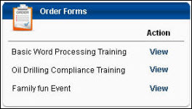
Select the training you'd like to purchase for yourself by selecting the For You option next to the appropriate items.
- If the training is not available for you, "Not Available" displays in that column.
- If you already have the LO on your transcript and the item is not available to purchase again, "Not Available" displays in that column.
Select the For Others option next to the appropriate LO to purchase the course as inventory in order to assign it to other users. If you do not have permission to manage inventory, this column does not appear.
- If you have permission to manage inventory, but the item does not allow inventory purchase, "Not Available" is displayed in the For Others column.
Be sure to note any promotional codes or coupons that you will need to enter during checkout in order to receive a discount. If there is a promotional code or coupon that applies to the order form, it should appear on this page. Highlight the code, right-click and select Copy to copy the code for use during shopping cart checkout.
After selecting the necessary LOs, click Add to Cart. This takes you to the shopping cart. You can modify the quantities for each item in your shopping cart. See Shopping Cart for additional information.
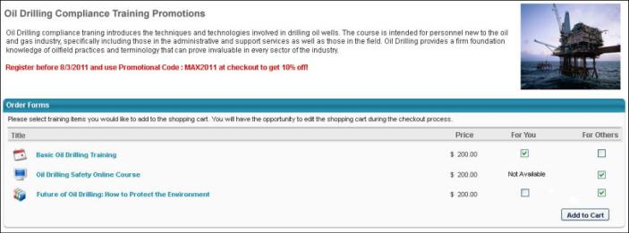

Waitlist and Interest Tracking
This page can be used to track interest history and view sessions that you are waitlisted for. To access this page click on the title or icon from the welcome page for the Waitlist & Interest Tracking widget.
Permissions
PERMISSION NAME | PERMISSION DESCRIPTION | CATEGORY

View My Interests and Waitlists | Grants access for users to view ILT interest lists and waitlists to which they've been added, and to take action when a matching ILT session is offered. This is an end user permission. | Learning
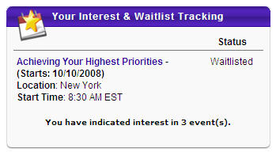
Interest Details
- Title - Click the title to see event details.
- Type - Displays learning object type.
- Date Submitted - Displays events from most recent interest to oldest interest. This column can be sorted by clicking on down arrow next to title.
- Preferred Location - Displays location you had chosen. Can be changed by selecting the Edit icon.
- # of Matches - Displays the number of approved sessions that have been scheduled since the user indicated interest. This column can be sorted by clicking on down arrow next to title.
- Comments - displays the comments that you entered when you indicated interest in the event. Can be changed by selecting the Edit icon.
- Edit - click icon to change details, add comments or edit preferred location
- Delete - click icon to remove the event. This will also remove reduce the # of matches for other users.
Waitlist Detail
- Title - click on title to see session details
- Type - displays learning object type
- Request Date - displays the date you were put on the waitlist. This column can be sorted by clicking on down arrow next to title.
- Location - displays location of the session
- Waitlist Order - displays your position on the waitlist for the session. This column can be sorted by clicking on down arrow next to title.
- Options - click Withdraw link to remove from waitlist. This will remove this title from this page. If your status is changed from waitlist, it will no longer appear on this page. You can access the training from your transcript if the waitlist has been accepted.
