Learning Details March 2024

Table of Contents
Learning Details Page 1
Learning Details Page 12
Learning Details Page 23
Learning Details - Events and Sessions 34
Learning Details - Curricula 40
Learning Details - Training with Recurrence 42
Learning Details Page (Legacy Design) 44
Learning Details Page (Legacy) - Details Tab 48
Learning Details Page (Legacy) - Interest Tracking 64
Learning Details Page (Legacy) - Actions 66
Learning Details Page (Legacy) - Ratings and Reviews Tab 69
Learning Details Page (Legacy) - Sessions Tab 79
Learning Details Page (Legacy) - Training Plan and Training Purpose 82
Learning Details Page (Legacy) - Rate this Training 83
Manager Learning Actions - Overview 85
Approve Training Overview 86
Manage On the Job Training Requests 100
Training Units Overview 115
Remove Training from User's Transcript 123
SF-182 Manager Actions - Overview 126

Learning Details Page
The Learning Details page features a modern, intuitive design which makes it easy for users to find key information about training items. The Learning Details page is also fully responsive, so users can interact with the Learning Details page on any mobile device.
To access the Learning Details page for a training item, the Learning Details page must firstly be supported and enabled via Learning Details Preferences. Then, users can access the Learning Details page by clicking the title of a training item from any of the following locations:
- Learner Home
- Learning Search
- Global Search
- Browse for Training
Permissions
PERMISSION NAME | PERMISSION DESCRIPTION | CATEGORY

Assign Training | Grants ability to assign learning objects to the transcripts of those for whom the user is the assigned manager, approver or cost center approver. This is a manager/approver permission. | Learning

LO Attachments - Manage | Grants ability to upload attachments to learning objects. Administrators with this permission are automatically granted the LO Attachments - View permission. This permission can be constrained by User's ILT Provider, Provider, and ILT Provider. This is an administrator permission. | Learning - Administration

LO Attachments - View | Grants ability to view the learning object attachments that are set to be available to administrators. This permission can be constrained by User's ILT Provider, Provider, and ILT Provider. This is an administrator permission. | Learning - Administration

LO Detail | Grants ability to view the LO Details page. This permission cannot be constrained. | Learning

Playlists - Create | Grants ability to create private Learning Playlists. This permission cannot be constrained. This is an end user permission. | Learning - Administration

View Transcript Item | Grants ability to view details of learning objects that appear on the transcript (training record), by clicking on the name of the learning object. Users must also have the Bio About - View permission in order to access the transcript within Universal Profile. This permission can be constrained by OU, User's OU, User Self and Subordinates, User, or User's Self. This is an end user permission. | Learning - Administration

Display all Training Custom Fields | Enables display of all training custom field values including blank fields when viewing details of training on transcript. Without this permission, the custom field will only appear if it is populated with a value. This is an end user permission. | Learning
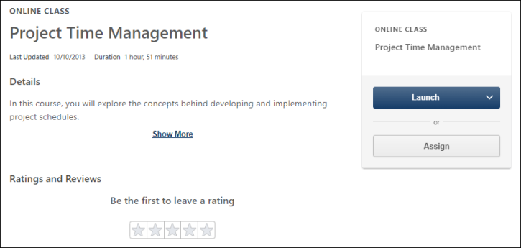
Header
The header section of the Learning Details page displays general information about the training. The following information and metadata is available in the header:
- Training Type - The type of the training, such as online course, material, curriculum, etc.
- Title - The title of the training
- Duration - The duration time of the training
- Last Update - The date and time at which the training was last modified by an administrator
- Rating - The overall star rating of the training, along with the total number of reviews which contributed to the overall rating
- Details - The Details section displays the following information, if available:
  - Description (including support for HTML)
  - Available metadata (see the Details - Metadata section below for more information about the metadata which may display in the Details section
  - Available custom fields
  - Show More - Click this link to expand any training details that are hidden
Details - Metadata
The metadata may display in the expanded Details section of the Learning Details page:
- Price - The price of the training, if applicable
- Version - The current version of the training item
- Available Languages - The languages in which the training is offered
- Training Equivalencies - All courses that have been configured as equivalent to this training. This field only displays if configured, and is a clickable link which navigates the user to the Learning Details page for that training item.
- Language Equivalencies - All courses that are equivalent to this training in another language. This field only displays if configured, and is a clickable link which navigates the user to the Learning Details page for that training item.
- Start Date/End Date - This field is only applicable to material training types. This field only displays if configured.
- Resources - Any documents that have been attached to the training and are visible to the user. The user must also have permission to view or manage LO attachments. Click the attachment title to open the document.
- Subjects - Any subjects associated with the training display. If you click a subject, you are redirected to the Learning Search page, where results will be filtered according to the subject you selected. This field only displays if configured. Note: If the Learning Search page is not enabled in the system, the subjects are not clickable on the Learning Details page.
- Objectives - Any objectives associated with instructor-led training (ILT) events and sessions display on the Learning Details page for events and sessions. Objectives can be disabled and enabled for the Learning Details page via the Learning Details Preferences page.
- Points - Any points associated with the training display. This field only displays if configured and if the user has permission to view points.
- Training Contact - The name of the training contact, as well as the associated contact information, such as email and phone number. These fields only display if configured.
- Recommended Training - This section displays all courses that are recommended for users who complete this training item. Administrators are able to specify training items as Recommended via the Course Catalog (only displays if configured).
- Training Custom Fields - Any custom fields associated with the training. This is a new feature exclusive to the Learning Details page. Note: This applies to the Details section of the primary Learning Details page. Session custom fields are displayed on the Session flyout for Session Details within the Events and Sessions Learning Details page.
- Version - The current version of the training item
- Provider - The training provider of the training item
- Available on Mobile - Indicates whether the training is available for mobile device. This is a new feature exclusive to the Learning Details page.
Action Card
The Action card displays in the upper-right corner of the Learning Details page when viewed on a desktop screen, and on the bottom of the screen as a sticky footer when viewed on a mobile screen. The options available within the card vary depending on the training type and the user's transcript status for the training. The following fields and features appear in the Action Card:
- Training Type - The type of the training, such as online course, material, curriculum, etc.
- Title - The title of the training
- Badge - If a badge has been configured for the training item, it displays in the Action card. Only one badge can be configured per training item. Points are not included in the badge display.
- Primary Action Button - The primary available action for the training item displays as a button in the Action card. The following actions may be available, depending on the training type and the training status:
  - Edit Training - Administrators have access to the Edit Training option. Clicking the Edit Training option navigates the administrator to the Course Catalog page for the training, where they can make modifications to the training metadata.
  - Save for Later - Click this option to add the training to the Saved for Later carousel on your Learner Home page. The permission to access Learner Home is needed to see this option.
  - Remove from Saved - Click this option to remove the training from the Saved for Later carousel on your Learner Home page. The permission to access Learner Home is needed to see this option.
  - Add to Playlist - Click this option to add the training to one of the existing playlists you have created. Permission to create playlists is required.
  - Create New Playlist - Click this option to begin creating a new playlist with this training as the first training item in the playlist. Permission to create playlists is required.
  - Transcript Actions - Available transcript actions may be available for the training, depending on the training type and the training status. For example, the user may have the ability to request training, launch training, select a session, etc. If the user selects any of the following actions, the user remains on the Learning Details page and receives the corresponding message:
    - Request - "You have successfully requested [training]!"
    - Re-request - "You have successfully requested [training]!"
    - Request Again - "You have successfully requested [training]!"
    - Register - "You have successfully registered for [training]!"
    - Mark Complete - "You have successfully completed [training]!"
    - Launch - No message displays. The training opens in a separate tab, but the user remains on the Learning Details page.
Note: For information about available actions for training with recurrence: See Learning Details - Training with Recurrence on page 42 for additional information..
  - Request Prerequisites - Click this option to access any prerequisite training items required for the training. The Learning Details page for the training item will open in a separate tab.
  - Specify Training Purpose - If a training item is configured to require a training purpose upon request or assignment, the learner requesting the training or the administrator assigning the training will have the option to specify a training purpose before the training request or assignment is complete. Note: This option leverages Amazon Web Services.
- Assign - If available, the Assign button displays below the Primary Action button. The Assign button only displays to users who have permission to assign training, and the button is only available if the user is a manager, approver, or cost center approver who can assign training to users. The rest of the process for assigning training is unchanged. See Assign Training.
- Add to Cart - Users with permission to purchase inventory for other users are able to purchase training licenses for other users. This purchased training can then be assigned to other users at a later time. After clicking Add to Cart, a pop-up appears where you can choose to purchase the training for yourself or for inventory. Select the Others: Pre-Purchase option and specify the number of users you are purchasing. Click Submit. The item is added to the shopping cart with the specified number of users listed in the Quantity column. You can update this amount here if necessary. See Shopping Cart for additional information.
- Transcript Status - If the training already exists on the user’s transcript, a color-coded transcript status flag displays with instructional text related to that status, which helps inform the user about what the status means and what next steps are required, if any. If the training has a due date, the due date information also displays. When the training is past due, a separate red flag appears to indicate that the training is overdue.
Prerequisites
Any prerequisite training items associated with the training display in the Prerequisites section. Each prerequisite training item displays with basic information about the training. Note: When a user has a status of Registered or higher for a training item that contains a prerequisite, that user can take action on the associated prerequisite regardless of the prerequisite's availability settings.
Each training item displays with the following information:
- Training type - This is the type of training, such as online course, curriculum, event, etc.
- Training Title - This is the title of the training item
- Completed Training Status - If the training is in a Completed status (including Completed, Completed Equivalent, and Exempt), the corresponding status tag displays next to the training.
Click the prerequisite to access the Learning Details page for the prerequisite. Note: If there are multiple options for completing a prerequisite, these options are separated into separate sections, labeled Option 1, Option 2, etc.
Note: The Request Exception workflow is NOT currently supported for prerequisites by the Learning Details page.
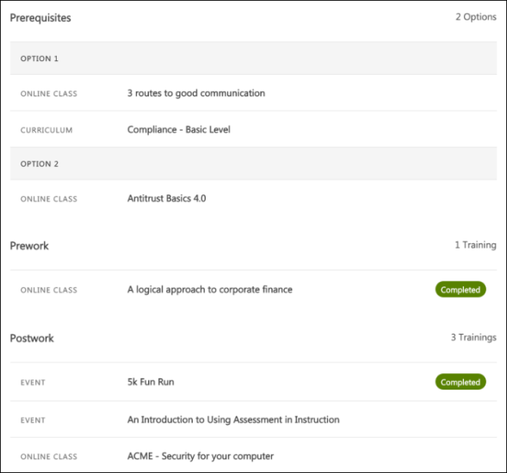
Pre-Work
Any pre-work training items associated with the training display in the Pre-Work section. Each pre-work training item displays with basic information about the training. Note: When a user has a status of Registered or higher for a training item that contains pre-work, that user can take action on the associated pre-work regardless of the pre-work's availability settings.
Each training item displays with the following information:
- Training type - This is the type of training, such as online course, curriculum, event, etc.
- Training Title - This is the title of the training item
- Completed Training Status - If the training is in a Completed status (including Completed, Completed Equivalent, and Exempt), the corresponding status tag displays next to the training.
Click the pre-work to access the Learning Details page for the pre-work. Note: If there are multiple options for completing pre-work, these options are separated into separate sections, labeled Option 1, Option 2, etc.
Post-Work
Any post-work training items associated with the training display in the Post-Work section. Each post-work training item displays with basic information about the training. Note: Learners cannot take action on post-work that is unavailable to them until they have first completed the parent training.
Each training item displays with the following information:
- Training type - This is the type of training, such as online course, curriculum, event, etc.
- Training Title - This is the title of the training item
- Completed Training Status - If the training is in a Completed status (including Completed, Completed Equivalent, and Exempt), the corresponding status tag displays next to the training.
Click the post-work to access the Learning Details page for the post-work. Note: If there are multiple options for completing post-work, these options are separated into separate sections, labeled Option 1, Option 2, etc.
Ratings and Reviews
Learners can view a training item's ratings and reviews in the Ratings and Reviews section of the Learning Details page, provided ratings and reviews functionality has been activated in the portal via Course Ratings Preferences. The following features display in this section:
- Average Rating - This is the average star rating the training has received from all its reviewers combined
- Total Reviews - This is the total number of reviews the training has received
- Review Distribution - This chart displays the percentage of reviewers which gave the training each star rating
- Leave a Review - To add your own review for the training, click the star rating you wish to give the training. You will be navigated to the Rate This Training page for the training item, where you can provide a review title and write your review.
- Individual Rating and Reviews - Each rating and review given to the training display on the page in the order in which they were given, with the following information:
  - Reviewer Name - The name of the user who provided the review
  - Profile Photo - The profile photo associated with the system user who provided the review
  - Rating - The star rating the user gave to the training
  - Review Title - The title the user gave their training review
  - Review Body - The full review the user wrote for the training
  - Show More - This link displays if the review is longer than three lines. Click the Show More link to read the full review if the review is more than three lines long
  - Delete - Users can delete reviews they have created by clicking the Delete icon next to their own review.
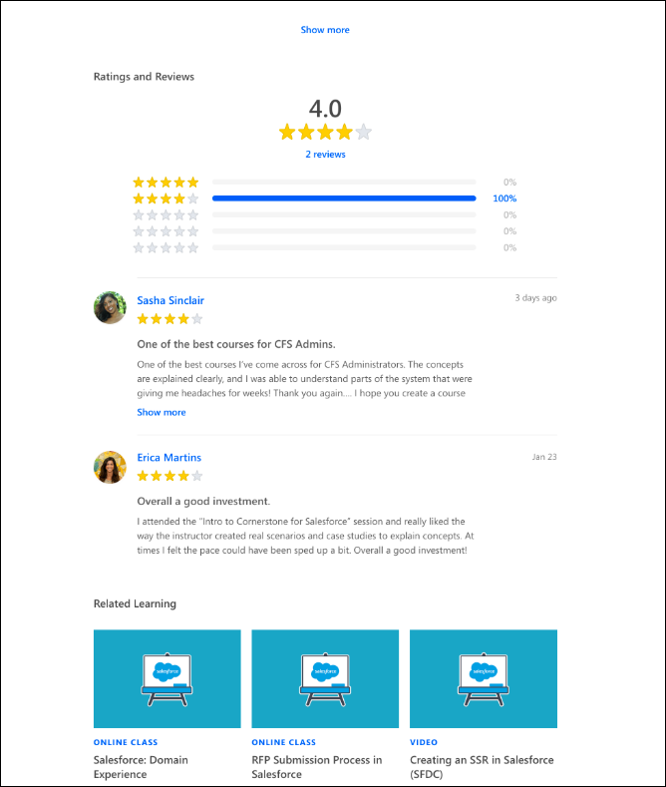
If no ratings or reviews have been created for the training, the Ratings and Reviews section supports a zero state that prompts the user to "Be the first to leave a rating," and the user can choose a star rating to begin creating a rating and review.
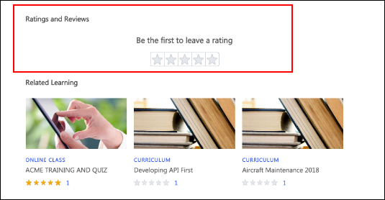
Delete Reviews (Administrator)
Administrators with permission to manage ratings and reviews have access to a Delete icon for all users' ratings and reviews. To delete another user's rating or review, the administrator can navigate to the Ratings and Reviews section of a training item's Learning Details page and click the Delete icon next to any rating or review.
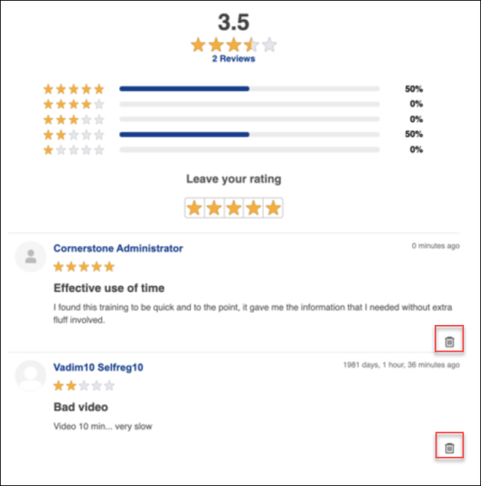
Related Learning
A Related Learning carousel, powered by machine learning, displays at the bottom of the Learning Details page. The Related Learning carousel provides users with quick access to training related to the training item for which they are currently viewing the Learning Details page. Note: The permission to view Learner Home is NOT required to view this carousel.
Each training tile in the carousel displays the following information:
- Thumbnail Image - The image associated with the training item displays at the top of each tile.
- Training Type - This field displays the type of the training item, such as online class, curriculum, material, etc.
- Title - This field displays the title of the training item.
- Duration - This field displays the duration of the training. Note: if the duration is 0, this field does not display.
Note: The tile is clickable and re-directs the user to the Learning Details page for the training item if the training type supports the Learning Details page and the Learning Details page has been enabled for that training type. If the training type does not have the Learning Details page enabled, the user is directed to the old version of the Details page for the training.
Mobile Responsive
When accessed from a mobile device, the Learning Details page provides access to all the same fields, and the entire page is mobile responsive and formatted to display optimally on any mobile device.

Learning Details Page
The Learning Details page features a modern, intuitive design which makes it easy for users to find key information about training items. The Learning Details page is also fully responsive, so users can interact with the Learning Details page on any mobile device.
To access the Learning Details page for a training item, the Learning Details page must firstly be supported and enabled via Learning Details Preferences. Then, users can access the Learning Details page by clicking the title of a training item from any of the following locations:
- Learner Home
- Learning Search
- Global Search
- Browse for Training
Permissions
PERMISSION NAME | PERMISSION DESCRIPTION | CATEGORY

Assign Training | Grants ability to assign learning objects to the transcripts of those for whom the user is the assigned manager, approver or cost center approver. This is a manager/approver permission. | Learning

LO Attachments - Manage | Grants ability to upload attachments to learning objects. Administrators with this permission are automatically granted the LO Attachments - View permission. This permission can be constrained by User's ILT Provider, Provider, and ILT Provider. This is an administrator permission. | Learning - Administration

LO Attachments - View | Grants ability to view the learning object attachments that are set to be available to administrators. This permission can be constrained by User's ILT Provider, Provider, and ILT Provider. This is an administrator permission. | Learning - Administration

LO Detail | Grants ability to view the LO Details page. This permission cannot be constrained. | Learning

Playlists - Create | Grants ability to create private Learning Playlists. This permission cannot be constrained. This is an end user permission. | Learning - Administration

View Transcript Item | Grants ability to view details of learning objects that appear on the transcript (training record), by clicking on the name of the learning object. Users must also have the Bio About - View permission in order to access the transcript within Universal Profile. This permission can be constrained by OU, User's OU, User Self and Subordinates, User, or User's Self. This is an end user permission. | Learning - Administration

Display all Training Custom Fields | Enables display of all training custom field values including blank fields when viewing details of training on transcript. Without this permission, the custom field will only appear if it is populated with a value. This is an end user permission. | Learning
Header
The header section of the Learning Details page displays general information about the training. The following information and metadata is available in the header:
- Training Type - The type of the training, such as online course, material, curriculum, etc.
- Title - The title of the training
- Duration - The duration time of the training
- Last Update - The date and time at which the training was last modified by an administrator
- Rating - The overall star rating of the training, along with the total number of reviews which contributed to the overall rating
- Details - The Details section displays the following information, if available:
  - Description (including support for HTML)
  - Available metadata (see the Details - Metadata section below for more information about the metadata which may display in the Details section
  - Available custom fields
  - Show More - Click this link to expand any training details that are hidden
Details - Metadata
The metadata may display in the expanded Details section of the Learning Details page:
- Price - The price of the training, if applicable
- Version - The current version of the training item
- Available Languages - The languages in which the training is offered
- Training Equivalencies - All courses that have been configured as equivalent to this training. This field only displays if configured, and is a clickable link which navigates the user to the Learning Details page for that training item.
- Language Equivalencies - All courses that are equivalent to this training in another language. This field only displays if configured, and is a clickable link which navigates the user to the Learning Details page for that training item.
- Start Date/End Date - This field is only applicable to material training types. This field only displays if configured.
- Resources - Any documents that have been attached to the training and are visible to the user. The user must also have permission to view or manage LO attachments. Click the attachment title to open the document.
- Subjects - Any subjects associated with the training display. If you click a subject, you are redirected to the Learning Search page, where results will be filtered according to the subject you selected. This field only displays if configured. Note: If the Learning Search page is not enabled in the system, the subjects are not clickable on the Learning Details page.
- Objectives - Any objectives associated with instructor-led training (ILT) events and sessions display on the Learning Details page for events and sessions. Objectives can be disabled and enabled for the Learning Details page via the Learning Details Preferences page.
- Points - Any points associated with the training display. This field only displays if configured and if the user has permission to view points.
- Training Contact - The name of the training contact, as well as the associated contact information, such as email and phone number. These fields only display if configured.
- Recommended Training - This section displays all courses that are recommended for users who complete this training item. Administrators are able to specify training items as Recommended via the Course Catalog (only displays if configured).
- Training Custom Fields - Any custom fields associated with the training. This is a new feature exclusive to the Learning Details page. Note: This applies to the Details section of the primary Learning Details page. Session custom fields are displayed on the Session flyout for Session Details within the Events and Sessions Learning Details page.
- Version - The current version of the training item
- Provider - The training provider of the training item
- Available on Mobile - Indicates whether the training is available for mobile device. This is a new feature exclusive to the Learning Details page.
Action Card
The Action card displays in the upper-right corner of the Learning Details page when viewed on a desktop screen, and on the bottom of the screen as a sticky footer when viewed on a mobile screen. The options available within the card vary depending on the training type and the user's transcript status for the training. The following fields and features appear in the Action Card:
- Training Type - The type of the training, such as online course, material, curriculum, etc.
- Title - The title of the training
- Badge - If a badge has been configured for the training item, it displays in the Action card. Only one badge can be configured per training item. Points are not included in the badge display.
- Primary Action Button - The primary available action for the training item displays as a button in the Action card. The following actions may be available, depending on the training type and the training status:
  - Edit Training - Administrators have access to the Edit Training option. Clicking the Edit Training option navigates the administrator to the Course Catalog page for the training, where they can make modifications to the training metadata.
  - Save for Later - Click this option to add the training to the Saved for Later carousel on your Learner Home page. The permission to access Learner Home is needed to see this option.
  - Remove from Saved - Click this option to remove the training from the Saved for Later carousel on your Learner Home page. The permission to access Learner Home is needed to see this option.
  - Add to Playlist - Click this option to add the training to one of the existing playlists you have created. Permission to create playlists is required.
  - Create New Playlist - Click this option to begin creating a new playlist with this training as the first training item in the playlist. Permission to create playlists is required.
  - Transcript Actions - Available transcript actions may be available for the training, depending on the training type and the training status. For example, the user may have the ability to request training, launch training, select a session, etc. If the user selects any of the following actions, the user remains on the Learning Details page and receives the corresponding message:
    - Request - "You have successfully requested [training]!"
    - Re-request - "You have successfully requested [training]!"
    - Request Again - "You have successfully requested [training]!"
    - Register - "You have successfully registered for [training]!"
    - Mark Complete - "You have successfully completed [training]!"
    - Launch - No message displays. The training opens in a separate tab, but the user remains on the Learning Details page.
Note: For information about available actions for training with recurrence: See Learning Details - Training with Recurrence on page 42 for additional information..
  - Request Prerequisites - Click this option to access any prerequisite training items required for the training. The Learning Details page for the training item will open in a separate tab.
  - Specify Training Purpose - If a training item is configured to require a training purpose upon request or assignment, the learner requesting the training or the administrator assigning the training will have the option to specify a training purpose before the training request or assignment is complete. Note: This option leverages Amazon Web Services.
- Assign - If available, the Assign button displays below the Primary Action button. The Assign button only displays to users who have permission to assign training, and the button is only available if the user is a manager, approver, or cost center approver who can assign training to users. The rest of the process for assigning training is unchanged. See Assign Training.
- Add to Cart - Users with permission to purchase inventory for other users are able to purchase training licenses for other users. This purchased training can then be assigned to other users at a later time. After clicking Add to Cart, a pop-up appears where you can choose to purchase the training for yourself or for inventory. Select the Others: Pre-Purchase option and specify the number of users you are purchasing. Click Submit. The item is added to the shopping cart with the specified number of users listed in the Quantity column. You can update this amount here if necessary. See Shopping Cart for additional information.
- Transcript Status - If the training already exists on the user’s transcript, a color-coded transcript status flag displays with instructional text related to that status, which helps inform the user about what the status means and what next steps are required, if any. If the training has a due date, the due date information also displays. When the training is past due, a separate red flag appears to indicate that the training is overdue.
Prerequisites
Any prerequisite training items associated with the training display in the Prerequisites section. Each prerequisite training item displays with basic information about the training. Note: When a user has a status of Registered or higher for a training item that contains a prerequisite, that user can take action on the associated prerequisite regardless of the prerequisite's availability settings.
Each training item displays with the following information:
- Training type - This is the type of training, such as online course, curriculum, event, etc.
- Training Title - This is the title of the training item
- Completed Training Status - If the training is in a Completed status (including Completed, Completed Equivalent, and Exempt), the corresponding status tag displays next to the training.
Click the prerequisite to access the Learning Details page for the prerequisite. Note: If there are multiple options for completing a prerequisite, these options are separated into separate sections, labeled Option 1, Option 2, etc.
Note: The Request Exception workflow is NOT currently supported for prerequisites by the Learning Details page.
Pre-Work
Any pre-work training items associated with the training display in the Pre-Work section. Each pre-work training item displays with basic information about the training. Note: When a user has a status of Registered or higher for a training item that contains pre-work, that user can take action on the associated pre-work regardless of the pre-work's availability settings.
Each training item displays with the following information:
- Training type - This is the type of training, such as online course, curriculum, event, etc.
- Training Title - This is the title of the training item
- Completed Training Status - If the training is in a Completed status (including Completed, Completed Equivalent, and Exempt), the corresponding status tag displays next to the training.
Click the pre-work to access the Learning Details page for the pre-work. Note: If there are multiple options for completing pre-work, these options are separated into separate sections, labeled Option 1, Option 2, etc.
Post-Work
Any post-work training items associated with the training display in the Post-Work section. Each post-work training item displays with basic information about the training. Note: Learners cannot take action on post-work that is unavailable to them until they have first completed the parent training.
Each training item displays with the following information:
- Training type - This is the type of training, such as online course, curriculum, event, etc.
- Training Title - This is the title of the training item
- Completed Training Status - If the training is in a Completed status (including Completed, Completed Equivalent, and Exempt), the corresponding status tag displays next to the training.
Click the post-work to access the Learning Details page for the post-work. Note: If there are multiple options for completing post-work, these options are separated into separate sections, labeled Option 1, Option 2, etc.
Ratings and Reviews
Learners can view a training item's ratings and reviews in the Ratings and Reviews section of the Learning Details page, provided ratings and reviews functionality has been activated in the portal via Course Ratings Preferences. The following features display in this section:
- Average Rating - This is the average star rating the training has received from all its reviewers combined
- Total Reviews - This is the total number of reviews the training has received
- Review Distribution - This chart displays the percentage of reviewers which gave the training each star rating
- Leave a Review - To add your own review for the training, click the star rating you wish to give the training. You will be navigated to the Rate This Training page for the training item, where you can provide a review title and write your review.
- Individual Rating and Reviews - Each rating and review given to the training display on the page in the order in which they were given, with the following information:
  - Reviewer Name - The name of the user who provided the review
  - Profile Photo - The profile photo associated with the system user who provided the review
  - Rating - The star rating the user gave to the training
  - Review Title - The title the user gave their training review
  - Review Body - The full review the user wrote for the training
  - Show More - This link displays if the review is longer than three lines. Click the Show More link to read the full review if the review is more than three lines long
  - Delete - Users can delete reviews they have created by clicking the Delete icon next to their own review.
If no ratings or reviews have been created for the training, the Ratings and Reviews section supports a zero state that prompts the user to "Be the first to leave a rating," and the user can choose a star rating to begin creating a rating and review.
Delete Reviews (Administrator)
Administrators with permission to manage ratings and reviews have access to a Delete icon for all users' ratings and reviews. To delete another user's rating or review, the administrator can navigate to the Ratings and Reviews section of a training item's Learning Details page and click the Delete icon next to any rating or review.
Related Learning
A Related Learning carousel, powered by machine learning, displays at the bottom of the Learning Details page. The Related Learning carousel provides users with quick access to training related to the training item for which they are currently viewing the Learning Details page. Note: The permission to view Learner Home is NOT required to view this carousel.
Each training tile in the carousel displays the following information:
- Thumbnail Image - The image associated with the training item displays at the top of each tile.
- Training Type - This field displays the type of the training item, such as online class, curriculum, material, etc.
- Title - This field displays the title of the training item.
- Duration - This field displays the duration of the training. Note: if the duration is 0, this field does not display.
Note: The tile is clickable and re-directs the user to the Learning Details page for the training item if the training type supports the Learning Details page and the Learning Details page has been enabled for that training type. If the training type does not have the Learning Details page enabled, the user is directed to the old version of the Details page for the training.
Mobile Responsive
When accessed from a mobile device, the Learning Details page provides access to all the same fields, and the entire page is mobile responsive and formatted to display optimally on any mobile device.

Learning Details Page
The Learning Details page features a modern, intuitive design which makes it easy for users to find key information about training items. The Learning Details page is also fully responsive, so users can interact with the Learning Details page on any mobile device.
To access the Learning Details page for a training item, the Learning Details page must firstly be supported and enabled via Learning Details Preferences. Then, users can access the Learning Details page by clicking the title of a training item from any of the following locations:
- Learner Home
- Learning Search
- Global Search
- Browse for Training
Permissions
PERMISSION NAME | PERMISSION DESCRIPTION | CATEGORY

Assign Training | Grants ability to assign learning objects to the transcripts of those for whom the user is the assigned manager, approver or cost center approver. This is a manager/approver permission. | Learning

LO Attachments - Manage | Grants ability to upload attachments to learning objects. Administrators with this permission are automatically granted the LO Attachments - View permission. This permission can be constrained by User's ILT Provider, Provider, and ILT Provider. This is an administrator permission. | Learning - Administration

LO Attachments - View | Grants ability to view the learning object attachments that are set to be available to administrators. This permission can be constrained by User's ILT Provider, Provider, and ILT Provider. This is an administrator permission. | Learning - Administration

LO Detail | Grants ability to view the LO Details page. This permission cannot be constrained. | Learning

Playlists - Create | Grants ability to create private Learning Playlists. This permission cannot be constrained. This is an end user permission. | Learning - Administration

View Transcript Item | Grants ability to view details of learning objects that appear on the transcript (training record), by clicking on the name of the learning object. Users must also have the Bio About - View permission in order to access the transcript within Universal Profile. This permission can be constrained by OU, User's OU, User Self and Subordinates, User, or User's Self. This is an end user permission. | Learning - Administration

Display all Training Custom Fields | Enables display of all training custom field values including blank fields when viewing details of training on transcript. Without this permission, the custom field will only appear if it is populated with a value. This is an end user permission. | Learning
Header
The header section of the Learning Details page displays general information about the training. The following information and metadata is available in the header:
- Training Type - The type of the training, such as online course, material, curriculum, etc.
- Title - The title of the training
- Duration - The duration time of the training
- Last Update - The date and time at which the training was last modified by an administrator
- Rating - The overall star rating of the training, along with the total number of reviews which contributed to the overall rating
- Details - The Details section displays the following information, if available:
  - Description (including support for HTML)
  - Available metadata (see the Details - Metadata section below for more information about the metadata which may display in the Details section
  - Available custom fields
  - Show More - Click this link to expand any training details that are hidden
Details - Metadata
The metadata may display in the expanded Details section of the Learning Details page:
- Price - The price of the training, if applicable
- Version - The current version of the training item
- Available Languages - The languages in which the training is offered
- Training Equivalencies - All courses that have been configured as equivalent to this training. This field only displays if configured, and is a clickable link which navigates the user to the Learning Details page for that training item.
- Language Equivalencies - All courses that are equivalent to this training in another language. This field only displays if configured, and is a clickable link which navigates the user to the Learning Details page for that training item.
- Start Date/End Date - This field is only applicable to material training types. This field only displays if configured.
- Resources - Any documents that have been attached to the training and are visible to the user. The user must also have permission to view or manage LO attachments. Click the attachment title to open the document.
- Subjects - Any subjects associated with the training display. If you click a subject, you are redirected to the Learning Search page, where results will be filtered according to the subject you selected. This field only displays if configured. Note: If the Learning Search page is not enabled in the system, the subjects are not clickable on the Learning Details page.
- Objectives - Any objectives associated with instructor-led training (ILT) events and sessions display on the Learning Details page for events and sessions. Objectives can be disabled and enabled for the Learning Details page via the Learning Details Preferences page.
- Points - Any points associated with the training display. This field only displays if configured and if the user has permission to view points.
- Training Contact - The name of the training contact, as well as the associated contact information, such as email and phone number. These fields only display if configured.
- Recommended Training - This section displays all courses that are recommended for users who complete this training item. Administrators are able to specify training items as Recommended via the Course Catalog (only displays if configured).
- Training Custom Fields - Any custom fields associated with the training. This is a new feature exclusive to the Learning Details page. Note: This applies to the Details section of the primary Learning Details page. Session custom fields are displayed on the Session flyout for Session Details within the Events and Sessions Learning Details page.
- Version - The current version of the training item
- Provider - The training provider of the training item
- Available on Mobile - Indicates whether the training is available for mobile device. This is a new feature exclusive to the Learning Details page.
Action Card
The Action card displays in the upper-right corner of the Learning Details page when viewed on a desktop screen, and on the bottom of the screen as a sticky footer when viewed on a mobile screen. The options available within the card vary depending on the training type and the user's transcript status for the training. The following fields and features appear in the Action Card:
- Training Type - The type of the training, such as online course, material, curriculum, etc.
- Title - The title of the training
- Badge - If a badge has been configured for the training item, it displays in the Action card. Only one badge can be configured per training item. Points are not included in the badge display.
- Primary Action Button - The primary available action for the training item displays as a button in the Action card. The following actions may be available, depending on the training type and the training status:
  - Edit Training - Administrators have access to the Edit Training option. Clicking the Edit Training option navigates the administrator to the Course Catalog page for the training, where they can make modifications to the training metadata.
  - Save for Later - Click this option to add the training to the Saved for Later carousel on your Learner Home page. The permission to access Learner Home is needed to see this option.
  - Remove from Saved - Click this option to remove the training from the Saved for Later carousel on your Learner Home page. The permission to access Learner Home is needed to see this option.
  - Add to Playlist - Click this option to add the training to one of the existing playlists you have created. Permission to create playlists is required.
  - Create New Playlist - Click this option to begin creating a new playlist with this training as the first training item in the playlist. Permission to create playlists is required.
  - Transcript Actions - Available transcript actions may be available for the training, depending on the training type and the training status. For example, the user may have the ability to request training, launch training, select a session, etc. If the user selects any of the following actions, the user remains on the Learning Details page and receives the corresponding message:
    - Request - "You have successfully requested [training]!"
    - Re-request - "You have successfully requested [training]!"
    - Request Again - "You have successfully requested [training]!"
    - Register - "You have successfully registered for [training]!"
    - Mark Complete - "You have successfully completed [training]!"
    - Launch - No message displays. The training opens in a separate tab, but the user remains on the Learning Details page.
Note: For information about available actions for training with recurrence: See Learning Details - Training with Recurrence on page 42 for additional information..
  - Request Prerequisites - Click this option to access any prerequisite training items required for the training. The Learning Details page for the training item will open in a separate tab.
  - Specify Training Purpose - If a training item is configured to require a training purpose upon request or assignment, the learner requesting the training or the administrator assigning the training will have the option to specify a training purpose before the training request or assignment is complete. Note: This option leverages Amazon Web Services.
- Assign - If available, the Assign button displays below the Primary Action button. The Assign button only displays to users who have permission to assign training, and the button is only available if the user is a manager, approver, or cost center approver who can assign training to users. The rest of the process for assigning training is unchanged. See Assign Training.
- Add to Cart - Users with permission to purchase inventory for other users are able to purchase training licenses for other users. This purchased training can then be assigned to other users at a later time. After clicking Add to Cart, a pop-up appears where you can choose to purchase the training for yourself or for inventory. Select the Others: Pre-Purchase option and specify the number of users you are purchasing. Click Submit. The item is added to the shopping cart with the specified number of users listed in the Quantity column. You can update this amount here if necessary. See Shopping Cart for additional information.
- Transcript Status - If the training already exists on the user’s transcript, a color-coded transcript status flag displays with instructional text related to that status, which helps inform the user about what the status means and what next steps are required, if any. If the training has a due date, the due date information also displays. When the training is past due, a separate red flag appears to indicate that the training is overdue.
Prerequisites
Any prerequisite training items associated with the training display in the Prerequisites section. Each prerequisite training item displays with basic information about the training. Note: When a user has a status of Registered or higher for a training item that contains a prerequisite, that user can take action on the associated prerequisite regardless of the prerequisite's availability settings.
Each training item displays with the following information:
- Training type - This is the type of training, such as online course, curriculum, event, etc.
- Training Title - This is the title of the training item
- Completed Training Status - If the training is in a Completed status (including Completed, Completed Equivalent, and Exempt), the corresponding status tag displays next to the training.
Click the prerequisite to access the Learning Details page for the prerequisite. Note: If there are multiple options for completing a prerequisite, these options are separated into separate sections, labeled Option 1, Option 2, etc.
Note: The Request Exception workflow is NOT currently supported for prerequisites by the Learning Details page.
Pre-Work
Any pre-work training items associated with the training display in the Pre-Work section. Each pre-work training item displays with basic information about the training. Note: When a user has a status of Registered or higher for a training item that contains pre-work, that user can take action on the associated pre-work regardless of the pre-work's availability settings.
Each training item displays with the following information:
- Training type - This is the type of training, such as online course, curriculum, event, etc.
- Training Title - This is the title of the training item
- Completed Training Status - If the training is in a Completed status (including Completed, Completed Equivalent, and Exempt), the corresponding status tag displays next to the training.
Click the pre-work to access the Learning Details page for the pre-work. Note: If there are multiple options for completing pre-work, these options are separated into separate sections, labeled Option 1, Option 2, etc.
Post-Work
Any post-work training items associated with the training display in the Post-Work section. Each post-work training item displays with basic information about the training. Note: Learners cannot take action on post-work that is unavailable to them until they have first completed the parent training.
Each training item displays with the following information:
- Training type - This is the type of training, such as online course, curriculum, event, etc.
- Training Title - This is the title of the training item
- Completed Training Status - If the training is in a Completed status (including Completed, Completed Equivalent, and Exempt), the corresponding status tag displays next to the training.
Click the post-work to access the Learning Details page for the post-work. Note: If there are multiple options for completing post-work, these options are separated into separate sections, labeled Option 1, Option 2, etc.
Ratings and Reviews
Learners can view a training item's ratings and reviews in the Ratings and Reviews section of the Learning Details page, provided ratings and reviews functionality has been activated in the portal via Course Ratings Preferences. The following features display in this section:
- Average Rating - This is the average star rating the training has received from all its reviewers combined
- Total Reviews - This is the total number of reviews the training has received
- Review Distribution - This chart displays the percentage of reviewers which gave the training each star rating
- Leave a Review - To add your own review for the training, click the star rating you wish to give the training. You will be navigated to the Rate This Training page for the training item, where you can provide a review title and write your review.
- Individual Rating and Reviews - Each rating and review given to the training display on the page in the order in which they were given, with the following information:
  - Reviewer Name - The name of the user who provided the review
  - Profile Photo - The profile photo associated with the system user who provided the review
  - Rating - The star rating the user gave to the training
  - Review Title - The title the user gave their training review
  - Review Body - The full review the user wrote for the training
  - Show More - This link displays if the review is longer than three lines. Click the Show More link to read the full review if the review is more than three lines long
  - Delete - Users can delete reviews they have created by clicking the Delete icon next to their own review.
If no ratings or reviews have been created for the training, the Ratings and Reviews section supports a zero state that prompts the user to "Be the first to leave a rating," and the user can choose a star rating to begin creating a rating and review.
Delete Reviews (Administrator)
Administrators with permission to manage ratings and reviews have access to a Delete icon for all users' ratings and reviews. To delete another user's rating or review, the administrator can navigate to the Ratings and Reviews section of a training item's Learning Details page and click the Delete icon next to any rating or review.
Related Learning
A Related Learning carousel, powered by machine learning, displays at the bottom of the Learning Details page. The Related Learning carousel provides users with quick access to training related to the training item for which they are currently viewing the Learning Details page. Note: The permission to view Learner Home is NOT required to view this carousel.
Each training tile in the carousel displays the following information:
- Thumbnail Image - The image associated with the training item displays at the top of each tile.
- Training Type - This field displays the type of the training item, such as online class, curriculum, material, etc.
- Title - This field displays the title of the training item.
- Duration - This field displays the duration of the training. Note: if the duration is 0, this field does not display.
Note: The tile is clickable and re-directs the user to the Learning Details page for the training item if the training type supports the Learning Details page and the Learning Details page has been enabled for that training type. If the training type does not have the Learning Details page enabled, the user is directed to the old version of the Details page for the training.
Mobile Responsive
When accessed from a mobile device, the Learning Details page provides access to all the same fields, and the entire page is mobile responsive and formatted to display optimally on any mobile device.

Learning Details - Events and Sessions
All the same Learning Details features available to other training types are also available to events and sessions, but additional features and considerations apply to event and session training items.
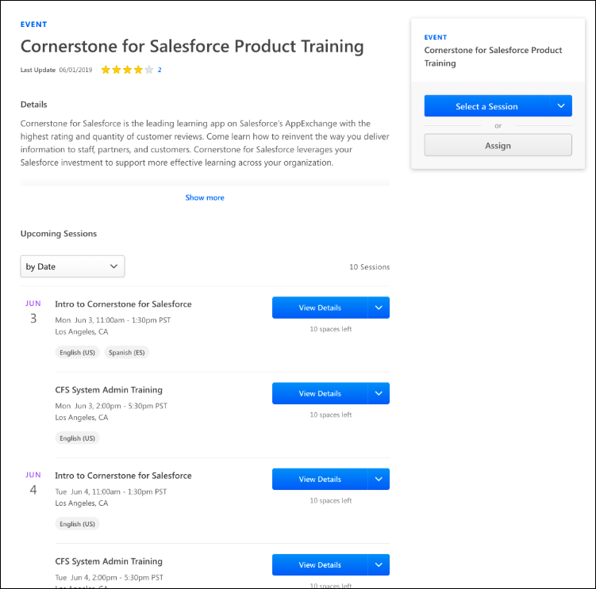
Event Details
In the Actions Card of the Learning Details page, the following information displays for the event:
- Training Type (event)
- Training Title
- Training Price - If a price has been configured for an event, the price displays in the Actions Card. Even if no sessions are currently scheduled for an event, the event price displays on the Learning Details page, if a price has been configured for the event. Note: When a user views the Learning Details page for an event, the event may have several available sessions. If these sessions have different prices, the Event Price text will state, "Session Price Varies" instead of an actual event price.
Actions
In the Actions Card of the Learning Details page, the primary action for the training item displays as a button. If a user accesses the Learning Details page for an event and the user has not already registered for a session of the event, a Select a Session button displays. Clicking this button automatically scrolls the user to the Upcoming Sessions section on the page, where the user can choose and register for a session.
If the user is able to assign training to other users, an Assign button displays, allowing them to assign the training to users to whom they have permission to assign training.
Upcoming Sessions
On the Learning Details page for events, an Upcoming Sessions section displays. The Upcoming Sessions section contains the following features:
- Sort drop-down - This drop-down allows the user to sort the sessions according to selected criteria. For example, the sessions can be sorted by date.
- Total number of sessions - The total number of sessions currently available for the event displays.
- Dates - The date on which the session will occur displays to the left of the session.
- Registration Deadline - If the Hide Registration Information option in ILT Preferences is not selected, a registration deadline alert displays in the Upcoming Sessions section. If a session does not have a registration deadline configured, the registration deadline defaults to the session start date.
- Sessions - Each session displays with the following information and options:
  - Title - This is the Session ID of the session.
  - Date and Time - This field displays the day of the week, date, time, and time zone of the session.
  - Location - This field displays the location of the session. When the address for a session is part of a location hierarchy, learners see the address of the session's actual location on the Session Details flyout. For example, if the session location is part of the EMEA > France > Paris hierarchy, the address that displays to the learner is the Paris location address.
  - Available Languages - Any languages supported by the session display as tags.
  - Price - If the session has a price, the price displays above the Action button. Event and session prices display with a strikethrough if the user viewing the page has the event or session included in a subscription. The strikethrough helps make it clear to the user that they do not need to pay the standard price for the event or session, as it is already included in their subscription.
  - Action Button - The action button provides access to any available actions for the session. The following actions may be available:
    - View Details - Clicking this option opens the Session flyout, where training details about the session display. Metadata about the session is available in the Session flyout, along with any associated prerequisites, pre-work, or post-work.
    - Select a Session - This option allows the user to select the session and add it to their transcript.
    - Add to Waitlist - If a session is full, an Add to Waitlist option displays for the session. If a user clicks the Add to Waitlist link, they are immediately placed on the waitlist for the session, and the user is redirected to their transcript. The waitlist will be managed by the system in the manner configured by the administrator who created the event.
    - View Roster - This option is available for administrators and ILT instructors when they view their sessions. Click the View Roster link to be redirected to the Roster page for the session within the same browser window. If a user is registered for a session, this option will not be available for this session. For more information about managing a session roster: See Session Roster - Roster Tab.
    - Notify Me of New Sessions - To be notified when new sessions are added for the event, the user can click the Notify Me of New Sessions link, which is located in the Options drop-down menu for the session. This navigates the user to the Interest Tracking page, and the user can specify that they would like to be notified when new sessions are added to the event.
      - Note: The "ILT Session Becomes Available" email must be configured via Email Administration in order for users to be notified via email when a new session is available for an event in which they are interested.
      - Note: If Interest Tracking is not enabled via ILT Preferences, the Notify Me of New Sessions link does not display.
    - Request - Clicking this option triggers a session request from the user. Note: If prerequisites are configured for the session, the prerequisites may have to be satisfied before the training can be requested. Administrators, it is also possible that the session has been configured to not allow users to request an exception to the prerequisites. More information on this can be found in ILT Preferences. See Exception Requests on page 38 for additional information.
    - Register - Clicking this option registers the user for the session.
    - Add to Cart - Clicking this option redirects the user to the shopping cart checkout process for the session.
    - Add to Waitlist - Clicking this option adds the user directly to the waitlist for the session.
    - Withdraw - Clicking this option withdraws the user from a session that the user is already registered for.
    - Save for Later/Remove from Saved - Clicking this option saves the session for later on the user's Learner Home page, or removes the session from the user's Learner Home page if it had already been saved.
    - Add to Playlist - Clicking this option triggers the playlist flyout, which allows the user to add the session to an existing playlist a new playlist.
  - Seats Available - The number of currently registered users displays with the total number of seats available. If no seats are currently available, the phrase "No seats available" displays. The visibility of this functionality is controlled by the Hide Registration Information option in ILT Preferences
  - Status - If the user is registered for the session, the user’s transcript status displays below the Action button instead of the number of spaces left in the session.
Note: Only sessions available to the user will display, meaning Availability Criteria and Advance Registration settings will be respected, so it is possible that not all sessions in the portal will display to the user. The Do not allow users to Request this session by Exception Request. If checked, only users in availability below will see this session preference does NOT apply here.
Session Flyout
The Session flyout is opened by clicking the View Details button for the session on the Learning Details page for the event. The Session flyout displays training details and metadata for the session, training contact information, custom fields, and any prerequisites. If enabled, you can also view links to resources and information about penalties.
If the user viewing the flyout is able to assign training, the Assign button displays at the bottom of the flyout. The primary action button displays the primary action available for the session, and additional options may be accessible by clicking the drop-down menu on the right side of the button.
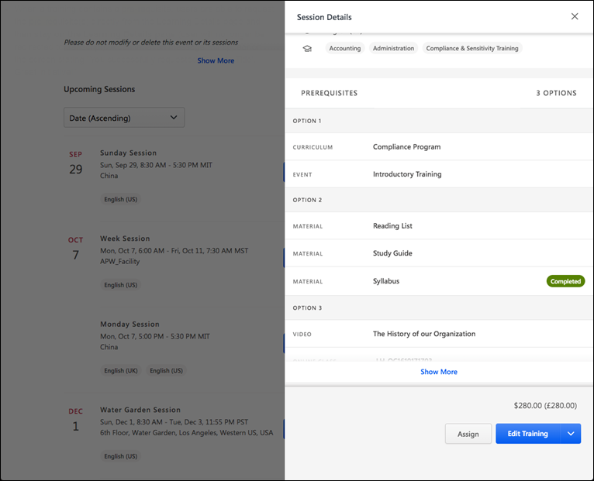
Notify Me When New Sessions Are Available
To be notified when new sessions are added for the event, the user can click the Notify me when new sessions are available link. This link, along with a zero state image, displays when no sessions are currently available. Note: The ILT Session Becomes Available email must be configured via Email Administration in order for users to be notified via email when a new session is available for an event in which they are interested.
Exception Requests
Users can generate an exception request when a session they are requesting has prerequisite training that the user has neither requested nor completed. However, exception requests can only be requested ifenabled for the session.
If the user requests a session with prerequisites, but the user has not yet completed the prerequisites, a pop-up appears and includes the following options:
- See Prerequisites- When this option is clicked, the following occurs, depending on the number of prerequisites configured for the session:
  - If there is a single prerequisite, the learner is redirected to the learning details page of the prerequisite.
  - If there are several prerequisites or several prerequisite options, the learner is redirected back to one of the following:
    - The learning details page of the curriculum where the prerequisites display.
    - The session flyout, where the prerequisites display. Note: It may be necessary to scroll down on the flyout to view the list of prerequisites.
- Exception Request- Click this option to submit an exception request for the prerequisite.
For more information about exception requests: See Exception Requests.
For more information about approving and denying exception requests as an administrator: See Grant/Deny Requests.
Session Scheduling Conflict Pop-Up
A pop-up displays when a learner attempts to register for a session that conflicts with the time and date of another session for which they are already registered. This allows the learner to decide if they want to register for the session despite the conflict or stop the registration process for the new session.
If the learner would like to cancel their registration request, they can click the X button in the upper-right corner of the pop-up. If the learner would like to proceed with registering for the training despite the scheduling conflict, they can click the Continue button. The registration request will be completed, and the user will have multiple sessions scheduled for the same time on their transcript.
One Waitlist Per Person Pop-Up
When a learner is already on the waitlist for an instructor-led training (ILT) session and then the learner attempts to add themselves to the waitlist for another session within the same event, a notification appears, stating that the event is limited to one waitlist per person. The learner must then acknowledge that if they proceed, they will be removed from the other waitlist.
If the user clicks the Continue button, they will be removed from the waitlist they were already on, and then they will be added to the waitlist for the selected session of the event.
Note: This behavior only applies in portals where the ILT Preference setting Limit Users to One Waitlist Per Person is configured. See ILT Preferences - General.
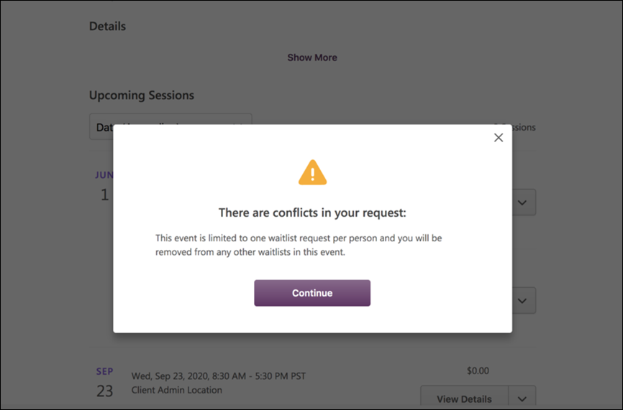
Considerations
The following considerations apply to the Learning Details page for events and sessions:
- Sessions Display - The Upcoming Sessions list for an event now displays all sessions available to the user
- View Full Calendar link - This link, which is available for the legacy Event Details page, is NOT available when viewing the new Learning Details page for an event

Learning Details - Curricula
When a user accesses the Learning Details page for a curriculum, they are able to view the contents of the curriculum. A list of the child training included in the curriculum displays on the Learning Details page in a flat, easy-to-view design.
Additionally, the contents of a curriculum are not clickable, to prevent user confusion about how to consume the curriculum training. If there is a pre-launch workflow configured for the curriculum, users can initiate it from the Action card. Similarly, if there are no pre-launch workflows configured, the user can click the OPEN CURRICULUM option to access the Curriculum Player and consume the child training from within the Curriculum Player.
Each child training item within the curriculum displays on the Learning Details page with the following information:
- Training type - This is the type of training, such as online course, curriculum, event, etc.
- Training Title - This is the title of the training item.
Note: If a curriculum is configured with nested levels, that structure is represented for one level on the Learning Details page.
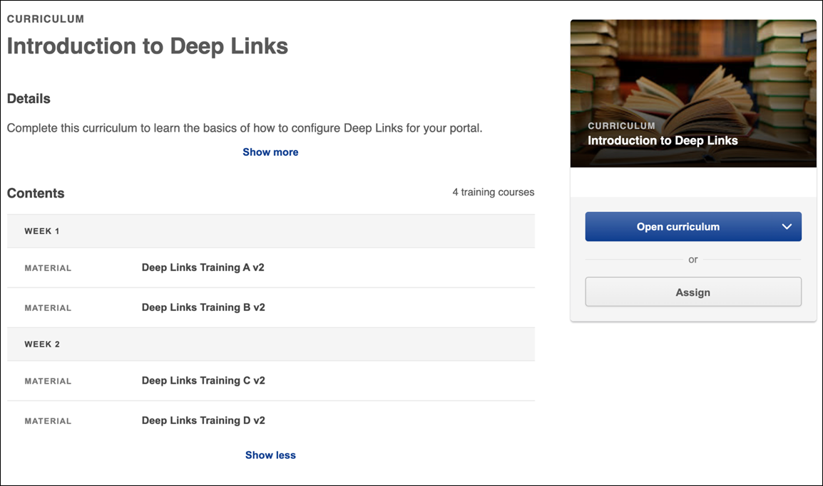
Exception Requests
Users can generate an exception request when a session they are requesting has prerequisite training that the user has neither requested nor completed.
If the user requests a session with prerequisites from the Curriculum Details page, but the user has not yet completed the prerequisites, a pop-up appears and includes the following options:
- See Prerequisites - When this option is clicked, the following occurs, depending on the number of prerequisites configured for the session:
  - If there is a single prerequisite, the learner is redirected to the learning details page of the prerequisite.
  - If there are several prerequisites or several prerequisite options, the learner is redirected back to one of the following:
    - The learning details page of the curriculum where the prerequisites display.
    - The session flyout, where the prerequisites display.
- Exception Request - Click this option to submit an exception request for the prerequisite.
For more information about exception requests: See Exception Requests.
For more information about approving and denying exception requests as an administrator: See Grant/Deny Requests.
Considerations
The following considerations apply to the Learning Details page for curricula:
- If the curriculum structure exceeds a certain length, a Show More link displays. The user can click this link to expand the entire curriculum and view all of its contents.

Learning Details - Training with Recurrence
If a training item has recurrence enabled, users can request a training item they have already completed to receive a second assignment and completion date.
If a user has already completed a training item that allows recurrence, Request displays as the primary action for that training item on the Learning details page, allowing the user to request the training again to receive a second assignment of the item and complete it again. The Launch option is available for completed training in the Options drop-down menu. Note: This behavior only applies when the learner is viewing the version of the training that they have completed. If the training has been versioned, the updated behavior will not apply. The learner is still able to request the new version, but the training is available in the Options drop-down.
Request New Instance of Completed Training
When a user has completed a training item that allows recurrence, they can request it again and complete a new instance of it by selecting the Request option available for the training on the Learning Details page.
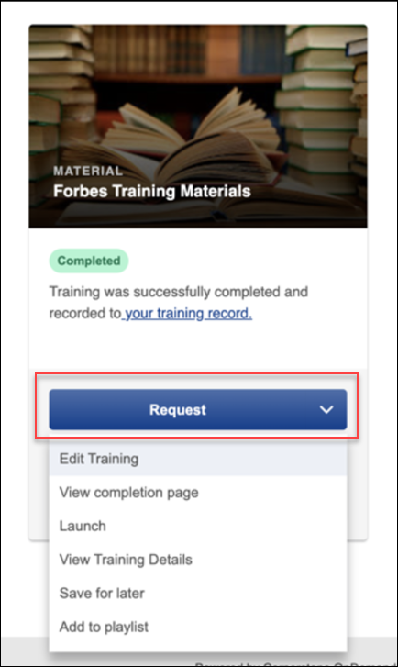
Selecting the Request option opens a pop-up window which alerts the user that they are about to begin a new assignment of the training item. The user must confirm this action by clicking the Request button in the pop-up, in order to complete the request for a new instance of the training. The pop-up also informs the user that if they only want to review the training they have already completed, they can do so by selecting the Launch option from the Options drop-down on the Learning Details page instead.
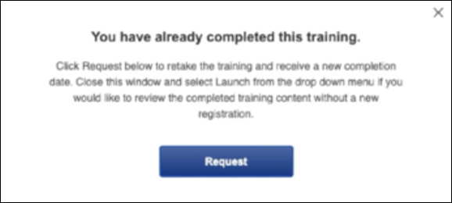

Learning Details Page (Legacy Design)
The layout of the Learning Details (Legacy Design) provides access to the features described in this topic.
Permissions
PERMISSION NAME | PERMISSION DESCRIPTION | CATEGORY

Assign Training | Grants ability to assign learning objects to the transcripts of those for whom the user is the assigned manager, approver or cost center approver. This is a manager/approver permission. | Learning

Course Reviews and Ratings - Manage | Grants ability to delete other users' reviews/ratings. This is an administrator permission. | eCommerce - Administration

Inventory - Manage | Grants ability to purchase multiple learning object licenses with the intent to assign that training to other users at a later time. This permission can be constrained by OU and User's OU. | eCommerce

Learning Badge - View | Grants ability to view the Badge field on the Learning Details page and the Training Completion page. This permission cannot be constrained. | Learning

Learning Points - View | Grants ability to view the Points field on the Learning Details page and the Training Completion page. This permission cannot be constrained. | Learning

LO Attachments - Manage | Grants ability to upload attachments to learning objects. Administrators with this permission are automatically granted the LO Attachments - View permission. This permission can be constrained by User's ILT Provider, Provider, and ILT Provider. This is an administrator permission. | Learning - Administration

LO Attachments - View | Grants ability to view the learning object attachments that are set to be available to administrators. This permission can be constrained by User's ILT Provider, Provider, and ILT Provider. This is an administrator permission. | Learning - Administration

LO Detail | Grants ability to view the LO Details page. This permission cannot be constrained. | Learning
Breadcrumbs
At the top of the page, the breadcrumbs for the page are displayed. Users can click the links within the breadcrumbs to navigate to those pages. Note: The page to which the Home icon is linked is configured by the administrator in Navigation Tabs and Links. Also, if a user navigates to the Learning Details page from either the Payment or Review page within the checkout process, the breadcrumbs include a link to the Shopping Cart.
Learning Summary
A detailed summary of the Learning is displayed below the breadcrumbs. The following information is displayed:
- Training Type icon
- Learning Title
- Learning Type
- Provider
- Training Hours
- Cost - This field displays the cost in the currency that is configured for the end user. This displays in currency and training units when both are configured for the learning. If pricing is disabled for the portal, then this field is hidden.
For training that is part of a subscription, the following pricing changes apply:
  - The price for the training displays with a strikethrough in the details section at the top of the page.
  - The price in the Price field will still display as it was set for the subscription, but it will show a strikethrough through the price. This will communicate to the user that this learning item is available to them via subscriptions for free.
  - The amount in the Training Units field, if applicable, will also be zero.
  - An Add to Cart button does not display, even if a price is normally associated with the training. Training that is within a subscription bypasses the checkout process, and the training can be requested instead of having to be purchased. Note: A transaction will still occur in the system for the training. The training item's usual price will be indicated in the transaction, and the subscription will be identified in the transaction.
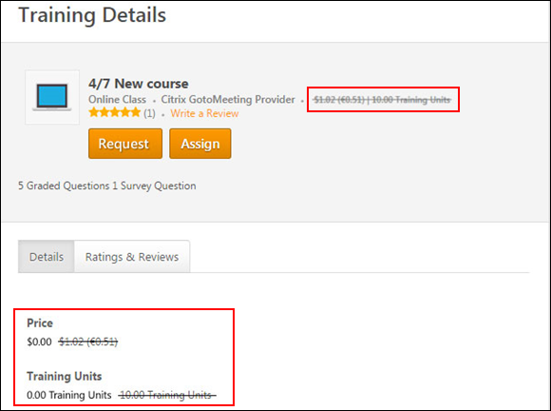
- Course Rating and Number of Ratings/Reviews - This displays the average learning item rating and the number of reviews that are available to the user based on the Course Ratings Preferences. This information is only displayed if course ratings are enabled and the course ratings are available to the user. Only the ratings and reviews that are available to the user are displayed and factored into the average course rating.
  - When the user clicks the star ratings or the number of ratings, the user is directed to the portion of the Learning Details page where the Reviews section is displayed.
- Write a Review - Click this link to write a review for the learning item. This opens the Write a Review pop-up. See Learning Details Page (Legacy) - Rate this Training on page 83 for additional information. This link is only available when course ratings are enabled and the user is able to view and apply course ratings for the selected learning item.
  - If the user has provided at least one rating or review for the course, then the Edit your Review link is available. Click the link to edit the review. See Learning Details Page (Legacy) - Rate this Training on page 83 for additional information.
- Course Description
Note: The information that is displayed may vary, depending on standard fields, custom fields, preferences, and system configuration.
Actions
The actions that are available may vary based on learning type. See Learning Details Page (Legacy) - Actions on page 66 for additional information.
Training Plan and Training Purpose
For some learning items, it may be required for users to select a training plan and/or training purpose before performing an action on the learning item (e.g., Assign, Request). When a user selects an action on the Learning Details page that requires the selection of either a training plan or training purpose, a pop-up opens, which enables them to make the appropriate selections. See Learning Details Page (Legacy) - Training Plan and Training Purpose on page 82 for additional information.
Sessions Tab
When viewing the Learning Details page for an event, the Sessions tab enables users to view the event sessions. This tab is only available when viewing the Learning Details page for an event. See Learning Details Page (Legacy) - Sessions Tab on page 79 for additional information.
Details Tab
The Details tab is selected by default and displays the learning details. Note: Tabs are only displayed when ratings and reviews are enabled and course ratings for the selected learning item are available to the user. If the tabs are not displayed, then the learning details appear below the course description. See Learning Details Page (Legacy) - Details Tab on page 48 for additional information.
Ratings & Reviews Tab
The Ratings & Reviews tab of the Learning Details page enables users to view the average review score for the learning item, the user's review for the learning item, and other available reviews for the learning item. See Learning Details Page (Legacy) - Ratings and Reviews Tab on page 69 for additional information.
Learning Details Redesign
With the February 2019 release, a redesigned Learning Details page was released as an Early Adopter project. As of the August 2020 release, this project is no longer in an Early Adopter status and is now generally available. The Learning Details page is available for the following training types if enabled by your system administrator:
- Curricula
- Events and Sessions
- External Content
- Materials
- Online Content
- Online Courses
- Tests
- Videos
More features will be added to the Learning Details page in future releases. For more information about the redesigned Learning Details page: See Learning Details Page on page 23 for additional information.

Learning Details Page (Legacy) - Details Tab
The Details tab is selected by default and displays the learning details. Note: Tabs are only displayed when ratings and reviews are enabled and course ratings for the selected learning item are available to the user. If the tabs are not displayed, then the learning details appear below the course description.
To access the details for a learning item, click the Details tab on the Learning Details page. If ratings and reviews are not available for the learning item, then no tabs are available and the learning details are displayed below the course description.
Permissions
PERMISSION NAME | PERMISSION DESCRIPTION | CATEGORY

Learning Badge - View | Grants ability to view the Badge field on the Learning Details page and the Training Completion page. This permission cannot be constrained. | Learning

Learning Points - View | Grants ability to view the Points field on the Learning Details page and the Training Completion page. This permission cannot be constrained. | Learning

LO Attachments - Manage | Grants ability to upload attachments to learning objects. Administrators with this permission are automatically granted the LO Attachments - View permission. This permission can be constrained by User's ILT Provider, Provider, and ILT Provider. This is an administrator permission. | Learning - Administration

LO Attachments - View | Grants ability to view the learning object attachments that are set to be available to administrators. This permission can be constrained by User's ILT Provider, Provider, and ILT Provider. This is an administrator permission. | Learning - Administration
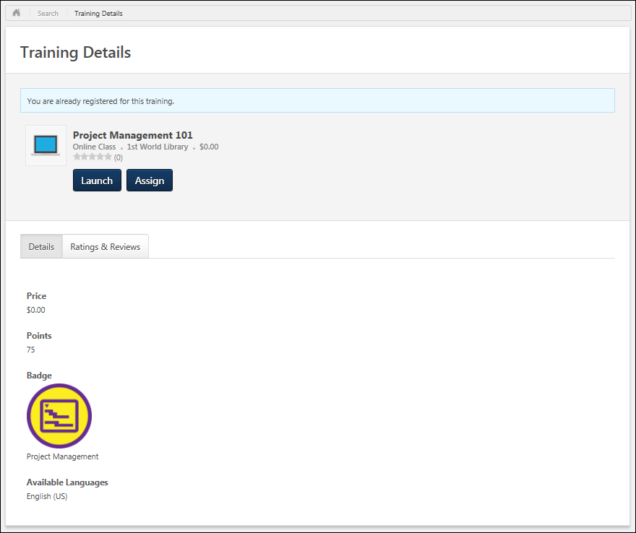
The fields that display vary by course, user, and portal configuration.
The following information may be displayed:
- Price - This displays the cost in the currency that is configured for the end user. This displays in currency and training units when both are configured for the learning item. If pricing is disabled for the portal, then this field is hidden.
- Points - This displays the total number of points the user will receive by completing the learning item. If the learning item has an associated badge, then this includes the points associated with the learning item and the learning item's badge. If there are no points associated with the learning item, then this field is hidden. Also, this field is only visible if the user has permission to view Learning Points.
- Badge - This displays the badge associated with the learning item. If there is no badge associated with the learning item, then this field is hidden. Also, this field is only visible if the user has permission to view Learning Badges.
- Language Equivalencies - This section displays all courses that are equivalent to the learning item, but are in a different language. The user can click the title for a language equivalent to navigate to the Learning Details page for the learning item. Language Equivalent Example: Item 1 has a language equivalent of Item 2, and a user is required to complete Item 1. If the user completes Item 2, then the user is exempt from having to complete Item 1, because Item 2 is a language equivalent of Item 1. If no language equivalent is set for this learning item, then this field is hidden.
- Available Languages - This displays all languages in which the learning item is available. This field is displayed even if only one language is enabled for the portal.
- Version - This is only available for learning items that can be reversioned.
- Start Date - This is only available for materials. If the material does not have a start date, then the field does not display.
- End Date - This is only available for materials. If the material does not have a end date, then the field does not display.
- Training Equivalencies - This section displays all courses that are equivalent to the learning item. The user can click the title for a training equivalent to navigate to the Learning Details page for the learning item. Training Equivalent Example: Item 1 has a training equivalent of Item 2, and a user is required to complete Item 1. If the user completes Item 2, then the user is exempt from having to complete Item 1, because Item 2 is a training equivalent of Item 1. If no training equivalent is set for this learning item, then this field is hidden.
- Resources - This section displays any documents that have been attached to the learning item and are visible to the user. The user must also page permission to view or manage learning item attachments. Users can click the attachment title to open the document.
- Subjects
- Registration Deadline - This is displayed for sessions and cohorts only.
- Seats Available - This is displayed for sessions and cohorts only.
- Maximum Registration - This is displayed for sessions only and is only visible to administrators.
- Currently Registered - This is displayed for sessions only and is only visible to administrators.
- Training Contact
- Recommended Training - This section displays all courses that are recommended for users who complete this learning item. Administrators are able to specify recommendations for learning items in the Course Catalog. Users can click the title to navigate to the Learning Details page for the learning item. If no recommended training is set for this learning item, then this field is hidden.
- Request this training from a Library - If the learning item is a part of a library, then this section displays all of the libraries of which the learning item is a part. Users can click the library title to navigate to the Learning Details page for the library. When a learning item is required to be requested through a library, then users cannot request the learning item; in this scenario, the user must request the library. If the learning item is not a part of any libraries, then this field is hidden.
Prerequisites
The Prerequisites section displays in the Details tab for learning items that have associated prerequisites. If no prerequisites are configured for the learning item, this section does not display. See Learning Details (Legacy) - Details - Prerequisites on page 60 for additional information.
Certifications
The Details tab for certifications is separated into two sections. The general information about the certification displays in the upper half of the page, and the certification periods display in separate boxes in the lower half of the page. See Learning Details (Legacy) - Details - Certifications on page 53 for additional information.
Cohort - Structure
When viewing the Learning Details page for a cohort, the Cohort section enables users to view the cohort structure. See Learning Details (Legacy) - Details - Cohort - Structure on page 57 for additional information.
Curriculum - Structure
When viewing the Learning Details page for a curriculum, the Curriculum section enables users to view the curriculum structure. See Learning Details (Legacy) - Details - Curriculum - Structure on page 58 for additional information.
Event - Sessions
When viewing the Learning Details page for an event, the Sessions tab enables users to view the event sessions. This tab is only available when viewing the Learning Details page for an event. See Learning Details Page (Legacy) - Sessions Tab on page 79 for additional information.
Library - Structure
When viewing the Learning Details page for a library, the Schedule section enables users to view the library structure. See Learning Details (Legacy) - Details - Library - Structure on page 59 for additional information.
Program - Cohorts
When viewing the Learning Details page for a program, the Cohorts section enables users to view the program's active cohorts. See Learning Details (Legacy) - Details - Program - Cohorts on page 61 for additional information.
Session - Schedule
When viewing the Learning Details page for a session, the Schedule section enables users to view the session's parts schedule. See Learning Details (Legacy) - Details - Session - Schedule on page 63 for additional information.
Learning Details Redesign
With the February 2019 release, a redesigned Learning Details page was released as an Early Adopter project. As of the August 2020 release, this project is no longer in an Early Adopter status and is now generally available. The Learning Details page is available for the following training types if enabled by your system administrator:
- Curricula
- Events and Sessions
- External Content
- Materials
- Online Content
- Online Courses
- Tests
- Videos
More features will be added to the Learning Details page in future releases. For more information about the redesigned Learning Details page: See Learning Details Page on page 23 for additional information.
Learning Details (Legacy) - Details - Certifications
The Details tab for certifications is separated into two sections. The general information about the certification displays in the upper half of the page, and the certification periods display in separate boxes in the lower half of the page.
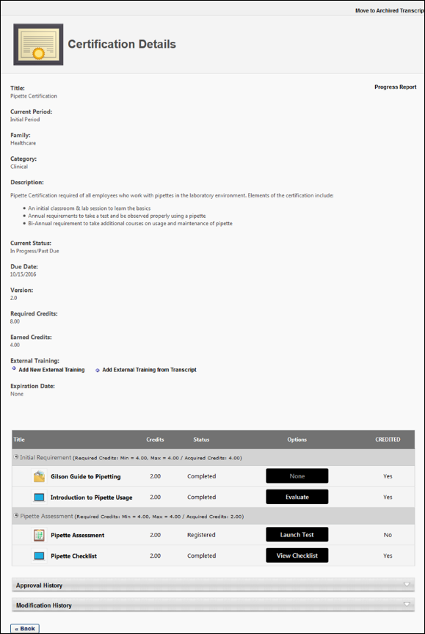
Actions
Depending on the accessing user's permissions and availability, the following action buttons may be available on the Learning Details page for the certification:
- Assign - If the certification is available to the user and the user is able to assign training to users, the Assign button displays. The user can click the Assign button to begin assigning the certification to available direct reports. When a manager with the permission for assigning certifications accesses the Training Details page for a certification, they will only see an Assign button if they are included in the availability settings for the certification. If the manager is not included in the certification's availability, they cannot assign the certification to users.
- Request - If the certification is available to the user accessing the Training Details page for the certification and the certification is not already on the user's transcript, the Request button displays. The user can click the Request button to request the certification.
- Manage - Users who have the certification on their transcript have access to a Manage button on the Training Details page for the certification. Clicking the Manage button navigates the user to the certification transcript, where the user can access the training contained within the certification.
General Information
This section displays the general details for the certification. The following information displays:
- Certification Icon - A certification icon displays to the left of the title.
- Title - The title displays at the top of the page.
- Learning Type - "Certification" displays as the learning type.
- Certification Family - The certification family displays to the right of the learning type.
- Certification Category - The category for the certification displays to the right of the certification family.
- Assign - The Assign button now displays at the top of the page.
- Request - The Request button now displays at the top of the page.
  - If requesting a certification has prerequisites that the user has not completed, a pop-up displays indicating that prerequisites are required. The user is informed that they can submit an exception request to be exempted from the prerequisites. The user can click Yes to request the training or No to cancel the request.
- Description - The description for the certification displays below the title information.
- Owner - This displays the name of the certification owner.
- Contact - This displays the training contact for the certification.
- Current Version - This displays the version number for the certification.
- Available Languages - This displays the languages defined for the certification.
- Prerequisites - If prerequisites are configured for the certification, they display below the available languages.
- Certification Period - This displays a drop-down from which to select the certification period that you would like to view. This option only displays for certifications for which a renewal period is defined. Click the drop-down to view and select the period. By default, all certification periods display. Note: The titles of the certification periods are defined by the administrator on the Scheduling tab when configuring the certification.
Certification Periods
Each certification period displays in a separate box. The following information displays for each period:
- Period - This displays the certification period.
- Due - This displays when the certification is due.
  - Relative Due Date - For certifications with a relative due date defined, the Due field displays the time frame from the start date (i.e., "2 days from start date," or "1 year from start date").
  - Fixed Due Date - For certifications with a fixed due date defined, the Due field displays the actual date.
- Duration - This displays for renewal periods and shows the duration of the renewal period.
- Required Credits - This displays the number of credits required to be completed in order to complete the certification.
- Expand/Collapse - An Expand/Collapse option displays in the upper-right corner of the period. Click the icons to view or close the information in the period. By default, all certification periods are expanded.
- Requirements - This column displays the sections for the certification and lists the learning items defined for each section.
  - If the certification is configured to override the Course Catalog learning availability settings, then all learning items display for the user regardless of whether or not the user meets the availability criteria for the learning items.
  - If the certification is not configured to override the Course Catalog learning item availability settings, then the only learning items that display are the items for which the user meets the availability criteria.
- Credits - This column displays credits information for the certification. If the certification is configured not to override learning item availability, then the number of credits is dependent upon the availability of the learning items in the certification.
  - Min/Max - This displays the minimum and maximum number of credits to be completed for a section.
  - Number of Credits - The number of credits defined for a learning item displays in the Credits column for each item.
Availability
The Training Details page for certifications respects the availability settings of the certification. The following scenarios result from this behavior:
- If a user is not included in the availability configured for the certification, they will NOT see a Request button on the Training Details page for the certification and cannot request the certification.
- If a user is not included in the availability configured for the certification, a notification stating that the certification is unavailable displays to the user when they access the Training Details page for the certification.
- When a manager with the permission for assigning certifications accesses the Training Details page for a certification, they will only see an Assign button if they are included in the availability settings for the certification. If the manager is not included in the certification's availability, they cannot assign the certification to users.
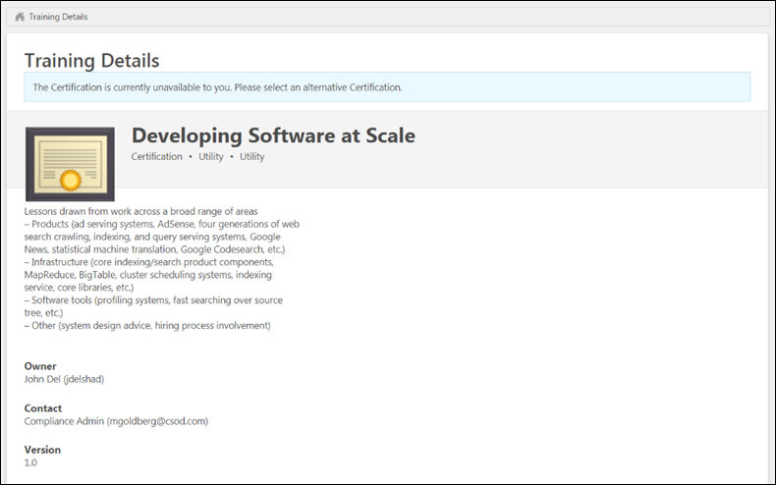
Visibility of Learning Objects
The learning items that display on the Details tab are dependent upon the settings defined by the administrator for the certification.
- If the certification is configured to override the Course Catalog learning item availability settings, then all items display for the user regardless of whether or not the user meets the availability criteria for the learning items.
- If the certification is not configured to override the Course Catalog learning item availability settings, then the only learning items that display are the items for which the user meets the availability criteria.
Learning Details (Legacy) - Details - Cohort - Structure
When viewing the Learning Details page for a cohort, the Cohort section enables users to view the cohort structure.
Cohort Structure Details
The learning items within the cohort are separated into sections, which matches the cohort structure.
For each learning item in the cohort, the following information is displayed:
- Type - The icon to the left of the title indicates the type.
- Title - The user can click the title to navigate to the Learning Details page for the learning item.
- Description - Only the first three lines of the description display. If the description exceeds three lines, a View more link is available at the end of the description. Click this link to view the full description.
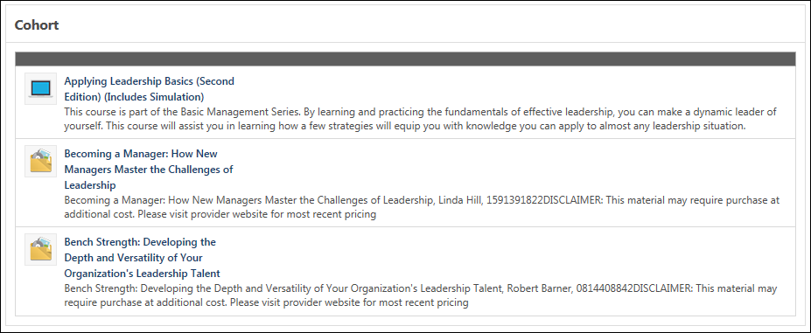
Learning Details (Legacy) - Details - Curriculum - Structure
When viewing the Learning Details page for a curriculum, the Curriculum section enables users to view the curriculum structure.
Curriculum Structure Details
The learning items within the curriculum are separated into sections, which matches the curriculum structure.
For each item in the curriculum, the following information displays:
- Type - The icon to the left of the title indicates the type.
- Title - The user can click the title to navigate to the Learning Details page for the item.
- Description - Only the first three lines of the description are displayed. If the description exceeds three lines, then a view more link is available at the end of the description. Click this link to view the full description.
- Price - This displays the cost of the item in the currency that is configured for the end user. When the price for each item within the curriculum is $0.00, then this field is hidden.
- Payment Term - This displays the payment term (e.g., Pay Upon Activation) for the item based on the administrator's configuration and the user's profile settings. If no payment term is configured for the item, then "n/a" is displayed. When the price for each item within the curriculum is $0.00, then this field is hidden.
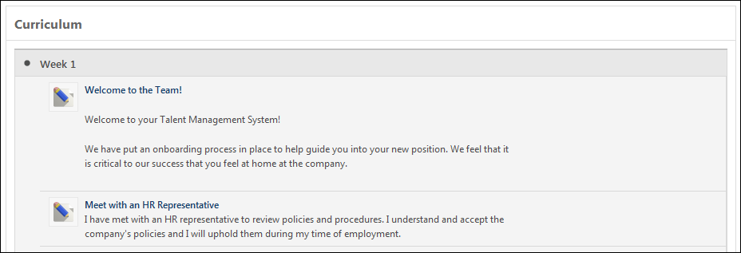
Learning Details Redesign
With the February 2019 release, a redesigned Learning Details page was released as an Early Adopter project. The Learning Details page is available for curricula if your system administrator has enabled it for that training type. More features will be added to the Learning Details page in future releases. For more information about the redesigned Learning Details page:
- See Learning Details Page on page 23 for additional information.
- See Learning Details - Curricula on page 40 for additional information.
Learning Details (Legacy) - Details - Library - Structure
When viewing the Learning Details page for a library, the Schedule section enables users to view the library structure.
Search
Users can search for learning items within the library by keyword using the Search functionality.
To search for a learning item within the library, enter the keyword in the Search Library field in the upper-right corner of the Library section and click the Search icon .
In order to clear the search and view all learning items within the library, clear the Search Library field and click the Search icon .
Library Structure Details
The learning items within the library are separated into sections, which matches the library structure.
For each learning item in the library, the following information is displayed:
- Type - The icon to the left of the title indicates the type.
- Title - The user can click the title to navigate to the Learning Details page for the learning item.
- Description - Only the first three lines of the description display. If the description exceeds three lines, a View more link is available at the end of the description. Click this link to view the full description.
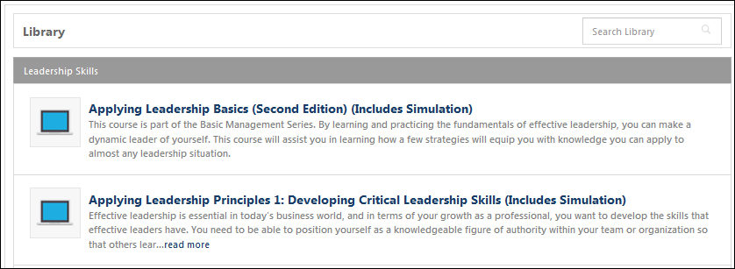
Learning Details (Legacy) - Details - Prerequisites
The Prerequisites section displays in the Details tab for learning items that have associated prerequisites. If no prerequisites are configured for the learning item, this section does not display.
To access the details for a learning item, click the Details tab on the Learning Details page. If ratings and reviews are not available for the learning item, then no tabs are available and the learning details are displayed below the course description.
Each prerequisite option is expanded by default, and can be collapsed by clicking the down arrow icon .
The prerequisite training title is a link. Users can click the link to view the Learning Details page for the prerequisite. If only one option is available, then the Option label does not display, and only the prerequisite learning items are displayed.
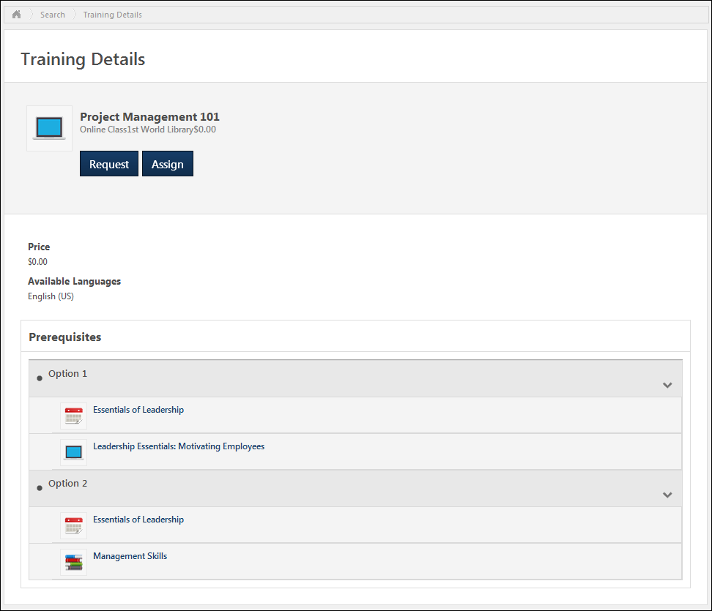
Learning Details (Legacy) - Details - Program - Cohorts
When viewing the Learning Details page for a program, the Cohorts section enables users to view the program's active cohorts.
Permissions
PERMISSION NAME | PERMISSION DESCRIPTION | CATEGORY

Assign Training | Grants ability to assign learning objects to the transcripts of those for whom the user is the assigned manager, approver or cost center approver. This is a manager/approver permission. | Learning
Cohort Details
For each of the program's active cohorts, the following information is displayed:
- Cohort Name - The user can click the cohort name to view the Learning Details page for the cohort.
- Type
- Cohort Provider
- Cohort Duration
- Cohort Start Date and Time
- Cohort End Date and Time
- Cohort Languages
- Available - This displays the number of available seats for the cohort.
Actions
The following actions may be available in the split button drop-down menu in the Actions column:
- Request
- Assign - This action is only available to managers with direct reports.
- Registration Closed - This is displayed when the registration deadline has passed. This cohort cannot be requested or assigned.
- Requested - This is displayed when the cohort has already been requested.
Click the left side of the drop-down to perform the displayed action. Or, click the drop-down arrow to select a secondary action. By default, the Action drop-down displays the primary action for the session.
When no actions are available to the user for the cohort, "None" displays in the Cohorts table.
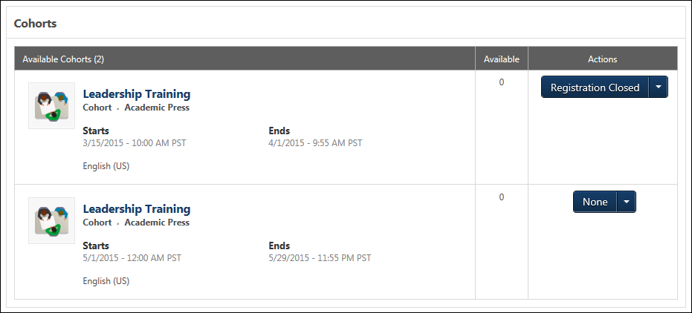
Learning Details (Legacy) - Details - Session - Schedule
When viewing the Learning Details page for a session, the Schedule section enables users to view the session's parts schedule.
Session Part Details
For each session part in the table, the following information displays:
- Part Name
- Part Location
- Part Instructor
- Part Start Date and Time - Note: If the administrator configures the session to display the start and end times in the user's time zone, then the start time displays in the user's time zone.
- Part End Date and Time - Note: If the administrator configures the session to display the start and end times in the user's time zone, then the end time displays in the user's time zone.
Events Calendar
Users can view the Events Calendar by clicking the View Full Calendar link to the right of the Schedule heading. This opens the Event Calendar page with the month of the first scheduled session part. See Events Calendar for additional information.
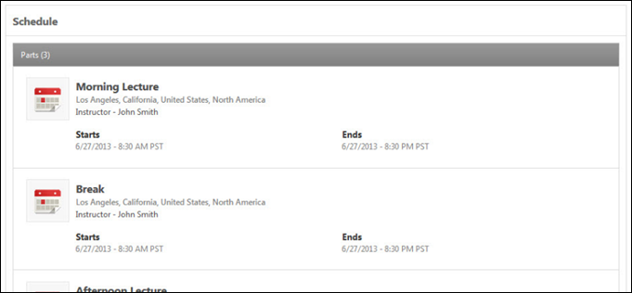

Learning Details Page (Legacy) - Interest Tracking
Interest Tracking enables a user to be alerted when a new event session becomes available if all of the available sessions are full or if the user cannot attend any of the available sessions. When a new session that meets the user's criteria is added for the event, the user will be notified via email.
When Interest Tracking is enabled for the portal and for an event, the Notify me of new sessions link is available below the Sessions section when viewing the Learning Details page for an event or the Schedule section when viewing the Learning Details page for a session. When a user clicks this link, they are navigated to the Interest Tracking page.
At the top of the Interest Tracking page, the name of the event that the user is tracking is displayed.
Enter the following criteria for the request to track the event:
- Location - Click the Select a location field or button to select the location in which you prefer to attend the event.
- Comments - Enter any comments that are relevant to the request, up to 3,000 characters.
- Notify me when this session is available at other locations. - Select this option to be notified when a session is available for this event, regardless of the session's location.
After entering the appropriate information, click the Submit button. The user is now tracking the event and will be notified when a session is available that matches the user's interest criteria. Or, the user can click Cancel to discard the request to track the event.
Note: If users are restricted from selecting a session for the event, managers can express interest on a user's behalf by clicking the Notify me of new sessions link. This opens the Interest Tracking page from which the manager can express interest. Interest Tracking notifications are sent to the manager instead of the user.
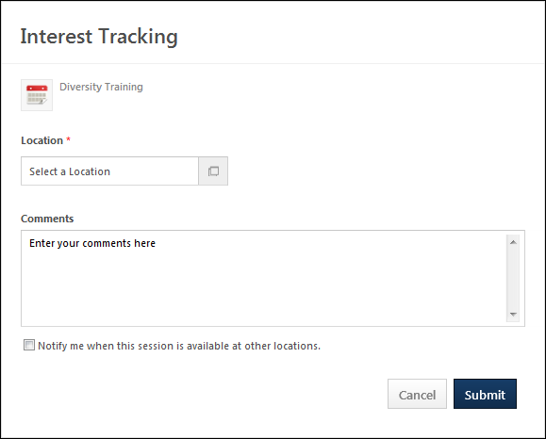

Learning Details Page (Legacy) - Actions
The actions that are available on the Learning Details page may vary based on learning type.
Permissions
PERMISSION NAME | PERMISSION DESCRIPTION | CATEGORY

Assign Training | Grants ability to assign learning objects to the transcripts of those for whom the user is the assigned manager, approver or cost center approver. This is a manager/approver permission. | Learning

Inventory - Manage | Grants ability to purchase multiple learning object licenses with the intent to assign that training to other users at a later time. This permission can be constrained by OU and User's OU. | eCommerce
The following actions may be available for each learning type on the Learning Details page.
Learning Type | Learning Actions
Online Course | Launch
 | Request
 | Add to Cart
 | Assign
Event | Request
 | Assign
Session | Request
 | Assign
 | Registration is Closed (not clickable)
 | Requested (not clickable)
 | Add to Cart
Curriculum | Request
 | Open Curriculum Player - This option is only available if the user is registered for the curriculum and if the Curriculum Player is enabled for the curriculum.
 | Assign
 | Add to Cart
Material | Request
 | Assign
 | Launch
 | Add to Cart
Library | Request
 | Assign
 | Add to Cart
Posting | Open
 | Request
Quick Course | Launch
 | Request
 | Assign
 | Add to Cart
Subscription | Request
 | Assign
Video | Launch - When the Launch option is selected, the video is automatically added to the user's transcript, the user is registered in the learning item, and the user is directed to the Launch Video page.  If the user is viewing the Learning Details page for a video for which the user has never registered, the Launch option is only available if the following conditions are met:  - The learning item does not require approval.  - The learning item is set to register upon approval.  - The learning item has no prerequisites.  - The learning item has no pre-work.  If the user is viewing the Learning Details page for a video for which the user has previously registered, the Launch option is only available if the following conditions are met:  - The learning item is registered or post registered.  - A link expiration rule has not passed for the learning item.  - A license for the learning item has not expired.
 | Request - This option is only available if the learning item requires approval.
 | Assign
Test | Request
 | Assign
 | Add to Cart
Cohort | Request
 | Assign
 | View Program - This option opens the Learning Details page for the cohort's program.

Learning Details Page (Legacy) - Ratings and Reviews Tab
The Ratings & Reviews tab of the Learning Details page enables users to view the average review score for the learning item, the user's review for the learning item, and other available reviews for the learning item.
To access the Ratings & Reviews details for a learning item, click the Ratings & Reviews tab on the Learning Details page. The Ratings & Reviews tab is available on the Learning Details page if the following are true:
- Course ratings are enabled
- The user is able to view and apply course ratings for the selected learning item
Permissions
PERMISSION NAME | PERMISSION DESCRIPTION | CATEGORY

Course Reviews and Ratings - Manage | Grants ability to delete other users' reviews/ratings. This is an administrator permission. | eCommerce - Administration
The Ratings & Reviews tab contains the following sections:
- Average Review - See Learning Details (Legacy) - Ratings & Reviews - Average Review on page 71 for additional information.
- My Review - See Learning Details (Legacy) - Ratings & Reviews - My Review on page 72 for additional information.
- User Reviews - See Learning Details (Legacy) - Ratings & Reviews - User Reviews on page 73 for additional information.
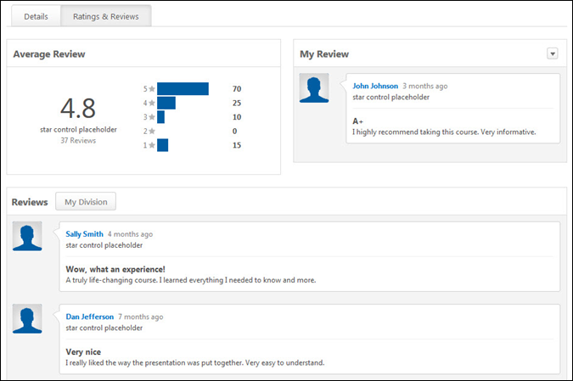
Learning Details (Legacy) - Ratings & Reviews - Average Review
The Average Review section of the Ratings and Reviews tab displays the average user rating and the total number of reviews for the learning item. Note: Users are only able to view ratings and reviews that are available to them. This may affect the average review, total number of reviews, and review breakdown. Review and rating visibility is determined by the administrator in Course Ratings Preferences.
To access the Ratings & Reviews details for a learning item, click the Ratings & Reviews tab on the Learning Details page.
The Ratings & Reviews tab is available on the Learning Details page if the following are true:
- Course ratings are enabled
- The user is able to view and apply course ratings for the selected learning item
On the left, the overall average rating for the learning item is displayed. The total number of reviews that are available for the learning item is displayed below the overall learning item rating.
On the right, the bar graph shows the distribution of the ratings for the learning item.
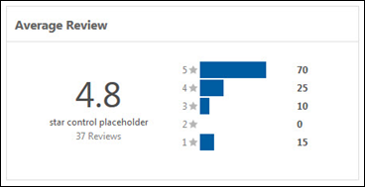
Learning Details (Legacy) - Ratings & Reviews - My Review
The My Review section of the Ratings and Reviews tab displays the user's rating and review information for the learning item. If the user has not yet reviewed the learning item, then the user is able to initiate a review of the learning item from this section.
To access the Ratings & Reviews details for a learning item, click the Ratings & Reviews tab on the Learning Details page.
The Ratings & Reviews tab is available on the Learning Details page if the following are true:
- Course ratings are enabled
- The user is able to view and apply course ratings for the selected learning item
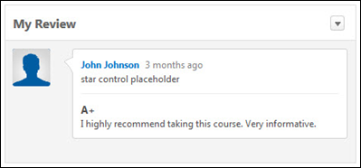
Write a Review
If the user has not yet reviewed the learning item, then a Write a Review link appears in this section. Click this link to write a review for the learning item. This opens the Write a Review pop-up. See Learning Details Page (Legacy) - Rate this Training on page 83 for additional information.
Edit Your Review
If the user has previously reviewed the learning item, then it is displayed in this section. In order to edit the review, from the drop-down in the upper-right corner of this section, select Edit. This opens the Write a Review pop-up. See Learning Details Page (Legacy) - Rate this Training on page 83 for additional information.
Delete Your Review
If the user has previously reviewed the learning item, then it is displayed in this section. To delete the review, from the drop-down in the upper-right corner of this section, select Delete.
Learning Details (Legacy) - Ratings & Reviews - User Reviews
The Reviews section of the Ratings and Reviews tab enables users to view all available reviews for the learning item, filter reviews, and delete reviews.
To access the Ratings & Reviews details for a learning item, click the Ratings & Reviews tab on the Learning Details page.
The Ratings & Reviews tab is available on the Learning Details page if the following are true:
- Course ratings are enabled
- The user is able to view and apply course ratings for the selected learning item
Permissions
PERMISSION NAME | PERMISSION DESCRIPTION | CATEGORY

Course Reviews and Ratings - Manage | Grants ability to delete other users' reviews/ratings. This is an administrator permission. | eCommerce - Administration
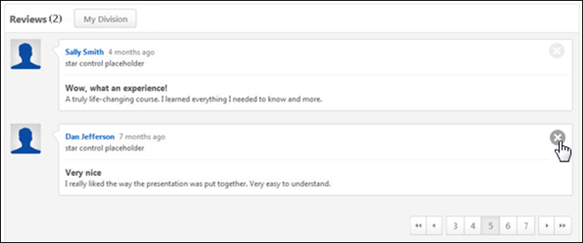
In the Reviews section, the available reviews are displayed. By default, all reviews that are available to the user are displayed. The number of reviews that are available is displayed to the right of the Reviews section header.
The following information is displayed for each review:
- Reviewer Photo - To the left of the review details, the reviewer's photo is displayed. Click the reviewer's photo to navigate to the reviewer's Profile page in Connect or the reviewer's Universal Profile - Bio page, if enabled. If anonymous ratings are enabled by the administrator and the reviewer chooses to rate the course anonymously, then a generic photo is displayed. The reviewer photo may be disabled by the administrator in Course Ratings Preferences.
- Reviewer Name - To the right of the reviewer photo, the reviewer's name is displayed. Click the reviewer's name to navigate to the reviewer's Profile page in Connect or the reviewer's Universal Profile - Bio page, if enabled. If anonymous ratings are enabled by the administrator and the reviewer chooses to rate the course anonymously, then the reviewer name displays as "Anonymous User."
- Review Timestamp - To the right of the reviewer's name, the review timestamp is displayed. This indicates when the review was made.
- Rating - The stars rating that the reviewer gave the course display below the reviewer's name. For example, if three of the five stars are highlighted, then the reviewer gave the course three out of five stars.
- Review Title - Below the rating, the review title is displayed. This is provided by the reviewer and is intended to summarize the review.
- Review - Below the review title, the reviewer's review is displayed.
Filter Reviews
Users are able to filter the reviews in order to limit the reviews that are displayed. In order to filter the reviews, select the appropriate filter from the drop-down to the right of the Reviews heading.
The following filters are available:
- All Reviews (selected by default)
- Reviews from users in my Connect Connection
- Reviews from users in my Position
- Reviews from users in my Division
- Reviews from users in my Cost Center
- Reviews from users in my Location
- Reviews from users in my Brand
- Reviews from users in my Employee Type
Delete a Review
If the user has permission to delete another user's review, then a Delete icon is available to the right of the review details. Click this icon to deactivate the review.
Pagination
If more than 25 reviews are available for the learning item, then pagination options appear in the lower-right corner of the Ratings & Reviews section.
- Click a specific page number to go directly to that page.
- To move one page forward or backward, click the right or left arrow icon.
- To move to the first or last page, click the double left or double right arrow icon.

Course Reviews and Ratings Page
The Course Reviews and Ratings page displays the details of all reviews that are visible to the user. A summary of all users' ratings is available, as well as a detailed view of each review. Only reviews that are visible to the user are displayed, based on the Course Ratings Preferences.
To view the Course Reviews for a training item, click the XX Reviews link, where XX is the number of available reviews. For example, if a course has 14 reviews, the link is 14 Reviews. On the Transcript Details page for a course, the XX Reviews link is available in the upper-right corner of the page. Note: This link is not available if the course is not configured to be reviewed and rated.
Permissions
PERMISSION NAME | PERMISSION DESCRIPTION | CATEGORY

Course Reviews and Ratings - Manage | Grants ability to delete other users' reviews/ratings. This is an administrator permission. | eCommerce - Administration
The Course Reviews and Ratings page is only available if course ratings are enabled. A specific permission is not needed for a user to be able to review and rate a course.
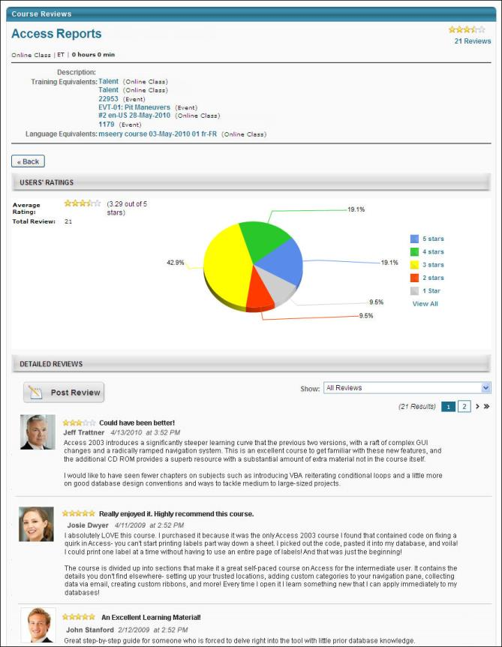
In the upper-right corner of the page, the overall course rating displays. The rating is displayed visually with a star rating. Also displayed is the number of ratings that are available for the course.
In the upper-left section of the page, an overview of the course is displayed, including the course title, LO type, LO provider, training hours, description, and any training equivalents.
In the Users' Ratings section, a summary of the course ratings displays:
- Average Rating - This displays the overall course rating visually with a star rating. To the right of the star rating is a text version of the rating out of five stars.
- Total Reviews - This displays the number of reviews that are available for the course. These are the ratings that are used to calculate the average rating.
- Pie Chart - The pie chart shows the distribution of the ratings for the course. To the right of the pie chart, the legend displays the rating that corresponds with each color in the chart. Click a section of the pie chart to view only the reviews that gave the course the corresponding rating. For example, click the "1 Star" section of the pie chart to view only the reviews that rated the course as 1 Star.
In the Detailed Reviews section, the available reviews are displayed. By default, all reviews are displayed. To view only the reviews that gave the course a certain rating, click the corresponding section of the pie chart. For example, click the "1 Star" section of the pie chart to view only the reviews that rated the course as 1 Star. You can also filter the reviews by reviewer OU using the Show drop-down list. For example, select "Reviews by users in my Position" to view only reviews made by other users in my position. The following information is displayed for each review:
- Rating - The stars display the rating that the reviewer gave the course. If three of the five stars are highlighted, then the reviewer gave the course three out of five stars, or an average rating.
- Review Title - To the right of the star rating, the review title is displayed. This is provided by the reviewer and is intended to summarize the review.
- Reviewer Name - Below the star rating, the reviewer's name is displayed. If anonymous ratings are enabled by the administrator and the reviewer chooses to rate the course anonymously, then the Reviewer name displays as "Anonymous User."
- Review Time and Date - To the right of the reviewer's name, the date and time at which the review was made is displayed.
- Review - Below the reviewer's name, the reviewer's review is displayed.
Post a Review
To review the course, click the Post Review button at the top of the Detailed Reviews section. This opens the Review and Rating pop-up. To post a review, you must meet the requirements for posting a review, which are set by the administrator. For example, for some courses, you must have registered for or completed the course in order to review the course. Note: If you have already reviewed the course, this option is not available.
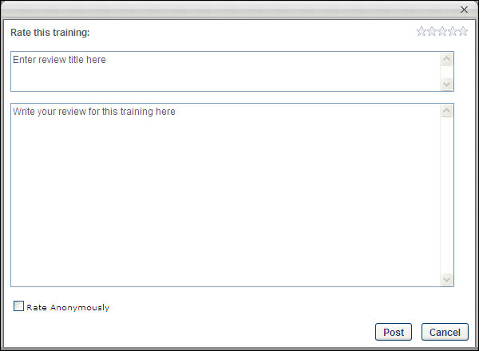
- Rating - In the Rate this training section, click the appropriate number of stars to rate the course. This rating is out of five stars. You must give the course at least 1 out of 5 stars. A zero star rating is not possible.
  - Click the fifth star to give the course 5 out of 5 stars, which is the best possible rating.
  - Click the first star to give the course 1 out of 5 stars, which is the worst possible rating.
- Title - In the Enter review title here field, enter a title for the review. This should briefly summarize the rating and review provided. The character limit for this field is 200.
- Review - In the Write your review for this training here field, enter your review. This should describe your overall thoughts on the course and explain why you rated the course the way you did. For example, if you rated the course 5 out of 5 stars, explain why the course was successful in your opinion. If you rated the course 1 out of 5 stars, explain the issues you had with the course and why you feel it is an unsuccessful course in your opinion. Be polite and respectful, and write your review in a way that will be helpful to other users who are considering the course. The character limit for this field is 2500.
- Rate Anonymously - Select this option to submit your review without displaying your name with the review. This option is only available if the administrator has enabled it.
Click Post to submit your review and post it to the Course Reviews and Ratings page.
After a review is posted, you may choose to delete the post by clicking the Remove icon to the right of the post.

Learning Details Page (Legacy) - Sessions Tab
When viewing the Learning Details page for an event, the Sessions tab enables users to view the event sessions. This tab is only available when viewing the Learning Details page for an event.
Permissions
PERMISSION NAME | PERMISSION DESCRIPTION | CATEGORY

Assign Training | Grants ability to assign learning objects to the transcripts of those for whom the user is the assigned manager, approver or cost center approver. This is a manager/approver permission. | Learning
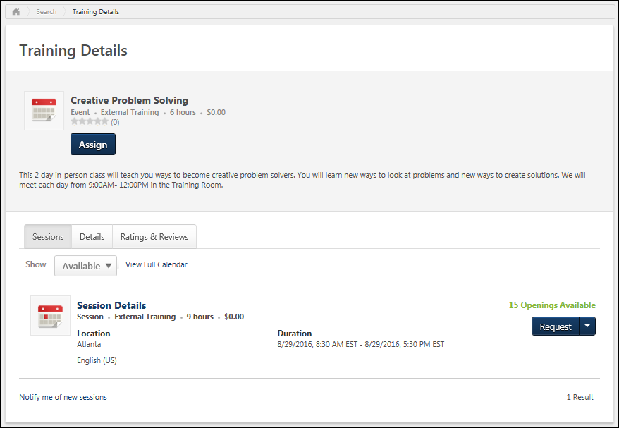
Show Available/Show All
From the drop-down menu below the Sessions tab, users can select from the following options:
- Available - Select this option to view all of the sessions that are available to the user. This option is selected by default.
- All - Select this option to view all sessions, including sessions that are not available to the user.
Session Details
For each session, the following information is displayed:
- Session Locator Number - This is only available if it is enabled by the administrator in ILT Preferences.
- Session Name - The user can click the session name to view the Learning Details page for the session.
- Type
- Session Provider
- Session Duration
- Session Price - This displays the cost in the currency that is configured for the end user. This displays in currency and training units when both are configured for the learning item. If pricing is disabled for the portal, then this field is hidden.
- Session Start Date and Time - Note: If the administrator configures the session to display the start and end times in the user's time zone, then the session start time displays in the user's time zone.
- Session End Date and Time - Note: If the administrator configures the session to display the start and end times in the user's time zone, then the session end time displays in the user's time zone.
- Session Location
- Session Languages
- Available - This displays the number of available seats for the session.
- Waitlist - This displays the number of users who are currently on the waitlist for the session.
Available Openings
If there are seats available for the session, then the number of seats displays. If there are no available seats but a waitlist is available, then the number of waitlist openings displays. If there are no available seats and no waitlist openings, then "No seats available" displays.
Actions
The following actions may be available in the split button drop-down menu:
- Add to Cart
- Assign - This action is only available to managers with direct reports.
- Request
Click the left side of the drop-down to perform the displayed action. Or, click the drop-down arrow to select a secondary action. By default, the Action drop-down displays the primary action for the session.
When no actions are available to the user for the session, "None" displays.
Events Calendar
Users can view the Events Calendar by clicking the View Full Calendar link to the right of the Show drop-down menu. This opens the Event Calendar page with the month of the first available session displayed. See Events Calendar.
Interest Tracking
If all of the available sessions are full or if the user cannot attend any of the available sessions, the user can choose to be alerted when a new session becomes available by clicking the Notify me of new sessions link. The user is navigated to the Interest Tracking page. See Learning Details Page (Legacy) - Interest Tracking on page 64 for additional information. This link is only available if Interest Tracking is enabled for the portal and for the event.
When a new session that meets the user's criteria is added for the event, the user will be notified via email.

Learning Details Page (Legacy) - Training Plan and Training Purpose
For some learning items, it may be required for users to select a training plan and/or training purpose before performing an action on the learning item (e.g., Assign, Request). When a user selects an action on the Learning Details page that requires the selection of either a training plan or training purpose, a pop-up opens, which enables them to make the appropriate selections.
In the upper-right corner of the pop-up, the action that is being performed on the Learning Details page is displayed (e.g., Assign, Request).
Select from the following options:
- Training Plan - This option is only available when training plans are enabled for the portal, a training plan is required for the user, and at least one training plan is available to the user. From the drop-down, select the appropriate training plan. This associates the training from the Learning Details page with the selected training plan.
- Training Purpose - This option is only available when training purpose is enabled for the portal and at least one training purpose has been configured for the learning item. The Training Purposing functionality tracks the context in which a user requests training by identifying a purpose for the training. From the drop-down, select the appropriate training purpose. This associates the training from the Learning Details page with the selected training purpose.
After making the appropriate selections, click the Submit button to complete the action. Or, click the Close button to cancel the action and return to the Learning Details page.
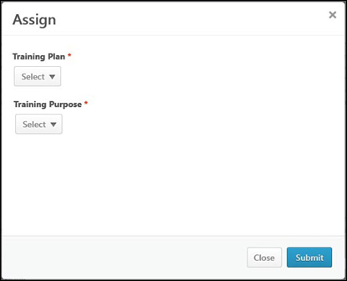

Learning Details Page (Legacy) - Rate this Training
From the Learning Details page, users can rate and review a learning item if the following are true:
- Course ratings are enabled
- The user is able to view and apply course ratings for the selected learning item
Write a Review
To write a review for a learning item:
- From the Learning Details page, click the Write a Review link. When this link is available for a user, it appears in the Ratings & Reviews tab or in the Summary section at the top of the Learning Details page.
- From the Training Completion page, click the Rate this Training link. A pop-up appears, and the training title displays at the top of the pop-up.
- Enter the following information for your review:
  - Assign Star Rating - Click the appropriate number of stars to rate the learning item. This is used to indicate how effective the training was. A rating of five stars is the highest rating available. A rating is required in order to submit a review.
  - Title - Enter a title for the review. This should briefly summarize the rating and review provided. The character limit for this field is 200.
  - Review - Enter your review. This should describe your overall thoughts on the course and explain why you rated the course the way you did. For example, if you rated the course 5 out of 5 stars, explain why the course was successful in your opinion. If you rated the course 1 out of 5 stars, explain the issues you had with the course and why you feel it is an unsuccessful course. Be polite and respectful, and write your review in a way that will be helpful to other users who are considering the course. The character limit for this field is 2500.
  - Make my review anonymous - Select this option to submit your review without displaying your name or photograph with the review. This option is only available if the administrator has enabled it in Course Ratings Preferences.
Click Submit to submit your review and post it to the Ratings and Reviews section. Or, click Close to exit the pop-up without reviewing or rating the learning item.
After a review is posted, you may choose to delete the review. To delete the review, from the drop-down in the upper-right corner of the My Review section on the Ratings & Reviews tab, select Delete.
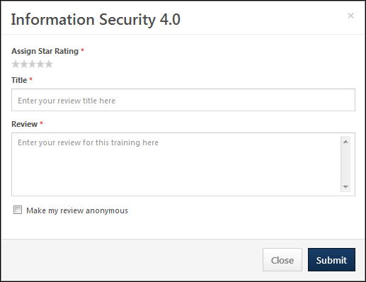

Manager Learning Actions - Overview

Approve Training Overview
Approve/Deny Pending Exemption Request
When a user requests exemption from a learning object (LO), the request appears on the Pending Exemption Requests page. The Active tab displays the details of active exemption requests, as well as and a Respond link to approve or deny a request. The Completed tab displays the details of past exemption requests. By default, the most recent request displays first. The columns cannot be sorted.
The Pending Exemption Requests page can be accessed in one of three ways:
- Select the View Training Exemption Requests link from the Inbox widget on the Welcome page.
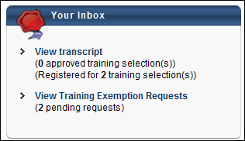
- Select the Exemption Tracking link from the Learn tab. Note: The location of this link is dependent upon the portal's Navigation Preferences configuration.
- For managers, select the link in the exemption request email, if available.
Permissions
PERMISSION NAME | PERMISSION DESCRIPTION | CATEGORY

Approve Exemption Request | Grants ability to view and respond to pending training exemption requests via the Welcome Page Inbox widget. This is an administrator permission. | Learning - Administration

Mark Transcript Exempt | Grants ability to exempt users from a learning object, using the "Mark Exempt" link on the top right corner of the target user's Transcript/Training details page. This permission can be constrained by OU, User's OU, and User's Subordinates. This is an administrator permission.  With the May '17 release, this permission also applies to prerequisites, pre-work, and post-work. Users without this permission cannot mark any training type exempt for a user. | Learning - Administration
Active Tab
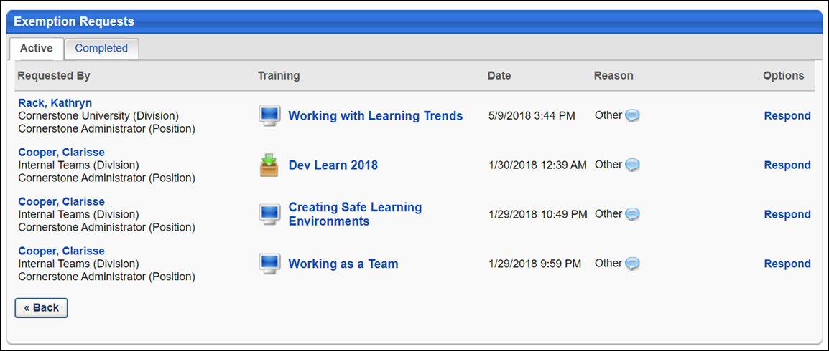
The following columns and features display in the Exemption Requests table:
- Requested By - The Requested By column displays the user who requested the exemption by last name, first name. The user's division and position display below their name. Clicking the user's name opens the Training Details page for the LO.
- Training - The Training column displays the name of the LO for which the user is requesting exemption. Clicking the LO title opens the LO Details page.
- Data - The Date column shows the date and time the exemption request was submitted.
- Reason - The Reason column displays the reason for the exemption.
- Comments - The Comments icon opens a pop-up that displays Request Comments, which includes the reason the user selected for the exemption and the comments they entered in the Comments box of the Exemption Request pop-up.
- Options - The Options column displays the Respond link from which to approve or deny a request.
Note: If the Pending Exemption Requests page is accessed via the View Training Exemption Requests link from the Inbox widget on the Welcome page, a Back button displays at the bottom of the page to return the user to the Welcome page. The Back button does not display if the page is accessed from the Exemption Tracking link or the approval page link in the exemption request email.
If an LO is removed from the user's transcript by the administrator or manager, the exemption request is deleted from the Pending Exemption Requests page.
Approve/Deny Exemption Request
The Respond link under the Options column opens the Exempt Response pop-up on which an exemption request is approved or denied.
To approve or deny a pending exemption request:
- Click the Respond link in the Options column. The Exempt Response pop-up opens.
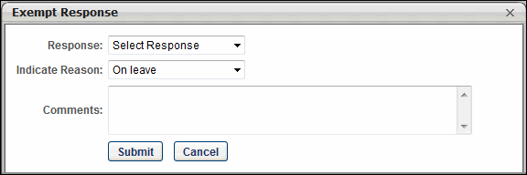
- You must select Approve or Deny from the Response field drop-down.
- Select the reason for the approval or denial in the Indicate Reason field. The reason the user selected when requesting the exemption displays by default. You can keep the reason the user selected or select a different reason from the drop-down. Note: Other is available by default in the drop-down. Additional reasons are available if configured in Exempt Training Reason Preferences and activated in Activate Exempt Training Reason Preferences (by Division).
- You must enter comments regarding the approval or denial in the Comments box.
- Click Submit. If the request is approved and submitted, the LO's status changes to Exempt on the user's transcript. If exempting a user from an LO within a curriculum, the status of the LO changes to Exempt on the Training Details page. If the request is denied, the LO's status remains unchanged. For both approved and denied requests, the action is recorded in the Approval History section of the Training Details page.
- Click Cancel to cancel the Respond action.
Completed Tab
The Completed tab on the Pending Exemption Requests page displays the details of past exemption requests. For managers, only requests marked exempt for their direct reports are visible.
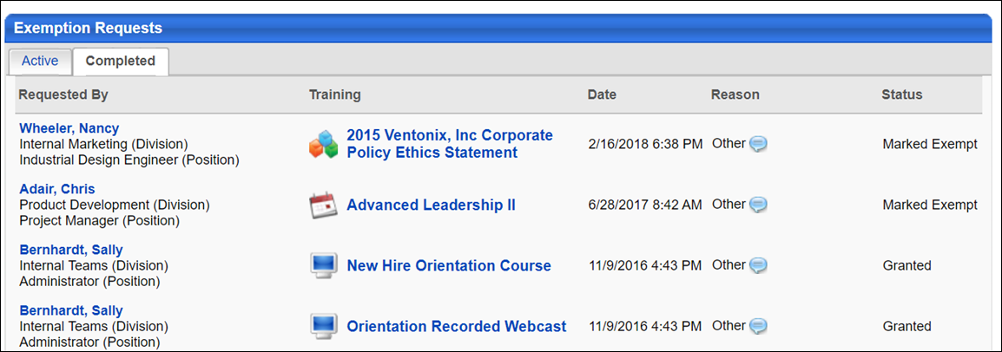
- Requested By - The Requested By column indicates the user who requested the exemption and displays by last name, first name. The user's division and position display below their name. Clicking the user's name opens the Training Details page for the LO.
- Training - The Training column displays the name of the LO for which the user is requesting exemption. Clicking the LO title opens the LO Details page. Only the Close button is available on the pop-up.
- Date - The Date column shows the date and time the exemption request was submitted or marked exempt.
- Reason - The Reason column displays the reason the user selected for the exemption.
- Comments - The Comments icon opens a pop-up that displays Request Comments and Response Comments sections. The user's reason for the request and their comments display in the Request Comments section. The approver's reason for the approval or denial and their comments display in the Response Comments section.
- Status - The Status column displays the status of both exemption requests submitted by a manager's direct reports and LOs marked exempt from the Transcript Details page or the Curriculum Player.
A Back button only displays if the page is accessed via the View Training Exemption Requests link from the Inbox widget on the Welcome page.
Manage Pending Training Requests - Manager/Approver
Managers and approvers can manage pending training requests from the View Pending Requests page.
Design Note: This page has an updated interface (UI) that is automatically enabled. However, administrators can still revert to legacy UI via Feature Activation Preferences. The page's functionality is unchanged with the new design. With the July 26, 2024 Release, the new UI will be permanently enabled in all production, stage, and pilot portals, and the legacy UI pages will no longer be available. The new UIs disabled in March will be auto-enabled in July.
The View Pending Requests page can be accessed in the following ways:
- Go to Learning > Manage Employee Learning. From the Manage Employee Learning page, select the Manage Pending Requests link.
- Go to Reports > Standard Reports > Track Employees > Pending Requests. See Pending Requests Report.
- Go to the Welcome page and click the Approve Training link in the Your Inbox widget. Note: The Your Inbox widget must be enabled for the portal by the administrator.
Permissions
PERMISSION NAME | PERMISSION DESCRIPTION | CATEGORY

Approve Training by Approver | Grants ability to approve training requests of those for whom the user is the designated approver. | Learning

Approve Training by Cost Center Approver | Grants ability to approve training requests of those for whom the user is the designated cost center approver. | Learning

Approve Training by Manager | Grants ability to approve training requests of those for whom the user is the designated manager.  Note: Delegating this permission only applies when "Manager" is designated in the Approval Workflow. If the Approval Workflow contains a custom employee relationship - even if the Manager happens to fill that role - the approval will not flow to the delegate. | Learning

Employee Transcripts - Manager/Approver Access | Grants access to transcript (training record) screen of those for whom user is designated manager, approver or cost center approver. System administrators can access all user transcripts from this page. Link to this screen appears under Standard Reports/Track Employees. This is a manager/approver permission. This permission can be constrained by Employee Relationship and User's Direct Subordinates.  Note: The Employee Relationship constraint allows administrators to constrain the permission to a user’s custom employee relationship. For example, an administrator can select to restrict the Matrix Manager relationship to viewing user data for users who have that Matrix Manager indicated on their user record.  Note: The User's Direct Subordinates constraint allows administrators to constrain the data that a user can view to only the data for their direct reports. The user will not be able to view their own data with this constraint.  Note: By design, for any Track Employees report permission that is included in the Manager default security role, all of the manager's direct and indirect reports are included in the constraints, even if they are not selected in the permission constraints for the role. | Reports - Track Employee
To manage training approvals on the View Pending Requests page:
- Find the pending request you wish to approve, defer, or deny.
  - Click the Approve , Defer , or Deny icon under the Options column.
    - If a training purpose with a category that requires a two-step process is associated with the LO, the Purpose column displays. The category must be selected in the Select Category drop-down prior to approving or denying the training. If there is only one category configured for the training purpose, then the field is always pre-selected and read-only.
  - The Approve/Defer/Deny Request page opens. Comments can be entered in the Comments box but are not required. Comments display in the Approval History section on the Training Details page of the user's transcript.
  - For approvals and if applicable to your organization, enter a percentage in the Employee pays by credit card field.
  - Click Submit.
    - If an external training requiring completion approval is also associated with a certification that has the Delegate the approval process of external training to user's manager option selected, then you are taken to the Certification Approval Requests page. See Certification Approval Requests for additional information.
- On the user's transcript, the status that displays is dependent upon the option the manager or approver chooses from the Options column.
  - If configured for the LO, an email confirmation request is sent to the user upon approval.
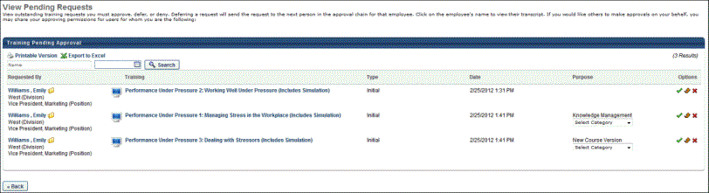
Session Approve/Defer Attempt After Registration Deadline
When acting on a session approval request, approvers are prevented from approving or deferring a session request when the session registration deadline has passed. This applies to both traditional classroom and virtual classroom sessions but is not applicable to vILT sessions.
Note: Deferring requests is only available in portals for which it is enabled by a backend setting.
The request will need to be denied on the View Pending Requests page.
If you are attempting to approve the request on the Approve Request page, a message displays to indicate that the registration deadline has passed for the session and that it is too late to approve the request and it also cannot be deferred. The request will need to be denied on the View Pending Requests page. The user can then request or be assigned to another session.
For sessions that require more than one approval level, all approval levels must approve a request prior to the registration deadline, or the request cannot be approved (i.e., Manager Approver approves the request before the registration deadline, but Indirect Manager Approver does not. The request cannot be approved).
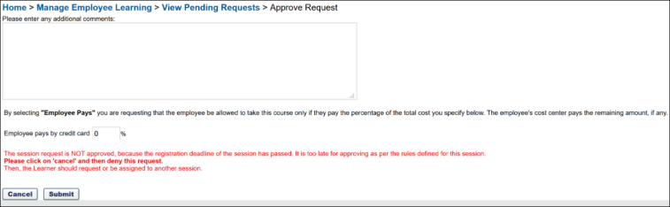
Helpful Hints - Training Approvals
See Approval Workflow Overview for additional information.
When Approval is required for training, the approval is routed in the following manner:
- If a training purpose with conditional approvals is associated with the LO and the LO does not have a predefined approval workflow, then the training purpose approval workflow is followed.
  - If there are no categories associated with the purpose and the LO requires one approval, then the status of the LO for the user is Approved if the manager is defined as an approver.
  - If a category is associated with the purpose and the LO requires one approval, then if the manager is defined as an approver, the manager is required to select a category on the approval page for each assigned user before the status of the LO on the user's transcript is Approved.
  - If the approver selects a category that applies a conditional approval, the system adds the conditional approval upon completion of the current approver's approval or denial action. Conditional approvals defined for a category are only applied upon the approval or denial made by the first approver and cannot be reapplied by a second approver even if the category is changed. However, if an approval is deferred by the first approver, then the second approver acts as the first approver when applying conditional approvals.
  - For Initial requests, the training purpose is read-only, and category is a required field. For Completion requests, the training purpose and category are read-only.
- When training is deferred, the request is sent to the next approver in the Approval chain.
See also:
MyTeam - Action Items
Mark Exempt
Marking a user exempt from a learning object (LO) means the user is exempted from taking the training. There are a variety of reasons why a user may be marked exempt, such as the user previously completed an equivalent training or will be on leave on the training due date. Users can only be marked exempt for LOs that are not in a Completed or Completed Equivalent status, including sessions.
- Note: For events, the Mark Exempt link displays on the Training Details page of the event.
- Note: Administrators can configure training exemption safelists for training items instead of relying on the Mark Transcript Exempt permission, if desired. For more information about configuring training exemption safelists: See Course Catalog - Training Exemptions.
Permissions
PERMISSION NAME | PERMISSION DESCRIPTION | CATEGORY

Edit Transcript Items | Grants ability to modify training due dates, statuses, and scores on other user's transcripts (training records) when viewing training details for particular learning objects on the transcript. User must also have permission to add external training in order to add or edit another user's external training. This permission can be constrained by OU, User's OU, User Self and Subordinates, User, and User's Self.  Note: Users with this permission also will also see the Add SF-128 link on the transcript. | Learning - Administration

Mark Transcript Exempt | Grants ability to exempt users from a learning object, using the "Mark Exempt" link on the top right corner of the target user's Transcript/Training details page. This permission can be constrained by OU, User's OU, and User's Subordinates. This is an administrator permission.  With the May '17 release, this permission also applies to prerequisites, pre-work, and post-work. Users without this permission cannot mark any training type exempt for a user. | Learning - Administration

View Transcript Item | Grants ability to view details of learning objects that appear on the transcript (training record), by clicking on the name of the learning object. Users must also have the Bio About - View permission in order to access the transcript within Universal Profile. This permission can be constrained by OU, User's OU, User Self and Subordinates, User, or User's Self. This is an end user permission. | Learning - Administration
Mark Exempt from Online Course, Quick Course, Posting, Event/Session, Material, Library, Certification Item, Test
- Navigate to the Training Details page of the LO. Note: The Training Details page can be reached numerous ways, such as via the Track Employees Training Status Summary report or Transcript report. You can mark a user exempt from the Training Details page, regardless of the path taken to reach the page.
- Click the Mark Exempt link in the upper-right corner of the Transcript Details page.
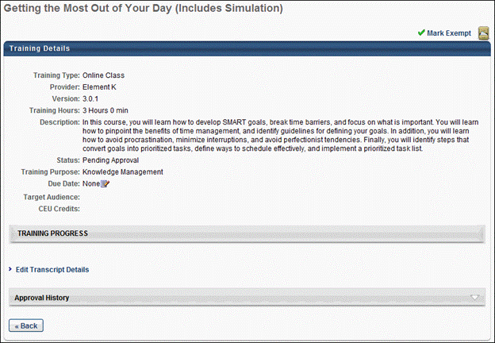
- The Mark Exempt pop-up opens. On the Mark Exempt pop-up, the Indicate Reason and Comments fields are required. Select a reason for the exemption from the drop-down and enter comments (character limit of 100). Note: "Other" is available by default from the Indicate Reason drop-down. Additional reasons are available if configured in Training Reason Preferences and activated in Activate Exempt Training Reason Preferences.
  - See Training Reasons Preferences - Exemptions.
  - See Activate Exempt Training Reason Preferences (by Division).
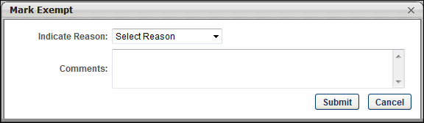
- Click Submit to complete the exemption. The LO's status on the user's transcript changes to Exempt. The Approval History section records the exemption.
- Click Cancel to cancel the action.
Mark Exempt from Non-Activated Curriculum
If a curriculum or curriculum item has not yet been activated, you can mark a user exempt on the Training Details page.
- Click the Mark Exempt link in the upper-right corner of the Transcript Details page to mark a user exempt from an entire curriculum. Click the Mark Exempt link in the Options column to exempt a user from a specific LO.
- The Mark Exempt pop-up opens. On the Mark Exempt pop-up, the Indicate Reason and Comments fields are required. Select a reason for the exemption from the drop-down and enter comments (character limit of 100). Note: "Other" is available by default from the Indicate Reason drop-down. Additional reasons are available if configured in Training Reason Preferences and activated in Activate Exempt Training Reason Preferences.
  - See Training Reasons Preferences - Exemptions.
  - See Activate Exempt Training Reason Preferences (by Division).
- Click Submit to complete the exemption. If exempting a user from an entire curriculum, the curriculum's status on the user's transcript changes to Exempt, and the value in the Options column changes to None|N/A. Note that the child LOs within the curriculum will not be marked as Exempt, only the parent curriculum. If exempting a user from a specific LO within a curriculum, the LO's status changes to Exempt. The Approval History section records the exemption.
- Click Cancel to cancel the action.
Mark Exempt from Activated Curriculum
If a curriculum or curriculum item has been activated, you can mark a user exempt from the View Details page or the Curriculum Player.
- Click the View Details icon in the Details column of the Training Details page or launch the View Details page from an individual LO in the Curriculum Player.
- The View Details page opens. Click the Mark Exempt link in the upper-right corner.
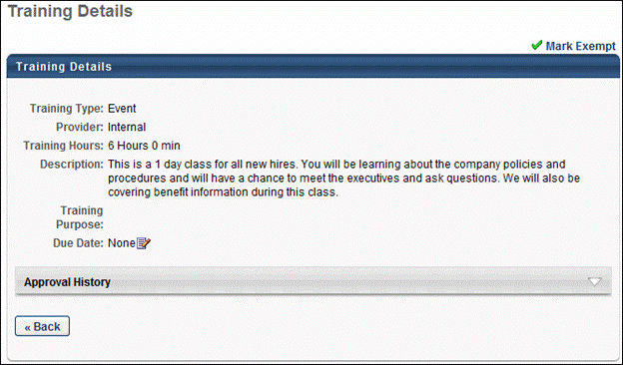
- The Mark Exempt pop-up opens. On the Mark Exempt pop-up, the Indicate Reason and Comments fields are required. Select a reason for the exemption from the drop-down and enter comments (character limit of 100). Note: "Other" is available by default from the Indicate Reason drop-down. Additional reasons are available if configured in Training Reason Preferences and activated in Activate Exempt Training Reason Preferences.
  - See Training Reasons Preferences - Exemptions.
  - See Activate Exempt Training Reason Preferences (by Division).
- Click Submit to complete the exemption. The LO's status changes to Exempt on the Training Details page. The View Details icon remains in the Details column and in the LO within the Curriculum Player. The Approval History section records the exemption.
- Click Cancel to cancel the action.
Considerations
- LOs marked exempt from the Training Details page cannot be removed from the user's transcript, either in My Team or on the user's Transcript page for administrators and managers with permission to view or edit transcript items. The far right column on the Transcript page in My Team displays None for LOs with an exempt status. The Options column on the Transcript page displays N/A.
- Events and Sessions - If a user is exempted from a session, then the exemption propagates to the event. However, if a user is exempted from an event, the exemption only affects the event and leaves the sessions unaffected.
- Library - If a user is exempted from all child LOs in a library that has Completion enabled, then the library's status changes to Completed on the user's transcript. If a user is exempted from all child LOs in a library that has Completion disabled, then the library's status is unchanged.
- Curriculum -
  - If a user is exempted from a curriculum, the child LOs inside the curriculum are not individually marked as Exempt. If a user is exempted from all child LOs in a curriculum in which all LOs are required, the curriculum's status changes to Completed on the user's transcript.
  - Curriculum child trainings cannot be marked as Exempt if they have been completed in another curriculum.
- Certifications - If a user is exempted from an LO within a certification, credit is awarded to the user. The user can only re-request the certification after the user is exempted and only if they do not receive credit for the LO.

Manage On the Job Training Requests
Users who have been designated as observers for On the Job Training (OJT) have access to a new On The Job Training page, where they can view and manage user requests for observation. To view the On The Job Training page, users must have the appropriate permissions and be designated as an observer for at least one OJT item. Only OJT items for which a user is a designated observer will display on this page.
Note: In order for the On The Job Training page to be accessible to users, an administrator must add the page link to a system navigation tab via the Navigation Tabs and Links preferences page. The user must also have the permission to manage On the Job Training.
Permissions
PERMISSION NAME | PERMISSION DESCRIPTION | CATEGORY

On The Job Training - Bulk Record | Grants access for Observers to bulk record On The Job Training Completion on the OJT page. This permission can be constrained by OU, User's OU, User, and User Self and Subordinates. This is an administrator permission | Learning - Administration

On the Job Training - Manage | Grants access for Observers to record On the Job Training (OJT) completion on the OJT page. This permission can be constrained by OU, User's OU, User, and User Self and Subordinates. This is an end user permission. | Learning - Administration
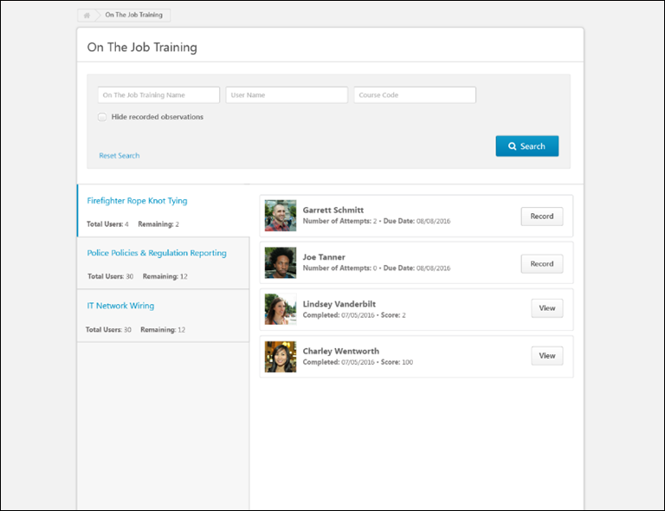
On The Job Training Search
The Search section of the On The Job Training page allows observers to search for and filter OJT items for which they have been designated as observers. Observers can search for their OJT items using the following fields:
- On The Job Training Name - The title of the OJT item
- User Name - The name of the user who sent a notification requesting to be evaluated on an OJT item
- Course Code - The unique, system-generated learning object (LO) ID code for the OJT item
- Hide recorded observations - Select this option to omit previously recorded OJT items from the search results. Only users with OJT items in a Pending Observer Completion status will continue to display in the search results
- Refine Search - Click this link to receive access to additional search fields and filter options
On The Job Training LO Tabs
On the left side of the On The Job Training page, tabs for all the OJT items for which the user has been designated as an observer appear. When the observer selects an OJT tab, the panel on the right side of the page displays all the users who have requested observation for the OJT. Each OJT tab displays the following information:
- On the Job Training title - The name of the OJT material LO
- Total Users - The total number of users who have the OJT material LO on their learning transcript in any status
- Remaining - The total number of users who must still be viewed and/or recorded by the observer for the OJT.
Observable Users
When the observer selects an OJT tab, the panel on the right side of the page displays all the users who have requested observation for the OJT. Each user tile may display the following features:
- Profile Photo - Each tile displays the profile photo of the user who requested observation.
- Name - Each tile displays the name of the user who requested observation.
- Number of Attempts - If the user has not yet passed the observation, the number of attempts they have made to complete the OJT displays on the tile.
- Due Date - If the user has not yet passed the observation, the due date for the OJT displays on the tile.
- Completion Date - If the observer has recorded a completion for the user, the date the user was given the Completed status displays on the tile.
- Score - If the observer has recorded a completion for the user, the score the user was given for the observation displays on the tile.
- Record - Click the Record button to record an OJT completion attempt for the user. This option is only available if the user has not yet passed the observation. For additional information about recording an OJT attempt: See On the Job Training - Record Observation on page 103 for additional information.
- View - Click the View button to view previous OJT attempts and observation records for the user. This option is only available if the user has passed the observation. See On the Job Training - Observation Attempts History on page 112 for additional information.
Note: If a user is removed as an observer from all OJT items, their access to the On The Job Training page is also removed. If a user is removed as an observer from only some of their OJT items, only access to those items from the On The Job Training page is removed.
Note: If an observer’s user account is deactivated in the system, they do not appear as a notifiable observer for any OJT for which they were designated as an observer. If the observer’s account is activated again, they will again be visible as an available observer, if no changes have been made to the observer list since the observer's deactivation.
On the Job Training - Record Observation
The Record Observation pop-up window, accessed from the On The Job Training page available to observers, allows observers to record details about users' On The Job Training completion attempts. If the observer has the related permission, they can record observations for multiple users at the same time.
Permissions
PERMISSION NAME | PERMISSION DESCRIPTION | CATEGORY

On The Job Training - Bulk Record | Grants access for Observers to bulk record On The Job Training Completion on the OJT page. This permission can be constrained by OU, User's OU, User, and User Self and Subordinates. This is an administrator permission | Learning - Administration

On the Job Training - Manage | Grants access for Observers to record On the Job Training (OJT) completion on the OJT page. This permission can be constrained by OU, User's OU, User, and User Self and Subordinates. This is an end user permission. | Learning - Administration
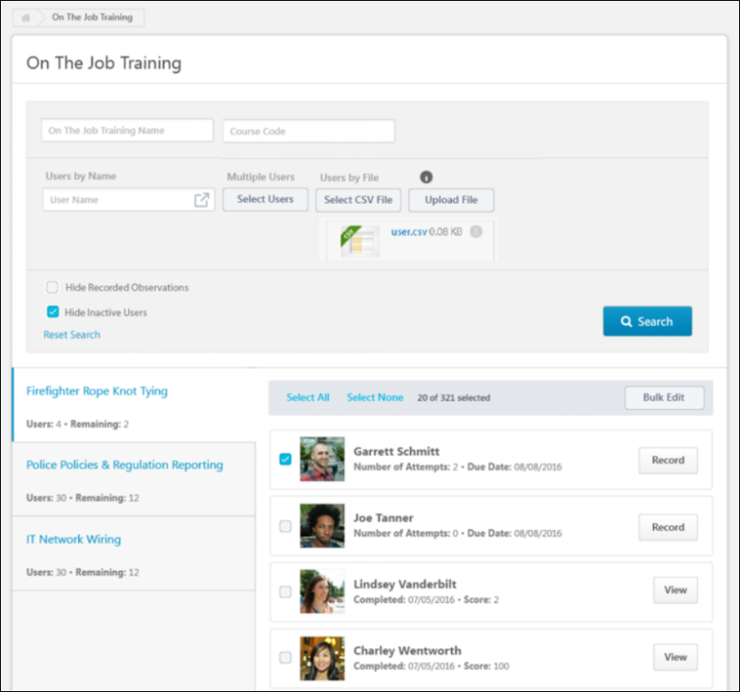
Search, Filter, and Select Users
When searching for users for whom to record observation attempts, you can enter search text into the following fields:
- On the Job Training Name - Search for a specific OJT item.
- Course Code - Search for an OJT item by Course Code.
- User Name - Search the system for one specific user.
The following filters and options are also available when finding users for whom you would like to record an observation:
Select Users
Using the Select Users button, you can search for and select multiple users by OU. To find users by OU:
- Click the Select Users button. This opens the Select Users flyout.
- From the OU drop-down menu, select an OU type. Then, enter the name of the desired OU in the search bar and press the Enter key on your keyboard.
- Once selected, refresh the search results clicking the Search button. Only users belonging to the OU you searched for appear in search results.
- To remove or add users, click the SELECT USERS button again and remove or add a filter. If you wish to instead upload a file of users, any applied filters must be removed.
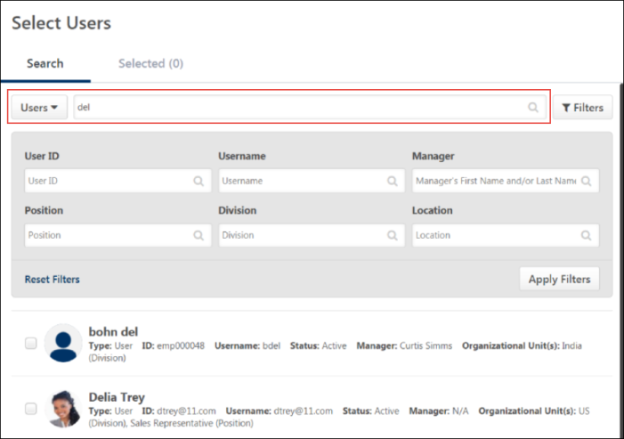
Select CSV File
Observers can upload a file of users for whom they wish to record a training observation, using the Select CSV File button.
- Create a .csv file with one column containing usernames, user IDs or email addresses of the users you wish to upload. Each file can have a maximum of 2000 users. Users above 2000 will be ignored.
- Click the Select CSV File button.
- Search for and select the .csv file of users from your computer.
- Click the Upload File button.
- Once the upload is complete, the users included in the file display in search results on the On the Job Training page. Multiple files can be uploaded to the search criteria.
Once selected, refresh the search results clicking the Search button. Only users contained in the file are returned in search results.
If needed, you can delete the uploaded file by clicking the X icon. In order to use the OU filter options instead of a file of users, any uploaded file must first be removed.
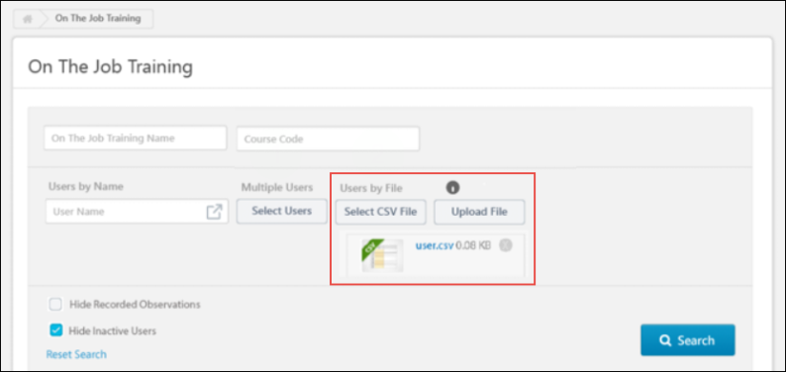
Hide Recorded Observations
The Hide Recorded Observations filter, which is selected by default, hides users who already have a completed status for the OJT item from the search results. Users who have been exempted from the OJT item are also hidden from search results. To include users with an exempted or completed status for the OJT item in search results, uncheck this box.
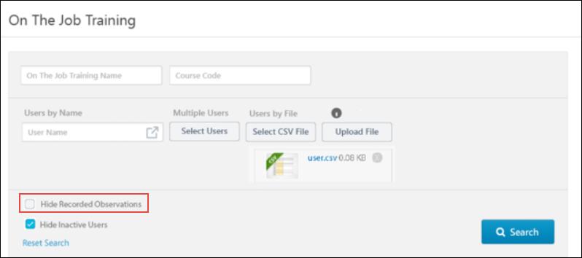
Hide Inactive Users
The Hide Inactive Users filter is available when finding users for whom to record an OJT observation. To prevent inactive system users from appearing in search results, check the Hide Inactive Users filter. If this filter is not checked, users who are not currently active in the system display in search results on the On the Job Training page. This option is selected by default.
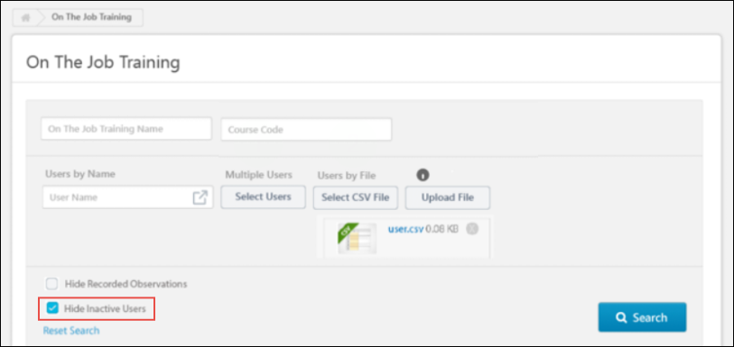
Record Observation
When an observer clicks the Record button for a user’s On the Job Training (OJT) request, a Record Observation pop-up window opens. Using the Record Observation pop-up, the observer can record information about the user’s most recent attempt and assign them a Completed or Failed status. The following read-only information appears at the top of the window:
- User - The name of the user whose observation attempt is being recorded
- Training Name - The title of the OJT material learning object (LO) for which the observer is recording an attempt
- Number of Attempts - The number of times the selected user has attempted to receive completion for the OJT
- View History - Click the View History link to view any previous attempts the user has made toward the completion of the OJT. For more information about this page: See On the Job Training - Observation Attempts History on page 112 for additional information.
Several fields for recording the user’s completion attempt for the OJT are available to the observer. Before recording the attempt, the observer can populate the following fields:
- Result - Select from one of the following options to specify the result of the OJT observation (this field is required):
  - Completed - Select this option to indicate that the user successfully demonstrated the skills presented in the OJT. The OJT item will be marked complete on the user’s learning transcript.
  - Failed - Select this option to indicate that the user did not successfully demonstrate the skills presented in the OJT. The OJT item will not be marked complete on the user’s learning transcript.
- Date Observed - Indicate the date, time, and time zone in which the user's skills were observed. To select a time, click the Time drop-down menu and select the time that will be associated with the observation record. The default time is 12AM. To select a time zone, select the Time Zone drop-down menu and select the time zone in which the observation attempt will be recorded. Selecting a time zone allows the time selection to remain accurate for the user observed, even if the user is located in another time zone. The default time zone is the OJT observer's own time zone.
- Training Hours - Enter in the number of training hours earned through the completion of the OJT.
- Score - If applicable, enter the numeric score the user achieved on the OJT.
- Comment - Enter any comments regarding the OJT completion attempt.
- Attachments - Add any attachments related to the OJT completion attempt. The attachment file name cannot exceed 45 characters. Observers can add up to five attachments. Each attachments size limit is 50MB, and the file types supported are: doc, docx, xls, xlsx, ppt, pptx, pdf, pps, ppsx, zip, jpg, jpeg, gif, mpeg, wmv, mp4, avi, and mov.
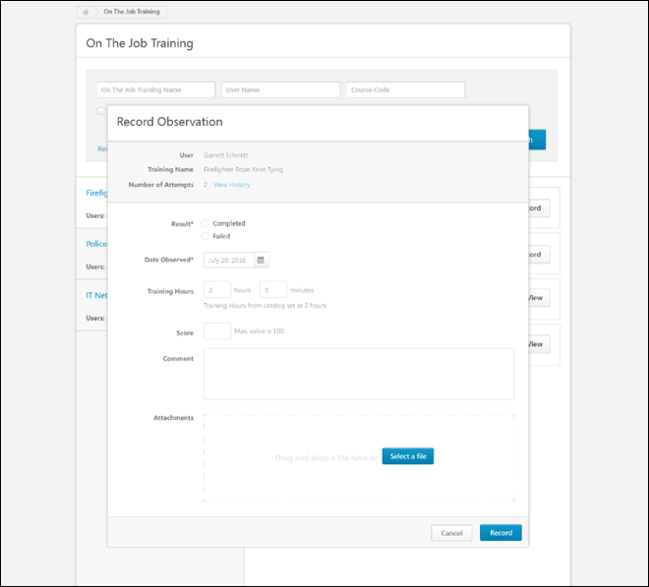
Record or Cancel
Finish recording the OJT completion attempt by clicking the Record button at the bottom of the pop-up. If the observer marks the user complete, the OJT on the user’s transcript is marked complete after the attempt is recorded. If the observer indicates that the user failed the observation, the OJT on the user’s transcript remains in a status of Pending Observer Completion.
To exit the Record Observation pop-up without saving any changes or recording an attempt, click the Cancel button.
Batch Observations
Using the Bulk Edit feature, observers can record OJT observations for more than one user at a time. The observer must have the permission to record observations in bulk in order for this functionality to be visible.
Please note that the restrictions on the On The Job Training - Bulk Record permission are considered if it and the On The Job Training - Manage permission are given to a user.
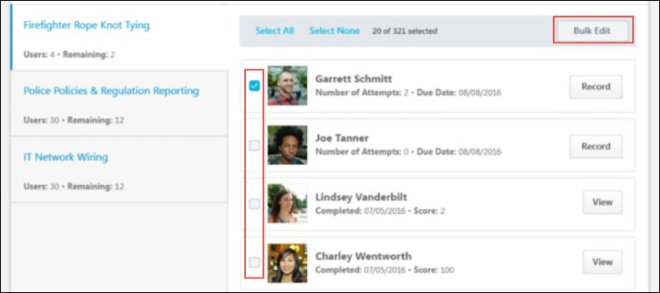
Select/Deselect Users for Bulk Edit
After selecting the tab for the OJT item you are observing and searching for or uploading a list of the appropriate users, check the checkbox next to the name of each user for whom you would like to record an observation. If a user should not be included in the bulk observation, deselect the checkbox next to their name.
- Note: If an observation is already processing for the user, the checkbox next to their name is greyed out and cannot be clicked. The Record button next to the user's name is also greyed out.
- Note: For concurrency scenarios in which two observers select the same user at the same time, a validation message displays, stating how many users are currently being processed.
Bulk Edit
Once you have selected all the users who should be included in the batch recording of an OJT item, click the Bulk Edit button. This navigates you to the Record Observation page, which allows you to record an OJT attempt for ALL of the selected users at one time. Each selected user receives their own OJT attempt record. All users selected for the batch observation attempt receive an OJT attempt record with the exact same information.
Bulk Record
When an observer clicks the Bulk edit button for users on the On the Job Training page, a Record Observation page opens. Using the Record Observation page, the observer can record information about the users' most recent attempt and assign them a Completed or Failed status. The following read-only information appears at the top of the window:
- Number of Users - The number of users for whom an observation attempt is being recorded
- Training Name - The title of the OJT material learning object (LO) for which the observer is recording an attempt
Several fields for recording the users' completion attempt for the OJT are available to the observer. Before recording the attempt, the observer can populate the following fields:
- Result - Select from one of the following options to specify the result of the OJT observation (this field is required):
  - Completed - Select this option to indicate that the users successfully demonstrated the skills presented in the OJT. The OJT item will be marked complete on the users' learning transcripts.
  - Failed - Select this option to indicate that the users did not successfully demonstrate the skills presented in the OJT. The OJT item will not be marked complete on the users' learning transcripts.
- Date Observed - Indicate the date, time, and time zone for when the users' skills were observed. To select a time, click the Time drop-down menu and select the time that will be associated with the observation record. The default time is 12AM. To select a time zone, select the Time Zone drop-down menu and select the time zone in which the observation attempt will be recorded. Selecting a time zone allows the time selection to remain accurate for the users observed, even if the users are located in other time zones. The default time zone is the OJT observer's own time zone.
- Training Hours - Enter in the number of training hours earned through the completion of the OJT.
- Score - If applicable, enter the numeric score the user achieved on the OJT.
- Comment - Enter any comments regarding the OJT completion attempt.
- Attachments - Add any attachments related to the OJT completion attempt.
Click the Record button after entering all the information for the bulk observation record.
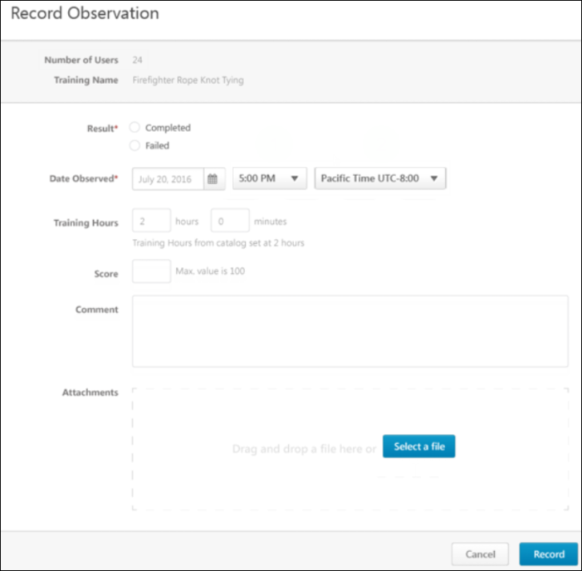
On the Job Training - Observation Attempts History
The Observation Attempts History page displays various read-only information about previously recorded On the Job Training (OJT) completion attempts. It is accessible to both users and associated observers.
A new View link is available on the Transcript Details page for OJT items, which allows users to view any previous completion attempts for the OJT item. This link becomes available for the OJT item after the user has made at least one completion attempt, if the user has the appropriate permission. Click the View link to access the Observation Attempts History page.
To access the Observation Attempts History page, go to Learning > Observation Attempts History.
Permissions
PERMISSION NAME | PERMISSION DESCRIPTION | CATEGORY

On the Job Training - Observation History From Transcript | Grants access for users to view On the Job Training Observation History from Transcript Details. This permission cannot be constrained. This is an end user permission. | Learning - Administration
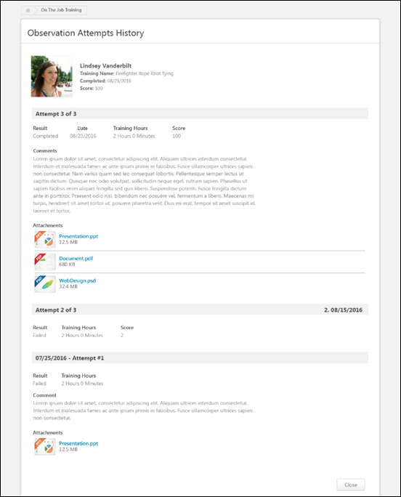
Observation Attempts History
The header of the Observation Attempts History page contains the following information:
- Profile Photo - The evaluated user’s profile photo
- Name - The evaluated user’s full name
- Training Name - The title of the attempted OJT
- Completed - The date the OJT was marked complete
- Score - The numeric score awarded for the user’s OJT attempt (if provided)
Each individual OJT completion attempt displays below the Observation Attempts History page header, from most recent to least recent. If provided by the observer at the time the attempt record was submitted, the following information displays for each attempt:
- Result - Displays whether the observer marked the user as Completed or as Failed for the observation attempt
- Date - The date the user's OJT attempt was recorded
- Training Hours - The number of training hours earned through the completion of the OJT, if applicable
- Score - Displays the numeric score the user achieved on the OJT, if applicable
- Comment - Any comments regarding the OJT completion attempt, if provided by the observer
- Attachments - Any attachments related to the OJT completion attempt, if uploaded by the observer
Close
To exit the Observation Attempts History page, click the Close button.

Training Units Overview
Assign Training Units
The Assign Training Units page allows you to distribute specific amounts of training units to individual users within an OU or group. The distributor does not have the ability to create new training units, but can distribute training units that are made available for a specific OU or group.
Permissions
PERMISSION NAME | PERMISSION DESCRIPTION | CATEGORY

Training Unit Distribution | Dynamically assigned permission which a user receives when designated as a “distributor” of one or more training unit assignments. With this permission the distributor is able to allocate training units to specific users within the target population of the training unit assignment. | eCommerce
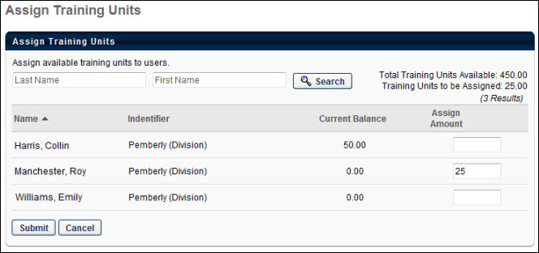
In the upper-right corner, the Total Training Units Available displays, which is the total number of training units you can assign to members of that OU. The Training Units to be Assigned is the sum of the amounts entered in the Assign Amount fields below. This number is updated as you enter each user's amount. For example, if you have entered 33 units and then you enter 15 for another user, that total updates to 48 to reflect the 15 you entered. Training unit amounts can be represented using up to two decimal places.
The Current Balance column shows the number of training units each user currently has assigned to them.
When you click Submit, the units are officially assigned. When you click Cancel, none of the training units entered are assigned.
Purchase Distributable Training Units
To purchase distributable training units, from the Distribute Training Units page, click the Purchase Distributable Training Units link. This link is only available to users that are granted the ability to purchase distributable training units by the administrator.
When the link is clicked, the Purchase Training Units pop-up appears and the price per training unit is displayed. In the Training Units field, enter the amount of training units you are purchasing, and then click Checkout. This takes you through the checkout process. Note: PayPal cannot be used as the payment processor to purchase distributed training units.
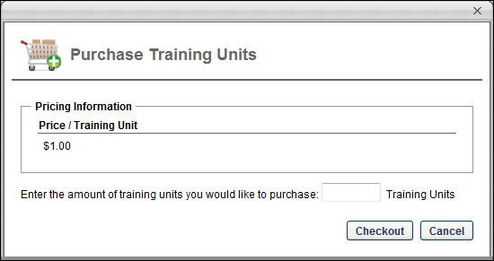
After completing the checkout process, the training unit distribution is available on the Distribute Training Units page. Note: Purchased training units do not have an expiration date. The training units can be distributed to users based on the distributor's constraints that are set by the administrator.
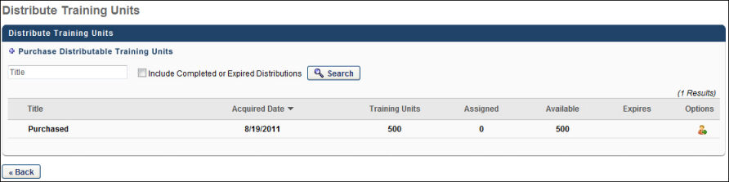
Distribute Training Units
Training units must first be assigned by a training unit creator. They can be assigned to individual users or to OUs. Once training units are assigned, they must be distributed by those selected as distributors. This page allows distributors to view all training units they are able to distribute. They can view the number of available units and the number of units they have already assigned.
Navigate to the Distribute Training Units page by navigating to Learning > Distribute Training Units.
Permissions
PERMISSION NAME | PERMISSION DESCRIPTION | CATEGORY

Training Unit Distribution | Dynamically assigned permission which a user receives when designated as a “distributor” of one or more training unit assignments. With this permission the distributor is able to allocate training units to specific users within the target population of the training unit assignment. | eCommerce
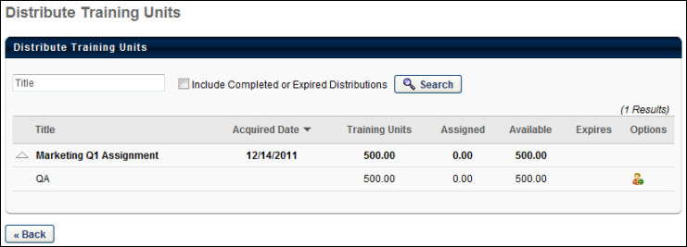
Distributions
The training unit distributor is defined during the training unit assignment process. Users that are designated as distributors (either by name or as part of a group or OU) automatically have access to this page. Once a user is a distributor, they are always a distributor and always have access to this page, even if all of their training units have been completed or expired.
This page displays all visible training unit assignments. You can search for an assignment using the search field. You can also include completed or expired distributions in your search.
To purchase distributable training units, click the Purchase Distributable Training Units link. This link is only available to users that are granted the ability to purchase distributable training units by the administrator. See Purchase Distributable Training Units for additional information.
From the Distribute Training Units page, you can view the following information:
- Title - The title of the assignment. Click the arrow next to the assignment title to expand the assignment to show the different OUs within the assignment.
- Acquired Date - The date on which you received the training units for distribution.
- Training Units - The total number of training units included in the assignment.
- Assigned - The number of training units from the assignment that have been distributed.
- Available - The number of training units from the assignment that are still available to be distributed.
- Expires - The date on which the training units expire.
Assign Training Units
To assign training units, you must have the appropriate permission.
- To assign training units from the Distribute Training Units page, first expand the training units assignment by clicking the arrow next to the title.
- Next to the appropriate assignment, in the Options column, click the Assign icon. This takes you to the Assign Training Units page where you can assign training units to anyone within the specified training unit availability. This icon is available to users with permission to distribute training units.
Edit Available Training Units
- To edit the amount of training units available in an assignment, from the Distribute Training Units page, first expand the training units assignment by clicking the arrow next to the title.
- Next to the appropriate assignment, in the Options column, click the Edit icon. This opens a pop-up where you can edit the number of available training units. This icon is available to users with permission to distribute training units.
Training Unit (Key Code) Management
The Training Unit (Key Code) Management page enables key code contacts to view training unit key code balances. Note: Key codes can only be edited from the Track Training Unit Assignment page (Training Unit Administration).
This page is hidden by default, and must be enabled by the administrator through the navigation tabs and links. The link, page header, and page instructions can be edited via navigation tabs and links.
To access the Training Unit (Key Code) Management page, go to Learning > Manage Training Unit Key Codes.
Permissions
PERMISSION NAME | PERMISSION DESCRIPTION | CATEGORY

Training Unit Assignment - View | Grants ability to view assignments of training units without being able to add or edit assignments. This permission can be constrained by OU and User's OU. This is an administrator permission. | eCommerce - Administration

Training Unit Distribution | Dynamically assigned permission which a user receives when designated as a “distributor” of one or more training unit assignments. With this permission the distributor is able to allocate training units to specific users within the target population of the training unit assignment. | eCommerce
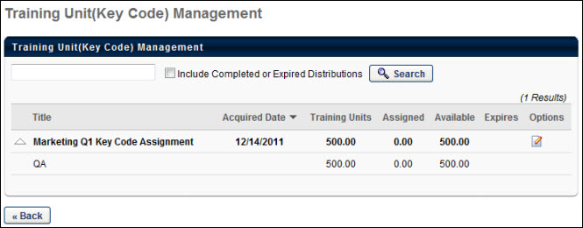
To search for a key code by title, enter the title in the search field and click the Search button. Select the Include Completed or Expired Distributions option to also search for key code distributions that have been completed or are expired.
For each key code distribution, the table displays the following information:
- Title - The distribution title.
- Acquired Date - The date the training unit distribution was assigned.
- Training Units - The number of training units originally in the distribution.
- Used - The number of training units that are redeemed.
- Available - The number of training units still available in the distribution.
- Expires - The date the training units expire if applicable.
Click the arrow to the left of the distribution title to view how the training units are distributed within the distribution.
To edit the details of the distribution, in the Options column, click the Edit icon.
- To edit the expiration date, click the Edit icon to the right of the expiration date.
- To select an additional training unit contact for the key code, click the Select Training Unit Contact pop-up icon.
- To remove a contact person, click the Trash icon to the left of the contact's name.
- To edit the key code availability amount, modify the value in the Amount column. Training unit amounts can be represented using up to two decimal places.
- Add any necessary comments in the Comments field.
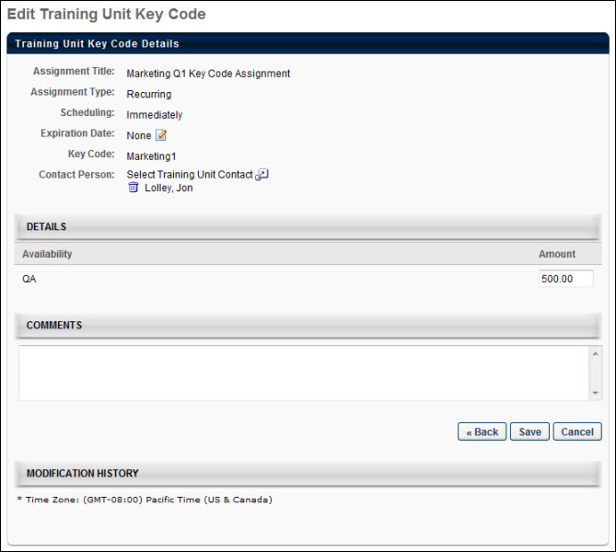

Remove Training from User's Transcript
Managers can be granted the ability to remove training they assigned to their employees from their employees' transcripts. To give managers this ability, an administrator can assign the Remove Training - Directly Assigned permission to them.
To access a user's Transcript page, go to HOME > UNIVERSAL PROFILE. Click the name of the employee for whom you want to remove training and then navigate to the user's Transcript tab.
Permissions
PERMISSION NAME | PERMISSION DESCRIPTION | CATEGORY

Bio About - View | Enables user to view the Bio page for users within their permission constraints. This permission must be enabled to view the Transcript page within Universal Profile. If a user does not have this permission and they click a person's name or user photo within the Universal Profile, then the Bio page will not open.  On the Learner Home page, this permission also allows end users to view the Completions & Hours field, the training sidebar, and the Continue Learning carousel.  This permission can be constrained by Employee Relationship, OU, User's OU, User's Direct Reports, User Self and Subordinates, and User. Note: For security purposes, this permission is constrained to User Self and Subordinates by default. However, the permission constraints can be modified to allow users to view the Bio About page for other users. | Universal Profile

Remove Training - Directly Assigned | Allows a manager to remove directly-assigned training from their employee's transcript. This permission can be constrained by the following criteria:  - User's Direct Subordinates  - User's Direct Reports  - User's Self  - Employee Relationship  - User's Subordinates  - User Self and Subordinates  - User's Defined OUs | Learning

View Transcript Item | Grants ability to view details of learning objects that appear on the transcript (training record), by clicking on the name of the learning object. Users must also have the Bio About - View permission in order to access the transcript within Universal Profile. This permission can be constrained by OU, User's OU, User Self and Subordinates, User, or User's Self. This is an end user permission. | Learning - Administration
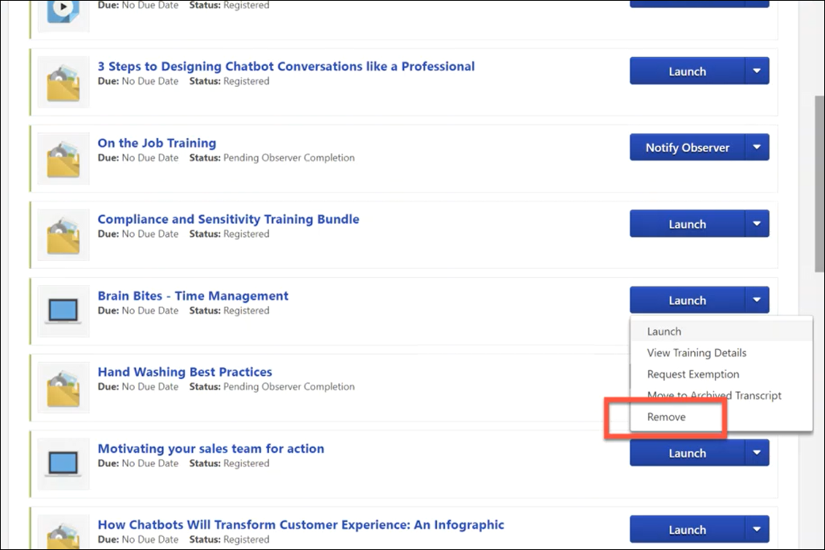
Remove
After a manager has assigned training to one of their employees, the manager can, if needed, remove that training by navigating to the employee's transcript and selecting the Options drop-down menu to the right of the training. If the manager has permission to remove assigned training, a Remove link is available in the drop-down. The manager can click the Remove link to remove the training from their employee's transcript. This opens the Remove Training pop-up, in which the manager must populate the following fields:
- Select Reason - Select the reason for removing the training. This is required. Note: Reasons appear in the user's display language, when available. If the user's display language is not available, then the reason appears in the reason's default language.
- Comments - In the field, enter additional comments regarding the training removal. Depending on the selected reason, this may be required.
When the manager has finished populating the above fields, they can click the Submit button, and the training item will be removed from the user's transcript. If the user does not wish to finalize the training removal, they can click the Cancel button and return to the Transcript page, and the training will not be removed.
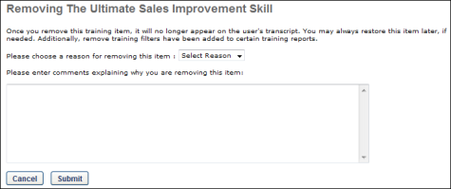
Considerations
- Managers can remove training they assigned to a user from the user's transcript even if the training was versioned after the manager assigned it, or even if the training has multiple registration numbers since its initial assignment, if all registrations were from the training being directly-assigned or self-requested. If previous registrations were from the Learning Assignment Tool or an administrator assignment, managers will not be able to remove the training.
- Managers cannot remove training when the training is later assigned to the learner by an administrator.

SF-182 Manager Actions - Overview
SF-182 Manager Actions - Overview
SF-182 Request Management
The SF-182 Request Management page allows administrators and managers to manage SF-182 requests. On this page, you can perform the following actions:
- Create an SF-182 request for a user.
- Edit an SF-182 request submitted by a user.
- Copy an SF-182 request submitted by a user.
- View a printable version of an SF-182 request.
The SF-182 Requests table is sorted by newest to oldest date submitted. All columns are sortable except the Options column.
To access the SF-182 Request Management page, go to the Your Inbox widget on the Welcome page and select the Approve SF-182 Requests link. You can also access the page through the SF-182 Form Management navigation tab.
Permissions
PERMISSION NAME | PERMISSION DESCRIPTION | CATEGORY

SF-182 Requests - Complete | Grants ability to mark complete SF-182 requests for a population of users based on constraints (e.g., managers can complete requests of their subordinates, etc.).  This permission can be constrained by the following: User Self and Subordinates, User's Subordinates, User's Division, User's Corporation, User's Position, User's Grade, User's Cost Center, User's Location, User's Group, User Custom OUs​, Division, Position, Grade, Cost Center, Location, Group, Custom OUs, Self Registration Groups, User's Self Registration Groups. | Limited Use/Obsolete

SF-182 Requests - Manage | Grants ability to view SF-182 requests for a population of users based on constraints.  If this permission is added to the dynamic Manager security role, the permission will automatically be constrained to self and subordinates. If the SF-182 approver is a manager and should not be constrained to just self and subordinates, please create a separate security role and add the SF-182 Requests Manage permission to that role with any needed constraints. | Limited Use/Obsolete

SF-182 Requests - Remove | Grants ability to remove/bulk-remove SF-182 requests for a population of users based on constraints (e.g., managers can remove/bulk-remove requests of their subordinates, etc.).  This permission can be constrained by the following: User Self and Subordinates, User's Subordinates, User's Division, User's Corporation, User's Position, User's Grade, User's Cost Center, User's Location, User's Group, User Custom OUs​, Division, Position, Grade, Cost Center, Location, Group, Custom OUs, Self Registration Groups, User's Self Registration Groups. | Limited Use/Obsolete
Create New Request
Click the Create New Request link to create a new SF-182 request for one or more users. In order to successfully submit an SF-182 request, your administrator must configure approval steps on the SF-182 Preferences page. See Set SF-182 Preferences - Set Approvals.
Search
Enter search filter options, and click Search.
For the Select OU Criteria filter, the following considerations apply:
- Organizational Unit (OU) filter combinations are not currently supported. For example, if a division is selected as filter criteria, it is not possible to also use a location or user filter.
- Locations, division, and user filters do not currently have the option to choose a parent and include all child location, division, or users. For example, to select a parent Location and all the child Locations for that parent please select the parent and the individual child locations.
Bulk Actions
From the SF-182 Request Management page, requests can be approved or denied in bulk using the Bulk Action drop-down menu. The following bulk actions are available from this drop-down:
- Bulk Approve - Select this option to begin approving SF-182 requests in bulk. See SF-182 Request Management - Bulk Approve Requests on page 142 for additional information.
- Bulk Deny - Select this option to begin denying SF-182 requests in bulk. See SF-182 Request Management - Bulk Deny Requests on page 144 for additional information.
- Bulk Mark Complete - Select this option to begin marking SF-182 requests complete in bulk. See SF-182 Request Management - Bulk Mark Complete on page 146 for additional information.
- Bulk Remove - Select this option to begin removing SF-182 requests in bulk. See SF-182 Request Management - Bulk Remove on page 149 for additional information.
Pending Prerequisites Table
This table includes the following columns:
- Requested by - This column displays the user that requested the training.
- Identifier - The Identifier column displays the trainee’s Cost Center, Division, Manager, Position and Location organizational units (OUs).​
- Training Title - This column displays the title of the external training.
- Request ID - This column displays the ID number of the request.
- Date Submitted - This column displays the date on which the request was submitted. If the request has not been submitted yet, "N/A" appears. Requests that have not been submitted appear at the top of the sort order.
- User Status - The User Status column displays the user's current SF-182 request form status.
- Status - This column displays the status of the request.
- Approval - Click the Approve or Deny icon to access the Approve/Deny SF-182 Request page on which you can perform approve/deny actions. The icons only appear if the form is in a Pending Approval status. See Approve Deny SF-182 Request on page 140 for additional information.
The following options are available in the Options column:
- Edit - Click this icon to edit the request. The icon is only visible if the manager is allowed to edit the request during the current step of the form.
- Copy - Click this icon to copy the request. When copying a request, the Training and Cost fields are copied. The original users that were added to the original form are included in the copy. For example, if there were ten users on the original form and the form is copied, all ten users will be included on the copied form.
- Print - Click this icon to print the request.
- View Training Details - Click this icon to view the Training Details for a request. See SF-182 Forms - View Training Details on page 151 for additional information.
Create SF-182 Request Overview
Administrators and managers can create an SF-182 request for one or more users at a time. The following are the four steps for completing the form:
- Training
- Costs and Billing
- User Details
- Confirm
To access the Create SF-182 External Training Request page, click the Create New Request link from the SF-182 Request Management page. In order to successfully submit an SF-182 request, your administrator must configure approval steps on the SF-182 Preferences page. See Set SF-182 Preferences - Set Approvals.
Permissions
PERMISSION NAME | PERMISSION DESCRIPTION | CATEGORY

SF-182 Requests - Manage | Grants ability to view SF-182 requests for a population of users based on constraints.  If this permission is added to the dynamic Manager security role, the permission will automatically be constrained to self and subordinates. If the SF-182 approver is a manager and should not be constrained to just self and subordinates, please create a separate security role and add the SF-182 Requests Manage permission to that role with any needed constraints. | Limited Use/Obsolete
SF-182 Form Instructions
To view instructions for completing the form, click the Download Instructions link in the upper-right corner of any step. Note: The Download Instructions link only appears if instructions are created by the administrator. If the link does not appear, then an instructions document is not available.
Required, Read-Only, and Preconfigured Fields
Some fields may be required or read-only, depending on how the administrator has configured the form. In addition, some fields may already contain a default value that is configured by the administrator. Preconfigured fields may be editable or read-only, depending on how the administrator has configured the form.
In-Progress SF-182 Forms
Forms that are in progress can be saved and completed at a later time. The Course Title field must be filled out and at least one user must be selected on the User Details step in order to save the form. Click Save Draft Form For All Users at the bottom of step 1, 2, or 3 to save a draft of the form. The form appears on the user's transcript with a status of Not Submitted.
To return to an in-progress form, click Edit from the Options column of the SF-182 Request Management page.
Create SF-182 Request - Step 1 - Training
Administrators and managers can create an SF-182 request for one or more users at a time. On the Training step of the request creation process, populate the following fields:
Training Information
- Course Title - Enter the course title, up to 400 characters.
- Course Number Code - Enter the course number code, up to 250 characters.
- Training Start Date - Enter the start date. Or, click the Calendar icon to select a date from the calendar feature.
- Training End Date - Enter the end date. Or, click the Calendar icon to select a date from the calendar feature.
- Training Duty Hours - Enter the number of duty hours.
- Training Non-Duty Hours - Enter the number of non-duty hours.
- Training Objective - Enter the objective of the training, up to 1000 characters.
Training and Vendor Location
- Vendor Name - Click the Select icon to open the Choose a Vendor pop-up. Select a vendor by clicking the plus sign in the Add column next to the vendor name. This closes the Choose a Vendor pop-up and enters the vendor name in the field.
- Vendor Contact Information - Enter the vendor's street address, city, state, zip, phone number, and email address.
- Training Location Address - Check the option to indicate that the training is located at the same address as the vendor. This populates the address fields with the information in the Vendor Contact area. If the address is not the same, enter the street address, city, state, and zip.
Advanced
- Training Purpose Type Code
- Training Type Code
- Training Sub Type Code
- Training Delivery Type Code
- Training Designation Type Code
- Training Credit Type Code
- Training Credit
- Training Source Type Code
- Training Accreditation Indicator
- Continued Service Agreement Required - If the administrator has configured this field to be required, then Yes will be preselected. You are required to download and complete the Continued Service Agreement form, and then attach the completed form to the request. If an expiration date is not preconfigured by the administrator, then enter the form's expiration date in the Continued Service Agreement Expiration Date field. Note: The completed Continued Service Agreement form appears in the printable view of the request.
If completing the Continued Service Agreement form is not required, then No will be preselected and you are not required to complete the form or enter an expiration date.
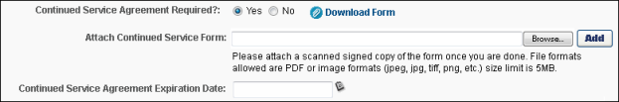
- Click Save Draft Form For All Users to add the form request to the users' transcript. Once the request appears on the user's transcript, the request functions in the same way that it would if the user submitted the request themselves. Note:The Course Title field must be completed and at least one user added on Step 3 in order for the form to be saved.
- Click Next to go to Step 2. See Create SF-182 Request - Step 2 - Costs and Billing on page 135 for additional information.
- Click Cancel to cancel the form.
Create SF-182 Request - Step 2 - Costs and Billing
On the Costs and Billing step of the form creation process, populate the following fields and sections:
Direct Cost and Appropriation/Fund Chargeable
- Enter the tuition/fees and books/material costs in the Amount column. The total appears in the Total field at the bottom of the column.
- Enter the tuition/fees and books/material costs in the Appropriation Fund column. Calculate the total and enter it in the Total field at the bottom of the column.
Note: Conditional approvals may apply. Conditional approvals are configured by the administrator in SF-182 Preferences.
Indirect Cost and Appropriation/Fund Chargeable
- Enter the travel and per diem cost in the Amount column. The total appears in the Total field at the bottom of the column.
- Enter the travel and per diem cost in the Appropriation Fund column. Calculate the total and enter it in the Total field at the bottom of the column.
Note: Conditional approvals may apply.
Other
- Total Training Non-Government Contribution Cost - Note: Conditional approvals may apply.
- Document/Purchasing Order/Registration Number
- 8-Digit Station Symbol
- Billing Instructions - Enter billing instructions.
Click Save Draft Form For All Users to add the form request to the users' transcript. Once the request appears on the user's transcript, the request functions in the same way that it would if the user submitted the request themselves. Note:The Course Title field must be completed and at least one user added on Step 3 in order for the form to be saved.
- Click Next to go to Step 3. See Create SF-182 Request - Step 3 - User Details on page 136 for additional information.
- Click Cancel to cancel the form.
Create SF-182 Request - Step 3 - User Details
The User Details Step allows you to add the users to the request. The fields that are required on this step are dependent upon the SF-182 preference settings.
Add Users
The Add Users section allows you to add the users for whom you are requesting the external training.
To add users:
- Click the Add Users link. This opens the Select pop-up. Note: The users available to select are dependent upon your SF-182 Requests-Manage permission constraints.
- Select up to 20 users.
- Click Done. The users appear in the Add Users section.
- Click the arrow icon in the Expand column for the user. This opens the user contact information and Advanced sections.
  - The fields in each section are auto-populated based on the preferences set by for the user by the administrator in SF-182 Preferences. Required fields are dependent upon the user's preferences and not the preferences of the administrator or manager creating the request. Note: To save a draft of the form, you are required to add at least one user. All other required fields on the User Details step do not need to be completed unless you are submitting the form.
Advanced
- Position Level - Select your position level from the drop-down.
- Position Title - Enter your job title.
- Special Accommodation - Select the option to indicate if special accommodations are needed for the user. If Yes is selected, describe the accommodations in the text field.
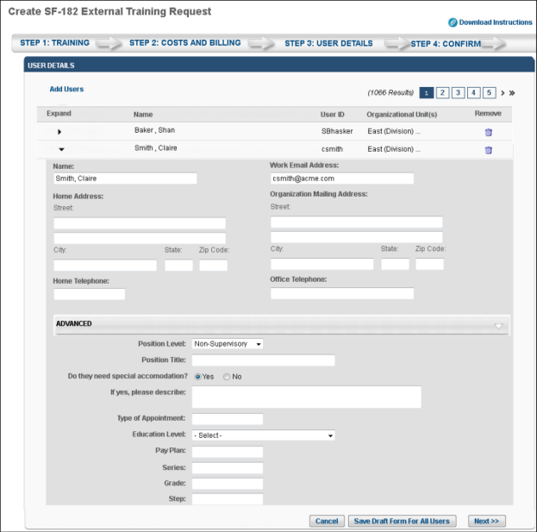
- Click Save Draft Form For All Users to add the form request to the users' transcript. Once the request appears on the user's transcript, the request functions in the same way that it would if the user submitted the request themselves. Note:The Course Title field must be completed and at least one user added on Step 3 in order for the form to be saved.
- Click Next to go to Step 4. See Create SF-182 Request - Step 4 - Confirm on page 138 for additional information.
- Click Cancel to cancel the form.
Create SF-182 Request - Step 4 - Confirm
On the Confirm step of the form creation process, review the information entered on each step and click Submit. This triggers the SF-182 Form Submitted email, if enabled. Once submitted, the SF-182 request is added to the user's transcript. If a file is attached to the form, the file is added to each user's form. If an attachment is required to be added to the form, you are prompted to add the attachment before you can save the form.
If the form requires approval, the status of the form is Pending Approval Step <current approval step>. Note: The approval step is dependent upon the current step in the approval process.
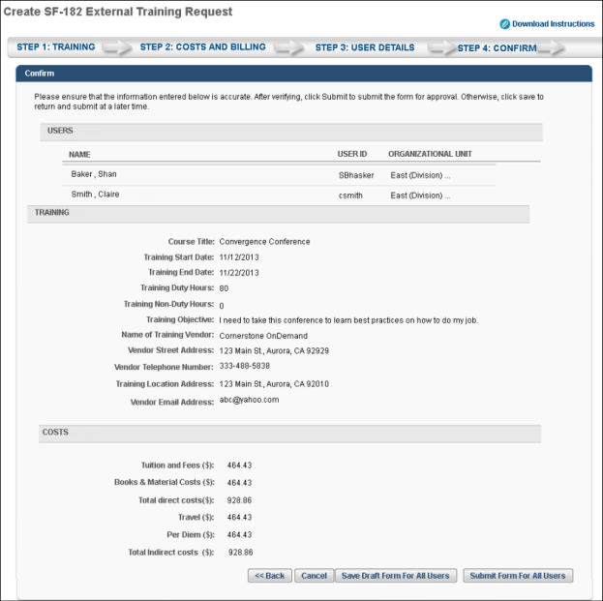
- Click Back to go to Step 3.
- Click Cancel to cancel the form.
- Click Save Draft Form For All Users to add the form request to the users' transcript. Once the request appears on the user's transcript, the request functions in the same way that it would if the user submitted the request themselves. Note:The Course Title field must be completed and at least one user added on Step 3 in order for the form to be saved.
Approve Deny SF-182 Request
Administrators and managers can approve or deny SF-182 requests on the Approve/Deny page.
Note: As part of the initial setup for the SF-182 functionality, at least one approval/denial reason must be available for each user that can approve or deny SF-182 requests.
To access the SF-182 Approve/Deny Request page, click the Approve or Deny icon in the Approval column of the SF-182 Request Management page.
Permissions
PERMISSION NAME | PERMISSION DESCRIPTION | CATEGORY

SF-182 Requests - Manage | Grants ability to view SF-182 requests for a population of users based on constraints.  If this permission is added to the dynamic Manager security role, the permission will automatically be constrained to self and subordinates. If the SF-182 approver is a manager and should not be constrained to just self and subordinates, please create a separate security role and add the SF-182 Requests Manage permission to that role with any needed constraints. | Limited Use/Obsolete
To approve or deny a request:
- Select a reason for the approval or denial from the Indicate Reason drop-down.
- Enter comments about approval or denial in the Comments box. Comments are tracked in the Approval History section of the Training Details page.
- Click Submit.
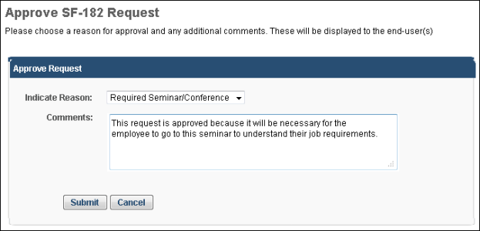
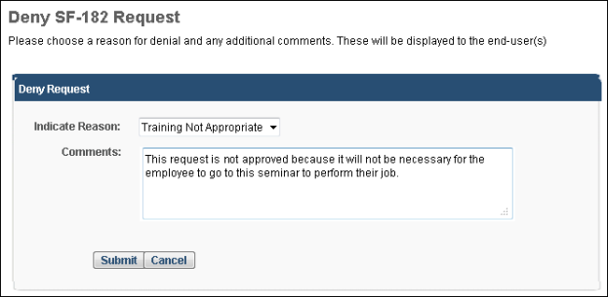
SF-182 Request Management - Bulk Approve Requests
SF-182 requests can be approved in bulk via the Bulk Approve option available on the SF-182 Request Management page. Note: No additional permissions are required to bulk approve SF-182 forms. If the approver is the current approver in the approval workflow, they can bulk approve requests.
To access the SF-182 Request Management page, go to the Your Inbox widget on the Welcome page and select the Approve SF-182 Requests link. You can also access the page through the SF-182 Form Management navigation tab.
Permissions
PERMISSION NAME | PERMISSION DESCRIPTION | CATEGORY

SF-182 Requests - Manage | Grants ability to view SF-182 requests for a population of users based on constraints.  If this permission is added to the dynamic Manager security role, the permission will automatically be constrained to self and subordinates. If the SF-182 approver is a manager and should not be constrained to just self and subordinates, please create a separate security role and add the SF-182 Requests Manage permission to that role with any needed constraints. | Limited Use/Obsolete
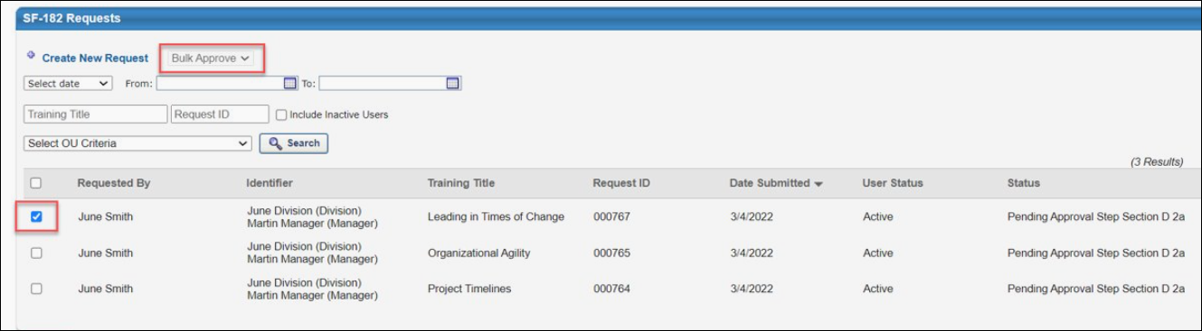
Bulk Approve
To approve SF-182 requests in bulk:
- Select the Bulk Approve option from the Bulk Actions drop-down menu.
- Select the checkbox to the left of all the SF-182 requests you want to approve.
- After all the requests you want to approve have been selected, click the Submit button at the bottom of the SF-182 Request Management page. Note: If more than 100 SF-182 requests are selected, a notification appears, explaining that only 100 SF-182 requests can be approved at one time. You can then modify your bulk approval.
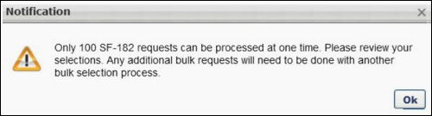
- Select a reason from the Reason drop-down menu and enter a comment in the Comment field.
- A confirmation pop-up appears, displaying the total number of requests that have been selected for approval. If users should receive an email about their approved request, leave the Send emails checkbox selected. If you do not want users to receive emails about their approved request, unselect this checkbox.
- To proceed with the bulk approval for the specified number of requests, click the Yes button. If you would like to cancel the bulk action, click the No button instead.
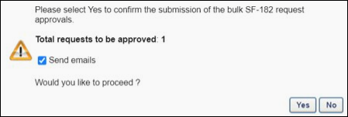
SF-182 Request Management - Bulk Deny Requests
SF-182 requests can be denied in bulk via the Bulk Deny option available on the SF-182 Request Management page. Note: No additional permissions are required to bulk deny SF-182 forms. If the approver is the current approver in the approval workflow, they can bulk deny requests.
To access the SF-182 Request Management page, go to the Your Inbox widget on the Welcome page and select the Approve SF-182 Requests link. You can also access the page through the SF-182 Form Management navigation tab.
Permissions
PERMISSION NAME | PERMISSION DESCRIPTION | CATEGORY

SF-182 Requests - Manage | Grants ability to view SF-182 requests for a population of users based on constraints.  If this permission is added to the dynamic Manager security role, the permission will automatically be constrained to self and subordinates. If the SF-182 approver is a manager and should not be constrained to just self and subordinates, please create a separate security role and add the SF-182 Requests Manage permission to that role with any needed constraints. | Limited Use/Obsolete
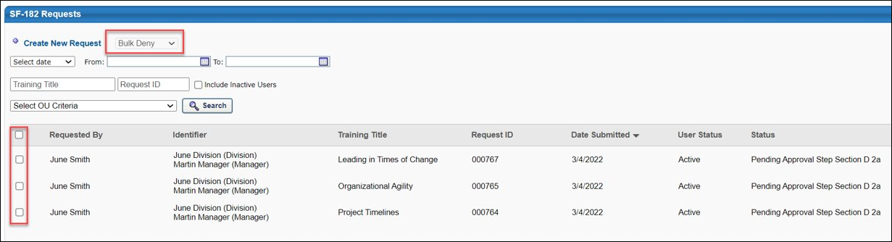
Bulk Deny
To deny SF-182 requests in bulk:
- Select the Bulk Deny option from the Bulk Actions drop-down menu.
- Select the checkbox to the left of all the SF-182 requests you want to deny.
- After all the requests you want to deny have been selected, click the Submit button at the bottom of the SF-182 Request Management page. Note: If more than 100 SF-182 requests are selected, a notification appears, explaining that only 100 SF-182 requests can be processed at one time. You can then modify your bulk denial.
- A confirmation pop-up appears, displaying the total number of requests that have been selected for denial. If users should receive an email about their denied request, leave the Send emails checkbox selected. If you do not want users to receive emails about their denied request, unselect this checkbox.
- To proceed with the bulk action for the specified number of requests, click the Yes button. If you would like to cancel the bulk action, click the No button instead.
SF-182 Request Management - Bulk Mark Complete
SF-182 requests can be completed in bulk via the Bulk Mark Complete option available on the SF-182 Request Management page. Only requests that are in an Approved status can be bulk completed. A user must have the SF-182 Requests - Complete permission to perform bulk completions.
To access the SF-182 Request Management page, go to the Your Inbox widget on the Welcome page and select the Approve SF-182 Requests link. You can also access the page through the SF-182 Form Management navigation tab.
Permissions
PERMISSION NAME | PERMISSION DESCRIPTION | CATEGORY

SF-182 Requests - Complete | Grants ability to mark complete SF-182 requests for a population of users based on constraints (e.g., managers can complete requests of their subordinates, etc.).  This permission can be constrained by the following: User Self and Subordinates, User's Subordinates, User's Division, User's Corporation, User's Position, User's Grade, User's Cost Center, User's Location, User's Group, User Custom OUs​, Division, Position, Grade, Cost Center, Location, Group, Custom OUs, Self Registration Groups, User's Self Registration Groups. | Limited Use/Obsolete

SF-182 Requests - Manage | Grants ability to view SF-182 requests for a population of users based on constraints.  If this permission is added to the dynamic Manager security role, the permission will automatically be constrained to self and subordinates. If the SF-182 approver is a manager and should not be constrained to just self and subordinates, please create a separate security role and add the SF-182 Requests Manage permission to that role with any needed constraints. | Limited Use/Obsolete
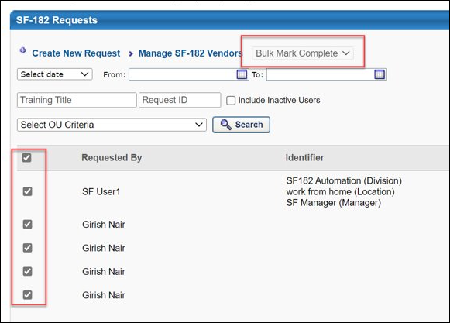
Bulk Mark Complete
To mark SF-182 requests complete in bulk:
- Select the Bulk Mark Complete option from the Bulk Actions drop-down menu.
- Select the checkbox to the left of all the SF-182 requests you want to mark complete.
- After all the requests you want to mark complete have been selected, click the Submit button at the bottom of the SF-182 Request Management page. Note: If more than 100 SF-182 requests are selected, a notification appears, explaining that only 100 SF-182 requests can be processed at one time. You can then modify your bulk action.
- If needed, you can also upload completion documentation. Up to 15 documents can be added to the bulk completion, and the documents uploaded to the bulk completion will apply to all the users. Note: If the approver uploads a document that is already attached to a user's SF-182 request, the duplicate file in the bulk completion will be skipped, and no duplicate file will be added to the user's request.
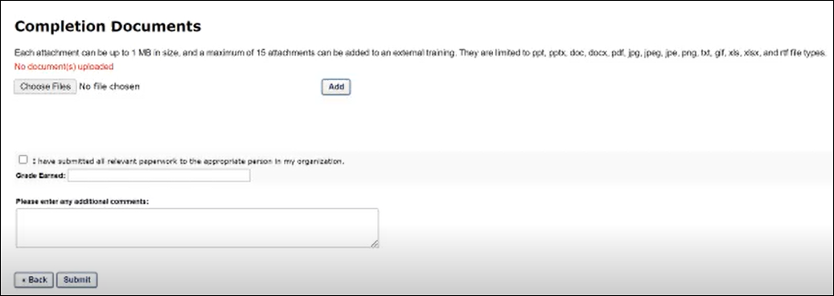
- Select the Acknowledgment checkbox, to confirm that you have submitted all relevant paperwork to the appropriate person in your organization.
- Enter the grade achieved by the user(s) in the Grade Earned field.
- Enter any additional comments you would like to provide in the Comments box, and click the Submit button at the bottom of the page.
- A confirmation pop-up appears, displaying the total number of requests that have been selected for completion. If users should receive an email about their completed request, leave the Send emails checkbox selected. If you do not want users to receive emails about their completed request, unselect this checkbox.
- To proceed with the bulk action for the specified number of requests, click the Yes button. If you would like to cancel the bulk action, click the No button instead.
SF-182 Request Management - Bulk Remove
SF-182 requests can be removed in bulk via the Bulk Remove option available on the SF-182 Request Management page. Only requests that have not been denied, completed, or approved can be bulk removed. A user must have the SF-182 Requests - Remove permission to bulk remove requests.
To access the SF-182 Request Management page, go to the Your Inbox widget on the Welcome page and select the Approve SF-182 Requests link. You can also access the page through the SF-182 Form Management navigation tab.
Permissions
PERMISSION NAME | PERMISSION DESCRIPTION | CATEGORY

SF-182 Requests - Manage | Grants ability to view SF-182 requests for a population of users based on constraints.  If this permission is added to the dynamic Manager security role, the permission will automatically be constrained to self and subordinates. If the SF-182 approver is a manager and should not be constrained to just self and subordinates, please create a separate security role and add the SF-182 Requests Manage permission to that role with any needed constraints. | Limited Use/Obsolete

SF-182 Requests - Remove | Grants ability to remove/bulk-remove SF-182 requests for a population of users based on constraints (e.g., managers can remove/bulk-remove requests of their subordinates, etc.).  This permission can be constrained by the following: User Self and Subordinates, User's Subordinates, User's Division, User's Corporation, User's Position, User's Grade, User's Cost Center, User's Location, User's Group, User Custom OUs​, Division, Position, Grade, Cost Center, Location, Group, Custom OUs, Self Registration Groups, User's Self Registration Groups. | Limited Use/Obsolete
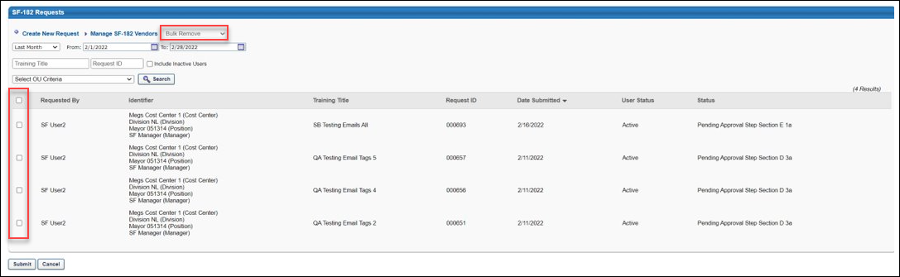
Bulk Remove
To remove SF-182 requests in bulk:
- Select the Bulk Remove option from the Bulk Actions drop-down menu.
- Select the checkbox to the left of all the SF-182 requests you want to remove.
- After all the requests you want to remove have been selected, click the Submit button at the bottom of the SF-182 Request Management page. Note: If more than 100 SF-182 requests are selected, a notification appears, explaining that only 100 SF-182 requests can be processed at one time. You can then modify your bulk action.
- A confirmation pop-up appears, displaying the total number of requests that have been selected for removal. To proceed with the bulk action for the specified number of requests, click the Yes button. If you would like to cancel the bulk action, click the No button instead.
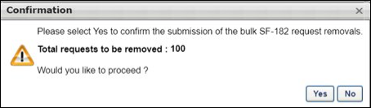
SF-182 Forms - View Training Details
Users and approvers can view the training details of an SF-182 request and also upload completion documentation to SF-182 requests via the Training Details page of the request. To view the training details of a request, approvers can click the View Details icon next to the request on the SF-182 Request Management page. Users can view the training details for their own requests by selecting the Training Details option from the SF-182 request on their transcript.
To access the Completion Documents page, click the Completion Documents icon on the Training Details page. See SF-182 Forms - Add Completion Evidence.
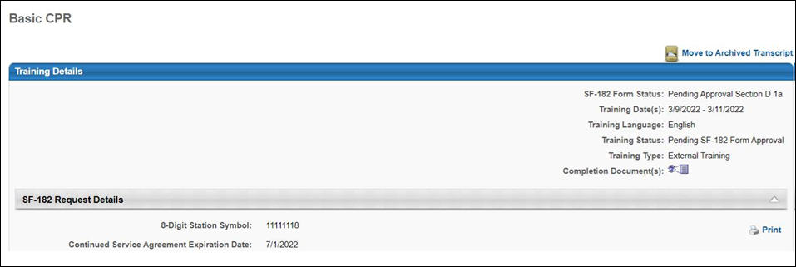
SF-182 Forms - Add Completion Evidence
Users and approvers can add completion documentation to SF-182 requests to provide evidence of the completion. Users and approvers can view previously attached or attach new completion documents from the training details of the SF-182 Request form on the user's transcript. Note: Completion documents cannot be added to SF-182 requests that are in a Denied, Draft, or Completed status.
- Both users and approvers can view and add completion documents to a SF-182 request by navigating to the Training Details page for the SF-182 request form on a user's transcript and selecting the Completion Documents icon.
To add the documentation to a request via the Completion Documents page:
- Click the Choose Files button and select the relevant document(s) from your computer.
- Click the Add button. The document will be uploaded to the SF-182 request.
- Click the Submit button to save your changes and finish attaching the completion documents to the SF-182 request. Once a request has moved to a Completed status, no completion documents can be added to or removed from the request.
Note: Completion documents can also be added to SF-182 requests in bulk by administrators.See SF-182 Request Management - Bulk Mark Complete on page 146 for additional information.
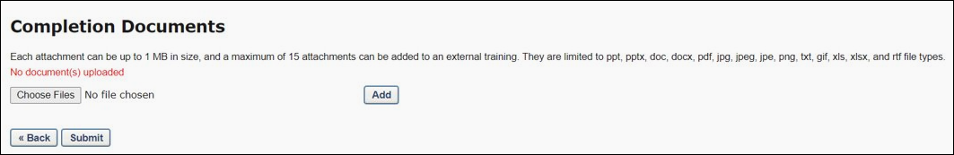
Considerations
- If a user and an approver both attempt to upload the same document to the same SF-182 request, a message appears stating that a duplicate file has been recognized, and the file cannot be added a second time.

