Learner Home and Search March 2024

Table of Contents
Learner Home and Search - Overview 1
Learner Home Configuration - Overview 2
Learner Home Preparations 4
Learner Home Image Specifications Impact 8
Setting Learner Home as the Landing Page - Use Case 12
Machine Learning Platform 14
Cornerstone for Salesforce Integration 24
Learner Home - End User View Overview 32
Learner Home - Introduction Banner 34
Learner Home - Search Training Bar 35
Learning Search 37
Learner Home - User Profile 61
Learner Home - Subjects 65
Learner Home - Playlists 69
Learner Home - Training Side Bar 74
Learner Home - Training and Banner Carousels 80
Learner Home - Transcript and Training Tiles 86

Learner Home and Search - Overview
The Learner Home serves as a learning hub which facilitates a seamless learning experience for users, allowing them to browse for and request relevant training, search and filter for specific training, and helps ensure compliance by helping you prioritize and take action on training you must complete. The Learner Home includes several features which enable learners to easily select subjects of interest, discover training based on machine learning, and quickly access and request new training.
The Learning Search page allows users to search for and filter training in the system. The robust filter options make it easy for users to find training.

Learner Home Configuration - Overview
The Learner Home serves as a learning hub which facilitates a seamless learning experience, allowing you to browse for and request relevant training, search and filter for specific training, and helps ensure compliance by helping you prioritize and take action on training you must complete. The Learner Home includes several features which enable learners to easily select subjects of interest, discover training based on machine learning, and quickly access and request new training.
It is recommended that learning administrators take action to prepare their portal to ensure the Learner Home performs optimally for users. Administrators can also customize various Learner Home features.
Click here to access the Learner Home and Learning Search Feature Focus Playlist in the Client Success Center!
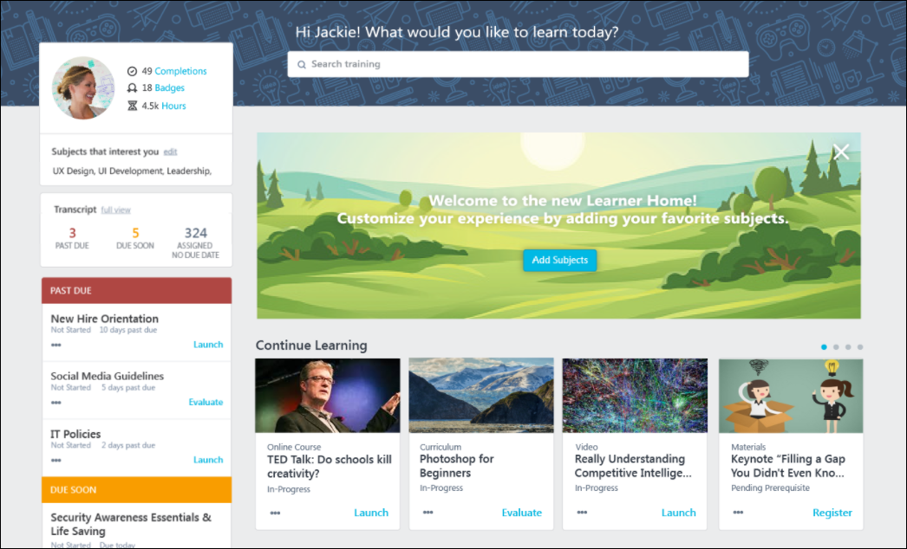
Learner Home - End User View
The Learner Home is end user-facing functionality. Documentation is available for all aspects of the Learner Home as it appears to users:
- For documentation about the end user's experience of Learner Home, See Learner Home - End User View Overview on page 32 for additional information.
Learner Home Preparations and System Impact
Before granting users access to the Learner Home, it is recommended that you prepare your portal's images, subjects, and other objects accordingly, and also understand how Learner Home setup will affect other system areas:
- For information about preparing your portal for Learner Home, See Learner Home Preparations on page 4 for additional information.
- For information about training image thumbnail behavior in Learner Home AND other system areas, such as Browse for Training, Course Console, and more, See Learner Home Image Specifications Impact on page 8 for additional information.
Learner Home Setup
Administrators can configure various Learner Home features via the following preferences pages:
- Learner Home Preferences - See Learner Home Preferences.
- Default Training Image Preferences - See Default Training Image Preferences.
Enhanced Search
The Enhanced Search page works in tandem with Learner Home to facilitate an intuitive training search experience, but administrators can also provide users with access to Enhanced Search without also giving them access to Learner Home by adding Enhanced Search as a link to a navigation tab.
For information about the end user's experience of Enhanced Search, See Learning Search on page 37 for additional information.
When searching for training, the results you receive will differ depending on whether you are using Enhanced Search or Global Search. For more information about the differences between these two tools: See Learning Search vs. Traditional Search on page 53 for additional information.

Learner Home Preparations
Prior to allowing users to access Learner Home, we recommend making some preparatory configurations to ensure an effective learning experience.
Click here to access the Learner Home and Learning Search Feature Focus Playlist in the Client Success Center!
Before granting end users access to the Learner Home page, complete the following preparations:
1. Organize Subjects
From the Learner Home page, users can select subjects in which they are interested and then view training items recommended to them based on their selected subjects. Users can also filter search results on the Learning Search page by subject. In order for the Learner Home page and Learning Search page to provide users with meaningful recommendations, it is essential that your system's subjects be up-to-date and appropriately associated with system training items.
- If needed, add and edit subjects via the Subject Management page. See Subject - Add/Edit for more information.
- Next, associate your system's subjects with the appropriate learning objects. This can be done for individual training items or in bulk using the Course Catalog. See Course Catalog - Subjects for more information, both about editing subjects individually and in bulk.
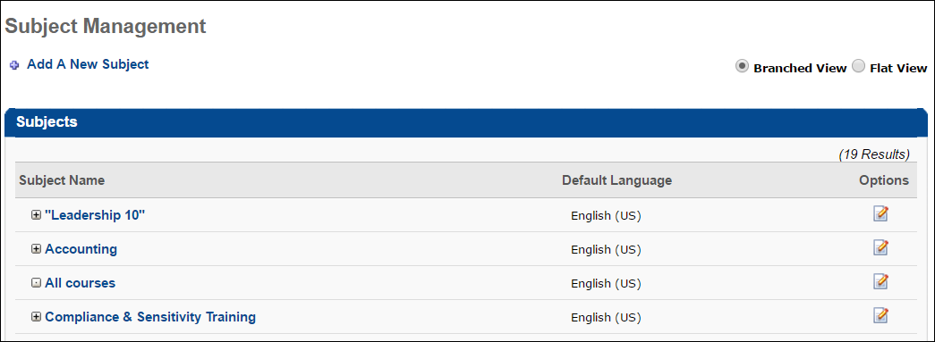
2. Update Training Metadata
On the Learner Home page, recommended training items display to users with the following data:
- Title
- Training Type
- Training Hours (i.e. Duration)
Using the Learning Search page, learners can search for training using the following criteria:
- Title
- Description
- Keywords
- Training Hours (i.e. Duration)
To ensure users see the correct data for recommended training on the Learner Home page and are able to receive relevant training results on the Learning Search page, ensure the above metadata is accurate for all training items. This data can be modified either via the inline editing feature of the Course Console or by using the Course Catalog.
See Course Console - Details for information about editing training metadata via the Course Console.
See Course Catalog - General for more information about editing training metadata via the Course Catalog.
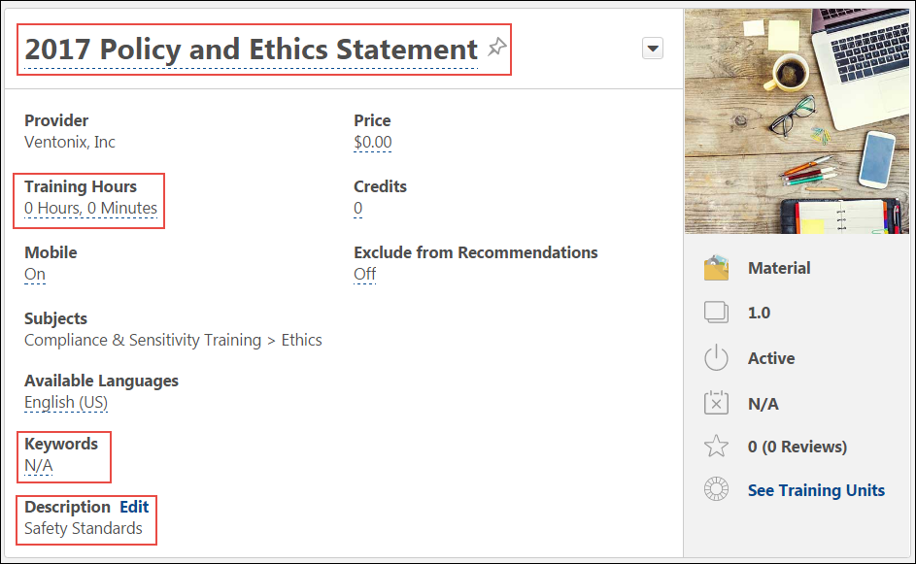
3. Set Training Images
The Learner Home includes several training carousels which display each training item with an image. These images are also displayed on the Learning Search page. The image thumbnails displayed in Learner Home are the same images that display for training in the following system areas:
- Browse for Training landing page and tile view
- Course Console
- Course Recommendations carousel on the Training Completion page
The recommended image resolution for Learner Home training items (660x336) is DIFFERENT than the image resolution recommendations for other system areas (200 x 200). This is because the images used in Learner Home are rectangular, while images used in other system areas are square.
It is recommended that prior to making Learner Home available to users in your portal, you do the following:
- For an optimal learning experience, provide all thumbnail images for training in a resolution of 660x336 immediately after the release. For best viewing results of training thumbnail images across all mobile devices and desktop types, the recommended aspect ratio is 2:1, and the recommended image size is 660x336. The minimum acceptable size is 220x112.
- If you are NOT currently utilizing Browse for Training AND/OR the Course Recommendations carousel on the Training Completion page, use 660x336 size images in your portal.
See Course Catalog - General for more information about updating thumbnail images for individual training items.
See Course Catalog - Batch Edit - Thumbnail Images for more information about updating thumbnail images in bulk.
Click here to download a zip file of the system's default LO thumbnail images.
New Thumbnail Image Sizing:
Old Thumbnail Image Sizing:
4. Flag Training
If there are any training items which should never be displayed in the training recommendation carousels on the Learner Home page to any user, they can be excluded from recommendations via the Course Catalog. If you have opted to exclude a training item from recommendations, it will never display in any recommendations carousel on Learner Home. For example, your organization may not wish to allow mandatory compliance training to display as a training recommendation because its completion is required at specific time intervals.
Prior to making Learner Home available to users, use the Course Catalog to select the Exclude from Recommendations option for any training item which should not be recommended to users. This action can be done for individual training items or for multiple training items at once.
See Course Catalog - General for information about excluding an individual LO from recommendations (scroll to list item 29).
See Course Catalog - Batch Edit - Exclude from Course Recommendations for information about excluding training from recommendations in bulk.

Learner Home Image Specifications Impact
Training thumbnail images may appear for training on the following pages:
- Learner Home
- Learning Search
- Browse for Training (landing page and tile view)
- Course Recommendations on the Training Completion Page
- Course Console
Learner Home and Learning Search present training thumbnail images in a rectangular format, while all other system locations using training thumbnail images present the images in a square format. Depending on how and when your organization plans to roll out Learner Home and Learning Search to users, different thumbnail image sizes may be recommended.
See Learner Home Preparations on page 4 for additional information.
See the matrix below for information about how differently sized training thumbnail images will display in your portal after the August 2017 release:
Learner Home Roll out Plan | shape | default training image preferences page | Learner home and Learning Search | Browse for training - tile view and landing page | Course Recs on training completion page | course Console
Roll out to all users | Rectangular | Rectangular image, with an aspect ratio of 2:1 is recommended. | No impact to Learner Home or Learning Search, as the image will fit in the rectangular container | No impact, as this page will no longer be used | The rectangular image will fit the container, but white space will be present above and below the image to preserve the aspect ratio | The image will fit as expected, with some blank space on the right side
Roll out to all users | Square | Rectangular image, with an aspect ratio of 2:1 is recommended. | The top and bottom of the image will be cropped evenly by 50px to fit within the rectangular container. Only the center of the square image will be visible on Learner Home and Learning Search | No impact, as this page will no longer be used | No impact, as the image will continue to fit the square container | No impact, as the image will continue to fit as expected
Roll out to some users | Rectangular | Rectangular image, with an aspect ratio of 2:1 is recommended. | No impact to Learner Home or Learning Search, as the image will fit in the rectangular container | The rectangular image will fit the container, but white space will be present above and below the image to preserve the aspect ratio | The rectangular image will fit the container, but white space will be present above and below the image to preserve the aspect ratio | The image will fit as expected, with some blank space on the right side
Roll out to some users | Square | Rectangular image, with an aspect ratio of 2:1 is recommended. | The top and bottom of the image will be cropped evenly by 50px to fit within the rectangular container. Only the center of the square image will be visible on Learner Home and Learning Search | No impact, as the image will fit the square container | No impact, as the image will continue to fit the square container | No impact, as the image will continue to fit as expected
No immediate plans to roll out | Rectangular | Square image is recommended | No impact, as Learner Home and Learning Searchwill not be used in this case | The rectangular image will fit the container, but white space will be present above and below the image to preserve the aspect ratio | The rectangular image will fit the container, but white space will be present above and below the image to preserve the aspect ratio | The image will fit as expected, with some blank space on the right side
No immediate plans to roll out | Square | Square image is recommended | No impact, as Learner Home and Learning Search will not be used in this case | No impact, as the image will fit the square container | No impact, as the image will continue to fit the square container | No impact, as the image will continue to fit as expected
Note: The default images provided are stored as squares on the backend.
Image Samples
The following images show the impact of using square or rectangular images in various system areas:
Square Image Cropped to Fit Rectangular Container
In this example, the top and bottom of the image are cropped evenly by 50 px to fit within the rectangular container. Only the center of the square image will be visible. For example, if you keep your thumbnail images in a square shape, this is how a square image will display as a thumbnail on the Learner Home page and Learning Search page. Square images will continue to fit other system areas optimally.
Rectangular Image Applied to Square Container (blank space above and below)
In this example, the rectangle image fits the square container, but white space is added above and below image to maintain the image's aspect ratio. For example, if you change your training thumbnail images to a rectangular shape, this is how a rectangular image will display on the Training Completion page. Training image thumbnails will display optimally on the Learner Home and Learning Search pages, however.
Rectangular Image Applied to Square Container (blank space on right side)
In this example, the image fits mostly as expected, with some blank space on the right side of the image. For example, if you change your training image thumbnails to a rectangular shape, this is how a rectangular image will display on the Course Console page. Training image thumbnails will display optimally on the Learner Home and Learning Search pages, however.
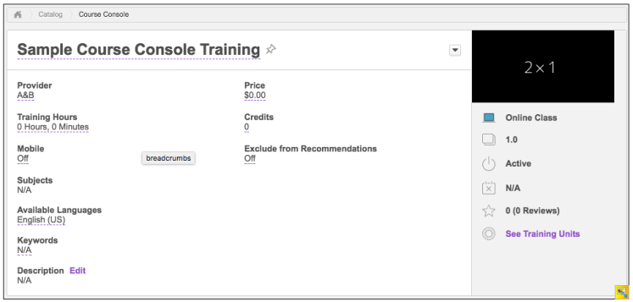
Image Continues to Fit Square Container
In this example, there is no impact, as the square image still fits the square container. For example, if you leave your training image thumbnails in a square shape, this is how a square image will fit the Browse for Training page and other system areas which use square images. Square images will not display optimally on the Learner Home or Learning Search pages, however.

Setting Learner Home as the Landing Page - Use Case
To increase visibility of the Learner Home page, your organization might consider setting the Learner Home page to be the first page users see when they log into the portal. To ensure that appropriate content is visible to the correct users in this scenario, it may be necessary to prepare the portal by using permissions, groups, and navigation link order to restrict users accordingly.
Use Case Scenario
Learner Home can be set as a system landing page, but access to landing pages is determined by division, which does not always provide the level of specificity an organization might require for a landing page. For example, at ABC Corp, the administrator has selected the Learner Home page as the landing page for all users in the Sales division. However, there is a group of users within the Sales division that should NOT be granted access to Learner Home. The administrator would like to exclude this group of users from being directed to the Learner Home, and instead direct them to the portal’s Welcome Page.
Setup
To allow most of the Sales division to see Learner Home as their landing page while also preventing a small group of Sales employees from accessing the Learner Home and instead direct them to the system Welcome Page, the ABC Corp administrator performs the following steps:
- Configure the navigation tabs and links for the Sales division accordingly:
  - Set the Learner Home Page as the first link under the Home tab.
  - Select the Learner Home Page as the homepage for the division.
  - Set the Welcome Page as the second link under the Home tab. See Navigational Tabs and Links.
- Via Security Role Administration, create a new security role which includes only the Learner Home permission. See Security Role - Create.
- Create a group which includes all users who should be able to see the Learner Home page. Any users in the Sales division who should not see Learner Home should be omitted from the group. See Group - Create/Edit.
- Assign the new security role (created in Step 2) to the group of users (created in Step 3) who should see the Learner Home page upon logging into the system. See Use Groups to Assign Security Roles.
- Remove the Learner Home permission from the default user security role, if it was ever added. The Learner Home permission should only be assigned to a user group or organizational unit (OU) if the entire group or OU should be granted access to the Learner Home page. See Modify Security Role.
- Ensure that the permission to view the Welcome Page is contained within the default user security role.
Outcome
With this setup, when sales employees who were assigned the new security role log into the portal, they will see the Learner Home page for the following reasons:
- The Learner Home page is set as the homepage for the Sales division.
- Sales employees who were assigned the new security role have permission to view the Learner Home page.
When sales employees who were NOT assigned the new security role log into the portal, they will see the system Welcome Page for the following reasons:
- Though these users are in the Sales division, and the Learner Home is configured as the homepage for the Sales division, these users do NOT have permission to view the Learner Home, because they were not included in the group that was assigned the Learner Home security role.
- Because these employees do not have permission to view their division's homepage, the system defaults to using the second link under the Home tab as the landing page for these users.
Considerations
- Groups used in this scenario must be mutually exclusive. If a user meets the criteria of more than one group, they will see both the Welcome and the Learner Home navigation links.
- Users who are set up to see the Welcome Page link when they initially navigate to the system CANNOT access the Learner Home.

Machine Learning Platform
Machine Learning Platform - Overview
The Machine Learning Platform (MLP) generates the training recommendations provided to users in various pages of the Cornerstone system. This platform applies a variety of analytical and machine learning techniques to user data, users' engagement and interaction with training, users' career mobility, learning trends, and learning over time. This collection of techniques is called the "Cluster Compute." The MLP applies many analytical techniques to generate recommendations for a specific user, based on their own portal.
Machine Learning provides the following benefits:
- Anticipates what a user might be interested in before they do
- Reduces workload for learning and development departments
- Shows trending content to users based on their associations
The Cornerstone MLP is a separate application from other Cornerstone product modules, such as Learning and Performance. For this reason, an integration was created to connect the MLP to applicable Cornerstone features, such as the Inspired by Your Subjects carousel and the Recommended for [User] carousel. Each feature correlates to a unique API which originates from the Cornerstone MLP.
See the following additional help topics for more information about the Machine Learning Platform:
- See Machine Learning Platform Features on page 18 for additional information.
- See Machine Learning Platform Exclusions on page 19 for additional information.
- See Recommendations Based on OU - Machine Learning on page 20 for additional information.
- See Recommendations Based on User - Machine Learning on page 22 for additional information.
Looking for an online course about how our Machine Learning Platform works? Click here: Machine Learning in the Learning Experience Platform
FAQ
Below are answers to frequently asked questions:
What is requested and returned in each API call?
In each call, the application typically sends a request that includes the following:
- User ID
- Portal ID
- The number of items to return
For example:
When Sarah accesses the Inspired by Your Subjects carousel on the Learner Home page, Cornerstone Learning calls the API with Sarah’s User ID, her portal (Acme), and 500 training items.
The Cornerstone MLP then returns 500 training items in the API call (if enough recommendations are generated by the algorithmic techniques). Cornerstone Learning applies exclusions to the training items (e.g. ensures availability is respected), and displays up to twenty training items in the carousel on the Learner Home. See Machine Learning Platform Exclusions on page 19 for additional information.
Why request 500 items and only display 20?
500 training recommendations are requested in order to ensure that at least twenty training items are available to appear in the carousel after all exclusions are applied . For example: The system requests 500 training items, and receives 150 MLP recommendations. Exclusions are applied to those results, which leaves thirty available results which can be displayed in a carousel. Twenty of these results can display in one of the user's carousels on Learner Home.
Why can't I report on recommendations?
Machine learning features are not stored anywhere in Cornerstone Learning. Instead, an API is called every time the user loads the page where the feature is displayed. For this reason, there is no way to pull a report of the training that is recommended to each user.
What is the Cluster Compute?
The Cornerstone MLP applies various algorithmic techniques to training data to generate training recommendations for users. This process is extremely complex and requires considerable computational power to run the algorithms for every user in every portal. This process is called the "Cluster Compute."
Running the Cluster Compute on the Cornerstone MLP requires many servers and a large amount of hardware to handle the load of analyzed data. Cornerstone continues to invest in more hardware to ensure the load is high-performing. However, due to the resources required, Cornerstone MLP runs according to a different schedule than other Cornerstone features.
What happens in the Cluster Compute?
The Cornerstone MLP analyzes current data in each portal for all users in order to generate recommendations for each individual user, based on the specific system feature. Each Cluster Compute is important because it analyzes the most up-to-date training registration and completion data to generate relevant machine learning recommendations for users.
For example: 100 users completed a training item yesterday. This data is not included in the machine learning recommendations from the last Cluster Compute. The next Cluster Compute will find this data, analyze it, and may recommend that training item to a specific user.
How long does the Cluster Compute take to process?
The Cluster Compute does NOT run instantly and may take days to process its data. The reason for this length of time is due to the volume of data to analyze for many users, for many portals, and many portal types.
The Cornerstone MLP includes Production portals, Stage portals, and internal portals that Cornerstone uses for testing in its Cluster Compute. All of these portals contribute to the large load in the overall cluster, which is why it may take days to complete each cluster run. Cornerstone has thousands of individual portals, and the Cluster Compute considers training registration data for all users, both active and inactive. This results in an immense amount of data to analyze.
Which portals are included in the Cluster Compute?
The Cornerstone MLP Cluster Compute currently includes Production portals, Stage portals, and internal portals that Cornerstone uses for testing. Note: Currently, the MLP does not include Pilot portals in its Cluster Compute. This is to reduce the load on the overall cluster to ensure that the process does not take too much time to complete.
The Cornerstone MLP supports Stage portals during User Acceptance Testing (UAT) to ensure clients can adequately test that the recommendations are working prior to enabling in Production portals.
How frequently does the Cluster Compute run?
The frequency of the Cluster Compute is dependent on the type of portal. This is due to the existing large load on the overall cluster.
The following portal types run according to the following schedules:
- Production portals: Approximately every 2 weeks
- Stage portals: Approximately every 2 weeks during UAT periods (less frequently between UAT periods)
Note: These times are subject to change, and the Cornerstone MLP team is working to decrease the amount of time it currently takes to run each Cluster Compute so that the frequency can be increased.
How can I tell when the last Cluster Compute completed?
To access the Cluster Compute Refresh Date and Time for each portal, please contact Global Customer Support, or check the Machine Learning Preferences page for the last cluster computation cycle time and date.
Note: The date and time listed are unique to each individual portal.
What happens if a new user is added to the portal after the last Cluster Compute ended and before the next Cluster Compute started? Will they see recommendations?
The user will not see personalized recommendations until the Cornerstone MLP performs the next cluster compute and learns which primary OU the new user belongs to. During the period of time before the cluster compute (before MLP knows the new user’s OUs), recommendations are provided to the new user based on what is popular across all OUs in the portal. Once the user’s OUs are recognized by MLP during the cluster compute, even if the user has not yet completed any learning, the bootstrapping mechanism will analyze the primary OU and its neighbors, if necessary, in order to deliver relevant recommendations based on the training signatures of other members of the new user's OU or neighboring OU(s).
Machine Learning Platform Features
Several system features use the Machine Learning Platform (MLP) to provide users with training recommendations. See the below chart for explanations of how each feature uses data from the MLP:
Feature | Location | Description
Top Picks for [User] carousel | Learner Home | Provides recommendations for a given user based on their previous training registrations
Top Picks for [User] carousel | Browse for Training | Provides recommendations for a given user based on their previous training registrations
Trending for Your Position carousel | Learner Home | Provides recommendations for a given user based on the user's current position and historic trends of other users in the same position
Inspired by Your Subjects carousel | Learner Home | Provides recommendations for a given user based on a combination of their previous training registrations and on the subjects in which they have indicated interest
Subject Suggestions | Your Subjects flyout on Learner Home | Provides subject suggestions for a given user based on their previous training registrations
Machine Learning Platform Exclusions
The Cornerstone Machine Learning Platform (MLP) applies some exclusion logic to the recommendations prior to sending them to Cornerstone Learning. This includes the following:
Latest Version
The Cornerstone MLP will only ever recommend the latest version of a training item. This means that if the MLP sees Version 2.0 as relevant to the user, but Version 5.0 is the latest version for the training (as of the start of the Cluster Compute), then the MLP assumes both versions are equivalent and will recommend Version 5.0 for the user.
Training already on Transcript
The Cornerstone MLP will never recommend training that the user has taken before (i.e. training that is on the user's transcript).
When do these exclusions apply? The MLP exclusions are only applied based on the data received by the Cluster Compute. This means that if a new version (4.0) is created by an administrator between Cluster Computes, the MLP will not know that the newer version exists until the next Cluster Compute, so it will continue to recommend Version 3.0.
Learning Exclusions
Cornerstone Learning applies exclusion logic to the recommendations after they are received from the Cornerstone MLP. This logic is a defense wall that ensures users are only recommended training that is relevant to them and that they have the ability to take.
The following training types are excluded from the recommendations returned by the MLP and do not display in the training carousels:
- Sessions
- Cohorts
- Training flagged as Exclude From Recommendations via the Course Catalog
- Training not available to the user
- Inactive training
- Training that was already requested by or assigned to the user
- Training that is NOT in a Published status
- Training that is NOT the latest version
- Training that has recurrence enabled and is already on the user's transcript
- Child training that is not standalone
- Child training that is standalone training and on a user's transcript as Active
- Child Training that is standalone training and on a user's transcript as Not Yet Activated
These exclusions are applied immediately and do not need to process in the Cluster Compute. For example, if a training item is made inactive, it is immediately removed from recommendations.
Recommendations Based on OU - Machine Learning
The below information outlines the algorithmic techniques that are used to calculate recommendations for system features which use machine learning to deliver recommendations to users:
Trending for Your Position
Summary Organizational Units (OUs) represent a group of many users that are included in a specific demographic, as defined by the organization. The Cornerstone MLP uses the data generated by these OUs to create recommendations specific to the group of users. For the Trending for Your Position carousel, recommendations are generated based on the Position OU.
For each Position OU, there is a group of employees that fall into one of the below categories:
- Users that are currently in the position
- Users that were previously in the position and moved to another position
- Users that were previously in the position but left the company
From this group of users, the Cornerstone MLP analyzes the accumulated history of all the training ever taken by its members. It also analyzes the registration data accumulated over time. The end result of this analysis is an output of recommendations that are contextualized to the specific position.
Examples
Example 1:
The Cornerstone MLP finds that the majority of the users currently in a certain position have taken Training A. It also finds that many users that were previously in the position took Training B. The MLP would likely recommend these two training items for the users in the position today. It might, however, prioritize Training A, because it prioritizes training taken by users currently in the position.
Example 2:
There are certain instances in which a position either has insufficient members or not enough training registration data for those members (e.g. the position may be newly created or it may be a position that only contains a few users that do not interact with the portal). In this scenario, the Cornerstone MLP first considers position(s) higher in the OU hierarchy. It also considers the learner's division and location (and then neighboring positions, divisions, and locations), and then performs the same analysis to gather sufficient recommendations.
OU training data is prioritized accordingly by the MLP:
- Users currently/previously in Position
- Users currently/previously in Division
- Users currently/previously in Location
- Users currently/previously in neighboring Position X (closest Position in hierarchy)
- Users currently/previously in neighboring Division X (closest Division in hierarchy)
- Users currently/previously in neighboring Location X (closest Location in hierarchy)
- Users currently/previously in neighboring Position Y (next closest Position in hierarchy)
- Users currently/previously in neighboring Division Y (next closest Division in hierarchy)
- Users currently/previously in neighboring Location Y (next closest Location in hierarchy)
The MLP analyzes training data according to this OU hierarchy until it finds enough training items (i.e. 500) to recommend for the user.
Position OU Not Available
In cases where the portal does not use the Position OU at all, the MLP analyzes more users in other OUs until it finds enough training (i.e. 500) to recommend for the user. For a portal that has never had a user in the Position OU, but utilizes the Division and Location OU, the following would be analyzed:
- Users currently/previously in Position
- Users currently/previously in Division
- Users currently/previously in Location
- Users currently/previously in neighboring Position X (closest Position in hierarchy)
- Users currently/previously in neighboring Division X (closest Division in hierarchy)
- Users currently/previously in neighboring Location X (closest Location in hierarchy)
- Users currently/previously in neighboring Position Y (next closest Position in hierarchy)
- Users currently/previously in neighboring Division Y (next closest Division in hierarchy)
- Users currently/previously in neighboring Location Y (next closest Location in hierarchy)
Relevancy Scores
The MLP applies a Relevancy Score to each training item for a specific group of users. It first considers training registrations for the user’s position, then training registrations for the user’s division and location. This is because data gathered from the position OU is assigned a higher Relevancy Score for recommendations generated for the Trending for Your Position carousel.
Recommendations Based on User - Machine Learning
The below information outlines the algorithmic techniques that are used to calculate recommendations for the following features:
- Top Picks for User
- Inspired by Your Subjects
- Subject Suggestions
These features provide training recommendations that are generated based on a specific user. These recommendations are generated through a hybrid of many algorithms. Cornerstone MLP uses a hybrid of multiple types of algorithms and mathematical techniques to generate recommendations. This includes:
- Interaction over time
- Collaborative Filtering
- Career Mobility
- Birds of a Feather
- Best Sellers
- Time Trends in Specific groups
- Boot-strapping
- Algorithms & Mathematical Techniques
- Collaborative Filtering
See below for descriptions of these techniques:
Collaborative Filtering
The Collaborative Filtering technique analyzes the preferences of many different users, such as the training that the users registered for, and uses this information to make training recommendations in which the user is likely to be interested. There are various techniques used, one of which is a modified version of the Latent-Factors Matrix Factorization algorithm, which runs on the big-data cluster within the Spark execution layer.
Example: Collaborative Filtering analyzes three users and the training that they have taken. It determines that User 1, User 2, and User 3 all took Training A. User 1 and User 2 both also took Training B. Since User 3 has similarities with Users 1 and 2, since they all took Training A, the MLP might recommend Training B to User 3, because Users 1 and 2 both took it.
User Position and Context-Based Recommendations
The location, department, and position that a user belongs to defines a user’s contextually relevant neighborhood of similar users, which provides a basis for pertinent recommendation. This is particularly helpful in cases where there are new users who have been added to the organization, for whom there does not necessarily exist a history of past preferences. Having this neighborhood of users is crucial so that the algorithms can still provide training recommendations based on the most popular training.
Career Mobility
The Career Mobility technique analyzes the career path of users and the training they took while in each role. This is dependent on the portal utilizing the Position OU. The MLP is able to map the history of an employee across various positions within the organization. This history of transitions allows the MLP to recommend training which users that were previously in the position registered for, training that users whose career transition you are following are registering for and completing, etc. This results in training recommendations for a user from a career mobility perspective.
Example: Career Mobility considers two users and the training that they have taken. User 1 and User 2 were both in Position A and then moved to Position B. User 1 is currently in Position B and User 2 has moved to Position C. By analyzing the hierarchy, Career Mobility considers Position C to be a higher position than Position B. Career Mobility also considers that User 2 has registered for and completed Training X while in Position C, but User 1 has not. Since User 1 appears to be following a similar career path to User 2, the MLP might recommend Training A to User 1.
Birds of a Feather
The MLP incorporates specific notions of similarity between users to derive recommendations. Amongst its recommendations are courses inferred from what other similar users have taken in the past. These recommendations are derived from the juxtaposition of users' tastes and training traits. The Athena recommendation engine provides a “bootstrapping” recommendation for users based on the notion of similarity arising from the triplet of <location, department, position> they belong to. Furthermore, clustering based on user similarity influences some of the recommendations. MLP uses registrations of training in the past three months in the minimal OU triplet in order to create bootstrapped recommendations.
Latest Version
While a training may have been prevalent in the past, there is no guarantee that the training will meet recommendation criteria when users access the training carousels. Often, there are latest iterations or versions of the training, representing enhancements or alignment to new goals. As a result, there is a lineage chain weaving through the various learning objects, each representing the next iteration in the chain. It is always preferable to recommend the latest avatar of a course-lineage. The Athena recommender performs this lineage discovery, and makes recommendations appropriately.
Training Equivalencies
In CES (client portal databases), data on equivalent courses and courses mapping with subjects and equivalent subjects is stored. These provide for a rich notion of similarity between learning objects, and this data is used in Insight applications and the Athena recommenders.
Popularity / Best Sellers
Popularity-based recommendations are similar to the bootstrapping recommendations and context based recommendations mentioned above. They operate on the principle of identifying a neighborhood of users and recommending training that is most popular in the neighborhood to users within the neighborhood.
Temporal Trends in a Neighborhood
Temporal Trends in a Neighborhood are popularity-based recommendations in which the neighborhood is the position to which the employee belongs. The most popular courses for this position are the recommendations for the employees in this position. When this cohort has less than a threshold number of employees, the Athena recommender moves hierarchically up to superset positions that contain this position as a subset, until it reaches a cohort with more than the threshold number. Then, popularity and current trends are collectively considered, prioritizing recent learning engagements.

Cornerstone for Salesforce Integration
The Cornerstone for Salesforce (CFS) integration is available in the Edge Marketplace. Once this integration is enabled, learners are empowered to interact with content within their flow-of-work by seamlessly surfacing Learner Home content in Salesforce. Administrators can add Cornerstone transcripts, learning carousels, and search components to any Force.com page or use the out-of-the box CFS Learner Home page. End users can view their full transcript, learning carousels and followed playlists. Additionally, end users can search for, launch, and complete learning, - all without leaving Salesforce.
Note: CFS is only available on the Salesforce Lightning platform.
Permissions
PERMISSION NAME | PERMISSION DESCRIPTION | CATEGORY

Learner Home | Grants access to the Learner Home and the Learning Search page. This is an end user permission. This permission cannot be constrained. | Learning

Edge Marketplace - Manage | Grants access to the Marketplace service for Edge Integrate, where the administrator can browse integrations that can be used to extend the Cornerstone system. This permission cannot be constrained. This is an administrator permission. | Edge

Edge Integrations - Manage | Grants access to the Integrations service for Edge Integrate, where the administrator can configure, enable, and disable their third-party integrations used within the Cornerstone system. This permission cannot be constrained. This is an administrator permission. | Edge

Access Partner Authorization - Manage | Grants ability to manage partner authorized access to portal via Partner Access Administration. This permission cannot be constrained. This is an administrator permission. | Core Administration

Note: To view CFS components, users need the Cornerstone User permission. To manage CFS components, users need Cornerstone Admin permission. You assign these permissions in Salesforce.
Install and Configure CFS
Install and configure CFS in the Edge Marketplace. To access the CFS Edge tile, go to ADMIN > TOOLS > EDGE > MARKETPLACE. Search for "Cornerstone for Salesforce", click the tile, and then click the Getting Started link for installation and configuration instructions.
Administrators can use the Lightning App Builder in Salesforce to add transcript, carousel, and search components to any page on Force.com. You can also move components around and delete them. Once the page configuration is done, activate the page so that users can access it.
Open the Lightning App Builder
- In Salesforce, click Setup. In the Quick Find box, type Lightning App Builder, and then click Lightning App Builder in the results. The Lightning App Builder page opens.
- In the Lightning App Builder, select one of the following options:
  - Create a new page - To create a new page, click New, select a page type and click Next. Enter a Label, select an Object (if visible) and click the Next button. Select a page format, and then click finish Note: If you are creating a new Home Page, for best results use the Console: Pinned Header and Left Sidebar (3 regions) or Console: Pinned Left Sidebar (3 regions)page template.
  - Edit an existing page - To modify an existing CFS home page, click Edit for the appropriate page.
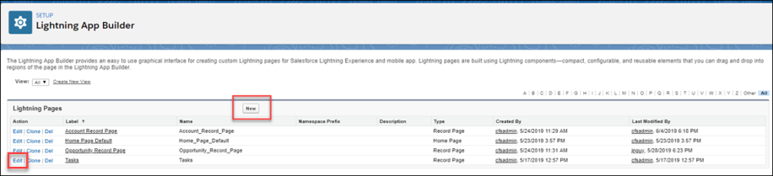
The Lightning Components page opens.
Add Components - Drag and Drop
Drag and drop CFS components onto any Force.com page to customize the end user's learner experience. You can also delete and move components. See Delete or Move a CFS Component on page 29 for additional information.
In the Lightning App Builder, in the left pane, select a CFS component and drag and drop it into a designated area.
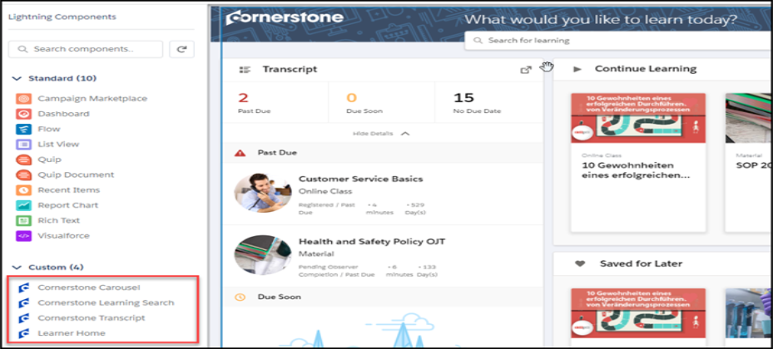
Cornerstone Carousel
Use the Cornerstone Carousel component to add a carousel to the Learner Home page. You can drag, drop, move, delete, and rename the Cornerstone Carousel.
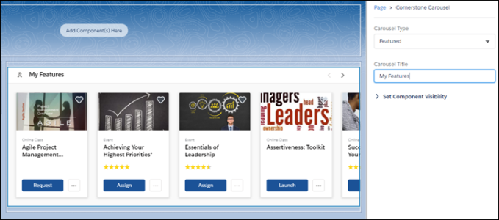
- Carousel Type - Select the type of carousel you want to create. Options are:
  - Subjects
  - Position
  - Popularity
  - Saved For Later
  - Continue Learning
  - Featured
  - Suggested
  - Required
  - Playlists
  - Followed Playlists
- Carousel Title - Enter the name for this carousel.
Cornerstone Learning Search
Use the Cornerstone Learning Search component to add the search feature to the Learner Home page. You can drag and drop, move and delete this component.
Note: You cannot rename this component in the Lightning App Builder.
Cornerstone Transcript
Use the Cornerstone Transcript component to add a Transcript section to the Learner Home page. You can drag and drop, move, delete and set the collapse option for this component. If you select Collapsed by Default, users see only the basic transcript information until they click Show Details. If you uncheck Collapsed by Default, users see full transcript details by default under the transcript box. You cannot rename this component in the Lightning App Builder. Note: For best results, we recommend that you use the smaller component box for the transcript component.
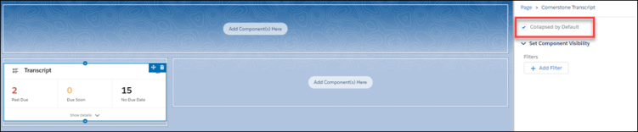
Learner Home
Use the Learner Home component to create a home page on a blank Force.com page. This is an out-of-the-box page that is not configurable and displays the users current Cornerstone Learner Home page.
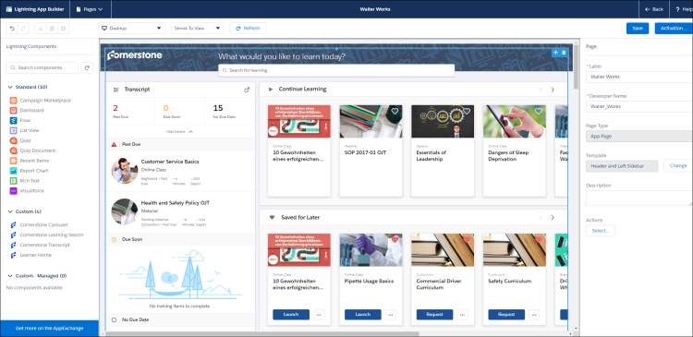
Save
Click Save to save your changes.
Activate
Click Activate to activate this page. Only active pages are available to users.

Activate and Assign Home Pages
Once the page is configured, administrators can activate a page and select it as the organizational default, set it for specific Lightning apps, or set it for different user profiles when using particular apps.
- On the completed home page, click the Activation button. The Activation page opens.
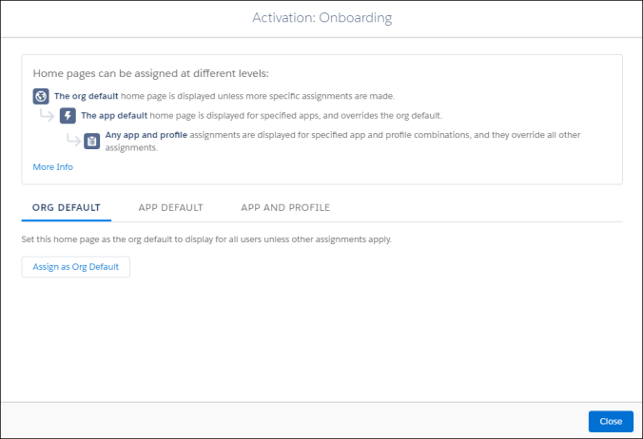
- Select one of the following options:
- Set the organizational default home page - Click Org Default, and then click the Assign as Org Default button. On the Set as Org Default page, review the selected options.
- Set a home page as the default for specific Lightning apps - Click App Default, and then click the Assign to Apps button. On the Select Apps page, check all of the Lightning apps that will have access to this page. On the Review Assignments page, review the selected options.
- Set a home page for selected user profiles for specific apps - Click App and Profile, and then click the Assign to Apps and Profiles button. On the Select Apps page, check the appropriate apps and click the Next button. On the Select Profiles page, check the profiles that will display the selected home page. On the Review Assignments page, review the selected options.
- Click the Save button. Based on their permissions and the selected options, users will see the appropriate learning home page.
Delete or Move a CFS Component
- To delete a component, hover over the upper right corner of the appropriate component and click the delete option. The component is removed from the page.
- To move a component, hover over the upper right-corner of the appropriate component, click the move icon and drag and drop the component to the new location.
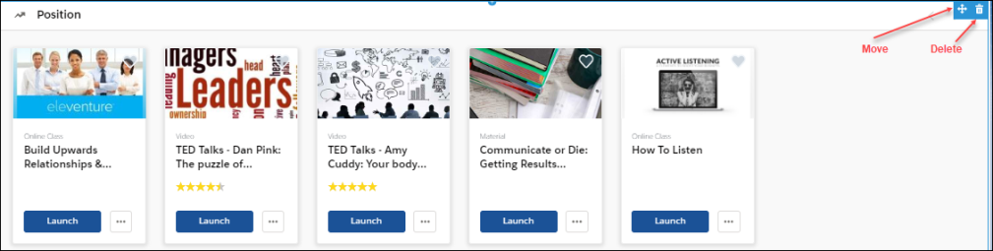
View the End-User Home Page
Once the Learner Home content is configured, end users can view and manage their learning options in Salesforce.
Users can perform the following tasks for each component:
- Transcript  - View the number of items in the user transcript.  - Click on any transcript item to view its details.  - If not visible by default, click View Details to view full transcript details and launch training. | 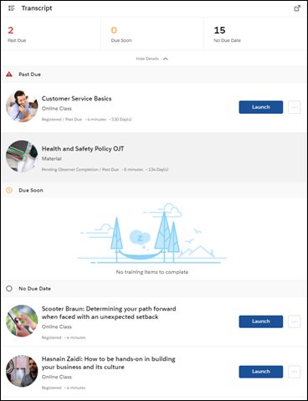
- Carousels  - Launch, request, and assign learning. Mark as a favorite by clicking the heart. Favorites appear in the Saved for Later carousel.  - Hover over a carousel item to view quick details and launch or assign training. | 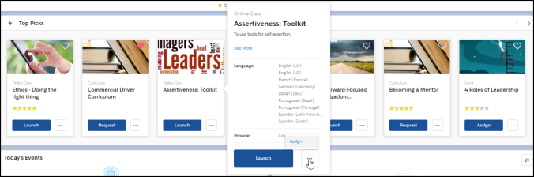
- Search bar  - Search for training by typing in search bar.  - While typing into search bar, relevant suggestions display (up to 10 suggestions).  - Click Enter or Search to open a page that displays all search results | 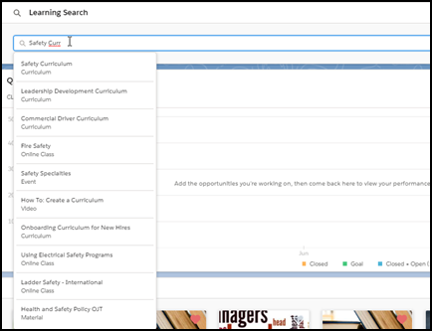

Learner Home - End User View Overview
The Learner Home serves as a learning hub which facilitates a seamless learning experience for users, allowing them to browse for and request relevant training, search and filter for specific training, and helps ensure compliance by helping you prioritize and take action on training you must complete. The Learner Home includes several features which enable learners to easily select subjects of interest, discover training based on machine learning, and quickly access and request new training.
To access Learner Home, go to: Learning > Learner Home.
Permissions
PERMISSION NAME | PERMISSION DESCRIPTION | CATEGORY

Bio About - View | Enables user to view the Bio page for users within their permission constraints. This permission must be enabled to view the Transcript page within Universal Profile. If a user does not have this permission and they click a person's name or user photo within the Universal Profile, then the Bio page will not open.  On the Learner Home page, this permission also allows end users to view the Completions & Hours field, the training sidebar, and the Continue Learning carousel.  This permission can be constrained by Employee Relationship, OU, User's OU, User's Direct Reports, User Self and Subordinates, and User. Note: For security purposes, this permission is constrained to User Self and Subordinates by default. However, the permission constraints can be modified to allow users to view the Bio About page for other users. | Universal Profile

Learner Home | Grants access to the Learner Home and the Learning Search page. This is an end user permission. This permission cannot be constrained. | Learning

LO Detail | Grants ability to view the LO Details page. This permission cannot be constrained. | Learning
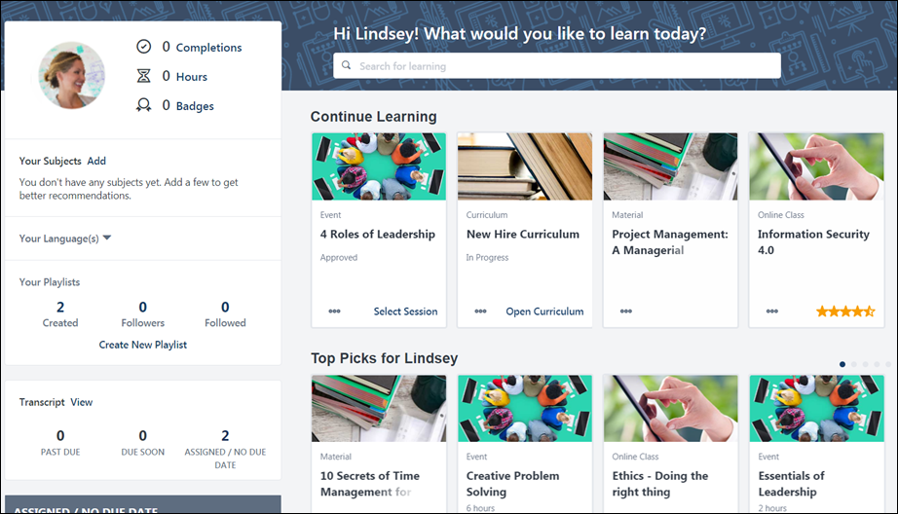
Learner Home Features
The following features are available on the Learner Home page:
- Search Training - Click here for more information about the Learner Home Search Training bar.
- User Profile - Click here for more information about the Learner Home User Profile.
- Training Side Bar - Click here for more information about the Learner Home Training Side Bar.
- Introduction Banner - Click here for more information about the introduction banner that displays on the Learner Home.
- Learner Home Carousels - Click here for more information about the various Learner Home carousels.

Learner Home - Introduction Banner
When a user navigates to the Learner Home page for the first time, the Learner Home displays an introduction banner above the various carousels. This banner includes a welcome message and a prompt to add subjects to their profile.
To access the Learner Home page, go to Learning > Learner Home.
Permissions
PERMISSION NAME | PERMISSION DESCRIPTION | CATEGORY

Learner Home | Grants access to the Learner Home and the Learning Search page. This is an end user permission. This permission cannot be constrained. | Learning
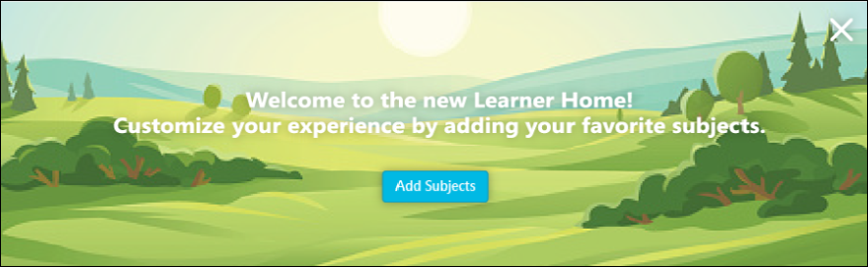
Introduction Banner
The introduction banner includes the following:
- Text - The introduction banner reads, "Welcome to the new Learner Home! Customize your experience by adding your favorite subjects."
- Add Subjects button - Clicking this button causes the Your Subjects flyout to open, allowing the user to add subjects to their profile.
The Introduction Banner displays either until the user selects a subject or until they dismiss the banner by clicking the ‘X’ in the upper right corner of the banner.
- Note: The introduction banner is not configurable.
- Note: Any custom banner configured by the administrator only appears on the Learner Home page after the user either adds subjects or dismisses the introduction banner. The introduction banner and the custom banners configured by the administrator via Learner Home Preferences never display on the Learner Home at the same time.

Learner Home - Search Training Bar
At the top of the Learner Home, a welcome message displays with the name of the user in the format of “Welcome <User First Name>! What would you like to learn today?” Note: This message is not configurable, but the message text is localized.
Directly below the welcome message, a search box displays and allows users to search for specific learning using powerful search technology that is fully optimized for both desktop and mobile browsers.
The welcome message and search box display on top of a banner image that spans across the width of the page. Note: This image is configurable.
To access Learner Home, go to Learning > Learner Home.
Permissions
PERMISSION NAME | PERMISSION DESCRIPTION | CATEGORY

Learner Home | Grants access to the Learner Home and the Learning Search page. This is an end user permission. This permission cannot be constrained. | Learning
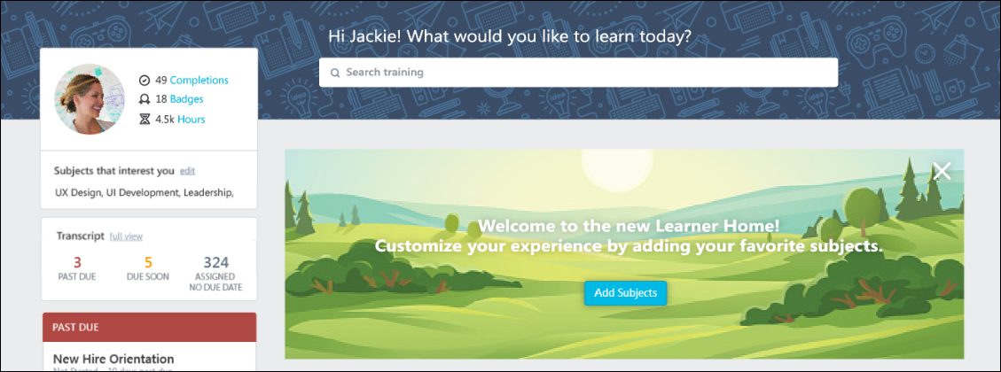
Search Training
To search for training on the Learner Home page:
- Enter a search term or phrase into the search box. Up to ten training titles most relevant to that search term display in the predictive search results below the search bar. If you wish to access one of the training items that displays in the predictive results, click the training title to be navigated to the Training Details page for that item. Alternatively, you can enter search terms and press the Enter key on your keyboard, which redirects you to the Learning Search page. You can also press the Enter key without entering search terms, which navigates you to the Learning Search page with all available results displayed.
- Peruse the results which display on the Learning Search page and use the available filters to receive more specific training results, if necessary. Search results are sorted by relevance, and text queries are matched with content title, descriptions, and keywords. See Learning Search on page 37 for additional information.
Note: Administrators can grant users access to the Learning Search page separately from Learner Home by adding Learning Search as a link to a navigation tab.

Learning Search
The Learning Search page allows users to search for and filter training in the system. The robust filter options make it easy for users to find training. Learning Search is accessed via the Learner Home page and is fully optimized for both desktop and mobile browsers. See Learner Home - End User View Overview on page 32 for additional information.
To access Learning Search, go to Learning > Learner Home and either enter search criteria into the search bar at the top of the page and press Enter, or press Enter without entering any criteria into the search bar to return all results.
Permissions
PERMISSION NAME | PERMISSION DESCRIPTION | CATEGORY

Events Calendar | Grants access to view Events Calendar page. This permission also makes the Event Calendar button on the Learning Search page visible. This is an end user permission. | Learning

Learner Home | Grants access to the Learner Home and the Learning Search page. This is an end user permission. This permission cannot be constrained. | Learning
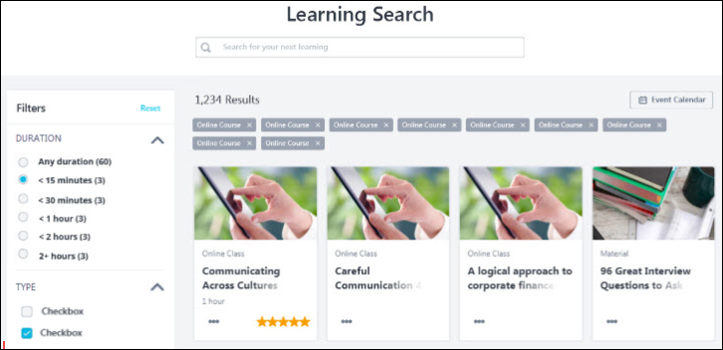
Search
To search for a specific training item or training related to a key phrase, enter a search term into the search bar and press the Enter key on your keyboard. The search will return training results with the entered phrase in the title, keywords, and description. Results are prioritized first by the presence of the entered phrase in the training's title, then in the training's description, and lastly in the training's keywords. For example:
If the search term, "Leadership" is entered in the search bar:
- Training with the word "Leadership" in the title displays first in search results.
- Training with the word "Leadership" in the training's description displays in search results AFTER training with "Leadership" in the title.
- Training with the word "Leadership" specified as a keyword for the training displays in search results AFTER training with "Leadership" in the training title and in training description.
The following weights are applied for a match within the title, description, or keywords:
- Title: 1,000
- Description: 2
- Keywords: 1
You can also press the Enter key on your keyboard without entering search terms or simply click the Search icon, which causes the search page to return all available training results based on the user's availability.
Note: When a user searches for a training title using Learning Search, and an exact title match is found, that training item is prioritized and returned higher in the search results than other items. Users can also receive exact title matches for training items offered in languages that are not their own by searching for the training using its default title. See the Exact Title Matches section later in this page for more information.
Search Logic
Each new text search resets the Learning Search filters to their default state, and each new text search resets the initial filter values. The initial filter values are based on the results returned for the text query. This is not limited just to what is on the page or what is in the user's availability.
Search Logic Example:
A user enters a search for the term, "product." Fifty training results are associated with the term and display on the page. When the user expands the Type filter, they see the following:
- Curriculum (20)
- Material (20)
- Online Class (10)
In this example, no other Type filter options display, because none of the training in the search results is any other training type. If no training meets the criteria for a filter option, the entire filter option does not display.
The Enhanced Search framework supports partial matching when special characters are used. This means that a training can be returned in search results, even if the entire search term connected with special characters is not used. For example, if the title of a training is "LMS-Compliance-2023" a user can search for "Compliance" and the training would be returned in results. This is because trainings and titles are broken down into individual terms for searching. Result sorting or order is dependent on the overall catalog. For more information regarding search weighting (e.g., Title vs Keyword searching), See Learning Search vs. Traditional Search on page 53 for additional information.
Exact Title Match
Users can receive exact title matches for training items offered in languages that are not their own by searching for the training using its default title.
Exact Title Match Use Case
- Gavi is a content administrator at ACME Corp. He creates an online course called "The Importance of Being Modest." Gavi's display language is set to English (US), so the default language of the training and the title of the training is set to English (US). This means that English (US) is the language in which the training displays to the user if the course is not localized in their language. Gavi also configures a localized title in Spanish (Spain) of "La importancia de ser modesto."
- Maya, a user whose display language is set to Italian (Italy), logs into the system and searches for "The Importance of Being Modest." Learning Search can find an exact title match using the default title even though the course is not available in Maya's display language.
- Henri, a user whose display language set to Spanish (Spain), logs into the system and searches for "La importancia de ser modesto" and sees Gavi's course prioritized in search results.
Q&A
See below for common questions and answers about exact title match functionality:
Q: How do I know the default language or title of a training item?
A: Access the Course Catalog page for the training item and view the Default Language field on the General tab.
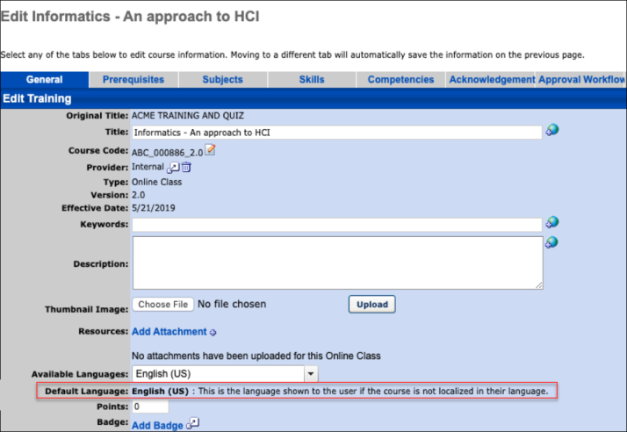
Q: Can I edit the default title of a training item?
A: If your display language matches the default language, simply edit the title of the training. If your display language does not match the default language, click the localization icon next to the Title field on the Course Catalog - General page for the training and change the title of the training for the default language.
Filters
Training filters are available in a sidebar on the left side of the Learning Search page, and the number of training results which meet each filter selection displays next to each filter option in parentheses. The following filters are available:
- Duration
- Type
- Modality (Early Adopter)
- Subject
- Rating
- Provider
- Language
- Skills (Capabilities)
- Show Only Mobile Enabled
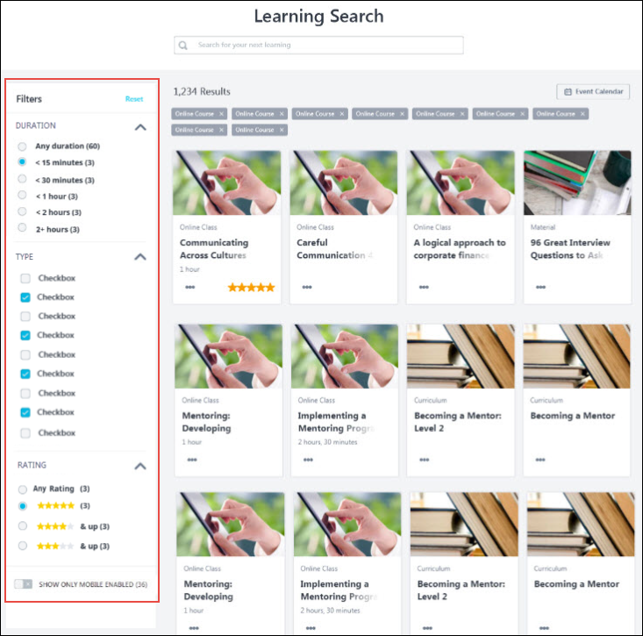
The administrators can enable and disable the filters in Learning Search Preferences based on requirements. To know more, See Learning Search Preferences .
Filter Sidebar
To apply a filter to your training search results, expand the appropriate section, and select one or multiple filter field options, depending on the selection type of the filter. The filter sidebar is collapsed by default. View the table below for more information about the available filters:
Filter | Selection Type | Options | Additional notes
Duration | Single-select radio buttons | - Any Duration (default)  - < 15 minutes  - < 30 minutes  - < 1 hour  - < 2 hours  - 2 + hours | Duration options display based on the entered search terms, meaning that if no training that meets a user's search criteria has a duration of greater than two hours, then the 2+ hours filter option doesn't display.
Type | Multi-select check boxes | - Curriculum  - Event  - Library  - Material  - Online Class  - Program  - Quick Course  - Test  - Video | Type options display based on the entered search terms, meaning that if, for example, no curricula meet the user's search criteria, the Curriculum filter option does not display.
Modality | Multi-select check boxes | The following default modality types are available in the Modality section of the Learning Search filter panel:  - Attend (includes events)  - Collections (includes curricula, playlists, external content, and programs)  - Listen (includes none by default)  - Practice (includes tests)  - Read (includes materials)  - Watch (includes online courses and videos) | This functionality is currently in an Early Adopter status. For more information: See Modality Preferences (Early Adopter).
Subject | Multi-select check boxes | All subjects related to the search results will display, all unselected by default | If no training that meets the user's search criteria has an associated subject, the subject filter does not display.
Rating | Single-select radio buttons | - Any Rating (default) Note: This includes training with no ratings | Duration options display based on the entered search terms, meaning that if no training that meets a user's search criteria has a rating of two stars, the  filter does not display. The rating filter does not display if Course Ratings functionality is disabled for the user or if the related security object is disabled in the portal.
Provider | Multi-select check boxes | Providers related to the search results display alphabetically, all unselected by default | Provider options display based on the entered search terms, meaning that if, for example, no training items that meet the user's search criteria are associated with the provider Skillsoft, the Skillsoft filter option does not display. Inactive providers may display if associated with the search results. When a large number of providers are displayed, a scrollbar will appear within the section. The provider filter returns the top 50 providers alphabetically, based on the user's availability and search query.
Language | Multi-select check boxes | Languages related to the search results display alphabetically, all unselected by default | Language options display based off the text query and learning object availability (e.g., if no training returned in the results has an Available Language of Spanish, then Spanish does not display as a language option). The language filter does not display if only one language matches the training returned in the results (e.g., if all training returned in the results has a language of English (US), then the language filter does not display). A language displays as a filter if it is specified as an Available Language for a learning object available to the user. When many languages are displayed, a scrollbar appears within the section.
Skills (Capabilities) | Multi-select check boxes | All skills that are associated with one or more trainings in the search results, all unselected by default. | Skills (Capabilities) options display skills based off the text query and the learner who have enabled content tagging or manually updated trainings with Skills (Capabilities). The Skills (Capabilities) filter allows learners to find trainings for the Skills (Capabilities) upon which they want to improve. The Skills (Capabilities) Filter is available on Learning Search page when the following criteria are met:  - The Skills Filter is enabled via Learning Search Preferences.  - The trainings in the portal are tagged with Skills (Capabilities).  - The search results have Skills (Capabilities) associated to them.  - If your portal contains a lot of inactive skills, the amount of inactive skills being returned within a search may cause the skills filter not to show. In this event, the View All button will also not show for users.  Like other filtered results in the Learning Search page, these results are sorted alphabetically. The filter shows up to 50 Skills (Capabilities) at any time. The learners can click View All under the Skills filter to open the View all skills modal that shows all active skills in the portal. In this modal, the learner can search the list and select the skill or skills they are interested in. Selected Skills are presented at the top of the flyout and can be removed anytime. The flyout closes once the learner saves their choices, and the learner is presented with an updated search result with the selected Skills.  Note: if you have enabled Skills (Capabilities) filter but do not see the filter on Learning Search, it means either no content is available to you that has been tagged with Skills (Capabilities) or no content in the search results has Skills (Capabilities) tagged to it.
Show Only Mobile Enabled | Enable/Disable toggle | All Training (toggle switch to Off position) - Default selection  Mobile Enabled Training (toggle switch to On position) | The Mobile Enabled filter displays based on the entered search terms, meaning that if no training that meets a user's search criteria is mobile enabled, the entire Show Only Mobile Enabled toggle is hidden from the sidebar.
Filter Tags
To ensure users know when filters have been applied to the results on the Learning Search page, filter tags appear at the top of the page to indicate which filters have been applied. Tags display for each unique filter selection.
The text in each tag matches the selected filter value in the filters based on the following logic:
- When the filter allows users to make a single selection, the filter tag displays the selected radio button (e.g., < 15 Minutes, 4 stars & up, etc.)
- When the filter allows users to make multiple selections, the filter tag displays all selected options. For example, if Material, Event, and Online Class were selected for the Type filter, all three training types appear as tags.
- When the Show Only Mobile Enabled filter is toggled to the On position, the filter tag displays the text, "Show Only Mobile Enabled." If the toggle is in the Off position, no tag displays.
Options
- Click the X icon to the right of a tag to remove the filter from the search.
- Click the Reset link to remove all filters and tags from the search at once.
Considerations
- Tags do not display for the default value that is automatically selected for a filter.
- Tags are ordered according to the order of filters in the filter sidebar, then by the order of the filter options within each section (e.g., Duration tags, then Type tags, then Subject tags, etc.)
- Global Search preferences are not respected by Learning Search. Global Search is configured via Core Preferences - Search Preferences, and these setting do not impact Learning Search. For example, if the Curriculum training type is turned off as a searchable type via Global Search, this does not disable the Curriculum training type as a searchable type via Learning Search.
- Learning Search does not currently support some searches, including Exact Title Match, in non-Latin languages, including Chinese (Traditional & Simplified), Japanese, and Korean.
Filter Logic
- Filters are hidden if no values are associated with them. For example, if no subjects are associated with the training that appears in search results, then the Subject filter does not display. Note: This does not apply to the "Show Only Mobile Enabled" filter.
- Numbers display in parentheses next to each filter value. These represent the number of results that will be returned on the page if the filter is selected. The numbers in the parentheses for each filter option always display the number of results that will be returned on the page if that option is selected. This number considers any other search criteria that has been entered or selected.
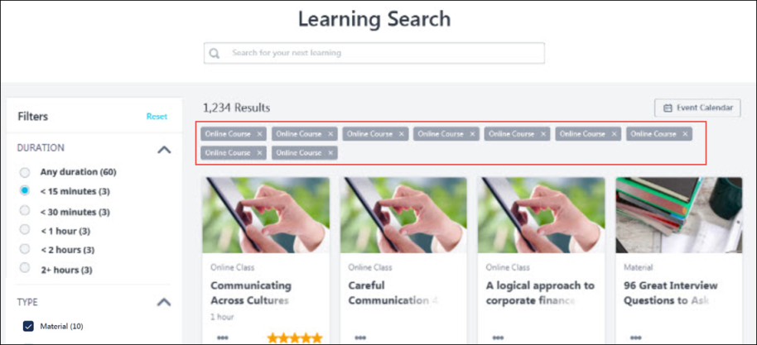
Filter Persistence
When learners use filters on the Learning Search page, select a training item, and then return to the Learning Search page, their filter selections will persist. The following Learning Search filters retain their selections when a user leaves Learning Search and then returns:
- Query (i.e., text entered into the Search bar)
- Duration
- Type
- Subject
- Rating
- Provider
- Languages
- Show Only Mobile Enabled
In addition, if a learner copies the URL for their filtered Learning Search page and sends the URL to another logged in user, when the second user accesses the Learning Search page, the first user's filter selections will be applied to the page. Note: Users may see different training results when using the same URL, due to differences in availability.
Administrators may use URLs for pre-filtered searches in custom search pages.
Event Calendar
Click the Event Calendar button to navigate to your Events Calendar page. From the Events Calendar page, you can view upcoming sessions. Note: This button only displays if the user has permission to access the Events Calendar. See Events Calendar.
Results
Training search results on the Learning Search page appear in tile format, with up to 25 training results displaying on each page of search results. To view additional pages of search results, either click a specific page number below the search results or click the navigation arrows to move chronologically through the search results pages. Search results are sorted by relevance, and text queries are matched with content title, descriptions, and keywords. Search results are returned for up to 38 characters per keyword.
The tiles on Learning Search display differently depending on the following:
- If the training is currently on the user’s transcript, the training item displays as a transcript tile
- If the training is not on the user’s transcript, the training item displays as a training tile
When searching for training, the results you receive will differ depending on whether you are using Learning Search or Global Search. For more information about the differences between these two tools: See Learning Search vs. Traditional Search on page 53 for additional information.
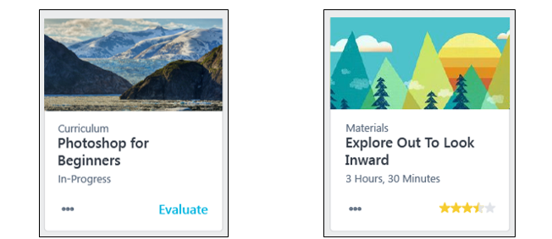
Transcript Tiles
A transcript tile displays for training items that are already on the user's transcript. Training is marked as Removed does not display as a transcript tile.
Transcript Tile Information
Each transcript tile displays the following information:
- Thumbnail Image - The image associated with the training item displays at the top of each tile.
- Training Type - This field displays the type of the training item, such as online class, curriculum, material, etc.
- Title - This field displays the title of the training item.
- Status - This field displays the current transcript status of the training.
Note: The tile is clickable and re-directs the user to the Training Details page for the training item.
Transcript Tile Actions
Each transcript tile provides access to the following actions:
- Primary Transcript Action - The bottom-right corner of each transcript tile provides quick access to the current primary action on the user’s transcript for the specific training item. For example, if the current action for the training on the user's transcript is Launch, a Launch link displays in the bottom right corner of the tile. Note: When a training item is inactive, Inactive appears as the Primary Transcript Action. This option is not clickable.
- Options - Click the "..." icon to access the following secondary actions:
  - Secondary Transcript Actions - Any other available transcript actions available to the user for the training item appear in the Options drop-down menu and allow the user to perform the associated action on the training. See Transcript (Universal Profile) - Status and Options. Note: Clicking some transcript actions causes the user to be redirected to their learning transcript.
  - Save for Later (if available) - Click this link to save the training item. Saved training items display in the Saved for Later section on the Learner Home page. Any training item available to the user can be saved except for certifications, and there is no limit on the number of items which can be saved.
  - Remove from Saved (if available) - This link is only available if the training has already been saved by the user. Click this link to remove the training item from the Saved for Later section.
Unsupported Transcript Tile Actions
If a training item has any of the following actions available, the action will be grayed out and not clickable. If a user needs to perform any transcript actions not supported by Learner Home or Learning Search, they can do so from their transcript. The following transcript actions are NOT supported by Learner Home or Learning Search:
- All actions for the Posting training type
- Unlock
- Launch Locally
- Upload & Verify (Materials)
- Authenticate (Curricula)
Training Tiles
A training tile displays for training items that are NOT on the user’s transcript, which includes training that is on the user’s transcript but is marked as Removed.
Each training tile displays the following information:
- Thumbnail Image - The image associated with the training item displays at the top of each tile.
- Training Type - This field displays the type of the training item, such as online class, curriculum, material, etc.
- Title - This field displays the title of the training item.
- Duration - This field displays the duration of the training. Note: if the duration is 0, this field does not display.
- Average Rating - The bottom-right corner of each training tile displays the average star rating for the training. The numeric value of the average rating displays when the user hovers over the stars. The rating displayed here respects settings in Course Ratings Preferences. Ratings do not display if any of the following are true:
  - The backend setting for Course Ratings is not enabled.
  - Course Ratings are not enabled for the user.
Note: The training tile is clickable and re-directs the user to the Training Details page for the training item.
Training Tile Actions
The training tile displays all available actions in the options drop-down.
Click the "..." icon to access the following actions:
- Launch (if available) - Click this option to launch the training. This adds the training item to the user’s transcript, and the training attempts to open in a new window. The page will then refresh to the transcript.
- Request (if available) - Click this option to request the training. This adds the training item to the user’s transcript. The page will then refresh to the transcript.
- Add to Cart (if available) - Clicking this option re-directs the user to the Training Details page for the training item.
- Save for Later (if available) - Click this link to save the training item. Saved training items display in the Saved for Later carousel on the Learner Home page. Any training item available to the user can be saved except for certifications, and there is no limit on the number of items which can be saved.
- Remove from Saved (if available) - This link is only available if the training has already been saved by the user. Click this link to remove the training item from the Saved for Later section.
Enhanced Search
When searching for training content, there may be a difference in search result behavior when searching via Enhanced Search and Traditional Search. Users may notice a varying number of results returned and a different order of search results for the same search query.
This behavior is due to Enhanced Search and Traditional Search being powered by different search engines that are separate and behave differently.
Content Ranking
Enhanced Search: Enhanced Search is powered by Cornerstone’s newest search engine. This engine indexes and intelligently surfaces training based on several variables powered by the user’s search string. It is designed to surface relevant training expeditiously.
Traditional Search: Traditional Search is powered by Cornerstone's original search engine. This engine contains a predetermined ranking model that recommends training based on a combination of titles, descriptions, and other matches driven by the user’s search string.
Predictive search results are displayed as a user is typing a search input in both Learning Search and Traditional Search pages, and the results are displayed before the search is executed. Predictive search only uses the title and description fields to show possible results and is powered by Enhanced Search.
Enhanced Search Content Ranking and Tokenization
Enhanced Search carries its ranking technology, which may return different results from Traditional Search. If the search text is present in more than one of the considered training fields, the score is aggregated. The ordering of results is determined by the total score. The fields considered for searches depend on the pages that use Enhanced Search. Please visit each page individually in CSX Online Help for more information on relevance scoring and the considered fields.
Note: No relevancy scoring will be listed in any query that only considers one field or carries equal weighting.
For Learning Search and Global Search information, see Learning Search vs. Traditional Search.
Enhanced Search presents full-text features such as instant search, fuzzy search, text splitting, text stemming, and more. Tokenizing terms is based on whitespace and special characters. Therefore, a phrase like "Compliance 2.0" becomes searchable in terms of "Compliance," "2," and "0" for an end user.
Another example involving special characters in a search term could include dashes. For example, the search term "LMS-Compliance-2023" is broken down into "LMS," "Compliance," and "2023". In this case, any training that has either "LMS," "Compliance," or "2023" in the Title, Description, or Keyword is included in the results (See search weighting above). However, any training with an exact title match is listed at the top.
Enhanced Search will tokenize a single string up to 38 characters long when tokenizing words within a search. This means any string without spaces or certain special characters greater than 38 characters will produce inconsistent results.
Example 1: This-is-a-string-of-characters-greater-than-38 as the dashes are considered as a separator within the tokenizer.
Example 2: Thisisastringofcharactersgreaterthan38 would produce inconsistent results since there are no separators in the search query, and the object being searched is longer than 38 characters.
Exact Title Match
When a user searches for a training title using Learning Search and finds an exact title match, that training item is prioritized and returned higher in the search results than other items. Users can also receive exact title matches for training items offered in languages that are not their own by searching for the training using its default title.
Display Language and Localized Languages
Enhanced Search prioritizes training localized to the searcher’s display language when partial matches are found. When exact matches are found, Enhanced Search finds the same match, regardless of the display or localized languages for that user or training.
Exact Title Match and Display Language Use Cases
Use Case 1: Gavi is a content administrator at ACME Corp. He created an online course called "The Importance of Being Modest." Gavi's display language is set to English (US), so the default language of the training and the title of the training is set to English (US). This means that English (US) is the language in which the training is displayed to the user if the course is not localized in their language. Gavi also configures a localized title in Spanish (Spain) of "La importancia de ser modesto."
Use Case 2: Maya, a user whose display language is set to Italian (Italy), logs into the system and searches for "The Importance of Being Modest." Learning Search can find an exact title match using the default title even though the course is unavailable in Maya's display language.
Use Case 3: Henri, a user whose display language is set to Spanish (Spain), logs into the system and searches for "La importancia de ser modesto" and sees Gavi's course prioritized in search results.
Use Case 4: Manuel, a user whose display language is set to Spanish (Latin America), logs into the system and searches for “La importancia.” Since the training is not localized to Spanish (Latin America), Enhanced Search will prioritize all training that matches the partial match “La importancia” and is localized to Spanish (Latin America) before Gavi’s course is shown.
Change Tracking and Data Updates for Search Results
A newly created or updated learning object is usually updated within Enhanced Search results within 15 minutes or less, with few exceptions:
- If the learning object is included as a part of a large data ingestion or a large bulk update was completed, the time for the update to be made available within search results may depend on the amount or the size of the change.
- If the learning object is created or updated at the exact moment of an update to the data set, you can expect the learning object to be available beyond 15 minutes.
- If a new user is added to the platform, the search results are typically available for that user within 1-3 hours.
Learning Search vs. Traditional Search
When searching for training content, there may be a difference in search result behavior when searching via Learning Search and when searching via Traditional Search. Users may notice a varying number of results returned, as well as a different order of search results for the same search query.
This behavior is due to Learning Search and Global Search being powered by different search engines. These search tools are separate and behave differently.
- Learning Search: Learning Search is powered by Cornerstone’s newest search engine. This engine indexes and intelligently surfaces training based on several variables, powered by the user’s search string. It is designed to surface relevant training in an expeditious manner.
- Traditional Search: Traditional Search is powered by Cornerstone's original search engine. This engine contains a predetermined ranking model which recommends training based on a combination of title, description, and other matches also driven by the user’s search string. Traditional Search returns predictive results as the user types, which is powered by the engine of Learning Search.
Predictive search results are displayed as a user is typing a search in both Learning Search and Traditional Search pages, and results are displayed before the search is executed. Predictive search only uses the title and description fields to show possible results.
Content Ranking
Each search engine carries its own ranking protocol which may cause results to return in a different order.
Search Type | Ranking Behavior
Learning Search | If the search text is present in more than one of the above training fields, the score is aggregated. The ordering of results is determined by the total score.  The following weights are applied for a match within the title, description, or keywords:  - Title: 1,000  - Description: 2  - Keywords: 1  Learning Search presents full-text features such as instant search, fuzzy search, text splitting, text stemming, and more.  Tokenizing of terms is based on whitespacing and special characters. Therefore, a phrase like "Compliance 2.0" would become searchable in terms of "Compliance," "2," and "0" for an end user.  Learning Search applies availability to search results.  Another example involving special characters in a search term could include dashes. An example search term of "LMS-Compliance-2023" would be broken down into "LMS", "Compliance", and "2023". In this case, any training that has either "LMS", "Compliance", or "2023" in the Title, Description, or Keyword would be included in the results (See search weighting above). However, any training with an exact title match would be listed at the top. See Learning Search on page 37 for additional information.
Traditional Search | - Contains the following logic: Starts With, Inflections, Locale-Based. See Global Search Logic for more information.  - Global Search applies availability to search results
Filters Availability
Filters are available for both Learning Search and Global Search. Many of the most used filters are present in both areas, but there are some differences. See the table below for the filters available in each search area.
Filter Type | Learning Search | Traditional Search
Subject | X | X
Provider | X | X
Type | X | X
Languages | X | X
Course Rating | X | X
Duration | X
Mobile-enabled | X
Title |  | X
Description |  | X
Keywords | X | X
Custom Fields |  | X
Subscription | X | X
Suggestions
- Begin with the search bar on the Learner Home page, which is fueled by Learning Search. Although Traditional Search is also an intelligent search engine, users may not find it as valuable when searching for training.
- It may make sense to choose your search tool based on the filters you wish to use if the desired filters are not available in one of the search tools. See the table above to help make your search tool choice if certain filters are necessary.
Learning Search - Custom URLs
Learning Search URLs can be configured to direct users to a pre-filtered Learning Search page. For example, a user can create a link which, when clicked, directs other users to the Learning Search page with results automatically filtered to a specific training provider, or automatically filtered to only show mobile-enabled training. The following filters can be automatically applied to the Learning Search page via a custom URL:
- Text Search
- Duration Filter
- Type Filter
- Rating Filter
- Subject Filter
- Provider Filter
- Language Filter
- Mobile Filter
Note: URLs are NOT be auto-populated when you apply filters to the page. This means that Custom URLs can only be constructed from manually, using the formulas below.
Custom URL Filter Formulas
Depending on the filter type, the value(s) you add to the URL may include ID numbers, numeric values, true/false values, and more. See each filter type for information about how to construct the related custom URL:
Text Search Filter
To create a custom URL which directs users to the Learning Search page with training results filtered by a specific search text entry, construct a URL using the following formula:
Portal URL for Learning Search page + /ui/lms-learner-search/search?query=& + search term
- Example: https://eds-talent.csod.com/ui/lms-learner-search/search?query=leadership
  - In this example, when the user navigates to the Learning Search page using the above link, training will be automatically filtered by the search term, "leadership."
Duration Filter
To create a custom URL which directs users to the Learning Search page with training results filtered by a specific search training duration selection or range, construct a URL using the following formula:
Portal URL + /ui/lms-learner-search/search?query= + &minDurationSeconds=X AND &maxDurationSeconds=Y
Note: In this formula, X and Y refer to the minimum and maximum number of seconds, respectively.
- Example: https://eds-talent.csod.com/ui/lms-learner-search/search?query=&minDurationSeconds=1&maxDurationSeconds=3600
  - In this example, when the user navigates to the Learning Search page using the above link, training will be automatically filtered for training items with a duration of < 1 Hour.
- Example: https://eds-talent.csod.com/ui/lms-learner-search/search?query=&minDurationSeconds=1&maxDurationSeconds=900
  - In this example, when the user navigates to the Learning Search page using the above link, training will be automatically filtered for training items with a duration of < 15 Minutes.
Duration | Input
< 15 Minutes | &minDurationSeconds=1&maxDurationSeconds=900
< 30 Minutes | &minDurationSeconds=1&maxDurationSeconds=1800
< 1 Hour | &minDurationSeconds=1&maxDurationSeconds=3600
< 2 Hours | &minDurationSeconds=1&maxDurationSeconds=7200
2+ Hours | &minDurationSeconds=7200
Type Filter
To create a custom URL which directs users to the Learning Search page with training results filtered by a specific training type, construct a URL using the following formula:
Portal URL + /ui/lms-learner-search/search?query= + &typeIds= + training type ID number (see table below for ID numbers)
Note: To automatically filter the page for more than one training type, add additional type IDs to the URL, separated by commas.
- Example: https://eds-talent.csod.com/ui/lms-learner-search/search?query=typeIds=8,64
  - In this example, when the user navigates to the Learning Search page using the above link, training will be automatically to only include training results which are curricula or tests.
Type | ID
Curriculum | 8
Event | 2
Library | 16384
Material | 524288
Online Class | 1
Playlist | 536870912
Program | 134217728
Quick Course | 4
Test | 64
Video | 67108864
Rating Filter
To create a custom URL which directs users to the Learning Search page with training results filtered by a specific minimum star rating, construct a URL using the following formula:
Portal URL + /ui/lms-learner-search/search?query= + &minRating=X
Note: In this formula, X refers to the minimum number of stars. X must be 1 or higher and must be a whole number.
- Example: https://eds-talent.csod.com/ui/lms-learner-search/search?query=&minRating=3
  - In this example, when the user navigates to the Learning Search page using the above link, training will be automatically filtered to only include training that has a Rating of 3 stars & up.
- Example: https://eds-talent.csod.com/ui/lms-learner-search/search?query=&minRating=5
  - In this example, when the user navigates to the Learning Search page using the above link, training will be automatically filtered to only include training that has a Rating of 5 stars.
Rating | input
5 stars | &minRating=5
4 stars & up | &minRating=4
3 stars & up | &minRating=3
2 stars & up | &minRating=2
1 stars & up | &minRating=1
Subject Filter
To create a custom URL which directs users to the Learning Search page with training results filtered by a specific subject, construct a URL using the following formula:
Portal URL + /ui/lms-learner-search/search?query= + &subjectIds= + Subject ID number (see Subject Management page in your portal for subject ID numbers)
- Example: https://eds-talent.csod.com/ui/lms-learner-search/search?query=&subjectIds=617
  - In this example, when the user navigates to the Learning Search page using the above link, training will be automatically to only include training results which are associated with the subject affiliated with the subject ID 617, which in the eds-talent.csod portal is "Orientation." Subject IDs are portal-specific.
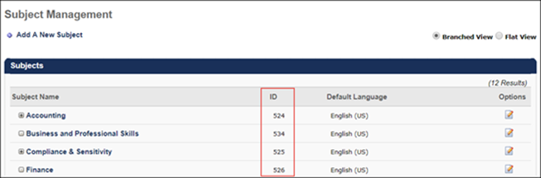
To access the Subject Management page and retrieve a subject's ID, go to Admin > Tools > Learning > Catalog Management > Subjects.
Provider Filter
To create a custom URL which directs users to the Learning Search page with training results filtered by a specific training provider, construct a URL using the following formula:
Portal URL + /ui/lms-learner-search/search?query= + &providerIds= + Provider ID number (see Manage Online Vendors page in your portal for provider ID numbers)
- Example: https://eds-talent.csod.com/ui/lms-learner-search/search?query=&providerIds=B7D65951-6EE6-4F9A-9E15-08CC95512675
  - In this example, when the user navigates to the Learning Search page using the above link, training will be automatically to only include training results which are associated with the provider affiliated with the provider ID B7D65951-6EE6-4F9A-9E15-08CC95512675, which in the eds-talent.csod portal is "Skillsoft." Provider IDs are portal-specific.
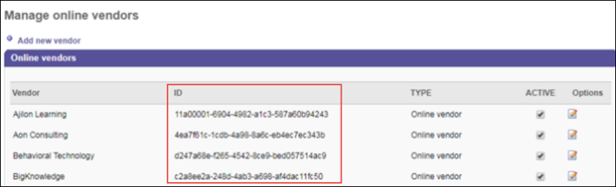
To access the Manage Online Providers page and retrieve a provider's ID, go to Admin > Tools > Learning > Catalog Management > Providers.
Language Filter
To create a custom URL which directs users to the Learning Search page with training results filtered by a language, construct a URL using the following formula:
Portal URL + /ui/lms-learner-search/search?query= + &languageIds= + Language ID number (see table below for ID numbers)
- Example: https://eds-talent.csod.com/ui/lms-learner-search/search?query=&languageIds=34
  - In this example, when the user navigates to the Learning Search page using the above link, training will be automatically filtered to only include training results in Chinese (Traditional).
Language | ID
Arabic | 28
Bahasa (Malaysia) | 38
Bulgarian (Bulgaria) | 31
Chinese (Simplified) | 7
Chinese (Hong Kong SAR) | 9
Chinese (Singapore) | 8
Chinese (Traditional) | 34
Croatian (Croatia) | 40
Czech (Czech Republic) | 21
Danish (Denmark) | 26
Dutch (Netherlands) | 18
English (Australia) | 35
English (UK) | 2
English (US) | 1
Estonian (Estonia) | 47
Finnish (Finland) | 36
French (Canada) | 3
French (France) | 13
German (Germany) | 4
Greek (Greece) | 29
Hebrew (Israel) | 27
Hungarian (Hungary) | 39
Indonesian (Indonesia) | 33
Italian (Italy) | 10
Japanese (Japan) | 6
Korean (Korea) | 30
Latvian (Latvia) | 22
Lithuanian (Lithuania) | 23
Norwegian (Bokmal) | 24
Polish (Poland) | 11
Portuguese (Brazil) | 12
Portuguese (Portugal) | 16
Romanian (Romania) | 20
Russian (Russia) | 5
Serbian (Latin) | 48
Slovak (Slovakia) | 41
Slovenian (Slovenia) | 42
Spanish (Mexico) | 14
Spanish (Spain) | 15
Swedish (Sweden) | 25
Thai (Thailand) | 17
Turkish (Turkey) | 19
Ukrainian (Ukraine) | 32
Vietnamese (Vietnam) | 37
Mobile Filter
To create a custom URL which directs users to the Learning Search page filtered to only display mobile enabled training or only training that is not mobile enabled, construct a URL using the following formula:
Portal URL + /ui/lms-learner-search/search?query= + &mobileOnly= + true OR false
- Example: https://eds-talent.csod.com/ui/lms-learner-search/search?query=&mobileOnly=true
  - In this example, when the user navigates to the Learning Search page using the above link, training will be automatically filtered to only include mobile enabled training results.
Multiple Criteria Considerations
Multiple types of filter criteria can be incorporated into a single custom URL. Multiple criteria types must be separated in the URL by an ampersand (&).
Example 1:
To filter the eds-train.csod.com Learning Search page for training associated with the search term, "leadership," and is also available in Spanish with a rating of at least three stars, the custom URL would be:
eds-train.csod.com/ui/lms-learner-search/search?query=leadership&languageIds=15,14&minRating=3
Example 2:
To filter the eds-train.csod.com Learning Search page for training that is less than fifteen minutes long and mobile enabled, the custom URL would be:
eds-train.csod.com/ui/lms-learner-search/search?query=&minDurationSeconds=1&maxDurationSeconds=900&typeIds=1&mobileOnly=true
Considerations
All filters are case-sensitive and do not work if they do not EXACTLY match the criteria listed above (e.g. MaxDurationSeconds=900, LANGUAGEIDS=4, MobileOnly=true does NOT apply filters). The URLs must match the criteria exactly as written above.

Learner Home - User Profile
The User Profile section of the Learner Home page displays information about the user, including their profile photo, badges, number of completions and hours, subjects they are interested in, and training on their transcript. Using the User Profile panel, users can get an overview of their transcript stats and quickly access more specific information about the data displayed in the panel.
To access the Learner Home page, go to Learning > Learner Home.
Permissions
PERMISSION NAME | PERMISSION DESCRIPTION | CATEGORY

Bio About - View | Enables user to view the Bio page for users within their permission constraints. This permission must be enabled to view the Transcript page within Universal Profile. If a user does not have this permission and they click a person's name or user photo within the Universal Profile, then the Bio page will not open.  On the Learner Home page, this permission also allows end users to view the Completions & Hours field, the training sidebar, and the Continue Learning carousel.  This permission can be constrained by Employee Relationship, OU, User's OU, User's Direct Reports, User Self and Subordinates, and User. Note: For security purposes, this permission is constrained to User Self and Subordinates by default. However, the permission constraints can be modified to allow users to view the Bio About page for other users. | Universal Profile

Learner Home | Grants access to the Learner Home and the Learning Search page. This is an end user permission. This permission cannot be constrained. | Learning

Snapshot - Badges | Enables user to view the Badges widget and subpage within the Universal Profile - Snapshot page for users within their permission constraints. Any user with this permission will always be able to view their own Badges widget when the widget is enabled. This permission also allows end users to view the Badges field on the Learner Home page.  This permission works in conjunction with the Snapshot Main - View permission. This permission can be constrained by OU, User's OU, User Self and Subordinates, User, User's Self, User's Manager, User's Superiors, User's Subordinates, User's Direct Reports, and Employee Relationship. Best Practice: For most users, this permission should be constrained by User Self and Subordinates. | Universal Profile
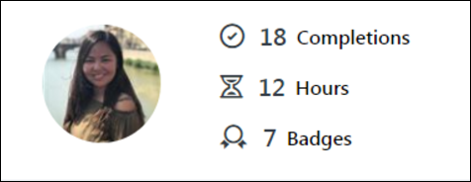
User Profile
The User Profile panel displays on the upper-left side of the Learner Home page and allows users to quickly view personal learning stats. From the User Profile panel, users can also open a flyout which allows them to indicate interest in specific training subjects, which the Learner Home uses to provide more tailored training suggestions.
The User Profile panel displays the following information to the user:
- Profile Photo - This field displays the user photo uploaded to the user record. Clicking the profile photo redirects the user to the Bio tab of their Universal Profile. Note: This picture is only clickable if the user has permission to view the Bio page.
- Completions - This field displays the number of all-time, standalone training items on the user's Completed transcript. This number matches the number of training returned on the Completed page of the transcript. This number does not include archived training, removed training, or any child training items (such as training items within a curriculum). Click the Completions link to be redirected to the Completed transcript. Note: This field only displays if the user has permission to view the Bio page.
- Badges - This field displays the number of all-time badges the user has earned. This number includes both Learning badges and Feedback badges, if Performance is also enabled in the portal. Click the Badges link to be redirected to the Badges Snapshot page. Note: This field only displays if the user has the permission to view badges on the Snapshot page.
- Hours - This field displays the sum of the training hours a user has completed. This number is calculated from the training hours that are currently associated to the training on the user’s transcript in a Completed status. Archived training and any child training items (such as training items within a curriculum) are included in this calculation. Click the Hours link to be redirected to the Completed transcript. Note: Training hours are not currently snapshotted on the Transcript. This means that the number is based off the training hours that are stored at the training level.
  - The following is INCLUDED in the Hours calculation:
    - Archived training
    - Child training (e.g. training with a curriculum)
    - Prerequisite, pre-work, and post-work training
    - Certification training types (Note: These are calculated using the sum of all the training hours for the child training within the certification)
    - Cohort training types (Note: These are calculated using the training hours set for the cohort, if any, and the sum of all the training hours for the child training)
    - Curriculum training types (Note: These are calculated using the aggregated value of child training hours, as opposed to the training hours set for the curriculum)
    - Material training types (Note: These are calculated using the training hours set for the Material and does NOT take the observation duration for an OJT Material into account)
    - Online course training types
    - Posting training types
    - Quick course training types
    - Session training types (Note: These are calculated using the sum of all the parts minus any breaks)
    - Test training types
    - Video training types
  - The following is EXCLUDED from the Hours calculation:
    - Removed training
    - Event training types (since sessions are accounted for)
    - Library training types (since online classes are accounted for)
    - Program training types (since these do not display on the transcript)
- Your Subjects - This section displays the training subjects in which the user has indicated interest. Selected subjects display alphabetically, and up to two lines of subjects can display in the Your Subjects section. If no subjects have been added to your profile, click the Add link to begin adding subjects. If at least one subject has already been selected, to modify the subjects contained in this section, click the Edit link. This opens the Your Subjects flyout. For information about selecting training subjects, See Learner Home - Subjects on page 65 for additional information.
- Your Languages - Click the Your Languages drop-down menu and select the checkboxes next to desired languages to define the languages in which you want your training recommendations to be available. The Learner Home only displays training that is available in the selected languages.
  - If a learning carousel does not contain any training that is available in your selected Learner Home languages, then the carousel is not displayed.
  - If the Learner Home preference to only show training recommendations in the user's display language is enabled, the Language filter only has the user's display language selected by default. If this setting is not enabled, all languages are selected in the Language filter by default. The user can update their language settings at any time, and any selections they make are saved on their Learner Home page when they access the page again in the future.
- Your Playlists - Users with permission to view playlists can view the number of followers their playlists have and the number of playlists they are following from the Learner Home page. In the Your Playlists section on the left side of the Learner Home page, the following fields display:
  - Created - This field displays the number of playlists the user has created. Click the number to be navigated to the My Playlists page, where you can access the playlists you have created.
  - Followers - This field displays the total number of followers that are currently following the user's playlists. Click the number to be navigated to the My Playlists page, where you can access the playlists you have created.
  - Followed - This field displays the total number of playlists that the user is following. Click the number to be navigated to the Following tab of the My Playlists page, where you can view all the playlists you are following.
  - Create New Playlist - Click this link to begin creating a new playlist. You will be navigated to the Playlist Details page for a new playlist. Note: If the user does not have permission to create playlists, this link does not display. See Create Playlists for more information.
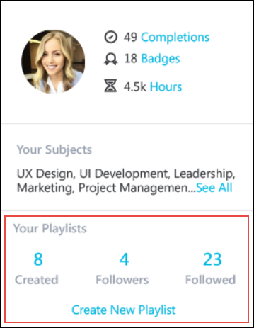

Learner Home - Subjects
The Your Subjects flyout allows users to add and remove training subjects from the list of subjects they are interested in, which impact the training suggestions offered in the Inspired by Your Subjects carousel on the Learner Home page. For more information about the Learner Home content sections, See Learner Home - Training and Banner Carousels on page 80 for additional information.
Note: In order to ensure subject selection is consistent across the learner experience, subject selections made from Learner Home are synced with the subject selections on the user's Universal Profile page.
To access the Your Subjects flyout, go to Learning > Learner Home and click either the Add link or the Edit link in the Your Subjects section of the User Profile panel.
Permissions
PERMISSION NAME | PERMISSION DESCRIPTION | CATEGORY

Global Search - Training | Grants ability to search for training via Global Search. This permission also grants users the ability to view Subjects in Learner Home. If this permission is constrained to a specific OU, then that constraint is automatically applied within Global Search, including search filters and search results. This is an end user permission. The availability of this permission is controlled by a backend setting. | Learning

Learner Home | Grants access to the Learner Home and the Learning Search page. This is an end user permission. This permission cannot be constrained. | Learning
Your Subjects
After the user clicks the Add link or the Edit link in the User Profile section of the Learner Home page, the Your Subjects flyout opens on the left side of the page. Users can find subjects either using the search bar with predictive search or by viewing the Suggestions section of the Your Subjects flyout.
Your Subjects - Search
To search for a specific subject or for subjects containing a keyword, enter a word or phrase into the Your Subjects search bar. As you type, the predictive search functionality displays subjects with words that start with the entered text. When the desired subject displays, click the subject to add it to your Selected subjects. After selecting all your subjects, click the Save button at the bottom of the flyout to add the subject(s) to Your Subjects section of the Learner Home user profile.
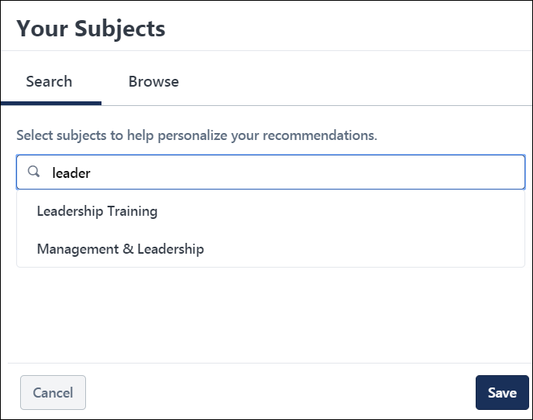
Your Subjects - Browse
To browse the entire hierarchy of subjects in the system, click the Browse tab in the Your Subjects flyout. On the Browse tab, the parent level subjects in the system display. If a subject has child subjects organized beneath it in the hierarchy, an arrow icon displays to the right of the subject. To expand the hierarchy and view the children of a subject, click the drop-down arrow next to the subject. Subjects you have already selected appear as selected in the Browse tab.
To select a subject from the hierarchy, check the box next to the subject. After selecting all your subjects, click the Save button at the bottom of the flyout to add the subject(s) to Your Subjects section of the Learner Home user profile.
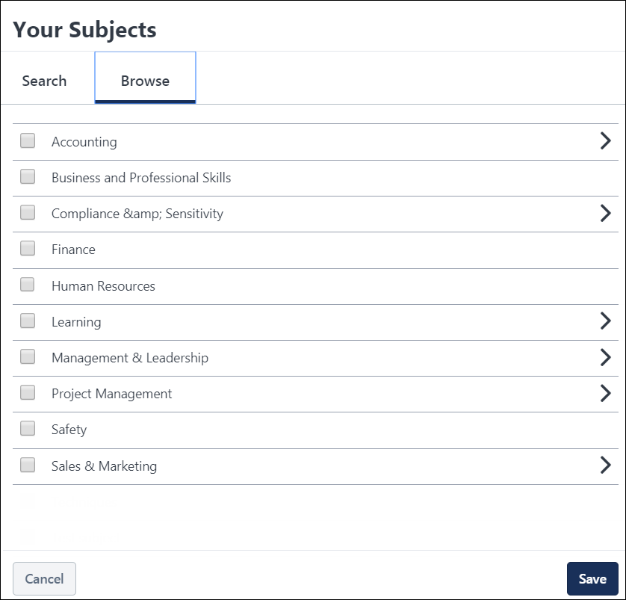
Note: When users first navigate to the Learner Home page, they will see an Add Subjects introductory banner, which displays text that says, "Welcome to the new Learner Home! Customize your experience by adding your favorite subjects." The banner provides access to an Add Subjects button which causes the Your Subjects flyout to open, allowing the user to add to or modify their subjects. Once the user has selected subjects for their Learner Home experience, or if they dismiss the banner, the introductory banner will disappear and a custom banner carousel may display on the Learner Home page, depending on the administrator's preference configurations. For information about Learner Home banners, See Learner Home - Training and Banner Carousels on page 80 for additional information.
Considerations
Only subjects which have at least one training item associated with them display to the user in the Your Subjects flyout. Subjects also respect availability, and if no training items associated with a subject are available to the user, the subject does not display to the user.

Learner Home - Playlists
A Playlists section is available in the User Bio section of the Learner Home page. Using this section, users can view the number of playlists a user has created, navigate to the user's Playlists page, and begin creating a new playlist, provided they have the appropriate permissions. Playlist creators can use Learner Home carousels to quickly add training to their playlists.
To access the Learner Home page, go to: Learning > Learner Home.
Permissions
PERMISSION NAME | PERMISSION DESCRIPTION | CATEGORY

Learner Home | Grants access to the Learner Home and the Learning Search page. This is an end user permission. This permission cannot be constrained. | Learning

LO Detail | Grants ability to view the LO Details page. This permission cannot be constrained. | Learning

Playlists - Create | Grants ability to create private Learning Playlists. This permission cannot be constrained. This is an end user permission. | Learning - Administration

Playlists - View | Playlists will be visible to users with this permission. The user can search for playlists, follow playlists, and consume training contained within playlists that are available to them. The learning playlists that are visible to a user are not impacted by this permission, but instead is based on the availability of the playlist. This permission cannot be constrained. This is an end user permission. | Learning - Administration
User Bio
Users with permission to view playlists can view the number of followers their playlists have and the number of playlists they are following from the Learner Home page. In the Your Playlists section on the left side of the Learner Home page, the following fields display:
- Created - This field displays the number of playlists the user has created. Click the number to be navigated to the My Playlists page, where you can access the playlists you have created.
- Followers - This field displays the total number of followers that are currently following the user's top 20 playlists in the order of creation date. Click the number to be navigated to the My Playlists page, where you can access the playlists you have created.
- Followed - This field displays the total number of playlists that the user is following. Click the number to be navigated to the Following tab of the My Playlists page, where you can view all the playlists you are following.
- Create New Playlist - Click this link to begin creating a new playlist. You will be navigated to the Playlist Details page for a new playlist. Note: If the user does not have permission to create playlists, this link does not display.See Create Playlists for more information.
Learning Search
When using the Search bar on the Learner Home page or when using Learning Search, predictive search results appear as the user enters search criteria. Playlists appear in the predictive search results, along with all other types of system training.
In the Filters menu on the left side of the Learning Search page, a Playlist filter is available in the Type section. Check the Playlist filter to view only Playlists in your search results.
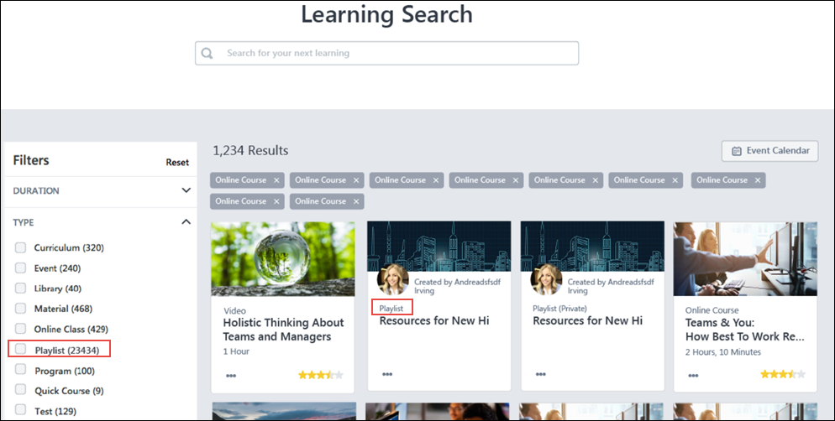
Training Tiles
On the Learner Home page and the Learning Search page, training items appear as training tiles. Each tile includes information about the training and access to various actions. With this enhancement, playlists can appear as training tiles in the Learner Home carousels and in Learning Search results. Playlist training tiles include the following information:
- Thumbnail Image - This is the thumbnail image associated with the playlist via the Course Catalog.
- User profile photo - This is the system profile photo of the playlist creator. Note: This field only displays if the Playlist Preference to make playlist creator information visible is turned on.
- Created by - This field displays the name of the playlist creator. Note: This field only displays if the Playlist Preference to make playlist creator information visible is turned on.
- Playlist Status - This field shows whether or not the playlist is private. If the playlist is private, the word "Private" displays in parentheses. If the playlist is not private, only the word, "Playlist" displays.
- Title - This is the title of the playlist. Click the title to navigate to the playlist. See Playlists - End User View.
- Options - The following option is available for playlists:
  - Delete - Click this option to delete a playlist. It will no longer be available in the system. This option is only available to the playlist creator.
In addition, an Add to Playlist option is available in the Options menu of non-playlist training tiles, if the user has permission to create playlists. Clicking the Add to Playlist option opens a menu with the following options:
- Quick Add - The titles of your five most recently updated playlists display as options. Click the title of a playlist to add the training item to that playlist. A validation message displays at the top of the page when the training has been successfully added to the playlist.
- Create New Playlist - Click this option to begin creating a new playlist, using this training item as the playlist's first item.
- Manage Playlists - Click this option to navigate to your own Playlists page.
Follow Playlist
Learners can follow playlists in order to be notified when updates are made to those playlists. The followed playlists are also added to the Following tab on the user's My Playlists page. The Follow option is available in the bottom right corner of playlist tiles when they display in the following system areas:
- Learner Home
- Learning Search
- My Playlists
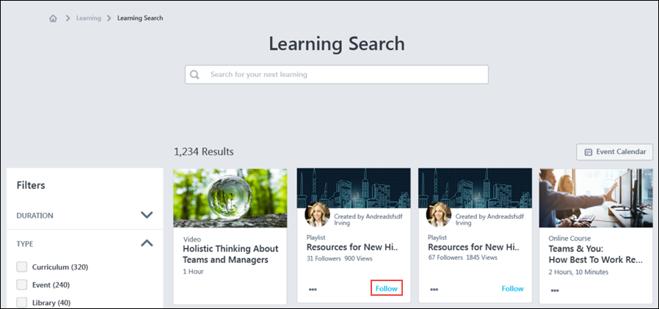
To follow a playlist from the Learner Home or the Learning Search pages, click the Follow link in the playlist tile. To follow a playlist from the Playlist Details page, click the Follow button in the upper-right corner of the Playlist Details page.
The playlist is added to the Following tab on the user's My Playlists page. If more than 24 playlists have been added to a user's Following tab, the Following tab paginates with up to 24 playlist tiles per page.
If configured, when items are added to a playlist a user is following, the user can receive an email digest notifying them of the addition.
Number of Followers
The number of followers who have followed each playlist displays below the playlist title when the playlist displays on Learner Home, Learning Search, and the My Playlists page.
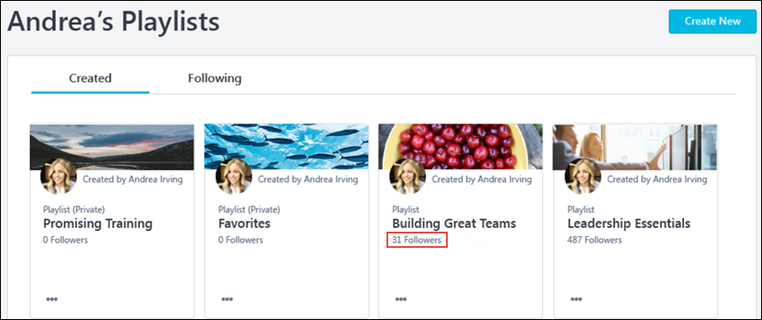

Learner Home - Training Side Bar
The Training Side bar displays below the User Profile panel on the left side of the Learner Home page. This section ensures the user is up to date on their training. This may include any training that is on their transcript with a due date and any assigned training. This section allows users to quickly assess their transcript health and ensure they never miss a deadline.
To access the Learner Home page, go to LEARNING > LEARNER HOME. The training sidebar is only visible to users who have the permission to view the transcript. The backend setting for the Universal Profile transcript section must also be enabled.
Permissions
PERMISSION NAME | PERMISSION DESCRIPTION | CATEGORY

View Transcript Item | Grants ability to view details of learning objects that appear on the transcript (training record), by clicking on the name of the learning object. Users must also have the Bio About - View permission in order to access the transcript within Universal Profile. This permission can be constrained by OU, User's OU, User Self and Subordinates, User, or User's Self. This is an end user permission. | Learning - Administration

Learner Home | Grants access to the Learner Home and the Learning Search page. This is an end user permission. This permission cannot be constrained. | Learning
Training Sidebar Considerations
The training sidebar includes the following sections:
- Required
- Past Due
- Due Soon
- Assigned/No Due Date
The following training types can display in these sections:
- Certification
- Curriculum
- Cohort
- Event
- External Content (added via playlists)
- Library
- Material
- Online Class
- Online Content
- Playlists
- Posting
- Quick Course
- Session
- Test
- Video
The following types of training items do NOT display in the training sidebar sections:
- Archived training
- Removed training
- Completed training
- Inactive training
  - Standalone inactive training
  - Inactive training inside curricula
  - Inactive training inside Cohorts
  - Inactive certifications
  - Inactive trainings in a ‘Not Activated’ or ’Pending Prior Training’ status, including all other statuses​
- Certified certifications
- Program training items
Child LOs display in the Past Due and Due Soon sections of training sidebar on the Learner Home page, along with their individual due dates, which provides learners with a granular view of the training they need to complete. The following child LO types display in the training sidebar:
- LOs within a curriculum
- LOs within a cohort
- Pre-work with a due date
- Post-work with a due date
- Training in a Pending Prior Training status
- Training in an Activated status
- Training that has been removed from a user's transcript, and then restored
Transcript Counts
The Transcript Counts section of the training sidebar displays a high-level overview of training the user may need to complete. This includes any training that is required, or on their transcript with a due date, and any assigned training. The following information displays in the section:
- Required - This field shows the number of non-completed required trainings. Clicking on the number will redirect the learner to its pre-filtered transcript. The number is not displayed if nothing is under the Required bucket, and the usual Past due, Due soon, and Assigned/No Due Date is shown. This is only available when Required Training Tagging is active in the portal. See Required Training Tagging Overview.
- Past Due - This field displays the total number of uncompleted past due training items on the user's transcript. If no training items meet the criteria, this number does NOT display.
- Due Soon - This field displays the total number of uncompleted training items on the user's transcript that have an approaching due date. If no training items meet the criteria, this number does NOT display.
- Assigned No Due Date - This field displays the total number of uncompleted training items that have been assigned to the user without a due date. If no training items meet the criteria, this number does NOT display.
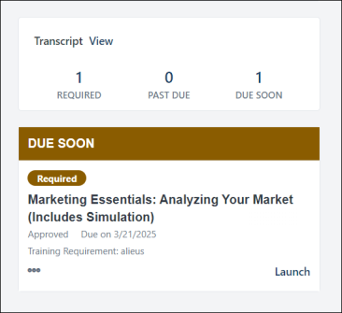
Click the View link to be redirected to your active transcript.
Required
The Required section of the training sidebar displays the number of non-completed required trainings. Clicking on the number will redirect the learner to its pre-filtered transcript. The number is not displayed if nothing is under the Required bucket, and the usual Past due, Due soon, and Assigned/No Due Date is shown. The training is marked by a Required tag.
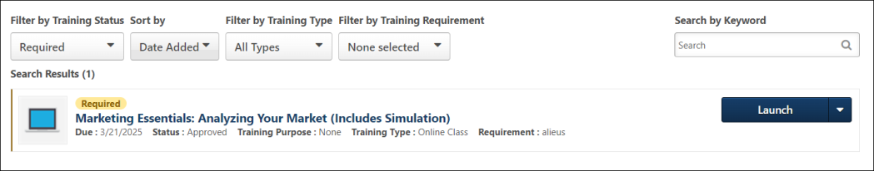
Past Due
The Past Due section of the training sidebar displays training on the user's transcript that has a due date that is greater than the current date. Up to ten training items can
display in this section, but only ten total items can display in the entire training sidebar. Priority is given to the ten training items with the most urgent due dates on the user's transcript. If no training items meet the criteria, this section does NOT display. Each training item displays with the following information:
- Title - This field displays the title of the training item. Clicking the title redirects the user to the Training Details page for the training item.
- Status - This field displays the training item's current status on the user's transcript. Note: Though no action can be taken, this section may include training items that are pending observation.
- Days Past Due - This field displays the number of days which has passed since the training item was due. Note: Items in this section are sorted by due date. Training due the greatest number of days ago displays at the top.
- Training Purpose - If a training purpose is associated with the training item, the training purpose displays in the tile.
- Primary Action & Options - Transcript tiles display a primary action and secondary actions for each individual training item. See Learner Home - Transcript and Training Tiles on page 86 for additional information.
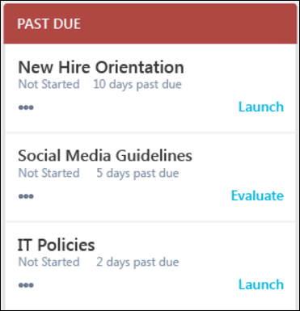
Due Soon
The Due Soon section of the training sidebar displays training items on the user's transcript with an approaching due date. Up to ten training items can display in this section, but only ten total items can display in the entire training sidebar. Priority is given to the ten training items with the most urgent due dates on the user's transcript. If no training items meet the criteria, this section does NOT display. Each training item displays with the following information:
- Title - This field displays the title of the training item. Clicking the title redirects the user to the Training Details page for the training item.
- Status - This field displays the training item's current status on the user's transcript. Note: Though no action can be taken, this section may include training items that are pending observation.
- Due Date - This field displays when the training item is due. If the training is due within the next 30 days, the number of days left until the due date displays. If the training is due in more than 30 days, the training due date displays. Note: Items in this section are sorted by due date. Training with the soonest due date displays at the top of the section.
- Training Purpose - If a training purpose is associated with the training item, the training purpose displays in the tile.
- Primary Action & Options - Transcript tiles display a primary action and secondary actions for each individual training item. See Learner Home - Transcript and Training Tiles on page 86 for additional information.
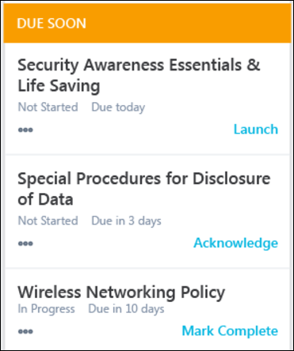
Assigned/No Due Date
The Assigned/No Due Date section of the training sidebar displays training that has been assigned to the user without a due date. Up to ten training items can display in this section, but only ten total items can display in the entire training sidebar. If no training items meet the criteria, this section does NOT display. Each training item displays with the following information:
- Title - This field displays the title of the training item.
- Status - This field displays the training item's current status on the user's transcript.
- Training Purpose - If a training purpose is associated with the training item, the training purpose displays in the tile.
- Primary Action & Options - Transcript tiles display a primary action and secondary actions for each individual training item. See Learner Home - Transcript and Training Tiles on page 86 for additional information.
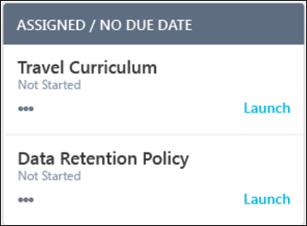
No Training on Transcript
If the user does not have any training on their transcript that is either assigned or has a due date, the entire training side bar is hidden. In this case, a sun icon and text that reads, “All done! It’s a new day, learn something.” displays.

Learner Home - Training and Banner Carousels
Below the search bar on the Learner Home page, several different carousels may display to the user if applicable training is available. These carousels include a custom banner carousel (if configured by an administrator) and various training recommendation carousels.
- The custom banner carousel cycles through various banner images which can include text and a clickable button which navigates the user to another system page.
- The training carousels allow users to page through categorized training items that are relevant to them.
For recommended banner image dimensions, please see Learner Home Preferences. See Learner Home Preferences.
Looking for an online course about how our Machine Learning Platform works? Click here: Machine Learning in the Learning Experience Platform
To access the Learner Home page, go to Learning > Learner Home.
Permissions
PERMISSION NAME | PERMISSION DESCRIPTION | CATEGORY

Bio About - View | Enables user to view the Bio page for users within their permission constraints. This permission must be enabled to view the Transcript page within Universal Profile. If a user does not have this permission and they click a person's name or user photo within the Universal Profile, then the Bio page will not open.  On the Learner Home page, this permission also allows end users to view the Completions & Hours field, the training sidebar, and the Continue Learning carousel.  This permission can be constrained by Employee Relationship, OU, User's OU, User's Direct Reports, User Self and Subordinates, and User. Note: For security purposes, this permission is constrained to User Self and Subordinates by default. However, the permission constraints can be modified to allow users to view the Bio About page for other users. | Universal Profile

Learner Home | Grants access to the Learner Home and the Learning Search page. This is an end user permission. This permission cannot be constrained. | Learning
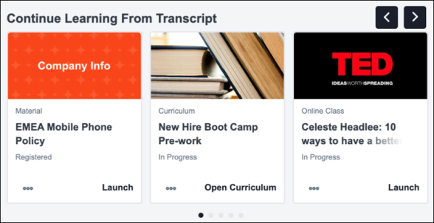
Learner Home Carousels
The following carousels display on the Learner Home page in the order configured by the administrator:
- Banner Carousel
- Continue Learning
- Saved for Later
- Top Picks for User
- Trending for User
- Inspired by Your Subjects
- Playlists for User
- Most Popular
- Featured
- Suggested
- Required
- Based on Skills You Want to Develop
- Based on Your Critical Skills
Custom Banner Carousel
The custom banner carousel on the Learner Home page cycles through different banners configured by the administrator. Depending on the preferences configured for the Learner Home page, the banner carousel may display before, amongst, or below the training category sections. Different banners may also be configured to display with text over the image, or with a button built into the banner which navigates the user to a different system page or external site when clicked.
Up to four banners can be included in the custom carousel. The banner will automatically shuffle through available custom banner images. Users can interact with the banner in the following ways:
- Page through the available banners by clicking the pagination dots below the banner
- Page through the available banners by clicking the left and right navigation arrows which appear when the user hovers over the banner
- Stop and resume auto-play by clicking the Play and Pause buttons that appear on the lower right of the banner
Training Carousels
Please allow up to 30 minutes for updates to be reflected when data is changed. This consideration applies to all training carousels.
If a training carousel does not contain any training that is available in the languages selected in the Your Languages drop-down on the Learner Home, then the carousel is not displayed.
Carousel | Details
Continue Learning | This section displays training that is on the user's active transcript. Training in this section is sorted by the last transcript status change date, and a maximum of 20 training items can display in the section. If no training is on the user's active transcript, this section is hidden. Note: The last transcript status change date is a date field that tracks when a training moves from one transcript status to another transcript status.
Saved for Later | This section displays training that has been saved by the user. Training in this section is sorted by most recently saved first, a maximum of 20 training items that can display in this section. If the user has not saved any training, this section is hidden. If any of the user's saved training has been made inactive or unavailable, that training is removed from the section automatically. Note: This section displays the most recent version of the saved training. For example, if the user saved Leadership Skills (Version 1), and Leadership Skills (Version 2) has since been published, Version 2 of the training displays for the user in this section.
Top Picks for User | This section displays training that is recommended to the user based on their training history. Training in this section is sorted by relevancy to the user (determined by machine learning), and a maximum of 20 training items can display in this section. If no recommendation results are found for the user, the system considers the training history of users in the user's position, division, and location, and then neighboring positions, divisions, and locations in the hierarchy to find recommendations. This section is hidden if any of the following are true:  - The backend setting for machine learning course recommendations is not enabled.  - No recommendation results are found for the user.  - An error occurs.
Trending for Your Position | This section displays training that is recommended to the user based on their position. Training in this section is sorted by relevancy to the user (determined by machine learning), and a maximum of 20 items can display in this section. If no recommendations are found for the user's position, then the system considers the user's division and location, then neighboring positions, divisions, and locations in the hierarchy to find recommendations. This section is hidden if any of the following are true:  - The backend setting for machine learning course recommendations is not enabled.  - No recommendation results are found for the user.  - An error occurs.
Inspired by Your Subjects | This section displays training that is recommended to the user based on subjects in which the user has indicated interest. See Learner Home - Subjects on page 65 for additional information. Training in this section is sorted by relevancy to the user (determined by machine learning), and a maximum of 20 items can display in the section. If the user has not selected any subjects, then the section displays a prompt for the user to add subjects. If no recommendations are found for the user’s selected subjects, the system considers the user's division and location, then neighboring positions, divisions, and locations in the hierarchy to find recommendations. This section is hidden if any of the following are true:  - The backend setting for machine learning course recommendations is not enabled.  - No recommendation results are found for the user.  - An error occurs.  Note: Training items are recommended to the user in this carousel if the subjects associated with the training include subjects in which the user is interested, at the time of the last Cluster Refresh. In Production portals the refresh occurs every two weeks, and in Stage portals the refresh occurs during releases.
Playlists for User | When a user views the Playlists for [User] carousel, they see their own first name in the carousel header, and in the carousel itself they see playlists that are recommended to them based on the training contained within the playlists. Each Playlist tile that displays within the carousel provides the following information:  - Thumbnail Image - The image associated with the playlist displays at the top of each tile.  - Created By - This field displays the name and profile photo of the user who created the playlist.  - Training Type - This field displays the type of the training item.  - Title - This field displays the title of the playlist.  - Followers - This field displays the number of user who are following the playlist.  - Views - This field displays the number of times a playlist has been viewed.  - Follow - Click this link to follow the playlist. The playlist will be added to the Following tab of your Playlists page.
Most Popular | This section displays training that was requested the most number of times in the last 60 days. Training in this section is sorted by the highest number of requests, and a maximum of 20 items can display in the section. If no training has been requested in the last 60 days, this section is hidden.
Featured | This section displays training items which have been designated as Featured on the Availability page of the Course Catalog by an administrator. If no training available to the user has been designated as Featured, this carousel does not display to the user. A maximum of 20 items at a time can display in the section, and items are displayed in last modified order (i.e. the most recently modified item will display first). This means the most recently modified 20 items designated as "Featured" from the Availability tab of the Course Catalog will display in the carousel on Learner Home .Note: If a playlist is designated as featured via the Course Catalog, it does NOT display in the Featured Training widget on the Welcome page. The featured playlist does, however, display in the Featured carousel on the Learner Home page.See Course Catalog - Availability for more information about setting the Availability Type of training items to Featured.
Suggested | This section displays training items which have been designated as Suggested on the Availability page of the Course Catalog by an administrator. If no training available to the user has been designated as Suggested, this carousel does not display to the user. A maximum of 20 items at a time can display in the section, and items are displayed in last modified order (i.e. the most recently modified item will display first). This means the most recently modified 20 items designated as "Suggested" from the Availability tab of the Course Catalog will display in the carousel on Learner Home. See Course Catalog - Availability for more information about setting the Availability Type of training items to Suggested.
Required | This section displays training items which have been designated as Required on the Availability page of the Course Catalog by an administrator. If no training available to the user has been designated as Required, this carousel does not display to the user. A maximum of 20 items at a time can display in the section, and items are displayed in last modified order (i.e. the most recently modified item will display first). This means the most recently modified 20 items designated as "Required" from the Availability tab of the Course Catalog will display in the carousel on Learner Home. See Course Catalog - Availability for more information about setting the Availability Type of training items to Required.
Based on Skills You Want to Develop | This section displays training items that has the skills they have identified in the related section of the Skills Profile. The training included in the carousel has at least one skill that matches the skills identified by the learner. If a training matches with more skills, that training is shown first. If trainings have the same number of skills, they are shown to the user using the ratings of the course. If there are more than 20 possible training to show, an even number of training is shown per skill to allow the Learner to choose from when the number of matching skills is the same. This carousel is disabled by default and can be enabled via Learner Home Preferences. See Learner Home Preferences.
Based on Your Critical Skills | This section displays training items that has the skills they have identified in the related section of the Skills Profile. The training included in the carousel has at least one skill match to skills identified in the Critical Skills portion of the Skills Profile. If the Learner has multiple critical skills with multiple pieces of training available to show, training is shown based on the difference in the learner’s target compared to the rating. If there are more than 20 possible training to show, an even number of training is shown per skill to allow the Learner to receive a variety of training with different skills to choose from. This carousel is disabled by default and can be enabled via Learner Home Preferences. See Learner Home Preferences.
On a desktop browser, up to four tiles can display at a time for each training carousel. When sized down to a mobile device, one and a half tiles display at a time for each training carousel. Users can interact with the carousel in the following ways:
- Page through the tiles by clicking the pagination dots on the top right of the carousel
- Page through the tiles by clicking the left and right navigation arrows which appear when the user hovers over the carousel. Note: Clicking the right navigation arrow on the last page of tiles will returns the user to the beginning of the carousel.
Recommendation Carousels - Filtering Logic
Four of the Learner Home carousels are recommendation carousels. The purpose of these carousels is to recommend relevant training to the user. To ensure that the system only recommends appropriate training to the user, the system automatically applies filtering logic to the results. This ensures that the user is not recommended any incorrect training (e.g. not in their availability, inactive, etc.). The exclusions documented in this section ONLY apply to the following Learner Home training carousels:
- Top Picks for User
- Trending for Your Position
- Inspired by Your Subjects
- Most Popular
The following training will NOT be recommended to users in the above training carousels:
- Session or cohort training items (because there is a date component to these types)
- Training flagged as "Exclude from Recommendations" via the Course Catalog
- Training not available to the user (i.e., not in their availability)
- Inactive training
- Training that is active on the user's transcript
  - This logic does not apply to the "Continue Learning" or "Saved for Later" carousels.
  - If a newer version of a training is available and does NOT exist on the user's transcript, the training can still display as a recommendation, even if a prior version exists on the user's transcript.
- Training that is NOT in a Published training status
- Training that is NOT the latest version
- Training that has recurrence enabled and is already on the user's transcript
- Child training that is not standalone
- Child training that is on a user's transcript as Active (and is also a standalone training item)
- Child training that is on a user's transcript as Not Yet Activated (and is also a standalone training item)

Learner Home - Transcript and Training Tiles
The Learner Home and Learning Search page both display training items in tile format. These tiles display differently depending on the following:
- If the training is currently on the user’s transcript, the training item displays as a transcript tile
- If the training is not on the user’s transcript, the training item displays as a training tile
Permissions
PERMISSION NAME | PERMISSION DESCRIPTION | CATEGORY

Learner Home | Grants access to the Learner Home and the Learning Search page. This is an end user permission. This permission cannot be constrained. | Learning
Transcript Tiles
A transcript tile displays for training items that are already on the user's transcript. Training that is marked as Removed does not display as a transcript tile. Transcript tiles may display in any of the below locations:
- Continue Learning carousel
- Saved for Later carousel
- Learning Search
Transcript Tile Information
Each transcript tile displays the following information:
- Thumbnail Image - The image associated with the training item displays at the top of each tile.
- Training Type - This field displays the type of the training item, such as online class, curriculum, material, etc.
- Title - This field displays the title of the training item.
- Status - This field displays the current transcript status of the training.
Note: The tile is clickable and re-directs the user to the Training Details page for the training item.
Transcript Tile Actions
Each transcript tile provides access to the following actions:
- Primary Transcript Action - The bottom-right corner of each transcript tile provides quick access to the current primary action on the user’s transcript for the specific training item. For example, if the current action for the training on the user's transcript is Launch, a Launch link displays in the bottom right corner of the tile. Note: When a training item is inactive, Inactive appears as the Primary Transcript Action. This option is not clickable.
- Options - Click the "..." icon to access the following secondary actions:
  - Secondary Transcript Actions - Any other transcript actions available to the user for the training item appear in the Options drop-down menu and allow the user to perform the associated action on the training. See Transcript (Universal Profile) - Status and Options for all available actions.Note: Clicking some transcript actions causes the user to be redirected to their learning transcript.
  - Save for Later (if available) - Click this link to save the training item. Saved training items display in the Saved for Later section on the Learner Home page. Any training item available to the user can be saved except for certifications, and there is no limit on the number of items which can be saved.
  - Remove from Saved (if available) - This link is only available if the training has already been saved by the user. Click this link to remove the training item from the Saved for Later section.
Unsupported Transcript Tile Actions
If a training item has any of the following actions available, the action will be grayed out and not clickable. If a user needs to perform any transcript actions not supported by Learner Home or Learning Search, they can do so from their transcript. The following transcript actions are NOT supported by Learner Home or Learning Search:
- All actions for the Posting training type
- Unlock
- Launch Locally
- Upload & Verify (Materials)
- Authenticate (Curricula)
Training Tiles
A training tile displays for training items that are NOT on the user’s transcript, which includes training that is on the user’s transcript but is marked as Removed. Training tiles may display in any of the below locations:
- Saved for Later carousel
- Top Picks for User carousel
- Trending for Your Position carousel
- Inspired by Your Subjects carousel
- Most Popular carousel
- Learning Search
Each training tile displays the following information:
- Thumbnail Image - The image associated with the training item displays at the top of each tile.
- Training Type - This field displays the type of the training item, such as online class, curriculum, material, etc.
- Title - This field displays the title of the training item.
- Duration - This field displays the duration of the training. Note: if the duration is 0, this field does not display.
- Average Rating - The bottom-right corner of each training tile displays the average star rating for the training. The numeric value of the average rating displays (e.g. 4.2) when the user hovers over the stars. The rating displayed here respects settings in Course Ratings Preferences. Ratings do not display if any of the following are true:
  - The backend setting for Course Ratings is not enabled.
  - Course Ratings are not enabled for the user.
Note: The tile is clickable and re-directs the user to the Training Details page for the training item.
Training Tile Actions
The training tile displays all available actions in the options drop-down:
- Options - Click the "..." icon to access the following actions:
  - Launch (if available) - Click this option to launch the training. This adds the training item to the user’s transcript, and the training attempts to open in a new window. The page will then refresh to the transcript. Note: This option does not display if the backend setting to launch from training details is not enabled and this option is only available for Materials, Online Classes, Quick Courses, and Videos.
  - Request (if available) - Click this option to request the training. This adds the training item to the user’s transcript. The page will then refresh to the transcript.
  - Add to Cart (if available) - Click this option to add the training to your shopping cart. After the user clicks this option, the page refreshes to the shopping cart page.
  - Save for Later (if available) - Click this link to save the training item. Saved training items display in the Saved for Later section on the Learner Home page. Any training item available to the user can be saved except for certifications, and there is no limit on the number of items which can be saved.
  - Remove from Saved (if available) - This link is only available if the training has already been saved by the user. Click this link to remove the training item from the Saved for Later section.

