Interview Management March 2024

Table of Contents
Interview Management Overview 1
HireVue 2
Interview Status Type - On Demand Video Interview 3
Interview Events & Sessions Page Overview 6
Create Interview Event - Overview 9
Applicant Profile - Interview Status Type 54
Interview Guide Management 56
Create Interview Guide - Overview 58
Create Interview Guide - Interview Guide Content 61
Create Interview Guide - Interview Guide Scoring 69
Interview Scheduler Page Overview 70
Create Interview - Add Interviewers 73
Create Interview - Available Interviewers Panel 77
Create Interview - Interview Guide 80
Create Interview - Set Schedule Details and Send Interview 82
Send Notification to Applicant 88
Edit Interview Session 92
Cancel Interview Session 95
Interview Manager Overview 97
Interview Manager Overview 99
Interview Management Preferences (by Division) 101
Interview Guide Page Overview 104
Completed Interviews Tab 123
Scheduled Interviews Tab - Future Interviews 126
Scheduled Interviews Tab - Incomplete Interviews 130
Scheduled Interviews Tab - Overview 135
Scheduled Interviews Tab - Today's Interviews 138

Interview Management Overview

HireVue

Interview Status Type - On Demand Video Interview
An on demand video interview is a video interview that the applicant conducts on their own time using HireVue. The applicant is displayed a list of questions, which they answer by recording themselves responding to the questions in HireVue. Once the applicant completes the video interview, the interviewers can access the video and review the applicant's responses.
Status change emails can be configured for the Interview status type panel. See Status Change Emails for additional information.
Note: The ability to conduct video interviews is controlled by backend settings that are disabled by default. To enable this functionality, contact Global Customer Support.
Note: If the panel was configured for the template selected on the General tab for the requisition, then the default configurations display in the panel on the Applicant Review tab.
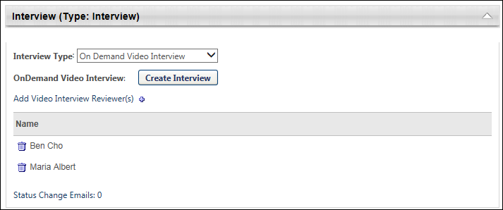
To access Manage Job Requisitions, go to Recruit > Manage Requisitions.
Permissions
PERMISSION NAME | PERMISSION DESCRIPTION | CATEGORY

Requisition: Edit Applicant Review | Grants ability to edit the Applicant Review tab of the Edit Requisition page. This permission cannot be constrained. | Recruiting

Requisition: Manage | Grants ability to access and manage all requisitions regardless of ownership (constraints permitting). This permission also grants read-only access to the Applicant Review tab when creating or editing a job requisition. This permission can be constrained by OU, User's OU, and Grade. | Recruiting

Requisition: Owner | Enables owner to access requisitions and applicants for requisitions for which they are an owner. This permission also grants read-only access to video interviews that are completed by applicants via HireVue. For portals with Referral Suite enabled, this permission also enables requisition owners to edit the referral source on the Applicant Profile page. This permission cannot be constrained.  Note: This is a dynamically assigned permission that is not available in Security Role Administration. If the user is removed as an owner, the permission is revoked for the associated requisition. This permission cannot be manually assigned. Also, if a user has both the permission necessary to manage requisitions and be a requisition owner, the constraints of the Requisition: Manage permission overrule those of the Requisition: Owner permission. For requisition owners that do not also have permission to manage requisitions, only certain fields are editable when editing a requisition. | Recruiting
Note: The permission to review or approve a job requisition grants users view access to the requisition.
Note: For users with permission to access job requisitions but who do not have permission to edit the Applicant Review tab, the tab is visible but cannot be modified.
Interview Type
Select the On Demand Video Interview type from the drop-down in the Interview Type field. When this option is selected, the Create Interview button displays.
Note: The "On Demand Video Interview" option may have already been selected in the Interview Type field on the requisition template.
Create Interview
Click Create Interview to configure the On Demand Video interview. This opens HireVue from which you can select questions for the interview. Note: You must have a valid email address and a HireVue account in order to create an interview in HireVue.
Once the interview is created in HireVue, the Create Interview button in the Interview status type panel changes to Edit Interview. You can click the Edit Interview button to open HireVue and edit the interview.
Add Video Interview Reviewers
Interviewers are added to the Video Interview Reviewers table by clicking the plus icon to the right of Add Video Interview Reviewer(s). This opens the Add pop-up. The pop-up displays the interviewers that were added to the Applicant Interviewer(s) section on the General tab. Click the plus icon to the left of each interview reviewer you would like to add. Then, click Done. The interview reviewers are added to the Video Interview Reviewers table.
Note: Interview reviewers only display in the Add pop-up if interviewers are defined in the Applicant Interviewer(s) section of the General tab for the template. Interviewers that are added to the Applicant Interviewer(s) section are not automatically added to the Video Interview Reviewers table. Interview reviewers must be added manually using the Add Video Interview Reviewer(s) feature.
Note: The same interview reviewer can be added to multiple Interview type status panels.
Note: On Demand Video interview reviewers must have a valid email address. If a valid email address is not defined for one or more interview reviewers, then an error message displays when the Save button is clicked to save the requisition template or when the administrator attempts to navigate to another tab.
Video Interview Reviewers Table
The Video Interview Reviewers table displays the interviewers and the option to remove interview reviewers.
The following information appears in the table:
Column Name | Description
Remove | Click the Trash Can icon to the left of the interview reviewer's name either in the Video Interview Reviewers table or in the Add pop-up. This removes the interview reviewer from the table.  Note: When removing interview reviewers from the Add pop-up, click Done to complete the removal action.
Name | This column displays the name of the interview reviewer.

Interview Events & Sessions Page Overview
The Interview Events & Sessions page enables administrators to manage interview events and sessions. From this page, administrators can create, edit, copy, view, and delete interview events.
To access the Interview Events & Sessions page, go to Recruit > Interview Events & Sessions.
Permissions
PERMISSION NAME | PERMISSION DESCRIPTION | CATEGORY

Interview Events - Manage | Grants access to create and edit interview events and sessions regardless of owner. The menu selection "Interview Events & Sessions" from the Recruit drop-down is available for users with this permission. This permission cannot be constrained. This is an administrator permission.  Note: Any administrator with this permission has access to all interview events, regardless of the organizational unit(s) to which they belong. | Recruiting Administration

Interview Event - Owner | Grants ability to access interview events for which user is listed as an owner. This permission cannot be constrained. This is an administrator permission.  Note: This is a dynamically assigned permission that is not available in Security Role Administration. Users must also have the Applicants: Manage Interviews permission in order to schedule events on the Interview Scheduler page. | Recruiting Administration
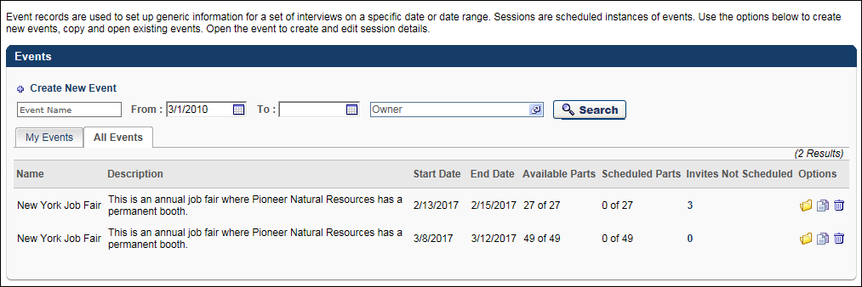
Create New Event
The Create New Event option allows administrators to create interview events. See Create Interview Event - Overview on page 11 for additional information.
Filter Options
The following filters are available:
- Event Name - Filter by event name by entering a full or partial name in the Event Name field. Click Search. The events table displays matching results.
- From/To - Filter by event start and end date. The current date displays by default in the From field. Enter start and end dates in the From/To fields. Or, use the calendar feature to select the dates from the calendar. Click Search. The events table displays matching results.
- Owner - Filter by owner name. Click the Select icon in the Owner field and select an owner from the pop-up. Once the owner is selected, the pop-up closes. Click Search. The events table displays matching results.
Events Table
The events table is separated into two tabs: My Events and All Events. The My Events tab displays by default and shows the events of which the administrator is an owner. The All Events tab is only available for administrators with permission to manage interview events and displays all events that have been created.
The following information displays in the table:
- Name - This column displays the event name. This column is sortable.
- Description - This column displays the event description. This column is not sortable.
- Start Date - This column displays the event start date in MM/DD/YYYY format. This column is sortable.
- End Date - This column displays the event end date in MM/DD/YYYY format. This column is sortable.
- Available Parts - This column displays the number of parts available in relation to the total number of parts for the session.
- Scheduled Parts - This column displays the number of parts that have been scheduled in relation to the number of sessions. Note: When an applicant self schedules an interview session for an interview event, the selected session is included in the session part count in the Scheduled Parts column.
- Invites Not Scheduled - This column displays the number of applicants who have been invited to self schedule for the event but have not yet scheduled an interview, have requested an alternative session, or declined the invitation. The number displays as a link. Clicking the link opens the Invites Not Scheduled page for the event.
- Options - The following options are available in the Options column:
  - Open - Click the Open icon to open the Event Details page. The event details can only be edited if one or more sessions have not been scheduled.
  - Copy - Click the Copy icon to copy the event. This opens the Event Details page. The event name, description, start/end date, and owner(s) are copied. Sessions are not copied.
  - Delete - Click the Trash Can icon to delete the event. This opens a confirmation pop-up. Click Yes to delete the event, or click No to cancel the delete action. Events can be deleted even if you have already created sessions for the event. When an event is deleted, all of its sessions are also deleted.

Create Interview Event - Overview
When creating, copying, and editing interview events, the administrator defines the event details and can also add sessions and session parts. See the following for information about each section of the Event Details page:
- Create Interview Event - Event Details
- Create Interview Event - Availability
- Create Interview Event - Sessions
- Create Interview Event - Add Sessions
Event Deletion Note: Once you create an event, the event along with all of its sessions can be deleted from the main Interview Events and Sessions page.
To create an interview event, go to Recruit > Interview Events & Sessions. Then, click the Create New Event link on the Interview Events & Sessions page.
Permissions
PERMISSION NAME | PERMISSION DESCRIPTION | CATEGORY

Interview Events - Manage | Grants access to create and edit interview events and sessions regardless of owner. The menu selection "Interview Events & Sessions" from the Recruit drop-down is available for users with this permission. This permission cannot be constrained. This is an administrator permission.  Note: Any administrator with this permission has access to all interview events, regardless of the organizational unit(s) to which they belong. | Recruiting Administration

Interview Event - Owner | Grants ability to access interview events for which user is listed as an owner. This permission cannot be constrained. This is an administrator permission.  Note: This is a dynamically assigned permission that is not available in Security Role Administration. Users must also have the Applicants: Manage Interviews permission in order to schedule events on the Interview Scheduler page. | Recruiting Administration
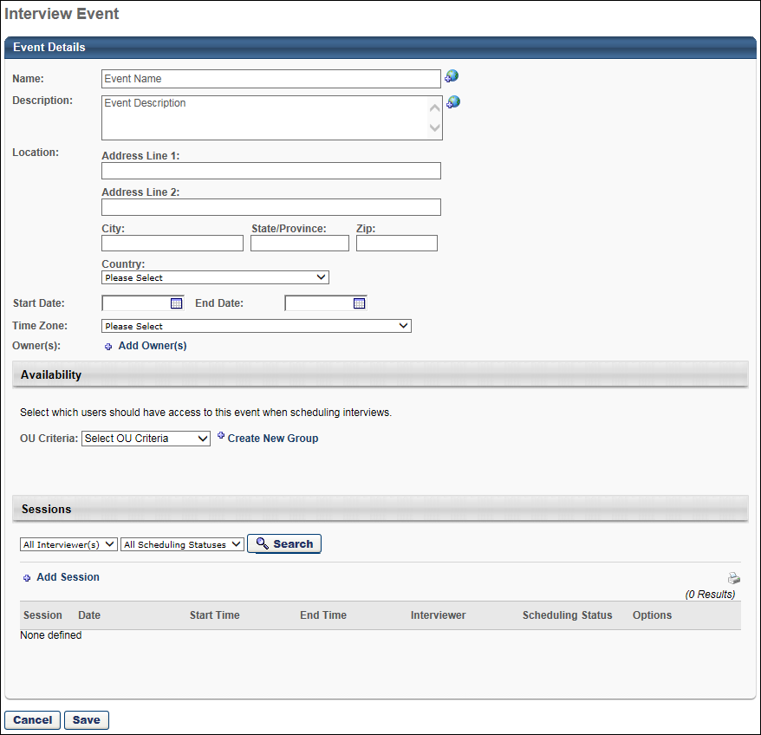
Create Interview Event - Overview
When creating, copying, and editing interview events, the administrator defines the event details and can also add sessions and session parts. See the following for information about each section of the Event Details page:
- Create Interview Event - Event Details
- Create Interview Event - Availability
- Create Interview Event - Sessions
- Create Interview Event - Add Sessions
Event Deletion Note: Once you create an event, the event along with all of its sessions can be deleted from the main Interview Events and Sessions page.
To create an interview event, go to Recruit > Interview Events & Sessions. Then, click the Create New Event link on the Interview Events & Sessions page.
Permissions
PERMISSION NAME | PERMISSION DESCRIPTION | CATEGORY

Interview Events - Manage | Grants access to create and edit interview events and sessions regardless of owner. The menu selection "Interview Events & Sessions" from the Recruit drop-down is available for users with this permission. This permission cannot be constrained. This is an administrator permission.  Note: Any administrator with this permission has access to all interview events, regardless of the organizational unit(s) to which they belong. | Recruiting Administration

Interview Event - Owner | Grants ability to access interview events for which user is listed as an owner. This permission cannot be constrained. This is an administrator permission.  Note: This is a dynamically assigned permission that is not available in Security Role Administration. Users must also have the Applicants: Manage Interviews permission in order to schedule events on the Interview Scheduler page. | Recruiting Administration
Create Interview Event - Add Sessions
The Sessions page allows administrators to add sessions and session parts to an interview event. From here, administrators can also add interviewers to the entire session as a whole or to each individual session part.
Note: At least one session must be added in order for the interview event to be available to select when inviting applicants to the event from the Applicant Profile page or the Manage ApplicantsManage Applicants page. If there are no sessions for the event, then the event will not display in the pop-up when selecting events.
To create an interview event, go to Recruit > Interview Events & Sessions. Then, click the Create New Event link on the Interview Events & Sessions page.
Permissions
PERMISSION NAME | PERMISSION DESCRIPTION | CATEGORY

Interview Events - Manage | Grants access to create and edit interview events and sessions regardless of owner. The menu selection "Interview Events & Sessions" from the Recruit drop-down is available for users with this permission. This permission cannot be constrained. This is an administrator permission.  Note: Any administrator with this permission has access to all interview events, regardless of the organizational unit(s) to which they belong. | Recruiting Administration

Interview Event - Owner | Grants ability to access interview events for which user is listed as an owner. This permission cannot be constrained. This is an administrator permission.  Note: This is a dynamically assigned permission that is not available in Security Role Administration. Users must also have the Applicants: Manage Interviews permission in order to schedule events on the Interview Scheduler page. | Recruiting Administration
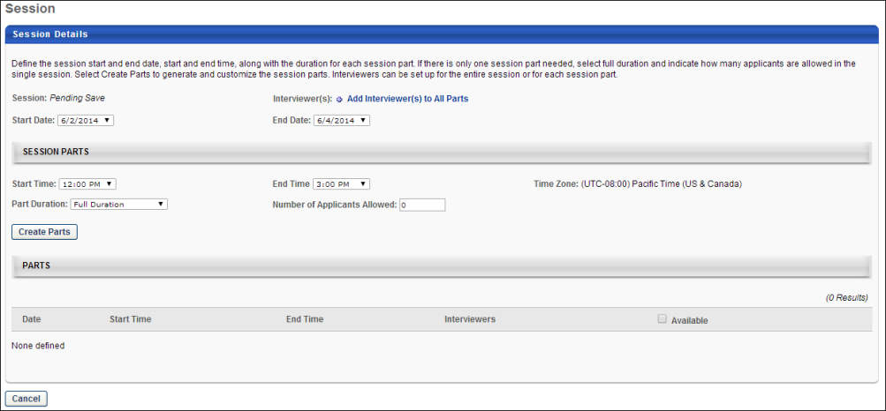
Session Details
In the Session Details section, administrators configure the start and end date for the session. An option is also available to add interviewers to all of the session parts. This section also displays the system-defined session number.
- Session - This field displays the system-defined session number. The session number is generated when the session is saved. If the session has not yet been saved, then this field displays "Pending Save."
- Interviewer - This is a required field. This field enables administrators to add interviewers to the entire session as a whole. To add interviewers:
  - Click Add Interviewer(s) to All Parts. This opens the Select Interviewer pop-up.
  - Select the interviewers.
  - Click Add. This adds the interviewers to all session parts.
There is no limit to the number of interviewers that can be added.Once added, an interviewer can be removed by clicking the Delete icon to the left of the interviewer's name. This removes the interviewer from all session parts.
- Start Date - Enter the date on which the session starts. Or, use the calendar feature to select a date from the calendar. This is a required field.
For single-day events, the field displays the event start date by default.
- End Date - Enter the date on which the session ends. Or, use the calendar feature to select a date from the calendar. This is a required field.
For single-day events, the field displays the event end date by default.
Session Parts
In the Session Parts section, administrators can configure the session parts. Adding parts is not required when creating sessions.
- Start Time - Select the session part start time from the drop-down. The times are listed in 15-minute intervals.
- End Time - Select the session part end time from the drop-down. The times are listed in 15-minute intervals.
- Time Zone - This field displays the time zone in which the event occurs. This field can only be modified from the Event Details page.
- Part Duration - Select the duration of the parts from the drop-down. The options are 15-minute intervals for the first hour, and then 30-minute intervals for the remaining hours.
A Full Duration option is also available. When selected, the session part occurs for the full duration between the start and end time of the session.
Note: If the sum time of the session part is longer than the duration, then any remaining time is discarded. For example, the duration of each part in a session is 45 minutes. The total session time is five hours. The session would have six 45-minute parts, and the remaining 30 minutes of the session would be discarded.
- Number of Applicants Allowed - This option only displays when Full Duration is selected in the Part Duration field. This is a required field.
This option allows administrators to define the maximum number of applicants that can be scheduled for the part. This field accepts up to three numeric characters.
Note: Once at least one applicant has been scheduled, the value in this field cannot be changed to a value lower than the number of scheduled applicants.
- Create Parts - Click the Create Parts button to create the parts. This populates the Parts table with the information for each part.
Parts Table
The Parts table lists all of the session parts. From here, administrators can add and remove interviewers. Individual parts cannot be deleted once they are created.
The following information displays for each part:
- Date - This column displays the date of the part.
- Start Time - This column displays the start time of the part.
- End Time - This column displays the end time of the part.
- Interviewers - This column allows administrators to add interviewers to the part. To add interviewers:
  - Click Add Interviewer(s). This opens the Select Interviewer pop-up.
  - Select the interviewers.
  - Click Add. This adds the interviewers to the part.
There is no limit to the number of interviewers that can be added.
If interviewers are selected in the Interviewer(s) field in the Session Details section, then those interviewers display by default in this column.
Hovering over the interviewer's name opens an information pop-up that displays the interviewer's image if available, name, position, phone number, and a linked email address. Click the interviewer's email address to send an email to the interviewer, using your organization's email provider.
Interviewers can be deleted by clicking the Delete icon to the left of the interviewer's name. This includes default interviewers who are added to the part via the Add Interviewer(s) to All Parts option in the Session Details section.
- Available - This column displays the availability for the part. The following values and options that display are dependent upon the option selected in the Part Duration field:
  - Specified Duration - If a specific duration is selected in the Part Duration field, then the Available column displays a checkbox for each part. The box is checked by default, which indicates that the part is available. When unchecked, the part is not available.
  - Full Duration - If the Full Duration option is selected in the Part Duration field, then the Available column displays the number of parts remaining to be scheduled vs. the total number of parts scheduled.
Save/Cancel
Click OK to create the session or confirm the changes to the session. This returns you to the interview event configuration page.
Click Cancel to cancel creating or editing the session. This returns you to the interview event configuration page.
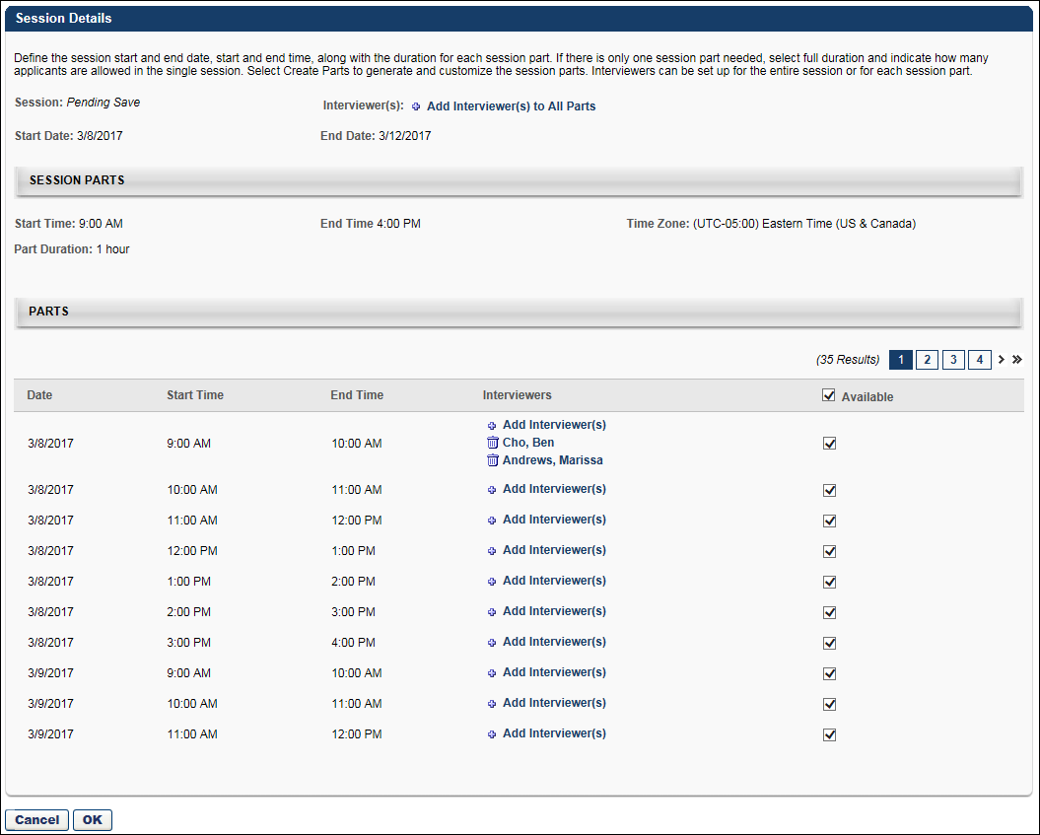
Editing Considerations
The following rules apply to editing the Session Details for an interview event:
- The event dates can only be modified if session parts have not been scheduled.
- Session part times can only be modified if session parts have not been scheduled.
- Events and sessions can be deleted at any time.
- Session parts cannot be deleted.
- For session parts defined as Full Duration, the Number of Applicants field can be modified. However, the value in this field cannot be changed to a value lower than the number of scheduled applicants.
- A session part that is defined as Full Duration cannot be removed if the part is already scheduled.
- Session parts for parts with a specified duration can be made unavailable by unchecking the box in the Available column. Note: If a session part is already scheduled, then the applicant who is scheduled for the session should first be rescheduled for a different part, and then uncheck the box in the Available column.
Create Interview Event - Availability
The Availability section enables administrators to define the users who will have access to the event when scheduling interviews. Defining the availability is required.
To create an interview event, go to Recruit > Interview Events & Sessions. Then, click the Create New Event link on the Interview Events & Sessions page.
Permissions
PERMISSION NAME | PERMISSION DESCRIPTION | CATEGORY

Interview Events - Manage | Grants access to create and edit interview events and sessions regardless of owner. The menu selection "Interview Events & Sessions" from the Recruit drop-down is available for users with this permission. This permission cannot be constrained. This is an administrator permission.  Note: Any administrator with this permission has access to all interview events, regardless of the organizational unit(s) to which they belong. | Recruiting Administration

Interview Event - Owner | Grants ability to access interview events for which user is listed as an owner. This permission cannot be constrained. This is an administrator permission.  Note: This is a dynamically assigned permission that is not available in Security Role Administration. Users must also have the Applicants: Manage Interviews permission in order to schedule events on the Interview Scheduler page. | Recruiting Administration
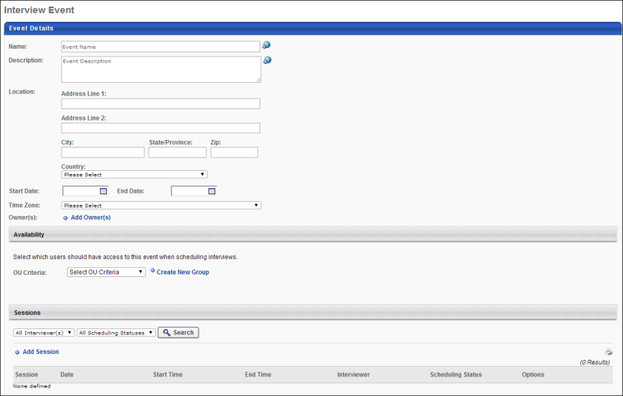
Define Availability
To define the availability for the event:
- Select an OU in the OU Criteria field.
- Click the Search icon to the left of the field. This opens the Search [OU] pop-up
- Select the OU from the pop-up. This closes the pop-up and adds the OU to the Availability section.
One or more OUs can be added to this section. To add additional OUs, follow the above steps.
Save/Cancel
Once the required settings in each section are completed for the interview event, click OK to save the event.
Click Cancel to cancel creating, copying, or editing the event.
Create Interview Event - Event Details
The Event Details section enables administrators to define general information about the event, such as the name, description, and start/end dates.
Note: Once you create an event, the event along with all of its sessions can be deleted from the main Interview Events and Sessions page.
To create an interview event, go to Recruit > Interview Events & Sessions. Then, click the Create New Event link on the Interview Events & Sessions page.
Permissions
PERMISSION NAME | PERMISSION DESCRIPTION | CATEGORY

Interview Events - Manage | Grants access to create and edit interview events and sessions regardless of owner. The menu selection "Interview Events & Sessions" from the Recruit drop-down is available for users with this permission. This permission cannot be constrained. This is an administrator permission.  Note: Any administrator with this permission has access to all interview events, regardless of the organizational unit(s) to which they belong. | Recruiting Administration

Interview Event - Owner | Grants ability to access interview events for which user is listed as an owner. This permission cannot be constrained. This is an administrator permission.  Note: This is a dynamically assigned permission that is not available in Security Role Administration. Users must also have the Applicants: Manage Interviews permission in order to schedule events on the Interview Scheduler page. | Recruiting Administration
Name
Enter a name for the event. This is a required field.
Description
Enter a description of the event. This is not a required field.
Location
Enter the address for the event. The location fields are not required fields. If a location is provided, then a map of the location displays for the applicant when viewing the interview invite.
This field allows location information to be included when inviting applicants to self schedule for an interview event. This is not a required field. If the Location field is not completed, then the address and map functionality are not included for applicants when viewing the interview invite, and the location will display "Not Specified" on the Applicant Profile page and interview scheduling pages.
Complete the following information in the Location field:
- Address Line 1 - Enter the street address, up to 110 characters.
- Address Line 2 - Enter additional address information, up to 55 characters.
- City - Enter the city, up to 35 characters.
- State/Province - If the United States or Canada is selected in the Country field, then the State/Province field displays a drop-down from which to select the state or province. For all other countries, a blank textbox displays in which to enter the value, up to 30 characters.
- Zip - Enter the zip code, up to 20 characters.
- Country - Select the country from the drop-down. This field is required if the other address fields are completed.
Start Date
Enter the date on which the event starts. Or, use the calendar feature to select a date from the calendar. The start date must be the current date or a future date. This is a required field.
Editing Note: When editing events that have a start date in the past, the start date must be changed to the current date or a future date in order to save changes to the event.
End Date
Enter the date on which the event ends. Or, use the calendar feature to select a date from the calendar. The end date must be the current date or a future date. This is a required field.
Time Zone
Select a time zone from the drop-down. This is a required field.
Owner
Event owners are able to view and manage the event for which they are an owner. Event owners are dynamically assigned permission to access the event. Click the Add Owner link to select one or more users from the pop-up. Click Add to add the owners to the event. There is no limit to the number of owners that can be added. This is a required field.
When creating events from the My Events tab, the current administrator's name is included as an owner by default. The default owner cannot be modified or deleted. Events that are created from the All Events tab are not assigned a default owner.
The Include Subordinates box is checked by default to include users in the subordinate organizational units (OU). Uncheck the box to not include subordinate OUs.
Owners can be deleted by clicking the Trash Can icon to the left of the owner.
Save/Cancel
Once the required settings in each section are completed for the interview event, click OK to save the event.
Click Cancel to cancel creating, copying, or editing the event.
Create Interview Event - Sessions
The Sessions section enables administrators to add and manage sessions for the event. From this section, administrators can also add session parts when adding a session. At least one session must be added in order for the interview event to be available to select when inviting applicants to the event from the Applicant Profile page or the Manage Applicants page.
To create an interview event, go to Recruit > Interview Events & Sessions. Then, click the Create New Event link on the Interview Events & Sessions page.
Permissions
PERMISSION NAME | PERMISSION DESCRIPTION | CATEGORY

Interview Events - Manage | Grants access to create and edit interview events and sessions regardless of owner. The menu selection "Interview Events & Sessions" from the Recruit drop-down is available for users with this permission. This permission cannot be constrained. This is an administrator permission.  Note: Any administrator with this permission has access to all interview events, regardless of the organizational unit(s) to which they belong. | Recruiting Administration

Interview Event - Owner | Grants ability to access interview events for which user is listed as an owner. This permission cannot be constrained. This is an administrator permission.  Note: This is a dynamically assigned permission that is not available in Security Role Administration. Users must also have the Applicants: Manage Interviews permission in order to schedule events on the Interview Scheduler page. | Recruiting Administration
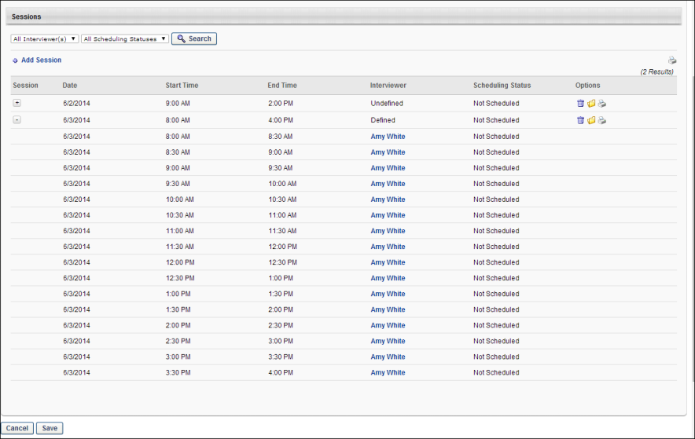
Filter Options
Use the following filter options to filter the results in the Sessions table:
- Interviewer - This option filters the results based on whether or not an interviewer has been defined for the session part. The following options are available for this filter:
  - All Interviewer(s) - This option is selected by default. This option displays all session parts, regardless of whether or not an interviewer is scheduled for the part.
  - [Interviewer Name] - If at least one user has been added as an interviewer to a session part, the user's name displays in the drop-down. Select an interviewer to search for parts for which the user is defined as an interviewer.
  - Undefined - Select this option to search for parts for which an interviewer is not yet defined.
- Scheduling Status - The following scheduling status options are available:
  - All Scheduling Statuses - This option is selected by default. This option displays sessions with any scheduling status.
  - Scheduled - This option displays parts for which at least one applicant is scheduled.
  - Not Scheduled - This option displays parts for which no applicants are scheduled.
Once the filters are defined, click Search. The Sessions table updates with the matching results.
Add Session
Click the Add Session link to add a session to the event. This opens the Session Details page, which also enables administrators to configure session parts. See Create Interview Event - Add Sessions on page 13 for additional information.
Note: Sessions cannot be added until the required fields are completed in the Event Details and Availability sections. Sessions can be added to ongoing events.
Print
Click the Print icon in the upper-right corner above the Sessions table to print the session and session part information. The print preview opens, showing the information in the Event Details section, as well as a grid displaying all of the sessions and each of their parts. The interviewers who are associated with the session part are included in the printable version, as well as the applicants who have been scheduled for the part.
The availability information does not display on the printable version.
Note: The Print option is available even if the event has not yet been saved.
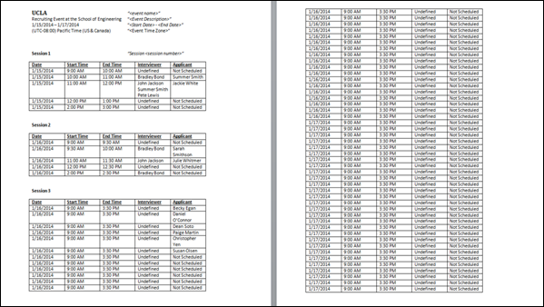
Sessions Table
The sessions table displays all sessions configured for the event. If session parts are configured for the session, then the parts also display.
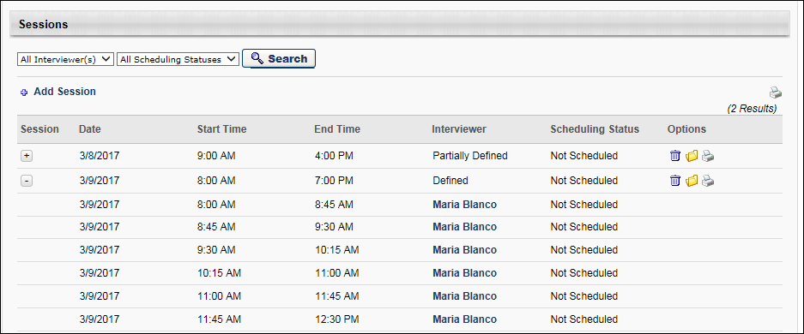
The following information displays in the table:
Session
This column lists the system-defined session number. This number is defined when the session is created. This column is not sortable.
An Expand/Collapse icon displays to the left of session numbers to view the list of parts for the session. Note: The session number only displays for the first session part row. The number does not appear in the column for other parts in the session.
If "Blank" displays in the Session column, this indicates that the session has not yet been saved to the event. Once the session is saved, a session number will be generated automatically for the session.
Date
This column displays the session part start date in MM/DD/YYYY format. This column is not sortable.
Start Time
This column displays the session or session part start time. The time displays in the time zone defined for the event. This column is not sortable.
The start time in the first row of a session is the start time of the actual session. For subsequent rows of the session, this column displays the start time of the part.
End Time
This column displays the session or session part end time. The time displays in the time zone defined for the event. This column is not sortable.
The end time in the first row of a session is the end time of the actual session. For subsequent rows of the session, this column displays the end time of the part.
Interviewer
This column indicates whether or not interviewers are defined for a session and the session parts. The following values display:
- Defined - This indicates that interviewers have been defined for all of the session parts but the interviewer names vary.
- [Interviewer Name] - The interviewer's name displays in this column if an interviewer has been defined for the session part. Hovering over the interviewer's name opens an information pop-up that displays the interviewer's image if available, name, position, phone number, and a linked email address. Click the email link to email the interviewer from your organization's email provider.
- Partially Defined - This displays if an interviewer has been defined for any of the session parts but not all parts have an interviewer defined.
- Undefined - In the session row, this displays for sessions for which an interviewer has not been defined for any of the session parts. In the session part rows, this displays for parts for which an interviewer has not been defined.
Scheduling Status
This column indicates whether or not applicants have been scheduled for the session and session parts. The following values display:
- [Applicant Name] - If an applicant has been scheduled for the session part, this column displays the applicant's name. The name displays as a link. Clicking the link opens the Applicant Profile page.
- Not Scheduled - In the session row, this displays for sessions for which an applicant has not been scheduled for the session parts. In the session part rows, this displays for session parts for which an applicant has not been scheduled.
- Partially Scheduled - This only displays in the session row. This displays if applicants have been scheduled for some of the session parts but not all of the parts.
- Scheduled - This only displays in the session row. This displays if applicants have been scheduled for all of the session parts.
Options
The options in the Options column only display for the session row. They do not display for the session parts.
- Delete - Click the Trash Can icon to delete the session. This opens a confirmation pop-up. Click Yes to delete the session, or click No to cancel the delete action. Deleting a session also deletes all of the session's parts. If an interviewer has been scheduled for the session part, the part no longer displays in the interviewer's interview dashboard on the Interview Manager page.
- Open - Click the Open icon to open the Session Details page for the session.
- Print - Click the Print icon to print the event details along with the details for single session and its parts. The print preview opens, showing the information in the Event Details section, as well as a grid displaying the session and its parts. The interviewers who are associated with the session parts are included in the printable version, as well as the applicants who have been scheduled for the parts. The availability information does not display on the printable version. Note: The Print option is available even if the event has not yet been saved.
Save/Cancel
Once the required settings in each section are completed for the interview event, click OK to save the event.
Click Cancel to cancel creating, copying, or editing the event.
Interview Event - Define Scheduling Details
Interview events are configured and scheduled from the Interview Scheduler page. The process for configuring the details for scheduling an interview event is similar to the process for scheduling other In Person or Phone interview types.
For interview events, recruiters access the scheduling details by clicking the Click to Schedule Event link from the Interview Scheduler page. Then, from the Schedule Event pop-up, recruiters can select the interview event they would like to schedule and define the sessions that will be available for applicants to select. Once the scheduling details are defined, recruiters return to the Interview Scheduler page and schedule the event.
Note: Applicants must be in an Interview status type in order to be scheduled for an interview event.
To access the Interview Scheduler page, navigate to the Statuses tab of the applicant's profile page. Then, click the Schedule Interview(s) button in the applicable Interview status type panel.
Permissions
PERMISSION NAME | PERMISSION DESCRIPTION | CATEGORY

Applicants: Manage Interviews | Grants ability to manage and schedule interviews for applicants. This permission cannot be constrained. | Recruiting

Requisition: Edit Interviewers | Grants ability to edit the requisition interviewers section for requisitions. Users with this permission can also edit the interviewers for Interview status types from the Applicant Profile page. This permission can be constrained by OU. Note: If OU constraints are applied, then the only users who recruiters can add as interviewers are the users who they can view based on the OU constraints. | Recruiting

Requisition: Interviewer | Grants ability to access and view past and future interviews and record interviewee recommendations. This permission cannot be constrained.  Note: This is a dynamically assigned permission that is not available in Security Role Administration. Once a user is scheduled as an interviewer for an applicant, the user will always have permission to view the interview details on the Interview Manager page. Users with this permission can do the following:  - Access the Interview Manager page.  - View the resume and cover letter for applicants for whom they are an interviewer.  - View the applicant profile for applicants for whom they are an interviewer.  - View the interview guide for the requisition for which they are listed as an interviewer.  - Recommend that an applicant be advanced or not advanced. | Recruiting

Requisition: Owner | Enables owner to access requisitions and applicants for requisitions for which they are an owner. This permission also grants read-only access to video interviews that are completed by applicants via HireVue. For portals with Referral Suite enabled, this permission also enables requisition owners to edit the referral source on the Applicant Profile page. This permission cannot be constrained.  Note: This is a dynamically assigned permission that is not available in Security Role Administration. If the user is removed as an owner, the permission is revoked for the associated requisition. This permission cannot be manually assigned. Also, if a user has both the permission necessary to manage requisitions and be a requisition owner, the constraints of the Requisition: Manage permission overrule those of the Requisition: Owner permission. For requisition owners that do not also have permission to manage requisitions, only certain fields are editable when editing a requisition. | Recruiting

Requisition: Reviewer | Enables reviewer to access requisitions and applicants for requisitions for which they are a reviewer. This permission cannot be constrained.  Note: This is a dynamically assigned permission that is not available in Security Role Administration. Once a requisition is in a Closed or Cancelled status or if the user is removed as a reviewer, the permission is revoked for the associated requisition. This permission cannot be manually assigned.  Note: If an applicant reviewer is removed as a reviewer via the Applicant Profile page, the Requisition: Reviewer permission is revoked for the associated requisition. However, if the reviewer was also added as a reviewer via the General tab when creating, editing, or copying the requisition, the reviewer still appears on the In Review panel as a duplicate reviewer and retains access to the requisition and applicants from the Requisition: Reviewer permission. See Applicant Profile Page Overview for more information about duplicate reviewer instances. | Recruiting
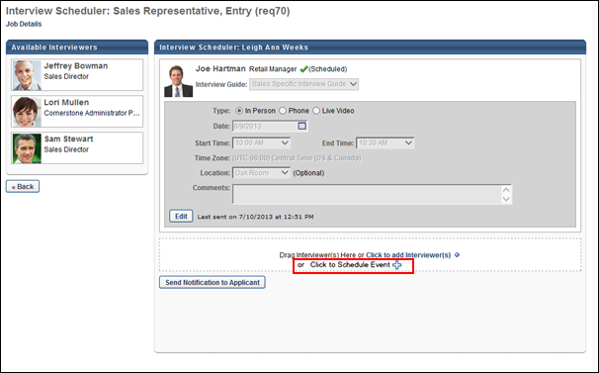
Define Scheduling Details for Interview Event
To define the details for scheduling an interview event, select the Click to Schedule Event link. This opens the Schedule Event pop-up. Note: This option only displays for recruiters with permission to edit interviewers for a job requisition.
The Schedule Event pop-up is separated into two sections: Schedule Event and Session Parts. The information and options that display in the pop-up are dependent upon the option selected by the administrator in the Part Duration field when configuring the session part.
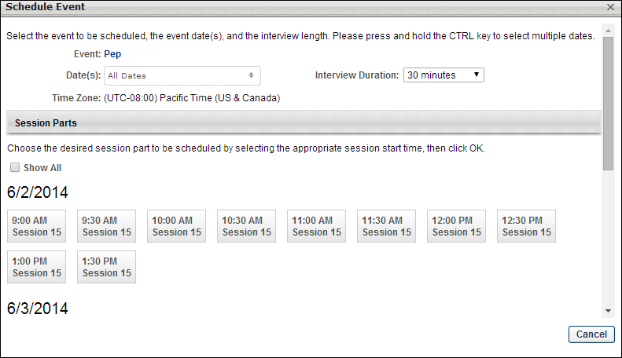
Schedule Event Section
The following displays in the Schedule Event section of the Schedule Event pop-up:
Field | Description
Event | This field enables the recruiter to select the event for which to schedule the applicant. The events that are available are the events for which the recruiter meets the availability criteria defined by the administrator when configuring the event. In addition, events must have at least one session saved in order to be available for selection.  To select an event, enter a full or partial name in the field. This field uses predictive search to display matching events. Select the event from the list. Events can only be selected if the end date is in the future.  Once the event is selected, the event and session details populate the additional options and information in the Schedule Event pop-up.
Date(s) | This field displays the dates available for the session part. Select the date of the session part in which to schedule the applicant.
Time Zone | This field displays the time zone in which the event occurs.
Interview Duration | Select the duration of the interview from the drop-down.  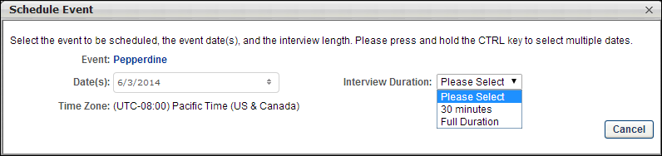
Session Parts Section
The Session Parts section requires the recruiter to select the session in which to schedule the applicant. The parts that display are the parts defined by the administrator for the date selected in the Date(s) field. The date of the event displays above the list of session parts.
Clicking the Show All option displays all session parts, including those that have already been scheduled. Sessions that have already been scheduled are grayed out and cannot be selected. Note: The Show All option does not display for session parts that are defined as Full Duration. In such cases, only one session part displays. The number of remaining slots available vs. the total number of slots displays below the session number in the box.
To select the session in which to schedule the applicant, click the box with the desired start time. The start time and session number display in the session part box. For session parts that are defined as Full Duration, the number of remaining slots vs. the total number of slots displays below the session number.
To view the interviewer scheduled for the session part, hover over the part. This opens an information pop-up that displays the interviewer's image if available, name, position, phone number, and a linked email address. Click the email link to email the interviewer from your organization's email provider.
Auto-Refreshing
The list of session parts is automatically refreshed each time the information in the Schedule Events section is modified.
Cancel/OK
Click Cancel to cancel scheduling the applicant for the interview.
Click OK to schedule the applicant for the interview. This adds the interview to the Interview Scheduler page, where the recruiter must save the interview in order to fully schedule the applicant for the interview event.
Interview Event - Schedule Event
Interview events are scheduled from the Interview Scheduler page. When the details for scheduling an interview event have been configured on the Schedule Event pop-up, the event displays on the Interview Scheduler page for the recruiter to save and send to the interviewers. From the Interview Scheduler page, recruiters can view the applicant's session information, remove the event from the applicant's profile, and add interviewers to the session. Recruiters can also add an interview guide for the interviewer.
In addition, much of the same functionality for In Person and Phone interview scheduling and notification is available for interview events. See Interview Scheduler Page Overview on page 70 for additional information.
Note: For information about configuring the details for scheduling an interview event, see the Interview Event - Define Scheduling Details topic in Online Help.
To access the Interview Scheduler page, navigate to the Statuses tab of the applicant's profile page. Then, click the Schedule Interview(s) button in the applicable status panel.
Permissions
PERMISSION NAME | PERMISSION DESCRIPTION | CATEGORY

Applicants: Manage Interviews | Grants ability to manage and schedule interviews for applicants. This permission cannot be constrained. | Recruiting

Requisition: Edit Interviewers | Grants ability to edit the requisition interviewers section for requisitions. Users with this permission can also edit the interviewers for Interview status types from the Applicant Profile page. This permission can be constrained by OU. Note: If OU constraints are applied, then the only users who recruiters can add as interviewers are the users who they can view based on the OU constraints. | Recruiting

Requisition: Interviewer | Grants ability to access and view past and future interviews and record interviewee recommendations. This permission cannot be constrained.  Note: This is a dynamically assigned permission that is not available in Security Role Administration. Once a user is scheduled as an interviewer for an applicant, the user will always have permission to view the interview details on the Interview Manager page. Users with this permission can do the following:  - Access the Interview Manager page.  - View the resume and cover letter for applicants for whom they are an interviewer.  - View the applicant profile for applicants for whom they are an interviewer.  - View the interview guide for the requisition for which they are listed as an interviewer.  - Recommend that an applicant be advanced or not advanced. | Recruiting

Requisition: Owner | Enables owner to access requisitions and applicants for requisitions for which they are an owner. This permission also grants read-only access to video interviews that are completed by applicants via HireVue. For portals with Referral Suite enabled, this permission also enables requisition owners to edit the referral source on the Applicant Profile page. This permission cannot be constrained.  Note: This is a dynamically assigned permission that is not available in Security Role Administration. If the user is removed as an owner, the permission is revoked for the associated requisition. This permission cannot be manually assigned. Also, if a user has both the permission necessary to manage requisitions and be a requisition owner, the constraints of the Requisition: Manage permission overrule those of the Requisition: Owner permission. For requisition owners that do not also have permission to manage requisitions, only certain fields are editable when editing a requisition. | Recruiting

Requisition: Reviewer | Enables reviewer to access requisitions and applicants for requisitions for which they are a reviewer. This permission cannot be constrained.  Note: This is a dynamically assigned permission that is not available in Security Role Administration. Once a requisition is in a Closed or Cancelled status or if the user is removed as a reviewer, the permission is revoked for the associated requisition. This permission cannot be manually assigned.  Note: If an applicant reviewer is removed as a reviewer via the Applicant Profile page, the Requisition: Reviewer permission is revoked for the associated requisition. However, if the reviewer was also added as a reviewer via the General tab when creating, editing, or copying the requisition, the reviewer still appears on the In Review panel as a duplicate reviewer and retains access to the requisition and applicants from the Requisition: Reviewer permission. See Applicant Profile Page Overview for more information about duplicate reviewer instances. | Recruiting
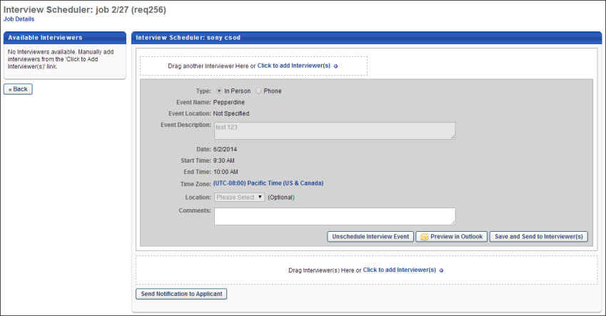
Interviewers
If an interviewer is scheduled for the session, the interviewer displays at the top of the Interview Scheduler page and is indicated as Scheduled. As with existing functionality, the recruiter can add an interview guide for the interviewer in the Interview Guide field, if enabled when configuring the Interview status type.
If interviewers have not yet been selected for the applicant's session, then the recruiter can add interviewers using the existing functionality for adding interviewers. See the following for information about configuring interviewers for an interview:
- Create Interview - Available Interviewers
- Create Interview - Add Interviewers
Interview Type
This field displays the type of interview, either In Person, Phone, or Virtual. When editing the interview schedule, this field can be modified.
The Live Video Interview option is not available for interview events.
Event Name
This field displays the name of the interview event.
Event Description
This field displays the description of the interview event.
Date
This field displays the date of the applicant's interview.
Start Time/End Time
These fields display the start and end time of the applicant's interview.
Time Zone
This field displays the time zone of the interview event.
Location
This field displays the interview event location. When editing the interview schedule, this field can be modified.
Comments
This field displays notes written for the interviewers. When editing the interview schedule, this field can be modified.
Unschedule Interview Event
This is a new option that is only available for interview events. Click the Unschedule Interview Event button to unschedule the applicant from the interview. This opens a confirmation pop-up. Click Yes to permanently remove the event from the Interview Scheduler page. This re-opens the interview session and makes it available for scheduling. In addition, the scheduled/available count for the interview session is updated. Or, click No to cancel the removal action.
Preview in Outlook
As with existing functionality for interviews, the interview session can be previewed in Outlook. See Create Interview - Set Schedule Details and Send Interview on page 82 for additional information.
Save and Send to Interviewer(s)
Click the Save and Send to Interviewer(s) button to send the interview to the interviewers. Clicking the button adds the interview to the Interview Manager Dashboard for each associated interviewer. This is existing functionality for interviews. See Create Interview - Set Schedule Details and Send Interview on page 82 for additional information.
Note: If there are no interviewers scheduled for the interview, then the Interview Scheduling Notification - Interviewer(s) email is not sent.
Send Notification to Applicant
As with existing functionality for interviews, clicking the Send Notification to Applicant button opens the Applicant Scheduling pop-up. For interview events, the pop-up includes event and session information, as well as a comments option.
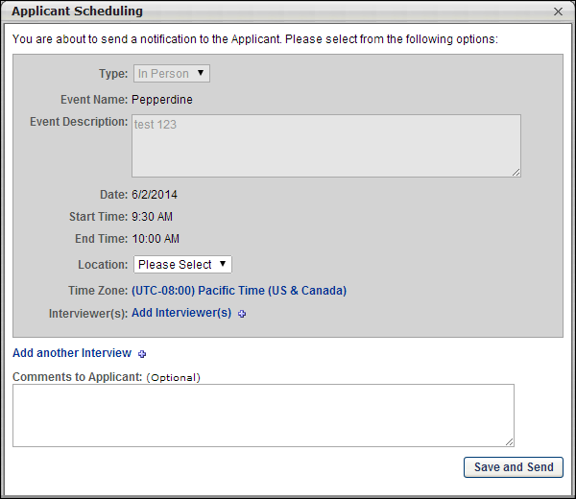
The following information is included in the Applicant Scheduling pop-up for interview events:
- Type - This field displays the interview type, either In Person, Phone, or Virtual.
- Event Name - This field displays the name of the event.
- Event Description - This field displays the description of the event.
- Date - This field displays the date of the applicant's interview.
- Start Time - This field displays the interview start time.
- End Time - This field displays the interview end time.
- Location - This field displays the location of the interview. The field can be modified. This is existing functionality for interviews. See Send Notification to Applicant on page 88 for additional information.
- Time Zone - This field displays the time zone for the interview start/end time. The field can be modified. This is existing functionality for interviews. See Send Notification to Applicant on page 88 for additional information.
- Interviewer(s) - This field displays the interviewers defined for the interview session. Interviewers can be added and removed from the list. Note: To add interviewers, you must have permission to edit interviewers. This is existing functionality for interviews. See Send Notification to Applicant on page 88 for additional information.
- Add another Interviewer - This option allows the recruiter to add an interview session. This is existing functionality for interviews. See Send Notification to Applicant on page 88 for additional information.
- Comments to Applicant - This field enables you to enter a note to the applicant. This is existing functionality for interviews. See Send Notification to Applicant on page 88 for additional information.
Re-Send Notification to Applicant
As with existing functionality for interviews, the interview notification can be resent to the applicant. The options that are available to resend an existing interview notification are available when resending an interview event notification. See Send Notification to Applicant on page 88 for additional information.
Interview Events on Interview Manager Page
If a user is scheduled as an interviewer for an interview event, the interview event displays on the interview dashboard on the Interview Manager page. The interview event displays the same information and options that are available for interview. See Interview Manager Overview on page 99 for additional information.
To access the Interview Manager page, go to Recruit > Interview Manager.
Permissions
PERMISSION NAME | PERMISSION DESCRIPTION | CATEGORY

Requisition: Interviewer | Grants ability to access and view past and future interviews and record interviewee recommendations. This permission cannot be constrained.  Note: This is a dynamically assigned permission that is not available in Security Role Administration. Once a user is scheduled as an interviewer for an applicant, the user will always have permission to view the interview details on the Interview Manager page. Users with this permission can do the following:  - Access the Interview Manager page.  - View the resume and cover letter for applicants for whom they are an interviewer.  - View the applicant profile for applicants for whom they are an interviewer.  - View the interview guide for the requisition for which they are listed as an interviewer.  - Recommend that an applicant be advanced or not advanced. | Recruiting
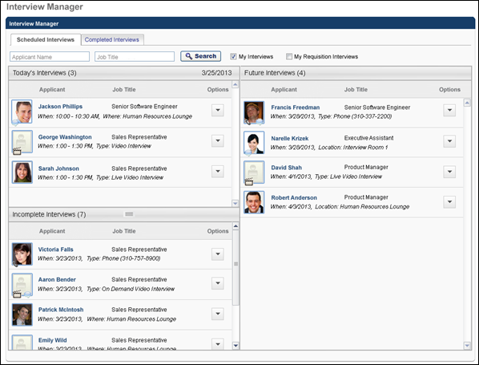
Invite Applicant to Event from Applicant Profile
Recruiters can invite an applicant to an interview event using the Invite to Event option in the Interview status type panel on the Statuses tab of the Applicant Profile page. This option allows recruiters to invite a single applicant to self schedule for an interview event.
Once the applicant is invited, the Interview status type panel displays the date and time at which the applicant was invited. When the applicant has self scheduled an interview for the event, the applicant's interview session information is available on the Applicant Profile page.
Note: When an applicant is invited to an event, the next step for the applicant is to schedule an interview session for the event. The applicant reviews the available sessions on the invite, and then selects their preferred session.
Note: Applicants can be batch invited to an interview event from the Manage Applicants page.
Permissions
PERMISSION NAME | PERMISSION DESCRIPTION | CATEGORY

Applicants: Manage Interviews | Grants ability to manage and schedule interviews for applicants. This permission cannot be constrained. | Recruiting

Requisition: Manage | Grants ability to access and manage all requisitions regardless of ownership (constraints permitting). This permission also grants read-only access to the Applicant Review tab when creating or editing a job requisition. This permission can be constrained by OU, User's OU, and Grade. | Recruiting

Requisition: Owner | Enables owner to access requisitions and applicants for requisitions for which they are an owner. This permission also grants read-only access to video interviews that are completed by applicants via HireVue. For portals with Referral Suite enabled, this permission also enables requisition owners to edit the referral source on the Applicant Profile page. This permission cannot be constrained.  Note: This is a dynamically assigned permission that is not available in Security Role Administration. If the user is removed as an owner, the permission is revoked for the associated requisition. This permission cannot be manually assigned. Also, if a user has both the permission necessary to manage requisitions and be a requisition owner, the constraints of the Requisition: Manage permission overrule those of the Requisition: Owner permission. For requisition owners that do not also have permission to manage requisitions, only certain fields are editable when editing a requisition. | Recruiting
Emails
EMAIL NAME | EMAIL DESCRIPTION | ACTION TYPE

Invitation to Interview Event (Applicant Self Schedule) | This email is triggered when a recruiter sends a self schedule invitation to an applicant for an interview event. The email can be sent to Applicant, Hiring Manager, Requisition Owner(s), Requisition Reviewer(s), or a specific user. This email can be configured as a Notification or Reminder type email. This email is active by default and can be found in the Recruitment action type section of Email Management.  Use Case: Use this email to send a message to the applicant regarding self scheduling an interview event. With this link, the applicant can schedule themselves into an interview event. | Recruiting
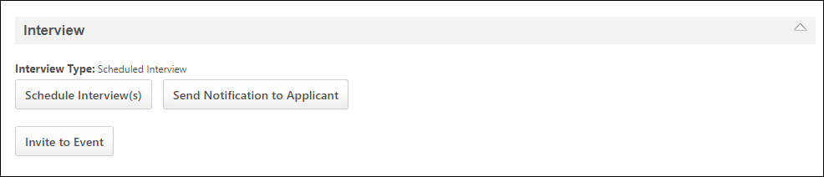
Invite to Event
The Invite to Event option in the Interview status type panel on the Applicant Profile page allows recruiters to send an applicant an invitation to schedule themselves into an interview event. This option is only available for recruiters with permission to manage interviews for applicants. In addition, the option only displays if at least one interview event configured with a session that has a start date for the current date or a future date. Note: Interview events are configured by the administrator on the Interview Events & Sessions page. See Create Interview Event - Overview on page 11 for additional information.
To invite an applicant:
- Click the Invite to Event button in the Interview status type panel. This opens the Invite to Event pop-up.
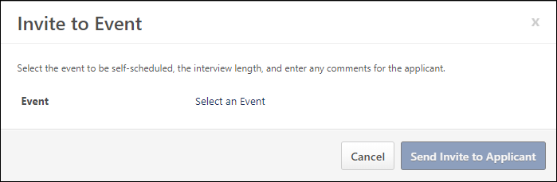
- Click the Select an Event link. This opens the Select Event pop-up, which displays the available events. The events that are available are the events for which the recruiter meets the availability criteria, as defined by the administrator when configuring the event.
- Select an event from the list. Once the event is selected, the Invite to Event pop-up displays additional fields for completion.
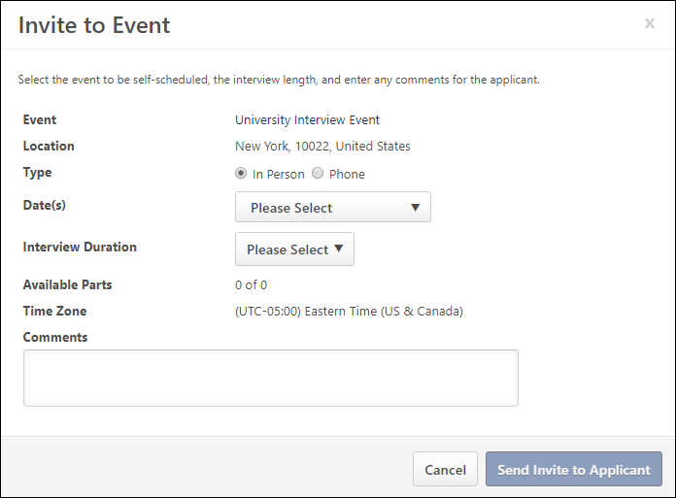
- View and complete the following information:
  - Location - This field displays the location of the event. This field cannot be modified.
  - Type - Select the interview type, either In Person, Phone, or Virtual.
  - Phone - This option only displays if the Phone option is selected in the Type field.
  - Date(s) - This field displays the dates available for the session part. Select one or more specific dates from which the applicant can choose to schedule themselves for an interview. Or, select the All Dates value to include all available interview slots from which the applicant can choose.
  - Interview Duration - Select the duration of the interview from the drop-down. The options that are available are dependent upon how the time intervals are configured the session parts available on the date selected in the Date field. If only one duration has been configured for all session parts for the event, then that duration value displays by default and cannot be modified.
  - Available Parts - This field displays the number of parts available in relation to the total number of parts for the session.
  - Time Zone - This field displays the time zone of the interview event. This field cannot be modified.
  - Comments - Enter comments to the applicant, up to 1000 characters.
- Click Send Invite to Applicant. This sends the invitation to the applicant. The following also occurs when sending the invite:
  - The Invitation to Interview Event email is triggered, if enabled by the administrator.
  - The Interview Type field on the Interview type status panel is updated to indicate "Invited - Pending Applicant Schedule."
  - The date and time at which the applicant was invited displays on the status panel to the right of the Invite to Event button. Note: The last invited date updates if the applicant is invited to the event again for the associated job requisition.
Clicking Cancel in the Invite to Event pop-up closes the pop-up and does not send the invitation.
Invite Applicant to Event from Manage Applicants
Recruiters can invite a single applicant or a group of applicants to an interview event using the Invite to Event option on the Manage Applicants page. This option is available in the Actions drop-down and enables recruiters to invite applicants to self schedule for an interview event.
To access the Manage Applicants page, go to Recruit > Manage Requisition. On the Manage Job Requisitions page, locate the requisition for which you would like to manage applicants. From there, click the linked number of applicants in the Applicants column.
Permissions
PERMISSION NAME | PERMISSION DESCRIPTION | CATEGORY

Applicants: Manage Interviews | Grants ability to manage and schedule interviews for applicants. This permission cannot be constrained. | Recruiting

Requisition: Manage | Grants ability to access and manage all requisitions regardless of ownership (constraints permitting). This permission also grants read-only access to the Applicant Review tab when creating or editing a job requisition. This permission can be constrained by OU, User's OU, and Grade. | Recruiting

Requisition: Owner | Enables owner to access requisitions and applicants for requisitions for which they are an owner. This permission also grants read-only access to video interviews that are completed by applicants via HireVue. For portals with Referral Suite enabled, this permission also enables requisition owners to edit the referral source on the Applicant Profile page. This permission cannot be constrained.  Note: This is a dynamically assigned permission that is not available in Security Role Administration. If the user is removed as an owner, the permission is revoked for the associated requisition. This permission cannot be manually assigned. Also, if a user has both the permission necessary to manage requisitions and be a requisition owner, the constraints of the Requisition: Manage permission overrule those of the Requisition: Owner permission. For requisition owners that do not also have permission to manage requisitions, only certain fields are editable when editing a requisition. | Recruiting

Requisition: Reviewer | Enables reviewer to access requisitions and applicants for requisitions for which they are a reviewer. This permission cannot be constrained.  Note: This is a dynamically assigned permission that is not available in Security Role Administration. Once a requisition is in a Closed or Cancelled status or if the user is removed as a reviewer, the permission is revoked for the associated requisition. This permission cannot be manually assigned.  Note: If an applicant reviewer is removed as a reviewer via the Applicant Profile page, the Requisition: Reviewer permission is revoked for the associated requisition. However, if the reviewer was also added as a reviewer via the General tab when creating, editing, or copying the requisition, the reviewer still appears on the In Review panel as a duplicate reviewer and retains access to the requisition and applicants from the Requisition: Reviewer permission. See Applicant Profile Page Overview for more information about duplicate reviewer instances. | Recruiting
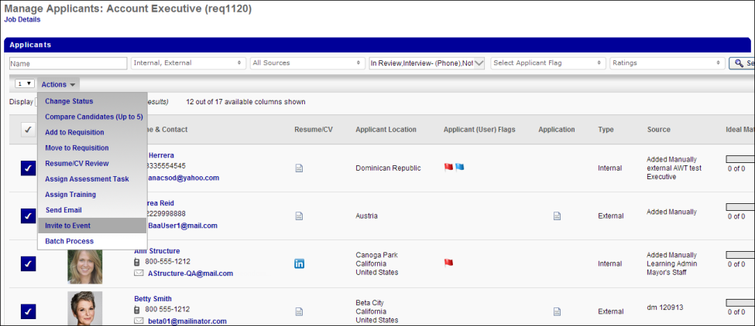
Invite to Event Action
The Invite to Event action in the Actions drop-down on the Manage Applicants page enables recruiters to invite a single applicant or a group of applicants to self schedule for an interview event. This option is only available for recruiters with permission to manage interviews. This option is disabled in the Actions drop-down when using the grouping and Batch Process functionality.
To invite applicants to an interview event:
- Select one or more applicants to invite by selecting the checkbox button in the left column for each applicant. When the checkbox is selected, the box changes from gray to dark blue. Applicants must be in an Interview status type in order to be invited to an interview event.
- Click the Invite to Event action in the Actions drop-down. This opens the Invite to Event pop-up.
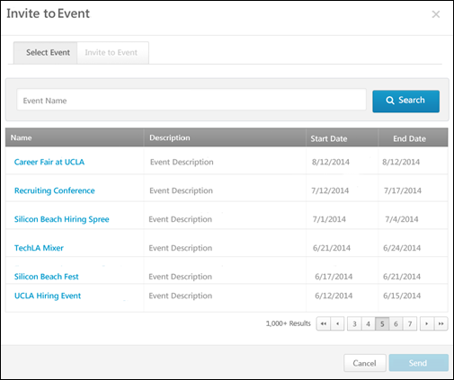
- On the Select Event tab, use the Event Name filter to search for events. Enter a full or partial name in the field, and then click Search. The events table updates to display the filtered results.
- Select an event by clicking the event name from the Name column. This adds the event to the Invite to Event tab. The events that are available are the events for which the recruiter meets the availability criteria, as defined by the administrator when configuring the event.
- Click the Invite to Event tab to configure the invite.
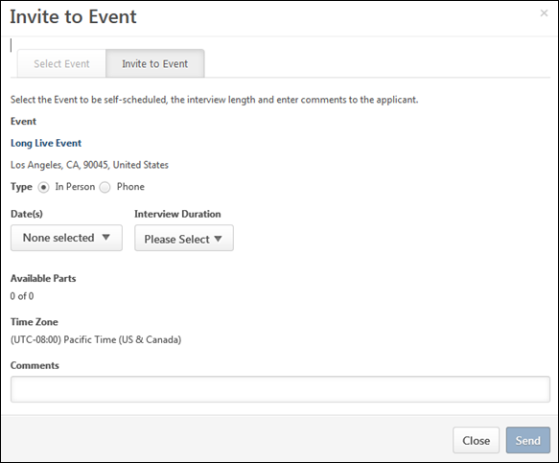
- View and complete the following information:
  - Event - The event name displays as a link. Click the link to view the event information.
  - Location - This displays the location of the event. This field cannot be modified.
  - Type - Select the interview type, either In Person or Phone.
  - Phone - This option only displays if the Phone option is selected in the Type field.
  - Date(s) - This field displays the dates available for the session part. Select one or more specific dates from which the applicant can choose to schedule themselves for an interview. Or, select the All Dates value to include all available interview slots from which the applicant can choose.
  - Interview Duration - Select the duration of the interview from the drop-down. The options that are available are dependent upon how the time intervals are configured the session parts available on the date selected in the Date field. If only one duration has been configured for all session parts for the event, then that duration value displays by default and cannot be modified.
  - Available Parts - This field displays the number of parts available in relation to the total number of parts for the session.
  - Time Zone - This field displays the time zone of the interview event. This field cannot be modified.
  - Comments - Enter comments to the applicant, up to 1000 characters.
- Click Send. This sends the invitation to the applicant or applicants. The Invitation to Interview Event email is triggered, if enabled by the administrator.
Clicking Cancel in the Invite to Event pop-up closes the pop-up and does not send the invitation.
When the invitation is successfully sent, a confirmation message displays on the Manage Applicants page.
Applicants Not in an Interview Status Type
If one or more of the selected applicants are not in an Interview status type, then the recruiter must change the applicant's status to an Interview status type in order to invite the selected applicants to an interview event. Once all applicants are in an Interview status type, click the Invite to Event action in the Actions drop-down to open the Invite to Event pop-up.
See the Manage Applicants - Change Status topic in Online Help for information about changing an applicant's status from the Manage Applicants page.
Interview Session Availability
If there are more applicants selected to invite than there are available seats for the selected interview sessions, then an error message displays on the Invite to Event pop-up. The message indicates that number of applicants invited must be reduced to fit the event's availability or the recruiter must select additional sessions from which applicants can select to self schedule an interview.
Once the number of applicants is reduced or the recruiter has increased the number of sessions available to the applicants, the recruiter can click the Invite to Event action in the Actions drop-down on the Manage Applicants page to invite applicants to the interview event.
Invite Applicant to Event from Manage Candidates
For information about inviting candidates to events from Manage Candidates, See Manage Candidates - Invite to Event.
Invites Not Scheduled Page
The Invites Not Scheduled page displays the applicants who have been invited to self schedule for the interview event but have not yet scheduled an interview, have requested an alternative session, or declined the invitation.
This page is accessed by clicking the linked number in the Invites Not Scheduled column on the Interview Events & Sessions page.
To access the Interview Events & Sessions page, go to Recruit > Interview Events & Sessions.
Permissions
PERMISSION NAME | PERMISSION DESCRIPTION | CATEGORY

Interview Events - Manage | Grants access to create and edit interview events and sessions regardless of owner. The menu selection "Interview Events & Sessions" from the Recruit drop-down is available for users with this permission. This permission cannot be constrained. This is an administrator permission.  Note: Any administrator with this permission has access to all interview events, regardless of the organizational unit(s) to which they belong. | Recruiting Administration

Interview Event - Owner | Grants ability to access interview events for which user is listed as an owner. This permission cannot be constrained. This is an administrator permission.  Note: This is a dynamically assigned permission that is not available in Security Role Administration. Users must also have the Applicants: Manage Interviews permission in order to schedule events on the Interview Scheduler page. | Recruiting Administration
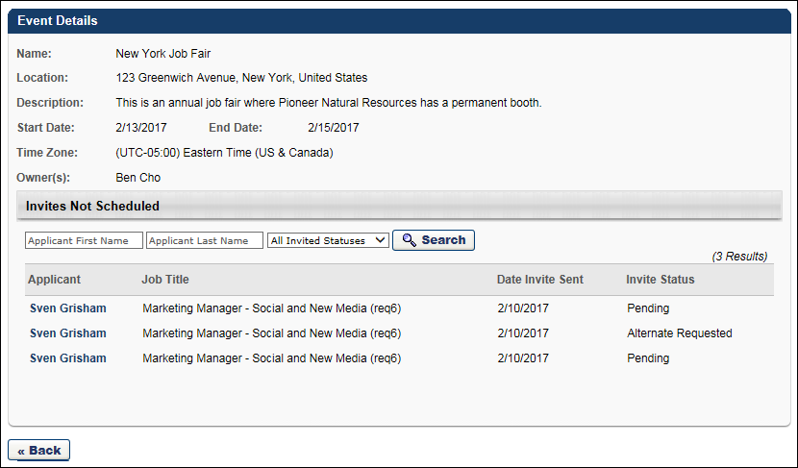
Event Details
The following information displays in the Event Details section:
- Name - This field displays the name of the event.
- Location - This field displays the location of the event. If the location was not included for the event, then "Not Specified" displays.
- Description - This field displays the description of the event. If the description was not included for the event, then "Not Specified" displays.
- Start Date - This field displays the start date of the event.
- End Date - This field displays the end date of the event.
- Time Zone - This field displays the time zone of the event.
- Owner(s) - This field displays the event owners.
Invites Not Scheduled
This section displays the applicants who have been invited to self schedule for the interview event but have not yet scheduled an interview, have requested an alternative session, or declined the invitation.
The following information displays in this section:
Search Filters
Use the search options to filter the results in the table by the applicant's first name, last name, and invitation status. The following invitation status options are available:
- All Invited Statuses
- Alternate Requested - This status indicates that the applicant has requested an alternative session.
- Declined - This status indicates that the applicant declined the interview invitation. To view the decline reason, hover over the Declined status. This opens a pop-up that displays the applicant's comments.
- Pending - This status indicates that the applicant has not yet scheduled an interview or taken any other action, such as declined the invitation or requested an alternative session.
Once the filters are defined, click Search. The table is updated to display matching results.
Invites Not Scheduled Table
The following information displays in the table:
- Applicant - This column displays the applicant's name as a link. Click the link to open the Applicant Profile page. This column is sortable.
- Job Title - This column displays the job title of the requisition to which the applicant applied.
- Date Invite Sent - This column displays the date on which the self schedule invitation was sent.
- Invite Status - This column displays the status of the invitation. The possible statuses are Alternate Requested, Declined, and Pending. See the Search Filters row above for status descriptions. The hover options are available for the Alternate Requested and Declined statuses.
Alternate Requested Status
This status indicates that the applicant has requested an alternate session. To view the request reason, hover over the "Alternate Requested" status in the Invite Status column. This opens a pop-up that displays the applicant's comments.
Do interviewers get an email when an applicant requests an alternate interview date/time?
No, an email is not sent to the interviewer. Interviewers must access the Event Details page and hover over the "Alternate Requested" status in the Invite Status column to see when an applicant has submitted this request. view the applicant's reason for requesting a different interview date/time.
Back
Click Back to return to the Interview Events & Sessions page.

Applicant Profile - Interview Status Type
When an applicant is scheduled for an interview event, the information displays in the Interview status type panel on the Statuses tab of the Applicant Profile page.
Access Applicant Profile Page
To access the Applicant Profile page, click the applicant's name from any of the following pages:
- Manage Job Requisitions >
  - Requisition Snapshot
  - Manage Applicants
- Recruit > Interview Manager
- Recruit > Review Applicants
- Recruit > Manage Candidates (Note:This functionality is in the Early Adopter phase. For more information about availability,see the Overview topic for this functionality.)
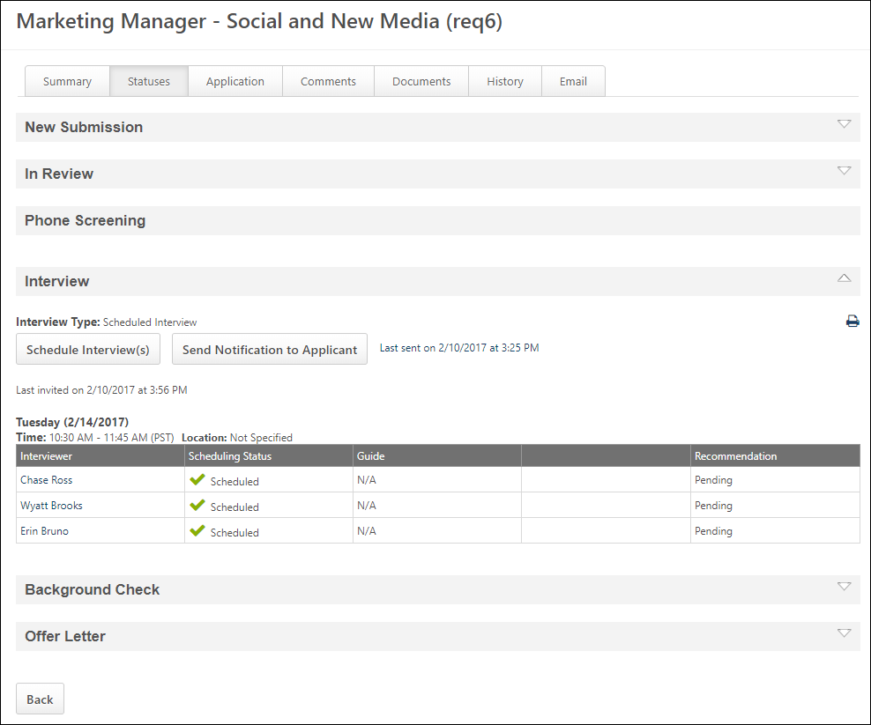
The following information displays for the interview event:
- Interview Type - This field displays the type of interview, either Scheduled or Phone.
- Print - The Print icon in the upper-right corner enables interviewers and requisition owners to print the interview schedule for the status. For interview events, the printable interview schedule includes an Event Name column to display the name of the event. See Statuses Tab - Interview Status Type - Scheduled Interview for additional information about printing the interview schedule.
- Schedule Interview(s) - Click the Schedule Interview(s) button to schedule one or more interviews. This is existing functionality for the Interview status type panel for Scheduled interviews. See Statuses Tab - Interview Status Type - Scheduled Interview for additional information.
- Send Notification to Applicant - Click the Send Notification to Applicant button to notify the applicant that an interview is scheduled. This is existing functionality for the Interview status type panel for Scheduled interviews. See Statuses Tab - Interview Status Type - Scheduled Interview for additional information. Also, See Interview Event - Define Scheduling Details on page 28 for additional information.
- Invite to Event - Click the Invite to Event button to send an invitation to the applicant to self-schedule for the event. See Invite Applicant to Event from Applicant Profile on page 41 for additional information.
- Interview Details - The following details display for the interview:
  - Date
  - Time and time zone
  - Location
  - Event Name
  - Event Location
- Interview Session Table - As with existing functionality for Scheduled interviews, the table displays interviewer, scheduling status, guide, and recommendation for the interview. If there are no interviewers scheduled for the interview, then "No Interviewer Specified" displays in the Interviewer column and "N/A" displays in the Scheduling Status, Guide, and Recommendation columns. See Statuses Tab - Interview Status Type - Scheduled Interview for additional information.

Interview Guide Management
Interview Guide Management enables administrators to build and configure interview guides that define the competencies that an interviewer should be looking for in a candidate for a specific interview. You can add questions to each competency to direct interviewers in assessing how the applicant demonstrates the competency. Interviewers can also rate applicants on each competency, based on a rating scale defined for the guide. The guides can be used by interviewers to more effectively manage the interview process and ensure that key elements of the skills, ideal qualifications, and minimum position requirements are covered during the interview.
From the Interview Guide Management page, administrators can create, view, edit, and copy all interview guides that are configured for the portal.
Note: Implementation of the Performance module is not required in order to use Interview Guide Management. Competencies and a rating scale can be created within the guide. However, for portals with Performance enabled, all existing competency models within Competency Assessment Management are available for use in interview guides.
To access Interview Guide Management, go to Admin > Tools > Recruit > Interview Guides.
Permissions
PERMISSION NAME | PERMISSION DESCRIPTION | CATEGORY

Interview Guide – Manage | Grants ability to access and manage Interview Guide Management. This permission can be constrained by User. This is an administrator permission. | Recruiting Administration
Use Case
A Recruiting Administrator would like to standardize the interview process for all positions in the organization. The administrator creates an interview guide in Interview Guide Management for each position. For each guide, she includes a list of competencies that interviewers will use to review and rate applicants. In addition, the guides include a series of questions that interviewers will ask during the interview to narrow down the applicant's fit for the position.
After the interview, the interviewers rate the applicant on the competencies and recommend whether or not to advance the applicant. The administrator can use the scores and recommendations to help them decide which applicants to move forward in the recruiting process.
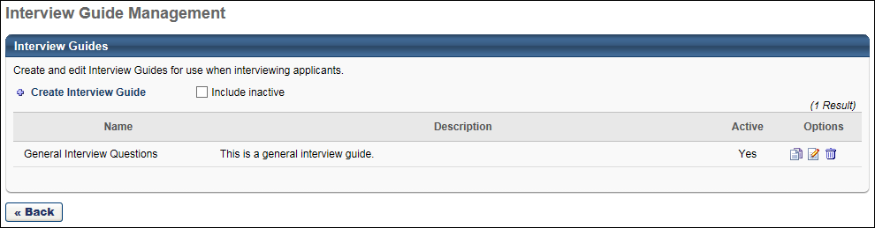
Create Interview Guide
Click the Create Interview Guide link to create an interview guide. See Create Interview Guide - Overview on page 58 for additional information.
Interview Guides Table
The following information displays for each guide:
- Include Inactive - Click Include Inactive to display inactive interview guides in the Interview Guides table.
- Name - This column displays the name of the guide. This column also defines the default alphabetical sort order for the table. This column is sortable.
- Description - This column displays the guide's description, as defined in the Description field when creating, editing, or copying a guide. This column is not sortable.
- Active - This column defines the active status of the guide. The column displays "Yes" for active and "No" for Inactive. This column is not sortable.
- Options - The following options are available in the Options column:
  - Copy - Click the Copy icon to copy the guide. All fields are copied except the Active field. When a guide is copied, the guide is active by default. For portals with multiple languages enabled, any translated text is also copied.
  - Edit - Click the Edit icon to edit the guide. If a guide has been associated with at least one interview, then a confirmation pop-up opens indicating that edits to the guide are not applied to the guides that have already been associated with an interview. Click Yes to proceed, or click No to cancel the edit action.
  - Remove - Click the Trash Can icon to delete the guide. This opens a confirmation pop-up indicating that deleted guides cannot be restored. Click Yes to permanently delete the guide. Or, click No to cancel the removal. A guide can only be deleted if it has not been associated with an interview.
Back
Click Back to return to the Admin > Tools > Recruit page.

Create Interview Guide - Overview
Interview guides define the competencies and rating scale that will be used to assess applicants. The guides provide a more effective way to manage the interview process and ensure that key elements of the skills, ideal qualifications, and minimum position requirements are covered during the interview.
Note: Implementation of the Performance module is not required in order to create interview guides. Competencies can be created within the guide, and a rating scale can be defined. However, for portals with Performance enabled, all existing competency models within Competency Assessment Management are available for use in interview guides.
To create an interview guide, go to Admin > Tools > Recruit > Interview Guides. Then, click Create Interview Guide.
Permissions
PERMISSION NAME | PERMISSION DESCRIPTION | CATEGORY

Interview Guide – Manage | Grants ability to access and manage Interview Guide Management. This permission can be constrained by User. This is an administrator permission. | Recruiting Administration
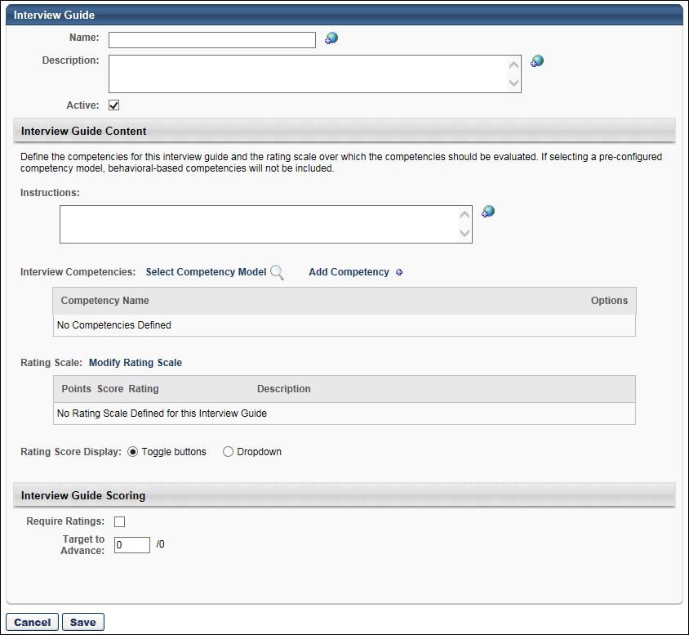
The process of creating an interview guide is divided into the following sections:
- General Information
- Interview Guide Content
- Interview Guide Scoring
Sample Interview Guide
The following image is a sample Interview Guide page with competencies, a rating scale, and questions configured for the guide:
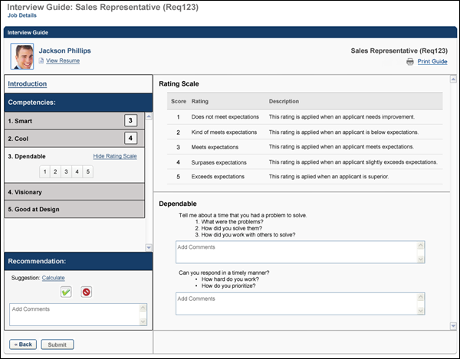

Create Interview Guide - Interview Guide Content
In the Interview Guide Content section, you define the competencies that the interviewers will use to evaluate the applicant. From here, you can add an existing competency model or create a new list of competencies. You can modify the rating scale for the competency model or define a new rating scale that is specific to the competencies you created.
Note: Implementation of the Performance module is not required in order to create interview guides. Competencies can be created within the guide, and a rating scale can be defined. However, for portals with Performance enabled, all existing competency models within Competency Assessment Management are available for use in interview guides.
To create an interview guide, go to Admin > Tools > Recruit > Interview Guides. Then, click Create Interview Guide.
Permissions
PERMISSION NAME | PERMISSION DESCRIPTION | CATEGORY

Interview Guide – Manage | Grants ability to access and manage Interview Guide Management. This permission can be constrained by User. This is an administrator permission. | Recruiting Administration
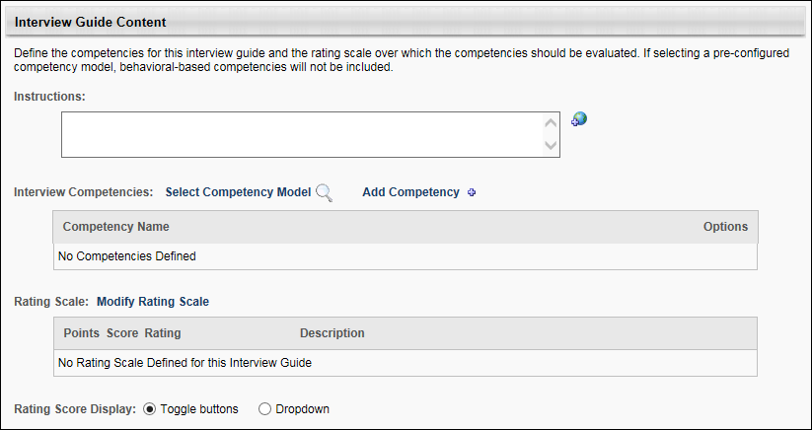
Instructions
The Instructions field enables administrators to provide general direction for the interview, such as requesting that the interviewer arrive to the interview on time and touch on all questions associated with each competency. This section can also be used to explain how to evaluate the applicant's aptitude for the competencies.
Enter instructions in the Instructions field, up to 2000 characters. The instructions appear for interviewers when viewing the guide. If instructions are not provided, then "None" displays in the Instructions section on the guide for the interviewer. This is not a required field. If multiple languages are enabled for your portal, select the Translate icon to translate the field into other available languages.
Best Practice: Instructions should include a note that the interviewer should click Begin Evaluation to be able to record scores and comments in the Interview Guide.
Best Practice: If the Require Ratings box is checked in the Interview Guide Scoring section, then it is a best practice to indicate in the Instructions field that interviewers are required to rate the applicant on each competency. If this information is not provided in the instructions, then interviewers may not be aware that rating the applicant is required until they click Submit on the Interview Guide page and view the error message informing them that rating the applicant is required.
Interview Competencies
The following options are available in this section:
Select Competency Model
Important Note: If you add a competency model to the interview guide, and you have already added competencies using the Add Competency option, the competencies you have added will be lost. The competency model will overwrite any competencies that you have created.
The option to select a competency model enables you to select a pre-configured competency model that contains the competencies on which users will rate the applicant. The Select Competency link only displays for portals that have Performance Management enabled. In addition, at least one competency model must already be configured in Competency Assessment Models. Only item-based competency models are available to select for interview guides. Any items that are configured for the competencies associated with the competency model are not included.
To select a competency model:
- Click the Select Competency link. This opens the Add Competency Model pop-up.
- Select a competency model by clicking the plus icon to the left of the model name. This closes the pop-up and populates the Interview Competencies table with the competencies from the model.
Only one competency model can be added to an interview guide. Selecting a different competency model overwrites the selection of the previous model and any configurations that have been made to the competencies, which includes editing the competency title, configuring questions for a competency, or defining a rating scale.
Add Competency
New competencies can be created within the interview guide and can also be added to the list of competencies that are pulled from a competency model. Interview guides must have at least one competency.
Note: Modifying the competencies in the interview guide that are associated with an existing competency model does not alter the competency model in Competency Assessment Models. Alternately, modifying a competency model or its associated rating scale in Competency Assessment Models does not alter the competencies or rating scale in the interview guide.
To add a competency:
- Click the Add Competency link. This opens the Add Competency pop-up.
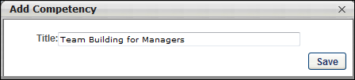
- Enter a title in the Title field, up to 300 characters.
- Click Save to add the competency to the Interview Competency table. Or, click the Close icon in the upper-right corner of the pop-up to close the pop-up without adding the competency.
Note: Adding a competency to an interview guide does not add the competency to the Competency Bank in Performance Management.
Interview Competencies Table
The following information displays in the Interview Competencies table for competencies that are pulled from a competency model or added via the Add Competency feature:
Competency Name
This column displays the name of the competency. Competencies can be reordered by dragging and dropping the competency to the desired location. Any questions that are associated with the competency are moved with the competency.
Competency Options
The following options are available for competencies:
Add Question
Questions can be added to each competency to provide interviewers with a list of questions to ask during the interview. The questions can be used to provide direction on how to gather information from the applicant to assess their aptitude with the competency. In addition, details can be included about the question to provide interviewers with an explanation of the question or help them understand how to use the question to evaluate applicants.
To add a question:
- Click the Add Question icon in the Options column. This opens the Add Question pop-up.
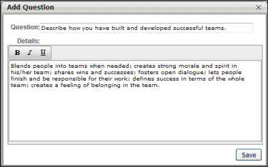
- For portals with multiple languages enabled, a language drop-down displays to enable you to translate the fields into each desired language. The language selected defines the language in which the fields will be translated. Before saving the action item, you can provide a translation for as many languages as desired based on the languages available. Selecting a different language preserves each translation that has been entered into the fields, even if you have not yet saved the question.
- Enter a question in the Question field, up to 500 characters.
- Enter details for the question in the Details field, up to 2000 characters. For example, the details may include an explanation of what to look for in an applicant's response to the question.
- Click Save to add the question to the competency. Or, click the Close icon in the upper-right corner of the pop-up to close the pop-up without adding the question.
Edit/Translate Competency
For portals with only one language enabled, an Edit icon displays. Click the Edit icon to edit a competency. This opens the Edit Competency pop-up from which you can edit the competency title. Click Save to save the changes. Or, click the Close icon in the upper-right corner of the pop-up to close the pop-up without saving the changes.
For portals with multiple languages enabled, a Translate icon displays instead of an Edit icon. This allows administrators to translate the competency into multiple languages.
To translate the competency:
- Click the Translate icon in the Options column. This opens the Translate pop-up.
- Enter the translated text in the desired languages.
- Click Save. This saves the translated text. When recruiters view the guide, the text displays in their language if a translation is configured. If a translation is not configured for the recruiter's language, then the text displays in the default language of the administrator who created the guide.
Note: If a competency is modified in the competency bank, the changes are not reflected on the interview guide.
Delete Competency
Click the Trash Can icon in the Options column to delete the competency. If a competency has any associated questions or competency items, then clicking the Trash Can icon opens a warning pop-up, indicating that deleting the competency also deletes the associated questions or items. Click Yes to delete the competency and its associated questions or items. Or, click No to close the pop-up and cancel the removal action.
Questions
Questions that are added to a competency display below the competency name. The following information and options are available for questions:
- Question - Competency questions that are added to the competency display below the competency.
- Question Details - Hover over the question mark icon to display the question details. The question details are entered when configuring the question. The question mark icon does not display if the Details field on the Add Question pop-up was not configured for the question. Questions within a competency can be reordered by dragging and dropping the competency to the desired location. Questions can be dragged and dropped to a different competency.
- Edit - The Edit icon only displays for portals with one language enabled. Clicking Edit opens the Edit Question pop-up from which you can edit the question. Click Save to save the changes. Or, click the Close icon in the upper-right corner of the pop-up to close the pop-up without saving the changes.
- Translate - The Translate icon only displays for portals with multiple languages enabled. Click the Translate icon in the Options column to edit a question. This opens the Edit Question pop-up from which you can edit the competency title. Click Save to save the changes. Or, click the Close icon in the upper-right corner of the pop-up to close the pop-up without saving the changes. Note: For portals with multiple languages enabled, the Translate icon appears instead of the Edit icon.
- Remove Question/Item - Click the Trash Can icon to delete the individual question or item. This deletes the question or item from the table.
Rating Scale
The Rating Scale section allows you to define the scale on which applicants will be rated for the competencies. For portals without Performance enabled, you can create and manage a rating scale for the guide.
For portals with Performance enabled, you can use or modify the existing rating scale for the competency model. The rating scale for the selected competency model displays in the Rating Scale section when the competency model is added.
A rating scale for the guide is required.
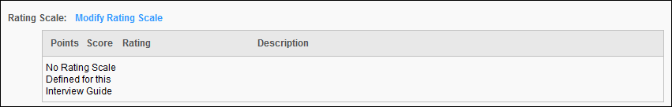
Modify Rating Scale
The option to modify the rating scale is used to create a new scale for the guide or edit an existing scale. To define the rating scale, click the Modify Rating Scale link. This opens the Define Rating Scale pop-up.

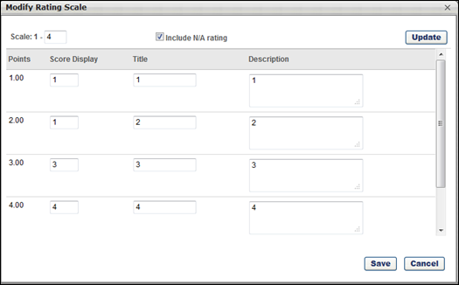
At the top of the pop-up, set the following configuration options to determine how the rating scale is structured:
- Scale - This setting represents the rating scale that will be used for the guide. Entering a number is required and creates a scale based on the number of ratings to be used in the guide. Additional rows appear for every point on the defined scale. Click the Add button to implement the settings and refresh the rating scale accordingly.
- Include N/A rating - Select this option to include a scoreless value titled N/A at the top of the scale. This option allows interviewers to not select a rating if the particular competency does not apply to the applicant or if the interviewer cannot properly judge the applicant's aptitude for the competency.
The following information displays for each point on the rating scale:
- Points - This field is fixed for each rating and cannot be changed. This represents the numerical value used to calculate a score for the rating using the scale. The Points column affects the Target to Advance field in the Interview Guide Scoring section. If the highest score in the column is changed, then the denominator value for the Target to Advance field is updated to reflect the change in the maximum value on the rating scale.
- Score Display - This is the value that interviewers see when viewing the guide and providing a rating. This represents the point value of the rating on the rating scale. This can be a number or letter or combination of both and is used to help express what the score is on the rating scale. Typically, this number matches the point value of the rating scale, but other examples include the first letter of the scale (E for Exceptional, A for Above Average, etc.).
Editing the Score Display column affects the Target to Advance field in the Interview Guide Scoring section. If the highest score in the column is changed, then the denominator value for the Target to Advance field is updated to reflect the change in the maximum value on the rating scale.
- Rating - This represents the value of the rating (Exceptional, Above Average, etc.). This can also be a combination of letters and numbers that express the value of the point on the rating scale.
- Description - This is used to explain the rating in greater detail.
After defining the rating scale, click Save to save the scale. Or, click Cancel to close the pop-up without creating/editing the scale. For portals with Performance enabled, a Revert to Default button displays. Click the button to revert any changes to the scale back to the default scale that is defined for the competency model in Competency Assessment Models.
Localization for Rating Scale
For portals with multiple languages enabled, a language drop-down is added to the Modify Rating Scale pop-up to enable localization of the Score Display, Title, and Description fields.
To localize the fields, select the language from the drop-down, and then enter the translated text into the fields.
To translate the fields into additional languages, select a different language from the drop-down and enter the translated text into the fields. You do not need to click Save before translating additional languages.
Once all desired fields are localized, click Save to save the changes.
Rating Scale Table
The Rating Scale table displays the scale defined for the competencies. For portals with Performance Management enabled, when a competency model is included from a previously-defined model in Performance, the associated rating scale is copied with the competency model. Note: As with competency models in Performance Management, editing a rating scale in the interview guide does not edit the rating scale defined for the competency model in Performance. Similarly, once a rating scale is associated with an interview guide, changes to the rating scale within Performance does not modify the rating scale on the interview guide.
See the Modify Rating Scale section above for a description of each column in the table.
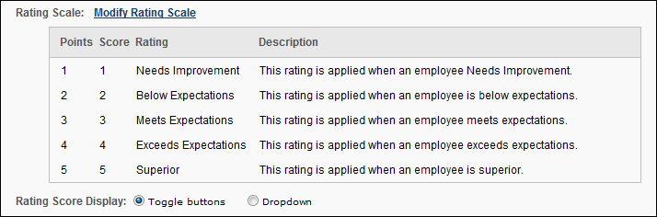
Rating Score Display
The following options are available to display the rating score:
- Toggle buttons - If this option is selected, then the ratings in the rating scale appear in a Toggle button display for interviewers when they rate the applicant. Note: This option cannot be used if the Score column on the rating scale exceeds 11 characters or displays non-numeric characters. In such cases, only the Dropdown option can be used to display the ratings.
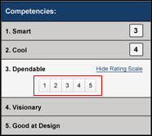
- Dropdown - If this option is selected, then the ratings in the rating scale appear in a drop-down for interviewers when they rate the applicant.
See Also
See the following for information on configuring the additional sections of the Create Interview Guide page:
- General Information
- Interview Guide Scoring

Create Interview Guide - Interview Guide Scoring
The Interview Guide Scoring section enables administrators to define whether to require interviewers to rate applicants on the competencies defined for the interview guide. Administrators can also define the target rating an applicant must receive in order for the system to suggest that the interviewer recommend the applicant to be advanced to the next status in the status workflow for the requisition. Note: The suggestion displays for interviewers in the Recommendation section of the guide.
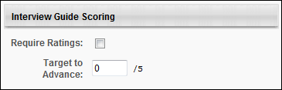
Require Ratings
Check the Require Ratings box to require interviewers to rate applicants on each competency before making a decision to advance or not advance the applicant. Uncheck the box to not require interviewers to rate applicants on each competency before making a decision to advance or not advance the applicant.
Best Practice: If the Require Ratings box is checked in the Interview Guide Scoring section, then it is a best practice to indicate in the Instructions field that interviewers are required to rate the applicant on each competency. If this information is not provided in the instructions, then interviewers may not be aware that rating the applicant is required until they click Submit on the Interview Guide page and view the error message informing them that rating the applicant is required.
Target to Advance
The Target to Advance field enables administrators to define the minimum average rating score for the competencies assessed in the interview that an applicant must receive for the system to suggest that the interviewer provide an "Advance" recommendation. For applicants who score above the target, the system suggests that the applicant be advanced to the next step in the status workflow for the requisition.
The field accepts one decimal point and up to two numerical characters before the decimal and two numerical characters after the decimal. Since 15 is the maximum value in a rating scale, 15 is the maximum value for the Target to Advance field. The value in the field must be less than the denominator.
If a rating scale is not defined for the guide, then the field is not editable.
See the following for information on configuring the additional sections of the Create Interview Guide page:
- General Information
- Interview Guide Content
Once all settings are configured for the guide, click Save to save the guide. Or, click Cancel to return to the Interview Guide Management page without saving the guide.

Interview Scheduler Page Overview
The Interview Scheduler page is used to schedule interviewers for the associated status. Through the use of scheduling tools, such as Outlook, all interview coordination can be performed from this page. An interview guide can be selected for each interviewer, and interviewers and applicants can be informed that an interview has been scheduled. The myriad features available on the Interview Scheduler page allow you to create a detailed, thorough interview process all from a single tool within the Interview Management functionality.
Interviews are created by adding interviewers to the Interview Scheduler panel, and then configuring the interview session. The options to configure an interview session do not appear until at least one interviewer is added to the Interview Scheduler panel.
Note: For interview event information, see the Interview Event - Schedule Event topic in Online Help.
To access the Interview Scheduler page, navigate to the Statuses tab of the applicant's profile page. Then, click Schedule Interview(s) in the applicable status panel.
Permissions
PERMISSION NAME | PERMISSION DESCRIPTION | CATEGORY

Applicants: Manage Interviews | Grants ability to manage and schedule interviews for applicants. This permission cannot be constrained. | Recruiting
Job Title/Requisition ID
The job title and requisition ID displays at the top of the page. For portals with multiple languages enabled, this displays in the user's language if available. If the user's language is not available, then this displays in the language of the user who defined it.
Job Details
The Job Details link at the top of the page allows for quick access to the job description and job qualifications for the requisition. Clicking the link opens the Job Details pop-up. The pop-up displays the requisition's internal and external job description, minimum qualifications, and ideal qualifications.
                - For portals with multiple languages enabled, this displays in the user's language if available. If the user's language is not available, then this displays in the language of the user who defined it.
Note: The fields on the pop-up are not editable from the pop-up.
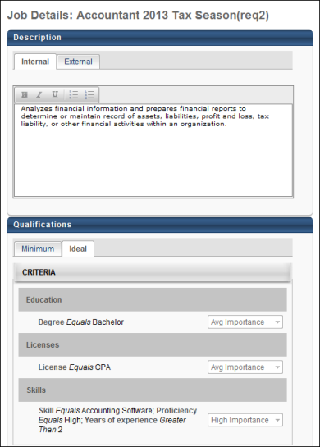
Interview Scheduler Page Organization
The Interview Scheduler page is separated into the following sections:
- Available Interviewers panel - This panel displays all interviewers configured on the Applicant Review tab of the job requisition for the associated status.
- Interview Scheduler panel - This panel displays the interviewers and interview sessions. From this panel, you can select an interview guide for each interviewer and add and remove interviewers. You can also define the interview schedule and notify the applicant that the interview is scheduled. In addition, you can preview the interview schedule in Outlook and send the interview to the interviewers.
- Interview Session - The interview session displays within the Interview Scheduler panel below the list of interviewers who are configured for the interview. Within the session box, you define the interview schedule and can also preview the schedule in Outlook and send the interview to the interviewers.
Within the Interview Scheduler heading, the applicant's name displays.
Interview Types
The following are the three types of interviews that can be scheduled:
- In Person
- Phone
- Live Video - A Live Video scheduled interview refers to an interview that is conducted via HireVue video between one or more interviewers and the applicant. This does not refer to an On Demand Video interview, which is an interview that is conducted by the applicant on their own time via HireVue video. On Demand Video interviews are not configured within the Interview Scheduler. This type of video interview is assigned to the applicant within the Interview status type panel that is configured as an On Demand Video interview. See Statuses Tab - Interview Status Type - On Demand Video Interview for additional information about assigning an On Demand Video interview to an applicant.
- Virtual
Migration of Existing Interview Data
For portals that have existing interview dates, the interview displays as a new interview session panel with the existing date selected for the interview session. If multiple interviews are scheduled for the same date, then each interview displays in a separate panel. If interviewers have been defined for the interviews, then the interviewers are added for each associated interview session panel.
See Also
See the following for information about each section of the Interview Scheduler page for scheduling in person, phone, and live video interviews:
- Create Interview - Available Interviewers
- Create Interview - Add Interviewers
- Create Interview - Interview Guide
- Create Interview - Schedule Interview Session
- Notify Applicant
- Edit Interview Session
See the following for information about scheduling interview events:
- Interview Event - Define Scheduling Details
- Interview Event - Schedule Event

Create Interview - Add Interviewers
Interviews are created by adding interviewers to the Interview Scheduler panel, and then configuring the interview session. The options to configure an interview session do not appear until at least one interviewer is added to the Interview Scheduler panel.
Interviewers can be added to the Interview Scheduler panel in the following ways:
- Drag and drop interviewers from the Available Interviewers panel.
- Add interviewers via the Click to add interviewer(s) link on the Interview Scheduler panel.
Note: In order to add interviewers using the Click to add interviewer(s) link, you must have permission to edit interviewers.
To access the Interview Scheduler, click Schedule Interview from Manage Candidates. Or, navigate to the Statuses tab of the applicant's profile page, and then click Schedule Interview(s) in the applicable status panel.
Permissions
PERMISSION NAME | PERMISSION DESCRIPTION | CATEGORY

Applicants: Manage Interviews | Grants ability to manage and schedule interviews for applicants. This permission cannot be constrained. | Recruiting
Add Interviewers
To add interviewers:
- Click Click to add interviewer(s) to open the Select Interviewer pop-up.
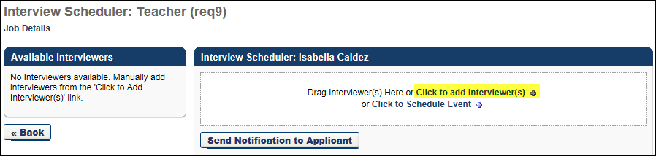
- Search for and select one or more users. There is no limit to the number of users that can be added as interviewers for In Person and Phone interview types. For Live Video interview types, the maximum number of interviewers for a session is three. Note: Users can only be added to a session once. They cannot be an interviewer for the same session multiple times.
- Click Add. This adds the users to the interview session.
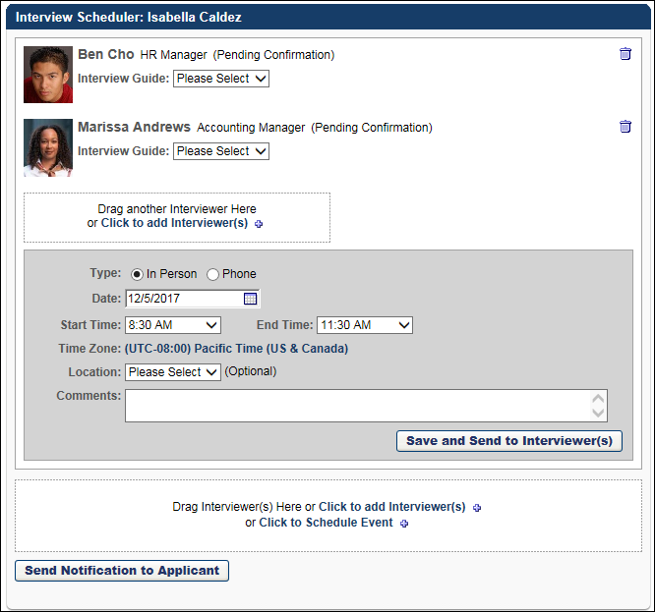
You can add additional interviewers by following the above steps. Interviewers display in the panel in the order in which they are added. All interviewers added to the session share the same session schedule. A separate interview schedule cannot be configured for each interviewer. In order to create a separate interview schedule, each interviewer would need to be added to separate interview sessions.
When at least one interviewer is added to a session, either via the click to add interviewer(s) link or the Available Interviewers panel, the Interview Session Scheduling options appears below the list of interviewers.
Note: If the Live Video option is selected in the Type field in the Interview Session Scheduling panel, the applicant and all interviewers selected must have a valid email address in order for the interview to be successfully sent to the interviewers and applicant.
Interviewer Details
The following information displays in the Interview Scheduler panel for each interviewer:
- Photo
- Name
- Job Title - Note: For portals with multiple languages enabled, this displays in the user's language if available. If the user's language is not available, then this displays in the language of the user who defined it.
- Notification Status - The following are the possible notification statuses:
  - Declined - This status displays when the interviewer has declined the interview scheduling request. Even if an interviewer declines the interview request, they are still required to submit a recommendation. Note: When a user is listed as an interviewer for a session, they are required to submit a recommendation about the applicant, either Advance or Do not Advance .
  - Scheduled - This status displays when the interviewer has accepted the interview scheduling request.
  - Pending Confirmation - This status displays when the interviewer has been sent an interview scheduling request but has not yet responded to the request.
Interview Guide
For information about selecting interview guides and iGuides (for portals with Selection enabled) in the Interview Guide and Selection iGuide fields, see the Create Interview - Interview Guide topic in Online Help.
Remove Interviewer
To remove an interviewer from a session:
- Click the Trash Can icon to the right of the interviewer details in the Interviewer Scheduler panel. This opens a confirmation pop-up indicating that removing an interviewer permanently deletes all partially or fully completed interview guides and recommendations that are associated with the interviewer for the session.
- Click Yes to remove the interviewer. Or, click No to cancel the removal action and close the pop-up.
Email Trigger
Removing an interviewer triggers the Interview Cancelled Notification email to the interviewer, if configured by the administrator in Email Administration. The email includes the option to cancel the interview in the user's email calendar, if an ICS attachment was originally sent along with the interview request.
When an interviewer is removed from a session, the recommendation bar for the applicant may need to be recalculated.
Interviewers who are removed from a session can no longer access the interview on the Interview Manager page.
Note: If there is only one interviewer in an interview session, and the interviewer is removed, then the session is also removed.
Note: Interviewers cannot be removed from the Available Interviewers panel. In addition, interviewers cannot be dragged back to the Available Interviewers panel. Once they are dragged to a session, they cannot be dragged back to the Available Interviewers panel to remove the interviewer.

Create Interview - Available Interviewers Panel
Interviews are created by adding interviewers to the Interview Scheduler panel, and then configuring the interview session. The options to configure an interview session do not appear until at least one interviewer is added to the Interview Scheduler panel.
Interviewers can be added to the Interview Scheduler panel in the following ways:
- Drag and drop interviewers from the Available Interviewers panel.
- Add interviewers via the Click to add interviewer(s) link on the Interview Scheduler panel.
Note: In order to add interviewers using the Click to add interviewer(s) link, you must have permission to edit interviewers.
To access the Interview Scheduler, click Schedule Interview from Manage Candidates. Or, navigate to the Statuses tab of the applicant's profile page, and then click Schedule Interview(s) in the applicable status panel.
Permissions
PERMISSION NAME | PERMISSION DESCRIPTION | CATEGORY

Applicants: Manage Interviews | Grants ability to manage and schedule interviews for applicants. This permission cannot be constrained. | Recruiting
Available Interviewers
The Available Interviewers panel displays all interviewers configured on the Applicant Review tab of the job requisition for the associated status. Having a list of preconfigured interviewers can help recruiters when trying to determine who should interview applicants for the job.
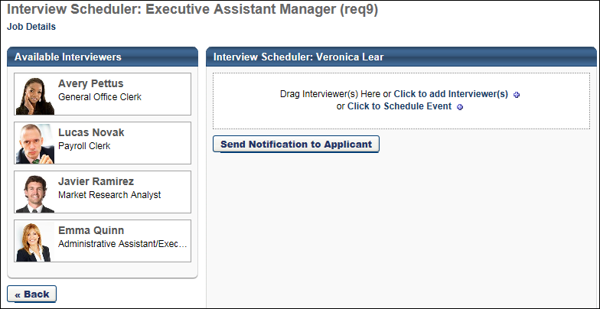
Interviewers from the Available Interviewers panel can be dragged and dropped into interview sessions on the Interview Scheduler panel.
If there are no interviewers in the Available Interviewers panel, then "No interviewers available. Manually add interviewers from the 'Click to Add Interviewer(s)' link" displays in the panel.
Interviewers display in the order in which they are defined at the requisition level and cannot be reordered in the panel.
Note: If the Live Video option is selected in the Type field in the Interview Session Scheduling panel, the applicant and all interviewers selected must have a valid email address in order for the interview to be successfully sent to the interviewers and applicant.
Interviewer Details
The following information displays for each interviewer in the panel:
- Photo
- Name
- Job Title
Drag and Drop Interviewer
You can drag and drop interviewers from the Available Interviewers panel to the Interview Scheduler panel. This allows you to quickly populate your list of interviewers without having to search for them.
To move an interviewer into a session, click and drag the interviewer into the Drag Interviewer(s) here or click to add interviewer(s) box in the Interview Scheduler panel. This adds the interviewer to the session and enables the Interview Scheduling Session options to appear below the list of interviewers. Interviewers display in the panel in the order in which they are added. There is no limit to the number of users that can be added as interviewers for In Person and Phone interview types. Video interviews can have a maximum of three interviewers.
When at least one interviewer is added, the text in the drag and drop box changes to "Drag another Interviewer Here or click to add interviewer(s)." You can add additional interviewers by dragging and dropping them into the box.
Only one interviewer can be dragged and dropped at a time. Interviewers can only be added to a session once. They cannot be added to a single session multiple times.
All interviewers added to the session share the same session schedule. A separate interview schedule cannot be configured for each interviewer. In order to create a separate interview schedule, each interviewer would need to be added to separate interview sessions.
Note: If you drag and drop an interviewer from the Available Interviewers panel but would like to include the interviewer in one or more additional sessions, then you can use the Click to add interviewer(s) feature within each session to add the interviewer.
Remove Interviewer
To remove an interviewer from a session:
- Click the Trash Can icon to the right of the interviewer details in the Interviewer Scheduler panel. This opens a confirmation pop-up indicating that removing an interviewer permanently deletes all partially or fully completed interview guides and recommendations that are associated with the interviewer for the session.
- Click Yes to remove the interviewer. Or, click No to cancel the removal action and close the pop-up.
Email Trigger
Removing an interviewer triggers the Interview Cancelled Notification email to the interviewer, if configured by the administrator in Email Administration. The email includes the option to cancel the interview in the user's email calendar, if an ICS attachment was originally sent along with the interview request.
When an interviewer is removed from a session, the recommendation bar for the applicant may need to be recalculated.
Interviewers who are removed from a session can no longer access the interview on the Interview Manager page.
Note: If there is only one interviewer in an interview session, and the interviewer is removed, then the session is also removed.
Note: Interviewers cannot be removed from the Available Interviewers panel. In addition, interviewers cannot be dragged back to the Available Interviewers panel. Once they are dragged to a session, they cannot be dragged back to the Available Interviewers panel to remove the interviewer.

Create Interview - Interview Guide
The Interview Guide field displays below each interviewer's interview details. The Interview Guide field allows you to view and/or select an interview guide for each interviewer.
To access the Interview Scheduler, click Schedule Interview from Manage Candidates. Or, navigate to the Statuses tab of the applicant's profile page, and then click Schedule Interview(s) in the applicable status panel.
Permissions
PERMISSION NAME | PERMISSION DESCRIPTION | CATEGORY

Applicants: Manage Interviews | Grants ability to manage and schedule interviews for applicants. This permission cannot be constrained. | Recruiting
Note: Interview guides are created in Interview Guide Management. Or, guides can be created using your own document creation tool, and then uploaded to the Interview Scheduler page. See Interview Guide Management on page 56 for additional information.
Interview Guide Options
The following are the possible options in the Interview Guide field:
- No Guide - This displays if the No Guide option is selected at the requisition level. In this case, an interview guide cannot be added for the interviewer.
- Drop-Down - A drop-down displays if the Select Guide option is selected at the requisition level. In this case, the guide that was selected at the requisition level displays by default in the drop-down. You can select a different guide by clicking the drop-down and selecting from all available guides that have been created in Interview Guide Management.
- [Name of Interview Guide] Link - This displays if the Upload Guide option is selected at the requisition level. In this case, the guide that was uploaded displays as a link. Click the link to view the guide. You can delete the guide by clicking the Trash Can icon to the left of the guide. Deleting the guide allows you to upload a different guide.
- Upload Guide - This displays if the Upload Guide option is selected at the requisition level but a guide was not added for the interviewer when configuring the requisition. This option also displays if the guide uploaded at the requisition level is deleted at the applicant level. the Upload Guide opens the Upload Guide pop-up. In the Title field, enter the title that will display to interviewers, up to 250 characters. Click Browse to locate and select the file. Then, click Upload. This adds a link to the guide in the Interview Guide field. The maximum file size is 1MB. The acceptable file types are .doc, .docx, .xls, .xlsx, .pdf, .txt, and .rtf. You can delete the guide by clicking the Trash Can icon to the left of the guide.
Note: Requisition level interviewers are added as interviewers on the Applicant Review tab of the job requisition. They can then be dragged and dropped into an interview session via the Available Interviewers panel on the Interview Scheduler page. See Applicant Review Tab - Interview Status Type Overview for additional information. See Create Interview - Available Interviewers Panel on page 77 for additional information.
Note: Applicant level interviewers are added as interviewers from the Interview Scheduler page.
Note: For interview guides for portals with multiple languages enabled, the name of the guide displays in the user's language if available. If the user's language is not available, then this displays in the language of the user who defined the name.
The Interview Guide field is not a required field.
Selection iGuide
The Selection iGuide field allows recruiters to include an iGuide that has been specifically defined for the position for use during interviews. The iGuide provides interviewers with various sets of questions, at least one of which must be asked during the interview. The questions also include examples of acceptable responses. The applicant's responses are scored by the interviewer, and the score can be used to narrow down the number of applicants for the requisition.
Note: The Selection iGuide option only displays if enabled by a backend setting that is disabled by default. To enable this functionality, contact Global Customer Support. The content of the iGuide is predefined and cannot be developed or modified by the administrator.
To select an iGuide, click the drop-down and select the desired guide. The iGuides that are available for the position are defined during the Selection functionality configuration process. Selecting an iGuide is not required. Interviewers can view the iGuide from the Interview Manager page or the Statuses tab of the Applicant Profile page.
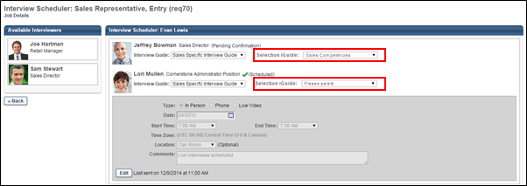

Create Interview - Set Schedule Details and Send Interview
Interviews are created by adding interviewers to the Interview Scheduler panel, and then configuring the interview session. The options to configure an interview session do not appear until at least one interviewer is added to the Interview Scheduler panel.
Each interview session displays in its own Interview Session Scheduling panel below the list of interviewers who are configured for the associated session. The options that are available in the Interview Session Scheduling panel are dependent on whether you are scheduling an in-person, phone, or video interview.
Regardless of the number of interviewers for a given session, there is only one Interview Session Scheduling panel per interview session.
To access the Interview Scheduler, click Schedule Interview from Manage Candidates. Or, navigate to the Statuses tab of the applicant's profile page, and then click Schedule Interview(s) in the applicable status panel.
Permissions
PERMISSION NAME | PERMISSION DESCRIPTION | CATEGORY

Applicants: Manage Interviews | Grants ability to manage and schedule interviews for applicants. This permission cannot be constrained. | Recruiting
Emails
EMAIL NAME | EMAIL DESCRIPTION | ACTION TYPE

Interview Scheduling Notification - Interviewer(s) | This email is triggered when an interview scheduling notification is sent to interviewers. The email can be sent to Applicant Interviewer(s) or a specific user. This email can be configured as a Notification or Reminder type email. For Reminder type emails, the reminder is triggered a set number of days, hours, or minutes before the interview start time. This email is active by default and can be found in the Recruitment action type section of Email Management.  This email is used when sending Outlook Meeting Invite requests. The email contains an ICS attachment if Outlook notifications are enabled by the administrator in Interview Management Preferences.  This email is used when using Outlook Scheduler to preview the email, if the Outlook scheduling option is enabled by the administrator in Interview Management Preferences.  Use Case: When a recruiter schedules an interview, they may want to notify the interviewers about the scheduled date, time, and interview type. Use this trigger to notify the interviewers that an interview session is scheduled. | Recruiting

Interview Scheduling Notification - Applicant | This email is triggered when an applicant scheduling notification is sent to the applicant, and is also triggered when an applicant self scheduled an interview for an interview event. The email can be sent to External Applicant, Internal Applicant, or a specific user. This email is active by default and can be found in the Recruitment action type section of Email Management.  Use Case: When a recruiter schedules an interview, they may want to send a notification to the applicant about the scheduled date, time, and interview type. Use this trigger to notify the applicant that an interview session is scheduled. | Recruiting
See Send Notification to Applicant on page 88 for additional information.
Schedule Session
To schedule an interview, configure the following options in the Interview Session Scheduling panel:
Type
The Type field is a required field that defines the type of interview that will be conducted for the applicant. Select one of the following interview types:
- In Person - This option is selected by default. This interview type is a traditional interview where the applicant meets face-to-face with the interviewer. Selecting this option enables the Location field to display in the Interview Session Scheduling panel.
- Phone - Select this option if the interview will be conducted over the phone. Selecting this option enables the Phone Number field to display in the Interview Session Scheduling panel.
- Live Video - A Live Video scheduled interview refers to an interview that is conducted via HireVue video between one or more interviewers and the applicant. This does not refer to an On Demand Video interview, which is an interview that is conducted by the applicant on their own time via HireVue video. On Demand Video interviews are not configured within the Interview Scheduler. This type of video interview is assigned to the applicant within the Interview status type panel that is configured as an On Demand Video interview. See Statuses Tab - Interview Status Type - On Demand Video Interview in the Applicant Profile section of Online Help for information about assigning an On Demand Video interview to an applicant.
- Virtual - Select this option if this interview will be conducted virtually.
Date
This field enables you to specify a date for the interview. Enter a date in the Date field or use the calendar option to select a date. This is a required field.
Start Time
This field enables you to specify the time at which the interview begins. Select a time from the drop-down. This is a required field.
End Time
This field enables you to specify the time at which the interview ends. Select a time from the drop-down. This is a required field.
Time Zone
This field enables you to specify the time zone in which the interview occurs. By default, the field displays the time zone of the user who is scheduling the interview. To change the time zone, click the time zone link. This opens a drop-down from which to select a different time zone. This is a required field.
Note: A standard list of time zones always appears, regardless of whether daylight savings is in effect or not. However, daylight savings time is reflected in other parts of the system, such as on the Statuses tab of the Applicant Profile and in emails that are triggered as a result of the scheduled interview.
Location
This option displays for In Person interview types. This field enables you to specify where the interview will take place. Select a location from the drop-down. The selections that are available are the locations defined by the administrator in Interview Management Preferences. This is not a required field. Note: If you change the selection in the Type field, the selected location is not retained.
Phone Number
This option displays for Phone interview types. This field enables you to define the phone number for the interview. Enter a phone number in the field. There is no character limit. This is not a required field. Note: If you change the selection in the Type field, the information entered in this field is not retained.
Comments
This field enables you to enter a note to interviewers. There is no character limit. This is not a required field.
Preview in Outlook
This option enables the scheduler to preview the Outlook email that will be sent to interviewers for the session.
If tags for attachments are included in the email, the attachments are not accessible in the preview. Clicking the Open button that displays in the preview for the ICS attachment opens the Outlook Meeting Invite. It also opens the scheduler's Outlook application, if the scheduler does not already have the application open.
Clicking any of the other buttons in the preview, such as Save, Accept, Decline, or Cancel has no functionality.
For video interviews, a link to the video does not display in the preview.
The time zone displays in the time zone defined in the scheduler's Outlook application.
Save and Send to Interviewer(s)
Click the Save and Send to Interviewer(s) button to send the interview to the interviewers. Clicking the button adds the interview to the Interview Manager Dashboard for each associated interviewer.
Clicking the button also triggers the Interview Scheduling Notification - Interviewers email, if configured by the administrator. If the option to enable Outlook notifications is selected by the administrator in Interview Management Preferences, then each applicable interviewer is sent an Outlook meeting invite. The invite is sent to the email address in the interviewer's user record. Within the email, if the interview type is Live Video, then the location displays as "Live Video Interview." The email may include the applicant's resume/CV and cover letter, as well as the interview guide that is defined for the interviewer. For On Demand Video interviews, the email includes a link to the interview. Note: The administrator must configure the email with the applicable tags in order for the video link, resume/CV, cover letter, and interview guide to be included in the email.
If changes are made to the interview schedule, and an interviewer has added the interview to their email calendar, then a new meeting invite is sent to the interviewer with the updated information.
The Save and Send to Interviewer(s) button must be clicked for each individual interview session. A batch save and send option is not available.
When Save and Send to Interviewer(s) is clicked, the button text changes to Edit. See Edit Interview Session on page 92 for additional information.
Outlook Meeting Invites
When an Outlook meeting invite is sent to an interviewer, the standard Outlook options are available. Any response to the interview request by the interviewer triggers the Interview Scheduling Response email, if configured by the administrator in Email Administration.
The following are the possible Outlook responses:
- Accept - If the interviewer responds as Accept, the status of the request is changed from Pending Confirmation to Scheduled.
- Deny - If the interviewer responds as Decline, the status of the request is changed from Pending Confirmation to Declined.
- Tentative - If the interviewer responds as Tentative, the status of the request is changed from Pending Confirmation to Declined.
Note: When an interviewer is accepting a calendar invite for an interview, the email acceptance must come from the same email address that is registered in Cornerstone for that specific interviewer.
Considerations
- If the interviewer includes comments in their reply when responding to the interview request, the comments do not appear in the system.
- If the interviewer proposes a new time for the interview, the system does not record the proposal.
- If the interviewer forwards the interview request, the system does not track the forwarding.
Last Sent Date
When Save and Send to Interviewer(s) is clicked, the last sent date appears to the right of the Edit button. This is the most recent date on which the interview was sent to the interviewers.

Send Notification to Applicant
The notify applicant option is used to send a notification to the applicant that an interview has been scheduled. A single notification is used to notify the applicant, even if there are multiple interview sessions occurring at different times and on different days. Once a notification is sent to an applicant, the last sent date displays as a link to the left of the button.
Applicants are notified via the Applicant Scheduling pop-up. Within the pop-up, all interview sessions display for the applicant for the associated status. Each session displays in a separate session box. Within the pop-up, you can configure details about the session, such as date and time, as well as remove individual sessions.
To access the Interview Scheduler, click Schedule Interview from Manage Candidates. Or, navigate to the Statuses tab of the applicant's profile page, and then click Schedule Interview(s) in the applicable status panel.
Permissions
PERMISSION NAME | PERMISSION DESCRIPTION | CATEGORY

Applicants: Manage Interviews | Grants ability to manage and schedule interviews for applicants. This permission cannot be constrained. | Recruiting
Emails
EMAIL NAME | EMAIL DESCRIPTION | ACTION TYPE

Interview Scheduling Notification - Applicant | This email is triggered when an applicant scheduling notification is sent to the applicant, and is also triggered when an applicant self scheduled an interview for an interview event. The email can be sent to External Applicant, Internal Applicant, or a specific user. This email is active by default and can be found in the Recruitment action type section of Email Management.  Use Case: When a recruiter schedules an interview, they may want to send a notification to the applicant about the scheduled date, time, and interview type. Use this trigger to notify the applicant that an interview session is scheduled. | Recruiting
Send Notification
To notify an applicant that an interview has been scheduled:
- Click Send Notification to Applicant. This opens the Applicant Scheduling pop-up. All existing settings for the interview session display. One or more sessions may display, depending on the configuration of the Interview Scheduler page for the applicant.
- Review and/or complete the following fields in the pop-up:
  - Date - This field displays the date for the interview. You can edit the date by entering a different date in the Date field or using the calendar option to select a date. This is a required field.
  - Start Time - This field displays the time at which the interview begins. You can edit the start time by selecting a different time from the drop-down. This is a required field.
  - End Time - This field displays the time at which the interview ends. You can edit the end time by selecting a different time from the drop-down. This is a required field.
  - Time Zone - This field displays the time zone in which the interview occurs. To change the time zone, click the time zone link. This opens a drop-down from which to select a different time zone. This is a required field.
  - Type - This field displays the interview type. If Live Video is selected in the Type field on the Interview Scheduler page, then the field cannot be edited in the pop-up. If In Person,or Phone are selected in the Type field on the Interview Scheduler page, then you can edit the field by changing the option to In Person or Phone.
  - Location - This field displays for In Person interview types. This field enables you to specify where the interview will take place. You can edit the location by selecting a different location from the drop-down. The selections that are available are the locations defined by the administrator in Interview Management Preferences. This is not a required field. Note: If you change the interview type in the Type field, the selected location is not retained.
  - Phone Number - This option displays for Phone interview types. This field enables you to define the phone number for the interview. You can edit the value by entering a different phone number in the field. There is no character limit. This is not a required field. Note: If you change the interview type in the Type field, the information entered in this field is not retained.
  - Interviewer(s) - This field displays the interviewers defined for the interview session. You can add and remove interviewers from the list. Note: To add interviewers, you must have permission to edit interviewers.
    - Add Interviewers - To add interviewers, click the Add Interviewer(s) link. This opens the Add User pop-up. Select one or more users. There is no limit to the number of users that can be added as interviewers for In Person and Phone interview types. For Live Video interview types, the maximum number of interviewers or interview reviewers for a session is three. Click Add. This adds the users to the interview session. Note: Users can only be added to a session once. They cannot be an interviewer for the same session multiple times.
    - Remove Interviewers - This option allows you to remove interviewers from the list. Clicking the Trash Can icon removes the interviewer. The Remove option is beneficial to organizations that may prefer not to provide the list of interviewers to applicants when notifying applicants that an interview is scheduled.
  - Add another Interviewer - This option allows you to add an interview session. Clicking the link adds a blank interview session box to the bottom of the pop-up. You must define the settings for the required fields in the session. See the field descriptions above for required settings. See Create Interview - Set Schedule Details and Send Interview on page 82 for additional information.
  - Comments to Applicant - This field enables you to enter a note to the applicant. There is no character limit. This is not a required field.
- Click Save and Send. This sends the notification to the applicant and adds the Last sent link to the right of the Send Notification to Applicant button. This also triggers the Interview Scheduling Notification - Applicant email.
Resend Notification to Applicant
You can resend a notification to an applicant to let them know that an interview is scheduled. This can be done by resending the notification without making changes to the notification. Or, you can edit the notification and then resend.
To resend a notification without editing the notification:
- Click Last sent. This opens the Applicant Scheduling pop-up. All fields are pre-populated with the existing settings for each interview session.
- Click Re-Send. This resends the notification to the applicant and updates the Last sent link.
To resend a notification by editing the notification before sending:
- Click Send Notification to Applicant. This opens the Applicant Scheduling pop-up. All fields in the pop-up are editable.
- Once all fields are configured, click Save and Send. This resends the notification to the applicant and updates the Last sent link.
Resending a notification triggers the Interview Scheduling Notification - Applicant email, if configured by the administrator in Email Administration. In addition, the Interview Notification Sent to Applicant event is logged on the History tab of the applicant's profile.
Note: When viewing the Applicant Scheduling pop-up, the date and time display in the viewer's time zone.
Remove Interview Session
When two or more interview sessions appear in the Applicant Scheduling pop-up, you can remove an interview session by clicking the Trash Can icon in the upper-right corner of the session box. This removes the session from the pop-up and from the notification that is sent to the applicant but does not remove the session from the interview schedule for the status. This only removes the session from the notification that is sent to the applicant.
The option to remove sessions is only available when there are multiple sessions scheduled. There must be at least one session in the Applicant Scheduling pop-up in order to send the notification to the applicant.

Edit Interview Session
When editing an interview session, all fields in the session are editable.
To access the Interview Scheduler to edit an interview, click View Feedback from Manage Candidates. Or, navigate to the Statuses tab of the applicant's profile page, and then click Schedule Interview(s) in the applicable status panel. This opens the interview that has been scheduled.
Permissions
PERMISSION NAME | PERMISSION DESCRIPTION | CATEGORY

Applicants: Manage Interviews | Grants ability to manage and schedule interviews for applicants. This permission cannot be constrained. | Recruiting
Emails
EMAIL NAME | EMAIL DESCRIPTION | ACTION TYPE

Interview Scheduling Notification - Interviewer(s) | This email is triggered when an interview scheduling notification is sent to interviewers. The email can be sent to Applicant Interviewer(s) or a specific user. This email can be configured as a Notification or Reminder type email. For Reminder type emails, the reminder is triggered a set number of days, hours, or minutes before the interview start time. This email is active by default and can be found in the Recruitment action type section of Email Management.  This email is used when sending Outlook Meeting Invite requests. The email contains an ICS attachment if Outlook notifications are enabled by the administrator in Interview Management Preferences.  This email is used when using Outlook Scheduler to preview the email, if the Outlook scheduling option is enabled by the administrator in Interview Management Preferences.  Use Case: When a recruiter schedules an interview, they may want to notify the interviewers about the scheduled date, time, and interview type. Use this trigger to notify the interviewers that an interview session is scheduled. | Recruiting

Interview Scheduling Notification - Applicant | This email is triggered when an applicant scheduling notification is sent to the applicant, and is also triggered when an applicant self scheduled an interview for an interview event. The email can be sent to External Applicant, Internal Applicant, or a specific user. This email is active by default and can be found in the Recruitment action type section of Email Management.  Use Case: When a recruiter schedules an interview, they may want to send a notification to the applicant about the scheduled date, time, and interview type. Use this trigger to notify the applicant that an interview session is scheduled. | Recruiting
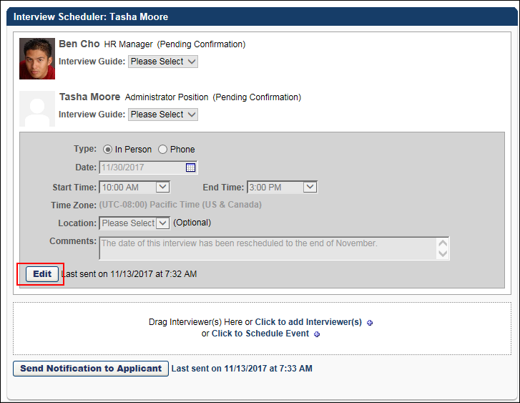
To edit an interview session click Edit in the schedule section. The session can be resent to the interviewers, and the session can be previewed in Outlook. You can also cancel the edits by clicking Cancel Edit. This cancels any pending changes to the session.
To save the changes, click Save and Send to Interviewer(s). This triggers the Interview Scheduling Notification - Interviewers email, if configured by the administrator in Email Management.
Notify Applicant of Cancelled Interview
If you are cancelling the interview and would like to notify the applicant, this will need to be done through one of the following options in the Applicant Tracking System:
- Manage Applicants > Send Email
- Manage Applicants > Send Customizable Email
- Applicant Profile > Summary Tab
A system email is not available in Email Administration that will automatically notify an applicant when an interview has been cancelled.
See Send Notification to Applicant on page 88 for additional information.

Cancel Interview Session
Interview sessions can be cancelled by removing all interviewers from the interview session.
To access the Interview Scheduler, click Schedule Interview from Manage Candidates. Or, navigate to the Statuses tab of the applicant's profile page, and then click Schedule Interview(s) in the applicable status panel.
Permissions
PERMISSION NAME | PERMISSION DESCRIPTION | CATEGORY

Applicants: Manage Interviews | Grants ability to manage and schedule interviews for applicants. This permission cannot be constrained. | Recruiting
To remove interviewers and cancel the session:
- Click the Trash Can icon to the right of the interviewer in the Interviewer Scheduler panel. This opens a confirmation pop-up indicating that removing an interviewer permanently deletes all partially or fully completed interview guides and recommendations that are associated with the interviewer for the session.
- Click Yes to remove the interviewer. Or, click No to cancel the removal action and close the pop-up.
- Click Save and Send to Interviewer(s). If all interviewers have been deleted, then clicking this button will remove the interview session from the page. If the Interview Cancelled Notification email is configured in Email Administration, then cancelling the session will trigger the email to be sent to the interviewers.
The Interview Cancelled Notification email is not sent to the applicant. A system email is not available in Email Administration that will automatically notify an applicant when an interview has been cancelled. Instead, an email can be manually sent to the applicant from the Send Email or Send Customizable Email options from the Manage Applicants page or the Applicant Profile page.
Note: Users who are not interviewers for any other interview session will no longer have access to the Interview Manager page after the session is cancelled. The link in the navigation tab for such users will be immediately removed.

Interview Manager Overview
The Interview Manager page displays an interviewer's interview sessions for interviews and interview events. This is the primary page that interviewers use to view their interviews. This page is also used by recruiters to view the interviews for their requisitions. From this page, interviewers can view the following:
- Today's interviews
- Incomplete interviews
- Future Interviews
- Application information for applicants to be interviewed
- Interview guide
Interviewers can also submit recommendations for applicants they have interviewed.
Note: Interviews are scheduled by the recruiter from the applicant's Applicant Profile page.
To access the Interview Manager page, go to Recruit > Interview Manager.
Permissions
PERMISSION NAME | PERMISSION DESCRIPTION | CATEGORY

Applicants: Comments - Manage | Grants ability to view and manage comments for applicants.  This permission also defines whether comments posted when an interviewer submits an interview recommendation are posted to the Comments section on the Applicant Profile tab. Note: Interview recommendation comments for interviewers who have this permission display on the Applicant Profile tab. For interviewers who do not have this permission, the comments do not display on the Applicant Profile tab. | Recruiting

Requisition: Interviewer | Grants ability to access and view past and future interviews and record interviewee recommendations. This permission cannot be constrained.  Note: This is a dynamically assigned permission that is not available in Security Role Administration. Once a user is scheduled as an interviewer for an applicant, the user will always have permission to view the interview details on the Interview Manager page. Users with this permission can do the following:  - Access the Interview Manager page.  - View the resume and cover letter for applicants for whom they are an interviewer.  - View the applicant profile for applicants for whom they are an interviewer.  - View the interview guide for the requisition for which they are listed as an interviewer.  - Recommend that an applicant be advanced or not advanced. | Recruiting
The Interview Manager page is divided into the following tabs:
- Scheduled Interviews - This tab displays interviews that have been scheduled for the interviewer.
- Completed Interviews - This tab displays interviews the interviewer has conducted. Note: This tab cannot be accessed by requisition owners unless they are also an interviewer.

Interview Manager Overview
The Interview Manager page displays an interviewer's interview sessions for interviews and interview events. This is the primary page that interviewers use to view their interviews. This page is also used by recruiters to view the interviews for their requisitions. From this page, interviewers can view the following:
- Today's interviews
- Incomplete interviews
- Future Interviews
- Application information for applicants to be interviewed
- Interview guide
Interviewers can also submit recommendations for applicants they have interviewed.
Note: Interviews are scheduled by the recruiter from the applicant's Applicant Profile page.
To access the Interview Manager page, go to Recruit > Interview Manager.
Permissions
PERMISSION NAME | PERMISSION DESCRIPTION | CATEGORY

Applicants: Comments - Manage | Grants ability to view and manage comments for applicants.  This permission also defines whether comments posted when an interviewer submits an interview recommendation are posted to the Comments section on the Applicant Profile tab. Note: Interview recommendation comments for interviewers who have this permission display on the Applicant Profile tab. For interviewers who do not have this permission, the comments do not display on the Applicant Profile tab. | Recruiting

Requisition: Interviewer | Grants ability to access and view past and future interviews and record interviewee recommendations. This permission cannot be constrained.  Note: This is a dynamically assigned permission that is not available in Security Role Administration. Once a user is scheduled as an interviewer for an applicant, the user will always have permission to view the interview details on the Interview Manager page. Users with this permission can do the following:  - Access the Interview Manager page.  - View the resume and cover letter for applicants for whom they are an interviewer.  - View the applicant profile for applicants for whom they are an interviewer.  - View the interview guide for the requisition for which they are listed as an interviewer.  - Recommend that an applicant be advanced or not advanced. | Recruiting
The Interview Manager page is divided into the following tabs:
- Scheduled Interviews - This tab displays interviews that have been scheduled for the interviewer.
- Completed Interviews - This tab displays interviews the interviewer has conducted. Note: This tab cannot be accessed by requisition owners unless they are also an interviewer.

Interview Management Preferences (by Division)
Interview Management Preferences (by Division) enables administrators to configure Interview Management settings for each Division Organizational Unit (OU). Administrators can manage the settings for interview events and guidelines, as well as Outlook integration. Administrators can also manage the visibility of interviewer comments.
Note: Configuring Interview Management Preferences settings is a required step for implementation of the Interview Management functionality.
Note: You can also set preferences for all Division OUs by setting them at the top level Division OU. However, setting preferences for each Division OU can be helpful because you can create interview locations that are specific to each Division OU.
To access Interview Management Preferences, go to Admin > Tools > Recruit > Interview Management.
Permissions
PERMISSION NAME | PERMISSION DESCRIPTION | CATEGORY

Interview Management Preferences – Manage | Grants ability to access and manage Interview Management Preferences. This permission can be constrained by OU and User's OU. This is an administrator permission. | Recruiting Administration
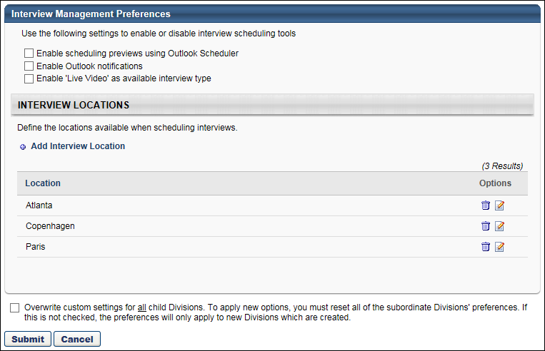
Interview Scheduling Tools
The following interview scheduling options are available in the upper portion of the Interview Management Preferences page:
- Enable scheduling previews using Outlook Scheduler - Select this option to enable the Preview in Outlook link to display on the Interview Scheduling page. This option is unchecked by default.
- Enable Outlook notifications - Select this option to enable an Outlook notification to be sent to interviewers for interviews. The notification is automatically sent when interviews are scheduled and is only available when using Interview Scheduler. This option can be used as an alternative to scheduling interviews in Outlook. This option is unchecked by default.
- Enable 'Video Interview' as available interview type - Select this option to enable Video as an option when defining the interview type. If this option is not selected, Live Video and On Demand Video interviews are not available as an interview type. Note: This option is only available if the HireVue integration is enabled. To enable this integration, access the Edge Marketplace. If the functionality is not enabled, then the Enable 'Video Interview' option is hidden on the Interview Management Preferences page.
Interview Locations
Interview locations are the physical locations where an interview is held. You can add and remove locations from this panel. For portals with multiple languages enabled, you can also translate the location name. There are no default interview locations configured.
Note: Locations are defined in Manage Organizational Unit Hierarchy. New Location OUs cannot be created using the Add Interview Location link. Location OUs can only be created in Manage Organizational Unit Hierarchy. See Location OU - Create.
Add Interview Location
To add an interview location:
- Click Add Interview Location. This opens the Select Location pop-up.
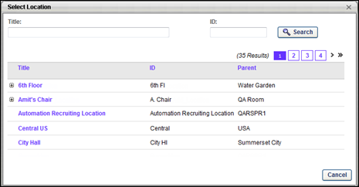
- Select one of the available Location OUs. This closes the pop-up and adds the location to the Interview Locations table.
Interview Locations Table
The following information appears for each location:
- Location - This column displays the title of the location. This column also defines the default sort order alphabetically by location. This column is sortable.
- Options - The following options are available in the Options column:
  - Remove - Click the trash can icon to delete the location. This opens a confirmation pop-up. Click Yes to delete the location. Or, click No to keep the location. Once a location is removed, the location is no longer available to select when configuring interviews.
  - Edit - Click the Edit icon to open the Edit Interview Location pop-up. The following options are available in the Edit Interview Location pop-up:
    - Language Drop-Down - This field displays for portals with multiple languages enabled. Select the language from the drop-down. The language selected corresponds to the applicant's language when viewing the interview details from the career site or Career Center.
    - Location Name - Enter the location name, up to 50 characters.
    - Location Address - Enter the address of the location. There is no character limit for this field.
For portals with multiple languages enabled, applicants can view the translated location when viewing the interview information from the career site or Career Center.
Overwrite Settings
Select this option to overwrite custom settings for child division OUs. If you overwrite custom settings for child division OUs, the selected settings are applied to both new and existing child OUs. Any previously customized child OUs are updated with the selected settings.
- If there are no customizations to the child OU, then the parent OU customizations are applied to all child OUs.
- Overwrite custom settings checkbox setting
  - If this option is selected, all child OU customizations are deleted from the database, which means the parent OU customizations will be applied to new and existing child OUs.
  - If this option is unselected, all existing child OU customizations will remain unchanged, and any new child OUs will inherit the parent OU customizations by default.
- If a child OU has been customized to display any widgets, then regardless of the parent OU customizations, the child OU customizations are applied.
- If a child OU has been customized to hide all widgets, then parent OU customizations will take precedence and will be applied.
Submit/Cancel
Once all preferences are configured, click Submit to save the settings. Or, click Cancel to cancel the changes.

Interview Guide Page Overview
The Interview Guide page enables interviewers to view the interview guide that is configured by the administrator for the interview. From this page, interviewers can do the following:
- View the applicant's photo, name, and resume.
- Print the interview guide, if an interview guide is defined for the interviewer by the administrator.
- View the competencies that are defined for the guide.
- View the rating scale, if a rating scale is defined by the administrator.
- Rate the applicant on the competencies, if a rating scale is defined for the guide. Note: Rating the applicant on the competencies may be required by the administrator.
- Enter comments about the applicant's response to the interview questions, if questions are defined for the competencies.
- Recommend that the applicant be advanced or not advanced based on the interview.
Note: Interview guides are created by the administrator in Interview Guide Management. Interview guides are required to include at least one competency and may also include a rating scale. In addition, questions may be associated with each competency to provide guidance in assessing how the applicant demonstrates the competency.
Note: Requisition owners can view interview guides for requisitions for which they are an owner. However, requisition owners cannot rate or comment on an applicant in the guide. Thus, the Interview Guide page is read-only for requisition owners who are not interviewers for the requisition.
Note: Once an interviewer submits a recommendation for an applicant, the Interview Guide is read-only and cannot be modified.
To access the interview guide, go to Recruit > Interview Manager. Then, click Launch Interview Guide in the Options column drop-down for the applicant. Note: The option does not display if an interview guide is not configured for the interviewer.
Permissions
PERMISSION NAME | PERMISSION DESCRIPTION | CATEGORY

Applicants: Comments - Manage | Grants ability to view and manage comments for applicants.  This permission also defines whether comments posted when an interviewer submits an interview recommendation are posted to the Comments section on the Applicant Profile tab. Note: Interview recommendation comments for interviewers who have this permission display on the Applicant Profile tab. For interviewers who do not have this permission, the comments do not display on the Applicant Profile tab. | Recruiting

Requisition: Interviewer | Grants ability to access and view past and future interviews and record interviewee recommendations. This permission cannot be constrained.  Note: This is a dynamically assigned permission that is not available in Security Role Administration. Once a user is scheduled as an interviewer for an applicant, the user will always have permission to view the interview details on the Interview Manager page. Users with this permission can do the following:  - Access the Interview Manager page.  - View the resume and cover letter for applicants for whom they are an interviewer.  - View the applicant profile for applicants for whom they are an interviewer.  - View the interview guide for the requisition for which they are listed as an interviewer.  - Recommend that an applicant be advanced or not advanced. | Recruiting
The Interview Guide page display the name of the requisition and the requisition ID at the top of the page, as well as a link to the view the job details.
Job Details
The Job Details link at the top of the page allows for quick access to the job description and job qualifications for the requisition. Clicking the link opens the Job Details pop-up. The pop-up displays the requisition's internal and external job description, minimum qualifications, and ideal qualifications.
                - For portals with multiple languages enabled, this displays in the user's language if available. If the user's language is not available, then this displays in the language of the user who defined it.
Note: The fields on the pop-up are not editable from the pop-up.
Interview Guide Sections
See the following for detailed information about each section of the Interview Guides page:
- General Information
- Applicant Evaluation
- Applicant Recommendation
- Print Interview Guide
Interview Guide Page Overview
The Interview Guide page enables interviewers to view the interview guide that is configured by the administrator for the interview. From this page, interviewers can do the following:
- View the applicant's photo, name, and resume.
- Print the interview guide, if an interview guide is defined for the interviewer by the administrator.
- View the competencies that are defined for the guide.
- View the rating scale, if a rating scale is defined by the administrator.
- Rate the applicant on the competencies, if a rating scale is defined for the guide. Note: Rating the applicant on the competencies may be required by the administrator.
- Enter comments about the applicant's response to the interview questions, if questions are defined for the competencies.
- Recommend that the applicant be advanced or not advanced based on the interview.
Note: Interview guides are created by the administrator in Interview Guide Management. Interview guides are required to include at least one competency and may also include a rating scale. In addition, questions may be associated with each competency to provide guidance in assessing how the applicant demonstrates the competency.
Note: Requisition owners can view interview guides for requisitions for which they are an owner. However, requisition owners cannot rate or comment on an applicant in the guide. Thus, the Interview Guide page is read-only for requisition owners who are not interviewers for the requisition.
Note: Once an interviewer submits a recommendation for an applicant, the Interview Guide is read-only and cannot be modified.
To access the interview guide, go to Recruit > Interview Manager. Then, click Launch Interview Guide in the Options column drop-down for the applicant. Note: The option does not display if an interview guide is not configured for the interviewer.
Permissions
PERMISSION NAME | PERMISSION DESCRIPTION | CATEGORY

Applicants: Comments - Manage | Grants ability to view and manage comments for applicants.  This permission also defines whether comments posted when an interviewer submits an interview recommendation are posted to the Comments section on the Applicant Profile tab. Note: Interview recommendation comments for interviewers who have this permission display on the Applicant Profile tab. For interviewers who do not have this permission, the comments do not display on the Applicant Profile tab. | Recruiting

Requisition: Interviewer | Grants ability to access and view past and future interviews and record interviewee recommendations. This permission cannot be constrained.  Note: This is a dynamically assigned permission that is not available in Security Role Administration. Once a user is scheduled as an interviewer for an applicant, the user will always have permission to view the interview details on the Interview Manager page. Users with this permission can do the following:  - Access the Interview Manager page.  - View the resume and cover letter for applicants for whom they are an interviewer.  - View the applicant profile for applicants for whom they are an interviewer.  - View the interview guide for the requisition for which they are listed as an interviewer.  - Recommend that an applicant be advanced or not advanced. | Recruiting
The Interview Guide page display the name of the requisition and the requisition ID at the top of the page, as well as a link to the view the job details.
Job Details
The Job Details link at the top of the page allows for quick access to the job description and job qualifications for the requisition. Clicking the link opens the Job Details pop-up. The pop-up displays the requisition's internal and external job description, minimum qualifications, and ideal qualifications.
                - For portals with multiple languages enabled, this displays in the user's language if available. If the user's language is not available, then this displays in the language of the user who defined it.
Note: The fields on the pop-up are not editable from the pop-up.
Interview Guide Sections
See the following for detailed information about each section of the Interview Guides page:
- General Information
- Applicant Evaluation
- Applicant Recommendation
- Print Interview Guide
Interview Guide - Applicant Evaluation
The left panel of the Interview Guide page enables the interviewer to view the instructions for the guide and evaluate the applicant. The competencies that are configured for the interview guide display in the Competencies section. If a rating scale is configured for the competencies, the interviewer can view the rating scale and rate the applicant on each competency.
To access the interview guide, go to Recruit > Interview Manager. Then, click Launch Interview Guide in the Options column drop-down for the applicant. Note: The option does not display if an interview guide is not configured for the interviewer.
Permissions
PERMISSION NAME | PERMISSION DESCRIPTION | CATEGORY

Applicants: Comments - Manage | Grants ability to view and manage comments for applicants.  This permission also defines whether comments posted when an interviewer submits an interview recommendation are posted to the Comments section on the Applicant Profile tab. Note: Interview recommendation comments for interviewers who have this permission display on the Applicant Profile tab. For interviewers who do not have this permission, the comments do not display on the Applicant Profile tab. | Recruiting

Requisition: Interviewer | Grants ability to access and view past and future interviews and record interviewee recommendations. This permission cannot be constrained.  Note: This is a dynamically assigned permission that is not available in Security Role Administration. Once a user is scheduled as an interviewer for an applicant, the user will always have permission to view the interview details on the Interview Manager page. Users with this permission can do the following:  - Access the Interview Manager page.  - View the resume and cover letter for applicants for whom they are an interviewer.  - View the applicant profile for applicants for whom they are an interviewer.  - View the interview guide for the requisition for which they are listed as an interviewer.  - Recommend that an applicant be advanced or not advanced. | Recruiting
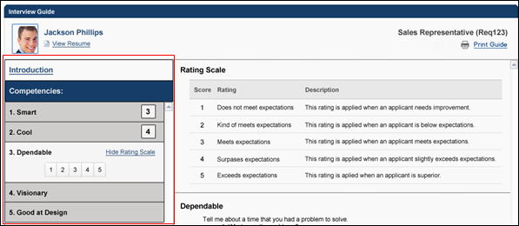
Introduction
Click Introduction to view the instructions for the guide. The instructions display in the right pane of the page. When viewing the Interview Guide page, the instructions appear by default but can be hidden or viewed by clicking Introduction.
Within the Introduction section in the right pane, click Begin Evaluation to begin evaluating the applicant. This expands the first competency in the Competencies table and also displays any questions and details that are associated with the competency.
Competencies/Rating
The Competencies section displays the competencies that are configured for the guide. Competencies display in the order in which they are configured by the administrator. The competency title displays on the left. If the interviewer rates the applicant on the competency, then the rating displays to the right of the competency title.
Rate Applicant
Click the competency title to rate the applicant. The ratings display as either a list of buttons or as a drop-down. Click the button that represents the desired rating, or select the rating from the drop-down. This rates the applicant on the competency.
Completing a rating for all of the competencies activates the Submit button at the bottom of the page. Note: For interview guides that do not require the interviewer to rate the applicant, the Submit button is activated by clicking either the Advance or Do not Advance icon in the Recommendation section.
Note: Rating the applicant on each competency may be required if configured to be required by the administrator. If a rating is required and the interviewer does not rate the applicant, then an error message displays when the interviewer clicks Submit, indicating that ratings are required.
View/Hide Rating Scale
To view the rating scale, click View Rating Scale. The rating scale opens in the right pane. The rating scale can be hidden by clicking Hide Rating Scale. The View Rating Scale link only displays for a competency when the competency is expanded.
The following information displays in the rating scale:
- Score - This column displays the score defined for each level of the rating scale.
- Rating - This column displays the title of the rating.
- Description - This column displays a description of the rating.
View Competency Questions
Clicking the competency title also displays any questions that are associated with the competency. The questions display in the right pane, along with any additional details that the administrator configured about the question.
Add Comments
An Add Comments box displays below each question. The comments box enables interviewers to enter feedback about the applicant's response to each question. The field accepts up to 2000 characters. Interviewers must have permission to add comments.
Note: When viewing the guide after it has been submitted, any comments entered in the Add Comments box cannot be edited.
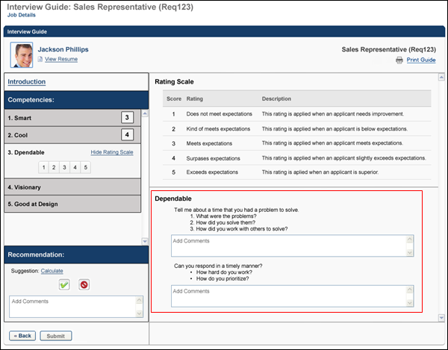
See Also
See the following for information about the additional sections of the Interview Guide page:
- General Information
- Applicant Recommendation
- Print Interview Guide
Interview Guide - Applicant Recommendation
The lower-left panel of the Interview Guide page requires interviewers to record a recommendation decision about the applicant. The interviewer must select to advance or not advance an applicant. The interviewer can also enter comments about their decision. The interviewer can calculate the applicant's rating score to compare the applicant's score with the target to advance threshold that is defined by the administrator.
To access the interview guide, go to Recruit > Interview Manager. Then, click Launch Interview Guide in the Options column drop-down for the applicant. Note: The option does not display if an interview guide is not configured for the interviewer.
Permissions
PERMISSION NAME | PERMISSION DESCRIPTION | CATEGORY

Applicants: Comments - Manage | Grants ability to view and manage comments for applicants.  This permission also defines whether comments posted when an interviewer submits an interview recommendation are posted to the Comments section on the Applicant Profile tab. Note: Interview recommendation comments for interviewers who have this permission display on the Applicant Profile tab. For interviewers who do not have this permission, the comments do not display on the Applicant Profile tab. | Recruiting

Requisition: Interviewer | Grants ability to access and view past and future interviews and record interviewee recommendations. This permission cannot be constrained.  Note: This is a dynamically assigned permission that is not available in Security Role Administration. Once a user is scheduled as an interviewer for an applicant, the user will always have permission to view the interview details on the Interview Manager page. Users with this permission can do the following:  - Access the Interview Manager page.  - View the resume and cover letter for applicants for whom they are an interviewer.  - View the applicant profile for applicants for whom they are an interviewer.  - View the interview guide for the requisition for which they are listed as an interviewer.  - Recommend that an applicant be advanced or not advanced. | Recruiting
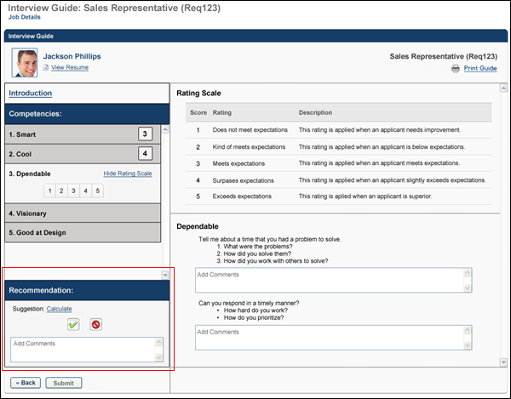
Calculate Applicant Score
Click Calculate to calculate the applicant's overall score for the competencies and view the suggested decision of whether to advance or not advance the applicant.
The score displays in parentheses and is an average of the competencies that are rated. The first value is the calculated score, and the second value is the minimum target score needed to advance.
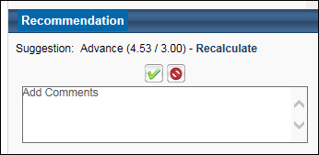
Once the score is calculated, the Suggestion field displays one of the following:
- Advance - The word "Advance" displays if the applicant's score equals or exceeds the target to advance.
- Do not Advance - The words "Do not Advance" displays if the applicant's score is less than the target to advance.
Note: The target to advance, which is defined by the administrator, is the minimum score the applicant is recommended to achieve in order to advance to the next step in the application process.
Recalculate
If the interviewer changes one or more ratings in the Competencies section, then a Recalculate link displays in the Recommendation section. Clicking the link recalculates the applicant's score, which may change the system's suggestion in the Suggestion field.
Advance/Do not Advance
To recommend that the applicant advance, click the Advance icon .
To recommend that the applicant not advance, click the Do not Advance icon .
Add Comments
The Add Comments box enables interviewers to enter comments about their recommendation. The box accepts up to 2000 characters. This is not a required field.
Comments cannot be modified after the guide is submitted. Comments display in the Comments section on the Applicant Profile page and are recorded on the History tab.
Note: For interviewers with permission to manage comments, the comments entered in the Add Comments box display on the Application tab of the applicant's profile and are recorded on the History tab of the profile.
Submit
Clicking either the Advance or Do not Advance icons activates the Submit button at the bottom of the page. Once all information is completed on the guide, click Submit to submit the guide. The guide cannot be modified once it is submitted.
Note: The Submit button is also activated by completing a rating for all competencies if ratings are required to be completed for the interview guide.
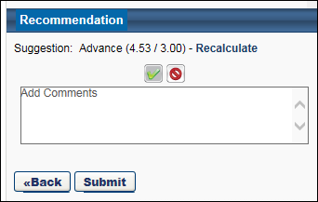
See Also
See the following for information about the additional sections of the Interview Guide page:
- General Information
- Applicant Evaluation
- Print Interview Guide
Interview Guide - General Information
The top portion of the Interview Guide page displays general information about the applicant, as well as the job title and requisition ID for the requisition. Interviewers can also access the applicant's resume and the interview guide, if configured by the administrator.
To access the interview guide, go to Recruit > Interview Manager. Then, click Launch Interview Guide in the Options column drop-down for the applicant. Note: The option does not display if an interview guide is not configured for the interviewer.
Permissions
PERMISSION NAME | PERMISSION DESCRIPTION | CATEGORY

Requisition: Interviewer | Grants ability to access and view past and future interviews and record interviewee recommendations. This permission cannot be constrained.  Note: This is a dynamically assigned permission that is not available in Security Role Administration. Once a user is scheduled as an interviewer for an applicant, the user will always have permission to view the interview details on the Interview Manager page. Users with this permission can do the following:  - Access the Interview Manager page.  - View the resume and cover letter for applicants for whom they are an interviewer.  - View the applicant profile for applicants for whom they are an interviewer.  - View the interview guide for the requisition for which they are listed as an interviewer.  - Recommend that an applicant be advanced or not advanced. | Recruiting
Applicant Information
The upper-left portion of the Interview Guide page displays the following information:
- The applicant's photo. If a photo is not available for the applicant, then a shadow image displays. Note: If General Preferences for the interviewer's division are configured by the administrator not to display candidate photos, then a shadow image displays instead of the photo.
- The applicant's name.
- The applicant's resume. Clicking View Resume opens the applicant's resume in the format in which the resume was submitted.
Requisition Information
The upper-right portion of the guide displays the job title and requisition ID for the requisition.
See Also
See the following for information about the additional sections of the Interview Guide page:
- Print Interview Guide
- Applicant Evaluation
- Applicant Recommendation
Print Interview Guide
The Print Guide link in the upper-right portion of the Interview Guide page enables interviewers to print the interview guide. This option is beneficial for organizations that would like interviewers to complete a paper copy of the guide to maintain paper records of interviews.
To access the interview guide, go to Recruit > Interview Manager. Then, click Launch Interview Guide in the Options column drop-down for the applicant. Note: The option does not display if an interview guide is not configured for the interviewer.
Permissions
PERMISSION NAME | PERMISSION DESCRIPTION | CATEGORY

Requisition: Interviewer | Grants ability to access and view past and future interviews and record interviewee recommendations. This permission cannot be constrained.  Note: This is a dynamically assigned permission that is not available in Security Role Administration. Once a user is scheduled as an interviewer for an applicant, the user will always have permission to view the interview details on the Interview Manager page. Users with this permission can do the following:  - Access the Interview Manager page.  - View the resume and cover letter for applicants for whom they are an interviewer.  - View the applicant profile for applicants for whom they are an interviewer.  - View the interview guide for the requisition for which they are listed as an interviewer.  - Recommend that an applicant be advanced or not advanced. | Recruiting
Printed View of Interview Guide
The first page of the printed guide displays the following:
- Name of interviewer
- Name of applicant
- Date of interview
- Interview instructions, if configured by the administrator (Note: If instructions are not configured by the administrator, then "None" displays in the Instructions section.)
- Rating scale, if configured by the administrator (Note: If a rating scale is not configured by the administrator, then "None" displays in the Rating Scale section.)
- Summary list of all competencies in the guide
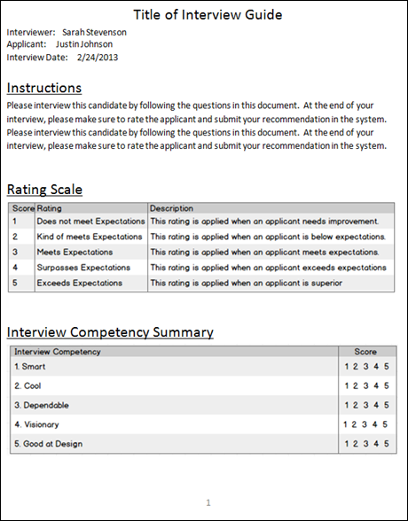
The following pages of the printed guide display the competencies that are configured for the guide, as well as the details and questions related to the competencies. Interviewers can also rate the applicant on the competencies directly on the printed copy of the guide. If a rating scale is not defined for the guide, then "None" displays in place of the rating section.
A comments box is provided for each question, allowing interviewers to provide written feedback about the applicant's responses to the questions.
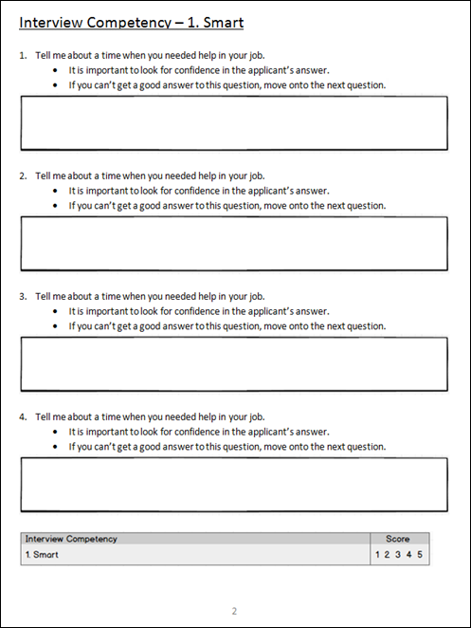
The option to print the guide is only available while completing the interview guide. Once the guide is submitted, the guide can no longer be printed.
See Also
See the following for detailed information about each section of the Interview Guides page:
- General Information
- Applicant Evaluation
- Applicant Recommendation

Completed Interviews Tab
The Completed Interviews tab on the Interview Manger page provides a dashboard from which interviewers can view the details of their completed interviews. This includes viewing the recommendation, current applicant status, and comments submitted about the recommendation decision.
Note: This tab cannot be accessed by requisition owners unless they are also an interviewer.
To access the Interview Manager page, go to Recruit > Interview Manager.
Permissions
PERMISSION NAME | PERMISSION DESCRIPTION | CATEGORY

Requisition: Interviewer | Grants ability to access and view past and future interviews and record interviewee recommendations. This permission cannot be constrained.  Note: This is a dynamically assigned permission that is not available in Security Role Administration. Once a user is scheduled as an interviewer for an applicant, the user will always have permission to view the interview details on the Interview Manager page. Users with this permission can do the following:  - Access the Interview Manager page.  - View the resume and cover letter for applicants for whom they are an interviewer.  - View the applicant profile for applicants for whom they are an interviewer.  - View the interview guide for the requisition for which they are listed as an interviewer.  - Recommend that an applicant be advanced or not advanced. | Recruiting
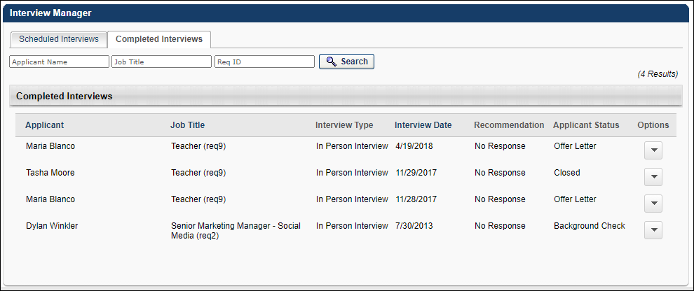
Search Filters
The following search filters are available at the top of the page:
- Applicant Name - This filter allows you to filter all sections by applicant name. Enter a name in the field, and then click Search. Each section updates to display all applicants matching the filter criteria. If there are no matches for a section, the section is blank.
- Job Title - This filter allows you to filter all sections by job title. Enter a job title in the field, and then click Search. Each section updates to display all applicants matching the filter criteria. If there are no matches for a section, the section is blank.
- ReqID - Enter an exact requisition ID, and then click Search. The page updates to display all applicants matching the filter criteria. If there are no matches, the Completed Interviews table is blank.
Completed Interviews Table
The following information displays for each interview:
- Applicant - This column displays the applicant's name. This column is sortable. Note: For archived applicants, "Archived" displays in place of the applicant's name.
- Job Title - This column displays the job title for which the interview took place. For portals with multiple languages enabled, this displays in the user's language if available. If the user's language is not available, then this displays in the language of the user who defined it.This column is sortable.
- Interview Type - This column displays the type of interview. This column is not sortable. The following are the possible interview types:
  - In Person
  - On Demand Video
  - Phone
  - Scheduled Video - This type displays for Live Video interviews. Live video interviews are interviews that take place via live video with one or more interviewers and the applicant. The HireVue digital interview application is used to conduct the interview. The applicant and all interviewers are visible on the screen when the interview is taking place.
  - Virtual
- Interview Date - This column displays the date on which the interview occurred. For On Demand Video Interviews, the date is the date that the applicant completed the interview. This column is sortable.
- Recommendation - This column displays the interviewer's recommendation for the applicant. Note: For archived applicants, this column is blank. The following are the possible recommendations:
  - Advance - This displays if the interviewer recommended that the applicant advance.
  - Do Not Advance - This displays if the interview recommended that the applicant not advance.
  - No Recommendation - This displays if the interview was automatically moved to the Completed Interviews tab after reaching the 30-day maximum period in which interviews remain in the Incomplete Interviews dashboard on the Scheduled Interviews tab.
- Applicant Status - This column displays the applicant's current status. This column is not sortable.
- Options - The following options are available in the Options column:
  - Open Resume/CV - Click this option to view the applicant's resume/CV. The document opens in the application in which it was submitted. If the resume/CV was submitted via LinkedIn, then the applicant's LinkedIn profile opens.
  - Open Cover Letter - Click this option to open the applicant's cover letter, if a cover letter is submitted by the applicant. The document opens in the application in which it was submitted.
  - Review Interview Guide - For interview guides created in Interview Guide Management, clicking Launch Interview Guide opens the Interview Guide page. See Interview Guide Page Overview on page 107 for additional information. For interview guides created outside the system, clicking the link opens the interview guide document. The interview guide is read-only.
  - Go to Applicant Profile - Click this option to open the applicant's Applicant Profile page.
  - Launch Video Interview - Click this option to view the recorded interview. This opens the interview in HireVue.
  - View Recommendation Comments - Click this option to view the comments that the interviewer entered for the recommendation. The comments open in the Comments pop-up.
Note: The Options column does not display for archived applicants.

Scheduled Interviews Tab - Future Interviews
The Future Interviews dashboard displays all interviews for the interviewer that are scheduled to occur the next day or later.
Note: Interviews do not appear for candidates who are in a Closed status.
To access the Interview Manager page, go to Recruit > Interview Manager.
Permissions
PERMISSION NAME | PERMISSION DESCRIPTION | CATEGORY

Requisition: Interviewer | Grants ability to access and view past and future interviews and record interviewee recommendations. This permission cannot be constrained.  Note: This is a dynamically assigned permission that is not available in Security Role Administration. Once a user is scheduled as an interviewer for an applicant, the user will always have permission to view the interview details on the Interview Manager page. Users with this permission can do the following:  - Access the Interview Manager page.  - View the resume and cover letter for applicants for whom they are an interviewer.  - View the applicant profile for applicants for whom they are an interviewer.  - View the interview guide for the requisition for which they are listed as an interviewer.  - Recommend that an applicant be advanced or not advanced. | Recruiting
Number of Interviews
The number of future interviews displays in parentheses at top of the dashboard.
List of Future Interviews
The Future Interviews dashboard displays the list of future interviews in the order in which the interview is scheduled to occur, from soonest to latest date. Interviews that are scheduled to occur on the same date display in a single panel under the date header. The interview date displays above the list of interviews. For interviews that occur the next day, "(Tomorrow)" displays to the right of the date.
The following applicant and interview information displays for each interview:
Applicant
The following information displays in the Applicant column:
- Applicant Photo - The applicant's photo displays, if configured to display by the administrator. If a photo is not available for the applicant, then a shadow image displays.
  - Comments - The Comments icon displays at the bottom of the applicant's photo if a comment has been configured for the interviewer for the associated interview session. Clicking the icon opens the comment. Note: Comments are configured by the interview scheduler.
  - Video - The view video icon displays at the bottom of the applicant's photo if the interview is a video interview. The icon has no functionality.
- Applicant Name - This displays the applicant's name as a link to the Applicant Profile page. If the applicant's name is longer than the space allows, then ellipses display in place of the remaining characters. Note: For archived applicants, "Archived" displays in place of the applicant's name.
Job Title
This column displays the job title for which the interview is taking place. If the job title is longer than the space allows, then ellipses display in place of the remaining characters.
                - For portals with multiple languages enabled, this displays in the user's language if available. If the user's language is not available, then this displays in the language of the user who defined it.
Interview Time/Location
The time at which the interview occurs and the interview location display below the applicant's name. If a time is not available for the interview, then "Not Available" displays. The time reflects the time zone of the user viewing the dashboard.
The location varies depending on the interview type:
- In Person - The location displays a physical interview location. If a location is not defined for the interview, then "Not Defined" displays.
- Phone - The location displays the phone number configured for the interview.
- Virtual - The location displays as "Virtual Interview".
If the location name is longer than the space allows, then ellipses display in place of the remaining characters.
For portals with multiple languages enabled, the location displays in the user's language if available. If the user's language is not available, then this displays in the language of the user who defined it.
Interviewer
The name of the interviewer only displays if the My Requisition Interviews filter option is checked. The name displays below the time/location information. If the requisition owner is the interviewer, then "Me" displays as the interviewer name.
Options
Note: The Options drop-down does not display for archived applicants.
The following options display in the Options drop-down in alphabetical order:
- Go to Applicant Profile - Click this option to open the applicant's Applicant Profile page.
- Launch Interview Guide - For interview guides created in Interview Guide Management, clicking this option opens the Interview Guide page. See Interview Guide Page Overview on page 107 for additional information.
For interview guides created outside the system, clicking the link opens the interview guide document.
The Launch Interview Guide option does not display if an interview guide is not associated with the interview.
Note: Requisition owners can view the interview guide for interviewers who are associated with requisitions for which they are an owner.
- Open Cover Letter - Click this option to open the applicant's cover letter, if a cover letter is submitted by the applicant. The document opens in the application in which it was submitted.
- Open Resume/CV - Click this option to view the applicant's resume/CV. The document opens in the application in which the document was submitted. If the resume/CV was submitted via LinkedIn, then the applicant's LinkedIn profile opens.
- Print Interview Guide - Click this option to print the interview guide for the interviewer. The only interview guides that are available to print are guides created in Interview Guide Management. Note: Requisition owners can print the interview guide for interviewers who are associated with requisitions for which they are an owner.
- View Comments - Click this option to view the comments that are configured for the interviewer by the interview scheduler.

Scheduled Interviews Tab - Incomplete Interviews
The Incomplete Interviews dashboard displays all interviews that have occurred in the past for which the interviewer has not yet submitted a recommendation. Incomplete interviews remain in this dashboard until the interviewer submits a recommendation or for one month, whichever occurs first.
The dashboard can be moved up and down within the left pane. This can be done by dragging and dropping the dashboard.
Note: After one month, incomplete interviews are moved to the Completed Interviews tab.
Note: Interviews do not appear for candidates who are in a Closed status.
To access the Interview Manager page, go to Recruit > Interview Manager.
Permissions
PERMISSION NAME | PERMISSION DESCRIPTION | CATEGORY

Requisition: Interviewer | Grants ability to access and view past and future interviews and record interviewee recommendations. This permission cannot be constrained.  Note: This is a dynamically assigned permission that is not available in Security Role Administration. Once a user is scheduled as an interviewer for an applicant, the user will always have permission to view the interview details on the Interview Manager page. Users with this permission can do the following:  - Access the Interview Manager page.  - View the resume and cover letter for applicants for whom they are an interviewer.  - View the applicant profile for applicants for whom they are an interviewer.  - View the interview guide for the requisition for which they are listed as an interviewer.  - Recommend that an applicant be advanced or not advanced. | Recruiting
Number of Interviews
The number of incomplete interviews displays in parentheses at top of the dashboard.
List of Incomplete Interviews
The Incomplete Interviews dashboard displays the list of incomplete interviews in the order in order of interview occurrence, with the most recently occurring incomplete interview displaying at the top.
The following applicant and interview information displays for each interview:
Applicant
The following information displays in the Applicant column:
- Applicant Photo - The applicant's photo displays, if configured to display by the administrator. If a photo is not available for the applicant, then a shadow image displays.
  - Comments - The Comments icon displays at the bottom of the applicant's photo if a comment has been configured for the interviewer for the associated interview session. Clicking the icon opens the comment. Note: Comments are configured by the interview scheduler.
  - Video - The view video icon displays at the bottom of the applicant's photo if the interview is a video interview. The icon has no functionality. Note: If the interview is a recorded interview, meaning that the applicant completed the On Demand Video interview or that the Live Video interview was completed and recorded, then the icon only displays for video interviews in the Incomplete Interviews dashboard.
- Applicant Name - This displays the applicant's name as a link to the Applicant Profile page. If the applicant's name is longer than the space allows, then ellipses display in place of the remaining characters. Note: For archived applicants, "Archived" displays in place of the applicant's name.
- Job Title
- This column displays the job title for which the interview is taking place. If the job title is longer than the space allows, then ellipses display in place of the remaining characters.
- For portals with multiple languages enabled, this displays in the user's language if available. If the user's language is not available, then this displays in the language of the user who defined it.
Interview Time/Location
The time at which the interview occurs and the interview location display below the applicant's name. If a time is not available for the interview, then "Not Available" displays. The time reflects the time zone of the user viewing the dashboard.
The location varies depending on the interview type:
- In Person - The location displays a physical interview location. If a location is not defined for the interview, then "Not Defined" displays.
- Phone - The location displays as "Phone."
- Virtual - The location displays as "Virtual Interview".
If the location name is longer than the space allows, then ellipses display in place of the remaining characters.
For portals with multiple languages enabled, the location displays in the user's language if available. If the user's language is not available, then this displays in the language of the user who defined it.
Interviewer
The name of the interviewer only displays if the My Requisition Interviews filter option is checked. The name displays below the time/location information. If the requisition owner is the interviewer, then "Me" displays as the interviewer name.
Options
Note: The Options drop-down does not display for archived applicants.
The following options display in the Options drop-down in alphabetical order:
- Go to Applicant Profile - Click this option to open the applicant's Applicant Profile page.
- Launch Interview Guide - For interview guides created in Interview Guide Management, clicking this option opens the Interview Guide page. See Interview Guide Page Overview on page 107 for additional information.
For interview guides created outside the system, clicking the link opens the interview guide document.
The Launch Interview Guide option does not display if an interview guide is not associated with the interview.
Note: Requisition owners can view the interview guide for interviewers who are associated with requisitions for which they are an owner.
- Launch Video Interview - Click this option to begin the live video interview or to view the applicant's recorded On Demand Video interview. This opens the interview in HireVue.
  - This option is only available for On Demand Video interviews if the applicant has completed the interview and none of the interviewers associated with the interview have submitted a recommendation for the applicant. When at least one interviewer has submitted a recommendation, then the option does not display.
  - This option is only available for Live Video interviews if the interview occurred the previous day or earlier and none of the interviewers associated with the interview have submitted a recommendation for the applicant. When at least one interviewer has submitted a recommendation, then the option does not display.
Note: Requisition owners can view the video for interviewers who are associated with requisitions for which they are an owner. They can also launch the live video interview to begin or join a live interview session but only if they are defined as an interview reviewer for the interview.
- Nudge Interviewer - Click this option to send the interviewer the Interview Recommendation Nudge email. This option is only available when viewing the interview session for another user. You cannot send the Interview Recommendation Nudge email to yourself. Note: The email must be configured by the administrator.
- Open Cover Letter - Click this option to open the applicant's cover letter, if a cover letter is submitted by the applicant. The document opens in the application in which it was submitted.
- Open Resume/CV - Click this option to view the applicant's resume/CV. The document opens in the application in which the document was submitted. If the resume/CV was submitted via LinkedIn, then the applicant's LinkedIn profile opens.
- Print Interview Guide - Click this option to print the interview guide for the interviewer. The only interview guides that are available to print are guides created in Interview Guide Management. Note: Requisition owners can print the interview guide for interviewers who are associated with requisitions for which they are an owner.
- Record Recommendation - This option enables interviewers to recommend whether or not to move the applicant forward, as well as enter comments about their decision. This option is not available if a rating is required for the interview guide.
To record a recommendation:
  - Click Record Recommendation in the Options column. This opens the Record Recommendation pop-up.
  - Click the Advance icon to recommend moving the applicant forward. Or, click the Do not Advance icon to recommend that the applicant not move forward. Clicking either option activates the Submit button.
  - Enter comments in the Add Comments field, up to 2000 characters.
  - Click Submit. This records the recommendation and comments and closes the pop-up. If the user has permission to manage comments, then the comments are added to the applicant's main Applicant Profile page and History tab. For users who do not have permission to manage comments, the comments only appear on the interview guide
Once the recommendation is submitted, the interview is moved to the Completed Interviews tab. Note: Requisition owners cannot submit a recommendation on behalf of interviewers.
- View Comments - Click this option to view the comments that are configured for the interviewer by the interview scheduler.

Scheduled Interviews Tab - Overview
The Scheduled Interviews tab on the Interview Manger page provides a dashboard from which interviewers can view their scheduled interviews and interview events and complete the actions associated with each interview. This tab is also used by requisition owners to view the interviews that are scheduled for their requisitions.
The tab is separated into the following dashboards:
- Today's Interviews
- Future Interviews
- Incomplete Interviews
Within each dashboard, interviews are organized by applicant. All interviews display in separate rows within the dashboard.
To access the Interview Manager page, go to Recruit > Interview Manager.
Permissions
PERMISSION NAME | PERMISSION DESCRIPTION | CATEGORY

Applicants: Comments - Manage | Grants ability to view and manage comments for applicants.  This permission also defines whether comments posted when an interviewer submits an interview recommendation are posted to the Comments section on the Applicant Profile tab. Note: Interview recommendation comments for interviewers who have this permission display on the Applicant Profile tab. For interviewers who do not have this permission, the comments do not display on the Applicant Profile tab. | Recruiting

Requisition: Interviewer | Grants ability to access and view past and future interviews and record interviewee recommendations. This permission cannot be constrained.  Note: This is a dynamically assigned permission that is not available in Security Role Administration. Once a user is scheduled as an interviewer for an applicant, the user will always have permission to view the interview details on the Interview Manager page. Users with this permission can do the following:  - Access the Interview Manager page.  - View the resume and cover letter for applicants for whom they are an interviewer.  - View the applicant profile for applicants for whom they are an interviewer.  - View the interview guide for the requisition for which they are listed as an interviewer.  - Recommend that an applicant be advanced or not advanced. | Recruiting
Search Filters
The following search filters are available at the top of the page:
- Applicant Name - This filter allows you to filter all sections by applicant name. Enter a name in the field. Each section updates to display all applicants matching the filter criteria. If there are no matches for a section, the section is blank. Note: Archived applicants cannot be searched in the filter. In addition, applicants who have been merged are not listed as interviewees. Instead, the name of the applicant with whom the applicant has been merged displays. The applicant profile for merged applicants can only be accessed from the Applicant Profile page of the target profile.
- Job Title - This filter allows you to filter all sections by job title. Enter a job title in the field. Each section updates to display all applicants matching the filter criteria. If there are no matches for a section, the section is blank.
- My Interviews - This filter is checked by default to display all interviews for the user in all sections. Uncheck the box to hide all interviews for the user in all sections.
- My Requisition Interviews - This option is only available for requisition owners. This option is unchecked by default. When checked, each section displays all interviews associated with each of the requisition owner's requisitions. When unchecked, the interviews are hidden.
For requisition owners viewing another user's dashboard, if both the My Interviews and My Requisition Interviews filters are checked, then the following displays in all sections:
- All interviews for whom the requisition owner is listed as an interviewer.
- All interviews associated with each of the requisition owner's requisitions. Note: If an interview includes multiple interviewers, then a separate interview session displays for each interviewer.
- All interviews for the user's dashboard for whom the requisition owner is viewing.
Time Zone
The time zone displays at the bottom of the page. The time zone is the user's default time zone.

Scheduled Interviews Tab - Today's Interviews
The Today's Interviews section displays all interviews that are scheduled to occur on the current date for which the interviewer has not yet completed. This includes interviews that occurred earlier in the day prior to viewing the dashboard.
Note: Once an interviewer completes the actions associated with an interview, the interview is moved to the Completed Interviews tab, even if the interview occurred on the current date.
Note: On Demand Video interviews only display in the Incomplete Interviews dashboard.
Note: Interviews do not appear for candidates who are in a Closed status.
To access the Interview Manager page, go to Recruit > Interview Manager.
Permissions
PERMISSION NAME | PERMISSION DESCRIPTION | CATEGORY

Applicants: Comments - Manage | Grants ability to view and manage comments for applicants.  This permission also defines whether comments posted when an interviewer submits an interview recommendation are posted to the Comments section on the Applicant Profile tab. Note: Interview recommendation comments for interviewers who have this permission display on the Applicant Profile tab. For interviewers who do not have this permission, the comments do not display on the Applicant Profile tab. | Recruiting

Requisition: Interviewer | Grants ability to access and view past and future interviews and record interviewee recommendations. This permission cannot be constrained.  Note: This is a dynamically assigned permission that is not available in Security Role Administration. Once a user is scheduled as an interviewer for an applicant, the user will always have permission to view the interview details on the Interview Manager page. Users with this permission can do the following:  - Access the Interview Manager page.  - View the resume and cover letter for applicants for whom they are an interviewer.  - View the applicant profile for applicants for whom they are an interviewer.  - View the interview guide for the requisition for which they are listed as an interviewer.  - Recommend that an applicant be advanced or not advanced. | Recruiting
Interview Sessions Dashboard
The top of the dashboard displays the number of interviews in parentheses for the current date. The current date displays in the upper-right corner of the dashboard.
Within the dashboard, applicants display in order of interview occurrence, with the earliest interview of the day displaying at the top. There are no sort options in the dashboard.
The following information displays for each interview:
Applicant
The following information displays in the Applicant column:
- Applicant Photo - The applicant's photo displays, if configured to display by the administrator. If a photo is not available for the applicant, then a shadow image displays.
  - Comments - The Comments icon displays at the bottom of the applicant's photo if a comment has been configured for the interviewer for the associated interview session. Clicking the icon opens the comment. Note: Comments are configured by the interview scheduler.
  - Video - The view video icon displays at the bottom of the applicant's photo if the interview is a video interview. The icon has no functionality.
- Applicant Name - This displays the applicant's name as a link to the Applicant Profile page. If the applicant's name is longer than the space allows, then ellipses display in place of the remaining characters. Note: For archived applicants, "Archived" displays in place of the applicant's name.
Job Title
This column displays the job title for which the interview is taking place. If the job title is longer than the space allows, then ellipses display in place of the remaining characters.
                - For portals with multiple languages enabled, this displays in the user's language if available. If the user's language is not available, then this displays in the language of the user who defined it.
Interview Time/Location
The time at which the interview occurs and the interview location display below the applicant's name. If a time is not available for the interview, then "Not Available" displays. The time reflects the time zone of the user viewing the dashboard.
The location varies depending on the interview type:
- In Person - The location displays a physical interview location. If a location is not defined for the interview, then "Not Defined" displays.
- Phone - The location displays the phone number configured for the interview.
- Video - The location displays as "Virtual Interview".
If the location name is longer than the space allows, then ellipses display in place of the remaining characters.
                - For portals with multiple languages enabled, the location displays in the user's language if available. If the user's language is not available, then this displays in the language of the user who defined it.
Interviewer
The name of the interviewer only displays if the My Requisition Interviews filter option is checked. The name displays below the time/location information. If the requisition owner is the interviewer, then "Me" displays as the interviewer name.
Options
Note: The Options drop-down does not display for archived applicants.
The following options display in the Options drop-down in alphabetical order:
- Go to Applicant Profile - Click this option to open the applicant's Applicant Profile page.
- Launch Interview Guide - For interview guides created in Interview Guide Management, clicking this option opens the Interview Guide page. See Interview Guide Page Overview on page 107 for additional information.
For interview guides created outside the system, clicking the link opens the interview guide document.
The Launch Interview Guide option does not display if an interview guide is not associated with the interview.
Note: Requisition owners can view the interview guide for interviewers who are associated with requisitions for which they are an owner.
- Launch Video Interview - Click this option to begin the live video interview or to view the applicant's recorded On Demand Video interview. This opens the interview in HireVue.
  - This option is only available for On Demand Video interviews if the applicant has completed the interview and none of the interviewers associated with the interview have submitted a recommendation for the applicant. When at least one interviewer has submitted a recommendation, then the option does not display.
  - This option is only available for Live Video interviews if the interview occurred the previous day or earlier and none of the interviewers associated with the interview have submitted a recommendation for the applicant. When at least one interviewer has submitted a recommendation, then the option does not display.
Note: Requisition owners can view the video for interviewers who are associated with requisitions for which they are an owner. They can also launch the live video interview to begin or join a live interview session but only if they are defined as an interview reviewer for the interview.
- Nudge Interviewer - Click this option to send the interviewer the Interview Recommendation Nudge email. This option is only available when viewing the interview session for another user. You cannot send the Interview Recommendation Nudge email to yourself. Note: The email must be configured by the administrator.
- Open Cover Letter - Click this option to open the applicant's cover letter, if a cover letter is submitted by the applicant. The document opens in the application in which it was submitted.
- Open Resume/CV - Click this option to view the applicant's resume/CV. The document opens in the application in which the document was submitted. If the resume/CV was submitted via LinkedIn, then the applicant's LinkedIn profile opens.
- Print Interview Guide - Click this option to print the interview guide for the interviewer. The only interview guides that are available to print are guides created in Interview Guide Management. Note: Requisition owners can print the interview guide for interviewers who are associated with requisitions for which they are an owner.
- Record Recommendation - This option enables interviewers to recommend whether or not to move the applicant forward, as well as enter comments about their decision. This option is not available if a rating is required for the interview guide.
To record a recommendation:
  - Click Record Recommendation in the Options column. This opens the Record Recommendation pop-up.
  - Click the Advance icon to recommend moving the applicant forward. Or, click the Do not Advance icon to recommend that the applicant not move forward. Clicking either option activates the Submit button.
  - Enter comments in the Add Comments field, up to 2000 characters.
  - Click Submit. This records the recommendation and comments and closes the pop-up. If the user has permission to manage comments, then the comments are added to the applicant's main Applicant Profile page and History tab. For users who do not have permission to manage comments, the comments only appear on the interview guide
Once the recommendation is submitted, the interview is moved to the Completed Interviews tab. Note: Requisition owners cannot submit a recommendation on behalf of interviewers.
- View Comments - Click this option to view the comments that are configured for the interviewer by the interview scheduler.

