Integrations for Recruiting March 2024

Table of Contents
Integrations for Recruiting Overview 1
Apply Integrations - Overview 2
Apply with LinkedIn (with Apply Starters) - Overview 3
CV-Library Apply Integration 9
One-Click Apply with Stepstone (Early Adopter) - Overview 10
PitchYou Integration 14
Assessment Integrations - Overview 15
DDI Recruiting Assessment Integration - Overview 16
pymetrics Talent Management and Screening Integration 26
SHL Talent Assessments Integration 27
Talent Plus TalentBank Integration 28
Background Check Integrations - Overview 29
Accurate Background Check - Overview 30
AccurateAce Background Check Integration - Overview 43
A-Check Global Background Screening Integration 56
Choice Screening Background Check Integration 57
First Advantage Background Check and Drug Screening Integration - Overview 58
HireRight Global Employment Screening Integration 80
Referoo Integration 81
Sterling Integration - Overview 82
Sterling RISQ Background Check Integration 103
Sterling ScreeningDirect Background Check Integration 104
Universal Background Screening Integration - Overview 105
Candidate Recruitment Management Integrations - Overview 120
Clinch Talent Integration 121
LinkedIn Recruiter System Connect - Overview 122
Phenom Talent Experience Integration (TXM) 131
TimeKO Integration 132
Chatbot Integrations - Overview 133
Olivia, Your AI Recruiting Assistant - Integration by Paradox 134
Drug Screening Integrations - Overview 135
Quest Diagnostics Drug Screening Integration - Overview 136
Interview Scheduling Integrations - Overview 146
Paradox Interview Scheduling Integration 147
Job Distribution Integrations - Overview 149
Online Help Topics Related to Broadbean 150
VONQ Job Post Integration 154
New Hire Onboarding Integrations - Overview 155
ADP Workforce Now (WFN) for Recruiting & Onboarding Integration 156
CIC Plus Integration 157
OFCCP Compliance Integrations - Overview 160
Broadbean OFCCP Compliance Integration 161
Video Interview Integrations - Overview 162
Outmatch Video Interview Integration 163
Visiotalent Assessment Integration 165
Work Opportunity Tax Credit Integrations - Overview 166
ADP Work Opportunity Tax Credit Overview 167
First Advantage Work Opportunity Tax Credit Integration - Overview 178
TCC Work Opportunity Tax Credit/TCC Integration - Overview 190
Non-Edge Integrations 207
HireVue Integration 208
Opportunity Marketplace 209
USAJOBS Integration 210

Integrations for Recruiting Overview

Apply Integrations - Overview

Apply with LinkedIn (with Apply Starters) - Overview
Apply with LinkedIn (with Apply Starters) is a plugin that you can implement on your career site, enabling candidates to apply with their LinkedIn profiles in the application workflow. When applying with LinkedIn, a job seeker's profile information instantly populates the resume fields and gets sent directly to the Applicant Tracking System (ATS) upon submission. This makes for a fast and easy candidate experience.
Recruiters can easily view an applicant's LinkedIn profile, getting access to valuable information that cannot always be found on a resume.
Apply with LinkedIn (with Apply Starters) is an evolution to the original plugin and differs from the previous Apply with LinkedIn integration in two significant ways:
- Connect with Applicants Who Start an Application - Candidates who start but do not complete the application are surfaced as an “Apply Starter” in LinkedIn Recruiter. These candidates have a significantly higher InMail response rate. Recruiters can connect with interested job seekers by messaging those who have started but not completed an application.
- Increased Conversion Rate - In the previous version of Apply with LinkedIn, candidates would need to log in to their LinkedIn account to “authenticate” on that customer’s career page, which led to drop-off. With the new Apply with LinkedIn, this additional step of logging in to LinkedIn to complete the application is removed if they have an active LinkedIn cookie ties to their session. This update to Apply with LinkedIn ensures a higher rate of completed applications.
Features of Apply with LinkedIn (with Apply Starters)
When a candidate clicks apply with linkedin: | old integration | new integration
Prefill resume with LinkedIn profile | Yes | Yes
Create account with LinkedIn email and password | Yes | No
Option to “create account” on Thank You page | No | Yes
Available on Standard Application Workflow | Yes | No
Available on Mobile-Friendly Application Workflow | Yes (Until the end of 2018) | Yes
Use Cases
- As an administrator who has a LinkedIn Recruiter contract, I would like the ability to support the new LinkedIn integration in my mobile-friendly application workflow so that more applicants complete the application.
- As an administrator who has both the new and old Apply with LinkedIn integration, I would like to use the new integration on mobile-friendly application workflows and the old integration on standard application workflows because that is what is supported.
- As an administrator who only has the new Apply with LinkedIn (with Apply Starters) integration, I would like to know that it is only functional on mobile-friendly experiences in the career site settings so that I know all dependencies.
- As a candidate, I would like the ability to upload my resume in an application via my LinkedIn profile so that it saves me multiple steps in the application and makes it easier to submit my application.
- As a candidate, I would like my LinkedIn profile to prefill my resume details so that I can quickly complete and submit the application.
- As an administrator, I would like to know why I cannot move an applicant to a new requisition on their profile so that I know the system is not broken. There will be a notification that says this applicant has applied with LinkedIn.
- As a recruiter, if I try to move multiple candidates at once to a new requisition, I will be notified that the LinkedIn candidates were not moved. An explanation will be included that lets me know that candidates who apply with LinkedIn cannot be added or moved to another requisition.
- As a candidate who has applied via Apply with LinkedIn (with Apply starters), when I return to the career site to check the progress of my application, I will have to either sign in with LinkedIn or create a password through the Forgot Passsword or Create Password user flow.
Implementation
Apply with LinkedIn (with Apply Starters) is available for Recruiting clients who also have LinkedIn Recruiter and/or active LinkedIn Job Slots. The plugin is available without cost to those clients. The plugin must be enabled from the Edge Marketplace. For questions about the plugin, please reach out to your LinkedIn representative. Additional instructions for enabling and configuring the integration are available on the Setup tab of the integration in Edge.
When enabling Apply with LinkedIn (with Apply Starters) in Edge, you will need to use the LinkedIn account that is tied to LinkedIn Recruiter or the active Job Slots. If an administrator tries to enable Apply with LinkedIn (with Apply Starters) with their personal LinkedIn account, they will receive an error.
Once Apply with LinkedIn (with Apply Starters) is installed via Edge, you will then need to enable it on an individual career site basis in Career Site Settings. The plugin is only compatible with mobile-friendly application workflows through the mobile-friendly candidate experience.
Considerations
Can all clients use the integration?
No. The Apply with LinkedIn (with Apply Starters) integration is only available for those with LinkedIn Recruiter and/or LinkedIn Jobs.
Will the integration be supported on both standard and mobile-friendly workflows?
No, this will only be supported on mobile-friendly workflows.
Can candidates who applied with Apply with LinkedIn (with Apply Starters) be added or moved to other requisitions?
Yes. Candidates who apply with LinkedIn can be added to other requisitions via Manage Candidates, Manage Applicants, Candidate Search, and the Applicant Profile. They can be moved to another requisition from Manage Candidates and Manage Applicants.
What if the candidate does not have an active LinkedIn cookie?
If a candidate does not have an active LinkedIn cookie, they will click the LinkedIn button twice: once to sign in to LinkedIn, and then again to populate their resume. In addition, LinkedIn candidates will be asked if they want to create an account on the Thank You page.
Permissions
The following permissions apply to this functionality:
PERMISSION NAME | PERMISSION DESCRIPTION | CATEGORY

Career Site - Manage | Grants ability to access and manage Career Site Management. This permission can be constrained by OU and User's OU. This is an administrator permission. | Recruiting Administration

Career Site - View | Grants ability to access and view Career Site Management. This permission can be constrained by OU and User's OU. This is an administrator permission. | Recruiting Administration

Edge Integrations - Manage | Grants access to the Integrations service for Edge Integrate, where the administrator can configure, enable, and disable their third-party integrations used within the Cornerstone system. This permission cannot be constrained. This is an administrator permission. | Edge

Edge Marketplace - Manage | Grants access to the Marketplace service for Edge Integrate, where the administrator can browse integrations that can be used to extend the Cornerstone system. This permission cannot be constrained. This is an administrator permission. | Edge
Add/Move LinkedIn Candidates to Another Requisition
Candidates who apply with LinkedIn can be added or moved to other requisitions via Manage Candidates, Manage Applicants, Candidate Search, and the Applicant Profile.
Manage Applicants Deprecation: Cornerstone is deprecating Manage Applicants in Q1 2024. See Manage Applicants Overview.
Add LinkedIn Candidates to Another Requisition
To add LinkedIn candidates to another requisition, see the instructions on the following pages:
- Applicant Profile
- Candidate Search
- Manage Applicants
- Manage Candidates
Move LinkedIn Candidates to Another Requisition
To move LinkedIn candidates to another requisition, see the instructions on the following pages:
- Manage Applicants
- Manage Candidates
Applicant Experience - Apply with LinkedIn (with Apply Starters)
Applicants can apply with Apply with LinkedIn (with Apply Starters) on mobile-friendly career sites by clicking the Apply with LinkedIn button on the application workflow. The applicant's contact information and resume details are automatically prefilled on the application once they apply with LinkedIn. This saves applicants time in filling out application fields so that they can quickly apply to the job.
Once the applicant applies with LinkedIn, recruiters can view their profile by clicking the LinkedIn icon that appears by the applicant's name when viewing applicant details in Recruiting.
Note: If resume parsing is not enabled but contact information parsing is enabled, then the contact information will still populate but resume details are not prefilled. If no parsing is enabled, then there are no fields that are prefilled.
Account Creation on Career Site
When an applicant applies with Apply with LinkedIn (with Apply Starters), they are prompted on the Thank You page of the application to create a profile. This allows LinkedIn applicants to set a user name and password for the career site.
With the previous experience with Apply with LinkedIn 1.0, an account was created automatically when applicants applied with LinkedIn. Their LinkedIn user name and password were used to set up the account. This resulted in numerous password resets for applicants when they did not remember (or realize) that their LinkedIn login credentials were used to create the account.
Visibility on Non-Mobile-Friendly Career Sites
For mobile-friendly applications that are on a career site that is not mobile-friendly, the Apply with LinkedIn (with Apply Starters) and Apply with Seek options do not appear on the job details page. All social media buttons for mobile-friendly application workflows now live on the Application Workflow page.
Offer Letters for Apply with LinkedIn (with Apply Starters) Candidates
For security reasons, when an applicant who has applied with LinkedIn, and has not created an account, accepts or declines an offer letter, they will need to create a password with Cornerstone to submit their responses.
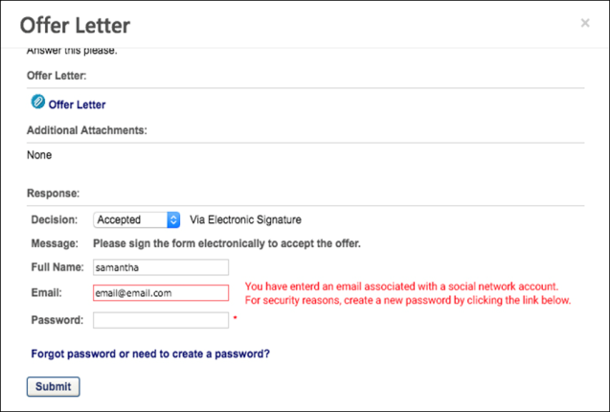

CV-Library Apply Integration
CV-Library has integrated with Cornerstone to provide customers with applicant details directly in their Cornerstone Recruiting system, ensuring recruiters never miss a prospective candidate. CV-Library’s ATS Apply automatically completes application forms and sends recruiters important candidate information, such as their curriculum vitae, directly from the candidate’s CV-Library account, which will be recorded against the job in Cornerstone and source-tracked as coming from CV-Library.
Implementation
The integration will be available to self-enable on 27 September 2021 via Edge Marketplace for all organizations using Recruiting and that also have an account with the integration vendor.
Additional instructions for enabling and configuring the integration are available in Edge. See Edge Integration - Configure.
Permissions
The following existing permissions apply to this functionality:
PERMISSION NAME | PERMISSION DESCRIPTION | CATEGORY

Edge Integrations - Manage | Grants access to the Integrations service for Edge Integrate, where the administrator can configure, enable, and disable their third-party integrations used within the Cornerstone system. This permission cannot be constrained. This is an administrator permission. | Edge

Edge Marketplace - Manage | Grants access to the Marketplace service for Edge Integrate, where the administrator can browse integrations that can be used to extend the Cornerstone system. This permission cannot be constrained. This is an administrator permission. | Edge

One-Click Apply with Stepstone (Early Adopter) - Overview
One-Click Apply with Stepstone delivers a seamless candidate experience with the ability to send job board application data to Cornerstone, enabling candidates to directly apply to requisitions using their information from job boards.
Job boards are a key way to source candidates. If a candidate wants to apply to a position from a job board, they are typically redirected to a career site, which can interrupt the candidate experience and decrease conversion rates. One-Click Apply with Stepstone is a user-centric interface that allows job seekers to apply using their resume details from the job board without having to visit the career site.
How Does this Enhancement Benefit My Organization?
- Increase conversion rates for candidates who would otherwise choose not to apply due to an inconvenient application process.
- Candidates can apply directly from a Stepstone job board, rather than having to be redirected to your career site to apply.
Is being an Early Adopter right for my organization?
- My organization uses Stepstone job boards to post jobs.
- My organization has simple application workflows, which do not include prescreening questions or assessments. Note: Prescreening questions are targeted to be available for a one-click apply workflow when this enhancement is ready for General Availability (GA).
- My organization would like to see the source of the application, even if the candidate is rerouted to the job board.
Use Case - Applicant
- Sally is looking for a project management role in London. Because her role is fairly flexible, she uses job boards so that she can get an aggregate look at companies that are hiring.
- Sally is very busy, so she does not have the time to go to every company's career site to apply to jobs.
- She uploads her resume on Total Jobs, which is one of the Stepstone job boards, and fills out a profile.
- On Total Jobs, Sally finds a few jobs that she is very interested in: Project Manager at ABC Company, Project Manager at DCE Company, and Project Manager at XYZ Company.
- ABC Company and DCE Company both allow their applicants to utilize the "One Click" apply functionality from Stepstone, so the candidate just needs to apply with their curriculum vitae (CV) from their profile.
- Sally easily applies to both companies without leaving the Total Jobs website. However, XYZ Company does not have any integration with a Recruiting product that allows for One-Click Apply, so Sally is redirected to their career site upon clicking Apply.
- Because none of her information is pre-populated, and she sees the application as lengthy, Sally decides she no longer wants to apply for the XYZ Company job.
Considerations
Requisitions with prescreening questions and custom assessments will not be available for a one-click apply workflow. However, for clients using the Mobile-Friendly Candidate Experience, candidates will be directed to the career site where their information is pre-populated in the application workflow, which reduces the time needed to complete the application.
Frequently Asked Questions
Why do I want to post jobs to Stepstone job boards?
The Stepstone job boards not only host your jobs, but they also host your application process. Candidates can apply with one-click by adding their resume to their Stepstone profile and applying to jobs that only require a resume and basic contact information. This saves candidates time in their job search process and may make a candidate more likely to apply when the application process is simple.
Why wouldn't I just want to use the career site that I created in my Cornerstone portal?
For external candidates, your career site can only be accessed from your website. If you only post jobs to your career site, then the reach of your jobs is limited to your website and search engines.
Implementation
This integration is available for all organizations using the Recruiting suite. This integration is available for free via Edge Marketplace. Additional instructions for enabling and configuring the integration are available on the Setup tab of the integration in Edge.
The integration can be accessed and configured via the Edge Marketplace. In order to use this integration, your organization must be using the Recruiting module and must have access to Edge and have an account with the integration vendor. There is no additional cost associated with enabling this integration, but the integration cannot be used without an account with the integration vendor.
Security
The following permissions apply to this functionality:
PERMISSION NAME | PERMISSION DESCRIPTION | CATEGORY

Edge Integrations - Manage | Grants access to the Integrations service for Edge Integrate, where the administrator can configure, enable, and disable their third-party integrations used within the Cornerstone system. This permission cannot be constrained. This is an administrator permission. | Edge

Edge Marketplace - Manage | Grants access to the Marketplace service for Edge Integrate, where the administrator can browse integrations that can be used to extend the Cornerstone system. This permission cannot be constrained. This is an administrator permission. | Edge
One-Click Apply with Stepstone Candidate Experience
Candidates can apply to your jobs on Stepstone job boards provided that you have an integration with Stepstone.
Candidates cannot apply to a job more than once by using the same email address.
One-Click Experience
When candidates apply to your jobs on job boards, they will have a one-click experience when the application only requires basic contact information and a resume.
Once they submit their application, they become an applicant for the job and are visible in job's applicant pool in your portal.
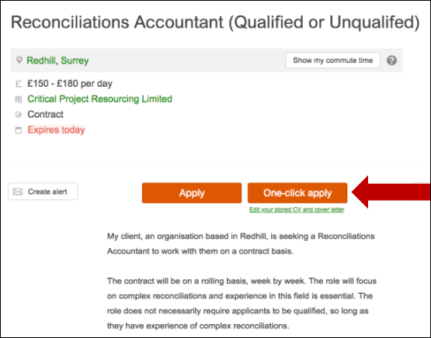
Applications with Assessments - Redirect to Your Career Site
If an application has assessments or other non-supported action items, the application cannot be completed with a one-click experience. Candidates are given an option to continue their application on your career sight, where they can take assessments.
Candidates will have to log in to the career site or create an account if they do not yet have one. If the application is utilizing the Mobile-Friendly Candidate Experience, they are taken to the application, where their information from the job board is prepopulated into the application fields. Their resume and cover letter are also passed to your portal.
Candidates can then complete and submit the application from your career site.
Candidate's Preferred Language
The candidate's preferred language will be respected when their data is passed to your portal.
Candidate Can Re-Apply
Candidates can re-apply to your jobs on Stepstone job boards if you allow reapplication. See General Preferences (by Division).

PitchYou Integration
WhatsApp is the most popular chat app in the world. Candidates need a seamless job application process in chat format that is easily accessible through mobile phones.​
Cornerstone integrates with PitchYou to allow candidates a seamless job application experience using WhatsApp.
Prerequisites
- Customers must have a PitchYou subscription.
- To enable and configure this integration, go to the Edge Marketplace and locate the PitchYou tile. See Marketplace - Browse Edge Integrations.
- Customer can reach out support@pitchyou.de for additional support. ​

Assessment Integrations - Overview

DDI Recruiting Assessment Integration - Overview
The DDI integration enables recruiters to place and track assessment requests. This integration streamlines and improves recruiters' efficacy of their hiring process.
Use Cases
Use Case 1: Activate the DDI integration through Edge
- James is Acme Company's administrator and has been tasked with enabling the integration between Cornerstone and DDI. This will allow Acme to include DDI assessments in their hiring workflow.
- James goes to the Edge Marketplace to purchase and activate the DDI Assessment integration.
- From the Edge Integrate page, James enters Acme's unique Client ID, which is provided by their DDI project team.
- Acme's Cornerstone portal now has an active integration between Cornerstone and DDI.
Use Case 2: Recruiting Administrator configures DDI Assessment action step in Application Workflow
- Allan is the Recruiting administrator for Acme.
- With the integration enabled, Allan is tasked with including DDI assessments in all of Acme's Customer Support requisitions.
- Allan creates a new custom application workflow template that includes an assessment action step, ensuring that DDI assessments is added as a custom integration.
- Allan configures all Customer Support requisitions to include DDI assessments.
- Applicants applying to the Customer Support requisition are now prompted to complete a DDI assessment as part of their application process.
Use Case 3: Recruiter assigns an ad hoc assessment to an applicant
- Lisa, a hiring manager at Acme, is looking to add two new members to her Customer Support team. Before finalizing hiring decisions, she wants to make sure that the candidates are a good fit.
- Lisa goes to the Manage Applicants page for the Customer Support requisition and identifies four potential candidates to assign an assessment to, making sure that all candidates' statuses are assigned to "DDI assessment.”
- While the same candidates are selected, Maria selects the Assign Integration Assessment option from the Actions drop-down. She proceeds to select the assessment to assign to the candidates and clicks Submit.
- The applicants will receive an email with a link that will redirect them to complete the DDI assessment. Note: The Assign Integration Assessment email trigger email will need to be successfully configured by the administrator in Email Administration in order for the applicant to receive the email.
- After the applicant completes the assessment, DDI sends Cornerstone a summary of the candidate’s results which are available for viewing on the Manage Applicants page.
- To further review the assessment results, Lisa clicks the View Report link, which will direct her to DDI to view a detailed report of the assessment results.
Implementation
This functionality is only available for organizations using Recruiting and must be purchased and activated via the Edge Integration Marketplace. It is necessary to have a contract and purchased assessments from DDI to implement the integration. The DDI integration will need to be activated via Edge Integrate, and you will need to provide your company's pre-existing DDI unique identifiers. Additional instructions for enabling and configuring the integration are available on the Setup tab of the integration in Edge.
DDI assessments are not supported on the Cornerstone mobile app.
Permissions
The following permissions apply to this functionality:
PERMISSION NAME | PERMISSION DESCRIPTION | CATEGORY

Applicant Status Bank - Manage | Grants ability to access and manage Applicant Status Bank. | Recruiting Administration

Applicants: Assign Assessment Integration | Grants access to manage assessment integrations from the Applicant Profile page. This applies to assessments that have been configured in the integration center. This permission cannot be constrained. This permission is only available for portals that have an active assessments integration.  This is the highest level of permission for this functionality. In addition to being able to assign assessments, users with this permission will be able to view the assessment status and assessment details. | Recruiting

Applicants: View Assessment Integration Status | Allows user to view the assessment integration check status on the Applications tab of the Applicant Profile page. The user cannot view the link to the detailed report of the assessment. This permission cannot be constrained. This permission is only available for portals that have an active assessments integration.  This is the lowest level of permission for this functionality. Users with this permission can only view the assessment status; they cannot assign assessments or view assessment details. | Recruiting

Applicants: View Assessment Integration Status and Details Link | Allows user to view the assessment integration status and view link to access the assessment report from the Applications tab of the Applicant Profile page and from the associated column on the Manage Applicants page. This permission cannot be constrained. This permission is only available for portals that have an active assessments integration.  This is the second highest level of permission for this functionality. Users with this permission will be able to view the assessment status and assessment details but will not be able to assign assessments. | Recruiting

Application Workflow Template - Manage | Grants ability to access and manage Application Workflow Templates. This permission can be constrained by OU and User’s OU. This is an administrator permission. | Recruiting Administration

Application Workflow Template - View | Grants ability to access and view Application Workflow Templates. | Recruiting Administration

Edge Integrations - Manage | Grants access to the Integrations service for Edge Integrate, where the administrator can configure, enable, and disable their third-party integrations used within the Cornerstone system. This permission cannot be constrained. This is an administrator permission. | Edge

Edge Marketplace - Manage | Grants access to the Marketplace service for Edge Integrate, where the administrator can browse integrations that can be used to extend the Cornerstone system. This permission cannot be constrained. This is an administrator permission. | Edge

Global Email Administration - Manage | Grants ability to manage email trigger templates across all active modules in the portal. Enables creating, editing and deleting email message templates for various system actions and workflows. This permission can be constrained by OU, User's OU, User Self and Subordinates, and User. This is an administrator permission. | Core Administration

Global Email Administration - View | Grants view only access to email templates/triggers and email logs at the global level for the portal. This permission can be constrained by OU, User's OU, User Self and Subordinates, and User. This is an administrator permission. | Core Administration

Requisition: Manage | Grants ability to access and manage all requisitions regardless of ownership (constraints permitting). This permission also grants read-only access to the Applicant Review tab when creating or editing a job requisition. This permission can be constrained by OU, User's OU, and Grade. | Recruiting

Requisition: Owner | Enables owner to access requisitions and applicants for requisitions for which they are an owner. This permission also grants read-only access to video interviews that are completed by applicants via HireVue. For portals with Referral Suite enabled, this permission also enables requisition owners to edit the referral source on the Applicant Profile page. This permission cannot be constrained.  Note: This is a dynamically assigned permission that is not available in Security Role Administration. If the user is removed as an owner, the permission is revoked for the associated requisition. This permission cannot be manually assigned. Also, if a user has both the permission necessary to manage requisitions and be a requisition owner, the constraints of the Requisition: Manage permission overrule those of the Requisition: Owner permission. For requisition owners that do not also have permission to manage requisitions, only certain fields are editable when editing a requisition. | Recruiting

Requisition: Reviewer | Enables reviewer to access requisitions and applicants for requisitions for which they are a reviewer. This permission cannot be constrained.  Note: This is a dynamically assigned permission that is not available in Security Role Administration. Once a requisition is in a Closed or Cancelled status or if the user is removed as a reviewer, the permission is revoked for the associated requisition. This permission cannot be manually assigned.  Note: If an applicant reviewer is removed as a reviewer via the Applicant Profile page, the Requisition: Reviewer permission is revoked for the associated requisition. However, if the reviewer was also added as a reviewer via the General tab when creating, editing, or copying the requisition, the reviewer still appears on the In Review panel as a duplicate reviewer and retains access to the requisition and applicants from the Requisition: Reviewer permission. See Applicant Profile Page Overview for more information about duplicate reviewer instances. | Recruiting
Applicant Statuses - Create Custom Status and Include in Application Workflow
Applicant Experience - DDI Assessment
DDI assessments can be added to the application workflow or assigned via Manage Candidates or Manage Applicants. Applicants complete the assessment using a link in an email or by using the link in the application.
Emails
EMAIL NAME | EMAIL DESCRIPTION | ACTION TYPE

Assign Integration Assessment | This email is triggered when an Edge integration assessment is assigned to an applicant, such as a WOTC assessment. This email can be configured as a notification or a reminder, and it can be sent to External Applicant, Internal Applicant, OU Approver, Hiring Manager, OU Approver, or a specific user.  This email only triggers when a successful response is received from the vendor.  Note: The APPLICANT.INTEGRATION.ASSESSMENT.LINK tag must be included in the email. This tag provides a link that the applicant can click to access the assessment.  Note about Auto-Assignment of Pre-Employment Verifications: This email also applies to auto-assignment of pre-employment verifications, via the Automated Candidate Progression (Early Adopter) functionality. For more information, see Feature Activation Preferences. | Recruiting

Integration Assessment Completed | This email is triggered when an applicant has successfully completed their custom integration task via their My Profile page in the career site or the assessment via the email link. The email can be sent to External Applicant, Hiring Manager, Internal Applicant, OU Approver, and Requisition Owner. This email can be configured as a Notification type email. This email is active by default and can be found in the Recruitment action type section of Email Management. | Recruiting
Application Workflow
When a DDI assessment is included in the application workflow, applicants can complete the assessment when filling out the application. The assessment appears as a step in the workflow. The name of the step is dependent on how the step is named when configuring the requisition.
The applicant clicks Launch on the application workflow step. This will register the applicant with DDI and open the assessment that is associated with the job requisition.
See Application Workflow - Add Integration.
Assign on Manage Candidates
See Manage Candidates - Assign Integrations.
Assign Ad Hoc Assessment on Manage Applicants
DDI assessments can be assigned via Manage Applicants. To assign an assessment:
- Navigate to the Manage Applicants page, and select the applicants to whom the DDI integration assessment should be assigned.
- Ensure that the applicant is in the proper DDI Integration status by selecting the Actions drop-down menu, selecting the Change status to action, selecting the DDI Integration Assessment status, and select Submit.
- While the appropriate applicants are still selected, select the Actions drop-down menu, and select the Assign Integration Assessment action.
- Select the DDI Assessment from the drop-down menu, and select Submit.
- The applicants will receive the Assign Integration Assessment email with a link that directs them to the DDI website. Once the assessment has been completed, the results are available on the Application tab within the Applicant Profile. Note: The Assign Integration Assessment email is only triggered if it is configured in Email Administration.
Note: In order for the vendor to post status/results back to Cornerstone in the QA environment, the vendor's IP address needs to be safe listed.
Manage Applicants Deprecation: Cornerstone is deprecating Manage Applicants in Q1 2024. See Manage Applicants Overview.
DDI Assessment Results
DDI assessment results can be viewed within the DDI application. A link will be provided by DDI so that recruiters can access the results. This information can be accessed from the Application tab on the Applicant Profile page.
Permissions
PERMISSION NAME | PERMISSION DESCRIPTION | CATEGORY

Applicants: Assign Assessment Integration | Grants access to manage assessment integrations from the Applicant Profile page. This applies to assessments that have been configured in the integration center. This permission cannot be constrained. This permission is only available for portals that have an active assessments integration.  This is the highest level of permission for this functionality. In addition to being able to assign assessments, users with this permission will be able to view the assessment status and assessment details. | Recruiting

Applicants: View Assessment Integration Status | Allows user to view the assessment integration check status on the Applications tab of the Applicant Profile page. The user cannot view the link to the detailed report of the assessment. This permission cannot be constrained. This permission is only available for portals that have an active assessments integration.  This is the lowest level of permission for this functionality. Users with this permission can only view the assessment status; they cannot assign assessments or view assessment details. | Recruiting

Applicants: View Assessment Integration Status and Details Link | Allows user to view the assessment integration status and view link to access the assessment report from the Applications tab of the Applicant Profile page and from the associated column on the Manage Applicants page. This permission cannot be constrained. This permission is only available for portals that have an active assessments integration.  This is the second highest level of permission for this functionality. Users with this permission will be able to view the assessment status and assessment details but will not be able to assign assessments. | Recruiting
Emails
EMAIL NAME | EMAIL DESCRIPTION | ACTION TYPE

Assign Integration Assessment | This email is triggered when an Edge integration assessment is assigned to an applicant, such as a WOTC assessment. This email can be configured as a notification or a reminder, and it can be sent to External Applicant, Internal Applicant, OU Approver, Hiring Manager, OU Approver, or a specific user.  This email only triggers when a successful response is received from the vendor.  Note: The APPLICANT.INTEGRATION.ASSESSMENT.LINK tag must be included in the email. This tag provides a link that the applicant can click to access the assessment.  Note about Auto-Assignment of Pre-Employment Verifications: This email also applies to auto-assignment of pre-employment verifications, via the Automated Candidate Progression (Early Adopter) functionality. For more information, see Feature Activation Preferences. | Recruiting

Integration Assessment Completed | This email is triggered when an applicant has successfully completed their custom integration task via their My Profile page in the career site or the assessment via the email link. The email can be sent to External Applicant, Hiring Manager, Internal Applicant, OU Approver, and Requisition Owner. This email can be configured as a Notification type email. This email is active by default and can be found in the Recruitment action type section of Email Management. | Recruiting
Access In-Progress Assessment
After placing a successful assessment order request, DDI will process the request, and the following fields will be available under the Application tab of the Applicant Profile page.
- Assigned - This field displays the date on which the assessment order request is assigned to the applicant.
- Reference ID - This field displays the DDI transaction ID.
- Status - This field displays a status of Acknowledged.
If the assessment order fails, the Status field displays "Error." The error description will be displayed on the user interface.
Note: The assessment results are also available from Manage Candidates. See Manage Candidates Page (Early Adopter).
Access Completed Assessment
When the applicant has completed the assessment, the following fields display in the DDI Assessment panel on the Application tab:
- Assigned - This field displays the date on which the assessment order request is assigned to the applicant.
- Reference ID - This field displays the DDI transaction ID.
- Status - This field displays a status of Completed.
- Details - This field displays the date on which the applicant completed the assessment.
  - Pass
  - Fail
- View Report - This field displays the link that will direct the recruiter to view a more detailed report of the applicant’s assessment results in DDI. Click the View Report link to open the DDI application from which you can view the applicant's assessment results.
If the Integration Assessment Completed email is configured and active in Email Administration, then this email is triggered when the applicant completes the assessment.
Emails
EMAIL NAME | EMAIL DESCRIPTION | ACTION TYPE

Integration Assessment Completed | This email is triggered when an applicant has successfully completed their custom integration task via their My Profile page in the career site or the assessment via the email link. The email can be sent to External Applicant, Hiring Manager, Internal Applicant, OU Approver, and Requisition Owner. This email can be configured as a Notification type email. This email is active by default and can be found in the Recruitment action type section of Email Management. | Recruiting
Assessment Statuses
The results will indicate one of two statuses to indicate that the assessment has been acknowledged or completed.
- Acknowledged - This status indicates that DDI acknowledges that the assessment has been scheduled for the applicant to complete.
- Completed - This status indicates that the applicant has completed the assessment.
Assessment Dates
The results will display the date on which the applicant completed the assessment, as well as the date when the assessment results expire.

pymetrics Talent Management and Screening Integration
The pymetrics Talent Management and Screening integration helps organizations make well-informed hiring decisions—all within the convenience and seamlessness of the Cornerstone recruitment and talent management system you already use. The assessments use data science to predict a candidate's job fit and future performance, rather than only focusing on the skills a candidate has already attained based on their resume.
pymetrics assessments can be included in the application workflow and can also be sent manually by the recruiter outside of the job application.
Implementation
This integration is available for all organizations using the Recruiting suite and that also have an account with the integration vendor. This integration is available in Edge Marketplace. Additional instructions for enabling and configuring the integration are available on the Setup tab of the integration in Edge. There is no additional cost associated with enabling this integration in Edge.
Permissions
The following existing permissions apply to this functionality:
PERMISSION NAME | PERMISSION DESCRIPTION | CATEGORY

Edge Integrations - Manage | Grants access to the Integrations service for Edge Integrate, where the administrator can configure, enable, and disable their third-party integrations used within the Cornerstone system. This permission cannot be constrained. This is an administrator permission. | Edge

Edge Marketplace - Manage | Grants access to the Marketplace service for Edge Integrate, where the administrator can browse integrations that can be used to extend the Cornerstone system. This permission cannot be constrained. This is an administrator permission. | Edge

SHL Talent Assessments Integration
The SHL Talent Assessments integration lets recruiters identify best-fit candidates, using targeted, predicted assessments, and provides an engaging, candidate-centric experience to help you attract the top candidates. This integration is available for clients using SHL TalentCentral.
If you are using the legacy SHL Select2Perform, please reach out to your SHL Account Manager to discuss the upgrade to SHL TalentCentral.
Migration
Both the SHL Talent Assessments and the SHL Select2Perform integrations can be used simultaneously. However, in order to use SHL Talent Assessments it is necessary to be on SHL Talent Central.
If you are using the legacy SHL Select2Perform, it is necessary to work with SHL to migrate. The new integration only works for mobile-friendly workflows and currently only supports one numeric value for the assessment score to be displayed.
Implementation
This integration is available on 23 December 2019. This integration is a vendor-built integration and not by Cornerstone. More information and instructions can be found in Edge Integrate.
Permissions
The following existing permissions apply to this functionality:
PERMISSION NAME | PERMISSION DESCRIPTION | CATEGORY

Edge Integrations - Manage | Grants access to the Integrations service for Edge Integrate, where the administrator can configure, enable, and disable their third-party integrations used within the Cornerstone system. This permission cannot be constrained. This is an administrator permission. | Edge

Edge Marketplace - Manage | Grants access to the Marketplace service for Edge Integrate, where the administrator can browse integrations that can be used to extend the Cornerstone system. This permission cannot be constrained. This is an administrator permission. | Edge

Talent Plus TalentBank Integration
The Talent Plus integrations provides a seamless candidate experience and easy access to Talent Plus assessment recommendations and results.
When a Talent Plus assessment is associated to a job requisition, candidates are taken to Talent Plus to complete the assessment. The Talent Plus system sends the results back to Cornerstone, including the recommendation statement and score, as well as a link to the candidate’s results.
Implementation
This integration is a vendor-built integration and not by Cornerstone. More information and instructions can be found in Edge Integrate.
Security
The following existing permissions apply to this functionality:
PERMISSION NAME | PERMISSION DESCRIPTION | CATEGORY

Edge Integrations - Manage | Grants access to the Integrations service for Edge Integrate, where the administrator can configure, enable, and disable their third-party integrations used within the Cornerstone system. This permission cannot be constrained. This is an administrator permission. | Edge

Edge Marketplace - Manage | Grants access to the Marketplace service for Edge Integrate, where the administrator can browse integrations that can be used to extend the Cornerstone system. This permission cannot be constrained. This is an administrator permission. | Edge

Background Check Integrations - Overview

Accurate Background Check - Overview
The Accurate Background Check integration allows you to place and track background checks for applicants. The integration is available through the Edge Marketplace.
Use Cases
Use Case 1: Activate the Accurate Background integration through Edge
- Barbara is Acme Company's administrator who has been tasked with enabling the integration with Accurate Background. This will allow Acme to include Accurate Background requests within their application workflow.
- Barbara goes to the Edge Marketplace to purchase and activate the Accurate Background integration.
- From the Edge Integrate page, Barbara enters Acme's unique Company ID and API credentials provided by their Accurate Background team.
- Acme's portal now has an active integration with Accurate Background.
Use Case 2: Recruiting Admin creates a custom applicant status
- Katie is the recruiting administrator for Acme Company.
- Ryan, a hiring manager at Acme, is looking to add a new member to his Integration Consulting team.
- With the integration enabled, Katie is tasked with adding a background check status in all of Acme's Integration Consultant requisitions.
- Katie creates a new custom applicant status that is set to a custom integration type under Accurate Background Check.
- Katie has now configured the Integration Consultant requisitions to include Accurate Background.
Use Case 3: Recruiter places a background check request for an applicant
- Dorothy, a recruiter at Acme, has identified John James to be a stellar applicant.
- To ensure a sound hiring decision is made and to protect Acme from potential risks, Dorothy assigns a background check on John by moving the status to Accurate Background Check.
- Dorothy selects the appropriate screening package then submits the request.
- John receives an email from Accurate Background and clicks on the link to complete the screening application request in Accurate Background.
Use Case 4: Recruiter views background check results and its detailed report in Accurate via a link
- Dorothy is eager to find out the results of John's background check status.
- Dorothy navigates to John's Applicant Profile Status page and sees the status on the request.
- To view additional details of the background request, Dorothy clicks on the Check Order Progress link which will direct her to Accurate Background site.
Implementation
The Accurate Background Check integration must be enabled and activated through the Edge Marketplace. Portals must have already purchased Accurate Background Check in order to enable it in Edge. Additional instructions for enabling and configuring the integration are available on the Setup tab of the integration in Edge.
Permissions
The following permissions apply to this functionality:
PERMISSION NAME | PERMISSION DESCRIPTION | CATEGORY

Applicants: Initiate Background Check | This permission grants access to manage background checks from the Applicant Profile page. This applies to background checks that have been configured in the Integration Center. This permission cannot be constrained. Users who have this permission will have an Assign to Applicant link in the background check status type panel on the Applicant Profile page. Once the background check is assigned, the page will display "Assigned - [Date Assigned]." | Recruiting

Applicant Status Bank - Manage | Grants ability to access and manage Applicant Status Bank. | Recruiting Administration

Applicants: View Background Check Status | Allow user to view the background check status. The user cannot view the link to the detailed report. This permission cannot be constrained. | Recruiting

Applicants: View Background Check Status and Details Link | This permission allows users to view the background check status and view a link to access the background check report, which can be found in the background check status type panel on the Applicant Profile page. This permission cannot be constrained. | Recruiting

Edge Integrations - Manage | Grants access to the Integrations service for Edge Integrate, where the administrator can configure, enable, and disable their third-party integrations used within the Cornerstone system. This permission cannot be constrained. This is an administrator permission. | Edge

Edge Marketplace - Manage | Grants access to the Marketplace service for Edge Integrate, where the administrator can browse integrations that can be used to extend the Cornerstone system. This permission cannot be constrained. This is an administrator permission. | Edge

Requisition: Manage | Grants ability to access and manage all requisitions regardless of ownership (constraints permitting). This permission also grants read-only access to the Applicant Review tab when creating or editing a job requisition. This permission can be constrained by OU, User's OU, and Grade. | Recruiting

Requisition: Owner | Enables owner to access requisitions and applicants for requisitions for which they are an owner. This permission also grants read-only access to video interviews that are completed by applicants via HireVue. For portals with Referral Suite enabled, this permission also enables requisition owners to edit the referral source on the Applicant Profile page. This permission cannot be constrained.  Note: This is a dynamically assigned permission that is not available in Security Role Administration. If the user is removed as an owner, the permission is revoked for the associated requisition. This permission cannot be manually assigned. Also, if a user has both the permission necessary to manage requisitions and be a requisition owner, the constraints of the Requisition: Manage permission overrule those of the Requisition: Owner permission. For requisition owners that do not also have permission to manage requisitions, only certain fields are editable when editing a requisition. | Recruiting

Requisition: Reviewer | Enables reviewer to access requisitions and applicants for requisitions for which they are a reviewer. This permission cannot be constrained.  Note: This is a dynamically assigned permission that is not available in Security Role Administration. Once a requisition is in a Closed or Cancelled status or if the user is removed as a reviewer, the permission is revoked for the associated requisition. This permission cannot be manually assigned.  Note: If an applicant reviewer is removed as a reviewer via the Applicant Profile page, the Requisition: Reviewer permission is revoked for the associated requisition. However, if the reviewer was also added as a reviewer via the General tab when creating, editing, or copying the requisition, the reviewer still appears on the In Review panel as a duplicate reviewer and retains access to the requisition and applicants from the Requisition: Reviewer permission. See Applicant Profile Page Overview for more information about duplicate reviewer instances. | Recruiting
Accurate Background Check - Create Custom Status
Accurate Background Check integrations are available and implemented through the Edge Marketplace. The Accurate Background Check integration allows you to place and track background checks for applicants.
Permissions
PERMISSION NAME | PERMISSION DESCRIPTION | CATEGORY

Edge Integrations - Manage | Grants access to the Integrations service for Edge Integrate, where the administrator can configure, enable, and disable their third-party integrations used within the Cornerstone system. This permission cannot be constrained. This is an administrator permission. | Edge

Edge Marketplace - Manage | Grants access to the Marketplace service for Edge Integrate, where the administrator can browse integrations that can be used to extend the Cornerstone system. This permission cannot be constrained. This is an administrator permission. | Edge
To create a custom status for the Accurate Background Check integration, perform the actions listed below.
- Navigate to Admin > Tools > Recruit > Applicant Statuses. Then, select the top level organizational unit (OU).
- Click Create Custom Status. This opens the Create Custom Status pop-up.
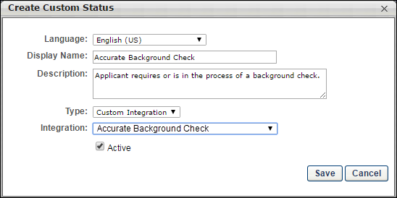
- Complete the fields in the pop-up.
  - Language - If multiple languages are enabled, select the language from the drop down list for which you are entering the status name and description. To localize the status name and description into other available languages, select the appropriate language from the drop-down list and enter the localized name and description in the appropriate fields.
  - Display Name - Enter the status name, which appears throughout the system. The character limit for this field is 50. When the Display Name of an active status is modified after the status is in use or has been used in a job requisition:
    - The new display name appears on the Default Status List page.
    - The new display name appears in the Status list on the job requisition template.
    - Any new job requisitions created after the display name is changed apply the new display name.
    - Job requisitions created before the status display name is changed continue to honor the name that existed at the time the requisition was created.
  - Description - Enter the status description. This should describe the purpose of the status and what is implied when an applicant is in that status. The character limit for this field is 500.
  - Type - Select “Custom Integration” from the drop-down. Note: This field is displayed only when creating a custom status at the top level OU. When creating a custom status for a child OU, the Type field displays the type selected for the parent OU but is not editable.
  - Integration - Select “Accurate Background Check” from the drop down.
  - Active - This field is checked by default. Ensure the field is checked before saving the status so that the status is active for the portal.
- Click Save in the pop-up. This returns you to the Manage Applicant Statuses page.
- Click Save at the bottom of the Manage Applicant Statuses page to save the custom status to the Division OU. If the custom status is not saved on the Manage Applicant Statuses page, the status will be lost once you leave the page.
The custom applicant status will need to be added to the Status List on the requisition template so that it will be included on the job requisition.
Assign Accurate Background Check
The Accurate Background Check integration allows you to place and track background checks for applicants. The integration is available through the Edge Marketplace.
The background check can be assigned via Manage Candidates, Manage Applicants, or the Applicant Profile page.
Manage Applicants Deprecation: Cornerstone is deprecating Manage Applicants in Q1 2024. See Manage Applicants Overview.
To access the Applicant Profile page, click the applicant's name from any of the following pages:
- Manage Job Requisitions >
  - Requisition Snapshot
  - Manage Applicants
- Recruit > Interview Manager
- Recruit > Review Applicants
- Recruit > Manage Candidates (Note:This functionality is in the Early Adopter phase. For more information about availability,see the Overview topic for this functionality.)
Permissions
PERMISSION NAME | PERMISSION DESCRIPTION | CATEGORY

Applicants: Initiate Background Check | This permission grants access to manage background checks from the Applicant Profile page. This applies to background checks that have been configured in the Integration Center. This permission cannot be constrained. Users who have this permission will have an Assign to Applicant link in the background check status type panel on the Applicant Profile page. Once the background check is assigned, the page will display "Assigned - [Date Assigned]." | Recruiting

Applicants: View Background Check Status and Details Link | This permission allows users to view the background check status and view a link to access the background check report, which can be found in the background check status type panel on the Applicant Profile page. This permission cannot be constrained. | Recruiting

Applicants: View Background Check Status | Allow user to view the background check status. The user cannot view the link to the detailed report. This permission cannot be constrained. | Recruiting

Requisition: Manage | Grants ability to access and manage all requisitions regardless of ownership (constraints permitting). This permission also grants read-only access to the Applicant Review tab when creating or editing a job requisition. This permission can be constrained by OU, User's OU, and Grade. | Recruiting

Requisition: Owner | Enables owner to access requisitions and applicants for requisitions for which they are an owner. This permission also grants read-only access to video interviews that are completed by applicants via HireVue. For portals with Referral Suite enabled, this permission also enables requisition owners to edit the referral source on the Applicant Profile page. This permission cannot be constrained.  Note: This is a dynamically assigned permission that is not available in Security Role Administration. If the user is removed as an owner, the permission is revoked for the associated requisition. This permission cannot be manually assigned. Also, if a user has both the permission necessary to manage requisitions and be a requisition owner, the constraints of the Requisition: Manage permission overrule those of the Requisition: Owner permission. For requisition owners that do not also have permission to manage requisitions, only certain fields are editable when editing a requisition. | Recruiting

Requisition: Reviewer | Enables reviewer to access requisitions and applicants for requisitions for which they are a reviewer. This permission cannot be constrained.  Note: This is a dynamically assigned permission that is not available in Security Role Administration. Once a requisition is in a Closed or Cancelled status or if the user is removed as a reviewer, the permission is revoked for the associated requisition. This permission cannot be manually assigned.  Note: If an applicant reviewer is removed as a reviewer via the Applicant Profile page, the Requisition: Reviewer permission is revoked for the associated requisition. However, if the reviewer was also added as a reviewer via the General tab when creating, editing, or copying the requisition, the reviewer still appears on the In Review panel as a duplicate reviewer and retains access to the requisition and applicants from the Requisition: Reviewer permission. See Applicant Profile Page Overview for more information about duplicate reviewer instances. | Recruiting
Assign Background Check
To assign the background check using Accurate Background, perform the following steps:
- Change the status of the applicant to Accurate Background Check (custom applicant status) via Manage Candidates, Manage Applicants, or the Applicant Profile page.
  - The following displays in the Accurate Background Check panel of the Applicant Profile > Statuses tab when the applicant status has been changed:
    - Current Status: Not Assigned to Applicant
    - Assign to Applicant action link
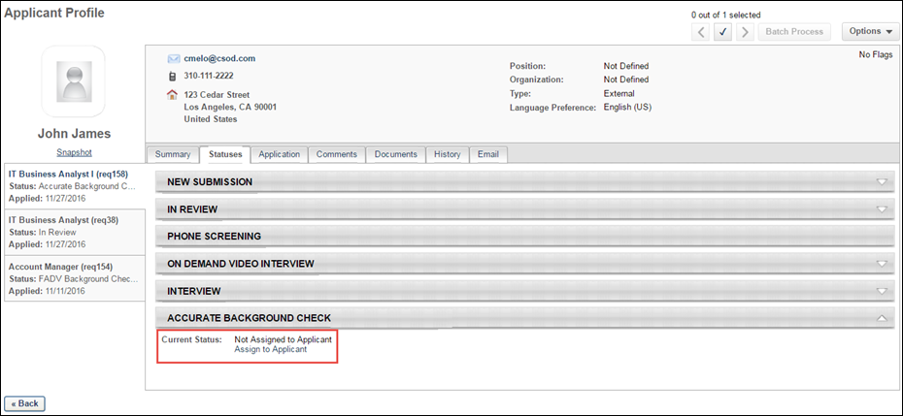
- Assign the background screening to the applicant by clicking Assign to Applicant. This opens the Select Screening Program Option pop-up.
- Complete the following fields in the pop-up:
  - Select Provider - Select Accurate Background in the field.
  - Select Package - Select the package sent by Accurate Background.
- Click Submit. This assigns the background check for the applicant. The date the background check was assigned displays in the panel, as well as a reference ID and the status of Acknowledged. An email is automatically sent to the applicant with a link to complete the screening in Accurate Background. The link is available to the applicant for seven days. The email address of the user launching the integration must exist in the Accurate system. Note: The reference ID is an internal system-defined value.
Background Check Panel
The following information displays in the background check panel on the Applicant Profile > Statuses tab during the background check process:
- Assigned - This status is the date the screening is assigned to the applicant.
- Reference ID - This displays the applicant ID (this is a backend ID within the system).
- Status - This displays the status of the overall transaction. The following are the possible values:
  - Acknowledged
  - In Progress
  - Complete
  - Cancelled
- [Package ID] - This displays the ID of the screening package assigned to the applicant.
- Provider Reference ID - This displays the Search ID from Accurate Background.
- Status - This displays the overall status of the screening request. The following are the possible values.
  - In Progress
  - Completed
  - Cancelled
- Results - The following displays for the results:
  - Percent Complete - This is a numerical value that indicates the progress of the background check.
  - Adjudication Results - This is a text value from Accurate Background. Note: Adjudication results is not a default feature in Accurate Background. Not all portals will have adjudication results.
- Check Order Progress - The link directs users to Accurate Background for a detailed report of the screening request. This option is displayed for screenings that have an In Progress status.
- View Report - A View Report link displays for screenings that have a Completed status.
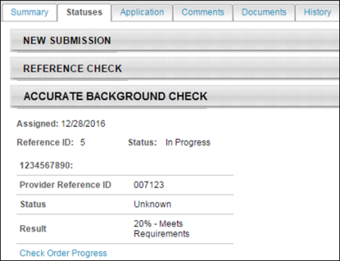
Additional Details
The following fields are sent to Accurate as part of the integration:
- Job requisition Division OU ID (Note: Accurate has a maximum character limit of 25 characters for this field. To ensure that the integration runs successfully, Cornerstone will only send the first 25 characters of the OU ID. Some OU IDs may have identical values in the first 25 characters.)
- Job requisition Location OU ID (Note: Accurate has a maximum character limit of 25 characters for this field. To ensure that the integration runs successfully, Cornerstone will only send the first 25 characters of the OU ID. Some OU IDs may have identical values in the first 25 characters.)
- Candidate first, middle, and last name
- Candidate address (address lines 1 and 2, city, state, zip, country)
- Candidate phone number
- Candidate email address
- Job requisition country
- Job requisition state
- Job requisition city
Applicant References Data
Data on an applicant's references is passed to Accurate Background Check when a background check is performed on the applicant. This means the applicant will not need to enter their references manually when filling out a background check form with Accurate.
Permissions
PERMISSION NAME | PERMISSION DESCRIPTION | CATEGORY

Manage Forms - Manage | Grants access to the Manage Forms functionality. This permission can be constrained by OU and User's OU. This is an administrator permission.  Note: This permission enables access to the Form Management functionality that is part of Cornerstone HR functionality and the Onboarding module. This permission does not grant access to the Training Forms Management functionality. | Forms Management Administration

Question Bank - Manage | Grants access to the Question Bank functionality. This permission can be constrained by OU and User's OU. This is an administrator permission. | Forms Management Administration
How Is the Applicant References Data Retrieved by Accurate?
In order for Accurate to retrieve the applicant's data, specific reference questions will need to be created in the Question Bank in Form Management so that the questions can be added to a form in Form Management that will be used to request the applicant's references.
Field Mapping
The name of the question in Cornerstone does not need to match the name of the field in Accurate, but it must be mapped to the correctly corresponding field in Accurate in order for the data to pass successfully to Accurate.
Question Sets
There are three different sets of these questions, since applicants can submit up to three references. Each set represents one applicant reference. It is necessary to create each set.
If more than three sets are created, any data outside of the first three sets will not be passed to Accurate.
Create Questions
To create the questions:
- Navigate to Admin > Tools > core functions > form management > question bank.
- Click Create Question.
- Select Text as the field type.
- Configure each question separately by entering a name for the question in the Question field and entering the API exactly as it is listed in the right-hand column. The "Field Name in Accurate Background Check" column indicates the exact name of the field in Accurate. You can use the Accurate field name as your question or enter a different name, but the API will need to correspond exactly so that the applicant's data can be transferred successfully.
field name in accurate background check |  | enter this api in the api name field on the create question page
SET 1
Reference Name |  | Accurate_Reference_Name_1
Reference Phone Number |  | Accurate_Reference_Phone1_1
Reference Phone Number 2 |  | Accurate_Reference_Phone2_1
Reference Email |  | Accurate_Reference_Email_1
Reference Relationship |  | Accurate_Reference_Relationship_1
Reference Street |  | Accurate_Reference_Street_1
Reference City |  | Accurate_Reference_City_1
Reference State |  | Accurate_Reference_State_1
Reference Zip Code |  | Accurate_Reference_Zip_1
SET 2
Reference Name |  | Accurate_Reference_Name_2
Reference Phone Number |  | Accurate_Reference_Phone1_2
Reference Phone Number 2 |  | Accurate_Reference_Phone2_2
Reference Email |  | Accurate_Reference_Email_2
Reference Relationship |  | Accurate_Reference_Relationship_2
Reference Street |  | Accurate_Reference_Street_2
Reference City |  | Accurate_Reference_City_2
Reference State |  | Accurate_Reference_State_2
Reference Zip Code |  | Accurate_Reference_Zip_2
SET 3
Reference Name |  | Accurate_Reference_Name_3
Reference Phone Number |  | Accurate_Reference_Phone1_3
Reference Phone Number 2 |  | Accurate_Reference_Phone2_3
Reference Email |  | Accurate_Reference_Email_3
Reference Relationship |  | Accurate_Reference_Relationship_3
Reference Street |  | Accurate_Reference_Street_3
Reference City |  | Accurate_Reference_City_3
Reference State |  | Accurate_Reference_State_3
Reference Zip Code |  | Accurate_Reference_Zip_3
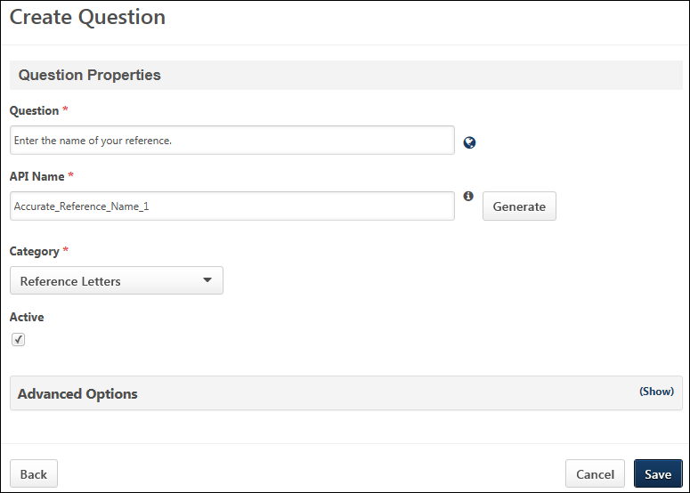
Create Form
Once you have created the questions, navigate to Form Management > Manage Forms and create a form for requesting an applicant's references, making sure to enter Accurate_Reference_Form in the API Name field on the Build tab. The purpose of entering this API name is so that the system knows the correct form to send to Accurate Background Check. See Build Tab - Define General Information.
On the form, add the questions that you created above. The references request form will be assigned to applicants on the Manage Applicants page. The form will be available to the applicant from their My Profile page in the career site, where they can then launch and complete the form.

AccurateAce Background Check Integration - Overview
The AccurateAce Background Check integration is available through the Edge Marketplace. The AccurateAce Background Check integration allows you to place and track background checks for applicants.
Use Cases
Use Case 1: Activate the AccurateAce Background Check integration through Edge
- Barbara is Acme Company's administrator who has been tasked with enabling the integration with AccurateAce Background Check. This will allow Acme to include AccurateAce Background Check requests within their application workflow.
- Barbara goes to the Edge Marketplace to purchase and activate the AccurateAce Background Check integration.
- From the Edge Integrate page, Barbara enters Acme's unique Company ID, which is provided by their AccurateAce project team.
- Acme's portal now has an active integration with AccurateAce.
Use Case 2: Recruiting Admin creates a custom applicant status
- Katie is the recruiting administrator for Acme Company.
- Ryan, a hiring manager at Acme, is looking to add a new member to his Marketing team.
- With the integration enabled, Katie is tasked with adding a background check status in all of Acme's marketing requisitions.
- Katie creates a new custom applicant status that is set to custom integration type AccurateAce Background Check.
- Katie creates a new job requisition that includes that new custom applicant status.
- Katie has now configured the marketing requisitions to include the AccurateAce Background Check custom applicant status.
Use Case 3: Recruiter places a background check request for an applicant
- Dorothy, a recruiter at Acme, has identified John James to be a stellar applicant.
- To ensure a sound hiring decision is made and to protect Acme from potential risks, Dorothy assigns a background check screening on John by moving the status to AccurateAce Background Check.
- Dorothy clicks the Assign to Applicant link on the Statuses tab of the Applicant Profile page, and a pop-up window appears. Dorothy confirms the selected background check provider, and then clicks Submit.
- Dorothy is re-directed to Acme's AccurateAce portal where she will select the appropriate background check package to assign to John.
Use Case 4: Recruiter views background check results and its detailed report in AccurateAce via a link
- Dorothy is eager to find out the results of John's background check status.
- Dorothy navigates to John's Applicant Profile > Statuses page and sees the status on the request.
- To view additional details of the background request, Dorothy clicks on the View Progress link, which will direct her to the AccurateAce site.
Implementation
The AccurateAce Background Check integration must be enabled and activated through the Edge Marketplace. Portals must have already purchased AccurateAce Background Check in order to enable it in Edge.
Security
The following permissions apply to this functionality:
PERMISSION NAME | PERMISSION DESCRIPTION | CATEGORY

Applicants: Initiate Background Check | This permission grants access to manage background checks from the Applicant Profile page. This applies to background checks that have been configured in the Integration Center. This permission cannot be constrained. Users who have this permission will have an Assign to Applicant link in the background check status type panel on the Applicant Profile page. Once the background check is assigned, the page will display "Assigned - [Date Assigned]." | Recruiting

Applicant Status Bank - Manage | Grants ability to access and manage Applicant Status Bank. | Recruiting Administration

Applicants: View Background Check Status | Allow user to view the background check status. The user cannot view the link to the detailed report. This permission cannot be constrained. | Recruiting

Applicants: View Background Check Status and Details Link | This permission allows users to view the background check status and view a link to access the background check report, which can be found in the background check status type panel on the Applicant Profile page. This permission cannot be constrained. | Recruiting

Requisition: Manage | Grants ability to access and manage all requisitions regardless of ownership (constraints permitting). This permission also grants read-only access to the Applicant Review tab when creating or editing a job requisition. This permission can be constrained by OU, User's OU, and Grade. | Recruiting

Requisition: Owner | Enables owner to access requisitions and applicants for requisitions for which they are an owner. This permission also grants read-only access to video interviews that are completed by applicants via HireVue. For portals with Referral Suite enabled, this permission also enables requisition owners to edit the referral source on the Applicant Profile page. This permission cannot be constrained.  Note: This is a dynamically assigned permission that is not available in Security Role Administration. If the user is removed as an owner, the permission is revoked for the associated requisition. This permission cannot be manually assigned. Also, if a user has both the permission necessary to manage requisitions and be a requisition owner, the constraints of the Requisition: Manage permission overrule those of the Requisition: Owner permission. For requisition owners that do not also have permission to manage requisitions, only certain fields are editable when editing a requisition. | Recruiting

Requisition: Reviewer | Enables reviewer to access requisitions and applicants for requisitions for which they are a reviewer. This permission cannot be constrained.  Note: This is a dynamically assigned permission that is not available in Security Role Administration. Once a requisition is in a Closed or Cancelled status or if the user is removed as a reviewer, the permission is revoked for the associated requisition. This permission cannot be manually assigned.  Note: If an applicant reviewer is removed as a reviewer via the Applicant Profile page, the Requisition: Reviewer permission is revoked for the associated requisition. However, if the reviewer was also added as a reviewer via the General tab when creating, editing, or copying the requisition, the reviewer still appears on the In Review panel as a duplicate reviewer and retains access to the requisition and applicants from the Requisition: Reviewer permission. See Applicant Profile Page Overview for more information about duplicate reviewer instances. | Recruiting
Enable AccurateAce Background Check Integration
Applicant Statuses - Create Custom AccurateAce Status
In order for the AccurateAce Background Check status to be available to select for applicants, it is necessary to create a custom integration status in Manage Applicant Statuses.
To create a custom applicant status, go to Admin > Tools > Recruit > Applicant Statuses. Then click the Create Custom Status link.
Permissions
PERMISSION NAME | PERMISSION DESCRIPTION | CATEGORY

Applicant Status Bank - Manage | Grants ability to access and manage Applicant Status Bank. | Recruiting Administration
To create a custom integration status for AccurateAce Background Check:
- Navigate to Admin > Tools > Recruit > Applicant Statuses.
- Click the Create Custom Status link. This opens the Create Custom Status pop-up.
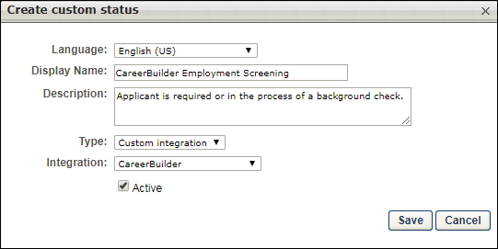
- Complete the following fields in the Create Custom Status pop-up:
  - Language - If multiple languages are enabled, from the drop-down list select the language in which you are entering the status name and description. To localize the status name and description into other available languages, select the appropriate language from the drop-down list and enter the localized name and description in the appropriate fields.
  - Display Name - Enter "AccurateAce Background Check" to identify the status as being specifically for AccurateAce Background Check.
  - Description - Enter a description, up to 500 characters. As a best practice, provide a description that helps recruiters understand the purpose of this status.
  - Type - Select "Custom Integration." The Custom Integration status type mans that the applicant is in an integration step of the status workflow.
  - Integration - Select "AccurateAce" in this field, which will associate the custom status to AccurateAce Background Check.
  - Active - This option is selected by default and means the status will be available to include in status workflows.
- Click Save to save the custom status. Your new custom integration status will be visible in the list of statuses on the Manage Applicant Statuses page.
Map Education and Experience Fields (AccurateAce Background Check)
In order for AccurateAce Background Check to retrieve the applicant's data, specific resume fields will need to be mapped.
Note: When configuring the application workflow template for the requisition, the Upload Attachment action item will need to be included so that the applicant can enter their resume data in the Education and Employment fields that are mapped for AccurateAce when filling out the application.
Education Fields
Education fields must be mapped in Succession > Resume in order for Cornerstone to pass the applicant's data to AccurateAce. The name of the field in Cornerstone (as defined in the Field Name field on the Add Field pop-up on the Resume > Education page) does not need to match the name of the field in AccurateAce, but it must be mapped to the correctly corresponding Applicant Mapping field in your portal in order for the data to pass successfully to AccurateAce.
To map the fields:
- Navigate to Admin > Tools > Succession Management > Resume.
- Select the Edit icon in the Education row.
- Ensure that Education is selected in the Applicant Resume drop-down.
- Configure or create the following fields and select the appropriate mapping option in the Applicant Mapping column:
field name in AccurateAce | select this option in drop-down in applicant mapping column | field type
Institution | Institution | Short Text Box; AccurateAce allows a candidate up to three records
Degree | Degree | Dropdown; AccurateAce allows a candidate up to four entry records
Degree Major | Area of Study | Short Text Box; AccurateAce allows a candidate up to four entry records
Degree Date | Graduation Date | Date Field; AccurateAce allows a candidate up to four entry records
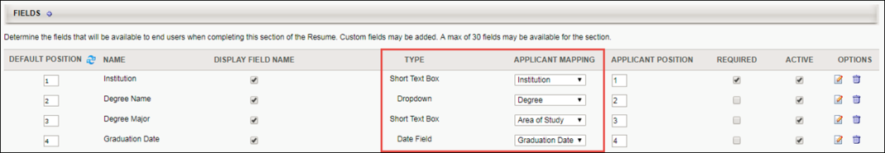
Employment Fields
Employment fields must be mapped in Succession > Resume in order for Cornerstone to pass the applicant's data to AccurateAce. The name of the field in Cornerstone (as defined in the Field Name field on the Add Field pop-up on the Resume > Previous Positions page) does not need to match the name of the field in AccurateAce, but it must be mapped to the correctly corresponding Applicant Mapping field in your portal in order for the data to pass successfully to AccurateAce.
To map the fields:
- Navigate to Admin > Tools > Succession Management > Resume.
- Select the Edit icon in the Previous Positions row.
- Ensure that Experience is selected in the Applicant Resume drop-down.
- Configure or create the following fields and select the appropriate mapping option in the Applicant Mapping column:
field name in AccurateAce | select this option in drop-down in applicant mapping column | field type
Employer Name | Organization | Short Text Box; AccurateAce allows a candidate up to four entry records
Title | Position | Short Text Box; AccurateAce allows a candidate up to four entry records
Start and End Date | Date Range | Date Range Field; AccurateAce allows a candidate up to four entry records
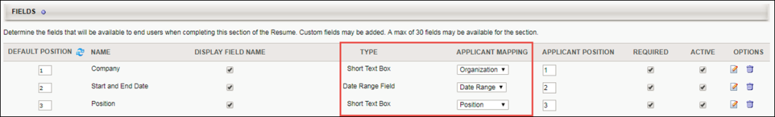
Application Workflow - Upload Attachments (AccurateAce Background Check)
When including the AccurateAce Background Check integration in the applicant statuses for a job requisition, the Upload Attachment action item must also be included in the application workflow. This allows applicants to enter their resume data when filling out the application. Their resume data will be mapped to specific field in AccurateAce during the background check process.
To create an application workflow template, go to Admin > Tools > Recruit > Application Workflow Templates. Then click the Create Template link.
Note: The application workflow can also be configured in requisition templates, the default requisition template, and job requisitions.
Permissions
PERMISSION NAME | PERMISSION DESCRIPTION | CATEGORY

Application Workflow Template - Manage | Grants ability to access and manage Application Workflow Templates. This permission can be constrained by OU and User’s OU. This is an administrator permission. | Recruiting Administration

Application Workflow Template - View | Grants ability to access and view Application Workflow Templates. | Recruiting Administration
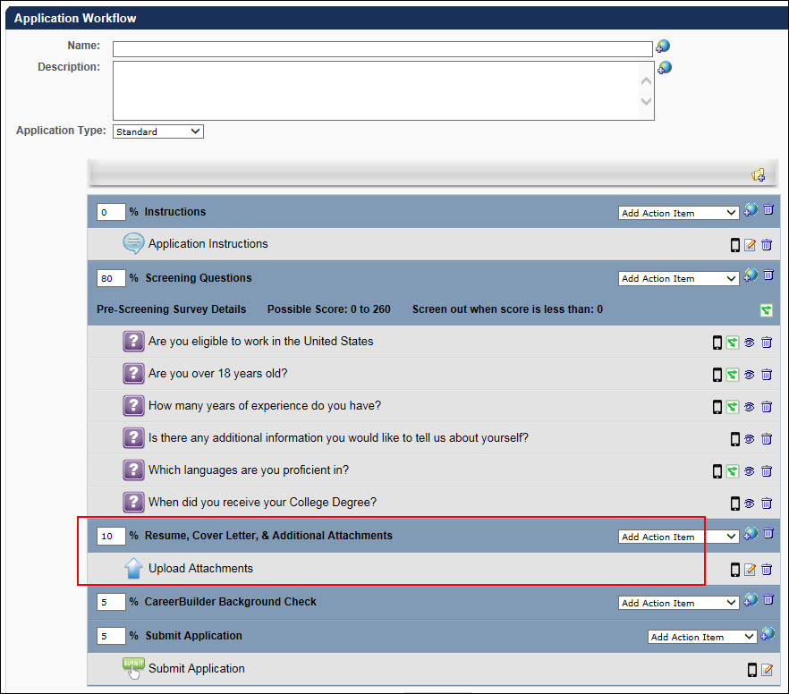
Assign AccurateAce Background Check
The AccurateAce Background Check can be assigned from the Applicant Profile > Statuses tab. The applicant's status must be changed to the custom AccurateAce Background Check status in order for the background screening to be available to assign.
Permissions
PERMISSION NAME | PERMISSION DESCRIPTION | CATEGORY

Applicants: Initiate Background Check | This permission grants access to manage background checks from the Applicant Profile page. This applies to background checks that have been configured in the Integration Center. This permission cannot be constrained. Users who have this permission will have an Assign to Applicant link in the background check status type panel on the Applicant Profile page. Once the background check is assigned, the page will display "Assigned - [Date Assigned]." | Recruiting

Applicants: View Background Check Status and Details Link | This permission allows users to view the background check status and view a link to access the background check report, which can be found in the background check status type panel on the Applicant Profile page. This permission cannot be constrained. | Recruiting

Applicants: View Background Check Status | Allow user to view the background check status. The user cannot view the link to the detailed report. This permission cannot be constrained. | Recruiting

Requisition: Manage | Grants ability to access and manage all requisitions regardless of ownership (constraints permitting). This permission also grants read-only access to the Applicant Review tab when creating or editing a job requisition. This permission can be constrained by OU, User's OU, and Grade. | Recruiting

Requisition: Owner | Enables owner to access requisitions and applicants for requisitions for which they are an owner. This permission also grants read-only access to video interviews that are completed by applicants via HireVue. For portals with Referral Suite enabled, this permission also enables requisition owners to edit the referral source on the Applicant Profile page. This permission cannot be constrained.  Note: This is a dynamically assigned permission that is not available in Security Role Administration. If the user is removed as an owner, the permission is revoked for the associated requisition. This permission cannot be manually assigned. Also, if a user has both the permission necessary to manage requisitions and be a requisition owner, the constraints of the Requisition: Manage permission overrule those of the Requisition: Owner permission. For requisition owners that do not also have permission to manage requisitions, only certain fields are editable when editing a requisition. | Recruiting

Requisition: Reviewer | Enables reviewer to access requisitions and applicants for requisitions for which they are a reviewer. This permission cannot be constrained.  Note: This is a dynamically assigned permission that is not available in Security Role Administration. Once a requisition is in a Closed or Cancelled status or if the user is removed as a reviewer, the permission is revoked for the associated requisition. This permission cannot be manually assigned.  Note: If an applicant reviewer is removed as a reviewer via the Applicant Profile page, the Requisition: Reviewer permission is revoked for the associated requisition. However, if the reviewer was also added as a reviewer via the General tab when creating, editing, or copying the requisition, the reviewer still appears on the In Review panel as a duplicate reviewer and retains access to the requisition and applicants from the Requisition: Reviewer permission. See Applicant Profile Page Overview for more information about duplicate reviewer instances. | Recruiting
Assign from Applicant Profile
To assign from the Applicant Profile page:
- Change the candidate's status to the applicable background check status on either the Manage Applicants page or the Applicant Profile page. This enables a background check to be assigned to a candidate on the Statuses tab of the Applicant Profile page.
- Navigate to the Applicant Profile > Statuses tab.
- Click the Assign to Applicant link in the background check status section. This opens the Select Screening Program Option pop-up.
- Select the AccurateAce Background Check provider from the Select Provider drop-down.
- Click Submit. This redirects the recruiter to the AccurateAce system where the appropriate screening package must be selected and assigned to the candidate. The recruiter has 30 minutes to complete this step before their AccurateAce session times out. Should a timeout occur, a background check will not be assigned to the candidate, and the recruiter will need to start the process again on the Applicant Profile page.
- 7. AccurateAce sends an email to the candidate to collect data for the remaining required fields.
If the screening request is successful and completed, the following information displays on the Applicant Profile page:
- Assigned - This field displays the date that the background screening was assigned to the candidate.
- Reference ID - This field displays the package name selected and assigned to the candidate in AccurateAce.
- Status - This field displays the overall status of the order.
  - If the request is successful, this field displays "Acknowledged."
  - If the request is not successful, this field displays "Error."
  - Once the background check process is started, this field displays "In Progress."
  - Once the background check is finished, this field displays "Completed."
The results of the background check display in the status panel on the Applicant Profile > Statuses tab. You can also view the results from the associated column on the Manage Applicants page.

A-Check Global Background Screening Integration
A-Check Global’s background screening integration with Cornerstone provides an effective resource to help organizations make well-informed hiring decisions—all within the convenience of the hiring management system you already use. A-Check Global provides employment, education, criminal, and other background checks that are required during the hiring process.
Background checks are requested from within your Cornerstone portal and are completed by A-Check Global. You can monitor the status of the background check, and once the request is completed, A-Check Global provides you with a secure link to download the results.
Implementation
This integration is available for all organizations using Recruiting. This integration is available for free via Edge Marketplace. Additional instructions for enabling and configuring the integration are available on the Setup tab of the integration in Edge.
The integration can be accessed and configured via the Edge Marketplace. In order to use this integration, your organization must be using the Recruiting module and must have access to Edge and have an account with the integration vendor. There is no additional cost associated with enabling this integration, but the integration cannot be used without an account with the integration vendor.
Permissions
The following existing permissions apply to this functionality:
PERMISSION NAME | PERMISSION DESCRIPTION | CATEGORY

Edge Integrations - Manage | Grants access to the Integrations service for Edge Integrate, where the administrator can configure, enable, and disable their third-party integrations used within the Cornerstone system. This permission cannot be constrained. This is an administrator permission. | Edge

Edge Marketplace - Manage | Grants access to the Marketplace service for Edge Integrate, where the administrator can browse integrations that can be used to extend the Cornerstone system. This permission cannot be constrained. This is an administrator permission. | Edge

Choice Screening Background Check Integration
The Choice Screening Background Check integration in Edge allows Cornerstone Recruiting clients with a Choice Screening account to seamlessly background check applicants all from within Recruiting.
The following functionality is included:
- Order Background Checks - Assign Choice Screening products and customized packages to applicants from within Cornerstone Recruiting.
- Track Background Check Status - Easily view the real-time status of an applicant’s background screening.
- View Completed Results - Access completed background checks all from within Cornerstone Recruiting.
Implementation
This integration is available for all organizations using the Recruiting suite. This integration is available for free via Edge Marketplace. Additional instructions are available in the Getting Started tab of the integration in Edge.
The Choice Screening Background Check integration can be accessed and configured via the Edge Marketplace. In order to use this integration, your organization must be using the Recruiting module and must have access to Edge and a Choice Screening Background Check account. There is no additional cost associated with enabling this integration, but the integration cannot be used without a Choice Screening Background Check account.
Permissions
The following permissions apply to this functionality:
PERMISSION NAME | PERMISSION DESCRIPTION | CATEGORY

Edge Integrations - Manage | Grants access to the Integrations service for Edge Integrate, where the administrator can configure, enable, and disable their third-party integrations used within the Cornerstone system. This permission cannot be constrained. This is an administrator permission. | Edge

Edge Marketplace - Manage | Grants access to the Marketplace service for Edge Integrate, where the administrator can browse integrations that can be used to extend the Cornerstone system. This permission cannot be constrained. This is an administrator permission. | Edge

First Advantage Background Check and Drug Screening Integration - Overview
First Advantage (FADV) integration provides screenings for background checks and drug screenings. This feature is available via Edge Integrate. Customers must also have an agreement in place with FADV in order to use this integration.
Implementation
This integration is available for all organizations using the Recruiting suite. This integration is available for free via Edge Marketplace. Additional instructions for enabling and configuring the integration are available on the Setup tab of the integration in Edge.
The integration can be accessed and configured via the Edge Marketplace. In order to use this integration, your organization must be using the Recruiting module and must have access to Edge and have an account with the integration vendor. There is no additional cost associated with enabling this integration, but the integration cannot be used without an account with the integration vendor.
Permissions
Portals must create a custom status to assign the background check and must use the Sensitive Status option in order to prevent access to the status.
The following permissions apply to FADV integrations.
PERMISSION NAME | PERMISSION DESCRIPTION | CATEGORY

Applicants: Access Sensitive Statuses | Grants ability to access the applicant statuses that are configured as sensitive. | Recruiting

Applicant Status Bank - Manage | Grants ability to access and manage Applicant Status Bank. | Recruiting Administration

Requisition: Manage | Grants ability to access and manage all requisitions regardless of ownership (constraints permitting). This permission also grants read-only access to the Applicant Review tab when creating or editing a job requisition. This permission can be constrained by OU, User's OU, and Grade. | Recruiting

Requisition: Owner | Enables owner to access requisitions and applicants for requisitions for which they are an owner. This permission also grants read-only access to video interviews that are completed by applicants via HireVue. For portals with Referral Suite enabled, this permission also enables requisition owners to edit the referral source on the Applicant Profile page. This permission cannot be constrained.  Note: This is a dynamically assigned permission that is not available in Security Role Administration. If the user is removed as an owner, the permission is revoked for the associated requisition. This permission cannot be manually assigned. Also, if a user has both the permission necessary to manage requisitions and be a requisition owner, the constraints of the Requisition: Manage permission overrule those of the Requisition: Owner permission. For requisition owners that do not also have permission to manage requisitions, only certain fields are editable when editing a requisition. | Recruiting

Requisition: Reviewer | Enables reviewer to access requisitions and applicants for requisitions for which they are a reviewer. This permission cannot be constrained.  Note: This is a dynamically assigned permission that is not available in Security Role Administration. Once a requisition is in a Closed or Cancelled status or if the user is removed as a reviewer, the permission is revoked for the associated requisition. This permission cannot be manually assigned.  Note: If an applicant reviewer is removed as a reviewer via the Applicant Profile page, the Requisition: Reviewer permission is revoked for the associated requisition. However, if the reviewer was also added as a reviewer via the General tab when creating, editing, or copying the requisition, the reviewer still appears on the In Review panel as a duplicate reviewer and retains access to the requisition and applicants from the Requisition: Reviewer permission. See Applicant Profile Page Overview for more information about duplicate reviewer instances. | Recruiting
Create Custom Applicant Status (FADV)
Administrators must create a new custom applicant status to be used for the First Advantage (FADV) background check integration. One custom status will be used for both background checks and drug screenings.
Permissions
PERMISSION NAME | PERMISSION DESCRIPTION | CATEGORY

Applicants: Access Sensitive Statuses | Grants ability to access the applicant statuses that are configured as sensitive. | Recruiting

Applicant Status Bank - Manage | Grants ability to access and manage Applicant Status Bank. | Recruiting Administration
Create Custom Status
To create a custom applicant status:
- Navigate to the Manage Applicant Statuses page.
- Click Create Custom Status. This opens the Create Custom Status pop-up.
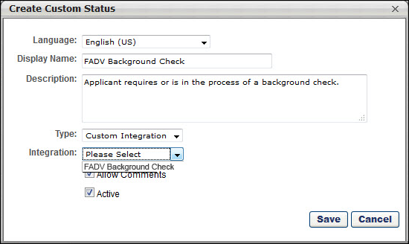
- Complete the following fields in the pop-up:
  - Language - If multiple languages are enabled, from the drop-down list select the language in which you are entering the status name and description. To localize the status name and description into other available languages, select the appropriate language from the drop-down list and enter the localized name and description in the appropriate fields.
  - Display Name - Enter the status name, which appears throughout the system. The character limit for this field is 50. When the Display Name of an active status is modified after the status is in use or has been used in a job requisition:
    - The new display name appears on the Default Status List page.
    - The new display name appears in the Status list on the job requisition template.
    - Any new job requisitions created after the display name is changed apply the new display name.
    - Job requisitions created before the status display name is changed continue to honor the name that existed at the time the requisition was created.
  - Description - Enter the status description. This should describe the purpose of the status and what is implied when an applicant is in that status. The character limit for this field is 500.
  - Type - Select Custom Integration from the drop-down. Note: This field only displays when creating a custom status at the top level OU. When creating a custom status for a child OU, the Type field displays the type selected for the parent OU but is not editable.
  - Integration - Select FADV Background check from the drop-down.
  - Allow Comments - If this option is selected, when an applicant profile has this status, comments can be applied and are tagged with this status. If the Allow Comments option is deselected for an active status, the change is applied to any templates implementing the status; new job requisitions created from the template apply the new behavior, but existing job requisitions are unaffected.
  - Active - This field is checked by default. Ensure the field is checked before saving the status so that the status is active for the portal.
- Click Save in the pop-up. This returns you to the Manage Applicant Statuses page.
- Click Save at the bottom of the Manage Applicant Statuses page to save the custom status to the Division OU. If the custom status is not saved on the Manage Applicant Statuses page, the status will be lost once you leave the page.
The custom applicant status will need to be added to the Status List on the requisition template so that it will be included on the job requisition.
Configure Status as Sensitive
The administrator must configure the FADV custom applicant status as sensitive to restrict access to the status. The status can be designated as sensitive in the following areas of the system:
- Default Status List - If the status is part of the default status list, then check the box in the Sensitive column of the default status list.
- Requisition Template - The status can be designated as sensitive on the General step when configuring job requisition templates. To designate the status as sensitive, check the box in the Sensitive column of the status list in the Status List section.
Note: Only users with permission to view sensitive statuses can view the status in the applicant status workflow.
Map Education Fields for FADV
For the purposes of being included in an applicant screening, an applicant's school type and degree type can be mapped to First Advantage (FADV). In order for FADV to receive the applicant's data, the fields will need to be mapped in Succession Management > Resume > Education.
Note: When configuring the application workflow template for the requisition, the Upload Attachment action item will need to be included so that the applicant can enter their resume data when filling out the application.
Permissions
PERMISSION NAME | PERMISSION DESCRIPTION | CATEGORY

Resume Administration | Grants access to resume administration, which enables configuration of resume sections, including custom resume fields. This permission cannot be constrained. This is an administrator permission. Note: This permission does not apply to the Universal Profile - Resume functionality. | Talent/Succession - Administration
Background Check Prerequisite
It is important to ensure that resume data exists in the system prior to submitting a background check request. Cornerstone will not send the data to FADV after a background check request has been placed.
Mapping Education Fields
The name of the field in Cornerstone (as defined in the Field Name field on the Add Field pop-up on the Resume > Education page) does not need to match the name of the field in FADV, but it must be mapped to the correct Applicant Mapping value noted in the table below.
Note: Users must have permission to access the Resume Administration page in Succession Management.
To map the fields:
- Navigate to Admin > Tools > Succession Management > Resume.
- Select the Edit icon in the Education row.
- Ensure that Education is selected in the Applicant Resume drop-down.
- Create the following fields and select the appropriate mapping option in the Applicant Mapping column:
field name in fadv | drop-down Option in applicant mapping column | field type | drop-down options to add
School Type (Note: A field on the resume in Cornerstone must be mapped to this field in Accurate in order for Accurate to process the data.) | Grade | Dropdown | - other  - highschool  - community  - college  - technicalCollege  - GED  - postGraduate  Note: The options for the dropdown field are case sensitive and must be added in the exact spelling as above in order for the data to map successfully to FADV. For example, do not capitalize "other" and do not add a space between "high" and "school."
Degree | Degree | Dropdown | - highschool  - vocational  - certification  - associates  - bachelors  - masters  - doctorate  - postdoctorate  - professional  - GED  - other  Note: The options for the dropdown field type are case sensitive and must be added in the exact spelling as above in order for the data to map successfully to FADV. For example, do not capitalize "other" and do not add a space between "high" and "school."
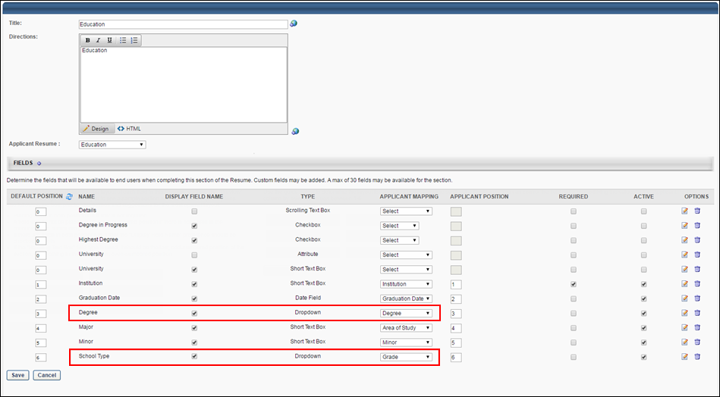
Map Reference Questions for FADV
For the purposes of being included in an applicant screening, an applicant's reference type can be mapped to First Advantage (FADV). In order for FADV to retrieve the applicant's data, a reference type question will need to be created in the Question Bank in Form Management so that the questions can be added to a form in Form Management that will be used to request the applicant's references
The name of the question in Cornerstone does not need to match the name of the field in FADV, but it must be mapped to the correctly corresponding field in FADV in order for the data to pass successfully to FADV.
There are three different sets of these questions, since applicants can submit up to three references. Each set represents one applicant reference. It is necessary to create each set. If more than three sets are created, any data outside of the first three sets will not be passed to FADV.
To access the question bank, go to Admin > Tools > Core Functions > Form Management. Then, click the Question Bank link.
Permissions
PERMISSION NAME | PERMISSION DESCRIPTION | CATEGORY

Manage Forms - Manage | Grants access to the Manage Forms functionality. This permission can be constrained by OU and User's OU. This is an administrator permission.  Note: This permission enables access to the Form Management functionality that is part of Cornerstone HR functionality and the Onboarding module. This permission does not grant access to the Training Forms Management functionality. | Forms Management Administration

Question Bank - Manage | Grants access to the Question Bank functionality. This permission can be constrained by OU and User's OU. This is an administrator permission. | Forms Management Administration
Background Check Prerequisite
It is important to ensure that reference data exists in the system prior to submitting a background check request. Cornerstone will not send the data to FADV after a background check request has been placed.
Create Questions
To create the questions:
- Navigate to Admin > Tools > core functions > form management > question bank.
- Click Create Question.
- Select Dropdown as the field type.
- Configure each question separately by entering a name for the question in the Question field and entering the API exactly as it is listed in the right-hand column.
Note about the FADV Telephone Field: When applicants enter a telephone number, they must enter it in the following format, or FADV will not load the data: +(country code) XXXXXXXXXX OR +(country code) (XXX)XXX-XXXX].
field name in fadv |  |  | field type | enter this api in the api name field on the create question page
SET 1
Given Name |  |  | Text | FADV_GivenName_1
Family Name |  |  | Text | FADV_FamilyName_1
Email Address |  |  | Text | FADV_Email_1
Telephone |  |  | Text | FADV_Phone_1
SET 2
Given Name |  |  | Text | FADV_GivenName_2
Family Name |  |  | Text | FADV_FamilyName_2
Email Address |  |  | Text | FADV_Email_2
Telephone |  |  | Text | FADV_Phone_2
SET 3
Given Name |  |  | Text | FADV_GivenName_3
Family Name |  |  | Text | FADV_FamilyName_3
Email Address |  |  | Text | FADV_Email_3
Telephone |  |  | Text | FADV_Phone_3
Create Form
Once you have created the questions, navigate to Form Management > Manage Forms and create a form for requesting an applicant's references, making sure to enter FADV_Reference_Form in the API Name field on the Build tab. The purpose of entering this API name is so that the system knows the correct form to send to FADV. See Build Tab - Define General Information.
On the form, add the questions that you created above. The references request form will be assigned to applicants on the Manage Applicants page. The form will be available to the applicant from their My Profile page in the career site, where they can then launch and complete the form.
Change Applicant Status to First Advantage
In order for applicants to be assigned the First Advantage (FADV) background check, the applicant's status must be changed to the custom FADV status. The status can be changed on Manage Candidates or by clicking the Change Status action on the Manage Applicants page for the desired applicants.
Manage Applicants Deprecation: Cornerstone is deprecating Manage Applicants in Q1 2024. See Manage Applicants Overview.
Permissions
PERMISSION NAME | PERMISSION DESCRIPTION | CATEGORY

Requisition: Manage | Grants ability to access and manage all requisitions regardless of ownership (constraints permitting). This permission also grants read-only access to the Applicant Review tab when creating or editing a job requisition. This permission can be constrained by OU, User's OU, and Grade. | Recruiting
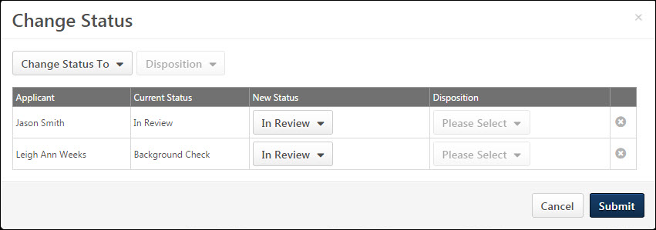
Applicant Profile - Assign First Advantage Screening
The First Advantage (FADV) screening is assigned to applicants from Manage Candidates or the FADV status panel on the Statuses tab on the Applicant Profile page. Applicants must be in the custom FADV status in order to assign the screening.
When applicants complete the screening, data is passed between Cornerstone and FADV, including the following:
- Cost Center OU Name - This is the Cost Center Organizational Unit (OU) associated to the job requisition to which the candidate applied. In FADV this is an alphanumeric field with a character limit of 250.
- Position OU Name - This field maps to the Display Job Title field on the job requisition to which the applicant applied. In FADV this is an alphanumeric field with a character limit of 250.
- Grade OU Name - This field maps to the Grade OU associated on the job requisition to which the applicant applied. In FADV this is an alphanumeric field with a character limit of 250.
For additional details and options available in the First Advantage status type panel, see the Applicant Profile - First Advantage Status Panel topic in Online Help.
Permissions
PERMISSION NAME | PERMISSION DESCRIPTION | CATEGORY

Applicants: Access Sensitive Statuses | Grants ability to access the applicant statuses that are configured as sensitive. | Recruiting

Requisition: Manage | Grants ability to access and manage all requisitions regardless of ownership (constraints permitting). This permission also grants read-only access to the Applicant Review tab when creating or editing a job requisition. This permission can be constrained by OU, User's OU, and Grade. | Recruiting

Requisition: Owner | Enables owner to access requisitions and applicants for requisitions for which they are an owner. This permission also grants read-only access to video interviews that are completed by applicants via HireVue. For portals with Referral Suite enabled, this permission also enables requisition owners to edit the referral source on the Applicant Profile page. This permission cannot be constrained.  Note: This is a dynamically assigned permission that is not available in Security Role Administration. If the user is removed as an owner, the permission is revoked for the associated requisition. This permission cannot be manually assigned. Also, if a user has both the permission necessary to manage requisitions and be a requisition owner, the constraints of the Requisition: Manage permission overrule those of the Requisition: Owner permission. For requisition owners that do not also have permission to manage requisitions, only certain fields are editable when editing a requisition. | Recruiting

Requisition: Reviewer | Enables reviewer to access requisitions and applicants for requisitions for which they are a reviewer. This permission cannot be constrained.  Note: This is a dynamically assigned permission that is not available in Security Role Administration. Once a requisition is in a Closed or Cancelled status or if the user is removed as a reviewer, the permission is revoked for the associated requisition. This permission cannot be manually assigned.  Note: If an applicant reviewer is removed as a reviewer via the Applicant Profile page, the Requisition: Reviewer permission is revoked for the associated requisition. However, if the reviewer was also added as a reviewer via the General tab when creating, editing, or copying the requisition, the reviewer still appears on the In Review panel as a duplicate reviewer and retains access to the requisition and applicants from the Requisition: Reviewer permission. See Applicant Profile Page Overview for more information about duplicate reviewer instances. | Recruiting
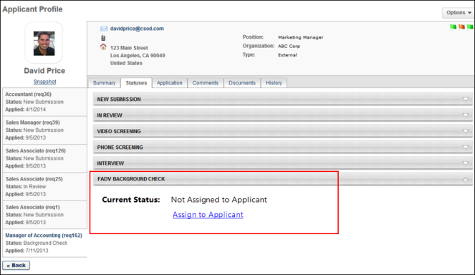
Assign from Manage Candidates
See Manage Candidates - Assign Integrations.
Assign from Applicant Profile
To assign the FADV screening:
- Click Assign to Applicant in the FADV status panel. This opens the Select Screening Program Option pop-up.
- Select the FADV account from the Select Account drop-down. The options in the drop-down are the account values sent by FADV.
- Select the package from the Select Package drop-down. The options in the drop-down are the package values sent by FADV.
- Click Submit to assign the screening. The selected account and package information is sent to FADV, and FADV sends an email to the applicant once the screening is assigned.
Applicant Profile - First Advantage Status Panel
The FADV status panel on the Statuses tab of the Applicant Profile page allows recruiters to assign screenings to applicants and view updates from FADV regarding the applicant's progress on completing the screening.
Permissions
PERMISSION NAME | PERMISSION DESCRIPTION | CATEGORY

Applicants: Access Sensitive Statuses | Grants ability to access the applicant statuses that are configured as sensitive. | Recruiting

Requisition: Manage | Grants ability to access and manage all requisitions regardless of ownership (constraints permitting). This permission also grants read-only access to the Applicant Review tab when creating or editing a job requisition. This permission can be constrained by OU, User's OU, and Grade. | Recruiting

Requisition: Owner | Enables owner to access requisitions and applicants for requisitions for which they are an owner. This permission also grants read-only access to video interviews that are completed by applicants via HireVue. For portals with Referral Suite enabled, this permission also enables requisition owners to edit the referral source on the Applicant Profile page. This permission cannot be constrained.  Note: This is a dynamically assigned permission that is not available in Security Role Administration. If the user is removed as an owner, the permission is revoked for the associated requisition. This permission cannot be manually assigned. Also, if a user has both the permission necessary to manage requisitions and be a requisition owner, the constraints of the Requisition: Manage permission overrule those of the Requisition: Owner permission. For requisition owners that do not also have permission to manage requisitions, only certain fields are editable when editing a requisition. | Recruiting

Requisition: Reviewer | Enables reviewer to access requisitions and applicants for requisitions for which they are a reviewer. This permission cannot be constrained.  Note: This is a dynamically assigned permission that is not available in Security Role Administration. Once a requisition is in a Closed or Cancelled status or if the user is removed as a reviewer, the permission is revoked for the associated requisition. This permission cannot be manually assigned.  Note: If an applicant reviewer is removed as a reviewer via the Applicant Profile page, the Requisition: Reviewer permission is revoked for the associated requisition. However, if the reviewer was also added as a reviewer via the General tab when creating, editing, or copying the requisition, the reviewer still appears on the In Review panel as a duplicate reviewer and retains access to the requisition and applicants from the Requisition: Reviewer permission. See Applicant Profile Page Overview for more information about duplicate reviewer instances. | Recruiting
Screening Not Yet Assigned
When a screening is not yet assigned to the applicant, the FADV status panel displays the following information:
- Current Status - This field displays a status of Not Assigned to Applicant to indicate that the screening is not yet assigned to the applicant.
- Assign to Applicant - The Assign to Applicant link displays below the status to enable recruiters to assign an FADV screening to the applicant. The link only displays if the screening has not yet been assigned to the applicant.
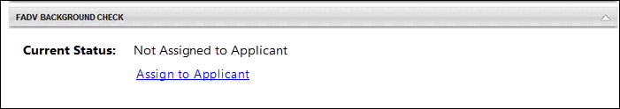
For detailed information about assigning a FADV screening, see the Applicant Profile - Assign First Advantage Screening topic in Online Help.
Screening Assigned
Once the screening is assigned, FADV sends updates to the system as the screening progresses through the various stages and statuses. The FADV status panel displays each status update. The following information displays in the status panel, depending on the stage of the screening process:
- Assigned - This field displays the date on which the screening was assigned.
- Reference ID - This field displays the Cornerstone Reference ID.
- Status - This field displays the status of the screening order (i.e., ordering a background check from FADV for an applicant) as Acknowledge, In Progress, or Completed.
- Background Package - This section displays once the applicant has submitted the screening. The "Background Package" section title in the status panel only displays if the applicant has been assigned a background package. If a background package was not assigned, a different package name will display. The following package information displays in the section:
  - Provider Reference ID - This field displays the reference ID returned from FADV for the order.
  - Status - This field displays the order status as In Progress, Completed, or Cancelled.
  - Result - This field displays the result and score (if applicable) of the screening. The value of the result is dependent upon the type of screening, either background check or drug screening. The following are the possible result values:
    - Background Checks - The following are the possible result or score values:
      - Pass
      - Fail
      - Eligible
      - Ineligible
      - Decisional
    - Drug Screenings - The following are the possible result or score values:
      - Pass
      - Fail
      - Positive
      - Negative
  - Check Order Progress - This option displays for screenings that have an In Progress status. Clicking the Check Order Progress link opens the order progress details on the FADV site. Availability for viewing the order progress is controlled by FADV.
  - View Report - This option displays for screenings that are in a Completed status. Clicking the View Report link opens the FADV site to display details regarding the Screening Report.
Multiple Screenings
If an applicant has multiple screenings, then the status panel displays the information for each screening in the same status panel but as separate sections within the panel.
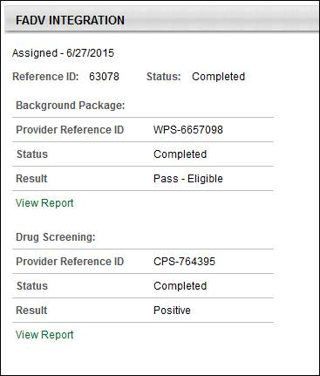
Applicant Profile - History Tab (FADV)
When a First Advantage (FADV) screening is assigned to an applicant or completed by FADV, the History tab on the Applicant Profile page logs the event.
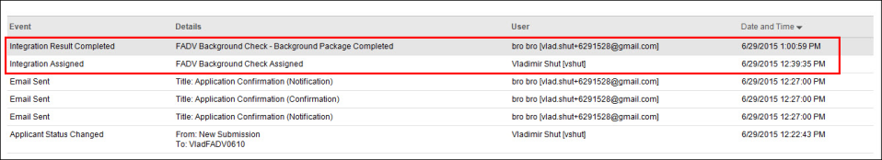
Integration Assigned
The Integration Assigned event is logged when an FADV screening is assigned to an applicant. The following information displays for the event:
- Event Title - This column displays the name of the event as Integration Assigned.
- Details - This column displays "<Integration Name> Assigned."
- User - This column displays the name of the user who executed the event along with their user name if available, as "<Jeremy Johnson [jjohnson]>."
- Date and Time - This column displays the date and time associated with the event.
Integration Result Completed
The Integration Result Completed event is logged when FADV sends the system a Completed status for the screening. The following information displays for the event:
- Event Title - This column displays the name of the event as Integration Assigned.
- Details - This column displays "<Integration Name - [Background Check Package Title] [Drug Screening Package Title] Result> Completed." Note: If the background check or drug screening does not have a title from FADV, then the title displays as the name of the custom FADV applicant status.
- User - This column displays the name of the user who executed the event along with their user name if available, as "<Jeremy Johnson [jjohnson]>."
- Date and Time - This column displays the date and time associated with the event.
Manage Applicants - View First Advantage Results Column
Recruiters can view the status and results of a First Advantage (FADV) screening assignment on Manage Candidates or Manage Applicants.
Note: For users who do not have access to view the data in the column because the custom FADV status is configured as sensitive and the user does not have permission to view sensitive statuses, the column is blank.
Permissions
PERMISSION NAME | PERMISSION DESCRIPTION | CATEGORY

Applicants: Access Sensitive Statuses | Grants ability to access the applicant statuses that are configured as sensitive. | Recruiting

Requisition: Manage | Grants ability to access and manage all requisitions regardless of ownership (constraints permitting). This permission also grants read-only access to the Applicant Review tab when creating or editing a job requisition. This permission can be constrained by OU, User's OU, and Grade. | Recruiting

Requisition: Owner | Enables owner to access requisitions and applicants for requisitions for which they are an owner. This permission also grants read-only access to video interviews that are completed by applicants via HireVue. For portals with Referral Suite enabled, this permission also enables requisition owners to edit the referral source on the Applicant Profile page. This permission cannot be constrained.  Note: This is a dynamically assigned permission that is not available in Security Role Administration. If the user is removed as an owner, the permission is revoked for the associated requisition. This permission cannot be manually assigned. Also, if a user has both the permission necessary to manage requisitions and be a requisition owner, the constraints of the Requisition: Manage permission overrule those of the Requisition: Owner permission. For requisition owners that do not also have permission to manage requisitions, only certain fields are editable when editing a requisition. | Recruiting

Requisition: Reviewer | Enables reviewer to access requisitions and applicants for requisitions for which they are a reviewer. This permission cannot be constrained.  Note: This is a dynamically assigned permission that is not available in Security Role Administration. Once a requisition is in a Closed or Cancelled status or if the user is removed as a reviewer, the permission is revoked for the associated requisition. This permission cannot be manually assigned.  Note: If an applicant reviewer is removed as a reviewer via the Applicant Profile page, the Requisition: Reviewer permission is revoked for the associated requisition. However, if the reviewer was also added as a reviewer via the General tab when creating, editing, or copying the requisition, the reviewer still appears on the In Review panel as a duplicate reviewer and retains access to the requisition and applicants from the Requisition: Reviewer permission. See Applicant Profile Page Overview for more information about duplicate reviewer instances. | Recruiting
View on Manage Candidates
See Manage Candidates Page (Early Adopter).
View on Manage Applicants
On the Manage Applicants page, a column displays in the applicants table to provide updates based on data received from FADV. The column must be configured to display on the Edit Page Layout page.
The column name displays as <Name of Integration>. The following are the possible values in the column:
- <Blank> - If the user does not have permission to view the custom status, then no value displays.
- Not Assigned - This displays if a screening has not yet been assigned to the applicant.
- Assigned - This displays if the screening has been assigned but the applicant has not yet started the application and a status has not been sent from FADV. Note: The term "application" refers to the screening application that the applicant must complete for FADV.
- Status: In Progress - In Progress displays if FADV has not yet returned a final result for the screening.
- Result - The result displays as <Screening Package Title>: <Result Value><Score Value, if applicable>. A result displays for each screening package that has been completed or cancelled and FADV has returned a final result value for the screening. The score displays only if a score has been provided by FADV as part of the type of screening.
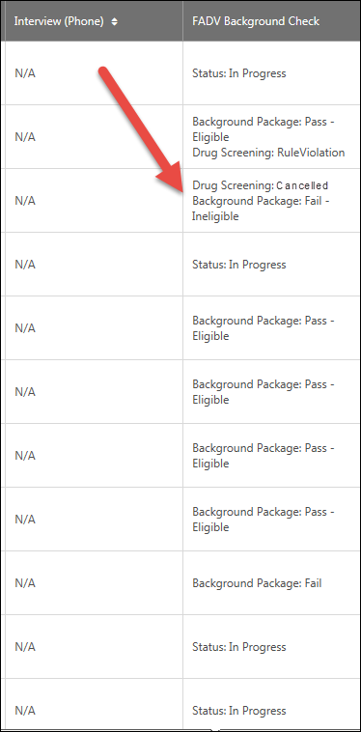
Analytics (FADV)
Reports can be created to report on First Advantage (FADV) data. Fields are available in the External Vendor section to report on the assigned and completed date, as well as the external vendor name, package result, package title, product, product result, product score, and vendor status.
These fields are in addition to the standard fields available for Recruiting reports.

HireRight Global Employment Screening Integration
The HireRight Global Employment Screening integration lets you order any of the HireRight 200+ global background screening and drug testing services directly from within Cornerstone. Status updates are provided in real-time, providing you with fast and reliable visibility into screening orders.
If you are using the legacy HireRight integration, please contact HireRight to begin the migration process.
Migration
If your company has an assigned HireRight Account Manager, contact them directly and they will guide you through the migration process.
If your company does not have an assigned HireRight Account Manager, contact HireRight Customer Support and tell them you want to be migrated to the Cornerstone Edge HireRight integration, and the HireRight Customer Support representative will start the migration process.
Implementation
This integration is available for all organizations using the Recruiting suite. This integration is available for free via Edge Marketplace. Additional instructions for enabling and configuring the integration are available on the Setup tab of the integration in Edge.
The integration can be accessed and configured via the Edge Marketplace. In order to use this integration, your organization must be using the Recruiting module and must have access to Edge and have an account with the integration vendor. There is no additional cost associated with enabling this integration, but the integration cannot be used without an account with the integration vendor.
Permissions
The following permissions apply to this functionality:
PERMISSION NAME | PERMISSION DESCRIPTION | CATEGORY

Edge Integrations - Manage | Grants access to the Integrations service for Edge Integrate, where the administrator can configure, enable, and disable their third-party integrations used within the Cornerstone system. This permission cannot be constrained. This is an administrator permission. | Edge

Edge Marketplace - Manage | Grants access to the Marketplace service for Edge Integrate, where the administrator can browse integrations that can be used to extend the Cornerstone system. This permission cannot be constrained. This is an administrator permission. | Edge

Referoo Integration
Referoo has integrated with Cornerstone to allow Cornerstone users to select candidates and request they complete the Referoo reference check process. Clients can create unlimited packages within the Referoo Application and access them within Cornerstone. Status updates are displayed in Cornerstone and final results and report URL returned to Cornerstone.
Implementation
The integration will be available to self-enable on 23 September 2022 via Edge Marketplace for all organizations using Recruiting and have an account with the integration vendor.
Additional instructions for enabling and configuring the integration are available in Edge. See Edge Integration - Configure.
Permissions
The following existing permissions apply to this functionality:
PERMISSION NAME | PERMISSION DESCRIPTION | CATEGORY

Edge Integrations - Manage | Grants access to the Integrations service for Edge Integrate, where the administrator can configure, enable, and disable their third-party integrations used within the Cornerstone system. This permission cannot be constrained. This is an administrator permission. | Edge

Edge Marketplace - Manage | Grants access to the Marketplace service for Edge Integrate, where the administrator can browse integrations that can be used to extend the Cornerstone system. This permission cannot be constrained. This is an administrator permission. | Edge

Sterling Integration - Overview
The Sterling integration is a background check and drug screening tool. This integration streamlines and improves recruiters' efficacy of their hiring process.
Use Cases
Use Case 1: Activate the Sterling integration through Edge
- James is Acme Company's administrator and has been tasked with enabling the integration between Cornerstone and Sterling . This will allow Acme to include Sterling background checks in their hiring workflow.
- James goes to the Edge Marketplace to purchase and activate the Sterling integration.
- From the Edge Integrate page, James enters Acme's unique Client ID, Auth Key, Account Name, Background Check Names and corresponding IDs. These are provided by the Sterling project team.
- Acme's Cornerstone portal now has an active integration between Sterling and Cornerstone.
Use Case 2: Recruiting Administrator configures Sterling Assessment action step in Application Workflow
- Lisa is the Recruiting administrator for Acme.
- Holly, a hiring manager at Acme, is looking to add a new member to her Marketing team.
- With the integration enabled, Lisa is tasked with adding a background check status in all of Acme's marketing job requisitions.
- Lisa creates a new custom applicant status that is set to a custom integration type under Sterling Background Check.
- Lisa has now configured the Marketing job requisitions to include the Sterling custom status.
Use Case 3: Recruiter assigns background check request for an applicant
- Ashley, a recruiter at Acme, has identified Paul James to be a qualified applicant.
- To ensure a sound hiring decision is made and to protect Acme from potential risks, Ashley assigns a background check for Paul by moving Paul's applicant status to Sterling Background Check.
- Ashley selects the appropriate background screening package, then submits the request.
- Paul receives an email from Sterling and clicks on the link to complete the screening application request in Sterling.
Use Case 4: Recruiter, who does not have an existing account in Sterling, assigns a background check request for an applicant
- Toby is a new recruiter at Acme.
- James, Acme’s administrator for both Cornerstone and Sterling, was tasked with creating a user record for Toby in both systems. James created a user record for Toby in Cornerstone but failed to do so in Sterling.
- Working under the assumption that he can begin working in both systems, Toby was tasked with assigning a background check to the applicant, Dan White.
- Toby selects the appropriate background screening package then submits the request.
- Sterling identifies that Toby does not exist in their system and creates a user record for him. Note: The user must have a valid email address in your Cornerstone portal in order for Sterling to automatically create a user record in the Sterling system.
- Dan White is assigned to a background check successfully and receives an email from Sterling.
Use Case 5: Recruiter views background check results and its detailed report in Sterling via a link
- Ashley is eager to find out the results of Paul's background check status.
- Ashley navigates to Paul's Applicant Profile Status page and sees the status on the request.
- To view additional details of the background request, Ashley clicks on the View Progress link, which will SSO her into Sterling site.
Use Case 6: Hiring manager, who does not have an existing account in Sterling, attempts to view a detailed report in Sterling via a link.
- Holly, one of Acme's hiring managers, does not have permissions in Cornerstone to assign a background check but has permissions to view its results.
- Holly would like to finalize hiring decisions and decides to review Paul's background check results.
- Holly navigates to Paul's Applicant Profile > Statuses page and clicks on the View Progress link. Note: Only the background check order request API has a provision to create a new user. If the user does not have an account in Sterling, the detailed report link will not automatically create a user record in Sterling. In order to allow access to this user, the client administrator should manually create users in Sterling.
- Upon launching the link, Holly receives an SSO error message indicating that she does not have an account in Sterling to view the report.
Implementation
This functionality is only available for organizations using Recruiting and must be purchased and activated via the Edge Integration Marketplace. It is necessary to have a contract and purchased assessments from Sterling Talent Solutions to implement the integration. The Sterling integration will need to be activated via Edge Integrate, and you will need to provide your company's pre-existing Sterling unique identifiers.
Security
The following existing permissions apply to this functionality:
PERMISSION NAME | PERMISSION DESCRIPTION | CATEGORY

Applicants: Initiate Background Check | This permission grants access to manage background checks from the Applicant Profile page. This applies to background checks that have been configured in the Integration Center. This permission cannot be constrained. Users who have this permission will have an Assign to Applicant link in the background check status type panel on the Applicant Profile page. Once the background check is assigned, the page will display "Assigned - [Date Assigned]." | Recruiting

Applicant Status Bank - Manage | Grants ability to access and manage Applicant Status Bank. | Recruiting Administration

Applicants: View Background Check Status | Allow user to view the background check status. The user cannot view the link to the detailed report. This permission cannot be constrained. | Recruiting

Applicants: View Background Check Status and Details Link | This permission allows users to view the background check status and view a link to access the background check report, which can be found in the background check status type panel on the Applicant Profile page. This permission cannot be constrained. | Recruiting

Application Workflow Template - Manage | Grants ability to access and manage Application Workflow Templates. This permission can be constrained by OU and User’s OU. This is an administrator permission. | Recruiting Administration

Application Workflow Template - View | Grants ability to access and view Application Workflow Templates. | Recruiting Administration

Edge Integrations - Manage | Grants access to the Integrations service for Edge Integrate, where the administrator can configure, enable, and disable their third-party integrations used within the Cornerstone system. This permission cannot be constrained. This is an administrator permission. | Edge

Edge Marketplace - Manage | Grants access to the Marketplace service for Edge Integrate, where the administrator can browse integrations that can be used to extend the Cornerstone system. This permission cannot be constrained. This is an administrator permission. | Edge

Manage Forms - Manage | Grants access to the Manage Forms functionality. This permission can be constrained by OU and User's OU. This is an administrator permission.  Note: This permission enables access to the Form Management functionality that is part of Cornerstone HR functionality and the Onboarding module. This permission does not grant access to the Training Forms Management functionality. | Forms Management Administration

Global Email Administration - Manage | Grants ability to manage email trigger templates across all active modules in the portal. Enables creating, editing and deleting email message templates for various system actions and workflows. This permission can be constrained by OU, User's OU, User Self and Subordinates, and User. This is an administrator permission. | Core Administration

Global Email Administration - View | Grants view only access to email templates/triggers and email logs at the global level for the portal. This permission can be constrained by OU, User's OU, User Self and Subordinates, and User. This is an administrator permission. | Core Administration

Requisition: Manage | Grants ability to access and manage all requisitions regardless of ownership (constraints permitting). This permission also grants read-only access to the Applicant Review tab when creating or editing a job requisition. This permission can be constrained by OU, User's OU, and Grade. | Recruiting

Requisition: Owner | Enables owner to access requisitions and applicants for requisitions for which they are an owner. This permission also grants read-only access to video interviews that are completed by applicants via HireVue. For portals with Referral Suite enabled, this permission also enables requisition owners to edit the referral source on the Applicant Profile page. This permission cannot be constrained.  Note: This is a dynamically assigned permission that is not available in Security Role Administration. If the user is removed as an owner, the permission is revoked for the associated requisition. This permission cannot be manually assigned. Also, if a user has both the permission necessary to manage requisitions and be a requisition owner, the constraints of the Requisition: Manage permission overrule those of the Requisition: Owner permission. For requisition owners that do not also have permission to manage requisitions, only certain fields are editable when editing a requisition. | Recruiting

Requisition: Reviewer | Enables reviewer to access requisitions and applicants for requisitions for which they are a reviewer. This permission cannot be constrained.  Note: This is a dynamically assigned permission that is not available in Security Role Administration. Once a requisition is in a Closed or Cancelled status or if the user is removed as a reviewer, the permission is revoked for the associated requisition. This permission cannot be manually assigned.  Note: If an applicant reviewer is removed as a reviewer via the Applicant Profile page, the Requisition: Reviewer permission is revoked for the associated requisition. However, if the reviewer was also added as a reviewer via the General tab when creating, editing, or copying the requisition, the reviewer still appears on the In Review panel as a duplicate reviewer and retains access to the requisition and applicants from the Requisition: Reviewer permission. See Applicant Profile Page Overview for more information about duplicate reviewer instances. | Recruiting

Resume Administration | Grants access to resume administration, which enables configuration of resume sections, including custom resume fields. This permission cannot be constrained. This is an administrator permission. Note: This permission does not apply to the Universal Profile - Resume functionality. | Talent/Succession - Administration
Sterling Integration - Overview
The Sterling integration is a background check and drug screening tool. This integration streamlines and improves recruiters' efficacy of their hiring process.
Use Cases
Use Case 1: Activate the Sterling integration through Edge
- James is Acme Company's administrator and has been tasked with enabling the integration between Cornerstone and Sterling . This will allow Acme to include Sterling background checks in their hiring workflow.
- James goes to the Edge Marketplace to purchase and activate the Sterling integration.
- From the Edge Integrate page, James enters Acme's unique Client ID, Auth Key, Account Name, Background Check Names and corresponding IDs. These are provided by the Sterling project team.
- Acme's Cornerstone portal now has an active integration between Sterling and Cornerstone.
Use Case 2: Recruiting Administrator configures Sterling Assessment action step in Application Workflow
- Lisa is the Recruiting administrator for Acme.
- Holly, a hiring manager at Acme, is looking to add a new member to her Marketing team.
- With the integration enabled, Lisa is tasked with adding a background check status in all of Acme's marketing job requisitions.
- Lisa creates a new custom applicant status that is set to a custom integration type under Sterling Background Check.
- Lisa has now configured the Marketing job requisitions to include the Sterling custom status.
Use Case 3: Recruiter assigns background check request for an applicant
- Ashley, a recruiter at Acme, has identified Paul James to be a qualified applicant.
- To ensure a sound hiring decision is made and to protect Acme from potential risks, Ashley assigns a background check for Paul by moving Paul's applicant status to Sterling Background Check.
- Ashley selects the appropriate background screening package, then submits the request.
- Paul receives an email from Sterling and clicks on the link to complete the screening application request in Sterling.
Use Case 4: Recruiter, who does not have an existing account in Sterling, assigns a background check request for an applicant
- Toby is a new recruiter at Acme.
- James, Acme’s administrator for both Cornerstone and Sterling, was tasked with creating a user record for Toby in both systems. James created a user record for Toby in Cornerstone but failed to do so in Sterling.
- Working under the assumption that he can begin working in both systems, Toby was tasked with assigning a background check to the applicant, Dan White.
- Toby selects the appropriate background screening package then submits the request.
- Sterling identifies that Toby does not exist in their system and creates a user record for him. Note: The user must have a valid email address in your Cornerstone portal in order for Sterling to automatically create a user record in the Sterling system.
- Dan White is assigned to a background check successfully and receives an email from Sterling.
Use Case 5: Recruiter views background check results and its detailed report in Sterling via a link
- Ashley is eager to find out the results of Paul's background check status.
- Ashley navigates to Paul's Applicant Profile Status page and sees the status on the request.
- To view additional details of the background request, Ashley clicks on the View Progress link, which will SSO her into Sterling site.
Use Case 6: Hiring manager, who does not have an existing account in Sterling, attempts to view a detailed report in Sterling via a link.
- Holly, one of Acme's hiring managers, does not have permissions in Cornerstone to assign a background check but has permissions to view its results.
- Holly would like to finalize hiring decisions and decides to review Paul's background check results.
- Holly navigates to Paul's Applicant Profile > Statuses page and clicks on the View Progress link. Note: Only the background check order request API has a provision to create a new user. If the user does not have an account in Sterling, the detailed report link will not automatically create a user record in Sterling. In order to allow access to this user, the client administrator should manually create users in Sterling.
- Upon launching the link, Holly receives an SSO error message indicating that she does not have an account in Sterling to view the report.
Implementation
This functionality is only available for organizations using Recruiting and must be purchased and activated via the Edge Integration Marketplace. It is necessary to have a contract and purchased assessments from Sterling Talent Solutions to implement the integration. The Sterling integration will need to be activated via Edge Integrate, and you will need to provide your company's pre-existing Sterling unique identifiers.
Security
The following existing permissions apply to this functionality:
PERMISSION NAME | PERMISSION DESCRIPTION | CATEGORY

Applicants: Initiate Background Check | This permission grants access to manage background checks from the Applicant Profile page. This applies to background checks that have been configured in the Integration Center. This permission cannot be constrained. Users who have this permission will have an Assign to Applicant link in the background check status type panel on the Applicant Profile page. Once the background check is assigned, the page will display "Assigned - [Date Assigned]." | Recruiting

Applicant Status Bank - Manage | Grants ability to access and manage Applicant Status Bank. | Recruiting Administration

Applicants: View Background Check Status | Allow user to view the background check status. The user cannot view the link to the detailed report. This permission cannot be constrained. | Recruiting

Applicants: View Background Check Status and Details Link | This permission allows users to view the background check status and view a link to access the background check report, which can be found in the background check status type panel on the Applicant Profile page. This permission cannot be constrained. | Recruiting

Application Workflow Template - Manage | Grants ability to access and manage Application Workflow Templates. This permission can be constrained by OU and User’s OU. This is an administrator permission. | Recruiting Administration

Application Workflow Template - View | Grants ability to access and view Application Workflow Templates. | Recruiting Administration

Edge Integrations - Manage | Grants access to the Integrations service for Edge Integrate, where the administrator can configure, enable, and disable their third-party integrations used within the Cornerstone system. This permission cannot be constrained. This is an administrator permission. | Edge

Edge Marketplace - Manage | Grants access to the Marketplace service for Edge Integrate, where the administrator can browse integrations that can be used to extend the Cornerstone system. This permission cannot be constrained. This is an administrator permission. | Edge

Manage Forms - Manage | Grants access to the Manage Forms functionality. This permission can be constrained by OU and User's OU. This is an administrator permission.  Note: This permission enables access to the Form Management functionality that is part of Cornerstone HR functionality and the Onboarding module. This permission does not grant access to the Training Forms Management functionality. | Forms Management Administration

Global Email Administration - Manage | Grants ability to manage email trigger templates across all active modules in the portal. Enables creating, editing and deleting email message templates for various system actions and workflows. This permission can be constrained by OU, User's OU, User Self and Subordinates, and User. This is an administrator permission. | Core Administration

Global Email Administration - View | Grants view only access to email templates/triggers and email logs at the global level for the portal. This permission can be constrained by OU, User's OU, User Self and Subordinates, and User. This is an administrator permission. | Core Administration

Requisition: Manage | Grants ability to access and manage all requisitions regardless of ownership (constraints permitting). This permission also grants read-only access to the Applicant Review tab when creating or editing a job requisition. This permission can be constrained by OU, User's OU, and Grade. | Recruiting

Requisition: Owner | Enables owner to access requisitions and applicants for requisitions for which they are an owner. This permission also grants read-only access to video interviews that are completed by applicants via HireVue. For portals with Referral Suite enabled, this permission also enables requisition owners to edit the referral source on the Applicant Profile page. This permission cannot be constrained.  Note: This is a dynamically assigned permission that is not available in Security Role Administration. If the user is removed as an owner, the permission is revoked for the associated requisition. This permission cannot be manually assigned. Also, if a user has both the permission necessary to manage requisitions and be a requisition owner, the constraints of the Requisition: Manage permission overrule those of the Requisition: Owner permission. For requisition owners that do not also have permission to manage requisitions, only certain fields are editable when editing a requisition. | Recruiting

Requisition: Reviewer | Enables reviewer to access requisitions and applicants for requisitions for which they are a reviewer. This permission cannot be constrained.  Note: This is a dynamically assigned permission that is not available in Security Role Administration. Once a requisition is in a Closed or Cancelled status or if the user is removed as a reviewer, the permission is revoked for the associated requisition. This permission cannot be manually assigned.  Note: If an applicant reviewer is removed as a reviewer via the Applicant Profile page, the Requisition: Reviewer permission is revoked for the associated requisition. However, if the reviewer was also added as a reviewer via the General tab when creating, editing, or copying the requisition, the reviewer still appears on the In Review panel as a duplicate reviewer and retains access to the requisition and applicants from the Requisition: Reviewer permission. See Applicant Profile Page Overview for more information about duplicate reviewer instances. | Recruiting

Resume Administration | Grants access to resume administration, which enables configuration of resume sections, including custom resume fields. This permission cannot be constrained. This is an administrator permission. Note: This permission does not apply to the Universal Profile - Resume functionality. | Talent/Succession - Administration
Sterling Integration Implementation Steps
Setting up the integration includes enabling the integration in Edge and completing pre-steps for mapping resume fields, as well as creating reference forms that can be used to request references.
Permissions
PERMISSION NAME | PERMISSION DESCRIPTION | CATEGORY

Edge Integrations - Manage | Grants access to the Integrations service for Edge Integrate, where the administrator can configure, enable, and disable their third-party integrations used within the Cornerstone system. This permission cannot be constrained. This is an administrator permission. | Edge

Edge Marketplace - Manage | Grants access to the Marketplace service for Edge Integrate, where the administrator can browse integrations that can be used to extend the Cornerstone system. This permission cannot be constrained. This is an administrator permission. | Edge

Manage Forms - Manage | Grants access to the Manage Forms functionality. This permission can be constrained by OU and User's OU. This is an administrator permission.  Note: This permission enables access to the Form Management functionality that is part of Cornerstone HR functionality and the Onboarding module. This permission does not grant access to the Training Forms Management functionality. | Forms Management Administration

Resume Administration | Grants access to resume administration, which enables configuration of resume sections, including custom resume fields. This permission cannot be constrained. This is an administrator permission. Note: This permission does not apply to the Universal Profile - Resume functionality. | Talent/Succession - Administration
Pre-Steps
Note: In order to send resume and/or reference fields to Sterling, Succession Management and Form Management must be available in your portal, respectively. This resume mapping is an optional step.
Configure the following resume sections:
- Education
  - Map a resume section to Applicant Resume "Education"
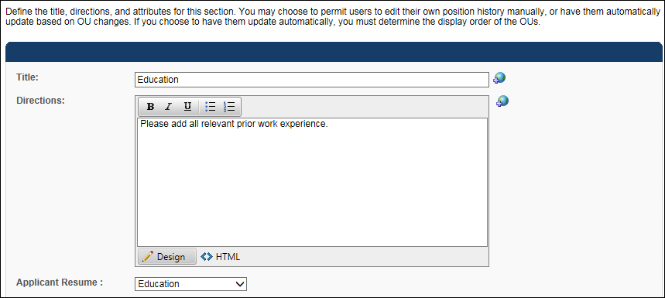
  - Map Sterling's education verification fields as described in the table below:
Sterling Education Verification Field Label | Cornerstone Resume Applicant Mapping | Additional Notes
School - Name | Institution
School - City | Grade
School - Major | Area of Study
School - Degree Earned | Degree | It is recommended that you set up the field as a drop-down, since Sterling only accepts the following values: GED, High School, Certificate, Associate's, Bachelor's, Master's, Doctorate, Other.
School - Date of Graduation | Graduation Date
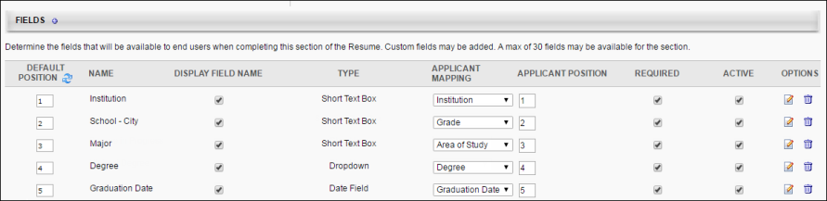
- Previous Position
  - Map a resume section to Applicant Resume "Experience"
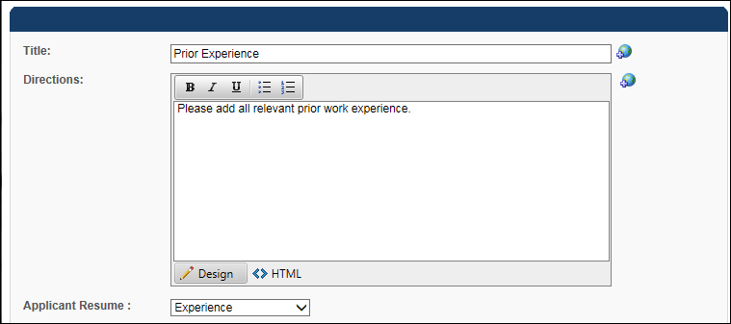
  - Map Sterling's employment verification fields as described in the table below:
Sterling Employment Verification Field Label | Cornerstone Resume Applicant Mapping
Employer - Company Name | Organization
Employer - Employment Start and End Date | Date Range
Employer - Employer Job Title | Position
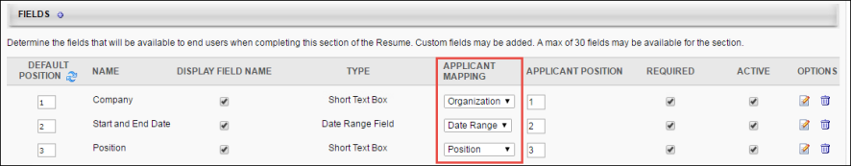
- Create questions and forms in Form Management (Admin > Configuration Tools > Core Functions > Form Management):
  - Create a new category (optional)
  - Create form questions on the Question Bank page. The API name entry must follow the naming convention described in the table below.
Sterling Reference Check Field Label | API Name
Reference Name | - Sterling_Reference_Name_1  - Sterling_Reference_Name_2  - Sterling_Reference_Name_3
Reference Occupation | - Sterling_Reference_Occupation_1  - Sterling_Reference_Occupation_2  - Sterling_Reference_Occupation_3
Reference Phone | - Sterling_Reference_Phone_1  - Sterling_Reference_Phone_2  - Sterling_Reference_Phone_3
Reference Email | - Sterling_Reference_Email_1  - Sterling_Reference_Email_2  - Sterling_Reference_Email_3
Reference Relationship | - Sterling_Reference_Relationship_1  - Sterling_Reference_Relationship_2  - Sterling_Reference_Relationship_3
  - Create a form on the Manage Forms page and include the questions created in step 2B. The form's API Name entry must be set to "Sterling_Reference_Form." The form can include up to three sets of reference fields.
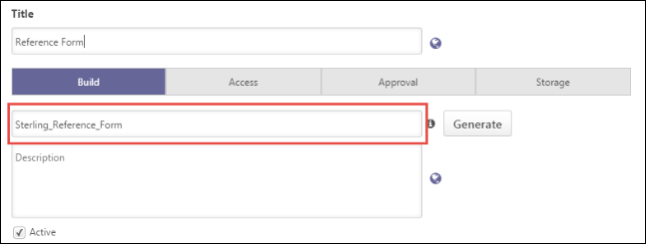
Edge Integrate Steps
In order to include Sterling background checks/drug screenings in the application workflow, the integration must first be enabled via Edge Integrate.
On the Edge Integrate > Settings page, you will enter your client ID, auth key, and account name. An API user name, password, and integration ID must also be entered.
In the Available Background Check Packages section, enter the background check package name and ID.
You can also configure which field is mapped to Sterling’s Reference Code and Access Credential Type fields by making a selection in the drop-down.
- Reference Code - This is a Sterling field that can be mapped to either of the Cornerstone organizational unit (OU) below. This is the OU associated to the job requisition the candidate has applied to. The available OU options are Division, Location, Position, and Grade.
- Access Credential Type - This is a Sterling field that can be mapped to either the username or user ID of the user submitting the background check request in Cornerstone (i.e., user assigning the candidate to a Sterling background check). Sterling uses this value to validate that the submitter has an existing user record in their system. If the submitter's unique identifier does not exist in Sterling, then Sterling will create a record.
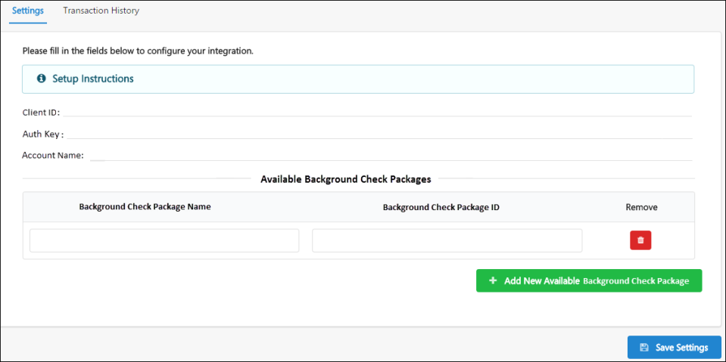
Create Custom Applicant Status for Sterling Background Check
This set up is required when assigning a background check to an applicant:
- Navigate to the Manage Applicant Status page:
  - Navigation: Admin > Tools > Recruit > Applicant Statuses > Select the top level OU
- Click the Create Custom Status link. This opens the Create Custom Status pop-up.
- Complete the following fields in the pop-up:
  - Language - If multiple languages are enabled for the portal, select the language from the drop-down list for which you are entering the status name and description. To localize the status name and description into other available languages, select the appropriate language from the drop-down list and enter the localized name and description in the appropriate fields.
  - Display Name - Enter the status name, which appears throughout the system. The character limit for this field is 50. When the display name of an active status is modified after the status is in use or has been used in a job requisition:
    - The new display name appears on the Default Status List page.
    - The new display name appears in the Status list on the job requisition template.
    - Any new job requisitions created after the display name is changed apply the new display name.
    - Job requisitions created before the status display name is changed continue to honor the name that existed at the time the requisition was created.
  - Description - Enter the status description. This should describe the purpose of the status and what is implied when an applicant is in that status. The character limit for this field is 500. This is not a required field.
  - Type - Select Custom Integration from the drop-down. Note: This field is displayed only when creating a custom status at the top level OU. When creating a custom status for a child OU, the Type field displays the type selected for the parent OU but is not editable.
  - Integration - Select Sterling from the drop-down.
  - Active - This field is checked by default. Ensure the field is checked before saving the status so that the status is active for the portal.
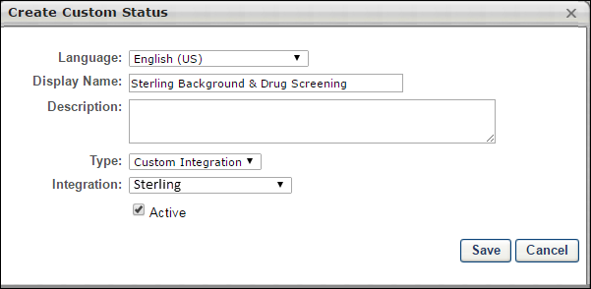
- Click Save to save the custom applicant status.
- Add custom applicant status to a job requisition.
Assign Sterling Background Check
The Sterling background check is assigned to applicants from their Applicant Profile > Statuses tab.
Permissions
PERMISSION NAME | PERMISSION DESCRIPTION | CATEGORY

Applicants: Initiate Background Check | This permission grants access to manage background checks from the Applicant Profile page. This applies to background checks that have been configured in the Integration Center. This permission cannot be constrained. Users who have this permission will have an Assign to Applicant link in the background check status type panel on the Applicant Profile page. Once the background check is assigned, the page will display "Assigned - [Date Assigned]." | Recruiting

Applicants: View Background Check Status | Allow user to view the background check status. The user cannot view the link to the detailed report. This permission cannot be constrained. | Recruiting

Applicants: View Background Check Status and Details Link | This permission allows users to view the background check status and view a link to access the background check report, which can be found in the background check status type panel on the Applicant Profile page. This permission cannot be constrained. | Recruiting

Requisition: Manage | Grants ability to access and manage all requisitions regardless of ownership (constraints permitting). This permission also grants read-only access to the Applicant Review tab when creating or editing a job requisition. This permission can be constrained by OU, User's OU, and Grade. | Recruiting

Requisition: Owner | Enables owner to access requisitions and applicants for requisitions for which they are an owner. This permission also grants read-only access to video interviews that are completed by applicants via HireVue. For portals with Referral Suite enabled, this permission also enables requisition owners to edit the referral source on the Applicant Profile page. This permission cannot be constrained.  Note: This is a dynamically assigned permission that is not available in Security Role Administration. If the user is removed as an owner, the permission is revoked for the associated requisition. This permission cannot be manually assigned. Also, if a user has both the permission necessary to manage requisitions and be a requisition owner, the constraints of the Requisition: Manage permission overrule those of the Requisition: Owner permission. For requisition owners that do not also have permission to manage requisitions, only certain fields are editable when editing a requisition. | Recruiting

Requisition: Reviewer | Enables reviewer to access requisitions and applicants for requisitions for which they are a reviewer. This permission cannot be constrained.  Note: This is a dynamically assigned permission that is not available in Security Role Administration. Once a requisition is in a Closed or Cancelled status or if the user is removed as a reviewer, the permission is revoked for the associated requisition. This permission cannot be manually assigned.  Note: If an applicant reviewer is removed as a reviewer via the Applicant Profile page, the Requisition: Reviewer permission is revoked for the associated requisition. However, if the reviewer was also added as a reviewer via the General tab when creating, editing, or copying the requisition, the reviewer still appears on the In Review panel as a duplicate reviewer and retains access to the requisition and applicants from the Requisition: Reviewer permission. See Applicant Profile Page Overview for more information about duplicate reviewer instances. | Recruiting
To assign the background check:
- Click the Assign to Applicant link in the background check status type panel from the Applicant Profile > Statuses tab.
- This opens a pop-up in which you select the background check provider and package. The options that are available in these fields are dependent upon the integrations you have enabled in Edge Integrate and the settings for those integrations.
- Click Submit. This initiates the Sterling background check process for the applicant. Auto-Creation of User Record Note: If the user assigning the background check does not yet have a user record in the Sterling application, a user record is automatically created, using the user's first and last name, phone number, and email address - all of which are required fields. When Sterling creates the user record for the user who is assigning the background check, Sterling will send an email to that user to indicate that their user record has been created.
If the submission process is successful, the status in the background check status type section will indicate Acknowledged. If the submission is not successful, then an error message displays.
Once the background check is assigned to the applicant, the status will change to Assigned, and Sterling will send an email to the applicant to initiate the background check process.
View Sterling Background Check Results
A high-level summary of the Sterling assessment results is available from the Manage Applicants page and the Applicant Profile > Statuses tab.
To access the Applicant Profile page, click the applicant's name from any of the following pages:
- Manage Job Requisitions > Requisition Snapshot
- Manage Job Requisitions > Manage Applicants
- Recruit > Interview Manager
- Recruit > Review Applicants
- Recruit > Manage Candidates (Note:This functionality is in the Early Adopter phase. For more information about availability,see the Overview topic for this functionality.)
Permissions
PERMISSION NAME | PERMISSION DESCRIPTION | CATEGORY

Applicants: Initiate Background Check | This permission grants access to manage background checks from the Applicant Profile page. This applies to background checks that have been configured in the Integration Center. This permission cannot be constrained. Users who have this permission will have an Assign to Applicant link in the background check status type panel on the Applicant Profile page. Once the background check is assigned, the page will display "Assigned - [Date Assigned]." | Recruiting

Applicants: View Background Check Status and Details Link | This permission allows users to view the background check status and view a link to access the background check report, which can be found in the background check status type panel on the Applicant Profile page. This permission cannot be constrained. | Recruiting

Applicants: View Background Check Status | Allow user to view the background check status. The user cannot view the link to the detailed report. This permission cannot be constrained. | Recruiting

Requisition: Manage | Grants ability to access and manage all requisitions regardless of ownership (constraints permitting). This permission also grants read-only access to the Applicant Review tab when creating or editing a job requisition. This permission can be constrained by OU, User's OU, and Grade. | Recruiting

Requisition: Owner | Enables owner to access requisitions and applicants for requisitions for which they are an owner. This permission also grants read-only access to video interviews that are completed by applicants via HireVue. For portals with Referral Suite enabled, this permission also enables requisition owners to edit the referral source on the Applicant Profile page. This permission cannot be constrained.  Note: This is a dynamically assigned permission that is not available in Security Role Administration. If the user is removed as an owner, the permission is revoked for the associated requisition. This permission cannot be manually assigned. Also, if a user has both the permission necessary to manage requisitions and be a requisition owner, the constraints of the Requisition: Manage permission overrule those of the Requisition: Owner permission. For requisition owners that do not also have permission to manage requisitions, only certain fields are editable when editing a requisition. | Recruiting

Requisition: Reviewer | Enables reviewer to access requisitions and applicants for requisitions for which they are a reviewer. This permission cannot be constrained.  Note: This is a dynamically assigned permission that is not available in Security Role Administration. Once a requisition is in a Closed or Cancelled status or if the user is removed as a reviewer, the permission is revoked for the associated requisition. This permission cannot be manually assigned.  Note: If an applicant reviewer is removed as a reviewer via the Applicant Profile page, the Requisition: Reviewer permission is revoked for the associated requisition. However, if the reviewer was also added as a reviewer via the General tab when creating, editing, or copying the requisition, the reviewer still appears on the In Review panel as a duplicate reviewer and retains access to the requisition and applicants from the Requisition: Reviewer permission. See Applicant Profile Page Overview for more information about duplicate reviewer instances. | Recruiting
The following package information displays on the Statuses tab for the background check:
- Assigned - This field displays the date of when screening is assigned to the applicant.
- Reference ID - This field displays Sterling’s screening ticket ID.
- Status - This field displays the status of the overall package status. The following are the possible values:
  - Acknowledged
  - In Progress
  - Completed
  - Cancelled
- Result - This field displays the candidate’s overall result of the background check request.
- [Background Package Name] - This field displays the name of the screening type.
- Provider Reference ID - This field displays the individual search ID.
- Status - This field displays the status of the screening type.
  - In Progress
  - Completed
  - Cancelled
To view a detailed report of the candidate’s assessment results:
- Click the View Report link in the background check column in the applicants table on the Manage Applicants page. Or, the link is also available from the Applicant Profile > Statuses tab.
- Sterling will authenticate the user who is attempting to view the report.
- If the user has an existing record in Sterling, then the user is deemed valid, and the report details open in the Sterling application.
- If the user does not have an existing record in Sterling, then an error message displays.

Sterling RISQ Background Check Integration
A background screening solution between Cornerstone Recruiting and Sterling’s RISQ platform that frees teams from manual, time consuming tasks related to screening program, while also providing real-time screening results directly into Cornerstone.
- Initiate a background check within Cornerstone Recruiting. The candidate information/required screening package is then automatically sent to Sterling.
- The candidate receives an email containing a link to complete consent, confirm and provide additional information and, if applicable, select a drug test location.
- Status of the background check is shared in real-time in Cornerstone Recruiting.
- Upon completion, the results are posted within Cornerstone Recruiting.
Implementation
This integration is a vendor-built integration and not by Cornerstone. More information and instructions can be found in Edge Integrate.
Permissions
The following existing permissions apply to this functionality:
PERMISSION NAME | PERMISSION DESCRIPTION | CATEGORY

Edge Integrations - Manage | Grants access to the Integrations service for Edge Integrate, where the administrator can configure, enable, and disable their third-party integrations used within the Cornerstone system. This permission cannot be constrained. This is an administrator permission. | Edge

Edge Marketplace - Manage | Grants access to the Marketplace service for Edge Integrate, where the administrator can browse integrations that can be used to extend the Cornerstone system. This permission cannot be constrained. This is an administrator permission. | Edge

Sterling ScreeningDirect Background Check Integration
The Sterling ScreeningDirect Background Check integration provides a pre-built integration between Sterling’s ScreeningDirect platform and Cornerstone’s Recruiting platform.
Background checks are requested from within your Cornerstone portal and are completed by Sterling ScreeningDirect. Candidates receive an email containing a link to consent to the background check, potentially provide additional information to Sterling ScreeningDirect, and select a background check location if applicable to the type of check.
You can monitor the status of the background check within your Cornerstone portal. Once the request is completed, the results are also posted within Cornerstone.
Implementation
This integration on 23 September 2019 is available for all organizations using the Recruiting suite. This integration is available for free via Edge Marketplace. Additional instructions for enabling and configuring the integration are available on the Setup tab of the integration in Edge.
The integration can be accessed and configured via the Edge Marketplace. In order to use this integration, your organization must be using the Recruiting module and must have access to Edge and have an account with the integration vendor. There is no additional cost associated with enabling this integration, but the integration cannot be used without an account with the integration vendor.
Permissions
The following existing permissions apply to this functionality:
PERMISSION NAME | PERMISSION DESCRIPTION | CATEGORY

Edge Integrations - Manage | Grants access to the Integrations service for Edge Integrate, where the administrator can configure, enable, and disable their third-party integrations used within the Cornerstone system. This permission cannot be constrained. This is an administrator permission. | Edge

Edge Marketplace - Manage | Grants access to the Marketplace service for Edge Integrate, where the administrator can browse integrations that can be used to extend the Cornerstone system. This permission cannot be constrained. This is an administrator permission. | Edge

Universal Background Screening Integration - Overview
With this enhancement, Universal Background Screening integrations are now available through the Edge Marketplace. The Universal Background Screening integration allows you to place and track background checks for applicants.
This integration allows organizations to choose a background vendor that fits their needs and budget, get the best satisfaction from the product, and minimize change management within their organization.
Use Cases
Use Case 1: Activate the Universal Background Screening integration through Edge
- Barbara is Acme Company's administrator who has been tasked with enabling the integration with Universal Background. This will allow Acme to include Universal Background Screening requests within their application workflow.
- Barbara goes to the Edge Marketplace to purchase and activate the Universal Background Screening background check integration.
- From the Edge Integrate page, Barbara enters Acme's unique Client Account ID, which is provided by their Universal Background Screening project team.
- Acme's Cornerstone portal now has an active integration between Cornerstone and Universal Background Screening.
Use Case 2: Recruiting Admin creates a custom applicant status
- Katie is the recruiting administrator for Acme Company.
- Ryan, a hiring manager at Acme, is looking to add a new member to his Marketing team.
- With the integration enabled, Katie is tasked with adding the Universal Background Screening status in all of Acme's marketing job requisitions.
- Katie creates a new custom applicant status that is set to a custom integration type under Universal Background Screening.
- Katie creates a new job requisition that includes that new custom applicant status
- Katie has now configured the Marketing job requisitions to include the Universal Background Screening custom applicant status.
Use Case 3: Recruiter assigns a candidate to a background check request
- Dorothy, a recruiter at Acme, has identified James to be a stellar applicant.
- To ensure a sound hiring decision is made and to protect Acme from potential risks, Dorothy assigns a background check screening on John by moving the status to Universal Background Screening.
- Dorothy clicks on the Assign to Applicant link on the Statuses tab, and a pop-up window appears. Dorothy confirms that background check provider then clicks on the Submit button.
- Dorothy is redirected to the Universal Background Screening system where she can select the appropriate background check package to assign to James.
- James receives an email from Universal Background Screening and clicks the link to complete the screening application request in Universal Background Screening
Use Case 4: Recruiter views background check screening updates/results and a detailed report in Universal Background Screening via a link
- Dorothy is eager to find out the results of James's background check status.
- Dorothy navigates to James's Applicant Profile Status page and sees the status on the request.
- To view additional details of the background request, Dorothy clicks on the View Progress link, which will direct her to the Universal Background Screening site.
Implementation
The Universal Background Screening integration must be enabled and activated through the Edge Marketplace. Portals must have already purchased Universal Background Screening in order to enable it in Edge.
During enablement, you will need to provide your pre-existing Universal Background Screening identifiers.
Security
The following existing permissions apply to this functionality:
PERMISSION NAME | PERMISSION DESCRIPTION | CATEGORY

Applicants: Initiate Background Check | This permission grants access to manage background checks from the Applicant Profile page. This applies to background checks that have been configured in the Integration Center. This permission cannot be constrained. Users who have this permission will have an Assign to Applicant link in the background check status type panel on the Applicant Profile page. Once the background check is assigned, the page will display "Assigned - [Date Assigned]." | Recruiting

Applicant Status Bank - Manage | Grants ability to access and manage Applicant Status Bank. | Recruiting Administration

Applicants: View Background Check Status | Allow user to view the background check status. The user cannot view the link to the detailed report. This permission cannot be constrained. | Recruiting

Applicants: View Background Check Status and Details Link | This permission allows users to view the background check status and view a link to access the background check report, which can be found in the background check status type panel on the Applicant Profile page. This permission cannot be constrained. | Recruiting

Requisition: Manage | Grants ability to access and manage all requisitions regardless of ownership (constraints permitting). This permission also grants read-only access to the Applicant Review tab when creating or editing a job requisition. This permission can be constrained by OU, User's OU, and Grade. | Recruiting

Requisition: Owner | Enables owner to access requisitions and applicants for requisitions for which they are an owner. This permission also grants read-only access to video interviews that are completed by applicants via HireVue. For portals with Referral Suite enabled, this permission also enables requisition owners to edit the referral source on the Applicant Profile page. This permission cannot be constrained.  Note: This is a dynamically assigned permission that is not available in Security Role Administration. If the user is removed as an owner, the permission is revoked for the associated requisition. This permission cannot be manually assigned. Also, if a user has both the permission necessary to manage requisitions and be a requisition owner, the constraints of the Requisition: Manage permission overrule those of the Requisition: Owner permission. For requisition owners that do not also have permission to manage requisitions, only certain fields are editable when editing a requisition. | Recruiting

Requisition: Reviewer | Enables reviewer to access requisitions and applicants for requisitions for which they are a reviewer. This permission cannot be constrained.  Note: This is a dynamically assigned permission that is not available in Security Role Administration. Once a requisition is in a Closed or Cancelled status or if the user is removed as a reviewer, the permission is revoked for the associated requisition. This permission cannot be manually assigned.  Note: If an applicant reviewer is removed as a reviewer via the Applicant Profile page, the Requisition: Reviewer permission is revoked for the associated requisition. However, if the reviewer was also added as a reviewer via the General tab when creating, editing, or copying the requisition, the reviewer still appears on the In Review panel as a duplicate reviewer and retains access to the requisition and applicants from the Requisition: Reviewer permission. See Applicant Profile Page Overview for more information about duplicate reviewer instances. | Recruiting
Enable Universal Background Screening in Edge
To enable the Universal Background Screening integration in Edge, perform the actions listed below.
- Select and purchase the Universal Background Screening background check integration through the Edge Marketplace
  - Navigation: Admin > Tools > Edge > Marketplace
- Activate the Universal Background Screening background check integration on Edge Integrations
  - Navigation: Admin > Tools > Edge > Integrations
- Configure the integration on the Edge Settings page
  - Client Account ID - This is the client’s unique identifier that enables Universal Background Screening to authorize background check submissions from Cornerstone. This code is provided by the client’s Universal Background Screening project team.
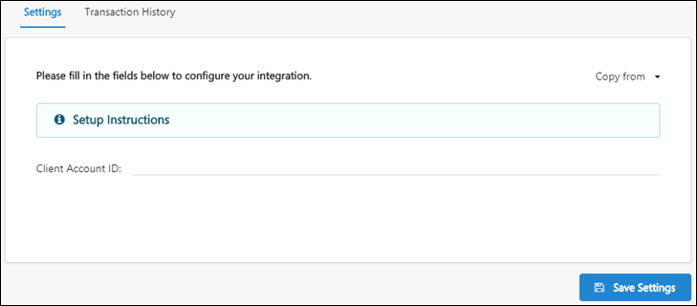
Additional Information
- You must have an existing contract with Universal Background Screening.
- You must work with your Universal Background Screening project team to purchase and configure their screening packages.
- No migration is required.
- The activation of the integration is a one-time activity per environment (Stage, Pilot, Production).
- The integration cannot be purchased independently of a product line.
- The cost will be displayed on Edge when you purchase the integration.
Applicant Statuses - Create Custom Integration Status (Universal Background Screening)
In order for the Universal Background Screening status to be available to select for applicants, it is necessary to create a custom integration status in Manage Applicant Statuses.
To create a custom applicant status, go to Admin > Tools > Recruit > Applicant Statuses. Then click the Create Custom Status link.
Permissions
PERMISSION NAME | PERMISSION DESCRIPTION | CATEGORY

Applicant Status Bank - Manage | Grants ability to access and manage Applicant Status Bank. | Recruiting Administration
To create a custom integration status for Universal Background Screening:
- Navigate to Admin > Tools > Recruit > Applicant Statuses.
- Click the Create Custom Status link. This opens the Create Custom Status pop-up.
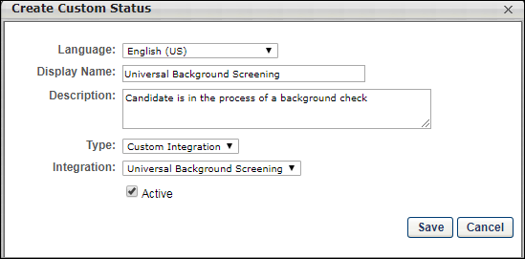
- Complete the following fields in the Create Custom Status pop-up:
  - Language - If multiple languages are enabled, from the drop-down list select the language in which you are entering the status name and description. To localize the status name and description into other available languages, select the appropriate language from the drop-down list and enter the localized name and description in the appropriate fields.
  - Display Name - Enter "Universal Background Screening" to identify the status as being specifically for Universal Background Screening.
  - Description - Enter a description, up to 500 characters. As a best practice, provide a description that helps recruiters understand the purpose of this status.
  - Type - Select "Custom Integration." The Custom Integration status type mans that the applicant is in an integration step of the status workflow.
  - Integration - Select "Universal Background Screening" in this field, which will associate the custom status to Universal Background Screening.
  - Active - This option is selected by default and means the status will be available to include in status workflows.
- Click Save to save the custom status. Your new custom integration status will be visible in the list of statuses on the Manage Applicant Statuses page.
Map Education and Experience Fields (Universal Background Screening)
In order for Universal Background Screening (UBS) to retrieve the applicant's data, specific resume fields will need to be mapped.
Note: When configuring the application workflow template for the requisition, the Upload Attachment action item will need to be included so that the applicant can enter their resume data in the Education and Employment fields that are mapped for UBS when filling out the application.
To access map resume fields, go to Admin > Tools > Succession Management > Resume.
Permissions
PERMISSION NAME | PERMISSION DESCRIPTION | CATEGORY

Resume Administration | Grants access to resume administration, which enables configuration of resume sections, including custom resume fields. This permission cannot be constrained. This is an administrator permission. Note: This permission does not apply to the Universal Profile - Resume functionality. | Talent/Succession - Administration
Education Fields
Education fields must be mapped in Succession > Resume in order for Cornerstone to pass the applicant's data to UBS. The name of the field in Cornerstone (as defined in the Field Name field on the Add Field pop-up on the Resume > Education page) does not need to match the name of the field in UBS, but it must be mapped to the correctly corresponding Applicant Mapping field in your portal in order for the data to pass successfully to UBS.
To map the fields:
- Navigate to Admin > Tools > Succession Management > Resume.
- Select the Edit icon in the Education row.
- Ensure that Education is selected in the Applicant Resume drop-down.
- Configure or create the following fields and select the appropriate mapping option in the Applicant Mapping column:
field name in UBS | select this option in drop-down in applicant mapping column | field type
SchoolName (Note: A field on the resume in Cornerstone must be mapped to this field in UBS in order for UBS to process the data.) | Institution (Note: Be sure to check the box in the Required column for this field.) | Short Text Box
DegreeName | Degree | Dropdown
DegreeMajor | Area of Study | Short Text Box
Degree Date (Note: This field is not required for the integration to run successfully. This field can be left out of the mapping if you do not wish to capture this data.) | Graduation Date | Date Field
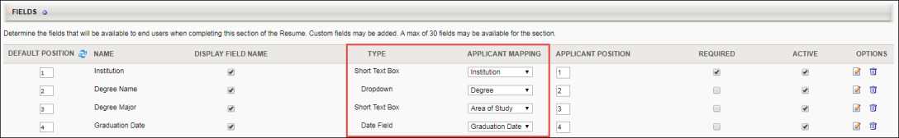
Employment Fields
Employment fields must be mapped in Succession > Resume in order for Cornerstone to pass the applicant's data to UBS. The name of the field in Cornerstone (as defined in the Field Name field on the Add Field pop-up on the Resume > Previous Positions page) does not need to match the name of the field in UBS, but it must be mapped to the correctly corresponding Applicant Mapping field in your portal in order for the data to pass successfully to UBS.
To map the fields:
- Navigate to Admin > Tools > Succession Management > Resume.
- Select the Edit icon in the Previous Positions row.
- Ensure that Experience is selected in the Applicant Resume drop-down.
- Configure or create the following fields and select the appropriate mapping option in the Applicant Mapping column:
field name in UBS | select this option in drop-down in applicant mapping column | field type
EmployerOrgName | Organization | Short Text Box
Title | Position | Short Text Box
Start and End Date (Note: This field is not required for the integration to run successfully. This field can be left out of the mapping if you do not wish to capture this data.) | Date Range | Date Range Field
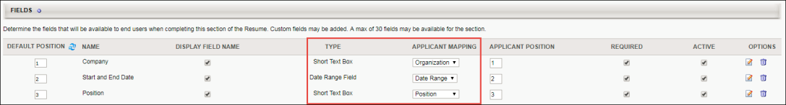
Candidate Reference Data (Universal Background Screening)
In order for Universal Background Screening (UBS) to retrieve the applicant's data, specific reference questions will need to be created in the Question Bank in Form Management so that the questions can be added to a form in Form Management that will be used to request the applicant's references.
The text of the question in Cornerstone does not need to match the name of the field in UBS, but it must be mapped to the correctly corresponding API label in your portal in order for the data to pass successfully to UBS.
There are three different sets of these questions, since applicants can submit up to three references. Each set represents one applicant reference. It is necessary to create each set. If more than three sets are created, any data outside of the first three sets will not be passed to UBS.
To manage forms, go to Admin > Tools > Core Functions > Form Management > Manage Forms.
To access the question bank, go to Admin > Tools > Core Functions > Form Management > Question Bank.
Permissions
PERMISSION NAME | PERMISSION DESCRIPTION | CATEGORY

Manage Forms - Manage | Grants access to the Manage Forms functionality. This permission can be constrained by OU and User's OU. This is an administrator permission.  Note: This permission enables access to the Form Management functionality that is part of Cornerstone HR functionality and the Onboarding module. This permission does not grant access to the Training Forms Management functionality. | Forms Management Administration

Question Bank - Manage | Grants access to the Question Bank functionality. This permission can be constrained by OU and User's OU. This is an administrator permission. | Forms Management Administration
Create Questions
To create the questions:
- Navigate to Admin > Tools > core functions > form management > question bank.
- Click Create Question.
- Select Text as the field type.
- Configure each question separately by entering a name for the question in the Question field and entering the API exactly as it is listed in the right-hand column. The "Field Name in UBS" column indicates the exact name of the field in UBS. You can use the UBS field name as your question or enter a different name, but the API will need to correspond exactly so that the applicant's data can be transferred successfully.
field name in UBS |  | enter this api in the api name field on the create question page | Field Type
SET 1
Person Name |  | Universal_Reference_Name_1 | Text
Formatted Number |  | Universal_Reference_Phone_1 | Text
Relationship |  | Universal_Reference_Relationship_1 | Text
SET 2
Person Name |  | Universal_Reference_Name_2 | Text
Formatted Number |  | Universal_Reference_Phone_2 | Text
Relationship |  | Universal_Reference_Relationship_2 | Text
SET 3
Person Name |  | Universal_Reference_Name_3 | Text
Formatted Number |  | Universal_Reference_Phone_3 | Text
Relationship |  | Universal_Reference_Relationship_3 | Text
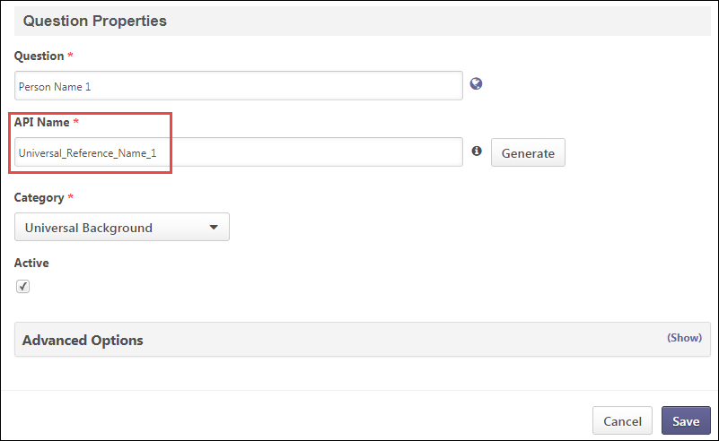
Create Form
Once you have created the questions, navigate to Form Management > Manage Forms and create a form for requesting an applicant's references, making sure to enter Universal_Reference_Form in the API Name field on the Build tab. The purpose of entering this API name is so that the system knows the correct form to send to UBS. See Build Tab - Define General Information.
On the form, add the questions that you created above. The references request form will be assigned to applicants on Manage Candidates or Manage Applicants. The form will be available to the applicant from their My Profile page in the career site, where they can then launch and complete the form.
Assign Universal Background Screening
The Universal Background Screening can be assigned from the Applicant Profile > Statuses tab. The applicant's status must be changed to the custom Universal Background Screening status in order for the background screening to be available to assign.
Permissions
PERMISSION NAME | PERMISSION DESCRIPTION | CATEGORY

Applicants: Initiate Background Check | This permission grants access to manage background checks from the Applicant Profile page. This applies to background checks that have been configured in the Integration Center. This permission cannot be constrained. Users who have this permission will have an Assign to Applicant link in the background check status type panel on the Applicant Profile page. Once the background check is assigned, the page will display "Assigned - [Date Assigned]." | Recruiting

Applicants: View Background Check Status and Details Link | This permission allows users to view the background check status and view a link to access the background check report, which can be found in the background check status type panel on the Applicant Profile page. This permission cannot be constrained. | Recruiting

Applicants: View Background Check Status | Allow user to view the background check status. The user cannot view the link to the detailed report. This permission cannot be constrained. | Recruiting

Requisition: Manage | Grants ability to access and manage all requisitions regardless of ownership (constraints permitting). This permission also grants read-only access to the Applicant Review tab when creating or editing a job requisition. This permission can be constrained by OU, User's OU, and Grade. | Recruiting

Requisition: Owner | Enables owner to access requisitions and applicants for requisitions for which they are an owner. This permission also grants read-only access to video interviews that are completed by applicants via HireVue. For portals with Referral Suite enabled, this permission also enables requisition owners to edit the referral source on the Applicant Profile page. This permission cannot be constrained.  Note: This is a dynamically assigned permission that is not available in Security Role Administration. If the user is removed as an owner, the permission is revoked for the associated requisition. This permission cannot be manually assigned. Also, if a user has both the permission necessary to manage requisitions and be a requisition owner, the constraints of the Requisition: Manage permission overrule those of the Requisition: Owner permission. For requisition owners that do not also have permission to manage requisitions, only certain fields are editable when editing a requisition. | Recruiting

Requisition: Reviewer | Enables reviewer to access requisitions and applicants for requisitions for which they are a reviewer. This permission cannot be constrained.  Note: This is a dynamically assigned permission that is not available in Security Role Administration. Once a requisition is in a Closed or Cancelled status or if the user is removed as a reviewer, the permission is revoked for the associated requisition. This permission cannot be manually assigned.  Note: If an applicant reviewer is removed as a reviewer via the Applicant Profile page, the Requisition: Reviewer permission is revoked for the associated requisition. However, if the reviewer was also added as a reviewer via the General tab when creating, editing, or copying the requisition, the reviewer still appears on the In Review panel as a duplicate reviewer and retains access to the requisition and applicants from the Requisition: Reviewer permission. See Applicant Profile Page Overview for more information about duplicate reviewer instances. | Recruiting
Emails
EMAIL NAME | EMAIL DESCRIPTION | ACTION TYPE

Assign Integration Assessment | This email is triggered when an Edge integration assessment is assigned to an applicant, such as a WOTC assessment. This email can be configured as a notification or a reminder, and it can be sent to External Applicant, Internal Applicant, OU Approver, Hiring Manager, OU Approver, or a specific user.  This email only triggers when a successful response is received from the vendor.  Note: The APPLICANT.INTEGRATION.ASSESSMENT.LINK tag must be included in the email. This tag provides a link that the applicant can click to access the assessment.  Note about Auto-Assignment of Pre-Employment Verifications: This email also applies to auto-assignment of pre-employment verifications, via the Automated Candidate Progression (Early Adopter) functionality. For more information, see Feature Activation Preferences. | Recruiting
Assign from Applicant Profile
To assign from the Applicant Profile page:
Navigate to the Applicant Profile > Statuses tab.
- Click the applicant's status in the Current Status field on the Summary tab.
- Change the status to the applicable background check status. This enables a background check to be assigned to a candidate on the Statuses tab.
- Click the Statuses tab.
- Click the Assign to Applicant link in the background check status section. This opens the Select Provider pop-up.
- Select the Universal Background Screening provider from the Select Provider drop-down.
- Click Submit. This opens the log-in page for Universal Background Screening.
- Log in to the Universal Background Screening site. The page will show the applicant's data passed to Universal Background Screening. The recruiter can enter additional required fields not passed as part of the integration, or the recruiter can select to assign this task to the candidate by selecting Background Check via e-Forms Invitation. If the latter, Universal Background Screening will send an email to the applicant.
If the screening request is successful and completed, the results display in the status panel on the Applicant Profile page. You can also view the results from the associated assessment column on the Manage Applicants page.
Custom Recruiting Reports (Universal Background Screening)
The Universal Background Screening can be reported on in Reporting 2.0 and Custom Recruiting Reports.
The following fields in the Background Check section provide data for the screenings:
- Assigned Date
- Completed Date
The following fields in the External Vendors section provide data for the screenings:
- External Vendor Name
- External Vendor Package Result
- External Vendor Package Title
- External Vendor Product

Candidate Recruitment Management Integrations - Overview

Clinch Talent Integration
Cornerstone and Clinch seamlessly integrate to deliver an optimized candidate experience to help talent acquisition teams recruit more effectively with less manual effort. Covering every step of the candidate journey - from first visit to the careers site all the way through apply, hire and pre-boarding.
Clinch Talent uses Cornerstone's Recruiting APIs to retrieve data from your Cornerstone portal. Requests made by Clinch Talent using these APIs will count toward your overall throttling limit for Cornerstone's APIs. If you have other integrations, including custom integrations, that use Cornerstone's APIs, you will want to ensure that the overall usage across all your integrations is within the throttling limits for Cornerstone's APIs. Throttling limits for Cornerstone's APIs are documented in the API Explorer.
Implementation
This integration is available for all organizations using the Recruiting suite. This integration is available for free via Edge Marketplace. Additional instructions for enabling and configuring the integration are available on the Setup tab of the integration in Edge.
The integration can be accessed and configured via the Edge Marketplace. In order to use this integration, your organization must be using the Recruiting module and must have access to Edge and have an account with the integration vendor. There is no additional cost associated with enabling this integration, but the integration cannot be used without an account with the integration vendor.
Permissions
The following permissions apply to this functionality:
PERMISSION NAME | PERMISSION DESCRIPTION | CATEGORY

Edge Integrations - Manage | Grants access to the Integrations service for Edge Integrate, where the administrator can configure, enable, and disable their third-party integrations used within the Cornerstone system. This permission cannot be constrained. This is an administrator permission. | Edge

Edge Marketplace - Manage | Grants access to the Marketplace service for Edge Integrate, where the administrator can browse integrations that can be used to extend the Cornerstone system. This permission cannot be constrained. This is an administrator permission. | Edge

LinkedIn Recruiter System Connect - Overview
LinkedIn Recruiter System Connect bridges the information gap between Cornerstone Recruiting and LinkedIn Recruiter by making candidate communication, notes, and application information available in both places. With this integration, a recruiter will no longer need to look up a candidate in both systems to get a complete picture of the candidate.
How Does this Integration Benefit My Organization?
Full Candidate Picture in LinkedIn and Recruiting
Drives Quicker and Easier Informed Decisions
Enhances Usability
LinkedIn Recruiter System Connect delivers a holistic view of the candidate in both LinkedIn and Cornerstone Recruiting, giving recruiters the information they need to make informed decisions more quickly.
Without this integration, LinkedIn Recruiter data will only display in LinkedIn Recruiter, and Recruiting information will only display in Recruiting. This means recruiters have to look up the candidate in both applications to get a complete view.
With LinkedIn Recruiter System Connect, recruiters can view all LinkedIn Recruiter information in Recruiting and vice versa, including InMail History, Notes, and Profiles. This provides a candidate picture in both applications. This also saves time and supports more informed decision-making by being able to look up candidate information in whichever application the recruiter is in.
What LinkedIn Recruiter Information Is Available in Cornerstone?
InMail History
A candidate's InMail history will display on the Emails tab of the Applicant Profile page. The date, sender, subject, and message body is included. InMail will appear with “via LinkedIn” next to the name of the user who sent the email. Attachments are not included. InMail history will only be visible to users who have a LinkedIn Recruiter seat on the same contract.
Prospect Notes
Notes that are created in LinkedIn Recruiter will be visible on the Comments tab on the Applicant Profile page. LinkedIn Recruiter notes will appear with "via LinkedIn" next to the name of the user who submitted the comment. Notes will only be visible to users who have a LinkedIn Recruiter seat on the same contract.
LinkedIn Profiles
A candidate's LinkedIn profile will be visible on a new "LinkedIn" tab on the Applicant Profile page. This tab will be available for all portals that enable LinkedIn Recruiter System Connect. Users with a LinkedIn Recruiter seat will be able to see the full LinkedIn profile, including links to save the candidate to a project, send an InMail, or choose to be notified when the candidate updates their LinkedIn profile. Users without a LinkedIn Recruiter seat will see the candidate’s public LinkedIn profile.
Considerations/Exclusions
- Application data can be deleted from LinkedIn. Cornerstone will send deletion requests when triggered by the candidate or after the period of inactivity specified by a client.
- Jobs must meet the following criteria to sync to LinkedIn:
  - "External Description" must contain at least 100 characters.
  - The Primary Location field must include a value for the Country field.
  - The Primary Location field must include a value for either the City field or the State/Province field.
- This integration is only available in Production environments.
Implementation
The option to activate LinkedIn Recruiter is available for all portals with Recruiting enabled. However, a LinkedIn Recruiter subscription is required for activation. LinkedIn Recruiter can be purchased through LinkedIn.
Additional instructions for enabling and configuring the integration are available on the Setup tab of the integration in Edge.
Security
The following permissions apply to this functionality:
PERMISSION NAME | PERMISSION DESCRIPTION | CATEGORY

Edge Integrations - Manage | Grants access to the Integrations service for Edge Integrate, where the administrator can configure, enable, and disable their third-party integrations used within the Cornerstone system. This permission cannot be constrained. This is an administrator permission. | Edge

Edge Marketplace - Manage | Grants access to the Marketplace service for Edge Integrate, where the administrator can browse integrations that can be used to extend the Cornerstone system. This permission cannot be constrained. This is an administrator permission. | Edge

Requisition: Manage | Grants ability to access and manage all requisitions regardless of ownership (constraints permitting). This permission also grants read-only access to the Applicant Review tab when creating or editing a job requisition. This permission can be constrained by OU, User's OU, and Grade. | Recruiting

Requisition: Owner | Enables owner to access requisitions and applicants for requisitions for which they are an owner. This permission also grants read-only access to video interviews that are completed by applicants via HireVue. For portals with Referral Suite enabled, this permission also enables requisition owners to edit the referral source on the Applicant Profile page. This permission cannot be constrained.  Note: This is a dynamically assigned permission that is not available in Security Role Administration. If the user is removed as an owner, the permission is revoked for the associated requisition. This permission cannot be manually assigned. Also, if a user has both the permission necessary to manage requisitions and be a requisition owner, the constraints of the Requisition: Manage permission overrule those of the Requisition: Owner permission. For requisition owners that do not also have permission to manage requisitions, only certain fields are editable when editing a requisition. | Recruiting

Requisition: Reviewer | Enables reviewer to access requisitions and applicants for requisitions for which they are a reviewer. This permission cannot be constrained.  Note: This is a dynamically assigned permission that is not available in Security Role Administration. Once a requisition is in a Closed or Cancelled status or if the user is removed as a reviewer, the permission is revoked for the associated requisition. This permission cannot be manually assigned.  Note: If an applicant reviewer is removed as a reviewer via the Applicant Profile page, the Requisition: Reviewer permission is revoked for the associated requisition. However, if the reviewer was also added as a reviewer via the General tab when creating, editing, or copying the requisition, the reviewer still appears on the In Review panel as a duplicate reviewer and retains access to the requisition and applicants from the Requisition: Reviewer permission. See Applicant Profile Page Overview for more information about duplicate reviewer instances. | Recruiting
Enable LinkedIn Recruiter System Connect
To enable the LinkedIn Recruiter System Connect integration, the client administrator must perform the actions listed below. The activation of the integration is a one-time activity.
To view detailed LinkedIn instructions for enabling the LinkedIn Recruiter System Connect integration, click the Getting Started link on the Setup page. A "LinkedIn Recruiter System Connect Enablement Guide" is available to download.
Additional Information
- You must have an existing LinkedIn Recruiter account with LinkedIn.
- No migration is required.
- The integration comes with Recruiting at no additional cost.
- The integration cannot be purchased independently of a product line.
Applicant Profile - LinkedIn Recruiter System Connect
When LinkedIn Recruiter System Connect is enabled in the portal, a candidate's LinkedIn Recruiter data appears on the Applicant Profile page. You can view InMail history, notes, and the LinkedIn Recruiter profile.
A candidate's Cornerstone data is also available in LinkedIn Recruiter.
InMail History
A candidate's InMail history displays on the Emails tab. The date, sender, and subject are visible to all users with access to the Applicant Profile page in Cornerstone. InMail history will only be visible to users who have a LinkedIn Recruiter seat on the same contract.
Attachments are not included.
Cornerstone Record Creation via InMail
When a LinkedIn recruiter sends an InMail to a candidate, the candidate will be able to respond to the InMail, and in the process can choose to share their contact information with the recruiter. If a candidate chooses to share their contact information, that detail will be passed to Cornerstone.
If the candidate does not have an account in the portal, a new record will be created for the user. The record will not be connected to any specific requisition and can only be found through Candidate Search Query. Note: If the Applicant Opt Out option in Requisition and Applicant Preferences is checked, then the new profile will not be visible in Candidate Search Query by default. The only way to find candidates generated through this InMail Stub Profile is to ensure Applicant Opt-Out is not checked.
If the candidate does have an account in the portal, then the record will be updated with the contact information shared through LinkedIn.
Notes
Notes added on LinkedIn display on the Comments tab. These notes will be distinguished from Recruiting notes by displaying "via LinkedIn" next to the name of the user who submitted the note. Notes will only be visible to users who have a LinkedIn Recruiter seat on the same contract.
Notes that are created in LinkedIn Recruiter and viewed in your Cornerstone portal cannot be edited or deleted in Cornerstone.
LinkedIn Recruiter Profile
A candidate's LinkedIn profile will now be visible on a new "Linkedin" tab on the Applicant Profile page. This tab is only available in portals that have enabled LinkedIn Recruiter System Connect. Users with a LinkedIn Recruiter seat will be able to see the full LinkedIn profile, including links to send an InMail or view the profile in LinkedIn Recruiter. Users without a LinkedIn Recruiter seat will see the candidate’s public LinkedIn profile.
For candidates who do not have a LinkedIn profile, the tab will display "Candidate Not Matched." If the profile being shown does not match the candidate, a Wrong person's profile? link can be clicked to unlink the current profile and select the correct one.
LinkedIn Experience
With LinkedIn Recruiter System Connect, Cornerstone Recruiting data and actions can be viewed on the candidate's LinkedIn Recruiter page.
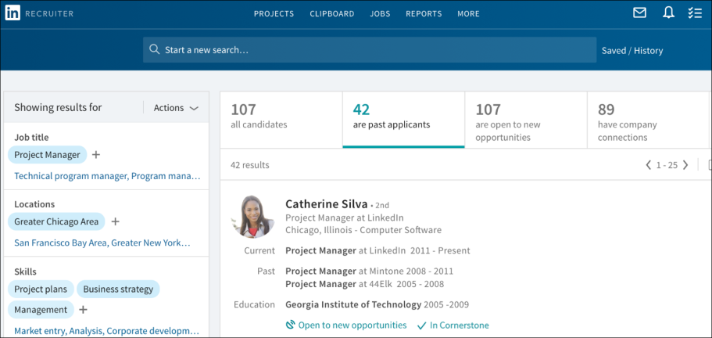
You can view Cornerstone data by clicking In Cornerstone in the candidate's details section on LinkedIn Recruiter. This opens a pop-up that displays their Cornerstone data. Much of the same candidate data that is visible in your Cornerstone portal will also be visible in LinkedIn Recruiter.
For example, you can view status changes and dates so that you know which jobs the candidate applied to, as well as their current and previous status(es) for those jobs. Note: A candidate’s application for a job is not visible until they are moved out of the New Submissions stage.
You can view comments from interviewers and their recommendation. A candidates score does not display.
Comments from recruiters and stakeholders will be visible in LinkedIn Recruiter so that you can use their input to make decisions about what actions to take. If attachments were included in the comment in Cornerstone, the attachment will not be visible in LinkedIn Recruiter.
You can also quickly and easily get to your Cornerstone portal to view the candidate on the Applicant Profile page by clicking the View in Cornerstone link.
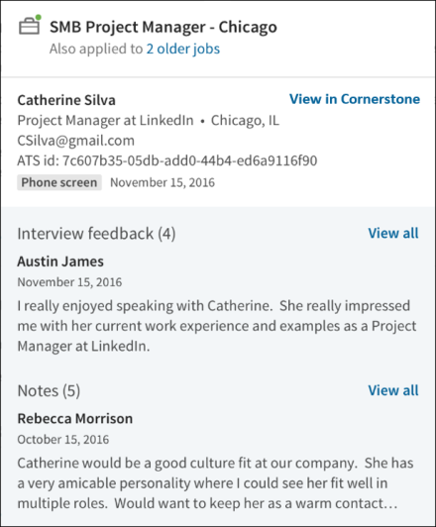
Information for candidates who have been archived, inactivated, or deleted will not display in LinkedIn Recruiter.
InMail Functionality
While viewing a candidate's profile in LinkedIn Recruiter, a recruiter can send an InMail to a candidate.
When responding to the InMail, the candidate will have the option to share their contact information with the recruiter. When the candidate replies, basic information about the candidate is synced from LinkedIn to Cornerstone. If no matching candidate is found in Cornerstone, a basic profile will be created with the candidate's name. No resume/CV information is synced from LinkedIn to Cornerstone. These candidates can now be added to requisitions using the Add Submission functionality on the Requisition Snapshot page, or they can be exported directly to a requisition from LinkedIn (see the "Export Candidate" section below). Approximately an hour after the candidate replies, a link to their Applicant Snapshot page should be visible in LinkedIn Recruiter.
If the candidate chose to share their contact information, the email address and phone number will be visible on the "ATS" tab of the LinkedIn profile approximately an hour after the candidate replied.
Export Candidate
Candidates can be exported from LinkedIn Recruiter to jobs in Cornerstone. To export a candidate:
- Navigate to their profile in LinkedIn Recruiter.
- Click the ellipsis icon and select Export to ATS. This opens the Export to your ATS flyout.
- Click the Job Name field and search for the job by keyword or job ID number. For example, entering "Product" should return options for "Product Manager" or "Associate Product Manager." Similarly, entering "25" will return job requisitions with IDs such as 25, 251, 252, etc. By default, no jobs will appear in the Job Name field. Note: Entering a prefix with the job ID (e.x., Req123) will likely result in no match.
The jobs that display are the jobs to which you have access based on your permission constraints, as well as those that meet the required criteria for syncing to LinkedIn:
  - "External Description" must contain at least 100 characters.
  - The Primary Location field must include a value for the Country field.
  - The Primary Location field must include a value for either the City field or the State/Province field.
Note: A recently created job that meets the criteria listed above may not appear for approximately two hours. The requisition must first be synced to LinkedIn, which occurs roughly every thirty minutes, and a separate list of the users who have access to the requisition must also be synced to LinkedIn, which occurs roughly every two hours.
- Click the job to select it and add it to the Job Name field.
- Click Export. A confirmation appears to indicate the export has been initiated.
To confirm the success of the export, click the ATS tab. An Export Summary section will indicate if the export is in progress, complete, or needs to be retried. This section will also show profile information from Cornerstone, as well as contact information shared by the candidate if they chose to share their contact information in response to an InMail.
When the export occurs, basic information about the candidate is synced from LinkedIn to Cornerstone. If no matching candidate is found in Cornerstone, a basic profile will be created with the candidate's name and a link to their LinkedIn profile. Additionally, an incomplete application for the selected job will be created. No resume/CV information is synced from LinkedIn to Cornerstone. To gain more information about a candidate, a recruiter can visit the LinkedIn tab of the Applicant Profile. Additionally, the recruiter can invite the candidate to apply to the requisition, where they can submit a resume/CV, answer pre-screening questions, and more.
Frequently Asked Questions - LinkedIn Recruiter System Connect
What is the difference between LinkedIn Recruiter and LinkedIn Recruiter System Connect?
LinkedIn Recruiter is the name of the recruiting application within LinkedIn. This application is purchased through LinkedIn and is necessary in order for LinkedIn Recruiter System Connect to be enabled in Cornerstone.
LinkedIn Recruiter System Connect is the name of the integration that can be enabled through Edge in Cornerstone.
Where do I find Cornerstone candidate data in LinkedIn?
Cornerstone candidate data can be viewed in LinkedIn on the candidate's page in LinkedIn Recruiter.
Can I turn off the integration after I enable it?
Yes. You can submit a request to LinkedIn (ltsatsintegrations@linkedin.com) to deactivate the integration.
Will permissions and constraints be respected in LinkedIn?
Yes. Constraints will be synched so that users with LinkedIn Recruiter will only be able to see jobs and application information for requisitions they can access in Cornerstone.
Can application data be deleted from LinkedIn?
Yes. Cornerstone will send deletion requests when triggered by the candidate or after the period of inactivity specified by a client.
How are Notes and InMails from LinkedIn attributed to recruiters in Cornerstone?
When Notes and InMails are synced from LinkedIn, LinkedIn email address of the Note/InMail author is matched with the corresponding email address in Cornerstone . If multiple users in Cornerstone have the same email address, the first matching user (based on ascending user ID) will be labeled as the author of the Note/InMail in Cornerstone.
If the LinkedIn profile displayed on the "LinkedIn" tab of the Applicant Profile page is incorrect, can the proper profile be mapped to the candidate?
Yes. A Not the right candidate? link will appear in the LinkedIn profile. Clicking this link will unlink the current LinkedIn profile. Afterwards, you can search for the correct LinkedIn profile and map the user to the selected profile.
When the profile is unlinked, any InMails and Notes from LinkedIn that are associated with the unlinked profile will be deleted from the candidate's record in Cornerstone. If the recruiter manually links a new LinkedIn profile to the candidate in Cornerstone, then all InMails and Notes from LinkedIn that are associated with the new profile will be synced to the candidate's record in Cornerstone.
Note: The process to sync all historical InMails and Notes for manually linked profiles will run once per day, so please allow up to 24 hours for the new information to appear in Cornerstone.
Note: If multiple candidates are mapped to the same LinkedIn profile, then Notes and InMails from LinkedIn may not sync properly. When new Notes and InMails come in from LinkedIn, they will be assigned to the first matching candidate that is connected to this profile (based on ascending user ID).

Phenom Talent Experience Integration (TXM)
The TXM integration gives mutual customers the benefit of two integrations:
- Job-Sync - The Job-Sync integration facilitates the extraction of requisitions from Cornerstone to Phenom for the purposes of job searching and recruiting scenarios. Upon the creation and publishing of a requisition in Cornerstone, the job will be extracted and posted to the front end of the Phenom platform. Customers need to purchase Phenom’s software for this integration to work. There are no sample workflows to document as this integration is automated. Any requisition published from Cornerstone will be published on the Phenom platform.
- Hiring-Status - The Hiring-Status integration facilitates the extraction and submission of candidate and status details to ensure the correct updated status is reflected in both systems. This sync allows recruiters working in both Cornerstone and Phenom to update candidate statuses and ensure the correct updated status is reflected in both systems. Customers need to purchase Phenom’s software for this integration to work. There are no sample workflows to document as this integration is automated. Any status change within either Phenom or Cornerstone will trigger a change in the other system.
Implementation
The TXM integration is available in Edge Marketplace for all organizations using the Recruiting suite and that also have an account with the integration vendor.
Additional instructions for enabling and configuring the integration are available on the Setup tab of the integration in Edge. There is no additional cost associated with enabling this integration in Edge.
Permissions
The following existing permissions apply to this functionality:
PERMISSION NAME | PERMISSION DESCRIPTION | CATEGORY

Edge Integrations - Manage | Grants access to the Integrations service for Edge Integrate, where the administrator can configure, enable, and disable their third-party integrations used within the Cornerstone system. This permission cannot be constrained. This is an administrator permission. | Edge

Edge Marketplace - Manage | Grants access to the Marketplace service for Edge Integrate, where the administrator can browse integrations that can be used to extend the Cornerstone system. This permission cannot be constrained. This is an administrator permission. | Edge

TimeKO Integration
TimeKO by LINKAVIE, provides best-in-class solutions to facilitate communication with candidates and employees by sending mass text messages and getting real-time categorized positive or negative answer. ​
Cornerstone integrates with TimeKO to provide customers an efficient ad hoc messaging and communication solution.
Prerequisites
- Customers must use Chrome or Firefox to access ATS.
- Customers must be a TimeKO customer to use this integration.
- Contact TimeKO at contact@linkavie.com to get quotes and guidelines to integrate this solution.
Key Features
- Multi-channel communication solution for candidates and employees.​
- Bulk SMS dispatch with automatic categorization of responses. ​
- Schedule messages to send reminders to candidates or employees.
Once enabled, the TimeKo icon appears on the Manage Candidates page. Clicking the icon opens the extension.
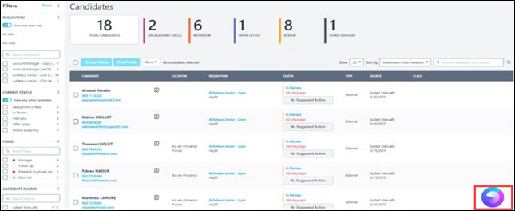

Chatbot Integrations - Overview

Olivia, Your AI Recruiting Assistant - Integration by Paradox
The Olivia integration by Paradox is an FAQ and scheduling powerhouse, pipeline builder, and real-time, mobile-first communication tool. The widget can be placed on a career site for candidates to interact with through an ontology specific to your organization.
The job search integration allows for Paradox to provide requisition information to candidates while searching for a job through a chat. Olivia can guide the candidate through an assisted conversation to search for a job that they are interested in. Through an integration with Cornerstone, Olivia can proactively look up jobs in Cornerstone through the job requisition API and display information on the job to the candidate.
Implementation
The Olivia integration by Paradox is available in Edge Marketplace for all organizations using the Recruiting suite and the Job Requisition API and that also have an account with the integration vendor.
Additional instructions for enabling and configuring the integration are available on the Setup tab of the integration in Edge. There is no additional cost associated with enabling this integration in Edge.
Permissions
The following existing permissions apply to this functionality:
PERMISSION NAME | PERMISSION DESCRIPTION | CATEGORY

Edge Integrations - Manage | Grants access to the Integrations service for Edge Integrate, where the administrator can configure, enable, and disable their third-party integrations used within the Cornerstone system. This permission cannot be constrained. This is an administrator permission. | Edge

Edge Marketplace - Manage | Grants access to the Marketplace service for Edge Integrate, where the administrator can browse integrations that can be used to extend the Cornerstone system. This permission cannot be constrained. This is an administrator permission. | Edge

Drug Screening Integrations - Overview

Quest Diagnostics Drug Screening Integration - Overview
Quest Diagnostics (Quest) is a third party vendor that provides drug screenings for Recruiting.
Use Cases
Use Case 1: Activate the Quest integration through Edge
- James is Acme Company's administrator and has been tasked with enabling the integration between Cornerstone and Quest. This will allow Acme to include Quest drug screenings in their hiring workflow.
- James goes to the Edge Marketplace to purchase and activate the Quest integration.
- From the Edge Integrate page, James enters Acme's unique API credentials, Company/Organization Name, Endpoint URL, Account Name and ID, and Drug Test Name and ID, which are provided by their Quest project team.
- Acme's Cornerstone portal now has an active integration between Cornerstone and Quest.
Use Case 2: Recruiting Administrator creates a custom applicant status
- Lisa is the Recruiting administrator for Acme.
- Holly, a hiring manager at Acme, is looking to add a new member to her Marketing team.
- With the integration enabled, Lisa is tasked with adding a drug screening status in all of Acme's marketing job requisitions.
- Lisa creates a new custom applicant status that is set to a custom integration type Quest Diagnostics.
- Lisa creates a new job requisition that includes that new custom applicant status.
- Lisa has now configured the Marketing job requisitions to include the Quest Diagnostics custom status.
Use Case 3: Recruiter assigns background check request for an applicant
- Ashley, a recruiter at Acme, has identified Paul James to be a stellar applicant.
- To ensure a sound hiring decision is made and to protect Acme from potential risks, Ashley assigns a drug screening test on Paul by moving his status to Quest.
- Ashley selects the appropriate drug test name, then submits the request.
- Paul receives an email from Quest and clicks the link to complete the screening application request in Quest.
Use Case 4: Recruiter views drug screening results and its detailed report in Quest via a link
- Ashley is eager to find out the results of Paul's drug screening status.
- Ashley navigates to Paul's Applicant Profile > Statuses page and sees the status on the request.
- To view additional details of the background request, Ashley clicks the View Progress link, which directs Ashley to the Quest site.
Implementation
This integration is available for all organizations using the Recruiting suite and that also have an account with the integration vendor. This integration is available in Edge Marketplace. Additional instructions for enabling and configuring the integration are available on the Setup tab of the integration in Edge. There is no additional cost associated with enabling this integration in Edge.
It is necessary to have a contract and purchased assessments from Quest to implement the integration.
Security
The following existing permissions apply to this functionality:
PERMISSION NAME | PERMISSION DESCRIPTION | CATEGORY

Applicants: Initiate Background Check | This permission grants access to manage background checks from the Applicant Profile page. This applies to background checks that have been configured in the Integration Center. This permission cannot be constrained. Users who have this permission will have an Assign to Applicant link in the background check status type panel on the Applicant Profile page. Once the background check is assigned, the page will display "Assigned - [Date Assigned]." | Recruiting

Applicants: View Background Check Status | Allow user to view the background check status. The user cannot view the link to the detailed report. This permission cannot be constrained. | Recruiting

Applicants: View Background Check Status and Details Link | This permission allows users to view the background check status and view a link to access the background check report, which can be found in the background check status type panel on the Applicant Profile page. This permission cannot be constrained. | Recruiting

Applicant Status Bank - Manage | Grants ability to access and manage Applicant Status Bank. | Recruiting Administration

Application Workflow Template - View | Grants ability to access and view Application Workflow Templates. | Recruiting Administration

Edge Integrations - Manage | Grants access to the Integrations service for Edge Integrate, where the administrator can configure, enable, and disable their third-party integrations used within the Cornerstone system. This permission cannot be constrained. This is an administrator permission. | Edge

Edge Marketplace - Manage | Grants access to the Marketplace service for Edge Integrate, where the administrator can browse integrations that can be used to extend the Cornerstone system. This permission cannot be constrained. This is an administrator permission. | Edge

Global Email Administration - View | Grants view only access to email templates/triggers and email logs at the global level for the portal. This permission can be constrained by OU, User's OU, User Self and Subordinates, and User. This is an administrator permission. | Core Administration

Requisition: Manage | Grants ability to access and manage all requisitions regardless of ownership (constraints permitting). This permission also grants read-only access to the Applicant Review tab when creating or editing a job requisition. This permission can be constrained by OU, User's OU, and Grade. | Recruiting

Requisition: Owner | Enables owner to access requisitions and applicants for requisitions for which they are an owner. This permission also grants read-only access to video interviews that are completed by applicants via HireVue. For portals with Referral Suite enabled, this permission also enables requisition owners to edit the referral source on the Applicant Profile page. This permission cannot be constrained.  Note: This is a dynamically assigned permission that is not available in Security Role Administration. If the user is removed as an owner, the permission is revoked for the associated requisition. This permission cannot be manually assigned. Also, if a user has both the permission necessary to manage requisitions and be a requisition owner, the constraints of the Requisition: Manage permission overrule those of the Requisition: Owner permission. For requisition owners that do not also have permission to manage requisitions, only certain fields are editable when editing a requisition. | Recruiting

Requisition: Reviewer | Enables reviewer to access requisitions and applicants for requisitions for which they are a reviewer. This permission cannot be constrained.  Note: This is a dynamically assigned permission that is not available in Security Role Administration. Once a requisition is in a Closed or Cancelled status or if the user is removed as a reviewer, the permission is revoked for the associated requisition. This permission cannot be manually assigned.  Note: If an applicant reviewer is removed as a reviewer via the Applicant Profile page, the Requisition: Reviewer permission is revoked for the associated requisition. However, if the reviewer was also added as a reviewer via the General tab when creating, editing, or copying the requisition, the reviewer still appears on the In Review panel as a duplicate reviewer and retains access to the requisition and applicants from the Requisition: Reviewer permission. See Applicant Profile Page Overview for more information about duplicate reviewer instances. | Recruiting
Quest Integration Implementation Steps
To enable the Quest Diagnostics (Quest) drug screening integration, the administrator must configure the items below on the Edge Settings page.
Before you begin, Quest Diagnostics will need to set up/configure their systems to enable this integration. Contact your Quest Diagnostics Drug Screen Account Manager or Sales Representative for more information. If you do not have one assigned, email the Quest Diagnostics Implementation Team at dgxesaccountimplementation@questdiagnostics.com. Due to certain Quest Diagnostics account setups that may already be in place, this integration may not be suitable for all employers.
The activation of the integration is a one-time activity per environment (Stage, Pilot, Production).
Permissions
PERMISSION NAME | PERMISSION DESCRIPTION | CATEGORY

Edge Integrations - Manage | Grants access to the Integrations service for Edge Integrate, where the administrator can configure, enable, and disable their third-party integrations used within the Cornerstone system. This permission cannot be constrained. This is an administrator permission. | Edge

Edge Marketplace - Manage | Grants access to the Marketplace service for Edge Integrate, where the administrator can browse integrations that can be used to extend the Cornerstone system. This permission cannot be constrained. This is an administrator permission. | Edge
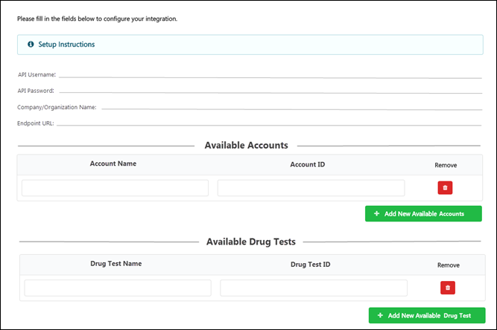
To enable the integration:
- API Username and Password - These credentials authorize Cornerstone to connect to Quest’s API. These credentials are provided by your Quest project team.
  - The API password is a masked field, i.e. the entered password will not appear in plain text.
- Company/Organization Name - This is your unique identifier that enables Quest to authorize background check submissions from Cornerstone. This code is provided by your Quest project team.
- Endpoint URL - This is the Quest endpoint for the API calls. This URL is provided by your Quest project team.
- Account Name and Account ID - These are your available account names and corresponding IDs, which are provided by your Quest project team.
- Drug Test Name and ID - These are provided by your Quest project team. The drug tests entered here will be available to recruiters when assigning a drug screening test to an applicant.
Additional Information
- You must have an existing contract with Quest.
- You must work with your Quest project team to purchase and configure their screening packages.
- No migration is required.
- The activation of the integration is a one-time activity per environment (Stage, Pilot, Production).
- The integration cannot be purchased independently of a product line.
- The cost will be displayed on Edge when you purchase the integration.
Assign and View Quest Drug Screening
To assign the Quest Diagnostics drug screening and view the results, start by creating a custom applicant status, then assigning the screening to the applicant. Once the screening is completed, it can be viewed via the Applicant Profile.
Permissions
PERMISSION NAME | PERMISSION DESCRIPTION | CATEGORY

Applicant Status Bank - Manage | Grants ability to access and manage Applicant Status Bank. | Recruiting Administration
Create Custom Status
- Navigate to the Manage Applicant Status page:
  - Navigation: Admin > Tools > Recruit > Applicant Statuses > Select the top level OU
- Click the Create Custom Status link. This opens the Create Custom Status pop-up.
- Complete the following fields in the pop-up:
  - Language - If multiple languages are enabled for the portal, select the language from the drop-down list for which you are entering the status name and description. To localize the status name and description into other available languages, select the appropriate language from the drop-down list and enter the localized name and description in the appropriate fields.
  - Display Name - Enter the status name, which appears throughout the system. The character limit for this field is 50. When the display name of an active status is modified after the status is in use or has been used in a job requisition:
    - The new display name appears on the Default Status List page.
    - The new display name appears in the Status list on the job requisition template.
    - Any new job requisitions created after the display name is changed apply the new display name.
    - Job requisitions created before the status display name is changed continue to honor the name that existed at the time the requisition was created.
  - Description - Enter the status description. This should describe the purpose of the status and what is implied when an applicant is in that status. The character limit for this field is 500.
  - Type - Select Custom Integration from the drop-down. Note: This field is displayed only when creating a custom status at the top level OU. When creating a custom status for a child OU, the Type field displays the type selected for the parent OU but is not editable.
  - Integration - Select "Quest Diagnostics" from the drop-down.
  - Active - This field is checked by default. Ensure the field is checked before saving the status so that the status is active for the portal.
- Click Save in the pop-up. This returns you to the Manage Applicant Statuses page.
- Click Save at the bottom of the Manage Applicant Statuses page to save the custom status to the Division OU. If the custom status is not saved on the Manage Applicant Statuses page, the status will be lost once you leave the page.
The custom applicant status will need to be added to the Status List on the requisition template so that it will be included on the job requisition.
Assign Screening
Assign the screening by navigating to the Applicant Profile > Statuses tab for the applicant.
- Click the Assign to Applicant link in the Quest status type section. This opens a pop-up.
- Complete the following required fields in the pop-up:
  - Select Provider - Select the background check provider. The options that are available are active integrations that have been enabled in Edge.
  - Select Account Name - Select the account name that the administrator has entered on the Edge Client Settings page.
  - Select Drug Test Name - Select the drug test name that the administrator has entered on the Edge Client Settings page.
- Click Submit.
Quest will send an order acknowledgment response.
View Screening Details and Status
The details and status for the screening is available on the Applicant Profile > Statuses tab. The following information displays:
- Assigned - This field displays the date on which the drug screen test was assigned to the applicant.
- Reference ID - This field displays the User ID value.
- Status - This field displays the overall status of the order. The status "In Progress" displays upon receipt of a successful drug test order. The status is updated automatically when status changes are made by Quest.
- Drug Test Name - This field displays the name of the drug test name assigned to the applicant.
- Provider Reference ID - This field displays the ProviderReferenceId received from Quest.
- Result - This field displays the results received from Quest.
- View Details - Click the View Details link to view the results in Quest. It is not necessary to enter additional credential in order to access Quest and view the results.
You can also view the results on Manage Candidates and Manage Applicants.
Report on Quest Diagnostics Screening
Quest Diagnostics (Quest) drug screenings can be reported on in Reporting 2.0 and Custom Recruiting Reports.
The following fields in the Background Check section provide Quest data:
- Assigned Date
- Completed Date
The following fields in the External Vendors section provide Quest data:
- External Vendor Name
- External Vendor Package Result
- External Vendor Package Title
- External Vendor Product

Interview Scheduling Integrations - Overview

Paradox Interview Scheduling Integration
Paradox Conversational Scheduling automates every type of interview in minutes - from a simple phone screen to a multi-person, multi-location interview day - saving recruiters and hiring managers countless hours, every day.​
Cornerstone integrates with Paradox to allow recruiters and candidates to schedule interviews using the calendar and virtual meeting tools of their choice.
Prerequisites
Customers must have Cornerstone CSX Recruiting licenses and Paradox scheduling licenses.
Customers must be Paradox customers to use the integration.
To enable this functionality, contact Global Customer Support.
Key Features
- Seamless integration from Cornerstone Recruiting pages towards the Paradox browser extension.
- Interview schedule returned to Cornerstone enables the recruiting feedback process.
- Ability to configure the integration in Edge
- Automatic deletion of candidates in Paradox upon anonymization in Cornerstone
- Cancellation of interviews for closed candidates
Benefits from Paradox
- Recruiter defined schedule or candidate selects a time.
- Calendar integrations/Virtual meeting integrations.
- Multi-modal communication with candidates.
- Schedule, reschedule, and cancel interviews.
- Integrate with calendar and virtual meeting tools​​.
- Communicate with candidates through Emails + SMS or WhatsApp (defined at portal level).
- Chat with candidates
Once enabled, the Paradox option appears on the Manage Candidates page:
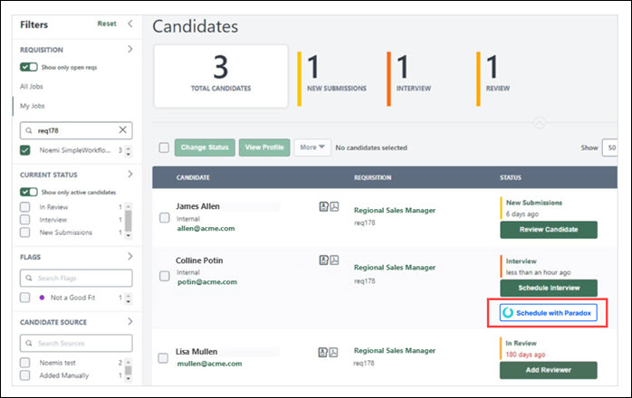
Starter Guide
Click here to view the Paradox Interview Scheduler Integration Starter Guide.

Job Distribution Integrations - Overview

Online Help Topics Related to Broadbean
The following topics in Online Help provide information about the configuration and functionality for the Broadbean Job Posting integration:
- Broadbean Configuration in Edge - This topic provides instructions for configuring Broadbean in Edge. See Broadbean Job Posting Configuration in Edge on page 151 for additional information.
- Broadbean OFCCP Integration - This topic provides information about the Broadbean OFCCP integration. See Broadbean OFCCP Compliance Integration on page 161 for additional information.
- My Account - Social - This topic explains how to connect your user account to Broadbean so that you are already connected to Broadbean when posting jobs on the Job Postings page. See My Account - Social.
- Edit Job Board Cost - This topic covers job board costs related to Broadbean. See Edit Job Board Cost.
- Create Job Requisition - General - This topic mentions that jobs posted via Broadbean will only show the primary location for the job, rather than any additional locations that are configured for the requisition. See Create Job Requisition - General.
- Job Posting Page - This topic covers external job postings. See Job Posting Page.
- Requisition Level Costs - This topic provides information about requisition level costs. See Requisition Level Costs.
- Edit Job Requisition - For Broadbean postings, this topic provides information about the impact of the Canceled and Closed status on Broadbean postings. See Edit Job Requisition.
- Create job Requisition - Job Ad - For Broadbean integrations, this topic provides information on how the Job Postings page is populated with available jobs. See Create Job Requisition - Job Ad.
Broadbean Job Posting Configuration in Edge
Cornerstone and Broadbean Technology have collaborated to deliver a seamlessly integrated job posting solution. From Cornerstone Recruiting, organizations can use the Broadbean integration to post jobs to over 4,500 job boards, social media sites such as LinkedIn, Twitter, and Facebook, and other recruitment channels. Through this integration, organizations can harness the power of internal and external sourcing within Cornerstone Recruiting and distribute job postings to the most popular job boards and eliminate the duplicative administrative burden to post jobs on individual job board sites.
Requirements
In addition to being required to have a Broadbean administrator account (along with a secret key), you are required to create a separate account in the Edge Integration Center for each user that will use Broadbean.
Implementation
This integration is available for all organizations using Recruiting. This integration is available for free via Edge Marketplace. Additional instructions for enabling and configuring the integration are available on the Setup tab of the integration in Edge.
Frequently Asked Questions (FAQs)
Why are users seeing this message and what can I do to fix it: "Error No Account Configured for User in Integration Center."
Because the user does not have an individual account configured on Edge. Individual user accounts need to be configured via Administrator > Tools > Edge Integration.
Does every user need their own unique individual account?
Yes. Individual user accounts need to be configured via Administrator > Tools > Edge Integration.
I have many users that need individual accounts, is there a way to bulk upload them?
No, there is not a way to bulk upload individual accounts.
When I am setting up the Broadbean integration in Edge, can I map several users to the same Broadbean user ID?
No.
What is the Candidate Profile field on the Settings page?
The qualifications in the Minimum Qualifications field for a job requisition can be sent to Broadbean's Candidate Profile field. It is important to note that in order to use the Candidate Profile field, you must confirm with your Broadbean representative that your integration can use this field. When the field is toggled to on, Broadbean will then independently choose to which specific job boards the Candidate Profile will be sent. It will be necessary for clients to work with Broadbean directly to select the job boards to which they would like to send the Candidate Profile field data. The benefit to a customer that enables this feature is that a requisition's minimum qualifications will be sent to Broadbean's Candidate Profile field for distribution to specific job boards.
In addition, when the field is toggled on, you can determine whether to send the Job Description field or the job ad in Cornerstone to map to the Detailed Job Description field in Broadbean. The benefit of having the ability to choose which field to send is that the content in the job ad in Cornerstone tends to duplicate information in the Minimum Qualifications field, which is mapped to the Candidate Profile field in Broadbean. For example, if you have the Candidate Profile option enabled in Edge for the Broadbean Job Posting integration, and you also include the JOB.MINIMUM.QUALIFICATIONS tag in the job ad, the minimum qualifications information will appear twice when applicants view the job via a Broadbean job board because it appears in both the Detailed Job Description and the Candidate Profile field.
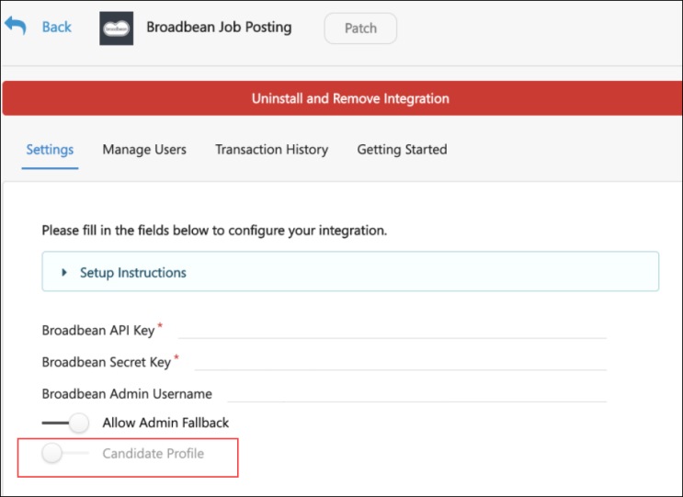
Online Help Topics Related to Broadbean
The following topics in Online Help provide information about the configuration and functionality for the Broadbean Job Posting integration:
- Broadbean Configuration in Edge - This topic provides instructions for configuring Broadbean in Edge. See Broadbean Job Posting Configuration in Edge on page 151 for additional information.
- Broadbean OFCCP Integration - This topic provides information about the Broadbean OFCCP integration. See Broadbean OFCCP Compliance Integration on page 161 for additional information.
- My Account - Social - This topic explains how to connect your user account to Broadbean so that you are already connected to Broadbean when posting jobs on the Job Postings page. See My Account - Social.
- Edit Job Board Cost - This topic covers job board costs related to Broadbean. See Edit Job Board Cost.
- Create Job Requisition - General - This topic mentions that jobs posted via Broadbean will only show the primary location for the job, rather than any additional locations that are configured for the requisition. See Create Job Requisition - General.
- Job Posting Page - This topic covers external job postings. See Job Posting Page.
- Requisition Level Costs - This topic provides information about requisition level costs. See Requisition Level Costs.
- Edit Job Requisition - For Broadbean postings, this topic provides information about the impact of the Canceled and Closed status on Broadbean postings. See Edit Job Requisition.
- Create job Requisition - Job Ad - For Broadbean integrations, this topic provides information on how the Job Postings page is populated with available jobs. See Create Job Requisition - Job Ad.

VONQ Job Post Integration
VONQ Job Post is an automation solution for high volume recruitment that reduces complexity and saves time. This integration simply and automatically distributes jobs to multiple sources, including programmatic advertising. Administrators can use the return on investment reports to make informed decisions about which sources deliver candidates at the lowest cost.
Implementation
This integration is available for self-activation in Edge Marketplace via the VONQ Job Post integration tile. This integration is for Cornerstone customers that also have an account with the integration vendor.
Permissions
The following existing permissions apply to this functionality:
PERMISSION NAME | PERMISSION DESCRIPTION | CATEGORY

Edge Integrations - Manage | Grants access to the Integrations service for Edge Integrate, where the administrator can configure, enable, and disable their third-party integrations used within the Cornerstone system. This permission cannot be constrained. This is an administrator permission. | Edge

Edge Marketplace - Manage | Grants access to the Marketplace service for Edge Integrate, where the administrator can browse integrations that can be used to extend the Cornerstone system. This permission cannot be constrained. This is an administrator permission. | Edge

New Hire Onboarding Integrations - Overview

ADP Workforce Now (WFN) for Recruiting & Onboarding Integration
ADP Workforce Now Recruiting & Onboarding Connector API integration creates new hire data in ADP. This is a one-way integration from Cornerstone to ADP Workforce Now current version (version 2.0 is not supported by API integration). This integration only applies to external new hires, not internal hires. The integration is triggered once the HR Admin saves the new hire’s user record in Cornerstone after going through the Manage Hired Applicants page.

CIC Plus Integration
Through integration with CIC Plus, employers can assign electronic tax withholding forms (W-4 forms) to new hires as part of the Onboarding workflow. New hires can then complete all applicable ho can then electronically complete tax withholding paperwork as part of their onboarding process. Employers are able to track tax withholding form completion, along with other onboarding tasks. This integration provides users access to the forms through a secure, self-service site.
Considerations
A future enhancement to the integration features may include the ability for employees to update existing W-4 forms.
Implementation & Configuration
The CIC Plus integration requires Cornerstone Onboarding and a CIC Plus account. This integration is available in the Edge Marketplace. Once the integration has been purchased, the functionality is not available until the integration is configured and enabled via Edge Integrations. Additional instructions for enabling and configuring the integration are available on the Setup tab of the integration in Edge.
When configuring the integration, the following applies:
- Provide User Refs as unique identifier for users. This helps to ensure that data syncs across Cornerstone, CIC Plus, and their other systems. If this information is not provided, then internal user IDs will be used.
- The target Location OUs for onboarding users must have complete address data, which includes a street address, city, state, ZIP code, and country.
- A parent form task that is assigned to the onboarding employee for the purpose of collecting the employee’s home address information must be configured prior to adding an integration task for completing W-4 forms.
- The W-4 Form (CIC Plus) integration task must be added to Onboarding Workflows as a child task of parent form tasks.
- A setting to collect the user's social security number and date of birth must be configured in CIC Plus.
Use Case
- Prior to issuing a new employee's first paycheck, an employer needs to know how much they need to withhold from an employee's paycheck for taxes. A task to complete the necessary W-4 form(s) needs to be assigned to new hires as an onboarding task.
- Amanda, an administrator, is configuring onboarding workflow tasks for new hire onboarding. She needs to add an integration task for W-4 forms to the onboarding tasks for the new hire. However, as a prerequisite to completing W-4 forms, Amanda needs to ensure that the employer has the most recent address information for the new hire. Amanda configures a form task as a parent task and assigns it to onboarding employees to collect their home address information. She then configures a form task as a child task and assigns it to Mark, a Human Resources (HR) representative, to collect the new hire's work location address. Finally as a child task to the two form tasks, Amanda configures an integration task for W-4 forms though integration partner CIC Plus to be assigned to onboarding employees.
- Vincent has just been hired and has started the onboarding process. He launches and completes a form task and fills out his home address.
- Mark launches and completes a form task to fill out Vincent's work address.
- Vincent is assigned an integration task to complete his W-4 forms. He clicks on his action item in Universal Profile to complete his W-4 forms. Through Single Sign-On (SSO), he is automatically signed into Paperless Employee, a CIC Plus Product, where he sees the W-4 forms he needs to complete. If Vincent still has more forms to complete after he submits a form, he receives a notification telling him how many pending forms he still has to complete. He can access and complete those forms through his original W-4 form action item. After Vincent completes all his pending forms, his W-4 form action items is automatically completed and removed from his list of action items.
- Esther, the HR Director, monitors the progress of onboarding employees. As new hires and HR representatives complete their respective tasks, she can see the completion progress for the new hire when it is updated. In the result column of the W-4 task, Esther can see how many W-4 forms are still pending for the new hire if they have not yet completed all the W-4 forms required for them.
Security
The following permissions apply to this functionality:
PERMISSION NAME | PERMISSION DESCRIPTION | CATEGORY

Action Items - View | Grants ability to view action items on the Action Items page and in the Your Action Items widget. Users without this permission cannot access the Action Items page. This permission can be constrained by Employee Relationship, OU, User's OU, User's Self and Subordinates, and User's Self. This is an end user permission. | Universal Profile

Employee Onboarding: Manage | Grants ability to manage user onboarding in the Onboarding Dashboard and the Onboarding tab on the Universal Profile. This permission can be constrained by OU, User's OU, and User Self and Subordinates. | Employee Onboarding

Action Items - Employee Onboarding | Grants ability to view Onboarding actions via the Universal Profile - Actions page or the Welcome/Custom page Actions widget. This permission cannot be constrained. This is an end user permission. | Universal Profile

Edge Marketplace - Manage | Grants access to the Marketplace service for Edge Integrate, where the administrator can browse integrations that can be used to extend the Cornerstone system. This permission cannot be constrained. This is an administrator permission. | Edge

Employee Onboarding: Manage | Grants ability to manage user onboarding in the Onboarding Dashboard and the Onboarding tab on the Universal Profile. This permission can be constrained by OU, User's OU, and User Self and Subordinates. | Employee Onboarding

Employee Onboarding: View | Grants ability to view the Onboarding Dashboard and the Onboarding tab on the Universal Profile. This permission can be constrained by OU, User's OU, and User Self and Subordinates. | Employee Onboarding

Onboarding Workflows - Manage | Grants ability to access and manage Onboarding Workflows. This permission cannot be constrained. This is an administrator permission. | Employee Onboarding - Administration

Onboarding Integrations - Manage | Grants administrator ability to manage Recruiting and Onboarding Integrations. This permission cannot be constrained. This is an administrator permission. | Employee Onboarding - Administration

Recruiting Integrations - Manage | Grants ability to access and manage the Recruiting Integrations Preferences page. This is an administrator permission. This permission cannot be constrained. | Recruiting Administration

OFCCP Compliance Integrations - Overview

Broadbean OFCCP Compliance Integration
OFCCP Compliance provider with non-government partnerships, which acquires Cornerstone job listings and distributes to state workforce agencies and their technology partners.
Implementation
This integration is a vendor-built integration and not by Cornerstone. More information and instructions can be found in Edge Integrate.
Permissions
The following existing permissions apply to this functionality:
PERMISSION NAME | PERMISSION DESCRIPTION | CATEGORY

Edge Integrations - Manage | Grants access to the Integrations service for Edge Integrate, where the administrator can configure, enable, and disable their third-party integrations used within the Cornerstone system. This permission cannot be constrained. This is an administrator permission. | Edge

Edge Marketplace - Manage | Grants access to the Marketplace service for Edge Integrate, where the administrator can browse integrations that can be used to extend the Cornerstone system. This permission cannot be constrained. This is an administrator permission. | Edge

Video Interview Integrations - Overview

Outmatch Video Interview Integration
The Outmatch Video Interview integration transforms your recruiting process with a video interview platform designed to boost efficiency in the hiring process and create engaging candidate experiences.
Outmatch lets recruiters create engaging recruitment experiences, while still managing, inviting, and reviewing candidates through the Cornerstone platform. Candidates complete the video interview via the Outmatch platform, where they can also experience your brand through engaging media and video content.
Video Interview Workflow
Recruiter Creates Interview > Recruiter Assigns Interview > Candidate Completes Interview > Recruiter Views Interview, Scores, and Status
Create Interview
Video interviews are created in the Outmatch platform. The recruiter will add a list of questions to the interview and save it in Outmatch.
Assign Interview
Video interviews are assigned on Manage Candidates or Manage Applicants, using the Assign Integration or Assign Assessment Task options respectively. Assigning the interview sends an email to the candidate, which will include a link to launch the interview.
For general information about assigning assessments to candidates:
- See Manage Candidates - Assign Integrations.
- See Manage Applicants - Assign Assessment Task.
Launch and Complete Interview
Candidates launch the video interview by clicking a link to the interview from the email sent by the recruiter. The video interview process consists of a series of questions, each of which appear on a new page within the interview. To answer a question, the candidate clicks a button to begin recording their answer. The candidate will be given a time limit for each question, and the recording will stop automatically at the end of the time limit.
Once all answers are recorded, the candidate can submit the interview.
View Interview, Scores, and Status
The interview is available to view from Manage Candidates or Manage Applicants by clicking the View Interview button. Clicking the button opens the Outmatch platform to the interview page, which includes options to view the interview, rate the candidate, and provide comments.
Any scores the candidate received for the interview are sent to Manage Candidates and Manage Applicants. The status of the interview is also available.
Implementation
The Outmatch Video Interview integration will be available on 8 March 2021 via Edge Marketplace for all organizations using Recruiting and that also have an account with the integration vendor.
Additional instructions for enabling and configuring the integration are available on the Setup tab of the integration in Edge. There is no additional cost associated with enabling this integration in Edge.
Permissions
The following existing permissions apply to this functionality:
PERMISSION NAME | PERMISSION DESCRIPTION | CATEGORY

Edge Integrations - Manage | Grants access to the Integrations service for Edge Integrate, where the administrator can configure, enable, and disable their third-party integrations used within the Cornerstone system. This permission cannot be constrained. This is an administrator permission. | Edge

Edge Marketplace - Manage | Grants access to the Marketplace service for Edge Integrate, where the administrator can browse integrations that can be used to extend the Cornerstone system. This permission cannot be constrained. This is an administrator permission. | Edge

Requisition: Manage | Grants ability to access and manage all requisitions regardless of ownership (constraints permitting). This permission also grants read-only access to the Applicant Review tab when creating or editing a job requisition. This permission can be constrained by OU, User's OU, and Grade. | Recruiting

Requisition: Owner | Enables owner to access requisitions and applicants for requisitions for which they are an owner. This permission also grants read-only access to video interviews that are completed by applicants via HireVue. For portals with Referral Suite enabled, this permission also enables requisition owners to edit the referral source on the Applicant Profile page. This permission cannot be constrained.  Note: This is a dynamically assigned permission that is not available in Security Role Administration. If the user is removed as an owner, the permission is revoked for the associated requisition. This permission cannot be manually assigned. Also, if a user has both the permission necessary to manage requisitions and be a requisition owner, the constraints of the Requisition: Manage permission overrule those of the Requisition: Owner permission. For requisition owners that do not also have permission to manage requisitions, only certain fields are editable when editing a requisition. | Recruiting

Visiotalent Assessment Integration
The Visiotalent Assessment integration built by CleverConnect offers cloud-based on-demand and live video interview solutions to uncover a candidate's personality and soft skills while reducing your time-to-hire.
Implementation
The Visiotalent Assessment integration will be available on 21 December 2020 via Edge Marketplace for all organizations using the Recruiting suite and that also have an account with the integration vendor.
Additional instructions for enabling and configuring the integration are available on the Setup tab of the integration in Edge. There is no additional cost associated with enabling this integration in Edge.
Permissions
The following existing permissions apply to this functionality:
PERMISSION NAME | PERMISSION DESCRIPTION | CATEGORY

Edge Integrations - Manage | Grants access to the Integrations service for Edge Integrate, where the administrator can configure, enable, and disable their third-party integrations used within the Cornerstone system. This permission cannot be constrained. This is an administrator permission. | Edge

Edge Marketplace - Manage | Grants access to the Marketplace service for Edge Integrate, where the administrator can browse integrations that can be used to extend the Cornerstone system. This permission cannot be constrained. This is an administrator permission. | Edge

Work Opportunity Tax Credit Integrations - Overview

ADP Work Opportunity Tax Credit Overview
The ADP Work Opportunity Tax Credit (WOTC) Integration provides an additional integration option for assigning WOTC surveys. This integration enables organizations to identify applicants that may qualify for WOTC program tax credits by assigning ADP's WOTC surveys from within Recruiting.
Use Cases
Use Case 1: Activate the ADP WOTC integration through Edge
- James is Acme Company's administrator and has been tasked with enabling the WOTC integration between Cornerstone and ADP. This will allow Acme to include the WOTC survey in their application process and enable ADP to manage the submission process.
- James goes to the Edge Marketplace to purchase and activate the ADP WOTC integration. James will also work with his ADP project team to configure Acme's ADP system.
- From the Edge Integrate page, James enters Acme's Client ID, Client Secret, Company Code, and Authentication Code, which is provided by their ADP project team.
- Acme's Cornerstone portal now has an active WOTC integration between Cornerstone and ADP.
Use Case 2: Recruiting Administrator configures ADP WOTC survey as an action step in Application Workflow
- Allan is the Recruiting administrator for Acme.
- With the integration enabled, Allan is tasked with including a WOTC survey in all of Acme's Customer Support requisitions.
- Allan creates a new custom application workflow template that includes a WOTC action step, ensuring that ADP WOTC is added as a custom integration.
- Allan configures all Customer Support requisitions to include the custom application workflow template, which includes a WOTC action step.
- Applicants applying to the Customer Support requisition are now prompted to complete an ADP WOTC survey as part of their application process.
Use Case 3: Recruiter assigns an ad hoc assessment to an applicant
- Lisa, a hiring manager at Acme, is looking to add two new members to her Customer Support team.
- To help reduce the company's income tax liability, Lisa would like to consider hiring a WOTC eligible candidate.
- Lisa goes to the Manage Applicants page for the Customer Support requisition and identifies four potential candidates to assign a WOTC survey to, making sure that all candidates' statuses are assigned to the custom status ADP WOTC.
- While the same candidates are selected, Lisa selects the Assign Integration Assessment option from the Actions drop-down. She proceeds with the assignment and clicks Submit.
- The applicants will receive an email with a link that will redirect them to complete the ADP WOTC survey. Note: The Assign Integration Assessment email will need to be successfully configured by the administrator in Email Administration in order for the applicant to receive the email.
- Cornerstone runs a batch update to update the candidate's assessment status.
- Lisa can check either the Manage Applicants page or the Applicant Profile page for updates on the applicant's potential eligibility status.
Use Case 4: Recruiter hires a candidate
- Annie the Candidate has accepted Acme's employment offer.
- Lisa updates Annie's status to "Hired," which triggers Cornerstone to send the offer information to ADP.
- Lisa can view updated eligibility information on Annie's Applicant Profile page or the Manage Applicants page. Lisa can also print relevant ADP forms by clicking the View Report link on the Manage Applicants page or the applicable status panel on the Applicant Profile > Statuses tab.
Implementation
This integration is available for all organizations using Recruiting. This integration is available for free via Edge Marketplace. Additional instructions for enabling and configuring the integration are available on the Setup tab of the integration in Edge.
Considerations
- Retroactive Application - WOTC surveys cannot be retroactively applied to requisitions prior to enabling of the integration, even though these requisitions are in open/active status.
- Social Security Number - With this integration, ADP will collect the candidate’s Social Security Number at the time the candidate is completing the WOTC survey.
- Application Workflow Set-Up - ADP WOTC surveys cannot be a required step in the application workflow.
Best Practices for Using WOTC Surveys
As a best practice, display the WOTC survey between an Education Experience section and a section such as EEO Questions.
Permissions
The following permissions apply to this functionality:
PERMISSION NAME | PERMISSION DESCRIPTION | CATEGORY

Applicant Status Bank - Manage | Grants ability to access and manage Applicant Status Bank. | Recruiting Administration

Applicants: Assign Assessment Integration | Grants access to manage assessment integrations from the Applicant Profile page. This applies to assessments that have been configured in the integration center. This permission cannot be constrained. This permission is only available for portals that have an active assessments integration.  This is the highest level of permission for this functionality. In addition to being able to assign assessments, users with this permission will be able to view the assessment status and assessment details. | Recruiting

Applicants: View Assessment Integration Status | Allows user to view the assessment integration check status on the Applications tab of the Applicant Profile page. The user cannot view the link to the detailed report of the assessment. This permission cannot be constrained. This permission is only available for portals that have an active assessments integration.  This is the lowest level of permission for this functionality. Users with this permission can only view the assessment status; they cannot assign assessments or view assessment details. | Recruiting

Applicants: View Assessment Integration Status and Details Link | Allows user to view the assessment integration status and view link to access the assessment report from the Applications tab of the Applicant Profile page and from the associated column on the Manage Applicants page. This permission cannot be constrained. This permission is only available for portals that have an active assessments integration.  This is the second highest level of permission for this functionality. Users with this permission will be able to view the assessment status and assessment details but will not be able to assign assessments. | Recruiting

Application Workflow Template - Manage | Grants ability to access and manage Application Workflow Templates. This permission can be constrained by OU and User’s OU. This is an administrator permission. | Recruiting Administration

Application Workflow Template - View | Grants ability to access and view Application Workflow Templates. | Recruiting Administration

Edge Integrations - Manage | Grants access to the Integrations service for Edge Integrate, where the administrator can configure, enable, and disable their third-party integrations used within the Cornerstone system. This permission cannot be constrained. This is an administrator permission. | Edge

Edge Marketplace - Manage | Grants access to the Marketplace service for Edge Integrate, where the administrator can browse integrations that can be used to extend the Cornerstone system. This permission cannot be constrained. This is an administrator permission. | Edge

Global Email Administration - Manage | Grants ability to manage email trigger templates across all active modules in the portal. Enables creating, editing and deleting email message templates for various system actions and workflows. This permission can be constrained by OU, User's OU, User Self and Subordinates, and User. This is an administrator permission. | Core Administration

Global Email Administration - View | Grants view only access to email templates/triggers and email logs at the global level for the portal. This permission can be constrained by OU, User's OU, User Self and Subordinates, and User. This is an administrator permission. | Core Administration

Requisition: Manage | Grants ability to access and manage all requisitions regardless of ownership (constraints permitting). This permission also grants read-only access to the Applicant Review tab when creating or editing a job requisition. This permission can be constrained by OU, User's OU, and Grade. | Recruiting

Requisition: Owner | Enables owner to access requisitions and applicants for requisitions for which they are an owner. This permission also grants read-only access to video interviews that are completed by applicants via HireVue. For portals with Referral Suite enabled, this permission also enables requisition owners to edit the referral source on the Applicant Profile page. This permission cannot be constrained.  Note: This is a dynamically assigned permission that is not available in Security Role Administration. If the user is removed as an owner, the permission is revoked for the associated requisition. This permission cannot be manually assigned. Also, if a user has both the permission necessary to manage requisitions and be a requisition owner, the constraints of the Requisition: Manage permission overrule those of the Requisition: Owner permission. For requisition owners that do not also have permission to manage requisitions, only certain fields are editable when editing a requisition. | Recruiting

Requisition: Reviewer | Enables reviewer to access requisitions and applicants for requisitions for which they are a reviewer. This permission cannot be constrained.  Note: This is a dynamically assigned permission that is not available in Security Role Administration. Once a requisition is in a Closed or Cancelled status or if the user is removed as a reviewer, the permission is revoked for the associated requisition. This permission cannot be manually assigned.  Note: If an applicant reviewer is removed as a reviewer via the Applicant Profile page, the Requisition: Reviewer permission is revoked for the associated requisition. However, if the reviewer was also added as a reviewer via the General tab when creating, editing, or copying the requisition, the reviewer still appears on the In Review panel as a duplicate reviewer and retains access to the requisition and applicants from the Requisition: Reviewer permission. See Applicant Profile Page Overview for more information about duplicate reviewer instances. | Recruiting
ADP WOTC Integration Implementation Steps
Applicant Statuses - Create Custom ADP WOTC Status
In order for the ADP WOTC status to be available to select for applicants, it is necessary to create a custom integration status in Manage Applicant Statuses.
Permissions
PERMISSION NAME | PERMISSION DESCRIPTION | CATEGORY

Applicant Status Bank - Manage | Grants ability to access and manage Applicant Status Bank. | Recruiting Administration
Emails
EMAIL NAME | EMAIL DESCRIPTION | ACTION TYPE

Assign Integration Assessment | This email is triggered when an Edge integration assessment is assigned to an applicant, such as a WOTC assessment. This email can be configured as a notification or a reminder, and it can be sent to External Applicant, Internal Applicant, OU Approver, Hiring Manager, OU Approver, or a specific user.  This email only triggers when a successful response is received from the vendor.  Note: The APPLICANT.INTEGRATION.ASSESSMENT.LINK tag must be included in the email. This tag provides a link that the applicant can click to access the assessment.  Note about Auto-Assignment of Pre-Employment Verifications: This email also applies to auto-assignment of pre-employment verifications, via the Automated Candidate Progression (Early Adopter) functionality. For more information, see Feature Activation Preferences. | Recruiting
Create Custom Status
To create a custom integration status for ADP WOTC:
- Navigate to Admin > Tools > Recruit > Applicant Statuses.
- Click Create Custom Status. This opens the Create Custom Status pop-up.
- Complete the following fields in the Create Custom Status pop-up:
  - Language - If multiple languages are enabled, from the drop-down list select the language in which you are entering the status name and description. To localize the status name and description into other available languages, select the appropriate language from the drop-down list and enter the localized name and description in the appropriate fields.
  - Display Name - Enter "ADP WOTC" to identify the status as being specifically for ADP WOTC assessments. This field accepts up to 50 characters. If you change the display name after it is in use:
    - The new display name appears on the Default Status List page.
    - The new display name appears in the Status list on the job requisition template.
    - Any new job requisitions created after the display name is changed will apply the new display name.
    - Job requisitions created before the status display name is changed will continue to honor the name that existed at the time the requisition was created.
  - Description - Enter a description, up to 500 characters. As a best practice, provide a description that helps recruiters understand the purpose of this status.
  - Type - Select Custom Integration. The Custom Integration status type mans that the applicant is in an integration step of the status workflow. When creating a custom status for a child organizational unit (OU), the Type field displays the type selected for the parent OU but is not editable.
  - Integration - Select ADP WOTC in this field, which will associate the custom status to ADP WOTC integration.
  - Active - This option is selected by default and means the status will be available to include in status workflows.
- Click Save in the pop-up. This returns you to the Manage Applicant Statuses page.
- Click Save at the bottom of the Manage Applicant Statuses page to save the custom status to the Division OU. If the custom status is not saved on the Manage Applicant Statuses page, the status will be lost once you leave the page.
The custom applicant status will need to be added to the Status List on the requisition template so that it will be included on the job requisition.
Add ADP WOTC Custom Integration Action
When including the ADP WOTC integration in the applicant statuses for a job requisition, the Custom Integration action item must also be included in the application workflow. This allows applicants to complete the assessment during the application process. See Application Workflow - Add Integration.
Note: ADP WOTC assessments can also be assigned to applicants on an ad hoc basis from the Manage Applicants page.
To create an application workflow template, go to Admin > Tools > Recruit > Application Workflow Templates. Then click the Create Template link.
Note: The application workflow can also be configured in requisition templates, the default requisition template, and job requisitions.
Permissions
PERMISSION NAME | PERMISSION DESCRIPTION | CATEGORY

Application Workflow Template - Manage | Grants ability to access and manage Application Workflow Templates. This permission can be constrained by OU and User’s OU. This is an administrator permission. | Recruiting Administration

Application Workflow Template - View | Grants ability to access and view Application Workflow Templates. | Recruiting Administration
Assign ADP WOTC Assessment
ADP WOTC assessments can be included in the application workflow for a job requisition and can also be assigned to applicants from the Manage Applicants page.
- When included in the application workflow, the assessment is part of the process of applying for the job and should be configured as optional to complete.
- When assigned via the Manage Applicants page, recruiters have more flexibility in when they want to assign the assessment and specify the applicants who will receive the assessment.
Assign Assessment in Application Workflow
To include the assessment in the application workflow, the "Custom Integration" action item must be part of the workflow on the job requisition. For more information about including the assessment in the application, see the Application Workflow - Add ADP WOTC Custom Integration Action topic in Online Help.
Applicants click the Launch option on the application workflow step to open and complete the assessment. This registers the applicant with ADP and provides the applicant with access to the WOTC assessment that is part of the job requisition.
Recruiters can view the results on either the Manage Applicants page or the Applicant Profile > Statuses tab. Results are updated every 15 minutes.
Assign Assessment from Manage Candidates
See Manage Candidates - Assign Integrations.
Assign Assessment from Manage Applicants Page
To assign the assessment from the Manage Applicants page:
- Navigate to the Manage Applicants page for the job requisition.
- Select one or more applicants to whom you would like to assign the assessment.
- Click Assign Integration Assessment from the Actions drop-down. This opens the Assign Integration Assessment pop-up.
- Verify that the ADP WOTC assessment is selected.
- Click Submit. This sends the Assign Integration Assessment email to the applicant, which includes a link that directs them to ADP to complete the assessment.
Note: The Assign Integration Assessment email trigger email will need to be successfully configured in Email Administration in order for the applicant to receive the email. See Email Triggers.
Recruiters can view the results on either the Manage Applicants page or the Applicant Profile > Statuses tab. Results are updated every 15 minutes.
Manage Applicants Deprecation: Cornerstone is deprecating Manage Applicants in Q1 2024. See Manage Applicants Overview.
View ADP WOTC Assessment Results
Recruiters can view the results of ADP WOTC assessments on Manage Candidates, Manage Applicants, or the Statuses tab on the Applicant Profile page. Results are updated every 15 minutes.
- Cornerstone will pull updates for candidates whose assessment status is in either In Progress or Incomplete and for those who have an assessment assign date of 60 days or less from the time the scheduler runs.
- Candidates whose assessment status is in either In Progress or Incomplete and have an assessment assign date of 61 days or more (from the time the scheduler runs) will be marked Cancelled.
Once a candidate is in a Hired status, Cornerstone sends an update to ADP to initiate and complete the tax credit paperwork.
The Location OU ID associated with the job requisition should match the work location IDs in ADP.
Manage Applicants Deprecation: Cornerstone is deprecating Manage Applicants in Q1 2024. See Manage Applicants Overview.

First Advantage Work Opportunity Tax Credit Integration - Overview
The First Advantage (FADV) Work Opportunity Tax Credit (WOTC) integration provides an additional integration option for assigning Work Opportunity Tax Credit surveys. This integration enables organizations to identify applicants that may qualify for Work Opportunity Tax Credit program tax credits by assigning First Advantage's Work Opportunity Tax Credit surveys from within the Applicant Tracking System (ATS).
Use Cases
Use Case 1: Activate the First Advantage Work Opportunity Tax Credit integration through Edge
- James is Acme Company's administrator and has been tasked with enabling the Work Opportunity Tax Credit integration between Cornerstone and First Advantage. This will allow Acme to include the Work Opportunity Tax Credit survey in their application process and enable First Advantage to manage the submission process.
- James goes to the Edge Marketplace to purchase and activate the First Advantage Work Opportunity Tax Credit integration.
- From the Edge Integrate page, James enters Acme's Company ID, which is provided by their First Advantage project team.
- Acme's Cornerstone portal now has an active Work Opportunity Tax Credit integration between Cornerstone and First Advantage.
Use Case 2: Recruiting Administrator configures First Advantage Work Opportunity Tax Credit survey as an action step in Application Workflow
- Allan is the Recruiting administrator for Acme.
- With the integration enabled, Allan is tasked with including a Work Opportunity Tax Credit survey in all of Acme's Customer Support requisitions.
- Allan creates a new custom application workflow template that includes a Work Opportunity Tax Credit action step, ensuring that First Advantage Work Opportunity Tax Credit is added as a custom integration.
- Allan configures all Customer Support requisitions to include the custom application workflow template, which includes a Work Opportunity Tax Credit action step.
- Applicants applying to the Customer Support requisition are now prompted to complete a First Advantage Work Opportunity Tax Credit survey as part of their application process.
Use Case 3: Recruiter assigns an ad hoc assessment to an applicant
- Lisa, a hiring manager at Acme, is looking to add two new members to her Customer Support team.
- To help reduce the company's income tax liability, Lisa would like to consider hiring a Work Opportunity Tax Credit eligible candidate.
- Lisa goes to the Manage Applicants page for the Customer Support requisition and identifies four potential candidates to assign a Work Opportunity Tax Credit survey to, making sure that all candidates' statuses are assigned to the custom status First Advantage Work Opportunity Tax Credit.
- While the same candidates are selected, Maria selects the Assign Integration Assessment option from the Actions drop-down. She proceeds with the assignment and clicks Submit.
- The applicants will receive an email with a link that will redirect them to complete the First Advantage Work Opportunity Tax Credit survey. Note: The Assign Integration Assessment email trigger email will need to be successfully configured by the administrator in Email Administration in order for the applicant to receive the email.
- After the applicants complete the survey, First Advantage sends Cornerstone a summary of the candidate’s results, which are available for viewing on the Manage Applicants page or the Application tab on the Applicant Profile page.
- To further review the assessment results, Lisa clicks the View Report link, which will direct her to First Advantage to view a detailed report of the assessment results.
Implementation
This integration is available for all organizations using the Recruiting suite. This integration is available for free via Edge Marketplace. Additional instructions for enabling and configuring the integration are available on the Setup tab of the integration in Edge.
The integration can be accessed and configured via the Edge Marketplace. In order to use this integration, your organization must be using the Recruiting module and must have access to Edge and have an account with the integration vendor. There is no additional cost associated with enabling this integration, but the integration cannot be used without an account with the integration vendor.
Considerations
- Mobile App - This functionality is not available in the mobile app. If the survey is included in a step of the application workflow, the step will be skipped in the mobile app.
- Retroactive Application - Work Opportunity Tax Credit surveys cannot be retroactively applied to requisitions prior to enabling of the integration, even though these requisitions are in open/active status.
- With this integration, First Advantage will collect the candidate’s Social Security Number at the time the candidate is completing the Work Opportunity Tax Credit survey.
Best Practices for Using WOTC Surveys
- Where to Place in Application Workflow - Display WOTC between an Education Experience section and a section such as Equal Employment Opportunity (EEO) Questions.
Permissions
The following permissions apply to this functionality:
PERMISSION NAME | PERMISSION DESCRIPTION | CATEGORY

Applicant Status Bank - Manage | Grants ability to access and manage Applicant Status Bank. | Recruiting Administration

Applicants: Assign Assessment Integration | Grants access to manage assessment integrations from the Applicant Profile page. This applies to assessments that have been configured in the integration center. This permission cannot be constrained. This permission is only available for portals that have an active assessments integration.  This is the highest level of permission for this functionality. In addition to being able to assign assessments, users with this permission will be able to view the assessment status and assessment details. | Recruiting

Applicants: View Assessment Integration Status | Allows user to view the assessment integration check status on the Applications tab of the Applicant Profile page. The user cannot view the link to the detailed report of the assessment. This permission cannot be constrained. This permission is only available for portals that have an active assessments integration.  This is the lowest level of permission for this functionality. Users with this permission can only view the assessment status; they cannot assign assessments or view assessment details. | Recruiting

Applicants: View Assessment Integration Status and Details Link | Allows user to view the assessment integration status and view link to access the assessment report from the Applications tab of the Applicant Profile page and from the associated column on the Manage Applicants page. This permission cannot be constrained. This permission is only available for portals that have an active assessments integration.  This is the second highest level of permission for this functionality. Users with this permission will be able to view the assessment status and assessment details but will not be able to assign assessments. | Recruiting

Application Workflow Template - Manage | Grants ability to access and manage Application Workflow Templates. This permission can be constrained by OU and User’s OU. This is an administrator permission. | Recruiting Administration

Application Workflow Template - View | Grants ability to access and view Application Workflow Templates. | Recruiting Administration

Edge Integrations - Manage | Grants access to the Integrations service for Edge Integrate, where the administrator can configure, enable, and disable their third-party integrations used within the Cornerstone system. This permission cannot be constrained. This is an administrator permission. | Edge

Edge Marketplace - Manage | Grants access to the Marketplace service for Edge Integrate, where the administrator can browse integrations that can be used to extend the Cornerstone system. This permission cannot be constrained. This is an administrator permission. | Edge

Global Email Administration - Manage | Grants ability to manage email trigger templates across all active modules in the portal. Enables creating, editing and deleting email message templates for various system actions and workflows. This permission can be constrained by OU, User's OU, User Self and Subordinates, and User. This is an administrator permission. | Core Administration

Global Email Administration - View | Grants view only access to email templates/triggers and email logs at the global level for the portal. This permission can be constrained by OU, User's OU, User Self and Subordinates, and User. This is an administrator permission. | Core Administration

Requisition: Manage | Grants ability to access and manage all requisitions regardless of ownership (constraints permitting). This permission also grants read-only access to the Applicant Review tab when creating or editing a job requisition. This permission can be constrained by OU, User's OU, and Grade. | Recruiting

Requisition: Owner | Enables owner to access requisitions and applicants for requisitions for which they are an owner. This permission also grants read-only access to video interviews that are completed by applicants via HireVue. For portals with Referral Suite enabled, this permission also enables requisition owners to edit the referral source on the Applicant Profile page. This permission cannot be constrained.  Note: This is a dynamically assigned permission that is not available in Security Role Administration. If the user is removed as an owner, the permission is revoked for the associated requisition. This permission cannot be manually assigned. Also, if a user has both the permission necessary to manage requisitions and be a requisition owner, the constraints of the Requisition: Manage permission overrule those of the Requisition: Owner permission. For requisition owners that do not also have permission to manage requisitions, only certain fields are editable when editing a requisition. | Recruiting

Requisition: Reviewer | Enables reviewer to access requisitions and applicants for requisitions for which they are a reviewer. This permission cannot be constrained.  Note: This is a dynamically assigned permission that is not available in Security Role Administration. Once a requisition is in a Closed or Cancelled status or if the user is removed as a reviewer, the permission is revoked for the associated requisition. This permission cannot be manually assigned.  Note: If an applicant reviewer is removed as a reviewer via the Applicant Profile page, the Requisition: Reviewer permission is revoked for the associated requisition. However, if the reviewer was also added as a reviewer via the General tab when creating, editing, or copying the requisition, the reviewer still appears on the In Review panel as a duplicate reviewer and retains access to the requisition and applicants from the Requisition: Reviewer permission. See Applicant Profile Page Overview for more information about duplicate reviewer instances. | Recruiting
Applicant Statuses - Create Custom Status and Include in Application Workflow
In order for the First Advantage (FADV) Work Opportunity Tax Credit (WOTC) survey status to be available to select for applicants, it is necessary to create a custom integration status in Manage Applicant Statuses. You will also need to include the assessment in the application workflow if you would like the assessment to be part of the application.
Permissions
PERMISSION NAME | PERMISSION DESCRIPTION | CATEGORY

Applicant Status Bank - Manage | Grants ability to access and manage Applicant Status Bank. | Recruiting Administration

Application Workflow Template - Manage | Grants ability to access and manage Application Workflow Templates. This permission can be constrained by OU and User’s OU. This is an administrator permission. | Recruiting Administration

Application Workflow Template - View | Grants ability to access and view Application Workflow Templates. | Recruiting Administration
Emails
EMAIL NAME | EMAIL DESCRIPTION | ACTION TYPE

Assign Integration Assessment | This email is triggered when an Edge integration assessment is assigned to an applicant, such as a WOTC assessment. This email can be configured as a notification or a reminder, and it can be sent to External Applicant, Internal Applicant, OU Approver, Hiring Manager, OU Approver, or a specific user.  This email only triggers when a successful response is received from the vendor.  Note: The APPLICANT.INTEGRATION.ASSESSMENT.LINK tag must be included in the email. This tag provides a link that the applicant can click to access the assessment.  Note about Auto-Assignment of Pre-Employment Verifications: This email also applies to auto-assignment of pre-employment verifications, via the Automated Candidate Progression (Early Adopter) functionality. For more information, see Feature Activation Preferences. | Recruiting
Emails
EMAIL NAME | EMAIL DESCRIPTION | ACTION TYPE

Assign Integration Assessment | This email is triggered when an Edge integration assessment is assigned to an applicant, such as a WOTC assessment. This email can be configured as a notification or a reminder, and it can be sent to External Applicant, Internal Applicant, OU Approver, Hiring Manager, OU Approver, or a specific user.  This email only triggers when a successful response is received from the vendor.  Note: The APPLICANT.INTEGRATION.ASSESSMENT.LINK tag must be included in the email. This tag provides a link that the applicant can click to access the assessment.  Note about Auto-Assignment of Pre-Employment Verifications: This email also applies to auto-assignment of pre-employment verifications, via the Automated Candidate Progression (Early Adopter) functionality. For more information, see Feature Activation Preferences. | Recruiting
Create Custom Status
To create a custom integration status:
- Navigate to Admin > Tools > Recruit > Applicant Statuses. Then, select the top level organizational unit (OU).
- Click Create Custom Status. This opens the Create Custom Status pop-up.
- Complete the following fields in the Create Custom Status pop-up:
  - Language - If multiple languages are enabled, from the drop-down list select the language in which you are entering the status name and description. To localize the status name and description into other available languages, select the appropriate language from the drop-down list and enter the localized name and description in the appropriate fields.
  - Display Name - Enter "First Advantage Work Opportunity Tax Credit" to identify the status as being specifically for First Advantage Work Opportunity Tax Credit assessments. This field accepts up to 50 characters. If you change the display name after it is in use:
    - The new display name appears on the Default Status List page.
    - The new display name appears in the Status list on the job requisition template.
    - Any new job requisitions created after the display name is changed will apply the new display name.
    - Job requisitions created before the status display name is changed will continue to honor the name that existed at the time the requisition was created.
  - Description - Enter a description, up to 500 characters. As a best practice, provide a description that helps recruiters understand the purpose of this status.
  - Type - Select Custom Integration. The Custom Integration status type mans that the applicant is in an integration step of the status workflow. When creating a custom status for a child organizational unit (OU), the Type field displays the type selected for the parent OU but is not editable.
  - Integration - Select First Advantage Work Opportunity Tax Credit in this field, which will associate the custom status to the integration.
  - Active - This option is selected by default and means the status will be available to include in status workflows.
- Click Save in the pop-up. This returns you to the Manage Applicant Statuses page.
- Click Save at the bottom of the Manage Applicant Statuses page to save the custom status to the Division OU. If the custom status is not saved on the Manage Applicant Statuses page, the status will be lost once you leave the page.
The custom applicant status will need to be added to the Status List on the requisition template so that it will be included on the job requisition.
Add to Standard Application Workflow
The assessment can be included in the application workflow template for Standard and Mobile-Friendly applications so that it is considered a step in the application workflow process for applicants. See Application Workflow - Add Integration.
For Standard application workflows:
- Navigate to Admin > Tools > Recruit > Applicant Workflow Templates.
- Click the Create Template link. This action directs the administrator to the Create Template page.
- Complete the fields on the Create Template page. Note: If "Mobile-Friendly" displays in the Application Type field, then you will need to select Standard from the field and restart the application workflow.
  - Name - Enter a descriptive name for the application workflow template. If multiple languages are enabled, select the language from the drop down list for which you are entering the status name and description. To localize the status name and description into other available languages, select the appropriate language from the drop down list and enter the localized name and description in the appropriate fields.
  - Description - Enter a description for the application workflow template. This should describe the purpose of the workflow. The character limit for this field is 100.
  - Add a Section - Click on the Add Section icon . This opens the Add Section pop-up.
    - Title - Enter a descriptive value in the field, which has a character limit of 50.
    - Click Save.
  - Add Action Item - Select Custom Integration from the Add Action Item drop-down. This opens the Edit Action Item pop-up. Complete the following fields in the pop-up:
    - Title - Enter a descriptive value in the Title field which is a required field. This character for this field is 50
    - Instructions - Enter instructions for the action item. This field is optional. It accepts HTML and does not have a character limit.
    - Integration - Select First Advantage Work Opportunity Tax Credit.
    - Please select - Select the appropriate assessment to associate with this application workflow template
    - Completion Required - Select this option to require applicants to complete the integration step before moving to the next step in the application workflow.
  - Click Save to save the action item.
- Click Save to save the application workflow template.
- Configure the job requisition to include the custom application workflow.
Add to Mobile-Friendly Application Workflow
See Create Mobile-Friendly Application Workflow.
Applicant Experience - FADV WOTC Survey
When an First Advantage (FADV) Work Opportunity Tax Credit (WOTC) survey is included in the application workflow, applicants can complete the survey when filling out the application. The survey appears as a step in the workflow. The name of the step is dependent upon how the step is named when configuring the application workflow template associated with the requisition.
Emails
EMAIL NAME | EMAIL DESCRIPTION | ACTION TYPE

Assign Integration Assessment | This email is triggered when an Edge integration assessment is assigned to an applicant, such as a WOTC assessment. This email can be configured as a notification or a reminder, and it can be sent to External Applicant, Internal Applicant, OU Approver, Hiring Manager, OU Approver, or a specific user.  This email only triggers when a successful response is received from the vendor.  Note: The APPLICANT.INTEGRATION.ASSESSMENT.LINK tag must be included in the email. This tag provides a link that the applicant can click to access the assessment.  Note about Auto-Assignment of Pre-Employment Verifications: This email also applies to auto-assignment of pre-employment verifications, via the Automated Candidate Progression (Early Adopter) functionality. For more information, see Feature Activation Preferences. | Recruiting
Launch Survey
The applicant clicks Launch on the application workflow step or from the email that was sent when the survey was assigned via the Manage Applicants page. This will register the applicant with First Advantage and open the Work Opportunity Tax Credit survey that is associated with the job requisition.
The survey opens in a new tab or browser. Upon the candidate completing the survey, First Advantage processes the results and sends an update to Cornerstone.
Initiate Tax Credit Paperwork
When a candidate is hired, Cornerstone sends an update to First Advantage to initiate the client's tax credit paperwork (i.e., when the hired candidate completes the required hours). The results display "Hire status submitted to First Advantage."
View First Advantage Work Opportunity Tax Credit Survey Results
A summary of the results are available in the following areas of Recruiting:
- Manage Candidates
- Manage Applicants
- Applicant Profile > Application tab > First Advantage Work Opportunity Tax Credit integration custom status panel
Manage Applicants Deprecation: Cornerstone is deprecating Manage Applicants in Q1 2024. See Manage Applicants Overview.
Permissions
PERMISSION NAME | PERMISSION DESCRIPTION | CATEGORY

Applicants: Assign Assessment Integration | Grants access to manage assessment integrations from the Applicant Profile page. This applies to assessments that have been configured in the integration center. This permission cannot be constrained. This permission is only available for portals that have an active assessments integration.  This is the highest level of permission for this functionality. In addition to being able to assign assessments, users with this permission will be able to view the assessment status and assessment details. | Recruiting

Applicants: View Assessment Integration Status | Allows user to view the assessment integration check status on the Applications tab of the Applicant Profile page. The user cannot view the link to the detailed report of the assessment. This permission cannot be constrained. This permission is only available for portals that have an active assessments integration.  This is the lowest level of permission for this functionality. Users with this permission can only view the assessment status; they cannot assign assessments or view assessment details. | Recruiting

Applicants: View Assessment Integration Status and Details Link | Allows user to view the assessment integration status and view link to access the assessment report from the Applications tab of the Applicant Profile page and from the associated column on the Manage Applicants page. This permission cannot be constrained. This permission is only available for portals that have an active assessments integration.  This is the second highest level of permission for this functionality. Users with this permission will be able to view the assessment status and assessment details but will not be able to assign assessments. | Recruiting
Survey Results
The results display the following information:
- Status
- Result
- Check Order Progress/View Report link - Click the link to check the progress of the survey processing or view the survey results once they have finished processing.
The results only appear for users with permission to assign and view assessment integrations and view the assessment integration status and details link. For users without these permissions, they can only view the date on which the survey was assigned and the integration order status (Acknowledged, Completed, etc.).

TCC Work Opportunity Tax Credit/TCC Integration - Overview
You can utilize the Tax Credit Co. (TCC) Work Opportunity Tax Credit (WOTC) Integrationto hire candidates that qualify for Work Opportunity Tax credits without having to manage the Tax Credit Co. submission and approval workflows separately. The Tax Credit Co. Work Opportunity Tax Credit integration allows you to leverage Tax Credit Co.'s legally sound Work Opportunity Tax Credit qualifying screening tool as part of your application process.
The Work Opportunity Tax Credit enhancement will need to be purchased and configured in the Cornerstone Edge Marketplace. Once configured, the integration can be enabled/disabled through the Cornerstone Edge portal.
Configuration Methods
Tax Credit Co. Work Opportunity Tax Credit assessments can be configured in the following ways:
- Tax Credit Co.-Work Opportunity Tax Credit Assessments as Part of the Application Workflow - This allows you to include an assessment step in the application workflow for a given job requisition. When an applicant reaches the Work Opportunity Tax Credit assessment step in the application, the assessment is launched in a new window, where the applicant can complete the assessment. When the assessment is completed, Tax Credit Co. sends your portal the eligibility information for the applicant. If the applicant is hired, then their "Hired" status and salary/rate is communicated to Tax Credit Co. Then, Tax Credit Co. processes the tax credit paperwork. Work Opportunity Tax Credit assessment status information is available on the Application tab within the Applicant Profile page. Applicants that complete the assessment as part of the application workflow can view the status of their Work Opportunity Tax Credit assessment from their Career Site > My Profile page by filtering for applications with a status of "Applied."
- Tax Credit Co.-Work Opportunity Tax Credit Assessments that Can Be Assigned on an Ad Hoc Basis - This allows you to assign assessments to applicants as needed. When the assessment is assigned from Manage Candidates or Manage Applicants, the applicant is sent an email with a link that will direct them to the vendor's site, where they can complete the assessment. The assessment is completed independently of the career site and application workflow. When the assessment is completed, Tax Credit Co. sends your portal the eligibility information for the applicant. If the applicant is hired, then the applicant's "Hired" status and salary/rate is communicated to Tax Credit Co. Then, Tax Credit Co. processes the tax credit paperwork. The Work Opportunity Tax Credit assessment status information is available on the Application tab within the Applicant Profile page.
Use Cases
Part 1: Client Engages with Work Opportunity Tax Credit Assessment Partner
- Randal is the Recruiting BPO for Acme Corporation. As a company, Acme provides technical and sales support for Fortune 500 organizations.
- Acme has engaged with Tax Credit Co. to handle the Work Opportunity Tax Credit assessment and submission process for WOTC-qualified applicants.
- Satisfied with the methodology and structure of the assessments, Randal would like to deploy the assessments via an Edge Integration with Tax Credit Co.
Part 2: Corp Admin activates Integration through Edge
- Jennifer is the corporate administrator for Acme.
- Randal has requested that Jennifer activate the integration between the portal and Tax Credit Co. so that Acme can include Tax Credit Co. Work Opportunity Tax Credit assessments in their application workflows.
- As the corporate administrator, Jennifer accesses the Edge Integration Marketplace to activate Acme's Tax Credit Co. Work Opportunity Tax Credit assessment.
- From the Edge Marketplace, Jennifer locates the Tax Credit Co. Work Opportunity Tax Credit integration and enters the credentials given to her by Tax Credit Co.
- Acme's portal now has an active integration with Tax Credit Co. Acme is ready to start distributing Work Opportunity Tax Credit assessments to applicants.
Part 3: Recruiting Admin configures Tax Credit Co. Work Opportunity Tax Credit Assessment action step in Application Workflow
- Roger is the recruiting administrator for Acme.
- With the integration active, Randall asks Roger to include a Tax Credit Co. Work Opportunity Tax Credit assessment in all of Acme's technical and sales support requisitions.
- As the recruiting administrator, Roger creates a new assessment action step, making sure to include Tax Credit Co. Work Opportunity Tax Credit assessment as a custom integration.
- Roger has now configured the Sales and Technical Support requisitions to include a Tax Credit Co. Work Opportunity Tax Credit assessment.
Part 4: Recruiter assigns an ad hoc assessment to an applicant
- Maria, a hiring manager at Acme, is looking to add two new members to her Sales Support team.
- She wants to make sure the candidates are Work Opportunity Tax Credit-eligible before she makes an offer.
- Maria goes to the Manage Applicants page for the Sales Support requisition.
- Maria identifies and selects the candidates to assign them to a Work Opportunity Tax Credit screening assessment.
- Maria then changes the candidates' status to the specific integration assessment and assigns the integration status using the Actions drop-down menu. Note: The Work Opportunity Tax Credit assessment must be added to the default status list.
- Upon assignment, the candidates receive an email with a link that directs them to the Work Opportunity Tax Credit qualifying screening tool. Once complete, the results are available on the Application tab within the Applicant Profile.
Part 5: Recruiting Admin is able to view Work Opportunity Tax Credit screening assessment results within the Applicant Profile
- Once a candidate has completed a Work Opportunity Tax Credit assessment, whether assigned on an ad hoc basis or configured within the Application Workflow, the recruiting admin is able to view assessment results within the Application tab of the Applicant Profile page.
- Once the candidate is hired, the recruiter will need to change that candidate's status to "Hired" in order to provide Tax Credit Co. with the candidate salary and hiring information. At that time, any potential qualifying credits will be finalized for that candidate and reflected in the Application tab within the Application Profile page.
Implementation
This functionality is only available for organizations using Recruiting and must be purchased and activated via the Edge Marketplace. Once purchased and downloaded, provide your pre-existing Tax Credit Co. account credentials, as well as packet IDs related to active Tax Credit Co. assessments. This is done once for the portal but is not needed again once configured. Once the integration has been configured, simply slide the toggle in order to enable/disable the integration.
This enhancement is only available for portals with Recruiting enabled.
Permissions
The following permissions apply to this functionality:
PERMISSION NAME | PERMISSION DESCRIPTION | CATEGORY

Applicants: Assign Assessment Integration | Grants access to manage assessment integrations from the Applicant Profile page. This applies to assessments that have been configured in the integration center. This permission cannot be constrained. This permission is only available for portals that have an active assessments integration.  This is the highest level of permission for this functionality. In addition to being able to assign assessments, users with this permission will be able to view the assessment status and assessment details. | Recruiting

Applicants: View Assessment Integration Status | Allows user to view the assessment integration check status on the Applications tab of the Applicant Profile page. The user cannot view the link to the detailed report of the assessment. This permission cannot be constrained. This permission is only available for portals that have an active assessments integration.  This is the lowest level of permission for this functionality. Users with this permission can only view the assessment status; they cannot assign assessments or view assessment details. | Recruiting

Applicants: View Assessment Integration Status and Details Link | Allows user to view the assessment integration status and view link to access the assessment report from the Applications tab of the Applicant Profile page and from the associated column on the Manage Applicants page. This permission cannot be constrained. This permission is only available for portals that have an active assessments integration.  This is the second highest level of permission for this functionality. Users with this permission will be able to view the assessment status and assessment details but will not be able to assign assessments. | Recruiting
TCC Work Opportunity Tax Credit Assessments Workflow
The following is the general workflow for configuring the TCC Work Opportunity Tax Credit assessment in the application, as well as manually assigning the assessment to applicants via the Manage Applicants page:
- Create a new Custom Applicant Status from the Applicant Statuses page. Select the type as “Custom Integration.” Select your Work Opportunity Tax Credit integration in the Type drop-down. Click Save.
- With the new status created, add the status to either the Default Status List or to the Custom Status List for a requisition template. The status will need to be included in the status list for a requisition template to ensure that related requisitions can include a Work Opportunity Tax Credit status.
- At this point, create a new requisition containing the new status.
- After the requisition has been created, candidates will begin to apply.
- Once candidates have applied, you can also assign Work Opportunity Tax Credit assessments by navigating to the Manage Applicants page for the requisition. From the manage applicants page, use the Assign Integration Assessment action to assign the assessments. Note that it may be necessary to manually change an applicant’s status to the assessment status to make sure they are in the proper status for assigning assessments.
- Applicants are automatically sent the Assign Integration Assessment email containing a link to the Work Opportunity Tax Credit assessment. Applicants can then complete the assessment. Note: This email is only triggered if it is configured in Email Administration.
Assessments can also be assigned from Manage Candidates. See Manage Candidates - Assign Integrations.
Emails
EMAIL NAME | EMAIL DESCRIPTION | ACTION TYPE

Assign Integration Assessment | This email is triggered when an Edge integration assessment is assigned to an applicant, such as a WOTC assessment. This email can be configured as a notification or a reminder, and it can be sent to External Applicant, Internal Applicant, OU Approver, Hiring Manager, OU Approver, or a specific user.  This email only triggers when a successful response is received from the vendor.  Note: The APPLICANT.INTEGRATION.ASSESSMENT.LINK tag must be included in the email. This tag provides a link that the applicant can click to access the assessment.  Note about Auto-Assignment of Pre-Employment Verifications: This email also applies to auto-assignment of pre-employment verifications, via the Automated Candidate Progression (Early Adopter) functionality. For more information, see Feature Activation Preferences. | Recruiting
See these topics in Online Help for information about the functionality associated with the workflow:
- See Create Custom Applicant Status.
- See Default Status List.
- See Create Application Workflow Template.
- See Job Requisition Template - Create.
- See Create Job Requisition.
- See Manage Applicants Overview.
- See Manage Applicants - Change Status.
- See Manage Applicants - Assigned Assessments and Training.
- See Manage Applicants - Applicants Table.
- See Applicant Profile Page - Application Tab.
Application Workflow - Add TCC WOTC Assessment
Portals with an active Tax Credit Co. (TCC) integration can add the Work Opportunity Tax Credit (WOTC) assessment to the application workflow for Mobile-Friendly or Standard applications.
Access Application Workflow
- To access the Application Workflow Templates page, go to Admin > Tools > Recruit. Then, click the Applicant Workflow Templates link in the Applicant Tracking section.
- To access Default Requisition Templates, go to Admin > Tools > Recruit. Then, click the Default Requisition Templates link in the Applicant Tracking section.
- To manage job requisitions, go to Recruit > Manage Requisition.
- To access the Requisition Templates, go to Admin > Tools > Recruit. Then, click the Requisition Templates link in the Applicant Tracking section.
Permissions
PERMISSION NAME | PERMISSION DESCRIPTION | CATEGORY

Application Workflow Template - Manage | Grants ability to access and manage Application Workflow Templates. This permission can be constrained by OU and User’s OU. This is an administrator permission. | Recruiting Administration

Application Workflow Template - View | Grants ability to access and view Application Workflow Templates. | Recruiting Administration

Requisition: Manage | Grants ability to access and manage all requisitions regardless of ownership (constraints permitting). This permission also grants read-only access to the Applicant Review tab when creating or editing a job requisition. This permission can be constrained by OU, User's OU, and Grade. | Recruiting

Requisition: Owner | Enables owner to access requisitions and applicants for requisitions for which they are an owner. This permission also grants read-only access to video interviews that are completed by applicants via HireVue. For portals with Referral Suite enabled, this permission also enables requisition owners to edit the referral source on the Applicant Profile page. This permission cannot be constrained.  Note: This is a dynamically assigned permission that is not available in Security Role Administration. If the user is removed as an owner, the permission is revoked for the associated requisition. This permission cannot be manually assigned. Also, if a user has both the permission necessary to manage requisitions and be a requisition owner, the constraints of the Requisition: Manage permission overrule those of the Requisition: Owner permission. For requisition owners that do not also have permission to manage requisitions, only certain fields are editable when editing a requisition. | Recruiting

Requisition: Reviewer | Enables reviewer to access requisitions and applicants for requisitions for which they are a reviewer. This permission cannot be constrained.  Note: This is a dynamically assigned permission that is not available in Security Role Administration. Once a requisition is in a Closed or Cancelled status or if the user is removed as a reviewer, the permission is revoked for the associated requisition. This permission cannot be manually assigned.  Note: If an applicant reviewer is removed as a reviewer via the Applicant Profile page, the Requisition: Reviewer permission is revoked for the associated requisition. However, if the reviewer was also added as a reviewer via the General tab when creating, editing, or copying the requisition, the reviewer still appears on the In Review panel as a duplicate reviewer and retains access to the requisition and applicants from the Requisition: Reviewer permission. See Applicant Profile Page Overview for more information about duplicate reviewer instances. | Recruiting

Requisition Template – Application Workflow Template - Manage | Grants ability to set and edit Application Workflow Templates when editing Requisition Templates. This permission can be constrained by OU and User’s OU. This is an administrator permission. | Recruiting Administration

Requisition Template - Manage | Grants ability to access and view Requisition Templates. This permission cannot be constrained. This is an administrator permission. | Recruiting Administration

Requisition Template - View | Grants ability to access and view Requisition Templates. This is an administrator permission. | Recruiting Administration
Add to Standard Application Workflow
To add a Work Opportunity Tax Credit assessment to a Standard application workflow:
- Click the Add Section icon to add a section to the application workflow that will include the Work Opportunity Tax Credit assessment. Name the section in the Add Section pop-up. Note: You can also add the assessment to an existing section.
- From within the section, click the Add Action Item drop-down and select the desired Work Opportunity Tax Credit assessment. This opens the Edit Action Item pop-up.
- Enter a title in the Title field, up to 50 characters.
- Enter instructions in the Instructions field. This field accepts HTML and there is no character limit.
- Select "Work Opportunity Tax Credit" from the Integration drop-down.
- Select the packet from the Packet field.
- Check the Completion Required field to require that applicants complete the assessment before moving to the next step in the application workflow. Or, leave the box unchecked to make the assessment optional.
- Click Save. This adds the assessment to the application workflow.
Add to Mobile-Friendly Application Workflow
See Create Mobile-Friendly Application Workflow.
Manage Applicants - TCC Work Opportunity Tax Credit Assessments
IRS Compliance Note: When assigning Work Opportunity Tax Credit (WOTC) assessments on an ad-hoc basis, it is important to ensure that the Work Opportunity Tax Credit survey is assigned and taken before the offer letter is sent in order to ensure IRS compliance.
The Assign Integration Assessment action item is available for portals that have an active Tax Credit Co. (TCC) integration. This action item allows recruiters to assign Work Opportunity Tax Credit assessments to applicants.
Note: Work Opportunity Tax Credit assessments can only be assigned via the Manage Applicants page or added to an application workflow. They cannot be assigned from Candidate Search or through a talent pool.
To access the Manage Applicants page, go to Recruit > Manage Requisition. On the Manage Requisition page, locate the requisition for which you would like to manage applicants. From there, click the linked number of applicants in the Applicants column.
Permissions
PERMISSION NAME | PERMISSION DESCRIPTION | CATEGORY

Applicants: Assign Assessment Integration | Grants access to manage assessment integrations from the Applicant Profile page. This applies to assessments that have been configured in the integration center. This permission cannot be constrained. This permission is only available for portals that have an active assessments integration.  This is the highest level of permission for this functionality. In addition to being able to assign assessments, users with this permission will be able to view the assessment status and assessment details. | Recruiting

Applicants: View Assessment Integration Status and Details Link | Allows user to view the assessment integration status and view link to access the assessment report from the Applications tab of the Applicant Profile page and from the associated column on the Manage Applicants page. This permission cannot be constrained. This permission is only available for portals that have an active assessments integration.  This is the second highest level of permission for this functionality. Users with this permission will be able to view the assessment status and assessment details but will not be able to assign assessments. | Recruiting

Requisition: Manage | Grants ability to access and manage all requisitions regardless of ownership (constraints permitting). This permission also grants read-only access to the Applicant Review tab when creating or editing a job requisition. This permission can be constrained by OU, User's OU, and Grade. | Recruiting

Requisition: Owner | Enables owner to access requisitions and applicants for requisitions for which they are an owner. This permission also grants read-only access to video interviews that are completed by applicants via HireVue. For portals with Referral Suite enabled, this permission also enables requisition owners to edit the referral source on the Applicant Profile page. This permission cannot be constrained.  Note: This is a dynamically assigned permission that is not available in Security Role Administration. If the user is removed as an owner, the permission is revoked for the associated requisition. This permission cannot be manually assigned. Also, if a user has both the permission necessary to manage requisitions and be a requisition owner, the constraints of the Requisition: Manage permission overrule those of the Requisition: Owner permission. For requisition owners that do not also have permission to manage requisitions, only certain fields are editable when editing a requisition. | Recruiting

Requisition: Reviewer | Enables reviewer to access requisitions and applicants for requisitions for which they are a reviewer. This permission cannot be constrained.  Note: This is a dynamically assigned permission that is not available in Security Role Administration. Once a requisition is in a Closed or Cancelled status or if the user is removed as a reviewer, the permission is revoked for the associated requisition. This permission cannot be manually assigned.  Note: If an applicant reviewer is removed as a reviewer via the Applicant Profile page, the Requisition: Reviewer permission is revoked for the associated requisition. However, if the reviewer was also added as a reviewer via the General tab when creating, editing, or copying the requisition, the reviewer still appears on the In Review panel as a duplicate reviewer and retains access to the requisition and applicants from the Requisition: Reviewer permission. See Applicant Profile Page Overview for more information about duplicate reviewer instances. | Recruiting
Assign Work Opportunity Tax Credit Assessment
To assign a Work Opportunity Tax Credit assessment:
- Check the Select All box to assign all applicants an assessment task at once. Or, select individual applicants by checking the box to the left of the applicant's name.
- Ensure that each applicant is in the custom integration status type of Assessment.
- Click Assign Integration Assessment from the Actions drop-down. This opens the Assign Integration Assessment pop-up.
- Select the assessment from the Select Package drop-down.
- Click Submit. This assigns the assessment to the selected applicants. If enabled by the administrator, an email is sent to the applicant, containing a link to the assessment.
Note: As a reminder, when assigning Work Opportunity Tax Credit on an ad-hoc basis, please ensure the Work Opportunity Tax Credit assessment is assigned and taken before the offer letter is sent in order to ensure IRS compliance. Failure to do so results in a non-compliant assessment that violates IRS Form 8850.
Note: An applicant cannot be assigned the same assessment more than once.
Applicant Experience - TCC Work Opportunity Tax Credit Assessment
TCC Work Opportunity Tax Credit (WOTC) assessments can be added to the application workflow or assigned via Manage Candidates or Manage Applicants.
Permissions
PERMISSION NAME | PERMISSION DESCRIPTION | CATEGORY

Applicant Status Bank - Manage | Grants ability to access and manage Applicant Status Bank. | Recruiting Administration

Application Workflow Template - Manage | Grants ability to access and manage Application Workflow Templates. This permission can be constrained by OU and User’s OU. This is an administrator permission. | Recruiting Administration

Application Workflow Template - View | Grants ability to access and view Application Workflow Templates. | Recruiting Administration
Emails
EMAIL NAME | EMAIL DESCRIPTION | ACTION TYPE

Assign Integration Assessment | This email is triggered when an Edge integration assessment is assigned to an applicant, such as a WOTC assessment. This email can be configured as a notification or a reminder, and it can be sent to External Applicant, Internal Applicant, OU Approver, Hiring Manager, OU Approver, or a specific user.  This email only triggers when a successful response is received from the vendor.  Note: The APPLICANT.INTEGRATION.ASSESSMENT.LINK tag must be included in the email. This tag provides a link that the applicant can click to access the assessment.  Note about Auto-Assignment of Pre-Employment Verifications: This email also applies to auto-assignment of pre-employment verifications, via the Automated Candidate Progression (Early Adopter) functionality. For more information, see Feature Activation Preferences. | Recruiting
Application Workflow
When a Work Opportunity Tax Credit assessment is included in the Standard application workflow, then applicants can complete the assessment when filling out the application. The assessment appears as a step in the workflow. The name of the step is dependent on how the step is named when configuring the requisition.
The assessment can also be added to the workflow for Mobile-Friendly applications by adding the assessment as an action item on the workflow.
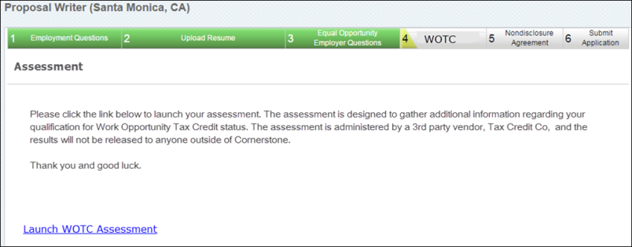
Assign on Manage Applicants
Work Opportunity Tax Credit assessments can be assigned via the Manage Applicants page. To assign an assessment:
- Navigate to the Manage Applicants page, and select the applicants to whom the Work Opportunity Tax Credit integration assessment should be assigned.
- Ensure that the applicant is in the proper Work Opportunity Tax Credit Integration status by selecting the Actions drop-down menu, selecting the Change status to action, selecting the Work Opportunity Tax Credit Integration Assessment status, and select Submit.
- While the appropriate applicants are still selected, select the Actions drop-down menu, and select the Assign Integration Assessment action.
- Select the Work Opportunity Tax Credit Assessment from the drop-down menu, and select Submit.
- The applicants will receive the Assign Integration Assessment email with a link that directs them to the Work Opportunity Tax Credit qualifying screening tool. Once complete, the results are available on the Application tab within the Applicant Profile. Note: This email is only triggered if it is configured in Email Administration.
View TCC Work Opportunity Tax Credit Assessment Results
Recruiters and applicants can view the results of the Work Opportunity Tax Credit (WOTC) assessment for the Tax Credit Co. (TCC) integration.
Recruiters
The results of the Work Opportunity Tax Credit assessment appear on the Application tab of the Applicant Profile page. Users must have permission to view assessment results.
Note: When a candidate who has taken the Work Opportunity Tax Credit assessment is hired, the candidate's status will need to be changed to Hired in order for Tax Credit Co. (TCC) to calculate the final qualifying credits.
Permissions
PERMISSION NAME | PERMISSION DESCRIPTION | CATEGORY

Applicants: View Assessment Integration Status | Allows user to view the assessment integration check status on the Applications tab of the Applicant Profile page. The user cannot view the link to the detailed report of the assessment. This permission cannot be constrained. This permission is only available for portals that have an active assessments integration.  This is the lowest level of permission for this functionality. Users with this permission can only view the assessment status; they cannot assign assessments or view assessment details. | Recruiting

Applicants: View Assessment Integration Status and Details Link | Allows user to view the assessment integration status and view link to access the assessment report from the Applications tab of the Applicant Profile page and from the associated column on the Manage Applicants page. This permission cannot be constrained. This permission is only available for portals that have an active assessments integration.  This is the second highest level of permission for this functionality. Users with this permission will be able to view the assessment status and assessment details but will not be able to assign assessments. | Recruiting
Applicants - View Assessment Status
Applicants can view the status and results of their completed Work Opportunity Tax Credit assessment results from the Completed Applications section on the My Profile page in the career site. The assigned date and status of the assessment will be displayed.
In order for internal applicants to view the results, the applicant must have permission. If the applicant does not have the appropriate permission, then only the status of the assessment displays.
Permissions
PERMISSION NAME | PERMISSION DESCRIPTION | CATEGORY

Applicants: View Assessment Integration Status | Allows user to view the assessment integration check status on the Applications tab of the Applicant Profile page. The user cannot view the link to the detailed report of the assessment. This permission cannot be constrained. This permission is only available for portals that have an active assessments integration.  This is the lowest level of permission for this functionality. Users with this permission can only view the assessment status; they cannot assign assessments or view assessment details. | Recruiting

Applicants: View Assessment Integration Status and Details Link | Allows user to view the assessment integration status and view link to access the assessment report from the Applications tab of the Applicant Profile page and from the associated column on the Manage Applicants page. This permission cannot be constrained. This permission is only available for portals that have an active assessments integration.  This is the second highest level of permission for this functionality. Users with this permission will be able to view the assessment status and assessment details but will not be able to assign assessments. | Recruiting
TCC WOTC Assessment Notified of Hiring
When an applicant who has taken the Work Opportunity Tax Credit (WOTC) assessment has been hired, Tax Credit Co. (TCC) is automatically notified so that you can get an updated estimation of the applicant's benefits. The estimation is visible when viewing the applicant's assessment results on the Manage Applicants page or the Application tab within the Applicant Profile page.

Non-Edge Integrations

HireVue Integration
The HireVue integration delivers a cloud-based solution that modernizes the recruiting process, improves the ability for human resources and business leaders to focus on the best talent, as well as gain clarity and insights into a candidate’s experience, abilities, and personality. The solution enables organizations to view, rate, and share candidate interviews anytime from within the HireVue platform or Cornerstone Recruiting while constructing interviews and capturing feedback in a standardized process. This integrated recruiting solution helps organizations see more candidates and hire more top performers while reducing the amount of time it takes to hire the best people.
With the deep integration to the Recruiting Cloud, recruiters can invite candidates to take HireVue On Demand and Live interviews within Cornerstone with a single click and track their interview completion status within the application history in Cornerstone. Users can capture and share feedback with other team members before bringing in candidates for face-to-face meetings, saving time and money.
Online Help Topics Related to HireVue
The following topics in Online Help provide information about the HireVue integration functionality:
- Applicant Profile - Applications Tab - See Applicant Profile Page - Application Tab.
- Scheduled Interview Session - See Create Interview - Schedule Interview Session.
- Completed Interviews Tab - See Completed Interviews Tab.
- Hiring Dashboard - Interviews Widget - See Hiring Dashboard - Interviews Widget.
- Incomplete Interviews - See Scheduled Interviews Tab - Incomplete Interviews.
- Interview - Scheduled - See Statuses Tab - Interview Status Type - Scheduled Interview.
- Interview - Video - See Statuses Tab - Interview Status Type - On Demand Video Interview.
- Interview Management Preferences - See Interview Management Preferences (by Division).
- Interview Scheduler Overview - See Interview Scheduler Page Overview.
- Job Requisitions - Applicant Review - Interview Status Type - See Applicant Review Tab - Interview Status Type Overview.
- Interview Status - See Applicant Review Tab - Interview Status Type Overview.
- Interview Status - Scheduled Interview - See Interview Status Type - Scheduled Interview.
- Interview Status - Video Interview - See Interview Status Type - On Demand Video Interview.
- Career Site - Completed Tasks - See My Profile - My Completed Tasks.
- Career Site - Pending Tasks - See My Profile - My Pending Tasks.
- Job Requisition - Applicant Review - On Demand Video Interview Status Type - See Interview Status Type - On Demand Video Interview.
- Requisition Templates - Applicant Review - On Demand Video Interview Status Type - See Interview Status Type - On Demand Video Interview.
- Recruiting Cloud Overview - See Recruiting Module Overview.
- Interview Manager - Today's Interviews - See Scheduled Interviews Tab - Today's Interviews.
- Email Tags - See Email Tags.

Opportunity Marketplace
The Opportunity Marketplace offers employees personalized career development with access to open roles, projects, learning content, and mentors. It empowers employees to take ownership of their professional growth and make informed decisions about next steps, so they can find new ways to contribute to the organization and belong. Whether employees are seeking to learn new skills or explore an open role, Opportunity Marketplace provides all the resources they need for career advancement and growth.
We provide a standard integration between Opportunity Marketplace and CSX Recruiting. This allows for job postings to be displayed within Opportunity Marketplace and for a seamless application experience.

USAJOBS Integration
The USAJOBS integration is available for Federal agencies and lets you post your positions from your Cornerstone career site to USAJOBS. U.S. Federal Agencies are required to post open positions to USAJOBS for applicants to review, apply, and track status. Prior to this Edge integration, clients did not have the option to post new openings to USAJOBS. With this Edge integration, Cornerstone meets the minimum federal requirement by providing the ability to post new jobs to USAJOBS from Cornerstone Recruiting, thereby helping clients that are Federal Agencies to stay compliant with federal regulations.
Included:
- Ability to create new requisitions and post to a career site. Cornerstone will then automatically post the job to USAJOBS.
- Ability to map standard and custom fields to USAJOBS fields when setting up the Edge Integration.
- Ability to edit and cancel job requisitions that have been posted on USAJOBS and are within the effective and expiration dates of the job posting. Job requisitions that fall outside of those dates cannot be edited or cancelled.
- Jobs that are posted on USAJOBS can be edited on the Postings page in your Cornerstone portal. This includes the ability to make changes such as modifying the effective and expiration dates.
- Hourly sync will post the job to USAJOBS and send log to emails configured in Edge.
For more information about this integration, see the Getting Started page for the integration in Edge Integrations.
For more information about editing job requisitions, see the Edit Job Requisition topic in Online Help.
For more information about editing job postings, see the Job Posting Page topic in Online Help.
Frequently Asked Questions
How long does it take for changes to appear in my job posting on USAJOBS?
- Same Posting Day Changes - USAJOBS cannot process changes made to a job requisition or job posting on the same day the job is posted to USAJOBS. If you would like to edit the job requisition or posting, the changes must wait until 12:00 a.m. the following day. At that time, you can submit changes to the job requisition or posting in Cornerstone and those changes will be visible in the posting on USAJOBS with their next hourly sync.
- Next Posting Day Changes - Once changes are submitted on the job requisition or job posting in Cornerstone, the changes are reflected in the job posting on USAJOBS in their next hourly sync.
What steps should I take to edit my job requisition and/or job posting on USAJOBS?
Changes to your USAJOBS posting or job requisition are done in your Cornerstone portal. When you need to edit the job requisition and the job posting on the same day, be sure to edit the job posting first and click Post to submit those changes. Then, you can edit the job requisition and submit those changes. USAJOBS will pick up your changes in their next hourly sync.
However, Cornerstone can only process one set of changes per day.
How many changes can I submit per day?
Changes to the job requisition and job posting can only be processed once per day.
For example, on Monday you post changes to the job posting and also submit one or more changes to the job requisition. Those changes are picked up in the next hourly sync by Cornerstone. Later that same day, you submit additional changes to the job requisition. Those changes will not be picked up by USAJOBS on Monday because only one set of changes can be processed per day. If you would like to edit the job requisition or posting again, you must wait until at least the next day (Tuesday) and make your changes, and once the changes are submitted, the changes will get picked up in the next hourly sync by Cornerstone.
Considerations
- Candidates cannot apply for jobs from USAJOBS. Candidates that wish to apply for a job posted through this integration must either email the recruiter or apply on the career site in Cornerstone.
- Reporting applicant status updates back in USAJOBS is not supported with this integration.
- Client are responsible for resolving errors that USAJOBS may return when Cornerstone posts the job.
- Jobs must have a career site posting with an effective date of today in order for the integration to post the job to USAJOBS.
Implementation
This integration is for U.S. Federal Agencies only. To enable this integration, please contact Global Customer Support. There is a $5,000 cost to purchase this integration via Edge Marketplace. Additional instructions are available in the Getting Started tab of the integration in Edge.
Security
The following existing permissions apply to this functionality:
PERMISSION NAME | PERMISSION DESCRIPTION | CATEGORY

Edge Integrations - Manage | Grants access to the Integrations service for Edge Integrate, where the administrator can configure, enable, and disable their third-party integrations used within the Cornerstone system. This permission cannot be constrained. This is an administrator permission. | Edge

Edge Marketplace - Manage | Grants access to the Marketplace service for Edge Integrate, where the administrator can browse integrations that can be used to extend the Cornerstone system. This permission cannot be constrained. This is an administrator permission. | Edge

