Integrations for Learning Overview

Content (non-CCA) Integrations - Overview
To enable a Content Provider integration listed below, please reach out to your Account Manager and complete a signed Order Form. 1:1 Online Content integrations are currently available for the following providers:
- GetAbstract
- GLOBIS
- Teach on Mars
- Udemy for Business

Cornerstone for Salesforce Integration
The Cornerstone for Salesforce (CFS) integration is available in the Edge Marketplace. Once this integration is enabled, learners are empowered to interact with content within their flow-of-work by seamlessly surfacing Learner Home content in Salesforce. Administrators can add Cornerstone transcripts, learning carousels, and search components to any Force.com page or use the out-of-the box CFS Learner Home page. End users can view their full transcript, learning carousels and followed playlists. Additionally, end users can search for, launch, and complete learning, - all without leaving Salesforce.
Note: CFS is only available on the Salesforce Lightning platform.
Permissions
PERMISSION NAME | PERMISSION DESCRIPTION | CATEGORY

Learner Home | Grants access to the Learner Home and the Learning Search page. This is an end user permission. This permission cannot be constrained. | Learning

Edge Marketplace - Manage | Grants access to the Marketplace service for Edge Integrate, where the administrator can browse integrations that can be used to extend the Cornerstone system. This permission cannot be constrained. This is an administrator permission. | Edge

Edge Integrations - Manage | Grants access to the Integrations service for Edge Integrate, where the administrator can configure, enable, and disable their third-party integrations used within the Cornerstone system. This permission cannot be constrained. This is an administrator permission. | Edge

Access Partner Authorization - Manage | Grants ability to manage partner authorized access to portal via Partner Access Administration. This permission cannot be constrained. This is an administrator permission. | Core Administration

Note: To view CFS components, users need the Cornerstone User permission. To manage CFS components, users need Cornerstone Admin permission. You assign these permissions in Salesforce.
Install and Configure CFS
Install and configure CFS in the Edge Marketplace. To access the CFS Edge tile, go to ADMIN > TOOLS > EDGE > MARKETPLACE. Search for "Cornerstone for Salesforce", click the tile, and then click the Getting Started link for installation and configuration instructions.
Administrators can use the Lightning App Builder in Salesforce to add transcript, carousel, and search components to any page on Force.com. You can also move components around and delete them. Once the page configuration is done, activate the page so that users can access it.
Open the Lightning App Builder
- In Salesforce, click Setup. In the Quick Find box, type Lightning App Builder, and then click Lightning App Builder in the results. The Lightning App Builder page opens.
- In the Lightning App Builder, select one of the following options:
  - Create a new page - To create a new page, click New, select a page type and click Next. Enter a Label, select an Object (if visible) and click the Next button. Select a page format, and then click finish Note: If you are creating a new Home Page, for best results use the Console: Pinned Header and Left Sidebar (3 regions) or Console: Pinned Left Sidebar (3 regions)page template.
  - Edit an existing page - To modify an existing CFS home page, click Edit for the appropriate page.
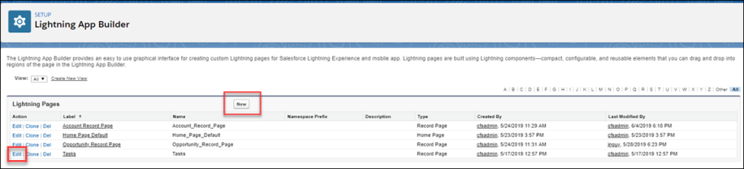
The Lightning Components page opens.
Add Components - Drag and Drop
Drag and drop CFS components onto any Force.com page to customize the end user's learner experience. You can also delete and move components. See Delete or Move a CFS Component on page 8 for additional information.
In the Lightning App Builder, in the left pane, select a CFS component and drag and drop it into a designated area.
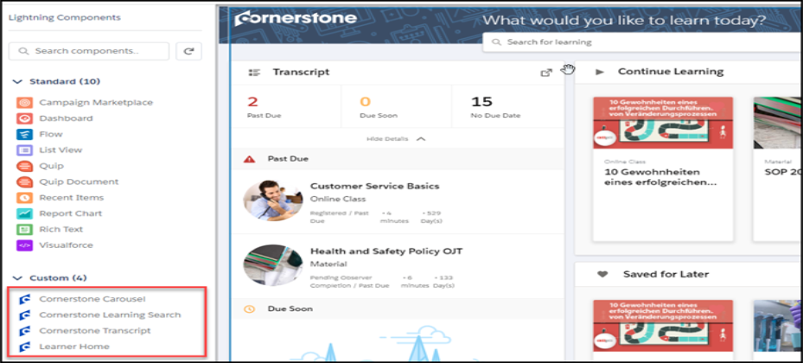
Cornerstone Carousel
Use the Cornerstone Carousel component to add a carousel to the Learner Home page. You can drag, drop, move, delete, and rename the Cornerstone Carousel.
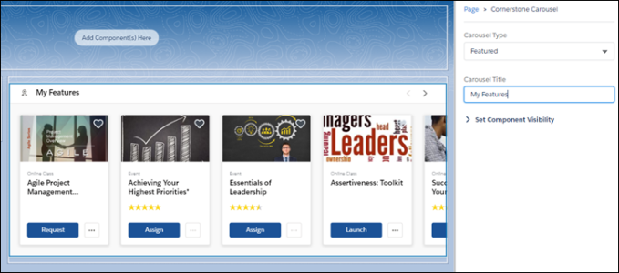
- Carousel Type - Select the type of carousel you want to create. Options are:
  - Subjects
  - Position
  - Popularity
  - Saved For Later
  - Continue Learning
  - Featured
  - Suggested
  - Required
  - Playlists
  - Followed Playlists
- Carousel Title - Enter the name for this carousel.
Cornerstone Learning Search
Use the Cornerstone Learning Search component to add the search feature to the Learner Home page. You can drag and drop, move and delete this component.
Note: You cannot rename this component in the Lightning App Builder.
Cornerstone Transcript
Use the Cornerstone Transcript component to add a Transcript section to the Learner Home page. You can drag and drop, move, delete and set the collapse option for this component. If you select Collapsed by Default, users see only the basic transcript information until they click Show Details. If you uncheck Collapsed by Default, users see full transcript details by default under the transcript box. You cannot rename this component in the Lightning App Builder. Note: For best results, we recommend that you use the smaller component box for the transcript component.
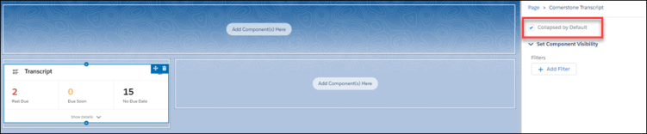
Learner Home
Use the Learner Home component to create a home page on a blank Force.com page. This is an out-of-the-box page that is not configurable and displays the users current Cornerstone Learner Home page.
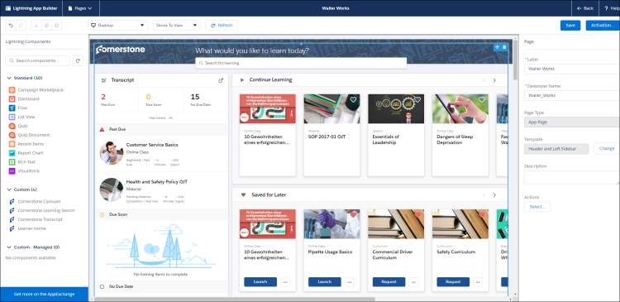
Save
Click Save to save your changes.
Activate
Click Activate to activate this page. Only active pages are available to users.

Activate and Assign Home Pages
Once the page is configured, administrators can activate a page and select it as the organizational default, set it for specific Lightning apps, or set it for different user profiles when using particular apps.
- On the completed home page, click the Activation button. The Activation page opens.
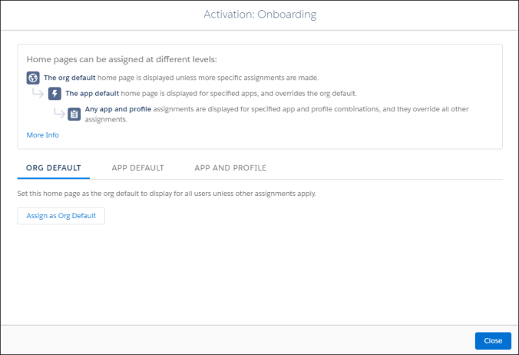
- Select one of the following options:
- Set the organizational default home page - Click Org Default, and then click the Assign as Org Default button. On the Set as Org Default page, review the selected options.
- Set a home page as the default for specific Lightning apps - Click App Default, and then click the Assign to Apps button. On the Select Apps page, check all of the Lightning apps that will have access to this page. On the Review Assignments page, review the selected options.
- Set a home page for selected user profiles for specific apps - Click App and Profile, and then click the Assign to Apps and Profiles button. On the Select Apps page, check the appropriate apps and click the Next button. On the Select Profiles page, check the profiles that will display the selected home page. On the Review Assignments page, review the selected options.
- Click the Save button. Based on their permissions and the selected options, users will see the appropriate learning home page.
Delete or Move a CFS Component
- To delete a component, hover over the upper right corner of the appropriate component and click the delete option. The component is removed from the page.
- To move a component, hover over the upper right-corner of the appropriate component, click the move icon and drag and drop the component to the new location.
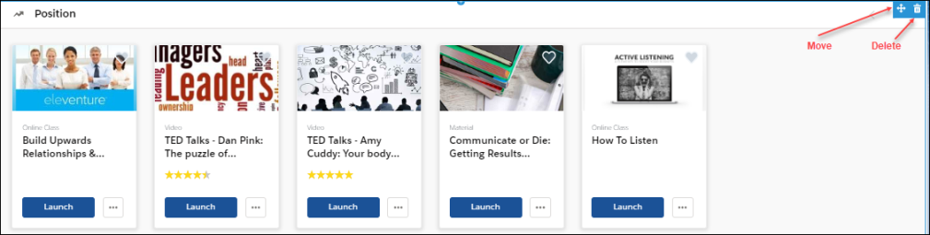
View the End-User Home Page
Once the Learner Home content is configured, end users can view and manage their learning options in Salesforce.
Users can perform the following tasks for each component:
- Transcript  - View the number of items in the user transcript.  - Click on any transcript item to view its details.  - If not visible by default, click View Details to view full transcript details and launch training. | 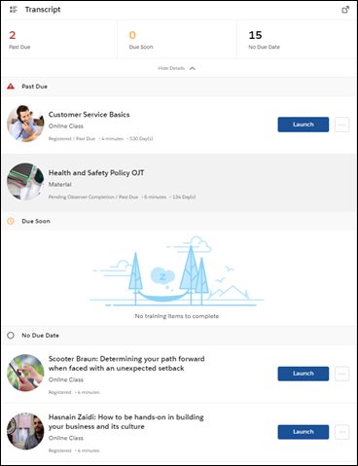
- Carousels  - Launch, request, and assign learning. Mark as a favorite by clicking the heart. Favorites appear in the Saved for Later carousel.  - Hover over a carousel item to view quick details and launch or assign training. | 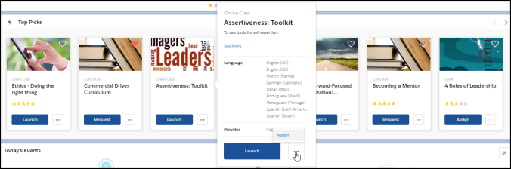
- Search bar  - Search for training by typing in search bar.  - While typing into search bar, relevant suggestions display (up to 10 suggestions).  - Click Enter or Search to open a page that displays all search results | 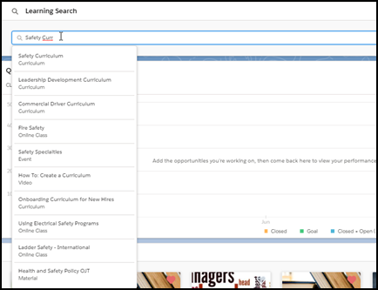

Coursera for Business Integration - Overview
The Cornerstone OnDemand and Coursera for business integration enables organizations to manage their Coursera content within the Cornerstone Learning Management System (LMS). With this integration, Coursera courses can be automatically synchronized to the LMS catalog, where they can be managed like other system training types.
The Coursera integration provides access to the following functionality:
- Catalog Synchronization
  - Automatic daily synchronization of content from Coursera to the Learning Management System catalog (Coursera content is classified as online content in the catalog)
  - The synchronization captures all purchased content from Coursera
  - Synchronized content added to the catalog with a Provider of Coursera
  - Loaded Coursera content is mobile-ready
  - Administrators can manage loaded Coursera content in the same manner they manage other training in the Learning Management System (e.g., set availability, set keywords, add to a curriculum, assign training to a learner)
- Content Launching
  - When a learner launches Coursera content from the Learning Management System, they are redirected to a Coursera pop-up window to complete the training, and no login is required
  - The learner’s training progress is recorded on their transcript page in the Learning Management System
- Report Completion
  - The learner’s training progress is recorded on their transcript page in the Learning Management System
- Single Sign-On (SSO)
  - The integration supports SMAL SSO implementation (IDP). No additional integration is required to enable the Cornerstone and Coursera for Business integration.
Considerations
The following considerations apply to this enhancement:
- Content disablement is required if your Learning Management System contains existing Coursera content.
- This integration is NOT a data-feed based integration.
- If your organization has an existing integration with Coursera and would like to enable the new integration, contact both Cornerstone Global Customer Support and the Coursera team to disable the existing integration.
Training Launched from Integrated Provider's Site
Progress data for externally launched content is supported by the Cornerstone Connector that is utilised by edX for this integration, but as it stands this feature is not implemented by edX, and therefore it is not supported by the "edX for Business" integration.
- Only the following two training statuses are supported by this behavior:
  - In Progress
  - Completed
- A Completed status cannot be reverted back to an In Progress status. Any progress data communicated after the online content completion will update all values except completion status and completion date.
Implementation
For organizations using the Learning module, this integration can be self-enabled via the Edge Marketplace. The Cornerstone OnDemand and Coursera for Business integration is available for a cost. Please contact your Account Manager for additional information.
Permissions
The following existing permissions apply to this functionality:
PERMISSION NAME | PERMISSION DESCRIPTION | CATEGORY

Course Catalog - Update | Grants ability to manage and edit training items listed in the Course Catalog and also grants access to the Course Console, where training can also be managed and edited. This permission also grants access to the Popular Requests and Highest Rated widgets on the Learning Admin Console (in conjunction with the Learning Admin Console - View permission). This permission also allows administrators to reversion online courses via the Course Console page. This permission also allows administrators to access an Edit Training option for training items included as objectives in Development plans.  This permission can be constrained by OU, User's OU, Training Type, Training Item, Provider, ILT Provider, User's ILT Provider, User, User Self and Subordinates, and User's LO Availability. This is an administrator permission.  Note: Adding an OU constraint and a provider constraint to this permission results in an "AND" statement. | Learning - Administration

Edge Integrations - Manage | Grants access to the Integrations service for Edge Integrate, where the administrator can configure, enable, and disable their third-party integrations used within the Cornerstone system. This permission cannot be constrained. This is an administrator permission. | Edge

Edge Marketplace - Manage | Grants access to the Marketplace service for Edge Integrate, where the administrator can browse integrations that can be used to extend the Cornerstone system. This permission cannot be constrained. This is an administrator permission. | Edge
Cornerstone OnDemand and Coursera for Business Integration - Configure in Edge
The Cornerstone OnDemand and Coursera for Business integration can be enabled via the Edge Marketplace and configured using Edge Integrations.
To access the Edge Marketplace, go to: Admin > Tools > Edge and click the Marketplace link.
Permissions
PERMISSION NAME | PERMISSION DESCRIPTION | CATEGORY

Edge Integrations - Manage | Grants access to the Integrations service for Edge Integrate, where the administrator can configure, enable, and disable their third-party integrations used within the Cornerstone system. This permission cannot be constrained. This is an administrator permission. | Edge

Edge Marketplace - Manage | Grants access to the Marketplace service for Edge Integrate, where the administrator can browse integrations that can be used to extend the Cornerstone system. This permission cannot be constrained. This is an administrator permission. | Edge
Coursera Integration - Edge Marketplace
In the Edge Marketplace, you can find the Coursera integration by searching or browsing. To learn more about the Coursera integration or begin the enablement and configuration process, click the Coursera integration tile.
The page for the Coursera integration provides access to the following tabs for learning more about and managing the integration:
- Vendor - This tab provides information about the vendor that provides the integration. Here, you can view more information about Coursera.
- Integration - This tab provides information about the integration itself and how it can be used with the learning management system (LMS).
- Pricing - This tab provides information about the costs associated with the integration. Note: The Coursera integration has an annual cost.
- Setup - This tab provides information about how to configure the integration once enabled. The integration can be configured via Edge Integrations.
Coursera Integration - Edge Integrations
Once the Coursera integration has been added through the Edge Marketplace, the integration can be managed and configured from Edge Integrations. The Integrations page for the integration provides access to setup options which the administrator can use to customize the behavior of the Coursera integration. See the Setup tab for the Coursera integration in the Edge Marketplace for more information about the configuration options available.
Coursera - Catalog Synchronization
The Learning Management System (LMS) course catalog is synchronized on a daily basis. New courses and course updates are communicated from Coursera to the Learning Management System using oAuth 2.0 as the authentication protocol. Coursera courses are available within 24 hours of enabling the integration, and are classified as online content in the Learning Management System.
Content delivered to the system via the Coursera integration is categorized as the online content training type. Because online content is updated via automatic synchronization, any manual changes made to online content metadata may be overridden in the Course Catalog and Course Console. For more information about how the online content training type behaves in the Course Catalog and Course Console, see the following:
- See Course Catalog - Online Content.
- See Course Console - Online Content.
Note: Only purchased courses are synchronized to the Learning Management System catalog.
Note: All courses are automatically defined as available for mobile consumption and can be used on the Cornerstone Learn app.
Permissions
PERMISSION NAME | PERMISSION DESCRIPTION | CATEGORY

Course Catalog - Update | Grants ability to manage and edit training items listed in the Course Catalog and also grants access to the Course Console, where training can also be managed and edited. This permission also grants access to the Popular Requests and Highest Rated widgets on the Learning Admin Console (in conjunction with the Learning Admin Console - View permission). This permission also allows administrators to reversion online courses via the Course Console page. This permission also allows administrators to access an Edit Training option for training items included as objectives in Development plans.  This permission can be constrained by OU, User's OU, Training Type, Training Item, Provider, ILT Provider, User's ILT Provider, User, User Self and Subordinates, and User's LO Availability. This is an administrator permission.  Note: Adding an OU constraint and a provider constraint to this permission results in an "AND" statement. | Learning - Administration
Training Data
The Cornerstone OnDemand and Coursera for Business integration can communicate the following metadata fields to the Learning Management System catalog:
Field | Description
ID | The unique ID of the course
Title | The course title
URL | The course URL (used to redirect users to the provider’s course)
IsActive | Specifies whether the course is available in the Coursera catalog. When a course is no longer available, it is defined as inactive in the Learning Management System catalog
Description | The description of the course
Thumbnail | The course thumbnail image
Languages | The list of available languages for the course
LastModifiedUTC | The time of the last modification made to a course (UTC)
Duration | The course duration
Subjects | The list of subjects, mapped to the Learning Management System subject taxonomy
Subjects Mapping
Coursera’s subjects are mapped to Cornerstone’s Subject Taxonomy. See the table below for the list of subjects communicated to the Learning Management System catalog as part of the integration.
Subject | Coursera Domains
Business Skills | Business
Technology | Computer-science, Data-science, Information-technology, Physical-science-and-engineering
Continuing Education & Certifications | Language-learning, Social-sciences, Math-and-logic
Health & Wellness | Life-sciences
Personal Development | Personal-development
Creative | Arts-and-humanities
View Courses Loaded to the Course Catalog
To view courses which have been loaded to the Course Catalog using the integration:
- Navigate to Admin > Tools > Learning > Catalog Management and click the Course Catalog link.
- Click the Refine your search link on the Course Catalog search page.
- Click the Provider filter and choose the Coursera provider as the filter.
- Click the Search button. The courses that are returned in the search are courses that were loaded via the integration.
Learner Progress Data
When a learner completes a training item, their training completion is automatically recorded on their Learning Management System transcript. Training progress data is communicated by the User Progress API, protected by the oAuth 2.0 protocol.
The following data is communicated to Coursera when learners launch Coursera courses:
Parameter | Description
userGuid | The user’s identifier in the Learning Management System
sessionToken | The current session token that is used to authenticate the call to the Learning Management System when Basic Access Authentication is used
callbackUrl | The Progress API callback path
subdomain | Cornerstone’s portal name. Example: company.csod.com
registrationNumber | The current user registration number
The following data is communicated back from Coursera:
JSON Value | Description
userGuid | The userGuid the Learning Management System communicated when launching the course
courseId | The unique ID of the course
status | Shows whether the course is in a status of In Progress or Completed
userScore | Shows the course score between 0 and 100
totalTime | The total time the user spent viewing the course (HHHH:MM:SS)
timesAccessed | The number of times accessed (total). Minimum value: 1
completionDate | The date and time the course was completed
lastTimeAccessed | The last date and time the user accessed the course
successStatus | Indicates whether the user passed or failed the course
bookmark | The last location the user reached in the content file
suspendData | Additional user experience data
progress | The percentage of a course the user completed (integer between 0 and 100)
registrationDate | The date and time the user was registered for the course
Online content metadata can be edited via the Course Catalog. The following fields may be overridden when Coursera sends course updates:
- Course Title
- Course Description
- Duration
- Available Languages
- Thumbnail
- Subjects (Only Coursera subjects are overridden. Subjects added by the administrator are not affected)
Considerations
- Only courses launched from the Learning Management System can be tracked by the integration.
- Custom fields are defined with an empty value for Coursera courses.
- A notification appears at the top of Coursera courses on the Course Console page, alerting the administrator that it is external content which may be updated via automatic synchronization, and manual changes may be overridden.
- The Active button is disabled for Coursera courses and can be only edited by Coursera via catalog synchronization
- This integration supports SMAL SSO implementation (IDP). No additional integration is required to enable the Cornerstone and Coursera for Business integration, because the following process is implemented:
  - Security Assertion Markup Language (SAML) metadata is exchanged and set up in advance to establish the trust relationship between the Learning Management System and Coursera.
  - The learner launches the course from their Learning Management System portal.
  - The learner is then redirected to either the course URL or the Learning Management System’s outbound SSO endpoint.

edX for Business Integration - Overview
The Cornerstone on Demand (CSOD) and edX for Business integration enables organizations to manage their edX content within the Cornerstone learning management system (LMS). With this integration, edX courses can be automatically synchronized to the LMS catalog, where they can be managed like other system training types.
The edX integration provides access to the following functionality:
- Catalog Synchronization
  - Automatic daily synchronization of content from edX to the LMS catalog (edX content is classified as online content in the catalog)
  - The synchronization captures all purchased content from edX
  - Synchronized content added to the catalog with a Provider of edX
  - Loaded edX content is mobile-ready
  - Administrators can manage loaded edX content in the same manner they manage other training in the LMS (e.g. set availability, set keywords, add to a curriculum, assign training to a learner)
- Content Launching
  - When a learner launches edX content from the LMS, they are redirected to an edX pop-up window to complete the training, and no login is required
  - The learner’s training progress is recorded on the their transcript page in the LMS
- Report Completion
  - The learner’s training progress is recorded on the their transcript page in the LMS
- Single Sign-On (SSO)
  - The integration supports SMAL SSO implementation (IDP). No additional integration is required to enable the Cornerstone and edX for Business integration
Considerations
The following considerations apply to this enhancement:
- Content disablement is required if your LMS contains existing edX content.
- This integration is NOT a data-feed based integration.
- If your organization has an existing integration with edX and would like to enable the new integration, contact both Cornerstone Global Customer Support and the edX team to disable the existing integration.
Training Launched from Integrated Provider's Site
Progress data for externally launched content is supported by the Cornerstone Connector that is utilised by edX for this integration, but as it stands this feature is not implemented by edX, and therefore it is not supported by the "edX for Business" integration.
- Only the following two training statuses are supported by this behavior:
  - In Progress
  - Completed
- A Completed status cannot be reverted back to an In Progress status. Any progress data communicated after the online content completion will update all values except completion status and completion date.
Implementation
For organizations using the Learning module, this integration can be self-enabled via the Edge Marketplace. The Cornerstone OnDemand edX for Business integration costs $5000 per year.
Permissions
The following existing permissions apply to this functionality:
PERMISSION NAME | PERMISSION DESCRIPTION | CATEGORY

Course Catalog - Update | Grants ability to manage and edit training items listed in the Course Catalog and also grants access to the Course Console, where training can also be managed and edited. This permission also grants access to the Popular Requests and Highest Rated widgets on the Learning Admin Console (in conjunction with the Learning Admin Console - View permission). This permission also allows administrators to reversion online courses via the Course Console page. This permission also allows administrators to access an Edit Training option for training items included as objectives in Development plans.  This permission can be constrained by OU, User's OU, Training Type, Training Item, Provider, ILT Provider, User's ILT Provider, User, User Self and Subordinates, and User's LO Availability. This is an administrator permission.  Note: Adding an OU constraint and a provider constraint to this permission results in an "AND" statement. | Learning - Administration

Edge Integrations - Manage | Grants access to the Integrations service for Edge Integrate, where the administrator can configure, enable, and disable their third-party integrations used within the Cornerstone system. This permission cannot be constrained. This is an administrator permission. | Edge

Edge Marketplace - Manage | Grants access to the Marketplace service for Edge Integrate, where the administrator can browse integrations that can be used to extend the Cornerstone system. This permission cannot be constrained. This is an administrator permission. | Edge
Cornerstone OnDemand and edX for Business Integration - Enable in Edge
The Cornerstone OnDemand and edX for Business integration can be enabled via the Edge Marketplace and configured using Edge Integrations.
To access the Edge Marketplace, go to: Admin > Tools > Edge and click the Marketplace link.
Permissions
PERMISSION NAME | PERMISSION DESCRIPTION | CATEGORY

Edge Integrations - Manage | Grants access to the Integrations service for Edge Integrate, where the administrator can configure, enable, and disable their third-party integrations used within the Cornerstone system. This permission cannot be constrained. This is an administrator permission. | Edge

Edge Marketplace - Manage | Grants access to the Marketplace service for Edge Integrate, where the administrator can browse integrations that can be used to extend the Cornerstone system. This permission cannot be constrained. This is an administrator permission. | Edge
edX Integration - Edge Marketplace
In the Edge Marketplace, you can find the edX integration by searching or browsing. To learn more about the edX integration or begin the enablement and configuration process, click the edX integration tile.
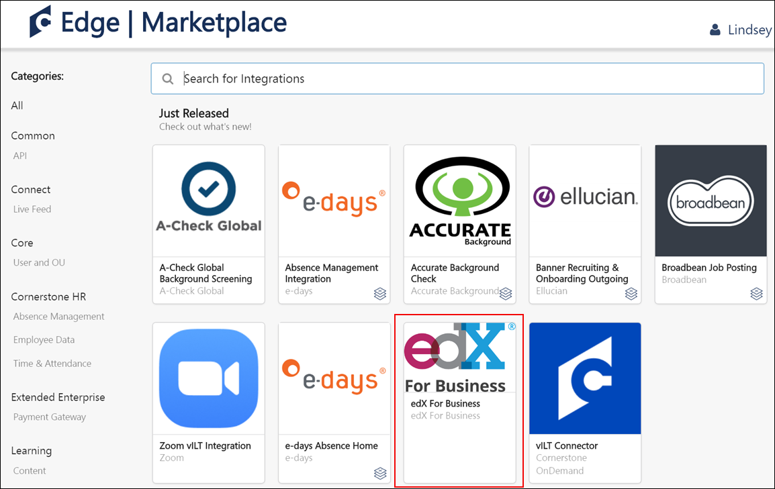
The page for the edX integration provides access to the following tabs for learning more about and managing the integration:
- Vendor - This tab provides information about the vendor that provides the integration. Here, you can view more information about edX.
- Integration - This tab provides information about the integration itself and how it can be used with the learning management system (LMS).
- Pricing - This tab provides information about the costs associated with the integration. Note: The edX integration costs $5000 annually.
- Setup - This tab provides information about how to configure the integration once enabled. The integration can be configured via Edge Integrations.
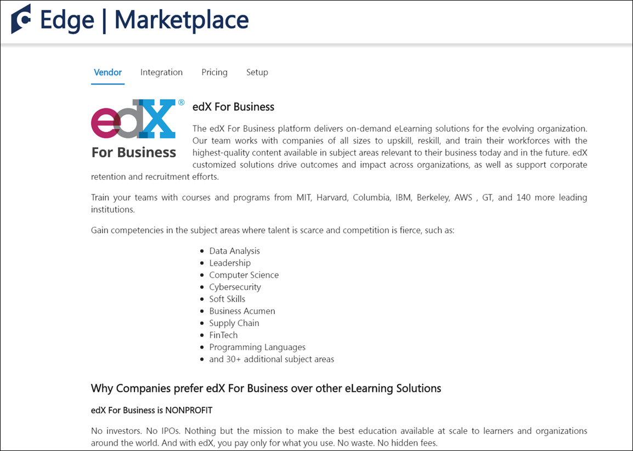
edX Integration - Edge Integrations
Once the edX integration has been added through the Edge Marketplace, the integration can be managed and configured from Edge Integrations. The Integrations page for the integration provides access to setup options which the administrator can use to customize the behavior of the edX integration. See the Setup tab for the edX integration in the Edge Marketplace for more information about the configuration options available.
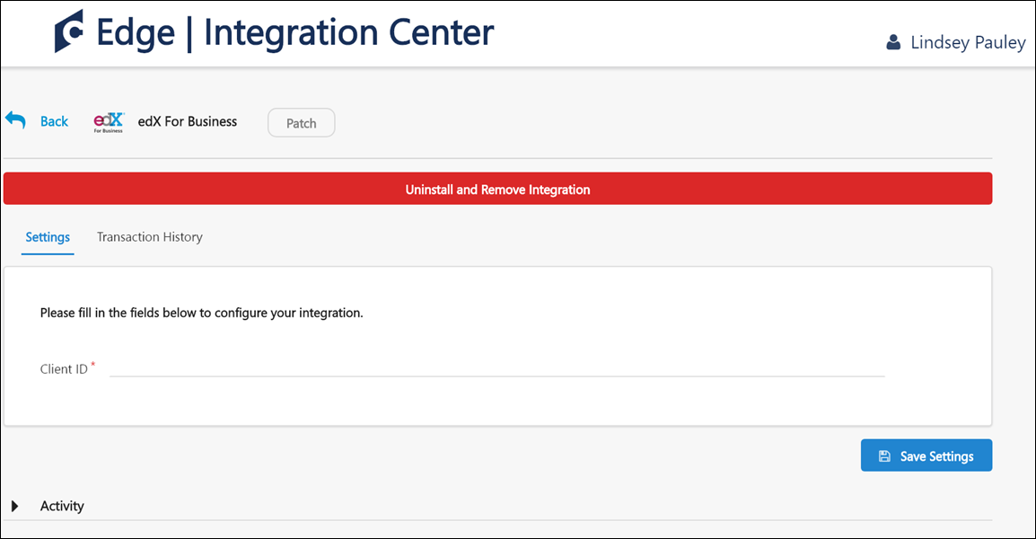
Cornerstone OnDemand and edX for Business Integration - Catalog Synchronization
The learning management system (LMS) course catalog is synchronized on a daily basis. New courses and course updates are communicated from edX to the LMS using oAuth 2.0 as the authentication protocol. edX courses are available within 24 hours of enabling the integration, and are classified as online content in the LMS.
Content delivered to the system via the edX integration is categorized as the online content training type. Because online content is updated via automatic synchronization, any manual changes made to online content metadata may be overridden in the Course Catalog and Course Console. For more information about how the online content training type behaves in the Course Catalog and Course Console, see the following:
- See Course Catalog - Online Content.
- See Course Console - Online Content.
Note: Only purchased courses are synchronized to the LMS catalog.
Note: All courses are automatically defined as available for mobile consumption and can be used on the Cornerstone Learn app.
Permissions
PERMISSION NAME | PERMISSION DESCRIPTION | CATEGORY

Course Catalog - Update | Grants ability to manage and edit training items listed in the Course Catalog and also grants access to the Course Console, where training can also be managed and edited. This permission also grants access to the Popular Requests and Highest Rated widgets on the Learning Admin Console (in conjunction with the Learning Admin Console - View permission). This permission also allows administrators to reversion online courses via the Course Console page. This permission also allows administrators to access an Edit Training option for training items included as objectives in Development plans.  This permission can be constrained by OU, User's OU, Training Type, Training Item, Provider, ILT Provider, User's ILT Provider, User, User Self and Subordinates, and User's LO Availability. This is an administrator permission.  Note: Adding an OU constraint and a provider constraint to this permission results in an "AND" statement. | Learning - Administration
Training Data
The Cornerstone OnDemand and edX for Business integration can communicate the following metadata fields to the LMS catalog:
Field | Description
ID | The unique ID of the course
Title | The course title
URL | The course URL (used to redirect users to the provider’s course)
IsActive | Specifies whether the course is available in the edX catalog. When a course is no longer available, it is defined as inactive in the LMS catalog
Description | The description of the course
Thumbnail | The course thumbnail image
Languages | The list of available languages for the course
LastModifiedUTC | The time of the last modification made to a course (UTC)
Duration | The course duration
Subjects | The list of subjects, mapped to the LMS subject taxonomy
Online content metadata can be edited via the Course Catalog. The following fields may be overridden when edX sends course updates:
- Course Title
- Course Description
- Duration
- Available Languages
- Thumbnail
- Subjects (Only edX subjects are overridden. Subjects added by the administrator are not affected)
View Courses Loaded to the Course Catalog
To view courses which have been loaded to the Course Catalog using the integration:
- Navigate to Admin > Tools > Learning > Catalog Management and click the Course Catalog link.
- Click the Refine your search link on the Course Catalog search page.
- Click the Provider filter and choose the edX provider as the filter.
- Click the Search button. The courses that are returned in the search are courses that were loaded via the integration.
Learner Progress Data
When a learner completes a training item, their training completion is automatically recorded on their LMS transcript. Training progress data is communicated by the User Progress API, protected by the provider's authentication.
The following data is communicated to edX when learners launch edX courses:
Parameter | Description
userGuid | The user’s identifier in the LMS
sessionToken | The current session token that is used to authenticate the call to the LMS when Basic Access Authentication is used
callbackUrl | The Progress API callback path
subdomain | Cornerstone’s portal name. Example: company.csod.com
registrationNumber | The current user registration number
Considerations
- Only courses launched from the LMS can be tracked by the integration.
- Custom fields are defined with an empty value for edX courses.
- The Active button is disabled for edX courses and can be only edited by edX via catalog synchronization

LinkedIn Learning Integration
The LinkedIn Learning integration allows LinkedIn Learning content to be synchronized with the Learning Management System (LMS). Learners can launch LinkedIn Learning content from the LMS or their LinkedIn portal and have their progress tracked in their LMS transcripts.
To access the Edge Marketplace, go to: Admin > Tools > Edge and click the Marketplace link.
Permissions
PERMISSION NAME | PERMISSION DESCRIPTION | CATEGORY

Edge Integrations - Manage | Grants access to the Integrations service for Edge Integrate, where the administrator can configure, enable, and disable their third-party integrations used within the Cornerstone system. This permission cannot be constrained. This is an administrator permission. | Edge

Edge Marketplace - Manage | Grants access to the Marketplace service for Edge Integrate, where the administrator can browse integrations that can be used to extend the Cornerstone system. This permission cannot be constrained. This is an administrator permission. | Edge
Use Cases
Use Case #1: Manage LinkedIn Content via Course Catalog
Brenda is a learning administrator at ACME Corp, which uses the LinkedIn Learning integration. She uses the Course Catalog to manage the courses offered by LinkedIn Learning. This content appears in the form of online courses within the Course Catalog.
Use Case #2: Launch and Complete LinkedIn Content in LMS
Lisa is an employee of ACME Corp. She browses for courses on Learner Home and decides to take a LinkedIn Learning course she finds. After launching the course, a new window opens with the course, and she does not need to provide additional login credentials. After she completes the course, it is added to her transcript in a Completed status.
Use Case #3: Sync LinkedIn Content with LMS Transcript
Lisa logged into the LinkedIn Learning site and completed a course for which she was not registered in the LMS. Because her learning administrator enabled the Bypass Registration option for the LinkedIn Learning integration, this completed course is synced to Lisa's transcript in the LMS.
Considerations
The following considerations apply to this functionality:
- When the LinkedIn Learning integration is enabled, LinkedIn Learning content is synced with the LMS on a nightly basis. Note: All synced content is flagged as Mobile Ready if the corresponding option on the Edge Configuration page for the integration is selected.
- Administrators can configure a Bypass Registration option for the integration. If enabled, when a learner completes a course on LinkedIn Learning, even if they are not registered for the course in the LMS, the course appears in a Completed status on their transcript and can be reported on. If this option is disabled, in the same scenario, the course appears in a Completed status in the form of a learning record, which is NOT reportable.
- The learning content progress report available through LinkedIn Learning is limited to training completions at this time. Other than completions, no other progress data is recorded in the LMS, meaning no percentage of progress or time spent in course is recorded.
- LinkedIn Learning courses cannot have their progress reset by assigning a new registration. If a new registration will be made, the information will be reset in the interface, but upon launch, progress made in the course will remain.
- While progress sent from LinkedIn Learning courses typically occurs in near real-time, in some cases it might take up to 24 hours for the progress to be sent back to Cornerstone CSX. This means that the course status and detail history might take up to 24 hours to be updated in the CSX system.
Implementation
This integration is available for no additional cost via the Edge Marketplace . Additional information about the LinkedIn Learning integration and its configuration options is also available through the Edge Marketplace.
Organizations currently using Lynda.com or LinkedIn Learning AICC courses will need a migration to be able to use this new integration. However, this migration is not yet available. Further information will be shared with organizations using Lynda.com or LinkedIn Learning AICC courses once the migration becomes available.
For more information about the LinkedIn Learning platform, see: LinkedIn Learning
LinkedIn Learning - Edge Marketplace
In the Edge Marketplace, you can find the LinkedIn Learning integration by searching or browsing. To learn more about the LinkedIn Learning integration or begin the enablement and configuration process, click the LinkedIn Learning integration tile.
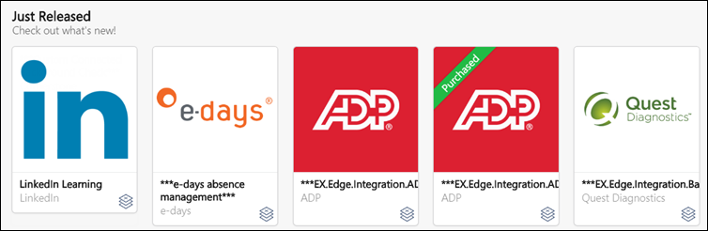
The page for the LinkedIn Learning integration provides access to the following tabs for learning more about and managing the integration:
- Vendor - This tab provides information about the vendor that provides the integration. Here, you can view more information about the LinkedIn Learning platform.
- Integration - This tab provides information about the integration itself and how it can be used with the learning management system (LMS).
- Pricing - This tab provides information about the costs associated with the integration. Note: There is no cost associated with the LinkedIn Learning integration. This integration is free to enable.
- Setup - This tab provides information about how to configure the integration once enabled. The integration can be configured via Edge Integrations.
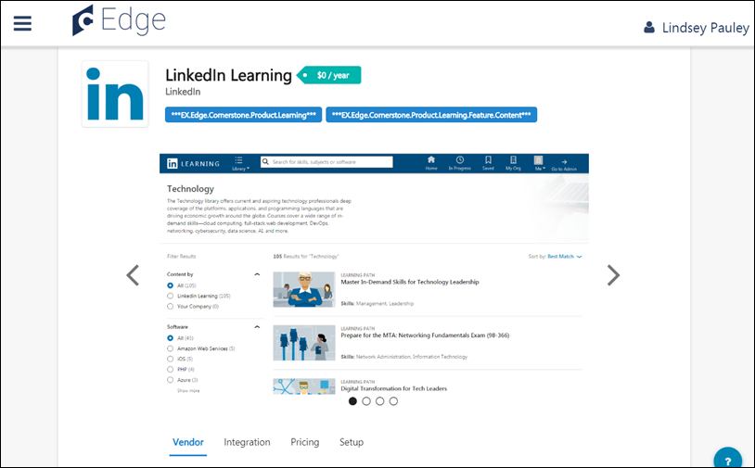
LinkedIn Learning - Edge Integrations
Once the LinkedIn Learning integration has been added through the Edge Marketplace, the integration can be managed and configured from Edge Integrations. The Integrations page for the integration provides access to setup options which the administrator can use to customize the behavior of the LinkedIn Learning integration. See the Setup tab for the LinkedIn Learning integration in the Edge Marketplace for more information about the configuration options available.
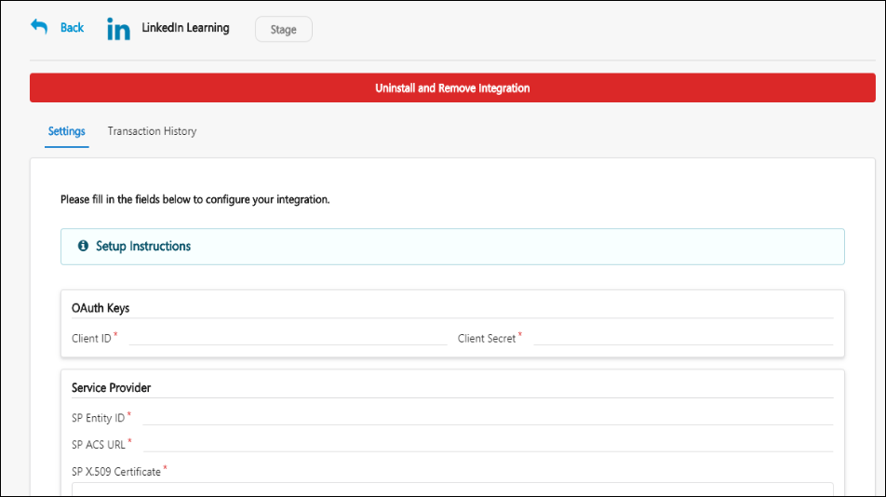
LinkedIn Learning - Course Catalog
LinkedIn Learning content that has been synced to the LMS appears in the Course Catalog as online courses, with a Provider name of LinkedIn Learning, and these courses can be managed through the Course Catalog by administrators. LinkedIn Learning content displays with its original language and course duration time in the system.
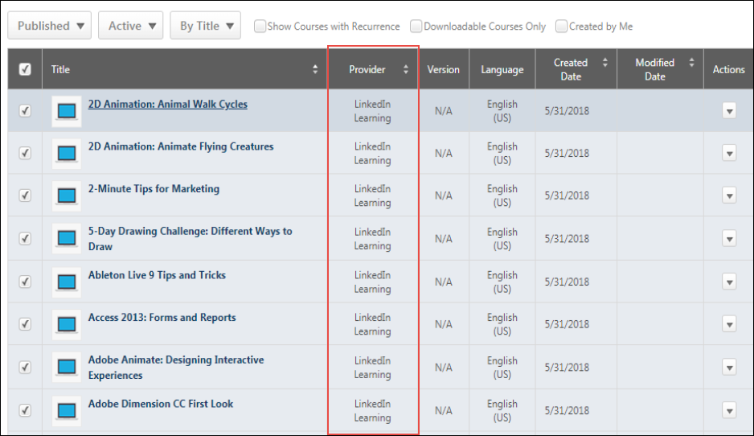

rapidRoster Integration
The rapidRoster Integration enables organizations to automate roster and attendance management by leveraging company badges, barcodes, or mobile devices for classroom registration, attendance, and completion.
How Does this Enhancement Benefit My Organization?
This integration enables organizations to eliminate paper-based rosters and automate roster management.
Implementation
This integration is available for Self-Activation in Edge Marketplace. Learning customers must also have an account with the integration vendor.
This integration is not currently available. The availability date is not determined.

Skillsoft Percipio Integration
Using this integration, an organization’s Percipio content can be automatically synchronized with the Cornerstone CSX Learning Management System (LMS) Course Catalog on a daily basis, and the synchronized content can be managed by administrators in the same manner as content created manually within the LMS. Synced Percipio courses include pre-populated metadata, such as keywords, descriptions, modalities, thumbnail images, and more. Percipio courses are also automatically configured as mobile-ready and can be accessed by learners via the Cornerstone Learn app.
When learners launch Percipio content from their portal, the training can be completed from a pop-up window with no additional login required. The learner's progress is tracked in their transcript and can be reported on using Reporting 2.0 when it is launched from the Cornerstone portal.
The following sync functionality is included with the integration:
- Synchronization of new and updated Percipio courses
- Synchronization of retired Percipio courses
- Embedded SAML SSO
Considerations
The following considerations apply to this functionality:
- Percipio courses are loaded to the portal designated as the online content training type
- Percipio courses are loaded to the portal with Percipio-US or Percipio-EU specified as the training provider
- Percipio courses include the Percipio course type as part of the course title (Channel, Audiobook, Linked Content, etc.)
- Subjects are not currently supported by the integration
- Custom Fields are assigned no value when Percipio courses are synced. Organizations can manually update the custom field with the relevant values. Custom fields are NOT overwritten by course synchronizations
- Only Percipio courses launched from the Cornerstone LMS are tracked
Training Launched from Integrated Provider's Site
Progress data for externally launched content is supported by the Cornerstone Connector that is utilised by edX for this integration, but as it stands this feature is not implemented by edX, and therefore it is not supported by the "edX for Business" integration.
- Only the following two training statuses are supported by this behavior:
  - In Progress
  - Completed
- A Completed status cannot be reverted back to an In Progress status. Any progress data communicated after the online content completion will update all values except completion status and completion date.
Prerequisites
Before enabling the integration, contact your Skillsoft account team to discuss your requirements for setting up the environment and configure it with SSO, metadata feed preferences, and the tracking connector. This process may take a few weeks.
Enable the integration on the CSOD side using the Edge Marketplace will only work when your Percipio environment is enabled on Skillsoft side.
Implementation
The Percipio integration can be purchased for an additional cost via the Edge Marketplace. Once purchased, the integration can be configured by an administrator via Edge Integrate. Percipio courses will be available within 24 hours after enabling the integration.Note: Edge integrations can be enabled for no cost in Pilot and Stage portals, allowing organizations to test the integration prior to purchasing.
Two Percipio integration tiles are available in the Edge Marketplace:
- Percipio-US - This version of the integration is for US-based organizations
- Perciptio-EU - This version of the integration is for European Union or global companies (including US-based) which have employees located in Europe
Note: If an existing Percipio integration exists for the organization, it must be disabled prior to enabling the new integration.
Permissions
The following existing permissions apply to this functionality:
PERMISSION NAME | PERMISSION DESCRIPTION | CATEGORY

Admin Search Preferences - Manage | Grants ability to configure preferences for Global Search and Course Catalog within Search Preferences. The constraints of this permission are inherited from the Global Search Preferences - Manage permission. This is an administrator permission. | Learning - Administration

Global Search Preferences - Manage | Grants ability to configure Global Search Preferences. This is an administrator permission. The availability of this permission is controlled by a backend setting. This permission can be constrained by OU and User's OU. By default, this permission is constrained to the organization. | Core Administration

Course Catalog - Update | Grants ability to manage and edit training items listed in the Course Catalog and also grants access to the Course Console, where training can also be managed and edited. This permission also grants access to the Popular Requests and Highest Rated widgets on the Learning Admin Console (in conjunction with the Learning Admin Console - View permission). This permission also allows administrators to reversion online courses via the Course Console page. This permission also allows administrators to access an Edit Training option for training items included as objectives in Development plans.  This permission can be constrained by OU, User's OU, Training Type, Training Item, Provider, ILT Provider, User's ILT Provider, User, User Self and Subordinates, and User's LO Availability. This is an administrator permission.  Note: Adding an OU constraint and a provider constraint to this permission results in an "AND" statement. | Learning - Administration

Course Catalog - View | Grants access to view the learning objects in the course catalog and enables administrators to view the Course Console and the Popular Requests and Highest Rated widgets on the Learning Admin Console (in conjunction with the Learning Admin Console - View permission). This permission can be constrained by OU, User's OU, Training Type, Training Item, Provider, ILT Provider, User's ILT Provider, and User's LO Availability. This is an administrator permission.  Adding an OU constraint and a provider constraint to this permission results in an "AND" statement. | Learning - Administration

Edge Integrations - Manage | Grants access to the Integrations service for Edge Integrate, where the administrator can configure, enable, and disable their third-party integrations used within the Cornerstone system. This permission cannot be constrained. This is an administrator permission. | Edge

Edge Marketplace - Manage | Grants access to the Marketplace service for Edge Integrate, where the administrator can browse integrations that can be used to extend the Cornerstone system. This permission cannot be constrained. This is an administrator permission. | Edge
Q&A
Q: After enabling the integration, how long will it take for my Percipio content to be available in my Cornerstone Course Catalog?
A: After your Percipio account is enabled for the integration, you may begin seeing Percipio courses in the Course Catalog as soon as one hour after the enablement. The full catalog synchronization will be complete after 24 hours.
Q: Should I create a specific provider for this integration?
A: No, the provider is automatically created in your portal. The provider’s name can be either Percipio-EU or Percipio-US, based on the selected integration.
Q: Can I change the provider’s name?
A: You can request a provider name change from Cornerstone’s Global Customer Support. However, you will not be able to replace the provider with another existing or new provider.
Q: What type of courses will be created as part of the integration?
A: All courses from Percipio are classified as the online content training type in the Cornerstone Course Catalog.
Enable and Configure Percipio via Edge Marketplace and Edge Integrate
The Percipio integration can be purchased for an additional cost via the Edge Marketplace. Once purchased, the integration can be configured by an administrator via Edge Integrate. Percipio courses will be available within 24 hours after enabling the integration. Note: Edge integrations can be enabled for no cost in Pilot and Stage portals, allowing organizations to test the integration prior to purchasing.
Note: If an existing Percipio integration exists for the organization, it must be disabled prior to enabling the new integration.
Permissions
PERMISSION NAME | PERMISSION DESCRIPTION | CATEGORY

Edge Integrations - Manage | Grants access to the Integrations service for Edge Integrate, where the administrator can configure, enable, and disable their third-party integrations used within the Cornerstone system. This permission cannot be constrained. This is an administrator permission. | Edge

Edge Marketplace - Manage | Grants access to the Marketplace service for Edge Integrate, where the administrator can browse integrations that can be used to extend the Cornerstone system. This permission cannot be constrained. This is an administrator permission. | Edge
Edge Marketplace
To enable the Percipio integration in Edge, go to: Admin > Tools > Edge > Marketplace. The Marketplace opens in a new browser tab.
Search or browse for the Percipio integration. Two Percipio integration tiles are available in the Edge Marketplace:
- Percipio-US - This version of the integration is for US-based organizations
- Percipio-EU - This version of the integration is for European Union or global companies (including US-based) which have employees located in Europe
To enable the Percipio integration, click the Percipio tile that is relevant to your organization. Then, click the Install button to enable the integration for your organization. Purchase is required when enabling the integration for a Production portal. Please contact your Account Manager for pricing information.
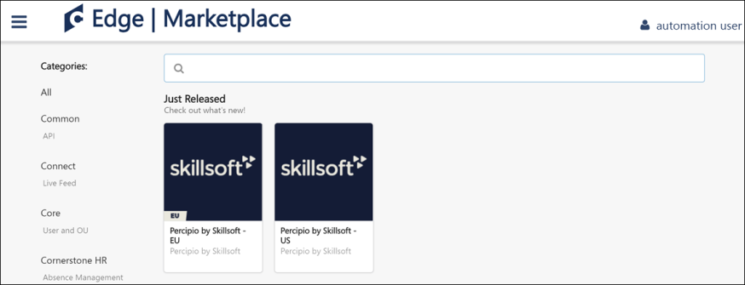
Edge Integrate
After enabling the integration, an administrator can configure the integration by doing the following:
- Add the Account ID as provided by Skillsoft to the Settings page for the integration in Edge Integrate and click the Save Settings button. Only when the Account ID is active from Skillsoft’s side will courses will be synchronized to the Course Catalog.
- Communicate the Client ID and Client Secret field values to Skillsoft's team. These credentials should be configured on Skillsoft’s side to enable the communication of progress reporting back to Cornerstone’s platform.
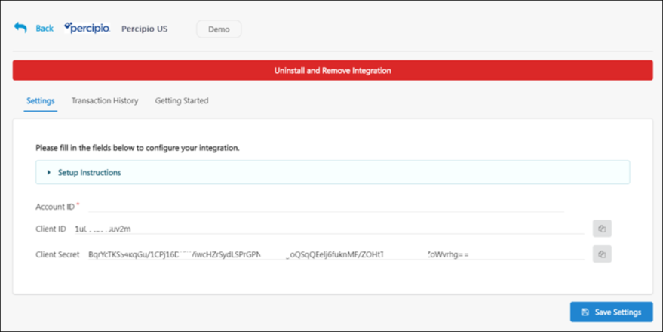
Percipio - Training Search Preferences
The Subscription filter and the online content training type are automatically enabled for portals using a content subscription. However, if your organization has defined specific search options by hierarchy level, the Subscription filter and the online content training type will not be visible, and your organization's search preferences will need to be updated manually.
To access the Search Preferences - Training page, go to ADMIN > TOOLS > CORE FUNCTIONS > CORE PREFERENCES > SEARCH. Then, select the Training tab on the left navigation bar.
Permissions
PERMISSION NAME | PERMISSION DESCRIPTION | CATEGORY

Admin Search Preferences - Manage | Grants ability to configure preferences for Global Search and Course Catalog within Search Preferences. The constraints of this permission are inherited from the Global Search Preferences - Manage permission. This is an administrator permission. | Learning - Administration

Global Search Preferences - Manage | Grants ability to configure Global Search Preferences. This is an administrator permission. The availability of this permission is controlled by a backend setting. This permission can be constrained by OU and User's OU. By default, this permission is constrained to the organization. | Core Administration
Enable Subscription Filter
To enable the Subscription filter, scroll to the Filters section and check the boxes for the Subscription filter to enable the filter for end user pages and administrator pages. Click the Save button at the bottom of the page to apply your changes to the portal.
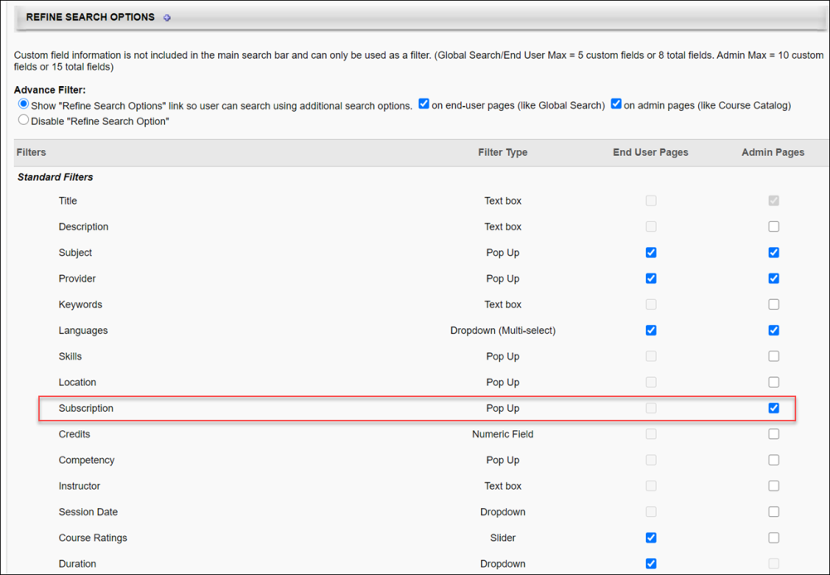
Enable Online Content Training Type
To enable the online content training type, check the Available for Searching checkbox for the Online Content type in the Training Types section. Click the Save button at the bottom of the page to apply your changes to the portal.
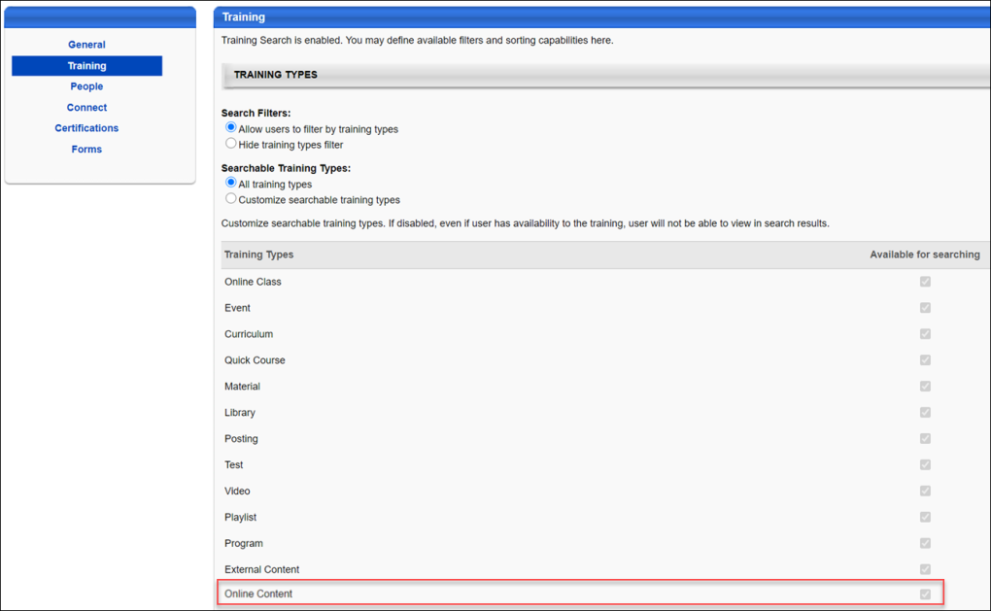
Percipio - Course Syncing
When the Percipio integration has been enabled for a portal, your organization's Percipio content is synced with the learning management system (LMS) Course Catalog on a daily basis. When Percipio content is synced, the following metadata fields are communicated to the Course Catalog:
- ID - The unique ID of the course
- Title - The course title
- URL - The course URL, which is used to redirect users to the provider’s course
- Active - Specifies whether the course is active in the Course Catalog (when a course is no longer available, it is defined as Inactive in the Course Catalog)
- Description - The course description
- Thumbnail - The thumbnail image associated with the course
- Languages - A list of available languages for the course
- Last Modified - The time the course was last modified (UTC)
- Duration - The course duration time
- Modalities - The tagged modality associated with the course (Read, Listen, Watch, Collection)
- Keywords - Words or phrases associated with the course, which allow users to search for training associated with various keywords
To access the Course Catalog, go to Admin > Tools > Learning > Catalog Management > Course Catalog.
Permissions
PERMISSION NAME | PERMISSION DESCRIPTION | CATEGORY

Course Catalog - Update | Grants ability to manage and edit training items listed in the Course Catalog and also grants access to the Course Console, where training can also be managed and edited. This permission also grants access to the Popular Requests and Highest Rated widgets on the Learning Admin Console (in conjunction with the Learning Admin Console - View permission). This permission also allows administrators to reversion online courses via the Course Console page. This permission also allows administrators to access an Edit Training option for training items included as objectives in Development plans.  This permission can be constrained by OU, User's OU, Training Type, Training Item, Provider, ILT Provider, User's ILT Provider, User, User Self and Subordinates, and User's LO Availability. This is an administrator permission.  Note: Adding an OU constraint and a provider constraint to this permission results in an "AND" statement. | Learning - Administration

Course Catalog - View | Grants access to view the learning objects in the course catalog and enables administrators to view the Course Console and the Popular Requests and Highest Rated widgets on the Learning Admin Console (in conjunction with the Learning Admin Console - View permission). This permission can be constrained by OU, User's OU, Training Type, Training Item, Provider, ILT Provider, User's ILT Provider, and User's LO Availability. This is an administrator permission.  Adding an OU constraint and a provider constraint to this permission results in an "AND" statement. | Learning - Administration
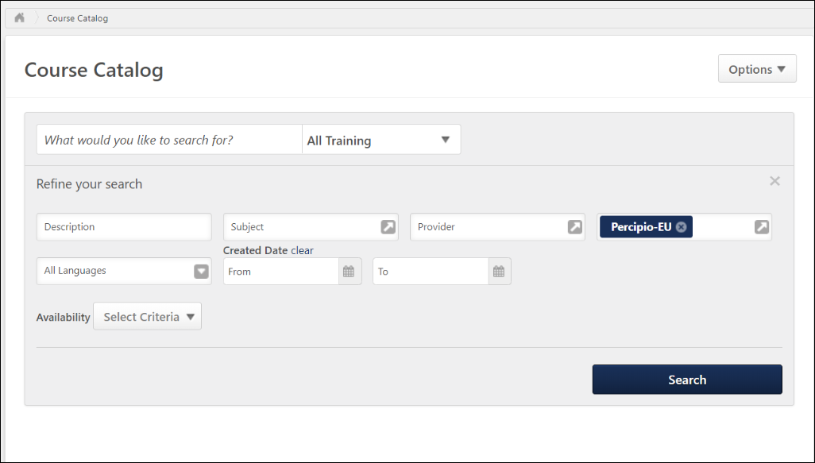
View Percipio Courses in the Course Catalog
To view Percipio courses which have been synced to the Course Catalog, click the Refine Search link on the Course Catalog search page. Then, select Percipio-US or Percipio-EU from the Subscription filter, depending on which version of the integration your organization has enabled. Click the Search button to view all the synced Percipio content in the Course Catalog. Note: Courses synced from Percipio are classified as the online content training type in the Cornerstone system.
Modality Mapping
Modalities are automatically associated with Percipio courses based on the Percipio content type. The following modalities are set to be associated with the listed Percipio content types:
- Collections - Channels
- Listen - Audio books, audio summaries
- Practice - Linked content labs
- Read - Books, book summaries
- Watch - Courses, linked content, videos
Percipio - End User Experience
Learners can search for, browse, and consume Percipio training synced to the learning management system (LMS) in the same manner as other training types created within the LMS. On the Learner Home page, Percipio content displays with the Percipio content type listed in the description to help users quickly identify relevant Percipio courses.
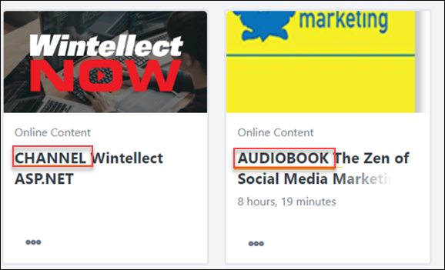
Percipio Integration - FAQ
Please see below for helpful questions and answers about the Percipio integration:
Q: Can I change the provider name for courses synced from Percipio?
A: Yes. To do this, open a ticket with Global Customer Support and request a change to the provider name. It is not recommended to change the provider name to Skillsoft if your organization already has a Skillsoft provider in the portal.
Q: My organization has existing SSO with Skillsoft - Percipio. Is it possible to keep this and not use the embedded SSO?
A: Some existing SSO configurations may be also used with the new integration. However, this requires a customization project aligned with the Global Integration Service (GIS) team. Please work with your CSM to create a custom request.
Q: Our organization already has Percipio content in the portal. Can we enable the new integration?
A: Enabling the new integration when Percipio courses are already in your system's Course Catalog may lead to content duplication. The new integration includes the activation of the online content LO, and old courses cannot be migrated to it. Before enabling the new integration, deactivate the old Percipio courses or submit a request to Global Customer Support to remove the old Percipio courses.

Learning in the Flow of Work Integrations - Overview

Microsoft Teams Learning in the Flow of Work Integration Overview
The "Learning in the Flow of Work" integration brings the Cornerstone Learning catalog directly to learners in their key productivity application. With this enhancement, Microsoft Teams users can add a chatbot to Teams that lets them search for and share training, all linked to the Cornerstone portal. Learners can also receive notifications about training with upcoming due dates.
This integration enables users to interact with learning content from within Teams and includes the ability to:
- Receive a welcome message with instructions on how to use the Learn Bot
- Search for, find, and access relevant content directly within the Learn Bot
- Search for relevant content directly from any message thread with a new Teams message extension
- Stay up-to-date on outstanding training via proactive nudges
- Launch learning content directly from the bot
For portals with single sign-on enabled, any links to training take the user directly to the learning details page without the user needing to log in to the portal if they are already logged in.
Search Logic
@Learn Search returns training results based on the phrase entered in the title, keywords, and description. Results are prioritized first by the phrase in the title of the training, then in the training keywords, and then in the description of the training. This is the same logic used by Learning Search.
Additional Information
Implementation
The Microsoft Teams Learning in the Flow of Work integration is available for Production portals only.
Upon implementation, the integration is available for portals with Learning and that also have a Microsoft Office 365 license with Teams. Administrators with permission to manage Edge Marketplace can enable the integration in Edge Marketplace. The administrator will need the organization’s Office 365 environment Tenant ID as well as access to their Cornerstone portal’s Single Sign-On configuration if they are utilizing Single Sign-On. Once the integration is enabled, individual users can complete installation through Microsoft Teams.
Additional instructions for enabling and configuring the integration will be available in Edge once the integration tile has been added.
Note: You may also be considering creating a subset of users to test the integration. This can be done through Microsoft Teams Custom App Management, which lets you enable the integration for test users. More information about this can be found in the starter guide.
Permissions
The following existing permissions apply to this functionality:
PERMISSION NAME | PERMISSION DESCRIPTION | CATEGORY

Edge Integrations - Manage | Grants access to the Integrations service for Edge Integrate, where the administrator can configure, enable, and disable their third-party integrations used within the Cornerstone system. This permission cannot be constrained. This is an administrator permission. | Edge

Edge Marketplace - Manage | Grants access to the Marketplace service for Edge Integrate, where the administrator can browse integrations that can be used to extend the Cornerstone system. This permission cannot be constrained. This is an administrator permission. | Edge
Microsoft Teams Learning in the Flow of Work - Using the Learn Bot
Microsoft Teams users can add a chatbot to Microsoft Teams that lets them search for and share training, all linked to the Cornerstone portal. Learners can also receive notifications about training with upcoming due dates.
This integration enables users to interact with learning content from within Teams and includes the ability to:
- Receive a welcome message with instructions on how to use the Learn Bot
- Search for, find, and access relevant content directly within the Learn Bot
- Search for relevant content directly from any message thread with a new Teams message extension
- Stay up-to-date on outstanding training via proactive nudges
- Launch learning content directly from the Learn Bot
For portals with Single Sign-On enabled, any links to training take the user directly to the learning details page without the user needing to log in to the portal if they are already logged in.
For customers with multiple Microsoft tenants or that use a specific regional app, see the Microsoft Teams Integration - Starter Guide for information about how to configure the integration for one of these scenarios.
Add the Chatbot
Users can add the chatbot in Teams through the Apps page. Click the name of the app, and then click Add.
Once the chatbot is added, it can be accessed by clicking Learn in the left panel of the Microsoft Teams page.
Welcome Message
A welcome message appears as the first chat with the bot. The message explains how users can find content and stay on top of their assigned training.
The message remains at the top of the chat.
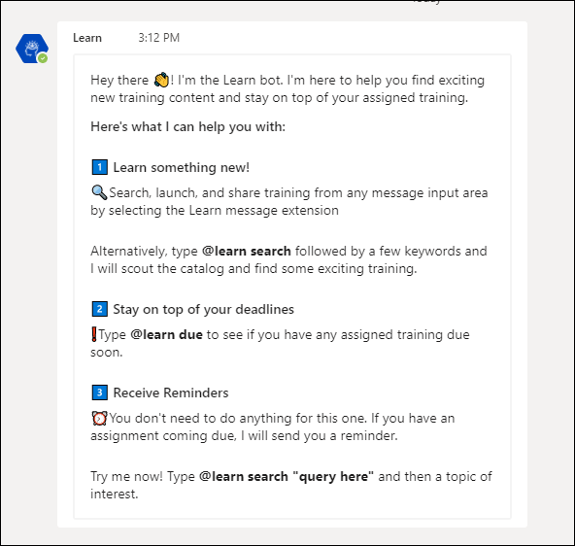
Search for and Launch Content
Within the Learn Bot, to search for content, enter @learn search "query here" followed by keywords. The bot displays the top five trainings that match the search and includes a description of the content if available.
To view the details of the training, simply click the training title or the View Detail button. This takes the user directly to the learning details page, from which they can launch the training.
Note: The keyword used in the search must be a minimum of three characters.
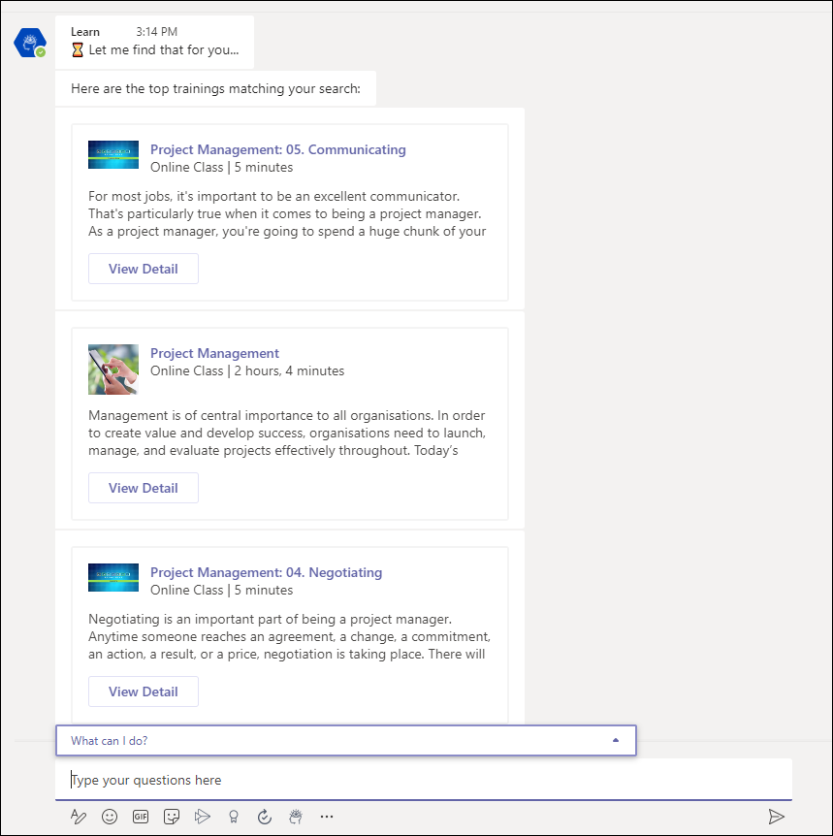
See What Training Is Due
To search for training that is due, enter @learn due, and then click the send icon . The bot searches for any outstanding training and displays a list of the training. A with a link that takes the user directly to the learning details so that they can complete the training.
If "Launch" action is available, a Launch button displays and users can click the button to launch the training content directly from Teams.
Training Is Due Reminders
Training is due reminders appear automatically in the chat on a daily basis to let learners know what training they have due and how soon it needs to be completed. Reminders are sent for trainings with due dates within seven days, either in the future or in the past.
The message includes a link directly to the learning details for quick access to complete the training.
Note: The messaging feature must be enabled by the administrator on the integration's configuration page in Edge by toggling on Enable Proactive Messaging.
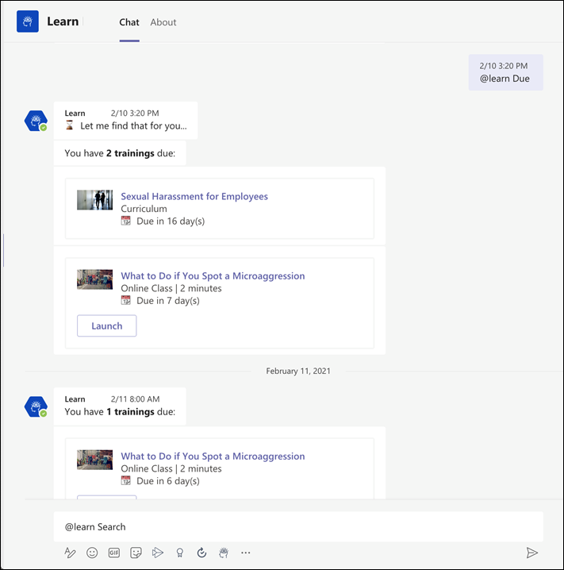
Share Training
Within any message thread with another user or group, users can search for and share Cornerstone training directly. To share training:
- Click the Learn Bot icon in the message extension bar. This will open a search modal.
- Enter any search query within the modal and click Search. The top five search results will be returned.
- Select Insert to add the training to their message input box or select View Detail to be taken to the Learning Details page of the training.
Invalid Commands
If a user enters an invalid command to the Learn Bot, the bot will return a message indicating the command was not recognized. The bot provides a refresher of how to use the app, similar to the Welcome message.
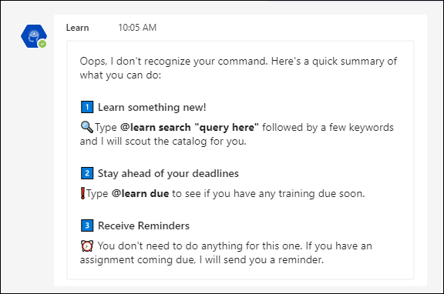

Slack Integration (Learning in the Flow of Work)
Learners often juggle between many applications that they must use for their day-to-day work. To simplify this experience and encourage learning, Cornerstone CSX can now integrate with Slack. When an organization installs the integration, a Slack chatbot pushes training reminders to learners in Slack, an app that they are already using.
Using the Slack chatbot, Learners can do the following:
- Search the Cornerstone training catalog using keywords
- Ask for a list of training due or past due (max 10 trainings returned)
- Launch and mark training complete
- Receive daily notifications (Monday - Friday) of past due and coming due training (up to 7 days)
The chatbot in Slack is easy to use. It has a Home tab where learners can view available commands and a Messages tab to send commands and view notifications received by the chatbot.
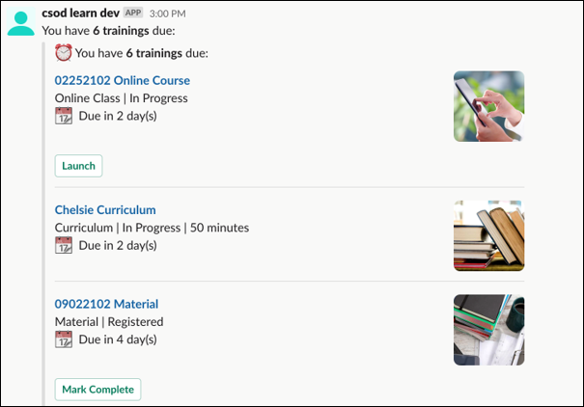
How Does this Enhancement Benefit My Organization?
This integration brings learning where your employees are while helping them remain up to date on required training. With this integration, learners gain self-service access to their CSX learning catalog and required training from within Slack.
Implementation
This integration is available for self-activation in Edge Marketplace.
This integration is not available for the Pilot environment.

Payment Gateway Integrations - Overview

Adyen Payment Gateway
Cornerstone's Extended Enterprise product was built on the Cybersource payment gateway, requiring organizations to solely use that service to accept payment for training sold via the Learning Management System (LMS). This has remained largely unchanged over time, with the exception of enabling PayPal as an additional payment processor.
The Adyen Payment Gateway payment processor is available for credit and debit card payments.
Use Case
Symone is a system administrator for an EMEA organization. Her organization has been using the Cybersource payment gateway for several years, but would prefer to use Adyen as their payment vendor.
- First, Symone contacts Cornerstone Customer Support to have the Adyen Payment Gateway enabled in the portal, and then she contacts Adyen and creates an Adyen merchant account. During her account setup, she obtains a username, password, and an API key to enable Adyen for extended enterprise in her Stage portal.
- She then populates her organization's merchant account information in the Cornerstone portal, allowing her to test the functionality.
- Once satisfied the functionality works as expected, she generates this same information for her Production portal and configures the payment account.
After setup, her users can seamlessly make purchases as they did before, but now all transactions are facilitated by Adyen instead of Cybersource.
Implementation
Administrators can enable the Adyen Payment Processor via the Edge Marketplace.
Please contact Adyen to create Adyen merchant account.
Administrators can test the Adyen Payment Gateway in a test portal if desired, but a separate set of Adyen credentials must be generated through Adyen's interface for use with the test portal.
No other changes, beyond the additional options available on the Define Payment Account page, have been made to Cornerstone's Extended Enterprise functionality as a result of this enhancement. The user's checkout experience will remain the same, except Adyen will be available as a payment method, if enabled.
Considerations
- Costs are associated with the creation of an Adyen merchant account, and these fees are charged by Adyen. Cornerstone is not responsible for any costs incurred through Adyen. The enablement of the Adyen Payment Gateway within the Cornerstone system, however, has no associated costs.
- The Cybersource Payment Gateway and the Adyen Payment Gateway cannot be enabled at the same time in the same portal. Enabling the Adyen Payment Gateway will disable the Cybersource Payment Gateway. The PayPal Payment Gateway, however, CAN be used in conjunction with either the Cybersource or Adyen Payment Gateways.
- Credit and debit card payments are supported through the Adyen Payment Gateway.
Permissions
The following existing permission applies to this functionality:
PERMISSION NAME | PERMISSION DESCRIPTION | CATEGORY

Payment Account - Modify | Grants ability to create payment profiles to determine the routing of users' payments. This permission cannot be constrained. This is an administrator permission. | eCommerce - Administration
Adyen Payment Processor - Enable in Edge
The Adyen Payment Processor integration can be enabled via the Edge Marketplace.
To access the Edge Marketplace, go to: Admin > Tools > Edge and click the Marketplace link.
Permissions
PERMISSION NAME | PERMISSION DESCRIPTION | CATEGORY

Edge Integrations - Manage | Grants access to the Integrations service for Edge Integrate, where the administrator can configure, enable, and disable their third-party integrations used within the Cornerstone system. This permission cannot be constrained. This is an administrator permission. | Edge

Edge Marketplace - Manage | Grants access to the Marketplace service for Edge Integrate, where the administrator can browse integrations that can be used to extend the Cornerstone system. This permission cannot be constrained. This is an administrator permission. | Edge
Adyen - Edge Marketplace
To enable the Adyen Payment Processor:
- Search for and select the Adyen tile in the Edge Marketplace.
- Then, click the Install button for the Adyen integration.
- Review the terms and conditions of using the Adyen integration and check the acknowledgment box to confirm that you read, understood, and agree to the terms and conditions.
- Click the Install button. The integration will be installed.
- Enable the Adyen tile in Edge in order to activate the payment processor. The Active toggle is switched to the Off position by default.
Account details for your Adyen account must be added within the Cornerstone system, via the Define Payment Account page. See Adyen Payment Gateway - Define Payment Account on page 62 for additional information.
Adyen Payment Gateway - Define Payment Account
On the Define Payment Account page, administrators can configure the payment account for their Adyen merchant account.
To access the Define Payment Account preferences page, go to ADMIN > TOOLS > Learning > Learning PREFERENCES > E-Commerce and click the Modify Payment Account link. In the Payment Account section, click the Add icon to add a new payment account.
Permissions
PERMISSION NAME | PERMISSION DESCRIPTION | CATEGORY

Payment Account - Modify | Grants ability to create payment profiles to determine the routing of users' payments. This permission cannot be constrained. This is an administrator permission. | eCommerce - Administration
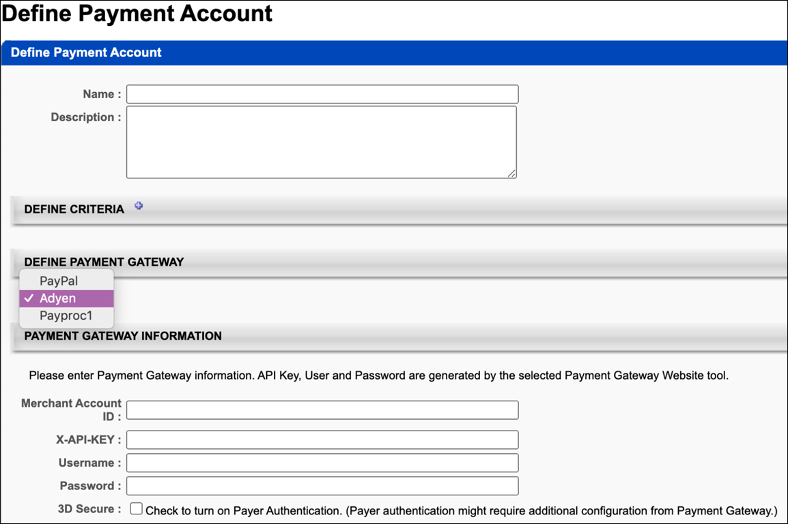
Define Payment Gateway
To define the Adyen Payment Gateway, complete the following steps:
- In the Define Payment Gateway section, select Adyen from the drop-down menu. Note: This option is only available if Cornerstone Customer Support has enabled the Adyen Payment Gateway in your portal.
- In the Payment Gateway Information section, populate the following fields with the API credentials obtained from Adyen:
  - Merchant Account ID - This is obtained from your Adyen account and displays on the API Credentials page in Adyen.
  - X-API-KEY - This is the API key generated through Adyen. This must be copied at the time it is generated, as it will be obfuscated in the Adyen account after creation.
  - Username - This is the username generated from within your Adyen account. Note: This is NOT the username used to log into your Adyen account; it is a username associated with the API key when it is generated. This data will display on the details page for the merchant account.
  - Password - This is the password generated from within your Adyen account. Note: This is not the password used to log into your Adyen account; it is a password associated with the API key it is generated. This password must be copied at the time it is generated, as it will be obfuscated in the Adyen account after creation.
  - 3D Secure - This setting, if enabled, must also be configured in your Adyen account in order to function. Without first configuring this option in Adyen, errors will occur when attempting to perform transactions in the Cornerstone portal. This option should only be selected AFTER it has first been configured via Adyen.
- Click the Save button to finish configuring the Adyen payment account. This account will then be available for users who meet the specified user criteria defined for the account. Note: More than one account can be defined for the portal.
For more information about generating API credentials, please see Adyen's documentation: Adyen Help Documentation.
For more information about creating a payment account: See Create Payment Account.
Save/Cancel
Click Save to save the payment account. Or, click Cancel to cancel creating the payment account.

NIC Colorado Payment Processor
The NIC Colorado Payment Gateway has been made available to help support US government customers. This new payment gateway has been implemented to support transactions including:
- Credit card and e-check payment methods
- Processing fee calculation, calculated as:
  - Percentage applied over the purchase order total value
  - Fixed value
  - Formula (using the purchase order total value)
Exclusions
The following features are not supported by this integration:
- Recurring billing
- Transactions with 3D Secure
- Partial refunds (only full refunds are supported)
- Save credit card
- Tax calculation
Considerations
- Only one payment processor may be enabled in a portal at a time, with the exception of the PayPal Payment Processor. The PayPal Payment Processor may be enabled in addition to one other payment processor, such as the NIC Colorado Payment Processor.
- Costs are associated with the creation of a NIC Colorado merchant account, and these fees are charged by NIC Colorado. Cornerstone is not responsible for any costs incurred through NIC Colorado.
- The enablement of the NIC Colorado Payment Gateway within the Cornerstone system has an associated cost. For more details, please contact your Account Manager.
Implementation
For organizations using the Learning module, this integration can be self-enabled via the Edge Marketplace. See NIC Colorado Payment Processor - Enable in Edge on page 66 for additional information.
Please contact NIC Colorado to create a NIC Colorado merchant account.
Edge Guide
Click here for the NIC Colorado Payment Gateway Edge Guide!
Permissions
The following existing permissions apply to this functionality:
PERMISSION NAME | PERMISSION DESCRIPTION | CATEGORY

Edge Integrations - Manage | Grants access to the Integrations service for Edge Integrate, where the administrator can configure, enable, and disable their third-party integrations used within the Cornerstone system. This permission cannot be constrained. This is an administrator permission. | Edge

Edge Marketplace - Manage | Grants access to the Marketplace service for Edge Integrate, where the administrator can browse integrations that can be used to extend the Cornerstone system. This permission cannot be constrained. This is an administrator permission. | Edge

Payment Account - Modify | Grants ability to create payment profiles to determine the routing of users' payments. This permission cannot be constrained. This is an administrator permission. | eCommerce - Administration
NIC Colorado Payment Processor - Enable in Edge
The NIC Colorado Payment Processor integration can be enabled via the Edge Marketplace.
To access the Edge Marketplace, go to: Admin > Tools > Edge and click the Marketplace link.
Permissions
PERMISSION NAME | PERMISSION DESCRIPTION | CATEGORY

Edge Integrations - Manage | Grants access to the Integrations service for Edge Integrate, where the administrator can configure, enable, and disable their third-party integrations used within the Cornerstone system. This permission cannot be constrained. This is an administrator permission. | Edge

Edge Marketplace - Manage | Grants access to the Marketplace service for Edge Integrate, where the administrator can browse integrations that can be used to extend the Cornerstone system. This permission cannot be constrained. This is an administrator permission. | Edge
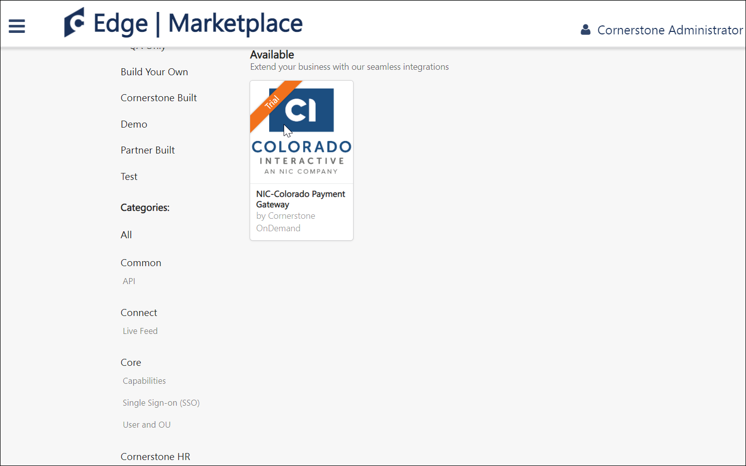
NIC Colorado - Edge Marketplace
To enable the NIC Colorado Payment Processor:
- Search for and select the NIC Colorado tile in the Edge Marketplace.
- Then, click the Install button for the NIC Colorado integration.
- Review the terms and conditions of using the NIC Colorado integration and check the acknowledgment box to confirm that you read, understood, and agree to the terms and conditions.
- Click the Install button. The integration will be installed.
- Enable the NIC Colorado tile in Edge in order to activate the payment processor. The Active toggle is switched to the Off position by default.
Account details for your NIC Colorado account must be added within the Cornerstone system, via the Define Payment Account page. See NIC Colorado Payment Processor - Define Payment Account on page 68 for additional information.
NIC Colorado Payment Processor - Define Payment Account
On the Define Payment Account page, administrators can configure the payment account for their NIC Colorado merchant account.
To access the Define Payment Account preferences page, go to ADMIN > TOOLS > Learning > Learning PREFERENCES > E-Commerce and click the Modify Payment Account link. In the Payment Account section, click the Add icon to add a new payment account.
Permissions
PERMISSION NAME | PERMISSION DESCRIPTION | CATEGORY

Payment Account - Modify | Grants ability to create payment profiles to determine the routing of users' payments. This permission cannot be constrained. This is an administrator permission. | eCommerce - Administration
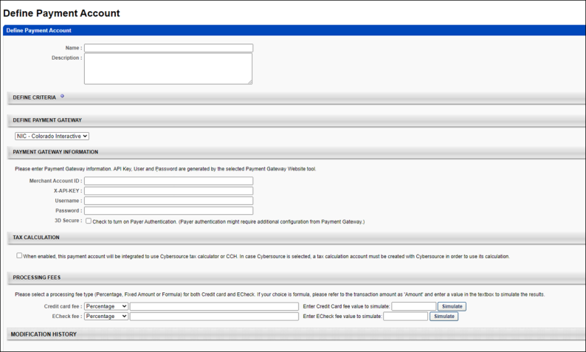
Define Payment Gateway
To define the NIC Colorado Payment Gateway, complete the following steps:
- In the Define Payment Gateway section, select NIC Colorado from the drop-down menu. Note: This option is only available if you have enabled the NIC Colorado Payment Gateway via Edge.
- Enter the following information for the payment account:
  - Name - Character limit is 50.
  - Description - This is for administrator use only. It is not displayed anywhere. Character limit is 250.
  - Define Criteria - At least one criteria is required and constraints do not apply to the available selections. The available attribute types are:
    - Currency
    - Provider
    - OU
    - LO
- The remaining fields that the administrator must populate depend on the payment processor selected for the portal. In the Payment Gateway Information section, populate the following fields with the API credentials obtained from NIC Colorado:
  - Merchant Account ID
  - API Key
  - Username
  - Password
  - 3D Secure
Note: The above fields can be obtained from NIC Colorado after you have created an account with NIC Colorado.
Save/Cancel
Click Save to save the payment account. Or, click Cancel to cancel creating the payment account.

PayPal Payment Gateway Integration Enablement
The PayPal Payment Gateway integration supports transaction management features, eliminating the need to perform additional bookkeeping for refunds. This functionality includes automatic refunds for users who withdraw from sessions.
Permissions
PERMISSION NAME | PERMISSION DESCRIPTION | CATEGORY

Edge Integrations - Manage | Grants access to the Integrations service for Edge Integrate, where the administrator can configure, enable, and disable their third-party integrations used within the Cornerstone system. This permission cannot be constrained. This is an administrator permission. | Edge

Edge Marketplace - Manage | Grants access to the Marketplace service for Edge Integrate, where the administrator can browse integrations that can be used to extend the Cornerstone system. This permission cannot be constrained. This is an administrator permission. | Edge

Payment Account - Modify | Grants ability to create payment profiles to determine the routing of users' payments. This permission cannot be constrained. This is an administrator permission. | eCommerce - Administration

Transaction Manager - Manage | Grants ability to access the Manage Transaction page and also create and edit transactions. On the Order History Details page, the administrator can edit the order status, adjust prices, issue refunds, or enter comments. This permission can be constrained by User's OU. This is an administrator permission. | eCommerce - Administration
To enable the PayPal Payment Gateway integration for your organization:
- Add the PayPal Payment Gateway integration from the Edge Marketplace. To access the Edge Marketplace and specific information about the integration, go to: Admin > Tools > Edge and click the Marketplace link.
- Configure the integration via Edge Integrate. To access Edge Integrate, go to: Admin > Tools > Edge and click the Integrate link.
- Create a PayPal business account. See Create PayPal Business Account.
- Add PayPal as a payment account in the learning management system (LMS). See PayPal Payment Gateway - Define Payment Account on page 93 for additional information.
- Enable PayPal as a payment method in User Payment Preferences. See PayPal - User Payment Preferences on page 79 for additional information.
Note: The backend setting for the PayPal Payment Gateway must be turned on in your portal in order for PayPal to be used as a payment method. This setting is automatically enabled when you install and configure the PayPal Payment Gateway integration.
Permissions
The following existing permissions apply to this functionality:
PERMISSION NAME | PERMISSION DESCRIPTION | CATEGORY

Edge Integrations - Manage | Grants access to the Integrations service for Edge Integrate, where the administrator can configure, enable, and disable their third-party integrations used within the Cornerstone system. This permission cannot be constrained. This is an administrator permission. | Edge

Edge Marketplace - Manage | Grants access to the Marketplace service for Edge Integrate, where the administrator can browse integrations that can be used to extend the Cornerstone system. This permission cannot be constrained. This is an administrator permission. | Edge

Payment Account - Modify | Grants ability to create payment profiles to determine the routing of users' payments. This permission cannot be constrained. This is an administrator permission. | eCommerce - Administration

Transaction Manager - Manage | Grants ability to access the Manage Transaction page and also create and edit transactions. On the Order History Details page, the administrator can edit the order status, adjust prices, issue refunds, or enter comments. This permission can be constrained by User's OU. This is an administrator permission. | eCommerce - Administration
Dynamic Tax Calculator - Cybersource
Dynamic Tax Calculator with Cybersource - Overview
Administrators can enable the PayPal Payment Gateway (Early Adopter) integration to calculate taxes dynamically using the Cybersource Tax Calculator integration.
Use Cases
Use Case 1: Existing Tax Calculation User
Flinn is the business process owner and administrator at ACME Corporation, which is a well-known provider of software engineering courses. They are using Extended Enterprise to sell the content. ACME is required to collect varying taxes on most of their sales. Their catalog has been configured to work with Cybersource as the payment gateway.
With the PayPal tax calculator, Flinn enables the PayPal Payment Gateway integration to accept payments, with confidence that ACME's complex tax rules will be respected.
Use Case 2: New Tax Calculation User
Khalil is the business process owner and administrator of Ventonix Enterprises, which is a well known provider of training content. Ventonix wants to sell content to the public, but must be compliant with various tax rules in order to do so. Because the PayPal Payment Gateway integration can be configured to dynamically calculate taxes, Khalil is able to create a new account with Cybersource, configure tax rules, and then enable the PayPal Payment Gateway integration to accept payments.
Considerations
- Organizations using the PayPal Payment Gateway integration who wish to use the dynamic tax calculator are responsible for contracting with Cybersource to establish a Tax Calculation account. See: https://www.cornerstoneondemand.com/marketplace/cybersource
- If Tax Calculation with Cybersource is enabled, organizations using the PayPal Payment Gateway integration are responsible for disabling any PayPal tax rules that have already been configured.
- Your organization will need a PayPal business account in order to use the Cybersource Tax Calculator.
- Organizations will need to have Cybersource enabled in two different environments:
  - Cybersource Test is linked to CSOD Stage, Pilot
  - Cybersource Live is linked to CSOD Production
- Tax fields for PayPal transactions will flow to Standard Reports, Custom Reports, and Reporting 2.0.
Implementation
In order to utilize this functionality, the PayPal Payment Gateway integration must be enabled, and your organization must create an account with Cybersource.
- For more information about configuring the PayPal Payment Gateway integration: See PayPal Payment Gateway Integration Enablement on page 70 for additional information.
- For more information about creating a Cybersource account: https://www.cornerstoneondemand.com/marketplace/cybersource
Dynamic Tax Calculation - Define Payment Account
On the Define Payment Account page, administrators can configure the Cybersource Tax Calculator integration.
To access the Define Payment Account preferences page, go to ADMIN > TOOLS > Learning > Learning PREFERENCES > E-Commerce and click the Modify Payment Account link. In the Payment Account section, click the Add icon to add a new payment account.
Permissions
PERMISSION NAME | PERMISSION DESCRIPTION | CATEGORY

Payment Account - Modify | Grants ability to create payment profiles to determine the routing of users' payments. This permission cannot be constrained. This is an administrator permission. | eCommerce - Administration
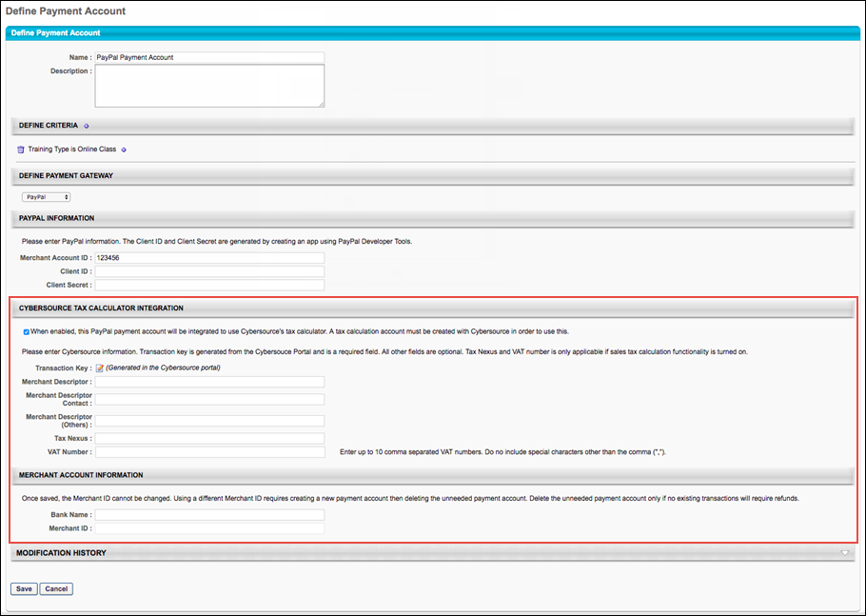
Cybersource Tax Calculator Integration
In the Cybersource Tax Calculator Integration section, administrators enable the setting which allows the PayPal Payment Gateway integration to use an existing Cybersource account to dynamically calculate taxes for PayPal transactions.
To enable this setting, toggle the Cybersource Tax Calculator Integration toggle to the On position. If you do not wish to enable the Cybersource Tax Calculator, leave this switch toggled to the Off position. Note: You must create a Cybersource account prior to enabling this option in order to allow the PayPal Payment Gateway integration to dynamically calculate taxes.
If the Cybersource Tax Calculator Integration has been enabled, the administrator can configure the following fields which appear on the page:
- Transaction Key - The Transaction Key is generated from the Cybersource portal and is a required field.
- Merchant Descriptor
- Merchant Descriptor Contact
- Merchant Descriptor (Others)
- Tax Nexus
- VAT Number
- Merchant ID
Dynamic Tax Calculator - Billing Address
In order to dynamically calculate taxes during the checkout process, a billing address must be collected from the user. If the Cybersource Tax Calculator integration has been enabled and the user has selected PayPal as the payment method, the user is prompted to populate the following billing address fields during the first step of the checkout process when purchasing training:
- Email
- First Name
- Last Name
- Address Line 1
- Address Line 2
- City
- Country
- State/Province
- Zip Code
This information allows Cybersource to dynamically calculate tax for the purchase.
- If enabled in User Payment Preferences, users can also opt to provide a secondary address if their billing address is separate from their shipping address. Providing a secondary address can be configured as required via User Payment Preferences, if needed. If preferences are set to collect a secondary address, the user will see the following options during checkout:
- Use the billing address as my shipping address?
  - No - If the user selects this option, the user's billing address will be the same as their shipping address.
  - Yes - If the user selects this option, the user will be prompted to complete the following fields for the secondary address:
    - Email
    - First Name
    - Last Name
    - Address Line 1
    - Address Line 2
    - City
    - Country
    - State/Province
    - Zip Code
For more information about the checkout process: See Checkout - Step 1 - Payment.
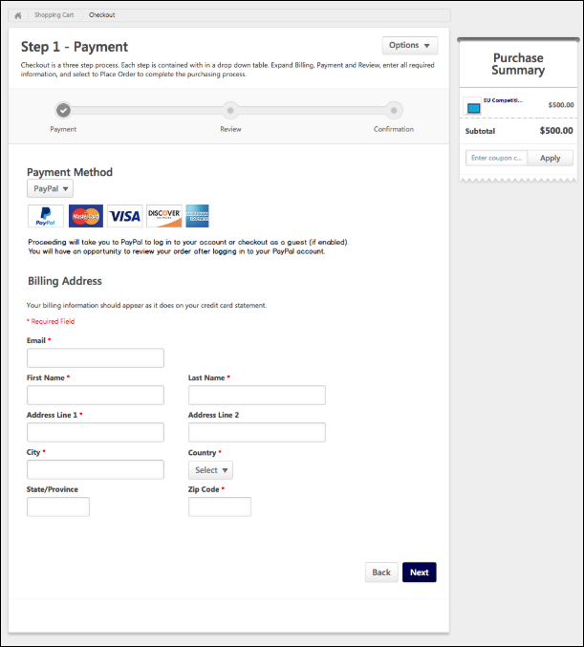
PayPal - User Payment Preferences
If the PayPal Payment Gateway is enabled in Payment Preferences, additional options to allow or require the collection of a secondary billing address are available to the administrator.
To manage User Payment preferences, go to ADMIN > TOOLS LEARNING > E-COMMERCE > PAYMENT METHODS.
Permissions
PERMISSION NAME | PERMISSION DESCRIPTION | CATEGORY

User Payment Preferences - Manage | Grants ability to manage user payment preferences, which includes determining the payment methods allowed and percentage of overall price that users must pay when purchasing learning content. This permission can be constrained by OU and User's OU. This is an administrator permission. | eCommerce - Administration
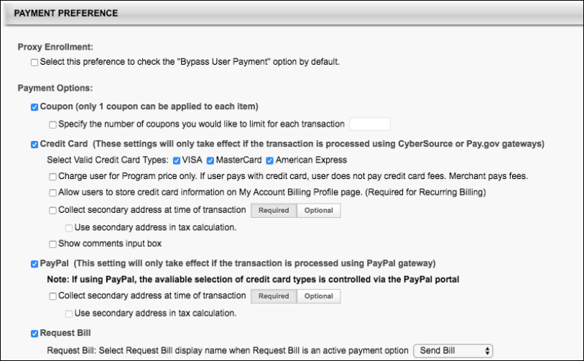
Payment Preference
When the PayPal option in the Payment Preference section is enabled, the following additional options can be configured:
- Collect secondary address at time of transaction - Select this option to allow users to enter a secondary address for the payment during the checkout process. When this option is selected, a Required/Optional toggle is enabled, which allows the administrator to determine whether the secondary address fields are required or optional. If the secondary address is optional, then all fields within the secondary address are optional, regardless of the Billing Information Preferences.
- Use Secondary Address in Tax Calculation - This field is enabled when the Collect secondary address field is selected and defined as required. This field only displays if at least one learning object (LO) is selected on the Tax Preferences page to indicate tax collection by LO.
Checkout with PayPal
When PayPal has been added as a payment method in a system using Extended Enterprise, users can pay for training using PayPal. After adding training to the shopping cart, the user can begin the checkout process. Please note that the PayPal integration only supports PayPal checkout and does not support any other PayPal products, such as Venmo or Braintree.
Step 1 - Payment
On the Payment step of the checkout process, the user can select PayPal from the Payment Method drop-down menu. After selecting PayPal as the payment method, click the Next button. Note: PayPal can only be used as the payment method if ALL items in the cart can be purchased using one payment method. PayPal cannot be used to purchase training units.
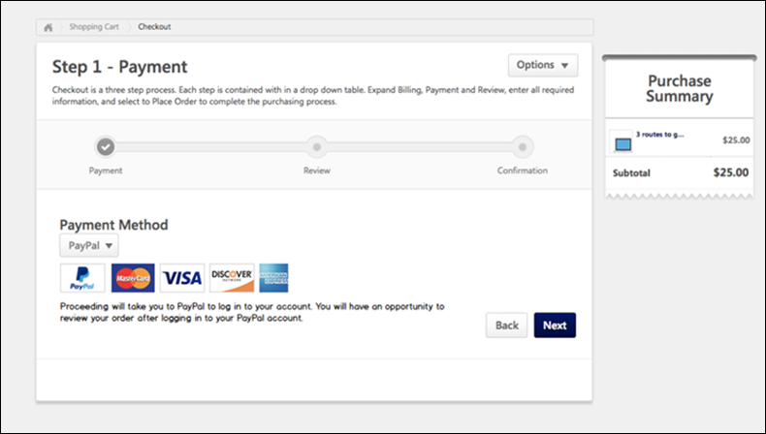
Checkout with PayPal
After selecting PayPal as the payment method and clicking the Next button, the user is redirected to PayPal's payment page. The user will be prompted to pay for the training in the cart using one of PayPal's supported payment methods. See PayPal.com for more information about creating a PayPal account and PayPal's checkout process.
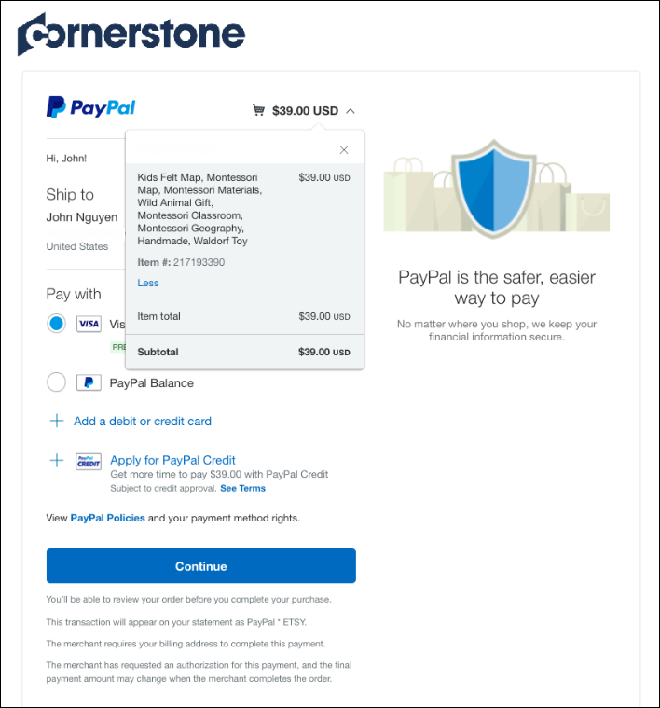
After completing the PayPal checkout process, PayPal provides the user with a receipt for their purchase on the screen and via email, and the user is navigated back transcript.
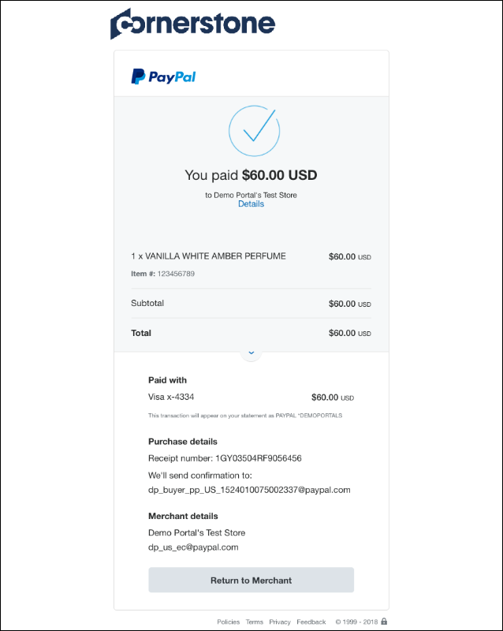
If payment was successful, the training is added to the user's transcript.
Order History
After the order has been processed, the user can view the transaction on the Order History tab of their My Account page. If the user paid for the order using PayPal, the Payment Method column displays a value of PayPal. For more information about the Order History page: See My Account - Orders - Order Details (Redesigned).
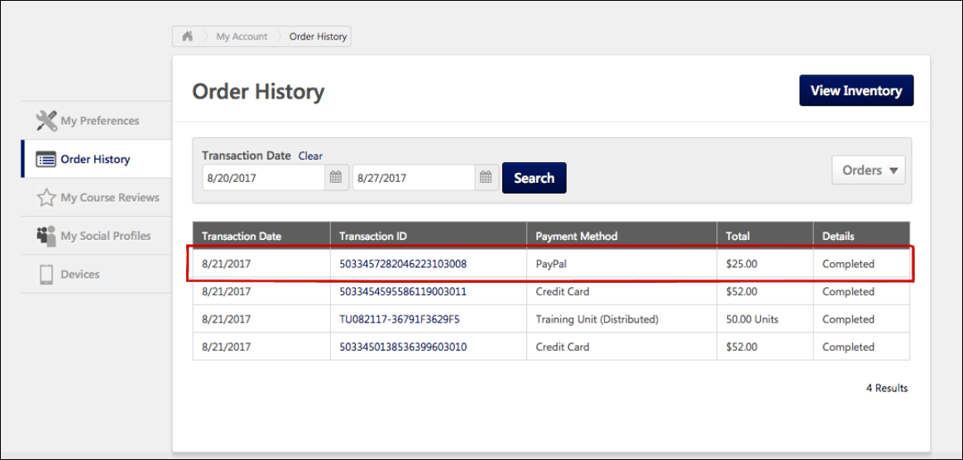
Manage PayPal Transactions
Transactions completed with PayPal can be viewed and managed by administrators via the Manage Transactions page, along with transactions completed with other payment methods.
To access the Manage Transactions page, go to Admin > Tools > Learning > E-Commerce > Manage Transactions.
Permissions
PERMISSION NAME | PERMISSION DESCRIPTION | CATEGORY

Transaction Manager - Manage | Grants ability to access the Manage Transaction page and also create and edit transactions. On the Order History Details page, the administrator can edit the order status, adjust prices, issue refunds, or enter comments. This permission can be constrained by User's OU. This is an administrator permission. | eCommerce - Administration

Transaction Manager - View | Grants ability to view the Manage Transaction page where the administrator can review the transactions that meet their permission constraints. This permission can be constrained by User's OU. This is an administrator permission. | eCommerce - Administration
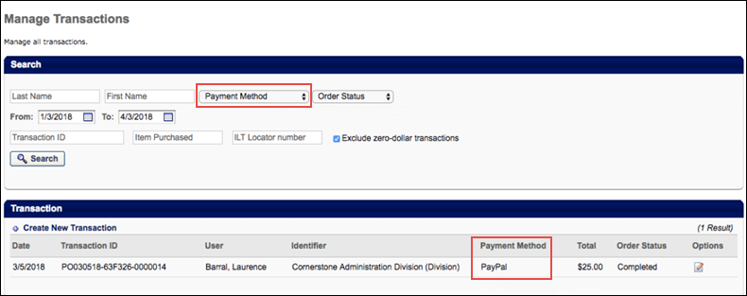
Manage Transactions
On the Manage Transactions page, you can search specifically for transactions that were completed with PayPal, and you can easily determine the payment method used for each transaction.
For general information about the Manage Transactions page: See Manage Transactions Overview.
Search
To search for only transactions which were completed using PayPal as the payment method, select the PayPal option from the Payment Method drop-down menu in the Search section and click the Search button. After the page refreshes, only transactions completed with PayPal will display in the Transaction section.
Transaction
In the Transaction section, view the Payment Method section to determine what payment method was used to complete each transaction. Transactions completed using PayPal display a value of PayPal in the Payment Method column. You can click the Details icon next to the transaction to view the Order Details page for the transaction. On the Order Details page for transactions completed with PayPal, the Payment Method field will display a value of PayPal.
Obtain Client ID and Client Secret from PayPal
Prior to configuring the PayPal Payment Gateway integration, an organization must have a PayPal business account. To retrieve the Client ID and Client Secret values required for configuring a payment account in Cornerstone:
- Go to: https://developer.paypal.com/developer/applications/ and log in with your PayPal business account credentials.
- Navigate to the My Apps & Credentials tab and click the Create App button in the REST API Apps section. This allows the Cornerstone system to authenticate with PayPal and process refunds.
- Name the application (this does not impact the integration) and associate the sandbox test account.
- Click the Create App button.
- The App will be created and the administrator can copy the Client ID and Secret from this page for the sandbox environment into the Modify Payment accounts page in their Cornerstone Stage environment. Note: These values do not expire, but they can be disabled by an administrator if needed.
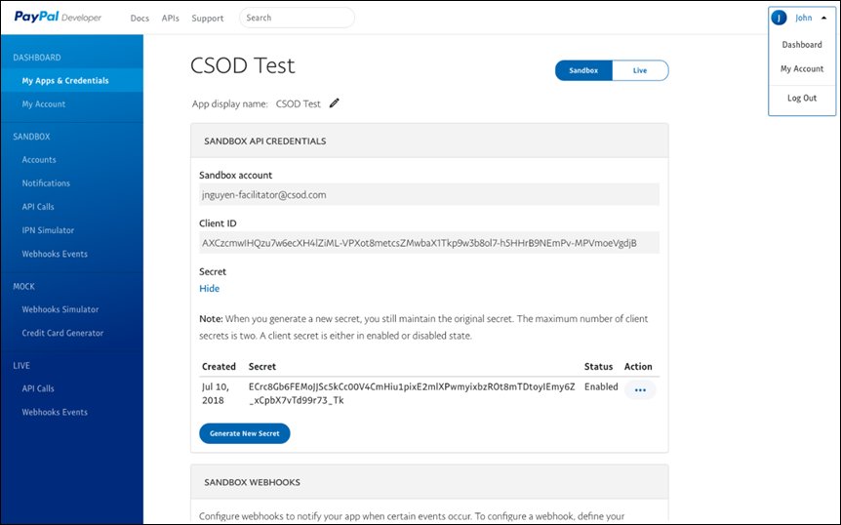
In order to view the Client ID and Secret values for the Cornerstone Production environment, click the Live tab in the upper-right of the PayPal business account page and repeat step four in the Cornerstone Production environment.
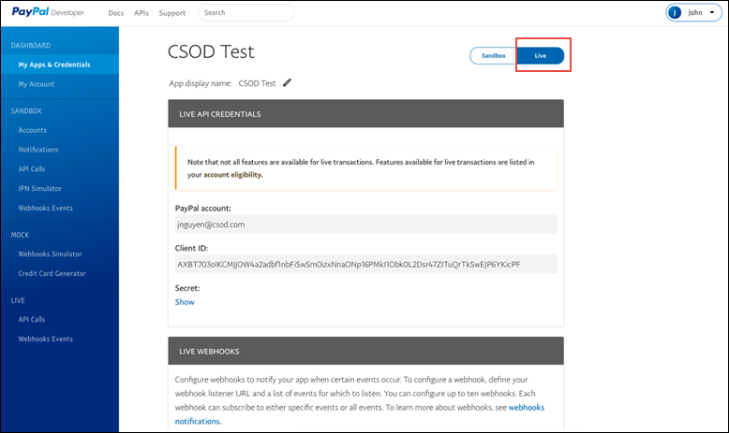
PayPal - Automatic Refunds
If a session was purchased using PayPal, and the Automate Refund Using Refund Terms option is enabled, existing system refund logic is respected and the session is automatically refunded due to the user withdrawing from the session.
If the refund is successful, the related refund information is reflected in the following locations:
- Manage Transactions page
- Order History
- Custom Reports
- Emails
To enable automatic refunds for PayPal transactions, go to: Admin > Tools > Learning > Learning Preferences > ILT Preferences.
Permissions
PERMISSION NAME | PERMISSION DESCRIPTION | CATEGORY

ILT Preferences - Manage | Grants ability to configure a variety of default settings that apply to new instructor led training events and sessions. This permission can be constrained by OU and User's OU. This is an administrator permission. | Learning - Administration
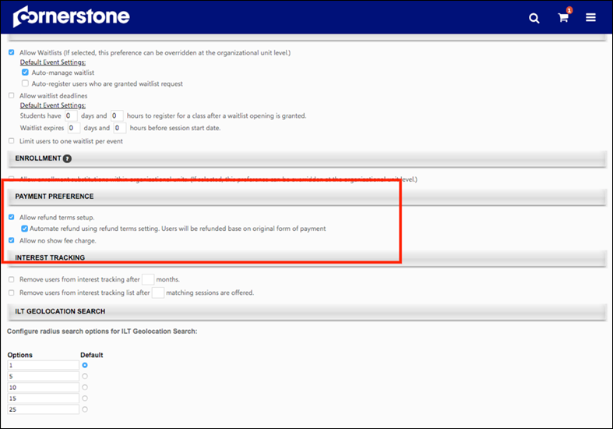
The following existing refund options are available in the Payment Preference section of ILT Preferences - General:
- Allow Refund terms setup - Select this option to enable administrators to set up refund terms when setting up an ILT event.
  - Automate refund using refund terms setting. Users will be refunded based on original form of payment. - This option is only available if the "Allow Refund terms setup" option is selected. Select this option to automatically issue refunds.
- Allow no show fee charge - Select this option to enable administrators to set up no show fees when setting up an ILT event.
See ILT Preferences - General for more information about ILT Preferences.
See Refunds Overview for more information about refunds.
PayPal - Manual Refunds
Administrators can manually initiate full and partial refunds for PayPal transactions via the Manage Transactions page.
To access the Manage Transactions page, go to Admin > Tools > Learning > E-Commerce > Manage Transactions. Then, click on the order you want to refund.
Permissions
PERMISSION NAME | PERMISSION DESCRIPTION | CATEGORY

Transaction Manager - Manage | Grants ability to access the Manage Transaction page and also create and edit transactions. On the Order History Details page, the administrator can edit the order status, adjust prices, issue refunds, or enter comments. This permission can be constrained by User's OU. This is an administrator permission. | eCommerce - Administration

Transaction Manager - View | Grants ability to view the Manage Transaction page where the administrator can review the transactions that meet their permission constraints. This permission can be constrained by User's OU. This is an administrator permission. | eCommerce - Administration
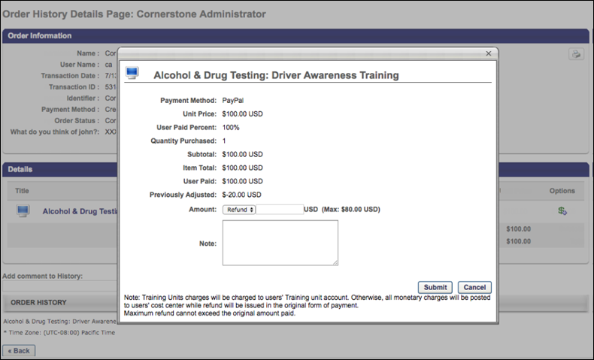
Manual Refund
To initiate a manual refund:
- Click the Refund icon in the Options column next to the training you are refunding. A pop-up window appears.
- In the pop-up, review the refund information and select a refund amount. Then add a note in the Note field explaining the refund.
- Click the Submit button to submit the refund.
If the refund is successful, the related refund information is reflected in the following locations:
- Manage Transactions page
- Order History
- Custom Reports
- Emails
See Refunds Overview for more information about refunds.
Considerations
- If tax was applied to the transaction by PayPal, during the refund process the administrator should specify the pre-tax amount to refund to the customer. The maximum refundable amount to a customer is the sub-total amount. Once the refund is triggered, PayPal refunds the tax proportional to the amount refunded.
- If tax is not applied to the transaction, the amount refunded is not changed.
PayPal Payment Gateway - Define Payment Account
On the Define Payment Account page, administrators can configure the payment account for their PayPal business account.
To access the Define Payment Account preferences page, go to ADMIN > TOOLS > Learning > Learning PREFERENCES > E-Commerce and click the Modify Payment Account link. In the Payment Account section, click the Add icon to add a new payment account.
Permissions
PERMISSION NAME | PERMISSION DESCRIPTION | CATEGORY

Payment Account - Modify | Grants ability to create payment profiles to determine the routing of users' payments. This permission cannot be constrained. This is an administrator permission. | eCommerce - Administration
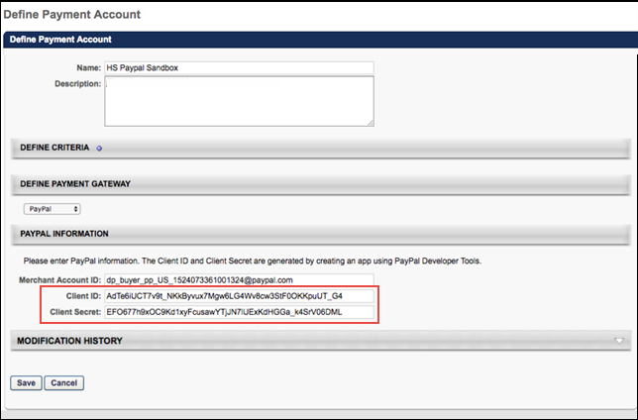
PayPal Information
In the PayPal Information section, the administrator can populate the following fields:
- Merchant Account ID - Provide the email address or merchant account ID associated with your organization's PayPal business account. This field is required.
- Client ID - Provide the Client ID associated with your organization's PayPal business account. This field is required.
- Client Secret - Provide the Client Secret associated with your organization's PayPal business account. This field is required.
Access your PayPal information from the My Apps & Credentials tab of your PayPal Developer account. See Obtain Client ID and Client Secret from PayPal on page 87 for additional information.
Click the Save button to finish configuring the PayPal payment account.
For more information about creating a payment account: See Create Payment Account.
Transaction Reporting - PayPal
The Transaction Payment Method field, available in Reporting 2.0, can generate an output of PayPal, in addition to the existing other potential payment method outputs.

PayPoint Payment Processor
The PayPoint Payment Gateway supports transactions including:
- Credit card and e-check payment methods
- Tax calculation
- Processing fee calculation, calculated as:
  - Percentage applied over the purchase order total value
  - Fixed value
  - Formula (using the purchase order total value)
Exclusions
The following features are not supported by this integration:
- Recurring billing
- Transactions with 3D Secure
Considerations
- Only one payment processor may be enabled in a portal at a time, with the exception of the PayPal Payment Processor. The PayPal Payment Processor may be enabled in addition to one other payment processor, such as the PayPoint Payment Processor.
- For tax calculation, a Cybersource or CCH account is required. PayPoint does not calculate taxes.
- Costs are associated with the creation of a PayPoint merchant account, and these fees are charged by PayPoint. Cornerstone is not responsible for any costs incurred through PayPoint.
- The enablement of the PayPoint Payment Gateway within the Cornerstone system has an associated cost. For more details, please contact your Account Manager.
Implementation
For organizations using the Learning module, this integration can be self-enabled via the Edge Marketplace. See PayPoint - Enable in Edge on page 98 for additional information.
Please contact PayPoint (Fiserv) to create a PayPoint merchant account.
Edge Guide
Click here for the PayPoint Payment Gateway Edge Guide!
Permissions
The following existing permissions apply to this functionality:
PERMISSION NAME | PERMISSION DESCRIPTION | CATEGORY

Edge Integrations - Manage | Grants access to the Integrations service for Edge Integrate, where the administrator can configure, enable, and disable their third-party integrations used within the Cornerstone system. This permission cannot be constrained. This is an administrator permission. | Edge

Edge Marketplace - Manage | Grants access to the Marketplace service for Edge Integrate, where the administrator can browse integrations that can be used to extend the Cornerstone system. This permission cannot be constrained. This is an administrator permission. | Edge

Payment Account - Modify | Grants ability to create payment profiles to determine the routing of users' payments. This permission cannot be constrained. This is an administrator permission. | eCommerce - Administration
PayPoint - Enable in Edge
The PayPoint Payment Processor integration can be enabled via the Edge Marketplace.
To access the Edge Marketplace, go to: Admin > Tools > Edge and click the Marketplace link.
Permissions
PERMISSION NAME | PERMISSION DESCRIPTION | CATEGORY

Edge Integrations - Manage | Grants access to the Integrations service for Edge Integrate, where the administrator can configure, enable, and disable their third-party integrations used within the Cornerstone system. This permission cannot be constrained. This is an administrator permission. | Edge

Edge Marketplace - Manage | Grants access to the Marketplace service for Edge Integrate, where the administrator can browse integrations that can be used to extend the Cornerstone system. This permission cannot be constrained. This is an administrator permission. | Edge
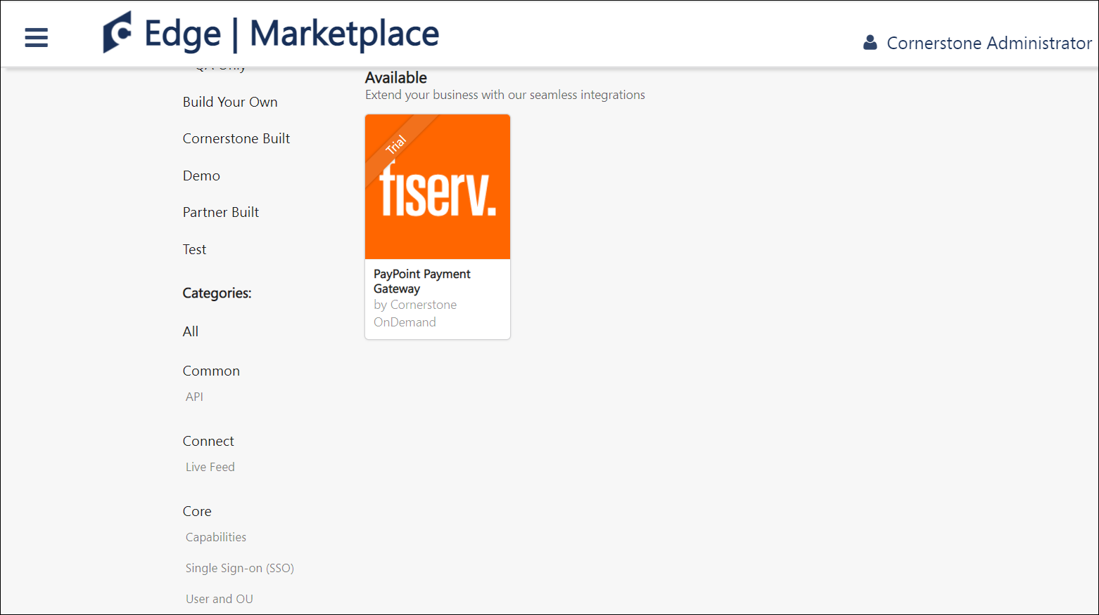
PayPoint - Edge Marketplace
To enable the PayPoint Payment Processor:
- Search for and select the PayPoint (Fiserv) tile in the Edge Marketplace.
- Then, click the Install button for the PayPoint integration.
- Review the terms and conditions of using the PayPoint integration and check the acknowledgment box to confirm that you read, understood, and agree to the terms and conditions.
- Click the Install button. The integration will be installed.
- Enable the PayPoint (Fiserv) tile in Edge in order to activate the payment processor. The Active toggle is switched to the Off position by default.
Account details for your PayPoint account must be added within the Cornerstone system, via the Define Payment Account page. See PayPoint - Define Payment Account on page 100 for additional information.
PayPoint - Define Payment Account
On the Define Payment Account page, administrators can configure the payment account for their PayPoint merchant account.
To access the Define Payment Account preferences page, go to ADMIN > TOOLS > Learning > Learning PREFERENCES > E-Commerce and click the Modify Payment Account link. In the Payment Account section, click the Add icon to add a new payment account.
Permissions
PERMISSION NAME | PERMISSION DESCRIPTION | CATEGORY

Payment Account - Modify | Grants ability to create payment profiles to determine the routing of users' payments. This permission cannot be constrained. This is an administrator permission. | eCommerce - Administration
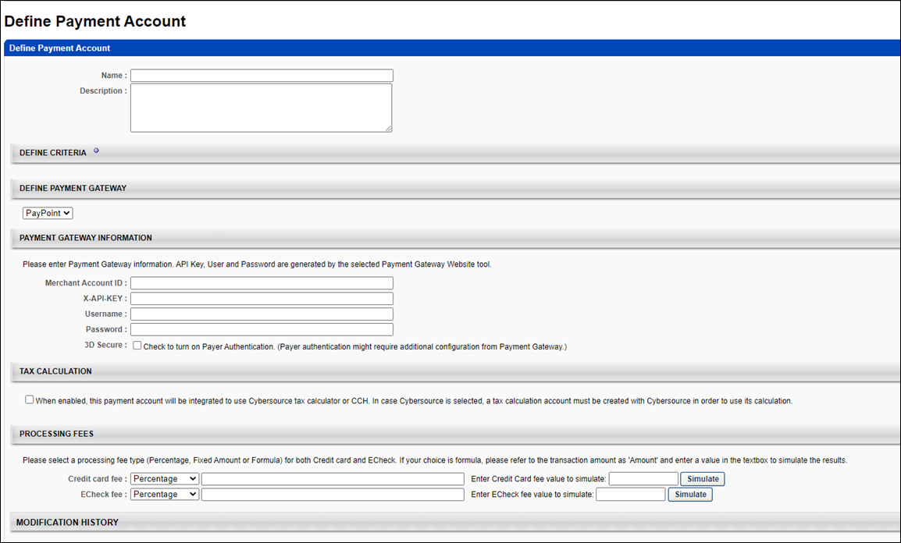
Define Payment Gateway
To define the PayPoint Payment Gateway, complete the following steps:
- In the Define Payment Gateway section, select PayPoint from the drop-down menu. Note: This option is only available if you have enabled the PayPoint Payment Gateway via Edge.
- Enter the following information for the payment account:
  - Name - Character limit is 50.
  - Description - This is for administrator use only. It is not displayed anywhere. Character limit is 250.
  - Define Criteria - At least one criteria is required and constraints do not apply to the available selections. The available attribute types are:
    - Currency
    - Provider
    - OU
    - LO
- The remaining fields that the administrator must populate depend on the payment processor selected for the portal. In the Payment Gateway Information section, populate the Payment Gateway information with the API credentials obtained from PayPoint.
Note: These fields can be obtained from PayPoint after you have created an account with PayPoint.
Save/Cancel
Click Save to save the payment account. Or, click Cancel to cancel creating the payment account.

Stripe Payment Gateway - Overview
The Stripe Payment Gateway integration with Cornerstone Learning is an API-based solution that provides users the ability to purchase courses offered through the e-commerce functionality available as part of the Extended Enterprise module (EXE).
Stripe provides the following key features:
- Transparent fee structure
- Fee calculation can be defined for each supported payment method as follows:
  - Percent applied over the purchase order total value
  - Fixed value
  - Formula, using the purchase order total value
- Easy administrator setup via Edge Marketplace
- High standards for fraud prevention
- 3DS/3DS2 Authentication
- Tax calculations
- Refunds
Considerations
- Customers must reach out to Stripe to create their account and request the following settings:
  - Stripe Account ID
  - Secret key
- The following features are not supported:
  - Recurring billing
Note: For tax calculations, a Cybersource account is required.
Implementation
Please contact your account manager to enable this integration.
Stripe Payment Gateway - Define Payment Account
On the Define Payment Account page, administrators can configure the payment account for their Stripe business account.
To access the Define Payment Account preferences page, go to ADMIN > TOOLS > Learning > Learning PREFERENCES > E-Commerce and click the Modify Payment Account link. In the Payment Account section, click the Add icon to add a new payment account.
Permissions
PERMISSION NAME | PERMISSION DESCRIPTION | CATEGORY

Payment Account - Modify | Grants ability to create payment profiles to determine the routing of users' payments. This permission cannot be constrained. This is an administrator permission. | eCommerce - Administration
Define Stripe Payment Account
Before you begin
Contact Stripe to create an account and request your Stripe Account ID and Secret Key.
- Complete the Name and Description fields.
- In the Define Payment Gateway drop-down, select Stripe.
- In theStripe Information section, enter your Client ID and Client Secret information.
- Click Save to save the changes.
Access your Stripe information from the My Apps & Credentials tab of your Stripe Developer account.
For more information about creating a payment account: See Create Payment Account.
Stripe Payment Processor - Refunds
The administrators can initiate refunds directly using the CSX Extended Enterprise module for payment transactions that were executed via the Stripe Payment gateway. This process does not require manual login to the Stripe account by the administrator. Refunds can be initiated by the user from the CSX user’s Transcript page itself if allowed by the Learning Object (LO) settings. For more information, See Stripe Payment Gateway - Define Payment Account on page 103 for additional information.
Permissions
PERMISSION NAME | PERMISSION DESCRIPTION | CATEGORY

Refund Training | Grants ability to issue a refund for a training item while removing it from the user's transcript. This is an administrator permission. | eCommerce - Administration

Remove Training | Grants ability to remove training from other users' transcripts (training records) when viewing their transcript. This permission can be constrained by OU, User's OU, User's Corporation, User Self and Subordinates, User's Self, User's Direct Subordinates, and User. This is an administrator permission. | Learning - Administration

Transaction Manager - Manage | Grants ability to access the Manage Transaction page and also create and edit transactions. On the Order History Details page, the administrator can edit the order status, adjust prices, issue refunds, or enter comments. This permission can be constrained by User's OU. This is an administrator permission. | eCommerce - Administration

Transaction Manager - View | Grants ability to view the Manage Transaction page where the administrator can review the transactions that meet their permission constraints. This permission can be constrained by User's OU. This is an administrator permission. | eCommerce - Administration
Refunds can be initiated by any user authorized to do so such as administrators, user’s managers, etc. using the Manage Transactions page. To initiate a refund, follow these steps.
- Go to Admin > Tools > Learning > E-Commerce > Manage Transactions. Find a transaction and click Options.
- In the Order History Details Page, click the Options icon under the Details section.
- In the Pricing Test, enter the refund amount beside the Amount option. Make sure to select Refund from the Amount drop-down.
- Type a note in the Notes section if required and click Submit to initiate the refund.
- View refund details under the Order History section on the Order History Details Page. You can also check the order status in your Stripe account.
Stripe Payment Gateway - Tax
Customers using the Stripe payment gateway can automatically collect tax from their end users during the transactions made via CSX EXE. Stripe Tax lets you calculate, collect, and report tax on global payments with a single integration. You can easily register with Stripe and access the reports within Stripe to file returns. There is no need for a separate tax account with Stripe. It is easy to define the specific regions within Stripe for tax calculation.
​
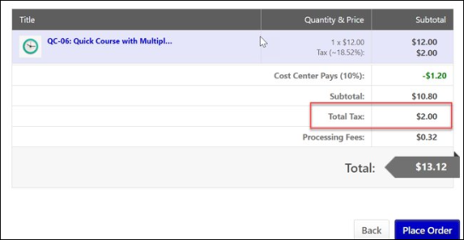
Permissions
PERMISSION NAME | PERMISSION DESCRIPTION | CATEGORY

Payment Account - Modify | Grants ability to create payment profiles to determine the routing of users' payments. This permission cannot be constrained. This is an administrator permission. | eCommerce - Administration
To enable Stripe Tax Calculation, go to ADMIN > TOOLS > LEARNING > LEARNING PREFERENCES > E-COMMERCE and click Modify Payment Account. In the Define Payment Account page, select Enable Stripe Tax Calculation check box.
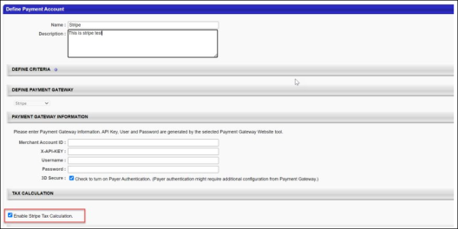
To select the Learning Objects (LOs) that are eligible for tax calculation, go to admin > tools > learning > e-commerce > taxes > tax preferences and select the LOs. Now go to the pricing section of an eligible LO and select Apply sales tax check box.
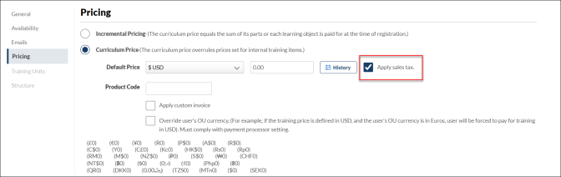
Note: Stripe Tax is an enhancement to the existing Stripe Payment Gateway and it is not available for other payment gateways.
Frequently Asked Questions (FAQs)
Can Stripe tax be used for tax calculation when the payment gateway provider is not Stripe?​
No. As of now, Stripe tax can only be used when Stripe is the payment processor for the transactions.
If a given LO does not have the pricing tab, can tax be calculated for that particular LO?​
No. Apply sales tax checkbox under the pricing tab of a given LO should be checked for Tax calculation. If the pricing tab is unavailable, tax cannot be calculated for that LO.
Stripe Tax Service - Other Payment Gateways
Customers who use other payment gateways within CSX EXE (like Adyen, Paypoint, etc.) to sell courses and want an additional Tax service can use the Stripe tax feature to add the sales tax to the purchase price of the products they sell through CSX EXE during the transaction. It is a standalone feature and is independent of the Stripe payment gateway.
Note: To enable this functionality, please contact your account manager to allow the Tax Stripe feature within CSX EXE.
Permissions
PERMISSION NAME | PERMISSION DESCRIPTION | CATEGORY

Payment Account - Modify | Grants ability to create payment profiles to determine the routing of users' payments. This permission cannot be constrained. This is an administrator permission. | eCommerce - Administration
The following key functionalities accompany this feature:
- Easy to register with Stripe.
- Automatically collect the right amount of Tax.
- Customers can easily access the reports within Stripe to file returns.
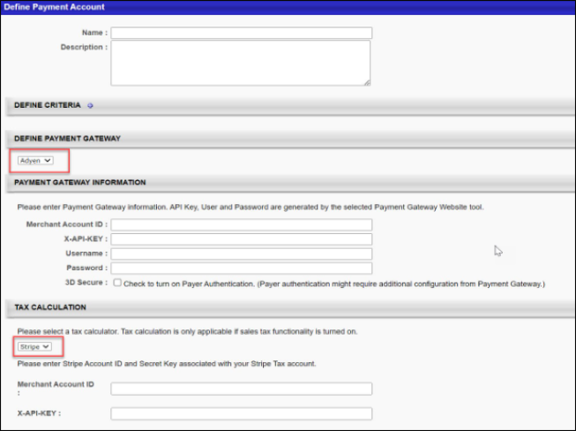
Note: Cybersource no longer provides Tax services to other payment gateways.
Setting up Stripe Tax in CSX user interface
To avail the Stripe Tax service, the customers must have a Stripe account. Set up the regions within your Stripe Account for which the sales tax needs to be calculated. Your Stripe Account ID and secret key are required to complete the setup in CSX EXE under the “Modify Payment Gateway” page.
In CSX EXE, Stripe Tax needs to be enabled via the “Define Payment Account” page. See Stripe Payment Gateway - Define Payment Account on page 103 for additional information.
In the “Define Payment Account” page, under the Tax Calculator section, select “Stripe” from the dropdown and enter your Stripe Account ID and secret key that Stripe provided. For more information, See Stripe Payment Gateway - Tax on page 106 for additional information.
Considerations​
- Stripe tax is now available for Adyen, NIC Colorado, and PayPoint Payment gateways.
- Stripe tax was already available for Stripe Payment Gateways users.
- Stripe tax is not available for Cybersource and PayPal payment gateways.
- Customers need a Stripe payment gateway account to use the Stripe tax service.
- Customers need to set up the regions in their Stripe account for which they want to collect Sales Tax.
- Stripe Tax can be calculated based on the billing address only.

Transcript Integrations - Overview

eeds - Continuing Medical Education Integration
The eeds integration allows organizations to view and track CME credits imported from eeds within learners' transcripts in the Cornerstone Learning Management System (LMS). Using this integration, learners and learning administrators are able to search, find, and confirm CME credits on the learner's transcript.
Use Case
ACME Hospital schedules a weekly session of Cardiology Grand Rounds. Dr. Smith would like to see the upcoming schedule, so she searches for Cardiology Grand Rounds in the Cornerstone LMS, finds the event, and clicks a link in the description to see the schedule for the event.
On May 8th, Dr. Smith is able to sign into the Cardiology Grand Rounds session via the eeds app or on the website. After she completes the various requirements for the course, such as an evaluation and post-test, the attendance data is sent to the Cornerstone LMS.
Dr. Smith logs into the LMS the next day and can view her transcript with the TEDMED event information. She can also view her certificate by clicking on the eeds Certificate link in the training details for the event. With the help of the eeds integration, Dr. Smith is able to take training, view training details, and complete associated actions all through one system.
Exclusions
The following exceptions apply to the eeds integration:
- CME/CEU credits will not be aggregated. If an organization needs a sum of the CME/CEU credits, they must go to eeds-CME via the certificate link or access a training report via the LMS and export to excel.
- Training hours, which refers to the actual hours and minutes of an event, appears on the user's transcript and will be aggregated with other learning objects (LOs).
- Historical data is not reflected on the transcript. eeds-CME will be the sole system of record for historical (i.e. pre-integration) data. Note: eeds-CME can send historical data as an add-on.
Implementation
For organizations using the Learning module, the eeds integration is available for an additional cost. To get started, access the Edge Marketplace by going to ADMIN > TOOLS > EDGE and clicking the Marketplace link.
Search for and select the eeds - Continuing Medical Education informational tile available in the Edge Marketplace and review the Vendor, Integration, and Setup tabs for the integration. When ready to proceed, click the GET STARTED button for the integration.
After you complete and submit the form, an eeds expert will contact you with pricing and setup steps.
Permissions
The following existing permissions apply to this functionality:
PERMISSION NAME | PERMISSION DESCRIPTION | CATEGORY

Course Catalog - Update | Grants ability to manage and edit training items listed in the Course Catalog and also grants access to the Course Console, where training can also be managed and edited. This permission also grants access to the Popular Requests and Highest Rated widgets on the Learning Admin Console (in conjunction with the Learning Admin Console - View permission). This permission also allows administrators to reversion online courses via the Course Console page. This permission also allows administrators to access an Edit Training option for training items included as objectives in Development plans.  This permission can be constrained by OU, User's OU, Training Type, Training Item, Provider, ILT Provider, User's ILT Provider, User, User Self and Subordinates, and User's LO Availability. This is an administrator permission.  Note: Adding an OU constraint and a provider constraint to this permission results in an "AND" statement. | Learning - Administration

Events - Create | Grants ability to create new instructor led training events. This permission works in conjunction with Events - View permission. This permission can be constrained by OU, User's OU, ILT Provider, and User's ILT Provider. This is an administrator permission. | Learning - Administration

Express Class - Manage | Grants the ability to create and add users to an Express Class for a facilitated training session. This permission can be constrained by OU, User, User Self and Subordinates, and User's OU. This is an end user permission. | Learning - Administration

Materials Management | Grants ability to view the Material Administration page and create, edit, and copy materials. Once created, these "materials" can be managed like other learning objects via the course catalog. This permission can be constrained by OU, User's OU, and Provider. The constraints on this permission determine which materials the administrator is able to view, edit, copy, and create. This is an administrator permission. | Learning - Administration

Training Custom Fields | Grants ability to create and edit custom fields to be used for one or more learning object types. This is an administrator permission. | Learning - Administration

ServiceNow Integration
A ServiceNow integration is available through the Edge Marketplace, meaning that organizations that rely on Cornerstone to train their employees can now directly integrate their Cornerstone Learning solution with their ServiceNow® HR Service Delivery solution.
Considerations
In order to use the ServiceNow integration, your organization must first meet the dependencies outlined here: Spoke Dependencies
Implementation
To get started with the ServiceNow integration, click the Get Started button for the integration tile in the Edge Marketplace. To access the Edge Marketplace, go to: Admin > Tools > Edge and click the Marketplace link.
To enable the ServiceNow integration via the Edge Marketplace:
- Search for and click the ServiceNow integration tile.
- Click the Install button to install the integration.
- Review and Accept the terms and conditions of the integration and click the Install button.
- Click the Configure Now button.
- Configure the integration on the Settings tab and click the Save button.
- Navigate to the Edge Integration Center, find the ServiceNow integration, and toggle the Enablement switch for the integration to the On position to complete the enablement.
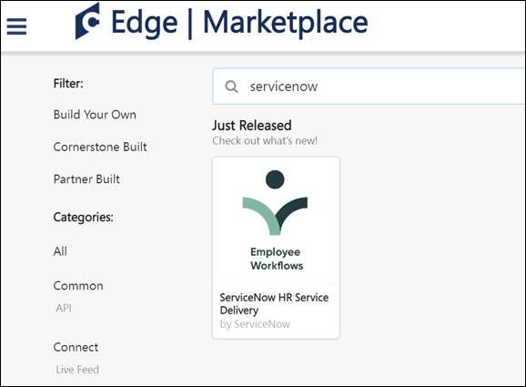
Integrate your Cornerstone application with your ServiceNow instance. Register an OAuth application in Cornerstone and authenticate requests from ServiceNow using the following documentation: Set Up the Cornerstone Spoke
Permissions
The following existing permissions apply to this functionality:
PERMISSION NAME | PERMISSION DESCRIPTION | CATEGORY

Edge Integrations - Manage | Grants access to the Integrations service for Edge Integrate, where the administrator can configure, enable, and disable their third-party integrations used within the Cornerstone system. This permission cannot be constrained. This is an administrator permission. | Edge

Edge Marketplace - Manage | Grants access to the Marketplace service for Edge Integrate, where the administrator can browse integrations that can be used to extend the Cornerstone system. This permission cannot be constrained. This is an administrator permission. | Edge

UKG Pro™ Transcript Data Outbound Integration
Eliminate the need for duplicate data entry and centralize transcript management by integrating Cornerstone’s Learning Platform and UKG Pro™. Cornerstone’s integration with UKG Pro™ provides a seamless process for managing user transcripts between systems. It automatically transfers completed transcripts for active users from Cornerstone to UKG Pro™.

UKG Pro Workforce Management™ Employee Dashboard Tile
The UKG Pro Workforce Management™ Employee Dashboard Tile in Edge automatically creates a Cornerstone tile on organizations' UKG Pro Workforce Management™ tenant. This tile provides learners with basic information about their Cornerstone training that is past due, assigned, in progress, and completed. It also allows learners to be redirected to their Cornerstone transcript if the learner has an active Cornerstone session.
Use Cases
Use Case 1: User views training transcript details on UKG Pro Workforce Management™ employee dashboard and navigates to Cornerstone transcript page
Lisa is an Acme Company employee, and she uses the Cornerstone Learning system. Lisa has added the Cornerstone Learning tile to her UKG Pro Workforce Management™ employee dashboard. She logs into Acme's UKG Pro Workforce Management™ tenant to access the employee dashboard page. She wants to know the number of training items assigned to her that are past due, so she views the Cornerstone Learning tile for a summary of her transcript details.
Lisa wants to complete one of her past due training items, so she clicks the View My Transcript link on the tile. Because Lisa has an active Cornerstone session, she is taken directly to her Cornerstone transcript page to complete her training.
Use Case 2: User views transcript details on UKG Pro Workforce Management™ employee dashboard and navigates to Cornerstone login page
Jessie is an employee at Acme Company and uses the Cornerstone Learning system. Jessie has added the Cornerstone Learning tile to her UKG Pro Workforce Management™ employee dashboard. She logs into Acme's UKG Pro Workforce Management™ tenant to access the employee dashboard page. She wants to know the number of training items that are in progress on her transcript, so she views the Cornerstone Learning tile to access her transcript details.
Jessie wants to complete one of her in progress training items, so she clicks the View My Transcript link on the tile. Because Jessie does not have an active Cornerstone session, she is taken to Acme's Cornerstone portal login page and is prompted to enter her credentials. After entering her credentials, she is navigated to her transcript page to complete her training.
Considerations
The following considerations apply to this integration:
- Certifications are not supported by this integration.
- SSO is supported for organizations which have an IDP SSO configured in both UKG Pro Workforce Management™ and in Cornerstone.
- This integration is only offered in English.
Implementation
To enable the UKG Pro Workforce Management™ Employee Dashboard Tile integration, contact your Account Manager. There is no additional cost associated with this integration.
Permissions
The following existing permissions apply to this functionality:
PERMISSION NAME | PERMISSION DESCRIPTION | CATEGORY

Edge Integrations - Manage | Grants access to the Integrations service for Edge Integrate, where the administrator can configure, enable, and disable their third-party integrations used within the Cornerstone system. This permission cannot be constrained. This is an administrator permission. | Edge

Edge Marketplace - Manage | Grants access to the Marketplace service for Edge Integrate, where the administrator can browse integrations that can be used to extend the Cornerstone system. This permission cannot be constrained. This is an administrator permission. | Edge

Workday Transcript Outbound Integration
The Workday Transcript Outbound integration is for organizations that are using the Learning module and using Workday as the source for their HCM data. This integration is a one-way sync of completed transcripts from Cornerstone to Workday. The outbound integration runs nightly (US-Pacific) and can be triggered on demand.
The following notes apply to this functionality:
- The following training types are supported: Online Course, Event, Session, Curriculum, Test, External Training, Material, Video.
- Only completed transcripts of active users are synced.
- Transcript sync may include Contingent Workers.
- Organizations can exclude users based on a user's OU and/or user custom field value is included.
- Organizations can exclude transcripts for certain training through a training custom field of type checkbox.
- Sync summary and log are emailed to a subscription list.
How Does this Enhancement Benefit My Organization?
This integration provides an Edge solution to synchronize completed transcript data from Cornerstone to Workday.
Implementation
It is recommended to implement the integration on your test environment prior to production environment.
The integration is available to install in the Edge Marketplace for a fee.
For organizations that are using the previously existing, legacy Workday Transcript Outbound integration, enablement information is available in the Resources section above.
For new integrations, this integration is available for self-activation via Edge Marketplace and Integrations. Organizations must have an existing contract with Workday. Starter Guides and Migration instructions are included with the integration in Edge Marketplace.
Security
The following existing permissions apply to this functionality:
PERMISSION NAME | PERMISSION DESCRIPTION | CATEGORY

Edge Integrations - Manage | Grants access to the Integrations service for Edge Integrate, where the administrator can configure, enable, and disable their third-party integrations used within the Cornerstone system. This permission cannot be constrained. This is an administrator permission. | Edge

Edge Marketplace - Manage | Grants access to the Marketplace service for Edge Integrate, where the administrator can browse integrations that can be used to extend the Cornerstone system. This permission cannot be constrained. This is an administrator permission. | Edge

vILT (Virtual Instructor Led Training) Integrations - Overview

Adobe Connect Meeting Room Integration
The Adobe Connect Meeting Room integration allows for seamless creation of virtual meetings that can host up to 100 meeting participants. The integration gives users the ability ot execute on all phases of the meeting setup and execution from within Cornerstone's Learning Management System (LMS). This vILT integration allows Learning Administrators to add instructors, create and manage sessions, and track attendance from within Cornerstone. Adobe Connect sessions can be launched from Cornerstone directly into Adobe Connect.
When an instructor is selected for an Adobe Connect vILT session, the instructor is automatically designated as a host for the Adobe Connect session.
Use Case
- An administrator working inside the LMS is setting up webinar training that will be attended by the entire company. She creates the session inside the LMS and assigns an instructor. The assigned instructor is automatically designated as a host for the session.
- Because there will be less than 100 attendees, she decides to use one of her company's licensed Meeting Rooms with Adobe Connect.
- One of the facilities inside of the LMS is mapped to the appropriate Meeting Room in Adobe Connect. The administrator makes sure that the location of the session is using a location with that facility so that the meeting will be held inside the Meeting Room.
- The webinar is assigned to the entire company and when it comes time for the session to start, the attendees launch the webinar directly from their transcripts and are taken directly into the Meeting Room inside of Adobe Connect.
Considerations
Webinars and Adobe Webinar licenses are not supported.
Implementation
The Adobe Connect Meeting Room integration requires purchase through Edge Marketplace. This integration requires Cornerstone Learning and at least one Adobe Connect administrator account.
Once the integration has been purchased, the functionality is not available until the integration is configured and enabled via Edge Integrations.

Adobe Connect Seminar Room
The Adobe Connect Seminar Room integration allows for seamless creation of virtual meetings from within Cornerstone Learning using the Adobe Connect API. This vILT integration allows Learning Administrators to add instructors, and create and manage sessions from within Cornerstone. Adobe Connect sessions can be launched from Cornerstone directly into Adobe Connect.
When an instructor is selected for an Adobe Connect vILT session, the instructor is automatically designated as a host for the Adobe Connect session.
Use Case
- An administrator working inside the Learning Management System (LMS) is setting up webinar training that will be attended by the entire company. She creates the session inside the LMS and assigns an instructor. The assigned instructor is automatically designated as a host for the session.
- Because there will be over 100 attendees, she decides to use one of her company's licensed Seminar Rooms with Adobe Connect.
- One of the facilities inside of the Learning Management System is mapped to the appropriate Seminar Room in Adobe Connect. The administrator makes sure that the location of the session is using a location with that facility so that the meeting will be held inside the Seminar Room.
- The webinar is assigned to the entire company and when it comes time for the session to start, the attendees launch the webinar directly from their transcripts and are taken directly into the Seminar Room inside of Adobe Connect.
Considerations
Webinars and Adobe Webinar licenses are not supported.
The Adobe Connect API does not support the passing back of attendance data from Adobe Connect to the Learning Management System.
The system enables administrators to move an ILT session into a seminar room. However, seminar rooms must be created and managed within Adobe Connect.
Implementation
The Adobe Connect Seminar Room integration requires Cornerstone Learning and an Adobe Connect Seminar Room account.
This integration is available in the Edge Marketplace. Once the integration has been purchased, the functionality is not available until the integration is configured and enabled via Edge Integrations.
Troubleshooting
Error type | Where found | Typical Cause | Possible Solution
Name cannot begin with the ' ' character, hexadecimal value 0x20. Line 15, position 32. | Creating an instructor. | Adobe Connect URL is incorrect. | Make sure the Adobe Connect URL in the Edge tool ends with /api/xml.
Object reference not set to an instance of an object. | Creating an instructor. | Site Administrator details are incorrect. | Check the Adobe Connect URL, make sure this has https not http, and ends with /api/xml. Also confirm the username and password are correct.
Session not created in the expected meeting template in Adobe Connect. | In Adobe Connect after the session is created. | Location of session in Cornerstone does not have the IT matching the meeting template’s SCO ID. | Make sure the ID of the location the session is being held in is either blank (will go to the General meeting template), or is the SCO ID of a specific meeting template in Adobe Connect.
When host launches Adobe Connect meeting, they join as a participant. | Launching a session. | Not enough host licenses in Adobe Connect for the user to be added as a Host. | Purchase more host licenses in Adobe Connect or remove a host license from a user who is no longer using it.
Move Session to Adobe Connect Seminar Room
The system enables administrators to move an ILT session into an Adobe Connect seminar room. However, seminar rooms must be created and managed within Adobe Connect.
To move an ILT session into a seminar room, first, create an ILT Facility that matches the name or ID of the shared seminar room in Adobe Connect. Second, create an ILT session. On the Parts Schedule page for the session, set the session location as the facility that corresponds to the Adobe Connect seminar room. This ensures the session is associated with the correct seminar room in Adobe Connect.
Permissions
PERMISSION NAME | PERMISSION DESCRIPTION | CATEGORY

Facilities - Create | Grants ability to create new facilities (locations) via ILT/Facilities and Resources. This is an administrator permission. | Learning - Administration

Sessions - Create | Grants ability to create new instructor led training sessions. This permission works in conjunction with Events - View and Sessions - View permissions. Administrators can only create sessions for events for which they have the availability to view. When adding users to a session in which the session roster is full, this permission grants the ability to increase the session's available seats. This permission can be constrained by OU, User's OU, Instructor, User as Instructor, Facility, Facilities Owned by User, ILT Provider, User's ILT Provider, User, and User Self and Subordinates. This is an administrator permission.  Note: The "Restrict to User as Instructor" constraint is available, but it does not actually constrain the permission. | Learning - Administration
Create Seminar Room Facility
To create a seminar room facility, go to ILT > Facilities and Resources. Then, click the Add Facility link.
The following information must be entered for the seminar room facility in order to map it to the seminar room in Adobe Connect:
- Name - Enter the Adobe Connect Seminar Room name. This is required.
- ID - Enter the Adobe Connect Seminar Room ID. This is required.
- Description - Enter an optional description for the seminar room facility.
- Active - Select this option to make facility active.
- Facility Type - Select the appropriate facility type from the drop-down list.
- In the address fields, enter the address of the seminar room, if applicable.
For more information about creating facilities: See Facility - Add.
Create Session with Seminar Room Facility
To create an ILT Event Session, go to ILT > Manage Events & Sessions. Search for the appropriate event and in the Options column next to the event, click the View Sessions icon . To create a new session, you can do so via one of the following options:
- Click Create New Session to create a new session.
- Click Copy icon to create a copy of an existing session which can be changed or edited and saved as a new session.
- Click Edit icon to modify an existing session.
The following information must be entered for the session on the Parts Schedule page in order to utilize the Adobe Connect seminar room facility:
- Name - Enter the session name.
- Description - Enter the session description.
- Location - Select the Seminar Room Facility.
For more information about creating sessions:

Cisco Webex Meetings SSO
The Cisco Webex integration enables organizations to utilize the Webex Single Sign On (SSO) functionality. When Webex SSO is enabled, Webex instructors are not required to enter their passwords when creating and launching meetings.
This integration includes Webex SSO Partner Delegated Authentication (PDA), which enables organizations to use their own SSO provider or have no SSO provider for their Webex portal.
Considerations
Organizations can use SSO for the Webex Administrator account. However, it is NOT supported to enable MFA (Multi-Factor-Authentication) in Webex for this account.
The Webex SSO (PDA) functionality only follows the "Launch Meeting as Instructor" workflow and does not support the creation of meetings or instructors.
Migration is not supported for this functionality. Webex SSO (PDA) only works for sessions that are created after the configuration. Sessions created prior to SSO (PDA) setup still require the integration to use instructor passwords.
Webex only allows one SAML certificate to authenticate users. This means that if SSO is set up between Cornerstone and Webex, the organization can only access Webex via the Cornerstone system. In this scenario, the organization cannot use SSO from multiple platforms into the same Webex account.
Implementation
- This functionality is disabled by default. Contact Global Customer Support to enable via a Billable Work Order across environments.
- Prior to enabling Webex SSO within the Cornerstone portal, organizations must request SSO from Webex and have the SAML metadata imported to their Webex support site.
Content
The following information is available within the this folder. Click a link to navigate directly to the appropriate topic:

Webex SSO: Webex Support Site
Prior to enabling Webex SSO within the Cornerstone portal, organizations must request SSO from Webex.
After SSO is enabled by Webex, organizations must have the SAML metadata imported to their Webex support site. This can be done via the SSO Configuration page within the Webex support site.
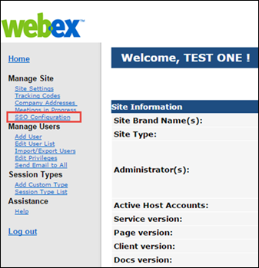
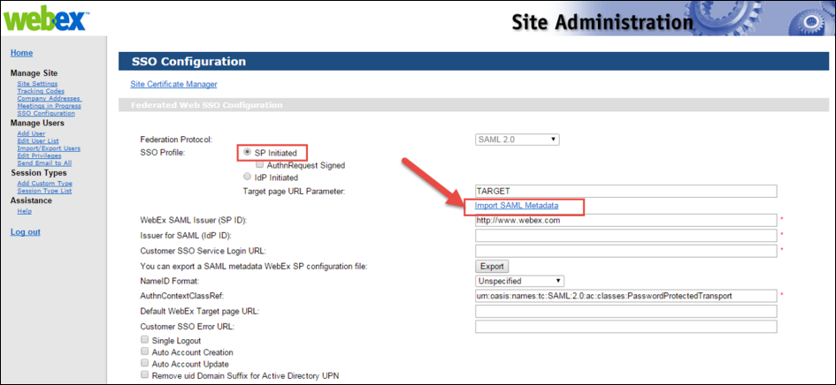
Webex SSO: Instructor Passwords
When Webex SSO is enabled, Webex instructor passwords are no longer necessary. Because of this, they are no longer stored within the Cornerstone portal.
When viewing the Instructor Details pop-up for a Webex instructor, the pop-up does not display password information if Webex SSO is enabled.
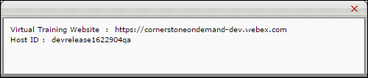

Microsoft Teams vILT Integration
A Microsoft Teams vILT integration is available in the Edge Marketplace. The Microsoft Teams vILT integration provides the following features:
- When administrators create, update, or cancel a single or multi-part session in the Learning Management System (LMS), its corresponding Teams meeting will be created, updated, or cancelled through the integration
- End users and instructors can launch MS Teams sessions through the Learning Management System
- Attendance information can be retrieved
- Ability to add Co-organizers to MS Teams session for support
- Support for Extended Options
- Recreating a session in MS Teams when the Primary Instructor is updated. If the Primary Instructor is changed, the existing session is deleted, and a new one is created. When fields like dates, time zone, or session part name are updated, and the Primary Instructor remains the same, the existing session is not deleted and re-created in Teams.
- Multi-part sessions are created with each session part as a separate meeting in MS Teams
- Manage virtual meetings for multiple accounts
- Mark attendance based on time (%) present in virtual session
- Support for the "Organizer" role for instructors and for Break Out rooms via the Organizer role when using Application authentication
- Support for Break Out rooms via the Organizer role when using Application authentication
- Support for multiple Microsoft Teams tenants when customer has several Microsoft Team accounts
- This integration attempts to map the instructor using the email address listed for the instructor in Cornerstone and their Azure unique UPN. If these two values do not match, an attempt will be made to map to the instructor's email address listed in Microsoft Azure.
Note: SSO is not built into the Microsoft Teams vILT integration. Customers who enable this integration will not automatically have SSO enabled in their portal. This integration is independent of any SSO solution. Click here to access a Knowledge article about how the email tags INSTRUCTOR.LAUNCH.SESSION.LINK and LAUNCH.SESSION.LINK behave with and without SSO using the MS Teams vILT Integration.
Considerations
The attendance formula for Microsoft Teams vILT sessions is calculated based on the actual run time of the session.
- Example 1: If the session was scheduled for 60 minutes but then actually lasted for 75 minutes, and then the user left the session after 50 minutes, the user would receive a calculated completion percentage of only 66%. The user would not be marked as completed, because 66% attendance is not enough to earn completion for a session.
- Example 2: If the session was scheduled for 60 minutes but then actually lasted for 45 minutes, and the user attended the whole session, the user would receive a calculated completion percentage of 100%. The user is marked as completed because they attended the full 45 minutes that the session actually lasted.
Exclusions
The following features are NOT supported by the Microsoft Teams vILT integration:
- Teams Live events
- Adding or updating instructors (internal or external)
- The option to set up a Teams channel or team
- Migration of scheduled sessions with another virtual meeting provider to MS Teams
- Sessions (single or multi-part) with multiple primary instructors
Implementation
Administrators can enable and configure the Microsoft Teams vILT integration via the Edge Marketplace and Edge Integrate. Some prerequisite setup is required through your organization's Azure portal. Details will be provided in the Starter Guide for this enhancement.
Permissions
The following existing permissions apply to this functionality:
PERMISSION NAME | PERMISSION DESCRIPTION | CATEGORY

Edge Integrations - Manage | Grants access to the Integrations service for Edge Integrate, where the administrator can configure, enable, and disable their third-party integrations used within the Cornerstone system. This permission cannot be constrained. This is an administrator permission. | Edge

Edge Marketplace - Manage | Grants access to the Marketplace service for Edge Integrate, where the administrator can browse integrations that can be used to extend the Cornerstone system. This permission cannot be constrained. This is an administrator permission. | Edge

Events - Create | Grants ability to create new instructor led training events. This permission works in conjunction with Events - View permission. This permission can be constrained by OU, User's OU, ILT Provider, and User's ILT Provider. This is an administrator permission. | Learning - Administration

Events - Edit | Grants ability to edit/update existing instructor led training events. This permission works in conjunction with Events - View permission. This permission can be constrained by OU, User's OU, ILT Provider, and User's ILT Provider. This is an administrator permission. | Learning - Administration

Events - View | Grants view-only access to instructor led training events, enabling the user to view all details/options that were selected when the event was created. This permission can be constrained by OU, User's OU, User's ILT Provider, and ILT Provider. This is an administrator permission. | Learning - Administration

ILT Schedule Part Occurrence | Allows the admin to create more than one ILT session schedule part at the same time using a part occurrence schedule wizard. This is an administrator permission. | Learning - Administration

ILT Vendors - Create | Grants ability to create new training Vendors (Providers). This permission works in conjunction with the Vendors - View permission. This is an administrator permission. | Learning - Administration

ILT Vendors - Update | Grants ability to edit/update existing training Vendors (Providers). This permission works in conjunction with the Vendors - View permission. This is an administrator permission. | Learning - Administration

ILT Vendors - View | Grants view only access to instructor led training vendors (providers), via the ILT Vendors and Instructors screen. This is an administrator permission. | Learning - Administration

Roster - Manage | Grants ability to manage instructor led training session rosters, including updating attendance, and marking the ILT session complete to update student transcripts. A variety of other features are available depending upon additional roster permissions. This permission works in conjunction with Events - View, Sessions - View, and Roster - View permissions. This permission can be constrained by Instructor, User as Instructor, ILT Provider, and User's ILT Provider. This is an administrator permission. | Learning - Administration

Roster - View | Grants view-only access to instructor led training session rosters. This permission works in conjunction with Events - View and Sessions - View permissions. This permission can be constrained by Instructor, ILT Provider, User's ILT Provider, and User as Instructor. This is an administrator permission. | Learning - Administration

Sessions - Cancel | Grants ability to cancel instructor led training sessions. This permission works in conjunction with Events - View and Sessions - View permissions. This is an administrator permission. | Learning - Administration

Sessions - Create | Grants ability to create new instructor led training sessions. This permission works in conjunction with Events - View and Sessions - View permissions. Administrators can only create sessions for events for which they have the availability to view. When adding users to a session in which the session roster is full, this permission grants the ability to increase the session's available seats. This permission can be constrained by OU, User's OU, Instructor, User as Instructor, Facility, Facilities Owned by User, ILT Provider, User's ILT Provider, User, and User Self and Subordinates. This is an administrator permission.  Note: The "Restrict to User as Instructor" constraint is available, but it does not actually constrain the permission. | Learning - Administration

Sessions - Edit | Grants ability to edit/update existing instructor led training sessions. This permission works in conjunction with Events - View and Sessions - View permissions. Administrators can only edit sessions for which they have the availability to view and edit. When adding users to a session in which the session roster is full, this permission grants the ability to increase the session's available seats. This permission can be constrained by OU, User's OU, Instructor, User as Instructor, Facility, Facilities Owned by User, ILT Provider, User's ILT Provider, User, and User Self and Subordinates. This is an administrator permission. | Learning - Administration

Sessions - View | Grants view-only access to instructor led training sessions, enabling the user to view all details/options that were selected when the session was created. This permission works in conjunction with the Events - View permission. This permission can be constrained by OU, User's OU, Instructor, Facility, Facilities Owned by User, ILT Provider, User's ILT Provider, User, User as Instructor, and User Self and Subordinates. This is an administrator permission.  Adding an OU constraint and a provider constraint to this permission results in an "AND" statement. | Learning - Administration
Microsoft Teams vILT Integration - Enable in Edge
The Microsoft Teams vILT integration can be enabled via the Edge Marketplace and configured using Edge Integrations.
To access the Edge Marketplace, go to: Admin > Tools > Edge and click the Marketplace link.
Permissions
PERMISSION NAME | PERMISSION DESCRIPTION | CATEGORY

Edge Integrations - Manage | Grants access to the Integrations service for Edge Integrate, where the administrator can configure, enable, and disable their third-party integrations used within the Cornerstone system. This permission cannot be constrained. This is an administrator permission. | Edge

Edge Marketplace - Manage | Grants access to the Marketplace service for Edge Integrate, where the administrator can browse integrations that can be used to extend the Cornerstone system. This permission cannot be constrained. This is an administrator permission. | Edge
Microsoft Teams vILT Integration - Edge Marketplace
In the Edge Marketplace, you can find the Microsoft Teams vILT integration by searching or browsing. To learn more about the integration or begin the enablement and configuration process, click the Microsoft Teams vILT integration tile.
To enable the integration:
- Click the Microsoft Teams vILT integration tile.
- Click the Install button.
- Review and agree to the terms and conditions of the integration.
- Click the Configure Now button.
You will need to configure the settings for the integration before it can be used.
Microsoft Teams vILT Integration - Configure
Once the Microsoft Teams vILT integration has been added through the Edge Marketplace, the integration can be managed and configured. On the Settings tab, configure the following fields:
- Integration Name
- Tenant ID
- App ID
- App Secret
- Username
- Password
- Min. Attendance % - This represents the time in % (max. 100) users need to attend a virtual session before being recognized as completed. Set this to 0 or keep it empty to disable min. attendance tracking. Important: Cornerstone does not recommend a value higher than 80% to balance acceptable deviations.
- Integration ID
- Active - Toggle the Active switch to the On position when you are ready to activate the integration.
Click the Save Settings button to save your configurations.
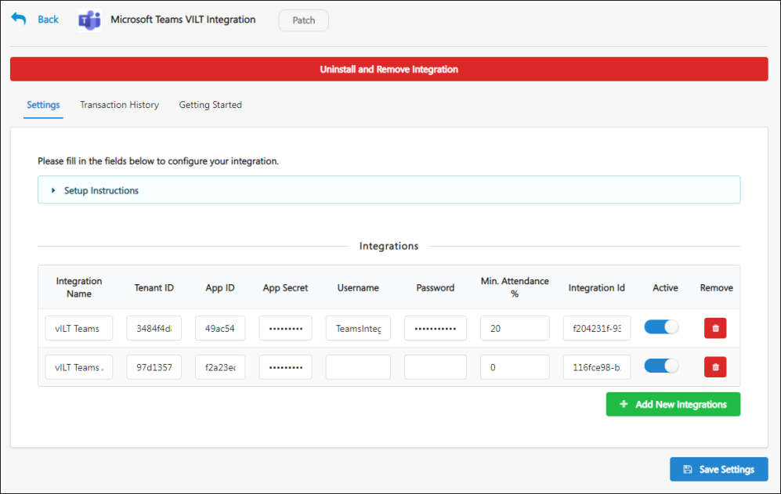

Webex Meeting Center - REST API​
Webex has modernized a set of APIs that impacts the Cornerstone CSX Learning and Webex Meeting Center integration. This integration provides a flexible way of setting up connection between Webex and Cornerstone CSX.
The Webex Meetings REST API enables seamless integration of Webex Meetings into your websites, apps, and services. Use Webex to schedule meetings, invite meeting attendees, update preferences, and more. The APIs used in the integration is replaced in the existing integration so that the transition for the customer is as smooth as possible. The key features are as follows:
- Create, update, and cancel sessions
- Create, update, and delete instructor
- Launch session as instructor and learner
- Report attendance from Webex to CSX
- Extended Options
- A new setting called New Edge Tile
- A new OAuth Workflow to authenticate instructors while using the integration
This functionality is available as a new tile titled ‘Webex Meeting Center – REST API’ for all customers in Edge Marketplace to be added as a Trial in Pilot and Stage environments.
New customers should reach out to their Account Manager to purchase the integration for Production.
For customers already using Webex Meeting Center integration, contact Global Customer Support to enable the Edge Tile in Production. This integration is available as a new integration in Edge Marketplace titled ‘Webex Meeting Center – REST API’.
Frequently Asked Questions (FAQs)
Are customers using multiple accounts supported? Do we have a workaround?
The Webex Meeting Center - REST API integration provides support to add only one Webex Account. As workaround, customers can continue to use the existing setup option available through the Vendors page (ILT > Vendors & Trainers) to add their REST API settings to each of them.
Is SSO supported with the new integration?
With REST API, Webex removes the possibility to authenticate via SSO through the backend to perform some actions on behalf of other users, for instance launching a meeting on behalf of a host. Since authentication through the REST API is done via OAuth, it becomes necessary for instructors (Webex hosts) to go through an OAuth Workflow the first time they launch a meeting from CSX.
Details about Deprecation of XML APIs?
https://developer.webex.com/docs/webex-xml-api-deprecation-announcement.

Webex Meeting Center Integration
Cisco Webex offers an interoperable ecosystem of solutions, each enabling individuals to work together, remotely. While most can be purchased and used alone, Webex products can be combined and customized to your needs.
Cisco Webex Meeting Center allows users to simplify business with online meetings, while keeping their people connected. Online meetings are an easy and cost-effective way to exchange ideas and information with anyone, anywhere, on any device. Whether your goal is to accelerate a project, keep your team on track, or just catch up, Cisco Webex Meeting Center fits your needs.
Integrating Webex Meeting Center with Instructor Led Training in Cornerstone allows the administrator, instructor, and participants to schedule, start, and join webcasts directly from your portal.

Webex Training Center Integration
Cisco Webex offers an interoperable ecosystem of solutions, each enabling individuals to work together, remotely. While most can be purchased and used alone, Webex products can be combined and customized to your needs.
Cisco Webex Training Center allows users to simplify business with online courses and training, while keeping learners connected. Instructors are able to deliver impactful trainings and keep your online learners engaged during and after the sessions. Share presentations, stream videos, and encourage participation using tools like whiteboard and annotation.
Integrating Webex Training Center with Instructor Led Training in Cornerstone allows the administrator, instructor, and participants to schedule, start, and join webcasts directly from your portal.

Zoom Meetings Integration - Overview
The Zoom Virtual Instructor-Led Training (vILT) Integration allows clients and partners to seamlessly integrate with the Cornerstone Learning platform and connect end users to virtual meeting sessions, track attendance, and make scheduling tools available for instructors.
Considerations
- This integration is for Zoom Meetings, NOT Zoom Webinar, which is a separate product.
- Cancel Session is currently not supported by Zoom.
- Extended Options are currently not supported by Zoom.
- Your organization may benefit from this integration if the following are true:
  - Your organization only uses single-part sessions
  - Your organization uses one account for managing virtual training
  - Access to the following vILT workflows is enough to satisfy your organization's vILT needs:
    - Create Instructor
    - Update Instructor
    - Create Session
    - Update Session
    - Get Attendance
    - Launch Session
  - Your organization already uses or is considering using Zoom for instructor-led training or virtual meetings
- Users may experience the below error while adding additional instructors. When this error occurs, the vendor must review the issue and potentially add the email address to the domain safelist.
  - "Error while creating instructors: Partner Error: Your CornerStone email is not in the domain whitelist!"
Implementation
The Zoom vILT integration can be accessed and configured via the Edge Marketplace. In order to use this integration, your organization must be using the Learning module, including instructor-led training (ILT) functionality, and must have access to Edge and a Zoom Pro, Business, or Education account.
Please contact your Account Manager for pricing. The integration cannot be used without a Zoom Pro, Business, or Education account.
Permissions
The following existing permission applies to this functionality:
PERMISSION NAME | PERMISSION DESCRIPTION | CATEGORY

Edge Marketplace - Manage | Grants access to the Marketplace service for Edge Integrate, where the administrator can browse integrations that can be used to extend the Cornerstone system. This permission cannot be constrained. This is an administrator permission. | Edge
Zoom vILT Integration - Setup
The Zoom vILT integration can be accessed and configured via the Edge Marketplace.
To access Integrations in the Edge Marketplace, go to: Admin > Tools > Edge and click the Marketplace link. Search for and click the integration tile. Click the Setup tab for setup instructions for the API.
Permissions
PERMISSION NAME | PERMISSION DESCRIPTION | CATEGORY

Edge Marketplace - Manage | Grants access to the Marketplace service for Edge Integrate, where the administrator can browse integrations that can be used to extend the Cornerstone system. This permission cannot be constrained. This is an administrator permission. | Edge
Zoom vILT Integration Setup
Select this link to learn how to enable and configure the Zoom vILT integration.
https://support.zoom.us/hc/en-us/articles/4417510686861-Using-the-Cornerstone-Learning-Suite-integration

