Instructor Led Training March 2024

Table of Contents
ILT Overview 1
Vendors and Instructors Overview 2
Manage Vendors & Instructors 3
Instructors - Add/Edit 5
Instructors - Manage 8
Instructor Requests - View 11
Vendor - Add/Edit 13
Facilities and Resources 16
Facilities and Resources Administration 17
Resource Requests - View 20
Facility Requests - View 21
Facility - Add 23
Resources - Manage 25
Room Layouts - Manage 27
Room Layouts - Manage 30
ILT Request Forms 31
Events and Sessions Overview 33
Manage Events and Sessions 34
ILT Event Overview - Search for Events 37
ILT Event Overview - Search for Sessions 40
ILT Event - Create/Edit 44
ILT Session Overview 94
ILT Session - Create/Edit 99
ILT Scheduling Wizard 194
Manage Evaluations 211
Manage Events & Sessions - Waitlists 213
Session Evaluation - Print Pop-up 215
View Your ILT Sessions 218
Session Roster Overview 219
Session Roster - Roster Tab 221
Session Roster - Assignments Tab 247
Session Roster - Attendance and Scoring Tab 249
Session Roster - Attendance and Scoring - Revert Completed Status 255
Session Roster - Bulk Add Users 263
Exception Requests 267
Interest Tracking 275
Session Roster - Add Users to a Session 278
Session Roster - Email Registered Users 286
Session Roster - Withdraw Users 288
Session Roster - Move Users 289
Session Roster - Edit Transcript Details 292
Session Roster - Exempt Users from Assignment 293
Managing Rosters Quick Reference Card 294
ILT Using Webex 295
Webex Attendance Troubleshooting 296

ILT Overview

Vendors and Instructors Overview

Manage Vendors & Instructors
The Vendors and Instructors feature allows you to add internal or external ILT providers (vendors) and instructors, track details of these providers, and manage information about all ILT vendors and instructors.
To manage vendors and instructors, go to ILT > Vendors & Instructors.
Permissions
PERMISSION NAME | PERMISSION DESCRIPTION | CATEGORY

ILT Vendors - Create | Grants ability to create new training Vendors (Providers). This permission works in conjunction with the Vendors - View permission. This is an administrator permission. | Learning - Administration

ILT Vendors - Update | Grants ability to edit/update existing training Vendors (Providers). This permission works in conjunction with the Vendors - View permission. This is an administrator permission. | Learning - Administration

ILT Vendors - View | Grants view only access to instructor led training vendors (providers), via the ILT Vendors and Instructors screen. This is an administrator permission. | Learning - Administration

Instructor Requests - Manage | Grants ability to approve or deny instructor requests for ILT sessions. This permission works in conjunction with the Vendors - View, and Instructor Requests - View permissions. This is an administrator permission. | Learning - Administration

Instructor Requests - View | Grants view-only access to instructor led training session Instructor Requests, via the ILT Vendors and Instructors screen. This permission works in conjunction with the Vendors - View permission. This is an administrator permission. | Learning - Administration
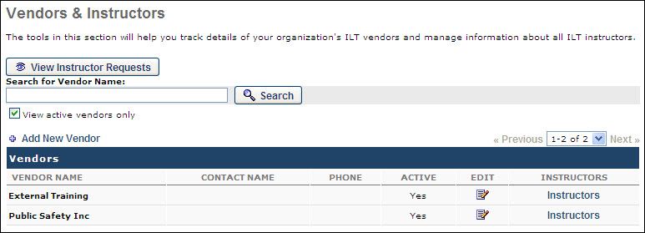
Vendors and Instructors
To search for an existing vendor, enter the vendor name in the search field and click Search. To include only active vendors in the search results, select the View active vendors only option.
To view instructor requests, click the View Instructor Requests button. See Instructor Requests - View on page 11 for additional information.
To add a new vendor, click the Add New Vendor link. See Vendor - Add/Edit on page 13 for additional information.
In the Vendors table, all existing vendors display. The following information displays for each vendor:
- Vendor Name - The name of the vendor.
- Contact Name - The name of the contact associated with the vendor.
- Phone - The phone number for the contact person.
- Active - This displays whether or not the vendor is active.
To edit an existing vendor, click the Edit icon to the right of the vendor. The editing process is similar to the process of adding a vendor. See Vendor - Add/Edit on page 13 for additional information.
To view and manage the instructors associated with a vendor, click the Instructors link to the right of the vendor. See Instructors - Add/Edit on page 5 for additional information.

Instructors - Add/Edit
Instructors can be added to the system or associated with a vendor from the Vendors and Instructors page. Note: When scheduling a session, only instructors who have been added to the selected vendor/provider for that session are available to select.
- To add an instructor to a vendor, go to ILT > Vendors & Instructors. To the right of the appropriate vendor, click the Instructors link. On the Instructors page, click the Add New Instructor link.
- To edit an existing instructor, go to ILT > Vendors & Instructors. To the right of the appropriate vendor, click the Instructors link. On the Instructors page, click the Edit icon to the right of the instructor.
Permissions
PERMISSION NAME | PERMISSION DESCRIPTION | CATEGORY

Instructors - Create | Grants the ability to add new instructors for Instructor Led Training Vendors. This permission works in conjunction with the Vendors - View, and Instructors - View permissions. This is an administrator permission. | Learning - Administration

Instructors - Update | Grants ability to edit/update existing instructors for Instructor Led Training Vendors. This permission works in conjunction with the Vendors - View, and Instructors - View permissions. This is an administrator permission. | Learning - Administration
Add Instructor
If you are adding an instructor to a Webex or Citrix provider, see the Webex and Citrix Integrations section below for information.
- If you are adding an existing user as an instructor, click the pop-up icon to the right of the Last Name field. Note: If the instructor you are adding is a user in the system, it is a best practice to select them from the system. Existing users selected as instructors can perform Instructor actions immediately within the system.
- Enter the following information for the instructor:
  - First Name - The character limit for this field is 100.
  - Last Name - The character limit for this field is 100.
  - Home Location - Click the pop-up icon to select the instructor's home location.
  - Phone - The character limit for this field is 100.
  - Fax - The character limit for this field is 100.
  - E-mail - The character limit for this field is 100.
  - Language(s) Spoken - Enter any languages the instructor is able to speak. This may be useful when locating an instructor that speaks a specific language. The character limit for this field is 100.
  - Education - Enter the instructor's education history.
  - Biography - Enter a brief biography about the instructor.
  - Certifications - Enter any certifications the instructor possesses. The character limit for this field is 100.
- Select the Active option to make the instructor active and available for selection. If an instructor is deactivated for a vendor, the instructor remains active for any other vendors with which they are associated. For example, Instructor Smith is associated with Vendor A and Vendor B. If Instructor Smith is deactivated for Vendor A, Instructor Smith remains active for Vendor B, unless they are deactivated for Vendor B as well.
- Decide whether or not approval is required. The Approval Required option only appears when the selected instructor is a system user. If this option is selected, the system will require instructor approval before publishing the learning object. Until approval is received, the LO status is Pending.
- Click Submit.
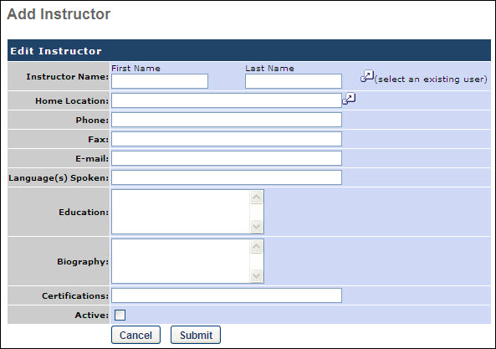
Webex and Citrix Integrations
Webex Integration Notes
When creating a new instructor using an existing user in the system, the system checks to see if the specified email address is already in use for a host on Webex.
- If the email address is already in use for a host on Webex, the system synchronizes the Host ID, stores the ID on the virtual ILT site, and updates the password with the system generated password. The system also updates Webex to ensure the host has the permissions to create meetings and training based on the provider to which the instructor is being added. In the event that there are multiple Webex vendors set up in the system which map to the same Webex site, the instructor's password is reset to the same value for all vendors with the same Webex URL in the system.
- If the email address is not already in use for a host on Webex, the system creates the host on Webex and generates a new password.
When selecting an existing user, if the selected user does not have an email address on the user record, an Instructor email can be entered in the Add Instructor window. Entering an email address here does not add the email address to the user record. If the email address does exist and is changed on the Edit Instructor screen, the user's Instructor email is changed, but the email address is not saved to the user record.
The time zone on the user's record is sent to the vILT provider when the user is added as an instructor. If the user record does not contain a time zone, the user's location time zone is used, then the portal time zone.
Additionally, the user's Cost Center ID can be sent to the vILT provider as a tracking code when the user is added as an instructor. To enable this functionality, contact Global Customer Support.
Note: This functionally is only available when adding existing users as instructors and only applies to Webex training courses.
Citrix Integration Notes
An instructor can be created for Citrix providers, such as GoToMeeting. The instructor information can be synchronized between the Cornerstone system and the Citrix provider. Instructors must also be users within the Cornerstone system.
This functionality is only available if Citrix is configured for the portal. To enable this functionality, visit the Edge Marketplace.
When creating a new instructor using an existing user in the system, the system checks to see if the specified email address is already in use for a host on Citrix.
- If the instructor does not have an instructor account within a Citrix provider, then the instructor must register for a GoToMeeting organizer account. Once registered, the instructor must be authenticated in the Cornerstone system.
- If the instructor's email address is already linked to an instructor account within a Citrix provider, then the instructor account within the Cornerstone system is linked with the Citrix instructor account.
After an instructor's account is synchronized with a Citrix account, if the instructor's account is deactivated within the Cornerstone system, it is also deactivated within Citrix. However, if an instructor's email address or other information is changed within the Cornerstone system, this does not update the instructor's information within Citrix.
Best Practice: If an instructor's email address must be updated, the best practice is to deactivate the instructor within the Cornerstone system, update the instructor's email address within Citrix, create a new instructor within the Cornerstone system with the updated email address, and then enter the instructor's credentials to link the accounts.

Instructors - Manage
The Instructors page displays all of the instructors associated with the vendor. Only the instructors that the user has permission to see are displayed.
To access the Instructors page for a vendor, go to: ILT > Vendors and Instructors and click the Instructors link next to a vendor.
Permissions
PERMISSION NAME | PERMISSION DESCRIPTION | CATEGORY

Instructor Requests - Manage | Grants ability to approve or deny instructor requests for ILT sessions. This permission works in conjunction with the Vendors - View, and Instructor Requests - View permissions. This is an administrator permission. | Learning - Administration

Instructor Requests - View | Grants view-only access to instructor led training session Instructor Requests, via the ILT Vendors and Instructors screen. This permission works in conjunction with the Vendors - View permission. This is an administrator permission. | Learning - Administration

Instructors - Create | Grants the ability to add new instructors for Instructor Led Training Vendors. This permission works in conjunction with the Vendors - View, and Instructors - View permissions. This is an administrator permission. | Learning - Administration

Instructors - Update | Grants ability to edit/update existing instructors for Instructor Led Training Vendors. This permission works in conjunction with the Vendors - View, and Instructors - View permissions. This is an administrator permission. | Learning - Administration

Instructors - View | Grants view-only access to ILT instructors via the ILT Vendors and Instructors screen. This permission works in conjunction with Vendors - View permission. This is an administrator permission. | Learning - Administration

Instructors - View VILT Details | Allows user to see host ID and password for VILT site. This is an administrator permission. | Learning - Administration
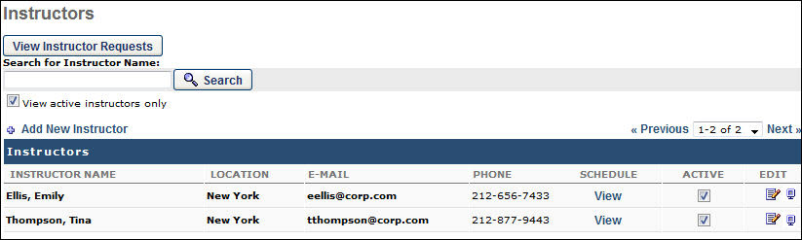
Instructors
To search for an existing instructor, enter the instructor name in the search field and click Search. To include only active instructors in the search results, select the View active instructors only option.
To view instructor requests, click the View Instructor Requests button. See Instructor Requests - View on page 11 for additional information.
To add a new instructor, click the Add New Instructor link. See Instructors - Add/Edit on page 5 for additional information.
In the Instructors table, all existing instructors are displayed. The following information is displayed for each instructor:
- Instructor Name
- Location
- E-Mail
- Phone
- Schedule - Click the View link for the instructor to view instructor requests for confirmed, completed, or tentative sessions.
- Authenticated? - Note: This column is only available when viewing the instructor list for a Citrix provider and if Citrix is configured for the portal. This column displays whether or not the instructor's account has been authenticated by Citrix. An instructor is authenticated if the following is true:
  - The instructor entered their Citrix credentials on their My Account - My Preferences page or if the instructor's credentials were entered during Citrix configuration.
  - The Citrix authentication token is valid.
- Active - If this option is selected, the instructor is active. If an instructor is deactivated for a vendor, the instructor remains active for any other vendors with which they are associated. For example, Instructor Smith is associated with Vendor A and Vendor B. If Instructor Smith is deactivated for Vendor A, Instructor Smith remains active for Vendor B, unless they are deactivated for Vendor B as well. Note: If the instructor is an authenticated Citrix instructor, then making the instructor inactive in the system also makes the instructor inactive in Citrix.
The following options are available in the Options column:
- Edit - To edit an existing instructor, click the Edit icon to the right of the instructor. The editing process is similar to the process of adding an instructor. See Instructors - Add/Edit on page 5 for additional information.
- Authenticate - Note: This option is only available when viewing the instructor list for a Citrix provider and if Citrix is configured for the portal. To enable this functionality, visit the Edge Marketplace. This option allows the administrator to update the instructor's credentials. This option opens the Citrix login page and is available for all instructors. For authenticated instructors, the credentials can be updated. For non-authenticated instructors, the credentials can be entered.
- View - Click this icon to view a read-only view of the instructor details. The Host Details pop-up appears. This displays the vILT host information, including the training website, host ID, and a link to send the host password. This option is only available for administrators with permission to view the host ID and password for a vILT site. Note: The system generates a new password and updates the vILT host account each time the instructor is edited and saved.
  - When clicking the link to email the current password to the user, the From address of the email sent is the email address of the logged-in user who is clicking the link. Both the instructor and the logged-in user should have a valid email address. Note: In the case of Webex, if Control Hub is enabled, the password will not be stored in our system, resulting in an empty value for the Password in the email.
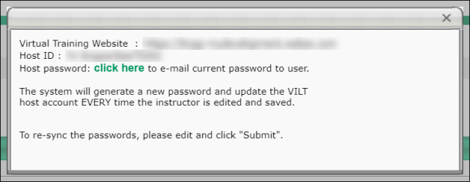

Instructor Requests - View
Instructor Requests are generated by the ILT administrator scheduling sessions. If they require confirmation by the instructor the session will not be visible to the user until the instructor approves the session. To respond to instructor requests, go to: ILT > Vendors and Instructors.
Permissions
PERMISSION NAME | PERMISSION DESCRIPTION | CATEGORY

Instructor Requests - Manage | Grants ability to approve or deny instructor requests for ILT sessions. This permission works in conjunction with the Vendors - View, and Instructor Requests - View permissions. This is an administrator permission. | Learning - Administration

Instructor Requests - View | Grants view-only access to instructor led training session Instructor Requests, via the ILT Vendors and Instructors screen. This permission works in conjunction with the Vendors - View permission. This is an administrator permission. | Learning - Administration
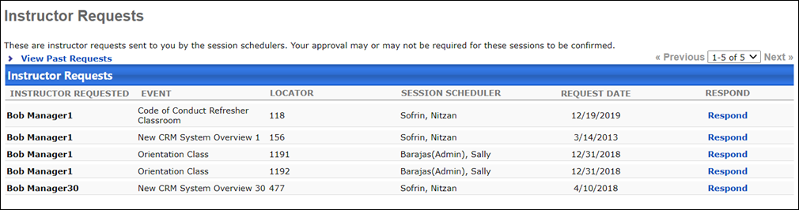
Approve or Deny Requests
To approve or deny an instructor request:
- Click the View Instructor Requests button.
- Click the Respond link next to the request to which you want to respond.
- Enter any comments for the approval or denial in the Comments box.
- Click the Approve icon or the Deny icon. The request will disappear from the Instructor Requests page after the decision has been made.
You can click the View Past Requests link to see requests that have already been responded to.
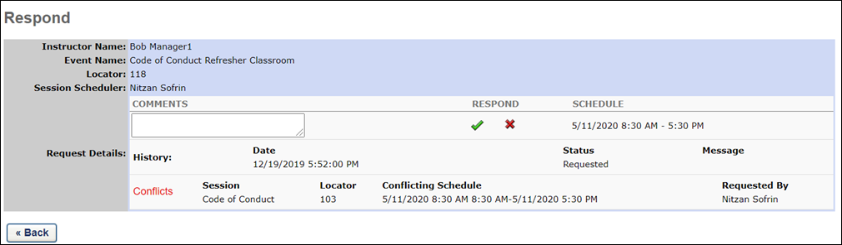

Vendor - Add/Edit
Instructor-led training (ILT) vendors can be added to the system and associated with ILT events and sessions.
To add a vendor, go to ILT > Vendors & Instructors. Then, click the Add New Vendor link.
To edit a vendor, go to ILT > Vendors & Instructors. Select the edit icon for the appropriate vendor.
Permissions
PERMISSION NAME | PERMISSION DESCRIPTION | CATEGORY

ILT Vendors - Create | Grants ability to create new training Vendors (Providers). This permission works in conjunction with the Vendors - View permission. This is an administrator permission. | Learning - Administration
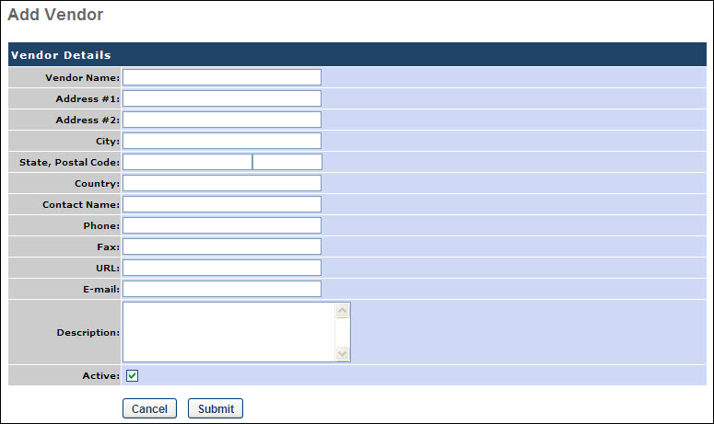
Add/Edit Vendor
Enter or edit the following information for the vendor:
- Vendor Name - This is required. The character limit is 100.
- Address # 1 - Enter the first line of the vendor address. The character limit for this field is 100.
- Address # 2 - Enter the second line of the vendor address. The character limit for this field is 100.
- City - The character limit for this field is 100.
- State, Postal Code
- Country
- Contact Name
- Phone
- Fax
- URL
- E-mail
- Description
- Active - Select this option to make this vendor active.
Click Submit. The vendor is added to the system.
Webex Control Hub Settings
Click the Webex Control Hub Settings link to reset the Client ID and secret key to generate a new token.
To reset Client ID and secret key:
- Go to ILT > Vendors & Instructors. Select the edit icon for the appropriate vendor.
- On the Webex Control Hub Settings page, select the Reset button. The current Client ID and secret key is removed from CSOD. A new token is created.
- Follow the instructions under the How to set up your Webex Control hub integration section to reset the Client ID and secret key.
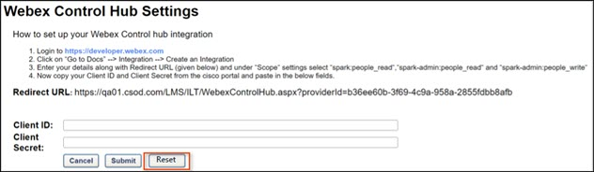
Deactivate Vendor
To deactivate a vendor, uncheck the Active checkbox. Note: If you deactivate a vendor, learners will no longer be able to interact with events and sessions attached to this vendor.
Options for vILT Integrations relying on vILT Connector
When editing or creating a vendor or provider, the following options may be configured for vILT integrations relying on the vILT Connector:
- Enable automatic cancellation of sessions on vILT provider side upon cancelling session in LMS - Selecting this option causes sessions that are cancelled in the Learning Management System (LMS) to be automatically cancelled in the vILT Connector. Both single and multi-part sessions can be cancelled through the vILT connector. Note: This functionality must be enabled by partners before it can be used.
- Enable extended options for vILT sessions - Selecting this option enables support for third party extended options for vILT sessions. Note: This functionality must be enabled by partners before it can be used. For more information about configuring these options for vILT: See vILT Connector - Support for Third Party Extended Options.
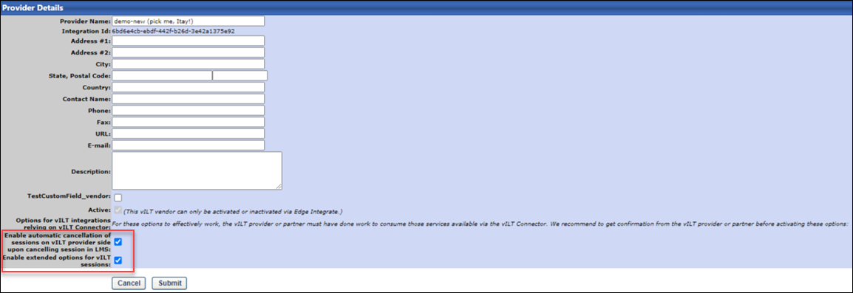
Click the Submit button at the bottom of the page to apply your changes to the system. To discard your changes, click Cancel.

Facilities and Resources

Facilities and Resources Administration
Managing Facilities and Resources allows the administrator to manage and track facilities used for instructor-led training sessions as well as the resources used in each location. Administrators can respond to facilities and resource requests and approve or deny use of facilities and resources.
Permissions
PERMISSION NAME | PERMISSION DESCRIPTION | CATEGORY

Equipment Requests - Manage | Grants ability to approve or deny requests for use of Resources for instructor led training sessions. User must also be designated as resource owner to approve the request. | Learning - Administration

Facilities - Create | Grants ability to create new facilities (locations) via ILT/Facilities and Resources. This is an administrator permission. | Learning - Administration

Facilities - Update | Grants ability to edit/modify existing facilities (locations) via ILT/Facilities and Resources. This is an administrator permission. | Learning - Administration

Facilities - View | Grants view-only access to existing facilities (locations) and their details, from the ILT Facilities and Resources screen. This is an administrator permission. | Learning - Administration

Facility Requests - Manage | Grants ability to approve or deny Facility Requests for instructor led training sessions. ILT sessions remain in a "pending" status until the facility (location) owner approves use of the facility for the session, when approval is required. User must also be designated "owner" of the facility (location). This permission works in conjunction with Facilities - View permission. This is an administrator permission. | Learning - Administration

Facility Requests - Update | Grants ability to approve or deny requests of Facilities for instructor led training sessions. User must also be designated as facility owner to approve the request. | Learning - Administration

Facility Requests - View | Grants view-only access to instructor led training session Facility Requests. This is an administrator permission. | Learning - Administration

Resource Requests - View | Grants view-only access to instructor led training session facility Resource Requests (View Equipment Requests) via the ILT Facilities and Resources screen. This permission works in conjunction with the Facilities - View permission. This is an administrator permission. | Learning - Administration

Resources - Create | Grants ability to create resources that can be associated with instructor led training sessions. This is an administrator permission. | Learning - Administration

Resources - Update | Grants ability to edit existing resources that can be associated with instructor led training sessions. This is an administrator permission. | Learning - Administration

Resources - View | Grants view-only access to existing facility Resources (re-usable and non-re-usable assets associated with a training facility (location), such as projectors, training workbooks, etc.) This permission works in conjunction with the Facilities - View permission. This is an administrator permission. | Learning - Administration
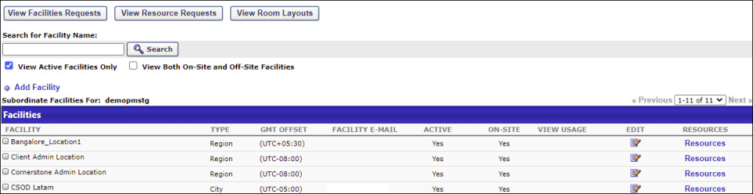
Facilities
To search for an existing facility, use the Search for Facility Name field. To include only active facilities in the display, select the View Active Facilities Only option. To include offsite and onsite facilities in the display, select the View Both On-Site and Off-Site Facilities option.
- To view facilities requests, click the View Facilities Requests button. See Facility Requests - View on page 21 for additional information.
- To view equipment requests, click the View Resource Requests button. See Resource Requests - View on page 20 for additional information.
- To view room layouts, click the View Room Layouts button. See Room Layouts - Manage on page 27 for additional information.
- To add a facility, click the Add Facility link. See Facility - Add on page 23 for additional information.
The following information is displayed for each facility in the table:
- Facility - This displays the name of the facility. If there are subordinate facilities (facilities within a facility), you can click the Expand icon to the left of the facility name to view them.
- Type
- GMT Offset
- Facility E-mail
- Active
- On-site
- View Usage - Click the View Usage link to view the facility usage, based on an eight hour work day. This option is only available if the resource is a room. In addition, the usage value does not include usage for future sessions.
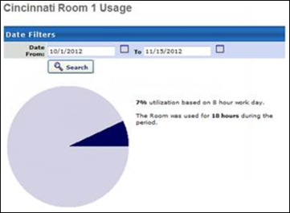
To edit an existing facility, click the Edit icon .
To view the resources associated with a facility, click the Resources link. See Resources - Manage on page 25 for additional information.
Helpful Hints
- By designating a facility and or resource approver, administrators have the ability to prevent sessions that utilize these resources from being scheduled without an approver's confirmation.

Resource Requests - View
The Facilities and Resources page allows administrators to view and manage training facilities and resources that are used for instructor-led training (ILT), including resource requests.
To access the Facilities and Resources page, go to ILT > Facilities and Resources.
Permissions
PERMISSION NAME | PERMISSION DESCRIPTION | CATEGORY

Equipment Requests - Manage | Grants ability to approve or deny requests for use of Resources for instructor led training sessions. User must also be designated as resource owner to approve the request. | Learning - Administration

Resource Requests - View | Grants view-only access to instructor led training session facility Resource Requests (View Equipment Requests) via the ILT Facilities and Resources screen. This permission works in conjunction with the Facilities - View permission. This is an administrator permission. | Learning - Administration
Respond to Request
To respond to a resource request:
- Click the View Resource Requests button.
- Click Respond to respond to a Resource Request.
- Enter any relevant comments in the Comments box.
- Click the Approve icon or the Deny icon. Note:Sessions requiring resource confirmation will not be available to users unless approved.
To Display All Resource Requests, check the associated checkbox. To view only past requests, click View Past Requests link.

Facility Requests - View
To view instructor-led training (ILT) facility requests, go to ILT > Facilities and Resources. Then, click the View Facilities Requests button.
Permissions
PERMISSION NAME | PERMISSION DESCRIPTION | CATEGORY

Facilities - Create | Grants ability to create new facilities (locations) via ILT/Facilities and Resources. This is an administrator permission. | Learning - Administration

Facilities - Update | Grants ability to edit/modify existing facilities (locations) via ILT/Facilities and Resources. This is an administrator permission. | Learning - Administration

Facilities - View | Grants view-only access to existing facilities (locations) and their details, from the ILT Facilities and Resources screen. This is an administrator permission. | Learning - Administration

Facility Requests - Manage | Grants ability to approve or deny Facility Requests for instructor led training sessions. ILT sessions remain in a "pending" status until the facility (location) owner approves use of the facility for the session, when approval is required. User must also be designated "owner" of the facility (location). This permission works in conjunction with Facilities - View permission. This is an administrator permission. | Learning - Administration

Facility Requests - Update | Grants ability to approve or deny requests of Facilities for instructor led training sessions. User must also be designated as facility owner to approve the request. | Learning - Administration

Facility Requests - View | Grants view-only access to instructor led training session Facility Requests. This is an administrator permission. | Learning - Administration
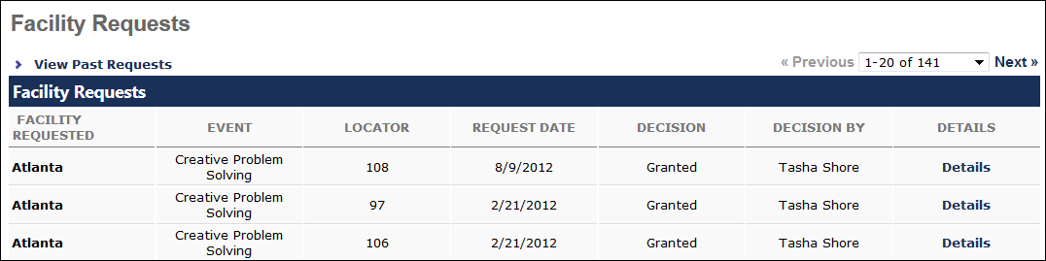
Facility Requests
To respond to a facility request:
- Click the Respond link for the request.
- Enter any comments in the appropriate Comments box.
- Click the Approve icon or the Deny icon. Note: Sessions requiring facility confirmation will not be available to users unless approved.
To view only past requests on the Facility Requests page, click View Past Requests link.

Facility - Add
Adding a location from facilities and resources adds this location in your Location organizational unit (OU) hierarchy. This OU can then be used to assign items, create groups, configure availability, and more.
To add a facility, go to ILT > Facilities and Resources. Then, click the Add Facility link.
Adobe Connect Integration Note: When creating an Adobe Connect seminar room facility, certain information must be entered in order to map it to the seminar room in Adobe Connect. See Move Session to Adobe Connect Seminar Room for additional information.
Permissions
PERMISSION NAME | PERMISSION DESCRIPTION | CATEGORY

Facilities - Create | Grants ability to create new facilities (locations) via ILT/Facilities and Resources. This is an administrator permission. | Learning - Administration

Facilities - Update | Grants ability to edit/modify existing facilities (locations) via ILT/Facilities and Resources. This is an administrator permission. | Learning - Administration

Facilities - View | Grants view-only access to existing facilities (locations) and their details, from the ILT Facilities and Resources screen. This is an administrator permission. | Learning - Administration

Facility Requests - Manage | Grants ability to approve or deny Facility Requests for instructor led training sessions. ILT sessions remain in a "pending" status until the facility (location) owner approves use of the facility for the session, when approval is required. User must also be designated "owner" of the facility (location). This permission works in conjunction with Facilities - View permission. This is an administrator permission. | Learning - Administration

Facility Requests - Update | Grants ability to approve or deny requests of Facilities for instructor led training sessions. User must also be designated as facility owner to approve the request. | Learning - Administration

Facility Requests - View | Grants view-only access to instructor led training session Facility Requests. This is an administrator permission. | Learning - Administration
To create a new facility, configure the following fields within the following sections:
General
- Name - Enter the name of the facility (required field).
- ID - Enter an ID (required if the Allow Reconciliation option is selected).
- Description - Enter the facility description.
Details
- Parent - Select a facility parent.
- Owner - Select an owner. Location owners are responsible for granting ILT facility requests for this location. When a facility is requested, the Facility Request email is sent to the location owner if the email is activated.
- Active - Check this box to make the facility active.
- Allow Reconciliation - Check this option to compare this record to incoming data feeds. Note: If adding a training room, it is recommended that you leave this option unchecked, as this facility is unlikely to be in your data feed.
Facility Information
- Facility Type - Select a facility type from the drop-down menu.
- Country - Select a country from the drop-down menu.
- Address #1 - Enter the first line of the address.
- Address #2 - Enter the second line of the address.
- City - Enter the city.
- State - Select a state from the drop-down list, if applicable.
- Postal Code - Enter the postal code.
- Time Zone - Select a time zone from the drop-down menu (required field). The time zone entered for a location will automatically set the time zone for all ILT session start dates which are scheduled at that location.
- Contact - Enter a contact for the location.
- Phone - Enter the contact's phone number.
- Fax - Enter the contact's fax number.
- Email - Enter the contact's email (for informational purposes only).
- Occupancy - Enter the maximum number of people that can be within the facility.
- Approval Required - Select this option if approval is required from the location owner for sessions scheduled at this location.
- On Site - Select this option if the location is on-site.
Save
Click Save to create the facility.

Resources - Manage
Individual resources can be viewed and managed for each facility via the Resources page.
To access the Resources page for a facility, go to ILT > Facilities and Resources. Then, click the Resources link next to a facility.
Permissions
PERMISSION NAME | PERMISSION DESCRIPTION | CATEGORY

Resources - Create | Grants ability to create resources that can be associated with instructor led training sessions. This is an administrator permission. | Learning - Administration

Resources - Update | Grants ability to edit existing resources that can be associated with instructor led training sessions. This is an administrator permission. | Learning - Administration

Resources - View | Grants view-only access to existing facility Resources (re-usable and non-re-usable assets associated with a training facility (location), such as projectors, training workbooks, etc.) This permission works in conjunction with the Facilities - View permission. This is an administrator permission. | Learning - Administration
Resources
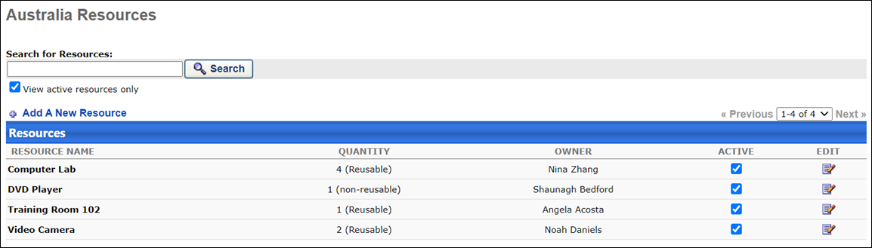
The following features are available on the Resources page:
- Search - Use the search bar to search for existing resources.
- View Active Resources Only - Select this option to display only active resources in search results.
- Add a New Resource - Click this link to add a new resource.
- Active - Check or uncheck this box to make resource active or inactive.
- Edit - Click this icon to edit an existing resource.
Add Resource
To add a resource:
- Click the Add a New Resource link.
- Populate the following fields and options:
  - Resource Name - Enter the name of the resource (required field).
  - Owner - Select an owner of the resource.
  - Quantity - Enter number (required field).
  - Active - Check this option to make the resource active.
  - Approval Required - Check this option if the resource requires approval before it is used.
  - Reusable - Check this option if the resource can be reused.
- Click the Submit button. The resource will be added to the facility.

Room Layouts - Manage
Room layouts can be added for use with facilities, if needed. Room layouts include a diagram of the room's floor plan. Room layouts can be added, viewed, and deleted from the Room Layouts page.
To access the Room Layouts page, go to ILT > Facilities and Resources and click the View Room Layouts button.
Permissions
PERMISSION NAME | PERMISSION DESCRIPTION | CATEGORY

Facilities - Create | Grants ability to create new facilities (locations) via ILT/Facilities and Resources. This is an administrator permission. | Learning - Administration

Facilities - Update | Grants ability to edit/modify existing facilities (locations) via ILT/Facilities and Resources. This is an administrator permission. | Learning - Administration

Facilities - View | Grants view-only access to existing facilities (locations) and their details, from the ILT Facilities and Resources screen. This is an administrator permission. | Learning - Administration
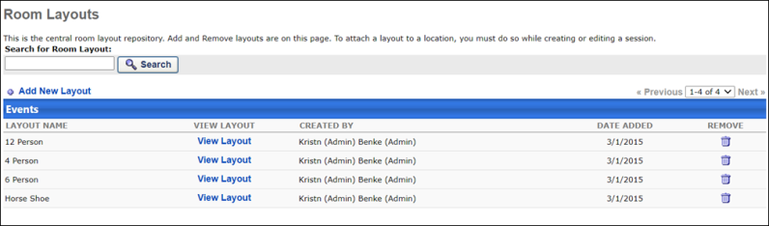
Room Layouts
The following options and information are available on the Room Layouts page:
- Search - Use the search bar to search for existing room layouts.
- Add New Layout - Click this link to add a new room layout. See the Add New Layout section below for more information.
- Table - The table of layouts contains the following information:
  - Layout Name - This is the name of the layout.
  - View Layout - Click this link to view the uploaded image associated with the layout.
  - Created By - This is the user who created the layout.
  - Date Added - This is the date the layout was added to the system.
  - Remove - Click the Remove icon to delete a layout from the system.
Add New Layout
To add a new room layout:
- Click the Add New Layout link.
- Enter a Description of the layout.
- Click the Browse button to locate the image of the layout you want to add from your computer. Upload the image.
- Click the Add button. The room layout will be added to the system.

Room Layouts - Manage

ILT Request Forms
ILT Request Forms (Training Request Forms) are designed to obtain additional information from a user at the time of request. For example, a custom travel form might be attached to sessions to obtain information from your employees regarding their travel bookings. ILT Request Forms can be added to instructor-led training. For more information about creating an ILT Request form so it can be associated with training, please see Training Request Forms Administration.
To view ILT request forms, go to ILT > ILT Request Forms.
Permissions
PERMISSION NAME | PERMISSION DESCRIPTION | CATEGORY

Training Request Form - Owner | Allows user to act as Training Request Form Owner. The Training Request Form Owner is able to view and manage request form statuses for users by session. Owners can only see the Training Request Forms for which they are an owner. This permission is dynamically assigned when a user is selected as an owner for a training request form. This is an administrator permission. | Training Forms Administration
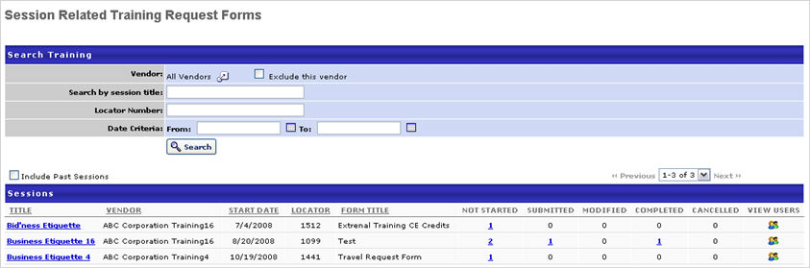
Training Request Forms
The following information displays for each ILT request form in the table:
- Title - This displays the name of the session that is associated with the request form. Select the session title to view the training details for the session.
- Not Started - This displays the number of users who have not started the form. Select this value to view users who have not started the form.
- Submitted -This displays the number of users who have submitted the form. Select this value to view users who have submitted the form.
- Modified - This displays the number of users who have modified the form. Select this value to view users who have modified the form.
- Completed - This displays the number of users who have completed the form. Select this value to view users who have completed the form.
- Cancelled - This displays the number users who are in a Cancelled status. If a session is cancelled, all users Request Forms are changed to Cancelled status.
- View Users - Select this icon to view the session with all statuses displayed.

Events and Sessions Overview
Administrators can create instructor-led training events which allow learners at an organization to attend training in-person with an instructor.

Manage Events and Sessions
Events are instructor-led training courses that contain general information about the course, such as the description, the objectives, the vendor, and the subjects. Because there are typically many instances of one course held at different times and locations by different instructors, every event can occur at a variety of times and places. In the system, these scheduled instances of an event are referred to as sessions. Events do contain some default session information, such as the course prerequisites, the course evaluation, and the registration procedures, but these defaults may be modified at the session level.
Creating events allows ILT Administrators to avoid re-inventing the wheel every time a new instance of the same course must be scheduled. The Event remains the constant so that the administrator has the flexibility to schedule and repeat the same learning experience an indefinite number of times, without ever re-entering the basic course information.
Design Note: This page has an updated interface (UI) that is automatically enabled. However, administrators can still revert to legacy UI via Feature Activation Preferences. The page's functionality is unchanged with the new design. With the July 26, 2024 Release, the new UI will be permanently enabled in all production, stage, and pilot portals, and the legacy UI pages will no longer be available. The new UIs disabled in March will be auto-enabled in July.
Permissions
PERMISSION NAME | PERMISSION DESCRIPTION | CATEGORY

Events - Create | Grants ability to create new instructor led training events. This permission works in conjunction with Events - View permission. This permission can be constrained by OU, User's OU, ILT Provider, and User's ILT Provider. This is an administrator permission. | Learning - Administration

Events - Edit | Grants ability to edit/update existing instructor led training events. This permission works in conjunction with Events - View permission. This permission can be constrained by OU, User's OU, ILT Provider, and User's ILT Provider. This is an administrator permission. | Learning - Administration

Events - View | Grants view-only access to instructor led training events, enabling the user to view all details/options that were selected when the event was created. This permission can be constrained by OU, User's OU, User's ILT Provider, and ILT Provider. This is an administrator permission. | Learning - Administration
Note: Only the events for which you have the availability to view will display.
Note: Events for which the provider is inactive do not display. To verify if a provider is active, go to ILT > Vendors & Instructors and make sure the vendor the event you are searching for is active.
On the Manage Events & Sessions page, both events and sessions can be searched, allowing for quick and convenient access to events and sessions. Filter options are also available to define the search criteria.
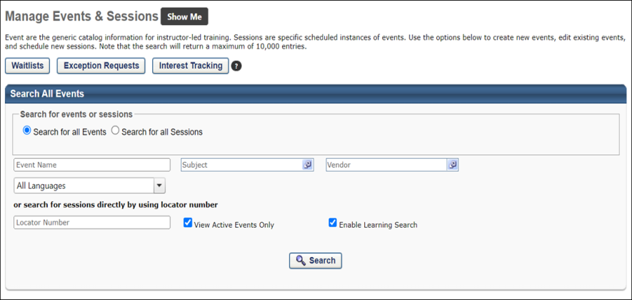
Waitlists
View users who are on a waitlist. See Session Roster - Roster - Waitlists on page 238 for additional information.
Exception Requests
View users who have requested training and have an exception. See Exception Requests on page 267 for additional information.
Interest Tracking
View users who have expressed an interest for an ILT event. See Interest Tracking on page 275 for additional information.
Search for all Events
Search for existing events. See ILT Event Overview - Search for Events on page 37 for additional information.
Search for all Sessions
Search for existing sessions. See ILT Event Overview - Search for Sessions on page 40 for additional information.
Create New Event
For documentation about creating events, See ILT Event - Create/Edit on page 44 for additional information.
Export to Excel
Click this link to export the list of events to Excel. The spreadsheet will download to your computer in .xlsx format. Note: This export is limited to the first 1,000 records. If there are more than 1,000 records, then only the first 1,000 are included in the Excel file.
See also:
- Create or Edit Session
- ILT Scheduling Wizard
Helpful Hints - Event Availability
- Events which are not available to users will not be visible to users.
- The availability of an event becomes the default availability of sessions within the event, but availability may be overridden at the session level.
- Users may search for sessions that are available to them for an event that is not available to them by using the Events Calendar.

ILT Event Overview - Search for Events
Administrators can search for events that have already been created using the search functionality at the top of the Manage Events & Sessions page.
Design Note: This page has an updated interface (UI) that is automatically enabled. However, administrators can still revert to legacy UI via Feature Activation Preferences. The page's functionality is unchanged with the new design. With the July 26, 2024 Release, the new UI will be permanently enabled in all production, stage, and pilot portals, and the legacy UI pages will no longer be available. The new UIs disabled in March will be auto-enabled in July.
The Search for all Events option is selected by default in the Search for All Events or Sessions section. To search for sessions instead, select the Search for all Sessions option. See ILT Event Overview - Search for Sessions on page 40 for additional information.
The following search filters are available:
- Vendor
- Subject
- Event Name (this field supports special characters)
- Language
- Locator Number
No events display on the Manage Events & Sessions page until a search has been run, and the Export to Excel option on this page does not display until a search has been run. The search will return results on both exact search terms and partial search terms.
- Selecting the View Active Events Only option causes the search results to include only active events matching your search criteria, taking into account your display language. For example, if the event title does not contain the words you entered as part of the translation corresponding to your display language, it would not display in search results, even if it is active.
- Select the View Active Events Only option to include active only events in your search results.
Enable Enhanced Search - This option allows the administrator to choose whether the event search uses Traditional Search or Enhanced Search. When the Enable Enhanced Search checkbox is selected, Enhanced Search is enabled for the event search. This option is selected by default. To disable Enhanced Search and use Traditional Search instead, unselect the Enable Enhanced Search checkbox. Note: If the administrator unselects the Enable Enhanced Search box, this selection is only maintained during the user's current session in the portal. After the administrator logs out of the system, the Manage Events & Sessions page will revert back to using Enhanced Search. See Enhanced Search vs. Traditional Search.
See the Search for Events - Information and Options section below for additional information.
Information and Options
The following information is displayed for each event in the Events table:
- Event Name
- Subjects
- Vendor
- Language(s)
- Tentative Sessions
- Approved Sessions
- Completed Sessions
The following primary option is available for events in the Events table:
- View Sessions - Click this link to view the event's child sessions. This is the primary action available for events.
The following secondary options may be available in the Options drop-down after clicking the "..." icon.
- Edit Evaluation - Associate evaluations to events. See Manage Evaluations on page 211 for additional information.
- View Evaluation Report - Run an evaluation report.
- Edit Event - Make changes to an existing event.
- Copy Event - Copy an existing event. The Event Properties, Availability, Pricing and Session Details are copied. The Event Title and Event Number are blank by default when you copy an event. Sessions and emails under the original event are not copied.
- Map Certification - Map an event to a certification.
Note: You cannot delete an event once it is created. However, you can make the event inactive on the Properties page for the event.
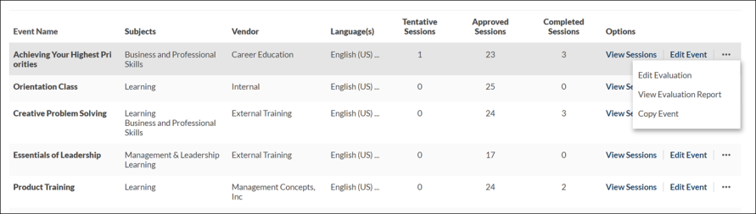

ILT Event Overview - Search for Sessions
Select the Search for all Sessions option to search for sessions. When searching by sessions, the search criteria table is named "Search All Sessions." When searching for sessions, there are additional filter options.
Design Note: This page has an updated interface (UI) that is automatically enabled. However, administrators can still revert to legacy UI via Feature Activation Preferences. The page's functionality is unchanged with the new design. With the July 26, 2024 Release, the new UI will be permanently enabled in all production, stage, and pilot portals, and the legacy UI pages will no longer be available. The new UIs disabled in March will be auto-enabled in July.
To search for sessions, go to ILT > Manage Events & Sessions. Then, select the Search for all Sessions option to search for sessions.
Permissions
PERMISSION NAME | PERMISSION DESCRIPTION | CATEGORY

Events - View | Grants view-only access to instructor led training events, enabling the user to view all details/options that were selected when the event was created. This permission can be constrained by OU, User's OU, User's ILT Provider, and ILT Provider. This is an administrator permission. | Learning - Administration

ILT Evaluations - Print | Grants ability to print evaluations at the session level for any session within the permission constraints. This permission can be constrained by Instructor, ILT Provider, User's ILT Provider, and User as Instructor. This is an administrator permission. | Learning - Administration

Sessions - View | Grants view-only access to instructor led training sessions, enabling the user to view all details/options that were selected when the session was created. This permission works in conjunction with the Events - View permission. This permission can be constrained by OU, User's OU, Instructor, Facility, Facilities Owned by User, ILT Provider, User's ILT Provider, User, User as Instructor, and User Self and Subordinates. This is an administrator permission.  Adding an OU constraint and a provider constraint to this permission results in an "AND" statement. | Learning - Administration
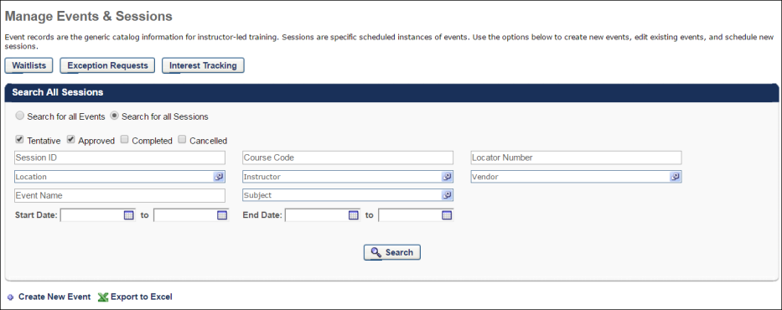
The following search filters are available:
- Session Status - Search for sessions by the following statuses:Tentative, Approved, Completed, or Canceled.
- Session ID
- Course Code - If course codes have been activated in your portal, training items that were created after the activation are automatically assigned a unique course code. Course codes can be used to find a specific session.
- Locator Number - If you are searching by locator number, the search will return a session in any status, regardless of any session status filters you have selected
- Start Date Range
- End Date Range
- Location - When searching by location, the system displays results for all sessions that are located in or below the defined Location criteria (i.e., the specified location or a subordinate location).
- Instructor
- Vendor
- Event Name
- Subject - When searching by subject, if a session part contains a subject, the part's subject is also searched.
Note: Daylight saving time (DST) time zones are supported for ILT for events or sessions.
Information and Options
When searching for sessions, there are both Event Options and Session Options in the Sessions table.
The following information is displayed for each event in the Sessions table:
- Day
- Start Date - This column is only displayed if the Show both Session Time and Date in Sessions tables option is selected by the administrator in ILT Preferences.
- End Date - This column is only displayed if the Show both Session Time and Date in Sessions tables option is selected by the administrator in ILT Preferences.
- Session ID
- Event Name
- Locator Number
- Location - This column displays the next-level location name that has a facility type of City for each session. If no location in the hierarchy for the associated session has a facility type of City, then the Location column displays the Location name for the associated session. This column is dependent upon an organization's configuration settings of the Location OU hierarchy and Facility Type settings. Parent level Location OUs that are designated as a facility type of City are displayed in the Location column.
- Instructor
- Enrollment
- Status
The following primary options are available for sessions in the results table:
View Roster - Click this link to view and manage the roster for the session.
Edit Session - Click this link to edit a session.
The following event options are available after clicking the "..." icon under the Event Options column.
- Edit Event - Edit the event.
- Copy Event - Copy the event.
- View Sessions - View available sessions.
- Edit Evaluation - Edit the associated evaluation. Note: The icon has been updated.
- View Evaluation Report - View the evaluation report for the associated evaluation.
- Map Certification - Map training and the training's credit values to associated certifications and training areas from both the Course Catalog and Manage Events & Sessions areas.
The following Session options are available in the Session Options column after clicking the "..." icon:
- View Roster - View the session's roster.
- Edit Session - Edit the session.
- Copy Session - Copy the session.
- View Session Details - View the details of the session.
- Cancel Session - Cancel the session.
- Edit Evaluation - Edit the associated evaluation. Note: The icon has been updated.
- View Evaluation Report - View the evaluation report for the associated evaluation.
- Print Evaluation - This enables administrators and instructor-led training (ILT) instructors to print evaluations for the session and distribute them to all session attendees. This icon is only available if an evaluation is configured for the corresponding session and if the user has permission to print evaluations. Administrators and ILT instructors can click the Print Evaluations icon to open the Print Evaluations pop-up. See Session Evaluation - Print Pop-up on page 215 for additional information.
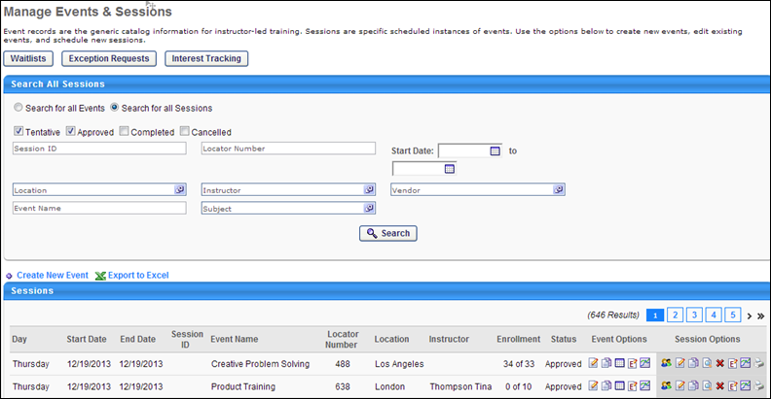

ILT Event - Create/Edit
To create an ILT event:
Go to ILT > Manage Events & Sessions. Then, click the Create New Event link.
OR, go to Admin > Tools > Learning > Learning Admin Console. Then, click the Create button and click the Event link.
Design Note: An updated interface is available for this page, which can be enabled by administrators in Feature Activation Preferences. With the new design, the functionality of the page is unchanged.
Permissions
PERMISSION NAME | PERMISSION DESCRIPTION | CATEGORY

Events - Create | Grants ability to create new instructor led training events. This permission works in conjunction with Events - View permission. This permission can be constrained by OU, User's OU, ILT Provider, and User's ILT Provider. This is an administrator permission. | Learning - Administration

Events - Edit | Grants ability to edit/update existing instructor led training events. This permission works in conjunction with Events - View permission. This permission can be constrained by OU, User's OU, ILT Provider, and User's ILT Provider. This is an administrator permission. | Learning - Administration

Events - View | Grants view-only access to instructor led training events, enabling the user to view all details/options that were selected when the event was created. This permission can be constrained by OU, User's OU, User's ILT Provider, and ILT Provider. This is an administrator permission. | Learning - Administration

LO Attachments - Manage | Grants ability to upload attachments to learning objects. Administrators with this permission are automatically granted the LO Attachments - View permission. This permission can be constrained by User's ILT Provider, Provider, and ILT Provider. This is an administrator permission. | Learning - Administration

LO Attachments - View | Grants ability to view the learning object attachments that are set to be available to administrators. This permission can be constrained by User's ILT Provider, Provider, and ILT Provider. This is an administrator permission. | Learning - Administration
The event creation process is separated into five sections. For information about any individual section, click one of the help links below:
- Properties
- Availability
- Pricing
- Training Units - The Training Units tab is only available if training units are enabled.
- Session Defaults
To edit an ILT event:
- Go to ILT Events & Sessions.
- Next to the appropriate event, click the Edit Event icon.
- See the process for creating an ILT event, as the process is similar.
See Also:
- ILT Scheduling Wizard
For information on configuring an event to have both virtual and onsite sessions, see the Session Options section of Online Help.
When changes are made to an event, are the changes applied to the event's sessions?
If... | Then...
Sessions have been created in the system before the change | the change will not be applied.
Sessions are created after the change and if the session was created by clicking the Create New Session link | the changes will be applied.
A new session is created by clicking the Copy Session icon | it will copy the options enabled/selected from that session and not the options selected in the event.
Advanced Registration Helpful Hints
- During the advanced registration period, users who are not on the interest tracking list for the event and location (or a parent of that location), at the time the event was created, will see that session as unavailable to them.
  - Users who subsequently join the interest tracking list will not be invited to join an advanced registration period that has already started. These users will still see the session as unavailable to them.
  - Users join the interest tracking list from the Event Summary page (when they search for an event) and click on the I would like to be notified when sessions at another location or time are scheduled link.
  - If the Add users on the waitlist to the interest tracking list for that event and location preference is checked on the ILT Preferences page, then users who are waitlisted for other sessions for this event and location are eligible for advanced registration. These users join the interest tracking list as soon as they are added to the waitlist.
  - The Advanced Registration email trigger may be activated to notify users that they are eligible for advanced registration.
ILT Event - Create - Step 1 - Properties
The Properties step is the first step of the event creation process. On this step, you will provide basic information about the event.
Design Note: An updated interface is available for this page, which can be enabled by administrators in Feature Activation Preferences. With the new design, the functionality of the page is unchanged.
To create an event, go to ILT > Manage Events & Sessions. Then, click the Create New Event link.
OR, go to Admin > Tools > Learning > Learning Admin Console. Then, click the Create button and click the Event link.
Permissions
PERMISSION NAME | PERMISSION DESCRIPTION | CATEGORY

Events - Create | Grants ability to create new instructor led training events. This permission works in conjunction with Events - View permission. This permission can be constrained by OU, User's OU, ILT Provider, and User's ILT Provider. This is an administrator permission. | Learning - Administration

Events - Edit | Grants ability to edit/update existing instructor led training events. This permission works in conjunction with Events - View permission. This permission can be constrained by OU, User's OU, ILT Provider, and User's ILT Provider. This is an administrator permission. | Learning - Administration

Events - View | Grants view-only access to instructor led training events, enabling the user to view all details/options that were selected when the event was created. This permission can be constrained by OU, User's OU, User's ILT Provider, and ILT Provider. This is an administrator permission. | Learning - Administration

LO Attachments - Manage | Grants ability to upload attachments to learning objects. Administrators with this permission are automatically granted the LO Attachments - View permission. This permission can be constrained by User's ILT Provider, Provider, and ILT Provider. This is an administrator permission. | Learning - Administration

LO Attachments - View | Grants ability to view the learning object attachments that are set to be available to administrators. This permission can be constrained by User's ILT Provider, Provider, and ILT Provider. This is an administrator permission. | Learning - Administration
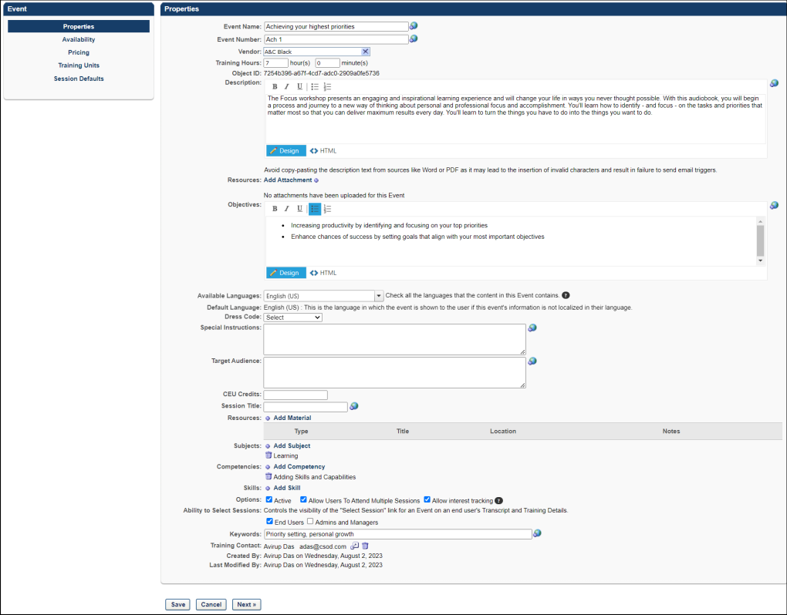
Properties
On the Properties step, configure the following fields and options:
- Event Name - Enter a name for the event that the user will see (required field). The character limit is 500.
- Event Number - Enter a number.
- Vendor - Choose a vendor from the pop-up menu (required field). The Vendor field cannot be edited once the event is created unless the Enable to change provider for events option is selected in ILT Preferences. Note: If this field is named Primary Vendor and a Secondary Vendor field appears below it, then your portal has enabled the ability to configure multiple providers for a session. See ILT Event - Create - Step 1 - Properties - Primary Vendor on page 52 for additional information.
Change Vendor
If the Enable to change provider for events option is selected in ILT Preferences, then the vendor can be changed. To change the vendor in the Primary Vendor field, click the Select icon and choose a different vendor from the pop-up. A warning message will appear and indicate that:Changing the vendor could cause some administrators to lose their right to take action on the event and associated sessions.Changing the vendor empties the preferred instructor fields on the Session Defaults tab on the event. The warning message lets the administrator know that they may want to select new preferred instructors at the event level. The instructors that are available to select will be from the new provider.
Note: If no preferred instructor is selected at the event level, then no instructor is populated by default when creating a new session from scratch.
Changing the vendor empties the preferred primary instructor on the Session Defaults page. Note: If you would like at least one instructor populated by default when a new session is created for the event, then it is necessary to add the instructor on the Session Defaults tab of the event. The instructors that are available to select are instructors that are tied to the new provider.
Once the event is saved:
  - If the preference Enable to select provider when creating sessions is unchecked, after the provider tied to an event is changed (e.g., from Provider A to Provider B), then administrators who have the ability to create a new session from scratch will only be able to create a new session tied to the current/latest event provider (Provider B). This is valid for both the Primary and Secondary vendor.
  - If the preference Enable to select provider when creating sessions is checked, after the provider tied to an event is changed (e.g., from Provider A to Provider B), then administrators who have the ability to create a new session from scratch will be able to create a new session tied to the current/latest event provider (Provider B) or define a previous provider to whom the event was historically tied for the session before creating it (Provider A). This is valid for both Primary and Secondary vendor.
In addition:
  - The new vendor is the default provider on sessions created from scratch.
  - The provider on existing sessions is NOT changed to the new provider.
  - When a session is copied, the session inherits the provider and the instructor from the existing session.
Note: At least one vendor is required for an event, so the Primary Vendor field cannot be blank. For portals with the ability to add multiple vendors, both the primary and secondary vendor can be changed if the Enable to change provider for events option is enabled in ILT Preferences. See ILT Event - Create - Step 1 - Properties - Primary Vendor on page 52 for additional information.
Changes to the vendor are tracked in the Modification History section of the event.
- Training Hours - Enter training hours/minutes that will display on the Event Detail pop-up. If 0 hours and 0 minutes is the event value then no value will display on the Event Details pop-up.
- Description - Enter an event description. This is HTML friendly. The character limit for this field is 4000.
- Resources (Attachments) - This section enables administrators to view and manage attachments for the event. The visibility of each attachment can be determined by the administrator. For example, some attachments may be visible to only administrators, while other attachments may be visible to all users. In addition, attachments can be made visible to users only if they are registered for the corresponding event. This section is only available for users that have permission to view or manage LO attachments. See ILT Event - Create - Properties - Resources on page 56 for additional information.
- Objectives - Enter objectives, if applicable. This field is HTML friendly. The text character limit for this field is 3000, while 500 characters are reserved for HTML tags.
- Language - Select language from drop-down if applicable.
- Enter information in the customizable event fields, if any. If you do not complete these fields, they do not display to users.
- Resources (Materials) - This section enables administrators to view and manage the materials for the event. Add by clicking on the Add Material link. Event materials are resources that are required for the event. These materials are not the same materials that are created in Course Catalog.
  - Select Material Type from drop-down. The following material types are available: Audio Cassette, Book, Course Kit, Course Reader/Packet, CD-ROM, Dictionary/Thesaurus, Equipment, Hardware (Special), Journal, Magazine, Miscellaneous, Software, Tool/Accessory, Video Cassette.
  - Enter a Material Title.
  - Enter a Material Location.
  - Enter Material Notes.
  - Click Add to add the material. Add more resources by repeating steps above if applicable.
- Subjects - Click Add Subject link to associate the event with a Subject Area. These subject names can be used by users when searching for training. This field is required. When a subject is selected, the subject appears below the Add Subject link. If the selected subject is a child subject, then the entire hierarchy is displayed. In addition, the entire subject hierarchy is displayed in the following areas:
  - Create Session > Summary Step
  - Edit Transcript Details for Session
  - Session Sign-in Sheet
  - Session Training Details Page
- Competencies - Click Add Competency link to associate a competency to this event.
- Skills - Click Add Skill link to associate a skill to this event.
- Options:
  - Active - Check to make this event active.
  - Allow Users to Attend Multiple Sessions - Check to allow users to register for more than one session of this event.
  - Allow Interest Tracking - Check to allow users to indicate interest for this event. This is checked by default. If this is unchecked after a user has already indicated interest, the event will not be visible to for the user on the Interest & Waitlist page. If it is re-activated, then event will be visible on the user's Interest & Waitlist page and the welcome page widget.
  - Allow users to select Sessions - This option is only available when using the old Transcript functionality. Allows users to choose a particular session when enrolling in an event. The box is checked by default. Unchecking the box hides the Select Session link for the user in the following instances and takes effect immediately upon saving the event:
    - Transcript page
    - LO Details page
    - Curriculum Player event item
    - Certification Player [older Compliance Player] event item
- Ability to Select Sessions - This option is only available when using the Universal Profile - Transcript functionality. This option enables administrators to configure which roles can select an event session on behalf of a user via the Select Session option on the user's Universal Profile - Transcript or Training Details page. At least one option must be selected. Select the appropriate roles:
  - End Users - By default, this option is checked for newly created events.
  - Admins and Managers - By default, this option is unchecked for newly created events.
- Keywords - Enter words to associate with the event. When a user searches and enters any of the keywords specified here, the course title will appear in the search results.
- Training Contact - If ILT Preferences are configured to have the administrator that is creating the event be the training contact by default, then the administrator's name appears in the Training Contact field when creating an event. The administrator can select a different training contact by clicking on the Select icon. If the administrator is not selected to display in the Training Contact field by default, then the field is blank and a training contact can be selected by clicking the Select icon. Only one training contact can be selected. The training contact is displayed to the user with the contact's phone number, fax number, and email address. Note: This field only appears if the Display Training Contact for Events and Sessions box is checked in ILT Preferences.
  - The event contact will default to the person scheduling the Event, but can be overridden. The session contact will default to the person scheduling the Session, but can also be overridden.
    - When this field is activated, events that have been created in the past will not have anybody listed in the training contact field. Editing an event without a contact will not default the contact field with the person performing the editing.
- Click Save or Next to continue to proceed to the Availability section, where you define who can view the Event and how settings will default for associated sessions. If no Event Availability and/or Session Defaults are defined, the Event will not be available to any user, and sessions assume system defaults. Availability and session default settings can be overridden at session level.
Modification History
For portals with multiple languages enabled, if the translation of a title or description is modified, the Modification History panel displays the change. However, only changes to languages that were added when the learning object was initially created are tracked.
The initial creation and changes to the title and description display in the panel as follows:
- Title at Initial Creation - <Learning Object Type> created with <Language of Title> Title "<Title>" by <User Full Name> (<User ID>) on <Date/Time of Creation>.
- Description at Initial Creation - <Learning Object Type> created with <Language of Description> Description of "<Description>" by <User Full Name> (<User ID>) on <Date/Time of Creation>.
- Change to Title - Title in <Language of Title> was changed to "<New Title>" by <User Full Name> (<User ID>) on <Date/Time of Creation>.
- Change to Description - Description in <Language of Description> was changed to "<New Description>" by <User Full Name> (<User ID>) on <Date/Time of Creation>.
- Title/Description Translation Change - Title/Description in <Language> "<New Title/Description>" was added by <User Full Name> (<User ID>) on <Date/Time of Creation>.
ILT Event - Create - Step 1 - Properties - Primary Vendor
For portals with the ability to configure multiple providers for a session, when creating, editing, or copying an event, the Properties step includes the option to add a secondary vendor. In addition, the Vendor field name changes to Primary Vendor.
Note: The changes to the vendor fields on the Properties step only appear if enabled by a backend setting. Once enabled, the changes appear for both new and existing events.
Design Note: An updated interface is available for this page, which can be enabled by administrators in Feature Activation Preferences. With the new design, the functionality of the page is unchanged.
To access Manage Events & Sessions, go to ILT > Manage Events & Sessions.
Permissions
PERMISSION NAME | PERMISSION DESCRIPTION | CATEGORY

Events - Create | Grants ability to create new instructor led training events. This permission works in conjunction with Events - View permission. This permission can be constrained by OU, User's OU, ILT Provider, and User's ILT Provider. This is an administrator permission. | Learning - Administration

Events - Edit | Grants ability to edit/update existing instructor led training events. This permission works in conjunction with Events - View permission. This permission can be constrained by OU, User's OU, ILT Provider, and User's ILT Provider. This is an administrator permission. | Learning - Administration
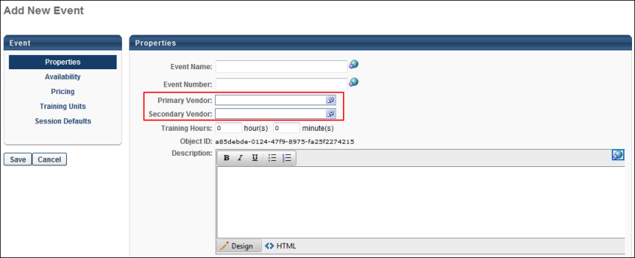
Select a vendor in both the Primary Vendor and Secondary Vendor fields. In order for sessions to be offered virtually and onsite, one of the vendors must be a virtual provider and the other must be an onsite provider. If both vendors are the same vendor type, either virtual or onsite, then sessions for the event cannot be created with both virtual and onsite options. The Primary Vendor field is required.
See Create an ILT Event - Properties for information about completing the other fields on the Properties step.
Note: Only the primary vendor displays in the Vendor column on the Manage Events & Sessions page.
Change Vendor After Event Creation
The primary and secondary vendor can be changed after the event is created if the Enable to change provider for events option is checked in ILT Preferences.
Note: Changing the provider at the event level does not impact existing sessions, nor does it impact any instructors for the sessions that were tied to the old provider. The ability to change a provider applies to both traditional classroom and vILT events and sessions.
Change Primary Vendor
To change the vendor in the Primary Vendor field, click the Select icon and choose a different vendor from the pop-up. A warning message will appear and indicate that:
Changing the vendor could cause some administrators to lose their right to take action on the event and associated sessions.
Changing the vendor empties the preferred instructor fields on the Session Defaults tab on the event. The warning message lets the administrator know that they may want to select new preferred instructors at the event level. The instructors that are available to select will be from the new provider.
Note: If no preferred instructor is selected at the event level, then no instructor is populated by default when creating a new session from scratch.
Once the event is saved:
If the preference Enable to select provider when creating sessions is unchecked, after the provider tied to an event is changed (e.g., from Provider A to Provider B), then administrators who have the ability to create a new session from scratch will only be able to create a new session tied to the current/latest event provider (Provider B). This is valid for both the Primary and Secondary vendor.
If the preference Enable to select provider when creating sessions is checked, after the provider tied to an event is changed (e.g., from Provider A to Provider B), then administrators who have the ability to create a new session from scratch will be able to create a new session tied to the current/latest event provider (Provider B) or define a previous provider to whom the event was historically tied for the session before creating it (Provider A). This is valid for both Primary and Secondary vendor.
In addition:
- The new vendor is the default provider on sessions created from scratch.
- The provider on existing sessions is NOT changed to the new provider.
- When a session is copied, the session inherits the provider and the instructor from the existing session.
Note: At least one vendor is required for an event, so the Primary Vendor field cannot be blank.
Permission Constraints Use Case
Administrators can only change the provider to providers within their permission constraints for the Events - Edit permission. For example, Joy is an administrator and has permission to edit events but is constrained to ILT Provider A and Provider B. Joy can edit the "Leadership" event and change the provider from Provider A to Provider B. However, Joy cannot change the provider from Provider A to Provider C because Provider C does not fall within Joy's constraints for the Events - Edit permission. If the Leadership event is edited by another administrator, and the provider is changed from Provider C to Provider B, then Joy can change the provider but only to Provider A.
Change/Remove Secondary Vendor
For portals with the ability to include a secondary vendor:
- You can select a different vendor in the Secondary Vendor field by clicking the Select icon and choosing a different vendor from the pop-up.
- You can remove the secondary vendor when editing the event.
- If a secondary vendor was not added when the event was created, you can add a secondary vendor when editing the event.
Preferred Instructors
If you change the primary vendor only, this empties only the preferred primary instructor.
If you change the secondary vendor only, this empties only the preferred secondary instructor.
If you change both the primary and secondary vendor, this empties both the preferred primary and secondary instructors.
Note: If you would like at least one instructor populated by default when a new session is created for the event, then it is necessary to add the instructor on the Session Defaults tab of the event. The instructors that are available to select are instructors that are tied to the new provider.
Search for Training - Updated Event Provider
Changing the provider on an event impacts the search for the training in the following ways:
- If the event and only some sessions have the new provider, and the search is filtered by provider, then the search will only return results if the new provider is used in the search filtering. If the old provider is used in the search filter, then no search results would display.
- If the event and only some sessions have the new provider, and the search is not filtered by provider, then the search will return all results, regardless of the providers. If the search is filtered by provider, the search will only return results associated to that provider. This may make it difficult for users to find the event and sessions associated to the new provider when using a provider filter.
This applies to the following:
- Learning Search
- Global Search
- Learning Assignment Tool Search
- Manage Events and Sessions - Filtering by vendor
- Reporting 2.0 - Filtering by a specific training
- Standard Reports - Filtering by provider
Track Changes to Vendor
Changes to the vendor appear in the Modification History section of the event.
ILT Event - Create - Properties - Resources
This section enables administrators to view and manage attachments for the event. The visibility of each attachment can be determined by the administrator. For example, some attachments may be visible to only administrators, while other attachments may be visible to all users. In addition, attachments can be made visible to users only if they are registered for the corresponding event. This section is only available for users that have permission to view or manage LO attachments.
Design Note: An updated interface is available for this page, which can be enabled by administrators in Feature Activation Preferences. With the new design, the functionality of the page is unchanged.
Permissions
PERMISSION NAME | PERMISSION DESCRIPTION | CATEGORY

Events - Create | Grants ability to create new instructor led training events. This permission works in conjunction with Events - View permission. This permission can be constrained by OU, User's OU, ILT Provider, and User's ILT Provider. This is an administrator permission. | Learning - Administration

Events - Edit | Grants ability to edit/update existing instructor led training events. This permission works in conjunction with Events - View permission. This permission can be constrained by OU, User's OU, ILT Provider, and User's ILT Provider. This is an administrator permission. | Learning - Administration

Events - View | Grants view-only access to instructor led training events, enabling the user to view all details/options that were selected when the event was created. This permission can be constrained by OU, User's OU, User's ILT Provider, and ILT Provider. This is an administrator permission. | Learning - Administration

LO Attachments - Manage | Grants ability to upload attachments to learning objects. Administrators with this permission are automatically granted the LO Attachments - View permission. This permission can be constrained by User's ILT Provider, Provider, and ILT Provider. This is an administrator permission. | Learning - Administration

LO Attachments - View | Grants ability to view the learning object attachments that are set to be available to administrators. This permission can be constrained by User's ILT Provider, Provider, and ILT Provider. This is an administrator permission. | Learning - Administration
Users with permission to manage LO attachments are able to view and manage the attachments, while users who only have permission to view attachments can only view the documents that have been attached to the LO. This section is hidden if the user does not have permission to view or manage LO attachments.
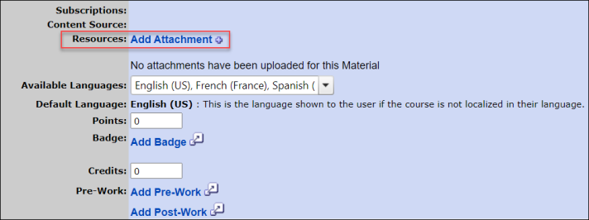
Add Attachment
To attach a document to an LO, click the Add Attachment link. This opens the Upload File pop-up.
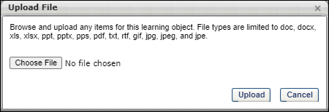
Click the Browse button to locate and select the appropriate document. Then, click Upload to close the pop-up and attach the selected documents. After a file is attached to the LO, the administrator can configure the attachment title and visibility. The maximum file size is 15 MB, and attachments are limited to the following file types:
- docx
- doc
- gif
- jpeg
- jpe
- jpg
- pdf
- pps
- pptx
- ppt
- rtf
- txt
- xlsx
- xls
Edit Attachment
After a file is uploaded to the LO, the administrator can configure the attachment title and visibility. To edit an attachment, click the Edit icon to the right of the attachment title. The attachment title and visibility options become editable.
- Attachment Title - In the text field, enter the display name for the attachment, up to 300 characters. This is the name that is visible to all users, instructors, or administrators who have permission to view the attachment. Note: Only the first 75 characters display in the Resources section. Hover over the attachment title to view the full attachment title. However, the full attachment title is visible on the LO Details page.
- Set Visibility - Using the checkboxes, set the visibility for the attachment. When a user is included in the attachment visibility, the user can view and open the attachment. The following visibility options are available:
  - Admin - This option is selected by default and cannot be unselected. This option enables all administrators who have permission to view or manage attachments to view the corresponding attachment.
  - All Users - This option enables all users to view the attachment. This includes users who are browsing anonymously. All users can view attachments on the LO Details page.
  - Approved Users - This option enables users who are approved for the corresponding LO to view the attachment. Attachments remain visible to users after they move past the Approved status (e.g., Registered, Complete, etc.). Approved users can view attachments on the Transcript Details page.
Click the Save icon to save the changes or click the Cancel icon to discard any unsaved changes.
Attachment - View
This functionality is only available to users with permission to view LO attachments.
When an LO has attachments, they appear in the Resources section based on the date on which the document was attached, with the oldest attachments appearing first. The visibility settings for the attachment are displayed to the right of the attachment title.
Administrators can click the attachment title to open the attachment.
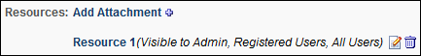
Attachment - Remove
This functionality is only available to users with permission to manage LO attachments.
To remove an attachment, click the Delete icon to the right of the attachment title. A confirmation pop-up displays. Click OK to remove the attachment. Or, click Cancel to cancel the action.
When an attachment is removed, it is no longer available anywhere in the system.

ILT Event - Create - Step 2 - Availability
The Availability step is the second step of the event creation process. On this step, you will determine who this event is available to.
Design Note: An updated interface is available for this page, which can be enabled by administrators in Feature Activation Preferences. With the new design, the functionality of the page is unchanged.
To create an event, go to ILT > Manage Events & Sessions. Then, click the Create New Event link.
OR, go to Admin > Tools > Learning > Learning Admin Console. Then, click the Create button and click the Event link. Click the Availability tab to manage the availability for this event.
Permissions
PERMISSION NAME | PERMISSION DESCRIPTION | CATEGORY

Events - Create | Grants ability to create new instructor led training events. This permission works in conjunction with Events - View permission. This permission can be constrained by OU, User's OU, ILT Provider, and User's ILT Provider. This is an administrator permission. | Learning - Administration

Events - Edit | Grants ability to edit/update existing instructor led training events. This permission works in conjunction with Events - View permission. This permission can be constrained by OU, User's OU, ILT Provider, and User's ILT Provider. This is an administrator permission. | Learning - Administration

Events - View | Grants view-only access to instructor led training events, enabling the user to view all details/options that were selected when the event was created. This permission can be constrained by OU, User's OU, User's ILT Provider, and ILT Provider. This is an administrator permission. | Learning - Administration

LO Attachments - Manage | Grants ability to upload attachments to learning objects. Administrators with this permission are automatically granted the LO Attachments - View permission. This permission can be constrained by User's ILT Provider, Provider, and ILT Provider. This is an administrator permission. | Learning - Administration

LO Attachments - View | Grants ability to view the learning object attachments that are set to be available to administrators. This permission can be constrained by User's ILT Provider, Provider, and ILT Provider. This is an administrator permission. | Learning - Administration
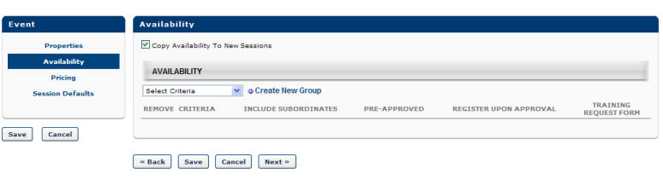
Availability
Configure the following fields and options in the Availability section:
- Copy Availability to New Sessions - Select this option to have sessions created for this event inherit the availability set at the event level.
- Click the Selection Criteria drop-down and do the following:
  - Select a specific Organizational Unit (OU).
  - Add availability to the OU.
  - Click the Done button. Additional configuration options become available:
    - Include Subordinates - Check this box to include the subordinate OUs of the OU selected in the availability criteria.
    - Pre-Approved - Check this box to bypass the approval process. When a user requests the event, they will be in an Approved status. Note: Even if the event is pre-approved, the session may still require approval.
    - Register Upon Approval - Check this box to bypass the Register step for the end user. Upon approval the curriculum will be in a Registered status.
    - Training Request Form - Select a request form from the drop-down if applicable.
    - Create New Group - Click this option to create new group if an existing group does not meet your availability needs.
- Click Save to save the event availability and return to the Manage Events & Sessions or click Next to continue to proceed to the Pricing section or Session Defaults section where you define how settings will default for associated sessions. If no Session Defaults are defined, the Sessions assume system defaults. Session default settings can be overridden at session level.

ILT Event - Create - Step 3 - Pricing
The Pricing step is the third step of the event creation process. On this step, set pricing information for the event. Note: Pricing functionality is only visible by client request.
Design Note: An updated interface is available for this page, which can be enabled by administrators in Feature Activation Preferences. With the new design, the functionality of the page is unchanged.
To create an event, go to ILT > Manage Events & Sessions. Then, click the Create New Event link. Click Pricing link to edit the event pricing. See Course Catalog - Pricing for additional information.
OR, go to Admin > Tools > Learning > Learning Admin Console. Then, click the Create button and click the Event link. Click the Pricing tab to manage the pricing settings for this event.
Permissions
PERMISSION NAME | PERMISSION DESCRIPTION | CATEGORY

Events - Create | Grants ability to create new instructor led training events. This permission works in conjunction with Events - View permission. This permission can be constrained by OU, User's OU, ILT Provider, and User's ILT Provider. This is an administrator permission. | Learning - Administration

Events - Edit | Grants ability to edit/update existing instructor led training events. This permission works in conjunction with Events - View permission. This permission can be constrained by OU, User's OU, ILT Provider, and User's ILT Provider. This is an administrator permission. | Learning - Administration

Events - View | Grants view-only access to instructor led training events, enabling the user to view all details/options that were selected when the event was created. This permission can be constrained by OU, User's OU, User's ILT Provider, and ILT Provider. This is an administrator permission. | Learning - Administration

LO Attachments - Manage | Grants ability to upload attachments to learning objects. Administrators with this permission are automatically granted the LO Attachments - View permission. This permission can be constrained by User's ILT Provider, Provider, and ILT Provider. This is an administrator permission. | Learning - Administration

LO Attachments - View | Grants ability to view the learning object attachments that are set to be available to administrators. This permission can be constrained by User's ILT Provider, Provider, and ILT Provider. This is an administrator permission. | Learning - Administration
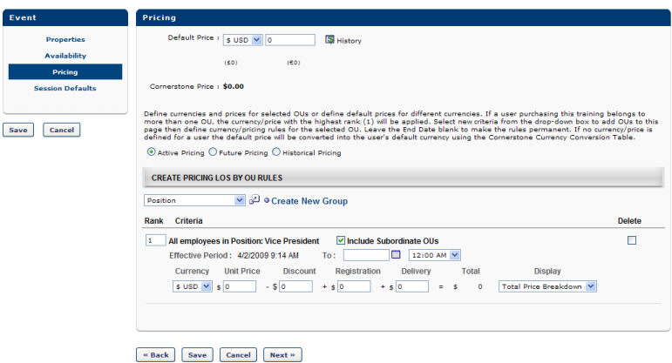
Pricing
Populate the following fields and options for the Pricing step:
Default Price
Enter a default price for the training. The default price is what the user (or user's cost center) is charged when registering for training of no other price is set for the user below. This price is converted into all currencies supported using the Current Conversion Rate table. If the rate is fixed, it is displayed using the Client's Fixed Rate. If not fixed, it displays the Cornerstone Rate. If the seller's currency is incompatible with the buyer's currency, the buyer is shown the price converted from the seller's currency to the buyer's default currency using the Currency Conversion Rate Table (Fixed rate or Cornerstone rate).
Apply Custom Invoice - Check this option to apply a custom invoice to the LO. If no custom invoice is available for the LO, this option is not available.
- Apply Sales Tax - Select this option to apply sales tax to the learning object. To implement sales tax functionality, contact Global Customer Support. A sub-account with Cybersource is required as well as a tax nexus.
- Product Code - Enter the product code for the LO up to 200 characters. Product codes are required if a product is non-taxable or if the product has a non-standard tax rate. When a product code is entered, this value is passed to CyberSource at the time of tax calculation to specify any tax exemptions. This field is only available to organizations using sales tax when the Apply sales tax option is selected.
- Billing Entity - Click the pop-up icon to select a billing entity for the LO. This can be used to define the division within the organization from which the product should be taxed. Once a billing entity is selected, it can be removed by clicking the Remove icon to the right of the value. When a billing entity is selected, this value is passed to CyberSource at the time of tax calculation. This field is only available to organizations using sales tax when the Apply sales tax option is selected. Also, this field is only available to users with permission to manage billing entities.
Override user's OU currency
Select this option to require the user to pay for training with the currency defined for the training rather than the currency defined for their OU. Note: The currency settings must match the payment processor's settings to ensure that the user can check out with the currency defined for the LO. If the payment processor is not configured to accept the user's currency, then the user cannot check out.
Cornerstone Price
This is the price Cornerstone charges the client (the company, not the user) when the billing is reconciled.
Active Pricing
Select this option to set the active price by OU. See the Create Pricing LOs by OU Rules section below for additional information.
Future Pricing
Select this option to set the future price by OU. See the Create Pricing LOs by OU Rules section below for additional information.
Historical Pricing
Select this option to search for historical prices by date.
Create Pricing LOs by OU Rules
Using the OU drop-down, you can set different prices for different organizational units (OUs). If no price is defined for a user, the default price is used. All pricing rules created on the learning object (LO) level expire immediately if any change is made at the group level. If no end date is set for the pricing, the pricing rules are permanent.
Because it is possible that a LO has multiple pricing rules set, the system observes the following rules:
- If a user falls under multiple OUs with multiple pricing rules that have different rankings, the cost associated with the highest (1) ranking is applied.
- If a user falls under multiple OUs with multiple pricing rules that have the same ranking, the cost associated with the lowest price is applied.
Note: Pricing LOs by OU rules is limited to 120 rules.
Save or Next
Click Save or Next to continue to Training Units or Session Defaults section. The Training Units section is only available if training units are enabled.

ILT Event - Create - Step 4 - Training Units
The Training Units step is the fourth step of the event creation process. On this step, configure training unit prices and options. The Training Units tab is only available if training units are enabled.
Design Note: An updated interface is available for this page, which can be enabled by administrators in Feature Activation Preferences. With the new design, the functionality of the page is unchanged.
To create an event, go to ILT > Manage Events & Sessions. Then, click the Create New Event link.
OR, go to Admin > Tools > Learning > Learning Admin Console. Then, click the Create button and click the Event link. Click the Training Units tab to manage the training units settings for this event.
Permissions
PERMISSION NAME | PERMISSION DESCRIPTION | CATEGORY

Events - Create | Grants ability to create new instructor led training events. This permission works in conjunction with Events - View permission. This permission can be constrained by OU, User's OU, ILT Provider, and User's ILT Provider. This is an administrator permission. | Learning - Administration

Events - Edit | Grants ability to edit/update existing instructor led training events. This permission works in conjunction with Events - View permission. This permission can be constrained by OU, User's OU, ILT Provider, and User's ILT Provider. This is an administrator permission. | Learning - Administration

Events - View | Grants view-only access to instructor led training events, enabling the user to view all details/options that were selected when the event was created. This permission can be constrained by OU, User's OU, User's ILT Provider, and ILT Provider. This is an administrator permission. | Learning - Administration

LO Attachments - Manage | Grants ability to upload attachments to learning objects. Administrators with this permission are automatically granted the LO Attachments - View permission. This permission can be constrained by User's ILT Provider, Provider, and ILT Provider. This is an administrator permission. | Learning - Administration

LO Attachments - View | Grants ability to view the learning object attachments that are set to be available to administrators. This permission can be constrained by User's ILT Provider, Provider, and ILT Provider. This is an administrator permission. | Learning - Administration
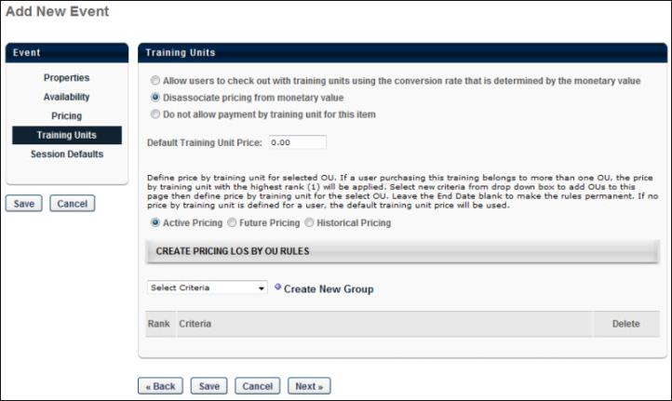
Training Units
When creating or editing an event, the Training Units tab offers the following options regarding training units:
- Allow users to check out with training units using the conversion rate that is determined by the monetary value - Select this option to allow users to purchase the event using training units, and the number of training units used is determined by converting the monetary value using the training unit conversion rate.
- Disassociate pricing from monetary value - Select this option to allow you to set a training unit price for the item that is unrelated to any monetary value that may be set. You can specify a default training unit price and training unit prices based on OU. Training unit prices can be represented using up to two decimal places.
- Do not allow payment by training unit for this item - This option prevents users from purchasing the test with training units.
Copying an event copies all active and future training unit pricing. Creating a new session copies all active and future training unit pricing.
Click Save or Next to continue to Session Defaults section.
ILT Event - Create - Step 5 - Session Defaults
The Session Defaults page is the fifth step in the event creation process. On this step, configure the default settings that will be applied to sessions created for this event.
Note: The session defaults when creating an event are initially set up in ILT Preferences and are organization specific. You may or may not see all session defaults in your portal.
Design Note: An updated interface is available for this page, which can be enabled by administrators in Feature Activation Preferences. With the new design, the functionality of the page is unchanged.
To create an event, go to ILT > Manage Events & Sessions. Then, click the Create New Event link.
OR, go to Admin > Tools > Learning > Learning Admin Console. Then, click the Create button and click the Event link. Click the Training Units tab to manage the training units settings for this event.
Permissions
PERMISSION NAME | PERMISSION DESCRIPTION | CATEGORY

Events - Create | Grants ability to create new instructor led training events. This permission works in conjunction with Events - View permission. This permission can be constrained by OU, User's OU, ILT Provider, and User's ILT Provider. This is an administrator permission. | Learning - Administration

Events - Edit | Grants ability to edit/update existing instructor led training events. This permission works in conjunction with Events - View permission. This permission can be constrained by OU, User's OU, ILT Provider, and User's ILT Provider. This is an administrator permission. | Learning - Administration

Events - View | Grants view-only access to instructor led training events, enabling the user to view all details/options that were selected when the event was created. This permission can be constrained by OU, User's OU, User's ILT Provider, and ILT Provider. This is an administrator permission. | Learning - Administration

LO Attachments - Manage | Grants ability to upload attachments to learning objects. Administrators with this permission are automatically granted the LO Attachments - View permission. This permission can be constrained by User's ILT Provider, Provider, and ILT Provider. This is an administrator permission. | Learning - Administration

LO Attachments - View | Grants ability to view the learning object attachments that are set to be available to administrators. This permission can be constrained by User's ILT Provider, Provider, and ILT Provider. This is an administrator permission. | Learning - Administration
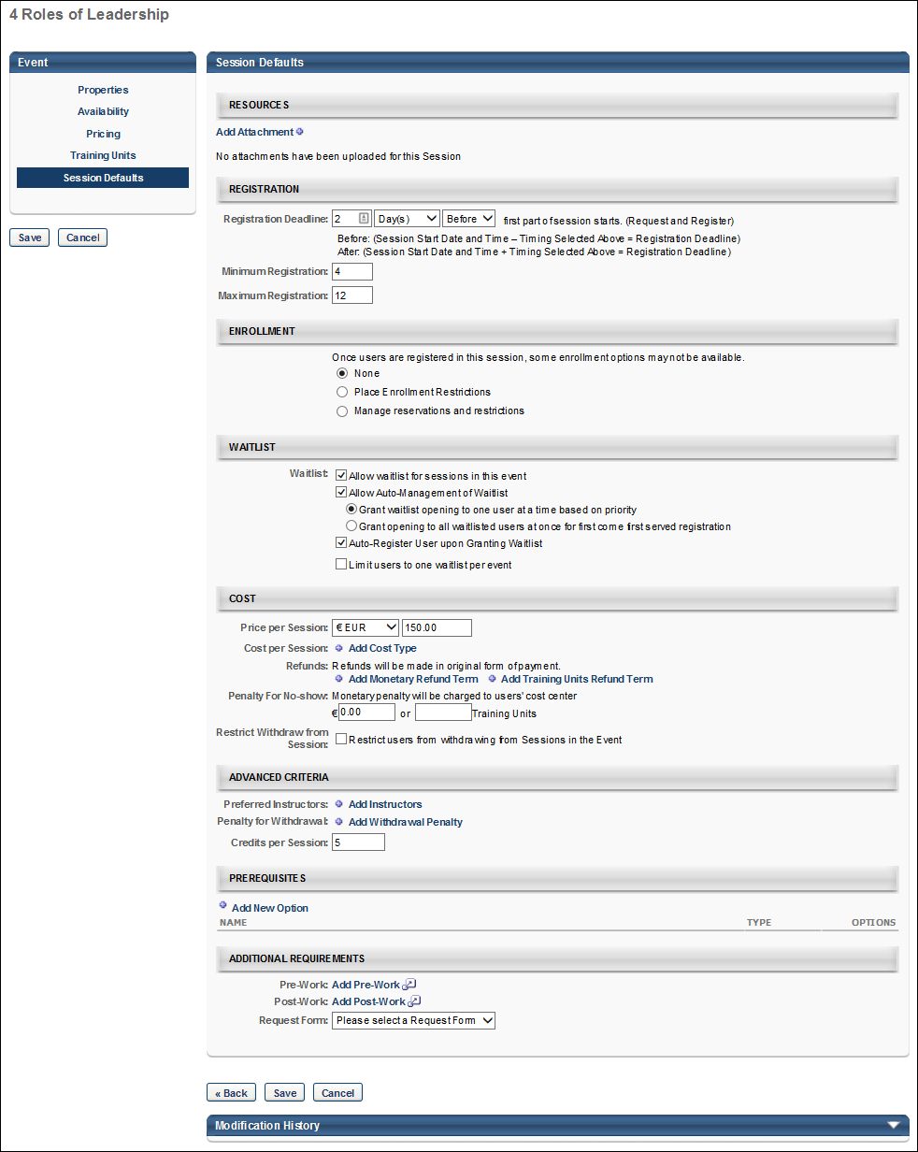
Session Defaults
Populate the following fields and settings in the Session Defaults section to specify how settings automatically default when creating a session:
Resources
This section of the Session Default page enables administrators to view and manage default attachments for all sessions that are created for the event. The visibility of each attachment can be determined by the administrator. For example, some attachments may be visible to only administrators, while other attachments may be visible to all users. In addition, attachments can be made visible to users only if they are registered for the corresponding session. This section is only available for users that have permission to view or manage LO attachments. See ILT Event - Create - Session Defaults - Resources on page 90 for additional information.
Registration
- Advance Registration:
  - Allow Advance Registration for Interested Users - Select to allow advanced registration, and then enter the advanced registration period in the Advanced Registration lasts for numeric text field.
  - Users are Pre-Approved - Select to allow users to be pre-approved for registration.
  - Register Users on Approval - Select to allow users to be registered for the session upon approval.
- Registration Deadline - Enter number of days/hours before the session start date when registration ends. Note: Users may not register for a session after the registration deadline, but administrators can assign users to a session after this date has passed.
- Minimum Registration - Enter minimum number of registered users. This field is required.
- Maximum Registration - Enter maximum number of registered users. This field is required. The maximum registration for sessions is 9,999 unless the event uses a Citrix integration.
  - Citrix Integration Note: When creating a Citrix event, the maximum registration is 25.
Note: If custom training fields are defined and active in Custom Field Administration, the fields display in the Registration section.
Enrollment
The Enrollment section on the Details tab allows administrators to limit the number of users by OU that can enroll for the event's sessions. If enrollment restrictions are placed on organizational units, the number of seats available to a user differs depending on the maximum registration defined for the OU, and the number of users currently registered from their OU. See ILT Event - Create - Session Defaults - Enrollment on page 78 for additional information.
Waitlist
- Allow waitlist for sessions in this event - Select this option to allow waitlists. Users are added to the waitlist when they register for a session that does not have seats available. Each session has a separate waitlist. If the option is not selected, then users are denied when they register for a session that has no seats available.
- Allow Auto-Management of Waitlist - Check to automatically grant openings to waitlisted users.
  - Grant waitlist opening to one user at a time - Select this option to allow waitlist openings to be granted to one user at a time based on priority.
  - Grant opening to all waitlisted users at once - Select this option to allow waitlist openings to be granted to all users at once for first come first served registration.
- Auto-register user upon Granting Waitlist - Check to automatically register users, thereby allowing them to bypass the transcript for registration. This should be used only if you are granting waitlist openings one at a time.
  - If the Auto-Register feature is not on, then a user who is granted an opening will have their status changed to Registration Pending with the option to register. The Grant Waitlist Request email trigger may be set up to notify this user, their manager, and the session administrators that the opening was granted
- Limit users to one waitlist per event - When this option is selected, users can only add themselves to one waitlist for the corresponding event. If this option is selected and a user attempts to add themselves to more than one waitlist for the event, then a message is displayed, indicating that they can only be on the waitlist for one session in the selected event. Note: This option is only visible if the Allow waitlist for sessions in this event option is selected.
  - When this option is selected, it limits users for all waitlist requests for the event after the preferences are saved. The system does not remove users from any waitlists if they have previously been added to multiple waitlists for the event. However, if this option is enabled, a user is already added to multiple waitlists for the event, and the user requests to be added to an additional waitlist for the same event, then the user must be removed from all other session waitlists for the event in order for the request to be granted.
- Waitlist Deadlines - The following waitlist deadline options are available:
  - Students have - Enter number of days and hours a user has to register for the session when waitlist is granted. If auto-register is on, this deadline does not apply.
If the opening is granted to all, then the waitlist acceptance deadline is not enforced in order to avoid the possibility of having every user on the waitlist denied.
If a user does not register for a session before the waitlist acceptance deadline passes, their status will automatically change to Denied and the opening will be granted to the next user on the waitlist, if auto-management is on. An email trigger may be activated to notify the user of the waitlist acceptance deadline. A tag may also be added to the Waitlist Opening Granted email to let them know the deadline.
  - Waitlist expires - Enter number of days and hours before registration deadline that the waitlist expires. When the waitlist expires all waitlisted users will have the status Waitlist Expired and receive an email. The purpose of having the waitlist expire before the registration deadline is that it creates a period when all users (on the waitlist or off) can register on a first come first served basis for open seats. This will reduce the risk of having open seats on the session start date. An email trigger may be configured to notify users in a Waitlist Expired status when a seat becomes available before the registration deadline.
Users with waitlist expired status will have the option to Register or Select Session. If they attempt to register for a class that is full, they will not be denied, they will just see a message that tells them the class is full and that they may attempt to register for open seats when they become available.
Cost
Price Per Session
Enter a price for session. Each user (or their cost center) will be billed this price upon registration. Administrators can enter any number of decimal places. Once the page is saved, this field is rounded to use two decimal places of precision.
Cost Per Session
Costs per Session. ILT Admin Reports under Session Cost Report. These costs are only used for reporting purposes to view the summary of total costs across certain division or during specified time periods. This data is not displayed to the users.
To add a cost type:
- Click the Add Cost Type link. This opens the cost type options.
- Select Cost Type from the drop-down.
- Enter the cost per session for the selected cost type. Administrators can enter up to ten digits, including decimal places. Once the cost is saved, this field is rounded to use two decimal places of precision.
- Click the Save icon.
Multiple cost types can be added.
Total Cost per Session
When a cost is added in the Cost per Session field, this field is displayed, and appears and displays the sum of the Cost per Session costs. Administrators are only able to add one cost per cost type. If no cost is added in the Cost per Session field, then the Total Cost per Session field does not display.
This calculation uses the rounded values that are displayed. This field always uses two decimal places of precision.
Refunds
Note: All refunds are billed to the user (or their cost center) on the session registration date. The Allow refund terms setup option must be selected in the Payment Preference panel in ILT Preferences to enable the refund options in ILT Manage Events & Sessions.
- Add Monetary Refund Term - Click this link to add a monetary refund term. This adds a new line to this section, which is listed below.
  - Refund XX% or $XX for withdrawals XX days prior to session start date - For a monetary refund, you may specify the percentage of the cost that is refunded, or you can specify the monetary amount. Also, specify the number of days prior to the session start date by which the user must withdraw to receive the specified refund. The maximum number of days is 9999. Click the Save icon to save the refund term.
Note: Refunds cannot be greater than the session cost.
- Add Training Units Refund Term - Click this link to add a training unit refund term. This enables the refund terms fields to appear below the link. Note: This option is only available if training units are enabled for the portal.
  - Refund XX Training Units for withdrawals XX days prior to session start date - For a training unit refund, enter either a percentage of training units to refund or a specific amount of training units to refund. The percentage field accepts values between 1 and 100. Training unit prices can be represented using up to two decimal places. Then, specify the number of days prior to the session start date by which the user must withdraw to receive the specified refund. The maximum number of days is 9999. Click the Save icon to save the refund term. Note: If you only click the Save button at the bottom of the page before clicking the Save icon, the refund terms are not saved.
Only one refund type can be configured. Therefore, if issuing a refund percentage, the Training Units field must be left blank and vice versa. Refunds cannot be greater than the session cost.
For training unit percentage refunds, if the user purchased the session with distributed training units, then the percentage is refunded to their personal training units account. If the user purchased the session with a training unit key code, then the percentage is refunded to their key code.
Note: If refunds are automated as specified in ILT Preferences, the user is refunded the entire amount less any processing fees. All refunds are made in the original form of payment. If a user paid by credit card, the refund is made via credit card. If both training units and credit cards are enabled, you must specify a refund term for each available payment method.
Penalty for No-Show
No Show penalties are charged to users who do not attend any part of a session for which they are registered (without prior withdrawal).
Specify the monetary value that is charged and also specify the amount of training units that is penalized. Training unit prices can be represented using up to two decimal places. No-show penalties are charged in the same form of payment that is used to purchase the session. If a user purchases a session with training units, but does not have any training units in their account, the no-show penalty is deferred to the monetary amount. If training units is not enabled for the portal, the training unit option is not available.
All no-show penalties are billed to the user (or their cost center) when the roster is submitted
Restrict Withdraw from Session
When this option is selected, the Restrict Withdraw for User option will be selected for all new sessions within the event by default. This option can be deselected if necessary when creating a session.
Advanced Criteria
Preferred Instructors
If selected, preferred instructors will display as the default value when creating sessions and defining schedule parts. More than one instructor can be selected. The Preferred Instructors can be overridden at the session level. If an Instructor is added, and later that instructor becomes inactive, the Instructor's name will still propagate to existing and new sessions. The Administrator must remove the Instructor from the Preferred Instructor list.
Note: If this field is named Primary Preferred Instructors and a Secondary Preferred Instructors field appears below, then your portal has enabled the ability to configure multiple providers for a session. See ILT Event - Create - Step 5 - Session Defaults - Primary Instructors on page 88 for additional information.
Penalty for Withdrawal
All withdrawal penalties are billed to the user on the session registration date.
To configure a withdrawal penalty:
- Click the Add Withdrawal Penalty link.
- Enter the percentage or dollar amount of the withdrawal penalty. Note: Only one of the fields can be configured per penalty. If a number is entered in both the percentage and dollar amount fields, only the number in the percentage field is accepted upon saving the penalty.
- Enter the number of days before the session start date that the penalty is incurred.
- Click the Save icon.
Multiple withdrawal penalties can be added.
Credits per Session
Enter a number of credits.
Prerequisites
The Prerequisites section on the Session Defaults tab enables administrators to set default prerequisites for sessions added to the event, and the defined prerequisites must be completed by the user before they are able to register for the session. The status of the training will be Exception Requested or Pending Prerequisite until the user completes the prerequisites. It is not required that a session have prerequisites. See ILT Event - Create - Session Defaults - Prerequisites on page 85 for additional information.
Additional Requirements
The Additional Requirements section of the Session Defaults page enables administrators to configure default pre-work and post-work. In addition, administrators can configure a default request form, as well as select to display the session start and end time in the user's time zone. See ILT Event - Create - Session Defaults - Additional Requirements on page 75 for additional information.
Required Training Approvals
Enter the number of approvals that are required for initial approval. Leaving this field blank or setting the field to 0 causes the system to default to the number of required training approvals set in the User Record. Setting required training approvals at the LO level will override the required training approvals in the User Record unless the required approvals on the User Record is set to zero. The visibility of this field is configurable.
Required Completion Approvals
Enter the required number of approvals that must be received for this LO to be considered completed. If left blank, the LO will follow the normal workflow for LO completion. If a value is entered (number greater than 0) the Learning Object will require Completion Approval. This applies to all users who complete the training using the normal approval work-flow process. (Visibility of this field is configurable by client)
Save
Once all fields are completed, click Save. Note: If course code functionality has been activated in your portal, a course code is automatically generated for the LO immediately after the administrator saves the new LO.
ILT Event - Create - Session Defaults - Additional Requirements
The Additional Requirements section of the Session Defaults page enables administrators to configure default pre-work and post-work. In addition, administrators can configure a default request form, as well as select to display the session start and end time in the user's time zone.
Design Note: An updated interface is available for this page, which can be enabled by administrators in Feature Activation Preferences. With the new design, the functionality of the page is unchanged.
Add Pre-Work
Instructors and session administrators can exempt students from pre-work from the Session Roster. See Session Roster - Exempt Users from Assignment on page 293 for additional information. Note: If you have permission to restrict the Select Training pop-up for prerequisites, pre-work, and post-work, then the learning objects visible to you are dependent upon the availability set with this permission.
To add pre-work:
- Click the Pre-Work link.
- Search for training by entering a full or partial title or a keyword.
- Click Search.
- Click the Add icon to add training.
- Click Add.
- Click Done. This adds the training items to the Pre-Work field.
- Or, add free-form training by entering the training in the text box on the Select Training pop-up and clicking Add. This adds the free form training item to the Prerequisites field.
Note: The completion of any pending pre- or post-work will mark its associated session's completion date per the Default Session Completion Date ILT preference setting.
Once pre-work is added, the following columns appear in the Pre-Work table:
- Req - Select this option to indicate that the training is required for the completion of the class. If a student does not complete this training, their status will be Incomplete when the session is marked complete.
- Seq - Enter the number for the training sequence to set a required sequence for the training. This means that the training must be completed in the order that is configured. Users will not be able to request training until the training that is before it in the sequence is completed. If no numbers are entered, then students may take all the pre-work training items in any order or all at once.
- Display Position - Enter a number for the display position. The training items will be displayed in this sequence on the Training Details page.
- Name - This column displays the name of the training item.
- Type - This column displays the training type.
- Remove - Click the Remove icon to remove the training item as pre-work.
Add Post-Work
Instructors and session administrators may exempt students from post-work from the session roster. See Session Roster - Exempt Users from Assignment on page 293 for additional information. Note: If you have permission to restrict the Select Training pop-up for prerequisites, pre-work, and post-work, then the learning objects visible to you are dependent upon the availability set with this permission.
To add post-work:
- Click the Pre-Work link.
- Search for training by entering a full or partial title or a keyword.
- Click Search.
- Click the Add icon to add training.
- Click Add.
- Click Done. This adds the training items to the Pre-Work field.
- Or, add free-form training by entering the training in the text box on the Select Training pop-up and clicking Add. This adds the free form training item to the Prerequisites field.
Note: The completion of any pending pre- or post-work will mark its associated session's completion date per the Default Session Completion Date ILT preference setting.
Once post-work is added, the following columns appear in the Pre-Work table:
- Req - Check the box to indicate that the training is required for the completion of the class. If a student does not complete this training, their status will be Incomplete when the session is marked complete.
- Seq - Enter the number for the training sequence to set a required sequence for the training. This means that the training must be completed in the order that is configured. Users will not be able to request training until the training that is before it in the sequence is completed. If no numbers are entered, then students may take all the pre-work training items in any order or all at once.
- Display Position - Enter a number for the display position. The training items will be displayed in this sequence on the Training Details page.
- Name - This column displays the name of the training item.
- Type - This column displays the training type.
- Remove - Click the Remove icon to remove the training item as post-work.
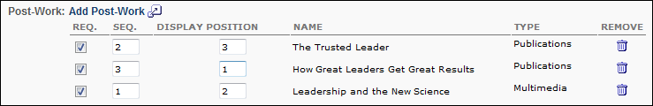
Request Form
Select a request form from the drop-down if applicable. The user will be able to complete this form at the time they request the session.
Display Times in Time Zone of User
This field allows administrators to display the session start and end times in the time zone of the user viewing the session.
Standard Sessions
For standard sessions, the field is unchecked by default checked by default for vILT sessions. When unchecked for standard sessions, the Display Times in Time Zone of User field on the Parts Schedule page is unchecked by default when configuring sessions. When checked, the Display Times in Time Zone of User field on the Parts Schedule page is checked by default. The field can be unchecked on the Parts Schedule page when configuring the sessions. If the field is checked on the Parts Schedule page, then the session start and end times in the time zone of the user viewing the session.
vILT Sessions
For vILT sessions, the field is checked by default. When checked, the Display Times in Time Zone of User field is also checked by default when configuring sessions on the Parts Schedule page. When unchecked, the Display Times in Time Zone of User field on the Parts Schedule page is unchecked by default. The field can be modified on the Parts Schedule page when configuring sessions. If the field is checked on the Parts Schedule page, then the session start and end times in the time zone of the user viewing the session.
ILT Event - Create - Session Defaults - Enrollment
The Enrollment section on the Details tab allows administrators to limit the number of users by OU that can enroll for the event's sessions. If enrollment restrictions are placed on organizational units, the number of seats available to a user differs depending on the maximum registration defined for the OU, and the number of users currently registered from their OU.
Design Note: An updated interface is available for this page, which can be enabled by administrators in Feature Activation Preferences. With the new design, the functionality of the page is unchanged.
Users whose organizational units have 0 seats available will be added to the waitlist if a waitlist is enabled. There may be users on the waitlist for one OU when there are seats available for users from other OUs. When the auto-management feature is on, the system will automatically check the OU availability for each user on the waitlist and only grant the opening to users who have seats available in their organization unit.
The enrollment restrictions also apply to ILT inventory purchases. For example, if this option is set to restrict enrollment by division to 10 people, each division can only enroll 10 users in the session. A user in Division A can purchase up to 10 sessions for inventory. If another user from Division A attempts to purchase inventory for the session, they are unable because the maximum of 10 is already reached for that division. Users in Division B and Division C are still able to purchase up to 10 seats for the session for inventory since their maximum is not yet reached. Note: Even if the Division A user were to assign the inventory seats to users outside of Division A, the seat limit is still counted towards Division A's limit because it is based on the purchaser's OU limit.
To manage events and sessions, go to ILT > Events & Sessions.
Permissions
PERMISSION NAME | PERMISSION DESCRIPTION | CATEGORY

Sessions - Create | Grants ability to create new instructor led training sessions. This permission works in conjunction with Events - View and Sessions - View permissions. Administrators can only create sessions for events for which they have the availability to view. When adding users to a session in which the session roster is full, this permission grants the ability to increase the session's available seats. This permission can be constrained by OU, User's OU, Instructor, User as Instructor, Facility, Facilities Owned by User, ILT Provider, User's ILT Provider, User, and User Self and Subordinates. This is an administrator permission.  Note: The "Restrict to User as Instructor" constraint is available, but it does not actually constrain the permission. | Learning - Administration

Sessions - Edit | Grants ability to edit/update existing instructor led training sessions. This permission works in conjunction with Events - View and Sessions - View permissions. Administrators can only edit sessions for which they have the availability to view and edit. When adding users to a session in which the session roster is full, this permission grants the ability to increase the session's available seats. This permission can be constrained by OU, User's OU, Instructor, User as Instructor, Facility, Facilities Owned by User, ILT Provider, User's ILT Provider, User, and User Self and Subordinates. This is an administrator permission. | Learning - Administration
Enrollment Reservations and Restrictions
The following options are available in the Enrollment Reservations and Restrictions section:
None
Select the None option to indicate that there are no enrollment restrictions.
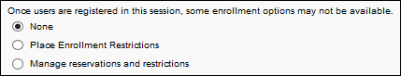
Place Enrollment Restrictions
When this option is selected, the administrator has the option to place enrollment restrictions by OU type or by OU.
By Organizational Unit Type
Select the Place Enrollment Restrictions option and then select the by Organizational Unit Type option to limit the number of users from each OU (of the selected type) that can register for the event's sessions. The administrator can only select one OU type to restrict upon.
From the drop-down, select an OU type. Then, enter the maximum registration for the OU.
Note: In order for this option to be available, the Allow enrollment restrictions to be placed on organizational unit types option must be enabled in ILT Preferences. See ILT Preferences - General for additional information.
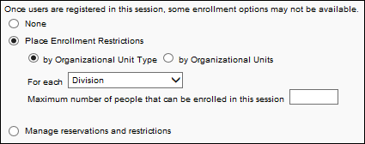
By Organizational Units
Select the Place Enrollment Restrictions option and then select the by Organizational Units option to place enrollment restrictions by a specific OU. In the Select OU field, select an OU type from the drop-down. You can also create a new group by clicking the Create New Group link. Once an OU type is selected, click the Search icon to the right of the Select OU field. This opens the Select OU pop-up. Select one or more OUs from the pop-up, and then click Done. The OUs appear in a table below the Select OU field. Multiple OUs from multiple OU types can be added. Note: The OUs available to select are dependent on the administrator's permission constraints.
Note: In order for this option to be available, the Allow enrollment restrictions to be placed on a specific organizational unit option must be enabled in ILT Preferences. If this option is not enabled, then the Place Enrollment Restrictions option is automatically by OU type. See ILT Preferences - General for additional information.
The following columns display in the OUs table:
- Criteria - This column displays the OU criteria.
- Include Subordinates - Select this box to include subordinate OUs.
- Maximum Seats Allowed - Enter the maximum number of users in the OU that can register for the session. The default number is 0. There is no limit to the number of restrictions that can be added. This is a required field for each OU.
- Remove - Remove the OU by clicking the Delete icon, if needed.
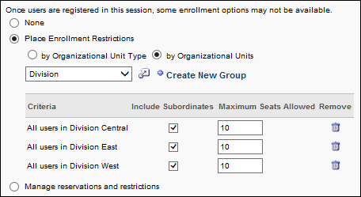
Manage Reservations and Restrictions
The Manage Reservations and Restrictions option allows administrators to define the number of seats to reserve for a specific OU. Administrators can also set a maximum number of seats that are allowed for a specific OU. Note: In order for this option to be available, the Allow reservation of seats for a specific organizational unit option must be enabled in ILT Preferences. See ILT Preferences - General for additional information.
A maximum of 50 OUs or groups can be added to the Criteria table. In addition, the same OU cannot be added more than once for a single session.
To manage reservations and restrictions by OU:
- Select the Manage Reservations and Restrictions option. A select OU drop-down appears below the option.
- Select an OU from the drop-down.
- Click the Select icon to the right of the drop-down to open the Search [OU] pop-up.
- Select one or more OUs from the pop-up. Note: The OUs available to select are the OUs that fall within the administrator's permission constraints.
- Click Add. The OUs are added below the select OU drop-down.
- The following information and fields are displayed:
Field | Description
Order | In this field, enter the priority order for each OU. The priority order determines the applicable reservations and restrictions for when a user belongs to more than one criterion. If a user belongs to more than one criterion, then the reservations and restrictions for the highest priority criterion are applied to the user. This field accepts up to three positive whole numbers.  Example Scenario:  Robert is a Product Manager and is in Santa Monica. Robert wants to register for training under the following configurations:  Configuration 1:  - Order #1 = Position: Product Manager, 5 Reserved Seats, 10 Max Seats, 0 Available  - Order #2 = Location: Santa Monica, 2 Reserved Seats, No Max Seats, 2 Available  In Configuration 1, Robert is not able to register because the restriction of 10 Max Seats for the Product Manager Position OU supersedes the available seats for the Santa Monica Location OU.  Configuration 2:  - Order #1 = Location: Santa Monica, 2 Reserved Seats, No Max Seats, 2 Available  - Order #2 = Position: Product Manager, 5 Reserved Seats, 10 Max Seats, 0 Available  In Configuration 2, Robert is able to register because the available seats for the Santa Monica Location OU supersedes the restriction of 10 Max Seats for the Product Manager Position OU.
Criteria | This column displays the OUs that were selected.
Include Subordinates | Select this option to apply the reservations and restrictions to all of the users who are in the selected OU or within subordinate OUs. For example, if the California location OU is selected, and the Include Subordinates option is checked, then the reservations and restrictions apply to all users in the California location OU, as well as any subordinate location OUs (e.g., Los Angeles, San Francisco, San Diego). Note: This option is available for all OUs, regardless of whether the OU has any subordinates.  If this option is selected for an OU, then one of the OU's child OUs cannot be added to the Criteria table individually because the same OU cannot be added more than once for a single session.  Reservations and restrictions that are applied to users in subordinate OUs do not need to be distributed evenly across all subordinate OUs. For example, Los Angeles, San Francisco, and San Diego are the subordinate OUs for the California location OU, and California has five reserved seats and a maximum of 10 seats. 10 users from the Los Angeles OU may register for the session. All 10 available seats for the California location OU are consumed by the 10 users from the Los Angeles location OU.
Reserved Seats | In this field, enter the number of seats to reserve for each OU. The field accepts up to seven positive whole numbers. If this field is left blank, then no seats are reserved. The Reserved Seats and the Maximum Seats Allowed fields cannot both be left blank. At least one must be set. Note: The total number of reserved seats cannot exceed the maximum registration limit.
Maximum Seats Allowed | In this field, enter the maximum number of seats that are allowed to be filled by users within each OU. This field accepts up to seven positive whole numbers. If this field is left blank, then there is no maximum for the OU. For each criterion, the Reserved Seats and the Maximum Seats Allowed fields cannot both be left blank. At least one must be set. Note: The maximum seats allowed must be greater than the number of reserved seats, if applicable, but cannot exceed the maximum registration limit for the session.
Remove | Click the Trash Can icon in the Remove column to remove the OU. OUs cannot be removed if at least one user has registered for the session. Note: If an OU is deleted and the administrator would like to re-add the OU, the OU must be within the administrator's permission constraints in order to be re-added.
Modifications to the Order, Include Subordinates, Reserved Seats, and Maximum Seats Allowed values are not saved until the Save button is clicked.
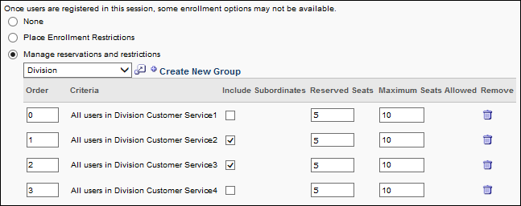
Seats Available Pop-Up Window
Registered users are reprocessed when an administrator makes changes to the enrollment and restrictions criteria for the following types of sessions:
- Sessions with seat reservations and no inventory
- Sessions with seat restrictions and no inventory
- Sessions with both seat reservations and seat restrictions and no inventory
When the registered users are reprocessed, the number of available seats is accurately calculated by the system and displays correctly to the administrator in the Reserved Seats Available column in the Seats Available pop-up window. This ensures the correct calculation and display of reserved seats available in the Seats Available pop-up window.
Considerations
- If at least one user has registered for the session, the administrator cannot decrease the Reserved Seats or Maximum Seats Allowed fields to a value that is lower than the current number of registered users from the corresponding OU. For example, if there are three users registered for the session from the West division, then the administrator cannot decrease these fields to a value that is less than three.
- When a user withdraws from a session from a reserved seat, the system processes the existing reservations to determine if an eligible user in the general availability for the session meets the criteria for a reserved seat.
  - If there is a user in the general availability for the session who meets the criteria for a reserved seat, then the system moves the user from the general availability to the reserved seat. An additional seat is now available in the general availability for the session.
  - If there is not a user in the general availability for the session who meets the criteria for a reserved seat, then an additional reserved seat becomes available for the OU of the withdrawn user.
- When a manager or administrator processes a substitution, the substituted user is processed based on the reservations and restrictions that apply to their OU. If there is not an available seat for the user that is being substituted, then the manager or administrator is not able to complete the substitution.
- When the number of users in a division reaches the maximum enrollment allowed, each subsequent user beyond the maximum is placed on the waitlist, if waitlisting is configured. Or, an exception request must be granted in order for users beyond the maximum to register.
- For users in multiple OUs, if one of their OUs reaches the maximum enrollment allowed, they cannot register for the session. Even if one of the other OUs they are in has not reached the maximum enrollment allowed, they cannot register. They are placed on the waitlist, if waitlisting is configured, or an exception request must be granted in order for them to register.
- If at least one user is registered for the session, the administrator cannot change the enrollment setting from one of the enrollment restrictions options to the reserved seats option and vice versa.
- If at least one user is registered for the session, the administrator cannot change the enrollment setting to None.
Edit OU Criteria
If edits are made to the OU criteria, the changes only affect users registering for the session after the changes are made. The changes do not affect users that are currently registered or who are in a Completed status. Example:
ILT Event - Create - Session Defaults - Prerequisites
The Prerequisites section on the Session Defaults tab enables administrators to set default prerequisites for sessions added to the event, and the defined prerequisites must be completed by the user before they are able to register for the session. The status of the training will be Exception Requested or Pending Prerequisite until the user completes the prerequisites. It is not required that a session have prerequisites.
Design Note: An updated interface is available for this page, which can be enabled by administrators in Feature Activation Preferences. With the new design, the functionality of the page is unchanged.
To manage events and sessions, go to ILT > Events & Sessions.
Permissions
PERMISSION NAME | PERMISSION DESCRIPTION | CATEGORY

Events - Create | Grants ability to create new instructor led training events. This permission works in conjunction with Events - View permission. This permission can be constrained by OU, User's OU, ILT Provider, and User's ILT Provider. This is an administrator permission. | Learning - Administration

Events - Edit | Grants ability to edit/update existing instructor led training events. This permission works in conjunction with Events - View permission. This permission can be constrained by OU, User's OU, ILT Provider, and User's ILT Provider. This is an administrator permission. | Learning - Administration
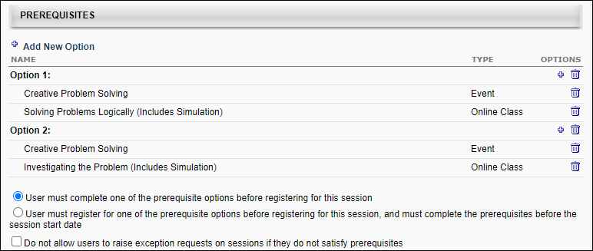
Add New Option
Prerequisite options are the options that a user can complete to satisfy the prerequisite requirement for training item. At least one of the training items within an option must be completed in order to satisfy the option.
- If the training only has one option, that option must be completed by the user before the user is able to register for the training.
- If the training has multiple options, the user is only required to complete one of the options before they can register for the training.
Click the Add New Option link to add a new prerequisite option. This opens the Select Training pop-up in which the administrator can select the training items that belong in the option. Multiple items can be selected. The selected training appears in alphabetical order within the new option in the Prerequisites table. Note: The same training item can be added to multiple options if it is a requirement for multiple options.
The following information displays for each item in the Prerequisites table:
- Name - This displays the name of the option or training within the option. Options are automatically numbered in the order in which they appear in the table (e.g., Option 1, Option 2). When an option is deleted, the remaining option names are updated to reflect the new option order.
- Type - This displays the training type for each item in the option.
A maximum of 10 prerequisite options can be defined. Once 10 options have been added, the Add New Option link is no longer available until an option is deleted.
A maximum of 50 training items can be added to an option. Once 50 items have been added, the Add Training icon is no longer available until a training item is deleted from the option.
Delete Option
To delete a prerequisite option, click the Delete icon in the Options column for the appropriate option. This also removes all the training items within the option. Options are automatically numbered in the order in which they appear in the table (e.g., Option 1, Option 2). When an option is deleted, the remaining option names are updated to reflect the new option order.
Add LO to Existing Option
To add an additional training item to an existing prerequisite option, click the Add Training icon in the Options column for the appropriate option. This opens the Select Training pop-up in which the administrator can select the additional training items that belong in the option. Multiple training items can be selected. The selected training appears in alphabetical order within the option in the Prerequisites table.
A maximum of 50 training items can be added to an option. Once 50 items have been added, the Add Training icon is no longer available until a training item is deleted from the option.
Delete LO within Existing Option
To remove a training item from an existing prerequisite option, click the Delete icon in the Options column for the item. If all items are deleted from an option, the option is also deleted after the changes are saved.
Radio Buttons
Once prerequisites are added, the following options appear below the Prerequisites table:
- User must complete one of the prerequisite options before registering for this session - Select this option to require users to complete at least one prerequisite option before registration is allowed. When selected, users who have not completed at least one prerequisite option but attempt to register for the session will receive an Exception Requested status until the request is approved. The user cannot register until the exception is granted.
- User must register for one of the prerequisite options before registering for this session, and must complete the prerequisites before the session start date - Select this option to require users to register for all of the prerequisites within a prerequisite option before being allowed to register for the session. When selected, users who have not completed the prerequisites will have the status Pending Prerequisite once they register. The user will be automatically withdrawn from the session on the session start date if the prerequisites are not complete.
- Do not allow users to raise exception requests on sessions if they do not satisfy prerequisites - This option may or may not be selected by default upon creating the event, based on whether or not the same option was selected by the administrator in ILT Preferences. Event creators have the flexibility to select or unselect this option at the event level, regardless of whether the setting is checked or unchecked in ILT Preferences.
When this option is checked, users cannot submit exception requests when they request a session for which they have not yet satisfied a required prerequisite.
When this option is unchecked, users can submit exception requests when they request a session for which they have not yet satisfied a required prerequisite.
The configuration of this option at the event level is inherited by the sessions created from scratch for the event. However, the configuration can be changed at the session level to either allow or prevent users from submitting exception requests.
Note: When copying an existing session, the configuration of this field is copied from the existing session, regardless of the configuration on the event.
Note: Sessions created prior to changing this option are not updated after the option is changed. Changes to this option only impact sessions created from scratch after the option is updated.
Considerations
  - The exception request setting has no user impact at the event level. Configuring this option at the event level only impacts the default exception request setting for sessions created for the event.
  - If a session has a required prerequisite and exception requests are not allowed for the session, users will need to complete the session's prerequisite before they can register for the session. Click here to view a workflow that illustrates the learner experience when requesting a session that has at least one required prerequisite configured for the session.
  - This option does not apply to users who do not meet the availability requirements of the session, which are configured on the Availability tab of the session.
ILT Event - Create - Step 5 - Session Defaults - Primary Instructors
For portals with the ability to configure multiple providers for a session, when creating, editing, or copying an event, a Secondary Preferred Instructors field appears on the Advanced Criteria panel of the Session Defaults step. This option enables you to add a secondary preferred instructor. In addition, the Preferred Instructors field name changes to Primary Preferred Instructors.
Note: The changes to the instructors fields only appear if enabled by a backend setting. Once enabled, the field appears for both new and existing events.
Design Note: An updated interface is available for this page, which can be enabled by administrators in Feature Activation Preferences. With the new design, the functionality of the page is unchanged.
To access Manage Events & Sessions, go to ILT > Manage Events & Sessions.
Permissions
PERMISSION NAME | PERMISSION DESCRIPTION | CATEGORY

Events - Create | Grants ability to create new instructor led training events. This permission works in conjunction with Events - View permission. This permission can be constrained by OU, User's OU, ILT Provider, and User's ILT Provider. This is an administrator permission. | Learning - Administration

Events - Edit | Grants ability to edit/update existing instructor led training events. This permission works in conjunction with Events - View permission. This permission can be constrained by OU, User's OU, ILT Provider, and User's ILT Provider. This is an administrator permission. | Learning - Administration
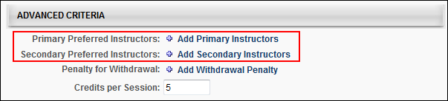
The selections that are available in the Primary Preferred Instructors field are associated with the vendor in the Primary Vendor field on the Properties step. The selections that are available in the Secondary Preferred Instructors field are associated with the vendor in the Secondary Vendor field on the Properties step. Important Note: If a primary or secondary vendor is not added on the Properties step, then there are no instructors from which to select in the respective primary and secondary instructors field on the Session Defaults page. Further, if there are no instructors associated with the vendor, then there are no instructors from which to select.
Selecting a primary or secondary preferred instructor is not required.
To add a primary or secondary preferred instructor:
- Click the Add Primary Instructors or Add Secondary Instructors link. This opens the Find Instructor pop-up.
- Select an instructor from the list or use the filter to search for an instructor by their first name or last name. Clicking the instructor's name closes the pop-up and adds the instructor to the field.
ILT Event - Create - Session Defaults - Resources
This section of the Session Default page enables administrators to view and manage default attachments for all sessions that are created for the event. The visibility of each attachment can be determined by the administrator. For example, some attachments may be visible to only administrators, while other attachments may be visible to all users. In addition, attachments can be made visible to users only if they are registered for the corresponding session. This section is only available for users that have permission to view or manage LO attachments.
Design Note: An updated interface is available for this page, which can be enabled by administrators in Feature Activation Preferences. With the new design, the functionality of the page is unchanged.
Permissions
PERMISSION NAME | PERMISSION DESCRIPTION | CATEGORY

Events - Create | Grants ability to create new instructor led training events. This permission works in conjunction with Events - View permission. This permission can be constrained by OU, User's OU, ILT Provider, and User's ILT Provider. This is an administrator permission. | Learning - Administration

Events - Edit | Grants ability to edit/update existing instructor led training events. This permission works in conjunction with Events - View permission. This permission can be constrained by OU, User's OU, ILT Provider, and User's ILT Provider. This is an administrator permission. | Learning - Administration

Events - View | Grants view-only access to instructor led training events, enabling the user to view all details/options that were selected when the event was created. This permission can be constrained by OU, User's OU, User's ILT Provider, and ILT Provider. This is an administrator permission. | Learning - Administration

LO Attachments - Manage | Grants ability to upload attachments to learning objects. Administrators with this permission are automatically granted the LO Attachments - View permission. This permission can be constrained by User's ILT Provider, Provider, and ILT Provider. This is an administrator permission. | Learning - Administration

LO Attachments - View | Grants ability to view the learning object attachments that are set to be available to administrators. This permission can be constrained by User's ILT Provider, Provider, and ILT Provider. This is an administrator permission. | Learning - Administration
Users with permission to manage LO attachments are able to view and manage the attachments, while users who only have permission to view attachments can only view the documents that have been attached to the LO. This section is hidden if the user does not have permission to view or manage LO attachments.
Add Attachment
To attach a document to an LO, click the Add Attachment link. This opens the Upload File pop-up.
Click the Browse button to locate and select the appropriate document. Then, click Upload to close the pop-up and attach the selected documents. After a file is attached to the LO, the administrator can configure the attachment title and visibility. The maximum file size is 15 MB, and attachments are limited to the following file types:
- docx
- doc
- gif
- jpeg
- jpe
- jpg
- pdf
- pps
- pptx
- ppt
- rtf
- txt
- xlsx
- xls
Edit Attachment
After a file is uploaded to the LO, the administrator can configure the attachment title and visibility. To edit an attachment, click the Edit icon to the right of the attachment title. The attachment title and visibility options become editable.
- Attachment Title - In the text field, enter the display name for the attachment, up to 300 characters. This is the name that is visible to all users, instructors, or administrators who have permission to view the attachment. Note: Only the first 75 characters display in the Resources section. Hover over the attachment title to view the full attachment title. However, the full attachment title is visible on the LO Details page.
- Set Visibility - Using the checkboxes, set the visibility for the attachment. When a user is included in the attachment visibility, the user can view and open the attachment. The following visibility options are available:
  - Admin - This option is selected by default and cannot be unselected. This option enables all administrators who have permission to view or manage attachments to view the corresponding attachment.
  - Instructor - This option is only available for session LOs. This option enables primary and secondary instructors for the corresponding session to view the attachment. Instructors can view attachments on the Session Defaults, Session Details, and Session Roster pages.
  - Registered Users - This option enables users who are registered for the corresponding LO to view the attachment. Attachments remain visible to users after they move past the Registered status (e.g., Complete). Registered users can view attachments on the Transcript Details page.
  - All Users - This option enables all users to view the attachment. This includes users who are browsing anonymously. All users can view attachments on the LO Details page.
Click the Save icon to save the changes or click the Cancel icon to discard any unsaved changes.
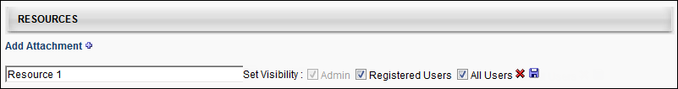
Attachment - View
This functionality is only available to users with permission to view LO attachments.
When an LO has attachments, they appear in the Resources section based on the date on which the document was attached, with the oldest attachments appearing first. The visibility settings for the attachment are displayed to the right of the attachment title.
Administrators can click the attachment title to open the attachment.
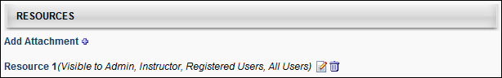
Attachment - Remove
This functionality is only available to users with permission to manage LO attachments.
To remove an attachment, click the Delete icon to the right of the attachment title. A confirmation pop-up displays. Click OK to remove the attachment. Or, click Cancel to cancel the action.
When an attachment is removed, it is no longer available anywhere in the system.

ILT Session Overview
Sessions enable administrators to create any type of scheduled learning event. Sessions may be instructor-led courses held in a classroom or virtual webcast sessions. It is helpful to think of sessions as scheduled instances of instructor-led training courses or individual occurrences of events. Course events include all of the "parent" information which defaults to the session, such as the course description, the objectives, the vendor, and the subjects. Events do contain some specific default session information as well, such as course prerequisites, course evaluations, and the registration procedures. While this kind of information defaults from the event setting, it can differ from one session to another because it is editable at the session level. However, sessions hold more specific data, including the times, locations, instructors, and resources for a specific course instance.
Design Note: This page has an updated interface (UI) that is automatically enabled. However, administrators can still revert to legacy UI via Feature Activation Preferences. The page's functionality is unchanged with the new design. With the July 26, 2024 Release, the new UI will be permanently enabled in all production, stage, and pilot portals, and the legacy UI pages will no longer be available. The new UIs disabled in March will be auto-enabled in July.
Permissions
PERMISSION NAME | PERMISSION DESCRIPTION | CATEGORY

ILT Evaluations - Print | Grants ability to print evaluations at the session level for any session within the permission constraints. This permission can be constrained by Instructor, ILT Provider, User's ILT Provider, and User as Instructor. This is an administrator permission. | Learning - Administration

Sessions - Cancel | Grants ability to cancel instructor led training sessions. This permission works in conjunction with Events - View and Sessions - View permissions. This is an administrator permission. | Learning - Administration

Sessions - Create | Grants ability to create new instructor led training sessions. This permission works in conjunction with Events - View and Sessions - View permissions. Administrators can only create sessions for events for which they have the availability to view. When adding users to a session in which the session roster is full, this permission grants the ability to increase the session's available seats. This permission can be constrained by OU, User's OU, Instructor, User as Instructor, Facility, Facilities Owned by User, ILT Provider, User's ILT Provider, User, and User Self and Subordinates. This is an administrator permission.  Note: The "Restrict to User as Instructor" constraint is available, but it does not actually constrain the permission. | Learning - Administration

Sessions - Create Child Sessions | Grants ability to create new instructor led training child sessions available when the backend setting to allow multiple providers for a session is enabled. When the multiple providers backend setting is enabled, administrators need this permission to create child sessions even if they have the Sessions - Create permission. This permission works in conjunction with Events - View and Sessions - View permissions. This is an administrator permission.  Note: This permission is visible in the system even if the backend setting to allow multiple providers for a session is disabled. However, the functionality to create child sessions is only granted when the backend setting is enabled. | Learning - Administration

Sessions - Edit | Grants ability to edit/update existing instructor led training sessions. This permission works in conjunction with Events - View and Sessions - View permissions. Administrators can only edit sessions for which they have the availability to view and edit. When adding users to a session in which the session roster is full, this permission grants the ability to increase the session's available seats. This permission can be constrained by OU, User's OU, Instructor, User as Instructor, Facility, Facilities Owned by User, ILT Provider, User's ILT Provider, User, and User Self and Subordinates. This is an administrator permission. | Learning - Administration

Sessions - View | Grants view-only access to instructor led training sessions, enabling the user to view all details/options that were selected when the session was created. This permission works in conjunction with the Events - View permission. This permission can be constrained by OU, User's OU, Instructor, Facility, Facilities Owned by User, ILT Provider, User's ILT Provider, User, User as Instructor, and User Self and Subordinates. This is an administrator permission.  Adding an OU constraint and a provider constraint to this permission results in an "AND" statement. | Learning - Administration
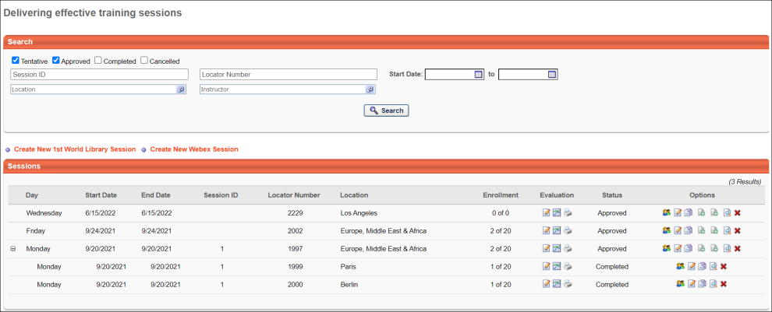
Search for Sessions
Select to view sessions that are in a Tentative, Approved, Completed, or Canceled status, or search by Session Number or Locator Number.
Create New Session
Click the Create New Session link to create a new session. See ILT Session - Create/Edit on page 99 for additional information.
Note: If this link is named Create New <Primary Vendor Name> Session and a Create New <Secondary Vendor Name> Session link appears to the right of it, then your portal has enabled the ability to configure multiple providers for a session.
Create New Session with Specific Provider
If the primary vendor is changed for the event, you can select which provider to use when creating new sessions from scratch. You can do this by clicking the linked name of the provider near the top of the sessions page. Or you can select the provider from the Select session provider before creating a new session drop-down and then click Create New Session.
The providers that are available to select are providers who have been tied to the event historically. In addition, the only available providers are those that fall within the your constraints for the Sessions - Create permission.
Note: The vendor for an event can only be changed if the Enable to change provider for events option is checked in ILT Preferences. In addition, the Enable to select provider when creating sessions option must also be checked in ILT Preferences in order for the provider to be selected when creating new sessions from scratch.
Note: If only one provider has been configured for the event, then no other providers are available in the drop-down. The drop-down does not display if the Enable to select provider when creating sessions option is unchecked in ILT Preferences.
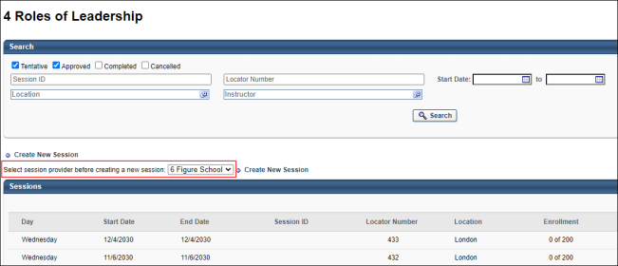
Sessions List
The following information displays for each session in the Sessions list:
- Day - If an Expand icon displays to the left of the session in the Day column, then your portal has enabled the ability to configure multiple providers for a session.
- Start Date - This column is only displayed if the Show both Session Time and Date in Sessions tables option is selected by the administrator in ILT Preferences.
- End Date - This column is only displayed if the Show both Session Time and Date in Sessions tables option is selected by the administrator in ILT Preferences.
- Session ID
- Locator Number
- Location - This column displays the next-level location name that has a facility type of City for each session. If no location in the hierarchy for the associated session has a facility type of City, then the Location column displays the Location name for the associated session. This column is dependent upon an organization's configuration settings of the Location OU hierarchy and Facility Type settings. Parent level Location OUs that are designated as a facility type of City are displayed in the Location column.
- Instructor
- Enrollment
- Status
Evaluation Options
The following Evaluation options are available in the Evaluation column:
- Edit Evaluation - Click this icon to manage the session evaluation.
- View Evaluation Report - Click this icon to run an evaluation report.
- Print Evaluation - This enables administrators and instructor-led training (ILT) instructors to print evaluations for the session and distribute them to all session attendees. This icon is only available if an evaluation is configured for the corresponding session and if the user has permission to print evaluations. Administrators and ILT instructors can click the Print Evaluations icon to open the Print Evaluations pop-up. See Session Evaluation - Print Pop-up on page 215 for additional information.
Options
The following options are available in the Options column:
- View Roster - Click this icon to view and manage roster. See Session Roster - Roster Tab on page 221 for additional information.
- Edit Session - Click this icon to make changes to an existing session. See ILT Session - Create/Edit on page 99 for additional information.
- Copy Session - Click this icon to create a copy of a session. See ILT Session - Create/Edit on page 99 for additional information.
- Session Options - Click the icon to create a child session. This option is only visible if your configuration allows multiple providers and if the user has the "Sessions - Create Child Sessions" permission.
- View Sessions Details - Click this icon to view session details. See Multiple Providers - Session - View Details on page 178 for additional information.
- Cancel Session - Click this icon to cancel a session. This cancels the session for all registered users and sends an email if active. For information about refunds on cancelled sessions: See Refunds Overview.
Note: If the Options column displays a Create Primary Session Option icon and a Create Secondary Session Option icon , then your portal has enabled the ability to configure multiple providers for a session. See Sessions Page and Session Options - Parts Schedule in the Session Options section of Online Help for more information about the session options functionality.
See also: ILT Scheduling Wizard

ILT Session - Create/Edit
To create an ILT event session, go to ILT > Manage Events & Sessions. Search for the appropriate event and in the Options column next to the event, click the View Sessions icon . To create a new session, you can do so via one of the following options:
- Click Create New Session to create a new session.
- Click Copy icon to create a copy of an existing session which can be changed or edited and saved as a new session.
- Click Edit icon to modify an existing session.
Design Note: An updated interface is available for this page, which can be enabled by administrators in Feature Activation Preferences. With the new design, the functionality of the page is unchanged.
If the primary vendor has been changed for the event, you can select which provider to use when creating new sessions from scratch. You can do this by clicking the linked name of the provider near the top of the sessions page. Or you can select the provider from the Select session provider before creating a new session drop-down and then click Create New Session. The providers that are available to select are providers who have been tied to the event historically. In addition, the only available providers are those that fall within the your constraints for the Sessions - Create permission.
Note: The vendor for an event can only be changed if the Enable to change provider for events option is checked in ILT Preferences. In addition, the Enable to select provider when creating sessions option must also be checked in ILT Preferences in order for the provider to be selected when creating new sessions from scratch.
Note: If only one provider has been configured for the event, then no other providers are available in the drop-down.
Note: Only the sessions for which you have the availability to view display.
Permissions
PERMISSION NAME | PERMISSION DESCRIPTION | CATEGORY

ILT Schedule Part Occurrence | Allows the admin to create more than one ILT session schedule part at the same time using a part occurrence schedule wizard. This is an administrator permission. | Learning - Administration

Sessions - Cancel | Grants ability to cancel instructor led training sessions. This permission works in conjunction with Events - View and Sessions - View permissions. This is an administrator permission. | Learning - Administration

Sessions - Create | Grants ability to create new instructor led training sessions. This permission works in conjunction with Events - View and Sessions - View permissions. Administrators can only create sessions for events for which they have the availability to view. When adding users to a session in which the session roster is full, this permission grants the ability to increase the session's available seats. This permission can be constrained by OU, User's OU, Instructor, User as Instructor, Facility, Facilities Owned by User, ILT Provider, User's ILT Provider, User, and User Self and Subordinates. This is an administrator permission.  Note: The "Restrict to User as Instructor" constraint is available, but it does not actually constrain the permission. | Learning - Administration

Sessions - Edit | Grants ability to edit/update existing instructor led training sessions. This permission works in conjunction with Events - View and Sessions - View permissions. Administrators can only edit sessions for which they have the availability to view and edit. When adding users to a session in which the session roster is full, this permission grants the ability to increase the session's available seats. This permission can be constrained by OU, User's OU, Instructor, User as Instructor, Facility, Facilities Owned by User, ILT Provider, User's ILT Provider, User, and User Self and Subordinates. This is an administrator permission. | Learning - Administration

Sessions - View | Grants view-only access to instructor led training sessions, enabling the user to view all details/options that were selected when the session was created. This permission works in conjunction with the Events - View permission. This permission can be constrained by OU, User's OU, Instructor, Facility, Facilities Owned by User, ILT Provider, User's ILT Provider, User, User as Instructor, and User Self and Subordinates. This is an administrator permission.  Adding an OU constraint and a provider constraint to this permission results in an "AND" statement. | Learning - Administration
Create Session
The session creation process includes the following steps:
- Parts Schedule
- Details
- Virtual Configuration - This section is only available when creating a session for a Citrix event.
- Availability
- Emails
- Pricing
- Training Units
- Summary
See also:
- ILT Scheduling Wizard
Troubleshooting Information
The following page contains a quick reference card to guide you through the process of creating a session:
- See Creating Sessions Quick Reference Card on page 193 for additional information.
Tips and Tricks
Session Schedule
- Users accessing this page can only see the facilities that they have permission and constraints to view.
- Users accessing this page can only see the instructors that they have permission and constraints to view.
- Sessions are listed on the Events Calendar after they are created.
ILT Preferences
The session defaults when creating an event are initially configured via ILT Preferences and are client-specific. You may or may not see all session defaults in your portal.
Registration Deadlines
Users may not register for a session after the registration deadline, but administrators can assign users to a session via a learning assignment after this date has passed.
Waitlist
- If Allow waitlists is not selected for a session, users will be denied when they register for a session that has no seats available.
- If Allow Auto-management of Waitlist/Grant waitlist opening to all users at once for first come first served registration is enabled, an administrator can still manually grant a waitlist one user at a time
- If the opening is granted to all, then the waitlist acceptance deadline is not enforced in order to avoid the possibility of having every user on the waitlist denied.
- If the Auto-Register feature is not on, then a user who is granted an opening will have their status changed to Registration Pending with the option to Register. The Grant Waitlist Request email trigger may be set up to notify this user, their manager, and the session administrators that the opening was granted.
- If a user does not register for a session before the waitlist acceptance deadline passes, their status will automatically change to Denied and the opening will be granted to the next user on the waitlist, if auto-management is on. An email trigger may be activated to notify the user of the waitlist acceptance deadline. A tag may also be added to the Waitlist Opening Granted email to let them know the deadline.
- The purpose of having the waitlist expire before the registration deadline is that it creates a period when all users (on the waitlist or off) can register on a first come first served basis for open seats. This will reduce the risk of having open seats on the session start date.
  - An email trigger may be set up to notify users with Waitlist Expired status when a seat becomes available before the registration deadline.
  - Users with waitlist expired status will have the option to Register or Select Session. If they attempt to register for a class that is full, they will not be denied, they will just see a message that tells them the class is full and that they may attempt to register for open seats when they become available.
Costs, Refunds & Penalty
Costs per Session are not displayed to the users. These costs are only used for reporting purposes to view the summary of total costs across certain division or during specified time periods. This data is found in the Session Cost Report under ILT Admin reports.
All refunds and withdraw or no-show penalties are billed to the user (or their cost center) on the session registration date.
If the Always refund withdrawal penalties if withdrawn user's place is filled preference on the Corporate ILT Preferences page is selected, then withdrawn users will have their penalties refunded in the order that their seats are filled.
Prerequisite, Pre-Work & Post-Work
If a user has not completed (or registered for) the session prerequisites, they will generate an exception request. Their status will be Exception Requested, and if activated emails will be sent and they will not have the option to register until the exception is granted.
Instructors and session administrators may exempt students from Pre-work or Post-work from the Session Roster. See Session Roster Overview on page 219 for additional information.
Training Contact
Administrators can choose to display a training contact for event and sessions. The event contact will default to the person scheduling the Event, but can be overridden. The session contact will default to the person scheduling the Session, but can also be overridden. These contacts will be displayed to the users when they search for the training, with their phone numbers, fax numbers, and email addresses listed.
- When this field is activated, events that have been created in the past will not have anybody listed in the training contact field. Editing an event without a contact will not default the contact field with the person performing the editing.
Advanced Registration
During the advanced registration period, users who are not on the interest tracking list for the event and location (or a parent of that location), at the time the event was created, will see that session as unavailable to them.
- Users who subsequently join the interest tracking list will not be invited to join an advanced registration period that has already started. These users will still see the session as unavailable to them.
- Users join the interest tracking list from the Event Summary page (when they search for an event) and click the I would like to be notified when sessions at another location or time are scheduled link.
- If the Add users on the waitlist to the interest tracking list for that event and location preference is checked on the Corporate ILT Preferences page, then users who are waitlisted for other sessions for this event and location are eligible for advanced registration. These users join the interest tracking list as soon as they are added to the waitlist.
- The Advanced Registration email trigger may be activated to notify users that they are eligible for advanced registration.
Enrollment Restrictions
If enrollment restrictions are placed on organizational units, the number of seats available to a user differs depending on the maximum registration defined for the OU, and the number of users currently registered from their organizational unit (OU).
If enrollment restrictions are placed on organizational units, then users whose organizational units have 0 seats available will be added to the waitlist.
- There may be users on the waitlist when there are seats available for users from other OUs.
- When the auto-management feature is on, the system will automatically check the OU availability for each user on the waitlist and only grant the opening to users who have seats available in their OU.
For users in multiple OUs, if one of their OUs reaches the maximum enrollment allowed, they cannot register for the session. Even if one of the other OUs they are in has not reached the maximum enrollment allowed, they cannot register. They are placed on the waitlist, if waitlisting is configured, or an exception request must be granted in order for them to register.

Create Session - Parts Schedule
When creating a session, the first step is to define a part for the session. See Create Session - Parts Schedule - Define Part on page 107 for additional information.
After at least one part is defined for a session, the parts are displayed in the Parts Schedule table. To create an ILT event session, go to ILT > Manage Events & Sessions. Search for the event and in the Options column next to the event, click the View Sessions icon . To create a new session, click the Create New Session link.
Design Note: An updated interface is available for this page, which can be enabled by administrators in Feature Activation Preferences. With the new design, the functionality of the page is unchanged.
Permissions
PERMISSION NAME | PERMISSION DESCRIPTION | CATEGORY

Events Calendar | Grants access to view Events Calendar page. This permission also makes the Event Calendar button on the Learning Search page visible. This is an end user permission. | Learning

ILT Schedule Part Occurrence | Allows the admin to create more than one ILT session schedule part at the same time using a part occurrence schedule wizard. This is an administrator permission. | Learning - Administration

Sessions - Cancel | Grants ability to cancel instructor led training sessions. This permission works in conjunction with Events - View and Sessions - View permissions. This is an administrator permission. | Learning - Administration

Sessions - Create | Grants ability to create new instructor led training sessions. This permission works in conjunction with Events - View and Sessions - View permissions. Administrators can only create sessions for events for which they have the availability to view. When adding users to a session in which the session roster is full, this permission grants the ability to increase the session's available seats. This permission can be constrained by OU, User's OU, Instructor, User as Instructor, Facility, Facilities Owned by User, ILT Provider, User's ILT Provider, User, and User Self and Subordinates. This is an administrator permission.  Note: The "Restrict to User as Instructor" constraint is available, but it does not actually constrain the permission. | Learning - Administration

Sessions - Edit | Grants ability to edit/update existing instructor led training sessions. This permission works in conjunction with Events - View and Sessions - View permissions. Administrators can only edit sessions for which they have the availability to view and edit. When adding users to a session in which the session roster is full, this permission grants the ability to increase the session's available seats. This permission can be constrained by OU, User's OU, Instructor, User as Instructor, Facility, Facilities Owned by User, ILT Provider, User's ILT Provider, User, and User Self and Subordinates. This is an administrator permission. | Learning - Administration

Sessions - View | Grants view-only access to instructor led training sessions, enabling the user to view all details/options that were selected when the session was created. This permission works in conjunction with the Events - View permission. This permission can be constrained by OU, User's OU, Instructor, Facility, Facilities Owned by User, ILT Provider, User's ILT Provider, User, User as Instructor, and User Self and Subordinates. This is an administrator permission.  Adding an OU constraint and a provider constraint to this permission results in an "AND" statement. | Learning - Administration
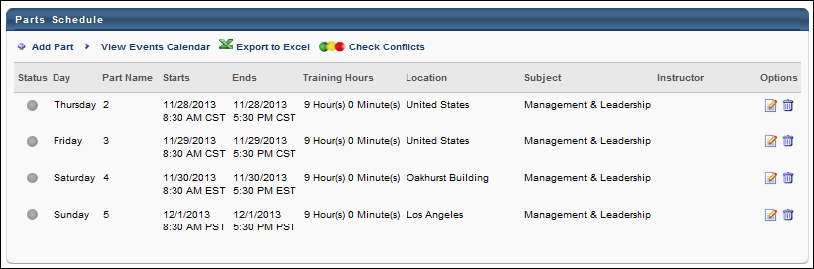
Webex Integration Note: For additional considerations when creating a Webex virtual session, meeting, or training session, creating session parts, and adding instructors, see ILT Webcast.
Adobe Connect Integration Note: When creating a session for an Adobe Connect seminar room facility, certain information must be entered in order to map it to the seminar room in Adobe Connect. See Move Session to Adobe Connect Seminar Room for additional information.
Add Part
If the session duration is more than a day, or if separate sessions within the same day are required, add the session parts by clicking the Add Part link on the Parts Schedule page. Multiple parts can be added if the session covers multiple days or time periods, or if parts of the session are held at different locations. Repeat the process for each required part.
View Events Calendar
Click this link to display the events calendar.
Export to Excel
Click this link to export the parts schedule to Excel.
Check for Conflicts
Click this link to check if multiple sessions are being conducted at the same date, time, and location. If a prior session has been scheduled at the same time as the session you are creating, a message is displayed and session details of the conflicting session are displayed. This message can be bypassed by clicking Next or Save.
Parts Schedule Table
The following information is displayed in the Parts Schedule Table:
- Status - This light represents the session status.
- Day - This is the day of the week on which the session part occurs.
- Part Name - This is the session part name as defined for the part.
- Starts - This is the date and time on which the session part starts.
- Ends - This is the date and time on which the session part ends.
- Training Hours - This is the number of training hours that are associated with the session part. This is calculated using the start and end times of the session part. Note: Part breaks are not included in the training hours for the part. For example, if a part has a Start Time of 8:00 AM, an End Time of 5:00 PM, and a Part Break of 30 minutes, then the total training hours for the part is 8.5 hours.
- Location - This is the location of the session part as defined for the part.
  - Note: A Location must be provided when creating the session to be able to generate a session QR code.
  - A Tax Location icon appears next to a location if it is the tax location for the session. The tax location is the location on which the tax should be based for the session, and it is set on the Pricing page for the session. If no tax location is set for the session, then the Tax Location icon does not appear for any session part.
- Instructor - This is the instructor for the session part as defined for the part.
- Options - The following options are available in the Options column:
  - Edit - Click this option to edit the part.
  - Delete - Click this option to delete the part.
Save or Continue
Click Save to save the session, or click Next to set Session Details. The session will inherit the availability and the session setting details from the event unless changed.
Create Session - Parts Schedule - Define Part
When creating a session, the first step is to define a part for the session. See Create Session - Parts Schedule - Define Part on page 107 for additional information.
After at least one part is defined for a session, the parts are displayed in the Parts Schedule table. To create an ILT event session, go to ILT > Manage Events & Sessions. Search for the event and in the Options column next to the event, click the View Sessions icon . To create a new session, click the Create New Session link.
Design Note: An updated interface is available for this page, which can be enabled by administrators in Feature Activation Preferences. With the new design, the functionality of the page is unchanged.
To define a session part, enter the following information:
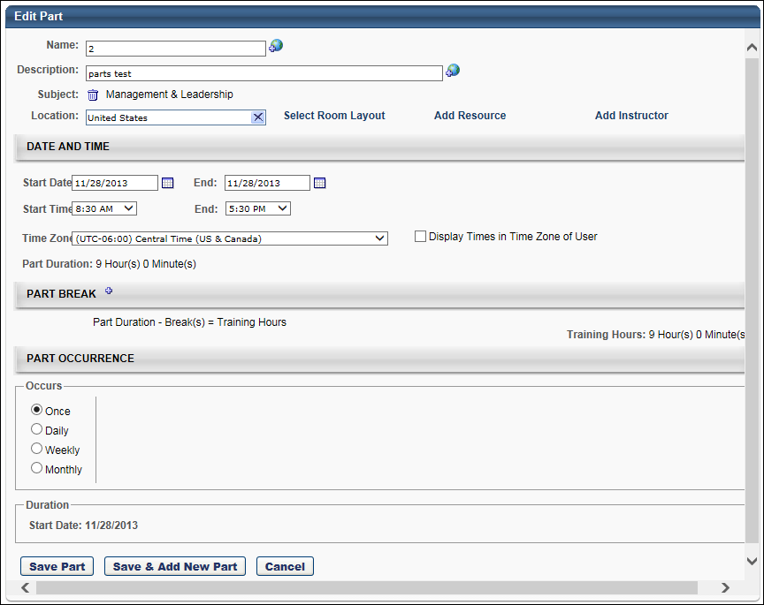
General Information
- Name - Enter a session name. The character limit is 50.
- Description - Enter a session description.
- Subject - Add a subject to the part by clicking the Add Subject link. This opens the Find Subject pop-up. Select a subject, which closes the pop-up automatically and populates the Subject field with the selected subject. Only one subject can be selected for a part.
  - The ability to add a subject to a part is and limit the number of subjects added to an LO is controlled by backend settings that are turned off by default. If the backend setting that limits the number of subjects that can be added to a part is set to one, then when the part is created, the part automatically inherits the subject of the event. If the backend setting is set to a value greater than one and the event has multiple subjects, no subjects from the event are inherited to the part and the part is not required to have a subject. If the event has one subject, the part inherits the subject of the event. Note: Subjects inherited from events do not display on the Add/Edit/Copy Part page or in the Subject column of the Parts Schedule. However, they are searchable in Global Search and Learning Search.
  - When copying an event or session, all subjects configured for all parts are copied.
  - If a subject is added to a part, it can no longer be deleted from Subjects Management.
- Location - Click this field to select a location. Session locations are managed in Facilities and Resources. See Facilities and Resources Administration on page 17 for additional information. See the Facilities, Room Layouts & Resources Tips section below for additional information.
  - Search for a location by Name, ID, or Owner. Then add the location by clicking the plus icon to the left of the location name. Note: A Location must be provided when creating the session to be able to generate a session QR code.
  - Select the Confirmation Required option to require the session's location to be approved by the Facility Owner before the session is approved. In this situation, the session status is Tentative the session is not searchable until the Facility Owner confirms.
  - In the Notes field, enter notes for the Facility Owner. These notes are viewed when the Facility Owner responds to the request.
  - Click Done. If confirmation is required, the location has a check mark next to it.
- Select Room Layout - Click this link to display available room layouts for the location, if applicable. Note: Room Layouts must be created for the location when setting up the location. See the Facilities, Room Layouts & Resources Tips section below for additional information.
  - Select a room layout by clicking the room layout name.
- Add Resource - Click this link to display available resources for the location, if applicable. Note: Resources must be created for the location when setting up the location. See the Facilities, Room Layouts & Resources Tips section below for additional information.
  - Click the applicable resource. Resources are tied to the facility.
  - Enter quantity needed in Quantity field.
  - Select whether the specified quantity is Per Part or Per Student.
  - Select the Confirmation Required option to require the resources to be approved by the Facility Owner before the session is approved. In this situation, the session status is Tentative the session is not searchable until the Facility Owner confirms.
  - Click Done. The selected resources are listed on the Session Schedule page with the quantity in parentheses.
- Add Instructor - Click this option to display available instructors for the vendor/provider for this session (Provider/Vendor is set at the event level). See the Instructor Tips section below for additional information.
  - Search for an instructor by name by their first name or last name. Then, select the instructor by clicking the instructor name.
  - From the Role drop-down list, select whether the instructor is the Primary or Secondary instructor.
  - Select the Confirmation Required option to require the instructor to be approved by the Facility Owner before the session is approved. In this situation, the session status is Tentative the session is not searchable until the Facility Owner confirms.
  - Click Done. You can then add additional instructors if necessary by repeating the process.
  - If confirmation is required, instructors have a check mark next to their name. Also, the Request Instructor email may be triggered, if enabled.
Date and Time
- Start Date - Enter the session start date with the format (MM/DD/YYYY) or click on the calendar icon to select a date. If the Start Date field is blank, ILT Preferences are configured to allow administrators to enter a start date manually. If the Start Date field is populated, ILT Preferences are configured to display a default start date that is a certain number of days following the end date of the most recently added part. See ILT Preferences - General for additional information.
- End Date - Enter the session end date with the format (MM/DD/YYYY) or click on the calendar icon to select a date. If the End date field is blank, ILT Preferences are configured to allow administrators to enter an end date manually. If the End date field is populated, ILT Preferences are configured to display a default end date that is a certain number of days following the end date of the most recently added part. Start date and end date should be the same unless the sessions spans across midnight. Multi-day sessions should be scheduled using Part Break functionality.
- Start Time - On the first instance of adding a part to a session, the default value in the Start Time field is dependent on the default configuration of this field in ILT Preferences. The default start time in ILT Preferences is 8:30 AM but can be modified by the administrator. If modified by the administrator, the Start Time field displays the setting configured by the administrator. To change the start time, select the session start time from the drop-down list. Note: When adding a part to a session that has at least one existing part, the start and end time will be the same as the most recently added part. See ILT Preferences - General for additional information.
- End Time - On the first instance of adding a part to a session, the default value in the End Time field is dependent on the default configuration of this field in ILT Preferences. The default end time in ILT Preferences is 5:30 PM but can be modified by the administrator. If modified by the administrator, the End Time field displays the setting configured by the administrator. To change the end time, select the session end time from the drop-down list.
- Time Zone - Select the time zone in which the session start and end times are provided. For example, if the session start time is 10:00 AM Pacific Time, select 10:00 AM for the start time and select Pacific Time as the time zone. For Webex sessions, the selected time zone is sent to Webex. Note: Daylight saving time (DST) time zones are supported for ILT for events or sessions.
- Display Times in Time Zone of User - This field allows administrators to display the session start and end times in the time zone of the user viewing the session. This field is checked by default if the Display Times in Time Zone of User field is checked on the Session Details page when configuring the event.
When unchecked for standard sessions, the session start and end times display in the time zone defined on the Parts Schedule page. When unchecked for vILT sessions, the start and end times display in the user's time zone only on the Events Calendar page and in the time zone defined on the Parts Schedule page in all other areas of the system where the start and end time appear.
When this field is checked, the session start and end times display in the user's time zone in the following areas of the system for both standard and vILT sessions:
  - Events Calendar > Start field in calendar box
  - Events Calendar > Start and end times in training details hover pop-up
  - LO Details page > Registration Deadline field
  - LO Details page > Starts/Ends fields in Schedule section
  - Training Details page > Start and Ends columns
  - Transcript > Select Session pop-up
System default and custom emails that include the session start and end time via email tags (REGISTER.DEADLINE, SESSION.END.DATE, SESSION.END.TIME, SESSION.START.DATE, SESSION.START.TIME) also display the times in the user's time zone. The affected emails are configured in the following areas of the system:
  - Create/Edit Session > Emails tab
  - Email Administration > ILT Administration emails
  - Email Administration > Instructor Led Training emails
Part Break
Click the plus icon to the right of the Part Break heading to add a part break.
In the field, enter the name of the break (e.g., lunch, coffee break). If multiple languages are enabled for your portal, select the Translate icon to translate the field into other available languages.
Enter any break duration in minutes. For example, if there is a lunch break or a nighttime break for a multi-day session.
To delete a part break, click the Delete icon to the left of the break.
Note: Part breaks are not included in the training hours for the part. For example, if a part has a Start Time of 8:00 AM, an End Time of 5:00 PM, and a Part Break of 30 minutes, then the total training hours for the part is 8.5 hours.
Part Occurrence
Select the occurrence of the part, whether it's Once, Daily, Weekly, or Monthly. Note: When creating a session for an event associated with a Citrix provider, the Part Occurrence section is not available because only one part is allowed for Citrix sessions.
Save Options
Click Save Part or Save & Add New Part button to continue.
Facilities, Room Layouts & Resources Tips
Room Layouts are not specific to Facilities.
Resources are specific to Facilities and can be defined as reusable or not. If resources are not reusable, then the number of available resources will decrease once they have been assigned to a session.
- Facilities inherit the resources of their parent facilities. For example, if a building has two projectors, every room in that building has access to those two projectors.
If resource confirmation is required, there will be a resource request for each Session for which the resource is selected.
If facility confirmation is required, there will be a facility request for that Session listing each part for which the Facility is selected.
When a session is created, a facility request for the location of that session's parts is always generated, regardless of whether or not the Confirmation Required box is checked for those Locations.
- The facility request status is Pending if that Facility has the Approval Required box checked on the Facility Details page. The status of the facility request does not depend on whether the Confirmation Required box was checked for that Session.
- If the Approval Required checkbox on the Facility Details page is not checked, or if the session scheduler is same as the facility's owner, then the request will automatically be approved.
- The facility request will remain Pending until the facility owner approves the request.
- If the Confirmation Required box is checked for that facility, for that session, the status of that session will be Tentative until that facility request has been approved.
If the Approval Required box is not checked on the Facility Details page, or if the session scheduler is the same as the facility's owner, the request is automatically approved.
Instructor Tips
If instructor confirmation is required, there will be an instructor request for that session. All the parts of that session part for which the instructor is specified, will be grouped into that request.
Instructor requests, resource requests, and facility requests are respectively sent to the Inbox of the instructors, resource or facility owners and are managed and responded to under Facilities & Resources.
Create Session - Details
The Details tab is the second step in the session configuration process. Details settings include the basic information for the session.
Design Note: An updated interface is available for this page, which can be enabled by administrators in Feature Activation Preferences. With the new design, the functionality of the page is unchanged.
To create an ILT event session, go to ILT > Manage Events & Sessions. Search for the event and in the Options column next to the event, click the View Sessions icon . To create a new session, click the Create New Session link. Navigate through the process to the Details step.
Permissions
PERMISSION NAME | PERMISSION DESCRIPTION | CATEGORY

ILT Schedule Part Occurrence | Allows the admin to create more than one ILT session schedule part at the same time using a part occurrence schedule wizard. This is an administrator permission. | Learning - Administration

Sessions - Cancel | Grants ability to cancel instructor led training sessions. This permission works in conjunction with Events - View and Sessions - View permissions. This is an administrator permission. | Learning - Administration

Sessions - Create | Grants ability to create new instructor led training sessions. This permission works in conjunction with Events - View and Sessions - View permissions. Administrators can only create sessions for events for which they have the availability to view. When adding users to a session in which the session roster is full, this permission grants the ability to increase the session's available seats. This permission can be constrained by OU, User's OU, Instructor, User as Instructor, Facility, Facilities Owned by User, ILT Provider, User's ILT Provider, User, and User Self and Subordinates. This is an administrator permission.  Note: The "Restrict to User as Instructor" constraint is available, but it does not actually constrain the permission. | Learning - Administration

Sessions - Edit | Grants ability to edit/update existing instructor led training sessions. This permission works in conjunction with Events - View and Sessions - View permissions. Administrators can only edit sessions for which they have the availability to view and edit. When adding users to a session in which the session roster is full, this permission grants the ability to increase the session's available seats. This permission can be constrained by OU, User's OU, Instructor, User as Instructor, Facility, Facilities Owned by User, ILT Provider, User's ILT Provider, User, and User Self and Subordinates. This is an administrator permission. | Learning - Administration

Sessions - View | Grants view-only access to instructor led training sessions, enabling the user to view all details/options that were selected when the session was created. This permission works in conjunction with the Events - View permission. This permission can be constrained by OU, User's OU, Instructor, Facility, Facilities Owned by User, ILT Provider, User's ILT Provider, User, User as Instructor, and User Self and Subordinates. This is an administrator permission.  Adding an OU constraint and a provider constraint to this permission results in an "AND" statement. | Learning - Administration
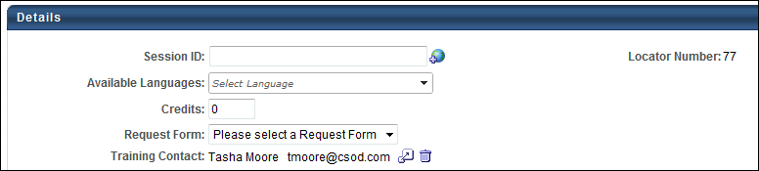
Details
- Session ID - Enter a session ID number that will be used to identify the session.
- Locator number - This is a system-generated number that is automatically populated and is used to uniquely identify the session.
- Available Languages - This displays the languages in which the session is available. If multiple languages are enabled for the portal and more than one language is selected in the Language field on the Properties step when creating the event, a Select Language drop-down displays to select the available languages for the session. If multiple languages are enabled for the portal and only one language is selected on the Properties step when creating the event or if multiple languages are not enabled for the portal, then the available language displays with no drop-down.
- Credits - Enter a number of credits that are awarded for completion of the session.
- Webex Extended Options - Click this link to set the default Webex extended options for the session. Visibility of this functionality requires that your Webex is integrated with the system ILT and that you have permission to set the default Webex options. See Create Session - Webex Extended Options on page 157 for additional information.
- Hands on Lab - Click this link to reserve computers from a Webex hands-on lab. Visibility of this functionality requires that your Webex is integrated with the system ILT. See Create Session - Webex Hands-On Lab on page 161 for additional information.
- Request Form - Select a request form from the drop-down if applicable. User can complete this form at the time they request the session.
- Required Training Approvals - Enter the number for this learning object for initial approval. If this is left blank, it defaults to the number of required training approvals set in the User Record. Setting required training approvals at the LO level overrides the required training approvals in the user record.
- Required Completion Approvals - Enter the number of completion approvals that are required for the session to be marked complete. If this is left blank, the LO follows the normal workflow for LO completion. If a value is entered (number greater than 0) the LO requires completion approval for all users who complete the training using the normal approval workflow process.
- Training Contact - Select a contact for the LO by clicking the Select icon . The administrator who is creating the LO is listed as the training contact by default, but this can be changed. Only one contact person can be selected. To delete the training contact, click the Delete icon to the right of the training contact. This field is optional.
QR Code
In the QR Code section of the Details step of the session creation process, the following QR code configuration options are available to the administrator:
- Enable QR Code - To enable QR code functionality for the session part, select the Yes option for the Enable QR Code field. If QR codes should not be activated for the session, leave the No option selected.
- Activation Time - Configure the activation time for QR codes generated for the session part. The activation can be a specified number of hours or minutes before or after the session part starts or begins. The QR code begins to be scannable at the defined activation time, either before or after a session part starts or ends. Example: Activation time is set to 2 hours before a session part starts. The session part begins at 10am. This means a user or instructor can scan QR codes beginning at 8am.
  - When setting the activation time for x amount of time "Before" a session part start or end, the session QR code will be active from the "Before" time through the part's start or end, depending on which was selected. Example: If Activation Time is set for 2 hours before part start, and the part starts at 10am, the session QR code is active from 8am - 10am.
  - When setting the activation time for x amount of time "After" a session part start or end, the session QR code will be active from the part start or end time, depending on which was selected, until the "After" time is reached. Example: If Activation Time is set for 2 hours after the session part start, and the part starts at 10am, the session QR code would be active from 10am - 12pm.
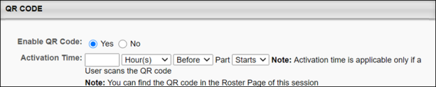
Email Tag for QR Codes
When QR code functionality is available for a session, a new SCHEDULES.DETAILS email tag is available when configuring session emails. The SCHEDULES.DETAILS email tag can be used in the following email types:
- Session Changed
- Session Start Date
- ILT Session Becomes Available
Resources
The Resources section on the Details tab enables administrators to view and manage attachments for the session. The visibility of each attachment can be determined by the administrator. For example, some attachments may be visible to only administrators, while other attachments may be visible to all users. In addition, attachments can be made visible to users only if they are registered for the corresponding session. This section is only available for users that have permission to view or manage LO attachments.
When the session is first created, this section contains any attachments that were added on the Session Defaults page for the event.
See Create Session - Details - Resources on page 133 for additional information.
Registration
- Attendance - Enter the number of session parts that must be attended by a user in order for the session to be marked complete in the user's transcript. For example, if there are five parts, a user may need to only complete three parts in order to complete the session. On the other hand, a user may also have to complete all five parts in order to complete the session.
- Advance Registration - If configured to display, you can select to allow users to register in advance, determine approval settings, and set the advanced registration period.
  - Allow Advance Registration for Interested Users - Select this option to allow advanced registration.
  - Users are Pre-Approved - Select this option to allow advanced registration users to be pre-approved.
  - Register Users on Approval - Select this option to allow users to be pre-approved.
  - is the number of days that advanced registration lasts after the session is created. The number of days that displays in the box is configured at the event level or in ILT Preferences. You can keep the default number or enter a different number.
- Registration Deadline - The deadline set here applies to the request and the registration. For example, if the deadline is 2 days before the first part of the session starts, the user must request the session and register by this deadline. This functionality can be useful with multi-part sessions where attendance of later parts is not contingent upon attendance of earlier ones because this option allows users to miss certain parts, but still attend others as needed. The administrator can also set a minimum number of parts that are required for completion. If the administrator edits the first part start time or the registration deadline, the request and registration deadline is recalculated for new users who wish to request or register for the session. If no registration deadline is added, then the default deadline is the start date and time of the session.
  - Select whether or not the deadline occurs before or after the first part of the session starts. This is selected from the last drop-down list.
  - From the middle field, select whether the deadline will be measured in minutes, hours, days, or weeks. For example, if you are setting the deadline to 4 days before the first part starts, select days from the middle field since you are measuring the deadline in days.
  - Specify the number of minutes, hours, days, or weeks before or after the first part starts that the deadline occurs. This quantity combines with the time unit and the before/after drop-down list to determine the deadline. For example, if you set the deadline as 10 minute(s) after first part of session starts, users must register for the session no more than 10 minutes after the first part starts. If a user attempts to register 11 minutes after the first part starts, they cannot register. Note: The system may display a variation of the time specified. For example, 24 hours is displayed as 1 day, and 60 minutes is displayed as 1 hour.
- Minimum Registration - Enter number of minimum registration users. The number of days that displays in the box is configured at the event level. You can keep the default number or enter a different number. This field is required. Email Notification email.
Minimum Registration Notification
  - Administrators can use the Registration Deadline email trigger to notify instructors or session administrators of low registration.
    - Create a new registration deadline email.
    - Set the email type to Reminder.
    - Specify the number of days before or after the registration deadline that the email is to be sent out.
    - Enter the condition CURRENT.REGISTRATION < MAX.REGISTRATION or CURRENT.REGISTRATION < [number].
    - Select instructor and session administrator as recipients.
    - Set email as active.
    - Enter tag CURRENT.REGISTRATION in the text to display the current notification.
    - This email can be used to help instructors and session administrators determine when sessions should be canceled.
- Maximum Registration - Enter number of maximum registration users. The default value is configured at the event level. You can keep the default number or enter a different number. This field is required. The maximum registration for sessions is 1,000 unless the sessions use a Citrix integration.
  - Citrix Integration Note: When creating a session for a Citrix event, the maximum registration is 25.
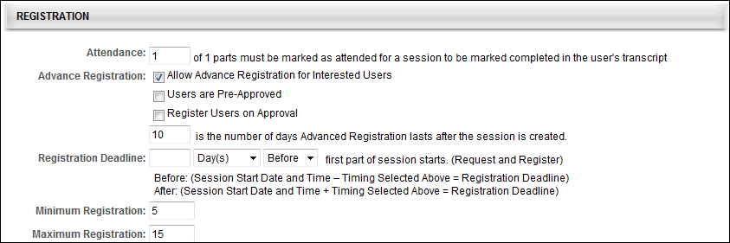
Enrollment
The Enrollment section on the Details tab allows administrators to limit the number of users by OU that can enroll for the event's sessions. If enrollment restrictions are placed on organizational units, the number of seats available to a user differs depending on the maximum registration defined for the OU, and the number of users currently registered from their OU.
Note: This section only displays if the "Allow reservation of seats" option or at least one of the "Allow enrollment restrictions" options are enabled in ILT Preferences.
See Create Session - Details - Enrollment on page 122 for additional information.
Waitlist
- Allow waitlist for sessions in this event - Check to allow waitlists. Users will be added to the waitlist when they register for a session with no seats available. Each session has a separate waitlist.
- Allow Auto-Management of Waitlist - Allow the system to manage the waitlist by maintaining a list of waitlisted users and granting waitlisted users a seat automatically if one becomes available or if another session is created.
  - Grant waitlist opening to one user at a time based on priority - Select to grant a waitlist opening to one user at a time based on the waitlist order.
  - Grant opening to all waitlisted users at once for first come first served registration - Select to grant waitlist opening to all users as soon as an opening is available.
- Auto-Register User upon Granting Waitlist - When a user is granted a seat from the waitlist, users are automatically registered if this option is selected.
- Waitlist Deadlines - If configured to display in ILT Preferences, you can set the period of time waitlisted users have to register. A default number for each box can be configured at the event level.
  - Time students have to register - Set the number of days and hours waitlisted users have to registered.
  - Waitlist expires XX days and XX hours before session start date - Set when the waitlist expires in relation to the session start date.
- Limit users to one waitlist per event - This option is not editable at the session level. It displays the configuration that is set at the event level. When this option is selected, users can only add themselves to one waitlist for the corresponding event. If this option is selected and a user attempts to add themselves to more than one waitlist for the event, then a message is displayed, indicating that they can only be on the waitlist for one session in the selected event. Note: This option is only visible if the Allow waitlist for sessions in this event option is selected.
  - When this option is selected, it limits users for all waitlist requests for the event after the preferences are saved. The system does not remove users from any waitlists if they have previously been added to multiple waitlists for the event. However, if this option is enabled, a user is already added to multiple waitlists for the event, and the user requests to be added to an additional waitlist for the same event, then the user must be removed from all other session waitlists for the event in order for the request to be granted.
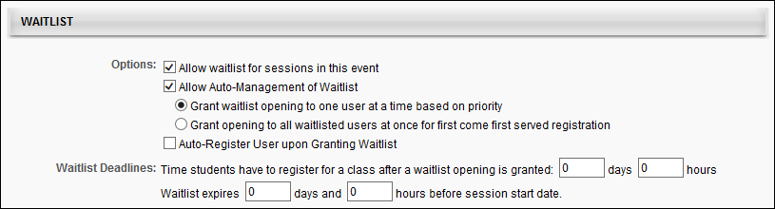
Cost
- Price - Enter a price for session. Each user (or their cost center) will be billed this price upon registration. Administrators can enter any number of decimal places. Once the page is saved, this field is rounded to use two decimal places of precision.
- Cost Per Session:
  - Click Add Cost Type link.
  - Select Cost Type from drop-down.
  - Enter amount of cost. Administrators can enter up to ten digits, including decimal places. Once the cost is saved, this field is rounded to use two decimal places of precision.
  - Click Save icon.
  - Repeat steps to add other costs.
- Total Cost per Session - When a cost is added in the Cost per Session field, this field is displayed, and appears and displays the sum of the Cost per Session costs. Administrators are only able to add one cost per cost type. If no cost is added in the Cost per Session field, then the Total Cost per Session field does not display. This calculation uses the rounded values that are displayed. This field always uses two decimal places of precision.
- Penalty for No-Show - No Show penalties are charged to users who do not attend any part of a session for which they are registered (without prior withdrawal).
  - Specify the monetary value that is charged and also specify the amount of training units that is penalized. Training unit prices can be represented using up to two decimal places.
  - No-show penalties are charged in the same form of payment that is used to purchase the session. If a user purchases a session with training units, but does not have any training units in their account, the no-show penalty is deferred to the monetary amount. If training units is not enabled for the portal, the training unit option is not available.
  - All no-show penalties are billed to the user (or their cost center) when the roster is submitted.
- Restrict Withdraw from Session - When this option is selected, users that are registered for the session are unable to withdraw from the session.
- Penalty for Withdrawal:
  - Click on Add Withdrawal Penalty link.
  - Enter % or $ amount of penalty for withdrawals from the event's sessions.
  - Enter number of days before session start date that penalty to be incurred.
  - Click Save icon.
  - Repeat steps to add another refund.
- Refunds - All refunds are billed to the user (or their cost center) on the session registration date. Multiple refund terms can be configured.
  - Add Monetary Refund Term - Click this link to add a monetary refund term. This adds a new line to this section, which is listed below.
    - Refund XX% or $XX for withdrawals XX days prior to session start date - For a monetary refund, you may specify the percentage of the cost that is refunded, or you can specify the monetary amount. Also, specify the number of days prior to the session start date by which the user must withdraw to receive the specified refund. Click the Save icon to save the refund term. The maximum number of days is 9999.
    - Note: Refunds cannot be greater than the session cost.
  - Add Training Units Refund Term - Click this link to add a training unit refund term. This enables the refund terms fields to appear below the link. Note: This option is only available if training units are enabled for the portal.
    - Refund XX Training Units for withdrawals XX days prior to session start date - For a training unit refund, enter either a percentage of training units to refund or a specific amount of training units to refund. The percentage field accepts values between 1 and 100. Training unit prices can be represented using up to two decimal places. Then, specify the number of days prior to the session start date by which the user must withdraw to receive the specified refund. The maximum number of days is 9999.Click the Save icon to save the refund term. Note: If you only click the Save button at the bottom of the page before clicking the Save icon, the refund terms are not saved.
Only one refund type can be configured. Therefore, if issuing a refund percentage, the Training Units field must be left blank and vice versa. Refunds cannot be greater than the session cost.
For training unit percentage refunds, if the user purchased the session with distributed training units, then the percentage is refunded to their personal training units account. If the user purchased the session with a training unit key code, then the percentage is refunded to their key code.
Note: If refunds are automated as specified in the ILT Preferences, the user is refunded the entire amount less any processing fees. All refunds are made in the original form of payment. If a user paid by credit card, the refund is made via credit card. If both training units and credit cards are enabled, you must specify a refund term for each available payment method.
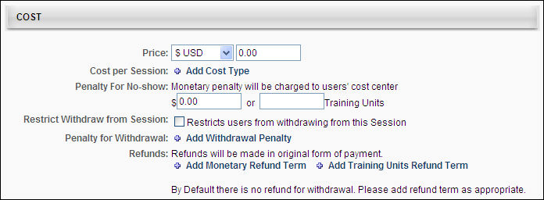
Prerequisites
The Prerequisites section on the Details tab enables administrators to set prerequisites for the session, and the defined prerequisites must be completed by the user before they are able to register for the session. The status of the training will be Exemption Requested or Pending Prerequisite until the user completes the prerequisites. It is not required that a session have prerequisites. See Create Session - Details - Prerequisites on page 129 for additional information.
Pre-Work
- Click on Add icon .
- Search for training by keyword by entering full or partial title or description in Keyword free-text box.
- Click Search button.
- Click Add icon to add training. Note: If you have permission to restrict the Select Training pop-up, the learning objects visible to you are dependent upon the availability set for this permission. Also, non-required learning objects cannot be marked as post-work for a learning object that is post-work of another item. This causes a circular reference, and a learning object cannot refer to itself.
- Add free form training if applicable by entering title in Free Form Training free-text box.
- Click Add.
- Click Done.
- Repeat the above steps to add more free form training.
- Check Req. for each training item that is required for the completion of the class.
  - If a student does not complete this training, their status will be Pending Pre-work. After completing the required pre-work, users will receive a Completed status for the session.
- Enter number for the training sequence in the Seq. free-text box for each training item to set a required sequence for the training.
  - If there is a required sequence, users will not be able to request training until the training which is before it in the sequence is completed first.
  - If no numbers are entered, students may take all the pre-work training in any order or all at once.
- Enter number for display position in the Display Position free-text box for each training item.
  - The training items will be displayed in this sequence on the Training Details page.
  - Note: The completion of any pending pre- or post-work will mark its associated session's completion date per the Default Session Completion Date ILT preference setting.
Post-Work
- Click the Add icon .
- Search for training by keyword by entering full or partial title or description in Keyword free-text box.
- Click Search button.
- Click Add icon to add training. Note: If you have permission to restrict the Select Training pop-up for prerequisites, pre-work, and post-work, then the learning objects visible to you are dependent upon the availability set with this permission.
- Add free form training if applicable by entering title in Free Form Training free-text box.
- Click Add.
- Click Done.
- Repeat steps to add more free form training.
- Check the Req. checkbox for each training item that is required for the completion of the class.
  - If a student does not complete this training, their status will be In Progress. When the student completes this training, their status is moved from In Progress to Completed.
- Enter number for the training sequence in the Seq. free-text box for each training item to set a required sequence for the training.
  - If there is a required sequence, users will not be able to request training until the training which is before it in the sequence is completed first.
  - If no numbers are entered, students may take all the post-work training at once.
- Enter number for display position in the Display Position free-text box for each training item.
  - The training items will be displayed in this sequence on the Training Details page.
  - Note: The completion of any pending pre- or post-work will mark its associated session's completion date per the Default Session Completion Date ILT preference setting.
Click Save to save the session or Next to set Availability. See Create Session - Availability on page 139 for additional information. The session will inherit the availability and the session setting details from the event unless changed.
Modification History
The initial creation of the session title and description and changes to the description display in the panel as follows:
- Title at Initial Creation - Session created by <User Full Name> (<User ID>) on <Date/Time of Creation>.
- Description at Initial Creation - <Learning Object Type> created with <Language of Description> Description of "<Description>" by <User Full Name> (<User ID>) on <Date/Time of Creation>.
- Change to Description - Description in <Language of Description> was changed to "<New Description>" by <User Full Name> (<User ID>) on <Date/Time of Creation>.
- Title/Description Translation Change - Description in <Language> "<New Description>" was added by <User Full Name> (<User ID>) on <Date/Time of Creation>.
Note: Editing the Description field for a session is enabled by a backend setting. To enable this functionality, contact Global Customer Support.
Create Session - Details - Enrollment
The Enrollment section on the Details tab allows administrators to limit the number of users by OU that can enroll for the event's sessions. If enrollment restrictions are placed on organizational units, the number of seats available to a user differs depending on the maximum registration defined for the OU, and the number of users currently registered from their OU.
Design Note: An updated interface is available for this page, which can be enabled by administrators in Feature Activation Preferences. With the new design, the functionality of the page is unchanged.
Users whose organizational units have 0 seats available will be added to the waitlist if a waitlist is enabled. There may be users on the waitlist for one OU when there are seats available for users from other OUs. When the auto-management feature is on, the system will automatically check the OU availability for each user on the waitlist and only grant the opening to users who have seats available in their organization unit.
The enrollment restrictions also apply to ILT inventory purchases. For example, if this option is set to restrict enrollment by division to 10 people, each division can only enroll 10 users in the session. A user in Division A can purchase up to 10 sessions for inventory. If another user from Division A attempts to purchase inventory for the session, they are unable because the maximum of 10 is already reached for that division. Users in Division B and Division C are still able to purchase up to 10 seats for the session for inventory since their maximum is not yet reached. Note: Even if the Division A user were to assign the inventory seats to users outside of Division A, the seat limit is still counted towards Division A's limit because it is based on the purchaser's OU limit.
To manage events and sessions, go to ILT > Events & Sessions.
Permissions
PERMISSION NAME | PERMISSION DESCRIPTION | CATEGORY

Sessions - Create | Grants ability to create new instructor led training sessions. This permission works in conjunction with Events - View and Sessions - View permissions. Administrators can only create sessions for events for which they have the availability to view. When adding users to a session in which the session roster is full, this permission grants the ability to increase the session's available seats. This permission can be constrained by OU, User's OU, Instructor, User as Instructor, Facility, Facilities Owned by User, ILT Provider, User's ILT Provider, User, and User Self and Subordinates. This is an administrator permission.  Note: The "Restrict to User as Instructor" constraint is available, but it does not actually constrain the permission. | Learning - Administration

Sessions - Edit | Grants ability to edit/update existing instructor led training sessions. This permission works in conjunction with Events - View and Sessions - View permissions. Administrators can only edit sessions for which they have the availability to view and edit. When adding users to a session in which the session roster is full, this permission grants the ability to increase the session's available seats. This permission can be constrained by OU, User's OU, Instructor, User as Instructor, Facility, Facilities Owned by User, ILT Provider, User's ILT Provider, User, and User Self and Subordinates. This is an administrator permission. | Learning - Administration
Enrollment Reservations and Restrictions
The following options are available in the Enrollment Reservations and Restrictions section:
None
Select the None option to indicate that there are no enrollment restrictions.
Place Enrollment Restrictions
When this option is selected, the administrator has the option to place enrollment restrictions by OU type or by OU.
By Organizational Unit Type
Select the Place Enrollment Restrictions option and then select the by Organizational Unit Type option to limit the number of users from each OU (of the selected type) that can register for the event's sessions. The administrator can only select one OU type to restrict upon.
From the drop-down, select an OU type. Then, enter the maximum registration for the OU.
Note: In order for this option to be available, the Allow enrollment restrictions to be placed on organizational unit types option must be enabled in ILT Preferences. See ILT Preferences - General for additional information.
By Organizational Units
Select the Place Enrollment Restrictions option and then select the by Organizational Units option to place enrollment restrictions by a specific OU. In the Select OU field, select an OU type from the drop-down. You can also create a new group by clicking the Create New Group link. Once an OU type is selected, click the Search icon to the right of the Select OU field. This opens the Select OU pop-up. Select one or more OUs from the pop-up, and then click Done. The OUs appear in a table below the Select OU field. Multiple OUs from multiple OU types can be added. Note: The OUs available to select are dependent on the administrator's permission constraints.
Note: In order for this option to be available, the Allow enrollment restrictions to be placed on a specific organizational unit option must be enabled in ILT Preferences. If this option is not enabled, then the Place Enrollment Restrictions option is automatically by OU type. See ILT Preferences - General for additional information.
The following columns display in the OUs table:
- Criteria - This column displays the OU criteria.
- Include Subordinates - Select this box to include subordinate OUs.
- Maximum Seats Allowed - Enter the maximum number of users in the OU that can register for the session. The default number is 0. There is no limit to the number of restrictions that can be added. This is a required field for each OU.
- Remove - Remove the OU by clicking the Delete icon, if needed.
Manage Reservations and Restrictions
The Manage Reservations and Restrictions option allows administrators to define the number of seats to reserve for a specific OU. Administrators can also set a maximum number of seats that are allowed for a specific OU. Note: In order for this option to be available, the Allow reservation of seats for a specific organizational unit option must be enabled in ILT Preferences. See ILT Preferences - General for additional information.
A maximum of 50 OUs or groups can be added to the Criteria table. In addition, the same OU cannot be added more than once for a single session.
To manage reservations and restrictions by OU:
- Select the Manage Reservations and Restrictions option. A select OU drop-down appears below the option.
- Select an OU from the drop-down.
- Click the Select icon to the right of the drop-down to open the Search [OU] pop-up.
- Select one or more OUs from the pop-up. Note: The OUs available to select are the OUs that fall within the administrator's permission constraints.
- Click Add. The OUs are added below the select OU drop-down.
- The following information and fields are displayed:
Field | Description
Order | In this field, enter the priority order for each OU. The priority order determines the applicable reservations and restrictions for when a user belongs to more than one criterion. If a user belongs to more than one criterion, then the reservations and restrictions for the highest priority criterion are applied to the user. This field accepts up to three positive whole numbers.  Example Scenario:  Robert is a Product Manager and is in Santa Monica. Robert wants to register for training under the following configurations:  Configuration 1:  - Order #1 = Position: Product Manager, 5 Reserved Seats, 10 Max Seats, 0 Available  - Order #2 = Location: Santa Monica, 2 Reserved Seats, No Max Seats, 2 Available  In Configuration 1, Robert is not able to register because the restriction of 10 Max Seats for the Product Manager Position OU supersedes the available seats for the Santa Monica Location OU.  Configuration 2:  - Order #1 = Location: Santa Monica, 2 Reserved Seats, No Max Seats, 2 Available  - Order #2 = Position: Product Manager, 5 Reserved Seats, 10 Max Seats, 0 Available  In Configuration 2, Robert is able to register because the available seats for the Santa Monica Location OU supersedes the restriction of 10 Max Seats for the Product Manager Position OU.
Criteria | This column displays the OUs that were selected.
Include Subordinates | Select this option to apply the reservations and restrictions to all of the users who are in the selected OU or within subordinate OUs. For example, if the California location OU is selected, and the Include Subordinates option is checked, then the reservations and restrictions apply to all users in the California location OU, as well as any subordinate location OUs (e.g., Los Angeles, San Francisco, San Diego). Note: This option is available for all OUs, regardless of whether the OU has any subordinates.  If this option is selected for an OU, then one of the OU's child OUs cannot be added to the Criteria table individually because the same OU cannot be added more than once for a single session.  Reservations and restrictions that are applied to users in subordinate OUs do not need to be distributed evenly across all subordinate OUs. For example, Los Angeles, San Francisco, and San Diego are the subordinate OUs for the California location OU, and California has five reserved seats and a maximum of 10 seats. 10 users from the Los Angeles OU may register for the session. All 10 available seats for the California location OU are consumed by the 10 users from the Los Angeles location OU.
Reserved Seats | In this field, enter the number of seats to reserve for each OU. The field accepts up to seven positive whole numbers. If this field is left blank, then no seats are reserved. The Reserved Seats and the Maximum Seats Allowed fields cannot both be left blank. At least one must be set. Note: The total number of reserved seats cannot exceed the maximum registration limit.
Maximum Seats Allowed | In this field, enter the maximum number of seats that are allowed to be filled by users within each OU. This field accepts up to seven positive whole numbers. If this field is left blank, then there is no maximum for the OU. For each criterion, the Reserved Seats and the Maximum Seats Allowed fields cannot both be left blank. At least one must be set. Note: The maximum seats allowed must be greater than the number of reserved seats, if applicable, but cannot exceed the maximum registration limit for the session.
Remove | Click the Trash Can icon in the Remove column to remove the OU. OUs cannot be removed if at least one user has registered for the session. Note: If an OU is deleted and the administrator would like to re-add the OU, the OU must be within the administrator's permission constraints in order to be re-added.
Modifications to the Order, Include Subordinates, Reserved Seats, and Maximum Seats Allowed values are not saved until the Save button is clicked.
Seats Available Pop-Up Window
Registered users are reprocessed when an administrator makes changes to the enrollment and restrictions criteria for the following types of sessions:
- Sessions with seat reservations and no inventory
- Sessions with seat restrictions and no inventory
- Sessions with both seat reservations and seat restrictions and no inventory
When the registered users are reprocessed, the number of available seats is accurately calculated by the system and displays correctly to the administrator in the Reserved Seats Available column in the Seats Available pop-up window. This ensures the correct calculation and display of reserved seats available in the Seats Available pop-up window.
Considerations
- If at least one user has registered for the session, the administrator cannot decrease the Reserved Seats or Maximum Seats Allowed fields to a value that is lower than the current number of registered users from the corresponding OU. For example, if there are three users registered for the session from the West division, then the administrator cannot decrease these fields to a value that is less than three.
- When a user withdraws from a session from a reserved seat, the system processes the existing reservations to determine if an eligible user in the general availability for the session meets the criteria for a reserved seat.
  - If there is a user in the general availability for the session who meets the criteria for a reserved seat, then the system moves the user from the general availability to the reserved seat. An additional seat is now available in the general availability for the session.
  - If there is not a user in the general availability for the session who meets the criteria for a reserved seat, then an additional reserved seat becomes available for the OU of the withdrawn user.
- When a manager or administrator processes a substitution, the substituted user is processed based on the reservations and restrictions that apply to their OU. If there is not an available seat for the user that is being substituted, then the manager or administrator is not able to complete the substitution.
- When the number of users in a division reaches the maximum enrollment allowed, each subsequent user beyond the maximum is placed on the waitlist, if waitlisting is configured. Or, an exception request must be granted in order for users beyond the maximum to register.
- For users in multiple OUs, if one of their OUs reaches the maximum enrollment allowed, they cannot register for the session. Even if one of the other OUs they are in has not reached the maximum enrollment allowed, they cannot register. They are placed on the waitlist, if waitlisting is configured, or an exception request must be granted in order for them to register.
- If at least one user is registered for the session, the administrator cannot change the enrollment setting from one of the enrollment restrictions options to the reserved seats option and vice versa.
- If at least one user is registered for the session, the administrator cannot change the enrollment setting to None.
Edit OU Criteria
If edits are made to the OU criteria, the changes only affect users registering for the session after the changes are made. The changes do not affect users that are currently registered or who are in a Completed status. Example:
Create Session - Details - Prerequisites
The Prerequisites section on the Details tab enables administrators to set prerequisites for the session, and the defined prerequisites must be completed by the user before they are able to register for the session. The status of the training will be Exemption Requested or Pending Prerequisite until the user completes the prerequisites. It is not required that a session have prerequisites.
Design Note: An updated interface is available for this page, which can be enabled by administrators in Feature Activation Preferences. With the new design, the functionality of the page is unchanged.
To manage events and sessions, go to ILT > Events & Sessions.
Permissions
PERMISSION NAME | PERMISSION DESCRIPTION | CATEGORY

Sessions - Create | Grants ability to create new instructor led training sessions. This permission works in conjunction with Events - View and Sessions - View permissions. Administrators can only create sessions for events for which they have the availability to view. When adding users to a session in which the session roster is full, this permission grants the ability to increase the session's available seats. This permission can be constrained by OU, User's OU, Instructor, User as Instructor, Facility, Facilities Owned by User, ILT Provider, User's ILT Provider, User, and User Self and Subordinates. This is an administrator permission.  Note: The "Restrict to User as Instructor" constraint is available, but it does not actually constrain the permission. | Learning - Administration

Sessions - Edit | Grants ability to edit/update existing instructor led training sessions. This permission works in conjunction with Events - View and Sessions - View permissions. Administrators can only edit sessions for which they have the availability to view and edit. When adding users to a session in which the session roster is full, this permission grants the ability to increase the session's available seats. This permission can be constrained by OU, User's OU, Instructor, User as Instructor, Facility, Facilities Owned by User, ILT Provider, User's ILT Provider, User, and User Self and Subordinates. This is an administrator permission. | Learning - Administration
When creating a session, the Prerequisites section already contains any default prerequisites that were defined for the event. Default prerequisites can be modified or removed, if necessary.
Add New Option
Prerequisite options are the options that a user can complete to satisfy the prerequisite requirement for training item. At least one of the training items within an option must be completed in order to satisfy the option.
- If the training only has one option, that option must be completed by the user before the user is able to register for the training.
- If the training has multiple options, the user is only required to complete one of the options before they can register for the training.
Click the Add New Option link to add a new prerequisite option. This opens the Select Training pop-up in which the administrator can select the training items that belong in the option. Multiple items can be selected. The selected training appears in alphabetical order within the new option in the Prerequisites table. Note: The same training item can be added to multiple options if it is a requirement for multiple options.
The following information displays for each item in the Prerequisites table:
- Name - This displays the name of the option or training within the option. Options are automatically numbered in the order in which they appear in the table (e.g., Option 1, Option 2). When an option is deleted, the remaining option names are updated to reflect the new option order.
- Type - This displays the training type for each item in the option.
A maximum of 10 prerequisite options can be defined. Once 10 options have been added, the Add New Option link is no longer available until an option is deleted.
A maximum of 50 training items can be added to an option. Once 50 items have been added, the Add Training icon is no longer available until a training item is deleted from the option.
Delete Option
To delete a prerequisite option, click the Delete icon in the Options column for the appropriate option. This also removes all the training items within the option. Options are automatically numbered in the order in which they appear in the table (e.g., Option 1, Option 2). When an option is deleted, the remaining option names are updated to reflect the new option order.
Add LO to Existing Option
To add an additional training item to an existing prerequisite option, click the Add Training icon in the Options column for the appropriate option. This opens the Select Training pop-up in which the administrator can select the additional training items that belong in the option. Multiple training items can be selected. The selected training appears in alphabetical order within the option in the Prerequisites table.
A maximum of 50 training items can be added to an option. Once 50 items have been added, the Add Training icon is no longer available until a training item is deleted from the option.
Delete LO within Existing Option
To remove a training item from an existing prerequisite option, click the Delete icon in the Options column for the item. If all items are deleted from an option, the option is also deleted after the changes are saved.
Radio Buttons
Once prerequisites are added, the following options appear below the Prerequisites table:
- User must complete one of the prerequisite options before registering for this session - Select this option to require users to complete at least one prerequisite option before registration is allowed. When selected, users who have not completed at least one prerequisite option but attempt to register for the session will receive an Exception Requested status until the request is approved. The user cannot register until the exception is granted.
- User must register for one of the prerequisite options before registering for this session, and must complete the prerequisites before the session start date - Select this option to require users to register for all of the prerequisites within a prerequisite option before being allowed to register for the session. When selected, users who have not completed the prerequisites will have the status Pending Prerequisite once they register. The user will be automatically withdrawn from the session on the session start date if the prerequisites are not complete.
- Do not allow users to raise exception requests on sessions if they do not satisfy prerequisites - If this option was selected on the Session Defaults page of the session's parent event, it is selected by default on the Session Details page for sessions created from scratch. See ILT Event - Create - Session Defaults - Prerequisites on page 85 for additional information. If this option was not selected for the parent event, it is also not selected by default for sessions created from scratch. Note: When copying an existing session, the configuration of this field is copied from the existing session, regardless of the configuration on the event.
When this option is checked, users cannot submit exception requests when they request a session for which they have not yet satisfied a required prerequisite.
When this option is unchecked, users can submit exception requests when they request a session for which they have not yet satisfied a required prerequisite.
Note: The default setting of the Do not allow users to raise exception requests on sessions if they do not satisfy prerequisites option for a session is always inherited from the session's parent event, regardless of the option's configuration in ILT Preferences. See ILT Preferences - General.
Considerations
  - The exception request setting has no user impact at the event level. Configuring this option at the event level only impacts the default exception request setting for sessions created for the event.
  - If a session has a required prerequisite and exception requests are not allowed for the session, users will need to complete the session's prerequisite before they can register for the session. Click here to view a workflow that illustrates the learner experience when requesting a session that has at least one required prerequisite configured for the session.
  - This option does not apply to users who do not meet the availability requirements of the session, which are configured on the Availability tab of the session.
Create Session - Details - Resources
The Resources section on the Details tab enables administrators to view and manage attachments for the session. The visibility of each attachment can be determined by the administrator. For example, some attachments may be visible to only administrators, while other attachments may be visible to all users. In addition, attachments can be made visible to users only if they are registered for the corresponding session. This section is only available for users that have permission to view or manage LO attachments.
When the session is first created, this section contains any attachments that were added on the Session Defaults page for the event.
Design Note: An updated interface is available for this page, which can be enabled by administrators in Feature Activation Preferences. With the new design, the functionality of the page is unchanged.
Permissions
PERMISSION NAME | PERMISSION DESCRIPTION | CATEGORY

Sessions - Create | Grants ability to create new instructor led training sessions. This permission works in conjunction with Events - View and Sessions - View permissions. Administrators can only create sessions for events for which they have the availability to view. When adding users to a session in which the session roster is full, this permission grants the ability to increase the session's available seats. This permission can be constrained by OU, User's OU, Instructor, User as Instructor, Facility, Facilities Owned by User, ILT Provider, User's ILT Provider, User, and User Self and Subordinates. This is an administrator permission.  Note: The "Restrict to User as Instructor" constraint is available, but it does not actually constrain the permission. | Learning - Administration

Sessions - Edit | Grants ability to edit/update existing instructor led training sessions. This permission works in conjunction with Events - View and Sessions - View permissions. Administrators can only edit sessions for which they have the availability to view and edit. When adding users to a session in which the session roster is full, this permission grants the ability to increase the session's available seats. This permission can be constrained by OU, User's OU, Instructor, User as Instructor, Facility, Facilities Owned by User, ILT Provider, User's ILT Provider, User, and User Self and Subordinates. This is an administrator permission. | Learning - Administration

Sessions - View | Grants view-only access to instructor led training sessions, enabling the user to view all details/options that were selected when the session was created. This permission works in conjunction with the Events - View permission. This permission can be constrained by OU, User's OU, Instructor, Facility, Facilities Owned by User, ILT Provider, User's ILT Provider, User, User as Instructor, and User Self and Subordinates. This is an administrator permission.  Adding an OU constraint and a provider constraint to this permission results in an "AND" statement. | Learning - Administration

LO Attachments - Manage | Grants ability to upload attachments to learning objects. Administrators with this permission are automatically granted the LO Attachments - View permission. This permission can be constrained by User's ILT Provider, Provider, and ILT Provider. This is an administrator permission. | Learning - Administration

LO Attachments - View | Grants ability to view the learning object attachments that are set to be available to administrators. This permission can be constrained by User's ILT Provider, Provider, and ILT Provider. This is an administrator permission. | Learning - Administration
Users with permission to manage LO attachments are able to view and manage the attachments, while users who only have permission to view attachments can only view the documents that have been attached to the LO. This section is hidden if the user does not have permission to view or manage LO attachments.
Add Attachment
To attach a document to an LO, click the Add Attachment link. This opens the Upload File pop-up.
Click the Browse button to locate and select the appropriate document. Then, click Upload to close the pop-up and attach the selected documents. After a file is attached to the LO, the administrator can configure the attachment title and visibility. The maximum file size is 15 MB, and attachments are limited to the following file types:
- docx
- doc
- gif
- jpeg
- jpe
- jpg
- pdf
- pps
- pptx
- ppt
- rtf
- txt
- xlsx
- xls
Edit Attachment
After a file is uploaded to the LO, the administrator can configure the attachment title and visibility. To edit an attachment, click the Edit icon to the right of the attachment title. The attachment title and visibility options become editable.
- Attachment Title - In the text field, enter the display name for the attachment, up to 300 characters. This is the name that is visible to all users, instructors, or administrators who have permission to view the attachment. Note: Only the first 75 characters display in the Resources section. Hover over the attachment title to view the full attachment title. However, the full attachment title is visible on the LO Details page.
- Set Visibility - Using the checkboxes, set the visibility for the attachment. When a user is included in the attachment visibility, the user can view and open the attachment. The following visibility options are available:
  - Admin - This option is selected by default and cannot be unselected. This option enables all administrators who have permission to view or manage attachments to view the corresponding attachment.
  - Instructor - This option is only available for session LOs. This option enables primary and secondary instructors for the corresponding session to view the attachment. Instructors can view attachments on the Session Defaults, Session Details, and Session Roster pages.
  - Registered Users - This option enables users who are registered for the corresponding LO to view the attachment. Attachments remain visible to users after they move past the Registered status (e.g., Complete). Registered users can view attachments on the Transcript Details page.
  - All Users - This option enables all users to view the attachment. This includes users who are browsing anonymously. All users can view attachments on the LO Details page.
Click the Save icon to save the changes or click the Cancel icon to discard any unsaved changes.
Attachment - View
This functionality is only available to users with permission to view LO attachments.
When an LO has attachments, they appear in the Resources section based on the date on which the document was attached, with the oldest attachments appearing first. The visibility settings for the attachment are displayed to the right of the attachment title.
Administrators can click the attachment title to open the attachment.
Attachment - Remove
This functionality is only available to users with permission to manage LO attachments.
To remove an attachment, click the Delete icon to the right of the attachment title. A confirmation pop-up displays. Click OK to remove the attachment. Or, click Cancel to cancel the action.
When an attachment is removed, it is no longer available anywhere in the system.
Create Session - Virtual Configuration
When creating a session for a Citrix event, the Virtual Configuration tab is available, which allows the administrator to properly configure the Citrix session options. Upon submitting the session, the Virtual Configuration settings are saved within the system and Citrix. This functionality is only available if Citrix is configured for the portal.
Design Note: An updated interface is available for this page, which can be enabled by administrators in Feature Activation Preferences. With the new design, the functionality of the page is unchanged.
The following options are available:
Audio
Select the Provide audio information option to provide users with audio information for the session. When this option is selected, the following options are enabled:
- Use GoToMeeting integrated audio
  - Provide VoIP only (requires microphone and speakers) - Select this option to allow participants to join via Voice over IP (VoIP). This option requires that participants have speakers or headphones to hear the session and a microphone if they want to speak.
  - Provide a conference call number only - Select this option to allow participants to join the meeting via telephone using a toll-based number.
  - Provide both
- Provide your own conference call information - Select this option to manually enter conference call information. If this option is selected, you must then enter the conference call information in the text field. There is no character limit.
Advanced
Password - Select this option to require that users enter a meeting password upon logging in to the session.
Show Launch Link - In this field, enter the number of minutes before the session starts that users can launch the session. The default for this field is 60 minutes. The Launch link is unavailable to users prior to this time. For example, if this field is set to 60 minutes, a user cannot launch the session until within 60 minutes of the session start time. The Launch link is not available 61 minutes or more before the session start time. There is no maximum value for this field.
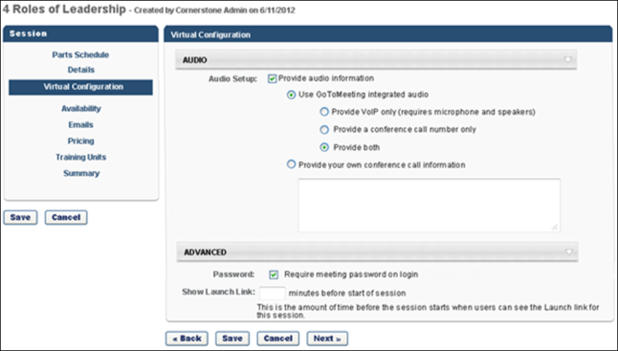

Create Session - Availability
The Availability tab is the third step in the session configuration process. Availability settings determine which users can access the session.
Design Note: An updated interface is available for this page, which can be enabled by administrators in Feature Activation Preferences. With the new design, the functionality of the page is unchanged.
To create an ILT event session, go to ILT > Manage Events & Sessions. Search for the event and in the Options column next to the event, click the View Sessions icon . To create a new session, click the Create New Session link. Navigate through the process to the Availability step.
Permissions
PERMISSION NAME | PERMISSION DESCRIPTION | CATEGORY

ILT Schedule Part Occurrence | Allows the admin to create more than one ILT session schedule part at the same time using a part occurrence schedule wizard. This is an administrator permission. | Learning - Administration

Sessions - Cancel | Grants ability to cancel instructor led training sessions. This permission works in conjunction with Events - View and Sessions - View permissions. This is an administrator permission. | Learning - Administration

Sessions - Create | Grants ability to create new instructor led training sessions. This permission works in conjunction with Events - View and Sessions - View permissions. Administrators can only create sessions for events for which they have the availability to view. When adding users to a session in which the session roster is full, this permission grants the ability to increase the session's available seats. This permission can be constrained by OU, User's OU, Instructor, User as Instructor, Facility, Facilities Owned by User, ILT Provider, User's ILT Provider, User, and User Self and Subordinates. This is an administrator permission.  Note: The "Restrict to User as Instructor" constraint is available, but it does not actually constrain the permission. | Learning - Administration

Sessions - Edit | Grants ability to edit/update existing instructor led training sessions. This permission works in conjunction with Events - View and Sessions - View permissions. Administrators can only edit sessions for which they have the availability to view and edit. When adding users to a session in which the session roster is full, this permission grants the ability to increase the session's available seats. This permission can be constrained by OU, User's OU, Instructor, User as Instructor, Facility, Facilities Owned by User, ILT Provider, User's ILT Provider, User, and User Self and Subordinates. This is an administrator permission. | Learning - Administration

Sessions - View | Grants view-only access to instructor led training sessions, enabling the user to view all details/options that were selected when the session was created. This permission works in conjunction with the Events - View permission. This permission can be constrained by OU, User's OU, Instructor, Facility, Facilities Owned by User, ILT Provider, User's ILT Provider, User, User as Instructor, and User Self and Subordinates. This is an administrator permission.  Adding an OU constraint and a provider constraint to this permission results in an "AND" statement. | Learning - Administration
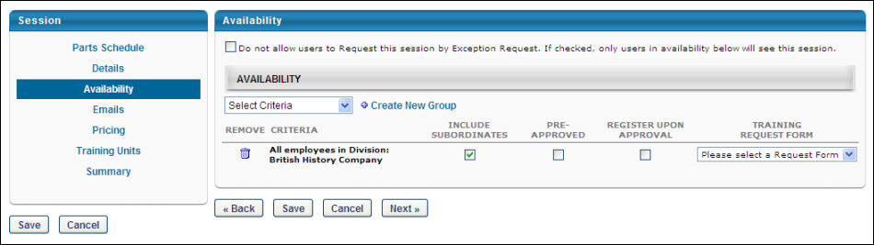
Availability
To configure availability for the session:
- Click Availability to specify the users and organizational units (OUs) to whom the session will be available.
- Do not allow users to Request this session by Exception Request - Select this option to allow only users who have the session available to them to request this session (No exceptions allowed). If not selected, users will need a direct invitation to the session so they can register.
- Select the Availability Select Criteria drop-down menu.
  - Select a specific OU.
  - Click to Add availability to the OU.
  - Click Done.
  - Include Subordinates - Select this box to include the subordinates of the OU selected.
  - Pre-Approved - Select this option to bypass the approval process. When a user requests the session, they will be in an Approved status. Note: Even though the session is pre-approved, the event may require approval.
  - Register Upon Approval - Select this option to bypass the Register step for the end user. Upon approval, the session will be in a Registered status.
  - Training Request Form - Select an appropriate training request form from the drop-down menu, if applicable. Note: If no selection is made, the request form configured at the session level will be applied.
  - Create New Group - Click this option to create new group if an existing group does not meet your availability needs.
- Click Save to save the session or click Next to configure custom Emails for the session.
Session Availability Tips
- Users can view sessions that are not available to them by selecting the View All Sessions option on the Event Summary page, which can be found by searching for training. These unavailable sessions will not be listed on the Events Calendar.
- These users will generate an exception request if they request the session unless the Do not allow users to Request this session by Exception Request option is selected on the Session Availability page.
- Sessions can be composed of an unlimited number of separate parts. When a user registers for this session, they will be automatically enrolled in each part. Webcast sessions may be composed of up to 120 parts.
- If the event is configured to restrict users from selecting a session, the manager or administrator needs to request a session on the user's behalf.
- When a session is copied, the Constraints & Availability will also be copied as per the legacy session. Availability for the newly copied session will be as following - All users in Legacy Availability: Legacy availability is '()' AND ''.

Create Session - Emails
The Emails tab is the fourth step in the session configuration process. Administrators can configure which emails send in relation to the session.
Design Note: An updated interface is available for this page, which can be enabled by administrators in Feature Activation Preferences. With the new design, the functionality of the page is unchanged.
To create an ILT event session, go to ILT > Manage Events & Sessions. Search for the event and in the Options column next to the event, click the View Sessions icon . To create a new session, click the Create New Session link. Navigate through the process to the Emails step.
Permissions
PERMISSION NAME | PERMISSION DESCRIPTION | CATEGORY

ILT Schedule Part Occurrence | Allows the admin to create more than one ILT session schedule part at the same time using a part occurrence schedule wizard. This is an administrator permission. | Learning - Administration

Sessions - Cancel | Grants ability to cancel instructor led training sessions. This permission works in conjunction with Events - View and Sessions - View permissions. This is an administrator permission. | Learning - Administration

Sessions - Create | Grants ability to create new instructor led training sessions. This permission works in conjunction with Events - View and Sessions - View permissions. Administrators can only create sessions for events for which they have the availability to view. When adding users to a session in which the session roster is full, this permission grants the ability to increase the session's available seats. This permission can be constrained by OU, User's OU, Instructor, User as Instructor, Facility, Facilities Owned by User, ILT Provider, User's ILT Provider, User, and User Self and Subordinates. This is an administrator permission.  Note: The "Restrict to User as Instructor" constraint is available, but it does not actually constrain the permission. | Learning - Administration

Sessions - Edit | Grants ability to edit/update existing instructor led training sessions. This permission works in conjunction with Events - View and Sessions - View permissions. Administrators can only edit sessions for which they have the availability to view and edit. When adding users to a session in which the session roster is full, this permission grants the ability to increase the session's available seats. This permission can be constrained by OU, User's OU, Instructor, User as Instructor, Facility, Facilities Owned by User, ILT Provider, User's ILT Provider, User, and User Self and Subordinates. This is an administrator permission. | Learning - Administration

Sessions - View | Grants view-only access to instructor led training sessions, enabling the user to view all details/options that were selected when the session was created. This permission works in conjunction with the Events - View permission. This permission can be constrained by OU, User's OU, Instructor, Facility, Facilities Owned by User, ILT Provider, User's ILT Provider, User, User as Instructor, and User Self and Subordinates. This is an administrator permission.  Adding an OU constraint and a provider constraint to this permission results in an "AND" statement. | Learning - Administration
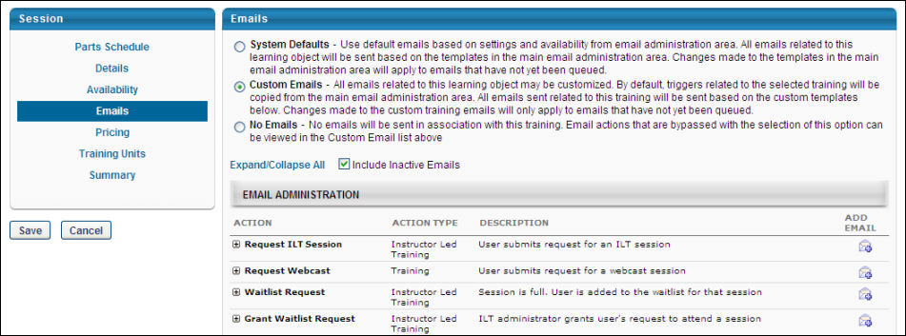
Emails
The following email options are available:
System Defaults
By default, all existing and new learning objects will have the System Defaults radio button selected. If selected:
- All emails related to this learning object will be sent based on the active email templates in the main email administration area
- Changes made to the templates in the main email administration area will apply to emails that have not yet been queued
Note: Changes to system emails made via the Email Management page will not apply to existing sessions which have the System Defaults email option selected. In order to affect changes to emails set for existing sessions, the Custom Emails option should be selected on the Emails step of the session creation process, and any changes should be made to the custom emails which become available on the page. Changes will only be affect newly-registered users; those already registered to the session will not see the changes.
No Emails
If selected, no emails will be sent in association with this training. Email actions that are bypassed with the selection of this option can be viewed in the Custom Email list displayed when the Custom Emails option is selected. This list of emails, are the emails that will not be sent, when No Emails is the option selected. Note: It is important to understand that there are two types of emails: those triggered by a user's action, and those triggered by an object. It is for this reason that the No Emails option does not always mean no emails will be received by the user.
Custom Emails
Select the Custom Emails field to customize emails to this training. By default, triggers related to the selected training will be copied from the main Email Administration area. All emails related to this training will be sent based on the configured custom templates.
- To see inactive emails, select the Include Inactive Emails option.
- If an Email Trigger is not available in the Custom Email area, it will still fire (if set to do so) from the main Email Administration area.
- Changes made to the custom training emails will only apply to emails that have not yet been queue.
- Both active and inactive templates will be copied down. Only the active email templates will fire in relation to this training request.
- The Custom Emails area does not display until this option is selected. These emails may then be edited, added or deleted as desired.
- Future training related emails will fire appropriately based on the settings and templates created within the Custom Emails section.
See Email - Create.
Custom Emails - Calendar Options
When configuring custom emails for a session, Calendar Options can be configured for the following email triggers:
Emails
EMAIL NAME | EMAIL DESCRIPTION | ACTION TYPE

Approve ILT Session | Approval settings can be set within the Event/Session or within the user details page. If approval is required, the requested training will remain in pending approval status until the approver approves, defers, or denies the request. This email is fired when an Approver approves a request for an ILT session. This email can be used to notify the student that the request has been approved or to notify a particular approver in the approval workflow (e.g., Cost center approver or User's manager). | Instructor Led Training

Cancel Registration (with withdrawal penalty) | In the Event/Session Details step, there is a Penalty for Withdrawal column. There is an Add Withdrawal Penalty link that opens up text boxes to apply a percentage or dollar amount, and the amount of days prior to the Session date when the user cancels, where these would be applied. Once a user withdraws from a Session, the selected recipients will receive this email, and the withdrawal penalty is applied. | Instructor Led Training

Cancel Registration (without withdrawal penalty) | In the Event/Session Details step, there is a Penalty for Withdrawal column. If the Add Withdrawal Penalty is not selected, and the user withdraws from a Session, the selected recipients will receive this email stating that no withdrawal penalty has been applied. | Instructor Led Training

Cancel Session | ILT Session is cancelled. This email will only fire for current/upcoming sessions and will not fire if the session dates were in the past when the session was cancelled.  The REASON.CANCEL.SESSION tag is available for the Cancel Session email so that the reason entered by the administrators when the session was cancelled can be included in the email. This tag will display the reason selected in the drop-down by the administrator who cancelled the session. | ILT Administration

Grant Waitlist Request | Once a user has submitted a Waitlist Request, they will remain in Waitlisted status until an administrator makes the decision to grant or deny the request. If the ILT administrator grants a user's request to attend a session, this email will be triggered.  When a user withdraws from a session and a seat becomes available, users on the waitlist are removed from the waitlist, they are granted the option to register for the open seat, and this email is triggered, if enabled. The waitlisted users will see the session on their transcripts in "Registration Pending" status.  - As soon as one of the user registers, all other users are moved back to the waiting list. In this scenario, if another user withdraws, the process is completed again for the users remaining on the waitlist.  - If none of the users register, the previously waitlisted users are not moved back to the waiting list. In this scenario, if another user withdraws, since no users are on the waiting list in that moment, this email is not triggered.  When a user withdraws from a session after the registration deadline, this email is not triggered. | Instructor Led Training

ILT Session Register | Once a user registers for an ILT session, this email can be sent to the student, approvers, assignors, instructors, and anyone else who would need information about the registered session. This email will not be triggered after the session start date, regardless of the session end date.  This email does not include Accept or Deny options when it is sent as a calendar invitation because this email does not interact with the Cornerstone system. It is designed to only allow recipients to save the session to their calendar. | Instructor Led Training

Session Changed | The Session Changed email is triggered if the following session fields were changed: Part Name, Part Description, Advanced Registration Settings, Instructor, Location, No Show Penalty, Pre-work/Post-work/Prerequisite Details, Session Charge Date, Start or End Dates and Times, and Waitlist Deadlines.  The following conditions can be used with this email:  - CURRENT.REGISTRATION, MAX.REGISTRATION, MIN.REGISTRATION  - NO.SHOW.PENALTY.CHANGED - Will be triggered when the no-show penalty is changed  - PRICE.CHANGED - Will be triggered when the session price is changed  - SCHEDULES.CHANGED - Will be triggered when any of the following fields are changed: part name, description, location, room layout, resource, instructor, start/end date/times, display times in time zone of user toggle, time zone, part break, part occurrence, pre-work, post-work  - TIMETABLE.CHANGED - Will be triggered if any of the following fields are changed: location, start/end date/times, time zone, part occurrence  - INSTRUCTOR.CHANGED - Will be triggered if an instructor is added or removed from a session (changing an instructor from primary to secondary does not trigger the email)  - PRE.POST.TRAINING.CHANGED - Will be triggered if a pre-work or post-work is added, removed, or made mandatory (if it is made optional, the email is not triggered)  - The COMMENT tag is relevant in combination with this condition. It displays the comments entered by the session administrator or instructor when the changes for this session were saved  This email is sent when the following conditions are met:  - The session is in an Approved status  - The last part of the session is not yet finished  When using the condition TIMETABLE.CHANGED or INSTRUCTOR.CHANGED, the email is only triggered if the change concerns at least one current or future part  Note: When the Session Changed email is configured as a meeting invitation, the email will only trigger for parts that are current or in the future. | ILT Administration
See Email Calendar Options.
Note: Changes made to custom email calendar settings only affect the event or session for which the custom emails are configured. The changes are not carried over to email settings in Email Management for the corresponding email trigger.
Save / Next
Click Save to save the session or Next to set Pricing for the session if applicable. See Create Session - Pricing on page 148 for additional information.
Troubleshooting Information
The following pages contain troubleshooting guides for using emails:
- See Troubleshooting Guide - Emails.
- See Email Troubleshooting Guide.

Create Session - Pricing
The Pricing tab is the fifth step in the session configuration process. Administrators can configure pricing settings for the session. Note: Pricing functionality is only visible by customer request.
Design Note: An updated interface is available for this page, which can be enabled by administrators in Feature Activation Preferences. With the new design, the functionality of the page is unchanged.
To create an ILT event session, go to ILT > Manage Events & Sessions. Search for the event and in the Options column next to the event, click the View Sessions icon . To create a new session, click the Create New Session link. Navigate through the process to the Pricing step.
Click Pricing link to edit the session pricing. See Course Catalog - Pricing for additional information.
Permissions
PERMISSION NAME | PERMISSION DESCRIPTION | CATEGORY

Pricing By OU | Grants access to create and maintain differing pricing for learning objects (LOs) based on OU or Group, when editing learning objects via the Course Catalog. This permission works in conjunction with the Course Catalog - Update and Course Catalog - View permissions. This permission cannot be constrained. This is an administrator permission. | Learning - Administration
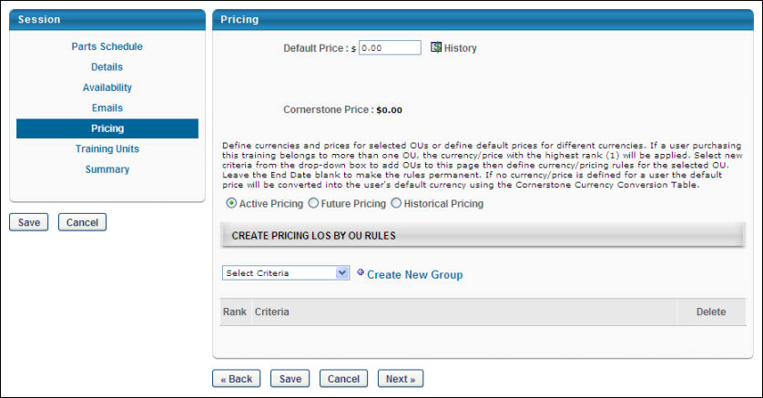
Default Price
Enter a default price for the training. The default price is what the user (or user's cost center) is charged when registering for training of no other price is set for the user below. This price is converted into all currencies supported using the Current Conversion Rate table. If the rate is fixed, it is displayed using the Client's Fixed Rate. If not fixed, it displays the Cornerstone Rate. If the seller's currency is incompatible with the buyer's currency, the buyer is shown the price converted from the seller's currency to the buyer's default currency using the Currency Conversion Rate Table (Fixed rate or Cornerstone rate).
Apply Custom Invoice - Check this option to apply a custom invoice to the LO. If no custom invoice is available for the LO, this option is not available.
- Apply Sales Tax - Select this option to apply sales tax to the learning object. To implement sales tax functionality, contact Global Customer Support. A sub-account with Cybersource is required as well as a tax nexus.
- Product Code - Enter the product code for the LO up to 200 characters. Product codes are required if a product is non-taxable or if the product has a non-standard tax rate. When a product code is entered, this value is passed to CyberSource at the time of tax calculation to specify any tax exemptions. This field is only available to organizations using sales tax when the Apply sales tax option is selected.
- Billing Entity - Click the pop-up icon to select a billing entity for the LO. This can be used to define the division within the organization from which the product should be taxed. Once a billing entity is selected, it can be removed by clicking the Remove icon to the right of the value. When a billing entity is selected, this value is passed to CyberSource at the time of tax calculation. This field is only available to organizations using sales tax when the Apply sales tax option is selected. Also, this field is only available to users with permission to manage billing entities.
Tax Location
From the drop-down, select the location on which the tax should be based for the session. By default, no location is selected. This drop-down contains all locations that are selected for each session part. For example, if a session has four parts and each part has a unique location, then each unique location is available in the Tax Location drop-down. The order in which the locations appear in the drop-down is determined by the order in which the parts occur within the session. This field is disabled unless the Apply sales tax option is checked.
- If a part is removed from the session, then the corresponding part location is removed as an option from the drop-down unless another session part utilizes the corresponding location. If the location that is selected as the tax location is removed from the session, then no tax location is set until the administrator selects another tax location.
- If the location that is selected as the tax location is deactivated, the tax is calculated based on the deactivated location until the tax location is updated.
Override user's OU currency
Select this option to require the user to pay for training with the currency defined for the training rather than the currency defined for their OU. Note: The currency settings must match the payment processor's settings to ensure that the user can check out with the currency defined for the LO. If the payment processor is not configured to accept the user's currency, then the user cannot check out.
Cornerstone Price
This is the price Cornerstone charges the client (the company, not the user) when the billing is reconciled.
Active Pricing
Select this option to set the active price by OU. See the Create Pricing LOs by OU Rules section below for additional information.
Future Pricing
Select this option to set the future price by OU. See the Create Pricing LOs by OU Rules section below for additional information.
Historical Pricing
Select this option to search for historical prices by date.
Create Pricing LOs by OU Rules
Using the OU drop-down, you can set different prices for different organizational units (OUs). If no price is defined for a user, the default price is used. All pricing rules created on the learning object (LO) level expire immediately if any change is made at the group level. If no end date is set for the pricing, the pricing rules are permanent.
Because it is possible that a LO has multiple pricing rules set, the system observes the following rules:
- If a user falls under multiple OUs with multiple pricing rules that have different rankings, the cost associated with the highest (1) ranking is applied.
- If a user falls under multiple OUs with multiple pricing rules that have the same ranking, the cost associated with the lowest price is applied.
Note: Pricing LOs by OU rules is limited to 120 rules.
Save or Next
Click Save or Next to continue to Training Units section.

Create Session - Training Units
The Training Units tab is the sixth step in the session configuration process. Administrators can configure training unit pricing settings for the session. The Training Units tab is only available if training units are enabled.
Design Note: An updated interface is available for this page, which can be enabled by administrators in Feature Activation Preferences. With the new design, the functionality of the page is unchanged.
To create an ILT event session, go to ILT > Manage Events & Sessions. Search for the event and in the Options column next to the event, click the View Sessions icon . To create a new session, click the Create New Session link. Navigate through the process to the Training Units step.
Permissions
PERMISSION NAME | PERMISSION DESCRIPTION | CATEGORY

Pricing By OU | Grants access to create and maintain differing pricing for learning objects (LOs) based on OU or Group, when editing learning objects via the Course Catalog. This permission works in conjunction with the Course Catalog - Update and Course Catalog - View permissions. This permission cannot be constrained. This is an administrator permission. | Learning - Administration
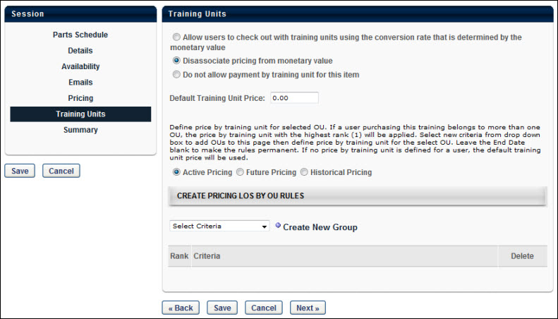
Training Units
When editing a session, the Training Units tab offers the following options for training units:
- Allow users to check out with training units using the conversion rate that is determined by the monetary value - Select this option to allow users to purchase the session using training units, and the number of training units used is determined by converting the monetary value and the training unit conversion rate.
- Disassociate pricing from monetary value - Select this option to allow you to set a training unit price for the session that is unrelated to any monetary value that may be set. You can specify a default training unit price and training unit prices based on OU. Training unit prices can be represented using up to two decimal places.
- Do not allow payment by training unit for this item - This will not allow the session to be purchased using training units.
Click Save or Next to proceed to the Summary section.

Create Session - Summary
The Summary tab is the final step in the session configuration process. Administrators can review the settings of the session before saving the session.
Design Note: An updated interface is available for this page, which can be enabled by administrators in Feature Activation Preferences. With the new design, the functionality of the page is unchanged.
To create an ILT event session, go to ILT > Manage Events & Sessions. Search for the event and in the Options column next to the event, click the View Sessions icon . To create a new session, click the Create New Session link. Navigate through the process to the Summary step.
Permissions
PERMISSION NAME | PERMISSION DESCRIPTION | CATEGORY

ILT Schedule Part Occurrence | Allows the admin to create more than one ILT session schedule part at the same time using a part occurrence schedule wizard. This is an administrator permission. | Learning - Administration

Sessions - Cancel | Grants ability to cancel instructor led training sessions. This permission works in conjunction with Events - View and Sessions - View permissions. This is an administrator permission. | Learning - Administration

Sessions - Create | Grants ability to create new instructor led training sessions. This permission works in conjunction with Events - View and Sessions - View permissions. Administrators can only create sessions for events for which they have the availability to view. When adding users to a session in which the session roster is full, this permission grants the ability to increase the session's available seats. This permission can be constrained by OU, User's OU, Instructor, User as Instructor, Facility, Facilities Owned by User, ILT Provider, User's ILT Provider, User, and User Self and Subordinates. This is an administrator permission.  Note: The "Restrict to User as Instructor" constraint is available, but it does not actually constrain the permission. | Learning - Administration

Sessions - Edit | Grants ability to edit/update existing instructor led training sessions. This permission works in conjunction with Events - View and Sessions - View permissions. Administrators can only edit sessions for which they have the availability to view and edit. When adding users to a session in which the session roster is full, this permission grants the ability to increase the session's available seats. This permission can be constrained by OU, User's OU, Instructor, User as Instructor, Facility, Facilities Owned by User, ILT Provider, User's ILT Provider, User, and User Self and Subordinates. This is an administrator permission. | Learning - Administration

Sessions - View | Grants view-only access to instructor led training sessions, enabling the user to view all details/options that were selected when the session was created. This permission works in conjunction with the Events - View permission. This permission can be constrained by OU, User's OU, Instructor, Facility, Facilities Owned by User, ILT Provider, User's ILT Provider, User, User as Instructor, and User Self and Subordinates. This is an administrator permission.  Adding an OU constraint and a provider constraint to this permission results in an "AND" statement. | Learning - Administration
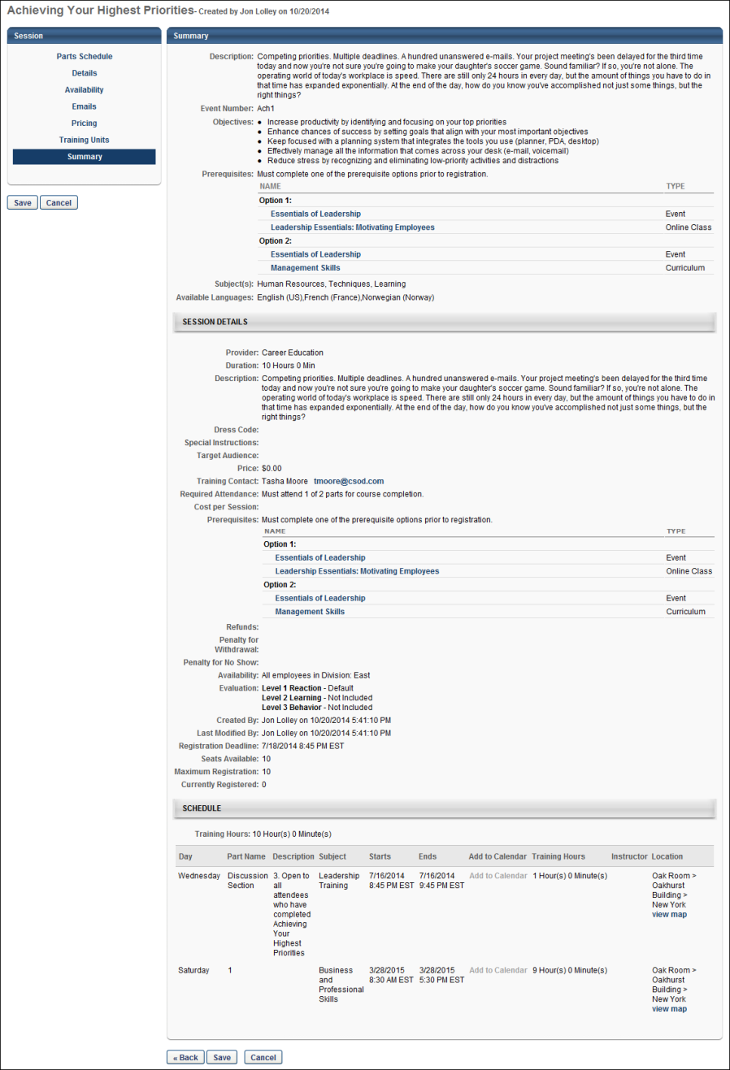
Summary
At the top of the Summary page, the event details are displayed, followed by the session details.
- Review the event and session details and Click Save to save session. Note: If course code functionality has been activated in your portal, a course code is automatically generated for the LO immediately after the administrator saves the new LO.
  - Note: Daylight saving time (DST) time zones are supported for ILT for events or sessions.
  - Note: Event custom fields are also displayed in the upper area of the summary, even if they are not enabled for sessions.

Create Session - Webex Extended Options
When creating a Webex Meeting and Training Center vILT event session, in the Details section, the Webex Extended Options link opens the Webex Extended Options pop-up where you can set the default Webex extended options for the session. This functionality is only available once activated by contacting Global Customer Support
Design Note: An updated interface is available for this page, which can be enabled by administrators in Feature Activation Preferences. With the new design, the functionality of the page is unchanged.
This functionality is available for portals with Webex Extended Integration for Webex Meeting and Training Center.
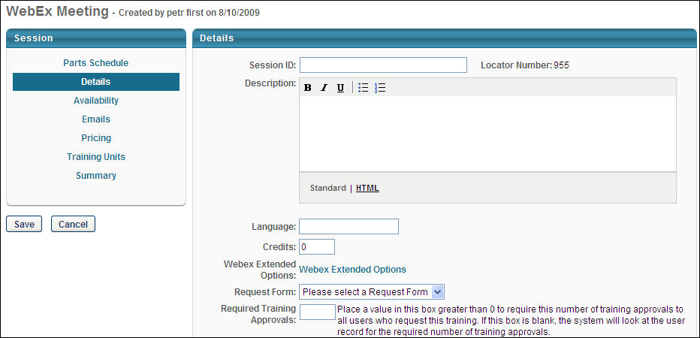
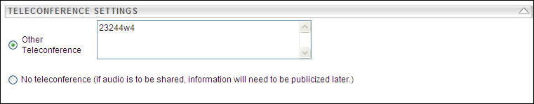
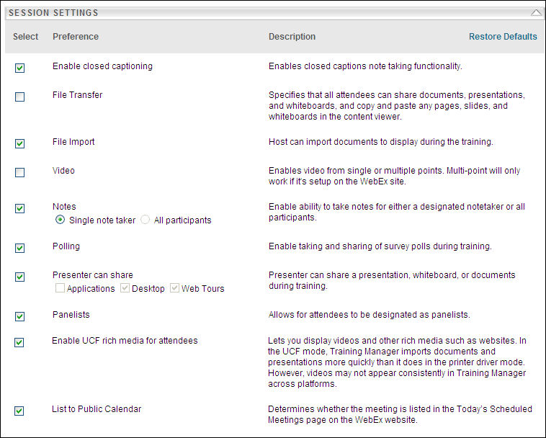
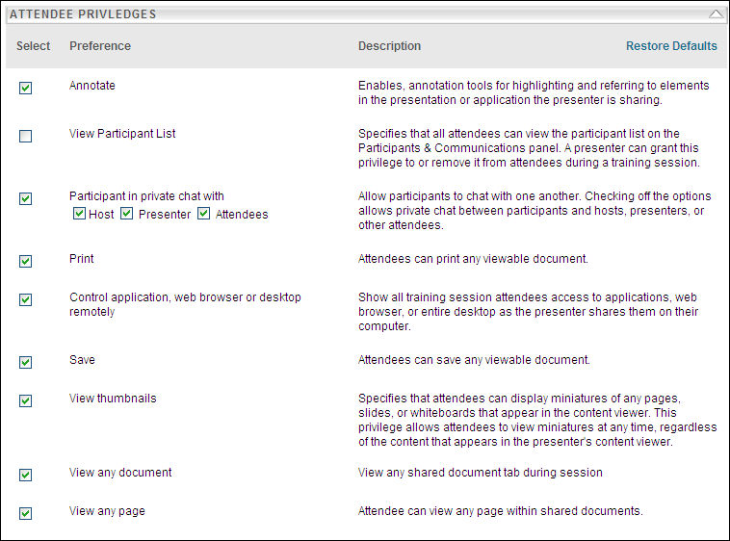
This pop-up only displays the options that are enabled for your portal. The options that are displayed and the default settings are set during implementation and can be modified by contacting Global Customer Support. All of the available options are set based on the configuration selections made in Webex, and they can be selected or deselected if desired. The administrator can also restore the defaults from Webex by clicking the Restore Defaults option in the upper-right corner of the Session Settings section. When you save these option settings, the settings are stored and sent to Webex when the session is created. This applies also when editing a session. When you copy a session, if the Webex Extended Options are set, they are also copied.
The following Teleconference Settings are available:
- Webex Audio - This option is only visible if the option to have Webex Audio editable on session is selected on the Session Options in ILT Preferences.
  - Display toll-free number - Select this option to instruct Webex to display the previously created toll-free number.
  - Display global call-in numbers - Select this option to instruct Webex to display the previously created global call-in numbers.
  - Attendees receive call back - Select this option to allow users to have Webex call them at a phone number that they specify.
- Other Teleconference - Select this option to allow ILT session creators or editors to manually enter international phone numbers and pass codes. This field can be populated with alphanumeric values.
- Use VOIP only (not hosted by Webex) - Select this option to enable VOIP to be hosted by the client.
- Teleconference service (previously set up in Webex) - Select this option to use a teleconference service.
  - Attendees receive call back - Select this option to allow users to have the system call them at a phone number that they specify.
- No teleconference (if audio is to be shared, information will need to be publicized later.) - This option is always available for all portals. Select this option to not include a teleconference service.
Note: When selecting a teleconference option, the selected option is populated for SESSION.PHONE tag in ILT emails.
All other session and attendee settings supported through Webex integration services are displayed in the Webex Extended Options pop-up.
Exclusions
The following options are NOT supported:
- Enable closed Captioning
- Notes
- Enable UCF rich media for attendees
- List to Public Calendar

Create Session - Webex Hands-On Lab
When creating a vILT session for Webex Training Center vendors, on the Details tab administrators have the ability to reserve computers in a hands-on lab. This option is only available if Hands-on Lab is also enabled. Note: This functionality requires that your Webex is integrated with the system ILT.
Design Note: An updated interface is available for this page, which can be enabled by administrators in Feature Activation Preferences. With the new design, the functionality of the page is unchanged.
To enable Hands on Lab, contact Global Customer Support. This can also be enabled during implementation.
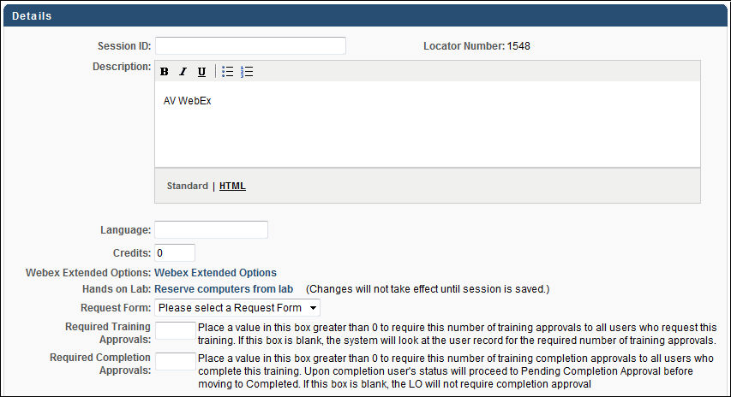
To reserve computers from a hands-on lab when creating a session, on the Details tab click the Reserve computers from lab link. This opens the Hands on Lab: Reserve Computers pop-up.
- This option is only available when creating sessions for Webex Training Centers.
- Hands on Lab must be enabled in ILT preferences and a Webex hands-on lab must be set up outside of the system prior to creating the session.
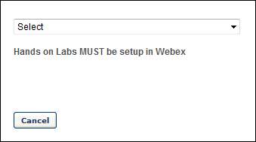
- From the drop-down list, select the appropriate Hands-on Lab in which you are reserving computers. Hands-on labs must be set up in Webex prior to creating the session. All previously set up hands-on labs are included in the drop-down list. If no labs have been set up, no labs appear in this list.
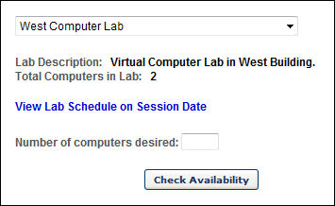
- Once a lab is selected, a description of the lab is displayed along with the total number of computers in the lab. Note: This information is specified within Webex. To view the lab schedule for the selected lab on the session date, click the View Lab Schedule on Session Date link. This displays the number of computers that are already reserved for the lab (if any) as well as the instructor that reserved them and the time at which they are reserved for the date specified in the Parts schedule.
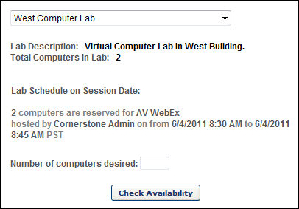
- In the Number of computers desired field, enter the number of computers you are reserving and click the Check Availability button.
- If the requested quantity of computers is available, click Continue to continue creating the session. Note: The computers are not yet reserved. The computers are reserved once session is saved.
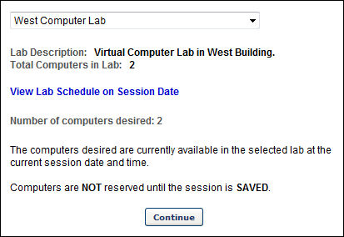
- If the requested quantity of computers is not available, an error message displays. You may then edit the number of computers desired and check for availability again, or you may select another lab from the drop-down list and check for availability at that lab.
- Once you successfully select a lab with a sufficient number of available computers, continue creating the session. The computers are not reserved until the session is saved. When you save the session, the system requests the computers from Webex. If the computers are still available, the session is saved. If the computers are no longer available, the administrator is able to select another lab or modify the number of computers desired and attempt to save the session once more.
- Once the session is saved and the computers are reserved, when viewing the Details section of the session, the number of reserved computers is displayed along with the lab name and the time during which they are reserved.
- When editing the session later, there are options to edit and cancel the Hands on Lab reservation.
Multiple Providers - Session Options Overview
The ability to configure the same session to have both virtual and onsite instances is controlled by a backend setting. To enable this functionality, contact Global Customer Support.
Configuration Basics
The following are the basic steps for configuring a session to have both virtual and onsite instances:
- Configure the event to have a primary and secondary vendor, with the primary vendor being a virtual provider and the secondary an onsite provider. (The vILT provider must be configured as the Primary Provider to be marked as a Webcast ILT and display the monitor icon).
- Configure the session to have both virtual and onsite session options.
Use Case
- An organization would like all of its new hires to be trained on their internal company policies. Normally, such training is performed through the use of instructor led training. However, the new hires are spread out over various locations, making virtual and onsite training a more practical solution.
- The ILT administrator creates a new Internal Company Policy event and configures the event for both an onsite and virtual provider. She then creates a webcast session for the event.
- Once the webcast session is created, the administrator creates multiple session options for the parent session. She creates one for the New York office and adjusts the maximum registration to 50 users. She creates one to be held in Paris, France, with a maximum registration of 25 users and availability set to only the Finance department. She creates three more session options, each with a different location and other unique settings.
- Users register for the sessions and are also enrolled via proxy enrollment. The administrator monitors the roster for the parent session and session options to ensure users are registering correctly.
- After the sessions occur, the administrator receives the sign-in sheets from each location and enters the attendance and score for each user. The rosters for users in the virtual sessions are automatically updated.
- The administrator prints a report to identify which session options still need their roster updated, and then updates the rosters accordingly.
Multiple Providers - Sessions Page
For portals that have the ability to configure multiple providers for a session, the following differences appear on the Sessions page:
- The Create New Session link is named Create New <Primary Vendor Name> Session. (Please note that the vILT provider must be configured as the Primary Provider to be marked as a Webcast ILT and display the monitor icon).
- If the Secondary Vendor field is completed on the Properties step when configuring the event, then a Create New <Secondary Vendor Name> Session link appears to the right of the Create New <Primary Vendor Name> Session link.
- The Options column includes icons to create virtual and onsite session options. These options only appear once the parent session is created.
- If session options are created for a parent session, then the options display below the parent session and are expanded by default.
Note: The icons in the Options column only appear for portals with the ability to configure multiple providers for a session.
Design Note: An updated interface is available for this page, which can be enabled by administrators in Feature Activation Preferences. With the new design, the functionality of the page is unchanged.
To access the Sessions page, go to ILT > Manage Events & Sessions. Then, select the View Sessions icon in the Options column for the desired event.
Permissions
PERMISSION NAME | PERMISSION DESCRIPTION | CATEGORY

Sessions - Cancel | Grants ability to cancel instructor led training sessions. This permission works in conjunction with Events - View and Sessions - View permissions. This is an administrator permission. | Learning - Administration

Sessions - Create | Grants ability to create new instructor led training sessions. This permission works in conjunction with Events - View and Sessions - View permissions. Administrators can only create sessions for events for which they have the availability to view. When adding users to a session in which the session roster is full, this permission grants the ability to increase the session's available seats. This permission can be constrained by OU, User's OU, Instructor, User as Instructor, Facility, Facilities Owned by User, ILT Provider, User's ILT Provider, User, and User Self and Subordinates. This is an administrator permission.  Note: The "Restrict to User as Instructor" constraint is available, but it does not actually constrain the permission. | Learning - Administration

Sessions - Edit | Grants ability to edit/update existing instructor led training sessions. This permission works in conjunction with Events - View and Sessions - View permissions. Administrators can only edit sessions for which they have the availability to view and edit. When adding users to a session in which the session roster is full, this permission grants the ability to increase the session's available seats. This permission can be constrained by OU, User's OU, Instructor, User as Instructor, Facility, Facilities Owned by User, ILT Provider, User's ILT Provider, User, and User Self and Subordinates. This is an administrator permission. | Learning - Administration
Create New Primary and Secondary Vendor Sessions
Clicking either the Create New <Primary Vendor Name> Session or Create New <Secondary Vendor Name> Session link enables administrators to create a new virtual or onsite session, depending on the type of vendor selected when configuring the event. For example, if the primary vendor at the event level is a virtual provider, then clicking the Create New <Primary Vendor Name> Session link enables the administrator to create a new virtual session.
Create Virtual and Onsite Session Options
A session option is an additional option for attending the corresponding session. For example, if a virtual session option is added to an onsite session, then users will have the option to attend the virtual session or the onsite session.
If enabled, the following options are now available in the Options column once the parent session is created:
- <Vendor Name> Session Option - Click the icon to create virtual session options. This opens the Parts Schedule step of creating a session. Note: If the primary and secondary vendors are both virtual providers, then two instances of this icon appear in the Options column. The first instance is associated with the primary vendor, and the second instance is associated with the secondary vendor.
- <Vendor Name> Session Option - Click the icon to create onsite session options. This opens the Parts Schedule step of creating a session. Note: If the primary and secondary vendors are both onsite providers, then two instances of this icon appear in the Options column. The first instance is associated with the primary vendor, and the second instance is associated with the secondary vendor.
View Session Options
If session options are added to a parent session, then the options display below the parent session and are expanded by default. Click the Expand/Collapse icon to the left of the Day column to collapse the session options.
Each session option has a separate locator number and roster. The enrollment options may vary, if configured by the administrator.
Session options can only be created for a parent session. Session options cannot be created for a session option.
To view all users associated with the session, including users associated with the session options, click the View Roster icon for the parent session. From the Parent Roster page, select the locator number filter options to view the desired roster.
To view all users associated with a specific session option, click the View Roster icon in the Options column for the session option.
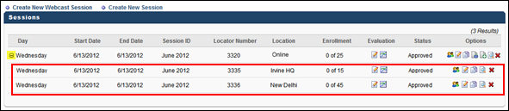
Edit Session
Edits made to a parent session do not affect the associated session options and vice versa.
Copy Session
Clicking the Copy icon in the Options column for a parent session creates a new parent session. Clicking the Copy icon for a session option creates a new session option within the associated parent session.
Cancel Session
Canceling a parent session that has at least one session option also cancels the session option. Clicking the Cancel Session icon in the Options column opens a pop-up that indicates canceling the parent session also cancels any associated session options.
A session option can be deleted by clicking the Cancel Session icon in Options column.

For more information about the Sessions page, see ILT Session Overview.
For more information about creating session options, see Create Session Options - Parts Schedule.
Multiple Providers - Create Session Options - Parts Schedule
Session options can be added to parent sessions, enabling administrators to create virtual and onsite versions of the same session to provide users with options about how they would like to attend the session. This is a valuable tool for organizations that have users at multiple sites who are required to attend the same training. By having virtual and onsite options, all of an organization's users can complete the required training whether they are at a physical location for the training or attending a virtual session.
Design Note: An updated interface is available for this page, which can be enabled by administrators in Feature Activation Preferences. With the new design, the functionality of the page is unchanged.
To create session options for the primary vendor session, click the <Vendor Name> Session Option icon on the Sessions page.
To create session options for the secondary vendor session, click the <Vendor Name> Session Option icon on the Sessions page. Note: The icons only appear once a parent session is created.
Permissions
PERMISSION NAME | PERMISSION DESCRIPTION | CATEGORY

Sessions - Cancel | Grants ability to cancel instructor led training sessions. This permission works in conjunction with Events - View and Sessions - View permissions. This is an administrator permission. | Learning - Administration

Sessions - Create | Grants ability to create new instructor led training sessions. This permission works in conjunction with Events - View and Sessions - View permissions. Administrators can only create sessions for events for which they have the availability to view. When adding users to a session in which the session roster is full, this permission grants the ability to increase the session's available seats. This permission can be constrained by OU, User's OU, Instructor, User as Instructor, Facility, Facilities Owned by User, ILT Provider, User's ILT Provider, User, and User Self and Subordinates. This is an administrator permission.  Note: The "Restrict to User as Instructor" constraint is available, but it does not actually constrain the permission. | Learning - Administration

Sessions - Edit | Grants ability to edit/update existing instructor led training sessions. This permission works in conjunction with Events - View and Sessions - View permissions. Administrators can only edit sessions for which they have the availability to view and edit. When adding users to a session in which the session roster is full, this permission grants the ability to increase the session's available seats. This permission can be constrained by OU, User's OU, Instructor, User as Instructor, Facility, Facilities Owned by User, ILT Provider, User's ILT Provider, User, and User Self and Subordinates. This is an administrator permission. | Learning - Administration
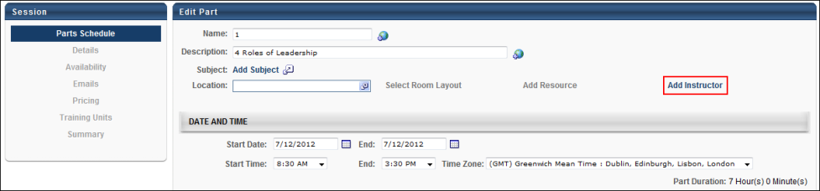
When creating virtual session options, the Add Instructor field is required and the Location field is not required.
When creating onsite session options, the Location field is required and the Add Instructor field is not required.
All other functionality for creating session options is identical to creating a session. See Create or Edit Session in Online Help for more information about creating sessions.
Multiple Providers - Parent Roster Page
For portals that have the ability to configure multiple providers for a session, the name of the Roster page is changed to Parent Roster. The name change is designed to differentiate the parent's roster page from those of its session options. In addition, following differences appear on the page:
- The Roster tab is renamed Parent Roster.
- Locator number filter options are added below the Parent Roster tab to enable administrators to view all or any combination of users on the roster.
- The session information section only displays the Session Status and Seats Available fields if one or more session options are selected in the locator number drop-down.
- Session parts in the Schedule panel are listed by locator number. Each part is collapsed by default.
- A Locator column is added to the Users panel.
To view the Parent Roster page for a session, click the View Roster icon in the Options column on the Sessions page.
Permissions
PERMISSION NAME | PERMISSION DESCRIPTION | CATEGORY

Events - View | Grants view-only access to instructor led training events, enabling the user to view all details/options that were selected when the event was created. This permission can be constrained by OU, User's OU, User's ILT Provider, and ILT Provider. This is an administrator permission. | Learning - Administration

Roster - Manage | Grants ability to manage instructor led training session rosters, including updating attendance, and marking the ILT session complete to update student transcripts. A variety of other features are available depending upon additional roster permissions. This permission works in conjunction with Events - View, Sessions - View, and Roster - View permissions. This permission can be constrained by Instructor, User as Instructor, ILT Provider, and User's ILT Provider. This is an administrator permission. | Learning - Administration

Roster - View | Grants view-only access to instructor led training session rosters. This permission works in conjunction with Events - View and Sessions - View permissions. This permission can be constrained by Instructor, ILT Provider, User's ILT Provider, and User as Instructor. This is an administrator permission. | Learning - Administration

Sessions - View | Grants view-only access to instructor led training sessions, enabling the user to view all details/options that were selected when the session was created. This permission works in conjunction with the Events - View permission. This permission can be constrained by OU, User's OU, Instructor, Facility, Facilities Owned by User, ILT Provider, User's ILT Provider, User, User as Instructor, and User Self and Subordinates. This is an administrator permission.  Adding an OU constraint and a provider constraint to this permission results in an "AND" statement. | Learning - Administration
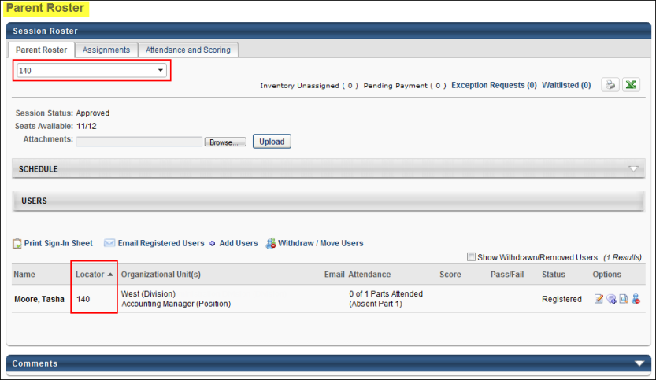
Locator Number Filter
From the Parent Roster tab, administrators can select to display the roster for the parent session and the session options. The locator number filter appears at the top of the Session Roster page when the Parent Roster tab is selected. This filter enables you to select one or more locator numbers to display the rosters. The parent session locator number is selected by default. Locator numbers appear in numeric order. Once all selections are made, click anywhere outside the drop-down to refresh the page with the selected rosters. Users appear in alphabetical order by last name.
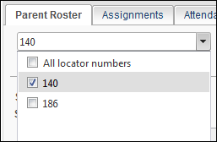
If multiple locator numbers are selected in the drop-down, then the following links do not appear in the Users panel:
- Print Sign-In Sheet
- Add Users
- Withdraw Users
Session Information Section
The Session Status and Seats Available fields only display in the session information section if one or more session options are selected in the locator number drop-down.
Schedule Panel
Session parts in the Schedule panel are now listed by locator number. If multiple locator numbers are selected in the locator number filter, then, each part is collapsed by default but can be expanded by clicking the Expand/Collapse arrow to the left of the Locator Number field.
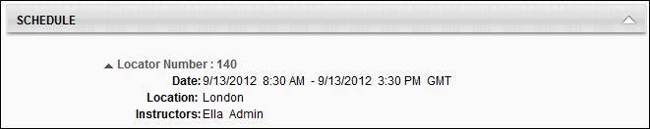
Users Panel
The Print Sign-In Sheet, Add Users, and Withdraw Users links are removed from the Users panel.
Clicking the Email Registered Users link enables you to email all users visible in the Users panel. This includes users on the roster for a session option if the roster is selected in the locator number drop-down.
Locator Column
The Locator column displays the locator number for the session to which each user is associated. This column also determines the sort order for the Users panel.
For more information about the Roster page, see Session Roster - Roster.
Multiple Providers - Parent Roster - Attendance and Scoring
For portals with the ability to configure multiple providers for a session, when viewing the Attendance and Scoring tab for a parent session, all users associated with the parent session and any associated session options display in the panel. This enables administrators to manage attendance and scoring for all users in a parent session and its associated session options at one time. In addition, a locator number drop-down appears in the upper-left corner of the tab to enable administrators to filter the users that appear in the Users panel.
Note: Changes to the Users panel are maintained when navigating across the tabs on the Parent Roster page as long as the locator number filter is not changed.
To access the Attendance and Scoring tab, click the tab name from the Parent Roster page.
Permissions
PERMISSION NAME | PERMISSION DESCRIPTION | CATEGORY

Events - View | Grants view-only access to instructor led training events, enabling the user to view all details/options that were selected when the event was created. This permission can be constrained by OU, User's OU, User's ILT Provider, and ILT Provider. This is an administrator permission. | Learning - Administration

Roster - Manage | Grants ability to manage instructor led training session rosters, including updating attendance, and marking the ILT session complete to update student transcripts. A variety of other features are available depending upon additional roster permissions. This permission works in conjunction with Events - View, Sessions - View, and Roster - View permissions. This permission can be constrained by Instructor, User as Instructor, ILT Provider, and User's ILT Provider. This is an administrator permission. | Learning - Administration

Roster - View | Grants view-only access to instructor led training session rosters. This permission works in conjunction with Events - View and Sessions - View permissions. This permission can be constrained by Instructor, ILT Provider, User's ILT Provider, and User as Instructor. This is an administrator permission. | Learning - Administration

Sessions - View | Grants view-only access to instructor led training sessions, enabling the user to view all details/options that were selected when the session was created. This permission works in conjunction with the Events - View permission. This permission can be constrained by OU, User's OU, Instructor, Facility, Facilities Owned by User, ILT Provider, User's ILT Provider, User, User as Instructor, and User Self and Subordinates. This is an administrator permission.  Adding an OU constraint and a provider constraint to this permission results in an "AND" statement. | Learning - Administration
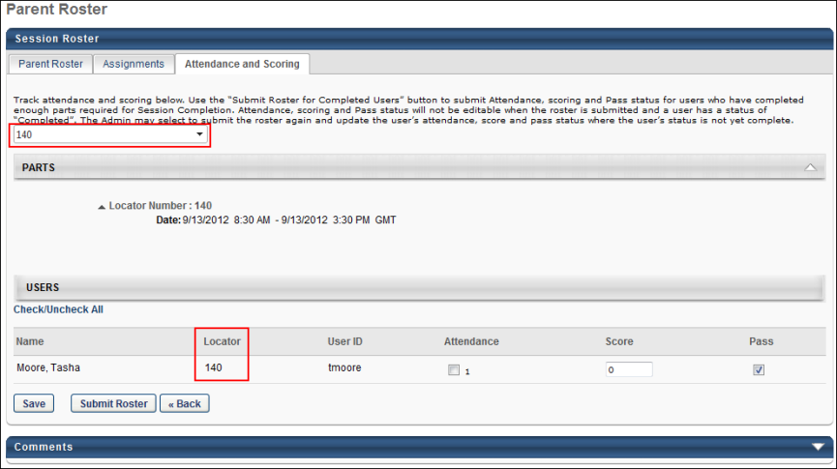
Best Practice: If you have made changes to the Users panel, always click Submit Roster before selecting a different locator number in the filter drop-down. Attendance and scoring changes are not saved when navigating between different locator numbers.
For more information about the Attendance and Scoring tab, see Session Roster - Attendance and Scoring.
Multiple Providers - Roster - Session Options
Administrators can view the Roster page for a particular session option. From the Sessions page, clicking the View Roster icon in the Options column for the session option opens the Roster page. The locator number filter is not available on the Roster page. All other roster management functionality and options are available. See Session Roster Overview on page 219 for additional information.
Note: The Parent Roster page cannot be accessed from the Roster page for a session option.
Design Note: An updated interface is available for this page, which can be enabled by administrators in Feature Activation Preferences. With the new design, the functionality of the page is unchanged.
Permissions
PERMISSION NAME | PERMISSION DESCRIPTION | CATEGORY

Events - View | Grants view-only access to instructor led training events, enabling the user to view all details/options that were selected when the event was created. This permission can be constrained by OU, User's OU, User's ILT Provider, and ILT Provider. This is an administrator permission. | Learning - Administration

Roster - Manage | Grants ability to manage instructor led training session rosters, including updating attendance, and marking the ILT session complete to update student transcripts. A variety of other features are available depending upon additional roster permissions. This permission works in conjunction with Events - View, Sessions - View, and Roster - View permissions. This permission can be constrained by Instructor, User as Instructor, ILT Provider, and User's ILT Provider. This is an administrator permission. | Learning - Administration

Roster - View | Grants view-only access to instructor led training session rosters. This permission works in conjunction with Events - View and Sessions - View permissions. This permission can be constrained by Instructor, ILT Provider, User's ILT Provider, and User as Instructor. This is an administrator permission. | Learning - Administration

Sessions - View | Grants view-only access to instructor led training sessions, enabling the user to view all details/options that were selected when the session was created. This permission works in conjunction with the Events - View permission. This permission can be constrained by OU, User's OU, Instructor, Facility, Facilities Owned by User, ILT Provider, User's ILT Provider, User, User as Instructor, and User Self and Subordinates. This is an administrator permission.  Adding an OU constraint and a provider constraint to this permission results in an "AND" statement. | Learning - Administration
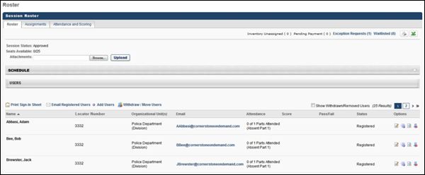
Multiple Providers - Session - View Details
The View Session Details page displays the details for each part within the session.
Design Note: An updated interface is available for this page, which can be enabled by administrators in Feature Activation Preferences. With the new design, the functionality of the page is unchanged.
To access the View Session Details page, click the View Sessions Details icon for a session in the Sessions table. See ILT Session Overview on page 94 for additional information.
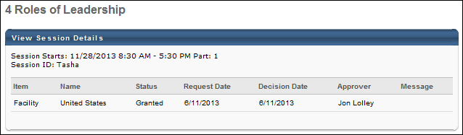
The following information is displayed at the top of the View Session Details panel:
- Session Starts
- Session ID
The following information displays for each item associated with the session part:
- Item
- Name
- Status
- Request Date
- Decision Date
- Approver
- Message
Note: Daylight saving time (DST) time zones are supported for ILT for events or sessions.
Multiple Providers - Waitlist - Parent Roster
For portals with the ability to configure multiple providers for a session, when viewing the waitlist for a parent session, all users associated with the parent session and any associated session options display in the Waitlist panel. This enables administrators to manage the waitlist for all users in a parent session and its associated session options at one time. In addition, a locator number drop-down appears in the Options panel to enable administrators to filter the users that appear in the panel.
Note: The locator number filter only appears when the Waitlist page is accessed from the Parent Roster page.
Design Note: An updated interface is available for this page, which can be enabled by administrators in Feature Activation Preferences. With the new design, the functionality of the page is unchanged.
To access the waitlist, click the Waitlist link in the upper-right corner of the Parent Roster tab.
Permissions
PERMISSION NAME | PERMISSION DESCRIPTION | CATEGORY

Events - View | Grants view-only access to instructor led training events, enabling the user to view all details/options that were selected when the event was created. This permission can be constrained by OU, User's OU, User's ILT Provider, and ILT Provider. This is an administrator permission. | Learning - Administration

Roster - Manage | Grants ability to manage instructor led training session rosters, including updating attendance, and marking the ILT session complete to update student transcripts. A variety of other features are available depending upon additional roster permissions. This permission works in conjunction with Events - View, Sessions - View, and Roster - View permissions. This permission can be constrained by Instructor, User as Instructor, ILT Provider, and User's ILT Provider. This is an administrator permission. | Learning - Administration

Roster - View | Grants view-only access to instructor led training session rosters. This permission works in conjunction with Events - View and Sessions - View permissions. This permission can be constrained by Instructor, ILT Provider, User's ILT Provider, and User as Instructor. This is an administrator permission. | Learning - Administration

Sessions - View | Grants view-only access to instructor led training sessions, enabling the user to view all details/options that were selected when the session was created. This permission works in conjunction with the Events - View permission. This permission can be constrained by OU, User's OU, Instructor, Facility, Facilities Owned by User, ILT Provider, User's ILT Provider, User, User as Instructor, and User Self and Subordinates. This is an administrator permission.  Adding an OU constraint and a provider constraint to this permission results in an "AND" statement. | Learning - Administration

Waitlists - Manage | Grants ability to approve or deny instructor led training waitlist requests. This permission works in conjunction with the Events - View and Waitlists - View permissions. This is an administrator permission. | Learning - Administration

Waitlists - View | Grants view-only access to instructor led training session waitlists, via the ILT Events and Sessions screen, enabling the user to view the waitlists for various ILT sessions. This permission works in conjunction with Events - View and Sessions - View permissions. | Learning - Administration
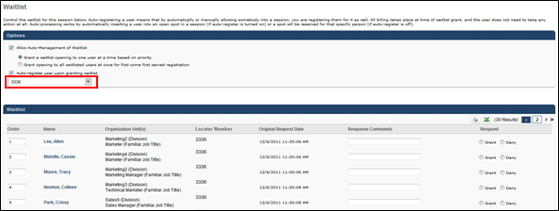
Locator Number Drop-Down
The locator number filter enables administrators to display waitlisted users for the parent session and the session options. From the filter, select one or more locator numbers to display the waitlist. The "All Locator Numbers" option is selected by default. Locator numbers appear in numeric order. Once all selections are made, click anywhere outside the drop-down to refresh the page with the selected waitlists.
Update Order Button
If multiple locator numbers are selected in the locator number filter, then the Waitlist panel displays all of the waitlisted users in the selected sessions. Changes can be made to waitlisted users in any of the selected sessions and updated all at once by clicking the Update Order button. Updates only apply to users that are visible on the page.
If changes are made to the selections in the locator number filter, then clicking the Update Order button maintains any pending order changes applied to the Waitlist panel for all users who continue to appear in the Waitlist panel after updating the locator number filter.
Process Response Button
If changes are made to the locator number filter, then clicking the Process Response button maintains any pending changes applied to the Waitlist panel for all users who continue to appear in the Waitlist panel after updating the locator number filter.
Multiple Providers - Waitlist - Session Options
Administrators can view the Waitlist page for a particular session option. From the Roster page, clicking the Waitlist link in the upper-right corner opens the Waitlist page. When accessing the Waitlist page for a session option from the Roster page, the locator number filter is not available. All other functionality and options are available. See Session Roster - Waitlist in Online Help for more information about managing the waitlist.
Note: The waitlist for the parent session cannot be accessed from the Waitlist page for a session option.
Design Note: An updated interface is available for this page, which can be enabled by administrators in Feature Activation Preferences. With the new design, the functionality of the page is unchanged.
Permissions
PERMISSION NAME | PERMISSION DESCRIPTION | CATEGORY

Events - View | Grants view-only access to instructor led training events, enabling the user to view all details/options that were selected when the event was created. This permission can be constrained by OU, User's OU, User's ILT Provider, and ILT Provider. This is an administrator permission. | Learning - Administration

Roster - Manage | Grants ability to manage instructor led training session rosters, including updating attendance, and marking the ILT session complete to update student transcripts. A variety of other features are available depending upon additional roster permissions. This permission works in conjunction with Events - View, Sessions - View, and Roster - View permissions. This permission can be constrained by Instructor, User as Instructor, ILT Provider, and User's ILT Provider. This is an administrator permission. | Learning - Administration

Roster - View | Grants view-only access to instructor led training session rosters. This permission works in conjunction with Events - View and Sessions - View permissions. This permission can be constrained by Instructor, ILT Provider, User's ILT Provider, and User as Instructor. This is an administrator permission. | Learning - Administration

Sessions - View | Grants view-only access to instructor led training sessions, enabling the user to view all details/options that were selected when the session was created. This permission works in conjunction with the Events - View permission. This permission can be constrained by OU, User's OU, Instructor, Facility, Facilities Owned by User, ILT Provider, User's ILT Provider, User, User as Instructor, and User Self and Subordinates. This is an administrator permission.  Adding an OU constraint and a provider constraint to this permission results in an "AND" statement. | Learning - Administration

Waitlists - Manage | Grants ability to approve or deny instructor led training waitlist requests. This permission works in conjunction with the Events - View and Waitlists - View permissions. This is an administrator permission. | Learning - Administration

Waitlists - View | Grants view-only access to instructor led training session waitlists, via the ILT Events and Sessions screen, enabling the user to view the waitlists for various ILT sessions. This permission works in conjunction with Events - View and Sessions - View permissions. | Learning - Administration
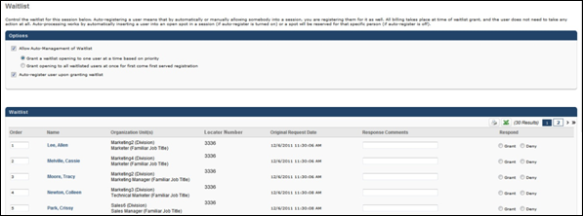
Multiple Providers - Create Learning Assignment - Setup
Administrators can add users to a session using the Learning Assignment Tool. Each session option is included in the list of sessions for an event and can be added to the learning assignment. Once added, the locator number and date/time of the session option displays with the event name to help administrators differentiate between training items.
Design Note: An updated interface is available for this page, which can be enabled by administrators in Feature Activation Preferences. With the new design, the functionality of the page is unchanged.
To access the Learning Assignment Tool, go to Admin > Tools > Learning > Learning Assignment Tool. See Learning Assignment Tool - Overview.
Permissions
PERMISSION NAME | PERMISSION DESCRIPTION | CATEGORY

Assignment Tool - Standard | Grants ability to create Standard (one-time) Learning Assignments to directly assign training to users. This permission can be constrained by OU, Provider, Training Item, Training Type, User, User Self and Subordinates, and User's OU. If this permission is constrained by Location, Provider, Training Type, or Training Item, then they can only assign training within the constraints. If this permission is constrained by OU, User, User Self and Subordinates, or User's OU, then they can only assign to and view assignments created by users within the constraints. This is an administrator permission. | Learning - Administration

Assignment Tool - Standard and Dynamic | Grants ability to create Standard (one-time) and Dynamic (continuous) Learning Assignments to directly assign training to users. This permission can be constrained by OU, Provider, Training Item, Training Type, User, User Self and Subordinates, and User's OU. If this permission is constrained by Location, Provider, Training Type, or Training Item, then they can only assign training within the constraints. If this permission is constrained by OU, User, User Self and Subordinates, or User's OU, then they can only assign to and view assignments created by users within the constraints. This is an administrator permission. | Learning - Administration

Assignment Tool - Standard and Dynamic - Recurrence | Grants ability to create Standard (one-time) and Dynamic (continuous) Learning Assignments to directly assign training to users. Also grants ability to enable/disable Recurrence when creating a Dynamic Learning Assignment. This permission can be constrained by OU, Provider, Training Item, Training Type, User, User Self and Subordinates, and User's OU. If this permission is constrained by Location, Provider, Training Type, or Training Item, then they can only assign training within the constraints. If this permission is constrained by OU, User, User Self and Subordinates, or User's OU, then they can only assign to and view assignments created by users within the constraints. This is an administrator permission. | Learning - Administration
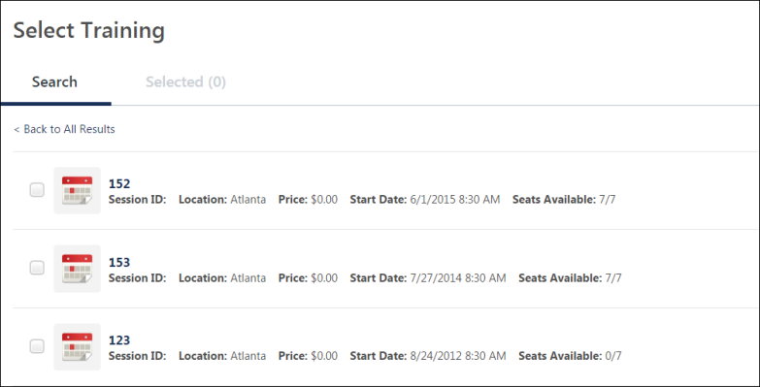
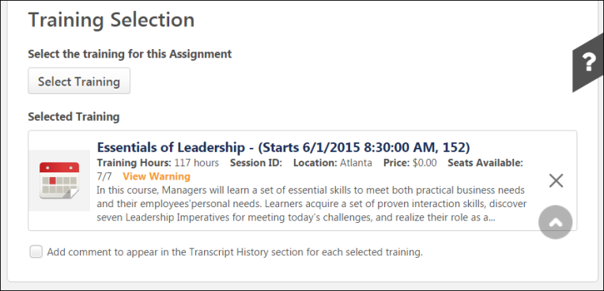
Multiple Providers - Coupon Administration - Create Coupon
When creating a coupon in Coupon Administration, administrators can specify the training items to which the coupon applies. For portals that have the ability to configure multiple providers for a session, coupons can be applied to session options. Note: Applying a coupon to the parent session does not automatically apply it to the session options.
Design Note: An updated interface is available for this page, which can be enabled by administrators in Feature Activation Preferences. With the new design, the functionality of the page is unchanged.
To create a coupon, go to Admin > Tools > Learning > Catalog Management > Coupon Administration. From the Coupon Manage page, click the Create New Coupon link. See Coupon - Create and Edit.
Permissions
PERMISSION NAME | PERMISSION DESCRIPTION | CATEGORY

Coupon Admin - Manage | Provides manage access to Coupon Administration screen, enabling admins to view, add, delete and edit coupons. This permission can be constrained by Provider, ILT Provider, OU, User's OU, and User's LO Availability. This is an administrator permission. | eCommerce - Administration
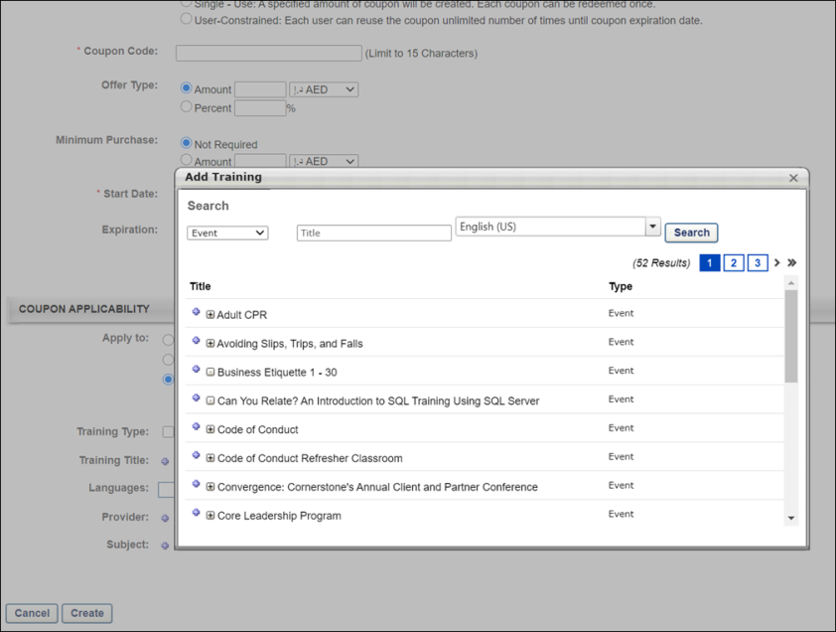
Multiple Providers - Request Session
When requesting a session that has multiple session options, the parent session and all session options are available for users to select.
Note: The ability to select a session must be enabled by the administrator.
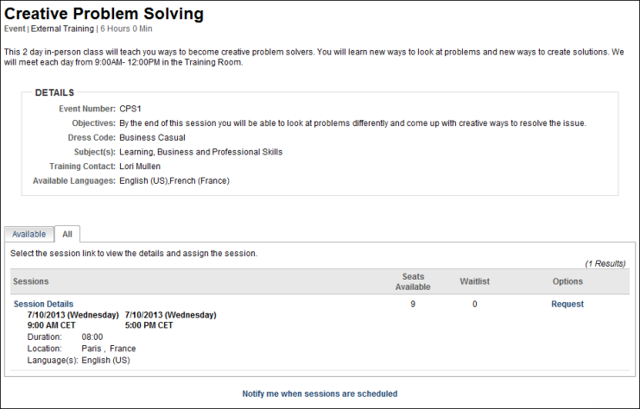
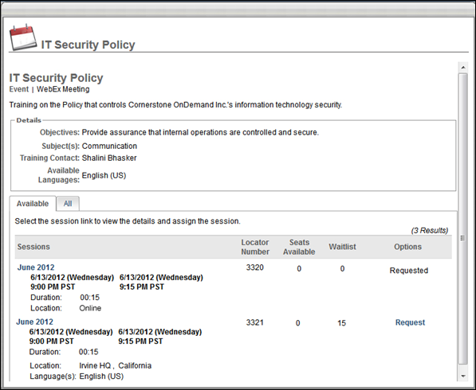
Multiple Providers - Transcript - Select Session
When users select sessions for an event in their transcript, the parent session and any associated session options are available to select. Once successfully selected, the roster for the parent session or session option is updated.
Note: The ability to select a session must be enabled by the administrator.
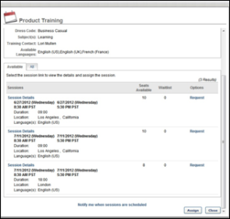
Multiple Providers - View Details Page
When accessing the roster for a parent session or session option from the View Details page, only the roster for the applicable session displays in the Student Roster field.
Permissions
PERMISSION NAME | PERMISSION DESCRIPTION | CATEGORY

Edit Transcript Items | Grants ability to modify training due dates, statuses, and scores on other user's transcripts (training records) when viewing training details for particular learning objects on the transcript. User must also have permission to add external training in order to add or edit another user's external training. This permission can be constrained by OU, User's OU, User Self and Subordinates, User, and User's Self.  Note: Users with this permission also will also see the Add SF-128 link on the transcript. | Learning - Administration

View Transcript Item | Grants ability to view details of learning objects that appear on the transcript (training record), by clicking on the name of the learning object. Users must also have the Bio About - View permission in order to access the transcript within Universal Profile. This permission can be constrained by OU, User's OU, User Self and Subordinates, User, or User's Self. This is an end user permission. | Learning - Administration
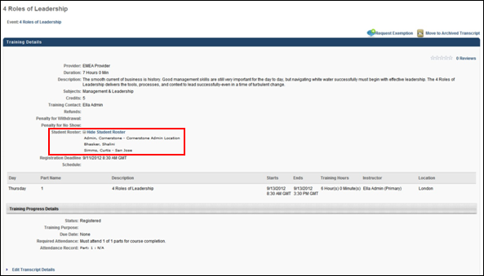
Multiple Providers - Shopping Cart - Review Step
When a user purchases multiple session options in their shopping cart, each session option displays as a separate item in the shopping cart and throughout the checkout process.
To access the shopping cart, click the Shopping Cart link in the upper-right corner of any page in the portal.
Creating Sessions Quick Reference Card
Select the following link to download a Quick Reference Card that guides you through the process of creating a session: Creating Sessions Quick Reference Card

ILT Scheduling Wizard
The Scheduling Wizard allows the administrator to create more than one session part at a time, create more than one session at a time (Batch Session Creation). The schedule wizard creates a date pattern or equation. At the conclusion of completing all steps of the session creation process, multiple sessions will have cascading dates and copies parts.
Citrix (e.g., GoToMeeting) Events: Creating multiple sessions for a Citrix event creates multiple sessions within Citrix. When modifying session information such as session name, conference call information, etc., changes made within GoToMeeting may not appropriately synchronize with the Cornerstone system. It is a best practice to not make any changes within GoToMeeting to any fields that exist within sessions in the Cornerstone system. This will prevent synchronization issues.
Design Note: An updated interface is available for this page, which can be enabled by administrators in Feature Activation Preferences. With the new design, the functionality of the page is unchanged.
To access the Scheduling Wizard, go to ILT > Manage Events and Sessions and click the Sessions icon for an ILT event. Click the Create New Session link. Alternatively, you can click the Copy or Edit icon for an existing session, which also opens the Scheduling Wizard.
Permissions
PERMISSION NAME | PERMISSION DESCRIPTION | CATEGORY

Events Calendar | Grants access to view Events Calendar page. This permission also makes the Event Calendar button on the Learning Search page visible. This is an end user permission. | Learning

ILT - Batch Create Sessions | Allows the admin to create more than one ILT session at the same time using a session schedule wizard. This is an administrator permission. | Learning - Administration

ILT Schedule Part Occurrence | Allows the admin to create more than one ILT session schedule part at the same time using a part occurrence schedule wizard. This is an administrator permission. | Learning - Administration

Sessions - Cancel | Grants ability to cancel instructor led training sessions. This permission works in conjunction with Events - View and Sessions - View permissions. This is an administrator permission. | Learning - Administration

Sessions - Create | Grants ability to create new instructor led training sessions. This permission works in conjunction with Events - View and Sessions - View permissions. Administrators can only create sessions for events for which they have the availability to view. When adding users to a session in which the session roster is full, this permission grants the ability to increase the session's available seats. This permission can be constrained by OU, User's OU, Instructor, User as Instructor, Facility, Facilities Owned by User, ILT Provider, User's ILT Provider, User, and User Self and Subordinates. This is an administrator permission.  Note: The "Restrict to User as Instructor" constraint is available, but it does not actually constrain the permission. | Learning - Administration

Sessions - Edit | Grants ability to edit/update existing instructor led training sessions. This permission works in conjunction with Events - View and Sessions - View permissions. Administrators can only edit sessions for which they have the availability to view and edit. When adding users to a session in which the session roster is full, this permission grants the ability to increase the session's available seats. This permission can be constrained by OU, User's OU, Instructor, User as Instructor, Facility, Facilities Owned by User, ILT Provider, User's ILT Provider, User, and User Self and Subordinates. This is an administrator permission. | Learning - Administration

Sessions - View | Grants view-only access to instructor led training sessions, enabling the user to view all details/options that were selected when the session was created. This permission works in conjunction with the Events - View permission. This permission can be constrained by OU, User's OU, Instructor, Facility, Facilities Owned by User, ILT Provider, User's ILT Provider, User, User as Instructor, and User Self and Subordinates. This is an administrator permission.  Adding an OU constraint and a provider constraint to this permission results in an "AND" statement. | Learning - Administration
Create or Edit Session
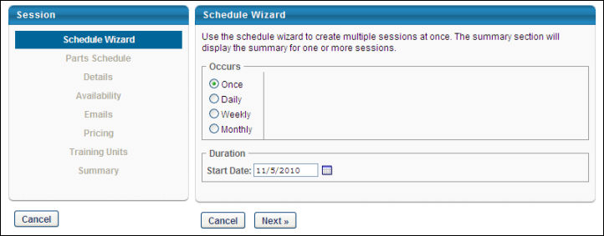
Schedule Wizard
Once you are creating or editing a session, the Scheduling Wizard opens and allows you to configure the following options:
- Occurs - select one of the options:
  - Once - Choose this option to schedule a one-time occurring session.
  - Daily - Choose this option to schedule daily session. If this option is selected, configure parameters for the daily session:
    - Every Day - Enter number in the Every Day field.
    - Start Date - Enter a start date.
    - End - Enter a specific end date OR move to the next option.
    - End After - Enter a number in this field to define how many occurrences the session should end after.
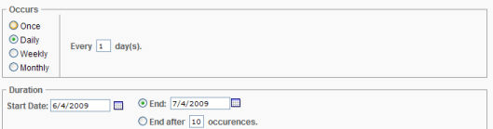
  - Weekly - Choose this option to schedule a weekly session.
    - Enter a number in the Recurs every week(s) on field.
    - Select the day of the week.
    - End - Enter a specific end date OR move to the next option.
    - End After - Enter a number in this field to define how many occurrences the session should end after.
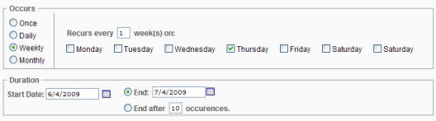
  - Monthly - Choose this option to schedule monthly session.
    - Select First, Second, Third, Forth or Last option from the drop-down menu.
    - Select a day from the drop-down menu.
    - Enter a number in the Of Every Month(s) field
    - Enter a Start Date.
    - End - Enter a specific end date OR move to the next option.
    - End After - Enter a number in this field to define how many occurrences the session should end after.
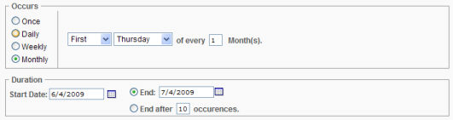
- Click the Next button.
Parts Schedule
On the Parts Schedule page, configure the session parts. For example, you might create a one-part session that only takes two hours to complete, or you might create a three-part session which requires learners to attend four hours of morning training on Monday, Wednesday, and Friday.
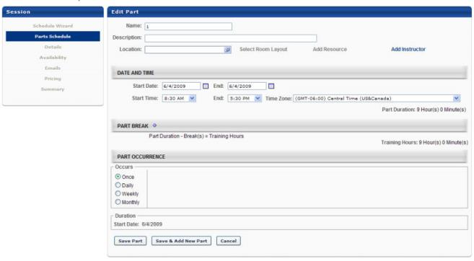
- Name - Enter the name of the first session part, up to 50 characters. This field displays on Training Session Details page from transcript, Training Session Details page from event calendar and Session LO Details page.
- Description - Enter a description of the part session which displays on the user's Session Details page accessed from the Transcript, up to 4000 characters.
- Select Location - if you copied or are modifying a session, click the delete icon to first remove the existing Location and then click the Select Location icon.
  - Click the Select Location link.
  - Search for a location by name, ID or Owner.
  - Add the location by clicking the Add icon next to the location name.
  - Check the Confirmation Required option only to require sessions location to be approved by the Facility Owner before the session is Approved. Session status is Tentative and not searchable until Facility Owner confirms. Note: Notes entered for the Facility Owner are viewed when the Facility Owner responds to the request.
  - Click Done. If confirmation is required, location will have checkmark next to it.
- Select Room Layout - Click this field to display available room layouts, if applicable.
  - Select room layout by clicking on room layout name.
- Add Resource - Click this option to display available resources, if applicable.
  - Click on the applicable resource. Resources are tied to the facility.
  - Enter the resource quantity needed in the Quantity field.
  - Select whether the quantity is Per Part or Per Student.
  - Check the Confirmation Required option to require resource to be approved by the Resource Owner before the session is Approved. Session status is tentative and not searchable until the Resource Owner confirms.
  - Click Done. The resource will be listed on the Session Schedule page with the quantity in parentheses.
- Add Instructor - Click this field o display available instructors for the vendor/provider for this session (Provider/Vendor is set at the event level).
  - Search for an instructor by name.
  - Select an instructor by clicking on an instructor name.
  - Select Primary or Secondary role from the Role drop-down list.
  - Select the Confirmation Required option to require request to be approved by the Instructor before the session is Approved. The session status is Tentative and not searchable until the instructor confirms.
  - Click Done.
  - Add additional instructors by repeating the above steps.
  - If confirmation is required, the instructor will have checkmark next to their name.
- Start Date - Enter a start date with the format MM/DD/YYYY, or click on the calendar icon to search for a date.
- End - Select an end date time from the drop-down list. The start date and end date should be the same unless the sessions go past midnight. Multi-day sessions should be scheduled using Part Break functionality.
- Start Time - Select a start time from the drop-down menu.
- End - Select an end time from the drop-down menu.
- Time Zone - Select a time zone from drop-down menu. By default, the time zone associated with the selected location displays.
- Part Break - Enter a name for the part, up to 50 characters, and a break duration (in minutes).
  - To delete a part break, click the Remove link.
- Part Occurrence - Use the scheduling wizard to define a schedule rule, resulting in more than one part being created and copied over a defined date range. Part Occurrence is the scheduling wizard tool. If more than on session is being created, the parts are copied for the batch-created sessions, with cascading dates.
  - The default occurrence value is set to Once.
  - If the session part should occur more than once, select Daily, Weekly or Monthly. The table will refresh based on which option is selected.
  - The duration displays a read-only start date, defined in the Part and Time section.
  - Select an End Date or enter a number of occurrences for the session to end after (required field).
  - Click Save Part or the Save & Add New Part button to continue. This step validates and checks for errors. If there are errors, you will need to make changes before saving again. Error messages display above the navigation table. The status lights populate with the colors red, green, or yellow, to indicate if each part does or does not have a conflict. You may hover over the status light to see the specific conflict description. Red status lights will prevent from saving the schedule until the error is corrected. Yellow status lights indicate there is a potential conflict, but you will not be prevented from saving the schedule.
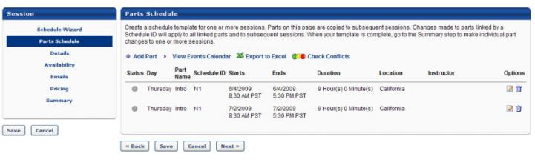
Creating More Than One Session
If you are creating more than one session at a time and are using Part Occurrence that the Part Schedule page will act as a template. If more than one session is being created the edit and delete options automatically will edit the series of parts linked by a schedule ID. To use the additional edit and delete options, navigate to the Summary page where the original and subsequent sessions are listed. From here you can edit individual sessions, and those session's parts.
Additional parts can be added or you can edit existing parts. For parts that were created by schedule rule, a Schedule ID is displayed in the column Schedule ID. This system generated number implies that the parts are linked to one another. Until the Session is saved the Schedule ID is N<#>. After the session or sessions are saved the Schedule ID will lose the "n" and be a unique numerical value. Due to the ability to create multiple parts using the schedule wizard, parts can be linked together, and therefore can be batch edited. With the exception of the options Start/End Dates, Start/End Time, and the scheduling wizard (Schedule date rule), all configurable options can be batch edited with three selections:
- Edit
  - Edit only this part occurrence
  - Edit this part occurrence and the following parts
  - Edit the series of parts (all parts sharing the same schedule ID)
- Delete
  - Delete only this part occurrence
  - Delete this part occurrence and the following parts
  - Delete the series of parts (all parts sharing the same schedule ID)
- Add Part - If session duration is more than one day, or separate sessions within the same day are required, add the session parts by clicking the Add Part link. Add multiple parts if session covers multiple days or time periods, or if parts of the session are held at different locations. Repeat the steps for each added part.
  - Click the Add Part link.
  - Enter Date and Time details.
  - Click the Save Part button.
  - To edit part, click Edit icon or to delete a part, click Delete icon.
- View Events Calendar - Click this option to display the Events Calendar.
- Export to Excel - Click this option to export to excel.
- Check Conflicts - Click this option to check if multiple sessions are being conducted at the same date, time and location. If a prior session has been scheduled at the same time as the prior location, a message will appear and detail the session number that conflicts. This message can be bypassed by clicking the Next or Save button.
- Click Save to save the session or Next to set session details. The session will inherit the availability and the session setting details from the event unless changed.
Details
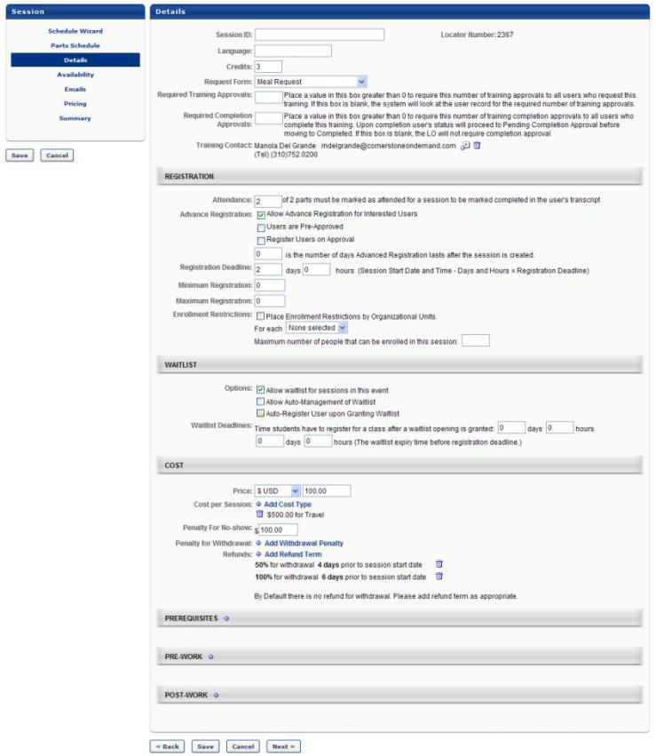
Populate the following fields in the Details section:
- Session ID - Enter a number that will be used to identify the session.
- Locator number - A system-generated number will be automatically populated here, and is used to uniquely identify the session when users search for training.
- Language - Select a language from the drop-down menu, if applicable.
- Request Form - Select a request form from the drop-down menu, if applicable. The user will be able to complete this form at the time they request the session.
- Required Training Approvals - Enter the number of initial approvals this session requires prior to registration. Leaving this blank causes the system to default to the number of Required Training Approvals set in the user's User Record. Setting Required Training Approvals at the LO level overrides the required training approvals in the User Record.
- Required Completion Approvals - Enter the number of completion approvals this training requires in order to be marked complete. If left blank, the training will follow the normal workflow for training completion. If a value is entered (number greater than 0) the training will require Completion Approval for ALL users who complete the training using the normal approval work-flow process.
- Training Contact - Select a training contact for the training.
- Credits per Session - Enter the number of credits received when a user completes the training.
- Attendance - This is the number of parts to be marked attended for a session to be marked complete in user's transcript. Enter a number to indicate how many parts of this session must be attended to show completion for this session.
- Advanced Registration - Select an advanced registration option:
  - Allow Advanced Registration for Interested Users - Check this option to create an early registration period only available to users on the interest tracking list.
  - Number of days Advanced lasts after session is created - Enter the number of days users will be allowed register in advance. Advanced registration will begin as soon as the session is created.
  - Users are Pre-Approved - Check this option to exempt users included in the Advanced Registration process from requiring approval for this session.
  - Register Users on Approval - Check this option to automatically register users included in the Advanced Registration, thereby bypassing the register link on the transcript.
- Registration Deadline - Enter the number of days/hours before the session start date, at which point registration ends.
- Minimum Registration - Enter the minimum number of users who must register for the session.
- Maximum Registration - Enter the maximum number of users who can register for the session. Note: When creating a session for a Citrix event, the maximum registration is 25.
- Enrollment Restrictions - Configure enrollment restrictions:
  - Place Enrollment Restrictions by Organizational Units - Check this option to limit number of users from each OU (of the selected type) that can register for the event's sessions.
  - Select an OU type from drop-down.
  - Enter maximum registration value for each OU.
- Waitlists - configure waitlist options:
  - Allow waitlists for sessions in this event - Check this option to allow waitlists for the session.
    - Users will be added to the waitlist when they register for a session with no seats available.
    - Each session has a separate waitlist.
  - Allow Auto-Management of Waitlist - Check this option to automatically grant openings to waitlisted users.
    - Grant waitlist opening to one user at a time based on priority - Select this option to automatically grant waitlist openings based on the waitlist order.
    - Grant opening to all waitlisted users at once for first come first served registration - Select this option to allow all waitlisted users an opportunity to register.
  - Auto-Register user upon Granting Waitlist - check to automatically register users thereby allowing them to bypass the transcript for registration. This should be used only if you are granting waitlist openings one at a time.
- Waitlist Deadlines - Configure waitlist deadline options:
  - Students have - Enter the number of days and hours a user has to register for the session when waitlist opening is granted. If auto-register is on, this deadline does not apply.
  - Waitlist expires - Enter the number of days and hours before the registration deadline that the waitlist expires. When the waitlist expires, all waitlisted users will have the status Waitlist Expired and will receive an email.
- Price Per Session - Enter a price for the session. Each user (or their cost center) will be billed this price upon registration.
- Cost Per Session:
  - Click the Add Cost Type link.
  - Select a Cost Type from drop-down menu.
  - Enter the amount the item costs per session.
  - Click the Save icon.
  - Repeat the above steps to add other costs to the session.
- Penalty for No-Show - Enter a number to charge users who do not attend any part of a session for which they are registered (without prior withdrawal).
- Penalty for Withdrawal - Configure penalty for withdrawal options:
  - Click the Add Withdrawal Penalty link.
  - Enter a percent or dollar amount for the penalty for withdrawals from the event's sessions.
  - Enter the number of days before the session start date that a penalty to be incurred.
  - Click the Save icon.
  - Repeat the above steps to add another type of withdrawal penalty.
- Refunds - Configure refund options:
  - Click the Add Refund Term link.
  - Enter a percent or dollar amount for the refund for withdrawals from the event's sessions. Refunds cannot be greater than the session price.
  - Enter the number of days prior to session start date that the refund takes place.
  - Click the Save icon.
  - Repeat the above steps to add another refund type.
- Prerequisites - Configure prerequisite options:
  - Click the Add icon .
  - Search for training by keyword by entering a full or partial title or description in the search box.
  - Click the Search button.
  - Click the Add icon to add training as a prerequisite.
  - Add free form training, if applicable, by entering a title in the Free Form Training search box.
  - Click Add.
  - Click Done.
  - Repeat the above steps to add more free form training.
  - Select User must complete prerequisite before registering for this session if all prerequisites must be completed before registration is allowed.
    - When selected, users who have not completed their prerequisites but attempt to register for this event's session will receive an Exception Requested status until the request is approved. The user cannot register until the exception is granted.
  - Select User must register for prerequisites before registering for this session, and must complete prerequisites before the session start dates session if the user must register for the prerequisites before being allowed to register for the event .
    - When selected, users who have not completed their prerequisites will have the status of Pending Prerequisite once they register. The user will be automatically withdrawn on the session start date if the prerequisites are not complete.
- Pre-Work:
  - Click the Add icon .
  - Search for training by keyword.
  - Click the Search button.
  - Click the Add icon to add training.
  - Add free form training, if applicable, by entering a title in the Free-Form Training text box.
  - Click Add.
  - Click Done.
  - Repeat the above steps to add more free form training.
  - Check Req. for each training item that is required for the completion of the class.
    - If a student does not complete this training, their status will be Incomplete when the session is marked complete.
  - Enter number for the training sequence in the Seq. text box for each training item to set a required sequence for the training.
    - If there is a required sequence, users will not be able to request training until the training which is before it in the sequence is completed first.
    - If no numbers are entered, students may take all the pre-work training in any order or all at once.
  - Enter number for display position in the Display Position text box for each training item
    - The training items will be displayed in this sequence on the Training Details page
- Post-Work - Configure post-work options:
  - Click the Add icon .
  - Search for training by keyword by entering full or partial title or description in the search box.
  - Click the Search button.
  - Click the Add icon to add training.
  - Add free form training, if applicable, by entering a title in the Free Form Training text box.
  - Click Add.
  - Click Done.
  - Repeat steps to add more free form training
  - Check the Req. checkbox for each training item that is required for the completion of the class.
    - If a student does not complete this training, their status will be Incomplete when the session is marked complete
  - Enter number for the training sequence in the Seq. text box for each training item to set a required sequence for the training
    - If there is a required sequence, users will not be able to request training until the training which is before it in the sequence is completed first.
    - If no numbers are entered, students may take all the post-work training at once.
  - Enter number for display position in the Display Position text box for each training item. The training items will be displayed in this sequence on the Training Details page
- Click Save to save the session or Next to set availability. The session will inherit the availability and the session setting details from the event unless changed.
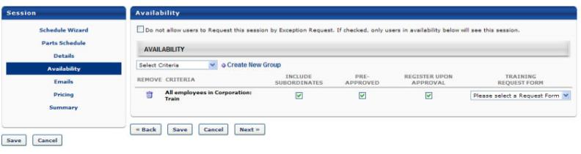
Availability
- Click Availability to specify which users or OUs to whom this session is available.
- Do not allow users to Request this session by Exception Request - Select this option to allow only users who have session available to them to request this session (No exceptions allowed)
- Click the Select Criteria drop-down menu and complete the following steps:
  - Click to select a specific OU.
  - Click Add to add availability to the OU.
  - Click Done.
  - Include Subordinates - Select this box to include the subordinates of the OU selected.
  - Pre-Approved - Select this box to bypass the approval process. Upon request, the session will be in an Approved Status.
  - Register Upon Approval - Select this box to bypass the Register step for the end user.
  - Training Request Form - Select a training request form from the drop-down menu if applicable.
  - Create New Group - Select this option to create new group if an existing group does not meet the availability needs.
- Click Save to save the session or click Next to configure custom emails for the session.
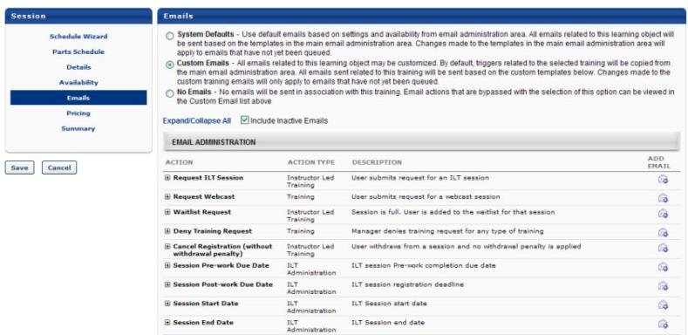
Emails
Configure email options for the event:
- System Defaults - By default, all existing and new learning objects will have the System Defaults option selected. If selected:
  - All emails related to this learning object (LO) will be sent based on the active email templates in the main email administration area.
  - Changes made to the templates in the main email administration area will apply to emails that have not yet been queued.
- Custom Emails - Select the Custom Emails option to customize emails for this LO. By default, triggers related to the selected training will be copied from the main email administration area. All emails related to this training will be sent based on the custom templates configured.
  - To see inactive emails, select Include Inactive Emails option.
  - If an email trigger is not available in the Custom Emails area, it will still be sent (if configured to do so) from the main Email Administration area.
  - Changes made to the custom training emails will only apply to emails that have not yet been queued.
  - Both active and inactive templates will be copied down. Only the active email templates will send in relation to this training request.
  - The Custom Emails area will not display until this option is selected. These emails may then be edited, added or deleted as desired.
  - Future training-related emails will send appropriately based on the settings and templates created within the Custom Emails section.
- No Emails - If this option is selected, no emails will be sent in association with this training. Email actions that are bypassed with the selection of this option can be viewed in the Custom Emails list displayed when the Custom Emails option is selected. This list of emails includes the emails that will not be sent when No Emails is the option selected. Note: There are two types of emails: those triggered by a user's action, and those triggered by an object. It is for this reason that the No Email option does not always mean No Emails will be received by the user.
- Click Save to save the session or the Next button to set pricing for the session if applicable.
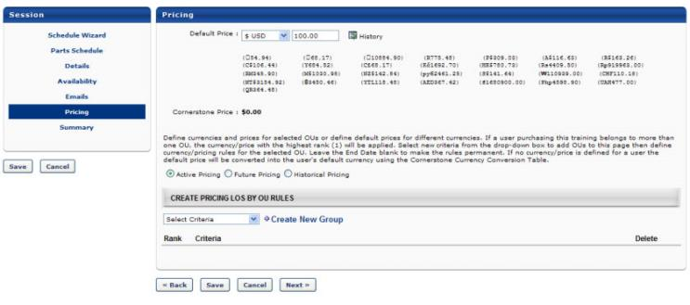
Pricing
- Click the Pricing link to edit the event pricing. See - Course Catalog - Pricing for more information.
- Click Save to save your configurations or click Next to continue to Session Summary.
Summary
On the summary page, you can edit an individual session's parts. When more than one session is created, each will have copied parts from the Part Schedule template. When selecting to edit a session, open the associated session list page that looks the same as the Part schedule step. This is where you can make unique changes for one session and not impact other sessions created in the same batch. DO NOT return to the Part Schedule step to make edits as it will overwrite or re-copy any unique changes made on the Summary page.
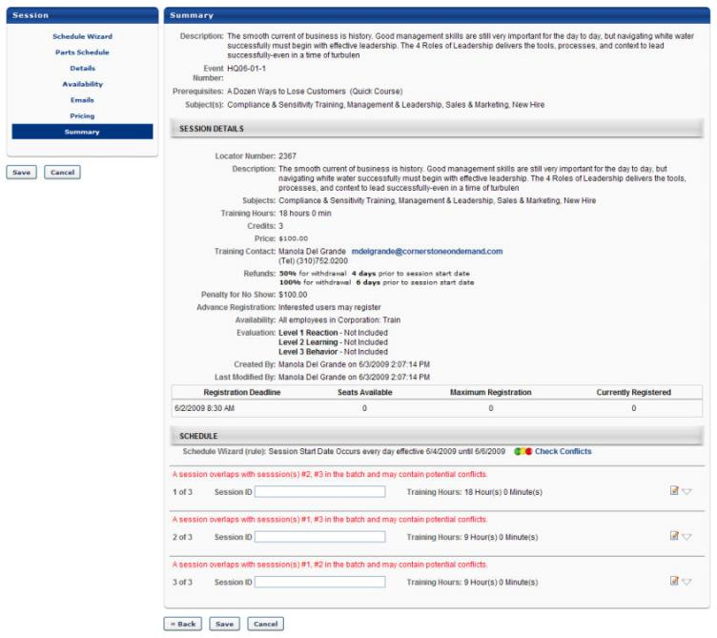
- Edit - Click this option to make individual changes to a session and its parts. You can make changes to individual parts for the sessions that will be created. If those parts have a schedule ID, they will provide the multiple editing and deletion options. The parts with in the sessions will be grouped with independent schedule IDs.
- Click Save to complete the creation of the one or more sessions.
Helpful Hints - Processing Time
- Best Practice - It is advised to not create a large batch of sessions which each have many parts. Processing time increases relative to the number of parts created and copied for each session in the batch.
  - Example: 100 Sessions, each has 1 part, 100 parts total, conflict check may take up to 15 seconds.
  - Example: 20 Sessions in a batch, each having 30 parts, total part = 600, conflict check may take up to 80 seconds.
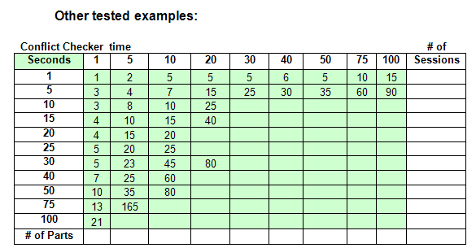
- Conflict Processing time - The Check Conflict processing time varies across portals, as it is impacted by the total number of sessions and parts that may be stored in the portal's ILT module. Each past session and its parts are checked against other parts already created and stored. A call is made to the database for each item that is checked, such as location, instructor, overlapping dates, and resources. The results displayed above were documented from a portal with a moderate amount of stored data.

Manage Evaluations
Level 1 Evaluations are used to measure and record a learner's reaction to training they’ve recently completed, such as their rating of the course content, materials, and relevance. Level 1 Evaluations are the most commonly used type of Cornerstone evaluation and can be attached to various learning object (LO) types. The information gathered by Level 1 Evaluations can drive decisions about the types of training that are most effective and engaging to your learning audience.
Design Note: An updated interface is available for this page, which can be enabled by administrators in Feature Activation Preferences. With the new design, the functionality of the page is unchanged.
To manage evaluations for an event or session, go to ILT > Manage Events & Sessions.
- Click the Edit icon in the Evaluations column to manage an evaluation for an event.
- Click the View Sessions icon and the Edit icon in the Evaluations column to manage an evaluation for a session.
Permissions
PERMISSION NAME | PERMISSION DESCRIPTION | CATEGORY

Events - Create | Grants ability to create new instructor led training events. This permission works in conjunction with Events - View permission. This permission can be constrained by OU, User's OU, ILT Provider, and User's ILT Provider. This is an administrator permission. | Learning - Administration

Events - Edit | Grants ability to edit/update existing instructor led training events. This permission works in conjunction with Events - View permission. This permission can be constrained by OU, User's OU, ILT Provider, and User's ILT Provider. This is an administrator permission. | Learning - Administration

Level 1 Evaluation Administration | Grant Access to create and manage level 1 (reaction) evaluations associated with learning objects. This permission cannot be constrained. This is an administrator permission. | Learning - Administration

Level 1 Evaluations - Manage | Grants ability to create and edit Level 1 (Reaction) learning evaluations that can be associated with learning objects. When viewing Course Console, this permission also grants the ability to view the status of Level 1 Evaluations. This permission works in conjunction with the Level 1 Evaluation Administration, Course Catalog - Update, and Course Catalog - View permissions. This permission cannot be constrained. This is an administrator permission. | Learning - Administration
ILT Evaluations
The following management options are available for evaluations attached to events or sessions:
- Active - Check the Active checkbox to associate an evaluation with an event or session.
  - The type field displays whether this course is using the corporate default, a custom evaluation, or the event default.
  - A session always has an evaluation associated with it, the Active checkbox says whether or not the users can complete the evaluation.
- Required - Check the Required checkbox to make the evaluation required for session completion.
  - When the user completes the session, their status will be Pending Evaluation until they complete the evaluation.
- Include Pre-Training - Check the Include Pre-Training checkbox to include a pre-test for Level 2 evaluations or a pre-evaluation for Level 3 evaluations.
- Preview - Preview the evaluation by clicking on the Preview icon .
  - This will open the user view of the evaluation in a pop-up window.
- Select Evaluation - Change the evaluation by clicking the Select icon .
  - Select evaluation by clicking on the Add icon.
  - To restore the evaluation to the corporate default, click on the Restore Default icon .
Click Submit to submit your changes.
Evaluation Helpful Hints
- Associating evaluations at the event level will associate that evaluation as a default to all sessions created for that event.
- If a session has an Level 1 evaluation assigned the users will see the Evaluate option on their transcript for that class on the date of the session.
- If a session has a Level 2 pre-training evaluation assigned the users will see the Take Pre-Test option on their transcript.
- If a session has a Level 2 evaluation assigned the users will see the Take Post-Test option on their transcript for that class on the date of the session or after they complete a Level 1 if Level 1 active.
- If a session has a Level 3 pre-training evaluation assigned the learner will see the Take Pre-Test option on their transcript.
- If a session has a Level 3 evaluation assigned the Level 3 will deploy as a task to the learner, manager, and subordinates (recipients depend on how Level 3 is set-up).
- If an evaluation is required then users will have the status Pending Evaluation when the session is marked complete and the status will not change to Completed until the evaluation is complete.
- Administrators and instructors can view the evaluation responses by viewing the Evaluation Report from the Manage Events and Sessions page or the ILT Admin Reports page.

Manage Events & Sessions - Waitlists
The Waitlisted Users page allows ILT administrators to view and act upon waitlist requests.
Design Note: An updated interface is available for this page, which can be enabled by administrators in Feature Activation Preferences. With the new design, the functionality of the page is unchanged.
To access the Waitlists page, go to ILT > Manage Events & Sessions. Then, click the Waitlists button.
Permissions
PERMISSION NAME | PERMISSION DESCRIPTION | CATEGORY

Waitlists - Manage | Grants ability to approve or deny instructor led training waitlist requests. This permission works in conjunction with the Events - View and Waitlists - View permissions. This is an administrator permission. | Learning - Administration

Waitlists - View | Grants view-only access to instructor led training session waitlists, via the ILT Events and Sessions screen, enabling the user to view the waitlists for various ILT sessions. This permission works in conjunction with Events - View and Sessions - View permissions. | Learning - Administration
Emails
EMAIL NAME | EMAIL DESCRIPTION | ACTION TYPE

Grant Waitlist Request | Once a user has submitted a Waitlist Request, they will remain in Waitlisted status until an administrator makes the decision to grant or deny the request. If the ILT administrator grants a user's request to attend a session, this email will be triggered.  When a user withdraws from a session and a seat becomes available, users on the waitlist are removed from the waitlist, they are granted the option to register for the open seat, and this email is triggered, if enabled. The waitlisted users will see the session on their transcripts in "Registration Pending" status.  - As soon as one of the user registers, all other users are moved back to the waiting list. In this scenario, if another user withdraws, the process is completed again for the users remaining on the waitlist.  - If none of the users register, the previously waitlisted users are not moved back to the waiting list. In this scenario, if another user withdraws, since no users are on the waiting list in that moment, this email is not triggered.  When a user withdraws from a session after the registration deadline, this email is not triggered. | Instructor Led Training
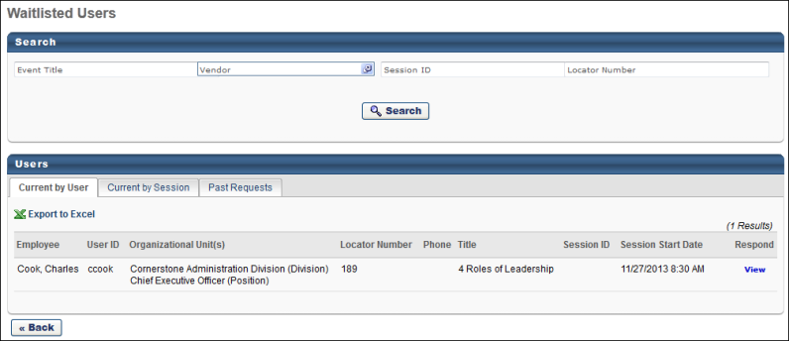
Waitlisted Users
The following tabs are available on the Waitlisted Users page and they control the information that is displayed:
- Current by User - This view displays all waitlisted user for any session. On this tab, you can click the View link to respond to waitlisted users. See Session Roster - Roster - Waitlists on page 238 for additional information.
- Current by Session - This view displays how many users are waitlisted for a particular session. Only sessions that have a waitlist are displayed. On this tab, you can copy a session by clicking the Copy icon in the Copy Session column. This creates an identical session and automatically enrolls the waitlisted users into the copied session. You can make changes to the copied session and select specific users for the new session. Users that are added to the new session are automatically denied from the waitlist for the original session. See Session Roster - Roster - Waitlists on page 238 for additional information.
- Past Requests - This view displays all past waitlist requests. For each request, the details of the request are displayed, including the decision that was made for the request (granted or denied).
Click the Export to Excel link to view the list of waitlisted users (Current by User, Current by Session, and Past Requests) in an Excel spreadsheet. The spreadsheet will download to your computer in .xlsx format.
On each tab, you can search for waitlist requests by event title, vendor, session ID, and locator number.

Session Evaluation - Print Pop-up
The Print Evaluations pop-up enables administrators and instructor-led training (ILT) instructors to print level 1, 2, or 3 evaluations for the session and distribute them to all session attendees. Instructors are responsible for entering evaluation information into the system for each printed evaluation. This can be done either via manual entry or by scanning completed evaluations and attaching them to the session.
Design Note: An updated interface is available for this page, which can be enabled by administrators in Feature Activation Preferences. With the new design, the functionality of the page is unchanged.
Evaluations for a session can be printed in the following manners:
- Go to ILT > Manage Events & Sessions. Then, search for the appropriate event and in the Options column next to the event, click the View Sessions icon . Then, in the Evaluation column next to the appropriate session, click the Print Evaluations icon .
- Go to ILT > Manage Events & Sessions. Then, select the Search for all Sessions option and search for the appropriate session. Then, in the Session Options column next to the appropriate session, click the Print Evaluations icon .
Permissions
PERMISSION NAME | PERMISSION DESCRIPTION | CATEGORY

Events - View | Grants view-only access to instructor led training events, enabling the user to view all details/options that were selected when the event was created. This permission can be constrained by OU, User's OU, User's ILT Provider, and ILT Provider. This is an administrator permission. | Learning - Administration

ILT Evaluations - Print | Grants ability to print evaluations at the session level for any session within the permission constraints. This permission can be constrained by Instructor, ILT Provider, User's ILT Provider, and User as Instructor. This is an administrator permission. | Learning - Administration

Sessions - View | Grants view-only access to instructor led training sessions, enabling the user to view all details/options that were selected when the session was created. This permission works in conjunction with the Events - View permission. This permission can be constrained by OU, User's OU, Instructor, Facility, Facilities Owned by User, ILT Provider, User's ILT Provider, User, User as Instructor, and User Self and Subordinates. This is an administrator permission.  Adding an OU constraint and a provider constraint to this permission results in an "AND" statement. | Learning - Administration
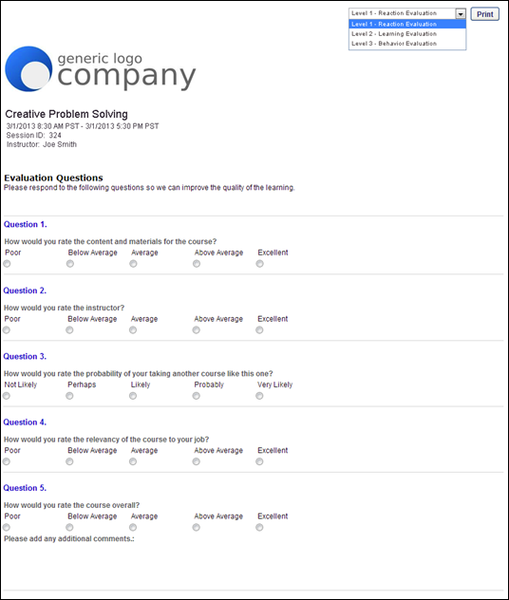
Print
From the drop-down in the upper-right corner, select the type of evaluation you are printing. Note: Only the evaluation types that are configured for the session are available in the drop-down list. A preview of the evaluation is displayed in the pop-up. If a header is configured for the evaluation, then it is displayed in the upper-left corner of the evaluation. The following evaluation information displays below the header, if configured:
- Session Name
- Session Date/Time - This is displayed in the appropriate date format for the user's culture. The time zone may be hidden in ILT Preferences.
- Session Locator Number/Session ID
- Instructor
Note: Custom fields are not displayed on printed evaluations.
After selecting the appropriate evaluation type, click the Print button. This initiates your internet browser's print function.

View Your ILT Sessions
The View Your ILT Sessions page is a calendar view of upcoming instructor-led training (ILT) sessions for which you are the instructor. In order to access this page, you must be a system instructor. For information about adding instructors to the system, See Instructors - Add/Edit on page 5 for additional information.
To view your ILT session calendar, go to ILT > View Your Sessions.
You can filter your training calendar using the filters on the left side of the page by the following statuses:
- Tentative
- Confirmed
- Completed
You can also view your calendar by Day, Week, Month, or Agenda by selecting the appropriate option at the top of the calendar.
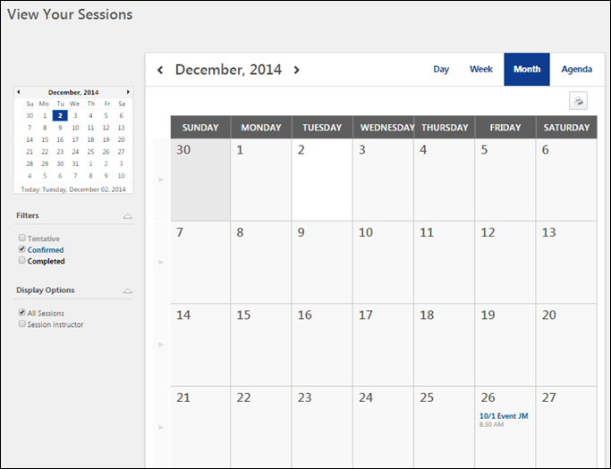

Session Roster Overview
The session roster allows instructors and administrators to see a list of all users who are scheduled to attend a session, as well as users who would like to attend the session and are awaiting an exception or opening in the class. The instructor-led training session roster is a central place where administrators or instructors can view and manage the users that are registered for a session or have requested the session. Administrators can manage sessions that have waitlists and sessions where multiple users must be transferred to another session of an event. Instructors can manage assignments as well as attendance and scoring. When the session has concluded, the final roster can be submitted.
Design Note: This page has an updated interface (UI) that is automatically enabled. However, administrators can still revert to legacy UI via Feature Activation Preferences. The page's functionality is unchanged with the new design. With the July 26, 2024 Release, the new UI will be permanently enabled in all production, stage, and pilot portals, and the legacy UI pages will no longer be available. The new UIs disabled in March will be auto-enabled in July.
To access the ILT session roster, go to ILT > Manage Events & Sessions. Search for the appropriate event and next to the event in the search results, in the Options column, click the View Sessions icon . This option is only available to users with permission to view sessions. Next to the appropriate session, in the Options column, click the View Roster icon .
Permissions
PERMISSION NAME | PERMISSION DESCRIPTION | CATEGORY

LO Attachments - Manage | Grants ability to upload attachments to learning objects. Administrators with this permission are automatically granted the LO Attachments - View permission. This permission can be constrained by User's ILT Provider, Provider, and ILT Provider. This is an administrator permission. | Learning - Administration

LO Attachments - View | Grants ability to view the learning object attachments that are set to be available to administrators. This permission can be constrained by User's ILT Provider, Provider, and ILT Provider. This is an administrator permission. | Learning - Administration

Roster - Manage | Grants ability to manage instructor led training session rosters, including updating attendance, and marking the ILT session complete to update student transcripts. A variety of other features are available depending upon additional roster permissions. This permission works in conjunction with Events - View, Sessions - View, and Roster - View permissions. This permission can be constrained by Instructor, User as Instructor, ILT Provider, and User's ILT Provider. This is an administrator permission. | Learning - Administration

Roster - View | Grants view-only access to instructor led training session rosters. This permission works in conjunction with Events - View and Sessions - View permissions. This permission can be constrained by Instructor, ILT Provider, User's ILT Provider, and User as Instructor. This is an administrator permission. | Learning - Administration

Sessions - View | Grants view-only access to instructor led training sessions, enabling the user to view all details/options that were selected when the session was created. This permission works in conjunction with the Events - View permission. This permission can be constrained by OU, User's OU, Instructor, Facility, Facilities Owned by User, ILT Provider, User's ILT Provider, User, User as Instructor, and User Self and Subordinates. This is an administrator permission.  Adding an OU constraint and a provider constraint to this permission results in an "AND" statement. | Learning - Administration
The Roster page is comprised of three tabs:
- Roster - This is the default tab and is always visible. This tab provides an overview of the session, including roster and schedule.
- Assignments - This tab only appears if the session has prerequisites, pre-work, or post-work.
- Attendance and Scoring - This tab is always visible and enables the administrator or instructor to track attendance and scoring.
See Also:
- Manage Session Waitlist
- Exception Requests
- Add Users to a Session via a Roster
- Edit Transcript Details
- Email Registered Users
- Exempt Users from Assignments
- Withdraw Users
- Interest Tracking
Troubleshooting Information
The following page contains a quick reference card to guide you through the process of managing the session roster:
- See Managing Rosters Quick Reference Card on page 294 for additional information.

Session Roster - Roster Tab
The Roster tab displays all of the users registered for the session along with the session schedule. This tab also contains links to view users that are on the waitlist or exception requested list for the session, as well as any users that have reserved a registration spot for the session. Instructors perform actions on the roster, including printing the sign-in sheet, email registered users, add users, and withdraw users.
Design Note: This page has an updated interface (UI) that is automatically enabled. However, administrators can still revert to legacy UI via Feature Activation Preferences. The page's functionality is unchanged with the new design. With the July 26, 2024 Release, the new UI will be permanently enabled in all production, stage, and pilot portals, and the legacy UI pages will no longer be available. The new UIs disabled in March will be auto-enabled in July.
Note: If the title of the Roster page is Parent Roster, then your portal has enabled the ability to configure multiple providers for a session. See Multiple Providers - Parent Roster Page on page 171 for additional information.
Permissions
PERMISSION NAME | PERMISSION DESCRIPTION | CATEGORY

Attachments in Transcript - Manage | Grants ability to upload new attachments and delete existing attachments for LOs on a user's transcript. Users with this permission are automatically granted permission to view attachments. This permission can be constrained by OU, User's OU, User Self and Subordinates, User, User's self, User's ILT Provider, ILT Provider, and Instructor. | Learning Administration

Attachments in Transcript - View | Grants ability to view attachments that have been uploaded for LOs on a user's transcript. This permission can be constrained by OU, User's OU, User Self and Subordinates, User, User's self, User's ILT Provider, ILT Provider, and Instructor. | Learning

Exceptions - Manage | Grants ability to approve or deny Instructor Led Training Exception requests (e.g. availability exceptions, pre-requisite exceptions). This permission works in conjunction with the Event - View and Exceptions - View permissions. This is an administrator permission. | Learning - Administration

Exceptions - View | Grants view-only access to instructor led training exception requests, via the ILT Events and Session screen. This permission works in conjunction with the Events - View permission. This is an administrator permission. | Learning - Administration

Roster - Add Attachments | Grant user the ability to upload files to the Roster page. User must also have Manage Roster or View Roster permission. This is an administrator permission. | Learning - Administration

Roster - Add Pending Users | Grant ability to add pending users to the ILT session roster. The administrator must also have the Roster - Manage or Roster - View permission. This permission cannot be constrained. This is an administrator permission. | Learning - Administration

Roster - Add Users | Grants ability to add named users to class rosters for instructor led training sessions. This permission works in conjunction with the Roster - View permission. This permission can be constrained by OU, User's OU, ILT Provider, and User's ILT Provider. This is an administrator permission. | Learning - Administration

Roster - Batch Withdrawal or Move Users | Grants ability to withdraw multiple users for an instructor led training session class roster, or to move them from one class roster to another. This permission works in conjunction with the Roster- View permission. | Learning - Administration

Roster - Email Registered Users | Grants ability to send a custom email message to all students listed on the roster for an instructor led training session. An additional link appears on ILT roster page for sending such messages. This is an administrator/ILT instructor permission. | Learning - Administration

Roster - Increase Seats | Grant user the ability to increase the session's available seats when adding users to the session roster if the added users exceed the number of available or reserved seats. User must also have Manage Roster or View Roster permission. This permission cannot be constrained. This is an administrator permission. | Learning - Administration

Roster - Manage | Grants ability to manage instructor led training session rosters, including updating attendance, and marking the ILT session complete to update student transcripts. A variety of other features are available depending upon additional roster permissions. This permission works in conjunction with Events - View, Sessions - View, and Roster - View permissions. This permission can be constrained by Instructor, User as Instructor, ILT Provider, and User's ILT Provider. This is an administrator permission. | Learning - Administration

Roster - View | Grants view-only access to instructor led training session rosters. This permission works in conjunction with Events - View and Sessions - View permissions. This permission can be constrained by Instructor, ILT Provider, User's ILT Provider, and User as Instructor. This is an administrator permission. | Learning - Administration

Roster - View Evaluation Status | Grants ability to view whether students' learning evaluations are pending for a given session. Without this permission, the admin sees status "completed" for any users who are actually in pending evaluation status on the roster This permission works in conjunction with Roster - View permission. This is an administrator permission. | Learning - Administration

Roster - Withdrawal Penalty Override | Grants ability to override the withdrawal penalty when withdrawing a student from an ILT session. This permission works in conjunction with the Events - View, Sessions - View, Roster - View and Roster - Manage permissions. This is an administrator permission. | Learning - Administration

Session Details - View Student Roster | Allows user to view student roster for a given ILT session via a link on ILT session details screen when searching for training, and from transcript details screen after a session has been added to the user's transcript. This is an end user permission. | Learning

View Transcript Item | Grants ability to view details of learning objects that appear on the transcript (training record), by clicking on the name of the learning object. Users must also have the Bio About - View permission in order to access the transcript within Universal Profile. This permission can be constrained by OU, User's OU, User Self and Subordinates, User, or User's Self. This is an end user permission. | Learning - Administration

Waitlists - Manage | Grants ability to approve or deny instructor led training waitlist requests. This permission works in conjunction with the Events - View and Waitlists - View permissions. This is an administrator permission. | Learning - Administration

Waitlists - View | Grants view-only access to instructor led training session waitlists, via the ILT Events and Sessions screen, enabling the user to view the waitlists for various ILT sessions. This permission works in conjunction with Events - View and Sessions - View permissions. | Learning - Administration
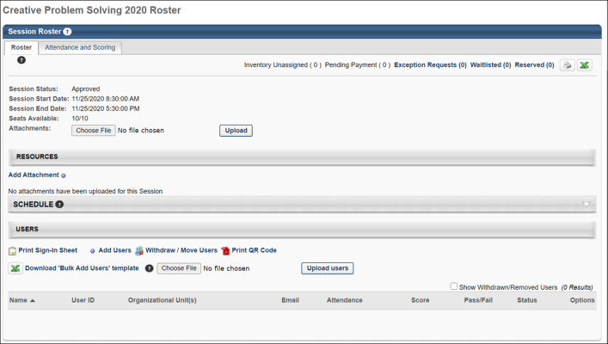
View new roster pages/View default roster pages
- Click the View new roster pages link to view the newly-designed roster page. All of the information on the page remains the same.
- Click the View default roster pages to return to the default roster pages.
Note: Clicking the View new roster page link opens the page in view-only mode at this time.
General Information
At the top of the page, the status of the session is displayed. Note: If the status is Completed, the Re-Submit link no longer appears.
Anytime "All Locator Numbers" is selected from the Locator Number drop-down menu, the Session Start Date and Session End Date fields are not displayed because multiple sessions are displayed.
Seats Available
The Seats Available field displays the number of seats available and the maximum number of possible users. For example, if a session can have a maximum of 15 users and 5 have registered thus far, the Registration value displays 10/15, indicating there are 10 remaining open seats. Users on the Reserved list do count towards the number of available seats. For example, if a session can have a maximum of 15 users, 5 have registered, and 5 are on the reservation list, the session has 5 available seats.
If the seat reservation option is enabled in ILT Preferences, then the Seats Available field displays as a link. Clicking the link opens the Seats Available pop-up, which displays the seat allocation details. See Session Roster - Roster - Seats Available Pop-up on page 236 for additional information.
Attachments
The Attachments feature below the Seats Available field allows administrators and instructors to add attachments to the roster. Attachments display below the Attachments field. This feature is only available to administrators and instructors with permission to add attachments to a roster. Acceptable file types are pdf, jpeg, gif, Microsoft Excel, Microsoft PowerPoint and word documents. There is no limit to the number of files that can be uploaded to the page. The upload maximum size is 25 MB per item.
Once you have selected your attachment, click Upload to upload it to the roster. Note: The Upload option does not refer to uploading users to the session. Refer to the Download 'Bulk add Users' template feature in the bottom-left of the roster page to upload users.
Additional Session Actions
In the upper-right corner, the following session action links may appear (see below for the Reserved option):
- Inventory Unassigned - This value represents the quantity of inventory that is purchased as inventory but has not yet been assigned to a user. With regards to the roster Availability, an inventory assignment reserves a seat, but an inventory purchase that is not yet assigned does not affect the availability.
- Pending Payment - This indicates the session has a cost and has not yet been paid for.
- Exception Requested - This link displays the number of users that have a pending exception request. If no exception requests have been made for the session, the link does not appear. After the administrator responds to all exception requests, the link remains visible with zero as the number of users. Click the link to go to the Exception Request page. This option is only available to users with permission to view or manage exception requests.
- Waitlisted - This link displays the number of users that are on the waitlist for the session. If waitlists are not enabled for the event or if there are no users on the waitlist, the link does not appear. After the administrator responds to all waitlisted users, the link remains visible with zero as the number of users. Click the link to go to the Manage Waitlist page. This option is only available to users with permission to view or manage the waitlist.
Reserved
The following only displays if the related backend setting is enabled (please contact Global Customer Support if you wish to enable this setting):
Reserved - This link displays the number of users on the reservation list for the session. Users on the Reserved list do count towards the attendance, decreasing the number of available seats, though they do not appear on the roster until they are registered. If no users are on the reservation list for the session, the link does not appear. After the administrator responds to all reserved users, the link remains visible with zero as the number of users. Click the link to go to the Manage Reservation page.
- Users are reserved a seat in the session when they are assigned to and approved for the session, but are not automatically enrolled until they either select Register or the administrator grants them access to the session.
- Users are reserved a seat in the session when they are assigned to and approved for the session, but are not automatically enrolled until they either select Register or the administrator grants them access to the session.
Resources
This section enables administrators to view and manage attachments for the session. The visibility of each attachment can be determined by the administrator. For example, some attachments may be visible to only administrators, while other attachments may be visible to all users. In addition, attachments can be made visible to users only if they are registered for the corresponding session. This section is only available for users that have permission to view or manage LO attachments.
When the session is first created, this section contains any attachments that were added on the Session Defaults page for the event.
See Session Roster - Roster - Resources on page 232 for additional information.
Schedule
The Schedule section appears collapsed by default, but when expanded displays the schedule of the session. Click the View Map to view a map of the location if available.
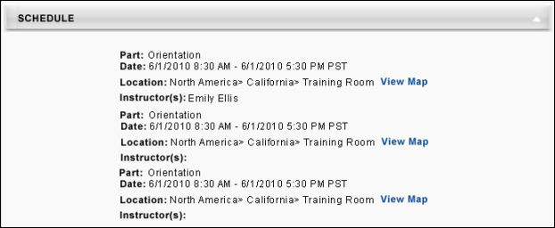
Add Pending Users to Roster
The Add Pending Users to Roster button is only available if there are users who have been selected to be added to the session, but have not yet been enrolled in the session. Also, this button is only available to users who have permission to add pending users to the roster. See Session Roster - Add Users to a Session on page 278 for additional information.
Roster Table
Above the roster table, the following user action links may appear:
- Administrators may choose whether to use the old versions of the sign-in sheets or the new versions with signature columns for each session part:
  - Print Sign-In Sheet - Click this option to use the old version of the sign-in sheet, which does NOT include a signature column for each session part.
  - Print Multi-Part Sign-In Sheet - Click this option to use the new version of the sign-in sheet, which includes a signature column for each session part.
  - Selecting one of the above options opens another window displaying the printable sign-in sheet. There are two types of each sign-in sheet version:
    - Simplified sign-in sheet
    - Expanded sign-in sheet (this version includes the attendee's name, user ID, OU, work phone, email, address, city, and state)
- Email Registered Users - This link navigates you to the existing email functionality. This option is only available to users who have permission to email registered users on the roster. See Session Roster - Email Registered Users on page 286 for additional information.
- Add Users - When an instructor or administrator clicks the Add Users link, this opens the Select User pop-up, in which the instructor or administrator can search for and select multiple users to be added to the session roster. Users who are already registered for the session or are pending registration cannot be selected from the pop-up. Note: This option is only available to instructors or administrators with permission to add users to a roster. In addition, the constraints on this permission determine which users can be viewed and selected. See Session Roster - Add Users to a Session on page 278 for additional information.
- Withdraw or Move Users - This option opens the Batch Withdraws or Move Users pop-up window. The administrator can then withdraw a user from the session. If the user is withdrawn, they no longer appear on the active roster. This option is only available to users that have permission to batch withdraw or move users from a roster.
  - See Session Roster - Withdraw Users on page 288 for additional information.
  - See Session Roster - Move Users on page 289 for additional information.
- Print QR Code - Administrators and instructors with permission to access the roster for a session can print the QR code for the session via the Session Roster page. To print the QR code from the roster, click the Print QR Code link, located in the Users section of the Session Roster page. A printable version of the session's QR code downloads from the browser, allowing the administrator to open the download and print the QR code. The printable QR code displays with the following information:
  - Event name
  - Locator number
  - Session part
  - Dates of session part
  - Location - Note: A Location must be provided when creating the session to be able to generate a session QR code.
Instructors can display the printed or digital version of the session part QR code to users at the session part. Users attending the session part can scan the session part QR code using the Learn app to mark themselves as attended.
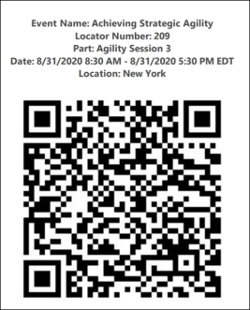
- Download Bulk Add Users Template - Administrators and instructors can add users to a roster in bulk via an Excel spreadsheet. For more information about this process: See Session Roster - Bulk Add Users on page 263 for additional information.
Roster Table
The roster table displays the following information for each user that is registered for the session. You must have permission to view the evaluation status of a user to view whether students' learning evaluations are pending for a given session.
If the Show Withdrawn/Removed Users option is selected, users who were previously registered, but are withdrawn also display in the table.
- Name - This column displays the name of the user.
- User ID - This column displays the user's user ID.
- Organizational Unit(s) - Displays any OUs for the user.
- Email - Displays the user's email address if one is defined in their user record. Click the email address to create an email to that user in your default email application. This feature does not require permission.
- Attendance - Displays the number of total session parts attended.
- Score - Displays the user's score for the session, which is entered by the instructor on the Attendance and Scoring page. If no score is entered, the value is blank.
- Pass/Fail - Displays if the user passed or failed the session, based on the session settings. If no value is determined, the value is blank.
- Status - Displays the user's status for the session.
Roster Options
In the Options column, next to each user, the following options are available:
- Edit Transcript - Click this icon to open the Edit Transcript pop-up, where you can edit the transcript of the user. See Session Roster - Edit Transcript Details on page 292 for additional information.
- Attachments - Click this icon to navigate to the user's Transcript Details page for the corresponding instructor-led training (ILT) session. From this page, the user can view previously uploaded attachments, upload attachments, and delete attachments, depending on the user's permissions. This option is only available to users with permission to view or manage attachments and to view transcript items. In addition, the permission constraints determine the users for which this option is available. See Session Roster - Roster - Resources on page 232 for additional information.
- Comments - Click this icon to open the Comments pop-up, where you can view all of the comments for that user and leave a comment for that user for the session. The author and date stamp is displayed for each comment. You must have permission to manage the roster to view and add comments. Users that have permission to view the roster can view comments, but cannot add comments. Users can delete comments they have left using the Delete icon. Comments are limited to 3000 characters. The comment field accepts HTML code.
- History - Click this icon to open the History pop-up, where you can view the history of the user with regards to the session.
- Withdraw/Remove - Click this icon to navigate to the Withdraw Registration page.
Comments Panel
The comments section appears below the roster table and displays all of the comments left for the session. The author and date stamp is displayed for each comment. This table is collapsed by default. If the user has permission to manage the roster, they also have the ability to leave a comment. Users can delete comments they have left using the Delete icon. Comments are limited to 3000 characters. The comment field accepts HTML code.
Export Roster Table
The roster table can be exported to Printable Version and Excel using the icons in the upper-right corner of the Roster tab. The exported roster includes the details from the roster table, but none of the information on the Assignments or Attendance and Score tab.
There are two display options for the roster table export. By default, the table displays the following information:
- User last name
- User first name
- User ID
- Division
- Email
- Training status
If needed, the table can be updated to a list format that displays the following information:
- User full name
- User ID
- Position
- Division
- Training status.
Unassigned Inventory Purchase
The Unassigned Inventory Purchase section may appear at the bottom of the Roster tab of the Session Roster. This section displays all inventory purchases that are made for the session that have not yet been assigned. In this section there is a link to email the Inventory Owner. Click this link to create an email that is sent to the inventory owner to alert them that they have not yet assigned the inventory for the session. See Session Roster - Roster - Unassigned Inventory Purchase on page 246 for additional information.

Session Roster - Roster - Reservations
The Reservation List page displays users who have requested a session or have been assigned a session, but have not yet enrolled in the session. Users on this list have a status of Approved or Pending Approval. This page allows the administrator to enroll the users.
To view the Reservation List, from the session roster, click the Registered link.
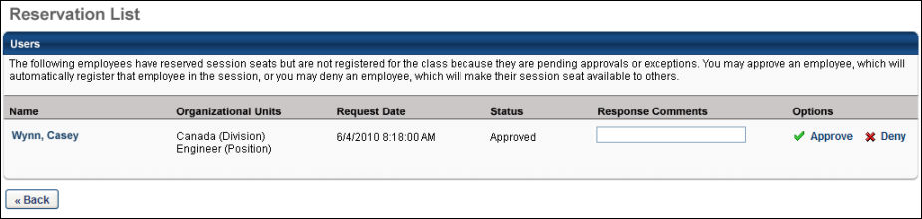
Reservation List
The following information and options display in the Reservation List table:
- Name - This is the name of the user. Click the user's name to view user information, including the user's email address, phone number, manager, and organizational units.
- Organizational Units - This column displays the organizational units (OUs) that the user belongs to.
- Request Date - This column displays the date of the request.
- Status - This column displays the current status of the user on the reservation list.
- Response Comments - In the Response Comments column, enter a comment for the reservation list response. These comments appear on the granted or denied user's Training Details page.
- Options - In the Options column, approve or deny the user a spot in the session:
  - Denying a reservation changes the user's status to Denied.
  - Approving a reservation changes the user's status to Registered.
Session Roster - Roster - Resources
This section enables administrators to view and manage attachments for the session. The visibility of each attachment can be determined by the administrator. For example, some attachments may be visible to only administrators, while other attachments may be visible to all users. In addition, attachments can be made visible to users only if they are registered for the corresponding session. This section is only available for users that have permission to view or manage LO attachments.
When the session is first created, this section contains any attachments that were added on the Session Defaults page for the event.
Permissions
PERMISSION NAME | PERMISSION DESCRIPTION | CATEGORY

Session Details - View Student Roster | Allows user to view student roster for a given ILT session via a link on ILT session details screen when searching for training, and from transcript details screen after a session has been added to the user's transcript. This is an end user permission. | Learning

Sessions - Create | Grants ability to create new instructor led training sessions. This permission works in conjunction with Events - View and Sessions - View permissions. Administrators can only create sessions for events for which they have the availability to view. When adding users to a session in which the session roster is full, this permission grants the ability to increase the session's available seats. This permission can be constrained by OU, User's OU, Instructor, User as Instructor, Facility, Facilities Owned by User, ILT Provider, User's ILT Provider, User, and User Self and Subordinates. This is an administrator permission.  Note: The "Restrict to User as Instructor" constraint is available, but it does not actually constrain the permission. | Learning - Administration

Sessions - Edit | Grants ability to edit/update existing instructor led training sessions. This permission works in conjunction with Events - View and Sessions - View permissions. Administrators can only edit sessions for which they have the availability to view and edit. When adding users to a session in which the session roster is full, this permission grants the ability to increase the session's available seats. This permission can be constrained by OU, User's OU, Instructor, User as Instructor, Facility, Facilities Owned by User, ILT Provider, User's ILT Provider, User, and User Self and Subordinates. This is an administrator permission. | Learning - Administration

Sessions - View | Grants view-only access to instructor led training sessions, enabling the user to view all details/options that were selected when the session was created. This permission works in conjunction with the Events - View permission. This permission can be constrained by OU, User's OU, Instructor, Facility, Facilities Owned by User, ILT Provider, User's ILT Provider, User, User as Instructor, and User Self and Subordinates. This is an administrator permission.  Adding an OU constraint and a provider constraint to this permission results in an "AND" statement. | Learning - Administration

LO Attachments - Manage | Grants ability to upload attachments to learning objects. Administrators with this permission are automatically granted the LO Attachments - View permission. This permission can be constrained by User's ILT Provider, Provider, and ILT Provider. This is an administrator permission. | Learning - Administration

LO Attachments - View | Grants ability to view the learning object attachments that are set to be available to administrators. This permission can be constrained by User's ILT Provider, Provider, and ILT Provider. This is an administrator permission. | Learning - Administration
Users with permission to manage LO attachments are able to view and manage the attachments, while users who only have permission to view attachments can only view the documents that have been attached to the LO. This section is hidden if the user does not have permission to view or manage LO attachments.
Add Attachment
To attach a document to an LO, click the Add Attachment link. This opens the Upload File pop-up.
Click the Browse button to locate and select the appropriate document. Then, click Upload to close the pop-up and attach the selected documents. After a file is attached to the LO, the administrator can configure the attachment title and visibility. The maximum file size is 15 MB, and attachments are limited to the following file types:
- docx
- doc
- gif
- jpeg
- jpe
- jpg
- pdf
- pps
- pptx
- ppt
- rtf
- txt
- xlsx
- xls
Edit Attachment
After a file is uploaded to the LO, the administrator can configure the attachment title and visibility. To edit an attachment, click the Edit icon to the right of the attachment title. The attachment title and visibility options become editable.
- Attachment Title - In the text field, enter the display name for the attachment, up to 300 characters. This is the name that is visible to all users, instructors, or administrators who have permission to view the attachment. Note: Only the first 75 characters display in the Resources section. Hover over the attachment title to view the full attachment title. However, the full attachment title is visible on the LO Details page.
- Set Visibility - Using the checkboxes, set the visibility for the attachment. When a user is included in the attachment visibility, the user can view and open the attachment. The following visibility options are available:
  - Admin - This option is selected by default and cannot be unselected. This option enables all administrators who have permission to view or manage attachments to view the corresponding attachment.
  - Instructor - This option is only available for session LOs. This option enables primary and secondary instructors for the corresponding session to view the attachment. Instructors can view attachments on the Session Defaults, Session Details, and Session Roster pages.
  - Registered Users - This option enables users who are registered for the corresponding LO to view the attachment. Attachments remain visible to users after they move past the Registered status (e.g., Complete). Registered users can view attachments on the Transcript Details page.
  - All Users - This option enables all users to view the attachment. This includes users who are browsing anonymously. All users can view attachments on the LO Details page.
Click the Save icon to save the changes or click the Cancel icon to discard any unsaved changes.
Attachment - View
This functionality is only available to users with permission to view LO attachments.
When an LO has attachments, they appear in the Resources section based on the date on which the document was attached, with the oldest attachments appearing first. The visibility settings for the attachment are displayed to the right of the attachment title.
Administrators can click the attachment title to open the attachment.
Attachment - Remove
This functionality is only available to users with permission to manage LO attachments.
To remove an attachment, click the Delete icon to the right of the attachment title. A confirmation pop-up displays. Click OK to remove the attachment. Or, click Cancel to cancel the action.
When an attachment is removed, it is no longer available anywhere in the system.
Session Roster - Roster - Seats Available Pop-up
The Seats Available pop-up can be viewed by clicking the Seats Available link on the Session Roster page. This link is not available if enrollment reservations and restrictions are not defined for the session.
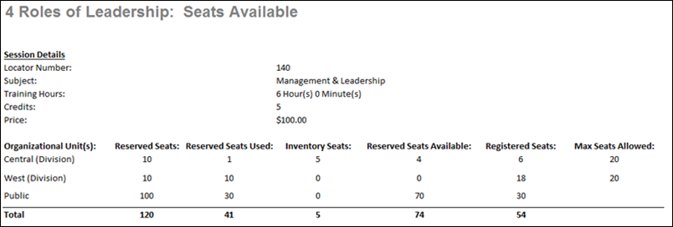
The following information displays in the Seats Available pop-up:
Session Details
The Session Details section displays the following:
- Locator Number - This field displays the locator number of the associated session.
- Subject - This field displays the subjects that are defined for the session at the event level.
- Training Hours - This field displays the number of training hours associated with the entire session. If the session has multiple parts, then the field displays the total training hours for all of the parts.
- Credits - This field displays the number of credits associated with the session, as defined at the session level.
- Price - This field displays the price of the session.
Organizational Units
The Organizational Units section displays all of the OU for which seats are reserved, as well as the number of seats available and reserved. The following columns display:
- Organizational Unit(s) - This displays the OUs for which seats are reserved or restricted. OUs are displayed according to the priority order that is set on the Session Defaults or Session Details page.
- Reserved Seats - This displays the number of seats that are reserved for the OU.
- Reserved Seats Used - This displays the number of reserved seats that have been used.
- Inventory Seats - This displays the number of pre-purchased inventory seats for each OU. This column only appears when there are pre-purchased inventory seats for the session. See Purchase Training Inventory for additional information.
- Reserved Seats Available - This displays the number of reserved seats that are still available for the OU.
- Registered Seats - This displays the total number of registered users for the OU.
- Max Seats Allowed - This displays the maximum number of users that are allowed to register for the session from the OU.

Session Roster - Roster - Waitlists
The session waitlist contains all of the users who attempted to register for a session that has no available roster spaces. Users join the waitlist in order to be added to the roster if any spaces become available. Instructors cannot view the waitlist if there are no users on the waitlist (i.e., there must be users on the waitlist for instructors to be able to view the waitlist).
There are two ways to view the waitlist for a session:
- From the session roster, click the Waitlisted link. See Session Roster - Roster Tab for additional information.
- Go to ILT > Manage Events & Sessions and click the Waitlists button and search for the session by title, vendor, session ID, or locator number. Waitlists can be viewed by User or by Session using the tabs. You can also view past waitlists on the Pass Requests tab. Next to the waitlist, click View to view and respond to waitlisted users.
Permissions
PERMISSION NAME | PERMISSION DESCRIPTION | CATEGORY

Waitlists - Manage | Grants ability to approve or deny instructor led training waitlist requests. This permission works in conjunction with the Events - View and Waitlists - View permissions. This is an administrator permission. | Learning - Administration

Waitlists - View | Grants view-only access to instructor led training session waitlists, via the ILT Events and Sessions screen, enabling the user to view the waitlists for various ILT sessions. This permission works in conjunction with Events - View and Sessions - View permissions. | Learning - Administration
Emails
EMAIL NAME | EMAIL DESCRIPTION | ACTION TYPE

Grant Waitlist Request | Once a user has submitted a Waitlist Request, they will remain in Waitlisted status until an administrator makes the decision to grant or deny the request. If the ILT administrator grants a user's request to attend a session, this email will be triggered.  When a user withdraws from a session and a seat becomes available, users on the waitlist are removed from the waitlist, they are granted the option to register for the open seat, and this email is triggered, if enabled. The waitlisted users will see the session on their transcripts in "Registration Pending" status.  - As soon as one of the user registers, all other users are moved back to the waiting list. In this scenario, if another user withdraws, the process is completed again for the users remaining on the waitlist.  - If none of the users register, the previously waitlisted users are not moved back to the waiting list. In this scenario, if another user withdraws, since no users are on the waiting list in that moment, this email is not triggered.  When a user withdraws from a session after the registration deadline, this email is not triggered. | Instructor Led Training
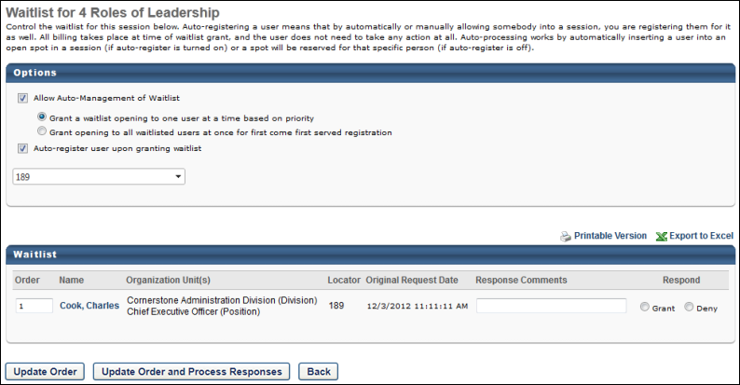
Options
Allow Auto-Management of Waitlist
On the Waitlist page for a session, you have the option to allow the system to automatically manage the waitlist by selecting the Allow Auto-Management of Waitlist option. If this option is selected, you can also select the way in which the system manages the waitlist:
- Grant a waitlist opening to one user at a time based on priority - This option grants the waitlist opening to the person at the top of the waitlist when a seat becomes available.
- Grant opening to all waitlisted users at once for first come first served registration - This option grants the waitlist opening to all users on the waitlist when the seat becomes available, and the seat is given to the first of those users to register.
  - When a seat becomes available, all waitlisted users have the status Registration Pending and the option to register. The first user to register is granted the seat and the status for all other users returns to Waitlisted.
  - This only applies when openings are granted through auto-management of the waitlist. If an instructor or administrator manually grants an opening to a user from the Waitlist page, the opening goes to that user.
  - The waitlist acceptance deadline is not enforced with this option as it would introduce the possibility of having every user on the waitlist denied.
Auto-register user upon granting waitlist
You also have the option to automatically register users if they are granted a seat from the waitlist by selecting the Auto register upon granting waitlist option.
- This setting is independent of the Register Upon Approval setting for a user because all users on the waitlist have already been approved.
- If this option is selected, the waitlist acceptance deadlines do not apply because the user is automatically registered.
- If this option is selected and the training has a price associated with it, the user is required to pay for the training before they can be auto-registered. The training is in a Pending status in the user's transcript until the training is paid. Once paid, the user is auto-registered. Note: To register a user for a training item by bypassing the training item's cost, the user must be assigned via learning assignment, and the Bypass User Payment option must be selected in the learning assignment.
- If this option is not selected, the granted user's Transcript status changes to Registration Pending with the option to Register. If there is a waitlist acceptance deadline, then that user has a limited amount of time to register for the class before their status changes to Denied and the opening is granted to the next person on the waitlist.
Waitlist
Users
The users who are on the waitlist are displayed in the table.
- Click the user's name to view user information, including the user's email address, phone number, manager, and organizational units.
- Users are not listed on the waitlist until they are approved and granted any exceptions requested, except in the following situations where the user can be in both on the waitlist and the exception request list:
  - The user has not met the prerequisites or does not meet the session's availability criteria (exception request)
  - The user requests a session which is full (waitlist request)
Order
In the Order column, enter the priority order for the waitlist. If a user has an order number of 1, they have the highest priority for the session.
Note: In order for the waitlist priority rank to be in the correct order after selecting the Grant and Process Responses waitlist options, you must click the Update Order button.
Response Comments
In the Response Comments column, enter a comment regarding the waitlist response. These comments appear on the granted or denied user's Training Details pages.
Respond
In the Respond column, grant or deny the user a spot in the session. See Session - Respond to a Waitlist Request on page 243 for additional information.
Reserved Seats
For waitlisted users that match the criteria for an organizational unit (OU) that has reserved seats, the user that is highest on the waitlist is granted the first available reserved seat for their matching OU if the Allow Auto-Management of Waitlist option is configured for the session.
Note: If the first available opening is in general seating, then the user is still granted the general seating opening even if the user matches an OU that has reserved seats. Thus, if a general seat is available for the session before a reserved seat is available for a user's matching OU, the general seat is granted.
Process Responses
Click the Update Order button to only update the waitlist order, or click the Update Order and Process Responses button to process all grant or deny selections and also update the waitlist order. When granting enrollment to a number of users that exceeded the number of available seats, the administrator is prompted to increase the maximum available seats prior to processing any enrollments. This enables the administrator to make any necessary adjustments to the session settings or the users who are being enrolled prior to enrolling any users from the waitlist.
Upon processing, all of the granted or denied users are removed from the waitlist.
Note: In order for the waitlist priority rank to be in the correct order after selecting the Grant and Process Responses waitlist options, you must click the Update Order button.
Waitlist Expiration
If a waitlist expiration date is specified on the Session Details page, after the expiration date, the waitlist no longer exists and all users previously on the waitlist are removed and have the status of Waitlist Expired. This triggers the Waitlist Expired email if active.
Users with the status of Waitlist Expired have the option to register or select a session. If they attempt to register for a class that is full, they are not denied. They see a message indicating that the class is full and that they may attempt to register for open seats when they become available. Users with a Waitlist Expired status receive an email when seats become available if the email is active.
Enrollment Restrictions
If enrollment restrictions are placed on organizational units, then users whose organizational units have zero seats available are added to the waitlist. There may be users on the waitlist when there are seats available for others. When the auto-management feature is enabled, the system automatically checks the OU availability for each user on the waitlist and only grants the opening to users who have seats available in their organization unit.
Interest Tracking
If the Add users on the waitlist to the interest tracking list for that event and location preference is checked on the ILT Preferences page, then users on the waitlist are also added to the interest tracking list for that event and location as soon as they are added to the waitlist. Users are removed from the interest tracking list if they register for the session.
Limit Users to One Waitlist Per Event
If a user has requested multiple waitlists prior to being limited to one waitlist per event, then administrators cannot grant multiple waitlist requests for the same event. When the administrator grants a waitlist request for a session, then all requests from the user for sessions within the same event are automatically denied.
When a user is withdrawn from a session waitlist as a result of the Limit Waitlist feature, then the system behaves as though the user withdrew from the session. On the Waitlisted Users page, if a user is withdrawn from the waitlist for a session, the request is removed from the Current by User and Current by Session tabs.
The withdrawn request appears on the Past Requests tab. On the Past Requests tab, the Decision Data column displays the date and time of the action, and the Decision Type column displays "Withdrawn."
Considerations
- If a user is in a Waitlist Expired or an Exempt status for a session, the registration number of the event will NOT increase, provided there is no further user action required for the event, and the user will not be prompted to retake another session of the same event.
Session - Respond to a Waitlist Request
Instructors can respond to waitlist requests from the Waitlist page of a Session Roster.
There are two ways to view the waitlist for a session:
- From the session roster, click the Waitlisted link. See Session Roster - Roster Tab for additional information.
- Go to ILT > Manage Events & Sessions and click the Waitlists button and search for the session by title, vendor, session ID, or locator number. Waitlists can be viewed by User or by Session using the tabs. You can also view past waitlists on the Pass Requests tab. Next to the waitlist, click View to view and respond to waitlisted users.
See Session Roster - Roster - Waitlists on page 238 for additional information.
Permissions
PERMISSION NAME | PERMISSION DESCRIPTION | CATEGORY

Waitlists - Manage | Grants ability to approve or deny instructor led training waitlist requests. This permission works in conjunction with the Events - View and Waitlists - View permissions. This is an administrator permission. | Learning - Administration

Waitlists - View | Grants view-only access to instructor led training session waitlists, via the ILT Events and Sessions screen, enabling the user to view the waitlists for various ILT sessions. This permission works in conjunction with Events - View and Sessions - View permissions. | Learning - Administration
Emails
EMAIL NAME | EMAIL DESCRIPTION | ACTION TYPE

Grant Waitlist Request | Once a user has submitted a Waitlist Request, they will remain in Waitlisted status until an administrator makes the decision to grant or deny the request. If the ILT administrator grants a user's request to attend a session, this email will be triggered.  When a user withdraws from a session and a seat becomes available, users on the waitlist are removed from the waitlist, they are granted the option to register for the open seat, and this email is triggered, if enabled. The waitlisted users will see the session on their transcripts in "Registration Pending" status.  - As soon as one of the user registers, all other users are moved back to the waiting list. In this scenario, if another user withdraws, the process is completed again for the users remaining on the waitlist.  - If none of the users register, the previously waitlisted users are not moved back to the waiting list. In this scenario, if another user withdraws, since no users are on the waiting list in that moment, this email is not triggered.  When a user withdraws from a session after the registration deadline, this email is not triggered. | Instructor Led Training
Respond
In the Respond column, grant or deny the user a spot in the session.
- Denying a waitlist request changes the users status to Denied and the Deny Waitlist email is triggered if active.
- Granting a waitlist request changes the user's status to Registration Pending or Registered (if the Auto-register users upon granting waitlist option is selected). The Grant Waitlist email is triggered if active.
- When waitlist openings are manually granted from the Waitlist page and there are no seats available at the time, the maximum registration of the session increases to accommodate the granted user.
  - If another user subsequently withdraws, the maximum registration does not decrease to its original number.
- If a waitlist opening is granted after the registration deadline, the granted user is not able to register for the session and has a Registration Closed status.
- If a user does not register for a session before the waitlist acceptance deadline passes, their status is changed from Registration Pending to Denied and the opening is granted to the next person on the waitlist if auto-management is enabled.
  - The waitlist acceptance deadline is specified on the Session Details page when the session is created. If the auto-register feature is enabled, the waitlist acceptance deadline does not apply.
  - An email trigger may be activated to notify the user of the waitlist acceptance deadline. Also, a tag may be added to the Waitlist Opening Granted email to notify the user of the deadline.
Process Responses
Click the Update Order button to only update the waitlist order, or click the Update Order and Process Responses button to process all grant or deny selections and also update the waitlist order. When granting enrollment to a number of users that exceeded the number of available seats, the administrator is prompted to increase the maximum available seats prior to processing any enrollments. This enables the administrator to make any necessary adjustments to the session settings or the users who are being enrolled prior to enrolling any users from the waitlist.
Upon processing, all of the granted or denied users are removed from the waitlist.
Note: In order for the waitlist priority rank to be in the correct order after selecting the Grant and Process Responses waitlist options, you must click the Update Order button.
Session Roster - Roster - Unassigned Inventory Purchase
The Unassigned Inventory Purchase section may appear at the bottom of the Roster tab of the Session Roster. This section displays all inventory purchases that are made for the session that have not yet been assigned. In this section there is a link to email the Inventory Owner. Click this link to create an email that is sent to the inventory owner to alert them that they have not yet assigned the inventory for the session.
Unassigned Inventory Purchase Table
The Unassigned Inventory Purchase table displays the following information for each inventory purchase of that session that has not yet been assigned:
- Inventory Owner - Full name of the inventory owner for the unassigned inventory.
- Organizational Units - The standard OU information for the owner.
- Email - The owner's email if available. Click the link to email the inventory owner to alert them that they have not yet assigned the inventory to the session.
- Sessions Pending Assignment - The number of unassigned seats that the inventory owner has.
- Options - The following options are available in the Options column:
  - Comment - This allows you to add comments regarding the unassigned inventory.
  - View Details - This allows you to view the details of the purchase of the unassigned inventory.

Session Roster - Assignments Tab
The Assignments tab displays all of the prerequisites, pre-work, and post-work assigned to each user that has the session on their transcript. From this tab, the instructor and administrators can exempt these assignments. If a session does not include any assignments, this tab does not appear. If all assignments are removed from a session after users are added, the Assignments tab is removed for all users. If the course assignments are edited after creation, the assignments listed may differ depending on when users request the session. If a user is missing pre-work or post-work but has attended and passes all parts, the user's status is In Progress.
Permissions
PERMISSION NAME | PERMISSION DESCRIPTION | CATEGORY

Roster - Manage | Grants ability to manage instructor led training session rosters, including updating attendance, and marking the ILT session complete to update student transcripts. A variety of other features are available depending upon additional roster permissions. This permission works in conjunction with Events - View, Sessions - View, and Roster - View permissions. This permission can be constrained by Instructor, User as Instructor, ILT Provider, and User's ILT Provider. This is an administrator permission. | Learning - Administration
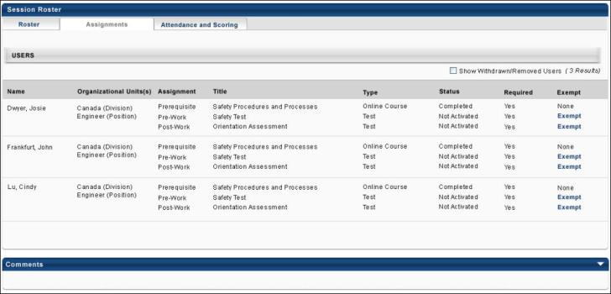
View new roster pages/View default roster pages
- Click the View new roster pages link to view the newly-designed roster page. All of the information on the page remains the same.
- Click the View default roster pages to return to the default roster pages.
Assignments
When the Show Withdrawn/Removed Users option is selected, users who were registered but are withdrawn from the session also display in the roster table. If this option is deselected, only users registered for the session are displayed.
The assignments table displays the following information for each user that is registered for the session. If the Show Withdrawn/Removed Users option is selected, users that were previously registered, but are withdrawn also display in the table.
- Name - This is the user's first and last name.
- Organizational Unit(s) - Displays any OUs for the user.
- Assignment - Displays the type of assignment (prerequisite, pre-work, post-work).
- Title - Displays the title of the learning object defined for the assignment.
- Type - Displays the type of learning object defined for the assignment.
- Status - Displays the user's status for the assignment. Note that until the learner activates the training item, the assignment status is "Not Activated."
- Required - Displays whether or not the user is required to complete the assignment.
- Exempt - If the administrator or instructor is permitted to exempt a user from completing an assignment, an Exempt link appears in this column next to the assignment. Clicking this link exempts the user from completing the assignment and the completion of the assignment no longer affects the completion status for the session. This option is only available to users with permission to manage the roster.

Session Roster - Attendance and Scoring Tab
The Attendance and Scoring tab allows administrators and instructors to manage attendance, enter scores, and pass/fail values.
Note: If a locator number drop-down appears in the upper-left corner of the tab, then your portal has enabled the ability to configure multiple providers for a session. See Multiple Providers - Parent Roster - Attendance and Scoring on page 174 for additional information.
Permissions
PERMISSION NAME | PERMISSION DESCRIPTION | CATEGORY

Events - View | Grants view-only access to instructor led training events, enabling the user to view all details/options that were selected when the event was created. This permission can be constrained by OU, User's OU, User's ILT Provider, and ILT Provider. This is an administrator permission. | Learning - Administration

Roster - Manage | Grants ability to manage instructor led training session rosters, including updating attendance, and marking the ILT session complete to update student transcripts. A variety of other features are available depending upon additional roster permissions. This permission works in conjunction with Events - View, Sessions - View, and Roster - View permissions. This permission can be constrained by Instructor, User as Instructor, ILT Provider, and User's ILT Provider. This is an administrator permission. | Learning - Administration

Roster - Revert Sessions Inside Curricula | Grants the ability to revert instructor led training session rosters that are completed. This permission works in conjunction with Roster - Manage and Roster - View permissions and supports reverting sessions that are part of one or more curricula. This is an administrator permission. | Learning - Administration

Roster - View | Grants view-only access to instructor led training session rosters. This permission works in conjunction with Events - View and Sessions - View permissions. This permission can be constrained by Instructor, ILT Provider, User's ILT Provider, and User as Instructor. This is an administrator permission. | Learning - Administration

Sessions - View | Grants view-only access to instructor led training sessions, enabling the user to view all details/options that were selected when the session was created. This permission works in conjunction with the Events - View permission. This permission can be constrained by OU, User's OU, Instructor, Facility, Facilities Owned by User, ILT Provider, User's ILT Provider, User, User as Instructor, and User Self and Subordinates. This is an administrator permission.  Adding an OU constraint and a provider constraint to this permission results in an "AND" statement. | Learning - Administration
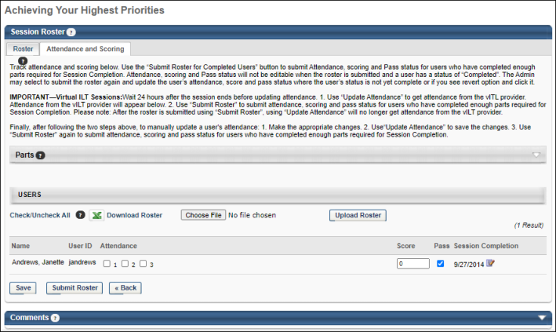
Parts
In the Parts section, each part within the session displays along with the part date and time. Each part is listed with a part number. The part numbers correspond with the Attendance option boxes in the Attendance and Scoring table. The Parts section is collapsed by default.
Users
In the Users section, you can update attendance in bulk or individually. To update attendance in bulk, download the roster, make updates to the spreadsheet, and upload the completed roster.
To update attendance individually, click the Check/Uncheck All Attendance link to mark each user as attended for each part of the session. All Attendance option boxes that are unchecked will be selected. Click the link a second time to clear all selected Attendance option boxes. The Check/Uncheck All Attendance link is only visible before the administrator or instructor submits the final roster.
Download Roster
To download an Excel spreadsheet of the roster, click the Download Roster link. The roster will download to your computer in .xlsx format. Once you have downloaded and opened the spreadsheet, you can make updates to the following fields:
- Part Attendance
- Score
- Pass
Do not modify any other fields in the spreadsheet. Once you have made any necessary updates to the above fields, save the roster in .xlsx format.
Download Roster Exclusions
The following changes to the roster spreadsheet are NOT supported:
- Adding or removing attendees
- Renaming any column name
- Modifying the file format to any format other than .xlsx
- Roster submission (the roster must still be submitted using the Submit Roster button on the Session Roster page)
- Any user identification other than username or user ID
Upload Roster
After saving the roster spreadsheet to your computer with updates to attendance:
- Click the Choose File button in the Users section of the Session Roster page.
- Search for and select your saved roster spreadsheet from your computer.
- Click the Upload Roster button to finish uploading your spreadsheet to the Session Roster page.
- If you are finished making updates to the roster, click the Submit Roster button. Note: After the roster has been submitted, the only modifiable field is the Score field. No other roster information may be modified after the roster has been submitted.
A maximum of 1,000 users can be uploaded, and a maximum of 10,000 updates can be uploaded. Each session part is treated as an independent record for every user. For example, if a session is comprised of two parts, and you are updating records for 100 users, the total count for updates is 200 records. If the total update count exceeds 10,000, the Download and Upload roster button will become unavailable. Note: This differs from the maximum while using the Bulk Add Users feature. See Session Roster - Bulk Add Users on page 263 for additional information.
Attendance and Scoring Table
The Attendance and Scoring table displays the following information for each user that is registered for the session:
- Name - This field displays the name of the user.
- User ID - Displays the user ID defined in the user's system record.
- Attendance - An Attendance box appears for each part within the session. These parts are listed in the Parts section above the table. For each part, select whether or not the user was in attendance. For example, if a user attended part 1 and 3 for a session, but missed part 2, select the Attendance box for 1 and 3, but not 2. Attendance can only be edited before the final roster is submitted. Once the final roster is submitted, all attendance is final. Select the Check/Uncheck All link to select or deselect all attendance boxes.
  - If a user has none of the Attendance checkboxes selected for a session, their training status is No Show when the roster is submitted and their cost center is charged for the No Show penalty if applicable.
  - If a user is not marked as attending the minimum number of required parts, their training status is Incomplete when the roster is submitted.
- Score - In this field, enter the user's score for the session. This value must be an integer. These scores appear on the Roster tab in the Score column. Scores can be edited before and after the final roster is submitted. Scores are visible to users on their training details page.
- Pass - Select this option to indicate the user has achieved a passing score for the session. When the final roster is submitted, if this option is selected, the Pass/Fail column on the Roster tab displays Pass, otherwise it displays Fail. The Pass option can only be edited before the final roster is submitted. Once the final roster submitted, the Pass option is final. If the Pass checkbox is not selected for a user, their training status is Incomplete when the roster is submitted.
If more than twenty users are registered for an instructor-led training (ILT) session, the Attendance and Scoring page of the session roster paginates, and users with permission to manage the roster can navigate through pages of registered users, with up to twenty users displaying per page.
Session Completion
The Session Completion column displays the date on which the user completed the session. In ILT Preferences, administrators are able to configure the logic that determines the completion date for sessions. This column is visible to all users who have permission to view or manage the session roster.
- When the administrator has configured the session completion date to be the date on which the session roster is submitted, then the Session Completion column displays "Pending" until the roster is submitted.
- Administrators who have permission to manage the roster have access to an Edit icon to the right of the session completion date. See Session Completion - Edit on page 252 for additional information.
Session Completion - Edit
To edit the session completion date for a user, click the Edit icon to the right of the user's session completion date. The session completion date can be set to any date, even if the date is before the session start date or after the session end date.
After selecting the appropriate date, click the Save icon to the right of the Session Completion date. Then, click the Save button at the bottom of the page to save the entire roster. Important: The updated session completion date is not saved until the entire roster is saved. In addition, the user's transcript is not updated until the roster is submitted.
Once the session roster is submitted, the user's transcript is updated with the new session completion date. However, administrators may edit the user's session completion date and submit the roster multiple times, if necessary.
Save or Update
Click Save or Update Attendance to save any changes made to the attendance and scoring. The button is available as soon as at least one user is registered for the session, and it remains available even after the final roster is submitted. No Show penalties are not charged at this time.
Submit Roster
Click Submit Roster to finalize the roster attendance and scores. The Submit Roster button is available once the last session part has started (this is only applicable to traditional classroom sessions and is not applicable to vILT sessions) or immediately after the last part of the session is concluded, depending on the settings in ILT Preferences:
- The roster can be submitted after the start time of the last part of the session for traditional classroom sessions if the Allow to submit roster after start time of the last part of the session option is enabled in ILT Preferences.
- The roster cannot be submitted until after the last part of the session has ended for traditional classroom sessions and vILT sessions if the Allow to submit roster after start time of the last part of the session option is not enabled in ILT Preferences.
Once Submit Roster is clicked, all user statuses for the session are updated and appear on the user's transcript record. No Show penalties are charged at this time if the user did not attend any parts.
- If the administrator adds a part after the roster is submitted, those parts appear for the user, but shows that the user has not completed the additional part. The administrator cannot mark the user as attended for the additional part if the user is complete. The attendance status for the new part after the roster is submitted does not change the status for users who already have a Completed status, but does affect the status for users who do not have a Completed status.
- For WebCasts, the Submit Roster for Completed Users button displays before session completion but only after enough parts have been completed for the session to have a status of Complete on a user's transcript. For example, a weekly training session has 52 parts, and 26 parts are required for completion of the session. After the first 26 parts have occurred, the Submit Roster for Completed Users button displays and continues to display until the completion of all 52 parts. Upon completion, the button name changes to Submit Roster.
Submit Roster for Completed Users
For WebCasts, the Submit Roster for Completed Users button displays before session completion but only after enough parts have been completed for the session to have a status of Complete on a user's transcript. For example, a weekly training session has 52 parts, and 26 parts are required for completion of the session. After the first 26 parts have occurred, the Submit Roster for Completed Users button displays and continues to display until the completion of all 52 parts. Upon completion, the button name changes to Submit Roster.
- To update the status of users who have completed all required parts before session completion, click Submit Roster for Completed Users. This changes the status of the learning object in the user's transcript to Completed.
- Once a session is completed and the Submit Roster for Completed Users button changes to Submit Roster, you can submit the roster and update user status based on attendance by clicking Submit Roster.
Mark Users as Attended without being Registered
To mark a user as having attended a session for which they were not registered, create a new learning assignment and on the Options step, select the Completed option. Use caution when assigning a user as completed, because this cannot be changed.
Revert Completed Status
Once the roster is submitted and processed, a user's Completed status can be reversed from the Attendance and Scoring tab. See Session Roster - Attendance and Scoring - Revert Completed Status on page 255 for additional information.
Penalties
- Withdrawal penalties are billed to the user (or their cost center) at the session start date. See Session Withdraw Penalties for additional information on when session withdraw penalties are charged.
- No Show penalties are billed to the user (or their cost center) when the Submit Roster button is clicked.
Webex, Live Meeting, Adobe Connect, Training Center
To retrieve the most up-to-date attendance on demand, click the Submit Final Roster button. This attendance retrieval also updates the user's transcripts accordingly once the instructor submits the roster. See Webex Attendance Troubleshooting on page 296 for additional information.
Citrix Sessions
To retrieve the most up-to-date attendance and scoring information, click the Update Attendance button. This functionality is only available if Citrix is configured for your portal.
Resubmit Stuck Roster
Occasionally, an instructor-led training (ILT) roster submitted by an administrator or instructor can get stuck while processing. Administrators and instructors can unstick a roster that has been stuck processing for more than 24 hours, via a pop-up available on the Submit Roster page.
If a session roster has been stuck processing for over 24 hours, a pop-up will appear to the administrator on the Roster page, alerting them that their roster is stuck. The administrator can click the Refresh button to refresh the Roster page, and after the page has refreshed, the administrator can resubmit the session roster using the Submit button.
Note: If the roster remains stuck even after refreshing the page and resubmitting the roster, it may be necessary to open a case with Global Customer Support.

Session Roster - Attendance and Scoring - Revert Completed Status
Once the roster is submitted and processed, a user's Completed status can be reversed from the Attendance and Scoring tab.
Note: The Score column is editable without needing to revert the status.
Permissions
PERMISSION NAME | PERMISSION DESCRIPTION | CATEGORY

Roster - Revert Sessions Inside Curricula | Grants the ability to revert instructor led training session rosters that are completed. This permission works in conjunction with Roster - Manage and Roster - View permissions and supports reverting sessions that are part of one or more curricula. This is an administrator permission. | Learning - Administration
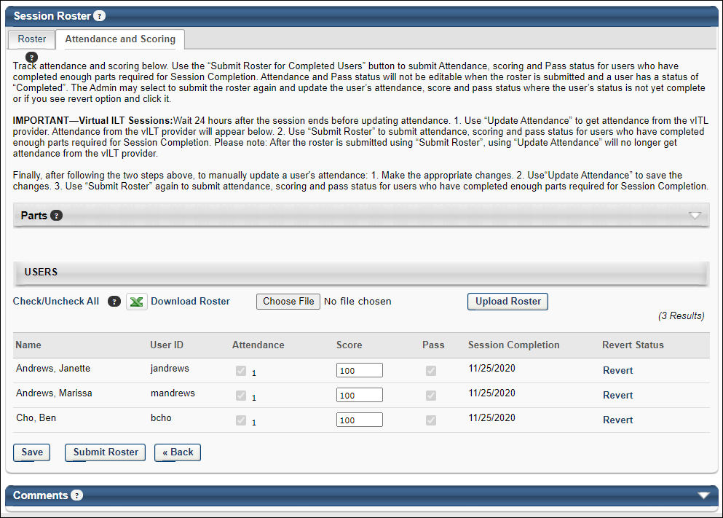
To reverse a user's Completed status, on the Attendance and Scoring tab, click the Revert link in the Revert Status column. The Revert link only displays if the following conditions for the user are true:
- The user is in a Completed status.
- The user is not registered for the session through one of the following training types:
  - Prerequisite
  - Curriculum
  - Certification
  - Library
  - Pre-Work
  - Post-Work
The Confirm Revert User pop-up opens. Click Yes to confirm the action. Click No or Cancel to cancel the action.
Note: A session completion where the ILT is a part of one or more curricula can be reverted under special conditions. To know more, See Revert Session Completed Status when Session is part of a Curriculum on page 256 for additional information.
The Revert Status column displays "Reverted" for users whose Completed status is reversed. If a user's status changes to Completed again, the Revert Status column replaces "Reverted" with the Revert link. Note: When a user's Completed status for a session is changed to Reverted, the Approval History section of the Training Details page records the change as "Reverted by <(user name) (user ID) on (M/D/YYYY)." The original timestamp recorded for the Completed status is unchanged.
Note: If a session was first marked as Completed and then changed to Cancelled, the administrator must carefully consider what should happen to the status of the users. If they are reverted, they will remain in a Registered status even though the session is cancelled.
Revert Session Completed Status when Session is part of a Curriculum
With the availability of Allow Revert for Sessions which are part of Curricula in Feature Activation Preferences, the administrators can revert session completions where the session is part of one or more curricula.
To activate, go to ADMIN > TOOLS > LEARNING > LEARNING PREFERENCES > FEATURE ACTIVATION PREFERENCES. In the Allow Revert for Sessions which are part of Curricula section, click ACTIVATE.
When the feature is activated, the Revert Status column displays the revert option for sessions that are part of one or more curricula. Clicking Revert prompts a revert confirmation message. Click Revert to confirm the revert action.
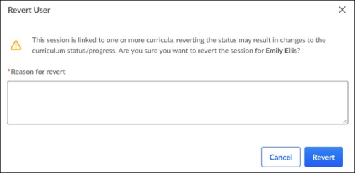
The Revert Status column displays the current status of the revert.​ Select Show Only Reverted filter to view only the reverted users. To revert a completed session when the session is a part of one or more curricula, administrators must have the Roster – Revert Sessions Inside Curricula permission.
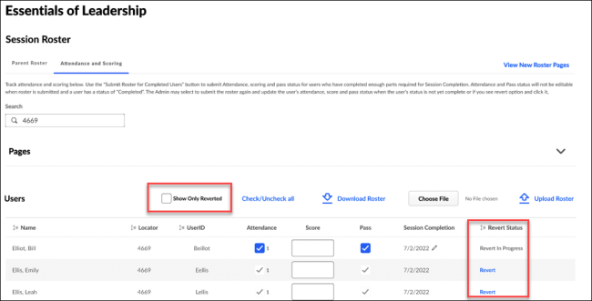
A successful Session completion revert impacts the curriculum in the following ways:
- The Curriculum status is updated if applicable.​ For example, a Curriculum moving from ‘Completed’ to ‘In Progress’ upon a Session revert.​
- The Curriculum progress percentage and the section progress are re-calculated.
- The Transcript History records and any comments captured during the session revert are reverted.
The updated Curriculum Transcript History shows curriculum updates caused by a reverted session.
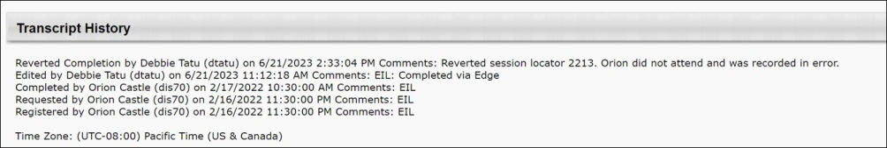
Supported curriculum transcript statuses for revert
The Transcript History entry is added when reverting a curriculum in any of these statuses.
- Approved
- In Progress
- Pending Evaluation
- Pending Acknowledgement
- Pending Completion Signature
- Pending Completion Approval
- Completed
Note: If a session being reverted is part of a curriculum that is a prerequisite or pre-work to another training, then the session revert changes the curriculum transcript status from ‘Completed’ to ‘In Progress.’ However, the training status does not change when the curriculum transcript status changes.
Some scenarios do not allow a revert and the Revert option is not displayed for the session that is part of one or more curricula. The scenarios are as follows:
- The Curriculum is also inside a certification. ​
- The Curriculum status is ‘Completed Equivalent’ or ‘Exempt’.
- The reverted session has a prerequisite, pre-work, or post-work association.
- The curriculum is completed and has points or badges associated with it.
Considerations
- Suppose a learning object inside a curriculum had moved from ‘Pending Prior Training’ to another status because the session was completed. In that case, the learning object does not move back to ‘Pending Prior Training’ and retains its current status.​
- If a curriculum is removed, the session revert is allowed, and the removed curriculum is reprocessed to support the restored curriculum to the learner.​
- An inactive curriculum can be reverted. If the session is part of three curricula, one inactive and two active, all three curricula will be reprocessed.​ Please also note that if an inactive curriculum is on the Archived tab due to transcript preference rules or being manually moved, the inactive curriculum will remain on the Archived tab even if the ILT session is reverted.​
- Reverting a session that is part of a curriculum may not always result in a transcript status change or progress percentage change for a curriculum. It depends on the setup and progress of the curriculum.
- Curricula that are in a status of ‘Completed Equivalent’ or ‘Exempt’ can not be reverted. If the session is part of 4 curricula, and 1 has a transcript status of ‘Completed Equivalent,’ and the other three have a status of ‘Completed,’ the Revert option on the Roster will not be available.​
- Curricula with a transcript status of ‘Pending Completion Signature,’ ‘Pending Evaluation,’ ‘Pending Acknowledgement,’ or ‘Pending Completion Approval’ are considered valid statuses. If these curricula are reverted, they may have a change in transcript status. Any related emails or approval requests are updated based on the transcript status change.
- If a completed curriculum has associated points or badges, then a session revert inside the curriculum is not supported. However, if the curriculum is not completed and has associated points or badges, then a session revert inside the curriculum is supported
Supported and Unsupported Revert Scenarios
The following representation shows different circumstances under which a revert is allowed and not allowed.
Supported Revert Scenarios
Number | Scenario | Expected Result
1 | Session is part of one or more curricula | Revert is allowed.
2 | Session is part of a removed curriculum ​ | Revert is allowed.
3 | Session is part of an inactive curriculum | Revert is allowed.
4 | Session being reverted is part of a curriculum A and the curriculum is a prerequisite to another curriculum - Curriculum B ​ | Revert is allowed. Curriculum A will be reprocessed but Curriculum B will not be updated. ​ ​ ​
5 | Session being reverted is part of a curriculum V1 that is versioned to V2. User A has C1V1 and User B has C1V2 ​ | Revert is allowed and both curricula will be reprocessed. ​
6 | Curriculum status is Completed, In Progress, Approved, Pending Approval, Pending Evaluation, Pending Acknowledgement, Pending Completion Approval, Pending Completion Signature | Revert is allowed and curriculum will recalculate progress and status.
7 | Session being reverted is part of a curriculum that has sections | Revert is allowed. Note: LOs will not move back to Pending Prior Training status.
8 | Session being reverted is part of a curriculum that has optional and required trainings ​ | Revert is allowed. Note: LOs will not move back to Pending Prior Training status.
9 | Session being reverted is part of Curriculum A which has bi-directional equivalency to Curriculum B and both curricula are NOT completed (none are completed equivalent) ​ | Revert is allowed.
10 | Session being reverted is part of a curriculum that has points or badges associated and Curriculum is NOT completed. (no points/badges were awarded)​ | Revert is allowed.
11 | Session being reverted is part of a curriculum in Completed Equivalent or Exempt status ​ | Revert is allowed.
Unsupported Revert Scenarios
Number | Scenario | Expected Result
1 | Session being reverted is part of three curricula, one is Completed Equivalent, two are Completed | Revert is not allowed for all three curricula.​
2 | Session being reverted is part of a curriculum and the event is a prerequisite to another training ​ | Revert is not allowed.
3 | Session being reverted is part of a Curriculum A which is inside a Certification. ​ | Revert is not allowed.
4 | Session being reverted is part of a completed curriculum that has badges or points associated to it. | Revert is not allowed.
ILT Session Revert Use Cases
Use Case 1: Recalculating curriculum completion dates when a session is reverted and the curriculum remains completed
Suppose a curriculum is completed, and the last completed training amongst child trainings is a session. Upon reverting that session, if another session was completed and is now mapped to the curriculum, the curriculum completion date is recalculated to consider the new session completion date and other child training completion dates.
Example
- Two “Leadership Workshop” sessions were attended. One was completed on October 1st, and another on December 18th.
- The “Leadership Workshop” is contained in the “Leadership Excellence” curriculum.
- The other child training in the “Leadership Excellence” curriculum was completed on November 15th.
- Therefore, the “Leadership Excellence” curriculum has a December 18th completion date.
- When the December 18th “Leadership Workshop” session is reverted, the completion for the October 1st session is credited to the curriculum.
- The curriculum ”Leadership Excellence” will now show a completion date of November 15th (the latest completion date amongst child trainings) and Transcript History will be updated.
Use Case 2: Added Transcript History entry when a session is reverted, and the curriculum is in Approved status.
A curriculum can be assigned in an Approved status with a completed session only if the session is optional. This means that the curriculum contains a section with optional training (for example, 0 of 1 required in the section), and a session is completed as optional training.
With this enhancement, a Transcript History entry is added when a curriculum is in an Approved status and the completed optional session is reverted.
Example
- The curriculum “New Hire Onboarding” contains two online courses in one section with 2 of 2 required. Another section is created with 0 of 1 required, and an event “Orientation” is added to this section.
- Jane attends a session for “Orientation” on January 5th.
- The “New Hire Onboarding” curriculum is assigned to Jane in an Approved status or moves to an Approved status after manager approval
  - Child trainings are not set to auto-register
  - Curriculum is not set to auto-register
- Suppose Jane’s January 5th session completion is reverted. In that case, the “New Hire Onboarding” curriculum will remain in an Approved status, and there will be an entry in Transcript History noting that the curriculum was reprocessed due to a session revert.
Use Case 3: Delete and retrigger multiple evaluations if a curriculum completion is reverted due to a session being reverted.
Before this Release, when a curriculum completion was reverted due to a session revert, it would delete only one evaluation associated with it, which would be re-triggered upon completing the curriculum again.
If multiple evaluations are associated with a curriculum, all evaluations are deleted and re-triggered upon re-completing the curriculum.
Example
- The curriculum “New Hire Onboarding” has a level 1 and 2 evaluation enabled.
- Upon completing the curriculum, “New Hire Onboarding,” both level 1 and level 2 evaluations were completed.
- Session “Orientation,” contained in the curriculum “New Hire Onboarding,” is reverted, causing the curriculum to move from Completed to In Progress status.
- Both completed evaluations are deleted and can no longer be reported on
- When another “Orientation” session is attended, causing curriculum “New Hire Onboarding” to be complete, both level 1 and level 2 evaluation will be re-triggered.

Session Roster - Bulk Add Users
The Attendance and Scoring tab of the Manage Roster page includes options to download the Bulk Add Users template and use it to upload users to the roster in bulk. You cannot use the Bulk Add Users template to upload users to a session roster if the session is tied to an inactive event.
To access the instructor-led training (ILT) session roster, go to ILT > Manage Events & Sessions. Search for the appropriate event, and in the Options column for the event, click the View Sessions icon . This option is only available to users with permission to view sessions. Next to the session, in the Options column, click the View Roster icon . Click the Attendance and Scoring tab on the Session Roster page.
Permissions
PERMISSION NAME | PERMISSION DESCRIPTION | CATEGORY

Roster - Add Users | Grants ability to add named users to class rosters for instructor led training sessions. This permission works in conjunction with the Roster - View permission. This permission can be constrained by OU, User's OU, ILT Provider, and User's ILT Provider. This is an administrator permission. | Learning - Administration

Roster - Increase Seats | Grant user the ability to increase the session's available seats when adding users to the session roster if the added users exceed the number of available or reserved seats. User must also have Manage Roster or View Roster permission. This permission cannot be constrained. This is an administrator permission. | Learning - Administration

Roster - Manage | Grants ability to manage instructor led training session rosters, including updating attendance, and marking the ILT session complete to update student transcripts. A variety of other features are available depending upon additional roster permissions. This permission works in conjunction with Events - View, Sessions - View, and Roster - View permissions. This permission can be constrained by Instructor, User as Instructor, ILT Provider, and User's ILT Provider. This is an administrator permission. | Learning - Administration

Sessions - Edit | Grants ability to edit/update existing instructor led training sessions. This permission works in conjunction with Events - View and Sessions - View permissions. Administrators can only edit sessions for which they have the availability to view and edit. When adding users to a session in which the session roster is full, this permission grants the ability to increase the session's available seats. This permission can be constrained by OU, User's OU, Instructor, User as Instructor, Facility, Facilities Owned by User, ILT Provider, User's ILT Provider, User, and User Self and Subordinates. This is an administrator permission. | Learning - Administration
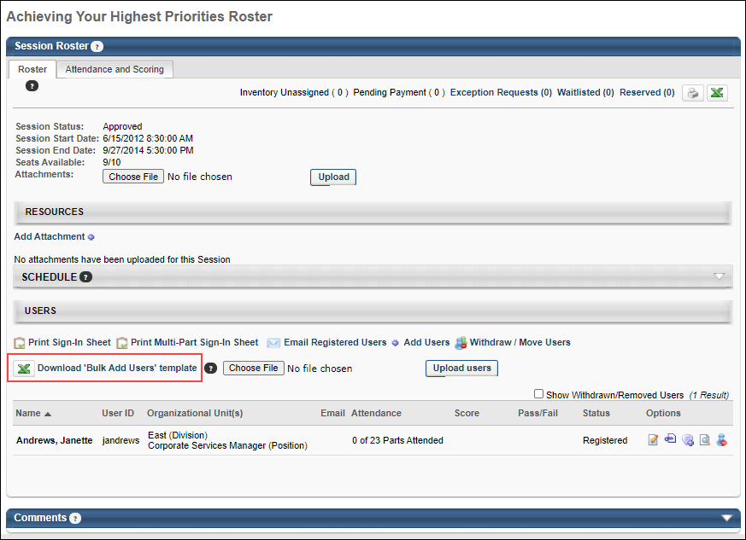
Download "Bulk Add Users" Template
To download an Excel spreadsheet for bulk uploading users, click the Download "Bulk Add Users" template link. The spreadsheet will download to your computer in .xlsx format. Once you have downloaded and opened the spreadsheet, you can enter the User IDs or emails of each user you want to add to the roster in the User ID column. If associated ILT emails should be sent to these users, type "1" into cell F2 of the spreadsheet. If associated emails should NOT be sent to these users, type "0" into column F2. Do not make changes to any other part of the spreadsheet.
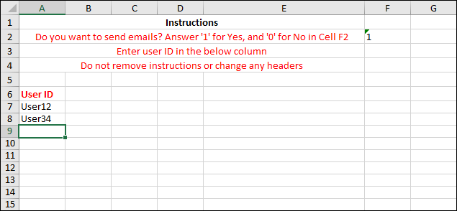
Upload "Bulk Add Users" File
After adding the User IDs of the users you are adding to the roster and saving the spreadsheet to your computer:
- Click the Choose File button in the Users section of the Session Roster page.
- Search for and select your saved spreadsheet from your computer.
- Click the Upload Bulk Users button to finish uploading your spreadsheet to the Session Roster page. While the file is uploading, the Upload Bulk Users button disappears, and an "Upload is in progress" notification displays in the Users section.
  - If the upload is successful, the users are added to the roster, and the Upload Bulk Users button reappears on the page.
  - If the upload is unsuccessful, an error appears, which allows you to download the error file. The error file will provide a description of the error. You can correct the error and attempt to upload the corrected file. Note: Uploading any file type other than .xls or .xlsx will result in an error.
Considerations
- The Bulk Add Users template is only used to upload users to a session roster if the session is tied to an active event.
- When the Bulk Add Users template is downloaded, the column headers are rendered in the user's selected language (culture). If the downloaded template is used by someone with a different language (culture), the application will generate an error.
- Only 100 users can be uploaded in a single "Bulk Add Users" spreadsheet. Note: This differs from the maximum while saving a roster spreadsheet. A maximum number of 1000 users can be uploaded while saving a roster spreadsheet in the Session Roster page. See Session Roster - Attendance and Scoring Tab on page 249 for additional information.
- While uploading, the following existing logic is adhered to:
  - The Seats Available count will increase automatically if the max registration for the session is exceeded. Note: Permission to increase session seats is needed in order to do this.
  - Even if waitlists are disabled for a session, users can still be added using the "Bulk Add Users" spreadsheet, increasing the user count.
  - Users included in the "Bulk Add Users" spreadsheet will be added even if they do not satisfy any configured enrollment restrictions.
- Users are added to the session, not to a session's individual session parts. Attendance of session parts is marked by the instructor.
Learning Assignment Tool - Bulk Users
When users are added to a roster in bulk using the "Bulk Add Users" spreadsheet, this training assignment is recorded on the Manage Learning Assignments page of the Learning Assignment Tool (LAT). See Manage Assignments Page.
Administrators can filter the Manage Assignments page for bulk user adds that were made from session rosters. To view assignments made from session rosters, on the Manage Learning Assignments page, select the Filter button. Then, select Created with ILT - Roster from the Source drop-down. This allows administrators to view the details of the bulk user add.
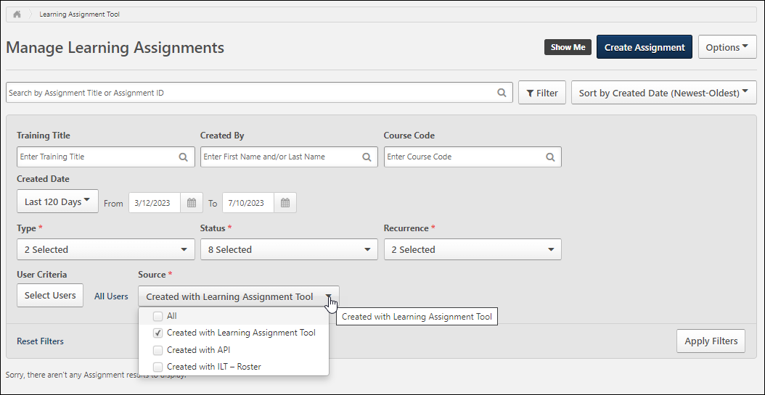

Exception Requests
Users generate an exception request when they request a session for which they have not met the prerequisites or do not meet the session's availability criteria. If the administrator sets the prerequisite to be completed before the user registers, the user will generate an exception request if the prerequisite is not completed at the time of the request.
To access the Exception Requests page, go to ILT > Manage Events & Sessions. Then:
- Click the Exception Requests button.
- OR, select a session and click the View Roster icon. On the Roster page, click the Exception Requests link. This link is only available if there are exception requests for the session.
Permissions
PERMISSION NAME | PERMISSION DESCRIPTION | CATEGORY

Exceptions - Manage | Grants ability to approve or deny Instructor Led Training Exception requests (e.g. availability exceptions, pre-requisite exceptions). This permission works in conjunction with the Event - View and Exceptions - View permissions. This is an administrator permission. | Learning - Administration

Exceptions - View | Grants view-only access to instructor led training exception requests, via the ILT Events and Session screen. This permission works in conjunction with the Events - View permission. This is an administrator permission. | Learning - Administration
Helpful Hints - Exception Requests
- Learning assignments bypass all prerequisite and availability requirements and will register a user without generating an exception request.
- Users do not generate an exception request until the training request is approved by their approver or manager.
  - The training status will automatically change from Pending to Exception Requested when the training request is approved.
  - The exception request is usually performed by another user: the training request is granted by the manager or approver, whereas the exception request is granted by the instructor or session administrator.
  - All users with Exception Requested status have already been approved.
  - If the administrator sets the prerequisite to be registered before the user registers for the session and completed before the session start date, the user will generate an exception request if they are not registered for the prerequisite at the time of the request. If the user is registered for the prerequisites but has not completed it, they can register without generating an exception request. The training status will be Pending Prerequisite when the user registers and that user will be added to the roster. Users with Pending Prerequisite status are automatically withdrawn on the session start date if they have not completed the prerequisite by then.
- Users generate an exception request when they request a session that is only open for advanced registration and the user is not eligible for advanced registration because they were not on the interest tracking list at the time the session was created.
- When a user's status changes to Exception Requested, the Exception Request email is triggered (if activated).
- If a user requests a session that will generate an exception request, they are notified of this on the Event Summary or Session Details pages at the time of requesting the course.
  - The notification will display the reason for the exception.
- Once an exception request is generated it can only be removed by granting or denying the request, or by the user withdrawing the request by clicking on the Withdraw link on the transcript.
  - If a user completes the prerequisites or subsequently gains availability for this session, their status remains Exception Requested. The system retroactively verifies and updates exceptions.
  - To change the status to Registered, the user must withdraw the exception request by clicking on Withdraw from the transcript, and then request the Session again, after having met the requirements or receiving availability. If the user was previously approved for the class, the approval process is bypassed, and the training status automatically changes to Registered or Waitlisted upon requesting the session.
- If an exception is granted for a prerequisite and the user successfully registers for the class, the prerequisite is listed as Already Exempted.
- Granting an exception request does not automatically register the user or bypass the waitlist for a session.
  - The user will automatically be registered if the Register Upon Approval setting is checked and there is a seat available for that user.
  - The user will automatically be added to the waitlist if the Register Upon Approval setting is checked and there are no seats available.
Related Documentation
- Current Requests
- Past Requests
- Grant/Deny Requests
Current Requests
The Current tab displays exception requests that have not yet been granted or denied. When accessing the Exception Requests page, the Current tab appears by default. To view past requests, click the Past Requests tab.
To access current requests, go to: ILT > Manage Events & Sessions. Then, click the Exception Requests button. Select a session and click the View Roster icon. On the Roster page, click the Exception Requests link.
Permissions
PERMISSION NAME | PERMISSION DESCRIPTION | CATEGORY

Exceptions - Manage | Grants ability to approve or deny Instructor Led Training Exception requests (e.g. availability exceptions, pre-requisite exceptions). This permission works in conjunction with the Event - View and Exceptions - View permissions. This is an administrator permission. | Learning - Administration

Exceptions - View | Grants view-only access to instructor led training exception requests, via the ILT Events and Session screen. This permission works in conjunction with the Events - View permission. This is an administrator permission. | Learning - Administration
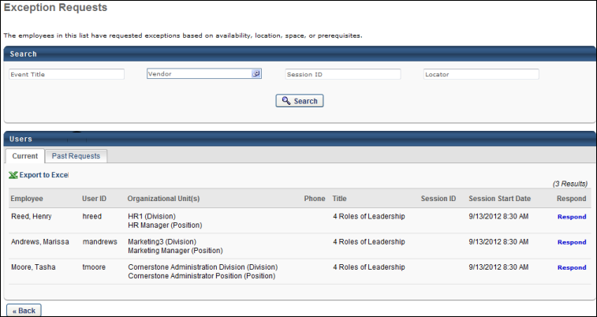
Current Tab
The following fields and features are available on the Current tab:
- Search - Use the search features to filter the results by event title, vendor, session ID, or locator number.
- Past Requests - Click the Past Requests tab to view past requests.
- Export to Excel - Click the Export to Excel link to view the list of current requests in an Excel spreadsheet. The spreadsheet will download to your computer in .xlsx format.
- Current Requests table - The following information displays in this table:
  - Employee - This column displays the name of the user for whom the exception is requested.
  - User ID - This column displays the user ID of the user for whom the exception is requested.
  - Organizational Unit - This column displays the organizational unit of the user for whom the exception is requested.
  - Phone - This column displays the phone number of the user for whom the exception is requested.
  - Title - This column displays the title of the event.
  - Session ID - This column displays the ID of the session for which the exception is requested.
  - Session Start Date - This column displays the start date and time of the session for which the exception is requested.
  - Respond - Click the Respond link to open the Respond page, where you can grant or deny requests.
Click Back to return to the previous page. The previous page that displays is dependent upon how you navigated to the Exception Requests page. If you accessed the page from the Manage Events & Sessions page, then you are returned to the Manage Events & Sessions page. If you accessed the Exception Requests page from the roster, then you are returned to the Sessions page. Note: You are not returned to the Roster page, even if you accessed the Exception Requests page by clicking the Exception Requests link on the Roster page.
Past Requests
The Past Requests tab displays past exception requests. A request is considered a past request if it has been granted or denied. A request is also a past request if the session start date passes without a response to the exception request.
To access past requests, go to ILT > Manage Events & Sessions. Then, click the Exception Requests button. On the Exception Requests page, click the Past Requests tab. Select a session and click the View Roster icon. On the Roster page, click the Exception Requests link. On the Exception Requests page, click the Past Requests tab.
Permissions
PERMISSION NAME | PERMISSION DESCRIPTION | CATEGORY

Exceptions - Manage | Grants ability to approve or deny Instructor Led Training Exception requests (e.g. availability exceptions, pre-requisite exceptions). This permission works in conjunction with the Event - View and Exceptions - View permissions. This is an administrator permission. | Learning - Administration
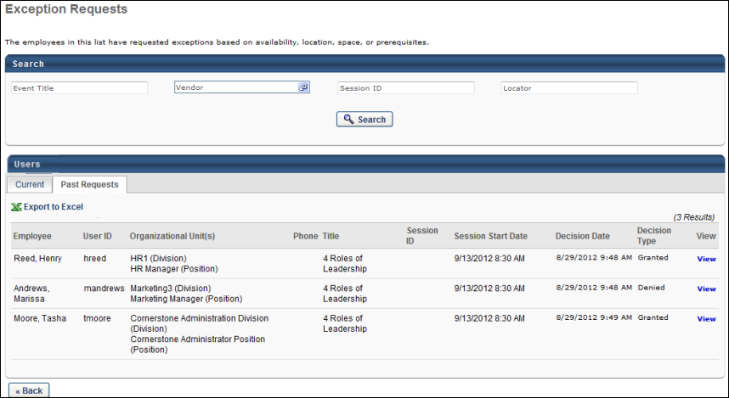
The following fields and features are available on the Past Requests tab:
- Search - Use the search features to filter the results by event title, vendor, session ID, or locator number.
- Current - Click the Current tab to view past requests.
- Export to Excel - Click the Export to Excel link to view the list of past requests in an Excel spreadsheet. The spreadsheet will download to your computer in .xlsx format.
- Past Requests Table - The following information displays in this table:
  - Employee - This column displays the name of the user for whom the exception is requested.
  - User ID - This column displays the user ID of the user for whom the exception is requested.
  - Organizational Unit - This column displays the organizational unit of the user for whom the exception is requested.
  - Phone - This column displays the phone number of the user for whom the exception is requested.
  - Title - This column displays the title of the event.
  - Session ID - This column displays the ID of the session for which the exception is requested.
  - Session Start Date - This column displays the start date and time of the session for which the exception is requested.
  - Decision Date - This column displays the date and time that the exception request decision was granted or denied. This column is blank if the exception request was never granted or denied because the session start date passed.
  - Decision Type - This column displays the exception request was granted or denied. This column is blank if the exception request was never granted or denied because the session start date passed.
  - View - Click the View link to view the details of the response. The following image shows the Respond Details page.
Click Back to return to the previous page. The previous page that displays is dependent upon how you navigated to the Past Requests tab. If you accessed the tab by clicking the tab name, then you are returned to either the Manage Events & Sessions page or the Sessions page, depending on which page you used to access the Exception Requests page. If you accessed the tab from the Respond page, then you are returned to the Respond page. Note: If clicking Back takes you to the Respond page, then any decisions that were made when previously on the Respond page are not lost.
Grant/Deny Requests
The Respond page allows you to grant or deny exception requests. The page is accessed from the Exception Requests page by clicking the Respond link in the Respond column on the Current tab.
Permissions
PERMISSION NAME | PERMISSION DESCRIPTION | CATEGORY

Exceptions - Manage | Grants ability to approve or deny Instructor Led Training Exception requests (e.g. availability exceptions, pre-requisite exceptions). This permission works in conjunction with the Event - View and Exceptions - View permissions. This is an administrator permission. | Learning - Administration
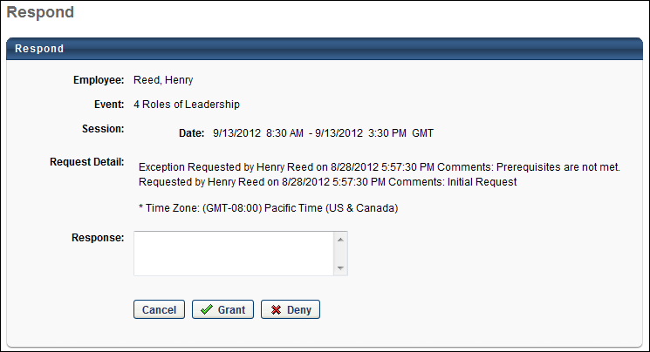
The following information displays in the upper section of the Respond page:
- Employee - This field displays the name of the user for whom the exception is requested.
- Event - This field displays the title of the event for which the exception is requested.
- Session - This field displays the date and time of the session for which the exception is requested.
- Request Detail - This field displays information about who submitted the request, when it was submitted, and the time zone in which it was submitted. If applicable, this field also displays the approver's name and the date and time that they approved the request. Note: When a request is submitted, if an approval process is associated with the training or the user, then the normal approval process must be completed before the exception request appears on the Exception Requests page.
To grant or deny a request:
- Navigate to the Current tab of the Exception Requests page.
- Click the Respond link in the Respond column. This opens the Respond page.
- Enter a reason for granting or denying the request in the Response box. Comments entered will appear on the LO Details page.
- Click Grant to grant the request. When a request is granted, the following occurs:
  - The training status on the user's transcript changes from Exception Requested to Approved, Registered (if register upon approval is set), or Waitlisted (if the class is full and register upon approval is set).
  - The Grant Exception Request email is triggered, if activated.
- Click Deny to deny the request. When a request is denied, the following occurs:
  - The training status on the user's transcript changes from Exception Requested to Denied.
  - The Deny Exception Request email is triggered, if activated.
- Click Cancel to cancel the action and return to the Current tab.

Interest Tracking
The Interest Tracking page enables administrators to view all events for which users have expressed interest. This page also enables administrators to quickly see how many tentative and confirmed future sessions there currently are for the corresponding events. With this information, administrators can choose to create additional sessions for events in which there are interested users. Users on the Interest Tracking list may be eligible for an early registration period when a new session is created, depending on the ILT Preferences.
To manage interest tracking for instructor led training (ILT) events, go to ILT > Manage Events & Sessions. Click the Interest Tracking button. Then, search for the appropriate event by name.
Permissions
PERMISSION NAME | PERMISSION DESCRIPTION | CATEGORY

Interest Tracking - Manage | Grants ability to manage Interest Lists for instructor led training events, including adding and removing users from interest lists. This permission works in conjunction with Events - View, and Interest Tracking - View permissions. This is an administrator permission. | Learning - Administration

Interest Tracking - View | Grants view-only access to instructor led training Interest Lists, via the ILT Events and Sessions screen, enabling the user to view the Interest Lists for various ILT events. This permission works in conjunction with the Events - View permission. This is an administrator permission. | Learning - Administration
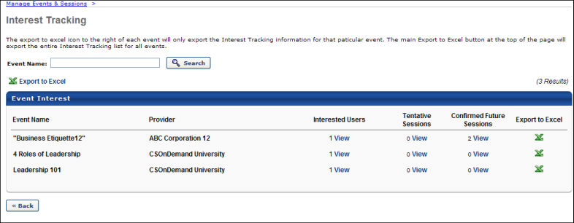
Export Interest Tracking for All Events
To export the entire Interest Tracking list for all events, click the Export to Excel link at the top of the Event Interest table. The spreadsheet will download to your computer in .xlsx format.
Interested Users
The Interested Users column displays the number of users who have expressed interest in the event.
To view all users who have expressed interest in the event, click the View link in the Interested Users column for the appropriate event. This includes current and past requests.
From the Interested Users page, administrators can add additional users to the interest list for the event. To add interested users, click the Add Users link. Note: Users can only be added to an event that has at least one other interested user.
- If the added users have the Interest Tracking widget on the Welcome page, they will see the interest count increase. If the added users view the Interest and Waitlist Tracking page, they will see the event that was added for them in the interest section, which will not have a delete icon associated with the event added by the administrator. The user will see no location selected, but the user can still edit the location preference.
- If a user has indicated interest in an event, and then you add the same user to the Interest list for the same event, the action overwrites any user defined location preference with any location (implied by a blank field in the Location Preference column). The user comment field is not overwritten and therefore would not display Added By Admin. Date submitted is overwritten with a new date stamp.
- There is only one request per user, therefore if an administrator overwrites a user's request, the original does not display on the Past Request page
Tentative Sessions
The Tentative Sessions column displays the number of tentative sessions that are scheduled to be added for the event.
To view all tentative sessions for the event or to create a new session for the event, click the View link in the Tentative Sessions column for the appropriate event.
Confirmed Future Sessions
The Confirmed Future Sessions column displays the number of future sessions that have been created for the event.
To view all future sessions that have been created for the event or to create a new session for the event, click the View link in the Confirmed Future Sessions column for the appropriate event.
Export Interest Tracking for Individual Event
To export the interest tracking information for a specific event, click the Export to Excel icon for the appropriate event. The spreadsheet will download to your computer in .xlsx format.
Interest Tracking Helpful Hints
- If users are removed from the Interest Tracking list after a certain number of matching sessions, for example three, then they are not actually removed until the next session, for example the 4th, is offered. Interested users are notified of matching sessions through the ILT Session Becomes Available email, if this is set up with Interested Users as recipients.
- Users join the interest tracking list from the Learning Object (LO) Details page for the event. See LO Details Page - Interest Tracking for additional information. On the ILT Preferences page, there is an Add users on the waitlist to the interest tracking list for that event and location option. When this option is selected, if a user joins a waitlist for a session, then the user is automatically added to the Interest Tracking list for the corresponding event and location. Users on the Interest Tracking list may be eligible for an early registration period when a new session is created, depending on the ILT Preferences.
- Learners who add an event to their interest list will only see sessions with advanced registration that have been added AFTER they added the event to the interest list.
- On the Events Calendar, sessions display to all users within the availability of the session, irrelevant if advanced registration is defined or not. However, if a learner requests the session within the advanced registration period without being on the interest list, they need to request an exception.
EMAIL NAME | EMAIL DESCRIPTION | ACTION TYPE

ILT Session becomes Available | Session is approved and available for enrollment. If this email is created with a Send To of "Interested users," it will trigger an email to users on the Interest Tracking list if the users are included in the session availability criteria for the session when that session is created. | ILT Administration
Considerations
Interest Tracking can be disabled by Cornerstone on the backend, if needed. However, it is not possible to disable Interest Tracking at the learning object (LO) level.

Session Roster - Add Users to a Session
On the Session Roster page, instructors and administrators may be able to add users to the session roster. When an instructor or administrator clicks the Add Users link on the Session Roster page, the instructor or administrator is directed to a Select Users pop-up that allows them to select the users to be added to the session roster. This avoids having to complete the learning assignment process. In addition, the instructor or administrator is able to know immediately if a user is added to the session roster.
To access the ILT session roster, go to ILT > Manage Events & Sessions. Search for the appropriate event and next to the event in the search results, in the Options column, click the View Sessions icon . This option is only available to users with permission to view sessions. Next to the appropriate session, in the Options column, click the View Roster icon .
To add users to the session, click the Add Users link.
Permissions
PERMISSION NAME | PERMISSION DESCRIPTION | CATEGORY

Roster - Add Pending Users | Grant ability to add pending users to the ILT session roster. The administrator must also have the Roster - Manage or Roster - View permission. This permission cannot be constrained. This is an administrator permission. | Learning - Administration

Roster - Add Users | Grants ability to add named users to class rosters for instructor led training sessions. This permission works in conjunction with the Roster - View permission. This permission can be constrained by OU, User's OU, ILT Provider, and User's ILT Provider. This is an administrator permission. | Learning - Administration

Roster - Increase Seats | Grant user the ability to increase the session's available seats when adding users to the session roster if the added users exceed the number of available or reserved seats. User must also have Manage Roster or View Roster permission. This permission cannot be constrained. This is an administrator permission. | Learning - Administration

Roster - View | Grants view-only access to instructor led training session rosters. This permission works in conjunction with Events - View and Sessions - View permissions. This permission can be constrained by Instructor, ILT Provider, User's ILT Provider, and User as Instructor. This is an administrator permission. | Learning - Administration

Sessions - Create | Grants ability to create new instructor led training sessions. This permission works in conjunction with Events - View and Sessions - View permissions. Administrators can only create sessions for events for which they have the availability to view. When adding users to a session in which the session roster is full, this permission grants the ability to increase the session's available seats. This permission can be constrained by OU, User's OU, Instructor, User as Instructor, Facility, Facilities Owned by User, ILT Provider, User's ILT Provider, User, and User Self and Subordinates. This is an administrator permission.  Note: The "Restrict to User as Instructor" constraint is available, but it does not actually constrain the permission. | Learning - Administration

Sessions - Edit | Grants ability to edit/update existing instructor led training sessions. This permission works in conjunction with Events - View and Sessions - View permissions. Administrators can only edit sessions for which they have the availability to view and edit. When adding users to a session in which the session roster is full, this permission grants the ability to increase the session's available seats. This permission can be constrained by OU, User's OU, Instructor, User as Instructor, Facility, Facilities Owned by User, ILT Provider, User's ILT Provider, User, and User Self and Subordinates. This is an administrator permission. | Learning - Administration

Sessions - View | Grants view-only access to instructor led training sessions, enabling the user to view all details/options that were selected when the session was created. This permission works in conjunction with the Events - View permission. This permission can be constrained by OU, User's OU, Instructor, Facility, Facilities Owned by User, ILT Provider, User's ILT Provider, User, User as Instructor, and User Self and Subordinates. This is an administrator permission.  Adding an OU constraint and a provider constraint to this permission results in an "AND" statement. | Learning - Administration
Emails
EMAIL NAME | EMAIL DESCRIPTION | ACTION TYPE

ILT Session Register | Once a user registers for an ILT session, this email can be sent to the student, approvers, assignors, instructors, and anyone else who would need information about the registered session. This email will not be triggered after the session start date, regardless of the session end date.  This email does not include Accept or Deny options when it is sent as a calendar invitation because this email does not interact with the Cornerstone system. It is designed to only allow recipients to save the session to their calendar. | Instructor Led Training

Training is Completed | This email will fire once the user has successfully completed a session, online class, quick course, curriculum, library, posting, test, or material.  To include a link to an associated Level 1 evaluation within the Training is Completed email, enter the tag, EVALUATION.LEVEL1, into the email body. When the email is sent to a user, the tag text is replaced by the link to the evaluation associated with the training item the user completed. The user can click this link to access and complete the Level 1 evaluation. Note: If no evaluation is associated with the training that was completed, the tag is removed from the email body and no content displays in its place.  Note: If no evaluation is associated with the completed training, the tag is removed from the email body and no content displays. Also, if the evaluation is completed prior to the email triggering, the tag is removed from the email body and no content is displayed. | Training
When an instructor or administrator clicks the Add Users link, this opens the Select User pop-up, in which the instructor or administrator can search for and select multiple users to be added to the session roster. Users who are already registered for the session or are pending registration cannot be selected from the pop-up. Note: This option is only available to instructors or administrators with permission to add users to a roster. In addition, the constraints on this permission determine which users can be viewed and selected.
Add Pending Users to Roster
The selected users have not yet been enrolled in the session, and they are displayed in a table above the enrolled users. This enables the administrator or instructor to view all of the users who have not yet been added to the session.
Emails can be configured for a session when the session is created. By default, any configured registration emails are triggered when the users are added to the session. To disable the two in the Email section mentioned Emails (ILT Session Register or Training is Completed) that may be sent when the users are added to the session, uncheck the Send emails option. This option must be unchecked before the ADD PENDING USERS TO ROSTER button is clicked. Disabling emails may be useful when adding users who attended the session but were not on the roster. In this scenario, the user does not need to be alerted that they were added to the roster.
- When users are added to a completed session and the roster is submitted, if the users are in a Completed status, then only the Training is Completed email is sent, if configured.
- When users are added to an approved session, only the ILT Session Register email is sent, if configured.
To enroll the pending users in the session, click the Add Pending Users to Roster button. Up to the first 10 users in the Pending Users table are added to the roster when the button is clicked.
When pending users are added to the roster, the system checks the number of available seats for the session. This includes the session's maximum registration and any reservations and restrictions. If the maximum registration or restrictions are exceeded, then the options that are available to the instructor or administrator may vary. This button is only available to users who have permission to add pending users to the roster. See the Insufficient Seats Scenarios section below for additional information.
When a user is added to the roster, the following occurs:
- Session is immediately assigned to the users.
- The session has no due date.
- Any prerequisites and pre-work associated with the session are bypassed.
- The user is assigned, approved, and registered. If payment is required, the user remains in an Approved status until payment is received. If the session has ended, users are automatically assigned a status of Completed. If there is a required evaluation, this is also bypassed and the user will be in a Completed status.
- Session emails are queued unless they are disabled.
If a user is added to the roster, but the enrollment fails, then the user will be removed from the Pending Users table and the Denied status will be reflected in the user's Transcript.
If multiple sessions are selected, the Add Pending Users to Roster button is not available, and the instructor must first select a locator number from the drop-down at the top of the Roster page.
Pending Users Table
The Pending Users table displays all users who have been selected to be added to the roster but have not yet been added. If a user is successfully added to the roster, then they are removed from this table. Similarly, if a user's registration is denied, then they are removed from this table.
The following information is displayed for each user who is pending enrollment:
- Name
- User ID
- Locator - This displays the session locator number, which is important if there are child sessions.
- Organizational Unit(s)
- Status
To remove a pending user, click the Remove icon to the right of the appropriate user in the Pending Users table.
Note: If the roster is submitted or if the session is cancelled, then all pending users are removed from the session.
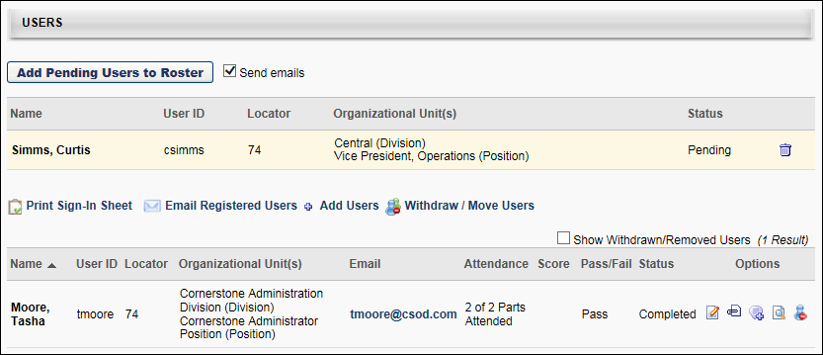
Insufficient Seats Scenarios
When adding users to a roster and there are insufficient seats, which options are available depends on whether the waitlist is enabled for the session and whether the administrator has permission to increase the number of session seats.
Scenario 1 - No Waitlist, Cannot Increase Seats
When the administrator attempts to enroll users where the number of users being enrolled exceeds the number of available seats for the session, the administrator cannot assign the users. The following pop-up appears, informing them that the number of selected users exceeds the number of available seats.
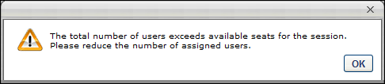
The administrator must then adjust the number of selected users or select a different session.
Scenario 2 - Waitlist Enabled, Can Increase Seats
When the administrator attempts to enroll users where the number of users being enrolled exceeds the number of available seats for the session, the administrator can either increase the session's available seats or add the excess users to the session waitlist. The following pop-up appears, informing the administrator of their options.
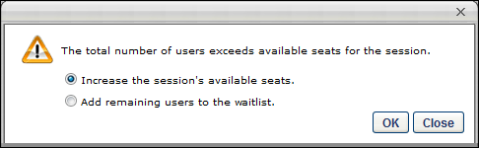
Increase Available Seats
Select this option to increase the session's available seats in order to accommodate the excess users. The maximum registration and the number of general seats for the session are increased by the number of matching users that are added to the session. If there are already users on the waitlist, then the pending users are added to the session and the waitlisted users remain on the waitlist.
Add Users to Waitlist
Select this option to maintain the session's number of available seats. Once all seats are filled, the remaining users are added to the session's waitlist. The waitlist options that are configured for the session apply. Note: The system begins assigning users at the top of the user list and moves downward.
The administrator may also click Close to reject these options and then adjust the number of selected users or select a different session.
Scenario 3 - Waitlist Enabled, Cannot Increase Seats
When the administrator attempts to enroll users where the number of users being enrolled exceeds the number of available seats for the session, the administrator can add the excess users to the session waitlist. The following pop-up appears, informing the administrator of their options.
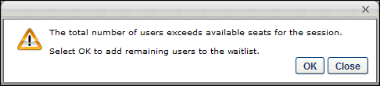
The administrator can click OK to add as many users to the session as possible. Once all seats are filled, the remaining users are added to the session's waitlist. Note: The system begins assigning users at the top of the user list and moves downward.
The administrator may also click Close to reject this option and then adjust the number of selected users or select a different session.
Scenario 4 - No Waitlist, Can Increase Seats
When the administrator attempts to enroll users where the number of users being enrolled exceeds the number of available seats for the session, the administrator can increase the number of session seats. The following pop-up appears, informing the administrator of their options.
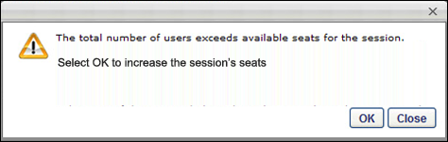
The administrator can click OK to increase the session's available seats in order to accommodate the excess users. The maximum registration and the number of general seats for the session are increased by the number of matching users that are added to the session.
The administrator may also click Close to reject this option and then adjust the number of selected users or select a different session.
Scenario 5 - Reserved Seats for OU
When enrolling users into a session for which one or more users match the criteria for an organizational unit (OU) that has reserved seats, if there are not enough reserved seats available for the OU, then a pop-up appears that asks the administrator to increase the number of available seats or add the user to the waitlist.
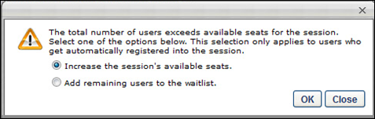
Increase Available Seats
Select this option to increase the session's available seats in order to accommodate the excess users. The maximum registration and the number of general seats for the session are increased by the number of matching users that are added to the session. If there are already users on the waitlist, then the pending users are added to the session and the waitlisted users remain on the waitlist.
Add Users to Waitlist
Select this option to maintain the session's number of available seats. Once all seats are filled, the remaining users are added to the session's waitlist. The waitlist options that are configured for the session apply. Note: The system begins assigning users at the top of the user list and moves downward.
The administrator may also click Close to reject these options and then adjust the number of selected users or select a different session.
Considerations
- Even if a user on the waitlist matches criteria for an OU that has reserved seats, the user is granted the first available opening. The opening could be a reserved seat for their matching OU or general seating, whichever opens first.
- If a reserved seat is the first available seat for multiple users on the waitlist that match the OU's criteria, then the user that is highest on the waitlist is granted the first available reserved seat for their matching OU if the Allow Auto-Management of Waitlist option is configured for the session.

Session Roster - Email Registered Users
Administrators can quickly email users registered for a session using the Email Registered Users link on the Roster page.
Note: When clicking the Email Registered Users link, individual users in the following transcript statuses will be added in the recipients list: Registered, In Progress, Completed, Cancelled, Incomplete, No Show, Pending Evaluation, Pending Payment.
Go to ILT > Manage Events & Sessions. Search for the event. In the Options column for the event, click the View Sessions icon. This option is only available to users with permission to view sessions. In the Options column for the appropriate session, click the View Roster icon.
Permissions
PERMISSION NAME | PERMISSION DESCRIPTION | CATEGORY

Roster - Email Registered Users | Grants ability to send a custom email message to all students listed on the roster for an instructor led training session. An additional link appears on ILT roster page for sending such messages. This is an administrator/ILT instructor permission. | Learning - Administration

Sessions - View | Grants view-only access to instructor led training sessions, enabling the user to view all details/options that were selected when the session was created. This permission works in conjunction with the Events - View permission. This permission can be constrained by OU, User's OU, Instructor, Facility, Facilities Owned by User, ILT Provider, User's ILT Provider, User, User as Instructor, and User Self and Subordinates. This is an administrator permission.  Adding an OU constraint and a provider constraint to this permission results in an "AND" statement. | Learning - Administration
Email Registered Users
- Click the Email Registered Users link. Selecting the Email Registered Users link opens a marketing email template where you can specify a time and date for the email to be sent. Emails will be sent on the hour and the half hour on the date specified.
- If applicable, select an email template from drop-down menu. When a template is selected, fields automatically populate as defined in the template.
- Enter the following information:
  - Email Title
  - From Address - The email address that appears as the From address in the email.
  - Reply-To Address - The email address to which any replies to this email are sent.
  - Send to - This automatically populates with users from your roster. Users can not be deleted nor added.
  - Language - Select a language from drop-down if applicable.
  - Tags - Click the link to view available tags for the email Subject or Message. The list of available tags that display depends on the email type selected. When the email is sent, the tags are replaced with actual information. The tags must be entered exactly as they are listed and they are case sensitive.
  - Subject - Enter the subject of the email message that is displayed for user. Tags may be used in this field.
  - Message - Enter the email message for user. Tags may be used in this field.
  - Send Date - Select the date and time at which the email will be sent.
- Click Save.
Email Tags
Below are email tags you can enter into the Message Subject or Body. When the email is sent, Cornerstone will replace these fields with actual information. The tags must be entered exactly as they are listed and are case sensitive. The available email tags for this functionality include:
- RECIPIENT.DIVISION
- RECIPIENT.FIRST.NAME
- RECIPIENT.LAST.NAME
- RECIPIENT.PHONE
- RECIPIENT.POSITION
- RECIPIENT.USERNAME

Session Roster - Withdraw Users
Administrators can withdraw or remove users from a session via the Withdraw/Remove User option for the session.
Go to ILT > Manage Events & Sessions. Search for the event. In the Options column for the event, click the View Sessions icon. This option is only available to users with permission to view sessions.
Permissions
PERMISSION NAME | PERMISSION DESCRIPTION | CATEGORY

Roster - Batch Withdrawal or Move Users | Grants ability to withdraw multiple users for an instructor led training session class roster, or to move them from one class roster to another. This permission works in conjunction with the Roster- View permission. | Learning - Administration

Sessions - View | Grants view-only access to instructor led training sessions, enabling the user to view all details/options that were selected when the session was created. This permission works in conjunction with the Events - View permission. This permission can be constrained by OU, User's OU, Instructor, Facility, Facilities Owned by User, ILT Provider, User's ILT Provider, User, User as Instructor, and User Self and Subordinates. This is an administrator permission.  Adding an OU constraint and a provider constraint to this permission results in an "AND" statement. | Learning - Administration
Withdraw Users
- Next to the appropriate session, in the Options column, click the View Roster icon.
- Click the Withdraw/Remove User link.
- Click the plus sign icon next to the appropriate users and click Withdraw.
- From the drop-down, select a reason for the withdrawal and explain in the Comments box.
- Select Do Not Charge Withdraw Penalty to waive the withdraw penalty for this user, if desired. Note: Withdrawal penalties are billed to the user (or their cost center) at the session start date.
- Select Do Not Sent Withdrawal Email to prevent the withdrawal email from being sent to this user, if desired.
- Click Submit. Upon submission, the user is immediately removed and charged any applicable withdrawal penalties.
Note: The options "Do Not Charge Withdraw Penalty" and "Do Not Send Withdrawal Email" are available to Admins/Managers when using the Withdraw/Remove User option for a session. These options do not apply when a user attempts to withdraw from a session.

Session Roster - Move Users
Administrators can move users from one session to another using the Move Users option on the Roster page. A common use case for moving users from one session to another is when an event is almost all full or is full, but more users want to participate. The administrator can open another session for this event to occur on the same date and time. The administrator can then redistribute the users into the additional sessions to achieve a better class balance. Users can only be moved to another session within the same event.
Go to ILT > Manage Events & Sessions. Search for the event. In the Options column for the event, click the View Sessions icon. This option is only available to users with permission to view sessions. In the Options column for the appropriate session, click the View Roster icon.
Permissions
PERMISSION NAME | PERMISSION DESCRIPTION | CATEGORY

Roster - Batch Withdrawal or Move Users | Grants ability to withdraw multiple users for an instructor led training session class roster, or to move them from one class roster to another. This permission works in conjunction with the Roster- View permission. | Learning - Administration

Sessions - View | Grants view-only access to instructor led training sessions, enabling the user to view all details/options that were selected when the session was created. This permission works in conjunction with the Events - View permission. This permission can be constrained by OU, User's OU, Instructor, Facility, Facilities Owned by User, ILT Provider, User's ILT Provider, User, User as Instructor, and User Self and Subordinates. This is an administrator permission.  Adding an OU constraint and a provider constraint to this permission results in an "AND" statement. | Learning - Administration
Move User
To move a user to a different session:
- Click the Withdraw/Move User link.
- Click the plus symbol next to the appropriate users and click Move.
- From the drop-down, select a reason for the move and explain in the comments box.
- Select Do Not Charge Withdraw Penalty to waive the withdraw penalty for this user.
- Select Do Not Sent Withdrawal Email to block the withdrawal email from being sent to this user.
- In the Move section, all future sessions for the event are displayed that have a status of Tentative or Approved. Completed or Cancelled sessions do not appear. All sessions regardless of start date are available, except the session from which the users are currently being moved. Select the session to which the users are to be reassigned.
  - If enrollment reservations or restrictions are defined for a session, then administrators can view the Seats Available pop-up by clicking the Enrollment link for the session. This allows administrators to review the available seats based on reservation and restriction settings.
- Click Submit and Continue. Upon submission the user is immediately removed and charged any applicable withdrawal penalties.
  - You can exclude withdrawn users from the movement part of the process by deselecting them. If waitlist functionality is available and the users intended for assignment exceed the number of seats available for the session, you can add remaining users to the waitlist for the session or increase the seats of the session.
  - Withdrawal penalties are billed to the user (or their cost center) at the session start date.
When moving a user to a different session or adding a user to a session, if the user matches an OU that has reserved seats but there are not enough reserved seats available for the OU, then a pop-up appears that asks the administrator to increase the number of available seats or add the user to the waitlist.
The following options are available in the pop-up:
- Increase the session's available seats - If the this option is selected, then the maximum registration and the number of general seats for the session are increased by the number of matching users that are added to the session. Note: You must have permission to edit sessions in order to increase the number of seats available in the session.
- Add remaining users to the waitlist - If the this option is selected, then the user is added to the waitlist. The waitlist options that are configured for the session apply.
  - Even if a user on the waitlist matches criteria for an OU that has reserved seats, the user is granted the first available opening. The opening could be a reserved seat for their matching OU or a general availability seat, whichever opens first.
  - If a reserved seat is the first available seat for multiple users on the waitlist that match the OU's criteria, then the user that is highest on the waitlist is granted the first available reserved seat for their matching OU if the Allow Auto-Management of Waitlist option is configured for the session.
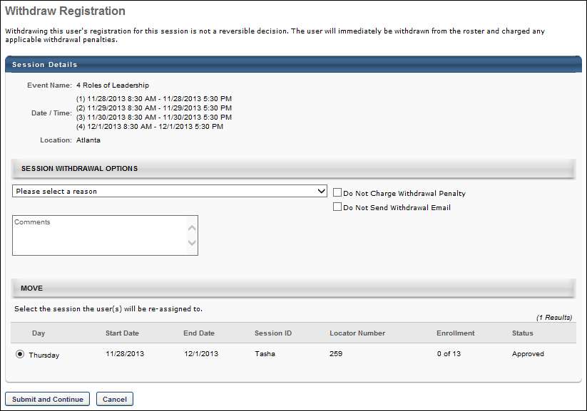

Session Roster - Edit Transcript Details
From the Roster, administrators can access the Edit Transcript option, which allows them to edit custom fields that have been configured as editable on the transcript.
To edit custom fields on a user's transcript for the session: Go to ILT > Manage Events & Sessions. Search for the event. In the Options column for the event, click the View Sessions icon. This option is only available to users with permission to view sessions. In the Options column for the appropriate session, click the View Roster icon.
Permissions
PERMISSION NAME | PERMISSION DESCRIPTION | CATEGORY

Sessions - View | Grants view-only access to instructor led training sessions, enabling the user to view all details/options that were selected when the session was created. This permission works in conjunction with the Events - View permission. This permission can be constrained by OU, User's OU, Instructor, Facility, Facilities Owned by User, ILT Provider, User's ILT Provider, User, User as Instructor, and User Self and Subordinates. This is an administrator permission.  Adding an OU constraint and a provider constraint to this permission results in an "AND" statement. | Learning - Administration
Edit Transcript
To edit the transcript details for the session on a user's transcript:
- Click the Edit Transcript icon for the appropriate user on the roster.
- Edit any custom fields that have previously been set-up as Editable on Transcript by the Administrator. See - Custom Fields for information on setting up custom fields.
- Enter comments in the comment box.
- Click Save.

Session Roster - Exempt Users from Assignment
Administrators can exempt users from an assignment of a session via the Roster page.
Go to ILT > Manage Events & Sessions. Search for the event. In the Options column for the event, click the View Sessions icon. This option is only available to users with permission to view sessions. In the Options column for the appropriate session, click the View Roster icon.
Permissions
PERMISSION NAME | PERMISSION DESCRIPTION | CATEGORY

Sessions - View | Grants view-only access to instructor led training sessions, enabling the user to view all details/options that were selected when the session was created. This permission works in conjunction with the Events - View permission. This permission can be constrained by OU, User's OU, Instructor, Facility, Facilities Owned by User, ILT Provider, User's ILT Provider, User, User as Instructor, and User Self and Subordinates. This is an administrator permission.  Adding an OU constraint and a provider constraint to this permission results in an "AND" statement. | Learning - Administration
- Click the Assignments tab.
- Next to the assignment, click the Exempt link to exempt a student from a pre-work, post-work, or prerequisite.
  - If an assignment is exempt, Already Exempted appears in the Exempt column.
  - If the student's status is Pending Prerequisite and the incomplete prerequisites are exempted, the user's Transcript status changes to Registered.
  - If a user's status is Past Due, exempting the user's pre-work changes the user's Transcript status from Past Due to Registered.
  - If a user has a required assignment that is not complete after the session was marked complete, their session training status is In Progress. Exempting a student from required pre-work or post-work makes the user's session status Completed once the roster is submitted. The roster does not have to be re-submitted to change from In Progress to Completed.

Managing Rosters Quick Reference Card
Select the following link to download a Quick Reference Card that guides you through the process of managing session rosters: Managing Rosters Quick Reference Card

ILT Using Webex
Integrating Webex Meeting Center or Training Center with ILT in Cornerstone allows the administrator, instructor, and participants to schedule, start, and join webcasts directly from your portal. To enable this integration, visit the Edge Marketplace.
- See Webex Meeting Center Integration.
- See Webex Training Center Integration.

Webex Attendance Troubleshooting
When troubleshooting attendance issues for a Webex session, check the following items:
- Attendees must launch the course from their Cornerstone portal rather than click the Webex Meeting link.
- When accessing the Webex meeting, the attendee must provide the email address that is used for their Cornerstone portal. Note: When an attendee accesses the Webex meeting through their Cornerstone portal, this occurs automatically.
- When an attendee leaves a Webex meeting, the attendee must click the Leave Session button within the Webex meeting. If an attendee does not do this, the instructor must follow these steps to ensure attendance is properly recorded for those attendees:
  - On the session roster, click the Update Roster button at least 24 hours after the session ends. This obtains the attendance information from Webex directly and updates the roster within the Cornerstone portal. The instructor must wait at least 24 hours after the session ends to ensure that Webex has properly recorded all attendance. Then, click the Submit Roster button.
Note: As long as the attendee is able to launch the Webex meeting successfully from their Cornerstone portal and participate in the Webex meeting, their attendance will be recorded within Webex, even if the host exists the meeting before the attendee.

Five users in the Sales division are currently registered for a session but are registered for general seats, not reserved seats. When the session was originally created, there were no seats reserved for the Sales division. The administrator who created the session decides that she would like to edit the session to reserve 10 seats for the Sales division. Once the edits are processed, the five users in the Sales division that are currently registered will remain registered for general seats. The first 10 users in the Sales division who register for the session after the edits are processed will be placed into reserved seats.
Five users in the Sales division are currently registered for a session but are registered for general seats, not reserved seats. When the session was originally created, there were no seats reserved for the Sales division. The administrator who created the session decides that she would like to edit the session to reserve 10 seats for the Sales division. Once the edits are processed, the five users in the Sales division that are currently registered will remain registered for general seats. The first 10 users in the Sales division who register for the session after the edits are processed will be placed into reserved seats.

