Insights March 2024

Table of Contents
Insights Overview 1
Insights Main Dashboard 2
Manage Favorites 4
Career Mobility 5
Career Mobility Overview 6
Career Path Details Page 7
Career Path Search Results Page 10
Export Career Path Details 12
Position Search Page 15
Compliance 17
Compliance Control Overview 18
Compliance Guide Overview 28
Employee Growth 36

Insights Overview
Insights is a predictive analytics tool that enables organizations to use data to better hire, train, manage, and retain top talent. Insights applies data science to workforce data and displays the results on a series of dashboards.
To access Insights, go to Insights > Insights Dashboards.
Permissions
PERMISSION NAME | PERMISSION DESCRIPTION | CATEGORY

Insights Dashboard | Allows user to access Insights Dashboard. This permission cannot be constrained. | Core
Dashboards
The following dashboards provide data-driven insights that help organizations solve important business problems and improve employee productivity:
- Career Mobility - The Career Mobility Insight empowers managers to create data driven career paths and development plans for individuals to realize their potential. See Career Mobility Overview on page 5 for additional information.
- Compliance Guide - The Compliance Guide dashboard helps organizations understand the impact of employees not completing training in a timely manner for all learning object types except events and sessions. See Compliance Guide Overview on page 28 for additional information.
- Employee Growth - Use the Employee Growth insight to search for employees and match them with positions that could be a good fit. For more information about this insight, see the Insights curriculum in the Success Center.
- Learning Trends - The Learning Trends dashboard provides crucial information for business process owners, learning administrators, and learning analysts to help strategize the most effective ways to provide learning for their teams. For more information about this insight, see the Insights curriculum in the Success Center.
- Predictive Succession - The Predictive Succession dashboard helps organizations identify internal successors for positions. For more information about this insight, see the Insights curriculum in the Success Center.

Insights Main Dashboard
The Insights Main Dashboard displays your favorites and the cards for Compliance, Mobility, and Learning. The Compliance Guide card enables you to access the Compliance Strategy dashboard. Click a card to open a dashboard.
Permissions
PERMISSION NAME | PERMISSION DESCRIPTION | CATEGORY

Insights Dashboard | Allows user to access Insights Dashboard. This permission cannot be constrained. | Core
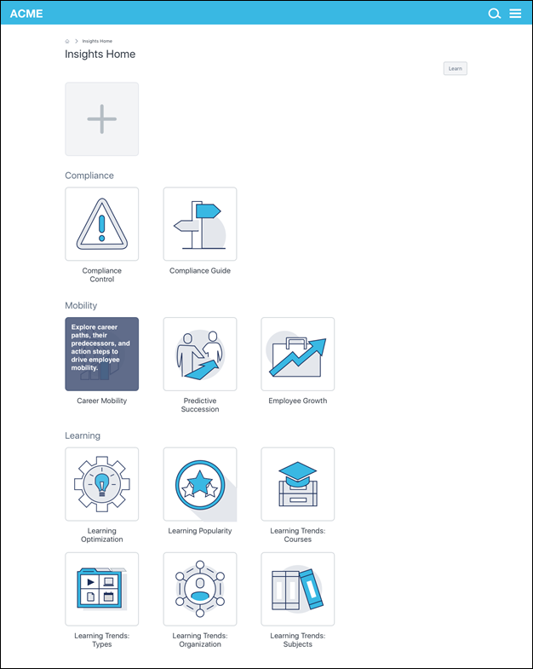

Manage Favorites
You can tag your favorite Insights and access them from a Favorites section at the top of the Insights homepage. Creating favorites provides a quick way for you to access your most used Insights so that you do not have to scroll down on the homepage to find them.
Add and Manage Favorites
To add and manage favorites:
- Click the plus icon at the top of the Insights homepage. This opens the Browse tab on the Manage Favorites flyout.
- Select the box next to each Insight you want to favorite. There is no limit to the number of favorites.
- Deselect a box to remove the Insight as a favorite.
- Click Save.
Your favorites will appear at the top of the Insights homepage. When an Insight is a favorite, it no longer appears in its default location on the homepage.
To view your list of favorites, click the Favorites tab in the Manage Favorites flyout.
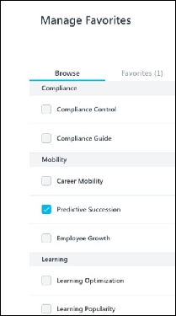

Career Mobility

Career Mobility Overview
The Career Mobility Insight empowers managers to create data driven career paths and development plans for individuals to realize their potential. Organizations will gain insight on internal career paths and the actions that drove historically successful successors along their paths. Furthermore, this will prescribe users with development plan action items that may help new successors mobilize in their career paths.
Use Cases
- An organization has high attrition for a particular position. Since lack of career mobility typically drives employees out of a company, you want to see all career paths that have started from that position. Then, you can generate the data you need to solve the attrition problem with support to generate career mobility for employees in that position. You can then output that data and share it with the appropriate internal stakeholders, such as managers of the starting position.
- An organization wants to understand all career paths between two particular positions. They use a start and end point to analyze all the paths that have taken place between both points and the actions necessary to mobilize talent from the starting position to the goal position. Then, they output the data and share it with the appropriate internal stakeholders, such as managers of the starting position.
Security
The following permission applies to this functionality:
PERMISSION NAME | PERMISSION DESCRIPTION | CATEGORY

Insights Dashboard | Allows user to access Insights Dashboard. This permission cannot be constrained. | Core

Career Path Details Page
From the career path details page, you can learn more about the historical successions of that career path and the recommended development actions for that career path to take place for a potential successor. See the number of successors and how long it has historically taken to reach the goal position. Find the training and competencies needed throughout the career path, as well as certifications and the total number of expected training hours.
To access the career path details page, click the Analyze button on the career path search results page.
Permissions
PERMISSION NAME | PERMISSION DESCRIPTION | CATEGORY

Insights Dashboard | Allows user to access Insights Dashboard. This permission cannot be constrained. | Core
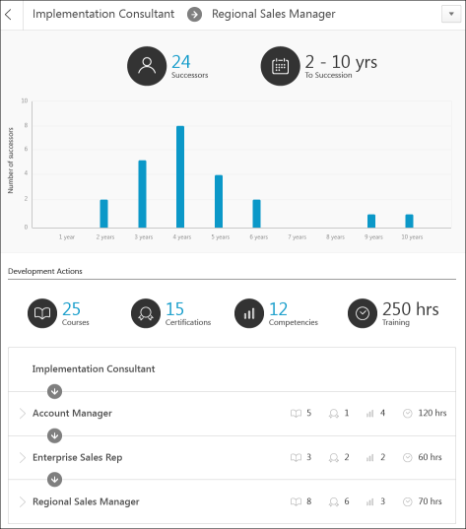
Start/Goal Position
The starting position and the goal position display at the top of the page.
Return to Previous Page
Click the back button to return to the career path search results page.
Number of Past Successors
This is the total number of past successors in the goal position. You can view the details for all successors by clicking the number of successors. This opens a pop-up that displays the successors and the number of years it took to reach the goal position. The list displays in order of the shortest amount of time to succession.
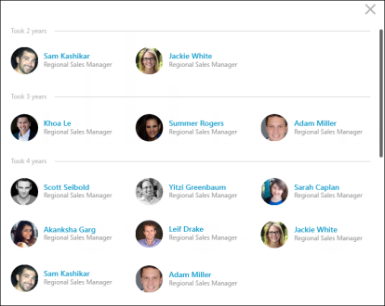
Years to Succession
This is the average number of years to succession to the goal position based on the total successors.
Successors Chart
The bar chart at the top shows a historical view of all past successors that made the transition from the starting position to the end position in the career path.
Axes
The x axis represents the number of past successors. The y axis groups the data by how many years it took successors to succeed from the starting position to the goal position.
View Successors in Each Group
Click a bar on the chart to view the successors within that group. A pop-up opens to display the past successors, their current position, and the total number of years to succession. If a successor is no longer with the company, then "Inactive Employee" displays in place of the current position name.
Total Development Actions
This section displays the total development actions in each category for all of the transition positions. Click the linked actions to view a pop-up with details of the actions, such as training and certification titles.
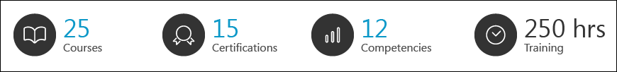
Position-Specific Development Actions
The positions in the career path display in ascending order from starting position to goal position and include the actions that need to be taken in order to get to that position.
To view the development actions for each position, expand the position. Types of development actions may be online courses, events, certifications, competencies to achieve.
The number of training items, certifications, competencies, and total training hours appears above the detailed development actions. You can scroll through the actions to view each action.
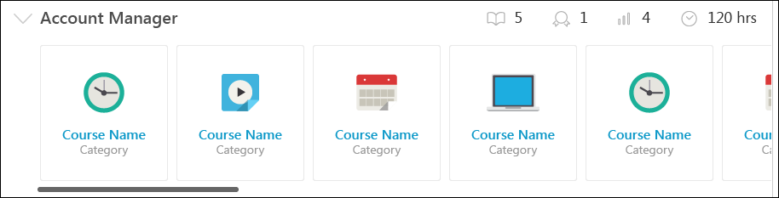

Career Path Search Results Page
The search results page displays the career path, from the starting position to the goal position. Additional positions may display between the Start and Goal positions to indicate the historical transition jobs that led to the next and goal steps in the career path.
To access the career path search results page, click Start on the position search page.
Permissions
PERMISSION NAME | PERMISSION DESCRIPTION | CATEGORY

Insights Dashboard | Allows user to access Insights Dashboard. This permission cannot be constrained. | Core
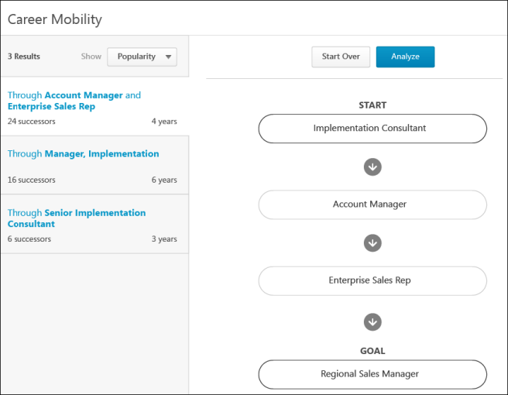
Number of Results
This displays the number of career paths.
Sorting
The Show option allows you to sort the search results by popularity or years.
- Popularity - The search results are sorted by popularity by default. This displays the career paths in order of the highest number of times employees have been transitioned into the next position in the career path from the previous position in the career path. In the image, the goal position of Regional Sales Manager has been reached the most number of times by employees who were in the Account Manager position and then the Enterprise Sales Rep position.
- Year - Displays the career path results in descending order by the number of years to succession.
Career Paths
The career paths display in the left panel. They indicate the various positions through which the goal position has been reached. For example, "Through Account Manager and Enterprise Sales Rep" indicates that the goal position of Regional Sales Manager has been achieved through the career path of Account Manager as the starting position, and then the successive position of Enterprise Sales Rep. Or, the starting position has also been Enterprise Sales Rep, which led to Regional Sales Manager.
Note: If there is only a starting position entered on the position search page, then the goal position will be any succession end position that has been reached from the starting position. If there is only a goal position entered on the position search page, then the starting position will be any position that was started from to reach the goal position.
Transition Steps
The transition steps display to the right of each career path. The steps display with an arrow between them, indicating that these are the starting and transition positions that have led to the goal position.
Successors
This indicates the total number of historic successors that took the career path.
Years
This is the measure of years of all successors that transitioned through the career path.
Start Over
Click Start Over to return to the position search page. The previously selected positions display in the Start and Goal fields.
Analyze
Click Analyze to open the career path details page.

Export Career Path Details
The information on the career path details page can be exported or printed.
Export
You can export the information on the career path details page by clicking the Export link in the export button in the upper-right corner of the page. This allows you to open a PDF of the information.
The PDF displays the successors chart, successors and their current role, and the development actions for each transition position.
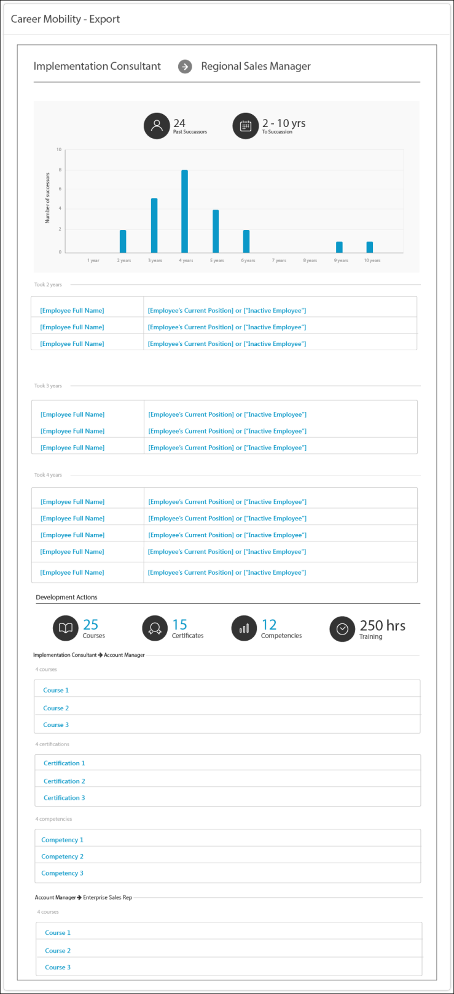
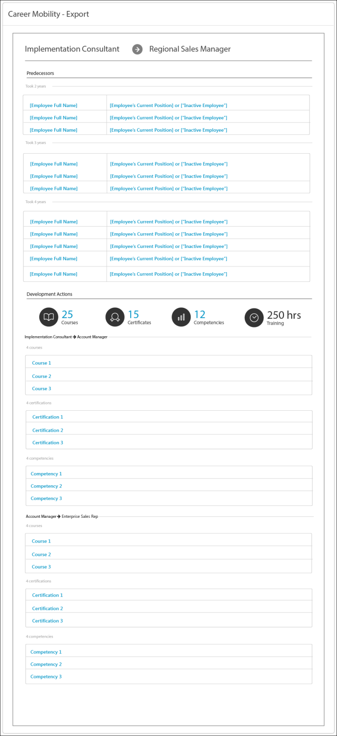

Position Search Page
The position search page allows you to select the starting position and the goal position for the career path.
The user may select a start position and no goal position if they want to search for all career paths stemming off of a single position. Or, a user may select a start and goal position to search for all career paths that stream between two positions. A user cannot, however, just select a goal position by itself to conduct a search.
- Starting Position - The position at the beginning of the career path.
- Goal Position - The position at the end of the career path.
To access the position search page, click the Career Mobility card on the Insights Main Dashboard. See Insights Main Dashboard on page 2 for additional information.
Permissions
PERMISSION NAME | PERMISSION DESCRIPTION | CATEGORY

Insights Dashboard | Allows user to access Insights Dashboard. This permission cannot be constrained. | Core
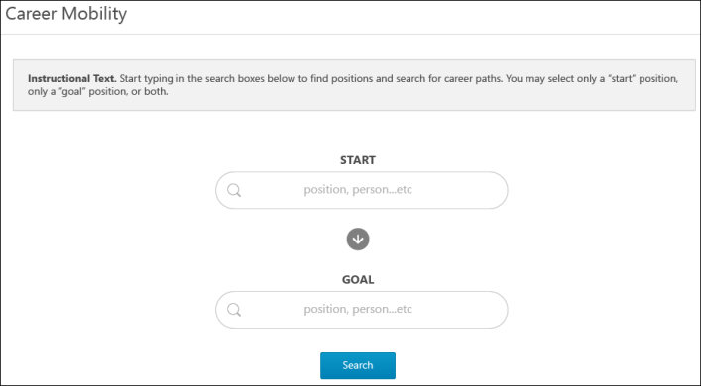
To select the positions:
- Enter text in the Start field. Predictive search results appear as you type.
- Select the starting position from the list. Positions that do not have enough data to suggest a potential path cannot be selected.
- Enter text in the Goal field. Predictive search results appear as you type, displaying the positions the most relevant positions in descending order.
- Select the goal position from the list. Positions that do not have enough data to suggest potential actions to take to succeed to the goal position cannot be selected.
- Click Search. This opens the career path search results page.
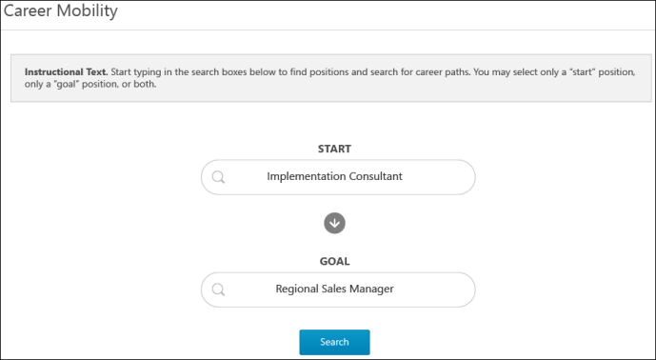

Compliance

Compliance Control Overview
The Compliance Control dashboard helps organizations understand their risk for not meeting compliance requirements for training completion. The dashboard displays widgets that show the number of employees who are at risk for not completing training on time and which trainings are the most at risk (i.e., the trainings that are the most "at risk" courses by number of employees that are at risk for not completing them). The primary risk factors also display, as well as a breakdown of the top at-risk trainings by organizational unit.
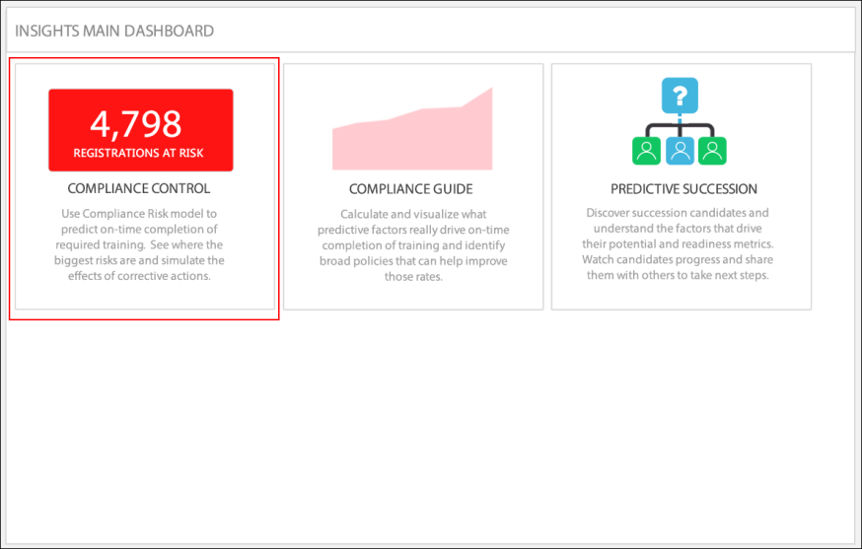
Implementation
This functionality is available as a purchased add-on to Insights. To enable this functionality, contact Global Customer Support.
Security
The following existing permission applies to this functionality:
PERMISSION NAME | PERMISSION DESCRIPTION | CATEGORY

Insights Dashboard | Allows user to access Insights Dashboard. This permission cannot be constrained. | Core
Compliance Control Dashboard
Compliance Control represents the risk associated with employees not finishing a learning object (LO) by the required deadline. Lack of employee compliance with deadlines can result in regulatory fines and/or may prevent employees from performing their assigned duties.
The Compliance Control dashboard identifies the LOs and users who are currently at risk of being out of compliance for completing training on time. The dashboard also helps organizations understand why users are at risk and what the organization can do to mitigate immediate compliance risk. The trends and data are different depending on the ongoing compliance risk and the risk factors driving the compliance risk for the organization.
When first accessing the dashboard, the Registrations at Risk tab displays. To view details of the employees at risk, click the Employees at Risk tab.
Permissions
PERMISSION NAME | PERMISSION DESCRIPTION | CATEGORY

Insights Dashboard | Allows user to access Insights Dashboard. This permission cannot be constrained. | Core
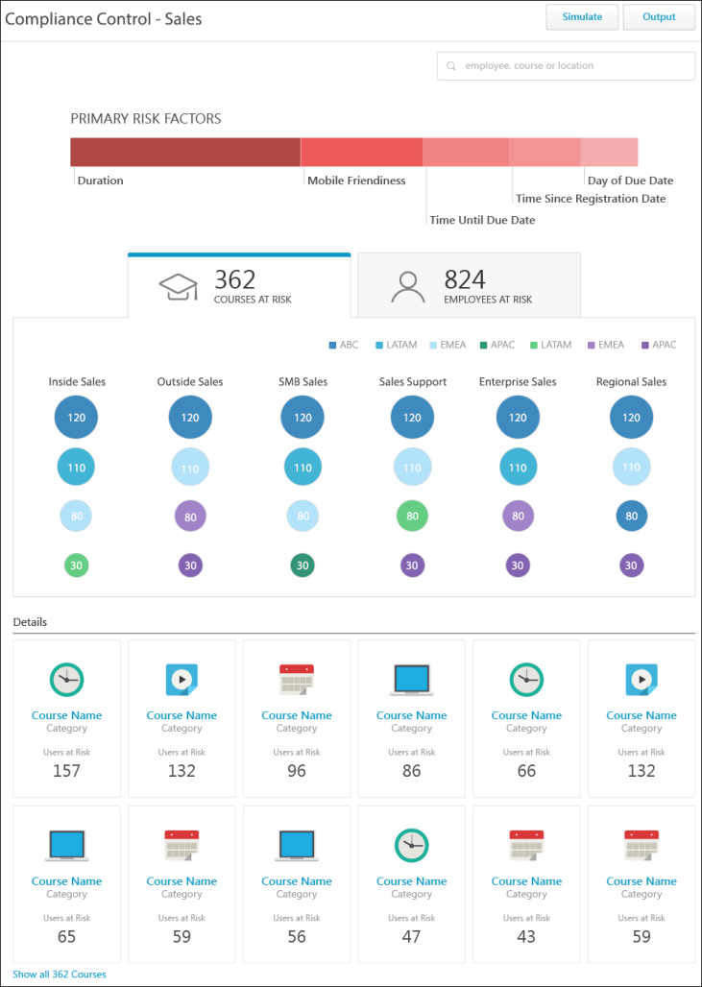
Simulate
The Simulate option allows you to simulate the risk value for the selected dimensions in the simulation section, which appears at the bottom of the page once the Simulate button is clicked. This enables you to view how the risk could be relieved if the recommended actions were taken based on the risk factors that are causing the LOs to be at risk for on-time completion.
To simulate click the Simulate button. This opens the simulate details at the bottom of the page.
Simulate Details
The simulate section displays the actions that can be taken to relieve the risk. The list is in descending order of actions that can relieve the most to least registrations at risk. You can select one or more actions, and then simulate the selected actions to show how the course completion risk would be reduced if the actions were taken.
The following information displays based on the risk factors that are impacting course completion:
- Action Needed - This column displays the recommended action to take to relieve the risk. Check the box next to the action to include the action in the simulation.
- Primary Risk Factor - This column displays the risk factor.
- Registrations at Risk - This column displays the total number of registrations at risk for the Location OUs and Department OUs.
- Employees at Risk - This column displays the total number of employees at risk for the Location OUs and Department OUs.
Once the actions are selected, click the Apply Simulation button. This updates the page to show the reduction in course completion risk in each section if the actions are applied.
- Primary Risk Factors - When simulating, the bar chart is updated to show the new percentage of risk for each risk factor if the action were to be taken. The simulated chart appears below the non-simulated chart.
- Registrations at Risk - When simulating, the number of registrations at risk is updated to reflect the change in risk if the action were to be taken. The simulated total displays to the right of the non-simulated total. The Department OU values are updated to show the simulated values as a percentage of the original value. They display as a bubble in a darker shade overlaying the original bubble. You can click any of the Department OU values to view the child OUs and their impacted risk based on the simulation.
- Employees at Risk - When simulating, the number of employees at risk is updated to reflect the change in risk if the action were to be taken. The simulated total displays to the right of the non-simulated total. The Department OU values are updated to show the simulated values as a percentage of the original value. They display as a bubble in a darker shade overlaying the original bubble. You can click any of the Department OU values to view the child OUs and their impacted risk based on the simulation.
- Details - When simulating, number of LOs or employees who are at risk within each card is updated to reflect the change in risk if the action were to be taken. The simulated number displays to the right of the arrow.
Clear Simulation
To view the data prior to simulation, click Clear Simulation in the bottom-right of the simulation section. This updates the page to show the values prior to simulation.
Edit Simulation
To change the simulation selections, click Edit in the bottom-left of the simulation section.
Output
The Output button allows you to output the dashboard data based on the current view. The output displays summary or detail risk data, depending on the current dashboard display and whether or not simulation has been applied.
The following outputs display before simulation:
- Summary - For the Registrations at Risk tab, the summary output displays each Department OU by location and the number of LOs that are at risk. For the Employees at Risk tab, the summary displays each Department OU by location and the number of employees who are at risk.
- Details - For the Registrations at Risk tab, the details output displays each LO that is at risk, as well as the employees at risk and the number of employees at risk. For the Employees at Risk tab, the details display each LO that is at risk and the employees who are at risk for the LO.
The following outputs display after simulation:
- Simulation Summary - This output displays the summary for the simulation.
- Simulation Details - This output displays the details for the simulation. This shows the simulation effects of all of the individual pages in the list.
Search
Use the search bar to search for a specific employee, LO, or Location OU. Enter the search terms in the bar, and then click the matching result from the list of predictive search results.
If you select an employee or LO, then clicking the name opens the details page for the result.
If you select a Location OU, then the page refreshes to display the risk results for the OU.
Primary Risk Factors
This section shows the distribution of the top five primary risk factors for all trainings that are at risk. The name of each risk factor is listed below the bar chart and displays in a separate color. The chart shows the percentage of the risk factor out of the total risk. The risk factors appear in order of largest to smallest proportion of total risk, from left to right.
The risk factors that generate are based on the analysis of the risk. For example, the Day of Due Date risk indicates that users are not completing training because the due date is on a day of the week that increases the risk that users will not complete training on that day.
Risk Factor Details
You can click any of the primary risk factors to update the page to show only the LOs that have the selected risk factor. This updates the Registrations at Risk, Employees at Risk, and Details sections to show only the LOs with the selected risk factor.
For example, if the Duration risk factor is selected, then the page updates to display only the LOs that are at risk for on-time completion due to the duration of the LO.
Registrations/Employees at Risk
When first accessing the Compliance Control dashboard, the Registrations at Risk tab displays. The registrations at risk are the number of registered users within the dimensions of the Location OUs and Department OUs who are at risk for not completing the training on time. The total number of registrations at risk displays above the section heading.
The Employees at Risk tab shows the individual users who are at risk for not completing training on time.
Location Organizational Unit Color Key
The color key identifies each Location OU by a specific color. The colors display within the OU bar charts for registrations and employees at risk.
Department Organizational Units Chart
The bubble chart displays the number of registered users who are at risk within a specific Department OU. The OUs are color coded based on the Location OU key above the chart.
View Child Organizational Unit Details
You can click a Department OU to view the child OUs and their registrations/employees at risk. This updates the page to reflect the results in relation to the selected OU.
Back
Once the OUs are narrowed to display results for a specific OU, a Back button displays at the top of the section. Click the Back button to go back to the previous OU.
Details
This section displays a card for each LO/employee that is at risk. Up to 12 LOs or employees display by default.
Registrations at Risk
The following information displays for each LO:
- LO icon
- Name of course
- Category - This indicates the LO type.
- Number of users at risk
Employees at Risk
The following information displays for each user:
- Photo
- Name
- Position OU
- Number of LO's at risk
View Details
To view further details about a specific LO or employee, click the card. This opens the details page for the LO or employee.
Employee Risk Page
The employee risk page displays the compliance risk for the learning objects (LO) for an individual employee.
To access the employee details page, do one of the following:
- From the Employees at Risk tab on the Compliance Control dashboard, click an employee's card in the Details section.
- From the Compliance Control dashboard, search for an employee in the search bar. Then, click the name from the list of predictive search results.
Output Options Drop-Down
The output options drop-down allows you to view summary and detail risk data from the Compliance Control dashboard. The options that are available are dependent upon whether or not simulation has been applied.
The following option is available in the options drop-down in the upper-right corner:
- Summary - Click the Summary link to view the summary output. This shows the employee details, number of LOs at risk, and the LOs at risk.
Employee Details
The following employee details display in the upper portion of the page:
- Photo
- Name
- Position OU
- Manager
Number of Courses at Risk
This section displays to the right of the employee details and indicates the total number of LOs for the user that are at risk for not being completed on time. The LOs display in ascending order by due date.
List of Courses at Risk
This section displays the LO name and type for each LO that is at risk for on-time completion.
Learning Object Risk Page
The learning object (LO) risk page displays the compliance risk for an individual LO.
To access the LO risk page, do one of the following:
- From the Registrations at Risk tab on the Compliance Control dashboard, click an LO card in the Details section.
- From the Compliance Control dashboard, search for an LO in the search bar. Then, click the name from the list of predictive search results.
Simulate
The Simulate option allows you to simulate the risk value for the selected dimensions in the simulation section, which appears at the bottom of the page once the Simulate button is clicked. This enables you to view how the risk could be relieved if the recommended actions were taken based on the risk factors that are causing the LOs to be at risk for on-time completion.
To simulate click the Simulate button. This opens the simulate details at the bottom of the page.
Simulate Details
The simulate section displays the actions that can be taken to relieve the risk. The list is in descending order of actions that can relieve the most to least registrations at risk. You can select one or more actions, and then click Apply Simulation. The page updates to show how the course completion risk would be reduced if the actions were to be taken.
The following information displays based on the risk factors that are impacting course completion:
- Action Needed - This column displays the recommended action to take to relieve the risk. Check the box next to the action to include the action in the simulation.
- Primary Risk Factor - This column displays the risk factor.
- Registrations at Risk - This column displays the total number of registrations at risk for the Location OUs and Department OUs.
- Employees at Risk - This column displays the total number of employees at risk for the Location OUs and Department OUs.
Once the actions are selected, you can also click the Apply Simulation button. This also updates the page to show the reduction in risk if the recommended actions are applied.
- Number of Employees at Risk - When simulating, the number of employees at risk is updated to reflect the new number if the action were to be taken.
- Primary Risk Factors - When simulating, the bar chart is updated to show the new percentage of risk for each risk factor if the action were to be taken. The simulated chart appears below the non-simulated chart.
- Registrations at Risk - When simulating, the number of registrations at risk is updated to reflect the change in risk if the action were to be taken. Each column displays a circle with the risk percentage, which is the percentage change caused by the simulation for that particular cohort. For example, if the simulation displays "0%," then the simulation is affecting that particular cohort (bubble) by 0%. If it displays "24%," then the simulation decreased that particular cohort’s course completions at risk by 24%. You can click any of the Department OU values to view the child OUs and their impacted risk based on the simulation.
- Employees at Risk - When simulating, the number of employees at risk is updated to reflect the change in risk if the action were to be taken. Each column displays a circle with the risk percentage, which is the percentage change caused by the simulation for that particular cohort. For example, if the simulation displays "0%," then the simulation is affecting that particular cohort (bubble) by 0%. If it displays "24%," then the simulation decreased that particular cohort’s course completions at risk by 24%. You can click any of the Department OU values to view the child OUs and their impacted risk based on the simulation.
- Details - When simulating, number of LOs or employees who are at risk within each card is updated to reflect the change in risk if the action were to be taken. The simulated number displays to the right of the arrow.
Clear Simulation
To view the data prior to simulation, click Clear Simulation in the bottom-right of the simulation section. This updates the page to show the values prior to simulation.
Edit Simulation
To change the simulation selections, click Edit in the bottom-left of the simulation section.
Output Options Drop-Down
The output options drop-down allows you to view summary and detail risk data from the Compliance Control dashboard. The options that are available are dependent upon whether or not simulation has been applied.
The following option is available in the options drop-down in the upper-right corner before simulation:
- Summary - Click the Summary link to view the summary output. This shows the LO name and employees at risk, as well as risk factors.
The following simulation options are available in the options drop-down in the upper-right corner after simulation:
- Summary - Click the Summary link to view the summary output. This shows the LO name and employees at risk, as well as risk factors.
- Simulation Summary - Click the Simulation Summary link to view the summary output for the simulation. This shows the LO name and employees at risk. You can also view the simulation actions that were taken at the bottom of the page.
Learning Object Title
The title of the LO displays in the upper-left of the page.
Number of Employees at Risk
The number of employees who are at risk for not completing the LO on time displays to the right of the LO title.
Risk Factors
This section shows the distribution of the top five primary risk factors for all trainings that are at risk. The name of each risk factor is listed below the bar chart and displays in a separate color. The chart shows the percentage of the risk factor out of the total risk. The risk factors appear in order of largest to smallest proportion of total risk, from left to right.
The risk factors that generate are based on the analysis of the risk. For example, the Day of Due Date risk indicates that users are not completing training because the due date is on a day of the week that increases the risk that users will not complete training on that day.
Risk Factor Details
You can click any of the primary risk factors to update the page to show only the LOs that have the selected risk factor. This updates the Employees at Risk section to show only the employees with the selected risk factor.
For example, if the Duration risk factor is selected, then the page updates to display only the employees who are at risk for on-time completion due to the duration of the LO.
List of Employees at Risk
This section displays the employees who are at risk for on-time completion. Employees display in ascending order by registration due date. The following information displays for each employee:
- Photo
- Name
- Position OU

Compliance Guide Overview
The Compliance Guide Insight helps organizations understand the impact of employees not completing training in a timely manner for all learning object types except events and sessions. Predictive factors are automatically compiled based on the data generated for the organizational units. These factors help organizations see the conditions that have and have not contributed to users completing their training on time, such as the date on which the training is due.
The purpose of knowing the non-contributing factors is that if there is no significance in a risk factor, then that information may be just as valuable to know. For example, if an organization believed that a certain factor was driving compliance issues, and then discovered through Insight that a different factor was the cause, then that information may be valuable as well.
Security
The following permission applies to this functionality:
PERMISSION NAME | PERMISSION DESCRIPTION | CATEGORY

Insights Dashboard | Allows user to access Insights Dashboard. This permission cannot be constrained. | Core
Compliance Guide Dashboard
Compliance risk represents the risk associated with employees not finishing a learning object by the required deadline. Lack of employee compliance with deadlines can result in regulatory fines and/or may prevent employees from performing their assigned duties. The Compliance Guide dashboard is designed to provide a better understanding of the factors that contribute to achieving high compliance rates and help advise in long-term corrective policies designed to reduce risk.
From the dashboard, you can analyze the factors that are predictive to the organization's on time course completion, determine potential actions to increase compliance rates, and help identify meaningful policy changes that can direct the organization to achieving higher long-term compliance rates.
The data in the Compliance Guide dashboard is calculated by looking at historic compliance levels and the factors that drive compliance. The data also looks at how the factors differ across the organization and what steps can be taken to increase compliance.
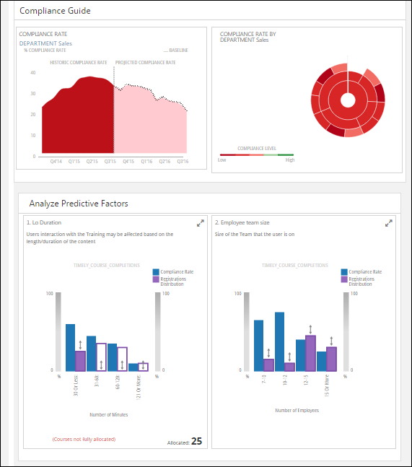
Analyze by Organizational Unit
The options in the upper-right corner of the dashboard allow you to select a specific organizational unit (OU) type by which to analyze. The OU types that are available in the drop-down are the OU types that are created for the portal. To select an OU, click the drop-down and select the OU type.
Compliance Rate
The Compliance Rate card shows a graphical representation of the historic compliance rate over a 1-year period, which is divided quarterly, and has a calculated forecasted rate of compliance looking ahead and divided quarterly. The future compliance rates are reflective of the current course registrations that are due in the future.
Compliance Rate by [Organizational Unit]
The Compliance Rate by [Organizational Unit] card shows a chart with the selected OUs and their compliance rating identified by a low to high color, where green represents a high level of compliance and red represents a low level of compliance. The color for a given OU is determined by the historic compliance rate in the Compliance Rate card. The colors are not customizable.
The compliance level is plotted from low to high (red to green) where the compliance level looks back over the course of the past data in the trend chart. For example, if the trend chart looks at the past four quarters in the historic section, this means that the historic information is comprised of those four quarters in the sunburst.
Each color box in the chart represents an individual OU. Hovering over a color box opens a tooltip that displays the department name, compliance rate percentage, and number of courses that are overdue for completion. Clicking on the color box drills into the OU and updates the Compliance Rate card and the predictive factors based on the data analysis for the selected OU type.
Analyze Predictive Factors
The Analyze Predictive Factors section displays a widget for each factor that contributes to predicting what makes users complete or not complete their training on time, based on the data in the Compliance Rate cards.
The following information displays in each widget to help understand the course completion rates for each group represented in the X axis:
- Name of the predictive factor
- Chart illustrating how the KPI's compliance rates change for various values of the predictive factor
- KPI and factor appropriate labels on the chart
- Ability to select the factor cards individually
- Verbal description of the data in the chart
Show More
Click the Show More link at the bottom of the first row of cards to display additional predictive factors.
Select Individual Cards
You can select one or more individual cards to analyze. To select a card, click anywhere in the card. When a card is checked, a checkbox appears in the card to indicate that the card has been selected.
Clear Selection
Click the Clear Selection link to clear the cards you have selected.
View Selection
Click the View Selection link to see a pop-up of all the predictive factors that have been selected for analysis. This allows you to view the different factors selected prior to going to the analysis page.
Analyze All
This button displays if no individual cards have been selected for analysis. Click Analyze All to analyze all of the predictive factors. This opens the Analyze Predictive Factors page, which summarizes the key insights and enables users to simulate analyses to generate the support needed for policy recommendations. The page allows users to forecast how a redistribution of courses based on those factors would impact their historic and forecasted compliance rates. This helps you understand the effects of changing some of the parameters surrounding the factors.
Analyze Selected
This button displays if one or more individual cards have been selected for analysis. Click Analyze Selected to analyze the selected predictive factors. This opens the Analyze Predictive Factors page, which summarizes the key insights and policy recommendations for the selected factors. This helps you understand the effects of changing some of the parameters surrounding the selected factors.
Predictive Factors Selection Page
The Predictive Factors Selection page summarizes the key insights and metrics for the factors that drive compliance. The predictive factors section helps the organization to approach an analysis that will help them take the next steps when putting policies in place to reduce future compliance risk and drive higher compliance rates.
To access the Analyze Predictive Factors page, click the Analyze All or Analyze Selected button in the Analyze Predictive Factors section on the Compliance Guide dashboard.
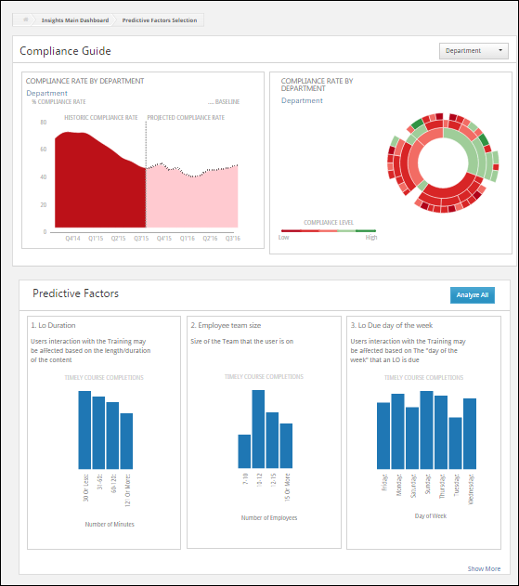
Factor Analysis Page
The Factor Analysis page allows users to simulate course distribution changes to see the effects on past or future compliance rates to help them make compliance policy change decisions. Users can verify compliance rates associated with the parameter groupings for each of the predictive factors, see the current allocation of courses among each one of the groups, and simulate the allocations to analyze the forecasted impacts to the organization's compliance rate.
If the user attempts the reallocate course registration distributions for each factor, then each factor needs to be 100% reallocated before you can simulate the compliance rate impacts of those risk factors on the cohort.
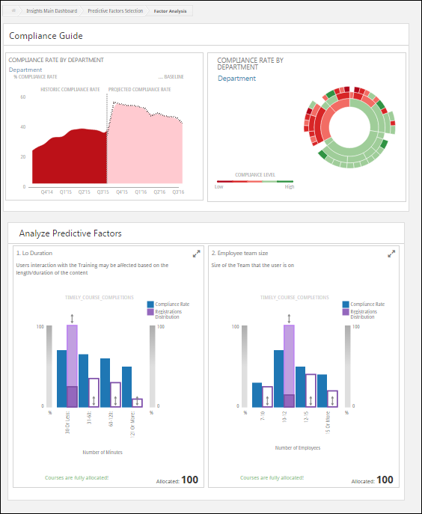

Employee Growth
Click here to access the Insights Learning Search page in the Success Center for more information about Employee Growth.

