Groups March 2024

Table of Contents
Groups Overview 1
Manage Groups 2
Group - Create/Edit 5
Group - Add Criteria 13
Edit Group - Generate Preview 20
Edit Group - Save Draft 22
View Users in a Group 24
Use Case - Create a Dynamic New Hire Group 26
Use Case - Multiple Checkbox Criteria in Groups 27
Modifying Groups Quick Reference Card 30
Group Preferences 31
Group Processing Times 33
Self Registration Groups - Manage 35

Groups Overview
Groups are used to create an organizational unit based on multiple criteria. Groups can very accurately identify a set of users. Some of the uses for groups are setting availability for tasks, competencies, assigning security roles, or filtering reports. There are three types of groups: static, dynamic, and combination.

Manage Groups
The Manage Groups page enables administrators to create groups, Prior to this enhancement, the system behaved in this manner, which led to these issues or prevented this opportunity.
With this enhancement, the system now behaves in this manner, which enables organizations to do this more efficiently and effectively.
To manage groups, go to Admin > Tools > Core Functions > Organizational Units. Click the Manage Organizational Unit Hierarchy link. From the Select Organizational Unit drop-down list, select Group.
Permissions
PERMISSION NAME | PERMISSION DESCRIPTION | CATEGORY

OU Group - Manage | Grants the ability to create, copy, and edit custom groups of users without allowing the ability to manage organizational units (OUs). This permission can be constrained by OU, User's OU, and Provider. This is an administrator permission. | Core Administration

OU Group - Update | Grants access to edit existing custom groups of users. This permission can be constrained by OU, User's OU, and Provider. This is an administrator permission. | Core Administration

OU Group - View | Grants access to view existing custom groups. This permission can be constrained by OU. This is an administrator permission. | Core Administration

OU Hierarchy - Manage | Grants ability to create and update/edit organizational units. This permission grants access to all OU types, both standard and custom. This permission can be constrained by OU and User's OU. This is an administrator permission. | Core Administration
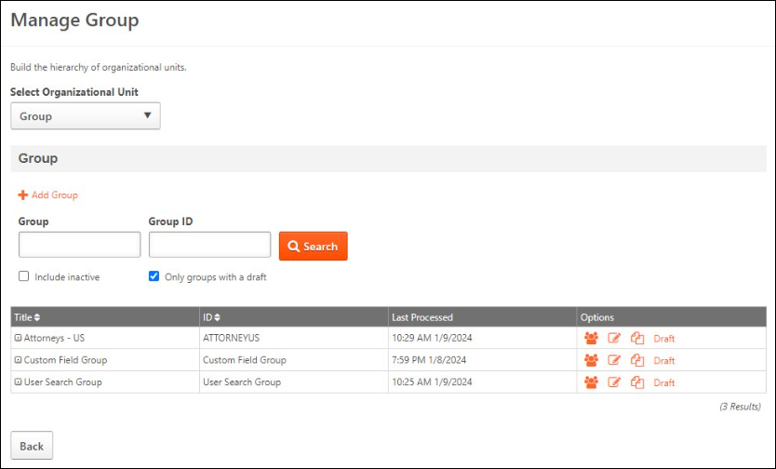
Add Group
To create a new group, select the Add group link. See Group - Create/Edit on page 5 for additional information.
Search Groups
Administrators can search the Manage Groups table by name or ID.
Select the Include inactive option to include inactive groups in the search.
Select the Only groups with a draft option to view only groups that have a draft. This enables administrators to efficiently identify and manage draft groups. This option is only available for organizations that have activated the Group Preview and Save Draft functionality in Group Preferences. See Group Preferences on page 31 for additional information.
Group Options
The following options may be available for groups:
- Users - Select this option to view all active users in the group. See View Users in a Group on page 24 for additional information.
- Edit - Select this option to edit the group. See Group - Create/Edit on page 5 for additional information.
- Copy - Select this option to copy the group. See Group - Create/Edit on page 5 for additional information.
- Draft - Select this option to access the group draft. See the Draft Groups section for additional information.
Note: There is no option to delete a group. However, they can be deactivated. See Group - Create/Edit on page 5 for additional information.
Draft Groups
When editing a Group, if the Group Preview and Save Draft functionality is activated in Group Preferences, administrators have the option to save the modified Group as a draft. See Edit Group - Save Draft on page 22 for additional information.
When an administrator saves a draft of a modified Group, any administrator with access to the Group can access the draft Group from a Draft link on the Manage Group page. The draft is available for 90 days unless it is published or deleted.
If an administrator edits a Group with a draft, a pop-up asks the administrator to resume the draft or continue editing the group. If the Group is edited and saved, the draft is automatically deleted.

Group - Create/Edit
Groups are used to create an organizational unit based on multiple criteria. Groups can very accurately identify a set of users. Some of the uses for groups are setting availability for tasks, competencies, assigning security roles, or filtering reports. There are three types of groups: static, dynamic, and combination. For dynamic groups, the users within the group can be dynamically updated based on the user criteria every time the group is processed.
Groups can be created from the Administrator Organizational Unit page and when setting availability for learning objects or tasks.
- To create a group from the Organizational Unit page, go to Admin > Tools > Core Functions > Organizational Units > Manage Organizational Unit Hierarchy. From the Select Organizational Unit drop-down list, select Group. Then, select the Add Group link.
- To create a group when setting availability, select the Add New Group link from the availability setting screen.
To edit a group from the Organizational Unit page, go to Admin > Tools > Core Functions > Organizational Units. Click the Manage Organizational Unit Hierarchy link. From the Select Organizational Unit drop-down list, select Group. Then, select the Edit icon in the Options column.
- See Modifying Groups Quick Reference Card on page 30 for additional information.
Permissions
PERMISSION NAME | PERMISSION DESCRIPTION | CATEGORY

Bypass Required Group Preview | When the Group Preview functionality is enabled and the Require Preview Before Saving Edits toggle is enabled in Group Preferences, administrators with this permission can save edits to a Group or publish a draft without generating a preview. Administrators with this permission still have the option to generate a preview.  This permission cannot be constrained. This is an administrator permission. | Core Administration

OU Group - Manage | Grants the ability to create, copy, and edit custom groups of users without allowing the ability to manage organizational units (OUs). This permission can be constrained by OU, User's OU, and Provider. This is an administrator permission. | Core Administration

OU Group - Update | Grants access to edit existing custom groups of users. This permission can be constrained by OU, User's OU, and Provider. This is an administrator permission. | Core Administration

OU Group - View | Grants access to view existing custom groups. This permission can be constrained by OU. This is an administrator permission. | Core Administration

OU Hierarchy - Manage | Grants ability to create and update/edit organizational units. This permission grants access to all OU types, both standard and custom. This permission can be constrained by OU and User's OU. This is an administrator permission. | Core Administration
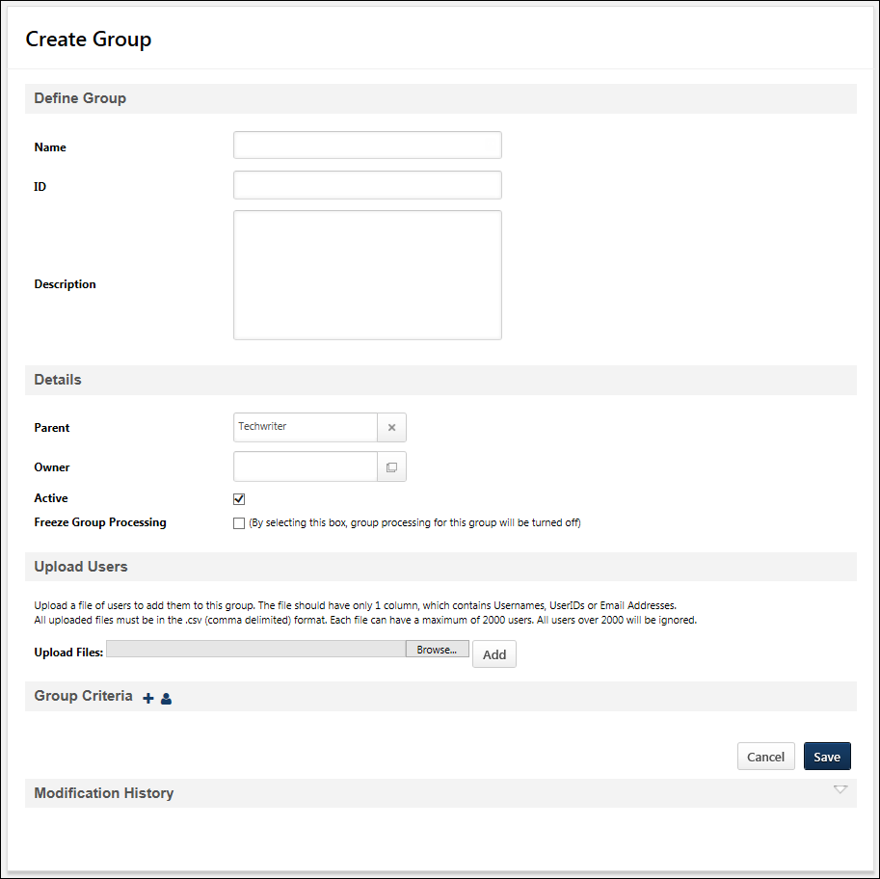
Specify the following information for the group:
General
Enter the following information in the General section:
- Name - Enter a descriptive name for the group. This is required.
- ID - Enter a unique identifier for the group.
- Description - Enter a clear description for the group. As a best practice, this should include the purpose of the group so that all administrators understand how to use the group. This is required.
Details
Enter the following information in the Details section:
- Parent - Click the field to make the group a child of an existing group (required and if not selected creates group as a parent group at the top node hierarchy).
- Owner - Click the field to choose an owner.
- Active - Select the checkbox to make the group active. Clear the checkbox to make the group inactive. Groups cannot be permanently deleted, they can be only activated or deactivated.
- Freeze Group Processing - Select this option to freeze or temporarily halt the daily processing of a group. When this option is selected for a group, the system does not add or remove any users based on the group criteria. For example, if a group is configured to include all users who are in the Accountant position organizational unit (OU), then selecting this option freezes the group processing, and no users will be added to or removed from the group even if new users are added to the Accountant position OU or if users are moved from the Accountant position OU to a different position OU. When this option is unselected, then the system resumes processing the group at the normal daily time. This option is unselected by default.
- Last Processed - This only appears when editing a group. This displays the date on which the Group was last processed. Previously, this information was only available on the Manage Group page. This date is displayed in the administrator’s time zone.
- Current Group Membership - This only appears when editing a group. This displays the number of users in the Group as of the Last Processed date.
- View Users - This only appears when editing a group. Select this link to view the users within the group. See View Users in a Group on page 24 for additional information.
Note: The Current Group Membership count and user list is only updated when the Group is processed.
Group Preview
When editing a group, if the Group Preview and Save Draft functionality is activated in Group Preferences, a Group Preview section is available. The administrator can preview or save the modified Group as a draft in the Group Preview section.
The Save Draft and Generate Preview options are only available if the Active checkbox is selected and the Freeze Group Processing checkbox is unchecked.
- Generate Preview - Select this button to preview the modified Group. The preview processing time varies depending on the criteria, but most previews will process in fewer than three minutes. While the preview is generated, administrators can cancel the preview or save the modified Group as a draft. See Edit Group - Generate Preview on page 20 for additional information.
- Save Draft - Select this button to save the modified Group as a draft. See Edit Group - Save Draft on page 22 for additional information.
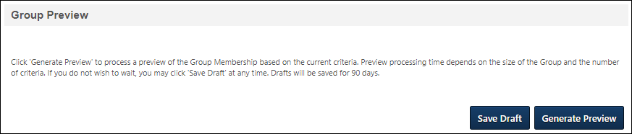
Upload Users
This section allows you to upload users using a .csv file. Note: The Upload Users option is controlled by a backend setting that is disabled by default. To enable this functionality, contact Global Customer Support.
To upload a file of users:
- Click Browse to find the file. The file should have only one column which includes unique usernames, user IDs, or email addresses. Files must be in .csv format (comma delimited). The file can have a maximum of 2,000 users; anything over this maximum number will be ignored and not added.
- Click Add.
When a file is uploaded, the users in the file will appear in the Group Criteria section.
Group Criteria - Who is Included in the Group?
The criteria for a group determine which users are included in the group. When a group is created or updated, the group will consist of all users who meet at least one criteria combination.
Depending on how the group criteria are configured, the group processes immediately or through a nightly process. When a group is processed, the system determines which users meet the criteria, and those users are added to the group. See Group Processing Times on page 33 for additional information.
See Use Case - Create a Dynamic New Hire Group on page 26 for additional information.
Add Criteria
When creating a group, up to 50 criteria can be added, which can be any combination of AND or OR statements (e.g., 25 AND statements and 25 OR statements, 10 AND statements and 40 OR statements).
To add a new criterion, select the Add Criteria icon in the Group Criteria section. See Group - Add Criteria on page 13 for additional information.
Add Users
To add one or more individual users to the group, select the Add Users icon in the Group Criteria section.
After setting the group criteria, select the Save button.
When editing a group, any inactive User Criteria are enclosed in brackets with the inactive flag, making it easy for administrators to identify inactive users. The user's name and user ID are followed by "(Inactive)" and the entire record is enclosed in brackets. The flag also appears if the criterion is part of a group of criteria.
The Inactive flag only applies to the following Group Criteria:
- User is
- User is not
- User is not or below
- User is or below
User Criteria Search
When editing a group, administrators can search for specific User Criteria by first name, last name, user ID, and user status, making it quick and easy to find and edit the necessary criteria.
The following considerations apply to the User Criteria Search:
- The User Criteria Search only returns users who meet the ‘User’ criteria type. For example, if a Group includes the "Executive" Division, and Anna Smith is included in the Group because she is in the Executive Division, searching for Anna Smith returns zero results because the search is only looking at the “User” criteria type. It does not search for users within dynamic criteria.
- The search criteria are reapplied each time the group criteria are edited. For example, if you search for a user who matches the group criteria, the matching criteria is displayed. If you then edit and save the matching criterion so that the user no longer matches the group criteria, the search results are refreshed, and the criteria is no longer displayed.
Maximum Criteria
When creating a group, up to 50 criteria can be added, which can be any combination of AND or OR statements (e.g., 25 AND statements and 25 OR statements, 10 AND statements and 40 OR statements).
Group Processing Times
- Static Groups - Groups that contain a static list of users are processed in real time upon saving the group. Each time a user is added to a static group, the group processes immediately and the newly added user appears in the group.
- Dynamic Groups - Groups that have one or more criteria are considered dynamic groups and process through the nightly group process. Note: The actual time at which the group is processed is dependent upon the configuration of a backend setting. Dynamic group processing times are implemented using UTC (Coordinated Universal Time), which does not observe daylight savings time. This should be considered when determining the best time for dynamic groups to process.
- Combination Group (Contains Static Users and Dynamic Criteria) - Groups that have a combination of static users and one or more criteria are considered a dynamic group and process through the nightly group process. Any users added to this type of group are not processed until the nightly group process. Note: The actual time at which the group is processed is dependent upon the configuration of a backend setting. Dynamic group processing times are implemented using UTC (Coordinated Universal Time), which does not observe daylight savings time. This should be considered when determining the best time for dynamic groups to process.
- Self-Registration Group - Groups that contain users from self-registration process immediately, allowing users to access training and other resources on the same day.
Note: When creating an assignment via the Learning Assignment Tool and setting the learning assignment availability to a group, ensure that AT LEAST ten minutes have passed since modifying the group criteria before creating the learning assignment for the group. This ensures the training is assigned to the correct users.
Add Users vs. the Attribute of User
Adding users to a group creates a static list of users. On the other hand, a User type attribute dynamically updates the user list for a given group.
- If Add User is selected, and then you select individual users, the system lists only the users you identified. If any of the selected users become inactive, the system removes them from the group automatically, but the criteria for both users remains.
- If Add Attribute is selected, and you select the User type attribute, then select the operator of Is or Below, then do a search for individual users, the system displays the user name and all of their direct reports in the organization. If a user becomes inactive or if a user is added to the selected users' direct reports over time, the user list updates automatically without the administrator having to review and update the the group attributes and list each user separately.
Group Operators
The following operators are available when creating a group:
Group Operators | Operation Performed
Is | Includes data matching the Operand.
Is or Below | Includes data matching the Operand and all OUs subordinate to the Operand.
Is Not | Includes all OUs of Operand's type, except that Operand.
Is Not or Below | Includes all OUs of Operand's type, except that Operand and its subordinates.
Below | Including all subordinates of the Operand. If the Operand is a user, then all subordinates of that user are included (but not the user).
After | Includes all users with a date value after the Operand date.
Before | Includes all users with a date value before the Operand date.
On or After | Includes all users with a date value on or after the Operand date.
On or Before | Includes all users with a date value on or before the Operand date.
On | Includes users with a date value on the Operand date.
Not On | Includes users with a date value on any date other than the Operand date.
Starts With | Includes users with a field value that starts with the Operand.
Equal To | Includes users with a field value that is equal to the Operand.
Not Equal To | Includes users with a field value that is not equal to the Operand.
Is exact match | Users who have an exact match to the selected options and only those options are included.
Is not exact match | Users who do not have an exact match to the selected options are included.
Includes any of | Users who have any one or more of the selected options are included.
Does not include any of | Users who do not have any of the selected options are included.
Includes all of | Users who have all of the selected options are included. Additional options can be selected and the user will still be included.
Does not include all of | Users who do not have all of the selected options are included. Fewer fields can be selected and the user will still be included.
Multiple Checkbox Use Cases
These use cases demonstrate how the multiple checkbox criterion is applied in groups.
See Use Case - Multiple Checkbox Criteria in Groups on page 27 for additional information.
Concurrent Group Edits Guardrail
When an administrator attempts to save a Group, generate a preview, or save a draft, the system confirms that the Group was not modified and saved by another administrator while they were editing it. If the Group was modified, the administrator attempting to save changes receives a Group Modified notification and cannot save the edits. This prevents an administrator from accidentally overwriting the edits of another administrator.
The Group Modified notification includes the name of the administrator and the date and time at which they saved their changes.
Administrators who receive this message can select Go Back to return to the Group and cancel their edits. This enables them to view their edits before canceling them. Selecting select Close immediately cancels the edits and returns the administrator to the Manage Groups page.
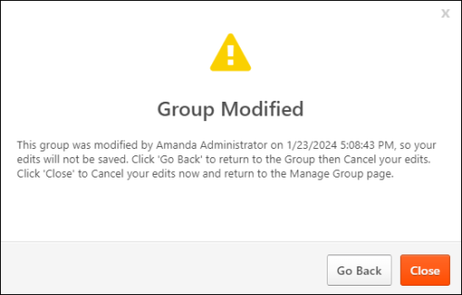
Required Preview Before Saving Edits
Administrators may require a Group preview to be generated whenever the Group Criteria are modified.
When this preference is enabled, the Save and Publish options are disabled when the Group Criteria are modified, and the administrator has not previewed the Group. The preview is optional for administrators with the Bypass Required Group Preview permission.
When this preference is disabled, administrators are not required to preview the Group membership, but they are prompted to optionally generate a preview of the Group membership when the Group is saved or the draft is published.

Group - Add Criteria
When creating a group, up to 50 criteria can be added, which can be any combination of AND or OR statements (e.g., 25 AND statements and 25 OR statements, 10 AND statements and 40 OR statements).
To create a group from the Organizational Unit page, go to Admin > Tools > Core Functions > Organizational Units > Manage Organizational Unit Hierarchy. From the Select Organizational Unit drop-down list, select Group. Then, select the Add Group link.
Permissions
PERMISSION NAME | PERMISSION DESCRIPTION | CATEGORY

OU Group - Manage | Grants the ability to create, copy, and edit custom groups of users without allowing the ability to manage organizational units (OUs). This permission can be constrained by OU, User's OU, and Provider. This is an administrator permission. | Core Administration

OU Group - Update | Grants access to edit existing custom groups of users. This permission can be constrained by OU, User's OU, and Provider. This is an administrator permission. | Core Administration

OU Group - View | Grants access to view existing custom groups. This permission can be constrained by OU. This is an administrator permission. | Core Administration

OU Hierarchy - Manage | Grants ability to create and update/edit organizational units. This permission grants access to all OU types, both standard and custom. This permission can be constrained by OU and User's OU. This is an administrator permission. | Core Administration
Add Criterion
To add a new criterion:
- Select the Add New Criteria icon in the Group Criteria section.
- From the pop-up, select the appropriate organizational unit (OU), standard field, or User custom field that will be used to define the group. The selected criteria appear in the Group Criteria section.
- Operand - Select the drop-down to select from list of operators. The operator determines how the data is to be manipulated. Operator list varies according to the selected attribute.
- Attribute Value - Select the field to select the appropriate criteria value. The character limit for this field is 5,000.
Field Type | Operand | Attribute Value
Checkbox | Equal to, Not Equal to | Drop-down
Date Field | On or after, On or before, After, Before, Not on, On | Date selector
Multiple Checkbox | Includes any of, Is exact match, Includes all of, Does not include any of, Is not exact match, Does not include all of | Drop-down
Number | Less than or equal, Greater than or equal, Less than, Greater than, Not equal to, Equal to | Numerical text box
Radio Button | Equal to, Not Equal to | Drop-down
Scrolling Text Box | Equal to, Starts with, Not equal to | Text box
Short Text Box | Equal to, Starts with, Not equal to | Text box
Drop-down | Equal to, Not Equal to | Drop-down
OU | Is, Is Not, Below, Is or Below, Is Not or Below | OU selector
Click the Save icon to save this criteria.
- OR statements signify that only one of the conditions must be met for a user to be included in the group. To create an OR statement for this group, click the Add New Criteria icon next to the Group Criteria section heading. Users who meet any criteria will be included in this group.
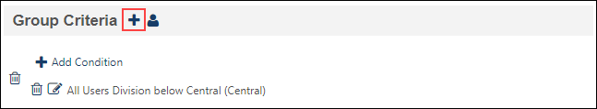
- AND statements signify that both conditions are required for a user to be included in the group. To create an AND statement, click the Add Condition link above an existing condition. Then, select attribute, operator, and operand and click the Save icon. Only users who meet all criteria and conditions of this group be included in this group.
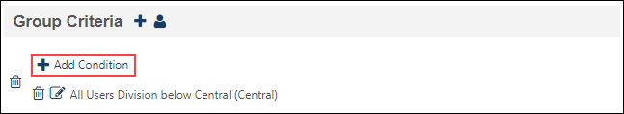
Tip: An OR statement is separated by a line; an AND statement is not.
Note: For Multiple Checkbox type custom fields, multiple options can be selected in the drop-down when configuring criteria. When multiple options are selected, the options are applied as an AND condition. For example, if two criteria options are selected, the selected options display for the criteria as "AND [Field Name] is exact match [Criterion 1] and [Criterion 2]." For all Multiple Checkbox type custom fields, an "All" option is also included. When selected, all criteria options are checked. When unselected, all criteria options are unselected. If the "All" option is selected, the selected options display for the criteria as "AND [Field Name] is exact match All ([Criterion 1] and [Criterion 2])." Options display in the order in which they are created by the administrator.
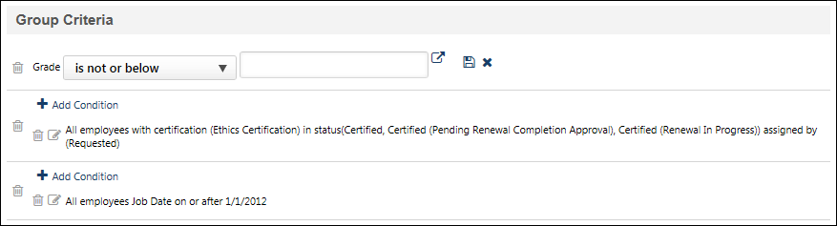
To create a group based on training or certification status, follow these steps:
- In the Group Criteria section, click the plus icon to the right of the section heading. From the pop-up, select the appropriate criteria (Training or Certification). The selected criteria appear in the Group Criteria section.
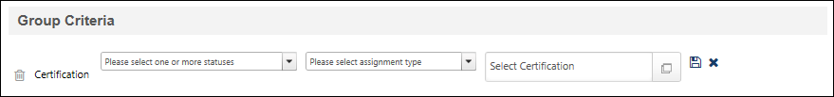
- From the Please select one or more statuses drop-down list, select the statuses on which you want to filter users. Multiple statuses can be selected. The available statuses depend on whether training or certification is selected. This field is optional, but at least one status or assignment type must be selected.
- From the Please select assignment type drop-down list, select the assignment types on which you want to filter users. Multiple assignment types can be selected. This field is optional, but at least one status or assignment type must be selected.
- Click the Select Certification or Select Training field to select specific certification or training items. This field is required and multiple training or certification items can be selected.
- After setting the appropriate criteria, click the Save icon or click the Cancel icon to remove the criteria. Once a criteria is saved, it appears in the Group Criteria section.
Training Condition Options
When adding a Training condition to the Group Criteria section, the two options under ‘assignment type’ are Assigned and Requested. If Assigned is selected (not Requested), administrators who assign training to themselves via the Learning Assignment Tool will not be included in the Group because the system will flag that Learning Object as ‘Requested.’
For the Training condition in the Group Criteria section, the following training status options are mapped to the below listed transcript statuses:
Drop-down option | Transcript Status
Approved | Approved  Approved / Past Due
Cancelled | Cancelled  Cancelled / Past Due
Completed | Completed  Completed (Equivalent)  Exempt
Completed (Equivalent) | Completed  Equivalent  Completed (Equivalent)  Exempt
Denied | Denied  Denied / Past Due
Discontinued | Discontinued  Discontinued / Past Due
Exception Requested | Exception Requested  Exception Requested / Waitlisted  Exception Requested / Past Due  Exception Requested / Waitlisted / Past Due
Exempt | Completed  Completed (Equivalent)  Exempt-Internal  Exempt
Expired | Expired  Expired / Past Due
Failed | Failed  Failed / Past Due
In Progress / Started | In Progress  In Progress / Past Due
Incomplete | Incomplete  Incomplete / Past Due
No Show | No Show  No Show / Past Due
None | This option corresponds to the training NOT being present on the user's transcript.
Not Started | Not Started  Not Started/ Past Due
Old Version | Old Version
Past Due | Past Due  Pending Approval / Past Due  Denied / Past Due  Approved / Past Due  Registration Pending / Past Due  Registered / Past Due  In Progress / Past Due  Exception Requested / Past Due  Expired / Past Due  Cancelled / Past Due  Waitlisted / Past Due  Pending Approval / Waitlisted / Past Due  Exception Requested / Waitlisted / Past Due Withdrawn / Past Due  Discontinued / Past Due  Incomplete / Past Due  Pending Completion / Past Due  Failed / Past Due  Pending Evaluation / Past Due  Pending Prerequisite / Past Due  Waitlist Expired / Past Due  Not Started/ Past Due  No Show / Past Due  Pending Acknowledgment / Past Due  Pending Grade / Past Due  Pending Post-Work/Past Due  Pending Pre-Work/Past Due  Completion Approval Denied / Past Due  Pending Payment / Past Due  Payment Denied /Past Due  Pending Completion Signature /Past Due  Payment Refunded /Past Due  Registered / Not Available / Past Due  Pending Observer Completion / Past Due  Pending Observer Completion / Not Available
Payment Denied | Payment Denied  Payment Denied /Past Due
Payment Refunded | Payment Refunded  Payment Refunded /Past Due
Pending Acknowledgment | Pending Acknowledgment  Pending Acknowledgment / Past Due
Pending Approval | Pending Approval  Pending Approval / Waitlisted  Pending Approval / Past Due  Pending Approval / Waitlisted / Past Due
Pending Completion Approval | Pending Completion Approval  Pending Completion / Past Due
Pending Completion Signature | Pending Completion Signature  Pending Completion Signature /Past Due
Pending Evaluation | Pending Evaluation  Pending Evaluation / Past Due
Pending Grade | Pending Grade  Pending Grade / Past Due
Pending Payment | Pending Payment  Pending Payment / Past Due
Pending Post-Work | Pending Post-Work  Pending Post-Work/Past Due
Pending Prerequisite | Pending Prerequisite  Pending Prerequisite / Past Due
Pending Pre-Work | Pending Pre-Work  Pending Pre-Work/Past Due
Registered | Registered  Registered / Past Due  Registered / Not Available  Registered / Not Available / Past Due
Registration Pending | Registration Pending  Registration Pending / Past Due
Waitlisted | Waitlisted  Pending Approval / Waitlisted  Exception Requested / Waitlisted  Waitlisted / Past Due  Pending Approval / Waitlisted / Past Due  Exception Requested / Waitlisted / Past Due
Withdrawn | Withdrawn  Withdrawn / Past Due

Edit Group - Generate Preview
When editing a group, if the Group Preview and Save Draft functionality is activated in Group Preferences, a Group Preview section is available. The administrator can preview or save the modified Group as a draft in the Group Preview section.
The Save Draft and Generate Preview options are only available if the Active checkbox is selected and the Freeze Group Processing checkbox is unchecked.
To edit a group from the Organizational Unit page, go to Admin > Tools > Core Functions > Organizational Units. Click the Manage Organizational Unit Hierarchy link. From the Select Organizational Unit drop-down list, select Group. Then, select the Edit icon in the Options column.
To preview the modified Group, select the Generate Preview button in the Group Preview section. The preview processing time varies depending on the criteria, but most previews will process in fewer than three minutes. While the preview is generated, administrators can cancel the preview or save the modified Group as a draft.
Permissions
PERMISSION NAME | PERMISSION DESCRIPTION | CATEGORY

Bypass Required Group Preview | When the Group Preview functionality is enabled and the Require Preview Before Saving Edits toggle is enabled in Group Preferences, administrators with this permission can save edits to a Group or publish a draft without generating a preview. Administrators with this permission still have the option to generate a preview.  This permission cannot be constrained. This is an administrator permission. | Core Administration

OU Group - Manage | Grants the ability to create, copy, and edit custom groups of users without allowing the ability to manage organizational units (OUs). This permission can be constrained by OU, User's OU, and Provider. This is an administrator permission. | Core Administration

OU Group - Update | Grants access to edit existing custom groups of users. This permission can be constrained by OU, User's OU, and Provider. This is an administrator permission. | Core Administration

OU Hierarchy - Manage | Grants ability to create and update/edit organizational units. This permission grants access to all OU types, both standard and custom. This permission can be constrained by OU and User's OU. This is an administrator permission. | Core Administration
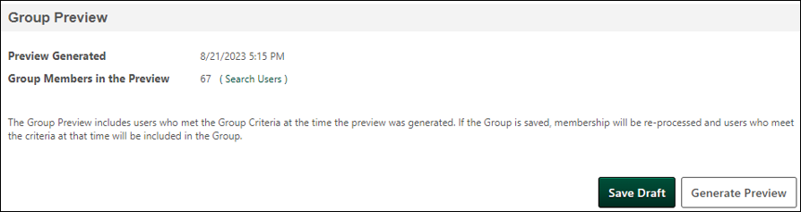
When the preview processing is complete, the following information is displayed:
- Preview Generated - This displays the date and time the preview was processed in the administrator's time zone.
- Group Members in the Preview - This displays the number of users in the portal who meet the Group Criteria. Administrators can compare this value with the Current Group Membership value to understand the potential impact on the Group if the edits are saved.
Note: The Group Preview includes users who met the Group Criteria when the preview was generated. If the Group is saved, membership will be re-processed, and users who meet the criteria at that time will be included in the Group.
Search Users in the Preview
- The administrator can select the Search Users link to search for specific users in the preview.
- When searching for users in the preview, the search fields return matches using 'starts with' logic. For example:
  - Searching the Last Name field for "John" will return users with the last name "John" or "Johnson," but searching for "ohn" will only return last names that start with "ohn."
  - The Manager Name field will return matches when either the manager's first name or last name starts with the search text. Entering 'John" in the Manager Name field will return users who report to 'John Smith" and users who report to "Tim Johnson" because both have either a first or last name that starts with "John."
- When searching for users, an error message is displayed if more than 100 users in the portal meet the search criteria.
- It is not possible to view or export the complete preview membership list.

Edit Group - Save Draft
When editing a group, if the Group Preview and Save Draft functionality is activated in Group Preferences, a Group Preview section is available. The administrator can preview or save the modified Group as a draft in the Group Preview section.
The Save Draft and Generate Preview options are only available if the Active checkbox is selected and the Freeze Group Processing checkbox is unchecked.
To edit a group from the Organizational Unit page, go to Admin > Tools > Core Functions > Organizational Units. Click the Manage Organizational Unit Hierarchy link. From the Select Organizational Unit drop-down list, select Group. Then, select the Edit icon in the Options column.
Select the Save Draft button to save the modified Group as a draft. A pop-up opens with the following options:
- Save Draft and Generate Preview - Select this option to create a draft with the modified Group Criteria and initiate the Group Preview process for the draft. If a Preview is already underway, the preview continues processing.
- Save Draft Only - Select this option to create a draft with the modified Group Criteria without generating a preview. If a preview is already underway, the preview continues processing.
After a draft is saved, any administrator with access to the Group can access the draft Group from the Manage Group page for 90 days unless the draft is published or deleted.
A draft Group can be edited asynchronously while the current Group remains active and regularly processes. The draft Group can later be published to replace the current group.
Permissions
PERMISSION NAME | PERMISSION DESCRIPTION | CATEGORY

OU Group - Manage | Grants the ability to create, copy, and edit custom groups of users without allowing the ability to manage organizational units (OUs). This permission can be constrained by OU, User's OU, and Provider. This is an administrator permission. | Core Administration

OU Group - Update | Grants access to edit existing custom groups of users. This permission can be constrained by OU, User's OU, and Provider. This is an administrator permission. | Core Administration

OU Hierarchy - Manage | Grants ability to create and update/edit organizational units. This permission grants access to all OU types, both standard and custom. This permission can be constrained by OU and User's OU. This is an administrator permission. | Core Administration
Draft Group Options
Draft Groups have the following options:
- Publish - Select this button to publish the draft Group. The draft replaces the active version of the Group, and the Draft link is removed from the Manage Group page.
- Delete Draft - Select this button to delete the draft.
- Save Draft - Select this option to save any changes made to the draft. This replaces the previous draft.

View Users in a Group
When editing a group that has at least one member, administrators can view the users within the group.
Note: The Current Group Membership count and user list is only updated when the Group is processed.
To edit a Group from the Organizational Unit page, go to Admin > Tools > Core Functions > Organizational Units. Click the Manage Organizational Unit Hierarchy link. From the Select Organizational Unit drop-down list, select Group. Then, select the Edit icon in the Options column.
To view the users in the group, in the Details section, select the View Users link next to the Current Group Membership value.
Permissions
PERMISSION NAME | PERMISSION DESCRIPTION | CATEGORY

OU Group - Manage | Grants the ability to create, copy, and edit custom groups of users without allowing the ability to manage organizational units (OUs). This permission can be constrained by OU, User's OU, and Provider. This is an administrator permission. | Core Administration

OU Group - Update | Grants access to edit existing custom groups of users. This permission can be constrained by OU, User's OU, and Provider. This is an administrator permission. | Core Administration
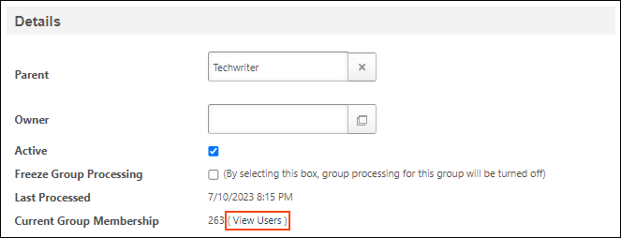
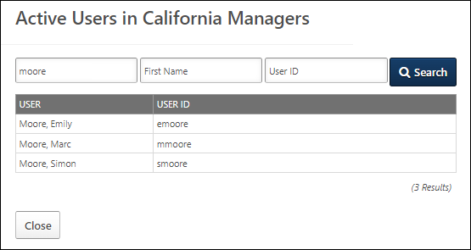

Use Case - Create a Dynamic New Hire Group
In this example, an organization has created training for newly hired employees. The organization would like the system to assign to all new hires automatically and continuously. To do this, they must first create a dynamic group which checks the system for newly hired users each day and adds them to the group. After creating the new hire group, as described below, you can use the Learning Assignment Tool to create a dynamic learning assignment to assign newly hired users training on an ongoing basis.
Create a Dynamic Group
On January 1, 2017, an organization wishes to create a group which automatically accumulates new employees on an ongoing basis, which will be used later to automatically assign a New Hire Orientation course to all new employees hired after a certain date.
- An administrator begins creating a group called, “2017 New Hires,” and rather than uploading or adding a list of individual users (static criteria), the administrator adds dynamic criteria: Original Hire Date is on or after January 1, 2017, and Original Hire Date is on or before December 31, 2017.
  - See Group - Create/Edit on page 5 for additional information.
- The administrator saves the group. Because the group utilizes dynamic criteria, the group processes once daily at an administrator-defined time (specified via a back end setting) and searches for any additional users who meet the criteria. When new users are added to the system with a hire date on or after January 1, 2017 on their user records, they will be automatically added to the 2017 New Hires group the next time the group processes.
  - See Group Processing Times on page 33 for additional information.
- It may be necessary for the administrator to wait up to ten minutes for the group to initially process, at which point the existing new hires for 2017 will be added to the group. Once the group has been processed for the first time, it can be used to automatically assign training to new hires on an ongoing basis.
Dynamically Assign Training to New Hires
After creating a dynamic new hire group, you can use the group to dynamically assign newly hired users training on an ongoing basis by using the Learning Assignment Tool. For a use case detailing how to create a dynamic learning assignment, See Dynamic Learning Assignment - Create.

Use Case - Multiple Checkbox Criteria in Groups
These use cases demonstrate how the multiple checkbox criterion is applied in groups.
To create a group from the Organizational Unit page, go to Admin > Tools > Core Functions > Organizational Units > Manage Organizational Unit Hierarchy. From the Select Organizational Unit drop-down list, select Group. Then, select the Add Group link.
Permissions
PERMISSION NAME | PERMISSION DESCRIPTION | CATEGORY

OU Group - Manage | Grants the ability to create, copy, and edit custom groups of users without allowing the ability to manage organizational units (OUs). This permission can be constrained by OU, User's OU, and Provider. This is an administrator permission. | Core Administration

OU Group - Update | Grants access to edit existing custom groups of users. This permission can be constrained by OU, User's OU, and Provider. This is an administrator permission. | Core Administration

OU Group - View | Grants access to view existing custom groups. This permission can be constrained by OU. This is an administrator permission. | Core Administration

OU Hierarchy - Manage | Grants ability to create and update/edit organizational units. This permission grants access to all OU types, both standard and custom. This permission can be constrained by OU and User's OU. This is an administrator permission. | Core Administration
Use Case Data
These use cases use the following data:
User Name | Issued Technology
Anna Burke | - Desktop - iOS  - Cell Phone - iPhone
Drew Han | - Laptop - iOS  - Cell Phone - iPhone
David Prince | - Desktop - iOS  - Cell Phone - iPhone  - Tablet - iPad
Quin Sanderson | - Laptop - Windows  - Tablet - iPad
Use Case 1: Includes any of
The administrator wants to create a group of users who have been issued an Apple desktop or laptop.
- The administrator creates a group with the following criterion: Issued Technology includes any of Desktop - iOS, Laptop - iOS.
- The group includes the following users:
  - Anna Burke
  - Drew Han
  - David Prince
Use Case 2: Is exact match
The administrator wants to create a group of users who have only been issued an Apple desktop and an iPhone.
- The administrator creates a group with the following criterion: Issued Technology is exact match Desktop - iOS, Cell Phone - iPhone.
- The group includes the following users:
  - Anna Burke
Use Case 3: Includes all of
The administrator wants to create a group of users who have been issued an Apple desktop and an iPhone.
- The administrator creates a group with the following criterion: Issued Technology includes all of Desktop - iOS, Cell Phone - iPhone.
- The group includes the following users:
  - Anna Burke
  - David Prince
Use Case 4: Does not include any of
The administrator wants to create a group of users who have not been issued any laptops.
- The administrator creates a group with the following criterion: Issued Technology does not include any of Laptop - iOS, Laptop - Windows.
- The group includes the following users:
  - Anna Burke
  - David Prince
Use Case 5: Is not exact match
The administrator wants to create a group of users who have not only been issued an Apple desktop and an iPhone.
- The administrator creates a group with the following criterion: Issued Technology is not exact match Desktop - iOS, Cell Phone - iPhone.
- The group includes the following users:
  - Drew Han
  - David Prince
  - Quin Sanderson
Use Case 6: Does not include all of
The administrator wants to create a group of users who have not been issued an Apple desktop and an iPhone together.
- The administrator creates a group with the following criterion: Issued Technology does not include all of Desktop - iOS, Cell Phone - iPhone.
- The group includes the following users:
  - Drew Han
  - Quin Sanderson

Modifying Groups Quick Reference Card
Select the following link to download a Quick Reference Card that guides you through the process of modifying a group: Modifying Groups Quick Reference Card

Group Preferences
The Group Preferences page enables administrators to activate the Group Preview and Save Draft features. Once Group Preview is activated, administrators can require a preview before saving edits.
Group Preferences are global and cannot be configured by organizational unit (OU).
To access Group Preferences, go to Admin > Tools > Core Functions > Core Preferences > Group Preferences.
Permissions
PERMISSION NAME | PERMISSION DESCRIPTION | CATEGORY

Bypass Required Group Preview | When the Group Preview functionality is enabled and the Require Preview Before Saving Edits toggle is enabled in Group Preferences, administrators with this permission can save edits to a Group or publish a draft without generating a preview. Administrators with this permission still have the option to generate a preview.  This permission cannot be constrained. This is an administrator permission. | Core Administration

Group Preferences - Manage | Grants the ability to access and modify the Group Preferences page. This permission cannot be constrained. This is an administrator permission. | Core Administration
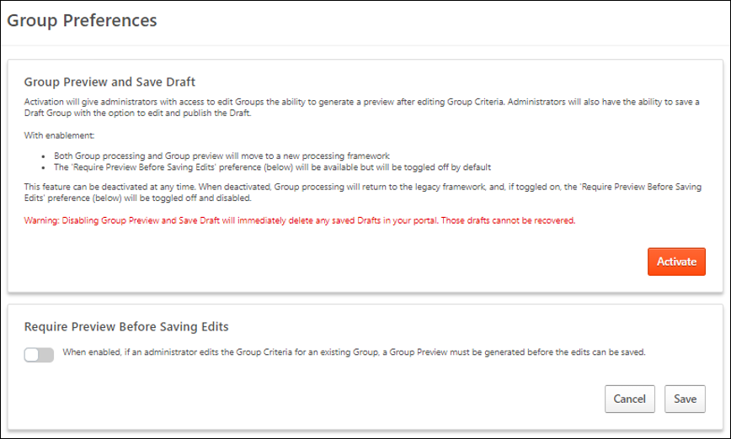
Group Preview and Save Draft
Select the Activate button to activate the Group Preview and Save Draft functionality. This also enables the option to change the Require Preview Before Saving Edits preference.
This functionality can be deactivated at any time. When this functionality is inactive, the Require Preview Before Saving Edits preference is disabled and cannot be enabled. Deactivating this functionality immediately deletes any saved Group drafts in the portal that cannot be recovered.
Require Preview Before Saving Edits
Select the toggle to require all administrators to generate a preview of the Group before saving any criteria changes. By previewing the membership of the Group before saving the changes, the administrator can review the updated Group and potentially identify any unexpected issues. The preview is optional for administrators with the Bypass Required Group Preview permission.
If this preferences is off, administrators are not required to generate a preview of the Group before saving edits. However, they still have the option to do so if Group Preview and Save Draft are activated.

Group Processing Times
Depending on how the group criteria are configured, the group processes immediately or through a nightly process. When a group is processed, the system determines which users meet the criteria, and those users are added to the group. Note: When creating an assignment via the Learning Assignment Tool and setting the learning assignment availability to a group, ensure that AT LEAST ten minutes have passed since modifying the group criteria before creating the learning assignment for the group. This ensures the training is assigned to the correct users.
The group type is determined by which types of criteria are added to the Group Criteria section, and this determines when the group is processed.
To create a group from the Organizational Unit page, go to Admin > Tools > Core Functions > Organizational Units > Manage Organizational Unit Hierarchy. From the Select Organizational Unit drop-down list, select Group. Then, select the Add Group link. See Group - Create/Edit on page 5 for additional information.
Permissions
PERMISSION NAME | PERMISSION DESCRIPTION | CATEGORY

OU Group - Manage | Grants the ability to create, copy, and edit custom groups of users without allowing the ability to manage organizational units (OUs). This permission can be constrained by OU, User's OU, and Provider. This is an administrator permission. | Core Administration

OU Group - Update | Grants access to edit existing custom groups of users. This permission can be constrained by OU, User's OU, and Provider. This is an administrator permission. | Core Administration

OU Group - View | Grants access to view existing custom groups. This permission can be constrained by OU. This is an administrator permission. | Core Administration

OU Hierarchy - Manage | Grants ability to create and update/edit organizational units. This permission grants access to all OU types, both standard and custom. This permission can be constrained by OU and User's OU. This is an administrator permission. | Core Administration
Static Groups
Groups that contain a static list of users are processed in real time upon saving the group. Each time a user is added to a static group, the group processes immediately and the newly added user appears in the group.
Dynamic Groups
Groups that have one or more criteria are considered dynamic groups and process through the nightly group process. Note: The actual time at which the group is processed is dependent upon the configuration of a backend setting. Dynamic group processing times are implemented using UTC (Coordinated Universal Time), which does not observe daylight savings time. This should be considered when determining the best time for dynamic groups to process.
Combination Group (Contains Static Users and Dynamic Criteria)
Groups that have a combination of static users and one or more criteria are considered a dynamic group and process through the nightly group process. Any users added to this type of group are not processed until the nightly group process. Note: The actual time at which the group is processed is dependent upon the configuration of a backend setting. Dynamic group processing times are implemented using UTC (Coordinated Universal Time), which does not observe daylight savings time. This should be considered when determining the best time for dynamic groups to process.
Self-Registration Group
Groups that contain users from self-registration process immediately, allowing users to access training and other resources on the same day.

Self Registration Groups - Manage
Self-Registration functionality allows administrators to manage new users coming into the system via pre-defined groups. By sending them to a special URL (or converting that URL to a hypertext link) and assigning the users a code, users will get assigned to a particular group when they register through the Self-Registration page. Each group can then have parameters set which will determine how that user will be classified and handled within the system.
See Self Registration Groups - Manage for additional information.

