Goals March 2024

Table of Contents
Goals - Overview 1
Goal Success Descriptors Overview 2
Goals - Create/Edit - Assign to Your Team 3
Goals - Create/Edit - Assign to Your Team 7
Goals - Create/Edit - Assign to Custom Assignment 11
Goals Configuration Overview 15
Goal Preferences By Division - Overview 16
Goals Configuration Overview 27
Goals Library 39
Goal Perspectives and Categories 42
Goals - Create/Edit 44
Goals Create/Edit - Align with Another Goal 52
Goals - Create/Edit - Add Task or Target 56
Goals - Copy 60
Goals Create/Edit - Goal Library 62
Goals Create/Edit - SMART Wizard 64
Goals - Create/Edit - Success Descriptors 70
View Goals - My Goals Overview 73
Goals - Copy 80
View Goals - My Goals Overview 82
View Goals - Team Goals 89
View Goals - Hierarchy 94
Goals - Manage - Overview 97
View Goals - History 103
Manage Shared and Dynamic Goals 106
Goals Report Dashboard 108

Goals - Overview
Goals allow users, managers, and organizations to set action oriented tasks and track results. User can set personal goals, managers can create goals for their teams, or administrators can populate goals across the entire organization. Goals can be shared or distributed among individuals, groups of users, entire divisions, or an entire organization. To ensure everyone is working towards the same shared goal, the goals management functionality allows users to align their personal goals with those set by their manager or senior leadership.
Goals management in Cornerstone OnDemand is a tool that supports the creation and tracking of specific and time-targeted goals. The functionality enables users to break goals into their constituent tasks and targets for easy tracking and reporting. The tool can be applied to individuals, managers and their subordinates, divisions, and the entire organization.
Goals can be included in performance reviews to allow users to be evaluated on both their effectiveness in their positions and their achievement on any strategic initiatives.

Goal Success Descriptors Overview
Within performance reviews, employees may be rated on their ability to achieve goals. Over the review period for the goal, perceptions of success for the employee can change for both the organization and the employee.
Success Descriptors enable employees to define how they deem success in relation to a goal. After an administrator defines the number of levels of success (at the OU level) as well as the labels for those success levels, users can describe what those levels mean in their own words. Administrators can also pre-configure the descriptions of those success levels to help guide the employee, who can later edit the descriptions in order to make them more personal or relevant to the goal.
After a review, through the Goal Details Report and the Performance Reviews Goal Rating section, employees and the organization are able to reflect on the employee's efforts and compare what the employee achieved to what they expected to achieve.
Administrators can define success descriptors by OU. They can also set some administrative details about the success descriptors functionality. Users can edit their own descriptors, defining how they interpret the goal success level.
When an administrator defines a goal template in the Goal Library, success descriptors do not appear as an option that can be defined. This is because success descriptors are added when the user pulls the template into their own goal.

Goals - Create/Edit - Assign to Your Team
Managers and administrators with the appropriate permissions can create a goal and assign it to members of their team, the entire organization, an organizational unit (OU) or group, or to specific users. If the Assignment section is not available when creating a goal, then the goal is automatically assigned to the user who is creating the goal.
When editing an individual goal, the Assignment section is not available, but users can edit the goal manager for goals they created.
Administrator Note: A preference in Corporate Preferences determines whether the goal owner/assignee's Goal Preferences and Goal Configurations are applied in Universal Profile Snapshot, Goals, and Goal Rating steps within performance reviews. Shared goals respect the goal owner's preferences and configurations.
- To create a goal, go to Performance > Goals. Then click the Create button.
- To edit a goal, go to Performance > Goals. Click the Actions menu icon to the right of the appropriate goal and select Edit.
To assign the goal to your entire team or specific members of your team, select the Your Team option in the Assignment section. Once this goal is assigned, it will appear in the My Goals section of the My Goals page for all selected employees. This goal may also appear in each user's performance review.
Caution: If the goal is created as a shared goal, be aware that it is not possible to remove a user from a shared goal.
Note: Managers can assign the Goals - Create permission to select subordinates when they are away from the office for an extended period.
Permissions
PERMISSION NAME | PERMISSION DESCRIPTION | CATEGORY

Employee Goals - Create | Allow user to Create Goals for other employees (other than self and subordinates). The constraints on this permission determine with which employees a user can align their goals. This permission can be constrained by OU, User's OU, Employee Relationships, and User. This is an administrator permission.  Note: If this permission is constrained by Employee Relationships, assigned co-planners can create, view, and approve goals. | Performance - Administration

Goals - Create | Grants ability for user to create goals for self, direct reports, and indirect reports only. Any constraint on this permission is operating as an "AND" function. This permission can be constrained by Employee Relationship, OU, User's OU, and User Self and Subordinates. This is an end user permission. | Performance

Goals - Dynamic Assignment Option | Grants ability to specify a goal as dynamically assigned, when assigning the goal to a population of users. If a goal is dynamically assigned, users who later meet the criteria will receive the goal. | Performance
Your Team - Select Users
When you select the Your Team option, a list of your direct reports displays with their photograph, name, and job title.
The manager creating the goal is listed as the first user in the table. This enables you to include yourself in the goal assignment.
Assign Goals
To assign the goal to a user, select the checkbox to the left of the user's name.
Select the Direct and Indirect Reports option for a user to include the selected user's direct and indirect reports in the goal assignment.
- Selecting this option only assigns the goal to direct and indirect reports for whom you have permission to assign a goal.
- Selecting this option automatically selects the corresponding user. However, if you select the Direct and Indirect Reports option in the table header, then this selects all checkboxes within the column, but the user checkboxes are not automatically selected.
- This option is only available if the corresponding user has at least one direct report.
- This option is not available in the manager's row.
To quickly select all users on your team and each user's direct and indirect reports, select the checkbox to the left of the Name column and to the right of the Direct and Indirect Reports column in the table header. Unselecting these options unselects all users and direct reports in the table.
Options
In this section, determine whether the assignees will share the goal or each work independently towards completing the goal:
Create a separate goal for each user
If this option is selected, each user is assigned a separate copy of the goal, and each user is responsible for completing the goal independently. For example, if the goal is to have $1 million in sales and you assign it to five users, each user will have to earn $1 million in sales for a total of $5 million. In this case, each user will be the owner of their own goal, allowing them to edit the goal or report progress on it.
Once this goal is assigned, it will appear on the My Goals page for all selected employees where they can edit and manage it. This goal may also appear in their performance review.
- Dynamic Assignment - This option is only available when creating a separate goal for each user, and it is only available for users who have permission to dynamically assign goals. When this option is selected, the goal is assigned to all selected users in the team, and the goal will also be assigned to any users who join the team between the goal start date and target/due date. Any users who join the team after the goal target/due date are not assigned the goal. Employees who are on the team but are excluded from the initial assignment are not assigned the goal as a result of the dynamic setting.
  - When the Dynamic Assignment option is not selected, the goal is only assigned to the selected users.
  - If a user is assigned a goal with the Dynamic Assignment option selected, and then leaves the team, the user continues to have the goal. The user is not dynamically removed from the goal.
All users will share this goal and its progress
This option is only available if the administrator has enabled the ability to create a shared goal.
If this option is selected, the assigned users share the goal, and each user's progress contributes to the progress of the shared goal. Shared goals allow all assigned users to add comments to the shared goal, even if they are not the goal owner. For example, if the goal is to have $1 million in sales, the selected users will work together to earn a total of $1 million.
- Managed by - A shared goal must be managed by a single user, and this user is considered the goal owner. The manager can choose to be the goal owner or select one of the assigned users. Although each selected user will contribute to the goal, the goal owner is responsible for editing and updating the goal progress. For example, if Mary is the goal owner and Bob makes a sale towards the goal, Bob cannot enter that information on the goal. Only Mary can update the progress of the goal.
A team shared goal is not assigned dynamically. For example, if a direct subordinate in your team is assigned the goal and then leaves your team, they will continue to have the shared goal until they are removed from the goal. If a user joins your team, they will not inherit the shared goal and must be assigned by the goal manager.
Note: If the Direct and Indirect Reports option is selected, anyone who is a direct or indirect subordinate of a user who is assigned this goal (i.e. selected in the list of assignment) will also have this goal. The direct and indirect reports for anyone assigned this goal are calculated dynamically. For example, if your direct subordinate is assigned this goal and a new hire joins your subordinate’s team, the new employee will automatically receive this shared goal. Similarly, if that new hire's manager changes to someone who is not assigned this goal, they will no longer have this shared goal.
Manager Goal Behavior
When a manager assigns a goal to members of their team and the manager is also selected in the assignment, the behavior that the manager experiences once the goal is approved depends on the goal configuration:
- Separate Goal - If a separate goal is created for each user, then each selected employee receives the individual, independent goal.
- Shared Goal - If the goal is a shared goal, two scenarios are possible:
  - Manager is selected as the goal owner:
    - The goal appears on the My Goals section of the My Goals page for the manager with an asterisk indicating it is a shared goal.
    - The goal can appear in the manager's performance reviews.
    - The manager can manage and edit the goal as the goal owner.
  - Manager is not selected as the goal owner:
    - The goal appears on the My Goals section of the My Goals page for the manager with an asterisk indicating it is a shared goal.
    - The goal will not appear in the manager's performance reviews. This is true for all users who are not the goal manager within shared goals.
    - The manager cannot manage and edit the goal.
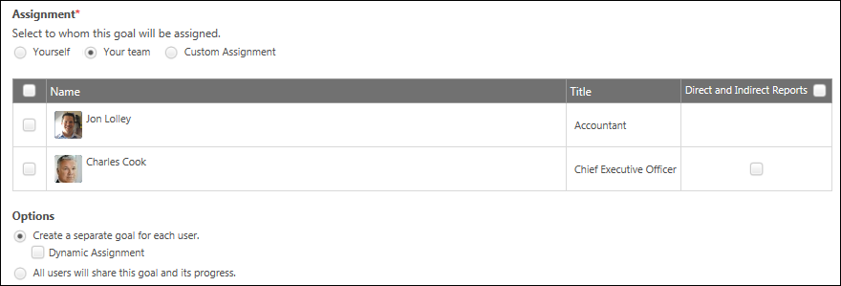

Goals - Create/Edit - Assign to Your Team
Managers and administrators with the appropriate permissions can create a goal and assign it to members of their team, the entire organization, an organizational unit (OU) or group, or to specific users. If the Assignment section is not available when creating a goal, then the goal is automatically assigned to the user who is creating the goal.
When editing an individual goal, the Assignment section is not available, but users can edit the goal manager for goals they created.
Administrator Note: A preference in Corporate Preferences determines whether the goal owner/assignee's Goal Preferences and Goal Configurations are applied in Universal Profile Snapshot, Goals, and Goal Rating steps within performance reviews. Shared goals respect the goal owner's preferences and configurations.
- To create a goal, go to Performance > Goals. Then click the Create button.
- To edit a goal, go to Performance > Goals. Click the Actions menu icon to the right of the appropriate goal and select Edit.
To assign the goal to your entire team or specific members of your team, select the Your Team option in the Assignment section. Once this goal is assigned, it will appear in the My Goals section of the My Goals page for all selected employees. This goal may also appear in each user's performance review.
Caution: If the goal is created as a shared goal, be aware that it is not possible to remove a user from a shared goal.
Note: Managers can assign the Goals - Create permission to select subordinates when they are away from the office for an extended period.
Permissions
PERMISSION NAME | PERMISSION DESCRIPTION | CATEGORY

Employee Goals - Create | Allow user to Create Goals for other employees (other than self and subordinates). The constraints on this permission determine with which employees a user can align their goals. This permission can be constrained by OU, User's OU, Employee Relationships, and User. This is an administrator permission.  Note: If this permission is constrained by Employee Relationships, assigned co-planners can create, view, and approve goals. | Performance - Administration

Goals - Create | Grants ability for user to create goals for self, direct reports, and indirect reports only. Any constraint on this permission is operating as an "AND" function. This permission can be constrained by Employee Relationship, OU, User's OU, and User Self and Subordinates. This is an end user permission. | Performance

Goals - Dynamic Assignment Option | Grants ability to specify a goal as dynamically assigned, when assigning the goal to a population of users. If a goal is dynamically assigned, users who later meet the criteria will receive the goal. | Performance
Your Team - Select Users
When you select the Your Team option, a list of your direct reports displays with their photograph, name, and job title.
The manager creating the goal is listed as the first user in the table. This enables you to include yourself in the goal assignment.
Assign Goals
To assign the goal to a user, select the checkbox to the left of the user's name.
Select the Direct and Indirect Reports option for a user to include the selected user's direct and indirect reports in the goal assignment.
- Selecting this option only assigns the goal to direct and indirect reports for whom you have permission to assign a goal.
- Selecting this option automatically selects the corresponding user. However, if you select the Direct and Indirect Reports option in the table header, then this selects all checkboxes within the column, but the user checkboxes are not automatically selected.
- This option is only available if the corresponding user has at least one direct report.
- This option is not available in the manager's row.
To quickly select all users on your team and each user's direct and indirect reports, select the checkbox to the left of the Name column and to the right of the Direct and Indirect Reports column in the table header. Unselecting these options unselects all users and direct reports in the table.
Options
In this section, determine whether the assignees will share the goal or each work independently towards completing the goal:
Create a separate goal for each user
If this option is selected, each user is assigned a separate copy of the goal, and each user is responsible for completing the goal independently. For example, if the goal is to have $1 million in sales and you assign it to five users, each user will have to earn $1 million in sales for a total of $5 million. In this case, each user will be the owner of their own goal, allowing them to edit the goal or report progress on it.
Once this goal is assigned, it will appear on the My Goals page for all selected employees where they can edit and manage it. This goal may also appear in their performance review.
- Dynamic Assignment - This option is only available when creating a separate goal for each user, and it is only available for users who have permission to dynamically assign goals. When this option is selected, the goal is assigned to all selected users in the team, and the goal will also be assigned to any users who join the team between the goal start date and target/due date. Any users who join the team after the goal target/due date are not assigned the goal. Employees who are on the team but are excluded from the initial assignment are not assigned the goal as a result of the dynamic setting.
  - When the Dynamic Assignment option is not selected, the goal is only assigned to the selected users.
  - If a user is assigned a goal with the Dynamic Assignment option selected, and then leaves the team, the user continues to have the goal. The user is not dynamically removed from the goal.
All users will share this goal and its progress
This option is only available if the administrator has enabled the ability to create a shared goal.
If this option is selected, the assigned users share the goal, and each user's progress contributes to the progress of the shared goal. Shared goals allow all assigned users to add comments to the shared goal, even if they are not the goal owner. For example, if the goal is to have $1 million in sales, the selected users will work together to earn a total of $1 million.
- Managed by - A shared goal must be managed by a single user, and this user is considered the goal owner. The manager can choose to be the goal owner or select one of the assigned users. Although each selected user will contribute to the goal, the goal owner is responsible for editing and updating the goal progress. For example, if Mary is the goal owner and Bob makes a sale towards the goal, Bob cannot enter that information on the goal. Only Mary can update the progress of the goal.
A team shared goal is not assigned dynamically. For example, if a direct subordinate in your team is assigned the goal and then leaves your team, they will continue to have the shared goal until they are removed from the goal. If a user joins your team, they will not inherit the shared goal and must be assigned by the goal manager.
Note: If the Direct and Indirect Reports option is selected, anyone who is a direct or indirect subordinate of a user who is assigned this goal (i.e. selected in the list of assignment) will also have this goal. The direct and indirect reports for anyone assigned this goal are calculated dynamically. For example, if your direct subordinate is assigned this goal and a new hire joins your subordinate’s team, the new employee will automatically receive this shared goal. Similarly, if that new hire's manager changes to someone who is not assigned this goal, they will no longer have this shared goal.
Manager Goal Behavior
When a manager assigns a goal to members of their team and the manager is also selected in the assignment, the behavior that the manager experiences once the goal is approved depends on the goal configuration:
- Separate Goal - If a separate goal is created for each user, then each selected employee receives the individual, independent goal.
- Shared Goal - If the goal is a shared goal, two scenarios are possible:
  - Manager is selected as the goal owner:
    - The goal appears on the My Goals section of the My Goals page for the manager with an asterisk indicating it is a shared goal.
    - The goal can appear in the manager's performance reviews.
    - The manager can manage and edit the goal as the goal owner.
  - Manager is not selected as the goal owner:
    - The goal appears on the My Goals section of the My Goals page for the manager with an asterisk indicating it is a shared goal.
    - The goal will not appear in the manager's performance reviews. This is true for all users who are not the goal manager within shared goals.
    - The manager cannot manage and edit the goal.

Goals - Create/Edit - Assign to Custom Assignment
Managers and administrators with the appropriate permissions can create a goal and assign it to members of their team, the entire organization, an organizational unit (OU) or group, or to specific users. If the Assignment section is not available when creating a goal, then the goal is automatically assigned to the user who is creating the goal.
When editing an individual goal, the Assignment section is not available, but users can edit the goal manager for goals they created.
Administrator Note: A preference in Corporate Preferences determines whether the goal owner/assignee's Goal Preferences and Goal Configurations are applied in Universal Profile Snapshot, Goals, and Goal Rating steps within performance reviews. Shared goals respect the goal owner's preferences and configurations.
- To create a goal, go to Performance > Goals. Then click the Create button.
- To edit a goal, go to Performance > Goals. Click the Actions menu icon to the right of the appropriate goal and select Edit.
To assign the goal to the entire organization, to an OU or group, or to specific users, select the Custom Assignment option in the Assignment section. Then, configure the assignment to include the appropriate selections.
Caution: If the goal is created as a shared goal, be aware that it is not possible to remove a user from a shared goal.
Note: This functionality is generally only available to system administrators.
Permissions
PERMISSION NAME | PERMISSION DESCRIPTION | CATEGORY

Company Goals - Create | Grants access to create goals that appear to all users as "company goals." This permission cannot be constrained. This is an administrator permission. | Performance - Administration

Employee Goals - Create | Allow user to Create Goals for other employees (other than self and subordinates). The constraints on this permission determine with which employees a user can align their goals. This permission can be constrained by OU, User's OU, Employee Relationships, and User. This is an administrator permission.  Note: If this permission is constrained by Employee Relationships, assigned co-planners can create, view, and approve goals. | Performance - Administration

Goals - Dynamic Assignment Option | Grants ability to specify a goal as dynamically assigned, when assigning the goal to a population of users. If a goal is dynamically assigned, users who later meet the criteria will receive the goal. | Performance

OU Goals - Create | Grants ability to create and assign goals to all users within a selected organizational unit or group. This is an administrator permission.  The constraints on this permission overwrite the constraints on the Goals - Create permission. That is, if a user has both permissions, then the constraints on the OU Goals - Create permission are applied. | Performance - Administration
Manage Assignments
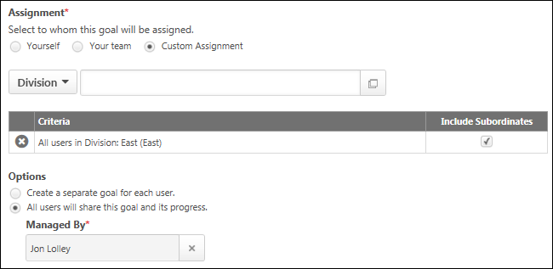
Assign to All Users (Company Goal)
To assign the goal to the entire organization, select All Users from the drop-down menu. This option is only available to administrators who have permission to create company goals.
Company goals appear in the Company Goals section of the My Goals page for all users in the company. This goal will only appears in a performance review task for the goal's owner (the person managing the goal). This goal will not appear in a performance review for any other users in the task, but it can be used in compensation tasks.
If there are multiple administrators who have the permission to create company goals, they all share each company goal. For example, if Mike, Sara, and Jim have permission to create company goals and Sara creates a company goal, Mike and Jim will also share that goal. As a result, Mike and Jim will also be able to edit, update, and cancel that goal.
Assign to OU or Group
To assign the goal to all users within a specific OU or group, select the appropriate OU type from the drop-down menu. Then, click the Select icon to select the appropriate OUs or groups. This option is only available to administrators who have permission to create OU goals.
Your selections are displayed in the Criteria table.
- Select the Include Subordinates option for an OU to include the child OUs for each OU in the goal assignment. If there are no child OUs, this option does not appear.
- Select the Include Subordinates option for a group to include direct and indirect reports for each user in the group.
When assigning a goal to OUs or groups, a goal can be assigned to different types of OUs at the same time. For example, a goal can be assigned to a Division OU and a Position OU at the same time. When an OU is selected, the OU type is displayed along with the OU name.
- If a user exists in more than one of the selected OUs for the goal assignment, the user is only assigned the goal once.
You can remove a selected OU or group by clicking the Remove icon to the left of the item.
Assign to Specific Users
To assign the goal to specific users, select the Users option from the drop-down menu. Then, click the Select icon to select the appropriate users. This option is only available to administrators who have permission to create user goals.
Your selections are displayed in the Criteria table. Select the Include Subordinates option for a user to include the selected user's direct and indirect reports in the goal assignment.
You can remove a selected user by clicking the Remove icon to the left of the user.
Options
Determine whether the assignees will share the goal or each work independently towards completing the goal:
Create a separate goal for each user
If this option is selected, each user is assigned a separate copy of the goal, and each user is responsible for completing the goal independently. For example, if the goal is to have $1 million in sales and you assign it to five users, each user will have to earn $1 million in sales for a total of $5 million. In this case, each user will be the owner of their own goal, allowing them to edit the goal or report progress on it.
Once this goal is assigned, it will appear on the My Goals page for all selected employees where they can edit and manage it. This goal may also appear in their performance review.
- Dynamic Assignment - This option is only available when creating a separate goal for each user, and it is only available for users who have permission to dynamically assign goals. When this option is selected, the goal is assigned to all users within the assignment criteria, and the goal will also be assigned to any users who meet the assignment criteria at any time between the goal start date and target/due date. Any users who match the assignment criteria after the goal target/due date are not assigned the goal.
  - When the Dynamic Assignment option is not selected, the goal is only assigned to users who meet the assignment criteria when the goal is created.
  - If a user is assigned a goal with the Dynamic Assignment option selected, and then the user no longer matches the assignment criteria, the user continues to have the goal. The user is not dynamically removed from the goal.
All users will share this goal and its progress
This option is only available if the administrator has enabled the ability to create a shared goal.
If this option is selected, the assigned users share the goal, and each user's progress contributes to the progress of the shared goal. Shared goals allow all assigned users to add comments to the shared goal, even if they are not the goal owner. For example, if the goal is to have $1 million in sales, the selected users will work together to earn a total of $1 million.
- Managed by - A shared goal must be managed by a single user, and this user is considered the goal owner. The manager can choose to be the goal owner or select one of the assigned users. Although each selected user will contribute to the goal, the goal owner is responsible for editing and updating the goal progress. For example, if Mary is the goal owner and Bob makes a sale towards the goal, Bob cannot enter that information on the goal. Only Mary can update the progress of the goal.
A shared goal for an OU is assigned dynamically. For example, if a user leaves the assignment criteria, they will no longer have the shared goal. If a user joins the assignment criteria, they will inherit the shared goal.
A shared goal for a Division appears in the Division Goals section of the My Goals page for all users in the division when the Division Goals option is selected. This goal will not appear in a performance review. All other shared goals appear in the My Goals section of the My Goals page and may appear in performance reviews.

Goals Configuration Overview

Goal Preferences By Division - Overview
Use the Goal Preferences page to manage goal settings to match your organization's needs.
To manage Goal Preferences, go to Admin > Tools > Performance Management > Goal Preferences.
Permissions
PERMISSION NAME | PERMISSION DESCRIPTION | CATEGORY

Goal Preferences - Manage | Grants ability to manage Goal Preferences, where various goal features can be enabled or disabled according to the needs of the organization. This permission can be constrained by OU and User's OU. This is an administrator permission. | Performance - Administration
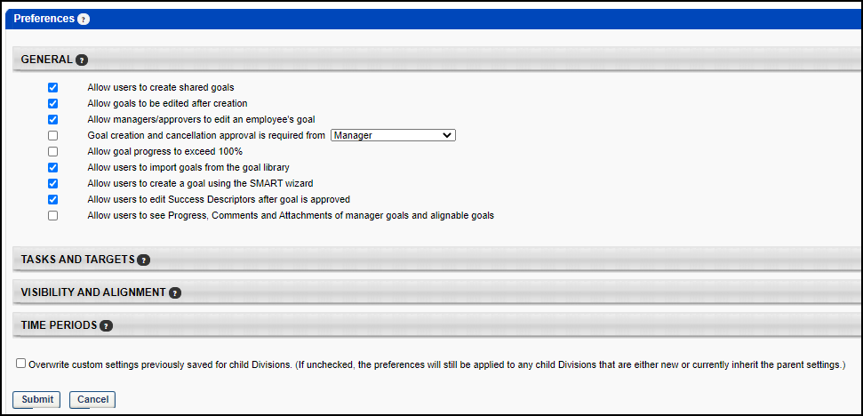
You can perform the following tasks:
- General - Manage the way users vies and use goals. See Goal Preferences - General on page 17 for additional information.
- Tasks and Targets - Manage how users see and use goal tasks and targets. See Goal Preferences - Tasks and Targets on page 20 for additional information.
- Visibility and Alignment - Manage the way users view and align their goals. See Goal Preferences - Visibility and Alignment on page 23 for additional information.
- Time Periods - Manage default dates for goals.See Goal Preferences - Time Periods on page 25 for additional information.

Goal Preferences - General
Use the General section to manage the way that users see and use goals.
To manage Goal Preferences, go to Admin > Tools > Performance Management > Goal Preferences.
Permissions
PERMISSION NAME | PERMISSION DESCRIPTION | CATEGORY

Goal Preferences - Manage | Grants ability to manage Goal Preferences, where various goal features can be enabled or disabled according to the needs of the organization. This permission can be constrained by OU and User's OU. This is an administrator permission. | Performance - Administration
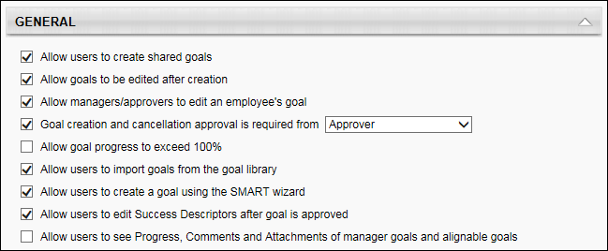
Allow users to create shared goals
Select this option to allow a user to create shared goals. Shared goals are goals that are assigned and visible to multiple users, a group, a division, or the entire company, indicating a shared responsibility, but shared goals can only be edited and managed by the designated goal owner. Shared goals are dynamically assigned to new users who meet the assignment criteria after the initial creation of the goal and are dynamically removed from users who no longer meet the criteria. Shared Company goals and Division goals are visible to users, but they do not appear in performance reviews. A potential use for allowing shared goals is to assign a shared goal to a group of users working as a team on a project. In this type of situation, the team leader might be designated as the goal owner and is responsible for updating the goal progress and making necessary edits to the goal. The other team members can see the shared goal and view goal progress, but cannot make changes to the goal.
Allow goals to be edited after creation
Deselect this option to prevent goals from being edited after they have been created. If this option is deselected, goals can still be managed and new goals can still be added. A potential use for deselecting this option is to temporarily prevent goals from being edited during a performance review task. This option is selected by default.
Allow managers/approvers to edit an employee's goal
Deselect this option to prevent managers or approvers from modifying their subordinate's goals. When this option is selected, managers can edit all aspects of an employee's goal, including tasks, targets, and goal progress. For example, if a user submits a goal for approval, their manager or approver can modify the goal before approving it. This option is selected by default.
Goal creation and cancellation approval is required from
Select this option if approval is required for new goals, edits to existing goals, or to cancel goals. Select the role that will be responsible for approving a goal creation or goal cancellation, as well as any modifications made to an approved goal. This person will receive an email alert (if the corresponding email is active) when one of these events occurs, and an item will appear in their Pending Goals list. This can be set to the user's Manager, Approver, or a custom role. If no one is assigned to this role, these actions will be automatically approved. See Create Role and Permissions for additional information.
If this setting is changed (e.g., from manager to a custom role) and there are existing goals pending approval, the old approver is still responsible for approving the goal. The new approver will have no knowledge of existing goals pending approval.
If the user gets a new manager or if a new person moves into the approver role, the new approver will receive an email for any goals still pending approval. The old approver will no longer have the ability to approve or deny the goals.
Allow goal progress to exceed 100%
While selected, overall goal progress can exceed 100%, which means that the following is also true:
- Overall progress can exceed 100%
- Manual progress can be set higher than 100%
- Target progress can exceed 100%, but cannot exceed the Stretch value
- Tasks cannot exceed 100%
Deselect this option to prevent goal progress from exceeding 100%, regardless of target progress. Allowing goal progress to exceed 100% allows users to record progress above and beyond their target progress. This may encourage employees to continue working on a goal even after the target is reached. This option is selected by default.
Allow users to import goals from the goal library
Select this option to enable the Goals Library when creating goals. The Goals Library can be populated with goal templates that can assist users when creating goals. When enabled, the Library button appears on the Create Goal - Set page. See Goals Create/Edit - Goal Library on page 62 for additional information.
If this functionality is disabled, be sure to remove references to it in your goal creation instructions, which can be changed in the Set field in the Goal Creation Administration section of the Goals Configuration page. See Goals Configuration - Goal Creation Administration on page 38 for additional information.
Allow users to create a goal using the SMART Wizard
Select this option to enable the SMART Wizard when creating goals. When enabled, the Wizard button appears on the Create Goal - Set page. See Goals Create/Edit - SMART Wizard on page 64 for additional information.
If not all features in the SMART Wizard are enabled (e.g., tasks, targets, weights, perspectives), some sections of the SMART Wizard will appear blank with no action to complete. If this is the case, you may wish to disable the SMART Wizard.
The SMART Wizard can be turned on or off, but its labels and instructions cannot be configured.
If this functionality is disabled, be sure to remove references to it in your goal creation instructions, which can be changed in the Set field in the Goal Creation Administration section of the Goals Configuration page. See Goals Configuration - Goal Creation Administration on page 38 for additional information.
Allow users to edit Success Descriptors after goal is approved
Select this option to allow users to edit Success Descriptors for a goal after the goal is approved. See Goals - Overview on page 1 for additional information.
Success Descriptors enable employees to define how they deem success in their own words in relation to a goal. Success Descriptors can be edited during goal creation, but once the goals are approved, the Success Descriptors can only be edited if the "Allow users to edit Success Descriptors after goal is approved" preference is selected. If goal approval is required for a goal and a user edits the success descriptors for their goal, the goal must be approved again, as with any other goal change.
If this option is enabled or disabled after a goal is created, the goal maintains the settings that were in place when the goal was created.
If a manager is able to edit a user's goal, they can always edit a goal's success descriptors. This is controlled by the "Allow managers/approvers to edit an employee's goal" preference.
Allow users to see Progress, Comments and Attachments of manager goals and alignable goals
Select this option to allow users to view Progress, Comments, and Attachments for any of the user's manager's goals and all goals with which the user can align. For example, an organization may choose to prevent users from viewing this information in order to preserve privacy in some higher-level objectives as well as any private status comments that may be added to a goal.
When this option is not selected, users are not able to view goal progress and any comments or attachments that are added to their manager's goals and any available goal with which the user is able to align.

Goal Preferences - Tasks and Targets
Use the Tasks and Targets section to manage how users see and use goal tasks and targets.
To manage Goal Preferences, go to Admin > Tools > Performance Management > Goal Preferences.
Permissions
PERMISSION NAME | PERMISSION DESCRIPTION | CATEGORY

Goal Preferences - Manage | Grants ability to manage Goal Preferences, where various goal features can be enabled or disabled according to the needs of the organization. This permission can be constrained by OU and User's OU. This is an administrator permission. | Performance - Administration
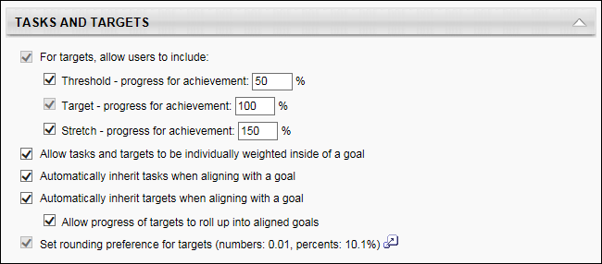
For targets, allow users to include
Select this option to allow users to include Threshold, Target, and Stretch values when creating goals. If Targets are enabled in Goal Configuration, this option is selected, allowing you to also select the sub options. Targets allow users to create specific numeric measures of goal achievement, such as "Increase sales by $500,000" or "Reduce employee turnover by 10%."
If the Threshold option is selected, thresholds are enabled and a threshold value must be entered for each target added in a user's goal. A threshold value is used to indicate a target is on track, but not yet complete. For example, if the threshold is set at 50%, when a user accomplishes 50% of their target, their target status will indicate they have reached the threshold. It is important to note that target progress is not updated until the target threshold is reached. For example, if your target is to open 10 accounts and the threshold is set to 5, if you open four accounts, your target progress is still 0%. It will not update until you open five accounts (and then it reflects 50% since you have opened five accounts and your target is 10). Keep this in mind as you implement a threshold percentage.
If targets are enabled, a Target value must be entered for each target added in a user's goal. A target progress for achievement percentage is entered here to indicate how much progress credit the user receives for achieving the goal target. Usually, this is set at 100%, meaning that if a target is set to increase sales by $100,000, the user receives 100% target progress credit when the target progress reaches $100,000. Alternatively, if this percentage is set to 80%, the user receives only 80% target progress upon reaching the target of $100,000.
Select Stretch to allow users to include a Stretch value when creating goals. The Stretch value allows users to exceed 100% completion for a target and is the maximum percentage that can be tracked. This functionality will not be utilized if Allow goal progress to exceed 100% is not also selected.
You can also set default percentages for these milestones, which can be manually adjusted when a target is created.
When setting target values, depending on the backend setting, the percentage fields may accept up to two decimal places.
Allow tasks and targets to be individually weighted inside of a goal
Deselect this option to prevent tasks and targets from being individually weighted inside a goal. Weighting allows you to place a greater value towards goal completion on certain tasks or targets. For example, if I have four targets within a goal and they are valued equally, I can assign them each a weight of 25%. Instead, if one target is more important than the others, I can give that target a weight of 40% and assign the other three a weight of 20%. The heavier weighted target will count more towards my goal completion than the other three.
When enabled, the Weight field appears when creating Tasks and Targets.
When disabled, the Weight field does not appear on the My Goals screen, the goal rating section of a review, or in the PDF printout of the Performance Review. If progress is calculated by both tasks and targets, all are weighted equally. If progress is calculated by only tasks, tasks will carry equal weight and targets will carry zero weight. If progress is calculated by only targets, the opposite applies. This option is selected by default.
Automatically inherit tasks when aligning with a goal
When this option is selected and a goal is aligned, all tasks are copied from the parent goal to the child goal. For example, when a user aligns with their manager's goal, all of the tasks from their manager's goal will now exist within their goal. The tasks can then be modified once they are copied. This serves as a starting point when aligning with a goal. When the user completes this task, it may affect the status of tasks from aligned goals. Even if this option is selected, goals that are aligned after creation (from the Related Goal section of the Edit Goal screen) will not inherit tasks when aligned. This option is selected by default.
Automatically inherit targets when aligning with a goal
When this option is selected and a goal is aligned, all targets are copied from the parent goal to the child goal. For example, when a user aligns with their manager's goal, all of the targets from their manager's goal will now exist within their goal. All aspects of the targets can then be modified except for the target type once they are copied. This serves as a starting point when aligning with a goal. Even if this option is selected, goals that are aligned after creation (from the Related Goal section of the Edit Goal screen, rather than the Create Goal - Align screen) will not inherit targets when aligned.
Select Allow progress of targets to roll up into aligned goals to allow progress made towards targets in child goals to count towards the progress of the parent goal. For example, if a manager has a goal with a target to sell 100 widgets, a user can align to that goal and set their target to sell 50 widgets. If the user then sells 25 widgets, his progress will be 50% since he has sold half of his target. Also, since the user's progress counts towards the manager's progress, the manager's progress will be 25% since 25 out of the 100 have been sold. If this option was not selected, the user's progress would not count towards the manager's progress, and the manager would still be at 0%.
Set rounding preferences for targets (numbers: 0.1, percents 10%)
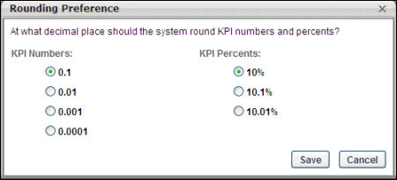
This allows you to set the number of decimal places that will display when displaying numbers and percents associated with targets. For example, if a target is two thirds complete, you can select whether the target will display as 66.67%, 66.7%, or 67%. This option is selected by default.
- KPI Numbers - Sets the max decimal place for Targets with type of Number, Hours, Days and Years. If it is set to 0.0001, it means that the user can enter a progress of up to four decimal places.
- KPI Percents - Sets the max decimal place for Targets with type of Percentage. If it is set to 10.01%, it means that the user can enter a progress of up to two decimal places. Targets of type Currency always allow up to two decimal places and will not be controlled by this setting.
Note: Corp Setting EPMPrecision controls the precision of decimals available to Goal Weight, Goal Progress, Task Weight, Task Progress, Target Weight, Performance Review Section Weight, and Performance Review Step Weight. Goal Target Progress decimal precision is determined by the Rounding Preference setting.

Goal Preferences - Visibility and Alignment
Use the Visibility and Alignment section to manage the way users view and align their goals.
To manage Goal Preferences, go to Admin > Tools > Performance Management > Goal Preferences.
Permissions
PERMISSION NAME | PERMISSION DESCRIPTION | CATEGORY

Company Goals - Create | Grants access to create goals that appear to all users as "company goals." This permission cannot be constrained. This is an administrator permission. | Performance - Administration

Create Employee Goals - Align | When creating a goal for users other than self or subordinates, this permission allows users to search for goals by user when aligning the goal with another user's goal. Users with this permission can only search for and align their goals with users who are within their permission constraints. If a user does not have this permission, then the Search field is not available within the Alignment pop-up. This permission works in conjunction with the Create Employee Goals permission. This permission can be constrained by OU, User's OU, and User. This is an administrator permission. | Performance - Administration

OU Goals - Create | Grants ability to create and assign goals to all users within a selected organizational unit or group. This is an administrator permission.  The constraints on this permission overwrite the constraints on the Goals - Create permission. That is, if a user has both permissions, then the constraints on the OU Goals - Create permission are applied. | Performance - Administration
The permission to align goals when creating employee goals can be constrained to determine with which employees a user can align their goals.
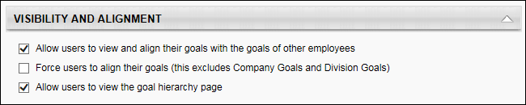
Allow users to view and align their goals with the goals of other employees
- When this option is selected, users can search for other employees beyond those mentioned above in order to align with their goals. If you would like to disable alignment, this option should be disabled.
- If this option is enabled at the division level, users can search for other users in their division. If this option is enabled at the company level, users can search for all users in the company.
- When enabled, the Align button appears on the Create Goal page. This option is selected by default.
Important Note: Changing this setting does not retroactively affect the visibility of existing goals.
By default, a user can align their goal with:
- Another goal they have created
- All subordinate goals
- A goal created by their direct manager, provided the manager has a goal that they have made visible and allowed for alignment
Force users to align their goals (this excludes Company Goals and Division Goals)
Select this option to force users to align each goal they create with another goal. When enabled, users do not have the option of creating an independent goal on the Create Goal page. Users with permission to create company goals or create OU goals can create Company or Divisional goals that are not aligned with another goal.
- This option is deselected by default. Select this option to force users to align each goal they create with another goal. When enabled, users do not have the option of creating an independent goal on the Create Goal page. Users with permission to create company goals or create OU goals can create Company or Divisional goals that are not aligned with another goal. Changing this setting will not retroactively affect the visibility existing goals.
- If this option is selected, make sure that Company and Division goals are available before individual planning begins. If no Company and Division goals exist, users will have no goals with which to align and will not be able to create a goal. This option is deselected by default.
Allow users to view the goal hierarchy page
- When this option is selected, users can view the overall hierarchy of their aligned goal.
- When enabled, the Hierarchy button appears on the Goals page and within the Goal Details page.
If you have Alignment enabled, it is recommended that users can view the Goal Hierarchy page. This allows users to see how their actions and efforts contribute to the overall company success. This option is selected by default.

Goal Preferences - Time Periods
Use the Time Periods section to manage default dates for goals.
To manage Goal Preferences, go to Admin > Tools > Performance Management > Goal Preferences.
Permissions
PERMISSION NAME | PERMISSION DESCRIPTION | CATEGORY

Goal Preferences - Manage | Grants ability to manage Goal Preferences, where various goal features can be enabled or disabled according to the needs of the organization. This permission can be constrained by OU and User's OU. This is an administrator permission. | Performance - Administration
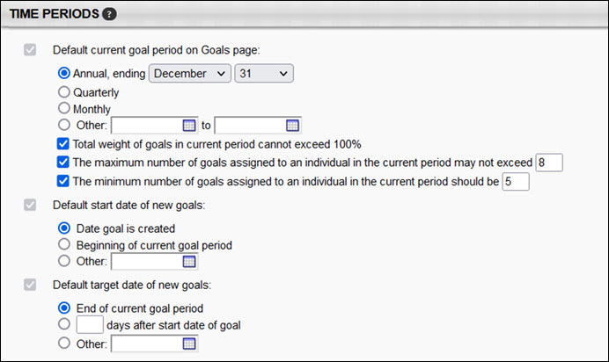
Default current goal period on Goals page
Select the default goal period that will display on the Goals page. This setting also applies to the Hierarchy page and the Goals Reports page. When a user opens the Goals, Hierarchy, or Goals Reports page, only goals with a start date or end date in the default goal period will display. This can then be manually modified by the user on that page. Also, this setting may be used when setting the default start date and end date for new goals.
- Annual - This is selected by default.
- Quarterly - This option uses the following dates: 1/1-3/31, 4/1-6/30, 7/1-9/30, 10/1-12/31
- Monthly - This option uses the calendar months.
- Other - This option allows you to create a custom goal period. This option may be useful when basing goal periods on fiscal year, a planning period not aligned with the calendar year, or a multi-year planning cycle.
Total weight of goals in current period cannot exceed 100% - This option is unchecked by default. When this option is selected, users cannot set goal weights so that the total weight of all goals for the current period cannot be more than 100%. By limiting total goal weight for the current period, administrators can ensure goal weights are aligned with employee review processes where stretch goals are not common.
Note: Shared goals appearing in My Goals are factored into the calculation of Total Weight for an individual’s goals. Shared Company and Division goals are not factored into Total Weight.
The max weight validation only applies to Goals that are created by the user for "Self" or are directly created for the user in the Universal Profile > Snapshot only. This setting doesn't apply for Dynamic Goals or Team Goals that are assigned.
The maximum number of goals assigned to an individual in the current period may not exceed <number> - When this option is selected, administrators can establish the maximum number of new goals that can be created by users. This option is unchecked by default.
Note: Administrators and managers can still create goals for others, even if the new goal causes them to violate this policy.
The minimum number of goals assigned to an individual in the current period should be <number> - When this option is selected, administrators can establish the minimum number of goals that can be assigned to a user in the current period.
These selected options apply to the user's My Goals page and error messaging appears if the user does not meet the assigned criteria.
Default start date of new goals
Select the default start date for a new goal. When a user creates a goal, this date will automatically be populated as the Start Date and can then be modified by the user.
- Date goal is created - The start date is the same as the date the goal is created.
- Beginning of current goal period - The start date of the goal period defined in the Default current goal period on Goals page preference will be used.
- Other - Select a customized start date.
Default target date of new goals
Select the default end date for a new goal. When a user creates a goal, this date will automatically be populated as the Due Date and can then be modified by the user.
- End of current goal period - The end date of the goal period defined in the Default current goal period preference is used.
- XX day after start date of goal - You must also enter the number of day. With this option, when a goal is created and the user select a start date, the end date is automatically populated based on the number of days specified in this preference. However, the due date can still be manually changed.
- Other - Select a customized target date.

Goals Configuration Overview
Use the Goals Configuration page to customize the way goals appear in your portal as well as goal statuses. This page also allows you to customize the instructions users receive as they create their goals.
To modify Goals Configuration, go to Admin > Tools > Performance Management > Goals Configuration.
Permissions
PERMISSION NAME | PERMISSION DESCRIPTION | CATEGORY

Goal Configuration | Grants ability to manage Goal Configuration, which enables configuration of goal fields as well as goal statuses. This permission can be constrained by OU and User's OU. This is an administrator permission. | Performance - Administration
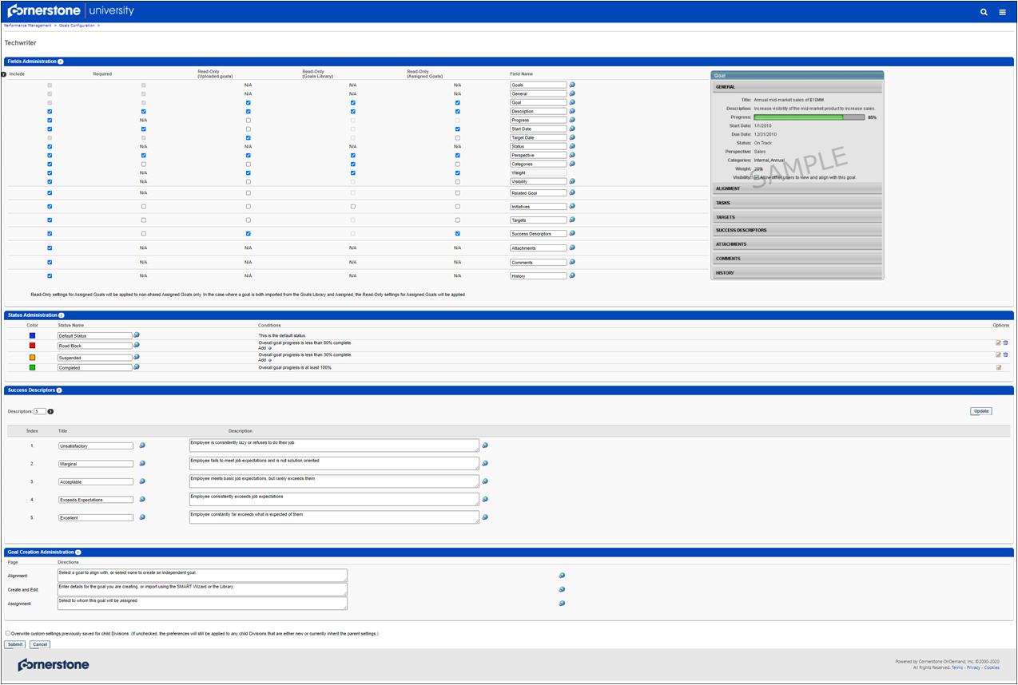
Field Administration
Select which fields are included in the goal process and which fields are required. You can set fields as read-only if necessary. You can also customize and localize the names of each field to suit your company's needs. For example, if you rename Goal to Objective, the word Objective will appear in place of Goal everywhere in the Goals module. See Goals Configuration - Fields Administration on page 29 for additional information.
Status Administration
Customize four different goal statuses that will be used throughout goals. You can set the status name and color that will appear as well as the criteria that determines the status of a goal. See Goals Configuration - Status Administration on page 33 for additional information.
Success Descriptors
Define success in relation to a goal. See Goals Configuration - Success Descriptors on page 36 for additional information.
Goal Creation Administration
Set the instructions that will appear to users for each of the three sections of the goal creation process. See Goals Configuration - Goal Creation Administration on page 38 for additional information.

Goals Configuration - Fields Administration
Use the Fields Administration section, to select which fields are configurable when users create goals. See Goals - Create/Edit on page 44 for additional information.
Administrators can configure required and read-only fields, and configure field names tthroughout goals. These configurations can be different between OUs, so the goal page can have varying views based on assigned OU.
Note: The sample image on this page displays which each field corresponds to a goal. This image does not change as you change the various options on this screen.
To modify Goals Configuration, go to Admin > Tools > Performance Management > Goals Configuration.
Permissions
PERMISSION NAME | PERMISSION DESCRIPTION | CATEGORY

Goal Configuration | Grants ability to manage Goal Configuration, which enables configuration of goal fields as well as goal statuses. This permission can be constrained by OU and User's OU. This is an administrator permission. | Performance - Administration
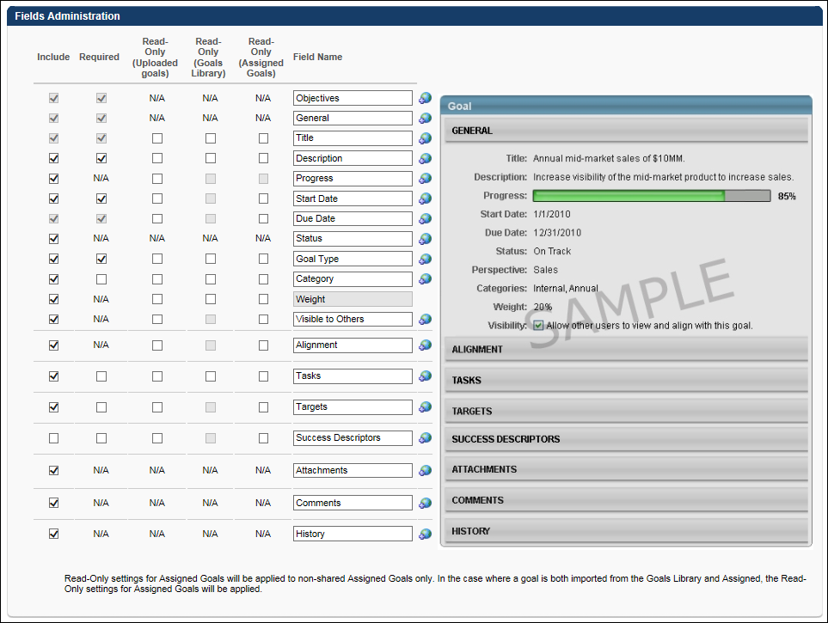
Planning
Before you start making fields included or required, consider which information you would like to be available for users to set in each goal and which information you would like to be a part of every goal. This will help you determine which fields should be included and also which fields should be required.
The available fields for customization are:
- Goals - This is always included and required.
- General - This is always included and required.
- Title - This is always included and required.
- Description
- Progress - If this is set to Read-Only for a goal, users cannot update the progress of their goal via the Manage Goals screen. This includes the tasks, targets, and overall progress of the goal.
- Start Date - If Start Date is turned off, the Start Date of a goal will default to the day it is created. If this is set to Read-Only for a goal, the goal cannot be advanced. The Advance option is not available for the goal.
- Due Date - This is always included and required. If this is set to Read-Only for a goal, the goal cannot be advanced. The Advance option is not available for the goal.
- Status
- Perspective - Perspective is used to specify to which aspect of the company the goal relates. If Perspective is included, by default it is also required. This cannot be changed.
- Categories - This is a similar to Perspective, in that it is a way to distinguish a type of goal. Users may select more than one Category. By default, Categories are not included or required.
- Weight - If Weight is included, by default it is also required. This cannot be changed. This field name cannot be changed.
- Visibility (to others) - When this option is included, it can be selected to allow other users to see the goal and align their goals with it.
  - When included, this option is generally used by managers to allow their direct reports to view manager goals and align their individual goals with them, but other users can use this function if the system administrator allows all users to align with each other. If alignment is disabled, this option is not available even if it is included.
- Alignment - This field controls the Alignment widget on the Create Goal page. If this is set to Read-Only for a goal, the goal's Alignment is read-only when configuring a goal.
- Tasks - If this is set to Read-Only for a goal, tasks cannot be edited or added to the goal. However, the progress of existing tasks can be updated via the Manage Goals screen as long as the Progress field is not read-only.
- Targets - If this is set to Read-Only for a goal, targets cannot be edited or added to the goal. However, the progress of existing targets can be updated via the Manage Goals screen as long as the Progress field is not read-only.
- Success Descriptors - Success Descriptors enable employees to define how they deem success in relation to a goal.
- Attachments
- Comments
- History
Include
Select this option if you want this field to appear to users during goal creation and throughout goals. Any field not selected does not display to users in the corresponding OU. This includes Progress and Status, so be sure to select fields you intend to utilize.
Required
Select this option to make if mandatory for users to enter or select information for this field. For example, if Targets is required, a user must enter at least one target for each goal.
Read Only
Select this option if you want this field to be read-only for the user. Selecting this option automatically selects the Include option for the field. The read-only settings apply to all types of goals in the system (e.g., individual goals, team goals, company goals, subordinate's goals) as long as they are uploaded, Goals Library, or assigned goals. The read-only attribute applies when creating and editing a goal, when copying a goal that contains read-only attributes, and when advancing a goal that contains read-only attributes. Applies as follows:
- Read-Only (Uploaded Goals) - Goals that are uploaded to the system via a data feed.
- Read-Only (Goals Library) - Goals that are imported from the Goals Library. Note: Some fields cannot be set as read-only for goals imported from the Goals Library, because these fields are not set when creating a goal template for the Goals Library.
- Read-Only (Assigned Goals) - Non-shared goals that are assigned to a user. Read-only settings for Assigned goals are applied to non-shared assigned goals only. If a goal is both imported from the Goals Library and assigned, the read-only settings for assigned goals are applied.
Field Name
Rename a field to something more appropriate for your company. This changes the field name everywhere it exists throughout goals. The image on this screen always displays the default name of each field. This may be helpful if you decide to change it again in the future. These fields have a 50 character limit.
If multi-language is enabled, a globe appears next to each field name. Click the globe to localize the field name or turn the field on or off for different languages.
Overwrite Settings
Select this option to overwrite custom settings for child division OUs. If you overwrite custom settings for child division OUs, the selected settings are applied to both new and existing child OUs. Any previously customized child OUs are updated with the selected settings.
- If there are no customizations to the child OU, then the parent OU customizations are applied to all child OUs.
- Overwrite custom settings checkbox setting
  - If this option is selected, all child OU customizations are deleted from the database, which means the parent OU customizations will be applied to new and existing child OUs.
  - If this option is unselected, all existing child OU customizations will remain unchanged, and any new child OUs will inherit the parent OU customizations by default.
- If a child OU has been customized to display any widgets, then regardless of the parent OU customizations, the child OU customizations are applied.
- If a child OU has been customized to hide all widgets, then parent OU customizations will take precedence and will be applied.

Goals Configuration - Status Administration
Use the Status Administration section to define the names assigned to the progress of a goal. Statuses are determined by a set of criteria and can be displayed as a color or a name. You can customize the color and name associated with the status, as well as the conditions that determine each status throughout the OU.
You can define up to four types of status and define a color and condition for each one. The default status for all goals is the first status in this list. Based on your organization's needs, you can define two additional interim statuses. The final status in the list indicates the goal, task, or target is completed. This is measured in different ways, but is used to indicate that the criteria for goal completion is satisfied.
Additionally, there are system-defined default goal statuses as follows:
- Draft - A goal is not submitted and is saved as a draft. The system-defined status column color is #1C1C1C.
- Pending Approval - A goal requires approval from a Manager or someone else. The system-defined status column color is #AFAC96.
- Not Started - A goal is submitted, approved, or created, but the Start Date is in the future and the progress is still at 0%. The system-defined status column color is #8E9AA7.
- In Review - Goals currently being worked on in a goal planning section.
Other the progress of the goal is greater than 0% and/or the Start Date is today or in the past , then, the status color and name will change according to the rules set forth in the Admin Configuration Status Administration section.
Goals take on the default status that is first on the list if:
- The Goal Start Date is today or in the past.
- No other interim status (Status 2 and 3) satisfies the goal condition.
To modify Goals Configuration, go to Admin > Tools > Performance Management > Goals Configuration.
Permissions
PERMISSION NAME | PERMISSION DESCRIPTION | CATEGORY

Goal Configuration | Grants ability to manage Goal Configuration, which enables configuration of goal fields as well as goal statuses. This permission can be constrained by OU and User's OU. This is an administrator permission. | Performance - Administration
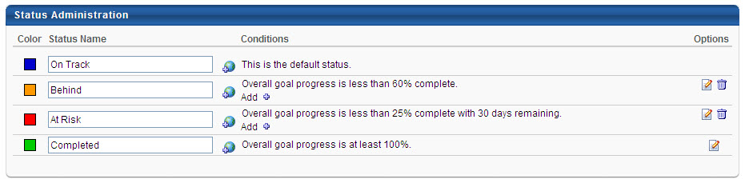
Color
Select a color to define the progress of a goal, if necessary. For example, green may be used to convey that a goal is either on track for completion or has been completed, and red may be used to convey that a goal is either behind in progress or at risk for failure. These colors are displayed in progress bars and in the hierarchy status column. You can change the color associated with each status by clicking the color square next to the Status Name. This opens a screen where you can either select a color, enter the Hex Value, or not use a color at all.
Status Name
Enter a name for each status. This name may also indicate the progress of the goal. For example, if the goal is finished, name it Completed; if the goal is at or above where it should be, name it On Track; if the goal is below where it should be, name it At Risk. You can change all status names. This field is limited to 25 characters.
If multiple languages are enabled for your portal, select the Translate icon to translate the field into other available languages. The following rules apply to the statuses in the order listed:
- Status 1 - There are no conditions for this goal, so if a goal does not fit in the other statuses you establish, it automatically defaults to this status.
- Status 2 and 3 - Indicates interim levels of goal progress.
- Status 4 - Indicates goal completion.
Conditions
Select a conditions to define the rules for the status.
When determining which status a goal is in, the goal will be set to the first status that matches the conditions starting at the bottom status and moving up. The Completed status is always checked first. For example, in the image above, that would be Completed, At Risk, Behind, On Track. You can add more than one condition for each of these statuses and if any of the conditions are met, that status is selected. You can also edit or delete conditions individually.
To manage status conditions:
- Status 1 - You cannot edit the condition for Status 1.
- Status 2 and 3:
  - To add a new condition, click the plus symbol next to the status. Conditions may be goal-based, task-based conditions, and target-based. If tasks or targets are turned off, those conditions will not appear.
  - To edit a condition, click the Edit icon next to the condition in the Options column.
  - To remove a condition, click the Delete icon next to the condition in the Options column.
When creating a goal-based, task-based, and target-based status conditions, depending on the backend setting, the percentage fields may accept up to two decimal places. Note: The days fields do not support decimal places.
- Status 4 - Click the Edit icon in the Options column. You may select only one of the following conditions for goal completion status:
  - All goal targets are complete.
  - All goal tasks are complete.
Overall goal progress is 100%.
If progress is disabled and a goal has no tasks or targets, users must manually update the goal's status by selecting it from a drop-down list.
Options
- Edit - Click the edit icon to edit goal status conditions. You can only edit status conditions for status 2. 3. and 4.
- Delete - Select the delete icon to delete a goal status. You cannot delete the first (default) status or the completed status. If you delete status 2 and 3 on the list, they no longer apply as status for this goal but are still visible in the list.
Note: If Goal Progress is disabled, the end user has the option to select the goal status.
Overwrite Settings
Select this option to overwrite custom settings for child division OUs. If you overwrite custom settings for child division OUs, the selected settings are applied to both new and existing child OUs. Any previously customized child OUs are updated with the selected settings.
- If there are no customizations to the child OU, then the parent OU customizations are applied to all child OUs.
- Overwrite custom settings checkbox setting
  - If this option is selected, all child OU customizations are deleted from the database, which means the parent OU customizations will be applied to new and existing child OUs.
  - If this option is unselected, all existing child OU customizations will remain unchanged, and any new child OUs will inherit the parent OU customizations by default.
- If a child OU has been customized to display any widgets, then regardless of the parent OU customizations, the child OU customizations are applied.
- If a child OU has been customized to hide all widgets, then parent OU customizations will take precedence and will be applied.

Goals Configuration - Success Descriptors
Use the Success Descriptors section to enable employees to define how they perceive success in relation to a goal. After an administrator defines the number of levels of success (at the OU level) as well as the labels for those success levels, users can describe what those levels mean in their own words. Administrators can also pre-configure the descriptions of those success levels to help guide the employee, who can later edit the descriptions in order to make them more personal or relevant to the goal.
Within performance reviews, employees may be rated on their ability to achieve goals. Over the review period for the goal, perceptions of success for the employee can change for both the organization and the employee.
To modify Goals Configuration, go to Admin > Tools > Performance Management > Goals Configuration.
Permissions
PERMISSION NAME | PERMISSION DESCRIPTION | CATEGORY

Goal Configuration | Grants ability to manage Goal Configuration, which enables configuration of goal fields as well as goal statuses. This permission can be constrained by OU and User's OU. This is an administrator permission. | Performance - Administration
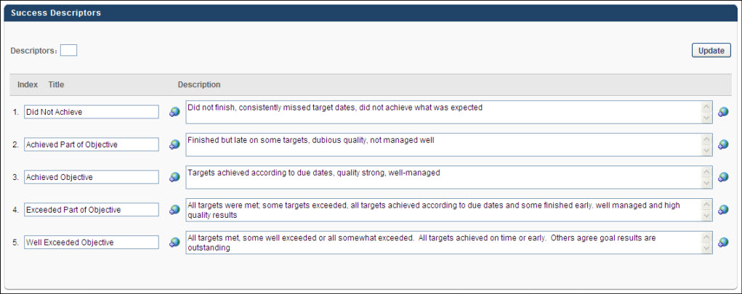
Descriptors
Define the number of descriptors you will provide for this goal. You can increase or decrease descriptors at any time.
To set descriptors:
- In the Descriptors field, enter the number of descriptors available for users. This value must be between 1 and 15. The number you enter here defines the descriptors you want for this goal. If you enter 10 in this box, 10 Title and Description rows appear below.
- Click the Update button. This updates the display with the appropriate number of descriptor fields. If the number is increased, additional descriptors appear, and if the number is decreased, the descriptors at the bottom of the list are removed.
Descriptor Table
Enter names and descriptions for the success descriptors.
- In the Title field for each Descriptor, enter a meaningful title. This should give the user a general understanding of the descriptor. This is required for each descriptor and the character limit for this field is 50.
- In the Description field, enter a detailed description for the descriptor. This should give the user a complete understanding of what the descriptor represents. This is optional and the character limit is 1000.
- If multi-language is enabled, a globe appear next to these fields. Click the globe to localize the description for different languages.
You can reorder the descriptors by dragging and dropping them into the desired order.
Overwrite Settings
Select this option to overwrite custom settings for child division OUs. If you overwrite custom settings for child division OUs, the selected settings are applied to both new and existing child OUs. Any previously customized child OUs are updated with the selected settings.
- If there are no customizations to the child OU, then the parent OU customizations are applied to all child OUs.
- Overwrite custom settings checkbox setting
  - If this option is selected, all child OU customizations are deleted from the database, which means the parent OU customizations will be applied to new and existing child OUs.
  - If this option is unselected, all existing child OU customizations will remain unchanged, and any new child OUs will inherit the parent OU customizations by default.
- If a child OU has been customized to display any widgets, then regardless of the parent OU customizations, the child OU customizations are applied.
- If a child OU has been customized to hide all widgets, then parent OU customizations will take precedence and will be applied.

Goals Configuration - Goal Creation Administration
Use the Goal Creation Administration section to configure the instructions that appear on the user's Alignment, Create and Edit, and Assignment screens during the goal creation process.
To modify Goals Configuration, go to Admin > Tools > Performance Management > Goals Configuration.
Permissions
PERMISSION NAME | PERMISSION DESCRIPTION | CATEGORY

Goal Configuration | Grants ability to manage Goal Configuration, which enables configuration of goal fields as well as goal statuses. This permission can be constrained by OU and User's OU. This is an administrator permission. | Performance - Administration
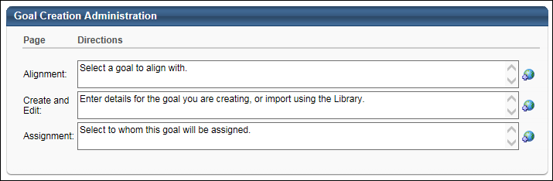
- To enter instructions, type the appropriate information in the appropriate box.
- If multi-language is enabled, a globe appear next to these fields. Click the globe to localize the description for different languages.
Overwrite Settings
Select this option to overwrite custom settings for child division OUs. If you overwrite custom settings for child division OUs, the selected settings are applied to both new and existing child OUs. Any previously customized child OUs are updated with the selected settings.
- If there are no customizations to the child OU, then the parent OU customizations are applied to all child OUs.
- Overwrite custom settings checkbox setting
  - If this option is selected, all child OU customizations are deleted from the database, which means the parent OU customizations will be applied to new and existing child OUs.
  - If this option is unselected, all existing child OU customizations will remain unchanged, and any new child OUs will inherit the parent OU customizations by default.
- If a child OU has been customized to display any widgets, then regardless of the parent OU customizations, the child OU customizations are applied.
- If a child OU has been customized to hide all widgets, then parent OU customizations will take precedence and will be applied.

Goals Library
The Goals Library allows administrators to create and manage goal templates, which can then be used by employees when creating their goals. Once goal templates are created, users can browse the library of pre-defined goals templates to create a goal for themselves or other employees. When a user selects a goal template from the Goal Library, all of the information in the template is added to the user's goal, where they can modify or remove any of the information. Goal templates are not limited by OU, but the goals library can turned off at the OU preference level.
Goal templates must contain a title and description, but can also contain an associated perspective, category, weight, and tasks. If perspective is enabled, it will be required as the Goals Library will be organized by perspective.
Templates do not contain targets, because targets should be created specifically for each employee based on experience and circumstances.
Before a user can use a goal template, the administrator must first create them. Once created, the administrator can deactivate a template by deselecting the Active checkbox next to it. This will make that template invisible to all users. Deactivated items will remain in the system, but will not be visible to end users. The administrator can also edit, copy, or delete a template using the corresponding icons found in the Options column.
To access the Goals Library, go to Admin > Performance Management > Goals Library. Then, click the Add Goal Template link.
Permissions
PERMISSION NAME | PERMISSION DESCRIPTION | CATEGORY

Goal Perspectives - Manage | Grants ability to create and manage goal perspectives and categories which are used to categorize and filter goals. This is an administrator permission. | Performance - Administration

Goals Library | Grants ability to create and edit/update goal templates within the goal library, which can then be used by employees when creating their goals. This permission cannot be constrained. This is an administrator permission. | Performance - Administration
Creating a Goal Template
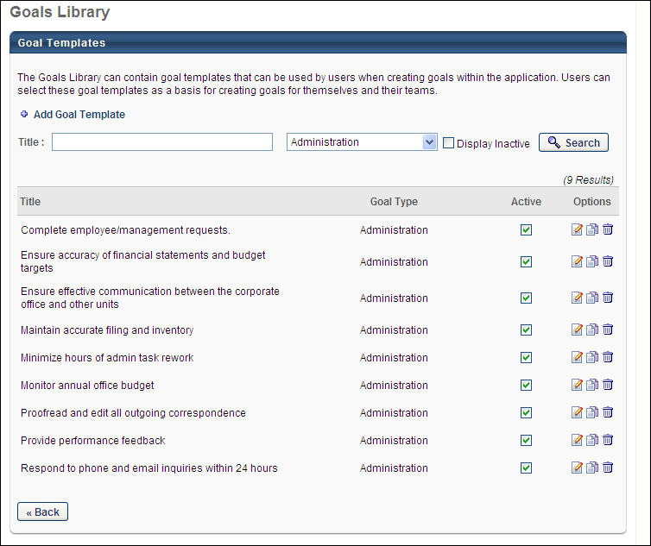
Template Details
Enter the following information for your template:
- Title (required) - This field is limited to 1000 characters. If multiple languages are available for the portal, the goal title can be localized by clicking the Translate icon to the right of the field.
- Description (required) - This field is limited to 3000 characters. If multiple languages are available for the portal, the goal description can be localized by clicking the Translate icon to the right of the field.
- Perspective - The Goals Library is filtered by Perspective.
- Category
- Weight - Depending on the backend setting, the weight percentage fields may accept up to two decimal places.
Add Task
To add a task to your template, click the Add Task button. Enter a Description and Weight for the task, then click Save. If multiple languages are available for the portal, the task description can be localized by clicking the Translate icon to the right of the field. You may enter multiple tasks if desired.
Set Template Availability
To make the goal template available to users, you must set the availability of the template. This is required for each goal template. From the drop-down list in the Available Selection Criteria section, select an OU type or group to add to the availability. Then, click the selection pop-up to select a specific OU. For example, to make the goal template available to all employees in the Client Success Manager position, first select the Position OU type from the drop-down list. Then, click the selection pop-up and select the Client Success Manager position. You can also click the Create New Group link to create a new group.
- After selecting and adding the appropriate OUs or groups, you can select the Include Subordinates option to include all subordinate OUs in the availability.
Save Template
Click Save to save your template.

Goal Perspectives and Categories
Goals can be organized using perspectives and categories. Perspective and Categories are used to specify to which aspect of the company your goal relates. Each goal is limited to one perspective, but can have multiple categories. Perspectives and categories can be limited in visibility to certain OUs.
Before a user can associate their goal with a perspective or category, the administrator must first create them and make them visible to that user.
Once created, the administrator can deactivate a perspective or category by deselecting the Active checkbox next to it. Deactivated items will remain in the system, but will not be visible to end users. The administrator can also edit or delete an item by clicking the corresponding icon found in the Options column.
Permissions
PERMISSION NAME | PERMISSION DESCRIPTION | CATEGORY

Goal Perspectives - Manage | Grants ability to create and manage goal perspectives and categories which are used to categorize and filter goals. This is an administrator permission. | Performance - Administration
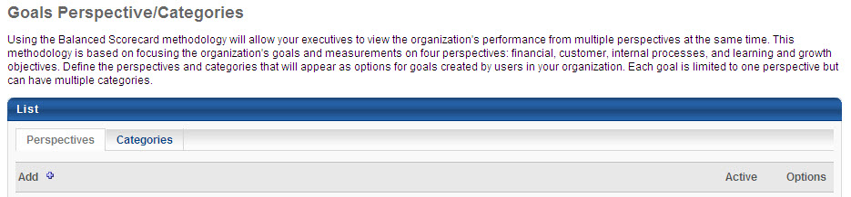
Considerations
Keep these items in mind as you begin mapping out the Perspectives and Categories for your company:
- Perspectives can be used to filter performance reviews, but categories cannot.
- Perspectives can be used to filter results in standard reports, but categories cannot. Categories can only be reported on in Analytics.
- If perspectives are enabled, the Goals Library is organized by perspective.
- Each goal can have only one perspective, but can have multiple categories. Also, you cannot limit the number of categories associated with a goal.
Creating a Goal Perspective or Category
- Select Admin > Tools > Performance Management > Goals Perspectives/Categories.
- Click the Perspectives or Categories tab (whichever you are creating).
- Click the plus sign at the top of the list.
- In the Perspective or Category field, name your Perspective or Category. This name will be visible during the goals creation process. This field is limited to 100 characters. If multiple languages are enabled for your portal, select the Translate icon to translate the field into other available languages.
- You can set the availability of the perspective/category by company, organizational unit, a set of users, or a group of individuals. From the User Criteria drop-down list, select a group that will be able to view and use the perspective/category. You may have to click the Search icon to continue your search. For example, if you selected Position from the drop-down list, you must then select the appropriate positions. You may select multiple groups in this manner. You also have the option to create a new group. See Group - Create/Edit.
- Select the Include Subordinates checkbox to include the subordinates of the employees of the group you selected. For example, if you selected the Manager position, you may also want to include their subordinates.
Note: Users who are not included in your selection will not be able to view this perspective or category, and as a result they will not be able to associate it with their goal. Be sure all of the required users are included.
- Once all groups have been added, click Submit.

Goals - Create/Edit
Goals are used to identify and formalize the achievements that you want to accomplish during a specific period of time. Goals help you to maintain focus on the correct priorities, and they allow you to track your progress towards the completion of those priorities.
The instructions at the top of the page are configured by the administrator in Goals Configuration Preferences.
- To create a goal, go to Performance > Goals. Then click the Create button.
- To edit a goal, go to Performance > Goals. Click the Actions menu icon to the right of the appropriate goal and select Edit.
Permissions
PERMISSION NAME | PERMISSION DESCRIPTION | CATEGORY

Create Employee Goals - Align | When creating a goal for users other than self or subordinates, this permission allows users to search for goals by user when aligning the goal with another user's goal. Users with this permission can only search for and align their goals with users who are within their permission constraints. If a user does not have this permission, then the Search field is not available within the Alignment pop-up. This permission works in conjunction with the Create Employee Goals permission. This permission can be constrained by OU, User's OU, and User. This is an administrator permission. | Performance - Administration

Goals - Create | Grants ability for user to create goals for self, direct reports, and indirect reports only. Any constraint on this permission is operating as an "AND" function. This permission can be constrained by Employee Relationship, OU, User's OU, and User Self and Subordinates. This is an end user permission. | Performance

Snapshot Goals - View | Enables user to view their own goals, and others’ public goals, using the Goals widget and subpage within the Universal Profile - Snapshot page, for users within their permission constraints. This permission can be constrained by Employee Relationship, OU, User's OU, User Self and Subordinates, User, User's Self, User's Manager, User's Superiors, User's Subordinates, and User's Direct Reports.  Best Practice: For most users, this permission should be constrained by User Self and Subordinates.  Note: Managers can assign this permission to select subordinates when they are away from the office for an extended period. | Universal Profile

Snapshot Goals - Manage | Enables user to manage their own goals, and others public goals, using the Goals widget and subpage within the Universal Profile - Snapshot page, for users within their permission constraints. This permission can be constrained by Employee Relationship, OU, User's OU, User Self and Subordinates, User, User's Self, User's Manager, User's Superiors, User's Subordinates, and User's Direct Reports.  Best Practice: For most users, this permission should be constrained by User Self and Subordinates. | Universal Profile
Emails
EMAIL NAME | EMAIL DESCRIPTION | ACTION TYPE

Request Goal Approval | This email is a batch type email that includes a notification for each situation in which a goal owner does the following:  - Creates and submits a goal for themselves when approval is required.  - Edits and resubmits a goal that has already been approved.  - Attempts to cancel a goal that has been approved when approval is required.  This email is triggered when a user clicks the Send Approval Request button on the My Goals or Snapshot Goals page.  The email is sent to the user in the Approver role. If no approver is set or if goal approval is not required, the goal is automatically approved and no email is sent.  The email can contain a link to the Pending Goals page. | Performance Management
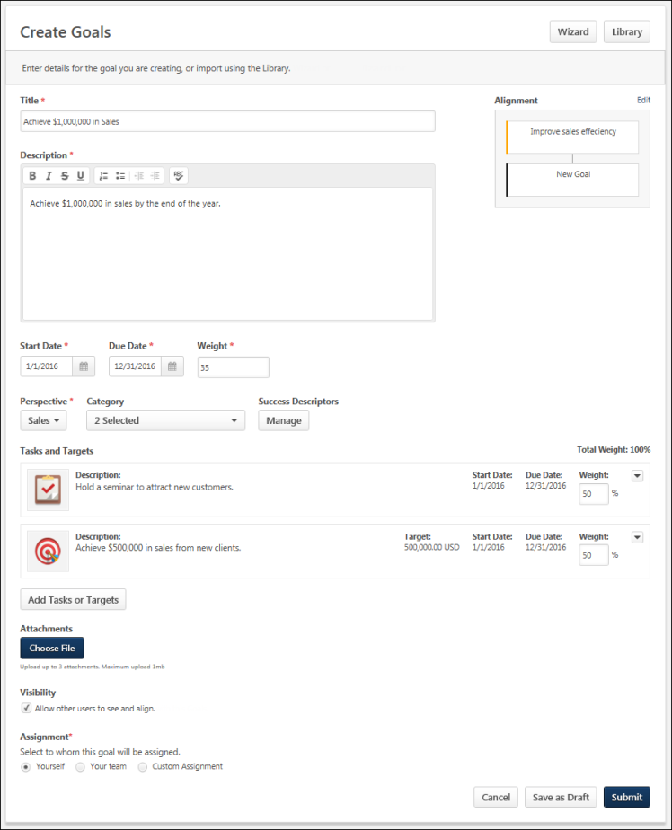
Troubleshooting Information
See Troubleshooting Guide - Creating and Editing Goals.
See QUICK START GUIDE - Goal Creation.
Considerations
- When creating or editing a goal that is imported from a data feed, created from the Goals Library, or assigned as a non-shared goal, if a field is set as read-only, the field cannot be modified by the user.
  - Text and date fields such as Title and Due Date cannot be modified.
  - Tasks and Targets cannot be added.
  - The Alignment section cannot be modified.
  - If the Start or Due Date is set as read-only, the goal cannot be advanced and the Advance option is not available on the My Goals page.
- If the Goals Library is not enabled, the Library button not visible.
- If Start Date, Due Date, Perspective, Categories, Weight, or Visibility are not enabled, these options are not visible. If Start Date is not enabled, it defaults to the creation date.
- If Success Descriptors are not enabled, the Success Descriptors section is not visible.
- If Tasks, Targets, or Attachments are not enabled, these sections are not visible.
- If an administrator set a maximum goal limit, and you attempt to create more than the set maximum, an error message appears.
Wizard
When creating a goal, the SMART Wizard guides users through the goal creation process, helping them to create specific, measurable, actionable, relevant, and timely goals.
If the SMART Wizard is enabled, you can click the Wizard button in the upper-right corner of the page to create a goal using the SMART Wizard. See Goals Create/Edit - SMART Wizard on page 64 for additional information.
Library
If the Goals Library is enabled, you can click the Library button in the upper-right corner of the page to create a goal using a predefined goal template. See Goals Create/Edit - Goal Library on page 62 for additional information.
When editing a goal, the Library button is not available.
Note: When a goal is imported from the Goal Library, some fields may be locked, and you cannot edit these fields. If this occurs, the field is disabled on the Create/Edit Goal page.
Options
When editing a goal, the following options are available in the Options drop-down menu:
- View History - View the history of the goal. The name of the user who updated the goal is included with the type of update and the date and time of the update. Also shows the modification history for goals created in a goal planning task. See View Goals - History on page 103 for additional information.
Alignment
If goal alignment is enabled, the Alignment widget is available in the upper-right corner of the page.
Aligning your goal with another goal indicates that your goal directly supports and contributes towards the success of the parent goal. Goal alignment ensures that all employees in a team, division, or company are working to achieve similar goals, and allows employees to see how their efforts contribute to the overall success of the company by creating a hierarchy of goals.
When you align to a goal, tasks and targets may be copied to your goal depending on the preferences set by your system administrator. You can modify these details to be appropriate for each user.
To align your goal with another goal, click the Align button within the Alignment widget. See Goals Create/Edit - Align with Another Goal on page 52 for additional information.
If your goal is aligned with another goal, the Alignment widget displays the alignment hierarchy of the goal. For example, if my goal is aligned to my manager's goal, then my manager's goal is displayed above my goal with a connecting line to my goal.
- The goal's title is displayed, and the color bar on the left of the goal card indicates the goal's status at the time the page is loaded. Users can hover the computer cursor over the goal card to view the goal title and status.
- Up to three goals are displayed in the widget. For example, if my goal is aligned with my manager's goal, and my manager's goal is aligned with my indirect manager's goal, then these three goals are all displayed in the widget.
To edit the goal alignment, click the Edit link above the Alignment widget. This opens the Alignment pop-up. See Goals Create/Edit - Align with Another Goal on page 52 for additional information.
Note: Any modifications to a goal's alignment are not saved until the goal is saved.
General Details
Enter the following general information for the goal:
- Title - Enter the title for your goal that will appear on the My Goals page as well as anywhere else your goal is visible. This field is limited to 1,000 characters.
- Description - Enter an overview of the goal, including any objectives or parameters. This field can be formatted using the text formatting buttons and is limited to 10,000 characters.
- Start Date and Due Date - Click the Calendar icon to select the date on which the goal should be started and the date by which the goal should be completed. The Start Date must be before the goal Due Date. If this goal is being aligned to another goal, these dates must be within the Start and Due Date of the parent goal. When you view your goals or run goal related reports, the Start Date and Due Date are used to determine which goals are included. If any part of a goal falls within the specified time frame, the goal will display.
- Weight - Enter a weight for your goal between 0 and 100. Weighting allows you to place a greater value on certain goals. For example, if you have four goals for a review period and they are valued equally, you should assign them each a weight of 25%. Similarly, if one goal is more important than the others, you may give that goal a weight of 40% and assign the other three a weight of 20%. The heavier weighted goal will count more towards your overall goal progress than the other three.
  - Depending on the portal configuration, the total weight of all of your goals may be required to be less than or equal to 100%. If your total goal weight is at or above 100% and you create a new goal, you are able to create the goal if the goal weight is set to 0%. This enables you to save the goal and then adjust the weights of all necessary goals.
  - Depending on a backend setting, the weight percentage field may accept up to two decimal places. Note: This backend setting controls the decimals of precision for Goal Weight, Goal Progress, Task Weight, Task Progress, Target Weight, Target Progress, Performance Review Section Weight, and Performance Review Step Weight.
- Perspective - From the drop-down menu, select a perspective. The perspective is used to specify to which aspect of the organization your goal relates. A goal can only be associated with one perspective. Perspectives are defined by system administrators.
- Category - From the drop-down menu, select all categories that are appropriate for your goal. Categories are used to further define the type of goal you are creating. A goal can have multiple categories. Categories are defined by system administrators.
- Success Descriptors - Success descriptors allow you to define how you judge success in relation to the goal. Click the Manage button to customize the success descriptors for the goal. Note: The term "Success Descriptors" can be customized by the administrator, so the link may appear differently in your portal.See Goals - Create/Edit - Success Descriptors on page 70 for additional information.
Task and Targets
Tasks and targets enable users to break down the different steps needed to accomplish the goal and to make the goal more clear to the user's performance manager.
To add a task or target to the goal, click the Add Tasks or Targets button. See Goals - Create/Edit - Add Task or Target on page 56 for additional information.
Once tasks and targets are added to a goal, they are displayed in the Tasks and Targets section.
The Weight field displays the weight that was entered when the task or target was created. However, you can continue to update the weight of each task and target until the goal is saved. The total weight of all tasks and targets is displayed in the upper-right corner of the Tasks and Targets section. When the goal is saved, the total weight must be equal to 100%.
To edit a task or target, click Actions menu icon to the right of the appropriate task or target and select Edit.
To delete a task or target, click Actions menu icon to the right of the appropriate task or target and select Delete. A task or target is not permanently deleted until the goal is saved.
Attachments
You can attach up to three documents that are relevant to the goal. This enables you to include more details or references that support the goal so that anyone viewing the goal can view the resources if they are evaluating or aligning to the goal.
- The maximum file size is 1 MB.
- Attachments can be avi, bmp, csv, doc, docx, gif, jpg, jpeg, jpe, mov, pdf, png, ppt, pptx, txt, xls, xlsx, and zip.
You can attach a file by dragging and dropping a file into the Attachment area. You can also attach a file by clicking the Choose File button and select a file from your computer. Note: The drag-and-drop functionality is not supported by Internet Explorer browsers.
After the file is attached, the attachment appears in the Attachments section.
An attachment can be removed by clicking the Cancel icon to the right of the attachment name.
Visibility
Select the Allow other users to see and align option to allow other users to see your goals and align with your goals, for example, users can decide which goals are public vs. private. This is often used by managers to allow their direct reports to view manager goals and align their individual goals with them. If alignment is disabled, this option is not available. Note: If a user or manager unchecks the “Allow other users to see and align” option, the user will see the goals in snapshot goals but the manager will not.
Assignment
Managers and administrators with the appropriate permissions can create a goal and assign it to members of their team, the entire organization, an organizational unit (OU) or group, or to specific users. If the Assignment section is not available when creating a goal, then the goal is automatically assigned to the user who is creating the goal.
When editing an individual goal, the Assignment section is not available, but users can edit the goal manager for goals they created.
- Yourself - Select this option to assign the goal to yourself. This option is selected by default. When the goal is approved, this goal will appear in the My Goals section of the My Goals page where you can edit and manage it. This goal may also appear in your performance review.
- Your Team - Select this option to assign the goal to members of your team. See Goals - Create/Edit - Assign to Your Team on page 7 for additional information.
- Custom Assignment - Select this option to assign the goal to the entire organization, to an OU or group, or to specific users. See Goals - Create/Edit - Assign to Custom Assignment on page 11 for additional information.
The instructions at the top of this section are configured by the administrator in Goals Configuration Preferences.
Comments
When editing a goal, the Comments section may be available. This section is not available when creating a goal.
If the Comments section is enabled, you and your manager can add comments related to all aspects of your goal. For example, you may add a comment to explain your recent efforts toward this goal. You manager can then reply to your comments or they can add an unrelated comment.
Comments are displayed with the user's profile picture and a timestamp. The three most recent comments are displayed by default, including replies to those comments. In order to view any additional comments, click the Show previous link.
Comment Actions
You can add, reply, delete, delete, or edit comments.
- To add a new comment, click the Add Comment link. This adds a field in which you can add your comment. After entering your comment, click Add to add the comment to the goal. There is no limit to the number of comments that can be added to a goal.
- To reply to a comment, click the Reply icon below the comment. This adds a field in which you can add your reply. After entering your reply, click Reply to add the reply to the comment.
- To delete a comment you have added, select Delete from the Options drop-down menu . You can delete any comments that you have added.
- To edit a comment you have added, select Edit from the Options drop-down menu .
Approve/Deny
Users with the appropriate permissions can approve or deny a goal on the Edit Goals page.
- Click the Approve button to approve a goal.
- Click the Deny button to deny a goal.
Submit/Save as Draft/Cancel
Click Submit to create the goal or to submit any modifications. When a goal is submitted, the goal status is Pending Approval, and you must click the Send Approval Request button on the My Goals or Snapshot Goals page to send an email to the approver (if the corresponding email is active). If goal approval is not required or if a goal approver is not set, your goal is automatically approved.
Click Save as Draft to save the goal without submitting it. The goal will be saved for you to continue creating later, but the goal will not be submitted and will not be visible to anyone but yourself. If the goal is configured to be assigned to another user, the goal is not yet assigned. The goal is only assigned once it is submitted.
- When saving a goal as a draft, the Title and Weight fields are required.
Click Cancel to cancel the goal creation process. When editing a goal, this discards any unsaved changes.
Send Approval Request
The Send Approval Request button is available in the upper-right corner of the page if you have goals that are pending approval. Click this button to send an email to your goal approver if the Request Goal Approval email is enabled. Once the request is sent, the button text is updated to "Request Sent" until the page is refreshed.
If goal approval is not required or if a goal approver is not set, then goals are automatically approved when they are created, edited, or cancelled.

Goals Create/Edit - Align with Another Goal
If goal alignment is enabled, the Alignment widget is available in the upper-right corner of the Create/Edit Goal page.
Aligning your goal with another goal indicates that your goal directly supports and contributes towards the success of the parent goal. Goal alignment ensures that all employees in a team, division, or company are working to achieve similar goals, and allows employees to see how their efforts contribute to the overall success of the company by creating a hierarchy of goals.
When you align to a goal, tasks and targets may be copied to your goal depending on the preferences set by your system administrator. You can modify these details to be appropriate for each user.
The instructions at the top of the pop-up are configured by the administrator in Goals Configuration Preferences.
- To create a goal, go to Performance > Goals. Then click the Create button.
- To edit a goal, go to Performance > Goals. Click the Actions menu icon to the right of the appropriate goal and select Edit.
- To align a goal with another goal, click the Align button within the Alignment widget.
- To edit the goal alignment, click the Edit link above the Alignment widget.
Permissions
PERMISSION NAME | PERMISSION DESCRIPTION | CATEGORY

Create Employee Goals - Align | When creating a goal for users other than self or subordinates, this permission allows users to search for goals by user when aligning the goal with another user's goal. Users with this permission can only search for and align their goals with users who are within their permission constraints. If a user does not have this permission, then the Search field is not available within the Alignment pop-up. This permission works in conjunction with the Create Employee Goals permission. This permission can be constrained by OU, User's OU, and User. This is an administrator permission. | Performance - Administration
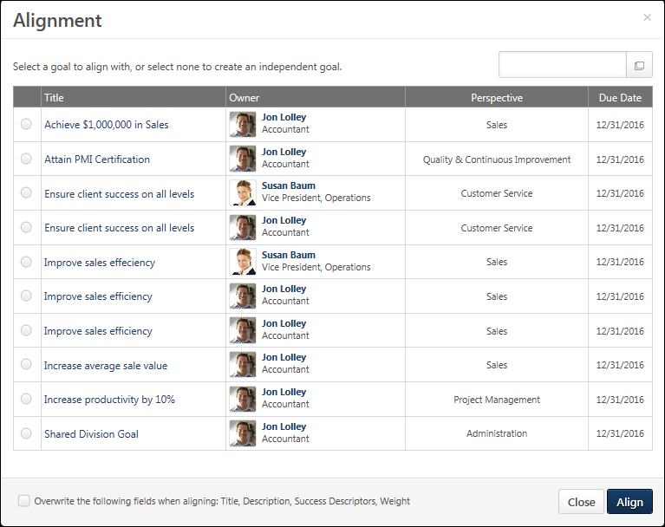

Align a Goal
The Align pop-up displays all goals with which you are allowed to align your goal. Managers must make their goals visible in order for their direct reports to be able to align with them. If they are not made visible, they are not available to be selected.
To align your goal with one of the available goals:
- Click the radio button to the left of the appropriate goal.
- Click the Align button. The alignment is not saved until the goal is saved or submitted.
Note: If Alignment is configured by the administrator to be read-only, then the goal's alignment cannot be modified when creating, copying, or advancing the goal. Alignment can be set as read-only for goals that are uploaded to the system via a data feed and non-shared goals that are assigned to a user.
Alignment and Goal Progress
If you want a goal to contribute to the progress of the goal to which it is aligned, two things must be set:
- The goals must be aligned.
- The aligned goals must have targets, and you must select the option to aggregate progress for the target when the target is created. This is done by selecting the Include Results option when creating the target. See Goals - Create/Edit - Add Task or Target on page 56 for additional information.
Aligning goal target progress works best with goal targets that are integers or dollars, rather than percentages.
- Example 1 dollars: A senior level manager can set a goal to increase sales by $500,000 and each sales representative reporting to that senior manager has his/her own territory goal as a part of that $500,000. As sales team members update the progress of their individual sales goals, their progress is combined to roll up to the senior manager’s overall goal, accurately reflecting total sales dollars in the combined territories.
- Example 2 percentages: If the senior level manager’s goal is to increase sales by 5% and each sales representative had their own individualized growth percentage (say, 5%). As sales team members update the progress of their individual sales percentages, their percentages are combined (5% + 5% + 5%, etc.) to roll up to the senior manager's goal. This total percentage does not accurately reflect the overall percentage increase in sales.
Search by User
The option to search for goals by user is only available if you have the Create Employee Goals - Align permission. Also, the constraints on this permission determine for which users you can search.
To search for a goal by user, click the Select icon in the Search by User field. This opens the Select a user page. Search for and select the appropriate user to view all of the user's goals which they have allowed other users to view and align. See Select User Pop-up.
When viewing a user's goals, the user's name appears in the Search by User field. If you decide not to align a goal of that user, click the Reset List icon to return to your original view.
View Goal Details
To view goal details, select the radio button to the left of the goal, or click the goal title.
The following information is displayed, if available:
- Goal Description
- Start Date
- Due Date
- Goal Categories
- Status
- Progress
- Tasks and Targets
- Success Descriptors
Edit Alignment - Do not align
When editing the goal alignment, a Do not align option is available. This allows the user to remove the existing alignment and choose to not align with another goal.
Overwrite the following fields when aligning: Title, Description, Success Descriptors, Weight
The Title, Description, Success Descriptors, and Weight of the selected goal will overwrite the information that you entered for your goal once you align with the selected goal. Also, the Start Date, Due Date, and Goal Perspective are overwritten by the information from the selected goal.
- Category - The Category field is appended with categories from the aligned goal.
- Visibility - The Visibility settings are not overwritten by the aligned goal.
- Attachments - The Attachments are not overwritten by the aligned goal.
Align/Close
Click Align to align your goal to the selected goal and return to the Create/Edit Goal page. See Goals - Create/Edit on page 44 for additional information.
Click Close to close the pop-up without modifying the goal alignment and return to the Create/Edit Goal page. See Goals - Create/Edit on page 44 for additional information.

Goals - Create/Edit - Add Task or Target
Tasks and targets enable users to break down the different steps needed to accomplish the goal and to make the goal more clear to the user's performance manager. You can set goal tasks and targets when you create or edit a goal.
Tasks are steps or activities that should be done to achieve the goal, and completing these tasks contributes to the overall goal completion progress. Tasks do not generally involve numbers or percent values. For example, if your goal is to have $1 million in sales, a task may be to hold a seminar to attract new customers.
Targets are quantifiable benchmarks within your goal that are used to keep the goal on track for completion, and completing these targets contributes to the overall goal completion progress. For example, if your goal is to have $1,000,000 in sales, a target may be to achieve $500,000 in sales from new clients. You can then track your progress in that target as you progress. For example, if after a month you have $100,000 in sales from new clients, you can enter your progress and the target will reflect that you are now 20% complete.
- To create a goal, go to Performance > Goals. Then click the Create button.
- To edit a goal, go to Performance > Goals. Click the Actions menu icon to the right of the appropriate goal and select Edit.
- To add a task or target to a goal, click the Add Tasks or Targets button on the Create/Edit Goal page.
Note: If the Task and Target fields are set as Read-Only in the Goal Configuration settings, then tasks and targets cannot be added to a goal when creating, copying, or advancing the goal. The Task and Target fields can be set as Read-Only for goals that are uploaded to the system via a data feed, imported from the Goals Library, and non-shared goals that are assigned to a user.
Permissions
PERMISSION NAME | PERMISSION DESCRIPTION | CATEGORY

Goals - Create | Grants ability for user to create goals for self, direct reports, and indirect reports only. Any constraint on this permission is operating as an "AND" function. This permission can be constrained by Employee Relationship, OU, User's OU, and User Self and Subordinates. This is an end user permission. | Performance

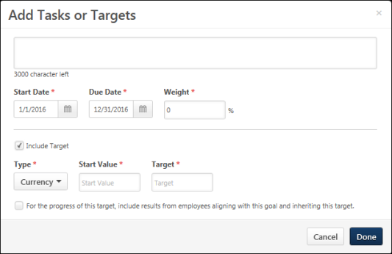 |  | 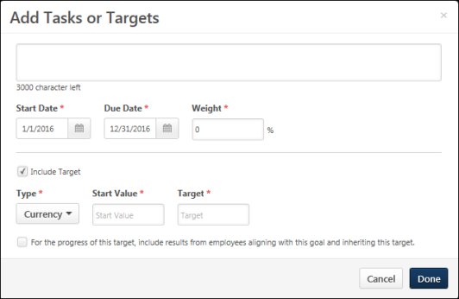

General Details
Enter the following information for the task or target:
- Title - Name of this goal.
- Description - Description for the task or target. This is required, and the character limit is 3,000. An example of a description may be "Hold a seminar to attract new customers." or "Achieve $500,000 in sales from new clients."
- Start Date - The date on which the task or target is started. This is required. The Start Date must be within the dates of the goal, and it must be before the task or target Due Date.
- Due Date - Date by which the task or target should be completed. This is required. The Due Date must be within the dates of the goal, and it must be after the task or target Start Date.
- Weight - Place a greater value towards goal completion on certain tasks or targets. This value must be between 0 and 100, and it is set to 0 by default. The weight of all tasks and targets within a goal must add up to 100%. This is required.
  - This field is only available if the administrator has configured Goal Preferences so that tasks and targets are assigned weights.
  - Depending on a backend setting, the weight percentage field may accept up to two decimal places. Note: This backend setting controls the decimals of precision for Goal Weight, Goal Progress, Task Weight, Task Progress, Target Weight, Target Progress, Performance Review Section Weight, and Performance Review Step Weight.
- Include Target - If the task that you are adding has a numeric target or benchmark that you are hoping to reach in order to accomplish the goal, then select this option to define the details of this target. When this option is selected, the below options are enabled and can be edited.
  - If this option is unchecked, then the item is saved as a task. When editing an existing task, this option is not available.
  - If this option is checked, then the item is saved as a target.
Target Only Details
The following fields only apply to targets, and only enabled if the Include Target option is selected. When editing an existing task, these fields are not available because they only apply to targets.
Enter the following information for the target:
- Type - How your target value is measured. Options are: Currency, Percentage, Integer, Number, Hours, Days, and Years. For example, if the target is a monetary value, the type is Currency. Currency type always allows up to 2 decimal places. Percentage type can be configured to accept up to two decimal places. Integer type does not allow any decimal places. The rest of the Target types (Number, Hours, Days, and Years) accept up to four decimal places. The number of decimal places allowed for these types are configurable per Organizational Unit (OU) through the Rounding Preference setting which is accessible from the Goal Preferences page. For more information about setting the rounding preference, See Goal Preferences - Tasks and Targets on page 20 for additional information.
- Start Value - Progress you already made towards the target. For example, if you are defining a sales target and already made a sale before this goal is created, include that starting value in this field. Depending on the target type, this value may be negative or positive. This is required.
- Target - Value you ultimately need to achieve to complete the target. For example, if your target is to achieve $500,000 in sales, then the target value would be 500,000. This value can be negative or positive. This is required.
- Threshold - Value used to determine whether the target is on track for completion. For example, if your target is to achieve $500,000 in sales, the target value is 500,000. You may set the threshold at 300,000 since you feel that if you reach this threshold value, you are very likely to make the overall target of 500,000. This value must be between the Start Value and the Target. This value can be negative or positive. This is optional.
- Stretch - Record additional progress beyond your target if target and goal progress exceeds 100%. For example, if your target is to achieve $500,000 in sales, the target value is 500,000. You may set the stretch value to 700,000 in the event you are able to exceed your target. As a best practice, this value should be beyond the Target value. This value can be negative or positive. This is optional.
- Align to Targets - Target is aligned with another goal's target and the progress of your target contributes to the parent goal's target. If the goal you are creating is aligned with another goal, this drop-down will be available for you to select a target from the parent goal. This drop-down only contains targets that are available to include results from aligned targets and is not available if the goal you are creating is not aligned with another goal.
- Include Results - Allow other employees to align with your goal and target and include their progress with your progress. For example, if you select this option and one of your subordinates aligns with this goal, when they make progress towards their target, your target will update with that information as well.
Aligning goal target progress works best with goal targets that are integers or dollars, rather than percentages.
- Example 1 dollars: A senior level manager can set a goal to increase sales by $500,000 and each sales representative reporting to that senior manager has his/her own territory goal as a part of that $500,000. As sales team members update the progress of their individual sales goals, their progress is combined to roll up to the senior manager’s overall goal, accurately reflecting total sales dollars in the combined territories.
- Example 2 percentages: If the senior level manager’s goal is to increase sales by 5% and each sales representative had their own individualized growth percentage (say, 5%). As sales team members update the progress of their individual sales percentages, their percentages are combined (5% + 5% + 5%, etc.) to roll up to the senior manager's goal. This total percentage does not accurately reflect the overall percentage increase in sales.
Done/Cancel
- Click Done to save the task or target and return to the Create Goal page. The task or target is added to the Tasks & Targets section. See Goals - Create/Edit on page 44 for additional information.
- Click Cancel to cancel the task or target creation process and return to the Create Goal page. This discards the new task or target. See Goals - Create/Edit on page 44 for additional information.

Goals - Copy
Use the My Goals page and the Advance option to copy the details of an expired goal to a new goal period. The goal progress is reset for the new, advanced goal.
For example, if the expired goal had a start and end date of 01/01/15-12/31/15, once you advance the goal, the new start and end date will be 01/01/16-12/31/16 and the goal progress is set to zero. This action is intended to help save time creating goals for the new goal period if they are similar to the previous period. This option is only available if you have permission to create goals and the goal is expired. This option is not available if goals are locked.
To view the My Goals page, go to Performance > Goals.
Permissions
PERMISSION NAME | PERMISSION DESCRIPTION | CATEGORY

Company Goals - Create | Grants access to create goals that appear to all users as "company goals." This permission cannot be constrained. This is an administrator permission. | Performance - Administration

Snapshot Goals - Manage | Enables user to manage their own goals, and others public goals, using the Goals widget and subpage within the Universal Profile - Snapshot page, for users within their permission constraints. This permission can be constrained by Employee Relationship, OU, User's OU, User Self and Subordinates, User, User's Self, User's Manager, User's Superiors, User's Subordinates, and User's Direct Reports.  Best Practice: For most users, this permission should be constrained by User Self and Subordinates. | Universal Profile

View Goals | Grants ability to view own goals and (depending on role and settings) goals of others (manager's visible goals, direct subordinate's goals, company goals, division goals). This permission can be constrained by Employee Relationship, OU, User's OU, and User Self and Subordinates. This is an end user permission. | Performance
Emails
EMAIL NAME | EMAIL DESCRIPTION | ACTION TYPE

Request Goal Approval | This email is a batch type email that includes a notification for each situation in which a goal owner does the following:  - Creates and submits a goal for themselves when approval is required.  - Edits and resubmits a goal that has already been approved.  - Attempts to cancel a goal that has been approved when approval is required.  This email is triggered when a user clicks the Send Approval Request button on the My Goals or Snapshot Goals page.  The email is sent to the user in the Approver role. If no approver is set or if goal approval is not required, the goal is automatically approved and no email is sent.  The email can contain a link to the Pending Goals page. | Performance Management
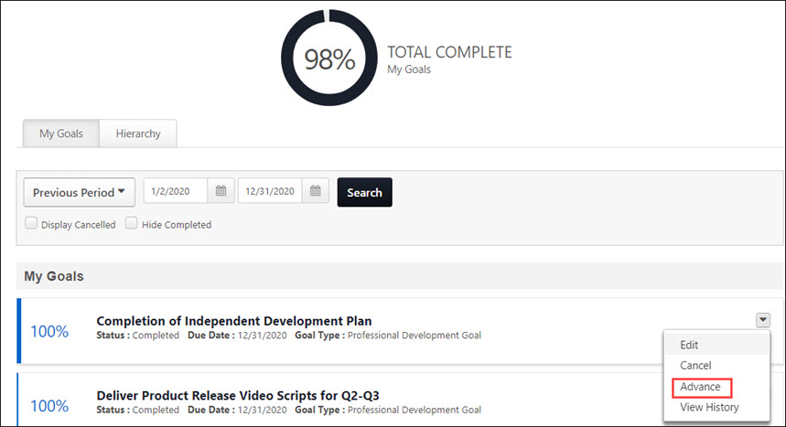
To copy a goal to the next period:
- On your My Goals page, select the My Goals tab.
- In the drop-down, select the period that lists your previous goals. A list of your previous goals appears below.
- Select the goal you want to copy, click the drop-down, and then click Advance. The Create Goals screen opens.
- Complete all required fields. The advanced goal is now part of your goals for the selected period.

Goals Create/Edit - Goal Library
The Goals Library contains a collection of predefined goal templates, which users can use to create a goal for themselves or other employees. Goal templates are created by the system administrator.
When a user selects a goal template from the Goal Library, all of the information in the template is added to the user's goal, where they can modify or remove any of the information. Note: When a goal is imported from the Goal Library, some fields may be locked, and you cannot edit these fields. If this occurs, the field is disabled on the Create/Edit Goal page. The Goals Library is only available if enabled by the administrator.
- To create a goal, go to Performance > Goals. Then click the Create button.
- To view the Goals Library, click the Library button from the Create/Edit Goal page.
Note: Field names may be customizable by the system administrator, so your field names may vary.
Permissions
PERMISSION NAME | PERMISSION DESCRIPTION | CATEGORY

Goals - Create | Grants ability for user to create goals for self, direct reports, and indirect reports only. Any constraint on this permission is operating as an "AND" function. This permission can be constrained by Employee Relationship, OU, User's OU, and User Self and Subordinates. This is an end user permission. | Performance
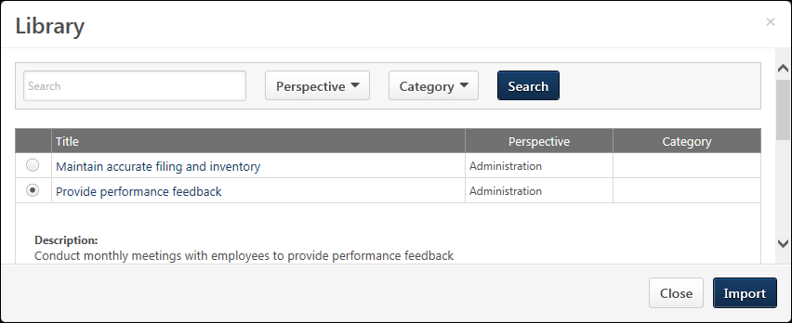
When you open the Library, the existing goal templates display, organized by perspective if perspectives are enabled. The list of available goal templates is constrained by organizational unit (OU).
Search
The following search fields and filters are available:
- Search - Enter terms in the field to search by goal title and description.
- Perspective - The list of available perspectives is constrained by OU. This drop-down is not available if perspectives are not enabled.
- Category - This drop-down is not available if categories are not enabled.
Click the Search button to display only goals that match all of the selected search criteria.
Template Table
- Title - The name of the template. Click the goal title or select the radio button to the left of the appropriate goal to view the goal description, tasks, targets, and weight.
- Perspective - The selected perspective.
- Category - The assigned category.
Import
Click the radio button to the left of the appropriate goal and click Import to create a goal from one of the goals in the Library. The details of the selected goal are copied to your new goal. Any details that had been entered for the new goal before the import action are overwritten by the details of the selected Library goal.
Note: When a goal is imported from the Goal Library, some fields may be locked, and you cannot edit these fields. If this occurs, the field is disabled on the Create/Edit Goal page.
Close
Click the Close button to close the Library pop-up without importing a goal from the Library.

Goals Create/Edit - SMART Wizard
Use the SMART Wizard to create specific, measurable, actionable, relevant, and timely goals. The SMART Wizard contains five sections that cover the different aspects of the goal. The wizard guides you through five goal sections that you must complete in order:
- Specific
- Measurable
- Actionable
- Relevant
- Timely
If any information is entered on the Create Goal page before opening the SMART Wizard, that information is automatically pre-populated in the SMART Wizard.
- To create a goal, go to Performance > Goals. Then click the Create button.
- To create a goal using the SMART Wizard, click the Wizard button in the upper-right corner of the Create Goals page.
Permissions
PERMISSION NAME | PERMISSION DESCRIPTION | CATEGORY

Create Employee Goals - Align | When creating a goal for users other than self or subordinates, this permission allows users to search for goals by user when aligning the goal with another user's goal. Users with this permission can only search for and align their goals with users who are within their permission constraints. If a user does not have this permission, then the Search field is not available within the Alignment pop-up. This permission works in conjunction with the Create Employee Goals permission. This permission can be constrained by OU, User's OU, and User. This is an administrator permission. | Performance - Administration

Goals - Create | Grants ability for user to create goals for self, direct reports, and indirect reports only. Any constraint on this permission is operating as an "AND" function. This permission can be constrained by Employee Relationship, OU, User's OU, and User Self and Subordinates. This is an end user permission. | Performance
Specific
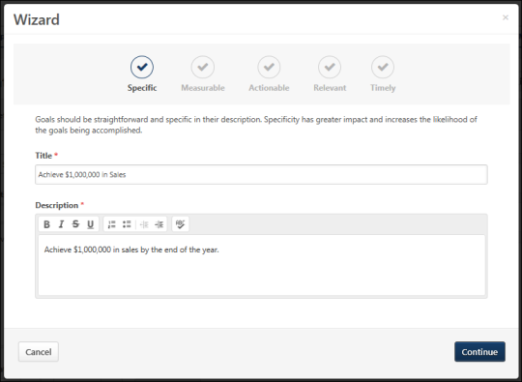
Enter a clear and meaningful title and description for your goal.
- Title - Enter the title for your goal that will appear on the My Goals page as well as anywhere else your goal is visible. This field is limited to 1,000 characters.
- Description - Enter an overview of the goal, including any objectives or parameters. This field can be formatted using the text formatting buttons and is limited to 10,000 characters.
Click Continue to go to the next page.
Measurable
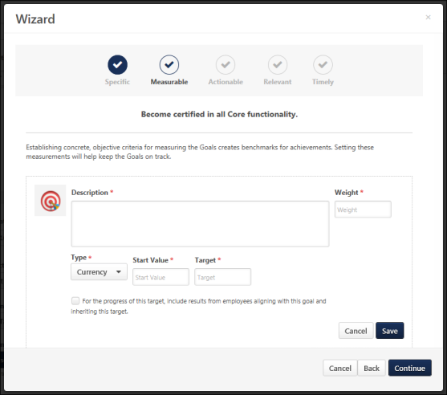
Make your goal measurable by adding quantifiable targets, ensuring your goal remains on track for completion.
- To add a target to the goal, click the Add Targets button. See Goals - Create/Edit - Add Task or Target on page 56 for additional information.
- To edit a target, click the Edit icon to the right of the appropriate target.
- To delete a target, click the Delete icon to the right of the appropriate target.
Note: Total weight is not visible for goals when using the wizard.
Click Continue to go to the next page.
Actionable
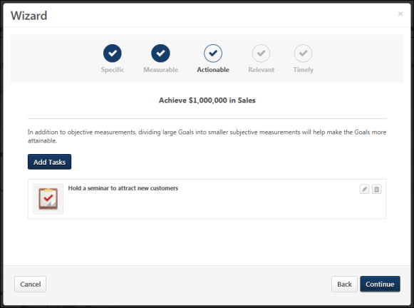
Make your goal actionable by adding tasks, which will help to make sure you are taking the right steps to complete your goal.
- To add a task to the goal, click the Add Tasks button. See Goals - Create/Edit - Add Task or Target on page 56 for additional information.
- To edit a task, click the Edit icon to the right of the appropriate task.
- To delete a task, click the Delete icon to the right of the appropriate task.
Click Continue to go to the next page.
Relevant
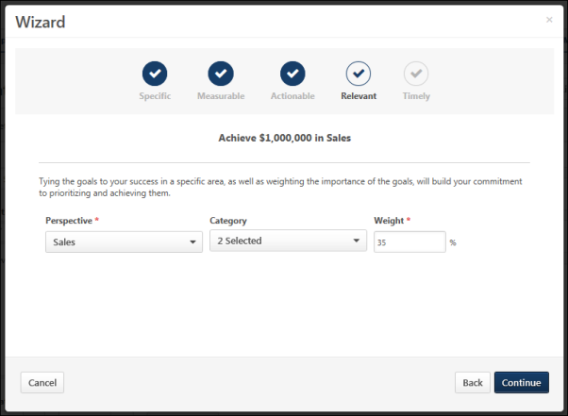
Associate your goal with certain aspects of the company and weigh its importance.
- Perspective - Select a perspective. The perspective is used to specify to which aspect of the organization your goal relates. A goal can only be associated with one perspective. Perspectives are defined by system administrators.
- Category -Select all categories that are appropriate for your goal. Categories are used to further define the type of goal you are creating. A goal can have multiple categories. Categories are defined by system administrators.
- Weight - Enter a weight for your goal between 0 and 100. Weighting allows you to place a greater value on certain goals. For example, if you have four goals for a review period and they are valued equally, you should assign them each a weight of 25%. Similarly, if one goal is more important than the others, you may give that goal a weight of 40% and assign the other three a weight of 20%. The heavier weighted goal will count more towards your overall goal progress than the other three. Depending on a backend setting, the weight percentage field may accept up to two decimal places.
Click Continue to go to the next page.
Timely
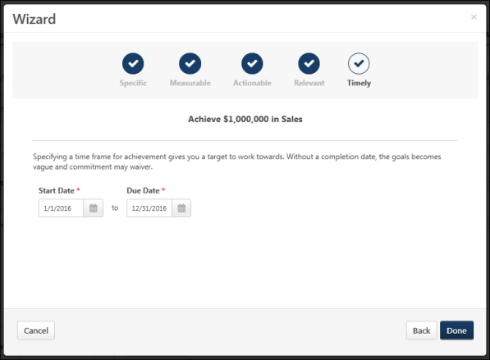
Specify a time frame for achieving your goal.
- Start Date and Due Date - Click the Calendar icon to select the date on which the goal should be started and the date by which the goal should be completed. The Start Date must be before the goal Due Date. If this goal is being aligned to another goal, these dates must be within the Start and Due Date of the parent goal. When you view your goals or run goal related reports, the Start Date and Due Date are used to determine which goals are included. If any part of a goal falls within the specified time frame, the goal will display.
Click Done to finish the Wizard and create the goal. The information you added is now included in the Create/Edit Goal screen. See Goals - Create/Edit on page 44 for additional information.

Goals - Create/Edit - Success Descriptors
Success descriptors allow you to define how you judge success in relation to the goal.
You set success descriptors when creating a goal, or you can add them when editing a goal. See Goals - Create/Edit on page 44 for additional information.
- To create a goal, go to Performance > Goals. Then click the Create button.
- To edit a goal, go to Performance > Goals. Click the Actions menu icon to the right of the appropriate goal and select Edit.
Then, click the Manage button in the Success Descriptors section. The Define Success Descriptors pop-up opens.
Permissions
PERMISSION NAME | PERMISSION DESCRIPTION | CATEGORY

Goals - Create | Grants ability for user to create goals for self, direct reports, and indirect reports only. Any constraint on this permission is operating as an "AND" function. This permission can be constrained by Employee Relationship, OU, User's OU, and User Self and Subordinates. This is an end user permission. | Performance
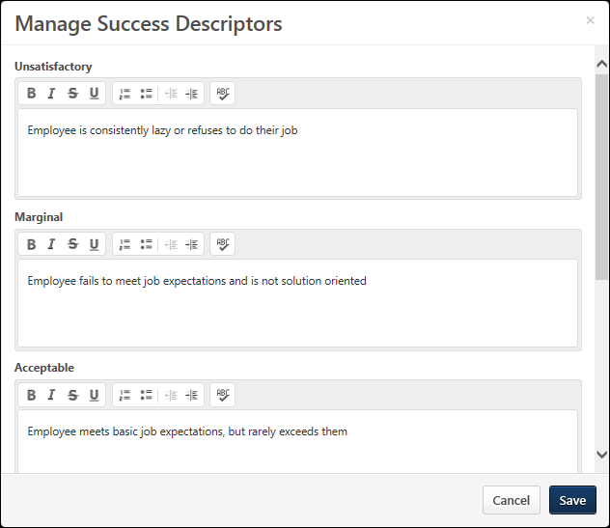

Success Descriptors
If the administrator entered default success descriptor information it is displayed by default. Note: The Success Descriptors label can be customized by the administrator, so the section name may appear differently in your portal.
- Success Descriptor title - The title of the descriptor. You cannot edit success descriptor titles; they are consistent for all users.
- Description - A description of the level of success that corresponds to the success level. The description represents what success means for each success level. You can edit the information in this field. This character limit is 1,000 and this field accepts HTML. See HTML Safe List.
  - If Success Descriptors are required by the administrator, you must enter a description for each goal success title.
  - After the goal is approved, these descriptions are only editable if enabled by the administrator.
- Note: Depending on the system configuration, users may not be able to edit success descriptors after the goal is approved.
Save/Cancel
- Click Save to save the goal's success descriptors and close the pop-up.
- Click Cancel to discard any unsaved changes and close the pop-up.

View Goals - My Goals Overview
The My Goals page contains all of your goals including goals you created and goals that are assigned to you. Shared goals also appear on this page. You can view goal details, edit goals, add attachments and comments and update goal progress.
You can also view goals on the Universal Profile Snapshot Goals page. See See Universal Profile - Snapshot Overview.
Administrator Note: A preference in Corporate Preferences determines whether the goal owner/assignee's Goal Preferences and Goal Configurations are applied in Universal Profile Snapshot, Goals, and Goal Rating steps within performance reviews. Shared goals respect the goal owner's preferences and configurations.
To view the My Goals page, go to Performance > Goals.
Note: Field names are customizable by the system administrator, so your field names may vary.
Permissions
PERMISSION NAME | PERMISSION DESCRIPTION | CATEGORY

Company Goals - Create | Grants access to create goals that appear to all users as "company goals." This permission cannot be constrained. This is an administrator permission. | Performance - Administration

View Goals | Grants ability to view own goals and (depending on role and settings) goals of others (manager's visible goals, direct subordinate's goals, company goals, division goals). This permission can be constrained by Employee Relationship, OU, User's OU, and User Self and Subordinates. This is an end user permission. | Performance
Emails
EMAIL NAME | EMAIL DESCRIPTION | ACTION TYPE

Request Goal Approval | This email is a batch type email that includes a notification for each situation in which a goal owner does the following:  - Creates and submits a goal for themselves when approval is required.  - Edits and resubmits a goal that has already been approved.  - Attempts to cancel a goal that has been approved when approval is required.  This email is triggered when a user clicks the Send Approval Request button on the My Goals or Snapshot Goals page.  The email is sent to the user in the Approver role. If no approver is set or if goal approval is not required, the goal is automatically approved and no email is sent.  The email can contain a link to the Pending Goals page. | Performance Management
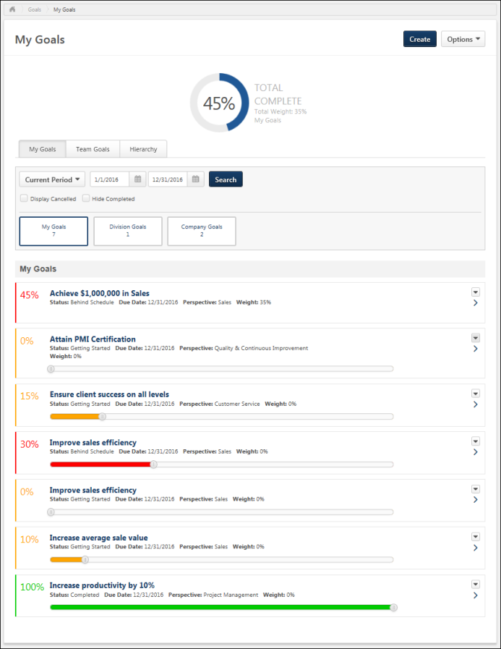
Create Goal
Click the Create button. This option is only available if you have permission to create a goal. See Goals - Create/Edit on page 44 for additional information.
Options
The following options are available in the Options drop-down menu:
- Download PDF - My Goals - Select this option to export your goals to a PDF document. This option is only available if you have available goals.
- Download PDF - Division Goals - Select this option to export all visible division goals to a PDF document. This option is only available if you have available division goals.
Overall Goal Progress and Weight
The user's overall goal progress is displayed at the top of the page. This represents the user's total progress for all goals that are within the selected date range. The overall goal progress accounts for goal weights.
The Total Weight represents the cumulative weight of all goals that are within the selected date range. Note: Shared goals appearing in My Goals are factored into the calculation of Total Weight for an individual’s goals. Shared Company and Division goals are not factored into Total Weight.
The user's overall goal progress is always displayed based on the selected date range, even if the My Goals tab is not selected.
Goals in Draft, Deleted, or Cancelled status are not included in goal progress and total weight.
Note: The Total Complete section is only displayed when Goal Progress is enabled by administrators. Total Weight is only displayed when Goal Weight is enabled by administrators.
If Goal Progress is disabled, but Goal Weight is enabled, then the Goal Weight is displayed without the progress gauge.
Search and Filter Goals
Use the search filters to determine which goals are displayed.
Select a specific time period, then, click the Search button to update the display. All goals within the selected time frame display. The following date filters are available:
- Goal Period - From the drop-down menu, select a defined date range.
- Date Range - Using the Calendar tools, select a specific start date and end date.
- Display Cancelled - Display goals that are cancelled. By default, cancelled goals are not displayed.
- Hide Completed - Hide goals that are completed. By default, all active goals are displayed, including Completed goals. You can hide Completed goals so that the page only displays goals that are still in progress. This allows you to view goal progress that is not completed.
My Goals/Manager's Goals/Division Goals/Company Goals
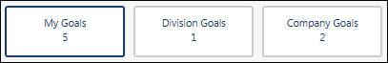
The options at the top of the page determine which goals are displayed on the page. The options display the number of goals that are available in each section. To hide a type of goal, unselect the appropriate option.
Note: If there are no manager, division, or company goals available, then the My Goals option is hidden.
The following options may be available:
- My Goals - This option is selected by default when the My Goals page is opened. When this button is selected, the My Goals section appears on the page, which displays all of your goals that fall within the defined goal period. Goals created in the goal planning section of a Performance Review Task also appear here.
- Manager's Goals - Select this option to view any visible goals that have been set for your manager. This adds the Manager's Goals section to the page which displays your manager's goals that are visible and that fall within the defined goal period. You can view the overall progress and details of each goal. If your manager does not have any goals that are visible within the specified time frame, then this option is not available.
- Division Goals - Select this option to view any goals that have been set for your division. This adds the Division Goals section to the page which displays division goals that fall within the defined goal period. You can view the overall progress and details of each division goal. If the division does not have any goals within the specified time frame, then this option is not available.
- Company Goals - Select this option to view any goals that have been set for your organization. This adds the Company Goals section to the page which displays company goals that fall within the defined goal period. You can view the overall progress and details of each company goal. If the company does not have any goals within the specified time frame, then this option is not available.
Send Approval Request
The Send Approval Request button is available in the upper-right corner of the page if you have goals that are pending approval. Click this button to send an email to your goal approver if the Request Goal Approval email is enabled. Once the request is sent, the button text is updated to "Request Sent" until the page is refreshed.
If goal approval is not required or if a goal approver is not set, then goals are automatically approved when they are created, edited, or cancelled.
My Goals Summary Table
To view the full details for a goal, click the goal title or the right arrow to the right of the goal.
To hide a goal's details, either click the goal title or the down arrow .
Goals are listed in alphabetical order by title. The following information may be displayed for each goal:
- Progress - Goal progress as a percentage. The color of the progress bar is determined by the goal status. Users may have the option to update goal progress using a progress slider. The goal progress is automatically saved as the progress slider is moved. The goal progress slider is only available if the following is true:
  - Administrators have enabled goal progress. If goal progress is not displayed, then users are not able to update goal progress.
  - Administrators prevented goal progress from exceeding 100%. If goal progress is allowed to exceed 100%, then goal progress is updated via a Progress field above the Description field.
  - The goal does not contain tasks or targets. If the goal contains tasks or targets, then goal progress is updated by updating the progress of the task or target.
  - The goal is not in Draft status.
- Title - Name of the goal. If the goal is a shared goal, an asterisk appears before the title.
- Status - Overall standing of the goal. This can be determined by goal, task, and target progress and can also factor in the amount of time remaining for completion. The status is also reflected in the progress color. For example, if a user has satisfied a goal, the status is Completed and the progress bar may be blue. The names, colors, and the criteria for each status can be modified by the system administrator.
- Target Date - Date the goal is due.
- Perspective - Which aspect of the company the goal relates.
- Weight - Prioritizes goals and places additional value on certain goals.
- Aligned To - Owner of the goal to which the direct report's goal is aligned. Only displays if the goal is aligned to another goal.
- Owner - For shared goals, this displays the name of the goal owner.
Goals created in the Goal Planning section of a performance review are visible in read-only status.

Note: Perspective, Weight, Status, and Progress are enabled by the system administrator. If disabled, these fields will not appear. For all fields except Weight, the field name is configurable by the administrator. As a result, fields may be named differently in your portal.
Manage Goal
To update goal progress, add comments or attachments, or view goal details, click the goal title or click the right arrow to the right of the goal. A details drop-down opens. See Goals - Manage - Overview on page 97 for additional information.
You are only able to manage goals that you own, including division and company goals. Clicking the title of a shared goal opens a read-only version of the goal. Note: Only users with permission to create company goals can update the progress of a company goal and add attachments to a company goal.
Goal Options
Select an option from the Options drop-down menu to the right of the goal summary:
- Edit -Edit the goal. This option is only available if enabled by the system administrator and the goal is not locked. See Goals - Create/Edit on page 44 for additional information.
- Copy - Copy the goal. All of the goal details are copied to the new goal except for the Assignment, Alignment, Attachments, and Comments. Also, the Start Date and End Date are set to the default values. This option is only available if you have permission to create goals and the goal is not expired. Also, this option is not available if the goal is locked. See Goals - Create/Edit on page 44 for additional information.
- Cancel - Cancel the goal. A confirmation pop-up opens to confirm the cancellation. This option is only available for unlocked, non-draft goals.
  - If cancellation approval is not required, the goal's status becomes Canceled.
  - If cancellation approval is required, the goal's status becomes Pending Cancellation Approval, and the Request Goal Approval email is triggered if it is enabled.
- Delete - Delete the goal. This option is only available for unlocked goals in Draft status.
- Advance - Copy the details of an expired goal and set the Start Date and End Date to the next goal period. The goal progress is reset for the new goal. For example, if the expired goal has a start and end date of 01/01/15-12/31/15, once you advance the goal, the new start and end date is 01/01/16-12/31/16 and the goal progress is set to zero. This saves time creating goals for the new goal period if they are similar to the previous period. This option is only available if you have permission to create goals and the goal is expired. This option is not available if goals are locked at the Corp level.To lock goals, go to Admin > Tools > Core Functions > Core Preferences > Corporate Preferences and go to the Goals General Settings section.
- Align - Create a new goal that is aligned with the selected goal. All of the goal information copied into your goal. Only available if alignment is enabled, available for alignment, and unlocked. Tasks and targets may be copied to your goal depending on the preferences set by your system administrator. You can edit the alignment of the goal before saving the goal. See Goals - Create/Edit on page 44 for additional information.
- View History - View the history of the goal. The name of the user who updated the goal is included with the type of update and the date and time of the update. Also shows the modification history for goals created in a goal planning task. See View Goals - History on page 103 for additional information.
Note: For a company goal, the Edit, Cancel, and Delete options are only available if the user has permission to create company goals. For a shared goal, the Edit, Cancel, and Delete options are only available to the goal manager.
Note: When a Performance Review Task containing a goal planning step expires, the goals created via the Review task are moved to Draft status and the Performance Review Task Expiration-Goal Moved to Draft Status email is triggered. You can view and manage these goals on the My Goals page.

Goals - Copy
Use the My Goals page and the Advance option to copy the details of an expired goal to a new goal period. The goal progress is reset for the new, advanced goal.
For example, if the expired goal had a start and end date of 01/01/15-12/31/15, once you advance the goal, the new start and end date will be 01/01/16-12/31/16 and the goal progress is set to zero. This action is intended to help save time creating goals for the new goal period if they are similar to the previous period. This option is only available if you have permission to create goals and the goal is expired. This option is not available if goals are locked.
To view the My Goals page, go to Performance > Goals.
Permissions
PERMISSION NAME | PERMISSION DESCRIPTION | CATEGORY

Company Goals - Create | Grants access to create goals that appear to all users as "company goals." This permission cannot be constrained. This is an administrator permission. | Performance - Administration

Snapshot Goals - Manage | Enables user to manage their own goals, and others public goals, using the Goals widget and subpage within the Universal Profile - Snapshot page, for users within their permission constraints. This permission can be constrained by Employee Relationship, OU, User's OU, User Self and Subordinates, User, User's Self, User's Manager, User's Superiors, User's Subordinates, and User's Direct Reports.  Best Practice: For most users, this permission should be constrained by User Self and Subordinates. | Universal Profile

View Goals | Grants ability to view own goals and (depending on role and settings) goals of others (manager's visible goals, direct subordinate's goals, company goals, division goals). This permission can be constrained by Employee Relationship, OU, User's OU, and User Self and Subordinates. This is an end user permission. | Performance
Emails
EMAIL NAME | EMAIL DESCRIPTION | ACTION TYPE

Request Goal Approval | This email is a batch type email that includes a notification for each situation in which a goal owner does the following:  - Creates and submits a goal for themselves when approval is required.  - Edits and resubmits a goal that has already been approved.  - Attempts to cancel a goal that has been approved when approval is required.  This email is triggered when a user clicks the Send Approval Request button on the My Goals or Snapshot Goals page.  The email is sent to the user in the Approver role. If no approver is set or if goal approval is not required, the goal is automatically approved and no email is sent.  The email can contain a link to the Pending Goals page. | Performance Management
To copy a goal to the next period:
- On your My Goals page, select the My Goals tab.
- In the drop-down, select the period that lists your previous goals. A list of your previous goals appears below.
- Select the goal you want to copy, click the drop-down, and then click Advance. The Create Goals screen opens.
- Complete all required fields. The advanced goal is now part of your goals for the selected period.

View Goals - My Goals Overview
The My Goals page contains all of your goals including goals you created and goals that are assigned to you. Shared goals also appear on this page. You can view goal details, edit goals, add attachments and comments and update goal progress.
You can also view goals on the Universal Profile Snapshot Goals page. See See Universal Profile - Snapshot Overview.
Administrator Note: A preference in Corporate Preferences determines whether the goal owner/assignee's Goal Preferences and Goal Configurations are applied in Universal Profile Snapshot, Goals, and Goal Rating steps within performance reviews. Shared goals respect the goal owner's preferences and configurations.
To view the My Goals page, go to Performance > Goals.
Note: Field names are customizable by the system administrator, so your field names may vary.
Permissions
PERMISSION NAME | PERMISSION DESCRIPTION | CATEGORY

Company Goals - Create | Grants access to create goals that appear to all users as "company goals." This permission cannot be constrained. This is an administrator permission. | Performance - Administration

View Goals | Grants ability to view own goals and (depending on role and settings) goals of others (manager's visible goals, direct subordinate's goals, company goals, division goals). This permission can be constrained by Employee Relationship, OU, User's OU, and User Self and Subordinates. This is an end user permission. | Performance
Emails
EMAIL NAME | EMAIL DESCRIPTION | ACTION TYPE

Request Goal Approval | This email is a batch type email that includes a notification for each situation in which a goal owner does the following:  - Creates and submits a goal for themselves when approval is required.  - Edits and resubmits a goal that has already been approved.  - Attempts to cancel a goal that has been approved when approval is required.  This email is triggered when a user clicks the Send Approval Request button on the My Goals or Snapshot Goals page.  The email is sent to the user in the Approver role. If no approver is set or if goal approval is not required, the goal is automatically approved and no email is sent.  The email can contain a link to the Pending Goals page. | Performance Management
Create Goal
Click the Create button. This option is only available if you have permission to create a goal. See Goals - Create/Edit on page 44 for additional information.
Options
The following options are available in the Options drop-down menu:
- Download PDF - My Goals - Select this option to export your goals to a PDF document. This option is only available if you have available goals.
- Download PDF - Division Goals - Select this option to export all visible division goals to a PDF document. This option is only available if you have available division goals.
Overall Goal Progress and Weight
The user's overall goal progress is displayed at the top of the page. This represents the user's total progress for all goals that are within the selected date range. The overall goal progress accounts for goal weights.
The Total Weight represents the cumulative weight of all goals that are within the selected date range. Note: Shared goals appearing in My Goals are factored into the calculation of Total Weight for an individual’s goals. Shared Company and Division goals are not factored into Total Weight.
The user's overall goal progress is always displayed based on the selected date range, even if the My Goals tab is not selected.
Goals in Draft, Deleted, or Cancelled status are not included in goal progress and total weight.
Note: The Total Complete section is only displayed when Goal Progress is enabled by administrators. Total Weight is only displayed when Goal Weight is enabled by administrators.
If Goal Progress is disabled, but Goal Weight is enabled, then the Goal Weight is displayed without the progress gauge.
Search and Filter Goals
Use the search filters to determine which goals are displayed.
Select a specific time period, then, click the Search button to update the display. All goals within the selected time frame display. The following date filters are available:
- Goal Period - From the drop-down menu, select a defined date range.
- Date Range - Using the Calendar tools, select a specific start date and end date.
- Display Cancelled - Display goals that are cancelled. By default, cancelled goals are not displayed.
- Hide Completed - Hide goals that are completed. By default, all active goals are displayed, including Completed goals. You can hide Completed goals so that the page only displays goals that are still in progress. This allows you to view goal progress that is not completed.
My Goals/Manager's Goals/Division Goals/Company Goals
The options at the top of the page determine which goals are displayed on the page. The options display the number of goals that are available in each section. To hide a type of goal, unselect the appropriate option.
Note: If there are no manager, division, or company goals available, then the My Goals option is hidden.
The following options may be available:
- My Goals - This option is selected by default when the My Goals page is opened. When this button is selected, the My Goals section appears on the page, which displays all of your goals that fall within the defined goal period. Goals created in the goal planning section of a Performance Review Task also appear here.
- Manager's Goals - Select this option to view any visible goals that have been set for your manager. This adds the Manager's Goals section to the page which displays your manager's goals that are visible and that fall within the defined goal period. You can view the overall progress and details of each goal. If your manager does not have any goals that are visible within the specified time frame, then this option is not available.
- Division Goals - Select this option to view any goals that have been set for your division. This adds the Division Goals section to the page which displays division goals that fall within the defined goal period. You can view the overall progress and details of each division goal. If the division does not have any goals within the specified time frame, then this option is not available.
- Company Goals - Select this option to view any goals that have been set for your organization. This adds the Company Goals section to the page which displays company goals that fall within the defined goal period. You can view the overall progress and details of each company goal. If the company does not have any goals within the specified time frame, then this option is not available.
Send Approval Request
The Send Approval Request button is available in the upper-right corner of the page if you have goals that are pending approval. Click this button to send an email to your goal approver if the Request Goal Approval email is enabled. Once the request is sent, the button text is updated to "Request Sent" until the page is refreshed.
If goal approval is not required or if a goal approver is not set, then goals are automatically approved when they are created, edited, or cancelled.
My Goals Summary Table
To view the full details for a goal, click the goal title or the right arrow to the right of the goal.
To hide a goal's details, either click the goal title or the down arrow .
Goals are listed in alphabetical order by title. The following information may be displayed for each goal:
- Progress - Goal progress as a percentage. The color of the progress bar is determined by the goal status. Users may have the option to update goal progress using a progress slider. The goal progress is automatically saved as the progress slider is moved. The goal progress slider is only available if the following is true:
  - Administrators have enabled goal progress. If goal progress is not displayed, then users are not able to update goal progress.
  - Administrators prevented goal progress from exceeding 100%. If goal progress is allowed to exceed 100%, then goal progress is updated via a Progress field above the Description field.
  - The goal does not contain tasks or targets. If the goal contains tasks or targets, then goal progress is updated by updating the progress of the task or target.
  - The goal is not in Draft status.
- Title - Name of the goal. If the goal is a shared goal, an asterisk appears before the title.
- Status - Overall standing of the goal. This can be determined by goal, task, and target progress and can also factor in the amount of time remaining for completion. The status is also reflected in the progress color. For example, if a user has satisfied a goal, the status is Completed and the progress bar may be blue. The names, colors, and the criteria for each status can be modified by the system administrator.
- Target Date - Date the goal is due.
- Perspective - Which aspect of the company the goal relates.
- Weight - Prioritizes goals and places additional value on certain goals.
- Aligned To - Owner of the goal to which the direct report's goal is aligned. Only displays if the goal is aligned to another goal.
- Owner - For shared goals, this displays the name of the goal owner.
Goals created in the Goal Planning section of a performance review are visible in read-only status.

Note: Perspective, Weight, Status, and Progress are enabled by the system administrator. If disabled, these fields will not appear. For all fields except Weight, the field name is configurable by the administrator. As a result, fields may be named differently in your portal.
Manage Goal
To update goal progress, add comments or attachments, or view goal details, click the goal title or click the right arrow to the right of the goal. A details drop-down opens. See Goals - Manage - Overview on page 97 for additional information.
You are only able to manage goals that you own, including division and company goals. Clicking the title of a shared goal opens a read-only version of the goal. Note: Only users with permission to create company goals can update the progress of a company goal and add attachments to a company goal.
Goal Options
Select an option from the Options drop-down menu to the right of the goal summary:
- Edit -Edit the goal. This option is only available if enabled by the system administrator and the goal is not locked. See Goals - Create/Edit on page 44 for additional information.
- Copy - Copy the goal. All of the goal details are copied to the new goal except for the Assignment, Alignment, Attachments, and Comments. Also, the Start Date and End Date are set to the default values. This option is only available if you have permission to create goals and the goal is not expired. Also, this option is not available if the goal is locked. See Goals - Create/Edit on page 44 for additional information.
- Cancel - Cancel the goal. A confirmation pop-up opens to confirm the cancellation. This option is only available for unlocked, non-draft goals.
  - If cancellation approval is not required, the goal's status becomes Canceled.
  - If cancellation approval is required, the goal's status becomes Pending Cancellation Approval, and the Request Goal Approval email is triggered if it is enabled.
- Delete - Delete the goal. This option is only available for unlocked goals in Draft status.
- Advance - Copy the details of an expired goal and set the Start Date and End Date to the next goal period. The goal progress is reset for the new goal. For example, if the expired goal has a start and end date of 01/01/15-12/31/15, once you advance the goal, the new start and end date is 01/01/16-12/31/16 and the goal progress is set to zero. This saves time creating goals for the new goal period if they are similar to the previous period. This option is only available if you have permission to create goals and the goal is expired. This option is not available if goals are locked at the Corp level.To lock goals, go to Admin > Tools > Core Functions > Core Preferences > Corporate Preferences and go to the Goals General Settings section.
- Align - Create a new goal that is aligned with the selected goal. All of the goal information copied into your goal. Only available if alignment is enabled, available for alignment, and unlocked. Tasks and targets may be copied to your goal depending on the preferences set by your system administrator. You can edit the alignment of the goal before saving the goal. See Goals - Create/Edit on page 44 for additional information.
- View History - View the history of the goal. The name of the user who updated the goal is included with the type of update and the date and time of the update. Also shows the modification history for goals created in a goal planning task. See View Goals - History on page 103 for additional information.
Note: For a company goal, the Edit, Cancel, and Delete options are only available if the user has permission to create company goals. For a shared goal, the Edit, Cancel, and Delete options are only available to the goal manager.
Note: When a Performance Review Task containing a goal planning step expires, the goals created via the Review task are moved to Draft status and the Performance Review Task Expiration-Goal Moved to Draft Status email is triggered. You can view and manage these goals on the My Goals page.

View Goals - Team Goals
Use the Team Goals page to view a manager's direct reports, their overall goal progress, and their goal details. Based on the system configuration, managers can perform actions on their direct reports' goals, such as editing goals and updating goal progress.
Administrator Note: A preference in Corporate Preferences determines whether the goal owner/assignee's Goal Preferences and Goal Configurations are applied in Universal Profile Snapshot, Goals, and Goal Rating steps within performance reviews. Shared goals respect the goal owner's preferences and configurations.
To access the Team Goals page, go to Performance > Goals. Then, click the Team Goals tab. If you have no direct reports or if you do not have permission to view your direct reports' goals, the Team Goals page is not available.
Permissions
PERMISSION NAME | PERMISSION DESCRIPTION | CATEGORY

Goals - Create | Grants ability for user to create goals for self, direct reports, and indirect reports only. Any constraint on this permission is operating as an "AND" function. This permission can be constrained by Employee Relationship, OU, User's OU, and User Self and Subordinates. This is an end user permission. | Performance

View Goals | Grants ability to view own goals and (depending on role and settings) goals of others (manager's visible goals, direct subordinate's goals, company goals, division goals). This permission can be constrained by Employee Relationship, OU, User's OU, and User Self and Subordinates. This is an end user permission. | Performance
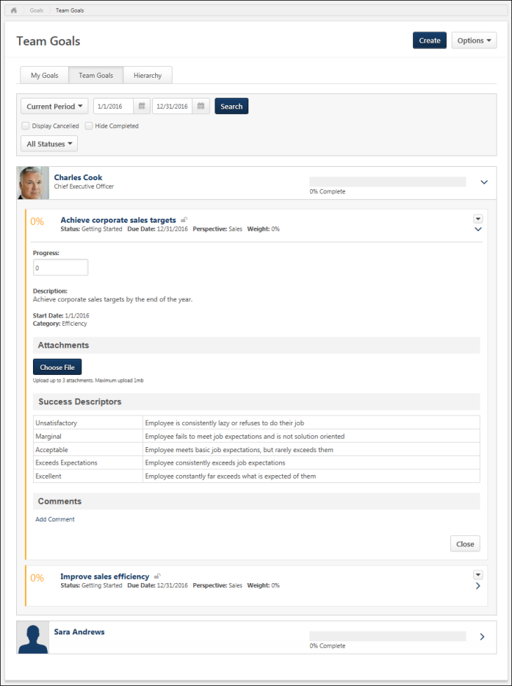
Create Goal
Click the Create button. This option is only available if you have permission to create a goal. See Goals - Create/Edit on page 44 for additional information.
Options
The following options are available in the Options drop-down menu:
- Download Excel - Export all of the team goals for the selected time period to an Excel document. This option exports the goals within the selected time period for all team members, even if the user's card is not expanded.
- Download PDF - Export the Team Goals page to a PDF document. This option only exports the goals that are currently displayed. If you have not expanded any direct reports to view their goals, then this option is not available because no goals are currently displayed. Similarly, if you expand one direct report, then only the goals of that direct report are included in the PDF.
Search and Filter Goals
Use the search filters to determine which goals are displayed.
Select a specific time period, then, click the Search button to update the display. All goals within the selected time frame display. The following date filters are available:
- Goal Period - From the drop-down menu, select a defined date range.
- Date Range - Using the Calendar tools, select a specific start date and end date.
Use the status filters to determine which goals are displayed. The following status filters are available:
- Display Cancelled - Display goals that are cancelled. By default, cancelled goals are not displayed.Note: Cancelled goals do not count towards the user's overall completion percentage.
- Hide Completed - Hide goals that are completed. By default, all active goals are displayed, including Completed goals. You can hide Completed goals so that the page only displays goals that are still in progress. This allows you to view goal progress that is not completed.Note: If all of a user's goals are Completed, then the user is not displayed when this option is selected.
- Status - Display goals in a specific status. By default, goals in all active statuse are displayed. This allows you to view goals with a specific completion status, such as Behind Schedule.
Goal Summary
Each employee is displayed with their overall goal progress. Click the user's name to view their Universal Profile - Bio. See Universal Profile - Bio Overview.
- To view a user's goals, click the Right arrow to the right of the user's overall goal progress. Goals in DRAFT status are not displayed.
- To hide a goal's hierarchy, either click the goal title or the Down arrow .
Users are listed in alphabetical order by first name, then last name. The following information may be displayed for each goal:
- Progress - Goal progress as a percentage. The color of the progress bar is determined by the goal status. Users may have the option to update goal progress using a progress slider. The goal progress is automatically saved as the progress slider is moved. The goal progress slider is only available if the following is true:
  - Administrators have enabled goal progress. If goal progress is not displayed, then users are not able to update goal progress.
  - Administrators prevented goal progress from exceeding 100%. If goal progress is allowed to exceed 100%, then goal progress is updated via a Progress field above the Description field.
  - The goal does not contain tasks or targets. If the goal contains tasks or targets, then goal progress is updated by updating the progress of the task or target.
  - The goal is not in Draft status.
- Title - Name of the goal. If the goal is a shared goal, an asterisk appears before the title.
- Status - Overall standing of the goal. This can be determined by goal, task, and target progress and can also factor in the amount of time remaining for completion. The status is also reflected in the progress color. For example, if a user has satisfied a goal, the status is Completed and the progress bar may be blue. The names, colors, and the criteria for each status can be modified by the system administrator.
- Target Date - Date the goal is due.
- Perspective - Which aspect of the company the goal relates.
- Weight - Prioritizes goals and places additional value on certain goals.
- Aligned To - Owner of the goal to which the direct report's goal is aligned. Only displays if the goal is aligned to another goal.
- Owner - For shared goals, this displays the name of the goal owner.
Goals created in the Goal Planning section of a performance review are visible in read-only status.
- Owner - For shared goals, this displays the name of the goal owner.
Note: For all fields except the Weight field, the field name is configurable by the administrator. As a result, fields may be named differently in your portal. Further, some fields can be configured to not display.
Lock Goal Results
Based on the configuration of the portal, a Lock icon may appear to the right of a direct report's goal. Managers can click this icon to lock or unlock the goal. The following statuses are available:
- Locked - The goal is locked. Click this icon to unlock the goal. Users cannot update the goal progress or edit the goal. Managers may lock a goal at the end of the goal period or at the beginning of a review period. This prevents any miscommunication between the manager and employee. Note: This does not prevent users from advancing the goal.
- Unlocked - The goal is unlocked. Click this icon to lock the goal. Users can update the goal progress and edit the goal.
Administrative Note: To disable the Lock Goal Results functionality, contact Global Customer Support.
Manage Goal
To update goal progress, add comments or attachments, or view goal details, click the goal title or click the right arrow to the right of the goal. A details drop-down opens. See Goals - Manage - Overview on page 97 for additional information.
A manager cannot update a team member's goal if the goal is locked or if the goal is a shared goal and the manager is not the goal manager.
Goal Options
Managers may have access to the following options from the Options drop-down menu to the right of the goal:
- Edit - Edit the user's goal. This option is only available if enabled by the system administrator and the goal is not locked. See Goals - Create/Edit on page 44 for additional information.
  - Shared goals cannot be edited by anyone other than the goal owner.
- Approve - Approve a goal. A confirmation pop-up opens to confirm the approval. This option is available if a goal is "Pending Approval".
- Deny - Deny a goal. A confirmation pop-up opens to confirm the denial. This option is available if a goal is "Pending Approval".
- Copy - Copy the user's goal. All of the goal details are copied to the new goal except for the Assignment, Alignment, Attachments, and Comments. Also, the Start Date and End Date are set to the default values. This option is only available if you have permission to create goals and the goal is not expired. Also, this option is not available if goals are locked. See Goals - Create/Edit on page 44 for additional information.
- Cancel - Cancel the user's goal. A confirmation pop-up opens to confirm the cancellation. This option is only available if enabled by the system administrator and if goals are not locked.
  - If cancellation approval is not required, then the goal's status becomes Canceled.
  - If cancellation approval is required, then the goal's status becomes Pending Cancellation Approval, and the Request Goal Approval email is triggered if it is enabled.
  - Shared goals cannot be canceled by anyone other than the goal owner.
- Advance - Copy the details of the goal and set the Start Date and End Date to the next goal period for an expired goal. The goal progress is reset for the new goal. For example, if the expired goal had a start and end date of 01/01/15-12/31/15, once you advance the goal, the new start and end date will be 01/01/16-12/31/16 and the goal progress is set to zero. This action is intended to help save time creating goals for the new goal period if they are similar to the previous period. This option is only available if you have permission to create goals and the goal is expired. Also, this option is not available if goals are locked.
- View History - View the history of the goal. The name of the user who updated the goal is included with the type of update and the date and time of the update. Also shows the modification history for goals created in a goal planning task. See View Goals - History on page 103 for additional information.

View Goals - Hierarchy
Use the Hierarchy page to view a visual representation of the user's goals and where they fit into the overall corporate strategy. For each goal, users can see to which goals it is aligned and all of the other goals that are aligned with it.
Administrator Note: A preference in Corporate Preferences determines whether the goal owner/assignee's Goal Preferences and Goal Configurations are applied in Universal Profile Snapshot, Goals, and Goal Rating steps within performance reviews. Shared goals respect the goal owner's preferences and configurations.
To view the Hierarchy page, go to Performance > Goals. Then, click the Hierarchy tab. This tab is not available if the Hierarchy page is disabled or if alignment is disabled.
Permissions
PERMISSION NAME | PERMISSION DESCRIPTION | CATEGORY

Goals - Create | Grants ability for user to create goals for self, direct reports, and indirect reports only. Any constraint on this permission is operating as an "AND" function. This permission can be constrained by Employee Relationship, OU, User's OU, and User Self and Subordinates. This is an end user permission. | Performance
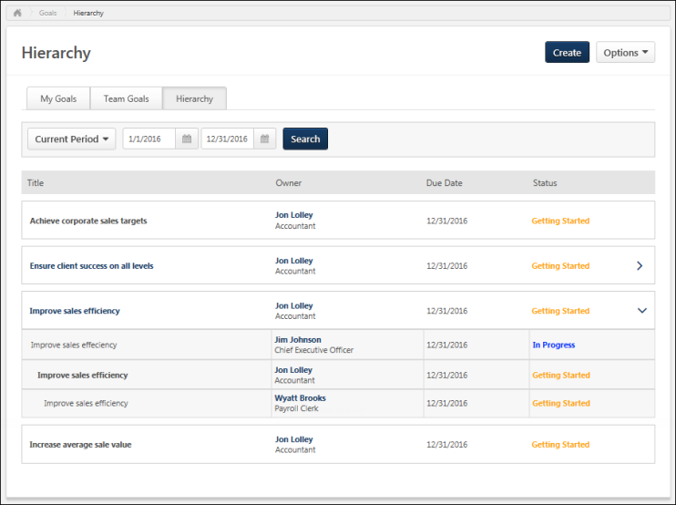
Create Goal
Click the Create button. This option is only available if you have permission to create a goal. See Goals - Create/Edit on page 44 for additional information.
Options
The following option is available in the Options drop-down menu:
Download PDF - Select this option to export your entire goal hierarchy to a PDF document.
Search Goals
Use the search filters to determine which goals are displayed.
Select a specific time period, then, click the Search button to update the display. All goals within the selected time frame display. The following date filters are available:
- Goal Period - From the drop-down menu, select a defined date range.
- Date Range - Using the Calendar tools, select a specific start date and end date.
View Goal Hierarchy
Initially, you will only see your own goals regardless of whether or not they are aligned.
Goals are indented to indicate their level in the goal hierarchy. All goals that appear with the same indentation are at the same level in the hierarchy. In the hierarchy, the goal that appears directly above yours is the goal to which you aligned your goal. Goals that appear below yours are goals that have been aligned to your goal.
The following information is displayed for each goal in the hierarchy:
- Title -The name of the goal. If the goal is aligned with at least one other goal, click the goal title to view the full goal hierarchy. If the goal is not aligned with any other goals, the title is not a hyperlink. The title of your goal is bold so that it is more easily identified.
- Owner - The goal owner. Click the owner's name to view their Universal Profile - Bio. See Universal Profile - Bio Overview.
- Due Date - The date the completed goal is due.
- Status - The goal's current status. The status text is displayed in the color that is associated with the goal status. Goal status can be determined by goal, task, and target progress and can also factor in the amount of time remaining for completion. It is used to indicate the overall standing of the goal. These settings are determined by the preferences set by the system administrator.
- Right Arrow - If your goal is aligned with at least one other goal, click to view full hierarchy of the goal.
- Down Arrow - Click to display or hide the goal hierarchy.

Goals - Manage - Overview
Use the Manage Goal view to view goal details, progress, perspective, alignment, task and target progress, attachments, and comments.
You can manage goal progress, task progress, and target progress. You can also add attachments and comments to the goal. There is no limit to the number of comments that you can add to a goal.
You can manage a goal by clicking the goal title or the Right arrow to the right of the goal on the following pages:
- My Goals
- Team Goals
- Snapshot Goals
Permissions
PERMISSION NAME | PERMISSION DESCRIPTION | CATEGORY

Company Goals - Create | Grants access to create goals that appear to all users as "company goals." This permission cannot be constrained. This is an administrator permission. | Performance - Administration

View Goals | Grants ability to view own goals and (depending on role and settings) goals of others (manager's visible goals, direct subordinate's goals, company goals, division goals). This permission can be constrained by Employee Relationship, OU, User's OU, and User Self and Subordinates. This is an end user permission. | Performance
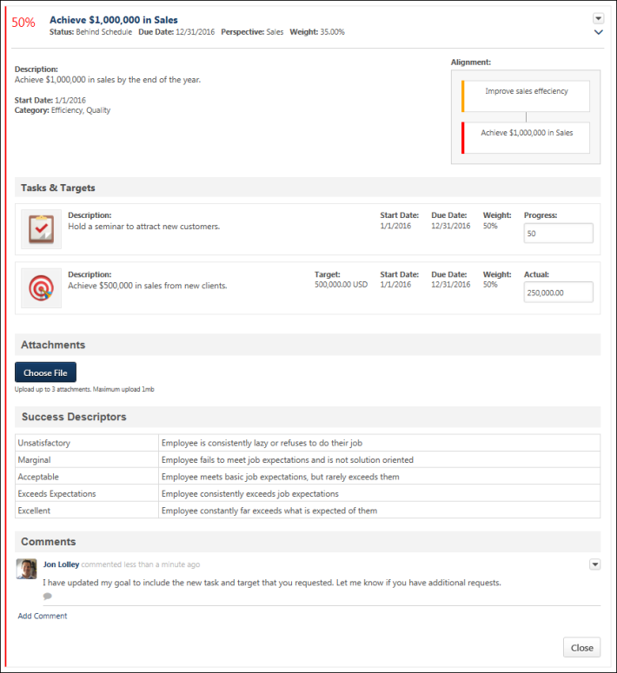
Alignment
If goal alignment is enabled, the Alignment widget is available in the upper-right corner of the page.
Aligning your goal with another goal indicates that your goal directly supports and contributes towards the success of the parent goal. Goal alignment ensures that all employees in a team, division, or company are working to achieve similar goals, and allows employees to see how their efforts contribute to the overall success of the company by creating a hierarchy of goals.
When you align to a goal, tasks and targets may be copied to your goal depending on the preferences set by your system administrator. You can modify these details to be appropriate for each user.
If your goal is aligned with another goal, the Alignment widget displays the alignment hierarchy of the goal. For example, if my goal is aligned to my manager's goal, then my manager's goal is displayed above my goal with a connecting line to my goal.
- The goal's title is displayed, and the color bar on the left of the goal card indicates the goal's status at the time the page is loaded. Users can hover the computer cursor over the goal card to view the goal title and status.
- Up to three goals are displayed in the widget. For example, if my goal is aligned with my manager's goal, and my manager's goal is aligned with my indirect manager's goal, then these three goals are all displayed in the widget.
Goal Summary
The goal summary displays the following:
- Progress - Goal progress as a percentage. The color of the progress bar is determined by the goal status. Users may have the option to update goal progress using a progress slider. The goal progress is automatically saved as the progress slider is moved. The goal progress slider is only available if the following is true:
  - Administrators have enabled goal progress. If goal progress is not displayed, then users are not able to update goal progress.
  - Administrators prevented goal progress from exceeding 100%. If goal progress is allowed to exceed 100%, then goal progress is updated via a Progress field above the Description field.
  - The goal does not contain tasks or targets. If the goal contains tasks or targets, then goal progress is updated by updating the progress of the task or target.
  - The goal is not in Draft status.
- Title - Name of the goal. If the goal is a shared goal, an asterisk appears before the title.
- Status - Overall standing of the goal. This can be determined by goal, task, and target progress and can also factor in the amount of time remaining for completion. The status is also reflected in the progress color. For example, if a user has satisfied a goal, the status is Completed and the progress bar may be blue. The names, colors, and the criteria for each status can be modified by the system administrator.
- Target Date - Date the goal is due.
- Perspective - Which aspect of the company the goal relates.
- Weight - Prioritizes goals and places additional value on certain goals.
- Aligned To - Owner of the goal to which the direct report's goal is aligned. Only displays if the goal is aligned to another goal.
- Owner - For shared goals, this displays the name of the goal owner.
Goals created in the Goal Planning section of a performance review are visible in read-only status.
Goal Progress/Status
Goal progress may be managed as follows:
- Goal Progress Slider - If available, the slider appears in the Goal Summary. See the Goal Summary section for additional information.
- Goal Progress Field - If available, this field appears below the Goal Summary. See below for additional information.
- Status - If available, this field appears below the Goal Summary. See below for additional information.
- Tasks and Targets - If goal progress is updated via task and target progress, then these progress fields are available in the Tasks and Targets section. See the Tasks and Targets section for additional information.
The goal's progress may be displayed below the Goal Summary as a percentage. Users may have the option to update goal progress using this field. Depending on the configuration of the portal, the progress percentage field may accept up to two decimal places. Note: This backend setting controls the decimals of precision for Goal Weight, Goal Progress, Task Weight, Task Progress, Target Weight, Target Progress, Performance Review Section Weight, and Performance Review Step Weight. Goal progress is automatically saved when you move the cursor from the field. The Goal Progress field may be available if the following are true:
- Administrators have enabled goal progress to be displayed. If goal progress is not displayed, then users are not able to update goal progress.
- Administrators have enabled goal progress to exceed 100%.
- The goal contains one or more tasks or targets. If the goal contains tasks or targets, then goal progress is updated by updating the progress of the task or target.
- The goal is not in Draft status.
The Goal Progress field is not available if any of the following are true:
- Administrators have disabled goal progress from being displayed.
- The goal is in Draft status.
The Status drop-down menu is available if Goal Progress is disabled by the administrator (i.e., the Progress field is disabled in Goals Configuration) and a goal has no tasks or targets. Users can select one of the statuses that are configured in Goal Preferences.
Note: Only users with permission to create company goals can update the progress of a company goal and add attachments to a company goal.
Note: If the Progress field is set as Read-Only in the Goal Configuration settings, the overall goal completion progress cannot be updated. The Progress field can be set as Read-Only for goals that are uploaded to the system via a data feed.
Goal Details
The following details are displayed below the goal summary:
- Description - Description of the goal.
- Start Date - The start date for the goal.
- Category - The goal for the category.
Task and Targets
Tasks and targets enable users to break down the different steps needed to accomplish the goal and to make the goal more clear to the user's performance manager.
The following information is displayed for each task and target:
- Description - Description of the task/target.
- Target Threshold - Only be displayed if a target value is defined.
- Target - Only displayed if a target value is defined. If the results of your target contribute to the results of another target, then the overall progress of the aligned target is displayed. This includes the progress that you have contributed, the progress that is inherited, and the overall target.
- Target Stretch - Only displayed if a target value was defined.
- Start Date - The start of the review period.
- Due Date - The date the target/task is due.
- Weight - The weight for this target/task.
For tasks, a Progress field is available. Update your completion progress by modifying this value. Updating task progress increases the overall goal progress as well. Depending on the configuration of the portal, the progress percentage fields may accept up to two decimal places.
For targets, an Actual field is available. Update this value to indicate your progress towards achieving the target. Updating target progress may increase the overall goal progress as well.
When you update the task or target progress, the progress is automatically saved when you move the cursor from the field.
If Weight or Progress is disabled, they will not display.
Note: Only users with permission to create company goals can update the progress of a company goal and add attachments to a company goal.
Note: If the Task and Target field is set as Read-Only in the Goal Configuration settings, Task and Target progress cannot be updated when managing the goal. Task and Target progress can be set as Read-Only for goals that are uploaded to the system via a data feed and non-shared goals that are assigned to a user. Also, Task progress can be set as Read-Only for goals that are imported from the Goal Library.
Attachments
You can attach up to three documents that are relevant to the goal. This enables you to include more details or references that support the goal so that anyone viewing the goal can view the resources if they are evaluating or aligning to the goal.
- The maximum file size is 1 MB.
- Attachments can be avi, bmp, csv, doc, docx, gif, jpg, jpeg, jpe, mov, pdf, png, ppt, pptx, txt, xls, xlsx, and zip.
You can attach a file by dragging and dropping a file into the Attachment area. You can also attach a file by clicking the Choose File button and select a file from your computer. Note: The drag-and-drop functionality is not supported by Internet Explorer browsers.
After the file is attached, the attachment appears in the Attachments section.
An attachment can be removed by clicking the Cancel icon to the right of the attachment name.
Success Descriptors
Success descriptors allow you to define how you judge success in relation to the goal. This section displays the success descriptors that have been defined for the goal. Note: The term "Success Descriptors" can be customized by the administrator, so the section name may appear differently in your portal.
Comments
If the Comments section is enabled, you and your manager can add comments related to all aspects of your goal. For example, you may add a comment to explain your recent efforts toward this goal. You manager can then reply to your comments or they can add an unrelated comment.
Comments are displayed with the user's profile picture and a timestamp. The three most recent comments are displayed by default, including replies to those comments. In order to view any additional comments, click the Show previous link.
Comment Actions
You can add, reply, delete, delete, or edit comments.
- To add a new comment, click the Add Comment link. This adds a field in which you can add your comment. After entering your comment, click Add to add the comment to the goal. There is no limit to the number of comments that can be added to a goal.
- To reply to a comment, click the Reply icon below the comment. This adds a field in which you can add your reply. After entering your reply, click Reply to add the reply to the comment.
- To delete a comment you have added, select Delete from the Options drop-down menu . You can delete any comments that you have added.
- To edit a comment you have added, select Edit from the Options drop-down menu .
Last Saved
When you update the goal, task, or target progress, the progress is automatically saved when you move the cursor from the field. The save time is automatically saved by the system is displayed to the left of the Close button.
Changes to the attachments and comments are saved when the action is performed. These actions do not update the Last Saved time.
Close
To close the expanded goal card, click Close at the bottom of the goal or click the goal title.

View Goals - History
The History pop-up displays the goal history, including Goal:
- Creation, edits, approval/denial
- Progress updates
- Task details updates
- Target details updates
Also displays:
- Criteria used to assign or share goals
- Status changes for goals created via review tasks
- Modification history for goals created in a goal planning task
- When a user is removed or re-added
The addition or removal of any comments or attachments are not included in the History pop-up.
To access this pop-up, click the View History link on the following pages:
- From the Options drop-down menu in the upper-right corner of the Edit Goal page.
- From the Options drop-down menu to the right of the goal on the My Goals page.
- From the Options drop-down menu to the right of the goal on the Team Goals page.
- From the Options drop-down menu to the right of the goal on the Snapshot Goals page.
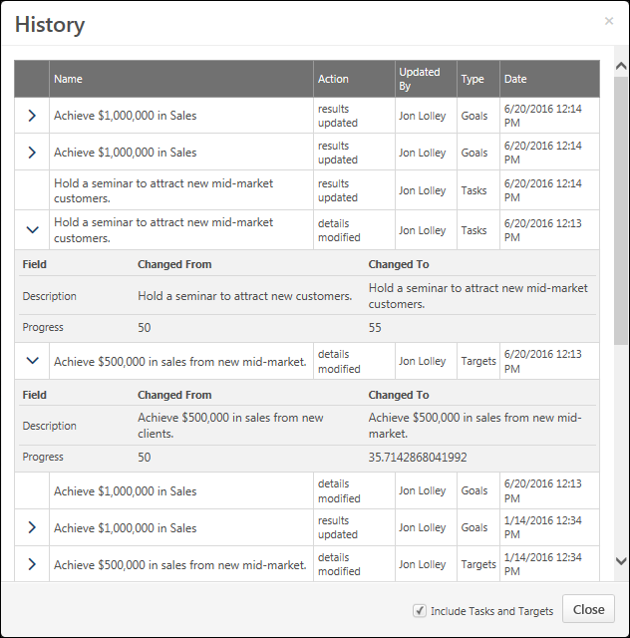
The following information is displayed for each item in the History pop-up:
- Name - The name of the goal, task, or target that is impacted.
- Action - The action taken for the goal, task, or target.
- Updated By - The name of the user who took the action on the goal, task, or target.
- Type - Whether the action was taken on the goal or a task or target within the goal.
- Date - The date and time when the action was completed.
By default, the pop-up only displays edits and updates to the goal. History information related to tasks and targets is not displayed.
Tasks and Targets
Click Include Tasks and Targets to include history information related to tasks and targets. This option name and the availability of the option dependent on the configuration of the goal functionality.
Right Arrow
Click the right arrow to view additional details for the modification. This displays the specific field that was modified, the previous value of the field, and the new value of the field. Note: This is only available for modifications to the goal details. This is not available for progress updates or modifications to tasks and targets.
Close
Click the Close button to close the pop-up .

Manage Shared and Dynamic Goals
The Manage Shared and Dynamic Goals page enables administrators or managers to edit shared and dynamic goals on behalf of the goal owner or goal manager. This page is only available when enabled via Navigation Tabs and Links.
Shared goals allow all assigned users to add comments to the shared goal, even if they are not the goal owner.
Note: It is not possible to remove a user from a shared goal and shared and dynamic goals cannot be copied.
To manage shared and dynamic goals, go to Performance > Manage Shared and Dynamic Goals. The location may vary depending on the settings in Navigation Tabs and Links.
Permission
PERMISSION NAME | PERMISSION DESCRIPTION | CATEGORY

Manage Shared and Dynamic Goals | Grants ability to turn off the dynamic behavior and edit a dynamic goal from the Edit Goals page. The administrator or manager can only view and edit goals created by users that exist within the OU constraints set for this permission. | Performance
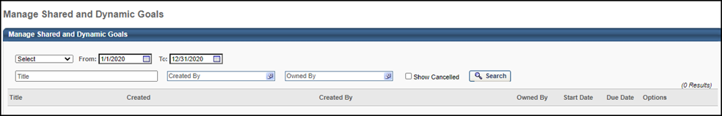
Search
Use the search fields to search for goals by:
- Goal Date Range - Select the date range either using the drop-down or the From and To date selectors. This displays goals that overlap in any way with the selected date range. The From and To date selectors default to the default goal period.
- Title - Enter the goal title. The character limit is 1000. You can search using the full or partial goal title.
- Created By - Search for goals by creator. The Select User pop-up enables users to search by Last Name, First Name, User ID, or Manager's Last Name.
- Owned By -Search for goals by goal owner.
- Show Canceled - Select this option to include canceled goals in the display. This option is deselected by default.
Goals are sorted by goal target date with the soonest target due date appearing first. Only the following types of goals appear on this page:
- Company Goals
- Shared Goals (OU or Team)
- Individual Goals created for an OU or Team that are not dynamic
Note: Individual goals created prior to the Spring 2012 release do not appear on this page, as they cannot be made dynamic retroactively.
Goals Table
The search results appear in the goals table as follows:
- Title - The goal title. For shared goals, click the goal title to open the Manage Goals page for the goal.
- Created - Displays the date on which the goal was created.
- Created By - Displays the name of the user who created the goal.
- Start Date - Displays the start date of the goal.
- Due Date - Displays the current target date/due date for the goal.
- Options - The following items are available as options:
  - Edit - Edit the goal. Only shared goals or dynamic individual goals can be edited.
    - Shared Goals - The user is navigated to the Edit Goals page for the shared goal. The user can perform all actions to the goal that the goal manager or owner can. Changes impact all users that currently share the goal.
    - Dynamic Individual Goals - The user can edit team or OU goals that have been indicated as dynamic. The user is navigated to the Edit page for the corresponding goal. To manage dynamic goals assignment, click edit for a dynamic goal. A table appears that displays two columns - Criteria and Include Subordinates.
  - Cancel - Cancel the goal. Only shared goals can be canceled. This cancels the goal for all users

Goals Report Dashboard
Use the Goal Reports Dashboard to view how your goals and your team's goals are progressing, and where their efforts should be focused. This is done using existing goals reports. The reports that are available are based on permissions and preferences established by the system administrator. Status can be determined by goal, task, and target progress and can also factor in the amount of time remaining for completion.
To access the Goal Reports dashboard, navigate to the Snapshot page within Universal Profile. Then, select the Goals widget to open the Snapshot > Goals page. Then, select the Options drop-down menu and select View Reports.
Dashboard reports must be enabled and you must have the appropriate dashboard report permission to view this option.
Note: On the Goal Configuration page, based on a user's OU,in the Include column, the Status, Targets, and Tasks boxes must be checked. See Goals Configuration Overview on page 27 for additional information.
Permissions
PERMISSION NAME | PERMISSION DESCRIPTION | CATEGORY

Dashboard - View | Grants the ability to view dashboards created by self or shared by others. User must also have permission to view the standard, custom or Reporting 2.0 reports that are included in any shared dashboards. If a user does not have permission to view a report type, the user cannot view that report type within the dashboard. This is an end user permission. | Reports - Dashboards

Goal Status Report | Grants access to the Goal Status Report, which summarizes the status of all goals for specific users during a specified date range. | Reports - Performance

Goal Target Report | Grants access to the Goal Target report, which summarizes all goal targets for specific users during a specific time period, regardless of the goal to which they belong. This report can be run on multiple users, but is always grouped by user. This permission can be constrained by OU, User's OU, User Self and Subordinates, and User. | Reports - Performance

Goal Tasks Summary Report | Grants access to Goal Tasks Summary Report, which summarizes all goal tasks for specific users during a specific time period, regardless of the goal to which each task belongs. This permission can be constrained by OU, User's OU, User Self and Subordinates, and User. | Reports - Performance
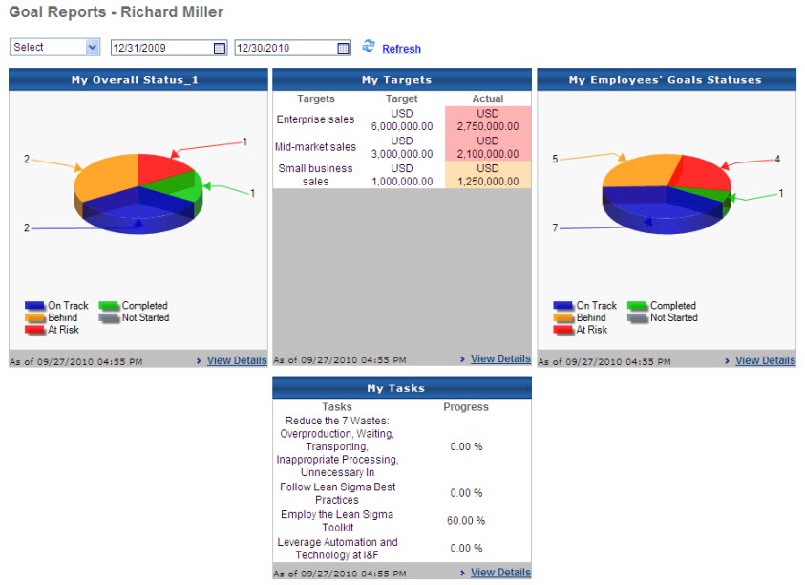
Time Period
Select a time period from the drop-down list. If any part of a goal falls within the selected time frame, the goal will display. Current period is the default period set by the system administrator. Previous period is the same length of time, but moved back one period.
You can also choose specific dates using the To and From fields.
My Overall Status
If enabled, this section displays the Goal Status Report with the following criteria:
- Date criteria are the date criteria selected above.
- User is set to the current user.
- Perspective is set to All Perspectives.
Click a piece of the pie to run the report and show the interactive version with the same criteria, filtered by the selected status.
My Targets
If enabled, this section displays the Goal Target Summary Report with the following criteria:
- Date criteria are the date criteria selected above.
- User is set to the current user.
- Perspective is set to All Perspectives.
My Tasks
If tasks are enabled, this section displays the Goal Tasks Summary Report with the following criteria:
- Date criteria are the date criteria selected above.
- User is set to the current user.
- Perspective is set to All Perspectives.
My Employees' Status
If the user has any direct reports and if status is enabled, this section displays the Goal Status Report with the following criteria:
- Date criteria are the date criteria selected above.
- User is set to the direct reports of the current user.
- Perspective is set to All Perspectives.
Click a piece of the pie runs the same report and shows the interactive version with the same criteria, filtered by the selected status.
View Details
- My Overall Status - Run a report and show the interactive version with the same criteria.
- My Targets - Run the report and show the printable version with the same criteria and inherited target details.
- My Employees' Goal Statuses - Click the Details link to run the report and show the interactive version with the same criteria.

