Feedback March 2024

Table of Contents
Universal Profile - Feedback - Overview 1
Feedback Preferences 6
Feedback Preferences - Edit Rating Scale 11
Feedback Wall Overview 14
Feedback - Post for Another User 15
Feedback Requests 19
Feedback - Add Comment 23
Feedback - Attach File 24
Feedback - Delete Post or Comment 27
Feedback - Set Visibility 29
Goals - View in Feedback 31
Feedback - Request Overview 32
Feedback - Make Anonymous 36
Feedback - Request for Goal 37
Snapshot Badges Overview 41
Badge & Point Preferences 42
Snapshot - My Badges 50
Snapshot - Leaderboard 53

Universal Profile - Feedback - Overview
The Feedback homepage allows you to view your own feedback, recognition, and milestone posts. You may also be able to request feedback from this page. When viewing the Feedback homepage for another user, you can post feedback for that user.
This functionality is fully optimized for use on mobile devices and is only available for organizations using the Performance module.
To access the Feedback homepage, go to Home > Universal Profile. Then, click the Feedback tab. Note: The location of this link is configurable by your system administrator.
When viewing another user's Feedback page, you may be able to view feedback, post feedback, award badges, assign training, and launch off-cycle performance reviews.
To access another user's Universal Profile - Bio page, select the user's photograph from any Universal Profile or Global Search page. From there, you can access the user's Feedback page by clicking the Feedback tab.
Permissions
PERMISSION NAME | PERMISSION DESCRIPTION | CATEGORY

Assign Training | Grants ability to assign learning objects to the transcripts of those for whom the user is the assigned manager, approver or cost center approver. This is a manager/approver permission. | Learning

Feedback - Delete | Enables user to delete a feedback post or comment on a user's page. The user can delete feedback from the Feedback page of any user who is within the permission constraints. This permission can be constrained by OU, User's OU, User Self and Subordinates, and User's Self. The permission constraints apply to the creator of the post or comment, not the target user. | Universal Profile

Feedback - Request for other users | Enables user to request feedback on behalf of other users from their Feedback page. This permission can be constrained by User's Subordinates, Direct Reports, and Custom Relationship. | Universal Profile

Feedback - Request | Enables user to request feedback from the Feedback page of their Universal Profile. Users can only request feedback from other users within their permission constraints. This permission can be constrained by OU, User's OU, User Self and Subordinates, and User's Self. This is an end user permission.  Note: This permission should not be constrained by Employee Relationship, as this constraint would not be effective and does not stop the user from requesting feedback from users outside of Employee Relationship constraint if applied.  Note: This permission should not be constrained by Restrict to Employee Relationship because the User Picker is unable to evaluate this constraint. | Universal Profile

Feedback Details - View | Enables user to view the Feedback Details page and provide feedback when they are requested to provide feedback. This permission cannot be constrained. This is an end user permission. | Universal Profile

Feedback - View and Post | Enables user to view the Feedback page of the Universal Profile and to post feedback. Users can only view the Feedback page for users within their permission constraints. Similarly, users can only post feedback for users within their permission constraints. This permission can be constrained by OU, User's OU, User Self and Subordinates, User's Self, and Employee Relationship. This is an end user permission. | Universal Profile

Launch Off-Cycle Performance Review Task | Enables a user to launch an off-cycle performance review task. Having this permission does not guarantee that the user can launch an off-cycle review, only that they will have access to the Launch Performance Review page. A task must still be configured properly for the user to successfully launch an off-cycle review task. This permission works only if user has been designated to launch at least one currently active off-cycle performance review task. This permission can be constrained by OU, User's Subordinates, and Employee Relationship. This is an end user permission and does not apply to an administrator role.

View Goals | Grants ability to view own goals and (depending on role and settings) goals of others (manager's visible goals, direct subordinate's goals, company goals, division goals). This permission can be constrained by Employee Relationship, OU, User's OU, and User Self and Subordinates. This is an end user permission. | Performance
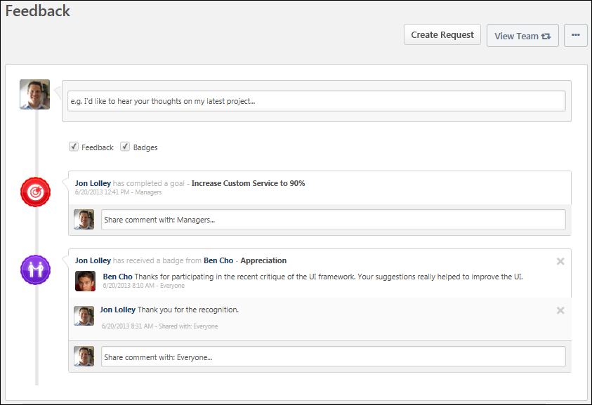
Troubleshooting Information
The following page contains an administrator's guide for configuring the Universal Profile:
- See Configuration Guide - Universal Profile.
Navigation
The navigation links displays the other available areas of the Universal Profile. Click the navigation tab to access the corresponding page. The following areas may be available:
- Bio - This tab opens the user's Bio homepage. This is only available if the corresponding user is within your permission to view a user's bio homepage.
- Feedback - This tab opens the user's Feedback page. This is only available if the corresponding user is within your permission to view feedback. In addition, this tab is only available for organizations using the Performance module.
- Action Items - This tab opens the user's Action Items page. This may include performance, learning, and volunteer action items. This is only available if the corresponding user is within your permission to view Action Items.
- Transcript - This tab opens the user's transcript. This option is available if the Learning module is enabled for the portal. This tab is only available if you are the corresponding user or the user's manager.
Filter Feedback and Badges
You can view only feedback, only badges, or both. This is controlled by the checkboxes below the Feedback field at the top of the page.
- Feedback - Feedback posts and requests are displayed on the Feedback page.
- Badges - Badges and goal posts are displayed on the Feedback page.
Both are checked by default. If both options are unchecked, then no posts display.
Create Request
Click the Create Request button to request feedback for yourself or for another user. This option is only available to users who have permission to request feedback on behalf of others. See Feedback - Request Overview on page 32 for additional information.
View Team
The View Team flyout allows managers, approvers, and custom relationships to quickly navigate between subordinates' profiles and transcripts. When enabled, the View Team flyout is available to managers and dotted line managers on all pages of their Universal Profile and the Universal Profile of their subordinates. This flyout displays the manager's reports visually.
The View Team button displays if enabled in the portal. Administrators may enable or disable this flyout via the My Team Dropdown section within Universal Profile General Preferences. See Universal Profile General Preferences.
See Universal Profile - View Team Flyout.
Options
An Options drop-down may be available on various pages of the Universal Profile. This menu may include options such as Assign Training and Create Goal. See Universal Profile Options Drop-down Overview.
Post Feedback for User
If you have the appropriate permissions, you can post feedback for another user. See Feedback - Post for Another User on page 15 for additional information.
Request Feedback
If you have the appropriate permissions, you can request feedback from your manager and peers. See Feedback - Request Overview on page 32 for additional information.
View Feedback
When someone posts feedback for you, it appears on your Feedback page. The following information is displayed with each feedback post:
- User Image - Image of the user who posted the feedback. If the user does not have an image in the system or if the feedback post is anonymous, then a generic image is displayed.
- User Name - Name of the user who posted the feedback. If the feedback post is anonymous, then "Anonymous" is displayed as the user's name.
- Feedback Content - Content of the feedback post.
- Timestamp - Indicates when the post is made. The timestamp is always displayed in the time zone of the user who is viewing the feedback.
View Comments
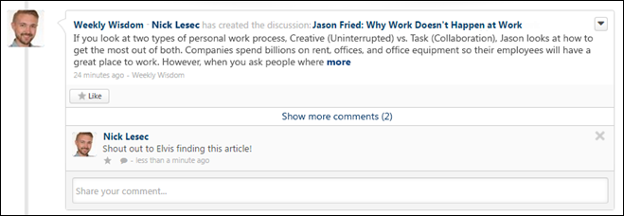
When users add comments to a post, the comments appear below the original post in reverse chronological order with the most recent comments displayed at the bottom. A timestamp is displayed with each comment to indicate when the comment was made. The timestamp is always displayed in the time zone of the user who is viewing the post.
- Show more comments - If a posting has more than one reply at its root level, select this link to view up to 10 of the most recent replies. If 10 comments are displayed and there are additional comments available, then a View full posting link is displayed. Select the link to view the Posting Details page in a new tab where all of the posting replies are visible.
- Show recent replies - If a posting reply has one or more replies,select this link or the Reply icon to view up to 10 of the most recent replies. If 10 comment replies are displayed and there are additional comment replies available, then a View full posting link is displayed. Select the link to view the Posting Details page in a new tab where all of the posting replies are visible.
Goals in Feedback
If your organization uses the Performance functionality, when you complete a goal, this achievement appears as a post on your Feedback page and is visible to you and your managers. See Goals - View in Feedback on page 31 for additional information.

Feedback Preferences
Use the Feedback Preferences page to configure which options are available when users are requesting and providing feedback within the Universal Profile: Feedback page.
To access the Feedback Preferences page, go to Admin > Tools > Core Functions > Universal Profile > Feedback.
Permissions
PERMISSION NAME | PERMISSION DESCRIPTION | CATEGORY

Feedback Preferences - Manage | Enables administrator to access and edit the Feedback Preferences page. From this page, administrators can configure which options are available when users are requesting and providing feedback within the Universal Profile: Feedback page. This permission can be constrained by OU and User's OU. This is an administrator permission. | Universal Profile
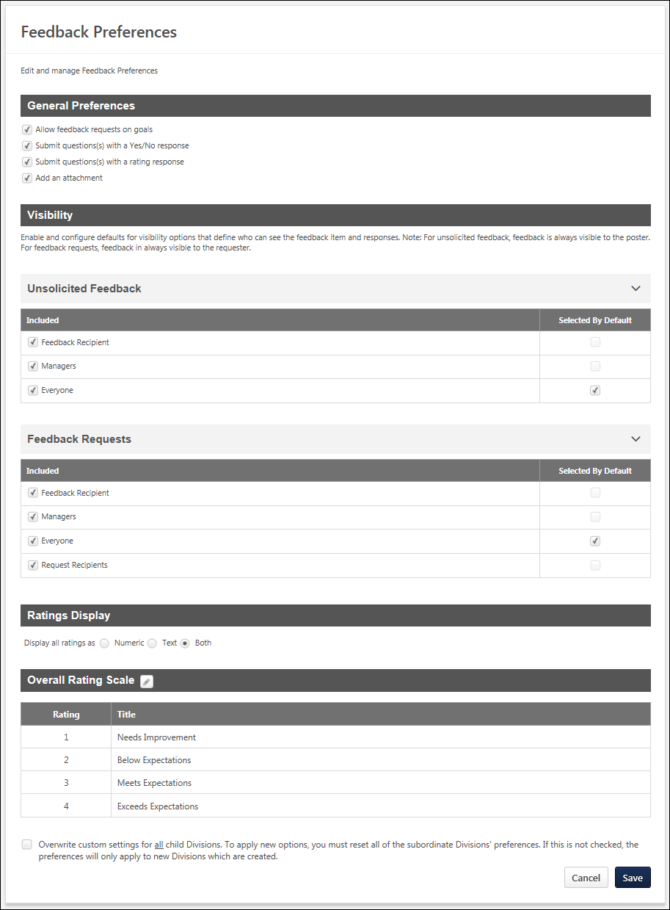
General Preferences
This section enables administrators to determine which options are available to users when they are requesting feedback within the Universal Profile: Feedback page.
The following options are available:
- Allow feedback requests on goals - When this option is selected, users have the option to request feedback on one of their non-shared personal goals in My Goals. Users are able to select a specific goal. Users can also add one yes/no or rating question to their request.
- Submit question(s) with a Yes/No response - When this option is selected, users have the option to add a question to their feedback request in which the user who responds to the question will provide either a Yes or No response.
- Submit question(s) with a rating response - When this option is selected, users have the option to add a question to their feedback request in which the user who responds to the question will provide a rating.
- Add an attachment - When this option is selected, users can add an attachment to their feedback request.
Visibility
The Visibility section enables administrators to configure which visibility options are available and which visibility options are selected by default. Visibility options can be configured for feedback requests and for unsolicited feedback.
Visibility - Unsolicited Feedback
The Unsolicited Feedback section enables administrators to configure which visibility options are available and which are selected by default for unsolicited feedback. Unsolicited feedback refers to feedback in which a user voluntarily provides feedback, awards a badge, or comments on an existing feedback item on another user's Feedback page. This type of feedback is not prompted by a feedback request. The following options are available:
- Included - Select this option to make the corresponding visibility option available to users when selecting the visibility settings for their unsolicited feedback.
- Selected By Default - Select this option to make the corresponding visibility option selected by default for users when selecting the visibility settings for their unsolicited feedback. This option can only be selected if the Included option is also selected for the visibility option.
The following visibility options are available:
- Feedback Recipient - This refers to the user who is receiving any type of feedback.
- Managers - This option includes all direct and indirect managers for the feedback recipient.
- Everyone - This refers to anyone who views the recipient's Feedback page. If the Selected By Default option is selected for this visibility option, then the Selected By Default option is automatically unselected and disabled for all other visibility options.
Visibility - Feedback Requests
The Feedback Requests section enables administrators to configure which visibility options are available and which are selected by default for feedback requests. Feedback requests refers to feedback that is provided when a user requests feedback from others, including general requests for feedback or requests for feedback on a specific goal. The following options are available:
- Included - Select this option to make the corresponding visibility option available to users when selecting the visibility settings for their feedback request.
- Selected By Default - Select this option to make the corresponding visibility option selected by default for users when selecting the visibility settings for their feedback request. This option can only be selected if the Included option is also selected for the visibility option.
The following visibility options are available:
- Feedback Recipient - This refers to the user who is receiving any type of feedback.
- Managers - This option includes all direct and indirect managers for the feedback recipient.
- Everyone - This refers to anyone who views the recipient's Feedback page. If the Selected By Default option is selected for this visibility option, then the Selected By Default option is automatically unselected and disabled for all other visibility options.
- Request Recipients - This refers to all users who are included in the request for feedback.
Ratings Display
Feedback ratings can be displayed as a numeric value, as text, or both. This section enables administrators to select how ratings are displayed to users who are providing and receiving feedback.
Overall Rating Scale
This section enables administrators to view and modify the rating scale that is used for feedback questions that use a rating response. The rating scale is displayed as it is currently configured. If the administrator modifies the rating scale, then this section reflects the modifications.
To edit the overall rating scale for feedback requests, click the Edit icon next to the section heading. See Feedback Preferences - Edit Rating Scale on page 11 for additional information.
Overwrite Settings
Select this option to overwrite custom settings for child division OUs. If you overwrite custom settings for child division OUs, the selected settings are applied to both new and existing child OUs. Any previously customized child OUs are updated with the selected settings.
- If there are no customizations to the child OU, then the parent OU customizations are applied to all child OUs.
- Overwrite custom settings checkbox setting
  - If this option is selected, all child OU customizations are deleted from the database, which means the parent OU customizations will be applied to new and existing child OUs.
  - If this option is unselected, all existing child OU customizations will remain unchanged, and any new child OUs will inherit the parent OU customizations by default.
- If a child OU has been customized to display any widgets, then regardless of the parent OU customizations, the child OU customizations are applied.
- If a child OU has been customized to hide all widgets, then parent OU customizations will take precedence and will be applied.
Submit/Cancel
- Click Submit to submit any unsaved changes.
- Click Cancel to discard any unsaved changes.

Feedback Preferences - Edit Rating Scale
When requesting feedback from the Universal Profile: Feedback page, users may be able to request feedback in which the feedback provider selects a rating. Administrators are able to define the rating scale that is used for feedback questions that use a rating system.
To edit the overall rating scale for feedback requests, go to Admin > Tools > Core Functions > Universal Profile > Feedback. In the Overall Rating Scale section, click the Edit icon next to the section heading.
Permissions
PERMISSION NAME | PERMISSION DESCRIPTION | CATEGORY

Feedback Preferences - Manage | Enables administrator to access and edit the Feedback Preferences page. From this page, administrators can configure which options are available when users are requesting and providing feedback within the Universal Profile: Feedback page. This permission can be constrained by OU and User's OU. This is an administrator permission. | Universal Profile
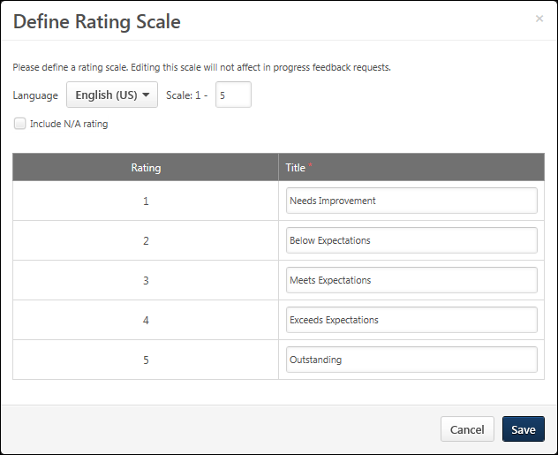
Language
If multiple languages are available for the portal, the rating scale titles can be localized by selecting the appropriate language from the Language drop-down menu. The titles for the administrator's default language must be entered prior to translating the titles for other languages.
When a rating scale is configured for the very first time, it inherits the language of that administrator and that language is considered to be the default language for the rating scale. See the Rating Scale Default Language Use Case for additional information.
Scale
The scale determines how many rating options are available to feedback providers when responding to rating questions. This field is required, and the maximum value for this field is 15.
When this field is modified and the administrator moves the cursor from the field, the rating table is automatically updated based on the number of ratings to be used. Additional rows appear for every point on the defined scale.
Include N/A rating
When this option is selected, a scoreless value titled N/A is included in the rating scale. This rating option can be selected by feedback providers if the question does not apply to the user or if there is no other rating option that is applicable to the user.
Rating Table
This table displays all of the rating options and their text titles. The number of rating options that are available is dependent on the value entered in the Scale field.
In the Title fields, enter a text title for each rating value.
Save/Cancel
- Click Save to commit any modifications to the rating scale.
- Click Cancel to discard any unsaved changes.
When the rating scale is modified, the new rating scale settings are only applied to feedback requests that are created after the modifications are saved. Any existing feedback requests will continue to use the rating scale that was set when the feedback request was created. Note: Changes to rating titles are immediately reflected in new and existing feedback requests.

Feedback Wall Overview

Feedback - Post for Another User
When viewing another user's Feedback page, you are able to post feedback for the user if you have the appropriate permission.
To access the Feedback homepage, go to Home > Universal Profile. Then, click the Feedback tab. Note: The location of this link is configurable by your system administrator. Users can only view the Feedback page for users who are within their permission constraints.
To access another user's Universal Profile - Bio page, select the user's photograph from any Universal Profile or Global Search page.
Permissions
PERMISSION NAME | PERMISSION DESCRIPTION | CATEGORY

Feedback - View and Post | Enables user to view the Feedback page of the Universal Profile and to post feedback. Users can only view the Feedback page for users within their permission constraints. Similarly, users can only post feedback for users within their permission constraints. This permission can be constrained by OU, User's OU, User Self and Subordinates, User's Self, and Employee Relationship. This is an end user permission. | Universal Profile
Emails
EMAIL NAME | EMAIL DESCRIPTION | ACTION TYPE

Feedback Provided Notification | This email is triggered when an employee provides feedback for another employee on their Universal Profile - Feedback page. Feedback can be provided by posting directly to the Feedback page or by commenting on a Feedback post. This email is not triggered when the manager provides feedback to a direct report that is only visible to the user's manager. This email can be sent as a notification to Feedback Recipient or a specific user. | Universal Profile
Post Feedback
To post feedback, enter the text for your feedback in the Share your feedback field. The character limit is 4000.
If necessary, you can clear the text that you have entered in the Share your feedback field by clicking the Cancel icon in the upper-right corner of the field.
Attach a File
You can attach files to your feedback, if applicable, by clicking the Attach a file button . This can be done to provide reference material for the feedback post. See Feedback - Attach File on page 24 for additional information.
Award a Badge
If your organization is utilizing the Performance functionality, you can award a badge with your feedback request, if applicable, by clicking the Give a badge button . A badge is a form of recognition that also has an associated point value that can be tracked. See Badge - Give a Badge on page 17 for additional information.
Set Visibility
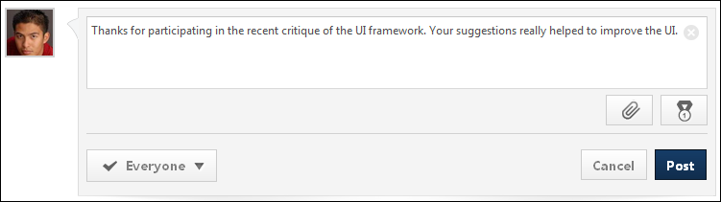
Set the visibility to determine who is able to view the post. See Feedback - Set Visibility on page 29 for additional information.
Post/Cancel
- Click Post to submit the feedback.
- Click Cancel to discard the feedback. If the email is configured and enabled in Email Administration, the Feedback Provided Notification email is triggered.
Frequently Asked Questions
Why can't I view the Feedback page for another user?
The permission that is listed in the Permissions section above controls a user's ability to view the Feedback page. If there are constraints on this permission, then these constraints limit which users' Feedback page they can view. Similarly, these constraints limit for which users they can post feedback.
Badge - Give a Badge
Use an employee's Feedback page to give them a badge for positive recognition. A badge may also have an associated point value. Depending on the portal configuration, users may be able to view their points and a points leaderboard on the Universal Profile - Snapshot page.
Note: Badge & Point Preferences should only be configured by the Division Organizational Unit (OU) type. If Badge & Point Preferences are configured by a different OU type, then the badges will not be available to users to select and grant to others. See Badge & Point Preferences - Badges on page 43 for additional information.
To access another user's Universal Profile - Bio page, select the user's photograph from any Universal Profile or Global Search page. Then, select the Feedback tab.
Permissions
PERMISSION NAME | PERMISSION DESCRIPTION | CATEGORY

Feedback - View and Post | Enables user to view the Feedback page of the Universal Profile and to post feedback. Users can only view the Feedback page for users within their permission constraints. Similarly, users can only post feedback for users within their permission constraints. This permission can be constrained by OU, User's OU, User Self and Subordinates, User's Self, and Employee Relationship. This is an end user permission. | Universal Profile
Emails
EMAIL NAME | EMAIL DESCRIPTION | ACTION TYPE

Badge Provided Notification | This email is triggered when an employee provides a badge for another employee on their Universal Profile - Feedback page. This email is not triggered for the Completed Goal post. This email can be sent as a notification to Feedback Recipient, Feedback Recipient's Manager, or a specific user. | Universal Profile
Give a Badge
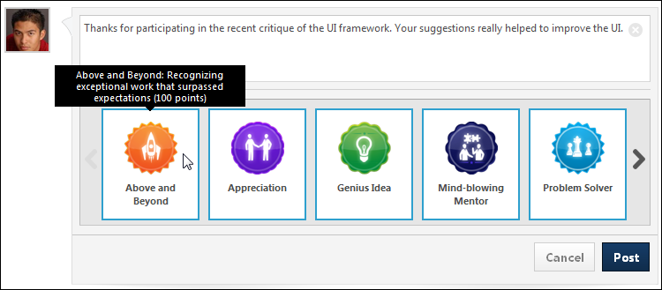
To give another employee a badge:
- Click the Give a badge button . This expands the Badges panel.
- Click the appropriate badge. You can also hover the computer cursor over the badge to view the badge details, including the badge points. If a badge is set to be Manager Only, then only direct or indirect managers are able to award this badge, and they can only award it to their direct or indirect reports.
- Enter your feedback.
- Click Post. The feedback is added to the user's Feedback page and the badge is also displayed in the post.
When adding a badge, you cannot control which users can view the badge. This feedback is always visible to everyone who is able to view the user's Feedback page. If the email is configured and enabled in Email Administration, the Badge Provided Notification email is triggered.

Feedback Requests
Use the Feedback Requests page to view all pending and deleted requests for feedback. When a user requests feedback, you have the option to either respond to the request or to ignore the request.
To access the Feedback homepage, go to Home > Universal Profile. Then, click the Feedback tab. Note: The location of this link is configurable by your system administrator.
- In the Your Inbox widget on the Welcome page, click the View All Feedback Requests link.
- On the Feedback page, from the Options drop-down, click the View Pending Requests link.
Permissions
PERMISSION NAME | PERMISSION DESCRIPTION | CATEGORY

Feedback - View and Post | Enables user to view the Feedback page of the Universal Profile and to post feedback. Users can only view the Feedback page for users within their permission constraints. Similarly, users can only post feedback for users within their permission constraints. This permission can be constrained by OU, User's OU, User Self and Subordinates, User's Self, and Employee Relationship. This is an end user permission. | Universal Profile
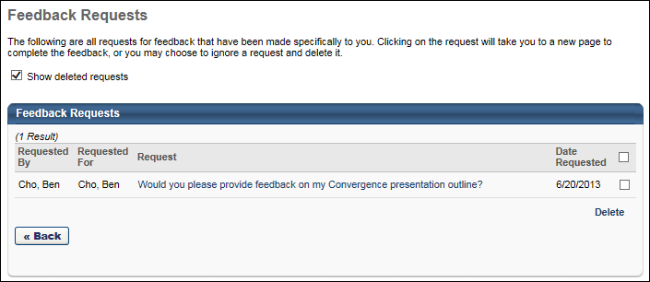
Show Deleted Requests
Check Show deleted requests if you want deleted requests do appear in the Feedback Requests table.
Feedback Requests Table
The Feedback Requests table displays all pending requests in chronological order with the most recent requests displayed first. New requests that have not yet been viewed appear in bold text.
The following information is displayed for each request:
- Requested By - This column displays the name of the user who created the feedback request.
- Requested For - This column displays the name of the user for whom the feedback request was created.
- Request - This displays the message that is associated with the request. This message was entered by the user who made the request. Click the request message to access the Feedback page of the requester. If the requester is now inactive, then the request message cannot be clicked. See Feedback Request - Respond on page 21 for additional information.
- Date Requested - This displays the date on which the request was made.
Note: If a user requests feedback, but then deletes their request, then the feedback request is removed from the Feedback Requests page for the users from whom feedback was requested. For example, if User A requests feedback from User C and User D, but then User A deletes the request, then the feedback request is removed from the Feedback Requests page for User C and User D.
Respond to a Request
To respond to a request for feedback, click the request message. This opens the Feedback page of the requester, displaying only the corresponding request. See Feedback Request - Respond on page 21 for additional information.
Delete a Request
To delete a request, check the option box to the right of the request and then click the Delete link.
Multiple requests can be deleted at once. When you click the Delete link, all selected requests are deleted. To delete all requests, check the Delete All option box at the top of the Delete column, and then click the Delete link.
Requests remains on the Feedback Requests page until deleted. Once a request is deleted, it is hidden from the Feedback Requests page, but you can always view it by checking the Show deleted requests option.
View Deleted Requests
When a request is deleted, you can still view it on the Feedback Requests page.
Feedback Request - Respond
You can request feedback from other employees.
To respond to a request for feedback, click the Options drop-down within Universal Profile and select View Feedback Requests. Then, click the appropriate request link. This opens the Feedback page for the user who requested the feedback. Depending on the feedback's visibility configuration, existing feedback from other users may be visible on the Feedback Details page. If the user provided anonymous feedback, then the user's name and photo are not displayed.
Note: If a user requests feedback from you, you are able to provide feedback for the user even if you do not have permission to post feedback for that user.
To access the Feedback homepage, go to Home > Universal Profile. Then, click the Feedback tab. Note: The location of this link is configurable by your system administrator
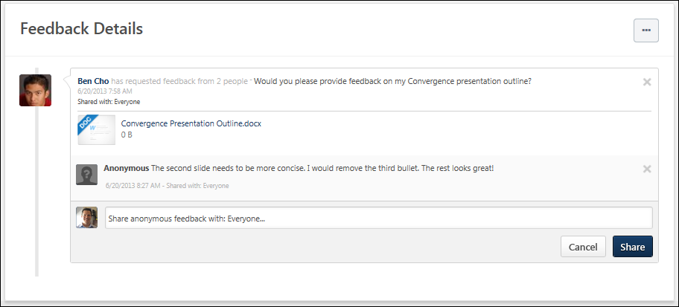
Provide Feedback
To provide feedback, click the text field. If the feedback request contains any questions, the questions are displayed below the text field.
- To add a feedback comment, enter the feedback in the text field. This is required.
- To respond to a question, click the Select drop-down menu and select the appropriate rating. The text to the right of the drop-down menu indicates the type of question. Responses to each question are not required.
Goal Details
Users can map a feedback request to a specific goal in order to solicit feedback that is directly related to a goal.
When a user is viewing a feedback request that is mapped to a goal, the basic details of the goal are displayed within the request. This enables the feedback provider to view the details and progress of the goal and use this information to help provide feedback. To view all of the goal's details, select the See More link.
Note: When a goal is added to a feedback request, the request displays the details and progress of the goal as it existed at the moment the feedback request is posted. If the details of the goal are modified or if progress is updated after the request is posted, then these updates will not be reflected in the feedback request. This behavior is intended to allow feedback providers to see the goal details and progress at the time the feedback was requested.
Share Feedback
After entering your feedback, click Share. This adds your comments and question ratings to the feedback request on the requester's Feedback page. Users are not able to modify their ratings after the feedback is shared unless they delete their feedback response. However, the feedback provider is always able to add additional comments to the feedback request.
A date and time stamp is displayed for each post and comment to indicate when the post was made. Timestamps are always displayed in the time zone of the user viewing the post.

Feedback - Add Comment
When viewing another user's Feedback page, you are able to comment on a feedback post if you have the appropriate permissions.
To comment on another user's post, navigate to their Feedback page, and enter your comment in the comment box directly below the appropriate post. Then, click Share.
To access another user's Universal Profile - Bio page, select the user's photograph from any Universal Profile or Global Search page. From there, you can access the user's Feedback page by clicking the Feedback tab.
Permissions
PERMISSION NAME | PERMISSION DESCRIPTION | CATEGORY

Feedback - View and Post | Enables user to view the Feedback page of the Universal Profile and to post feedback. Users can only view the Feedback page for users within their permission constraints. Similarly, users can only post feedback for users within their permission constraints. This permission can be constrained by OU, User's OU, User Self and Subordinates, User's Self, and Employee Relationship. This is an end user permission. | Universal Profile
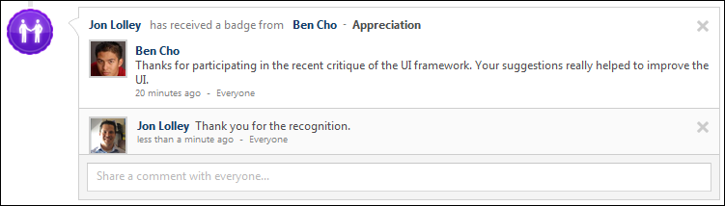

Feedback - Attach File
When a user requests feedback or posts feedback, they have the option to attach a file to the post or request. This can be done to provide reference material for your feedback post or feedback request. See the Attachment Restrictions section below for information on attachment restrictions.
To access another user's Universal Profile - Bio page, select the user's photograph from any Universal Profile or Global Search page. From there, you can access the user's Feedback page by clicking the Feedback tab.
Attachment Restrictions
The following attachment restrictions apply:
- You can attach up to three attachments per post.
- The maximum file size is 20 MB.
- The attachment file name cannot exceed 50 characters.
- You cannot upload executable files.
File Types
You can attach the following file types to feedback:
File Type | Extension
Audio | - mid  - m4a  - mp3  - wav
Compressed | - zip
Data | - xls/xlsx
Image | - bmp  - gif  - jpeg/jpg  - png
Presentation | - pps/ppsx  - ppt/pptx
Project | - mpp
Recording | - arf
Text | - doc/docx  - dot/dotx  - htm/html - The ability to upload htm/html files is controlled by the system administrator. This limit is controlled by a backend setting,. Organizations may choose to disable the ability to upload HTML files because malicious HTML files may be uploaded, which is a potential security risk.  - pdf  - txt
Video | - avi  - flv  - m4v  - mpeg/mpg  - mp4  - rm  - swf  - wma/wmv
Attach a File
Select one of the following options to attach a file:
- To attach a file to a post or request, click the Attach a file button . The Attachment area expands.

- Drag and drop a file into the Attachment area. Note: The drag-and-drop functionality is not supported by Internet Explorer browsers.
- Click the Select a file button and select a file from your computer.
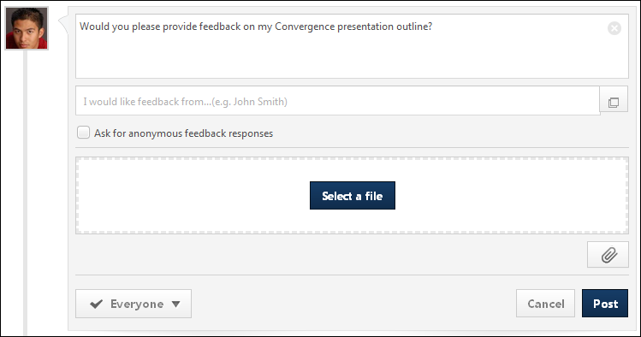
After the file has loaded, the attachment appears below the comment box.
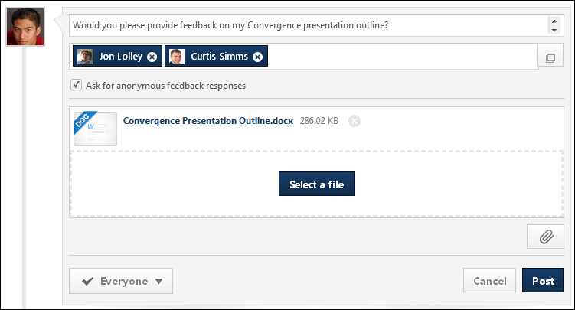
Post/Cancel
Click Post to add the attachments to the feedback.
Click the Cancel icon to the right of the attachment name to delete an attachment.

Feedback - Delete Post or Comment
You can delete a feedback post, badge, request, or comment from another user's Feedback page by clicking the Delete icon in the upper-right corner of the post or comment. This option is only available if you have permission to delete feedback, and you can only delete feedback that has been left by users within your permission constraints.
To access another user's Universal Profile - Bio page, select the user's photograph from any Universal Profile or Global Search page. From there, you can access the user's Feedback page by clicking the Feedback tab.
When a feedback post or badge is deleted, this also deletes any comments that are added to the post.
When a feedback request is deleted, this also deletes any feedback that has been left and any corresponding notifications for the feedback request.
Permissions
PERMISSION NAME | PERMISSION DESCRIPTION | CATEGORY

Feedback - Delete | Enables user to delete a feedback post or comment on a user's page. The user can delete feedback from the Feedback page of any user who is within the permission constraints. This permission can be constrained by OU, User's OU, User Self and Subordinates, and User's Self. The permission constraints apply to the creator of the post or comment, not the target user. | Universal Profile

Feedback - View and Post | Enables user to view the Feedback page of the Universal Profile and to post feedback. Users can only view the Feedback page for users within their permission constraints. Similarly, users can only post feedback for users within their permission constraints. This permission can be constrained by OU, User's OU, User Self and Subordinates, User's Self, and Employee Relationship. This is an end user permission. | Universal Profile
Delete Post, Request, or Badge
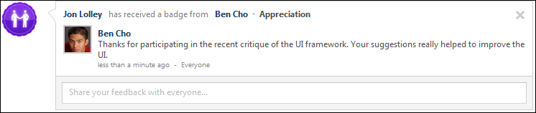
Delete Comment

Feedback - Set Visibility
When creating a post on the Feedback page, such as a feedback post or a request for feedback, you have the ability to set the visibility of the post. The visibility limits who is able to view the post.
Visibility can be set when managers are creating a feedback post for a subordinate, when colleagues are creating a feedback post for another user, and when a user is creating a feedback request.
The visibility that is set for the initial post also applies to any comments or responses that are added to the initial post. For example, when the visibility is set for a feedback request, the visibility setting also applies to any feedback responses that are made for the request. Also, when the visibility is set for a feedback post, the visibility setting also applies to any comments that are added to the post.
The options that are available in the drop-down are determined by the administrator in Feedback Preferences. In addition, the administrator can configure which options are selected by default. See Feedback Preferences on page 6 for additional information.
Permissions
PERMISSION NAME | PERMISSION DESCRIPTION | CATEGORY

Feedback - Request for other users | Enables user to request feedback on behalf of other users from their Feedback page. This permission can be constrained by User's Subordinates, Direct Reports, and Custom Relationship. | Universal Profile

Feedback - Request | Enables user to request feedback from the Feedback page of their Universal Profile. Users can only request feedback from other users within their permission constraints. This permission can be constrained by OU, User's OU, User Self and Subordinates, and User's Self. This is an end user permission.  Note: This permission should not be constrained by Employee Relationship, as this constraint would not be effective and does not stop the user from requesting feedback from users outside of Employee Relationship constraint if applied.  Note: This permission should not be constrained by Restrict to Employee Relationship because the User Picker is unable to evaluate this constraint. | Universal Profile
To set the visibility for the post and corresponding comments, select the appropriate visibility options from the Who would you like to see request responses? drop-down. If a user is able to view the feedback post, they are also able to see the visibility setting of the post. The selected visibility is displayed below the drop-down so that the selected visibility options are explicitly clear.
Note: It is important to note that feedback posts and requests are displayed on the Feedback page. A user must also have permission to view the corresponding user's Feedback page in order to view the feedback post or request.
In all scenarios, the ability to add a comment to a post is available to anyone who can view the post.
When requesting feedback on behalf of another user, the following visibility options may be available:
- User - This option makes the feedback visible to the feedback recipient.
- User's Managers - This option makes the feedback visible to the feedback recipient's direct and indirect managers.
- Request Recipients - This option makes the feedback visible to the feedback request recipients.
- Everyone - This option makes the feedback visible to everyone who has permission to view the feedback recipient's Feedback page.
When requesting feedback for yourself, the following visibility options may be available:
- Managers - This option makes the feedback visible to the feedback recipient's direct and indirect managers.
- Request Recipients - This option makes the feedback visible to the feedback request recipients.
- Everyone - This option makes the feedback visible to everyone who has permission to view the feedback recipient's Feedback page.
When providing unsolicited feedback for another user, the following visibility options may be available:
- User - This option makes the feedback visible to the feedback recipient.
- User's Managers - This option makes the feedback visible to the feedback recipient's direct and indirect managers.
- Everyone - This option makes the feedback visible to everyone who has permission to view the feedback recipient's Feedback page.
Note: If no visibility options are selected, then the feedback is visible only to the feedback provider or request recipient.
Note: When a badge is awarded to a user, this feedback is always visible to everyone who has permission to view the feedback recipient's Feedback page.

Goals - View in Feedback
If an organization is utilizing the Performance functionality, when a user goal is 100% complete, this achievement appears as a post on the user's Feedback page. These posts are always visible to the employee and managers and users who can view the post can add comments to the post. The date and time associated with the post is when the goal was marked 100% complete. Both individual and shared goals will appear on the Feedback page.
A goal can only appear on a user's Feedback page once. If a user completes a goal, changes the goal to In Progress and then completes the goal again, the goal will not appear on the Feedback page again.
To access the Feedback homepage, go to Home > Universal Profile. Then, click the Feedback tab. Note: The location of this link is configurable by your system administrator
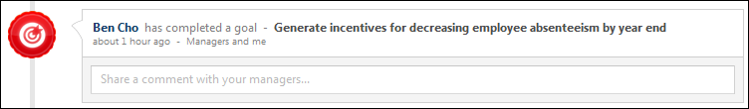

Feedback - Request Overview
When viewing your own Feedback page, you can request feedback from your manager and peers if you have the appropriate permissions.
To access the Feedback homepage, go to Home > Universal Profile. Then, click the Feedback tab. Note: The location of this link is configurable by your system administrator.
- From any page in the Universal Profile, select the Options button, and then select Create Feedback Request. This opens the user's Universal Profile Feedback page.
- From the Universal Profile Feedback page, select the Create Request button.
Note: The ability to request feedback is only available if you have the appropriate permissions. In addition, the constraints on these permissions determine whether these options are available when viewing another user's Feedback page.
Permissions
PERMISSION NAME | PERMISSION DESCRIPTION | CATEGORY

Feedback - Request for other users | Enables user to request feedback on behalf of other users from their Feedback page. This permission can be constrained by User's Subordinates, Direct Reports, and Custom Relationship. | Universal Profile

Feedback - Request | Enables user to request feedback from the Feedback page of their Universal Profile. Users can only request feedback from other users within their permission constraints. This permission can be constrained by OU, User's OU, User Self and Subordinates, and User's Self. This is an end user permission.  Note: This permission should not be constrained by Employee Relationship, as this constraint would not be effective and does not stop the user from requesting feedback from users outside of Employee Relationship constraint if applied.  Note: This permission should not be constrained by Restrict to Employee Relationship because the User Picker is unable to evaluate this constraint. | Universal Profile
Emails
EMAIL NAME | EMAIL DESCRIPTION | ACTION TYPE

Feedback Request Notification | This email can be configured as a notification and is triggered when an employee requests feedback from their Feedback page. This email can be sent to a specific user, the Feedback Request Recipient, the Feedback Requester, or the Feedback Requester's Manager. | Universal Profile
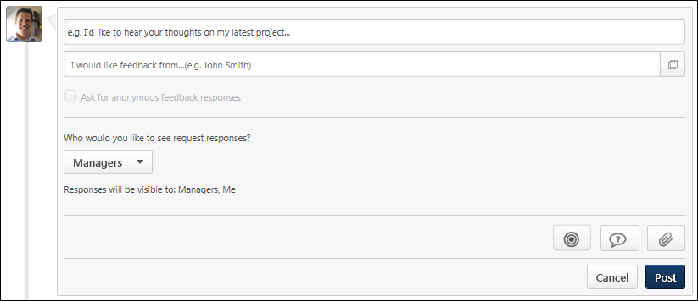
Request Feedback
To request feedback, enter the text for your request in the Feedback field. The character limit is 4000.
If necessary, you can clear the text that you have entered in the Feedback field by clicking the Cancel icon in the upper-right corner of the field.
Add Goal
Users can map a feedback request to a specific goal. This enables users to solicit feedback that is directly related to a goal. Note: The ability to add a goal to a feedback request is set by the administrator in Feedback Preferences.
To add a goal to your feedback request, select the Goal button . The Select a goal pop-up opens. See Feedback - Request for Goal on page 37 for additional information.
Add Question
To add a question to your feedback request, click the Add Questions button 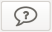. A blank question is added to the feedback request. Enter the following information for the question:
- What is your question? - In the text field, enter the question text. Be sure that the question text matches the selected rating type. For example, if the rating type is Yes/No, be sure that the question that is being asked can be answered with a yes or no response. This field is required, and the character limit for this field is 500.
- Select Rating Type - From the drop-down menu, select the type of rating that should be used with the question. The following rating types are available:
  - Rating - Users who respond to this question will provide a rating between one and five. Note: The ability to submit a question with a rating response is controlled by the administrator in Feedback Preferences.
  - Yes/No - Users who respond to this question will provide either a Yes or No response. Note: The ability to submit a question with a yes/no response is controlled by the administrator in Feedback Preferences.
To remove a question from a feedback request, click the Remove icon to the right of the Select Rating Type drop-down menu.
To add an additional question, click the Add another question link. An additional blank question is added to the page. Up to 10 questions can be added to a feedback request.
Attach File
You can attach files to your feedback request, if applicable, by clicking the Attach a file button . This can be done to provide the project files on which you are requesting feedback. See Feedback - Attach File on page 24 for additional information.
Note: The ability to attach a file to a feedback request is controlled by the administrator in Feedback Preferences.
Select Users for Feedback
After entering your request, enter the names of the users from whom you are requesting feedback in the I would like feedback from field. This field allows you to search for users by name, email, department, or manager. After you enter at least two characters, the system begins to display possible matches for your search. These search results are refreshed after each additional character is entered. Select the appropriate users. The selected users are added to the I would like feedback from field. Note: Users can only request feedback from users within their permission constraints. You can also select users by clicking the Select Users button .
Set Feedback Visibility
You can set the visibility of the request within the Feedback tab. See Feedback - Set Visibility on page 29 for additional information.
You also have the option to ask for anonymous responses. See Feedback - Make Anonymous on page 36 for additional information.
Post/Cancel
After selecting the appropriate recipients, click Post to submit the request or click Cancel to discard the request. When a feedback request is submitted, an email may be triggered, if configured by the system administrator in Email Administration.
Related Topics

Feedback - Make Anonymous
When requesting feedback from three or more people, you have the option to ask for anonymous feedback responses by checking the Ask for anonymous feedback responses option. This option is only available if at least three feedback providers have been selected. This helps to ensure that any feedback that is provided is truly anonymous.
When feedback is anonymous, the user who is requesting the feedback will not be able to see the names or photos of the users who provide feedback, but they will be able to see the content of the feedback.
When feedback is not anonymous, the user who is requesting the feedback can see the names and photos of the users who provide feedback.
The following is an example of how anonymous feedback appears to the user who requests feedback.
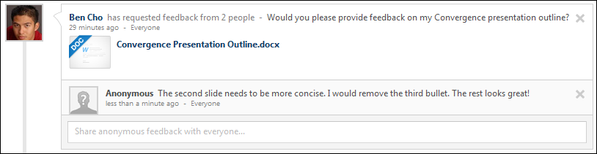

Feedback - Request for Goal
Users can map a feedback request to a specific goal. This enables users to solicit feedback that is directly related to a goal.
Note: When a goal is added to a feedback request, the request displays the details and progress of the goal as it existed at the moment the feedback request is posted. If the details of the goal are modified or if progress is updated after the request is posted, then these updates will not be reflected in the feedback request. This behavior is intended to allow feedback providers to see the goal details and progress at the time the feedback was requested.
To access the Feedback homepage, go to Home > Universal Profile. Then, click the Feedback tab. Note: The location of this link is configurable by your system administrator.Then, place the cursor in the Feedback field. The Feedback field expands to display additional options.
Permissions
PERMISSION NAME | PERMISSION DESCRIPTION | CATEGORY

Feedback - Request | Enables user to request feedback from the Feedback page of their Universal Profile. Users can only request feedback from other users within their permission constraints. This permission can be constrained by OU, User's OU, User Self and Subordinates, and User's Self. This is an end user permission.  Note: This permission should not be constrained by Employee Relationship, as this constraint would not be effective and does not stop the user from requesting feedback from users outside of Employee Relationship constraint if applied.  Note: This permission should not be constrained by Restrict to Employee Relationship because the User Picker is unable to evaluate this constraint. | Universal Profile

View Goals | Grants ability to view own goals and (depending on role and settings) goals of others (manager's visible goals, direct subordinate's goals, company goals, division goals). This permission can be constrained by Employee Relationship, OU, User's OU, and User Self and Subordinates. This is an end user permission. | Performance
Emails
EMAIL NAME | EMAIL DESCRIPTION | ACTION TYPE

Feedback Request Notification | This email can be configured as a notification and is triggered when an employee requests feedback from their Feedback page. This email can be sent to a specific user, the Feedback Request Recipient, the Feedback Requester, or the Feedback Requester's Manager. | Universal Profile
Add Goal
The option to add a goal to a feedback request is only available if the user has permission to view goals and request feedback. In addition, the option to add a goal is only available if enabled by the administrator in Feedback Preferences.
To add a goal to your feedback request, select the Goal button . The Select a goal pop-up opens.
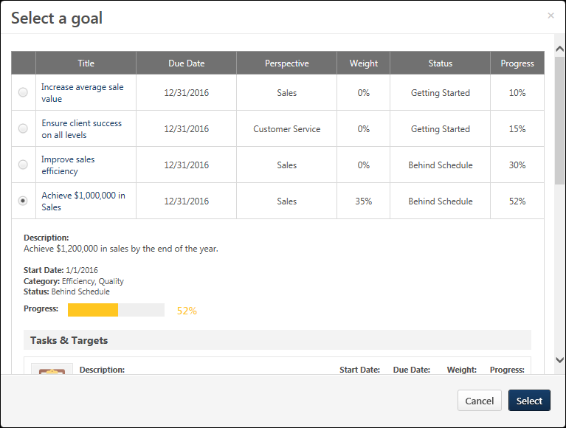
The Select a goal pop-up displays all of the user's approved goals that are within the current goal period. Team goals and shared goals are not displayed. When a goal is selected, the pop-up displays the details of the goal. Select the appropriate goal, and select the Select button. The goal appears within the feedback request.
Note: When a goal is added to a feedback request, the request displays the details and progress of the goal as it existed at the moment the feedback request is posted. If the details of the goal are modified or if progress is updated after the request is posted, then these updates will not be reflected in the feedback request. This behavior is intended to allow feedback providers to see the goal details and progress at the time the feedback was requested.
After a goal is added to a request, the user can add request text and one question. Then, the user must post the feedback request.
The Visibility for a request for goal feedback is set to Managers and Me by default. However, this visibility can be adjusted, if necessary. Note: When setting the visibility for the feedback request, be aware that anyone who can view the request can also view the details and progress of the associated goal.See Feedback - Set Visibility on page 29 for additional information.
- When providing unsolicited feedback for another user on the Feedback page, the visibility is set to Everyone by default.
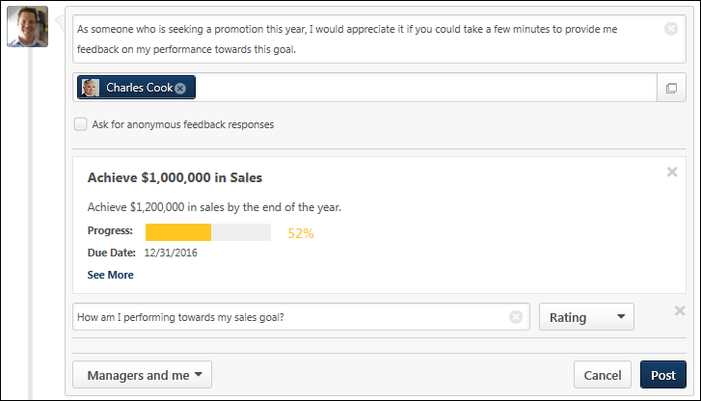
The following information is displayed for the selected goal:
- Title
- Description
- Progress
- Due Date
To view all of the goals details, select the See More link.
Remove Goal
To remove a goal from a feedback request, click the Remove icon in the upper-right corner of the goal details. This returns the page to its original state.

Snapshot Badges Overview

Badge & Point Preferences
Organizations can use rewards and recognition to make the learning experience more engaging and encourage employees to complete training.
The Badges tab of the Badge & Point Preferences page enables administrators to create and configure the badges that can be awarded to a user, including the points that are awarded when the user receives the badge. See Badge & Point Preferences - Badges on page 43 for additional information.
The Points tab of the Badge & Point Preferences page enables administrators to configure the Leaderboard page that exists within Universal Profile: Snapshot. See Badge & Point Preferences - Points on page 46 for additional information.
To manage Badges and Points:
- Go to Admin > Tools > Core Functions > Core Preferences > Badges & Points.
- Go to Admin > Tools > Learning > Learning Preferences > Badges & Points.
Permissions
PERMISSION NAME | PERMISSION DESCRIPTION | CATEGORY

Badge & Point Preferences - Manage | Enables user to access and edit preferences on the Badge & Point Preferences page. The availability of this permission is controlled by a backend setting. This permission can be constrained by OU and User's OU. This is an administrator permission. | Core Administration.
Badge Image Recommendations
For badge images, the acceptable file types are .png, .jpeg, and .gif. Badge images should be square with a recommended size of 100 x 100 pixels. To have a square badge image display properly on the My Badges page, use a 66 x 66 pixel image centered on a white square that is 100 x 100 pixels.
Next Steps
After a badge is created, it is awarded to a user via the Universal Profile: Feedback page. You can also associate it with a learning object (LO) so that it is automatically awarded when a user completes the associated LO.
- See Badge - Give a Badge on page 17 for additional information.
- See Course Catalog - General.
Badge & Point Preferences - Badges
Badges are a form of employee recognition awarded when a user receives positive feedback or when a user completes training. Badges may have an associated point value. Based on portal configuration, you may be able to view badges through a widget on the Universal Profile - Snapshot page.
The Badges tab of the Badge & Point Preferences page enables administrators to create and configure the badges that can be awarded to a user, including the points that are awarded when the user receives the badge.
Note: Badge & Point Preferences should only be configured by the Division Organizational Unit (OU) type. If Badge & Point Preferences are configured by a different OU type, then the badges will not be available to users to select and grant to others.
To manage Badges and Points:
- Go to Admin > Tools > Core Functions > Core Preferences > Badges & Points.
- Go to Admin > Tools > Learning > Learning Preferences > Badges & Points.
Permissions
PERMISSION NAME | PERMISSION DESCRIPTION | CATEGORY

Badge & Point Preferences - Manage | Enables user to access and edit preferences on the Badge & Point Preferences page. The availability of this permission is controlled by a backend setting. This permission can be constrained by OU and User's OU. This is an administrator permission. | Core Administration.
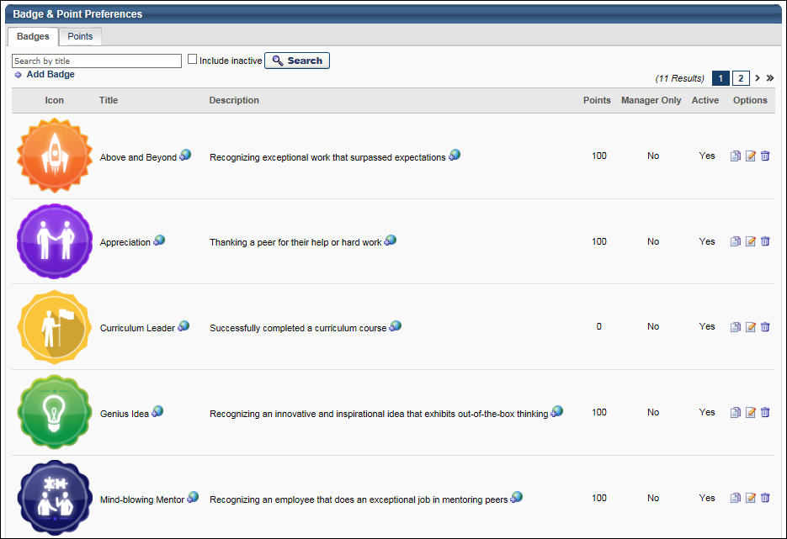
Badge - Search
To search for a badge by title, enter the badge title in the search field and click the Search button. Select the Include Inactive option to also search for inactive badges.
Badge - Add
To add a new badge, click the Add Badge link. See Badge - Add/Edit on page 48 for additional information.
Badge Table
The following information is displayed for each badge in the table:
- Icon - This displays the image that is associated with the badge.
- Title - This displays the badge title.
- Description - This displays the badge description.
- Points - This displays the point value that is associated with the badge. Note: Currently, the badge point values are being stored in the system. However, there is no functionality associated with the point values.
- Manager Only - This displays whether the badge is only available to be given by managers. If a badge is manager only, then only managers are able to give the badge to their subordinates.
- Active - This displays whether the badge is currently active. When a badge is active, then it is available to be given to users.
Badge Options
The following options are available in the Options column:
- Localize - If multiple languages are enabled, click the Globe icon to localize the badge title and description.
- Copy - Click this icon to duplicate the badge. A Copy Badge pop-up is opened, in which the administrator can edit the badge details prior to saving the badge. See Badge - Add/Edit on page 48 for additional information.
- Edit - Click this icon to edit the badge details. See Badge - Add/Edit on page 48 for additional information.
- Delete - Click this icon to delete the badge. See the Deleting or Deactivating Badges section for additional information.
Deleting or Deactivating Badges
Administrators are able to delete badges or make them inactive.
Learning Badges:
- Deactivate Badge:
  - The badge will still display on LO Details or the Course Catalog (if already associated to an existing LO).
  - The badge will no longer display in the Badge Search Results (admins cannot associate to LOs via the Course Catalog).
  - Any users who completed training (and were awarded the badge) will not be impacted; the badge will still display on the Training Completion page and on the Badges widget.
  - Any users who have not yet completed the training (with the badge associated to it) will still be awarded the badge when they complete the training.
- Delete Badge:
  - The badge will no longer display on LO Details or the Course Catalog (if already associated to an existing LO).
  - Any users who completed training (and were awarded the badge) will not be impacted; the badge will still display on the Training Completion page and on the Badges widget.
  - Any users who have not yet completed the training (with the badge associated to it) will not be awarded the badge when they complete the training.
Feedback Badges:
- The badge no longer displays in the results when attempting to award a badge via Feedback (i.e., users cannot award that badge to other users).
- The badge will continue to display in Feedback and the Badges widget (if it was already awarded to a user).
Badge Image Recommendations
For badge images, the acceptable file types are .png, .jpeg, and .gif. Badge images should be square with a recommended size of 100 x 100 pixels. To have a square badge image display properly on the My Badges page, use a 66 x 66 pixel image centered on a white square that is 100 x 100 pixels.
Badge & Point Preferences - Points
A user may receive points for completing training. Also, when a user receives a badge, they are also awarded any points that are associated with the badge. Depending on the portal configuration, users may be able to view their points and a points leaderboard via a widget on the Universal Profile - Snapshot page.
The Points tab of the Badge & Point Preferences page enables administrators to configure the Leaderboard page that exists within Universal Profile: Snapshot.
To manage Badges and Points:
- Go to Admin > Tools > Core Functions > Core Preferences > Badges & Points.
- Go to Admin > Tools > Learning > Learning Preferences > Badges & Points.
Permissions
PERMISSION NAME | PERMISSION DESCRIPTION | CATEGORY

Badge & Point Preferences - Manage | Enables user to access and edit preferences on the Badge & Point Preferences page. The availability of this permission is controlled by a backend setting. This permission can be constrained by OU and User's OU. This is an administrator permission. | Core Administration.
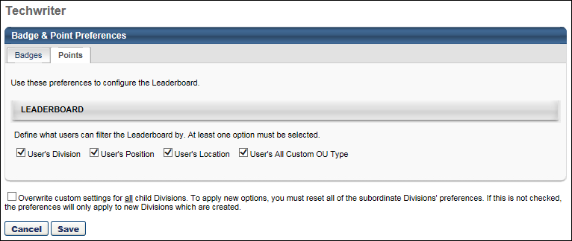
Leaderboard
This section enables administrators to define which filter options are available to the user when viewing the Leaderboard. When an option is selected, the corresponding filter option is able to select on the Leaderboard page. The various organizational unit (OU) filter options enable the user to compare their points totals with other users from the same OU. The following options are available:
- User's Division
- User's Position
- User's Location
- User's All Custom OU Type - If a user has more than one custom OU type configured for their user record, then all applicable custom OU types are available in the filter.
By default, User's Division is selected, and all other options are not selected. At least one option must be selected.
Overwrite Settings
Select this option to overwrite custom settings for child division OUs. If you overwrite custom settings for child division OUs, the selected settings are applied to both new and existing child OUs. Any previously customized child OUs are updated with the selected settings.
- If there are no customizations to the child OU, then the parent OU customizations are applied to all child OUs.
- Overwrite custom settings checkbox setting
  - If this option is selected, all child OU customizations are deleted from the database, which means the parent OU customizations will be applied to new and existing child OUs.
  - If this option is unselected, all existing child OU customizations will remain unchanged, and any new child OUs will inherit the parent OU customizations by default.
- If a child OU has been customized to display any widgets, then regardless of the parent OU customizations, the child OU customizations are applied.
- If a child OU has been customized to hide all widgets, then parent OU customizations will take precedence and will be applied.
Note: This option only applies to the Points tab.
Save/Cancel
Click Save to commit any unsaved changes. Or, click Cancel to discard any unsaved changes.
Badge - Add/Edit
Badges are a form of employee recognition awarded when a user receives positive feedback or when a user completes training. Badges may have an associated point value. Based on portal configuration, you may be able to view badges through a widget on the Universal Profile - Snapshot page.
Note: Badges can only be edited from the division in which they are created. For example, if you create a badge for the California division, the Edit option will only be available for that badge when you access the California division's Badge and Point Preferences. If you access the Los Angeles division's Badge and Point Preferences, the badge that was created for the California division is NOT editable. Either return to the division where the badge was created, or copy the badge to the child division and edit the copy.
To add a new badge, click the Add Badge link on the Badge Preferences page.
Permissions
PERMISSION NAME | PERMISSION DESCRIPTION | CATEGORY

Badge & Point Preferences - Manage | Enables user to access and edit preferences on the Badge & Point Preferences page. The availability of this permission is controlled by a backend setting. This permission can be constrained by OU and User's OU. This is an administrator permission. | Core Administration.
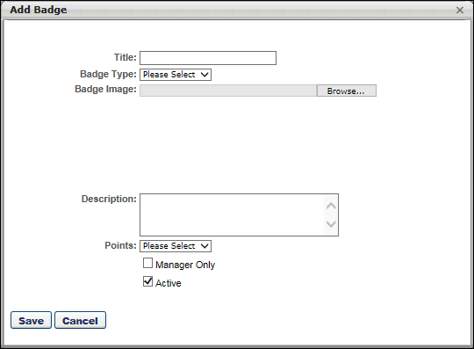
To add/edit a badge:
- Complete or edit the following fields:
  - Title - The purpose of the badge. When editing a badge, modifications to the badge title are reflected on the Training Completion page and Snapshot: Badges sub-page for users who have already completed training and earned the badge. 50 characters maximum.
  - Badge Type - The purpose of the badge. This will determine in which scenarios the badge can be awarded. When editing a badge, you cannot modify the badge type. Options are:
    - Feedback - Select this type when the badge should only be used when awarding feedback.
    - Learning - Select this type when the badge should only be used when a user completes training.
  - Badge Image - The image that represents the badge. Click the Browse button to select an image file. When uploading an image file, the character limit for the file name is 91. When editing a badge, modifications to the badge image are reflected on the Training Completion page and Snapshot: Badges sub-page for users who have already completed training and earned the badge. For badge images, the acceptable file types are .png, .jpeg, and .gif. Badge images should be square with a recommended size of 100 x 100 pixels. To have a square badge image display properly on the My Badges page, use a 66 x 66 pixel image centered on a white square that is 100 x 100 pixels.
  - Description - The description of the badge, up to 150 characters. This should describe the purpose of the badge in detail. When editing an existing badge, changes to this field are applied to all past instances of this badge.
  - Points - The point value associated with the badge. A user's badge points are visible on the Universal Profile Snapshot page and on the Points Leaderboard. When editing an existing badge, changes to this field are only applied to future instances of this badge. The points that are associated with badges already awarded will not be changed.
  - Manager Only - Whether the badge is only available to be awarded by managers. When this option is selected, only direct or indirect managers are able to award this badge, and they can only award it to their direct or indirect reports. When editing an existing badge, changes to this field are only applied to future instances of this badge. This option is only available when the Badge Type is set to Feedback.
  - Active - Whether the badge is active. When editing an existing badge, changes to this field are only applied to future instances of this badge. See the Deleting or Deactivating Badges section of the Badge & Point Preferences - Badges topic for additional information. See Badge & Point Preferences - Badges on page 43 for additional information.
- Click Save.
After a badge is created, it is awarded to a user via the Universal Profile: Feedback page. You can also associate it with a learning object (LO) so that it is automatically awarded when a user completes the associated LO.
- See Badge - Give a Badge on page 17 for additional information.
- See Course Catalog - General.

Snapshot - My Badges
The My Badges page enables users, managers, and administrators to view all of the badges that the user has been awarded. This page displays all types of badges such as Feedback and Learning badges. This page can be filtered by badge type.
To access the My Badges page, click the Badges widget on the Universal Profile - Snapshot page.
Permissions
PERMISSION NAME | PERMISSION DESCRIPTION | CATEGORY

Snapshot - Badges | Enables user to view the Badges widget and subpage within the Universal Profile - Snapshot page for users within their permission constraints. Any user with this permission will always be able to view their own Badges widget when the widget is enabled. This permission also allows end users to view the Badges field on the Learner Home page.  This permission works in conjunction with the Snapshot Main - View permission. This permission can be constrained by OU, User's OU, User Self and Subordinates, User, User's Self, User's Manager, User's Superiors, User's Subordinates, User's Direct Reports, and Employee Relationship. Best Practice: For most users, this permission should be constrained by User Self and Subordinates. | Universal Profile

Snapshot Main - View | Enables user to view the Snapshot page for users within their permission constraints. This permission can be constrained by Employee Relationship, OU, User's OU, User Self and Subordinates, User, User's Self, User's Manager, User's Superiors, User's Subordinates, and User's Direct Reports. Best Practice: For most users, this permission should be constrained by User Self and Subordinates. | Universal Profile
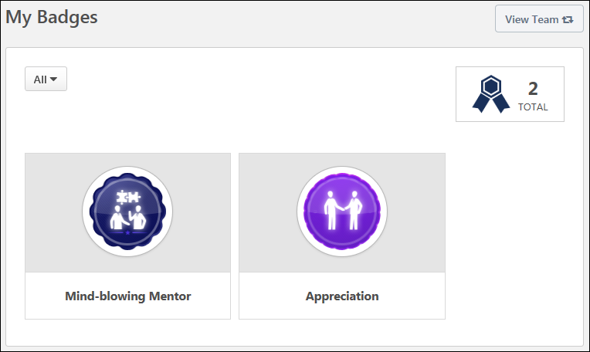
View Team
The View Team flyout allows managers, approvers, and custom relationships to quickly navigate between subordinates' profiles and transcripts. When enabled, the View Team flyout is available to managers and dotted line managers on all pages of their Universal Profile and the Universal Profile of their subordinates. This flyout displays the manager's reports visually.
The View Team button displays if enabled in the portal. Administrators may enable or disable this flyout via the My Team Dropdown section within Universal Profile General Preferences. See Universal Profile General Preferences.
See Universal Profile - View Team Flyout.
Filter Badges
By default, all types of badges are displayed. To filter the badges by type, select the appropriate badge type from the drop-down menu, such as Feedback or Learning.
Total Number of Badges
In the upper-right corner of the page, the total number of times a user has been awarded a badge is displayed. If the user has been awarded the same badge multiple times, then each time is counted as a separate occurrence in this total.
Earned Badges
This page displays all of the badges the user has been awarded. A number is displayed in the lower-right corner of the badge which indicates the number of times the user has received this badge.
This page displays all types of badges such as Feedback and Learning badges. Badges are displayed in the order in which they were awarded, with the most recently awarded badge displayed first.
Note: Badges and Points do not display on the Training Completion page for ILT sessions. Any earned Badges or Points will still be awarded to the user, but for ILT sessions they must be accessed from the Badges and/or Points Snapshot widgets in Universal Profile.

Snapshot - Leaderboard
A user may receive points for completing training. Also, a user may be awarded a badge by completing training or receiving positive feedback from another user. When a user receives a badge, they are also awarded any points that are associated with the badge.
The Leaderboard page enables users to view their total number of points, their overall points ranking within their organizational unit, and the top 10 users who have the most points. Note: Total number of points is calculated by adding their training points (points earned from completing trainings) and their badge points (both learning badges and feedback badges).
If multiple users have the same number of points, then they are ranked alphabetically by first name. Also, if the user is not in the top 10 ranking, then the user is displayed at the bottom of the page with the user who ranks above them and the user who ranks below them.
This page can be filtered by organizational unit (OU) and by time frame.
To access the Leaderboard page, click the Leaderboard widget on the Universal Profile - Snapshot page.
Permissions
PERMISSION NAME | PERMISSION DESCRIPTION | CATEGORY

Snapshot - Leaderboard | Enables user to view the Leaderboard widget and subpage within the Universal Profile - Snapshot page for users within their permission constraints. This permission works in conjunction with the Snapshot Main - View permission. This permission can be constrained by OU, User's OU, User Self and Subordinates, User, User's Self, User's Manager, User's Superiors, User's Subordinates, User's Direct Reports, and Employee Relationship. Any user with this permission will always be able to view their own Leaderboard widget when the widget is enabled. Best Practice: For most users, this permission should be constrained by User Self and Subordinates. | Universal Profile

Snapshot Main - View | Enables user to view the Snapshot page for users within their permission constraints. This permission can be constrained by Employee Relationship, OU, User's OU, User Self and Subordinates, User, User's Self, User's Manager, User's Superiors, User's Subordinates, and User's Direct Reports. Best Practice: For most users, this permission should be constrained by User Self and Subordinates. | Universal Profile
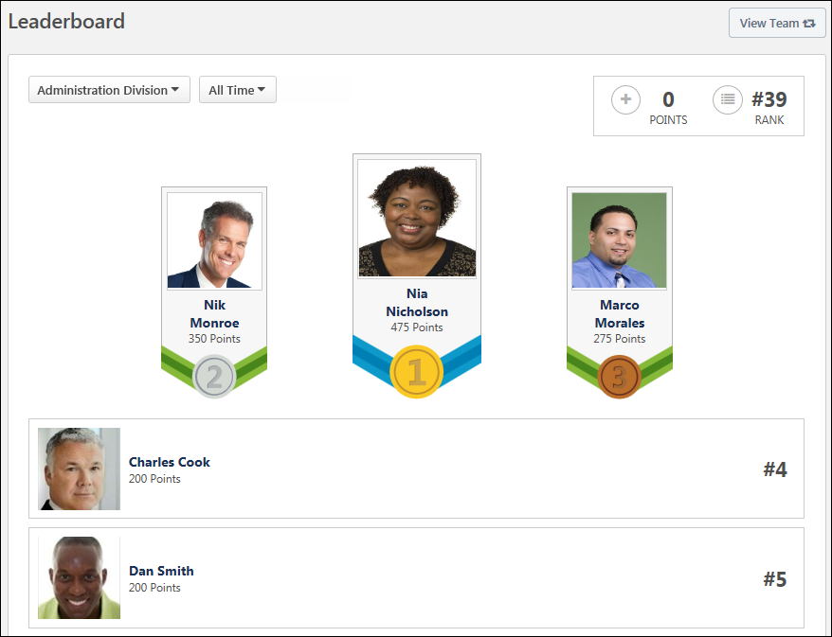
View Team
The View Team flyout allows managers, approvers, and custom relationships to quickly navigate between subordinates' profiles and transcripts. When enabled, the View Team flyout is available to managers and dotted line managers on all pages of their Universal Profile and the Universal Profile of their subordinates. This flyout displays the manager's reports visually.
The View Team button displays if enabled in the portal. Administrators may enable or disable this flyout via the My Team Dropdown section within Universal Profile General Preferences. See Universal Profile General Preferences.
See Universal Profile - View Team Flyout.
Filter by User's OUs
By default, the Leaderboard includes all users within the user's division. However, the user can also filter the Leaderboard by their Position, Location, or custom OU type. This enables the user to see how they rank within each of these OUs. Note: Only the user's OUs are available in the drop-down. The user cannot select an OU to which they do not belong. Also, the administrator can configure which filter options are available within Badge & Points Preferences. See Badge & Point Preferences - Points on page 46 for additional information.
To filter the Leaderboard by a particular OU, select the appropriate OU type from the drop-down menu.
Filter by Time
By default, the Leaderboard includes points that have been awarded within the calendar month. For example, on April 15, this only includes points that have been awarded from April 1 through April 15. However, the user can filter the Leaderboard by calendar year or include all historical points. This enables the user to see how they rank over different periods of time. Note: The time filter follows UTC (Coordinated Universal Time).
To filter the Leaderboard by a particular time frame, select the appropriate option from the drop-down menu.
Overall Points and Rank
In the upper-right corner of the page, the user's total number of points and their overall ranking is displayed based on the selected time and OU filter.
Top 10 Ranking
The top 10 users who have the most amount of points are displayed based on the selected time and OU filter. Also, the top three users are displayed more prominently at the top of the list. If multiple users have the same number of points, then they are ranked alphabetically by first name.
The user whose Snapshot is being viewed is always displayed in the Leaderboard. If the user is not in the top 10 ranking, then the user is displayed below the top 10 with the user who ranks above them and the user who ranks below them.
Users can click another user's photo or name within the Leaderboard to view the user's Universal Profile: Bio page.

