External Training March 2024

Table of Contents
External Training Overview 1
External Training - Add Overview 2
External Training - Add from Transcript 3
SF-182 Form - Overview 7
SF-182 Form - Overview 20
External Training Request - Mark Complete 24
SF-182 Overview 25
SF-182 Administration 29
Mark SF-182 Request Complete 31
SF-182 Vendors 34

External Training Overview

External Training - Add Overview
External training allows users to capture training taken outside the system, such as conferences, external online courses, books, etc. on their learning transcript.

External Training - Add from Transcript
Users with the related permission can add external training to their learning transcript.
To add external training to your transcript, go to Learning > View Your Transcript. Then, select the Add External Training option from the Options drop-down menu.
Permissions
PERMISSION NAME | PERMISSION DESCRIPTION | CATEGORY

External Training - Add | Grants a user the ability to add or edit their own external training. When viewing another user's transcript, the user must also have permission to edit transcript items in order to add or edit the user's external training. This permission cannot be constrained. This is an end user permission. | Learning
Clicking the Add External Training link opens the Add External Training page.
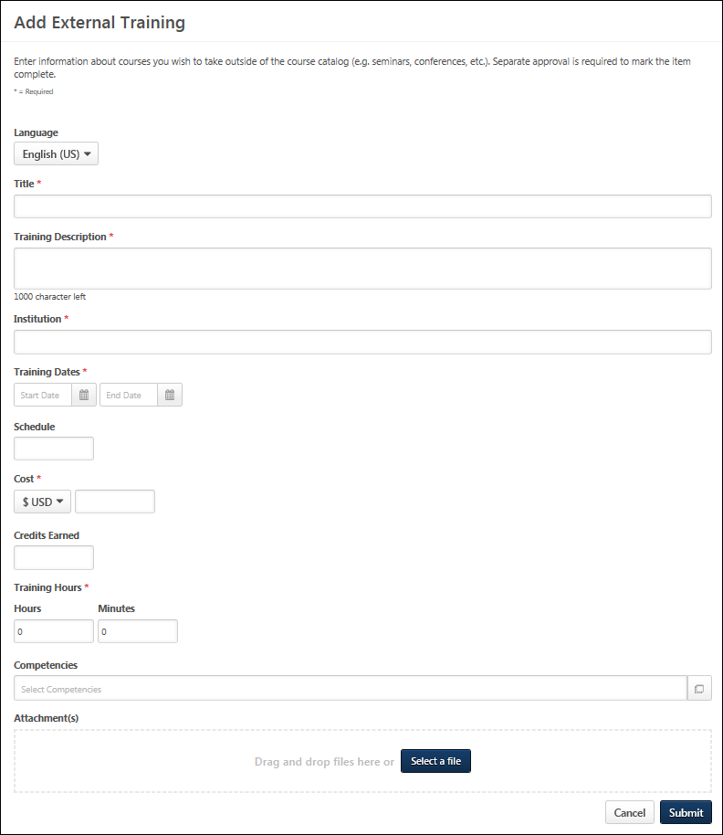
The instructions and field names that appear on this page are configurable by the system administrator in Configure External Training Preferences. Also, the system administrator can configure which fields and options are available and required in Configure External Training Preferences. See Configure External Training by Division for additional information.
Populate the following fields for the external training.
- Language - Select language if applicable.
- Title - Enter the external training title.
- Training Description - Enter the training description.
- Provider/Institution - Enter the provider or institution providing the external training.
- Training Dates - Use the Calendar icon to select a training start date (From) and end date (To).
- Schedule - Enter a schedule.
- Cost - Enter a training cost.
- Credits - Enter the credits earned.
- Training Hours - Enter the number of training hours.
- Course Syllabus - Enter the course syllabus, if applicable.
- Attachments - Click the Attachments link to add attachments to the external training. Each attachment can be up to 1 MB in size, and a maximum of 15 attachments can be added to an external training. They are limited to ppt, pptx, doc, docx, pdf, jpg, jpeg, jpe, png, txt, gif, xls, xlsx, and rtf file types. After selecting the appropriate attachments, click the SAVE button to save the attachments to the review.
Click Submit to submit the form after all the required fields have been populated.
Troubleshooting
Upon clicking Submit, you may receive an error message next to a field, indicating that the value you entered in the field is not valid. This error occurs if an administrator has configured the field to only accept certain values. If the value you entered does not meet the criteria configured by the administrator, an error message displays. The value must re-entered and calculated as valid before the external training can be submitted successfully. Note: For portals with multiple languages enabled, the custom validation message appears in the user's display language, if available. If the user's language is not available, the error message appears in its default language.
Only one error message displays at a time. This means that if there are multiple invalid values, the error message displays for the first invalid value until the value in that field is valid. Once the value is valid and the Submit or Calculate button clicked, the error message for the next invalid field displays.
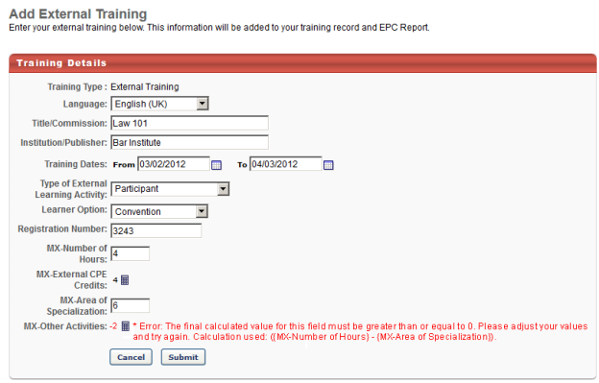
NOTE: When loading a large set of External Training transcript records with Edge, there is a limit of two million records per portal.

SF-182 Form - Overview
When requesting external training, users can use the SF-182 request form if the functionality is available in the portal.
To request SF-182 external training, select the Add SF-182 External Training option from the Options drop-down menu on the Transcript page.
When SF-182 functionality is available in the portal, the Add External Training option on the Transcript page is changed to Add Regular External Training. Also, an SF-182 filter option is available in the Training Type drop-down at the top of the transcript. When this is selected and the Search icon is clicked, only external training that was requested using the SF-182 request form displays. The results also display in-progress SF-182 requests.
Note: The Add SF-182 External Training and Add Regular External Training options must be configured in SF-182 Preferences in order for the links to display on the Transcript page.
Permissions
PERMISSION NAME | PERMISSION DESCRIPTION | CATEGORY

Edit Transcript Items | Grants ability to modify training due dates, statuses, and scores on other user's transcripts (training records) when viewing training details for particular learning objects on the transcript. User must also have permission to add external training in order to add or edit another user's external training. This permission can be constrained by OU, User's OU, User Self and Subordinates, User, and User's Self.  Note: Users with this permission also will also see the Add SF-128 link on the transcript. | Learning - Administration

SF-182 Administration | Grants ability to view SF-182 requests for populations of users (based on constraints), approve SF-182 forms at any step of the process, and view the link for managing SF-182 specific vendors for their organization. (Governmental clients). This is an administrator permission. | Limited Use/Obsolete

SF-182 Requests - Manage | Grants ability to view SF-182 requests for a population of users based on constraints.  If this permission is added to the dynamic Manager security role, the permission will automatically be constrained to self and subordinates. If the SF-182 approver is a manager and should not be constrained to just self and subordinates, please create a separate security role and add the SF-182 Requests Manage permission to that role with any needed constraints. | Limited Use/Obsolete

User View “Add SF-182” link on Transcript | Grants ability to view the "Add SF-182 External Training" link to complete the form for requesting an external course (Governmental clients). This is an end user permission.  Note: If a user does not have this permission but has the Edit Transcript Items permission, the Add SF-182 External Training link will also appear. | Limited Use/Obsolete
Note: The Add SF-182 External option will appear if the user has any one or more of the above security permissions.
When using the SF-182 form to request external training, there are four steps to completing the form:
- Training
- Costs and Billing
- Personal Details
- Confirm
Form Instructions
To view instructions for completing the form, click the Download Instructions link in the upper-right corner of any step. Note: The Download Instructions link only appears if instructions are created by the administrator. If the link does not appear, then an instructions document is not available.
Required, Read-only, and Pre-configured Fields
Some fields may be required or read-only, depending on how the administrator has configured the form. In addition, some fields may already contain a default value that is configured by the administrator. Pre-configured fields may be editable or read-only, depending on how the administrator has configured the form. Note: An SF-182 request cannot be edited if the vendor is set to inactive.
In-Progress Forms
Forms that are in progress can be saved and completed at a later time. Only the Course Title field is required in order to save the form. Click Save at the bottom of any step to save the form. The form appears on your transcript under the course title with a status of Not Submitted.
To return to an in-progress form, select the Edit option on the Transcript page. This opens the form and allows you to continue completing it. Note: An SF-182 request cannot be edited if the vendor is set to inactive. To delete an in-progress form, select the Withdraw option on the Transcript page. This opens the Withdraw pop-up. Click Submit to delete the form from your transcript.
Status Workflow
When the user submits the form, the external training is added to their transcript. The following is the workflow of the status process once a form is submitted:
User Action | SF-182 Form Request Status | External Training Transcript Status | External Training Options Available On Transcript
Saves SF-182 | Not Submitted | Not Submitted | Edit, Remove
Submits SF-182 and SF-182 approvals are required | Pending Approval Step "<current approval step no.>" (e.g., Pending Approval Step 3) | Pending SF-182 Form Approval | None
Edits SF-182 that is currently pending approval | Pending Approval Step "<current approval step no.>" (e.g., Pending Approval Step 3) | Not Started | Edit
LO approval is also required for user | Approved | Pending Approval
LO approval denied | Approved | Denied | None
SF-182 approval denied | Denied | SF-182 Form Denied | None
Exempted | Same status that the form had at the time of exemption | Exempt | None
Gained all approvals for SF-182 and Register upon Approval is unchecked | Approved | Approved | Withdraw
Gained all approvals for SF-182 and Register upon Approval is checked for portal | Approved | Registered | Withdraw
User withdraws from training | Same status as the form was at the time of withdrawal | Withdrawn | None
Training end date has passed | Approved | Registered | Mark Complete
User marks complete; External Training and Completion Approvals are required for user | Approved | Pending Completion Approval | None
Completion approval is granted or external training is completed | Completed | Completed | None
Note: The Register Upon Approval option is configured in Default Approval Requirements (by Division) preferences.
Create SF-182 Request - Step 1 - Training
The Training step is the first step of the SF-182 request process, and it includes the following sections:
- Training Information
- Training and Vendor Location
- Advanced
Some fields may be pre-populated if enabled by the administrator in Configure External Training preferences. The following table shows which fields on the Training step may be pre-populated if their corresponding external training field is enabled by the administrator:
External Training Field | SF-182 Field
Language | N/A in SF-182. Use end user's language
Title | Course Title
Training Description | Training Objective
Training Provider | Name of Vendor
Training Dates | Start and End Date
Schedule | N/A
Cost | Total direct costs + Total indirect costs
Credits earned | Training Credit
Training Hours | Training Duty Hours + Training Non-duty hours
Grade | N/A
Comments | N/A
Training Information
- Course Title - Enter the course title, up to 400 characters.
- Course Number Code - Enter the course number code, up to 250 characters.
- Training Start Date - Enter the start date or click the Calendar icon to select a date from the calendar feature.
- Training End Date - Enter the end date or click the Calendar icon to select a date from the calendar feature.
- Training Duty Hours - Enter the number of duty hours.
- Training Non-Duty Hours - Enter the number of non-duty hours.
- Training Objective - Enter the objective or purpose of taking the training, up to 1000 characters.
Training and Vendor Location
- Name of Training Vendor - Click the Select icon to open the Choose a Vendor pop-up. Select a vendor by clicking the plus sign in the Add column next to the vendor name. This closes the Choose a Vendor pop-up and enters the vendor name in the field.
- Vendor Contact Information - Enter the vendor's street address, city, state, zip, phone number, and email address.
- Training Location Address - Check this option to indicate that the training is located at the same address as the vendor. This populates the address fields with the information in the Vendor Contact area. If the address is not the same, enter the street address, city, state, and zip.
Advanced
- Training Purpose Type Code
- Training Type Code
- Training Sub Type Code
- Training Delivery Type Code
- Training Designation Type Code
- Training Credit Type Code
- Training Credit
- Training Source Type Code
- Training Accreditation Indicator
- Continued Service Agreement Required - This indicates whether you are required to complete the Continued Service Agreement form, and this is configured by the administrator.
  - If this option is set to Yes, you are required to download and complete the Continued Service Agreement form, and then attach the completed form to the request. Enter the form's expiration date in the Continued Service Agreement Expiration Date field. Note: The completed Continued Service Agreement form appears in the printable view of the request.
    - If the Continued Service Agreement Required toggle is set to Yes and an attachment has not been included, the SF-182 printable form will display a value of Yes but the transcript view will display a value of No to indicate no form was attached.
    - If the Continued Service Agreement Required toggle is set to Yes and an attachment has been included, the SF-182 printable form will display a value of Yes AND the transcript view will display a value of Yes.
  - If this option is set to No, you are not required to complete the form or enter an expiration date.
    - If the Continued Service Agreement Required toggle is set to No then it will display No on both the SF-182 printable form and the transcript view.
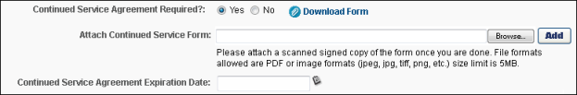
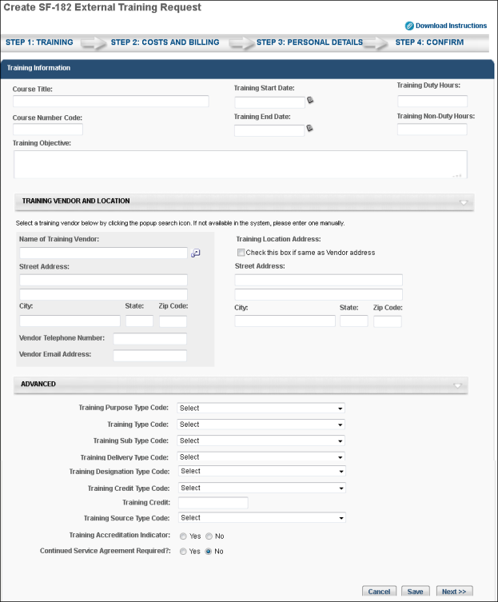
- Click Cancel to cancel the form.
- Click Save to save the form without submitting it. Note: The Course Title field must be completed before you can save the form.
- Click Next to go to Step 2. See Create SF-182 Request - Step 2 - Costs and Billing on page 15 for additional information.
Create SF-182 Request - Step 2 - Costs and Billing
The Costs and Billing step is the second step of the SF-182 request process, and allows the user to enter cost information about the training. This step includes the following sections:
- Direct Cost and Appropriation/Fund Chargeable
- Indirect Cost and Appropriation/Fund Chargeable
- Other
Direct Cost and Appropriation/Fund Chargeable
To enter costs for tuition, fees, books, or materials:
- Enter the tuition/fees and books/material costs in the Amount column. The total appears in the Total field at the bottom of the column.
- Enter the fund information in the Appropriation Fund column. The system automatically calculates the total and populates it in the Total field at the bottom of the column.
Indirect Cost and Appropriation/Fund Chargeable
To enter related travel and per diem costs:
- Enter the travel and per diem cost in the Amount column. The total appears in the Total field at the bottom of the column.
- Enter the travel and per diem fund information in the Appropriation Fund column. The system automatically calculates the total and populates it in the Total field at the bottom of the column.
Other
Enter other relevant cost information, including:
- Total Training Non-Government Contribution Cost
- Document/Purchasing Order/Registration Number
- 8-Digit Station Symbol
- Billing Instructions - Enter billing instructions.
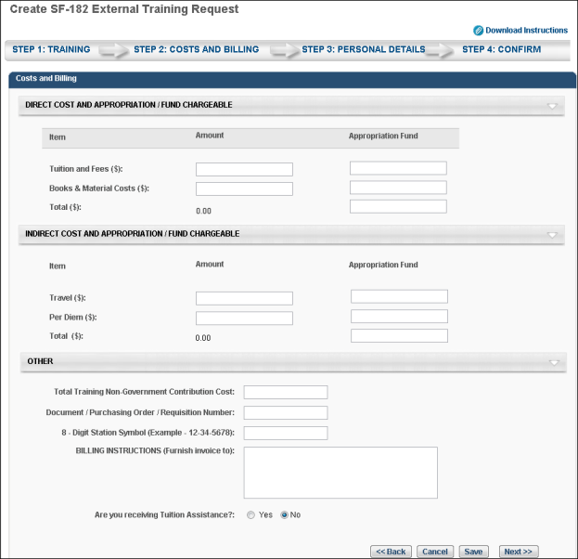
- Click Back to return to Step 1.
- Click Cancel to cancel the form.
- Click Save to save the form without submitting it. Note: The Course Title field must be completed before you can save the form.
- Click Next to go to Step 3. See Create SF-182 Request - Step 3 - Personal Details on page 17 for additional information.
Create SF-182 Request - Step 3 - Personal Details
The Personal Details step is the third step in the SF-182 request process, and it includes the following sections:
- Personal Information
- Advanced
Personal Information
In this section, enter your name and personal contact information, as well as work contact information.
Advanced
- Position Level - Select your position level from the drop-down menu.
- Position Title - Enter your job title.
- Special Accommodation - Use this option to indicate if special accommodations are needed. If Yes is selected, describe the accommodations in the text field.
Navigation
- Click Back to go to Step 2.
- Click Cancel to cancel the form.
- Click Save to save the form without submitting it. Note: The Course Title field must be completed before you can save the form.
- Click Next to go to Step 4. See Create SF-182 Request - Step 4 - Confirm on page 18 for additional information.
Create SF-182 Request - Step 4 - Confirm
The Confirm step is the fourth and final step of the SF-182 request process, and allows the user to review the request for accuracy and submit the request.
Review the information entered on each step and click Submit. This triggers the SF-182 Form Submitted email, if enabled. Once submitted, the SF-182 request is added to your transcript. If the form requires approval, the status of the form is Pending Approval <Current Approval Step>. Note: The approval step is dependent upon the current step in the approval process.
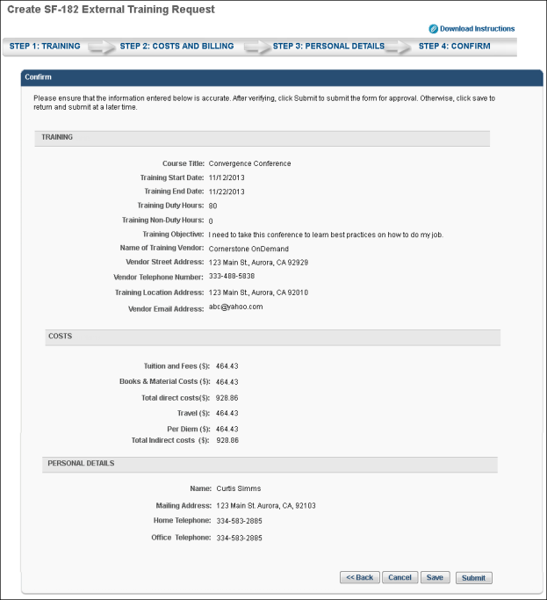
- Click Back to go to Step 3.
- Click Cancel to cancel the form.
- Click Save to save the form without submitting it. Note: The Course Title field must be completed before you can save the form.

SF-182 Form - Overview
When requesting external training, users can use the SF-182 request form if the functionality is available in the portal.
To request SF-182 external training, select the Add SF-182 External Training option from the Options drop-down menu on the Transcript page.
When SF-182 functionality is available in the portal, the Add External Training option on the Transcript page is changed to Add Regular External Training. Also, an SF-182 filter option is available in the Training Type drop-down at the top of the transcript. When this is selected and the Search icon is clicked, only external training that was requested using the SF-182 request form displays. The results also display in-progress SF-182 requests.
Note: The Add SF-182 External Training and Add Regular External Training options must be configured in SF-182 Preferences in order for the links to display on the Transcript page.
Permissions
PERMISSION NAME | PERMISSION DESCRIPTION | CATEGORY

Edit Transcript Items | Grants ability to modify training due dates, statuses, and scores on other user's transcripts (training records) when viewing training details for particular learning objects on the transcript. User must also have permission to add external training in order to add or edit another user's external training. This permission can be constrained by OU, User's OU, User Self and Subordinates, User, and User's Self.  Note: Users with this permission also will also see the Add SF-128 link on the transcript. | Learning - Administration

SF-182 Administration | Grants ability to view SF-182 requests for populations of users (based on constraints), approve SF-182 forms at any step of the process, and view the link for managing SF-182 specific vendors for their organization. (Governmental clients). This is an administrator permission. | Limited Use/Obsolete

SF-182 Requests - Manage | Grants ability to view SF-182 requests for a population of users based on constraints.  If this permission is added to the dynamic Manager security role, the permission will automatically be constrained to self and subordinates. If the SF-182 approver is a manager and should not be constrained to just self and subordinates, please create a separate security role and add the SF-182 Requests Manage permission to that role with any needed constraints. | Limited Use/Obsolete

User View “Add SF-182” link on Transcript | Grants ability to view the "Add SF-182 External Training" link to complete the form for requesting an external course (Governmental clients). This is an end user permission.  Note: If a user does not have this permission but has the Edit Transcript Items permission, the Add SF-182 External Training link will also appear. | Limited Use/Obsolete
Note: The Add SF-182 External option will appear if the user has any one or more of the above security permissions.
When using the SF-182 form to request external training, there are four steps to completing the form:
- Training
- Costs and Billing
- Personal Details
- Confirm
Form Instructions
To view instructions for completing the form, click the Download Instructions link in the upper-right corner of any step. Note: The Download Instructions link only appears if instructions are created by the administrator. If the link does not appear, then an instructions document is not available.
Required, Read-only, and Pre-configured Fields
Some fields may be required or read-only, depending on how the administrator has configured the form. In addition, some fields may already contain a default value that is configured by the administrator. Pre-configured fields may be editable or read-only, depending on how the administrator has configured the form. Note: An SF-182 request cannot be edited if the vendor is set to inactive.
In-Progress Forms
Forms that are in progress can be saved and completed at a later time. Only the Course Title field is required in order to save the form. Click Save at the bottom of any step to save the form. The form appears on your transcript under the course title with a status of Not Submitted.
To return to an in-progress form, select the Edit option on the Transcript page. This opens the form and allows you to continue completing it. Note: An SF-182 request cannot be edited if the vendor is set to inactive. To delete an in-progress form, select the Withdraw option on the Transcript page. This opens the Withdraw pop-up. Click Submit to delete the form from your transcript.
Status Workflow
When the user submits the form, the external training is added to their transcript. The following is the workflow of the status process once a form is submitted:
User Action | SF-182 Form Request Status | External Training Transcript Status | External Training Options Available On Transcript
Saves SF-182 | Not Submitted | Not Submitted | Edit, Remove
Submits SF-182 and SF-182 approvals are required | Pending Approval Step "<current approval step no.>" (e.g., Pending Approval Step 3) | Pending SF-182 Form Approval | None
Edits SF-182 that is currently pending approval | Pending Approval Step "<current approval step no.>" (e.g., Pending Approval Step 3) | Not Started | Edit
LO approval is also required for user | Approved | Pending Approval
LO approval denied | Approved | Denied | None
SF-182 approval denied | Denied | SF-182 Form Denied | None
Exempted | Same status that the form had at the time of exemption | Exempt | None
Gained all approvals for SF-182 and Register upon Approval is unchecked | Approved | Approved | Withdraw
Gained all approvals for SF-182 and Register upon Approval is checked for portal | Approved | Registered | Withdraw
User withdraws from training | Same status as the form was at the time of withdrawal | Withdrawn | None
Training end date has passed | Approved | Registered | Mark Complete
User marks complete; External Training and Completion Approvals are required for user | Approved | Pending Completion Approval | None
Completion approval is granted or external training is completed | Completed | Completed | None
Note: The Register Upon Approval option is configured in Default Approval Requirements (by Division) preferences.

External Training Request - Mark Complete
To mark an external training item complete, go to Learning > View Your Transcript.
Once the external training is approved and the external training date has passed, a Mark Complete option is available for the external training. Select the Mark Complete option for the external training.
If the Grade and Submitted Paperwork options are enabled by the administrator, you are prompted to provide responses for these fields on a separate page after the external training is marked complete.
- Grade - If applicable, Enter the grade that was earned for this external training, up to 100 characters.
- Submitted Paperwork - Select whether or not paperwork has been submitted for the external training.
If external training required completion approval by your approver, status will be Pending Completion Approval until your manager or approver approves completion. Upon approval, the training status will be Completed.
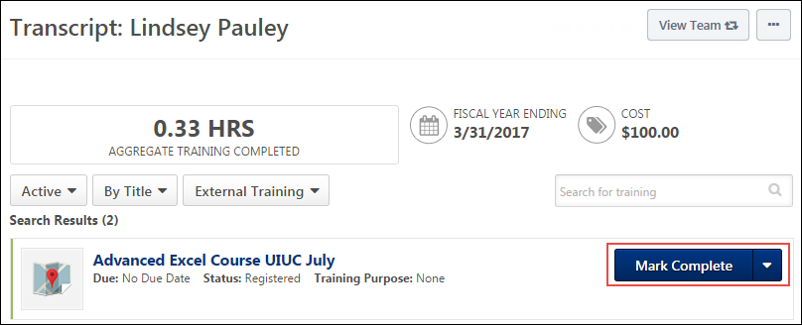

SF-182 Overview
The SF-182 (Standard Form 182) "Authorization, Agreement, and Certification of Training" form can be used by users when requesting external training and for administrators and managers requesting external training on behalf of a user. Administrators can also configure preferences so that only the SF-182 form can be used for requesting external training.
The SF-182 form is controlled by backend settings that are turned off by default. To enable this functionality, contact Global Customer Support. Note: Learning Management System must also be enabled in your portal.
Permissions
PERMISSION NAME | PERMISSION DESCRIPTION | CATEGORY

Set SF-182 Preferences | Grants ability to configure SF-182 preferences for standard fields, approvers and reasons. (Governmental clients). This is an administrator permission. | Limited Use/Obsolete

Set SF-182 Reason Preferences | Grants ability to create and edit/update SF-182 reasons for users to select when approving or denying an SF-182 request. (Governmental clients). This is an administrator permission. | Limited Use/Obsolete

SF-182 Administration | Grants ability to view SF-182 requests for populations of users (based on constraints), approve SF-182 forms at any step of the process, and view the link for managing SF-182 specific vendors for their organization. (Governmental clients). This is an administrator permission. | Limited Use/Obsolete

SF-182 Custom Fields - Manage | Grants ability to manage SF-182 Fields (Governmental clients). This is an administrator permission. | Limited Use/Obsolete

SF-182 Requests - Manage | Grants ability to view SF-182 requests for a population of users based on constraints.  If this permission is added to the dynamic Manager security role, the permission will automatically be constrained to self and subordinates. If the SF-182 approver is a manager and should not be constrained to just self and subordinates, please create a separate security role and add the SF-182 Requests Manage permission to that role with any needed constraints. | Limited Use/Obsolete

User View “Add SF-182” link on Transcript | Grants ability to view the "Add SF-182 External Training" link to complete the form for requesting an external course (Governmental clients). This is an end user permission.  Note: If a user does not have this permission but has the Edit Transcript Items permission, the Add SF-182 External Training link will also appear. | Limited Use/Obsolete
Note: In order to successfully submit an SF-182 request, your administrator must configure approval steps on the SF-182 Preferences page. See Set SF-182 Preferences - Set Approvals.
Workflow
User Creates SF-182 Request
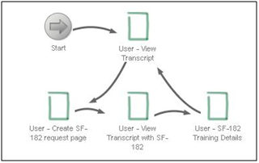
Manager Creates SF-182 Request
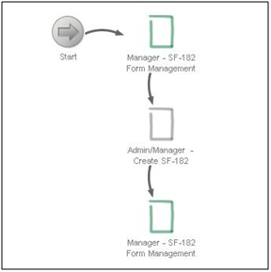
Administrator Tracks SF-182 Requests in Their Organization
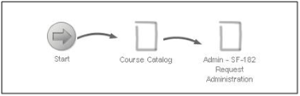
Administrator Creates SF-182 Request
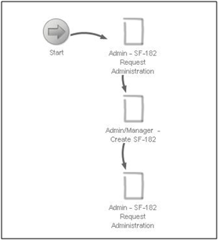
Administrator Sets Preferences for SF-182
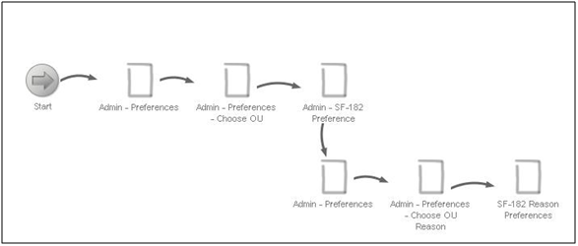
Administrator Tracks SF-182 Vendors in Their Organization
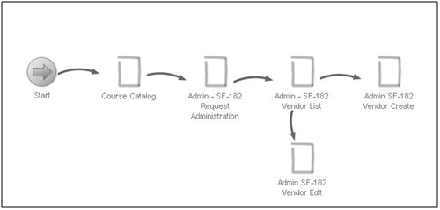
Administrator Sets Custom Fields for SF-182
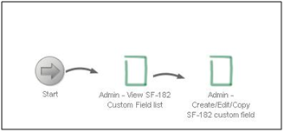

SF-182 Administration
The SF-182 Administration page enables administrators to track, approve, and create SF-182 requests. Administrators can also manage vendors from this page.
To access SF-182 Administration, go to Admin > Tools > Learning > Learning preferences > SF-182 Administration.
Permissions
PERMISSION NAME | PERMISSION DESCRIPTION | CATEGORY

SF-182 Administration | Grants ability to view SF-182 requests for populations of users (based on constraints), approve SF-182 forms at any step of the process, and view the link for managing SF-182 specific vendors for their organization. (Governmental clients). This is an administrator permission. | Limited Use/Obsolete
Create New Request
Click the Create New Request link to create a new SF-182 request for one or more users.
Manage SF-182 Vendors
Click the Manage SF-182 Vendors link to open the SF-182 Vendors page. See SF-182 Vendors on page 34 for additional information.
Search
Enter search filter options in the Training Title or Request ID. A filter by location, division, or user, can also be applied by using Select OU criteria. You can also select one or more statuses from the Status drop-down. Click Search to use the filter options selected to Search.
Note: When using the Select OU filter, only Location, or Division, or User can be selected and you cannot select a combination of location, division, and user. Also, the location, division, and user filters do not currently support selecting or displaying child organizational units.
SF-182 Requests table
This table displays all requests within the manager's permission constraints. The table is sorted by newest to oldest request date. All columns are sortable except the Options column. The following information displays for each request:
- Requested by - This column shows the name of the user that requested the training.
- Training Title - This column shows the title of the external training.
- Request ID - This column shows the ID number of the request. The ID number is auto-generated for the request the first time it is submitted.
- Date Submitted - This column shows the date on which the request was submitted.
- Status - This column shows the status of the request.
- Approval - Click the Approve or Deny icons to access the Approve/Deny SF-182 Request page on which you can perform approval and denial actions. The icons are available only for forms that are in a Pending Approval status.
The following options are available in the Options column:
- Edit - Click the Edit icon to edit the request. The icon is always visible regardless of the status of the form or the external training.
- Copy - Click the Copy icon to copy the request. When copying a request, the Training and Cost fields are copied. The information in the User Details section is not copied.
- Print - Click the Print icon to print the request.

Mark SF-182 Request Complete
Managers with the permission to mark training complete can access their employees' transcripts and mark SF-182 requests complete. Managers with SF-182 Requests - Complete permission can mark a request complete through the SF-182 requests page.
Permissions
PERMISSION NAME | PERMISSION DESCRIPTION | CATEGORY

Mark Training Complete | Grants ability to mark learning objects complete for other users, via the training details page when viewing the learning object from the user's transcript. This permission does not grant ability to mark a user's learning object complete from their Transcript page. This permission can be constrained by OU, User's OU, User, User's Self, and User Self and Subordinates. This is an administrator permission. | Learning - Administration

SF-182 Add Approver | Allows users to view and click on the +Add Approver on the SF-182 Training details page. This permission can be constrained by OU, User's OU, and User Self. This is an end user permission. | Learning - Administration

SF-182 Requests - Complete | Grants ability to mark complete SF-182 requests for a population of users based on constraints (e.g., managers can complete requests of their subordinates, etc.).  This permission can be constrained by the following: User Self and Subordinates, User's Subordinates, User's Division, User's Corporation, User's Position, User's Grade, User's Cost Center, User's Location, User's Group, User Custom OUs​, Division, Position, Grade, Cost Center, Location, Group, Custom OUs, Self Registration Groups, User's Self Registration Groups. | Limited Use/Obsolete
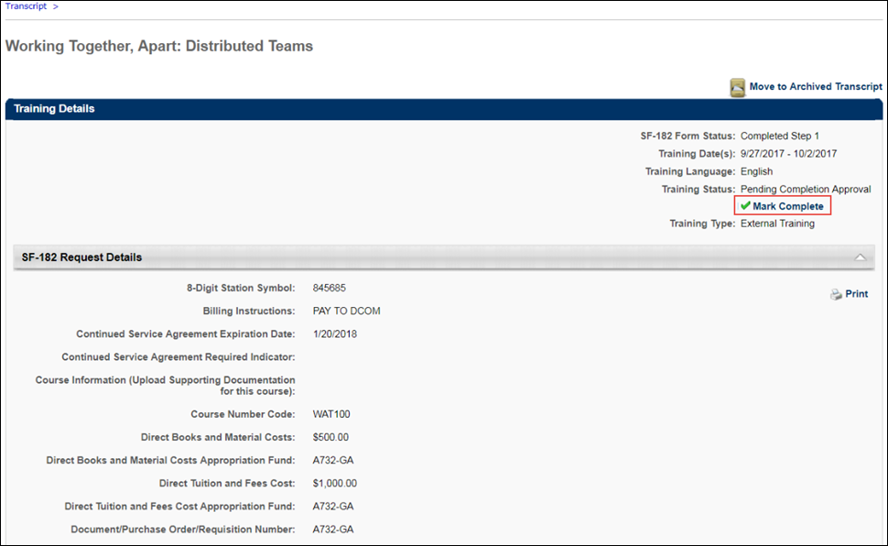
Add Approver
Activate the Add Approver functionality on the training details page to configure which approvers can be included in the SF-182 approval workflow. This functionality is available to any security role that has the "SF-182 Add Approver" permission. If the security permission is not added, the Add Approver option does not appear in the training details for the SF-182 requests. The permission allows greater control over whether approvers can be included in the SF-182 approval workflow and can be constrained to restrict which approvers can be selected.
The constraints OU, User's OU, and User Self can be added to the "SF-182 Add Approver" permission to restrict who can be added as an additional approver through the training details page for an SF-182 request.
​
Mark Complete
To mark an employee's SF-182 request complete, navigate to the employee's transcript, then click the title of the SF-182 external training that requires completion. On the Training Details page for the user's SF-182 external training request, click the Mark Complete link. The SF-182 request will be completed.
Approvers with SF-182 Requests - Complete permission can mark complete through the SF-182 requests page by clicking the View Training Details icon under Options column and then clicking Mark Complete under Training Details. It marks the SF-182 form request status and the training status as completed. The completion workflow is also fully completed.
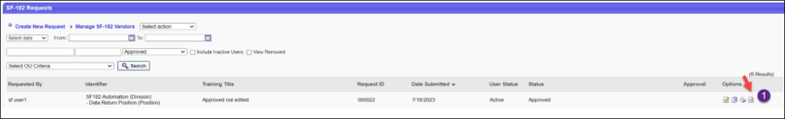
Note: When an approver edits a completed form and saves it, the completion workflow is finished.

SF-182 Vendors
The SF-182 Vendors page enables administrators to track, approve, and create SF-182 vendors.
To access the SF-182 Vendors page, go to Admin > Tools > Learning > Learning preferences > SF-182 Administration. On the SF-182 Administration page, click the Manage SF-182 Vendors link.
Permissions
PERMISSION NAME | PERMISSION DESCRIPTION | CATEGORY

SF-182 Administration | Grants ability to view SF-182 requests for populations of users (based on constraints), approve SF-182 forms at any step of the process, and view the link for managing SF-182 specific vendors for their organization. (Governmental clients). This is an administrator permission. | Limited Use/Obsolete
Search
Enter search terms in the Search box. Check the Show Inactive option to show inactive vendors. Click Search.
Add New Vendor
Click the Add New Vendor link to open the Add Vendors page. See SF-182 Vendor - Add on page 35 for additional information.
Vendors Table
This table displays all SF-182 vendors. The table is sorted alphabetically by vendor name. All columns are sortable except the Phone and Options columns. The following information displays for each vendor:
- Vendor Name
- Phone
- Email Address
- City, State
- Active - This column indicates whether or not the vendor is active. When active, the vendor can be selected on SF-182 requests.
Click the Edit icon in the Options column to edit the vendor.
SF-182 Vendor - Add
On the Add Vendors page, administrators can create and edit vendors. They can also manage the active status of a vendor.
To add a new SF-182 Vendor, go to Admin > Tools > Learning > learning preferences > SF-182 Administration. On the SF-182 Administration page, click the Manage SF-182 Vendors link. Then, click the Add New Vendor link on the SF-182 Vendors page.
Permissions
PERMISSION NAME | PERMISSION DESCRIPTION | CATEGORY

SF-182 Administration | Grants ability to view SF-182 requests for populations of users (based on constraints), approve SF-182 forms at any step of the process, and view the link for managing SF-182 specific vendors for their organization. (Governmental clients). This is an administrator permission. | Limited Use/Obsolete
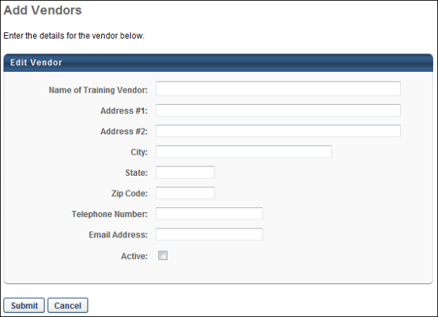
Add Vendor
When adding a vendor, all fields except Address #2 are required.
To add a vendor:
- Enter the vendor name, up to 500 characters.
- Enter the address in the Address #1 field, up to 500 characters.
- Enter additional address information in the Address #2 field, up to 500 characters.
- Enter the city in which the vendor is located, up to 250 characters.
- Enter the state in which the vendor is located, up to 100 characters.
- Enter the vendor's zip code, up to 20 characters.
- Enter the vendor's phone number, up to 20 characters.
- Enter the vendor's email address, up to 250 characters.
- Check the Active option to activate the vendor.
- Click Submit.
If the vendor is active, the vendor appears on the SF-182 Vendors page and is available to select on the Training Vendor pop-up of the SF-182 request form.
If the vendor is not active, the vendor is not visible on the SF-182 Vendors page unless you check the Show Inactive box. Further, inactive vendors are not available to select when creating, editing, or copying an SF-182 request.

