Express Class March 2024

Table of Contents
Express Class Gathered Learning Capture Tool - Overview 1
Create Express Class - General Information 3
Create Express Class - Attendees 9
Create Express Class - Summary 18
Express Class Define Training Time 21
Express Class on Transcript 23
Express Class Gathered Learning Capture Tool - FAQ 25

Express Class Gathered Learning Capture Tool - Overview
The Express Class Gathered Learning Capture Tool allows facilitators and administrators to quickly and easily document gathered learning after the learning takes place and give credit to the learners, from either a mobile or a desktop device.
Permissions
PERMISSION NAME | PERMISSION DESCRIPTION | CATEGORY

Express Class - Manage | Grants the ability to create and add users to an Express Class for a facilitated training session. This permission can be constrained by OU, User, User Self and Subordinates, and User's OU. This is an end user permission. | Learning - Administration
Use Cases
Use Case #1: Impromptu Training
Bill, a warehouse foreman, sees one of his warehouse unloaders, Zack, drop a stack of boxes onto the floor in the warehouse while operating a forklift. Bill sees an opportunity to give Zack additional training on forklift driving. After giving Zack training, Bill marks adds Zack to Forklift Training 101 on his tablet using Express Class and marks Zack as complete. Zack receives transcript credit for the training.
Use Case #2: Informal Training
Henry, an intern, is having trouble evaluating data in a data analysis software and decides to ask Michelle, his learning administrator, for help. Recognizing that this could be a good learning opportunity for another intern, Michelle asks another intern named David to join them. After an hour of instruction, Michelle decides that Henry and David have learned enough to warrant the completion of the Data Analysis 101 course offered in their company's portal, so she retroactively adds them as attendees to this instructor-led training (ILT) course via Express Class and gives them transcript credit for the training.
Use Case #3: Classroom Training
Andy, a training facilitator at ACME Corp, is responsible for training groups of employees on machinery used on the manufacturing floor. Each week, he gathers employees who require machinery training, delivers the training himself, and then adds the employees who attended his training as attendees to his Express Class, selects the appropriate training in the catalog, and gives them transcript credit for their time with him.
Resources
For information about creating an Express Class, see the following:
- Create Express Class - Step One (General Information): See Create Express Class - General Information on page 3 for additional information.
- Create Express Class - Step Two (Attendees): See Create Express Class - Attendees on page 9 for additional information.
- Create Express Class - Step Three (Summary): See Create Express Class - Summary on page 18 for additional information.
- For information about how Express Classes appear on user transcripts, see the following:
  - Express Class on User Transcript: See Express Class on Transcript on page 23 for additional information.

Create Express Class - General Information
The process for creating an Express Class is comprised of three steps:
- General Information
- Attendees - See Create Express Class - Attendees on page 9 for additional information.
- Summary - See Create Express Class - Summary on page 18 for additional information.
On the General Information step, the user creating the Express Class provides basic information about the Express Class, such the training item, completion time, and time zone.
To create an Express Class, go to: Learning > Express Class.
Permissions
PERMISSION NAME | PERMISSION DESCRIPTION | CATEGORY

Express Class - Create Material | This permission controls whether a user can create a material training item via Express Class. This permission cannot be constrained. Materials created via Express Class will be visible within Material Administration and Course Catalog, but by default, end users cannot search for them. To make materials created via Express Class searchable, the administrator can set availability for the material within the Course Catalog after the new material has been created. | Learning - Administration

Express Class - Manage | Grants the ability to create and add users to an Express Class for a facilitated training session. This permission can be constrained by OU, User, User Self and Subordinates, and User's OU. This is an end user permission. | Learning - Administration

Express Class - View Training | Grants ability to select training via Express Class. This permission can be constrained by any of the following criteria, but keep in mind that adding an OU constraint and a training-related constraint to this permission results in an "AND" statement:  - User's ILT Provider  - User's Self  - User's LO Availability  - User's Subordinates  - User's Corporation  - User's Division  - User's Position  - User's Grade  - User's Cost Center  - User's Location  - User's Group  - User's Self Registration Group  - Provider  - Training Type  - ILT Provider  - User  - Training Item  - Division  - Position  - Grade  - Cost Center  - Location  - Group  - Self Registration Group | Learning - Administration
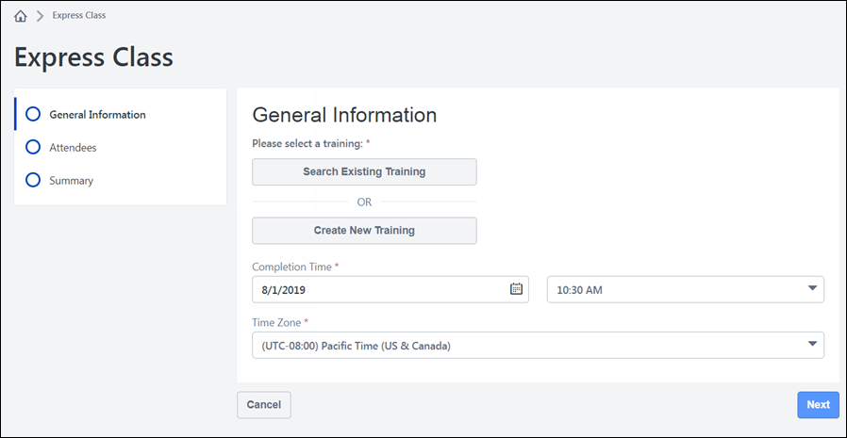
General Information
On the General Information page, you can either search for and select an existing training item in the Course Catalog, or you can create a new training item.
Search Existing Training
To add training from the Course Catalog to the Express Class:
- Click the Search Existing Training button. This opens a flyout. Training results in this flyout are controlled by the Express Class - View Training permission. The constraints applied to this permission control what training can be found.
  - Note: If the Express Class - View Training Permission is constrained by more than one constraint, an “AND” statement results. For example, if this permission is constrained to a training item called “Leadership in Action,” which is an event, and the permission is ALSO constrained to material type training items, “Leadership in Action” will not appear in the flyout, as it is not a material.
- Enter the training title in the flyout's search bar. As you type, up to 10 training results that contain your search term will display in the search results. Note the following:
  - Express Class Training Search first considers the Training Title. Entering the exact Training Title of a learning object should return that LO at the top of the predictive results list.
  - If there are fewer than 10 learning objects with the search term in the Training Title, the search results will return LOs with the search term in the Training Description.
  - Keywords are not considered in the Express Class training search.
- Click the training item you want to add to the Express Class. The training will be added to the General Information page, where you can view basic information about the training. If needed, you can click the Remove Training link to delete the training from the Express Class and search for a different item.
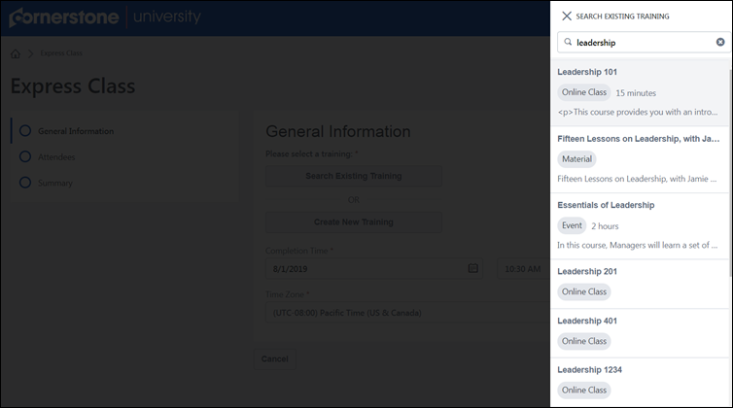
More Details
After selecting a training item, the Express Class creator can view the title, training type, description, and training hours for the training item in the training tile. To view additional information, click the More Details link. This causes the More Details flyout to appear. The flyout displays any custom fields and training hours attached to the training, to help differentiate between similar training items. If there is no value associated with a custom field, it will display as “N/A.”
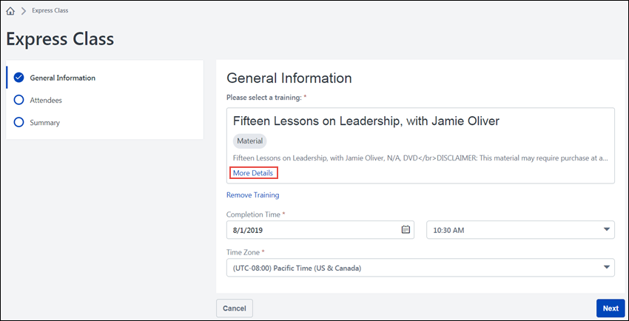
To close the flyout and return to the General Information page, click the X icon in the upper-left corner of the flyout.
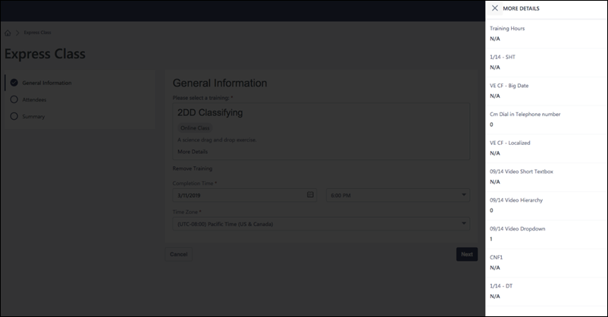
Create New Training
To create a new material training item, click the Create New Training button. This opens the Create New Training flyout. Using the flyout, populate the following fields for the new training:
- Training Title - Enter a title for the new training item in the Training Title field. This field is required.
- Description - Enter a description for the training in the Description field.
- Subjects - Search for and select any subjects which should be associated with the training item using the Subjects search bar. At least one subject must be selected.
- Training Hours - Enter the number of training hours users will receive for completing this training, in hours and minutes. This field is required, and the Training Hours time provided must be at least one minute.
After populating all the necessary fields, click the Save button to create the training item for which attendees of this Express Class will receive credit.
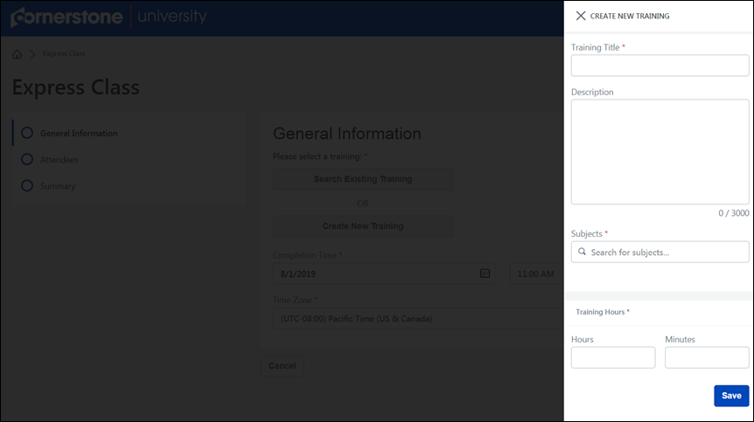
Considerations
- After the Express Class has been submitted, the material is created and added to Material Administration and the Course Catalog, but by default it is NOT searchable in system areas such as Global Search and Learning Search. The material is, however, searchable and available to select when adding training to another Express Class.
- Because materials created via Express Class do not have a source, they are not launchable on users' transcripts. The ability to create materials via Express Class is intended to be used as a method of quickly giving users credit for training that does not yet exist in the Course Catalog.
- New training created via Express Class (materials) do not generate a course code.
Additional Details
After either selecting an existing training item or creating a new training item, populate the following additional general information for the Express Class:
- Completion Time - In the Completion Time section, select the date of the training completion from the date field, and then select the completion time of the training from the time drop-down menu. This field is required.
- Time Zone - From the Time Zone field, select the time zone in which the training was completed. This field is required.
After populating at least the required fields on the General Information page, click the Next button to advance to the Attendees step. See Create Express Class - Attendees on page 9 for additional information.
Mobile Browser
Express Classes can be created in-browser on mobile devices. The process for creating the Express Class and the available fields are the same, but the display is optimized for mobile devices.
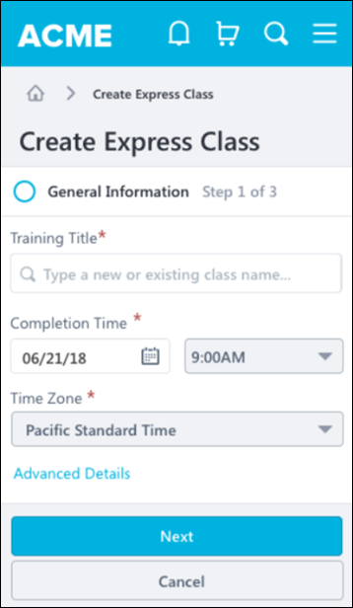

Create Express Class - Attendees
The process for creating an Express Class is comprised of three steps:
- General Information - See Create Express Class - General Information on page 3 for additional information.
- Attendees
- Summary - See Create Express Class - Summary on page 18 for additional information.
On the Attendees step, the user creating the Express Class searches for and selects the users who will be marked as having attended the Express Class.
To create an Express Class, go to: Learning > Express Class.
Permissions
PERMISSION NAME | PERMISSION DESCRIPTION | CATEGORY

Express Class - CSV Upload | This permission grants the ability to upload CSV files for attendees included in an Express Class. This permission can be constrained by OU, User, User Self and Subordinates, and User's OU. This is an end user permission. | Learning - Administration

Express Class - Manage | Grants the ability to create and add users to an Express Class for a facilitated training session. This permission can be constrained by OU, User, User Self and Subordinates, and User's OU. This is an end user permission. | Learning - Administration
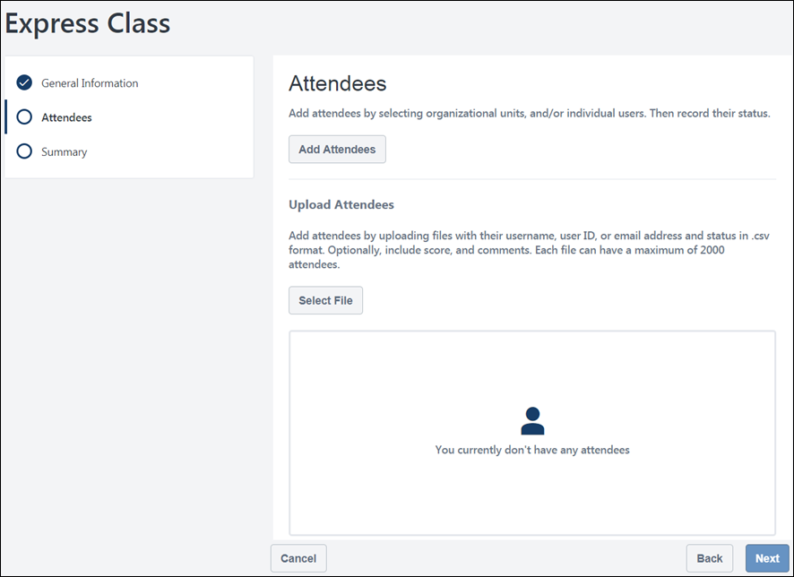
Add Attendees
The administrator creating the Express Class can add attendees to the Express Class by selecting a group or OU. This allows all members of a group or OU to be quickly added to the Express Class at one time.
To add a group or an OU to the attendees list:
- Click the Add Attendees button. This opens the Add Attendees flyout. The Add Attendees flyout contains two tabs: Search and Selected. On the Search tab, you can search for and select users, groups, and OUs. On the Selected tab, you can view users, groups, and OUs that you have already selected for the Express Class.
- On the Search tab of the Add Attendees page, click the drop-down menu next to the search bar and select a criteria type. To add users individually to the Express Class, you can choose the Users option. To add users in bulk, you can select an OU type or the Group option. Note: Because Express Class functionality does not take availability into account when selecting Users or OUs (similar to the Learning Assignment Tool), all OU types will appear for selection in the drop-down, even if availability has been set via the Manage Organizational Unit Types administrator page.
- After selecting an OU type or group, enter the name of the OU or group into the search bar and press the Enter key on your keyboard. Find the specific user, OU, or group you want to add and check the box next to it. You can select more than one if needed. If you select an OU or group, all the users included in the OU or group appear individually, allowing you to unselect any users you do not want to include.
- Once all the desired users, OUs, or groups have been selected, click the Save button at the bottom of the flyout. The users included in the criteria you selected will be added to the Attendees list of the Express Class.
The selected users will be added to the Attendees page, where you can record their completion results and scores for the Express Class.
Note: A maximum of 2000 users can be added and submitted in Express Class.
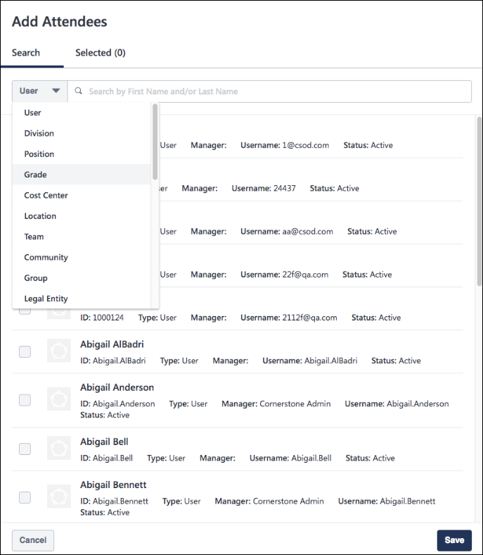
Upload Attendees
A CSV file may be uploaded during the Add Attendees step, allowing the administrator to quickly import a list of users who should be included in the Express Class. The CSV file should not included headers. Column A must contain the user identifier for each user. The remaining fields are optional, but the column order must be maintained, even if there is no value in the column.
- Column A: Identifier - In the Identifier column, enter one of the following identifiers for each user:
  - Username
  - User ID
  - Email Address
- Column B: Status -Enter the number the corresponds with one of the supported statuses:
  - 1 = Completed
  - 2 = Failed
  - 3 = Incomplete
Note: If a status is not included in the CSV file, the Status must be updated in the UI before the attendee list can be submitted.
- Column C: Score - Commas are not supported by the optional Score field. Do not include commas in the CSV file. The score will appear on the Observation History page, available via Transcript Details.
- Column D: Comments - Each optional comment can contain up to 3000 characters. Users who are successfully identified after the upload will be added to the Express Class. Important: If a user is identified from the CSV file but the user is NOT within the Express Class creator's availability, the user will NOT be added to the Express Class.
- Column E: Observed Training Hours - Total time entered cannot exceed 99,999 hours
- Column F: Observed Training Minutes - Any value over 59 will convert to hours and minutes, and the hours will be added to the value entered into the hours field (e.g. entering '999' minutes will convert to 16 hours, 39 minutes)
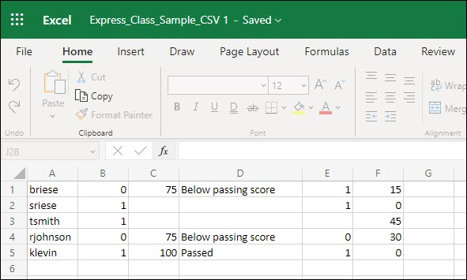
To upload a CSV file to the Express Class:
- Click the Select File button.
- Search for and select the CSV file from your computer. The system will process the users included in the file and add all successfully identified users within the creator's availability to the Express Class. If any users are not successfully identified based on the user criteria provided, an error displays.
Record
After users have been added to the Express Class, you can record their completion results and scores individually or in bulk. You can also upload attachments to attendees, if needed.
Individual Record
To record a user's results and score individually on the Attendees page, click the Record button next to the specific user. A pop-up window appears, and you can populate the following fields for the user's Express Class record:
- Result - A result selection is required. Select one of the following three training results for the user:
  - Complete - Select this result to indicate the user successfully completed the Express Class training. The Express Class will appear as Completed on the user's transcript.
  - Incomplete - Select this result to indicate the user did not complete the Express Class training. The Express Class will appear as Incomplete on the user's transcript.
  - Fail - Select this result to indicate that the user completed the Express Class training unsuccessfully. The Express Class will appear as Incomplete on the user's transcript.
- Score - If a numeric score applies to the user's Express Class completion attempt, enter the score in the Score field. This field is not required.
- Comments - Enter an explanation for the assigned result and score in the Comments field. This field is limited to 3000 characters and is not required.
- Attach File - Either drag a file into the upload zone or click the Browse link to search for and select a file from your computer to upload. For example, if a learning facilitator wants to give learners credit for a test he distributed on paper, the administrator can upload a scan of each test to the associated user. If a file was attached to an attendee when the Express Class was created, the attachment is visible on the user's Observation History page for the related training item.
- Click the Save link at the bottom of the pop-up. The record will be saved for the user.
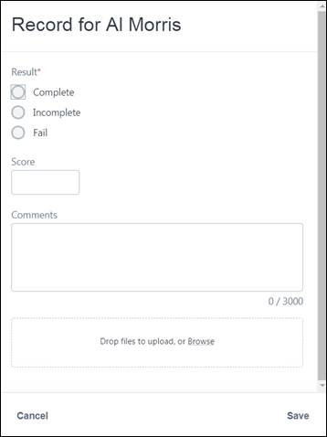
Bulk Record
To record results and scores for multiple users at the same time, check the box next to all users you want to include in the bulk record, and then click the Bulk Record button. A pop-up window appears, and you can populate the following fields for the ALL the selected users:
- Result - A result selection is required. Select one of the following three training results for the users:
  - Complete - Select this result to indicate the users successfully completed the Express Class training. The Express Class will appear as Completed on the users' transcript.
  - Incomplete - Select this result to indicate the users did not complete the Express Class training. The Express Class will appear as Incomplete on the users' transcript.
  - Fail - Select this result to indicate that the users completed the Express Class training unsuccessfully. The Express Class will appear as Incomplete on the users' transcript.
- Score - If a numeric score applies to the users' Express Class completion attempt, enter the score in the Score field. This field is not required.
- Comments - Enter an explanation for the assigned result and score in the Comments field. This field is limited to 3000 characters and is not required.
- Attach File - Either drag a file into the upload zone or click the Browse link to search for and select a file from your computer to upload. If a file was attached to an attendee when the Express Class was created, the attachment is visible on the user's Observation History page for the related training item.
- Click the Save link at the bottom of the pop-up. The record will be saved for ALL selected users.
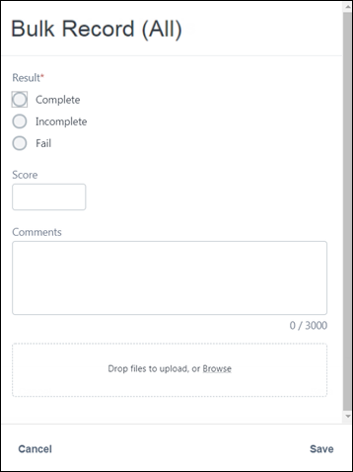
View Results and Scores for Users
After results and scores have been recorded for users on the Attendees page, you can view the selections made for each user. To search for a specific user in the Attendees list, you can enter the user's name in the Search added attendees search bar. The list of users will be filtered for users whose names correspond to your entered text.
If a score and result have been recorded for the user, the entered score and the selected result appear below the user's name and user ID. To make changes to these selections, click the Edit button to the right of the user's name. The Record pop-up window appears again, allowing you to edit the user's record information. If you wish to make edits in bulk, select the users whose records you want to modify and click the Bulk Record button again. You will be able to create a new bulk record for all the selected users.
To continue to the Summary step of the Express Class creation process, click the Next button at the bottom of the page. See Create Express Class - Summary on page 18 for additional information.
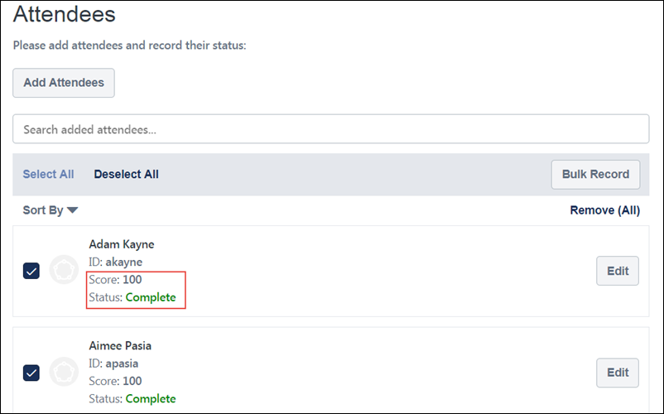
Mobile Browser
Express Classes can be created in-browser on mobile devices. The process for creating the Express Class and the available fields are the same, but the display is optimized for mobile devices.
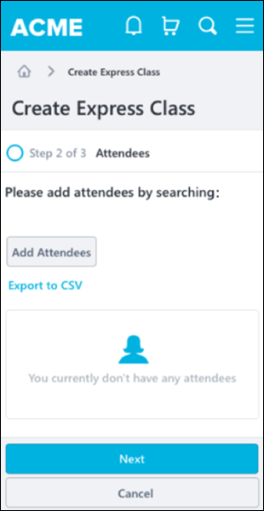

Create Express Class - Summary
The process for creating an Express Class is comprised of three steps:
- General Information - See Create Express Class - General Information on page 3 for additional information.
- Attendees - See Create Express Class - Attendees on page 9 for additional information.
- Summary
On the Summary step, the user can review their Express Class selections, go back and make changes if necessary, and submit the Express Class.
To create an Express Class, go to: Learning > Express Class.
Permissions
PERMISSION NAME | PERMISSION DESCRIPTION | CATEGORY

Express Class - Manage | Grants the ability to create and add users to an Express Class for a facilitated training session. This permission can be constrained by OU, User, User Self and Subordinates, and User's OU. This is an end user permission. | Learning - Administration
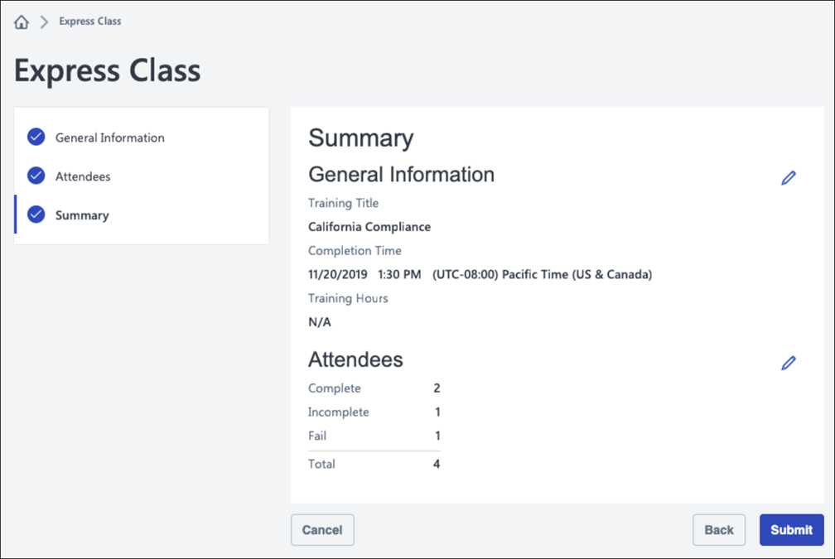
Summary
The Summary page displays your selections for the General Information and Attendees steps in the Express Class creation process.
The following fields and your corresponding selections appear in the General Information section:
- Training Title
- Completion Time
- Training Hours
To make changes to this information, click the Edit icon to the right of the General Information section. You will be returned to the General Information step, where you can make modifications and progress through the Express Class process again.
The following fields and your corresponding selections appear in the Attendees section:
- Total (number of users assigned to the Express Class)
- Pass (number of assigned users who are recorded as having passed the Express Class)
- Incomplete (number of assigned users who are recorded as having not completed the Express Class)
- Fail (number of assigned users who are recorded as having failed the Express Class)
To make changes to this information, click the Edit icon to the right of the Attendees section. You will be returned to the Attendees step, where you can make modifications and progress through the Express Class process again.
To finalize and submit the Express Class, click the Submit button at the bottom of the Summary page.
Mobile Browser
Express Classes can be created in-browser on mobile devices. The process for creating the Express Class and the available fields are the same, but the display is optimized for mobile devices.
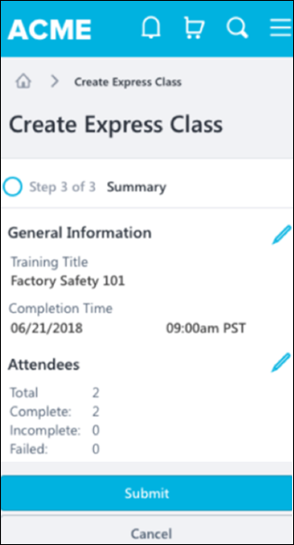

Express Class Define Training Time
Learning administrators or training facilitators can define the actual time spent in training when submitting an Express Class, on both individual or bulk levels. Observed Training Hours and minutes can be defined for Express Class attendees, whose values can then be seen via the User Interface (UI) or in Reporting after completion.
To access this feature, go to Learning > Express Class.
Permissions
PERMISSION NAME | PERMISSION DESCRIPTION | CATEGORY

Express Class - Manage | Grants the ability to create and add users to an Express Class for a facilitated training session. This permission can be constrained by OU, User, User Self and Subordinates, and User's OU. This is an end user permission. | Learning - Administration
To define training time:
- On the Express Class page, select Search Existing Training to locate the appropriate training or select Create New Training.
- On the Attendees page, select one of the following:
  - Add attendees: Add attendees manually via user selector. Selected attendees appear in the attendee list.
    - Upload Attendees: Select the Select File button to bulk upload attendees via .csv file. The .csv file now supports values for observed training hours and minutes. Note: If the .csv file has observed hours and/or training minutes columns, the values entered in those columns are pre-populated in the attendees list.
    - Identifier: In the Identifier column, enter one of the following identifiers for each user:
      - Username
      - User ID
      - Email Address
    - Status: In the optional Status column, enter the number that corresponds with one of the supported statuses:
      - 1 = Completed
      - 2 = Failed
      - 3 = Incomplete
    - Score: Commas are not supported by the optional Score field. Do not include commas in the CSV file. The score will appear on the Observation History page, available via Transcript Details.
    - Comments: Each optional comment can contain up to 3000 characters.
    - Observed Training Hours: Total time entered cannot exceed 99,999 hours
    - Observed Training Minutes: Any value over 59 will convert to hours and minutes, and the hours will be added to the value entered into the hours field (e.g. entering '999' minutes will convert to 16 hours, 39 minutes)
- Click Save. The defined training is visible on the Observation History page for the completed training or in Reporting via the Observed Training Hours field.
Notes
- Observed Training Hours can be defined for existing and newly-created training.
- The Observation History page displays the Observed Training Hours defined via Express Class in the “Training Hours” field.
- The new “observedTrainingHours” property can be used to define hours and/or minutes spent in training via the Express Class API. Use ISO 8601 formatting, for example 1 hour and 30 minutes, is PT1H30M.

Express Class on Transcript
Training assigned via Express Class appears on users' learning transcripts. The options and information available for Express Classes on users' transcripts may differ from other training types on the transcript.
To access your transcript page, go to: Learning > Transcript.
Permissions
PERMISSION NAME | PERMISSION DESCRIPTION | CATEGORY

On the Job Training - Observation History From Transcript | Grants access for users to view On the Job Training Observation History from Transcript Details. This permission cannot be constrained. This is an end user permission. | Learning - Administration

View Transcript Item | Grants ability to view details of learning objects that appear on the transcript (training record), by clicking on the name of the learning object. Users must also have the Bio About - View permission in order to access the transcript within Universal Profile. This permission can be constrained by OU, User's OU, User Self and Subordinates, User, or User's Self. This is an end user permission. | Learning - Administration
Transcript
The following actions are available on the transcript for Express Classes:
- View Training Details - Click this option to view the Training Details page for the Express Class. This action is always available for Express Classes, regardless of whether the Express Class result is Complete or Incomplete. On the Training Details page, the View Observation History link displays along with general information about the training. Click the View Observation History link to view observation information for the Express Class training. See the Observation History section below for more information about the information available on the Observation History page.
- ReRequest - Click the ReRequest option to receive a new instance of the training on your transcript in a Registered status. This option is ONLY available if ALL the following conditions are met:
  - The transcript status for the Express Class is Incomplete
  - Recurrence is enabled for the training contained in the Express Class
  - The user is included in the availability for the training item
Observation History
The header of the Observation History page contains the following information:
- Profile Photo - The evaluated user’s profile photo
- Name - The evaluated user’s full name
- Training Name - The title of the attempted training
- Completed - The date the training was marked complete
- Score - The numeric score awarded for the user’s training attempt (if provided)
The most recent Express Class completion attempt displays below the Observation History page header. If provided by the observer at the time the attempt record was submitted, the following information displays for each attempt:
- Result - Displays whether the observer marked the user as Completed, Incomplete, or Failed for the training attempt
- Date - The date the user's training attempt was recorded
- Score - Displays the numeric score the user achieved on the training, if applicable
- Comment - Any comments regarding the training completion attempt, if provided by the observer/facilitator
Considerations
- Any On the Job Training records submitted via Express Class will NOT appear on the On the Job Training - Observer page.

Express Class Gathered Learning Capture Tool - FAQ
See below for answers to frequently-asked questions about Express Class:
Q: Can we create training using Express Class?
A: Yes, users with the permission to create materials via Express Class are able to create new material training items using Express Class.
Q: Is it possible to limit the training available when creating an Express Class?
A: Yes, you can limit the training available when creating an Express Class using the permission to view Express Class training.
Q: Is it possible to create an Express Class for a specific session?
A: No, it is not possible to select a specific session. You can, however, select the event and mark the learner complete for the event.
Q: Is Express Class a Training Type?
A: No, Express Class is a tool to quickly give credit to learners for a particular training item.
Q: Can you give credit for a training item for all training types using Express Class?
A: You can give credit using Express Class for materials, tests, videos, events, and online classes.
Q: Can we give credit to learners for a training item already on their Transcript?
A: Yes, if the training is on a learner’s transcript, they can be marked complete using Express Class.
Q: Is there a way to give partial credit for an Express Class?
A: No, credit can only be given in Complete, Fail, or Incomplete statuses.
Q: Is there a limitation on how many learners you can give credit to at one time?
A: Yes, there is a limit of 40,000 learners for whom you can submit an Express Class. When using the CSV Upload functionality, CSV files are limited to 2,000 attendees each, with a maximum of 20 files per Express Class submission. Please note that when submitting a large volume of learners, processing can be delayed.
Q: Are Approvals, Pre-Work, Post-Work, and Prerequisites still observed with Express Class?
A: Express Class will bypass all Approvals, Pre-Work, Post-Work, and Prerequisites. The Pre-Work, Post-Work, and Prerequisites will be assigned to the learner in the same status of the Express Class.
Q: Does completing an event with Express Class include any evaluations?
A: Any level 1 and level 2 evaluations are ignored by the Express Class, but any level 3 evaluations configured for the event are triggered by the Express Class.
Q: Are there any Email Triggers for Express Class?
A: Email Triggers are not currently supported for Express Class. Any existing triggers tied to the training will not fire.
Q: Can you select an organizational unit or group for an Express Class?
A: Yes, you can select an organizational unit or group, including subordinate organizational units.
Q: Is it possible to search the entire training catalog when creating an Express Class?
A: Yes, but the training available via Express Class may be restricted based on the permission to view Express Class training.
Q: What Custom Reports currently support Express Class fields?
A: Express Class fields can be found in Assignment Reports, Compliance Reports, Curriculum Transcript Reports, Transaction Report, Transcript Report, Multi-Module Report.
Q: Are Express Class fields available in Reporting 2.0?
A: Yes, Express Class fields are available in Reporting 2.0.

