Evaluations March 2024

Table of Contents
Evaluations Overview 1
Evaluation Administration 2
Evaluations Question Bank 6
Evaluations Categories 9
Evaluations Question Categories 10
Evaluation Category - Create 12
Evaluation Defaults - Manage 14
Level 1 Evaluations - Create 16
Level 1 Reaction Question - Create 17
Level 1 Reaction Evaluation - Create 20
Level 2 Evaluations - Create 24
Level 2 Knowledge Question - Create 25
Level 2 Knowledge Evaluation - Create 28
Level 2 Scored Question - Create 31
Level 2 Scored Evaluation - Create 34
Level 3 Evaluations - Create 38
Level 3 Behavior Question - Create 39
Level 3 Behavior Evaluation - Create 42
Add a Section to an Evaluation 46
Add a Question to an Evaluation Section 48
Configure Questions Within an Evaluation Section 51

Evaluations Overview

Evaluation Administration
The Course Evaluation module is an effective tool for administrators to measure the value of online learning and instructor-led training. Based on the first three levels of Kirkpatrick's Evaluation Model, the course evaluation tool includes three separate evaluations to measure the participant's reaction to the course, the amount of knowledge the participant gained, and how well the participant transferred the new knowledge to his or her job. The course evaluation module includes a wide variety of question types and response formats.
The ability to add course-specific second and third level evaluations allows managers and participants to assess the value of a course. Transfer of learning can be measured because participants can take these evaluations both prior to and following the learning experience.
To access Evaluation Administration, go to Admin > Tools > Learning > Catalog Management > Evaluations.
Permissions
PERMISSION NAME | PERMISSION DESCRIPTION | CATEGORY

Evaluation Defaults - Modify | Allows admin to define the default level 1, level 2 and level 3 evaluations. | Learning - Administration

ILT Evaluations - Update | Grants ability to configure training evaluation settings at instructor led training event or session level, including choosing which evaluation template to use, and indicating whether an evaluation is active and required for the event or session. This is an administrator permission. | Learning - Administration

ILT Evaluations - View | Grants ability to view evaluation questions and user responses to those questions for evaluations associated with instructor led training events and sessions. This permission works in conjunction with Events - View permission. This is an administrator permission. | Learning - Administration

Level 1 Evaluations - Manage | Grants ability to create and edit Level 1 (Reaction) learning evaluations that can be associated with learning objects. When viewing Course Console, this permission also grants the ability to view the status of Level 1 Evaluations. This permission works in conjunction with the Level 1 Evaluation Administration, Course Catalog - Update, and Course Catalog - View permissions. This permission cannot be constrained. This is an administrator permission. | Learning - Administration

Level 1 Evaluation Administration | Grant Access to create and manage level 1 (reaction) evaluations associated with learning objects. This permission cannot be constrained. This is an administrator permission. | Learning - Administration

Level 2 Evaluations - Manage | Grants ability to create and edit Level 2 learning evaluations that can be associated with learning objects. When viewing Course Console, this permission also grants the ability to view the status of Level 2 Evaluations. This permission works in conjunction with the Level 2 Evaluation Administration (knowledge and scored), Course Catalog - Update, and Course Catalog - View permissions. This permission cannot be constrained. This is an administrator permission. | Learning - Administration

Level 2 Knowledge (Non-Scored) Evaluation Administration | Grant Access to create and manage level 2 knowledge (non-scored) evaluations associated with learning objects. This permission cannot be constrained. This is an administrator permission. | Learning - Administration

Level 2 Scored Evaluation Administration | Grant Access to create and manage level 2 (scored) evaluations associated with learning objects. This permission cannot be constrained. This is an administrator permission. | Learning - Administration

Level 3 Evaluation - Manage | Grants ability to create and edit Level 3 (Behavior) learning evaluations that can be associated with learning objects. When viewing Course Console, this permission also grants the ability to view the status of Level 3 Evaluations. This permission works in conjunction with the Level 3 Evaluation Administration, Course Catalog - Update, and Course Catalog - View permissions. This permission cannot be constrained. This is an administrator permission. | Learning - Administration

Level 3 Evaluation Administration | Grant Access to create and manage level 3 (behavior) evaluations associated with learning objects. This permission cannot be constrained. This is an administrator permission. | Learning - Administration
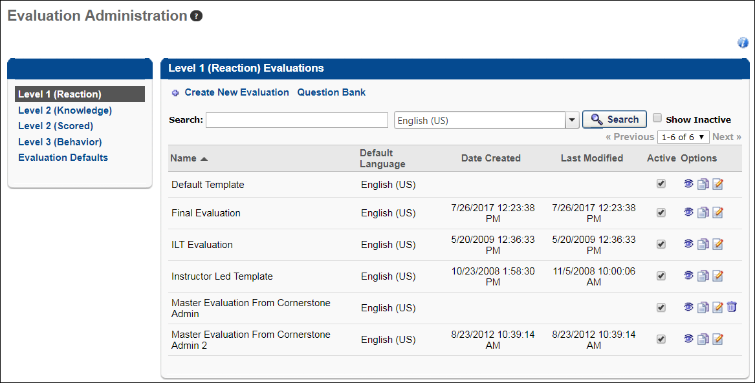
Evaluation Administration
The following fields and features are available on the Evaluation Administration page:
- Link Panel - From this panel, you can click the appropriate link to manage Level 1-3 evaluations, manage the question bank for each evaluation level, and modify evaluation defaults.
- Create New Evaluation - Click the Create New Evaluation link to create a new evaluation.
- Question Bank - Click the Question Bank link to view the question bank for the associated evaluation level.
- Search - Search for evaluations by entering criteria in the Search field. Narrow by the results by the evaluation's default language using the Language filter drop-down. Select the Show Inactive box to display inactive evaluations. Displays the evaluation's default language.
- Evaluations Table - The following information displays for existing evaluations:
  - Name - This is the name of the evaluation.
  - Default Language - This is the default language associated with the evaluation.
  - Date Created - This is the date the evaluation was created.
  - Last Modified - This is the date the evaluation was last edited.
  - Active - Check or uncheck this box to manage the Active status of an evaluation.
  - Options - The following options may be available for existing evaluations:
    - Preview - Preview - Click this icon to preview the evaluation. For portals with multiple languages enabled, when previewing an evaluation, the content appears in the language of the administrator viewing the evaluation. If the administrator's language is not available, the content appears in the display language of the administrator that created the content. Note: Localizable content includes the evaluation name, section name, question name, question, and response choices.
    - Copy - Copy - Click the Copy icon to copy the evaluation.
    - Edit - Edit - Click the Edit icon to edit the evaluation. Some fields cannot be edited if the evaluation is in use.
    - Delete - Click the Delete icon to delete the evaluation. This option is only available if the evaluation is not in use.
Additional Resources
Click any of the following links for more information about the listed topic:
- Create New Evaluation Category
- Create Level 1 Question
- Create Level 1 Evaluation
- Create Level 2 Knowledge Question
- Create Level 2 Knowledge Evaluation
- Create Level 2 Scored Question
- Create Level 2 Scored Evaluation
- Create Level 3 Question
- Create Level 3 Evaluation
- Modify Evaluation Defaults
Helpful Hints
Editing Evaluations
If the evaluation for a learning object is changed, the evaluation report will display all the questions from both the old and the new evaluations. The number of responses for each question will help indicate what was on the old evaluation and what is on the new one.
Attaching Evaluations
- Attaching a Level 1 evaluation to a learning object that previously had no evaluation and if set as not required will display the Evaluate link and allow users to complete the evaluation who have currently have the course on their transcript in a Completed status. If the evaluation is set to Required for that learning object, then users in a Completed status will not have the Evaluate link because their status will not change back to Pending Evaluation.
- If you attach a different evaluation to a learning object that previously had an evaluation, then the following occurs:
  - Users who have clicked the Evaluate link to view or complete the original evaluation will not be able to complete the new evaluation.
  - Users who have not clicked the Evaluate link to view the original evaluation will see the new evaluation when they click on the Evaluate link.

Evaluations Question Bank
A Question Bank is available for each evaluation level. The Question Bank is used to create questions and question categories. By default, when accessing the Question Bank, the Questions tab displays.
To access the Question Bank for evaluations, go to Admin > Tools > Learning > Catalog Management > Evaluations. Click the evaluation level from the left navigation panel. Then, click the Question Bank link.
Permissions
PERMISSION NAME | PERMISSION DESCRIPTION | CATEGORY

Level 1 Evaluation Administration | Grant Access to create and manage level 1 (reaction) evaluations associated with learning objects. This permission cannot be constrained. This is an administrator permission. | Learning - Administration

Level 2 Knowledge (Non-Scored) Evaluation Administration | Grant Access to create and manage level 2 knowledge (non-scored) evaluations associated with learning objects. This permission cannot be constrained. This is an administrator permission. | Learning - Administration

Level 2 Scored Evaluation Administration | Grant Access to create and manage level 2 (scored) evaluations associated with learning objects. This permission cannot be constrained. This is an administrator permission. | Learning - Administration

Level 3 Evaluation Administration | Grant Access to create and manage level 3 (behavior) evaluations associated with learning objects. This permission cannot be constrained. This is an administrator permission. | Learning - Administration
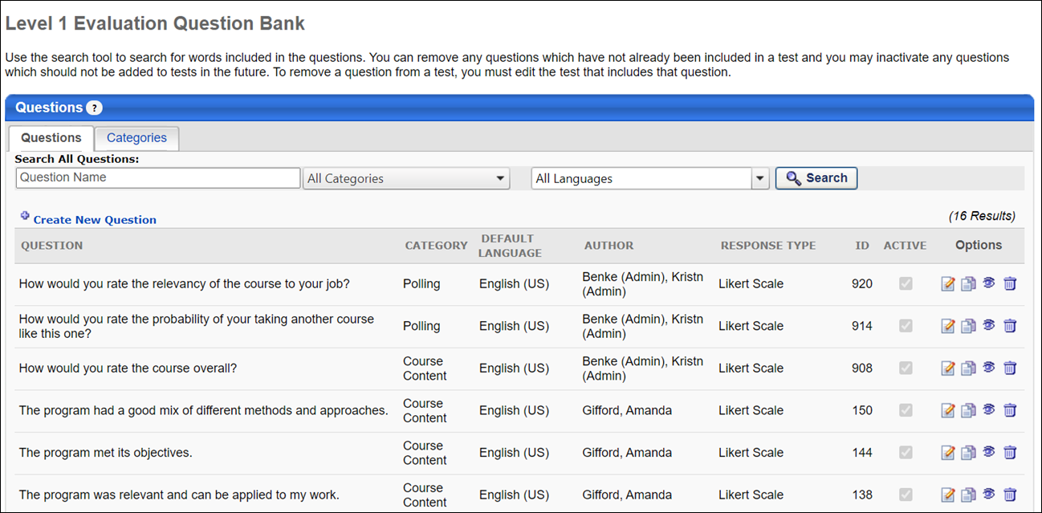
Question Bank
The following tabs are available on this page:
- Questions - The Questions tab displays all questions in the Question Bank for the evaluation level. From this tab, you can search for questions, as well as create, edit, copy, or view a question.
- Categories - The Categories tab displays all categories in the Question Bank for the evaluation level. From this tab, you can create, edit, and delete categories. For more information: See Evaluations Question Categories on page 9 for additional information.
The following fields and features are available on the Questions tab:
- Search - You can search for questions by name, category, or language. When using the language search filter, the language searched is the question's default language. These filters work together so that only the questions that match the criteria are displayed when Search is clicked.
- Create New Question - Click the Create New Question link to create a new question.
- Table of existing questions - Previously created questions display in the Question table. Each question displays with the following fields and options:
  - Question - The question name displays in the language of the administrator that created the test. Or, if available, the test name appears in the user's display language. If the administrator's language is not available, the test displays in the test's default language.
  - Category - This column displays the category associated with the question.
  - Default Language - This column displays the default language of the question.
  - Author - This column displays the name of the question creator.
  - Response Type - This column displays the question type, such as multiple choice, likert scale, Yes/No, Text Only, etc.
  - ID - This column displays the unique ID of the question. This ID can be used by administrators to help identify the question.
  - Active - The Active column checkbox is read-only. Note: The Active status of a question is managed when creating, editing, or copying the question.
  - Options - The following options may be available for existing questions:
    - Edit - Click this option to edit the question. Keep in mind that the question may be in use within an evaluation, and changing the question will change it within existing evaluations.
    - Copy - Click this option to copy the question. You can make modifications to the copy.
    - View - Click this option to preview the question in a pop-up window. This is how the question will appear to users in an evaluation.
    - Delete - Click this option to delete the question. Questions may only be deleted if they are not currently included in an evaluation.

Evaluations Categories

Evaluations Question Categories
The Categories tab displays all categories in the Question Bank for the evaluation level. From this tab, you can create, edit, and delete categories.
To access the Categories tab for evaluations, go to Admin > Tools > Learning > Catalog Management > Evaluations. Click the evaluation level from the left navigation panel. Click the Question Bank link. Then, click the Categories tab.
Permissions
PERMISSION NAME | PERMISSION DESCRIPTION | CATEGORY

Level 1 Evaluation Administration | Grant Access to create and manage level 1 (reaction) evaluations associated with learning objects. This permission cannot be constrained. This is an administrator permission. | Learning - Administration

Level 2 Knowledge (Non-Scored) Evaluation Administration | Grant Access to create and manage level 2 knowledge (non-scored) evaluations associated with learning objects. This permission cannot be constrained. This is an administrator permission. | Learning - Administration

Level 2 Scored Evaluation Administration | Grant Access to create and manage level 2 (scored) evaluations associated with learning objects. This permission cannot be constrained. This is an administrator permission. | Learning - Administration

Level 3 Evaluation Administration | Grant Access to create and manage level 3 (behavior) evaluations associated with learning objects. This permission cannot be constrained. This is an administrator permission. | Learning - Administration
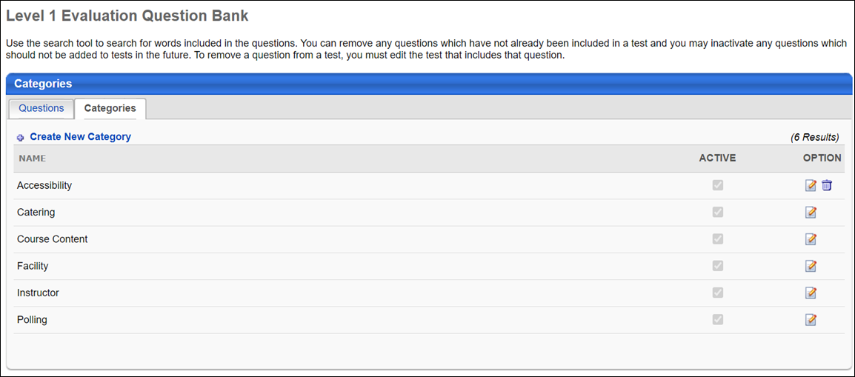
Categories
The following features are available on this page:
- Create New Category - Click the Create New Category link to create a new category for questions.
- Table of existing categories - The following information and options are available for categories that have already been created:
  - Name - This is the name of the category. When an administrator views a category, if the category is not available in their display language, it appears in the language of the administrator that created the category.
  - Active - The Active column checkbox is read-only. Note: The Active status of a category is managed by clicking the Edit icon.
  - Options - The following options may be available:
  - Edit - Click to edit the category. To edit a category:
    - Enter changes to the category name in the text box. For portals with multiple languages enabled, localize the field by using the Translate icon to enter localized text.
    - Check or uncheck the box in the Active column to change the Active status.
    - Click the Save icon to save the changes. Click the Cancel icon to cancel the changes.
  - Delete - Click this icon to delete the category. This option is only available if the category has not yet been associate with an evaluation.

Evaluation Category - Create
Evaluation categories are used to help organize different types of evaluations. Administrators can create categories that align with their organization's needs.
To create evaluation categories, go to Admin > Tools > Learning > Catalog Management > Evaluations.
Permissions
PERMISSION NAME | PERMISSION DESCRIPTION | CATEGORY

Level 1 Evaluation Administration | Grant Access to create and manage level 1 (reaction) evaluations associated with learning objects. This permission cannot be constrained. This is an administrator permission. | Learning - Administration

Level 2 Knowledge (Non-Scored) Evaluation Administration | Grant Access to create and manage level 2 knowledge (non-scored) evaluations associated with learning objects. This permission cannot be constrained. This is an administrator permission. | Learning - Administration

Level 2 Scored Evaluation Administration | Grant Access to create and manage level 2 (scored) evaluations associated with learning objects. This permission cannot be constrained. This is an administrator permission. | Learning - Administration

Level 3 Evaluation Administration | Grant Access to create and manage level 3 (behavior) evaluations associated with learning objects. This permission cannot be constrained. This is an administrator permission. | Learning - Administration
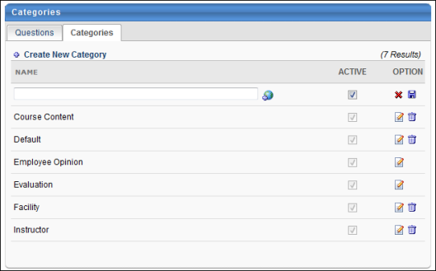
Create New Category
To create a new evaluation category, follow these steps:
- Click the Level 1, 2 or 3 Evaluation Administration link.
- Click the Question Bank link.
- Click the Categories tab.
- Click the Create New Category link. A blank row appears at the top of the Categories table.
- Enter the category name in the text box. For portals with multiple languages enabled, localize the field by using the Translate icon to enter localized text.
- The Active box is checked by default. Leave the box checked to ensure the category is active. To deactivate the category, uncheck the box.
- Click the Save icon to save the category. Click the Cancel icon to discard the new category without saving, if needed.
Categories which have not yet been associated with an evaluation can be deleted if necessary. If a category has been associated with at least one evaluation, it cannot be deleted, but it can be edited. It is recommended that only minor changes be made to categories already associated with an evaluation.

Evaluation Defaults - Manage
Evaluation Defaults are used to define the default evaluation for learning object types per evaluation level. The default evaluation appears for all new learning objects created in that learning type. Changing the default evaluation does not change evaluations already associated to learning objects.
To access Evaluation Defaults, go to Admin > Tools > Learning > Catalog Management > Evaluations. Then, click the Evaluation Defaults link in the left-side navigation panel. The Localized Defaults tab opens as the default view of the Evaluation Defaults page.
Permissions
PERMISSION NAME | PERMISSION DESCRIPTION | CATEGORY

Evaluation Defaults - Modify | Allows admin to define the default level 1, level 2 and level 3 evaluations. | Learning - Administration
Localized Defaults Tab
Default evaluations for specific learning object (LO) types per evaluation level are defined on the Localized Defaults tab, both for portals with single languages and multiple languages enabled. One localized evaluation can be set per LO type and evaluation level. Evaluations set on the Localized Defaults tab are used by default. If an LO type does not have an evaluation defined on the Localized Defaults tab, the evaluation defined for the LO on the Non-Localized Defaults tab is used.
To set a default evaluation:
- Click Select in the evaluation level column. This opens the Select Evaluation pop-up.
- Click the plus sign icon to the left of the evaluation. This adds the evaluation in the evaluation column.
To change the default evaluation:
- Click the evaluation name in the evaluation column. This opens the Select Evaluation pop-up.
- Click the plus sign to the left of the evaluation. This replaces the evaluation in the evaluation column.
If needed, you can remove a default evaluation by clicking the X icon to the right of the selected evaluation. After a default evaluation has been removed, the Select option is available again and you can add a new default evaluation if needed.
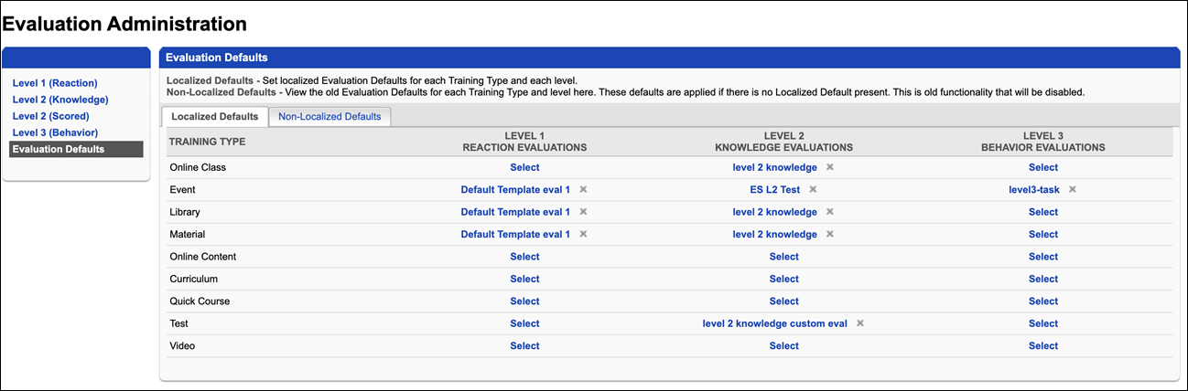
Non-Localized Defaults Tab
Non-Localized Defaults is a read-only tab that displays the default evaluations set for a particular language. From the Enable Language Preferences drop-down, you can select a language to view which default evaluations are defined for a particular language.
While the Non-Localized Defaults tab is read-only by default, a back end setting is available that enables administrators to modify the tab's default evaluation settings. The back end setting is turned off by default and should only be turned on if you would like to modify a non-localized default setting and do not wish not to modify the setting on the Localized Defaults tab.
Note: When defining evaluations for LOs on the Evaluations tab in Course Catalog, evaluations that display as "Default" in the Type column are pulled from the Localized Defaults tab.
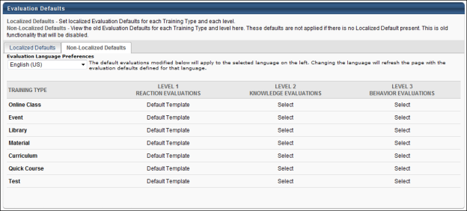

Level 1 Evaluations - Create

Level 1 Reaction Question - Create
Level 1 Evaluations are used to measure and record a learner's reaction to training they’ve recently completed, such as their rating of the course content, materials, and relevance. Level 1 Evaluations are the most commonly used type of Cornerstone evaluation and can be attached to various learning object (LO) types. The information gathered by Level 1 Evaluations can drive decisions about the types of training that are most effective and engaging to your learning audience.
To access Level 1 (Reaction) questions, go to Admin > Tools > Learning > Catalog Management > Evaluations. Click the Level 1 (Reaction) link on the left navigation panel. Then, click the Question Bank link.
Permissions
PERMISSION NAME | PERMISSION DESCRIPTION | CATEGORY

Evaluation Defaults - Modify | Allows admin to define the default level 1, level 2 and level 3 evaluations. | Learning - Administration

Level 1 Evaluation Administration | Grant Access to create and manage level 1 (reaction) evaluations associated with learning objects. This permission cannot be constrained. This is an administrator permission. | Learning - Administration

Level 1 Evaluations - Manage | Grants ability to create and edit Level 1 (Reaction) learning evaluations that can be associated with learning objects. When viewing Course Console, this permission also grants the ability to view the status of Level 1 Evaluations. This permission works in conjunction with the Level 1 Evaluation Administration, Course Catalog - Update, and Course Catalog - View permissions. This permission cannot be constrained. This is an administrator permission. | Learning - Administration
To create a question, click the Create New Question link. Enter the following information:
- Question - Enter the text of the question. For portals with multiple languages enabled, localize the field by using the Translate icon to enter localized text. Note: If a user's language is not available for the value in the field, the value displays in the default language of the question. The default language is the display language of the administrator that created the question.
- Response Type - Click this drop-down to select an answer response type.
  - Yes/ No - For this question type, answers are Yes or No.
  - True / False - For this question type, answers are True or False.
  - Likert Scale - Select this question type to create a question with a Likert scale. For portals with multiple languages enabled, localize the field by using the Translate icon to enter localized text. Note: If a user's language is not available for the value in the field, the value displays in the default language of the question. The default language is the display language of the administrator that created the question.
    - You can edit the rating descriptions if desired.
      - The descriptions defined on the Evaluation Preferences page are used by default. See Evaluation Preferences.
  - Multiple Choice - Single Answers - Use this question type to provide users with a multiple choice question that allows one answer.
    - Click Add Response Choice and enter answer choices. For portals with multiple languages enabled, localize the field by using the Translate icon to enter localized text. Note: If a user's language is not available for the value in the field, the value displays in the default language of the question. The default language is the display language of the administrator that created the question.
    - Check the Include 'None of the above' box to display 'None of the above' as an answer choice.
    - Check the Include 'All of the above' box to display 'All of the above' as an answer choice.
  - Multiple Choice - Multiple Answers - Use this question type to provide users with a multiple choice question that allows multiple answers.
    - Click Add Response Choice and enter answer choices. For portals with multiple languages enabled, localize the field by using the Translate icon to enter localized text. Note: If a user's language is not available for the value in the field, the value displays in the default language of the question. The default language is the display language of the administrator that created the question.
    - Check the Include 'None of the above' box to display 'None of the above' as an answer choice.
    - Check the Include ' All of the above' box to display 'All of the above' as an answer choice.
  - Text Only - Use this question type to provide users with question that allows a text-based response.
- Create a multi-part question by checking the Include multi-part sub-questions checkbox.
    - Click the Add sub-question link.
    - Enter the Order of each sub-question.
    - Enter the sub-question text. For portals with multiple languages enabled, localize the field by using the Translate icon to enter localized text. Note: If a user's language is not available for the value in the field, the value displays in the default language of the question. The default language is the display language of the administrator that created the question.
    - Remove a sub-question by clicking on the Delete icon.
      - Each sub-question will have the same response choice and will be listed under the main question on the actual survey. The main question will not have a separate response.
- Comments Instructions:
    - Enable Comments - Check this option to include a Comments box for question.
    - Comments Required - Check this option to make comments required. If checked user can not submit evaluation until comments are entered.
    - Directions for comments box - Enter the comments instructions. For portals with multiple languages enabled, localize the field by using the Translate icon to enter localized text. Note: If a user's language is not available for the value in the field, the value displays in the default language of the question. The default language is the display language of the administrator that created the question. Also, the Translate icon only appears once the Enable Comments box is checked.
- Category - Click this drop-down to select category (required field).
- Active - The Active box is checked by default. Leave the box checked to make the question active. Uncheck the box to inactivate the question.
- Click Submit to finish creating the question.
Helpful Hints - Create Evaluation Questions
- Editing a question changes that question in all evaluations the question has been used. It is recommended that you use the Edit option to make changes to the grammar or correct errors but not change the meaning or the structure of the question.
- In a Multiple Choice - Multiple Answers question, the user will not be able to select more than one choice if they have selected either "None of the Above" or "All of the Above".
- The same questions may be repeated in different sections on an evaluation (with the exception of multi-part). The system will give a warning to the administrator that the question appears multiple times. Evaluation Reports will list the question once for that evaluation, but the number of responses will indicate that this question was answered more than once for each user.
- Categorizing questions will allow you to quickly add all questions in a category when you can create the evaluations.

Level 1 Reaction Evaluation - Create
Level 1 Evaluations are used to measure and record a learner's reaction to training they’ve recently completed, such as their rating of the course content, materials, and relevance. Level 1 Evaluations are the most commonly used type of Cornerstone evaluation and can be attached to various learning object (LO) types. The information gathered by Level 1 Evaluations can drive decisions about the types of training that are most effective and engaging to your learning audience.
Evaluation Availability: With most learning objects (LOs), the evaluation is available to the user after the LO is completed. However, when an evaluation is used with an event session, the evaluation is only available to the user at the session start time. In the case of a multi-part session, the evaluation is only available at the session start time of the final part.
For troubleshooting information regarding Level 1 evaluations: See Troubleshooting Guide - Level 1 Evaluations.
To access Level 1 (Reaction) evaluations, go to Admin > Tools > Learning > Catalog Management > Evaluations. Then, click the Level 1 (Reaction) link on the left navigation panel.
Permissions
PERMISSION NAME | PERMISSION DESCRIPTION | CATEGORY

Level 1 Evaluation Administration | Grant Access to create and manage level 1 (reaction) evaluations associated with learning objects. This permission cannot be constrained. This is an administrator permission. | Learning - Administration

Level 1 Evaluations - Manage | Grants ability to create and edit Level 1 (Reaction) learning evaluations that can be associated with learning objects. When viewing Course Console, this permission also grants the ability to view the status of Level 1 Evaluations. This permission works in conjunction with the Level 1 Evaluation Administration, Course Catalog - Update, and Course Catalog - View permissions. This permission cannot be constrained. This is an administrator permission. | Learning - Administration
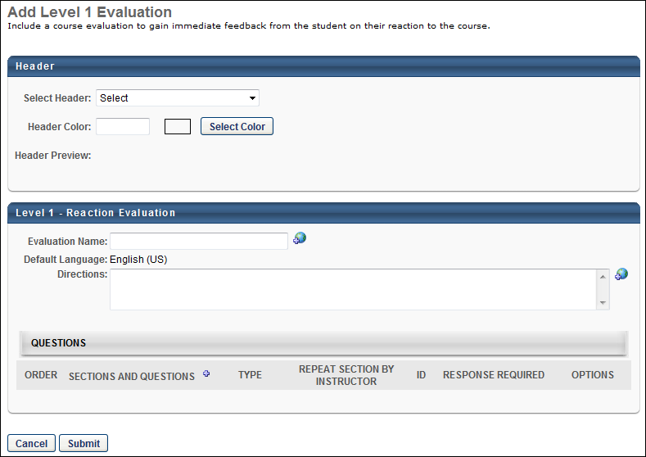
To create an evaluation, click the Create New Evaluation link, or copy an existing evaluation by clicking the Copy icon in the Options column.
Header
- Select Header - From the drop-down list, select a header image for the evaluation. The available images are taken from the Corporate Preferences images. A preview of the header image is displayed in the Header Preview field. This is optional.
- Header Color - Select the header color, which is the color that fills the header in areas that the header image does not fill. You may enter a hex value for the color or select a color by clicking the Select Color button. This is optional.
- Header Preview - This displays a preview of what the header will look like on the evaluation. The selected image is always aligned in the upper-left portion of the header. Any empty space in the header is filled with the selected header color. The selected logo is not resized.
General Information
Enter the following information for the evaluation:
- Evaluation Name - Enter the evaluation title. For portals with multiple languages enabled, localize the field by using the Translate icon to enter localized text.
- Default Language - This displays the evaluation's default language. When adding an evaluation, the default language is the language of the administrator adding the evaluation. When editing or copying an evaluation, the default language is the language of the administrator that created the evaluation. The default language is read-only and cannot be changed.
- Directions - Enter instructions for the evaluation. The instructions appear on a separate page when the user launches the evaluation. If the field is left blank, an introductory page does not appear when users access the evaluation. For portals with multiple languages enabled, localize the field by using the Translate icon to enter localized text.
Add a Section to the Evaluation
When creating or editing an evaluation, administrators must add at least one section to the evaluation to which they can then add questions. Each section is considered a page break on the evaluation. See Add a Section to an Evaluation on page 46 for additional information.
To remove a section, select the Remove icon in the Options column. Note: Removing a section also removes all questions in the section.
Add Questions to an Evaluation Section
When creating or editing an evaluation, administrators must add questions to a section within the evaluation. See Add a Question to an Evaluation Section on page 48 for additional information.
Configure Questions Within the Evaluation Section
When creating or editing an evaluation, administrators can reorder, configure, and preview the questions that have been added to an evaluation section. See Configure Questions Within an Evaluation Section on page 51 for additional information.
Repeat Section by Instructor
Select this option to repeat all the questions in a section for the user completing the evaluation. This functionality is useful for ILT sessions with multiple instructors. Users can evaluate each instructor individually.
Note: Questions in this section must be created using the INSTRUCTOR.NAME tag in place of the instructor's name. The system replaces the tag with instructor's name and duplicates the questions for each instructor.
- When using a question that includes the INSTRUCTOR.NAME tag, the Repeat Section by Instructor option must be selected for the section in which the question is used. This must be done even if there is only one instructor for the session. If the option is not selected, the INSTRUCTOR.NAME tag itself displays in the question on the evaluation rather than being replaced with the instructor's name.
- If there is only one instructor in the session, this option must be selected to replace it with the actual value in the Level 1 Evaluation Report.
Submit
Click Submit to finalize the evaluation.
After creating an evaluation, you can associate it with training via the Course Catalog. See Course Catalog - Evaluations.
Helpful Hints - Evaluations and Sessions
- The Evaluate option will appear in the User Transcript at the session start time, regardless of whether the instructor has submitted a roster for the class.
  - In the case of a multi-part session, the Evaluate option will appear on the User Transcript at the session start time of the final part.
- The Evaluate option will display on the User Transcript for sessions that show a Completed status on the transcript.
- In the case where a user has attended, but did not pass the session as indicated on the roster, the Evaluate option will display for a user in an Incomplete status.
- The Evaluate option is not displayed for users with a No-show status.
Helpful Hints - Evaluations and Tests
- The Evaluate link will display after the test shows a Completed status (user passes the test). It will not display if the user fails the test.
Helpful Hints - Evaluations and Transcript History
It is possible to see two similar "Evaluation is completed" Transcript History entries for a single evaluation completion if an evaluation was completed for a training which also had a Level 1 evaluation required and was not expired at time of completion. For example:
- Completed by Cornerstone Admin (cesadmin) on 1/12/2022 8:59:39 AM Comments: Evaluation is completed
- Completed by Cornerstone Admin (cesadmin) on 1/12/2022 8:59:38 AM Comments: Evaluation is completed

Level 2 Evaluations - Create

Level 2 Knowledge Question - Create
To access Level 2 (Knowledge) questions, go to Admin > Tools > Learning > Catalog Management > Evaluations. Click the Level 2 (Knowledge) link on the left navigation panel. Then, click the Question Bank link.
Permissions
PERMISSION NAME | PERMISSION DESCRIPTION | CATEGORY

Level 2 Evaluations - Manage | Grants ability to create and edit Level 2 learning evaluations that can be associated with learning objects. When viewing Course Console, this permission also grants the ability to view the status of Level 2 Evaluations. This permission works in conjunction with the Level 2 Evaluation Administration (knowledge and scored), Course Catalog - Update, and Course Catalog - View permissions. This permission cannot be constrained. This is an administrator permission. | Learning - Administration

Level 2 Knowledge (Non-Scored) Evaluation Administration | Grant Access to create and manage level 2 knowledge (non-scored) evaluations associated with learning objects. This permission cannot be constrained. This is an administrator permission. | Learning - Administration
To create a question, click the Create New Question link. Enter the following information:
- Question - Enter the question text. If multiple languages are enabled for your portal, select the Translate icon to translate the field into other available languages. Note: If a user's language is not available for the value in the field, the value displays in the default language of the question. The default language is the display language of the administrator that created the question.
- Response Type - Click this drop-down to select answer response type. The following types are available:
  - Yes/No - For this question type, answers are Yes or No.
  - True / False - For this question type, answers are True or False
  - Likert Scale - Select this question type to create a question with a Likert scale. If multiple languages are enabled for your portal, select the Translate icon to translate the field into other available languages. Note: If a user's language is not available for the value in the field, the value displays in the default language of the question. The default language is the display language of the administrator that created the question.
    - You can edit the rating descriptions if needed. The descriptions defined on the Evaluation Preferences page are used by default. See Evaluation Preferences.
  - Multiple Choice - Single Answers - Use this question type to provide users with a multiple choice question that allows one answer.
    - Click Add Response Choice and enter answer choices. For portals with multiple languages enabled, localize the field by using the Translate icon to enter localized text. Note: If a user's language is not available for the value in the field, the value displays in the default language of the question. The default language is the display language of the administrator that created the question.
    - Include 'None of the above' - Check this option to display 'None of the above' as an answer choice.
    - Include 'All of the above' - Check this option to display 'All of the above' as an answer choice.
  - Multiple Choice - Multiple Answers - Use this question type to provide users with a multiple choice question that allows multiple answers.
    - Click Add Response Choice and enter answer choices. For portals with multiple languages enabled, localize the field by using the Translate icon to enter localized text. Note: If a user's language is not available for the value in the field, the value displays in the default language of the question. The default language is the display language of the administrator that created the question.
    - Include 'None of the above' - Check this option to display 'None of the above' as an answer choice.
    - Include 'All of the above' - Check this option to display 'All of the above' as an answer choice.
  - Text Only - Use this question type to provide users with a question for which users provide a text response.
- Create a multi-part question by checking the Include multi-part sub-questions checkbox.
  - Click the Add sub-question link.
  - Enter the Order of each sub-question.
  - Enter the sub-question text. If multiple languages are enabled for your portal, select the Translate icon to translate the field into other available languages. Note: If a user's language is not available for the value in the field, the value displays in the default language of the question. The default language is the display language of the administrator that created the question.
  - Remove a sub-question by clicking on the Remove icon.
    - Each sub-question will have the same response choice and will be listed under the main question on the actual survey. The main question will not have a separate response.
- Comments Instructions:
  - Enable Comments - Check this option to include a Comments box for question.
  - Comments Required - Check this option to make comments required. If checked user can not submit evaluation until comments are entered.
  - Directions for comments box - Enter the Comments box instructions. For portals with multiple languages enabled, localize the field by using the Translate icon to enter localized text. Note: If a user's language is not available for the value in the field, the value displays in the default language of the question. The default language is the display language of the administrator that created the question. Also, the Translate icon only appears once the Enable Comments box is checked.
- Category - Click this drop-down to select category. This is required.
- Active - The Active box is checked by default. Leave the box checked to make the question active. Uncheck the box to inactivate the question.
- Click Submit.
Helpful Hints - Create Evaluation Questions
- Editing a question changes that question in all evaluations the question has been used. Best Practice is to make changes to the grammar or correct errors but not change the meaning or the structure of the question.
- In a Multiple Choice - Multiple Answers question, the user will not be able to select more than one choice if they have selected either "None of the Above" or "All of the Above".
- The same questions may be repeated in different sections on an evaluation (with the exception of multi-part). The system will give a warning to the administrator that the question appears multiple times. Evaluation Reports will list the question once for that evaluation, but the number of responses will indicate that this question was answered more than once for each user.
- Categorizing questions will allow you to quickly add all questions in a category when you can create the evaluations.

Level 2 Knowledge Evaluation - Create
To access Level 2 (Knowledge) evaluations, go to Admin > Tools > Learning > Catalog Management > Evaluations. Then, click the Level 2 (Knowledge) link on the left navigation panel. These evaluations are non-scored.
Permissions
PERMISSION NAME | PERMISSION DESCRIPTION | CATEGORY

Level 2 Evaluations - Manage | Grants ability to create and edit Level 2 learning evaluations that can be associated with learning objects. When viewing Course Console, this permission also grants the ability to view the status of Level 2 Evaluations. This permission works in conjunction with the Level 2 Evaluation Administration (knowledge and scored), Course Catalog - Update, and Course Catalog - View permissions. This permission cannot be constrained. This is an administrator permission. | Learning - Administration

Level 2 Knowledge (Non-Scored) Evaluation Administration | Grant Access to create and manage level 2 knowledge (non-scored) evaluations associated with learning objects. This permission cannot be constrained. This is an administrator permission. | Learning - Administration
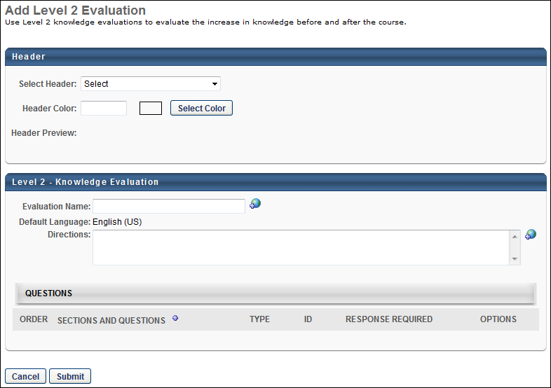
To create an evaluation, click the Create New Evaluation link, or copy an existing evaluation by clicking the Copy icon in the Options column.
Header
- Select Header - From the drop-down list, select a header image for the evaluation. The available images are taken from the Corporate Preferences images. A preview of the header image is displayed in the Header Preview field. This is optional.
- Header Color - Select the header color, which is the color that fills the header in areas that the header image does not fill. You may enter a hex value for the color or select a color by clicking the Select Color button. This is optional.
- Header Preview - This displays a preview of what the header will look like on the evaluation. The selected image is always aligned in the upper-left portion of the header. Any empty space in the header is filled with the selected header color. The selected logo is not resized.
General Information
Enter the following information for the evaluation:
- Evaluation Name - Enter the evaluation title. For portals with multiple languages enabled, localize the field by using the Translate icon to enter localized text.
- Default Language - This displays the evaluation's default language. When adding an evaluation, the default language is the language of the administrator adding the evaluation. When editing or copying an evaluation, the default language is the language of the administrator that created the evaluation. The default language is read-only and cannot be changed.
- Directions - Enter instructions for the evaluation. The instructions appear on a separate page when the user launches the evaluation. If the field is left blank, an introductory page does not appear when users access the evaluation. For portals with multiple languages enabled, localize the field by using the Translate icon to enter localized text.
Add a Section to the Evaluation
When creating or editing an evaluation, administrators must add at least one section to the evaluation to which they can then add questions. Each section is considered a page break on the evaluation. See Add a Section to an Evaluation on page 46 for additional information.
To remove a section, select the Remove icon in the Options column. Note: Removing a section also removes all questions in the section.
Add Questions to an Evaluation Section
When creating or editing an evaluation, administrators must add questions to a section within the evaluation. See Add a Question to an Evaluation Section on page 48 for additional information.
Configure Questions Within the Evaluation Section
When creating or editing an evaluation, administrators can reorder, configure, and preview the questions that have been added to an evaluation section. See Configure Questions Within an Evaluation Section on page 51 for additional information.
Submit
Click Submit to finalize the evaluation.

Level 2 Scored Question - Create
To access Level 2 (Scored) questions, go to Admin > Tools > Learning > Catalog Management > Evaluations. Select the Level 2 (Scored) link on the left navigation panel. Then, select the Question Bank link.
Permissions
PERMISSION NAME | PERMISSION DESCRIPTION | CATEGORY

Level 2 Evaluations - Manage | Grants ability to create and edit Level 2 learning evaluations that can be associated with learning objects. When viewing Course Console, this permission also grants the ability to view the status of Level 2 Evaluations. This permission works in conjunction with the Level 2 Evaluation Administration (knowledge and scored), Course Catalog - Update, and Course Catalog - View permissions. This permission cannot be constrained. This is an administrator permission. | Learning - Administration

Level 2 Scored Evaluation Administration | Grant Access to create and manage level 2 (scored) evaluations associated with learning objects. This permission cannot be constrained. This is an administrator permission. | Learning - Administration
To create a question, click the Create New Question link. Enter the following information:
- Question - Enter the text of the question box. For portals with multiple languages enabled, localize the field by using the Translate icon to enter localized text. Note: If a user's language is not available for the value in the field, the value displays in the default language of the question. The default language is the display language of the administrator that created the question.
- Response Type - Click this drop-down to select answer response type.
  - Yes/No - For this question type, answers are Yes or No.
  - True / False - For this question type, answers are True or False
  - Multiple Choice - Single Answers - Use this question type to provide users with a multiple choice question that allows one answer.
    - Click Add Response Choice and enter answer choices. For portals with multiple languages enabled, localize the field by using the Translate icon to enter localized text. Note: If a user's language is not available for the value in the field, the value displays in the default language of the question. The default language is the display language of the administrator that created the question.
      - For each answer choice, enter the order in which it should appear. Check Correct if this answer choice is the correct one, and check Always Display answers are randomized and this answer choice is always displayed.
    - Include 'None of the above' - Check this option to display 'None of the above' as an answer choice.
    - Include 'All of the above' - Check this option to display 'All of the above' as an answer choice.
    - Random Answer Selection - Check this option to randomize a subset of a larger group of answers. Enter the number of answer choices that will be displayed for this question.
  - Multiple Choice - Multiple Answers - Use this question type to provide users with a multiple choice question that allows multiple answers.
    - Click Add Response Choice and enter answer choices. For portals with multiple languages enabled, localize the field by using the Translate icon to enter localized text. Note: If a user's language is not available for the value in the field, the value displays in the default language of the question. The default language is the display language of the administrator that created the question.
      - For each answer choice, enter the order in which it should appear. Check Correct if this answer choice is the correct one, and check Always Display answers are randomized and this answer choice is always displayed.
    - Include 'None of the above' - Check this option to display 'None of the above' as an answer choice.
    - Include 'All of the above' - Check this option to display 'All of the above' as an answer choice.
    - Random Answer Selection - Check this option to randomize a subset of a larger group of answers. Enter number of answer choices to be displayed for this question.
  - Text Only - Use this question type to provide users with a question for which users provide a text response.
    - Add Correct Answer - Enter the correct answer into this field. Multiple correct answer fields may be added if answer can be spelled or written a variety of ways. For example, the answer could be 100 or one hundred. Capitalization in answer response is ignored when user is answering question. Note: When scoring text only responses, the user's response is matched against any of the available translations entered in the Add Correct Answer field. If the answer matches at least one of the translations exactly, the answer is deemed correct. If the answer does not match exactly, it is marked incorrect.
- Answer Explanation - Enter corrective feedback or an answer explanation. All answer explanations can only be viewed by the user after the test is completed. If multiple languages are enabled for your portal, select the Translate icon to translate the field into other available languages. Note: If a user's language is not available for the value in the field, the value displays in the default language of the question. The default language is the display language of the administrator that created the question. Also, the Translate icon only appears once the Enable Comments box is checked.
- Category - Click this drop-down to select category. This field is required.
- Active - The Active box is checked by default. Leave the box checked to make the question active. Uncheck the box to inactivate the question.
- Click Submit.
Helpful Hints - Create Evaluation Questions
- Editing a question changes that question in all evaluations the question has been used. Best Practice is to make changes to the grammar or correct errors but not change the meaning or the structure of the question.
- In a Multiple Choice - Multiple Answers question, the user will not be able to select more than one choice if they have selected either "None of the Above" or "All of the Above".
- The same questions may be repeated in different sections on an evaluation (with the exception of multi-part). The system will give a warning to the administrator that the question appears multiple times. Evaluation Reports will list the question once for that evaluation, but the number of responses will indicate that this question was answered more than once for each user.
- Categorizing questions will allow you to quickly add all questions in a category when you can create the evaluations.

Level 2 Scored Evaluation - Create
To access Level 2 (Scored) evaluations, go to Admin > Tools > Learning > Catalog Management > Evaluations. Then, click the Level 2 (Scored) link on the left navigation panel.
Permissions
PERMISSION NAME | PERMISSION DESCRIPTION | CATEGORY

Level 2 Evaluations - Manage | Grants ability to create and edit Level 2 learning evaluations that can be associated with learning objects. When viewing Course Console, this permission also grants the ability to view the status of Level 2 Evaluations. This permission works in conjunction with the Level 2 Evaluation Administration (knowledge and scored), Course Catalog - Update, and Course Catalog - View permissions. This permission cannot be constrained. This is an administrator permission. | Learning - Administration

Level 2 Scored Evaluation Administration | Grant Access to create and manage level 2 (scored) evaluations associated with learning objects. This permission cannot be constrained. This is an administrator permission. | Learning - Administration
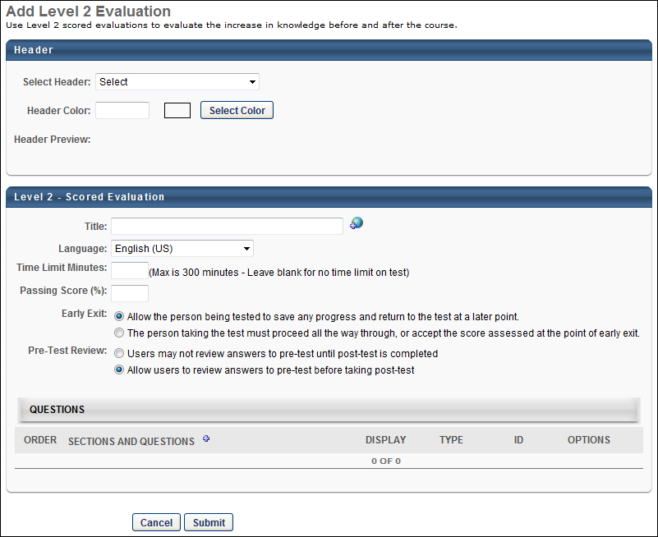
To create an evaluation, click the Create New Evaluation link, or copy an existing evaluation by clicking the Copy icon in the Options column.
Header
- Select Header - From the drop-down list, select a header image for the evaluation. The available images are supplied from the Corporate Preferences images. A preview of the header image is displayed in the Header Preview field. This is optional.
- Header Color - Select the header color, which is the color that fills the header in areas that the header image does not fill. You may enter a hex value for the color or select a color by clicking the Select Color button. This is optional.
- Header Preview - This displays a preview of what the header will look like on the evaluation. The selected image is always aligned in the upper-left portion of the header. Any empty space in the header is filled with the selected header color. The selected logo is not resized.
General Information
Enter the following information for the evaluation:
- Title - Enter the evaluation title. For portals with multiple languages enabled, localize the field by using the Translate icon to enter localized text.
- Language - Select the language for the evaluation.
- Time Limit Minutes - Define the time limit for users to take the evaluation in minutes. The maximum time limit is 300 minutes. Leave this field blank to have no time limit for the evaluation.
- Passing Score (%) - Enter passing score percentage. If this field is blank, the default passing score is 80%.
- Early Exit - Select one of the following options to determine whether or not a user can exit the test and resume at a later time:
  - Allow the person being tested to save any progress and return to the test at a later point - If this option is selected, users can exit the evaluation and resume at a later time.
  - The person taking the test must proceed all the way through, or accept the score assessed at the point of early exit - If this option is selected, users must complete the evaluation without exiting the evaluation. If the user exits the evaluation, their score is based on their responses at that point and the user cannot resume the evaluation.
- Pre-Test Review - Select one of the following options regarding a pre-test:
  - Users may not review answers to pre-test until post test is completed - Select this option to prevent users from reviewing their answers to the pretest until they have completed the post-test.
  - Allow users to review answers to pre-test before taking post-test - Select this option to allow users to review their answers to the pretest before taking the post-test.
Add a Section to the Evaluation
When creating or editing an evaluation, administrators must add at least one section to the evaluation to which they can then add questions. Each section is considered a page break on the evaluation. See Add a Section to an Evaluation on page 46 for additional information.
To remove a section, select the Remove icon in the Options column. Note: Removing a section also removes all questions in the section.
Add Questions to an Evaluation Section
When creating or editing an evaluation, administrators must add questions to a section within the evaluation. See Add a Question to an Evaluation Section on page 48 for additional information.
Configure Questions Within the Evaluation Section
When creating or editing an evaluation, administrators can reorder, configure, and preview the questions that have been added to an evaluation section. See Configure Questions Within an Evaluation Section on page 51 for additional information.
Display Subset of Questions to Users
By default, all questions in the section are displayed to the user. To only display a portion of the questions, click the Edit icon in the Display column. Then, enter the number of questions that should be displayed in the section. Click the Save icon to save the new display value.
Displaying only a portion of the questions allows you to create a unique evaluation experience for each evaluation attempt. For example, there are 10 questions in a section, but only five are displayed. If another user completes the evaluation, then that user may see different questions in their evaluation.
Submit
Click Submit to finalize the evaluation.

Level 3 Evaluations - Create

Level 3 Behavior Question - Create
To access Level 3 (Behavior) questions, go to Admin > Tools > Learning > Catalog Management > Evaluations. Click the Level 3 (Behavior) link on the left navigation panel. Then, click the Question Bank link.
Permissions
PERMISSION NAME | PERMISSION DESCRIPTION | CATEGORY

Level 3 Evaluation - Manage | Grants ability to create and edit Level 3 (Behavior) learning evaluations that can be associated with learning objects. When viewing Course Console, this permission also grants the ability to view the status of Level 3 Evaluations. This permission works in conjunction with the Level 3 Evaluation Administration, Course Catalog - Update, and Course Catalog - View permissions. This permission cannot be constrained. This is an administrator permission. | Learning - Administration

Level 3 Evaluation Administration | Grant Access to create and manage level 3 (behavior) evaluations associated with learning objects. This permission cannot be constrained. This is an administrator permission. | Learning - Administration
To create a question, click the Create New Question link. Enter the following information:
- Question - Enter the question text. For portals with multiple languages enabled, localize the field by using the Translate icon to enter localized text. Note: If a user's language is not available for the value in the field, the value displays in the default language of the question. The default language is the display language of the administrator that created the question.
- Response Type - Click this drop-down to select an answer response type.
  - Yes/ No - Answer values for this question type are Yes and No.
  - True / False - Answer values for this question type are True and False.
  - Likert Scale - Select this question type to create a question with a Likert scale. For portals with multiple languages enabled, localize the field by using the Translate icon to enter localized text. Note: If a user's language is not available for the value in the field, the value displays in the default language of the question. The default language is the display language of the administrator that created the question.
    - You can edit the Rating Descriptions if desired.
      - The descriptions defined on the Evaluation Preferences page are used by default. See Evaluation Preferences.
  - Multiple Choice - Single Answers - Use this question type to provide users with a multiple choice question that allows one answer.
    - Click Add Response Choice and enter answer choices. For portals with multiple languages enabled, localize the field by using the Translate icon to enter localized text. Note: If a user's language is not available for the value in the field, the value displays in the default language of the question. The default language is the display language of the administrator that created the question.
    - Check the Include 'None of the above' box to display 'None of the above' as an answer choice.
    - Check the Include 'All of the above' box to display 'All of the above' as an answer choice.
  - Multiple Choice - Multiple Answers - Use this question type to provide users with a multiple choice question that allows multiple answers.
    - Click Add Response Choice and enter answer choices. For portals with multiple languages enabled, localize the field by using the Translate icon to enter localized text. Note: If a user's language is not available for the value in the field, the value displays in the default language of the question. The default language is the display language of the administrator that created the question.
    - Check the Include 'None of the above' box to display 'None of the above' as an answer choice.
    - Check the Include 'All of the above' box to display 'All of the above' as an answer choice.
  - Text Only - Use this question type to provide users with question which allows a text-based response.
- Create a multi-part question by checking the Include multi-part sub-questions checkbox.
    - Click the Add sub-question link.
    - Enter the Order of each sub-question.
    - Enter the sub-question text. For portals with multiple languages enabled, localize the field by using the Translate icon to enter localized text. Note: If a user's language is not available for the value in the field, the value displays in the default language of the question. The default language is the display language of the administrator that created the question.
    - Remove a sub-question by clicking on the Remove icon.
      - Each sub-question will have the same response choice and will be listed under the main question on the actual survey. The main question will not have a separate response.
- Comments Box:
    - Enable Comments - Check this option to include a Comments box for question.
    - Comments Required - Check this option to make comments required. If checked user can not submit evaluation until comments are entered.
    - Directions for comments box - Enter the Comments box instructions. For portals with multiple languages enabled, localize the field by using the Translate icon to enter localized text. Note: If a user's language is not available for the value in the field, the value displays in the default language of the question. The default language is the display language of the administrator that created the question. Also, the Translate icon only appears once the Enable Comments box is checked.
- Category - Click this drop-down to select a category for the question. This field is required.
- Active - The Active box is checked by default. Leave the box checked to make the question active. Uncheck the box to inactivate the question.
- Click Submit.
See also:
- Create New Evaluation Category
Helpful Hints - Create Evaluation Questions
- Editing a question changes that question in all evaluations the question has been used. Best Practice is to make changes to the grammar or correct errors but not change the meaning or the structure of the question.
- In a Multiple Choice - Multiple Answers question, the user will not be able to select more than one choice if they have selected either "None of the Above" or "All of the Above".
- The same questions may be repeated in different sections on an evaluation (with the exception of multi-part). The system will give a warning to the administrator that the question appears multiple times. Evaluation Reports will list the question once for that evaluation, but the number of responses will indicate that this question was answered more than once for each user.
- Categorizing questions will allow you to quickly add all questions in a category when you can create the evaluations.

Level 3 Behavior Evaluation - Create
To access Level 3 (Behavior) evaluations, go to Admin > Tools > Learning > Catalog Management > Evaluations. Then, click the Level 3 (Behavior) link on the left navigation panel.
Permissions
PERMISSION NAME | PERMISSION DESCRIPTION | CATEGORY

Level 3 Evaluation - Manage | Grants ability to create and edit Level 3 (Behavior) learning evaluations that can be associated with learning objects. When viewing Course Console, this permission also grants the ability to view the status of Level 3 Evaluations. This permission works in conjunction with the Level 3 Evaluation Administration, Course Catalog - Update, and Course Catalog - View permissions. This permission cannot be constrained. This is an administrator permission. | Learning - Administration

Level 3 Evaluation Administration | Grant Access to create and manage level 3 (behavior) evaluations associated with learning objects. This permission cannot be constrained. This is an administrator permission. | Learning - Administration
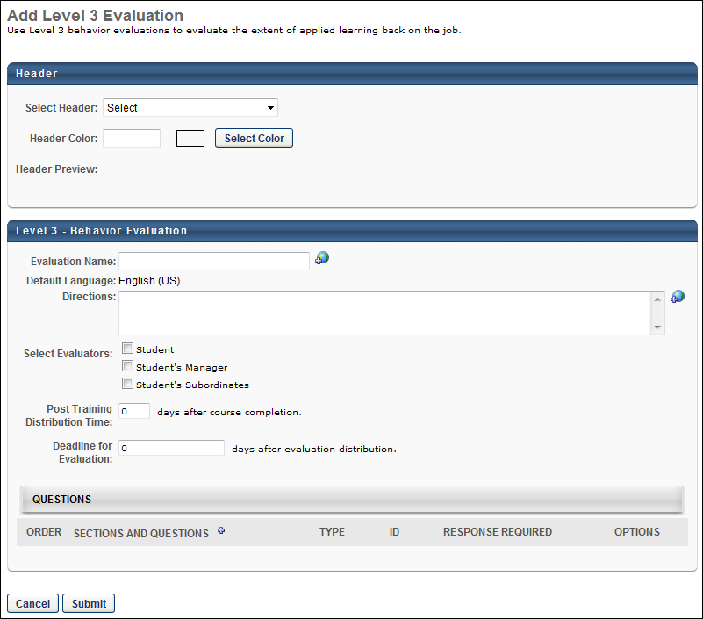
To create an evaluation, click the Create New Evaluation link, or copy an existing evaluation by clicking the Copy icon in the Options column.
Header
- Select Header - From the drop-down list, select a header image for the evaluation. The available images are taken from the Corporate Preferences images. A preview of the header image is displayed in the Header Preview field. This is optional.
- Header Color - Select the header color, which is the color that fills the header in areas that the header image does not fill. You may enter a hex value for the color or select a color by clicking the Select Color button. This is optional.
- Header Preview - This displays a preview of what the header will look like on the evaluation. The selected image is always aligned in the upper-left portion of the header. Any empty space in the header is filled with the selected header color. The selected logo is not resized.
General Information
Enter the following information for the evaluation:
- Evaluation Name - Enter the evaluation title. For portals with multiple languages enabled, localize the field by using the Translate icon to enter localized text.
- Default Language - This displays the evaluation's default language. When adding an evaluation, the default language is the language of the administrator adding the evaluation. When editing or copying an evaluation, the default language is the language of the administrator that created the evaluation. The default language is read-only and cannot be changed.
- Directions - Enter instructions for the evaluation. The instructions appear on a separate page when the user launches the evaluation. If the field is left blank, an introductory page does not appear when users access the evaluation. For portals with multiple languages enabled, localize the field by using the Translate icon to enter localized text.
- Select Evaluators - Select the groups that are assigned the post-training evaluation task:
  - Student
  - Student's Manager
  - Student's Subordinates
- Post Training Distribution Time - Determine the assignment time. This is set by entering the number of days after the course completion that the evaluation is assigned. For example, if this is set to 5 days, then the evaluation is sent five days after the course is completed.
Note: For Session LOs, the Course Completion is when the roster is submitted, even if the portal ILT Preferences are set to use the Session End Date as the Transcript Completion Date. This also applies if the session completion date is manually edited. The Level 3 Evaluation will always trigger X amount of days after the roster is submitted. If the Assign Evaluation Task email is configured, it will fire as soon as the evaluation is assigned to the user.
- Deadline for Evaluation - Determine the deadline for completing the evaluation. This is set by entering the number of days after the evaluation is assigned that the evaluation is due. For example, if this is set to 3 days, then the evaluation is due three days after it is assigned.
Add a Section to the Evaluation
When creating or editing an evaluation, administrators must add at least one section to the evaluation to which they can then add questions. Each section is considered a page break on the evaluation. See Add a Section to an Evaluation on page 46 for additional information.
To remove a section, select the Remove icon in the Options column. Note: Removing a section also removes all questions in the section.
Add Questions to an Evaluation Section
When creating or editing an evaluation, administrators must add questions to a section within the evaluation. See Add a Question to an Evaluation Section on page 48 for additional information.
Configure Questions Within the Evaluation Section
When creating or editing an evaluation, administrators can reorder, configure, and preview the questions that have been added to an evaluation section. See Configure Questions Within an Evaluation Section on page 51 for additional information.
Submit
Click Submit to finalize the evaluation.
Considerations
- Level 3 Evaluations only display to users on the Scheduled Tasks page and widget. Level 3 evaluations do NOT display on the Universal Profile - Actions page. Level 3 evaluations are assigned as a task, but after the submission of the session roster. The session end date is not considered to be the course completion date.

Add a Section to an Evaluation
When creating or editing an evaluation, administrators must add at least one section to the evaluation to which they can then add questions. Each section is considered a page break on the evaluation.
Before this step, you must first create an evaluation. See Evaluation Administration on page 2 for additional information.
To add a section to an evaluation, go to Admin > Tools > Learning > Catalog Management > Evaluations. Then, select the appropriate evaluation type on the left navigation panel. Select the Create New Evaluation link. Select the Add New Section icon to the left of the Sections and Questions column heading. This opens the Add Section pop-up.
Permissions
PERMISSION NAME | PERMISSION DESCRIPTION | CATEGORY

Level 1 Evaluation Administration | Grant Access to create and manage level 1 (reaction) evaluations associated with learning objects. This permission cannot be constrained. This is an administrator permission. | Learning - Administration

Level 1 Evaluations - Manage | Grants ability to create and edit Level 1 (Reaction) learning evaluations that can be associated with learning objects. When viewing Course Console, this permission also grants the ability to view the status of Level 1 Evaluations. This permission works in conjunction with the Level 1 Evaluation Administration, Course Catalog - Update, and Course Catalog - View permissions. This permission cannot be constrained. This is an administrator permission. | Learning - Administration

Level 2 Evaluations - Manage | Grants ability to create and edit Level 2 learning evaluations that can be associated with learning objects. When viewing Course Console, this permission also grants the ability to view the status of Level 2 Evaluations. This permission works in conjunction with the Level 2 Evaluation Administration (knowledge and scored), Course Catalog - Update, and Course Catalog - View permissions. This permission cannot be constrained. This is an administrator permission. | Learning - Administration

Level 2 Knowledge (Non-Scored) Evaluation Administration | Grant Access to create and manage level 2 knowledge (non-scored) evaluations associated with learning objects. This permission cannot be constrained. This is an administrator permission. | Learning - Administration

Level 2 Scored Evaluation Administration | Grant Access to create and manage level 2 (scored) evaluations associated with learning objects. This permission cannot be constrained. This is an administrator permission. | Learning - Administration

Level 3 Evaluation - Manage | Grants ability to create and edit Level 3 (Behavior) learning evaluations that can be associated with learning objects. When viewing Course Console, this permission also grants the ability to view the status of Level 3 Evaluations. This permission works in conjunction with the Level 3 Evaluation Administration, Course Catalog - Update, and Course Catalog - View permissions. This permission cannot be constrained. This is an administrator permission. | Learning - Administration

Level 3 Evaluation Administration | Grant Access to create and manage level 3 (behavior) evaluations associated with learning objects. This permission cannot be constrained. This is an administrator permission. | Learning - Administration
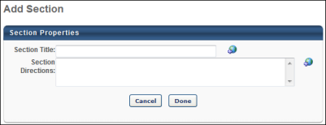
Enter the following information for the section:
- Section Title - Enter a title for the section. If multiple languages are enabled for your portal, select the Translate icon to translate the field into other available languages.
- Section Directions - Enter directions for the section. On the evaluation, the directions display beneath the section name. If multiple languages are enabled for your portal, select the Translate icon to translate the field into other available languages.
Select Done to add the section. The section appears as a row in the Questions panel.

Add a Question to an Evaluation Section
When creating or editing an evaluation, administrators must add questions to a section within the evaluation.
Before this step, you must first create an evaluation and add sections to that evaluation. See Evaluation Administration on page 2 for additional information.
To add a question to an evaluation section, go to Admin > Tools > Learning > Catalog Management > Evaluations. Then, select the appropriate evaluation type on the left navigation panel. Select the Create New Evaluation link. Add a section to the evaluation. Then, select the Add Question icon in the Options column for the section. This opens the Search Questions pop-up.
Permissions
PERMISSION NAME | PERMISSION DESCRIPTION | CATEGORY

Level 1 Evaluation Administration | Grant Access to create and manage level 1 (reaction) evaluations associated with learning objects. This permission cannot be constrained. This is an administrator permission. | Learning - Administration

Level 1 Evaluations - Manage | Grants ability to create and edit Level 1 (Reaction) learning evaluations that can be associated with learning objects. When viewing Course Console, this permission also grants the ability to view the status of Level 1 Evaluations. This permission works in conjunction with the Level 1 Evaluation Administration, Course Catalog - Update, and Course Catalog - View permissions. This permission cannot be constrained. This is an administrator permission. | Learning - Administration

Level 2 Evaluations - Manage | Grants ability to create and edit Level 2 learning evaluations that can be associated with learning objects. When viewing Course Console, this permission also grants the ability to view the status of Level 2 Evaluations. This permission works in conjunction with the Level 2 Evaluation Administration (knowledge and scored), Course Catalog - Update, and Course Catalog - View permissions. This permission cannot be constrained. This is an administrator permission. | Learning - Administration

Level 2 Knowledge (Non-Scored) Evaluation Administration | Grant Access to create and manage level 2 knowledge (non-scored) evaluations associated with learning objects. This permission cannot be constrained. This is an administrator permission. | Learning - Administration

Level 2 Scored Evaluation Administration | Grant Access to create and manage level 2 (scored) evaluations associated with learning objects. This permission cannot be constrained. This is an administrator permission. | Learning - Administration

Level 3 Evaluation - Manage | Grants ability to create and edit Level 3 (Behavior) learning evaluations that can be associated with learning objects. When viewing Course Console, this permission also grants the ability to view the status of Level 3 Evaluations. This permission works in conjunction with the Level 3 Evaluation Administration, Course Catalog - Update, and Course Catalog - View permissions. This permission cannot be constrained. This is an administrator permission. | Learning - Administration

Level 3 Evaluation Administration | Grant Access to create and manage level 3 (behavior) evaluations associated with learning objects. This permission cannot be constrained. This is an administrator permission. | Learning - Administration
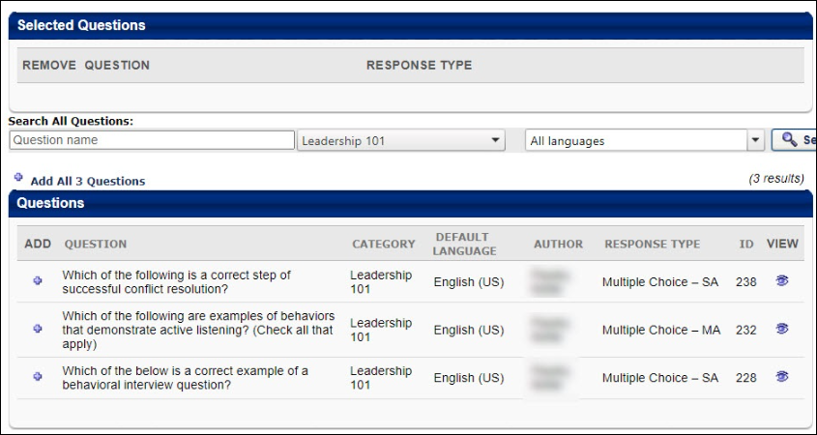
Search Existing Questions
Use the search features to filter the results by question name, category, or language.
View Questions from Existing Evaluation
You can view questions from the evaluation of an existing training item and select from those questions. To search for an existing evaluation, select the pop-up icon to the right of the Select Course to View Questions From: field. This opens the Search Course Evaluations pop-up.
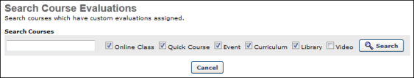
Click Search to search for evaluations from the selected LO types. All LOs for which there is a corresponding level evaluation appear below the search options in the pop-up. Click the plus sign to the left of the LO to add the LO's evaluation questions to the Questions panel in the Search Questions pop-up. This closes the Search Course Evaluations pop-up.
All existing evaluation questions from the corresponding evaluation level appear in the Questions panel in the Search Questions pop-up. Preview a question by clicking the Preview icon in the View column. Note: Any new questions added using the Add Question icon append to that specific section of the evaluation.
Add Question
To add a question:
- To add an individual question from the Questions panel, select the plus sign in the Add column. This adds the question to the Selected Questions panel.
- To add all questions in the Questions panel, select the Add All Questions link that is above the Questions panel.
Add Selected Questions to the Evaluation Section
Select Done when all desired questions are placed in the Selected Questions panel. The questions appear under the section title.

Configure Questions Within an Evaluation Section
When creating or editing an evaluation, administrators can reorder, configure, and preview the questions that have been added to an evaluation section.
Before this step, you must first create an evaluation, add sections to that evaluation, and then add questions to the section. See Evaluation Administration on page 2 for additional information.
To add a question to an evaluation section, go to Admin > Tools > Learning > Catalog Management > Evaluations. Then, select the appropriate evaluation type on the left navigation panel. Select the Create New Evaluation link. Add a section to the evaluation. Then, select the Add Question icon in the Options column for the section. This opens the Search Questions pop-up.
Permissions
PERMISSION NAME | PERMISSION DESCRIPTION | CATEGORY

Level 1 Evaluation Administration | Grant Access to create and manage level 1 (reaction) evaluations associated with learning objects. This permission cannot be constrained. This is an administrator permission. | Learning - Administration

Level 1 Evaluations - Manage | Grants ability to create and edit Level 1 (Reaction) learning evaluations that can be associated with learning objects. When viewing Course Console, this permission also grants the ability to view the status of Level 1 Evaluations. This permission works in conjunction with the Level 1 Evaluation Administration, Course Catalog - Update, and Course Catalog - View permissions. This permission cannot be constrained. This is an administrator permission. | Learning - Administration

Level 2 Evaluations - Manage | Grants ability to create and edit Level 2 learning evaluations that can be associated with learning objects. When viewing Course Console, this permission also grants the ability to view the status of Level 2 Evaluations. This permission works in conjunction with the Level 2 Evaluation Administration (knowledge and scored), Course Catalog - Update, and Course Catalog - View permissions. This permission cannot be constrained. This is an administrator permission. | Learning - Administration

Level 2 Knowledge (Non-Scored) Evaluation Administration | Grant Access to create and manage level 2 knowledge (non-scored) evaluations associated with learning objects. This permission cannot be constrained. This is an administrator permission. | Learning - Administration

Level 2 Scored Evaluation Administration | Grant Access to create and manage level 2 (scored) evaluations associated with learning objects. This permission cannot be constrained. This is an administrator permission. | Learning - Administration

Level 3 Evaluation - Manage | Grants ability to create and edit Level 3 (Behavior) learning evaluations that can be associated with learning objects. When viewing Course Console, this permission also grants the ability to view the status of Level 3 Evaluations. This permission works in conjunction with the Level 3 Evaluation Administration, Course Catalog - Update, and Course Catalog - View permissions. This permission cannot be constrained. This is an administrator permission. | Learning - Administration

Level 3 Evaluation Administration | Grant Access to create and manage level 3 (behavior) evaluations associated with learning objects. This permission cannot be constrained. This is an administrator permission. | Learning - Administration
After adding questions to an evaluation section, the following options may be available:
- Reorder Questions - You can reorder the questions by changing the number in the Order column.
- Response Required - Select this option to require users to answer the corresponding question. This option is not available for Level 2 - Scored evaluations. This is because these evaluation types behave similar to a test. If the learner does not answer the question, they do not receive points towards the score.
- Preview - In the Options column, select the Preview icon to view the question.
- Edit - In the Options column, select the Edit icon to edit an existing question. Note: If a question has already been answered by a user, you cannot change the response type or format of the question; you may only edit the spelling or phrasing. The response type drop-down will be inactive, and the links to add response choices or sub-questions will not appear. Editing a question changes that question in all tests the question has been used. A best practice is to make changes to the grammar or correct errors but not change the meaning or structure of the question.
- Remove - In the Options column, select the Remove icon to remove the question from the section.

