Employee Relationships March 2024

Table of Contents
Employee Relationships Overview 1
Permissions Constrained by Employee Relationship 2
Manage Employee Relationships 9
Employee Relationships Administration 10
Performance - Manage Peers 13

Employee Relationships Overview

Permissions Constrained by Employee Relationship
The following permissions can be constrained by Employee Relationship:
Forms Management and Administration
PERMISSION NAME | PERMISSION DESCRIPTION | CATEGORY

Form Proxy Completion - Manage | Allows administrator to configure the Proxy Availability settings for a form. These settings determine which users can complete the form on behalf of other users and for which users they can complete the form. This permission can be constrained by OU, User's OU, User, and Employee Relationship. This is an administrator permission. | Forms Administration
Performance Permissions
PERMISSION NAME | PERMISSION DESCRIPTION | CATEGORY

Goals - Create | Grants ability for user to create goals for self, direct reports, and indirect reports only. Any constraint on this permission is operating as an "AND" function. This permission can be constrained by Employee Relationship, OU, User's OU, and User Self and Subordinates. This is an end user permission. | Performance

View Goals | Grants ability to view own goals and (depending on role and settings) goals of others (manager's visible goals, direct subordinate's goals, company goals, division goals). This permission can be constrained by Employee Relationship, OU, User's OU, and User Self and Subordinates. This is an end user permission. | Performance
Reports - Compensation Permissions
PERMISSION NAME | PERMISSION DESCRIPTION | CATEGORY

Compensation Statement Report | Grants access to Compensation Statement Report which enables printing the compensation statement for one user at a time. This permission can be constrained by Employee Relationship, OU, User's OU, User Self and Subordinates, and User's Subordinates. | Reports - Compensation
Reports - Track Employee Permissions
PERMISSION NAME | PERMISSION DESCRIPTION | CATEGORY

Employee Transcripts - Manager/Approver Access | Grants access to transcript (training record) screen of those for whom user is designated manager, approver or cost center approver. System administrators can access all user transcripts from this page. Link to this screen appears under Standard Reports/Track Employees. This is a manager/approver permission. This permission can be constrained by Employee Relationship and User's Direct Subordinates.  Note: The Employee Relationship constraint allows administrators to constrain the permission to a user’s custom employee relationship. For example, an administrator can select to restrict the Matrix Manager relationship to viewing user data for users who have that Matrix Manager indicated on their user record.  Note: The User's Direct Subordinates constraint allows administrators to constrain the data that a user can view to only the data for their direct reports. The user will not be able to view their own data with this constraint.  Note: By design, for any Track Employees report permission that is included in the Manager default security role, all of the manager's direct and indirect reports are included in the constraints, even if they are not selected in the permission constraints for the role. | Reports - Track Employee

ILT Session Withdrawal Report - Manager Version | Grants access to Session Withdrawal report for subordinates of the user. The report displays subordinates who registered and later withdrew their registration, including reasons for withdrawal. This is a manager report. This permission can be constrained by Employee Relationship and User's Direct Subordinates.  Note: The Employee Relationship constraint allows administrators to constrain the permission to a user’s custom employee relationship. For example, an administrator can select to restrict the Matrix Manager relationship to viewing user data for users who have that Matrix Manager indicated on their user record.  Note: The User's Direct Subordinates constraint allows administrators to constrain the data that a user can view to only the data for their direct reports. The user will not be able to view their own data with this constraint.  Note: By design, for any Track Employees report permission that is included in the Manager default security role, all of the manager's direct and indirect reports are included in the constraints, even if they are not selected in the permission constraints for the role. | Reports - Track Employee

Track Employees - Training Progress Pie Chart | Grants access to Employee Training Progress Summary Report, a pie chart report that displays transcript status on a single learning object for a manager's direct reports. This is a manager permission. This permission can be constrained by Employee Relationship and User's Direct Subordinates.  Note: The Employee Relationship constraint allows administrators to constrain the permission to a user’s custom employee relationship. For example, an administrator can select to restrict the Matrix Manager relationship to viewing user data for users who have that Matrix Manager indicated on their user record.  Note: The User's Direct Subordinates constraint allows administrators to constrain the data that a user can view to only the data for their direct reports. The user will not be able to view their own data with this constraint.  Note: By design, for any Track Employees report permission that is included in the Manager default security role, all of the manager's direct and indirect reports are included in the constraints, even if they are not selected in the permission constraints for the role. | Reports - Track Employee

Track Employees - Training Status Summary Report | Grants access to Employee Training Status Summary Report, which displays transcript status of all training for a manager's direct reports, and allows the manager to view the transcript details for any learning object listed on the report. This is a manager permission. This permission can be constrained by Employee Relationship and User's Direct Subordinates.  Note: The Employee Relationship constraint allows administrators to constrain the permission to a user’s custom employee relationship. For example, an administrator can select to restrict the Matrix Manager relationship to viewing user data for users who have that Matrix Manager indicated on their user record.  Note: The User's Direct Subordinates constraint allows administrators to constrain the data that a user can view to only the data for their direct reports. The user will not be able to view their own data with this constraint.  Note: By design, for any Track Employees report permission that is included in the Manager default security role, all of the manager's direct and indirect reports are included in the constraints, even if they are not selected in the permission constraints for the role. | Reports - Track Employee
Universal Profile Permissions
PERMISSION NAME | PERMISSION DESCRIPTION | CATEGORY

Action Items - View | Grants ability to view action items on the Action Items page and in the Your Action Items widget. Users without this permission cannot access the Action Items page. This permission can be constrained by Employee Relationship, OU, User's OU, User's Self and Subordinates, and User's Self. This is an end user permission. | Universal Profile

Bio About - View | Enables user to view the Bio page for users within their permission constraints. This permission must be enabled to view the Transcript page within Universal Profile. If a user does not have this permission and they click a person's name or user photo within the Universal Profile, then the Bio page will not open.  On the Learner Home page, this permission also allows end users to view the Completions & Hours field, the training sidebar, and the Continue Learning carousel.  This permission can be constrained by Employee Relationship, OU, User's OU, User's Direct Reports, User Self and Subordinates, and User. Note: For security purposes, this permission is constrained to User Self and Subordinates by default. However, the permission constraints can be modified to allow users to view the Bio About page for other users. | Universal Profile

Bio Career Preferences - View | Grants ability to view the Bio - Career Preferences page for users within the permission constraints. This permission can be constrained by Employee Relationship, OU, User's OU, User Self and Subordinates, User's Direct Reports, User's Self, and User. | Universal Profile

Bio Resume - View | Enables user to view the Bio - Resume page for users within their permission constraints. If a user does not have permission to view the Bio - Resume page, then the Resume tab is not available. This permission can be constrained by Employee Relationship, OU, User's OU, User Self and Subordinates, User's Direct Reports, User's Self, and User. | Universal Profile

Documents - Delete | Enables user to delete a file that has been uploaded to the Snapshot - Documents page. The constraints on this permission determine which documents the user can delete. This permission can be constrained by Employee Relationship, OU, User's OU, User Self and Subordinates, Self and Direct Reports, User's Self, User's Manager, User's Superiors, User's Subordinates, and User's Direct Reports. | Universal Profile

Feedback - View and Post | Enables user to view the Feedback page of the Universal Profile and to post feedback. Users can only view the Feedback page for users within their permission constraints. Similarly, users can only post feedback for users within their permission constraints. This permission can be constrained by OU, User's OU, User Self and Subordinates, User's Self, and Employee Relationship. This is an end user permission. | Universal Profile

Snapshot - Badges | Enables user to view the Badges widget and subpage within the Universal Profile - Snapshot page for users within their permission constraints. Any user with this permission will always be able to view their own Badges widget when the widget is enabled. This permission also allows end users to view the Badges field on the Learner Home page.  This permission works in conjunction with the Snapshot Main - View permission. This permission can be constrained by OU, User's OU, User Self and Subordinates, User, User's Self, User's Manager, User's Superiors, User's Subordinates, User's Direct Reports, and Employee Relationship. Best Practice: For most users, this permission should be constrained by User Self and Subordinates. | Universal Profile

Snapshot - Compensation | Enables user to view the Compensation widget within the Universal Profile - Snapshot page for users within their permission constraints. This permission can be constrained by Employee Relationship, OU, User's OU, User Self and Subordinates, User, User's Self, User's Manager, User's Superiors, User's Subordinates, and User's Direct Reports. Best Practice: For most users, this permission should be constrained by User Self and Subordinates. | Universal Profile

Snapshot - Competencies | Enables user to view the Competencies widget and subpage within the Universal Profile - Snapshot page for users within their permission constraints. This permission can be constrained by OU, User's OU, User Self and Subordinates, User, User's Self, User's Manager, User's Superiors, User's Subordinates, User's Direct Reports, and Employee Relationship. Best Practice: For most users, this permission should be constrained by User Self and Subordinates. | Universal Profile

Snapshot - Development Plans | Enables user to view the Development Plans widget and subpage within the Universal Profile - Snapshot page for users within their permission constraints. This permission can be constrained by OU, User's OU, User Self and Subordinates, User, User's Self, User's Manager, User's Superiors, User's Subordinates, User's Direct Reports, and Employee Relationship. Best Practice: For most users, this permission should be constrained by User Self and Subordinates. | Universal Profile

Snapshot Goals - Manage | Enables user to manage their own goals, and others public goals, using the Goals widget and subpage within the Universal Profile - Snapshot page, for users within their permission constraints. This permission can be constrained by Employee Relationship, OU, User's OU, User Self and Subordinates, User, User's Self, User's Manager, User's Superiors, User's Subordinates, and User's Direct Reports.  Best Practice: For most users, this permission should be constrained by User Self and Subordinates. | Universal Profile

Snapshot - Leaderboard | Enables user to view the Leaderboard widget and subpage within the Universal Profile - Snapshot page for users within their permission constraints. This permission works in conjunction with the Snapshot Main - View permission. This permission can be constrained by OU, User's OU, User Self and Subordinates, User, User's Self, User's Manager, User's Superiors, User's Subordinates, User's Direct Reports, and Employee Relationship. Any user with this permission will always be able to view their own Leaderboard widget when the widget is enabled. Best Practice: For most users, this permission should be constrained by User Self and Subordinates. | Universal Profile

Snapshot - Reviews | Enables user to view the Reviews widget and subpage within the Universal Profile - Snapshot page for users within their permission constraints. This permission can be constrained by OU, User's OU, User Self and Subordinates, User, User's Self, User's Manager, User's Superiors, User's Subordinates, User's Direct Reports, and Employee Relationship. Best Practice: For most users, this permission should be constrained by User Self and Subordinates. | Universal Profile

Snapshot Documents - View | Grants ability to view the Documents widget and subpage within the Universal Profile - Snapshot page. This permission can be constrained by Employee Relationship, OU, User's OU, User's Self and Subordinates, User, User's Self, User's Manager, User's Superiors, User's Subordinates, and User's Direct Reports. This is an end user permission. | Universal Profile

Snapshot Main - View | Enables user to view the Snapshot page for users within their permission constraints. This permission can be constrained by Employee Relationship, OU, User's OU, User Self and Subordinates, User, User's Self, User's Manager, User's Superiors, User's Subordinates, and User's Direct Reports. Best Practice: For most users, this permission should be constrained by User Self and Subordinates. | Universal Profile

Snapshot Preferences – Manage | Enables administrator to access and edit the Snapshot Preferences page. This permission can be constrained by Employee Relationship, OU, and User's OU. This is an administrator permission. | Universal Profile

Snapshot Succession – Manage | Enables user to view the Succession widget and subpage within the Universal Profile - Snapshot page for users within their permission constraints. On this page, users can view and manage successors and successor ratings. Users cannot view their own Succession widget and subpage, regardless of permissions. This permission can be constrained by OU, User's Subordinates, User's Direct Subordinates, and Employee Relationship. | Universal Profile

Snapshot Succession - View | Enables user to view the Succession widget and subpage within the Universal Profile - Snapshot page for users within their permission constraints. On this page, users can view successors and successor ratings. Users cannot view their own Succession widget and subpage, regardless of permissions. This permission can be constrained by OU, User's Subordinates, User's Direct Subordinates, and Employee Relationship. For most users, this permission should be constrained by User Self and Subordinates. | Universal Profile

Manage Employee Relationships
Permissions
PERMISSION NAME | PERMISSION DESCRIPTION | CATEGORY

Employee Relationships - Manage | Grants ability to add and remove user peers and approve or deny peers that are pending approval. This access may be granted for all users or a subset of users depending on constraints. This permission also grants access to the Peers section on custom User reports. This is an administrator permission. | Performance - Administration
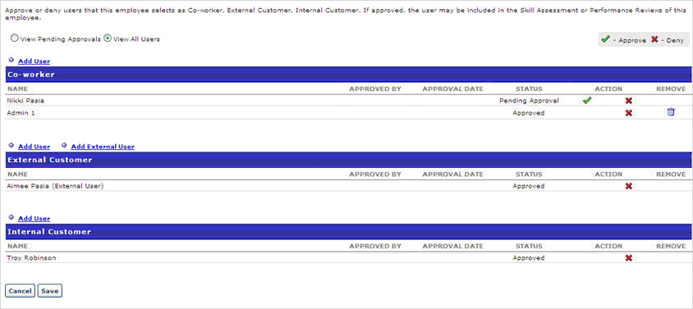
- Go to Performance > Manage Employee Relationships.
- Search Users - enter name if search filed and click Search. By default, employees with pending approvals will be shown. To view all employees that do not have any outstanding relationships to approve, check Include all users.
- View By User - check to view peer group pending approval by user
- View By Pending Approval - check to view peer group by pending approval status
- View Approvals - click to view pending approvals
- Approve - click to approve request
- Deny - click to deny request
- Remove - click to remove a peer that you added. Peers added by user can not be removed.
- Add User (Co-worker) - click to add a user for co-worker
- Add User (External Customer) -click to add a user for external customer
- Add External User (External Customer) - click to add an external user for external customer
- Add User (Internal Customer) - click to add a user for Internal Customer

Employee Relationships Administration
The Employee Relationship functionality allows you to add additional employee relationships to the system that are relevant to your organization for each employee. Examples of such custom relationships may include the employee's HR Generalist, Matrix Managers, Dotted Line Managers, etc. There are a number of predefined employee relationships that are used in performance management. These include Self (the user), Manager (the user's manager from their user record), Indirect Manager (the user's manager's manager), and Approver (the approver listed in the user's record).
Custom Relationships are used in Performance Reviews or Compensation Tasks, but not in Competency Assessment Tasks. Custom Peer Groups can be used in 360 Competency Assessments. Note: Indirect managers cannot be selected as peers.
Custom employee relationships appear in the user record and can be defined for each user. The administrator can select any of these custom employee relationships when assigning a performance review step as part of an employee's performance review. Custom relationships are also used in the Goals functionality to set the goal approver.
You can add relationships, add, edit and translate peer groups. You can also view details for relationships and peer groups.
To access the Employee Relationships page, go to Admin > Tools > Core Functions > Employee Relationships.
Permissions
PERMISSION NAME | PERMISSION DESCRIPTION | CATEGORY

Employee Relationships - Define | Grants ability to create and manage custom user relationship roles and peer groups that are utilized in performance tasks. This is an administrator permission. | Performance - Administration
Add Relationships
- To add a relationship, click the plus icon to the right of the Relationships heading. This opens the Add Relationship pop-up. You can add up to ten relationships.
- Enter a name for the relationship. The relationship name will appear on the User Record and other places where employee relationships are used. The character limit is 50. This field is required.
- Click Save to create the employee relationship. The relationship is added to the Relationships table.
Relationships Table
The following options may be available for employee relationships within the Relationships table:
- Active - Relationships can be made inactive by deselecting the Active checkbox. If a relationship is inactive, then it is not available on the User Record or other locations in the system.
- Security Role - A checkbox is only available in this column for custom employee relationships. When this option is selected, a dynamic security role is created for the custom employee relationship. The new security role is created as an active child role of the System Administrator role using the same name as the employee relationship. Upon creation, the security role does not contain any permissions. The security role can be fully configured via Security Administration.
  - The Security Role checkbox is selected and cannot be unselected if the relationship already has a dynamic security role.
  - The Security Role checkbox cannot be selected if the relationship is not active.
  - Whenever a user logs in to the portal and is within an active custom employee relationship that has an associated security role, the user is dynamically assigned the security role. The user is only assigned the security role while they are within an active custom employee relationship for another active user.
  - As with system defined security roles, a dynamic security role that is associated with a custom employee relationship cannot be deleted and users cannot be manually added to the role.
  - If a custom employee relationship is selected as a constraint for a permission within any security role, the custom employee relationship cannot be deactivated.
- Translate - If multiple languages are enabled in the portal, the names of custom relationships can be translated into other available languages by clicking the Translate icon.
Add Peer Group
To add a peer group
- Click the plus icon to the right of the Peer Groups heading. This opens the Add Peer Group pop-up. Note: The maximum number of peer groups is 34. If 34 peer groups exist, the plus icon is no longer available.
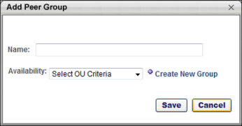
- Enter the following information for the peer group:
  - Name - Enter a name for the peer group. The character limit is 50. This field is required.
  - Availability - From the drop-down, select the availability for the peer group. The availability applies to both administrators and users. Administrators can only see peer groups for which they have availability when creating performance reviews or competency assessments or managing employee relationships. Users can only add peer groups for which they have availability when selecting peers during reviewer selection steps in reviews and assessments. There is no limit to the number of availability OUs that can be selected. This is required.
- Click Save to create the peer group. The peer group is added to the Peer Groups table with none of the options selected.
Peer Groups Table
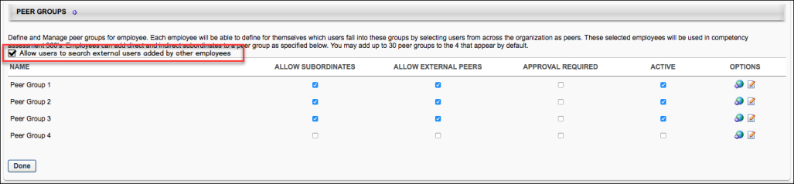
The following options may be available in the Peer Groups table:
- Allow users to search external users added by other employees.- If checked, when users working in Performance Reviews, Competency Assessment, or Peers, click the Add External User button, the Add External User pop-up opens and they can search for and add any previously added external user - even those added by other employees. See When unchecked, users who click the Add External User button bypass the Add External User Search pop-up and the New External User pop-up opens instead.
The following options may be available for peer groups within the Peer Groups table:
- Allow Subordinates - Select this option if subordinates of peers in the peer group are also included in the peer group. If this option is selected, users can add direct and indirect subordinates to the peer group from their My Peers page. A subordinate cannot be added to multiple peer groups.
- Allow External Peers - Select this option to allow a user to define external peers (users who are not defined within the system) within the peer group. peers that are not users in the system to be available in the peer group.
- Approval Required - Select this option to require the user's manager to approve a peer that they have selected. If approval is required, then the peer must be approved before it is available for use within the system.
- Active - Select this option to make the peer group active and visible to administrators when creating performance reviews or competency assessments. Peer groups cannot be deleted. They can only be made inactive. When a peer group is made inactive, existing performance review tasks are not affected; the inactive custom relationship is still included in the task.
Once a peer group is created and active, users can view and add to their peer groups via the Peers widget on the Snapshot page as long as the Peers widget is enabled and the user has permission to select peers. See Universal Profile - Snapshot Overview.
Edit/Translate
- To edit a peer group, click the Edit icon in the Options column.
- To translate the peer group name into other available languages, click the Translate icon in the Options column.

Performance - Manage Peers
A peer is a user with whom you work and collaborate on a regular basis. Users are able to define which users fall into each available peer group, and managers may be required to approve the selected peers. The selected peers may be used in peer reviews and assessments, such as competency assessments and performance reviews.
You can add an internal or external peers, remove a peer, and view peer status.
To manage peers:
- Go to Performance > My Peers.
- From the Universal Profile: Snapshot page, select the Peers widget. This widget is only available if enabled by the administrator in Snapshot General Preferences. See Snapshot General Preferences.
Permissions
PERMISSION NAME | PERMISSION DESCRIPTION | CATEGORY

Select Peers and Reviewers | Grants ability to select peers and reviewers in off-cycle performance reviews. This permission can be constrained by User's Corporation, OU, and User's OU. This is an end user permission. | Performance
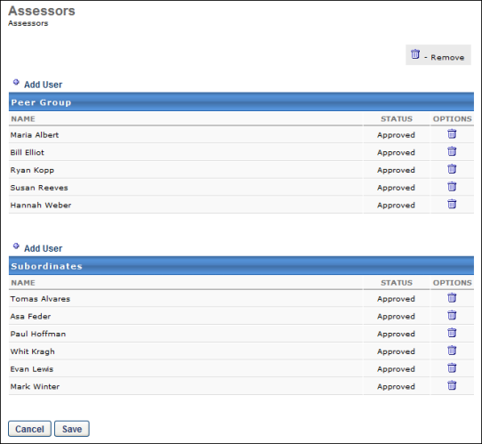
Add Internal Peer
To add an existing user within the system as a peer:
- Click the Add User link next to the appropriate peer group.
- Select a user by clicking Add icon . Note: In order to select peers, the user must have permission to select peers and reviewers. The constraints on this permission determine who the user can select. Also, peer group availability is set by the administrator in Employee Relationships. Managers and indirect managers cannot be selected as peers.
- Click Done.
Add External Peer
The ability to add an external user as a peer is only available if the administrator enabled this functionality.
To add an external user to a peer group:
- Click the Add External User link next to the appropriate peer group.
- Click the Add New External User link in the pop-up window.
- Add the external user's first, last name, and email address.
- Click Add.
Peer Status
If approval is required for to add a peer, the status is Pending Approval until your manager approves the peer. If approval is not required, then the status is Approved as soon as the peer is added.
Remove Peer
You can remove a peer that you added by clicking the Trash Can icon next to the peer. Note: You can only remove a peer if you added the peer. If another user added this peer, you cannot remove them.

